Pelagic larval duration links life history traits and species persistence in Darters (Percidae: Etheostomatinae)

A Thesis Presented for the

Master of Science

Degree

The University of Tennessee, Knoxville

Morgan Jessica Douglas

August 2013

ACKNOWLEDGEMENTS
Jen Schweitzer, Joe Bailey, and Phillip Hollingsworth provided useful comments and encouragement. Many hardworking people at Conservation Fisheries, Inc. helped with darter husbandry.

ABSTRACT
Pelagic larval duration (PLD) likely influences evolutionary processes including dispersal, genetic connectivity, and extinction in aquatic organisms. PLD has been well studied in marine systems, but very few freshwater species have been studied. Darters are a diverse group of freshwater North American fish with available information on the length of this stage from propagation efforts. There is surprising variation in the length of this stage ranging from 0 to 60 days. By compiling information from Conservations Fisheries, Inc. (Knoxville, TN) and the literature, we were able to make comparisons between the PLD of 23 species and other life history characteristics. We hypothesized that 1) PLD will influence developmental characteristics and reflect tradeoffs at these critical stages 2) a higher extinction risk should associate with lower PLD. Size at yolk absorption was found to have a marginally significant, relationship with PLD, but juvenile size and maximum size were found to have positive relationships. These relationships indicate a possible developmental tradeoff between larval survival and potential size and that pelagic larval duration in darters is greatly influenced by life history characteristics. Additionally, through a phylogenetic comparative analysis, we found lower PLD in darter lineages was evolutionarily associated with extinction risk, which is similar to patterns commonly recovered from the marine fossil record. These findings provide some of the first support in extant taxa for the hypothesis that PLD is an important determinant of extinction. This study indicates that PLD is highly influential in species life history characteristics and predictions of species’ persistence.

TABLE OF CONTENTS
INTRODUCTION 1
CHAPTER I Pelagic Larval duration links life History Characteristics in Darters 4
Abstract 5
Introduction 5
Materials and Methods.....................................................................................................8
Results 14
Discussion 19
CHAPTER II Pelagic larval duration predicts extinction risk in a freswater fish clade 23
Abstract 24
Introduction 25
Materials and Methods 26
PLD Measurements 26
Phylogenetic Reconstruction 27
Comparative Analyses 27
Results 28
Discussion 29
CONCLUSION 33
REFERENCES.................……………………………………………………….........…35
VITA 42

LIST OF TABLES

Table 1. Life History Traits of Darter Species ……………………...…...........................10

Table 2. GenBank numbers used to construct the darter phylogeny….............................13

LIST OF FIGURES

Figure 1. PLD and larval size at yolk-absorption………………………….…………….16
Figure 2. PLD and juvenile size………………………………………….………………17
Figure 3. PLD and maximum adult size………………………………………..………..18
Figure 4. Phylogenetic association with IUCN status and PLD………………..………..31

INTRODUCTION
The larval stage of fish is considered to be one of the most critical stages contributing to the survival and propagation of species [1, 2]. This stage occurs after an offspring hatches from the egg and ends when it successfully develops into a juvenile. The larval stage often is characterized by high mortality rates (>90%) making variations in this stage extremely important in determining which individuals reach reproductive age [3]. The larval stage presents many developmental “hurdles" including the first stages of feeding and locomotion [3]. These important stages are considered hurdles to larval development because if larvae do not obtain these characteristics quickly enough they become susceptible to starvation and predation. These barriers contribute to the high mortality rates, and trade offs in life history traits that are reflected in adult reproductive tactics of species. For example, some populations invest in high numbers of larvae that have a low survival while others invest higher amounts of energy in the survival and development of a low number of larvae. Larval characteristics are also important for population dynamics because larvae can exhibit behaviors that are absent in adults [3]. Many fish species are benthic as adults and only associate with the bottom and not open water making long distance dispersal as adults difficult. For these species, the larval stage is often the only mode of dispersal.
Many species of fish have larvae that move into the water column after hatching for a varying amount of time. This time period is known as pelagic larval duration (PLD). PLD has been widely studied in marine systems [4, 5], and longer pelagic stages have been linked to increased dispersal capability, gene flow, and range size [2, 6, 7]. This relationship has been shown to be critical in allowing gene flow among populations of coral reef systems [2]. Throughout the marine fossil record, the absence of a pelagic stage has been linked to increased extinction risk, higher speciation rates, and reduced geographic range reflecting this relationship between PLD and dispersal[8]. However, these relationships are not universal across marine life, and interspecific life history variation complicates these relationships. [9, 10].
Many freshwater fish exhibit pelagic stages during development, but little is known about how variation of this stage impacts other aspects of their biology. Because of the complexity of freshwater systems, the relationship between PLD and dispersal is even less clear. Freshwater systems present many opportunities for natural isolation through different flow regimes, water level fluctuations, and dendritic areas. Difficulties in quantifying PLD in freshwater species further complicate the ability to study the effects of this developmental stage. However, the persistence of a pelagic stage in freshwater species indicates this stage plays an important role even in these complex systems.
Darters (Percidae: Etheostomatinae) are an extremely species-rich group of North American freshwater fish and variation in their larval life history could be a major factor influencing this diversity [3]. Darters are small, ecologically similar fish that exhibit incredible variation in their reproductive biology. Many darter species exhibit a pelagic larval stage before beginning the benthic lifestyle they maintain for the rest of their lives. Because many darter species have become imperiled from the human alteration of their habitat, many of these fish have become the focus of conservation programs. Captive propagation and restoration efforts have yielded estimates of PLD for this group of freshwater fish. There is incredible variation is the length of this stage, providing a opportunity to make comparisons across this clade of freshwater fish.
To examine the possible influence of PLD in this group of fish, Chapter 1 compares life history characteristics to PLD for several species of darters, and Chapter 2 examines the influence of PLD on extinction risk in this freshwater clade.

CHAPTER I
Pelagic Larval duration links life History

Characteristics in Darters

Crystal Ruble, Melissa Petty, J.R. Shute, and Patrick Rakes from Conservation Fisheries, Inc. were the principle researcher responsible for care and records needed to collect the necessary data.

Abstract
The pelagic larval duration (PLD) has been well studied in marine systems, but very few freshwater species have been studied. Darters are a diverse group of freshwater North American fish with available information on PLD because of propagation and restoration efforts. There is considerable variation in the length of this stage ranging from 0 to 60 days. By compiling information from Conservations Fisheries, Inc. (Knoxville, TN) and the literature, we were able to make comparisons between the PLD of 23 species and other life history characteristics. We hypothesized that PLD will influence developmental stage characteristics and reflect life history strategy tradeoffs of these critical stages. Size at yolk absorption was found to have a marginally significant, negative relationship with PLD, (but juvenile size and maximum size were found to have a positive relationship. These relationships indicate a possible developmental tradeoff between larval survival and potential size. These findings further indicate that pelagic larval duration in darters is greatly influenced by life history characteristics.

Introduction
Life history characteristics, such as developmental rates, maturation age, life span and fecundity, are often highly variable among closely related species and even between populations [11, 12]. This variation often represents trade-offs in the evolutionary history of populations. These inherent trade-offs in life history traits are evident from the absence of certain combinations in nature. For example, some populations invest more in fecundity but cannot invest the same energy in the survival of juveniles, and populations that optimize offspring size cannot also have larger number of offspring [12]. The study of life history theory has been important in understanding evolutionary history of groups as life history traits are critical for reproduction and fitness in various environments [11].
Darters (Percidae: Etheostomatinae) are an extremely species rich group of North American freshwater fish and variation in their life history could be a major factor influencing this diversity [3]. They are small, ecologically similar fish that exhibit substantial variation in their reproductive biology. Captive propagation efforts have led to data on a number of life history traits. These efforts have also led to the observation that many darter species exhibit a pelagic larval stage before beginning the benthic lifestyle they maintain for the remainder of their lives. There is substantial variation in the lengths of this pelagic period across the darter radiation, ranging from no pelagic stage in species such as Etheostoma percnurum to the 60 days that E. zonistium spends in the water column. This variation could be indicative of evolutionary trade-offs in the development and reproductive behavior of this group of fish.
For many benthic species, such as darters, this pelagic larval stage is the only time during which dispersal may occur. The length of this pelagic state, also known as pelagic larval duration (PLD), has been widely studied in marine systems [4, 5]. Longer pelagic stages have been linked to increased dispersal capability and increased gene flow [2, 6, 7]. However, these relationships are not consistent across all aquatic organisms and are often complicated by interspecific life history variation [9, 10]. Many freshwater fish exhibit pelagic stages during development, but little is known about the relationship of this life history trait to other life history phenotypes in these fish. Because of the complexity of freshwater systems, the relationship between PLD and dispersal is even less clear. The difficulty in quantifying PLD in freshwater species further complicates the ability to study the effects of this developmental stage on other traits of species.
Through comparative studies, major life history strategies have been described for major vertebrate groups including marine and freshwater fish, and dispersal capabilities are a major component of life history strategies. For example, seed dispersal in plants is a classic example of life history trade-offs. Larger, heavier seeds are typically associated with better chances of survival but with lower fecundity and dispersal ability [13-15]. Furthermore, the importance of dispersal as a component of life history theory extends to other taxa. For freshwater fish, important traits for these strategies are a combination of mostly body size, environmental stability, fecundity, juvenile survivorship, and parental investment [11]. In general, larger body size is associated with greater fecundity, less juvenile survivorship and parental investment, as well as greater dispersal potential [11, 16]. However, the importance of a pelagic period for dispersal or its effect on other life history traits has not been studied in darters. To examine the possible influence of PLD on other life history traits in this group of fish, we compared life history characteristics to PLD for several species of darters. We hypothesized that PLD will influence developmental stage characteristics and reflect trade-offs among these critical stages.
Material and Methods
Twenty darter species were reared at Conservation Fisheries, Inc. (CFI) in Knoxville, Tennessee to obtain species mean PLD. PLDs for three additional species were obtained from the literature [17-19]. To determine PLD at CFI, tanks with breeding darters were routinely checked for spawning. Following spawning, eggs were removed from the tank, examined under a microscope for development, transferred to a shallow tray if fertilized, and monitored for hatching.
Once the larvae hatched and began swimming, they were transferred to a pelagic rearing tub marking day 0 of the pelagic stage. Black 94 liter tubs were used to raise the pelagic larvae as these tubs reduced phototactic behavior. This setup also served to simultaneously maintain sufficient aeration, current, and surface agitation at this sensitive stage. Larvae were monitored daily for mortality and position in the water column. When larvae began to spend more than 50% of their time on the bottom of the tub, the PLD was determined to have ended. Detailed records of egg removal, larval transfer, and date of benthic stage were kept to establish mean PLDs [20]. Mean PLDs were square root transformed for statistical analysis.
Life history traits for darter species that have a known PLD (Table 1) were obtained by searching the literature and through records of life history traits collected at CFI’ [21-23]. Maximum Size (cm TL), egg diameter (mm), size at hatch (mm TL), size at yolk absorption (mm TL), juvenile size (mm TL), incubation period (days), female age of sexual maturity (years), spawning strategy, and parental care were available measurements. Spawning strategy descriptions were sorted into four darter spawning strategies categories: attacher, burier, clumper, and clusterer [23]. Attachers were described as species that scatter individual, adhesive eggs that attach to the available but not specific substrate. Buriers are species where a half-buried female is mounted by a male before non-adhesive eggs are scattered on the gravel substrate. Clumpers are species that deposit adhesive clumps of several eggs on non-specific substrate. Clusterers deposit adhesive clumps of several eggs specifically on the undersides of rocks. Darter parenting varies from simple egg guarding to nest guarding all the way through juvenile stage. Presence of parental care was described as any energy investment into the care or guarding of eggs or offspring.
To estimate the phylogenetic relationships among the 23 darter species and two outgroups (Perca flavescens and Sander vitreus), we compiled sequence data available on GenBank (Table 2) for three loci. The loci included the mitochondrial encoded cytochrome b (Cytb), nuclear encoded S7 ribosomal protein intron 1 (S7), and nuclear encoded recombination activating protein 1 (RAG1) exon 3. We used sequence alignments and models of molecular evolution from Near et al. [3]. Using MrBayes 3.2 [24], we ran a Bayesian analysis on the dataset partitioned by gene for 5 million generations and sampling every 1000 generations. A standard deviation of ≤ 0.01 between the two independent MrBayes runs was assumed to indicate convergence. We used Tracer 1.5 [25] to estimate the effective sample size (ESS) of MCMC mixing and ESS values > 200 were considered adequate. Once the phylogenetic search was complete,

Table 1. Life history traits of Darter species with available Pelagic Larval Duration estimates. Values were obtained from Conservation Fisheries, Inc. or though the literature.
Species | PLD | Max Life Span (years) | Sexual Mature (female,Years) | Incubation Period (days) | Max Size (cm)
Percina aurora | 17.5 | 3.5 |  |  | 7.7[22]
Percina copelandi | 21 | 3.5[23] | 1[23] |  | 6.2[22]
Percina aurantiaca | 37 | 4[21] | 2 |  | 18[22]
Percina tanasi | 17.5[18] | 4[21] | 1[23] | 15[21] | 9[22]
Percina aurolineata | 28 |  | 2 |  | 9[22]
Percina sciera | 41[19] | 4[23] | 1[23] | 4[21] | 13[22]
Nothonotus etowahae | 14 |  |  |  | 6.5[22]
Nothonotus maculatus | 17.5 |  | 2[21] |  | 9[22]
Nothonotus moorei | 25 |  |  |  | 7.2[22]
Nothonotus sanguifluus | 16.5 | 5[23] | 1[23] | 7.5[23] | 9[22]
Nothonotus vulneratus | 17.5 | 5[23] | 2[23] | 8 | 8[22]
Nothonotus wapiti | 14 |  | 2 | 10 | 8.5[22]
Etheostoma susanae | 0 | 4[21] | 1 | 8 | 6[21]
Etheostoma marmorpinnum | 0 |  | 1 |  | 6.3[22]
Etheostoma percnurum | 0 | 2[26] | 1[26] | 12.5[23] | 6.4[22]
Etheostoma sitikuense | 0 |  | 1 |  | 6.3[22]
Etheostoma stigmaeum | 30 | 2[23] | 1[23] | 9.5[21] | 6.1[22]
Etheostoma parvipinne | 30 | 3[23] | 1 | 12 | 7[22]
Etheostoma spilotum | 27.5 | 3[23] | 1[23] | 10 | 12[22]
Etheostoma boschungi | 0 | 3[23] | 2[23] |  | 7.8[22]
Etheostoma variatum | 35[17] | 3[21] |  | 13.5 | 11[22]
Etheostoma cf. zonistium | 60 |  |  | 11[21] | 7.1[22]
Etheostoma caeruleum | 1 | 4[23] | 1[23] | 9.5[23] | 7.7[22]

Table 1. Life History Traits (cont.)

Species | PLD | Egg Diameter (mm) | Size at Hatch (mm TL) | Size at Yolk Absorption (mm TL) | Juvenile Size (mm TL)
Percina aurora | 17.5
Percina copelandi | 21 | 1.4[21] | 5 | 6.1[23] | 37.5[23]
Percina aurantiaca | 37 | 2.1[21] | 8.75 |  | 61[23]
Percina tanasi | 17.5[18] | 0.88[23] | 6[23] | 8[23] | 42.5[23]
Percina aurolineata | 28 | 1.75 | 6.25
Percina sciera | 41[19] | 1.5[21] | 5.5[23] | 7.2[23] | 54[23]
Nothonotus etowahae | 14 | 2.2[21]
Nothonotus maculatus | 17.5 | 2[21] | 5.5[21] | 8[23]
Nothonotus moorei | 25 | 1.8 | 5
Nothonotus sanguifluus | 16.5 | 1.7[23] | 8.5 |  | 40
Nothonotus vulneratus | 17.5 | 2.95[23] | 8.3[23] | 9[23] | 40[23]
Nothonotus wapiti | 14 | 1.7 | 8.5
Etheostoma susanae | 0 | 1.7[21]
Etheostoma marmorpinnum | 0
Etheostoma percnurum | 0 | 2.8[23] | 5[23] | 9.3[23] | 15.5[23]
Etheostoma sitikuense | 0
Etheostoma stigmaeum | 30 | 1.7[21] | 4.2[23] | 5.4[23] | 10.7[23]
Etheostoma parvipinne | 30 | 1 | 4.5 |  | 47[23]
Etheostoma spilotum | 27.5 | 1.65 | 5.2[23] | 6[23]
Etheostoma boschungi | 0
Etheostoma variatum | 35[17] | 1.67[23] | 6.9[21] | 8[23]
Etheostoma cf. zonistium | 60 | 1.65 | 4.1[23] | 5.2[23]
Etheostoma caeruleum | 1 | 1.75[21] | 6.1[23] | 8[23] | 13[23]

Table 1. Life History Traits (cont.)

Species | PLD | Parental Care | Spawning Strategy
Percina aurora | 17.5 | No | burier
Percina copelandi | 21 | No | burier
Percina aurantiaca | 37 | No | burier
Percina tanasi | 17.5[18] | No | burier
Percina aurolineata | 28 | No | burier
Percina sciera | 41[19] | No | burier
Nothonotus etowahae | 14 | No | clumper
Nothonotus maculatus | 17.5 | Yes | clusterer
Nothonotus moorei | 25 | No | clumper
Nothonotus sanguifluus | 16.5 | No | clumper
Nothonotus vulneratus | 17.5 | Yes | clumper
Nothonotus wapiti | 14 | Yes | clumper
Etheostoma susanae | 0 | Yes | clusterer
Etheostoma marmorpinnum | 0 | Yes | clusterer
Etheostoma percnurum | 0 | Yes | clusterer
Etheostoma sitikuense | 0 | Yes | clusterer
Etheostoma stigmaeum | 30 | Yes | burier
Etheostoma parvipinne | 30 | No | attacher
Etheostoma spilotum | 27.5 | Yes | burier
Etheostoma boschungi | 0 | Yes | clusterer
Etheostoma variatum | 35[17] | No | burier
Etheostoma cf. zonistium | 60 | No | attacher
Etheostoma caeruleum | 1 | No | burier

Table 2. List of GenBank numbers for the sequence data used to construct the darter phylogeny. (cytb = mitochondrial cytochrome b, S7 = S7 ribosomal protein gene intron 1, Rag1 = recombinase activating gene protein 1 exon 3).
Species | cytb | S7 | Rag1
Perca flavescens | AY20099 | AY517755 | FJ381301
Sander vitreus | AF386602 | EU094723 | FJ381300
Etheostoma cf. zonistium | HQ128100 | HQ128320 | HQ127785
Etheostoma boschungi | HQ128094 | HQ128314 | HQ127779
Etheostoma caeruleum | FJ381011 | HQ128321 | HQ127786
Etheostoma marmorpinnum | HQ128166 | HQ128401 | HQ127871
Etheostoma parvipinne | HQ128189 | HQ128427 | HQ127902
Etheostoma percnurum | AF412525 | AF412556 | HQ127903
Etheostoma sitikuense | HQ128227 | HQ128466 | HQ127944
Etheostoma spilotum | HQ128230 | HQ128469 | HQ127948
Etheostoma stigmaeum | HQ128232 | HQ128472 | HQ127952
Etheostoma susanae | HQ128237 | HQ128477 | HQ127957
Etheostoma variatum | EU296693 | EU296727 | HQ127975
Nothonotus etowahae | AY742660 | EU094769 | GU015711
Nothonotus maculatus | AY742663 | EU094780 | GU015717
Nothonotus moorei | EU094693 | EU094785 | GU015725
Nothonotus sanguifluus | EU094707 | EU094803 | HQ005709
Nothonotus vulneratus | AY742666 | EU094812 | GU015841
Nothonotus wapiti | EU094720 | EU094818 | GU015847
Percina aurantiaca | AF386579 | FJ381346 | FJ381302
Percina aurolineata | AF386575 | HQ128506 | HQ127995
Percina aurora | AF386566 | HQ128508 | HQ127997
Percina copelandi | AF386568 | HQ128510 | HQ12811
Percina sciera | AF386573 | HQ128537 | HQ12847
Percina tanasi | HQ128276 | HQ128549 | HQ12859

we isolated the 100 best topologies and used the program Treeedit’s non-parametric rate smoothing algorithm [27] to generate ultrametric trees for comparative analyses.
To account for phylogenetic relatedness, independent contrasts were performed for the analysis. Phylogenetic regressions were for maximum size, egg diameter, size at hatch, size at yolk absorption, juvenile size, and incubation period against PLD to test for relationships between these developmental characteristics and increasing PLD by using Phenotypic Diversity Analysis Program in Mesquite [28]. These life history traits not only represent the available and most complete groups of data for these particular species, but also include important traits for life history theory. Because spawning strategy and age of female sexual maturity do not have much variability across the darter tree, any significant contrasts were unable to be made. Parental care will be addressed in the later chapter.

Results
There was no relationship between PLD and life span (r=0.052, p=0.85), egg diameter (r=-0.014, p=0.95), size at hatch (r= -0.12, p=0.62), or incubation period (r= -0.20, p=0.52). The affect of PLD on these early life history stages appears to be negligible or confounded with other factors. However, the other stages of development did have stronger relationships with PLD. Size at yolk absorption and PLD had a marginally significant negative relationship (Figure 1: n=11, r= -0.51, p=0.11). As PLD increases, the larvae size at yolk absorption decreases. Although there were not many measurements available for size at yolk sac absorption, these results indicate there is a potential significant influence of PLD at this developmental stage. From visual observation, lower PLD tends to be associated with a larger yolk sac, which is associated with more nutrition and longer absorption time.
In contrast, juvenile size had a significant positive relationship with PLD (Figure 2: n=10, r=0.64 p=0.047). Increasing PLD was associated with increasing juvenile size. This reflects a reversal of the relationship between larval size and PLD during the pelagic stage. This size relationship was also extended to the adult stage. Maximum size and PLD also have a marginally significant positive relationship (Figure 3: n=23, r=0.34, p=0.10). Increasing PLD tends to be associated with species of larger size.

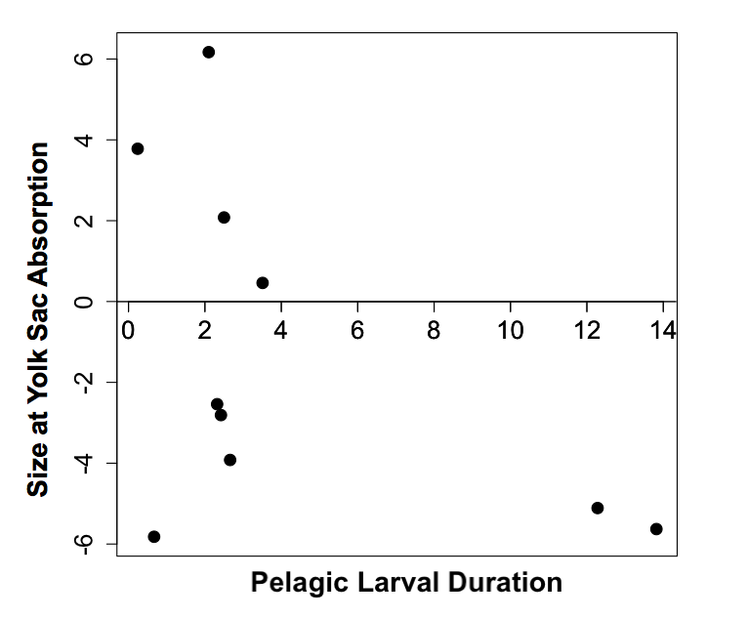
Figure 1. Relationship between pelagic larval duration and larval size at yolk sac absorption of darters. Points represent species means obtained from the literature. (r= -0.51, p=0.11).

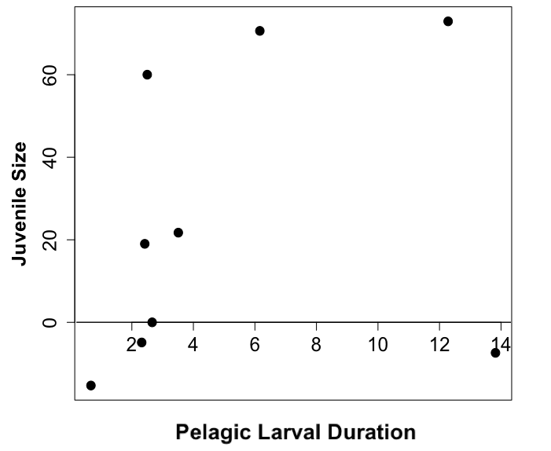
Figure 2. Relationship between pelagic larval duration and juvenile size of darters. Points represent species means obtained from the literature. (r=0.64 p=0.047).

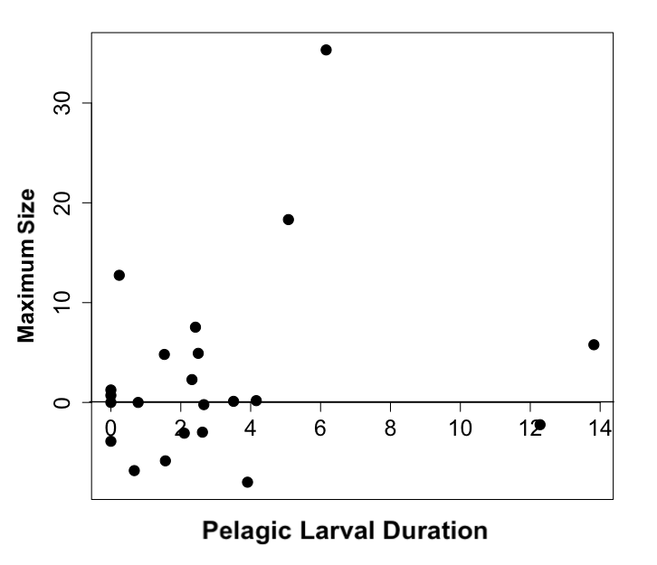
Figure 3. Relationship between pelagic larval duration and adult maximum size of darters. Points represent species means obtained from the literature. (r=0.34, p=0.10)

Discussion
This study emphasizes the importance of PLD to the biology of darters. Variation in the length of the pelagic stage correlates with size differences at various developmental stages (yolk-sac larvae, juvenile, adult) and may reflect the constraints of these stages. Pelagic larval duration is likely linked to dispersal, gene flow, and speciation rates in this clade, and our results suggest that the biological factors could highly influence other life history characteristics.
The relationships between PLD and size at different points in development suggest that PLD may reflect a possible evolutionary trade-off between larval survival and potential adult size [29]. Large larval size at yolk sac absorption is associated with lower PLD. This larger yolk size probably provides more nutrition and time for larval development. A larger yolk-sac larvae may also indicate more parental investment as a larger yolk sac is more energetically costly to the parents. These larvae may be more likely to survive and more capable of capturing food because of increased size when they initially swim into the water column. However, the relationship with juvenile size and maximum size is reversed, suggesting that species with longer PLDs are able to obtain greater body size. This greater juvenile size could be reached simply because of more available food of appropriate size in the water column. However, this relationship could also be indicative of some developmental requirement needed to navigate the water column for extended lengths of time. Whatever the underlying reason for this relationship, this larger body size is extended to the adult fish. These relationships generate questions about the developmental requirements and behavior of pelagic larvae in darters. However, answers to the questions require a better understanding of the ontogeny and development rates of these organisms.
PLD is generally associated with greater dispersal ability and gene flow in fish [1, 2, 5]. This relationship has not been established in darters, but our results further imply the pelagic stage of darter larvae may serve as a dispersal mechanism by the relationship between PLD and body size. A positive relationship between dispersal ability and body size has been demonstrated across vertebrate taxa, and in fish, body size is a major component of life history strategy [30-32]. Dispersal is thought to correlate with an r-type strategy (high fecundity and quicker maturation) [33]. This categorization does not fully extend to fishes because more fecund fish species typically take longer to reach sexual maturation [16]. However, greater dispersal ability tends to also negatively correlate with many fitness related traits like survival and developmental rates [34]. For fish, this relationship might result in less dispersive species having greater larval survival and more parental investment. Our results indicate that individuals with less PLD have larger larvae at yolk sac absorption indicating more investment in the nutrition of offspring. Many darters also exhibit parental care but this potential relationship was not examined here. An association with low PLD and parental care would point to a trade-off between larval survival and dispersal.
Fecundity is consistently linked with dispersal ability and other life history traits [35]. Kin competition is thought to link the relationship between greater fecundity and dispersal ability [36-39]. Unfortunately, consistent measures of darter fecundity or brood size were unavailable. However, there is evidence for this relationship in darters and examining the relationship between this life history traits and PLD would further shed light on life history strategy in darters. We were also unable to make any conclusions based on reproductive spawning strategy due to lack of variation in these characteristics across the darter radiation. However, the variation in darter spawning strategy is an interesting component of examining kin competition during the larval stage [35]. If kin competition is associated with greater dispersal ability, species that lay eggs in groups should have more dispersal than those that scatter their eggs among the substrate. However, many species without any pelagic stage exhibit spawning behavior where groups of eggs are laid together in a nest that is later protected by the male. This relationship may further indicate that fecundity plays a large role in the life history strategy and PLD variation in darters.
Like many marine species, PLD appears to be associated with interspecific variation in other life history traits [31]. However, unlike in many marine species, we detected no relationship with some of the early developmental characteristics (egg size at hatch) and PLD [10]. Egg size is also an important component in life history strategy with more dispersive individuals having larger numbers of smaller eggs [16]. Additionally, darters have been shown to exhibit similar correlations. The genus Percina tends to be bigger, more fecund, take longer to mature, and have smaller eggs [40]. However, our results indicate there is not a relationship between egg size and PLD. Therefore, this general life history strategy may not be enough to describe all of the variation in PLD in darters and indicates combinations of life history traits may be much more complicated.
Although this study provides important insight into the significance of PLD in freshwater, questions about the significance of PLD in the role of dispersal and gene flow are still left unanswered. Species with no PLD indicate that a negative effect of low PLD is reduced gene flow. However, if PLD is an actual driver of gene flow or how long larvae must actually stay pelagic to gain ample dispersal for connectivity cannot be answered by these findings. The study of the variation in pelagic larval duration has been a major focus in marine ecology and recent studies highlight that larval behavior and life history variation may be the drivers of complexity in the PLD, dispersal, and gene flow[5]. Dispersal ability together with other life history traits is associated with disturbed habitat [41]. Therefore, links between life history traits and extinction risk are becoming increasingly important to predicting which species will be most affected by environmental change [42]. Understanding how PLD is related to life history variation is important in understanding the evolution of life history as well as gene flow in many organisms and these traits could be critical to predicting the persistence of aquatic species.

CHAPTER II
Pelagic larval duration predicts extinction risk in a freswater fish clade

A version of this chapter has been submitted for publication to Biology Letters by Morgan J. Douglas, Benjamin P. Keck, Crystal Ruble, Melissa Petty, J.R. Shute, Patrick Rakes, and C. Darrin Hulsey
Crystal Ruble, Melissa Petty, J.R. Shute, and Patrick Rakes from Conservation Fisheries, Inc. were the principle researchers responsible for care and records needed to collect the necessary data. Benjamin Keck and Darrin Hulsey provided and ran the phylogenetic analysis. The article has been revised for resubmission to Biology Letters.

Abstract
Pelagic larval duration (PLD) likely influences evolutionary processes including dispersal, genetic connectivity, and extinction in aquatic organisms. Using estimates of PLD obtained from species of North American darters (Percidae: Etheostomatinae), we demonstrated that this clade of freshwater fish exhibits surprising variation in PLD. Tradeoffs associated with increased parental care, dispersal, and flow regimes likely structure the variability in PLD of these freshwater fish. Additionally, similar to patterns commonly recovered from the marine fossil record, lower PLD in darter lineages was found to be evolutionarily associated with extinction risk. These findings provide some of the first support in extant taxa for the hypothesis that PLD is an important determinant of extinction risk.

Introduction
Although all species eventually go extinct, a species’ risk of extinction and length of its lifetime are significantly affected by biological and environmental characteristics. Larval characteristics could heavily influence species’ susceptibility to extinction [8, 43, 44]. For instance, pelagic larval duration (PLD), or the time an aquatic larva spends in the water column, has been suggested to greatly influence factors associated with diversification such as genetic connectivity and range size in marine taxa [1, 2, 4-7, 10]. PLD is also thought to be a key determinant of extinction probability in the fossil record [8, 29, 43]. However, evolutionary divergence in PLD and its potential relationship with extinction risk has rarely been examined in extant, freshwater organisms. Also, extant organisms are by definition the clades that have not gone extinct. Therefore, assessing the relationship between PLD and the likelihood of extinction in living groups has been difficult. However, human activity is precipitating a global wave of extinction. We used the freshwater fish group known as darters (Percidae: Etheostomatinae) to take advantage of this anthropogenic “experiment” in order to comparatively examine evolutionary divergence in PLD and its association with extinction risk.
Darters are an especially species rich clade (~ 250 species) of North American stream-dwelling fishes, and life history variation could have structured both speciation and extinction in this group [3, 21]. Many darter species are currently considered endangered [22], but the biological characteristics influencing this risk of extinction is not generally clear. However, propagation efforts focused on restoring imperiled darters have led to observations that many darter species exhibit a pelagic larval stage before beginning the benthic lifestyle that they maintain for the remainder of their lives [17, 19, 23]. If there were substantial variation in the length of this pelagic period across the darter phylogeny, this variation could heavily influence extinction risk of darter lineages due to the association of PLD with greater extinction risk in the marine fossil record. To assess the evolutionary variability of PLD and its association with the likelihood of darter extinction, we examined the phylogenetic association between darter species International Union for Conservation of Nature (IUCN) status and their PLD.

Materials and Methods

PLD Measurements
Twenty darter species were reared at Conservation Fisheries, Inc. (CFI) in Knoxville, Tennessee to obtain species mean PLD. PLDs for three additional species were obtained from the literature [17-19]. To determine PLD at CFI, tanks with breeding darters were routinely checked for spawning. Following spawning, eggs were removed from the tank, examined under a microscope for development, transferred to a shallow tray if fertilized, and monitored for hatching.
Once the larvae hatched and began swimming, they were transferred to a pelagic rearing tub marking day 0 of the pelagic stage. Black 94 liter tubs were used to raise the pelagic larvae as these tubs reduced phototactic behavior. This setup also served to simultaneously maintain sufficient aeration, current, and surface agitation at this sensitive stage. Larvae were monitored daily for mortality and position in the water column. When larvae began to spend more than 50% of their time on the bottom of the tub, the PLD was determined to have ended. Detailed records of egg removal, larval transfer, and date of benthic stage were kept to establish mean PLDs [20].

Phylogenetic Reconstruction
To estimate the phylogenetic relationships among the 23 darter species and two outgroups (Perca flavescens and Sander vitreus), we compiled sequence data available on GenBank (Table 2) for three loci. The loci included the mitochondrial encoded cytochrome b (Cytb), nuclear encoded S7 ribosomal protein intron 1 (S7), and nuclear encoded recombination activating protein 1 (RAG1) exon 3. We used sequence alignments and models of molecular evolution from Near et al. [3]. Using MrBayes 3.2 [24], we ran a Bayesian analysis on the dataset partitioned by gene for 5 million generations and sampling every 1000 generations. A standard deviation of ≤ 0.01 between the two independent MrBayes runs was assumed to indicate convergence. We used Tracer 1.5 [25] to estimate the effective sample size (ESS) of MCMC mixing and ESS values > 200 were considered adequate. Once the phylogenetic search was complete, we isolated the 100 best topologies and used the program Treeedit’s non-parametric rate smoothing algorithm [27] to generate ultrametric trees for comparative analyses.

Comparative Analyses
To examine the ability of parental care to explain darter PLD variation, nodes of the phylogeny that subtend clades exhibiting parental care were highlighted [45]. Species values for the two clades of darters that show parental care were compared to species that do not. Extinction risk for the darter species was determined based on their status on the International Union for Conservation of Nature (IUCN) red list [46]. The darter species E. sitikuense and E. marmorpinnum were considered to be red list species because they have recently been elevated from the red listed E. percnurum. Prior to performing phylogenetic comparative analyses, the PLD values were square root transformed. We then examined the phylogenetically corrected association of red list status, coded as a categorical state, with transformed PLD, a continuous variable, using the “brunch” function from the caper CRAN package [47] implemented in R [48]. The brunch algorithm examines evolutionary associations between combinations of continuous and categorical data while accounting for the lack of phylogenetic independence of phenotypes. Brunch identifies and calculates contrasts for all variables in the model for a set of nodes where the two sub-trees on either side of a node can be assigned to alternative categories. A linear model is then generated with the degrees of freedom equal to the number of inferred transitions between categories of extinction risk. To account for phylogenetic uncertainty, we ran the brunch algorithm on the 100 best ultrametric topologies generated above. If lower values of PLD are associated with extinction risk, we expected a significant association between PLD and IUCN status.

Results
The PLDs ranged from 0 to 60 days in the darter species examined (Figure 4). The species values for darter lineages with parental care (μ=8 ± 11) were generally lower than those without it (μ=25 ± 15). The species values for the imperiled (μ=12 ± 3) and non-imperiled (μ=25 ± 4) darters were also generally divergent. The phylogenies we reconstructed largely mirrored relationships recovered in Near et al. [3], and PLD values have repeatedly increased and decreased during darter diversification. Thirteen of the species examined were on the IUCN red list as a species of concern (Near Threatened, vulnerable, endangered, or critically endangered) and ten are not currently imperiled (Least Concern or not evaluated). Notably, all species with no pelagic stage were on the red list as a species of concern. Over the 100 phylogenetic topologies, the evolution of a lower darter PLD was significantly associated with extinction risk (d.f. = 7; p = 0.038 ± 0.013).

Discussion
The evolutionary variation in darter PLD is substantial (Figure 4). There are components of the darter radiation that have lost a pelagic stage while others have surprisingly lengthy PLDs. The lack of a PLD in darters like Etheostoma boschungi and E. percnurum mimics what is often seen in large freshwater groups [49]. Conversely, other species like E. variatum and Percina aurantiaca have larval durations similar to many marine fish that exhibit PLDs lasting over a month [4, 10]. Tradeoffs are likely driving this variation. Longer PLDs could be associated with greater dispersal and decreased competition among relatives, whereas shorter PLDs could be related in part to the evolution of parental care (figure 1). Yet, the two origins of parental care [45] provide insufficient evolutionary replication to explain all of darter PLD diversity. Variation in flow regimes could also structure darter PLD [50]. Longer PLD might increase population connectivity and dispersal in large, slow rivers. Alternatively, in high gradient streams with rapid flows, reduced pelagic zones, and lack of suitable downstream habitat, a reduced time in the water column might be particularly advantageous. Despite the potential advantages, reduced dispersal associated with lower PLD probably leads to small, isolated populations that are less stable and more vulnerable to environmental changes [45].

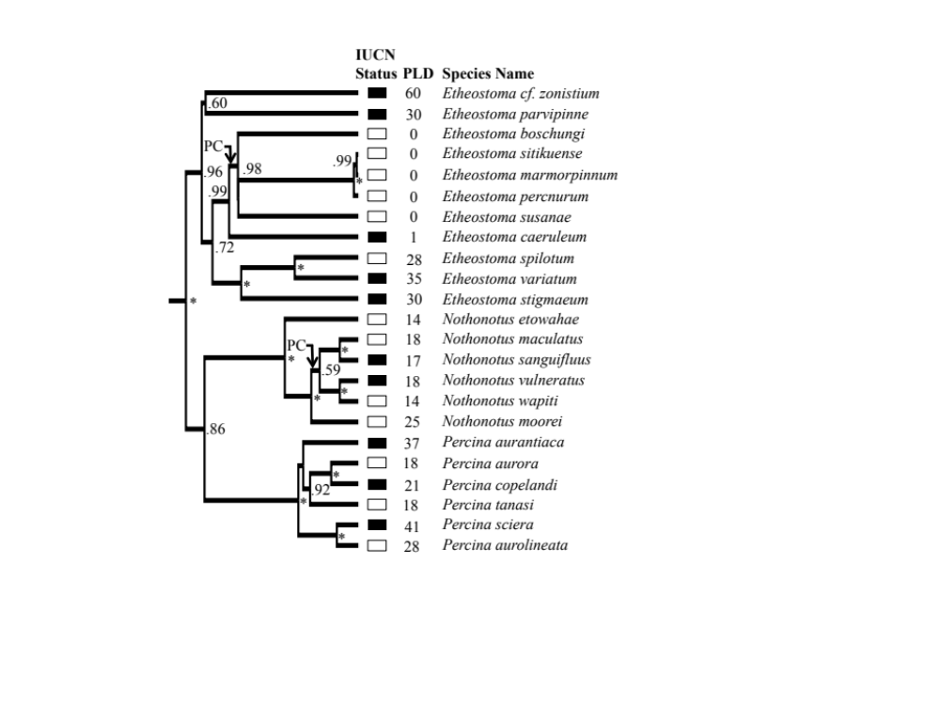
Figure 4. Phylogentic association between IUCN red list status and pelagic larval duration (PLD). The phylogeny is reconstructed using the genes Cytb, S7 intron, and Rag1. Asterisks to the right of nodes represent 1.00 posterior probability support and the support for other nodes over 0.50 is also given. Rectangles next to the tips indicate IUCN status (black = not listed, white = listed). The mean PLD of each species is shown next to its IUCN status. Nodes subtending clades that exhibit parental care (PC) are indicated [45].
The association of lower PLD with darter extinction risk (figure 1) is consistent with inferences from marine paleontological studies [8, 29, 44], and our analyses provides one of the first tests of this relationship in extant taxa. Furthermore, in many fossil taxa, it is only feasible to test whether the qualitative presence or absence of a larval stage influences extinction [51]. One advantage of working with living groups like darters is that quantitative divergence in PLD can be explored, and continuous estimates of PLD could allow more fine scaled parsing of the importance of PLD to processes like extinction. Because both paleontological and neontological inferences provide incomplete views of evolution [52], increased examination of the importance of traits like PLD in extant taxa will provide a more robust understanding of mechanisms influencing macroevolutionary patterns of diversification.
The relationship between PLD and imperilment not only emphasizes the importance of the larval stage for species persistence, but it also provides us with an opportunity to predict aquatic species that are most at risk of extinction. In both marine and freshwater environments that are facing intensifying anthropogenic modifications, we predict that species with a reduced PLD will generally suffer greater extinction risk. Learning more about PLD and other crucial life history traits in our increasingly imperiled aquatic environments could provide powerful inferences for both management and conservation

CONCLUSION
The larval stage is a critical and sensitive stage in the life history of fish[1]. Characteristics of larvae can often be a major factor in an individual reaching reproductive age. The diversification of darters is thought to be linked with variation in their life history and reproductive characteristics[3]. These results suggest that the variation of the pelagic stage of darters may represent tradeoffs between the survival of larvae and dispersal ability and could contribute to the diversity of these reproductive characteristics. Losing the pelagic stage appears to be linked with parental care and may also be associated with species that tend to live in lower order streams. These species may be sacrificing potential dispersal in the water column to ensure better larval survival in a more variable environment. These potential links between variation in PLD and these tradeoffs provide promising comparisons that could examine darter diversification and variation in reproductive biology.
Although reduction of the pelagic stage could correspond to higher larval survival, our results also indicate that it does not lead to longer species persistence. Multiple darter lineages have experienced reduction of their pelagic larval stage even though it appears to put species at more risk. The link between the lack of a pelagic larval stage and greater extinction risk has been shown through the marine fossil record [8]. However, this relationship also appears to extend to freshwater systems. Furthermore, the use of an extant lineage allowed for the use of a continuous data set. These two distinctions provide new avenues for work in aquatic larval ecology.
These comparisons not only provide important knowledge on the biology of the darter group, they offer opportunities to aid in the management of these species. The information needed to conduct this study came from data gathered from an organization that specializes in raising imperiled fish, and much of the data would not have been obtained if these species were not in decline. They and other conservation institutions could benefit from the ability to better predict species at high risk for major decline. These results also indicate that some species require a more specialized reintroduction plan. The inherent biology of certain species may keep them from being receptive to propagation protocols that do not include several points of reintroduction because they lack the ability for dispersal. Therefore, understanding the basic biology of an organism is vital for targeting at risk species and developing effective protocols to ensure persistence.

References

1 Sale, P. F. 2002 Coral Reef Fishes: Dynamics and Diversity in a Complex Ecosystem. San Diego, CA: Elservier Science.
2 Arndt, A. & Smith, M. 1998 Genetic diversity and population structure in two species of sea cucumber: differing patterns according to mode of development. Mol. Ecol. 7, 1053-1064.
3 Near, T. J. et al. 2011 Phylogeny and temporal diversification of darters. Syst. Biol. 60, 565-595.
4 Sponaugle, S. & Cowen, R. K. 1994 Larval durations and recruitment patterns for two Carribean fishes. Mar. Freshwater Res. 47, 433-447.
5 Shanks, A. L. 2008 Pelagic larval duration and dispersal distance revisited. Biol. Bull. 216, 373-385.
6 Hunt, A. 1993 Effect of contrasting patterns of larval dispersal on the genetic connectedness of local population of two intertidal starfish. Mar. Ecol. Prog. Ser. 92, 179-186.
7 Riginos, C. & Victor, B. C. 2001 Larval spatial distributions and other early life-history characteristics predict genetic differentiation in eastern Pacific blennioid fishes. Proc. R. Soc. Lond. 268, 1931-1936.
8 Jablonski, D. 1986 Larval ecology and macroevolution in marine invertebrates. Bull. Mar. Sci. 39, 565-587.
9 Shulman, M. J. 1998 What can population genetics tell us about dispersal and biogeographic history of coral-reef fishses? Aust J Ecol 23, 216-225.
10 Wellington, G. M. & Robertson, D. R. 2001 Variation in larval life-history traits among reef fishes across the Isthmus of Panama. Mar. Biol. 138, 11-22.
11 Stearns, S. C. 1992 The Evolution of Life Histories. Oxford, UK: Oxford Univeristy Press.
12 Charnov, E. L. 1993 Life History Invariants. Oxford, UK: Oxford University Press.
13 Bekker, R. M. et al. 1998 Seed size, shape, and vertical distribution in the soil: indicators of seed longevity. Funct. Ecol. 12, 834-842.
14 Dalling, J. W. & Hubbel, S. P. 2002 Seed size, growth rate and gap microsite conditions as determinants of recruitment. J. Ecol. 90, 557-568.
15 Mole, A. T. & Westoby, M. 2004 Seedling survival and seed size: a synthesis of the literature. J. Ecol. 92, 372-383.
16 Winemiller, K.O. & Rose, K. A. 1992 Patterns of life-hisotry diversification in North American fishes: implications for popluation regulation. Can. J. Fish. Aquat. Sci. 49, 2196-2218.
17 May, B. 1969 Observations on the biology of the Variegated Darter, Etheostoma variatum (Kirkland). Ohio J. Sci. 69, 85-92.
18 Starnes, W. C. 1977 The ecology and life history of the endangered snail darter, Percina (Imostoma) tanasi (Etnier). University of Tennessee, Knoxville, TN.
19 Muller, B. 2001 Raising dusky darters. Am. Currents 27, 23-24.
20 Rakes, P. L., Shute, J. R., & Shute, P. W. 1996 Reproductive behavior, captive breeding, and restoration ecology of endangered fishes. Environ. Biol. of Fish. 55, 31-42.
21 Page, L. M. 1983 Handbook of Darters. 1st ed. Neptune City, NJ: TFN Publishers, Inc.
22 Page, L. M. & Burr, B. M. 2011 Peterson Field Guide to Freshwater Fishes. 2nd ed. Boston, MA: Houghton Mifflin Harcourt.
23 Simon, T. P. & Wallus, R. 2005 Reproductive Biology and Early Life History of Fishes in the Ohio River Drainage (Percidae—Perch, Pikeperch, and Darters) Bacon Raton, FL: CRC Press.
24 Ronquist, F. et al. 2012 MrBayes 3.2: Efficient Bayesian phylogenetic inference and model choice across a large model space. Syst. Biol. 61, 539-542. (doi:10.1093/sysbio/sys029).
25 Drummond, A. J. & Rambaut, A. 2007 BEAST: Bayesian evolutionary analysis by sampling trees. BMC Evol. Biol. 7, 214.
26 Jones-Powers, G. L. & Mayden, R. L. 2003 Threatened fishes of the world: Etheostoma percnurum. Environ. Biol. Fish. 67, 358.
27 Rambaut, A. & Charleston, M. 2002 TreeEdit: phylogetic tree editor v. 1.0 alpha 10.
28 Midford, P. E., Garland, T., & Maddison, W. P. 2011 PDAP:PDTREE: A translation of the PDTREE application of Garland et al.'s Phenotypic Diveristy Analysis Programs.
29 Strathmann, R. R. 1985 Feeding and non-feeding larval development and life-history evolution in marine invertebrates. Annu. Rev. Ecol. Sys. 16, 339-361.
30 Paradis, E., Ballie, S. R., Sutherland, W. J. & Gregory, R. D. 1998 Patterns of natal and breeding dispersal in birds. J. Anim. Ecol. 67, 518-536.
31 Sutherland, G. D., Harestad, A. S, Price, K. & Lertzmann, K. P. 2000 Scaling of natal dispersal distances in terrestrial birds and mammals. Conserv. Ecol. 4, 16.
32 Bradbury, I. R. et al. 2008 Global Patterns in marine dispersal estimates: the influence of geography taxonomic category and life history. Proc. R. Soc. Biol. Sci. 275, 1803-1809.
33 Dingle, H. 1996 Migration: the Biology of Life on the Move. Oxford, UK: Oxford University Press.
34 Houle, D. 1991 Genetic covariance of fitness correlates: what genetic correlations are made of and why it matters. Evolution 45, 630-648.
35 Stevens, V. M. et al. 2012 How is dispersal integrated in life histories: a quatitative analysis using butterflies. Ecol. Lett. 15, 74-86.
36 Hamilton, W. D. & May, R. M. 1997 Dispersal in stable habitats. Nature 269, 578-581.
37 Clobert, J. R. & Rousset, F. 2004 Causes, Mechanisms, and Evolution of Dispersal. In Ecology, Genetics, and Evolution of Metapopulations (ed. Hanksi, I. & Gaggiotti, O. E.) pp. 307-335. Amsterdam, Elseview Academis Press pp. 307-335.
38 Bowler, D. E. & Benton, T. G. 2005 Causes and consequences of animal dispersal strategies: relating individual behavior to spatial dynamics. Biol. Rev. 80, 205-225.
39 Ronce, O. 2007 How does it feel to be like a rolling stone? Ten questions about dispersal evolution. Annu. Rev. Ecol. Sys. 38, 231-253.
40 Turner, T.F. & Trexler, J. C. 1998 Ecological and historical association of gene flow in darters. Evolution 52, 1781-1801.
41 Shapiro, A. M. 1975 The temporal components of butterfly species diversity. In Ecology and Evolution of Communities (ed. Cody, M. L. & Diamond, J. M.) Cambridge, MA: Harvard University Press pp. 181-195.
42 Reynold, J. D., Webb, T. J. & Hawkins, L. A. 2005 LIfe history and ecological correlates of extinction risk in European freshwater fish. Can J Fish Aquat Sci 62, 854-862.
43 Chatterton, B. D. E. & Speyer, S. E. 1989 Larval ecology, life history strategies, and patterns of extinction and survivorship among Ordovician trilobites. Paleobiology 15, 118-132.
44 Jeffery, C. H. & Emlet, R. B. 2003 Macroevolutionary consequences of developmental mode in temnopleurid echinoids from the tertiary of southern Australia. Evolution 57, 1031-1048.
45 Kelly, N. B., Near, T. J., & Alonzo, S. H. 2012 Diversification of egg-deposition behaviours and the evolution of male parental care in darters (Teleostei: Percidae: Etheostomatinae). J. Evol. Biol. 25, 836-846.
46 IUCN. 2012 The IUCN Red List of Threatened Species. Version 2012.2 ed.
47 Orme, D. et al. 2012 caper: Comparative Analyses of Phylogenetics and Evolution in R. Meth. Ecol. Evol. 3, 145-151.
48 R Development Core Team. 2013 A Language and Environment for Statistical Computing Vienna, Austria: R Foundation for Statistical Computing.
49 Clutton Brock T.H. 1991 The Evolution of Parental Care. Princeton, NJ: Princeton University Press.
50 Sorte, C. J. B. 2013 Predicting persistence in a changing climate: flow direction and limitations to redistribution Oikos 122, 161-170.
51 Jablonski, D. & Hunt, G. 2006 Larval ecology, geographic range, and species survivorship in Cretaceous mollusks: Organismic versus species-level explanations. Am. Nat. 168, 556-564.
52 Jablonski, D. 2008 Biotic interactions and macroevolution: extensions and mismatches across scales and levels. Evolution 62, 715-739.

VITA
Morgan Jessica Douglas was born in Knoxville, TN. After graduating from Karns High School in 2007, she entered Maryville College in Maryville, TN. She received the degree of Bachelor of Science from that institution in May 2011. She entered into the Graduate School of the University of Tennessee, Knoxville in the Department of Ecology & Evolutionary Biology in August 2011.

