An Automated System for Determination of Hydration Kinetics of Dry Legumes: Improvement, verification, and modeling of commercial hydration of navy beans (Phaseolus vulgaris)

A Thesis Presented for the
Master of Science
Degree
The University of Tennessee, Knoxville

Erin Nicole Strickland
May 2025

ACKNOWLEDGEMENTS

I would like to acknowledge the following individuals and organizations whose support, encouragement, and collaboration have been essential to this research.
Special thanks to Dr. Mark Morgan, my dedicated advisor, for his guidance, insightful feedback, and continuous encouragement throughout the last few years. Dr. Tao Wu for his guidance and support. I am grateful for the opportunity entrusted to me by Paul Angelino and his nonstop words of encouragement.
I would like to express my appreciation to the entire Bush Brothers and Company for their financial support and for working with me to complete this research.

ABSTRACT
The species of Phaseolus vulgaris, which contains many commonly consumed cultivars of beans, can be found in grocery stores across the United States as a canned product. Beans are often hydrated to reach equilibrium moisture to ensure the safety and quality of canned bean products. The hydration kinetics of specific species or cultivars of beans must be analyzed to optimize soak time. Existing methods for assessing hydration kinetics are both time-consuming and labor-intensive. An automated system, called the Bean Volume Automated Tester (BVAT), was developed to monitor changes in the weight and volume of legumes as they absorb water. This system was tested against the AACC method 44-17.01 for moisture determination to calibrate the BVAT to provide percent moisture content readings consistent with the standard method (Cereals and Grains Association, 1999c) The two moisture determination methods had a linear relationship (y =1.09x-6.04). Using the Peleg model, the BVAT as able to distinguish hydration patterns at different temperatures (P < 0.0001). The BVAT also showed significant differences in hydration patterns across three varieties of black bean using Peleg model parameters (P=0.0013 [k₁], P=0.0347 [k₂]).
Hydration patterns from a commercial hydration process (soak tank) were tested for uniformity. Three depths within a soak tank were sampled and their moisture contents over time were fitted to the Weibull model. The beans at the top (3 ft depth) of the tank hydrated significantly more slowly than the middle (6 ft) and bottom (9 ft) levels (P = 0.0133). The three depths showed no significant difference between the Weibull model parameter related to the time it takes to reach 63% of equilibrium hydration. The depths did not show a significant difference in initial hydration rate (alpha = 0.05) after adjusting the soaking time for the time it takes to fill the soak tank. The BVAT accurately predicted hydration at the top of the soak tank (RMSE = 0.370, R² = 0.992). When soak time was adjusted, the BVAT also accurately predicted hydration at the middle of the soak tank (RMSE = 1.0, R² = 0.980​). This automated system will allow bean manufacturers to better understand the hydration kinetics of beans before canning. Understanding hydration ensures a uniform product and optimizes processing and quality while maintaining microbial safety and cutting costs.

TABLE OF CONTENTS
Chapter 1 LITERATURE REVIEW 1
Importance of Hydration 2
Current Literature Summarizing the Factors Influencing Hydration 6
Influence of the Soaking Medium 6
Influence of Microstructures and Chemical Composition 7
Moisture Determination Methods 11
Direct Methods 11
Indirect Methods 14
Mathematical Modeling of Hydration 17
Sigmoid Model 18
Exponential Model 20
Fick’s Diffusion Model 20
Peleg’s Model 21
Weibull Model 23
The Bean Volume Automatic Tester 24
Chapter 2 IMPROVEMENT AND VERIFICATION OF AN AUTOMATED METHOD FOR DETERMINING THE HYDRATION KINETICS OF DRY LEGUMES 27
Abstract 28
Introduction 28
Methods 31
BVAT Components 31
BVAT Procedures 35
Standard procedure for BVAT 43
Standard Method for Determining Moisture Content 44
Effect of Soak Water Temperature 45
Discrimination of Bean Variety 46
Statistical Analysis 46
Results and Discussion 49
Model Fitting 49
Evaluation of the BVAT 51
Effect of Temperature 52
Discrimination of Bean Variety 54
Discussion 54
Conclusions 57
Chapter 3 MODELING COMMERCIAL HYDRATION 58
Abstract 58
Introduction 59
Methods 62
Sampling from Commercial-Scale Soak Tanks 62
Standard Oven Method for Moisture Determination 65
BVAT Testing 65
Adjusting for Fill Time 66
Data Analysis 66
Results and Discussion 69
Model 69
Depth 69
Method of hydration 70
Adjustment for Fill Time 71
Discussion 74
Conclusions 77
LIST OF REFERENCES 78
APPENDIX 87
VITA 117

LIST OF TABLES
Table ‎1-1: Mathematical models, their equations, and reported R² 18
Table ‎1-2: Weibull parameters from hydration profiles of international navy bean cultivars. Cultivars with the same letter subscript are similar (modified from Mannam, 2013). 26
Table ‎2-1: Model parameters (± standard deviation [STD]), root mean square error, and the coefficient of variation for Weibull and Peleg for each soak water temperature using moistures (%w.b.) from the BVAT. 50
Table ‎2-2: Comparison of Peleg parameters (±STD) for the three soak chambers of the BVAT using the same lot of navy beans at 49ºC. Values within the same column with the same letter have no significant difference. 51
Table ‎2-3: Comparison of Peleg parameters (±STD) for three BVAT runs using the same lot of navy beans at 49ºC (120ºF). Values within the same column with the same letter have no significant difference. 52
Table ‎2-4: Estimates of the linear relationship between the standard method and the BVAT method using the Passing-Bablok method when testing the same lot of navy beans at the same DI water temperature (49ºC/120ºF) 53
Table ‎2-5: Comparison between k₁ and k₂ (±STD for 3 soak chambers) at different soak water temperatures when testing the same lot of navy beans 55
Table ‎2-6: Comparison between k₁ and k₂ for different black bean samples when run using 10ºC DI water 55
Table ‎3-1: Comparison between Weibull and Peleg model parameters fit to triplicate moisture content (%w.b.) data from each depth of the commercial soak tanks (± STD) 69
Table ‎3-2: Comparison of Weibull parameters calculated from moisture content data from each depth of the commercial soak tank 70
Table ‎3-3: The estimates and 95% confidence intervals for the linear regression model between the moisture contents from the commercial soak tanks and the BVAT for each depth 71
Table ‎3-4: Comparison of Weibull parameters calculated from moisture content data from soak tank sampling between depths of the soak tank when adjusting for tank fill time 74
Table ‎3-5: The estimates and 95% confidence intervals for the linear regression model between the moisture contents from the commercial soak tanks and the BVAT for each depth when adjusted for fill time 75

LIST OF FIGURES

Figure 1-1: The hydration curves of four types of legumes at each of three different temperatures (Kaptso et al., 2008). WB= white Bambara, BB= black Bambara, GC=Garoua cowpea, WC=west cowpea 5
Figure 1-2: Diagram showing various microstructures of Adzuki beans (Miano & Augusto, 2015). 8
Figure 1-3: The hydration curves of Adzuki beans with different initial moisture contents (Miano & Augusto, 2015). 10
Figure 1-4: Classification of grain moisture measurement methods (Flor et al., 2022). 13
Figure 1-5: Hydration curve showing the associated phases of water permeability by the seed coat. (a) Seed coat is impermeable to water and water enters the seed through the hilum (lag phase), (b) water begins to enter through the seed coat (inflection point), (c) water begins to diffuse within the bean, specifically to the cotyledon (intake of water slows) (Miano & Augusto, 2015). 19
Figure 1-6: The fit of the Peleg model, as represented by the lines, to the experimental values for the hydration of red kidney beans at different temperatures, as represented by the points: 30 ●, 40 ○, 50▼, 60 Δ, 70■, 80□ ◦C (Devkota et al., 2022). The X axis measures hydration time in minutes, and the Y axis measures the percent moisture content on a dry basis. 22
Figure 1-7: Diagram of the BVAT (Mannam et al., 2013) 26
Figure 2-1: A representation of the BVAT including all three soak chambers (modified from Mannam et al. (2013)). 32
Figure 2-2: A representation of the BVAT including all pumps and valves (modified from Mannam (2013)). 33
Figure 2-3: Overall sequence of the BVAT 36
Figure 2-4: Sequence of weight measurement of the BVAT 38
Figure 2-5: Sequence of volume measurement of the BVAT 42
Figure 2-6: The relationship between the BVAT and the standard method’s moisture content results when testing the same lot of navy beans at 49ºC. Experimental data (data points) and y=x line (solid line) are shown. 53
Figure 3-1: Soak tank sampling diagram 64
Figure 3-2: The linear regression models for the moisture contents from the BVAT compared to the moisture contents from the commercial soak tanks for each depth 73
Figure 3-3: Linear regression graphs for the moisture contents from the commercial soak tank hydration method compared against moisture contents from the BVAT hydration method for middle (A) and bottom depths (B), adjusted for fill time (6 and 9 minutes, respectively) 75

LITERATURE REVIEW

A common way to process Phaseolus vulgaris varieties is by canning. The canning of these bean varieties usually requires a few standard steps. These include soaking, blanching, filling the cans, adding brine or sauce, sealing the cans, and then heating (Matella et al., 2012). Prior to processing, dry beans usually have a moisture content between 12 and 14% dry basis (d.b.) (Matella et al., 2012). Soaking is the first step of the canning process and is conducted primarily to raise the moisture content of the beans. The moisture content must be around 55% (d.b.; 35% w.b.) before to going into the can (Matella et al., 2012). This ensures the quality and safety of the finished product. Hydration is often accomplished by soaking beans in water. There are many factors that affect how quickly beans will rehydrate as well as what percent moisture they will rehydrate to.
The temperature and composition of the water the beans soak in can affect hydration. The intrinsic properties of the beans also affect hydration. These influences affect the quality and safety of a canned bean product; therefore, it is important to evaluate a bean’s hydration characteristics prior to commercial cooking to better predict soak time and conditions (Matella et al., 2012).

Importance of Hydration
The moisture content of the beans directly affects the heating process and therefore the safety of the final product. Beans which have a low moisture content will have a smaller volume and therefore more beans will be able to fit in one can (Matella et al., 2012). Those with a higher moisture content will have a larger volume and therefore fewer beans will be able to fit in a can. This changes how the beans are packed into the cans and the amount of liquid in the can, which in turn affects how the cans will heat during the thermal process.
This change in heating will change the time required to properly heat the product to achieve commercial sterility (Matella et al., 2012). Along with this, if beans are not fully hydrated before going into a can, they will absorb the water from the brine or sauce in the can during the thermal process (Howard et al., 2018). This will cause the level of liquid and the viscosity of the liquid in the can to fluctuate and change the method of heat transfer in the can. If the sauce or brine is more viscous and there are more beans tightly packed into a can, the can will heat primarily through conduction. However, if the sauce is not as viscous and there are fewer, looser, beans in a can, the can may heat from both conduction and convection (Matella et al., 2012).
The moisture content of beans is also related to the quality and favorable sensory qualities of the final product. Beans which are not fully hydrated can absorb sauce or brine in the can. This reduces the amount of sauce or brine in the can, which can be undesirable (Howard et al., 2018). The softness of beans has also been found to be directly correlated to the length of time they soaked (Abu-Ghannam, 1998). In a bean’s first stage of hydration, where water is quickly absorbed into the seed, the texture becomes softer. This is due to the mass transfer that occurs between the beans and the soaking medium (Abu-Ghannam, 1998). This direct correlation between water uptake and bean softness confirms that texture and preferable sensory properties increase as the beans soak. Consumers want a product that is high in quality and has the sensory characteristics they enjoy. Therefore, hydration is important to make a product that consumers will enjoy.
The hydration of beans follows a distinct curve. Beans take up water very quickly at first, but the rate of water uptake eventually decreases making a curve like the one modeled in Figure 1-1. The period of slower water uptake is important to reach an appropriate moisture content for canning. The rate of hydration varies between bean varieties, types, and crop years. This is evident in Figure 1-1, which shows the moisture content (d.b.) over time of four different varieties of beans soaked in water at three temperatures. These graphs show different rates of hydration as well as different final moisture contents, across both varieties and temperatures (Kaptso et al., 2008). Because of this variation, it can be difficult to estimate how long a kind of bean needs to soak for to reach an acceptable moisture content. Therefore, it is important to first understand the hydration kinetics of a specific type of bean before processing.
Another benefit of soaking beans is the loss of antinutrients. Beans naturally contain many compounds that are considered antinutritional. These compounds are especially prominent in red kidney beans but are found in many cultivars. Antinutritional compounds in red kidney beans include lectins, trypsin inhibitors, tannins, and phytate (Ayyagari et al., 1989; Haileslassie et al., 2019). These factors are not digested by the body and can affect how the body utilizes nutrients, potentially leading to a deficiency of these nutrients (Ayyagari et al., 1989; Godrich et al., 2023). Lectins from plant sources, phytohemagglutinins, cause the agglutination of red blood cells and can impair the absorption of nutrients from food (Howard et al., 2018).
Red kidney beans, which have a high lectin content, have been proven to have antinutritional properties (Ayyagari et al., 1989). It is important to ensure the removal or inactivation of these compounds before consumption. These components have been

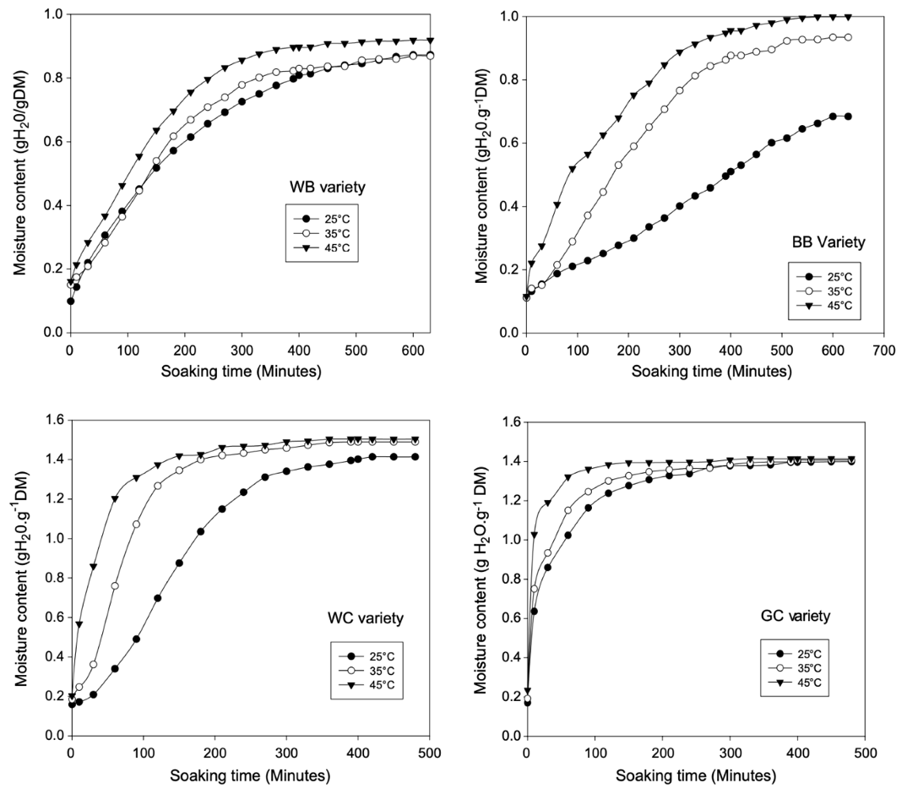
Figure 1-1: The hydration curves of four types of legumes at each of three different temperatures (Kaptso et al., 2008). WB= white Bambara, BB= black Bambara, GC=Garoua cowpea, WC=west cowpea

shown to decrease with exposure to both water and heat. Antinutritional compounds will decrease in beans with soaking or when cooking them in water. (Ayyagari et al., 1989; Godrich et al., 2023; Haileslassie et al., 2019). Soaking red kidney beans for 12 hours at room temperature has been shown to significantly decrease phytate across four varieties.
Some minerals in beans, on the other hand, are not significantly affected by soaking (Haileslassie et al., 2019). Zinc and iron are less affected by soaking and cooking while calcium can be affected by soaking for 18 hours at room temperature (Haileslassie et al., 2019). While soaking reduced levels of riboflavin, vitamin E was not affected by soaking times (Howard et al., 2018).

Current Literature Summarizing the Factors Influencing Hydration
Many factors influence how a bean will rehydrate. These include the medium the bean soaks in as well as the cultivar, microstructures, and chemical compositions of the bean. The temperature of the water and any addition of additives to the soaking water can affect how beans rehydrate. However, even beans soaked in similar conditions can still rehydrate differently. Within the same type of bean, cultivars can vary enough to affect hydration. This can be caused by differences in microstructure or chemical composition of the beans.

Influence of the Soaking Medium
The conditions under which the dry beans soak will affect their hydration kinetics. Raising the temperature of the soaking medium has been shown to increase the water absorption rate of split chickpeas and red kidney beans for temperatures of 25ºC to 80ºC (Devkota et al., 2022; Johnny et al., 2015).
Raising the soaking water temperature from 25ºC to 65ºC in 10ºC intervals will significantly increase the solids lost during soaking at each temperature interval (Johnny et al., 2015). These solids include nitrogenous compounds, including non-protein nitrogen (Lo et al., 1968). Oligosaccharides are also lost. These carbohydrates cannot be digested and are often linked to intestinal discomfort and flatulence (Matella et al., 2012).
Additives in the soaking medium have been shown to influence hydration. The addition of salts has been widely researched. Specifically, the addition of 2.5% NaHCO₃ and 1% KCl to the soaking medium has been shown to speed up hydration and reduce final product hardness of cowpeas (Ávila et al., 2015). When compared to other ions, Na⁺ was shown to have the greatest effect on reducing cooking time of fresh common beans (de León et al., 1992).
Water hardness can also affect bean hydration. Hard water contains higher levels of calcium and magnesium. High levels of calcium in soak water has been linked to slower hydration rates and slower softening rates (Matella et al., 2012).

Influence of Microstructures and Chemical Composition
Specific microstructures within beans are linked to hydration characteristics. The seed coat is regarded as the structure which limits water absorption, while the hilum has been accredited to take in the most water during hydration (Devkota et al., 2022; Miano et al., 2015). The seed coat is the outer layer of the bean, and the hilum is the site where the seed was attached to the ovaries of the plant (Esau, 1960). These structures can be seen in Figure 1-2. The seed coat is made up of three major cell layers: the macrosclereid, osteosclereid and parenchyma cell layers. The macrosclereid layer, which is the outer layer,
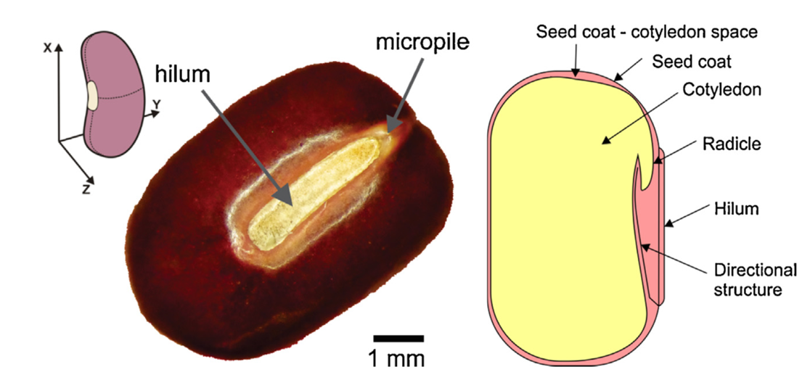
Figure 1-2: Diagram showing various microstructures of Adzuki beans (Miano & Augusto, 2015).

is mostly responsible for preventing hydration. The middle, osteosclereid layer has intercellular space. The inner, parenchyma layer is made up of dead, compact cells (Miano et al., 2015). The thickness of the layers of parenchyma and osteosclereid cells, have been linked to hydration rate (Devkota et al., 2022). Comparing small red beans and red kidney beans under a scanning electron microscope, while the two have similar seed coat thickness, small red beans had a thicker layer of parenchyma cells and red kidney beans have a larger osteosclereid layer (Devkota et al., 2022). Red kidney beans absorb water quickly in the beginning of hydration, while small red beans have a lag phase in the beginning of hydration, before taking in water (Devkota et al., 2022).
This can be explained by water moving easily through the larger osteosclereid layer due to the intracellular space, while water is prevented from moving through the larger parenchyma layer due to the densely packed cells (Devkota et al., 2022).
Small red beans contain hydrophobic compounds such as lipids which may contribute to the prominent lag phase in their hydration. Compared to red kidney beans, small red beans have a higher lipid content in their seed coats as determined by Soxhlet extraction (Devkota et al., 2022). Since the main water uptake mechanism of the seed coat is diffusion, the lag in hydration rate may be attributed to these lipids (Devkota et al., 2022; Miano et al., 2015).
The impermeability of the seed coat is dependent on the initial moisture content. When the moisture content of a bean is above 20% (d.b.), the seed coat becomes permeable and allows water into the bean (Miano & Augusto, 2015). This explains the lag phase in hydration before rapid water intake through the seed coat. Figure 1-3 displays hydration curves for adzuki beans at different starting moisture contents. If the moisture content on a dry basis is under 20%, then water will not enter as quickly through the seed coat and will rehydrate initially through the hilum (Miano & Augusto, 2015).
While the seed coat limits hydration, the hilum region is responsible for most of hydration. A smaller hilar groove, which is microstructure within the hilum, has been associated with longer hydration times, specifically a longer time to reach an equilibrium moisture content (Gargiulo et al., 2020). Another region of the hilum, the micropyle, was associated with initial moisture uptake, and was attributed as being the first structure which allows water into the bean (Gargiulo et al., 2020).
Along with microstructures of the beans, the chemical composition can also affect hydration. The total fat content and potassium content have a positive correlation with lag time, while the protein to lipid ratio has a negative correlation with lag time
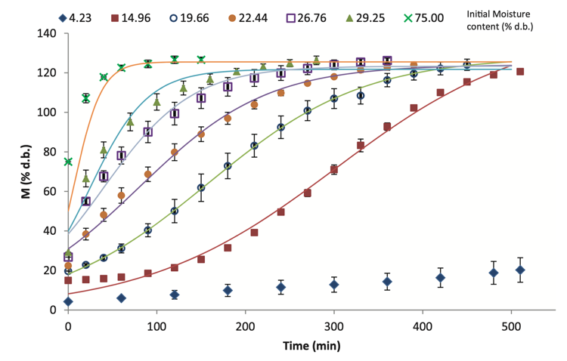
Figure 1-3: The hydration curves of Adzuki beans with different initial moisture contents (Miano & Augusto, 2015).

(Miano et al., 2018). Of the chemical components of beans, lipid content has the largest influence on hydration (Miano et al., 2018).
A few studies have been conducted which analyze how water moves through the bean once it enters. Water moves into the intracellular space via the cotyledon during the first stage of water absorption, which is when most water gets absorbed. Then, when water
stops entering the bean so rapidly, water begins to enter the extracellular space (Zhang & McCarthy, 2013). This can help understand changes in volume and weight of the beans while they rehydrate.
There has been shown to be a significant difference in structure and chemical characteristics between beans of different cultivars (Miano et al., 2018). Due to these different characteristics, beans of different cultivars will rehydrate by different mechanisms and hence differ by rate of hydration (Gargiulo et al., 2020; Miano & Augusto, 2015; Zhang & McCarthy, 2013). Therefore, it is important to evaluate and monitor new cultivars of beans which are being commercially processed to ensure they completely rehydrate as they may be different than the previous cultivar.

Moisture Determination Methods
Currently, there are numerous methods of moisture determination for legumes. There are both direct and indirect methods. Direct methods are considered the most accurate. Figure 1-4 shows divisions of the current direct methods, including gravimetric/oven methods, distillation methods, and coulometry methods (Flor et al., 2022). However, some methods are destructive, and therefore only one moisture reading can be taken from each sample. These methods are also time-consuming, some taking multiple days (Cereals & Grains Association, 1999a).

Direct Methods
The Cereals & Grains Association has multiple published methods for moisture determination, three of which apply to legumes. One method which is verified and published by the Cereals & Grains Association as an AACC Approved Method of Analysis is the Air-Oven Method, AACC 44-15.02 (Cereals & Grains Association, 1999a). This method outlines the proper steps to test the moisture determination of corn and soybeans. This method involves first weighing out 15 grams of unground sample, then drying in a 103ºC oven for 72 hours (about 3 days).
After this time in the oven, the sample is removed and placed in a desiccator and allowed to cool before weighing it. The moisture content can then be calculated on a wet basis using Equation 1-1, or on a dry basis using Equation 1-2.
Equation 1-1
$${\%M}_{wb} = \frac{W-D}{W} x 100$$
Equation 1-2
$${\%M}_{db}= \frac{W-D}{D} x 100$$
Where W= weight of wet sample in grams, D= weight of dry sample in grams (Cereals and Grains Association, 1999a).
Another method published by AACC is the Air-Oven Method for pulses, 44-15.02 (Cereals & Grains Association, 1999a). This method is applicable for lentils, peas, and beans, not including soybeans. The procedure for this method first utilizes a preconditioning stage. During this stage, 25 grams of an unground sample is weighed out. This sample is then either dried in a 103ºC oven until the sample reaches 9-11% moisture content, then cooled to room temperature without a desiccator, or the sample is left in room temperature conditions until the sample reaches 9-11% moisture content. After this preconditioning stage, the sample is weighed again. Then, the sample is ground using an appropriate laboratory mill, and 2 to 3 grams of the sample is weighed out. The sample is then placed in a 130ºC oven for 120 min. After this time in the oven, the sample is removed and placed in a desiccator until it is cooled to room temperature. Finally, the sample is weighed, and the moisture content on a wet basis (%MC w.b.) is calculated using Equation 1-3.
Equation 1-3
$$M = \left[\frac{\left(C-D\right) x B}{C}+\left(A-B\right)\right] x \frac{100}{A}$$
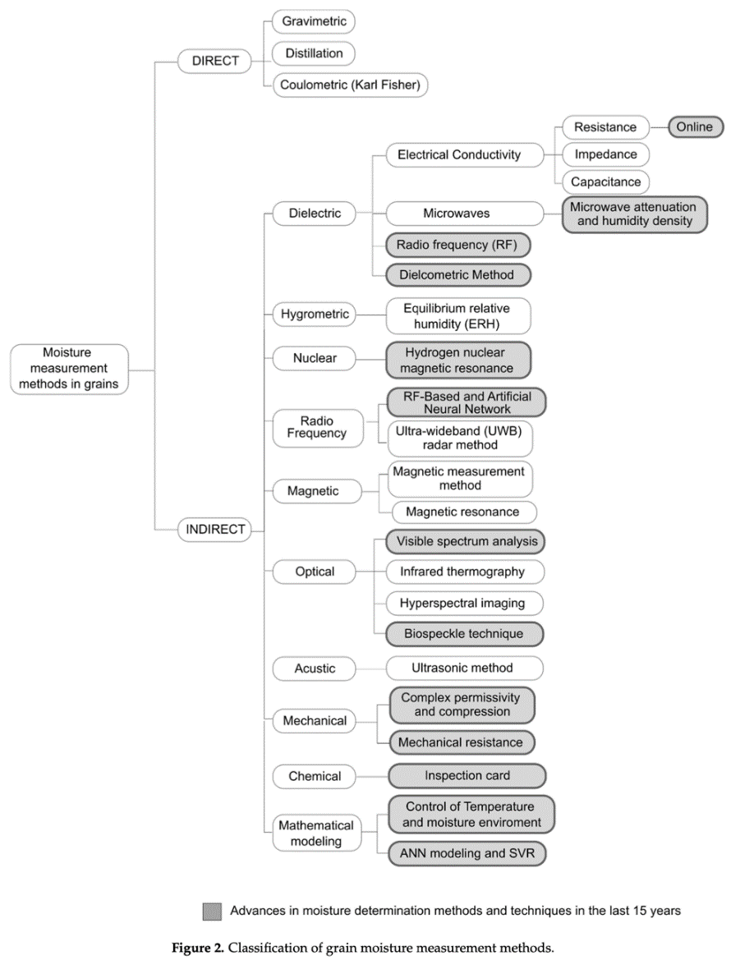
Figure 1-4: Classification of grain moisture measurement methods (Flor et al., 2022).

Where: M = moisture on a percent wet basis; A = mass (g) of sample before preconditioning; B = mass (g) of sample after preconditioning; C = mass (g) of test sample before oven-drying; D = mass (g) of test sample after oven-drying.
Karl-Fischer Titration is also a direct method of moisture determination and is regarded as accurate and sensitive. However, this method is used to determine very low moisture contents, usually up to around 10% moisture, making it not very applicable to hydration (Tavčar et al., 2012). The Brown-Duvel distillation method involves heating a sample in oil for one hour (Bala, 2017). This method also uses the principle of weight loss to determine moisture content. The oven method can be used across a wider range of moisture contents and requires fewer materials compared to the Brown-Duvel method and the Karl-Fischer Titration method.
Direct methods are considered accurate, but most methods for hydrating beans are time-consuming, labor-intensive, and destructive to the sample. These methods are simple for one or two samples, but when testing many, they require a lot of time and become impractical.

Indirect Methods
Indirect methods have been developed which are faster, easier to conduct, and non-destructive. Flor et al. (2022) summarizes all these methods into categories of dielectric, hygrometric, nuclear, radio frequency, magnetic, optical, mechanical, and mathematical modeling. These methods are often utilized for testing in the field due to their simplicity and often their portability. Compared to direct methods, they are often considered less accurate, and many indirect methods require calibration and extensive testing for specific applications.
An indirect method of moisture determination is the use of a dielectric moisture meter. This method is popular and has become standardized in agricultural settings. This method uses the principles of the difference in the dielectric properties, or permittivity, of free water compared to food solids (Jones et al., 2022). Free water has a high permittivity compared to solid food particles, which have a low permittivity. The permittivity of a sample can be measured with a dielectric meter to determine the amount of free water in a food product (Jones et al., 2022). The AACC published a standard method (44-11.01) for using a dielectric meter (Cereals and Grains Association, 1999b). This method uses a Motomco moisture meter, model 919. This meter was approved and used by the USDA to test grain moisture contents in 1962 (Jones et al., 2022). Since then, the USDA has switched to the Dickey-John GAC 2500-UGMA (Dickey-John Corp., Auburn, IL) and the Perten AM 5200-A (USDA, 2024). These meters serve as an easy, fast, and non-destructive method of moisture determination for beans, legumes, and cereal grains.
Another indirect method of moisture determination is the use of near-infrared spectroscopy (NIRS). This method is quick and easy making it favorable to other more complex methods. Some sensors are also portable, so they can be used in the field. The use of NIRS to determine moisture content has been verified in many food products. These include soybeans (Zhu et al., 2018), rice (Makky et al., 2019), common beans (Hermida et al., 2006), and maize (Wang et al., 2022).
All food matrixes contain multiple types of hydrogen bonds which each have a specific vibrational frequency, depending on the type of bond (Workman Jr & Shenk, 2004). The Near Infrared (NIR) region of the electromagnetic spectrum will match the vibrational frequency of the H bonds at specific wavelengths. The photons will be reflected if the frequences do not match, but the bonds will absorb the photons if the frequencies match (Workman Jr & Shenk, 2004). Specifically, OH bonds have very large and identifiable absorbance peaks which makes NIRS good for quantifying moisture (Isengard, 1995; Nicolaï et al., 2007; Workman Jr & Shenk, 2004). While this is true, due to the varying components of foods and their hydrogen bonds, calibrations must be completed for specific foods before determining moisture content (Isengard, 1995; Nicolaï et al., 2007; Workman Jr & Shenk, 2004).
NIRS has historically been used for multiple applications. AOAC has published methods for determining moisture in forages and the protein content of whole grains (AOAC 991.01 and 997.06). While NIRS has official uses in other applications, there is no official method for its use in beans or legumes. However, multiple studies have been conducted to determine NIRS’ accuracy in various food products. In chia seeds, a cross validation (CV) R² of .89 was found for moisture determination of whole seeds with NIRS (Serson et al., 2020). In hemp seeds, whole seeds had a higher CV R² (0.94) than ground seeds (R²=0.91) (Su et al., 2022). This was also noted in corn, where whole samples were preferred except in cases of very low moisture contents (Paulsen et al., 2019).
Specifically for beans, ground soybeans have been used to establish a calibration for moisture content. Against the standard method, the NIR gave a CV R² of 0.965 (Zhu et al., 2018). Similarly, with common beans, a calibration was established for moisture determination with an R² of 0.96 (Hermida et al., 2006).
NIRS has some limitations however, which include NIR’s poor penetration (Workman Jr & Shenk, 2004). NIR only penetrates a few millimeters into the surface of a sample, depending on the composition and structure. This can lead to inaccurate readings if the water on the outer part of a sample is not representative of the entire sample (Workman Jr & Shenk, 2004). NIR calibrations can usually only be used on a very small range of samples which have the same color, particle size, and sample layer thickness (Isengard, 1995). As the NIR range of the electromagnetic spectrum is large and all food particles will react at some wavelength, this can cause overlap of wavelengths which can be hard to read when looking at absorbance or reflectance (Adnan et al., 2017).

Mathematical Modeling of Hydration
Previous studies have determined mathematical models that adequately model the moisture uptake of foods including grains, corn, pasta, and legumes (Cunningham et al., 2007; Johnny et al., 2015; Miranda et al., 2019). These studies have used multiple models including sigmoidal, exponential, Fick’s diffusion, Peleg, and Weibull. Sigmoid and exponential models are basic math functions adapted for specific use to model hydration processes. Sigmoidal functions have been historically used for a variety of other applications, but have since been adapted to model hydration, focusing on the initial lag phase in hydration (Leal-Oliveira et al., 2013). Fick’s diffusion is based on Fick’s second law of diffusion and is often used to model drying (Azzouz et al., 2002). The two models most commonly used in legume hydration are Peleg and Weibull. Peleg’s equation was originally developed specifically to model the whole sorption process of food materials (Peleg, 1988). Weibull, however, was originally developed to determine the strength of lumber. Since then, it has been adapted to model hydration (Cunha et al., 1998). Each model discussed, its equation, and estimated R² values are reported in Table 1-1.

Table ‎1-1: Mathematical models, their equations, and reported R²
Model | Equation | R² |  | Reference
Sigmoid | $$M_{t}=\frac{M_{e}}{1+exp⁡[-k\left(t-τ\right)]}$$ | >0.961 for common beans |  | Lopez et al., 2017
Exponential | $$M_{t}=M_{eq}\left(1-\exp\left(-kt\right)\right)$$ | >0.97 for soybeans |  | Miranda et al., 2019
Fick’s Diffusion | $$M_{t}=M_{e}+(M_{0}-M_{e})\frac{6}{π^{2}}exp⁡(-\frac{D_{ef}π^{2}t}{r^{2}})$$ |  | >0.989 for navy beans | (Ghafoor et al., 2014)
Peleg | $$M\left(t\right)=M_{0}+\frac{t}{(k_{1}+k_{2}t)}$$ | >.89 for soybeans |  | Miranda et al., 2019
Weibull | $$\frac{X_{t}-X_{e}}{X_{0}-X_{e}}=exp\left[-{\left(\frac{t}{B}\right)}^{A}\right]$$ | >0.986 for common beans |  | Lopez et al., 2017

Sigmoid Model
A sigmoidal model was developed to model the lag time experienced at the very beginning of legume hydration (Kaptso et al., 2008). This lag time is attributed to the impermeability of the seed coat when at lower moisture contents (Miano & Augusto, 2015). The seed coat becomes permeable to water when the bean reaches higher moisture contents. This creates an inflection point in the hydration curve as illustrated in Figure 1-5. This behavior is modeled in the sigmoidal model (Equation 1-4). This model has been
evaluated across multiple cultivars of common beans for moisture contents ranging from 9-163% (d.b.) (Kaptso et al., 2008; Lopez et al., 2017). R² values ranging from 0.961 to 0.998 were reported among the different bean varieties when comparing experimental
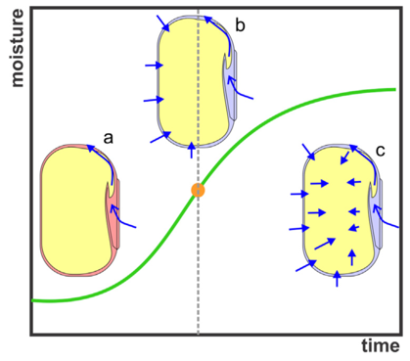
Figure 1-5: Hydration curve showing the associated phases of water permeability by the seed coat. (a) Seed coat is impermeable to water and water enters the seed through the hilum (lag phase), (b) water begins to enter through the seed coat (inflection point), (c) water begins to diffuse within the bean, specifically to the cotyledon (intake of water slows) (Miano & Augusto, 2015).

values of moisture content as determined by AOAC method 967.19 to the model calculated estimates. (Lopez et al., 2017). However, it was not the model that fit best out of the models compared (sigmoidal, first order, Peleg, and Weibull). The sigmoid model was also used to successfully model the hydration of small red beans (Devkota et al., 2022). For this, it was reported that the sigmoidal model had an R² ≥ 0.99.
Equation 1-4
$$M_{t}=\frac{M_{e}}{1+exp⁡[-k\left(t-τ\right)]}$$
Where M_{t} is the moisture content at a time, t, M_{e} is the equilibrium moisture content, k is a water uptake parameter, t is the hydration duration (min), and τ is the time required to reach the point of inflection (Kaptso et al., 2008). The moisture units of the model will correspond to the units of the given moisture contents.

Exponential Model
The exponential model has been used to model corn and soybean hydration for moisture contents on a dry basis up to 130% (d.b.) (Miranda et al., 2019). This model follows Equation 1-5 and uses a model constant, k, which was found to increase with increasing hydration temperature (Miranda et al., 2019). Compared to other commonly used models (Peleg, Weibull distribution, and first-order kinetic), the exponential model did not adequately model corn or soybean hydration. Compared to the other models, smaller R² values were reported for the exponential model.
Equation 1-5
$$M_{t}=M_{eq}\left(1-\exp\left(-kt\right)\right)$$
Where M_{t} is the moisture content at a time, t, M_{eq} is the equilibrium moisture content, t is the hydration duration (min), and k is the model constant. The moisture units of the model will correspond to the units of the given moisture contents.

Fick’s Diffusion Model
This model is based on Fick’s second law of diffusion, which assumes that water is being diffused through a spherical body (Ghafoor et al., 2014). It can be applied to all diffusion situations meeting these assumptions. This model has been tested for moisture contents ranging from 10-115% d.b., and has reported R² values of greater than 0.989 (Ghafoor et al., 2014). The equation for this model includes specific terms such as the radius and the effective diffusivity of the seed. These variables allow the model to account for the pores in the plant matter (Saguy et al., 2005). However, this mechanistic model is less practical than other hydration models as additional measurements are required. This model has been used to model the hydration of navy beans using Equation 1-6 (Ghafoor et al., 2014; Saguy et al., 2005). When compared to other models (Peleg, Weibull, first-order), Fick’s diffusion was not the best for the modeling of navy bean hydration (Ghafoor et al., 2014).
Equation 1-6
$$M_{t}=M_{e}+(M_{0}-M_{e})\frac{6}{π^{2}}exp⁡(-\frac{D_{ef}π^{2}t}{r^{2}})$$
Where M_{t} is the moisture content at a time, t, M_{e} is the equilibrium moisture content, M₀ is the initial moisture content, r is the equivalent radius (m), and D_{ef} is the effective diffusivity (m²/s) (Ghafoor et al., 2014; Saguy et al., 2005). The moisture units of the model will correspond to the units of the given moisture contents.

Peleg’s Model
This model is a two-parameter, nonexponential model developed to model the entire sorption process of food materials (Peleg, 1988). It has been successfully used across moisture contents of 9-134% d.b. (Lopez et al., 2017; Miranda et al., 2019). R² of greater than .89 for soybeans have been reported using the Peleg model (Miranda et al., 2019). It has described the hydration behavior of pasta (Cunningham et al., 2007), red kidney beans (Figure 1-6; (Devkota et al., 2022), split chickpeas (Johnny et al., 2015), common beans (Lopez et al., 2017), corn, soybeans (Miranda et al., 2019), lupin seeds (Solomon, 2009), and navy beans (Ramaswamy et al., 2005). Peleg’s equation (Equation 1-7) uses constants k₁ and k₂. k₁ is related to water absorption rate, while k₂ defines equilibrium moisture content (Peleg, 1988; Ramaswamy et al., 2005).
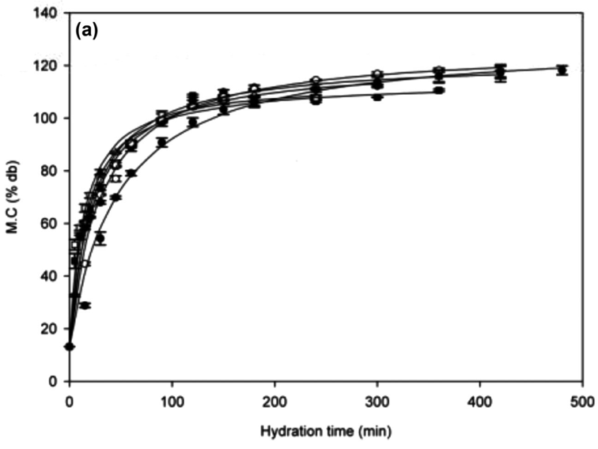
Figure 1-6: The fit of the Peleg model, as represented by the lines, to the experimental values for the hydration of red kidney beans at different temperatures, as represented by the points: 30 ●, 40 ○, 50▼, 60 Δ, 70■, 80□ ◦C (Devkota et al., 2022). The X axis measures hydration time in minutes, and the Y axis measures the percent moisture content on a dry basis.

Equation 1-7
$$M\left(t\right)=M_{0}+\frac{t}{(k_{1}+k_{2}t)}$$
Where M_{t} is the moisture at time, t, M₀ is the initial moisture, and k₁ and k₂ are constants (Peleg, 1988). The moisture units of the model will correspond to the units of the given moisture contents.

Weibull Model
This model, when applied to the hydration of food products, involves the time it takes for the material to reach equilibrium moisture. When compared to other models, it was found that Weibull fit best with corn and soybeans (Miranda et al., 2019), common beans (Lopez et al., 2017), and navy beans (Ghafoor et al., 2014). This model was also proven to fit the hydration of various varieties of Italian beans (Gargiulo et al., 2020) and wheat (Polachini et al., 2023). This model has been tested across moisture contents of 10-130% d.b. (Ghafoor et al., 2014; Miranda et al., 2019). R² values of 0.986-0.999 have been reported for the Weibull model (Lopez et al., 2017).
The equation (Equation 1-8) uses two variables that represent the shape (A) and scale (B) of the curve which, in terms of hydration, represent the inverse of the initial rate of water uptake and the time to accomplish 63% of the equilibrium moisture, respectively (Polachini et al., 2023).
Equation 1-8
$$\frac{X_{t}-X_{e}}{X_{0}-X_{e}}=exp\left[-{\left(\frac{t}{B}\right)}^{A}\right]$$

Where X_{t} is the moisture content at time t, X₀ is the initial moisture content, X_{e} is the equilibrium moisture content, A is the shape parameter, and B is the scale parameter (Cunningham et al., 2007). The moisture units of the model will correspond to the units of the given moisture contents.

The Bean Volume Automatic Tester
To improve upon current moisture determination methods, a new technology was developed that could accurately measure hydration with minimal effort. This technology was developed in “Automatic Seed Hydration Analysis System: Design and Evaluation” by Mannam et al. (2013). The system was named the Bean Volume Automatic Tester (BVAT). For the current study, changes were made to the BVAT to upgrade the control system to make it more user-friendly. However, the working principle of the BVAT remained the same.
The BVAT accurately measures the volume and weight of a bean sample throughout its hydration. It uses a small sample size and is automated, making it cheap and easy to monitor the hydration of multiple samples over time. Briefly, this system simultaneously soaks the beans and measures the change in volume and weight of three replicate, forty-gram samples as they rehydrate and absorb water. The soaking process is accomplished by housing each sample in one of three separate soak chambers, which are then filled with water for three minutes to allow for hydration, then emptied to measure the weight of the sample. The bean weight is obtained by a load cell which weighs a basket of beans in each chamber. As the chambers are refilled, the volume of the water needed to fill the chamber is also measured. The volume of water is measured by an ultrasonic level sensor in a separate measuring chamber. First, the measuring chamber is filled up and the level of water measured. Then, the water in the measuring chamber is used to fill up a soaking chamber containing the sample of beans. The change in water level (in the measuring chamber) required to fill a soak chamber containing the beans to the same level each time as determined by a level switch, is indirectly related to the bean volume in the soak chamber. The density of the samples can be calculated with measurements of bean weight and volume. Figure 1-7 shows a representation of the BVAT.
In Mannam (2013), the BVAT was evaluated for accuracy, system repeatability, and replicate variation. The accuracy of the system was determined to be 97.87% for volume, and 99.08% for weight. The covariance was determined to be 1.6% for volume and 0.29% for weight. The variation amongst the soak chambers was 2.2% for volume and 0.2% for weight. The system was also used to evaluate cultivars of beans from different countries. Table 1-2 compares the equilibrium volume, time to equilibrium volume, and Weibull parameters, alpha (initial rate of water uptake) and beta (time to accomplish 63% of hydration), for each cultivar.

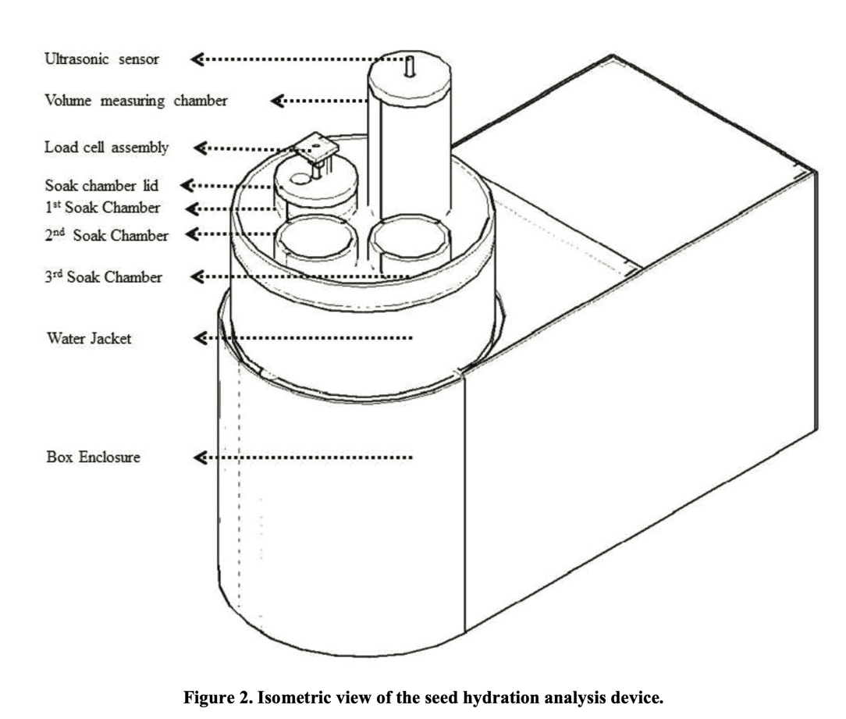
Figure 1-7: Diagram of the BVAT (Mannam et al., 2013)

Table ‎1-2: Weibull parameters from hydration profiles of international navy bean cultivars. Cultivars with the same letter subscript are similar (modified from Mannam, 2013).
Cultivar of navy bean | Equilibrium Volume  (P < 0.0001) | Time to Reach Eq. Vol. (P<0.0001) | Alpha | Beta
Ethiopia _{b} | 1.78±0.034 | 86±6.245 | 30.05±1.449 | 0.73±0.005
Argentina-1 _{b} | 1.79±0.044 | 53±3.464 | 10.9±1.512 | 0.54±0.019
Argentina-2 _{a} | 2.02±0.037 | 104±9.165 | 47.86±4.349 | 1.07±0.021
China-1 _{c} | 1.43±0.031 | 66±3.000 | 31.92±1.925 | 0.86±0.056
China-2 _{b} | 1.77±0.036 | 57±3.000 | 17.51±0.084 | 0.67±0.009
US-Control _{b} | 1.82±0.035 | 76±6.245 | 31.04±2.481 | 0.80±0.035

IMPROVEMENT AND VERIFICATION OF AN AUTOMATED METHOD FOR DETERMINING THE HYDRATION KINETICS OF DRY LEGUMES

Abstract
The hydration of dry beans within the Phaseolus vulgaris species is an important step in their preparation for canning. Each type of legume will have unique hydration kinetics which must be understood before commercial canning. This will ensure a uniform product and optimize processing and quality while maintaining the product’s microbial safety. The current methods to determine hydration kinetics are time consuming and labor intensive. The Bean Volume Automatic Tester (BVAT) is an automated system which was developed to measure the change in weight and volume of a legume over time, as it absorbs water. As this system is automated, it reduces labor and the time required to analyze hydration. This system was modified to give moisture content readings which are equivalent to moisture contents given by the current published standard method (AACC 44-17.01; Cereals & Grains Association, 1999c). The system was shown to be highly correlated with the standard method, with the two having a linear relationship (y=1.09x-6.04).
Two models, Peleg and Weibull, were fitted to navy bean hydration data from the BVAT.
The model which had the smallest root mean square error (RMSE) was used to compare hydration curves at different temperatures (average Peleg RMSE = 0.9). By comparing the parameters from the Peleg model, the system was able to distinguish hydration curves of navy beans at different temperatures (P <.0001 [k₁]) and different varieties of black beans (P=0.0013 [k₁]; P=0.0347 [k₂]).

Introduction
Varieties of Phaseolus vulgaris are a good source of many nutrients. They contain high levels of protein, ranging from 17-31%, depending on the cultivar and growing region. They also contain high amounts of dietary fiber, which has been linked to numerous health benefits including, reduced risk of heart disease, reduced risk of colon cancer, and lower blood cholesterol. They are also good sources of iron and zinc, which are minerals essential to our diets (Popescu & Golubev, 2012).
One common way beans are purchased in grocery stores is as a canned good. This way, the beans are ready to eat and are easy and convenient to prepare. The process of canning beans starts with dry beans. The dry beans are soaked to rehydrate and reach a higher moisture content before canning (Matella et al., 2012). Beans must reach a high enough moisture content, usually above 50% moisture on a dry basis (d.b.), to ensure the safety and quality of the final product. The moisture content will directly affect how the product heats during thermal processing. Beans with a low moisture content will have a smaller volume and therefore more beans will be able to fit in one can. Those with a higher moisture content will have a larger volume and therefore fewer beans will be able to fit in a can. Also, if beans are not fully hydrated before being added to a can, they may absorb water from the brine or sauce in the can during the thermal process (Howard et al., 2018). This will cause the amount of liquid in the can to fluctuate and affects how the product will heat (Matella et al., 2012).
The moisture content of beans affects the quality of the final product. The time beans were allowed to soak, and their softness are directly correlated (Abu-Ghannam, 1998). Long soaking times can increase costs, decrease processing efficiency, and cause a loss of favorable sensory properties (Howard et al., 2018). One influence on the rate of water absorption is the temperature of the soaking medium. Increasing the temperature of the soaking water will increase the rate at which the beans absorb water (Devkota et al., 2022; Johnny et al., 2015). Due to properties such as microstructures and chemical composition which are intrinsic to a bean, different varieties, cultivars, or crop years will have different hydration rates (Devkota et al., 2022).
Many mathematical models have been used to model hydration of various food materials. Of them, the most used are Peleg and Weibull. Peleg’s model was originally designed to model the whole sorption process of food materials (Peleg, 1988). Weibull was originally developed as a probability distribution. However, since Weibull’s development, it has been adapted for multiple applications, including the hydration of food products. The Peleg model has been successfully used in numerous studies to describe the hydration behavior of red kidney beans (Devkota et al., 2022), split chickpeas (Johnny et al., 2015), common beans (Lopez et al., 2017), soybeans (Miranda et al., 2019), lupin seeds (Solomon, 2009), and navy beans (Ramaswamy et al., 2005). Similarly, the Weibull model has been successfully used to model the hydration of corn and soybeans (Miranda et al., 2019), common beans (Lopez et al., 2017), navy beans (Ghafoor et al., 2014), Italian beans (Gargiulo et al., 2020), and wheat (Polachini et al., 2023).
Current attempts to predict an optimal soaking time for both safety and quality use a time-consuming and destructive method to determine moisture content of multiple samples at various stages in the process. Since soaking is often the longest step in the canning process, soaking for the shortest amount of time, while still reaching an appropriate moisture content, can increase production rates.
A technology was developed that semi-continuously monitors the hydration of a bean sample. This system, called the Bean Volume Automatic Tester (BVAT), is automated, uses a small sample size, and measures both weight and volume changes of three replicate samples over time. These measurements can be used to analyze the hydration characteristics of a specific type of bean before processing on a large scale. This analysis gives more knowledge on hydration and therefore the time to equilibrium moisture can be estimated more accurately.
The BVAT currently only measures volume and weight, which while important, does not directly correlate with moisture content which is currently used to discuss the safety and quality of beans. This study updates the computer components of the previously developed system and calibrates the BVAT to give moisture content data consistent with the current published standard method (AACC 44-17.01; Cereals & Grains Association, 1999c).

Methods

BVAT Components

Overview
The BVAT was designed to measure and record the volume and weight of a legume, grain, or seed sample over time, as it soaks. This data gives an insight into the hydration kinetics of the sample. The BVAT includes an external, temperature-controlled water bath containing the soaking medium and a pump, a measuring chamber, three soaking chambers for replicate samples, and a control box containing a programmable logic controller (PLC) with a human machine interface (HMI). The water bath is used to heat the soaking water to a consistent temperature for testing. The measuring chamber includes an ultrasonic level sensor (USLS), and the three soaking chambers each contain a load cell and a level switch (Figure 2-1). There are two pumps and seven solenoid
valves to control water flow in and out of the chambers (Figure 2-2). All system parts,
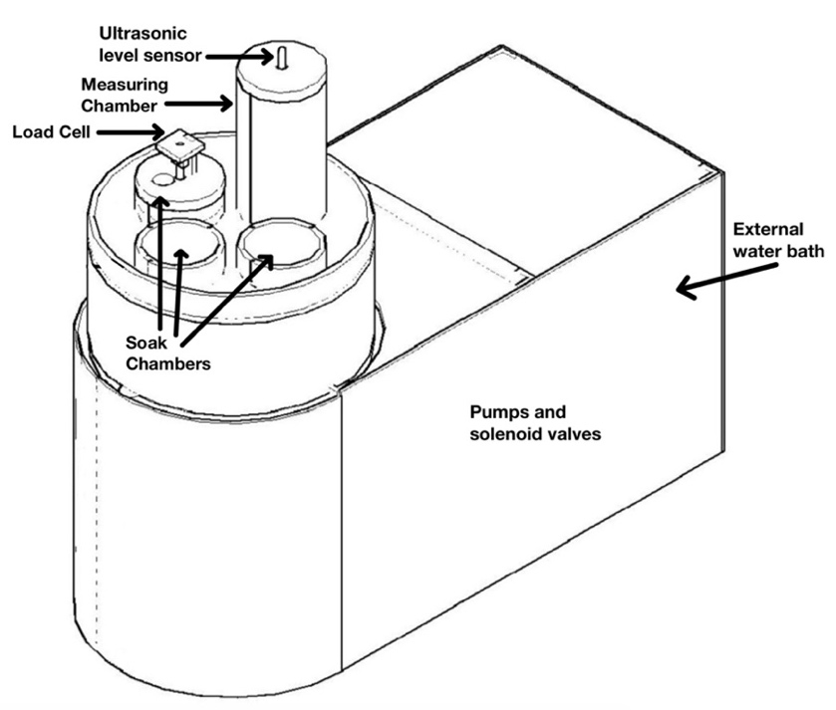
Figure 2-1: A representation of the BVAT including all three soak chambers (modified from Mannam et al. (2013)).

part numbers, and manufacturers are listed in Appendix 1.

Measuring Chamber
The measuring chamber is made up of a cylindrical CPVC tube with an inner diameter of 7.27cm, a height of 17cm, and a total volume of 705.7ml. There is an opening at the bottom for water to enter and exit. An external, circulating, water bath (Model Isotemp 6200 H24, Fisher Scientific, Inc., Pittsburgh, PA, USA), supplies the measuring chamber with constant temperature water, or soaking medium. The pump within the water bath is used to move the water into the BVAT. The water enters the BVAT through a solenoid valve (Model. 1335BV3T, Jefferson Solenoid Valves USA, Miami, FL, USA) which is controlled by the PLC (Model D0-06DR-D, AutomationDirect, Cumming, GA, USA).
The water level in the measuring chamber is measured using an ultrasonic level sensor
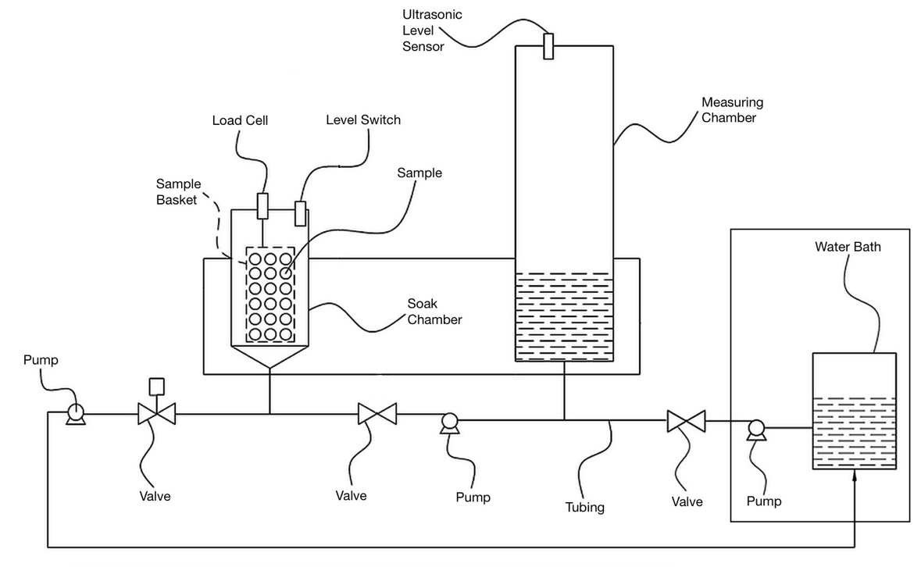
Figure 2-2: A representation of the BVAT including all pumps and valves (modified from Mannam (2013)).

(USLS; Model UNAM 12I9914/S14, Baumer Ltd., Bristol, CT, USA) which is situated in the middle of the lid, as seen in Figure 2-1. This level sensor has a range of 20-200 mm. This means the USLS can measure a change of 415 mL of water in the measuring chamber. This measuring chamber also has multiple openings and a fan above the maximum water level to help to prevent condensation from building up on the level sensor when using warm water for hydration.

Soak Chambers
The BVAT contains three soak chambers with an inner diameter of 8.9cm, a height of 6.5cm, and a total volume of 404ml. A centrifugal pump (Model 33BPLA, Franklin Electric, Fort Wayne, IN, USA) and solenoid valves are used to individually fill each of the three soak chambers with water from the measuring chamber. Each soaking chamber has a level switch (Model LLE101000, Honeywell International, Inc., Charlotte, NC, USA) ensuring it is filled to the same level each time. Three solenoid valves regulate water entering the soak chambers. Each soak chamber has a valve in between the chamber and the centrifugal pump. These valves select which soak chamber the water enters. A diaphragm pump (Model 1335BV3T, W.W. Grainger, Lake Forest, IL, USA) is on the outlet side of the soak chambers to drain each chamber. Like the centrifugal pump, there are solenoid valves in between each of the chambers and the drain pump to select which soak chamber drains. These valves also prevent water draining from the chamber once it is full.
Each soaking chamber contains a load cell (Model LFS 270-M3 1, Cooper Instruments & Systems Warrenton, VA, USA) which measures the weight of the sample, with an output of 2mV/V full scale. A basket holding the sample hangs from the load cell in each soaking chamber. Each basket measures 2 in (5.1 cm) tall and has a 3 in (7.6 cm) diameter, with a volume of 14.14 cubic inches (231.7 ml).

Computer
The BVAT is controlled by a Programmable Logic Controller (PLC) (Model DL06 Micro PLC, AutomationDirect, Cumming, GA, USA). The PLC has analog input modules for the USLS (Model F0-08ADH-2, AutomationDirect, Cumming, GA, USA) and the load cells (Model F0-04THM, AutomationDirect, Cumming, GA, USA). The load cells are set at 0-39.0625mV/0-65535 counts. A ladder logic program in the PLC controls the flow of the entire system and reads signals from the USLS and load cells runs on the PLC. The program used for the PLC was written in DirectSOFT5 (AutomationDirect, Cumming, GA, USA), and can be found in Appendix 2.
The PLC is used in conjunction with a Human Machine Interface (HMI) (Model CM5-T7W, AutomationDirect, Cumming, GA, USA) which can be used to start and stop the program and monitor and control the equipment. The HMI records all the data from the USLS and the load cells and collects it on a removable SD card where it can be transferred to a separate computer for analysis. The program used for the HMI was written in C-More Programming Software (CM5 Series, AutomationDirect, Cumming, GA, USA). Screenshots of the HMI are shown in Appendix 3.

BVAT Procedures
The overall flow of the BVAT is described in Figure 2-3. First, the BVAT goes through a Priming stage which fills all tubing, pumps, and valves with water to ensure accurate volume measurements. Then, the initial volume of the empty soak chamber is recorded. The sample is then loaded into the baskets in the soak chamber. An initial weight and volume measurement is taken. The soak chambers are repeatedly emptied and refilled after a three-minute soaking period and the weight and volume recorded.

Weight Measurement
To obtain an accurate weight measurement, first, the weight of the sample to be tested is weighed on an external scale, usually about 40 grams. This sample size is representative of a type of bean while still allowing for enough space in the sample basket for bean swelling due to water absorption. The weight is then recorded on an external computer. The sample is placed into the basket in the soak chamber; then the sample loaded button is pressed on the HMI. From here, the BVAT automatically fills the soak chamber up

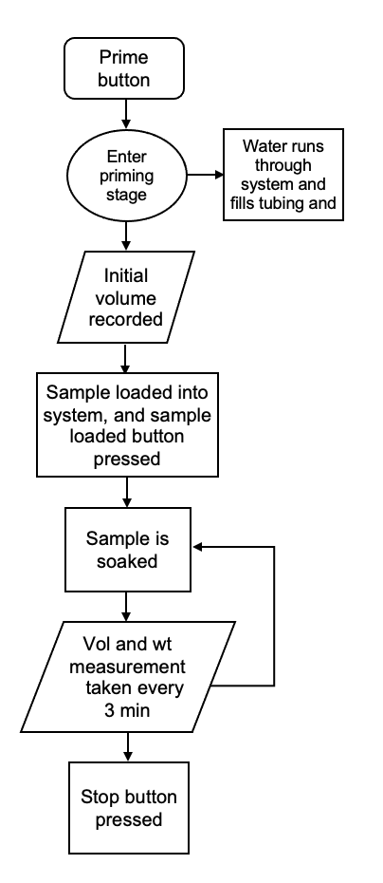
Figure 2-3: Overall sequence of the BVAT

with water up to a level switch and then immediately drains the water. The weight of the sample from the load cell is then recorded. This weight is later adjusted to the sample's weight taken previously with a scale to remove the weight of the basket and the weight of water which will cling to both the sample and the basket but is not absorbed by the sample. After the initial weight is determined, the BVAT again fills the soaking chamber up with water and the sample is soaked for three minutes before the water is drained again and a weight measurement recorded. This is repeated for the duration of the soak. The steps of weight measurement are summarized in Figure 2-4. For each weight measurement, data is collected over a 10 second period, with one data point being collected per second. These data points are then averaged to create one data point which is used for analysis. This average is used to create a more accurate measurement and minimize the influence of any fluctuation due to water movement. The weight of the sample is calculated for soak chamber 3 using Equation 2-1.
Equation 2-1
$$W_{t}=\left(0.0267*R_{t}-96.689\right)+\left(W_{i}-(0.0267*R_{1}-96.689\right))$$
Where W_{t} is the weight of the sample (g) at time, t, R is the reading from load cell (counts between 0 and 65535) at time, t, W_{i} is the initial weight of sample before being placed in the BVAT (g), R₁ is the first reading from the load cell once the sample is put into the BVAT (counts between 0 and 65535), and constants are from a regression equation as displayed in Appendix 4. Equations for each soak chamber can be found in Appendix 4.

Volume Measurement
When the program starts, before the sample is added, but ensuring the sample basket is in

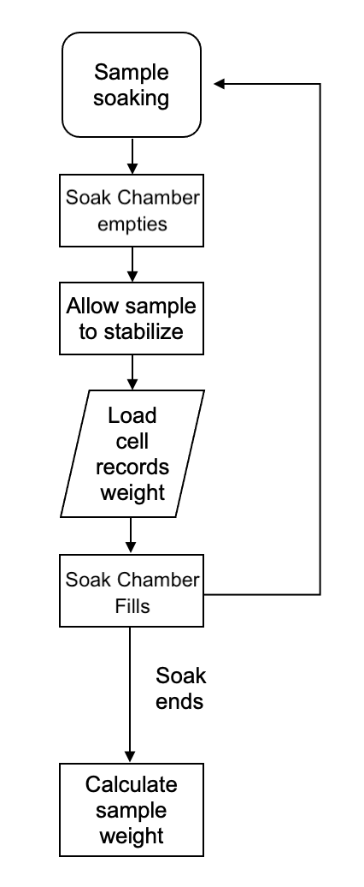
Figure 2-4: Sequence of weight measurement of the BVAT

place, the valve before the measuring chamber opens and allows water in from the water bath. When the water level in the measuring chamber reaches a specified level, as measured by the USLS, the valve will close. Once the measuring chamber is full, the level of water is measured by the USLS and recorded by the HMI. This level, since the dimensions of the chamber are constant, can be translated to a volume of water by the established calibration curve. After the initial level of water is recorded, the water moves from the measuring chamber into the soaking chamber until it triggers a level switch in the soak chamber. The level switches ensure the water is filled to the same level in the soak chambers each time they are filled. After the soak chamber is full, the level of water remaining in the measuring chamber is recorded.
All measurements from the USLS are collected over a 10 second period, with one data point being collected per second. These data points are then averaged to create one data point which is used for analysis. The vapor produced by the heated water from the water bath entering the BVAT can condense on the USLS and affect the reading. Therefore, before the 10 volume data points are averaged, they are evaluated for outliers. The vapor interference only causes the reading to be higher than it is, so the readings are only evaluated for high value outliers.
The data is assessed using the interquartile range method. This method considers any value which falls outside of the calculated range to be an outlier. The range is determined by first finding the first and third quartile limits of the ten recorded data points. Then, the difference between the two is found, giving the inter quartile range (IQR). The IQR is then multiplied by a factor of 1.5. To calculate the upper limit which defines outliers, the IQR*1.5 is added to the third quartile limit. Any reading above this number is considered an outlier and is not included in the average calculation.
Once evaluated for outliers, the averaged reading is used to calculate the volume of the water in the measuring chamber using Equation 2-2.
Equation 2-2
$$V_{t}=\left(-0.0169*\left({USLS}_{t2}-{USLS}_{t1}\right)+1209.5\right)-(-0.0169*\left({USLS}_{i2}-{USLS}_{i1}\right)+1209.5)$$
Where V_{t} is volume of the sample (mL) at time, t, USLS_{t1} and USLS_{t2} are the measuring chamber measurements before and after filing the soak chamber (counts between 0 and 65535) at t, USLS_{i1} and USLS_{i2} are the measuring chamber measurements before and after filing the soak chamber before the beans are placed into the BVAT (counts between 0 and 65535), and the constants are from a regression equation as displayed in Appendix 4.
Once translated to volume measurements, the volume of water that entered the soak chamber can be calculated using the measurements from before and after the soak chamber is filled, as in Equation 2-3. The volume of available space in the soak chamber can be expected to decrease with soaking time due to the increased volume of the sample due to bean swelling from water absorption.
Equation 2-3
$$V_{sc}=V_{mc1}-V_{mc2}$$
Where V_{sc} is the volume of water in the soak chamber (mL), V_{mc1} is the initial volume of water in the measuring chamber (mL), and V_{mc2} is the final volume of water in the measuring chamber (mL) after filling the soak chamber.
After the volume of the chamber is determined, the sample is added. The process to determine volume is repeated. Using the volume of water that it took to fill the soak chamber before and after the sample was added, the volume of the sample is calculated using Equation 2-4.
Equation 2-4
$$V_{s}=V_{i}-V_{t}$$
Where V_{s} is the calculated volume (mL) of the sample, V_{i} is the initial volume of the soak chamber without the sample (mL), and V_{t} is the available volume of the soak chamber containing the sample at time, t (mL).
After the initial volume is determined, the BVAT again fills the soaking chamber up with water, recording the volume, and the sample is soaked for three minutes before the water is drained and filled again and another volume measurement recorded. This is repeated for the duration of the soak. The steps of volume measurement are summarized in Figure 2-5.

Density and Moisture Calculation
Density can be calculated using the volume and weight measurements (Equation 2-5). Moisture content can be calculated using the weight measurements. Equation 2-6 shows this calculation for soak chamber 3.
Equation 2-5
$$Density= \frac{Wt}{V_{t}}$$
Where W_{t} is the weight of sample (g) at a time, t, and V_{t} is volume of sample (mL) at time, t.
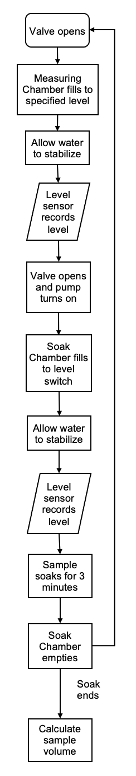
Figure 2-5: Sequence of volume measurement of the BVAT
Equation 2-6
$$M_{t}= \frac{\left[\left(0.0267*R-96.689\right)+\left(W_{i}-W_{1}\right)\right]-[W_{i}-\left(W_{i}*M_{i}\right)]}{\left(0.0267*R-96.689\right)+\left(W_{i}-W_{1}\right)}*100$$
R= reading from load cell (counts)
W_{i}= weight of sample before placed into BVAT (g)
W₁= first weight from load cell after sample added and wettened (g)
M_{i}= initial moisture content (% w.b.)
M_{t} = moisture content of sample (% w.b.) at a time, t
Equation 2-6 can be simplified to:
Equation 2-7
$$M_{t}= \frac{(W_{t}-DM)}{W_{t}}*100$$
Where M_{t} is the moisture content (% w.b.) at a time, t; W_{t} is the weight of sample (g) at a time, t; and DM is the dry matter weight of the original sample (g) as calculated using the initial moisture content (% w.b.)

Standard procedure for BVAT
All tests conducted using the BVAT followed a standard operating procedure to ensure precise results. The full procedure for the BVAT can be found in Appendix 3. Briefly, this procedure consists of:
- Turn the BVAT on and allow it to warm up for one hour.
- Fill the water bath with the desired soaking medium and allow it to warm up to desired temperature.
- Once warmed up, ensure the baskets are in their respective soak chambers and press the “Prime” button on the HMI and wait for the BVAT to prime. The priming stage will fill all of the tubing and pumps with water to accurately measure volume.
- Measure and record the weight of three, 40-gram samples to be tested, using a laboratory balance.
- When prompted, remove the sample baskets, place the samples into their respective baskets, and return the baskets to their respective soak chambers.
- Press the “Start Program” button on the HMI to start the program.
- Allow the BVAT to run for the desired amount of time, for most tests about 3 hours to achieve significant bean hydration.
- Once finished, press the end button and remove the samples from the BVAT.
- Move the data collected by the BVAT from a USB drive to a computer for analysis.

Standard Method for Determining Moisture Content
To compare to the BVAT method, the standard published method (AACC 44-17.01) was used (Cereals & Grains Association, 1999c). For testing, the same lot of navy beans was used for the published method as was tested in the BVAT. For each experiment, deionized (DI) water heated to 49ºC in the BVAT’s external, circulating water bath was used to soak samples to be measured using the standard method (Matella et al., 2012). A sample was pulled from the water bath and tested every ten minutes for three hours for a total of 18 samples. Each sample was divided in three sub-samples for replicate testing. The moisture contents of these samples were compared to data at the same soak times collected using the BVAT and the same lot of navy beans.

Procedure
AACC method 44-17.01 details a method to accurately determine the moisture content of pulses, including beans and was followed for all testing (Cereals & Grains Association, 1999c). Briefly, this method’s steps include weighing out a 25g sample of whole beans (A) before placing the sample in an oven at 130ºC until the moisture content of the sample reaches 9-11% as estimated by loss of weight and the initial moisture content. Then, the sample is placed in an ambient environment for two hours to cool and equilibrate. After this the sample is weighed (B). Then, the sample is ground with a laboratory mill and 2-3 grams (C) is quickly transferred to an oven dish and placed in the oven for two hours. Finally, the sample is placed in a desiccator until it is cool and weighed (D). The moisture content on a wet basis (%MC w.b.) is then calculated using Equation 2-8.
Equation 2-8
$$\%Moisture wb= \frac{\left(C-D\right)*B}{C+(A-B)}*\frac{100}{A}$$

Effect of Soak Water Temperature
The BVAT’s ability to discriminate between differences in hydration was evaluated by running the system using five different soak water temperatures (26.7, 32.2, 37.8, 48.9, 60 °C) and following the standard BVAT operating procedure. DI water and the same lot of navy beans were used for all testing. A hydration curve of the average of three soak chambers over three hours with measurements every three minutes obtained from the BVAT was used for comparison of hydration at each temperature.

Discrimination of Bean Variety
The BVAT’s ability to discriminate between hydration of different bean varieties was evaluated by running three different black bean samples in the BVAT following the standard procedure. Of the three samples, two samples were obtained from the same source, but were stored for different lengths of time. The sample which had been stored longer required a longer soaking time to reach adequate moisture content (de León et al., 1992).The third sample was of a different variety. DI water at the same temperature (10ºC) was used for all testing. A hydration curve of the average of three soak chambers over two hours with measurements every three minutes (obtained from the BVAT) was used for comparison of hydration across the three varieties.

Statistical Analysis
All statistical tests were performed using JMP Pro 17 (SAS institute, Inc., Cary, NC, USA)

Model Fitting
The Peleg model follows Equation 2-9.
Equation 2-9
$$M\left(t\right)=M_{0}+\frac{t}{(k_{1}+k_{2}t)}$$
Where M_{t} is the moisture content (%w.b.) at time, t; M₀ is the initial moisture content (%w.b.); and k₁ and k₂ are model parameters related to the water absorption rate (hr/%wt) and the equilibrium moisture content (1/%mo), respectively (Peleg, 1988). This model can be fit to either wet basis or dry basis moisture contents; in this study, wet basis moisture content was used.
The Weibull model adapted to model food hydration as used in this study follows Equation 2-10 (Cunningham et al., 2007).
Equation 2-10
$$\frac{X_{t}-X_{e}}{X_{0}-X_{e}}=exp\left[-{\left(\frac{t}{B}\right)}^{A}\right]$$
Where X_{t} is the moisture content (%w.b.) at time, t; X_{e} is the equilibrium moisture content (%w.b.); X₀ is the initial moisture content (%w.b.); A is the related to the rate of water uptake (dimensionless); and B is the time (min) it takes to accomplish 63% of hydration (Cunningham et al., 2007; Machado et al., 1999). The units of the model will correspond to the units of the given moisture contents.
For each model (Weibull and Peleg), model parameters, root mean square error (RMSE), and coefficient of determination (R²) were calculated for the hydration curves at five soak water temperatures, using equations Equation 2-11 and Equation 2-12, respectively.
Equation 2-11
$$RMSE=\sqrt{\frac{1}{N}\sum_{i=1}^{N}{{(y_{i}-ŷ)}^{2}}}$$
Equation 2-12
$$R^{2}=1-\frac{\sum{({y_{i}-ŷ)}^{2}}}{\sum{{(y_{i}-ȳ)}^{2}}}$$
Where N is the number of values in a data set, y_{i} is the measured value of y, ŷ is the predicted value of y, and ȳ is the mean value of y.
Fitting the models to a range of temperatures ensures each fits at different soak conditions. A hydration curve of the average of three soak chambers over three hours with measurements every three minutes obtained from the BVAT was used to fit the models for each soak water temperature.

Consistency and Repeatability
The BVAT’s consistency was determined using the best fitting model and its model parameters. The BVAT was run three times using the same lot of navy beans at 49ºC. For each bean hydration curve, 61 bean moisture content measurements over time (calculated every three minutes for three hours) were used to fit the best fitting model and determine the model parameters. Data from each of the BVAT’s soak chambers were compared to one another to evaluate the BVAT’s consistency within one run and the system as a whole was compared between runs to evaluate the BVAT’s repeatability. Each run was conducted according to the standard procedure to minimize any user error. The BVAT gives moisture content data points every three minutes for three hours, for a total of 60 data points. These moisture contents were fit to the best fitting model, and the model parameters were calculated. An ANOVA and a Tukey-Kramer multiple comparison test was used to compare model parameters for different soak chambers and different BVAT runs.

Accuracy
The Passing-Bablok procedure was used to evaluate the BVAT's accuracy compared to the standard method. This is a non-parametric model which is commonly used in instrument testing (Bablok & Passing, 1985). It is not sensitive to outliers and does not assume normal distribution of errors. It measures constant and proportional errors (Bilić-Zulle, 2011). This procedure tests the linearity of the relationship between the two methods. It uses the equation:
Equation 2-13
$$y=A+Bx$$
A and B are then compared to values 0 and 1, respectively.
The conditions used when testing moisture content with the standard method of moisture determination of beans was replicated with the BVAT. A sample of the same lot of navy beans and same temperature (49ºC/120ºF) of DI water was used for a test in the BVAT. The average of the three BVAT soak chambers were compared to the average of triplicate readings by the standard method for only the times tested by the standard method (every 10 minutes for three hours) for a total of 18 comparisons.

Differences in Hydration
For each of five soak water temperatures, the model parameters for the best fitting model were calculated using 61 bean moisture contents over time (calculated every three minutes for three hours) and compared using an ANOVA (Analysis of Variance) test and Tukey-Kramer multiple comparison test.

Results and Discussion

Model Fitting
A hydration curve of the average of three soak chambers over three hours with measurements every three minutes obtained from the BVAT was used to fit the models for each soak water temperature. The model parameters and measurements of fit are shown in Table 2-1. The Peleg model exhibits a slightly better fit to the experimental data, with an average RMSE of 0.9 and an average R² of 0.99. The Weibull model

Table ‎2-1: Model parameters (± standard deviation [STD]), root mean square error, and the coefficient of variation for Weibull and Peleg for each soak water temperature using moistures (%w.b.) from the BVAT.
Tempe-  rature  (ºC) | Weibull Model |  |  |  |  | Peleg Model
Tempe-  rature  (ºC) | A | B | R² | RMSE |  | k₁ | k₂ | R² | RMSE
26.7 | 0.62 ± 0.43 | 31.00 ± 1.17 | 0.997 | 0.78 |  | 0.38 ± 0.38 | 0.021 ± 0.0001 | 0.99 | 0.79
32.2 | 0.59 ± 0.06 | 25.11 ± 2.54 | 0.997 | 0.76 |  | 0.31 ± 0.31 | 0.021 ± 0.0001 | 0.995 | 0.69
37.8 | 0.61 ± 0.04 | 22.28 ± 2.87 | 0.99 | 1.46 |  | 0.29 ± 0.29 | 0.020 ± 0.001 | 0.99 | 1.11
48.9 | 0.54 ± 0.12 | 15.80 ± 3.76 | 0.99 | 0.81 |  | 0.19 ± 0.19 | 0.022 ± 0.0004 | 0.99 | 0.75
60.0 | 0.37 ± 0.02 | 10.13 ± 1.67 | 0.94 | 1.94 |  | 0.11 ± 0.11 | 0.022 ± 0.002 | 0.96 | 1.16
Mean |  |  | 0.98 | 1.15 |  |  |  | 0.90 | 0.99

presented a good fit with an average RMSE of 1.15 and an average R² of 0.98.
Both models fit the data very well, but since the Peleg model had a slightly lower RMSE when fit to the experimental data, it will be used for further data analysis.

Evaluation of the BVAT

Consistency and Repeatability
The consistency of the BVAT’s moisture readings across soak chambers was evaluated by using the Peleg model to compare the model parameters fit to data for each of the soak chambers. Model parameters were calculated for each soak chamber for three runs. Each soak chamber was averaged for three runs, then compared to the other two chambers. The model parameters and their comparison are shown in Table 2-2. The moisture contents over time determined for each soak chamber are shown in Appendix 5. The repeatability of the BVAT was evaluated by using the Peleg model to compare the model parameters across three different runs. The Peleg model was fit to three BVAT bean hydration curves for each soak chamber for three different BVAT runs. For each bean hydration curve, 61 bean moisture contents over time (calculated every three minutes for three hours) were used to fit the Peleg model and determine the model parameters. For each run, the Peleg parameters calculated for each soak chamber were averaged and then compared across

Table ‎2-2: Comparison of Peleg parameters (±STD) for the three soak chambers of the BVAT using the same lot of navy beans at 49ºC. Values within the same column with the same letter have no significant difference.
Soak Chamber | k₁ | k₂
1 | 0.27 ± 0.02 a | 0.021 ± 0.0002 a
2 | 0.23 ± 0.02 a | 0.021 ± 0.0002 a
3 | 0.22 ± 0.05 a | 0.020 ± 0.0005 a
the different runs. The model parameters and their comparison are shown in Table 2-3.

Accuracy
The accuracy of the BVAT was evaluated by determining the linear relationship between the published standard method for determining moisture content and the moisture content as determined by the BVAT. The two hydration methods were compared at 18 data points. Figure 2-6 shows the linear relationship between the two methods.
The equation for the linear relationship was estimated using the Passing-Bablok method; as seen in Table 2-4, the 95% confidence interval for the intercept contains 0, with an estimated value of -6.04, and the 95% confidence interval for the slope contains 1, with an estimated value of 1.09.
Appendix 6 shows the hydration over time of the two methods.

Effect of Temperature
The ability of the BVAT to discriminate between differences in hydration was evaluated by comparing the Peleg parameters calculated for each run at each temperature. Parameters k₁ and k₂ were calculated for each run at each temperature, then compared across temperatures using a Tukey-Kramer multiple comparison test. Parameter k₁ decreases with an increase in temperature, with significant differences. Parameter k₂

Table ‎2-3: Comparison of Peleg parameters (±STD) for three BVAT runs using the same lot of navy beans at 49ºC (120ºF). Values within the same column with the same letter have no significant difference.
Run | k₁ | k₂
1 | 0.25 ± 0.02 a | 0.021 ± 0.0002 a
2 | 0.24 ± 0.02 a | 0.021 ± 0.0004 a
3 | 0.23 ± 0.06 a | 0.021 ± 0.0009 a

y = 1.09x – 6.04
R² = 0.99
RMSE = 0.66
Figure 2-6: The relationship between the BVAT and the standard method’s moisture content results when testing the same lot of navy beans at 49ºC. Experimental data (data points) and y=x line (solid line) are shown.

Table ‎2-4: Estimates of the linear relationship between the standard method and the BVAT method using the Passing-Bablok method when testing the same lot of navy beans at the same DI water temperature (49ºC/120ºF)
Parameter | Estimate | Lower 95% Confidence Interval | Upper 95% Confidence Interval
Intercept | -6.04 | -14.43 | 0.56
Slope | 1.09 | 0.97 | 1.25

changes minimally with increasing temperatures, with no significant differences. These results are shown in Table 2-5. The hydration curves at each temperature are shown in Appendix 7.

Discrimination of Bean Variety
The ability of the BVAT to discriminate between different bean varieties was evaluated by comparing the Peleg parameters calculated for each sample. k₁ and k₂ were calculated for each sample, then compared across samples using a Tukey-Kramer multiple comparison test. These results are shown in Table 2-6. k₁ showed significant differences between each sample. k₂ showed differences between samples A and C.

Discussion
The Peleg model parameters calculated for each of the three soak chambers demonstrate the consistency in the readings between the soak chambers. It can be concluded
that the three soak chambers all measure samples reliably and therefore can be used as test replicates. The Peleg model parameters calculated for three runs of the same lot of beans show that the BVAT is repeatable and consistent. It can be concluded that the BVAT will give reliable results each time it is run.
The Passing-Bablok test shows that there is a linear relationship between the two methods. The linear relationship allows the conclusion of the equality of the BVAT and the oven method. When using different temperatures of soak water, the BVAT gave hydration curves that showed k₁ and k₂ values consistent with literature. k₁ was reported to decrease as temperature increases, with minimal changes in k₂

Table ‎2-5: Comparison between k₁ and k₂ (±STD for 3 soak chambers) at different soak water temperatures when testing the same lot of navy beans
Temperature (ºC) | k₁ | k₂ | RMSE | R²
26.7 | 0.38 ± 0.38 a | 0.021 ± 0.0001 a | 0.79 | 0.99
32.2 | 0.31 ± 0.31 ab | 0.021 ± 0.0001 a | 0.69 | 0.995
37.8 | 0.29 ± 0.29 b | 0.020 ± 0.001 a | 1.11 | 0.99
48.9 | 0.19 ± 0.19 c | 0.022 ± 0.0004 a | 0.75 | 0.99
60.0 | 0.11 ± 0.11 d | 0.022 ± 0.002 a | 1.16 | 0.96
k₁ and k₂ are Peleg model parameters related to initial hydration rate and time to equilibrium moisture. There is no statistical difference between values within the same column with the same letter (Alpha=0.05; P<0.0001)

Table ‎2-6: Comparison between k₁ and k₂ for different black bean samples when run using 10ºC DI water
Bean Variety ​ | k₁​ | k₂​
Sample A​ | 1.23 ± 0.09 a​ | 0.0287 ± 0.001 a​
Sample B​ | 0.74 ± 0.05 c​ | 0.0270 ± 0.001 ab​
Sample C​ | 0.98 ± 0.10 b​ | 0.0267 ± 0.001 b​
k₁ and k₂ are Peleg model parameters related to initial hydration rate and time to equilibrium moisture. There is no statistical difference between values within the same column with the same letter. Alpha=0.05; P=0.0013 (k₁); P=0.0347 (k₂)

(Foke & Kuljarni, 2018; Johnny et al., 2015; Kaptso et al., 2008). The k₁ and k₂ values also had significant differences across temperatures (P <.0001) showing the differences in hydration at different temperatures as proven in literature (Foke & Kuljarni, 2018; Johnny et al., 2015; Kaptso et al., 2008).
The BVAT was able to discriminate between different black bean varieties, showing statistical differences between three black bean samples. The data shows the difference in hydration due to storage time and the variety of bean with the significant difference between k₁ for each bean sample tested. The BVAT data also showed a difference in k₂ values, which are related to the equilibrium moisture, for the sample of a different variety and the sample which was stored longer.
The BVAT can be applied to industrial and research uses. It can be used to evaluate beans prior to processing and determine the optimal soaking time. The shorter testing time and reduced labor required will help manufacturers test more samples with less work, giving them a better understanding of specific dry bean hydration characteristics before processing. It can also be applied to determine soaking requirements for different cultivars or varieties prior to canning.
The BVAT can be further used to evaluate new crops or cultivars of navy beans to determine the most efficient processing parameters to reach equilibrium moisture. Then applied to a commercial process to potentially reduce soaking and therefore processing time for each new cultivar of bean processed. Future research should be conducted to evaluate the BVAT for use with other legumes or grains which go through a similar hydration process. Different cultivars or varieties of beans will have different mechanisms of hydration. Therefore, the BVAT should be verified for each bean type.

Conclusions
Comparing the three soak chambers of the BVAT shows that each of the three soak chambers give precise data. Comparing the average of the soak chambers between runs shows that the BVAT gives repeatable results. Due to their linear relationship, the BVAT can be used to predict readings from the standard moisture determination method. Since the Weibull and Peleg models fit the moisture versus time data very well, the significant differences between model parameters for different bean varieties and soak water temperatures illustrates the BVAT’s ability to distinguish the differences between hydration curves.

MODELING COMMERCIAL HYDRATION

Abstract
Hydration is an essential step in the preparation of dry common beans, Phaseolus vulgaris, for canning. Commercial processes for the hydration of dry beans in large soak tanks can result in variations in hydration rates for different batches of beans and between different depths in the tank. When operating a commercial process, it is important to understand and account for any possible sources of variation to ensure uniformity of the final product. Additionally, commercial processes may differ from smaller bench top hydration procedures due to the scale of the process.
To predict dry bean hydration rate, an automated, bench-scale system for measuring dry bean hydration rate, the Bean Volume Automated Tester (BVAT), was developed. It uses a small sample size to rehydrate and evaluate beans and legumes, measuring the sample’s change in weight and volume during soaking. Samples were collected from three different depths (3ft, 6ft, and 9ft) within a commercial size soak tank during navy bean hydration to compare to the BVAT measurements. Samples of the same navy beans as used in the commercial-scale soak tanks were hydrated using the BVAT. Comparison of hydration at the three depths in the commercial soak tank showed that the beans at the top of the soak tank exhibited significantly slower hydration than the beans at the middle and the bottom of a soak tank (P>0.0133). Two models, Peleg and Weibull, were fitted to navy bean hydration data from the BVAT and commercial soak tanks collected over time. The model which had the smallest RMSE (Weibull, 0.645) was used to compare hydration at different depths within the soak tanks and agreement between the two methods of hydration. The two Weibull parameters were compared using an ANOVA test and Tukey-Kramer multiple comparisons test to compare the different depths within the commercial-scale soak tanks and the two methods of hydration.
Of the three depths tested, the bottom and the middle of the tank showed similar hydration, while the top of the tank showed initial hydration rates different from the other depths (P=0.013).
When comparing the BVAT data to the soak tank, results showed the BVAT accurately predicts hydration (percent moisture content on a wet weight basis [% MC w.b.] vs time) at the top of the soak tank (RMSE=0.370 %MC w.b.; R²=0.992). The three depths showed no significant difference in Weibull alpha parameters which are related to initial hydration rates (Alpha = 0.05) after adjusting for the time it takes for the beans to fill the soak tank. The BVAT also accurately predicted the hydration at the middle depth of the tank after the time adjustment for filling the tank (RMSE = 1.0 %MC w.b.; R² = 0.98​). The beans which hydrated at the bottom depth of the soak tank also presented a strong relationship with the data from the BVAT after the time adjustment for filling the tank (RMSE = 0.61 %MC w.b.; R² = 0.97​).

Introduction
Varieties of common bean, Phaseolus vulgaris, are often canned as this processing extends the product’s shelf life and makes the product more convenient for consumers to prepare. Typically, the canning process of beans consists of soaking, blanching, filling the cans with beans, adding brine or sauce, sealing the cans and thermally processing them (Matella et al., 2012).
The canning of beans, like most canning processes, is controlled to ensure the safety and quality of the finished product. Each step of this process is controlled to ensure certain characteristics of the product meet quality and safety specifications. These characteristics include the amount and viscosity of the liquid in the can, the initial temperature of both the liquid and the beans, and the size and moisture content of the beans (Tucker & Featherstone, 2021). The bean characteristics rely on the first step of the process, soaking. This step works to control the beans’ moisture content when going into the can. The rate at which the beans rehydrate and the amount of water they absorb affect all the consequent steps of the process (Matella et al., 2012).
Canned whole bean products are a mixed heating product, meaning the beans will heat by conduction while the sauce is heated by convection during the in-container thermal process (Howard et al., 2018). The moisture content of the beans will affect the heating rate of the beans themselves. Beans with a higher moisture content will heat faster via conduction due to their higher thermal conductivity (Tucker & Featherstone, 2021). Also, the moisture content of the beans is directly related to their volume. A bean with a higher moisture content typically has a larger volume. Therefore, beans with different moisture contents will pack into cans differently. This directly affects how the beans will heat in the can, due to the reduced amount of liquid which can fit in the can with the larger beans (Matella et al., 2012; Tucker & Featherstone, 2021).
The moisture content of the beans is usually controlled by a soaking step during which the beans are allowed to absorb water until they reach an equilibrium moisture content. Ensuring beans reach equilibrium moisture during soaking ensures uniformity in moisture content when thermally processed. This uniformity ensures that each bean will heat similarly. Due to the size of commercial soak tanks, there may be some variation in hydration between the beans at the top and bottom of the tanks. Also, since benchtop-scale testing is used to initially evaluate bean samples, this data may not predict hydration on a commercial scale. For example, due to the depth of commercial-scale soak tanks, which can be up to 10 feet deep, beans at the bottom of the tank are under higher hydrostatic pressure than those near the top.
Naviglio et al. (2013) and Zanella-Díaz et al. (2014) showed that higher pressures will increase the hydration rate of beans. Temperature differences may also occur due to a faster rate of heat loss at the top of the soak tank. As beans at higher temperatures hydrate at a faster rate, this could also cause variation in the rate of hydration within a commercial size tank (Devkota et al., 2022; Johnny et al., 2015). Another possible reason for inconsistencies within a soak tank is due to the time it takes to fill the soak tank. As commercial soak tanks can soak a large quantity of beans at once, it takes up to 10 minutes to fill the tank with beans. This causes a difference in soak times from the bottom to the top of the tank. Therefore, it is necessary to test multiple layers of the soak tank to determine if there is a statistical difference in the rate of hydration.
Microstructures and chemical compositions of beans vary across type, variety, harvest location, and bean lot. Variations can include the thickness of the seed coat, the fat content, the potassium content, and the amount of extracellular space within the seed. These attributes will affect how a bean hydrates, the time to equilibrium moisture, the optimum soak temperature, and the equilibrium moisture content. Evaluating beans before processing would ensure the product’s safety and quality during the optimal thermal process time.
The Bean Volume Automatic Tester (BVAT) is a bench-scale device which semi-continuously monitors the hydration of bean samples (Mannam, 2013). This automated system requires only a small sample size and monitors changes in the sample weight and volume during hydration and collects readings every three minutes. The data given by the BVAT helps analyze the hydration properties of a specific lot of dry beans prior to large-scale processing, providing deeper insights into hydration behavior and enabling more accurate estimation of the time needed to reach equilibrium moisture during soaking. This study utilized the previously developed BVAT to model dry bean hydration for a canning process using commercial sized soak tanks.
Various equations have been employed to model hydration, with the Peleg and Weibull equations being the most used. Peleg’s equation was initially developed to model the entire sorption process in food materials (Peleg, 1988). The Weibull equation, originally developed as a probability distribution, has since been adapted for a range of applications, including the hydration of food products including common bean, Phaseolus vulgaris, cultivars (Cunningham et al., 2007). Both models have been used in literature to compare the rate of hydration and equilibrium moistures of beans and other food products, and were used in this study to compare commercial and bench-scale hydration (Cunningham et al., 2007; Ghafoor et al., 2014; Miranda et al., 2019; Ramaswamy et al., 2005).

Methods

Sampling from Commercial-Scale Soak Tanks
A commercial soak tank with a depth of ten feet and an approximate volume of 12,000 gallons was used to soak navy beans at 120°F, as is common in commercial processing settings. (Naviglio et al., 2013; Zanella-Díaz et al., 2014). Bean hydration at three different depths (3ft, 6ft, 9ft) in soak tanks were monitored by sampling beans from different tanks and depths over time. Each depth was tested three times and due to time constraints, different soak tanks were used for each sampling from a selected depth. Each tank used the same crop year of beans to limit bean-to-bean variation. For each soak tank, the tank was sampled 12 times per soak with sampling every 12 minutes for the first two hours, then at 2.5 and 3 hours. Each sample collected was divided into three sub-samples for replicates of moisture testing. The overall soak tank sampling scheme is represented in Figure 3-1.
Sampling was accomplished using double tube sampling probes with a two-inch diameter. For sampling different depths, probes were used with lengths of eight, six and three feet. Each probe had one opening near the bottom of the probe. To sample beans,

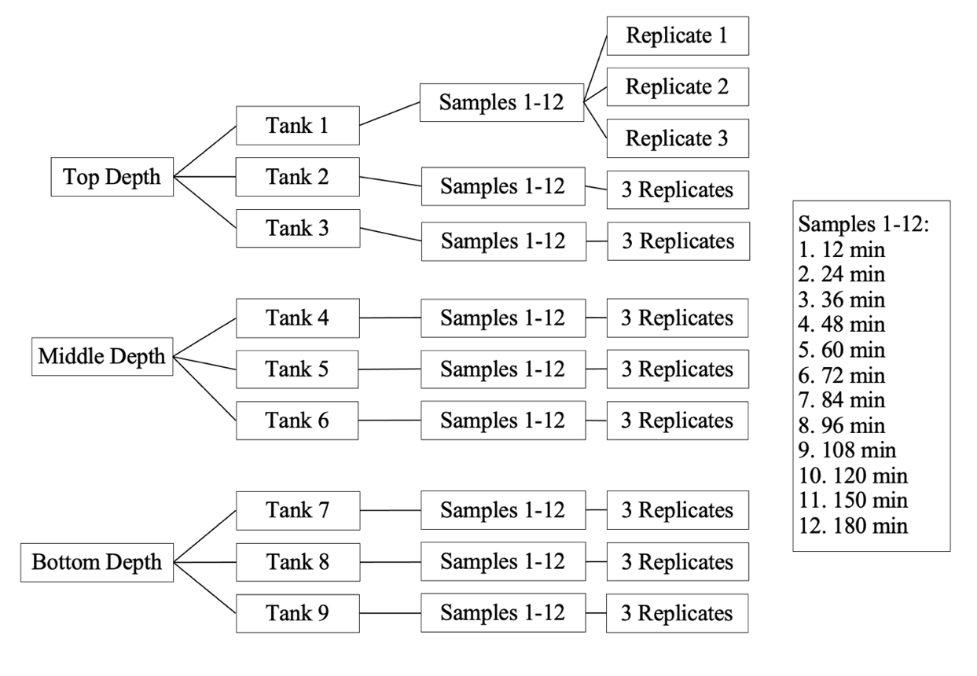
Figure 3-1: Soak tank sampling diagram

the probe was closed by twisting the inner tube, then inserted fully into the tank, at a 45º angle from the side of the tank. The sampling probe was opened, and the entire probe twisted so that beans could fall into the opening. The probe was then closed, pulled out of the tank, and emptied into a #8 sieve. The sieve was shaken for 5 seconds to remove excess water from outside of the sample. Each collected sample approximately filled a 140 mL airtight container. The sample remained in the sealed container to prevent moisture loss until the sample could be tested (about 2-3 minutes) to prevent any additional changes in moisture content. Each sample underwent the standard oven method moisture analysis following a modified AACC method 44-15.02 (Cereals & Grains Association, 1999a).

Standard Oven Method for Moisture Determination
The moisture content of the beans at each sample time was tested according to a modified version of AACC method 44-15.02 (Cereals & Grains Association, 1999a). This consisted of first grinding the sample for 5 seconds in the KN 295 Knifetec (Foss Analytical A/S, Hillerød, Denmark). Then, the sample was mixed and approximately 10 grams of sample was placed onto a pre-weighed aluminum dish and the weight was recorded. The sample dishes were then placed into an oven set to 130ºC and left overnight (about 16 hours). The samples were then removed, placed into a desiccator until they reached room temperature, and re-weighed. The moisture content of the samples was calculated on a wet basis (%MC w.b.) using the equation:
Equation 3-1
$$\%Moisture wb= \frac{(soaked weight-dried weight)}{soaked weight}*100$$

BVAT Testing
Samples of dry beans collected before the commercial soak process and water from the same source used in the commercial soak tanks were used to test the bean sample’s hydration in the BVAT. The same water temperature measured in the commercial soak tanks (120ºF) was controlled in the BVAT to replicate the commercial soak conditions. By using the same water sample at the same temperature, outside influences on hydration are minimized as could be introduced by the soaking medium.
Dry bean samples were hydrated using the BVAT according to the standard procedure (Appendix 4). Sample weight and volume was automatically recorded every three minutes during the approximately three-hour soak in the BVAT.
A dielectric moisture meter (DICKEY-John GAC 2500-UGMA) was used for the initial moisture measurement (w.b.) of the dry beans. The UGMA is used by the USDA’s Federal Grain Inspection Service to measure the moisture content of grains, pulses, and other agricultural commodities. The UGMA, compared to the air oven moisture, has a mean difference of 0 % moisture content, and a standard deviation of differences of 0.11% moisture content (USDA, 2024).

Adjusting for Fill Time
Soak tanks are filled halfway with water at the appropriate temperature before beans are added. Then beans are added to the tanks as the rest of the tank fills with water. The total time for beans to enter the tank is approximately 10 minutes. The soaking times for the different depths in the tank were adjusted to account for the additional time the beans soaked during the filling process. The bottom of the tank was adjusted by 9 minutes and the middle of the soak tank by 6 minutes.

Data Analysis
Moisture contents over time from the commercial-scale soak tanks and the bench-scale BVAT were compared using the Passing-Bablok test. This analysis was completed before and after adjusting for fill time. The Passing-Bablok test is a robust, non-parametric model which is commonly used in comparing two instruments or methods, measuring the same property (Bablok & Passing, 1985). This procedure tests the linearity of the relationship between the two methods which can both have measurement errors and can identify bias in one measurement over the other. It uses the linear equation:
Equation 3-2
$$y=A+Bx$$
Where A and B are then compared to values 0 and 1, respectively, to determine if the two methods are identical or result in bias.
Then, mathematical hydration models, Peleg and Weibull, were fit to the commercial-scale soak tank hydration data (%MC, w.b.) over time in the commercial-scale soak tank to compare hydration between the soak tank depths tested. For each model, the two unique model parameters were determined and statistically compared across the three depths.
The Peleg model (Equation 3-3) was developed to model the process of hydration.
Equation 3-3
$$M\left(t\right)=M_{0}+\frac{t}{(k_{1}+k_{2}t)}$$
Where M_{t} is the moisture content (% w.b.) at time, t, M₀ is the initial moisture content (% w.b.), and k₁ and k₂ are model parameters (Peleg, 1988). Parameter k₁ is related to water absorption rate (hr/%wt), while k₂ defines equilibrium moisture content (1/%MC; Peleg, 1988; Ramaswamy et al., 2005).
The Weibull model follows Equation 3-4 (Cunningham et al., 2007).
Equation 3-4
$$\frac{X_{t}-X_{e}}{X_{0}-X_{e}}=exp\left[-{\left(\frac{t}{B}\right)}^{A}\right]$$
Where X_{t} is the moisture content. (%w.b.) at time, t; X_{e} is the equilibrium moisture content (%w.b.), X₀ is the initial moisture content (%w.b.), and A and B are model parameters. Parameter A is the related to the rate of water uptake (dimensionless) and parameter B is the time (min) it takes to accomplish 63% of hydration to the equilibrium moisture content (Cunningham et al., 2007; Machado et al., 1999).
For each sampling depth, the average standard oven method moisture contents of triplicate bean subsamples taken from the commercial soak tanks (a total of 12 moisture contents over time) were used to fit both the Peleg and Weibull models. The root mean square error (RMSE) and the coefficient of determination (R²) were calculated for each depth to determine which model best describes the data. RMSE was calculated using Equation 3-5. R² was calculated using Equation 3-6.
Equation 3-5
$$RMSE=\sqrt{\frac{1}{N}\sum_{i=1}^{N}{{(y_{i}-ŷ)}^{2}}}$$
Equation 3-6
$$R^{2}=1-\frac{\sum{({y_{i}-ŷ)}^{2}}}{\sum{{(y_{i}-ȳ)}^{2}}}$$
Where N is the number of values in a data set, y_{i} is the measured value of y, ŷ is the predicted value of y, and ȳ is the mean value of y.
The model which had the smallest RMSE was used to compare bean hydration at different depths within the soak tanks. The two parameters for the best fitting model were compared using an ANOVA test and Tukey-Kramer multiple comparisons test to compare hydration rates. This analysis was completed before and after adjusting for fill time.
All statistical testing was completed using JMP Pro 17 (SAS institute, Inc., Cary, NC, USA).

Results and Discussion

Model
Peleg and Weibull models were fit to the moisture contents over time for each soak tank depth, using 12 data points. The RMSE of each model was calculated to find the standard deviation of the residuals and compared for each depth. This is presented in Table 3-1. While both models adequately fit the data, with RMSE under 1.0 for all depths and methods, the Weibull model presents the smallest average RMSE and largest average R², compared to the Peleg model. Weibull had an average RMSE of 0.645 and an average R² of 0.96. The Peleg model had an average RMSE of 0.729 and an average R² of 0.96. Therefore, the Weibull model was used to analyze experimental data.

Depth
The moisture contents of replicate samples from each depth in the soak tanks are shown in Appendix 8. When comparing how beans rehydrate at different depths within the soak tank, the Weibull model was used. The parameters A and B were calculated for each
Table ‎3-1: Comparison between Weibull and Peleg model parameters fit to triplicate moisture content (%w.b.) data from each depth of the commercial soak tanks (± STD)
 | Weibull Model |  |  |  |  | Peleg Model
Depth | A | B | R² | RMSE |  | k₁ | k₂ | R² | RMSE
Top | 0.51± 0.07 | 12.97± 1.89 | 0.99 | 0.52 |  | 0.21 ± 0.02 | 0.024 ± 0.0005 | 0.97 | 0.94
Middle | 0.29± 0.12 | 5.93± 0.86 | 0.92 | 0.87 |  | 0.11 ± 0.04 | 0.025 ± 0.0008 | 0.96 | 0.70
Bottom | 0.31± 0.10 | 5.43 ± 5.58 | 0.97 | 0.55 |  | 0.10 ± 0.07 | 0.024 ± 0.0004 | 0.96 | 0.55

tank sampled at the same depth, then the parameters were averaged within each depth and compared across the different depths using an ANOVA and Tukey-Kramer multiple comparisons test. The A parameters exhibited a significant difference between the top of the soak tank and the middle and bottom (P=0.013). However, there was no significant difference between B values for the different depths. These results can be seen in Table 3-2.

Method of hydration
To compare the two methods of hydration, the moisture contents determined over time
from each method (BVAT and soak tanks) were plotted against each other for the same times of soaking and compared linearly according to the Passing-Bablok test (Bablok & Passing, 1985). This test was repeated for each depth.
The linear regression coefficients, slope and intercept, and 95% confidence intervals for each comparison between commercial-scale soak tank moisture contents and bench- scale BVAT moisture contents at the same time points based on depth are shown in Table 3-3. Graphs of the comparison between methods at each depth are shown in Figure 3-2. When comparing the top of the soak tank with the BVAT, the 95% confidence interval for the intercept contains 0, with an estimated value of 6.72, and the

Table ‎3-2: Comparison of Weibull parameters calculated from moisture content data from each depth of the commercial soak tank
Depth | Weibull Model Parameters
Depth | A | B
Top | 0.51 ± 0.07 a | 12.97 ± 1.89 a
Middle | 0.29 ± 0.12 b | 5.93 ± 0.86 a
Bottom | 0.31 ± 0.10 b | 5.43 ± 5.58 a
A and B are Weibull model parameters related to initial hydration rate and time to equilibrium moisture. There is no statistical difference between values within the same column with the same letter (Alpha=0.05; P=0.013 [A]; P=0.064 [B])

Table ‎3-3: The estimates and 95% confidence intervals for the linear regression model between the moisture contents from the commercial soak tanks and the BVAT for each depth
Regression Parameter | Estimate | Lower 95% | Upper 95% | Test requirements met?
Top
Intercept | 6.72 | -0.95 | 11.32 | Yes
Slope | 0.86 | 0.78 | 1.00 | Yes
Middle
Intercept | -6.33 | -47.98 | -3.16 | No
Slope | 1.13 | 1.06 | 1.90 | No
Bottom
Intercept | -32.16 | -65.00 | -22.73 | No
Slope | 1.58 | 1.41 | 2.19 | No

A  y = 0.86x + 6.72  R² = 0.992  RMSE = 1.0 | B  y = 1.13x - 6.33  R² = 0.986  RMSE = 0.53
C  y = 1.58x - 32.2  R² = 0.985  RMSE = 1.8 | D
Figure 3-2: The linear regression models for the moisture contents from the BVAT compared to the moisture contents from the commercial soak tanks for each depth
A: top depth. B: middle depth. C: bottom depth. D: all depths

95% confidence interval for the slope contains 1, with an estimated value of 0.86. Moisture content data graphed against time for both soak tank and BVAT methods are in Appendix 9.

Adjustment for Fill Time
The soak times of the middle and bottom of the soak tank were adjusted to account for their longer soak time due to the staggered fill time of the soak tank. The moisture contents over time for the middle and bottom depths were then re-fit to the Weibull model and their parameters determined. The parameters were then averaged within each depth and compared across the different depths using an ANOVA and Tukey-Kramer multiple comparisons test. These results can be seen in Table 3-4. This comparison shows no statistical differences between the depths of the soak tank. The moisture contents from the middle and bottom of the soak tank were again compared to the BVAT method of hydration. For this analysis, the moisture contents from the BVAT at the

Table ‎3-4: Comparison of Weibull parameters calculated from moisture content data from soak tank sampling between depths of the soak tank when adjusting for tank fill time
​ | Weibull Model Parameters​
Depth​ | A​ | B​
Top​ | 0.51 ± 0.06 a​ | 12.97 ±1.9 a​
Middle​ | 0.56 ± 0.04 a​ | 11.03 ± 0.4 a​
Bottom​ | 0.52 ± 0.09 a ​ | 10.39 ± 6.8 a​
A and B are Weibull model parameters related to initial hydration rate and time to equilibrium moisture. There is no statistical difference between values within the same column with the same letter (Alpha=0.05).

adjusted soak times were used to compare. The Passing-Bablok test was used to compare the linearity of the methods (Table 3-5; Bablok & Passing, 1985). For the middle of the soak tank, the 95% confidence interval for the intercept contains 0, with an estimated value of 7.95, and the 95% confidence interval for the slope contains 1, with an estimated value of 0.87. The bottom of the soak tank did not meet the Passing-Bablok requirements. Graphs showing the linear regression can be found in Figure 3-3.

Discussion
When compared to the Peleg model, the Weibull model presents a better fit to the experimental data as can be seen by the RMSE and R² (Table 3-1). Using the Weibull
model to analyze differences by depth within the commercial soak tanks, there is a significant difference in the A parameter for the top of the tank compared to the middle and the bottom of the tank. For the B parameter, this test showed no statistical differences across depth (Table 3-2). The top of the soak tank has a statistically lower

Table ‎3-5: The estimates and 95% confidence intervals for the linear regression model between the moisture contents from the commercial soak tanks and the BVAT for each depth when adjusted for fill time
Parameter | Estimate | Lower 95% | Upper 95% | Test requirements met?
Adjusted Middle
Intercept | 7.95 | -0.523 | 14.03 | Yes
Slope | 0.87 | 0.75 | 1.03 | Yes
Adjusted Bottom
Intercept | -17.87 | -35.71 | -2.34 | No
Slope | 1.32 | 1.04 | 1.65 | No

A  y = 0.87x + 7.95  R² = 0.9814  RMSE= 1.0 | B  y = 1.32x – 17.87  R²= 0.968  RMSE= 0.61
Figure 3-3: Linear regression graphs for the moisture contents from the commercial soak tank hydration method compared against moisture contents from the BVAT hydration method for middle (A) and bottom depths (B), adjusted for fill time (6 and 9 minutes, respectively)

initial rate of hydration than the middle and bottom. However, all three depths had similar times to 63% of hydration, which is around 35% moisture (w.b.) for these samples, as seen in Appendix 9.
After adjusting for the fill time of the soak tanks and comparing across depths, there is no significant difference between hydration rate at the different depths. From this, we can reason that the reason for the initial difference in the soak tank depths is due to the difference in soaking time because of the staggered fill of the tank. While pressure and temperature differences may influence hydration as suggested by literature (Naviglio et al., 2013; Zanella-Díaz et al., 2014), this influence in non-significant.
The Passing-Bablok test was used to test how well the BVAT models the hydration within the soak tank. The BVAT displays a strong linear relationship with each soak tank depth (all R² > 0.985). The top depth exhibits the best fit with an R² of 0.992 and an RMSE of 0.370. According to the Passing-Bablok test, the hydration in the BVAT is identical to the hydration at the top of the soak tank.
After adjusting for fill time, the relationship between the BVAT and the middle of the soak tank becomes stronger. According to the Passing-Bablok test, when adjusted, the hydration in the BVAT is identical to the hydration at the middle of the soak tank. The bottom depth of the soak tank exhibited a liner relationship, with a strong R² (0.968) and RMSE (0.61).
The BVAT can be further used to evaluate new crops or cultivars of navy beans to determine the most efficient commercial processing parameters to reach equilibrium moisture. Then applied to potentially reduce soaking and therefore processing time for each new cultivar of bean processed for commercial canning.

Conclusions
The initial variation in the depths of the soak tanks can be explained by the time it takes the soak tank to fill. Within the soak tank, all levels consistently took the same time to reach 63% of hydration as shown by the B Weibull parameter. The BVAT has a strong linear relationship with all levels of the soak tank. The Passing-Bablok tests proves the hydration at the top and middle of the soak tank is identical to that which occurs in the BVAT.
In production settings, the top of the soak tank will hydrate the slowest due to the middle and bottom of the soak tanks soaking longer. In this case, it is necessary to monitor the slowest hydrating beans and ensure all beans in the soak tank rehydrate sufficiently. The BVAT accurately models the hydration which occurs at the top of the soak tank and can therefore be used to model the hydration in the soak tank and ensure all of the beans in the soak tank rehydrate sufficiently. Understanding the time of moisture equilibration is more important than the initial hydration because bean need to reach above 50% prior to processing. All depths of the soak tank showed no significant difference in their time to 63% of equilibrium moisture.

LIST OF REFERENCES
Abu-Ghannam, N. (1998). Modelling textural changes during the hydration process of red beans. Journal of food engineering, 38(3), 341-352. https://doi.org/10.1016/S0260-8774(98)00127-7
Adnan, A., von Hörsten, D., Pawelzik, E., & Mörlein, D. (2017). Rapid prediction of moisture content in intact green coffee beans using near infrared spectroscopy. Foods, 6(5), 1-11. https://doi.org/10.3390/foods6050038
Ávila, B. P., Santos dos Santos, M., Nicoletti, A. M., Alves, G. D., Elias, M. C., Monks, J., & Gularte, M. A. (2015). Impact of Different Salts in Soaking Water on the Cooking Time, Texture and Physical Parameters of Cowpeas. Plant foods for human nutrition (Dordrecht), 70(4), 463-469. https://doi.org/10.1007/s11130-015-0504-7
Ayyagari, R., Narasinga Rao, B. S., & Roy, D. N. (1989). Lectins, trypsin inhibitors, BOAA and tannins in legumes and cereals and the effects of processing. Food chemistry, 34(3), 229-238. https://doi.org/10.1016/0308-8146(89)90143-X
Azzouz, S., Guizani, A., Jomaa, W., & Belghith, A. (2002). Moisture diffusivity and drying kinetic equation of convective drying of grapes. Journal of food engineering, 55(4), 323-330.
Bablok, W., & Passing, H. (1985). Application of statistical procedures in analytical instrument testing. Journal of analytical methods in chemistry, 7(2), 74-79. https://doi.org/10.1155/s1463924685000177
Bala, B. K. (2017). Moisture Contents and Equilibrium Moisture Content Models. In (2nd Edition ed., pp. 1-1). John Wiley & Sons. https://doi.org/10.1002/9781119124207.ch2
Bilić-Zulle, L. (2011). Comparison of methods: Passing and Bablok regression. Biochemia medica, 21(1), 49-52. https://doi.org/10.11613/bm.2011.010
Cunha, L. M., Oliveira, F. A. R., & Oliveira, J. C. (1998). Optimal experimental design for estimating the kinetic parameters of processes described by the Weibull probability distribution function. Journal of food engineering, 37(2), 175-191. https://doi.org/10.1016/S0260-8774(98)00085-5
Cunningham, S. E., McMinn, W. A. M., Magee, T. R. A., & Richardson, P. S. (2007). Modelling water absorption of pasta during soaking. Journal of food engineering, 82(4), 600-607. https://doi.org/10.1016/j.jfoodeng.2007.03.018
de León, L. F., Elías, L. G., & Bressani, R. (1992). Effect of salt solutions on the cooking time, nutritional and sensory characteristics of common beans ( Phaseolus vulgaris). Food research international, 25(2), 131-136. https://doi.org/10.1016/0963-9969(92)90154-W
Devkota, L., He, L., Midgley, J., & Haritos, V. S. (2022). Effect of seed coat microstructure and lipid composition on the hydration behavior and kinetics of two red bean (Phaseolus vulgaris L.) varieties. Journal of food science, 87(2), 528-542. https://doi.org/10.1111/1750-3841.16030
Esau, K. (1960). Anatomy of seed plants. Wiley.
Flor, O., Palacios, H., Suárez, F., Salazar, K., Reyes, L., González, M., & Jiménez, K. (2022). New Sensing Technologies for Grain Moisture. Agriculture (Basel), 12(3), 386. https://doi.org/10.3390/agriculture12030386
Foke, V., & Kuljarni, D. (2018). Application of Peleg's equation to model the water absorption behaviour of green gram during soaking.
Gargiulo, L., Sorrentino, G., & Mele, G. (2020). 3D imaging of bean seeds: Correlations between hilum region structures and hydration kinetics. Food research international, 134, 109211-109211. https://doi.org/10.1016/j.foodres.2020.109211
Ghafoor, M., Misra, N. N., Mahadevan, K., & Tiwari, B. K. (2014). Ultrasound assisted hydration of navy beans (Phaseolus vulgaris). Ultrasonics sonochemistry, 21(1), 409-414. https://doi.org/10.1016/j.ultsonch.2013.05.016
Godrich, J., Rose, P., Muleya, M., & Gould, J. (2023). The effect of popping, soaking, boiling and roasting processes on antinutritional factors in chickpeas and red kidney beans. International journal of food science & technology, 58(1), 279-289. https://doi.org/10.1111/ijfs.16190
Haileslassie, H. A., Henry, C. J., & Tyler, R. T. (2019). Impact of pre‐treatment (soaking or germination) on nutrient and anti‐nutrient contents, cooking time and acceptability of cooked red dry bean (Phaseolus vulgaris L.) and chickpea (Cicer arietinum L.) grown in Ethiopia. International journal of food science & technology, 54(8), 2540-2552. https://doi.org/10.1111/ijfs.14165
Hermida, M., Rodriguez, N., & Rodriguez-Otero, J. L. (2006). Determination of Moisture, Starch, Protein, and Fat in Common Beans (Phaseolus vulgaris L.) by Near Infrared Spectroscopy. Journal of AOAC International, 89(4), 1039-1041. https://doi.org/10.1093/jaoac/89.4.1039
Howard, L. R., White, B. L., Uebersax, M. A., & Siddiq, M. (2018). Dry beans processing, quality evaluation, and nutrition. Handbook of vegetables and vegetable processing, 559-587.
Isengard, H. D. (1995). Rapid water determination in foodstuffs. Trends in Food Science & Technology, 6(5), 155-162. https://doi.org/10.1016/S0924-2244(00)89024-X
Johnny, S., Razavi, S. M. A., & Khodaei, D. (2015). Hydration kinetics and physical properties of split chickpea as affected by soaking temperature and time. Journal of food science and technology, 52(12), 8377-8382. https://doi.org/10.1007/s13197-015-1893-1
Jones, S. B., Sheng, W., & Or, D. (2022). Dielectric Measurement of Agricultural Grain Moisture-Theory and Applications. Sensors (Basel, Switzerland), 22(6), 2083. https://doi.org/10.3390/s22062083
Kaptso, K. G., Njintang, Y. N., Komnek, A. E., Hounhouigan, J., Scher, J., & Mbofung, C. M. F. (2008). Physical properties and rehydration kinetics of two varieties of cowpea ( Vigna unguiculata) and bambara groundnuts ( Voandzeia subterranea) seeds. Journal of food engineering, 86(1), 91-99. https://doi.org/10.1016/j.jfoodeng.2007.09.014
Leal-Oliveira, A., Colnaghi, B. G., Silva, E. Z. d., Gouvêa, I. R., Vieira, R. L., & Augusto, P. E. D. (2013). Modelling the effect of temperature on the hydration kinetic of adzuki beans (Vigna angularis). Journal of food engineering, 118(4), 417-420. https://doi.org/10.1016/j.jfoodeng.2013.04.034
Lo, W. Y. L., Steinkraus, K., Hand, D., Hackler, L., & Wilkens, W. (1968). Soaking soybeans before extraction as it affects chemical composition and yield of soymilk. Food Technology, 22(9), 1188-+.
Lopez, L. R. L., Ulloa, J. A., Ulloa, P. R., Ramirez, J. C. R., Carrillo, Y. S., & Ramos, A. Q. (2017). MODELLING OF HYDRATION OF BEAN : EFFECT OF THE LOW-FREQUENCY ULTRASOUND. Italian journal of food science, 29(2), 288. https://doi.org/10.14674/1120-1770/ijfs.v686
Machado, M. F., Oliveira, F. A. R., & Cunha, L. M. (1999). Effect of milk fat and total solids concentration on the kinetics of moisture uptake by ready-to-eat breakfast cereal. International journal of food science & technology, 34(1), 47-57. https://doi.org/10.1046/j.1365-2621.1999.00238.x
Makky, M., Santosa, Putri, R. E., & Nakano, K. (2019, 2019). Determination of moisture content in rice using non-destructive short-wave near infrared spectroscopy. Melville.
Mannam, V. K. (2013). Design and Development of Seed Hydration Analyzing Device and its Utilization in Studying Cereal and Legume Hydration
Mannam, V. K., Worley, S. K., Smith, D. R., Wilkerson, J. B., & Harte, F. M. (2013). Automatic Seed Hydration Analysis System: Design and Evaluation. Transactions of the ASABE, 56(6), 1449-1455. https://doi.org/10.13031/trans.56.10291
Matella, N. J., Mishra, D. K., & Dolan, K. D. (2012). Hydration, blanching and thermal processing of dry beans. Dry beans and pulses production, processing and nutrition, 129-154.
Miano, A. C., & Augusto, P. E. D. (2015). From the sigmoidal to the downward concave shape behavior during the hydration of grains: Effect of the initial moisture content on Adzuki beans (Vigna angularis). Food and bioproducts processing, 96, 43-51. https://doi.org/10.1016/j.fbp.2015.06.007
Miano, A. C., García, J. A., & Augusto, P. E. D. (2015). Correlation between morphology, hydration kinetics and mathematical models on Andean lupin (Lupinus mutabilis Sweet) grains. Food science & technology, 61(2), 290-298. https://doi.org/10.1016/j.lwt.2014.12.032
Miano, A. C., Saldaña, E., Campestrini, L. H., Chiorato, A. F., & Augusto, P. E. D. (2018). Correlating the properties of different carioca bean cultivars (Phaseolus vulgaris) with their hydration kinetics. Food research international, 107, 182-194. https://doi.org/10.1016/j.foodres.2018.02.030
Miranda, L. B., Moura, B. A. d., Martins, G. A. d. S., Coelho, A. F. S., & Silva, W. G. d. (2019). Statistical modelling of the soaking kinetics of corn and soybean cultivars. Acta scientiarum. Technology, 41(1), 41803-e41803. https://doi.org/10.4025/actascitechnol.v41i1.41803
Naviglio, D., Formato, A., Pucillo, G. P., & Gallo, M. (2013). A cyclically pressurised soaking process for the hydration and aromatisation of cannellini beans. Journal of food engineering, 116(3), 765-774. https://doi.org/10.1016/j.jfoodeng.2013.01.017
Nicolaï, B. M., Beullens, K., Bobelyn, E., Peirs, A., Saeys, W., Theron, K. I., & Lammertyn, J. (2007). Nondestructive measurement of fruit and vegetable quality by means of NIR spectroscopy: A review. Postharvest biology and technology, 46(2), 99-118. https://doi.org/10.1016/j.postharvbio.2007.06.024
Paulsen, M. R., Singh, M., & Singh, V. (2019). Chapter 7 - Measurement and Maintenance of Corn Quality. In S. O. Serna-Saldivar (Ed.), Corn (Third Edition) (pp. 165-211). AACC International Press. https://doi.org/https://doi.org/10.1016/B978-0-12-811971-6.00007-3
Peleg, M. (1988). An Empirical Model for the Description of Moisture Sorption Curves. Journal of food science, 53(4), 1216-1217, 1219. https://doi.org/10.1111/j.1365-2621.1988.tb13565.x
Polachini, T. C., Norwood, E.-A., Le-Bail, P., Le-Bail, A., & Cárcel, J. A. (2023). Pulsed electric field (PEF) application on wheat malting process: Effect on hydration kinetics, germination and amylase expression. Innovative food science & emerging technologies, 86, 103375. https://doi.org/10.1016/j.ifset.2023.103375
Popescu, E., & Golubev, I. (2012). Beans nutrition, consumption and health. Nova Science Publishers.
Ramaswamy, R., Balasubramaniam, V. M., & Sastry, S. K. (2005). Effect of High Pressure and Irradiation Treatments on Hydration Characteristics of Navy Beans. International journal of food engineering, 1(4), 3. https://doi.org/10.2202/1556-3758.1024
Saguy, S., Marabi, A., & Wallach, R. (2005). New approach to model rehydration of dry food particulates utilizing principles of liquid transport in porous media. Trends in Food Science & Technology, 16(11), 495-506. https://doi.org/10.1016/j.tifs.2005.07.006
Serson, W., Armstrong, P., Maghirang, E., Al‐Bakri, A., Phillips, T., Al‐Amery, M., Su, K., & Hildebrand, D. (2020). Development of Whole and Ground Seed Near‐Infrared Spectroscopy Calibrations for Oil, Protein, Moisture, and Fatty Acids in Salvia hispanica. Journal of the American Oil Chemists' Society, 97(1), 3-13. https://doi.org/10.1002/aocs.12300
Solomon, W. K. (2009). HYDRATION KINETICS OF ROASTED LUPIN (LUPINUS ALBUS) SEEDS. Journal of food processing and preservation, 33(s1), 214-225. https://doi.org/10.1111/j.1745-4549.2008.00294.x
Su, K., Maghirang, E., Tan, J. W., Yoon, J. Y., Armstrong, P., Kachroo, P., & Hildebrand, D. (2022). NIR spectroscopy for rapid measurement of moisture and cannabinoid contents of industrial hemp (Cannabis sativa). Industrial crops and products, 184, 115007. https://doi.org/10.1016/j.indcrop.2022.115007
Tavčar, E., Turk, E., Kreft, S., & Araújo, A. N. (2012). Simple Modification of Karl-Fischer Titration Method for Determination of Water Content in Colored Samples. Journal of analytical methods in chemistry, 2012(2012), 1-6. https://doi.org/10.1155/2012/379724
Tucker, G., & Featherstone, S. (2021). Essentials of Thermal Processing (2nd ed.). John Wiley & Sons, Incorporated.
USDA. (2024). US Standards for Beans. https://www.ams.usda.gov/grades-standards/beans
Wang, D., Chen, G., Yang, B., Chen, X., Song, J., Kong, X., & Kan, J. (2022). Kinetic study on soybean hydration during soaking and resulting softening kinetic during cooking. Journal of food science, 87(1), 266-279. https://doi.org/10.1111/1750-3841.15984
Workman Jr, J., & Shenk, J. (2004). Understanding and using the near‐infrared spectrum as an analytical method. Near‐infrared spectroscopy in agriculture, 44, 1-10.
Zanella-Díaz, E., Mújica-Paz, H., Soto-Caballero, M. C., Welti-Chanes, J., & Valdez-Fragoso, A. (2014). Quick hydration of tepary (Phaseolus acutifolius A. Gray) and pinto beans (Phaseolus vulgaris L.) driven by pressure gradients. Food science & technology, 59(2), 800-805. https://doi.org/10.1016/j.lwt.2014.05.042
Zhang, L., & McCarthy, M. J. (2013). NMR study of hydration of navy bean during cooking. Food science & technology, 53(2), 402-408. https://doi.org/10.1016/j.lwt.2013.03.011
Zhu, Z., Chen, S., Wu, X., Xing, C., & Yuan, J. (2018). Determination of soybean routine quality parameters using near‐infrared spectroscopy. Food science & nutrition, 6(4), 1109-1118. https://doi.org/10.1002/fsn3.652

APPENDIX
Appendix 1: BVAT Parts and Model Numbers
Part | Model Number | Manufacturer
Water bath | Isotemp 6200 H24 | Fisher Scientific, Inc
Programmable Logic Controller | D0-06DR-D | AutomationDirect
Human-Machine Interface | CM5-T7W | AutomationDirect
Ultrasonic level sensor | UNAM 12U9914/S14 | Baumer Ltd.
Load Cell | LFS 270-M3 1 | Cooper Instruments & Systems
Solenoid Valves | 1335BV3T | Jefferson Solenoid Valves USA
Diaphragm (Drain) Pump | 1335BV3T | W. W. Grainger
Centrifugal (Fill) Pump | 33BPLA | Franklin Electric
Level Switch | LLE101000 | Honeywell International Inc.

Appendix 2: The BVAT program with a list of addresses and their tag names
Address | Tag Name
V3000 | USLS
V2000 | Load Cell 1
V2002 | Load Cell 2
V2004 | Load Cell 3
C2 | Priming button*
C10 | Start button*
C11 | End button*
C14 | Stop button*
C24 | Drain and end button*
C25 | Sample loaded button*
C30 | USLS graph
C40 | LC1 graph
C50 | LC2 graph
C60 | LC3 graph
C51-56 | Visibility on HMI
X21 | LS- overflow
X3 | LS1
X0 | LS3
X1 | LS2
Y0 | Fill Pump
Y1 | Drain Pump
Y4 | Valve IN
Y5 | Valve IN1
Y6 | Valve OUT1
Y7 | Valve IN2
Y10 | Valve OUT2
Y11 | Valve IN3
Y12 | Valve OUT3
*All buttons on HMI

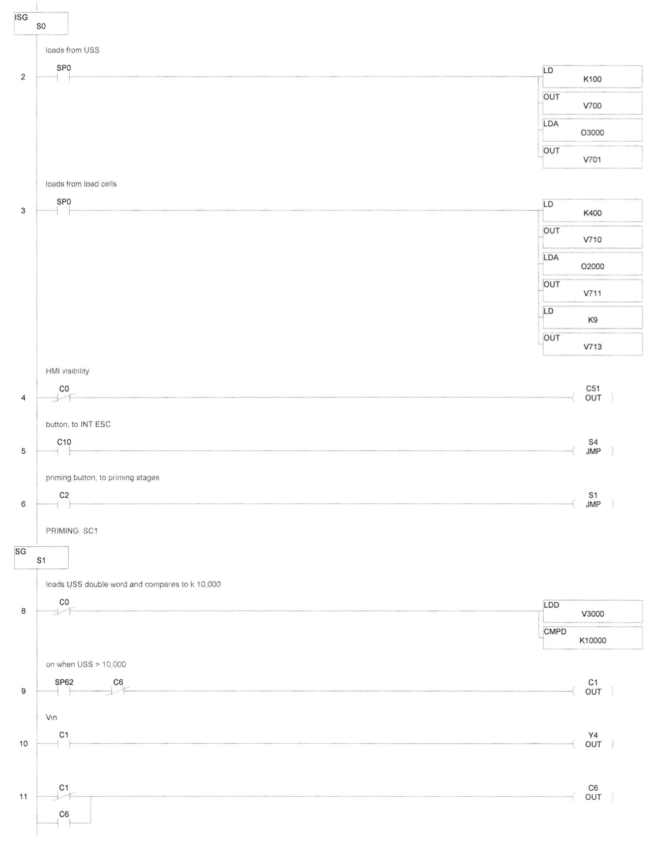
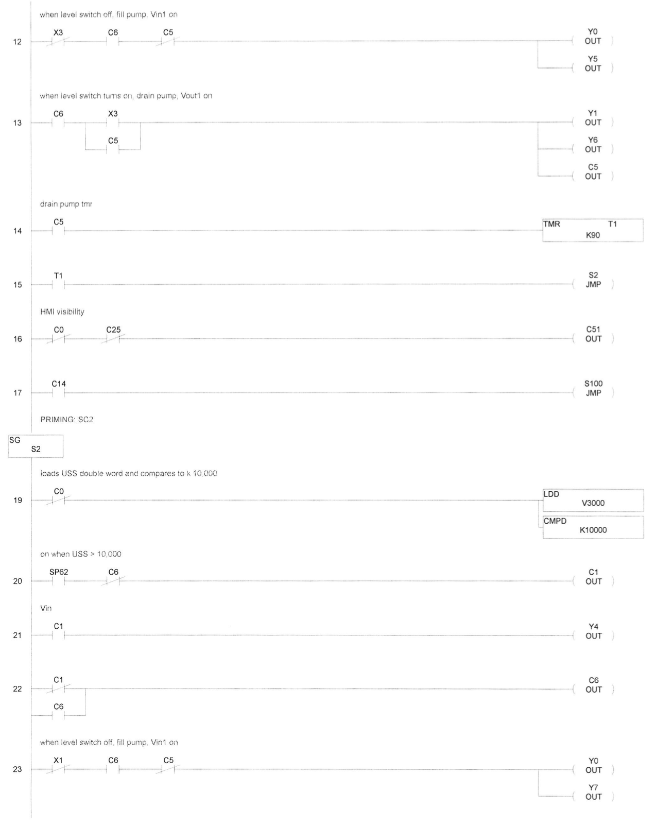
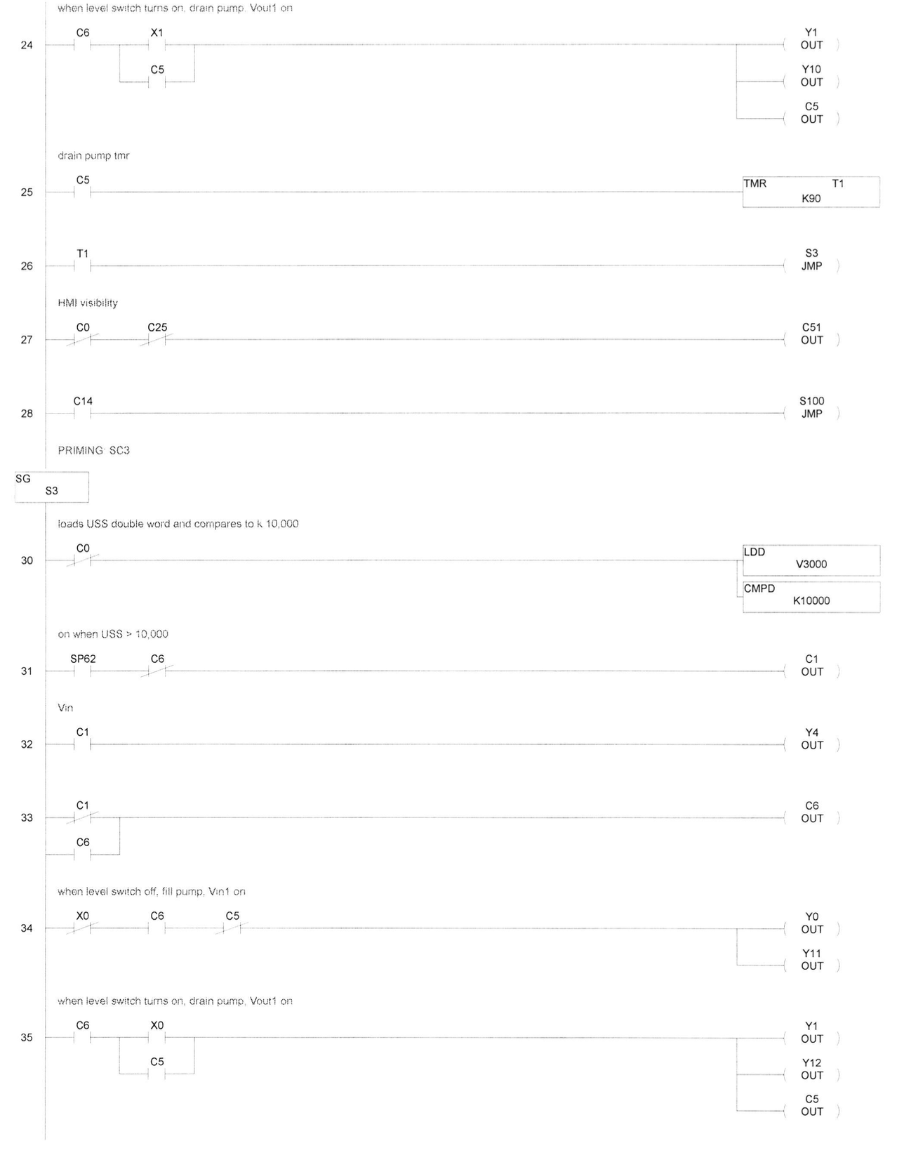
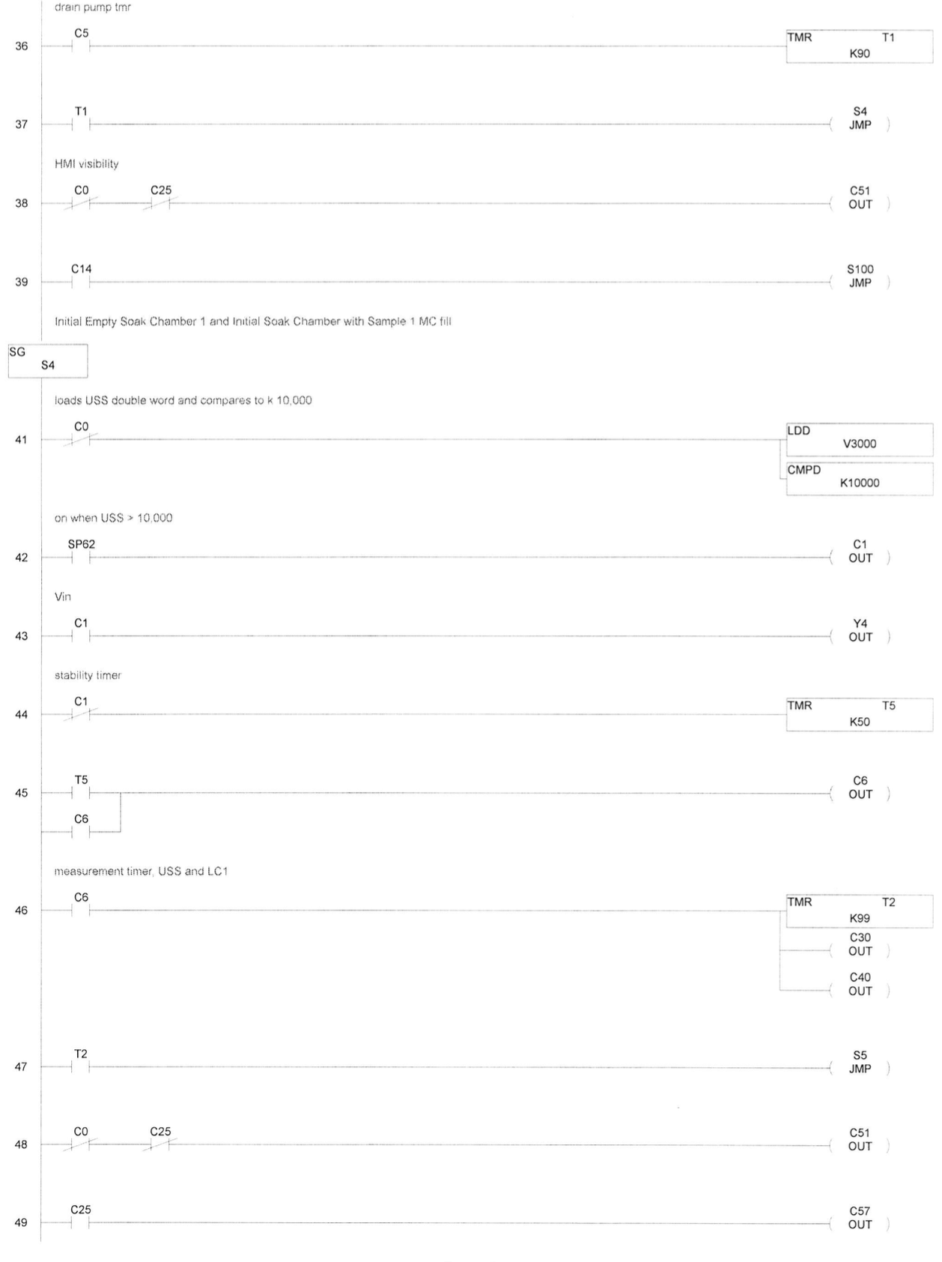
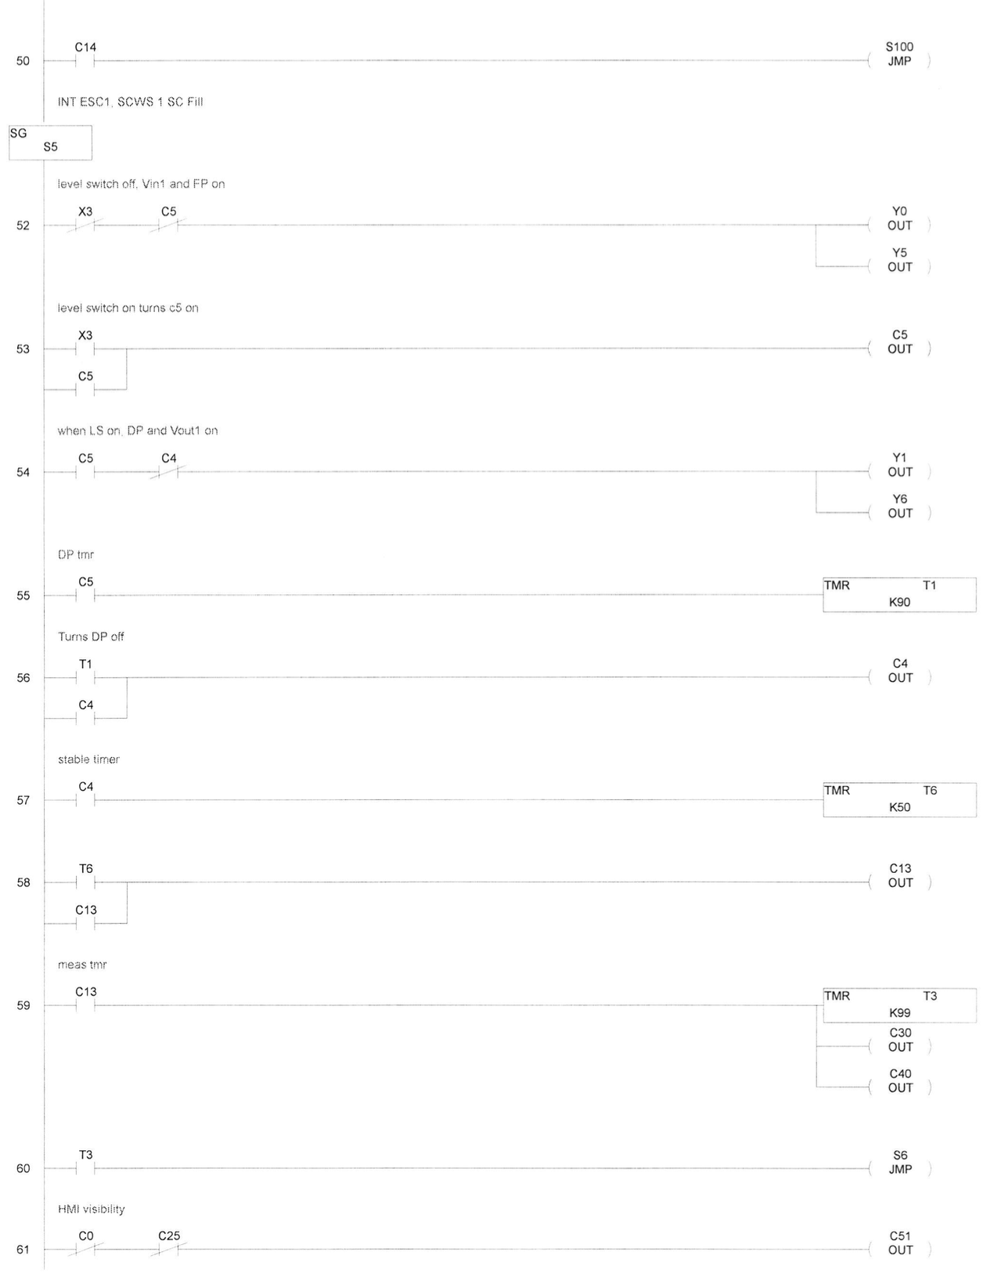
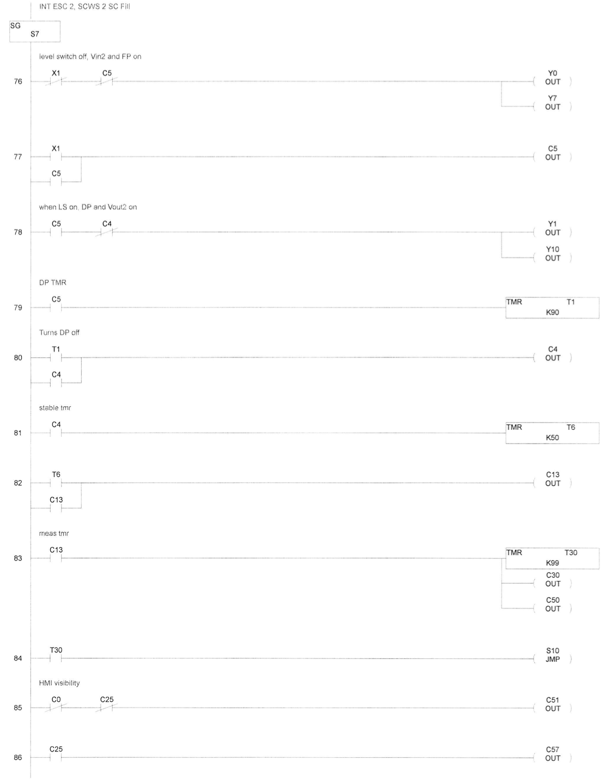
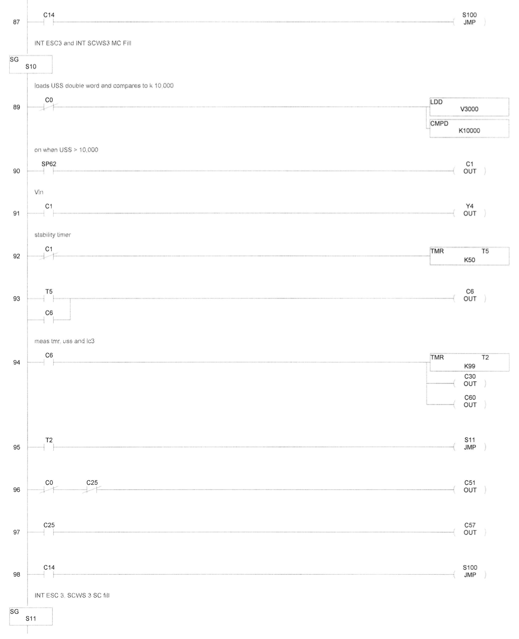


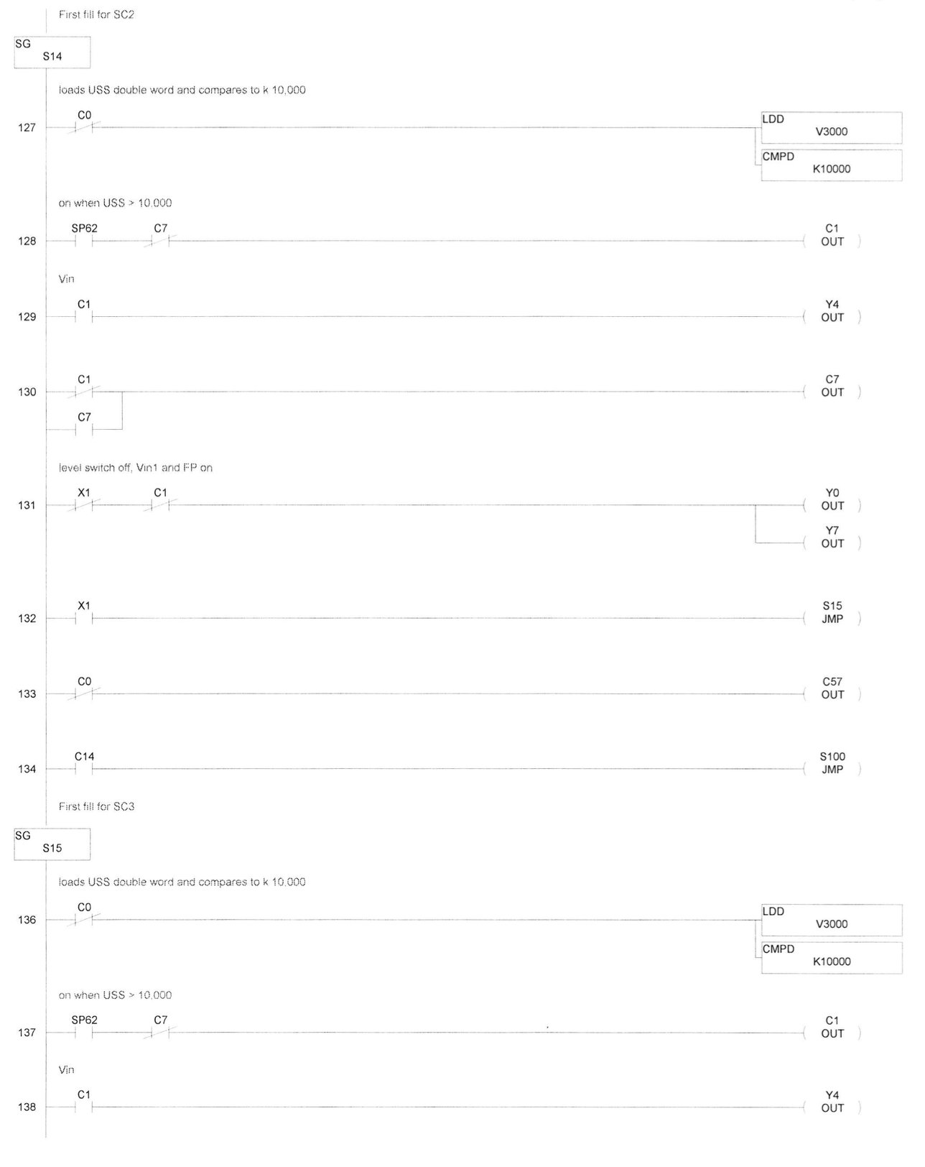




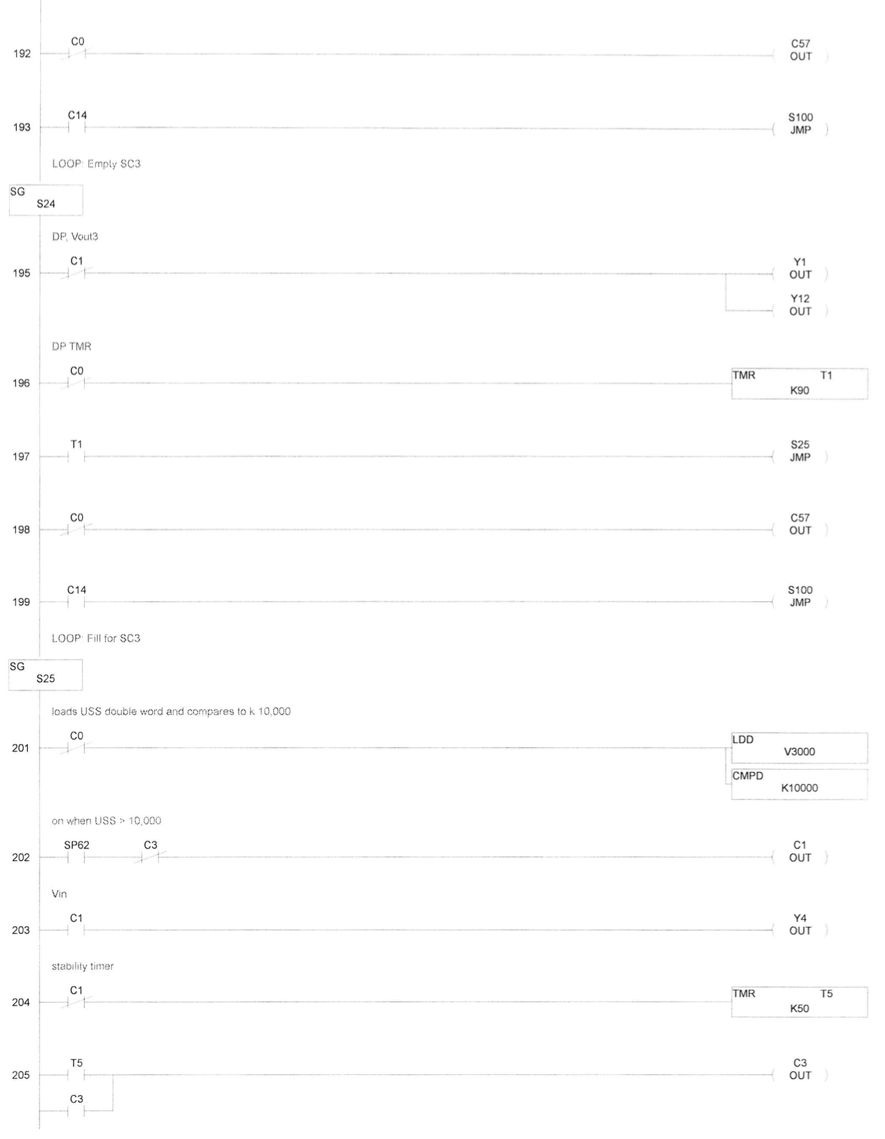

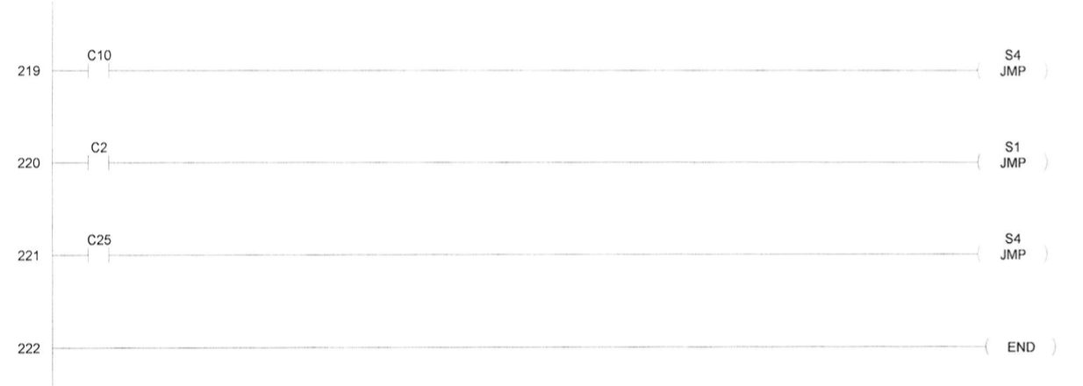

Appendix 3: BVAT standard method and HMI screenshots
- Turn on the BVAT and allow to warm up for 1 hour
- Fill up the water bath with the water you want to test with and turn it on and allow it time to circulate and heat up to the temperature you want to test.
- After the warmup hour, turn off the water bath and hook it up to the BVAT. Ensure the tube from the drain pump connects to the inlet of the water bath and the tube from Valve in connects to the outlet of the water bath.
- Ensure each of the sample baskets are in their respective chambers by hanging them from the load cell.
- Turn the water bath on and hit the “prime” button on the HMI.
- Allow the BVAT time to prime. The tubing and pumps in the system will fill with water, allowing for a more accurate volume measurement.
- In the meantime, weigh out three 40-gram samples of the beans you want to test and record the weights.
- When prompted, add the samples into their respective baskets, return the baskets to their respective chambers, and hit the “sample loaded” button on the HMI.
- Allow the BVAT to run for the amount of time needed. Due to the repeated draining of the BVAT, run for 1.24 times longer than what you want to test (for example, if testing a three-hour soak, run for three hours and forty-three minutes).
- Once the BVAT has run long enough, hit the stop button on the BVAT as well as the water bath. Then, use the equipment controls to open the 6 soak chamber valves (Vin1,2,3 and Vout1,2,3) and turn on the drain pump. Keep the pump on until all water has left the system. Then, remove the samples from the baskets, and drain the water from the water bath.
- Turn off the BVAT and remove the SD card containing the collected data from the HMI. Upload this data onto a separate computer and convert the computer readings to measurements.
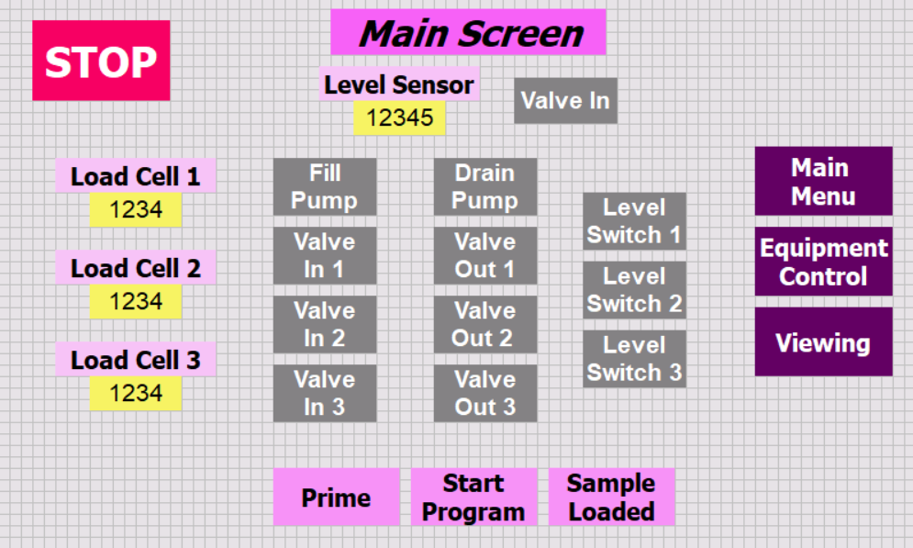
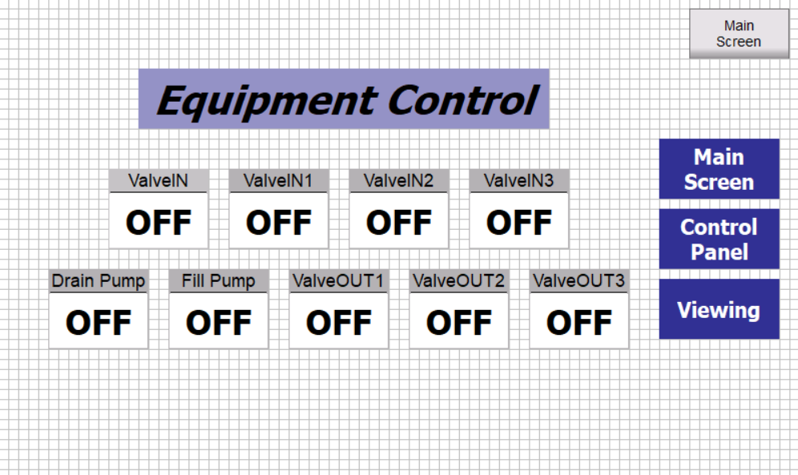
Appendix 4:
Regression between the voltage reading recorded from the load cells and the weight of the sample without adjustment for water cling for each load cell. ● = load cell 1, y=0.0301x – 100.52, R²=1; ▼ = load cell 2, y=0.0291x-100.96, R²=1; ■ = load cell 3, y=0.0267x-96.689, R²=1.

Equation for soak chamber 1:
$$W_{t}=\left(0.0301*R_{t}-100.52\right)+\left(W_{i}-(0.0301*R_{1}-100.52\right))$$
Equation for soak chamber 2:
$$W_{t}=\left(0.0291*R_{t}-100.96\right)+\left(W_{i}-(0.0291*R_{1}-100.96\right))$$
Where W_{t} is the weight of the sample (g) at time, t, R is the reading from load cell (counts) at time, t, W_{i} is the initial weight of sample before being placed in the BVAT (g), R₁ is the first reading from the load cell once the sample is put into the BVAT (counts), and constants are from regression equation.

Regression between the counts recorded from the ultrasonic level sensor and the volume of the measuring chamber (y=-0.0169x+1209.5, R²=1).

Appendix 5: Moisture content versus time for each soak chamber of the BVAT using the same lot of navy beans and DI water at 49ºC. See Table 2-3.

Appendix 6: Moisture contents versus time for the standard method and the BVAT method of moisture determination when testing the same lot of navy beans with DI water at 49ºF. The blue circles are BVAT moisture calculations, red squares are standard method moisture readings. See Table 2-4.

Appendix 7: Moisture contents determined by the BVAT at five different soak water temperatures when testing the same lot of navy beans
See Table 2-5.

Appendix 8: Moisture contents (% w.b.) over time (min) for each replicate at each depth of the commercial-scale soak tank. T1, T2, and T3 represent the three replicates sampled from the top of the soak tank. M1, M2, and M3 represent the three replicates sampled from the middle of the soak tank. B1, B2, and B3 represent the three replicates sampled from the bottom of the soak tank.

Appendix 9: Moisture content versus time for the commercial soak tank and BVAT hydration methods for the top (A), middle (B), and bottom (C) depths

A.

B.

C.

VITA
Erin Strickland grew up in Knoxville, Tennessee and graduated from Bearden High School. She attended the University of Tennessee, Knoxville and received a Bachelor of Science in Food Science. During her undergraduate years, Erin interned with Bush Brothers and Company who were generous enough to support her education. She received a Master of Science degree in Food Science with a focus on Food Engineering and Processing. After graduation, she will start her new position in the food industry. She is grateful for all the support from her parents, sisters, and friends as she begins her new career.

