Honors BCMB and Chancellor’s Honors Program Research Thesis Project
Investigating the Role of the Rough Deal Protein in Spindle Assembly Complex Signaling
Ryan Mihealsick
Bruce McKee PhD, Quitao He
The University of Tennessee, Knoxville
August, 2018

Abstract
The spindle assembly checkpoint (SAC) is the metaphase/anaphase checkpoint that ensures the faithful bipolar segregation of chromosomes during the M phase of the cell cycle. After nuclear envelope breakdown in late prophase, a large number of proteins are recruited to kinetochores to establish a stoichiometric inhibition of a key protein in cell cycle progression, the anaphase promoting complex/cyclosome (APC/C). To inhibit the APC/C, the main function of the SAC signaling pathway is to sequester the effector of the APC/C, Cdc20. Though the outcome of effective SAC signaling is clear, the diverse roles of the many proteins are still being characterized. The rough deal protein (Rod) is a protein that is known to be involved with the transport and removal of Mad2, another component of the SAC, to and from the kinetochore, but null mutations in these proteins have different effects on the viability of the organism. rod null mutants are lethal, whereas mad2 null mutation is not, leading to the postulation that Rod has additional, uncharacterized importance in SAC signaling. By using a bubR1-KEN;rod double mutant, we hope to learn more about the involvement of Rod in Drosophila meiosis.
Introduction/Background
The Rough Deal protein is a widely conserved eukaryotic protein that plays a role in mitosis and meiosis. In Drosophila, cell cycle progression is an incredibly complex and well-studied mechanism of cellular division that is regulated by fail-safe checkpoints to ensure the fidelity of chromosomal segregation. One of these highly conserved checkpoints is seen in dividing mitotic and meiotic cells and is known as the spindle assembly checkpoint. The spindle assembly checkpoint (SAC) is the metaphase checkpoint tasked with the vital role of guaranteeing the bipolar segregation of chromosomes during anaphase. To do this, the SAC monitors kinetochore-microtubule interactions, giving a dividing cell feedback on two aspects of the connection: the first being appropriate microtubule tension forces and the second being appropriate microtubule attachment. Once the attachment is made and appropriate tension is applied bi-directionally, the SAC becomes inactivated through active transport of SAC proteins from the kinetochore, and the cell cycle progresses into anaphase. The complexity of the SAC mechanism comes from the many proteins involved and the interplay amongst them to generate a proficient cell-cycle arrest from metaphase leading into anaphase. The rough deal protein is multifunctional in its role in the SAC, contributing to SAC protein recruitment and the recruitment of the dynein-dynactin complex that removes SAC proteins from the kinetochores. However, the function of Rod has not been completely characterized and its role in promoting SAC signaling remains unclear.
The chief role of the SAC in arresting cell cycle progression can be attributed to the inhibition of an E3 ubiquitin ligase known as the anaphase promoting complex/cyclosome through sequestering its effector, cell-division cycle protein 20 (CDC20). Upon forming a complex with CDC20, the anaphase promoting complex/cyclosome (APC/C; APC/C^{CDC20}) triggers the breakdown of two important cell cycle inhibitors, securin and cyclin B, through targeting these proteins for destruction by polyubiquitylation. Securin targets the protease, separase. Separase is required at the onset of anaphase to cleave the cohesin complex that holds sister chromatids together (8). By targeting and inhibiting separase, securin effectively maintains the force holding the two sister chromatids together. The other target of the APC/C, cyclin B, is an M phase cyclin that forms a complex with cyclin-dependent-kinase 1 (CDK1) which phosphorylates and activates many proteins in the early stages of a dividing cell. Upon polyubiquitylation and subsequent breakdown of these two proteins, the cell will exit metaphase and sister chromatid separation will progress (8). Now, when the two aspects of kinetochore-microtubule attachment are not appropriate bi-directionally, proponents of the SAC sequester the effector of the APC/C, CDC20, and inhibit breakdown of securing and cyclin B by the cyclosome (Fig. 7).
Among the key proponents of the SAC are the mitotic arrest deficient proteins, Mad1 and Mad2, and budding inhibited by benzimidazole and related proteins, Bub1, Bub3 and BubR1. A unique interplay between these proteins and other SAC proteins directly inhibits the APC/C from triggering the premature progression into anaphase. Mad2 and BubR1 are recruited to kinetochores and form the mitotic checkpoint complex (MCC) with Bub3, and Cdc20 (2). Mad2 and BubR1 bind Cdc20 and therefore directly inhibit the progression of the cell cycle into anaphase by stopping the formation of the APC/C^{CDC20} complex. When proper microtubule-kinetochore attachment is not present, large numbers of the SAC proteins, including those involved in the MCC, localize to the unattached kinetochore and trigger a signaling cascade to stop anaphase onset. Significantly, one study shows that a depletion of proteins involved in the RZZ complex (Rod, Zw10, and Zwilch) results in decreased levels of Mad1/Mad2 complexes at the kinetochores, suggesting that Rod has a central role in the localization of Mad1/Mad2 for MCC formation. A null mutation of rod is lethal, whereas a null mutation of mad2 is viable (3), giving rise to the idea that Rod affects the SAC more robustly than a simple transport of Mad2/Mad1 to the kinetochore. Rod is continuously recruited to and discarded from kinetochores throughout prometaphase and anaphase (with the RZZ complex) (4), and given the lethality of a rod null mutation, discovering the other functions of the protein in the SAC is a point of great interest.
Rod is a 240 kDa protein with a gene locus that is approximately 8.5 kb pairs on the tip of the 3rd chromosome. It is a part of the RZZ complex in drosophila that is vital to the function of the cell. A null mutation in rod is a lethal mutation, signifying the importance of the protein in cell function (1). There are some rod mutants that are viable but still have a serious impact on its function, such as rod^{x-5}. All females and 90% of the males with a homozygous rod^{x-5} mutation are sterile because of severe agitation introduced during gametogenesis (1), raising questions about the capacity Rod operates in during meiosis I and II. Further experimentation of sex chromosome and 3rd chromosome FISH done by Qiutao He shows that trans-heterozygous mutation of rod^{x-5}/117086 results in elevated rates of equational and unilateral segregation in sex chromosomes, as seen in Fig. 1 (information and cytology supplied by He, Qiutao). This preliminary data suggests that Rod plays an important role in maintaining appropriate segregation of chromosomes in meiosis.
Both BubR1 and Mad2 can bind Cdc20 independently, but BubR1 is required for Cdc20 localization to the kinetochore, while Mad2 is not (5). Mad2 adopts two different formations depending on its binding of Cdc20: a closed, Cdc20 bound state (Cdc20-C-Mad2) and an open, unbound state (O-Mad2). Cdc20-C-Mad2 is found at the kinetochore and catalyzes the conversion of O-Mad2 to additional Cdc20-bound C-Mad2. In a paper by Ibrahim et al., they find that passive diffusion of O-Mad2 to the kinetochore is not sufficient to trigger APC/C inhibition and suggests that an active transportation of O-Mad2 to the kinetochore is a key process in the timing of cell cycle progression (4). On the other hand, BubR1 binds free Cdc20 and transports it to the kinetochore for sequestration. Within the BubR1 protein, there are three identifiable regions that contribute to the overall functionality of the protein. The first is the N-terminal domain that, in drosophila, consists of two N-terminal domains that are essential for BubR1 binding to Cdc20 and subsequent inhibition of the APC/C. This terminal is multifunctional, also contributing to the minimum timing of cycle progression from nuclear envelope breakdown to the onset of anaphase (9). Secondly, there is a non-conserved intermediate region that is required for the binding of Bub3 with BubR1, generating the mitotic checkpoint complex with Mad2/Bub3/BubR1/Cdc20 localizing at the kinetochores (6). And finally, there is a carboxy-terminal domain that encodes a serine-threonine kinase that plays a part in maintaining sister-chromatid cohesion through detecting improper kinetochore-microtubule attachments and arresting cell cycle progression until bi-directional attachment and tension has been made (7).
While the MCC complex is the most efficient inhibitor of the APC/C, Mad2-Cdc20 and Bub3-BubR1-Cdc20 complexes also show mildly potent inhibition as well (4). A null mutation for bubR1 is lethal, but in bubR1-KEN mutants with one mutated N-terminal Cdc20 binding domain of two, partial SAC function is lost due to decreased Cdc20 being transported to kinetochores (9). On the other hand, flies with null mutations in mad2 are still viable, showing a phenotype of early onset of cyclin B degradation (OCBD) (3), but seemingly this is not a lethal event. When mutations for bubR1-KEN and mad2^{p} are introduced together, the timing of nuclear envelope breakdown to OCBD is 30% faster than mad2 mutants and 40% faster than WT or bubR1-KEN mutants (9), suggesting that Mad2 influences the timing-dependent activation of the APC/C by bubR1-KEN. Interestingly, the double mutation is not lethal, and suggests that a bubR1-KEN mutant with impaired SAC ability remains functionally operable in the presence of a null-mad2 background. In our experiment, we will investigate the role that Rod has on the spindle assembly complex by introducing a double mutant for rod and bubR1. By generating a phenotype similar to mad2^{p} where functional Mad2 is not recruited to the kinetochore by rod, we want to investigate the phenotype that results, as it may show an undescribed function of Rod in generating an appropriate SAC signal. Is the phenotype of rod;bubR1-KEN double mutants similar to the phenotype seen in mad2;bubR1-KEN double mutants? If not, then does Rod only function in SAC signaling, or does it also take part in other essential processes that contribute to proper cell division? These are questions we hope to answer to further elucidate the function of the rough deal protein.
Methods
For our experimentation, we used two different Rod mutations, rod^{x-5} and 117086, to induce a trans-heterozygous rod mutant fly that is more fertile than the rod^{(x-5)}/ rod^{(x-5)} mutant. The 117086 rod mutant allele identified in our lab and has a point mutation of the Methionine located at position 1922 to a Lysine. This allele is weaker than the rod^{(x-5)} allele, with large 12 bp and 189 bp deletions and a 3 bp substitution, and it yields much more progeny while still having a mild effect on the function of the protein. The bubR1-KEN mutant allele used in our experimentation is a gift from the Karess lab (9) and is a full-length protein with the KEN box Lysine (K), Glutamate (E) both mutated to an Alanine, generating a non-functional AAN domain.
Fluorescent In Situ Hybridization (FISH)
FISH cytological studies were used to examine both the sex chromosomes and the third chromosome in bubR1-KEN single and double mutants. Methodology for these studies comes from Thomas and McKee (10). Testes from these flies were collected and dissected on precleaned slides and then placed through a series of EtOH washes for 30 minutes. After testes had been dried at room temperature, we incubated the slides in 2XSSCT (2x SSC containing 0.1% Tween-20) for 10 minutes three times for rehydration. Then, testes were placed for 10 minutes in one solution of 25% formamide/2XSSCT, a 50% formamide/2XSSCT for another 10 minutes, and then a solution of 50% formamide/2XSSCT for three hours. FISH probes were added to a hybridization buffer in a ratio of 1 μl of probe (AATAC&359 in sex chromosome FISH and DODECA for 3rd chromosome FISH) to 8 μl Formamide, 2 μl 20XSSC and 3 μl Dexran. Then, 13 μl of the FISH probe solution was applied to the slides via a SigmaCote coverslip. Slides were sealed with rubber cement and placed in a 37°C incubator for 15 minutes. The slides were then denatured at 98°C for 6 minutes and incubated at a distinct temperature for each probe for 1 day (16°C AATAC/359 and 37°C for Dodeca).
Day 2 experimentation began with removing the coverslip and washing 3 times with 50% formamide/2XSSCT for 1 hour each, then placing slides in 25% formamide/2XSSCT for 10 minutes. Slides were placed through another three rounds of washing with 2XSSCT for 10 minutes each and then wiped of excess solution. To visualize the DNA of testes completely, slides were counterstained with 400 μl of DAPI (1 μg 4’,6-diamidino-2-phenylindole/L solution) for 5-10 minutes and washed in PBS twice for 5 minutes each. Slides were then mounted with VECTASHIELD and analyzed under a microscope.
Nondisjunction Test method
Thirteen rod^{x-5}/117086 males were crossed with (C(4)RM ci eyR) females at a ratio of 1 male to 2 females and the progeny from these crosses were scored for the two recessive markers on the female 4th chromosome. Progeny with the ci eyR recessive markers can only result from a fertilization of nullo-4 sperm with the C(4)RM, ci eyR egg. Fertilization of the diplo-4 or nullo-4 eggs with any other class of sperm will yield wild type or lethal (quadro-4 or nullo-4) progeny.
Twenty-one males carrying the rod mutation were crossed with C(2)EN, b pr females at a ratio of 1 male to 2 females and progeny were counted. The only progeny that are viable result from a NDJ event of chromosome 2, where a diplo-2 sperm fertilizes a nullo-2 egg or a nullo-2 sperm fertilizes a diplo-2 egg to generate a euploid zygote.
Additionally, two control experiments were constructed with 24 phenotypically WT male 117086/TM6B flies and 5 male single mutant bubR1-KEN/cyo crossed with 2 females each from the 2nd and 4th chromosome compound stocks. Progeny were scored and results were recorded.
In each cross, parent flies were removed from the vials on the 9th day and all flies were discarded. Scoring of the progeny began on the 10th day and vials were discarded after 10 days of scoring.
Creation of rod and bubR1-KEN Double Mutant Stock
In an attempt to create a double mutant rod and bubR1 stock, we crossed flies from the P{bubR1-KEN} bubR1¹/cyo;MKRS/TM6,Tb stock with noc^{sco}/cyo;117086/TM6,Tb to generate the phenotype P{bubR1-KEN} bubR1¹/cyo;117086/TM6,Tb. We then crossed the same P{bubR1-KEN} bubR1¹/cyo;MKRS/TM6,Tb stock with another rod allele. noc^{sco}/cyo;e ca rod^{x-5}/TM6,Tb. By crossing the two single mutants, the end phenotype would be the double mutant we were expecting: P{bubR1-KEN} bubR1¹;117086/e ca rod^{x-5}. However, despite our best efforts we were unable to generate these flies through this method.
Results
Autosomal Nondisjunction Results
To determine if there is nondisjunction when a mutation in the rough deal protein is introduced, we tested for missegregation of both the 2nd chromosome and the 4th chromosome pairs. In crosses testing for 2nd chromosome NDJ, females from the C(2)EN stock with attached 2nd chromosomes were mated with rod^{x-5}/117086 mutants. C(2)EN females will only generate diplo-2 or nullo-2 eggs and when fertilized by haplo-2 sperm from wild type males, the haplo-2 or triplo-2 zygotes formed will be lethal. Thus, any viable offspring from this cross will signify a paternal 2nd chromosome nondisjunction event. Male rod mutants generated an average of 28.14 progeny per male, indicating that the frequency of rod^{x-5}/117086 NDJ is much higher than wild-type males, producing NDJ events at frequencies of ~0.5 per male (Fig. 5). Crosses using the bubR1-KEN single mutant did not produce any progeny, leading to the assumption of a very low rate of nondisjunction of the 2nd chromosome. This data is not shown in the C(2)EN NDJ test graph in Figure 5.
Additionally, the 4th chromosome was analyzed for NDJ events in crosses mating rod males with females from the C(4)RM stock. To examine the true NDJ rate of crosses involving the compound 4 stock, the observed number of flies with recessive markers is one half of the actual NDJ rate. Nullo-4 sperm is produced at the same rate as diplo-4 sperm, and when a diplo-4 sperm cell fertilizes a C(4)RM ci eyR nullo-4 egg, the observed phenotype in the progeny is WT. In rod^{x-5}/117086 crosses, we found an average NDJ rate of 12.7% when scoring for flies with recessive phenotypes and applying the 2x multiplier. This is indicative of a highly elevated NDJ rate when compared to a 0.2% NDJ rate in wild type controls. Additionally, bubR1-KEN single mutants had a mildly elevated NDJ rate at 7.2%. Data for this experiment can be found in Table 6.
We were not able to ascertain the NDJ rate for rod/bubR1 double mutants due to the lethality of the mutation, so it seems that less disruptive mutants will need to be established for the NDJ data for bubR1-KEN single mutants to have significant meaning.
Cytological Analysis
FISH of Sex Chromosomes in bubR1-KEN single and double mutants
Fluorescent In-Situ Hybridization labeling of the X and Y chromosomes yielded results that were consistent with a normal SAC function of both single mutant, P{bubR1-KEN} bubR1¹/cyo, and double mutants, P{bubR1-KEN} bubR1¹/ P{bubR1-KEN} bubR1¹. In meiosis I of double mutants, normal phenotypes of sex chromosome distribution were visualized before chromosome separation (n=41) and after anaphase I onset (n=43). Additionally, normal bipolar meiosis I segregation is seen in the high number of normal prometaphase and metaphase II cells visualized (n=95). After anaphase II, findings were consistent with a normal meiosis II sister chromatid segregation, though the data has a severe lack of robustness (n=4). A comprehensive view of our data for bubR1-KEN double mutants can be found in Table 2 and visualized findings are represented in Figure 8.
In bubR1-KEN single mutants, our findings are similar to that of the double mutants. In meiosis I, prophase cells show a normal phenotype of XXYY (n=16) and anaphase cells show normal XX/YY segregation (n=14). Many early-meiosis II cells were visualized using the FISH technique, and these showed flawlessly normal segregation of the sex chromosomes during meiosis I (n=130). Telophase II was visualized with normal findings of X/X sister chromatid separation, though this data is not sufficient to form assumptions (n=7). All stages and the phenotypes discovered can be seen in Table 3, as well as imaging through meiosis I in Figure 9.
DODECA in bubR1-KEN mutants
Chromosome 3 meiosis was visualized using the DODECA probe in FISH studies. Prior to anaphase I onset, 100% of PI and PMI cells showed normal phenotypes of either one or two spots for 3rd chromosome labeling, (Table 1, n=62). Of the post-anaphase I cells visualized, 92% showed a 1/1 segregation of 3rd chromosomes, while the remaining ~8% showed a 2/1 labeling. Interestingly, anaphase bridging was present in three of the anaphase I cells visualized and two of these spermatocytes had an abnormal 2/1 labeling of the third chromosome, (Fig. 4). The additional 3rd chromosome label seen post-anaphase I may be a result of PSCS in bubR1-KEN mutants, but this is not explored further in this study. Complete data collection can be found in Table 1.
In meiosis II, one marker was visualized on all 11 spermatocytes prior to anaphase, and after anaphase II all nine spermatocytes showed a 1/1 sister chromatid segregation phenotype.
Discussion
One of the more interesting discoveries of our experimentation was that the generation of a double mutant Rod and BubR1 stock (bubR1-KEN bubR1¹;117086/rod^{x-5}) was unsuccessful. Previous experimentation shows that a bubR1-KEN and mad2^{p} double mutant is a viable mutation resulting in decreased base time from nuclear envelope breakdown to anaphase onset (9). Additionally, trans-heterozygous mutants of Rod (rod^{x-5}/117086) are viable and early data shows a phenotype of high NDJ rates, equational segregation in MI, and anaphase bridging (He, Qiutao). When considering that a function of Rod is the recruitment of Mad2, our purpose in generating this double mutant of Rod and BubR1 was to search for a possible function of Rod in the SAC beyond that which is currently characterized. The lethality seen in bubR1-KEN bubR1¹;117086/rod^{x-5} mutants suggests that this may indeed be the case. Apparently, introducing the trans-heterozygous rod^{x-5}/117086 mutant into a homozygous bubR1-KEN has lethal phenotype that is not characterized in a mad2/bubR1-KEN double mutant. Why is it that this mutation is lethal, but bubR1-KEN;mad2 mutants are viable? Previous experimentation has shown that Rod has function in the recruitment, stabilization, and removal of Mad2 from the kinetochores. So, if this were the extent of Rod involvement in SAC signaling, the observed phenotype would be identical to the bubR1-KEN;mad2^{p} double mutant, which is not the case. Our study may suggest that Rod has a multifocal role in activating the SAC signaling pathway, a new finding that should be characterized further before publication of this data.
Our early nondisjunction test data show that bubR1-KEN is a much weaker mutant than rod^{x-5}/117086. While our data for the Rod mutant show high NDJ rates, our finding that bubR1-KEN single mutants still have normal SAC activity, judging by the inability of male mutants to produce offspring with females from the C(2)EN, b pr stock, provides additional evidence to support previous experimentation by the Karess lab. Maintenance of SAC signaling in bubR1-KEN mutants may be attributable to the multifocal role of Rod, as introduction of rod trans-heterozygous mutations in a homozygous bubR1-KEN background is fatal. Furthermore, there is preliminary C(4)RM NDJ test data for a mild increase in the rate of missegregation in BubR1 mutants. Contrary to the C(2)EN NDJ data, this test showed that loss of BubR1 has some effect on SAC function in autosomes. This point of contradiction could be attributable to different methodology of autosome segregation, but may just be a lack of sufficient data. A link between our bubR1-KEN mutant and While our early experimentation using NDJ tests shows characteristics of the individual mutants, there will need to be further NDJ tests conducted of flies homozygous/heterozygous, heterozygous/trans-heterozygous, and heterozygous/heterozygous for BubR1 and Rod mutants respectively, as a homozygous/homozygous mutation is lethal.
Our cytological analysis of bubR1-KEN single and double mutants revealed that bubR1-KEN sex chromosome nondisjunction occurs at a nearly nonexistent rate. On the other hand, sex chromosome cytological data for rod trans-heterozygous mutants supplied by Qiutao He, UTK, shows that homozygous mutations of rod are particularly potent in inducing NDJ of chromosomes in meiosis I and of sister chromatids in meiosis II. A goal of our experimentation was to visualize the sex chromosomes of rod;bubR1 double mutants using FISH. Seemingly, equational segregation rates would be affected in the double mutants due to severe perturbations in the SAC signaling pathway, but this data is unavailable because of the lethality of the double mutant.
Small amounts of data gathered for post-anaphase II cells of single and double bubR1-KEN mutants is a significantly weak point of our experimentation, and additional rounds of FISH and DODECA are needed to determine how this phenotype behaves under a microscope.
We are currently generating three mutants to support our postulation that Rod has a multifocal role in SAC signaling: heterozygous bubR1-KEN/cyo in a trans-heterozygous 117086/rod^{x-5} background, heterozygous 117086/TM6, TB in a homozygous bubR1-KEN background, and homozygous bubR1-KEN in a homozygous 117086 background. Examination of these mutants through nondisjunction tests of the 2nd and 4th chromosomes will hopefully provide provocative data of the missegregation rate with both of these mutations present in some capacity. Additionally, cytological experiments of the sex chromosomes and the 3rd chromosome will allow us to better understand the phenotype that these phenotypes bring into the picture. First round cytological experimentation of the heterozygous bubR1-KEN/cyo in a trans-heterozygous 117086/rod^{x-5} background has exciting preliminary findings. In the very first round of sex chromosome FISH, we saw high levels of X chromosome PSCS in both meiosis I and II (Fig. 10), though a Y chromosome AATAC signal is not present (a complication that has affected our data gathering through many FISH experiments). If this phenotype has an increased rate of equational or unilateral segregation than that of single mutant rod trans-heterozygous flies, we may be able to establish a link between Rod and BubR1 in signaling and activating the spindle assembly checkpoint.

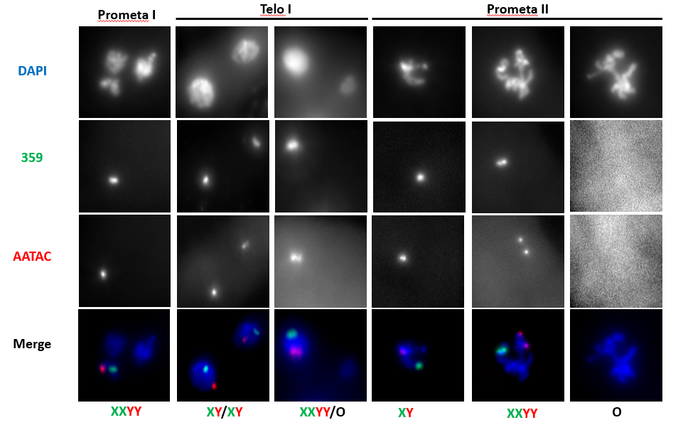

Figure 1: Equational segregation and unilateral segregation of sex chromosomes of rod trans-heterozygous mutants, courtesy of Quitao He, UTK.
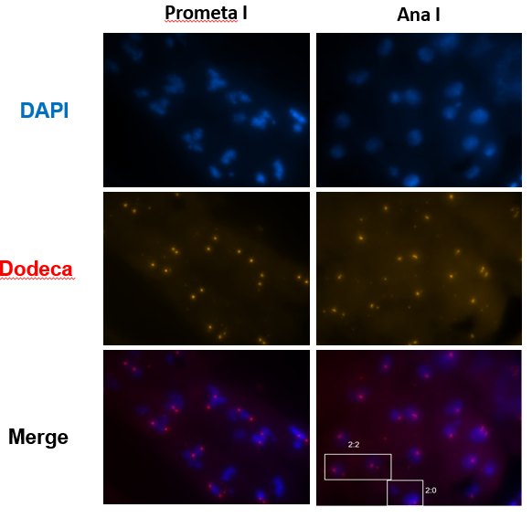
Figure 2: Unilateral segregation and PSCS of chromosome 3 in rod trans-heterozygous mutants. Images courtesy of Qiutao He, UTK.

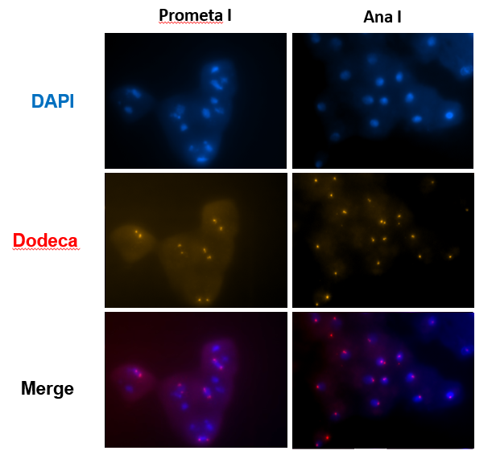

Figure 3: Dodeca imaging of the 3rd chromosome in homozygous bubR1-KEN mutants.

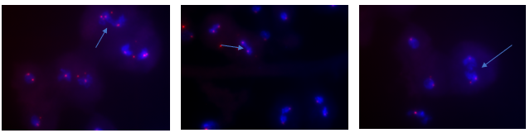
Figure 4: Anaphase bridging and PSCS seen in homozygous bubR1-KEN mutant Dodeca staining.
bubR1-KEN/bubR1-KEN
Dodeca FISH
Meiosis I
 | Prophase I |  | Prometaphase I |  | Anaphase I
 | 2 spot | 1 Spot | 2 spot | 1 spot | 1&1 | 2&1
 | 17 | 2 | 43 | 0 | 84 | 7
Percentage(%) | 89.4 | 10.6 | 100 | 0 | 92.3 | 7.7
Total | 19 |  | 43 |  | 91
Meiosis II
 | Prophase II |  | Prometaphase I |  | A/T II
 | 1 spot | NDJ | 1 spot | NDJ | 1/1 | NDJ
 | 10 | 0 | 2 | 0 | 9 | 0
Percentage(%) | 100 | 0 | 100 | 0 | 100 | 0
Total | 10 |  | 2 |  | 9
Table 1: FISH was used to analyze the 3rd chromosome of bubR1-KEN homozygous mutants for cytological abnormalities in both Meiosis I and II.
bubR1-KEN/bubR1-KEN
359/AATAC FISH
Meiosis I
 | Prophase I |  | Prometaphase I |  | Metaphase I |  | Anaphase I
 | Normal | PSCS | XXYY | PSCS |  | PSCS | XX/YY | XY/XY | XXYY/O | XXY/Y | XYY/X
 | 0 | 0 | 41 | 0 | 0 | 0 | 43 | 0 | 0 | 0 | 0
Percentage(%) | 0 | 0 | 100 | 0 | 0 | 0 | 100 | 0 | 0 | 0 | 0
Total | 0 |  | 41 |  | 0 |  | 43
 |  |  |  |  | Meiosis II
 | Prometaphase II |  |  |  |  | Metaphase II
 | XX | YY | XY | XXYY | O | XX | YY | XY | XXYY | O
 | 48 | 33 | 0 | 0 | 0 | 7 | 7 | 0 | 0 | 0
Percentage(%) | 100 |  | 0 | 0 | 0 | 100 |  | 0 | 0 | 0
Total | 81 |  |  |  |  | 14
 | Anaphase II
 | X/X | Y/Y | XX/O | YY/O | X/Y | XY/XY | XX/YY | XXYY/O | O/O
 | 2 | 2 | 0 | 0 | 0 | 0 | 0 | 0 | 0
Percentage(%) | 100 |  | 0 |  | 0 | 0 |  |  | 0
Total | 4
Table 2: Homozygous bubR1-KEN mutant sex chromosome FISH of meiosis I and meiosis II. There are no apparent abnormalities seen for the segregation of sex chromosomes in these mutants.

 | Prophase I |  | Prometaphase I |  | Metaphase I |  | Anaphase I
 | Normal | PSCS | XXYY | PSCS | Normal | PSCS | XX/YY | XY/XY | XXYY/O | XXY/Y | XYY/X
 | 16 | 0 | 0 | 0 | 0 | 0 | 15 | 0 | 0 | 0 | 0
Percentage(%) | 100 | 0 | 0 | 0 | 0 | 0 | 100 | 0 | 0 | 0 | 0
Total | 16 |  | 0 |  | 0 |  | 15
Meiosis II
 | Prometaphase II |  |  |  |  | Metaphase II
 | XX | YY | XY | XXYY | O | XX | YY | XY | XXYY | O
 | 57 | 59 | 0 | 0 | 0 | 7 | 7 | 0 | 0 | 0
Percentage(%) | 100 |  | 0 | 0 | 0 | 100 |  | 0 | 0 | 0
Total | 116 |  |  |  |  | 14
 | Anaphase II
 | X/X | Y/Y | XX/O | YY/O | X/Y | XY/XY | XX/YY | XXYY/O | O/O
 | 7 | 0 | 0 | 0 | 0 | 0 | 0 | 0 | 0
Percentage(%) | 100 |  | 0 |  | 0 | 0 |  |  | 0
Total | 7
Table 3: Heterozygous bubR1-KEN/cyo single mutant sex chromosome FISH of meiosis I and II. Data visualized and compiled for this mutant is similar to that which is seen in a WT phenotype.
bubR1-KEN/cyo
359/AATAC FISH
Meiosis I

Figure 5: Nondisjunction of chromosome 2 was measured by scoring the progeny-per-male of crosses with female C(2)EN, b pr compound stock and males from three separate phenotypes: 117086/rod^{x-5}, bubR1-KEN/cyo, and 117086/(TM6, Tb). Progeny yield for bubR1-KEN/cyo x C(2)EN, b pr was 0 progeny per male among 12 crosses and is not shown in the graph.

Figure 6: Progeny from C(4)RM, ci eyR females crossed with males from 117086/rod^{x-5}, bubR1-KEN/cyo, and 117086/(TM6, Tb) were scored for recessive markers and the NDJ rate of chromosome 4 for each cross was deduced.
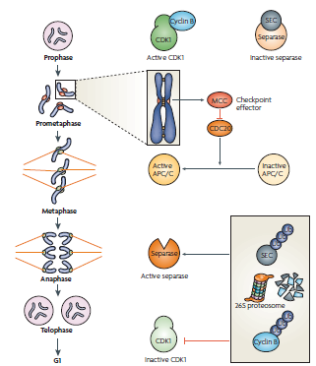
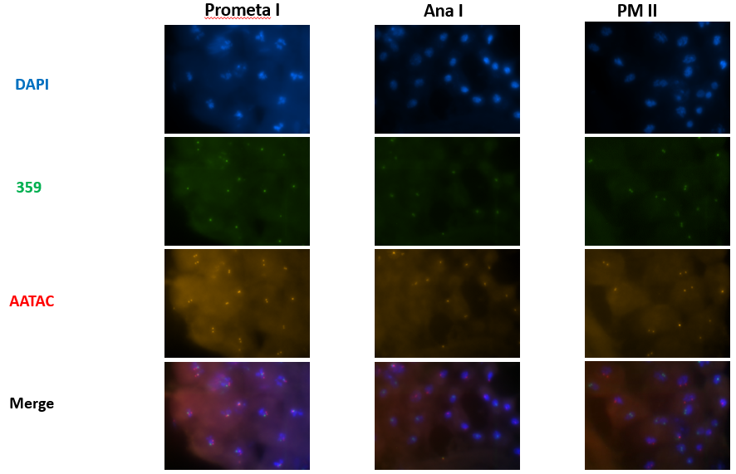
Figure 7: A visual representation of the relationship of SAC components with cell-cycle machinery. During prometaphase when microtubule connections are not fundamentally established, components of the SAC interact with the effector of the APC/C, CDC20, and prohibit the activation of the APC/C. When proper K-MT connection is made, the APC/C is activated, and the polyubiquitilation and subsequent destruction of securin and cyclin B results in an active separase and inactive CDK1, triggering anaphase onset (The spindle- assembly checkpoint in space and time, Musacchio)
Telo I
Figure 8: Cytological results from our homozygous bubR1-KEN mutant in prometaphase I, telophase I, and prometaphase II. These stages were chosen because it shows the normal segregation of sex chromosomes throughout the first cell division in meiosis. Sister chromatid separation in meiosis II is not shown here due to the extremely limited number of cells visualized in anaphase/telophase II.
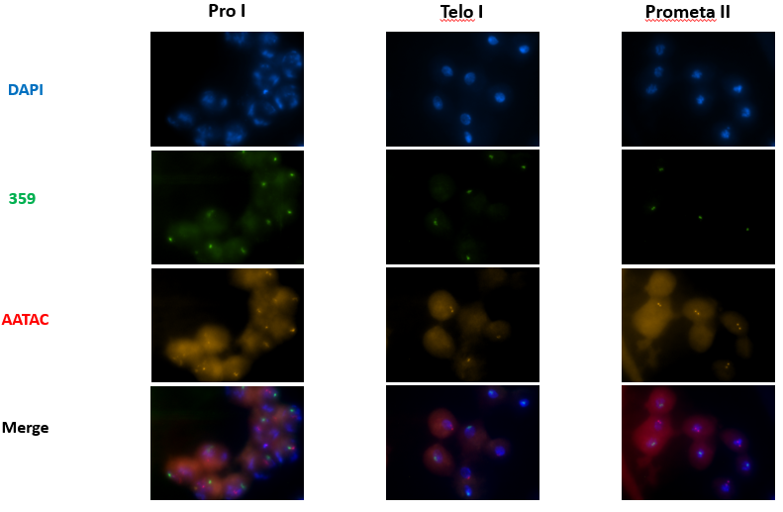
Figure 9: Cytological results from heterozygous mutants of bubR1-KEN in prophase I, telophase I, and prometaphase II. Like our homozygous bubR1-KEN data, a robust anaphase/telophase II signal was not visualized and is therefore omitted from this figure.

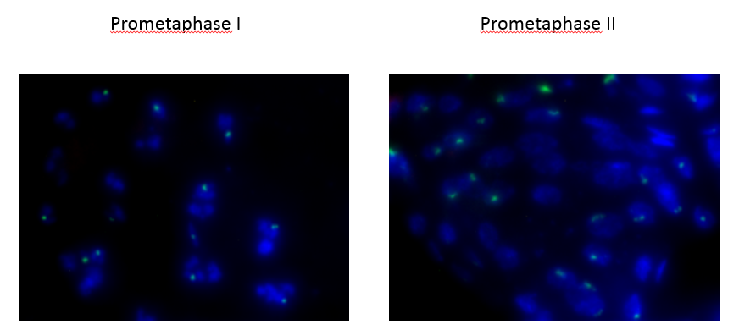
Figure 10: First round 359&AATAC FISH data showing elevated levels of PSCS in both PMI and PMII.

Works Cited
- Karess, R. E. (1989). Rough deal: A gene required for proper mitotic segregation in Drosophila. The Journal of Cell Biology,109(6), 2951-2961. doi:10.1083/jcb.109.6.2951
- Lara-Gonzalez, P., Westhorpe, F.G., Taylor, S.S. (2012). The Spindle Assembly Checkpoint. (2012, November 19). Retrieved from https://www.sciencedirect.com/science/article/pii/S096098221201189X
- Buffin, E., Emre, D., & Karess, R. E. (2007, April 08). Flies without a spindle checkpoint. Retrieved from https://www.nature.com/articles/ncb1570
- Ibrahim, B., & Henze, R. (2014). Active Transport Can Greatly Enhance Cdc20:Mad2 Formation. International Journal of Molecular Sciences,15(10), 19074-19091. doi:10.3390/ijms151019074
- Li, D., Morley, G., Whitaker, M., & Huang, J. (2010). Recruitment of Cdc20 to the Kinetochore Requires BubR1 but Not Mad2 in Drosophila melanogaster. Molecular and Cellular Biology,30(13), 3384-3395. doi:10.1128/mcb.00258-10
- Gorbsky, G. J. (2015, January 12). The spindle checkpoint and chromosome segregation in meiosis. Retrieved from https://febs.onlinelibrary.wiley.com/doi/full/10.1111/febs.13166
- Malmanche, N., Owen, S., Gegick, S., Steffensen, S., Tomkiel, J., & Sunkel, C. E. (2007). Drosophila BubR1 Is Essential for Meiotic Sister-Chromatid Cohesion and Maintenance of Synaptonemal Complex. Current Biology,17(17), 1489-1497. doi:10.1016/j.cub.2007.07.042
- Musacchia, A. (2007, April 11). The Spindle-Assembly Checkpoint in Space and Time. Nature Reviews Molecular Cell Biology, 8(379-393).
- Rahmani, Z., Karess, R.E. et al. (2009). Separating the spindle, checkpoint, and timer functions of BubR1. The Journal of Cell Biology, Vol. 187(5), (597-605)
- McKee, B.D. (2009) Homolog pairing and segregation in Drosophila meiosis. Genome Dyn 5:56-58

