ASSESSING THE RELIABILITY OF ENVIRONMENTAL
DNA AND RNA FOR FRESHWATER
BIODIVERSITY MONITORING: A DAM STUDY

A Thesis Presented for the
Master of Science
Degree
The University of Tennessee, Knoxville

Alaa S. Ahmed
December 2025

ACKNOWLEDGEMENTS

First of all, I would like to sincerely thank Kristine for being an amazing, patient, and supportive supervisor. Thanks also to Steven Gardener, Nate Marshalls, and all my committee members for their invaluable help. To all the ORNL and UTK professors, colleagues, and cohorts, I’m so glad I crossed paths with such wonderful people.
To my friends Ghada, Fedaa, Najwa, Ruwaa, Yousry, and their little Layla, thank you for bringing so much joy and support into my everyday life. To Zahraa, my amazing study buddy, I’m truly grateful for the eight years I’ve known you. To Mariam, my best friend, I will miss you and Chicago, and I genuinely hope this next chapter of your life will only be your best one yet.
As always, I owe very special thanks to my loving family: Mama, Baba, and all my dear siblings, who have always supported me in all my academic and personal decisions, even the questionable ones, and despite the pain of having me so far from home. To all my dearest nephews and nieces, I hope I inspire you to take any path you choose in life, even if you’re the first one you know to ever set foot on it.
Last but not least, I thank my husband, Kasem, to whom I owe so much for rekindling a childlike wonder I thought I lost for so many things, including science. Thank you for your support, despite thinking that Hellbender salamanders are “menacingly ugly”.

“Science and everyday life cannot and should not be separated.”
— Rosalind Franklin

ABSTRACT

Freshwater biodiversity has been declining at an alarming rate, largely due to anthropogenic impacts such as hydropower development. Rigorous monitoring systems are needed for timely mitigation, yet conventional survey methods rely on capturing individuals and identifying them morphologically, which can introduce several limitations and biases. Environmental DNA (eDNA) and environmental RNA (eRNA) offer promising, non-invasive tools for studying aquatic biodiversity; however, further research is still needed to develop and standardize these methods before they can be fully integrated into biomonitoring programs.
This study tested eDNA and eRNA metabarcoding for detecting fish and mussel communities in the Apalachia Cutoff Reach (ACR) of the Hiwassee River, Tennessee, a 14.4-mile bypassed section between the Apalachia Dam and its powerhouse that is historically known to harbor endemic taxa. Water samples were collected from 19 mainstem sites and three tributaries in 2023, and molecular detections were compared to concurrent morphological surveys and historical records (1992–2016). Fish communities were analyzed using mitochondrial 12S rRNA markers from eDNA and eRNA, while mussels were assessed using cytochrome c oxidase I (COI) and 16S rRNA markers using eDNA. We also quantified the presence of the endangered Hellbenders (Cryptobranchus alleganiensis alleganiensis) using qPCR on the Cytochrome b (Cytb) gene.
Despite several technical and practical challenges, both eDNA and eRNA produced consistent and ecologically meaningful results. eDNA detected 26 fish species, eRNA detected 18, and morphological surveys recorded 16, with six unique eDNA detections and full overlap between molecular fractions. For mussels, COI detected eight species, 16S detected five, and morphological surveys documented seven. Notably, eDNA has outperformed morphological methods in many aspects, such as detecting Venustaconcha trabalis (Endangered). Hellbenders were also detected at multiple sites consistent with historical observations, confirming the persistence of local populations.
Overall, this study shows that even with technical difficulties, eDNA and eRNA metabarcoding can still yield reliable results. eDNA reflected broader species presence, while eRNA indicated more recent biological activity, offering complementary perspectives on biodiversity. These findings highlight both the promise and the challenges of molecular monitoring and provide practical insight into how eDNA and eRNA can support freshwater conservation and environmental assessment.

Table of Contents
Chapter One Literature Review 1
Importance of Biodiversity Monitoring in Freshwater Ecosystems 1
Limitations of Conventional Biodiversity Monitoring Approaches 2
The Evolution of Molecular Taxonomic Identification Methods 3
Environmental Nucleic Acids (eNAs) 5
Differences between eDNA and eRNA 7
Different Approaches of eNA Tools 10
Metabarcoding Approaches: Community Composition 10
Quantitative Approach: Species-Specific 11
Other Approaches 12
Challenges and Bottlenecks of eNAs 12
Standardization and Methodological Optimization 12
Molecular Degradation and False Positives 13
Reference Database Gaps and Taxonomic Resolution 13
Primer Bias and Marker Selection 14
Quantitative Limitations and Abundance Estimation 14
Early Adoption and Credibility Setbacks 15
Broader Significance 16
Chapter Two Evaluating the Reliability of Environmental DNA and RNA Tools for Freshwater Biomonitoring 18
Introduction 18
Methods 19
Study Area 19
Conventional Surveying and Historical Data 19
Water Sampling for eDNA/eRNA 21
eDNA/eRNA Extraction 23
Metabarcoding Library Preparation 25
Bioinformatics Analysis 29
Community and Diversity Analyses 30
Hellbender qPCR analysis 32
Results and Discussion 33
Water Chemistry Analysis 33
Metabarcoding Libraries Sequencing Quality 34
Fish Community Detection and Environmental Patterns 36
Mussel Community Detection and Molecular Marker Comparison 40
Detection of Hellbender Salamanders 44
Conclusion 47
References 48
Vita 49

LIST OF TABLES
Table 1. Conventional survey sites for mussel and fish morphological assessments within the Apalachia Cutoff Reach of the Hiwassee River. 22
Table 2. Sampling Sites for Environmental DNA and RNA Data in the Apalachia Dam Cutoff Reach. 26
Table 3. Primer sets used for fish and mussel metabarcoding, with target genes, sequences, amplicon sizes, and references. 28
Table 4. Summary of sequencing read counts across positive samples in all metabarcoding libraries. 38
Table 5. Results of envfit analyses for MiFish eDNA and eRNA NMDS ordinations. Shown are r² values and permutation p-values (999 permutations). Asterisks indicate significance: p < 0.05 = *, p < 0.01 = **, p ≤ 0.001 = *** 42
Table 6. Results of envfit analyses for COI and 16S NMDS ordinations. Shown are r² values and permutation p-values (999 permutations). Significance: * p < 0.05; ** p < 0.01; *** p ≤ 0.001. 45

LIST OF FIGURES

Figure 1. Sites of environmental DNA/RNA (eDNA/RNA) sampling and morphological surveys in the Apalachia Cutoff Reach. Photo credit for the Apalachia Powerhouse: Alan Cressler (Flickr), used with permission. Photo credit for the dam: Tennessee Valley Authority (TVA) website. 25
Figure 2. Spatial variation in water chemistry parameters along the Apalachia Cutoff Reach mainstem. 37
Figure 3. Comparison of fish species detected across methods in the Apalachia Cutoff Reach. 39
Figure 4. Bubble heat maps showing fish species composition and relative abundance across sampling sites in the Apalachia Cutoff Reach. (A) eDNA and (B) eRNA datasets generated using the MiFish-U 12S primers. Bubble size represents proportional read abundance (%) of each taxon within sites, illustrating spatial variation and compositional differences between molecular fractions. 40
Figure 5. NMDS ordinations showing fish community composition derived from eDNA and eRNA data. 41
Figure 6. Comparison of mussel species detections across methods. (A) Number of unique species detected by COI, 16S, and 2023 morphological surveys (MS). (B) Venn diagram showing species overlap among methods. 43
Figure 7. Combined NMDS ordination showing mussel community composition derived from COI and 16S eDNA data. 44
Figure 8. Historical and contemporary mussel detections in the Hiwassee River. Tile plot showing species recorded across historical surveys (1918–2016), the 2023 morphological survey (MS), and eDNA metabarcoding results from COI and 16S markers. 46
Figure 9. eDNA-based detection of mussel species across sites using (A) COI and (B) 16S markers. 47
Figure 10. Detection of Eastern Hellbender (Cryptobranchus alleganiensis alleganiensis) across sampling sites in the Apalachia Cutoff Reach. (A) Proportion of eDNA replicates showing positive amplification, distinguishing detections above (≥ LoD) and below the limit of detection. (B) Proportion of eRNA replicates showing positive amplification using the same Cytb assay. 48
Figure 11. Percentage of Hellbender CytB eDNA detection along the Apalachia Cutoff Reach. 50

Literature Review

Importance of Biodiversity Monitoring in Freshwater Ecosystems
                - Freshwater ecosystems face disproportionately severe threats compared to terrestrial and marine environments, with biodiversity declining at rates up to five times faster than in other biomes (Ricciardi & Rasmussen, 1999; WWF, 2016). Effective freshwater biodiversity monitoring is hence essential to provide accurate detections of changes in aquatic species distribution and abundance, allowing for prompt conservation interventions (Albert et al., 2021; Sayer et al., 2025). This need has become increasingly urgent given the unprecedented scale of anthropogenic modifications affecting freshwater habitats worldwide (Dudgeon, 2019; Reid et al., 2019).
                - Hydropower development is among the most significant drivers of freshwater habitat modification globally, as dam construction and reservoir impoundment substantially disrupt natural flow regimes, sediment transport, water quality, and habitat connectivity (Chen et al., 2023; Wu et al., 2019). These alterations result in fragmented aquatic populations, reduced access to critical spawning and feeding habitats, and changes in community composition across multiple taxonomic groups such as freshwater mussels and migratory fishes (Liermann et al., 2012), among others. In response, comprehensive biomonitoring in hydropower facilities is increasingly mandated as part of environmental impact assessments (EIAs), which are required by regulatory agencies to ensure compliance with environmental mitigation measures and license conditions (Morgan, 2012). With the urgent global need to balance renewable energy development with biodiversity conservation to achieve truly sustainable and green energy (Bogdanov et al., 2019), robust and sensitive monitoring strategies have become critical for detecting ecological responses and guiding sustainable hydropower management practices.

Limitations of Conventional Biodiversity Monitoring Approaches
Conventional survey methods for aquatic macroorganisms face substantial limitations that reduce their effectiveness for comprehensive biodiversity monitoring. These approaches typically rely on capturing and handling individuals for morphological identification, which can disrupt sensitive habitats and cause unwanted mortality, which is particularly problematic when surveying endangered species (Holubová et al., 2025; Jewell, 2013; Pollard et al., 2022). Gear selectivity also introduces systematic biases, as different equipment may preferentially capture certain species, sizes, or behavioral types while missing others, leading to incomplete community assessments (Fujii et al., 2019; Kubecka et al., 2009; Shelton et al., 2016). In large and deep river systems, no single method can reliably sample all habitats, leaving significant spatial gaps in biodiversity data (Goffaux, 2005; Zajicek & Wolter, 2018).
Taxonomic identification further challenges the reliability of conventional monitoring programs. Observer error is very common, as researchers vary in their morphological expertise and interpretation of diagnostic traits (Barata et al., 2017; Lotz & Allen, 2007). The problem intensifies when addressing highly diverse taxonomic groups such as aquatic invertebrates, with over 1.25 million species documented globally and many lacking adequate morphological reference data (Eisenhauer & Hines, 2021). Additionally, closely related taxa can lack clear distinguishing features, while larval stages differ drastically from adult forms, making identification particularly challenging (Thomsen & Willerslev, 2015). Many aquatic organisms also undergo multiple life stages with detectability that varies across seasons and environmental conditions, creating temporal biases in survey results (Wikston et al., 2023).
                - Beyond these technical obstacles, conventional methods face practical constraints that limit their long-term sustainability. They are often costly, labor-intensive, and time-consuming, as well as requiring niche taxonomic expertise (Hopkins & Freckleton, 2002; Wheeler et al., 2004). Detecting rare or cryptic species remains especially unreliable and is further constrained by the fact that morphological identifications cannot be revisited in most cases (MacKenzie et al., 2005). Taken together, these limitations mean that conventional survey methods alone are insufficient to meet the growing demand for efficient, accurate, and systematic monitoring of aquatic biodiversity (Pawlowski et al., 2020).

The Evolution of Molecular Taxonomic Identification Methods
                - The development of DNA barcoding has transformed biodiversity assessment by providing a rapid, reproducible, and broadly applicable molecular tool for species identification (Tournayre et al., 2023). In this approach, DNA is extracted from small tissue samples and specific genomic regions are amplified using polymerase chain reaction (PCR) to generate short, standardized sequences known as barcodes (Joly et al., 2014; Valentini et al., 2009). These barcode regions are chosen for their variability between species (high interspecific variation) to distinguish them, while remaining largely consistent within a species (low intraspecific variation), allowing for accurate taxonomic assignment (Hebert et al., 2003). Commonly used barcode regions differ between taxonomic groups, with specific standard marker genes and PCR primers established for animals, plants, and fungi (Ramirez et al., 2023). Barcode sequences of specific specimens are then compared against curated reference databases, such as the National Center for Biotechnology Information (NCBI) GenBank (Benson et al., 2012) or the Barcode of Life Data Systems (BOLD) (Ratnasingham & Hebert, 2007), for taxonomic identification. By providing a standardized framework, DNA barcoding addresses many of the challenges inherent to morphology-based identification, including observer error, cryptic species, and variation across life stages, while reducing reliance on specialized taxonomic expertise (Marshall, 2005).
                - Building on this foundation, as well as thanks to the expansion in next-generation sequencing (NGS; also referred to as high-throughput sequencing, HTS) technology, DNA metabarcoding advanced the conventional barcoding framework to community-level assessments by amplifying and sequencing mixed DNA from multiple organisms simultaneously (Hajibabaei et al., 2011). Early metabarcoding applications used DNA extracted from bulk tissue samples pooled from multiple organisms, enabling the simultaneous identification of entire communities (Yu et al., 2012). The innovation of metabarcoding has greatly improved the efficiency and scalability of biodiversity assessments while reducing the limitations of morphology-based identification (Ji et al., 2013). It has also improved compared to the standard Sanger technology that is limited to sequencing a single gene from a single specimen in each run (Evans et al., 2016). However, reliance on collected tissue specimens could still result in incomplete or biased coverage. The limitations of capture-based sampling ultimately led to the development of environmental DNA (eDNA) and, later, environmental RNA (eRNA) approaches (both collectively referred to as environmental nucleic acids, eNAs), which eliminate the need for tissue collection through non-invasive sampling.

Environmental Nucleic Acids (eNAs)
                - Environmental nucleic acids (eNAs) refer to any genetic material (DNA and RNA), that organisms release into their environment through sloughed cells, mucus, waste, gametes, or tissue decay. They can be recovered from any environmental samples, such as water, sediment, soil, or air and analyzed without direct contact with the organisms (Cristescu 2019; Yates et al. 2023).
                - By eliminating the invasive and often lethal consequences of biodiversity assessments, eNA methods are particularly beneficial for the conservation of delicate aquatic ecosystems and the species they support. They allow for non-invasive and highly sensitive detection of biodiversity by detecting genetic traces of all organisms present in the environment, regardless of body size, mobility, life stage, or other ecological characteristics that bias capture-based surveys (Bohmann et al. 2014; Thomsen & Willerslev 2015).
                - Seventeen years ago, it was first demonstrated that eDNA could be collected from aquatic environments and used for macro-organism detection (Ficetola et al. 2008). Early research efforts primarily focused on single or multiple sites within riverine systems for detecting rare, threatened, or invasive species (Thomsen et al. 2012; Mächler et al. 2014). Since then, the field has grown exponentially, with over a thousand peer-reviewed studies validating the power of eDNA analyses (Beng & Corlett 2020).
                - Although initial applications were largely species-specific, eDNA has increasingly been applied to characterize entire biological communities, revealing cryptic or “hidden” diversity (Deiner et al. 2016; Mächler et al. 2019; Sales et al. 2021; Bylemans et al. 2018a). eDNA metabarcoding, for example, can detect a wide range of taxonomic groups and often uncovers greater invertebrate diversity compared to conventional sampling methods (Creer et al. 2016; Fediajevaite et al. 2021; Ji et al. 2022).
                - A notable project demonstrating eDNA’s potential in large-scale biomonitoring came from Pont et al. (2018), who analyzed water samples collected along a 500 km stretch of the Rhône River. Their results showed a moderate but significant correlation between standardized read counts and fish species’ relative abundances, and the eDNA-based assessment conducted over 12 days yielded data comparable to a decade’s worth of electrofishing surveys (~300 field days). This highlighted eDNA’s efficiency and scalability for ecological monitoring at the basin level.
                - Although eDNA is highly effective for biodiversity monitoring, its detectability can be influenced by local environmental conditions. Flow variation, sediment resuspension, and temperature shifts can all change how eDNA moves and breaks down in freshwater systems (Griffiths et al. 2020; Boivin-Delisle et al. 2021; Hayami et al. 2020; Coble et al. 2019). These effects are particularly relevant in rivers affected by hydropower, yet few studies have examined how flow regulation influences eDNA detection or how it might be applied in environmental monitoring frameworks (Kelly et al. 2024).
                - Moreover, the analysis of environmental RNA (eRNA), which consists of RNA molecules shed by organisms and recovered from environmental samples, is an emerging area in molecular biomonitoring (Cristescu 2019; Yates et al. 2023). eRNA-based methods such as metabarcoding and metatranscriptomics can complement or even outperform eDNA approaches in some ecological assessments because eRNA degrades more quickly, turns over faster, and is more specific to living organisms (Giroux et al. 2022; Greco et al. 2022; Macher et al. 2024).
                - While eDNA has become relatively well established for biodiversity surveys, eRNA offers the potential to complement eDNA’s taxonomic insights with functional information, making the integration of both molecules a promising frontier for biodiversity monitoring.

Differences between eDNA and eRNA
                - Although often discussed together, eDNA and eRNA differ in their molecular properties, persistence, and interpretative value for ecological monitoring.
                - eDNA sampling involves the isolation of both extracellular and intracellular DNA fragments deposited into an environmental matrix (Taberlet et al. 2012). DNA released via epidermal cells, feces, mucus, gametes, or hair is captured from environmental samples such as filtered water (Levy-Booth et al. 2007; Lodge et al. 2012; Rees et al. 2014). Its relative stability makes eDNA widely deployable in natural freshwater environments, enabling detection of species that are elusive, invasive, or rare (Goldberg et al. 2011; Dejean et al. 2012; Thomsen et al. 2012).
                - eDNA has become especially useful for fish monitoring, demonstrating higher detection sensitivity than conventional methods such as gillnetting, trapping, or electric fishing (Kelly et al. 2014; Taylor & Gemmell 2016). Moreover, because eDNA persists for longer periods, it integrates biological signals over time, providing a more comprehensive representation of community diversity (Cristescu & Hebert 2018).
                - However, this persistence can complicate ecological interpretation. eDNA can be resuspended from sediments (Corinaldesi et al. 2008) or transported considerable distances downstream (Deiner & Altermatt 2014; Shogren et al. 2017), leading to potential false positives or spatial uncertainty in signal origin (Jerde et al. 2011). The extent of signal transport varies depending on substrate flow rates, abiotic and biotic degradation processes, and shedding dynamics (Deiner et al. 2016).
                - Numerous studies highlight eDNA’s strong correlation with species richness and presence–absence data (Williford et al. 2023; He et al. 2023; Przybyla–Kelly et al. 2023) and its emerging use in large-scale riverine and hydropower-affected systems. Yet, attempts to link eDNA concentration to species abundance or biomass remain contentious. Recent meta-analyses (Lamb et al. 2019; Yates et al. 2019) show only moderate correlations between eDNA signal strength and actual biomass, due largely to environmental variability, degradation rates, and unquantified shedding rates (Barnes et al. 2014; Strickler et al. 2015; Jo et al. 2019).
                - In contrast to eDNA, environmental RNA (eRNA) originates from actively transcribed cellular molecules, making it highly dynamic and short-lived (Cristescu 2019; Yates et al. 2023). Chemically, RNA’s single-stranded structure and the presence of a 2'-hydroxyl group render it more susceptible to enzymatic degradation (Li & Breaker 1999; Tan & Yiap 2009). Owing to this structural lability, eRNA’s half-life is shorter than that of eDNA under comparable conditions by approximately 4–5 hours (Marshall et al. 2021).
                - Because RNA molecules are produced only by living cells, eRNA provides evidence of active, viable populations rather than residual or transported genetic signals (Barnes & Turner 2016; Pawlowski et al. 2018). Studies comparing eDNA and eRNA metabarcoding of benthic or planktonic communities show that eRNA more accurately reflects metabolically active taxa and community responses to environmental stressors such as aquaculture impacts (Pawlowski et al. 2014; Dowle et al. 2015).
                - This temporal precision is a major advantage: whereas eDNA can persist from dead organisms or historical deposits, eRNA captures “real-time” biological activity, making it a promising proxy for physiological and metabolic assessment in ecological health studies. Notably, eRNA-based approaches can help differentiate between present versus past occupancy signals. This distinction can be critical when assessing ecosystem dynamics near hydropower installations or other anthropogenic perturbations.
                - While eDNA dominates current freshwater biomonitoring, the inclusion of eRNA can refine temporal resolution and provide insights into live community function (Veilleux et al. 2021; Macher et al. 2024). When combined, eDNA and eRNA provide complementary spatial and temporal perspectives of ecosystem biodiversity. The durability of eDNA captures community legacy and distribution, while the transience of eRNA indicates active metabolism and biological function (Marshall et al. 2021; Veilleux et al. 2021). Together, they offer a more holistic representation of freshwater systems, essential for high-resolution monitoring programs in hydropower-affected rivers, lakes, and reservoirs.

Different Approaches of eNA Tools
                - Environmental nucleic acid (eNA) methods encompass a diversity of molecular, analytical, and bioinformatic approaches, each with distinct advantages and limitations for biodiversity assessment. There are two main methodological frameworks applied in the field (1) community-level metabarcoding and (2) species-specific assays (e.g., qPCR or ddPCR).

Metabarcoding Approaches: Community Composition
                - Metabarcoding combines universal primers with high-throughput sequencing (HTS) to amplify DNA or RNA fragments from multiple taxa within a sample (Deiner et al., 2017; Elbrecht & Leese, 2015). This approach enables multi-taxa biodiversity surveys from a single water or sediment sample. The amplification success and community representativeness in metabarcoding depend heavily on primer performance and database completeness. Ideal primers must be specific to target groups, have broad coverage, generate short amplicons (for degraded DNA), and map to well-represented regions in reference databases (Elbrecht et al., 2017; Ficetola et al., 2021). Many ‘universal’ primers can unintentionally amplify nontarget taxa (e.g., fungi, algae, bacteria) or fail to capture entire phyla such as Nematoda or Platyhelminthes (Hajibabaei et al., 2019; Poyntz-Wright et al., 2024). Moreover, some markers, particularly 18S or low-variability 16S fragments, lack sufficient interspecific variation to distinguish closely related species. The completeness of barcoding reference databases also remains a major bottleneck (Weigand et al., 2019; Lin et al., 2021). Incomplete databases reduce confidence in taxonomic assignments and limit comparability of community datasets between regions or marker systems.

Quantitative Approach: Species-Specific
                - Species-specific eDNA methods use quantitative polymerase chain reaction (qPCR) or digital droplet PCR (ddPCR) to detect and quantify DNA from specific taxa using customized primers and probes (Shelton et al., 2016; Jerde et al., 2011). These approaches are highly sensitive and precise, suitable for early detection of rare, endangered, or invasive species. Quantitative data from these assays can be correlated with organism abundance or biomass, although environmental factors (e.g., dilution, flow dynamics, degradation) can complicate interpretation (Yates et al., 2019). While qPCR is powerful for known species, it is limited by the need for prior taxonomic knowledge and existing sequence data. It is optimal where monitoring efforts focus on focal taxa, such as endangered or indicator species near hydropower reservoirs.

Other Approaches
                - To mitigate individual marker biases, multi-marker metabarcoding combining mitochondrial and nuclear regions is increasingly used to improve taxonomic coverage (Bunholi et al., 2023). In parallel, metagenomics (untargeted DNA sequencing) and metatranscriptomics (untargeted RNA sequencing) provide genome-wide or transcriptome-wide perspectives, respectively, allowing quantification of both community composition and functional activity (Bizic et al., 2022; Vlok et al., 2019). The inclusion of eRNA in metabarcoding or metatranscriptomics workflows adds a functional gene-expression dimension, linking biodiversity patterns to physiological or stress-response processes, which is particularly relevant for assessing biological impacts of hydropower operations and flow alterations.

Challenges and Bottlenecks of eNAs
                - Despite the revolutionary potential of eNA methods for freshwater biomonitoring, several technical and interpretive challenges remain. These issues span the entire workflow, from field sampling and molecular processing to data analysis and ecological inference, and remain to be addressed to ensure reliable, standardized, and meaningful results.

Standardization and Methodological Optimization
                - The lack of standardized protocols for eDNA and eRNA sampling, preservation, extraction, and bioinformatic analysis is a major barrier to comparability and reproducibility across studies (Cordier et al., 2021). Variability in filter pore size, buffer choice, storage temperature, and time to extraction can all influence nucleic acid recovery, especially for the more labile eRNA (Deiner et al., 2015; Dickie et al., 2018). Rigorous optimization and harmonization of field-to-lab workflows are essential for generating robust biodiversity indicators and for the broader adoption of eNA methods in regulatory frameworks.

Molecular Degradation and False Positives
                - Both eDNA and eRNA are subject to environmental degradation, but eRNA is particularly sensitive to temperature, pH, and microbial activity (Sansom & Sassoubre, 2017; Strickler et al., 2015; Tsuji et al., 2017). DNA can persist in sediments or be transported downstream, leading to potential false positives or legacy signals that do not reflect current community composition (Corinaldesi et al., 2008; Deiner & Altermatt, 2014). This complicates the interpretation of presence–absence data, especially in dynamic or regulated systems.

Reference Database Gaps and Taxonomic Resolution
                - The efficiency of metabarcoding studies hinges on the completeness and accuracy of reference barcode databases. Gaps in these databases, especially for non-model or regionally endemic taxa, severely limit the ecological interpretation of eDNA and eRNA data (Weigand et al., 2019; Cilleros et al., 2019; Sales et al., 2019, 2021). The COI gene, while widely used, is suboptimal for some taxa due to primer site limitations and low specificity in vertebrates (Collins et al., 2019; Deagle et al., 2014). Conversely, 12S and 16S rRNA genes offer better performance for vertebrate monitoring but suffer from less complete reference libraries. The ability to detect and assign species is thus constrained by both the robustness of the chosen marker and the quality of the reference database (Sassoubre et al., 2016).
                - Moreover, since RNA molecules actively reflect gene transcription from living cells, eRNA profiles can offer temporal “snapshots” of community activity and even insights into physiological or stress-related states (Yates et al. 2021). The abundance or presence of particular transcripts can mirror real-time physiological responses, including stress, metabolism, or development. Thus, eRNA enables researchers not only to identify which species are present but also to infer their functional or physiological status at the time of sampling.

Primer Bias and Marker Selection
                - Universal primers used in metabarcoding can preferentially amplify non-target taxa or fail to capture the full diversity of target groups, leading to biased community profiles (Hajibabaei et al., 2019; Poyntz-Wright et al., 2024). The use of a single mitochondrial barcode may not reliably distinguish closely related species, and some markers lack the interspecific variation needed for fine-scale taxonomic resolution. Multilocus approaches and the development of more comprehensive reference databases are needed to overcome these limitations (Seymour et al., 2020; Andres et al., 2021; Manel et al., 2025).

Quantitative Limitations and Abundance Estimation
                - A persistent challenge is the accurate estimation of species abundance or biomass from eDNA concentrations. While qPCR and ddPCR can provide quantitative data, the relationship between eDNA copy number and organism abundance is influenced by variable shedding rates, environmental degradation, and hydrological transport (Barnes et al., 2014; Yates et al., 2019). Meta-analyses reveal only moderate correlations between eDNA signal and true abundance, and few studies have validated these relationships in natural freshwater systems (Lamb et al., 2019; Jo et al., 2019). This uncertainty limits the use of eDNA for quantitative ecological assessments.
                - Methodological optimization and standardization remain active research frontiers in eNA-based biomonitoring. Addressing challenges related to molecular degradation, abundance estimation, primer bias, and reference database completeness is essential for realizing the full potential of eDNA and eRNA technologies in freshwater ecosystem assessment and management (Cordier et al. 2021; Sansom & Sassoubre 2017; Strickler et al. 2015; Tsuji et al. 2017).

Early Adoption and Credibility Setbacks
                - The rapid emergence of eDNA technologies in the 2010s brought unprecedented excitement but also highlighted the risks of premature application before methodological consensus was achieved. Early studies often produced inconsistent results due to variation in workflows, contamination, and uncertain detection thresholds, which temporarily weakened confidence in eDNA among managers and policymakers (Darling & Mahon, 2011; Cristescu & Hebert, 2018). These lessons emphasize that deploying molecular tools before strong standardization and validation can erode credibility, particularly outside the research community.
                - Rushing to rely solely on eDNA or treating it as a fully mature replacement for conventional biomonitoring can risk repeating those early missteps. Without careful validation, such premature adoption could set the field back years by diminishing trust in eDNA-based evidence among practitioners and decision-makers. Sustainable integration of eDNA and eRNA into management frameworks therefore requires patience, transparency, and consistent interlaboratory standards to ensure that progress in molecular ecology strengthens, rather than undermines, long-term monitoring credibility.

Broader Significance
                - This research contributes to a growing body of evidence demonstrating that environmental nucleic acids represent a transformative toolset for freshwater biodiversity monitoring. By validating eDNA and eRNA metabarcoding against conventional surveys and historical data in a hydropower-regulated river, this study provides a foundation for integrating molecular methods into environmental impact assessments, license compliance monitoring, and adaptive management frameworks. As regulatory agencies and hydropower operators increasingly recognize the value of non-invasive, high-throughput biomonitoring, the methods and findings presented here offer a roadmap for implementation that balances rigor, practicality, and ecological sensitivity.
                - Ultimately, the conservation of freshwater biodiversity in an era of accelerating environmental change will require innovative, scalable, and scientifically robust monitoring strategies. eDNA and eRNA metabarcoding, when applied thoughtfully and in combination with traditional approaches, provide a powerful lens for understanding and protecting the aquatic ecosystems upon which both human communities and imperiled species depend. The continued refinement and application of these tools will be essential for achieving the dual goals of sustainable hydropower development and freshwater biodiversity conservation.

Evaluating the Reliability of Environmental DNA and RNA Tools for Freshwater Biomonitoring

Introduction
                - Freshwater ecosystems support an extraordinary share of global biodiversity yet remain among the most threatened on Earth. Although they cover less than one percent of the planet’s surface, they sustain more than ten percent of all known species, including roughly 26% of fish, 70% of unionid mussels, and several amphibian taxa such as the Eastern Hellbender (Cryptobranchus alleganiensis alleganiensis) (Sayer et al., 2025; IUCN, 2025). Recent global assessments estimate that one in four freshwater species is now at risk of extinction, making freshwater systems the most imperiled biome on the planet in terms of proportional biodiversity loss (IUCN, 2025). The main pressures driving these declines include hydrological modification, land-use change, pollution, invasive species, and climate change (Dudgeon et al., 2006; Reid et al., 2019).
                - Among these pressures, dam construction remains one of the most widespread and ecologically disruptive. While dams are vital for hydropower, irrigation, and flood control, they fundamentally alter natural flow regimes, fragment habitats, and block migration routes for aquatic organisms (Orr et al., 2012; Wu et al., 2019). These changes cascade through ecosystems by reducing connectivity, trapping sediment, and degrading water quality. Migratory fishes lose access to spawning grounds, while benthic species such as mussels and Hellbenders experience unstable substrates and increased sedimentation downstream of impoundments (Liermann et al., 2012; Huang & Li, 2024; Fernandez et al., 2024).
                - The disruption of fish movement has further consequences for mussel populations. Many unionid mussels depend on specific fish hosts to complete their larval stage (glochidia), attaching to gills or fins before transforming into juveniles and dropping off to settle in new habitats. By serving as hosts and dispersal agents, fish play a critical role in maintaining gene flow and enabling recolonization across river networks. When dams restrict fish migration, these life cycle connections are broken, leading to isolated or declining mussel populations even in habitats that otherwise remain suitable (Vaughn, 2018). Over time, such disruptions contribute to localized extirpations, homogenized communities, and a gradual loss of ecosystem resilience (Barbarossa et al., 2020).
                - Freshwater fishes make up nearly 40% of all vertebrate diversity, with more than 28,000 described and undescribed species across 57 orders and over 480 families (Lundberg et al., 2000). They play essential roles in nutrient cycling, trophic balance, and energy transfer across ecosystems, and their diversity often reflects the ecological health of aquatic habitats (Sajina et al., 2021). Fish are also vital for the life cycle and dispersal of unionid mussels. Mussel larvae, known as glochidia, must attach to specific fish hosts for successful metamorphosis into juveniles. This temporary parasitic stage not only ensures survival during early development but also allows mussels to disperse and colonize new habitats. The decline of host fish populations can therefore directly limit mussel recruitment and contribute to local extinctions, even in habitats that remain otherwise suitable.
                - Unionid mussels are equally critical to freshwater systems. They function as ecosystem engineers that filter suspended particles, stabilize sediments, and recycle nutrients, improving water quality and providing habitat for other organisms. Despite their importance, mussel populations across North America are in steep decline. More than 70% of species are currently threatened or endangered, largely due to habitat loss, pollution, and reduced host-fish availability (Prié et al., 2020; Klymus et al., 2021; Marshall et al., 2022).
                - The Eastern Hellbender, a fully aquatic salamander native to the Appalachian region, serves as another key indicator of river health. Its persistence depends on cool, well-oxygenated, and sediment-free habitats, conditions that are increasingly rare in regulated rivers. Declines in Hellbender populations, primarily caused by siltation, pollution, and habitat fragmentation, often reflect broader ecological deterioration (Bodinof Jachowski et al., 2020).
                - Environmental DNA (eDNA) metabarcoding has transformed biodiversity monitoring by enabling the detection of species through trace genetic material shed into the environment. Compared to traditional methods, eDNA provides higher sensitivity for rare and low-density species, broader spatial coverage, and minimal disturbance to habitats (Bohmann et al., 2014; Bonar et al., 2017; Yao et al., 2022).
                - Environmental RNA (eRNA) builds upon this framework by targeting short-lived molecules produced by metabolically active organisms. Because RNA degrades within hours, it offers a more temporally precise snapshot of recent biological activity and reduces the likelihood of detecting DNA remnants from organisms that are no longer present (Pochon et al., 2017; Marshall & Stepien, 2019). When used together, eDNA and eRNA, collectively referred to as environmental nucleic acids (eNAs), capture both cumulative and immediate biological signals, providing a more complete view of ecosystem dynamics.
                - Field studies have shown strong overlap between eNA results and conventional survey data. eDNA often detects additional species that are missed by traditional methods, while conventional surveys continue to provide valuable demographic and abundance information (Cilleros et al., 2019; Pont et al., 2018). Molecular assays have also detected imperiled taxa such as unionid mussels and Hellbenders in areas where morphological surveys failed, demonstrating their potential to fill long-standing detection gaps (Miyata et al., 2021). Despite existing challenges, eNA-based approaches are becoming steadily more reliable, and currently, pairing molecular and morphological assessments is the best way to achieve the highest accuracy in biodiversity analysis (Jackman et al., 2021; Liu et al., 2025).
                - This chapter evaluates the performance of eDNA and eRNA metabarcoding as complementary tools for freshwater biomonitoring in hydropower-regulated systems, focusing on fish, mussel, and Hellbender assemblages within the Apalachia Cutoff Reach (ACR) of the Hiwassee River, Tennessee. Specifically, this study aims to:
- Assess species richness and community composition across taxa using eDNA and eRNA.
- Compare molecular detections across target genes as well as with concurrent morphological surveys and historical records.
- Identify environmental factors influencing detection patterns and diversity in relation to hydropower regulation.
                - This study assesses the ability of eDNA and eRNA to characterize multi-taxon biodiversity and examines their potential to strengthen freshwater biomonitoring programs in regulated river environments.

Methods

Study Area
                - The Apalachia Cutoff Reach (ACR) is located in Polk County, southeastern Tennessee, as a part of the southern Appalachian Mountains and the Cherokee National Forest. The reach extends approximately 14.4 river miles between the Apalachia Dam and the Apalachia Powerhouse and is characterized by steep hills and rugged terrain. There are no parallel roads along the reach, and access is limited to the U.S. Highway 68 bridge, which is the only vehicle crossing to the ACR. The remaining sections are accessible only by the John Muir Trail on the north bank and the railroad corridor on the south. Forest Service administrative roads reach within about half a mile of the river near where Turtletown and Wolf creeks join the Hiwassee River, but the steep terrain in those areas still makes access difficult, making regular conventional surveys in the area more challenging.

Conventional Surveying and Historical Data
                - Conventional mussel and fish surveys were conducted in collaboration with the Tennessee Valley Authority (TVA) from July 25–27, 2023. A total of nine sites (Figure 1; Table 1) were surveyed along the ACR using standard visual and tactile methods, including snorkeling, hand-digging, fanning substrate, and turning slab boulders to locate live mussels. Snorkelers searched across transects spanning suitable substrates such as sand, gravel, cobble, boulder, and bedrock. Each site was surveyed by 2–9 snorkelers for an average cumulative effort of four hours per site, covering areas ranging from approximately 100 to 2,800 m².
                - Mussels encountered at each site were identified in the field following Williams et al. (2017) and the FMCS (2023) checklist. Live individuals were measured with calipers, photographed, and returned to the substrate. Fresh-dead and relic shells were identified, counted, and recorded.
Table 1. Conventional survey sites for mussel and fish morphological assessments within the Apalachia Cutoff Reach of the Hiwassee River.
- Site | - Survey Type | - River Mile | - Latitude | - Longitude | - Date
- CV01 | - Mussels, Fish | - 58.4 | - 35.17506 | - -84.37482 | - 7/27/2023
- CV02 | - Mussels, Fish | - 58.7 | - 35.17323 | - -84.37011 | - 7/27/2023
- CV03 | - Mussels | - 59.2 | - 35.17031 | - -84.36504 | - 7/27/2023
- CV04 | - Mussels, Fish | - 59.7 | - 35.16793 | - -84.35647 | - 7/26/2023
- CV05 | - Mussels, Fish | - 60.04 | - 35.16794 | - -84.35149 | - 7/26/2023
- CV06 | - Mussels, Fish | - 60.8 | - 35.17568 | - -84.34275 | - 7/25/2023
- CV07 | - Mussels | - 60.9 | - 35.17749 | - -84.3408 | - 7/25/2023
- CV08 | - Mussels | - 61.6 | - 35.17614 | - -84.32985 | - 7/25/2023
- CV09 | - Mussels, Fish | - 62.5 | - 35.16859 | - -84.32127 | - 7/25/2023

                - Historical survey data for both fish and mussels were obtained from TVA records and previous reports spanning 1992–2016 to allow comparison of the historical and current community compositions (Ahlstedt, 2002, 2003; Ahlstedt et al., 2016; Bogan, 1993; Ortmann, 1918; Parmalee & Hughes, 1994).
                - Historical mussel data were compiled from TVA and U.S. Forest Service surveys (USFS) conducted between 1992 and 2023, focusing on the Apalachia Cutoff Reach and the three major tributaries (Turtletown, Loss, and Wolf creeks). Across these surveys, a total of 13 mussel species were reported, with Cambarunio iris, Eurynia dilatata, Lampsilis fasciola, Leaunio vanuxemensis, and Pleurobema oviforme occurring most frequently. Federally listed taxa historically documented within the ACR include Venustaconcha trabalis, Fusconaia subrotunda, and Pleuronaia dolabelloides, although these were rarely detected in recent surveys.
                - Contemporary fish surveys conducted at six sites along the ACR documented 29 species dominated by Cyprinidae and Centrarchidae, including Campostoma anomalum, Luxilus coccogenis, Lepomis auritus, Micropterus dolomieu, Etheostoma blennioides, and Notropis leuciodus, consistent with previous TVA records from the ACR and its tributaries.

Water Sampling for eDNA/eRNA
                - Water sampling for eDNA and eRNA was conducted by Stantec over four days (September 5–8, 2023) by a three-person survey team hiking along the Hiwassee River to obtain evenly distributed samples along the full length of the Apalachia Cutoff Reach (ACR). A total of 84 water samples were collected from 19 sites along the ACR mainstem and five tributary sites (Turtletown Creek, Wolf Creek, and Loss Creek). The 19 mainstem sites spanned the entire reach from the upstream end near Apalachia Dam to the downstream TVA Apalachia Powerhouse (Figure 1; Table 2), averaging one sampling site approximately every 0.7 river miles.
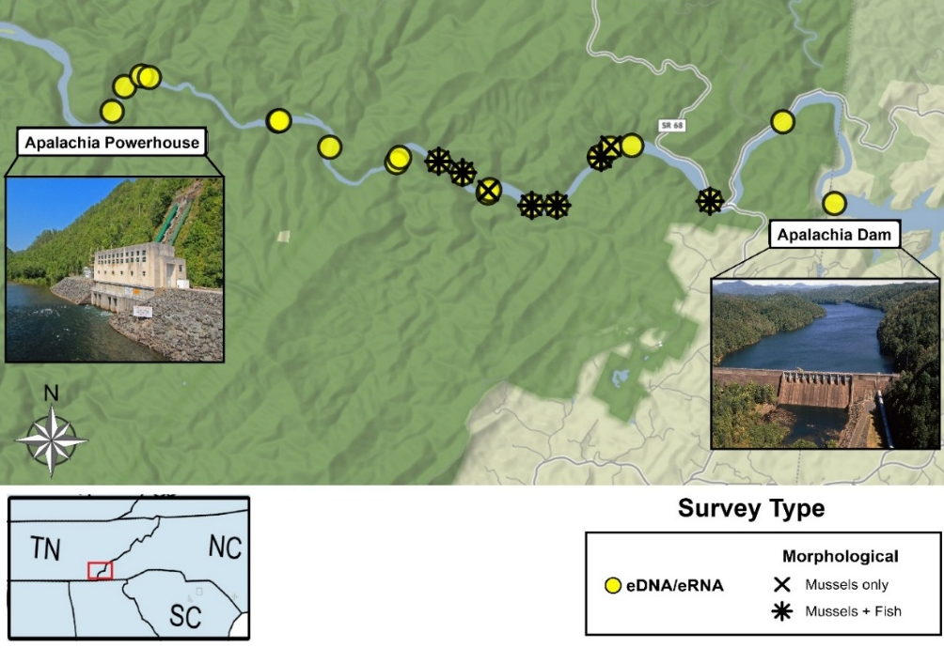
                - At each site, 750–2,000 mL of water was collected near the benthos using a drill-powered peristaltic pump with a polypropylene filter holder attached to a painter’s pole. Water was filtered through 47-mm, 3.0-µm mixed cellulose ester (MCE) membranes until clogging occurred due to turbidity or flow rate. For each site, three replicate samples were collected by moving approximately 2–3 m upstream between filtrations.
To control for potential contamination from equipment or field activity, six field negative controls were included. A blank sample was collected every four sampling sites by filtering 500 mL of distilled water through the same peristaltic pump setup. All equipment was decontaminated daily with a 30% bleach solution, and sterile nitrile gloves were changed at each site and during the handling of eDNA materials.
Figure 1. Sites of environmental DNA/RNA (eDNA/RNA) sampling and morphological surveys in the Apalachia Cutoff Reach. Photo of Apalachia Powerhouse by Alan Cressler (via Flickr), used with permission. Photo of the dam from the Tennessee Valley Authority (TVA) website.

                - After filtration, each membrane was folded twice and placed into a 2-mL microcentrifuge tube containing 1 mL of DNA/RNA Shield Reagent (Zymo Research, Cat# R1100-250). Tubes were kept on ice in the field and stored at 4 °C prior to transport to Oak Ridge National Laboratory (ORNL), arriving on September 10, 2023, and subsequently stored at 4 °C until processing.
Table 2. Sampling Sites for Environmental DNA and RNA Data in the Apalachia Dam Cutoff Reach.
Site ID | Location | Latitude | Longitude | Downstream from Dam (miles) | Date
HR18 | Hiwassee River | 35.16823 | -84.2967 | 0.08 | 9/8/2023
HR17 | Hiwassee River | 35.18144 | -84.3069 | 2.27 | 9/8/2023
HR16 | Hiwassee River | 35.1687 | -84.3212 | 3.74 | 9/8/2023
HR10 | Hiwassee River | 35.17759 | -84.3367 | 4.89 | 9/6/2023
HR09 | Hiwassee River | 35.17719 | -84.341 | 5.15 | 9/6/2023
HR08 | Hiwassee River | 35.17574 | -84.3431 | 5.32 | 9/6/2023
HR07 | Hiwassee River | 35.17556 | -84.3428 | 5.32 | 9/6/2023
HR06 | Hiwassee River | 35.16789 | -84.3516 | 6.05 | 9/6/2023
HR05 | Hiwassee River | 35.16792 | -84.3564 | 6.36 | 9/6/2023
HR04 | Hiwassee River | 35.17046 | -84.3648 | 6.9 | 9/6/2023
HR03 | Hiwassee River | 35.17304 | -84.3701 | 7.31 | 9/5/2023
HR02 | Hiwassee River | 35.17506 | -84.3748 | 7.64 | 9/5/2023
HR01 | Hiwassee River | 35.17566 | -84.3825 | 8.19 | 9/5/2023
HR15 | Hiwassee River | 35.17734 | -84.3963 | 9.37 | 9/7/2023
HR14 | Hiwassee River | 35.18154 | -84.4066 | 10.2 | 9/7/2023
HR13 | Hiwassee River | 35.18859 | -84.4319 | 11.9 | 9/7/2023
HR12 | Hiwassee River | 35.18883 | -84.4335 | 12.01 | 9/7/2023
HR11 | Hiwassee River | 35.18711 | -84.4368 | 12.27 | 9/7/2023
PH01 | Powerhouse Plume | 35.1831 | -84.4393 | 12.61 | 9/7/2023
TC01 | Turtletown Creek | 35.16994 | -84.3651 | 6.93 | 9/6/2023
WC01 | Wolf Creek | 35.17485 | -84.3831 | 8.25 | 9/5/2023
LC01 | Loss Creek | 35.18162 | -84.4062 | 10.18 | 9/7/2023

                - At each sampling site, temperature (°C), pH, conductivity (µs/cm), and dissolved oxygen (mg/L) were collected using an AZ Instruments Water Quality Meter (86031 AZ EB). Additionally, turbidity (NTU) was measured at each sampling site using an AMTAST Testing AMT27 Portable Turbidimeter. All water chemistry measuring equipment was calibrated prior to the first day of sampling on September 5, 2023.

eDNA/eRNA Extraction
                - At Oak Ridge National Laboratory (ORNL), half of each collected filter was shredded in DNA/RNA Shield Lysis & Collection Tubes™ (Zymo Research) using a FastPrep tissue homogenizer (MP Biomedicals), while the remaining half was stored at -80 °C as a repository for potential future analyses. DNA and RNA were co-extracted using the Quick-DNA/RNA™ Miniprep Kit (Zymo Research) according to the manufacturer’s protocol and eluted in a final volume of 75 µL. A total of 84 samples were analyzed, including 78 water samples, 6 field blanks, and corresponding DNA/RNA extraction negative controls. Each extraction batch (~ 24 samples) included an extraction blank containing HyClone™ HyPure water (Cytiva) to monitor potential contamination during co-extraction and subsequent processing.
During RNA purification, residual genomic DNA was removed by DNase I treatment (15-min incubation at room temperature) following the Zymo protocol. The purified RNA was eluted in 75 µL of nuclease-free water and stored at −80 °C prior to reverse-transcription. Complementary DNA (cDNA) was synthesized from 1 µL of RNA in a 20-µL reaction containing 15 µL nuclease-free water and 4 µL SuperScript™ IV VILO™ Master Mix (ThermoFisher). Reactions were incubated at 25 °C for 10 min, 50 °C for 10 min, and 85 °C for 5 min, after which cDNA was stored at −20 °C.
The resulting eRNA-derived cDNA (hereafter cDNA) and the extracted eDNA were stored for downstream analyses. All extractions and molecular steps were performed using sterile, filtered pipette tips. Work involving fish samples was conducted in physically separated, dedicated laboratory spaces for DNA extraction, RNA extraction and reverse transcription, pre-PCR setup, and post-PCR processing, while mussel library preparation was performed inside a laminar flow hood equipped with UV sterilization to minimize the risk of carry-over contamination.

Metabarcoding Library Preparation
                - Amplicon sequencing libraries were prepared from eDNA and cDNA (reverse-transcribed eRNA) templates for fish and from eDNA only for mussels. Field blanks, extraction blanks, and no-template PCR controls were included throughout the process to monitor potential contamination. Library construction followed Illumina’s dual-index amplicon workflow, using locus-specific primers from Miya et al. (2015) for fish and from Klymus et al. (2020) and Prié et al. (2020) for mussels. For fish, the MiFish-U primers were synthesized with Illumina adapter overhangs (5′–TCGTCGGCAGCGTCAGATGTGTATAAGAGACAG-[locus-specific sequence] and 5′–GTCTCGTGGGCTCGGAGATGTGTATAAGAGACAG–[locus-specific sequence]) to allow direct indexing during library preparation. For mussel libraries, we used unmodified primers for the initial PCR, then used adapter-tailed primers in the subsequent PCR step. The targeted regions included the mitochondrial 12S rRNA gene for fish and the cytochrome c oxidase subunit I (COI) and 16S rRNA genes for mussels (PfaCOI2-Degen and Unionid-16S primer sets; Table 3).
Table 3. Primer sets used for fish and mussel metabarcoding, with target genes, sequences, amplicon sizes, and references.
Taxon | Gene |  | Primer Name | Sequence (5′–3′) | Size (bp) | Reference
Fish |  | 12S | MiFish-U-F | GTCGGTAAAACTCGTGCCAGC | ~172 |  | Miya et al., 2015
 |  | 12S | MiFish-U-R | CATAGTGGGGTATCTAATCCCAGTTTG |  |  | Miya et al., 2015
Mussels |  | COI | PfaCOI2-Degen-F | AGKCTTTTRATTCGDGCTGA | ~238 |  | Klymus et al., 2020
 |  | COI | PfaCOI2-Degen-R | CCAGTHCCAACACCHCTCTC |  |  | Klymus et al., 2020
Mussels |  | 16S | Unionid-16S-F | GCTGTTATCCCCGGGGTAR | ~175 |  | Prié et al., 2020
 |  | 16S | Unionid-16S-R | AAGACGAAAAGACCCCGC |  |  | Prié et al., 2020

                - For fish, a two-step PCR protocol was used to amplify the 12S rRNA gene from both eDNA and cDNA templates. The first PCR amplified the target 12S rRNA region while simultaneously incorporating Illumina adapter overhangs attached to the MiFish-U primers. Reactions were prepared in 25 µL volumes containing 12.5 µL KAPA HiFi HotStart ReadyMix (Roche), 5 µL of each primer (2 µM), and 2.5 µL of template. Thermocycling conditions were 95 °C for 3 minutes; 25 cycles of 95 °C for 30 seconds, 55 °C for 30 seconds, and 72 °C for 30 seconds; followed by a final extension at 72 °C for 5 minutes. Each sample was amplified in triplicate, pooled, and purified using AMPure XP beads (Beckman Coulter) at a 0.25× bead-to-product ratio, then eluted in 45 µL of 10 mM Tris. A second PCR (indexing) was used to attach dual Nextera XT indices and sequencing adapters using the Nextera XT Index Kit v2 (Illumina). Reactions were prepared in 25 µL total volume containing 5 µL purified PCR I product, 5 µL of each Nextera XT index primer (i5/i7), 25 µL of 2× KAPA HiFi HotStart ReadyMix, and 10 µL HyPure™ water (Cytiva). Cycling conditions consisted of 95 °C for 3 minutes; 8 cycles of 95 °C for 30 seconds, 55 °C for 30 seconds, and 72 °C for 30 seconds; with a final extension at 72 °C for 5 minutes. Indexed amplicons were cleaned using 56 µL AMPure XP beads per sample and eluted in 25 µL of 10 mM Tris. The resulting 12S libraries were normalized and pooled equimolarly to a final concentration of 4 nM prior to sequencing.
                - Mussel libraries were constructed from eDNA only using a three-step PCR protocol for both COI and 16S targets. For COI, the initial amplification was performed in 20 µL reactions containing 10 µL AmpliTaq Gold 360 Master Mix (Thermo Fisher Scientific), 0.6 µL each of the PfaCOI2-Degen forward and reverse primers (10 µM), 6.8 µL nuclease-free water, and 2 µL of eDNA template. The PCR program consisted of 95 °C for 5 minutes; six touchdown cycles of 95 °C for 30 seconds, 60.3 °C decreasing by 1 °C per cycle for 30 seconds, and 72 °C for 1 minute; followed by 34 cycles of 95 °C for 30 seconds, 54.3 °C for 30 seconds, and 72 °C for 1 minute; with a final extension at 72 °C for 5 minutes. Triplicate reactions were pooled and purified using a 0.7× AMPure XP bead cleanup and eluted in 50 µL of 10 mM Tris. The second PCR added Illumina adapter tails using the same overhang-tailed primers in 20 µL reactions containing 10 µL KAPA HiFi HotStart ReadyMix, 0.6 µL of each primer (10 µM), and 6.8 µL of water. Conditions were 95 °C for 3 minutes followed by 12 cycles of 98 °C for 20 seconds, 64 °C for 30 seconds, and 72 °C for 1 minute, then held at 4 °C. Products were purified again with 0.7× AMPure XP beads and eluted in 50 µL of 10 mM Tris. A final indexing PCR was conducted in 20 µL reactions containing 10 µL KAPA HiFi HotStart ReadyMix, 2 µL each of the Nextera XT index primers, 2 µL HyPure water, and 4 µL template. Cycling conditions were 95 °C for 3 minutes; eight cycles of 95 °C for 30 seconds, 55 °C for 30 seconds, and 72 °C for 30 seconds; followed by a 5-minute extension at 72 °C. The indexed libraries were cleaned with 0.8× AMPure XP beads and eluted in approximately 25 µL of 10 mM Tris. Libraries were then normalized and pooled equimolarly to a final concentration of 4 nM prior to sequencing.
                - The 16S mussel libraries followed a similar three-step approach, with modifications based on the Marshall et al., 2022 protocol. The first amplification used the Unionid-16S primer set in 10 µL reactions containing 5 µL Environmental TaqMan® Master Mix (Thermo Fisher Scientific), 0.4 µL of each primer (10 µM), 2.2 µL nuclease-free water, and 2 µL eDNA template. Cycling conditions were 95 °C for 5 minutes, followed by 35 cycles of 95 °C for 15 seconds, a 5% ramp down to 55 °C for 30 seconds, and 72 °C for 30 seconds, with a final hold at 4 °C. Triplicate reactions were pooled and diluted 1:10 for the next step. The second PCR added Illumina adapters in 12 µL reactions consisting of 6 µL AmpliTaq Gold 360 Master Mix, 0.5 µL of each primer (10 µM), 2 µL water, and 3 µL of template. The thermocycling program included an initial denaturation at 95 °C for 5 minutes, six cycles of 98 °C for 20 seconds with a 1% ramp down to 65 °C for 15 seconds and 72 °C for 15 seconds, followed by seven similar cycles but with a 5% ramp rate. Samples were diluted 1:10 before the indexing PCR, which was performed in 12 µL reactions containing 6 µL KAPA HiFi HotStart ReadyMix, 0.75 µL of each index primer, 3.5 µL water, and 1 µL template. The program consisted of 95 °C for 3 minutes, 10 cycles of 98 °C for 20 seconds with a 5% ramp down to 72 °C for 15 seconds, and a final 5-minute extension at 72 °C. The indexed library was pooled and run on 2% TopVision™ agarose gels in 1× TAE buffer containing GelRed®, and the target bands were excised and purified using the QIAquick Gel Extraction Kit (Qiagen) according to the manufacturer’s instructions. Following gel extraction, 16S libraries were pooled in equal volumes and subsequently diluted to 4 nM prior to sequencing.
                - Library fragment size and quality were verified using an Agilent TapeStation, and concentrations were quantified with a Qubit® Fluorometer and dsDNA HS Assay Kit (Thermo Fisher Scientific). A 25% PhiX control was spiked in to increase base diversity, and the pooled library was denatured and loaded at 8 pM on an Illumina MiSeq using a MiSeq v3 reagent kit (2 × 250 bp paired-end reads). Demultiplexed FASTQ files for all samples and controls were generated using Illumina’s onboard demultiplexing workflow.

Bioinformatics Analysis
                - Raw sequence reads were demultiplexed by the Illumina MiSeq system based on dual Nextera i7/i5 index combinations. Demultiplexed reads were processed using the Barque pipeline v1.8.5 (Mathon et al., 2021; https://github.com/enormandeau/barque). Within Barque, raw reads were quality trimmed using Trimmomatic v0.39 (Bolger et al., 2014) to remove low-quality bases and adapters, then merged by overlapping paired-end reads with FLASH v1.2.11 (Magoč & Salzberg, 2011). Reads falling outside the expected amplicon length range (150–200 bp for 12S, 170–240 bp for 16S, and 220–260 bp for COI) were excluded from further analysis using a custom Barque script. Chimeric sequences were identified and removed using VSEARCH v2.27.0 (Rognes et al., 2016). All unique reads were dereplicated into amplicon sequence variants (ASVs), which were taxonomically assigned using BLASTn against the corresponding reference database for each target. Assignments were accepted for the species-level at ≥97% sequence identity and ≥80% query coverage. For fish data, the 12S reference database was downloaded from the MitoFish eDNA metabarcoding repository (Miya et al., 2020; Sato et al., 2018; Zhu et al., 2023; updated April 2025). For mussel target genes, reference databases were constructed for each the 16S and COI markers using CRABS v1.12.0 (Jeunen et al., 2023) to download all available GenBank sequences corresponding to the order Unionida. CRABS was used to trim and de-replicate the reference databases, then they were exported and modified to accommodate for the format that Barque tool requires.
                - Following taxonomic assignment, all ASVs were manually inspected to remove taxa considered highly improbable for the study area based on historical records from the Tennessee Valley Authority (TVA) and publicly available databases (e.g., USGS, FishBase). To reduce potential false positives, ASVs with fewer than ten reads per site were excluded. Multi-hit ASVs that could not be resolved to a single species were retained at the genus level (e.g., Campostoma sp., Notropis sp.).

Community and Diversity Analyses
                - All statistical analyses were conducted in R v4.4.2 (R Core Team, 2024). Species detections were compiled into site-by-species matrices for each molecular assay (12S eDNA, 12S eRNA, 16S eDNA, and COI eDNA). For mussel datasets, binary (presence–absence) matrices were used to minimize the influence of the COI amplification bias and current incomplete reference coverage. Analyses for both taxa incorporated available conventional survey data to the extent possible. For fish, the 12S eDNA and eRNA results were compared with concurrent 2023 morphological surveys conducted at partially overlapping sites. Similarly, for mussels, the 16S and COI eDNA datasets were evaluated alongside results from the 2023 conventional survey.
                - Alpha diversity (species richness) was calculated for each method, and pairwise Wilcoxon signed-rank tests were used to compare richness between detection methods at paired sites. Venn diagrams were generated using the VennDiagram R package (Chen & Boutros, 2011) to visualize species overlap among molecular and conventional (morphological) surveys for both fish and mussels. Moreover, beta diversity (community composition) was examined using Non-metric Multidimensional Scaling (NMDS) ordination based on Jaccard dissimilarities computed from site-level read counts (fish) or presence–absence data (mussels). NMDS analyses were implemented with the metaMDS() function in the vegan v2.7–1 package (Oksanen et al., 2001) using 999 permutations.
                - For the 12S datasets, ordinations were generated separately for eDNA and eRNA libraries using aggregated site-level read counts (summed across technical replicates). For the 16S and COI datasets, NMDS was conducted using presence–absence (binary) data, as amplification bias and incomplete reference coverage precluded quantitative interpretation. Community dissimilarities were computed using the Bray–Curtis index with binary transformation (Sørensen equivalent). Procrustes analyses (protest()) were used to evaluate the degree of alignment between ordination configurations (e.g., eDNA vs. eRNA, COI vs. 16S), while Mantel tests (mantel()) were performed to assess correlations between corresponding distance matrices. All tests were based on 999 permutations.
                - The influence of environmental variables (temperature, pH, dissolved oxygen, conductivity, turbidity, and distance from dam) on NMDS ordination structure was assessed using envfit() in vegan. PERMANOVA analyses (adonis2()) were used to test for significant effects of dam distance on community composition, and betadisper() was applied to verify homogeneity of dispersion among groups.

Hellbender qPCR analysis
                - Quantitative PCR (qPCR) assays targeting the Eastern Hellbender (Cryptobranchus alleganiensis alleganiensis) were performed using the CRALQ CytB assay developed by Spear et al. (2015). The published primers CRALQ-F (5′-GTTTGCATGAGTATTRCGGATT-3′) and CRALQ-R (5′-TCGCTATRCATTATACAGCAGATACA-3′), along with the species-specific hydrolysis probe 5′-6FAM-CATCTCGGCAGATATG-MGB-NFQ-3′, were used to amplify a 104 bp fragment of the mitochondrial cytochrome b gene.
                - Each 20 µL qPCR reaction contained 10 µL of Environmental TaqMan® Master Mix (Thermo Fisher Scientific), 1.8 µL of each primer (10 µM), 0.5 µL of probe (10 µM), 3.9 µL of nuclease-free water, and 2 µL of DNA or cDNA template. Reactions were run on a QuantStudio™ 3 Real-Time PCR System (Thermo Fisher Scientific) under the following cycling conditions: 95 °C for 15 min, followed by 50 cycles of 94 °C for 60 s and 60 °C for 60 s, with fluorescence data collected during the annealing/extension step.
                - Each plate included a no-template control, extraction and field blanks, and a gBlock® synthetic DNA standard curve diluted in two series (10,000–0.1 and 5,000–5 copies µL⁻¹). All standards, samples, and controls were run in triplicate. Standard curves were retrieved from Design & Analysis 2 (DA2) software (version 2.8.0) to be used in determining amplification efficiency and the limit of detection (LOD) following Hunter et al. (2017), where LOD = 3.3 × σ / S (σ = standard deviation of the y-intercept; S = slope of the standard curve). Runs in which any negative controls amplified were repeated in full or partially repeated for the samples concurring with those field negatives. Samples were considered a positive detection when at least one of three technical replicates showed a quantifiable amplification above the LoD. Replicates below the LoD were noted but treated separately during analysis. Site-level detection was recorded when at least one positive sample occurred per site.
                - To estimate occupancy and detection probabilities, single-season occupancy models were fitted using the unmarked R package (Fiske & Chandler, 2011). Two detection datasets were analyzed: (1) all detections (either above or below the LoD); and (2) ≥ LoD detections, which were restricted to quantifiable amplifications above the LoD threshold. Candidate models incorporated site-level covariates including conductivity, temperature, and dissolved oxygen, which were measured concurrently at each sampling location.

Results and Discussion

Water Chemistry Analysis
                - Majority of water chemistry parameters were found to be uniform along the ACR (average temperature = 23.7 ± 1.4 (SD) °C, average pH = 7.14 ± 0.14, average DO = 7.95 ± 0.47 mg/L, average conductivity = 32.0 ± 5.3 µs/cm). However, turbidity (NTU) increased significantly downstream of Turtletown Creek (upstream average = 0.30± 0.20, downstream average = 2.17 ± 0.26, p<0.05). The turbidity measured within Turtletown Creek had the highest turbidity measurement of any sampling site at 7.49 NTU. The high level of turbidity may lead to the presence of environmental inhibitors within the samples collected downstream of Turtletown Creek (Figure 2).
                - 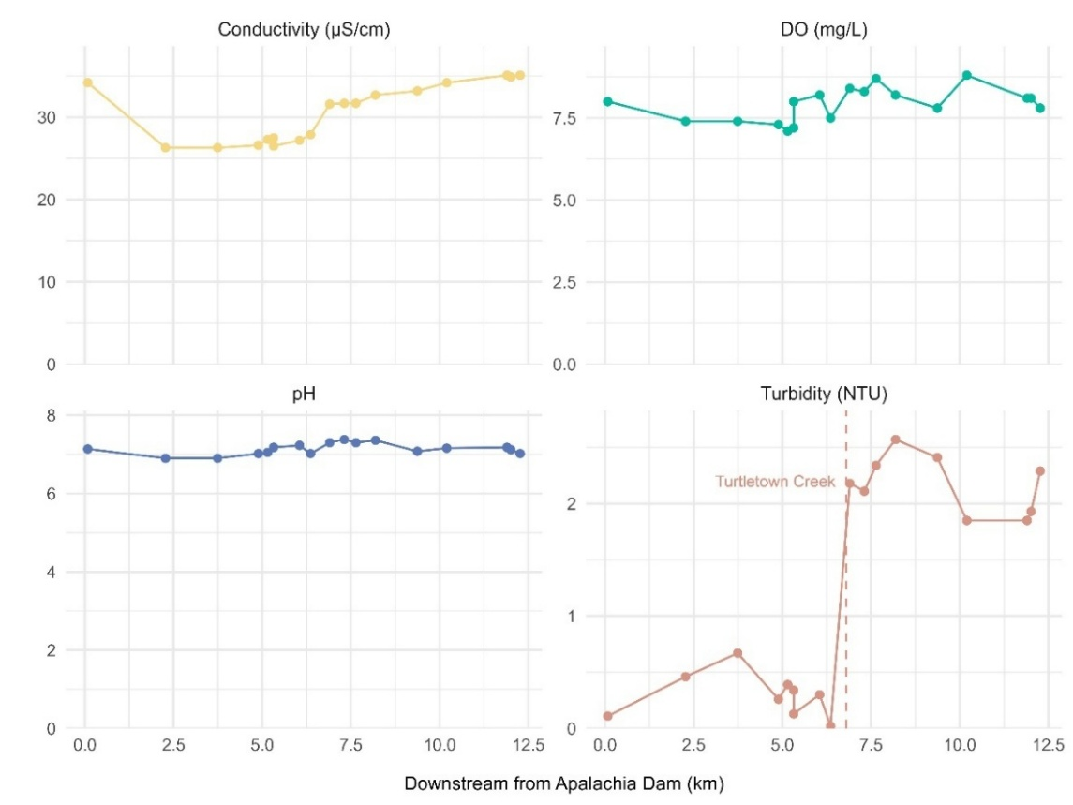
Figure 2. Spatial variation in water chemistry parameters along the Apalachia Cutoff Reach mainstem.

Metabarcoding Libraries Sequencing Quality
                - The sequencing output summary for all metabarcoding libraries is provided in Table 4. These values represent only positive samples and exclude negative controls.
                - For the Fish 12S sequencing results, the majority of raw reads from both eDNA and eRNA libraries corresponded to non-target bacterial 16S rRNA sequences, representing more than 99% of the total dataset. This off-target amplification is consistent with the known limitations of MiFish 12S primers when used in complex environmental extracts containing abundant microbial DNA. However, we still used the ASV results for preliminary community analyses. The 12S eDNA and eRNA assays will both be repeated with modified library preparation protocols to reduce the non-target amplification and improve efficiency in future runs. Moreover, all eDNA and eRNA negative controls were clean, except for one extraction blank that yielded a single detection of Oncorhynchus mykiss. However, O. mykiss was not detected in any positive samples, so it was just discarded.
Table 4. Summary of sequencing read counts across positive samples in all metabarcoding libraries.
Marker | Raw Reads | Trimmed | Merged | Split Amplicons | Non-chimeras | Final Results
12S eDNA | 22,455,563 | 20,289,329 | 19,423,289 | 111,745 | 111,745 | 52,396
12S eRNA | 21,316,774 | 19,462,277 | 18,676,207 | 36,143 | 36,068 | 11,076
COI eDNA | 5,229,089 | 3,267,318 | 3,119,884 | 3,072,972 | 3,072,972 | 2,988,877
16S eDNA | 9,979,580 | 9,437,752 | 6,773,560 | 6,537,448 | 6,307,948 | 4,777,999

                - For the mussel metabarcoding datasets, the COI libraries showed strong carry-over contamination of Cambarunio iris DNA across both positive and negative samples, dominating read counts in most libraries. Since C. iris was highly abundant at all sites, representing 266 individuals out of a total of 369 mussels identified morphologically (~72%), the COI results were only interpreted qualitatively. The 16S eDNA libraries, in contrast, showed better sequencing and cleaner negative controls. This library data will be analyzed qualitatively alongside the COI results until the corresponding eRNA sequencing data for both COI and 16S become available. These additional datasets, currently in progress, will allow for a more complete comparison of mussel community detection across markers and methods.
                - 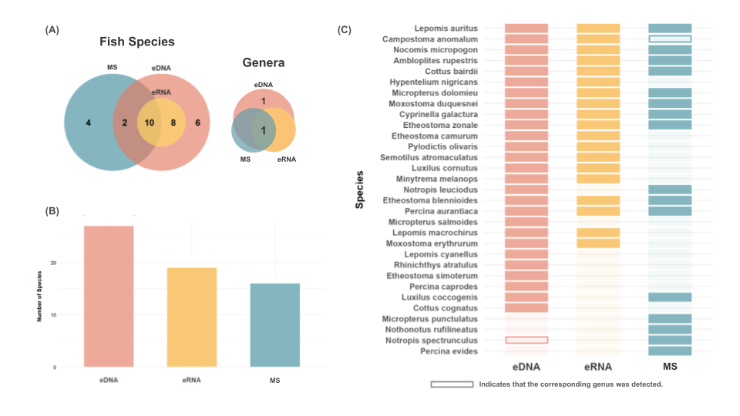
Figure 3. Comparison of fish species detected across methods in the Apalachia Cutoff Reach. (A) Venn diagram showing species overlap among eDNA, eRNA, and conventional morphological surveys (MS); (B) total number of unique fish species detected by each method; and (C) tile plot showing detection patterns of individual species across methods, with hollow tiles indicating detections at the genus level.
                - It is worth noting that the CRABS-based retrieval relied solely on downloading already annotated records (of COI and 16S genes), which may have excluded valid but unannotated sequences in GenBank. Future iterations of the reference database will incorporate non-annotated Unionida (order) sequences identified through targeted GenBank scraping, as well as newly generated Sanger barcode sequences from regional mussel and fish specimens. These improvements are expected to expand taxonomic coverage and enhance assignment accuracy in subsequent analyses.

Fish Community Detection and Environmental Patterns
                - Across all sites, eDNA detected the highest number of fish species (n = 26), followed by eRNA (n = 18) and conventional morphological surveys (n = 16) (Figure 3A–C). All taxa identified by eRNA were also detected by eDNA, showing complete overlap between the two molecular fractions. Ten of the eRNA-detected species were also found in the morphological surveys. Moreover, eDNA revealed six unique species not observed by any other method, while the morphological surveys detected four species that were missed by both molecular approaches. At the genus level, all three methods detected Campostoma, and eDNA alone detected Notropis. Overall, eDNA captured the most complete picture of the fish community, while eRNA and morphological surveys showed overlapping but partially incomplete subsets of the same assemblage. However, it is worth noting that the smaller number of detections from eRNA may reflect a more recent “snapshot” of the community, as eDNA signals are more persistent in the environment and can have higher false-positive detections. Relative read abundance (%) of each detected species across sampling sites for both eDNA and eRNA libraries is shown in Figure 4, with panels A and B representing eDNA and eRNA datasets, respectively.
s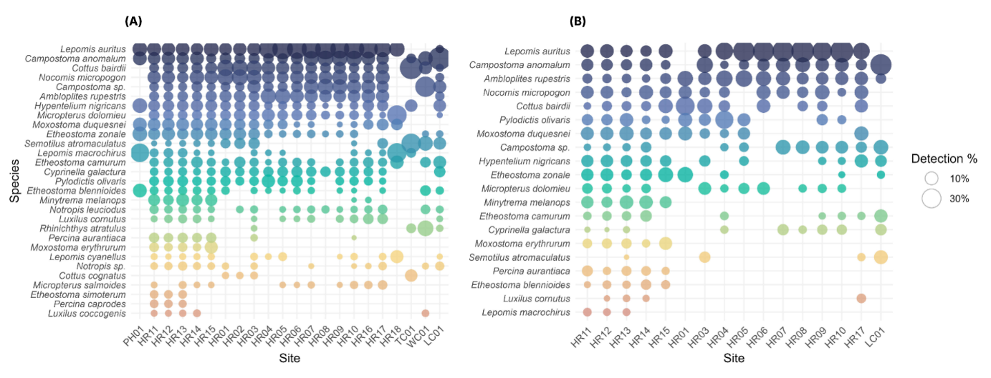
Figure 4. Bubble heat maps showing fish species composition and relative abundance across sampling sites in the Apalachia Cutoff Reach. (A) eDNA and (B) eRNA datasets generated using the MiFish-U 12S primers. Bubble size represents proportional read abundance (%) of each taxon within sites, illustrating spatial variation and compositional differences between molecular fractions.
                - Non-metric multidimensional scaling (NMDS) ordinations based on Jaccard dissimilarities produced relatively low stress values (0.14 for eDNA and 0.16 for eRNA), indicating reliable two-dimensional representations of community dissimilarities (Figure 5). The ordinations revealed strong downstream structuring of communities, consistent with PERMANOVA results, which indicated a significant effect of distance from the dam for both datasets (eDNA: R² = 0.096, F = 6.60, p = 0.001; eRNA: R² = 0.159, F = 5.87, p = 0.001). These results confirm that community composition varied significantly along the downstream gradient, with the higher R² for eRNA suggesting that RNA signals may capture more immediate biological responses to environmental gradients.
                - 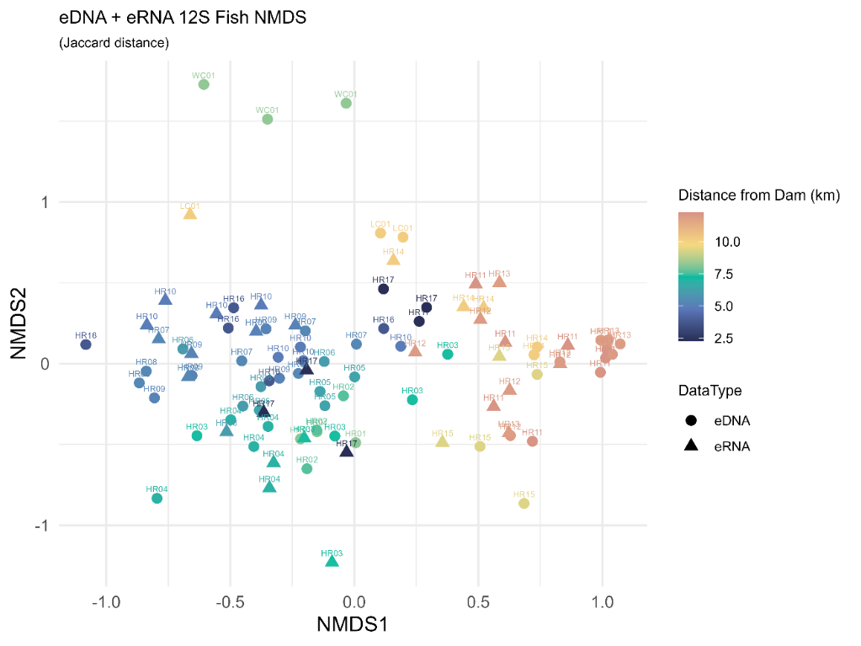
Figure 5. NMDS ordinations showing fish community composition derived from eDNA and eRNA data.
                - Moreover, procrustes analysis further demonstrated strong concordance between eDNA- and eRNA-derived community structures (sum of squares = 0.68, RMSE = 0.21, p = 0.008), while the Mantel test indicated a significant correlation between their corresponding Jaccard distance matrices (r = 0.44, p = 0.001). Together, these results confirm that eDNA and eRNA recovered congruent spatial patterns in fish community composition across sites.
                - Environmental fitting (envfit) analyses showed that conductivity, turbidity, and distance from the dam were strongly correlated with community composition (r² = 0.37–0.69, p ≤ 0.001) in both datasets (Table 5). For eDNA, pH, DO, conductivity, turbidity, and dam distance were significant, whereas temperature was not. In contrast, eRNA showed significant relationships with temperature, DO, conductivity, turbidity, and dam distance. The emergence of temperature as a significant factor in eRNA but not in eDNA suggests that RNA signals may reflect short-term or recent biological activity more sensitively. These findings collectively indicate that eDNA and eRNA capture overlapping but distinct ecological information: eDNA reflects longer-term species presence, while eRNA emphasizes metabolically active or recently present taxa, providing a more comprehensive view of fish community dynamics along the Hiwassee River.
Table 5. Results of envfit analyses for MiFish eDNA and eRNA NMDS ordinations. Shown are r² values and permutation p-values (999 permutations). Asterisks indicate significance: p < 0.05 = *, p < 0.01 = **, p ≤ 0.001 = ***
Variable | r² (eDNA) | p (eDNA) | r² (eRNA) | p (eRNA) | Common significance
Temp | 0.04 | 0.354 | 0.34 | 0.002 ** | eRNA only
pH | 0.16 | 0.007 ** | 0.1 | 0.213 | eDNA only
DO | 0.2 | 0.004 ** | 0.21 | 0.027 * | eDNA ≫ eRNA
Conductivity | 0.37 | 0.001 *** | 0.45 | 0.001 *** | both
Turbidity | 0.56 | 0.001 *** | 0.69 | 0.001 *** | both
DamDist | 0.62 | 0.001 *** | 0.69 | 0.001 *** | both

Mussel Community Detection and Molecular Marker Comparison
                - Across all sites, the COI assay detected eight mussel species, the 16S assay detected five, and the 2023 morphological surveys (MS) recorded seven species (Figure 6A-B). Pairwise Wilcoxon signed-rank tests based on binary richness data indicated no significant differences in richness between either metabarcoding assay (COI or 16S) and morphological surveys (p = 0.19 and 0.75, respectively). However, COI detected significantly higher richness than 16S (p = 0.048), consistent with the broader taxonomic coverage of COI.
                - 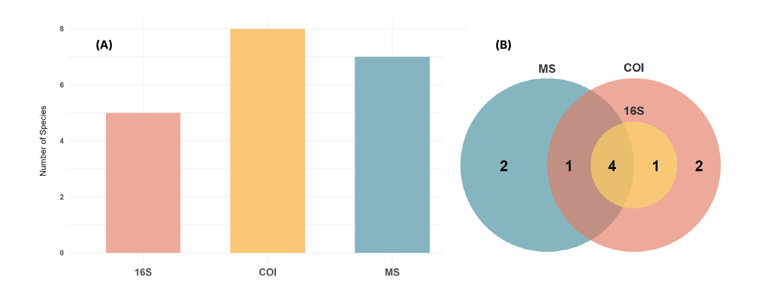
Figure 6. Comparison of mussel species detections across methods. (A) Number of unique species detected by COI, 16S, and 2023 morphological surveys (MS). (B) Venn diagram showing species overlap among methods.

                - Non-metric multidimensional scaling (NMDS) ordinations using binary Jaccard distances yielded low stress values (0.12 for COI and 0.09 for 16S), indicating good two-dimensional representation of community dissimilarities (Figure 7). PERMANOVA revealed significant effects of dam distance on mussel community composition for both markers (COI: R² = 0.062, F = 4.54, p = 0.006; 16S: R² = 0.055, F = 3.99, p = 0.017), suggesting consistent downstream turnover in assemblage structure across datasets.
                - Moreover, Procrustes and Mantel tests further demonstrated strong concordance between COI and 16S ordinations (sum of squares = 0.64, RMSE = 0.17, p = 0.001; Mantel r = 0.46, p = 0.001), confirming that both markers recovered broadly similar community-level patterns despite differences in taxonomic resolution.
                - 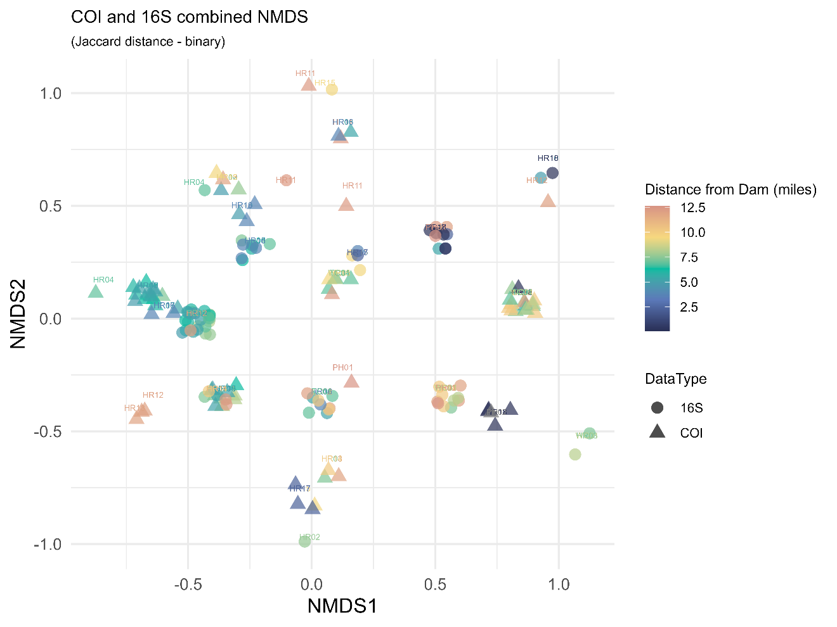
Figure 7. Combined NMDS ordination showing mussel community composition derived from COI and 16S eDNA data.
                - Environmental fitting (envfit) analyses identified several physicochemical variables correlated with NMDS structure (Table 6). For COI, temperature (r² = 0.28, p = 0.079) and turbidity (r² = 0.27, p = 0.073) showed weak but notable relationships, while conductivity displayed a moderate association (r² = 0.24, p = 0.098). In contrast, the 16S dataset showed stronger and more consistent correlations, with dissolved oxygen (r² = 0.11, p = 0.007), conductivity (r² = 0.33, p = 0.001), and turbidity (r² = 0.09, p = 0.035) emerging as significant predictors of community structure. These results suggest that both markers captured downstream environmental gradients, though 16S was more closely aligned with measured environmental variables, indicating greater ecological sensitivity despite its reduced taxonomic completeness.
Table 6. Results of envfit analyses for COI and 16S NMDS ordinations. Shown are r² values and permutation p-values (999 permutations). Significance: * p < 0.05; ** p < 0.01; *** p ≤ 0.001.
Variable | r² (COI) | p (COI) | r² (16S) | p (16S) | Common significance
Temp | 0.28 | 0.079 · | 0.001 | 0.968 | COI only (weak)
pH | 0.16 | 0.234 | 0.05 | 0.177 | none
DO | 0.06 | 0.535 | 0.11 | 0.007 ** | 16S only
Conductivity | 0.24 | 0.098 · | 0.33 | 0.001 *** | 16S ≫ COI
Turbidity | 0.27 | 0.073 · | 0.09 | 0.035 * | 16S ≫ COI
DamDist | 0.12 | 0.35 | 0.05 | 0.141 | none
                - Despite the overall consistency among methods, some marker-specific differences in detections were noteworthy (Figure 8). The 2023 morphological surveys recorded a single individual of Venustaconcha trabalis (Endangered) near the TN-68 pulloff, while the COI eDNA assay detected this species in three replicates at site HR12 and two at HR11, both near the powerhouse. These detections showed clear amplification patterns with minimal background noise, suggesting that V. trabalis may still persist within the lower reach of the ACR. Although this represents an encouraging finding, additional verification is needed to confirm its presence given the limited number of detections.
                - The COI dataset also produced a detection of Lampsilis ovata at site HR13, a species last reported in 2016 (and previously in 1992), potentially indicating persistence of this taxon downstream of the powerhouse (Ahlstedt et al., 2016; Bogan, 1993). Alasmidonta marginata was detected once in the COI dataset (single replicate, low read count), but this result should be interpreted cautiously due to the known Cambarunio iris carry-over contamination.
                - 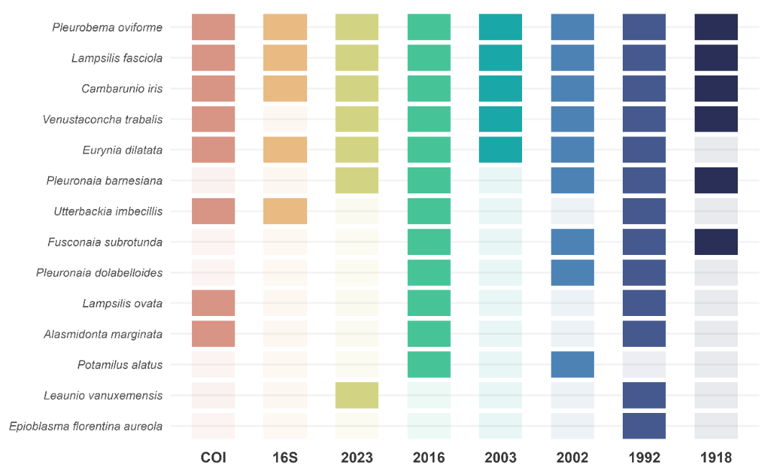
Figure 8. Historical and contemporary mussel detections in the Hiwassee River. Tile plot showing species recorded across historical surveys (1918–2016) (Ahlstedt, 2002, 2003; Ahlstedt et al., 2016; Bogan, 1993; Ortmann, 1918; Parmalee & Hughes, 1994), the 2023 morphological survey (MS), and eDNA metabarcoding results from COI and 16S markers.
                - Both COI and 16S assays detected Utterbackia imbecillis, a species previously recorded in 1992 and 2016, across multiple sites (Ahlstedt, 2002, 2003; Ahlstedt et al., 2016; Bogan, 1993; Ortmann, 1918; Parmalee & Hughes, 1994). Its repeated detection across two independent markers provides moderate support for its continued occurrence, even though it was not found in the 2023 morphological surveys. Figure 9 further shows the detection of COI and 16S eDNA, respectively, throughout the ACR sites.
                - Ongoing work aims to improve reference coverage and detection reliability by expanding the 16S database through retrieval of unannotated GenBank sequences and Sanger sequencing of regional mussel and fish voucher specimens. These efforts are expected to enhance taxonomic resolution and improve the complementarity of COI and 16S in future eDNA/eRNA analyses.
                - 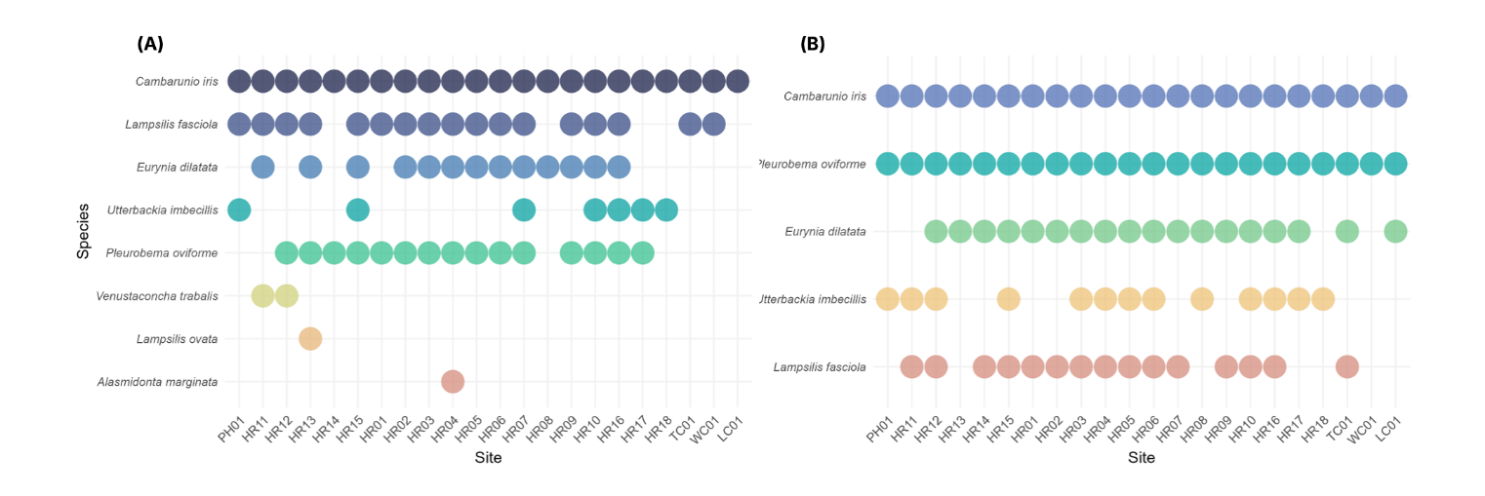
Figure 9. eDNA-based detection of mussel species across sites using (A) COI and (B) 16S markers.

Detection of Hellbender Salamanders
                - Hellbender DNA and RNA were detected at multiple sites across the Apalachia Cutoff Reach (ACR) of the Hiwassee River (Figure 10A–B). Interestingly, eDNA sampling occurred in September, coinciding with the species’ documented breeding period (Nickerson & Mays, 1973). Elevated eDNA release during mating activities, such as male combat, nest guarding, and gamete release, may have contributed to the strong detection rates observed, despite the species’ typically low abundance and cryptic behavior. Similar seasonal peaks in eDNA concentration during reproductive periods have been documented in other studies (Olson et al., 2012; Spear et al., 2015).
                - These sites include ones where individuals were previously observed by Ahlstedt et al. (2016). That survey recorded live individuals at three locations corresponding to sites HR17, HR16, and HR11 in this study, first two of which have almost perfect detection across eDNA replicates. These results suggest that Hellbender populations persist within the bypassed reach and may represent locally sustaining groups that have survived since the previous field surveys.
                - 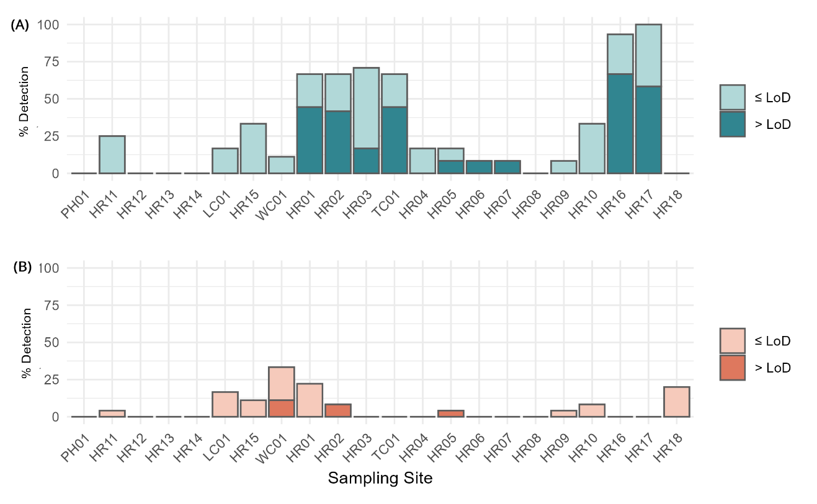
Figure 10. Detection of Eastern Hellbender (Cryptobranchus alleganiensis alleganiensis) across sampling sites in the Apalachia Cutoff Reach. (A) Proportion of eDNA replicates showing positive amplification, distinguishing detections above (≥ LoD) and below the limit of detection.
(B) Proportion of eRNA replicates showing positive amplification using the same Cytb assay.
                - Although eRNA samples were analyzed using the same cytochrome b (Cytb) qPCR assay, detections were limited to very low levels and were therefore not included in occupancy modeling. This low recovery aligns with recent experimental findings showing that Cytb messenger RNA (mRNA) is extremely labile, degrading to undetectable levels within approximately three hours under ambient conditions (Brandão-Dias et al., 2025). Given this rapid decay rate, the few RNA detections obtained here are nevertheless notable, as they may indicate biological activity that occurred within just a few hours prior to sampling.
                - Single-season occupancy models were fitted to two detection datasets: (1) an “all detections” dataset that included both above- and below-LoD amplifications, and (2) a “≥LoD” dataset restricted to quantifiable detections. For the all-detections dataset, occupancy estimates were high (mean ψ = 0.86, 95% CI = 0.56–0.97) with moderate detection probability (p = 0.65, 95% CI = 0.49–0.78). Models including conductivity as a covariate produced slightly better fit (ΔAIC < 2), but the effect was weak and uncertain (β = −0.59 ± 0.68 SE).
                - When only ≥LoD detections were used, mean occupancy declined (ψ = 0.47, 95% CI = 0.22–0.73), while detection probability remained similar (p = 0.63, 95% CI = 0.46–0.78).
Parameter uncertainty was high due to the limited number of quantifiable detections (9 of 20 sites), and no environmental covariates were statistically significant. Overall, despite how Hellbenders were detected at several sites, the limited number of positive detections and high uncertainty is preventing drawing significant conclusions about environmental predictors. Spatial variation in eDNA detection rates along the ACR is shown in Figure 11, where detection probability increases toward the mid-reach and declines again near the downstream end.

Conclusion
                - Even with limited sequencing yield and extensive off-target amplification, this study shows that environmental DNA and RNA can reveal biologically meaningful patterns across multiple taxonomic groups. Clear spatial and environmental trends emerged despite technical challenges, reflecting the inherent strength of eNA-based detection.
                - 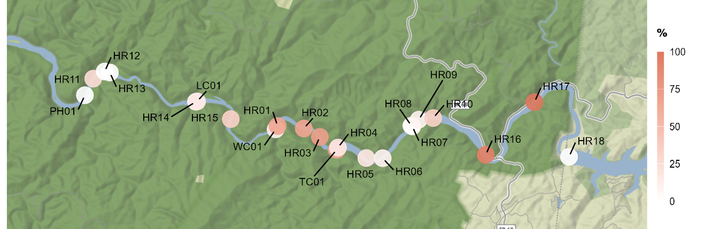
Figure 11. Percentage of Hellbender CytB eDNA detection along the Apalachia Cutoff Reach.

                - At the same time, these results highlight how essential it is to understand the weaknesses of each molecular assay in order to interpret them correctly and develop them reliably.
                - The 12S libraries had strong bacterial co-amplification yet still produced fish community patterns consistent with morphological data. For the mussel assays, the COI marker showed carry-over contamination and a high abundance of Cambarunio iris, while the 16S libraries were cleaner but limited by incomplete and poorly annotated reference databases. Together, these results indicate that methodological imperfections can obscure biological signals if they are not identified and accounted for.
                - For Hellbender detection, molecular results indicated continued presence in the Apalachia Cutoff Reach. This species is difficult to observe through conventional surveys because of its cryptic behavior and the risk of disturbing its habitat. eDNA and eRNA offer a practical alternative for monitoring without physical disruption. Current studies are also testing improved eRNA targets for Hellbenders to increase detection reliability and to evaluate the potential of RNA-based monitoring for other species.
                - Ongoing research continues to refine molecular approaches by improving primer specificity, minimizing contamination, and expanding reference databases. These databases should be taxonomically complete, accurately annotated, and include ecological metadata such as habitat, region, and voucher information. Such improvements will reduce analytical uncertainty, increase reproducibility, and improve ecological interpretation.
                - Using eDNA alone before methodological and interpretive frameworks are fully standardized could repeat some of the early credibility issues seen in this field. Continued validation and transparent reporting are needed to ensure consistent progress and confidence in these approaches. With careful refinement, eDNA and eRNA can become dependable tools for long-term freshwater biodiversity assessment and conservation.

References
Ahlstedt, S. A. (2002). Preliminary survey for federally listed and non-listed mussel species in the upper Nolichucky River and Hiwassee River (Apalachia Cutoff) bordering the Cherokee National Forest [Final Report]. U.S. Forest Service, Cherokee National Forest.
Ahlstedt, S. A. (2003). Search for tan riffleshell (Epioblasma walkeri) in the Hiwassee River (Apalachia Cutoff), and update the current status of mussel populations in the Conasauga River (Aug.–Sept. 2003) [Final Report]. U.S. Forest Service, Cherokee National Forest.
Ahlstedt, S. A., Howard, C., Reed, M., Saylor, C., & Herrig, J. (2016). Evaluation of freshwater mussels in the Hiwassee River Appalachia Cutoff (Polk County, Tennessee) following high flow releases from Appalachia Dam [Report]. Cherokee National Forest and Tennessee Valley Authority.
Albert, J. S., Destouni, G., Duke-Sylvester, S. M., Magurran, A. E., Oberdorff, T., Reis, R. E., Winemiller, K. O., & Ripple, W. J. (2021). Scientists’ warning to humanity on the freshwater biodiversity crisis. Ambio, 50(1), 85–94. https://doi.org/10.1007/s13280-020-01318-8
Andres, K. J., Sethi, S. A., Lodge, D. M., & Andrés, J. (2021). Nuclear eDNA estimates population allele frequencies and abundance in experimental mesocosms and field samples. Molecular Ecology, 30(3), 685–697. https://doi.org/10.1111/mec.15765
Barata, I. M., Griffiths, R. A., & Ridout, M. S. (2017). The power of monitoring: Optimizing survey designs to detect occupancy changes in a rare amphibian population. Scientific Reports, 7(1), 16491. https://doi.org/10.1038/s41598-017-16534-8
Barbarossa, V., Schmitt, R. J. P., Huijbregts, M. A. J., Zarfl, C., King, H., & Schipper, A. M. (2020). Impacts of current and future large dams on the geographic range connectivity of freshwater fish worldwide. Proceedings of the National Academy of Sciences, 117(7), 3648–3655. https://doi.org/10.1073/pnas.1912776117
Barnes, M. A., & Turner, C. R. (2016). The ecology of environmental DNA and implications for conservation genetics. Conservation Genetics, 17(1), 1–17. https://doi.org/10.1007/s10592-015-0775-4
Barnes, M. A., Turner, C. R., Jerde, C. L., Renshaw, M. A., Chadderton, W. L., & Lodge, D. M. (2014). Environmental Conditions Influence eDNA Persistence in Aquatic Systems. Environmental Science & Technology, 48(3), 1819–1827. https://doi.org/10.1021/es404734p
Beng, K. C., & Corlett, R. T. (2020). Applications of environmental DNA (eDNA) in ecology and conservation: Opportunities, challenges and prospects. Biodiversity and Conservation, 29(7), 2089–2121. https://doi.org/10.1007/s10531-020-01980-0
Bizic, M., Ionescu, D., Karnatak, R., Musseau, C. L., Onandia, G., Berger, S. A., Nejstgaard, J. C., Lischeid, G., Gessner, M. O., Wollrab, S., & Grossart, H. (2022). Land‐use type temporarily affects active pond community structure but not gene expression patterns. Molecular Ecology, 31(6), 1716–1734. https://doi.org/10.1111/mec.16348
Bodinof Jachowski, C., Ross, B., & Hopkins, W. (2020). Evaluating artificial shelter arrays as a minimally invasive monitoring tool for the hellbender Cryptobranchus alleganiensis. Endangered Species Research, 41, 167–181. https://doi.org/10.3354/esr01014
Bogan, A. E. (1993). Freshwater Bivalve Extinctions (Mollusca: Unionoida): A Search for Causes1. American Zoologist, 33(6), 599–609. https://doi.org/10.1093/icb/33.6.599
Bogdanov, D., Farfan, J., Sadovskaia, K., Aghahosseini, A., Child, M., Gulagi, A., Oyewo, A. S., de Souza Noel Simas Barbosa, L., & Breyer, C. (2019). Radical transformation pathway towards sustainable electricity via evolutionary steps. Nature Communications, 10(1), 1077. https://doi.org/10.1038/s41467-019-08855-1
Bohmann, K., Evans, A., Gilbert, M. T. P., Carvalho, G. R., Creer, S., Knapp, M., Yu, D. W., & de Bruyn, M. (2014). Environmental DNA for wildlife biology and biodiversity monitoring. Trends in Ecology & Evolution, 29(6), 358–367. https://doi.org/10.1016/j.tree.2014.04.003
Boivin-Delisle, D., Laporte, M., Burton, F., Dion, R., Normandeau, E., & Bernatchez, L. (2021). Using environmental DNA for biomonitoring of freshwater fish communities: Comparison with established gillnet surveys in a boreal hydroelectric impoundment. Environmental DNA, 3(1), 105–120. https://doi.org/10.1002/edn3.135
Bolger, A. M., Lohse, M., & Usadel, B. (2014). Trimmomatic: A flexible trimmer for Illumina sequence data. Bioinformatics, 30(15), 2114–2120. https://doi.org/10.1093/bioinformatics/btu170
Bonar, S. A., Hubert, W. A., & Willis, D. W. (2009). Standard methods for sampling North American freshwater fishes.
Brandão-Dias, P. F., Shaffer, M., Guri, G., Parsons, K. M., Kelly, R. P., & Allan, E. A. (2025). Differential decay of multiple environmental nucleic acid components. Scientific Reports, 15(1), 26791. https://doi.org/10.1038/s41598-025-12916-5
Bunholi, I. V., Foster, N. R., & Casey, J. M. (2023). Environmental DNA and RNA in aquatic community ecology: Toward methodological standardization. Environmental DNA, 5(6), 1133–1147. https://doi.org/10.1002/edn3.476
Bylemans, J., Gleeson, D. M., Lintermans, M., Hardy, C. M., Beitzel, M., Gilligan, D. M., & Furlan, E. M. (2018). Monitoring riverine fish communities through eDNA metabarcoding: Determining optimal sampling strategies along an altitudinal and biodiversity gradient. Metabarcoding and Metagenomics, 2, e30457. https://doi.org/10.3897/mbmg.2.30457
Chen, H., & Boutros, P. C. (2011). VennDiagram: A package for the generation of highly-customizable Venn and Euler diagrams in R. BMC Bioinformatics, 12(1), 35. https://doi.org/10.1186/1471-2105-12-35
Chen, Q., Li, Q., Lin, Y., Zhang, J., Xia, J., Ni, J., Cooke, S. J., Best, J., He, S., Feng, T., Chen, Y., Tonina, D., Benjankar, R., Birk, S., Fleischmann, A. S., Yan, H., & Tang, L. (2023). River Damming Impacts on Fish Habitat and Associated Conservation Measures. Reviews of Geophysics, 61(4), e2023RG000819. https://doi.org/10.1029/2023RG000819
Cilleros, K., Valentini, A., Allard, L., Dejean, T., Etienne, R., Grenouillet, G., Iribar, A., Taberlet, P., Vigouroux, R., & Brosse, S. (2019). Unlocking biodiversity and conservation studies in high-diversity environments using environmental DNA (eDNA): A test with Guianese freshwater fishes. Molecular Ecology Resources, 19(1), 27–46. https://doi.org/10.1111/1755-0998.12900
Coble, A. A., Flinders, C. A., Homyack, J. A., Penaluna, B. E., Cronn, R. C., & Weitemier, K. (2019). eDNA as a tool for identifying freshwater species in sustainable forestry: A critical review and potential future applications. Science of The Total Environment, 649, 1157–1170. https://doi.org/10.1016/j.scitotenv.2018.08.370
Collins, R. A., Bakker, J., Wangensteen, O. S., Soto, A. Z., Corrigan, L., Sims, D. W., Genner, M. J., & Mariani, S. (2019). Non‐specific amplification compromises environmental DNA metabarcoding with COI. Methods in Ecology and Evolution, 10(11), 1985–2001. https://doi.org/10.1111/2041-210X.13276
Cordier, T., Alonso-Sáez, L., Apothéloz-Perret-Gentil, L., Aylagas, E., Bohan, D. A., Bouchez, A., Chariton, A., Creer, S., Frühe, L., Keck, F., Keeley, N., Laroche, O., Leese, F., Pochon, X., Stoeck, T., Pawlowski, J., & Lanzén, A. (2021). Ecosystems monitoring powered by environmental genomics: A review of current strategies with an implementation roadmap. Molecular Ecology, 30(13), 2937–2958. https://doi.org/10.1111/mec.15472
Corinaldesi, C., Beolchini, F., & Dell’Anno, A. (2008). Damage and degradation rates of extracellular DNA in marine sediments: Implications for the preservation of gene sequences. Molecular Ecology, 17(17), 3939–3951. https://doi.org/10.1111/j.1365-294X.2008.03880.x
Creer, S., Enderby, P., Judge, S., & John, A. (2016). Prevalence of people who could benefit from augmentative and alternative communication (AAC) in the UK: Determining the need. International Journal of Language & Communication Disorders, 51(6), 639–653. https://doi.org/10.1111/1460-6984.12235
Cressler, A. (2012). Apalachia Powerhouse. https://www.flickr.com/photos/alan_cressler/7532635950/player/db535b92c8
Cristescu, M. E. (2019). Can Environmental RNA Revolutionize Biodiversity Science? Trends in Ecology & Evolution, 34(8), 694–697. https://doi.org/10.1016/j.tree.2019.05.003
Cristescu, M. E., & Hebert, P. D. N. (2018). Uses and Misuses of Environmental DNA in Biodiversity Science and Conservation. Annual Review of Ecology, Evolution, and Systematics, 49(1), 209–230. https://doi.org/10.1146/annurev-ecolsys-110617-062306
Darling, J. A., & Mahon, A. R. (2011). From molecules to management: Adopting DNA-based methods for monitoring biological invasions in aquatic environments. Environmental Research, 111(7), 978–988. https://doi.org/10.1016/j.envres.2011.02.001
Deagle, B. E., Jarman, S. N., Coissac, E., Pompanon, F., & Taberlet, P. (2014). DNA metabarcoding and the cytochrome c oxidase subunit I marker: Not a perfect match. Biology Letters, 10(9), 20140562. https://doi.org/10.1098/rsbl.2014.0562
Deiner, K., & Altermatt, F. (2014). Transport Distance of Invertebrate Environmental DNA in a Natural River. PLoS ONE, 9(2), e88786. https://doi.org/10.1371/journal.pone.0088786
Deiner, K., Bik, H. M., Mächler, E., Seymour, M., Lacoursière‐Roussel, A., Altermatt, F., Creer, S., Bista, I., Lodge, D. M., De Vere, N., Pfrender, M. E., & Bernatchez, L. (2017). Environmental DNA metabarcoding: Transforming how we survey animal and plant communities. Molecular Ecology, 26(21), 5872–5895. https://doi.org/10.1111/mec.14350
Deiner, K., Fronhofer, E. A., Mächler, E., Walser, J.-C., & Altermatt, F. (2016). Environmental DNA reveals that rivers are conveyer belts of biodiversity information. Nature Communications, 7(1), 12544. https://doi.org/10.1038/ncomms12544
Dejean, T., Valentini, A., Miquel, C., Taberlet, P., Bellemain, E., & Miaud, C. (2012). Improved detection of an alien invasive species through environmental DNA barcoding: The example of the American bullfrog Lithobates catesbeianus. Journal of Applied Ecology, 49(4), 953–959. https://doi.org/10.1111/j.1365-2664.2012.02171.x
Dowle, E., Pochon, X., Keeley, N., & Wood, S. A. (2015). Assessing the effects of salmon farming seabed enrichment using bacterial community diversity and high-throughput sequencing. FEMS Microbiology Ecology, 91(8), fiv089. https://doi.org/10.1093/femsec/fiv089
Dudgeon, D. (2019). Multiple threats imperil freshwater biodiversity in the Anthropocene. Current Biology, 29(19), R960–R967. https://doi.org/10.1016/j.cub.2019.08.002
Eisenhauer, N., & Hines, J. (2021). Invertebrate biodiversity and conservation. Current Biology, 31(19), R1214–R1218. https://doi.org/10.1016/j.cub.2021.06.058
Elbrecht, V., & Leese, F. (2015). Can DNA-Based Ecosystem Assessments Quantify Species Abundance? Testing Primer Bias and Biomass—Sequence Relationships with an Innovative Metabarcoding Protocol. PLOS ONE, 10(7), e0130324. https://doi.org/10.1371/journal.pone.0130324
Elbrecht, V., Vamos, E. E., Meissner, K., Aroviita, J., & Leese, F. (2017). Assessing strengths and weaknesses of DNA metabarcoding‐based macroinvertebrate identification for routine stream monitoring. Methods in Ecology and Evolution, 8(10), 1265–1275. https://doi.org/10.1111/2041-210X.12789
FCMS. (2023). The 2023 checklist of freshwater bivalves (Mollusca: Bivalvia: Unionida) of the United States and Canada. Considered and approved by the Bivalve Names Subcommittee. Updated September 2023. https://molluskconservation.org/Library/Committees/Names/Appendix_1_Bivalves_Revised_Names_List_20230928_draft.pdf
Fediajevaite, J., Priestley, V., Arnold, R., & Savolainen, V. (2021). Meta-analysis shows that environmental DNA outperforms traditional surveys, but warrants better reporting standards. Ecology and Evolution, 11(9), 4803–4815. https://doi.org/10.1002/ece3.7382
Fernandez, N. B., Komoroske, L. M., Danylchuk, A. J., Primack, C., & Cheng, B. S. (2024). Damming creates winners and losers: Life history traits fail to predict vulnerability in freshwater fishes. Global Ecology and Conservation, 52, e02957. https://doi.org/10.1016/j.gecco.2024.e02957
Ficetola, G. F., Boyer, F., Valentini, A., Bonin, A., Meyer, A., Dejean, T., Gaboriaud, C., Usseglio‐Polatera, P., & Taberlet, P. (2021). Comparison of markers for the monitoring of freshwater benthic biodiversity through DNA metabarcoding. Molecular Ecology, 30(13), 3189–3202. https://doi.org/10.1111/mec.15632
Ficetola, G. F., Miaud, C., Pompanon, F., & Taberlet, P. (2008). Species detection using environmental DNA from water samples. Biology Letters, 4(4), 423–425. https://doi.org/10.1098/rsbl.2008.0118
Fiske, I., & Chandler, R. (2011). unmarked: An R Package for Fitting Hierarchical Models of Wildlife Occurrence and Abundance. Journal of Statistical Software, 43, 1–23. https://doi.org/10.18637/jss.v043.i10
Fujii, K., Doi, H., Matsuoka, S., Nagano, M., Sato, H., & Yamanaka, H. (2019). Environmental DNA metabarcoding for fish community analysis in backwater lakes: A comparison of capture methods. PLOS ONE, 14(1), e0210357. https://doi.org/10.1371/journal.pone.0210357
Giroux, M. S., Reichman, J. R., Langknecht, T., Burgess, R. M., & Ho, K. T. (2022). Environmental RNA as a Tool for Marine Community Biodiversity Assessments. Scientific Reports, 12(1), 17782. https://doi.org/10.1038/s41598-022-22198-w
Goffaux, D. G. (2005). Electrofishing versus gillnet sampling for the assessment of fish assemblages in large rivers. Archiv Für Hydrobiologie, 73–90. https://doi.org/10.1127/0003-9136/2005/0162-0073
Goldberg, C. S., Pilliod, D. S., Arkle, R. S., & Waits, L. P. (2011). Molecular Detection of Vertebrates in Stream Water: A Demonstration Using Rocky Mountain Tailed Frogs and Idaho Giant Salamanders. PLoS ONE, 6(7), e22746. https://doi.org/10.1371/journal.pone.0022746
Greco, M., Lejzerowicz, F., Reo, E., Caruso, A., Maccotta, A., Coccioni, R., Pawlowski, J., & Frontalini, F. (2022). Environmental RNA outperforms eDNA metabarcoding in assessing impact of marine pollution: A chromium-spiked mesocosm test. Chemosphere, 298, 134239. https://doi.org/10.1016/j.chemosphere.2022.134239
Griffiths, N. P., Bolland, J. D., Wright, R. M., Murphy, L. A., Donnelly, R. K., Watson, H. V., & Hänfling, B. (2020). Environmental DNA metabarcoding provides enhanced detection of the European eel Anguilla anguilla and fish community structure in pumped river catchments. Ecology. https://doi.org/10.1101/2020.07.22.216523
Hajibabaei, M., Porter, T. M., Robinson, C. V., Baird, D. J., Shokralla, S., & Wright, M. T. G. (2019). Watered-down biodiversity? A comparison of metabarcoding results from DNA extracted from matched water and bulk tissue biomonitoring samples. PLOS ONE, 14(12), e0225409. https://doi.org/10.1371/journal.pone.0225409
Hajibabaei, M., Shokralla, S., Zhou, X., Singer, G. A. C., & Baird, D. J. (2011). Environmental Barcoding: A Next-Generation Sequencing Approach for Biomonitoring Applications Using River Benthos. PLOS ONE, 6(4), e17497. https://doi.org/10.1371/journal.pone.0017497
Hayami, K., Sakata, M. K., Inagawa, T., Okitsu, J., Katano, I., Doi, H., Nakai, K., Ichiyanagi, H., Gotoh, R. O., Miya, M., Sato, H., Yamanaka, H., & Minamoto, T. (2020). Effects of sampling seasons and locations on fish environmental DNA metabarcoding in dam reservoirs. Ecology and Evolution, 10(12), 5354–5367. https://doi.org/10.1002/ece3.6279
He, X., Jeffery, N. W., Stanley, R. R. E., Hamilton, L. C., Rubidge, E. M., & Abbott, C. L. (2023). eDNA metabarcoding enriches traditional trawl survey data for monitoring biodiversity in the marine environment. ICES Journal of Marine Science, 80(5), 1529–1538. https://doi.org/10.1093/icesjms/fsad083
Hebert, P. D. N., Cywinska, A., Ball, S. L., & deWaard, J. R. (2003). Biological identifications through DNA barcodes. Proceedings of the Royal Society of London. Series B: Biological Sciences, 270(1512), 313–321. https://doi.org/10.1098/rspb.2002.2218
Holubová, M., Richta, J., Čech, M., Vejřík, L., Draštík, V., Kočvara, L., & Peterka, J. (2025). Assessing the applicability of diver-based surveys for monitoring fish populations in lentic lakes. Fisheries Research, 284, 107308. https://doi.org/10.1016/j.fishres.2025.107308
Huang, Z., & Li, H. (2024). Dams trigger exponential population declines of migratory fish. Science Advances, 10(19), eadi6580. https://doi.org/10.1126/sciadv.adi6580
IUCN. (2025). The IUCN Red List of Threatened Species. Version 2025-1. International Union for Conservation of Nature. https://www.iucnredlist.org
Jackman, J. M., Benvenuto, C., Coscia, I., Oliveira Carvalho, C., Ready, J. S., Boubli, J. P., Magnusson, W. E., McDevitt, A. D., & Guimarães Sales, N. (2021). eDNA in a bottleneck: Obstacles to fish metabarcoding studies in megadiverse freshwater systems. Environmental DNA, 3(4), 837–849. https://doi.org/10.1002/edn3.191
Jerde, C. L., Mahon, A. R., Chadderton, W. L., & Lodge, D. M. (2011). “Sight-unseen” detection of rare aquatic species using environmental DNA: eDNA surveillance of rare aquatic species. Conservation Letters, 4(2), 150–157. https://doi.org/10.1111/j.1755-263X.2010.00158.x
Jeunen, G., Dowle, E., Edgecombe, J., Von Ammon, U., Gemmell, N. J., & Cross, H. (2023). crabs—A software program to generate curated reference databases for metabarcoding sequencing data. Molecular Ecology Resources, 23(3), 725–738. https://doi.org/10.1111/1755-0998.13741
Jewell, Z. (2013). Effect of Monitoring Technique on Quality of Conservation Science. Conservation Biology, 27(3), 501–508. https://doi.org/10.1111/cobi.12066
Ji, F., Han, D., Yan, L., Yan, S., Zha, J., & Shen, J. (2022). Assessment of benthic invertebrate diversity and river ecological status along an urbanized gradient using environmental DNA metabarcoding and a traditional survey method. Science of The Total Environment, 806, 150587. https://doi.org/10.1016/j.scitotenv.2021.150587
Jo, T., Murakami, H., Yamamoto, S., Masuda, R., & Minamoto, T. (2019). Effect of water temperature and fish biomass on environmental DNA shedding, degradation, and size distribution. Ecology and Evolution, 9(3), 1135–1146. https://doi.org/10.1002/ece3.4802
Joly, S., Davies, T. J., Archambault, A., Bruneau, A., Derry, A., Kembel, S. W., Peres-Neto, P., Vamosi, J., & Wheeler, T. A. (2014). Ecology in the age of DNA barcoding: The resource, the promise and the challenges ahead. Molecular Ecology Resources, 14(2), 221–232. https://doi.org/10.1111/1755-0998.12173
Kelly, R. P., Lodge, D. M., Lee, K. N., Theroux, S., Sepulveda, A. J., Scholin, C. A., Craine, J. M., Andruszkiewicz Allan, E., Nichols, K. M., Parsons, K. M., Goodwin, K. D., Gold, Z., Chavez, F. P., Noble, R. T., Abbott, C. L., Baerwald, M. R., Naaum, A. M., Thielen, P. M., Simons, A. L., … Weisberg, S. B. (2024). Toward a national eDNA strategy for the United States. Environmental DNA, 6(1), e432. https://doi.org/10.1002/edn3.432
Kelly, R. P., Port, J. A., Yamahara, K. M., & Crowder, L. B. (2014). Using Environmental DNA to Census Marine Fishes in a Large Mesocosm. PLoS ONE, 9(1), e86175. https://doi.org/10.1371/journal.pone.0086175
Klymus, K. E., Richter, C. A., Thompson, N., Hinck, J. E., & Jones, J. W. (2021). Metabarcoding assays for the detection of freshwater mussels (Unionida) with environmental DNA. Environmental DNA, 3(1), 231–247. https://doi.org/10.1002/edn3.166
Kubecka, J., Hohausova, E., Matena, J., Peterka, J., Amarasinghe, U. S., Bonar, S. A., Hateley, J., Hickley, P., Suuronen, P., Tereschenko, V., Welcomme, R., & Winfield, I. J. (2009). The true picture of a lake or reservoir fish stock: A review of needs and progress. Fisheries Research, 96(1), 1–5. https://doi.org/10.1016/j.fishres.2008.09.021
Lamb, C. T., Ford, A. T., Proctor, M. F., Royle, J. A., Mowat, G., & Boutin, S. (2019). Genetic tagging in the Anthropocene: Scaling ecology from alleles to ecosystems. Ecological Applications, 29(4), e01876. https://doi.org/10.1002/eap.1876
Levy-Booth, D. J., Campbell, R. G., Gulden, R. H., Hart, M. M., Powell, J. R., Klironomos, J. N., Pauls, K. P., Swanton, C. J., Trevors, J. T., & Dunfield, K. E. (2007). Cycling of extracellular DNA in the soil environment. Soil Biology and Biochemistry, 39(12), 2977–2991. https://doi.org/10.1016/j.soilbio.2007.06.020
Li, Y., & Breaker, R. R. (1999). Kinetics of RNA Degradation by Specific Base Catalysis of Transesterification Involving the 2‘-Hydroxyl Group. Journal of the American Chemical Society, 121, 5364–5372.
Liermann, C. R., Nilsson, C., Robertson, J., & Ng, R. Y. (2012). Implications of Dam Obstruction for Global Freshwater Fish Diversity. BioScience, 62(6), 539–548. https://doi.org/10.1525/bio.2012.62.6.5
Lin, X., Jiang, K., Liu, W., Liu, W., Bu, W., Wang, X., & Mo, L. (2021). Toward a global DNA barcode reference library of the intolerant nonbiting midge genus Rheocricotopus Brundin, 1956. Ecology and Evolution, 11(17), 12161–12172. https://doi.org/10.1002/ece3.7979
Liu, S., Chen, J., Cui, G., Zhang, B., Yan, B., & Nie, Q. (2025). Environmental DNA metabarcoding: Current applications and future prospects for freshwater fish monitoring. Journal of Environmental Management, 376, 124531. https://doi.org/10.1016/j.jenvman.2025.124531
Lodge, D. M., Turner, C. R., Jerde, C. L., Barnes, M. A., Chadderton, L., Egan, S. P., Feder, J. L., Mahon, A. R., & Pfrender, M. E. (2012). Conservation in a cup of water: Estimating biodiversity and population abundance from environmental DNA. Molecular Ecology, 21(11), 2555–2558. https://doi.org/10.1111/j.1365-294X.2012.05600.x
Lotz, A., & Allen, C. R. (2007). Observer Bias in Anuran Call Surveys. The Journal of Wildlife Management, 71(2), 675–679. https://doi.org/10.2193/2005-759
Lundberg, J. G., Kottelat, M., Smith, G. R., Stiassny, M. L. J., & Gill, A. C. (2000). So Many Fishes, So Little Time: An Overview of Recent Ichthyological Discovery in Continental Waters. Annals of the Missouri Botanical Garden, 87(1), 26–62. https://doi.org/10.2307/2666207
Macher, T.-H., Arle, J., Beermann, A. J., Frank, L., Hupało, K., Koschorreck, J., Schütz, R., & Leese, F. (2024). Is it worth the extra mile? Comparing environmental DNA and RNA metabarcoding for vertebrate and invertebrate biodiversity surveys in a lowland stream. PeerJ, 12, e18016. https://doi.org/10.7717/peerj.18016
Mächler, E., Deiner, K., Steinmann, P., & Altermatt, F. (2014). Utility of Environmental DNA for Monitoring Rare and Indicator Macroinvertebrate Species. Freshwater Science, 33(4), 1174–1183. https://doi.org/10.1086/678128
Mächler, E., Little, C. J., Wüthrich, R., Alther, R., Fronhofer, E. A., Gounand, I., Harvey, E., Hürlemann, S., Walser, J.-C., & Altermatt, F. (2019). Assessing different components of diversity across a river network using eDNA. Environmental DNA, 1(3), 290–301. https://doi.org/10.1002/edn3.33
MacKenzie, D. I., Nichols, James. D., Sutton, N., Kawanishi, K., & Bailey, L. L. (2005). Improving Inferences in Population Studies of Rare Species That Are Detected Imperfectly. Ecology, 86(5), 1101–1113. https://doi.org/10.1890/04-1060
Magoč, T., & Salzberg, S. L. (2011). FLASH: Fast length adjustment of short reads to improve genome assemblies. Bioinformatics, 27(21), 2957–2963. https://doi.org/10.1093/bioinformatics/btr507
Manel, S., Gauthier, J., Benestan, L., Dubois, M., Romant, L., Macé, B., Bruno, M., Arnal, V., Testud, G., Garcia, M., Carrasquer Puyal, I., Bilat, J., Miaud, C., & Alvarez, N. (2025). An enrichment‐based capture method from nuclear environmental DNA presents new opportunities for population genomics: A case study on the common frog. Methods in Ecology and Evolution, 16(6), 1106–1115. https://doi.org/10.1111/2041-210X.70039
Marshall, E. (2005). Taxonomy. Will DNA bar codes breathe life into classification? Science (New York, N.Y.), 307(5712), 1037. https://doi.org/10.1126/science.307.5712.1037
Marshall, N. T., & Stepien, C. A. (2019). Invasion genetics from eDNA and thousands of larvae: A targeted metabarcoding assay that distinguishes species and population variation of zebra and quagga mussels. Ecology and Evolution, 9(6), 3515–3538. https://doi.org/10.1002/ece3.4985
Marshall, N. T., Symonds, D. E., Dean, C. A., Schumer, G., & Fleece, W. C. (2022). Evaluating environmental DNA metabarcoding as a survey tool for unionid mussel assessments. Freshwater Biology, 67(9), 1483–1507. https://doi.org/10.1111/fwb.13955
Marshall, N. T., Vanderploeg, H. A., & Chaganti, S. R. (2021). Environmental (e)RNA advances the reliability of eDNA by predicting its age. Scientific Reports, 11(1), 2769. https://doi.org/10.1038/s41598-021-82205-4
Miya, M., Sato, Y., Fukunaga, T., Sado, T., Poulsen, J. Y., Sato, K., Minamoto, T., Yamamoto, S., Yamanaka, H., Araki, H., Kondoh, M., & Iwasaki, W. (2015). MiFish, a set of universal PCR primers for metabarcoding environmental DNA from fishes: Detection of more than 230 subtropical marine species. Royal Society Open Science, 2(7), 150088. https://doi.org/10.1098/rsos.150088
Miyata, K., Inoue, Y., Amano, Y., Nishioka, T., Yamane, M., Kawaguchi, T., Morita, O., & Honda, H. (2021). Fish environmental RNA enables precise ecological surveys with high positive predictivity. Ecological Indicators, 128, 107796. https://doi.org/10.1016/j.ecolind.2021.107796
Morgan, R. K. (2012). Environmental impact assessment: The state of the art. Impact Assessment and Project Appraisal, 30(1), 5–14. https://doi.org/10.1080/14615517.2012.661557
Nickerson, M. A., & Mays, C. E. (1973). A Study of the Ozark Hellbender Cryptobranchus Alleganiensis Bishopi. Ecology, 54(5), 1164–1165. https://doi.org/10.2307/1935586
Oksanen, J., Simpson, G. L., Blanchet, F. G., Kindt, R., Legendre, P., Minchin, P. R., O’Hara, R. B., Solymos, P., Stevens, M. H. H., Szoecs, E., Wagner, H., Barbour, M., Bedward, M., Bolker, B., Borcard, D., Borman, T., Carvalho, G., Chirico, M., De Caceres, M., … Weedon, J. (2001). vegan: Community Ecology Package (p. 2.7-2) [Dataset]. https://doi.org/10.32614/CRAN.package.vegan
Olson, Z. H., Briggler, J. T., & Williams, R. N. (2012). An eDNA approach to detect eastern hellbenders (Cryptobranchus a. Alleganiensis) using samples of water. Wildlife Research, 39(7), 629. https://doi.org/10.1071/WR12114
Orr, S., Pittock, J., Chapagain, A., & Dumaresq, D. (2012). Dams on the Mekong River: Lost fish protein and the implications for land and water resources. Global Environmental Change, 22(4), 925–932. https://doi.org/10.1016/j.gloenvcha.2012.06.002
Ortmann, A. E. (1918). The naiades (freshwater mussels) of the Tennessee River system below Knoxville. Proceedings of the American Philosophical Society, 57, 521–626.
Parmalee, P. W., & Hughes, M. H. (1994). Freshwater mussels (Bivalvia: Unionidae) of the Hiwassee River in East Tennessee. American Malacological Bulletin, 11(1), 21–27.
Pawlowski, J., Apothéloz-Perret-Gentil, L., & Altermatt, F. (2020). Environmental DNA: What’s behind the term? Clarifying the terminology and recommendations for its future use in biomonitoring. Molecular Ecology, 29(22), 4258–4264. https://doi.org/10.1111/mec.15643
Pawlowski, J., Kelly-Quinn, M., Altermatt, F., Apothéloz-Perret-Gentil, L., Beja, P., Boggero, A., Borja, A., Bouchez, A., Cordier, T., Domaizon, I., Feio, M. J., Filipe, A. F., Fornaroli, R., Graf, W., Herder, J., van der Hoorn, B., Iwan Jones, J., Sagova-Mareckova, M., Moritz, C., … Kahlert, M. (2018). The future of biotic indices in the ecogenomic era: Integrating (e)DNA metabarcoding in biological assessment of aquatic ecosystems. Science of The Total Environment, 637–638, 1295–1310. https://doi.org/10.1016/j.scitotenv.2018.05.002
Pawlowski, J., Lejzerowicz, F., & Esling, P. (2014). Next-generation environmental diversity surveys of foraminifera: Preparing the future. The Biological Bulletin, 227(2), 93–106. https://doi.org/10.1086/BBLv227n2p93
Pochon, X., Zaiko, A., Fletcher, L. M., Laroche, O., & Wood, S. A. (2017). Wanted dead or alive? Using metabarcoding of environmental DNA and RNA to distinguish living assemblages for biosecurity applications. PLOS ONE, 12(11), e0187636. https://doi.org/10.1371/journal.pone.0187636
Pollard, S., Anderson, J., Bah, F., Mateus, M., Sidhu, M., & Simmons, D. (2022). Non-Lethal Blood Sampling of Fish in the lab and Field With Methods for Dried Blood Plasma Spot Omic Analyses. Frontiers in Genetics, 13, 795348. https://doi.org/10.3389/fgene.2022.795348
Pont, D., Rocle, M., Valentini, A., Civade, R., Jean, P., Maire, A., Roset, N., Schabuss, M., Zornig, H., & Dejean, T. (2018). Environmental DNA reveals quantitative patterns of fish biodiversity in large rivers despite its downstream transportation. Scientific Reports, 8(1), 10361. https://doi.org/10.1038/s41598-018-28424-8
Poyntz-Wright, I. P., Harrison, X. A., Pedersen, S., & Tyler, C. R. (2024). Effectiveness of eDNA for monitoring riverine macroinvertebrates. Science of The Total Environment, 941, 173621. https://doi.org/10.1016/j.scitotenv.2024.173621
Prié, V., Valentini, A., Lopes-Lima, M., Froufe, E., Rocle, M., Poulet, N., Taberlet, P., & Dejean, T. (2021). Environmental DNA metabarcoding for freshwater bivalves biodiversity assessment: Methods and results for the Western Palearctic (European sub-region). Hydrobiologia, 848(12–13), 2931–2950. https://doi.org/10.1007/s10750-020-04260-8
Przybyla-Kelly, K., & Spoljaric, A. M. (2023). Round goby detection by environmental DNA, trawl, and angling in Lakes Huron and Michigan [Dataset]. U.S. Geological Survey. https://doi.org/10.5066/P92V61KL
Ramirez, J. L., Núñez-Rodriguez, D., Britzke, R., Siccha-Ramirez, R., & Ramírez, R. (2023). DNA barcoding for assessing biodiversity. In Conservation Genetics in the Neotropics (pp. 21–45). Springer.
Ratnasingham, S., & Hebert, P. D. N. (2007). bold: The Barcode of Life Data System (http://www.barcodinglife.org). Molecular Ecology Notes, 7(3), 355–364. https://doi.org/10.1111/j.1471-8286.2007.01678.x
Rees, H. C., Maddison, B. C., Middleditch, D. J., Patmore, J. R. M., & Gough, K. C. (2014). REVIEW: The detection of aquatic animal species using environmental DNA – a review of eDNA as a survey tool in ecology. Journal of Applied Ecology, 51(5), 1450–1459. https://doi.org/10.1111/1365-2664.12306
Reid, A. J., Carlson, A. K., Creed, I. F., Eliason, E. J., Gell, P. A., Johnson, P. T. J., Kidd, K. A., MacCormack, T. J., Olden, J. D., Ormerod, S. J., Smol, J. P., Taylor, W. W., Tockner, K., Vermaire, J. C., Dudgeon, D., & Cooke, S. J. (2019). Emerging threats and persistent conservation challenges for freshwater biodiversity. Biological Reviews of the Cambridge Philosophical Society, 94(3), 849–873. https://doi.org/10.1111/brv.12480
Ricciardi, A., & Rasmussen, J. B. (1999). Extinction Rates of North American Freshwater Fauna. Conservation Biology, 13(5), 1220–1222. https://doi.org/10.1046/j.1523-1739.1999.98380.x
Rognes, T., Flouri, T., Nichols, B., Quince, C., & Mahé, F. (2016). VSEARCH: A versatile open source tool for metagenomics. PeerJ, 4, e2584. https://doi.org/10.7717/peerj.2584
Sajina, A., Sudheesan, D., Kumar, L., & Sandhya, K. (2021). Fish as ecological health indicators of freshwater ecosystems. Biotica Research Today, 3(1), 77–80.
Sales, N. G., Wangensteen, O. S., Carvalho, D. C., Deiner, K., Præbel, K., Coscia, I., McDevitt, A. D., & Mariani, S. (2021). Space-time dynamics in monitoring neotropical fish communities using eDNA metabarcoding. Science of The Total Environment, 754, 142096. https://doi.org/10.1016/j.scitotenv.2020.142096
Sales, N. G., Wangensteen, O. S., Carvalho, D. C., & Mariani, S. (2019). Influence of preservation methods, sample medium and sampling time on eDNA recovery in a neotropical river. Environmental DNA, 1(2), edn3.14. https://doi.org/10.1002/edn3.14
Sansom, B. J., & Sassoubre, L. M. (2017). Environmental DNA (eDNA) Shedding and Decay Rates to Model Freshwater Mussel eDNA Transport in a River. Environmental Science & Technology, 51(24), 14244–14253. https://doi.org/10.1021/acs.est.7b05199
Sassoubre, L. M., Yamahara, K. M., Gardner, L. D., Block, B. A., & Boehm, A. B. (2016). Quantification of Environmental DNA (eDNA) Shedding and Decay Rates for Three Marine Fish. Environmental Science & Technology, 50(19), 10456–10464. https://doi.org/10.1021/acs.est.6b03114
Sato, Y., Miya, M., Fukunaga, T., Sado, T., & Iwasaki, W. (2018). MitoFish and MiFish Pipeline: A Mitochondrial Genome Database of Fish with an Analysis Pipeline for Environmental DNA Metabarcoding. Molecular Biology and Evolution, 35(6), 1553–1555. https://doi.org/10.1093/molbev/msy074
Sayer, C. A., Fernando, E., Jimenez, R. R., Macfarlane, N. B. W., Rapacciuolo, G., Böhm, M., Brooks, T. M., Contreras-MacBeath, T., Cox, N. A., Harrison, I., Hoffmann, M., Jenkins, R., Smith, K. G., Vié, J.-C., Abbott, J. C., Allen, D. J., Allen, G. R., Barrios, V., Boudot, J.-P., … Darwall, W. R. T. (2025). One-quarter of freshwater fauna threatened with extinction. Nature, 638(8049), 138–145. https://doi.org/10.1038/s41586-024-08375-z
Seymour, M., Edwards, F. K., Cosby, B. J., Bista, I., Scarlett, P. M., Brailsford, F. L., Glanville, H. C., De Bruyn, M., Carvalho, G. R., & Creer, S. (2021). Environmental DNA provides higher resolution assessment of riverine biodiversity and ecosystem function via spatio-temporal nestedness and turnover partitioning. Communications Biology, 4(1), 512. https://doi.org/10.1038/s42003-021-02031-2
Shelton, A. O., O’Donnell, J. L., Samhouri, J. F., Lowell, N., Williams, G. D., & Kelly, R. P. (2016). A framework for inferring biological communities from environmental DNA. Ecological Applications, 26(6), 1645–1659. https://doi.org/10.1890/15-1733.1
Shogren, A. J., Tank, J. L., Andruszkiewicz, E., Olds, B., Mahon, A. R., Jerde, C. L., & Bolster, D. (2017). Controls on eDNA movement in streams: Transport, Retention, and Resuspension. Scientific Reports, 7(1), 5065. https://doi.org/10.1038/s41598-017-05223-1
Spear, S. F., Groves, J. D., Williams, L. A., & Waits, L. P. (2015). Using environmental DNA methods to improve detectability in a hellbender (Cryptobranchus alleganiensis) monitoring program. Biological Conservation, 183, 38–45. https://doi.org/10.1016/j.biocon.2014.11.016
Strickler, K. M., Fremier, A. K., & Goldberg, C. S. (2015). Quantifying effects of UV-B, temperature, and pH on eDNA degradation in aquatic microcosms. Biological Conservation, 183, 85–92. https://doi.org/10.1016/j.biocon.2014.11.038
Taberlet, P., Coissac, E., Hajibabaei, M., & Rieseberg, L. H. (2012). Environmental DNA. Molecular Ecology, 21(8), 1789–1793. https://doi.org/10.1111/j.1365-294X.2012.05542.x
Tan, S. C., & Yiap, B. C. (2009). DNA, RNA, and Protein Extraction: The Past and The Present. BioMed Research International, 2009(1), 574398. https://doi.org/10.1155/2009/574398
Taylor, H. R., & Gemmell, N. J. (2016). Emerging Technologies to Conserve Biodiversity: Further Opportunities via Genomics. Response to Pimm et al. Trends in Ecology & Evolution, 31(3), 171–172. https://doi.org/10.1016/j.tree.2016.01.002
Tennessee Valley Authority. (2013). Apalachia Dam. https://www.tva.com
Thomsen, P. F., Kielgast, J., Iversen, L. L., Møller, P. R., Rasmussen, M., & Willerslev, E. (2012). Detection of a Diverse Marine Fish Fauna Using Environmental DNA from Seawater Samples. PLOS ONE, 7(8), e41732. https://doi.org/10.1371/journal.pone.0041732
Thomsen, P. F., & Willerslev, E. (2015). Environmental DNA – An emerging tool in conservation for monitoring past and present biodiversity. Biological Conservation, 183, 4–18. https://doi.org/10.1016/j.biocon.2014.11.019
Tsuji, S., Ushio, M., Sakurai, S., Minamoto, T., & Yamanaka, H. (2017). Water temperature-dependent degradation of environmental DNA and its relation to bacterial abundance. PLOS ONE, 12(4), e0176608. https://doi.org/10.1371/journal.pone.0176608
Valentini, A., Pompanon, F., & Taberlet, P. (2009). DNA barcoding for ecologists. Trends in Ecology & Evolution, 24(2), 110–117. https://doi.org/10.1016/j.tree.2008.09.011
Vaughn, C. C. (2018). Ecosystem services provided by freshwater mussels. Hydrobiologia, 810(1), 15–27. https://doi.org/10.1007/s10750-017-3139-x
Veilleux, H. D., Misutka, M. D., & Glover, C. N. (2021). Environmental DNA and environmental RNA: Current and prospective applications for biological monitoring. The Science of the Total Environment, 782, 146891. https://doi.org/10.1016/j.scitotenv.2021.146891
Vlok, M., Lang, A., & Suttle, C. (2019). Marine RNA virus quasispecies are distributed throughout the oceans. mSphere 4: E00157-19.
Weigand, H., Beermann, A. J., Čiampor, F., Costa, F. O., Csabai, Z., Duarte, S., Geiger, M. F., Grabowski, M., Rimet, F., Rulik, B., Strand, M., Szucsich, N., Weigand, A. M., Willassen, E., Wyler, S. A., Bouchez, A., Borja, A., Čiamporová-Zaťovičová, Z., Ferreira, S., … Ekrem, T. (2019). DNA barcode reference libraries for the monitoring of aquatic biota in Europe: Gap-analysis and recommendations for future work. Science of The Total Environment, 678, 499–524. https://doi.org/10.1016/j.scitotenv.2019.04.247
Williams, J. D., Bogan, A. E., Butler, R. S., Cummings, K. S., Garner, J. T., Harris, J. L., Johnson, N. A., & Watters, G. T. (2017). A Revised List of the Freshwater Mussels (Mollusca: Bivalvia: Unionida) of the United States and Canada. Freshwater Mollusk Biology and Conservation, 20(2), 33. https://doi.org/10.31931/fmbc.v20i2.2017.33-58
Williford, D., Hajovsky, P., & Anderson, J. (2023). Environmental DNA compliments traditional sampling for monitoring fish communities in a Texas estuary. North American Journal of Fisheries Management, 43(5), 1372–1394. https://doi.org/10.1002/nafm.10937
Wu, H., Chen, J., Xu, J., Zeng, G., Sang, L., Liu, Q., Yin, Z., Dai, J., Yin, D., Liang, J., & Ye, S. (2019). Effects of dam construction on biodiversity: A review. Journal of Cleaner Production, 221, 480–489. https://doi.org/10.1016/j.jclepro.2019.03.001
WWF. (2016). Living Planet Report 2016: Risk and resilience in a new era. WWF International. https://www.worldwildlife.org/publications/2016-living-planet-report-risk-and-resilience-in-a-new-era
Yao, M., Zhang, S., Lu, Q., Chen, X., Zhang, S., Kong, Y., & Zhao, J. (2022). Fishing for fish environmental DNA: Ecological applications, methodological considerations, surveying designs, and ways forward. Molecular Ecology, 31(20), 5132–5164. https://doi.org/10.1111/mec.16659
Yates, M. C., Fraser, D. J., & Derry, A. M. (2019). Meta‐analysis supports further refinement of eDNA for monitoring aquatic species‐specific abundance in nature. Environmental DNA, 1(1), 5–13. https://doi.org/10.1002/edn3.7
Yates, M. C., Furlan, E., Thalinger, B., Yamanaka, H., & Bernatchez, L. (2023). Beyond species detection—Leveraging environmental DNA and environmental RNA to push beyond presence/absence applications. Environmental DNA, 5(5), 829–835. https://doi.org/10.1002/edn3.459
Yates, M. C., Wilcox, T. M., McKelvey, K. S., Young, M. K., Schwartz, M. K., & Derry, A. M. (2021). Allometric scaling of eDNA production in stream-dwelling brook trout (Salvelinus fontinalis) inferred from population size structure. Environmental DNA, 3(3), 553–560. https://doi.org/10.1002/edn3.150
Zajicek, P., & Wolter, C. (2018). The gain of additional sampling methods for the fish-based assessment of large rivers. Fisheries Research, 197, 15–24. https://doi.org/10.1016/j.fishres.2017.09.018
                - Zhu, T., Sato, Y., Sado, T., Miya, M., & Iwasaki, W. (2023). MitoFish, MitoAnnotator, and MiFish Pipeline: Updates in 10 Years. Molecular Biology and Evolution, 40(3), msad035. https://doi.org/10.1093/molbev/msad035

Vita
Alaa S. Ahmed was raised in Mersa Matrouh, a small beautiful Mediterranean town, before moving to Cairo, Egypt. After completing high school, she spent one year studying Medicine but soon realized that her true passion lay in scientific discovery rather than its clinical applications. She then transferred to Zewail City of Science and Technology, where she earned her bachelor’s degree in biomedical sciences (cum laude) with a concentration in Computational Biology and Genomics. At the time, Zewail City was a newly established university founded under the vision and guidance of Nobel Laureate Dr. Ahmed Zewail, providing an inspiring environment that deepened Alaa’s commitment to scientific research. Her undergraduate research focused on mitochondrial gene expression dysregulation in neurodegenerative diseases.
For graduate school, Alaa joined the University of Tennessee, Knoxville, as a joint student with the Oak Ridge National Laboratory under Dr. Kristine Moody’s supervision. Alaa’s current research, presented in this thesis, focuses on developing and applying novel environmental DNA (eDNA) and RNA (eRNA) techniques as non-invasive tools for biological monitoring, particularly in the context of hydropower environmental impact assessments.

