Characterization of head involution defective (hid) as a pro-apoptotic gene in Megasalia scalaris

Hakyong Gloria Kwak
Department of Biochemistry and Cellular and Molecular Biology
The University of Tennessee, Knoxville
Faculty Advisor: Jae H. Park, PhD

Abstract
Apoptosis, a specific form of programmed cell death, is an evolutionary conserved mechanism that unwanted cells undergo as a way for organisms to maintain homeostasis. Drosophila melanogaster is known to be a widely studied model organism for the molecular pathways of apoptosis, typically the cell death genes reaper, head involution defective (hid), grim, and sickle. Since the hid gene in both D. melanogaster and Megasalia scalaris were found to be homologous, experiments using hid were done to possibly characterize the gene as a pro-apoptotic gene. Transgenic lines of the schid gene located on different chromosomes were made and crossed to different UAS-gal4 lines for targeted expression. Most, if not all, of the neurons of all the different lines, underwent apoptosis. The results indicate that the functions of the hid gene are conserved and that the hid gene is a pro-apoptotic gene in M. scalaris. Also, when a caspase inhibitor was introduced, the killing nature of schid was mitigated, as some of the neurons were rescued, indicating that capsases were successfully inhibited.

Introduction
Overview of apoptosis
Programmed cell death (PCD) is crucial for normal development of animals. PCD helps maintain homeostasis by eliminating unwanted cells (Lee and Baehrecke, 2000). PCD is also called apoptosis and is a highly regulated genetic program of cell death. The term apoptosis was first coined in 1972 in a paper by Kerr, Wylie, and Currie in order to distinguish this form of cell death, which has distinct morphological characteristics (Elmore, 2007). During apoptosis, the cells shrink, the chromatin condense, the DNA fragments, all the while the integrity of the membrane is retained, and they are quickly eliminated by phagocytosis (Fuchs, 2011). Apoptosis helps maintain cellular proofreading and defend organisms from dangerous cells, such as those infected with pathogens (Hay et al., 2004). Defective apoptosis can lead to neurodegenerative diseases, autoimmune diseases, and many types of cancers (Elmore, 2007).
Although the cell death of certain neurons can cause neurodegenerative diseases, apoptosis is necessary for the proper development of the nervous system. In vertebrates, about 50% of the neurons undergo apoptosis at some point during development (Yeo et al., 2004). Apoptosis can occur in both proliferating (early PCD) and differentiated neurons (neurotrophic cell death) (Yeo et al., 2004). Early PCD is observed in a variety of different organisms. Although the fact that early PCD is seen in different organisms (C. elegans, mouse, D. melanogaster) suggests that this form of apoptosis is conserved evolutionarily (Yeo et al., 2004), there is little known about the trigger for early PCD (Yeo et al., 2004). In neurotrophic cell death, neurons compete for a finite number of nerve growth factors that is released by the neurons’ target cells (Yeo et al., 2004). The neurons that do not receive the nerve growth factor eventually undergo apoptosis.
Much of what is known about the mechanisms of apoptosis was elucidated from studying PCD in the development of the nematode C. elegans. Studying this organism led to the discovery of the core cell death machinery called caspases (Fuchs, 2011). Caspases are a family of cysteine proteases that act as the ultimate executioners of apoptosis (Fuchs, 2011; Lee et al., 2013). In general, an apoptotic stimulus (or stimuli) leads to an interaction between signaling proteins. This causes an apoptotic protease factor to induce an initiator caspase that stimulates effector caspases that commit the cells to apoptosis.

Comparative mechanisms of apoptosis
In C. elegans, 131 of the 1090 somatic cells undergo apoptosis during the process of forming an adult worm. The start of apoptosis is controlled by ced-9, ced-4, and ced-3. Two of the genes, ced-9 and ced-3, have mammalian homologs that have similar roles during apoptosis; ced-9 is part of the Bcl-2 family and ced-3 is homologous to a family of cysteine proteases called caspases (Grether et al., 1995). Also, expression of human Bcl-2 can partially make-up for the loss of ced-9 function in C. elegans and suppress some PCD (Grether et al., 1995). Cell death in mammals and flies also show many similar morphological and biochemical hallmarks (Hay et al., 2011). This shows that many of the components of cell death have been conserved throughout evolution. However, despite many studies done on apoptosis regulation and mechanisms in C. elegans, D. melanogaster, and mammals, the specifics of this mechanism are still largely unknown.
D. melanogaster is a useful model system to study apoptosis because it occurs throughout the development of the fly and has been extensively used as a genetic model system to study the molecular pathways leading to apoptosis (Hay et al., 2004). The adaptor protein ARK interacts with the initiator caspase DRONC, which activates subsequent effector capases. Cells survive because they express DIAP1, an inhibitor of apoptotic proteins (IAP) that inhibits Dronc and its downstream effects (Hay et al., 2004). Reaper, Grim, and Hid, together known as RHG proteins, bind to DIAP-1, interfering with the DIAP1-caspase complex, which disrupts the anti-caspase function of DIAP1 (Hay et al., 2004).

Molecular functions of the hid gene
The head involution defect (hid) death gene plays an important role in cell death in D. melanogaster. The hid gene is located in the H99 interval, a locus on the third Drosophila chromosome (Grether et al., 1995). Deletion of this genomic region blocked hid-induced cell death (Grether et al., 1995). The hid mRNA is expressed in the embryo where cell death occurs, and the gene encodes for a 410-amino-acid protein (Grether et al., 1995). Initially, in order to know the role hid has in PCD, the effect of expressing hid cDNA was studied. A construct in which hid cDNA was control by the hsp70 heat shock promoter was made. The heat shocked embryos containing this construct were seen to have much higher levels of PCD, which occurred by apoptosis (Grether et al., 199). The patterns of hid mRNA expression and cell death were also observed to be correlated (Grether et al., 1995). Interestingly, the hid gene seems to work cooperatively, yet with distinct functions, with the other death genes, rpr and grim, to promote PCD as a way to prevent unintended cell death in corazonin neurons (Sandu et al., 2010).

Biology of Scuttle flies
To understand how the cell death mechanisms are conserved throughout evolution, Park laboratory recently cloned and characterized a cell death gene, hid, in Scuttle Fly (Megaselia scalaris), a species that has diverged from the Drosophila lineage around150 million years ago. Scuttle flies are so named because they walk in rapid bursts of movement with short pauses in between (Harrison et al., 2003). As compared to D. melanogaster, scuttle flies mature at a slower rate and their movements, such as the rate of larval body wall contractions and mouth hook movements, are slower as well (Harrison et al., 2003). The Scuttle hid gene encodes a protein of 197 amino acids, which is much shorter than D. melanogaster hid protein of 410 amino acids. Despite the size difference, several regions of the gene were found to be highly conserved. This project aims to characterize the role of head involution defective (hid) as a potential pro-apoptotic gene in Megasalia scalaris.

Methods
Transgenic line
To see if the function of the hid gene was evolutionary conserved, the Scuttle hid gene (schid) was injected into the Drosophila embryo using a P-element mediated transformation to produce UAS-schid transgenic flies. We established two independent insertions, one on the second and on the third chromosome. We overexpressed schid using UAS-GAL4 system in Drosophila with five different GAL4 lines that were combined with UAS-lacZ to drive the reporter expression in Pigment dispersion factor (Pdf), buriscon (Burs), partner of bursicon receptor (pburs), corazonin (Crz), and neuropeptide F (Npf) expressing neurons. It was evident from the X-gal staining that most of the peptidergic neurons underwent apoptosis. In order to confirm that the apoptotic function of the transgene was because of the nature of the transgene itself and not because of the location of the gene in the genome, schid on the third chromosome, yw;;schid^{III} was expressed in the GAL4 lines indicated in the table below. We also made a double transgenic line with schid and p35. The p35 gene is a caspase inhibitor that inhibits caspase induced cell death. If the apoptotic function was due to the nature of the transgene itself, then that the p35 gene should inhibit the activity of the caspase induced by the U-schid gene, and the peptidgeric neurons of the larvae ideally should not undergo apoptosis or will have partial apoptosis depending on the neuron. The presence of neurons was observed by staining the tissues using the X-gal staining protocol and viewing the mounted samples using a light microscope.

X-gal staining
X-gal staining was typically used to monitor the expression of genes using a light microscope. X-gal, which is an analog of lactose, is used to test for the presence of Beta-galactosidase, and enzyme produce by the LacZ gene. In the presence of an active Beta-galactosidase enzyme, X-gal is cleaved to yield galactose and 5,5’-dibromo-4,4’dichloro-indigo, which is the blue precipitate that is easily detected with a microscope (Levitsky et al., 2013).
X-gal staining was performed to stain the neurons. The central nervous system (CNS) from third instar stage larvae from the F1 generation of the UAS/GAL4 crosses (indicated in the table below) was dissected in phosphate buffered saline (PBS) on ice. The tissues were then fixed with 8% glutaraldehyde for ten min. and then washed in PBS (3 X 5 min.). The tissues were then stained with x-gal staining solution (0.2 M NaPi, 5M NaCl, 1M MgCl₂, K-Ferro-CN (P-3289/3667, Sigma), 10% Triton X-100) and kept in a dark, damp container at 37°C until the blue staining was clearly visible (1.5-2 h). The tissues were then rinsed in PBS and subsequently in 70% ethanol (2 X 30 min). The tissues were then kept in 90% glycerol and the neurons were viewed using a light microscope.

Fly crossings
Below are all the crosses that were done and dissected.
Females (virgin) | Males
yw; Crz-gal4^{S8}; UAS-lacZ | w¹¹¹⁸
 | UAS-schid^{S3}
 | UAS-schid^{S3}; UAS-p35
 | UAS-schid^{III}/TM6B
Burs-gal4^{x}; UAS-lacZ; +/(TM6B) | w¹¹¹⁸
 | UAS-schid^{S3}
 | UAS-schid^{S3}; UAS-p35
Pdf-gal4^{M}; UAS-lacZ; +/(TM6B) | w¹¹¹⁸
 | UAS-schid^{S3}
 | UAS-schid^{S3}; UAS-p35
 | UAS-schid^{III}/TM6B
yw; UAS-lacZ^{II}; npf-gal4^{III} | w¹¹¹⁸
 | UAS-schid^{S3}
 | UAS-schid^{S3}; p-35
UAS-schid^{III}/(TM6B) | yw; Crz-gal4^{S8}; UAS-lacZ
 | Pdf-gal4^{M};UAS X-lacZ; +/(TM6B)
UAS-schid^{II}; UAS-lacZ | ;;crz-gal4^{t2a}
 | ;;crz-gal4^{t2a}, UAS-p35^{III}
Pburs-gal4^{S3} | yw; Bl/cyo,y+; UAS-lacZ
Pburs-gal4^{S3} | yw; UAS-schid; UAS-lacZ
Pburs-gal4^{S6} | yw; Bl/cyo,y+; UAS-lacZ
Pburs-gal4^{S6} | yw; UAS-schid; UAS-lacZ

Results and Discussion

X-gal Staining
I
In order to visualize the effects schid and p35 have on the neurons expressing the neuropeptides Pigment dispersion factor (Pdf), buriscon (Burs), partner of bursicon receptor (pburs), corazonin (Crz), and neuropeptide F (Npf), lacZ staining was performed on the brains of third instar larvae.
In larvae, Pdf is expressed in the lateral and abdominal neurons. Using the UAS-GAL4 system, when schid^{S3} was overexpressed in Pdf containing lateral neurons, not all of the neurons underwent apoptosis (Fig. 1B). However, when schid^{III} was overexpressed in the lateral neurons, all of the neurons underwent apoptosis (Fig. 1C).

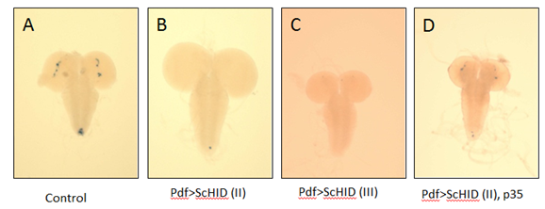
Figure 1: Pdf expressing neurons detected with X-gal staining. A: control larval CNS - four lateral neurons (arrow) and four abdominal neurons (arrowhead); n=10. B: An average of 0.3 neurons remaining; n=10 C: Shows complete cell death of neurons; n=10. D. Partial rescue (88%) of Pdf neurons by p35 expression in both the lateral and abdominal regions; n=10. Pictures taken at 10X.

Bursicon (BURS) is typically expressed in the ventral nerve cord –four pairs of two neurons followed by four single neurons (Fig. 2A). BURS plays an important role in wing expansion, as well as in tanning and plasticization of the wings (Peadbody et al., 2008). When both fly strains of schid was overexpressed in the bursicon expressing neurons, all the neurons underwent apoptosis (Fig. 2B, C). A similar result is seen in the pburs expressing neurons (Fig. 2F, H). Like BURS, pBURS also plays a role in wing expansion and the phenotypic effects of the expression of schid are visible (Luo et al., 2005). Because of the role in wing expansion pburs has, the hypothesis was that the wings of the F1 generation of the pburs strains crossed with schid would be abnormal. Two different pburs strains were tested: Pburs-gal4^{S3} and Pburs-gal4^{S6} with UAS-schid; UAS-lacZ as the variable and yw; Bl/cyo,y+;UAS-lacz as the control. As expected, the neuropeptides of the larvae crossed with UAS-schid; UAS-lacZ underwent apoptosis, and the wings of the F1 generation adults did not expand (Fig.2I). The adults of both of the controls had the normal wing phenotype (Fig. 2J).
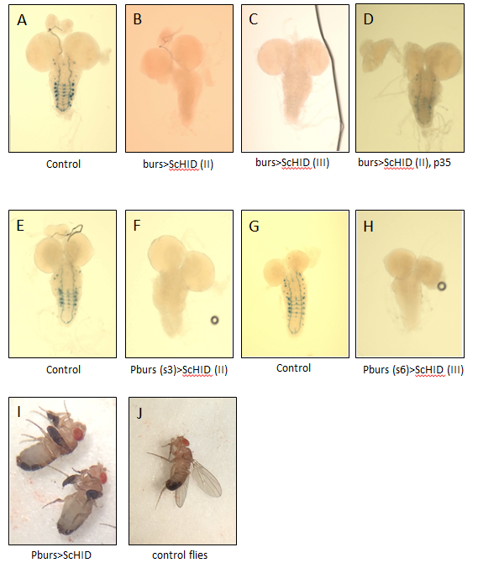
Figure 2: Burs and pburs neurons detected with X-gal staining. A: control larval CNS (4 pairs of neurons followed by four single neurons in the ventral nerve cord (VNC); n=10. B,C: complete cell death of Burs neurons; n=10. D. Partial rescue (50%) of PDF neurons by p35 expression in both the VNC; n=8. E: control larval CNS expressing pburs (s3) neurons; n=10. F: complete cell death of pburs neurons; n=10. G: control larval CNS expressing pburs (s6) neurons; n=10. H: complete cell death of pburs neurons; n=9. I. image of F1 generation of Pburs X yw; Bl/cyo,y+; UAS-lacz. J: image of F1 generation of Pburs X yw; UAS-scHID; UAS-lacz. Pictures taken at 10X.

The corzanonin neuropeptide (Crz) is expressed in the dorso-lateral (DL) neurons, the dorso-medial neurons (DM), and in the ventral nerve cord (vCrz) (Fig. 3A). When scHID was overexpressed using UAS-schid^{S3} in the Crz expressing neurons using Crz-GAL4^{S8}, there were a small number of neurons that survived (Fig. 3B). However, when overexpressed using UAS-schid^{III}, all the Crz expressing neurons underwent complete apoptosis (Fig. 3C).
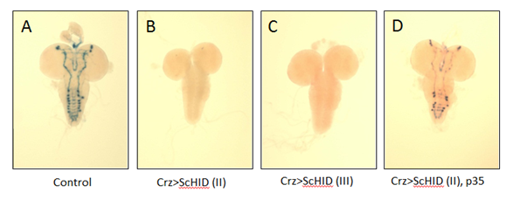
Figure 3: Crz expressing neurons detected with X-gal staining. A: control larval CNS (are two sets of dorsal neurons, DM (arrowhead) and DL (arrow), and 8 pairs of neurons in the ventral nerve cord); n=10. B: An average of 1.7 neurons remaining; n=10. C: Shows complete cell death of neurons; n=10. D. Partial rescue (50.6%) of Crz neurons by p35 expression in both the lateral and abdominal regions; n=10. Pictures taken at 10X.

In the larval stages, NPF is expressed in four neurons in the lateral region (Fig. 4A). When schid^{S3} was ectopically expressed in the four lateral neurons expressing Npf, an average of 0.33 neurons did undergo apoptosis (Fig. 4B). However, when schid^{III} was ectopically expressed in the same neurons, all of the neurons underwent apoptosis (Fig. 4C).

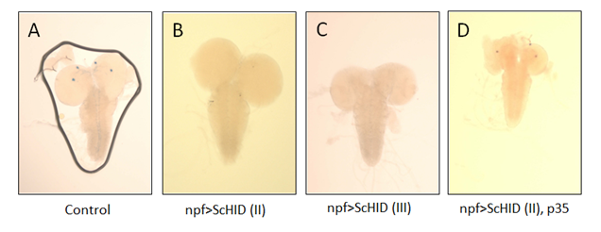
Figure 4: Npf expressing neurons detected with X-gal staining. A: control larval CNS expressing Npf neurons (four lateral neurons); n=8. B: An average of 0.33 neurons remaining; n=9. C: complete cell death of neurons; n=9. D. Partial rescue (75%) of Pdf neurons by p35 expression in the lobes; n=9. Pictures taken at 10X.

When the above mentioned genotypes were crossed with UAS-schid^{S3}; UAS-p35, there was partial recovery of the neurons, although the amount of recovery varied from genotype to genotype, it is clear that the p35 gene was able to recover some of the neurons. 88% of the Pdf neurons were rescued, 50% of the Burs neurons were rescued, 50.6 % of the Crz neurons were rescued, and 75% of the Npf neurons were rescued (Fig. 1D, 2D, 3D, 4D). As previously mentioned, the p35 gene is a caspase inhibitor. In this case, p35 was combined with the hid gene. The partial recovery of neurons suggests that it was successful in blocking the caspase activated by the hid. This also reinforces the idea that p35 acts downstream of hid (Grether et al., 1995). On the other hand, the partial recovery is also indicative of the fact that other cell death genes, grim and rpr, also play a role in apoptosis. In a species related to Drosophila, Anastrepha suspensa, the cell death activity was higher when Anasterpha-hid and Anasterpha-rpr were expressed together (Schetelig et al., 2011). On the other hand, induced cell death by rpr and hid was blocked in Drosophila when p35 was introduced (Zhou et al., 1997).
This cooperative interaction between death genes hid, grim, and rpr to induce programmed cell death may also explain why the Pdf, Crz, and Npf expressing neurons did not undergo complete cell death (figures 1B, 3B, 4B). The interaction between schid and the other death genes may not have been strong enough to promote complete PCD in the samples. Another reason may be because the apoptotic function of the grim death gene is sufficient enough to carry out PCD even in the absence of hid and rpr (Cho et al., 1996). Thirdly, the effect of the GAL-4 drivers on their target gene may vary depending on the location of the schid gene. Although there were a small number of samples still present when schid^{S3} was expressed, when schid^{III} was expressed, the neurons underwent complete apoptosis.
The results reveal that the function of the hid gene is not specific to one neuropeptide producing neuron, but affects BURS, NPF, CRZ, and PDF producing neurons. The fact that the killing nature of the hid gene is seen in all of the neurons tested indicates that the function of the hid gene in PCD is conserved between D. melanogaster and M. scalaris. These results bring us one step closer to exploring PCD in M. scalaris.

Acknowledgements

I would like to thank Dr. Jae H. Park for all of his guidance and encouragement during
this project and over the past three years. I would also like to thank the other members of the Park lab for their advice, especially Dr. Geni Lee for her work in producing the UAS-scHID transgenic lines

References
Cho Po, Nordstrom W, Gish B, and Abrams JM (1996). Grim, a novel death gene in Drosophila.
Genes Dev 10(14):1773-82.
Elmore, Susan (2007). Apoptosis: A Review of Programmed Cell Death. Taxicol Path 35(4):
495-516.
Fuchs Y, Steller H (2011). Programmed cell death in animal development and disease. Cell
147(4):742-58.
Grether ME, Abrams JM, Agapite J, White K, and Stellar H (1995). The head involution
Defective gene of Drosophila melanogaster functions in programmed cell death. Genes
Dev 9: 1694-1708.
Harrison DA and Cooper RL (2003). Characterization of development, behavior and
neuromuscular physiology in the phorid fly, Megaselia scalaris. Comp Biochem Physiol
A Mol Integr Physiol 136: 427-439.
Hay BA, Huh JR, and Guo M (2004). The genetics of cell death: approaches, insights and
opportunities in Drosophila. Nat Rev Genet 5:911-922.
Lee G, Sehgal R, Wang Z, Nair S, Kikuno K, Chen C-H, Hay B, and Park JH (2013). Essential
role of grim-led programmed cell death for the establishment of corazonin-producing
peptidergic nervous system during embryogenesis and metamorphosis in Drosophila
melanogaster. Biology Open 2: 283-94.
Levitsky KL, Toledo-Aral JJ, Barneo JL, and Villadiego J (2013). Direct confocal acquisition of
fluorescence from X-gal staining on thick tissue sections. Sci Rep 14;3:2937.
Luo CW, Dewey EM, Sudo S, Ewer J, Hsu SY, Honegger HW, Hsueh AJ (2005). Bursicon, the
Insect cuticle-hardening hormone, is a heterodimeric cysteine knot protein that activates
G protein-coupled receptor LGR2. Proc Natl Acad Sci U.S.A 102(8):2820-5.
Peabody NC, Diao F, Luan H, Wang H, Dewey EM, Honegger HW, and White BH (2008).
Bursicon Functions within the Drosophila Central Nervous System to Modulate Wing
Expansion Behavior, Hormone Secretion, and Cell Death. J Neurosci 28(53):14379-
14391.
Sandu C., Ryoo H. D., Steller H. (2010). Drosophila IAP antagonists form multimeric
complexes to promote cell death. J. Cell Biol 190:1039–1052.
Schetelig MF, Nirmala X, and Xavier N (2011). Pro-apoptotic cell death genes, hid and reaper,
from the tephritid pest species, Anastrepha suspensa. Apoptosis 16:759-68.
Yeo W, Gautier J (2004). Early neural cell death: dying to become neurons. Dev Bio.
15;274(2):233-44.
Zhou L, Schnitzler A, Schwartz LM, Steller H, and Nambu JR (1997). Cooperative functions of
the reaper and head involution defective genes in the programmed cell death of
Drosophila central nervous system midline cells. PNAS. 13; 94(10): 5131–5136.

