Health Monitoring of Seasoned Sows in a New and Unfamiliar Environment
Author: Rebecca Kocak
Advisor: Dr. Cheryl Kojima
Data Collection Collaborator: Sara Nash

University of Tennessee
College of Agricultural Sciences and Natural Resources
University of Tennessee Honors Thesis

Abstract
Sows originating from the University of Kentucky were relocated to the University of Tennessee on September 3rd, 2013. The sows were gestating upon arrival and due to farrow September 18-20, 2013. The relocation combined with gestation and farrowing resulted in an increased amount of stress, which led to the compromise of their immune system. This study examined the effect of the new environment on the sows’ health throughout the end of gestation, farrowing, lactation, weaning, and rebreeding. Starting on September 3rd, the six-week study was conducted during which respiration, heart rate, rectal temperature, and litter size were monitored. The study was helpful in early recognition of metritus through an observed increase in rectal temperature. In addition, there was a P-value<0.001 between pre-farrowing (lower) and the high farrowing and post-farrowing temperatures. Heart rate and lung scores were not correlated with any disease. Heart Rate was not statistically significant between intervals (P>0.05) while lung score differences between intervals were barely significant (0.048<P<0.05). There was a trend that was not statistically significant between post-farrow rectal temperature and litter size (R=0.642, P=0.08).
Health Monitoring of Seasoned Sows in a New and Unfamiliar Environment

INTRODUCTION
Regardless of any being’s level of animate consciousness, stress is a reality that is inescapable. Stress coincides with existence and has varying and complex effects upon an organism. Even attempting to simply define ‘stress’ itself is difficult and the ultimate effect of stress on a body is even more complex. In relation to an animal, stress is especially difficult to monitor relative to a human due to communication inhibition and, as a result, can be overlooked except in the most obvious of situations. Environment and physical state are two factors that contribute to stress levels however unobvious the amount of distress may be. This stress, in turn, affects an animal’s overall health.
Hans Selye was one of the first people to study stress physiology. Selye determined that stressors led to an adrenal response and adverse health effects that were similar to health problems such as gastrointestinal ulcers, thymic involution, and enlargement of the adrenal glands (Selye 1936). While ulcer-like symptoms and the hormonal imbalances resulting from enlarged adrenal glands negatively affect one’s health, thymic involution (the shrinking of the thymus) is directly connected to immunity. Naïve T-lymphocyte production is decreased, which lowers immunity. Thus, stress was found to affect disease susceptibility.
Further complicating the matter, stress is not always necessarily bad. Stress activates neural, endocrine, and immunity mechanisms that allows for adaptation as a response to a situation, thus ensuring survival. This adaptive ability for stability as a product of change in stress is known as allostasis (Fisher & Reason, 1988). Such an adaptive ability maintains homeostasis for an animal. Dr. Bruce McEwen aided in the understanding of such a concept by noting a need for distinguishing between the beneficial and hurtful effects of stress. Dr. McEwen noted that the mediators that help allostatic adaption such as adrenalin and cortisol can result in allostatic overload when produced at either too high and/or too long a level and subsequently lead to disease (McEwen 2005).
The source of stress simply adds to its complexity. Outside of the innate stressors animals naturally face, animals in captivity interact with numerous abiotic and biotic stressors that animals in the wild do not encounter nearly as often, such as artificial lighting or restricted movement and space (Morgan & Tromborg, 2007). Swine are not exempt from stress’s weakening of their immune system regardless of the level of seriousness or obvious symptoms (Almond & Kick, 2010). Transport, social interactions, and new environments lead to stress that has been shown to negatively affect health in swine (McGlone et al., 1993).
Pregnancy adds to the complexity of health status, the immune system, and stress. Individuals are more susceptible to certain diseases while pregnant (Mor & Cardenas, 2011); however, they do not necessarily experience increased susceptibility to all diseases while pregnant. Regardless of pregnancy’s direct effect upon one’s immune system, it is still a natural stressor that is not necessarily remedied by delivery.
Within this study, eight pregnant sows’ (Sus scrofa domesticus) health was monitored for six weeks throughout the end of their gestation, farrowing, and lactation until rebreeding. The sows originated from the University of Kentucky and were relocated to the University of Tennessee on September 3rd, 2013. The sows began farrowing on September 20th, 2013 and the last one farrowed on September 21st, 2013. The sows were subject to an increased amount of stress due to their relocation to an unfamiliar environment and the stress associated with gestation, farrowing, and lactation. This study examined the effects of the new environment on the sows’ health throughout the farrowing process and lactation until the rebreeding that occurred post weaning. The six-week study examined the effect of stress on the sows’ health by monitoring rectal temperature (degrees Fahrenheit), heart rate (beats per minute), and respiration patterns (by using lung scores that are determined by recording lung sounds and rating them on a relative scale of harshness using a computerized software system). Litter size was also recorded. This study was used to determine the effects of increased stress on the health of sows and to allow for early disease recognition and prevention. I hypothesized that by recording temperature, heart rate, and respiration patterns, early detection of disease would be possible.

METHODS
Eight sows were obtained from the University of Kentucky on September 3rd, 2013 and transported via truck to the University of Tennessee with the intention of being used in Animal Science 483: Swine Management and for this study. All eight of the sows were pregnant and due to farrow between September 18th and September 21st, 2013. The sows arrived and were immediately herded into individual farrowing stalls. The sows were then numbered one through eight and the identification numbers were attached to each crate. These identification numbers were maintained as each individual’s identity throughout the study. The sows were fed six pounds of feed each day during gestation. Three pounds of feed were fed twice a day (once in the morning and once in the evening) and the feed contained corn, soybeans, and a premix of vitamins, minerals, and proteins. Post-farrowing, the sows were allowed unlimited feed. The sow room was cleaned twice a day at the same time as when the sows were fed. The sows were on a 12 hour cycle of light and dark. The lights were turned on at 7 AM and turned off at 7 PM each day consistently so as to not upset their circadian rhythm.
Data was collected in three intervals. The three intervals were pre-farrow, farrow, and post farrow. Pre-farrow data were taken from September 3rd, 2013 to September 18th, 2013. Farrow data were taken on September 19th through 21st, 2013. Finally, post-farrow data were taken on September 22nd through October 21st, 2013.
Each Monday through Thursday the sows’ rectal temperature, heart rate, and respiration (lung scores) were monitored and recorded. Any change in general appearance was also taken note of. On Friday through Sunday, only the rectal temperature and general appearance were monitored. Once the sows had farrowed, the health monitoring continued in the same way until rebreeding on October 21st, 2013. At farrowing, each sow’s litter size was recorded (TABLE 5).
Rectal temperature was taken using a rectal thermometer that recorded temperature in degrees Fahrenheit. The rectal thermometer was cleaned and sanitized before and after each use. A sow’s normal body temperature varies throughout the stages of life and is lowest during gestation and post weaning, higher during lactation, and highest during farrowing (Soza, E. and Smith, S. 2003). If a temperature was abnormally high or low, temperature was retaken three more times to reach a consistent number. If a sow defecated immediately prior to recording the temperature, she was temporarily skipped and later returned to in order to ensure accurate readings.
Heart rate was also recorded for each sow on every Monday through Thursday until rebreeding. A stethoscope was used to find the heart beat while a watch was used to time fifteen seconds. During those fifteen seconds, each heartbeat was counted. The number of heartbeats was then multiplied by four to determine the number of beats per minute (bpm) for each sow on that day. When a sow’s heart rate was abnormally low or high, the heart rate was retaken three times to determine an accurate reading.
The sows’ respiration status was also taken every Monday through Thursday. A Whisper Electronic Stethoscope was used to determine the sow’s lung score. The Whisper stethoscope measures lung health by grading the frequency of lung sounds as one of five levels that each correlate with a probability of death for each lung score (Table 4). The stethoscope is used by holding it over the lung of the animal and pressing record. The stethoscope records for eight seconds and then transmits the lung sound wirelessly to a laptop that has a USB adaptor. The accompanying software analyzes the lung sound based off of the frequencies of lung sounds and not only gives it a score that is correlated with a probability of mortality, but also graphically models the respiration patterns (Figure 3.1, Figure 3.2, Table 4).
As each sow farrowed, live litter size was recorded for each individual. In addition, the number of stillborns and mummies were also recorded (Table 5)
Finally, any significant changes in general appearance was also noted of such as serious lacerations or behavioral changes. When a sow obtained a laceration that required attention, the laceration was treated with iodine and/or (Alu-Shield). If metritis was identified through fever and white discharge from the vulva (“Metritis,” n.d.), then one dose (8 mL) of the cattle form of Excede, an antibiotic, was given. On October 26, 2013, all remaining sows were also given 8 mL of Excede if they had not previously received a dose. The cattle form of Excede was used because it is given as one dose due to an increased concentration, which allows for easier administration.
The data was analyzed for significance and correlation using Statview (SAS). Interval (pre-farrow, farrow, and post-farrow) was the main effect. Correlations were performed between variables within each interval. Any P-value less than or equal to 0.05 was considered statistically significant.
RESULTS
The mean pre-farrow rectal temperature amongst all sows was 100.05 ± 0.057 ºF (mean±standard error) (Figure 1.1, Figure 2.1, Table 1). Within the farrowing and post-farrowing intervals, rectal temperatures were 101.475±0.115 ºF with 0.115 (Figure 1.1, Figure 2.1, Table 1) and 101.338 ±0.068 ºF (Figure 1.1, Figure 2.1, Table 1), respectively. The pre-farrow interval was lower than the farrow and post-farrow intervals (<0.0001) (Figure 1.1, Figure 2.1, Table 1).
The mean heart rates and mean lung scores were somewhat less informative than the rectal temperatures. The mean heart rate for the pre-farrowing interval was 83.538 ± 0.841 bpm (Figure 1.2, Table 2). The mean heart rate for the farrowing interval was 84.750±0.840 bpm (Figure 1.2, Table 2). Finally, the mean heart rate for the post farrowing interval was 83.013±0.615 bpm (Figure 1.2, Table 2). No difference in heart rate was observed between intervals (P>0.05). The mean lung scores were 1.550±0.065 pre-farrow, 1.563±0.113 farrowing, and 1.825±0.059 post-farrowing (Figure 1.3, Figure 2.2, Table 3). The P value for the difference in lung scores was 0.048.
The average number of live born was 12±0.70 (Table 5). Correlations were performed between rectal temperature, heart rate, lung score, and live born in each of the three intervals. A trend was observed as a positive correlation between post-farrow rectal temperature and live born (R=0.642, P=0.08). No other association was detected.

DISCUSSION
The results of the study did not fully support the hypothesis. The hypothesis stated that taking rectal temperatures, heart rates, and lung scores would assist in early detection of disease within sows during the last 16 days of gestation and through weaning. Rectal temperature was successful in helping identify metritus in sow 4 when the high rectal temperature was paired with an excess of vulvular discharge (Mulrhead, M. & Alexander, T., n.d.); however, there were not enough cases of metritus or any other disease to fully support the hypothesis.
Although there were a few temperature spikes of 102.8 ºF or greater, the rectal temperatures remained fairly stable and, therefore, there is not enough evidence to support the hypothesis. There was, however, two incidences where a spike in temperature noted staff to observe the sow in question more closely; these spikes were paired with vulvular discharge, which indicated metritis and led to early (and successful) antibiotic intervention. Furthermore, temperatures in the farrowing and post-farrowing intervals were higher than those of the pre-farrowing interval. From a physiological standpoint, an increased temperature during farrowing and post-farrowing during lactation makes sense. Farrowing results in lots of work being done to deliver which leads to lots of energy being used and an increase in temperature to be expected. Furthermore, lactation occurs post-farrowing which increases the sow’s metabolic activity and, subsequently, her temperature (Jones, R. 1986). These findings indicate that taking the rectal temperature daily throughout these intervals will be helpful in not only determining how close a sow is to farrowing, but also in recognizing that differences in temperature throughout the three intervals is normal and not necessarily a sign of disease. Individual spikes in temperature are cause for increased observation of that animal, which can improve overall herd health through early detection treatment of infection.
Heart rate variation was not associated with presence of disease or interval. The mean heart rate in beats per minute remained fairly constant throughout the intervals. There are a few outliers in mean heart rates, which contributed to the relatively large variation. These outliers may be explained by human error in determining the beats per minute, or the various states of alerness in the sow during the time of measurement. Pigs that are sleeping and have normal, non-diseased hearts will have a lower heart rate than when they are awake (Skinner, J. E., Mohr, D. N., and Kellaway, P. 1975).
Lung scores were also unable to be used successfully in early disease detection because the vast majority of the lung scores throughout were scored at two (Figure 1.3, 2.2) regardless of health status. One score of 3 was observed on October 16, 2013 in sow 5 that was not associated with any disease development. When sows were asleep, they usually scored a one and while awake they usually scored a two due to the sound of eating and vocalizations. The pre-farrowing and farrowing intervals tended to have lower lung scores than the post-farrowing interval. This difference may be due either to the increase in activity and subsequent frequency of vocalization or the increased feed intake that lactating sows experience associated with post-farrowing.
A trend of associated between post-farrow rectal temperature and number of live born was also observed. When a sow had a higher number of babies, she often had higher rectal temperatures. This finding could be a result of increased lactation needed to feed higher number of piglets, which leads to an increase in metabolic activity to provide the necessary increase in lactation. However, there was no way to determine exact sow lactation output over time in conjunction with number of live piglets over time, which may have caused this trend’s P-value to increase over 0.05.
Although there were a few instances of metritis development that could be correlated with temperature increase, more studies should be done to better characterize this relationship. The rectal temperature did prove to be helpful enough to support its use in future Animal Science 483 classes.
Additional experiments should be done to verify or reject the use of rectal temperature, heart rate, and lung score in early disease detection in sows. This study was not vast enough in number of sows or in number of diseases developed. Although it is not recommended or ethical to necessarily introduce diseases to sows, simply an increase in the natural incidence of disease that may occur if an increased number of sows are used may be sufficient. A possible future site for research would be at a swine production facility. Such experiments are crucial in helping lower the financial losses that occur within the swine industry when disease strikes and will increase general sow welfare.

BIBLIOGRAPHY
Almond, G. W. & Kick, A. R. (2009). Effects of Stress on Immune Cell Populations in Pigs. NC Pork Council Final Report. 1-12.

Fisher S., Reason J. (1988). Handbook of Life Stress, Cognition and Health. J. Wiley Ltd. 631.

Jones, R. (1986). Farrowing and Lactation in the Sow and Gilt. University of Georgia: Cooperative Extension work (Bulletin 872).

McEwen, B. (2000). Definition and Concepts of Stress. Encyclopedia of Stress. 3: 508- 509. San Diego, CA: Academic Press.

McEwen, B. S. (2005). Stressed or not stressed? What is the difference? Journal of Psychiatry & Neuroscience, (30), 315-318.

Mor, G. & Cardenas, I. (2010). The Immune System in Pregnancy: A Unique Complexity. American Journal of Reproductive Immunology, 63(6): 425-433.

Morgan, K. N. & Tromborg, C. T. (2007). Sources of stress in captivity. Applied Animal Behaviour Science, 102: 262-302.

Mulrhead, M. & Alexander, T. (n.d.). Metritis. Retrieved from http://www.thepigsite.com/diseaseinfo/67/metritis.

Selye, H. (1936). A syndrome produced by diverse noxious agents. Nature, 138(32).

Skinner, J. E., Mohr, D. N., and Kellaway, P. (1975). Sleep-stage regulation of ventricular arrhythmias in the anaesthetized pig. American Heart Assocation: Circulation Research, 37: 342-349.

Soza, E. and Smith, S. (2003). Proceedings of the North Carolina Healthy Hogs Seminar: Important Issues in our Farrowing Department. Retrieved from http://www.ncsu.edu/project/swine_extension/healthyhogs/book2003/soza.htm.

FIGURES AND TABLES

Figure 1.1: Mean Daily Rectal Temperatures in Degrees Fahrenheit with Standard Error Recorded

Figure 1.2: Mean Daily Heart Rate in Beats per Minute with Standard Error Recorded

Figure 1.3: Daily Mean Lung Score (1-5) with Standard Error Recorded

Figure 2.1: Rectal Temperature Grouped by Interval

Figure 2.2: Lung Score Grouped by Interval

Figure 3.1: Lung Score of 1, Normal
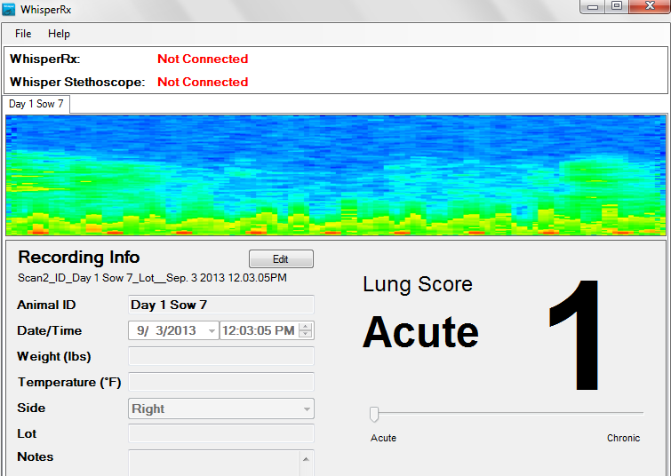
Figure 3.2: Lung Score of 2, Mildly Acute
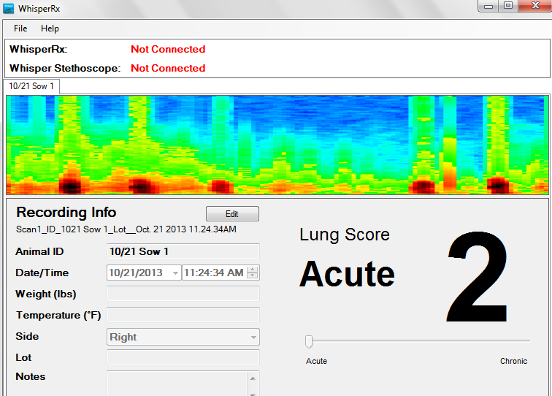

Table 1: Correlation and Means Table for Average Rectal Temperature for each Interval with P<0.0001
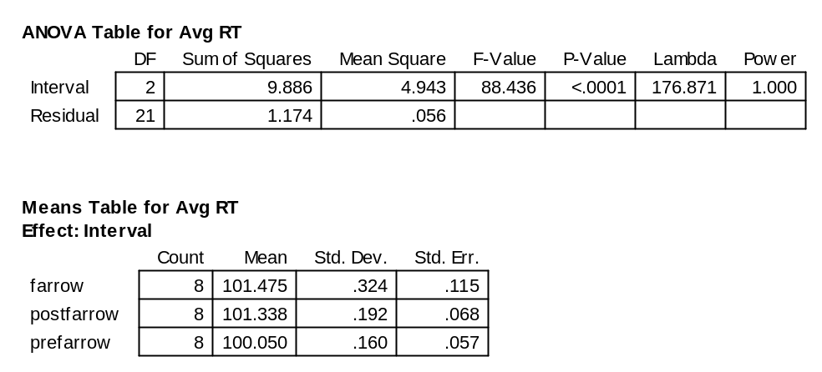

Table 2: Means Table for Average Heart Rate for each Interval with P>0.05
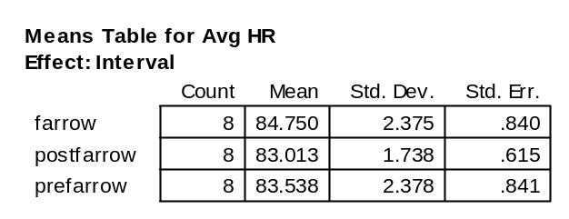

Table 3: Correlation and Means Table for Average Lung Score for each Interval with P=0.048
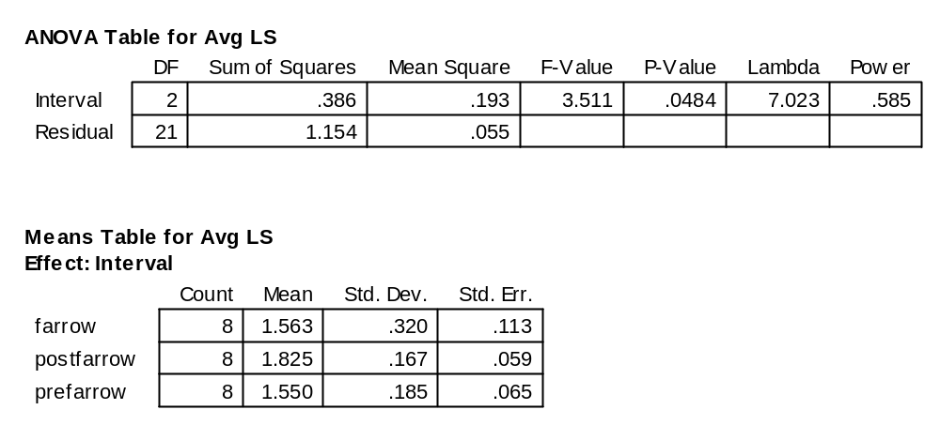

Table 4: Lung Score Descriptions and Mortality Probability
Lung Score | Description | Mortality Rate
1 | Normal | 0%
2 | Mildly Acute | 11%
3 | Moderately Acute | 15%
4 | Severely Acute | 27%
5 | Chronic | 54%

Table 5: Farrowing Table
Sow Number | Date Farrowed | Born Live | Born Dead | Mummies
1 | 9/21 | 13 | 0 | 0
2 | 9/21 | 12 | 0 | 0
3 | 9/19 | 11 | 0 | 1
4 | 9/19 | 11 | 0 | 2
5 | 9/21 | 10 | 0 | 0
6 | 9/20 | 14 | 0 | 0
7 | 9/21 | 15 | 0 | 1
8 | 9/19 | 10 | 1 | 1

