Psychological Determinants of Physical Activity and the Prediction of Physical Activity Levels in African American Men

A Dissertation Presented for the
Doctor of Philosophy
Degree
The University of Tennessee, Knoxville

Alvin Lewis Morton III
December 2022

DEDICATION

To my beautiful and magnificent wife Claire, you are my everything. Thank you for your unconditional love, encouragement, and care for the past couple of years. None of this would have been possible with you.

ACKNOWLEDGMENTS
During this dissertation, there have been many people who have supported me in the process. I thank all the participants who took time out of their schedules to complete the online survey. I would like to thank the Department of Kinesiology, Recreation, and Sport Studies for providing the financial support for this study. I must thank Cary Springer for providing her expertise in statistical analysis.
I want to thank my committee members, who served an invaluable purpose in this dissertation. I would like to thank Dr. Deborah R. Baldwin and Dr. Kelley Strohacker. Each has taught me various aspects of the research process and contributed to my general knowledge of our field, without which I would not be where I am today. Finally, I thank my co-advisors, Dr. David R. Bassett and Dr. Lyndsey Hornbuckle. They have been excellent teachers and support systems for my professional growth for the last few years. I have learned a great deal about the research process and the mentoring process. I strive to apply this knowledge to my future so that I may be a source of pride for them. Your persistent efforts to ensure my success mean the world to me. With the deepest gratitude, I thank you both for taking a chance on me and for everything you have done to get me to this point.
ABSTRACT
African American (AA) men experience disproportionally higher rates of non-communicable, chronic diseases (e.g., cardiovascular, type 2 diabetes, and renal failure) than White men. Physical activity (PA) is known to reduce the progression of CVD, type 2 diabetes, and renal failure. National statistics illustrate that AA men are less likely to get sufficient levels of PA to obtain health benefits. Although many factors (e.g., biomedical, socio-cultural) influence participation in PA, the psychological factors at the individual level are essential to beginning and maintaining activity. Therefore, understanding the psychological determinants of PA in AA men and their associations with meeting national guidelines for aerobic and muscle-strengthening activity is vital to improving PA adherence and decreasing disease risk. This cross-sectional study used an online survey to obtain measures of the psychological determinants of PA in AA men and compared groups of AA men who were meeting aerobic and muscle-strengthening guidelines to AA men who were not meeting the guidelines. In total, 134 men responded to the survey. Of the respondents, 59.7% and 73.1% reported meeting current PA guidelines for aerobic and muscle-strengthening activity, respectively. The majority of men (n = 119) reported engaging in moderate intensity leisure-time activity, with 85.1% doing at least 21-30 minutes per session. In this sample, 50% (n = 67) of the men reported doing muscle-strengthening activities of at least 21-30 minutes per session, with three sessions per week as the median number of sessions performed. The physical and socioeconomic characteristics of the two groups were similar. However, AA men who met aerobic PA guidelines scored significantly higher in autonomy, competence, introjected regulation, identified regulation, integrated regulation, intrinsic regulation, task self-efficacy, and scheduling self-efficacy. AA men who met aerobic PA guidelines scored lower in “likegroup” and “showoff” on the AFFEXX questionnaire, indicating preferences to exercise alone and avoiding an audience. AA men who met muscle-strengthening guidelines demonstrated higher scores for autonomy, relative autonomy, coping self-efficacy, scheduling self-efficacy, “interest,” “honor,” “competence,” “energy,” “calmness,” and “attraction.” These findings identify potential psychological determinants that may be important when designing PA interventions to improve adherence to national PA guidelines in AA men.

TABLE OF CONTENTS
Chapter 1 Introduction 1
Purpose of the Study 5
Research Questions 5
Research Hypotheses 5
Assumptions 6
Delimitation 6
Definition of Terms 7
Chapter 2 Review of Literature 10
General Health Disparities 11
Cardiometabolic Health Disparities 13
Social Determinants of Health 20
Physical Activity Disparities Between Race/Ethnic Groups 30
Resistance Exercise 33
Implications of Racial Disparities in Aerobic and Muscle-Strengthening Activities 34
Rationale for Focusing on AA Men 37
Summary 58
Chapter 3 Methods 60
Study Design 60
Ethical Considerations 60
Participants 60
Recruitment 61
Procedures 61
Instruments 63
Data Analysis 68
Chapter 4 Results 69
Respondents 69
Anthropometric and Sociodemographic Data 69
Physical Activity Characteristics 72
Psychological Characteristics and Aerobic Physical Activity 72
Psychological Characteristics and Muscle-strengthening Activity 85
Chapter 5 Discussion 102
Psychological Determinants of Meeting Physical Activity Guidelines for Aerobic PA 102
Psychological Characteristics and Muscle-strengthening Activity 107
Limitations 111
Future Research 112
Summary 113
Psychological Determinants of Aerobic Physical Activity Interpretations 113
Psychological Determinants of Muscle-strengthening Activity Interpretations 113
Conclusion 114
List of References 115
Appendices 154
Appendix A: Institutional Review Board Approval & Informed Consent Form 155
Appendix B: Study Questionnaire 162
Appendix C: Social Media Advertisement 190
Vita 192

LIST OF TABLES
Table 1. Respondents’ characteristics……………………………………………………………71
Table 2. Respondent demographics………………………………………………...……............73
Table 3. Mean scores of the Behavioral Regulation in Exercise Questionnaire (Aerobic)..…….77
Table 4. Mean scores of the Basic Psychological Needs in Exercise Scale (Aerobic)…………..79
Table 5. Mean scores of the Multidimensional Exercise Self-Efficacy Scale (Aerobic).…..........81
Table 6. Mean scores of the Affective Exercise Experiences Questionnaire(Aerobic)……….....83
Table 7. Stepwise prediction of meeting aerobic PA guidelines.…………………...….....……...84
Table 8. Prediction results for meeting aerobic physical activity guidelines…………...….….....86
Table 9. Mean scores of the Basic Psychological Needs in Exercise Scale (Strength)…..….…..88
Table 10. Mean scores of the Multidimensional Exercise Self-Efficacy Scale (Strength)………89
Table 11. Mean scores of the Affective Exercise Experiences Questionnaire (Strength)….........91
Table 12. Stepwise logistic regression results for muscle-strengthening activity …….…………92
Table 13. Prediction results for meeting muscle-strengthening guidelines…................................93
Table 14. Mean scores of the Basic Psychological Needs in Exercise Scale (Adjusted)…….......95
Table 15. Mean scores of the Behavioral Regulation in Exercise Questionnaire (Adjusted)........96
Table 16. Mean scores of the Multidimensional Exercise Self-Efficacy Scale (Adjusted)...........98
Table 17. Mean scores of the Affective Exercise Experiences Questionnaire (Adjusted)……....99
Table 18. Stepwise logistic regression for adjusted muscle-strengthening …………………......100
Table 19. Prediction results for meeting adjusted muscle-strengthening …………. ..……….…101

LIST OF FIGURES
Figure 1. Behavioral Risk Factor Surveillance System Physical Activity Code List.....................65
Figure 2. Recruitment Summary and completion rate………………………………….....…...…70
Figure 3. Types of Activities most frequently done during the past month……………................75

Chapter 1
Introduction
Non-communicable diseases (NCD) represent a substantial risk to human mortality, accounting for 60% of deaths globally (1). NCD, also known to as chronic diseases, have long durations and develop as a result of genetic, metabolic, environmental, and behavioral factors (2). The main forms of NCD are cardiovascular disease, cancer, chronic respiratory disease, and diabetes. Approximately 52% of American adults are diagnosed with at least 1 of the 10 most common NCD (i.e., hypertension, heart disease, stroke, diabetes, cancer, arthritis, hepatitis, weak or failing kidneys, asthma, and chronic obstructive pulmonary disease) (3, 4). For African Americans (AA), as many as 53.7% are diagnosed with at least one chronic disease, the highest of any ethnic minority group (5).
The higher prevalence of chronic disease in AA men in comparison to White men contributes to higher mortality rates (6-8). AA experience disproportionally higher rates of hypertension and type 2 diabetes than their White counterparts increasing their risk of premature mortality (9, 10). Hypertension and type 2 diabetes are common comorbidities, with hypertension being twice as common in diabetics, and those with hypertension being at greater risk of developing diabetes than normotensive individuals (11). The age-adjusted prevalence of hypertension in AA adults compared to Whites was 57.1% to 43.6%, respectively (12). Among men, the prevalence was 57.2% compared to 50.2%, respectively (12). Approximately 10.5% of the entire U.S. population has diabetes, and when examined by race/ethnicity, the prevalence of diabetes among AAs rises to 11.7% compared to 7.5% in Whites. Among AA men the diabetes prevalence is 11.4% compared to 8.6% in White men (13). The risk of these NCD can be reduced by decreasing the risk factors associated with their development. Modifiable factors, such as decreased tobacco use, increased healthy eating, and increased physical activity (PA), all can reduce the risk of many NCD (14).
To reduce the prevalence of NCD and improve the health of Americans, both former and current U.S. Surgeon Generals along with the U.S. Department of Health and Human Services have campaigned to reduce the rate of tobacco use, and balance healthy eating with regular PA. Current national guidelines recommend that adults accumulate at least 150 minutes of moderate-intensity aerobic PA, or 75 minutes of vigorous-intensity PA, or an equivalent combination of both weekly. The guidelines also stipulate that adults should engage in muscle-strengthening activities of moderate-intensity or more for all major muscle groups on two or more days per week for additional health benefits (15). The benefits of regular PA include weight control, increased muscle-strengthening, increased balance, improvements in mental health, and increased quality of life. Regularly achieving a weekly combined 150 minutes of moderate-intensity aerobic activity has been shown to reduce the risk of many NCD, with more than 150 minutes providing additional health benefits (15).
Despite the health benefits of regular PA, national survey data show that 42 percent of AA men do not meet the combined national PA guidelines for aerobic and resistance training, limiting the potential benefits of regular PA (16). While there are many reasons why some adults do not engage in regular PA, common reported reasons are lack of time, energy, social support, and motivation (17). With the limited engagement in regular PA, AAs experience disproportionally higher overweight/obesity, hypertension, and diabetes rates than their White counterparts (18-21).
Racial categories in the U.S. have historically been used to disadvantage groups socially, economically, and politically, and it still used in contemporary society as a substitute for measuring socioeconomic and sociocultural factors (22). A disadvantage of using race as a substitute for the above-mentioned factors is that AA people are not a homogenous group, which demands that their multitude of differences be considered in its entirety (23). Unfortunately, researchers examining the PA behaviors of AAs have traditionally accounted primarily for race and other social determinants, neglecting to analyze how sex/gender may also intersect to contribute (24, 25). PA interventions that aim to include AA, tend to have an uneven distribution of gender, with a previous systematic review showing less than 30% of its sample of participants identified as males (26). The lack of AA male representation has limited the understanding of the factors that encourage PA in AA men (27, 28).
Due to the lack of AA men included in PA research interventions, there is a larger body of research examining AA women. In general, research has identified various determinants of PA in AA women and in predominantly White populations. Determinants of PA include intrapersonal factors (e.g., lack of time, knowledge, and motivation), interpersonal factors (e.g., family responsibilities, lack of social support, and lack of PA partner), and environmental barriers to regular PA engagement (e.g., neighborhood safety) (29, 30). Though data are limited, qualitative research has suggested that AA men share similar barriers to regular PA as other American adults, such as lack of time, lack of access to facilities, lack of social support, lack of motivation, and poor health status (30-32). However, their status as men and the barriers unique to AA men have not been fully explored. These data also showed that AA men identified potential facilitators to PA as receiving positive messages about PA, making PA enjoyable, peer social interaction, social support, and competition (31, 33). The above-mentioned facilitators of regular PA can be equated to motivational factors that serve to initiate and maintain regular PA.
To increase the percentage of AA men successfully initiating and maintaining regular PA, interventions must identify the factors that encourage regular PA. Regrettably, studies have shown that approximately 50% of participants who adopt a PA program stop within six months, thus missing out on the substantial benefits of regular PA (34, 35). To increase the effectiveness of PA interventions, complementing the interventions with behavior change theories has proven useful (36). One theoretical framework that conceptualizes an individual’s motivation for activities in various domains (e.g., education, religion, medicine, and PA) is self-determination theory (SDT). SDT, represents a comprehensive framework for the study of human motivation and personality. Embedded in SDT are mini theories that identify intrinsic and extrinsic sources of motivation, additionally, SDT aids in explaining how one’s environment can support or undermine one’s desire to be active (37, 38). SDT aims to explain why people do what they do and how their surroundings influence their behaviors.
In addition to SDT, self-efficacy, one of the psychological determinants of PA to be explored further in this dissertation, is one's belief or confidence to control challenging demands. Self-efficacy is significant in behavior change because it is the foundation for human motivation and action (39, 40). Finally, supplementing the psychological factors that can influence engagement in PA, one's previous experience with exercise will significantly impact future motivation for engagement in PA. Past experiences with PA and the subsequent appraisal of PA as being either pleasant or unpleasant can influence one’s motivation for future exercise (41). Because of the increasing burden of chronic disease and poor adherence rate of AA men to national PA guidelines, a study examining the intrapersonal factors (i.e., psychological factors) that influence sufficient and long-term PA engagement in AA men is warranted.

Purpose of the Study
The primary purpose of this study is to explore the psychological determinants of PA that influence PA engagement in AA men. Specifically, this study aims to determine how autonomy, competence, relatedness, self-efficacy, and affective valence may contribute to increased adherence to national PA guidelines in AA men.

Research Questions
- Do AA men who adhere to the aerobic PA guidelines differ in measures of psychological determinants (autonomy, competence, relatedness, self-efficacy, affective experience, degree of self-determination) of PA from AA men who do not meet aerobic PA guidelines?
- Do AA men who adhere to the muscle-strengthening guidelines differ in measures of psychological determinants (autonomy, competence, relatedness, self-efficacy, affective experience, degree of self-determination) of PA from AA men who do not meet muscle-strengthening guidelines?

Research Hypotheses
The hypotheses for this study include:
- There will be significant differences in the psychological determinants (autonomy, competence, relatedness, self-efficacy, affective experience, degree of self-determination) of AA men who meet aerobic PA guidelines and AA men not meeting aerobic PA guidelines, with AA men scoring higher in the abovementioned psychological variables meeting aerobic PA guidelines.
- There will be significant differences in the psychological determinants (autonomy, competence, relatedness, self-efficacy, affective experience, degree of self-determination) of AA men meeting muscle-strengthening guidelines and AA men not meeting muscle-strengthening guidelines, with AA men scoring higher in the abovementioned psychological variables meeting muscle-strengthening guidelines.

Assumptions
The assumptions for this study include:
- All participants will report their age, height, and weight accurately.
- All participants will answer the survey questions honestly.
- All participants will accurately recall their PA from the previous week.

Delimitation
The delimitation for this study includes:
AA men will be recruited through Facebook group pages whose name indicated that AA men are included in its membership.
Limitations
The limitations of this study include:
- The use of nonprobability sampling will limit the ability to know how well the sample surveyed is representative of the AA male population. Participants were recruited from Facebook exclusively, and there was a potential that there were AA men who were unaware of the study’s existence, or it may not have been a representative sample of the AA male population, and there could also be a selection bias in terms of who chose to respond.
- Since only AA men will be recruited into this study, the results will be limited in their generalizability to men, women, and other ethnic/racial groups.
- The survey will have closed-end questions, limiting the amount of information obtainable from participants without the opportunity for follow-up or clarification.

Definition of Terms
Affect - a feeling, and those experiencing affect, feel something. In contemporary psychology, the usage of "affect” refers to the mental counterpart of internal bodily representation associated with emotions, actions that include some degree of motivation, intensity, and force, or even personality dispositions. It is a general term that has come to mean anything emotional (42).
African Americans - an ethnic group of Americans with partial or total ancestry from any of the Black racial groups of Africa. The term African American generally denotes descendants of enslaved Africans from the U.S., while some Black immigrants or their children may also come to identify as African American (43).
Autonomy- (1) the quality or state of being self-governing, (2) Self-directing freedom and especially moral independence (44).
Autonomous Regulation - the engagement in a behavior because it is consistent with intrinsic goals or outcomes that emanates from within one’s self (45).
Controlled Regulation - the engagement in behavior is for an external reason, such as the attainment of a reward or avoidance of a negative consequence (45).
Core Affect - the most fundamental and subjective emotional experience that can influence reflexes, perception, cognition, and behavior caused by internal and external stimuli (46).
Emotions - a complex reaction pattern, involving experiential, behaviors, and psychological elements. Emotions are how individuals deal with matters or situations they find personally significant. Emotional experiences have three components: subjective experience, physiological response, and a behavioral response (47).
Ethnicity - a common proper name to identify a community with shared historical memories, usually includes religion, customs, and language (48).
Exercise - a subset of PA that is planned, structured, and repetitive and has as a final or an intermediate objective the improvement or maintenance of physical fitness (49).
Motivation- 1) broad tendencies to satisfy the need for food, safety, and sex. “Behaviors that serve to meet the needs will be demonstrated.” 2) a particular desire to perform a specific behavior at an exact moment, “the desire in context and is likely to achieve a specific outcome” (50).
Physical activity - defined as any bodily movement produced by skeletal muscles that result in energy expenditure. The energy expenditure can be measured in kilocalories. PA in daily life can be categorized into occupational, sports, conditioning, household, or other activities (49).
Self-determination - determining one’s own fate or course of action without compulsion; free will (51).
Summary
Chronic NCD disproportionally affect AA men in the U.S. PA has been shown to treat be effective in the prevention and treatment of these diseases. Unfortunately, based on national surveys, AA men are not getting sufficient leisure-time PA (LTPA), compounding the problem, and contributing to health disparities. Theories of behavior change have successfully increased initial engagement and long-term adherence (greater than six months) in PA programs. The focus on behavior change theories in PA interventions permits an examination of factors preceding positive PA, and allowing for the replication of factors that prompt positive PA behaviors (52). SDT, a popular theory related to human motivation, has grown in popularity among exercise psychologists due to its examination of the motivational factors contributing to PA behaviors (53). In addition, self-efficacy, a component of social cognitive theory, has been shown to be a strong predictor of a person’s initial engagement in PA. Finally, one's previous experience with PA is influential, based on how they appraised the PA in the past. This study seeks to explore how adherence to national PA guidelines affect the psychological determinants of PA in AA men.

Chapter 2
Review of Literature
In 1985, after witnessing poorer health for AAs and minorities than Whites (the largest racial/ethnic population in the U.S.), Margaret Heckler, the then secretary of health and human services, commissioned a task force to address the factors contributing to the poorer health. This report, famously known as the Heckler report, was the first time the federal government sought to describe and address the disparities in health (54). The report stated that AAs and minorities experience more negative health outcomes for infectious (e.g., HIV/AIDS) and NCD (e.g., obesity, type 2 diabetes, cancer, and cardiovascular disease) compared to Whites (54). At the same time, health disparities for AAS continue to include higher rates of chronic disease and earlier mortality rates compared to Whites (55). In addition, the top two causes of death (heart disease and cancer) are the same for both AAs and Whites in the U.S., but morbidity and mortality rates are greater among AAs (56).
Differences in health outcomes can also be found between genders, with women having a greater life expectancy than men, 80.5 years and 75.1 years, respectively (57). The disparity in life expectancy can be attributed to behavioral factors between the genders. In general, women tend to eat a healthier diet than men, and women are more likely to have health insurance and visit their primary care doctor than men. While the gap in alcohol consumption is closing, men are still more likely to abuse alcohol (58). Gender differences in these behaviors contribute to a more significant disease burden for men.
In reference to NCD or lifestyle diseases, their presence places a significant burden on the health care system and significantly reduces the quality of life for the individual (59). Because of the substantial prevalence of NCD and its contribution to chronic disease, they encompass the leading cause of preventable death across the globe (60). In addition, physical inactivity contributes to many NCDs that impact mortality and quality of life (61, 62). Approximately 10% of premature mortality is associated with insufficient PA (63). Unfortunately, many Americans do not meet the PA guidelines despite overwhelming evidence highlighting the benefits of PA (64). Individuals who do not meet the recommended PA guidelines are at increased risk of NCD, such as obesity, diabetes, heart disease, and certain cancers (65-69). According to the Centers for Disease Control and Prevention’s (CDC) most recent data, approximately 23.5% of American adults met both the aerobic activity and muscle-strengthening PA guidelines for Americans (70). There is a disparity in health outcomes when comparing individuals who obtain sufficient PA and those who do not (15). Therefore, being physically active is critical to improving health and reducing premature mortality. Substantial evidence also supports the benefits of regular PA on physical and mental health in adults (69, 71-74).
This chapter will describe the current literature on disparities in gender and racial/ethnic health outcomes, PA disparities, and the determinants of PA.

General Health Disparities
The World Health Organization (WHO) defines health as “a state of complete physical, mental and social well-being and not merely the absence of disease or infirmity” (75). Despite health being dependent on a combination of biological, genetic, and individual behaviors, more substantial factors contributing to good health may be the social, economic, and environmental conditions of a group of people (76). Apart from one’s biology and genetics, the contributors to health are often modifiable; some are more easily changed than others; therefore, the capacity for good health can be within reach for many people. Unfortunately, the reality is that resources are limited and unavailable to some people, creating disparities in health outcomes.
Health disparities are defined as health differences that are closely linked with social, economic, or environmental disadvantages (77). A group (i.e., racial, gender, orientation) has a health disparity if there is a significant difference in the overall rate of disease incidence, prevalence, morbidity, or mortality compared to the health status of the general population. Race/ethnicity is a socially constructed grouping that has had tangible effects on the lives of individuals grouped into these categories (76). In the U.S., minority groups (e.g., AA, Native Americans) that have been subject to racial discrimination have worse health than groups (e.g., White Americans) that have not been subject to the same discriminatory practices (78). The health disparities have been persistent over time and at all levels of income and education, prompting researchers to explore race as an additional determinant of health (79, 80)
The overall population health can be measured by life expectancy at birth, morbidity, age-adjusted mortality rates, and health-related quality of life (81). Life expectancy measures mortality from birth to senior years, conveying the average age of death (57). Morbidity and mortality rates are the frequency of new illness/death in a specific group during a set period (82). High morbidity rates indicate a population with low health and lower quality of life. Age-adjusted mortality rates capture population deaths due to all causes, particularly those not due to old age. High mortality rates suggest that a population faces severe health threats and lacks the resources to address them (76). Health-related quality of life focuses on a person’s health and functional status, particularly with age (83).
Disparities in overall health exist between AA and White Americans. AAs have worse outcomes in most health measures such as life expectancy, disease morbidity, mortality rates, and health-related quality of life (84). In 2019, Americans had an age-adjusted death rate of 715.2 per every 100,000 persons. The age-adjusted death rates for White and AA men was 868.6 and 1092.8 per every 100,000 persons, respectively, a difference of 22.86% (85). The difference in mortality is a result of late diagnosis and earlier onset of NCDs in comparisons to White men (86). The decrease in age-adjusted mortality is welcomed in both groups; however, the persistent disparity in mortality rates for AA men vs. White men is concerning. Furthermore, evidence indicates a lack of resources to care for this sub-population effectively. The social determinants of health section will discuss this in further detail.

Cardiometabolic Health Disparities
Cardiometabolic disease begins with insulin resistance and progresses to metabolic syndrome, prediabetes, and more severe conditions such as cardiovascular disease and type 2 diabetes (87). Insulin is a hormone that controls the amount of glucose in the blood. With insulin resistance, the body’s cells do not respond in the typical fashion toward insulin, causing elevated levels of glucose in the blood (88). A metabolic syndrome is a group of risk factors (obesity, elevated blood sugar, hypertension) that increase the risk of heart disease, stroke, and diabetes (89). Metabolic syndrome particularly concerns overall health as an individual with multiple risk factors is at greater risk than someone with a single risk factor (90). Therefore, metabolic syndrome’s numerous health conditions are vital when discussing cardiometabolic health disparities between the races.

Obesity
Weight control is the balance of calories consumed and calories expended. A lifestyle with fewer calories expended than consumed will result in weight gain. Excess calories are primarily stored in the body as fat (triglycerides). Obesity, characterized as an excess in body fat and a common precursor in many cardiometabolic diseases, is a public health crisis with a combination of individual and environmental causes (91). Body mass index (BMI) is used at the population level to screen for obesity. Obesity is typically defined as BMI $≥$30 kg/m², even though it is not the ideal measure of obesity for the individual due to variations in body composition (92). Whites have an obesity prevalence of 42.2%, while AAs, have an obesity prevalence of 49.6% (93). White men have a higher obesity prevalence of 44.7% compared to AA men, with an obesity prevalence of 41.3%. The obesity prevalence is 39.8% in White women and 56.9% in AA women (93).
The distribution of fat accumulation in the body contributes to different risk levels between men and women. The two main types of fat patterns are android and gynoid. More common in men, the android’s fat pattern is characterized by excess body fat surrounding the abdomen, increasing the risk of heart disease and insulin resistance. Gynoid fat pattern, which is more common in women, is the accumulation of excess fat around the hips and buttocks. In contrast, the android fat pattern protects against cardiovascular disease (94). The android fat pattern has an increased risk of heart disease and insulin resistance because of the organs surrounding visceral fat. Visceral fat is fat tissue surrounding the thoracic (e.g., heart, lungs) and abdominal (e.g., kidney, liver) cavities, in contrast to subcutaneous fat, which lies beneath the skin (95). Visceral fat in the abdominal area releases free fatty acids, which travel into the circulation and directly to the liver (96). Excessive free fatty acids in the liver may cause insulin resistance, hyperlipidemia, type 2 diabetes, hypertension, and atherosclerosis (96, 97). Because of the vital organs surrounded by visceral fat in the abdomen, individuals with the android fat pattern are at a greater risk of developing cardiometabolic diseases than those with a gynoid fat pattern. While the location of visceral fat significantly increases the risk of developing cardiovascular disease, obesity alone will increase the risk of developing diabetes mellitus type 2 and cardiovascular disease (98-100). Among adults diagnosed with diabetes, 89% were overweight or obese (101).

Diabetes Mellitus
Diabetes mellitus is a disease that results in an inability to produce insulin or a resistance to the effects of insulin in the bloodstream (88). Insulin is a hormone produced by the beta cells of the pancreas that facilitates the delivery of blood glucose to the cells, thus reducing the glucose level in the bloodstream. The diagnosis of diabetes is made by one of three tests: a glycated hemoglobin a1c (a1c) test, a fasting plasma glucose test, or an oral glucose tolerance test. The a1c test measures an average glucose level from the preceding three months. The diagnosis criteria for diabetes from an A1C test are readings of 6.5% or higher. The fasting plasma glucose test measures the glucose in the blood following an 8-hour fast. Fasting glucose above 126 mg/dl meets the diagnostic criteria for diabetes. The oral glucose tolerance test measures how the body processes a measured amount of glucose over 2 hours. Baseline blood is sampled before ingestion of the glucose solution. Blood draws occur on a predetermined schedule following the glucose solution to track the body’s ability to clear the glucose. Diabetes is diagnosed from this test if, after 2 hours, the blood glucose is above 200 mg/dl (101).
There are four forms of diabetes, including type 1, type 2, prediabetes, and gestational diabetes. Type 1 diabetes is an autoimmune disease that destroys the insulin-producing beta cells in the pancreas (88, 102). Type 1 diabetes makes up 5.8% of all diagnosed cases of diabetes in adults (103). Type 2 diabetes accounts for 90.9% of all diabetes cases and is characterized by cells becoming resistant to insulin, causing elevated blood glucose (101). Prediabetes is diagnosed when a1c levels are between 5.7% and 6.4% or fasting blood glucose is between 100 to 125 mg/dl. Prediabetes indicates an increased risk of developing type 2 diabetes (103). Finally, gestational diabetes is when women develop elevated blood sugar during pregnancy due to excess weight or a change in hormone levels (103). It is often asymptomatic and resolves after the child’s birth, though it does place the mother and child at increased risk for insulin resistance later in life (103).
The most recent estimates from the U.S. Department of Health and Human Services are that 34.2 million people have diabetes, which equates to approximately 10.5% of the entire population. Among the 34.2 million Americans with diabetes, 26.9 million have been diagnosed with the remaining 7.3 million undiagnosed. AAs have a diabetes prevalence of 11.7% compared to 7.5% in Whites. AA men had a diabetes prevalence of 11.4% compared to 8.6% in White men. AA women had a diabetes prevalence of 12.0% compared to 6.6% in White women. In addition to those diagnosed with diabetes, an estimated 88 million people have prediabetes, placing them at significant risk of developing diabetes. Common risk factors for the development of diabetes are smoking, overweight/obesity, physical inactivity, high blood pressure, family history, race, and high cholesterol (103).
Complications of diabetes can include but are not limited to cardiovascular disease, nerve damage, kidney damage, eye damage, and even depression. A diagnosis of type 2 diabetes doubles the odds of experiencing a heart attack or stroke compared to nondiabetics. The longer a person lives with diabetes, the less their diabetes is controlled, and the higher their risk of additional complications. Control of diabetes is dependent on the type diagnosed. Type 1 diabetics must monitor their blood sugar and replace their insulin with artificial insulin daily. Individuals with type 2 diabetes can manage diabetes with diet, PA, medication, and insulin supplementation (103).

Hypertension
Approximately 47.3% of the U.S. adult population is affected by hypertension, amounting to 116 million people (104). As many as 92 million adults do not have their hypertension under control with either lifestyle modifications, medication, or both (104). Hypertension is an asymptomatic condition, leaving many undiagnosed and at greater risk for complications. Uncontrolled hypertension places a person at increased risk for heart disease and stroke. In addition, prolonged elevated blood pressure can reduce the arterial walls’ elasticity (i.e., compliance). Stage 1 hypertension is consistent blood pressure between 130-139 mmHg (systolic) or 80-89 mmHg (diastolic) or currently taking medication to manage blood pressure is the criterion threshold of a hypertensive diagnosis (105). Stage 2 hypertension, a more severe health condition, is diagnosed after consistent systolic pressure measurements above 140 mmHg and diastolic pressure above 90 mmHg. Data from the 2017-2018 national health and nutrition examination survey (NHANES) observed that the age-adjusted prevalence of hypertension in AA adults compared to Whites was 57.1% to 43.6%, respectively (12). Among men, the prevalence was 57.2% in AAs compared to 50.2% in Whites, respectively (12). The prevalence of hypertension in AA women was 56.7% compared to 36.7% in White women (12). This higher prevalence places AAs at a higher risk for hypertension-related complications and premature death (106). While hypertension is not an immediate cause of death, it is a significant contributor to conditions that increase morbidity and mortality (e.g., ischemic heart disease, heart failure, and cerebrovascular disease) in AA men (107-109). The ratio of hypertension-related cardiovascular deaths in AA men compared to White men in 2018 was 1.76, down from 2.44 in 2000 (110). This apparent decrease in the disparity is encouraging. Still, a closer look reveals that the age-adjusted mortality rate of hypertension-related cardiovascular deaths for White men rose from 100.8 to 117.2 per 100,000 (110). During that same period, AA men also increased their age-adjusted mortality rate of hypertension-related cardiovascular deaths from 197.7 to 206.6 per 100,000 (110).

Renal Failure
Approximately 1 in 7 adults (or 37 million adults) live with chronic kidney disease (CKD), with many unaware of the diagnosis (111). It is estimated that more women (14.3%) than men (12.4%) are living with CKD (111). CKD is more common in AAs than Whites, with prevalence levels of 16.3% and 12.7%, respectively (111). Among adults 18 years or older, the most common cause of CKD is uncontrolled hypertension and diabetes (111).
The kidneys filter waste and excess fluid from the blood eventually excreted from the body in urine. Improper kidney function can cause a buildup of harmful waste in the body. The causes of kidney disease are numerous, but the most common causes include prolonged diabetes or hypertension, highlighting the significance of managing blood glucose levels and blood pressure. As the disease progresses, the kidneys eventually fail and lose the ability to filter the blood and excess fluid; this would be end-stage renal disease (ESRD). With the complete loss of kidney function, the individual must replace the kidney or undergo dialysis. Transplanting a functioning kidney from a deceased or living donor can treat renal failure. Unfortunately, a kidney transplant may not be the most feasible option for all patients (not suitable for older patients, those with advanced heart disease, or a recent history of cancer) because of the complications associated with transplanting a kidney. Complications and risks may arise from the surgery, possible rejection of the donor’s kidney, and potential side effects from the immunosuppressant medication taken to reduce the donor’s rejection risk. Dialysis is a procedure that mimics the kidneys by filtering the blood through a machine that filters waste products out. Dialysis must be done at least three times per week, each lasting 3 to 5 hours. Dialysis can be burdensome to the patient, reducing their quality of life (111).
A person with ESRD has the highest mortality rates within the first six months of initiating dialysis. The 5-year survival rate for patients treating their ESRD with long-term dialysis is 35%, and 25% in patients with diabetes (111). Death data from 2014 show that men have an age-adjusted death rate of 16.2 per 100,000 compared to women with an age-adjusted death rate of 11.1 per 100,000. Based on death certificates from 2014, 4,034 AA men died from kidney complications, the eighth leading cause of death, while death from kidney complications amounted to approximately 3,150 deaths in White men. When examining mortality data, renal failure is combined with nephritis, nephrotic syndrome, and nephrosis. The criteria for selecting renal failure as the cause of death was modified in 2011, thus affecting the number of deaths in the nephritis, nephrotic syndrome, nephrosis, and diabetes categories. This change decreased fatalities from nephritis, nephrotic syndrome, nephrosis, and increased diabetes mellitus (112). Because of the difference in population size, the slight difference in death from deaths amounts to a significant disparity in the death rate from kidney complications, representing a burden and lower quality of life for AA men.

Cardiovascular Disease
Cardiovascular disease is the leading cause of death in the U.S., accounting for 25% of all deaths and an overall death rate of 161.5 per 100,000 individuals (85, 113). Men have a higher mortality rate from heart disease than women, 204.8 versus 126.2 per 100,000 individuals, respectively (114). Heart disease is an umbrella term that describes several heart conditions, including arrhythmia, heart attack, heart failure, and coronary artery disease (CAD). CAD, the most common form of cardiovascular disease, develops when the coronary arteries that supply the heart with oxygenated blood are blocked or damaged, causing a decrease in blood flow to the heart (115, 116). Cad can go undiagnosed if the person does not feel symptoms, making the disease dangerous. It will likely not be diagnosed before an adverse event (i.e., heart attack, angina). Modifiable risk factors for cad include obesity, physical inactivity, poor diet, and smoking (115). According to a National Health Interview Survey (NHIS), AAs have a 5.4% prevalence of coronary artery disease compared to 5.8% in Whites (117).

Stroke
Strokes have two main classifications, including ischemic and hemorrhagic. Ischemic strokes account for 87% of all strokes and occur when the blood supply to a part of the brain is stopped (118). A hemorrhagic stroke occurs when a blood vessel is damaged, causing blood to spill out into the spaces around the brain, reducing oxygen delivery. Without oxygen, brain cells die, affecting the entire body. Persons who have suffered a stroke may have partial paralysis on one side of the body or difficulty with cognitive functioning (119). Among men, strokes are the leading cause of death and long-term disability (120). From 2013-2016, about 7 million (2.5% ) adults in the U.S. suffered a stroke (118). AA men had a stroke prevalence of 3.1% compared to 2.4% for White men (118). For women, the prevalence of stroke was 3.8% to 2.5% for AA women compared to White women, respectively (118). There is a strong relationship between strokes and hypertension, with hypertension leading to damage to the blood vessels in the brain and early cognitive dysfunction (121).

Social Determinants of Health
Since the 18th century, many White medical professionals have believed and sought to prove that members of the AA race were inferior to Whites using methods (e.g., cranial capacity) that would not meet modern scientific methods standards (122). This practice laid the foundation for the justification of the general mistreatment of AAs. More recently, with the help of sociologists, race is understood to be a social construct used to classify observable characteristics like skin color (123). As early as 1899, W.E.B. Du Bois observed the disparity in health between AAs and Whites and attributed the poorer health of AAs not to the race of the people but the racial inequality in the U.S. (124). The main barrier to equality of the time was racism. Racism impacted economic opportunities, educational attainment, access to health care, neighborhood safety, and community cohesion (125, 126)
According to healthy people 2020 and the public health community, the five major social determinates of health include economic stability, education, health care access, neighborhood/built environment, and social and community context (127, 128). These determinants are shaped by economics, social policies, and politics (132). Operationally, social determinants of health are non-medical contributors to health outcomes (131).

Economic Stability
Poverty is possibly the most significant determinant of health as it affects many other determinants of health. The 2020 threshold of poverty in the U.S. for a family of four was $26,500 (129). The U.S. census bureau uses a set dollar amount to determine the poverty threshold. Even so, the family size, makeup, and geographic location must also be considered when considering the family’s socioeconomic status (SES) (130). SES can determine the family’s employment opportunities, food security, and housing stability (131). Globally, poverty and poor health are connected (132). Poorer countries tend to have a shorter life expectancy. Within developed nations, poor communities have more negative health outcomes such as malnutrition, higher infant mortality rates, and higher death rates from the leading causes of death (132). Thus, poverty and health are very clearly linked, with poverty leading to poor health and poor health leading to poverty (133). In 2019, the overall poverty rate in the U.S. was 10.5% (129). In the same year, 18.8% of AAs lived in poverty (a record low for this race), compared to 9.1% of Whites, who saw their prevalence of poverty remain stable (129). AAs’ median income during the same year was $45,438 annually compared to $76,057 for Whites (129).
Racial disparities in unemployment rates affect earned income and health risk. In 2020, the unemployment rate for AAs was 11.4% compared to 7.3% for Whites (134). The employment rate for AA and White men in the first quarter of 2021 was 10.8% and 6.3%, respectively (134). Among women, the unemployment rates were 9.2% and 5.4% for AA and White women, respectively (134). Being employed is critical because it provides access to affordable health insurance, making it possible to afford medical care and endure unexpected healthcare situations (135). Conversely, being without health insurance can negatively affect how one can interact with the healthcare system.

Education
Educational attainment is an essential barrier to adverse health effects. A high school diploma is a minimal standard for hiring for many jobs in the U.S. Those who do not obtain their high school diploma are at greater risk for unemployment, low wages, and poverty (136, 137). In addition, students who drop out of high school are more susceptible to at least one chronic condition and early mortality (138, 139). There are disparities in high school completion rates among racial groups in the U.S. in the 2018-2019 school year, the overall high school graduation rate was 86%, with Whites and AAs graduating at 89% and 80%, respectively (140). The status dropout rate is the percentage of all 16- to 24-year-olds not enrolled in school and who have not completed a high school diploma or a graduate equivalency degree (GED), in contrast to the event dropout rate, which represents high school dropouts within one year. The dropout rate among AA boys was 7.8% compared to 4.8% for Whites (140). The dropout rate for AA girls was 4.9% compared to 3.6% for White girls (140).
Conversely, college graduation can positively impact health by providing better-paying jobs and less hazardous work (141). Stable employment affords an individual greater access to health insurance and opportunities to obtain resources that improve health (141). In 2019, the college enrollment rate among 18- to 24-year-old AA males was 34% compared to 37% for 18- to 24-year-old White males. Among women, the college enrollment rate among 18- to 24-year-old AA females was 40%, compared to 45% among 18- to 24-year-old White females (142). Also, in 2019, the percentage of AA and White college students that completed their bachelor’s degree within six years was 40% and 64%, respectively (143). Among men, 34% of AA men complete their degree in six years compared to 61% of White men (143). For women completing their bachelor’s degree, 44% of AA women complete their degree within six years compared to 67% of White women (143). Higher education reduces the risk of premature death, with college graduates self-reporting better health than high school graduates (144). Those with a college degree are less likely to report experiencing heart disease, hypertension, diabetes, and depression (145). Finally, after controlling for other potentially confounding SES variables, the odds ratio for smoking, engaging in no exercise, and a BMI classification of obese is lower for at least a college degree than for those who have not received a college degree (146).

Health and Health Care
Income and educational attainment have an impact on access to affordable healthcare. Insufficient health insurance coverage is a barrier to health care access, with varied insurance coverage causing more significant health disparities (147, 148). In 2019, the percentage of AAs who stated that they did not get needed medical care or delayed care due to the cost in the previous 12 months was 11.1% and 10.6%, respectively, compared to 7.7% and 8.8% in a White sample (149, 150). During that same year, 19.8% of AAs were uninsured for a portion of the year compared to 17.3% of Whites (151). Adults without health insurance are less likely to receive preventive services for chronic conditions, such as diabetes and hypertension, leading to more detrimental effects of these diseases (152, 153). Limited health care resources are another barrier that increases the risk of poor health (147). A shortage in available medical providers may mean patients have to wait longer for an appointment and delay their care, placing them at more significant risk for adverse outcomes (154).
In addition to barriers presented by inadequate health insurance and the shortage of medical providers, the history of AAs’ medical exploitation has indoctrinated many with a distrust of the medical establishment (155, 156). The mistrust towards the medical community is frequently attributed to the Tuskegee study of untreated syphilis in the negro male, which ran from 1932 until 1972 (157). In that study, AA men in Tuskegee, Alabama, with and without syphilis, were monitored by the U.S. public health service and given placebos such as aspirin, despite treatments such as penicillin being available by 1947 (157). As a result, many men went blind, insane, or experienced other severe health problems due to untreated syphilis (157). More than 100 men died from syphilis or other complications related to the disease, and many spouses and children contracted the disease (157). In the end, the study was only stopped after a public outcry in 1972, when news outlets revealed what was happening in the Tuskegee study (157). The unethical treatment of AAs in Tuskegee, AL was not novel then; in fact, experimentation by the medical community on AAs was common in American history, dating back to slavery (158, 159).

Neighborhood and Built Environment
Neighborhoods are places where people live and interact with one another, often sharing similar family types, incomes, and education (160). The built environment of these neighborhoods in which people live influences their health (161). Access to recreational outlets, healthy food choices, and the neighborhood’s safety can impact participation in healthy behaviors. Redlining, the formal practice of racial residential segregation, has shaped the characteristics of neighborhoods across the U.S. (162). Redlining led to a discriminatory pattern of disinvestment in AA neighborhoods, and the impediment of homeownership for AAs has had lasting effects on wealth, education, and health (162).
Redlining, the formal practice of racial residential segregation, has shaped the characteristics of neighborhoods across the U.S. (162). Redlining led to a discriminatory pattern of disinvestment in AA neighborhoods, and the impediment of homeownership for AAs has had lasting effects on wealth, education, and health (162). Redlining made homeownership and, subsequently, the growth of AA wealth difficult (162). Discriminatory housing practices brought on by redlining led to the divestment of funds, negatively affecting communities and causing food deserts (161). A “food desert” is an area that lacks access to affordable fruits, vegetables, whole grains, low-fat milk, and other food products that comprise a healthy diet (163). Food deserts are more common in communities where AAs and lower SES individuals live (164, 165). In some areas of the country, only 19% of predominately AA neighborhoods have access to healthy food choices compared to 68% of White communities (164).
“Food swamps” are also more common in low SES and minority communities (165). A food swamp is where foods/beverages low in nutrients and high calories are more readily available than healthy food options. For example, inexpensive fast-food chains and corner stores often do not sell fresh fruits and vegetables (165, 166), and living in a community where these food outlets are more common influences one’s diet and, therefore, their health (165, 166). Another potential influence on the health of a community is the available green space. Though a causal relationship is difficult to establish between the community’s health and the green space, most studies report findings that support the idea that green spaces have a beneficial health effect. However, the relationship is very complex (167). Studies have observed that higher SES neighborhoods have greater accessibility to green spaces, while communities, where minorities live are more likely to have less green space (168, 169).
Chronic exposure to actual or perceived violence can negatively affect health and create a sense of fear (170). Individuals who fear violence in their community may be more resistant to performing PA outdoors in their neighborhood (171). In a study examining the perceived safety of an area and obesity association, the researchers found that perceived crime safety was associated with less moderate PA performed and higher BMI values in participants (172). Some neighborhoods’ lack of perceived safety can be traced back to the discriminatory redlining practices intended to maintain racial segregation but has had a disparate effect on the health of people living in these formally redlined areas (162). Still manifesting in low-income minority communities, a history of disinvestment in AA neighborhoods fueled an increase in poverty, resulting in higher crime rates and poorer health (173).

Social and Community Environment
Like the built environment, the interpersonal relationship among neighbors and colleagues influences health. Negative interactions will undoubtedly harm health, with negative interactions such as racism and discrimination notable (174). A simple definition of racial discrimination is the unequal treatment of persons or groups based upon their race (174). Scholars have constructed a more in-depth description with two parts, differential treatment and disparate impact (174, 175). Differential treatment is when individuals are treated differently based on race (174). When individuals are treated unequally by law, the disadvantaged groups feel a disparate impact (174, 175). This disparate impact includes decisions that would not be explicitly discriminatory on the surface but have consequences that produce or reinforce racial disadvantage (e.g., voter disenfranchisement, lower-quality schools, fewer neighborhood amenities, and fewer parks and green spaces).
Discrimination can be either structural (e.g., housing segregation) or individualistic (e.g., interactions with health care providers), or a combination of both (176). Constant discrimination of a community or person triggers adaptations to maintain stability, commonly understood as allostasis (177). The allostatic load of being AA in the U.S. causes a physiological response that contributes to the poorer health of AAs and other marginalized groups experiencing constant stress (178). A study on the effects of race on physical and mental health found that the health disparities were reduced after adjusting for education and income (179). However, even after removing education and income as moderators of health, perceived discrimination and stress were still associated with poor health, accounting for health disparities between AAs and Whites (179). In a study asking AAs how much they have experienced discrimination, the report found that 92% of AAs had experienced discrimination (180). Cultural racism, the individual or institutional belief that one culture is superior to another, is another potential source of bias. The subscale to assess cultural racism positively correlates with perceived stress (181). The source of discrimination can come from an individual or an institution’s agent, such as a police officer. Their belief that one culture is superior or that one culture is inferior can alter their interaction with people from those cultures. Although discrimination may be perceived and not overt, it can still harm the individual since people who perceive it are more likely to experience depression, anxiety, and other adverse health outcomes (182). The constant discrimination experienced by AAs has detrimental effects on health, going so far as increasing the biological age of the individual on the receiving end of discrimination (183).
Police violence is a leading cause of death for young men, and young AA men face a higher risk of being killed by police than young men of other races. From 2013 – 2018, it is estimated that 52 per 100,000 men will be killed by a police officer (184). AA males are 2.5 times more likely to be killed by a police officer than White males. AA women are 1.4 times as likely to be killed by police than White women (184). American policing originates in slave patrols, responsible for capturing runaways and preventing slave revolts, often with brute force (185). After the police forces across the country were made uniformed and official following the American civil war, they stood by as mobs lynched AAs throughout the American south (186). Local police forces were used to suppress protests during the civil rights movement, and they sought to accomplish this goal with severe brutality (187).
The lack of PA in AA neighborhoods may be attributable to the decreased safety of the community. However, even in spaces that do not have the same actual or perceived danger level, there is still fear that performing exercise in predominately White spaces may unnecessarily warrant an interaction with law enforcement. One study found that AA men are significantly less likely to be physically active in neighborhoods perceived as White. They may attempt to mitigate this fear by signaling to the community members that they are non-threatening. Examples of signaling behaviors would be carrying a driver’s license, wearing a notable university t-shirt, smiling, and waving at neighbors. Unfortunately, these behaviors may be burdensome and reduce PA volume in AA men (188).
In addition to the disproportionate killing of AA males by police, another discriminatory practice is the higher incarceration rates of AAs compared to Whites. The rate of AA incarceration is 1,408 per 100,000 compared to 275 per 100,000 for Whites (189). While AAs may appear more prone to criminal activity due to overrepresentation in the prison system, recent data concluded that the criminal offenses alone do not explain the racial disparity in the prison populations. There is abundant evidence that the U.S.-based criminal justice system is biased, leading to higher arrest rates, incarceration rates, and longer prison sentences among poor communities (190). In 2017, 21.2% of AAs lived in poverty compared to just 8.7% of Whites, making AAs more likely to interact with the justice system more probable (190, 191). Being in the criminal justice system has lasting effects on the individual, family members, and community. In addition, concentrated incarceration in AA communities removes resources and increases crime rates, creating a cycle of poverty (192).
Although men in the U.S. live in what is most accurately described as a patriarchal society, where men hold primary roles in politics and social privileges, men find themselves disadvantaged in most areas of health outcomes compared to their female counterparts (193). The social determinants of health are not isolated factors but are simultaneous contributors, potentially affecting one another and contributing to poor health. When the social determinants of health are controlled for, there is still a disparity between AA men and White men. This may occur because of the complex nuances (i.e., perceived, and actual discrimination) of AA men in the U.S. Research into the health of any population is first intended to document any areas that could improve people’s health. Still, it ultimately transitions to finding ways to correct the problems discovered. Among all gendered and racial groups, AA men have some of the worst health outcomes of any racial ethnic group, justifying a deeper look into the causes of these disparities in hopes of addressing them.

Physical Activity Disparities Between Race/Ethnic Groups
One of the mediating variables through which social determinants can negatively impact AAs’ health is physical inactivity. In Americans, physical inactivity is associated with many NCDs (e.g., hypertension, diabetes, obesity, cardiovascular disease, stroke, and renal failure) (69, 71-74). On the other hand, PA can mitigate the harmful effects of the social determinants of health. PA can be assessed either through self-report measures (i.e., questionnaire, diary) or wearable devices (e.g., accelerometers, pedometers) (194). The 2018 PA Guidelines for Americans suggest that for substantial health benefits, adults should accumulate at least 150 - 300 minutes of moderate-intensity, or 75 -150 minutes of vigorous-intensity aerobic physical activity per week. Adults should also engage in moderate or greater intensity muscle-strengthening activities that involve all major muscle groups on 2 or more days per week. Children and adolescents (6-17 years old) should 60 minutes a day of moderate-to-vigorous PA, with at least 3 days a week including muscle-strengthening activities (15).

Disparities Between Race/Ethnic Groups in Aerobic Activities (Self-Report Measures)
The NHIS, a cross-sectional household survey of the non-institutionalized population, reports that 54.2% of Americans report being sufficiently active (195). Sufficiently active, meet the aerobic guidelines of 150 minutes of moderate-intensity aerobic PA or 75 minutes a week of vigorous aerobic activity (or an equivalent combination) (15, 72, 195). In 2018, only 53.1% of AA males reported meeting the aerobic guidelines compared to 60.6 % of White males (195). Among women, 39.7% of AAs report meeting the aerobic guidelines compared to 54.7% of White women (195). Self-report instruments make it feasible to conduct national health surveys (e.g., the U.S. national health interview survey, or NHIS) regarding the volume of participants reached and the cost of administering the survey (196). Potential limitations of surveys are the potential for recall bias and social desirability (196). Recalling PA is complicated as it requires individuals to remember all their PAs outside their planned exercise (196). In addition, social desirability may cause participants to overestimate their PA to potentially avoid criticism and make themselves look better in the eyes of the survey Administer (197). Objective measurements of PA are available to reduce the potential bias of subjective measures. In 2018, the PA guidelines were updated. A significant change involved removing the need for PA to occur in 10-minute bouts since evidence had emerged to show that even aerobic activities performed for shorter durations had health benefits. However, it is hard to capture smaller time increments of PA with self-report instruments (15).

Disparities Between Race/Ethnic Groups (Wearable Devices)
Compared to self-report measures of PA, wearable devices are more objective and can remove potential biases. Using wearable devices to assess aerobic PA, authors have reported lower adherence to the PA guidelines in U.S. adults (198). According to the 2005-2006 National Health and Nutrition Examination Survey (NHANES) 2005-2006, 62.0% of adults met PA guidelines using self-report, but only 9.65% met PA guidelines using accelerometry data (198). Accelerometers measure acceleration, and the information obtained allows for the measurement of PA. Accelerometer-based measurements utilize cut points to classify activity intensity (199). Based on the NHANES 2003-2006 data, among adults ages 20-65, the mean counts per minute was 392.7 ± 4.3 (200). Among AA men, the mean counts per minute were 374.4 ± 8.7 and 383.6 ± 5.0 (200). For AA women, the mean counts per minute were 297.9 ± 6.6, while White women had mean counts per minute of 324.7 ± 4.1 (200). The average minutes spent in moderate-vigorous PA (MVPA) for adults 20-65 years was 35.6 ± 0.8 (200). For AA men, the average time spent in MVPA was 33.4 ± 1.4 minutes); for White men, the average time spent in MVPA was 34.7 ± 0.9 minutes (200). Among women, the time spent in MVPA was 21.6 ± 0.8 and 18.5 ±1.3 minutes for AAs and Whites, respectively (200). The intensity was based on cut points of 2020 counts per minute for moderate activity and 5999 counts per minute for vigorous activity in 1-min bouts (199, 201). Based on data from accelerometers, there is little difference in PA in contrast to what is self-reported by individuals (195).

Domains
Because PA includes any voluntary movement performed by contraction of the skeletal muscles that results in energy expenditure (202), most, if not all, waking activities encompass PA. The intensity level will vary, but something is better than nothing (15). Many studies report PA performed during leisure-time physical activity (LTPA) and seldom acknowledge the other PA domains, such as occupation, transportation, and household chores (203-206). Regarding all PA domains, the adherence to PA guidelines was 65.2% for adults compared to 49% from a national survey (207, 208). Considering that the most common reason for people not getting sufficient PA is lack of time, a focus on LTPA does not begin to cover all the other areas that may contribute to PA (209, 210). For example, PA done on the job may be high and could alleviate the need for additional LTPA (211). In addition, the differences in occupational status, i.e., White versus blue-collar workers, influence the amount of LTPA (211).
Transportation PA provides substantial health benefits to the end-user because it is usually done routinely (212). In the U.S., 29% of public transportation individuals are sufficiently active by aerobic standards, solely from their walk to public transport (213). Individuals engaged in active transportation depend on the local government’s willingness to provide safe and adequate active transportation opportunities. In the U.S., where most cities were designed for cars to be the primary form of transportation, a shift occurs where elected officials make changes to improve health by increasing access to bike lanes (214).
As stated above, AAs have lower levels of LTPA than White Americans, contributing to the health disparities between the groups. An analysis of the NHANES III (1988-1994) data revealed that adults without any chronic disease are less likely to be obese if employed in an occupation that requires a high level of activity, even if they do not engage in LTPA (215). These findings are encouraging because it is believed that due to lower educational attainment by AA men, they are more likely to be employed in jobs that entail more manual labor, possibly providing for high levels of occupational PA. A study comparing individuals’ LTPA, household PA, and occupational PA by race, ethnicity, and education found that minorities are engaged in less LTPA than Whites. LTPA declined with decreasing levels of education. Work-related PA (heavy household chores and strenuous job activities) had the opposite trend, with Work-related PA being lowest in Whites and those with more education. While race, ethnicity, and education varied the type of PA done, cumulative PA was similar across the different groups, with minorities reporting slightly higher levels of total PA. It must be noted that the assessment of PA was by self-report, allowing for errors in recall (216). As stated in the PA guidelines, every little bit of PA is beneficial and counts towards meeting the guidelines. It will be necessary to accurately assess PA in the workplace and household as LTPA alone does not tell the whole story of PA.

Resistance Exercise
Based on the 2018 NHIS, 3.6% of Americans reported performing muscle-strengthening activities at least twice per week and thus met the PA guidelines for muscle-strengthening (15, 72, 195). For AA men and White men in the U.S., the prevalence of meeting the muscle-strengthening guidelines was 4.2% and 3.5%, respectively (16). While the difference in muscle-strengthening prevalence between AA and White men is minimal, some low adherence to the guidelines could be attributed to age and time constraints (217). Access to a gym with weight equipment may be more difficult to find in predominately AA neighborhoods. In a study of fitness center availability, researchers found that fitness-center availability and neighborhood socioeconomic status are positively correlated. There are more fitness centers in communities with more wealth, college graduates, and a professional workforce (218). Among women, 3.3% of AA women and 3.9% of White women met the muscle-strengthening guidelines (195). Human beings are sexually dimorphic creatures. Physical attraction and the ability to care for one’s offspring are the primary rationales for selecting a partner. In a potential attempt to enhance their feminine features, women may focus on their lower bodies and maintain or improve their waist-to-hip ratio (219). The ideal body type for men has changed, with the ideal body being more muscular than in previous generations, and this influence has even altered the action figure toys that boys play with (220). Among men, the desire to be seen as a virile mate may cause men to engage in more resistance training to build muscle (219). PA guidelines for strength training are low in both genders, and the data are gathered using self-report methods. It must be assumed to be as accurate as possible without any objective measures. Nonetheless, the low compliance rate highlights the need for increased strength training as strength training combats frailty and osteoporosis with advanced age (221).

Implications of Racial Disparities in Aerobic and Muscle-Strengthening Activities
With cardiovascular disease (CVD) being the number one cause of death worldwide (222), it is essential to reduce the risk of its development. Furthermore, the most common forms of CVD are coronary heart disease and hypertension, both conditions that reduce the compliance of arterial blood vessels. Slowing the reduction in elasticity of these vessels is vital to reducing CVD risk. Arterial compliance naturally decreases with age, but the extent of the decrease depends on the individual’s arterial health (223). In addition to the age-related declines for hypertensive patients, arterial compliance is further reduced by sustained adaptations of the arteries in response to elevated pressure (224). Considering the higher prevalence of hypertension in AA males, a push for interventions that could potentially treat elevated blood pressure is crucial. The decrease in arterial compliance among AA males is compounded by hypertension developing earlier than in Whites (225). A cross-sectional study of children and adolescents 8-17 years of age found systolic blood pressure to be 2.9 mm hg higher for AA boys than White boys, highlighting a need for early intervention to control blood pressure (226). In this study, AA girls showed 1.6 mm hg higher systolic blood pressure than their White counterparts (226).
Because these trends in blood pressure can lead to health disparities later in life, reducing blood pressure is vital to preserving the compliance of the arteries and reducing CVD risk. Consequently, aerobic exercise or moderate-to-vigorous PA lowers blood pressure, maintaining arterial compliance (227). A cross-sectional study by Tanaka et al. (228) examined the arterial compliance of 151 healthy men who were inactive, recreationally active, or endurance trained. Arterial compliance was reduced with age in all activity groups, and compared to the inactive group, men who participated in endurance training had higher arterial compliance by roughly 50%. In the same study, the researchers had 20 healthy middle-aged and older sedentary men participate in aerobic exercise training for three months. Following the three-month intervention, the men had increased their arterial compliance, reducing some of the age-related compliance declines shown (228). These results confirm that aerobic exercise has beneficial effects on arterial compliance for adults. Thus, considering the disparity in the prevalence of meeting aerobic PA guidelines for AA men and women compared to White men and women, not engaging in sufficient aerobic PA could have long-lasting, adverse health effects.
In contrast to aerobic exercise, resistance training reduces arterial compliance after just one bout of resistance training (229). In a study on the acute effects of resistance training on arterial compliance in sixteen healthy sedentary and recreationally active adults, arterial compliance was measured immediately following exercise, 30 minutes following exercise, and 60 minutes following exercise. The exercise performed were nine resistance exercises at 75% of 1-repetition maximum. Results showed that blood pressure was elevated for up to 60 minutes following resistance exercise, and arterial compliance was reduced but returned to baseline after 60 minutes (229). In a recent review of the effects of resistance training on arterial stiffness, the authors note that interventions longer than four weeks did not seem detrimental to cardiovascular health when meeting the muscle-strengthening guidelines of two days per week (230). However, the authors also suggested that high-intensity resistance training of the upper body may result in chronic increases in arterial stiffness. Finally, they concluded that moderate-intensity resistance exercise might be safely added to a healthy population with minor concerns for arterial stiffness. However, considering the high prevalence of hypertensive individuals living in the U.S., caution should be exerted when prescribing resistance exercise. Further, the slightly higher prevalence of meeting the muscle-strengthening guidelines in AA men (compared to White men) and their greater prevalence of hypertension may make them particularly vulnerable.

Rationale for Focusing on AA Men
The health of any individual will be influenced by the social determinants of health, either positively or negatively. The social determinants of health are modifiable, though the ease of modifying some of the determinants is not as feasible for all members of society. Even for AA men who can finish a four-year degree, secure gainful employment, and live in a neighborhood that affords them additional amenities that aid in increasing their health, their disparities in health outcomes remain (231). Though the U.S. has made positive changes in its racial attitudes toward AA people, racism still is present in American society. According to Gallup’s 2021 update on minority rights and relations, 84% of AAs feel racism against AAs is widespread, while 72% of Hispanics and 59% of Whites agree with this statement (232). Racism is an organized system that categorizes and ranks social groups into races that disempowers and allocates desirable societal opportunities and resources away from certain groups (238).
The positive changes in the U.S. surrounding racial relations have made documenting racism more difficult today. Evidence indicates that coupled with reasonable judgment based on one’s senses, humans also rely on implicit biases that influence their behavior or beliefs towards their outside world. A summary of over 2.5 million self-reported implicit association tests revealed that Americans harbor negative feelings and opinions about AAs, Hispanics, individuals who are overweight/obese, and individuals who are lesbian/gay/bisexual/transgender (LGBT) (233). Another form of racism is aversive racism, where an individual will have sympathy for past injustices but still favor Whites over AAs. Almost 70% of Americans (i.e., American Indians, Asians, Hispanics, multi-racial, and others) have an implicit bias that favors Whites over AAs, with AAS being the only group not having an implicit pro-White preference for AA vs. White. The survey also asked participants to draw an association between AAs and Whites with weapons and harmless objects in the same study. Seventy-two percent of participants showed a stronger association of AAs with weapons (233). These findings, coupled with depictions of AA men after the American civil war as being threatening, sociopaths, and predators, have conditioned AA men to behave in a manner to appear less threatening doing everyday activities (e.g., standing on an elevator, walking, or jogging in the neighborhood, riding public transportation) (234, 235). Having a prejudice does not automatically presume discrimination. Still, discrimination is a behavior that applies unequal treatment to a person or group based on race, gender, or sexual orientation (175).
Despite prejudice not being a prerequisite for discrimination, the high rate of self-reported implicit bias in Americans could suggest that discrimination may be routine in American society. The discrimination that persists in society has lasting effects on the lives of those discriminated against, including AA men. Studies that evaluate racial discrimination in employment by conducting audits of employers with matched job applicants on everything except for race found that White job applicants with a criminal record are more likely to be offered a job than an AA applicant with an identical resume without a criminal record (174). This form of discrimination highlights both real and perceived discrimination that AA men may endure in employment and directly impacts the individual’s economic stability. As racial discrimination is a social determinant of health, it will contribute to the potential worsening of health. This does not suggest that AA women do not face discrimination in hiring practices. A survey of 749 adult AA women online over six days found that 45% of AA women report experiencing racism most frequently at their workplace (236).
While the social determinants of health affect all people in society, either positively or negatively, altering a determinant on an individual level is a difficult journey attempted by many. Converting individual determinants of health requires achieving higher education, higher income, or changing one’s neighborhood. As college enrollment rates demonstrate, many pursue higher education to change their social determinants. Unfortunately, despite this positive action, in AA men, health disparities persist at all income and education levels (237). By age 45, AA men have a life expectancy three years less than White men (113). Successful interventions within this demographic group are vital to their health and quality of life. A search of PubMed using keywords “AA men” and “PA” yields 687 results, whereas a search for “AA women” and “PA” yields 1,808 results. This nearly three-fold difference in the research on AA men vs. Women demonstrates a need for more studies on AA male health and PA. Unfortunately, the long-standing mistrust between the medical research community and AA men and AA men’s traditional ideologies of masculinity make enrolling them in research studies difficult. More studies must be conducted to inform the development of future interventions to intervene in this population effectively. This dissertation’s overarching goal is to identify PA determinants in AA men. More specifically, an examination of the psychology determinants of PA may uncover how AA men perceive PA, the value they place on it, what motivates them to be physically active, and what aspects of it they find enjoyable.

Determinants of Physical Activity: Income
As previously discussed, income is a significant facilitator and barrier to PA engagement and serves as PA’s most critical determinant (238). The income of a household influence other determinants of PA that shall be discussed below. High-income individuals are more likely to engage in leisure-time PA than lower-income individuals (205, 238). Compared to those making less than $20,000 per year, high earners with an annual income of at least $75,000 per year engage in 4.6 more daily minutes of MVPA (238). While most Americans do not meet the recommended guidelines for PA, the prevalence is not the same for people in all 50 states (205, 207). The most significant predictor of weekly PA at the state level was income (205). Residents with higher median incomes were more likely to engage in PA than those in low-income states. In 2015, the national average for men meeting the PA guidelines was 27.2%; at the state level, this ranged from 17.7% in South Dakota to 35.2% in Idaho (205). For women, 18;7% met the PA guidelines, with a range of 9.7% in Mississippi to 31.5% in Colorado meeting the guidelines (205). States with a higher percentage of people employed in managerial and professional jobs have higher rates of PA since people in these professions generally have higher incomes (205).
An examination of the association between income and meeting PA guidelines during a two-day and seven-day period revealed that high-income individuals were 1.6 and 1.9 times more likely to meet PA guidelines than their lower-income counterparts (238). Higher-income individuals performed PA at a higher intensity but less frequently than low-income individuals (238). Additionally, higher-income people were more likely to meet activity guidelines than lower incomes (238). Income can dictate what neighborhood a person lives in and what access they have to fitness-related facilities. Individuals with lower income may face time constraints if they work multiple jobs. In addition, they may face other obstacles, including a lack of exercise facilities, parks, green spaces, and an inflexible work environment, which have consistently been associated with a decreased likelihood of meeting PA guidelines (238-240).
In contrast, high-income individuals may also have time constraints on their leisure time. Still, they have more resources and places to exercise, which assist in meeting PA guidelines (238, 241). Conversely, non-White adults without a college degree are often employed in lower-paying jobs and engage in greater work-related PA despite not engaging in leisure-time PA at the same rate as Whites. The total accumulated PA from work may compensate for lower levels of LTPA, thus bringing the total PA levels closer together (216).

Determinants of Physical Activity: Education
College graduates live healthier lives than those with less education. A review of several national data sets revealed that greater educational attainment is associated with greater PA engagement (242). Because obtaining a college degree is a process starting from youth, the greater PA levels signal earlier differences in PA behaviors and a facilitator for future PA behaviors in college graduates (243). Those with higher levels of education have consistently also demonstrated engagement in more leisure-time PA than those who are less educated. The rationale is their greater access to capital for a gym membership and potentially neighborhoods that may foster greater outdoor PA (215).
Both health status and PA participation in adults have early beginnings in childhood (244, 245). Adults who participated in daily physical education classes during childhood have been shown to engage in more PA as an adult than those exposed to less physical education in childhood (246). A study comparing a group of school-aged children participating in five hours of physical education (PE) weekly and another group participating in one 40-minute session weekly showed that after 6-years, students in the group exposed to five hours of PE scored better on tests of fitness (247). However, after a 20-year follow-up, the two groups showed no differences in fitness, lipid levels, blood pressure, and body fat despite these advantages. This study underscores the need for continuous PA across the lifespan and that additional factors influence adult PA behavior (248).

Determinants of Physical Activity: Built Environment
A person’s home and neighborhood environment can be a barrier to, or facilitator of, PA. As noted above, inadequate participation in PA can be a function of income and education, as these factors significantly influence the environment in which a person lives. Just as there are differences in PA engagement between high earners and low earners and college degree holders and those without a high school diploma, the characteristics that differentiate highly affluent and poverty-stricken neighborhoods also contribute to differences in PA engagement (249).
Approximately 76.5% of Americans do not receive sufficient PA and thus will not receive the full benefits of regular PA (70). The neighborhood factors that serve as barriers or facilitators of PA are crucial to understanding. An early study by Sallis et al. (250) found that residents of San Diego, CA, reporting that they exercised three or more times per week, had a significantly higher density of private fitness facilities near them than those who said they did no exercise during the week. After controlling for age, education, and income, the author concluded that the proximity of exercise facilities was associated with the frequency of exercise (250). While a more significant number of exercise facilities in an area may promote greater engagement in PA, the cost may also serve as a barrier. Thus, policymakers have attempted to construct public, accessible areas conducive to PA (e.g., bike and walking trails). In a cross-sectional study on the association between self-reported PA and physical environment variables (i.e., distance to the bikeways, steep hill barriers, busy street barriers), researchers found that environmental obstacles were associated with decreased use of bikeways (251). There may be limited areas suitable for constructing adequate trails near residents in neighborhoods with higher population density.
A study by Estabrooks and colleagues documented the availability and accessibility of PA resources in a midwestern U.S. city. They aimed to investigate whether the availability of PA resources differed by neighborhood. The operational definition of availability was PA resources in a neighborhood, and accessibility was operationally defined as pay-for-use (less accessible) and free-for-use (more accessible). PA resources included school parks, community parks, health clubs, community centers, dance studios, and martial arts studios. The city was then divided into high, medium, and low socioeconomic status (SES) based on unemployment data, the percentage living below the poverty line, and per capita income. The available resources differed between low- and medium-SES neighborhoods with significantly fewer PA resources than high SES neighborhoods. While 64% of the resources were free-to-use, the high SES had significantly more free-to-use facilities (249). The differences in neighborhood resources demonstrated in this study highlight how the environment could determine the PA engagement, with other than high SES areas benefitting from the environment.
As discussed, the resources available in a neighborhood will impact the PA of its residents. The neighborhood characteristics can also serve as facilitators of, or barriers to, PA. One such characteristic is the actual or perceived safety of a community. The perceived safety of a neighborhood has long been cited as one reason AA women are not as active in predominately AA neighborhoods (210). As noted above, areas primarily occupied by AA often have fewer resources, and when they are resources, they usually cater to men in the form of strength training equipment. Men’s PA engagement in PA is not related to the actual or perceived safety of the neighborhood. AA men may be more comfortable exercising in AA neighborhoods because of the reduced likelihood of being seen as a criminal (252, 253). AA men in middle to upper-class neighborhoods are less likely to engage in PA, especially outdoors, and when they do, extra steps are taken to ensure they are not seen as threats (188). The physical environment of AA neighborhoods serves as both a barrier to and facilitator of exercise, with availability and accessibility playing a prominent role in how people choose to engage in regular PA.

Determinants of Physical Activity: Age
Like men of other racial-ethnic backgrounds, AA men’s rate of PA tends to decline from adolescence/young adulthood and reach their lowest levels during middle age (254). Though PA rates among older AA men tend to be higher than in middle age, they do not return to the rates of activity reported in young adults (254, 255). A qualitative study of AA men in a predominantly AA neighborhood identified barriers to PA among the group. The study participants ranged in ages from 33-77, with an average age of 54.8 years. Compared to national data, based on the average age of participants, men in this age range are the least likely to meet PA recommendations (256). The men in the study cited work, family, and community commitments as priorities that allowed little time for leisure-time PA. In middle age (e.g., 34-60 years), AA men are more focused on fulfilling their roles as providers, despite the flexibility in gender roles in society (257). Among AA men, an additional barrier to PA was the feeling that it might prevent them from contributing to the family or work. Lastly, men’s effort to fulfill their role as providers for their families once again limited their motivation and capacity to engage in PA (258). Among older AA adults, those with higher self-concept (i.e., how they perceive themselves and their abilities) for exercise engaged in more PA (259). In addition, older adults with positive perceptions of their neighborhood and a positive social life engaged in more PA than those with more negative perceptions of their community and less of a social life (260). This last study highlights the determinants of PA in older adults, such as higher-than-average scores of self-concept and a positive perception of their neighborhood.
In addition to multiple commitments superseding PA as a priority for AA men, it is hypothesized that beyond their early twenties, AA people in the U.S. experience a phenomenon known as “weathering,” potentially contributing to the reduction of insufficient PA. Weathering, first introduced in 1992 by A.T. Geronimus (183), sought to explain the deteriorating health of AA women in early adulthood as the physical consequence of their socioeconomic disadvantage and effectively increasing the biological age well above the chronological age of the individual, making them susceptible to chronic conditions earlier in life (183). In a later study, utilizing data from the NHANES iv, 1999-2002, Geronimus et al. (261) examined the gender and race difference in age-related allostatic load. Participants 18-64 years old who self-identified as either AA or White were included in the examination. A comparison of the excluded and included participants revealed no difference in age distribution. Still, a slightly larger group of poor or AA participants, potentially excluding AAs with the worst health from being represented. For comparison, ten biomarkers were collected: systolic and diastolic blood pressure, BMI, glycated hemoglobin, albumin, creatine clearance, triglycerides, c-reactive protein, homocysteine, and total cholesterol. Participants were assigned a biomarker reading, and total points were summed to obtain an allostatic load score. After grouping all participants by age, race, gender, and socioeconomic status, AA men and women had a greater probability of having higher allostatic load scores than Whites. Although poor AAs and poor White had higher scores than their nonpoor counterparts, the poverty rates in AAs did not account for the AA-White difference in allostatic load scores. Nonpoor AAs had a greater probability of high scores than did poor Whites. Consistent with the weathering hypothesis, this study confirms that AAs experience earlier deterioration of health than Whites. In each age group, the mean score for AAs was comparable to Whites who were ten years their senior. The disparity in an allostatic load along the basis of age and race suggests that living in a society with persistent discrimination is detrimental to one’s health (261). The findings also highlight that nonpoor AAs have protection against early mortality, but not early morbidity.

Determinants of Physical Activity: Physical Function
Adults with a physical impairment are less likely to meet the PA guidelines than those without impairments. In a study on older adults at risk for developing osteoarthritis in the knee joint, sedentary behavior was measured objectively using an accelerometer. Participants were 49-83 years old and asked to perform a timed 20-meter walk test and chair stand. The 20-meter walk test assessed gait speed in feet/second based on the average speed walked over a twenty-meter distance. The chair stand assessment is measured by the time to complete five repetitions of standing from a seated position and returning to the same seated position. They were also asked to wear an Actigraph GT1M accelerometer for seven days from when they woke until bedtime in the evening to determine their daily PA and sedentary behavior. Adults with osteoarthritis in the knee spent on average 67% ± 8.7% (range 28–91%) of their day engaged in sedentary behavior. There were 2,127 participants drawn from a more extensive study (i.e., osteoarthritis initiative) who had at least one knee with osteoarthritis, measured radiographically. Individuals with osteoarthritis accumulated more sedentary times. Conversely, groups that were less sedentary and more active had better physical functioning. This study demonstrates a strong correlation between a more sedentary and impaired physical function from knee osteoarthritis (262).
In a study to determine the PA preferences and barriers to exercise in an urban diabetic clinic population, survey data were collected from all patients attending the clinic for the first time. Survey measurements included type and frequency of favorite leisure-time PA, prevalence, and type of barriers to exercise, and the analysis of the characteristics of the patients who reported obstacles to exercise. For the 605 patients (44% males, 89% AA), the mean age was 50, with an average diagnosis of diabetes occurring 5.6 years before the study. Fifty-two percent of subjects reported that walking outdoors is the preferred method of PA. The barriers to PA in this population were pain (41%), no willpower (27%), not being healthy enough to exercise (21%), not sure what to do (17%), and no one to exercise with (15%). In this sample of diabetic patients, those who reported barriers to exercise were older, had a higher BMI, had a college education, and were smokers. Conversely, being male decreased the chances of reporting barriers to PA. Of note, in this sample of diabetic patients, participants older than 65 years of age, approximately 35% identified “having no one to exercise with” as a barrier (263).

Determinants of Physical Activity: Psychological Factors
SDT is a theory on human motivation that explains self-determined motivation across various domains, such as education, religion, parenting, and PA (37, 38, 264). The interpersonal factors that lead a person to be self-determined are often investigated in the context of motivation and basic psychological needs (265, 266). The interpersonal factors of SDT about health that are often examined are the basic psychological needs and the types of motivation (266). The basic psychological needs theory proposes that when the three psychological needs (autonomy, competence, and relatedness) are fulfilled, a person has an optimal intrinsic motivation to do activities that promote growth and development (37, 265). Of the types of motivation, three broad categories exist on a motivational continuum: 1) amotivation (an absence of motivation), 2) extrinsic motivation (motivated due to an external reason), and 3) intrinsic (motivated by the satisfaction of doing a behavior) (37, 267). Basic psychological needs theory assumes that all human beings have an innate desire for growth and actively seek to manage their environment while integrating new experiences into their sense of self (37, 266, 268). In studies that utilize SDT and the motivation continuum as models for changing behavior, positive associations are found in studies that satisfy the three psychological needs and more autonomous forms of motivation and PA behavior (266, 268-270).
In SDT, the need for autonomy is satisfied when a person believes they are in control of their behaviors, giving way to an increased autonomous motivation, which consistently increases intentions and multiple health-related behaviors (e.g., walks, exercise, taking the stairs) (45). When autonomy is not satisfied, autonomous motivation will be degraded, and the growth of the individual is impeded (37, 271). Autonomy support, reducing external control, and the perception of choice have improved exercise behaviors in adults (269). In a three-month, randomized control trial (RCT) of 120 adults receiving autonomy-supportive PA counseling, the intervention group demonstrated higher autonomy support and autonomous motivation at the 6-week point, with higher PA levels at the 13-week time point (272). A cross-section survey of college-aged women revealed that perceived autonomy support from friends leads to an affinity to endorse more autonomous forms of motivation, which were strongly correlated to continue exercising for the next four months (273). A correlational study was done on male cardiac rehabilitation patients to examine the relationship between autonomy support, motivation for exercise, and exercise behaviors (frequency, duration, total exercise time). The results revealed that autonomy support affects a clinical population’s self-determined motivation and exercise behavior (274).
According to Deci & Ryan (2017), competence is the need to master a task and learn a new skill (265). When competence is satisfied, a person will likely act towards a goal (37, 265, 266). When one’s perceived competence is not satisfied, hesitation or avoidance of a task may occur. A distinguishing characteristic of competence is the need for personal effectance (the state of having a casual effect on objects and events in the environment) (275). The personal effectance distinguishes activities that satisfy the need for competence from other activities that are otherwise inconsequential to the competence need (276).
Relatedness is the need to feel connected with or have a sense of belonging to other individuals and one’s community (277). Research supports the theory that intrinsic motivation is reinforced by the satisfaction of autonomy and competence in exercise behaviors. Because activities can occur in isolation, relatedness as a need for intrinsic motivation is secondary in supporting inherent motivation (269, 277). A study of coaches’ cooperative or individualistic coaching styles to build a social relationships and relatedness was examined. Over eight weeks, coaches were randomized to cooperative, and individual coaching styles led their teams through various activities supporting the randomization assignment. Though both groups saw an increase in peer acceptance, making it difficult to distinguish the sources, the individual changes in relatedness were associated with differences in self-determined motivation (278).
Self-efficacy, the central construct from social cognitive theory, is a strong predictor of exercise behavior (279, 280). In contrast to competence, self-efficacy is not a need for mastery of a task but rather the belief that one can successfully perform an action that will produce the desired outcome (39). Self-efficacy is theorized to influence the execution of behaviors under different social contexts (276). In a group of 116 older adults with type 2 diabetes, taken through an 8-week intervention that included walking exercise and PA educational workshops, there was an increase in self-efficacy and PA at the study conclusion. Still, the rise in PA did not extend to the 6-month follow-up (281). Finally, a study analyzing the role of psychosocial determinants (i.e., theory of planned behavior and self-efficacy) and their relationship with obesity prevention found that self-efficacy was the most prominent moderating factor future interventions should consider during the development (282). While self-efficacy has shown itself essential for behavior change, it will only motivate behavior when necessary skills and incentives are already in place for the intended behavior (40).
Intended to explain the quality of extrinsic motivation, organismic integration theory (a sub-category of SDT) proposes that motivation ranges from controlled to autonomous on a continuum (283). The different types of external motivation vary according to the internalization and integration of the values of the activity. The continuum is anchored on the left with amotivation and moves through external regulation, introjected regulation, identified regulation, and integrated regulation, and then anchored on the right with intrinsic motivation (271). Amotivation, the least autonomous form of motivation, is a lack of intention to undertake a behavior (37). Following amotivation, the first type of extrinsic motivation is external regulation. Individuals who participate in behavior to receive an external reward or avoid punishment have an externally regulated motivational source. Motivations in this category can be classified as controlled motivation and are the least autonomous on the continuum (277, 284). SDT theorizes that external regulation is linked to negative PA behaviors (i.e., not engaged in PA behaviors without an external motivation). In a study of the motivations for PA across the life span, researchers surveyed 547 adults (age 18-64) who self-reported their PA level and motivation for PA. The study found that contrary to SDT, external regulation was not significantly negatively linked to PA behavior in the sample (285). While this sample did not demonstrate the expected association with high external regulation, it must be noted that this form of motivation did not increase the level of autonomous motivation.
The second type of extrinsic and controlled motivation is introjected regulation, characterized by a need to perform behaviors to avoid negative feelings (guilt, shame) or improve their self-worth (277, 285). While introjected regulation is internal to the individual, it remains external because it is still derived from external sources (e.g., engaging in PA to prove their self-worth to someone) (286). Edmund et al. (2006) examined the satisfaction of the three psychological needs and their relationship to the types of motivational regulation that guide exercise behaviors. In a cross-sectional study of 369 physically active adults, utilizing self-reports data using regression analysis, the researcher found that in addition to other psychological factors, introjected regulation positively predicted total and strenuous exercise (270).
Passing through the midpoint of the continuum, the third type of extrinsic motivation is identified regulation. This form of motivation is characterized by the individual recognizing the
value of a behavior (e.g., health benefits of regular exercise) but not incorporating the behavior into their identity (277, 285). Identified regulation represents the lowest form of autonomous motivation but is still extrinsic because the behavior is not yet done for the pleasure of the activity alone. Wilson et al. (2003) delivered a 12-week structured exercise program to 53 adults. Before starting the program, baseline measures of psychological needs, motivation, leisure-time PA, and maximal aerobic capacity were assessed. Correlations between exercise regulations and behavioral indexes were examined, and regression analysis was conducted. Identified and introjected regulations were moderately correlated with exercise behavior and physical fitness.
Both regulations also strongly predict physical fitness and exercise behavior (287). This study supports that those more autonomous in motivation are more likely to adhere to long-term PA. Next on the continuum, and the most autonomous form of extrinsic motivation, is integrated regulation. Integrated regulation is when the behavior is personally endorsed similarly to the values, goals, and needs already integral to the individual (277). While integrated regulated behaviors are done voluntarily, it is still an extrinsic motivation because the behavior is done to attain an outcome rather than for the behavior itself. Duncan et al. (2010) used a cross-sectional analysis to examine the relationships between three exercise behaviors (frequency, intensity, and duration) and behavioral regulation (288). The researchers surveyed 1054 adults who were regular exercisers about their exercise behaviors and behavioral regulation regarding exercise. All three behavior indices were more highly correlated with more autonomous regulation, with regression analysis revealing that integrated and identified regulation predicted exercise frequency for males and females. Integrated regulation was the only predictor of exercise duration in both genders, with introjected regulation predicting exercise intensity in females. This study suggests that integrated regulation is an important determinant of exercise behavior in regular exercisers.
Intrinsic motivation is autonomous and self-regulated motivation. Intrinsic motivation is characterized by an individual engaging in an activity to enjoy the activity without the promise or expectation of a reward (38). A central tenant of SDT, the fulfillment of the three basic psychological needs, is theorized to enhance an individual’s intrinsic motivation and is associated with greater adherence to PA (269). Buckworth et al. (2007) examined the reliability and predictive validity of intrinsic and extrinsic motivation measures for exercisers in different stages of motivational readiness using a cross-sectional design. Healthy college students (n = 184) completed surveys to measure motivation and exercise stage of change. Their results revealed that intrinsically motivated students were in the maintenance phase of behavior change. Additionally, they found that intrinsic motivation was greater for the group that remained active, but for the group that was more extrinsically motivated, PA continually decreased (289). This study demonstrates that regular PA, the optimal behavior for all individuals, is enhanced by intrinsic motivation.
Intrinsically motivated individuals engage in PA without a promise of a reward but for the enjoyment of the activity itself. Regular PA is vital for maintaining and improving good health. Exercise enjoyment is associated with increased PA levels and enhances intrinsic motivation, making it a vital contributor to PA promotion. To increase regular PA, enhancing positive affect (i.e., enjoyment) during bouts of PA is effective in improving adherence (290). Hagberg et al. (2009) conducted a controlled, non-randomized study of 120 patients in a health care setting to increase exercise. The control group received usual care, while the intervention groups were matched with trained instructors whose directive was to make the exercise fun for the patients. The two groups did not differ significantly at baseline, except for expected enjoyment of exercise and exercise level found only in the control group. Following the 12-month intervention, enjoyment of exercise was higher in the intervention group than in the control group, and exercise had increased significantly in the intervention group (291).

Determinants of Physical Activity: African American Male Masculinity
The choice in PA type may be based on gender and the desire to reproduce sexually (219). There is a desire for physical attractiveness in women, with men desiring women smaller than themselves and women choosing men larger than themselves (219). Gender differences significantly dictate the exercise behaviors of men and women, with the male gender being more inclined to perform muscle-building activities over aerobic activities (292). In a study comparing the amount of exercise time on anaerobic and aerobic activity in a sample of college-aged men and women, the authors hypothesized that men would spend more time on anaerobic activities, especially to build muscles in their upper bodies. They utilized a questionnaire that sought information on the motivation for exercise and time spent in various categories (i.e., stretching, aerobic workout, and anaerobic workout of the upper body, lower body, and torso) of activity during a typical workout. The absolute time spent in each category was converted to a proportion for comparison. In this sample, men spent more time exercising and performing an anaerobic activity to build musculature in the upper torso (292). The women in the study spent more time performing aerobic activities than men. The number one reason for exercising among women was weight control, possibly motivated by their desire for physical attractiveness. The authors conclude that the differences in types of exercise performed by men and women are based on gender with a potential underlying motive to increase sexual attractiveness.
In a similar study by Jonason (2007), looking at the evolutionary psychology of exercise behaviors and motivation in men and women, the authors repeated the above research in a more representative sample of college-aged adults. Results were similar in that men reported more time building muscle mass than women and were more concerned with muscle tone than women, and men also spent less time trying to lose weight than women (219). Unlike the study by Mealey, this study reported the inclusion of AAs (34%). While the researchers failed to break down the participant pool by gender and race, they concluded that no main effect was associated with the participants’ races. Evolutionary psychologists do not acknowledge any biological reason for a discrepancy in the motivation to exercise for AAs and Whites since nearly all individuals are interested in attracting a mate (219).
As noted above, race designation does not influence behaviors geared towards attracting a mate. A study was conducted with the goals of 1) gaining perspective on masculinity in AA men aged 45-84 years, 2) determining if the perspective varies by age or PA, 3) identifying the potential influence on health, and 4) understanding how the potentially differing perspectives may be utilized to engage middle-aged to older AA men. The study included men who self-identified as AA, living in the southeast U.S. participants were placed in subgroups based on their age and self-reported PA levels. Each participant completed a survey on masculinity to assess their attitudes about being a man. Mean masculinity scores ranged from 13.5-14.9 on a 5–25-point scale, consistent with the abovementioned study on AA male self-perceived masculinity. In the study, most men believed that changes in health and physical capacity related to age altered their perception of their self-perceived masculinity. The men reported that with increasing age, there was a feeling of “acceptance” and “letting go” concerning physical changes, with one commenting that “I am too old to do anything about it anyway (32).
The men in the study expressed views on masculinity that were in line with traditional perceptions of manhood. More than 50% of the men did not believe masculinity differed between races and ethnicities but did report that real or perceived racism contributed to the stress of being an AA man, which required them to build up resiliency so as not to give up being active members of society. These men described an additional stressor as the stress of providing for their family; this caused wear on the body, creating extra strain and causing more health problems (32). In contrast to this perceived decrease in health and physical capacity, some men explained becoming more health-conscious and engaging in healthier behaviors over time (35).
Generally, men with traditional beliefs on masculinity/manhood have been shown to engage in less health-protective behaviors than men who do not endorse conventional ideals of masculinity (293). Across all racial and ethnic sub-populations, men who hold traditional views on masculinity are less likely, to perceive themselves as at risk for illness, believe they have control over their health, consider changing unhealthy behaviors, and utilize preventive health services (293). The predominant characteristics of masculinity in the U.S. are power, wealth, physical strength, emotional control, self-sufficiency, and virility (32). A 2017 pew research survey found that 23% of AA men state it is important for them to be perceived as masculine versus only 7% of White men, a three-fold difference (294). In that same survey, 49% of AA men surveyed described themselves as very masculine compared to 28% of White men, an almost two-fold difference.
AA men of middle-class socio-economic status often have experiences in majority-White spaces before living in a predominately White neighborhood. Experiences obtained in a predominately White college or workplace often provide a defensive mechanism to thwart any unjust encounter. For example, one author discussed how he would whistle classic melodies to alert those around him that he was not dangerous, ensuring that one is always carrying some form of identification or wearing an alumnus shirt from a university to announce their middle-class status (188, 295).
Because of many White people’s perceived or actual discrimination, middle-class AA men may be less physically active when they are in predominately White neighborhoods and more physically active when they are in predominately AA areas. Predominately AA communities may allow AA men to blend into the crowd instead of the hyper-visibility they experience in predominately White neighborhoods. While predominantly AA neighborhoods are often perceived as less safe, this safety concern does not manifest as a barrier for AA men as much as it does for AA women (210, 296).

Determinants of Physical Activity: Focus on African American Men
Like many people, PA declines during middle-aged to its lowest level. Because of the numerous health benefits (weight control, controlled blood pressure, and blood sugar control), PA should be performed at every stage of life. More importantly, AA men experience more chronic health conditions early in life that could be prevented with regular PA (297). Considering the higher prevalence of chronic diseases and lower life expectancy, interventions are needed to address AA men’s gendered and racial identities.
The hardships associated with being both AA and male in the U.S. find that many AA males struggle to cover living expenses despite their educational attainments and employment status. AA workers, irrespective of gender, earn less than White workers. Furthermore, for both AA and White workers, men earn more than women, but the pay gap between AA men and women is small compared to White men and women. On average, AA men earn $378 less than White men and $125 less than White women per week (298). The stress of consistently having one of the highest unemployment rates may not allow for prioritization for PA when maintaining employment is such an arduous task. This reaction of prioritizing earning a living can be viewed as commendable, but it can come at a cost since engagement in PA may decline, speeding the onset of chronic disease. With about half of AA men describing themselves as very masculine, it would be assumed that they would participate in traditional forms of PA, such as weightlifting, to attract a partner. This might be true in younger AA men. However, in middle age, the priorities change as the responsibility to work and family changes.
Masculinity may interfere with PA, diminishing the potential benefits (258). An examination of the determinants of PA in AA men reveals that while they report higher levels of masculinity, it does not translate into a higher prevalence of meeting PA guidelines than their White counterparts. Due to educational attainment and employment status, AA men engage in less LTPA yet have similar amounts of PA (i.e., work + leisure-time) as their White counterparts (299). A study examined the racial and gender differences in PA using the American time use survey, which captures the duration of activity with the intensity that non-work PA (leisure-time PA) was significantly lower in AAs and Hispanics, and among males. Work PA was substantially higher among males and all other ethnic groups, excluding Asians, in relation to Whites. The results from this study suggest that minorities and males engage in more PA than previously reported with leisure-time PA surveys alone (299).
The numerous determinants of PA for AA men highlight several significant barriers. In addition, two other potential obstacles to health-enhancing PA include masculinity and the view that resistance exercise is ideally suited for improving sexual attractiveness and physical vitality. In contrast, aerobic exercise is ideal for females to make themselves smaller by losing weight (219). Finding ways to overcome the numerous barriers to PA in AA men is vital since their health affects them, their family, and their community.

Summary
The is an approximate five-year discrepancy in life expectancy between men and women, with women having the advantage. The difference in life expectancy has been explained by the behavioral norms of the two different genders. There are other health disparities (e.g., obesity, diabetes, hypertension) that have been associated with social, economic, or environmental detriments. These health disparities between racial groups have long persisted, causing a significant difference in the overall rate of disease incidence, prevalence, morbidity, or mortality compared to the health status of the general population. To combat the harmful effects of the poor social determinants, health organizations (e.g.- Center for Disease and Control, American Heart Association, American Diabetes Association) recommend accumulating adequate amounts of regular PA.
Unfortunately, like most Americans, AA men engage in insufficient amounts of PA. Consistent participation of PA by AA men may reduce the prevalence of non-communicable diseases in this population. Attempts to intervene in this subgroup may challenge the gendered and cultural complexities. Disparities in income, education, neighborhood characteristics, discrimination, and masculinity have all affected PA behaviors in AA men. However, few studies have been able to identify factors that would result in a prolonged increase in PA behavior
Psychological determinants may be an important determinants of PA in AA men. SDT suggests that people are intrinsically motivated and persistent when their basic psychological needs are satisfied (autonomy, competence, relatedness). There are strong associations between regular PA and intrinsic motivation. Studies have shown that when autonomy, competence, relatedness, self-efficacy, and enjoyment are elevated, this seems to foster greater initiation and sustained maintenance of PA (269).

Chapter 3
Methods

Study Design
A cross-sectional, exploratory study design was used to explain the psychological determinants of PA behavior in AA men. This study examined a sample of AA men with varying levels of PA, to assess the psychological factors associated with PA engagement. AA men were evaluated on their current level of PA, satisfaction of the basic psychological needs, degree of self-determination for PA, degree of self-efficacy for PA, and current appraisal PA based on previous experiences with PA. The 2020 rotating core of PA from the NHIS and a portion of the Behavioral Risk Factor Surveillance System (BRFSS) was used to assess aerobic and muscle-strengthening activity levels and their compliance with national PA guidelines. Descriptive statistics were reported for demographics and outcome variables. Responses to survey questions about psychological determinants of physical activity were compared in AA men meeting aerobic and muscle-strengthening guidelines.

Ethical Considerations
The institutional review board (IRB) from the University of Tennessee, Knoxville approved this study prior to data collection (IRB #22-06854-XM).

Participants
AA males were recruited through Facebook group pages by using a recruitment flyer (Appendix C) that contained details about the study. The caption for the advertisement included a working uniform resource locator (URL) that was linked to a survey intended to identify individuals who met inclusion criteria. The inclusion criteria included: self-identified AA males, age 18-80 years, able to walk ¼ mile without difficulty, fluent in written English, access to a device that was connected to the internet, and email access.

Recruitment
Potential participants were recruited from the social media platform, Facebook. Facebook groups whose names suggested a membership potentially consisting of AA men (e.g., Dear Black Men, Black Fitness Movement, Just some Black Nerds, African Americans for Better Health) were used to advertise the study. The advertisement (Appendix C) had a live link for potential participants, that directed them to Qualtrics® (Provo, UT), a web-based survey platform, accessible from devices connected to the internet. Qualtrics® housed the qualifiers survey, main survey, and gift card survey, and was anonymous except for participants’ IP addresses. The qualifier survey consisted of four questions that allowed participants to self-identify whether they met the inclusion criteria (Appendix B).

Procedures
Participants who met inclusion criteria were given an opportunity to enter an email address at the end of the qualifier survey. The submission of an email address triggered an automatic survey link to be sent to the participant. If a participant did not meet the inclusion criteria, they were directed to the end of the survey with a message informing them that they did not qualify for the study. Those who received the main survey first encountered the informed consent and were required read the document and agree to participate in the study before moving on to the main survey. If they did not agree to be in the study after reading the informed consent, they were routed to the end of the survey and thanked for their time. The study recruitment was from February 2022 until June 2022.
The main survey had 112 questions and was comprised of multiple choice and fill-in the blank options. Respondents were asked to provide their PA history, demographics information, and responses to surveys about their psychological status related to PA. After participants completed the survey, they were then routed to a separate survey to supply an email address to receive compensation in the form of an electronic $10 Amazon gift card. Gift card responses were not affiliated with the main survey to protect the anonymity of the participants. Once the researcher was able to verify that the survey was completed, then the participant was sent a separate email thanking them for participating along with a unique Amazon gift card code was sent to the provided email address.
Before compensation could be distributed to participants for completing the survey, each participants’ response was checked to ensure they were not fraudulent. Fraudulent data was identified by Qualtrics® through a preliminary examination of the data. Though the survey was anonymous, IP addresses were collected to verify that participants were not filling out the survey more than once to receive compensation multiple times. Responses with identical IP address were flagged as duplicated and removed from the final data analysis. As the survey was conducted online with a monetary incentive, reCAPTCHA information was collected to ensure that a human was responding to the survey. The reCAPTCHA information was collected without participants needed to actively answer additional puzzles or questions. Qualtrics® examined the mouse activity on the screen to determine the likelihood of a human or robot. A reCAPTCHA scores of less than 0.5 was used to identify robots. Additionally, quality check questions were embedded into the main survey to ensure that participants were reading the questions. These questions were intended to elicit the same answer but in a different format, for example a respondents age and a respondents birth year. Respondents whose answers were not the same were not included in the final data analyses. Finally, the average time to complete the survey was determined to be between 10-15 minutes at a pace of ten seconds per question. Respondents who completed the survey in under seven minutes were assumed to have chosen answers without reading the questions in their entirety and therefore, their responses were not included in the final data analyses.

Instruments
The complete survey included the rotating core on PA from the NHIS, Behavioral Risk Factor Surveillance System (BRFSS) (300), the Behavioral Exercise Regulations Questionnaire (BREQ-3) (301), the Affective Exercise Experience Questionnaire (AFFEXX) (41), the Basic Psychological Needs in Exercise Scale (BPNES) (302), Multidimensional Exercise Self-efficacy Scale (MSES) (303). Participants were also asked to provide demographic information to identify any potential confounding variables.

National Health Interview Survey
The total volume of LTPA obtained during the previous week was assessed using the NHIS rotating core questions on PA (304). The PA section asked questions to adults about their LTPA, including exercise, sports, or physically active hobbies. The questions are designed to assess adherence to the 2018 PA Guidelines for Americans, which recommend that adults complete at least 150 minutes of moderate-intensity activity, or 75 minutes of vigorous-intensity aerobic activity per week, or a combination of the two. The guidelines also recommend engaging in muscle-strengthening activities on two or more days a week (15). The NHIS primarily captures LTPA, since it does not prompt respondents to think about transportation or occupational PA.
The adapted NHIS consisted of nine questions about LTPA and the intensity of PA. The first question assessed whether the respondent engaged in vigorous LTPA. A “YES” response prompted the next question about the number of vigorous LTPA bouts lasting at least ten minutes in a typical week, followed by how long each bout lasts in duration. A “NO” response directed the respondent to the next question about moderate-intensity LTPA, bypassing the questions about vigorous bout frequency and average time per bout. The sequence of questions was the same for moderate-intensity LTPA and muscle- strengthening LTPA. Two questions from the BRFSS identified the exercise, sport, or physically active hobby participants spent the most and next most time doing during the past month. Participants choose from a 71-item list, with options for “other” and “refuse” included (Figure 1). Participants were then asked, “How many times per week did you take part in the chosen activity during the past month” along with the average time spent per activity session.
Participants were classified based on whether their PA levels met the 2018 PA Guidelines for Americans for aerobic activity and categorized as either meeting or not meeting aerobic PA guidelines. Not meeting aerobic PA guidelines was defined as less than 150 minutes of total activity per week, of combined moderate- and vigorous-intensity activity. Meeting aerobic PA guidelines was defined as 150 minutes or more of a combined moderate and vigorous PA per week. Meeting the 2018 strength PA Guidelines was also assessed based on if respondents indicated engaging in strength training activities on two or more days per week.

Behavioral Regulations in Exercise Questionnaire
The BREQ-3 is a 24-item questionnaire divided into six subscales: intrinsic regulation, integrated regulation, identified regulation, introjected regulation, external regulation, and Figure 1. Behavioral Risk Factor Surveillance System Physical Activity Code List

amotivation (301, 305). The questionnaire lists a statement about exercise, such as “it is important to me to exercise regularly.” Participants marked the corresponding choice that demonstrates their belief that the statement is true for them or not true for them. The six subscales include four items, and all 24 items are scored on a Likert-type 5-point scale, with anchors at 0 (not true for me), 2 (sometimes true for me), and 4 (very true for me). The average score for each subscale is used to identify the type of motivation influencing exercise behavior.

Affective Exercise Experience Questionnaire
The AFFEXX is a self-reported measurement instrument to assess affective exercise experiences (i.e., pleasure-displeasure, energy-tiredness, calmness-tension) that may influence the motivation for exercise in the present and future (41). The AFFEXX is a bipolar 36-item questionnaire based on a three-tiered conceptual model of exercise's core affective experiences (pleasure-displeasure, energy-tiredness, calmness-tension). These affective experiences in exercise influence six precursors, cognitive appraisals (liking vs. disliking exercise in groups, showing off vs. shying away, physical empowerment vs. bodily damage, pride, and honor vs. shame and guilt, competence vs. incompetence, interest vs. boredom) and these appraisals influence either desire or aversion for exercise. The statements in the AFFEXX were presented as pairs of opposites (e.g., “exercise is stimulating” versus “exercise is boring”). On a Likert-type 7-point scale, participants marked the number “1” if their views, attitudes, and experiences with exercise exactly match the statement on the left. If their views, attitudes, and experiences with exercise exactly match the statement on the right, they were instructed to mark “7.” A “4” was chosen if the participant’' views, attitudes, and experiences with exercise were between the two opposites. Participants were able to choose other numbers to demonstrate their level of agreement.

Basic Psychological Needs in Exercise Scale
The BPNES is a self-reported measurement devised to gauge the extent to which the psychological needs for autonomy, competence, and
relatedness are satisfied in exercise (302). The three subscales include four items for autonomy
and competence and three items for relatedness. All 11 items were scored on a Likert-type 5-point scale from “1” (I don't agree at all) to “5” (I completely agree). The following are examples of questions for each subscale: I feel exercise is an activity which I do very well (perceived competence); I feel that I have the opportunity to make choices with regard to the way I exercise (perceived autonomy); my relationships with the people I exercise with are very friendly (perceived relatedness). An average score was calculated for each subscale, and the higher scores indicated higher levels of perceived competence, autonomy, or relatedness (306).

Multidimensional Exercise Self-Efficacy Scale
The MSES is a nine-item questionnaire used to evaluate the three domains of self-efficacy in exercise (i.e., task, coping, and scheduling efficacy) (303). Whether they were regular exercisers or not, participants rated their confidence to consistently perform the behaviors described in the statements for at least six months. All nine items were scored on a Likert-type 10-point scale from“1” (not at all confident) to“10” (completely confident). Each statement was preceded by the stem question of, “How confident are you that you can...", followed by an item for each subscale: task (e.g., complete your exercise using proper technique), coping (e.g., exercise when you lack energy), and scheduling efficacy (e.g., consistently exercise three times per week). Mean scores for each of the three subscales were calculated.

Data Analysis
Data were analyzed using IBM® SPSS statistical software version 28 (Chicago, IL). Descriptive statistics were computed, including mean, range, standard deviation, and frequency of the activity selection. A multivariate analysis of variance (MANOVA) were performed to test the statistical significance of the psychological determinants of PA on meeting and not meeting both aerobic, muscle-strengthening, and the adjusted muscle-strengthening guidelines. The effect size of the significant differences was calculated in SPSS with the partial eta squared and the outcome measure. The values of partial eta squared ranges from 0 to 1, with values closer to 1 indicative that a higher proportion of the variance capable of being explained by the variable (e.g., psychological determinant). The effect size from the partial eta squared values were interpretated as small, medium, and large at 0.01, 0.06, and 0.14 or higher, respectively (307). Internal consistency of the questionnaires was measured with Cronbach’s alphas. Overall survey responses and survey subscales with Cronbach’s alpha value of 0.7 or greater were classified as having acceptable internal consistency (308). A forward stepwise logistic regression was used to identify possible predictors of meeting aerobic and muscle-strengthening guidelines, respectively, from the psychological variables measured. At each step, variables were added based on their ability to aid in the prediction meeting or not meeting the PA guidelines. For all analyses, statistical significance was accepted at p < 0.05.

Chapter 4
Results

Respondents
Of the 1,361 individuals who completed the qualifier survey, 91.9% (n = 1,251) of responses met the inclusion criteria for the study. Of those starting the PA and psychological determinants survey (n = 838, 66.9%), 46% (n = 392) were deemed as high-quality responses by the Qualtrics® survey platform. High-quality responses were determined by identifying reCAPTCHA scores greater than 0.5 and duplicate scores less than 1. Finally, the principal investigator examined each response for consistency in responses, such as zip code matched the country and state of IP address, and survey questions included in the survey as quality checks were answered correctly, and data consistent with normal human proportions of height and weight. The valid completion rate for the survey was low, with 134/838 (15.9%) containing valid survey responses (Figure 2). Possible reasons for this were the use of “bots” (robots used to fill out online surveys to gain access to the financial incentive) or individuals filling out the survey solely to gain access to the financial incentive.
Most respondents provided geographic information (99.3%, n = 133). Out of those who provided geographic information, most lived in the Northeast region of the U.S. (Northeast: 42.5%, South: 35.5%, West: 13%, Midwest: 9%).

Anthropometric and Sociodemographic Data
All respondents indicated that they identified as an AA man, 18 years of age or older. The average age of respondents was 36.7 ± 9.8 years (range = 20-70 years) and an average BMI of 24.9 ± 5.9 kg/m² (Table 1). A large portion of the sample (40.6%, n = 54) reported obtaining some college education without obtaining a degree, 6% (n = 8) reporting obtaining an associate
Figure 2. Participant Recruitment Summary. ¹Individuals did not meet one of the inclusion criteria, ²Criteria for duplicates responses were; if the Q_RelevantIDDuplicateScore was greater than 1. ³Q_RecaptchaScores less than 0.5, indicated the response likely came from a bot. ⁴Participants who answered the survey under seven minutes.
Table 1. Respondents’ characteristics (mean± SD)
Variable | (n = 134)
Age (y)  Weight (kg)  Height (m)  BMI (kg/m²) | 36.7± 9.8  81.4± 18.3  1.81± 0.08  24.9± 5.9
*y: years, m: meters, kg: kilograms, BMI: body mass index.

degree, 17.2% (n = 23) reported obtaining a bachelor’s degree, 14.2 % (n = 19) reported obtaining a master’s degree, and 3.7% (n = 5) reported obtaining a doctoral or professional degree. Most men were married (57.6%, n = 76), employed full-time 86.6 %, (n = 116), with most reporting an annual household income greater than $50,000 (83.5%, n = 112). Slightly over half of the men reported having children living in the household under 19 years (54.2%, n = 71), with two children being the most common number (32.9%, n = 23) (Table 2).

Physical Activity Characteristics
Most respondents (59.7%, n = 80) reported obtaining 150 minutes or more of aerobic PA, thus meeting national PA guidelines for aerobic activity. An even greater majority of respondents (73.1%, n = 98) reported meeting the national PA guidelines for muscle-strengthening exercises of twice per week or more. Approximately half (50.7%, n = 68) of respondents reported meeting both aerobic and strength guidelines. Of the 134 respondents, 112 (83.6%) provided information on which type of PA they spent the most time engaging in during the past month. The men engaged in a variety of activities that represented exercise, sports, and PA hobbies (Figure 3). Despite jogging and weightlifting being the most popular activities, other activities mentioned included basketball, bicycling, swimming, walking, and calisthenics.

Psychological Characteristics and Aerobic Physical Activity

Relationship between Behavioral Regulation in Exercise Questionnaire and Aerobic Activity
The 24-item BREQ-3 was completed by 111 respondents and identifies six different types of motivation: amotivation, external regulation, introjected regulation, identified regulation, integrated regulation, and intrinsic regulation. The amotivation subscale consisted of 4 items (α = 0.655), the external regulation subscale consisted of 4 items (α = 0.798), the
Table 2. Respondent demographics
Education | (n = 134) | Valid percent
High school degree or equivalents (e.g., GED) | 24 | 18%
Some college, no degree | 54 | 40.6%
Associate degree (e.g., AA, AS) | 8 | 6%
Bachelor's degree (e.g., BA, BS) | 23 | 17.3%
Master's degree (e.g., MA, MS, MEd) | 19 | 14.3%
Doctorate or professional degree (e.g., MD, DDS, PhD) | 5 | 3.8%
Employment Status
Employed | 116 | 86.6%
Unemployed | 7 | 5.2%
Retired | 3 | 2.2%
Self-employed | 7 | 5.2%
Prefer not to answer | 1 | 0.7%
Household Income
Less than $25,000 | 4 | 3.0%
$25,000 - $49,999 | 11 | 8.2%
$50,000 - $74,999 | 58 | 43.3%
$75,000 - $99,999 | 27 | 20.1%
$100,000 - $149,999 | 16 | 11.9%
$150,000 or more | 11 | 8.2%
Prefer not to answer | 7 | 5.2%
Marital Status
Single (never married) | 50 | 37.9%
Married, or in a domestic partnership | 76 | 57.6%
Widowed | 1 | 0.8%
Divorced | 4 | 3.0%
Separated | 1 | 0.8%

Table 2. continued
Children under the age of 19 in the household | (n = 134) | Valid percent
No | 60 | 44.8%
Yes | 71 | 53.0%
Prefer not to answer | 3 | 2.2%
Number of children under 19 living in household | (n = 70)
One | 21 | 30.0%
Two | 23 | 32.9%
Three | 20 | 28.6%
Four or more | 6 | 8.6%

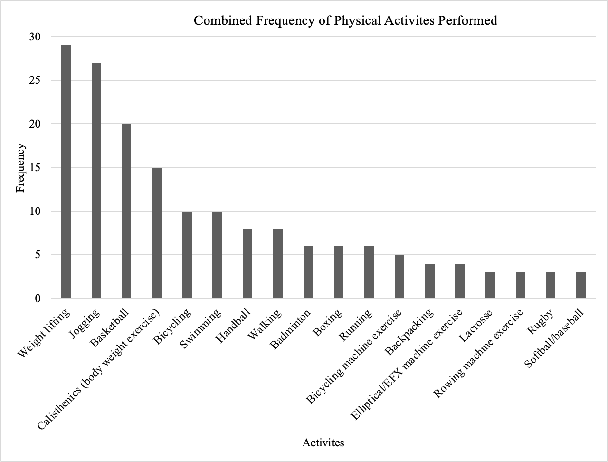
Figure 3. Respondents’ reported activity type engaged in during the past month. Frequency represents how often the respondents selected the activity. Activities not shown (active gaming devices, bowling, dancing, inline skating, rock climbing, snorkeling, wrestling, other, aerobic video or class, carpentry, frisbee, gardening, hiking, hockey, paddleball, racquetball, scuba diving, stair climbing, tai chi, touch football) had less than two respondents choose that activity.

interjected regulation subscale consisted of 4 items (α = 0.772), the identified regulation subscale consisted of 4 items (α = 0.705), the integrated regulation subscale consisted of 4 items (α = 0.811), and the intrinsic regulation subscale consisted of 4 items (α = 0.866). A multivariate analysis of variance (MANOVA) of the subscales of the BREQ-3 regarding aerobic PA indicated that at least one of the subscales had significantly different means for the two groups. The groups were significantly different with a p < 0.001. All subscales were significantly different except for amotivation. Those meeting the aerobic PA guidelines had a higher mean score on the BREQ-3 for introjected regulation , identified regulation, integrated regulation, and intrinsic regulation. Respondents who did not meet the aerobic PA guidelines scored higher on external regulation (Table 3). The subscales for external regulation (ηp2 = 0.050) and introjected regulation (ηp2 = 0.075) had a medium effect size for meeting aerobic PA guidelines. The subscales of identified (ηp2 = 0.103) and integrated regulation (ηp2 = 0.104) had a medium to large effects size for AA men meeting or not meeting aerobic PA guidelines. Intrinsic regulation (ηp2 = 0.138) had a large effect size for AA men meeting aerobic PA guidelines, indication much of the variance between the two groups can be attributed with this psychological determinant.

Relationship between Relative Autonomy Index and Aerobic Activity
The relative autonomy index derived from the BREQ-3 subscales, provides an indication of the degree to which a respondent’s motivations are either autonomous regulated or controlled regulated. Each subscale is multiplied by its weight (amotivation [-3], external motivation [-2], introjected motivation [-1], identified motivation [1], integrated motivation, [2] and intrinsic motivation [3]) and the scores are summed. Higher, positive scores indicate greater relative
autonomy, and lower, negative scores indicate more controlled regulation (309). Respondents
Table 3. Mean scores of the Behavioral Regulation in Exercise Questionnaire (Aerobic) subscale items were significantly different between the two aerobic groups. Scores ranged from 0-5, with higher scores indicating a greater tendency for the type of motivation for engaging in physical activity. Significantly different mean scores (p < 0.05) are shown in boldface, and the psychological variable is shown in grey highlighter.

who met the aerobic PA guidelines a significantly (p <.001) higher relative autonomy index compared to those who did not meet the aerobic PA guidelines (10.24 ± 7.72 vs. 5.58 ± 48.89).

Relationship between Basic Psychological Needs in Exercise Scale scores and Aerobic Activity
The BPNES questionnaire was completed by 111 respondents with an overall Cronbach’s alpha of (α = 0.908), indicating excellent internal consistency of the survey questions. The autonomy subscale consisted of 4 items (α = 0.822), the competence subscale consisted of 4 items (α = 0.799), and the relatedness subscale consisted of 3 items (α = 0.778). A MANOVA was conducted on the BPNES scores to examine all three subscales (autonomy, competence, relatedness) to determine if there were any differences between respondent who reported meeting aerobic PA guidelines and respondents who reported not meeting aerobic PA guidelines. The Wilks’ Lamba from the MANOVA was p = 0.005 which indicated there was a significant difference in at least one of the BPNES subscale between the two groups. A test of between-subjects effects was then conducted, which found that autonomy (p < 0.001) and competence (p = 0.003) were significantly different between the two groups. Relatedness had a p = 0.228 and did not meet criteria for statistical significance. Finally, when examining the means of autonomy and competence of those who reported meeting the aerobic PA guidelines compared to those who did not report meeting the aerobic PA guidelines, respondents meeting aerobic PA guidelines had higher mean scores for autonomy (3.71 ± 0.098 vs. 3.16 ± 0.126) and competence (3.70 ± 0.096 vs. 3.22 ± 0.123) (Table 4). The subscale of relatedness (ηp2 = 0.013) had a small effect size for meeting aerobic PA guidelines. The subscale of competence (ηp2 = 0.080) had a medium effect size on meeting aerobic PA guidelines, indicating that while there are other variables to consider when determining what may influence AA men meeting aerobic PA
Table 4. Mean Basic Psychological Needs in Exercise Scale (Aerobic) had three subscales (four items for autonomy and competence and three items for relatedness). All 11 items were scored on a Likert-type 5-point scale from “1” (I don't agree at all) to “5” (I completely agree). Significantly different mean scores (p < 0.05) are shown in boldface, and the psychological variable is highlighted in grey.

guidelines, competence does play a role. Autonomy (ηp2 = 0.101) had a medium-to-large effect on meeting aerobic PA guidelines for AA men, suggesting a large influence on meeting aerobic PA guidelines for AA men.

Relationship between Multidimensional Exercise Self-Efficacy Scale and Aerobic Activity
The 9-item MSES questionnaire was completed by 131 respondents. The confidence in task subscale consisted of 3 items (α = 0.915), the confidence in coping subscale consisted of 3 items (α = 0.765), and confidence in scheduling consisted of 3 items (α = 0.883). To examine respondents’ level of self-efficacy regarding exercise behavior a MANOVA was conducted with the three domains of self-efficacy (task, coping, and scheduling) between those meeting and not meeting aerobic PA guidelines. There was a significant difference between those meeting aerobic guidelines and those not meeting aerobic guidelines (p < 0.001). Upon closer examination it was determined that respondents who met and did not meet aerobic guidelines had a statistically significant difference in mean scores for confidence in task (p = 0.008) and scheduling of exercise (p < 0.001). Those who were able to meet aerobic PA guidelines had a significantly higher mean score on task self-efficacy (7.177 ± 0.220 vs. 6.241 ± 0.266) and scheduling self-efficacy (6.905 ± 0.221 vs. 5.111 ± 0.267) (Table 5). The effect size for coping self-efficacy (ηp2 = 0.008) was small. Task self-efficacy (ηp2 = 0.053) approached a medium effect size and scheduling self-efficacy (ηp2 = 0.170) had a large effect size on meeting aerobic PA guidelines in AA men.

Relationship between Affective Exercise Experience Questionnaire and Aerobic Activity
The 36-item AFFEXX questionnaire was completed by 134 respondents. Among the antecedent appraisals: “liking – disliking group exercise” consisted of 3 items (α = 0.814), “showing off – shying away” consisted of 3 items (α = 0.546), “empowerment-damage”
Table 5. Mean Multidimensional Exercise Self-Efficacy Scale (Aerobic) included nine items scored on a 10-point Likert scale from“0” (not at all confident) to“10” (completely confident). Significantly different mean scores (p < 0.05) are shown boldface, and the psychological variable is highlighted in grey.

consisted of 3 items (α = 0.837), “pride/honor-shame/guilt” consisted of 3 items (α = 0.688), “competence – incompetence” consisted of 3 items (α = 0.814), “interest-boredom” consisted of 3 items (α = 0.759). Among the core affective exercise experience, “pleasure-displeasure” consisted of 4 items (α = 0.809), “energy-tiredness” consisted of 4 items (α = 0.798), “calmness-tension” consisted of 4 items (α = 0.810). Attraction-antipathy consisted of 5 questions (α = 0.736). The AFFEXX questionnaire revealed, two items (“show off-shying away” and “liking-disliking group exercise”) were statistically different between those who met aerobic guidelines and those who do not meet aerobic guidelines. Respondents who met guidelines scored lower for showoff towards shying away (4.429 ± 0.123 vs. 4.972 ± 0.150) and likegroup towards disliking group exercise (4.679 ± 0.143 vs. 5.352 ± 0.174) compared to those who do not meet guidelines (Table 6). The affective exercise experience of the AA men in this study had a small effect size on meeting aerobic PA guidelines. All variables that were not significantly different had a small effect size, with a value no larger than ηp2 = 0.015. The two significantly different variables “show off-shying away” (ηp2 = 0.056) and “like-dislike group exercise” (ηp2 = 0.063) had a medium effect size. The medium effect size of these two antecedent cognitive appraisals may suggest that AA men who meet and do not meet aerobic PA guidelines have more impactful determinants that influence their decisions besides their previous experiences.
Prediction of Adherence to Aerobic PA Guidelines
Starting with all twenty-three psychological variables that might be good predictors of meeting aerobic guidelines, a forward stepwise logistic regression model (Table 7) was applied to the data. This reduced the number of predictors to 5: scheduling self-efficacy, showoff, calmness, competence (from AFFEXX), and intrinsic motivation, to be explored further in future studies. The stepwise regression was able to correctly predict 79.3% of respondents who either
Table 6. Mean scores of the Affective Exercise Experience Questionnaire (Aerobic). Scores ranged from 1-7 on a 7-point Likert scale separates two conflicting statements with anchors from“1” (if the statement perfectly matches what the respondent feels in the left column) to“7” (if the statement perfectly matches what the respondent feels in the right column). Significantly different mean scores (p < 0.05) are shown in boldface, and the psychological variable is shown in grey highlighter.

Table 7. Stepwise logistic regression analysis to predict the likelihood of meeting national PA guidelines for aerobic activity, based upon psychological determinants.

met (or did not meet) aerobic guidelines (Table 8). Of those who met guidelines for aerobic PA, 85.5% were correctly predicted, and of those who did not meet guidelines for aerobic PA, 69.0% were correctly predicted.

Psychological Characteristics and Muscle-strengthening Activity
Relationship between Relative Autonomy Index and Muscle-strengthening Activity
The Relative Autonomy Index of respondents who met strength guidelines versus those who did not meet the strength guidelines revealed a significant (p = 0.009) difference between the two groups. Those who reported meeting the strength guidelines had a higher RAI compared to those who reported not meeting the strength guidelines (8.99 ± 7.32 vs. 5.07 ± 4.58). A MANOVA of the subscales of the BREQ-3 regarding meeting strength PA guidelines had a p = 0.52 which indicated no significant difference between the two groups regarding their source of motivation for meeting strengthening guidelines.

Relationship between Basic Psychological Needs scores and Muscle-strengthening Activity
A MANOVA was conducted on the BPNES scores to examine all three subscales (autonomy, competence, relatedness) to determine if there were any differences between respondent who reported meeting strength PA guidelines and respondents who reported not meeting strength PA guidelines. The Wilks’ Lamba from the MANOVA was significant with a p = 0.027, highlighting a significant difference in at least one of the BPNES subscale. A test of between-subjects effects was then conducted, which found that autonomy had a p = 0.049 indicating a significant difference between the two groups. Competence had a p = 0.596 and relatedness had a p = 0.906 and did not meet criteria for significance. Respondents meeting muscle-strengthening guidelines had higher mean scores for autonomy (3.567 ± 0.086 vs. 3.10 ± 0.219). The effect size of autonomy (η_{p}² = 0.035) on meeting muscle-strengthening PA
Table 8. Results of stepwise logistic regression for predicting who meets, or does not meet, national PA guidelines for aerobic activity.

guidelines was small-to-medium, while the psychological determinants of competence and relatedness had little to no effect on whether AA men met or did not meet muscle-strengthening guidelines (Table 9).
Relationship between Multidimensional Exercise Self-Efficacy Scale and Muscle-strengthening Activity
There was two statistically significant difference between those who met muscle-strengthening guidelines and those not meeting muscle-strengthening guidelines (p <0.001) regarding self-efficacy. Both coping self-efficacy (5.802 ± 0.179 vs. 5.097 ± 0.294) and scheduling self-efficacy (6.668 ± 0.202 vs. 4.852 ± 0.332) were significantly different between the two groups, with those meeting strength guidelines reporting higher scores on the MSES (Table 10). Dimensions of self-efficacy were mixed in their effect size, with task self-efficacy (η_{p}² = 0.022) having a small effect size. Coping self-efficacy (η_{p}² = 0.031) had a medium effect size on AA men meeting or not meeting muscle-strengthening guidelines, while scheduling self-efficacy (η_{p}² = 0.143) had a large effect size, indicating a potentially higher influence on AA men’s ability to meet muscle-strengthening guidelines.
Relationships between Affective Experience Questionnaire and Muscle-strengthening Guidelines
Among respondents who reported meeting strength guidelines, mean scores for the antecedent cognitive appraisal were significantly higher for interest, honor, and competence. AA men who met muscle-strengthening guidelines scored higher in energy and calmness among the core affective exercise experiences. Finally, AA men who met muscle-strengthening guidelines scored higher in the outcome motivational variable, attraction (Table 11). While there were significant differences in many of the antecedent appraisal variables and affective exercise
Table 9. Basic psychological needs in exercise scale (BPNES) means and SE (Strength). Significantly different mean scores (p < 0.05) are shown in boldface, and the variable name is highlighted in grey.

Table 10. Multidimensional Exercise Self-Efficacy Scale (Strength). Significantly different mean scores (p < 0.05) are shown in boldface, and the variable name is highlighted in grey.
Table 11. Mean scores of the Affective Exercise Experiences Questionnaire (Strength) subscale items were significantly different between the two strength groups. Scores range from 1-7 for each item, with a higher number indicating a greater affective experience towards exercise. Significantly different (p < 0.05) mean scores are shown in boldface, and the variable name is highlighted in grey.

experiences variables, the effect sizes ranged from no effect-to-small on AA men’s ability to meet muscle-strengthening PA guidelines (Table 11).

Prediction of Adherence to Muscle-strengthening Guidelines
The forward stepwise logistic regression was able to reduce the 23 variables that might have been good predictors for meeting muscle-strengthening guidelines to one: integrated motivation (Table 12). Only one psychological variable, the BREQ-3 integrated motivation, was found to be predictive of meeting strength training guidelines when this was defined as “performing muscle-strengthening activities for 2 or more sessions per week.” For those who meet the strength guidelines, 86.5% of respondents were correctly predicted using BREQ-3 integrated motivation in the stepwise regression (Table 13). However, this high number reflects the fact that the vast majority of respondents reported that they were doing strength training for 2 or more sessions per week.
Adjusted Strength Guidelines
A large majority of respondents (73.1%, n = 98) indicated that they were meeting the national PA guidelines for muscle-strengthening activities, by doing two or more activities of LTPA designed to strengthen muscles per week. Nationally, the prevalence of U.S. men meeting this recommendation in 2018 was approximately 3.7%. Between Whites and AA, an estimated 3.5% and 4.2% met the full muscle-strengthening guidelines, respectively (16). In the present
study, 73.1% of AA men reported meeting the national PA guidelines for muscle-strengthening activities. The high prevalence respondents reporting meeting the muscle-strengthening PA guidelines may have been due to recruitment of a very active sample or the potential over-reporting of the volume of engagement in muscle-strengthening PA. Therefore, to further examine possible psychological differences in AA men engaged in greater versus lesser amounts
Table 12. Stepwise logistic regression analysis to predict the likelihood of meeting national PA guidelines for muscle-strengthening activity, based upon psychological determinants. (Only the BREQ 3 integrated variable was found to be a statistically significant predictor.)

Table 13. Results of stepwise logistic regression for predicting who meets, or does not meet, national PA guidelines for muscle-strengthening activity.

of muscle-strengthening activity, four or more sessions per week was set as high, with three or less categorized as low. With this adjusted cut point for those who engaged in more muscle-
strengthening activities versus less, 30.6% (n = 41) of respondents were classified as having high engagement in muscle-strengthening activities. All data were re-analyzed with the adjusted cut point of 4 or more sessions per week categorized as high engagement in muscle-strengthening PA.
Psychological Determinants of High Muscle-Strengthening Activity
The cut point for high and low engagement in muscle-strengthening activities revealed a significant difference between those who met guidelines and those who did not meet guidelines. There was a significant different in two of the basic psychological needs in exercise. AA men who engaged in 4 or more sessions of muscle-strengthening scored higher in competence (3.76 ± 0.127 vs. 3.38 ± 0.096) and autonomy (3.81 ± 0.130 vs. 3.33 ± 0.098)compared to those who obtained 3 session or less of muscle-strengthening PA (Table 14).The effect size for competence (ηp2 = 0.049) and autonomy (ηp2 = 0.074) was small-to-medium for engagement in 4 or more sessions per week of muscle-strengthening (Table 14).
For the BREQ-3, identified, integrated, and intrinsic regulation were significantly different between the two groups. Respondents who engaged in 4 or more sessions of muscle-strengthening activities scored higher on identified (3.83 ± 0.121 vs. 3.43 ± 0.091), integrated (3.79 ± 0.133 vs. 3.23 ± 0.101), and intrinsic motivation (3.79 ± 0.135 vs. 3.35 ± 0.102) compared to those who did 3 session or less per week (Table 15). Identified and intrinsic regulation (ηp2 = 0.059) had a medium effect size on whether AA men engage in less than 3 or less session per week or if they engage in more than 4 session per week. Integrated regulation

Table 14. Mean scores of the Basic Psychological Needs in Exercise Scale (Adjusted). Significantly different (p < 0.05) mean scores are shown in boldface, and the variable name is highlighted in grey.

Table 15. Mean scores of the Behavioral Regulation in Exercise Questionnaire (Adjusted). Significantly different (p < 0.05) mean scores are shown in boldface, and the variable name is highlighted in grey.

(ηp2 = 0.091) had a medium-to-large effect size on whether AA men’s muscle-strengthening activity was classified as high or low.
For measures of self-efficacy, task self-efficacy (7.41 ± 0.307 vs. 6.53 ± 0.205 ) and scheduling self-efficacy (7.11 ± 0.321 vs. 5.76 ± 0.215) were significantly different between the two groups, with those who engaged in muscle-strengthening 4 or more times per week scoring higher of the MSES (Table 16). The effect size of task self-efficacy (ηp2 = 0.041) was small-to-large and medium-to-large for scheduling self-efficacy(ηp2 = 0.085). No significant difference was found between those engaged in high volumes of muscle-strengthening PA and those obtaining lower volumes of muscle-strengthening PA when the AFFEXX scale was examined. The effects sizes were small-to-none for the new adjusted high/low criteria engagement in muscle-strengthening PA ranging from ηp2 of 0.001 - 0.029) (Table 17).

Prediction of Adherence to Prediction of Adherence to Adjusted Muscle-strengthening Guidelines.
The forward stepwise logistic regression was able to reduce the 23 variables that might be good predictors for those who performed muscle-strengthening 4 or more times per week which were: integrated motivation, amotivation, task self-efficacy, and external regulation (Table 18). Using the adjusted criterion for meeting adjusted muscle-strengthening guidelines, the stepwise logistic regression was able to correctly predict 76.6% of respondents who met the adjusted muscle-strengthening guidelines (Table 19). Of those who did muscle-strengthening 4 or more times per week, 68.3% were correctly predicted, and of those who did not muscle-strengthening fewer than 4 times per week, 81.4% were correctly predicted.

Table 16. Mean scores of the Multidimensional Exercise Self-Efficacy Scale (Adjusted). Significantly different (p < 0.05) mean scores are shown in boldface, and the variable name is highlighted in grey.

Table 17. Mean scores of the Affective Exercise Experiences Questionnaire (Adjusted)
Table 18. Stepwise logistic regression analysis to predict the likelihood of achieving 4 or more sessions per week of muscle-strengthening activity, based upon psychological determinants

Table 19. Results of stepwise logistic regression for predicting AA men who performs 4 or more sessions of muscle-strengthening activities per week and those who performs less than 4 sessions per week.

Chapter 5
Discussion
This study aimed to explore psychological determinants of PA that have been identified through research on predominantly White populations or in AA women, in order to determine if they differ significantly between AA men meeting and not meeting PA guidelines for aerobic and muscle-strengthening independently. In this sample of AA men, we found significant differences in some of the psychological determinants of PA, between those meeting and not aerobic PA guidelines. AA men meeting aerobic PA guidelines scored higher in psychological determinants that, according to SDT, would foster more autonomous motivation for positive behaviors. There were some slight differences for those engaged in muscle-strengthening activity, but since most of the men reported meeting guidelines, only integrated regulation from the BREQ-3 questionnaire was able to predict meeting the muscle-strengthening guidelines. Thus, in order delve further into comparing AA men who engaged in greater or lesser amounts of muscle-strengthening activities, a cut-point of four days per week was used to distinguish these two groups. Significant differences in autonomy, competence, identified regulation, integrated regulation, intrinsic regulation, task self-efficacy, and scheduling self-efficacy were observed between AA men who engaged in four or sessions per week and those who engaged in less, with all scores being higher in those engaged in more muscle-strengthening activity. Utilizing the psychological determinants of PA, our study was able to predict AA men who would meet and not meet PA guidelines for aerobic, and muscle-strengthening activities, and those who would engage in greater than four or more sessions of muscle-strengthening activities.

Basic Psychological Needs in Exercise Scale and Aerobic Activity
There were several differences in the psychological determinants of PA for aerobic activity, between AA men who met national PA guidelines for aerobic activity and those who did not. AA men who met aerobic PA guidelines scored significantly higher in psychological determinants, such as autonomy, competence, introjected regulation, identified regulation, integrated regulation, intrinsic regulation, task self-efficacy, scheduling self-efficacy which have been shown to support engagement in physical activity (269). AA men who met aerobic PA guidelines scored significantly lower on psychological variables such as external regulation,, ”liking-disliking group exercise,” and “show off- shying away,” where the evidence in mixed on its effect on PA engagement. (269). In general, this provides confirmation that many of the psychological determinants of PA that have been elucidated through research on predominantly White populations and AA women, also have relevance for AA men.
Autonomy from the basic psychological needs in exercise survey was significantly different between the two groups, with those who met the aerobic PA guidelines having higher scores. According to SDT, the satisfaction of autonomy will foster more autonomous motivation and potentially increase positive behaviors (267). Teixeira et al. found that most studies measuring relative autonomy reported a positive associations with PA behaviors (269). The higher score in this sample provides further evidence for the need for the satisfaction of autonomy in PA engagement. Research in the context of PA has demonstrated that as a predictor of PA behavior, competence is a prominent psychological need that positively affects PA behavior (18-21). Deci and Ryan’s SDT suggested that individuals whose basic psychological needs (autonomy, competence, relatedness) are satisfied will gain greater self-determined motivation (310). In this sample, AA men who reported meeting aerobic PA guidelines had significantly higher scores of autonomy and competence on the BPNES. These findings are generally consistent with Martinez et al.’s findings that only competence was a significant predictor of exercise participation in a sample of predominately White male college students followed for six weeks, with a primary outcome of admission to the university fitness center. However, unlike our sample, Martinez et al. found that competence only predicted exercise participation in young college women, and not in college-aged men (311).
Behavioral Regulation in Exercise Questionnaire and Aerobic Activity
AA men who met aerobic PA guidelines scored significantly higher for introjected, identified, integrated, and intrinsic regulation on the BREQ-3. AA men who did not meet aerobic PA guidelines scored higher for external regulation. These data are consistent with previous research on the forms of motivational regulation and PA behavior. Zamarripa et al. surveyed 530 Mexican participants using an adapted BREQ-3 and readiness to change questionnaire (Transtheoretical Model) to examine correlations between the motivational regulation and the participant’s current position in the stage of change cycle (312). The Transtheoretical Model assumes that people do not change behavior quickly; instead, change occurs continuously in a cyclical manner through six stages: precontemplation, contemplation, preparation, action, maintenance, and termination (313, 314). Results indicated that individuals with more autonomous motivational regulation were more likely to be in the action and maintenance phase. Though no direct or indirect measure of PA was performed, respondents did indicate whether they had been doing regular PA for the past six months, which draws a loose comparison to our respondents meeting aerobic PA guidelines. The association of higher autonomous regulation and positive PA behaviors is consistent with research on other populations (e.g., college students, adult exercisers, AA women) (315-317). Introjected regulation, classified as controlled regulated motivations, could infer individuals would not meet PA guidelines. However, in our sample, AA men whose motivational regulation was reported as introjected also met aerobic PA guidelines. AA men with significantly higher scores for external regulation, also classified as controlled regulated, were less likely to meet aerobic PA guidelines. This finding is supported by Brunet et al., who found that introjected regulation was positively correlated with PA behavior while external regulation negatively correlated with PA behavior (285). These findings also confirm the relationship between more autonomous individuals and positive PA behavior (meeting aerobic PA guidelines), with those meeting aerobic PA guidelines scoring higher in relative autonomy.
Multidimensional Exercise Self-Efficacy Scale and Aerobic Activity
AA men who met aerobic PA guidelines scored higher in task and scheduling self-efficacy. These findings are consistent with findings from previous research on task self-efficacy. In a study of 437 previously sedentary German patients with coronary heart disease and a medical recommendation for exercise, surveys of task self-efficacy, outcome expectations, risk awareness, and behavioral intentions were administered. The patients were surveyed at three time points, with the task self-efficacy survey occurring at the first time and the PA questionnaire occurring at the final time. The correlation between task self-efficacy and outcome expectancies and; and task self-efficacy and outcome expectancies with risk awareness were significant. While outcome expectancies and risk awareness were significant predictors of exercise behavior at time point three, task self-efficacy had the strongest effect on intention (318). Task self-efficacy is an individual’s perception that they can perform an action, which is essential to have the confidence to embark on a PA behavior (319). Scheduling self-efficacy was also scored high for AA men who met aerobic PA guidelines. Previous research supports our finding that scheduling self-efficacy significantly correlates with meeting aerobic PA guidelines. In a random sample of 203 participants divided into five exercise categories (never, 1-3x/months, 4-8x/month, 9-15x/month, and >15 x/month), scheduling self-efficacy was moderately correlated with their exercise behavior. It is worth noting that the authors identified two items most strongly related to the group difference, scheduling exercise regularly and exercising when one feels one doesn’t have time. This is consistent with the research on barriers to exercise (320). Lack of time is often cited, but in our sample of AA men, those who were confident in their ability to schedule their PA met aerobic PA guidelines compared to those who were not as confident in their ability to schedule PA (29, 321, 322).
Affective Exercise Experiences Questionnaire and Aerobic Activity
Existing research finds that exercising in a group (cohesive group) is superior to exercise in a standard exercise class (non-cohesive), in a home-based program with contact, and a home-based program without contact (323). AA men in the current study met aerobic PA guidelines while scoring low on antecedent cognitive appraisal variables of “liking-disliking group exercise” and “showing off-shying away.” A study examining whether belonging to an exercise group was associated with higher levels of PA in adults found that group exercise membership was positively related to the amount of PA per week for women. In men, however, group exercise membership was not directly associated with the amount of PA per week (324). This finding supports what was observed in the current sample. There is evidence that there may be a difference in PA preference types for men and women, with men participating more in weightlifting and golf and women participating more in aerobics and bicycling (325). The lower scores for “showoff” may come from higher self-efficacy in their chosen PA type. However, unlike males in a study on high school students that had high confidence in their athletic ability (task self-efficacy), which prompted them to compete “showoff” in sports with friends, our population potentially did not have a strong desire to compete (326).

Psychological Characteristics and Muscle-strengthening Activity
For AA men meeting the national PA guidelines for muscle-strengthening activity, there were several differences in the psychological determinants of PA. AA men who met muscle-strengthening guidelines scored significantly better in autonomy, relative autonomy, coping self-efficacy, scheduling self-efficacy, “interest,” “honor,” “competence,” “energy,” “calmness,” and “attraction.”
Basic Psychological Needs in Exercise Scale and Muscle-Strengthening Activity
The fulfillment of autonomy, which refers to the ability to make choices and exert control, promotes motivation and healthy behaviors (2, 25). In the current sample of AA men, those meeting muscle-strengthening guidelines scored higher in autonomy on the basic psychological needs in exercise scale. The satisfaction of the need for autonomy can enhance positive outcomes and may result in higher self-efficacy and intrinsic motivation compared to controlled situations (327). The current findings are supported by research on adolescent boys whose autonomy was manipulated in an eight-week intervention. Researchers randomly assigned three groups, autonomy training, training without autonomy, and control, and performed pre- and post-measures of behavioral intentions, intrinsic motivation, and physical fitness. Following the intervention, the autonomy training reported higher PA intentions and significantly higher intrinsic motivation than the other groups (328).
Behavioral Regulation in Exercise Questionnaire and Muscle-Strengthening Activity
In the current sample of AA men, 73.1% reported meeting muscle-strengthening guidelines by engaging in two or more activities of LTPA designed to strengthen muscles per week, a substantially higher prevalence than the national prevalence in AA men of 4.2%. AA men who met the muscle-strengthening guidelines scored significantly higher on the relative autonomy index, indicating a more autonomous motivation for strength training. Borges et al. found that among the five different exercise modalities (Pilates, extreme fitness, strength training, fight training, and functional training) participated in, the mean ± standard deviation of relative autonomy index was 13.29 ± 6.23 (329). In our study, the relative autonomy index did not reach the levels found in the aforementioned study but was positive (8.99 ± 7.32), indicating the motivation for muscle-strengthening activity was more autonomous than controlled. Low and negative scores for relative autonomy index would indicate that source of motivation for muscle-strengthening activity was controlled. The other subscales of the BREQ-3 were not examined because the MANOVA did not display a significant difference between the two groups in our sample. AA men who met muscle-strengthening guidelines also scored higher on autonomy from the BPNES, confirming their self-determined regulation. Because most men reported meeting muscle-strengthening guidelines, the differences between the groups were difficult to examine. A decision was made to change the cut-off from at least two sessions of muscle-strengthening activity per week to at least four sessions per week, to correct for potential over-reporting muscle-strengthening activities.
Multidimensional Exercise Self-Efficacy Scale and Muscle-Strengthening Activity
In an investigation of the determinants of bodyweight exercise behaviors in adult men and women, self-efficacy, and other measures (social support, outcome expectations, self-regulation) from social cognitive theory were measured along with exercise behavior. The authors showed in their sample that self-efficacy and social support, followed by outcome expectations, were the strongest determinants of bodyweight exercise behavior (330). This finding is consistent with our study that AA men who met muscle-strengthening activity scored higher in coping and scheduling self-efficacy. The authors also illustrated a significantly stronger effect of self-efficacy on bodyweight exercise for men than for women (330). While we did not directly compare gender in our study, the difference between the two groups surrounding self-efficacy supports the theory of its importance in maintaining muscle-strengthening activities.
Affective Exercise Experiences Questionnaire and Muscle-Strengthening Activity
Those who reported meeting national PA guidelines for muscle-strengthening activity scored higher in areas that can contribute to positive appraisals of PA, thus potentially contributing to increased participation. AA men who scored high on “interest” did not find muscle-strengthening activities boring but rather found them worthwhile. Activities that appear valuable to the individual may be engaged more often, as was the case for our sample (331). Honor was significantly different between the two groups, with those meeting the guidelines potentially having greater pride in their PA routine, as opposed to shame. As noted earlier, competence is positively associated with PA behavior, and men who met muscle-strengthening guidelines scored high for competence. Past experiences with muscle-strengthening activities can increase confidence and self-efficacy, further contributing to positive behavior (332). Seemingly intuitive, high scores in energy may encourage engagement in activities that provide a sensation of physical empowerment that motivates future activity (333). For those who scored high in calmness, engaging in muscle-strengthening activities may have been seen as relaxing or relieving tension, providing them a sense of peace. Finally, AA men who scored high in attraction likely preferred muscle-strengthening activities, which may explain the high prevalence of AA men’s engagement compared to national averages. As was stated before, men have a higher preference for weightlifting (70.3% vs. 29.7%) compared to women.
Prediction of Adherence to Aerobic Guidelines
After comparing all the individual psychological variables for those meeting aerobic PA guidelines, we utilized a stepwise logistic regression to identify which combination of variables could predict those who would meet the aerobic PA guidelines and those who would not meet the aerobic PA guidelines. In this sample, five variables were identified: scheduling self-efficacy, “showoff,” “calmness,” “competence,” and intrinsic regulation. Based on the stepwise logistic regression, the variables can correctly predict 69% of those who did not meet the aerobic PA guidelines. The regression correctly predicted 85.5% of respondents who met the aerobic PA guidelines. Overall, the stepwise logistic regression accurately predicted 79.3% of whether respondents met or did not meet aerobic PA guidelines.
Prediction of Adherence to Muscle-Strengthening Guidelines
After comparing all the individual psychological variables for those meeting muscle-strengthening guidelines, the stepwise logistic regression identified just one variable that could correctly predict those who would meet the muscle-strengthening guidelines and those who would not. In this sample, integrated regulation correctly predicted 13.3% of respondents who did not meet the muscle-strengthening guidelines. The regression correctly predicted 99% of respondents who met the national PA guidelines for muscle-strengthening. Overall, the stepwise logistic regression accurately predicted 87.4% of respondents who either met or did not meet muscle-strengthening guidelines.
Prediction of Adherence to Adjusted Muscle-Strengthening Guidelines
To examine the psychological predictors of AA men engaged in four or more sessions per week of muscle-strengthening, the stepwise logistic regression for the adjusted muscle-strengthening cut point was analyzed. The stepwise logistic regression identified four variables that, in combination, could correctly predict those who would meet the adjusted muscle-strengthening guidelines and those who would not meet the adjusted muscle-strengthening guidelines. In this sample, the four variables identified were: scheduling self-efficacy, integrated regulation, amotivation, scheduling self-efficacy, and external regulation. Based on the stepwise logistic regression, the variables can correctly predict 81.4% of those who did not meet the adjusted muscle-strengthening guidelines. The regression correctly predicted 68.3% of respondents who met the adjusted muscle-strengthening guidelines. Finally, the stepwise logistic regression accurately predicted 76.6% of respondents who either met or did not meet the new strength training cut-point of 4 or more sessions per week. Overall, the current findings suggest that select psychological determinants of PA can potentially predict whether AA men will engage in sufficient levels of aerobic and muscle-strengthening PA to meet the current national guidelines, independently.

Limitations
This study was not without limitations. First, the survey was cross-sectional, which prevented any conclusions about causality. Second, the self-reported survey may have allowed for more overreporting of PA behavior compared to use of a wearable device (194). Third, the NHIS PA questions primarily capture LTPA, excluding PA from work, which may exceed the LTPA in this sample of men (216). Fourthly, because the survey was online, any questionable data were removed, which may have eliminated some valid responses. In addition to the potential loss of valid responses, potential overreporting of muscle-strengthening activities could have occurred due to the wording of survey questions that were unclear to respondents.
Despite these limitations, there are several strengths of this study. This study’s focus on AA men enabled the author to examine the psychological determinants of PA and their potential impact on meeting the PA guidelines in an understudied population. The use of an online survey allowed recruitment of respondents from a potential more representative sample as opposed to conducting the research in one city or region. The study’s sample of AA men was very heterogeneous, comprising men from various socioeconomic levels and educations, allowing our findings to be more generalizable to an AA male population. This study provided insights into the potential factors that might be relevant to the promotion of meeting the aerobic and muscle-strengthening guidelines in AA men. These psychological factors may inform the work of those who design future interventions by reinforcing that consideration of psychological determinants is vital to fostering greater adherence to PA.

Future Research
During data analysis, some questions could not be answered due to the closed-ended surveys. The option for participants to provide additional feedback with open-ended questions would yield additional insights into how AA men perceive physical activity, and their attitudes and feelings toward it. Conducting research in person would allow for clarification of questions from respondents and researchers. While there could have been some misunderstanding with the survey question surrounding muscle-strengthening activity, the current survey for meeting the guidelines is too vague. It does not adequately differentiate between individuals who exercise only a few muscle groups (e.g., arms and chest) and those who recruit all major muscle groups (e.g., legs, hips, back, abdomen, chest, shoulders, and arms) as specified by the PA guidelines for muscle-strengthening activity. ). Like the aerobic PA guidelines, a time component could be added to ensure adequate muscle-strengthening engagement. The current study's results were mixed on the association of all three forms of self-efficacy (task, coping, scheduling) with meeting guidelines. Additionally, understanding the practical strategies employed by AA men meeting PA guidelines should be explored to inform practitioners and community leaders on how best to assist AA men in meeting the PA guidelines. Community feedback on the common barriers to engagement to PA could be sought out. Researchers could potentially provide various common scenarios based on community input regarding barriers to engagement in PA and allow respondents to indicate how they might increase engagement in PA.

Summary

Psychological Determinants of Aerobic Physical Activity Interpretations
- AA men who met aerobic PA guidelines scored significantly higher in psychological variables (i.e., autonomy, competence, relative autonomy index, scheduling self-efficacy, task self-efficacy) shown to have a positive impact on aerobic PA engagement and lower for variables (i.e., liking-disliking group exercise and showing off-shying away) that have mixed results on influencing aerobic PA engagement.
- Despite several psychological determinants being significantly different between the two groups, a stepwise logistic regression identified five variables (scheduling self-efficacy, show off-shying away, calmness, competence-incompetence [AFFEXX questionnaire], and intrinsic motivation) that, when entered, accounted for 79.3 % of the variance seen in AA men meeting aerobic PA guidelines and those not meeting aerobic PA guidelines. This hypothesis was not supported in full.

Psychological Determinants of Muscle-strengthening Activity Interpretations
- AA men who met muscle-strengthening guidelines scored statistically higher in autonomy, coping self-efficacy, scheduling self-efficacy, and significantly higher in areas of interest, honor, competence, energy, calmness, and attraction from the AFFEXX questionnaire.
- A stepwise logistic regression identified integrated regulation as the sole predictor of AA men meeting not meeting muscle-strengthening guidelines despite the other variables found to be significantly different. Integrated regulation accounted for 87.4 % of the variance in AA men meeting and not meeting muscle-strengthening guidelines.

Conclusion
In the current study, AA men meeting and not meeting aerobic PA guidelines were similar in most of their demographic characteristics. However, there were several differences in the psychological determinants of AA men meeting aerobic and muscle-strengthening guidelines, versus those not meeting guidelines. The satisfaction of basic psychological needs, greater self-efficacy, and greater self-determined motivation was found among AA men meeting the aerobic PA guidelines, compared to those who did not meet guidelines. The satisfaction on the basic psychological needs and greater self-efficacy was found among AA men meeting the muscle-strengthening guidelines, compared to those who did not meet them. To examine AA men who engaged in more muscle-strengthening activities a new cut point was established to categorized AA men engaged in four or more sessions per week as high and those doing less than four session per week. The adjusted analyses illustrated more differences between the group, like those engaged in four or more sessions per week of muscle-strengthening activities scored higher in the satisfaction of autonomy and competence, had more self-determined motivation, and had greater self-efficacy than those doing three sessions or less of muscle-strengthening activity. Overall, the understanding of the psychological determinants of PA in this underserved population may inform other researchers and practitioners on which factors to consider when designing interventions to increase adherence to national PA guidelines.

List of References
1. Habib S. H., Saha S. Burden of non-communicable disease: Global overview. Diabetes & Metabolic Syndrome: Clinical Research & Reviews. 2010;4(1):41-7.
2. Hunter D. J., Reddy K. S. Noncommunicable diseases. N Engl J Med. 2013;369(14):1336-43.
3. Ward B. W., Schiller J. S., Goodman R. A. Peer reviewed: Multiple chronic conditions among U.S. Adults: A 2012 update. Preventing Chronic Disease. 2014;11.
4. Comlossy M. Chronic disease prevention and management. In: Proceedings of the National Conference of State Legislatures. 2013. p. 1-16.
5. Ellis K. R., Hecht H. K., Young T. L. et al. Peer reviewed: Chronic disease among African American families: A systematic scoping review. Preventing Chronic Disease. 2020;17.
6. Leung M.-Y. M., Pollack L. M., Colditz G. A., Chang S.-H. Life years lost and lifetime health care expenditures associated with diabetes in the U.S., national health interview survey, 1997–2000. Diabetes Care. 2015;38(3):460-8.
7. Siegel R. L., Miller K. D., Jemal A. Cancer statistics, 2016. CA Cancer J Clin. 2016;66(1):7-30.
8. Aldwin C. M., Igarashi H., Gilmer D. F., Levenson M. R. Health, illness, and optimal aging: Biological and psychosocial perspectives. Springer Publishing Company; 2017.
9. Saab K. R., Kendrick J., Yracheta J. M., Lanaspa M. A., Pollard M., Johnson R. J. New insights on the risk for cardiovascular disease in African Americans: The role of added sugars. J Am Soc Nephrol. 2015;26(2):247-57.
10. U.S. Department of Health & Human Services. Summary health statistics: National health interview survey. In: Table A-4a editor2018.
11. Petrie J. R., Guzik T. J., Touyz R. M. Diabetes, hypertension, and cardiovascular disease: Clinical insights and vascular mechanisms. Can J Cardiol. 2018;34(5):575-84.
12. Ostchega Y., Fryar C. D., Nwankwo T., Nguyen D. T. Hypertension prevalence among adults aged 18 and over: United States, 2017–2018. 2020.
13. Pollard K., Scommegna P. The health and life expectancy of older Blacks and Hispanics in the United States. Population Reference Bureau. 2013;28:1-8.
14. Forouzanfar M. H., Afshin A., Alexander L. T. et al. Global, regional, and national comparative risk assessment of 79 behavioural, environmental and occupational, and metabolic risks or clusters of risks, 1990–2015: A systematic analysis for the global burden of disease study 2015. The Lancet. 2016;388(10053):1659-724.
15. U.S. Department of Health & Human Services. Physical activity guidelines for Americans 2nd edition. In: Health and Human Services editor2018.
16. Villarroel M., Blackwell D., Jen A. Tables of summary health statistics for U.S. adults: 2017 national health interview survey. National Center for Health Statistics. 2018.
17. Center for Disease Control and Prevention [Internet]. Division of Nutrition, Physical Activity, and Obesity; [cited 2021 December 29]. Available from: https://www.cdc.gov/physicalactivity/basics/adding-pa/barriers.html.
18. Blackwell D. L., Lucas J. W., Clarke T. C. Summary health statistics for U.S. Adults: National health interview survey, 2012. Vital and health statistics. Series 10, Data from the National Health Survey. 2014;(260):1-161.
19. Forde A. T., Sims M., Muntner P. et al. Discrimination and hypertension risk among African Americans in the jackson heart study. Hypertension. 2020;76(3):715-23.
20. Stepanikova I., Baker E. H., Simoni Z. R. et al. The role of perceived discrimination in obesity among African Americans. American Journal of Preventive Medicine. 2017;52(1):S77-S85.
21. Whitaker K. M., Everson-Rose S. A., Pankow J. S. et al. Experiences of discrimination and incident type 2 diabetes mellitus: The multi-ethnic study of atherosclerosis (mesa). Am J Epidemiol. 2017;186(4):445-55.
22. Williams D. R. Race and health: Basic questions, emerging directions. Ann Epidemiol. 1997;7(5):322-33.
23. Harper S. R., Nichols A. H. Are they not all the same?: Racial heterogeneity among Black male undergraduates. Journal of College Student Development. 2008;49(3):199-214.
24. Whitt-Glover M. C., Kumanyika S. K. Systematic review of interventions to increase physical activity and physical fitness in African-Americans. Am J Health Promot. 2009;23(6):S33-56.
25. Kumanyika S. K., Whitt-Glover M. C., Gary T. L. et al. Expanding the obesity research paradigm to reach African American communities. Prev Chronic Dis. 2007;4(4):A112.
26. Griffith D. M., Bergner E. M., Cornish E. K., McQueen C. M. Physical activity interventions with African American or Latino men: A systematic review. Am J Men’s Health. 2018;12(4):1102-17.
27. Bopp M., Wilcox S., Laken M. et al. Factors associated with physical activity among African-American men and women. Am J Prev Med. 2006;30(4):340-6.
28. Whitt‐Glover M., Keith N., Ceaser T., Virgil K., Ledford L., Hasson R. A systematic review of physical activity interventions among African American adults: Evidence from 2009 to 2013. Obesity Reviews. 2014;15:125-45.
29. Joseph R. P., Ainsworth B. E., Keller C., Dodgson J. E. Barriers to physical activity among African American women: An integrative review of the literature. Women & Health. 2015;55(6):679-99.
30. Siddiqi Z., Tiro J. A., Shuval K. Understanding impediments and enablers to physical activity among African American adults: A systematic review of qualitative studies. Health Education Research. 2011;26(6):1010-24.
31. Hooker S. P., Wilcox S., Rheaume C. E., Burroughs E. L., Friedman D. B. Factors related to physical activity and recommended intervention strategies as told by midlife and older African American men. Ethn Dis. 2011;21(3):261-7.
32. Hooker S. P., Wilcox S., Burroughs E. L., Rheaume C. E., Courtenay W. The potential influence of masculine identity on health-improving behavior in midlife and older African American men. J Mens Health. 2012;9(2):79-88.
33. Friedman D. B., Hooker S. P., Wilcox S., Burroughs E. L., Rheaume C. E. African American men's perspectives on promoting physical activity:“We're not that difficult to figure out!”. Journal of Health Communication. 2012;17(10):1151-70.
34. Dishman R. K. Exercise adherence: Its impact on public health. Human Kinetics; 1988.
35. Bullard T., Ji M., An R., Trinh L., Mackenzie M., Mullen S. P. A systematic review and meta-analysis of adherence to physical activity interventions among three chronic conditions: Cancer, cardiovascular disease, and diabetes. BMC Public Health. 2019;19(1):1-11.
36. Hagger M. S., Weed M. Debate: Do interventions based on behavioral theory work in the real world?, International Journal of Behavioral Nutrition and Physical Activity. 2019;16(1):1-10.
37. Deci E. L., Ryan R. M. Motivation and self-determination in human behavior. 1 ed. New York, NY: Springer; 1985, 372 p.
38. Ryan R. M., Deci E. L. Self-determination theory and the facilitation of intrinsic motivation, social development, and well-being. Am Psychol. 2000;55(1):68-78.
39. Bandura A. Self-efficacy: Toward a unifying theory of behavioral change. Psychol Rev. 1977;84(2):191-215.
40. Bandura A. Social foundation of thought and action: A social-cognitive view. Englewood Cliffs, NJ: Prentice Hall; 1986, 617 p.
41. Ekkekakis P., Zenko Z., Vazou S. Do you find exercise pleasant or unpleasant? The affective exercise experiences (AFFEXX) questionnaire. Psychology of Sport and Exercise. 2021;55:101930.
42. Barrett L. F., Bliss‐Moreau E. Affect as a psychological primitive. Advances in Experimental Social Psychology. 2009;41:167-218.
43. African-American. In. Collins English Dictionary. Glasgow, U.K.: Harper Collins Publishers Ltd; 2018, p 2336.
44. Autonomy. In. Collins English Dictionary. Glasgow, U.K.: Harper Collins Publishers Ltd; 2018, p 2336.
45. Hagger M. S., Hardcastle S. J., Chater A., Mallett C., Pal S., Chatzisarantis N. L. Autonomous and controlled motivational regulations for multiple health-related behaviors: Between- and within-participants analyses. Health Psychol Behav Med. 2014;2(1):565-601.
46. Russell J. A. Core affect and the psychological construction of emotion. Psychol Rev. 2003;110(1):145-72.
47. Cornelius R. R. The science of emotion: Research and tradition in the psychology of emotions. Upper Saddle River, N.J.: Prentice-Hall, Inc; 1996, 260 p.
48. Baumann T. Defining ethnicity. The SAA archaeological record. 2004;4(4):12-4.
49. Caspersen C. J., Powell K. E., Christenson G. M. Physical activity, exercise, and physical fitness: Definitions and distinctions for health-related research. Public Health Rep. 1985;100(2):126-31.
50. Baumeister R. F. Toward a general theory of motivation: Problems, challenges, opportunities, and the big picture. Motivation and Emotion. 2016;40(1):1-10.
51. Self-determination. In: Houghton Mifflin Harcourt Publsihing Company editor. American Heritage Dictionary of the English Language: Houghton Mifflin Harcourt Publsihing Company; 2016.
52. Buchan D. S., Ollis S., Thomas N. E., Baker J. S. Physical activity behaviour: An overview of current and emergent theoretical practices. J Obes. 2012;2012:546459.
53. Biddle S., Mutrie N., Gorley T., Faulkner G. Psychology of physical activity: Determinants, well-being and interventions. 4th ed. New York, NY: Routledge; 2021, 502 p.
54. Heckler M. Report of the secretary's task force on black & minority health. US Department of Health and Human Services; 1985.
55. National Center for Health S. Health, United States. In. Health, United States, 2015: With special feature on racial and ethnic health disparities. Hyattsville (MD): National Center for Health Statistics (US); 2016.
56. Xu J., Murphy S. L., Kochanek K. D., Bastian B., Arias E. Deaths: Final data for 2016. Natl Vital Stat Rep. 2018;67(5):1-76.
57. Roser M., Ortiz-Ospina E., Ritchie H. Life expectancy. In. OurWorldInData.org2013.
58. Simon H. Mars vs. Venus: The gender gap in health. Harvard Men’s Health Watch. 2010;14(6):1-5.
59. Tremmel M., Gerdtham U. G., Nilsson P. M., Saha S. Economic burden of obesity: A systematic literature review. Int J Environ Res Public Health. 2017;14(4):435.
60. Benziger C. P., Roth G. A., Moran A. E. The global burden of disease study and the preventable burden of ncd. Glob Heart. 2016;11(4):393-7.
61. Kohl 3rd H. W., Craig C. L., Lambert E. V. et al. The pandemic of physical inactivity: Global action for public health. The Lancet. 2012;380(9838):294-305.
62. Motl R. W., McAuley E. Physical activity, disability, and quality of life in older adults. Phys Med Rehabil Clin N Am. 2010;21(2):299-308.
63. Carlson S. A., Fulton J. E., Pratt M., Yang Z., Adams E. K. Inadequate physical activity and health care expenditures in the United States. Prog Cardiovasc Dis. 2015;57(4):315-23.
64. National Center for Health Statistics. About the national health interview survey. In: Center for Disease Control and Prevention editor. Hyattsville, MD2018.
65. Blair S. N., Brodney S. Effects of physical inactivity and obesity on morbidity and mortality: Current evidence and research issues. Med Sci Sports Exerc. 1999;31(11 Suppl):S646-62.
66. Venables M. C., Jeukendrup A. E. Physical inactivity and obesity: Links with insulin resistance and type 2 diabetes mellitus. Diabetes Metab Res Rev. 2009;25 Suppl 1(S1):S18-23.
67. Knight J. A. Physical inactivity: Associated diseases and disorders. Ann Clin Lab Sci. 2012;42(3):320-37.
68. Lee I. M., Shiroma E. J., Lobelo F. et al. Effect of physical inactivity on major non-communicable diseases worldwide: An analysis of burden of disease and life expectancy. Lancet. 2012;380(9838):219-29.
69. Diaz K. M., Shimbo D. Physical activity and the prevention of hypertension. Curr Hypertens Rep. 2013;15(6):659-68.
70. Bennie J. A., De Cocker K., Teychenne M. J., Brown W. J., Biddle S. J. H. The epidemiology of aerobic physical activity and muscle-strengthening activity guideline adherence among 383,928 U.S. Adults. Int J Behav Nutr Phys Act. 2019;16(1):34.
71. Reiner M., Niermann C., Jekauc D., Woll A. Long-term health benefits of physical activity--a systematic review of longitudinal studies. BMC public health. 2013;13(1):813.
72. U.S. Department of Health and Human Services. 2008 physical activity guidelines for Americans: Be active, healthy, and happy! In: Health and Human Services editor. http://www.health.gov/paguidelines2008, p 76.
73. Fletcher G. F., Balady G., Blair S. N. et al. Statement on exercise: Benefits and recommendations for physical activity programs for all Americans. A statement for health professionals by the committee on exercise and cardiac rehabilitation of the council on clinical cardiology, American Heart Association. Circulation. 1996;94(4):857-62.
74. Rebar A. L., Stanton R., Geard D., Short C., Duncan M. J., Vandelanotte C. A meta-meta-analysis of the effect of physical activity on depression and anxiety in non-clinical adult populations. Health Psychol Rev. 2015;9(3):366-78.
75. World Health Organization. Preamble to the constitution of who as adopted by the international health conference. New York. 1946;19:100.
76. National Academies of Sciences E., Medicine. Communities in action: Pathways to health equity. 2017.
77. Edberg M., Hayes B. E., Montgomery-Rice V., Tchounwou P. B. The 2014 minority health and health disparities grantees’ conference. In: Multidisciplinary Digital Publishing Institute; 2016.
78. Williams D. R. Miles to go before we sleep: Racial inequities in health. Journal of health and social behavior. 2012;53(3):279-95.
79. Williams D. R., Mohammed S. A. Racism and health i: Pathways and scientific evidence. Am Behav Sci. 2013;57(8):1152-73.
80. Braveman P. A., Cubbin C., Egerter S., Williams D. R., Pamuk E. Socioeconomic disparities in health in the United States: What the patterns tell us. American journal of public health. 2010;100(S1):S186-S96.
81. National Research Council. Defining and measuring population health. In. Accounting for health and health care: Approaches to measuring the sources and costs of their improvement: National Academies Press Washington, DC; 2010., 238 p.
82. Center for Disease Control and Prevention [Internet]. Available from: https://www.cdc.gov/csels/dsepd/ss1978/lesson3/section3.html.
83. Hand C. Measuring health-related quality of life in adults with chronic conditions in primary care settings: Critical review of concepts and 3 tools. Canadian Family Physician. 2016;62(7):e375-e83.
84. Geronimus A. T., Bound J., Waidmann T. A., Colen C. G., Steffick D. Inequality in life expectancy, functional status, and active life expectancy across selected Black and White populations in the United States. Demography. 2001;38(2):227-51.
85. Kenneth D. Kochanek J. X., Elizabeth Arias,. Mortality in the United States, 2019. In: National Center for Health Statistics editor. Hyattsville, MD 2020.
86. Thorpe R. J., Fesahazion R. G., Parker L. et al. Accelerated health declines among African Americans in the USA. Journal of Urban Health. 2016;93(5):808-19.
87. Guo F., Moellering D. R., Garvey W. T. The progression of cardiometabolic disease: Validation of a new cardiometabolic disease staging system applicable to obesity. Obesity (Silver Spring). 2014;22(1):110-8.
88. American Diabetes Association. Classification and diagnosis of diabetes. Diabetes Care. 2015;38(Supplement 1):S8-S16.
89. Cornier M. A., Dabelea D., Hernandez T. L. et al. The metabolic syndrome. Endocr Rev. 2008;29(7):777-822.
90. Gami A. S., Witt B. J., Howard D. E. et al. Metabolic syndrome and risk of incident cardiovascular events and death: A systematic review and meta-analysis of longitudinal studies. J Am Coll Cardiol. 2007;49(4):403-14.
91. Campos P., Saguy A., Ernsberger P., Oliver E., Gaesser G. The epidemiology of overweight and obesity: Public health crisis or moral panic?, Int J Epidemiol. 2006;35(1):55-60.
92. Nuttall F. Q. Body mass index: Obesity, bmi, and health: A critical review. Nutr Today. 2015;50(3):117-28.
93. Fryar C. D., Carroll M. D., Ogden C. Prevalence of overweight, obesity, and severe obesity among adults age 20 and over: United States, 1960-1962 through 2015-2016. 2018.
94. Wiklund P., Toss F., Weinehall L. et al. Abdominal and gynoid fat mass are associated with cardiovascular risk factors in men and women. J Clin Endocrinol Metab. 2008;93(11):4360-6.
95. McArdle W. D., Katch F. I., Katch V. L. Exercise physiology: Nutrition, Energy, and Human Performance. 8 ed. Baltimore, MD: Wolters Kluwer Health; 2015., 1088 p.
96. Matsuzawa Y., Shimomura I., Nakamura T., Keno Y., Kotani K., Tokunaga K. Pathophysiology and pathogenesis of visceral fat obesity. Obesity research. 1995;3(S2):187s-94s.
97. Bays H., Mandarino L., DeFronzo R. A. Role of the adipocyte, free fatty acids, and ectopic fat in pathogenesis of type 2 diabetes mellitus: Peroxisomal proliferator-activated receptor agonists provide a rational therapeutic approach. J Clin Endocrinol Metab. 2004;89(2):463-78.
98. Piernas C., Wang D., Du S. et al. Obesity, non-communicable disease (ncd) risk factors and dietary factors among chinese school-aged children. Asia Pac J Clin Nutr. 2016;25(4):826-40.
99. U.S. Department of Health & Human Services. Obesity and African Americans. In: Office of Minority Health editor: Health and Human Services; 2017.
100. Hales C. M., Fryar C. D., Carroll M. D., Freedman D. S., Ogden C. L. Trends in obesity and severe obesity prevalence in us youth and adults by sex and age, 2007-2008 to 2015-2016. Jama. 2018;319(16):1723-5.
101. Centers for Disease Control and Prevention. National diabetes statistics report, 2020. Atlanta, GA: Centers for Disease Control and Prevention, US Department of Health and Human Services. 2020:12-5.
102. Kahanovitz L., Sluss P. M., Russell S. J. Type 1 diabetes - a clinical perspective. Point Care. 2017;16(1):37-40.
103. Centers for Disease Control Prevention. National diabetes statistics report, 2020. Atlanta, GA: Centers for Disease Control and Prevention, US Department of Health and Human Services. 2020:12-5.
104. Al Kibria G. M., Nemirovsky A., Sharmeen A., Day B. Age-stratified prevalence, treatment status, and associated factors of hypertension among us adults following application of the 2017 acc/aha guideline. Hypertension Research. 2019;42(10):1631-43.
105. Elliott W. J. Systemic hypertension. Curr Probl Cardiol. 2007;32(4):201-59.
106. Carey R. M., Whelton P. K., Committee A. A. H. G. W. Prevention, detection, evaluation, and management of high blood pressure in adults: Synopsis of the 2017 American College of Cardiology/American Heart Association hypertension guideline. Ann Intern Med. 2018;168(5):351-8.
107. Kung H.-C., Xiu J. Hypertension-related mortality in the United States, 2000-2013. US Department of Health and Human Services, Centers for Disease Control and …; 2015.
108. Murphy S. L., Xu J., Kochanek K. D., Arias E. Mortality in the United States, 2017. NCHS Data Brief. 2018;(328):1-8.
109. Centers for Disease Control Prevention. Health disparities experienced by black or African Americans--United States. MMWR: Morbidity and mortality weekly report. 2005;54(1):1-3.
110. Rethy L., Shah N. S., Paparello J. J., Lloyd-Jones D. M., Khan S. S. Trends in hypertension-related cardiovascular mortality in the United States, 2000 to 2018. Hypertension. 2020;76(3):e23-e5.
111. Centers for Disease Control and Prevention. Chronic kidney disease in the United States, 2021. US Department of Health and Human Services, Centers for Disease Control and Prevention. 2021.
112. National Center for Health Statistics. Health, United States, 2015: With special feature on racial and ethnic health disparities. In: U.S. Department of Health & Human Services editor. Hyattsville, MD 2016.
113. Heron M. Deaths: Leading causes for 2016. Natl Vital Stat Rep. 2018;67(6):1-77.
114. National Center for Health Statistics. Summary health statistics: National health interview survey. In. Hyattsville, MD 2018.
115. Torpy J. M., Burke A. E., Glass R. M. Jama patient page. Coronary heart disease risk factors. Jama. 2009;302(21):2388.
116. Malakar A. K., Choudhury D., Halder B., Paul P., Uddin A., Chakraborty S. A review on coronary artery disease, its risk factors, and therapeutics. J Cell Physiol. 2019;234(10):16812-23.
117. National Center for Health Statistics. Summary health statistics: National health interview survey, 2018. Atlanta, GA: National Center for Health Statistics, 2014.
118. Benjamin E. J., Muntner P., Alonso A. et al. Heart disease and stroke statistics-2019 update: A report from the American Heart Association. Circulation. 2019;139(10):e56-e528.
119. Grinnon S. T., Miller K., Marler J. R. et al. National institute of neurological disorders and stroke common data element project - approach and methods. Clin Trials. 2012;9(3):322-9.
120. Lackland D. T., Roccella E. J., Deutsch A. F. et al. Factors influencing the decline in stroke mortality: A statement from the American Heart Association/American stroke association. Stroke. 2014;45(1):315-53.
121. Pistoia F., Sacco S., Degan D., Tiseo C., Ornello R., Carolei A. Hypertension and stroke: Epidemiological aspects and clinical evaluation. High Blood Press Cardiovasc Prev. 2016;23(1):9-18.
122. Menand L. Morton, agassiz, and the origins of scientific racism in the United States. The Journal of Blacks in Higher Education. 2001;(34):110-3.
123. Williams D. R., Sternthal M. Understanding racial-ethnic disparities in health: Sociological contributions. J Health Soc Behav. 2010;51 Suppl(Suppl):S15-27.
124. Du Bois W. E. B. The philadelphia negro: A social study. Published for the University; 1899.
125. Johnson T. J. Intersection of bias, structural racism, and social determinants with health care inequities. Pediatrics. 2020;146(2).
126. Yearby R. Structural racism and health disparities: Reconfiguring the social determinants of health framework to include the root cause. J Law Med Ethics. 2020;48(3):518-26.
127. Braveman P., Egerter S., Williams D. R. The social determinants of health: Coming of age. Annu Rev Public Health. 2011;32:381-98.
128. U.S. Department of Health Human Services. Healthy people 2020: Social determinants of health. DHHS: Washington, DC, USA. 2015.
129. Semega J., Kollar M., Shrider E. A., Creamer J. F. Income and poverty in the United States: 2019.
130. Koh H. K., Piotrowski J. J., Kumanyika S., Fielding J. E. Healthy people: A 2020 vision for the social determinants approach. Health Educ Behav. 2011;38(6):551-7.
131. Broer M., Bai Y., Fonseca F. A review of the literature on socioeconomic status and educational achievement. Socioeconomic inequality and educational outcomes. 2019:7-17.
132. Wagstaff A. Poverty and health sector inequalities. Bull World Health Organ. 2002;80(2):97-105.
133. Gupta R., Kumar P. Social evils, poverty & health. Indian J Med Res. 2007;126(4):279-88.
134. Bureau of Labor Statistics. Unemployment Rate: Labor force statistics from the current population survey. Bureau of Labor Statistics. 2021.
135. Sommers B. D., Gawande A. A., Baicker K. Health insurance coverage and health - what the recent evidence tells us. N Engl J Med. 2017;377(6):586-93.
136. Hahn R. A., Knopf J. A., Wilson S. J. et al. Programs to increase high school completion: A community guide systematic health equity review. Am J Prev Med. 2015;48(5):599-608.
137. Freudenberg N., Ruglis J. Peer reviewed: Reframing school dropout as a public health issue. Preventing Chronic Disease. 2007;4(4).
138. Krueger P. M., Tran M. K., Hummer R. A., Chang V. W. Mortality attributable to low levels of education in the United States. PLoS One. 2015;10(7):e0131809.
139. Vaughn M. G., Salas-Wright C. P., Maynard B. R. Dropping out of school and chronic disease in the United States. Z Gesundh Wiss. 2014;22(3):265-70.
140. National Center for Educational Statistics. Status dropout rates. In: U.S. Department of Education editor. Condition of Education. Institute of Education Sciences,2022.
141. Kawachi I., Adler N. E., Dow W. H. Money, schooling, and health: Mechanisms and causal evidence. Ann N Y Acad Sci. 2010;1186:56-68.
142. National Center for Educational Statistics. College enrollment rates. In: Postsecondary Education editor 2000-2018.
143. National Center for Educational Statistics. Postsecondary graduation rates. 2019.
144. Goesling B. The rising significance of education for health?, Social Forces. 2007;85(4):1621-44.
145. Cutler D. M., Lleras-Muney A. Education and health: Evaluating theories and evidence. National bureau of economic research 2006. Available from: National Bureau of Economic Research.
146. Pampel F. C., Krueger P. M., Denney J. T. Socioeconomic disparities in health behaviors. Annu Rev Sociol. 2010;36:349-70.
147. Call K. T., McAlpine D. D., Garcia C. M. et al. Barriers to care in an ethnically diverse publicly insured population: Is health care reform enough?, Medical Care. 2014:720-7.
148. Nelson A. Unequal treatment: Confronting racial and ethnic disparities in health care. J Natl Med Assoc. 2002;94(8):666-8.
149. Statistics N. C. f. H. Percentage of adults aged 18 and over who did not get needed medical care due to cost in the past 12 months. In. National Health Interview Survey 2019.
150. National Center for Health Statistics. Percentage of adults aged 18 and over who delayed getting medical care due to cost in past 12 months. In. National Health Interview Survey 2019.
151. National Center for Health Statistics. Percentage of being uninsured for at least part of the past year for adults aged 18-64. In. National Health Interview Survey 2019.
152. Institute of Medicine. Americans uninsured crisis: Consequences for health and health care. Washington, DC: The National Academies Press; 2009, 237 p.
153. Ayanian J. Z., Weissman J. S., Schneider E. C., Ginsburg J. A., Zaslavsky A. M. Unmet health needs of uninsured adults in the United States. Jama. 2000;284(16):2061-9.
154. Bodenheimer T., Pham H. H. Primary care: Current problems and proposed solutions. Health Aff (Millwood). 2010;29(5):799-805.
155. Powell W., Richmond J., Mohottige D., Yen I., Joslyn A., Corbie-Smith G. Medical mistrust, racism, and delays in preventive health screening among African-American men. Behavioral Medicine. 2019;45(2):102-17.
156. Savitt T. L. The use of blacks for medical experimentation and demonstration in the old south. The Journal of southern history. 1982;48(3):331-48.
157. White R. M. Unraveling the Tuskegee study of untreated syphilis. Arch Intern Med. 2000;160(5):585-98.
158. Sartin J. S. J. Marion Sims, the father of gynecology: Hero or villain?, South Med J. 2004;97(5):500-5.
159. Gamble V. N. Under the shadow of Tuskegee: African Americans and health care. Am J Public Health. 1997;87(11):1773-8.
160. Diez Roux A. V. Investigating neighborhood and area effects on health. Am J Public Health. 2001;91(11):1783-9.
161. Williams D. R., Collins C. Racial residential segregation: A fundamental cause of racial disparities in health. Public Health Reports. 2016.
162. Nardone A., Chiang J., Corburn J. Historic redlining and urban health today in U.S. cities. Environmental Justice. 2020;13(4):109-19.
163. Ver Ploeg M., Breneman V., Farrigan T. et al. Access to affordable and nutritious food: Measuring and understanding food deserts and their consequences: Report to Congress. 2009.
164. Franco M., Diez Roux A. V., Glass T. A., Caballero B., Brancati F. L. Neighborhood characteristics and availability of healthy foods in Baltimore. Am J Prev Med. 2008;35(6):561-7.
165. Larson N. I., Story M. T., Nelson M. C. Neighborhood environments: Disparities in access to healthy foods in the U.S.. American Journal of Preventive Medicine. 2009;36(1):74-81. e10.
166. Fleischhacker S. E., Evenson K. R., Rodriguez D. A., Ammerman A. S. A systematic review of fast food access studies. Obes Rev. 2011;12(5):e460-71.
167. Lee A. C., Maheswaran R. The health benefits of urban green spaces: A review of the evidence. J Public Health (Oxf). 2011;33(2):212-22.
168. Powell L. M., Slater S., Chaloupka F. J. The relationship between community physical activity settings and race, ethnicity and socioeconomic status. Evidence-Based Preventive Medicine. 2004;1(2):135-44.
169. Martin C. A., Warren P. S., Kinzig A. P. Neighborhood socioeconomic status is a useful predictor of perennial landscape vegetation in residential neighborhoods and embedded small parks of Phoenix, AZ. Landscape and Urban Planning. 2004;69(4):355-68.
170. Margolin G., Vickerman K. A., Oliver P. H., Gordis E. B. Violence exposure in multiple interpersonal domains: Cumulative and differential effects. J Adolesc Health. 2010;47(2):198-205.
171. Meyer O. L., Castro-Schilo L., Aguilar-Gaxiola S. Determinants of mental health and self-rated health: A model of socioeconomic status, neighborhood safety, and physical activity. Am J Public Health. 2014;104(9):1734-41.
172. Brown B. B., Werner C. M., Smith K. R., Tribby C. P., Miller H. J. Physical activity mediates the relationship between perceived crime safety and obesity. Preventive Medicine. 2014;66:140-4.
173. Appel I., Nickerson J. Pockets of poverty: The long-term effects of redlining. Available at SSRN 2852856. 2016.
174. Pager D., Shepherd H. The sociology of discrimination: Racial discrimination in employment, housing, credit, and consumer markets. Annu Rev Sociol. 2008;34:181-209.
175. National Research Council. Measuring racial discrimination. Washington, DC: The National Academies Press; 2004, 334 p.
176. Krieger N. Discrimination and health inequities. Int J Health Serv. 2014;44(4):643-710.
177. McEwen B. S. Stress, adaptation, and disease. Allostasis and allostatic load. Ann N Y Acad Sci. 1998;840(1):33-44.
178. Szanton S. L., Gill J. M., Allen J. K. Allostatic load: A mechanism of socioeconomic health disparities?, Biol Res Nurs. 2005;7(1):7-15.
179. Williams D. R., Yan Y., Jackson J. S., Anderson N. B. Racial differences in physical and mental health: Socio-economic status, stress and discrimination. J Health Psychol. 1997;2(3):335-51.
180. Bates K. All things considered. In: R Siegel editor. You, Me And Them: Experiencing Discrimination In America. NPR News October 2017.
181. Utsey S. O. Development and validation of a short form of the index of race-related stress (irrs)—brief version. Measurement and Evaluation in Counseling and Development. 1999;32(3):149-67.
182. Pascoe E. A., Smart Richman L. Perceived discrimination and health: A meta-analytic review. Psychol Bull. 2009;135(4):531-54.
183. Geronimus A. T. The weathering hypothesis and the health of African-American women and infants: Evidence and speculations. Ethn Dis. 1992;2(3):207-21.
184. Edwards F., Lee H., Esposito M. Risk of being killed by police use of force in the United States by age, race–ethnicity, and sex. Proceedings of the National Academy of Sciences. 2019;116(34):16793-8.
185. Bass S. Policing space, policing race: Social control imperatives and police discretionary decisions. Social Justice. 2001;28(1 (83):156-76.
186. Clarke J. W. Without fear or shame: Lynching, capital punishment and the subculture of violence in the American south. British Journal of Political Science. 1998:269-89.
187. Gaines L. K., Kappeler V. E. Policing in america. 9 ed. New York, NY: Routledge; 2022, 537 p.
188. Ray R. Black people don't exercise in my neighborhood: Perceived racial composition and leisure-time physical activity among middle class Blacks and Whites. Social Science Research. 2017;66:42-57.
189. Nellis A. The color of justice: Racial and ethnic disparity in state prisons. 2021:1-25.
190. Hinton E., Henderson L., Reed C. An unjust burden: The disparate treatment of black Americans in the criminal justice system. Vera Institute of Justice. 2018:1-20.
191. Fontenot K., Semega J., Kollar M. Income and poverty in the United States: 2017. Washington, DC: US Census Bureau, Current Population Reports;2018.
192. Clear T. R. The effects of high imprisonment rates on communities. Crime and Justice. 2008;37(1):97-132.
193. Evans J., Frank B., Oliffe J. L., Gregory D. Health, illness, men and masculinities (himm): A theoretical framework for understanding men and their health. Journal of Men's Health. 2011;8(1):7-15.
194. Prince S. A., Adamo K. B., Hamel M. E., Hardt J., Connor Gorber S., Tremblay M. A comparison of direct versus self-report measures for assessing physical activity in adults: A systematic review. Int J Behav Nutr Phys Act. 2008;5(1):56.
195. National Center for Health Statistics. Summary health statistics: National health interview survey, 2018. In. Atlanta, GA: National Center for Health Statistics,2018.
196. Sallis J. F., Saelens B. E. Assessment of physical activity by self-report: Status, limitations, and future directions. Research Quarterly for Exercise and Sport. 2000;71(sup2):1-14.
197. Adams S. A., Matthews C. E., Ebbeling C. B. et al. The effect of social desirability and social approval on self-reports of physical activity. Am J Epidemiol. 2005;161(4):389-98.
198. Tucker J. M., Welk G. J., Beyler N. K. Physical activity in us adults: Compliance with the physical activity guidelines for Americans. American Journal of Preventive Medicine. 2011;40(4):454-61.
199. Pober D. M., Staudenmayer J., Raphael C., Freedson P. S. Development of novel techniques to classify physical activity mode using accelerometers. Medicine and Science in Sports and Exercise. 2006;38(9):1626-34.
200. Luke A., Dugas L. R., Durazo-Arvizu R. A., Cao G., Cooper R. S. Assessing physical activity and its relationship to cardiovascular risk factors: Nhanes 2003-2006. BMC Public Health. 2011;11(1):387.
201. Troiano R. P., Berrigan D., Dodd K. W., Masse L. C., Tilert T., McDowell M. Physical activity in the United States measured by accelerometer. Med Sci Sports Exerc. 2008;40(1):181-8.
202. Caspersen C. J. Physical activity epidemiology: Concepts, methods, and applications to exercise science. Exerc Sport Sci Rev. 1989;17:423-73.
203. Carlson S. A., Fulton J. E., Schoenborn C. A., Loustalot F. Trend and prevalence estimates based on the 2008 physical activity guidelines for Americans. Am J Prev Med. 2010;39(4):305-13.
204. Ladabaum U., Mannalithara A., Myer P. A., Singh G. Obesity, abdominal obesity, physical activity, and caloric intake in us adults: 1988 to 2010. Am J Med. 2014;127(8):717-27 e12.
205. Blackwell D. L., Clarke T. C. State variation in meeting the 2008 federal guidelines for both aerobic and muscle-strengthening activities through leisure-time physical activity among adults aged 18-64: United states, 2010-2015. National Health Statistics Reports. 2018;(112):1-22.
206. Ussery E. N., Fulton J. E., Galuska D. A., Katzmarzyk P. T., Carlson S. A. Joint prevalence of sitting time and leisure-time physical activity among us adults, 2015-2016. JAMA. 2018;320(19):2036-8.
207. Du Y., Liu B., Sun Y., Snetselaar L. G., Wallace R. B., Bao W. Trends in adherence to the physical activity guidelines for Americans for aerobic activity and time spent on sedentary behavior among us adults, 2007 to 2016. JAMA network open. 2019;2(7):e197597-e.
208. Clarke T. C., Ward B. W., Freeman G., Schiller J. S. Early release of selected estimates based on data from the january–march 2015 national health interview survey. National Center for Health Statistics. 2015:1-120.
209. Trost S. G., Owen N., Bauman A. E., Sallis J. F., Brown W. Correlates of adults' participation in physical activity: Review and update. Med Sci Sports Exerc. 2002;34(12):1996-2001.
210. Joseph R. P., Ainsworth B. E., Keller C., Dodgson J. E. Barriers to physical activity among African American women: An integrative review of the literature. Women Health. 2015;55(6):679-99.
211. Kirk M. A., Rhodes R. E. Occupation correlates of adults' participation in leisure-time physical activity: A systematic review. Am J Prev Med. 2011;40(4):476-85.
212. Mueller N., Rojas-Rueda D., Cole-Hunter T. et al. Health impact assessment of active transportation: A systematic review. Prev Med. 2015;76:103-14.
213. Besser L. M., Dannenberg A. L. Walking to public transit: Steps to help meet physical activity recommendations. Am J Prev Med. 2005;29(4):273-80.
214. Sadik-Khan J., Solomonow S. Improving public health by making cities friendly to walking and biking: Safer, more active transportation starts with the street. JAMA Intern Med. 2017;177(5):613-4.
215. King G. A., Fitzhugh E. C., Bassett D. R., Jr. et al. Relationship of leisure-time physical activity and occupational activity to the prevalence of obesity. Int J Obes Relat Metab Disord. 2001;25(5):606-12.
216. He X. Z., Baker D. W. Differences in leisure-time, household, and work-related physical activity by race, ethnicity, and education. J Gen Intern Med. 2005;20(3):259-66.
217. Wolin K. Y., Bennett G. G., McNeill L. H., Sorensen G., Emmons K. M. Low discretionary time as a barrier to physical activity and intervention uptake. American Journal of Health Behavior. 2008;32(6):563-9.
218. Florida R. Your fitness resolution might be easier if you're rich. In. Bloomberg City Lab. Online: CityLab; 2019.
219. Jonason P. K. An evolutionary psychology perspective on sex differences in exercise behaviors and motivations. J Soc Psychol. 2007;147(1):5-14.
220. Pope Jr H. G., Olivardia R., Gruber A., Borowiecki J. Evolving ideals of male body image as seen through action toys. International Journal of Eating Disorders. 1999;26(1):65-72.
221. Seguin R., Nelson M. E. The benefits of strength training for older adults. Am J Prev Med. 2003;25(3 Suppl 2):141-9.
222. Katan M., Luft A. Global burden of stroke. In: Proceedings of the Seminars in neurology. 2018. p. 208-11.
223. Rowe J. W. Clinical consequences of age-related impairments in vascular compliance. Am J Cardiol. 1987;60(12):68G-71G.
224. Safar M. E., Asmar R., Benetos A. et al. Interaction between hypertension and arterial stiffness: An expert reappraisal. Hypertension. 2018;72(4):796-805.
225. Lackland D. T. Racial differences in hypertension: Implications for high blood pressure management. Am J Med Sci. 2014;348(2):135-8.
226. Muntner P., He J., Cutler J. A., Wildman R. P., Whelton P. K. Trends in blood pressure among children and adolescents. JAMA. 2004;291(17):2107-13.
227. Whelton S. P., Chin A., Xin X., He J. Effect of aerobic exercise on blood pressure: A meta-analysis of randomized, controlled trials. Ann Intern Med. 2002;136(7):493-503.
228. Tanaka H., Dinenno F. A., Monahan K. D., Clevenger C. M., DeSouza C. A., Seals D. R. Aging, habitual exercise, and dynamic arterial compliance. Circulation. 2000;102(11):1270-5.
229. DeVan A. E., Anton M. M., Cook J. N., Neidre D. B., Cortez-Cooper M. Y., Tanaka H. Acute effects of resistance exercise on arterial compliance. J Appl Physiol (1985). 2005;98(6):2287-91.
230. Garcia-Mateo P., Garcia-de-Alcaraz A., Rodriguez-Perez M. A., Alcaraz-Ibanez M. Effects of resistance training on arterial stiffness in healthy people: A systematic review. J Sports Sci Med. 2020;19(3):444-51.
231. Anderson V. Education usually improves health. But racism sabotages benefits for black men. In. Kaiser Health News2021.
232. Jones, Jeffrey M., and Camille Llyod. Larger Majority Says Racism Against Black People Widespread, Gallup, 23 July 2021, news.gallup.com/poll/352544/larger-majority-says-racism-against-black-people-widespread.aspx. Accessed 15 Aug. 2021.
233. Nosek B. A., Smyth F. L., Hansen J. J. et al. Pervasiveness and correlates of implicit attitudes and stereotypes. European Review of Social Psychology. 2007;18(1):36-88.
234. Butler, Paul. Interview. "Fear Of Black Men: How Society Sees Blac." Morning Edition, National Public Radio, 31 Mar. 2015. , www.npr.org/2015/03/31/396415737/societys-fear-of-black-men-and-its-consequences. Accessed 2 Aug. 2021.
235. Caricatures of African Americans: The Brute, 25 Nov. 2012, www.historyonthenet.com/authentichistory/diversity/african/4-brute/index.html. [accessed January 11, 2021].
236. Magazine E. More than three-quarters of black mothers worry their children will be victims of police brutality, essence survey finds. In. Essence Magazine2020.
237. Olshansky S. J., Antonucci T., Berkman L. et al. Differences in life expectancy due to race and educational differences are widening, and many may not catch up. Health Affairs. 2012;31(8):1803-13.
238. Shuval K., Li Q., Gabriel K. P., Tchernis R. Income, physical activity, sedentary behavior, and the ‘weekend warrior’among us adults. Preventive Medicine. 2017;103:91-7.
239. Wen M., Zhang X., Harris C. D., Holt J. B., Croft J. B. Spatial disparities in the distribution of parks and green spaces in the USA. Ann Behav Med. 2013;45 Suppl 1(suppl_1):S18-27.
240. Williams J., Boushey H. The three faces of work-family conflict: The poor, the professionals, and the missing middle. Available at SSRN 2126314. 2010.
241. Thompson D. The free-time paradox in america. The Atlantic. 2016.
242. Cutler D. M., Lleras-Muney A. Understanding differences in health behaviors by education. J Health Econ. 2010;29(1):1-28.
243. Lawrence E. M. Why do college graduates behave more healthfully than those who are less educated?, Journal of Health and Social Behavior. 2017;58(3):291-306.
244. Braveman P., Barclay C. Health disparities beginning in childhood: A life-course perspective. Pediatrics. 2009;124 Suppl 3(Supplement 3):S163-75.
245. Hayward M. D., Gorman B. K. The long arm of childhood: The influence of early-life social conditions on men's mortality. Demography. 2004;41(1):87-107.
246. Trudeau F., Laurencelle L., Tremblay J., Rajic M., Shephard R. J. Daily primary school physical education: Effects on physical activity during adult life. Med Sci Sports Exerc. 1999;31(1):111-7.
247. Lavallée H., Shephard R., Jéquier J. et al. A compulsory physical activity program and out-of-school free activities in the trois-rivières longitudinal study.(programme d'activités physiques imposé et activités para-scolaires libres dans l'étude longitudinale de trois-rivières). Child Growth and Development, H. Lavallée and RJ Shephard (Eds.). Trois-Rivières, Québec: Éditions du Bien Public. 1982:61-71.
248. Trudeau F., Espindola R., Laurencelle L., Dulac F., Rajic M., Shephard R. J. Follow‐up of participants in the trois‐rivières growth and development study: Examining their health‐related fitness and risk factors as adults. American Journal of Human Biology: The Official Journal of the Human Biology Association. 2000;12(2):207-13.
249. Estabrooks P. A., Lee R. E., Gyurcsik N. C. Resources for physical activity participation: Does availability and accessibility differ by neighborhood socioeconomic status?, Annals of Behavioral Medicine. 2003;25(2):100-4.
250. Sallis J. F., Hovell M. F., Hofstetter C. R. et al. Distance between homes and exercise facilities related to frequency of exercise among san diego residents. Public Health Reports. 1990;105(2):179.
251. Troped P. J., Saunders R. P., Pate R. R., Reininger B., Ureda J. R., Thompson S. J. Associations between self-reported and objective physical environmental factors and use of a community rail-trail. Preventive Medicine. 2001;32(2):191-200.
252. Bennett G. G., Wolin K. Y., Puleo E., Emmons K. M. Pedometer-determined physical activity among multiethnic low-income housing residents. Medicine and Science in Sports and Exercise. 2006;38(4):768.
253. Feagin J. R. The continuing significance of race: Antiblack discrimination in public places. American Sociological Review. 1991:101-16.
254. Griffith D., Metzl J., Gunter K. Considering intersections of race and gender in interventions that address us men’s health disparities. Public Health. 2011;125(7):417-23.
255. Sallis J. F. Age-related decline in physical activity: A synthesis of human and animal studies. Med Sci Sports Exerc. 2000;32(9):1598-600.
256. Centers for Disease Control and Prevention.National Center for Chronic Disease Prevention and Health Promotion, Division of Nutrition, Physical Activity, and Obesity.Data, Trend and Maps [online]. [accessed January 15, 2021]. URL: https://www.cdc.gov/nccdphp/dnpao/data-trends-maps/index.html.
257. Bowman, P. J. Research perspectives on Black men: Role strain and adaptation across the adult life cycle. In R. L. Jones (Ed.), Black Adult Development and Aging. Cobb & Henry Publishers; 1989. p. 117–150.
258. Griffith D. M., Gunter K., Allen J. O. Male gender role strain as a barrier to African American men’s physical activity. Health Education & Behavior. 2011;38(5):482-91.
259. Gecas V. The self-concept. Annual Review of Sociology. 1982;8(1):1-33.
260. Sweeney A. M., Wilson D. K., Van Horn M. L. Longitudinal relationships between self-concept for physical activity and neighborhood social life as predictors of physical activity among older African American adults. International Journal of Behavioral Nutrition and Physical Activity. 2017;14(1):1-12.
261. Geronimus A. T., Hicken M., Keene D., Bound J. “Weathering” and age patterns of allostatic load scores among Blacks and Whites in the United States. American Journal of Public Health. 2006;96(5):826-33.
262. Lee J., Chang R. W., Ehrlich-Jones L. et al. Sedentary behavior and physical function: Objective evidence from the osteoarthritis initiative. Arthritis Care Res (Hoboken). 2015;67(3):366-73.
263. Wanko N. S., Brazier C. W., Young-Rogers D. et al. Exercise preferences and barriers in urban African Americans with type 2 diabetes. Diabetes Educ. 2004;30(3):502-13.
264. Deci E. L., Ryan R. M. The" what" and" why" of goal pursuits: Human needs and the self-determination of behavior. Psychological Inquiry. 2000;11(4):227-68.
265. Ryan R. M., Deci E. L. Self-determination theory: Basic psychological needs in motivation, development, and wellness. New York, NY: Guilford Publications; 2017, 756 p.
266. Ntoumanis N., Ng J. Y. Y., Prestwich A. et al. A meta-analysis of self-determination theory-informed intervention studies in the health domain: Effects on motivation, health behavior, physical, and psychological health. Health Psychol Rev. 2021;15(2):214-44.
267. Deci E. L., Ryan R. M. Intrinsic Motivation and Self-determination in Human Behavior. 1 ed. New York, NY: Springer; 1985, 372 p.
268. Ng J. Y., Ntoumanis N., Thogersen-Ntoumani C. et al. Self-determination theory applied to health contexts: A meta-analysis. Perspect Psychol Sci. 2012;7(4):325-40.
269. Teixeira P. J., Carraca E. V., Markland D., Silva M. N., Ryan R. M. Exercise, physical activity, and self-determination theory: A systematic review. Int J Behav Nutr Phys Act. 2012;9:78.
270. Edmunds J., Ntoumanis N., Duda J. L. A test of self‐determination theory in the exercise domain. Journal of Applied Social Psychology. 2006;36(9):2240-65.
271. Deci E. L., Ryan R. M. Intrinsic Motivation and Self-determination in Human Behavior. New York: Plenum; 2013, 371 p.
272. Fortier M. S., Sweet S. N., O’Sullivan T. L., Williams G. C. A self-determination process model of physical activity adoption in the context of a randomized controlled trial. Psychology of Sport and Exercise. 2007;8(5):741-57.
273. Wilson P. M., Rodgers W. M. The relationship between perceived autonomy support, exercise regulations and behavioral intentions in women. Psychology of Sport and Exercise. 2004;5(3):229-42.
274. Russell K. L., Bray S. R. Promoting self-determined motivation for exercise in cardiac rehabilitation: The role of autonomy support. Rehabil Psychol. 2010;55(1):74-80.
275. White R. W. Motivation reconsidered: The concept of competence. Psychol Rev. 1959;66(5):297-333.
276. Rodgers W. M., Markland D., Selzler A. M., Murray T. C., Wilson P. M. Distinguishing perceived competence and self-efficacy: An example from exercise. Res Q Exerc Sport. 2014;85(4):527-39.
277. Ryan R. M., Deci E. L. Overview of self-determination theory: An organismic dialectical perspective. Rochester, NY: University of Rochester Press; 2002. P. 3-33.
278. McDonough, Meghan Heather. “The Role of Relatedness in Physical Activity Motivation, Behaviour, and Affective Experiences : A Self-Determination Theory Perspective.” [dissertation]. British Columbia (CN): The University of British Columbia; 2010. 343 p.

279. Samson A., Solmon M. Examining the sources of self-efficacy for physical activity within the sport and exercise domains. International Review of Sport and Exercise Psychology. 2011;4(1):70-89.
280. Sallis J. F., Hovell M. F. Determinants of exercise behavior. Exerc Sport Sci Rev. 1990;18(1):307-30.
281. Olson E. A., McAuley E. Impact of a brief intervention on self-regulation, self-efficacy and physical activity in older adults with type 2 diabetes. J Behav Med. 2015;38(6):886-98.
282. Liou D., Kulik L. Self-efficacy and psychosocial considerations of obesity risk reduction behaviors in young adult White Americans. PLoS One. 2020;15(6):e0235219.
283. Deci E. L., Ryan R. M. Toward an organismic integration theory. In. Intrinsic Motivation and Self-determination in Human Behavior: Springer; 1985, pp. 113-48.
284. Ednie A., Stibor M. Influence and interpretation of intrinsic and extrinsic exercise motives. Journal of Human Sport and Exercise. 2017;12(2):414-25.
285. Brunet J., Sabiston C. M. Exploring motivation for physical activity across the adult lifespan. Psychology of Sport and Exercise. 2011;12(2):99-105.
286. Deci, E. L., & Moller, A. C. The concept of competence: A starting place for understanding intrinsic motivation and self-determined extrinsic motivation. In A. J. Elliot & C. S. Dweck (Eds.), Handbook of Competence and Motivation. Guilford Publications; 2005. p. 579–597.

287. Wilson P. M., Rodgers W. M., Blanchard C. M., Gessell J. The relationship between psychological needs, self‐determined motivation, exercise attitudes, and physical fitness 1. Journal of Applied Social Psychology. 2003;33(11):2373-92.
288. Duncan L. R., Hall C. R., Wilson P. M., Jenny O. Exercise motivation: A cross-sectional analysis examining its relationships with frequency, intensity, and duration of exercise. Int J Behav Nutr Phys Act. 2010;7(1):7.
289. Buckworth J., Lee R. E., Regan G., Schneider L. K., DiClemente C. C. Decomposing intrinsic and extrinsic motivation for exercise: Application to stages of motivational readiness. Psychology of Sport and Exercise. 2007;8(4):441-61.
290. Lakicevic N., Gentile A., Mehrabi S. et al. Make fitness fun: Could novelty be the key determinant for physical activity adherence?, Frontiers in Psychology. 2020;11.
291. Hagberg L., Lindahl B., Nyberg L., Hellénius M. L. Importance of enjoyment when promoting physical exercise. Scandinavian Journal of Medicine & Science in Sports. 2009;19(5):740-7.
292. Mealey L. Bulking up: The roles of sex and sexual orientation on attempts to manipulate physical attractiveness. Journal of Sex Research. 1997;34(2):223-8.
293. Courtenay W. H. Dying to be men : Psychosocial, environmental, and biobehavioral directions in promoting the health of men and boys. New York, NY: Routledge/Taylor & Francis Group; 2011. 502 p.
294. Horowitz, Julianna M. "Americans’ views on masculinity differ by party, gender and race." Pew Research Center, 23 Jan. 2019, www.pewresearch.org/fact-tank/2019/01/23/americans-views-on-masculinity-differ-by-party-gender-and-race/. [accessed November 15, 2020].
295. Staples B. Just walk on by: A black man ponders his power to alter public space. Race, ethnicity, and gender: Selected readings. 2007:186-9.
296. Bennett G. G., McNeill L. H., Wolin K. Y., Duncan D. T., Puleo E., Emmons K. M. Safe to walk? Neighborhood safety and physical activity among public housing residents. PLoS medicine. 2007;4(10):e306.
297. Wade, Marland. Interview by Noel King. "Researchers May Have Found A Way To Impr." Morning Edition, National Public Radio, 13 June 2019. , www.npr.org/2019/06/13/732270787/researchers-may-have-found-a-way-to-improve-the-life-expectancy-of-black-men. [accessed November 20, 2020].
298. Reeves R. N., Sarah; Smith, Sarah. The challenges facing black men – and the case for action. Up Front [Internet]. 2020 [cited 2021 September 27]. Available from: https://www.brookings.edu/blog/up-front/2020/11/19/the-challenges-facing-black-men-and-the-case-for-action/.
299. Saffer H., Dave D., Grossman M., Leung L. A. Racial, ethnic, and gender differences in physical activity. J Hum Cap. 2013;7(4):378-410.
300. Harris C., Watson K. A data users guide to the brfss physical activity questions: How to assess the 2008 physical activity guidelines for Americans. In: PA Division of Nutrition, and Obesity editor. Hyattsville, MD: National Center fro Chronic Disease Prevention and Health Promotion; 2011.
301. Markland D., Tobin V. A modification to the behavioural regulation in exercise questionnaire to include an assessment of amotivation. Journal of Sport and Exercise Psychology. 2004;26(2):191-6.
302. Wilson P. M., Rogers W. T., Rodgers W. M., Wild T. C. The psychological need satisfaction in exercise scale. Journal of Sport and Exercise Psychology. 2006;28(3):231-51.
303. Rodgers W. M., Wilson P. M., Hall C. R., Fraser S. N., Murray T. C. Evidence for a multidimensional self-efficacy for exercise scale. Res Q Exerc Sport. 2008;79(2):222-34.
304. National Center for Health Statistics. National health interview survey. 2020.
305. Wilson P. M., Rodgers W. M., Loitz C. C., Scime G. “It's who i am… really!’the importance of integrated regulation in exercise contexts 1. Journal of Applied Biobehavioral Research. 2006;11(2):79-104.
306. Hsu Y.-T., Buckworth J., Focht B. C., O'Connell A. A. Feasibility of a self-determination theory-based exercise intervention promoting healthy at every size with sedentary overweight women: Project change. Psychology of Sport and Exercise. 2013;14(2):283-92.
307. Miles J., Shevlin M. Applying regression and correlation: A guide for students and researchers. London, England: Sage Publications Ltd.; 2001, 272 p.
308. Urbina S. Essentials of psychological testing. Hoboken, NJ: John Wiley & Sons, Inc.; 2014, 400 p.
309. Ryan R. M., Connell J. P. Perceived locus of causality and internalization: Examining reasons for acting in two domains. J Pers Soc Psychol. 1989;57(5):749-61.
310. Deci, E. L., & Ryan, R. M. A motivational approach to self: Integration in personality. In R. A. Dienstbier (Ed.), Nebraska Symposium on Motivation, 1990: Perspectives on Motivation. University of Nebraska Press; 1991. p. 237–288.
311. Martinez J. V., Oberle C. D., Nagurney A. J. Basic psychological needs in predicting exercise participation. Advances in Physical Education. 2013;3(01):20.
312. Zamarripa J., Castillo I., Banos R., Delgado M., Alvarez O. Motivational regulations across the stages of change for exercise in the general population of Monterrey (Mexico). Front Psychol. 2018;9:2368.
313. Prochaska J. O., Velicer W. F. The transtheoretical model of health behavior change. Am J Health Promot. 1997;12(1):38-48.
314. Prochaska, J. O., & Marcus, B. H. The transtheoretical model: Applications to exercise. In R. K. Dishman (Ed.), Advances in Exercise Adherence. Human Kinetics Publishers; 1994. p. 161–180.
315. Landry J. B., Solmon M. A. African American women’s self-determination across the stages of change for exercise. Journal of Sport and Exercise Psychology. 2004;26(3):457-69.
316. Daley A. J., Duda J. L. Self-determination, stage of readiness to change for exercise, and frequency of physical activity in young people. European Journal of Sport Science. 2006;6(4):231-43.
317. Thogersen-Ntoumani C., Ntoumanis N. The role of self-determined motivation in the understanding of exercise-related behaviours, cognitions and physical self-evaluations. J Sports Sci. 2006;24(4):393-404.
318. Sniehotta F. F., Scholz U., Schwarzer R. Bridging the intention–behaviour gap: Planning, self-efficacy, and action control in the adoption and maintenance of physical exercise. Psychology & Health. 2005;20(2):143-60.
319. Rodgers W. M., Hall C. R., Blanchard C. M., McAuley E., Munroe K. J. Task and scheduling self-efficacy as predictors of exercise behavior. Psychology and Health. 2002;17(4):405-16.
320. Rodgers W. M., Sullivan M. J. Task, coping, and scheduling self‐efficacy in relation to frequency of physical activity 1. Journal of Applied Social Psychology. 2001;31(4):741-53.
321. Gavarkovs A. G., Burke S. M., Petrella R. J. The physical activity-related barriers and facilitators perceived by men living in rural communities. Am J Mens Health. 2017;11(4):1130-2.
322. Manaf H. Barriers to participation in physical activity and exercise among middle-aged and elderly individuals. Singapore Med J. 2013;54(10):581-6.
323. Burke S. M., Carron A. V., Eys M. A., Ntoumanis N., Estabrooks P. A. Group versus individual approach? A meta-analysis of the effectiveness of interventions to promote physical activity. Sport and Exercise Psychology Review. 2006;2(1):19-35.
324. Berkman L. F., Glass T. Social integration, social networks, social support, and health. Social Epidemiology. 2000;1(6):137-73.
325. Ransdell L. B., Vener J. M., Sell K. International perspectives: The influence of gender on lifetime physical activity participation. J R Soc Promot Health. 2004;124(1):12-4.
326. Garcia J. M., Sirard J. R., Deutsch N. L., Weltman A. The influence of friends and psychosocial factors on physical activity and screen time behavior in adolescents: A mixed-methods analysis. J Behav Med. 2016;39(4):610-23.
327. Hodges N. J., Edwards C., Luttin S., Bowcock A. Learning from the experts: Gaining insights into best practice during the acquisition of three novel motor skills. Research Quarterly for Exercise and Sport. 2011;82(2):178-87.
328. Sfandyari B., Ghorbani S., Rezaeeshirazi R., Noohpisheh S. The effectiveness of an autonomy-based exercise training on intrinsic motivation, physical activity intention, and health-related fitness of sedentary students in middle school. International Journal of School Health. 2020;7(1):40-7.
329. Borges J. C., de Oliveira Filho G. G., de Lira C. A. B. et al. Motivation levels and goals for the practice of physical exercise in five different modalities: A correspondence analysis. Front Psychol. 2021;12:793238.
330. Oyibo K., Adaji I., Vassileva J. Social cognitive determinants of exercise behavior in the context of behavior modeling: A mixed method approach. Digit Health. 2018;4:2055207618811555.
331. van Tilburg W. A., Igou E. R. Boredom begs to differ: Differentiation from other negative emotions. Emotion. 2017;17(2):309-22.
332. Maddux J. E. Self-efficacy theory. In. Self-efficacy, adaptation, and adjustment. New York, NY: Springer; 1995, pp. 3-33.
333. Burn N., Niven A. Why do they do (h) it? Using self-determination theory to understand why people start and continue to do high-intensity interval training group exercise classes. International Journal of Sport and Exercise Psychology. 2019;17(5):537-51.

Appendices
Appendix A: Institutional Review Board Approval & Informed Consent Form

Consent for Research Participation

Research Study Title: The Relationship Between Psychological Determinants of Physical Activity and Physical Activity Levels in African American Men.

Researcher(s): Alvin L. Morton, III, M.S., University of Tennessee, Knoxville
David R. Bassett, Jr., Ph.D., University of Tennessee, Knoxville
Lyndsey Hornbuckle, Ph.D., RD, University of Tennessee, Knoxville

We have asked you to be in this research study because you have indicated that you are an African American (AA) man between 18 and 80 years old. The information in this consent form is to help you decide if you want to be in this research study. Please take your time reading this form and contact the researcher(s) to ask questions if you do not understand anything.

Why is the research being done?
Chronic disease risk is high among AA men. Adhering to recommendations of at least 150 minutes a week of moderate-intensity aerobic activity and two days of resistance training can reduce disease risk. Unfortunately, despite their increased risk of chronic disease, approximately 42% of AA men do not meet the national PA guidelines. While numerous external factors influence engagement in PA, the focus of this study will be on the psychological factors that determine participation in PA in AA men.

What will I do in this study?
If you agree to be in this study, you will complete an online survey. The survey includes questions about your recent PA participation, as well as your thoughts and motivations related to PA. The survey should take you about 10-15 minutes to complete. When you have completed the study, you will be directed to a separate survey where you will be asked to input an email address if you would like to receive a $10 Amazon gift card.

Can I say “No”?
Being in this study is up to you, and you can stop participating right up until you submit the survey. After submitting the survey, we cannot remove your responses because we will not know which answers came from you.

Are there any risks to me?
No personally identifiable information about respondents will be collected or stored as part of the research. The researchers will collect network IP addresses during the survey. While there is a very low probability that your IP address could be used to identify an individual, it is a possible risk. To minimize the risk to you, only study investigators will have access to the data, and all programs and devices will be password protected.
Are there any benefits to me?
There are no direct benefits to you of being in this study. However, your participation may help us learn more about the psychological factors contributing to PA engagement in AA men. We hope the knowledge gained from this study will aid in the development of future interventions to increase adherence to PA guidelines in minority populations.

What will happen with the information collected for this study?

Researchers will summarize information collected for this study to write a doctoral dissertation with the possibility of submission to peer-reviewed journals for publication. No single person’s responses will be disclosed, and all data will be presented as a group. The data will be stored on an encrypted storage server, hosted by the University of Tennessee Knoxville, accessible from a password-protected laptop by approved study personnel.

Will I be paid for being in this research study?

Upon completing the survey, you will receive an Amazon gift valued at $10. The researchers will send the Amazon gift card electronically to your email.

Who can answer my questions about this research study?
If you have questions or concerns about this study, or have experienced a research-related problem or injury, contact the researchers:
Alvin L. Morton, III, M.S., amorto16@vols.utk.edu, 631-742-3638
David R. Bassett, Jr., Ph.D., dbassett@utk.edu, (865) 974 -8766
Lyndsey Hornbuckle, Ph.D., RD, lhornbuc@utk.edu, (865) 974-1288

For questions or concerns about your rights or to speak with someone other than the research team about the study, please contact:
Institutional Review Board
The University of Tennessee, Knoxville
1534 White Avenue
Blount Hall, Room 408
Knoxville, TN 37996-1529
Phone: 865-974-7697
Email: utkirb@utk.edu

Statement of Consent
I have read this form and have been given a chance to ask questions and have my questions answered. If I have more questions, I have been told who to contact. By selecting “I Agree” below, I am providing my signature electronically and agree to be in this study. I can print or save a copy of this consent information for future reference. If I do not want to be in this study, I can select “I Do Not Agree” to exit the survey.
- I agree to participate
- I do not agree to participate

Appendix B: Study Questionnaire
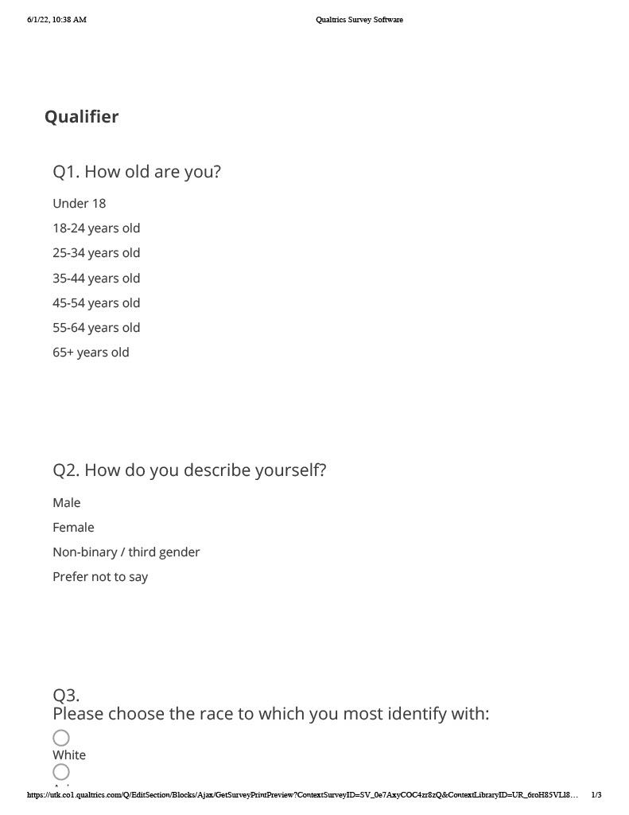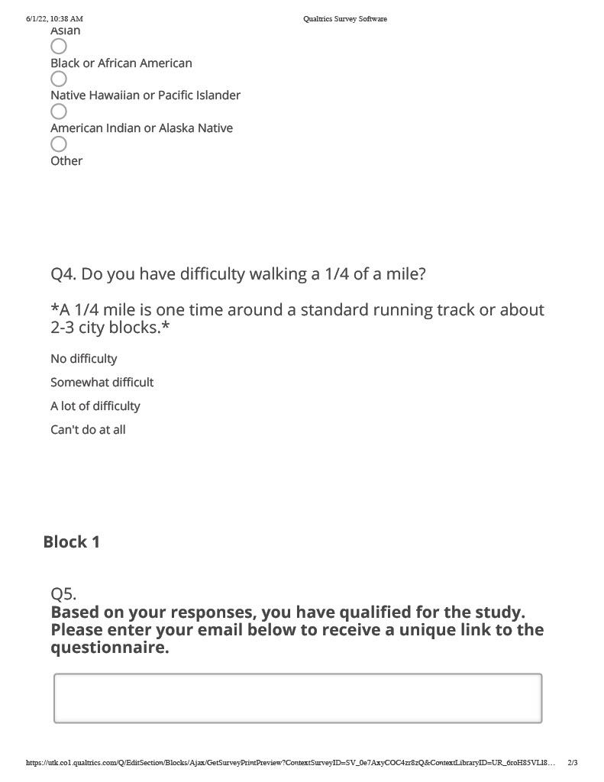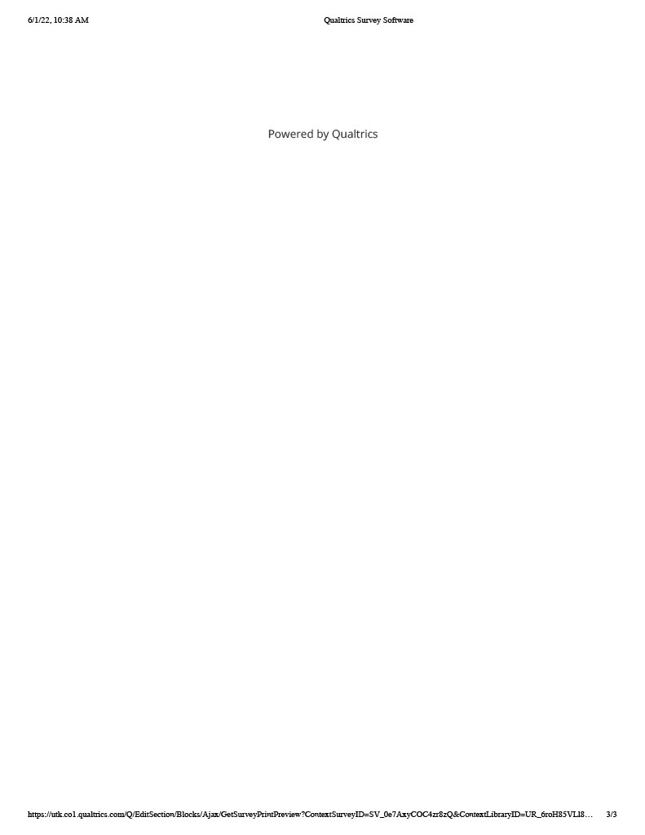
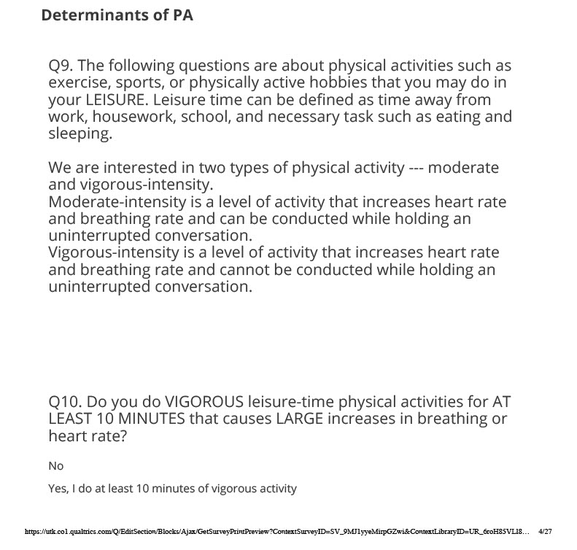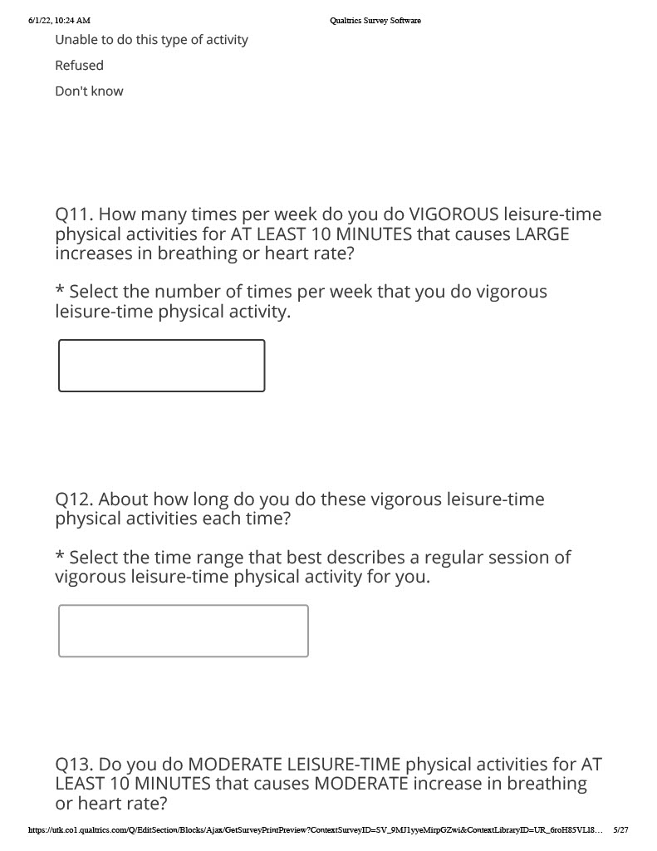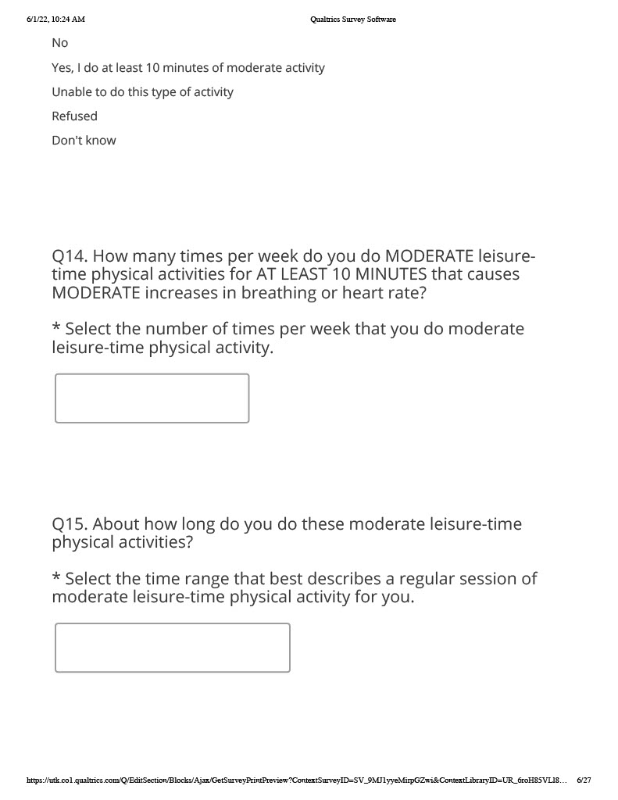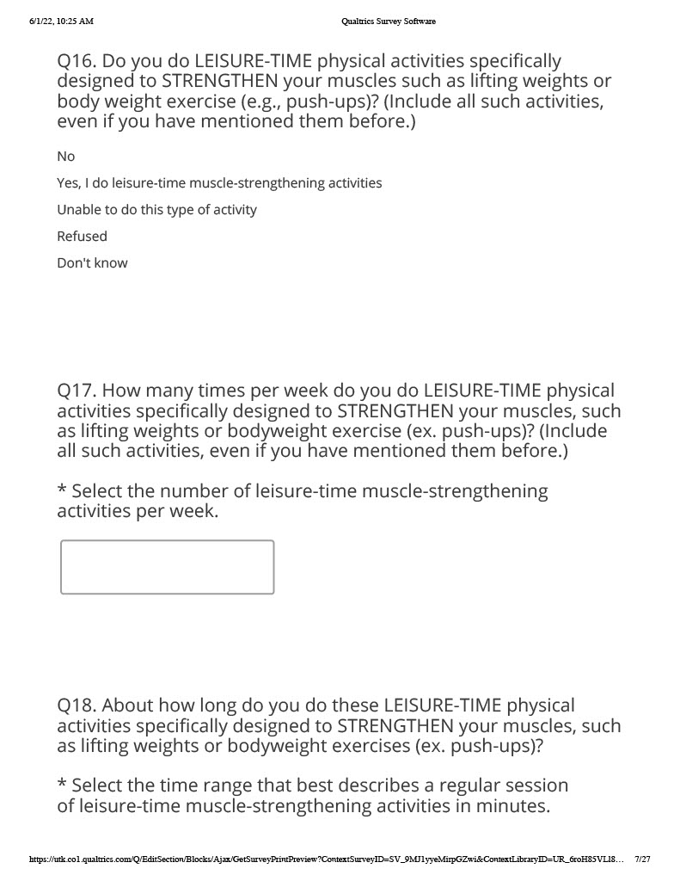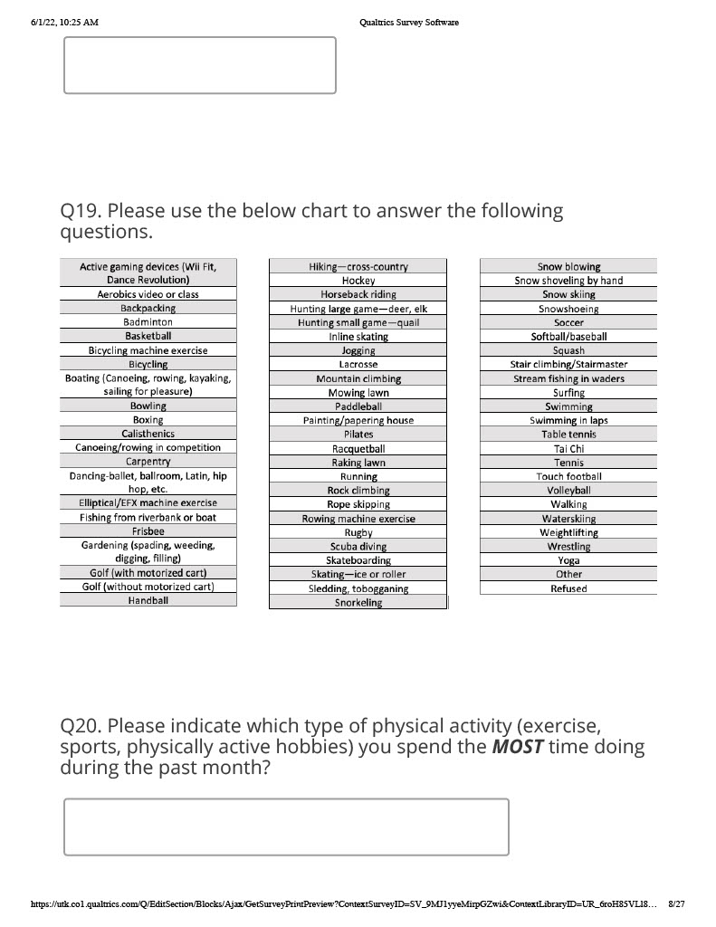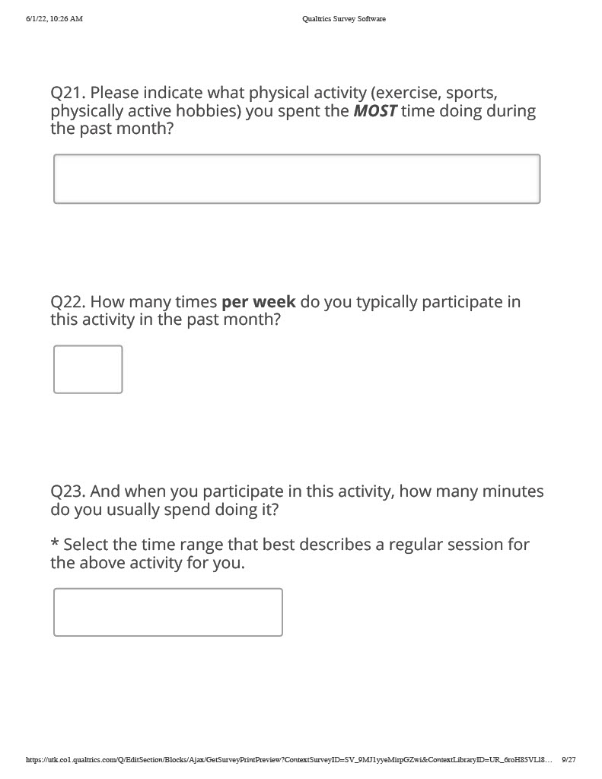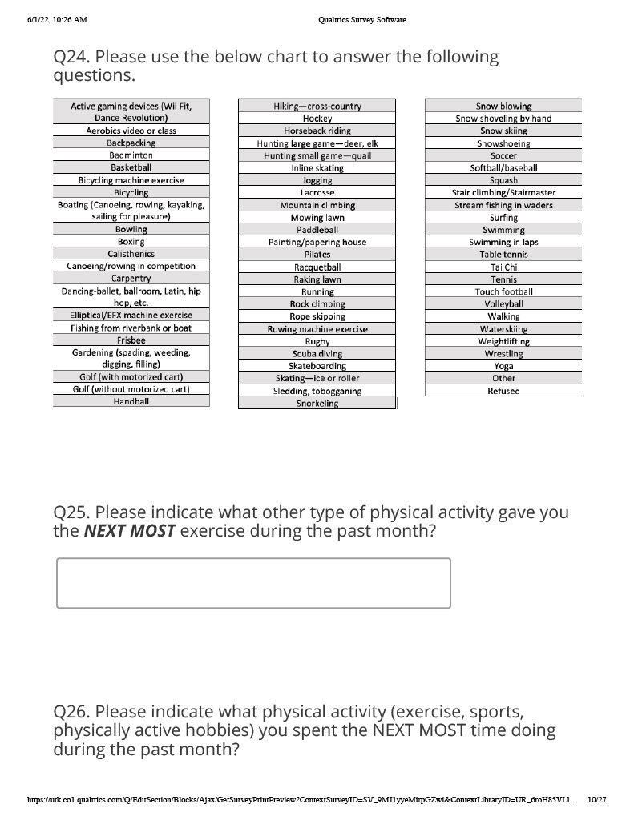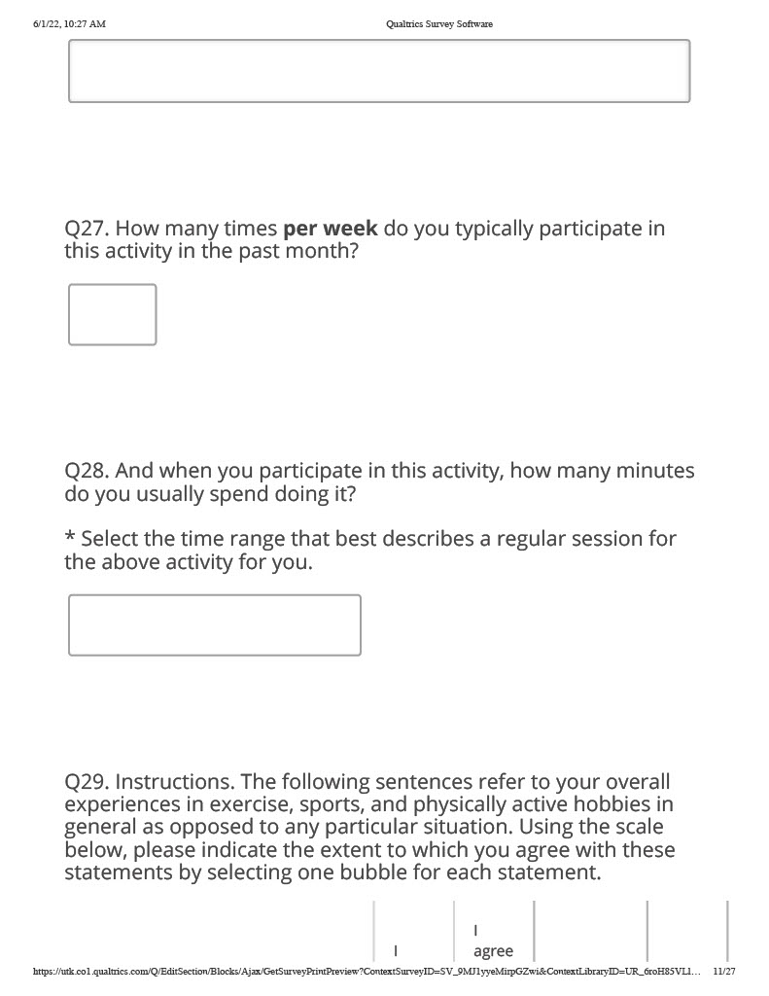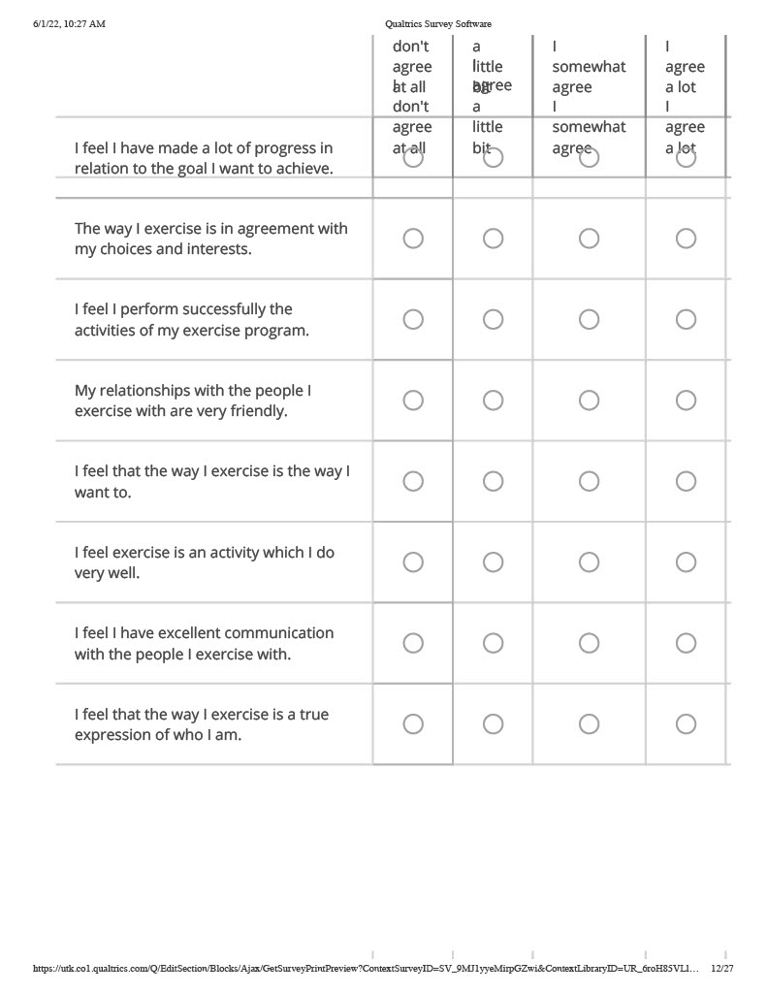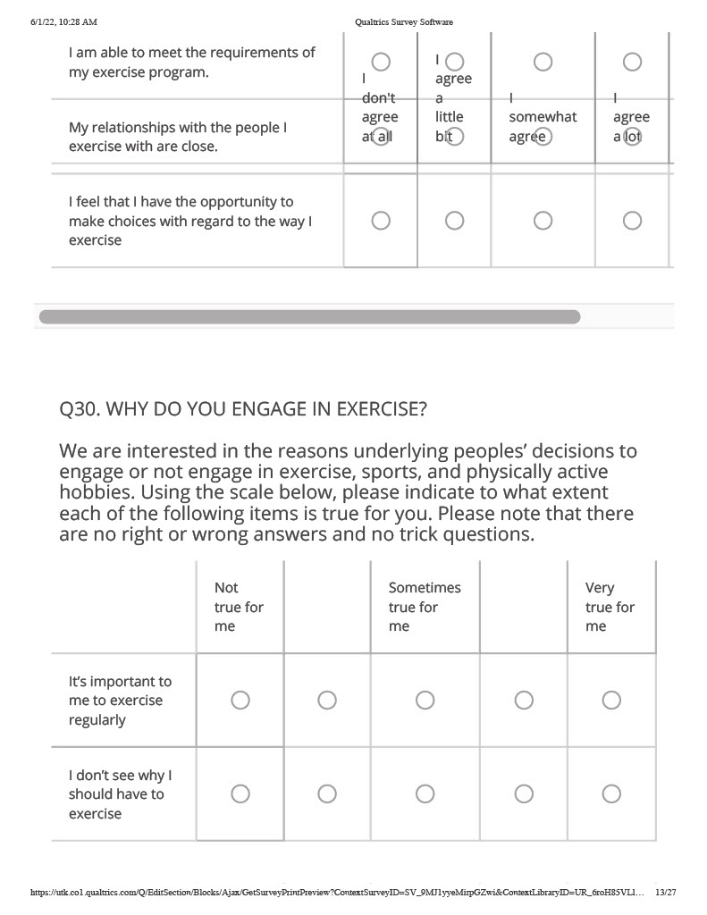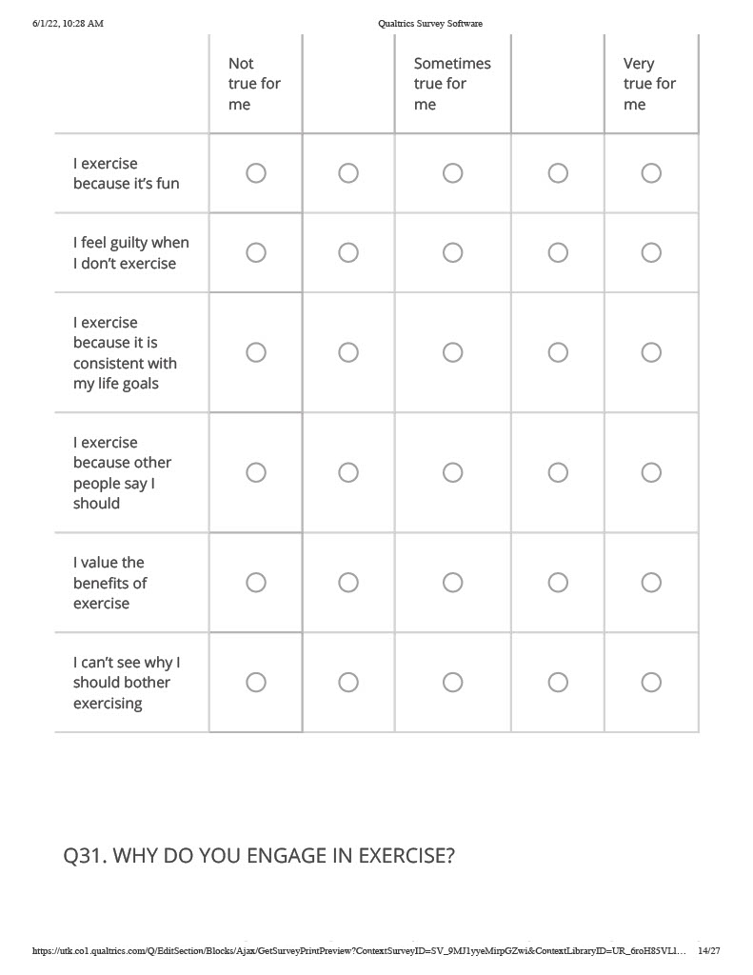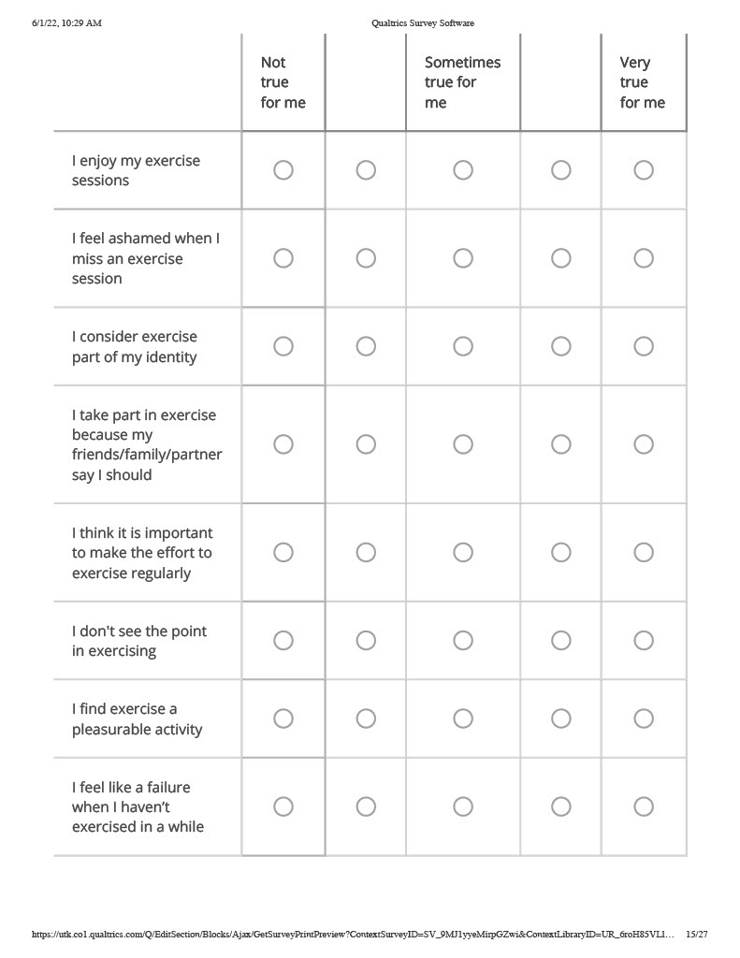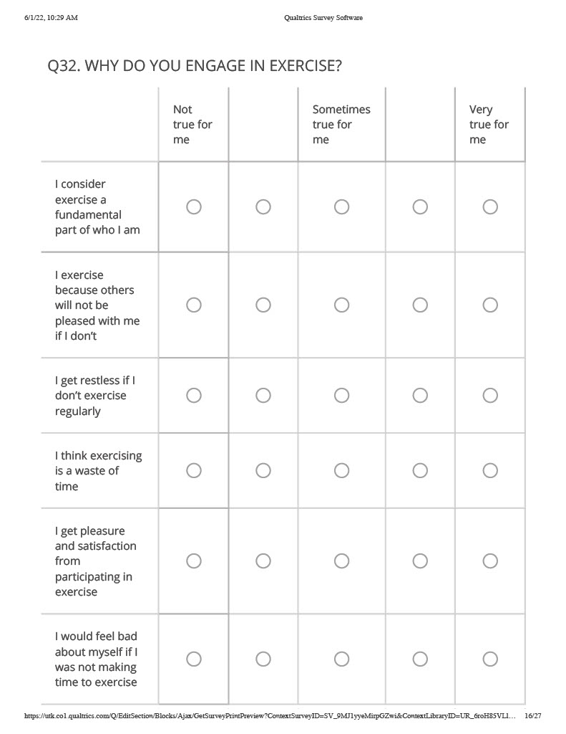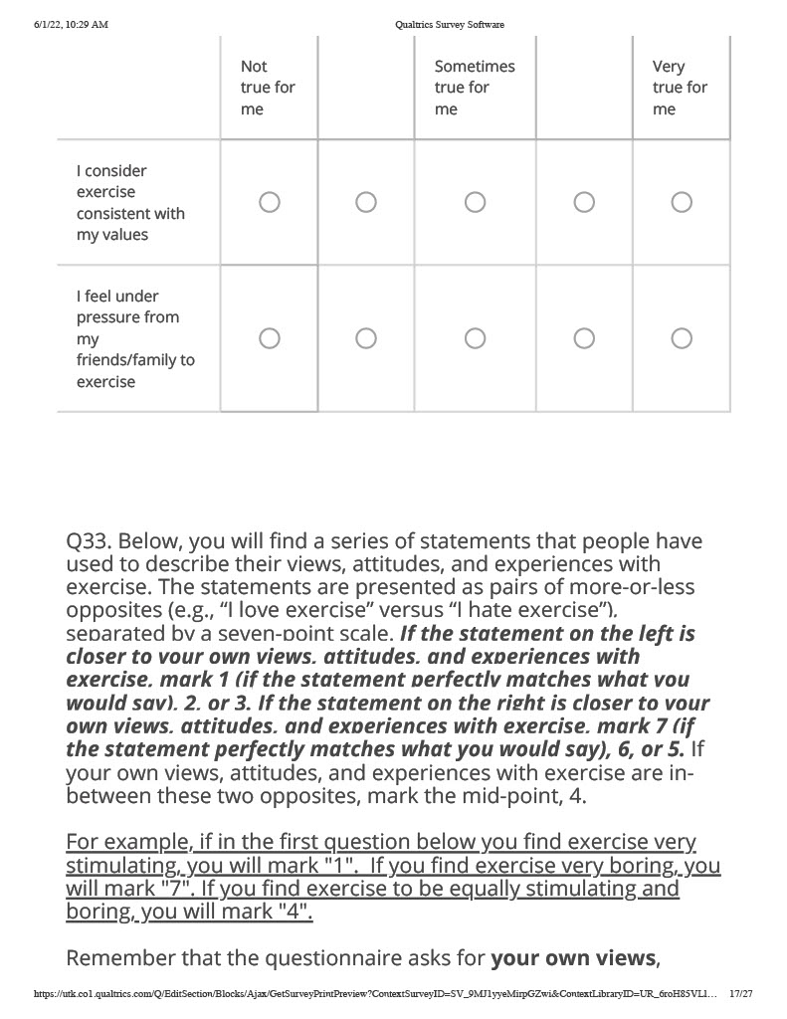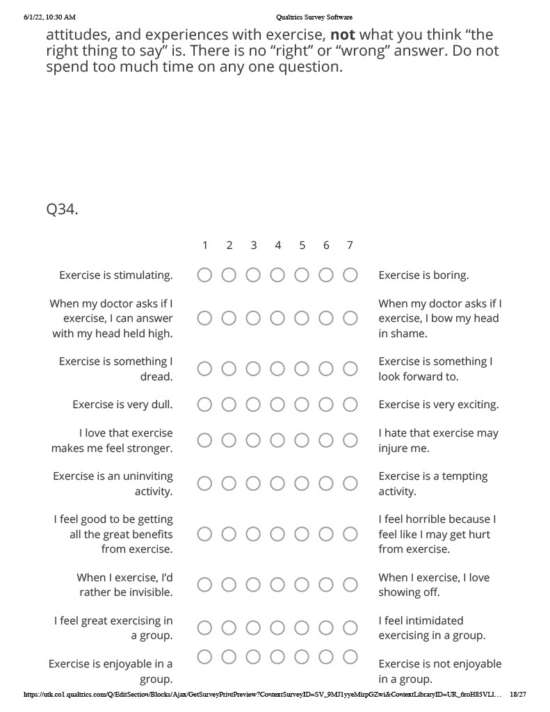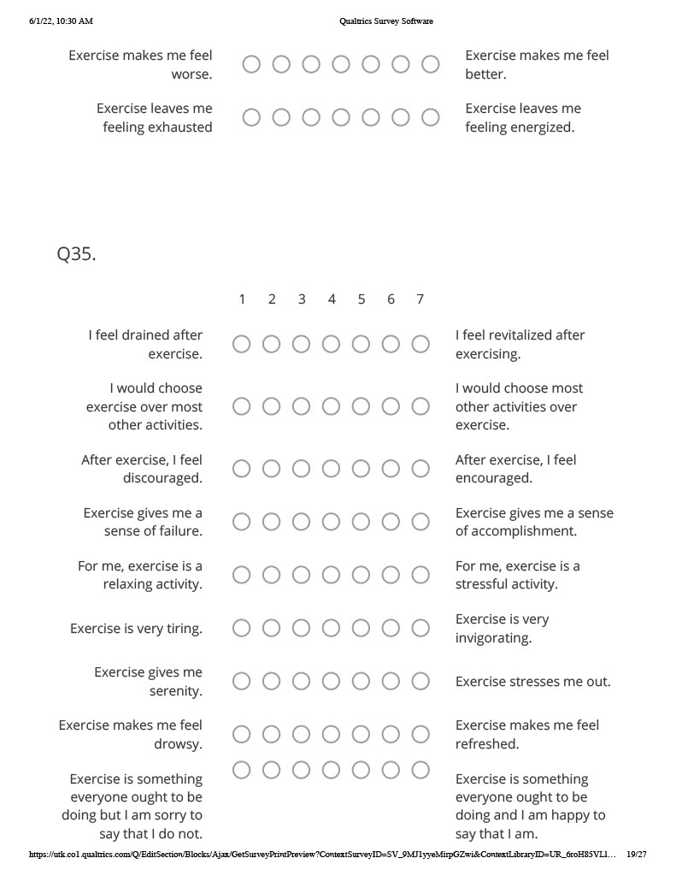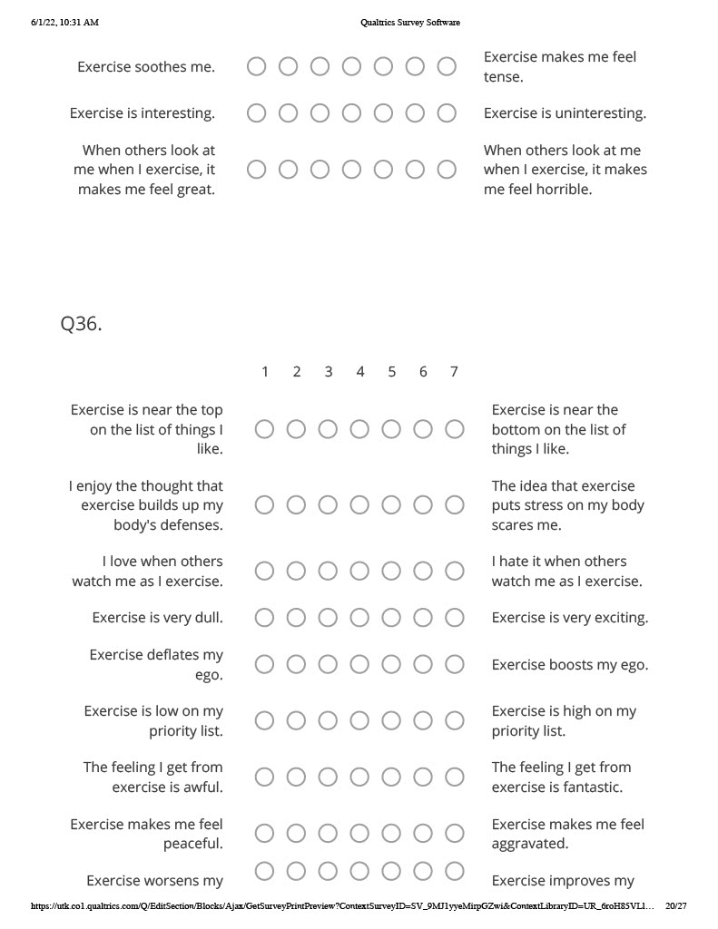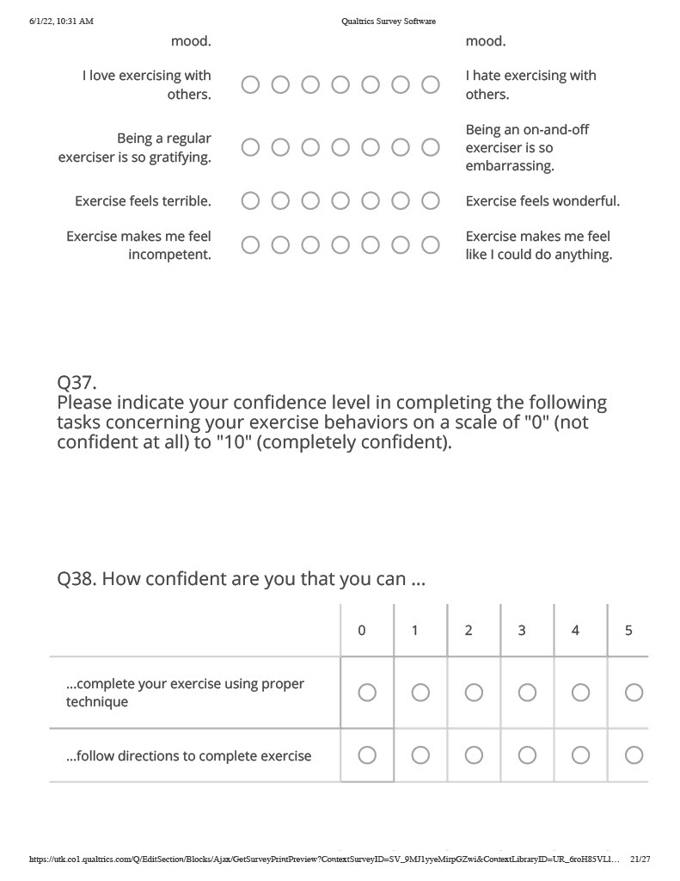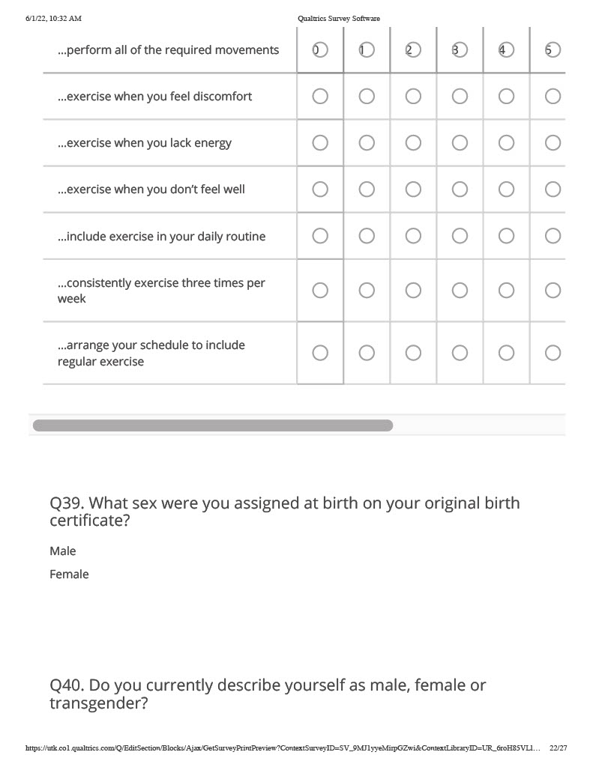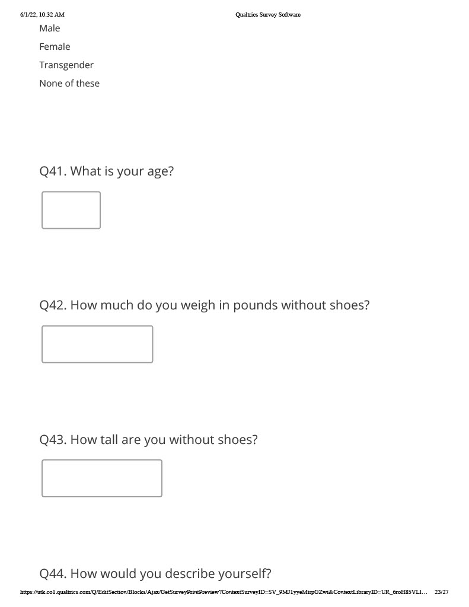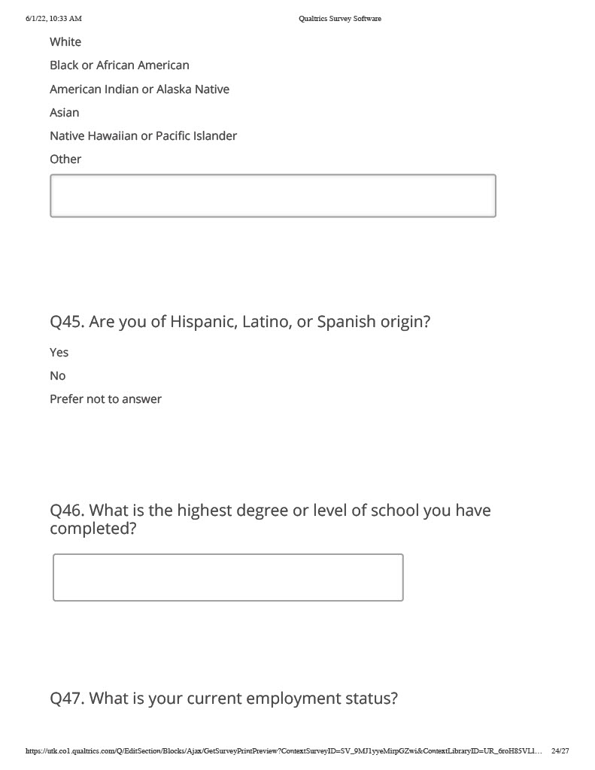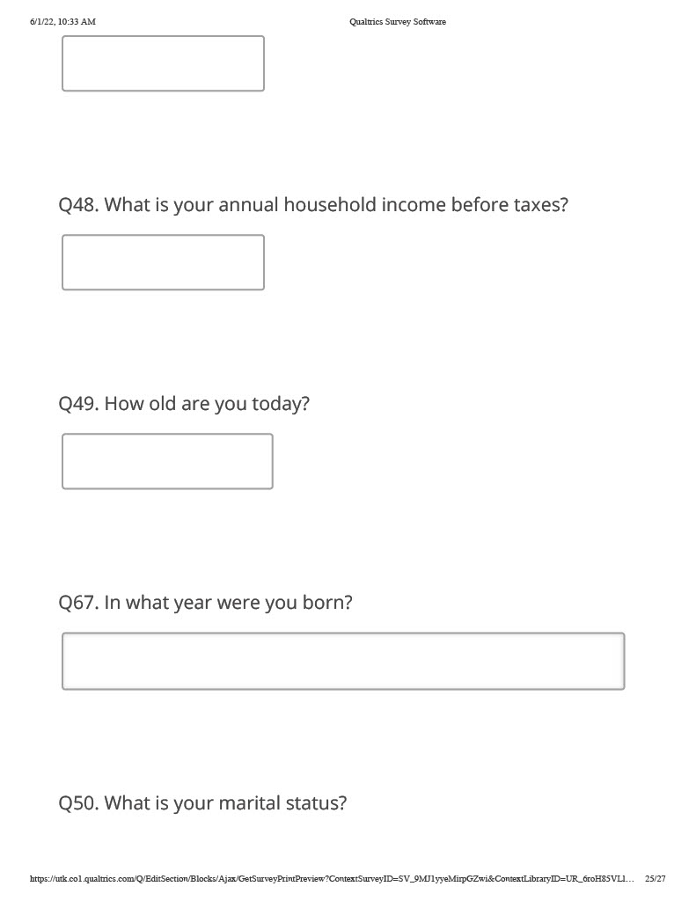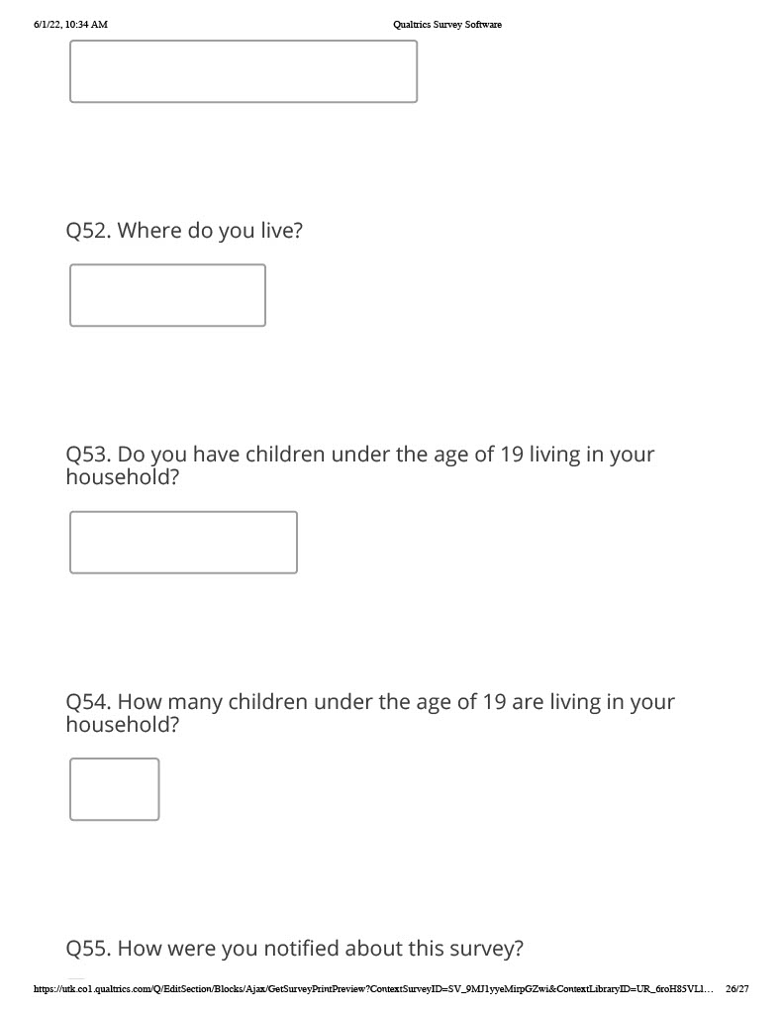

Appendix C: Social Media Advertisement
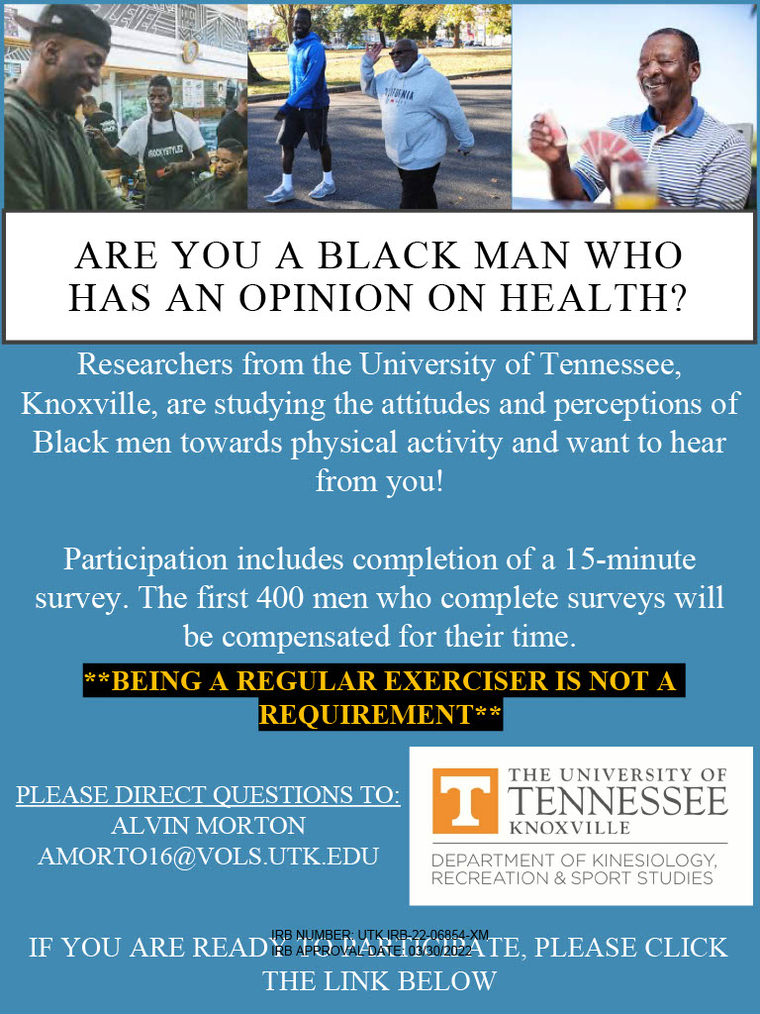

Vita
Alvin L. Morton III was born in Queens, New York in 1986 and is the only son of Alvin L. Morton Jr. and Gloria Barber-Morton, M.S. Alvin graduated from Choate Rosemary Hall in Wallingford, Connecticut in 2004. After completing high school, Alvin moved to Boston, Massachusetts where he graduated in 2010 with a Bachelor of Science in Cardiopulmonary Sciences from Northeastern University. After aiding post-surgical patients with their rehabilitation as an exercise specialist, Alvin went to the United States Army Reserve where he trained in the culinary arts. Upon graduating from the U.S. Army Culinary School, Alvin returned to Northeastern University, earning his Masters in Exercise Science with a Concentration in Physical Activity in 2016. Alvin then moved down to Knoxville, Tennessee to begin his education at the University of Tennessee, Knoxville in 2016. Alvin completed his education at the University of Tennessee, Knoxville, earning a Doctor of Philosophy in Kinesiology with a specialization in Exercise Physiology in 2022. Alvin has accepted a position in the Department of Health and Rehabilitation Science at Merrimack College as a Tenure-Track Assistant Professor, starting in the Fall of 2022.

