Investigating the effects of urbanization on residual forest Soils in Knox Co., Tennessee

A Thesis Presented for the
Master of Science
Degree
The University of Tennessee, Knoxville

Benjamin Lee Reichert
December 2014

Acknowledgements
I am deeply grateful for all those who have made this thesis possible. I would like to express a special thank you to my major professor Dr. Sharon Jean-Philippe for her guidance, patience, and support she provided throughout my time at the University of Tennessee. I am also thankful for her financial support and willingness to listen well guiding me through my graduate education. I also would like to thank my committee: Dr. Jennifer Franklin, Dr. Mark Radosevich, and Dr. Chris Oswalt. Your encouragement and valuable input was vital to my completion of this thesis.
I also would like to thank Dr. Essington, Dr. Schaeffer and Dr. Labbe for allowing me to use their chemistry labs, as well as Melanie Stewart, Choo Hamilton, and Galina Melnichinko for analyzing my numerous soil extracts. Thanks to those who helped me with field and lab work: Thomas Turnbull, Thomas Jennings, Christine Sullivan, and Brandon James.
Finally, I would like to thank my wife, Courtney. Her support and patience these past two years have provided me with constant encouragement to move forward with the completion of my work. I would also like to thank my son Thomas for providing the innocence of youth with every laugh and smile when I was stressed.

Abstract
As the process of urbanization advances across the country, so does the importance of urban forests, which include both trees and the soils in which they grow. Soil microbial biomass, which plays a critical role in nutrient transformation in urban ecosystems, is affected by factors such as soil type and the availability of water, carbon, and nitrogen. However, the microbial dynamics of urban forest soils remain largely unknown. A key mechanistic link between plant species diversity and ecosystem function is heterotrophic microbial communities that inhabit the soil and mediate principal processes that control ecosystem carbon (C) and nitrogen (N) cycling.
The aim of this study was to characterize residual forest patches and open fields in residential areas in the City of Knoxville. A field study was conducted along an urban-to-rural gradient in order to address the three objectives: 1.The first objective was to investigate tree species diversity and soil characteristics along an urban-to-rural gradient in residual forest patches and open fields. 2. The second objective was to investigate spatial and temporal differences in chemical, physical and biological soil characteristics along urban-to-rural gradient in residual forest patches and open fields. 3. The third objective was to utilize the chemical, physical and biological soil characteristics and tree diversity in study plots to predict residual forest patches or open field based on urban or rural location.
Determining tree species diversity and soil composition along an urban-to-rural gradient in residual forest patches and open fields it was found that tree diversity did not differ significantly for residential urban and rural plots in Knoxville, Tennessee. Biologically, there was no indication that soils were affected by tree diversity, in terms of soil microbial biomass C/N along an urban-to-rural gradient in Knoxville residential plots. Rural soils did differ physically from urban soils, cation exchange capacity (CEC) and soil moisture content (GSM). Similarly, physical soil properties such as bulk density, both urban and rural sites were negatively correlated with tree diversity. Results indicate that although the urban-rural gradient is subject to urban environmental stressors, the urban ecosystem is resilient in maintaining the ecosystem functions of more natural systems.

Table of Contents
Part I Introduction 1
Overview of Urbanization 2
Land Use and Land Cover 3
Southeastern United States Land Use and Land Cover 4
Tennessee’s Forest Land and Urban Development 5
Defining the Urban Forest 5
The Soil Environment 7
Nutrient Cycling in Natural and Urban Forest 8
Soil Microbes in the Natural and Urban Forest 10
Microbes and Tree Diversity 10
Soil Microbial Biomass 12
Statement of Problem 12
Objectives and Hypotheses 13
References 15
Part II Woody Vegetation and Soil Charateristics of Residental forest patches and open spaces Along an Urban-to-Rural Gradient 23
Abstract 24
Introduction 26
Methods 30
Study site 30
Selection of urban and rural plots 31
Tree inventory and soil sampling 34
Soil nutrient analysis 35
Soil microbial biomass analysis 37
Statistical analysis 38
Results 38
Discussion 54
Woody vegetation diversity along urban-to-rural gradient 54
MBC and MBN differences along urban-to-rural gradient 55
Fluxes in soil nutrients and associated measurements by season and location 57
References 60
PART III Conclusions and Implications 68
Appendix 71
Vita 94

List of Tables
Table 1. Species by occurrence, relative abundance, and relative dominance along an urban-to-rural gradient in Knoxville, TN 40
Table 2. Average occurrence of species/genera by quadrant for 26 plots in Knoxville, TN 41
Table 3. Soil microbial biomass means for carbon (µ C gˉ¹) and nitrogen (µ N gˉ¹) by location and season 44
Table 4.Soil chemistry for urban and rural areas and Pearson’s correlation between locations 45
Table 5. Soil chemical and physical properties in urban and rural areas, and Pearson’s correlation between tree diversity and locations 46
Table 6a. Summer Pearson’s correlation between population density, distance (km), ICP analytes, biological and physical properties 47
Table 6b. Fall Pearson’s correlation between population density, distance (km), ICP analytes, biological and physical properties 48
Table 6c. Winter Pearson’s correlation between population density, distance (km), ICP analytes, biological and physical properties 49
Table 6d. Spring Pearson’s correlation between population density, distance (km), ICP analytes, biological and physical properties 50
Table 7. Linear regression stepwise backward elimination results for distance from city center prediction model summary 52
Table 8. ANOVA results for the two retained models 53
Table 9 Results for the regression equation final model 54
Table A.1. Variables used in the principal component analysis (PCA) for the covariance matrix 72
Table A.2. Resulting eigenvalues for the principal component analysis (PCA) 73
Table A.3. Variables used in the principal component analysis (PCA) for the correlation matrix 74
Table A.4. Resulting eigenvalues for the principal component analysis (PCA) percent of variance for ten highest components 75
Table A.5. Pearson’s correlations between distance (km) and PCA component scores 75
Table A.6. List of all predictors for linear regression stepwise model not retained 76

List of Figures
Figure 1. Map of urban forest study site in Knox Co., Tennessee 30
Figure 2. Map showing the location of 26 0.4 ha residential plot 33
Figure 3. Map of residential plot distance from geographic city center 34
Figure 4. Map of the distance from city center to each plot 36
Figure 5. The average diversity indices (H´) by location 42
Figure 6. The average diversity indices (H´) by quadrant 43
Figure A.1. Map with 423 potential sampling points in Knox, Co. Tennessee 78
Figure A.2. Map with 423 potential sampling points in Knoxville city limit 79
Figure A.3. Map with 423 potential sampling points in Knoxville city limits and one mile city buffer zone 80

PART I
INTRODUCTION

Introduction
Overview of Urbanization
In the mid to late 1800’s fewer than three percent of the world’s population inhabited urban areas. Small pockets of populations greater than 20 percent during the 1890's lived in Great Britain’s cities of London, Manchester, and Liverpool; North-West Europe’s cities of Paris, France, Copenhagen, Denmark, and Berlin, Germany; and United States cities of New York city, Chicago, and Philadelphia (Weber, 1899). Historically, urbanization has been driven by the concentration of investment and employment opportunities offered in urban areas. According to the United Nations, urbanization in 1995 was high across the Americas, most of Europe, parts of western Asia and Australia. South America was the most urban continent with the population in all but one of its countries (Guyana) being more urban than rural. More than 80 percent of the population lived in towns and cities in Venezuela, Uruguay, Chile and Argentina. An estimated 41 percent of China's 1.2 billion people and 29 percent of India's 0.96 billion lived in towns and cities in 1995 (Clark, 1998).
In 2011, approximately three quarters of the 3.6 billion urban residents in the world lived in 25 countries, whose urban populations ranged from 31 million in Ukraine to 682 million in China (United Nations, 2012). The United States, China, and India accounted for 37 percent of the world urban population. Australia, New Zealand and Northern America had high levels of urbanization, surpassing 80 percent in 2011. Europe, with 73 percent of its population living in urban areas, was the least urbanized area in the developed world. Most of the 25 countries with the largest urban populations are highly urbanized, but eight have levels of urbanization ranging from 28 percent to 51 percent and they include some of the most populous countries in the world: Bangladesh, China, India, Indonesia, Nigeria and Pakistan (United Nations, 2012). By 2050, Australia, New Zealand and Northern America populations are projected to have over 90 percent of their populations living in urban areas. Europe is projected to see a decline in population living in urban areas (United Nations, 2012).

Land Use and Land Cover
Land-use is defined as the function of land in relation to the activities allowed. This is directly tied into development of land for the purpose of agricultural, industrial, residential and recreational uses (Howard, 1985). Land-cover refers to the physical and biological cover over the surface of land, including water, vegetation, bare soil, and/or artificial structures. The percentage of the total United States surface area in the 48 contiguous states occupied by developed or built-up uses is projected to increase from 5.2% in 1997 to 9.2% by 2025 (Alig et. al, 2004). The projected developed and built-up area of 70.5 million ha in 2025 represents an area equal to 38% of the current United States cropland base, or 23% of the current U.S. forestland base (Smith et al., 2001).
Between the 1960’s and the 1980’s, urban land in the United States has increased to 22 million acres (Frey, 1984). In 1997, the United States had 747 million acres of forestland (Smith et al. 2001), covering about one-third of the land area (Alig and Plantinga, 2004). Urban land in the contiguous United States increased from 2.5% in 1990 to 3.1% in 2000, an area about the size of Vermont and New Hampshire combined (Nowak et al. 2005). United States forest area is projected to be about 3% smaller by 2050, primarily due to conversions to residential and commercial areas (Alig et al., 2002).
Anthropogenic drivers of land-use and land-cover change have altered over 30% of the Earth’s surface (Houghton 1994; Vitousek et al., 1997). These changes of the earth’s terrestrial ecosystems have been to manage forest, agriculture land or residential systems for the basic needs of food, fuel, and housing (Botequilha Leita et. al., 2006). The effects of these changes in land-cover to the biophysical attributes of the earth's surface and land-use for human purposes are among the most important (Lambin et al., 2001). They directly impact biodiversity and alter bio-geophysical characteristics such as albedo, evaporation, and heat flux, biogeochemical functions of carbon and nutrient cycling, and bio-geographical processes that in turn affect local and global climate (Stohlgren et al., 1998; Kalnay and Cai, 2003).

Southeastern United States Land Use and Land Cover
The South region of the United States accounts for 30 % of the unreserved forest area and 27 % of all forest land resources (Smith et al., 2009) in the U.S. Eastern forests have increasingly faced two major anthropogenic disturbances: timber harvesting and permanent conversion due to land-use change (McDonald et al., 2006). Historically, of the major land uses; forests have been the largest source of land for development purposes (Alig and Plantinga, 2004).
The 2002 Southern Forest Resource Assessment defines forest fragmentation as the breaking up of large, contiguous forested tracts into smaller or less contiguous tracts. Converting forest land for development purposes, such as housing and infrastructure, changes the land-cover resulting in forest fragmentation. This means that forests become islands and peninsulas as patches of forest disconnected from one another by roads, farms, suburbs, cities, and other human activities. Land-use and land-cover changes such as forest fragmentation and urbanization have direct and indirect impacts on a wide range of ecological processes (Schwartz, 1997; Turner et al., 2001). Forest land converted into subdivision; to accommodate more people, and the larger house size of expanding communities, directly affects nearby forests (Duryea and Vince, 2005). The direct effects of urbanization are loss of habitat, land transformation, and fragmentation. In addition to the direct effect that urbanization has on forest land, the influence of increased population has additional indirect effects, such as air pollution, human health, and the introduction and spread of exotic plants and diseases (Monroe et al., 2012).
Tennessee’s Forest Land and Urban Development
Forested land areas in the State of Tennessee over the past 50 years have remained relatively unchanged with approximately 50 percent of Tennessee's landscape remaining forested (Oswalt et al., 2009). Forest land cover for the state of Tennessee in 2010 encompassed an estimated 14 million acres, with nearly 84 percent (11.7 million acres) of all forest land in the state primarily under private ownership. The remaining 16 percent is owned federally (1.4 million acres) or by State and local governments. Non-forest land area, areas that did not fall within the Forest Inventory and Analysis (FIA) criteria; were estimated at 13 million acres (Oswalt, 2012).
Defining the Urban Forest
Forested land is periodically inventoried by state forestry agencies, which provide data on the amount, status and character of the forest resources across the nation. The United States Department of Agriculture (USDA) Forest Service’s FIA program defines forest land as areas at least 1 acre in size, at least 120 feet wide, and at least 10 percent stocked with trees. The FIA program also requires forest lands within the above parameters to have an understory that is undisturbed by another land use such as parks, agricultural lands, and residential property (U.S. Department of Agriculture, 2010).
The urban forest is defined as “non-forest land” by FIA and does not support these forests. Included in these areas are previously forested areas used for timber harvesting, which have now been developed for other uses. These uses include areas used for crops, improved pasture, residential areas, city parks, improved roads of any width and adjoining rights-of-way (U.S. Department of Agriculture, 2010). Urban forests, all trees and other associated resources within urban areas, are characterized by integration of natural resources with urban developments (Nowak, 1994).
Delineation of forested lands by FIA standards left urban vegetation, particularly trees, out of annual forest inventories in the past. Tree resources in urban areas represent a portion of information not collected by periodic FIA inventories on species, health, and biomass (Riemann, 2003). There have been various non-FIA inventories or city tree inventories conducted periodically by Nowak et al., (1996) in urban areas (almost exclusively within city limits) which leaves areas that occur outside the city limits, and/or in residential areas which include backyard trees, small woodlots in the middle of developments, or patches of residual forest lands, not inventoried.
In 2001, the USDA forest service, Forest Health and Monitoring (FMH) program initiated an assessment of urban forest conditions. The assessment of urban forest conditions is due to more ecological attention and the increasingly critical need to understand larger scale consequences of people’s interactions with their immediate environment in areas of high population density (Grimm et al., 2000). Urban areas were classified based on areas with core population density of 1,000 people per square mile from the 2000 U.S. Census Bureau data and consisted of all territory, population, and housing units located within either urbanized areas or urban clusters (U.S. Department of Commerce, 2011). Urban boundaries were delineated from the FMH 2000 census assessment and then tree information was collected from established plots within the urban boundaries (Nowak et al., 2011). The census data was used to define clusters of block groups based population densities for urban boundaries. Urbanized areas consist of densely settled territory ≥ 50,000 people and urban clusters consist of densely settled territories that have ≥ 2,500 people but < 50,000 people.
Nowak et al., (2011) reported on urban forests inventory for the state of Tennessee based on Forest Health and Monitoring (FMH) urban boundary parameters. The inventory found that urban land covered 1.6 million acres; within the urban boundary approximately 234,000 acres (284.1 million trees) were considered forest land by the FIA program. Transportation followed by residential land use covered the largest forested area within the urban boundary, with an estimated 44.2 million trees found in transportation corridors and 37.6 million trees on residential lands.

The Soil Environment
During soil formation, primary soil components are rearranged and glued together into microaggregates which depend on soil organic matter (SOM) and organic material (OM) inputs (Six et al., 2004; Abiven et al., 2009) and are mediated and affected by soil microorganisms. Soil organic matter represents a complex mixture of recognizable plant and animal parts (non-humic substance) and material that has been altered (humic substance) to the degree that it no longer contains its original structural organization (Oades, 1989). Organic matter in the form of leaf litter provides a source of energy for heterotrophic soil microorganisms (bacteria, algae, and fungi) from decomposition, which in turn supplies most of the natural soil nitrogen, half of the phosphorous, sulfur, carbon and many other organic compounds essential to plant growth (Brady and Weil, 2002: Kimble et al., 2003). The rates of decomposition and nutrient mineralization, key soil processes involved in forest nutrient cycling, are governed by temperature and moisture conditions and by the chemical and physical nature of the litter (Prescott, 2002). The canopy buffers temperature extremes and alters the chemical composition of moisture that passes through the canopy. Concentrations of nutrients such as N, P, K, and Ca may increase or decrease (Sollins et al., 1980; Lovett and Lindberg, 1993) through this interaction with the canopy.
The natural forest soils of the eastern United States have formed under the influence of climate, parent material, topography, biota and time (Jenny, 1941). Soils in this region are highly weathered and the possibility for nutrient release from mineral soils due to geochemical or biogeochemical processes is slight. Atmospheric inputs of ammonium and nitrate are often the primary source of mineral soil nitrogen within the natural forest soil formation processes.
Similar to natural forest soils, urban soils are influence by the same abiotic and biotic interactions but formed through the process of urbanization. Modification through human activity is predominate active agent with the placement of parent material (Craul, 1985). Activities such as urban site development have immediate and dramatic impacts on the soil environment. Compaction and topsoil removal associated with urbanization along with amendments and contaminates, may strongly alter soil carbon (C) and nitrogen (N) pools in urban soils (Beyer et al., 1996; Jim, 1998; Craul, 1999; Scherenbroch et al., 2005).
Nutrient Cycling in Natural and Urban Forest
Soil forms the “foundation” of forest ecosystems and is critical to the cycling of nutrients, a process which influences the functioning of the entire ecosystem (Barnes et al., 1997). Soil nutrient cycling in the natural forest supports the plants nutritional needs through its inherent biogeochemical processes (Perry and Amacher, 2007). Nutrient cycles are biogeochemical processes controlled by the activities, interactions of plants and soil microorganisms in conjunction with the geochemical processes that control the nutrient supply in the soil (Barnes et al., 1997; Brady and Weil, 2002).
Most urban areas exhibit elevated temperatures, increased inorganic nitrogen and hydrogen ion deposition, and higher heavy metal concentrations relative to surrounding rural areas (Parker et al., 1978; Carreiro et al., 2009; Gatz, 1991; Pouyat and McDonnell, 1991; Botkin and Beveridge, 1997; Lovett et al., 2000; Pouyat et al., 2008). Modifications of land-use and land-cover to accommodate increases in populations tend to alter the biological, chemical, and/or physical conditions of urban soil in urban areas (Scharenbroch et al., 2005). Soils are dramatically altered by human activities in urban environments which distinguish these urban soils from other ecosystems (Craul, 1999).
As land is converted to urban use, both direct and indirect factors can affect the functioning of soils (Pickett et al., 2001). Direct effects by impervious surfaces, physical disturbances, and alteration of soil by fill material often lead to highly modified substrates in which soil development then proceeds (Effland and Pouyat, 1997). Indirect effects by urban heat island, introduction of exotic plant and animal species, and atmospheric deposition of pollutants change the abiotic and biotic environment, which in turn may influence soil development and ecological processes in intact soil (Pickett et al., 2001). Soil microbial biomass and community composition have been shown to be sensitive indicators of changes in nutrient type (Peacock et al., 2001; Kirchner et al., 1993), botanical composition (Borga et al., 1994), pollutant toxicity (Stephen et al., 1999), and climate change (Zogg et al., 1997).
In a study by Pouyat et al., (1995) along an urban-rural land use gradient in New York City, higher concentrations of heavy metals (Pb, Cu, and Ni), organic matter, salts, and soil acidity were found in the surface (10 cm) of forest soils at the urban end of the transect. Studies of soil C and N dynamics in unmanaged urban forests, highly disturbed soils, and surface soils of various urban land-use types all show that urbanization can directly and indirectly affect soil C pools and N-transformation rates (Pickett et al., 2001).

Soil microbes in the Natural and Urban Forest
Microorganisms found in the natural forest soil provide functions important to tree productivity and growth. Prokaryotes and fungi are the main decomposers in ecosystems; converting organically held nutrients into inorganic compound through decomposition for consumption by trees (Young and Giese, 1990; Brady and Weil, 2002; Campbell and Reece, 2002). Decomposition of organic materials from litter and soils releases carbon, phosphorous, calcium, potassium, sulfur, and nitrogen in ionic form, which trees can utilize. Trees also require nitrogen in simple ionic compounds such as nitrate (NO⁻³) and ammonia (NH₄), which enters the forest soil naturally through atmospheric deposition and nitrogen fixation from certain microorganisms. Additionally, a symbiotic relationship exists between trees and mycorrhizal fungi. This relationship increases nutrient and water uptake for trees, while providing fungi with photosynthate (Young and Giese, 1990; Brady and Weil, 2002; Kimble et. al., 2003).
Microbes and Tree Diversity
Recent studies have shown that many microbes have restricted biogeographic distributions (e.g. Peay et al., 2007) suggesting that variations in the composition of microbial communities can impact ecosystem functioning. Soil chemical and microbiological characteristics of terrestrial forests have been shown to be affected by the dominant tree species in several studies (Miles and Young, 1980; Mikola, 1985; Bauhus et al., 1998; Priha and Smolander, 1999; Côté et al., 2000; Hackl et al., 2004; Grayston and Prescott, 2005). One study on the differences in bacterial community composition among forest soils (Hackl et al., 2004) found bacterial composition corresponds with differences in other microbiological and soil characteristics. They propose that the composition of bacterial communities inhabiting natural forest soils is related to specific environmental conditions which go along with various types of natural forest vegetation. Individual tree species comprising forest communities can have important influences on soil properties and ecosystem processes (Boettcher and Kalisz, 1990).
Little is known about factors that regulate microbial diversity at different temporal and spatial scales (Green and Bohannan, 2006) and its interdependency with plant diversity (Zak et al., 2003). Microbial diversity occurs in response to seasonal cycles, long-term climatic variations, and ecological processes such as succession. In some groups of organisms, diversity measured at one time of year is very different from that measured at different time of year (Huston 1994). Traditionally, urban areas have been regarded as locations of low biodiversity that are dominated by non-native species. However, evidence is mounting that urban and suburban areas can contain relatively high levels of biodiversity (Balmford et al., 2001; Jim and Liu, 2001; Araújo, 2003; Godefroid and Koedam, 2003; Riemann, 2003; Cornelis and Hermy, 2004; Kühn et al., 2004), and urban forests can contain a significant percentage of species that naturally occur in an area.
Shifts in abundance and species composition of mycorrhizal fungi, which form the crucial interface between roots and soil for most plants, have been observed in response to N deposition in Europe, Alaska, and southern California (Arnolds 1991; Lilleskov et al., 2001; Siguenza et al., 2006). Recent work has shown that microbial diversity in soil ecosystems is reduced because of land-use intensification and increased nutrient availability (Helgason et al., 1998), nitrogen deposition (Lilleskov et al., 2002), and chemical contamination (Gans et al., 2005).

Soil Microbial Biomass
Soil microbial biomass, both a source and sink of available nutrients for plants, plays a critical role in nutrient transformation in terrestrial ecosystems (Singh et al. 1989). Soil biomass comprises of living organisms that are not part of a plant, including a wide variety of microbes, protozoa, and invertebrates. Estimates of soil biomass in particular the microbial component, represents less than 1% to approximately 5% of total soil organic matter (Anderson and Domsch, 1980; Paul, 1984; Grigal and Vance, 2000). Soil microorganisms are essential for nutrient cycling in terrestrial ecosystems and through retention and release they regulate the supply of plant-available nutrients from the soil (Jenkinson, 1987; Singh et al., 1989).
Any changes in the microbial biomass may affect the cycling of soil organic matter. The effects of an increase or decrease in microbial biomass may disrupt the mobilization and/or immobilization of cations and anions, thereby changing their availability to plants (Birch and Bachofen, 1990). Thus, the soil microbial activity has a direct influence on ecosystem stability and fertility (Smith et al., 1993).
Statement of Problem
More attention is being paid to the ecological heath of cities due to the increasingly critical need to understand the larger scale consequences of people’s interactions within their immediate environment (Grimm et al., 2000). Of particular interest are urban soils, which provide numerous ecosystem services that could be potentially compromised by urbanization (Dobbs, 2009; Dobbs et al., 2011; Shuster et al., 2011). The multiple pollutants and nutrients in urban areas alter urban biogeochemical cycles (Kaye et al., 2006). Soil management practices in urban areas through use of irrigation and fertilization is one way by which biogeochemical cycles are altered in urban soils. Viable microbial biomass is integral for nutrient storage and cycling (Rice et al., 1996), soil aggregate formation (Tisdall and Oades, 1982), and other ecological factors such as filtering, buffering, and gene reserves (Blum, 1998).
In Tennessee, urban and community land comprised about 10.6% of the state land area in 2000, an increase from 8.7% in 1990. Tree canopy cover averaged 44.9% and tree cover in urban and community areas was about 29.9%. Statewide, urban and community land in Tennessee has an estimated 161.1 million trees, which store approximately 30.8 million metric tons of carbon and remove about 1.0 million metric tons of atmospheric carbon. These trees also facilitate the removal of 32,160 metric tons of air pollution annually (Nowak and Greenfield, 2010).
Various non-FIA inventories such as city tree inventories have been periodically conducted almost exclusively within city limits of urban areas, but inventories on residential areas (i.e. backyard trees, small woodlots in the middle of developments, or patches of residual forest lands) and the impact these “non-forested areas” as defined by FIA standards, have on cycling of elements, tree diversity and soil microbial biomass are limited. By adapting FIA tree inventory techniques for “non-forested areas” in urban areas that specifically affect the capture of the urban tree resource and ecosystem services we can provide information on a portion of species, health, and soil biomass not currently collected in FIA inventories. Most research on urban biodiversity has focused on the diversity within a city or county. In 2000, according to census data, the population of the county was about 382,000. Urban growth continues at a fairly rapid pace, with the most rapid growth occurring along highway corridors extending west and northwest from Knoxville, Tennessee (NRCS, 2006).
Objectives and Hypotheses
The aim of this study was to characterize residual forest patches and open fields in residential areas in the City of Knoxville. A field study was conducted along an urban-to-rural gradient in order to address the three objectives: 1.The first objective was to investigate tree species diversity and soil characteristics along an urban-to-rural gradient in residual forest patches and open fields. 2. The second objective was to investigate spatial and temporal differences in chemical, physical and biological soil characteristics along urban-to-rural gradient in residual forest patches and open fields. 3. The third objective was to utilize the chemical, physical and biological soil characteristics and tree diversity in study plots to develop a predictive model for residual forest patches or open field based on urban or rural location. All objectives will be addressed in Part II.

Objective 1: Hypothesis 1 – Residential forests will differ in their over story vegetation and soil characteristics spatially (urban-to-rural gradient) due to the level of land use / land change.
Objective 2: Hypothesis 1 – The increased population density will affect soil biological, chemical and physical characteristics spatially based on distance from geographic city center to rural areas and temporally as seasons change in Knox Co.
Objective 2: Hypothesis 2 – Soil biological, chemical and physical properties will increase along an urban-to-rural gradient as human population’s densities decreases outward from geographic city center.

REFERENCES

References
Alig, R.J., Mills, J., Butler, B., 2002. Private timberlands: growing demands, shrinking land base. Journal of Forestry 100, 2, 32-37.
Alig, R.J, Kline, J.D., Lichtenstein, M., 2004. Urbanization on the US Landscape: Looking Ahead in the 21st Century. Landscape and Urban Planning 69, 2-3, 219-34.
Alig, R.J., Plantinga, A.J., 2004. Future Forestland Area: Impacts from Population Growth and Other Factors that Affect Land Values. Journal of Forestry 102, 8, 19-24.
Anderson, J.P.E., Domsch, K.H., 1980. Quantities of plant nutrients in the microbial biomass of selected soils. Soil Science 130, 211-216.
Arnolds, E., 1991. Decline of ectomycorrhizal fungi in Europe. Agriculture, Ecosystems & Environment 35, 209-244.
Araújo, M.B., 2003. The coincidence of people and biodiversity in Europe. Global Ecology and Biogeography 12, 5-12.

Balmford, A., Moore, J.L., Brooks, T., Burgess, N., Hansen, L.A., Williams, P., Rahbek, C., 2001. Conservation conflicts across Africa. Science 291, 2616–2619.

Bauhus, J., Paré, D., Coté, L. 1998. Effects of tree species, stand age, and soil type on soil microbial biomass and its activity in a southern boreal forest. Soil Biology & Biochemistry 30, 1077-1089.
Beyer, L., Cordsen, E., Blume, H.P., Schleuss, U., Vogt, B., Wu, Q., 1996. Soil organic matter composition in urbic anthrosols in the city of Kiel, NW-Grmany, as revealed by wet chemistry and CPMSA 13C-NMR spectroscopy of whole soil samples. Soil Technology 9, 121-132.
Birch, L.D., Bachofen, R., 1990. Effects of microorganisms on the environmental mobility of radionucleides. In: Bollang, J.M., Stozky, G., Soil Biochemistry, vol. 6. Marcel Dekker, New York, N.Y., pp. 483-527.
Blum, W.H., 1998. Basic concepts: degradation, resilience, and rehabilitation. In: Lal, R., Blum,W.H., Valentine, C., Stewart, B.A., Methods for Assessment of Soil Degradation. CRC Press, Boca Raton, Florida.
Boettcher, S.E., Kalisz, P.J., 1990. Single-tree influence on soil properties in the mountains of eastern Kentucky. Ecology 71, 4, 1365-1372.
Borga, P., Nilsson, M., Tunlid, A., 1994. Bacterial communities in peat in relation to botanical composition as revealed by phospholipid fatty acid analysis. Soil Biology and Biochemistry Journal 26, 841-848.

Botequilha-Leitão A, Ahern, J., 2002. Applying landscape ecological concepts and metrics in sustainable landscape planning. Landscape Urban Planning 59, 2, 65-93.

Botkin D.B., Beveridge C.E., 1997. Cities as environments. Urban Ecosystems 1, 3-19.
Brady, N.C., Weil, R.R., 2002. The Nature and Properties of Soils, Thirteenth Edition. Prentice Hill: New Jersey, pp 1-28, 140 – 146.
Carreiro M.M., Pouyat R.V., Tripler C.E., Zhu W., 2009. Carbon and nitrogen cycling in soils of remnant forests along urban-rural gradients: case studies in New York City and Louisville, Kentucky. In: McDonnell MJ, Hahs A, Breuste J (eds) Comparative ecology of cities and towns. Cambridge University Press, New York, pp 308–328.
Cornelis, J., Hermy, M., 2004. Biodiversity relationships in urban and suburban parks in Flanders. Landscape and Urban Planning 69, 385-401.
Côté, L., Brown, S., Paré, D., Fyles, J., Bauhus, J., 2000. Dynamics of carbon and nitrogen mineralization in relation to stand type, stand age and soil texture in the boreal mixedwood. Soil Biology and Biochemistry 32, 1079-1090.

Clark, D., 1998. “Interdependent Urbanization in an Urban World: an Historical Overview”. The Geographical Journal 164, 1, 85-95.

Craul, P.J., 1985. A description of urban soils and their desired characteristics. Journal of Arboriculture 11, 11, 330-339.

Craul, P.J., 1999. Urban Soils: Applications and Practices. Wiley, New York.

Dobbs, C., 2009. An index of Gainesville’s urban forest ecosystem services and goods. University of Florida Masters of Science Thesis, University of Florida, USA.
Dobbs, C., Escobedo, F.J. & Zipperer, W.C., 2011. A framework for developing urban forest ecosystem services and goods indicators. Landscape and Urban Planning 99, 196-206.
Duryea, M., Vince, S., 2005. Introduction: The city is moving to our frontier’s doorstep. pp. 3-13 in Forests at the wildland-urban interface: Conservation and management
Gans, J., Wolinsky, M., Dunbar, J., 2005. Computational improvements reveal great bacterial diversity and high metal toxicity in soil. Science 309, 1387-1390.
Gatz, D.F. 1991. Urban precipitation chemistry: a review and synthesis. Atmospheric Environment 25B, 1-15.
Godefroid, S., Koedam, N., 2003. Distribution pattern of the flora in a peri-urban forest: an effect of the city–forest ecotone. Landscape and Urban Planning 65, 169–185.
Grayston, S.J., Prescott, C.E., 2005. Microbial communities in forest floors under four tree species in coastal British Columbia. Soil Biology & Biochemistry 37, 1157-1167.

Green, J., Bohannan, B.J.M., 2006. Spatial scaling of microbial biodiversity. Trends in Ecology & Evolution 21 501-507.

Grigal, D.F., Vance, E.D. 2000. Influence of soil organic matter on forest productivity. New Zealand Journal of Forestry Science 30, 169-205.

Grimm, N.B., Faeth, S.H., Golubiewski, N.E., Redman, C.L., Wu, J., Bai, X., Briggs, J.M., 2008. Global change and the ecology of cities. Science 319, 756-760.
Hackl, E., Zechmeister-Boltenstern, S., Bodrossy, L., Sessitsch, A., 2004. Comparison of diversities and compositions of bacterial populations inhabiting natural forest soils. Applied and Environmental Microbiology 70, 9, 5057-5065.
Helgason, T., Daniell, T.J., Husband, R., Fitter, A.H., Young, J.P.W., 1998. Ploughing up the wood-wide web? Nature 394, 431-431.
Houghton, R.A., 1994. The worldwide extent of land-use change. BioSci, 44, 305–313.
Howard, R.W. 1985. The Vanishing Land. The Columbia Electronic Encyclopedia, 6th ed. Columbia University Press.
Huston, M. A., 1994. Biological Diversity: The coexistence of species on changing landscapes. Cambridge, Great Britain: Cambridge University Press.

Jenkinson, D.S., 1987. Determination of Microbial Biomass Carbon and Nitrogen in Soil. In: Wilson, J.R. (Ed.) Advances in N Cycling in Agricultural Ecosystem. CBAT national, London, pp. 368-386.

Jenny, H., 1941. Factors of Soil Formation; A system of Quantitative Pedology. McGraw-Hill, New York.
Jim, C.Y., 1998. Physical and chemical properties of a Hong Kong roadside soil in relation to urban tree growth. Urban Ecosystems 2, 171-181.
Jim, C.Y., Liu, H.T., 2001. Species diversity of three major urban forest types in Guangzhou City, China. Forest Ecology and Management 146, 99-114.
Kalnay, E., Cai, M., 2003. Impact of urbanization and land-use change on climate. Nature 423, 528-531.
Kaye, J.P., Groffman, P.M, Grimm, N.B., Baker, L.A., Pouyat R.V., 2006. A distinct urban biogeochemistry? Trends in Ecology and Evolution 21, 4, 192-199.
Kimble, J.M., Heath, L.S., Birdsey, R. A., Lal, R., 2003. The Potential of U.S. Forest Soils to Sequester Carbon and Mitigate the Greenhouse Effect. CRC Press LLC.
Kirby, K.R., Potvin, C., 2007. Variation in carbon storage among tree species: implications for the management of a small-scale carbon sink. Forest Ecology and Management 246, 2-3, 208-221.
Kirchner, M.J., Wollum, A.G., King, L.D., 1993. Soil microbial populations and activities in reduced chemical input agroecosystems. Soil Science Society of America Journal 57, 1289-1295.
Kühn, I., Brandl, R., Klotz, S., 2004. The flora of German cities is naturally species rich. Evolutionary Ecology Research 6, 749-764.
Lambin E.F., Turner II B.L., Geist H., Agbola S., Angelsen A., Bruce J.W., Coomes O., Dirzo R., Fischer G., Folke C., George P.S., Homewood K., Imbernon J., Leemans R., Li X., Moran E.F. Mortimore M., Ramakrishnan P.S., Richards J.F., Skånes H., Steffen W., Stone G.D., Svedin U., Veldkamp T., Vogel C., Xu J., 2001. Our Emerging Understanding of the Causes of Land-Use and -Cover Change. Global Environmental Change 11, 261-269.
Lilleskov, E.A., Fahey, T.J., Lovett, G.M., 2001. Ectomycorrhizal fungal aboveground community change over an atmospheric nitrogen deposition gradient. Ecological Applications 11, 397-410.
Lilleskov, E.A., Fahey, T.J., Horton, T.R., Lovett, G.M., 2002. Belowground ectomycorrhizal fungal community change over a nitrogen deposition gradient in Alaska. Ecology, 83, 104-115.
Lovett G.M., Traynor M.M., Pouyat R.V., Carreiro M.M., Zhu W., Baxter J.W., 2000. Atmospheric deposition to oak forests along an urban-rural gradient. Environmental Science & Technology 34, 20, 4294-4300.
McDonald, R., Motzkin, G., Bank, M., Kittedge, D., Burk, J., Foster, D., 2006. Forest harvesting and land-use conversion over two decades in Massachusetts. Forest Ecology and Management 227, 31-41.
.
Mikola, P., 1985. The effect of tree species on the biological properties of forest soil. National Swedish Environmental Protection Board, Rapport 3017, 27 p.
Miles, J., Young, W.F., 1980. The effects on heathland and moorland soils in Scotland and northern England following colonization by birch (Betula spp.). Bulletin d’Écologie (France) 11, 233-242.
Monroe, M.C., Jones, J.J., Soldinger, A., 2012. Technical Note: Wildland-Urban interface forestry success in Texas. South Journal of Applied Forestry 36, 2, 107-109.
Nowak, D.J., Walton, J.T., Dwyer, J.F., Kaya, L.G., Myeong S., 2005. The increasing influence of urban environments on US forest management. Journal of Forestry 103, 8, 377–382.
Nowak, D.J., Greenfield, E.J., 2010. Urban and Community Forests of the South Central East Region. General Technical Report NRS-58. Newton Square, PA: U.S. Department of Agriculture, Forest Service, Northern Research Station.
Nowak, D.J., Cumming, A.B., Twardus, D., Hoehn, R. E. III, Oswalt, C.M., Brandeis, J.T., 2011. Urban forests of Tennessee, 2009. Gen. Tech. Rep. SRS–149. Asheville, NC: U.S. Department of Agriculture Forest Service, Southern Research Station.
Oswalt, C.M., Oswalt, S.N., Johnson, T.G. [and others]. 2009. Tennessee’s forests, 2004. Resour. Bull. SRS–144. Asheville, NC: U.S. Department of Agriculture Forest Service, Southern Research Station. 96 p.
Oswalt, C. M., 2012. Tennessee, 2010 forest inventory and analysis factsheet. e-Science Update SRS–051. Asheville, NC: U.S. Department of Agriculture Forest Service, Southern Research Station. 5 p.
Parker G.R., McFee W.W., Kelly J.M., 1978. Metal distribution in forested ecosystems in urban and rural northwestern Indiana. Journal of Environmental Quality 7, 3, 337-342.
Paul, E.A., 1984. Dynamics of organic matter in soils. Plant Soil. 76, 275-285
Peay, K.G., Bruns, T.D., Kennedy, P.G., Bergemann, S.E., Garbelotto, M., 2007. A strong species-area relationship for eukaryotic soil microbes: island size matters for ectomycorrhizal fungi. Ecology Letters 10, 470-480.
Pouyat, R.V., McDonnell M.J., 1991. Heavy metal accumulations in forest soils along an urban- rural gradient in southeastern New York, USA. Water, Air, and Soil Pollution 57, 58, 797-807.
Pouyat, R.V., Yesilonis, I.D., Szlavecz, K., Csuzdi, C., Hornung, E., Korsos, Z., Russell-Anelli, J., Giorgio, V., 2008. Response of forest soil properties to urbanization gradients in three metropolitan areas. Landscape Ecology 23, 1187-1203.
Pickett, S.T.A., Cadenasso, M.L., Grove, J.M., Boone, C.G., Groffman, P.M., Irwin, E., Kaushal, S.S., Marshall, V., McGrath, B.P., Nilon, C.H., Pouyat, R.V., Szlavecz, K., Troy, A., Warren, P., 2011. Urban ecological systems: scientific foundations and a decade of progress. Journal of Environmental Management 92, 331-362.
Priha, O., Smolander, A., 1999. Nitrogen transformations in soil under Pinus sylvestris, Picea abies and Betula pendula at two forest sites. Soil Biology & Biochemistry 31, 965-977.
Rice, C.W., Moorman, T.B., Beare, M., 1996. Role of microbial biomass carbon and nitrogen in soil quality. In: Doran, J.W., Jones, A.J. (Eds.), Methods for Assessing Soil Quality. Special Publication no. 49, SSSA, Madison, Wisconsin, USA, pp. 203-215.
Riemann, R., 2003. Pilot Inventory of FIA Plots Traditionally Called ‘nonforest’. General Technical Report NE-312. Newton Square, PA: USD A Northeastern Research Station.
Scharenbroch, B.C., Lloyd, J.E., Johnson-Maynard, J.L., 2005. Distinguishing urban soils with physical, chemical, and biological properties. Pedobiologia 49, 283-296.
Schwartz, M., 1997. Conservation in Highly Fragmented Landscapes. Chapman & Hall, NewYork
Shuster, W.D., Barkasi, A., Clark, P., Dadio, S., Drohan, P., Furio, B., Gerber, T., Houser, T., Kelty, A., Losco, R., Reinbold, K., Shaffer, J., Wander, J., 2011. Moving beyond the Udorthent- a proposed protocol for assessing urban soils to service data needs for contemporary urban ecosystem management. Soil Survey Horizons 52, 1–8.
Siguenza, C., Crowley, D.E., Allen, E.B., 2006. Soil microorganisms of a native shrub and exotic grasses along a nitrogen deposition gradient in southern California. Applied Soil Ecology 32, 13-26.
Singh, J.S., Raghubanshi, A.S., Singh, R.S., Srivastava, S.C., 1989. Microbial biomass acts as a source of plant nutrients in dry tropical forest and savanna. Nature 338, 499-500.
Smith, J.L., Papendick, R.I., Bezdicek, D.F., Lynch, J.M., 1993 Soil organic matter dynamics and crop residue management. Soil Microbial Ecology. pp. 65-94.

Smith, W. Brad, tech. coord.; Miles, Patrick D., data coord.; Perry, Charles H., map coord.; Pugh, Scott A., Data CD coord. 2009. Forest Resources of the United States, 2007. Gen. Tech. Rep. WO-78. Washington, DC: U.S. Department of Agriculture, Forest Service, Washington Office. 336 p.

Sollins, P., Grier, C.C., McCorison, F. M., Cromack, K. Jr., Fogel, R., Fredriksen, R. L., 1980. The internal element cycles of an old-growth Douglas-fir ecosystem in western Oregon. Ecological Monographs 50, 261-285.

Stephen, J.R., Chang, Y.J., Gan, Y.D., Peacock, A.D., Pfiffner, S.M., Barcelona, M.J., White, D.C., Macnaughton, S.J., 1999. Microbial characterization of a JP-4 fuel-contaminated site using a combined lipid biomarker/polymerase chain reaction-denaturing gradient gel electrophoresis (PCR-DGGE)-based approach. Environmental Microbiology 1, 3, 231- 241.

Stohlgren, T.J., Chase, T.N., Pielke, S., Kittel, T.G.K., Baron, J.S., 1998. Evidence that local land use practices influence regional climate, vegetation, and stream flow patterns in adjacent natural areas. Global Change Biology 4, 495-504.

Tisdall, J.M., Oades, J.M., 1982. Organic matter and water stable aggregates in soils. Journal of Soil Science 33, 141-163.

Turner, M., Gardner, H., O’Neill, R., 2001. Landscape Ecology in Theory and Practice: Pattern and Process. Springer, New York.

United Nations, Department of Economic and Social Affairs, Population Division (2012). World Urbanization Prospects: The 2011 Revision. CD-ROM Edition – Data in digital form (POP/DB/WUP/Rev.2011).

U.S. Department of Agriculture Forest Service. 2010. Forest inventory and analysis national core field guide: field data collection procedures for phase 2 plots. Version 5.0. Volume 1. Arlington, VA: U.S. Department of Agriculture Forest Service, Forest Inventory and Analysis Program. 361 p. www.fia. fs.fed.us/library/field-guides-methods-proc/. [Date assessed unknown].

Vitousek, P.M., Mooney, H.A, Lubchenco, J., Melillo, J.M., 1997. Human domination of earth’s ecosystems. Science 277, 494-499.

Weber, A.F., 1899. The growth of cities in the nineteenth century: A study in statistics. NewYork: Macmillan, 1962 reprint. Ithaca: Cornell University Press.

Zak, D.R., Holmes, W.E., White, D.C., Peacock, A.D., Tilman, D., 2003. Plant diversity, soil microbial communities, and ecosystem function: are there any links? Ecology, 84, 2042-2050.

Zogg, G.P., Zak, D.R., Ringelberg, D.B., Macdonald, N.W., Pregitzer, K.S., White, D.C., 1997. Compositional and functional shifts in microbial communities due to soil warming. Soil Science Society of America Journal 61, 475-481.

Part II
Woody Vegetation and Soil Charateristics of residental forest patches and open spaces along an urban-to-rural gradient

Benjamin L. Reichert, Sharon R. Jean-Philippe*, Christopher Oswalt, Jennifer Franklin and Mark Radosevich
University of Tennessee, Department of Forestry, Wildlife and Fisheries, 274 Ellington Plant Science Building, Knoxville, Tennessee 37996-4563

*Address correspondence to author. Phone 865-974-2946; email: jeanphil@utk.edu

Abstract
As the process of urbanization advances across the country, so does the importance of urban forests, which include both trees (i.e. biodiversity, regeneration, succession) and the soils in which they grow (i.e. root growth, microbial decomposition, nutrient cycling). Soil microbial biomass is affected by factors such as soil type, water availability, and carbon and nitrogen availability. However, the microbial dynamics of urban forest soils remain largely unknown. A key mechanistic link between plant species diversity and ecosystem function is heterotrophic microbial communities that inhabit the soil and mediate principal processes that control ecosystem carbon (C) and nitrogen (N) cycling. Here we conduct a field study to quantitatively assess woody vegetation and soil microbial carbon (MBC) and soil microbial nitrogen (MBN) biomass along an urban-to-rural gradient in the City of Knoxville, TN. Forest communities differed with topography, but were dominated by Carya spp. and Quercus spp. Mean soil MBC and MBN in urban plots was 20.7 + 14.8 g C m⁻² and 2.0 + 1.3 g N m⁻²; whereas mean MBC and MBN in rural plots was 27.7 + 17.4 g C m⁻² and 3.2 + 2.2 µg N g⁻¹. Plots differed quantitatively in MBC and MBN in urban and rural plots but there was no significant effect of season (p = 0.46), location (p = 0.69) or season*location (p = 0.37). Utilizing the chemical, physical and biological soil characteristics and tree diversity in the development of a predictive model for residual forest patches or open field based on urban or rural location can provide a tool for development in terms of residential land use. Characterizing residual forest patches and open fields in residential areas has the potential to promote different land use and land change practices.

Keywords: Forest soils, soil function, soil chemistry, urban trees, urban soils

Introduction

Various non-FIA inventories such as city tree inventories have been periodically conducted almost exclusively within city limits of urban areas, but inventories on residential areas (i.e. backyard trees, small woodlots in the middle of developments, or patches of residual forest lands) are limited as is the impact these “non-forested areas” as defined by FIA standards have on cycling of elements, tree diversity and soil microbial biomass. Dwyer et al. (2000) reported, from the first national assessment of urban forests within the conterminous United States, urban areas (metropolitan counties) cover 24.5% of the land and contain 74.4 billion trees. Urban areas have doubled in size over the past 20-25 years; unfortunately urban tree cover declined across the United States at an annual rate of about 4 million trees annually from 2001-2009 (Nowak and Greenfield, 2012). Tree cover across the United States within urban areas is dynamic due to natural and anthropogenic causes. Natural causes include regeneration, tree growth and mortality, and the presence of insects and diseases (Nowak and Greenfield, 2012). Anthropogenic causes include urban sprawl from residential and commercial developments, particulate matter and reactive nitrogen from automobile exhaust, industrial pollution, and over-use of pesticides and fertilizers (Nowak et al, 2006a; Nowak, 2002). Historically, forests have been the largest source of land for development purposes of the major land uses (Alig and Plantinga, 2004). Nowak et al. (2009) reported on the first statewide inventory and forest health monitoring to quantify and describe the ecosystem services and values of the State of Tennessee urban forests. Tennessee’s urban forests have an estimated structural value of $79 billion, provide an annual energy saving to residents of $66 million, remove $204 million worth of pollution from the air annually and store 16.9 million tons of carbon valued at $350 million. Tennessee’s urban areas have an estimated 284.1 million trees as compared 8 billion trees in forests outside urban areas across the State.
Some important functions of urban forests such as carbon storage and nutrient transformation take place the urban soils. Several definitions of soils associated in urban areas have been proposed in the literature (Bockheim, 1974; Craul, 1992; Evans et al, 2000; Pouyat and Effland, 1999); recently Lehmann and Stahr, 2007 broadly define urban soils as physically disturbed (e.g. old industrial sites and landfill) and undistributed, and altered by urban environmental changes (e.g. temperature or moisture regimes). Soils in urban areas are highly disturbed and heterogeneous, with minimal systematic pattern in their characteristics (Pouyat et al, 2010). Soils in urban areas are exposed to vehicle and factory emissions, oil, gas, fertilizer, pesticides, and other pollutants that run off from urban areas. Additionally, construction activities, compaction, and surface sealing affect soil properties, often resulting in reduced critical function. Most urban soil studies have focused on soils along streets and in highly compacted areas (Patterson et al., 1980; Short et al., 1986; Jim, 1998), and the results indicated that urban soil was drastically disturbed and low in fertility. However, the biological, chemical and physical response of soils to urban land use across the entire landscape is complex and varies, such that soils in urban areas have been identified that are largely undisturbed or highly fertile (Hope et al., 2005; Pouyat et al., 2007).
Soil quality is the capacity of a soil to function within “ecosystem boundaries” to sustain biological productivity, maintain environmental quality, and promote plant and animal health. Soil quality assessment provides a basic means to evaluate the sustainability of agricultural and land management systems. Our ability to assess soil quality and identify key soil properties that serve as indicators is complicated by the multiplicity of physical, chemical, and biological factors that control biochemical processes. Practical assessment of quality requires consideration of all these functions (Doran et al., 1994). Soils have various levels of quality that are defined by stable or inherent features related to soil-forming factors and dynamic changes induced by soil management. Detecting changes in the dynamic component of soil quality is essential to evaluating the performance and sustainability of soil management systems (Doran et al., 1994). A set of indicators of soil quality for urban soils has not been previously defined, largely due to the difficulty in defining and identifying what soil quality represents and how it can be measured (Doran et al., 1994).
To understand the sustainability of land management systems an emphasis on soil quality assessment is crucial (Aon et al., 2001). The assessment of soil quality is beneficial to determining the sustainability of land management systems (Aon et al., 2001). Identifying early signals of ecosystems stress may provide advance warning about soil degradation as compared to other classical and slowly changing soil properties, such as organic matter (Dick, 1994). Land use can influence the ability of soil to process nutrients, the soil’s biochemical processes, and soil quality. Possible indicators of soil quality and land management changes include soil texture, soil bulk density, water holding capacity, soil temperature, microbial biomass, organic C and N, soil respiration, soil enzyme activity, and soil microbial populations.
Soil microbial biomass is critical to the maintenance of good soil quality because microorganisms are involved in important soil functions such as carbon and nitrogen cycling, soil tilth (tillage) and structure, and organic matter transformation (Singh et al., 1989; Ibekwe et al., 2002). Soils that suffer physical, chemical, and biological degradation such as erosion and compaction, acidification, nutrient depletion, industrial pollution, over-use of pesticides and fertilizers, and organic matter depletion, also suffer losses of biodiversity (Girvan et al., 2003). Disturbances affects the aboveground biota (e.g. plant community composition, density and cover), soil chemical characteristics (e.g. pH, organic matter quantity and quality), and thus belowground soil biota (Certini, 2005; Hart et al., 1994; Neary et al., 1999). Soil microbes regulate the cycling of C and N in soils, function in soil formation, groundwater quality maintenance, and contaminant degradation (Zak et al., 2003; Fierer et al., 2003). Transformation of non-urban lands to urban land use has the potential to modify soil carbon pools and fluxes (Pouyat et al., 2002). Microbial carbon to total organic carbon (MBC/TOC), and microbial carbon to nitrogen (MBC/MBN) are reliable indicators for organic matter quality or community composition (Scharenbroch et al., 2005).
Soils in urban areas are created through physical disturbance, directly altering the biogeochemical transformation of C and N through the synergistic effect of key soil and organism processes (McDonnell et al., 1997; Pickett et al., 2001). Mixing perturbs the partitioning of coarse material, the soil structure and texture and alters the depth distribution of C and N (Craul, 1999). Additionally pore volume and macro-pores are affected in the top soil, while the subsoil layers are usually compacted, but depending on the depth of disturbance and machinery used, the subsoil may be loose (Baumgartl, 1998). The aim of this study was to characterize residual forest patches and open fields in residential areas in the City of Knoxville. Here we conducted a field study to investigate tree species diversity and quantitatively determine soil chemical, physical and biological characteristics along an urban-rural gradient within the City of Knoxville, TN. We tested whether tree diversity affected the quantitative change in soil chemical, biological and physical properties among sampled plots by season (fall, summer, winter and spring) and location (urban versus rural).

Methods
Study Site
The city of Knoxville is situated in the Great Appalachian (Tennessee) Valley in the Upper Tennessee Basin and is the third largest metropolitan city in the State of Tennessee (Figure 1). Historically, during the early 1800s the area that is now Knoxville, TN was inhabited by the Cherokee Indians (Deaderick, 1976). North Carolina legislature passed the “land grab act” in 1783 which resulted in the purchase and development of (640 acres) Knoxville area lands by John Yates (Deaderick, 1976). Agricultural land use in Knox Co. changed since 1900 from predominantly crop production to mainly feed for cattle (Knoxville and Knox County Planning Commission, 1988). In 1933, the Tennessee Valley Authority (TVA) was
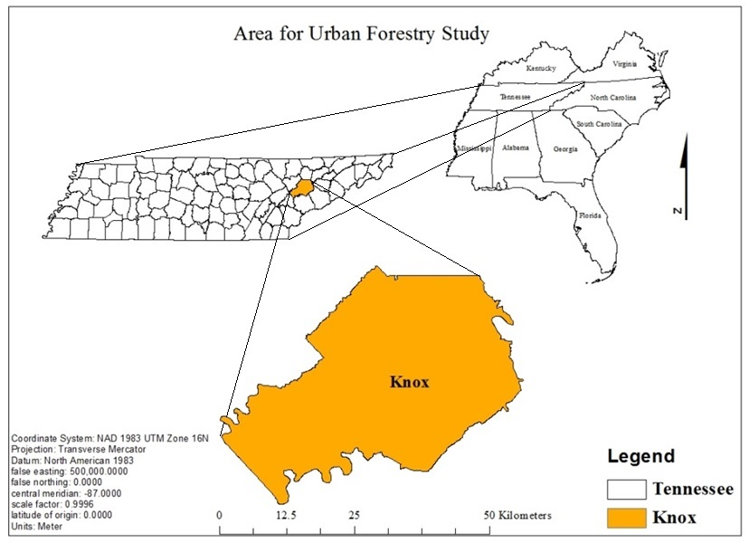
Figure 1. Map of urban forest study site in Knox Co., Tennessee.
established in Knoxville to solve problems caused by city development via soil conservation, reforestation, and improved agricultural practices (Knoxville and Knox County Planning Commission, 1988). The city of Knoxville has a mean housing density of 1.07 residences per acre and median of 0.55 houses per acre (Cho et al., 2006). The city has a total area of 269.38 km² (255.2 km² - land and 14.6 km² - water). The climate is temperate with no distinct wet and dry season, with average temperature in summer 24.5° and winter 4.1° and annual precipitation 119.74 centimeters (Hampson et al., 2000; Hartgrove, 2004). The Natural Resource Conservation Service classified general soil types in Knox Co. as inceptisols and ultisols. These soils formed under forest vegetation typically have light color, and range in depth from shallow to very deep with underlying bedrock consisting of limestone, dolomite, shale, siltstone, and sandstone (Hartgrove, 2004).
Selection of urban and rural plots
To identify potential urban and rural plots in Knox Co. we used ArcGIS to place a boundary box over the state of Tennessee. At both the northeast and southwest positions within the boundary box two x, y coordinates were established and the difference between x₁ and x₂ / y₁ and y₂ was calculated with the equation Rand ()*differences + x₂ in Excel. Initially, approximately 78,000 0.40-hectar (tenth-acre) potential sampling points were randomly generated in Excel and exported to ArcGIS program (ArcMap10.0) to create a shape file. The city of Knoxville was isolated and demographic information such as race, age (median age), average family size, property owners versus renters, housing units occupied, families, farmland and average lot size was generated for each 0.40-hectar (tenth-acre) potential sampling point as well as urban and rural-residential areas within the established 1.609 kilometer (1 mile) buffer zone for the city. This assessment defined urban boundaries using the 2000 U.S. Census Bureau data (U.S. Department of Commerce, 2010), to be consistent with the USDA Forest Service, Forest Health and Monitoring (FMH) programs 2001 assessment of urban forest conditions. Following the FMH programs definition of urbanized areas 2918 tenth-acre potential sampling points landed within the urban boundary. There was total of 423 0.40-hectar (tenth-acre) potential sampling points for the City of Knoxville selected based on areas with population densities ≥ 50,000 for Knox Co. Tennessee (Nowak et al., 2011). The shape file (ArcMap 10.1) was exported to a KML file to visually accept or reject potential sampling points in Google Earth using imagery data from 2011 for the city of Knoxville. Guidelines for acceptance of potential sampling points included areas ≥ 0.40 hectare forested or open field (non-agricultural) and residential properties only; points that landed in commercial lands, government lands, on tops of buildings, in the water, on impervious cover (streets and parking lots), or where the edge of each 0.4 hectare plot measured to ≥ 30.48 meters from any structure, were rejected. Accepted potential points numbered 180, of which twenty-six were selected for sampling based on acceptance by residential land owners. The 26 plots consisted of 10-urban residential and 16-rural residential plots. Rural plots were within 1.609 km of the Knoxville city-limits (Figure 2). This plot size was chosen in order to capture sufficient tree data but to avoid multiple ownerships and has been used in other city wide inventories of urban forest (Riemann, 2003).
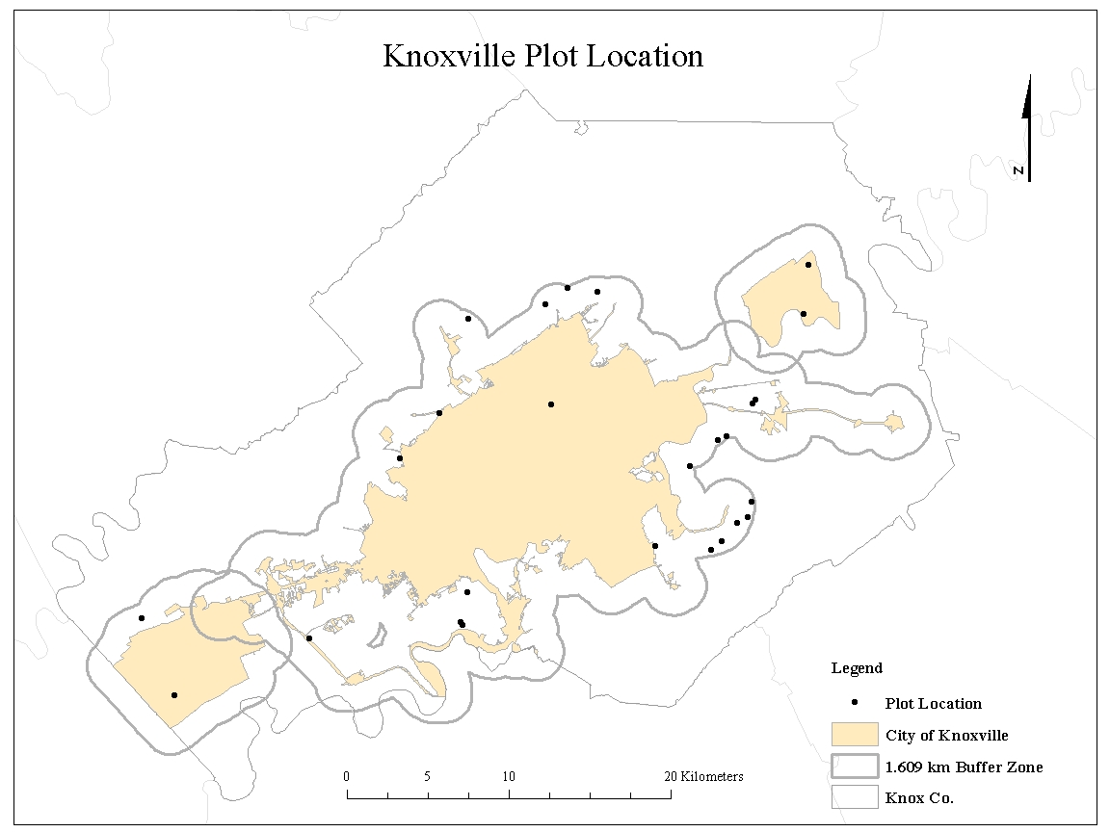
Figure 2. Map showing the location of 26 0.4 ha residential plot locations within the city of Knoxville and a 1.609 km buffer zone for Knox Co., Tennessee.

Due to the topographic differences that affect soil composition and water flow, our study area was divided into four quadrants. (Figure 3). The northeast (8 plots) is mostly ridge tops and shoulders with a general soil material of the Corryton-Townley complex, having 5 to 12 percent slopes, with most areas cleared and used for hay, pasture, or cropland. The southeast (5 plots) is mostly shoulders, side slopes, and back-slopes with a general soil material consisting of the Loyston-Talbott-Rock outcrop complex, having 15-50 percent slopes, mainly in woodland and cleared areas that are used as pasture or remain idle. The southwest (6 plots) is mostly shoulders, foot-slopes, toe-slopes, and side slopes with a general soil material consisting of Coghill-Corryton complex, having 5-25 percent slopes, and mainly woodland consisting of mixed
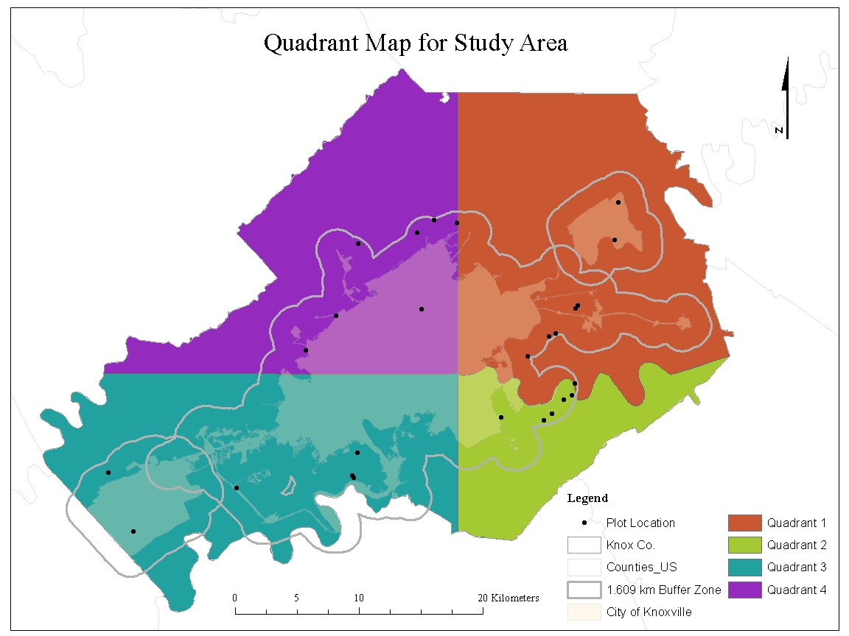
Figure 3. Map indicating the four quadrants for Knox Co. Tennessee.

hardwoods and areas cleared for residential or commercial developments. The northwest (7 plots) is mostly on shoulders, side slopes, and back-slopes with a general soil material consisted of the Apison-Montevallo complex, having 35-75 percent slopes, with most areas in woodland consisting mainly of mixed hardwoods. The entire study area is generally well drained.
Tree Inventory and Soil Sampling
Within urban and rural residential plots tree species and diameter were inventoried for woody plants measuring > 2.54 cm diameter at breast height. Soils were sampled during June 2012, October 2012, January 2013 and April 2013. In each plot six 2 cm diameter by 30.4 cm deep soil cores were randomly collected, combined and mixed in the field, placed in 25-μm thick polyethylene storage bags, placed in coolers with ice, and taken back to the lab where they were processed for analysis. Subsamples from the heterogeneous mixture were used for total elemental, soil microbial biomass C& N, total organic carbon (TOC), pH, CEC, bulk density and gravimetric soil moisture (GSM) analysis. To measure relative dominance of species in our 26 -
0.04 ha plots we utilized the importance value (IV) calculation (Curtis and McIntosh, 1951; Kent and Coker, 1992). Importance values rank species within a site based upon three criteria 1) relative frequency (species occurrence), 2) relative density (total number of individual species) and 3) relative dominance (total amount of forest area occupied) (Curtis and McIntosh, 1951; Kent and Coker, 1992). Plots with multiple species within a genus were grouped and importance value calculations were averaged. The geographic center (-83.942222, 35.972778) for the city of Knoxville was used to calculate the distance from city-center for each plot. This distance metric was used to place each plot on an urban-to-rural gradient (Figure 4).
Soil nutrient analysis
All soil samples (0.2g) were air dried for 2 days then passed through a 250 µm (60 –mesh) sieve. Microwave oven digestion by Nadkarni (1984), with modifications; was used for elemental analysis. Elemental analysis of the digested soil samples was analyzed by inductively coupled atomic emission spectrometry (ICP). Exchangeable As, Ba, Ca, Cd, Co, Cr, Cu, Fe, K, Mg, Mn, Mo, Na, Ni, P, Pb, S, Se, Sr, Ti, and Zn were determined by extraction with 1 N ammonium acetate (1NH₄OAc, pH 7.0). The pH of the 1NH₄OAc was adjusted by adding concentrated ammonium hydroxide. Exchangeable Al, As, Ba, Ca, Cd, Co, Cr, Cu, Fe, K, Mg,
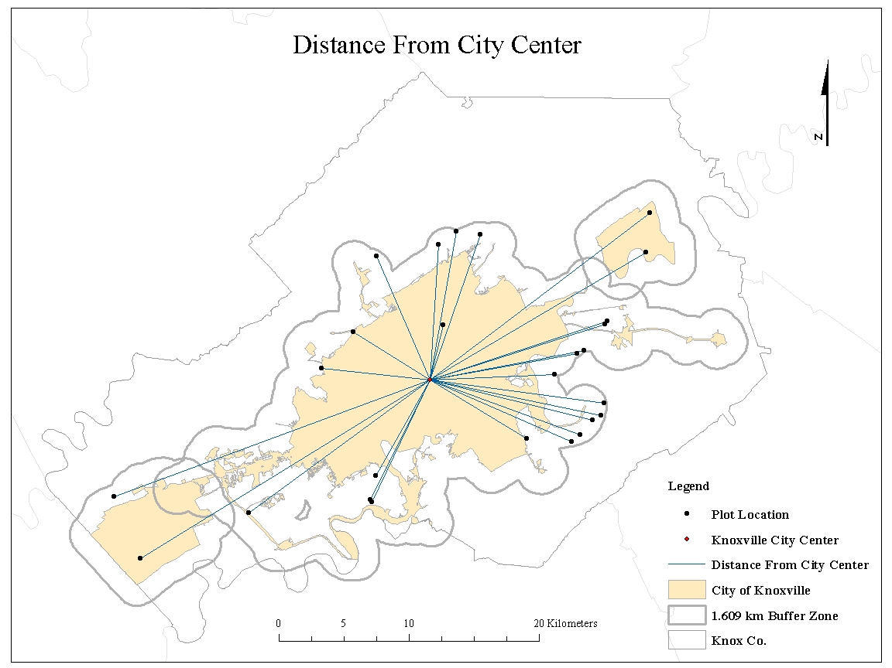
Figure 4. Map of the distance from city center to each plot for the city of Knoxville, Tennessee in Knox County.

Mn, Mo, Na, Ni, P, Pb, S, Se, Sr, Ti, and Zn were analyzed by ICP. The sodium saturation method (pH 7.0) was used to determine cation exchange capacity (CEC) (Chapman, 1965). Soil bulk density $D_{b}=m_{s}/V_{t}$ is the ratio of the mass of oven-dried solids ($m_{s}$) to the bulk volume ($V_{t}$) of the soil, which include the volume of the solids and the pore space between the soil particles (Blake and Hartge, 1986). Soil bulk density was calculated as oven dry weight${(m}_{s}$) divided by the volume of the soil core ($V_{t}$) = g/cm³. Gravimetric soil moisture (Θ g ) was calculated as the difference between soil fresh weight (m_{w}) and oven dry weight (m_{s}) using the following equation: Θ g = m_{w} - m_{s} / m_{s.}

Soil microbial biomass analysis
The simultaneous chloroform fumigation extraction (sCFE) “slurry “method was adapted from Fierer et al. (2003). Two subsamples from the composite soil samples (5g fresh weight) for each plot were placed into a 250 ml Pyrex glass bottle. Two treatments, control and fumigated were used. To each subsample 40 ml of 2M KCl was added. Fumigated subsamples received 0.5ml of ethanol-free ClCH₃ and both fumigated and control samples were placed on a shaker for 4 hours. Following shaking, slurries were allowed to settle and approximately 20-30 ml of soil extract was decanted. Extracts were filtered (Whatmans 100 mm) through a glass funnel and aerated to remove residual chloroform. The extracts were placed in 50 ml screw-cap falcon tubes and stored at 4ºC until analyzed. To analyze total carbon a TOC-VCPH SHIMADZU (detection limit 0.1ppm) was used. Microbial C biomass was determined using the following equation:
Microbial biomass Carbon (MBC) = EC/kEC
Where, the chloroform-labile pool (EC) is the difference between C in the fumigated and non-fumigated extracts, and kEC is soil-specific constant and estimated as 0.45 (Beck et al., 1997). Microbial N biomass was determined using the following equation:
Microbial biomass Nitrogen (MBN) = EN/kEN
Where, the chloroform-liable N pool is the difference between N in the fumigated and non-fumigated extracts, and kEN is soil-specific constant and estimated as 0.54 (Brookes et al. 1985). MBC and MBN were expressed as µg N g⁻¹. Soil carbon to nitrogen, microbial biomass carbon to nitrogen and microbial carbon to organic carbon ratios were calculated. To analyze total organic carbon the TOC the acidification/sparging method was used. To analyze total nitrogen a TNM-1 SHIMADZU unit was used (detection limit 0.1 ppm). To correct for high variance in both MBC and MBN calculations, we utilize a conversion factor to correct for differences in bulk density by expressing microbial biomass C and N in grams of dry soil per meter squared.
Statistical analysis
Tree species diversity in plots was calculated by the Shannon diversity index as:
s
H′ = ∑ (Pi * ln Pi)
i=1
Where, s = number of species and, p_{i} is the fraction of the entire population made up of species i. Tree less plots were included in calculation of tree diversity. The Pearson correlation coefficient parametric test was used to correlate MBC, MBN, TOC, tree species diversity, tree diameter, CEC, pH, bulk density, soil moisture, average Al, As, Ba, Ca, Cd, Co, Cr, Co, Fe, K, Mg, Mn, Mo, Na, Ni, P, Pb, S, Sr, Ti and Zn. Principle component analyses (PCA) was used to reduce the variable dimensions and provide information to identify the variance with in the data set. Linear regression stepwise method was used to retain predictors in the best regression model for distance using the variables: MBC, MBN, TOC, tree species diversity, CEC, pH, bulk density, soil moisture, average Al, As, Ba, Ca, Cd, Co, Cr, Co, Fe, K, Mg, Mn, Mo, Na, Ni, P, Pb, S, Sr, Ti and Zn. . All analyses were performed with SPSS 19 (IBM Corp., Armonk, NY USA) and SAS 9.3 (SAS Inc., Cary, NC USA).
Results
The total number of trees that were inventoried along the urban-to-rural transect in Knoxville was 958, with forty-nine woody plant species identified (Table 1). The most abundant tree species within all plots sampled were Pinus virginiana, Acer rubrum, Juniperus virginiana, Ulmus Americana, Acer saccharum, and Liriodendron tulipifera L. The five most abundant species based on IV calculations within each quadrant were: Carya spp., Celtis spp., Juniperus spp., Quercus spp., and Ulmus spp. (Quadrant 1); Carya spp., Celtis spp., Juniperus spp., Pinus spp., and Ulmus spp. (Quadrant 2); Acer spp., Carya spp., Fagus spp., Liriodendron spp, and Quercus spp. (Quadrant 3); Acer rubrum, Liqustrum spp., Pinus spp., Prunus spp., and Quercus spp. (Quadrant 4) (Table 2). Shannon’s diversity index for 76% (20) of sampled plots in rural areas mean H´ = 1.30 + 1.0 as compared to urban areas mean H´ = 1.51 + 0.73 (Figure 5). Quadrant mean Shannon’s diversity indices were H´= 1.13 ± 1.24 (Q1), H´= 1.82 ± 0.37 (Q2), H´= 1.85 ± 0.53 (Q3), and H´= 0.94 ± 0.84 (Q4) (Figure 6).
Soil MBC mean in rural plots was 109.75 + 60.74 µ gˉ¹ (summer) 187.16 + 417.19 µ gˉ¹ (fall), 51.15 + 41.77 µ gˉ¹ (winter) and 110.31 + 74.03 µ gˉ¹ (spring), whereas urban MBC mean was 86.49 + 90.65 µ gˉ¹ (summer), 96.28 + 139.39 g µ gˉ¹ (fall), 45.4 + 53.67 g µ gˉ¹ (winter) and 68.67 + 40.7 µ gˉ¹ (spring). Rural soil MBN mean was 10.17 + 4.64 µ gˉ¹ (summer), 9.5 + 8.61 µ gˉ¹ (fall), 18.41 + 48.22 µ gˉ¹ (winter) and 10.89 + 12.21 µ gˉ¹ (spring), whereas urban MBN mean was 7.03 + 6.73 µ gˉ¹ (summer), 13.73 + 32.67 µ gˉ¹ (fall), 5.46 + 3.75 µ gˉ¹ (winter) and 5.0 + 7.41 µ gˉ¹ (spring) (Table 3).
In soils we identified twenty-three major and trace elements (Table 4). Based on Pearson’s correlation coefficient bulk density in both urban (r = -0.555, p < 0.001) and rural (r = -0.692, p < 0.001) locations were negatively correlated to tree diversity (Table 5). However, GSM (r = 0.367, p < 0.01) and CEC (r = 0.347, p < 0.01) in rural plots was positively correlated to tree diversity (Table 5). Additionally, in rural locations, GSM, pH, three macro-nutrients (Ca, Mg and S) and Pb were significantly correlated (p < 0.05) to MBC and MBN. Total C and N, CEC, bulk density, TOC, GSM, three macro nutrients (Ca, Mg, and S), Cr and Ti were significantly positively correlated (p < 0.05) (Table 4). There was no significant correlation (r =0.101, r= -.001 p = .539, p = .994) found between tree diversity and urban MBC or urban MBN,
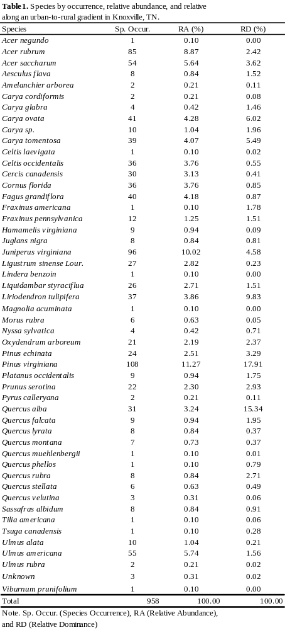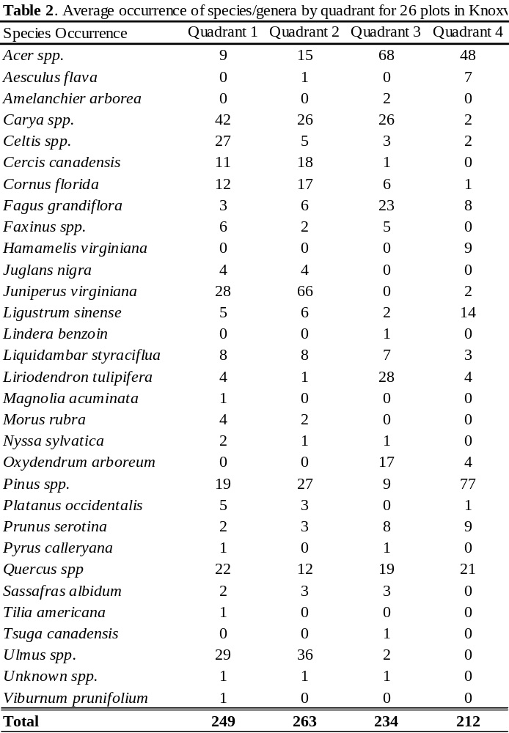
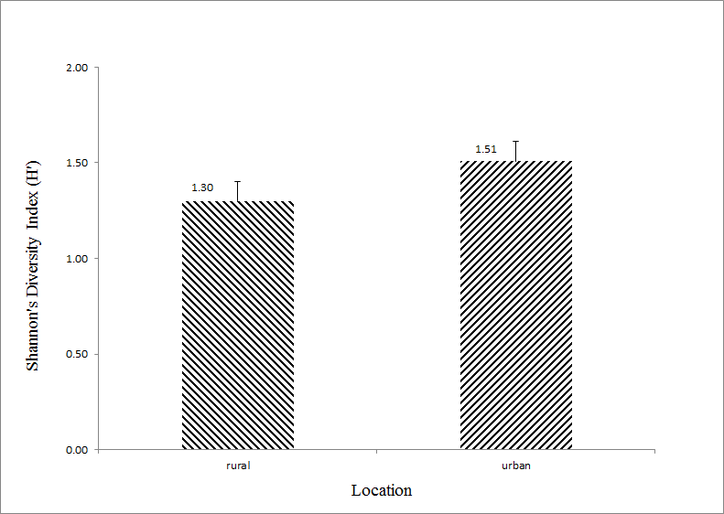
Figure 5. The average diversity indices (H´) by location for rural (n=16) H´= 1.30±1.03 and urban (n=10) H´1.51±0.73 urban-to-rural gradient plots in Knoxville, TN.

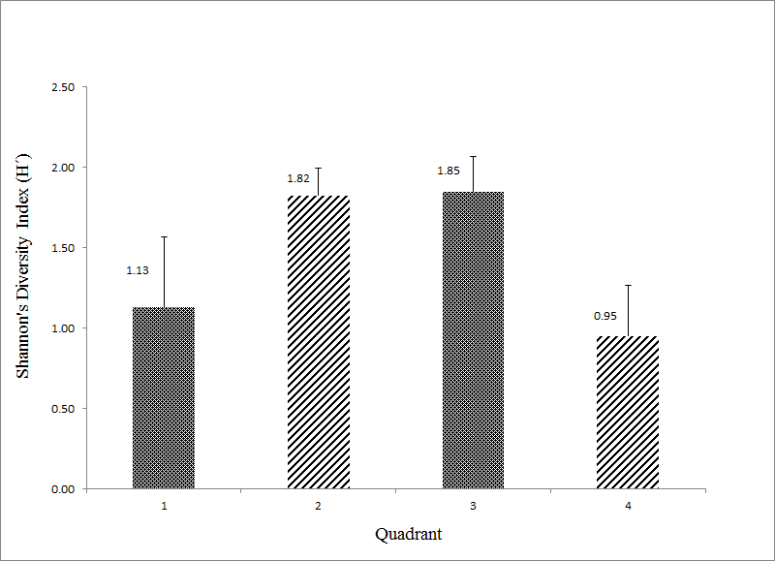

Figure 6. The average diversity indices (H´) by quadrant for quadrant 1 (n=8) H´= 1.13 ± 1.24, quadrant 2 (n=5) H´= 1.82 ± 0.37, quadrant 3 (n=6) H´= 1.85 ± 0.53, and quadrant 4 (n=7) H´= 0.94 ± 0.84 areas of Knoxville, TN.
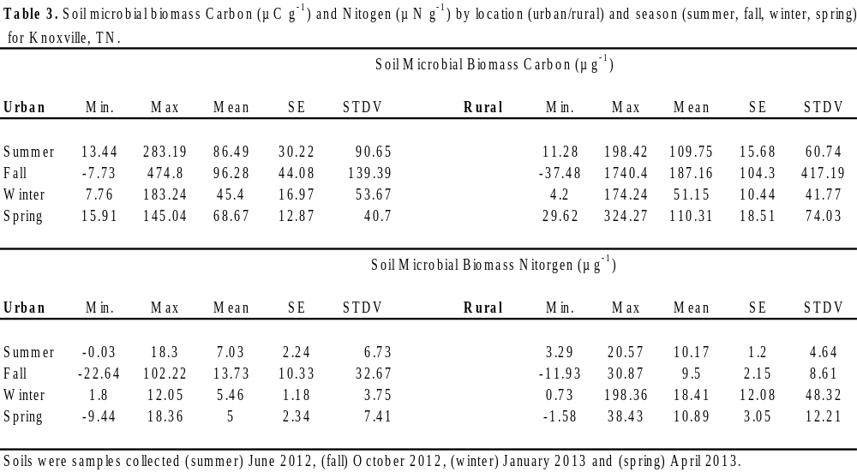
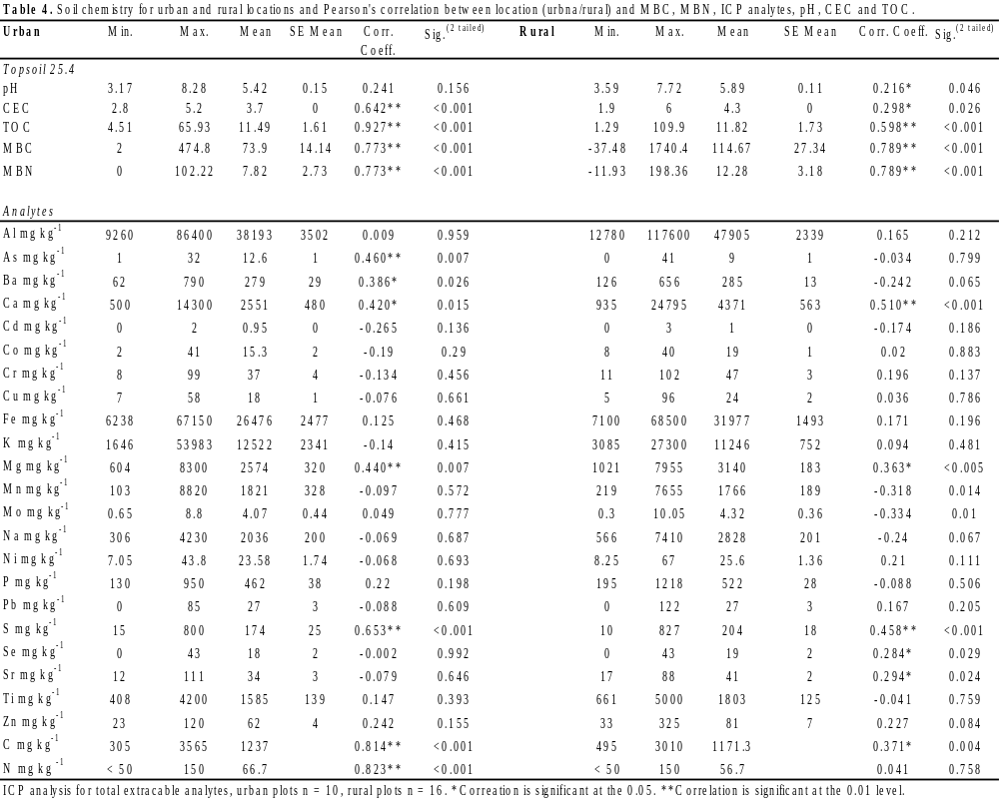
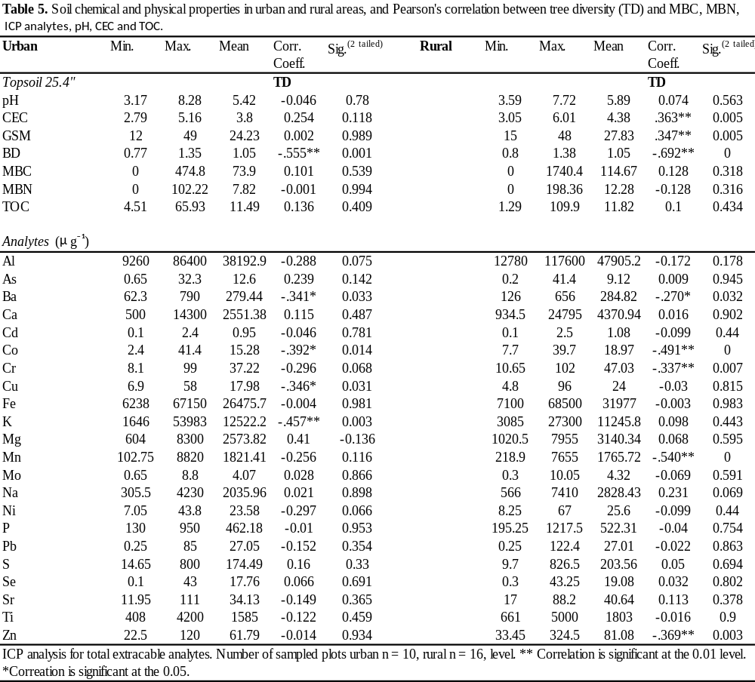
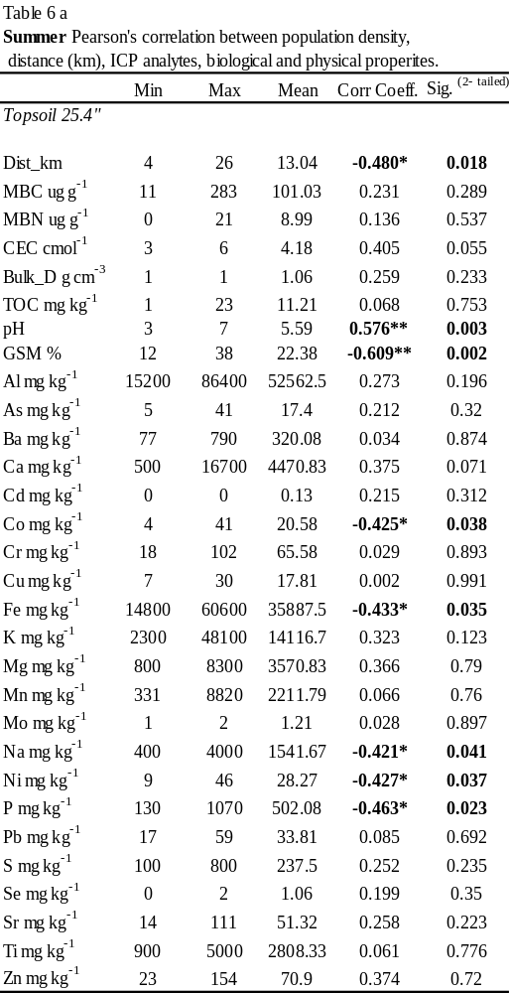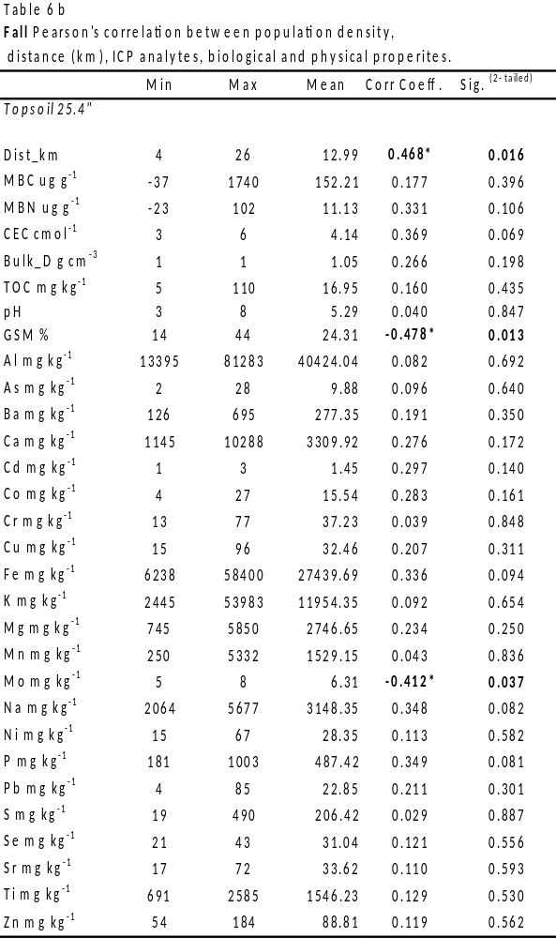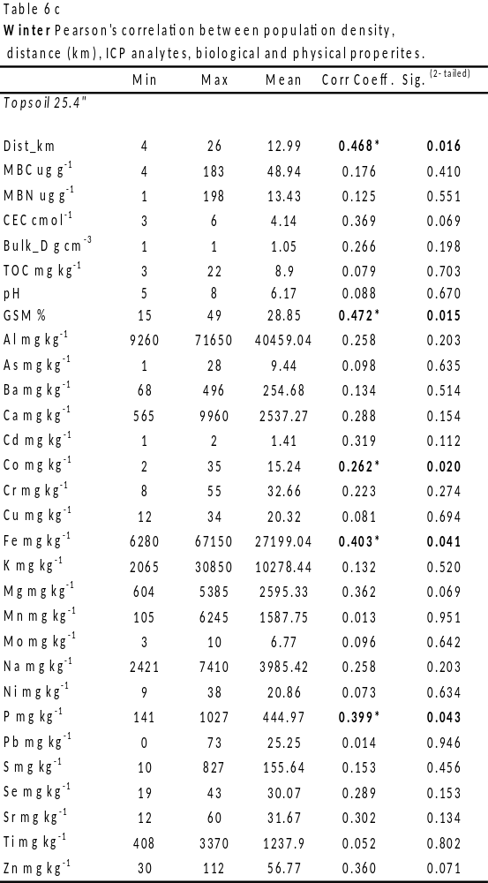
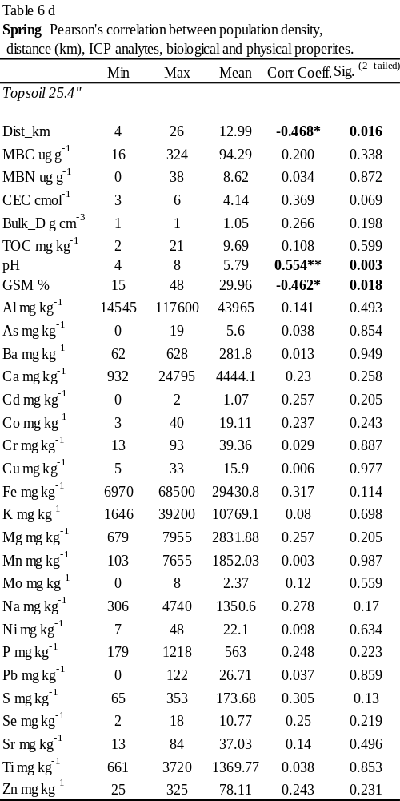
respectively by season, location (urban/rural) or season*location (uban/rural). Since tree diversity was not a significant covariate either as a simple covariate interaction with season and location (fixed), we removed the covariate and reran the MANOVA. Based on our repeated measures MANOVA there was no significant effect of season and no significant interaction with location (urban or rural) with MBC and MBN. We next evaluated the differences in soil physical properties (pH and GSM) between locations and seasons and found a significant difference in means by season (p < 0.001), but there is no significant interaction of season and location (p = 0.257). Soil pH values were between 3.17 and 8.28 in urban and 3.59 and 7.72 in rural plots, with pH significantly correlated (p< 0.001) to rural MBC (Table 4). Soil cation exchange capacity (CEC) tended to be higher in rural (4.3 cmol g⁻¹) than urban (3.7 cmol g⁻¹) plots, with CEC significantly correlated (p< 0.05), in urban locations (Table 4).
Pearson’s correlation between population density, distance (km), ICP analytes, biological and physical properties for summer indicated negative correlations for distance, Co, Fe, Na,Ni, and P at (p< 0.05). Additionally, pH was positively correlated with population density at (p<0.001) and GSM had a negative correlation at (p<0.001) (Table 6.a). Distance and GSM for fall, winter and spring were negatively correlated with population density at (p<0.05) (Table 6b, 6c, 6d). Principal component analysis (PCA) produced a total of twenty-nine components. These are the ten components with the heights extracted eigenvalues which account for ninety-nine percent of the variance among the 29 variables (Table A4). From the ten components only components one and two were retained for the correlation matrix with distance for geographic city center and chemical, biological, and physical properties. Component one accounted for 82.422 percent of the total variance were as component two accounted for 11.064 percent of the total variance among the variables (Table A.1). The combined components (1 and 2) account for 93.486% of the variance in the total set of variables in the PCA (Table A.2). That is, the 29 variables can be reduced to two dimensions (components) that account for as much variance as the 29 variables. Pearson’s Correlations between distance and component scores, where generic first component is not correlated with distance. The second component has a negative correlation with Distance at the p<0.001. So as distance from the city center increases the component 1 scores decreases or vice-versa (Table A.3).
Linear regression stepwise backward elimination method was used to retain predictors in the best regression model for distance. The last model retained, with the predictors Ba ppm and Sr ppm, explains about 7% (.067) of the total variation in distance to city center (Table 7). The model retained two predicative constants with at least one significant predictor of distance: F = 4.62; df = 2, 99; p = 0.012 (Table 8).
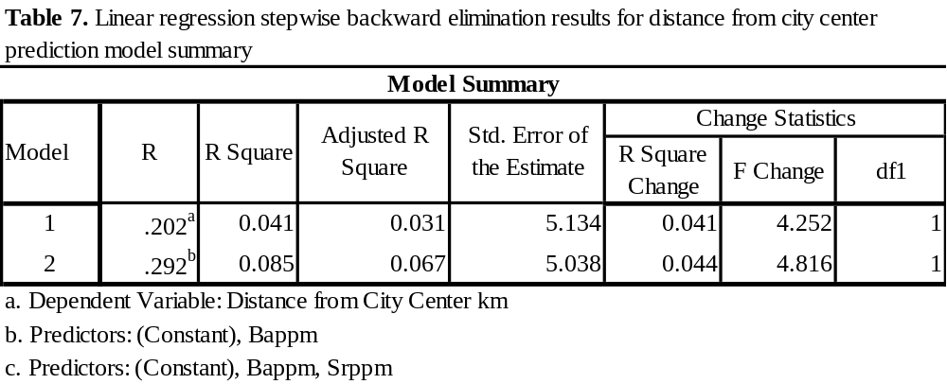
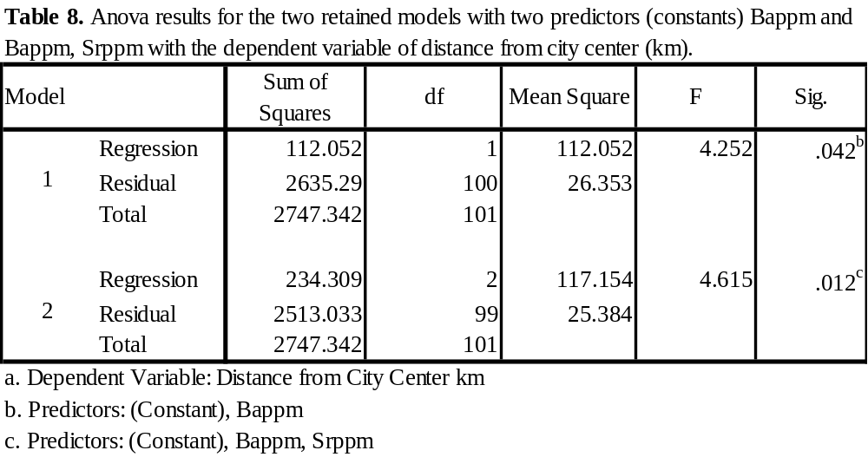
Regression equation for the final model is:
predicted value of Distance = 12.009 + 0 .390 ± 0.005 Ba ppm - .282 ± 0.037 Sr ppm Standardized Betas indicate that Ba ppm (.390) is a stronger predictor than Sr ppm (-.282). T-tests on the regression coefficients (B) show that both are signficant predictors: Ho: B=0 Ba ppm: t=3.028; df=1, 99; p=.003 and Sr ppm: t=-2.195; df=1, 99; p=.031for both, Ho is rejected at alpha=.05 (Table 9).
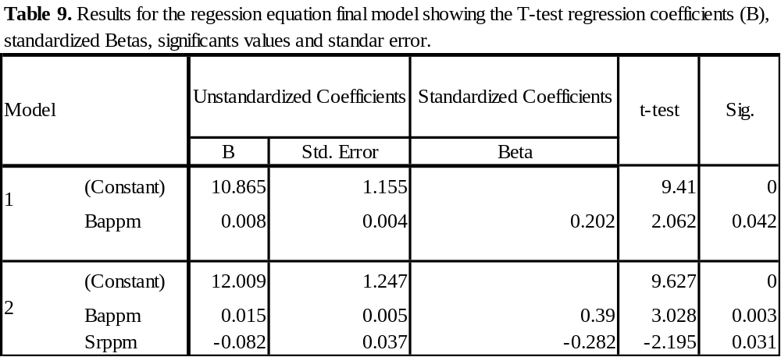
Discussion
Woody vegetation diversity along urban-rural gradient
Urban and rural areas have distinct differences in plant species composition and soil characteristics (Porter, et. al., 2001). One way to assess forest community structure in urban forests is to calculate IVs for each species within designated urban forest plots or whole communities in urban areas. Nowak et al., (2006a) analyzed forest structure (i.e. tree species composition, species diversity, number of trees, etc.), forest function (i.e. environmental and ecosystem services) and forest value (i.e. economic worth) within the Washington D.C. area. To identify the most important species the authors calculated IVs for each species inclusive of relative leaf area and relative abundance. The study reported Fagus grandifolia, Lirodendron spp. and Acer rubum the most important species based on their calculated IVs. Here we assess the most importance species within four distinct quadrants in the city of Knoxville (including a 1.609 km buffer around the city). Quadrants were designated based on topographic differences in Knox Co. which affects soil composition and water flow. Three species, Acer spp., Pinus spp. and Quercus spp. had > 8 occurrences per plot (26 – 0.04 ha plot) within each quadrant (Table 2). In quadrant one (northeast location) the dominant over-story species were Carya (IV = 108) and Quercus (IV = 33). In quadrant two (southeast location) the dominant over-story species were Juniperus (IV = 69), Pinus (IV = 75), and Quercus (IV = 37). In quadrant three (southwest location) the dominant over-story species were Carya (IV =33), Quercus (IV =61) and Liriodendron (IV = 78). In quadrant four (northwest location) the dominant over-story were Quercus (IV = 26), Prunus (IV = 22) and Acer (IV = 76).
Even though mean species richness was slightly higher in urban (1.51) than rural (1.30) plots, no significantly difference was found. Porter et al., (2001), studied six specific sites (a preserve, a recreational area, a golf course, a residential subdivision, apartment complexes, and a business district) in Oxford, OH along a forest-to-urban gradient. Their study found that in urban areas species richness was greater H’ = 2.69 (residential), 2.19 (apartment), 2.06 (business districts) than in natural sites with H’ = 2.30 (golf course), 1.94 (recreational areas) and 1.70 (preserves). Our study did not inventory commercial, business or recreational areas within the City of Knoxville. We focused on natural forest patches within residential areas, with minimal to no human interaction. McKinney (2008) reviewed 105 studies on the effects of urbanization on species richness of non-avian species and plants. He found that for all groups species richness tends to be reduced in areas with extreme urbanization whereas species richness varies significantly as you move away from central urban core areas.
MBC and MBN differences along urban –rural residential gradient
We tested whether tree diversity affected the quantitative change in soil microbial biomass carbon (MBC) and microbial biomass nitrogen (MBN) among sampled plots by season (fall, summer, winter and spring) and location (urban versus rural). Our study quantitatively assessed MBC and MBN spatially (urban and rural) and temporally (summer, fall, winter and spring) in the City of Knoxville from May 2012 to May 2013. In comparing MBC between urban and rural plots, there was no significant difference. There are several possibly explanations 1) soils may contain similar quantities of labile and passive carbon pools, 2) residential urban and rural soils have similar capacities in terms of carbon sequestration and cycling or 3) soil carbon pools in residential rural plots are impacted by urbanization and environmental changes as much as residential urban plots (Pouyat et al, 2002). Pouyat et al., (2002) studied the potential effects of urbanization on soil organic carbon (SOC) in the City of Baltimore, MD. They found that along an urban-to-rural gradient soil organic carbon was significantly higher in urban forest stands than suburban and rural stands. Groffman et al., (1995) compared carbon pools along the urban-rural gradient and found that urban areas contained more passive pools of carbon; therefore, lower MBC could be expected due to the longer turnover rate for C mineralization. Overall, this study points to the heterogeneity of soils and their functions, especially in and around urban fringes.
MBN means did differ by location, mean rural MBN was 3.2 g N m⁻² compared to a mean urban MBN of 2.0 g N m⁻² but no significantly difference was found. An earlier study by Goldman et al. (1995) found consumption rates higher for soil NH₄⁺ and total inorganic N; therefore both showing lower concentrations at (p < 0.05) in urban areas than in rural areas along a urban-rural transect from highly urbanized Bronx County, NY to rural Litchfield County, CT. These consumption rates were lower for soil N0₃⁻ with higher concentration rates at (p< 0.05) in urban areas than in rural areas. Raciti et al. (2008) estimated the production and consumption of NO₋₃ to NH₄⁺ to assess differences in internal nitrogen cycling under the two vegetation types, urban lawns and forests. They found higher turnover rates of N retention in urban lawns than forests, but no deference in the MBN even though there was twice the amount of N retention in urban lawns than forests. Zhu and Carreiro (2004) found that there were higher turnover rates of N in urban areas which caused increased N mineralization when compared to rural areas. The landscape age could also be a potential driver for the lower MBN in the urban residential plots. Scharenbroch et al. (2005) found that new residential landscapes had lower MBN than old residential landscapes. In residential urban and rural plots sampled throughout the City of Knoxville urban plots had a more recent disturbance history as compared to rural plots. The rural plots therefore have had time to establish microbial populations and undergo ecological succession. One possible explanation for the lower MBN in the urban sites is that increased amounts of earthworms could contribute to lower MBN as well as lower quality leaf litter (Zhu and Carreiro, 2004). Additionally, increased fertilization rates have been found to decrease microbial C and N in northern hardwood forests, which is likely due to large quantities of N in the soil and faster microbial turnover rates (Fisk and Fahey, 2001).
Fluxes in soil nutrients and associated measurements by season and location
The biogeochemical interactions in soil habitats are composed of connecting organic, inorganic and biological factors that influence each other and interact in soil ecosystems (Totsche et al., 2009). Our soils contained twenty three elements and trace metals; of which Pb, and macronutrients S, Mg, and Ca, were significantly correlated (p < 0.05), with MBN and MBC. MBC in rural residential plots were significantly correlated (p<.05) with S, Mg, and Ca and significantly correlated (p < 0.1) urban plots. A field study in Spain’s temperate zone found when soils exhibited increases in MBC and flux of Mg (Diaz-Ravina et al, 1992), soil microbes are a component mediating soil Mg levels. In metropolitan Bejjing, concentrations of Mg and Ca did not vary between park, industrial, residential, agricultural, traffic, and public soils (Wang et al., 2011); Mg and Ca could be influenced by fluxes in MBC regardless of location.
Interestingly, there was a significant correlation (p<.05) between MBN and Pb in rural residential plots. In Aberdeen city, Scotland, UK and rural agricultural fields in the vicinity of Aberdeen city, Yuangen et al. (2006) found that the elements Pb and Zn had different accumulations in the urban soils compared with rural soil. Contents of Pb and other metals were significantly higher in urban soils (roadside soils and parkland soils) than in rural soils (p < 0.05). Pouyat and McDonnell (1991) found variation in the concentration of metals (Pb and Cu) along an urban-rural gradient in southern New York, being generally higher closer to the urban core of the transect line and decreasing as you moved out from the urban core. The elements Pb and Zn are known to be anthropogenic pollutants in urban environment. Yuangen et al. (2006) suggests that microbial biomass may be the most sensitive indicator to metal Pb inputs in soil.
Rural residential plots were found to have a higher CEC than urban plots indicating higher fertility and nutrient exchange in forests as one move along an urban-to-rural gradient. Interestingly, this suggests that MBC should also be higher in rural residential plots based off findings from an urban soils study (Ohya et al, 1988). MBC along the urban-rural gradient, however, did not follow the pattern of CEC being higher in rural and lower in urban residential plots. Instead of MBC differing along the urban-rural gradient by location, it proved to differ significantly between the summer and winter; whereas MBN differed only by location and not by season. MBN has been found to increase in the spring along the urban-rural gradient of New York City from microbes utilizing inorganic N that was stored throughout winter (Zhu and Carreiro, 2004). Our plots did not exhibit this spring MBN flux. In a seasonal turf grass study, MBC and MBN were found to be lowest in September and the highest in December (Yao, 2011). Following the pattern of urban-to-rural plots in regards to the seasons for MBC. Since MBC accounts for a portion of TOC, MBC can be positively related to the amount of SOM (Jenkinson and Ladd, 1981). This would explain the elevated MBC during the winter season due to leaf litter accumulation on the forest floors combined with decomposition occurring throughout the fall. Indicating though the urban-rural gradient is subject to urban environmental stressors, the urban ecosystem is resilient in maintaining the ecosystem functions of more natural systems.
Acknowledgements
We thank the property owners of the City of Knoxville, TN for allowing access to conduct this research study. Funding support came from University of Tennessee Institute of Agriculture, UTK-Graduate School and the Departments of Forestry, Wildlife and Fisheries and Biosystems Engineering and Soil Science.

REFERENCES

References

- Alig, R.J. and Plantinga, A.J., 2004. Future Forestland Area: Impacts from Population Growth and Other Factors that Affect Land Values. Journal of Forestry 102, 8, 19-24.
- Aon, M.A., Sarena, D.E., Burgos, J.L., Cortassa, S., 2001. Microbiological, chemical and physical properties of soils subjected to conventional or no-tillage management: an assessment of their quality status. Soil Till Resources 60, 173–186.
- Baumgartl, Th., 1998. Physical soil properties in specific fields of application especially in anthropogenic soils. Soil Till Resources 47, 51-59.
- Beck, T., Joergensen, R.G., Kandeler, E., Makeschin, F., Nuss, E., Oberholzer, H.R., Scheu, S., 1997. An inter-laboratory comparison of ten different ways of measuring soil microbial biomass C, Soil Biology and Biochemistry 29, 7, 1023-1032.
- Brookes, P. C., Landman, A., Pruden, G., Jenkinson, D. S., 1985. Chloroform fumigation and the release of soil nitrogen: a rapid direct extraction method to measure microbial biomass nitrogen in soil. Soil Biology and Biochemistry 17, 837 – 842.
- Certini, G., 2005. Effects of fire on properties of forest soils: a review. Oecologia, 143, 1-10.
- Chapman, H.D., 1965. Cation-exchange capacity. P. 891-901. In C. A. Black et al. (eds.) Methods of soil analysis. Part 2. Chemical and microbiological properties. Agron. No. 9. ASA, Madison, WI.
- Cho, S-H, Clark, C. D., Park, W. M., 2006. Two Dimension of the Spatial Distribution of Housing: Dependency and Heterogeneity across Tennessee’s Six Metropolitan Statistical Areas. Journal of Agricultural and Applied Economics 38, 299-316.
- Craul, P.J., 1999. Urban Soils: Applications and Practices. Wiley, New York.
- Curtis, J.T. and McIntosh, R.P. 1951. An upland forest continuum in the prairie-forest border region of Wisconsin. Ecology 31, 476-496.
- Deaderick, L., 1976. Heart of the Valley: A History of Knoxville, Tennessee. The East Tennessee Historical Society. Knoxville, Tennessee.
- Dick, R.P., 1994. Soil enzyme activities as indicators of soil quality. In: Defining soil quality for a sustainable environment. SSSA, Special Publication no 35, Madison, pp 107–124.
- Diaz-Ravifia, M., Acea, M. J., Carballas, T., 1992. Microbial biomass and C and N mineralization in forest soils. Bioresource Technology 43, 150-157.
- Doran, J. W., Coleman, D. C., Bezdicek, D. F., Stewart, B. A., 1994. The dynamics of soil quality as a measure of sustainable management.
- Dwyer, J. F., Nowak, D. J., Noble, M. H., Sisinni, S. M., 2000. Assessing our nation’s urban forest: Connecting people with ecosystems in the 21stcentury. General Technical Report PNW-490. Portland, OR: USDA Forest Service.
- Fierer, N., J.P. Schimel, P.A. Holden, 2003. Variations in microbial community composition through two soil depth profiles. Soil Biology & Biochemistry 35, 167–176.
- Fisk, M.C., Fahey, T.J., 2001. Microbial biomass and nitrogen cycling responses to fertilization and litter removal in young northern hardwood forests. Biogeochemistry 53, 201-223.
- Girvan, M. S., Bullimor, J., Pretty, J. N., Osborn, A. M., Ball, A. S., 2003. Soil type is the primary determinant of the composition of the total and active bacterial communities in arable soils. Applied and Environmental Microbiology 69, 1800 -1809.
- Goldman, M. B., Groffman, P. M., Pouyat, R. V., McDonnell, M. J., and Pickett, S. T., 1995. CH4 uptake and N availability in forest soils along an urban to rural gradient. Soil Biology and Biochemistry 27, 281-286.
- Groffman, P. M., Pouyat, R. V., McDonnell, M. J., Pickett, S. T. A., Zipperer, W. C., 1995. Carbon pools and trace gas fluxed in urban forest soils. In Advances in soil science, soil management and greenhouse effect (R. Lat, J. Kimble, E. Levine and B. A. Steward, eds) pp. 147–158. CRC Press, Inc., Boca Raton, Florida.
- Hampson, P. S., Treece Jr., M.W., Johnson, G.C., Ahlstedt, S.A., Connell, J.F., 2000. "Water Quality in the Upper Tennessee River Basin, Tennessee, North Carolina, Virginia, and Georgia 1994–98”. pubs.water.usgs.gov/circ1205.
- Hart, S.C., Stark, J. M., Davidson, E. A., Firestone, M. K., 1994. Nitrogen mineralization, immobilization, and nitrification. In R. V. Weaver et al (ed.) Methods of Soil Analysis, Part 2. SSA Book Series 5. SSSA, Madison, WI, pp. 985 – 1018.
- Hartgrove, N. R., 2004. Soil Survey of Knox County, Tennessee. Natural Resource Conservation Service. pp 1-3.
- Hope, D., Zhu, W., Gries, C., Oleson, J., Kaye, J., Grimm, N., Baker, L., 2005. Spatial variation in soil inorganic nitrogen across an arid urban ecosystem. Urban Ecosystem 8, 251-273.
- Ibekwe, A. M., Watt, P. M., Grieve, C. M., Sharma, V. K., Lyons, S. R., 2002. Multiplex fluorgenic real-time PCR for detection and quantification of Escherichia coli O157:H7 in dairy wastewater wetlands. Applied and Environmental Microbiology, 68, 4853-4862.
- Jim, C.Y., 1998. Soil characteristics and management in an urban park in Hong Kong. Environmental Management 22, 683-695.
- Kent, M., Coker, P., 1992. Vegetation Description and Analysis, A Practical Approach. John Wiley and Sons, New York, pp. 167-169.
- Knoxville and Knox County Planning Commission, 1988. Future of our past. University of Tennessee Hodges Library, F444 .K7F8 1988. pp1-9
- McDonnell, M. J., Pickett, S. T. A., Groffman, P. M., Bohlen, P. Pouyat, R.V., Zipperer, W.C., Permelle, R. W., Carreiro, M. M., Medley, K., 1997. Ecosystem processes along an urban-to- rural gradient. Urban Ecosystems 1, 21 – 36.
- McKinney, M., 2008. Effects of urbanization on species richness: A review of plants and animals. Urban Ecosystems 11, 161-176.
- Neary, D., Klopatek, C., DeBano, L., Ffolliott, P., 1999. Fire effects on belowground sustainability: A review and synthesis. Forestry Ecology Management 122, 51-71.
- Nowak, D. J., Greenfield, E. J., 2012. Tree and impervious cover change in U.S. cities. Urban Forestry and Urban Greening 11, 21-30.
- Nowak, D.J., Cumming, A.B., Twardus, D., Hoehn, R. E. III, Oswalt, C.M., Brandeis, J.T. 2011. Urban forests of Tennessee, 2009. Gen. Tech. Rep. SRS–149. Asheville, NC: U.S. Department of Agriculture Forest Service, Southern Research Station.
- Nowak, D. J., Hoehn, R. E., Crane, D. E., Stevens, J. C., Walton, J. T., 2006a. Assessing Urban Forest Effects and Values. USDA Forest Service, http://www.fs.fed.us/pnw/about/arra/pdfs/Mills%20fact%20sheet.pdf.
- Nowak, D. J., Crane, D. E., Stevens, C. J., 2006b. Air pollution removal by urban trees and shrubs in the United States. Urban Forestry & Urban Greening 4,115-123.
- Nowak, D. J., 2002. The effects of urban trees on air quality. USDA Forest Service, www.nrs.fs.fed.us/units/urban/local-resources/downloads/Tree_Air_Qual.pdf.
- Ohya, H., Fujiwara, S., Komai, Y., Yamaguchi, M., 1988. Microbial biomass and activity in urban soils contaminated with Zn and Pb. Biology and Fertility of Soils 6, 9-13.
- Patterson, J. C., Murray, J. J., Short, J. R., 1980. The impact of urban soils on vegetation. METRIA: 3, Proc. of the Third Conference of the Metropolitan Tree Improvement Alliance. Rutgers, New Brunswick, NJ.
- Pickett, S.T.A., Cadenasso, M.L., Grove, J.M., Boone, C.G., Goffman, P.M., Irwin, E., Kaushal, S.S., Marshall, V., McGrath, B.P., Nilon, C.H., Pouyat, R.V., Szlavecz, K., Troy, A., Warren, P., 2001. Urban ecological systems: Scientific foundations and a decade of progress. Journal of Environmental Management 92, 331-368.
- Porter, E.E., Forschner, B.R., Blair, R.B., 2001. Woody vegetation and canopy fragmentation along a forest-to-urban gradient. Urban Ecosystems 5, 131-151.
- Pouyat, R. V., Szlavecz, K., Yesilonis, I.D., Groffman, P. M., Schwarz, K., 2010. Chemical, Physical and Biological Characteristics of Urban Soils. Urban Ecosystem Ecology 55, 119 -151.
- Pouyat, R.V., Yesilonis, I.D., Russell-Anelli, J., Neerchal, N.K., 2007. Soil chemical and physical properties that differentiate urban land-use and cover types. Soil and Water Management and Conservation 71, 3, 1010 – 1019.
- Pouyat, R., Groffman, P., Yesilonis, I., Hernandez, L., 2002. Soil carbon pools and fluxes in urban ecosystems. Environmental Pollution 116, S107-S118.
- Pouyat, R.V., Effland, W.R., 1999. The investigation and classification of humanly modified soils in the Baltimore Ecosystem Study, in Classification, Correlation, and Management of Anthropogenic Soils. Kimble, J.M., Ahrens, R.J., Bryant, R.B., Eds., USDA Natural Resource Conservation Service, National Soil Survey Center, Lincoln, NE, pp141 – 154.
- Pouyat, R.V., McDonnell, M.J., 1991. Heavy metal accumulation in forest soils along an urban-rural gradient in southeastern New York, USA. Water, Air, Soil Pollution 57-58, 797-807.
- Raciti, S.M., Groffman, P.M., Fahey, T.J., 2008. Nitrogen retention in urban lawns and forests. Ecological society of America. Ecological Application 18, 7, 1615-1626.
- Riemann, R., 2003. Pilot Inventory of FIA Plots Traditionally Called ‘nonforest’. General Technical Report NE-312. Newton Square, PA: USD A Northeastern Research Station.
- Scharenbroch, B.C., Lloyd, J.E., Johnson-Maynard, J.L., 2005. Distinguishing urban soils with physical, chemical, and biological properties. Pedobiologia 49, 283-296.
- Shannon, C.E., Weaver, W., 1949. The mathematical theory of communication. The University of Illinois Press, Urbana: 1 – 117.
- Short, J. R., Fanning, D. S., Foss, J. E., Patterson, J. C., 1986a. Soils of the Mall in Washington DC: I. Statistical summary of properties. Soil Science Society of America Journal 50, 699-705.
- Singh, J.S., Raghubanshi, A.S., Singh, R.S., Srivastava, S.C. 1989. Microbial biomass acts as a source of plant nutrients in dry tropical forest and savanna. Nature 338, 499-500.
- Totsche, K.U., Rennert, T., Gerzabek, M.H., Kogel-Knabner, I., Smalla, K., Spiteller, M., 2009. Biogeochemical interfaces in soil: the interdisciplinary challenge for soil science. Journal of Plant Nutrition. Soil Science 173, 88-99.
- U.S. Department of Agriculture Forest Service, 2010. Forest inventory and analysis national core field guide: field data collection procedures for phase 2 plots. Version 5.0. Volume Arlington, VA: U.S. Department of Agriculture Forest Service, Forest Inventory and Analysis Program. 361 p. www.fia. fs.fed.us/library/field-guides-methods-proc/. [Date assessed unknown].
- Wang, M., Markert, B., Shen, W., Chen, W., Peng, C., Ouyang, Z., 2011. Microbial biomass carbon and enzyme activities of urban soils in Beijing. Environmental Science and Pollution Research 18, 6, 958-967.
- Yuangen, Y., Campbell, C.D., Clark, L., Cameron, C.M., Paterson, E., 2006. Microbial indicators of heavy metal contamination in urban and rural soils. Chemosphere 63, 1942-1952.
- Zak, D. R. Holmes, W. E. White, D. C. Peacock, A. D. Tilman, D., 2003. Plant diversity: Soil microbial communities and ecosystem function, Are there any links? Ecology 84, 4, 2042-2050.
- Zhu, W.-X., Carreiro, M.M., 2004. Temporal and spatial variations in nitrogen transformations in deciduous forest ecosystems along an urban-rural gradient. Soil Biology and Biogeochemistry 36, 2, 267-278.
PART III
Conclusion and implications

In determining tree species diversity and soil composition along an urban-to-rural gradient in residual forest patches and open field it was found that tree diversity did not differ significantly for residential urban/rural plots in Knoxville, Tennessee. The diversity of Knoxville’s urban forest is relatively resilient to the presses of different levels of land use / land change. Spatial (urban/rural) and temporal differences were identified for chemical, physical and biological soil properties along an urban-to-rural gradient. Chemically, residual forest patches along the urban-to-rural gradient were found to be negatively correlated, both in urban and rural; with Barium and Cobalt. In both locations soil solution mean concentrations were approximated at 280 µ g⁻¹ Ba and 20 µ g⁻¹ Co. Other elements negatively correlated with tree diversity were Potassium and Copper for urban plots and Manganese, Zinc and Cromium in rural plots. Similarly, physical soil properties such as bulk density in both urban and rural sites were negatively correlated with tree diversity. Both land use types had mean density of 1.05 g/m³ which is typical for natural forest soils and indicates that Knoxville’s residual forest are minimally impacted by continual land use changes often found in the urban ecosystem.
Rural soils did differ physically from urban soil, in cation exchange capacity (CEC) and soil moisture content (GSM). Both were positively correlated with tree diversity and rural residential plots were found to have a higher CEC than urban plots indicating higher fertility and nutrient exchange in forests as one move along an urban-to-rural gradient. Biologically, there was no indication that soils were affected by tree diversity, in terms of soil microbial biomass C/N along an urban-to-rural in Knoxville residential plots.
When determining the impacts of land-use change from urban to rural on tree diversity and soil biological, chemical, and physical properties within urban residual forest patches it was found that chemical soil concentrations differed seasonal and by location along the urban-to rural gradient. Distance from city center along an urban-to-rural gradient for MBC by location did differ significantly between the summer and winter; whereas MBN differed only by location and not by season. The principal component analyses (PCA) indicated that the variation along the gradient was mostly due to the soil chemical properties as compared to the physical and biological properties. The distances from city center and tree diversity were not significant in the loading values for the PCA. Residual forest patches and open fields of residential land use in the city of Knoxville function similarly to natural vegetative areas. Characterizing residual forest patches and open fields in residential areas has the potential to promote different land use and land change practices. Utilizing the chemical, physical and biological soil characteristics and tree diversity in the development of a predictive model for residual forest patches or open field based on urban or rural location can provide a tool for development in terms of residential land use. Though the predictive model developed for the city of Knoxville indicates the predicted value of Distance = 12.009 + 0 .390 ± 0.005 Ba ppm - .282 ± 0.037 Sr ppm can be used to estimate/designate whether a location is urban or rural, further data mining is suggested to further improve the models accuracy and capabilities. Through the understanding of how urban ecosystems work as well as the functions forest patches and open spaces provide; city manager can offer residents higher quality urban environments.

Appendix

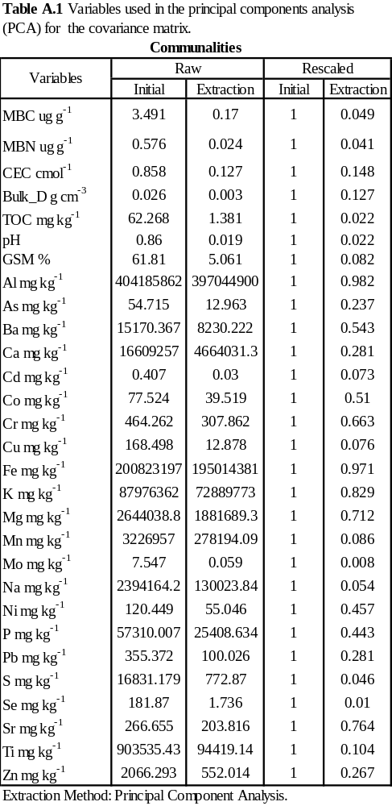
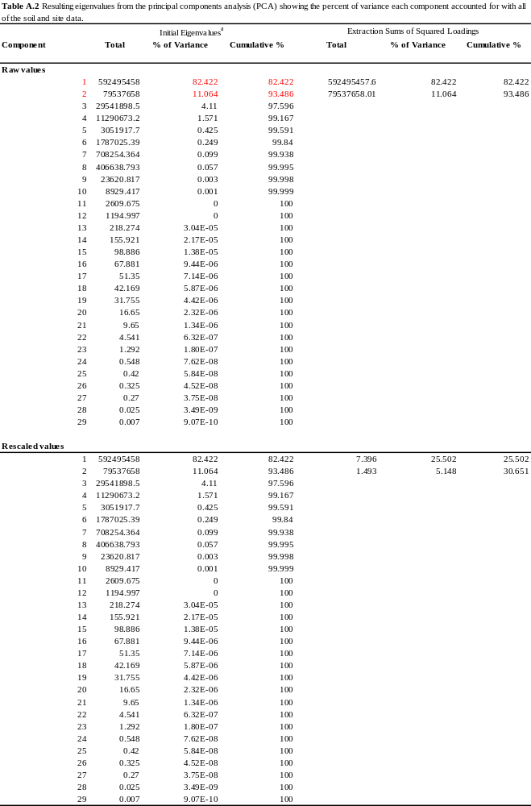
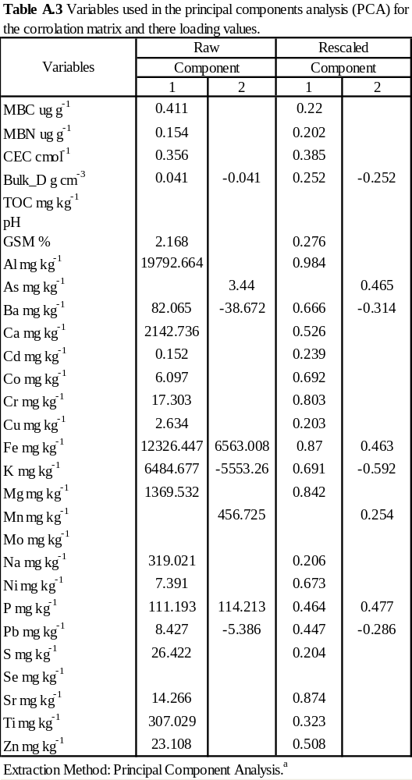

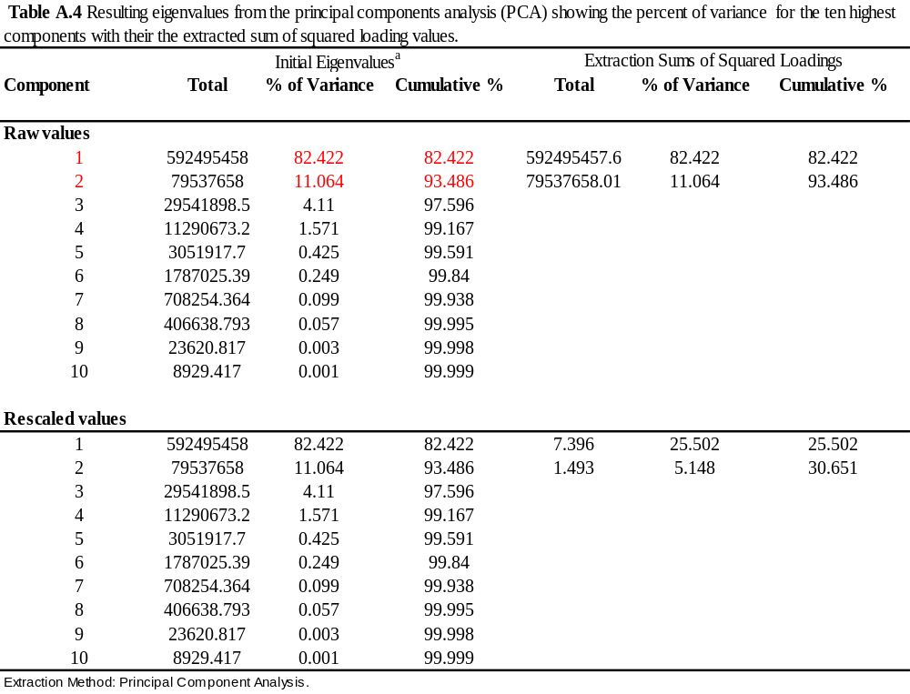

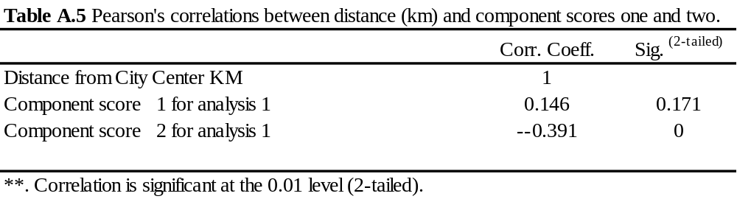

Table A.6. List of all the predictors for linear regression stepwise
model not retained.
Excluded Variablesª
Model |  | Beta In | t | Sig. | Partial Correlation | Collinearity Statistics
 |  |  |  |  |  | Tolerance
1 | Alppm | -.154^{b} | -1.128 | 0.262 | -0.113 | 0.51
1 | Asppm | .042^{b} | 0.427 | 0.67 | 0.043 | 0.996
1 | Cappm | -.071^{b} | -0.724 | 0.471 | -0.073 | 0.999
1 | Cd | -.044^{b} | -0.445 | 0.657 | -0.045 | 0.983
1 | Coppm | .096^{b} | 0.84 | 0.403 | 0.084 | 0.737
1 | Crppm | -.221^{b} | -1.745 | 0.084 | -0.173 | 0.587
1 | Cu | .057^{b} | 0.581 | 0.563 | 0.058 | 0.991
1 | Feppm | -.185^{b} | -1.735 | 0.086 | -0.172 | 0.826
1 | Kppm | -.029^{b} | -0.206 | 0.837 | -0.021 | 0.487
1 | Mgppm | -.147^{b} | -1.394 | 0.166 | -0.139 | 0.851
1 | Mnppm | .148^{b} | 1.439 | 0.153 | 0.143 | 0.897
1 | Mo | .000^{b} | 0.005 | 0.996 | 0 | 0.998
1 | Nappm | -.046^{b} | -0.464 | 0.644 | -0.047 | 0.997
1 | Nippm | -.133^{b} | -1.172 | 0.244 | -0.117 | 0.742
1 | Pppm | -.060^{b} | -0.587 | 0.558 | -0.059 | 0.911
1 | Pb | .041^{b} | 0.392 | 0.696 | 0.039 | 0.863
1 | Sppm | .004^{b} | 0.035 | 0.972 | 0.004 | 0.99
1 | Seppm | -.035^{b} | -0.352 | 0.726 | -0.035 | 1
1 | Srppm | -.282^{b} | -2.195 | 0.031 | -0.215 | 0.558
1 | Tippm | -.037^{b} | -0.357 | 0.722 | -0.036 | 0.897
1 | Znppm | .051^{b} | 0.506 | 0.614 | 0.051 | 0.949
1 | pH | .034^{b} | 0.343 | 0.732 | 0.034 | 0.985
2 | Alppm | .159^{c} | 0.773 | 0.441 | 0.078 | 0.22
2 | Asppm | .082^{c} | 0.84 | 0.403 | 0.085 | 0.965
2 | Cappm | .132^{c} | 1.01 | 0.315 | 0.102 | 0.542
2 | Cd | -.090^{c} | -0.909 | 0.365 | -0.091 | 0.944
2 | Coppm | .165^{c} | 1.441 | 0.153 | 0.144 | 0.694
2 | Crppm | -.078^{c} | -0.481 | 0.631 | -0.049 | 0.353
2 | Cu | .066^{c} | 0.679 | 0.499 | 0.068 | 0.989
2 | Feppm | -.068^{c} | -0.508 | 0.613 | -0.051 | 0.515
2 | Kppm | .072^{c} | 0.492 | 0.624 | 0.05 | 0.44
2 | Table A.6. Continued
2 | Model | Beta In | t | Sig. | Partial Correlation | Collinearity Statistics
 |  |  |  |  |  | Tolerance
2 | Mgppm | .017^{c} | 0.122 | 0.903 | 0.012 | 0.452
2 | Mnppm | .090^{c} | 0.841 | 0.402 | 0.085 | 0.817
2 | Mo | -.059^{c} | -0.586 | 0.56 | -0.059 | 0.93
2 | Nappm | .004^{c} | 0.044 | 0.965 | 0.004 | 0.942
2 | Nippm | -.041^{c} | -0.332 | 0.741 | -0.033 | 0.621
2 | Pppm | -.038^{c} | -0.371 | 0.711 | -0.037 | 0.901
2 | Pb | .113^{c} | 1.048 | 0.297 | 0.105 | 0.798
2 | Sppm | .067^{c} | 0.665 | 0.507 | 0.067 | 0.915
2 | Seppm | -.094^{c} | -0.948 | 0.345 | -0.095 | 0.935
2 | Tippm | .034^{c} | 0.321 | 0.749 | 0.032 | 0.813
2 | Znppm | .113^{c} | 1.107 | 0.271 | 0.111 | 0.889
2 | pH | .119^{c} | 1.159 | 0.249 | 0.116 | 0.873
a. Dependent Variable: Distance from City Center (km)
b. Predictors in the Model: (Constant), Ba ppm
c. Predictors in the Model: (Constant), Ba ppm, Sr ppm

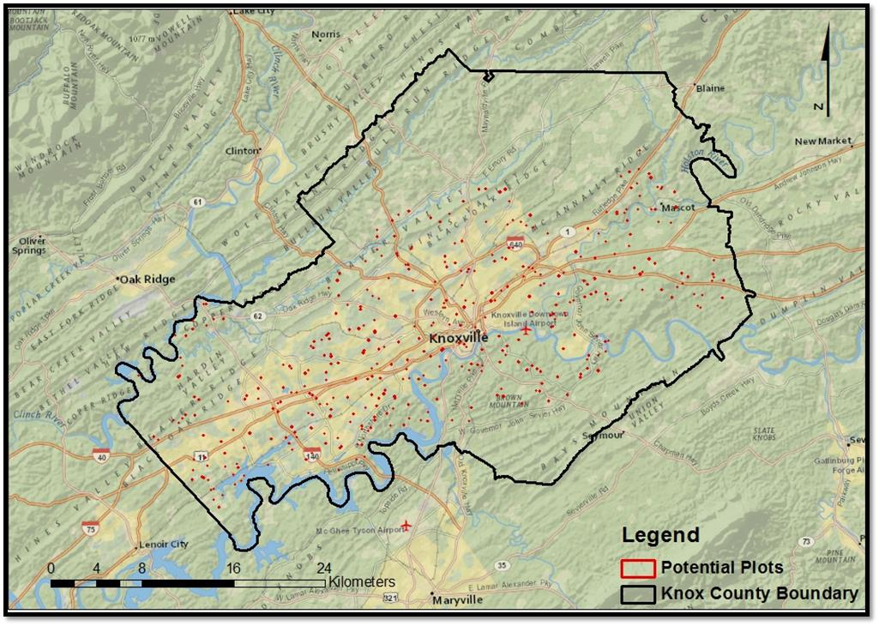
Figure A.1. Map with 423 potential sampling points in Knox, Co. Tennessee.

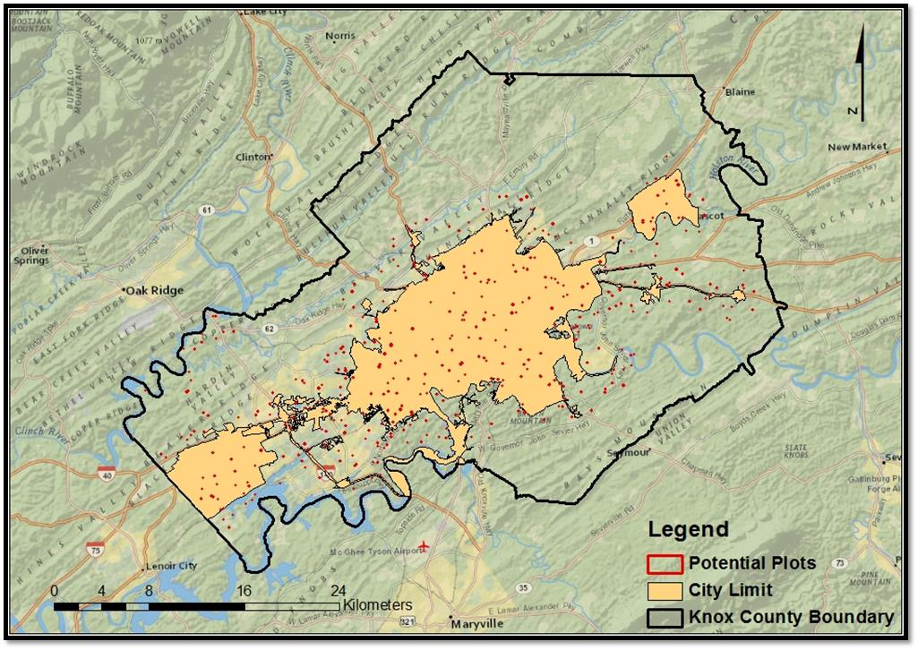
Figure A.2. Map with 423 potential sampling points in Knoxville city limit.
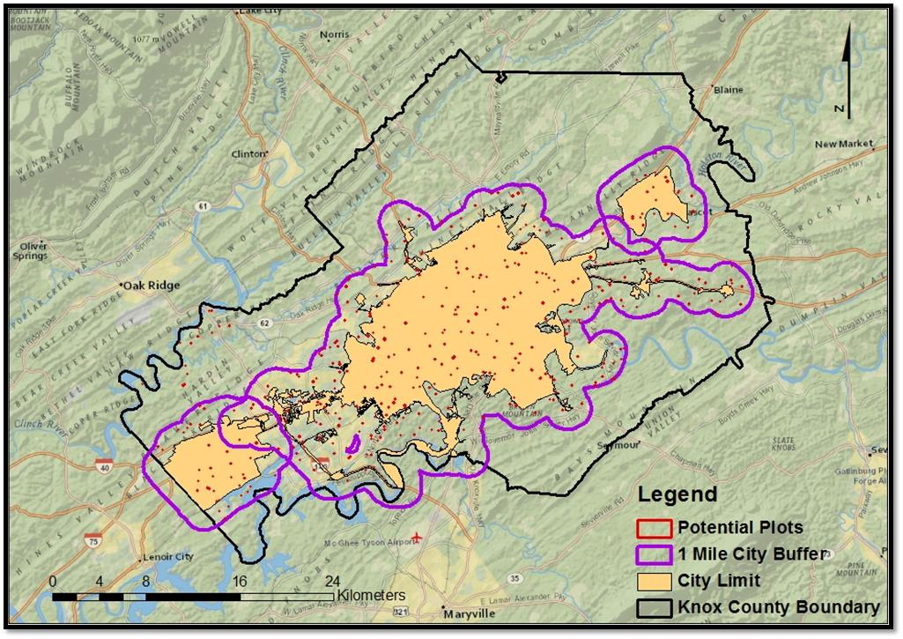
Figure A.3. Map with 423 potential sampling points in Knoxville city limits and one mile city buffer zone.
Identification of urban and rural plots
To identify potential urban and rural plots in Knox Co., using ArcGIS a boundary box was placed on top of the state of Tennessee. At both the northeast and southwest positions within the boundary box, two x, y coordinates were established and the difference between x₁ and x₂ / y₁ and y₂ was calculated with the equation Rand ()*differences + x₂ in Excel. Initially, approximately seventy-eight thousand potential sampling points were randomly generated in Excel. Once the points had been generated, the Excel file was exported to ArcGIS program (ArcMap10) to create a shape file. Initially, 78,000 tenth–acre sampling points were generated throughout the state of Tennessee. The city of Knoxville was isolated and demographic information such as race, age (median age), average family size, property owners versus renters, housing units occupied, families, farmland and average lot size was generated for each tenth- acre potential sampling point as well as urban and rural-residential areas within the established 1 mile buffer zone for the city. The city of Knoxville has a mean housing density of 1.07 residences per acre and median of 0.55 houses per acre (Cho et al., 2006). Urban boundaries were delineated from the initial 78,000 tenth–acre potential sampling points based on the USDA Forest Service, Forest Health and Monitoring (FMH) programs 2001 assessment of urban forest conditions. This assessment defined urban boundaries using the 2000 U.S. Census Bureau data (U.S. Department of Commerce, 2011). Following the FMH programs definition of urbanized areas 2918 tenth-acre potential sampling points landed within the urban boundary. There was total of 423 tenth-acre potential sampling points for the City of Knoxville selected based on areas with population densities ≥ 50,000 for Knox Co. Tennessee (Nowak et al., 2011).
The shape file (ArcMap 10) was exported to a KML file to visually accept or reject potential sampling points in Google Earth using imagery data from 2011 for the city of Knoxville. Guidelines for acceptance of potential sampling points included areas ≥ 1 acre forested or open field (non-agricultural) and residential properties only. Points that landed in commercial lands, government lands, on tops of buildings, in the water, on impervious cover (streets and parking lots), and within 100 feet buffer zone for any structure, where the edge of each 0.04-ha (0.10 acre) plot measured to ≥ 30.48 meters (100 feet) from any structure, were not used for inventory. After visually accepting or rejecting potential points there was a total of 180 potential points for Knoxville. Twenty-six, 0.04-ha residential (urban-to-rural) plots were established during May 2012 – August 2012. This plot size was chosen in order to capture sufficient tree data but to avoid multiple ownerships and has been used in other city wide inventories of urban forest (Stewart et al., 2004).
Site and species description of urban and rural plots
Our interests are in natural forest patches within residential areas, with minimal to no human interaction. Due to the topography difference in Knox co. which affect soil composition and water flow, we define our natural forest patches within residential areas into four quadrant (Fig 1: Q-I, Q-II, Q-III, Q-IV) forest communities using primary cardinal direction. The Upper Tennessee River flows from east (35.971856°, -83.654923°) to west (35.975663°, -84.195269°) through Knox co. Our twenty-six plots were stratified into four quadrants based on the flow of the Upper Tennessee River and difference in soil composition of the northeast (quadrant-1: 8 plots) mostly ridge tops and shoulders with a general soil material consisted of Corryton-Townley complex, having 5 to 12 percent slopes, with most areas cleared and used for hay, pasture, or cropland; southeast (quadrant-2: 5 plots) mostly shoulders, side slopes, and back-slopes with a general soil material consisted of Loyston-Talbott-Rock outcrop complex, having 15-50 percent slopes, mainly areas are in woodland and cleared areas are used as pasture of remain idle; southwest (quadrant-3: 6 plots) mostly shoulders, foot-slopes, toe-slopes, and side slopes with a general soil material consisted of Coghill-Corryton complex, having 5-25 percent slopes, mainly woodland consisting of mixed hardwoods and areas cleared for residential or commercial developments: northwest (quadrant-4: 7 plots) mostly shoulders, side slopes, and back-slopes with a general soil material consisted of Apison-Montevallo complex, having 35-75 percent slopes, most areas are in woodland consisting mainly of mixed hardwoods. All quadrants in the study are generally well drained.
To measure relative dominance of species in our 26 - 0.04 ha plots we utilized the Importance Value (IV) Calculation (Curtis and McIntosh, 1951; Kent and Coker, 1992). Importance values rank species within a site based upon three criteria 1) relative frequency (species occurrence), 2) relative density (total number of individual species) and 3) relative dominance (total amount of forest area occupied) (Curtis and McIntosh, 1951; Kent and Coker, 1992). Quadrants 1 and 4 contain a total of six open field plots which have not been in production within the past 10 years. Based on our importance value calculations we define 4 forest communities. Plots with multiple species within a genus were grouped and importance value calculations were average.

Identification of Knox Co. Property Owners
Owner information (names, addresses, and telephone numbers) was obtained by Tennessee Property Viewer, a digital property map and parcel database maintained by the KGIS**. Because most owners were not available during the day, contacting them entailed several steps: 1) letters were distributed with information about the study at each residence, 2) a follow-up phone call to the owner(s), and 3) upon receiving permission from an owner, meeting with them and conducting the inventory.
Urban-to-Rural Forest Inventory
Twenty-six – 0.04-hectare (0.10-acre) plots were inventoried along an urban-to-rural gradient in Knox Co., TN. Each plot, 11.35-meter (37.24 ft.) fixed –radius plot; where all trees ≥ 2.54 centimeters (1.0 inches) diameter at breast height (dbh), herbaceous plants and invasive were measured. To measure relative dominance of species for the 26 - 0.04 ha plots the Importance Value (IV) Calculation (Curtis and McIntosh, 1951; Kent and Coker, 1992) was utilized. Importance values rank species within a site based upon three criteria 1) relative frequency (species occurrence), 2) relative density (total number of individual species) and 3) relative dominance (total amount of forest area occupied) (Curtis and McIntosh, 1951; Kent and Coker, 1992). Quadrants 1 and 4 contain a total of six open field plots which have not been in production within the past 10 years. Based on our importance value calculations we define 4 forest communities. Plots with multiple species within a genus were grouped and importance value calculations were averaged
Urban-to-Rural Forest Soil Sampling
Soil samples were collected for each of the 26 – 0.04-hectar (0.10-acre) fixed-radius urban-to-rural gradient plots during June 2012, October 2012, February 2013, April 2013, June 2013, October 2013, February 2014 and April 2014 in Knoxville, Tennessee. Within each 11.35-meter (37.24 ft.) fixed-radius plot, 6 forest floor samples to the depth of 30.4 cm were extracted at random using a 2 cm diameter metal core. Mineral soil was removed if it was attached to the base of the forest floor core. The soil samples from each plot were placed in 25-μm thick polyethylene storage bags which were labeled with the plot number, season, date of soil extraction, and study location (Knox Co,). Next, the 6 samples for each plot were mixed in the field creating a single bulked/composite soil sample, placed in a cooler of ice and taken back to the University of Tennessee – Knoxville Urban Soil Laboratory for processing. After processing, soil subsamples from the heterogeneous mixture for each plot were used to determine soil physical, chemical and biological properties.
Soil Analysis
All soil samples were air dried for 2 days passed through a 250 µm (60 –mesh) sieve. Soil samples (heterogeneous mixture for each plot) were used to determine soil pH, gravimetric soil moisture (GSM), soil bulk density, cation exchange capacity (CEC), total soil elemental concentrations, soil microbial biomass C& N, and total soil organic carbon (TOC).
Soil pH
From each composite soil sample, weigh two soil subsample of 5.0 g – 10.0 g soil each and place into 50 mL centrifuge falcon tube. Record the date, time, plot number with replication letter, and the weight of fresh soil to the nearest 0.1 g for each sample in laboratory research notebook. Next, add deionized (DI) water to each sample at a 1:1 ration (5.0 g soil: 5.0 ml DI water) then place the 50 mL centrifuge falcon tube on a Glas-Col: Touch Vortexer to mix solution into a slurry. Next using a Denver Instrument Model 250 pH/ISE/conductivity meter with two calibration points, immerse the electrode into suspension within 50 mL centrifuge falcon tube. The Model 250 reads conductivity, salinity, resistivity and TDS, and automatically selects the correct range for the sample. Model 250 automatically recognizes 22 built-in buffer values with temperature correction. You can enter up to five custom buffers for auto-recognition or enter a buffer manually. The Model 250 automatically checks your electrode and will warn of any problems before the final results are affected. Select the graph function to obtain an on-screen view of your electrode calibration data, or output complete calibration data to a computer or printer. Allow an appropriate amount of time to pass before recording the measurement, this will permit stabilization of output data, then record to the nearest pH resolution of 0.01.
Gravimetric Soil Moisture
From each composite soil sample, weigh three soil subsamples of 10 g soil (fresh wt.) each into aluminum weigh boat. Each weigh boat is labeled with plot number and sample replication letter for identification (plot 1981-A, B, C). Record the date, time, plot number with replication letter, and the weight of fresh soil to the nearest 0.001 g for each sample in laboratory research notebook. Place the aluminum weigh boat containing the 10 g of soil into a ventilated drying oven, 105° C, for 24 hours uncovered. After the drying period, let aluminum weigh boat cool for 5 minutes. Weigh each sample immediately and record the oven-dry weight. To determine the oven-dry weight, weigh the aluminum boat with sample then again empty. Subtract the empty weight (boat) from the sample weight (boat with soil sample). To calculate the gravimetric soil moisture content for each sample use the equation:$θg= \frac{m-d}{d}$, where $m$ is the soil fresh weight (moist) mass prior to drying and $d$ is the dry soil mass of the same soil after the oven drying process. This will provide a value for moisture represented as a percent for each soil sample.
Bulk Density
Soil bulk density by the core method was used for soils samples collected October 14, 2013 – October 18, 2013 for all 26 plots. Soil bulk density $D_{b}=m_{s}/V_{t}$ is the ratio of the mass of oven-dried solids ($m_{s}$) to the bulk volume ($V_{t}$) of the soil, which include the volume of the solids and the pore space between the soil particles (Blake and Hartge, 1986) offers the opportunity to obtain $D_{b}$ information inexpensively and in a timely manner (Soil Survey Staff method 3B6a, 2004). Within each 11.35-meter (37.24 ft.) fixed-radius plot, six soil samples were collected (30.0 cm) randomly using a 2 cm diameter metal core. Soil core samples were measured with a cementer ruler to assure all samples extracted where the same length. Mineral soil was removed with a knife if it was attached to the base of the core. The soil samples from each plot were placed in 25-μm thick polyethylene storage bags which were labeled with the plot number, season, date of soil extraction, sampling procedure (bulk density) and study location (Knox Co.). Soil samples were mixed (6 cores per site) from each plot and the composite soil sample was stored until analyzed.

Cation Exchange Capacity (CEC)-NA Saturation Method pH 7

To measure cation exchange capacity of each soil sample, Chapman (1965) Na saturation method was adopted. Sodium acetate (NaOAc) was prepared by placing 136 g of NaOAc into a 1 L beaker and dissolved into 800 ml of deionized water. The solution was buffered with 10% acetic acid until the pH read 7.0. The solution was transferred to a 1 L volumetric flask and brought to volume (1 L) with deionized water. To prepare the ammonium acetate (NH₄Oac) solution, 77.08 g of NH₄Oac was placed into a 1 L beaker and dissolved into 800 milliliters of deionized water. Afterwards, the solution was transferred to a 1 L volumetric flask and brought to volume (1 L) with deionized water.
Five grams of soil were weighed into 50 ml centrifuge tubes. To each sample, 30 ml of the pH 7 1M NaOAc solution was added. The tubes were capped and placed on a shaker for 5 minutes. After shaking, the tubes were transferred to a centrifuge where they were centrifuged at 4000 rpm (rotations per minute) for 4 minutes. The tubes were removed and the clear supernatant was discarded. Thirty ml of pH 7 1M NaOAc was added again to each tube. The tubes were capped and the soil was stirred using a vortex mixer. Next, the tubes were set on the shaker for 5 minutes and transferred again to the centrifuge for the same rate and time as the previous step. The tubes were removed from the centrifuge and the supernatant was discarded. This step was repeated two more times. Samples were then centrifuged and washed three times with 30 ml of 95% ethanol in each tube. Following each wash, the ethanol was discarded. Thirty ml of 1 M NH₄Oac added was added to each tube. Tubes were capped and stirred with a vortex mixer until the soil was re-suspended. The samples were placed on a shaker for 5 minutes and centrifuged for 4 minutes at 4000 rpm. The clear supernatant was decanted into 100 ml volumetric flasks. This step was repeated three times. Lastly, the volumetric flasks were then brought to volume with pH 7 1M NH₄Oac and stored in 15 ml centrifuge tubes in a refrigerator until ICP analysis.
Simultaneous Chloroform Fumigation Slurry-Extraction (sCFE)

Soil microbial biomass Carbon and Nitrogen was determined by using an adaptation of the Chloroform Fumigation Extraction “slurry” Method (sCFE) proposed by Fierer (2003).
From each soil sample, two 5 g subsamples of sieved soil were weighed out into 250ml Pyrex No.1395 glass bottles, one fumigated (with chloroform) and one un-fumigated (without chloroform). 40ml of 2 M KCl were added to each sample. To one sample 0.5 ml of ethanol-free chloroform was added. Both the chloroform exposed and control samples were sealed with chloroform resistant screw caps and placed on orbital shaker for 4 hours at 150 rev/min. Following shaking, the slurry was allowed to settle for 10 minutes, and 20 – 30 ml of extract from the top was decanted. By decanting only the top portion, the chloroform that concentrated at the bottom of the bottle was avoided. The extracts were then filtered through Whatman No. 1 filter paper using glass funnels in 50 ml Erlenmeyer flasks. Extracts were bubbled with air through rubber tubes using glass tips for 30 minutes. Extracts were then transferred to 50ml Falcon tubes and frozen until analysis. Samples then were thawed and transferred to glass tubes. A standard curve was made then the bottles were sent to be analyzed for total carbon (TC) and total nitrogen (TN).
From each extract, total carbon (TC) and total nitrogen (TN) were determined. TC was analyzed by a TOC-VCPH SHIMADZU analyzer with a 0.1ppm detection limit. The machine first flushed 150 ml/min of carrier gas (purified air) through a TC combustion tube which was heated to 680˚C. After the injection, the TC in the sample was then oxidized and decomposed into the form of carbon dioxide. The carrier gas along with the products of the combustion were then cooled and dehumidified. The products were then passed through a non-dispersive infrared detector (NDIR) sample cell that detects carbon dioxide. The NDIR analog signal then peaks and the data processor calculated the peak area detected. The TC concentration was then determined by relating the measured peak to the calibration curve made by a known, predetermined TC standard solution. Microbial biomass carbon (MBC) was calculated by the following equation: Microbial C – EC/kEC, whereas, the chloroform-labile pool (EC) is the difference between the fumigated and non-fumigated extracts and kEC is the soil-specific constant at 0.45 (Beck et al, 1997). Extractable organic carbon (EOC), was measured from the non-chloroform exposed extracts and total labile carbon (TLC) was determined by add MBC and EOC (MBC + EOC = TLC). All three measurements (MBC, EOC, and TLC) were used to test hypothesis three under the second objective.
Total nitrogen (TN), was determined by using a TNM-1 SHIMADZU analyzer with a 0.1ppm detection limit. Again, carrier gas was used to flow into a combustion tube at a rate of 150 ml/min and then heated to 720˚C with the use of a catalyst. After thermal decomposition had taken place, the TN was measured from the nitrogen monoxide product which was detected by the chemiluminescence detector. A standard calibration curve was used to determine the TN by expressing the measured peak and the standard curve peak as a ratio. Microbial biomass N was then determined by the following equation: Microbial N = EN/kEN. The EN represents the difference between the fumigated and non-fumigated extracts, and the kEN is the soil specific constant estimated at 0.54 (Brookes et al., 1985). Extractable organic nitrogen (EON), was measured from the non-chloroform exposed extracts and total labile nitrogen (TLN) was determined by add MBN and EON (MBN + EON = TLN).

Acid Digestion for Total Elemental Analysis
A hydrofluoric acid microwave digestion developed by Nadkarni (1984) was used to measure total elemental concentrations. Each soil sample was done in triplicate. For each sample, 0.2 grams of air dried sieved soil was weighed out into polyallomar centrifuge tubes with caps. Then, 2 ml of reagent grade hydrofluoric acid (HF) was added to each sample and allowed to sit in fume hood overnight (at least 16 hours). Next, 5 ml of aqua-regia (3:1:1 mixture of reagent grade hydrochloric acid (HCL), reagent grade nitric acid, and deionized water) was added to each sample and mixed with a vortex. The tubes (12-18) were then placed in a Tappen 800 watt microwave oven for 3 minutes at 80% power with two beakers of deionized water present in the microwave. The tubes were then removed from the microwave and allowed to cool. Approximately 1 gram of reagent grade boric acid was then added to each sample and mixed with a vortex. Tubes were then returned to the microwave for 10 minutes at 20% power. Tubes were mixed with a vortex while still warm in order to dissolve as much boric acid as possible. After the tubes were cool, they then were rinsed into 100 ml volumetric flasks with deionized water and then brought to volume. Flasks were then parafilmed and inverted to insure proper mixing. The solution was then filtered through Whatman No. 1 paper into 15 ml centrifuge tubes (around 13-15 ml). The samples were then stored in a refrigerator until the ICP analysis.
Experimental Design
This project utilized a Randomized Complete Block Design (RCBD) with replication and repeated measures as the overall experiment and treatment design. Measurements and observations occurred from summer 2012 through the winter 2014 calendar years; years were blocked upon as differences were expected. Twenty-six randomly identified experimental plots were established along an urban-rural gradient, each 0.1 acres in size, around Knoxville, TN. Six randomly collected soil cores were taken within each plot to produce one sample. These samples were repeatedly taken for each season (spring, summer, fall, and winter). Unable to randomize on season, repeated measures was required. 2 Blocks * 2 Treatments * 26 Replications * 4 Seasons = 416 observations

Statistical Analysis
Woody vegetation diversity indices including importance values, total number of species (S), differences between tree species diversity by the Shannon diversity index (H´) were calculated for the forest stand at each plot.
Shannon diversity index (1949) H´ as: $H´=-\sum_{i=1}^{S*}{{Pᵢ}^{\left(lnPᵢ\right)}}$
Where H´ is the average uncertainty per species in an infinite community made up of S* = number of species and, Pᵢ is the fraction of the entire population made up of species i (Shannon and Weaver, 1949). H_{max} was calculated as the natural log of the total number of species sampled in each plot (Ludwig and Reynolds, 1988).
Measures of forest structure, species frequency ($f_{i}$), density ($D_{i}$), basal area (${Do}_{i}$), and average dbh were calculated in Microsoft Excel for each plot to obtain species importance value (IV ₃₀₀).
Frequency: divide the number of plots in which a given species is found by the total number of plots sampled and given by $f_{i}= j_{i}/k$
Where $f_{i}$ is the percentage of plots occupied by a given species, $j_{i}$ is the number of sampling points at which the species was counted, and $k$ indicates the total number of points sampled.
Density: divide the total number of individuals tallied for a given species by the total area of all measured plots (in acres or hectares) to give number of trees per acre or hectare for each species and given by $D_{i}= n_{i}/a_{i}$
Where $D_{i}$ the density for a given species, $n_{i}$ is the total number of individuals sampled for that species, and $a_{i}$ is the sum of the basal areas for a species.
Dominance (Basal Area): sum the basal area (computed from DBH) of each tree of a species (from all plots) and divide by the total area of all measured plots (= in ft2 per acre or m2 per hectare) and given by ${Do}_{i}=(a_{i})(D_{i})/n_{i}$
Where ${Do}_{i}$ the proportion of the ground is occupied by a given species, $a_{i}$ is the sum of the basal areas for a species, $D_{i}$ is the density of a species, and $n_{i}$ is the total number of individuals sampled for that species.
Tree Basal Area:
stem dbh (in) * dbh (in) * 0.005454 = BA in ft2 per tree
stem dbh (cm) * dbh (cm) * 0.00007854 = BA in m2 per tree.
Relative Frequency: number of occurrences of one species as a percentage of the total number of occurrences of all species and given by ${Rf}_{i}= f_{i}/\sum{f}$
Where ($Rf$) is the frequency of a given species ($f_{i}$) as a proportion of the sum of the frequencies for all species ($\sum{f}$)
Relative Density: Divide the density of each individual species by the sum of the densities of all of the species and multiply by 100 to obtain the Relative Density for each species.
Relative Dominance: Divide the total basal area of each individual species by the sum of the basal areas of all of the species and multiply by 100 to obtain the Relative Dominance for each species.
Importance Value: Add together the Relative Frequency, Relative Density, and Relative Dominance for each species to obtain the Importance Value for each species. (Note: The maximum importance value for any one species is 300 (100 + 100 + 100). After calculations are complete species can be ranker from high to low for comparison with other sites
Importance value calculation (1951) IV ₃₀₀ as: IV ₃₀₀ = (R) + (RD) + (RDo)
A Pearson’s two-tailed correlation coefficient in SPSS 21 was used to determine what soil biological, chemical and physical properties were correlated with microbial biomass carbon (MBC) and microbial biomass nitrogen (MBN) in the urban soils along an urban-to-rural gradient (IBM Corp. Released 2012).

VITA
Benjamin Lee Reichert was born in 1978 in the city of Bloomington, Minnesota. He grew up in Oak Grove, Minnesota where he graduated from Saint Frances High School in 1997. He began his undergraduate studies at the University of Tennessee in 2006, where he studied Forestry. In December 2011 he received his Bachelor of Science degree in Forestry Resource Management and decided to pursue a graduate education in Forestry.
In the summer of 2012, Benjamin began his Master’s in Forestry under Dr. Sharon Jean-Philippe. His thesis research was focused on studying tree diversity and soil properties along an urban-to-rural gradient in Knoxville, Tennessee.

