

The Effect of Ethanol Consumption and Stress on Brain Derived Neurotrophic Factor and Tropomyosin Receptor Kinase B Expression.

Katie Masters

Chancellor’s Honors Program Thesis
Faculty Mentor: Dr. Rebecca Prosser
Graduate Student Mentors: Jonathon Lindsay and Alex Grizzell

- Abstract
According to the National Center for PTSD (http://www.ptsd.va.gov/), 7-8 out of every 100 people will experience post-traumatic stress disorder (PTSD) at some point in their lives. Many individuals with PTSD self-medicate with alcohol. Our experiments have found that ethanol consumption for 1 week prior to an acute social defeat (an animal model for PTSD) significantly increases stress susceptibility in mice compared to mice not consuming ethanol. In this study, we investigated the combined effects of stress and ethanol on the expression of brain derived neurotrophic factor (BDNF) and its receptor, tropomyosin receptor kinase B (TrkB). BDNF and TrkB are components of the signaling pathways that mediate stress- and alcohol-induced changes in the Nucleus Accumbens (NAc), ventral tegmental area (VTA) and amygdala. We hypothesized that stress + ethanol increases BDNF and TrkB expression in these brain regions above levels in control mice and mice exposed to only stress or ethanol. We collected tissue from the NAc and amygdala in mice treated as above to determine BDNF and TrkB protein expression levels using Western blots. Preliminary results in the NAc (n=4) showed that the expression of proBDNF was modulated by acute EtOH consumption, mBDNF was modulated by stress, and Trk B did not have a significant difference in expression due to acute EtOH consumption or acute stress. Results from the amygdala (n=3) showed that proBDNF was modulated by acute stress. There was not a significant difference in TrkB or mBDNF expression due to acute EtOH consumption or acute stress. Understanding the neural mechanisms related to stress conditions, such as PTSD, and alcohol will advance how conditions, such as PTSD, are understood and treated.

- Introduction
Stress is an unavoidable component of life. A major question in investigations assessing stress- induced behavior is what factors contribute to determining whether one is stress resilient or stress susceptible. Individuals who are considered “resilient” to stress exhibit traits such as cognitive flexibility and regulation of their emotions (Yehuda et al 2006). Being susceptible to stress may increase the likelihood of developing conditions such as post-traumatic stress disorder (PTSD) or depression. For those susceptible, stress can become debilitating to the point that afflicted individuals find daily functions difficult. Symptoms related to cardiovascular diseases, respiratory disease, chronic pain conditions, and gastrointestinal illnesses are other examples of the consequences of stress (Sareen et al. 2007). Individuals with stress associated with PTSD also exhibit avoidance behaviors to escape recollections related to the trauma (Yehuda et al. 2006). A common mechanism used by those with PTSD is to self-medicate with alcohol to relieve stress (Leeies et al. 2006).
The degree to which alcohol alleviates or exacerbates the neural mechanism underlying PTSD are not clear. Social defeat in mice has been confirmed as a suitable model of social stress for diseases such as PTSD and depression (Martinez et al., 1998). Avoidance behaviors displayed in mice exposed to chronic social defeat have been shown to be dependent on brain derived neurotrophic factor (BDNF) signaling in the mesolimbic dopamine circuit. Part of this circuit is formed by the nucleus accumbens (NAc), ventral tegmental area (VTA) and amygdala, as illustrated in Figure 1. Increased NAc BDNF protein expression is modulated by activity-dependent BDNF release from VTA dopamine neurons (Krishnan et al. 2007). The NAc is the region of the brain known for reward-seeking and motivation (Volman et al. 2013).
The amygdala is a region of the brain responsible for processing of emotions such as fear, anger and pleasure. Elevated basolateral amygdala BDNF levels has been determined as a key factor that corresponds to the level of conditioned fear response a mouse displays (Chou et al. 2014). The output from the amygdala sends information to the hypothalamus, thalamus, reticular formation and hippocampus, which modify behaviors related to seeking rewards and avoiding punishment (Purves et al. 2001).
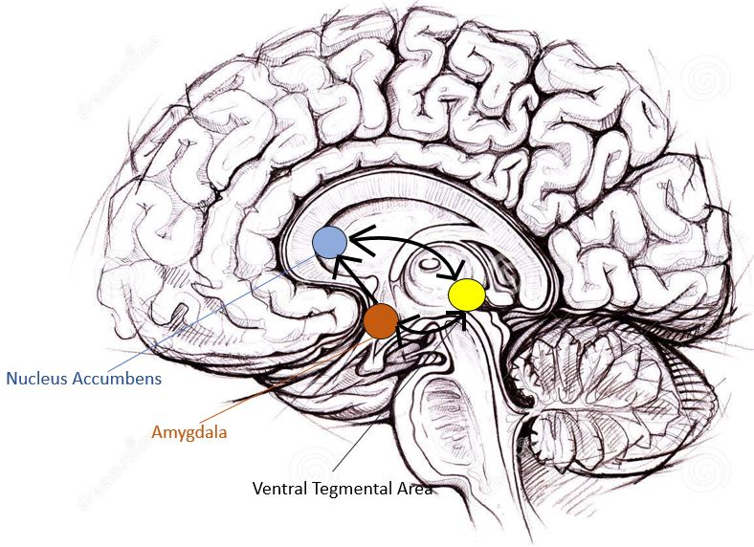

Figure 1: Part of the mesolimbic dopamine circuit is formed by projections from the ventral tegmental area (VTA) to the amygdala and nucleus accumbens. Modified image from Alena Hovorkova (2017).
Many studies have focused on the molecular components that are modulated due to ethanol (EtOH) consumption. Chronic self-administration of EtOH administration results in decreased BDNF mRNA levels in the NAc and amygdala. However, chronic self-administration of EtOH increases BDNF mRNA levels in the VTA (Raivio et al. 2012). BDNF and its signaling pathway have been proposed as a mechanism that alters the function of neurons within the VTA-NAc circuit to affect motivations to take drugs, such as EtOH (Russo et al. 2008). A form of synaptic modulation seen during chronic EtOH consumption is long-term potentiation (LTP). LTP is a long-lasting increase in synaptic transmission that includes increased neuronal growth and survival. Long-term depression (LTD) is an opposing form of synaptic modulation, which includes reduced efficacy of neuronal synapses. These two processes underlie changes in synaptic functions referred to as synaptic plasticity (Purves et al 2001). Previous studies indicate that drugs of abuse capable of changing behavior generate both LTP and LTD-like changes in synaptic plasticity in brain reward circuits. (Niehaus et al. 2009).
The research summarized here indicates that BDNF signaling has been identified as a molecular component that is modulated by both social defeat and ethanol consumption. This protein is translated as a precursor protein, proBDNF, and then proteolytically cleaved into mature BDNF, as illustrated in Figure 2 (Borodinova et al. 2016). The mature molecule can then bind and activate its receptor, tropomyosin receptor kinase B (TrkB). TrkB is a single transmembrane- spanning protein. This receptor homodimerizes in response to ligand binding, which leds to activation of various signaling cascades. Full TrkB is translated and then cleaved into truncated TrkB. These forms induce different modes of dendritic growth. Full-length TrkB induces short dendritic branches that are added to regions proximal to the soma, or cell body of a neuron, and truncated TrkB induces the addition of dendrites in regions distal to the soma. Each form of TrkB contributes to the regulation of neuronal growth (Yacoubian et al. 2000). Full-length TrkB activation regulates many factors, such as phosphoinositide 3-kinase (PI3K), mitogen-activated protein kinase (MAPK), and phospholipase C (PLC). These signaling cascades participate in vital functions such as LTP as well as neuronal survival, growth, differentiation and structure (Russo et al. 2008).
In contrast to mBDNF, the precursor protein, proBDNF is involved in functions opposing those of mBDNF. ProBDNF binds to p75 neurotrophin receptors (p75^{NTR}), which participate in the induction of LTD. The proposed mechanism underlying this is through the regulation of the NR2B subunit N-methyl-D- aspartate (NMDA) receptors. When proBDNF binds to p75^{NTR}, activity-dependent signals promote LTD (Lu et al. 2005).
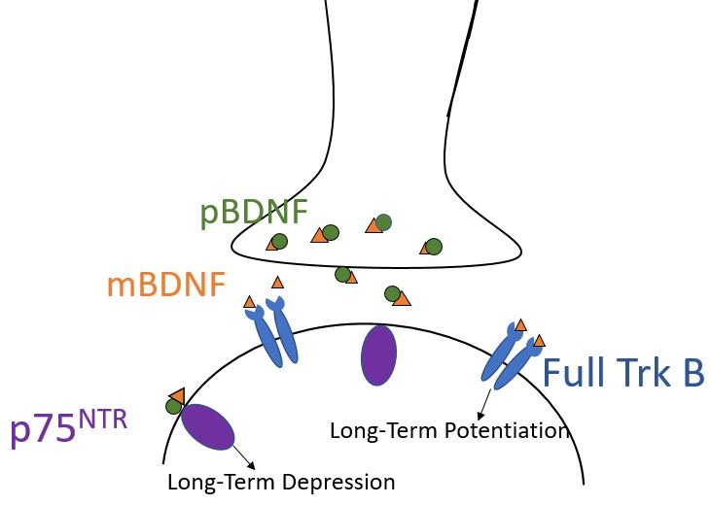
Figure 2: Diagram illustrating molecular relationships between proBDNF and, mBDNF and Trk B. proBDNF is translated and then either binds to p75^{NTR} or is proteolytically cleaved into mBDNF. mBDNF then binds and activates Full Trk B, which homodimerizes and phosphorylates signaling cascades that led to LTP.
We have been investigating the behavioral effects of acute stress and short-term alcohol (ethanol) self-administration. Specifically, we are interested in the interaction between these two variables and their effect on activity-dependent signaling in the brain. Mice were randomly assigned to 4 experimental groups: EtOH + social defeat, EtOH + no social defeat, water + social defeat and water + no social defeat. Each mouse then underwent a social interaction test (as detailed in methods) to determine whether they were stress resilient or stress susceptible (Grizzell et al. 2016). As shown in Figure 3, 81.25% of the water-consuming mice exposed to social defeat exhibited resiliency and 18.75% exhibited stress susceptibility (social avoidance). However, in the EtOH-consuming mice exposed to social defeat, all the mice displayed stress susceptibility and none were resilient. These results suggest that consuming alcohol prior to experiencing acute stress does not alleviate, but increases avoidance behaviors. Based on this information, we hypothesized that there would be highest levels of mature BDNF and full-length Trk B expression in the NAc of mice exposed to EtOH consumption and social defeat versus mice in the other experimental groups.

Figure 3: Percentage of resilient versus susceptible mice determined by Social Interaction Test following variables set for each experimental group. The group that had both ethanol consumption and social defeat displayed 100% susceptibility (n= 24).

- Materials and Methods

- Subjects

The subjects for this experiment were adult male C57Bl6 mice. Mice were individually housed in a 1AM to 1PM, 12:12 light-dark cycle. All experiments were performed meeting the IACUC standards. Mice were randomly assigned to 4 experimental groups: EtOH + acute stress, EtOH + no stress, water + acute stress and water + no stress.
- Drinking paradigm

We used the drinking-in the dark (DID) paradigm, an established and reliable animal model of binge-like ethanol drinking (Thiele et al. 2014). Mice were allowed access to 15% ethanol/ water solutions for 7 consecutive days. Ethanol access, which involved exchanging their water bottle with one that contained 15% EtOH, occurred during the first four-hour period of the dark phase of the 24- hour light cycle. This time interval was chosen because mice drink the most during the early night period (Brager et al. 2010). In water control mice, the water bottle was exchanged during that same 4-hour period with another water bottle.
- Social Defeat
One day following completion of the 7-day DID paradigm (or drinking water for controls), the mice underwent either social defeat at the beginning of lights out (or no defeat for controls). Social defeat involved placing a C57 mouse consecutively into the cages of 3 individual CD1 mice that had been prescreened for aggression (Tsankova et al. 2006). The mouse was placed in each aggressor mouse cage for 2 minutes with 2-minute breaks in between. After the defeats were completed the mice were returned to their home cage and were given access to ethanol or water as described above. The mice not exposed to social defeat were placed in an empty cage where a CD1 mouse had been housed.
d) Social Interaction Test
The social interaction test (SIT) was conducted on day 9, 1 day following social defeat. Each mouse was placed in a white plastic open 43.2 cm³ field and a video tracking system (Noldus Ethovision) was used to score approach-avoidance behaviors of the C57 mice towards an unfamiliar social target.
Trial 2:
W/ a Social Target
5 mins
Trial 1:
No Social Target
5 mins

Figure 4: For trial 1, mouse was placed in open field (43.2 cm³) with empty cube. In trial 2, a C57 mouse was placed in the cube, and the mouse was placed in the open field. A 3.5 cm perimeter was monitored to track interaction ratio between the trials.
In the first trial, the mouse was placed in the open field containing an empty 7 cm² plastic cube located on one side of the field for 5 minutes. The mouse was then removed from the open field. During the second trial, the mouse was placed in the open field for 5 minutes with the same plastic cube, but a social target C57 mouse placed within the cube (Berton et al.). The system tracked how many times the mouse entered the interaction zone around the cube. The interaction zone was set at 3.5 cm from each side of the cube. The time spent in the interaction zone in trial 2 was divided by the time spent in the interaction zone in trial 1. If the interaction zone ratio was above 1, the mouse was considered stress-resilient. If the interaction zone ratio was below 1, the mouse was considered stress-susceptible. 24 hours after the SIT was conducted, the mice were euthanized and 1 mm tissue punches were taken from the NAc and amygdala. The tissue was stored at -80 °C until the tissue was processed for western blotting.
e) Western Blotting
To prepare the tissue for western blotting, a lysis buffer consisting of protease inhibitor, phosphate inhibitor, radioimmunoprecipitation assay (RIPA) buffer, dithiothreitol (DTT), sodium dodecyl sulfate (SDS) and glycerol were mixed. This mixture begins the process of lysing the tissue. Tissue punches were placed on ice and 10 µL of lysis buffer was added per tissue punch. Next, samples were homogenized, centrifuged and the supernatant was collected. A Bradford protein assay was used to determine protein concentration for each sample. Using the results from the Bradford assay, tissues samples were diluted with loading dye to standardize protein concentration. Samples were then boiled for 5 minutes to further denature the proteins. After extraction was completed, the samples were loaded into a 4-12% gradient SDS gel and electrophoresis was used to separate the proteins based on molecular weight. A protein ladder was included in one lane of the gel to monitor protein separation during electrophoresis and verify protein weights during analysis. Proteins were then transferred to a polyvinylidene fluoride (PVDF) membrane using the Transblot Turbo Blotting System. Membranes were incubated in 5% milk in tris-buffered saline with tween (TBST) for 1 hour to block non-specific binding of primary antibodies to non-target proteins on the membrane. After that the blot was incubated in 2% milk in tris-buffered saline (TBS) plus primary antibodies for TrkB, BDNF or actin (Santa Cruz Biotech.). After 3x5 minute washes in TBS, the blot was incubated with secondary antibodies (LiCOR; 700 and 800 nm fluorescent wavelengths) for 1 hour. Antibody dilutions are listed in Table 1. The blot was imaged using a LiCOR Odyssey CLx imaging system. The pixel density of each protein band was quantified with ImageJ (NIH). Values were normalized to actin loading controls and expressed as relative protein levels.
Table 1. Proteins of interest, respective antibodies and dilutions used.
Primary Antibody Protein of interest | Optimized Primary Dilution | Secondary Antibody type | Optimized secondary Dilution
Trk B [794] sc-12 Santa Cruz | 1:200 | α- rabbit | 1:10,000
BDNF [794] sc-12 Santa Cruz | 1:200 | α- rabbit | 1:10,000
Actin Santa Cruz | 1:2,000 | α- rabbit | 1:10,000

- Results
After seeing such a drastic difference in the behavioral results (Figure 3), we wanted to take a closer look at how the variables were modulating protein expression. We were particularly interested in understanding cellular changes associated with EtOH consumption and social defeat that lead to our results in figure 3. We first compared the effects of EtOH and social defeat with respect to proBDNF, mBDNF, and full TrkB expression in the NAc. As shown in figure 5A for the western blots, proBDNF and mBDNF separate into distinct bands of 32 kDa and 14 kDa, respectively. TrkB forms a band at 140 kDa. When analyzed using a 2-way ANOVA, mice that consumed EtOH had a significant decrease in proBDNF expression in the NAc (72.19 ± 8.64; p=0.0262 n= 4, Figure 5B), but showed no changes with respect to social defeat. Total expression levels for mBDNF in the NAc showed a significant increase for social defeat compared to no stress controls (176.93 ± 14.23; p= 0.004, n=4, Figure 5B). EtOH consumption did not cause a significant change in mBDNF in the NAc. No significant changes were seen in TrkB expression in the NAc (Figure 5B).
We next set the raw score for band densities of mBDNF and proBDNF as a ratio of one another. This will determine whether proteolytic cleavage of proBDNF to mBDNF is promoted in any of the conditions. Using a 2-way ANOVA, the ratio of mBDNF/ proBDNF expression in the NAc was greater for social defeat compared to no social defeat (p= 0.0058, Figure 6). Further analysis, using Tukey’s least significant difference test, showed a significant difference in the group exposed to both EtOH and social defeat (3.03 ± 0.65; p=0.0109 n=4) compared to the control.
We also assessed changes caused by social defeat and EtOH in the amygdala. Western blots of the amygdala tissue in the different experimental groups are shown in Figure 7A. Significant decreases in proBDNF expression occurred for groups exposed to social defeat compared to no social defeat controls (88.33 ± 8.64; p=0.025 Figure 7B). No significant changes were noted for mBDNF in the amygdala. For TrkB expression, the Shapiro- Wilks normality test was failed, which indicates the data did not have a normal distribution (p< 0.05 Figure 7B). This is most likely due to the small sample size for the amygdala (n=3). There was no significant different in the mBDNF/ proBDNF ratio in the amygdala.

A.)
EtOH - - + +
Social Defeat - + - +

1.)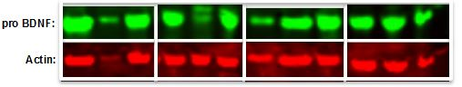
2.)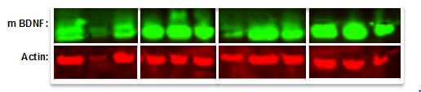
3.)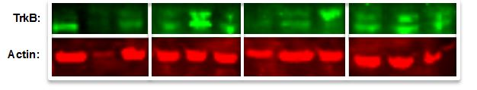
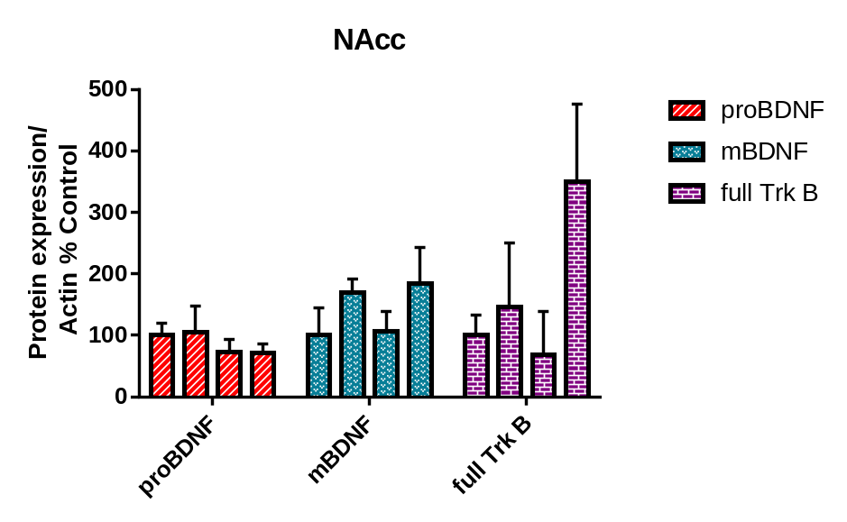
B.)
EtOH - - + + - - + + - - + +
Social Defeat - + - + - + - + - + - +
*
*
†
*
Figure 5: A.) Western blots from NAc tissue showing actin (42 kDa) together with 1.) proBDNF (32 kDA) 2.) mBDNF (14 kDA) 3.) full Trk B (140 kDA) Bands are grouped based on conditions as indicated by the box. B.) Total protein expression of proteins in NAc across experimental groups measured using western blots. Y-axis indicates total protein expression levels of protein normalized to actin relative to control. X-axis indicates use of either EtOH or social defeat experimental conditions. EtOH decreased proBDNF expression when compared to groups with no EtOH. Total expression of mBDNF expression significantly increased in experimental groups exposed to social defeat. Total expression of TrkB in NAc showed no significant differences, but there was a trend (p=0.139) towards increased expression in the EtOH+ social defeat group. Significance was calculated using two-way ANOVA (* indicates significant difference compared to non-stressed mice, with p=value <0.05, † indicates a trend towards significance.)

*
*
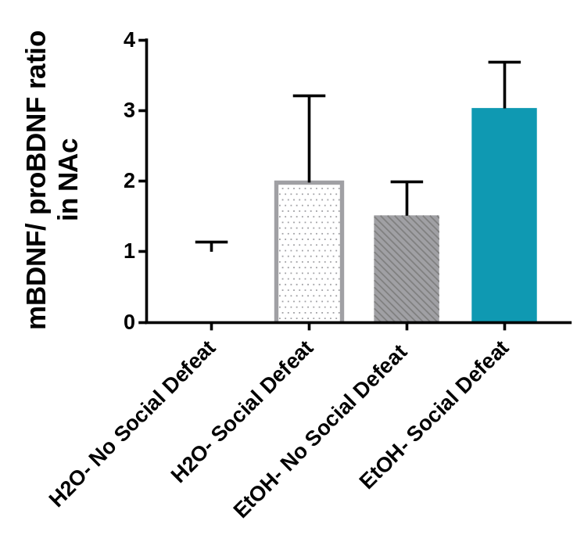
EtOH - - + +
Social Defeat - + - +
Figure 6: Ratio of mBDNF to proBDNF in the nucleus accumbens. The y-axis represents raw scores of band densities set as a ratio of mBDNF to proBDNF relative to the control condition. Experimental groups indicated by +/- signs in the x-axis. Single asterisk indicates significant difference in groups exposed to social defeat vs. non-stressed controls (two-way ANOVA). Double asterisks indicate significant difference compared to control (Tukey’s LSD test).

*
*

EtOH - - + +
Social Defeat - + - +
A.)
1.)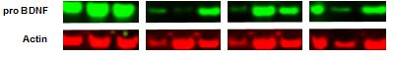
2.)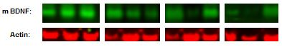
3.)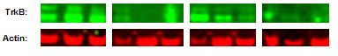
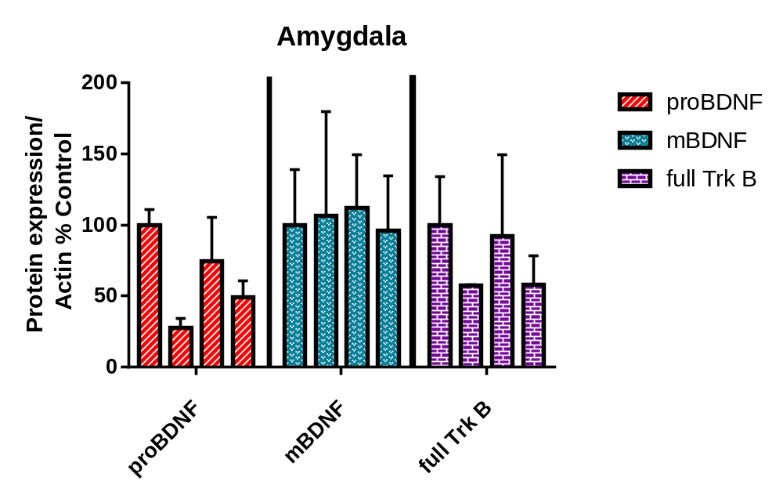
*
*
B.)
EtOH - - + + - - + + - - + +
Social Defeat - + - + - + - + - + - +
Figure 7: A.) Western bands for protein from amygdala compared to Actin (42 kDA) 1.) proBDNF (32 kDA) 2.) mBDNF (14 kDA) 3.) full Trk B (140 kDA). ANOVA test of total protein expression in amygdala across experimental groups was significant only for proBDNF (p<0.05). Social defeat decreased proBDNF expression when compared to groups with no social defeat (p= 0.025). mBDNF expression showed no significant difference. Expression of full TrkB in amygdala showed no significant difference and the normality test indicated that the data did not have a normal distribution (Shapiro-Wilk Normality test; p<0.050).
- Discussion
The focus of this experiment was to understand the neural mechanisms that contributed to the 100% susceptibility to stress previously seen in mice exposed to a combination of EtOH and social defeat (Figure 3). Specifically, we set out to quantify the expression of proBDNF, mBDNF and TrkB in response to administration of stress, EtOH or stress and EtOH. We hypothesized that the combination of short-term EtOH consumption and acute stress would increase mBDNF and full TrkB expression in the NAc above levels in control mice and mice exposed to only stress or ethanol.
Our results show that mice exposed to short-term EtOH consumption express lower levels of proBDNF in the NAc when compared to water only to mice. This suggests that within the NAc, EtOH consumption decreases signaling mechanisms that generate long-term depression (Figure 2 and 5). Conversely, mBDNF expression was increased in the groups exposed to social defeat regardless of EtOH exposure. This finding parallels previous studies suggesting increased BDNF expression as a molecular marker of stress susceptibility (Krishnan et al. 2007). Importantly, our results determined that the combination of EtOH + social defeat significantly increased the mBDNF/proBDNF ratio in the NAc compared to control (non-defeated, no EtOH) mice. This result suggests that the combination of EtOH and stress leds to increased proteolytic cleavage of proBDNF into mBDNF, which could enhance TrkB signaling and increase induction of LTP. Our results assessing full length TrkB suggest a trend towards increased expression in mice exposed to EtOH + social defeat compared to controls. If this trend is confirmed after increasing sample size, this result would further validate our hypothesis indicating an increase in TrkB signaling in response to EtOH and acute social defeat. Thus, increases in total protein expression of TrkB receptors together with higher mBDNF, lower proBDNF are consistent with the induction of LTP, which causes a strengthening of synaptic signals in the NAc.
The intent of this study was to determine the interaction between short-term EtOH consumption and acute stress, and how this interaction affects BDNF and TrkB expression levels. The NAc is known for its reward-seeking role within the mesolimbic dopamine circuit. The results from the NAc showed that proBDNF expression was modulated by EtOH consumption, mBDNF expression was modulated by social defeat, and full Trk B showed a trending increase in response to EtOH + social defeat. If this trend is confirmed, it suggests that enhanced susceptibility seen in mice exposed to EtOH + stress could be due in part to increased BDNF/ TrkB signaling in the NAc. Our results so far give us a correlation between acute EtOH consumption and acute stress and increased stress susceptibility. Future experiments could focus on confirming a causal relationship by blocking urokinase-type plasminogen activator (uPA) with doxycycline or tissue-type plasminogen activator (tPA) with small interfering RNAs (siRNAs). These extracellular proteases cleave proBDNF into mBDNF (Bahi et al. 2007), so we could assess whether inhibiting mBDNF production prevents the increase in susceptibility. Another way to confirm a causal relationship would be to block activation of TrkB with α₂- Macroglobulin (Hu et al. 1998.) and see if that prevents the EtOH + social defeat-induced increase in susceptibility.
The results for the amygdala showed significantly lower levels of proBDNF expression in mice exposed to social defeat compared to no stress cohorts, but no changes occurred in mBDNF protein expression. The ratio of mBDNF to proBDNF also showed no difference. This result was somewhat surprising considering the lower level of proBDNF results seen here and other studies showing increases in mBDNF after social defeat in the amygdala (Dulka et al. 2016). Having less proBDNF implies a shift towards LTP versus LTD. With a larger sample size, it will be interesting to see if and how full TrkB expression is modulated. There was not a significant difference in mBDNF/proBDNF ratio for the amygdala.
The amygdala is known for its role in processing emotions related to fear, anger and pleasure. The results for proBDNF indicated that experiencing acute stress caused a decrease in total expression for both proteins. There was not a significant change in mBDNF. Not having a change in mBDNF expression in the amygdala could be related to the 24-hour time delay between when the mice received the social defeat and when the samples were collected. Previous studies have indicated that when samples were taken immediately following social defeat, there was a change in mBDNF expression in the basolateral amygdala (Dulka et al. 2016). Full TrkB did not have a significant change in expression across the experimental groups. Unlike the NAc, there were no EtOH-induced changes in these proteins in the amygdala. This suggests that either the amygdala plays a less important role in modulating behavior in association with the combination of EtOH + stress or that other neural mechanisms are affected in the amygdala. In the amygdala, AVP synthesis has been shown to regulate social and addictive behaviors (Zhou et al 2008). The V1b receptor antagonist for AVP was shown to block stress-induced recurrence of drug-seeking behaviors. Thus, future studies of the amygdala could focus on other signaling mechanisms.
In summary, this study showed that changes in expression of BDNF and Trk B due to short-term EtOH consumption and acute stress are brain region specific. Our data suggests that consuming alcohol prior to acute stress leads to enhanced synaptic signaling in the NAc. For the amygdala, we saw that social defeat decreased proBDNF expression, but EtOH exposure did not have any effect, suggesting acute social stress decreases proBDNF related signals in the amygdala.

References
Special thanks to Alex Grizzell, Jonathon Lindsay, Dr. Prosser, and Dr. Cooper.

- Akaneya, Y. "Brain-derived Neurotrophic Factor Blocks Long-term Depression in Rat Visual Cortex." Journal of Neurophysiology. U.S. National Library of Medicine, 7 Dec. 1997.
- Bahi, A. “Overexpression of plasminogen activators in the nucleus accumbens enhances cocaine-, amphetamine- and morphine-induced reward and behavioral sensitization” Journal of Genes, Brain and Behavior. Wiley Online Library 11 July 2007.
- Bahi, A. “Silencing urokinase in the ventral tegmental area in vivo induces changes in cocaine-induced hyperlocomotion.” Journal of Neurochemistry. Wiley Online Library 2006
- Brager, Allison J., Ruby Christina L., Prosser Rebecca A., and Glass David J. “Chronic Ethanol Disrupts Circadian Photic Entrainment and Daily Locomotor Activity in the Mouse” Alcoholism: Clinical and Experimental Research, US National Library of Medicine July 2010.
- Berton, Olivier. “Essential Role of BDNF in the Mesolimbic Dopamine Pathway in Social Defeat Stress.” American Association for Advancement of Science, US National Library of Medicine Feb 10, 2010.
- Borodinova A, Salozhin. “Diversity of proBDNF and M BDNF functions in the central nervous system.” US National Library of Medicine January 2016
- Chou, D., Huang C., Hsu KS. “Brain-derived neurotropic factor in the amygdala mediates susceptibility to fear conditioning.” Experimental Neurology, US National Library of Medicine May 2014
- Dulka, B.N., “Proteolytic Cleavage of ProBDNF into Mature BDNF in the Basolateral Amygdala Is Necessary for Defeat-induce Social Avoidance.” Learning & Memory (Cold Spring Harbor, N.Y.).U.S. National Library of Medicine, 15 Mar. 2016
- Ghitza, Udi. et al “Role of BDNF and GDNF in drug reward and relapse: A review” El Sevier (2010)
- Grizzel, Alex. “Stress Resiliency is Differentially Altered by Ethanol in Modality-Specific Manner” Neuronet Fall Retreat in Knoxville, Tennessee, 2016.
- Hovorkova, Alena. “Pencil Sketch Study of Human Brain.” Stock Photos, Video Footage & Audio by Dreamstime. Dreamstime, Web. 05 Apr. 2017
- Hu, Yi-qun et al. “Inhibition of Phosphorylation of TrkB and TrkC and their Signal Transduction by α₂- Macroglobulin” Journal of Neurochemistry Wiley Online Library, 1998
- Krishnan, V. et al. "Molecular Adaptations Underlying Susceptibility and Resistance to Social Defeat in Brain Reward Regions." Cell U.S. National Library of Medicine (2007)
- Leeies, Murdoch, Jina Pagura, Jitender Sareen, and James M. Bolten. “The Use of Alcohol and Drugs to Self-medicate symptoms of Posttraumatic Stress Disorder.” Depression and Anxiety, U.S. National Library of Medicine 2010
- Marinez, A. Calvo-Torrent, M., Pico-Alfonso. “Social Defeat and subordination as models of social stress in laboratory rodents: A Review” Aggress. Behav. U.S. National Library of Medicine 1998
- Purves D, Augustine G, Fitzpatrick D, “The importance of the Amygdala in Neuroscience. 2nd edition.” 2001
- Purves D, Augustin G, Fitzpatrick D, “Long-term synaptic depression” 2nd edition.” 2001
- Raivio N., Ettore Tiraboschi, Saarikoski S., Castren E., Kiianmaa K. “Brain-derived Neurotropic Factor Expression After Acute Administration of Ethanol.” El Sevier (2012)
- Russo SJ, Mazei-Robison Michelle, Ables J., Nestler E. “Neurotrophic Factors and Structural Plasticity in Addiction” Neuropharmacology U.S. National Library of Medicine, 2008
- Sareen, Jitender, Brian J. Cox, Murray B. Stein, Tracie O. Afifi, Claire Fleet, and Gordon J. G Asmundson. “Physical and Mental Comorbiditity, Disability and Suicidal Behavior Associated with Posttraumatic Stress Disorder in Large Community Sample” Psychosomatic Medicine (2007)
- Thiele, Todd E., and Monstserrat Navaroo. “Drinking in the Dark.” (DID) Procedures: A Model of Binge-like Ethanol Drinking in Non-dependent Mice.” Alcohol (2014); Web.
- Tsankova N.M., O. Berton, W. Renthal, A. Kumar, R.L. Neve, E.J. Nestler. Sustained hippocampal chromatin regulation in a mouse model of depression and antidepressant action Nat. Neurosci., 9 (2006)
- Volman, S. “New Insights into the Specificity and Plasticity of Reward and Aversion Encoding in the Mesolimbic System.” The Journal of Neuroscience. Society for Neuroscience, 6 Nov. 2013
- Yacoubian, T. “Truncated and Full-length TrkB Receptors Regulate Distinct Modes of Dendritic Growth” Nature: Neuroscience. Nature, 3 Apr. 2000
- Yehuda, R. “Developing an agenda for translational studies of resilience and vulnerability following trauma exposure” Ann. N Y Acad. Sci. 1070 (2006),
- Yehuda, R. “Risk and Resilience in Posttraumatic Stress Disorder.” J. Clin Psychiatry (2004)
- Zhou Yan, Colombo Giancarlo, Carai Mauro. “Involvement of Arginine Vasopressin and V1b Receptor in Alcohol Drinking in Sardinian Alcohol-Preferring Rats.” Alcoholism; Clinical and Experimental Research 2011.

