Development of a Mathematical Model for the Estimation of Required Maintenance for a Homogenous Facilities Portfolio Using Multiple Linear Regression

A Dissertation Presented for the
Doctor of Philosophy
Degree
The University of Tennessee, Knoxville

Timothy Jay Nipp
May 2017

COPYRIGHT© Timothy J. Nipp, 2017
All Rights Reserved

DEDICATION
To my family, for their support and encouragement during this educational journey. To my wife, Carolyn, who provided unconditional encouragement, support, and the vision to complete this academic endeavor. To my mother, who instilled the value to always complete what I start.

ACKNOWLEDGEMENTS
I would like to thank the faculty serving on my doctoral committee: Dr. James Simonton, Chairman; Dr. Janice Tolk; Dr. Trevor Moeller; Dr. Andrew Yu; and Dr. Mingzhou Jin. A special thanks to Dr. Tolk for her hard work during this dissertation’s preparation. I could not have completed this effort without her advice, support, ideas, and encouragement. Also, a special thank you to Dr. Xiaojuan Zhu for her statistical support and reviews from the Office of Information Technology Research Computing Support, University of Tennessee. Thank you to Linda Blake Walsh for her proofreading and technical editing. Finally, a special heartfelt thank you to the UT Martin Physical Plant, for their support and inspiration for the last 22 years as we work together to maintain our wonderful campus.

ABSTRACT
The maintenance and upkeep of a university facilities portfolio requires the facilities manager to be vigil in overseeing the facilities’ care and to aggressively and innovatively pursue maintenance funds. The problem of insufficient maintenance funds compounded by the budgetary requirement of advanced fund requests in the university environment can cause shortfalls in maintenance dollars. This lack of maintenance funding has led to increased deferred maintenance. Deferring maintenance has negative consequences for the university’s mission. Thus, in pursuing university dollars to further maintenance activities, a facilities manager must be able to substantiate the funds requested.
This research discusses the existing maintenance-prediction models that have contributed in estimating maintenance costs. Also, the causes and impacts of deferring maintenance are investigated in the literature review. The research shows how a facilities manager can take historical facility-attribute data from a maintenance work-order system and develop a prediction equation by using multiple regression analysis for predicting required maintenance. The derived prediction equation’s results were compared with those of three popular models discussed in the research. The prediction equation’s results strongly correlated with all three of the models’

TABLE OF CONTENTS
CHAPTER 1: INTRODUCTION…………………………………………………………. 1 Background………………………………………………………………………… 1
Growth of University Facilities/Importance of Maintenance……………………… 5 Deferred Maintenance’s Impacts on Facilities Portfolios………………………….. 10
Results of Deferring Maintenance………………………………………................. 12 Problem Statement…………………………………………………………………. 15
Objectives and Purpose…………………………………………………………...... 16
Definitions…………………………………………………………………….......... 17
Limitations…………………………………………………………………………. 21 Assumptions……………………………………………………………………....... 22
Summary…………………………………………………………………………… 22

CHAPTER 2: REVIEW OF LITERATURE……………………………………………… 23
Literature Search…………………………………………………………………… 23
Discussion of Models……………………………………………………………… 24
Facility Attributes’ Contributions to a Model……………………………………... 24
Plant Value Models………………………………………………………………… 27
Air Force PRV-Facilities Investment Metric (FIM)……………………...... 28
CPV Model………………………………………………………………… 28
Coast Guard Model……………………………………………………….... 29
PRV Model (Kraft)………………………………………………………… 29
Life-cycle Cost Models…………………………………………………………….. 30
Christian-Pandeya Model …………………………………………….......... 31
Dergis-Sherman Model…………………………………………………….. 31
DOD Sustainment Model…………………………………………………... 32
Leslie-Minkarah Model……………………………………………………. 33
MRPM Model……………………………………………………………… 33
Phillips Model……………………………………………………………… 33
Stanford Model…………………………………………………………….. 34
Turner Model ……………………………………………………………… 35
UNIFORMAT Model……………………………………………………… 36
Condition Assessment Model……………………………………………………… 36
Army ISR Methodology…………………………………………………… 36
Beach, Carson and Keating Model.………………………………………... 37
BUILDER Model…………………………………………………………... 37
Facility Condition Index …………………………………………………... 38
NASA DM Model………………………………………………………….. 39
University of Virginia Model……………………………………………… 40
Formula-based Models…………………………………………………………....... 40
Bello-Loftness Model……………………………………………………… 40
FISC Model………………………………………………………………… 41
Incremental Budget Model………………………………………………… 42
Li-Guo Model……………………………………………………………... 42
NACUBO Model……………………………………………………………43
Navy LRMP System……………………………………………………...... 45
NRC Model………………………………………………………………… 45
Square Foot Model………………………………………………………… 47
Tolk Equation……………………………………………………………… 48
Tu-Huang Model ………………………………………………………....... 48
Other Maintenance Models………………………………………………………... 49
Review of Advantages and Disadvantages………………………………… 51
Justification for Research and Gap Analysis ……………………………… 52

CHAPTER 3: METHODOLOGY………………………………………………………… 59
Data Available to Facilities Managers……………………………………………... 59
Attributes of a Good Model………………………………………………………... 59
Data Available for Model Development…………………………………………… 60
Development of the Model………………………………………………………… 64
Significance of Regression Equation………………………………………. 64
Process to Develop the Formula…………………………………………… 64
Work Sequence……………………………………………………………. 65
Testing the Model….……………………………………………………………… 66

CHAPTER 4: RESULTS………………………………………………………………...... 69
Descriptive Statistics of Facility Attributes………………………………………... 69
Testing Hypotheses… ……………………………………………………………... 70
Testing of Hypothesis 1……………………………………………………. 70
Regression Analyses with the Dependent
Variable of Campus-funded Maintenance Costs…………………... 71
Regression Analyses Adding Capital Improvements
to the Dependent Variable…………………………………………. 74
Regression Analyses Normalizing the Capital Improvements…….. 75
Selection of Prediction Equation…………………………………... 78
Testing of Hypothesis 2……………………………………………………. 80
Testing of Hypothesis 3……………………………………………………. 84
Testing of Hypothesis 4……………………………………………………. 86
Testing of Hypothesis 5……………………………………………………. 86
Testing of Hypothesis 6……………………………………………………. 86
Summary of Model Comparisons (Related to Hypotheses 4, 5, and 6).…… 87
Testing of Hypothesis 7……………………………………………………. 89
Comparison of the Derived Model to the Attributes of a Good Model……………. 91
CHAPTER 5: CONCLUSIONS…………………………………………………………. 94
Discussion of Results………………………………………………………………. 94
Opportunities for Future Research…………………………………………………. 97
REFERENCES…………………………………………………………………………….. 99

APPENDICES………………………………………………………………………………109
Appendix A ERM Using Plant Value Methodology…………………………….. 110
Appendix B ERM Using Formula Based – NACUBO………………………….. 116
Appendix C Dergis Sherman Calculations, OM Costs,
OM/Plus Capital Improvements…………………………………… 122
Appendix D ERM Using Life Cycle Methodology – Dergis-Sherman………….. 140
Appendix E ERM from Prediction Equation…………………………………… 144
VITA……………………………………………………………………………………….. 148

LIST OF TABLES

Table 2.1 Summary of Facility Attributes by Model………………………………… 26
Table 2.2 Facility Condition Index…………………………………………................ 39
Table 2.3 Plant Value Models Advantages and Disadvantages………………............. 53
Table 2.4 Life-cycle Models Advantages and Disadvantages………………………... 54
Table 2.5 Condition Assessment Models Advantages and Disadvantages…………… 55
Table 2.6 Formula-based Models Advantages and Disadvantages…………………… 56
Table 3.1 University of Tennessee at Martin: Facilities’ Attributes………………….. 63
Table 3.2 Model Analysis Summary…………………………………………………. 68
Table 4.1 Statistical Data for Facility Attributes Used in Research …………........... 69
Table 4.2 Summary of Regression Analyses: Maintenance
Excluding Capital Improvements………………………………………….. 74
Table 4.3 Summary of Regression Analyses: Maintenance
Including Capital Improvements…………………………………………... 76
Table 4.4 Summary of Regression Analyses: All Maintenance Costs………………. 79
Table 4.5 11-Year Actual and Predicted ERM by Building………………………….. 83
Table 4.6 Results of Paired T-test for Facility Use ………………............................... 84
Table 4.7 Actual and Predicted Maintenance Costs by Building Use………………....85
Table 4.8 Comparison of Data for Model Calculations……………………………… 87
Table 4.9 Comparison of Models vs. Prediction Equation by Building……………… 88
Table 4.10 Facility Data and Model Tabulation for Other University………………… 90
Table 5.1 Summary of Hypotheses’ Tests and Results……………………………… 95
Table 5.2 Percent Difference between Model Value and Prediction Equation............. 96

LIST OF FIGURES

Figure 1.1 Annual Operating Expense per Gross Square Feet…………….................... 5
Figure 1.2 Effect of Adequate and Timely Maintenance and Repairs on the
Service Life of a Building………………………………………………….. 14
Figure 3.1 University of Tennessee at Martin Campus: Growth by Decade………….. 61
Figure 3.2 Maintenance Funding……………………………………………………… 62
Figure 4.1 Residual Plots for OM vs. CPV, Size, and Initial Cost……………………. 71
Figure 4.2 Residual Plots for LnOM vs. CPV, Size, and Age………………………… 72
Figure 4.3 Residual Plots for (OM)^{1/2} vs. CPV, Age, Size, and Initial Cost…………... 73
Figure 4.4 Residual Plots for OMCI vs. Size and Initial Cost………………………… 75
Figure 4.5 Residual Plots for NORMOMCI vs. CPV, Size, and Initial Cost…………. 77
Figure 4.6 Residual Plots for (NORMOMCI)^{1/2} vs. CPV, Size, Age, and Initial Cost... 78
Figure 4.7 Actual vs. Prediction Equation by Building……………………………….. 82
Figure 4.8 Comparison of NACUBO, Plant Value, Dergis-Sherman, and Prediction Equation……………………………………………………………………. 89
Figure 4.9 Comparison of Models for Other University………………………………. 91

LIST OF ABBREVIATIONS

AMB Annual Maintenance Budget
APPA Association of Physical Plant Administrators; known today as APPA: Leadership in Educational Facilities
APWA American Public Works Association
ARV Asset Replacement Value
ASCE American Society of Civil Engineers
BMS Building Management Systems
BIM Building Information Modeling
BRB Building Research Board of the National Research Council
CI Condition Index
CPV Current Plant Value
CSI Construction Specifications Institute
DM Deferred Maintenance
DOD Department of Defense
FASAB Federal Accounting Standards Advisory Board
FCA Facilities Condition Assessment
FCI Facilities Condition Index
FDC Facility Deterioration Curve
FM Facilities Management
FMM Facility Maintenance and Management
GASB Governmental Accounting Standards Board
HVAC Heating, ventilation and air conditioning
KPIs Key Performance Indicators
LBPA Lifecycle Building Performance Assessment
LCA Life Cycle Assessment
M&R Maintenance and Repair
MCDM Multi-criteria Decision Making
MR&R Maintenance, Repair, and Renovation
NACUBO National Association of College and University Business Officers
NRC National Research Council
PRV Plant Replacement Value
RPM Real Property Maintenance
UTM University of Tennessee Martin
WSM Weighted Sum Model

CHAPTER 1: INTRODUCTION
Facilities managers are constantly faced with the ever-growing problem of maintaining their real estate portfolio, which can include apartment complexes, K-12 school systems, and university facilities. These managers need the tools for determining required maintenance, requesting necessary funds, and incorporating the funds into a prioritized maintenance list. Failure to complete these steps leads to their real estate portfolio’s premature failure. Specifically, the university facilities managers must ensure that their facilities contribute to the success of the campus by being well-maintained.
Background
The construction of residential, commercial, industrial, and institutional buildings in the United States alone costs more than $400 billion annually. However, the remaining life-cycle cost of operating, maintaining, renovating, and eventually demolishing a building far exceeds this initial cost (Grussing & Liu, 2014). Facilities require proper investment and maintenance to operate at their optimal efficiency.
A university facilities manager is also faced with properly maintaining facilities within a university environment. This upkeep is critical to the success of the campus. Universities’ infrastructures are the result of dramatic growth of new and existing facilities, more than half of which were developed after World War II when enrollment grew by more than 600%.
The importance of developing a capital renewal and replacement program for a university’s facilities portfolio cannot be overemphasized. A very important part of such a program is requesting funds for required maintenance. A capital renewal and replacement program can provide a facilities manager with the tools to make such decisions as funding the required maintenance, postponing maintenance or totally cancelling the maintenance. (Christensen, 1986). University facilities managers face the constant challenge of maintaining a facilities portfolio by identifying maintenance items and then securing funding for renovations and repairs (Howard, 1985; Kennedy, 2013; Sightlines, 2015). Many times lack of funding is a result of the lack of credible and practical estimation tools (Lufkin, Desai, & Janke, 2005).
Maintaining a facilities portfolio, whether commercial or public, requires an infrastructure management system and the ability to predict and fund maintenance costs. This task of maintaining the infrastructure system involves many issues. Facilities managers are faced with not only shrinking financial and human resources but also aging and deteriorating facilities portfolios. Many times, these facilities have exceeded their design lives. The 2009 Infrastructure Report Card reduced the overall infrastructure grade for the United States from a D+ to a D and indicated that $2.2 trillion was needed over 5 years to improve the infrastructure (Kabir, Sadiq, & Tesfamariam, 2014).
If maintenance funding is unavailable, facilities managers must confront the problem of deferred maintenance. New facilities are considered a one-time capital investment; thus, funds for new construction are always separate from funds for maintaining the facilities portfolio. Maintenance funds are much more difficult to obtain than the initial capital investment for a new facility due to the lack of glamor associated with maintenance versus new construction (Rose, Cain, Dempsey, & Schneider, 2007). As funds become harder to obtain, the portfolio’s deferred maintenance backlog increases. The Federal Accounting Standards Advisory Board defines deferred maintenance as maintenance not performed when it should be or is scheduled to be and which, therefore, is delayed (FFC, 2001; Kaiser, 2014). This deferred maintenance is very visible and overwhelming for many schools and universities. From the late 1970s to the early to-middle 1980s, the national higher education associations increased their discussion of deferred maintenance and possible solutions (Kaiser, 2014).
The problem of deferred maintenance can become an overwhelming non-controllable dilemma if the facilities manager does not request and receive necessary funds. For example, in the 2000 presidential campaign, George Bush pledged to eliminate the $4.9 billion National Park Service’s maintenance backlog in five years. However, despite a 35% budget increase for maintenance during the Bush administration’s first five years, the backlog increased from approximately $5 billion to $9.7 billion (Rose et al., 2007). This increase can be attributed to maintenance appropriations not keeping up with maintenance requirements and the difference between the estimated cost of an acceptable quality level and that of a preferred level (Rose et al., 2007).
The United States has more than 4,100 colleges and universities that enroll over 15 million students. These facilities employ approximately 2% of the United States’ work force. Approximately $20 billion is spent annually on facilities operations including maintenance, energy, and utilities. From 1980 to 2000, the average amount spent on operations and maintenance decreased by more than 26% of annual educational and general (E&G) expenditures. However, during this same period, the total E&G expenditures increased by nearly 400% (from $34 billion to $136 billion ) (Rose et al., 2007). From 2008 to 2012, the national average for university facilities’ operating budgets increased by a modest 1.5%. From 2012 to 2014, the facilities’ operating budgets increased only 6.4% (Sightlines, 2015). This trend reinforces the need to accurately predict maintenance costs so they can be effectively communicated to the respective funding entities.
The APPA: Leadership in Educational Facilities organization (APPA) conducts a yearly Facilities Performance Indicators (FPI) survey among universities within the United States. In 2015, almost 300 schools, including the University of Tennessee at Martin (UTM), participated in this survey. Among the many data collected for the report were costs, including the cost per square foot spent on a university, representing a very important part of a university’s budget. Figure 1.1 presents the maintenance and repair costs per gross square foot for 23 of UTM’s peer institutions and compares those costs with the 290-campus APPA average of $5.80 per gross square foot (APPA, 2016). Based on the APPA’s FPI survey, UTM was underfunded compared to its peer institutions. This underfunding can have serious implications and cause serious problems for a facility manager in such areas as requesting maintenance dollars, justifying maintenance funds, and eventually funding maintenance improvements.
The purpose of this research was to develop an equation enabling university facilities managers to estimate required maintenance costs for their facilities portfolio. This equation was developed to apply to any homogenous group of facilities, including those that are brick exterior with either a steel frame or block structure. HVAC systems in these facilities are simple and are standard in typical construction. The electrical systems are standard electrical power, lights, and lighting controls. Furthermore, these buildings have no unusual or extensive maintenance requirements (e.g., “clean” rooms, complex pressurization requirements for classrooms or labs, or extraordinary cleaning maintenance requirements). This research focused on a homogenous university portfolio.

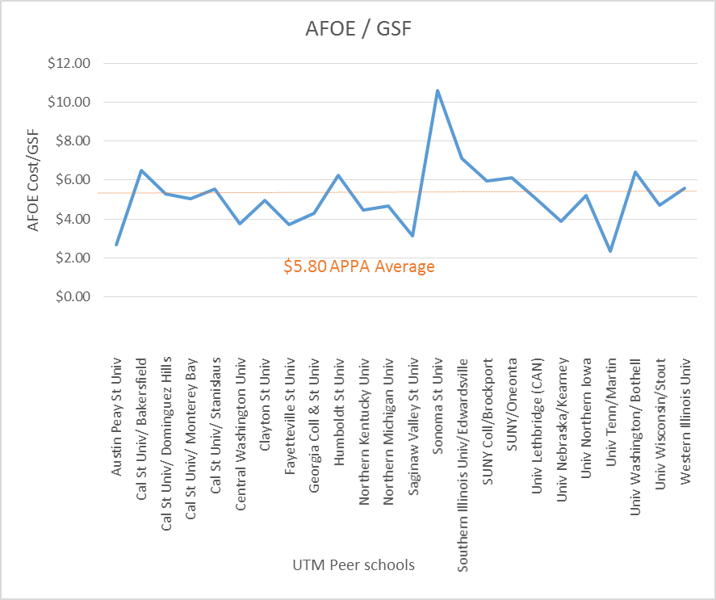
Figure 1.1 Annual Operating Expense per Gross Square Foot
Growth of University Facilities/Importance of Maintenance
The facilities portfolio is necessary for a university’s success. A campus facilities’ quality and architectural character are important in attracting and retaining students and faculty. The appeal and beauty of the campus grounds and facilities are sources of pride for students, faculty, staff, alumni, and surrounding communities. A university’s image and reputation are intertwined with the surrounding community’s appearance and success (Rose et al., 2007). The pressures of maintaining image and reputation motivate a university’s facilities manager to provide a comprehensive and robust analysis to budget decision makers.
The importance of maintenance within a facilities system can be summarized with the ancient Chinese proverb “Dig a well before you are thirsty.” Facilities managers cannot wait until buildings need maintenance before requesting repair funds. Instead, they must be proactive and diligent in their quest to provide maintenance in a timely and economical fashion.
Facilities managers struggle with inadequate maintenance funding for facilities portfolios. Whether a portfolio is considered private, government, or academic, the facilities manager is faced with the problem of communicating to funding authorities and then securing adequate maintenance funds. In the university environment, funds are often readily available for funding a new facility. However, when an aging structure needs maintenance, funds are not as plentiful. This lack of adequate long-term planning and budgeting for maintenance restoration, renewal, and capital improvements leads to increased deferred maintenance.
Research indicates that a university campus’s strength is enhanced by having attractive facilities. However, these facilities can become a weakness if they are not well-maintained (Leaders, 2010). This concern is accentuated by the competition between the brick-and-mortar campus and the on-line campus. On-line courses have gone from a tiny subset of higher education to a critical part of the college experience. More than 5.6 million students took an on-line course during the fall of 2009. This number has continued to increase with over 30% of students taking at least one course on-line as of 2014 (new reference). Specifically, at the University of Tennessee at Martin, on-line classes require only an on-line support fee as opposed to maintenance and facilities fees for classes on campus. The increase of on-line enrollment versus on-campus enrollment could decrease operation and maintenance funding at universities. However, the infrastructure to produce on-line courses are still required.
The importance of maintenance also relates to the different building components and systems. Neglecting the basic maintenance of systems such as heating, ventilation, and air conditioning (HVAC) equipment can have significant impacts on buildings’ conditions and on
overall national energy consumption. HVAC systems consume almost half of the total energy used in the United States’ buildings (Wang & Hong, 2013). The consequences of basic maintenance’s underfunding includes the following: (1) threats to health and safety; (2) health impacts to building occupants; (3) critical building systems’ safety failure; (4) structural failure; (5) power service loss; (6) heating, ventilation, and air-conditioning system failure; (7) excessive repair costs for neglected equipment;; (8) increased energy costs; (9) minor failures leading to major failures; (10) equipment replacement versus repair costs; (11) production loss due to failing building systems; and (12) human resource issues (e.g., inability to attract and retain personnel, poor morale, and the organization’s loss of readiness) due to failing building systems (NRC, 1990).
With universities growing and expanding over the years, the importance of maintenance funding and building upkeep has increased. Between 1870 and the late 1970s, higher education enrollment increased at an annual rate of 5% while population only increased 1.6%. Enrollment grew from 2.3 million in 1950 to just over 19 million in the fall of 2016 (Center, 2016 #136). More than half of the current campus facilities were constructed after World War II (Kaiser, 2014). In the second half of the 20th century, college enrollment increased from about 2.3 million in 1947 to a projected 20 million in 2016 (Kaiser & Klein, 2010). Almost half of today’s buildings on college and university campuses were constructed in the 1960s and 1970s when the Baby Boom generation reached college age (APPA, 2012).
The baby boom following World War II had a tremendous impact on higher education enrollment’s increase. The introduction of the GI Bill after World War II contributed to funding availability for students wanting to further their education. Furthermore, the federal government’s focus on research within the natural sciences increased federal contracts to colleges and campuses, leading to the expansion of facilities to accommodate this funding windfall (Biedenweg & Hutson, 1989; Kaiser, 1984, 1996).
The Sightlines organization, which has developed a database drawing from over 450 institutions in 43 states with over 1 billion gross square feet of space, confirms the importance of adequate funding for universities and colleges (Sightlines, 2015). According to Sightlines’ 2015 research, capital and operating investments for campus facilities fell and remained below FY 2009 levels. In terms of real dollars, these facilities’ capital needs to continue growing as campus spaces built in the 1950s and1960s have aged and need to be renovated. In addition, the more complex campus buildings constructed since 1995 require increased attention to keep them operating efficiently (Sightlines, 2015).
Facilities managers struggle to keep campus facilities attractive and functional. The main take away from the 2014 APPA Thought Leaders Symposium was that higher education facilities can help colleges and universities achieve their goals. The success of a campus facilities’ inventory contributes greatly to the university’s overall success and advancement in the following ways: (1) increasing recruitment and retention rates by creating a positive impression on students, faculty and potential students; (2) contributing to the campus’s mission and focus by providing facilities clearly aligning with the overall mission ; and (3) providing well-maintained facilities that provide the proper space management and use of campus programs (APPA, 2014).
The importance of campus appearance is apparent when a student first visits a campus. In a 2014 APPA survey of more than 16,000 students at 46 institutions, 50% of the respondents indicated their first campus visit and initial impression dictated their campus choice. Two-thirds of those surveyed indicated the facilities’ overall quality and the campus’s attractiveness were either “very important” or “essential” to their campus selection (APPA, 2014).
The efforts of facilities managers to maintain their facility portfolios worsened during the last recession from 2008 to 2011. During that time, operating and capital budgets were cut as the demand for student financial aid increased. Everyone on campus, including facilities managers, was asked to do more with less. Such financial strain requires facility managers to provide more accurate and defendable monetary requests to support their capital improvement needs. As facilities managers handle growing deferred maintenance, they recognize that capital and operating budgets will probably not return to pre-recession levels for some time. Furthermore state appropriations, debt, and enrollment increases are not viable options for closing the systemic gap between needs and funding (Sightlines, 2014).
According to the Sightline survey, two distinct groups of institutional buildings have competing needs: buildings constructed during the 1950-1975 era and those constructed after 1995 (Sightlines, 2014). According to the Sightlines database, 40% of current university space was constructed between 1950 and 1975. Unfortunately, the large amount of square feet constructed and the speed of construction during this timeframe resulted in a lower quality finished product. This timeframe also introduced some experimental construction techniques, which led to problematic mechanical and HVAC systems within some buildings.
According to the 2014 Sightlines report, the second-largest construction era for colleges and universities occurred after 1995, when approximately 27% of all university and college space was increased. The buildings constructed during this timeframe represent strong construction quality. Many of these buildings are LEED certified, requiring a more complex mechanical system. These buildings have shorter equipment lifecycles, often requiring more frequent maintenance (Sightlines, 2014).
Deferred Maintenance’s Impacts on Facilities Portfolios
Facilities managers have struggled with deferred maintenance since its first documentation in the early 1980s, when it became one of the top agenda items for facility managers, chief financial officers, presidents/chancellors, and governing boards. Deferred maintenance seemed not only to introduce a conjecture that buildings were not being well-maintained but also to be a stigma attached to senior facilities officers. Thus, the use of the term deferred maintenance implied mismanagement or inattention to building maintenance (Kaiser & Klein, 2010).
Faced with the deferred maintenance problem’s severity, a facilities manager must evaluate a long-term strategy in the deferred maintenance reduction program. Kaiser (2014) identified the following major steps associated with a long-term plan: (1) the facility can be viewed as a collection of components whereby one component breakdown may cause other component breakdowns, (2) an annual audit should be completed for the facility inventory to determine this inventory’s physical condition, (3) developing a five-year budget plan and a capital renewal plan is necessary, (4) proper facilities maintenance should be ensured and verified , (5) work management systems should be used to manage and track maintenance with a facilities portfolio (Kaiser, 2014). Successfully implementing these steps and developing a long-term deferred maintenance reduction program relies heavily on a facilities manager’s ability to determine and communicate required maintenance costs for the facilities portfolio—whether university, government, or private.
Struggling with the deferred maintenance problem on campus, a facilities manager must communicate the maintenance and repair needs of the facilities portfolio to administrators. Funding authorities must consider these maintenance needs in the form of estimated maintenance dollars to be accurate and timely. This information is the cornerstone of how campus leaders communicate their stories to legislators, governors, or donors when seeking additional funding and campus improvements. Managing a college or university campus’s physical plants and grounds is absolutely essential to the institution’s well-being, for maintaining both the enormous investment and the institution’s educational purpose (Calgaard, 1987).
Confronting the capital renewal process as it relates to deferred maintenance, facility managers must communicate the required maintenance or capital renewal dollars in a manner that is believable and verifiable. The funding cycle for capital renewal is several years away from implementing improvements. Competing funds within states for capital improvements are insufficient to cover requests. State legislatures and university officials must be able to anticipate a levelized funding amount each year instead of relying on fluctuating yearly requests. Calculating reliable estimates for correcting deferred maintenance and communicating this data to the appropriate bodies are essential for reducing deferred maintenance issues in a university’s facilities portfolio. Kaiser identified several factors that contributed to an institutions success (or failure) in addressing deferred maintenance. Identified factors include the following:
- priority of eliminating deferred maintenance by top administrators,
- support of trustees or legislators,
- budgetary and/or financial strategies,
- availability of state appropriations. (Kaiser, 1996)
To be successful, a facilities manager must be proactive in dealing with the facilities portfolio’s assets. The concept of proactive asset management involves maintaining and repairing an asset or a system of assets at strategic points within the life of the asset to extend its expected service life. A stable segment of life for an asset or facility is then followed by a downturn of the condition of the asset or facility at an increasing rate as system components wear out. Intervention to maintain and/or rehabilitate the asset leads to cost trade-off scenarios. Generally, cost diminishes as planned maintenance replaces unplanned maintenance. This diminishing cost emphasizes the need to plan maintenance regularly (Cagle, 2003).
Results of Deferring Maintenance
Completing maintenance on a timely basis is critical. Deferred maintenance is not simply the sum of annual maintenance deficits but rather the compounding effect of deferring maintenance from one year to the next. If maintenance is not completed in year one, the costs of maintenance, repair, or replacement are higher in subsequent years as discussed in De Sitter’s “Law of Fives” (Vanier, 2001).
To adequately respond to the battle against deferred maintenance, facilities managers must shift from the crisis management mode to planned management. This effort allows these mangers to tackle maintenance with proven engineering and management concepts. Efforts to battle deferred maintenance’s effects must start with a strategically planned and deferred maintenance reduction strategy (Melvin, 1992a).
The long-term impacts of deferring maintenance cannot be overstated. The facilities manager pays the price of neglecting much needed repairs (Geaslin, 2004). According to Geaslin, deferring maintenance that eventually becomes a breakdown event can result in a cost 15 to 40 times higher than the original repair estimate. Known as Geaslin’s Inverse-Square Rule for Deferred Maintenance, this concept involves the premise that if a part is known to be failing and the repair is deferred and the part is allowed to remain in service until the next failure level, the resultant expense will be the square of the failed part’s cost (Geaslin, 2004).
Facilities neglected as a result of deferred maintenance result in increased deterioration, leading to replacement or renovation or in a worst-case scenario, design and new construction. The process from design to occupancy is lengthy (18 to 36 months), potentially disrupting the organization’s mission (NRC, 1993). This long-term process to replace failed buildings can affect the overall mission of an organization or entity.
Facilities managers defer maintenance for several reasons, including the following:
- a focus on design and construction costs instead of life-cycle costs within the budget process,
- inadequate funding for maintenance and repairs,
- aging facilities that require increased levels of maintenance and repair to keep them operating effectively,
- lack of information needed to make appropriate decisions regarding maintenance and repair,
- lack of stewardship accountability. (FFC 2001; NRC, 1998)
The federal government is very sensitive to deferred maintenance’s effects and the need to maintain proper funding for government facilities’ repairs. The Department of Defense, for example, has over 550,000 facilities worth over $800 billion (GAO, 2014). Deferring maintenance will not only later increase the cost of these repairs by an exponential amount but in the short-term diminish the quality of building services and accelerate the death of the building and the building components. This result is demonstrated in Figure 1.2 (FFC, 2001).
Deferred maintenance’s consequences are also evident in K-12 facilities, which account for approximately 25% of state and local infrastructure investments (21st Century School Fund, National Council on School Facilities, & The Center for Green Schools, 2016). K-12 facilities managers must proactively deal with the issues or suffer the consequences of delay.

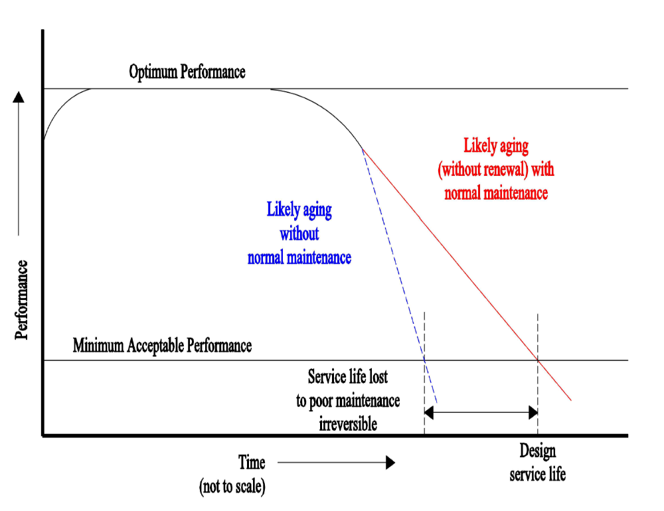
Figure 1.2 Effect of Adequate and Timely Maintenance and Repairs on the Service Life of a Building (NRC, 1993; FFC, 2001; Bello & Loftness, 2010)

The effects and growth of deferred maintenance in K-12 are clearly documented as indicated below:
- In 1989, the Education Writers Association stated that public schools needed $41 billion to address facility maintenance and repairs.
- The 1992, report by the American Association of School Administrators indicated public schools needed $100 million for deferred maintenance projects.
- In 2000, the U.S. Department of Education’s National Center for Education Statistics reported that public schools needed $127 billion to bring the nation’s public schools into good overall condition.
- In 2000, The National Education Association issued a report stating that the nationwide cost of repairing, renovating, and building school facilities and installing modern educational technology was $322 billion.
- In 2009, the 21st Century School Fund, an organization that advocates modernizing educational facilities, reported that public schools had $271 million in deferred maintenance.
- In 2013, the U.S. Green Building Council’s Center for Green Schools reported a total of $542 billion to address the deferred maintenance issue and to modernize facilities in order to meet education, safety, and health standards. (Kennedy, 2013)
Problem Statement
University facilities managers constantly face the problem of insufficient maintenance funds compounded by the budgetary requirement of advanced requests for funds. Based on the type of facility, maintenance and repair costs for university facilities vary in magnitude and scope. Despite repeated requests for funds, universities are left with a significant shortfall of sufficient maintenance dollars due to both lack of funds available either by private, federal, or state agencies and the cycle of funding requests that do not result in a consistent level of required funding. Because of insufficient funds, facilities managers are seeing an increase in deferred maintenance of university facilities. This ever-increasing deferred maintenance results in the degradation of universities’ missions. Thus, a more consistent method of predicting maintenance costs is needed to help level maintenance funding requests. Research investigating the prediction of maintenance costs for a homogeneous facilities portfolio would allow out-year planning of universities’ projected maintenance costs. These costs could be rolled up by university and by system to allow legislatures to fund and plan maintenance and repair costs for their respective school systems without having to know detailed scopes and estimates.
Objectives and Purpose
This research fulfilled the following objectives:
- A mathematical model was developed to estimate the required maintenance and repair budget for a facilities portfolio, specifically a university’s. The model was based on actual maintenance and repair and on capital improvement cost information gathered from these facilities. This information is readily available to any facilities manager who can then communicate it to funding authorities. The attribute of homogenous use was analyzed for these facilities to derive an equation to be used for a university environment or any similar homogenous inventory. This equation was tested for applicability to both the facilities portfolio and individual buildings.
- The equation was compared to several existing estimated required maintenance (ERM) models and evaluated the variances.
- The benefit or accuracy of using this equation for a homogenous inventory of facilities at another university was determined.
Definitions
Adaption: Alterations in a physical plant to address changes in use, codes, or standards. Such changes include those required under the American Disabilities Act and those made to keep up with technology as well as to maintain facilities that become obsolete for program reasons (Biedenweg, Seisburg-Swanson, & Gardner, 1998).
Alterations: Work performed to change the interior arrangements or other physical characteristics of an existing facility or installed equipment so that it can be either used more effectively for its currently designated purpose or adapted to a new use. Alterations may include work referred to as improvements, conversion, remodeling, and modernization but that are not maintenance (NRC, 1990).
Artificial neural network: A mathematical informational processing model that is valuable for forecasting tasks due to its distinguishing features a data-driven, self-adaptive method with the ability to learn from experience, it can generalize what is learned from the data and accurately infer the unseen part of a population. It is also capable of performing nonlinear modeling without prior knowledge about the relationships between input and output variables (Tu & Huang, 2013).
Asset management: Defined as a set of processes or activities addressing the proactive management of capital assets and/or infrastructure in the following ways: (1) maintaining a systematic record of individual assets (i.e., an inventory) with regard to acquisition cost, original and remaining useful life, physical condition, and cost history for repair and maintenance; (2) maintaining a defined program for sustaining an aggregate body of assets through planned maintenance, repair, and/or replacement; (3) implementing and managing information systems in support of those elements (Cagle, 2003).
Building maintenance: The preservation of a building that can serve its intended purpose. Maintenance can be classified into three frequencies: routine, periodic, and construction. Routine maintenance is general maintenance to common areas. Periodic maintenance is required at intervals ranging from a few months to a few years (e.g., repainting, carpeting, window resealing, replacing HVAC equipment, lifts, security systems, fire and systems). Construction maintenance is the long-term (40 to 50 years) major repair and replacement of such components as facades, windows, and roofing. (Augenbroe & Park, 2002). Maintenance excludes activities aimed at expanding the capacity of an asset or otherwise upgrading it to serve needs different from or significantly greater than those originally intended (Hirai et al., 2004).
Building portfolio: A collection of buildings or other constructed facilities managed by a single agency or other owner (NRC, 1993).
Commissioning: An activity, commenced at completion of construction and often including initial user’s occupancy, intended to check functional subsystems, to determine if the facility is functioning as designed, and to undertake any necessary remedial action. Commissioning typically spans 6 to 12 months (NRC, 1993).
Cost of ownership: All of an owner’s expenditures over the course of the building’s service lifetime. The way these expenditures are measured and reported may vary from owner to owner depending on such factors as whether the owner is a private individual, a business enterprise, or a public agency (NRC, 1990).
Current plant value: The initial acquisition cost adjusted to the current year for inflation, improvements, and changes in size or capacity (Lofgren, Nixon, & Ottoman, 1999).
Deferred maintenance: As defined by the Federal Accounting Standards Advisory Board (FASAB), maintenance not performed when it should be or is scheduled to be and, therefore, is delayed (FFC, 2001; GAO, 1998; Hirai, Krause, & Munson, 2004; Kaiser, 2014). The difference between a required formula-generated amount for a physical plant’s maintenance and the actual amount spent on maintenance for a specific year (Monterecy, 1985).
Design service life: The time during which a building or a building subsystem or component (e.g., roof, mechanical equipment, plumbing, sheathing) is designed to provide at least an acceptable minimum level of shelter or service as defined by the owner. The amount of time typically depends on assumptions, sometimes implicit, regarding satisfactorily completing normal maintenance activities (NRC, 1993).
Facilities condition index: An equation involving the deferred maintenance backlog divided by the current replacement value expressed as an index or percentage (Kaiser, 2014).
Facilities renewal: A systematic approach to repairing or replacing major building subsystems (e.g., roofs, HVAC, electrical, and plumbing systems) with predictable life cycles in order to maintain and extend the facility’s life. Normally funded by an institution’s capital budget, this approach is referred to as planned maintenance or capital repair (Biedenweg, Seisburg-Swanson, & Gardner, 1998).
Life cycle: The sequence of events in planning, design, construction, use, and disposal during a facility’s service life that may include changes in use and reconstruction (NRC, 1993).
Performance: The degree to which a building or other facility serves its users and fulfills the purpose for which it was built or acquired; the ability of a facility to provide the shelter and service for which it was intended (NRC, 1993).
Modernization: The alteration of facilities solely to implement new or higher standards, to accommodate new functions, or to replace building components that typically last longer than the facility’s expected service life (Lufkin et al., 2005).
Obsolescence: The condition of being antiquated, old fashioned, or out of date, resulting when there is a change in the requirements or expectations regarding the shelter, comfort, profitability, or other dimension of performance that a building or building subsystem is expected to provide. Obsolescence may occur because of functional, economic, technical, or social and cultural changes (NRC, 1993).
Plant replacement value: The cost to replace a facility with one of equivalent capacity and function (Barco, 1994).
Repair: Work to restore damaged or worn-out property to its normal operating condition. Repairs are curative while maintenance is preventative (NRC, 1990).
Required maintenance: Required work activities funded through the annual budget cycle, done to either continue or achieve the originally anticipated life of a fixed asset (i.e., buildings and fixed equipment) at an established suitable level of performance (APPA, FFC, Holder, International Facility Management Association, & NASFA, 2002).Restoration: The repair and replacement work to restore facilities damaged or degraded by inadequate sustainment, excessive age, acts of war, natural disaster, fire, or accident (Lufkin et al., 2005).
Service lifetime: The period of years during which a building provides shelter and an environment supporting the activities it houses (NRC, 1990). The period of time during which a building, component, or subsystem adequately performs; a technical parameter that depends on design, construction quality, operations and maintenance practices, use, environmental factors, and users’ and owners’ expectations (NRC, 1993).
Limitations
This research was limited in the following ways:
- The research was limited to a portfolio of 34 facilities located on a university campus.
- The actual maintenance and capital improvements over an 11-year period (2004-2014) were used.
- The equation was tested for a homogenous, small facilities portfolio and did not include infrastructure (i.e., sewer, roads, and utility services).
- The research did not analyze individual building systems or specialized equipment.
- The equation did not predict or account for changes in building use resulting from academic reprogramming.
- This research addressed the method of calculating maintenance costs based on the historical maintenance costs per facility without addressing the reason for the maintenance (i.e. changing legal requirements, life safety systems, or new academic programs).

Assumptions
This research was based on the following assumptions:
- Data used in the modeling equation is actual historical information and considered to be accurate.
- Current plant values (CPV) were based on initial costs escalated to the first year of the study and then escalated through the 11th year of the study. Capital improvements to the building were added to the building value.
Summary
University facilities managers are faced with estimating and communicating required maintenance of their facilities portfolios to legislative representatives and upper management. This information must be accurate and easily obtained. The information must be derived from existing data that is readily available and consistently retained in a physical plant work order system. The proposed maintenance equation must be easy to use and understand.
Chapter Two will provide a literature review of existing ERM models to predict estimated required maintenance and will discuss the justification for continued research in this area. The methodology for deriving the maintenance equation will be discussed in Chapter Three. The results of the data analysis will be discussed and compared with those of existing models in Chapter Four. The results for the entire facilities portfolio and for individual buildings will be discussed. Chapter Five will summarize the research and provide recommendations for using the equation including its applicability to a university portfolio.
CHAPTER 2: REVIEW OF LITERATURE
A literature search was conducted on models that help a facilities manager estimate required maintenance funding. This search was also expanded to determine maintenance’s importance within a facilities portfolio and the related impacts of deferred maintenance’s growth. Several models were reviewed and are further discussed in this chapter. It was also determined that additional research on this subject is warranted along with the development of a model determining necessary maintenance costs based on readily accessible facility attributes.
Literature Search
The literature search was performed using several Web-based scientific search engines and databases. These included the Web of Science, Scopus, IEEE Xplore, APPA Library, and American Society of Civil Engineering (ASCE) Library. Key words used during the search included deferred maintenance, prediction of maintenance costs in facilities, facilities maintenance, development of models for maintenance costs for facilities, predicting maintenance costs by building type, modeling facility maintenance costs, university capital maintenance, capital maintenance, maintenance and modeling, maintenance models, cost prediction models, cost predictions for facilities, and capital budgeting. The literature review also expanded into the cited references of reviewed articles that were deemed relevant to this research. Over 9,500 articles were retrieved during this research. The articles’ title or abstract were scanned for relevancy to this research related to deferred maintenance, maintenance within a university, and the development of maintenance models for predicting required maintenance. This number was reduced to 150 relevant articles that were read for this literature search.

Discussion of Models
During this research, four common methods of maintenance and repair models were addressed: (1) plant value methodologies, (2) life-cycle cost methodologies, (3) condition assessment methodologies, and (4) other formula-based methodologies. Each method provided advantages and disadvantages for the facilities manager use (Lofgren, Nixon, & Ottoman, 1999). During this research, facility attributes were found to be essential in the models’ development.
Facility Attributes’ Contributions to a Model
The NRC (1990) determined that building factors have a major influence on the appropriate level of maintenance and repair. These factors include the following: building size and complexity, types of finishes, current age and condition, mechanical and electrical system technologies, telecommunication and security technologies, historic or community value, type of occupants or users, climatic severity, turnover rates, criticality of function, ownership’s time horizon, labor prices, energy prices, material prices, and distance between buildings in facility inventory (Bello & Loftness, 2010; NRC, 1990).
These facility attributes play a key role in developing a deferred maintenance model. According to Barco (1994), key facilities attributes are location, facility type, age, acquisition cost, size, capital improvements, current value, and replacement value. Barco stated that as these variables trend up or down, so does the justification for maintenance and repair resources. Barco also identified a facility’s current condition as important in determining M&R budget requirements (Barco, 1994; Lofgren et al., 1999). Kaiser stated that a funding model for M&R should consider a facility’s size, age, previous renewals and renovations, and previous levels of maintenance funding.
To determine a facilities portfolio’s attributes directly affecting maintenance and repair costs, Monterecy (1985) documented facilities portfolio managers’ eight most-often cited reasons for having a deferred maintenance backlog. These reasons are the physical plant’s age, high energy cost, ability to pay, poor construction quality, lack of facility planning, demographic changes, compliance with federally mandated improvements, and lack of maintenance staff. Monterecy performed a multiple regression analysis using the eight attributes as predictor variables. The result showed that only three of the variables were related to increased deferred maintenance: facility age, facility planning, and construction quality. He also found that age, size and CRV had the highest correlation to maintenance and repair funding.
Based on relevant literature in her research, Tolk (2007) compiled the following facility attributes in order of the number of times mentioned: (1) age and facility type; (2) size; (3) subsystem technologies and facility size; (4) current replacement value, current condition, location, and subsystem life-cycle cost; and (5) subsystem cost, repair costs, and distance between facilities. Table 2.1 summarizes the major models discussed in this chapter and their 11 corresponding facility attributes. The most frequent facility attributes were use, type, size, age, current condition, plant replacement value (PRV), and location. To be as consistent as possible with this trend, the following attributes associated with the UTM facility portfolio were used during the research: age, use, size, current plant value, (CPV), and initial cost. To be as consistent as possible with this trend, the following attributes associated with the UTM facility portfolio were used during the research: age, use, size, current plant value, (CPV), and initial cost. UTM portfolio’s PRV was unavailable. Therefore, the CPV was used. As stated in Chapter One, the UTM facility portfolio is a homogenous portfolio; therefore, facility

Table 2.1 Summary of Facility Attributes by Model (derived from Bello, 2010)
Model Categories | Models | Age of Facility | Construction Quality | Use | Type of Facility | Size of Facility | Location of Facility | Current Condition | Plant Replacement Value | Current Plant value | Facility Maintenance Planning | Budget Constraint
Plant Value Methodologies | Air Force PRV-FIM |  |  | ● | ● | ● |  | ● | ●
Plant Value Methodologies | CPV Model | ● | ● |  | ● | ● | ● |  |  | ●
Plant Value Methodologies | Coast Guard |  |  | ● | ● | ● | ● | ● | ● |  | ● | ●
Plant Value Methodologies | PRV Model |  |  | ● | ● | ● | ● |  | ●
Life Cycle Cost Methodologies | Christian-Pandeya | ● | ● | ● | ● | ● | ● |  | ● |  |  | ●
Life Cycle Cost Methodologies | Dergis-Sherman Model | ● | ● |  | ● | ● | ● | ● |  | ●
Life Cycle Cost Methodologies | DOD Sustainment | ● |  | ● | ● |  | ● |  |  |  | ●
Life Cycle Cost Methodologies | Leslie-Minkarah | ● | ● | ● | ● |  |  | ●
Life Cycle Cost Methodologies | MRPM Model | ● |  | ● | ● | ● |  |  |  |  | ●
Life Cycle Cost Methodologies | Phillips Model | ● |  |  |  |  |  | ●
Life Cycle Cost Methodologies | Stanford Model | ● |  | ● | ● |  |  |  |  |  | ●
Life Cycle Cost Methodologies | Turner | ● |  | ● | ● | ● |  |  |  |  | ● | ●
Life Cycle Cost Methodologies | Uniformat Model |  |  | ● | ● | ● | ● | ● | ●
Condition Assessment Methodologies | Army ISR | ● |  | ● | ● | ● |  | ● | ● |  | ●
Condition Assessment Methodologies | Beach, Carson Keating |  | ● |  |  |  |  | ● |  |  | ● | ●
Condition Assessment Methodologies | BUILDER |  | ● | ● | ● | ● |  | ● |  |  | ● | ●
Condition Assessment Methodologies | FCI | ● | ● | ● | ● |  | ● | ● | ● | ●
Condition Assessment Methodologies | NASA DM |  |  | ● | ● | ● | ● | ● | ●
Condition Assessment Methodologies | University of Virginia Model |  |  | ● | ● | ● | ● | ● | ● |  | ●
Formula Based | Bello-Loftness | ● | ● | ● | ● | ● | ● | ● | ● | ● | ● | ●
Formula Based | FISC Model | ● |  | ● | ● |  |  | ●
Formula Based | Incremental Budget Model |  |  |  |  |  |  |  |  |  | ● | ●
Formula Based | Li & Guo | ● |  | ● |  | ●
Formula Based | NACUBO | ● |  |  |  |  |  | ● | ●
Formula Based | Navy LRMP System | ● |  | ● |  |  |  | ● |  |  | ●
Formula Based | NRC Model |  |  | ● | ● | ● | ● | ● | ●
Formula Based | Square Foot Model |  |  | ● | ● | ● | ●
Formula Based | Tolk | ● |  |  |  | ●
Formula Based | Tu & Hung | ● |  | ● |  | ● |  |  | ●
Totals |  | 18 | 8 | 22 | 21 | 19 | 13 | 17 | 13 | 4 | 12 | 7

type was not considered. Location was not considered since all the buildings are located on the UTM campus. The current condition was also not considered since a condition assessment had not been consistently completed on these facilities. This data was unavailable for an 11-year period. However, the UTM portfolio’s initial cost was readily available and considered to be one of the attributes contributing to maintenance and repair costs, as noted by Barco (1991). As stated in Chapter One, building systems were not considered in this study because of the lack of historical cost data.
Plant-Value Models
The plant-value method is based on the concept that maintenance and repair costs may be estimated as a function of either the construction cost or the replacement value of the facilities inventory. A facilities portfolio’s plant value can be calculated in two ways. The first defines each facility’s CPV as the initial construction cost adjusted to the current year for inflation, improvements, and changes in size and capacity. The second method defines the plant value in terms of the cost to replace the facility with one of equivalent capacity and function.
In a joint effort with the American Public Works Association, The BRB Committee on Advanced Maintenance Concepts for Buildings determined the appropriate M&R funding level for federal agencies to be in the range of 2% to 4% of those facilities’ current replacement value (NRC, 1990). This range was determined to be most valid as a budget guide for a large inventory of buildings over several years. The facilities manager must provide a reliable estimate of the current replacement value of a building or a facility’s inventory. Adjustments within this range account for differences in building size, type of finishes, current age and condition, type of occupants (users), climatic severity, tenancy turnover rates, and local labor and material costs (Lofgren et al., 1999).
Air Force PRV-Facilities Investment Metric (FIM)
The Air Force PRV-Facilities Investment Metric (FIM) combines the PRV model and a unique FIM concept in an overall facilities’ investment strategy. This model involves a preventative maintenance level, facilities repair and minor construction projects, military construction, and demolition. The FIM process begins at each Air Force base by identifying requirements, estimating costs, and assigning initial impact ratings. Impact ratings are categorized as critical, degraded, or minimal. These impact ratings are viewed in the context of the affected “mission area” (i.e., primary mission, mission support, base support, and community support). A facility investment index (FII) divided by the PRV for that mission area is calculated at the beginning and end of each funding cycle and serves as a metric for the facility inventory’s overall health. The FIM prescribes no formal condition- assessment procedures but requires facility inspections (Lofgren et al., 1999).
CPV Model
The CPV model may be expressed as
Annual Facility M&R budget = x% (CPV) of facility inventory (1)
The CPV is the original acquisition cost of each facility in the inventory. Adjusted for inflation to the current calendar or fiscal year, this cost also includes additions, demolitions, and improvements. The percentage multiplier may vary from 2% to 4%. (NRC, 1990; Hirai et al., 2004). The CPV is most appropriately applied to a large inventory as opposed to a single facility. As noted above with the Kraft model, a certain percentage of the CPV is assigned to both maintain and enable reducing or removing a facility’s maintenance backlog. The CPV model is effective when used on an inventory of facilities.
The CPV model’s strength is that understanding how the calculation is made is easy. The CRV of each facility is added and then multiplied by the fixed percentage. Another strength is that this methodology can be easily adjusted by asking the governing body for a different percentage (F. Biedenweg, Seisburg-Swanson., & Gardner, 1998;Logren et al, 1999) .
Coast Guard Model
The Coast Guard M&R budget combines replacement cost, square-feet-based, and incremental budgeting in one model. Three work classifications are applied: (1) recurring, (2) nonrecurring, and (3) acquisition, construction and improvements which may be used for M&R action related to major renovation projects. The percentage of PRV is also used to request the amount of funding for the Coast Guard, which targets a nonrecurring work budget between 1.5% and 2.0% of the PRV. The Coast Guard’s budget does not consider facility or subsystem life cycles, nor does it provide a mechanism to compensate for maintenance-deferral penalty costs (Lofgren et al., 1999).
PRV Model (Kraft)
The Plant Replacement Value (PRV), or Kraft, model (Barco, 1994) considers the cost to replace the plant’s capacity and functionality. The model can be expressed as
Annual Facility M&R budget = X% (PRV) of the facility inventory (2)
The PRV is the product of a unit cost of construction. The decision maker determines the percentage multiplier. As with the CPV model, the PRV model should not be applied to individual buildings.

The PRV model can be expressed with the following equation:
Maintenance budget = MCF (CRV) (3)
where MCF is a local maintenance cost factor, which is a function of a given facility’s type of construction. Kraft, the originator of this model, used three MCF categories: (1) wood frame (1.75%), (2) masonry and wood frame (1.30%), and (3) concrete floor construction (1.10%). The PRV model is one of the earliest cited models for estimating the adequate amount of facility maintenance. Many studies and organizations have determined different values for X in Equation 3 above. Also, the facilities manager can assign a certain percentage of the PRV that will reduce or remove a facility’s maintenance backlog and improve its condition (Lofgren et al., 1999).
Life-cycle Cost Models
Life-cycle methodologies estimate facility maintenance investment by factoring the service life expectancy and resulting maintenance needs of facility systems and components. With the frequency of maintenance tasks specified, cost data from cost guides are then used to predict annual funding needs (Ottoman et al., 1999).
The life-cycle budgeting approach requires a facilities manager to analyze building components’ life expectancy. Melvin (1992a) identified four types of situations in which life-cycle cost is applicable in building maintenance: (1) repairing versus replacing decisions; (2) selecting among alternative building materials, equipment, or repair and restoration methods; (3) evaluating deferred maintenance’ economic consequences; and (4) establishing reserve funds to finance maintenance activities. Melvin documented the use of eight major systems: (1) foundations, (2) roofing, (3) exterior closure, (4) interior walls, (5) HVAC, (6) plumbing, (7) electrical, and (8) fire and safety. The descriptive details for each system may range from very general to thousands of specific tasks on various subsystems (Lofgren et al., 1999; Melvin, 1992b; Neely, Neathammer, & Stirn, 1991).
Christian-Pandeya Model
Christian and Pandeya (1997) analyzed the operating and maintenance costs of 14 universities and 8 government buildings. Their research attempted to make more realistic life-cycle cost predictions for these buildings. Historical annual OM cost data for university facilities were available, and the combined historical OM costs were available for the government buildings. This research involved four main steps: (1) determination of costs, (2) data collection, (3) knowledge collection, and (4) data analysis and prediction. In their research, Christian and Pandeya identified factors affecting a facility’s OM cost: facility location, facility type and purpose, facility size, and design, quality of construction material, price indices for utilities and services, and budgetary conditions.
Dergis-Sherman Model
Sherman and Dergis (1981) developed a formula-based model to estimate facility- renewal funding requirements at the University of Michigan. Their formula is expressed as
Annual Appropriation = 2/3 x BV x BA/1275 (4)
The building value (BV) is adjusted for inflation from its original cost. The building age (BA) is corrected for partial or total building renewal. The factor “2/3” is called the building renewal constant, which is based on the theory that the building renewal should not cost more than two-thirds of the new construction’s cost (Lofgren et al., 1999). The value 1,275 is an age-weighted constant based on a 50-year life cycle, which is the sum-of-the-years-digits. This model was intended to be applied to a system of buildings and not just to one building. Applying this model to a portfolio of buildings minimizes the possible differences that may exist. The formula also accounts for the facility’s original cost (Lofgren et al., 1999; Monterecy, 1985).
Monterecy (1985) applied the Dergis-Sherman model to 40 Rhode Island public school districts. During this research, he found a partial correlation of the age of the plant, its current replacement value, and its floor area with M&R requirements (Lofgren et al., 1999).
DOD Sustainment Model
The Department of Defense (DOD) (1989) conducted research to determine the appropriate level of investment in real property maintenance. This study used the PRV and average age factors incorporating specific criteria. After evaluating these criteria using regression analysis, the DOD adopted a 1% PRV for service calls and recurring M&R. A 0.75% PRV was used for non-recurring M&R and minor construction (DOD, 1989).
The DOD (2007) prepared a report addressing the methods and tools to develop funding targets and to measure performance for DOD facilities. According to the report, sustainment costs are calculated for each year in the budget request and for the Future Years Defense Program. The following formula is used:
Annual sustainment requirement = facility quantity x sustainment cost factor x location factor x inflation factor. (5)
Quantity = the facility size expressed in square feet
Sustainment cost factor = the average annual unit cost (in current year dollars)
Location factor = a location adjustment based on the local costs for labor,
equipment, materials, and currency exchange rates
Inflation = a factor to adjust current year prices to the target future year.
(DOD, 2007)
Leslie-Minkarah Model
Leslie and Minkarah’s research provided a practical “estimating technique” for determining long-term costs and timing forecasts of renewal funding needs. This research’s primary goal was to prepare and justify an adequate user-fee policy for a specific building. The research provided a procedure for converting construction costs to renewal event costs forecast the revenue recovery rate needed for renewal. This model can be applied to a single facility (Leslie & Minkarah, 1997).
MRPM Model
Neely (1991) developed the Maintenance Resource Predication Model (MRPM) as part of a seven-year effort at the United States Army Construction Engineering Research Laboratory (USACERL) to create a comprehensive cost database for Army facilities. The maintenance-task database was built according to UNIFORMAT divisions, including all the maintenance work required over the life of every component of the building system. The MRPM model was designed to estimate annual maintenance costs over a 120-year facility life cycle in response to 5 levels of facility data (Lofgren et al., 1999; Neely et al., 1991)
Phillips Model
The Phillips Model was developed as a result of The Alabama Commission on Higher Education’s effort to estimate maintenance and repair requirements of Alabama’s college and university facilities. Phillips stated that facility systems are characterized by 25- or 50-year life cycles. In this model, major items of repair and replacement are separated from routine and preventative maintenance activities. Roofing and HVAC are classified as 25-year systems. Other building components (e.g., exterior walls, partitions, fixed equipment, conveyances, specialties, electrical, plumbing, and fire protection) are classified as 50-year systems. The R.S. Means, or Dodge, system estimates the square-foot cost for replacing or renovating each system for each facility type in the inventory. The following formulas are associated with the model:
RA_{25 year system} = (BA/325) x Replacement cost of 25-year systems (6)
RA_{50 year system} = (BA/1.275) x Replacement cost of 50-year systems (7)
where 325 and 1,275 represent the sum of the years of a system’s maximum life age for a 25- and a 50-year life, respectively. The effect of earlier renovations is accounted for by adjusting the building age (BA) based on the following formula:
BA_{adjusted} = (renovated fraction x years since renovation) + (unrenovated fraction x age of building). (8)
This method does not account for the penalties in maintenance costs and premature system failures resulting from neglect (Lofgren et al., 1999).
Stanford Model
Biedenweg and Hutson (1989) developed a model for Stanford University, which was presented in an article appropriately titled “Before the Roof Caves In: A Predictive Model for Physical Plant Renewal.” This model’s central theme addresses the predictable cycles for facility renewal and replacement because systems within a facility have an expected life span. Through proper maintenance, the equipment’s life span can be extended until replacements can be made for the benefit of technology updates or increased efficiencies. According to this model, facility’s functional use drives subsystem design and resulting costs. The model identifies five facility types: (1) research and teaching laboratories; (2) office, classroom, athletic, and library; (3) patient care; (4) storage and other areas with minimal usage; and (5) residential. The model then provides 13 classes of facility subsystems (e.g., roofing and exterior cladding) with each having its own life-cycle characteristics. An estimate of the life-cycle replacement cost is determined for each subsystem. The facilities are classified into a five-year age cohort based on facility type and age. Projections are summed across the sub-systems and facility categories to provide an estimate of the total facility’s renewal needs for the five-year period. A moving average is used to balance the fluctuations between years. This model is best applied as a planning tool for a large inventory of facilities. It does not determine appropriate levels of preventive maintenance or allow for past or future failures of routine maintenance (F. M. Biedenweg & Hutson, 1989).
Turner Model
Turner’s research (1996) developed a funding formula for the University of Nevada, Reno that used three assumptions: (1) funding is allocated during each two-year legislative session with excess funds returned at the end of the two years; (2) funding factors, such as the gross square feet or age of the facilities, should be used; and (3) the method must accommodate phased-in funding increases. The research used an audit of the 13 major subsystems that proposed Hutson and Biedenweg in the Stanford Model. The model was based on building subsystems’ replacement costs, which were used to request funds for annual M&R funding needs for the University of Nevada, Reno (Turner, 1996).
UNIFORMAT Model
The Uniform Building Component Format (UNIFORMAT) was developed by the American Institute of Architects and the General Services Administration. The research associated with this model developed a method to estimate life-cycle costs of long-range M&R needs. The modeling structure associated with this model includes four schemes which range from the whole-facility approximation (level 1) to the subsystem components (level 4). Estimates are used in conjunction with the R.S. Means and Dodge cost guides (Lofgren et al., 1999; Melvin, 1992b).
Condition-assessment Models
Condition-assessment models determine the deficiencies in a facility or a portfolio of facilities and then generate an estimate of the total cost to renovate and repair these facilities to an acceptable condition. These models may also be used to calculate future maintenance and backlog investment needs by analyzing the remaining service life of a facility and its building systems (Bello & Loftness, 2010).
Army ISR Methodology
The Army Installation Status Report (ISR) methodology is used by the Army throughout its installations. The ISR consists of three parts: (1) infrastructure; (2) environment; and (3) services. It is then broken down into five facility types: (1) mission, (2) strategic mobility, (3) housing, (4) community, and (5) utility systems. These are further broken down into 215 facility category groups. The ISR is only applied to large multifacility inventories (Bello & Loftness, 2010; Lofgren et al., 1999).

Beach, Carson, and Keating Model
Beach, Carson, and Keating’s research (1998) proposed a macro-financial model relating the next year’s facility condition to the current year’s facility condition and expected funding. This model is based on the concept that the cost of the required maintenance and repair is a measure of the facility’s condition based on assessments or inspections. The model is expressed as follows:
C_{t+1} = (1+R) x (C_{t} + S – F) (9)
where C_{t} is the identified deficiencies at the beginning of the year;
R = degradation rate;
S= sustainment rate (cost of maintaining current condition);
F = expected funding for the year;
C_{t+1} = unexecuted maintenance and repair projects at the beginning of next year.
This model relies on a facility condition’s historical data and knowledge of the deterioration rate (Beach, Carson, & Keating, 1998).
BUILDER Model
The BUILDER Model was developed by Uzarski and Burley (1997) and the United States Army Construction Engineering Research Laboratory (USACERL). This model uses a process of inventory, inspection, condition assessment, deterioration modeling, condition prediction, and M&R planning. The BUILDER model includes 12 facility systems: (1) site, (2) structural, (3) roofing, (4) exterior circulation, (5) exterior closure, (6) interior construction, (7) plumbing, (8) HVAC, (9) electrical, (10) fire suppression, (11) conveyance and (12) specialties. A facility inventory is the first step in using the model. The next step is the inspection and condition assessment. A key aspect of the BUILDER model is its use of a subcomponent condition index (CI), which ranges from 0 (failed) to 100 (free of observable distress). Once the CI ratings have been calculated, condition deterioration curves are used to determine CI values over time. By using the BUILDER model, facilities managers can predict the facilities portfolio’s current and anticipated condition. This information can allow the creation of a multi-year M&R plan based on “what-if” scenarios (Lofgren et al., 1999;)(Uzarski & Grussing, 2011).
Facility Condition Index
The Facility Condition Index (FCI) provides a classification method for a facility’s maintenance needs by examining the facility’s maintenance requirements divided by the facility’s replacement cost. Many facilities managers use this number to communicate their funding needs to the funding officers. The FCI was extensively used by the Federal Facilities Council (FFC) in the review of the federal building inventory. The FFC focused on various methods of deferred maintenance reporting. The FFC recommended using condition- assessment surveys as a means to assess, document, and then articulate its infrastructure needs to higher management (Federal Facilities Council, 2001)The initial reason for the FCI was for use in budget preparation. The U.S. Army Construction Engineering Research Laboratories (USACERL) has developed several computerized maintenance-management systems designed to assess the condition of civil works’ facilities and help facilities managers prioritize the allocation of maintenance and repair dollars. The heart of these systems is the facility’s FCI. APPA stresses the need to use the FCI for higher education not only to determine required maintenance funds but also to assist managers in determining how many people are needed to maintain a campus and its distribution of required skills (Hirai et al., 2004). According to the literature developed by the National Association of College and University Business Officers (NACUBO) and as shown in Table 2.2, an FCI below 0.05 is considered good, above 0.10 is considered poor, and between 0.05 and 0.10 is considered fair.
Table 2.2 Facility Condition Index

The Facility Condition Index (FCI) | Equals | Deficiencies Current Replacement Value
FCI less than 5% (.05) | = | Good Condition
FCI equal to 5 – 10% (.05 -.10) | = | Fair Condition
FCI greater than 10% (.10) | = | Poor Condition

Using the FCI enables facilities managers to perform financial analyses over time. The FCI can also be held steady and calculate the investment rate required to maintain a specific FCI. Finally, the effect on funding to achieve a desired FCI can be calculated (NRC, 1993).
NASA DM Model
The NASA Deferred Maintenance (DM) Parametric Estimating Method was developed and tested in 2001. This method was fully implemented at all NASA facilities to estimate deferred maintenance for the annual Agency Accountability Report. NASA’s DM method involves an independent assessment of nine systems within each NASA facility: (1) structure, (2) roof, (3) exterior, (4) interior finishes, (5) heating/ventilating/air conditioning (HVAC), (6) electrical systems, (7) plumbing systems, (8) conveyance systems, and (9) program-support equipment. The independent assessment team does not receive input from the local facilities management staff when rating each system. Systems are rated from 5 (normal maintenance required) to 1 (system does not function as intended). These condition ratings are then used in conjunction with the current replacement value (NASA, 2003).
University of Virginia Model
A condition-based model approach was developed by the University of Virginia (UVA) and described in a paper entitled “How to Inspect Your Facilities and Still Have Money Left to Repair Them.” UVA began its research in 1980 as a formal assessment-inspection program, which documented the condition of its 600 buildings ranging from new to over 100 years old. The initial inspections focused on maintenance deficiencies as defined by the budget process. Inspections were completed on a four-to-six-year cycle for most of the facilities. Annual reports showed the replacement value of each of the UVA buildings and the deficiencies’ estimated dollar value. The Facilities Condition Index was then calculated using the deficiency value divided by the replacement value. This system was used as a model for data gathered from all of Virginia’s institutions of higher education (Federal Facilities Council, 2001).
Formula-based Models
The formula budgeting approach applies a mathematical equation using formulas ranging from a simple, single-variable to complex algorithms. Concerns with the formula methods are that they are more cumbersome to use and that data is often not readily available to facilities managers.
Bello-Loftness Model
The Bello-Loftness model provides an equation for identifying annual facility maintenance-investment needs. This model provides a variation of the NRC (1990) study’s recommendation of using 2% to 4% of the PRV for maintenance as shown Equation 10. The investment level determined by the Bello-Loftness model excludes staffing costs, custodial work, operational utility bills, security services, fire protection services, snow removal, pest control, refuse collection and disposal, grounds care, landscaping, environmental operations, and recordkeeping. It also excludes such non-maintenance items as alterations, service requests, and support for special events or activities, and mechanics’ standby services required by mission activities. Using both the PRV and the CPV, the Bello-Loftness Model may be applied to all facility types including schools. This model is effective on a facility-by-facility basis though it can yield the annual maintenance investment for a facilities inventory. The variations of this model are identified below:
Bello-Loftness Model (without Maintenance and Repair backlog
Annual Facility Maintenance = [2% x ((0.35 x PRV) + (0.65 x CPV))] (10)
Bello-Loftness Model (with Maintenance and Repair backlog)
Annual Facility Maintenance = [2% x ((0.35 x PRV) + (0.65 x CPV))] + [2% x ((0.35 x PRV) + (0.65 x CPV))] (Bello & Loftness, 2010) (11)
FISC Model
The Facility Infrastructure Sustainment Cost (FISC) model uses a predictive risk-based algorithm and database (INEEL, 2004). The concept of this model and algorithm is the use of “bins” to accrue M&R costs for specific facilities and areas. The FISC algorithm is expressed as
B_{im} = forecast annual sustainment cost of i^{th} facility during mission phase
B_{im} = B1_{i} + B2_{i} + B4_{i}, (12)
where B1_{i} = BASC_{i x} ACT_{i} x MAVF_{i} x CCF_{i} (13)
BASC_{i} = baseline asset sustainment cost forecast from type of DOE sources
ACF_{i} = asset condition factor = impact of facility condition evaluation on sustainment cost (from FISC B1)
MAVF_{i} = material asset value factor, impact of value-added mission on sustainment cost (from FISC B1)
CCF_{i} = compliance cost factor = impact of facility compliance requirements on sustainment cost (from FISC B1)
B2_{i} = allocated costs for sustainment of operating areas infrastructure
B4_{i} = allocated costs for site wide infrastructure sustainment.
Incremental Budget Model
The Incremental Budget Model, also referred to as historical budgeting, operates on the assumption that the previous period’s budget is valid and adjusts for inflation and specific requirement changes. This model is widely used in public organizations because of its simplicity and suitability in tight budget environments. A drawback of this model is that after several years it loses any connection with the actual M&R requirement and tends to rely on the base to justify itself (Barco, 1994; Lofgren et al., 1999).
Li-Guo Model
This model was developed by using maintenance and repair data spanning 42 years from a campus of National Taiwan University. A cost-prediction model using the life-cycle cost was developed using three methods: (1) simple linear regression (SLR), (2) multiple regression (MR), and (3) a back-propagation artificial neural network (BPN). This study used building age, number of floors, number of classrooms, and number of elevators as the prediction model’s independent variables. The four buildings used were a general courses building, a common courses building, a general purpose building, and a freshman building. The equation developed using SLR was
ERM = 2.6388x² + 35.25x – 26.678, and R² = 0.9008. (14)
The following equations were based on the MR study:
ERM = -4957.1 + 147.84building age + 774.2floor + 35.1class -34.5elevators (15)
ERM = -2578.6 + 142.1building age + 403.6floor + 314elevator (16)
ERM = -4812.8 + 147.6building age + 742.3floor + 34.4class (17)
ERM = -3677.7 + 142.9building age + 683.1floor. (18)
The research also developed a prediction equation using the BPN. The BPN was determined to be superior to the SLR and MR models ( Li & Guo, 2012; Li, Chen, & Guo, 2010).
NACUBO Model
The NACUBO model estimates levels of maintenance and backlog requirements based on projected investment. Combining condition assessment, life-cycle analysis, and plant value, this model calculates deferred maintenance for a given M&R budget. This model can also be used to estimate both an M&R budget to maintain a given deferred maintenance level and required funding needs to achieve a certain level of maintenance backlog.

The formula to project backlog is as follows:
B_{n}= (B_{n-1}) (1 + I_{n} + D_{n}) + (V_{n})(P_{n}) - F_{n} (19)
B_{n}= Backlog at end of year n
V_{n} = Current replacement value at end of year n
V_{n} = (V_{n-1}) (1 + I_{n} + G_{n}) (20)
I_{n} = Inflation rate in year n
D_{n} = Backlog deterioration rate in year n
P_{n} = Plant deterioration rate in year n
G_{n}= Average plant growth rate in year n
F_{n} = Projected annual funding
The funding-projection model determines the level of annual maintenance and repair funding required to produce a certain backlog level. The funding projection’s formula is
F_{n}= (B_{n-1}) (1 + I_{n} + D_{n}) + (V_{n})(P_{n}) - B_{n} (21)
F_{n} = Projected annual funding
B_{t}= Target backlog at end of t years (“t” may be greater than, equal to, or less than the number of years projected)
B₀ = Backlog at end of year 0
B_{n}= Backlog at end of year n, B_{n}= B_{n-1} – [(B₀- B_{t})/t] (22)
for n$≤$ t; B_{n} = B_{t} for n > t
V_{n} = Current replacement value at end of year n
V_{n} = (V_{n-1}) (1 + I_{n} + G_{n}) (23)
I_{n} = Inflation rate in year n
D_{n} = Backlog deterioration rate in year n
P_{n} = Plant deterioration rate in year n
G_{n} = Average plant growth rate in year n.
(NACUBO, 1991)
Navy LRMP System
The Navy LRMP system provides an in-depth documentation of maintenance and repair requirements using a five-year cost-estimating system (Bello & Loftness, 2010).
NRC Model
The National Research Council (2004) assesses systems and subsystems based on a Facility Deterioration Curve, which is stated as
FDC (f,t) = (1+a) / (a+b) (24)
where a and b = constants to be determined through model calibration with observed data obtained from condition assessment data. The NRC’s research made important observations concerning the FDC as it related to the condition of new and existing facilities. These correlations provide valuable insight into maintenance’s impact on facilities over time. The model recommends the following 11-step approach in the budget planning process:
1. Identify the facility to be analyzed.
2. Determine the organization’s sub-missions and their criticality to the overall organization mission.
3. Determine each facility’s relative criticality to each sub-mission and then calculate the facility’s relative criticality to the mission based on the sum of the components.
4. Determine the initial mission condition adjustment factors for the facility by using a NRC-developed table rating the degree to which the facility supports a mission or sub-mission.
5. Determine the ACI, the initial asset condition index. for the facilities based on the facility deterioration curve.
6. Determine the initial mission condition index for the facility.
7. Determine the initial mission effectiveness for the facility.
8. Identify the possible renewal strategies for the facility and the corresponding unit costs, their corresponding adjustment factors, and the corresponding asset condition indices using a NRC-developed table of parameter values of Facility Deterioration Curves.
9. Determine the facility’s MCI, mission condition index, after the strategy is applied.
10. Determine the facility’s ME, mission effectiveness, after the strategy is applied.
11. Calculate CE, cost effectiveness, of applying the strategy to the facility.
In the report’s conclusion, the NRC committee identified seven attributes of a successful facilities and infrastructure program. The seven attributes of a successful facilities and infrastructure program as stated by the NRC report include:
- The realization and communication of the strategic role that facilities and infrastructure play in achieving site missions and program objectives
- Shared understanding between headquarters and field operations that facility and infrastructure management are linked in a clear and distinct manner with site missions.
- Clear operational guidance for field sites that links program objectives to management’s expectations.
- Consistent integration across programs and sites of corporate goals, site activities, and budgets.
- Incorporation of best practices in facility management and facilitate the transfer of lessons learned among programs and sites.
- The use of performance metrics to measure department-wide outcomes.
- Effective horizontal and vertical communication among all areas of the organization (NRC, 2004).
Square Foot Model
The Square Foot (SF) Model is a simple model using only the area of the facility inventory to determine maintenance and repair requirements. The SF formula can be illustrated as the following:
Annual M&R Budget = SF of facilities x Cost Factor (25)
The cost factor can be determined in several ways derived from historical data from such sources as the Building Owners and Managers Association (BOMA) and the R.S. Means cost guides. The SF-based model is intended to be applied to many facilities. The strengths of this model are the ease of use and simplicity of application. This model’s weakness is that it ignores the range of facility differences that may impact M&R requirements (Lofgren et al., 1999)
Tolk Equation
Tolk (2007) developed a prediction equation using multiple regression analysis to estimate the required maintenance and repair budget for a facility portfolio. The results of Tolk’s research indicated that facility size, age, type, and use proved to be significant predicators of required maintenance funding. Tolk’s best model was derived using age, size, and a mixture of thirteen type and use predicators. However, to achieve an equation that would apply to a more universal facility portfolio, only age and size were used in the final model. The derived equation for the annual estimated required maintenance ERM is the following:
ERM = (185 + 0.0143Size – 2.06Age)$^{2}$ (26)
This model was developed to be applied to a large facility portfolio and not individual buildings.
Tu-Huang Model
Tu and Huang (2013) developed a model for assessing the implications of planning and design decisions made during the project planning phase. These decisions impact the portfolio’s O&M costs in later years. This cost-predication model developed an artificial neural network (ANN) assisting developers and architects in assessing decisions regarding O&M costs in the planning phase of condominium projects. This model analyzed six critical building-design attributes (i.e., building age, number of apartment units, numbers of floors, average sale price, total floor area, and common facility floor area). The results from the analysis provided the condominium facilities’ monthly O&M cost. Tu and Huang’s study showed that ANN is an effective method in predicting condominium facilities’ building O&M costs (Tu & Huang, 2013).
Other Maintenance Models
Along with the research for facility funding models, much information was found concerning various types of modeling dealing with facilities’ maintenance. Although these models did not produce a dollar amount for a facility’s estimated required maintenance, they did provide mathematical models for a facilities portfolio’s maintenance. Several of these models are mentioned because of their close relationship with the life-cycle cost methodologies that are a segment of the cost models discussed during this review.
The model developed by Chen, Hou, and Weng (2013) used facility maintenance and management (FMM) items, including 3D viewing of the facility; facility database; and contract information (i.e., contract drawings, historical information, shop drawings, and OM manuals). This information allows a facilities manager to better analyze and plan maintenance activities for the facilities portfolio. Accurate maintenance-cost estimating is possible through this better information from the FMM technology (Chen, Hou, & Wang, 2013).
Thanaraju and Ali’s research (2015) centered on the public higher education institutions in Malaysia. This research identified important facilities’ maintenance activities that should be included in the activity-based (ABC) life-cycle cost process. The ABC approach is an effective way of analyzing maintenance cost by considering a cost-effective way of choosing the most relevant and critical elements and/or activities for the facilities use and the facilities’ users. Unnecessary or noncritical elements in the renovation process could be avoided, thus contributing to cost reduction in maintenance and repair (Thanaraju & Ali, 2015).
Grussing and Li (2014) conducted research on key facility performance indicators— age, condition, and functional obsolescence—based on the factors used to measure building reliability, performance, and value. Based on this research, facilities managers can manage facility requirements using real-time life-cycle metrics such as the condition index (CI) and remaining service life. Grussing and Li developed this model to provide the optimal building investment strategies for maintenance repair and renovation, thus maximizing facility performance and minimizing negative impacts of owning and operating a facility (Grussing & Liu, 2014).
Chasey, Garza, and Drew (2002) developed a model to study deferred maintenance’s impact on a highway system. Their research used dynamic simulation to help quantify deferred maintenance’s impact on a highway system and the effect on user and non-user benefits. With this information, the user can determine the best use of available resources (Chasey, 2002).
Paulo, Branco, and Brito (2013) researched software platforms aiding in the development of maintenance strategies using building assets. As a result, BuildingsLife building management systems (BdMS) was developed as a tool giving building managers the ability to maintain building assets more efficiently. The software not only allows building managers or owners to better plan and implement required maintenance but also provides the best constructive solutions and materials. The platform considers a database of building defects, the best repair techniques for them, and the costs involved (Paulo et al., 2014).
Gupta, Gupta, and Gandhi (2014) researched the development of annual maintenance budgets (AMB) for a plant system. These budgets were calculated as a percentage of the system’s asset replacement value. This research focused on developing the AMB for a plant system rather than an actual facility or facility portfolio. The results of this research provided a procedure enabling facilities managers to evaluate the annual maintenance budgets or maintenance tasks. These budgets were built on specific plant variables, which could vary among plants without requiring the facilities manager to apply general rules of thumb or expert judgement. This information is mentioned in this research review because of its close tie to the facilities world (Gupta, Gupta, & Gandhi, 2014).
Kamil, Alias, Mohammed, Muthuveerappan, and Plamonia (2014 researched road maintenance and cost modeling. The purpose of their research was to develop a sustainable road maintenance and management (SRMM) model, enabling them in turn to develop a reliable and sustainable road maintenance management system (Kamil, Alias, Mohammed, Muthuveerappan, & Plamonia, 2014).
Khodakarami, Mitchell, and Wang (2014) conducted research regarding the prioritization and cost development of maintenance projects on waterway transportation networks. This research is useful in selecting maintenance projects requiring funding, whether at locks/dams or on the waterway network itself. This research examines the waterway network’s components and helps in properly prioritizing the network system (Khodakarami, Mitchell, & Wang, 2014).
Review of Advantages and Disadvantages
The wide spectrum of models discussed in this chapter offer both advantages and disadvantages of their respective uses. Ottoman, Nixon, and Chan (1999) compared 18 M&R models based on the model evaluation criteria of the following salient characteristics: system life cycle, deferral penalty costs, and data requirements. Those 18 models are the following: current plant value, plant-replacement value, Kraft Model, Coast Guard Methodology, Dergis-Sherman Formula, Facilities Renewal, Preventing Deferred Maintenance, Air Force PRV-FIM Methodology, Square Foot Model, Incremental Budget, MRPM Area-Use-Age Model, Army Installation Status Report (ISR), Stanford Model, UNIFORMAT, MRPM Component Model, BUILDER, NACUBO Model, and the Navy LRMP Model. This research showed that no model dominated the other models. Ottoman et al. (1999) narrowed their research to the four non-dominated models and found the BUILDER model to be the superior choice the Air Force uses. A list of the advantages and disadvantages of the classifications of models are listed in Tables 2.3, 2.4, 2.5, and 2.6.
Justification for Research and Gap Analysis
Facilities managers must identify and secure maintenance funding. Competition for dollars within a university environment requires that the maintenance funds be spent efficiently in specific areas of need. Facilities managers must be cognizant of where money is needed and use the money wisely. Unfortunately, building maintenance is a neglected area of research and study. Few schools of architecture and engineering include it in their curricula. Although research on building maintenance has progressed, no one model has proven to be superior, as found in this literature review (Arditi & Nawakorawit, 1999).
This literature review has discussed several types of models from which facilities managers can choose. Each model has its own advantages, disadvantages, level of accuracy, facility attributes needed, and ease of use level. However, the literature review does not indicate a widely-accepted method of estimating a required maintenance budget (Ottoman et al., 1999).

Table 2.3 Plant Value Models’ Advantages and Disadvantages

Model | Advantages | Disadvantages
- Air Force PRV-FIM  - CPV  - Coast Guard  - PRV | - Ease of use—simple calculations  - Limited data required  - Straightforward calculations  - Provides a more budgetary estimate  - The facilities portfolio’s size reduces small cumulative errors | - More limited accuracy because of the formula’s budgetary nature  - CRV alone is not a good predictor of maintenance costs.  - Facility condition or functional use is not considered.  - Lacks documentary evidence of validation  - Ignores the facility’s history  - Factors can be manipulated incorrectly to justify additional funding.  - Does not account for size and complexity, current age, condition, use, historical or community value, geographical location, climate, mechanical or electrical technologies needed, or criticality of building function.  - Does not account for variability over the life cycle

(Lofgren et al., 1999; Ottoman et al., 1999; Tolk, 2007; Biedenweg, Seisburg-Swanson, Gardner, 1998)

Table 2.4 Life Cycle Models’ Advantages and Disadvantages

Models | Advantages | Disadvantages
- Christian-Pandeya  - Dergis-Sherman  - DOD Sustainment  - Leslie and Minkarah  - MRPM  - Phillips  - Stanford  - Turner  - Uniformat | - Algorithms are used to measure data.  - Ease of use on an existing facility inventory  - Minor differences tend to be smoothed, and the technique becomes an appropriation or budgeting tool.  - Inflation may be addressed in the formulas.  - Accounts for renovations and improvements to the facilities  - Capable of benchmarking  - Actual condition data can be adjusted with feedback from assessments.  - Based on actual construction cost  - Recognizes renewal should cost be less than replacement  - Minor differences tend to be smoothed with the technique becoming an appropriation or budgeting tool. | - Assumes a facility inventory exists  - Does not consider DM  - Must have knowledge of estimating construction cost  - Accuracy is +/- 20%  - Requires extensive data  - Costly to maintain  - Does not account for penalties in maintenance costs and premature system failures caused by neglecting requirements in intervening years  - Does not determine appropriate levels of preventative maintenance  - Assumes maintenance is conducted as required and does not account for deferred maintenance

(Lofgren et al., 1999; Ottoman et al., 1999; Tolk, 2007; Biedenweg, Seisburg-Swanson, Gardner, 1998)

Table 2.5 Condition Assessment Models’ Advantages and Disadvantages

Model | Advantages | Disadvantages
- Army ISR  - Beach, Carson, Keating  - BUILDER  - FCI  - NASA BMAR  - University of Virginia | - Good for short-term estimates if based on repair costs  - Good for long-term estimates if based on remaining useful life  - Good for calculating DM  - Provides detailed and specific list of buildings and components that require maintenance or have DM  - Provides good projection of future needs based on facility condition rather than past funding practices  - Applied to large multifacility inventories  - May create multiple plans to respond to “what-if” scenarios.  - Compares performance differences resulting from continuous underfunding and one-time failures to fund M&R requirements  - Provides detailed results | - Requires a facilities assessment program for the facilities inventory  - Only identifies current DM  - High level of detail is difficult to transform into long-term facilities’ renewal plan  - Requires extensive data and assessment

(Lofgren et al., 1999; G.R. Ottoman et al., 1999; Tolk, 2007; Biedenweg, Seisburg-Swanson, Gardner, 1998)

Table 2.6 Formula-based Models’ Advantages and Disadvantages

Models | Advantages | Disadvantages
- Bello-Loftness  - FISC  - Incremental Budget Model  - Li and Guo  - NACUBO  - Navy LRMP System  - NRC Model  - Square Foot Model  - Tolk  - Tu and Hung | - Simple to use  - Provides good results for short term estimates  - Suitable in constrained budget environments  - Uses facility attributes widely available and easily quantifiable  - May provide “what-if” analysis for various input factors  - Provides DM calculation  - Provides budget requests | - Some versions are not good for long-term estimates.  - Applied to a facility portfolio not intended for individual buildings  - Facilities managers are needed to obtain the information and facility attributes for use in the equations.  - Assumes a linear relationship between base factors and resource requests  - Zero-based  - Loses correlation with the actual M&R requirement  - Fails to consider specific facility characteristics, life cycles, or maintenance-deferral penalty costs  - Assumes M&R has been and will continue to be met as required and with sufficient resources

(Lofgren et al., 1999; G.R. Ottoman et al., 1999; Tolk, 2007)
To verify the need for more research in developing a maintenance and repair prediction model, the author surveyed the physical plants in the University of Tennessee’s state system (i.e., University of Tennessee Chattanooga, University of Tennessee Knoxville, University of Tennessee Martin, University of Tennessee Space Institute, and University of Tennessee Health Sciences). None of the physical plants were using a prediction model to estimate the required maintenance funding for future years. The author then broadened this survey to the Tennessee Board of Regents’ schools. Although the Tennessee Board of Regents has an equation that uses building value and age to predict capital maintenance costs, there is not widespread use of this equation. The survey was broadened again to a national level using the APPA’s “discussion list,” which includes approximately 1,000 active members identified on the site who respond to posted items. On the APPA discussion list, the author asked if they were using any prediction model. The response required a “no” or “yes.” Only two universities indicated they were using a simplistic prediction model, such as a plant value model, to predict maintenance and repair costs. The author understands that this finding does not indicate that only two universities are using some type of model or equation to predict or estimate their required maintenance funding needs. However, the low number of responses indicates a lack of model use at the national level for predicting maintenance and repair costs. This finding contributed to the evidence of needing additional research in this field.
As various researchers noted, estimating a facilities portfolio’s maintenance costs to reduce deferred maintenance is an on-going problem, which will only worsen. Facilities managers must have a means of estimating maintenance costs for their facilities portfolio that is accurate, reliable, and easy to use with repeatable results. Additional research is needed in developing deferred maintenance and a mathematical model that will fit the needs of estimating facilities portfolios’ maintenance costs in whatever spectrum they exist, whether university, government, or private.

CHAPTER 3: METHODOLOGY
The purpose of this research was to develop a mathematical model providing an estimate for the annual maintenance and repair costs for a homogenous facilities’ portfolio. This chapter is divided into the following sections: (1) discussion of data that is normally available to a facilities portfolio manager, (2) a good model’s attributes, (3) data available to this author in analyzing a linear regression, (4) the model’s development, and (5) testing the formula against other models.
Data Available to Facilities Managers
During this research, many models were found containing readily available and easily maintained facility attributes to best serve facilities managers. As shown in Table 2.1, those attributes included age, construction quality, use, type, size, location, current condition, plant replacement value, current plant value, facility maintenance planning, and budget constraints. For the reasons cited in Chapter 2, the attributes used for this study of the UTM facility portfolio included (1) age, (2) facility use (3) size, (4) current plant value, and (5) initial cost.
Attributes of a Good Model
Various facility budget formulas and models are discussed in this dissertation. These models range from simple estimates to highly complex and detailed formulas, which range from requiring very little data to detailed data- rich equations involving information from all a facility’s subsystems.
Dergis and Sherman (1981) listed five attributes of a good model while Monterecy (1985) listed ten. Bello (2010) consolidated attributes from both lists to derive the following attributes defining a model that can be effectively and feasibly used:
- The formula should use quantifiable input data which are easily obtained.
- The formula should be simple to apply.
- The formula should be objective, and should be applicable to and treat equally all institutions using it.
- The formula should be easy to understand.
- The formula should be flexible to meet a changing budget environment.
- The formula should provide reliable results and allow comparison of results to other users.
- The formula should provide an adequate, but economic budget level.
- The formula input should bear an acceptable and logical relationship to physical plant function.
- The formula should define the functions and costs of resource allocation. It must preserve management flexibility.
Data Available for Model Development
The proposed model was developed using the historical information from a 34- building portfolio from the University of Tennessee Martin in Martin, Tennessee. Those buildings represent the campus’s major facilities portfolio.
The University of Tennessee Martin (UTM) campus started as a small religious institution in the early 1900s. The campus thrived and experienced modest growth as a Tennessee junior college from 1927 through 1951. It had a senior college status from 1951 until 1967 as it was renamed the University of Tennessee Martin Branch. In 1967, the campus was renamed the University of Tennessee at Martin, which is the current name (Carroll, 2000).
During each of these time periods, the campus experienced expansion. The growth of building on the UTM campus followed the same general trend as other universities and colleges discussed earlier in this dissertation. Figure 3.1 provides a snapshot of campus’s growth from the 1920s to 2010.
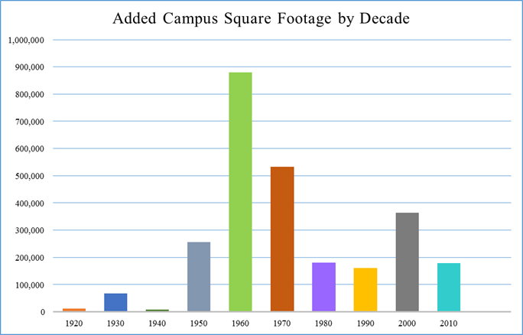
Figure 3.1 University of Tennessee at Martin Campus: Growth by Decade
(University of Tennessee Schedule D, 2015)

The proposed model was developed using the independent predictor variables of facility age, size, use, CPV, and initial cost. These predicator variables were regressed against the dependent variable of the actual maintenance and capital improvement costs for each facility listed in the portfolio.
The maintenance costs for the 11-year period from 2004 through 2014 consisted of two very distinct parts: (1) maintenance repairs funded through campus funds, and (2) capital improvements funded through fluctuating state appropriations. The total cost for maintenance funded by the campus was $19,567,307. The total maintenance cost, including all capital improvements funded during this 11-year period, was $49,033,739. The capital improvements’ funding was sporadic and inconsistent due to dependence on the state funds’ availability. The comparison of the campus’s funded maintenance and the total maintenance including capital funding is shown in Figure 3.2. The addition of capital funds is necessary to a campus’s maintenance effort in to fund high-dollar maintenance items such as HVAC replacements, roof replacements, building envelope upgrades, and other major building systems’ upgrades.

Figure 3.2 Maintenance Funding

Each building’s data also include the initial capital investment, CPV, initial year built, gross square feet, and facility use. This information is tabulated in Table 3.1 with facility use as follows: A – Large academic facility with labs/large athletic: 14 Buildings; B – Academic, office facility no labs: 15 Buildings; C – Residential construction: 5 Buildings.
Table 3.1 University of Tennessee at Martin Facilities’ Attributes
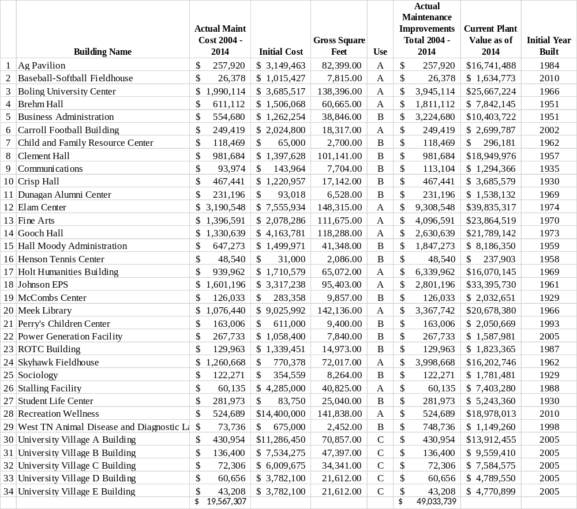

The author considers the 34 facilities at UTM as a homogenous construction, i.e., the facilities are all brick exterior with either a steel frame or block structure. The HVAC systems are not complex or out of the ordinary; and the electrical systems are standard electrical power, lights, and lighting controls. Furthermore, these buildings require no unusual or extensive maintenance (i.e., research level clean rooms, complex pressurization requirements for classrooms or labs, extraordinary cleaning maintenance requirements).
Development of the Model
The formula for estimating the building portfolio’s required maintenance as discussed in Section 3.4 was developed by using multiple linear regression on the independent predictor variables (i.e., facility age, facility size, facility use, CPV, and initial capital investment). These predicator variables were regressed against the dependent variables of the actual M&R costs plus each facility’s capital improvements to determine which variables were considered significant.
Significance of Regression Equation
Multiple regression is a statistical technique through which the relationship between a dependent variable and a set of independent, or predicator, variables can be analyzed. Every value of the independent variable is associated with a value of the dependent variable y. The model for multiple linear regression, given n observations is
Y_{i} = β₀ + β_{1xi1} + β_{2xi2} + … β_{pxip} + ε_{i} for i = 1,2, … n (27)
Process to Develop the Formula
As mentioned above, the information about 34 buildings located on the University of Tennessee at Martin campus was collected. The maintenance costs and capital improvements for these buildings were collected using the University of Tennessee at Martin’s work order system, The Maintenance Authority (TMA. The TMA work order system was used to retrieve this information for 2004 through 2014. Facility age, size, use, initial cost, and current plant value were the attributes used during the regression analysis for the reasons discussed earlier.
Each facility’s CPV was taken from the University of Tennessee Schedule D Physical Facilities Inventory. The author checked this value using square-foot construction values to ensure the beginning 2004 value was reasonable. The construction value was then escalated for each year from 2004 to 2014 using inflation rates calculated using the consumer price index documented by the Bureau of Labor. This information was needed for comparing existing models to the formulated model.
Work Sequence
The following work sequence was used to develop the proposed maintenance prediction equation:
- The following attributes were regressed against the existing maintenance data to see which attributes had the highest correlation:
  - β₁ = Facility Initial Capital Investment
  - β₂ = Facility Current Plant Value
  - β₃ =Facility Age
  - β₄ = Facility Gross Square Feet
  - β₅= Facility Use
at least one β $≠$ 0
The equation was regressed for the 34 buildings using the attribute data from each year starting in 2004 and ending in 2014.
- The equation was developed as it related to the significant attributes based on the statistical results and correlation significance using SPSS software.
- The developed equation was tested against the results of existing model methodologies (i.e., plant value, life-cycle cost, and formula based).
- The developed equation was tested for validity for a portfolio of any facility use.
- The developed equation was tested for validity for individual buildings as well as the entire facilities portfolio.
- The equation was tested against a university facilities portfolio similar in size and construction.
- The derived model was reviewed and compared against a good model’s attributes as discussed by Bello (2010) and listed in section 3.3
- Conclusions were drawn from these results.
Testing the Model
The following hypotheses were tested:
Hypothesis 1: A prediction equation can be developed to estimate M&R funding for a facilities portfolio using facility attribute data commonly available to a facilities manager. The following attribute data were tested: facility age, size, use, initial cost, and current plant value. Each attribute’s significance was tested statistically to determine its importance in the funding model.
Hypothesis 2: The prediction equation is valid to predict maintenance funding for individual buildings.
Hypothesis 3: The prediction equation is valid for a portfolio of any facility use.
Hypothesis 4: The prediction equation yields results consistent with those of the plant value methodology equation. The results of the plant value methodology using the equation ERM = x% (CPV) were compared with the developed prediction equation’s results. The value of “x” was 1.6% as calculated from existing data. The total for 11 years was compared for both equations.
Hypothesis 5: The prediction equation yields results consistent with the formula-based model NACUBO. The results of the NACUBO model were compared with those of the developed prediction equation. The total for 11 years was compared for both equations.
Hypothesis 6: The prediction equation yields results consistent with the life-cycle-methodology-based Dergis-Sherman equation. The results of the Dergis-Sherman model were compared with those of the developed prediction equation. The total for 11 years was compared for both equations.
Hypothesis 7: The prediction equation can be applied to other university portfolios of similar size.
Table 3.2 summarizes each hypothesis.

Table 3.2 Model Analysis Summary
Hypothesis | Description | Test Method | Dependent Variables | Independent Variable
1 | A prediction equation can be developed to estimate M&R funding for a facilities portfolio using facility attribute data commonly available to a facilities manager. | Linear Regression | *Historical Maintenance Data | Facility Age, Size, Use, Initial Cost, CPV
2 | The prediction equation is valid to predict maintenance funding for individual buildings. | Calculates ERM for the entire portfolio, and compares to calculated sum of ERM for individual buildings for 11-year timeframe | *Historical Maintenance Data | Significant Facility Attributes from Prediction Model
3 | The prediction equation is valid for a portfolio of any facility use. | Calculates ERM for each facility use, and compares results to the calculated ERM for the entire portfolio | *Historical Maintenance Data | Significant Facility Attributes from Prediction Model
4 | The prediction equation yields results consistent with the Plant Value Methodology’s equation. | Compares ERM from prediction equation to ERM from PVM equation | ERM
5 | The prediction equation yields results consistent with the Formula Methodology. | Compares ERM from prediction equation to ERM from NACUBO equation | ERM
6 | The prediction equation yields results consistent with the Life-cycle Methodology equation. | Compares ERM from prediction equation to ERM from Dergis-Sherman equation | ERM
7 | The prediction equation can be applied to other university portfolios of similar size. | Calculates ERM from prediction equation for a similar size university and compares results to an accepted model | ERM | Significant Facility Attributes from Prediction Model

*Historical maintenance data include maintenance costs plus capital improvement.
CHAPTER 4: RESULTS
This chapter addresses the results associated with testing the hypotheses stated in the previous chapter. A series of multiple regressions were conducted on the existing facility attribute data using the statistical software SPSS. Based on statistical information, a prediction equation was selected. The 11-year total results of the prediction equation were compared to the 11-year totals of three selected models. The prediction equation’s results were compared to a good model’s attributes as defined by Bello (2010).
Descriptive Statistics of Facility Attributes
The 34-facility portfolio used in this research consisted of the statistical data shown in Table 4.1.
Facility Attribute | Unit | Mean | Range | Maximum | Minimum | #of Cases | Standard  Error | Standard  Deviation
Facility Age | Years | 36.19 | 85 | 85 | 0 | 374 | 36.19 | 25.513
Facility Size | Gross Square Feet | 51,008 | 146,229 | 148,315 | 2,066 | 374 | 2,430.78 | 47,009.20
CPV | Dollars | $7,697,336 | $36,434,205 | $36,434,205 | $ 0 | 374 | $415,573 | $8,036,814
Initial Cost | Dollars | $2,887,162 | $14,372,000 | $14,400,000 | $ 2,086 | 374 | $175,682 | $3,397,543
Table 4.1 Statistical Data for Facility Attributes Used in Research
Facility Type | Frequency | Percent
A | 14 | 41
B | 15 | 44
C | 5 | 15
Total | 34 | 100.0

The average age of the facilities in the portfolio was 36 years with an average size of approximately 51,000 square feet. The average current plant value was approximately $7.7 million. The facilities portfolio’s average initial cost was $2.9 million. As mentioned in Chapter 3, the actual maintenance costs for the 11-year period (from 2004 through 2014) consisted of two distinct parts: (1) maintenance repairs funded by campus funds and (2) capital improvements funded through fluctuating state appropriations. The total campus funding for maintenance was $19,567,307. The total maintenance including all capital improvements was $49,033,739.
Testing Hypotheses
Testing of Hypothesis 1: An equation that predicts required M&R funding for a facility portfolio can be derived from readily available facility attribute data. A series of linear regressions were run on the research portfolio’s facility attributes, which included the historical maintenance data of facility age, size, use, initial cost, and current plant value. This information was gathered from the 34-building portfolio for an 11-year period (from 2004 through 2014). The historical maintenance data are (1) maintenance costs funded through the campus maintenance budget designated (OM) in the regression analysis and (2) capital improvements funded through state appropriations designated (OMCI) in the regression analysis. Three regression iterations were completed to see the effects on the model due to inconsistent and fluctuating funding of the yearly capital improvements. In the first analysis, the independent variables of facility age, size, use, initial cost, and current plant value were regressed against the dependent variable of actual maintenance excluding capital improvements. The second regression analysis added capital improvements to the campus-funded maintenance items. The third regression analysis normalized the capital improvements over each of the study years

Regression Analysis with the Dependent Variable of Campus-funded Maintenance Costs
The first analyses were run using the dependent variable of maintenance costs funded by the campus maintenance budget. The independent variables were facility age, size, use, initial cost, and current plant value. A stepwise regression was run to determine the significant variables. The resulting significant variables were CPV, size, and initial cost. The resulting R² was .482, and the adjusted R² was .478. As shown in Figure 4.1, the normality plot and histogram of the residuals indicated the need to transform the dependent variable to normalize the response variable.
A series of linear regressions were completed using the stepwise function of SPSS using the transformed dependent variable lnOM against all the facility attributes. The R2 and adjusted R2 of .516 and .512 came from the facility attributes of “size,” “age,” and “CPV.” The residual plots showed a normal distribution as depicted in Figure 4.2.

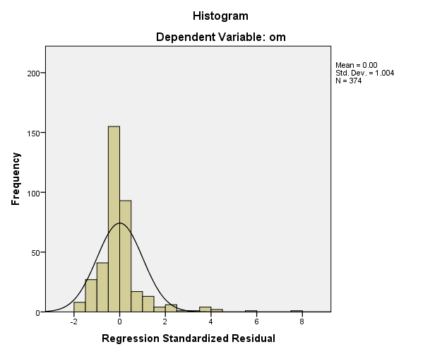 | 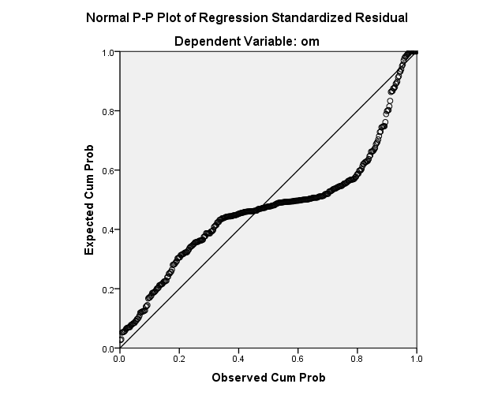

Figure 4.1 Residual Plots for OM vs. CPV, Size, and Initial Cost

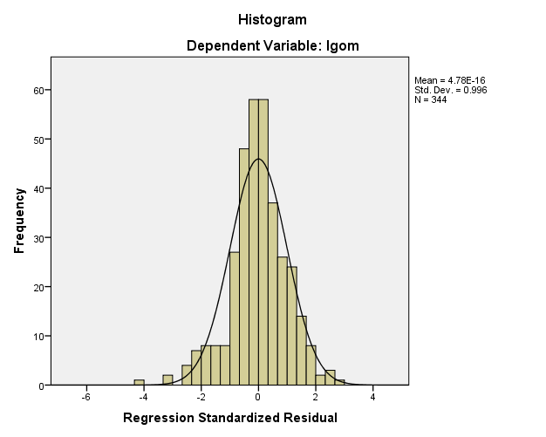 | 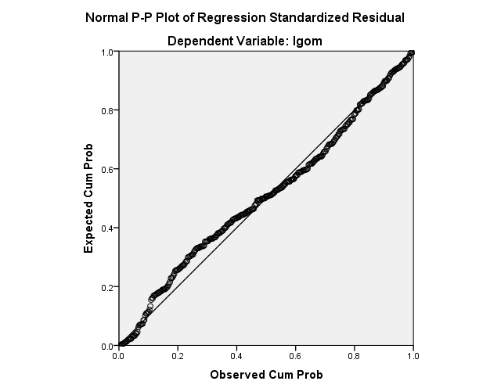

Figure 4.2 Residual Plots for LnOM vs. CPV, Size, and Age
To improve the model, the CPV was transformed to the natural logarithm of CPV (lnCPV) in order to better balance the resulting equation because of the large range of CPV values. The result increased the R² to .583 and the adjusted R² to .578. The significant attributes remained size, age, lnCPV; and the facility use proved significant.
The OM dependent variable was transformed to (OM) ^{1/2} to determine the effects on the model. This transformation was made to determine if the correlation to the existing maintenance improved and if the adjusted R² improved. Regression iterations were performed using this dependent variable on all the independent variables (i.e. facility age, size, use, initial cost, and CPV). The resulting transformation improved the model results. The best result for this series of regressions was an R² of .616 and an adjusted R² .611. The significant variables were CPV, age, size, and initial cost. The plots of residuals showed some non-normality as indicated in Figure 4.3. The significant variables were checked for multi-collinearity. The variance inflation factors (VIF) indicated that the CPV and size were moderately correlated with values of 4.767 and 5.483, respectively.
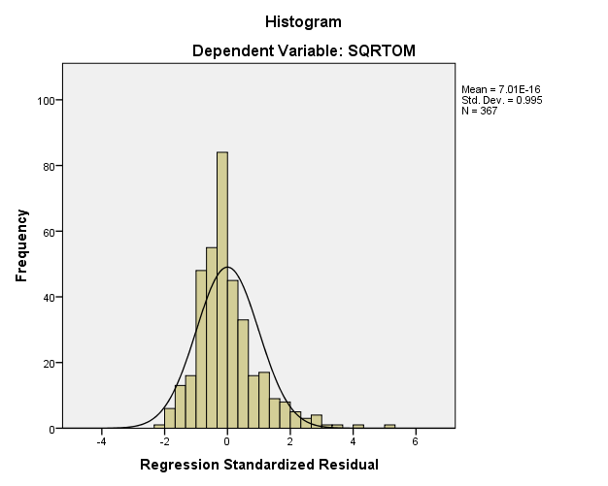 | 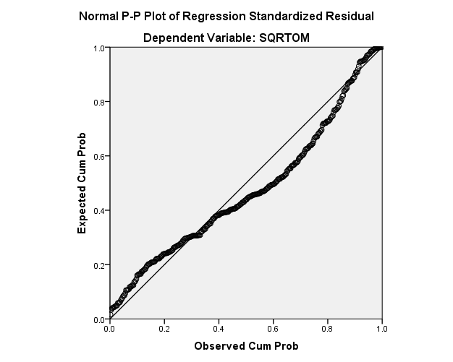

Figure 4.3 Residual Plots for (OM)^{1/2} vs. CPV, Age, Size, and Initial Cost

To determine the effects of removing a variable in order to make the model more applicable to a wide spectrum of users, a regression was run using the stepwise function with the same dependent variable of (OM)^{1/2} and independent variables of PRV, age, and size. The R² was .603, and the adjusted R² equaled .600. The series of regression analyses as described above are summarized in Table 4.2. The results column in Table 4.2 (page 74) is the ERM calculation using the historical data within the prediction equation to compare to the actual maintenance costs of $19,567,307.
The following equation was selected from the series of regressions:
ERM = (41.776 + 6.808E-6(CPV) +.745(age)+.002(size)-7.957E-6(initial cost))2 (28). This equation provided an ERM of $20,983,511 as compared to the actual OM cost of $19,567,307. Although this series of regressions provided an equation providing a very close correlation to the actual maintenance costs excluding capital improvements, it did not provide the entire maintenance picture needed.

Table 4.2 Summary of Regression Analyses: Maintenance Excluding Capital Improvements

Dependent Variable | Independent Variable | Significant Variables | Adjusted R² | VIF | Coefficients | Results of Model with Actual Data  ($19,567,307)
OM | CPV, age, initial cost, size, use | CPV,  size,  initial cost | .478 | 4.747  3.335  1.558 | -769.799(constant)  .004(CPV)  .694(size)  -.006(int cost) | $18,077,471
lnOM | CPV, age, initial cost, size, use | size,  Age,  CPV | .512 | 4.764  1.003  4.759 | 8.162 (constant)  1.879E-5(size)  .011(age)  4.143E-8(CPV) | $15,171,352
lnOM | age,  initial cost, size, use, lnCPV | size,  lnCPV,  type | .578 | 3.902  3.756  1.452  1.939 | -1.758 (constant)  .719 (lnCPV)  -.269 (use)  1.005E-5(size) | $9,963,674
OM^{1/2} | CPV, age, initial cost, size | CPV,  age,  size,  initial cost | .611 | 4.767  1.448  5.483  2.249 | 41.776 (constant)  6.808E-6 (CPV)  .745 (age)  .002 (size)  -7.957E-6(int cost) | $20,983,511
OM^{1/2} | CPV, age, size | size,  age,  CPV | .600 | 4.758  1.004  4.764 | 21.025(constant)  .001 (size)  1.166 (age)  6.689E-6(CPV) | $13,723,030

Regression Analysis Adding Capital Improvements to the Dependent Variable
The capital improvement costs were added to the maintenance costs as the dependent variable for a series of regression analyses. The independent variables were facility age, size, use, initial cost, and current plant value. The first analysis provided an R² of .112 and an adjusted R² of .107. The significant variables included size, and initial cost. As shown in Figure 4.4 (page 75), a normality plot and residuals histogram indicated the need to transform the dependent variable to remove the response variable’s non-normality.
The dependent variable was transformed using the log of maintenance costs plus capital improvements (OMCI) and regressed against the independent variables of age, size, CPV, initial cost, and use. The significant variables from this regression analysis were size, age, and CPV.
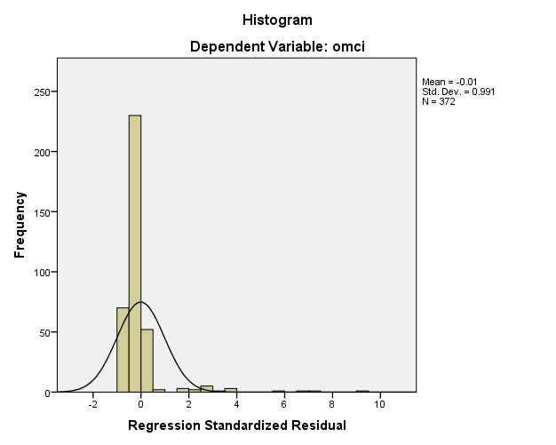 | 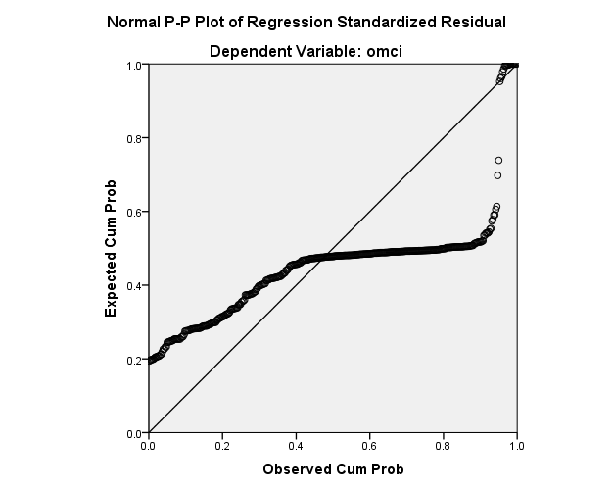

Figure 4.4 Residual Plots for OMCI vs. Size and Initial Cost

The resulting R² was .494, and the adjusted R² was .490. Regression analyses were also run using the same dependent variable of log of the maintenance costs plus capital improvements and regressed against size, initial cost, age, and lnCPV. The significant variables included size, lnCPV, and age. The resulting R² was .531, and the adjusted R² was .527. The dependent variable was transformed to (OMCI)^{1/2} to determine the effects on the model. This transformation degraded the model. Adding the capital improvements degraded the model in all cases as compared to the regressions using just campus-funded maintenance costs as the independent variable. The results are provided in Table 4.3.
Regression Analysis Normalizing the Capital Improvements
Based on previous regressions, the capital improvements’ sporadic funding degrades the model that includes both components of the maintenance costs. The best equation that can be derived is one containing only the costs funded by the campus on a more consistent yearly basis. However, a total model predicting the entire maintenance spectrum is desired for this research. To achieve a model that shows total spending needs and that can be compared to developed
models, the capital improvement costs were normalized by taking the average of the total capital

Table 4.3 Summary of Regression Analyses: Maintenance Including Capital Improvements

Dependent Variable | Independent Variable | Significant Variables | Adjusted R² | VIF | Coefficients | Results of Model with Actual Data  ($49,033739)
OMCI | age, size, CPV, initial cost, use | size  initial cost | .107 | 1.558  1.558 | -1209.259 (constant)  3.636 (size)  -.017 (initial cost) | $50,437,423
lnOMCI | age, size, CPV, initial cost, use | size  age  CPV | .490 | 4.764  1.003  4.759 | 8.069 (constant)  2.122E-5 (size)  .013 (Age)  4.379E-8 (CPV) | $20,560,836
lnOMCI | size, initial cost, age, LnCPV | size  lnCPV  age | .527 | 3.216  3.241  1.014 | .435 (constant)  1.526E-5 (size)  .538 (lnCPV)  .015(age) | $18,163,444
(OMCI)^{1/2} | CPV, age, size, initial cost, use | size  initial cost  CPV | .312 | 5.316  1.558  4.729 | 71.377 (constant)  .003 (size)  -1.863E-5 (init cost)  8.724E-6 (CPV) | $31,971,739
(OMCI)^{1/2} | CPV, age, size | CPV  age  size | .309 | 4.746  1.004  4.741 | -2.916 (constant)  .002 (size)  1.686 (age)  8.159E-6 (CPV) | $27,086,485

improvements by building and distributing them over each year by each building. Obviously, this is not the actual historical distribution of funds spent. However, it does represent the total amount spent for each of the buildings during the 11-year cycle. It is also a more desirable distribution of the facilities manager’s spending because it provides a consistent level of funding for a facilities portfolio over time. The sporadic funding of maintenance dollars is less desirable for many reasons.
Several regression iterations were run on the normalized dependent variable of total maintenance costs including capital improvements (NORMOMCI) and the most significant facility attributes from the previous iterations described above. The most significant attributes providing the highest adjusted R² from Table 4.2 were used as the starting point for this regression. The first regression of the dependent variable against the current plant value, age, size, and initial cost using the stepwise function provided significant variables of size, initial cost, and current plant value. The regression provided an R² of .531 and an adjusted R² of .527. A normality plot and histogram of the residuals (Figure 4.5) indicated the need to transform the independent variable to remove the response variable’s non-normality.
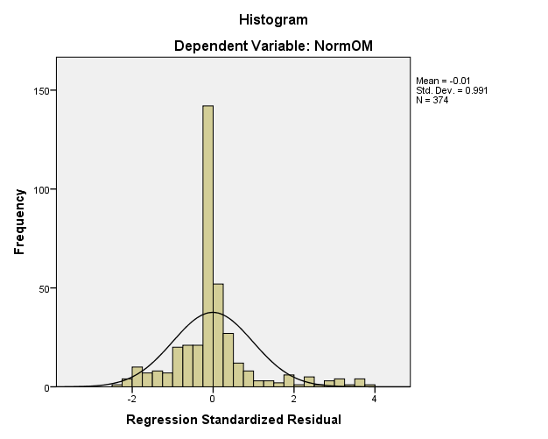 | 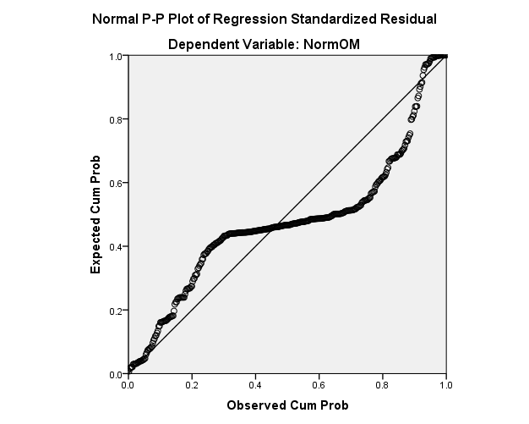

Figure 4.5 Residual Plots for NormOMCI vs. CPV, Size, and Initial Cost

A series of linear regressions were completed using the stepwise function of the transformed dependent variable “(NORMOMCI)^{1/2}” against the facility attributes of current plant value, size, age, and initial cost. The R² and adjusted R² of .629 and .625 came from the facility attributes of size, age, initial cost, and current plant value. The residual plots also showed a more normal distribution and linear relationship (Figure 4.6). A facility attribute was removed from the equation to determine the effects of removing a variable in order to make the model more applicable to a wide spectrum of users. A regression was run using the stepwise function with the same dependent variable and the independent variables of size and initial cost. The resulting R2 was .616, and the adjusted R2 was .614. A series of other regressions were run by using the same dependent variable and by transforming it to Ln(NORMOMCI). All iterations degraded the model. The results are included in Table 4.3. The results column in Table 4.4 is the
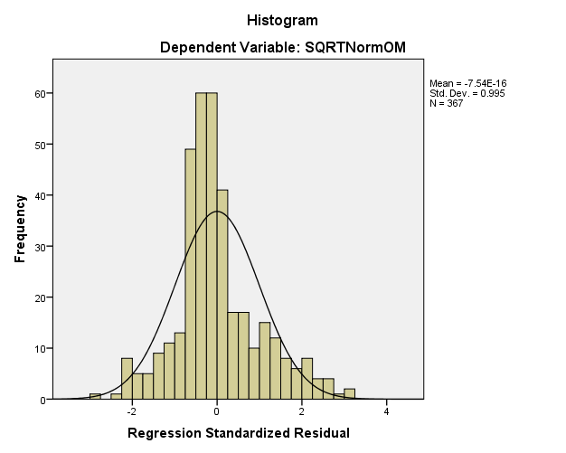 | 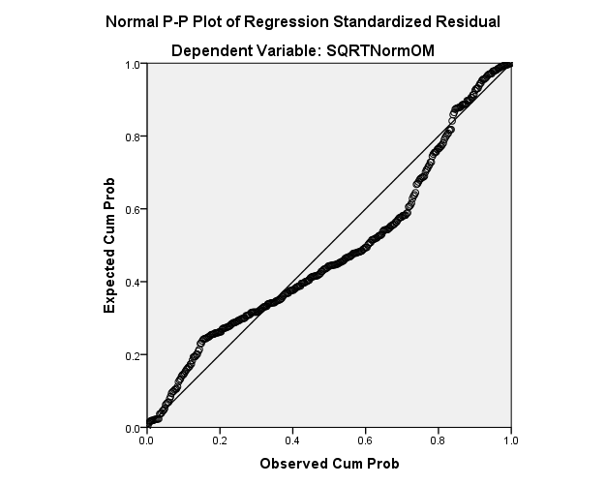
Figure 4.6 Residual Plots for (NormOMCI)^{1/2} vs. CPV, Size, Age, and Initial Cost
the maintenance calculation using the historical data within the developed prediction equation to compare to the actual maintenance costs of $49,033,739. These regressions’ results provided an equation that compared well to the actual OM costs plus capital improvements and high adjusted R2. The selection of the prediction equation is discussed in the following section.
Selection of Prediction Equation
The final equation was selected after considering the regression results from using the dependent variable of maintenance costs with the following modifications: (1) excluding the capital improvements, (2) including the capital improvements, and (3) capital improvements normalized by averaging the capital improvement amounts by building, by year. A proposed prediction equation was developed using the maintenance costs excluding capital improvements with a high correlation to the campus-funded maintenance costs that excluded capital improvements. However, this equation only provided results consistent with costs excluding capital improvements. An equation that cannot predict a facilities portfolio’s entire maintenance projection is not beneficial to a facilities manager.

Table 4.4 Summary of Regression Analyses: All Maintenance Costs
Dependent Variable | Independent Variables | Significant Variables | Adjusted R² | VIF | Coefficients | Results of Model with Actual Data  ($49,033739)
NormOMCI | CPV,  age, size,  initial cost | size  initial cost  CPV | .527 | 5.335  1.558  4.747 | -2194.029 (constant)  2.496 (size)  -.018(init cost)  .008(CPV) | $50,521,910
(NormOMCI)^{1/2} | CPV, age, size,  initial cost | size  initial cost  CPV  age | .625 | 5.483  2.249  4.767  1.448 | 64.864 (constant)  .004(size)  -2.355E-5(init cost)  5.889E-6(CPV)  .747(age) | $41,257,375
(NormOMCI)^{1/2} | CPV, size, initial cost | size  initial cost  CPV | .621 | 5.335  1.558  4.747 | 94.762(constant)  .004(size)  -2.789E-5(init cost)  6.168E-6(CPV) | $39,267,037
(NormOMCI)^{1/2} | size,  initial cost | size  initial cost | .614 | 1.558  1.558 | 95.466(constant)  .005(size)  -2.799E-5(init cost) | $40,429,816
(NormOMCI)^{1/2} | CPV, age, size | size  age  CPV | .588 | 4.758  1.004  4.764 | 3.455 (constant)  .003(size)  1.991(age)  5.535E-6(CPV) | $38,610,071
(NormOMCI)^{1/2} | CPV, age, size,  initial cost, lnCPV | size  initial cost  CPV | .611 | 5.315  1.583  4.861 | 99.036 (constant)  .004(size)  -2.707E-5(init cost)  5.475E-6(CPV) | $39,218,267
Ln(NormOMCI) | CPV, age, size,  initial cost | size  initial cost | .525 | 1.614  1.614 | 9.0 (constant)  3.736E-5(size)  -1.768E-7(init cost) | $37,588,835
Ln(NormOMCI) | CPV, age, size,  initial cost, LnCPV | size  initial cost  lnCPV  age | .564 | 3.775  2.297  3.243  1.411 | 1.560  2.440E-5(size)  -1.588E-7(init cost)  .511(lnCPV)  .007(age) | $34,725,625
Ln(NormOMCI) | size,  initial cost, lnCPV | size  initial cost  LnCPV | .560 | 3.557  1.639  3.243 | 1.862 (constant)  2.583E-5(size)  -1.972E-7(init cost)  .510(lnCPV) | $34,755,447

As the regression process continued by adding the capital improvements back into the dependent variable, it was obvious that the capital improvements as they were funded degraded the model. Although ANOVA results provided an acceptable R-squared and an adjusted R-squared value in one of the iterations, the lack of correlation between the value derived from the prediction equation and the actual total maintenance amount caused this model to be rejected.
In order to develop a total maintenance projection model, an attempt was made to normalize the sporadically funded capital improvements by taking the average of the totals and distributing them over the 11 years for each building. A series of regression iterations were conducted on this dependent variable and the significant variables from the previous regressions. The initial result provided a model with a very high correlation to the actual values and to the low R-squared (adjusted R-squared) values. After rejecting this model because of the low adjusted R², the regression iterations continued and provided results with a higher R-squared (adjusted R-squared) and a more moderate correlation value compared to the actual models. The result with the highest R-squared (adjusted R-squared) provided a more detailed model with four variables. This model was kept while the models with fewer variables and lower R-squared (adjusted R-squared values) were rejected. The ANOVA results were checked to verify the final decision during this process. Based on these factors, the final equation used to test the remaining hypotheses was
ERM = (64.864+.004(size) – 2.355E-5(initial cost) +5.889E-6(CPV) +.747(age)) ² (29).
Testing of Hypothesis 2: The prediction equation can be developed to predict maintenance for individual buildings. To test this hypothesis, the ERM from the 11 years for each building was calculated using the derived equation. This calculation was compared to the actual maintenance costs from the historical data including capital improvements. The total maintenance including all capital improvements funded was $49,033,739. The total for each building for the 11-year period was compared to the prediction equation. The tabulated data for the historical maintenance costs are shown in Table 4.5. A paired T test was calculated on the existing historical data versus the calculated maintenance from the predication equation. The results provided a strong correlation of .760 (R² of .578) and a p value of .345, indicating no significant difference between the means of the existing historical data and predicted values.
A graph of the actual maintenance versus the maintenance computed by the prediction equation for the 11 years by building is shown in Figure 4.7. The peaks for the actual maintenance versus the prediction equation are very different in some cases because the prediction equation averages the capital improvement costs for each building for each of the 11 years.

Figure 4.7 Actual vs. Prediction Equation by Building

Table 4.5 11-year Actual and Predicated ERM by Building
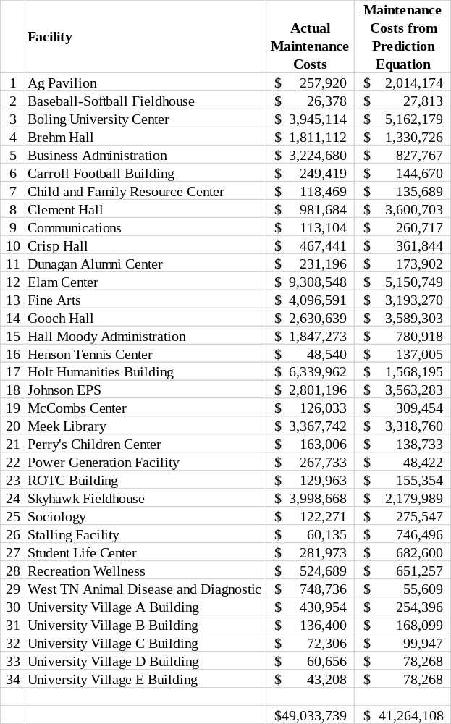

Testing of Hypothesis 3: The prediction equation is valid for a portfolio of any facility use. The building uses for the 34-building portfolio are the following:
A – Large academic facility with labs/ large athletic: 14 buildings
B – Academic or office facility with no labs: 15 buildings
C – Residential construction: 5 buildings
To test this hypothesis, the buildings were grouped according to their use and compared with the predication equation. A paired T test for each use was conducted to determine the correlation between actual and predicated values for each building use. The individual tests’ results, listed in Table 4.6, show a strong correlation among the data in Facility Use A, B, and C. The buildings grouped by use along with the actual maintenance and prediction equation costs are shown in Table 4.7.
Table 4.6 Results of Paired T-test for Facility Use
Facility Use | Correlation | R-Squared | P-Value
A | .705 | .497 | .362
B | .330 | .100 | .817
C | .957 | .915 | .769

Table 4.7 Actual and Predicted Maintenance Costs by Building Use
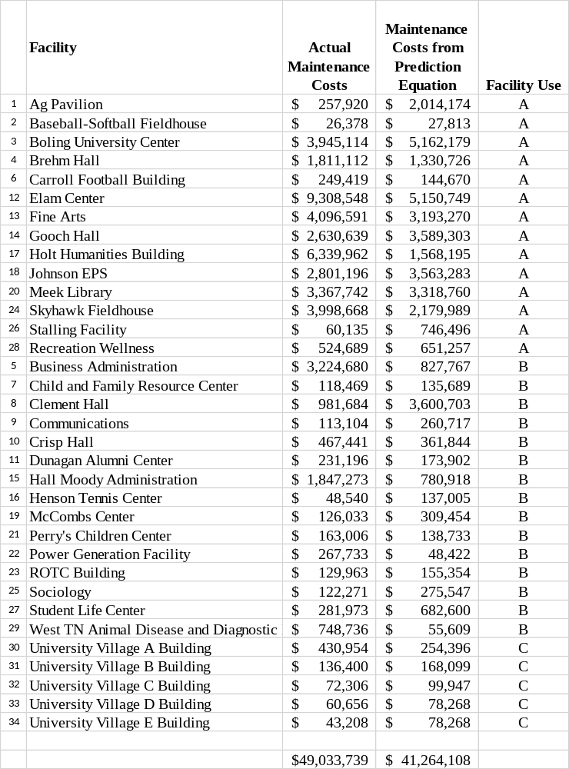
Testing of Hypothesis 4: The prediction equation yields results consistent with the Plant Value Methodology equation. The plant value formula used to test this hypothesis was
ERM = (x%) CPV using 1.6% as a multiplier (30).
The plant value was multiplied by 1.6% for each of the 34 buildings for each of the 11 years (2004-2014). This value was calculated from the building portfolio’s data. The research portfolio’s ERM for the plant value calculated from 2004 through 2014 was $46,043,927. The total ERM calculated from the predication equation was $41,264,108.
Testing of Hypothesis 5: The prediction equation yields results consistent with the NACUBO model. The NACUBO formula was calculated using equation 19 from Chapter 2 assuming no existing deferred maintenance backlog exists and that no deferred maintenance backlog can be develop. Estimating an amount of deferred maintenance backlog would be difficult. The plant deterioration rate was calculated to be 1.6% using actual operation and maintenance and capital improvement costs for the 34-building portfolio. The plant deterioration rate is defined as the facility portfolio’s rate of deterioration expressed as a percentage of current replacement value per year. This rate was calculated for each of the 11 years and then averaged. The 1.6% rate is reasonable since many times 2% is assumed in using the calculations. The plant growth rate was calculated to be 1.7% for the facility portfolio. The research portfolio’s ERM for the NACUBO calculated from 2004 through 2014 was $46,826,674. The total ERM calculated from the predication equation was $41,264,108.
Testing of Hypothesis 6: The prediction equation yields results consistent with the Life Cycle methodology based on Dergis-Sherman model. The Dergis-Sherman equation was applied to the research data for the 34 buildings for the 11-year timeframe. The formula for the Dergis-Sherman model as described in Equation 4 from Chapter Two was used in this calculation. The ERM for the research portfolio for the Dergis-Sherman model calculated from 2004 through 2014 was $41,548,531. The ERM calculated from the predication equation was $41,264,108.
Summary of Model Comparisons (Related to Hypotheses 4, 5, and 6)
Table 4.8 summarizes the results using the above-mentioned models to the derived prediction equation. The results as shown in Table 4.8 indicate there is a good correlation among the three models for a facility portfolio with the attributes detailed in this research. These results are summarized in Table 4.9 (Comparison of Models vs. Prediction Equation by Building) and Figure 4.8 (Graphical Comparison of NACUBO, Plant Value, Dergis-Sherman, and Prediction Equation). Figure 4.8 shows the close correlation between the prediction equation and the compared models.
Table 4.8 Comparison of Data for Model Calculations
Prediction Equation Source | Calculated ERM for  2004 – 2014
Prediction Equation | $41,264,108
Plant Value | $46,043,927
NACUBO | $46,826,674
Dergis-Sherman | $41,548,531

Table 4.9 Comparison of Models vs. Prediction Equation by Building

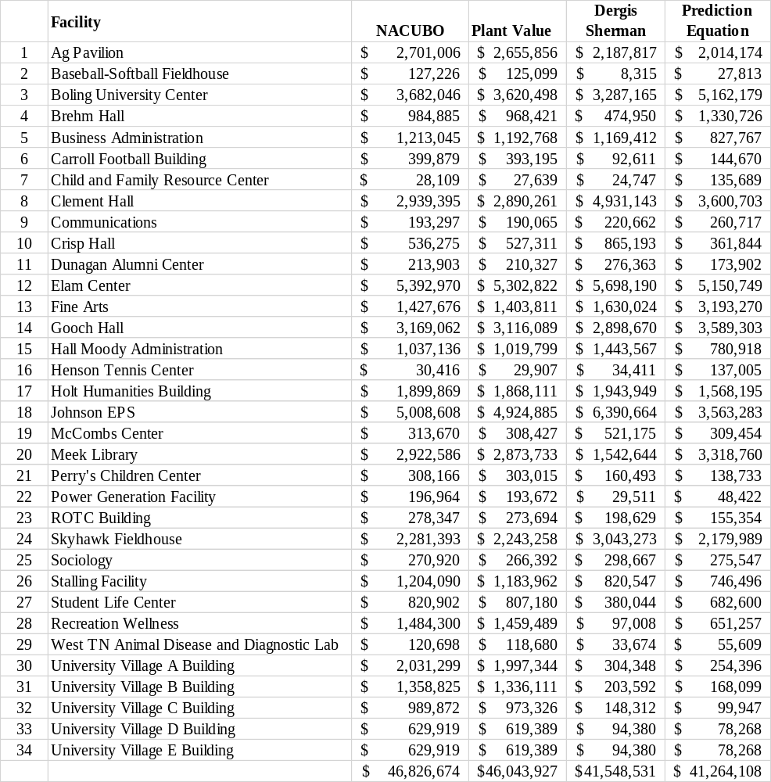

Figure 4.8 Comparison of NACUBO, Plant Value, Dergis-Sherman, and Prediction Equation

Testing of Hypothesis 7: The prediction equation can be applied to other university portfolios of similar size.
The ERM for a 20-building portfolio from the University of Tennessee at Chattanooga was calculated. The facility attribute data was taken for 2016 from the University’s Schedule D information and are listed in Table 4.10. The prediction equation provided an ERM of $2,684,964. Since the actual OM/capital improvements are unknown, the plant value ERM for this facility portfolio was calculated to be $5,736,218. Also, the NACUBO equation was used to calculate a prediction maintenance amount of $4,637,818. As shown in Figure 4.9, the prediction equation tends to follow the other models’ trend; however, several values are significantly different. The data indicate that the prediction equation would not compare to the models associated with this 20-facility portfolio from another university. Although comparing actual maintenance to the prediction equation would be interesting, these numbers were not available.
Table 4.10 Facility Data and Model Tabulation for Other University
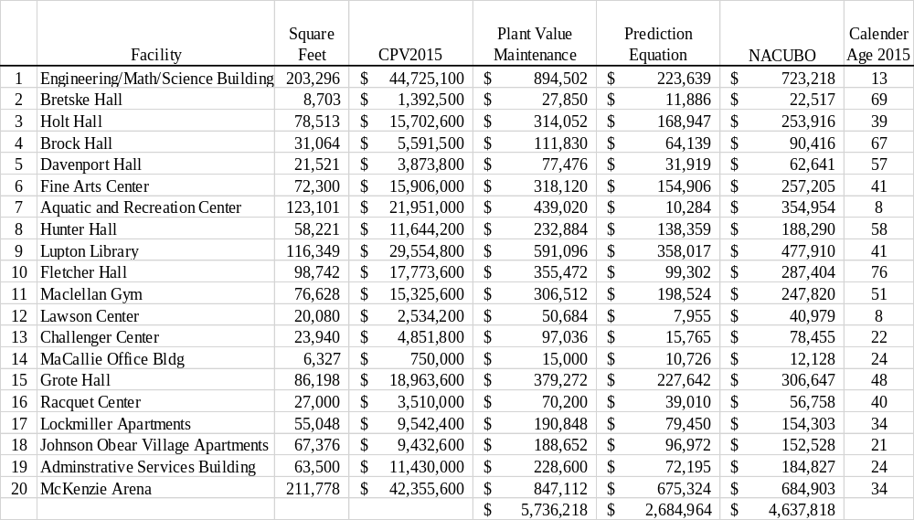

Figure 4.9 Comparison of Models for Other University

Comparison of the Derived Model to the Attributes of a Good Model
One of the main objectives in developing this equation was to provide a realistic and working model that is beneficial to facilities managers in estimating required maintenance costs. Dergis and Sherman (1981), Monterecy (1985), and Bello (2010) identified attributes of a good model. Bello consolidated the attributes from Dergis and Sherman and from Monterecy to derive a set of attributes defining a model that can be effectively and feasibly used. A discussion of how this model meets those attributes follows.
- The formula should utilize quantifiable input data which are easily obtained. The developed equation uses attributes from the facilities portfolio readily accessible to any facilities manager. The significant attributes used in the prediction equation are data facilities managers have at their disposal. This objective is met.
- The formula should be simple to apply. The formula is a simple math equation, which is easy to understand and apply. The facilities manager can relate the facility attributes to the building portfolio. The number of facilities are small and easy to obtain. This objective is met.
- The formula should be objective. It should be applicable and equal treatment for all institutions using the formula. The equation was initially applied to a university’s 34-building portfolio. The equation was also applied to another university’s building portfolio and did not provide comparable results to the NACUBO or plant value methods. Based on this finding, the equation does not appear to provide objective results and cannot be applied to other institutions. However, further research and application to other portfolios needs to be completed to fully accept or reject this objective.
- The formula should be easy to understand. The equation includes facility attributes common to a facility portfolio and easily understood by those in facilities management. This objective is met.
- The formula should be flexible to meet a changing budget environment. Since the model equation uses common facility attributes, the equation will adapt to a changing portfolio size. As the building numbers increase, the model can be applied to those buildings by knowing the attributes used in the equation. To fully accept this objective, this equation should be further tested on various facilities portfolios.
- The formula should provide reliable results and allow comparison of results to other users. The model equation did provide a good comparison to the Dergis-Sherman, NACUBO, and the Plant Value model results for this facility portfolio. The objective was met.
- The formula should provide an adequate, but economic budget level. The prediction equation’s results provided numbers similar to the compared models. These results could be assumed to be reasonable for a portfolio similar to the one presented in this research. Also, the model can provide budgetary estimates for the facilities manager’s use. The objective is met.
- The formula input should have an acceptable and logical relationship to the physical plant function. The model uses facility attributes readily available to a facilities manager. Those attributes provide a definite meaning regarding the facility’s physical attributes. The attributes used in the prediction equation are readily available to the facilities manager and are tied to physical plant functions. The objective is met.
- The formula should define the resource allocation’s functions and costs, and it must preserve management flexibility. The model equation estimates the building portfolio’s required maintenance and appears to provide building-level maintenance projections for a facilities portfolio such as the one used in this research. There should be additional research and testing of this prediction equation on other portfolios to determine this equation’s flexibility. This objective cannot be fully accepted or rejected at this point.
An equation was derived through the regression analysis of the significant facilities attributes. Each of the stated hypotheses were evaluated and discussed regarding the derived prediction equation. Also, a good model’s attributes were reviewed in relation to the results, and most were found to be met. Chapter Five will discuss the conclusions of this study and the opportunities for future research.
CHAPTER 5: CONCLUSIONS
The purpose of this research was to provide a robust equation that would predict a facilities portfolio’s maintenance costs. During this research, many models were identified that ranged from the overly simplistic to those providing lengthy calculations. Specifically, this research developed an equation for a university facility portfolio. This chapter discusses this study’s results as well as opportunities for future research.
Discussion of Results
This research met the following objectives:
- A mathematical model was developed to estimate the required maintenance and repair budget for a university’s facilities portfolio. The model was based on actual maintenance and repair as well as capital improvement cost information gathered from these facilities. This information is readily accessible to any facilities manager. This model was tested for applicability to both the facilities portfolio and individual buildings. Significant facility attributes were used in developing this model.
- The equation from the developed model was compared to several existing maintenance prediction methods, and the variances were evaluated.
- The equation was then used for another university’s facilities portfolio.
In meeting these objectives, a set of hypotheses was developed and tested. The results are listed in Table 5.1.

Table 5.1 Summary of Hypotheses’ Tests and Results
 | Hypothesis Description | Results
1 | An equation that predicts required M&R funding for a facility portfolio can be derived from readily available facility attribute data. | Cannot be rejected
2 | The prediction equation can be developed to predict maintenance funding for individual buildings. | Cannot be rejected or accepted
3 | The prediction equation is valid for a portfolio of any facility use. | Cannot be rejected or accepted
4 | The prediction equation can be developed to determine the usefulness of the developed equation to the Plant Value Methodology. | Cannot be rejected
5 | The prediction equation can be developed to determine the usefulness of the developed equation against other formula-based equations – NACUBO. | Cannot be rejected
6 | The prediction equation can be developed to determine the usefulness of the developed equation against the Life Cycle methodology—Dergis Sherman. | Cannot be rejected
7 | The prediction equation can be applied to other university’s portfolios of similar size. | Cannot be rejected or accepted

During the testing of Hypothesis 1, the facility attributes from the University of Tennessee at Martin’s 34-building portfolio for a period from 2004 through 2014. After a series of linear regression analyses was completed, a prediction equation was developed based on the historical data. A result that was not surprising was being able to regress facility attributes against a dependent variable to define a best-fit equation for the data. If a facilities manager is fortunate enough to have historical data on his/her portfolio, an equation can be developed for predicting maintenance expenses. Interestingly, the capital improvements’ sporadic funding degraded the model to the point that the predicted values had little correlation with the actual maintenance values. The model was developed only after capital improvements were normalized by taking a yearly average for each affected building. The research confirmed that the facility attributes of size, current plant value, age, and initial cost were significant attributes during the regression process. Facility age and current plant value were identified as significant attributes with the highest frequency during the iteration process. Not surprisingly, the facility use did not play a significant role in this equation since all the buildings were homogenous.
As the equation was tested for applicability to individual buildings in Hypothesis 2 and the facility use in Hypothesis 3, the prediction equation had a high correlation between the predicted amount and the actual amount both by building and facility use. Although only tested on this facilities portfolio, this is an interesting finding that deserves additional research in relation to other portfolios to see if the correlation holds true. The ability to estimate maintenance costs on an individual building level is beneficial to a facilities manager. There were considerable differences in the 11-year totals for several of the buildings because of decisions to implement certain maintenance replacements based on engineering judgement.
The developed equation provided a good comparison to the Plant Value Methodology, NACUBO, and Dergis-Sherman models for the portfolio used in this study. The percentage difference was calculated for each model and is shown in Table 5.2
Table 5.2 Percent Difference between Model Value and Prediction Equation
Prediction Equation  Source | Calculated ERM  for 2004 – 2014 | Percentage Difference from Prediction Equation
Prediction Equation | $41,264,108
Plant Value | $46,043,927 | 11%
NACUBO | $46,826,674 | 13%
Dergis-Sherman | $41,548,531 | Minimal
Determining whether the developed prediction equation is better or worse than other models is difficult. The developed prediction equation produced results comparable to the mentioned models for the facilities portfolio studied. The models selected to provide a comparison to the prediction equation did not allow for predicting maintenance costs by buildings. The equation provided a high correlation to maintenance costs by individual building, a benefit that the other models did not provide. As stated previously, additional testing is needed to ensure that this correlation is true for other facilities in a portfolio. This study should encourage facilities managers to use their historical data for preparing a prediction equation that serves their building portfolio. As the use of building information systems increases and historical data are more readily accessible, facilities managers should use this approach. Developing such an equation is relatively easy and seems to be better suited for producing results for a specific set of buildings.
The political ramifications of having this required maintenance estimate can put additional stress on facilities managers. If funds are not provided and spent on buildings, facilities mangers and university officials are going to be held accountable to these estimated amounts. This accountability can have both positive and negative consequences for facilities managers as they publish the needs of their building portfolio. Funding authorities and state legislators will be encouraged to provide funding in accordance with funding requirements. Facilities managers must spend these funds wisely and strategically or else be held accountable for their mismanagement and/or failures.
Opportunities for Future Research
This research’s results provide an equation very close to the building portfolio’s actual maintenance and repair expenses from 2004 through 2014. Additional research is required to see if this equation can apply to a wide spectrum of university facilities portfolios or if the equation is only applicable to the 34-building portfolio from which it was derived. The available data for this research were limited to 2004 through 2014. Although the data used in this study was historical, more data would help in the regression analysis by smoothing the effect of fluctuating maintenance funding.
It would be very interesting to apply the developed prediction equation to universities that might have historical information from their work order system to determine how the developed equation compares to costs, including or excluding capital funding.
Application of this equation by individual building was also a result. It would be helpful to test this equation against a commercial building portfolio, such as office buildings or apartment complexes, to see how the prediction equation compares with actual costs over time.
The increasing availability of historical maintenance data will benefit researchers in documenting and verifying equation results. Along with the application of a prediction equation to a facilities portfolio, the analytical and discerning judgement of the facilities manager is always needed in requesting funds and correctly applying the funds. No prediction equation provides a silver-bullet solution to maintaining a maintenance portfolio.

REFERENCES

Alabdulkarim, A. A., Ball, P. D., & Tiwari, A. (2013). Applications of simulation in
maintenance research. World Journal of Modelling and Simulation, 9(1), 14-37.
APPA. (2011). Workplace demographics and technology: Challenges and opportunities to the campus mission. Alexandria, VA: APPA.
APPA. (2012). Campus space... An asset and a burden. Alexandria, VA: APPA.
APPA. (2014). Leveraging facilities for institutional success. Alexandria, VA: APPA.
APPA. (2016). NACUBO/APPA key facilities metric survey and report. Retrieved from http://www.appa.org/research/nacubo.cfm
APPA, Federal Facilities Council, Holder, International Facility Management Association, & NASFA. (2002). Asset lifecycle model for total cost of ownership management: A framework for facilities lifecycle cost management. Alexandria, VA: APPA.
Arditi, D., & Nawakorawit, M. (1999). Issues in building maintenance: Property managers' perspective. Journal of Architectural Engineering, 5(4), 117-132. doi: 10.1061/(ASCE)1076-0431(1999)5:4(117)
Augenbroe, G., & Park, C.-S. (2002). Towards a maintenance performance toolkit for GSA. Atlanta, GA: Georgia Institute of Technology.
Au-Yong, C. P., Ali, A. S., & Ahmad, F. (2014). Predication cost maintenance model of office building based on condition-based maintenance. Maintenance and Reliability, 16(2), 319-324.
Barco, A. L. (1994). Budgeting for facility repair and maintenance. Journal of Management in Engineering, 10(4), 28-34. doi: doi:10.1061/(ASCE)9742-597X(1994)10:4(28)

Beach, R., Carson, J., & Keating, K. (1998). Cost predictions of facilities. Journal
of Management in Engineering, 14(5), 80-82. doi:10.1061/(ASCE)0742-597X(1998)14:5(80)
Bello, M. A., & Loftness, V. (2010). Addressing inadequate investment in school facility maintenance. School of Architecture. Paper 50. Pittsburgh, PA: Carnegie Mellon University.
Biedenweg, F., Seisburg-Swanson L., & Gardner, C. (1998, January 30). Planning for capital reinvestment: Alternatives for facilities renewal budgeting. Washington, DC: NACUBO.
Biedenweg, F. M., & Hutson, R. E. (1982, Aug.). Before the roof caves in: A predictive model
for physical plant renewal. APPA Newsletter, 30 (8), 7-12.
Cagle, R. F. (2003,). Infrastructure asset management: An emerging direction. Paper presented
at the AACE International. Transactions of the Annual Meeting, Orlando, FL.
Calgaard, R. (1987, Winter). The view from the top: A president looks at facilities management.
Facilities Manager, 3(4), 12-18.
Carroll, R. L. (2000). The University of Tennessee at Martin: The first one hundred years. Franklin, TN: Hillsboro Press.
Chasey, A. D., Garza, Jesus M. de la, & Drew, Donald R. (2002). Using simulation to understand the impact of deferred maintenance. Computer-Aided Civil and Infrastructure Engineering, 17, 269-279.
Chen, H. M., Hou, C. C., & Wang, Y. H. (2013). A 3D visualized expert system for maintenance and management of existing building facilities using reliability-based method. Expert Systems with Applications, 40(1), 287-299. doi: 10.1016/j.eswa.2012.07.045

Christian, J., & Pandeya, A. (1997, January/February). Cost predictions of facilities. Journal of Management in Engineering, 13, 52-61.
Council, N. R. (1998). Stewardship of federal facilities: A proactive strategy for managing the nation's public assets. Washington DC: National Academy Press.
Department of Defense (DOD). (1989). Renewing the built environment. RPMA study report to Congress. Washington DC: U.S. Government Printing Office.
Department of Defense (DOD). (2007). Budget models used for base operations support, sustainment, and facilities recapitalization. Report to Congress. Washington DC: U.S. Government Printing Office.
Dergis, W. A., & Sherman, D. R. (1981). A funding model for building renewal. Planning for Higher Education, 9(3), 21-25.
Federal Facilities Council (FFC). (2001). Deferred maintenance reporting for federal facilities: Meeting the requirements of federal accounting standards, Advisory Board standard #6 as amended (Federal Facility Council Technical Report 3141).
GAO. (1998). Deferred maintenance reporting: Challenges to implementation.
Washington DC: GAO//AIMD 98-42.
GAO. (2014). Defense infrastructure: DOD needs to improve its efforts to identify unutilized and underutilized facilities. Washington DC: GAO.
Geaslin, D. T. (2004, July 12). The disastrous effects of deferring maintenance. The News
Grussing, M. N., & Liu, L. Y. (2014). Knowledge-based optimization of building maintenance,
repair, and renovation activities to improve facility life cycle investments. Journal of Performance of Constructed Facilities, 28(3), 539-548. doi: 10.1061/(ASCE)CF.1943-5509.0000449
Gupta, P., Gupta, S., & Gandhi, O. P. (2014). Annual maintenance budget estimation for a plant system: Digraph model and matrix approach. Journal of Quality in Maintenance Engineering, 20(2), 193-210. doi: 10.1108/JQME-04-2013-0015
Hirai, S., Krause, D., & Munson, G. (2004). Industry use of the facility condition index. Paper presented at Department of the Interior Facilities and Asset Management Conference.
Howard, S. (1985, Spring/Summer). The future of campus facilities management. Facilities
Manager, 1 (1), 3-5.
Kabir, G., Sadiq, R., & Tesfamariam, S. (2014). A review of multi-criteria decision-making methods for infrastructure management. Structure and Infrastructure Engineering, 10(9), 1176-1210. doi: 10.1080/15732479.2013.795978
Kaiser, H. (1984). Crumbling academe: Solving the capital renewal and replacement dilemma. Washington, DC: Association of Governing Boards of Universities and Colleges.
Kaiser, H. (1996). A foundation to uphold: A study of facilities conditions at U.S. colleges and universities. Alexandria, VA: APPA, Leadership in Educational Facilities.
Kaiser, H. (2014). Capital renewal and deferred maintenance. APPA Body of Knowledge. Alexandria, VA: APPA, Leadership in Educational Facilities.
Kaiser, H., & Klein, E. (2010). Strategic capital development--The new model for campus
investment: Alexandria, VA: APPA, Center for Facilities Research.
Kamil, I., Alias, B., Mohammed, A. H., Muthuveerappan, C., & Plamonia, M. (2014). A study to develop critical success factors of roads maintenance management system for sustainable facility management. Jurnal Teknologi (Sciences and Engineering), 69(6), 37-41. doi: 10.11113/jt.v69.3237
Kennedy, M. (2013, April 1). Falling behind: School maintenance and operations. American School and University. Retrieved from http://asumag.com/deferred-maintenance/falling-behind-school-maintenance-operations
Khodakarami, M., Mitchell, K., & Wang, X. (2014). Modeling maintenance project selection on a multimodal transportation network. Transportation Research Record, 1-8. doi: 10.3141/2409-01
Leaders, A. T. (2010). Assessing and forecasting facilities in higher education: APPA Thought Leaders 2010. Alexandria, VA: APA Center for Facilities Research.
Leslie, S. E., & Minkarah, I. A. (1997). Forecasts of funding needs for infrastructure renewal. Journal of Infrastructure Systems, 3(4), 169-176. doi: doi:10.1061/(ASCE)1076-0342(1997)3:4(169)
Li, C. S., Chen, P. J., & Guo, S. J. (2010, August 10-12). Application of backpropagation artificial neural network to predict maintenance costs and budget for university buildings. In IEEE, 3, 1546-1551. Paper presented at 2010 Sixth International Conference on Natural Computation in Yanti, China. DOI: 10.1109/ICNC.2010.5583722.
Li, C.-S., & Guo, S.-J. (2012). Development of a cost predicting model for maintenance of university buildings. In F. L. Gaol & Q. V. Nguyen (Eds.), Proceedings of the 2011 2nd International Congress on Computer Applications and Computational Science, 144, 215-221. Berlin, Germany: Springer Berlin Heidelberg.
Lofgren, S. T., Nixon, W. B., & Ottoman, G. R. (1999). Budgeting for facility maintenance and repair. I: Methods and models. Journal of Management in Engineering, 15(4), 71-83. doi: doi:10.1061/(ASCE)0742-597X(1999)15:4(71)

Lufkin, P. S., Desai, A., & Janke, J. (2005). Estimating the restoration and modernization
costs of infrastructure and facilities (John Glenn Working Paper Series No. 2005-2). Columbus, OH: The John Glenn Institute for Public Service and Public Policy and
The School of Public Policy and Management.
Melvin, E. (1992, September). Assessing the impact of deferred maintenance. Paper presented at the 1992 International Public Works Congress and Exposition, Boston, Massachusetts.
Melvin, E. (1992). Plan, predict, prevent: How to reinvest in public buildings. Chicago, IL:
American Public Works Association.
Monterecy, O. P. (1985). A formula budgeting model and framework for controlling physical plant deferred maintenance: An empirical analysis of public schools in Rhode Island (Doctoral dissertation). University of Rhode Island, Kingston, RI. Retrieved from http://worldcat.org /z-wcorg/ database.
National Association of College and University Business Officers (NACUBO). (1991). Managing the facilities portfolio: A practical approach to institutional facility renewal and deferred maintenance. Virginia Beach, VA: Applied Management Engineering, P.C.
National Aeronautics and Space Administration (NASA). (2003). The NASA deferred
maintenance parametric estimating guide version 2 for NASA's Facilities Engineering Division.
National Research Council (NRC). (1990). Committing to the cost of ownership, maintenance and repair of public buildings. Washington DC: National Academy Press.
National Research Council (NRC). (1993). The fourth dimension in building: Strategies for minimizing obsolescence. Washington DC: National Academy Press.

National Research Council (NRC). (2004). Intelligent sustainment and renewal of Department of Energy facilities and infrastructure. Washington DC: The National Academies Press.
National Student Clearinghouse Research Center. (2016, Fall). Current term enrollment
estimates. Retrieved from https://nscresearchcenter.org/currenttermenrollmentestimate-fall2016/
Neely, E. S., Neathammer, R. D., & Stirn, J. R. (1991, May). Maintenance resource prediction
in the facility life cycle process. US Army Corps of Engineers Construction Engineering Research Laboratory.
Ottoman, G. R., Brent Nixon, W., & Chan, Y. (1999). Budgeting for facility maintenance and
repair. II: Multicriteria process for model selection. Journal of Management in Engineering, 15(4), 84-95. doi: 10.1061/(ASCE)0742-597X(1999)15:4(84)
Paulo, P. V., Branco, F., & de Brito, J. (2014). Buildings life: A building management system. Structure and Infrastructure Engineering, 10(3), 388-397. doi: 10.1080/15732479.2012.756919
Rose, R., Cain, D. A., Dempsey, J. J., & Schneider, R. (2007). Buildings...The gifts that keep on taking: A framework for integrated decision making. Alexandria, VA: APPA and the Center for Facilities Research.
Sightlines. (2015). State of facilities in higher education: 2015 benchmarks, best practices and trends. Guilford, CT: Sightlines.
Sightlines. (2014). State of facilities in higher education: 2014 benchmarks, best practices and trends. Guilford, CT: Sightlines.

Thanaraju, P., & Ali, H. (2015). Important activities in activity-based life cycle cost in
building facilities maintenance: A case study. Jurnal Teknologi (Sciences and Engineering), 74, 79-85.
Tolk, J. N. (2007). Predicting required maintenance and repair funding based on standard facility data elements (Doctoral dissertation). Texas Tech University, Lubbock, TX.
Tu, K. J., & Huang, Y. W. (2013). Predicting the operation and maintenance costs of
condominium properties in the project planning phase: An artificial neural network approach. International Journal of Civil Engineering, 11(4 A), 242-250.
Turner, C. S. (1996). Integrating the renewal and adaption needs of existing facilities into the facilities planning process at the University of Nevada, Reno (Master’s thesis). University of Nevada, Reno, NV.
21st Century School Fund, National Council on School Facilities, & The Center for Green Schools. (2016). 2016 the state of our schools: America's K-12 facilities.
Uzarski, D. R., & Grussing, M. N. (2006). BUILDER condition assessment manual for
building component-sections. Unpublished manuscript, U.S. Army Engineer Research and Development Center Construction Engineering Research Laboratory, Vicksburg, VA.
Uzarski, D. R., & Grussing, M. N. (2011). Building condition assessment metrics: Best practices. Retrieved from http://railtec.illinois.edu/articles/Files/Journal%20Articles/2008/Uzarski%20and%20Grus sing%20Building%20condition%20assessment%202008.pdf
Vanier, D. J. (2001, January). Why industry needs asset management tools. Journal of
Computing in Civil Engineering, 15, 35-43.
Wang, S.-L., Yang, N., & Schonfeld, P. (2009). Simulation-based network maintenance planning
and scheduling. Transportation Research Record: Journal of the Transportation Research Board, 2100, 94-102. doi: 10.3141/2100-11

APPENDICES

APPENDIX A
ERM Using Plant Value Methodology

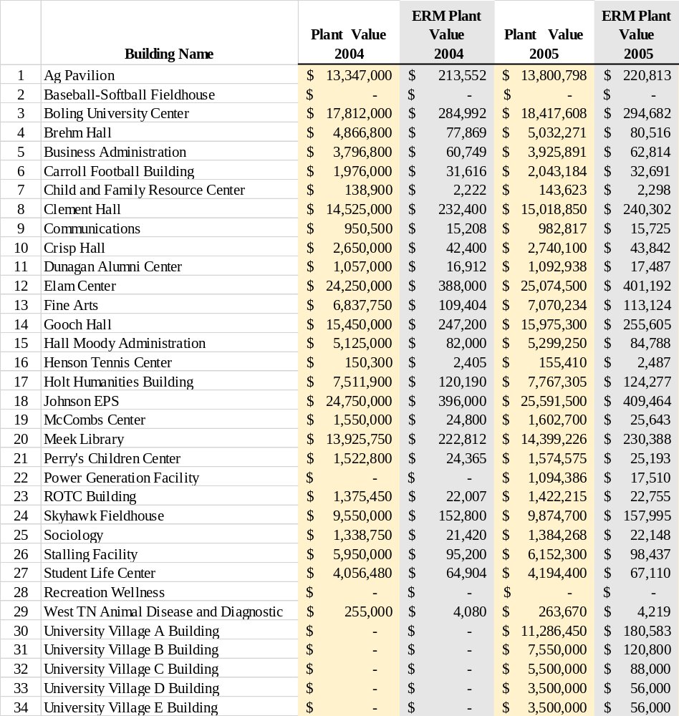

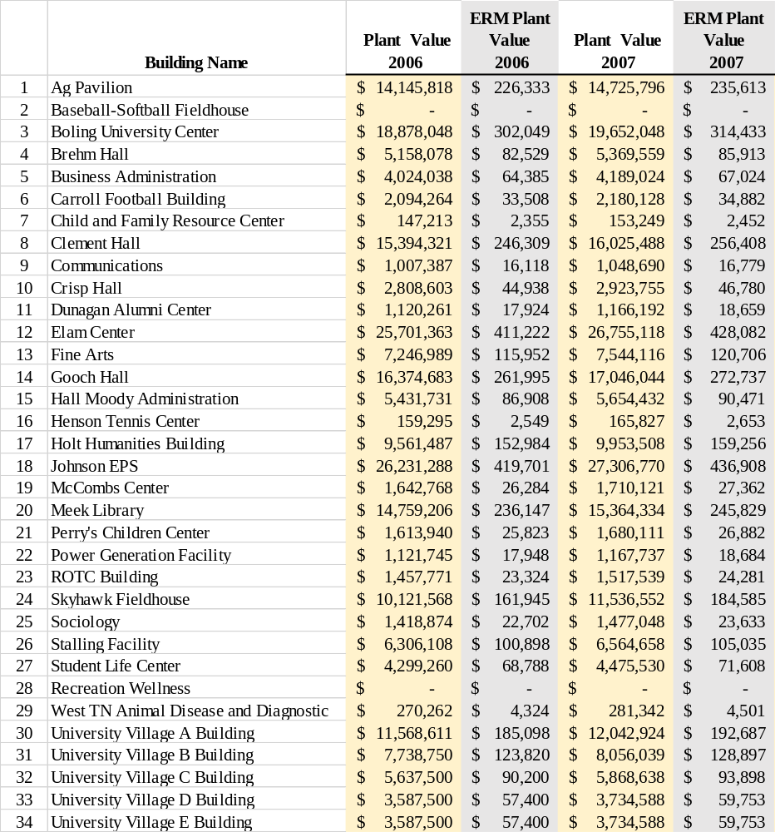

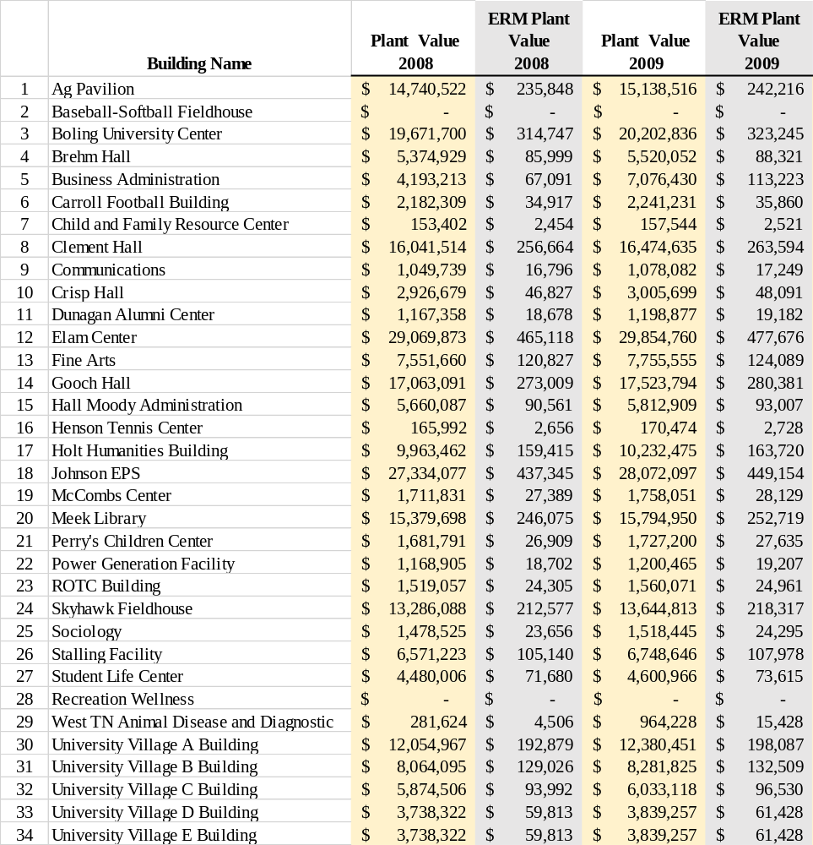

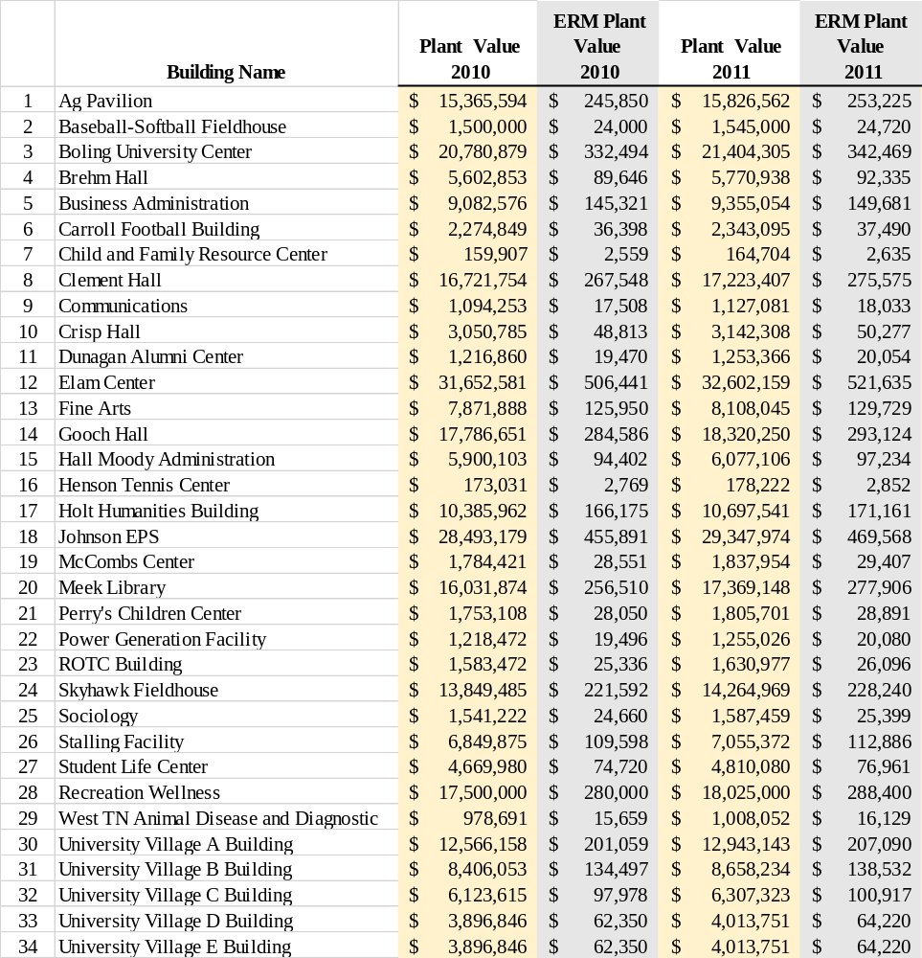

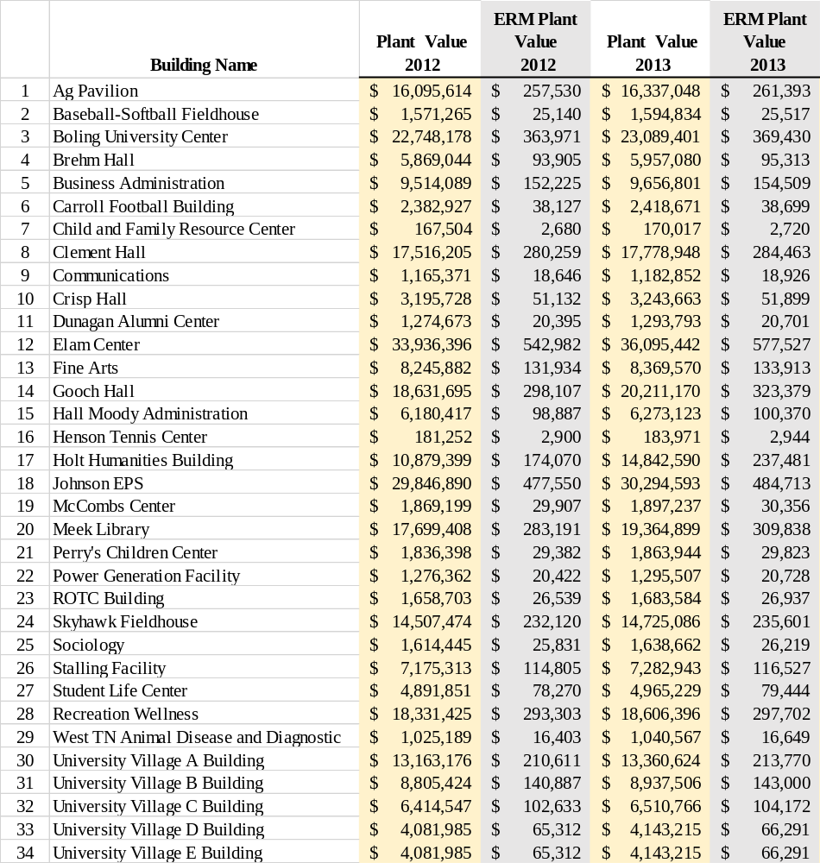

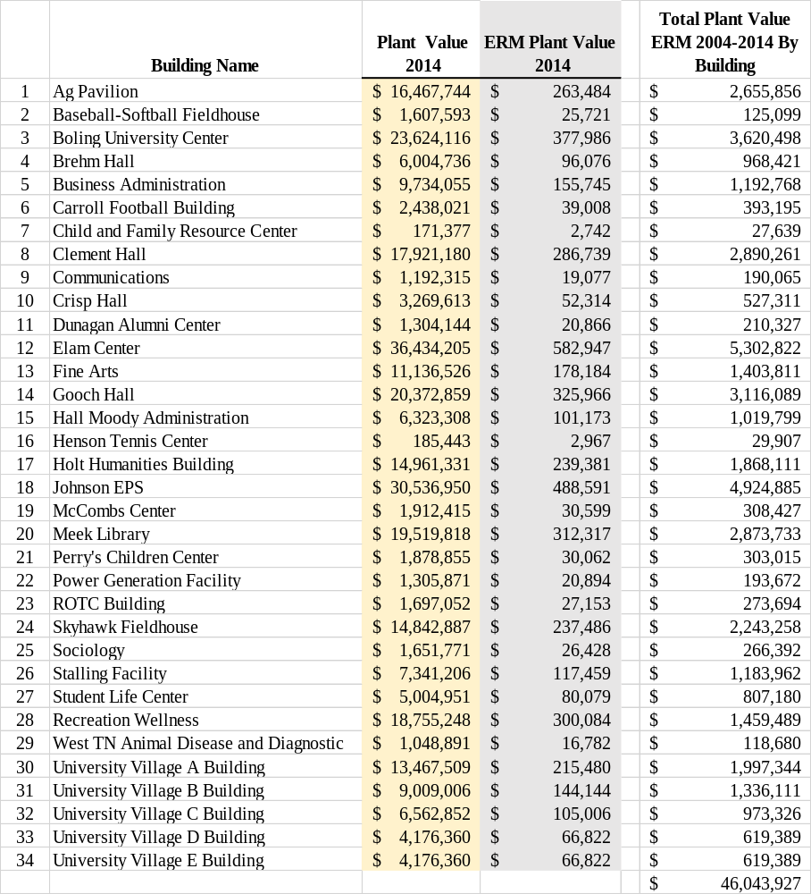

APPENDIX B
ERM Using Formula Based- NACUBO
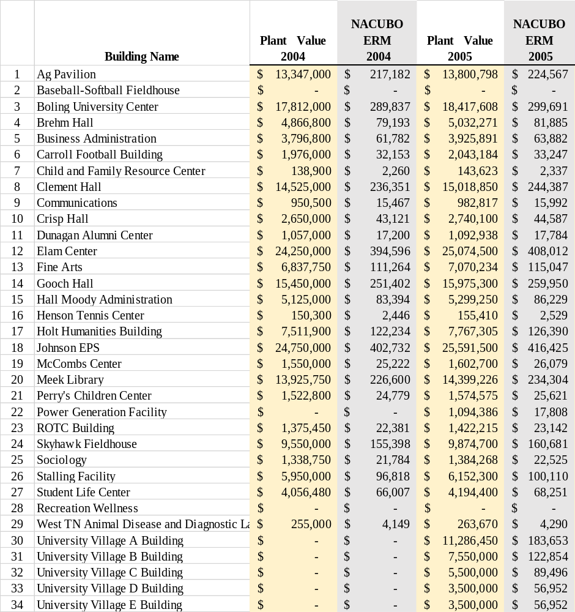

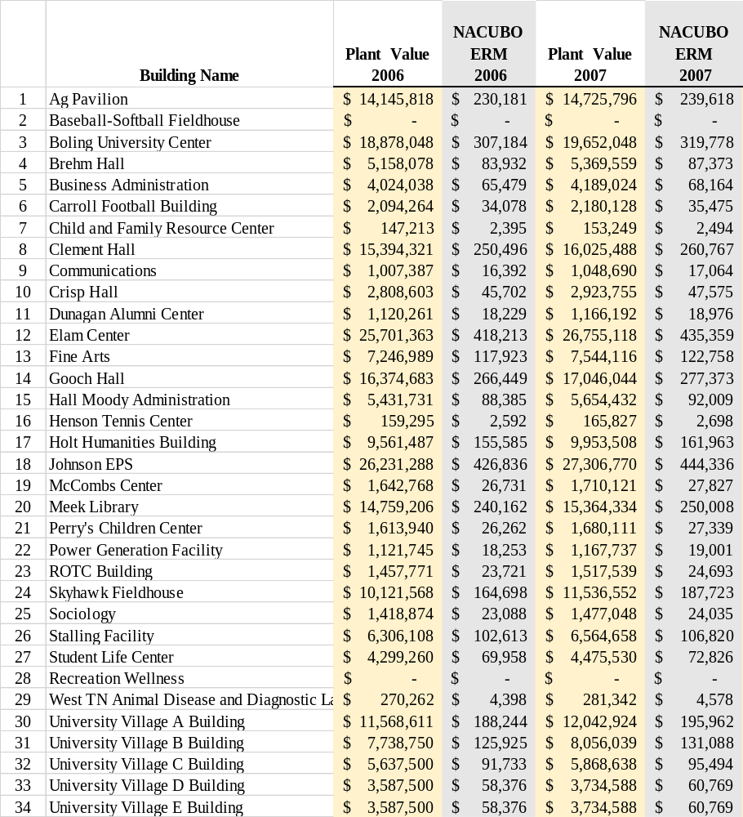

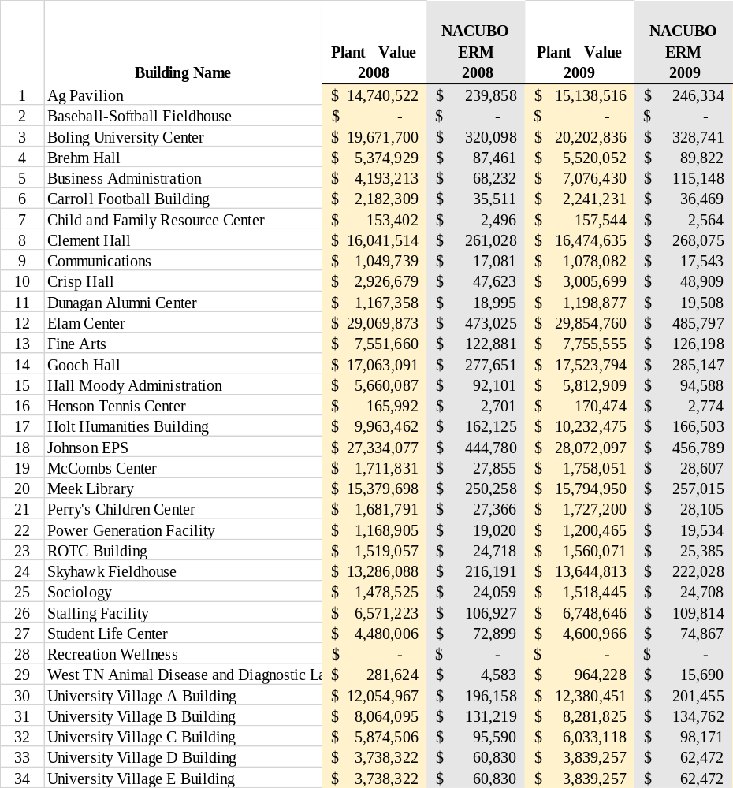

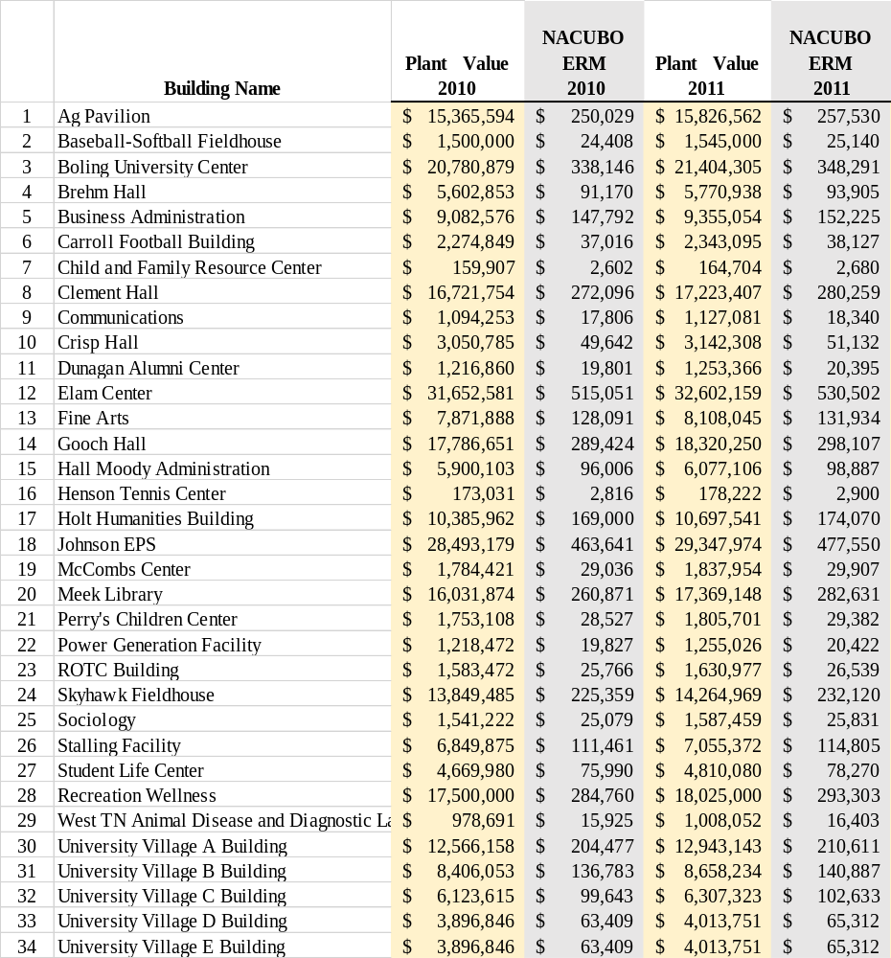

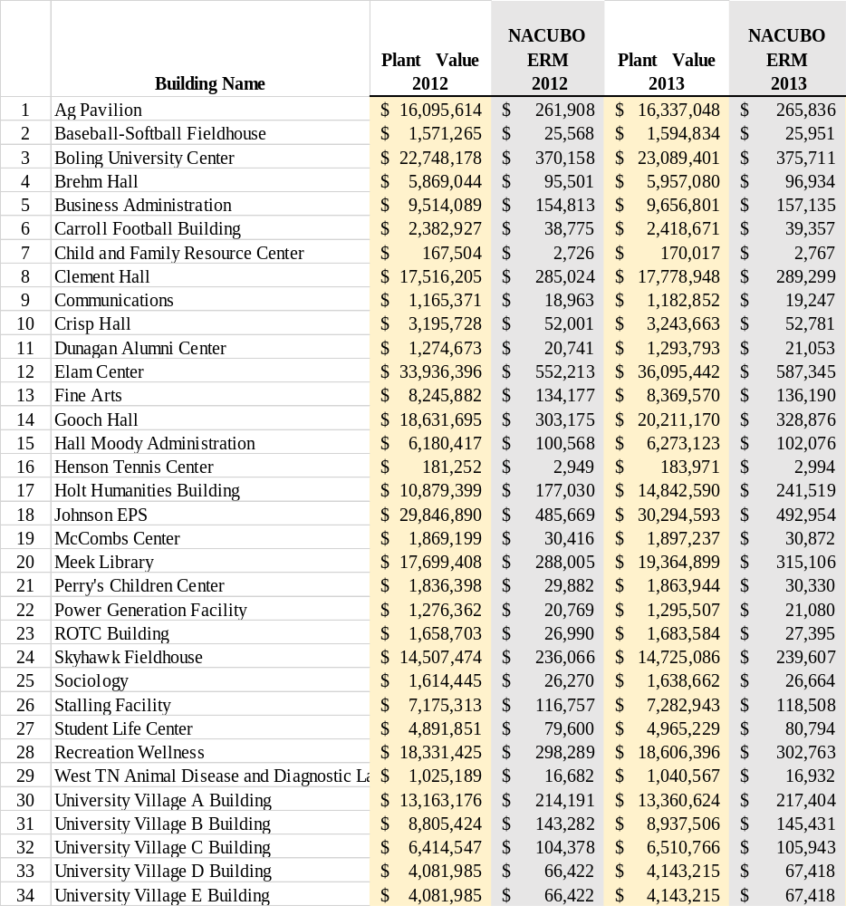

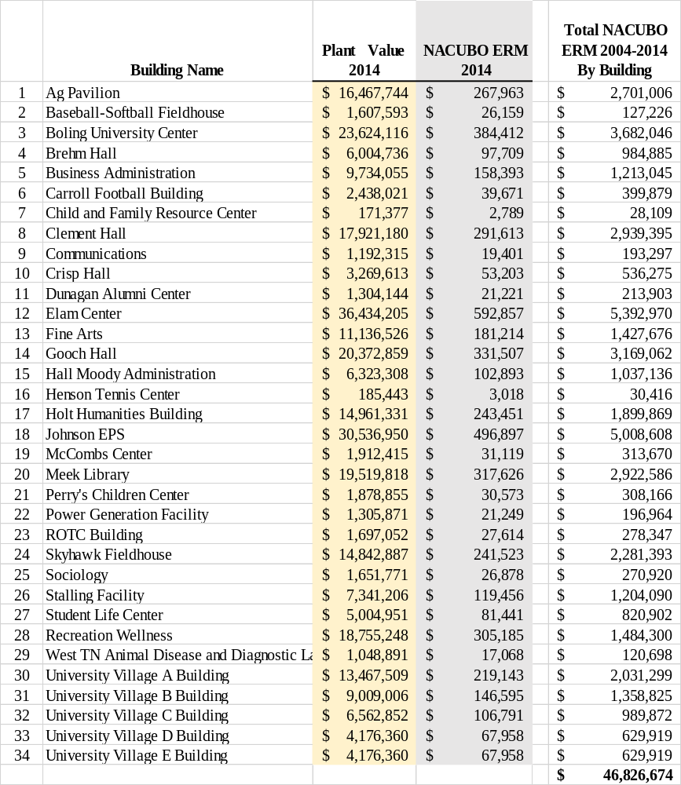

APPENDIX C
Dergis Sherman Calculations, OM Costs, OM/Plus Capital Improvements
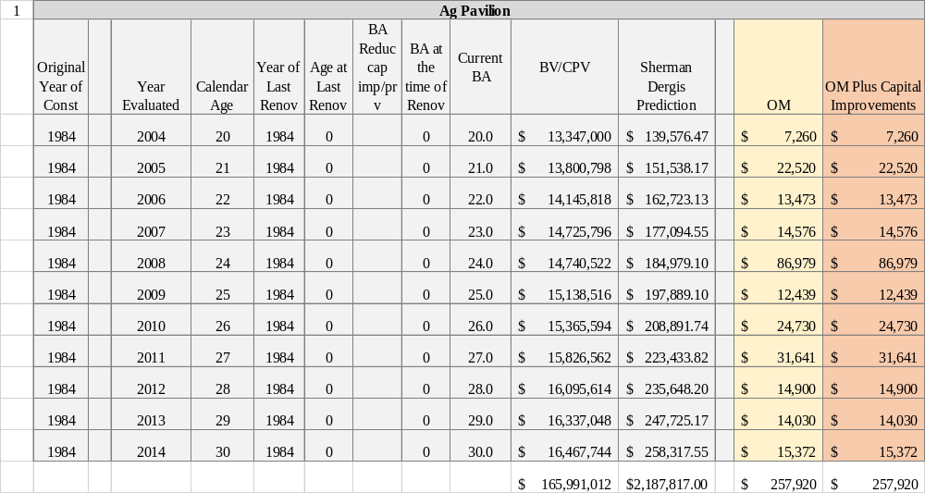

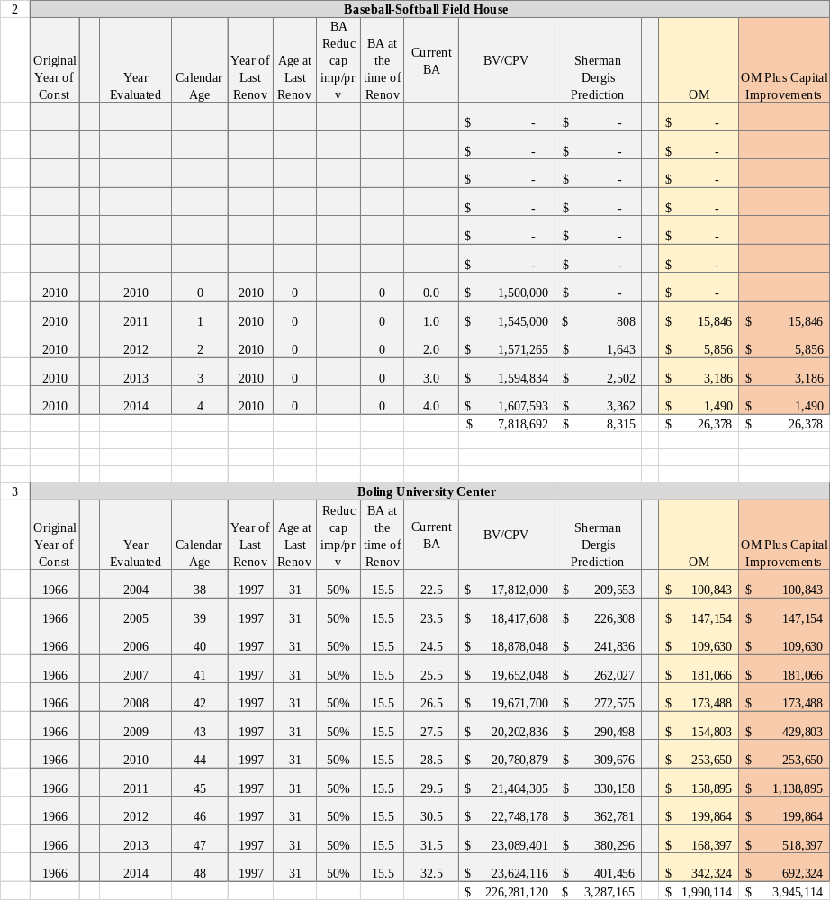

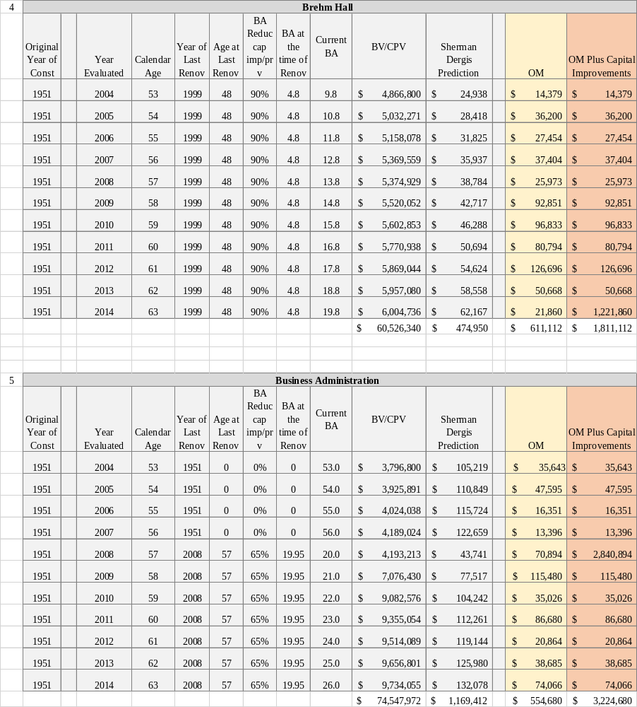

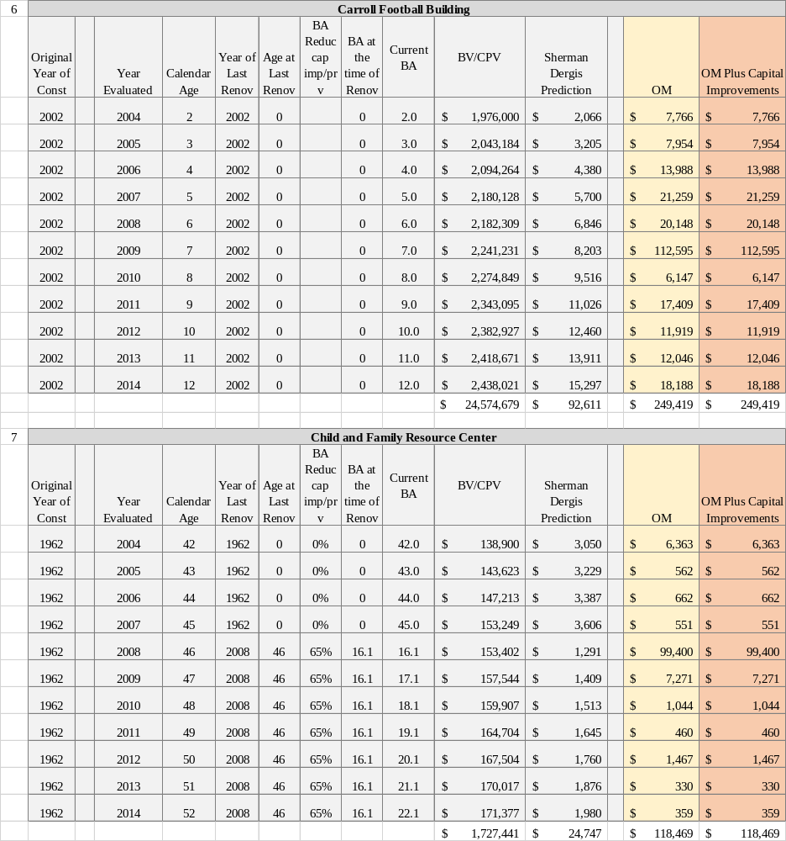

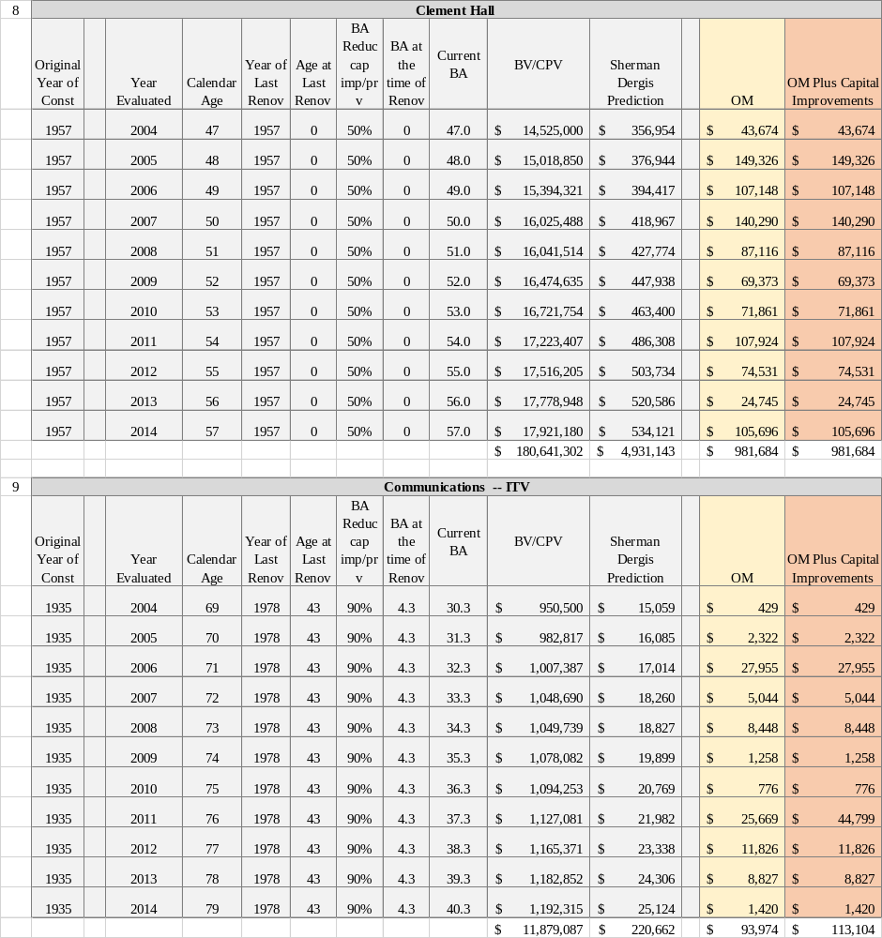

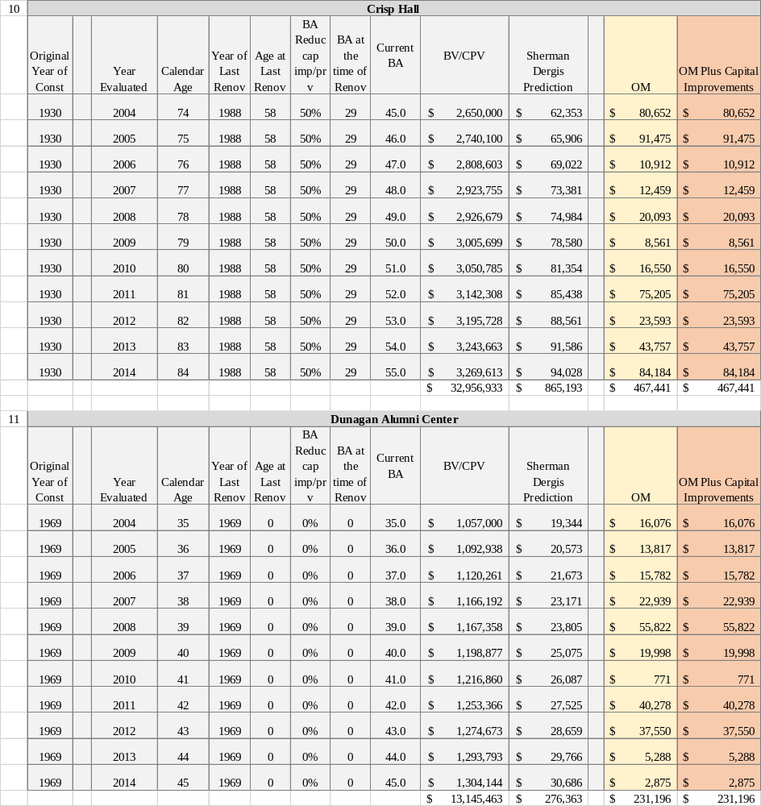

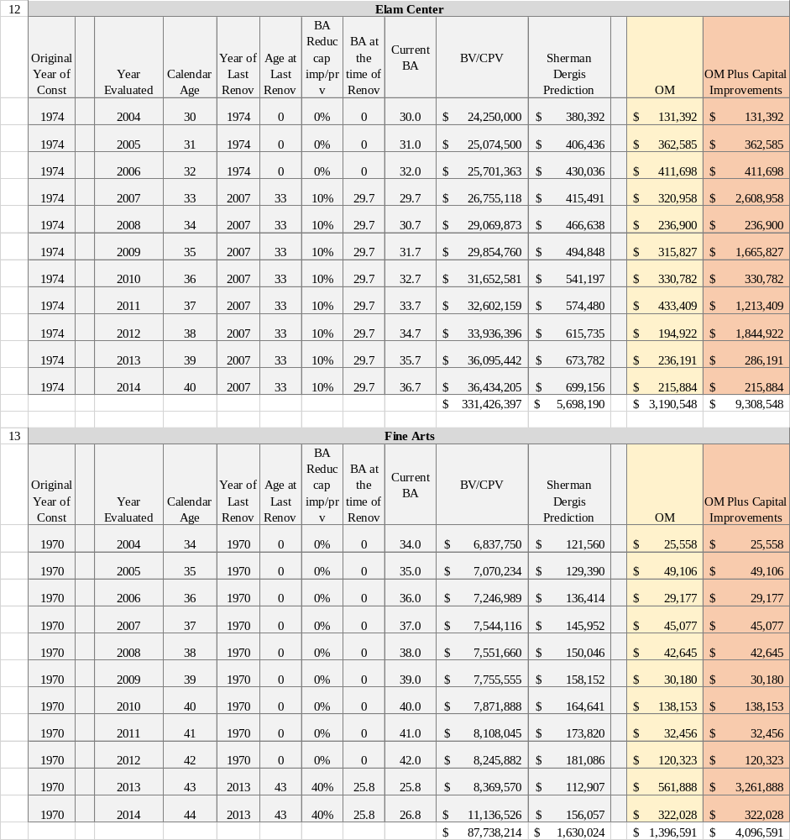

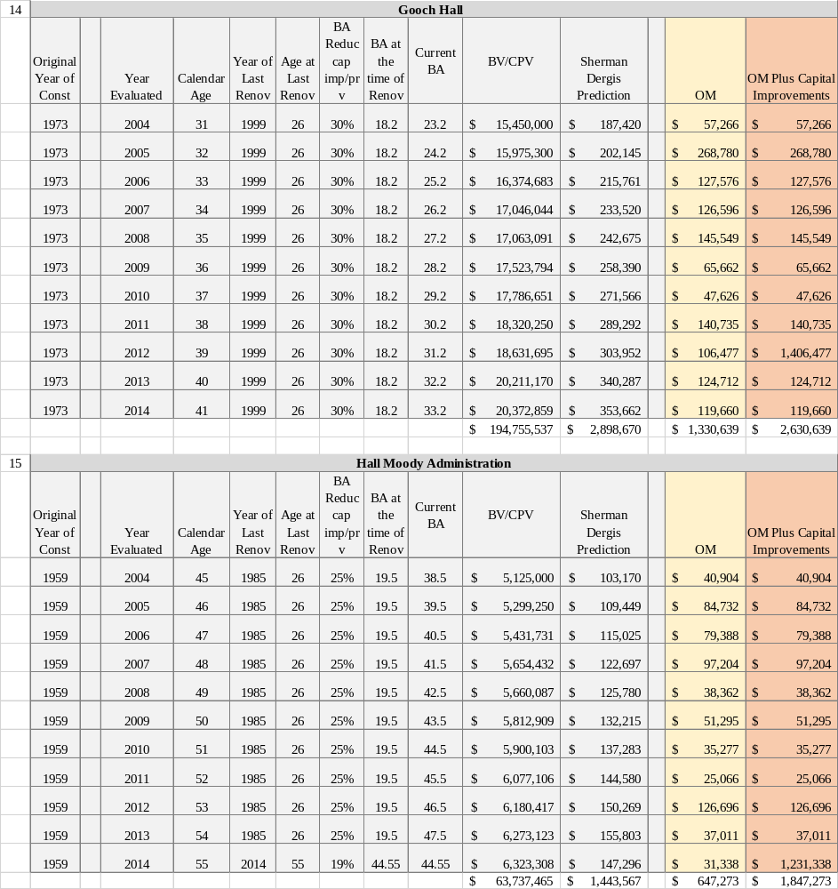

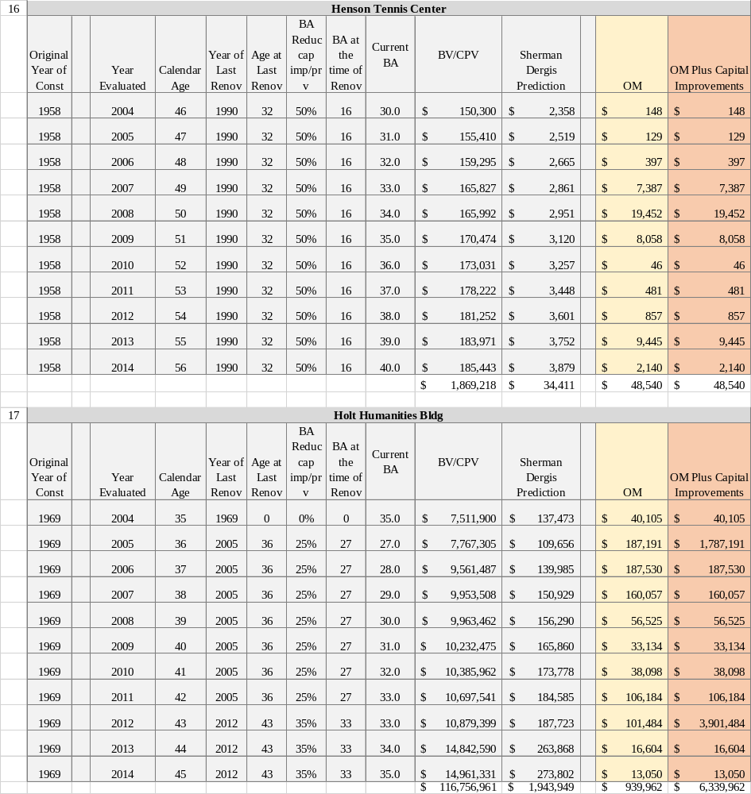

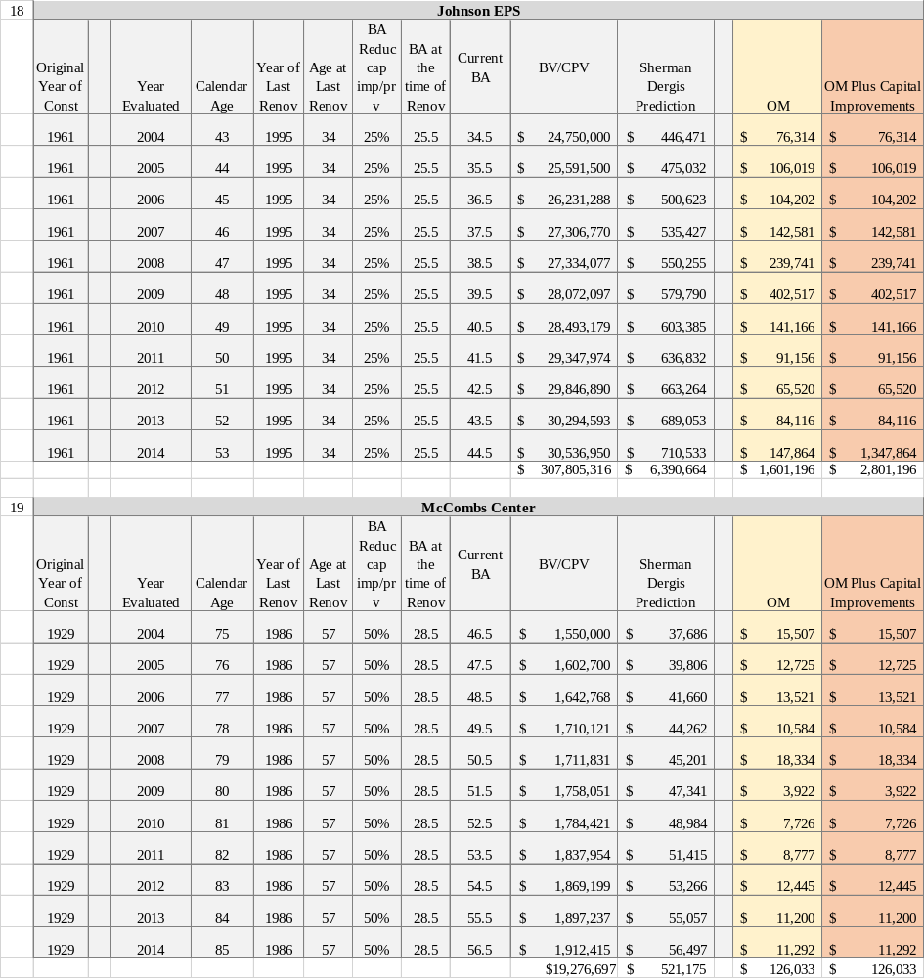

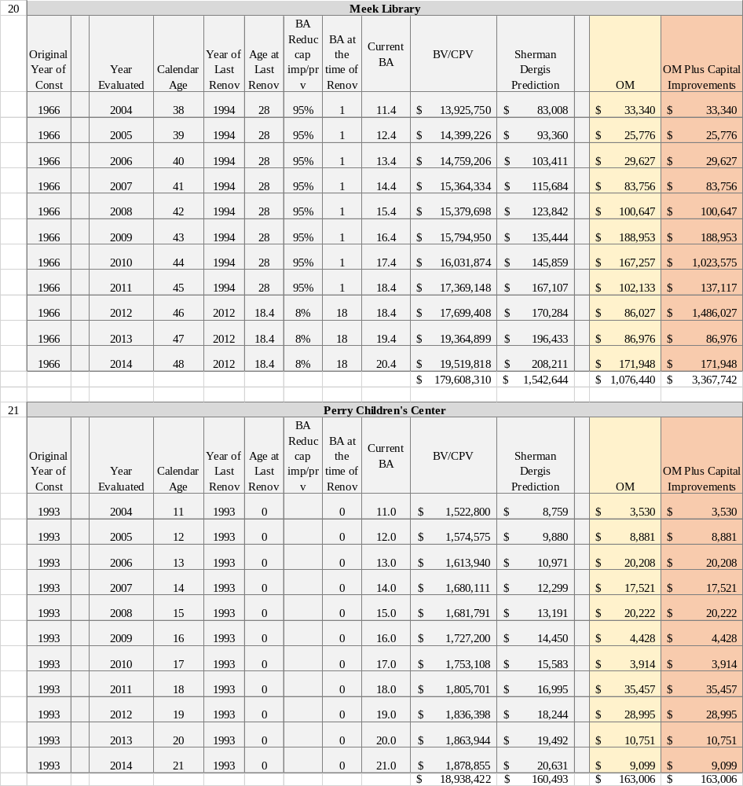

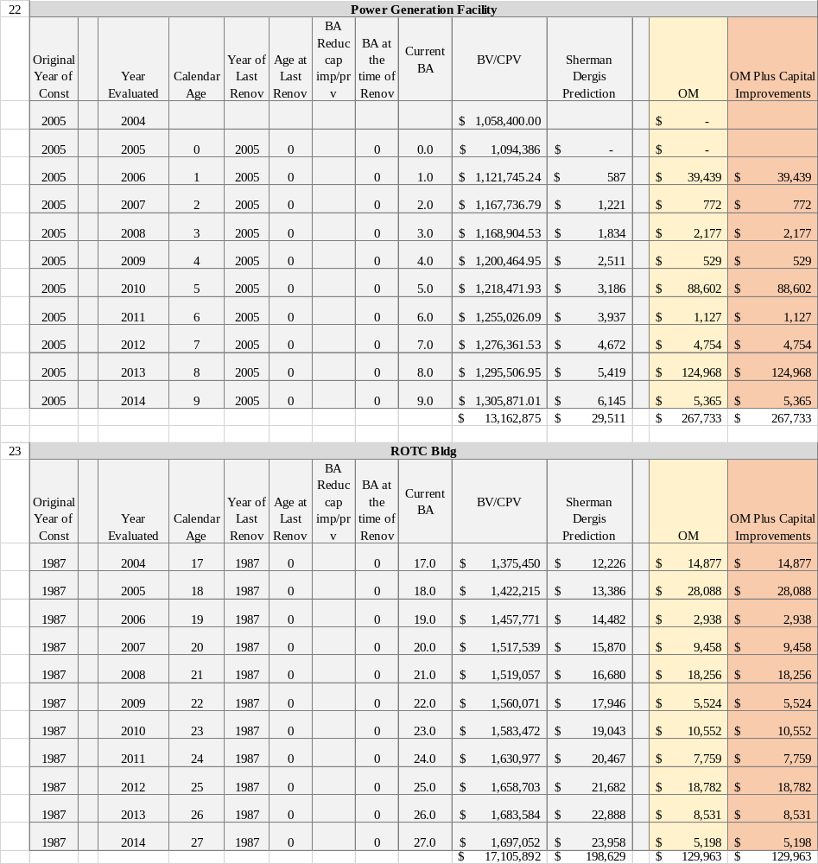

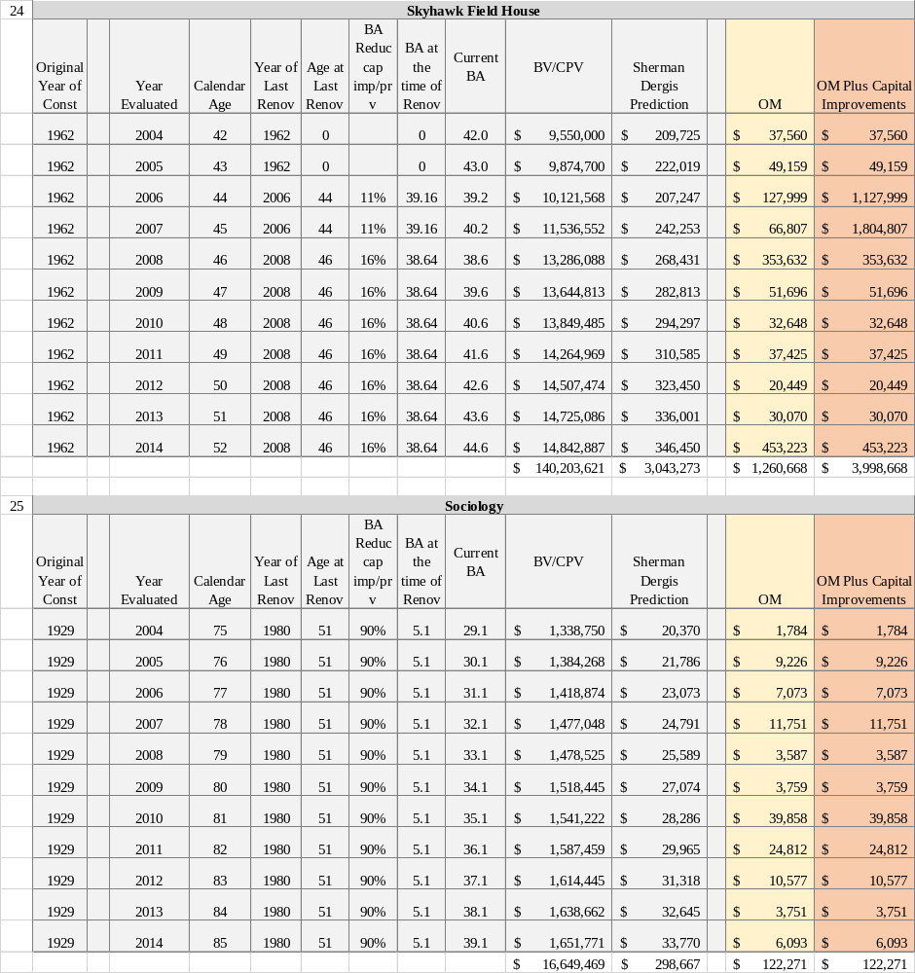

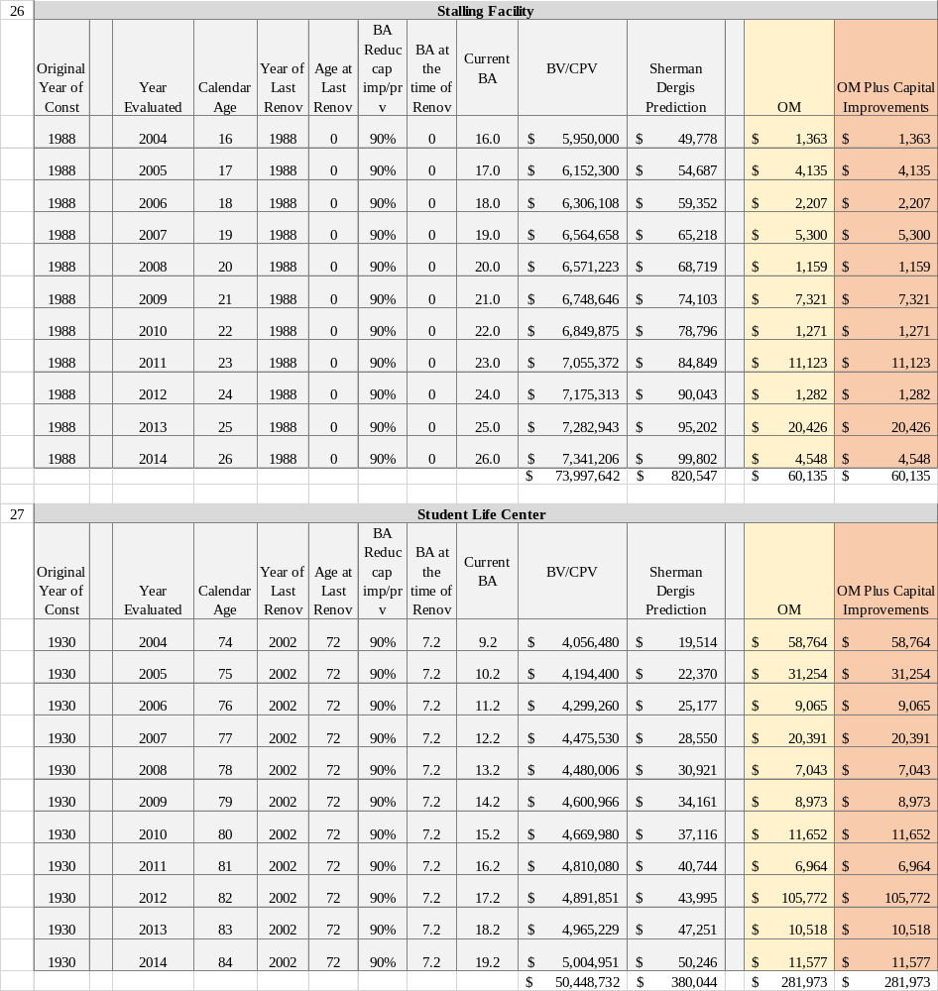

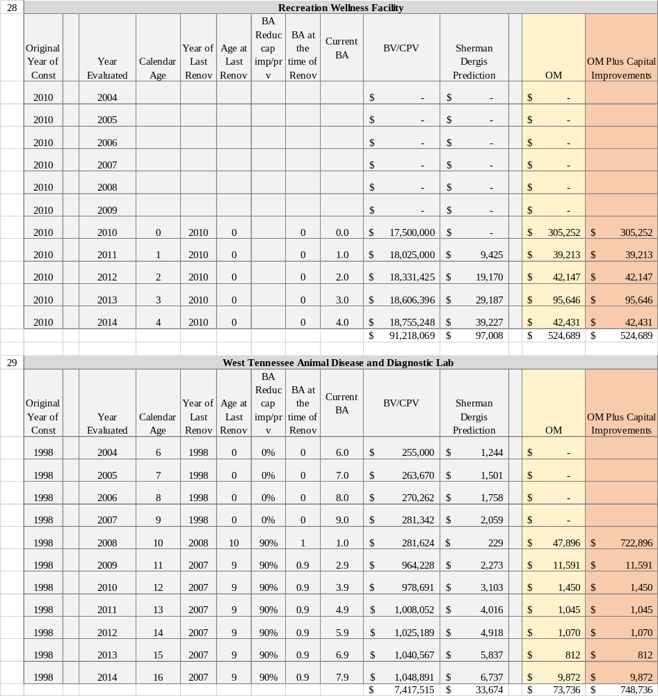

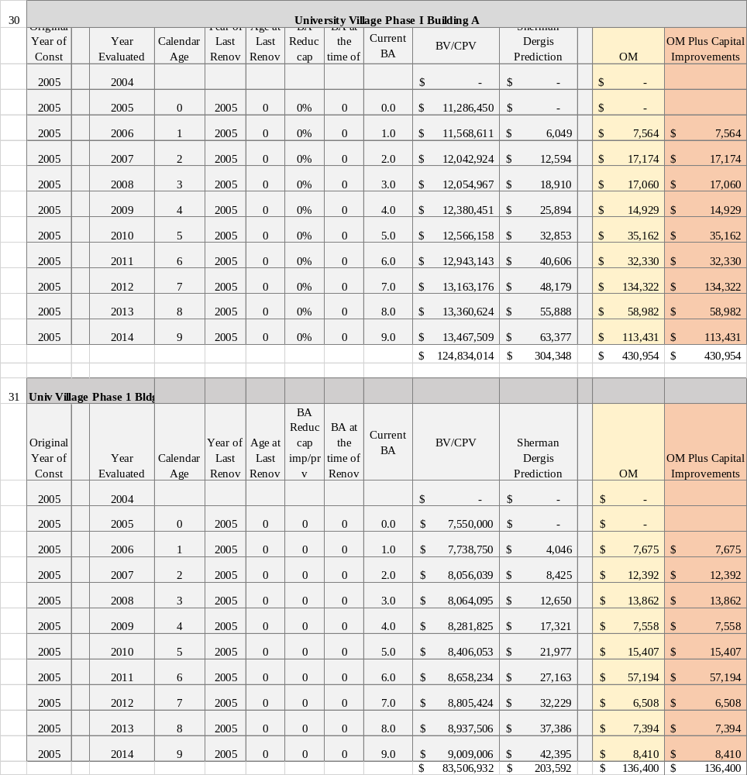

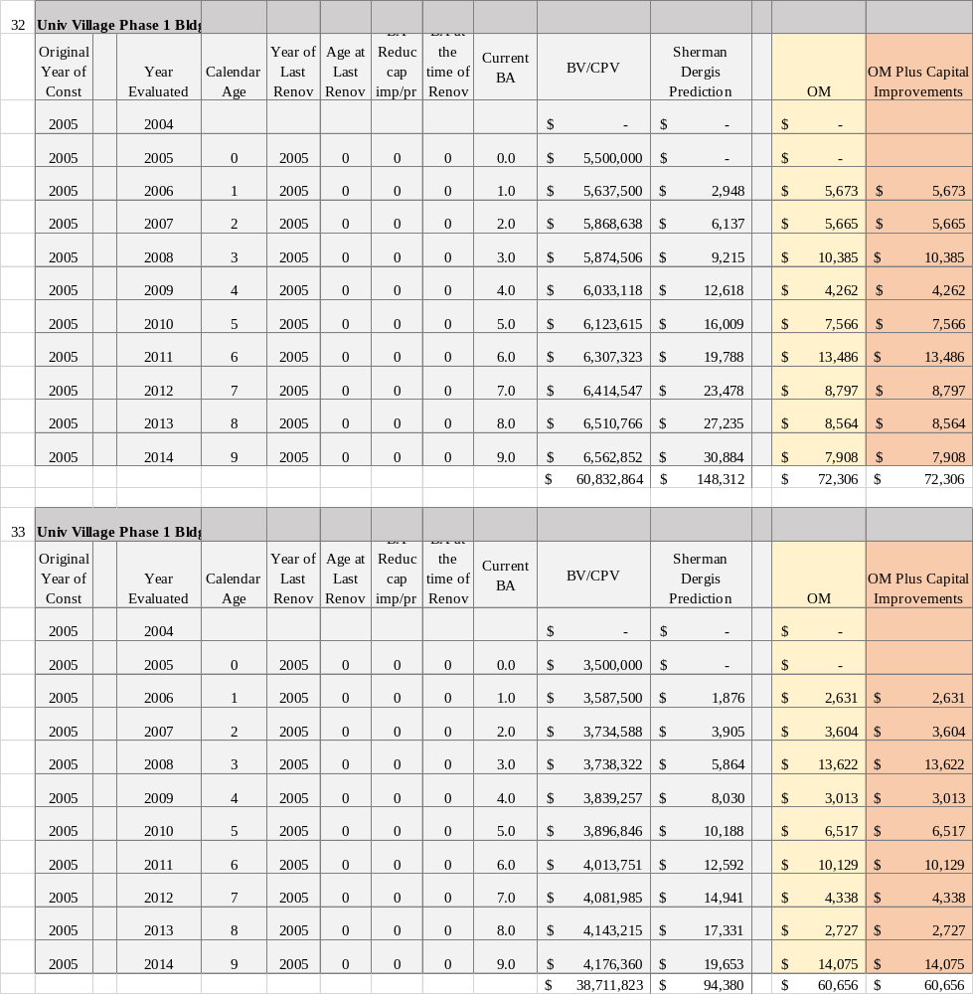

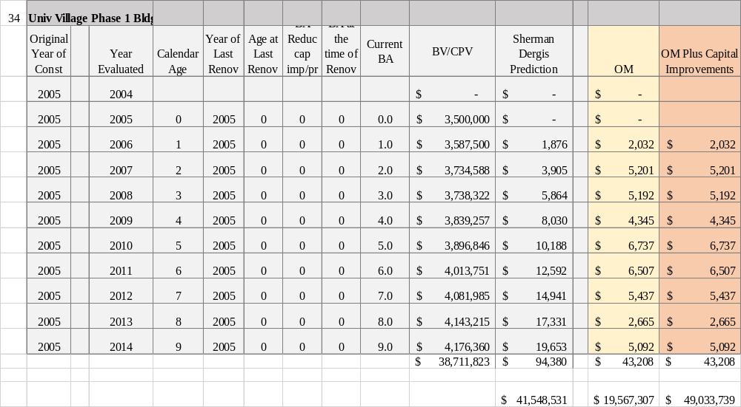

APPENDIX D
ERM Using Life Cycle Methodology-Dergis-Sherman

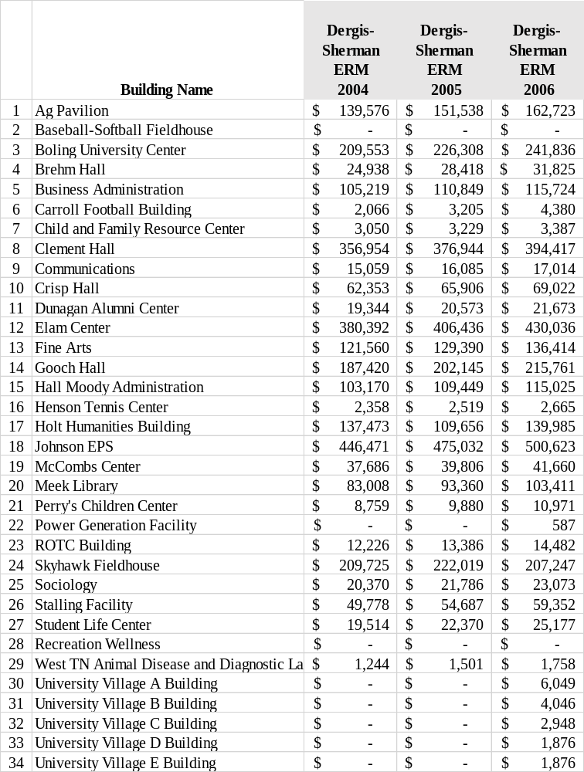
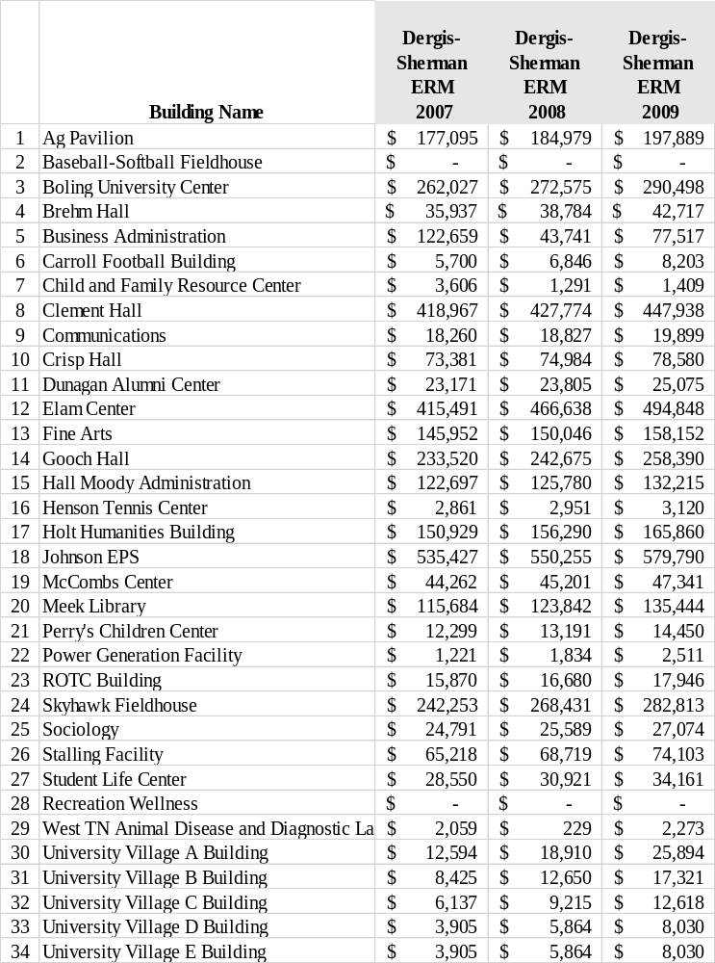

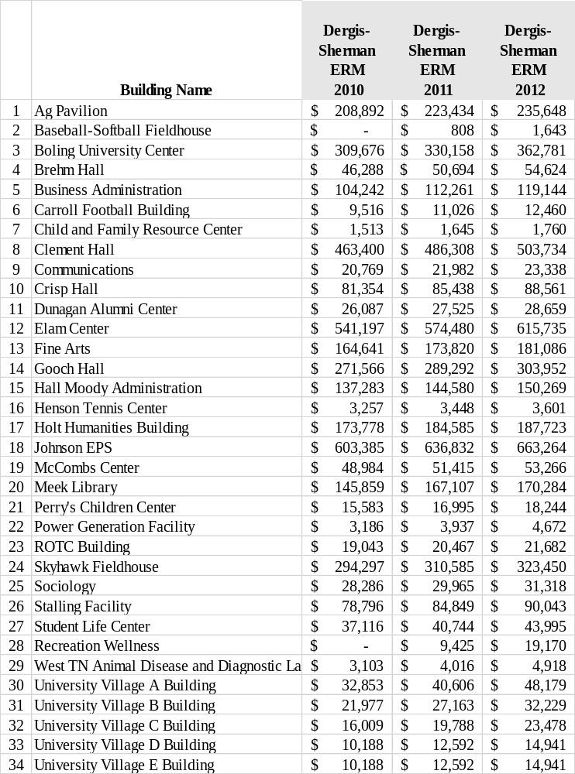

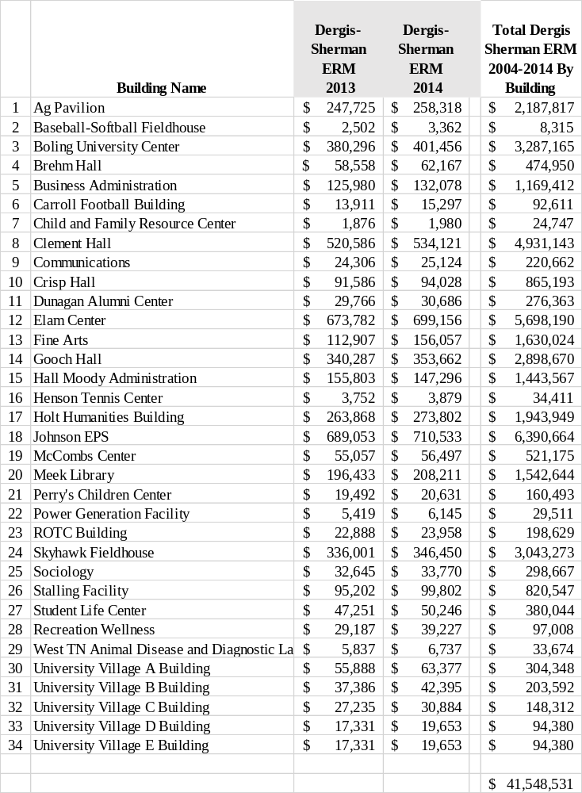APPENDIX E
ERM from Prediction Equation
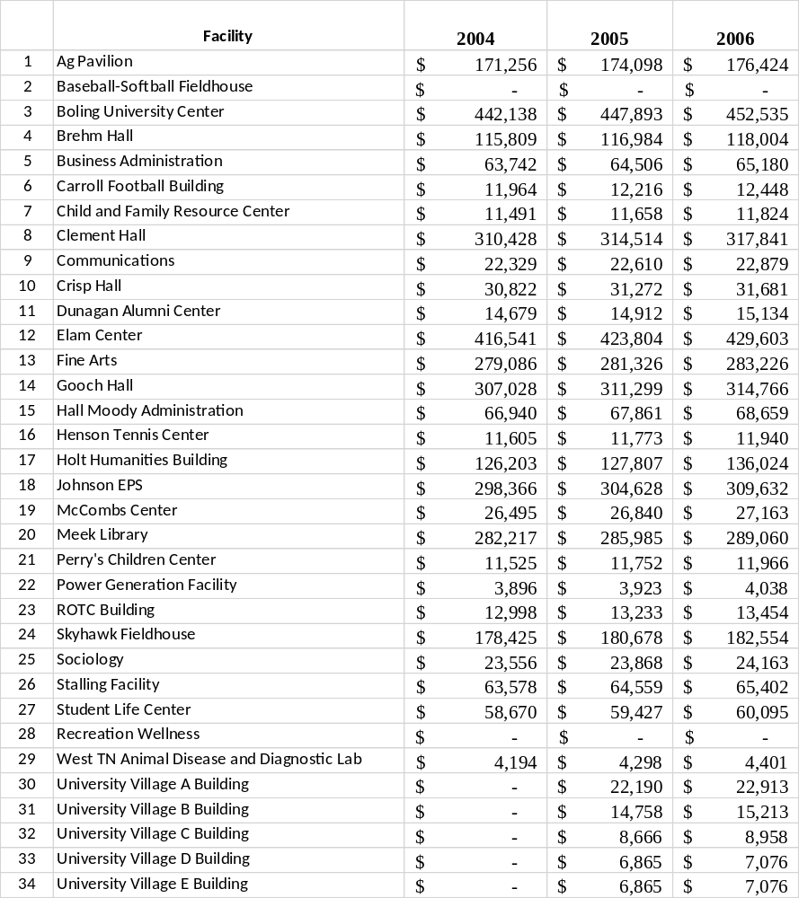

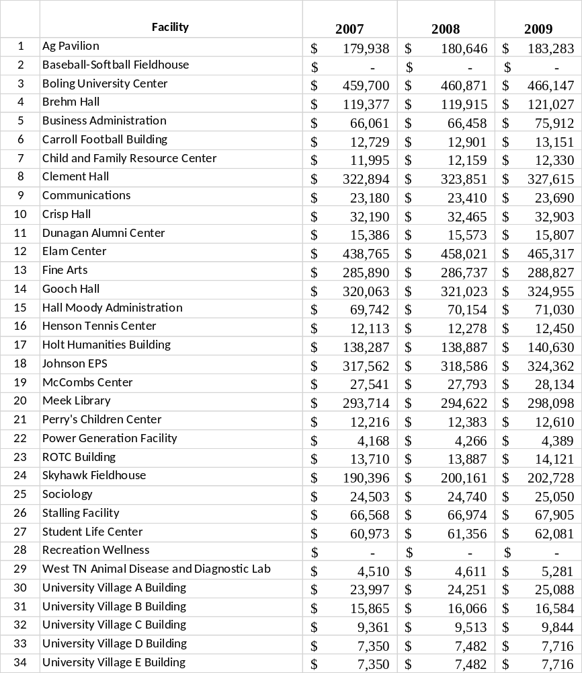

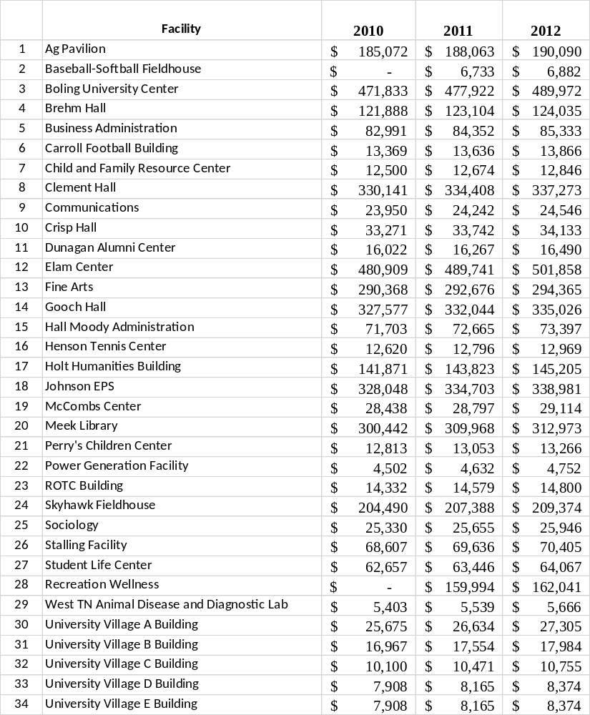

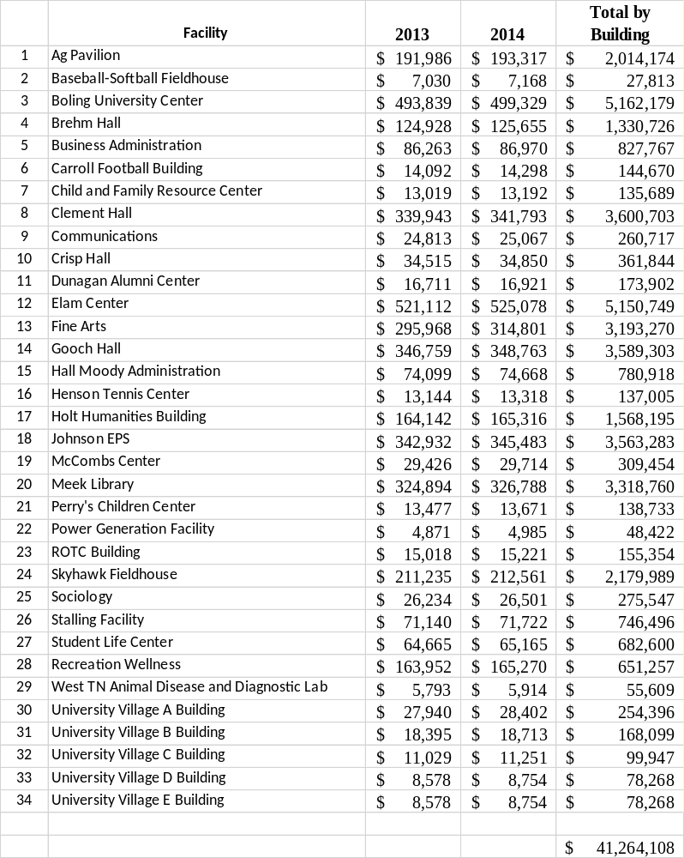

VITA
Timothy J. Nipp was born in Cape Girardeau, Mo. Reared in Union City, TN, he graduated from Union City High School in 1977. After graduating from the University of Tennessee Knoxville in 1982 with a Bachelor of Science in Civil Engineering, he accepted a job with the Oklahoma City Air Logistics Center in Oklahoma City, OK. In 1984, a career move took him to the U.S. Army Corps of Engineers Little Rock District, Little Rock AR. During his employment with the Corps of Engineers as a project manager of military projects and nonfederal hydropower, he completed his Master of Science in Engineering Management from the University of Arkansas in 1989. He received his professional engineering registration in 1989 from the state of Arkansas and later in Tennessee in 1994. In 1990, he accepted a position with Martin Marietta Energy Systems in Paducah, Kentucky as a project manager for environmental restoration efforts at the Paducah Gaseous Diffusion Plant. In 1995, he continued his career path by accepting the position of Associate Director of the Physical Plant at the University of Tennessee at Martin. In 2004, he was promoted to Director of the Physical Plant at the University of Tennessee at Martin where he currently is employed. He began his pursuit of his doctoral degree in the summer of 2011 in the field of Engineering Management. He and his wife Carolyn are the parents of three sons Andrew and his wife Laura, Luke, and Landon. They are the proud grandparents of two grandsons Aaron and Austin Nipp.

