Conservation of Terrestrial Salamanders Through Hemlock Woolly Adelgid Management in Eastern Hemlock Forests within Great Smoky Mountains National Park

A Thesis Presented for the
Master of Science
Degree
The University of Tennessee, Knoxville

Jonathan Lawrence Cox
December 2020

Copyright © 2020 by Jonathan Lawrence Cox
All rights reserved.

ACKNOWLEDGEMENTS
To my primary advisor, Dr. Mike McKinney, thank you for allowing me to work on this passion project and trusting that I could get the job done! A huge thank you to the Inventory and Monitoring Division of the National Park Service at Great Smoky Mountains National Park for all of the guidance, equipment, and assistance one graduate student could ask for. Special thanks to Joshua Albritton, Troy Evans, Becky Nichols, Ian Sabo, David Siripoonsup, Paul Super, and Jesse Webster of the NPS for their help in planning and execution of this project.
Thanks to Evin Carter for your mentorship, guidance, and insights in all things salamander and research related. I don’t know where’d I be without the responsibilities and trust you gave me while I was in undergrad running thermal trials for hours on end. You inspired me and pushed me to pursue this project regardless of funding, and for that I am extremely grateful.
The biggest thanks to my family who got me outside playing in streams and mud from an early age, without you I would’ve never made it here. A special thanks to my brother, David, who checked salamander species off of our list as we found them after convincing Mom and Dad to pull over at every stream crossing in the Smokies. Thank you to all of the undergraduate students who helped with field and lab work towards the completion of my thesis: Xuiyan He, Duncan McCurry, and Tatiana Turdakova. I especially would like to thank Lawton Bryant, who hiked hundreds of miles and pushed through the rhododendron and green briar to help me get this sucker done.
I’d also like to thank the other graduate students in my department for being a mental safety net but also spurring ideas, snacks, and friendship. I’d particularly like to thank Chris Cook, Vickie Frazier, Katie Marcacci, Rhianna Moore, Hannah Rigoni, and Nicholas Smith. A special shout-out to Mia Wavrek whose support and love for our natural world, and the people in it, pushed me forward at every turn. Thanks for an unforgettable two years poking plants and teaching me how to be still and listen, correctly season my taters, and dancing in the car.

ABSTRACT
Hemlock woolly adelgid (Adelges tsugae; HWA), an invasive aphid-like arthropod, was first documented on the east coast of the United States in the 1950s. HWA is an herbivore which primarily feeds at the needle base of hemlock tree species (Pinaceae: Tsuga). With no evolutionary defenses and few biotic controls, the eastern and Carolina hemlock (Tsuga canadensis and Tsuga carolinensis) serve as the primary diet of HWA in eastern North America. The invasive pest began to spread rapidly throughout the hemlock’s range causing defoliation and death of the trees within 4 – 10 years. With the loss of the foundational species, Tsuga canadensis, several microenvironmental changes were documented. Microenvironmental changes in response to biological invasions and anthropogenic forestry practices can lead to shifts in populations of physiologically sensitive taxa such as salamanders and their prey, terrestrial arthropods.
National Park Service staff at Great Smoky Mountains National Park manage HWA by treating eastern hemlocks with the neonicotinoid pesticides, imidacloprid and dinotefuran. To measure indirect effects of eastern hemlock mortality, and HWA management, this study measured several parameters in hemlock-dominated stands that have been repeatedly treated by the NPS and stands which were untreated and where hemlock woolly adelgid has reduced the hemlock canopy. Our major objectives were to assess microenvironmental and vegetative community differences between managed and un-managed eastern hemlock stands and analyze those differences with respect to arthropod and woodland salamander abundance and/or diversity. A mixed effects ANOVA was used to compare mean soil organic matter (or duff) pH, substrate volumetric water content, vegetative litter depth, temperature, coarse woody debris abundance, and arthropod diversity and abundance between managed and un-managed stands. A mixed effects linear model using elevation range as a random effect or block was used to model salamander abundance with the aforementioned continuous variables. While the microenvironmental parameters were not significantly different between stand types, order-level diversity of soil arthropods, order-level richness of arthropods, and woodland salamander abundance did significantly differ (α = 0.05). According to the linear mixed effects model, substrate moisture and forest management were the strongest predictors of salamander abundance (α = 0.05).

Contents
ACKNOWLEDGEMENTS iii
ABSTRACT v
LIST OF TABLES ix
LIST OF FIGURES x
Introduction 1
Eastern Hemlock 1
Hemlock Woolly Adelgid 3
Great Smoky Mountains National Park 5
Eastern Hemlock 5
Biological Control Management 6
Chemical Management 7
Salamanders 9
Salamander Physiology and Sensitivity 9
CHAPTER ONE 12
foundational species conservation: microenvironments of un-managed southern appalachian forests 12
Abstract 13
Introduction 14
Materials and Methods 17
Experimental Units 17
Temperature 19
Canopy Cover 19
Substrate 20
Results 21
Canopy Composition 21
Micro-Environment 23
Temperature 24
Discussion 25
CHAPTER TWO effects of management on Terrestrial Salamander abundance in southern appalachian hemlock forests 28
Abstract 29
Introduction 30
Terrestrial Salamanders 30
Prey Availability 34
Conservation Importance 36
Materials and Methods 38
Ethics 38
Site Selection and Geospatial Analyses 38
Microclimate 40
Salamander Assemblages 40
Prey Availability 41
Substrate 41
Results 42
Discussion 47
Conclusions and Recommendations 50
References 57
Appendix 69
Vita 103

LIST OF TABLES
Table 1.1: Mean and standard error of microenvironmental variables between managed and un-managed eastern hemlock stands across an elevational gradient. Differences in superscript letters describe statistically significant differences in means resulting from the ANOVA used on the linear mixed-effects model. 70
Table 1.2: P-values resulting from a Satterthwaite’s ANOVA on the linear mixed-effects models including elevation as a random effect. 71
Table 1.3: Site location data including Aspect (in degrees), elevation (feet), and categorical anthropogenic disturbance (UN= undisturbed, LC= low cut, ST= settled, HC= heavy cut; Pyle 1988). 72
Table 1.4: Mean and standard error of hourly temperature data collected from June - September 2019 averaged across daily and monthly values. Letters indicate significant differences among treatments. 73
Table 2.1: Means and standard errors of arthropod data between managed and un-managed eastern hemlock stands. Differences in letters indicate statistically significant differences between means resulting from the ANOVA on the linear mixed effects model. 74
Table 2.2: Total counts of identified salamander species across all plots. 75
Table 2.3: Average and standard error in snout-vent length (SVL) of the three most abundant salamander species across management type. Differences in superscript letters indicate significant differences between management types. 76
Table 2.4: Average Relative Abundance of the most abundant salamander species surveyed (salamanders/100 CWD Objects). 77
Table 2.5: Results from a step-wise analysis and Satterthwaite’s ANOVA on each mixed effects linear model. All models include elevation range as a random effect or block and is not included in the results. Each model’s results are shown as the remaining fixed-effects following the step-wise analysis and each includes Management Type so as to test the overarching hypothesis. If Management Type was removed during the step-wise analysis it is shown in italics. (* Indicate significance levels of: * p < 0.05, ** p < 0.005, *** p < 0.0005. ) 78
Table 2.6: Average abundance and standard errors of all arthropod orders collected between managed and un-managed eastern hemlock stands. 79

LIST OF FIGURES

Figure 1: Hemlock wooly adeglid infested eastern hemlock. 82
Figure 2: Image of an Adelges tsugae. 83
Figure 3: Map of HWA infestation by county in the Eastern United States. 84
Figure 4: Life cycle of HWA in Japan compared with North America. 85
Figure 5: Comparison of % soil moisture across years between hemlock controls (blue), logged (yellow), and infested (red). 86
Figure 6: Table of invertebrate orders presented as Percent Total (PT) and Percent F (PF) in four salamander species. 87
88
Figure 7: Map of potential area for random site selection and actual site location (yellow circles). 88
Figure 8: Mean relative cover of each canopy tree by site as a proportion of the total cover of all species by management type and elevation. Species are presented as a 7 letter code (first four letters of the genus and first three letters of the species; * indicate dead trees). 89
Figure 9: Boxplot of substrate water content between managed and un-managed stands. 90
Figure 10: Boxplot of organic matter pH between managed and un-managed stands. 91
Figure 11: Boxpot of leaf litter depth between managed and un-managed stands. 92
Figure 12: Boxplot of mean relative Tsuga canadensis cover between managed and un-managed stands separated by elevation band. 93
Figure 13: Average daily maximum temperatures between managed and un-managed stands separated by elevation bands. 94
Figure 14: Average daily temperatures between managed and un-managed stands separated by elevation bands. 95
Figure 15: Average minimum daily temperatures between managed and un-managed stands separated by elevation bands. 96
Figure 16: Average daily range between minimum and maximum temperatures separated by elevation bands. 97
Figure 17: Boxplot of arthropod abundance between un-managed and managed eastern hemlock stands. 98
Figure 18: Boxplot of arthropod order richness between Managed and Un-managed eastern hemlock stands. 99
Figure 19: Boxplot of arthropod diversity between managed and un-managed eastern hemlock stands. 100
Figure 20: Boxplot of salamander abundance between un-managed and managed eastern hemlock stands. 101
Figure 21: Bar plot of total salamander abundance stacked by species and grouped by elevation and management type. 102
Figure 22: Map of forest communities dominated or co-dominated by eastern hemlock within the boundary of Great Smoky Mountains National Park. 103
Figure 23: Map of area of eastern hemlock forests being managed for hemlock woolly adelgid invasion. 104

Introduction

Eastern Hemlock

North America is home to 4 of the 14-known hemlock (Pinaceae: Tsuga) species. Western hemlock, Tsuga heterophylla (Sargent), and mountain hemlock, T. mertensiana (Carrière), are native to western North America, while eastern hemlock, T. canadensis (L. Carrière), is found in the eastern U.S. and Canada and Carolina hemlock, T. caroliniana (Engelmann), is found in North and South Carolina (Hakeem 2013). Eastern hemlock is a shade-tolerant coniferous evergreen tree associated with north-facing slopes and mesic but well-drained soils (Fowells 1965). It can be found from sea level to 2,000ft in elevation at its most northern range (Fowells 1965) and in the southern Appalachians to about ~ 5,000ft. Within this range, eastern hemlocks can be up to 800 years old but many were logged after European settlement primarily for pulp and tannins used in the hide-tanning industry (Fowells 1965). Despite being a long-lived species, eastern hemlock is often found in the subcanopy. It can thrive in these low-light conditions due to its shade-tolerant nature, dark green needles, and dense canopy. Eastern hemlock is of special conservation concern because it is a foundational species (Ellison et al. 2005). Foundational species locally stabilize conditions for other species and modulate fundamental ecosystem processes (Dayton 1972). Hemlock trees create these conditions by reducing light penetration through the canopy, owing to their evergreen and shade-tolerant nature, reducing soil pH and nitrification through decomposition of their needle litter, and having low evapotranspiration rates with a thick insulating canopy (Lustenhouwer et al. 2012). These microenvironmental conditions have been well studied in the northeastern Appalachians and are likely manipulated by the anatomy and physiology of hemlocks. Tsuga canadensis’ dense insulating canopy of dark green needles absorbs and prevents sunlight from reaching the forest floor reducing evaporation of substrate moisture while stabilizing air temperatures. This effect is exacerbated by T. canadensis’ shade tolerance which allows the trees to grow and thrive beneath an existing canopy, further reducing sunlight penetration (Orwig et al. 2008). Additionally, T. canadensis is known to have a slower evapotranspiration rate, despite its evergreen nature, than sympatric deciduous species, or the successional hardwoods which colonize after T. canadensis extirpation. More moisture is therefore retained in the soil due to this reduced evapotranspiration rate. These foundational aspects of the eastern hemlock create unique habitats for flora and fauna, usually typified as darker, cooler, and moister than surrounding mixed deciduous forests. Forests in which eastern hemlocks are a component are known to have habitat associations with many species of breeding birds, small mammals, and salamanders (Lissamphibia: Caudata). In a meta-analysis of several habitat publications, Yamasaki et al. (2000) found that 96 bird species and 47 mammal species were associated with hemlock forest types in the northeastern U.S. These taxa include 8 bird and 10 mammal species that rely on hemlock forests for habitat (Yamasaki et al. 2000). Siddig et al. (2016) surveyed two species of terrestrial salamanders, Notophthalmus viridescens (in the red eft stage; Caudata: Salamandridae) and Plethodon cinereus (Caudata: Plethodontidae), in hemlock-dominated stands, hardwood stands, and girdled/logged stands to simulate HWA infestation. The researchers found that relative abundance of these two species was higher in hemlock compared to hardwood stands and abundance declined significantly with HWA actual and simulated infestations (Siddig et al. 2016).

Hemlock Woolly Adelgid

Invasive species are a leading cause of habitat loss and native species’ decline (Orwig et al. 2008; Vitousek et. al. 1997). Invasive species can disrupt trophic relationships and alter vegetation composition in recently invaded ecosystems (Spaulding & Rieske 2010; Vitousek 1990). In the 1950s the invasive pest Adelges tsugae Annand (Hemiptera: Adelgidae; hemlock woolly adelgid; HWA; Fig. 2) was first documented in eastern North America in Virginia (Souto et al. 1996). HWA primarily feeds at the needle base of hemlock tree species (Pinaceae: Tsuga) by inserting its stylet bundle (Fig. 2) intracellularly into xylem ray parenchyma cells and extracting nutrients from the tree storage cells (Young et al. 1995). These parenchyma cells store and transfer plant nutrients and therefore contain high concentrations of carbohydrates (Havill et al. 2016). As the stylet bundle is removed, a layer of protein-laden saliva is left in the wound which may have ill-effects on tree health (Young et al. 1995). As with most adelgid species, HWA has a complex lifecycle (Fig.4). In Japan, HWA utilizes both Tsuga sieboldii and Picea torano as host trees and can alternate between the two within its native range. Typically, P. torano is considered the primary host, where sexual reproduction occurs, while T. sieboldii is considered the secondary host, which only supports asexual generations (Havill et al. 2016). In eastern North America, HWA only uses Tsuga species as a host and therefore fully relies on parthenogenic reproduction. Each year two asexual generations are produced and the offspring of migrant sexuparae do not survive. The first generation consists of sistens which diapause in the first instar. The second generation, called progrediens, lack the long diapause and therefore have a shorter generation time. In the spring, progrediens crawlers hatch and disperse to suitable needles on the previous year’s growth. They quickly mature into adults and lay a clutch of sistens eggs inside a “woolly” wax ovisac at the base of a suitable needle where they will remain until their death. The sistens will then settle on the new year’s growth and remain in diapause through the summer. Development continues in the autumn until finally reaching the adult stage and laying eggs in the late winter or early spring (Havill et al. 2016). Hemlock trees in eastern North America (i.e., T. canadensis, T. caroliniana) seemingly have little to no evolutionary defense mechanisms and few if any biotic controls to defend against HWA and therefore this herbivory results in the deprivation of cellular nutrients and the eventual defoliation and death of the tree within 4-10 years (Spaulding & Rieske 2010). By the 1980s, HWA had spread through a considerable proportion of the range of these hemlock species resulting in widespread loss of hemlock trees and the beginning of succession from hemlock forest types in the Appalachians to sweet birch (Betula lenta), oak-hickory (Quercus & Carya), and tulip poplar (Liriodendron tulipifera), dominated stands (Spaulding & Rieske 2010).

Great Smoky Mountains National Park

Eastern Hemlock
Great Smoky Mountains National Park (GRSM) is an 800 square mile area of federally protected land in the southern Appalachians of the eastern United States. This area of land crosses one of the oldest mountain ranges on Earth and ranges from 250m – 2,025m in elevation. This steep elevational gradient and wet climate provides habitat for 1,800 species of vascular plants, over 100 species of trees, and over 4,000 non-flowering plants (ATBI 2020). The national park land was settled and extensively logged until the purchase of the land parcels by the people of Tennessee and North Carolina from 1926 to 1934 to pay for the park’s establishment (Pyle 1985). Despite intense logging, pre-1940, GRSM still maintains 20% undisturbed or old-growth forests (Johnson et al. 2008). GRSM currently contains 87,470 acres of forest with an eastern hemlock component, 18,000 acres of hemlock-dominated forest types (Welch et al. 2002), and 5,000 acres of pure hemlock (Johnson et al. 2005). Within that area of hemlock-dominated forests are 700 acres of old-growth hemlock ranging up to 600 years old (Yost et al. 1994). Eastern hemlock is a dominant canopy component in many forest types within the Great Smoky Mountains and Blue Ridge Mountains, unlike in the northeastern Appalachians where it is primarily found in the hemlock/white pine type. Eastern hemlock is a canopy component of over 50 forest types within GRSM, ranging from eastern hemlock/red spruce forests at 5,500 ft in elevation to montane alluvial hardwood acidic coves at 2,500 ft (USGS 2004). Krapfl et al. (2011) surveyed several eco-groups, or forest community types, which contained canopy eastern hemlocks within GRSM and found that there were significant reductions in hemlock crown density and significant increases in top die-back across all eco-groups between 2003 and 2008. This decline in crown health for overstory hemlocks is likely to lead to changes in the foundational function of hemlock. Importantly, Krapfl et al. (2011) also found that hemlock mortality was 34% in the understory compared to 11% in the overstory. This indicates a bottom-up species decline where hemlock forest regeneration is being halted at the seedling and sapling phase.

Biological Control Management
Located near urban population centers and being the most visited National Park in the country, GRSM has been managing and monitoring invasive pests since the 1940s (Johnson et al. 2008). Beginning in the 1940s with kudzu, NPS staff at GRSM have had to manage or monitor many biological invasions such as the balsam woolly adelgid, chestnut blight, emerald ash borer, southern pine beetle, beech bark disease, and currently hemlock woolly adelgid (Johnson et al. 2008). Hemlock woolly adelgid reached GRSM in 2002, and by 2006, it had been identified in every major watershed within the park’s boundary (Johnson et al. 2008). GRSM began managing the HWA invasion in 2002, utilizing both chemical and biological control methods. Under the guidance of the United States Department of Agriculture, park staff began to release biological control organisms beginning with the predatory beetle, Sasajiscymnus tsugae (Coleoptera: Coccinelidae), in 2002 (Johnson et al. 2008). Sasajiscymnus tsugae, native to Japan, is a small beetle which preys on all HWA life stages in both its larval and adult forms. The S. tsugae releases were soon followed by another release of 2,400 Laricobius nigrinus (Coleoptera: Derodontidae) beetles in 2004. Laricobius nigrinus, native to the western United States, are also small beetles that appear to feed preferentially on adelgids (Flowers et al. 2005). This species is known to feed on all HWA life stages as both larvae and adults. As of 2010, approximately 550,000 S. tsugae and 7,857 L. nigrinus have been released in GRSM (Webster 2010). Within GRSM, Hakeem (2013) recovered S. tsugae from 20% of all sampled release sites. Additionally, L. nigrinus was recovered from 59% of all sampled release sites in the eastern U.S. (Hakeem 2013) and therefore both species are believed to be established within their respective ecosystems.

Chemical Management
The NPS began to implement chemical treatments within the GRSM by 2005. These treatments primarily consist of systemic application of the neonicotinoid pesticide imidacloprid, dinotefuran, and foliar sprays of insecticidal soaps. Systemic treatments of hemlock with imidacloprid are applied either through soil drenching, where the organic layer of soil is pulled back from the base of the tree and an imidacloprid dilution is poured into the soil around the tree, or a more concentrated dose of imidacloprid is injected directly into the xylem at the trunk of the tree (National Park Service 2005). The amount of imidacloprid active ingredient used on each hemlock is dependent on the diameter at breast height (DBH) of each at-risk tree. In both treatment methods, imidacloprid is passively transported to branches and foliage where it can be consumed by and kill adelgids. As of 2008, over 75,000 hemlocks had been treated systemically on 2,200 acres (Johnson et al. 2008). Imidacloprid (C₉H₁₀CIN₅O₂) is a neonicotinoid pesticide. Neonicotinoids act as neurotoxins to insects and belong to the chloronicotinyl nitroguanidine chemical family which affect insects’ central nervous system (Ruiz de Arcaute et al. 2014). Imidacloprid and other nitroguanidine neonicotinoids interfere with nervous system stimulus transmission by binding to insects’ nicotinic acetylcholine receptors (nAChR) (Blacquière et al. 2012; Ruiz de Arcaute et al. 2014). Subsequent acetylcholine accumulation causes paralysis and eventual death. Imidacloproid can be delivered via diet or dermally and is likely less toxic to mammals, fish, and amphibians (Ruiz de Arcaute et al. 2014) because it binds more readily to insect nicotinic neuron receptors, but research on this subject is ongoing. Concentrations in soil (Knoepp et. al. 2012) a year after treatment, at all tested soil depths and distances, were detected below the LC₅₀ of the tree frog species, Hypsiboas pulchellus (Ruiz de Arcaute et.al. 2014). Studies conducted in GRSM and in the outhern Appalachian region found that there was no significant difference in aquatic benthic macroinvertebrate communities after imidacloprid treatment (Benton et al. 2017; Churchel et al. 2011). It is currently unknown if imidacloprid treatments impact the health of woodland salamanders directly, but it is possible that systemic and chronic imidacloprid treatments, and other neonicotinoids, have altered fossorial terrestrial invertebrate communities (Knoepp et al. 2012) which could have a bottom-up effect on salamander assemblages within managed hemlock stands (Harper 1999). Crayton (2019) reports bioaccumulation of imidacloprid in stream salamanders (Plethodontidae: Desmognathus) possibly from feeding on contaminated stream invertebrates. Exposure to imidacloprid was also correlated with elevated levels of corticosterone in the sampled salamanders, indicating increased levels of physiological stress (Crayton 2019).

Salamanders
Great Smoky Mountains National Park is home to the highest beta biodiversity of salamander species on the planet, with 31 documented species (Dodd 2004). Such high diversity is likely due to the relatively high precipitation, humidity, canopy cover, and extreme elevation gradient with many highly oxygenated streams and rivers. The southern Appalachians are the hypothesized center of diversification of the family Plethodontidae, the lungless family of salamanders (Dodd 2004), because the repeated loss of lungs in larval salamanders reduced buoyancy in high velocity mountain streams. High oxygen concentrations of these streams could easily be diffused cutaneously which would allow for this adaptation. More recent geological data has provided evidence for an alternative hypothesis that the modern plethodontids lost their lungs and evolved a smaller buccal cavity and a narrower head in order to acquire prey more easily in seepage habitats (Dodd 2004). Regardless, the diversity of habitats across elevations led to geographic isolation and the eventual allopatric speciation of many plethodontid salamanders. These speciation events likely led to the diversity of salamanders we see today in GRSM.

Salamander Physiology and Sensitivity

Changes in abiotic factors following hemlock death, such as soil moisture, light availability, and substrate temperature (Lustenhouwer et al. 2012), might subsequently affect habitat suitability for salamanders (Lissamphibia: Caudata). As previously mentioned, woodland salamanders (Plethodontidae: Plethodon) are lungless terrestrial species which lack an aquatic larval stage. All Plethodon and two species of Desmognathus (Caudata: Plethodontidae) species undergo direct development, which is the process of metamorphosis within the egg. Taxa which undergo direct development hatch as juveniles and appear to be miniature adults rather than hatching into larvae and undergoing metamorphosis in an aquatic environment. Plethodontid salamanders are abundant and diverse in the southern Appalachians, specifically the Great Smoky Mountains and Blue Ridge Mountains of Tennessee and North Carolina, where eastern hemlock is widespread and imperiled. Species in this family rely on cutaneous respiration which requires moist skin for gas exchange (Dodd 2004). Their permeable skin allows water to easily transfer between themselves and their environment, therefore making the microclimate of their environment that much more important (Baecher and Richter 2018). Taxa within the subclass Lissamphibia are also ectotherms, meaning they’re unable to regulate their body temperature metabolically and must therefore regulate their temperature behaviorally. Salamander habitat occupancy has therefore been shown to change according to environmental gradients of solar exposure, soil moisture, canopy openness, and abundance of cover objects (Baecher and Richter 2018). Some, if not all, of these factors may change following hemlock death from increased solar exposure with opening of the canopy (Lustenhouwer et al. 2012). Past studies have also compared abundance in several salamander species between hemlock-dominated stands and mixed hardwood stands in the northeastern U.S and found that often times these species have higher abundances in undisturbed eastern hemlock stands. (Mathewson 2009; Mathewson 2014; Siddig et al. 2016). Given that eastern hemlock death causes changes in environmental factors associated with salamander habitat ,and salamander abundance has been shown to differ between hemlock-dominated stands and mixed hardwood stands, it seems possible that woodland salamander abundance may be significantly different between hemlock-dominated stands and historically hemlock-dominated, but currently infested or dead, stands.
Research questions that are raised include: 1) Are there significant differences among environmental conditions, salamander communities, and prey availability (i.e., invertebrate abundance) between managed and un-managed eastern hemlock forests in GRSM? 2) How do salamander assemblages differ between managed and un-managed eastern hemlock forests in GRSM, if at all? 3) What microclimatic and habitat variables are significantly associated with changes in salamander assemblages, if any, within these forest types? “Managed” herein means a site where eastern hemlock trees have been treated with neonicotinoid pesticides imidacloprid or dinotefuran and therefore is dominated by living hemlocks. An “un-managed” site is defined as an area that was historically dominated by hemlocks, did not receive insecticide treatment, and therefore has high hemlock mortality due to HWA infestation.

CHAPTER ONE

foundational species conservation: microenvironments of un-managed southern appalachian forests

Abstract
Microclimatic conditions within hemlock forests are expected to change with the invasion of the hemlock woolly adelgid (HWA). HWA is an invasive pest which feeds on hemlock tree species and was first documented in eastern North America in the 1950s. HWA herbivory results in the death of both the eastern and Carolina hemlock within 4 - 10 years. Eastern hemlock is a foundational species which modulates its environment by providing unique habitat and microenvironmental conditions for eastern North American flora and fauna. In the northeastern Appalachians, death of hemlock trees has been associated with more extreme temperatures, drier soil, and increasing soil pH (Lustenhouwer et al. 2012). The goal of our study was to investigate similar microenvironmental parameters in southern Appalachian eastern hemlock stands which have been treated with the pesticide imidacloprid and dinotefuran to prevent defoliation and death of the trees, and compare these conditions with sites that were left un-managed for the past 17 years. All research sites were located within Great Smoky Mountains National Park (GRSM) where HWA was first documented in 2002. GRSM is home to 18,000 acres of eastern hemlock and is actively managing for HWA through imidacloprid and dinotefuran applications. Each research site was measured for volumetric substrate moisture, organic matter pH, and vegetative litter depth along three transects. Data loggers were left at the center of each site for 4 months collecting hourly temperature readings which were summarized into mean, maximum, minimum, and range in daily temperatures. We found no significant difference (α= 0.05) in any microenvironmental parameters between managed and un-managed sites. The lack of significant results may be attributed to 17 years of forest succession and variation in vegetation communities among managed and un-managed sites.

Introduction
Eastern hemlock (Pinaceae: Tsuga canadensis; Carriér) is a coniferous tree which thrives in the canopy and subcanopy of about 50 southern Appalachian forest types from 2,000 – 5,500ft in elevation (USGS 2004). It is known to be shade-tolerant and is most often found in mesic well-drained soils and is common in the canopy of cove forests (Fowells 1965). As a foundational species, it plays a vital ecosystem role (Ellison et al. 2005) through the modulation of the surrounding microenvironment and therefore the habitat of sympatric flora and fauna. The microenvironment of T. canadensis forests are characterized as being cool with less variable air temperatures, with moister and more acidic soil, and with larger volumes of woody debris and deeper organic layers when compared to hardwood deciduous stands in the northeastern Appalachians (Lustenhouwer et al. 2012; Orwig et al. 2008).
Tsuga canadensis and its foundational effects are currently under threat due to the invasion of the exotic pest, Adelges tsugae Annand (Hemiptera: Adelgidae; hemlock woolly adelgid; HWA). HWA was first documented in eastern North America in the 1950s and rapidly spread throughout Tsuga canadensis and Tsuga caroliniana ranges. HWA is an aphid-like insect which feeds at the base of hemlock needles by inserting its stylet into the needle-base and removing carbohydrates from the tree’s storage cells. This herbivory deprives the tree of key nutrients resulting in the eventual defoliation and death of the tree.
Microenvironments are expected to change following T. canadensis death. Lustenhouwer et al. (2012) compared microhabitats in northeastern Appalachian stands where eastern hemlocks were girdled (mimicking HWA infestation), logged (simulating tree mortality), and unmanipulated (control). Temperatures were on average warmer in the summer and colder in the winter in girdled and logged stands compared with controls. Air temperatures varied as much as -0.4ºC in winter and +2.6ºC in summer between stands with hemlocks and logged plots; soil temperature varied as much as -1.1ºC in winter to +3.1ºC in summer. Orwig et al. (2008) did not find a difference in substrate temperatures between infested and un-infested eastern hemlock stands. They did however postulate that as the canopy thins, and infestation progresses, substrate temperatures would become more extreme. This temperature change is likely due to increased light penetration as the canopy and subcanopy thins. Mean global site factor (GSF), a measure of direct and diffuse solar radiation, was higher in logged, girdled, and hardwood stands when compared to intact eastern hemlock stands (Lustenhouwer et al. 2012). Eastern hemlocks have also been found to have low but constant transpiration rates in part due to their evergreen nature (Lustenhouwer et al. 2012). Hemlocks retain their needles throughout the year and therefore transpire continuously. However, the eastern hemlock has been shown to have lower transpiration rates than other evergreen and deciduous species. As hemlocks die, soil moisture increases, caused by a reduction in the root-to-needle pressure gradient (transpiration); then as deciduous species subsequently colonize the area soil moisture correspondingly decreases due to their higher seasonal transpiration. Soil moisture eventually becomes lower in these mixed deciduous successional stands than in the eastern hemlock stands (Orwig et al. 2008; Lustenhouwer et al. 2012). Lustenhouwer et al. (2012) documented significant deviations in soil temperature in girdled and logged stands exceeding a +3ºC difference in some summer months; soil moisture was significantly lower in hemlock stands than manipulated stands likely owing to reduced evapotranspiration from hemlocks. These changes are caused by an opening of the canopy from the removal and expected replacement of the shade-tolerant evergreen species by deciduous hardwood species such as sweet birch (Betula lenta) and oak species, (Quercus spp.) (Spaulding & Rieske 2010).
Hemlock woolly adelgid was first documented in the Great Smoky Mountains National Park (GRSM) in 2002, and by 2006 was found in every major watershed (Johnson et al. 2008). GRSM provides habitat for 18,000 acres of T. canadensis dominated or co-dominated canopy forest and has roughly 50 T. canadensis associated forest types (USGS 2004). Management of HWA by the National Park Service (NPS) began in 2005 with both chemical and biological controls (Johnson et al. 2005). The neonicotinoid pesticide, imidacloprid, is commonly used throughout the park to manage HWA infestations through systemic eastern hemlock treatments. All managed eastern hemlock research sites, for the purposes of this study, were treated via imidacloprid soil drenching. Johnson et al. (2008) found that hemlocks treated with imidacloprid via soil drenching had more new branch terminals, either through a direct or indirect effect of imidacloprid application, than other treatment methods and fewer branches with HWA infestations than control sites.
We hypothesized that eastern hemlock forests treated with imidacloprid would have significantly different microenvironmental conditions than forests that had been left un-managed since the HWA invasion. This study collected data on several microenvironmental parameters including air temperature just above the forest floor, organic soil pH, forest floor moisture, and vegetative litter depth. Forest composition data were collected at the species level to compare how cover of canopy species, particularly eastern hemlock, differed between managed and un-managed sites. These data will be used to inform how management can affect the microenvironment of southern Appalachian forests and therefore habitat suitability for sympatric flora and fauna.

Materials and Methods

Experimental Units
Cosby and adjacent Big Creek watershed, in GRSM, were sampled at three elevational bands: low (412-800 m), mid (801-1300 m), and high (1301-1800 m). These watersheds were chosen based on eastern hemlock imidacloprid treatment and the general north-northeast broad aspect from the southern Appalachian Mountain ridge. Maintaining a similar aspect across sites reduced variation in precipitation and sun exposure between sites. Elevation bands were chosen based on the elevational gradient within the Cosby watershed, from the front country campground to the summit of Mount Cammerer. Potential site areas were determined by using the NPS “Hemlock Dominant” and “Treatment” ArcGIS layer files, then clipping 40m buffers from around streams, trails, and the inside of the perimeter of the “Treatment” and “Hemlock Dominant” polygons. These layers represent areas in the park where T. canadensis has at least 50% relative canopy cover, as determined by infrared aerial imagery, and where hemlocks have received systemic treatments with imidacloprid. All managed areas of hemlock had been treated with imidacloprid via soil drenching. Soil drenching treatments are given by pulling the organic layer of the soil away from the tree of concern and drenching the soil with an imidacloprid dilution, volume of dilution is determined by the diameter and breast height of the tree (National Park Service 2005). The imidacloprid is then absorbed by the roots and moved up the xylem via the passive root to needle gradient where it will eventually be consumed by the HWA resulting in its death. To reduce travel time, a logistics layer was clipped from the remaining potential sites based on an off-trail hiking speed of 1mi/hr reduced by density of ericaceous understory vegetation (Rhododendron maximum and Kalmia latifolia) and slope. Points were randomly generated within the remaining potential area using the National Oceanic and Atmospheric Administration (NOAA) Sampling Design Tool (https://coastalscience.noaa.gov/project/sampling-design-tool-arcgis/). Sites were stratified based on elevational ranges previously mentioned and evenly distributed between managed and un-managed hemlock dominated stands resulting in five random sites within each hemlock management polygon and at each elevation band with a minimum distance of 100m separating each site. Each managed site has been systemically treated with imidacloprid via soil drenching at least once in the last 10 years. The first four sites within each stratum were sampled leaving one oversample site per stratum in the event that a site was rejected for safety concerns or miss-mapping (Table 1.3). Plot centers were moved up to 30 meters if treated sites had less than 50% relative eastern hemlock cover or if un-treated sites had no evidence of historic eastern hemlock cover. Treated sites were rejected if they contain less than 50% relative T. canadensis cover, while un-treated sites were rejected if they show no historic evidence of T. canadensis (i.e. no eastern hemlock snags or down deadwood). These methods were chosen to maintain randomness while excluding effects of proximity to a stream, anthropogenic disturbance, and crossing an ecotone out of eastern hemlock forest. Once sites were selected, data from several NPS layer files were extracted to create a geospatial database: whether or not a site had been treated with imidacloprid, treatment date, and historic anthropogenic disturbance.

Temperature
An iButton Hygrochron (DS1923) data logger was installed at the center of each site in May 2019. Each data logger was housed in poly-vinyl chloride (PVC) pipe, cut into 6 cm long parallelograms, and wrapped in plastic-coated screen mesh. Data logger housings were attached to rebar at the center of each site, 5 cm from the surface of the substrate. Data loggers recorded temperature each hour for 4 months from June 2019 – September 2019. Temperature data were summarized into daily averages, ranges, minimums, and maximums and then each summary statistic was averaged for each month and then again for the sample period (June – September 2019).

Canopy Cover
During the first visit when the data loggers were installed, descriptive site data were collected. Aspect and elevation were documented to account for variance in precipitation or solar exposure. Aspect was collected on site with a compass while elevation was collected with a GPS unit (Garmin 64st). Aspect was transformed from a 360º scale to a linear variable (0 - 2) based on a scale of direction and wetness (0: southwest-facing slopes; 2: northeast-facing slopes) using a Beers transformation (Beers et al. 1966).
At each research site, three 30 m transects were extended from the randomly generated plot center. Transects were run at the azimuths 0, 120, and 240 degrees from the center at each site. All data collection occurred from the 5 m point onward on any transect, excluding a 5 m radius circle at the center of each plot to leave field equipment. The line-point intercept method was used to characterize canopy cover at each research site. Starting at the 5 m mark of each transect, at every 1 m a forestry laser pointer was held at a 90-degree angle to the transect to determine plant species covering that point on the meter tape. Any piece of vegetation which the laser light came in contact with was identified to species and recorded according to its position in the canopy structure (i.e., canopy, sub-canopy, shrub, understory). Substrate cover was also recorded to account for percent cover of cover objects and type (i.e., coarse woody debris, fine woody debris, rock, soil, vegetative litter, moss, water, duff, and non-vegetative litter) (BLM 2017).

Substrate
Substrate moisture, duff pH, and leaf litter depth were measured every 5m along each transect, starting at the 5 m mark, and averaged for each transect and plot (Baecher and Richter 2018). Substrate moisture was measured using a Vegetronix Soil Moisture Meter inserted 10cm into the substrate to measure volumetric water content presented as a percentage. Duff pH was measured by collecting 20 g of duff just below the vegetative litter layer and creating a 1:1 mass ratio slurry by stirring the duff with 20 g of deionized water. The pH of the heterogeneous mixture was measured with an electronic pH meter (LaMotte Tracer). Leaf litter depth was measured using a metric ruler from the beginning of the duff layer to the top of the leaf litter layer.

Results

Canopy Composition
A total of 1,795 forest composition line-point intercept samples were collected describing species-level canopy, sub-canopy, shrub, understory, and forest floor composition. An ANOVA was used to test for differences in relative eastern hemlock canopy and sub-canopy cover between managed and un-managed stands. Relative eastern hemlock cover was determined as a proportion of the line-point intercept samples which were eastern hemlock of the total number of transect samples (n = 26 per transect) averaged for each transect per site (n = 3 transects per site). Hemlock cover was then power transformed to the ½ and tested for normality using a Shapiro-Wilk test, which resulted in the failure to reject the null hypothesis (α = 0.05). Relative hemlock cover significantly differed between management types (α = 0.05; p = 2.4 * 10⁻⁶). A post-hoc Tukey Honest Significant Difference (HSD) test revealed that low elevation and mid elevations differed between management types (p = 0.005; p = 0.002 respectively) while high elevation sites failed to reject the null hypothesis (Fig. 11). The canopy cover of each species at each site was then averaged across elevation and management type and was then presented as proportions of the total cover for each treatment group (Table 1.5; Fig. 8).
Un-managed sites had an average of 73.7 ± 8.3% relative Rhododendron maximum cover while managed sites averaged 56.2 ± 10.5% relative R. maximum in their respective shrub layers. Additionally, un-managed sites had an average of 18.2 ± 3.8% understory vegetation cover while managed sites had an average of 26.1 ± 5.5% understory cover. A linear mixed-effects model was used to analyze the means of R. maximum and understory cover between management types using elevation as a random effect. Neither response variable rejected the null hypothesis that the means were the same (p > 0.05).

Microenvironment
A mixed-effects model was used to determine the fixed effect , or variable of interest used to predict the outcomes of the response variable, of management type on substrate moisture, pH, and leaf litter depth using elevation as a random effect. All response variable samples (n=5) were averaged across transects (n=3) and sites (n = 23) and then tested for normality using a Shapiro-Wilks test (α > 0.05); volumetric water content and pH failed the test for normality and were therefore power transformed to the ½. Each mixed-effects model failed to reject the null hypothesis that there was a significant effect of management on each response variable (α < 0.05) using a Satterthwaite’s ANOVA (Table 1.2). A stepwise analysis was then conducted and management type was removed as a predictor from each model to obtain the lowest possible AIC score. All micro-environmental variables were back-transformed by raising to the second power, if needed, and averaged by elevation group and management type (Table 1.1). Despite the lack of significant results, managed sites had higher average volumetric water content (Fig. 8), lower average organic matter pH (Fig. 9), and lower average vegetative litter depth (Fig. 10).

Temperature
Likely due to American black bear activity, eight data loggers were found unattached and removed from their housing, and three missing data loggers were never found. Therefore, only the 12 remaining data loggers that were left undisturbed were used in these analyses (three managed and two un-managed high elevation, one managed and two un-managed mid elevation, and two managed and two un-managed low elevation). Hourly temperature data were summarized into maximum (Fig. 12), mean (Fig. 13), minimum (Fig. 14), and range (Fig. 15) for each 24hr period at each site. These daily summary statistics were then averaged by month and then by sample period (June – September 2019). A Shapiro-Wilk test was then used to test the null hypothesis that the datasets were normally distributed, and all data failed to reject that null hypothesis (α < 0.05). Each of the summary statistics were then used in an ANOVA with management type interacting with elevation band as predictors (Table 1.4). Management type did not have a significant effect on any of the temperature datasets (α < 0.05). A post-hoc Tukey HSD test was then used to compare values within each elevation band, and while values differed significantly between elevation bands, no single elevation band significantly differed across treatment types (Table 1.4).

Discussion

Application of imidacloprid in these research sites by the NPS has resulted in significantly higher eastern hemlock canopy and sub-canopy cover (p < 0.05; Fig. 11), but this effect was not observed in this study at every elevation. Low- and mid-elevation hemlock cover was significantly higher in managed sites (p < 0.05), while high-elevation site data failed to reject the null hypothesis that there was no significant difference in hemlock cover. This is possibly due to having fewer eastern hemlocks at higher elevations, which could result in large reductions of cover if a single tree dies due to failed treatment. While the sites that were managed for HWA had higher coverage of eastern hemlock than un-managed stands (37.1 ± 0.002 % and 0.03 ± 0.004 %, respectively), we failed to find significant differences among microenvironmental factors. Forest floor moisture is similar in infested and un-infested stands in the first two years of infestation but in the third declines in infested stands below un-infested forest floor measurements (Orwig et al. 2008). The un-managed sites in this study had been infested for up to 17 years and therefore were in a later stage of hemlock die-back and hardwood deciduous succession. This influx of hemlock debris on the forest floor and closure of canopy light gaps by deciduous species may be the cause of more similar substrate moisture measurements between managed and un-managed sites. Soil moisture is expected to increase after hemlocks die and then steadily decline as deciduous species colonize an area (Lustenhouwer et al. 2012). The decline in soil moisture below original levels, before hemlock extirpation, was not seen 5 years after simulated hemlock death via logging (Lustenhouwer et al. 2012). As the hemlock needles continue to decompose and more deciduous species reach the canopy, the forest floor moisture may diverge between managed and un-managed sites due to changes in site-level transpiration, light reaching the forest floor during fall and winter, and vegetative litter composition.
We expected to see thicker layers of vegetative litter within the managed eastern hemlock stands, as hemlock debris has high concentrations of lignin and therefore decomposes more slowly (Orwig et al. 2008). The lack of significant results could be due to the influx of vegetative litter on the forest floor in un-managed sites where there is an abundance of recently fallen hemlocks and their debris across the forest floor. As the hemlock litter continues to decompose within the un-managed sites and is replaced by deciduous litter, we may see a reduction in vegetative litter depth in un-managed eastern hemlock sites.
Un-infested eastern hemlock stands have been found to have lower organic soil pH than infested stands across years (Orwig et al. 2008). The lack of a significant result in this study’s pH data may be caused by large quantities of eastern hemlock debris from HWA die-back in the un-managed stands over longer periods of HWA infestation as well as high cover of allelopathic shrubs such as Rhododendron maximum known to reduce soil pH (Nilsen et al. 2001). While these sites had higher abundance of deciduous species in the canopy, the forest floor was littered with recent and historic hemlock debris which could be maintaining a low organic layer pH.
One studie found that undisturbed eastern hemlock stands had less extreme air temperatures than logged or girdled stands in the northeastern Appalachians (Lustenhouwer et al. 2012). While our un-infested managed sites had lower mean daily temperatures than un-managed sites, the results were not significant. This lack of significant differences between maximum, minimum, mean, and range in temperatures between managed and un-managed sites may be due to higher humidity in the Southeastern Appalachians, and a small sample size of intact data loggers. Eastern hemlock is known to have an insulating effect, which can lead to higher winter temperatures in un-infested stands (Lustenhouwer et al. 2012). This insulating effect may be exacerbated in the high-humidity summer conditions of the southern Appalachians and particularly the Smoky Mountain range, which could have led to similar summer maximums in the managed stands.
While some microenvironmental conditions were trending towards what previous studies found in the northeastern Appalachians in un-infested eastern hemlock stands having higher forest floor moisture, less extreme temperatures, and a deeper organic layer (Lustenhouwer et al. 2012; Orwig et al. 2008), this study failed to find statistically significant results (α = 0.05). While we failed to reject the null hypothesis that the microenvironments between management types were similar, it appears that managed eastern hemlock stands had lower duff layer pH, higher substrate volumetric water content, and a thinner vegetative litter layer. As time since HWA invasion increases these microenvironmental conditions may diverge further as more deciduous species take advantage of the opening of the canopy, causing evapotranspiration to increase (reducing substrate moisture) and altering the forest floor composition.

CHAPTER TWO
effects of management on Terrestrial Salamander abundance in southern appalachian hemlock forests

Abstract
Foundational species modulate their environment and create unique conditions for sympatric flora and fauna (Dayton 1972). The invasive pest Adelges tsugae (hemlock woolly adelgid; HWA) is threatening conditions associated with the foundational species Tsuga canadensis (eastern hemlock). Eastern hemlock is known to modulate its environment by altering the microclimate and soil chemistry of the surrounding forest, but it also provides habitat for indicator species such as fossorial arthropods and terrestrial salamanders (Adkins and Rieske 2013; Mathewson et al. 2009; Rohr et al. 2009; Siddig et al. 2016). Eastern hemlock is conserved on public and private lands, typically by application of the neonicotinoid pesticide, imidacloprid. Direct application of this pesticide to the soil and subsequent systemic distribution in hemlocks prevents defoliation and death by killing hemlock woolly adelgids feeding on the tree’s sugars. Salamander abundances are known to be significantly different between eastern hemlock and mixed hardwood stands, and simulated HWA invasion (through logging and girdling) seems to have an effect on salamander abundances as well. This study compared blue-ridge two-lined (Eurycea wilderae), red-cheeked (Plethodon jordani), and pygmy salamander (Desmognathus wrighti) relative abundances across eastern hemlock stands which have been managed with imidacloprid and stands which were historically hemlock-dominated and have been left un-managed since HWA invasion. We found that managed eastern hemlock stands had significantly higher relative salamander abundances of all terrestrial and semi-terrestrial species combined. Red-cheeked salamanders and pygmy salamanders were significantly positively correlated with hemlock forests that had been managed, while blue-ridge two-lined salamanders were more significantly correlated with substrate moisture rather than management type. Arthropods were found in higher abundances in managed stands with significantly higher order-level diversity and richness. Although arthropods were more diverse and abundant in managed stands, arthropod data were not a significant predictor of salamander abundance. Conservation of eastern hemlock forests appears to have a positive effect on both salamander and arthropod communities in the southern Appalachians.

Introduction
Eastern hemlock is not only considered a foundational species due to how it influences microenvironments, but also owing to the habitats those conditions provide for native flora and fauna. These conditions can create habitat that may be ideal for physiologically sensitive fauna such as terrestrial salamanders. The goal of this study was to ascertain how the management of hemlock woolly adelgid (Adelges tsugae; HWA), and therefore the conservation of eastern hemlock forests, affects woodland salamander abundance, the community composition of their prey, fossorial arthropods, and if any relevant microenvironmental parameters known to be impacted by eastern hemlock presence are associated with terrestrial salamander abundance.

Terrestrial Salamanders
Salamanders are physiologically sensitive fauna, that have a bi-phasic lifecycle, and are known to inhabit cool, moist forests, streams, rivers, caves, and ponds in the southern Appalachians. All salamanders are ectothermic and are unable to regulate their body temperature physiologically, and must therefore do so behaviorally. Additionally, these animals have permeable skin which allows for the transfer of water and gasses to and from their body and their environment. The family Plethodontidae is the most speciose family in the southern Appalachians, and the Great Smoky Mountains National Park (GRSM), and all species within the family lack lungs and therefore rely solely on cutaneous respiration and external gills as larvae. This creates an increased need to maintain moist skin. Most plethodontids are known to have small home ranges which limit their movement across the landscape, and also make them vulnerable to changes in their environment. Eastern red-backed salamanders (Plethodon cinereus) are known to have a home range between 13 m² and 24 m² and typically only travel <1 m/day (Kleeberger and Werner 1982). This study focuses on the more terrestrial species of plethodontids including the woodland salamanders (Plethodontidae: Plethodon), some species of dusky salamanders (Plethodontidae: Desmognathus), and a species of brook salamander (Plethodontidae: Eurycea wilderae). These taxa are unique in that they are more terrestrial compared to other salamanders, meaning they travel to and from streams and seeps to the forest floor only to forage or mate or live the entirety of their lives on the forest floor under woody debris, rocks, and organic matter. Microenvironments are particularly important for taxa such as Plethodon and D. wrighti that undergo direct development (metamorphosing within the egg and hatching as juveniles), have small home ranges, and require moist skin to prevent desiccation and allow for cutaneous respiration. Landscape level changes in terrestrial salamander habitat could lead to emigration or extirpation of these fauna and forest disturbances, such as logging, have been shown to affect their abundances for up to 60 years (Siddig et al. 2016; Hyde & Simons 2001). Therefore, we expect terrestrial salamander abundances to differ between eastern hemlock stands which have been managed to prevent HWA infestation and stands which have been left un-managed where the eastern hemlock is being extirpated.
Abundance of northern red-backed salamanders (Plethodontidae: Plethodon cinereus) and red-efts (Salamandridae: Notophthalmus viridescens) has been found to be the same or greater in eastern hemlock stands than deciduous hard wood stands, the forest type likely to follow hemlock death, and in girdled and logged hemlock stands (Siddig et al. 2016; Mathewson 2009). While Mathewson (2009) and Siddig et al (2016) found higher abundances of these salamanders, Wyman and Jancola (1992) noted lower P. cinereus abundances in hemlock stands. This is likely due to acidic soils associated with eastern hemlock stands; hemlocks create a positive feedback loop in soil conditions by preferring lower soil pH and creating lower pH soil via needle decomposition (Lustenhouwer et al. 2012). The pH of hemlock soil was indeed below the threshold that P. cinereus can tolerate which could explain the lower abundance (Wyman and Jancola 1992). The differences between the three studies could be due to soil pH, detection probability, or volume of coarse woody debris (CWD) (Mathewson 2009). Mathewson (2009) found that among sites with CWD cover data, the site with the highest cover percentage also had the highest abundance of P. cinereus. Additionally, P. cinereus was found to have higher abundance in eastern-hemlock stands compared to mixed deciduous stands when using an artificial cover object method; this survey method could increase detection in sites with low cover of natural cover objects by providing a singular area of refuge (Mathewson 2009). Coarse woody debris abundance and decay stages have been shown to be higher in old-growth stands due to large trees undergoing disturbance events across long periods of time (D’Amato et al. 2008). This could mean that there is more suitable salamander habitat in old-growth hemlock stands, but there should be increasing amounts of CWD in the hardwood successional stands due to more recent hemlock death which provides an abundance of early decay stage deadwood. Larger cover objects are sometimes preferred by larger individuals of some salamander species (Mathis 1990). This is likely caused by an increase in microhabitat quality due to cooler temperatures and higher soil moisture (Wells 2007). However, occupation of larger, more decayed deadwood habitats might also be related to food availability and quality.
This study was conducted in GRSM due to its abundance of eastern hemlock forests, active HWA management, and diversity of salamanders. The Great Smoky Mountains National Park has over 18,000 acres of eastern hemlock-dominated forests, characterized by at least 50% T. canadensis species composition (Welch et al. 2002). Of these 18,000 acres, 700 are old-growth eastern hemlock stands, some containing trees up to 600 years old (Yost et al. 1994). Currently within GRSM, T. canadensis is primarily found thriving in sites which have been treated with the neonicotinoid pesticides to prevent defoliation by HWA and ultimately death. Within GRSM, HWA is managed by several techniques including soil drenching and tree injection with imidacloprid, oil foliar sprays, and biological control with predatory beetles. Sites managed by the GRSM, for the purposes of this study, will have been treated by soil drenching where the litter/duff layer is pulled back from the base of the tree and the soil is drenched with an imidacloprid solution within a foot of the tree trunk, but only where nearby water sources would not be contaminated (National Park Service 2005). In order to compare woodland salamander communities between eastern hemlock-dominated forests and where eastern hemlock has perished, we used sites which have been managed by the NPS with imidacloprid applications and sites which have been left un-managed and are therefore comprised of dead or dying eastern hemlocks.

Prey Availability
Food resource availability seems to be a determinant of salamander territory quality (Gabor 1995). Therefore, changes in prey availability could be a cause of salamander assemblage changes. Terrestrial arthropod family abundance in riparian zones dominated by hemlocks was on average higher than in areas dominated by deciduous tree species, although the data was significantly different (Adkins & Rieske 2013). Although few unique taxa were detected between hemlock-dominated and deciduous dominated stands, there were differences in some groups of terrestrial arthropod’s density during active sampling. These results suggest that an HWA-induced transition to a deciduous-dominated stand may cause changes in relative abundance and community dominance of specific terrestrial arthropod taxa (Adkins and Rieske 2013). Additionally, seven species or morphospecies were classified as indicator species of hemlock stands, and their abundance was less in hardwood stands while 23 other unique morphospecies’ abundances were greater in hardwood stands (Rohr et al. 2009). Rohr (2009) also found that this decline in abundance was conservative given project limitations and they postulate that more arthropod taxa will likely decline with the spread of HWA.
The arthropod detritivore guild studied in Adkins and Rieske (2013) was higher in abundance in hemlock stands than in deciduous stands. This arthropod guild is the main prey for salamanders (Harper and Guynn 1999). However, Harper and Guynn (1999) postulate that arthropod biomass and density do not have a large impact on salamander abundance. Notably, there is a significant difference between arthropod density between sites with and without salamanders; sites with salamanders have higher arthropod densities (Harper and Guynn 1999). Similarly, five species of salamanders (Plethodontidae: Eurycea bislineata, Gyrinophilus porphyriticus, Desmognathus fuscus, Plethodon cinereus; Salamandridae: Notophthalmus viridescens) are euryphagic consumers that prey on a wide variety of terrestrial invertebrates with a high percentage of their diet by weight comprised of insects (Burton 1976). In the same study it appears that interspecific competition is reduced due to body size, where larger individuals are consuming larger prey items (too large to be consumed by smaller salamanders) less frequently, and differences in microclimatic niches, streamside compared with fully terrestrial species (Burton 1976). However, some variations exist, with N. viridescens consuming a higher proportion of gastropods by weight when compared to other salamander species. While further studies on prey availability need to be done to confirm this preference, it appears that the terrestrial eft stage of N. viridescens prefers gastropods over other potential prey (Burton 1976).
Four species of sympatric woodland salamanders have been shown to consume invertebrates in different proportions, with some species’ diets composed primarily of Collembola and Acari while others prey primarily on Hymenoptera (Fig. 6; Bury and Martin 1973). Bury and Martin postulate that this difference in food items between sympatric species is derived from ecological and morphological differences. But could a change in the terrestrial arthropod community, owing to HWA invasion, cause changes in relative salamander abundance or alpha and beta diversity? Spatial data needed to answer this question are lacking, but it does appear that sympatric salamanders consume varying compositions of terrestrial invertebrates with some species of salamanders consuming higher percentages of specific invertebrate taxa (Bury and Martin 1973; Burton 1976; Harper and Guynn 1999).

Conservation Importance
Great Smoky Mountains National Park is home to the highest beta biodiversity of salamanders on Earth with 31 documented species (Dodd 2004). Amphibians are the oldest living vertebrate clade on the planet and are one of the most imperiled vertebrate classes with 33% of the global amphibian species threatened with extinction (Wells 2007; Stuart et. al. 2004). Climate change, disease, pollution, habitat fragmentation, and fungal infections are reducing amphibian populations across the globe, therefore the need for amphibian monitoring and conservation is at an all-time high. Salamanders are highly abundant and appear to influence nutrient cycling through a top-down effect on detrital communities (Milanovich and Peterman 2016). They provide an important mid-trophic link between higher trophic vertebrates and these detrital communities while also facilitating nutrient and energy transfers between aquatic and terrestrial communities (Burton 1976; Burton and Likens 1975; Milanovich and Peterman 2016). Representing some of the largest vertebrate biomass within these forests, a reduction in caudate populations could result in larger populations of leaf shredding invertebrates (Burton and Likens 1975). At densities as high as 18 individuals per m², woodland salamanders (Plethodontidae: Plethodon) can exert control on carbon cycling by preying on detrital invertebrate communities (Milanovich and Peterman 2016).
Terrestrial salamanders’ physiological sensitivity, position as a mid-trophic link, and abundance makes them excellent indicator species of ecological changes (Best and Welsh 2014). Characterized by dark, cool, and moist climates with an abundance of late decay stage deadwood, southern Appalachian old growth eastern hemlock forests appear to be high quality terrestrial salamander habitat even when considering the acidic soils and sparse understory vegetation. Therefore, it seems plausible that eastern hemlock stands managed with pesticides to prevent HWA infestation provide better habitat for terrestrial salamanders than un-managed stands. By understanding how a lack of HWA management impacts hemlock forest’s microenvironments we can better inform future management decisions regarding the conservation of eastern hemlock as well as the associated woodland salamander communities and how habitat disturbance may affect salamander communities.

Materials and Methods

Ethics
All protocols for wildlife handling have been approved by the University of Tennessee, Knoxville Institute of Animal Care and Use Committee (protocol #2696-0619), the National Park Service (permit #GRSM-02072), Tennessee Wildlife Resources Agency (permit #2132), and the North Carolina Wildlife Resources Commission (permit #19-SC01333). All equipment that came into contact with an amphibian was sanitized using 0.75% chlorohexidine gluconate and a fresh Ziploc bag and gloves were used for each sampled salamander. Boots of every researcher were also sanitized with 0.75% chlorohexidine gluconate before accessing a research site. This sanitation protocol was used to prevent the transmission of Rana virus and chytrid fungi between each individual salamander and from site to site.

Site Selection and Geospatial Analyses
Cosby and adjacent Big Creek watershed were sampled at 3 elevational bands, low (412-800 m), mid (801-1300 m), and high (1301-1800 m). These watersheds were chosen based on availability of eastern hemlock treatment areas and the general north-northeast broad aspect from the southern Appalachian Mountain ridge. Maintaining a similar aspect across sites reduces variation in precipitation and sun exposure between sites. Elevation bands were chosen based on the elevational gradient within the Cosby watershed, from the front country campground to the summit of Mount Cammerer, and breaks were determined based on salamander species’ ranges (Dodd 2004). Potential site areas were determined by using the NPS “Hemlock Dominant” and “Treatment” ArcGIS layer files then clipping 40m buffers from around streams, trails, and the inside of the perimeter of the “Treatment” and “Hemlock Dominant” polygons. To reduce travel time a logistics layer was clipped from the remaining potential sites based on an off-trail hiking speed of 1 mi/hr reduced by density of evergreen understory vegetation (Rhododendron maximum and Kalmia latifolia) and slope. Points were randomly generated within the remaining potential area using the NOAA Sampling Design Tool (https://coastalscience.noaa.gov/project/sampling-design-tool-arcgis/). Sites were stratified based on elevation and evenly distributed between managed and un-managed hemlock-dominated stands resulting in five random sites within each hemlock treatment polygon and at each elevation band with a minimum distance of 100 m separating each site. The first four sites within each stratum were sampled leaving one oversample site per stratum in the event that a site was rejected for safety concerns or miss-mapping. Treated sites were rejected if they contained less than 50% relative T. canadensis cover, while un-treated sites were rejected if they show no historic evidence of T. canadensis (i.e., no eastern hemlock snags or down deadwood). These methods were chosen to maintain randomness while excluding effects of proximity to a stream, anthropogenic disturbance, and crossing an ecotone out of eastern hemlock forest.
Once sites were selected, data from several NPS layer files were extracted to create a geospatial database: whether or not a site had been treated with imidacloprid, treatment date, and historic anthropogenic disturbance. Categorical historical anthropogenic disturbance data were extracted to each site to account for potential impacts on salamander abundance (Pyle 1988). Landscape level disturbance events have been documented as having long term impacts on salamander abundance and diversity for up to 60 years (Hyde and Simons 2001).

Microclimate
An iButton Hygrochron (DS1923) data logger was installed at the center of each site in May 2019. Each data logger was housed in poly-vinyl chloride (PVC) pipe, cut into 6cm long parallelograms and wrapped in plastic coated screen mesh. Data logger housings were attached to rebar at the center of each site, 5cm from the surface of the substrate. Data loggers recorded temperature and relative humidity each hour for at least 5 months from May 2019 – October 2019. Weather data was summarized into daily and monthly averages, ranges, minimums, and maximums and then average again for the sample period of June – September 2019.

Salamander Assemblages
Once canopy cover was measured, a diurnal natural cover object (NCO) area-constrained survey was conducted by searching beneath every natural cover object (e.g., down deadwood and rocks) greater than 3 cm in width along each transect, beginning at 5 m, and extending 1.5 m on either side of the transect (Baecher and Richter 2018; Hyde and Simons 2001; Milanovich et. al. 2015; Smith and Petranka 2000; O’Donnell et al. 2014). NCO survey methodology has been found to have the least detection variability, excluding night visual encounter surveys which are most effective on nights with weather conditions favorable to salamander activity (Hyde and Simons 2001). Any salamander that was found was identified to species, measured for snout-vent length (SVL), and returned adjacent to its original cover object within two minutes. Egg clutches and associated cover were also recorded. All researchers wore clean nitrile gloves while handling each salamander and each salamander was placed into a sterile plastic bag for measuring and identification. Sites were sampled once from June – October 2019, and mid elevation sites were sampled again in May 2020.

Prey Availability
Prey availability was estimated by investigating arthropod abundance and diversity among managed and un-managed hemlock stands (Gifford & Kozak 2012). Invertebrate sampling at ≥10m apart has been shown to have no significant effect on abundance or composition between samples (Ward et al. 2001). Therefore, 1L of leaf litter and 1L of duff were collected every 12.5m along each transect and sieved for invertebrates using a fine mesh sieve. An aspirator was used to separate the arthropods from the fine litter and duff. Arthropods were stored in 75% ethanol, identified to order using a dichotomous key, then diversity and abundance were calculated (Triplehorn and Johnson 2004; Oliver and Beatie 1996). A National Park Service entomologist was consulted for difficult identifications and confirmations.

Substrate
Substrate moisture, duff pH, and leaf litter depth were measured every 5 m along the transect, starting at the 5 m mark, and averaged for each transect and plot (Baecher and Richter 2018). Substrate moisture was measured using a Vegetronix soil moisture Meter inserted 10 cm into the substrate to measure volumetric water content presented as a percentage. Duff pH was measured by collecting 20 g of duff just below the vegetative litter layer and creating a 1:1 mass ratio slurry by stirring the duff with 20 g of deionized water. The pH of the heterogeneous mixture was measured with an electronic pH meter (LaMotte Tracer). Many species of terrestrial salamanders have been found using leaf litter as refuge diurnally therefore duff was chosen as the soil horizon for pH testing as it may be more ecologically relevant. Leaf litter depth was measured using a ruler from the beginning of the duff layer to the top of the leaf litter layer.
Sites were not visited more frequently than once every three weeks to reduce disturbance and possible impacts to salamander abundance (Marsh and Goicochea 2003). After the data logger installation in May 2019, all sites were surveyed once between June 2019 and October 2019 and the mid-elevation sites were surveyed again in May 2020. All salamander data were collected according to methods outlined in the Great Smoky Mountains National Park Amphibian Monitoring Protocol (Dodd 2003).

Results
All results were analyzed using the software, R Studio, and analyses are reported within the context of the R package that was used. We collected, identified, and preserved 3,779 arthropods from 29 taxonomic orders. Abundance, Shannon’s diversity index (H), and order richness were calculated and summarized for each site. Managed sites comprised a total of 28 arthropod orders, 2 of which were only found on managed sites (Platydesmida and Thysanoptera). Un-managed sites comprised 25 arthropod orders, with Microcoryphia only being found on un-managed sites. We calculated relative abundance for each site and then averaged it across elevation bands and management type (Table 2.6).
A mixed-effects ANOVA, or nested ANOVA, was used to test the differences among average arthropod abundance, mean order level richness, and average Shannon’s diversity index including management type as a fixed effect and elevation band as a random effect or block. All residuals variables were tested for normality using a Shapiro-Wilk test. All three variables failed to reject the null hypothesis that their distributions were significantly different from normal (α = 0.05). The ANOVA found that the mean of order richness was significantly different between management types (p < 0.05; Fig. 17) while management type failed to reject the null hypothesis for arthropod abundance and diversity( p > 0.05; Figs.16, 18). Results are presented only for the fixed effect in the model, management type (Table 2.1).
We searched 6,362 natural cover objects during the diurnal area constrained NCO surveys and found 87 salamanders, from 7 species and one species hybrid, across both the 2019 and 2020 field seasons. Salamander species on managed sites included: Eurycea wilderae (Blue Ridge two-lined salamander), Desmognathus imitator (imitator salamander), Desmognathus ocoee (Ocoee salamander), Desmognathus wrighti (pygmy salamander), Plethodon jordani (red-cheeked salamander), Plethodon teyahalee (southern Appalachian salamander), and Plethodon jordani x teyahalaee (red-cheeked and southern Appalachian hybrid). Un-managed sites’ salamander communities included E. wilderae, D. imitator, D. ocoee, D. wrighti, P., Plethodon serratus (southern red-backed salamander), and P. teyahalee. We calculated relative abundance for the total number of salamanders on each transect, and for each of the three most abundant species across plots (E. wilderae, D. wrighti, and P. jordani), by dividing the total salamander abundance by the number of CWD natural cover objects searched and then multiplied by 100 (salamanders per 100 CWD). Each relative abundance value was power transformed to the ½ and averaged by transects within sites and then averaged across years and by management type before being back-transformed (Table 2.4). A mixed effects linear model was then used to analyze relative salamander abundances within the R package lme4 utilizing the lmer() function.
The linear mixed-effects model consisted of arthropod abundance, order richness, and diversity; substrate volumetric water content, duff pH, cover of understory vegetation, Beers aspect, and vegetative litter depth as fixed effects interacting with management type. These fixed-effects were used as predictors of relative salamander abundance, with elevation range as a random effect or block. This model was used to determine if there was an effect of management type, prey availability, and microenvironmental parameters on relative salamander abundance. We used a step-wise analysis on this model to find the model with the lowest AIC score and the fixed-effects with the most significant predicting power. That same analysis was conducted on the relative abundance of each of the three most abundant species (E. wilderae, D. wrighti, and P. jordani). Elevation range was included as a block or random effect and was therefore not included in the results table. All temperature data were excluded as fixed effects due to an uneven sampling design. The standard salamander occupancy and detection probability model was not used to correct our abundance values due to a lack of rigorous temporal replication (Mackenzie et al. 2002; Royle 2004; Siddig et al 2016). Our sample design was chosen to maximize spatial replication and therefore repeated sampling was logistically improbable within the same season.
We conducted a backwards stepwise analysis on the resulting models and p -values were determined using a Satterthwaite’s ANOVA and presented as the contribution of each remaining fixed effect on salamander abundance (Table 2.5). Hypothesis testing ANOVAs were run in R using the anova() function modified with the lmerTest package. Management type was a significant predictor of each model, excluding the model of E. wilderae relative abundance. The resulting model of overall salamander relative abundance included: Management type and volumetric water content with estimates of 0.335 and 5.457 salamanders/100 CWD respectively. Both management type and water content were significant predictors (p < 0.05). The P. jordani and D. wrighti models both resulted in management type being the only remaining fixed effect with p-values of 0.0023** and 0.0156* respectively. Eurycea wilderae relative abundance was predicted most significantly by volumetric water content (p= 0.0022**). Management type was left in that model to test the hypothesis that management has a significant effect on E. wilderae relative abundance, but it failed to be a significant predictor (p = 0.4317). Each model’s residuals were determined to be normal after testing for normality using a Shapiro-Wilk’s test via the R function normalTest() in the package fBasics. Estimates and standard errors are shown as the back-transformed coefficients, by raising to the second power, for each remaining fixed-effect in the models (Table 2.5). Managed sites had over 5.85 times the total relative salamander abundance of un-managed sites (1.17 salamanders / 100 CWD). There were 2.3 times as many relative E. wilderae, 19 times as many relative D. wrighti, and over 300 times as many relative P. jordani in managed sites compared to un-managed sites (Table 2.4). The microenvironmental model’s AIC score (AIC = 51.18) was then compared against the prey availability and composition model (AIC = 73.30) to determine which was a more effective predictor of total relative salamander abundance. The microenvironmental model had the lower AIC score and was therefore a more effective predictor of relative salamander abundance.
Across the three most abundant salamander species (D. wrighti, E. wilderae, and P. jordani) individuals had larger SVLs in managed stands (Table 2.3). A mixed effects ANOVA was used to test the hypothesis that there was a significant effect of management using elevation as a random effect or block. No species was significantly larger than in un-managed stands but further investigation should be done to collect more samples between management types.

Discussion
Despite previous findings that locations with higher arthropod densities had higher salamander densities (Harper and Guynn 1999), we found that arthropod densities had no significant effect on total relative salamander abundance. However, it does appear that arthropod community composition is significantly richer in managed eastern hemlock stands. This may indicate that canopy level disturbances alter fossorial arthropod communities due to a lack of management. A previous study found seven taxa with significant Indicator Values (IV) in eastern hemlock forests and may decline with the extirpation of eastern hemlock from the canopy (Rohr et al. 2009). Three of these seven taxa (Acari, Lithobiomorpha, and Julida) were unique to hemlock forests at the order level and found during soil sampling. Acari and Lithobiomorpha were both found during our study in high abundances between the managed and un-managed stands. Both of these indicator taxa were found in un-managed stands (albeit in lower relative abundance), 17 years after HWA invasion, despite the loss of eastern hemlock. It’s possible that these taxa are still present in un-managed stands due to the large influx of eastern hemlock debris across the forest floor as the hemlock defoliates and dies. This hemlock debris could be maintaining their required habitat conditions, and the reduced relative abundance of both taxa might be the beginnings of a decline in their populations as the forest successes. Rohr et al. (2009) postulated that as hemlock forests transition into hardwood that there would be a significant increase in alpha diversity and abundance of arthropods. Considering both the results of Rohr et al. (2009) and our study it seems possible that HWA management maintains a richer community, but eventually the succession into a hardwood stand will increase un-managed stands’ abundance and diversity beyond managed eastern hemlock’s values. While the richness in managed stands is encouraging, more research needs to be conducted to fully understand the costs and benefits of eastern hemlock neonicotinoid application in conservation of fossorial arthropod communities.
The most effective predictors of relative salamander abundance, in total and by species, were management type and volumetric water content. Therefore, relative salamander abundance had a positive relationship with both managed eastern hemlock stands and increasing substrate moisture. Substrate moisture has been found to have a significant effect on Plethodon abundance (Baecher and Richter 2018) and is likely due to the physiological constraints of terrestrial salamanders. Moist forest floors allow terrestrial salamanders to maintain their moist skin for cutaneous respiration and prevent desiccation. From these results, and a growing body of literature, we can begin to understand how forest disturbance from invasive pests and the removal of foundational species can impact indicator species (Mathewson 2009; Mathewson 2014; Siddig et al. 2016) with managed stands having almost six times the average relative number of salamanders. Forests with an eastern hemlock canopy component in the Great Smoky Mountains can represent up to 50 unique forest communities. We still found a significant effect of undisturbed hemlock without controlling for this variation between forest communities with hemlock in the canopy. Additionally, this effect was seen along a steep elevational gradient with the lowest site at 1,823 feet to the highest site at 5,191 feet and across three salamander genera. Lack of HWA induced canopy disturbance was more significant than the availability of prey and its composition as well as other factors known to influence relative salamander abundance of terrestrial salamander species such as understory vegetation cover and aspect (Baecher and Richter 2018; Siddig et al. 2016). Canopy disturbance through HWA has a negative effect on salamander abundance despite the microenvironmental parameters thought to be influenced by hemlock presence lacking a significant relationship. It is possible that increased solar flux, due to opening of the canopy, and potential changes in forest floor and downed dead wood temperatures could be responsible for the reduced abundances (Garcia et al. 2020). Canopy disturbances, simulated and natural, have been shown to negatively affect terrestrial and arboreal salamander abundances across genera (Garcia et al. 2020; Highton 2005; Hyde & Simons 2009; Mathewson 2009; Mathewson 2014; Siddig et al. 2016). This study reinforces the idea that the loss of a foundational species and canopy disturbance by invasive species disturbs terrestrial salamanders. It appears that by managing hemlock woolly adelgid and therefore conserving eastern hemlock we can also maintain higher terrestrial salamander abundance. Further research needs to be done studying how salamander communities are affected by a lack of HWA management over time within a single site and to make comparisons with hemlock and hardwood controls in the southern Appalachians. Additionally, it will be critical to understand how chronic imidacloprid application affects terrestrial salamanders’ abundance and physiology.

Conclusions and Recommendations

Hemlock mortality caused by hemlock woolly adelgid is expected to cause drastic changes in the microenvironment and associated fauna of eastern hemlock-dominated forests. Hemlock decline has been associated with changes in vegetation community (Spaulding and Rieske 2010), migratory bird populations (Tingley et al. 2002), arthropod communities (Rohr et al. 2009; Adkins and Rieske 2013), and salamander abundances (Mathewson 2009; Mathewson 2014; Siddig et al. 2016). Management of hemlock woolly adelgid by the National Park Service is maintaining eastern hemlock in the canopy and subcanopy of Great Smoky Mountains National Park (managed stands = 37.1 ± .002%; un-managed stands = 2.5 ± 0.004%). Previous studies have shown that presence of eastern hemlock modulates the environment in several ways by having less extreme temperatures, higher soil moisture, and a lower soil pH (Lustenhouwer et al. 2012; Orwig et al. 2008; Ellison et al. 2005). Our study failed to find significant differences between the measured microenvironmental parameters including substrate moisture, duff pH, vegetative litter depth, and mean, max, range, and minimum temperatures. Despite a lack of significant results, our data follow some of the previously studied trends with intact eastern hemlock stands having on average moister soils, a more acidic organic soil layer, cooler mean temperatures, and higher minimum temperatures but with a higher maximum and range in temperatures and thinner vegetative litter depth (Table 1.1; Table 1.4).
The management type comparative method used in this study did not account for differences in forest types and stand age or the ecological history of each research location. This study does provide insights into the indirect values of HWA management through the conservation of arthropod and salamander communities by maintaining eastern hemlock in the canopy and sub-canopy. Although, we can draw some conclusions from this it is important to note that these data are lacking baseline, pre-adelgid invasion, data and therefore disallows us to conclude how management conserves populations over time within the same community. Microenvironmental parameters may not have significantly differed between the managed and un-managed eastern hemlock stands, but the arthropod and salamander communities were positively impacted. Managed stands had significantly higher average arthropod diversity and order richness (Table 2.1). Other studies have found that mixed hardwood forests have higher arthropod diversity and abundance than hemlock forests in the southern Appalachians, and it was expected that as hemlock forests transition into mixed hardwood communities that arthropod diversity and abundance would increase (Rohr et al. 2009). Our results do not refute these findings but instead may shed light on how arthropod communities could be affected by forest disturbance and succession before conditions stabilize.
We collected arthropod data at a coarse taxonomic rank due to the bulk of samples collected. Coarse taxonomic rank has been commonly used in arthropod community studies and has been utilized to assess ecosystem impacts (Ferraro and Cole 1992), arthropod community changes associated with hemlock declines (Adkins and Rieske 2013; Rohr et al. 2009), and imidacloprid application (Knoepp et al. 2012). While coarse taxonomic ranks, such as order and family, have been used in similar studies it is important to note that functional groups can be different across family and genera within an order and therefore those conclusions cannot be made from this dataset. Arthropod communities are known to differ across forest types and are expected to increase in diversity with increasing diversity and structural complexity of vegetation (Adkins and Rieske 2013). Changes in soil chemistry and composition could be responsible for the differences in arthropod communities between managed and un-managed hemlock stands. With certain taxa known to be associated with eastern hemlock (Rohr et al. 2009) we could expect to see declines in those taxa as the time since HWA invasion increases in un-managed stands. Therefore, we may have captured the arthropod community during a transition from the community composition typically seen in southern Appalachian hemlock forests to a composition more frequently seen in mixed hardwood stands.
The deciduous trees with the most cover in the un-managed stands in this study were yellow birch (Betula allegheniensis; 51.71%) at high elevations, American beech (Fagus grandifolia; 25.64%) at mid elevations, and chestnut oak (Quercus montana; 47.44%) at low elevations, rather than sweet birch (Spaulding and Rieske 2013). Canopy gaps had higher relative cover in un-managed stands at high elevations (Un-managed (UM) = 23.08%; Managed (M) = 9.29%), mid elevations (UM = 27.56%; M = 19.55%), and similar coverage at low elevations (UM = 25.64%; M = 26.28%). These differences in canopy composition could have led to the differences in arthropod communities, as noted by Adkins and Rieske (2013).
Imidacloprid application was not found to have a significant effect on surface soil microarthropod abundance at low and high elevations (Knoepp et al. 2012). Our data support these findings in that the managed stands, where imidacloprid is applied, were richer than un-managed stands. These data do not indicate whether or not imidacloprid application has an effect on arthropods, but instead indicates that there are indirect benefits of eastern hemlock conservation compared to the ecological cost of leaving the stands un-managed.
Terrestrial salamanders were also more abundant on managed stands than on un-managed stands. Although the relationship between arthropod abundance, diversity, and richness were not significantly correlated with relative salamander abundance, managed stands had significantly higher salamander abundances and arthropod abundances. Harper and Guynn (1999) found that sites with higher fossorial arthropod densities had higher salamander densities, although the results were not significant. They postulated that terrestrial salamanders are not limited to habitat with higher arthropod densities but could prefer habitat with specific invertebrate taxa such as Gastropods (snails). This could mean nutritional needs, such as the high proportion of Ca in snails, leads to higher salamander habitat quality. Our study did not find a significant relationship with the arthropod data in general but there could be underlying relationships with specific arthropod taxa abundances. Further research needs to be conducted on salamander diet to fully understand these predator-prey relationships and how forest disturbances may cause a bottom-up trophic cascade.
Management type and/or volumetric water content were significant predictors of relative salamander abundances for all species and within each of the three most abundant species sampled across three genera (E. wilderae, D. wrighti, and P. jordani). The Blue-Ridge two-lined salamander (E. wilderae) was the one most abundant species which was not significantly affected by management type (although was found at two times higher relative abundance in managed stands). E. wilderae is the most aquatic species of the three most abundant and while it is commonly found under down deadwood across the forest floor, it is more often found along streams and seeps where it breeds. During favorable weather conditions it has been known to travel further from water across the forest floor and is commonly seen as it migrates back to streams during the mating season (Niemiller and Reynolds 2011). E. wilderae is the only one of the most abundant species captured which undergoes a larval stage in an aquatic environment. Both P. jordani and D. wrighti undergo direct development and metamorphose within the egg, hatching into the juvenile stage. Of the species captured, conservation of eastern hemlock has a more significant effect on salamander species which undergo direct development. These taxa may also be more resilient to changes in substrate moisture as they were not significantly predicted by volumetric water content in the soil. Red-cheeked salamanders are a southern Appalachian endemic species, occurring from around 3,000 ft up to the highest peak at Clingman’s Dome (6,643 ft). They are commonly associated with cool and moist northern hardwood and spruce fir forests of the Smoky Mountain range. They occur in high abundances throughout their range with densities estimated to be 1 individual per m² in favorable habitat. They are a long-lived species, up to 10 years, and exert a significant top-down effect on detritivore communities (Burton and Likens 1975; Hairston 1983). Our results indicate that Red-Cheeked salamanders can be found in abundances of up to 2.8 individuals/100 CWD in managed mid-elevation eastern hemlock stands, and .34/100 CWD ± 0.038 more individuals on average in managed stands. Pygmy salamanders (D. wrighti) represent one of two species of the genus Desmognathus which undergoes direct development. This is a relatively small salamander, which averaged 22.3 ± 1.3 mm SVL in managed stands, that is typically found across the forest floor at the highest elevations of the GRSM but can also be found in lower elevation mature cove forests (Niemiller and Reynolds 2011).
The effects of conservation of eastern hemlock in the canopy has a significant effect on total salamander, Red-Cheeked, and Pygmy salamander species’ abundances. This effect is likely due to a change in forest floor microclimate and composition not reflected in the data collected within this study. Parameters that may need to be collected in future studies could include solar flux and within woody debris temperature loggers (Baecher and Richter 2018; Garcia et al. 2020). Further analysis of arthropod taxa and finer taxonomic resolution of arthropods collected may reveal significant relationships between prey composition and salamander community and abundance. We recommend eastern hemlock management continue in order to best conserve native southern Appalachian, and endemic Great Smoky Mountains National Park, salamander communities. Many southern and northeastern Appalachian terrestrial salamander species are sympatric with eastern hemlock and will likely be impacted by the loss of this foundational species, and their reduced abundance could be seen for up to 60 years (Hyde and Simons 2001). Reduction in salamander abundances will likely impact carbon cycling (Burton and Likens 1975), movement of nutrients into higher trophic orders with salamander’s position as a mid-trophic link (Burton 1976; Burton and Likens 1975), fungal spore dispersal (Lilleskov and Bruns 2005).

References

Adkins, J. K. & Rieske, L. K. 2013. Loss of a foundation forest species due to an exotic invader impacts terrestrial arthropod communities. Forest Ecology and Management, 295. 126-135
Baecher, J. A., Richter S. C. 2018. Environmental gradients in old‐growth Appalachian forest predict fine‐scale distribution, co‐occurrence, and density of woodland salamanders. Ecology and Evolution. 1-13.
Beers, T. W., Dress, P. E., & Wensel, L. C. (1966). Aspect transformation in site productivity research. Journal of Forestry, 64, 691–692.
Benton, E. P., Grant F. J., Nichols R. J., Webster J. R., Schwartz J. S., Bailey J. K. 2017. Risk assessment of imidacloprid use in forest settings on the aquatic macroinvertebrate community. Environmental Toxicology and Chemistry, 36(11). 3108-3119.
Bernardo, J., Agosta S. J. 2002. Determinants of clinal variation in life history of dusky salamanders (Desmognathus ocoee): prey abundance and ecological limits on foraging time restrict opportunities for larval growth. The Journal of Zoology, London, 259. 411-421.
Best, M. L. and Welsh, H. H. 2014. The Trophic Role of a Forest Salamander: Impacts on Invertebrates, Leaf Litter Retention, and the Humification Process. Ecosphere, 5(2). 1-19.
Bureau of Land Management. 2017. Monitoring Manual for Grassland, Shrubland, and Savanna Ecosystems (2nd edition).
Burnham, K. P., & Anderson, A. D. (2002). Model selection and multimodel inference: A practical information‐theoretic approach, 2nd ed. New York, NY: Springer‐Verlag.
Burton, T. M. 1976. An Analysis of the Feeding Ecology of the Salamanders (Amphibia, Urodela) of the Hubbard Brook Experimental Forest, New Hampshire. Journal of Herpetology, 10. 187-204.
Burton, T. M., Likens, G. E. 1975. Energy Flow and Nutrient Cycling in Salamander Populations in the Hubbard Brook Experimental Forest, New Hampshire. Ecology, 56. 1068-1080.
Bury, R. B., Martin, M. 1973. Comparative Studies on the Distribution and Foods of Plethodontid Salamanders in the Redwood Region of Northern California. Journal of Herpetology, 7. 331-335
Cecala, K. K., Price, S. P., Dorcas, M. E. 2007. Diet of Larval Red Salamanders (Pseudotriton ruber) Examined Using a Nonlethal Technique. Journal of Herpetology, 41(4). 741-745.
Churchel, M., Hanula, J., Berisford, C.W., Vose, J., Dalusky, M. 2011. Impact of Imidacloprid for control of Hemlock Woolly Adelgid on nearby aquatic macroinvertebrate assemblages. Southern Journal of Applied Forestry, 35(1). 26-32.
Crayton, S. M. 2019. Stream Salamander and Benthic Macroinvertebrate Community Responses to Imidacloprid Exposure. Graduate Theses, Dissertations, and Problem Reports. 4015.
D’Amato, A.W., Orwig D.A., Foster D.R. 2008. Understory vegetation in old-growth and second-growth Tsuga canadensis forests in western Massachusetts. Forest Ecology and Management 257. 1043-1052.
Dayton, P.K., 1972. Toward an understanding of community resilience and the potential effects of enrichment to the benthos at McMurdo Sound, Antarctica. In: Parker, B.C. (Ed.), Proceedings of the Colloquium on Conservation Problems in Antarctica. Allen Press, Lawrence, KS.
Dodd, C. K. 2003. Monitoring Amphibians in Great Smoky Mountains National Park. U.S. Geological Survey Circular: 1258.
Dodd, C. K. 2004. The Amphibians of Great Smoky Mountains National Park. The University of Tennessee Press / Knoxville.
Ellison, A. M., Barker-Plotkin, A. A., Foster, D. R., Orwig, D. A. 2010. Experimentally Testing the Role of Foundation Species in Forests: the Harvard Forest Hemlock Removal Experiment. Methods in Ecology and Evolution, 1(2). 168-179.
Ferraro, S. P. and Cole, F. A. 1992. Taxonomic Level Sufficient for Assessing a Moderate Impact on Macrobenthic Communities in Puget Sounds Washington, USA. Canadian Journal of Fisheries and Aquatic Sciences, 49(6). 1184-1188.
Fiske, I., & Chandler, R. 2011. Unmarked: An R package for fitting hierarchical models of wildlife occurrence and abundance. Journal of Statistical Software, 43. 1-23.
Fiske, I., Chandler, R.. 2017. Overview of Unmarked: An R package for the analysis of data from unmarked animals. CRAN. https://cran.r-project.org/web/packages/unmarked/index.html
Flowers, R. W., Salom, S. M., Kok, L. T. 2005. Competitive Interactions Among Two Specialist Predators and a Generalist Predator of Hemlock Woolly Adelgid, Adelges tsugae (Homoptera: Adelgidae), in the Laboratory. Environmental Entomology, 34(3). 664-675.
Gabor, C. R. 1995. Correlational Test of Mathis' Hypothesis That Bigger Salamanders Have Better Territories. Copeia, 3. 729-735.
Garcia, T. S., Johnson, J., Jones, J., Kroll, A. J. 2020. Experimental Evidence Indicates Variable Responses to Forest Disturbance and Thermal Refugia by two Plethodontid Salamanders. Journal of Forest Ecology and Management, 464.
Gifford, M. E. and Kozak, K. H. 2012. Islands in the Sky or Squeezed at the Top? Ecological Causes of Elevational Range Limits in Montane Salamanders. Ecography, 35(3). 193-203.
Govindan, B. N., Kéry, M., & Swihart, R. K. 2012. Host selection and responses to forest fragmentation in acorn weevils: Inferences from dynamic occupancy models. Oikos, 121. 623–633.
Hairston, N. G. 1987. Community Ecology and Salamander Guilds. Cambridge University Press.
Harper, C. A., Guynn, D. C. 1999. Factors affecting salamander density and distribution within four forest types in the Southern Appalachian Mountains. Forest Ecology and Management, 114(2-3). 245-252.
Havill, N. P., Vieira, L. C., Salom, S. M. 2016. Biology and Control of Hemlock Woolly Adelgid. FHTET-2014-05. USDA Forest Health Technology Enterprise Team. Morgantown, WV.
Hickerson, C. M., Anthony, C. D., Walton, B. M. 2017. Easter Red-backed Salamanders regulate top-down effects in a temperate forest-floor community. Herpetology, 73. 180-189.
Hyde E. J., Simons T. R. 2001. Sampling Plethodontid Salamanders: Sources of Variability. The Journal of Wildlife Management, 65(4). 624-632.
Hutton J. M., Price S. J., Richter S. C. 2017. The Diet of the Cumberland Plateau Salamander (Plethodon kentucki) in an Old Growth Forest of Southeastern Kentucky. American Midland Naturalist, 178(1). 144-150.
Jachowski, C. M. B., Millspaugh, J. J., & Hopkins, W. A. 2016. Current land use is a poor predictor of hellbender occurrence: Why assumptions matter when predicting distributions of data‐deficient species. Diversity and Distributions, 22. 865–880.
Jaeger R.G. 1971. Moisture as a factor influencing the distributions of two species of terrestrial salamanders. Oecologia, 6. 191-207.
Johnson, K., G. Taylor, and T. Remaley. 2005. Managing hemlock woolly adelgid and balsam woolly adelgid at Great Smoky Mountains National Park. Third Symposium on Hemlock Woolly Adelgid in the Eastern United States. FHTET 2005-01. USDA Forest Service, Forest Health Technology Enterprise Team, Morgantown, WV.
Johnson, K., T. Remaley, and G. Taylor. 2008. Managing hemlock woolly adelgid at Great Smoky Mountains National Park: situation and response. Fourth Symposium on Hemlock Woolly Adelgid in the Eastern United States. FHTET-2008-01. USDA Forest Service, Forest Health Technology Enterprise Team, Morgantown, WV.
Kéry, M., Guillera‐Arroita, G., and Lahoz‐Monfort, J. J. 2013. Analysing and mapping species range dynamics using occupancy models. Journal of Biogeography, 40. 1463–1474.
Kleeberger, S. R., and Werner, J. K. 1982. Home Range and Homing Behavior of Plethodon cinereus in Northern Michigan. Copeia, 2. 409-415.
Knoepp J. D., Vose J. M., Reynolds B. 2012. Imidacloprid Movement in Soils and Impacts on Soil Microarthropods in Southern Appalachian Eastern Hemlock Stands. Journal of Environmental Quality, 41(2). 469-478.
Kizlinski M. L., Orwig D. A., Cobb R. C., Foster D. R. 2002. Direct and indeirect ecosystem consequences of an invasive pest on forests dominated by eastern hemlock. Journal of Biogeography, 29. 1489-1503.
Lilleskov, E. A., Bruns, T. D. 2006. Spore Dispersal of a Resupinate Ectomycorrhizal Fungus, Tomentella sublilacina, via Soil Food Webs. Mycologia, 97(4). 762-769.
Lustenhouwer, M. N., L. Nicoll, and A. M. Ellison. 2012. Microclimatic effects of the loss of a foundation species from New England forests. Ecosphere, 3(3). 26.
Mackenzie D. I., Nichols J.D., Hines J.E., Knutson M.G., and Franklin A.B. 2002. Estimating site occupancy rates when detection probabilities are less than one. Ecology, 83. 2248-2255.
MacKenzie D.I. and Royle J.A. 2005. Designing occupancy studies: General advice and allocation survey effort. Journal of Applied Ecology, 42. 1105-1114.
Marsh D. M., Goicochea M. A. 2003. Monitoring Terrestrial Salamanders: Biases Caused by Intense Sampling and Choice of Cover Objects. Journal of Herpetology, 37(3). 460-466.
Mathewson B. 2009. The Relative Abundance of Eastern Red-Backed Salamanders in Eastern Hemlock-Dominated and Mixed Deciduous Forests at Harvard Forest. Northeastern Naturalist, 16(1). 1-12.
Mathewson B. 2014. The Relative Abundance of the Juvenile Phase of the Eastern Red-Spotted Newt at Harvard Forest Prior to the Arrival of the Hemlock Woolly Adelgid. Forest Impacts and Ecosystem Effects of the Hemlock Woolly Adelgid in the Eastern US Southeastern Naturalist, 13(6). 117-129.
Mathis, A. 1990. Territoriality in a Terrestrial Salamander: the Influence of Resource Quality and Body Size. Brill, 112(3-4). 162-175.
Mazerolle, M. J. (2006). Improving analysis in herpetology: Using Akaike’s Information Criterion (AIC) to assess the strength of biological hypotheses. Amphibia‐Reptilia, 27, 169–180.
Mazerolle, M. J. (2017). AICcmodavg: Model selection and multimodel inference based on (Q)AIC(c). CRAN.
McKenny H. C., Keeton W. S., Donovan T. M. 2006 Effects of structural complexity enhancement on eastern red-backed salamander populations in northern hardwood forests. Forest Ecology and Management, 230. 186-196.
Milanovich J., Hocking D., Peterman W., Crawford J. A. 2015. Effective Use of Trails for Assessing Terrestrial Salamander Abundance and Detection: A Case Study at Great Smoky Mountains National Park. Natural Areas Journal, 35(4). 590-598
Milanovich J. R., Peterman W. E. 2016. Revisiting Burton and Likens (1975): Nutrient Standing Stock and Biomass of a Terrestrial Salamander in the Midwestern United States. Copeia, 104(1). 165-171
Muller R. N., Liu T. 1991. Coarse Woody debris in an old-growth deciduous forest on the Cumberland Plateau, southeast Kentucky. Canadian Journal of Forest Restoration, 21. 1567-1572
Niemiller M., Reynolds G. 2011. The Amphibians of Tennessee. The University of Tennessee Press.
Nilsen, E. T., Clinton, B. D., Lei, T. T., Miller, O. K., Semones, S. W., Walker, J. F. 2001. Does Rhododendron maximum L. (Ericaceae) Reduce the Availability of Resources Above and Belowground for Canopy Tree Seedlings. The American Midland Naturalist, 145(2). 325-343.
O’Donnell K. M., Thompson F. R. III, Semlitsch R. D. 2014. Predicting variation in microhabitat utilization of terrestrial salamanders. Herpetologica, 70. 259-265.
O’Donnell K. M., Thompson F. R. III, Semlitsch R. D. 2015. Partitioning detectability components in populations subject to within-season temporary emigration sing binomial mixture models. PLoS ONE, 10.
Oliver I., Beatie A. J. 1996. Designing a Cost-Effective Invertebrate Survey: A Test of Methods for Rapid Assessment of Biodiversity. Ecological Applications, 6(2). 594-607
Orwig D. A., Cobb R. C., D’Amato A. W., Kizlinski M. L., Foster D. R. 2008. Multi-year ecosystem response to hemlock woolly adelgid infestation in southern New England forests. Canadian Journal of Forest Restoration, 38. 834-843.
Orwig D. A., Foster D. R., Mausel D. L. 2002. Landscape patterns of hemlock decline in New England due to the introduced hemlock woolly adelgid. Journal of Biogeography, 29. 1475-1487.
Orwig D. A., Foster D. R. 1998. Forest Response to the hemlock woolly adelgid in southern New England, USA. Journal of the Torrey Botanical Society 125(1). 60-73.
Perez-Iglesias J. M., Ruiz de Arcaute C., Nikoloff N. et al. 2014. The genotoxic effects of the imidacloprid-based insecticide formulation Glacoxan Imida on Montevideo tree frog Hypsiboas pulchellus tadpoles (Anura,Hylidae). Ecotoxicology and Environmental Safety, 104. 120-126
Peterman W. E., Semlitsch R. D. 2013. Fine-scale habitat associations of a terrestrial salamander: The role of environmental gradients and implications for population dynamics. PLoS ONE, 8.
Peterman, W. E., Crawford, J. A., & Kuhns, A. R. (2013). Using species distribution and occupancy modeling to guide survey efforts and assess species status. Journal for Nature Conservation, 21. 114–121.
Petranka J. W., Brannon M. P., Hopey M. E., Smith C. K. 1994. Effects of timber harvesting on low elevation populations of southern Appalachian salamanders. Forest Ecology and Management, 67. 135-147.
Pyle C. 1988. The Type and Extent of Anthropogenic Vegetation Disturbance in the Great Smoky Mountains Before National Park Service Acquisition. Castanea, 53(3).183-196.
R Core Team. (2017). R: A language and environment for statistical computing. Vienna, Austria: R Foundation for Statistical Computing. http://www.R-project.org/
Rémi Teissier Du Cros, Sandra Lopez. 2009. Preliminary study on the assessment of deadwood volume by the French national forest inventory. Annals of Forest Science, Springer Verlag/EDP Sciences, 66 (3).
Rohr J. R., Mahan C. G., Kim K. C. 2009. Response of arthropod biodiversity to foundation species delcines: The case of the eastern hemlock. Forest Ecology and Management, 258. 1503-1510.
Royle, J. A. (2004). N‐mixture models for estimating population size from spatially replicated counts. Biometrics, 60, 108–115.
Scherer, R. D., Muths, E., & Noon, B. R. (2012). The importance of local and landscape‐scale processes to the occupancy of wetlands by pond‐breeding amphibians. Population Ecology, 54, 487–498.
Semlitsch R. D., O’Donnell K. M., Thompson III, F. R. 2014. Abundance, biomass production, nutrient content, and the possible role of terrestrial salamander in Missouri Ozark Forest ecosystems. Canadian Journal of Zoology, 92. 997-1004
Siddig A., Ellison A. M., Mathewson B. G. 2016. Assessing the impacts of the decline of Tsuga canadensis stands on two amphibian species in a New England forest. Ecosphere, 7(11).
Souto, D., Luther, T., and Chianese, B. 1996. Past and current status of HWA in eastern and Carolina hemlock stands. In Proceedings of the First Hemlock Woolly Adelgid Review, Charlottesville, Va., 12 October 1995. Edited by S.M. Salom, T.C. Tignor, and R.C. Reardon. USDA Forest Service, Morgantown, W.Va. pp. 9–15.
Smith C. K., Petranka J. W., 2000. Monitoring Terrestrial Salamanders: Repeatability and Validity of Area-Constrained Cover Object Searches. Journal of Herpetology, 34(4). 547-557.
Spaulding H. L. & Rieske L. K. 2010. The aftermath of an invasion: Structure and composition of Central Appalachian hemlock forests following establishment of the hemlock woolly adelgid, Adelges tsugae. Biol Invasions, 12. 3135-3143.
Stuart S. N., Chanson J. S., Cox N. A., et. al. 2004. Status and trends of amphibian declines and extinctions worldwide. Science, 306(5702). 1783-1786.
Triplehorn, C., Johnson, N. F. 2004. Borror’s Introduction to the Study of Insects 7th Edition. Cengage Learning; 7th ed.
United States. National Park Service. 2005. Environmental Assessment of Hemlock Woolly Adelgid Control Strategies In Great Smoky Mountains National Park [Gatlinburg, TN]: National Park Service, U.S. Department of the Interior
Vitousek, P.M., 1990. Biological invasions and ecosystem processes: towards an integration of population biology and ecosystem studies. Oikos, 57. 7–13.
Vitousek, P.M., D’Antonio, C.M., Loope, L.L., Rejmanek, M., Westbrooks, R., 1997. Introduced species: a significant component of human-caused global change. N. Z. J. Ecol, 21. 1–16.
Ward, D.F., New, T.R., Yen, A.L., 2001. Effects of pitfall trap spacing on the abundance, richness, and composition of invertebrate catches. Journal of Insect Conservation, 5. 47-53.
Webster, R. J. 2010. Management of hemlock woolly adelgid in Great Smoky Mountains National Park, pp. 57-60. In B. Onken and R. Reardon (eds.), Fifth Symposium on Hemlock Woolly Adelgid in the Eastern United States, 17-19 August 2010, U.S. Department of Agriculture, Forest Service, Asheville, NC.
Welch, R., Madden M., and Jordan T. 2002. Photogrammetric and GIS techniques for the development of vegetation databases of mountainous areas: Great Smoky Mountains National Park. ISPRS Journal of Photogrammetry & Remote Sensing 57 (2002) 53-68.
Wells, K.D. 2007. The Ecology and Behavior of Amphibians. The University of Chicago Press.
Yost, E.C., Johnson, K.S., Blozan W.F. 1994. Old-growth project stand delineation and
disturbance rating in Great Smoky Mountains National Park. Technical Report. NPS/SERGRSM/NRTR. 62 p.

                - Appendix
Table 1.1: Mean and standard error of microenvironmental variables between managed and un-managed eastern hemlock stands across an elevational gradient. Differences in superscript letters describe statistically significant differences in means resulting from the ANOVA used on the linear mixed-effects model.
Treatments | Elevation Group | Organic pH | Substrate Volumetric Water Content | Vegetative Litter Depth (cm)
Managed | Low | 3.96$±$ 0.005 | 0.20$±$ 0.009 | 3.45 $±$ 0.10
Managed | Mid | 3.86 $±$ 0.002 | 0.22$±$ 0.010 | 2.85 $±$ 0.42
Managed | High | 3.23 $±$ 0.001 | 0.09 $±$0.003 | 3.34 $±$ 0.39
Managed | All | 3.66 $±$ 0.001ᵃ | 0.16 $±$ 0.002ᵃ | 3.22 $±$ 0.36ᵃ
Un-Managed | Low | 4.29$±$ 0.012 | 0.19$±$ 0.009 | 4.25 $±$ 0.66
Un-Managed | Mid | 3.70$±$ 0.003 | 0.14 $±$ 0.001 | 3.63 $±$ 0.54
Un-Managed | High | 3.20$±$ 0.001 | 0.12 $±$ 0.003 | 2.70 $±$ 0.90
Un-Managed | All | 3.77 $±$ 0.003ᵃ | 0.15$±$ 0.001ᵃ | 3.60 $±$ 0.40ᵃ

Table 1.2: P-values resulting from a Satterthwaite’s ANOVA on the linear mixed-effects models including elevation as a random effect.
Fixed Effects | Organic pH | Substrate Volumetric Water Content | Vegetative Litter Depth (cm)
Treatment | p = 0.81 | p = 0.73 | p = 0.47

Table 1.3: Site location data including aspectraw aspect (in degrees), elevation (feet), year of imidacloprid treatment, and categorical anthropogenic disturbance (UN= undisturbed, LC= low cut, ST= settled, HC= heavy cut; Pyle 1988).
Site ID | Type | Elevation Band | Aspect | Elevation | Disturbance History | Treatment Year
CL1 | Un-Managed | Low | 100 | 1823 | LC | N/A
CL2 | Un-Managed | Low | 310 | 2599 | ST | N/A
CL4 | Un-Managed | Low | 30 | 1893 | ST | N/A
CL6 | Un-Managed | Low | 350 | 2670 | HC | N/A
CM1 | Un-Managed | Mid | 345 | 2897 | UN | N/A
CM2 | Un-Managed | Mid | 330 | 3170 | ST | N/A
CM3 | Un-Managed | Mid | 300 | 2776 | UN | N/A
CM4 | Un-Managed | Mid | 90 | 3367 | UN | N/A
CH1 | Un-Managed | High | 220 | 5191 | UN | N/A
CH3 | Un-Managed | High | 325 | 4980 | UN | N/A
CH4 | Un-Managed | High | 285 | 4780 | UN | N/A
TL1 | Managed | Low | 60 | 1932 | ST | 2016
TL2 | Managed | Low | 20 | 1762 | LC | 2013
TL3 | Managed | Low | 100 | 1955 | LC | 2014
TL6 | Managed | Low | 50 | 1894 | HC | 2012
TM1 | Managed | Mid | 320 | 3355 | UN | 2017
TM2 | Managed | Mid | 320 | 3435 | UN | 2015
TM4 | Managed | Mid | 0 | 3131 | UN | 2017
TM5 | Managed | Mid | 25 | 3248 | UN | 2017
TH1 | Managed | High | 150 | 4538 | ST | 2011
TH2 | Managed | High | 130 | 4576 | ST | 2011
TH3 | Managed | High | 90 | 4790 | UN | 2011
TH4 | Managed | High | 90 | 4796 | UN | 2011

Treatments | Elevation Group | Mean Temperature (˚C) | Mean Maximum Temperature (˚C) | Mean Minimum Temperature (˚C) | Mean Range Temperature (˚C)
Managed | Low | 20.47 $±$ 0.17ᵃᵉ | 25.29 $±$ 0.57ᵃ | 17.67 $±$ 0.25ᵃ | 7.62 $±$ 0.813ᵃ
Managed | Mid | 19.50 $±$ N/Aᵃᵇ | 23.19 $±$ N/Aᵃᵇ | 17.37 $±$ N/Aᵃ | 5.81 $±$ N/Aᵃ
Managed | High | 17.26 $±$ 0.38ᵈ | 20.52 $±$ 0.97ᵇᵈ | 15.13 $±$ 0.21ᵇ | 5.40 $±$ 0.75ᵃ
Managed | All | 18.70 $±$ 0.68⁰ | 22.56 $±$ 1.06⁰ | 16.35 $±$ 0.56⁰ | 6.21 $±$ 0.60⁰
Un-Managed | Low | 21.25$±$ 0.16ᵉ | 26.20$±$ 0.32ᵃᵉ | 18.22 $±$ 0.66ᵃ | 7.98 $±$ 0.34ᵃ
Un-Managed | Mid | 19.34$±$ 0.29ᵃᵇ | 21.74 $±$ 0.92ᵃᵇᵉ | 17.24 $±$ 0.05ᵃ | 4.50 $±$ 0.96ᵃ
Un-Managed | High | 16.14$±$ 0.23ᵈ | 18.89 $±$ 0.89ᵈᵇ | 14.21 $±$ 0.01ᵇ | 4.69$±$ 0.88ᵃ
Un-Managed | All | 18.91 $±$ 0.95⁰ | 22.28 $±$ 1.39⁰ | 16.56 $±$ 0.78⁰ | 5.72 $±$ 0.79⁰
Table 1.4: Mean and standard error of hourly temperature data collected from June - September 2019 averaged across daily and monthly values. Letters indicate significant differences among treatments.

Canopy Species | Managed |  |  | Un-Managed
 | Low | Mid | High | Low | Mid | High
Acer pensylvanicum | - | - | - | - | - | 7.7
Acer rubrum | 12.8 | 3.8 | 3.5 | 24.0 | 16.2 | 9.0
Acer saccharum | - | 48.1 | - | - | 11.5 | -
Acer spicatum | - | - | - | - | - | 2.6
Aesculus flava | - | - | - | - | 10.3 | -
Amelachier arborea | - | - | - | <1.0 | - | -
Amelachier laevis | - | - | 3.8 | - | - | 1.3
Betula alleghaniensis | - | - | 61.5 | - | 10.3 | 51.7
Betula lenta | <1.0 | 17.9 | - | 5.1 | 7.3 | -
Cornus florida | 1.3 | - | - | - | - | -
Fagus grandifolia | 1.3 | 9.0 | - | - | 25.6 | -
Halesia tetraptera | - | 20.8 | - | 2.6 | 6.4 | -
Liquidambar styraciflua | 3.8 | - | - | 2.6 | - | -
Liriodendron tulipifera | 8.0 | 28.2 | - | 17.5 | 21.3 | -
Magnolia fraseri | - | 7.7 | - | - | 10.3 | -
Nyssa sylvatica | 4.5 | - | - | - | - | -
Oxydendrum arboreum | 3.2 | - | - | 7.1 | - | -
Picea rubens | - | - | 2.9 | - | - | 23.1
Pinus rigida | 3.8 | - | - | - | - | -
Pinus virginiana | <1.0 | - | - | - | - | -
Prunus serotina | 5.1 | <1.0 | - | - | 3.8 | -
Quercus alba | 2.6 | - | - | - | - | -
Quercus montana | 7.7 | - | - | 47.4 | - | -
Quercus rubra | 12.0 | - | - | 7.7 | 6.4 | -
Quercus velutina | - | - | - | - | 12.8 | -
Sorbus americana | - | - | 3.8 | - | - | -
Tilia americana | - | - | - | <1.0 | - | -
Tsuga canadensis | 43.6 | 10.3 | 21.8 | 16.7 | - | <1.0
*Tsuga canadensis | - | 5.1 | 1.3 | - | 4.5 | <1.0
Canopy Gap | 26.3 | 19.6 | 9.3 | 25.6 | 27.6 | 23.1
Canopy Species Richness | 15 | 9 | 6 | 11 | 12 | 7
Table 1.5: Total cover of all canopy species averaged by elevation band within management types (* indicate dead species).

Table 2.1: Means and standard errors of arthropod data between managed and un-managed eastern hemlock stands. Differences in letters indicate statistically significant differences between means resulting from the ANOVA on the linear mixed effects model.
Treatment | Arthropod Abundance | Arthropod Diversity | Arthropod Order Richness
Managed | 189 ± 27.0ᵃ | 2.28 ± 0.07ᵃ | 18.8 ± 0.85ᵃ
Un-Managed | 137 ± 21.4ᵃ | 2.13 ± 0.05ᵃ | 15.0 ± 1.20ᵇ

Table 2.2: Total counts of identified salamander species across all plots.
Salamander Species | Counts
Eurycea wilderae | 23
Desmognathus imitator | 1
Desmognathus ocoee | 8
Desmognathus wrighti | 23
Plethodon jordani | 24
Plethodon jordani x teyahalee | 4
Plethodon serratus | 1
Plethodon teyahalee | 1

Table 2.3: Average and standard error in snout-vent length (SVL) of the three most abundant salamander species across management type. Differences in superscript letters indicate significant differences between management types.
Salamander Species | Management | SVL (mm)
Eurycea wilderae | Managed | 30.9 ± 1.6ᵃ
Eurycea wilderae | Un-Managed | 24.3 ± 3.1ᵃ
Desmognathus wrighti | Managed | 22.3 ± 1.3ᵃ
Desmognathus wrighti | Un-Managed | 21.1 ± 1.6ᵃ
Plethodon jordani | Managed | 36.0 ± 2.2ᵃ
Plethodon jordani | Un-Managed | 19.0 ± N/Aᵃ

Table 2.4: Back transformed average relative abundance of the most abundant salamander species surveyed (salamanders/100 CWD Objects) and the species richness of the management types.
Management Type | Relative Salamander Abundance | Salamander Species Richness | Eurycea wilderae | Desmognathus wrighti | Plethodon jordani
Managed | 1.17 | 6 (+1 hybrid) | 0.21 | 0.19 | 0.39
Un-Managed | 0.21 | 7 | 0.09 | 0.01 | 0.001

Table 2.5: Results from a step-wise analysis and Satterthwaite’s ANOVA on each mixed effects linear model. All models specify elevation range as a random effect or block and therefore elevation range is exlcuded from the results. Each model’s results are shown as the remaining fixed-effects following the step-wise analysis and each includes Management Type so as to test the overarching hypothesis. If Management Type was removed during the step-wise analysis it is shown in italics. (* Indicate significance levels of: * p < 0.05, ** p < 0.005, *** p < 0.0005. )
Full Model:
Salamander Spp. Abundance ~ Management Type x (Volumetric Water Content + Vegetative Litter Depth + Duff pH + Understory Cover + Arthropod Abundance, Diversity, and Richness + Beers Aspect)
Model: Salamander Relative Abundance ~ Management Type + Volumetric Water Content
Fixed Effects | df | Estimates | Std Error | F-value | P-value
Management Type | 1 | 0.335 | 0.057 | 5.885 | 0.0259 *
Volumetric Water Content | 1 | 5.457 | 1.108 | 4.925 | 0.0389 *
Model: E. wilderae ~ Volumetric Water Content + Management Type
Management Type | 1 | 0.014 | 0.020 | 0.646 | 0.4317
Volumetric Water Content | 1 | 4.685 | 0.380 | 12.333 | 0.0022 **
Model: D. wrighti ~ Management Type
Management Type | 1 | 0.120 | 0.017 | 7.059 | 0.0156 *
Model: P. jordani ~ Management Type
Management Type | 1 | 0.340 | 0.038 | 12.328 | 0.0023 **

Table 2.6: Average abundance and standard errors of all arthropod orders collected between managed and un-managed eastern hemlock stands.
Order | Managed | Un-Managed
Acari | 23.5 ± 4.4 | 10.5 ± 2.2
Araneae | 37.6 ± 5.7 | 25.2 ± 6.1
Chordeumida | 7.5 ± 1.7 | 4.4 ± 0.7
Coleoptera | 9.2 ± 2.2 | 10.0 ± 1.7
Collembola | 44.5 ± 8.7 | 34.6 ± 8.0
Diplura | 2.4 ± 0.8 | 1.7 ± 0.3
Diptera | 8.0 ± 1.1 | 11.3 ± 3.8
Geophilomorpha | 2.9 ± 1.1 | 1.5 ± 0.3
Hemiptera | 2.6 ± 0.4 | 3.8 ± 1.1
Hymenoptera | 11.9 ± 3.6 | 18.7 ± 5.1
Isopoda | 2.4 ± 1.2 | 5.5 ± 3.0
Lepidoptera | 2.5 ± 0.2 | 1.8 ± 0.5
Lithobiomorpha | 8.8 ± 1.6 | 4.3 ± 0.8
Microcoryphia | - | 4.0 ± N/A
Opiliones | 4.9 ± 0.8 | 2.4 ± 0.6
Opisthospermophora | 3.5 ± 0.6 | 2.0 ± 0.5
Orthoptera | 1.5 ± 0.5 | 2.0 ± N/A
Platydesmida | 1.5 ± 0.5 | -
Polydesmida | 4.6 ± 1.4 | 4.5 ± 2.5
Polyzoniida | 1.3 ± 0.3 | 1.0 ± N/A
Protura | 5.0 ± 2.4 | 2.6 ± 0.7
Pseudoscorpiones | 8.0 ± N/A | 3.9 ± 0.7
Scolopendromorpha | 2.0 ± 0.3 | 2.0 ± 0.4
Symphyla | 2.6 ± 0.5 | 1.8 ± 0.5
Tetramerocerata | 2.7 ± 0.6 | 2.0 ± 0.6
Thysanoptera | 3.0 ± N/A | -

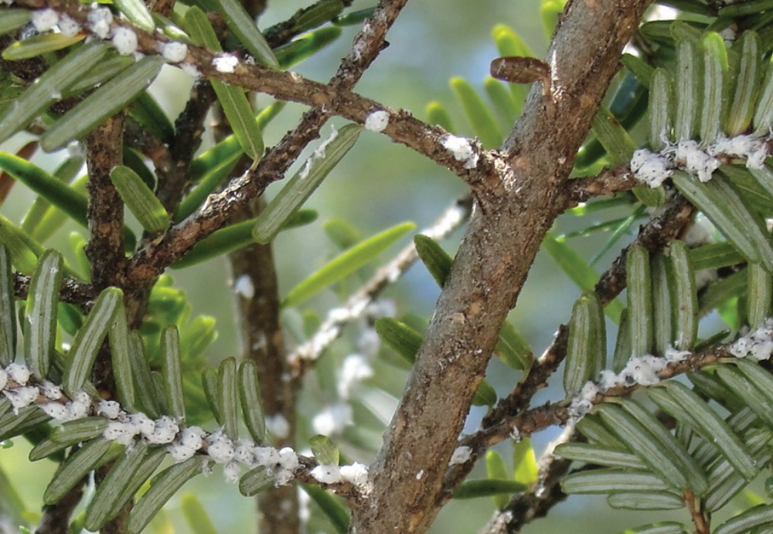

Figure 1: Hemlock wooly adeglid infested eastern hemlock (Havill et al. 2016).

                - 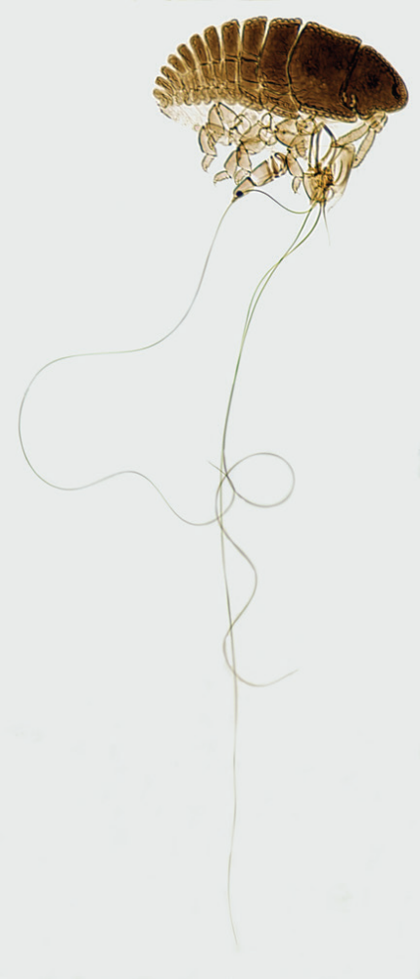
Figure 2: Image of a first instar Adelges tsugae (Havill et al. 2016).
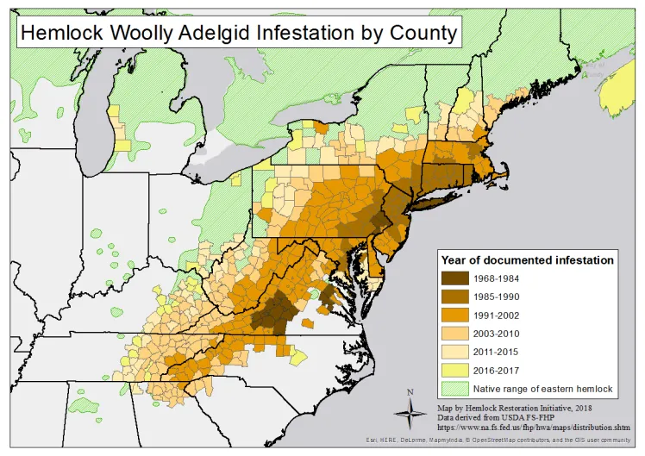
Figure 3: Map of HWA infestation by county in the Eastern United States.

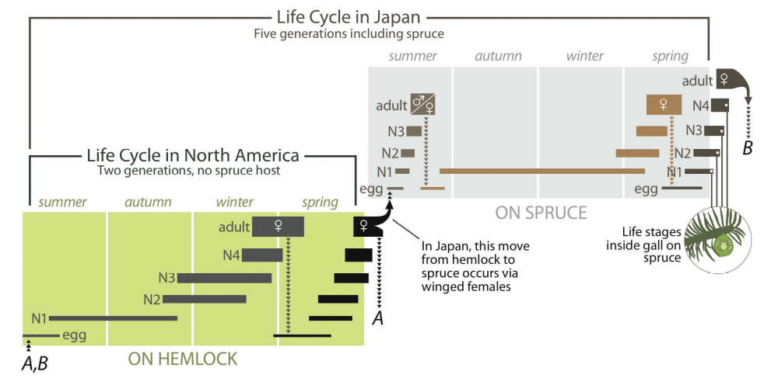

Figure 4: Life cycle of HWA in Japan compared with North America (Havill et al. 2016).

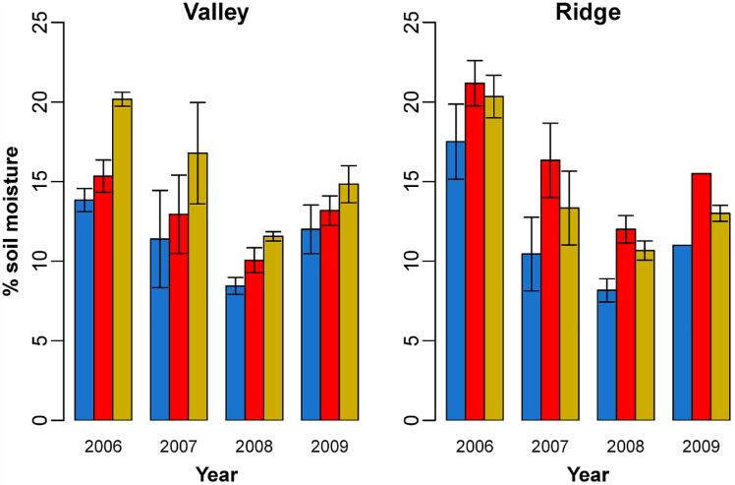
Figure 5: Comparison of % soil moisture across years between hemlock controls (blue), logged (yellow), and infested (red) (Lustenhouwer et al. 2012).

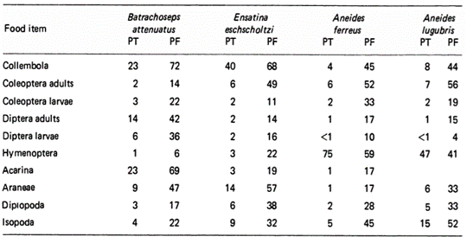
Figure 6: Table of invertebrate orders presented as Percent Total (PT) and Percent F (PF) in four salamander species (Bury and Martin 1973).

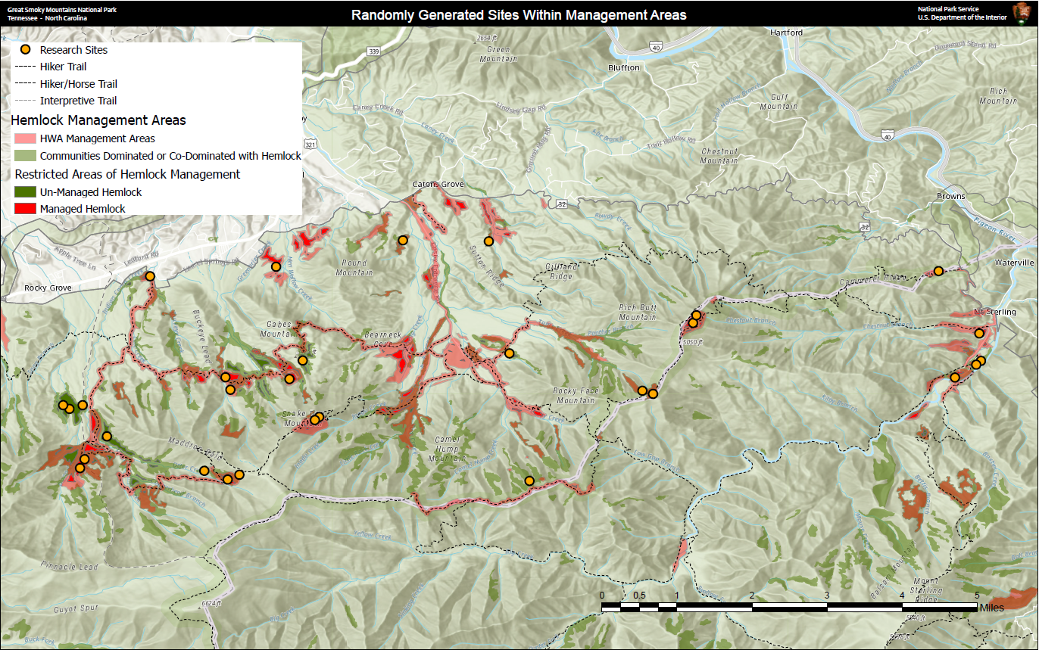
Figure 7: Map of potential area for random site selection and actual site location (yellow circles).

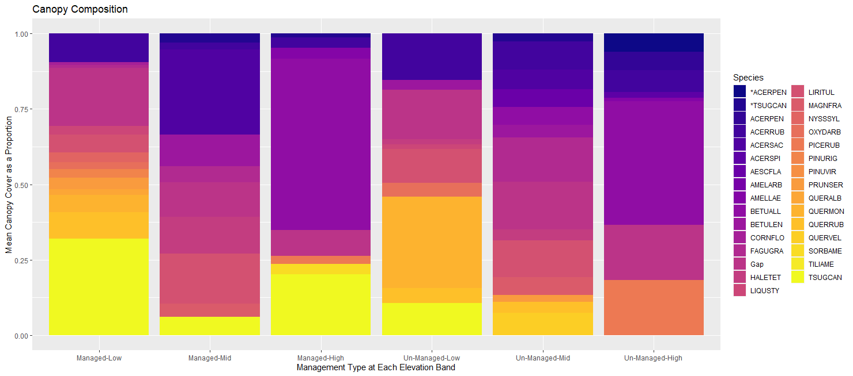
Figure 8: Mean relative cover of each canopy tree by site as a proportion of the total cover of all species by management type and elevation. Species are presented as a 7 letter code (first four letters of the genus and first three letters of the species; * indicate dead trees).

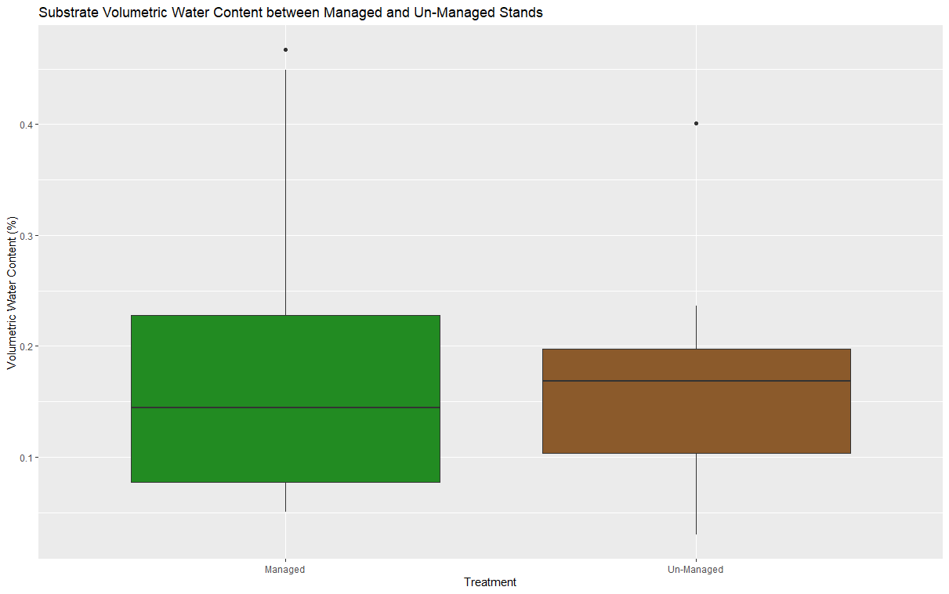
Figure 9: Boxplot of substrate water content between managed and un-managed stands.

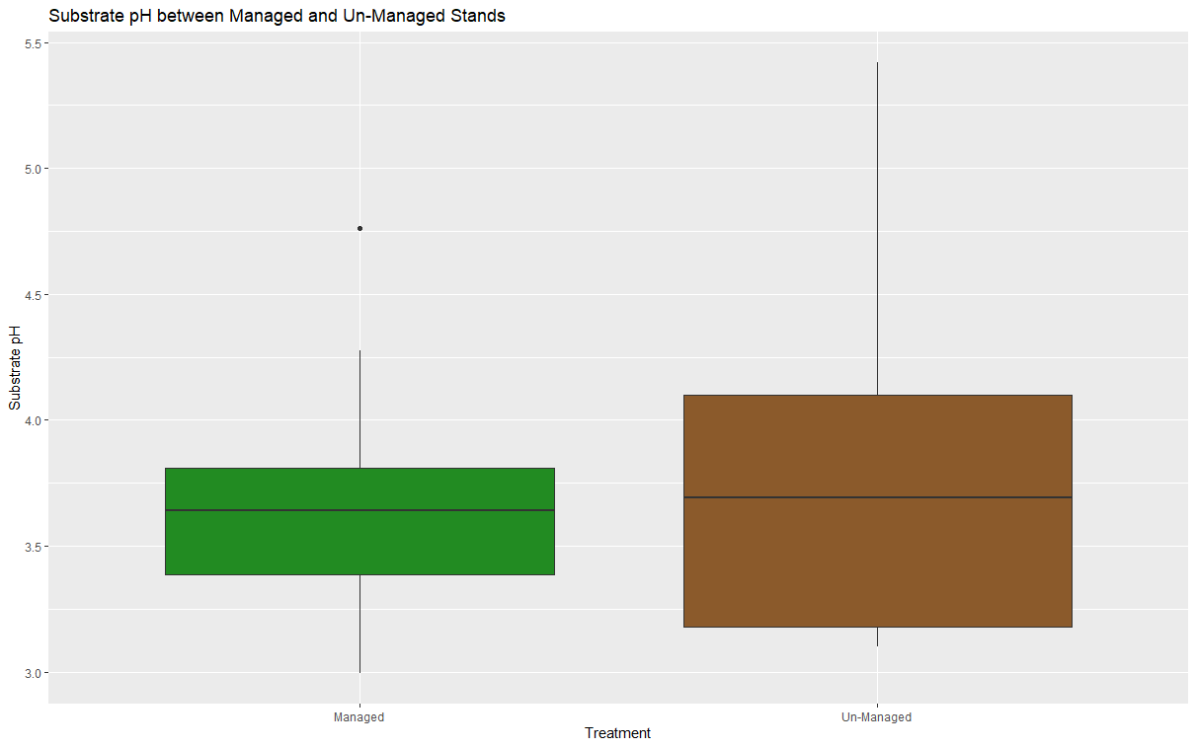
Figure 10: Boxplot of organic matter pH between managed and un-managed stands.

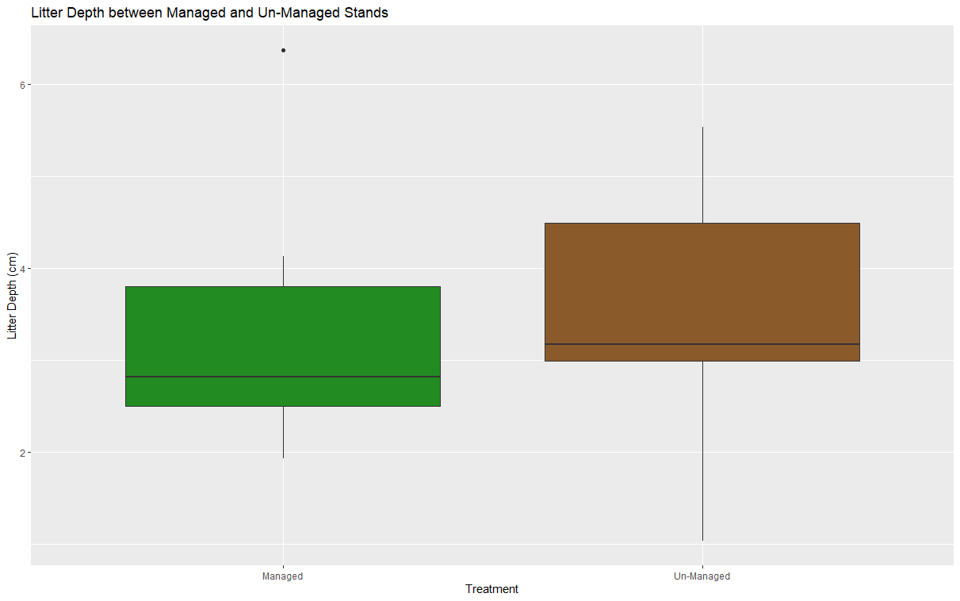
Figure 11: Boxpot of leaf litter depth between managed and un-managed stands.
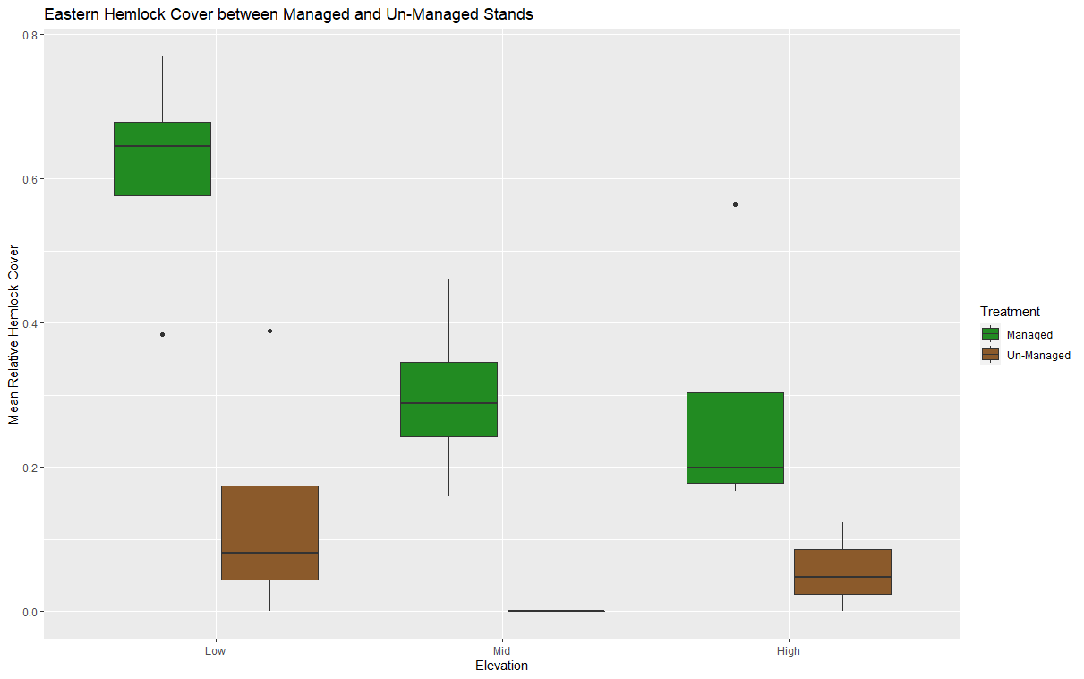
Figure 12: Boxplot of mean relative Tsuga canadensis cover between managed and un-managed stands separated by elevation band.

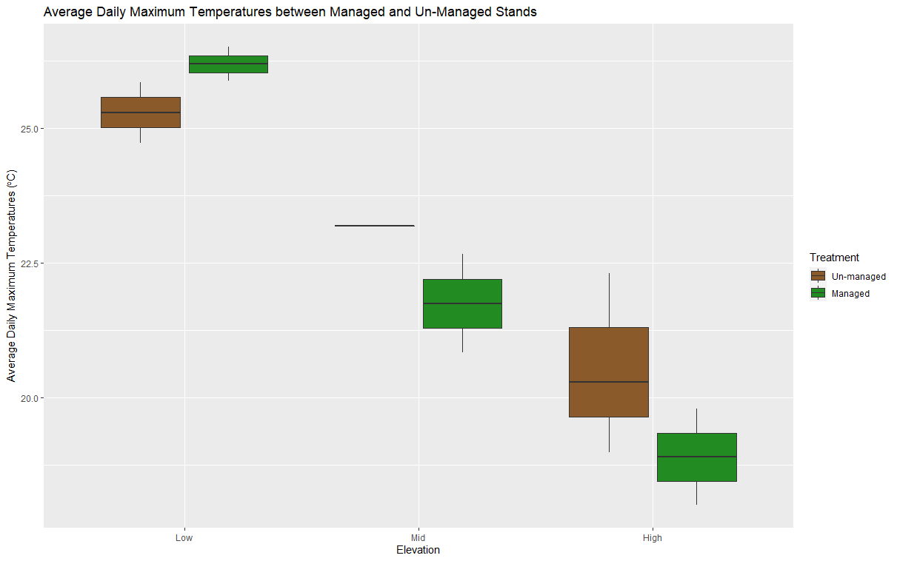
Figure 13: Average daily maximum temperatures between managed and un-managed stands separated by elevation bands.

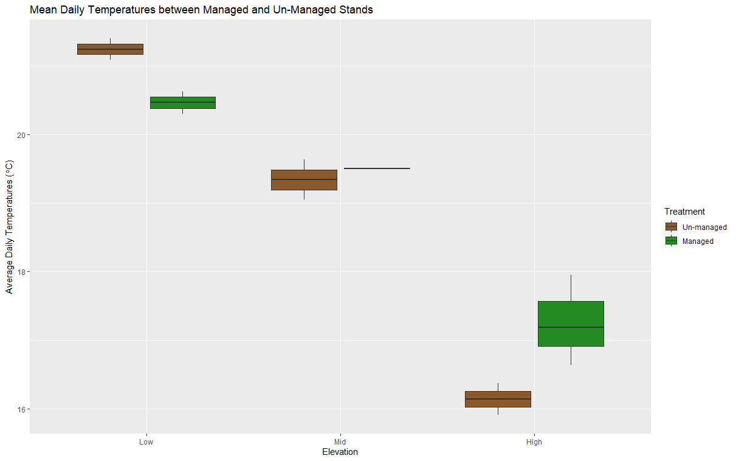
Figure 14: Average daily temperatures between managed and un-managed stands separated by elevation bands.

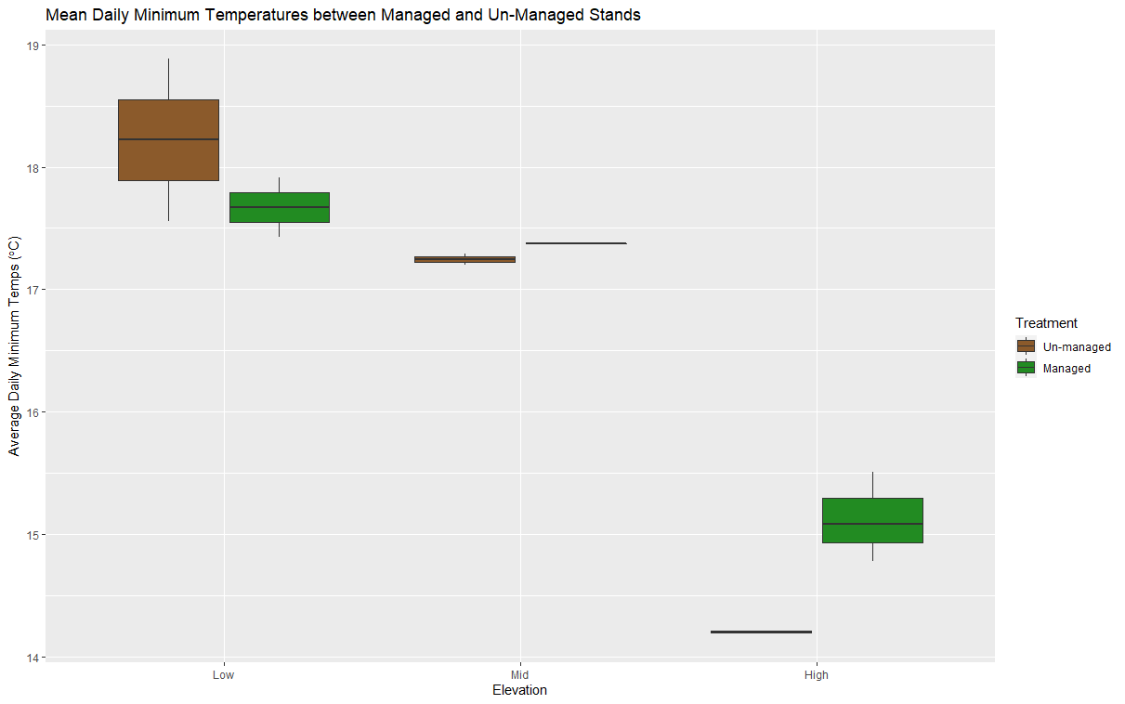
Figure 15: Average minimum daily temperatures between managed and un-managed stands separated by elevation bands.

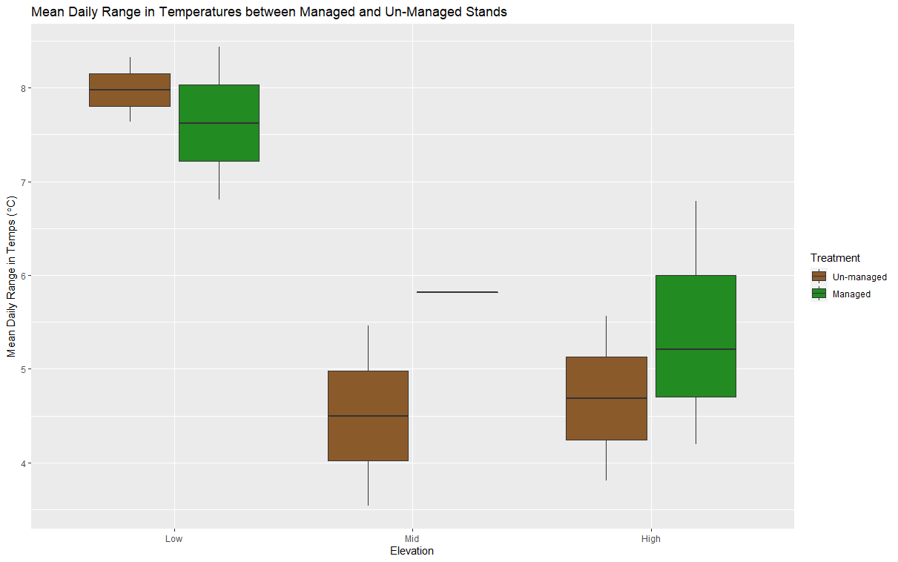
Figure 16: Average daily range between minimum and maximum temperatures separated by elevation bands.

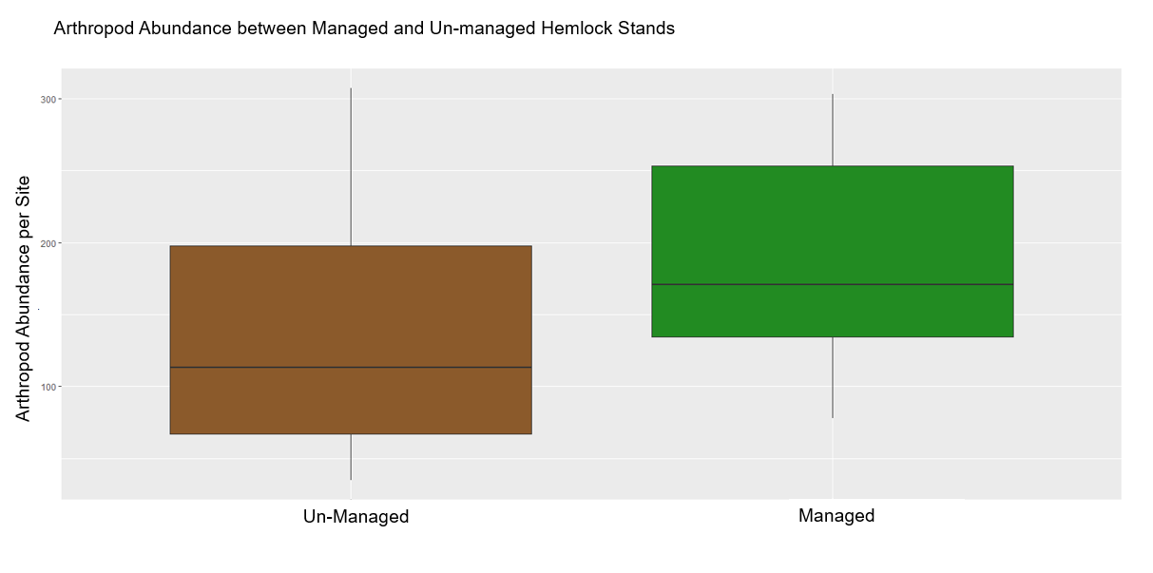
Figure 17: Boxplot of arthropod abundance between un-managed and managed eastern hemlock stands.
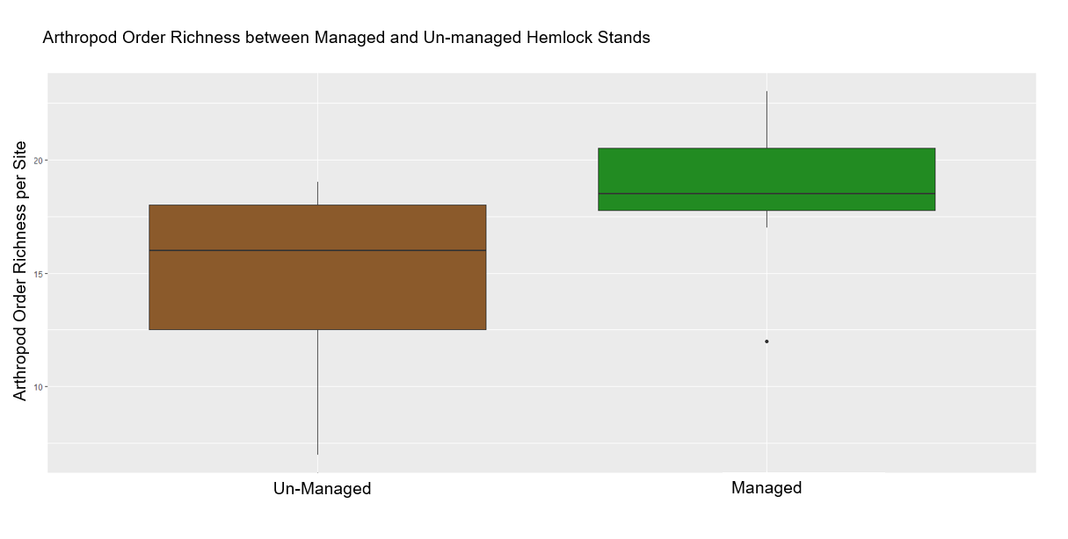
Figure 18: Boxplot of arthropod order richness between Managed and Un-managed eastern hemlock stands.

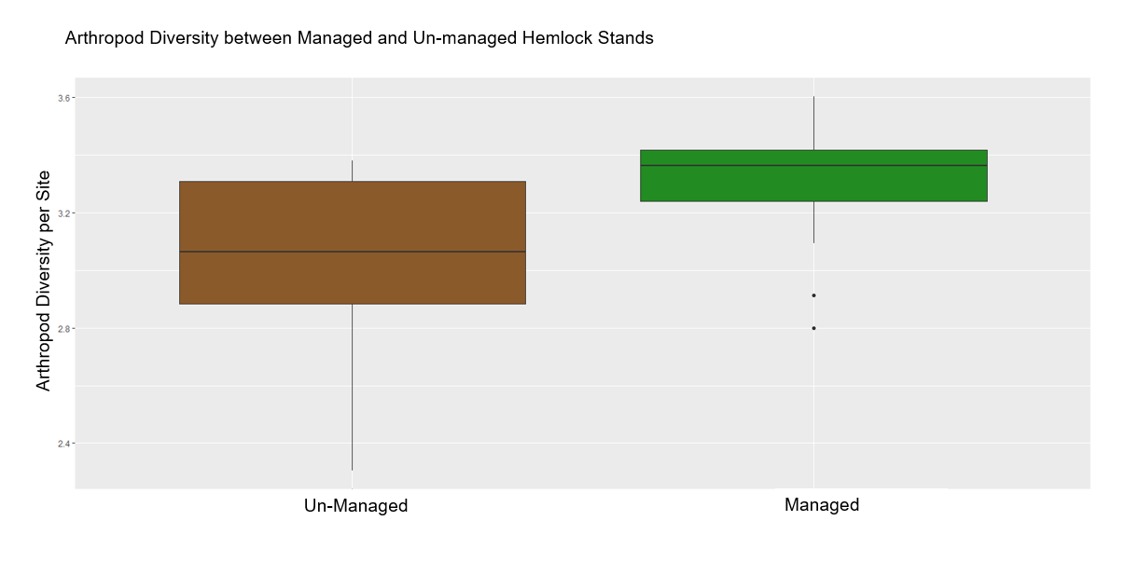Figure 19: Boxplot of arthropod diversity between managed and un-managed eastern hemlock stands.

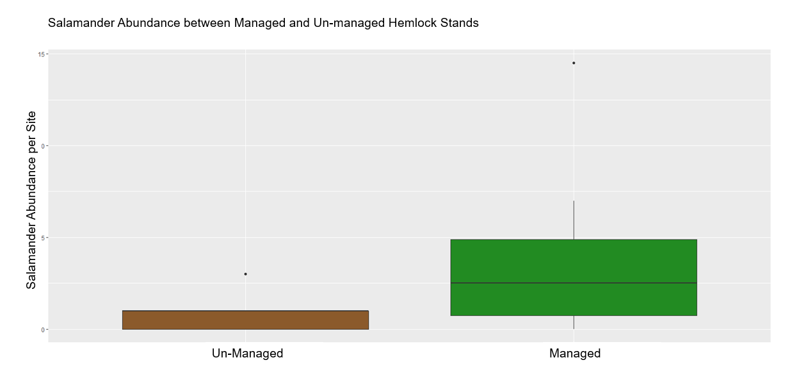
Figure 20: Boxplot of salamander abundance between un-managed and managed eastern hemlock stands.

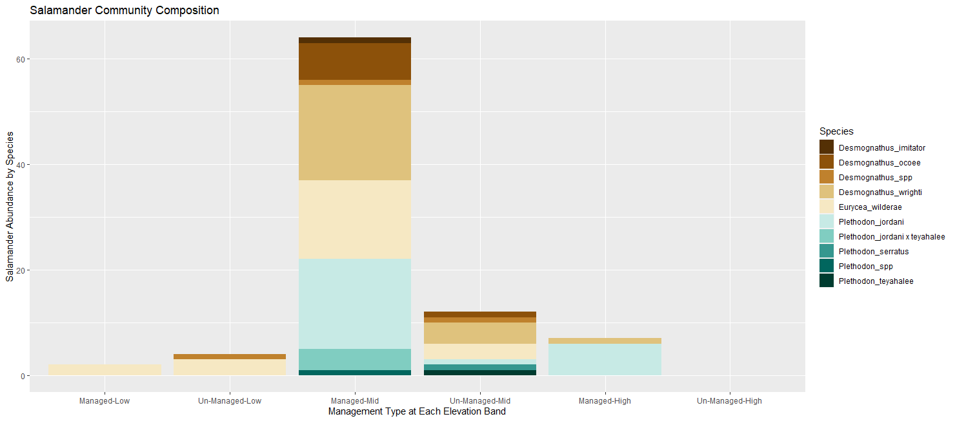
Figure 21: Bar plot of total salamander abundance stacked by species and grouped by elevation and management type.

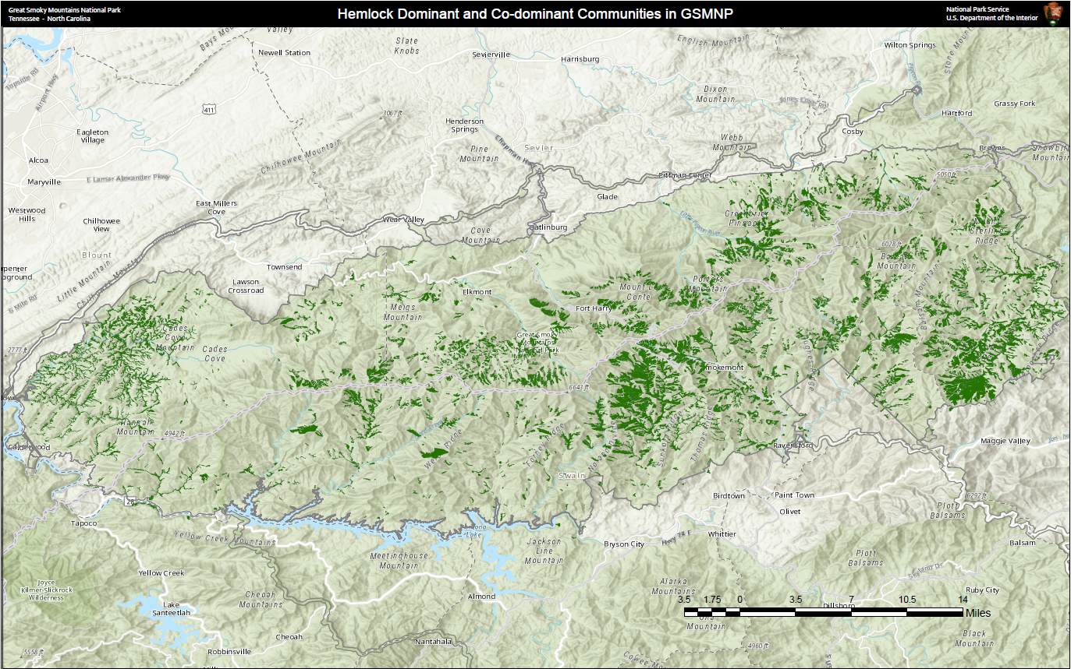
Figure 22: Map of forest communities dominated or co-dominated by eastern hemlock within the boundary of Great Smoky Mountains National Park.

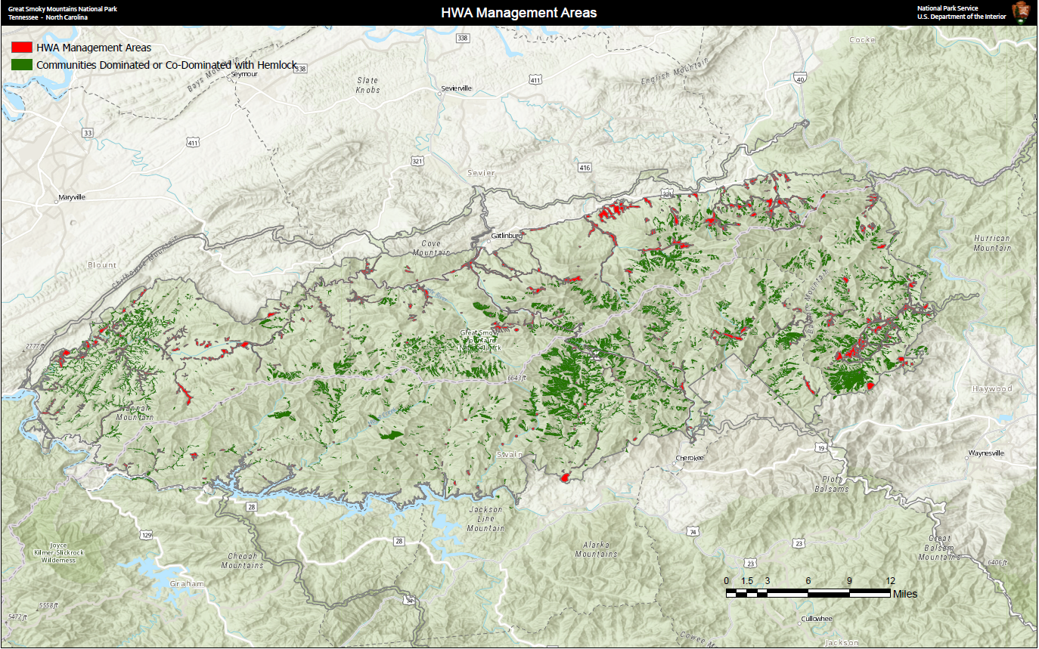
Figure 23: Map of area of eastern hemlock forests being managed for hemlock woolly adelgid invasion.

                - Vita

Jonathan Lawrence Cox was born to Lawrence and Rebecca Cox. He has one brother, David. Jonathan graduated from Hardin Valley Academy in May 2012 in Knoxville, TN. He attained his Bachelor of Science in Environmental Studies in December 2016 from the University of Tennessee, Knoxville. He was accepted into the University of Tennessee, Knoxville Department of Earth and Planetary Sciences as a Master of Science Candidate in the Fall of 2018. During his time at UT, Jonathan studied indirect effects of hemlock woolly adelgid invasion and its management with Dr. Michael McKinney and Dr. Benjamin Fitzpatrick. He completed his Master of Science degree in December 2020.

