The Medal of Honor: Transcending Perceptions of U.S.
Foreign Policy and War

by
Taylor Annese Hathorn

This thesis submitted in partial fulfillment of the
requirements for the Chancellor’s Honors Program with the degree of

Honors: Journalism and Electronic Media, Business Administration

The University of Tennessee
2014

Abstract

The purpose of this work is to show the way in which the Medal of Honor alters the media coverage of a war. Using media coverage as the basis for public perception and opinion this thesis will show the ways in which the Medal of Honor transcends the typical coverage of war and the role it plays in doing so for each specific action.
This thesis will attempt to answer the question: How does media coverage vary between battle coverage and the Medal of Honor coverage? Thus highlighting the ways in which the Medal of Honor transcends public perceptions of U.S. foreign policy and war. I will be arguing that this media coverage will ultimately alter public opinion, but I want to see if the coverage of the Medal of Honor acts to change public perception of those specific battles. The results were that the Medal of Honor does not act to change coverage, but to fall in line with the public sentiments of that war and the battles discussed.
If one were to take this further it would be beneficial for research to be done that looks at the implications of social media and television on coverage of war and the Medal of Honor as well, in the same way that I evaluated newspapers throughout World War II, the Vietnam War, and The War in Afghanistan.

Keywords:
The Medal of Honor, War, American Perceptions of War, Heroes, Soldiers, Media Coverage, Vietnam, World War II, Afghanistan
Dedication
To the brave men and women who proudly serve our country, we recognize and appreciate all that you sacrifice both at home and abroad.

“To hear that there is this hierarchy of Medals, and that this is the highest medal you can receive, I don’t know of any recipient that wears it form themselves. We wear it for those that are around us, those that we served with, and for this country. There is a strand, a fiber, in this [medal] for you right now. It is out resilience it is our character as Americans.”
-Staff Sgt. Salvatore Giunta, Medal of Honor Recipient

Acknowledgements
Thank you to Dr. Nick Geidner, Michael Wiseman, and The School of Journalism and Electronic Media for all of their help and encouragement throughout my time with the Medal of Honor Project.

Table of contents

Abstract 1
Keywords: 1
Dedication 2
Acknowledgements 3
Introduction 5
Methodology 6
Results and Discussion 7
Conclusion 8
Bibliography 9
Appendix A: World war II 38
Appendix B: vietnam 47
APPENDIX C: AFGHANISTAN ………………………………………………………………………...12

Introduction
Partisan blinders tend to shape the opinions American have of United States foreign policy and American-led wars. A commonality throughout the United States is that you are either in support of our government officials’ implemented policies or against those decisions. Having a strong opinion either way is not the issue, after all this is the United States; opinions are welcomed. The problem is that a very narrowed view of a problem that is much broader than most treat it, leads to an unintentional inability for many Americans to change their opinion when new information arises, henceforth an evident blindness that persists. But where does this public blindness originate? My answer, and one that I intend to show throughout this thesis, is that it lies in the media and our dependency on media as a holistic truth.
For the purpose of this thesis I will focus specifically on print because of the constant nature of that medium throughout all three wars that I will be analyzing: WWII, Vietnam, and Afghanistan. Although I will touch briefly on the impact that film had on changing the landscape of the media during Vietnam, this thesis will focus predominantly on print and the impact that it had throughout multiple battles on American understanding of war.
My primary focus is to look at the way in which journalists shape the public perception of war in regards to their coverage and then how the Medal of Honor acts to alter or confirm those perceptions. Although society as a whole claims to not have confidence in the mass media and their ability to report the news fairly and accurately (Fig. 1), we tend to gather most of our news from those same sources. (Fig. 2)

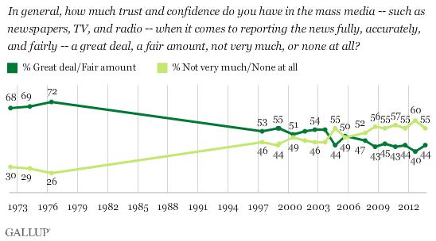
Figure 1 Source: GALLUP Online
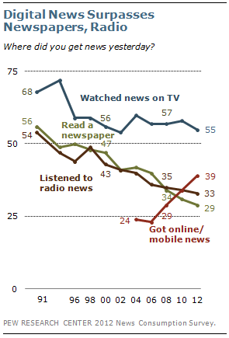
Figure 2 Source: Pew Research Center Online

Taking it a step further, not only do we gather our news from these media platforms we depend on and form our perceptions from it. The theory of media dependency, developed in 1976 by Sandra Ball-Rokeach and Melvin Defleur, states that the more dependent an individual is on the media for receiving his or her information, the more important the media will be to that person. Steven W. Hook reflects on the impact that media has on Americans perceptions of U.S. foreign policy and the way in which they use the news:
Because of the large scale of these political systems, most people do not participate directly in the political process. Instead, they learn what their government is doing primarily by following news reports in the electronic and print media. The public places even greater dependence on the news media when it comes to foreign policy issues, which commonly involve faraway and seldom-seen people and places. (Hook 252)
This dependency is not the public’s fault. Throughout history, specifically in terms of U.S. foreign relations and war, the media are often the only segway that the public has into what is developing in other nations. Since the media has the access, people then use the media for their understanding of foreign policy and war, that coverage then allows the public to form an opinion, which may alter their perception of a war. My goal is to analyze the affect that print media has had during war and conclude whether that same impact is evident when the coverage of the awarding of a Medal of Honor is introduced.
This thesis will attempt to answer the question: How does media coverage vary between battle coverage and the Medal of Honor coverage? Arguing that this same media coverage will ultimately alter public opinion.

Methodology
Throughout this thesis I will be evaluating news coverage of individual battles during WW II, Vietnam, and Afghanistan we will call this “Time 1.” I will also be evaluating the coverage about the specific wars that has no relation to the Medal of Honor. I will then look at the coverage of the awarding of the Medal of Honor, in regards to those same battles, to determine if there is a change in the way journalists refer to the battles, this will be titled “Time 2.”
In order to reflect a variety all articles were randomly selected throughout a multitude of historical databases such as ProQuest Historical Newspapers including papers from: The Wall Street Journal, The Boston Globe, The Chicago Tribune, USA Today, The Washington Post, and The New York Times. The random selection was carried out through a series of search terms. For time 1 I included specific battle titles, war titles (relevant to the era I was studying), and soldiers. The filters of ‘article’ and ‘war news’ were always selected to provide consistency. I chose the top group of articles from the generated list. ProQuest Historical Databases show these as the articles with the highest relatable search to my keywords. This random selection, without me reading the articles prior to, is important to the research because no bias was used during selection. During WWII I used 10 articles, Vietnam 16 articles, Afghanistan 11 articles. The number of articles was selected by a fair amount in comparison to the number that showed up in the search that met my criterion.
My initial process was to compare the adjectives that were used throughout the articles, but I found that none of the journalists were that blatant in their descriptions. Thus, I began looking at the language and tone differences throughout the text. Using the phrases that journalists used from each era allowed me to use the media coverage as a reflection of public opinion. By evaluating the tone from both time 1 and time 2 from several articles and newspapers this allowed me to see how the Medal of Honor transcends original perceptions of U.S. foreign policy and war, through both the eye of the public and the media, and the implications of such.

Results and Discussion
World War II
“WW II, we regard this as the last “good war.” It truly was good vs. evil. We were the good guys, the right guys. What happened with media, correspondents that were covering the war in Europe were essentially behind the lines, they were way back from the front. They were essentially just getting second hand information from leaders. The only guy who really went up to the front was a guy named Ernie Pyle, other than that most of the reporting was second hand. You would be back in the HQ and the information officer would come up and tell you stuff. The material Americans were getting back home was very censored, very carefully censored.”
- Dr. James Gilchrist, University of Tennessee, Political Science

This war was the difference between right (Allied Forces) and wrong (Axis Forces), a morality war if you will. After the embarrassment and defeat that Germany suffered during World War I, they needed to get back on their feet; the man for the job was Adolf Hitler. Although he seemed crazy to most, Hitler provided a plan that included stability for many Germans who were unemployed, starving, and searching for hope. After the signing of a neutrality agreement with Russia, allowing German forces into Poland without interference, the Allied forces started sensing great concern for a potential fascist and communistic take over. France and Britain were both forced to declare war against Hitler and the Nazi forces when they continued to advance their front. President Franklin D. Roosevelt felt that America was called to come to the aid of their allies of both France and Britain, regardless of the popular desire to stay out of war.
There was a sense of denial throughout the United States, the country was on the rise from the fatalities in World War I, wives had their husbands, and mothers had their sons. The country was also still on the mend from the Great Depression. “[William L. Shirer] he and other reporters would send back their stories about German atrocities, only to find them shoved to the back of the newspaper or the bottom of the broadcast, if they were used at all.” (Willis 120) Once German aggression started heightening for all to see, Government officials knew the fear of a communist regime spread from the Axis forces could not be ignored. Committees across the United States like “The Committee to Defend America by Aiding the Allies” were formed and President Roosevelt told Americans to get ready for war. They were to become “the great arsenal of democracy.” President Roosevelt made a point to persuade American’s on why they should be on the side of the interventionists “a British defeat would mean German domination of Europe as well as Asia, Australia, Africa, and the seas.” (Willis 122) On December 7, 1941 the unprovoked attack on Pearl Harbor by Japanese forces pushed Americans over the edge. They were not going to stand for an attack on United States soil, and intended to prove to the communists exactly which power reigned supreme.
The following article reviews of both the battles of Iwo Jima and the Normandy Invasion, during World War II, reflect the sentiment of the war and perceptions of the American public at the time. Americans were angry and wanted revenge for the lives lost at Pearl Harbor, Propaganda filled the streets, and everyone was on board to spread democracy and stop the Axis forces from spreading any further. Unlike wars in the future, the wordings throughout the text of these articles are very uplifting and supportive. The loss of life is presented as heroism, which acts as a catalyst to sanitize the war and make the massive loss of life a reflection of the good and the duty that Americans have to defend democracy and this country. Films were made about the United States involvement in World War II, even throughout the time of loss.

“The photo of the flag-raising at Iwo Jima inspired Americans and made them even more grateful for the job their troops were doing overseas. As for the government, they saw in this single photo a chance to raise more funds through the sale of war bonds; enough money that might enable the country to bring a speedier end to the war in the Pacific.” (Willis 123)

Americans were proud of the fact that every dime given and everything their boys over seas did; helped the effort of the world, of the good guys. Even when there was bad news given, the public rallied, Americans were supporting the troops and the effort. The theme that I found throughout the articles that did not mention the Medal of Honor was the same theme that was reflected throughout the articles with mention of the Medal of Honor. There was a reflection of pride, a sense of duty, and a responsibility to a nation. This theme throughout the articles is conducive to the public sentiment during that time.

3/16/1945 “4,000 Marine Dead on Iwo Indicated: Admiral Turner Says Loss Was Less Than Fifth of Japanese Killed – Operation Praised”
- “Because of those who have conquered Iwo Jima, we bow our heads in humble appreciation to those who, never questioning their orders, have made Iwo Jima ours.”
- “I cannot help but express my wholehearted respect and admiration for those fighting troops of the Fifth Amphibious Corps, their steadfast courage is magnificent.”

3/17/1945 “Woman’s Plea to End Iwo Battle Revealed”
- “Having chosen to fight, we had then, and have now, no final means of winning battles except through the valor of the Marine or Army soldier who, with rifle and grenades, storms enemy positions, takes them and holds them. There is no short cut or easy way. I wish there were.”

3/18/1945 “Camera Man Hails Iwo Jima Marines”
- “Joe Rosenthal, Associated Press photographer, who saw Iwo Jima’s bloodiest fighting and took a famous picture, came home today humble, he said, before the gallantry of the marines.”
- “After looking at it, I think it is a good picture, I think it reflects credit on the marines. It symbolizes their gallant actions. That was the toughest fight they ever had.”
4/1/1945 “Twin Sons Named Iwo and Jima”
- “Mrs. Martha Johnson has named her twin sons Iwo and Jima. Their father, George, is in the Navy.”

Looking at the media as a driver of public opinion, the integration of the Medal of Honor proves no change in public opinion during this time period. American pride is just as strong, in fact even more fervent with medals and awards given. In World War II, the medal and recipients were seen as a beacon of hope, honor, and valor. These soldiers were heroes, symbols of the American spirit.

12/18/1944 “Home Town Greets Medal of Honor Man Who Slew 18 Nazis After Brother Was Killed”
- “A crowd of some 200 welcomers joined the hero soldier’s parents, Mr. and Mrs. John Ethlers, when an Army plan brought him to the municipal airport, ending a trip that began last Wednesday in France.”
- “He went immediately to the home of his parents, to whom he had written that he did not want to come home yet because ‘I have a score to settle with the Jerries in Berlin.’”
- “Other officials promised a parade in his honor and a celebration with speeches and everything.”
10/6/1945 “Top Medal Award is conferred on 14: The President Conferring Nation’s Highest Honor on War Heroes”
- “President Truman bestowed the highest award of a grateful nation, the Congressional Medal of Honor, on eleven marines and three other Navy heroes of Pacific fighting today and then called on all Americans to fight for a ‘peaceful world so that this war will not have been in vain.’”
- “The youngest man honored was the 17-year-old marine private Jacklyn H. Lucas. In the bloody battle for Iwo Jima he put the lives of his comrades above his own by falling on one Japanese grenade and pulling another under his belly to absorb the full impact of the explosion and came back to tell about it.”
- “His citation tells the story of Feb. 26 this year, the day he killed seventy-five Japanese to destroy sixteen enemy positions on Iwo. Armed with a bazooka gun, Corporal Jacobson charged into the Japanese fire and, in the worlds of the Marine Corps, ‘contributed to essentially the success of his division’s operations against that fanatically defended outpost of the Japanese empire.’”
- “Sout-hearted and indomitable in the face of extreme peril, Private Sigler effected the release of his besieged company from enemy fire and contributed essentially to its further advance against a savagely fighting enemy.”
6/15/1946 “The Commander in Chief Congratulating Medal of Honor Recipients”
- This article is important because of the photograph. Although no mention of the battles or citations; Shown are the five recipients laughing and joking with President Truman. This reflects the notion that these men were not even affected by the war, giving the public perception that all was good and well.
12/9/1947 “Ships to be Named For 8 War Heroes: General Officers and Winners of Medal of Honor Designated for Honors on Coast”
- “The names of deceased Army personnel will be given to eight ships as signed to the San Francisco Port. Four transports of the P-2 Class are to be renamed for distinguished general officers of World War II and four victory Class cargo ships will carry the names of Medal-of-Honor soldiers.”
6/26/1948 “Honored For Outstanding Heroism in World War II”
- “They won the nation’s highest tribute for risking their lives under intense German and Japanese fire. The presentation ceremonies were in the Rose Garden of the White House.”
- “The citation said his inspiring leadership was largely responsible for keeping the California in action during the attack.”
1/26/1955 “Medal of Honor Hero Trades Lieutenancy For Sergeancy ‘to Get Back With Troops’”
- Caption: “Jake William Lindsey admires a master sergeant’s jacket. The 33-year-old former infantryman wears Medal of Honor.”
- “A rugged, 33 year old war hero who calls his wounds “nicks”-and doesn’t remember how many times he was ‘nicked’-gave up his second lieutenant’s bars in the Army for the stripes of a master sergeant yesterday.”
- “He gave as his reason for resigning his commission, ‘I want to get back with the troops.’”
- “I suppose once you’re a soldier, you’re always a soldier. I was a sergeant so long; it’s hard to get over it. My sergeant’s tactics don’t go as an officer. In battle, rank doesn’t matter very much.”
- “I’ve got thirteen years in and seventeen more to go. This being back in now as a master sergeant and being with my men is the greatest.”

The take away from this examination of the coverage of the battles of Iwo Jima and Normandy within World War II and the examination of the article mentions of the Medal of Honor is to show that the Medal of Honor does not combat the journalists intent for the emotion behind the text, but rather highlights it. Although media coverage does have the ability to alter public sentiment many times, such as this, it also reflects popular opinion. The Medal of Honor does not transcend any perceptions here because it again reflects the sentiment of the time and highlights the already preconceived opinions that the American public had.

Vietnam War
“We lost a lot of people [in Vietnam.] There was one battle that we lost... 155 dead, 125 wounded, in one day. No one wins in war, no one. You try to make the other guy lose so much that he wants to quit.” Lt. Col. Bruce P. Crandall, United States Army

Communism was yet again on the rise, this time in Vietnam. The world had already witnessed the largest loss of life of any war in history with World War II and this newer generation was still witnessing the recovery of that war through their parents. American’s were made aware by Johnson that if they did not support the civilians in South Vietnam, this domino affect of a communist take over of South Vietnam was going to spread quickly. Congress voted to support President Lyndon B. Johnsons request for involvement, with the exception of two Senators. Initially this war was labeled a “conflict” and most were not concerned.
If everyone was on board, then when did tensions begin to get heated? Why were there so many protests throughout the Vietnamese conflict? How did the media play into America’s support of Vietnam? The lack of fervent support from the public did not rise from nothing. The Vietnam War was a very costly war to Americans, but not just in terms of the 58,000 American lives lost. America lost faith in their leadership, their trust in the government’s ability to be open and honest, and the press was helping that. “It became clear to the Johnson and Nixon administrations that the press was fueling public opinion about the war and that conducting the war under such intense media scrutiny was extremely hard.” (Willis 127)
The first wave of public disproval was October of 1965 when the draft went from 3000 monthly to 33,000. If you could afford to wave your involvement in the draft, for example by going to college, you were left alone. Sadly, many of the poor working class Americans were not afforded that luxury. The dissent of the war began to heat up during the Tet Offensive (Jan. 30, 1968). The Tet Offensive, which was the largest military attack/strategy used by either side up to that point, proved to be a defeat for the communists after the initial stunning of U.S. and South Vietnamese Forces. Yet, this is the turning point when Americans began to realize that they had not been given the entire picture of the loss of life that was occurring, in regards to both United States soldiers and Vietnamese civilians.
As part of this effort to guide the news media into buying into this theme, Johnson brought Westmoreland to Washington, D.C. to address a large gathering of journalists, reporting that America was winning the war and that the end was in sight. This speech was highly publicized, and it seemed for awhile as if much of America was buying the idea, until January 1968 when the North Vietnamese regular army and the Viet Cong launched an all-out offensive (called the “TET” or New Year offensive) against 100 cities in South Vietnam, including Saigon itself. The fury and magnitude of this attack convinced much of America that the war was not being won. (Willis 127)

The Tet Offensive proved that South Vietnam could not defend itself from the Communist north, even with the years of French and American aid; the American public began to question our involvement. The media played a huge role in the public opinion about Vietnam, this was the first conflict where they were given free reign to roam and report their own stories rather than stay with a military supervisor, this was very unlike the heavy censorship in World War II. This was also known as the first television war where Americans could really see the impact of what was taking place in Vietnam, rather than just look at words on paper. The government began to see that the press were fueling the public opinion about their war. The presses ability to release all information made it very difficult to conduct wartime decisions with the public protesting at every turn. “… the press is a big determinant of the American public opinion, and this was certainly the case with the Vietnam War ... They became aware that what the government and military were saying, as opposed to what was happening before their eyes in Vietnam, were not one and the same.” (Willis 128)

The inside information from the press, turned into an outcry of dissent which led to protests, but not just toward our government. Soldiers returning home began to serve as punching bags to the public’s dissatisfaction of their government. “War leaves those who fought with scars, but the scars Vietnam veterans bear are different from those who fought in other wars for the United States. In no other conflict were those who fought in it scorned by their fellow Americans upon their return. The latest Gallup poll shows 72% of Americans believe that the people of the United States have not treated Vietnam veterans well in the years since the war.” (Gillespie) The following article comparisons highlight the disproval of American involvement in the war. I specifically looked at instances of IA Drang and the Tet offensive. With a series of negative connotations underlying throughout the text you can see that this was the first time that the press became gutsy enough to raise questions, and the public answered. I have the following articles listed by date so that you can tell the advancement in press/public dissent throughout the progression in time of the war.
The following compare titles and a few statements from the text(s):

11/26/1965 “Death Struggle Seen in Highlands”
- “…Total Community Strength in the Highlands is believed to exceed the command allied strength. Even the most optimistic estimate holds that it takes five government or allied troops to counter each guerrilla in this kind of war.”
- “Despite the infusion of an American division into that section of the Annamese Cordillera, the Western position seems deteriorating because of more rapid North Vietnamese reinforcement and a heavy toll among government troops in intermittent clashes.”
11/11/1967 “Buildup in Ground Warfare Reflects Red Determination”
- “Initiative seems more important to the Communists than their casualties. ‘Our losses are not important. What was important at Loc Ninh was that we demonstrated we have the ability to attack, to gain the initiative when we want to.’”
- “This war cry has been made before, but never has the response been so evident.”
- “We know there are big clouds in the sky around here, but we don’t know where the rain will fall. That’s our problem with the communists.”
1/31/1968 “Washington Views Latest Red Assaults in Vietnam as Prelude to Peace Moves”
- “The Administration often before has displayed optimism only to see it proved unfounded, and of course the Administration constantly faces a temptation to put the best interpretation upon the worst news.”
- “Admittedly, Communist thinking actually may be headed in the opposite direction [of peace]. If Hanoi can muster the strength for a prolonged large-scale offensive, it could be aiming at stirring a big surge of end-the-war sentiment in the U.S. and, even if it’s aiming at early peace talks, it could be a long road to a peace agreement.”
- “The attacks proved that the seven-day truce the communists had [Tet] proclaimed was a hoax and a fraud.”
- “The military opinion that the attacks were primarily for purposes of harassment was bolstered by the size of the Vietcong forces used.”
2/1/1968 “Time for Decision in Vietnam”
- “Unless we are prepared to let the communists take over South Vietnam, we shall have to keep many more troops there than the 50,000 we now have in South Korea, more than 14 years after the armistice. There will be repeated humiliations of the United States in the South China Sea like the seizure of the Pueblo in the Sea of Japan, and there will be more Koreas, more Vietnams. Thailand, which we are committed to defend, is next on the communist ‘liberation’ program.”
- “Undoubtedly this spectacular show of strength was intended to paralyze the will of the United States for continued support of South Vietnam against communist aggression and create conditions for a negotiated settlement on the enemy’s terms.”
4/21/1968 “Security Procedure Criticized”
- “The Defense Department reacted quickly, as it does to any sign of dissent in its ranks.”
- “The patients supervisor will determine his fitness for duty. If he is fit, it means he no longer disagrees with U.S. policy. If he isn’t fit, then he must leave.”
- “He [the doctor] was prepared to give a verdict on the fit for duty question. The trouble about this is that a psychiatrist does not get paid if he does not reveal all the information requested by the Defense Department.”
8/12/1968 “Saigon: Off Stage Center and Uneasy”
- “A mood of unease and of anger seems to have descended on Americans here during the past few weeks, complementing the hot, humid summer that also is settling in.”
- “… the news here now is more implicit in the questions not being asked than in the answers not being given; the significance is more in the silences than the statements.”
- “Tens of thousands of homeless, destitute Vietnamese still crowd emergency refugee camps throughout the country, yet human misery has become a tiresome topic.”
- “Peace, after all, is not a very likely prospect and the hopes will fade. Perhaps peace pressures will produce an explosion here, another coup d’etat. If peace contacts fail, the war could sharply escalate.”
An interesting aspect of the reporting are the articles that are released that are direct quotes from the military. They carry an entirely different tone than those mainly written by the journalists. The tone is more uplifting throughout with a definite “America is in the right” prose. Especially the articles referencing the Tet Offensive, the military spokesperson acts as if America still has the upper hand, which is not reflective of the sentiment of the public.

11/20/1965 “Air Blows Smash North Viet Human Wave Assaults”
- “A U.S. Spokesperson said a Vietnamese paratrooper detachment heading south toward the valley ran into a stiff fight. He reported heavy fire from North Vietnamese regulars inflicted light causalities and help up the reinforcements.”
- “It was hand to hand combat, a real infantry action. So you can expect these casualties.”
- “…they took on a large force and did a great deal of damage.”
- “I would say they performed like you hoped green soldiers would perform. They all fought like pros, whether they were draftees or regulars.”
- “It renews your faith in man’s ability to stay alive.”
- “It was a risk to take. It worked beautifully.”
11/22/1965 “Home are the Heroes… Boys Now Men”
- “The brave young boys who left their youth behind in the fighting of Ia Drang Valley came home like men …”
- “You met tough, professional, capable enemy troops and you gave them a mauling they will never forget.”
- “But there would be no empty tents for the battalion. Fresh replacements arrived Saturday and have been assigned to the cots of the fallen … ‘Try not to wake them up,’ a captain said half-heartedly, ‘they just got here and they are tired.’”
2/2/1968 “Westmoreland: Foe’s Biggest Push To Come”
- “Not completely. I felt there would be fireworks during the Tet lunar New Year period.”
- “’He apparently hoped the people would join his ranks,’ Westmoreland said. He said the ‘popular reactions seems to be one of outrage.’”
- “The next phase of this master plan we have seen unfold during the past several days. D-day for this plan was set at Tet despite the fact that the Communists had made quite a point that they would observed a cease-fire at Tet.”
- “The second phase of the campaign was a bold one. It was characterized by treachery and deceitfulness. It showed a callous disregard for human life and it brought about considerable disruption in a number of towns and cities. The enemy has paid dearly.”
- “There is, however, evidence to suggest that he’s about to run out of steam. On the other hand, he does still have some reserves that are yet to be committed. We are aware of these. I’m confident that nay further initiatives can be blunted.”
- “When he does attack, he will have to accept great risk because of the preparation we have made and the fire power available to us.”
8/12/1972 “Pride Worn Thin as Yanks Leave Viet”
- “Now as the last American infantrymen have stood down-with determination dissipated to boredom, pride worn thin.”
- “By then it was too late and the American public was aroused about the war. The military wanted to push the American troop level over the 600,000 mark. That attempt failed, and the stage was set for gradual withdrawal.”

Viewing the media as a driver of public opinion, the integration of the Medal of Honor into the conversation proves no change in public perception about the war or conflicts. American pride during this time is just as weak; the Medal does not act as sanitization of war or affirmation of pride and triumph. In fact, Medal of Honor recipients were not portrayed the same way that they were throughout World War II. Rather than heroes, these recipients were a reflection of the battles and rigid nature of the conflict in Vietnam. They were not given the welcome home, the parade of pride and honor that they deserved; that the men of the Second World War received. Lt. Col. Bruce P. Crandall, United States Army commented, “The way they [the American public] treated us when we came back from Vietnam was totally unacceptable, but today you see the troops in the airport; they’re in their uniforms and everyone is saying “Thank you for your service.” During our day we couldn’t come off of the military installation in uniform [for the potential of harassment.]”
The presentation of the Medal is transformed throughout the articles as the dissent of war grows over time. The recognition of the Medal and the recipients is strong in the first few years (mentions) but as the American public grows wary of the conflict and dissatisfied with the government, the praise begins to decrease.
*These articles were a random selection through multiple databases.

11/25/1965 “Charges Viet Foe To Show Way To Mates: Yank is Credited with 18 Killed”
- The article begins “I may as well go up and do it myself, I wouldn’t ask my men to do anything I wouldn’t do.”
- The illustration in the article is of Lt. Joe Marm with his mouth sewn shut showing a dedication of sacrifice courage and resilience.
6/24/1966 “Medal of Honor Awarded Fourteenth Veteran of Vietnam”
- The illustration of this article is President Lyndon B. Johnson holding the daughter of First Lieut. Charles Q. Williams out side of the White House following the Medal of Honor Ceremony, reflecting a sentiment of family and honor.
- There was a reflection of light humor throughout the article. The Lieut. Stated, “As President Eisenhower said, with all due respect to you, sir, and your duties, he would rather have the Medal of Honor than be President of the United States. These are my sentiments.”
- “The lieutenant had words of praise for the members of the Army Special Forces group and the Navy Seabees.”
- “For our deceased comrades who are not with us today from Dongxoai, if I may offer some small condolence o loved ones, these brave and courageous men did not die in vain, but for a true and just cause which makes our great country what it is today.”
- “a patriot’s gift to his country.”
12/20/1966 “Lieutenant, Iadrang Hero, Wins the Medal of Honor”
- The illustration of this article is the parents of Lieut. Walter J. Marm Jr. after the Medal of Honor ceremony with their son smiling proudly at his Medal.
- “By your courage and skill, you have set an example which will bring new strength and resolution to all American fighting men.”
- This excerpt reflects the dedication that the military and the public initially had for those honored with the medal. “The Army provided a full honor ceremony with a 19- gun salute for the young officer from Washington, PA., who was wounded in the battle that brought him the Medal of Honor.”
- “Personal courage is a magnificent thing. The ability to lead other men in the face of extreme danger is a rare gift.”
- “… in a situation that demanded all a fighting man could give, he responded with total disregard for self.”
12/20/1966 “Hero Eager to Fight again”
- “… the nations newest congressional Medal of Honor winner, said today that he thinks “it’s about time” he went back to Vietnam.”
- “… he had decided to make the army his career and that he would like to go back to Vietnam. He was asked why, but, before he could reply, his mother Mrs. Dorothy Marm, cut in and said, only half in jest, ‘That’s what I’d like to know.’”
- “I’m a professional soldier and that’s how I can best fulfill my obligation, either by fighting or by training others.”
- “Then, despite wounds in the face and neck, he killed the remaining machine gunners with rifle fire.”
3/10/1967 “President Gives Medal of Honor to Medic: Paratrooper Hailed as a Selfless Hero in Vietnam War”
- “Ruffles, flourishes, honor guards and 21 salvos of salute-the kind normally offered only to visiting chiefs of state- were offered to the 39-year-old soldier who was the first medic to be so honored in Vietnam”
- “He heard himself praised for gallantry that saved the lives of many men and inspired the performance of many more.”

POST TET- OFFENSIVE: A reflection of the turning point in the war of American Public Opinion on Vietnam

11/19/1968 “Johnson To Present 5 Medals of Honor”
- This article is incredibly basic. It lists the soldiers citations, dates of actions, using no words of gallantry or heroism as in the last group of articles.
1/17/1969 “Johnson Awards Medal of Honor to Four Heroes of Vietnam War”
- The first fourth of this article is about the fact that this is President Johnsons last medal presentation while in office. The rest of the article just lists the citation and reflects upon the fact that two of the recipients are from the same hometown. The word hero is used in the article title, but there was no public display for these men as there was previously.
3/30/1969 “Medal of Honor Winner Enlists Again After Year”
- Unlike the display and full length article that Lieut. Joe Marm received prior to the change in American perception of the war, about the same thing that Sgt. Dolby is doing; Sgt. Dolby received an article two paragraphs long including a statement from the Sgt.
- “Sergeant Dolby of Suburban Oaks said he felt he was better suited to helping his fellow man in the army.”

War In Afghanistan

has become America’s longest war, continuing over 12 years since our first entrance in 2001 following the attacks of September 11th. Gallup polls show that Americans were more supportive of our entrance into this war than any since World War II. 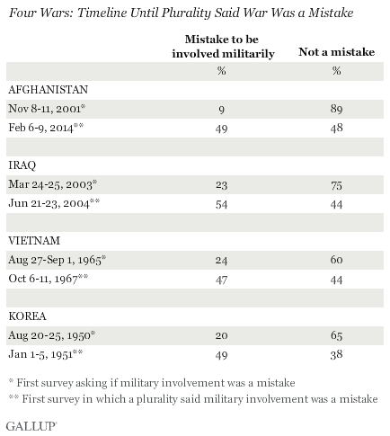
Figure 3 Source: Gallup Online

The War In Afghanistan is an entirely different beast than the Vietnam War. This difference is predominantly seen in the nature of the United States being on the defense after September 11th, much like America during World War II with the attacks on Pearl Harbor. Americans were already opinionated about war, which was evident from the remnants of Vietnam; they no longer blindly trusted the government. With the introduction of Internet, extremely fast technology, camera availability around every corner; nothing was kept under lock and key, including American perception and opinions of war. Americans, now more than ever, have an opinion about everything and need not rely fully on the news anymore to form those. Although we do rely some on the interpretation, we are more wary to blindly trust the media due to their bias (Fig. 4).

“In many instances, journalists were acting too: doing reports which were based, not on any actual newsgathering, but on press releases and agency stories which had been read to them down the satellite phone from studios in London or Washington prior to their live pieces to camera. Yet if the media were guilty, as Air Marshal Burridge suggested, of turning war into ‘reality TV’ and ‘infotainment’ (The Telegraph, 7 April 2003), so too were the military.” (Hammond)
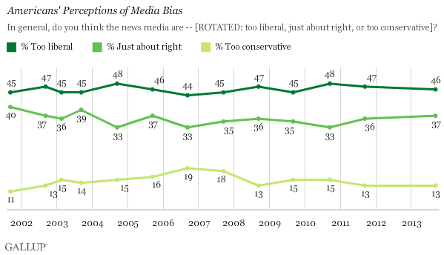
Figure 4 Source: Gallup Online
Yet, because of this reflection of bias, the media seemed to truly reflect the perceptions of all Americans and argued both sides with the introduction of opinion segments on television and political leaning news networks such as Fox News and CNN. Because of the means and willingness of travel from foreign correspondents working in the multimillion dollar media companies, Americans were able to get a first hand view with consistent video, pictures, and interpretation daily. “Despite the administrations’ best efforts to put a positive face on the war and to ask Americans for patience, the daily media reports focused mostly on the negative aspects of the war: the steady drumbeat off the dead and wounded U.S. troops the increased fighting in the provinces, the toll on civilians, and the questionable results from all of it.” (Willis 133)
Although the visual facets of coverage are easier for the public to understand and conceptualize, the written interpretations were just as strong in Afghanistan coverage as they were in both World War II and the Vietnam War. The text speaking out about what happened in Afghanistan was now more detailed than ever before, American society was different. This was no longer the keep your head down and say nothing society of the past. Americans had a voice; soldiers had a voice. Although older generations reflected this sentiment as well, citizens during this era were very vocal about wanting to know what was really happening overseas and what their tax dollars and the sacrifice of their family and friends were going toward and they weren’t afraid to ask questions to get it.
It took eight years before the majority Americans started questioning the involvement in Vietnam; with Afghanistan it took a matter of minutes. One can see the change in culture from the smallest textual comparisons. During WW II and Vietnam, many Medal of Honor recipients did not speak out about the medal or who they were wearing it for, now practically every recipient that has been given the medal takes a public stance on the fact that they are wearing the medal for their friends that they lost in conflict, that none of them like war, that no one should like war. This sentiment is reflected throughout the text bellow and furthermore in the articles listed in the Appendix. These are our heroes now; just as brave and gallant as those of the past conflicts, but with a generational change that is evident in more than the weaponry that they use.
The following text comparisons show yet another defense that public perception and media coverage go hand in hand, the only difference with this “new media” and “new war” is that all sides of an opinion are publicly reflected through coverage. An element of this new war, as reflected in the following text, shows that rather than just labeled as soldiers; they are now referred to as Americans throughout most of the media coverage. The new type of coverage allows us to put a face to the war and the loss, which no longer sanitizes the coverage of war.

8/14/2005 “Marines and Afghans Drive Against Rebels Tied to Deadly Attacks”
- “United States Marines and Afghan troops launched an offensive on Saturday to take from insurgents a remote mountain valley that was tied to the deadliest blow against American forces since the Taliban government was ousted nearly four years ago.”
- “The offensive came at the end of a deadly week for American forces in Afghanistan. Seven Americans have died.”
- “We want them running for their lives way up in the hills where they can’t attack polling stations. We want to isolate them from the community.”
2/24/2008 “Battle Company is Out There”
- “The counterinsurgency in Afghanistan’s Korengal Valley is one day after another of difficult decisions and bloody consequences. Hearts and minds are hardening.”
- “He had been in Iraq and told me he had gone emotionally dead there with all the dying and killing, and stayed that way until the birth of his son a year ago. His hardest day in Iraq was when a close friend, Rob Shaw, was severely wounded by an improvised explosive device that killed his first sergeant and a bunch of their friends – and the next thing he knew their colonel was asking Kearney to step in for Shaw and lead the company. But as hard as Iraq was, he said, nothing was as tough as the Korengal.”
- “’My guys would tell me they didn’t know which houses they’re shooting from, and I’d tell them they can’t shoot back into the villages, they hated me.’ The insurgents were testing the new captain, he suspected, by deliberately shooting from homes.”
- “The insurgents regularly use civilians as shields, children as spotters and women as food suppliers, NATO killing civilians is great propaganda for the Taliban.”
- “It was a lot to ask of young soldiers; play killer, cultural anthropologist, hearts-and-minds winner, then kill again.”
10/31/08 “McCain and Obama Advisers Briefed on Deteriorating Afghan War”
- “The group was there to deliver a grim message: the situation in Afghanistan is getting worse.”
- “American intelligence officials believe that Taliban commanders are convinced that they are winning. Not only are they establishing themselves in larger swaths of the country, but their campaign of violence is shaking the will of European countries contributing troops to the NATO mission.”
- “Of more than 400 major tribal networks inside Afghanistan, the general said recently, most have been ‘traumatized by over 30 years of war, so a lot of that traditional tribal structure has broken down.’”
10/4/2009 “The Difference Between ‘We Must’ and ‘We Can’”
- “This summer, Mr. Obama described the effort in Afghanistan as “a war of necessity.” In such a war, you do whatever you need to do to win. But now, as criticism mounts from those who argue that we war in Afghanistan cannot, in fact, be won with more troops and a better strategy, the President is having second thoughts.”
- “The idea that American foreign policy must be founded upon a prudent recognition of the country’s capacities and limits, rather than its hopes and wishes, gained currency after World War II, possibly the last unequivocally necessary war in American history.”
- “Americans broadly agree that their government must at all costs prevent major attacks on American soil by Al Qaeda. But there the consensus ends, and their questions begin.”
- “What if the fall of Kabul would constitute not only an American abandonment of the Afghan people, but a major strategic and psychological triumph for Al Qaeda, and a recruiting tool of unparalleled value? … In that case – and perhaps only in that case – Afghanistan really would be a war of necessity.”

The most interesting aspect of the new type of war that is fought is the way the Medal of Honor and its coverage ties in. For the first time throughout my research, the Medal is not simply a reflection of a public opinion, but serves to transcend and uphold a stronger symbol and example of valor and sacrifice, something that is long over due in terms of public perception and media coverage. Movies like ‘We were soldiers’ and ‘Medal of Honor’ highlights the sacrifice of these men and show the courage that they displayed. Every single text that I found showed the dedication of these men to their country. I have not figured out if it is because of our culture or because of the media coverage. At some point throughout history the men that received the Medal for actions during WW II and Vietnam were all recognized and honored, but never before have the Medal of Honor recipients served as such a beacon in the public eye. This is seen through every day facets of our society such as social media, public presence, and their openness about war.
11/14/2010 “In One Moment, Heroism and Heartbreak”
- “None of this had been part of the plan for Rock Avalanche, Battle Company’s six-day mission to tame the valley before the onset of winter. But then again, that is what war is, the mocking of plans. The reaction in those moments of mockery is why we have the Medal of Honor.”
- “And then Giunta said, “All my feelings are with my friends and they are getting smaller. I have sweat more, cried more, bled more in this country than in my own.””
- “On Tuesday Giunta will become the first living soldier to receive the Medal of Honor since Vietnam. He has said that if he is a hero then everyone who goes into the unknown is a hero. He has said he was angry to have a medal around his neck at the price of Brennan’s and Mendoza’s lives.”

11/17/2010 “Rare Honor for a Living Service Member”
- “In an emotional ceremony, President Obama on Tuesday awarded the Medal of Honor to an Army staff sergeant who placed himself in the line of fire in Afghanistan to try to save his squad mates and to protect and comfort a dying American soldier.”
- “By now, the East Room was so silent you could hear a rustle from across the room. One Army Officer took out a handkerchief and wiped his eyes.”
- “He crested a hill alone with no cover but the dust kicked up by the storm of bullets still biting into the ground.”
- “I lost two dear friends of mine, I would give this back in a second to have my friends with me right now.”
2/12/2014 “Obama awards Medal of Honor for valor in Afghan battle”
- “The investigation also found that Combat Outpost Keating ‘was tactically indefensible’ but that was what these soldiers were asked to do, defend the indefensible.”
- “He added: I accept this tremendous honor on behalf of all soldiers who have served with me that day. This award is for the eight soldiers that didn’t make it and for the rest of the team that fought valiantly and magnificently that day. I will forever be humbled by their bravery, their commitment to service and their loyalty to one another.”
- “That’s what these soldiers did for each other in sacrifice drive by pure love.”
8/26/2013 “Obama awards Medal of Honor to Staff Sgt. Ty Carter for heroism in Afghanistan”
- “… hopes to use the award to help others suffering from post-traumatic stress disorder.”
- “…absolutely critical to put an end to any stigma that prevents troops from getting treatment.”
- “Mace later died in surgery at a field hospital, and Carter blamed himself, believing that he had “failed” because he could not save the young specialist he had carried to safety.”
- “I’m hoping that I can help people through what I have to say, what I’ve experienced, to help them go seek help, or else we’re going to have more out there who self-medicate and end up taking their own lives.”
10/15/2013 “Former Army Capt. William Swenson receives Medal of Honor at White House”
- “Swenson’s path to the White House ceremony was a rocky one. After he criticized his army superiors, saying they failed to provide enough air and artillery support during the 2009 engagement, his medal nomination was delay for years. Army officials said his nomination packet was lost in a computer system for 19 months.”
- “It does not really belong to me; it belongs to that event and the people I stood with,” he said of the medal … You could have told me it happened, and I wouldn’t have believed you. But it did, and it was captured on film. And it offered a glimpse of the humanity that does occur on battlefields.”

Conclusion
Throughout my analysis I have found that whether the Medal of Honor transcends American perceptions of US Foreign Policy and war is not the question. The way the public views the Medal of Honor is completely reflective of the current sentiments of the public opinion on that war and the publics direct relationship with the media.

Initially I expected to find that the mention of the Medal of Honor would act to change the perception of the war at hand, just like it changes the way that journalists write about the war in their articles. What I found is that although journalists change their language and voice when writing about the Medal of Honor, to that of more respect, that integration of the Medal into the war does not alter the overall public perception of that war.

To break it down:

In terms of World War II battles, the public was already in full support of the Allied Powers and their fight against the Axis Powers. Everything that took place in regards to battles about that war, American patriotism, consumption of steel, sacrifices the public made were in reflection with the public support of the involvement in World War II. Even during the mention of a negative situation, such as a mass loss of life, the underlying tone seemed to hint that although sad, the soldiers dying were not in vain because of the goal and mission of the war. Any mention of the Medal of Honor in the articles continued to build pride about America’s involvement in the war. The Medal of Honor recipients were viewed as heroes and icons for younger soldiers and citizens alike to look up to.

Throughout Vietnam, the public sentiment of the war was not strong or encouraging. There was much dissent toward our involvement and many Americans did not see the point in sending so many to die for a cause that did not directly affect us. Due to, in part, the media coverage and the way in which it altered public opinion, any recognition of Medal of Honor recipients was not highlighted or given attention to like the soldiers of World War II that were so respected, admired, and labeled as American figure heads for the war.

Afghanistan’s coverage was also reflective of both World War II and Vietnam’s coverage in its unique way. The coverage was similar to World War II due to the public pride for the brave men that fight for us on a daily basis. In terms of the Vietnam War coverage similarities, public opinion is vocal and widely known and is reflected throughout the media and vice versa. Although many are proud of the Medal of Honor recipients, no one is jumping for joy over the recognition of the medals.

Throughout my research I have found that the mention of the Medal of Honor in the newspaper articles does not transcend public opinions about the war or individual battles mentioned. The recognition that the Medal of Honor receives and the tone in which it is mentioned is highly indicative of the current sentiment of the war that is reflected by the public in general.

Bibliography

Gillespie, M. (2000, November 17). Americans Look Back at Vietnam War. GALLUP. Retrieved April 29, 2014, from http://www.gallup.com/poll/2299/americans-look-back-vietnam-war.aspx

Hammond, P. (2007). The media war on terrorism. Media, War & Postmodernity (pp. 59-80). New York: Routledge.

Hook, S. W. (2011). The Impact of Mass Communications. U.S. Foreign Policy: The Paradox of World Power (Third Edition ed., pp. 242-275). Washington, DC: CQ Press.

Willis, J. (2007). Conducting War in the Media Age. The media effect how the news influences politics and government (pp. 117-135). Westport, Conn.: Praeger.

Appendix A: World War II

1 A
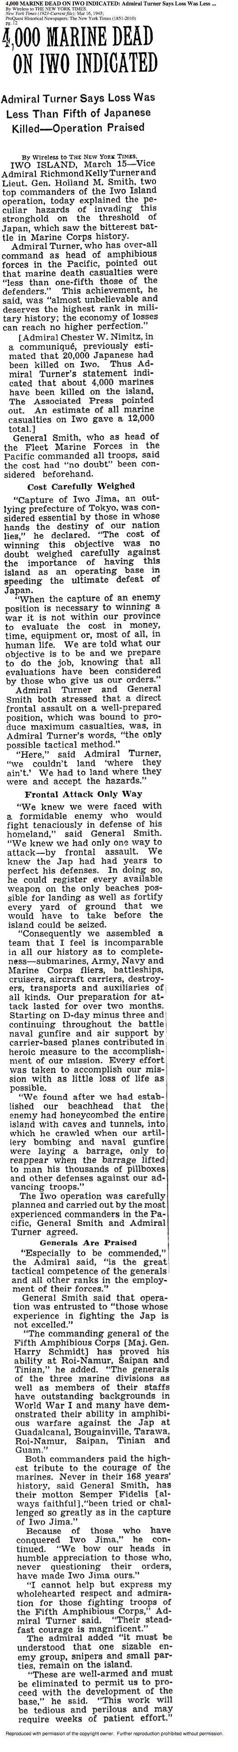

2 A

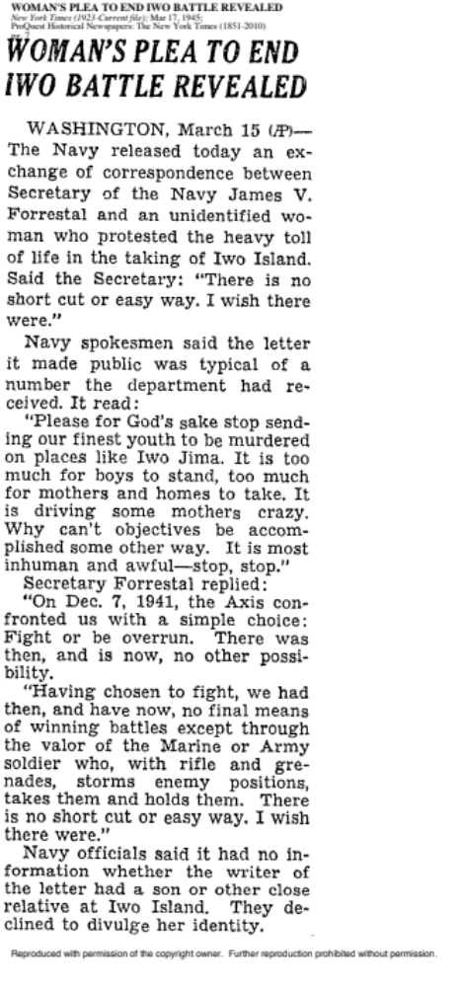

3 A
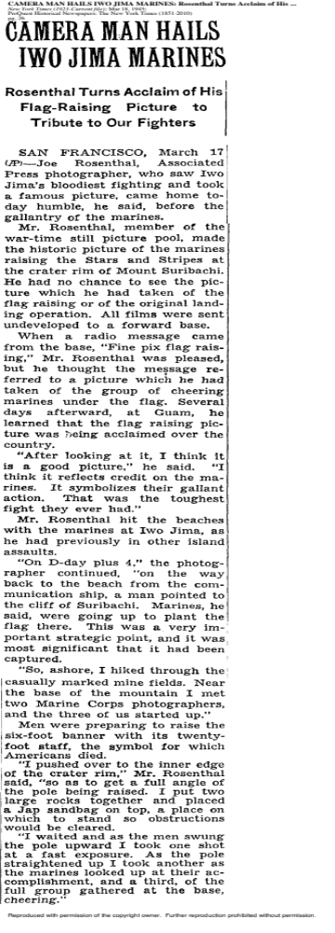
4 A
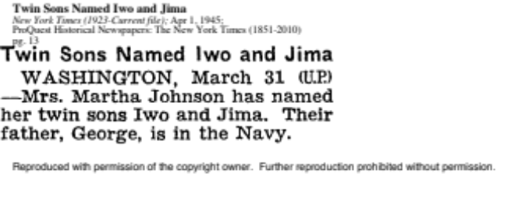

5 A

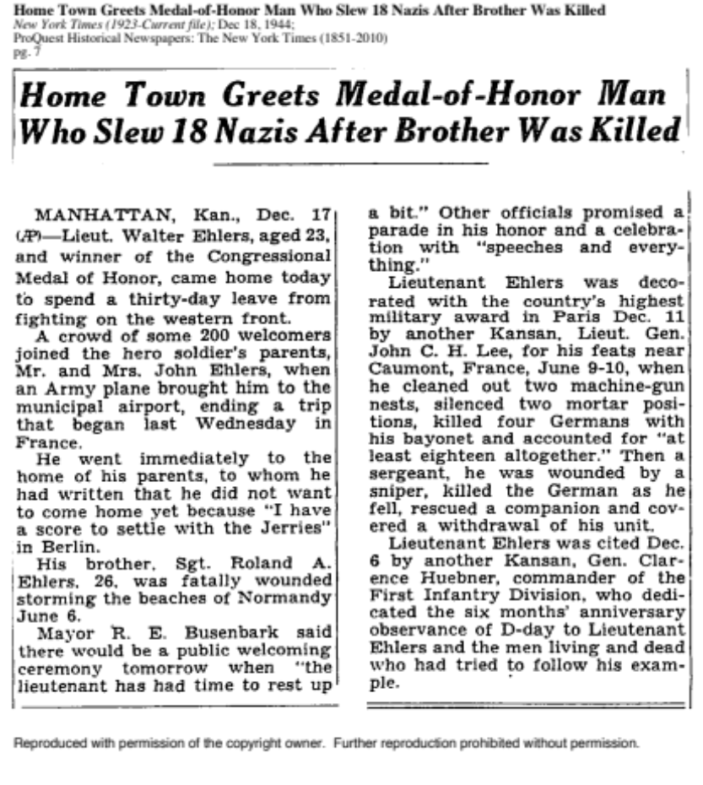

6 A
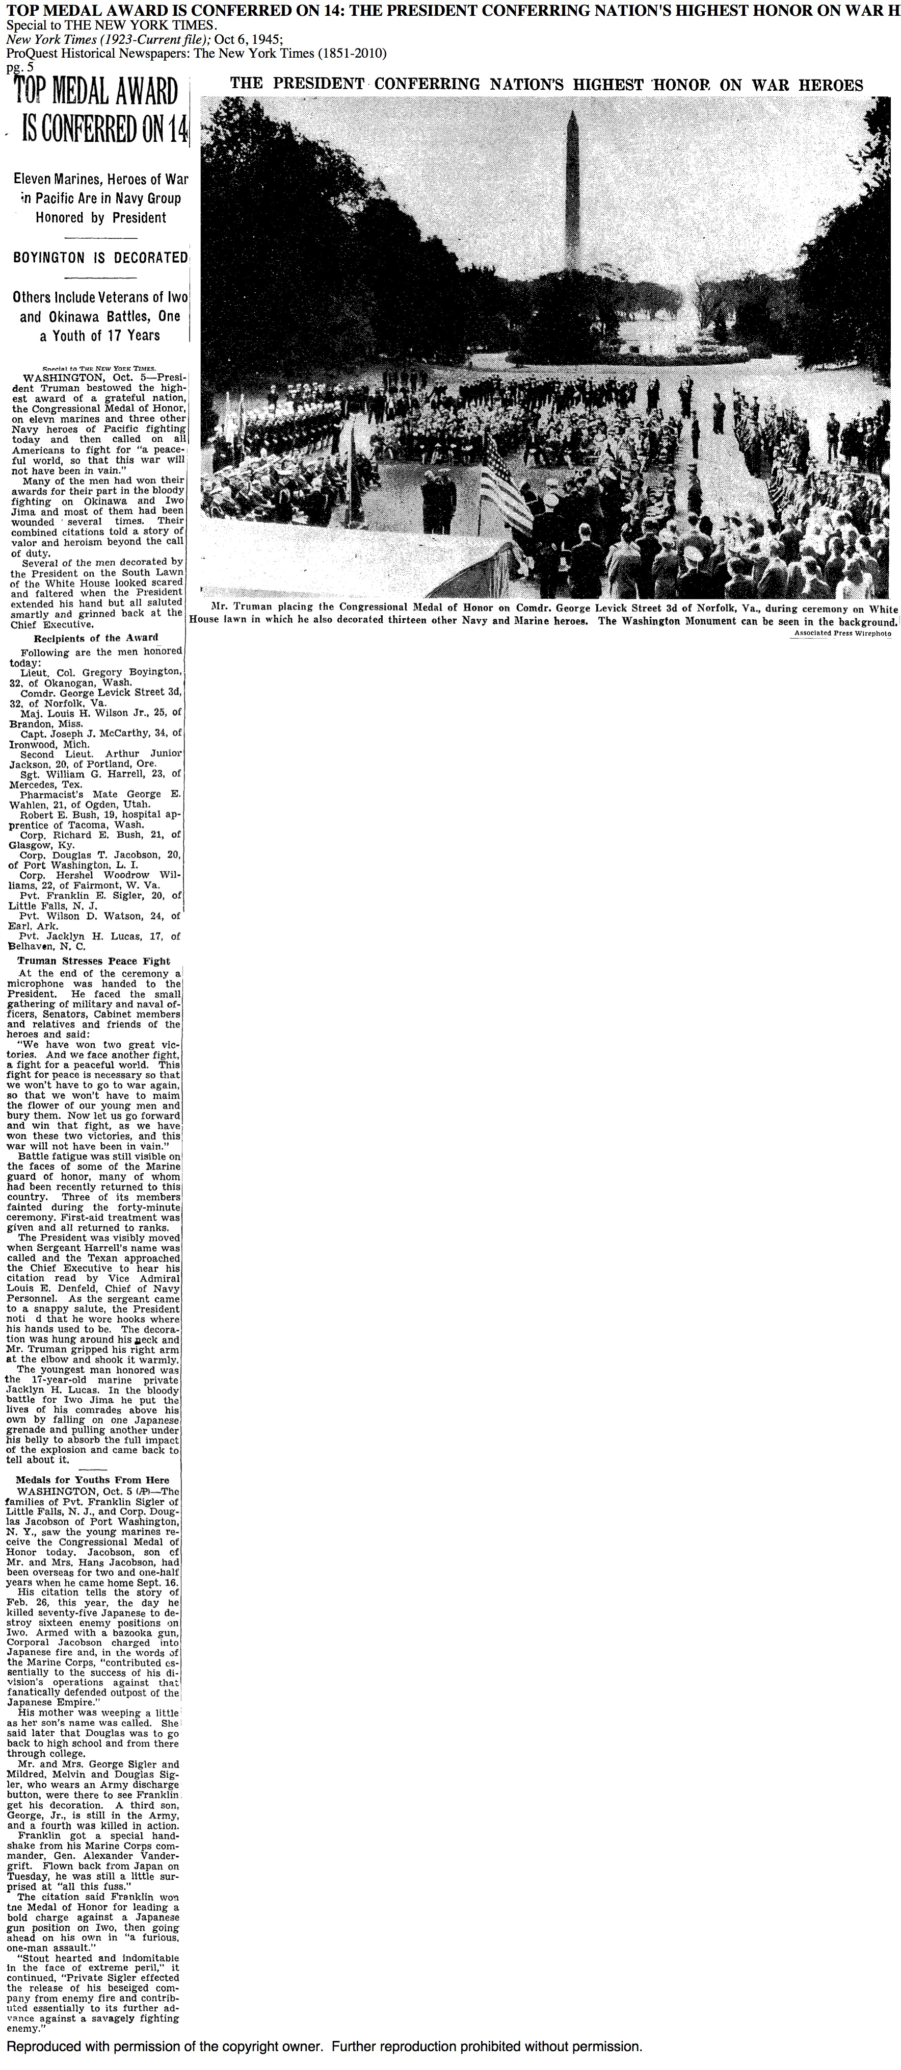
7 A 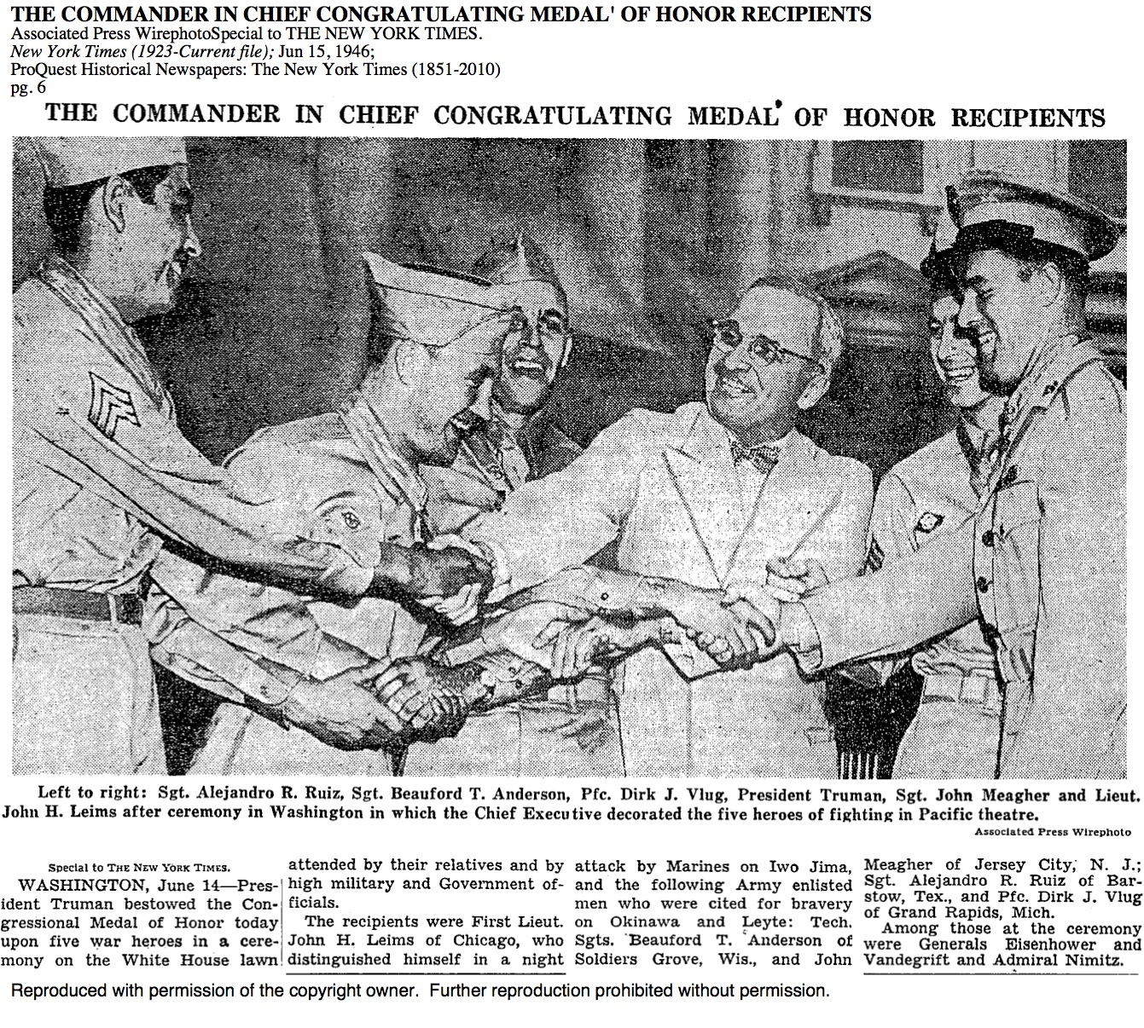

8 A
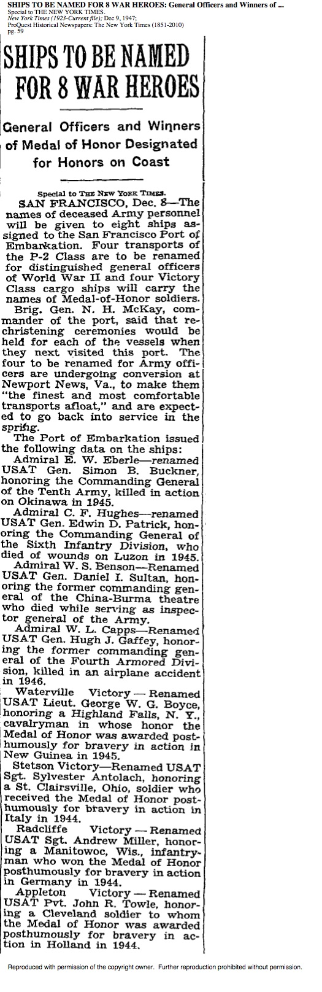
9 A 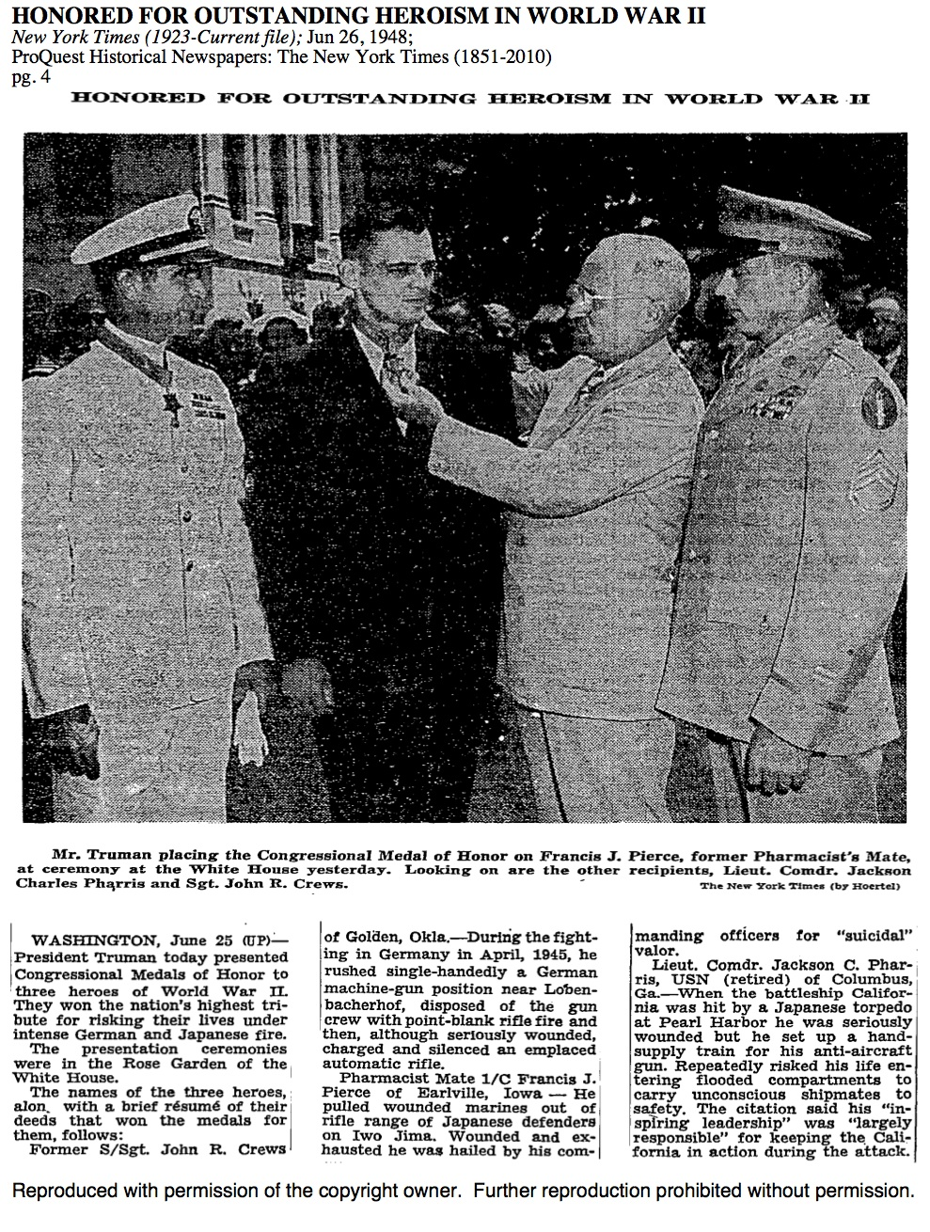
10 A
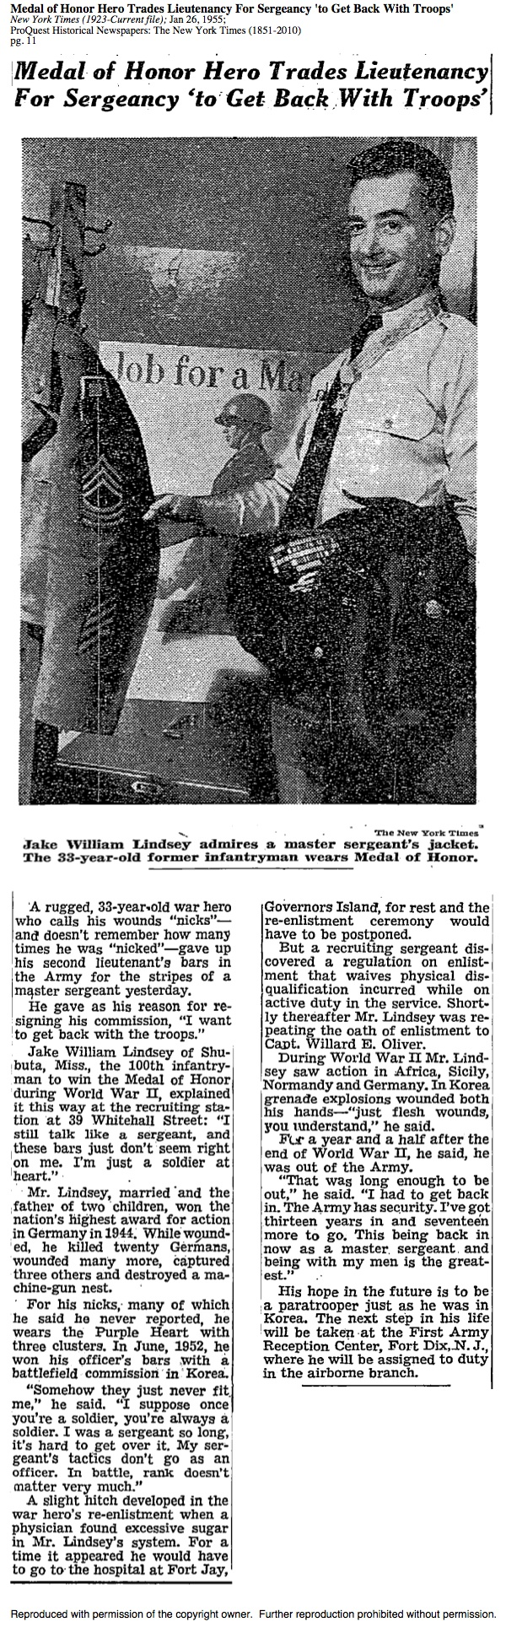

Appendix B: VIETNAM
1 B

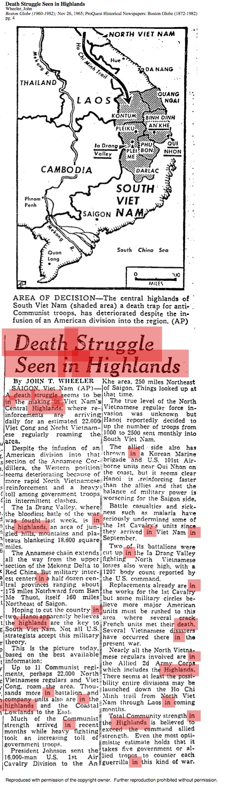
2 B
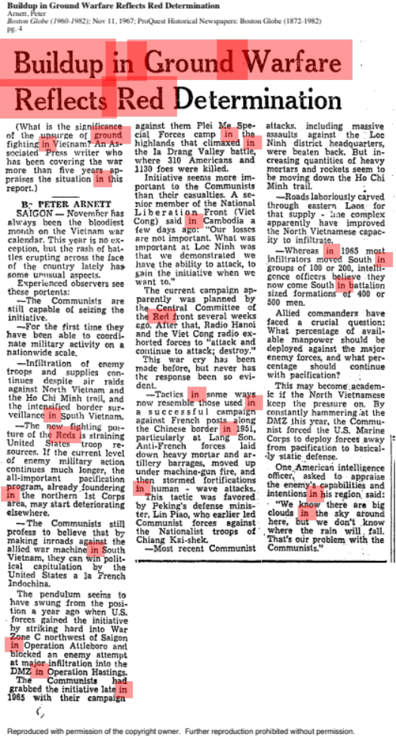
3 B
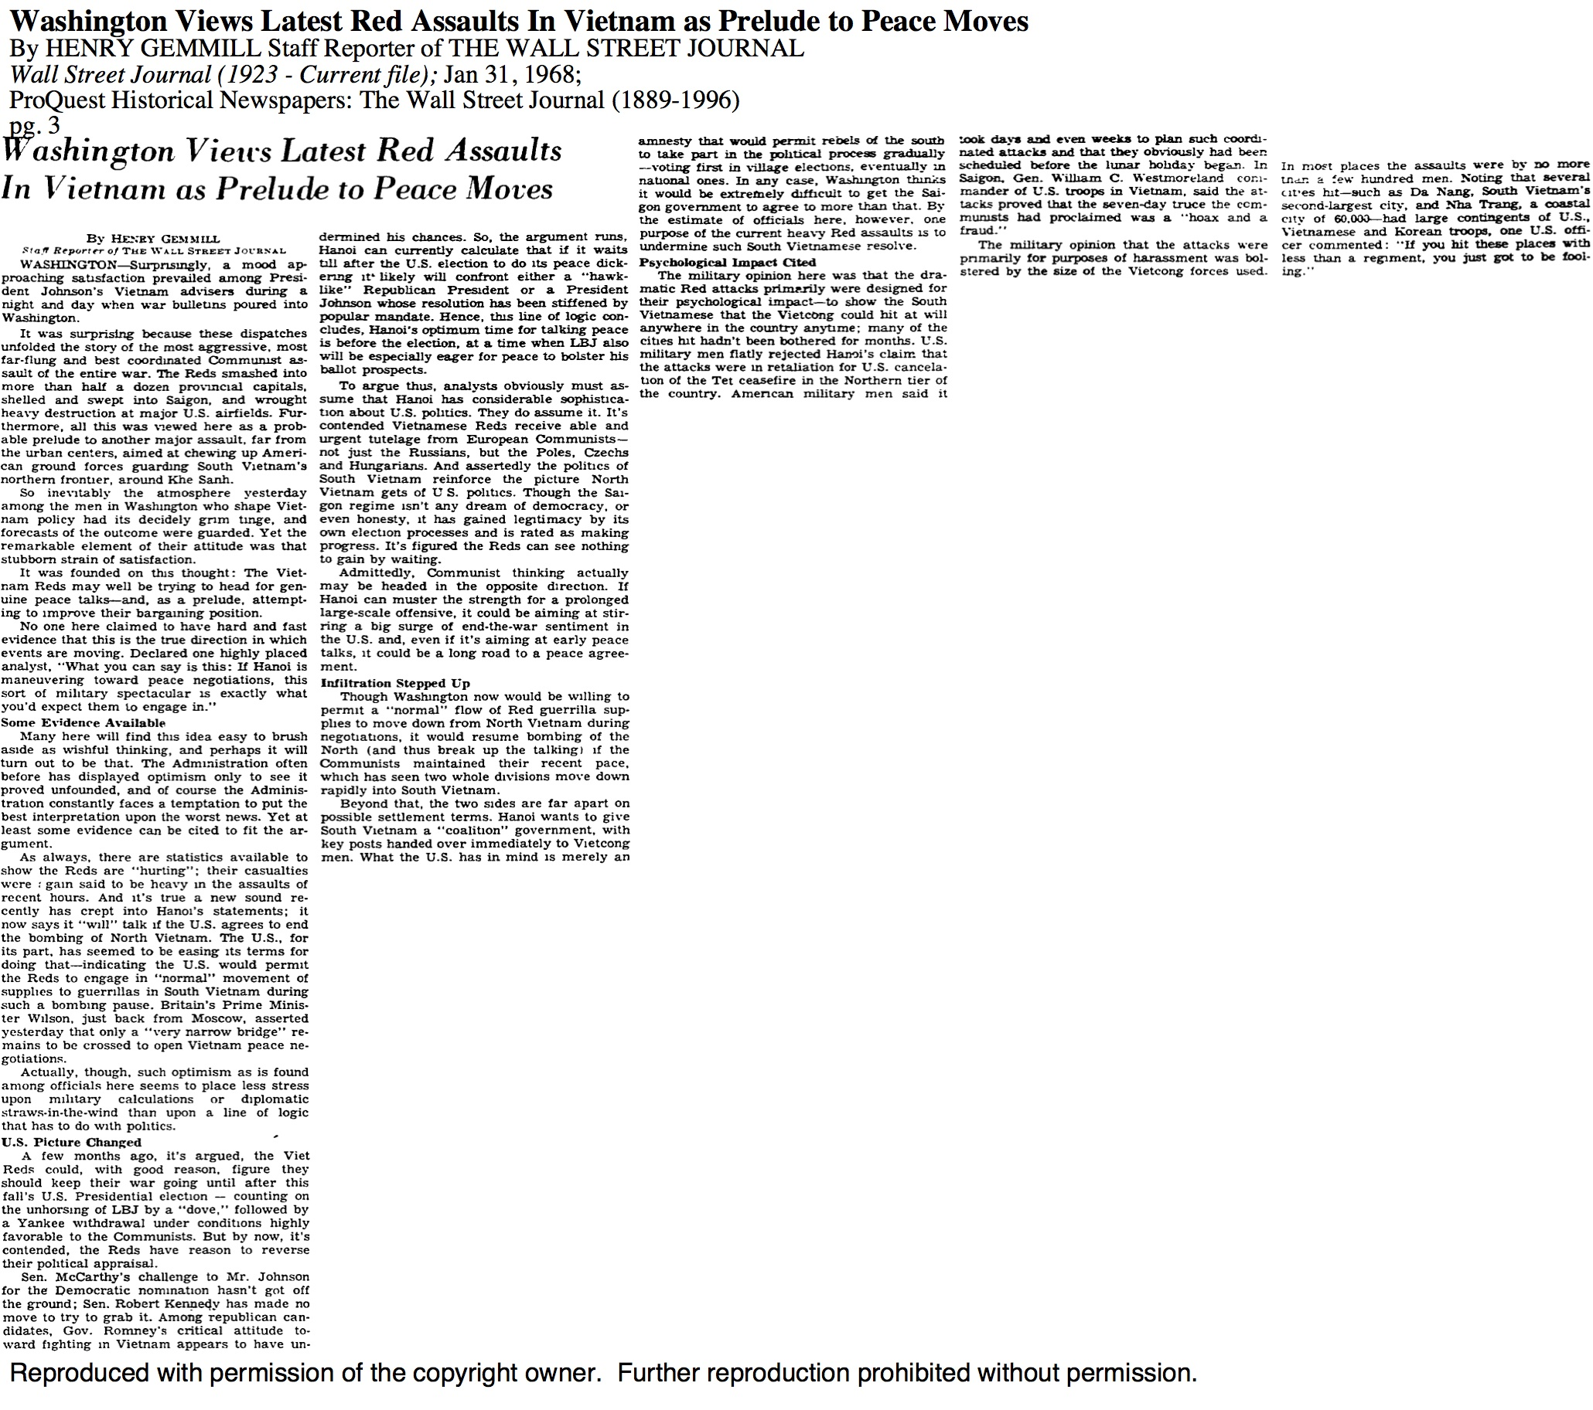

4 B
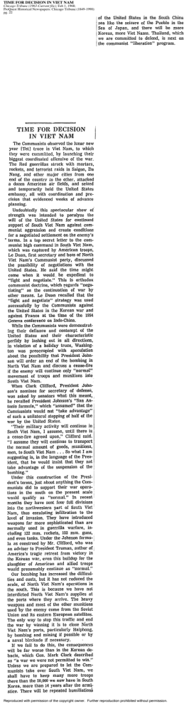
5 B

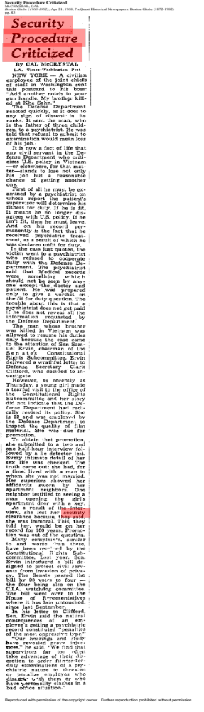

6 B
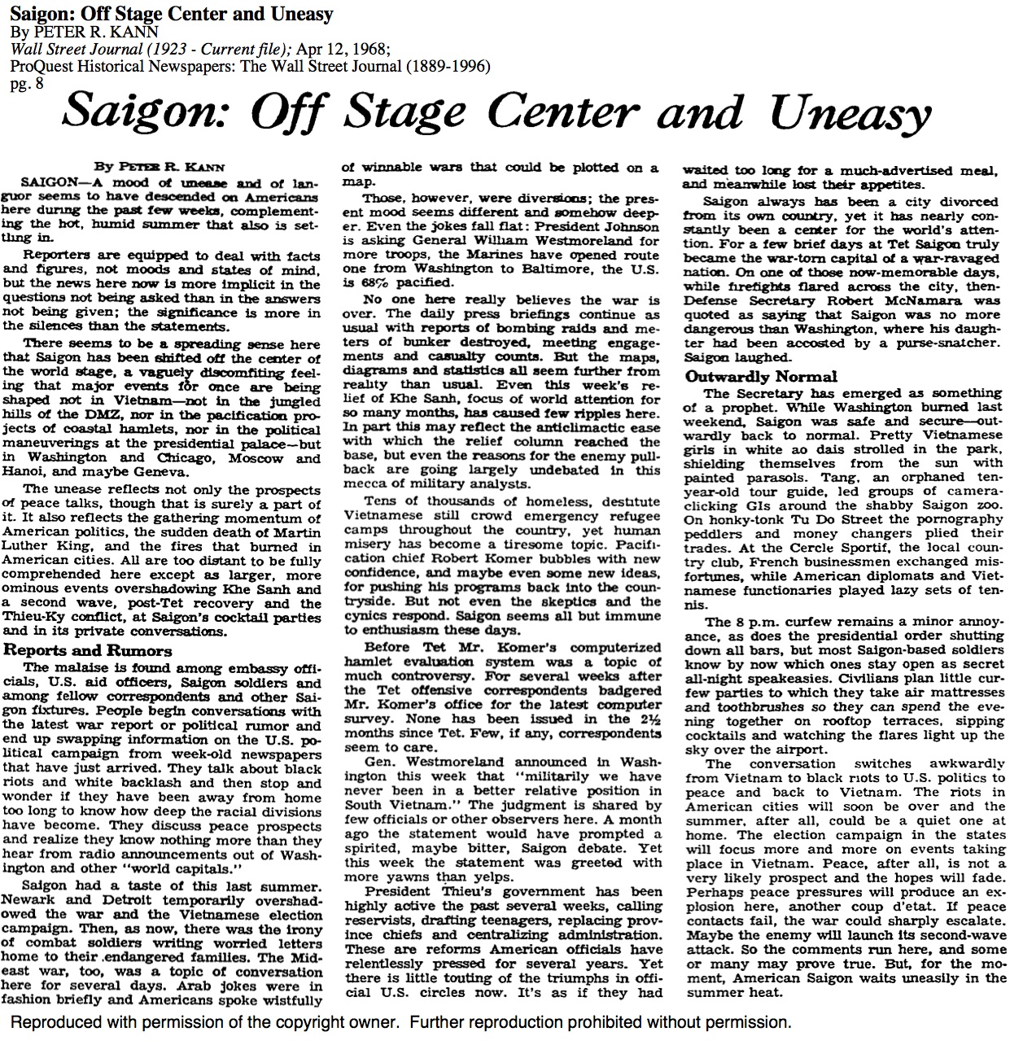

7 B
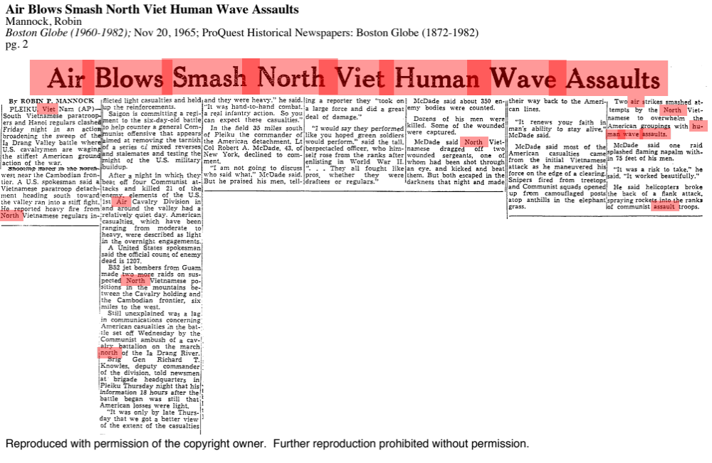

8 B
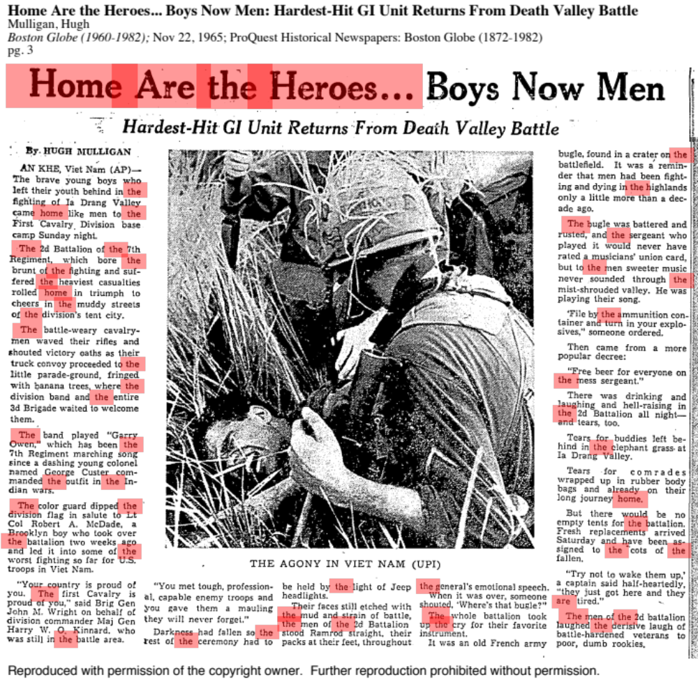

9 B
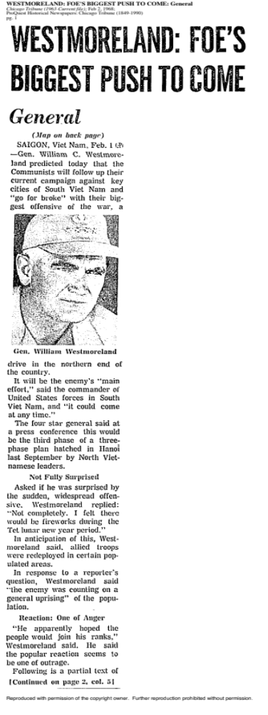

10 B
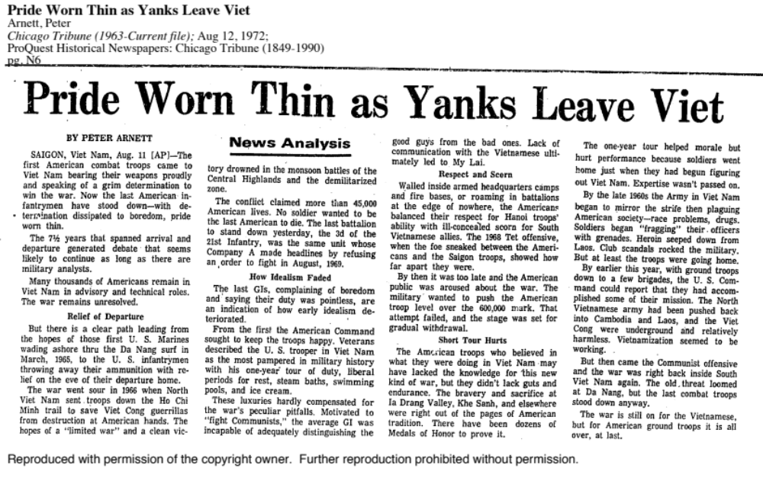

11 B
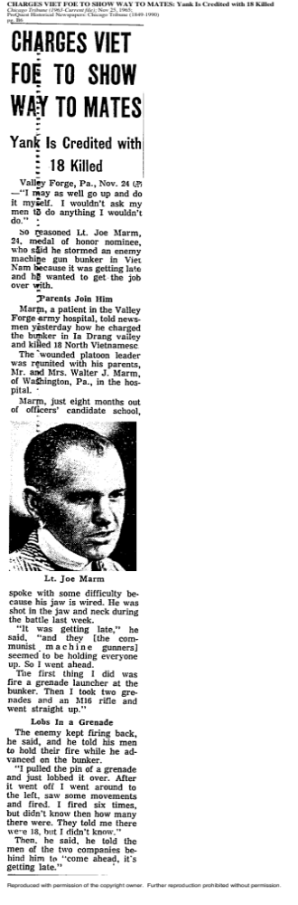

12 B

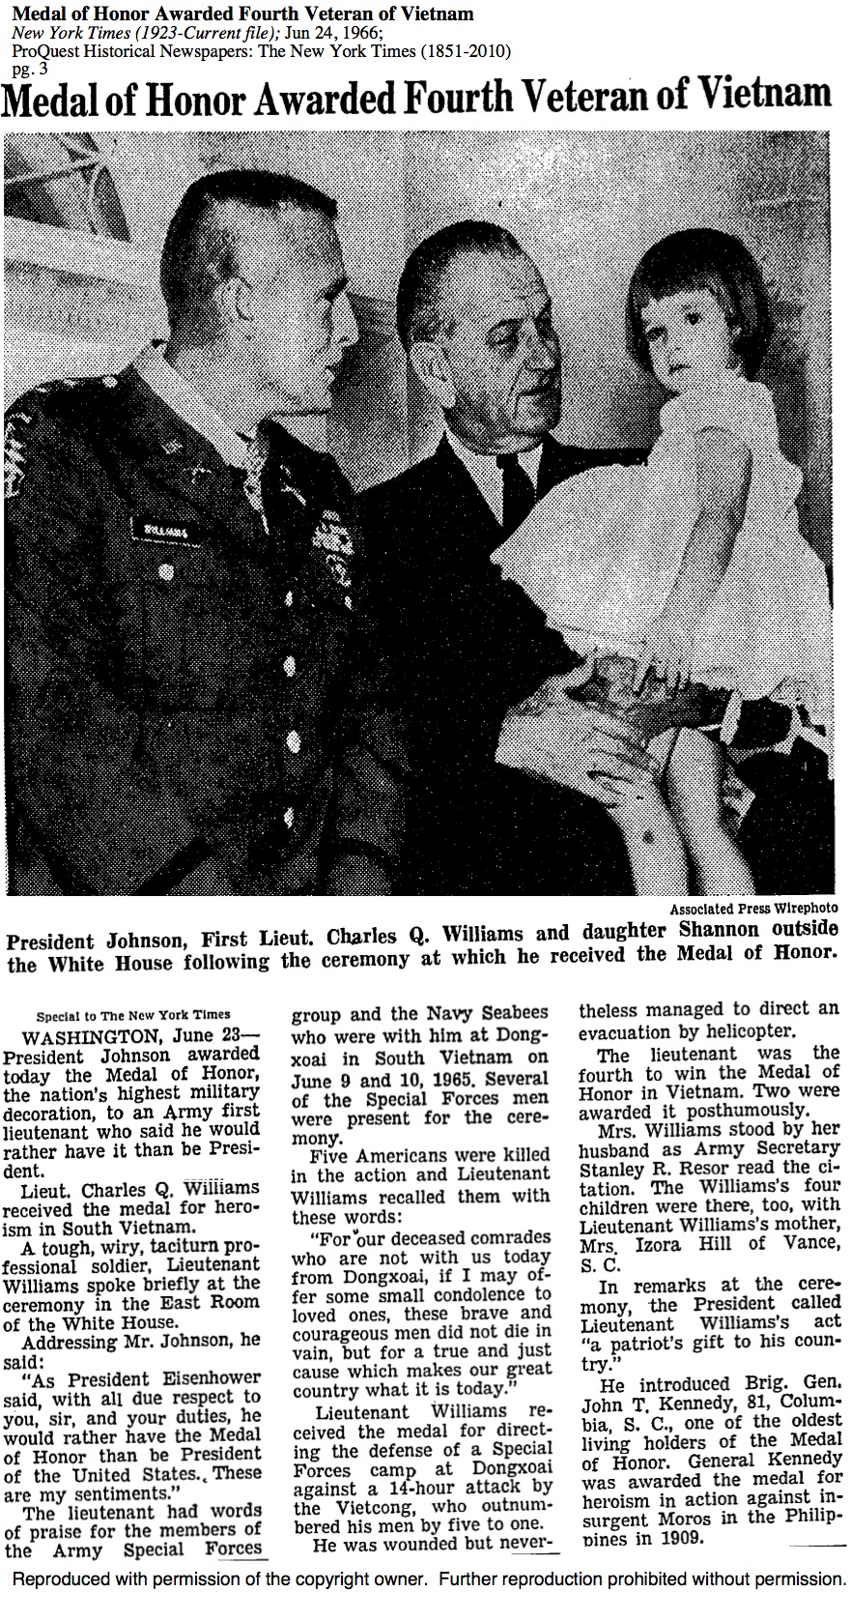
13 B

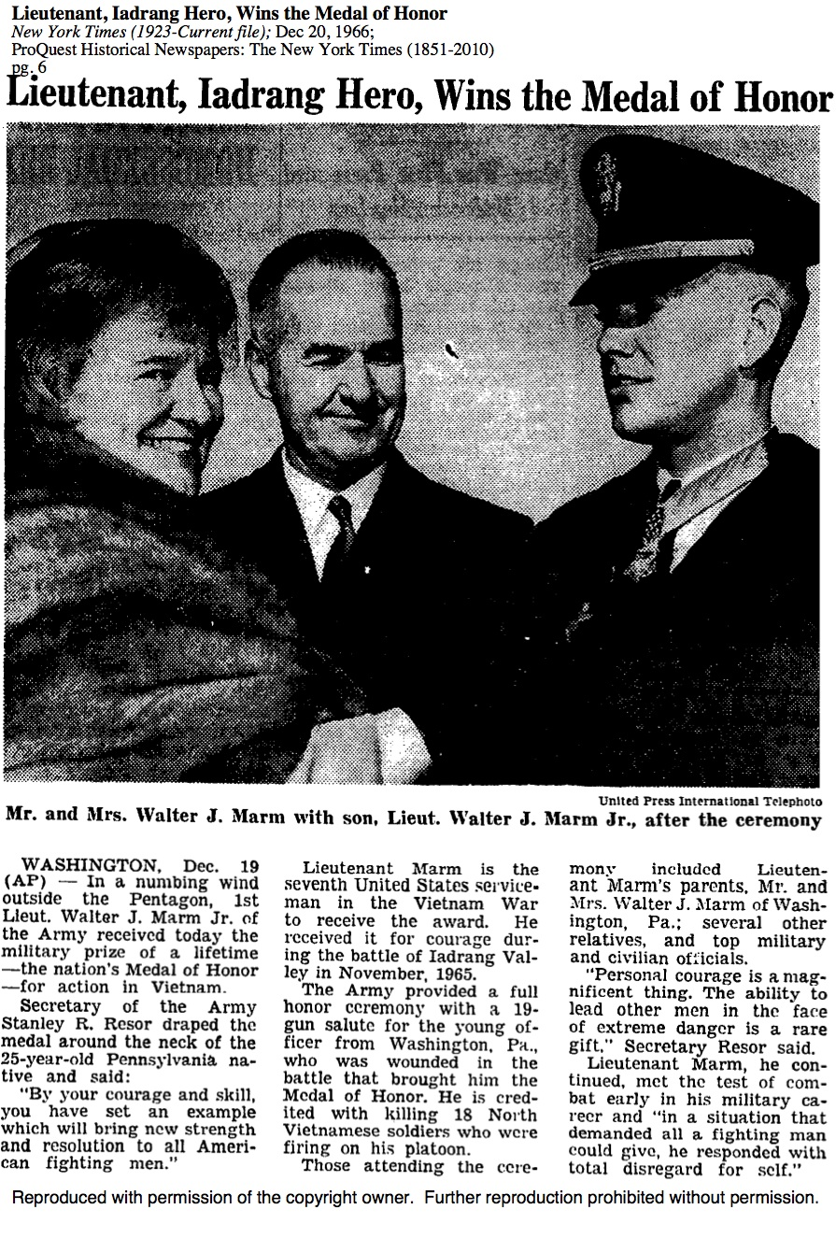

14 B
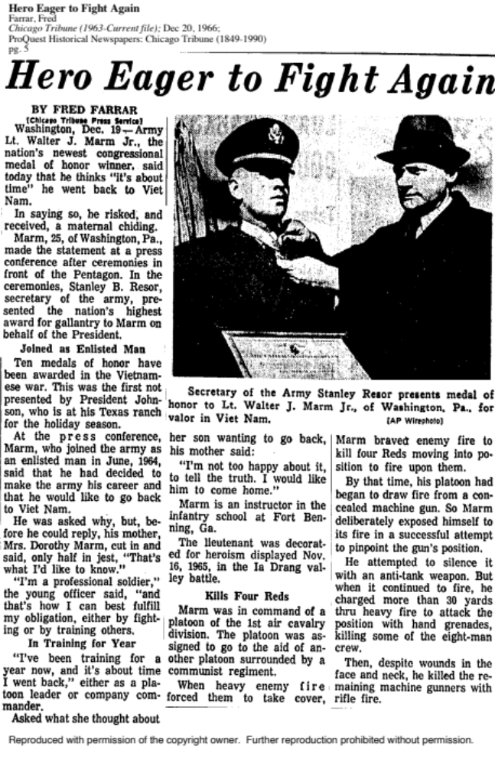

15 B
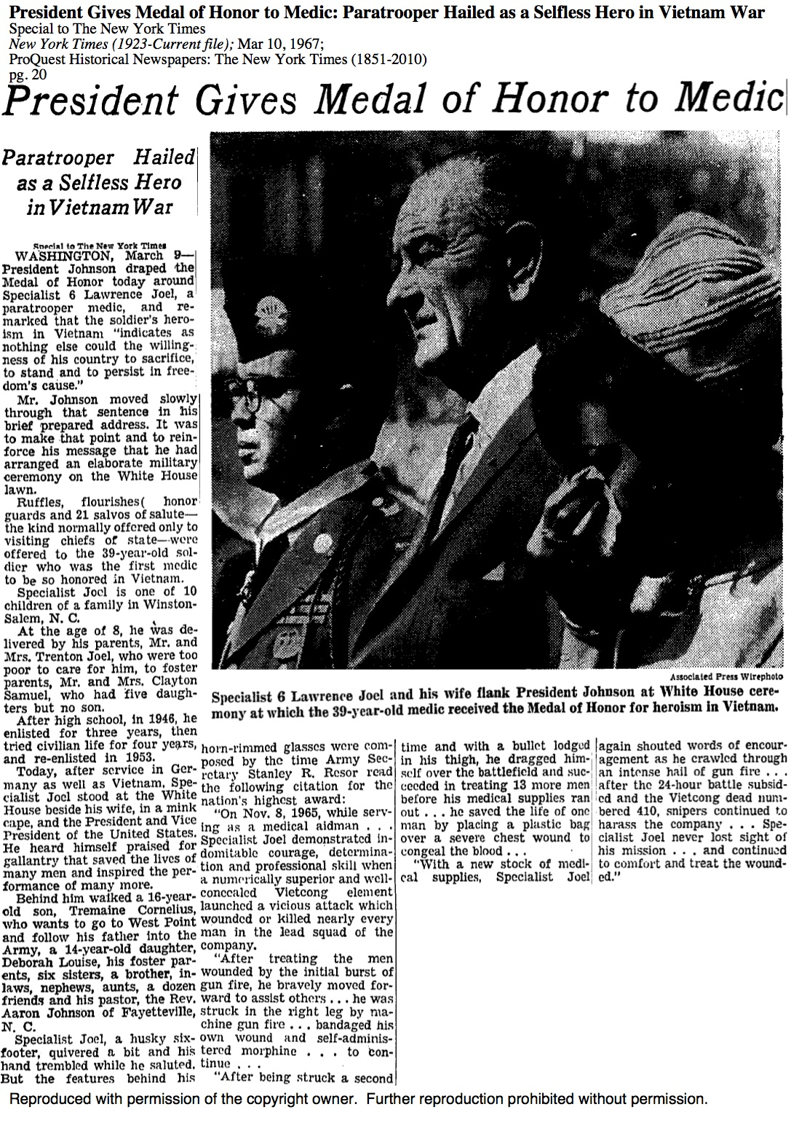

16 B
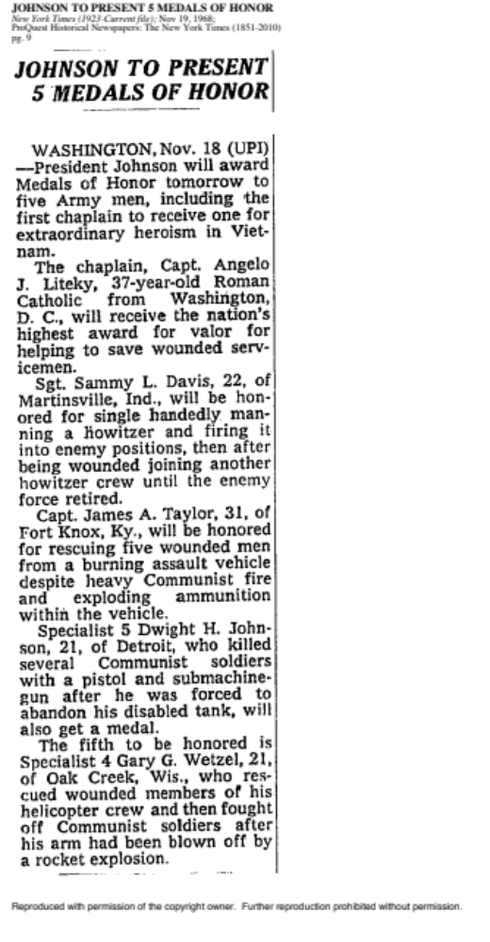

17 B
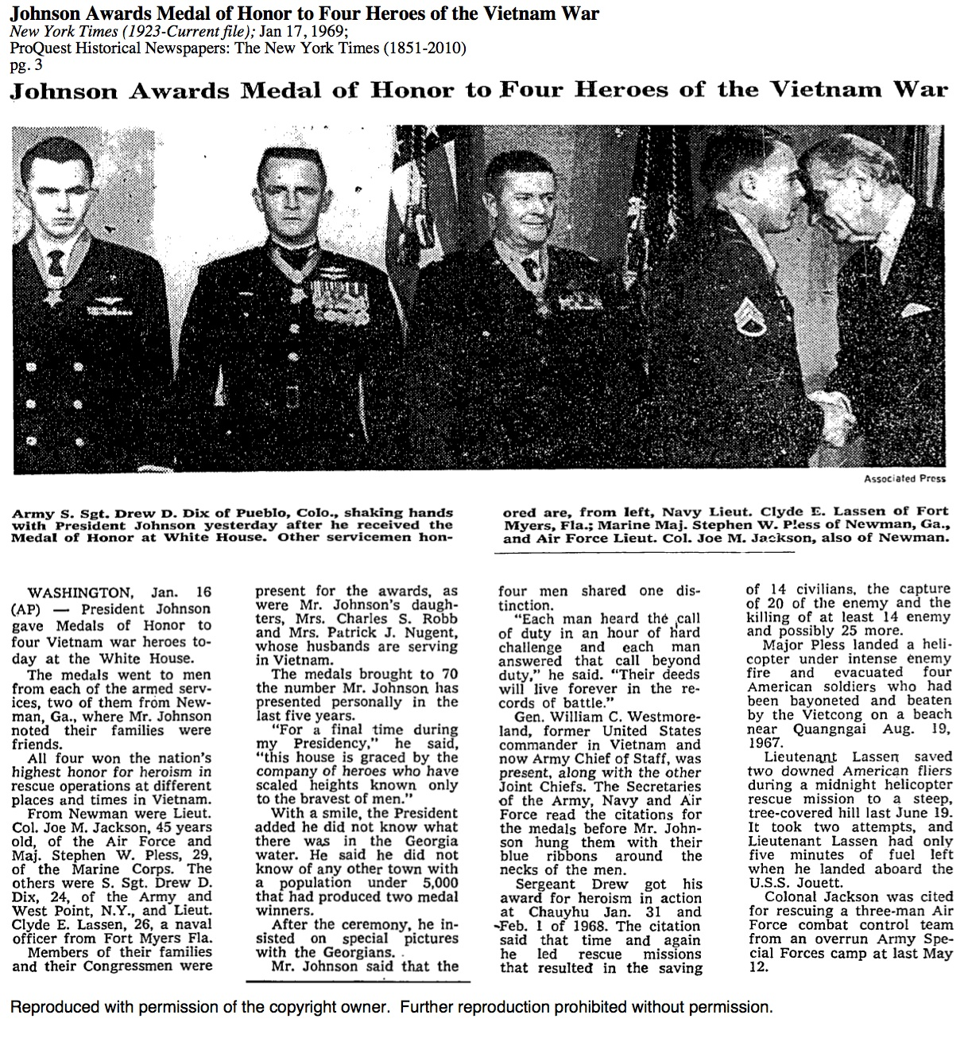

18 B
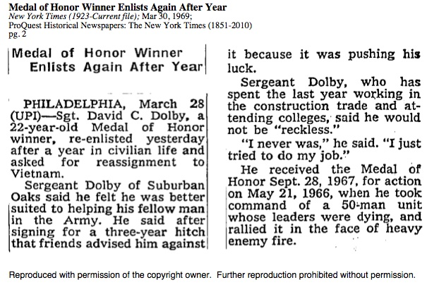

Appendix C: AFGHANISTAN
1 C
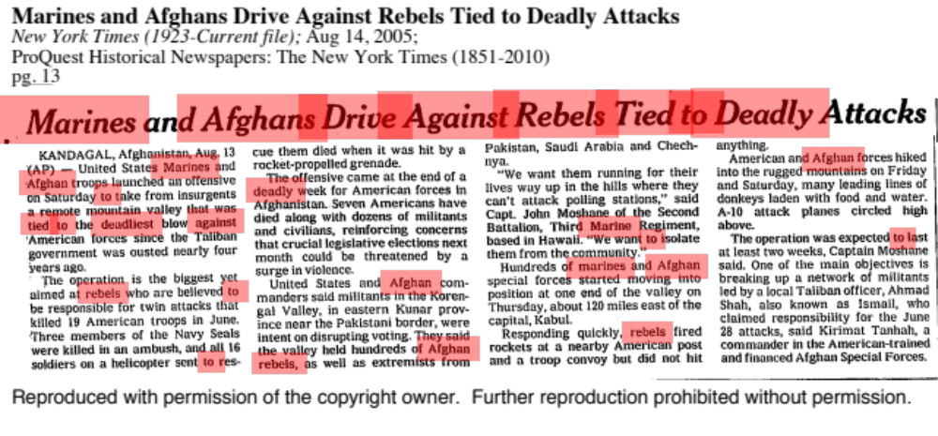

2 C
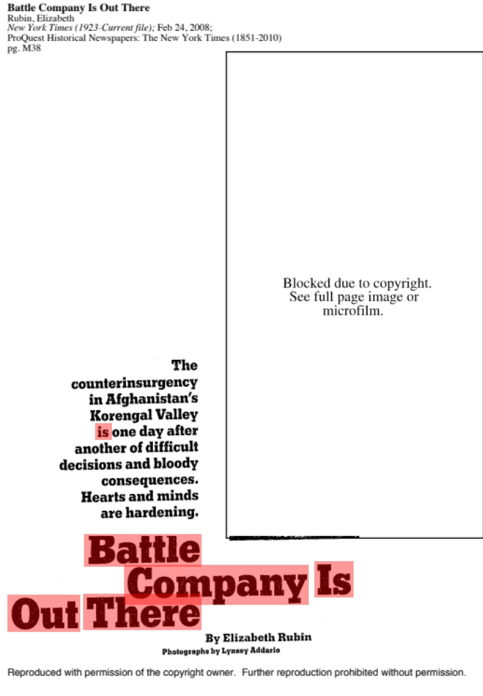

3 C
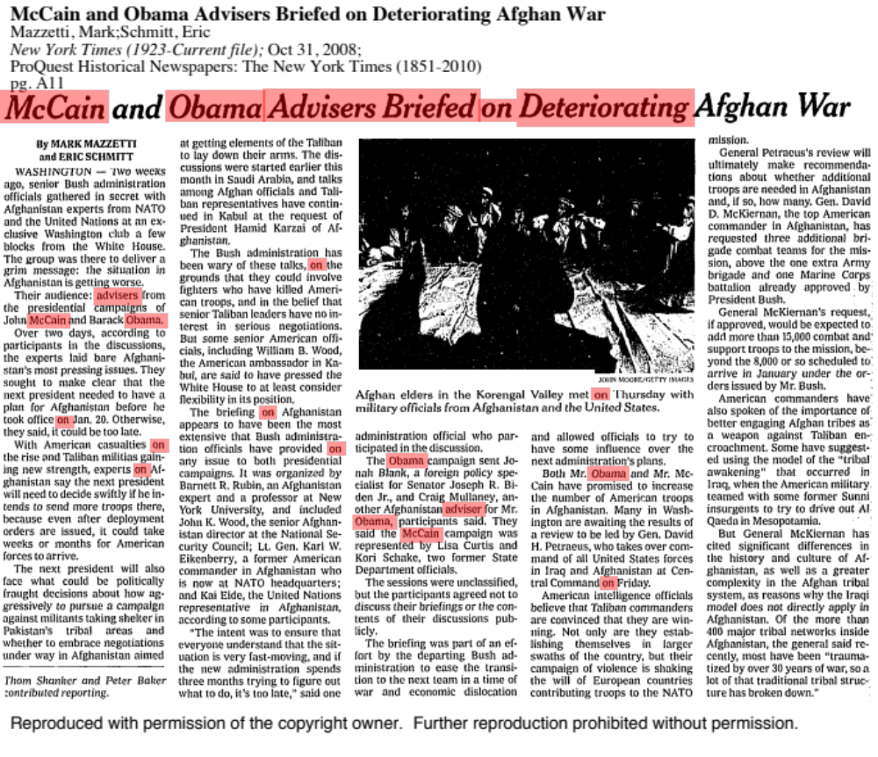

4 C
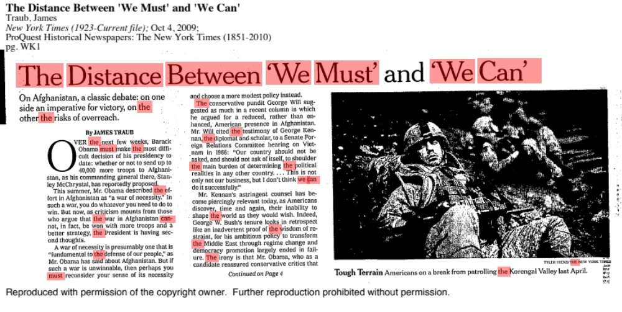

5 C
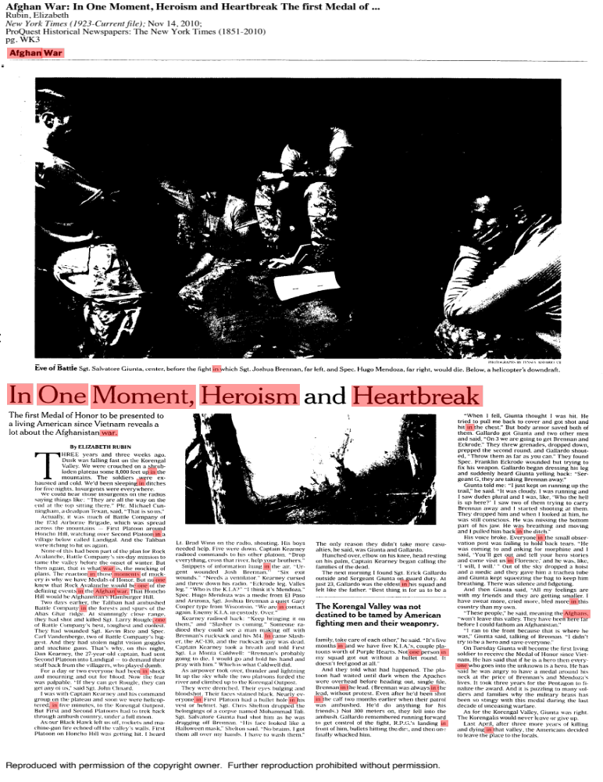

6 C

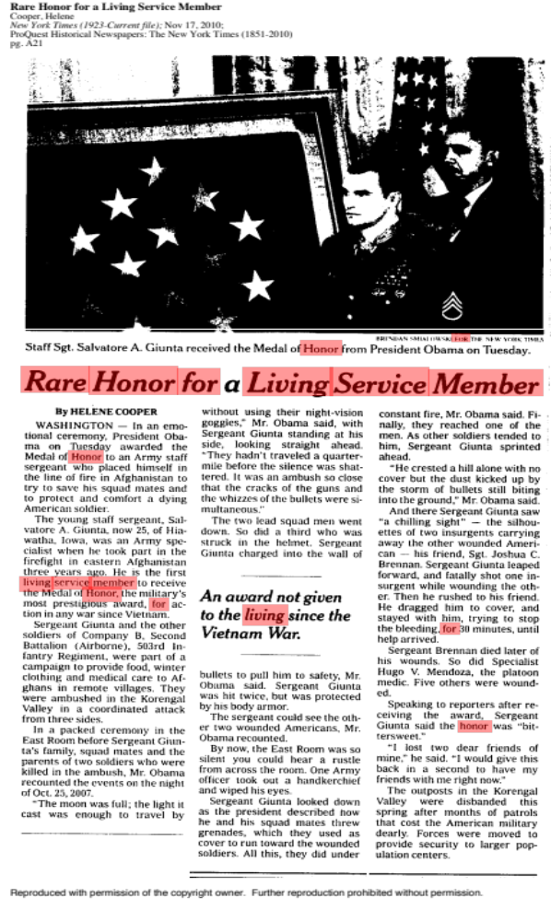

7 C
Obama awards Medal of Honor for valor in Afghan battle
David Jackson, USA TODAY 4:04 p.m. EST February 12, 2013
Clinton Romesha led a battle to defend a U.S. outpost in rural Afghanistan in 2009.
President Obama awarded the nation's highest military honor Monday to a U.S. soldier who led a counterattack in Afghanistan after he and his comrades were asked to "defend the indefensible."
Clinton Romesha, a former Army staff sergeant, earned the Medal of Honor for leading the defense of a plywood-and-concrete outpost dangerously placed in a valley of the Afghanistan mountains, and staffed by only 53 American troops.
More than 300 Taliban fighters attacked Combat Outpost Keating from above on Oct. 3, 2009. Throughout a day-long firefight, Romesha led efforts to beat back the Taliban after some of its fighters penetrated the camp.
The outpost "sat at the bottom of a steep valley," Obama said, and a later investigation determined that the surrounding mountain terrain "gave ideal cover for insurgents to attack."
That investigation also found that Combat Outpost Keating "was tactically indefensible," Obama said. "But that's what these soldiers were asked to do, defend the indefensible."
Eight soldiers died in the battle and 22 were wounded, including Romesha. CNN anchor Jake Tapper wrote about the attack in his book,The Outpost: An Untold Story of American Valor.
Romesha, 31, who sustained shrapnel words, cited the "loss of our battle buddies" in a statement to reporters after the Medal of Honor ceremony, saying he has "mixed emotions of both joy and sadness," and is "feeling conflicted with this medal I now wear."
He added: "I accept this tremendous honor on behalf of all soldiers who have served with me that day. This award is for the eight soldiers that didn't make it and for the rest of the team that fought valiantly and magnificently that day. I will forever be humbled by their bravery, their commitment to service and their loyalty to one another."
At the White House ceremony, Obama described Romesha as "a pretty humble guy" who was born in Lake City, Calif., a town of less than 100 people. No longer in the military, Romesha works in the oil fields of North Dakota.
This is not even the biggest event of Romesha's week, Obama joked, as he and his wife celebrate their 13th wedding anniversary.
In describing why Romesha deserves the Medal of Honor, Obama said he "gathered up his guys" after the Taliban invaded the outpost, "and they began to fight their way back -- storming one building and then another, pushing the enemy back, having to actually shoot up at the enemy in the mountains above."
Amid fire and smoke, Obama said, "Clint stood in the doorway calling in airstrikes that shook the earth all around them."
In saluting all of the Americans at Combat Outpost Keating, Obama repeated that one of the lessons "is that our troops should not -- ever -- be put in a position where they have to defend the indefensible."
He added: "That's what these soldiers did for each other in sacrifice driven by pure love."

8 C
Obama awards Medal of Honor to Staff Sgt. Ty Carter for heroism in Afghanistan
By William Branigin, Published: August 26, 2013
President Obama on Monday awarded the Medal of Honor to Army Staff Sgt. Ty M. Carter, who hopes to use the award to help others suffering from post-traumatic stress disorder.
Carter, 33, has struggled with PTSD since a 2009 battle in eastern Afghanistan that cost eight fellow soldiers their lives. The Washington state resident is the fifth living recipient of the nation’s highest military honor for heroic actions in Iraq or Afghanistan.
In bestowing the medal at the White House, Obama hailed Carter’s gallantry in combat and “his courage in the other battle he has fought” — a reference to coping with PTSD. Obama said it was “absolutely critical . . . to put an end to any stigma” that prevents troops from getting treatment.
Carter, then a specialist, distinguished himself when more than 300 Afghan insurgents launched a coordinated attack at dawn on Oct. 3, 2009, in an effort to overrun Combat Outpost Keating, a vulnerable position surrounded by peaks of the Hindu Kush mountains in the remote Kamdesh district of Afghanistan’s Nuristan province. Of his 53 fellow 4th Infantry Division soldiers who defended the outpost that day, eight were killed and more than 25 were injured, according to the Army.
“Without regard to his own safety, Spc. Ty Michael Carter . . . resupplied ammunition to fighting positions, provided first aid to a battle buddy, killed enemy troops, and valiantly risked his own life to save a fellow Soldier who was injured and pinned down by overwhelming enemy fire,” the Army said in its medal citation.
Carter, who was wounded in the fighting, became the second survivor of that battle to receive the Medal of Honor. In February, Obama awarded the medal to Staff Sgt. Clinton L. Romesha for actions in another part of the outpost. It was the first battle to produce two living Medal of Honor recipients since the 1967 Battle of Ap Bac during the Vietnam War.
What became known as the Battle of Kamdesh exposed flaws in the military’s counterinsurgency strategy and failures in addressing an increasingly untenable situation for isolated U.S. troops near the Pakistani border. A Pentagon review found that the outpost, which was closed immediately after the attack, should never have been established because it was too difficult to defend.
Carter braved fire from insurgents armed with recoilless rifles, rocket-propelled grenades, antiaircraft machine guns, mortars, sniper rifles and small arms as he repeatedly ran across open ground to deliver ammunition to comrades and to rescue a badly wounded soldier, Spec. Stephan L. Mace, 21, of Lovettsville.
Carter ran into “the blizzard of bullets and steel” not once or twice, “but perhaps 10 times,” Obama said.
Mace later died in surgery at a field hospital, and Carter blamed himself, believing that he had “failed” because he could not save the young specialist he had carried to safety.
Obama noted Monday that another survivor of the battle who struggled with PTSD, Spec. Edward W. Faulkner Jr., “eventually lost his own life back home.” Faulkner, 27, of Burlington, N.C., died in 2010 of an accidental methadone overdose, with PTSD a “contributing” condition, according to his death certificate.
Carter’s experiences led him to become active in helping veterans of the Iraq and Afghanistan wars deal with PTSD. He is now stationed with the 7th Infantry Division at Joint Base Lewis-McChord, in his home state.
In an article published on the Army’s Web site, Carter said that until the battle at Combat Outpost Keating, he believed “myths” that PTSD was not a real disorder but was “a reason for soldiers to get out of work.”
Now, he said, “I’m hoping that I can help people through what I have to say, what I’ve experienced, to help them go seek help, or else we’re going to have more out there who self-medicate and end up taking their own lives.”

© The Washington Post Company

9 C
Former Army Capt. William Swenson receives Medal of Honor at White House
By David Nakamura, Published: October 15, 2013
It was a tender moment that demonstrated the brotherhood of the U.S. servicemen who fought for their lives in a remote Afghanistan province four years ago. In the heat of battle, Army Capt. William Swenson leaned in and kissed the head of a severely wounded comrade while loading him into an evacuation helicopter.
On Tuesday, President Obama cited that moment — captured in a video taken by a medevac crewman — as he presented Swenson, 34, with the Medal of Honor for heroic service in the Ganjgal valley in eastern Afghanistan. Swenson, who has since left the military, is credited with risking his life to help save other U.S. troops and Afghan allies and retrieve the bodies of four Americans who were killed Sept. 8, 2009.
“Amidst the whipping wind and the deafening roar of the helicopter blades, he does something unexpected. He leans in and kisses the wounded soldier on the head — a simple act of compassion and loyalty to a brother in arms,” Obama said of Swenson during a ceremony attended by 250 guests, including Vice President Biden, Defense Secretary Chuck Hagel, first lady Michelle Obama and several previous medal recipients.
Obama said that the nation has awarded the Medal of Honor, its highest military decoration, nearly 3,500 times, and that the video of Swenson “may be the first time that we can actually bear witness to a small fraction of those actions for ourselves.”
Swenson, who lives in Seattle, did not speak during the White House ceremony. Afterward, an Army spokesman confirmed that Swenson had asked to return to active duty more than two years after he left the service. “We are currently reviewing his request and processing it within established policy,” said the spokesman, George Wright. Swenson would have to undergo a routine drug test and background check.
A return to active service would be a remarkable turnabout.
Swenson’s path to the White House ceremony was a rocky one . After he criticized his Army superiors, saying they failed to provide enough air and artillery support during the 2009 engagement, his medal nomination was delayed for years. Amy officials said his nomination packet was lost in a computer system for 19 months.
Swenson became the second service member to be awarded the Medal of Honor for the Ganjgal battle. The other recipient, former Marine Cpl. Dakota Meyer, who accepted the award in 2011, was not in attendance Tuesday. Swenson has expressed skepticism about the accuracy of Meyer’s account of the battle.
Two other Marines — Ademola Fabayo and Juan Rodriguez-Chavez, who helped Swenson and Meyer in the rescue effort — attended Tuesday’s ceremony. They both have received the Navy Cross for their actions.
During an interview with The Washington Post, Swenson said he would accept the medal to honor fellow soldiers and Marines and the family members of those who died. “It does not really belong to me; it belongs to that event and the people I stood with,” he said of the medal.
In the interview, he said he had no memory of kissing the head of Sgt. 1st Class Kenneth Westbrook, who had been shot in the cheek and shoulder, until he saw the video this year.“You could have told me it happened, and I wouldn’t have believed you,” he said. “But it did, and it was captured on film. And it offered a glimpse of the humanity that does occur on battlefields.”
Westbrook, the father of three, died about a month after the battle of complications from a blood transfusion. His wife, Charlene Westbrook, was in the audience at the White House on Tuesday. “Charlene will always be grateful for the final days she was able to spend with her husband,” Obama said.
Swenson and Westbrook had been working for a year as embedded trainers with the Afghan Border Police in Kunar province in eastern Afghanistan near the Pakistani border. They were trying to prepare the Afghan forces to patrol remote tribal areas often teeming with insurgents and beyond the control of the Afghan national government.
On the day of the battle, about 11 U.S. trainers and 80 Afghan troops set out to meet with town elders. As soon as they reached the valley, they were ambushed by Taliban fighters hidden on the higher terrain that ringed the valley on three sides. Five Americans, 10 Afghan troops and an Afghan interpreter were slain.
Looking back on his last moments with Westbrook, Swenson said of the video: “To see him and to see me in that situation gives me comfort. . . . I would trade anything for that not to be our last moment, but that was our last moment, and I’ll always have that now.”

© The Washington Post Company

