Elucidating the effects of neutral lipid synthesis on lipid droplet formation in Schizosaccharomyces pombe

A Thesis Presented for the

Doctorate of Philosophy

Degree

The University of Tennessee, Knoxville

Alexander W. Meyers

December 2014

Copyright © 2014 by Alexander Meyers
All rights reserved.

DEDICATION

I dedicate this work to all over the past several years to my friends and family who have all supported me. I will finish this section at a later time.

ACKNOWLEDGEMENTS

Thank you all for your help. However, this page is optional.

ABSTRACT

This is a sample Word document that can be used as a template in formatting your multipart or manuscript thesis/dissertation. This abstract should cover all parts of your multi-part thesis or dissertation. This abstract must be 350 words or fewer If you are using special characters, you’ll want to spell them out between square brackets after each time you use them (this is in the abstract only. It’s not necessary elsewhere in the document, although use of special characters in the title is prohibited.)
For our purposes a special character is any character which cannot be found on your typical English language keyboard. Because of how your abstract is used in the cataloging process, you will want to tell people how to interpret your special character in case the character itself gets garbled. So, if I wanted to use the µ [micro] character in my abstract, I would have to tell people how to interpret it. Since you’re the expert, you decide how to best interpret that character. It could be µ [micro] or µ [mu], whichever would make the most sense if the symbol itself cannot be replicated

PREFACE

This page is optional.

TABLE OF CONTENTS

CHapter 1 1
1-1 INTRODUCTION 1
1-2 Appendix 1
CHAPTER 2 2
MaSS Specometry of Proteins associated with lipid droplet in the fission yeast, Schizosaccharomyces pombe 2
Abstract 2
2-1 Introduction 3
CHAPTER 3 22
Lipid droplets form from distinct regions of the Er in the fission yeast, Schizosaccharomyces pombe 22
3-1 Introduction 23
CHapter 6 45
CONCLUSION and future work 45
VITA 46

LIST OF TABLES

Table 2: This Is The Second Table 21

LIST OF FIGURES

No table of figures entries found.
In your document, select the words to include in the table of contents, and then on the Home tab, under Styles, click a heading style. Repeat for each heading that you want to include, and then insert the table of contents in your document. To manually create a table of contents, on the Document Elements tab, under Table of Contents, point to a style and then click the down arrow button. Click one of the styles under Manual Table of Contents, and then type the entries manually.

CHapter 1

1-1 INTRODUCTION

Overview
The intracellular storage of fats is relevant across all biological spectrums, from single-celled prokaryotes to man. Triacylglyceryols and sterol esters together are termed neutral lipids, and their involvement within humans-related disorders, such as obesity, type 2-diabetes, and artherosclerosis is well documented. Depending on the organism and particular cell type, neutral lipids can be utllimately utilized in a variety of cellular functions including substrates for beta-oxdation, membrane biogenesis, and other lipids. Figure 1 illustrates the biological structure of a lipid droplet.

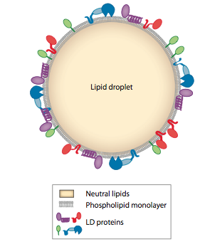

Figure 1-1
Lipid Droplet Schematic

Relevance
Despite their mostly negative association with atherosclerosis, lipoproteins, which include chylomicrons, very (VLDL), (LDLs), and (HDLs), contain beneficiary cellular functions. These structures are biophysically synonamous with lipid droplets which contain various amounts of cholesteryl ester, triacylglcycerol, and protein. A list of sizes and their relative composititions are listed in Table 1.

Table 1
Name | Size (nm) | TAG | CE | Protein
Chylomicron  VLDL  LDL  HDL | 1000  80  20  15

1-2 Appendix

WALTHER, T. C. & FARESE, R. V., JR. 2012. Lipid Droplets and Cellular Lipid Metabolism. Annual Review of Biochemistry, Vol 81, 81, 687-714.

CHAPTER 2

MaSS Specometry of Proteins associated with lipid droplet in the fission yeast, Schizosaccharomyces pombe

Abstract

Lipid droplets consist of a core of neutral lipids surrounded by a phospholipid monolayer with bound proteins. Much of the information on lipid droplet function comes from proteomic and lipodomic studies of the components of droplets isolated from organisms throughout the phylogenetic tree. Here, we add to that important inventory by reporting lipid droplet factors from the fission yeast, Schizosaccharomyces pombe. Unique to this study was the fact that cells were cultured in three different environments: 1) log growth phase in glucose-based media, 2) stationary phase in glucose-based media, and 3) log growth phase in media containing oleic acid. In the isolated lipid droplet floating layers, we identified 78 proteins in Set 1, 95 proteins in Set 2, and 259 proteins in Set 3. Notable factors intriguing for lipid droplet biogenesis and function were multiple components of protein synthesis machinery; the guanosine triphosphatase, Sar1, which has been shown to regulate membrane constriction and ER export; the vesicle coating factor, COPII; the long chain fatty acid CoA ligase, Lcf1p, whose ortholog has been found to promote lipid droplet biogenesis in COS-1 cells; and the GTPase, Sey1p, which has been shown to mediate the homotypic fusion of ER tubules. We confirmed colocalization of major factors with lipid droplets using live-cell fluorescent microscopy. The sterol ester (SE) : triacylglycerol (TAG) ratios of the lipid droplets isolated from the three sets were 55:45 (Set 1); 40:60 (Set 2); and 15:85 (Set 3). The results provide further insights into the workings of these ubiquitous organelles.

2-1 Introduction

Lipid droplets are energy storage organelles (Martin and Parton, 2006, Farese and Walther, 2009, Guo et al., 2009, Murphy et al., 2009, Walther and Farese, 2009, Beller et al., 2010, Fujimoto and Parton, 2011, Walther and Farese, 2012, Ohsaki et al., 2014, Pol et al., 2014). Structurally, they consist of a phospholipid monolayer - with bound and embedded proteins - that surrounds a hydrophobic core of neutral lipids. It is widely accepted that lipid droplets form from the endoplasmic reticulum (ER) when the local concentration of neutral lipids in the cytosolic side of the ER bilayer exceeds a threshold causing the budding of a nascent droplet (Ploegh, 2007, Farese and Walther, 2009, Ohsaki et al., 2009, Walther and Farese, 2009, Pol et al., 2014). After formation, droplet behavior is less clear. This is partially due to the complexity of their relationships with other organelles including the ER (Leber et al., 1998, Wu et al., 2000, Martin and Parton, 2006, Fei et al., 2009, Ohsaki et al., 2009, Hartman et al., 2010, Jacquier et al., 2011, Jacquier et al., 2013, Kassan et al., 2013), peroxisomes (Binns et al., 2006, Zehmer et al., 2009), mitochondria (Pu et al., 2011), endosomes (Liu et al., 2007), and vacuoles (Gaspar et al., 2008, van Zutphen et al., 2014). However, proteomic studies on isolated droplets have uncovered many factors that potentially modulate droplet interactions with these organelles and have been crucial for determining droplet behavior (Leber et al., 1994, Wu et al., 2000, Brasaemle et al., 2004, Fujimoto et al., 2004, Jolivet et al., 2004, Liu et al., 2004, Cermelli et al., 2006, Wolinski and Kohwein, 2008, Connerth et al., 2009, Low et al., 2010, Grillitsch et al., 2011, Zhang et al., 2012, Du et al., 2013, Krahmer et al., 2013, Schmidt et al., 2013b, Umlauf et al., 2004, Sato et al., 2006, Zhang et al., 2011, Mannik et al., 2014, Ivashov et al., 2013). Even with such an impressive inventory of lipid droplet-associated proteins from a wide-range of organisms, gaps still exist. Here we aim to help fill this void by studying the protein and neutral lipid compositions of lipid droplets isolated from the fission yeast, Schizosaccharomyces pombe. This yeast is a celebrated model system for cell division (Russell and Nurse, 1986, Gould and Nurse, 1989), cell polarity (Hagan and Hyams, 1988), and cell shape studies (Mata and Nurse, 1997), and is also an important organism for studying lipid droplet regulation because it has been shown that droplet numbers change during the cell cycle (Long et al., 2012) and that cell cycle factors play crucial roles in regulating the neutral lipid content of yeast cells (Kurat et al., 2009, Lin et al., 2009, Adeyo et al., 2011, Long et al., 2012).
We determined the protein and neutral lipid content of lipid droplets isolated from fission yeast S. pombe cells that were split into three categories: 1) cells in log growth phase grown in glucose-rich media, 2) cells in stationary phase grown in glucose-rich media, and 3) cells in log growth phase grown in media supplemented with 0.1% oleic acid (YPO). We identified 78 proteins in Set 1, 95 proteins in Set 2, and 259 proteins in Set 3. Roughly one-third of the factors matched those identified in previous proteomic studies of lipid droplet proteins isolated from other organisms, especially budding yeast (Leber et al., 1994, Binns et al., 2006, Wolinski and Kohwein, 2008, Connerth et al., 2009, Grillitsch et al., 2011, Schmidt et al., 2013b, Ivashov et al., 2013) giving us confidence in our techniques. However, several novel protein synthesis, vesicle trafficking, and ER morphology factors were revealed shedding light on lipid droplet formation and subsequent interactions with neighboring organelles.

2-2 Materials and Methods

Yeast Cell Culture
Lipid droplets were isolated from protease-deficient fission yeast TM011 cells [55]. Set 1 cells were grown to late log phase to an optical density (O.D.) of ~0.8 at 30°C in yeast extract plus five supplement (YE5S) media (Sunrise Science Products, #2011). Set 2 cells were grown to stationary phase to an O.D. of ~6.0 at 30°C in YE5S. Set 3 cells were grown in log phase to an O.D. of 0.4 at 30°C in YE5S. The cells were then pelleted in a Sorvell Legend XTR centrifuge at 25°C for 5 minutes at 3800 x g. The YE5S was removed and the cells were resuspended in YPO (0.5 % yeast extract, 0.1% oleic acid, 0.2% Tween 80, 0.1% glucose, 0.5% peptone, 0.3% potassium phosphate) and incubated at 30°C for an additional four hours at which point their O.D. reached ~0.8.
Lipid droplet isolation
We followed the exact protocol of Mannik et al. for the isolation of lipid droplets from fission yeast S. pombe cells using density gradient centrifugation as the central technique. In that work, the purity of the lipid droplet fraction was determined using Western Blot Analysis.
Protein Extraction
We added diethyl ether to the lipid droplet fraction in a 3:2 volume:volume ratio and vortexed the combined sample every 5 minutes over 20 minutes total at 25°C. The diethyl ether separated the proteins from the lipid droplets with the proteins remaining in the aqueous phase. We then centrifuged the mixture in Eppendorf tubes at 25°C for 10 min at 17,000 x g in a Fisher Scientific AccuSpin Micro 17 centrifuge. The upper phase containing the diethyl ether was removed and discarded. Residual diethyl ether remaining on the top of the aqueous layer was evaporated under a steady stream of N₂ at 25°C. 100% trichloroacetic acid (TCA) was added at 4°C for 1 hour to ensure a final concentration of 10% TCA in order to precipitate the proteins. Samples were then spun at 4°C for 20 minutes at 17,000 x g and any remaining TCA was removed, followed by a wash with chilled acetone. Any residual acetone was removed and the protein pellet was stored in at -80°C.
Digestion of Proteins
Proteins extracted from the lipid droplet fraction were solubilized in guanidine buffer [6 M Guanidine HCl, 10 mM DTT in Tris buffer (100 mM Tris; 10 mM CaCl₂), pH 7.6], and incubated at 60°C for 4 hours. Following incubation, 25 µl sample was used for protein estimation and the rest of the sample was diluted 6-fold using Tris buffer (100 mM Tris; 10 mM CaCl₂, pH 7.6), amended with trypsin (Promega, Madison, WI) and subjected to overnight proteolysis at 37°C with gentle mixing as described before [56]. Following trypsin digestion, the peptides were amended with 10 mM DTT, and incubated at 37°C for 1 hour. The reaction was stopped by adding 10% formic acid to a final concentration of 0.1% and the peptide samples were stored at -80°C until mass spectrometry analysis. All chemicals were obtained from Sigma Chemical Co. (St. Louis, MO), unless specified otherwise. High performance liquid chromatography- (HPLC-) grade water, acetonitrile and acetone were obtained from Burdick & Jackson (Muskegon, MI) and 99% formic acid was purchased from EM Science (Darmstadt, Germany). Total protein present in a sample was estimated using the RC/DC protein estimation kit (Bio-Rad Laboratories, Hercules, CA, USA) per the manufacturer’s protocol using protein standard (supplied in the kit) for the assay.
2D- LC-MS/MS analysis
A single aliquot of peptide mix (~70 ug) was pressure loaded onto an in-house SCX (Luna, Phenomenex, Torrance, CA)-C18 (Aqua, Phenomenex, Torrance, CA) resin packed column as previously described (Brown et al., 2006, Thompson et al., 2007). The sample column was desalted offline (Chourey et al., 2013), then connected to an C18 packed PicoFrit tip (New Objective) interfaced with an LTQ Orbitrap instrument (Thermo Scientific). The peptides were chromatogrpahically separated and analyzed via 24h Multi-Dimensional Protein Identification Technology (MuDPIT) approach as previously described (Thompson et al., 2007, Sharma et al., 2012) using three salt pulses (30, 60 and 100 % of 500 mM ammonium acetate followed by 120 min elution gradient). Peptide fragmentation data were collected using LTQ-Orbitrap, operated in data-dependent mode and under the control of Xcalibur software (Thermo Scientific). LTQ Orbitrap was set to 30K resolution while the rest of the settings were maintained as previously described (Sharma et al., 2012). The MS/MS data obtained was searched against Schizosaccharomyces pombe 972h genome using the SEQUEST algorithm (Eng et al., 1994). A list of commonly occurring contaminants was concatenated to the database for identification and removal of the mentioned proteins from the final data. The resultant datasets were sorted using DTASelect [61] under set parameters: fully tryptic peptides only with ΔCN of at least 0.08 and cross-correlation scores (Xcorr) of at least 1.8 (+1), 2.5 (+2), and 3.5 (+3) and identification of at least two peptides per protein sequence was a prerequisite for protein identifications. Spectral counts of identified peptides was normalized as described before [62] and the normalized spectral abundance factor (NSAF) was used as a relative measure of protein abundance.
Neutral Lipid Extraction and Analysis
Neutral lipids were extracted from previously purified lipid droplets using 2 volumes of chloroform:methanol (2:1). Samples were vortexed for 1 minute followed by centrifugation at 1000 x g for 10 minutes at 25°C. The lower organic phase was removed and dried under a stream of N₂ at 25°C and resuspended in 100 uL of chloroform. Samples were then run on TLC plates (Whatman Diamond LK6F Silica Gel 60 Å, 4500) using hexane:diethyl ether:acetic acid (70:30:1), and stained overnight with iodine [63]. ImageJ was used to quantify the intensities of the sterol ester and triacylglycerol bands. Commercially available cholesteryl oleate (Sigma-Aldrich, C9253) and glyceryl trioleate (Sigma-Aldrich, T7140) were used as standards.
Live Cell Fluorescent Microscopy
We reserved 20 ml each of the three sets of cells to determine the distribution and number of lipid droplets. Cells were pelleted at 25°C for 5 minutes at 3800 x g in a swinging bucket centrifuge. The supernatants were removed and the cells were resuspended in 1 ml of fresh YE5S and transferred to new Eppendorf tubes. Cells from Set 3 were washed twice with 1 ml of YE5S to remove any oleic acid, which interferes with BODIPY 493/503 staining of neutral lipids. All cells were then transferred to new Eppendorf tubes that contained 10 μl of a 100 μM stock of BODIPY 493/503 in ethanol. All three samples were pelleted at 25°C for 10 min at 1000 x g in a Fisher Scientific AccuSpin Micro 17 centrifuge and the supernatant was removed down to 100 μl. The cells were resuspended and 2 μl aliquots were placed between a glass cover slip (Fisher Scientific; #12-542-B) and a microscope slide (Fisher Scientific; #12-544-7). Images were collected on a Leica SP2 laser scanning confocal microscope and an EVOS inverted microscope equipped with a 100x objective (Advanced Microscopy Group). Fission yeast strains expressing fluorescent fusion proteins from native loci were created using the techniques of Bahler et al.. BODIPY 493/503 was added to the cells in the exact manner as above and the cells were subsequently imaged as above.

2-3 Results

We performed three sets of experiments to determine the protein and neutral lipid composition of lipid droplets isolated from fission yeast S. pombe cells that were 1) mitotic (Figure 1A), 2) post-mitotic (Figure 1B), and 3) mitotic and incubated in media supplemented with free fatty acids (Figure 1C). We grew the first set of cells to late-log phase in glucose-rich media (Set 1), the second set of cells to stationary phase in glucose-rich media (Set 2), and the third set of cells to mid-log phase in glucose-rich media, after which, the cells were pelleted and resuspended in media containing 0.1% oleic acid (YPO) for an additional four hours of incubation until they reached late-log phase (Set 3). In the first experiment, we aimed to determine factors responsible for neutral lipid storage during cell growth; in the second experiment, we aimed to determine factors responsible for neutral lipid storage in post-mitotic eukaryotes; and in the third
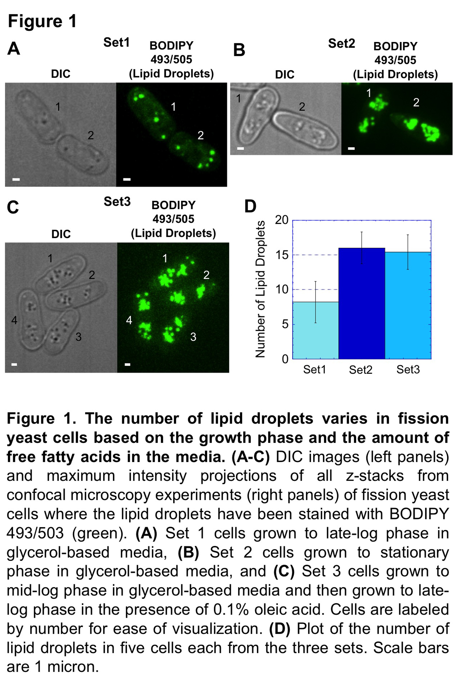

experiment, we aimed to determine factors responsible for neutral lipid storage when eukaryotic cells were dividing in the presence of high levels of freely diffusing fatty acids (oleic acid). We used confocal microscopy to show that the number of BODIPY 493/503-stained cellular lipid droplets increased in cells from Set 1 to cells in both Set 2 and Set 3 by a factor of two (Figure 1D). Thus, incubating cells that were in stationary phase in YPO and isolating the droplets for proteomics of bound factors would have been redundant since the main purpose of this work was to determine factors responsible for droplet formation.
Lipid droplet associated proteins
We followed exactly the techniques of a recently published lipid droplet isolation protocol based on density gradient centrifugation to obtain droplets from the three sets of cells (Mannik et al., 2014). The enrichment of lipid droplets and the depletion of other organelles in the floating layer after each centrifugation step in the isolation protocol was confirmed by Western Blot analysis as previously published (Mannik et al., 2014). In brief, Erg6p (lipid droplet marker (Athenstaedt et al., 1999, Binns et al., 2006, Fei et al., 2011, Grillitsch et al., 2011, Ayciriex et al., 2012)) became enriched in the floating layer while Por1p (mitochondria marker (Binns et al., 2006, Fei et al., 2011, Grillitsch et al., 2011)), Pma1p (plasma membrane marker (Binns et al., 2006)), Dpm1p (ER marker (Binns et al., 2006, Takeda and Nakano, 2008, Grillitsch et al., 2011, Ayciriex et al., 2012)), and Vma1p (vacuole marker (van Zutphen et al., 2014)) became depleted although not completely eliminated, confirming the ubiquitous association of lipid droplets with other organelles as seen in other lipid droplet proteomic studies (Leber et al., 1994, Binns et al., 2006, Grillitsch et al., 2011, Ivashov et al., 2013, Krahmer et al., 2013, Schmidt et al., 2013a).
We identified a total of 294 unique factors, many of which were present in more than one set: 78 proteins in Set 1, 95 proteins in Set 2, and 259 proteins in Set 3 (Table 1). For a numerical comparison, a recent proteomic study identified 440 factors in the lipid droplet fraction of budding yeast Saccharoymces cerevisiae cells grown in glucose-based media to stationary phase (equivalent to our Set 2) (Fei et al., 2011). We used GeneDB to determine the cellular localizations of the identified factors, but it should be kept in mind that this system is often qualitative. Of the 294 proteins, 26% associated with the ER, 22% with mitochondria, 9% with Golgi, 9% with vacuoles, 5% with ribosomes, 4% with the plasma membrane, and 1% with peroxisomes (Table 1).
We sorted the 294 proteins in decreasing order by their average adjusted NSAF scores across the three sets: raw spectral counts were normalised by NSAF and then multiplied by 100,000 from two independent runs of each sample. The RNA-binding protein, Vip1p, the delta-sterol C-methyltransferase, Erg6p, the squalene monooxygenase, Erg1p, the cyclophilin family peptidyl-prolyl cis-trans isomerase, Cyp4p, and the binding immunoglobulin protein, Bip1p, had the top five scores (Table 1). To our knowledge, Vip1p has not previously been identified in the lipid droplet fraction. We confirmed the localization of Vip1p, Erg6p, Erg6p, and Cyp4 to lipid droplets by creating individual strains expressing the following fluorescent fusion proteins from each respective native locus: Vip1p-mCherry, Erg6p-mCherry, Erg1p-mCherry, and Cyp4p-mCherry. A strain expressing Bip1p was not created since this factor has been associated with lipid droplets in other studies (Fei et al., 2011, Grillitsch et al., 2011). We grew each of these strains expressing fluorescent fusion proteins in the described conditions for all three sets, stained the lipid droplets with BODIPY 493/503, and performed Epi fluorescence microscopy experiments to determine the extent of colocalization.
Vip1p-mCherry colocalized with BODIPY 493/503 in all three sets, although droplets from Sets 2 and 3 had higher levels of association (Figure 2A-C). The regions of BODIPY 493/503 signal were a subset of the total Vip1p-mCherry signal indicating that lipid droplets are a subset of the locations where Vip1p is present and possibly active. We postulate that the Vip1p presence on lipid droplets is a consequence of localized protein synthesis at the lipid droplet surface. As expected, both Erg1p-mCherry and Erg6-mCherry localized strongly to BODIPY 493/503-stained lipid droplets across all three sets (Figure 2D-I). Cyp4p-mCherry had a weak signal in Set 1, but strongly localized to BODIPY
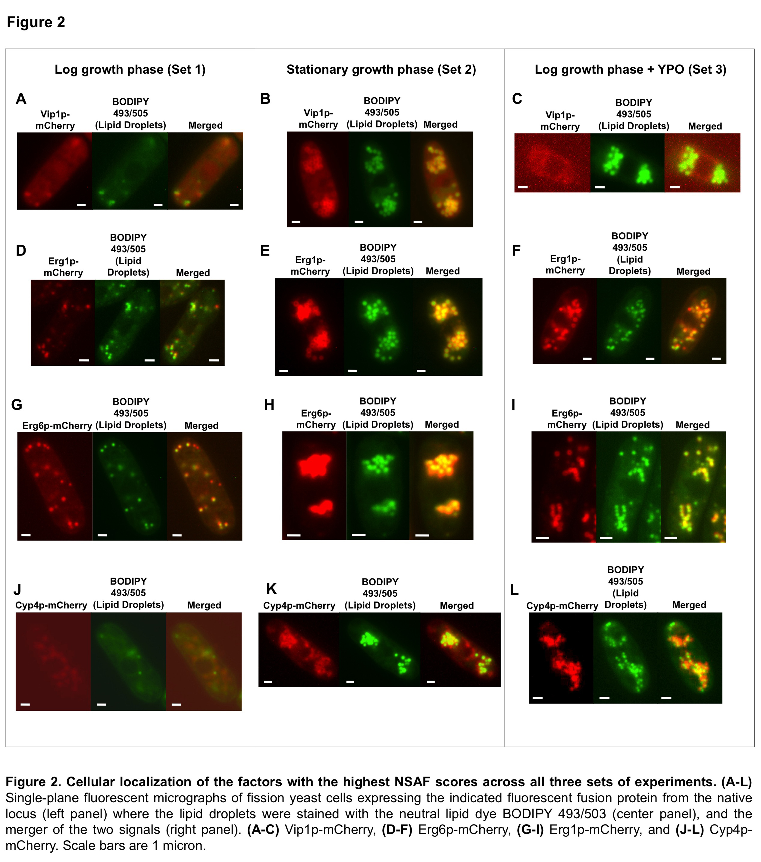

493/503-stained lipid droplets in Sets 2 and 3 in environments when lipid droplets would have been forming (Figure 2J-L).
We identified protein similarities and differences across the three sets to determine functionality synergies of these factors in lipid droplet formation and maintenance. First, we determined which factors had the lowest variability among the three sets. We calculated the standard deviation of the NSAF values for each factor and normalized this number by the average of the same values. This was done so that the results were not biased by the magnitude of the NSAF score. We reported a maximum of ten factors (tying scores included) for each grouping (Table 2). Sets 1, 2, and 3 shared the V-type ATPase subunit A (vph1 and vma1), the acetohydroxyacid reductoisomerase (ilv5), the rho family GTPase (rho1), the DNAJ domain protein (mas5), BiP (bip1), the delta-sterol C-methyltransferase (erg6), the V-type ATPase V1 subunit B (vma2), and three translation elongation factors EF-1 alpha Ef1a-a-c (tef101-tef103). Sets 1 and 2 shared only the dephospho-CoA kinase (SPCC14G10.01) showing that the bound proteins between lipid droplets isolated from cells in log growth phase versus those in stationary phase seem to be the least similar of the three conditions. Sets 1 and 3 shared the acetyl-CoA ligase (SPCC1827.03c), the translation initiation factor eIF3f (csn6), the ATP-dependent RNA helicase (sum3), the translation elongation factor eEF3 (tef3), and the 1-acyldihydroxyacetone phosphate reductase (ayr1). Sets 2 and 3 shared the ER protein translocation subcomplex subunit Sec72 (SPAC2F3.02), the F0-ATPase subunit (atp4), the protein disulfide isomerase (SPAC17H9.14c), the rho family GTPase (rho5), a conserved fungal protein (SPBP23A10.11c), protein 14-3-3 (rad24), the homoisocitrate dehydrogenase (lys12), the triosephosphate isomerase (tpi1), the mitochondrial outer membrane voltage-dependent anion-selective channel protein (SPAC1635.01), and the 1,3-beta-glucanosyltransferase (gas2).
We also determined which factors had the greatest population variance among the three sets. This was done by again sorting the factors by the normalized standard deviation of their NSAF scores, looking for the largest discrepancies. The ribosomal-ubiquitin fusion proteins Ubi1p (ubi1), Ubi2p (ubi2), Ubi3p (ubi3), Ubi5p (SPAC589.10c), the histidinol dehydrogenase (his2), ubquitin (ubi4), the fructose-biphosphate aldolase (fba1), the ferrous iron transporter (pcl1), the DNAJ domain protein (SPCC63.13), and the mitochondrial heat shock protein Hsp10p (hsp10) were all present in high amounts in Set 1 but were absent in Sets 2 and 3 (Table 3). The monomeric 2,3-biphosphoglycerate-dependent phosphoglycerate mutase PGAM (gpm1), the pyruvate decarboxylase (SPAC1F8.07c), the V-type ATPase subunit F (vma7), the thioredoxin peroxidase (SPCC330.06c), the N-acetyltransferase (SPAC17G8.06c), the dihydroxy-acid dehydratase (SPAC17G8.06c), inorganic pyrophosphatase (ipp1), glutathione S-transferase (gst3), 60S ribosomal protein L2 (rpl401), But2 family protein (but2) were the top ten factors having signals in Set 2 but not in Sets 1 or 3 based on NSAF scores (Table 3). The mitochondrial adenine nucleotide carrier (anc1), the malate dehydrogenase (SPCC306.08c), the CIA30 family protein (SPAC9E9.15), the ADP-ribosylation factor (sar1), actin (act1), F0-ATPase subunit D (atp7), ubiquinol-cytochrome-c reductase complex subunit 6 (gcr7), triglyceride lipase-cholesterol esterase (SPCC1672.09), ubiquinol-cytochrome-c reductase complex core protein (gcr2), and the superoxide dismutase (sod1) were the top ten factors having signals in Set 3 but not in Sets 1 or 2 based on NSAF scores (Table 3).
In all three sets, we identified the following factors in decreasing NSAF values that are known to be involved in neutral lipid metabolism: Erg6p, Erg1p, dephospho-CoA kinase, Lcf1p, Ayr1p, glycerophosphoryl diester phosphodiesterase, Erg26p, phosphoglycerate kinase (predicted), glyceraldehyde 3-phosphate dehydrogenase, Erg11p, Erg27p, Plb1p, triglyceride lipase-cholesterol esterase (predicted), Dga1p, glycerol-3-phosphate O-acyltransferase (predicted), triglyceride lipase-cholesterol esterase (predicted), Erg10p, Ptl3p, 1-acylglycerol-3-phosphate acyltransferase, Ptl1p, Gpd2p, and acetyl-CoA ligase.
Factors identified that traditionally associated with lipid droplets included Erg6p [20,29,65,66,68], Erg1p [20,29], short chain dehydrogenase (SPCC736.13) [29,36,69], glyceraldehyde-3-phosphate dehydrogenase (tdh1) [29,66,68], acetohydroxyacid reductoisomerase (ilv5) [20,65], translation elongation factor EF-1 alpha Ef1a-a (tef101) [20], Rho family GTPase (rho1) [20,29,65], protein disulfide isomerase (pdi1) [20,29,65], 1-acyldihydroxyzcetone phosphate reductase (ayr1) [20,29,65,66], glycerophosphoryl diester phosphodiesterase (SPAC4D7.02c) [29,65,66], 3 beta-hydroxysteriod dehydrogenase/delta 5-4-isomerase (erg26) [65], F1-ATPase beta subunit (atp2) [20,65], phosphoglycerate kinase (phk1) [20,66], mitochondrial heat shock protein Hsp70 (ssc1) [65], sterol 14-demethylase (erg11) [65], triacylglycerol lipase (ptl2) [29], mitochondrial adenine nucleotide carrier (anc1) [20], malate dehydrogenase (SPCC306.08c) [70], heat shock protein (lhs1) [65], Rho family GTPase (rho5) [65], mitochondrial outer membrane voltage-dependent anion-selective channel (SPAC1635.01) [20,29,65].
As stated, lipid droplets interact with other organelles. Major ER factors that have been postulated to be involved in lipid droplet function in decreasing NSAF scores included Erg6p, Erg1p, dephospho-CoA kinase (SPCC14G10.01), long-chain fatty acid CoA ligase (lcf1), Ayr1p, Erg26p, Erg11p, Erg27p, Sar1p, Dga1p, COPII-coated vesicle components (erv25, SPAC12B10.02c, erp5, sec24, SPBC4.03c), Erg5p, Tts1p, Sey1p, and Dnm1p. Pertinent mitochondria factors included Ayr1p, citrate synthase (cit1), and acetyl-CoA ligase (acs1); Golgi factors included Ayr1p, Erg26p, COPII-coated vesicle component (erp5), Tts1p, and triglyceride lipase-cholesterol esterase (SPBC14C8.15); Vacuole factors included triglyceride lipase-cholesterol esterase (SPBC14C8.15). Remaining organelles and the plasma membrane had non-traditional lipid droplet factors as discussed below.

Lipid droplet neutral lipids
We extracted neutral lipids from lipid droplets using the techniques of Ref. 63. Individual classes of lipids were separated using thin-layer chromatography (TLC). The cellulose containing the lipids was stained with iodine and the intensities of the bands were quantified using ImageJ software. Neutral lipid analysis confirmed sterol esters (SEs) and triacylglycerols (TAGs) as the primary components of S. pombe lipid droplets. Droplets from the three sets were composed of SE:TAG in the following ratios: Set 1, 55:45; Set 2, 40:60; Set 3, 15:85 (Figure 3). Comparable results were previously obtained from lipid droplets isolated from budding yeast cells cultured in glucose-based media to stationary phase where the SE:TAG ratio was 30:70 (Grillitsch et al., 2011). Lipid droplets isolated from the same cells grown in oleic acid for 24 hours were exclusively composed of TAG where the higher TAG content versus our lipid droplets from Set 3 was most likely due to their extended incubation time.

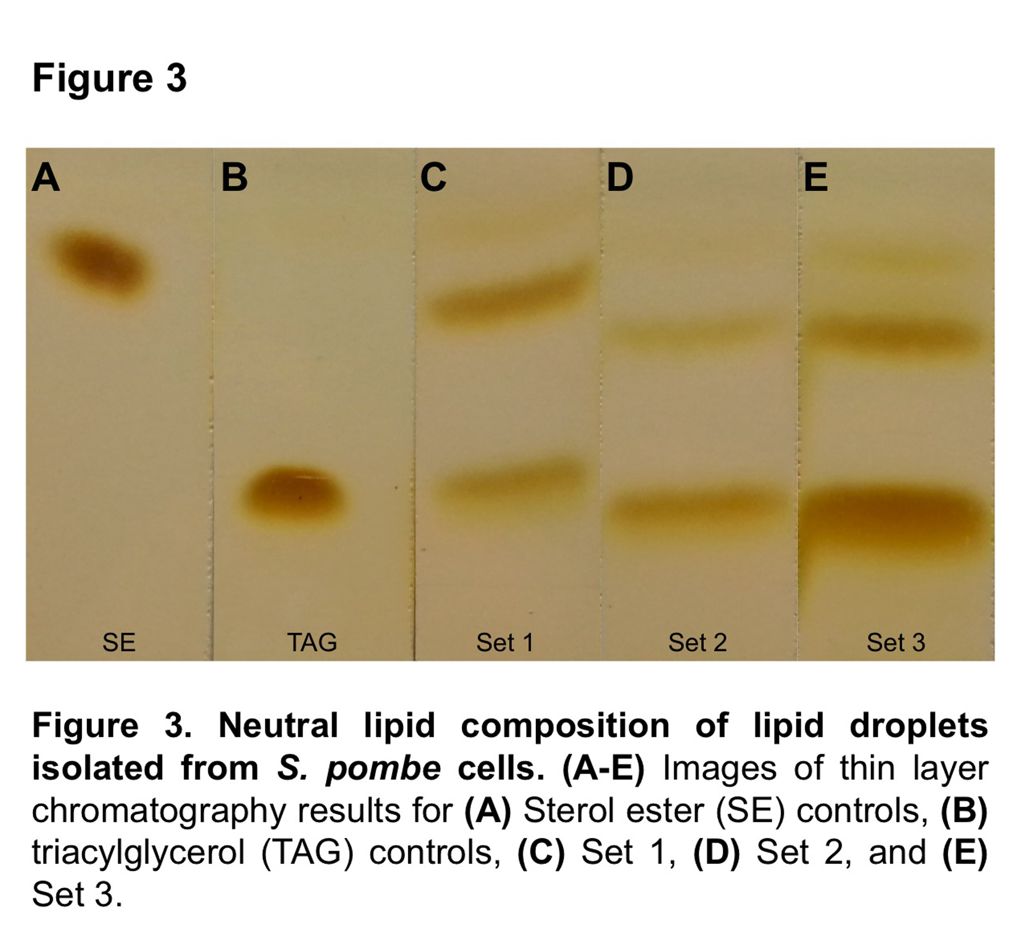

2-4 Discussion

We determined the protein and neutral lipid composition of lipid droplets isolated from fission yeast S. pombe cells as a function of cell growth phase and the free fatty acid content of the media in which the cells were cultured. We performed three sets of experiments where droplets were isolated from fission yeast cells grown to 1) late-log phase in glucose rich media, 2) stationary phase in glucose rich media, and 3) late-log phase in the presence of oleic acid. We uncovered 294 total proteins in the lipid droplet fractions across all three sets, with the most factors being uncovered in Set 3 where incubation of cells in media supplemented with oleic acid caused the formation of lipid droplets [16], seemingly maximizing proteomic affiliations. Approximately 30% of our identified factors have been previously identified in the lipid droplet fraction of lipid droplet proteomic studies [20,27,29,36,43,53,54,65,66,69,70]. In this study, those common factors had NSAF scores ranging from the second highest (Erg6p) to the lowest (Lsd1p) giving us confidence that our techniques accurately reproduced and added to the findings of other published works.
The ER is the organelle that is most commonly associated with lipid droplets, and factors that are potentially involved in droplet biogenesis from the ER are of special interest (Leber et al., 1998, Fei et al., 2009, Murphy et al., 2009, Ohsaki et al., 2009, Walther and Farese, 2009, Hartman et al., 2010, Grillitsch et al., 2011, Jacquier et al., 2011, Jacquier et al., 2013, Kassan et al., 2013, Pol et al., 2014). One such potential factor is the COPII-related gene sar1, which is responsible for vesicle fission and membrane tubulation (Barlowe et al., 1994, Long et al., 2010). The presence of Sar1p along with the membrane fission protein dynamin (Dnm1p), in Set 3 where oleic acid addition caused the formation of lipid droplets, points to the possible contribution of these two factors to droplet biogenesis [20,65,68]. We also identified the homotypic ER fusion protein, Sey1p, [65,73,74,75] and the tetra-spanning protein 1, Tts1p, the latter of which contributes to the formation of ER tubules (Zhang et al., 2010). Both factors could play important roles in droplet formation by modulating ER membrane curvature at a droplet formation site. Interestingly, the reticulon, Rtn1p (De Craene et al., 2006), the DPI protein, Yop1p (Zhang et al., 2010), and the Lunapark family protein, Lnp1p (Chen et al., 2012), were not present in the lipid droplet fraction of any of the three sets showing that droplet formation may require certain ER structural factors but not others.
Also of great interest are the relative contributions of the neutral lipid synthesizing enzymes to droplet formation and subsequent growth. Neutral lipids are formed by the acylation of intermediates beginning with either dihydroxyacetone phosphate (DHAP) or glycerol-3-phosphate (G3P). We uncovered several acyltransferases (Yamashita et al., 2014) including the gene product of SPBC1718.04, which acylates G3P (Sets 1-3), the diacylglycerol transferase, Dga1p (Set 3), and the predicted lysophosphatidic acid acyltransfase, SPBC428.14 (Set 3). We also found the fatty acid-CoA ligases, Lcf1p in all three sets and Lcf2p only in Set 3 [80]. The human ortholog of Lcf1p, acyl-CoA synthetase 3 (GI:4758330), has been found to promote lipid droplet biogenesis in COS-1 cells (Kassan et al., 2013) and the acyl-CoA synthetase 4 isoenzymes mediate the metabolic flux of fatty acids towards phosphatidylinositol (Kuech et al., 2014). The presence of Lcf2p in Set 3 is most likely a cellular response to the need for fatty acid sequestration.
Ergosterol biosynthesis in the ER is another crucial element controlling lipid droplet size and distribution as several of the precursors of ergosterols - zymosterol, fecosterol, and episterol - can be rapidly esterified to form SEs (Sorger et al., 2004). Following the formation of squalene, ergosterol synthesis primarily occurs in the ER bilayer where hydrophobic intermediates can be protected from aqueous environments. A number of these pathway proteins, Erg1p, Erg5p, Erg6p, Erg7p, Erg10p, Erg11p, Erg26p, and Erg27p, were significantly enriched in lipid droplet fractions in Set 3 despite the fact that the neutral lipid synthesis pathway is shifted towards TAG production over SE production when yeast cells are incubated in high levels of oleic acid since the Are1p/Are2p pathways should be shut off (Connerth et al., 2010). Thus, these factors may have additional functionalities that have yet to be determined.
Factors that initiate neutral lipid breakdown for either energy or phospholipid needs are typically found in the lipid droplet fraction. Their colocalization with lipid droplets has been widely documented using fluorescent fusion proteins with much focus on the tgl gene products, which in S. pombe include the TAG lipases Ptl1p, Ptl2p, and Ptl3p. These enzymes showed unique expression profiles in this study. Ptl1p was identified in the lipid droplet fractions of Sets 2 and 3 where large lipid droplets predominated. Ptl2p was present in all three sets and Ptl3p was present only in the lipid droplet fraction of Set 1. These results indicate that these three lipases are tightly regulating as a function of the cellular growth phase and also potentially by the numbers and sizes of the cellular lipid droplets (Kurat et al., 2009). Additional factors that break down neutral lipids included Ayr1p, which is required for the biosynthesis of phosphatidic acid via the DHAP pathway [84] and has recently been identified as a triacylglycerol lipase [85]. Ayr1p was discovered in Sets 1 and 3 but not in Set 2, showing that this factor is bound to lipid droplets during fission yeast growth phase but not during stationary phase.
In yeast, β-oxidation is the primary mechanism for fatty acid degradation where free fatty acids that can be obtained by the incremental deacylation of triacylglycerol are transported to peroxisomes where they can be further catabolized into acetyl-CoA. However in higher eukaryotes, this process takes place in mitochondria. Here mitochondrial proteins were second in number only to ER proteins in the lipid droplet fraction of the three sets. This indicates a tight association between lipid droplets and mitochondria and leads to the postulate that mitochondria may be the primary source for β-oxidation in fission yeast cells, as opposed to peroxisomes since none of the three conditions provided evidence for lipid droplet association with peroxisomes as we uncovered only the peroxisomal docking protein (pex14), a thioredoxin peroxidase (SPCC330.06c), and an acetyl-CoA ligase (SPCC1827.03c) across all three sets. The low number of peroxisome-associated factors is in contrast to lipid droplet proteomic studies in budding yeast and methylotropic yeast Pichia pastoris where lipid droplets and peroxisomes have shown to have strong interactions (Binns et al., 2006, Ivashov et al., 2013). It should be noted, however, that cells in Set 3 may not have been incubated long enough in oleic acid for peroxisome biogenesis. In fact, peroxisome biogenesis was observed in fission yeast cells after 20 hours of incubation in oleic acid based media [86]. However, this would still not explain why the lipid droplets isolated from cells from Sets 1 and 2 contained a negligible number of peroxisome versus mitochondrial factors.
The discovery of ribosomal and protein synthesis factors in the lipid droplet fraction of Set 1 with an emphasis on the cyclopilin family peptidyl-prolyl cis-trans isomerase Cyp4p (cyp4) lends weight to the theory that protein synthesis may occur close to or on the surfaces of lipid droplets potentially as they remain in contact with the ER (Jacquier et al., 2011). The synthesis and translocation of lipid droplet proteins from the ribosome has long been puzzling because of the need for these factors to be incorporated into the unique monolayer geometry of the lipid droplet. Cyclophilin B regulates the distribution of ApoB-100 on cellular lipid droplets, and cyclophilin A is essential for hepatitis C virus replication, both in hepatocytes [66,87]. Hepatitis C replication has been directly linked to aspects of lipid droplet formation [88,89,90]. Thus, genetic studies on the cyp4 gene in yeast may provide insight into lipid droplet protein translocation and lipid droplet formation mechanisms.
Both the targeting of proteins to lipid droplets and the dissociation of proteins from lipid droplets have been areas of intense interest and will mostly likely involve a variety of mechanisms including translocation of factors from the ER [91] and potentially from other organelles such as ribosomes and the Golgi. Coatomer-dependent protein (COP) machinery has been postulated to be involved in lipid droplet dynamics (Farese and Walther, 2009), substantiated by the presence of both COPI and COPII proteins in lipid droplet fractions [50?]. Our results indicate that COPII gene products may play an important role in droplet distribution. We discovered six COPII factors in Set 3 with oleate-induced lipid droplet formation (sar1, erv25, SPAC12B10.02c, erp5, sec24, and SPBC4.03c). Sar1p is especially intriguing for lipid droplet biogenesis because it has been found in lipid droplet fractions in several species including S. cerevisiae (Binns et al., 2006), D. melanogastor (Cermelli et al., 2006) and human hepatocytes (Fujimoto et al., 2004). However just as insightful is the absence of any COPI factors from the lipid droplet fraction of S. pombe cells. COPI’s primary component Arf1p, has been shown to be involved in the translocation of ATGL to lipid droplets in HeLa cells [92] and also the formation of ~70 nm lipid droplets from larger droplets extracted from fly cells [93]. These proteomic differences point to potential divergences in lipid droplet function throughout eukaryotes. Genetic experiments that target these genes will continue to shed light on lipid droplet function throughout the phylogenetic tree.

2-5 Appendix

ADEYO, O., HORN, P. J., LEE, S., BINNS, D. D., CHANDRAHAS, A., CHAPMAN, K. D. & GOODMAN, J. M. 2011. The yeast lipin orthologue Pah1p is important for biogenesis of lipid droplets. J Cell Biol, 192, 1043-55.
ATHENSTAEDT, K., ZWEYTICK, D., JANDROSITZ, A., KOHLWEIN, S. D. & DAUM, G. 1999. Identification and characterization of major lipid particle proteins of the yeast Saccharomyces cerevisiae. J Bacteriol, 181, 6441-8.
AYCIRIEX, S., LE GUEDARD, M., CAMOUGRAND, N., VELOURS, G., SCHOENE, M., LEON, S., WATTELET-BOYER, V., DUPUY, J.-W., SHEVCHENKO, A., SCHMITTER, J.-M., LESSIRE, R., BESSOULE, J.-J. & TESTET, E. 2012. YPR139c/LOA1 encodes a novel lysophosphatidic acid acyltransferase associated with lipid droplets and involved in TAG homeostasis. Molecular Biology of the Cell, 23, 233-246.
BARLOWE, C., ORCI, L., YEUNG, T., HOSOBUCHI, M., HAMAMOTO, S., SALAMA, N., REXACH, M. F., RAVAZZOLA, M., AMHERDT, M. & SCHEKMAN, R. 1994. COPII - A MEMBRANE COAT FORMED BY SEC PROTEINS THAT DRIVE VESICLE BUDDING FROM THE ENDOPLASMIC-RETICULUM. Cell, 77, 895-907.
BELLER, M., THIEL, K., THUL, P. J. & JAECKLE, H. 2010. Lipid droplets: A dynamic organelle moves into focus. Febs Letters, 584, 2176-2182.
BINNS, D., JANUSZEWSKI, T., CHEN, Y., HILL, J., MARKIN, V. S., ZHAO, Y. M., GILPIN, C., CHAPMAN, K. D., ANDERSON, R. G. W. & GOODMAN, J. M. 2006. An intimate collaboration between peroxisomes and lipid bodies. Journal of Cell Biology, 173, 719-731.
BRASAEMLE, D. L., DOLIOS, G., SHAPIRO, L. & WANG, R. 2004. Proteomic analysis of proteins associated with lipid droplets of basal and lipolytically stimulated 3T3-L1 adipocytes. Journal of Biological Chemistry, 279, 46835-46842.
BROWN, S. D., THOMPSON, M. R., VERBERKMOES, N. C., CHOUREY, K., SHAH, M., ZHOU, J. Z., HETTICH, R. L. & THOMPSON, D. K. 2006. Molecular dynamics of the Shewanella oneidensis response to chromate stress. Molecular & Cellular Proteomics, 5, 1054-1071.
CERMELLI, S., GUO, Y., GROSS, S. P. & WELTE, M. A. 2006. The lipid-droplet proteome reveals that droplets are a protein-storage depot. Current Biology, 16, 1783-1795.
CHEN, S. L., NOVICK, P. & FERRO-NOVICK, S. 2012. ER network formation requires a balance of the dynamin-like GTPase Sey1p and the Lunapark family member Lnp1p. Nature Cell Biology, 14, 707-716.
CHOUREY, K., NISSEN, S., VISHNIVETSKAYA, T., SHAH, M., PFIFFNER, S., HETTICH, R. L. & LOEFFLER, F. E. 2013. Environmental proteomics reveals early microbial community responses to biostimulation at a uranium- and nitrate-contaminated site. Proteomics, 13, 2921-2930.
CONNERTH, M., CZABANY, T., WAGNER, A., ZELLNIG, G., LEITNER, E., STEYRER, E. & DAUM, G. 2010. Oleate Inhibits Steryl Ester Synthesis and Causes Liposensitivity in Yeast. Journal of Biological Chemistry, 285, 26832-26841.
CONNERTH, M., GRILLITSCH, K., KOEFELER, H. & DAUM, G. 2009. Analysis of Lipid Particles from Yeast. Lipidomics: Vol 1: Methods and Protocols, 579, 359-374.
DE CRAENE, J. O., COLEMAN, J., DE MARTIN, P. E., PYPAERT, M., ANDERSON, S., YATES, J. R., FERRO-NOVICK, S. & NOVICK, P. 2006. Rtn1p is involved in structuring the cortical endoplasmic reticulum. Molecular Biology of the Cell, 17, 3009-3020.
DU, X., BARISCH, C., PASCHKE, P., HERRFURTH, C., BERTINETTI, O., PAWOLLECK, N., OTTO, H., RUEHLING, H., FEUSSNER, I., HERBERG, F. W. & MANIAK, M. 2013. Dictyostelium Lipid Droplets Host Novel Proteins. Eukaryotic Cell, 12, 1517-1529.
ENG, J. K., MCCORMACK, A. L. & YATES, J. R. 1994. AN APPROACH TO CORRELATE TANDEM MASS-SPECTRAL DATA OF PEPTIDES WITH AMINO-ACID-SEQUENCES IN A PROTEIN DATABASE. Journal of the American Society for Mass Spectrometry, 5, 976-989.
FARESE, R. V. & WALTHER, T. C. 2009. Lipid Droplets Finally Get a Little R-E-S-P-E-C-T. Cell, 139, 855-860.
FEI, W., WANG, H., FU, X., BIELBY, C. & YANG, H. 2009. Conditions of endoplasmic reticulum stress stimulate lipid droplet formation in Saccharomyces cerevisiae. Biochemical Journal, 424, 61-67.
FEI, W. H., ZHONG, L., TA, M. T., SHUI, G. H., WENK, M. R. & YANG, H. Y. 2011. The size and phospholipid composition of lipid droplets can influence their proteome. Biochemical and Biophysical Research Communications, 415, 455-462.
FUJIMOTO, T. & PARTON, R. G. 2011. Not just fat: the structure and function of the lipid droplet. Cold Spring Harb Perspect Biol, 3.
FUJIMOTO, Y., ITABE, H., SAKAI, J., MAKITA, M., NODA, J., MORI, M., HIGASHI, Y., KOJIMA, S. & TAKANO, T. 2004. Identification of major proteins in the lipid droplet-enriched fraction isolated from the human hepatocyte cell line HuH7. Biochimica Et Biophysica Acta-Molecular Cell Research, 1644, 47-59.
GASPAR, M. L., JESCH, S. A., VISWANATHA, R., ANTOSH, A. L., BROWN, W. J., KOHLWEIN, S. D. & HENRY, S. A. 2008. A block in endoplasmic reticulum-to-golgi trafficking inhibits phospholipid synthesis and induces neutral lipid accumulation. Journal of Biological Chemistry, 283, 25735-25751.
GOULD, K. L. & NURSE, P. 1989. TYROSINE PHOSPHORYLATION OF THE FISSION YEAST CDC2+ PROTEIN-KINASE REGULATES ENTRY INTO MITOSIS. Nature, 342, 39-45.
GRILLITSCH, K., CONNERTH, M., KOFELER, H., ARREY, T. N., RIETSCHEL, B., WAGNER, B., KARAS, M. & DAUM, G. 2011. Lipid particles/droplets of the yeast Saccharomyces cerevisiae revisited: Lipidome meets Proteome. Biochimica Et Biophysica Acta-Molecular and Cell Biology of Lipids, 1811, 1165-1176.
GUO, Y., CORDES, K. R., FARESE, R. V., JR. & WALTHER, T. C. 2009. Lipid droplets at a glance. Journal of Cell Science, 122, 749-752.
HAGAN, I. M. & HYAMS, J. S. 1988. THE USE OF CELL-DIVISION CYCLE MUTANTS TO INVESTIGATE THE CONTROL OF MICROTUBULE DISTRIBUTION IN THE FISSION YEAST SCHIZOSACCHAROMYCES-POMBE. Journal of Cell Science, 89, 343-357.
HARTMAN, I. Z., LIU, P., ZEHMER, J. K., LUBY-PHELPS, K., JO, Y., ANDERSON, R. G. W. & DEBOSE-BOYD, R. A. 2010. Sterol-induced Dislocation of 3-Hydroxy-3-methylglutaryl Coenzyme A Reductase from Endoplasmic Reticulum Membranes into the Cytosol through a Subcellular Compartment Resembling Lipid Droplets. Journal of Biological Chemistry, 285, 19288-19298.
IVASHOV, V. A., GRILLITSCH, K., KOEFELER, H., LEITNER, E., BAEUMLISBERGER, D., KARAS, M. & DAUM, G. 2013. Lipidome and proteome of lipid droplets from the methylotrophic yeast Pichia pastoris. Biochimica Et Biophysica Acta-Molecular and Cell Biology of Lipids, 1831, 282-290.
JACQUIER, N., CHOUDHARY, V., MARI, M., TOULMAY, A., REGGIORI, F. & SCHNEITER, R. 2011. Lipid droplets are functionally connected to the endoplasmic reticulum in Saccharomyces cerevisiae. Journal of Cell Science, 124, 2424-2437.
JACQUIER, N., MISHRA, S., CHOUDHARY, V. & SCHNEITER, R. 2013. Expression of oleosin and perilipins in yeast promotes formation of lipid droplets from the endoplasmic reticulum. Journal of Cell Science, 126, 5198-+.
JOLIVET, P., ROUX, E., D'ANDREA, S., DAVANTURE, M., NEGRONI, L., ZIVY, M. & CHARDOT, T. 2004. Protein composition of oil bodies in Arabidopsis thaliana ecotype WS. Plant Physiology and Biochemistry, 42, 501-509.
KASSAN, A., HERMS, A., FERNANDEZ-VIDAL, A., BOSCH, M., SCHIEBER, N. L., REDDY, B. J. N., FAJARDO, A., GELABERT-BALDRICH, M., TEBAR, F., ENRICH, C., GROSS, S. P., PARTON, R. G. & POL, A. 2013. Acyl-CoA synthetase 3 promotes lipid droplet biogenesis in ER microdomains. Journal of Cell Biology, 203, 985-1001.
KRAHMER, N., HILGER, M., KORY, N., WILFLING, F., STOEHR, G., MANN, M., FARESE, R. V., JR. & WALTHER, T. C. 2013. Protein correlation profiles identify lipid droplet proteins with high confidence. Mol Cell Proteomics, 12, 1115-26.
KUECH, E.-M., VELLARAMKALAYIL, R., ZHANG, I., LEHNEN, D., BRUEGGER, B., STREMMEL, W., EHEHALT, R., POPPELREUTHER, M. & FUELLEKRUG, J. 2014. Differentially localized acyl-CoA synthetase 4 isoenzymes mediate the metabolic channeling of fatty acids towards phosphatidylinositol. Biochimica Et Biophysica Acta-Molecular and Cell Biology of Lipids, 1841, 227-239.
KURAT, C. F., WOLINSKI, H., PETSCHNIGG, J., KALUARACHCHI, S., ANDREWS, B., NAFTER, K. & KOHWEIN, S. D. 2009. Cdk1/Cdc28-Dependent Activation of the Major Triacylglycerol Lipase Tgl4 in Yeast Links Lipolysis to Cell-Cycle Progression. Molecular Cell, 33, 53-63.
LEBER, R., LANDL, K., ZINSER, E., AHORN, H., SPOK, A., KOHLWEIN, S. D., TURNOWSKY, F. & DAUM, G. 1998. Dual localization of squalene epoxidase, Erg1p, in yeast reflects a relationship between the endoplasmic reticulum and lipid particles. Molecular Biology of the Cell, 9, 375-386.
LEBER, R., ZINSER, E., ZELLNIG, G., PALTAUF, F. & DAUM, G. 1994. CHARACTERIZATION OF LIPID PARTICLES OF THE YEAST, SACCHAROMYCES-CEREVISIAE. Yeast, 10, 1421-1428.
LIN, M., GRILLITSCH, K., DAUM, G., JUST, U. & HOEFKEN, T. 2009. Modulation of sterol homeostasis by the Cdc42p effectors Cla4p and Ste20p in the yeast Saccharomyces cerevisiae. Febs Journal, 276, 7253-7264.
LIU, P., BARTZ, R., ZEHMER, J. K., YING, Y.-S., ZHU, M., SERRERO, G. & ANDERSON, R. G. W. 2007. Rab-regulated interaction of early endosomes with lipid droplets. Biochimica Et Biophysica Acta-Molecular Cell Research, 1773, 784-793.
LIU, P. S., YING, Y. S., ZHAO, Y. M., MUNDY, D. I., ZHU, M. F. & ANDERSON, R. G. W. 2004. Chinese hamster ovary K2 cell lipid droplets appear to be metabolic organelles involved in membrane traffic. Journal of Biological Chemistry, 279, 3787-3792.
LONG, A. P., MANNESCHMIDT, A. K., VERBRUGGE, B., DORTCH, M. R., MINKIN, S. C., PRATER, K. E., BIGGERSTAFF, J. P., DUNLAP, J. R. & DALHAIMER, P. 2012. Lipid Droplet De Novo Formation and Fission Are Linked to the Cell Cycle in Fission Yeast. Traffic, 13, 705-714.
LONG, K. R., YAMAMOTO, Y., BAKER, A. L., WATKINS, S. C., COYNE, C. B., CONWAY, J. F. & ARIDOR, M. 2010. Sar1 assembly regulates membrane constriction and ER export. Journal of Cell Biology, 190, 115-128.
LOW, K. L., SHUI, G., NATTER, K., YEO, W. K., KOHLWEIN, S. D., DICK, T., RAO, S. P. S. & WENK, M. R. 2010. Lipid Droplet-associated Proteins Are Involved in the Biosynthesis and Hydrolysis of Triacylglycerol in Mycobacterium bovis Bacillus Calmette-Guerin. Journal of Biological Chemistry, 285, 21662-21670.
MANNIK, J., MEYERS, A. & DALHAIMER, P. 2014. Isolation of cellular lipid droplets: two purification techniques starting from yeast cells and human placentas. Journal of visualized experiments : JoVE.
MARTIN, S. & PARTON, R. G. 2006. Lipid droplets: a unified view of a dynamic organelle. Nature Reviews Molecular Cell Biology, 7, 373-378.
MATA, J. & NURSE, P. 1997. tea1 and the microtubular cytoskeleton are important for generating global spatial order within the fission yeast cell. Cell, 89, 939-949.
MURPHY, S., MARTIN, S. & PARTON, R. G. 2009. Lipid droplet-organelle interactions; sharing the fats. Biochimica Et Biophysica Acta-Molecular and Cell Biology of Lipids, 1791, 441-447.
OHSAKI, Y., CHENG, J., SUZUKI, M., SHINOHARA, Y., FUJITA, A. & FUJIMOTO, T. 2009. Biogenesis of cytoplasmic lipid droplets: From the lipid ester globule in the membrane to the visible structure. Biochimica Et Biophysica Acta-Molecular and Cell Biology of Lipids, 1791, 399-407.
OHSAKI, Y., SUZUKI, M. & FUJIMOTO, T. 2014. Open Questions in Lipid Droplet Biology. Chemistry & Biology, 21, 86-96.
PLOEGH, H. L. 2007. A lipid-based model for the creation of an escape hatch from the endoplasmic reticulum. Nature, 448, 435-438.
POL, A., GROSS, S. P. & PARTON, R. G. 2014. Biogenesis of the multifunctional lipid droplet: Lipids, proteins, and sites. Journal of Cell Biology, 204, 636-646.
PU, J., HA, C. W., ZHANG, S., JUNG, J. P., HUH, W.-K. & LIU, P. 2011. Interactomic study on interaction between lipid droplets and mitochondria. Protein & Cell, 2, 487-496.
RUSSELL, P. & NURSE, P. 1986. CDC25+ FUNCTIONS AS AN INDUCER IN THE MITOTIC CONTROL OF FISSION YEAST. Cell, 45, 145-153.
SATO, S., FUKASAWA, M., YAMAKAWA, Y., NATSUME, T., SUZUKI, T., SHOJI, I., AIZAKI, H., MIYAMURA, T. & NISHIJIMA, M. 2006. Proteomic profiling of lipid droplet proteins in hepatoma cell lines expressing hepatitis C virus core protein. Journal of Biochemistry, 139, 921-930.
SCHMIDT, C., PLOIER, B., KOCH, B. & DAUM, G. 2013a. Analysis of Yeast Lipid Droplet Proteome and Lipidome. Lipid Droplets, 116, 15-37.
SCHMIDT, C., PLOIER, B., KOCH, B. & DAUM, G. 2013b. Analysis of yeast lipid droplet proteome and lipidome. Methods Cell Biol, 116, 15-37.
SHARMA, R., DILL, B. D., CHOUREY, K., SHAH, M., VERBERKMOES, N. C. & HETTICH, R. L. 2012. Coupling a Detergent Lysis/Cleanup Methodology with Intact Protein Fractionation for Enhanced Proteome Characterization. Journal of Proteome Research, 11, 6008-6018.
SORGER, D., ATHENSTAEDT, K., HRASTNIK, C. & DAUM, G. 2004. A yeast strain lacking lipid particles bears a defect in ergosterol formation. Journal of Biological Chemistry, 279, 31190-31196.
TAKEDA, Y. & NAKANO, A. 2008. In vitro formation of a novel type of membrane vesicles containing Dpm1p: Putative transport vesicles for lipid droplets in budding yeast. Journal of Biochemistry, 143, 803-811.
THOMPSON, M. R., VERBERKMOES, N. C., CHOUREY, K., SHAH, M., THOMPSON, D. K. & HETTICH, R. L. 2007. Dosage-dependent proteome response of Shewanella oneidensis MR-1 to acute chromate challenge. Journal of Proteome Research, 6, 1745-1757.
UMLAUF, E., CSASZAR, E., MOERTELMAIER, M., SCHUETZ, G. J., PARTON, R. G. & PROHASKA, R. 2004. Association of stomatin with lipid bodies. Journal of Biological Chemistry, 279, 23699-23709.
VAN ZUTPHEN, T., TODDE, V., DE BOER, R., KREIM, M., HOFBAUER, H. F., WOLINSKI, H., VEENHUIS, M., VAN DER KLEI, I. J. & KOHLWEIN, S. D. 2014. Lipid droplet autophagy in the yeast Saccharomyces cerevisiae. Mol Biol Cell, 25, 290-301.
WALTHER, T. C. & FARESE, R. V. 2009. The life of lipid droplets. Biochimica Et Biophysica Acta-Molecular and Cell Biology of Lipids, 1791, 459-466.
WALTHER, T. C. & FARESE, R. V., JR. 2012. Lipid Droplets and Cellular Lipid Metabolism. Annual Review of Biochemistry, Vol 81, 81, 687-714.
WOLINSKI, H. & KOHWEIN, S. D. 2008. Microscopic Analysis of Lipid Droplet Metabolism and Dynamics in Yeast. Methods in Molecular Biology, 457, 151-163.
WU, C. C., HOWELL, K. E., NEVILLE, M. C., YATES, J. R. & MCMANAMAN, J. L. 2000. Proteomics reveal a link between the endoplasmic reticulum and lipid secretory mechanisms in mammary epithelial cells. Electrophoresis, 21, 3470-3482.
YAMASHITA, A., HAYASHI, Y., NEMOTO-SASAKI, Y., ITO, M., OKA, S., TANIKAWA, T., WAKU, K. & SUGIURA, T. 2014. Acyltransferases and transacylases that determine the fatty acid composition of glycerolipids and the metabolism of bioactive lipid mediators in mammalian cells and model organisms. Progress in Lipid Research, 53, 18-81.
ZEHMER, J. K., HUANG, Y., PENG, G., PU, J., ANDERSON, R. G. W. & LIU, P. 2009. A role for lipid droplets in inter-membrane lipid traffic. Proteomics, 9, 914-921.
ZHANG, D., VJESTICA, A. & OLIFERENKO, S. 2010. The Cortical ER Network Limits the Permissive Zone for Actomyosin Ring Assembly. Current Biology, 20, 1029-1034.
ZHANG, H., WANG, Y., LI, J., YU, J., PU, J., LI, L., ZHANG, H., ZHANG, S., PENG, G., YANG, F. & LIU, P. 2011. Proteome of Skeletal Muscle Lipid Droplet Reveals Association with Mitochondria and Apolipoprotein A-I. Journal of Proteome Research, 10, 4757-4768.
ZHANG, P., NA, H., LIU, Z., ZHANG, S., XUE, P., CHEN, Y., PU, J., PENG, G., HUANG, X., YANG, F., XIE, Z., XU, T., XU, P., OU, G., ZHANG, S. O. & LIU, P. 2012. Proteomic Study and Marker Protein Identification of Caenorhabditis elegans Lipid Droplets. Molecular & Cellular Proteomics, 11, 317-328.

Table 2-1. Strains used in this study.

Name | Genotype
TP150  AM  Table data  Table data  Table data | Erg6-mcherry  Erg1-mcheery  Vip1-Mcherry  Cyp4-mcherry

Table 2-2

CHAPTER 3

Lipid droplets form from distinct regions of the Er in the fission yeast, Schizosaccharomyces pombe
Abstract
Eukaryotic cells store cholesterol/sterol esters (SEs) and triacylglycerols (TAGs) in lipid droplets, which form from the contiguous endoplasmic reticulum (ER) network. However, it is not known if droplets preferentially form from certain regions of the ER over others. Here, we used the elongated geometry of fission yeast S. pombe cells where the nuclear and cortical/peripheral ER domains are easily distinguishable in a model genetic system, to show that SE-enriched lipid droplets form the cortical ER away from the nucleus whereas TAG lipid droplets form around the nuclear ER. These observations were confirmed by manipulating the expression levels of the four neutral lipid synthesizing enzymes Are1p, Are2p, Dga1p, and Plh1p which are responsible for the final steps of SE and TAG production. SE droplet formation at the tips of fission yeast cells can be explained by the presence of sterols in those neighboring regions of the curved plasma membrane. TAG droplet formation and subsequent localization around the nuclear ER appears to be a function of the localized activities of the lipin ortholog Ned1p and its binding partners but also by the action of Cpt1p, which incorporates diacylglycerol into the Kennedy Pathway. Cpt1p is localized exclusively to the nuclear ER in fission yeast cells. The results profoundly modify the standard lipid droplet formation model, which has SEs and TAGs flowing into the same nascent lipid droplet regardless of its biogenesis point in the ER membrane.

3-1 Introduction

Eukaryotic cells convert free fatty acids into neutral lipids and package them into lipid droplets (Martin and Parton, 2006, Farese and Walther, 2009, Goodman, 2009, Walther and Farese, 2009, Beller et al., 2010, Fujimoto and Parton, 2011, Pol et al., 2014). In yeast cells, the two most prominent neutral lipids are sterol esters (SEs) and triacylglycerols (TAGs), which are synthesized in the endoplasmic reticulum (ER) membrane (Binns et al., 2006, Connerth et al., 2010, Adeyo et al., 2011, Jacquier et al., 2011). The acyl-CoA sterol acyltransferases, Are1p and Are2p convert sterols to SEs (Zweytick et al., 2000, Shin et al., 2012); the acyl-CoA-diacylglycerol acyltransferase, Dga1p, converts diacylglycerol (DAG) to TAG (Sorger and Daum, 2002, Kurat et al., 2006, Kohlwein, 2010), and the phospholipid:diacylglycerol acyltransferse, Plh1p, cleaves an acyl chain from phosphatidylcholine (PC) and conjugates it to DAG to form TAG (Choudhary et al., 2011, Horvath et al., 2011). It is widely held that lipid droplets originate from the ER as seen in static high-resolution electron micrographs and dynamic lower resolution fluorescent images (Robenek et al., 2006, Jacquier et al., 2011, Kassan et al., 2013). Also, lipid droplet proteomic and functional studies have identified several ER factors crucial for droplet formation and maintenance (for example (Leber et al., 1994, Binns et al., 2006, Grillitsch et al., 2011, Ayciriex et al., 2012, Xu et al., 2012, Markgraf et al., 2014)). Even with these data, it is not clear if droplets form from specific locations in the ER network over others (Pol et al., 2014).
Because domains of the ER can be both enzymatically and geometrically diverse, it stands to reason that certain regions of the ER could be more amenable than others for lipid droplet formation. Here, we used both wild-type and temperature-sensitive cdc25-22 fission yeast Schizosaccharomyces pombe cells to show that lipid droplets form from different regions of the ER network based on the initial neutral lipid content of the nascent droplet. In elongated fission yeast cdc25-22 cells, lipid droplets enriched in SEs formed exclusively at the cell tips. Cdc25-22 cells lacking Are1p and Are2p had a negligible number of polarized droplets. These results led to the hypothesis that SE lipid droplets form from the cortical and not the nuclear ER.
We used wild-type fission yeast cells to show that TAG lipid droplets form around the nuclear ER when cells were incubated in oleic acid and also grown to stationary phase. In both of these cases neutral lipid synthesis is pushed strongly towards TAG formation and away from SE production (Connerth et al., 2010). Single and combination knockouts of dga1 and plh1 greatly reduced droplet numbers around the nuclear ER. However, lipid droplets in are1Δare2Δ cells had the same lipid droplet pattern around the nuclear ER as in wild-type cells showing that the lack of SE production has little or no effect on nuclear ER droplet formation.
We also probed the effects of neutral lipid breakdown on spatially diverse droplet populations. The sn-1,2,-diacylglycerol cholinephosphotransferase, Cpt1p (Hjelmstad and Bell, 1987), which converts diacylglycerol (DAG) – the precursor of TAG – into phosphatidylcholine (PC) was localized exclusively to the nuclear ER showing that TAG droplets are processed for phospholipid needs at the nuclear ER. Taken in sum, these results augment the current droplet formation model where both SEs and TAG flow into a forming lipid droplet regardless of the droplet’s biogenesis point in the ER network and also show that droplets can be broken down in specific locations in eukaryotic cells.

3-2 Materials and Methods

Strains, Growth Conditions, Cellular Methods
The S. pombe were constructed by PCR-based gene targeting and standard genetic methods with wild-type or cdc25-22 cells as genetic backgrounds (Moreno et al., 1991, Forsburg and Sherman, 1997, Bahler et al., 1998). Cdc25-22 cells have a guanine to an adenine mutation at position 1595 of the ORF, resulting in C532Y. Integration of all linear PCR products into the native loci was confirmed by diagnostic PCR.
Strains with a wild-type genetic background were grown in 20 ml of media in 200-ml baffled flasks at 200 rpm at 30°C. All strains were grown in yeast extract plus five supplement (YE5S) media (Sunrise Science Products, #2011) to desired density (O.D. ~ 0.3 for late log phase, O.D. ~ 6.0 for stationary phase). For TAG formation experiments with oleic acid, the cells were pelleted, the YE5S was removed and the cells were washed with YPO (0.1% oleic acid, 0.2% Tween 80, 0.1% glucose, 0.5% peptone, 0.3% potassium phosphate) and incubated at 30°C for an additional four hours.
Strains with a cdc25-22 genetic background were grown in 20 ml of YE5S media in 200-ml baffled flasks at 200 rpm at 25°C until they reached an O.D. ~ 0.1. For the live time-lapse confocal microscopy experiments the cells were mounted between a slide and a coverslip in a climate-controlled stage that had a fixed temperature of 36°C. For single time point confocal microscopy experiments the cells continued to be incubated in the baffled flasks but at a temperature of 36°C for 2.5 hours. 20 ml of cells were pelleted at 2,000 rpm for 5 m in a swinging bucket centrifuge and resuspended in 1 ml of YE5S. For lipid droplet staining, a stock of 100 μM BODIPY 493/503 (Invitrogen; #D3922) was prepared in 100% ethanol. 1 μl of this stock was added to 1 ml of cells per O.D. of 0.1 as done previously (Long et al., 2012). This mixture was incubated for 1 minute. The stained yeast cells were pelleted at 2,000 rpm for 1 m in a micro centrifuge. The supernatant was removed down to 100 μl containing the pellet, which was resuspened. 2 μl of the resuspended pellet was placed between a slide and a coverslip for light microscopy imaging.
Microscopy
We used a Zeiss LSM710 confocal microscope where the stage was enclosed within an environmental control chamber (Incubator XL LSM710 S, PeCon GmbH) to track the positions of BODIPY 493/503-stained lipid droplets in elongating cdc25-22 cells at 36°C. Images were acquired every 10 minutes using a Plan-Apochromat 63x/1.40 oil DIC M27 objective at a vertical spacing of 360 nm. We used an Olympus IX83 equiped with a vt-Hawk (VisiTech International) and a Hamamatsu EM-CCD digital camera ImagEM equipped with a 100x/1.40 oil objective with z-spacing of 360 nm to quantify the positions of BODIPY 493/503-stained lipid droplets at specific time points during lipid droplet formation. We used an epi fluorescent EVOS microscope equipped with a 100x Zeiss objective to quantify the localization of proteins fused to monomeric YFP (mYFP) in cells where lipid droplets had been stained with BODIPY 493/503.
Image Analysis
We used ImageJ to analyze the number and positions of lipid droplets in fission yeast cells. We used the methodology of Long et al. to determine the minimal fluorescent value for a lipid droplet, which is based on an extrapolation of known fluorescent intensities of droplets having diameters greater than the wavelength of light. This allowed us to determine the fluorescent intensity of a lipid droplet with a diameter of ~6 nm, which we chose as the minimal allowed droplet diameter, which is on the order of the ER membrane thickness.
Thin Layer Chromatography
We cultured 1.5 liters of cells to the desired O.D. (0.3 for log phase and 6.0 for stationary phase) for each TLC experiment. To obtain lipid droplets we followed the procedure of Mannik et al. [34]. Neutral lipids were extracted from previously purified lipid droplets using 2 volumes of chloroform:methanol (2:1). Samples were vortexed for 1 minute followed by centrifugation at 1000 x g for 10 minutes at 25°C. The lower organic phase was removed and dried under a stream of N₂ at 25°C and resuspended in 100 uL of chloroform. Samples were then run on TLC plates (Whatman Diamond LK6F Silica Gel 60 Å, 4500) using hexane:diethyl ether:acetic acid (70:30:1), and stained overnight with iodine [47]. ImageJ was used to quantify the intensities of the sterol ester and triacylglycerol bands. Commercially available cholesteryl oleate (Sigma-Aldrich, #C9253) and glyceryl trioleate (Sigma-Aldrich, #T7140) were used as standards.
Electron Microscopy
Samples were prepared for electron microscopy as follows. Cells were washed three times in sterile water and then fixed in 2% potassium permanganate. Fixed cells were harvested by centrifugation and washed three times with sterile water. Fixed cells were resuspended in 70% ethanol and incubated overnight at 4°C. The samples were dehydrated by sequential washes in 90% ethanol (twice for 15 min) and 100% ethanol (three times for 20 min) at 25°C. The pellet was resuspended in propylene oxide for 10 min and incubated in a 1:1 mixture of propylene oxide and Spurr’s medium for 1 hour. The cells were then incubated in only Spurr’s medium for 1 hour followed by another change of medium and incubation at 65°C for 1 hour. Finally, the cells were embedded in Spurr’s medium in a capsule and resin in the medium was allowed to polymerize at 60°C overnight. Blocks were sectioned with a diamond knife and stained with uranyl acetate and lead citrate. Thin sections (<100 nm) were cut on a Leica EM UC7 ultramicrotome and examined with a Zeiss Auriga operating in STEM mode.

3-3 Results

Results
We used fission yeast S. pombe cells to determine the formation locations of lipid droplets from the ER in a model eukaryote. Temperature sensitive fission yeast cdc25-22 cells are particularly useful for this aim, they have wild-type morphologies at temperatures less than 30°C but show an elongated phenotype at 36°C where the nuclear ER is separated from regions of the cortical ER by up to 10 microns allowing for accurate spatial mapping of droplet formation from either domain in a model genetic system (Fantes, 1981, Russell and Nurse, 1986). This is especially important for the aims here because lipid droplets are highly dynamic and can move significant distances over short time periods thus making their point of origin difficult to determine (Cermelli et al., 2006, Martin and Parton, 2006, Walther and Farese, 2009, Beller et al., 2010, Wolinski et al., 2011, Long et al., 2012, Ta et al., 2012).
Unexpectedly, the number of BODIPY 493/503-stained lipid droplets increased substantially at the tips of elongating cdc25-22 cells at 36°C without the addition of fatty acids or manipulation of the expression levels of the neutral lipid synthesizing enzymes (Figure 1A-C). We used the techniques of Long et al. to resolve individual droplets. We identified the ER in these cells by expression of the luminal marker mCherry-AHDL from the leu⁺ locus under the control of the Bip promoter (Zhang et al., 2010). The increase in polarized droplet number was accompanied by a similar increase in polarized BODIPY 493/503 fluorescent intensity after an initial reduction most likely due to droplet lipolysis for phospholipid needs of the growing membranes (Figure 1B). Droplet formation was not observed around the nuclear ER as the cdc25-22 cells elongated and the droplets that were in close proximity to the nuclear ER at t = 0 disappeared over the time course of the experiment, again most likely because of lipolysis (Figure 1C). These observations gave us our first clue that lipid droplets might form from specific regions of the ER.
To determine the neutral lipid content of the polarized droplets, we grew ~1.5 L of cdc25-22 cells to late log phase and allowed the cells to elongate at 36°C for 160 minutes (~2.5 hours) when polarized lipid droplet formation had taken place as confirmed by fluorescent microscopy. We then isolated the lipid droplets following the protocol of Mannik et al. and used thin layer chromatography (TLC) to determine the droplet neutral lipid content. Droplets were composed of SE over TAG in a 70:30 ratio compared to droplets isolated from both wild-type and cdc25-22 cells grown at 25°C where the ratios were 55:45 (Figure 1D).
We knocked out both are1 and are2 genes - which are responsible for SE production in yeast cells (Zweytick et al., 2000, Garbarino et al., 2009, Shin et al., 2012)- in a cdc25-22 genetic background to confirm that the polarized droplets were composed mostly of SEs. There were a negligible number of BODIPY 493/403-stained droplets throughout these elongated cells, compared to positive controls (Figure 1E,F). These TLC and microscopy results led us to conclude that the nascent BODIPY 493/403-stained droplets at the tips of elongated cdc25-22 cells were formed by the actions of Are1p/Are2p and are composed primarily of SEs. Thus, we hypothesize that SE lipid droplets form from the cortical/peripheral ER and not from the nuclear ER.
We wished to determine if TAG lipid droplets also formed from specific areas of the cell as we observed with SE droplets. However, observing TAG droplet formation in elongating cdc25-22 cells is challenging because TAG is incorporated into the Kennedy Pathway for phospholipid synthesis for expanding membranes as seen by the disappearance of droplets in the perinuclear regions of elongating cells (Figure 1A). In those cells, the neutral lipid equilibrium is pushed away from long-term storage of TAG and thus away from TAG droplet formation. Therefore, we turned to wild-type fission yeast cells where the nuclear

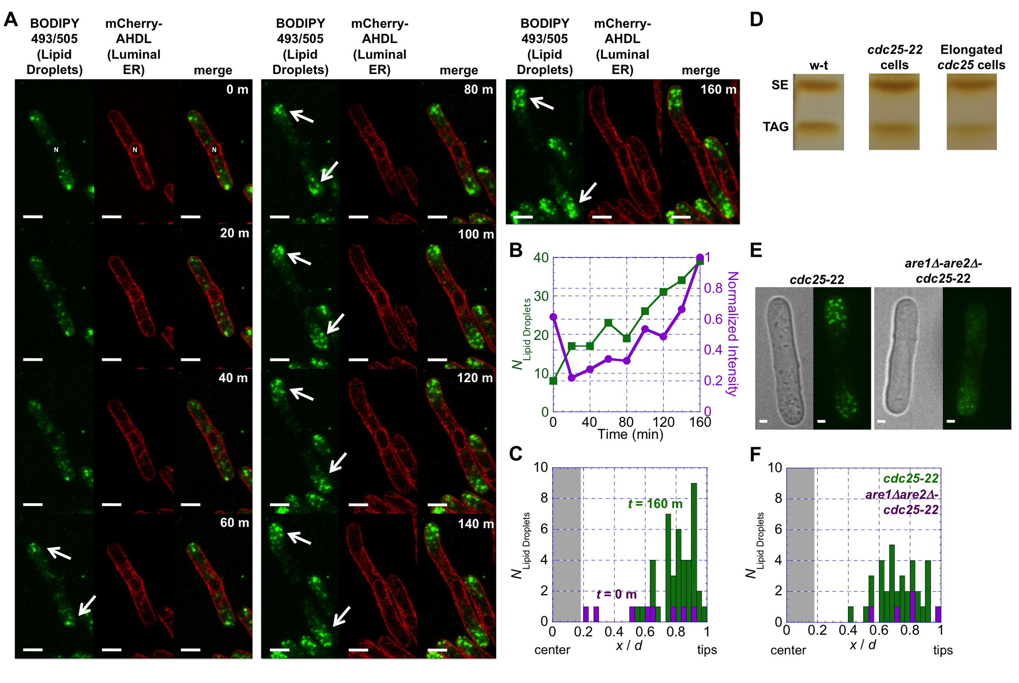

Figure 2-1. Lipid droplets that are enriched in SEs form exclusively at the tips of elongated fission yeast cdc25-22 cells. (A) Confocal microscopy images of cdc25-22 cells expressing the ER luminal marker mCherry-AHDL (red) where the lipid droplets have been stained with BODIPY 493/503 (green). Left panels are maximum intensities of all z-stacks (green), center panels are the middle z-stack (red), and right panels are the sums of the left and center panels. Arrows highlight the increase in the number of lipid droplets at the tips of the cells. Scale bars are 5 microns. (B) Plot of the number (left axis) and normalized intensity (right axis) of the lipid droplets in the cell in (A) as a function of time. (C) Plot of the number of lipid droplets as a function of their cellular position in the cell in (A) at t = 0 min (green) and t = 160 min (purple). The symbol, d, represents the distance from the center of the nucleus to the tip of the cell. The symbol, x, represents the position of the lipid droplet from the center of the nucleus. The gray vertical rectangle represents the position of the nuclear ER. (D) Thin layer chromatography results of the neutral lipid content of lipid droplets isolated from wild-type cells, cdc25-22 cells, and elongated cdc25-22 cells. (E) Bright field (left panels) and maximum intensity of all z-stacks (right panels) for elongated cdc25-22 and are1Δare2Δ-cdc25-22 cells where the lipid droplets have been stained with BODIPY 493/503. Scale bars are 1 micron. (F) Plot of the number of lipid droplets as a function of their cellular position in the cells in (E).

and cortical/peripheral ER domains are still distinguishable by light microscopy and TAG needs for expanding membranes should be minimal.
We induced TAG lipid droplet formation by incubating wild-type cells expressing mCherry-AHDL in yeast media containing 0.1% oleic acid (YPO) for four hours. Not only does oleic acid addition cause the production of TAG, it shut downs the production of SEs in yeast (Connerth et al., 2010). BODIPY 493/503-stained lipid droplets formed distinct and exclusive rings around the nuclear ER in wild-type cells grown in YPO versus cells grown in YE5S media, the latter having BODIPY 493/503-stained lipid droplets throughout their cytoplasms (Figure 2A,B). We also induced TAG lipid droplet formation by growing fission yeast cells to stationary phase where TAG production is active but SE synthesis activity is minimal. In those cells, BODIPY 493/503-stained lipid droplets again formed a distinct ring around the nuclear ER and were absent in the rest of the cytoplasm (Figure 2A,B). The neutral lipid composition of the cells from each set of cells was confirmed by TLC analysis (Figure 2C).
We constructed plh1Δ and dga1Δ strains expressing mCherry-AHDL and repeated the above experiments to determine the relative contributions of each enzyme to nuclear-ER-localized TAG lipid droplet formation. In both strains, BODIPY 493/503-stained lipid droplets were dispersed throughout the cells after incubation in YPO and also after long-term growth to stationary phase in YE5S (Figure 2D-I). The number of lipid droplets in these strains was comparable to that of wild-type cells and TLC analysis showed that these knockout strains had comparable levels of TAG to each other and wild-type cells (Figure 2F,I). Yeast cells lacking both genes (plh1Δdga1Δ) had no droplets around the nuclear ER when grown in YE5S (Figure 2J,K). The same cells were not viable when grown in YPO (Figure S1A,B). Double knockouts showed vesicle-shaped BODIPY 493/503-stained structures when grown to stationary phase in YE5S negating any possible analysis of droplet position (Figure 2J). As expected TAG is not present in these cells (Figure 2L). To confirm that Are1p and Are2p were not responsible for droplet formation around the nuclear ER, we knocked out both genes in a strain expressing mCherry-AHDL and performed the above experiments. BODIPY 493/503-stained lipid droplets formed around the nuclear ER in are1Δare2ΔmCherry-AHDL cells grown in YPO media and also grown to stationary phase in YE5S media, matching the patterns observed in cells expressing all four neutral lipid synthesizing enzymes (Figure 2M,N vs. Figure 2A,B). We used TLC to confirm that the lipid droplets in these cells were exclusively composed of TAG (Figure 2O). In sum, these results indicate that TAG lipid droplets form around the nuclear ER in fission yeast cells.
We next determined the localization of the four enzymes responsible for the final synthesis steps of SE and TAG in both elongated cdc25-22 and wild-type fission yeast cells. We expressed mYFP-Are1p, mYFP-Are2p, mYFP-Dga1p, and mYFP-Plh1p from their native loci under the control of P3nmt1 promoters in cdc25-22 cells and allowed the cells to elongate for ~2.5 hours.
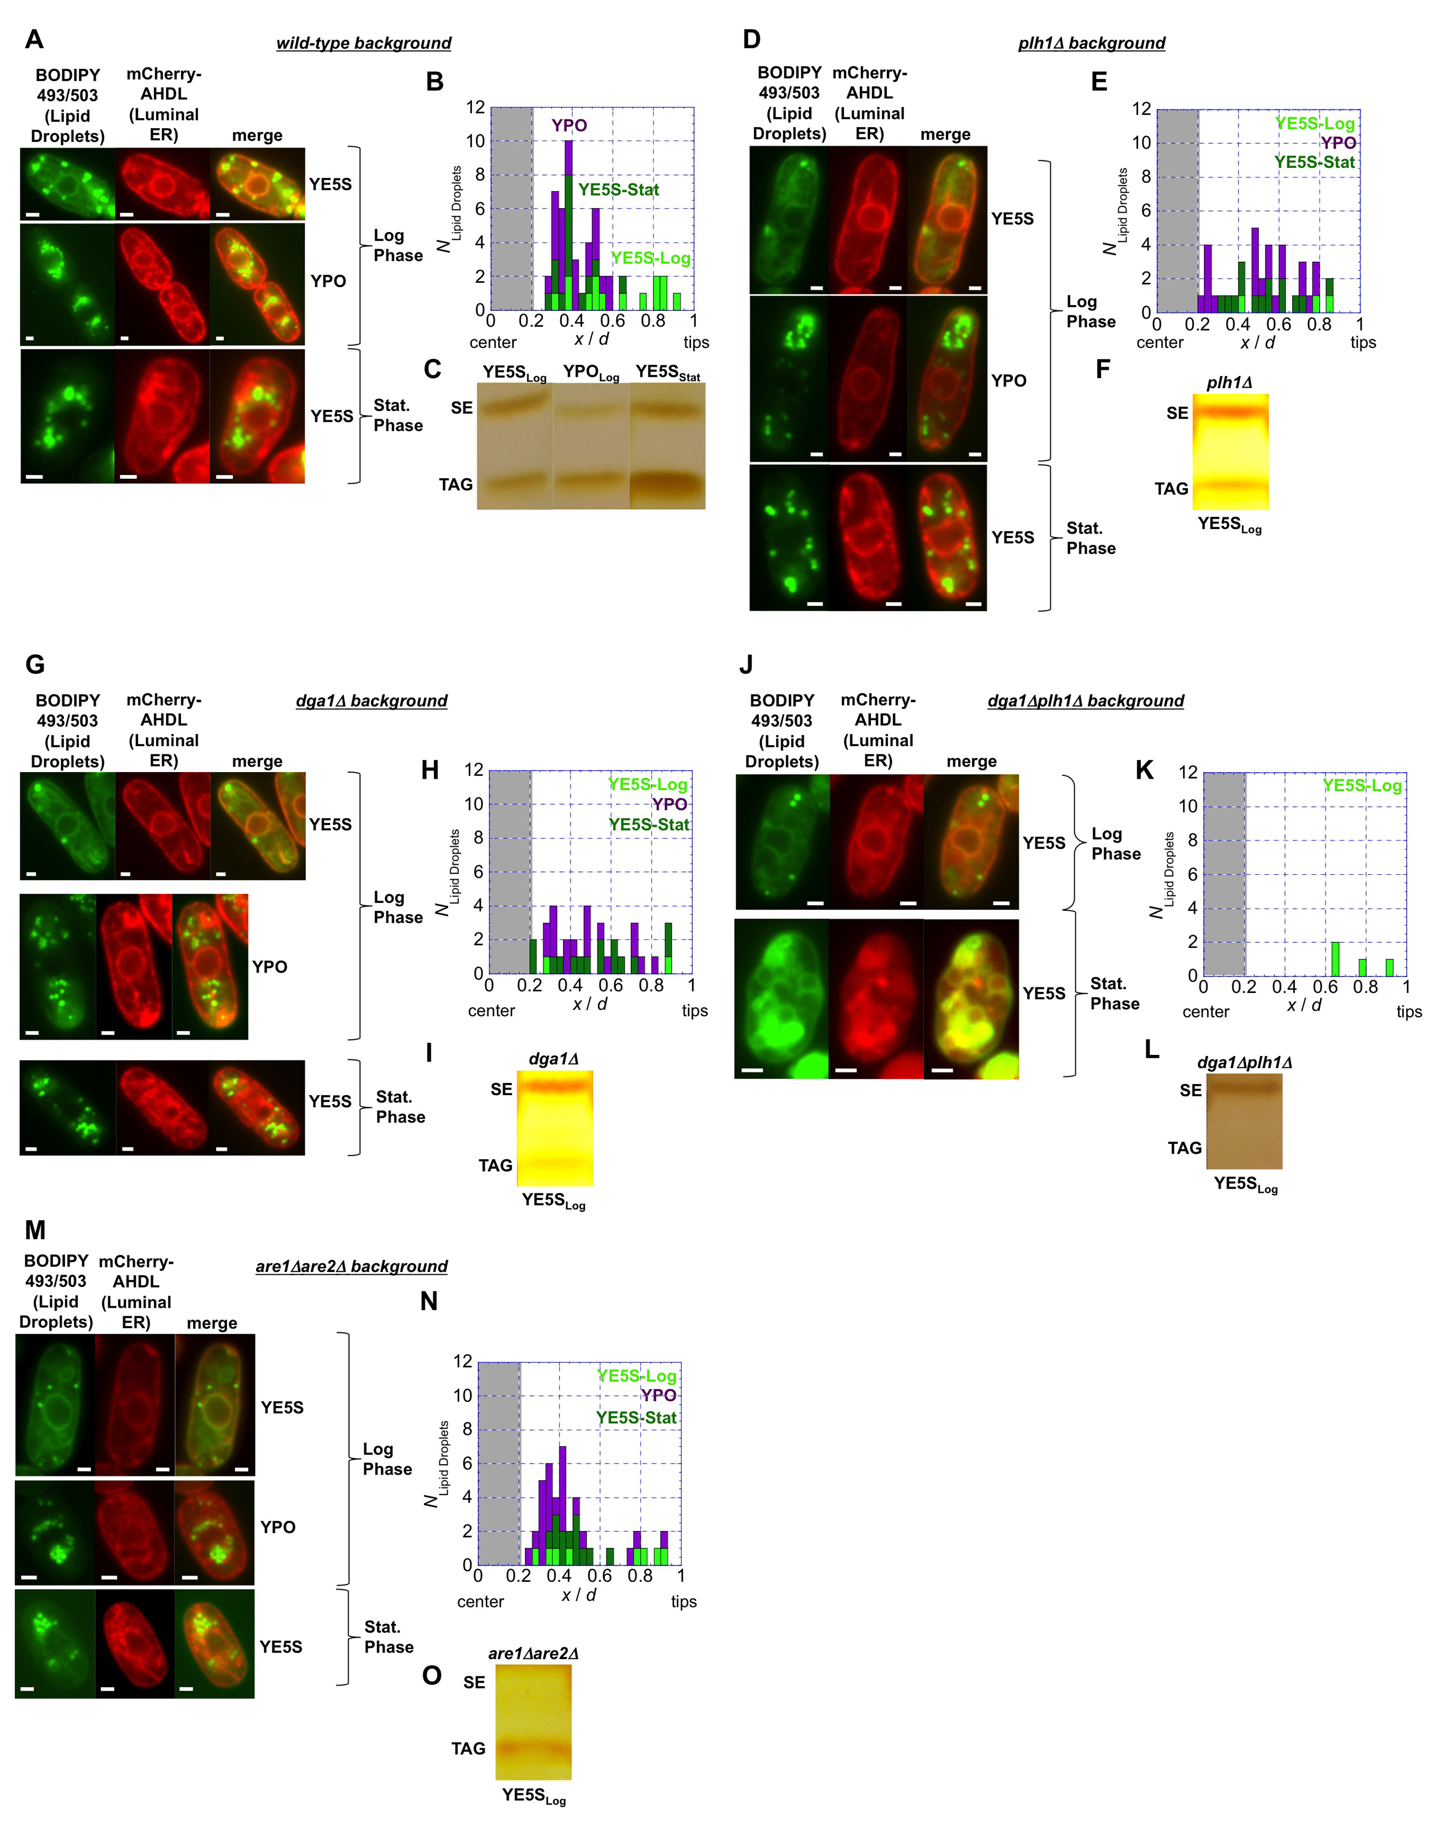

Figure 3-2. TAG lipid droplets form around the nuclear ER by the in fission yeast cells. (A-O) Sets of epi fluorescent micrographs of fission yeast cells that have been stained with BODIPY 493/503 (left panel) that are expressing the ER luminal marker mCherry-AHDL (center panel) and the merger of these two signals (right panel) with accompanying plots of the positions of lipid droplets and TLC analysis of the neutral lipid content of the cells. [Note: we are still collecting and analyzing the TLC data, which is incomplete.] Cells were grown to late log phase in YE5S (top row), YPO (center row), and to stationary phase in YE5S (bottom row) except in (J-L) where cells grown to stationary phase had unstable ER and lipid droplet morphologies and cells incubated in YPO were inviable. Scale bars are 1 micron.

mYFP-Are1p-cdc25-22 and mYFP-Are2-cdc25-22 do not elongate in these experiments; we are working on understanding why this is the case (Figure 3A,B). mYFP-Dga1p and mYFP-Plh1p are present throughout the ER but mYFP-Dga1p had a 200% higher average signal at the nuclear ER over the cortical/peripheral ER at the plasma membrane (Figure 3C) and mYFP-Plh1p showed a ~40% higher average signal at the nuclear ER over the peripheral ER at the plasma membrane as revealed by fluorescent intensity analysis (Figure 3D). We repeated these experiments in wild-type genetic backgrounds and saw similar YFP signal patterns showing that the cdc25-22 temperature sensitive mutant does not affect the localization of these enzymes (Figure 3E-H). Thus, the localization of these four enzymes does not provide sufficient evidence to explain observed spatial differences in lipid droplet formation.
Sterols are localized to sites of active cell growth and cytokinesis [36]. In wild-type and cdc25-22 cells that are in G2 phase of the cell cycle, which are the cells in focus here, the sterol marker filipin is localized to the plasma membrane at the tips of the cells (Wachtler et al., 2003). Therefore, we postulate that the localization of sterol is the main driving factor in the formation and localization of SE-enriched lipid droplets. [This will ultimately go in the Discussion Section. We are currently confirming the filipin results in our own strains.]
We wished to gain further insight into TAG lipid droplet spatial regulation by studying the factors that convert TAG into phospholipids. In yeast, Cpt1p converts DAG – the precursor of TAG - into phosphatidylcholine (PC) in the Kennedy Pathway and Dgk1p converts DAG into phosphatidic acid (PA) (Han et al., 2008, Adeyo et al., 2011, Fakas et al., 2011, Henry et al., 2012). We wished to determine where these factors localized in cdc25-22 and wild-type fission yeast cells to give further insight into the localization of TAG lipid droplets. Cpt1p-mYFP localizes exclusively to the nuclear ER in both elongated cdc25-22 cells and wild-type fission yeast cells (Figure 4A). mYFP-Dgk1p localizes strongly to the nuclear ER in both elongated cdc25-22 cells and wild-type fission yeast cells over the cortical/peripheral ER (Figure 4B).

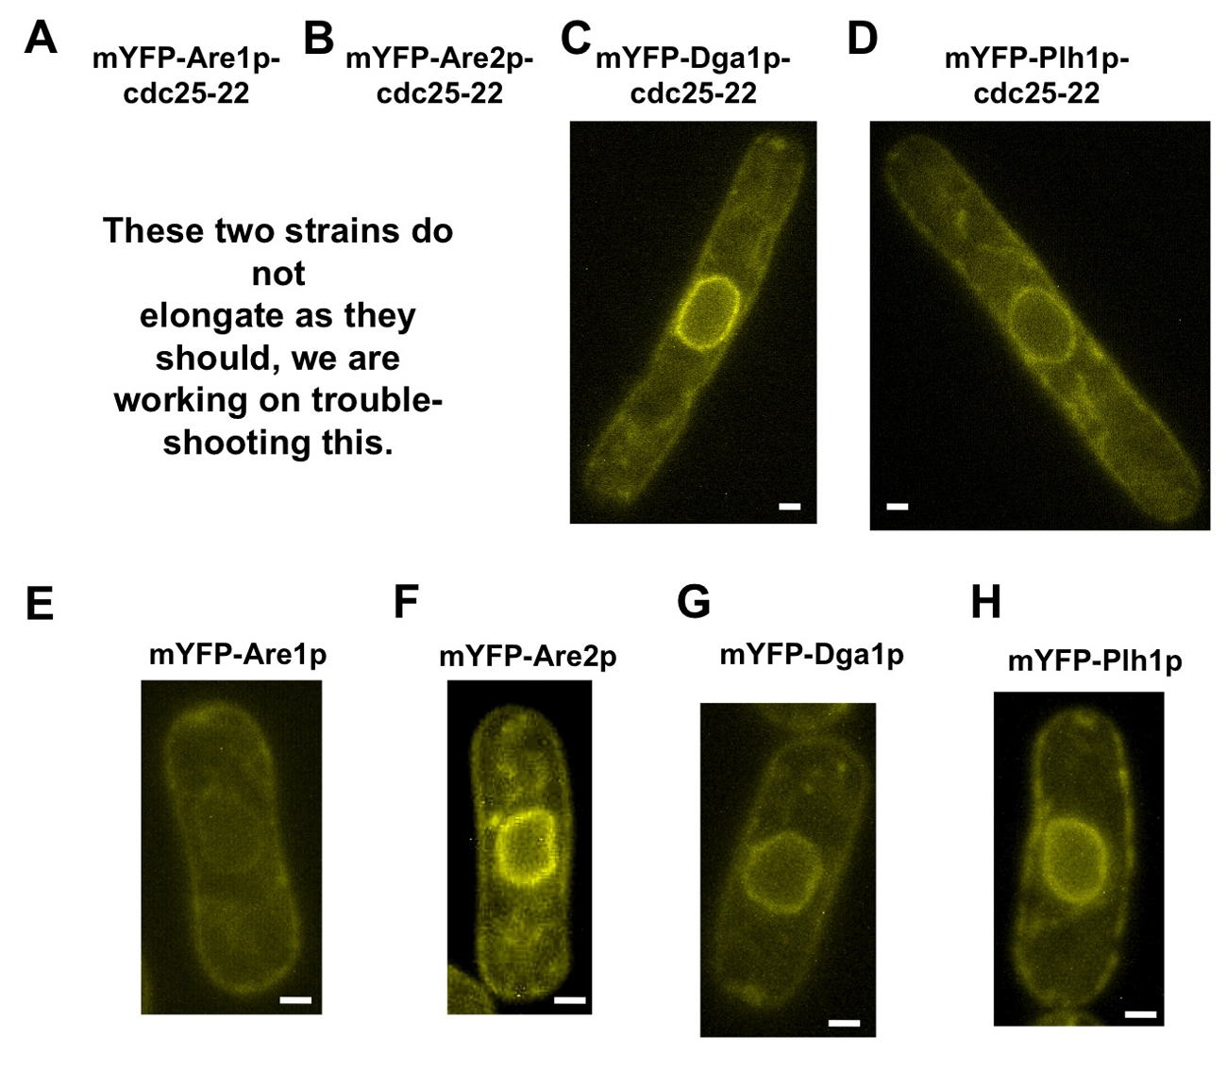

Figure 3-3. Localization of the four key neutral lipid synthesizing enzymes in cells with cdc25-22 and wild-type genetic backgrounds. (A-H) Single focal plane fluorescence micrographs of (A) mYFP-Are1p-cdc25-22, (B) mYFP-Are2p-cdc25-22, [Note: These two strains do not elongate. We are working on determining the reasons for this observation.] (C) mYFP-Dga1p-cdc25-22, (D) mYFP-Plh1p-cdc25-22. (E) mYFP-Are1p, (F) mYFP-Are2p, (G) mYFP-Dga1p, (H) mYFP-Plh1p. All four fusion proteins were expressed from native loci using the P3nmt1 promoter. Scale bars are 1 micron.

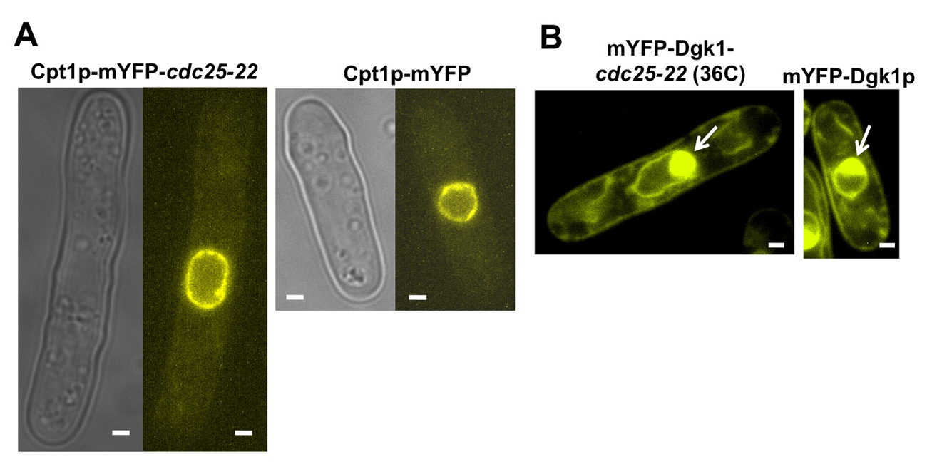

Figure 3-4. Cpt1p and Dgk1p localize strongly to the nuclear ER over the cortical/peripheral ER in elongated cdc25-22 cells and wild-type cells. (A) Phase contrast (left panel) and epi fluorescent (right panel) micrographs of elongated cdc25-22 and wild-type fission yeast cells expressing Cpt1p-mYFP from the native locus. (B) Phase contrast (left panel) and epi fluorescent (right panel) micrographs of elongated cdc25-22 and wild-type fission yeast cells expressing mYFP-Dgk1p from the native locus under control of a P41nmt1 promoter. Scale bars are 1 micron.
3-4 Discussion

Lipid droplets form from the ER but their specific biogenesis locations are only beginning to be elucidated (Kassan et al., 2013, Pol et al., 2014). Here we showed that SE lipid droplets form at the cell tips of elongated cdc25-22 cells when the neutral lipid content of cells is pushed towards SE production over TAG production, and that TAG lipid droplets form around the nucleus of wild-type fission yeast cells when cells form TAG while simultaneously shutting down or greatly reducing SE synthesis. With these results, we propose that SE lipid droplets form from the cortical/peripheral ER away from the nuclear ER and TAG lipid droplets form from the nuclear ER. These results provide insight into lipid droplet formation by showing that droplet neutral lipid content determines where in the cell droplets originate and that SE and TAG may not necessarily flow into the same nascent lipid droplet at the same site on the ER membrane. Results from previous studies on factors involved in the neutral lipid synthesis pathways support our hypothesis.
Lipin gene products bind and convert phosphatidic acid (PA) into DAG, the precursor of TAG. In flies, inhibition of CNEP-1, a nuclear envelope-enriched activator of lipin, leads to the formation of ER sheets in regions of the nuclear envelope (Bahmanyar et al., 2014). The lipin functional ortholog in budding yeast, Pah1p, controls nuclear ER membrane expansion (Siniossoglou, 2009, Fakas et al., 2011, Karanasios et al., 2013) and modulates lipid droplet number and size (Adeyo et al., 2011). Furthermore, the Nem1p-Spo7p complex, which binds Pah1p facilitating the formation of DAG (Adeyo et al., 2011, Karanasios et al., 2013) is localized to the nuclear ER in budding yeast cells (Siniossoglou, 2009). The action of these factors at the nuclear ER provides further evidence that TAG synthesis should be favored at the nuclear ER over the cortical/peripheral ER. In addition, lipid droplets - labeled by BODIPY 493/503 - formed in close proximity to the nucleus in COS7 cells expressing mCherry-Rab18 after 18 hours of incubation in media containing oleate-BSA complexes; almost no droplets were visible in the tubular ER network extending to the periphery in the same cells (Gerondopoulos et al., 2014). The biophysical properties of SEs and TAGs also lend weight to the theory that they could initiate lipid droplet formation at spatially unique sites. Lipid droplets in mammalian cells can be composed entirely of CE or TAG depending on the metabolic function of the tissue (Khor et al., 2014, Kraemer, 2007). Furthermore, SE and TAG droplets can be mutually exclusive as both experimental and computational results previously showed (Czabany et al., 2008, Hsieh et al., 2012).
TAG breakdown is equally insightful for understanding droplet localization. TAG is mobilized for phospholipid synthesis during yeast growth such as during the elongation of cdc25-22 cells or when wild-type cells are taken from dormancy and placed into a nutrient-rich environment (Fakas et al., 2011). In these situations, lipid droplet localized lipases break down TAG into a free fatty acid and DAG. Cpt1p converts DAG into PC and Dgk1p converts DAG into PA. It has been suggested that nascent phospholipids that could support lipid droplet expansion could be synthesized in the neighboring ER by Cpt1p activity (Krahmer et al., 2011). If that is the case, the localization of Cpt1p-mYFP exclusively to the nuclear ER in both cdc25-22 and wild-type fission yeast cells would support our hypothesis that TAG lipid droplets are synthesized there. GFP-Dgk1p localizes to the nuclear ER over the peripheral ER in budding yeast cells (Han et al., 2008). Also, Dgk1p overexpression in budding yeast causes proliferation of the nuclear ER membrane but not the cortical ER membrane (Han et al., 2008). The fact that Dgk1p is localized to and functions at the nuclear ER membrane – like lipin - leads to the conclusion that TAG lipid droplets should form at the nuclear ER and also remain close to the nuclear ER post-formation for further processing.
The morphology of the ER could also play a role in spatially regulated lipid droplet formation. The nuclear ER is comprised mostly of sheets whereas the cortical/peripheral ER contains tubular, highly curved regions (Voeltz et al., 2002, Shibata et al., 2006, Voeltz et al., 2006, Hu et al., 2008, Hu et al., 2009, Shibata et al., 2010, Zhang et al., 2010, Lin et al., 2012). It can be hypothesized that different formation energies would be needed for droplets to emerge from sheet versus tubular membrane geometries. In fission yeast, the tetra-spanning protein1 (Tts1p) and the reticulons (Rtn1p) and DPI (Yop1p) function together to maintain the shape of the tubular ER (De Craene et al., 2006, Voeltz et al., 2006, Hu et al., 2008, Shibata et al., 2008, Zhang et al., 2010) with other factors such as atlastins and lunapark family proteins being recently identified as also having influence on ER morphology and ultimately lipid droplet size (Chen et al., 2012, Klemm et al., 2013, Moriya et al., 2013). These factors are all intriguing targets that could contributing to lipid droplet formation by modulating local ER membrane curvature. Indeed, lipid droplet structures of ~250 nm have very recently been seen localized to ER tubules (Kassan et al., 2013, Pol et al., 2014). Although we documented TAG droplet formation around the nuclear ER, which is typically associated with a sheet-like geometry, the ER tubulation factors Tts1p and Ypo1p both partially localize to the nuclear ER in fission yeast showing that regions of the nuclear ER could be tubular (Zhang et al., 2010).

3-5 Appendix

ADEYO, O., HORN, P. J., LEE, S., BINNS, D. D., CHANDRAHAS, A., CHAPMAN, K. D. & GOODMAN, J. M. 2011. The yeast lipin orthologue Pah1p is important for biogenesis of lipid droplets. J Cell Biol, 192, 1043-55.
AYCIRIEX, S., LE GUEDARD, M., CAMOUGRAND, N., VELOURS, G., SCHOENE, M., LEON, S., WATTELET-BOYER, V., DUPUY, J.-W., SHEVCHENKO, A., SCHMITTER, J.-M., LESSIRE, R., BESSOULE, J.-J. & TESTET, E. 2012. YPR139c/LOA1 encodes a novel lysophosphatidic acid acyltransferase associated with lipid droplets and involved in TAG homeostasis. Molecular Biology of the Cell, 23, 233-246.
BAHLER, J., WU, J. Q., LONGTINE, M. S., SHAH, N. G., MCKENZIE, A., STEEVER, A. B., WACH, A., PHILIPPSEN, P. & PRINGLE, J. R. 1998. Heterologous modules for efficient and versatile PCR-based gene targeting in Schizosaccharomyces pombe. Yeast, 14, 943-951.
BAHMANYAR, S., BIGGS, R., SCHUH, A. L., DESAI, A., MUELLER-REICHERT, T., AUDHYA, A., DIXON, J. E. & OEGEMA, K. 2014. Spatial control of phospholipid flux restricts endoplasmic reticulum sheet formation to allow nuclear envelope breakdown. Genes & Development, 28, 121-126.
BELLER, M., THIEL, K., THUL, P. J. & JAECKLE, H. 2010. Lipid droplets: A dynamic organelle moves into focus. Febs Letters, 584, 2176-2182.
BINNS, D., JANUSZEWSKI, T., CHEN, Y., HILL, J., MARKIN, V. S., ZHAO, Y. M., GILPIN, C., CHAPMAN, K. D., ANDERSON, R. G. W. & GOODMAN, J. M. 2006. An intimate collaboration between peroxisomes and lipid bodies. Journal of Cell Biology, 173, 719-731.
CERMELLI, S., GUO, Y., GROSS, S. P. & WELTE, M. A. 2006. The lipid-droplet proteome reveals that droplets are a protein-storage depot. Current Biology, 16, 1783-1795.
CHEN, S. L., NOVICK, P. & FERRO-NOVICK, S. 2012. ER network formation requires a balance of the dynamin-like GTPase Sey1p and the Lunapark family member Lnp1p. Nature Cell Biology, 14, 707-716.
CHOUDHARY, V., JACQUIER, N. & SCHNEITER, R. 2011. The topology of the triacylglycerol synthesizing enzyme Lro1 indicates that neutral lipids can be produced within the luminal compartment of the endoplasmatic reticulum: Implications for the biogenesis of lipid droplets. Communicative & integrative biology, 4, 781-4.
CONNERTH, M., CZABANY, T., WAGNER, A., ZELLNIG, G., LEITNER, E., STEYRER, E. & DAUM, G. 2010. Oleate Inhibits Steryl Ester Synthesis and Causes Liposensitivity in Yeast. Journal of Biological Chemistry, 285, 26832-26841.
CZABANY, T., WAGNER, A., ZWEYTICK, D., LOHNER, K., LEITNER, E., INGOLIC, E. & DAUM, G. 2008. Structural and biochemical properties of lipid particles from the yeast Saccharomyces cerevisiae. Journal of Biological Chemistry, 283, 17065-17074.
DE CRAENE, J. O., COLEMAN, J., DE MARTIN, P. E., PYPAERT, M., ANDERSON, S., YATES, J. R., FERRO-NOVICK, S. & NOVICK, P. 2006. Rtn1p is involved in structuring the cortical endoplasmic reticulum. Molecular Biology of the Cell, 17, 3009-3020.
FAKAS, S., KONSTANTINOU, C. & CARMAN, G. M. 2011. DGK1-encoded Diacylglycerol Kinase Activity Is Required for Phospholipid Synthesis during Growth Resumption from Stationary Phase in Saccharomyces cerevisiae. Journal of Biological Chemistry, 286, 1464-1474.
FANTES, P. A. 1981. ISOLATION OF CELL-SIZE MUTANTS OF A FISSION YEAST BY A NEW SELECTIVE METHOD - CHARACTERIZATION OF MUTANTS AND IMPLICATIONS FOR DIVISION CONTROL MECHANISMS. Journal of Bacteriology, 146, 746-754.
FARESE, R. V. & WALTHER, T. C. 2009. Lipid Droplets Finally Get a Little R-E-S-P-E-C-T. Cell, 139, 855-860.
FORSBURG, S. L. & SHERMAN, D. A. 1997. General purpose tagging vectors for fission yeast. Gene, 191, 191-195.
FUJIMOTO, T. & PARTON, R. G. 2011. Not just fat: the structure and function of the lipid droplet. Cold Spring Harb Perspect Biol, 3.
GARBARINO, J., PADAMSEE, M., WILCOX, L., OELKERS, P. M., D'AMBROSIO, D., RUGGLES, K. V., RAMSEY, N., JABADO, O., TURKISH, A. & STURLEY, S. L. 2009. Sterol and Diacylglycerol Acyltransferase Deficiency Triggers Fatty Acid-mediated Cell Death. Journal of Biological Chemistry, 284, 30994-31005.
GERONDOPOULOS, A., BASTOS, R. N., YOSHIMURA, S.-I., ANDERSON, R., CARPANINI, S., ALIGIANIS, I., HANDLEY, M. T. & BARR, F. A. 2014. Rab18 and a Rab18 GEF complex are required for normal ER structure. Journal of Cell Biology, 205, 707-720.
GOODMAN, J. M. 2009. Demonstrated and inferred metabolism associated with cytosolic lipid droplets. Journal of Lipid Research, 50, 2148-2156.
GRILLITSCH, K., CONNERTH, M., KOFELER, H., ARREY, T. N., RIETSCHEL, B., WAGNER, B., KARAS, M. & DAUM, G. 2011. Lipid particles/droplets of the yeast Saccharomyces cerevisiae revisited: Lipidome meets Proteome. Biochimica Et Biophysica Acta-Molecular and Cell Biology of Lipids, 1811, 1165-1176.
HAN, G. S., O'HARA, L., CARMAN, G. M. & SINIOSSOGLOU, S. 2008. An unconventional diacylglycerol kinase that regulates phospholipid synthesis and nuclear membrane growth. Journal of Biological Chemistry, 283, 20433-20442.
HENRY, S. A., KOHLWEIN, S. D. & CARMAN, G. M. 2012. Metabolism and Regulation of Glycerolipids in the Yeast Saccharomyces cerevisiae. Genetics, 190, 317-349.
HJELMSTAD, R. H. & BELL, R. M. 1987. MUTANTS OF SACCHAROMYCES-CEREVISIAE DEFECTIVE IN SN-1,2-DIACYLGLYCEROL CHOLINEPHOSPHOTRANSFERASE - ISOLATION, CHARACTERIZATION, AND CLONING OF THE CPT1-GENE. Journal of Biological Chemistry, 262, 3909-3917.
HORVATH, S. E., WAGNER, A., STEYRER, E. & DAUM, G. 2011. Metabolic link between phosphatidylethanolamine and triacylglycerol metabolism in the yeast Saccharomyces cerevisiae. Biochimica Et Biophysica Acta-Molecular and Cell Biology of Lipids, 1811, 1030-1037.
HSIEH, K., LEE, Y. K., LONDOS, C., RAAKA, B. M., DALEN, K. T. & KIMMEL, A. R. 2012. Perilipin family members preferentially sequester to either triacylglycerol-specific or cholesteryl-ester-specific intracellular lipid storage droplets. Journal of Cell Science, 125, 4067-4076.
HU, J., SHIBATA, Y., VOSS, C., SHEMESH, T., LI, Z., COUGHLIN, M., KOZLOV, M. M., RAPOPORT, T. A. & PRINZ, W. A. 2008. Membrane proteins of the endoplasmic reticulum induce high-curvature tubules. Science, 319, 1247-1250.
HU, J., SHIBATA, Y., ZHU, P.-P., VOSS, C., RISMANCHI, N., PRINZ, W. A., RAPOPORT, T. A. & BLACKSTONE, C. 2009. A Class of Dynamin-like GTPases Involved in the Generation of the Tubular ER Network. Cell, 138, 549-561.
JACQUIER, N., CHOUDHARY, V., MARI, M., TOULMAY, A., REGGIORI, F. & SCHNEITER, R. 2011. Lipid droplets are functionally connected to the endoplasmic reticulum in Saccharomyces cerevisiae. Journal of Cell Science, 124, 2424-2437.
KARANASIOS, E., BARBOSA, A. D., SEMBONGI, H., MARI, M., HAN, G. S., REGGIORI, F., CARMAN, G. M. & SINIOSSOGLOU, S. 2013. Regulation of lipid droplet and membrane biogenesis by the acidic tail of the phosphatidate phosphatase Pah1p. Mol Biol Cell, 24, 2124-33.
KASSAN, A., HERMS, A., FERNANDEZ-VIDAL, A., BOSCH, M., SCHIEBER, N. L., REDDY, B. J. N., FAJARDO, A., GELABERT-BALDRICH, M., TEBAR, F., ENRICH, C., GROSS, S. P., PARTON, R. G. & POL, A. 2013. Acyl-CoA synthetase 3 promotes lipid droplet biogenesis in ER microdomains. Journal of Cell Biology, 203, 985-1001.
KHOR, V. K., AHRENDS, R., LIN, Y., SHEN, W.-J., ADAMS, C. M., ROSEMAN, A. N., CORTEZ, Y., TERUEL, M. N., AZHAR, S. & KRAEMER, F. B. 2014. The Proteome of Cholesteryl-Ester-Enriched Versus Triacylglycerol-Enriched Lipid Droplets. Plos One, 9.
KLEMM, R. W., NORTON, J. P., COLE, R. A., LI, C. S., PARK, S. H., CRANE, M. M., LI, L. Y., JIN, D., BOYE-DOE, A., LIU, T. Y., SHIBATA, Y., LU, H., RAPOPORT, T. A., FARESE, R. V., BLACKSTONE, C., GUO, Y. & MAK, H. Y. 2013. A Conserved Role for Atlastin GTPases in Regulating Lipid Droplet Size. Cell Reports, 3, 1465-1475.
KOHLWEIN, S. D. 2010. Triacylglycerol Homeostasis: Insights from Yeast. Journal of Biological Chemistry, 285, 15663-15667.
KRAEMER, F. B. 2007. Adrenal cholesterol utilization. Molecular and Cellular Endocrinology, 265, 42-45.
KRAHMER, N., GUO, Y., WILFLING, F., HILGER, M., LINGRELL, S., HEGER, K., NEWMAN, H. W., SCHMIDT-SUPPRIAN, M., VANCE, D. E., MANN, M., FARESE, R. V., JR. & WALTHER, T. C. 2011. Phosphatidylcholine Synthesis for Lipid Droplet Expansion Is Mediated by Localized Activation of CTP:Phosphocholine Cytidylyltransferase. Cell Metabolism, 14, 504-515.
KURAT, C. F., NATTER, K., PETSCHNIGG, J., WOLINSKI, H., SCHEURINGER, K., SCHOLZ, H., ZIMMERMANN, R., LEBER, R., ZECHNER, R. & KOHLWEIN, S. D. 2006. Obese yeast: Triglyceride lipolysis is functionally conserved from mammals to yeast. Journal of Biological Chemistry, 281, 491-500.
LEBER, R., ZINSER, E., ZELLNIG, G., PALTAUF, F. & DAUM, G. 1994. CHARACTERIZATION OF LIPID PARTICLES OF THE YEAST, SACCHAROMYCES-CEREVISIAE. Yeast, 10, 1421-1428.
LIN, S., SUN, S. & HU, J. 2012. Molecular basis for sculpting the endoplasmic reticulum membrane. International Journal of Biochemistry & Cell Biology, 44, 1436-1443.
LONG, A. P., MANNESCHMIDT, A. K., VERBRUGGE, B., DORTCH, M. R., MINKIN, S. C., PRATER, K. E., BIGGERSTAFF, J. P., DUNLAP, J. R. & DALHAIMER, P. 2012. Lipid Droplet De Novo Formation and Fission Are Linked to the Cell Cycle in Fission Yeast. Traffic, 13, 705-714.
MARKGRAF, D. F., KLEMM, R. W., JUNKER, M., HANNIBAL-BACH, H. K., EJSING, C. S. & RAPOPORT, T. A. 2014. An ER Protein Functionally Couples Neutral Lipid Metabolism on Lipid Droplets to Membrane Lipid Synthesis in the ER. Cell Reports, 6, 44-55.
MARTIN, S. & PARTON, R. G. 2006. Lipid droplets: a unified view of a dynamic organelle. Nature Reviews Molecular Cell Biology, 7, 373-378.
MORENO, S., KLAR, A. & NURSE, P. 1991. MOLECULAR GENETIC-ANALYSIS OF FISSION YEAST SCHIZOSACCHAROMYCES-POMBE. Methods in Enzymology, 194, 795-823.
MORIYA, K., NAGATOSHI, K., NORIYASU, Y., OKAMURA, T., TAKAMITSU, E., SUZUKI, T. & UTSUMI, T. 2013. Protein N-Myristoylation Plays a Critical Role in the Endoplasmic Reticulum Morphological Change Induced by Overexpression of Protein Lunapark, an Integral Membrane Protein of the Endoplasmic Reticulum. Plos One, 8.
POL, A., GROSS, S. P. & PARTON, R. G. 2014. Biogenesis of the multifunctional lipid droplet: Lipids, proteins, and sites. Journal of Cell Biology, 204, 636-646.
ROBENEK, H., HOFNAGEL, O., BUERS, I., ROBENEK, M. J., TROYER, D. & SEVERS, N. J. 2006. Adipophilin-enriched domains in the ER membrane are sites of lipid droplet biogenesis. Journal of Cell Science, 119, 4215-4224.
RUSSELL, P. & NURSE, P. 1986. CDC25+ FUNCTIONS AS AN INDUCER IN THE MITOTIC CONTROL OF FISSION YEAST. Cell, 45, 145-153.
SHIBATA, Y., SHEMESH, T., PRINZ, W. A., PALAZZO, A. F., KOZLOV, M. M. & RAPOPORT, T. A. 2010. Mechanisms Determining the Morphology of the Peripheral ER. Cell, 143, 774-788.
SHIBATA, Y., VOELTZ, G. K. & RAPOPORT, T. A. 2006. Rough sheets and smooth tubules. Cell, 126, 435-439.
SHIBATA, Y., VOSS, C., RIST, J. M., HU, J., RAPOPORT, T. A., PRINZ, W. A. & VOELTZ, G. K. 2008. The reticulon and DP1/Yop1p proteins form immobile oligomers in the tubular endoplasmic reticulum. Journal of Biological Chemistry, 283, 18892-18904.
SHIN, G. H., VEEN, M., STARK, R. & LANG, C. 2012. Overexpression of genes of the fatty acid biosynthetic pathway leads to accumulation of sterols in Saccharomyces cerevisiae. Yeast, 29, 371-383.
SINIOSSOGLOU, S. 2009. Lipins, Lipids and Nuclear Envelope Structure. Traffic, 10, 1181-1187.
SORGER, D. & DAUM, G. 2002. Synthesis of triacylglycerols by the acyl-coenzyme A: Diacyl-glycerol acyltransferase Dga1p in lipid particles of the yeast Saccharomyces cerevisiae. Journal of Bacteriology, 184, 519-524.
TA, M. T., KAPTERIAN, T. S., FEI, W., DU, X., BROWN, A. J., DAWES, I. W. & YANG, H. 2012. Accumulation of squalene is associated with the clustering of lipid droplets. Febs Journal, 279, 4231-4244.
VOELTZ, G. K., PRINZ, W. A., SHIBATA, Y., RIST, J. M. & RAPOPORT, T. A. 2006. A class of membrane proteins shaping the tubular endoplasmic reticulum. Cell, 124, 573-586.
VOELTZ, G. K., ROLLS, M. M. & RAPOPORT, T. A. 2002. Structural organization of the endoplasmic reticulum. Embo Reports, 3, 944-950.
WACHTLER, V., RAJAGOPALAN, S. & BALASUBRAMANIAN, M. K. 2003. Sterol-rich plasma membrane domains in the fission yeast Schizosaccharomyces pombe. Journal of Cell Science, 116, 867-874.
WALTHER, T. C. & FARESE, R. V. 2009. The life of lipid droplets. Biochimica Et Biophysica Acta-Molecular and Cell Biology of Lipids, 1791, 459-466.
WOLINSKI, H., KOLB, D., HERMANN, S., KONING, R. I. & KOHLWEIN, S. D. 2011. A role for seipin in lipid droplet dynamics and inheritance in yeast. Journal of Cell Science, 124, 3894-3904.
XU, N., ZHANG, S. O., COLE, R. A., MCKINNEY, S. A., GUO, F., HAAS, J. T., BOBBA, S., FARESE, R. V., JR. & MAK, H. Y. 2012. The FATP1-DGAT2 complex facilitates lipid droplet expansion at the ER-lipid droplet interface. J Cell Biol, 198, 895-911.
ZHANG, D., VJESTICA, A. & OLIFERENKO, S. 2010. The Cortical ER Network Limits the Permissive Zone for Actomyosin Ring Assembly. Current Biology, 20, 1029-1034.
ZWEYTICK, D., LEITNER, E., KOHLWEIN, S. D., YU, C. J., ROTHBLATT, J. & DAUM, G. 2000. Contribution of Are1p and Are2p to steryl ester synthesis in the yeast Saccharomyces cerevisiae. European Journal of Biochemistry, 267, 1075-1082.

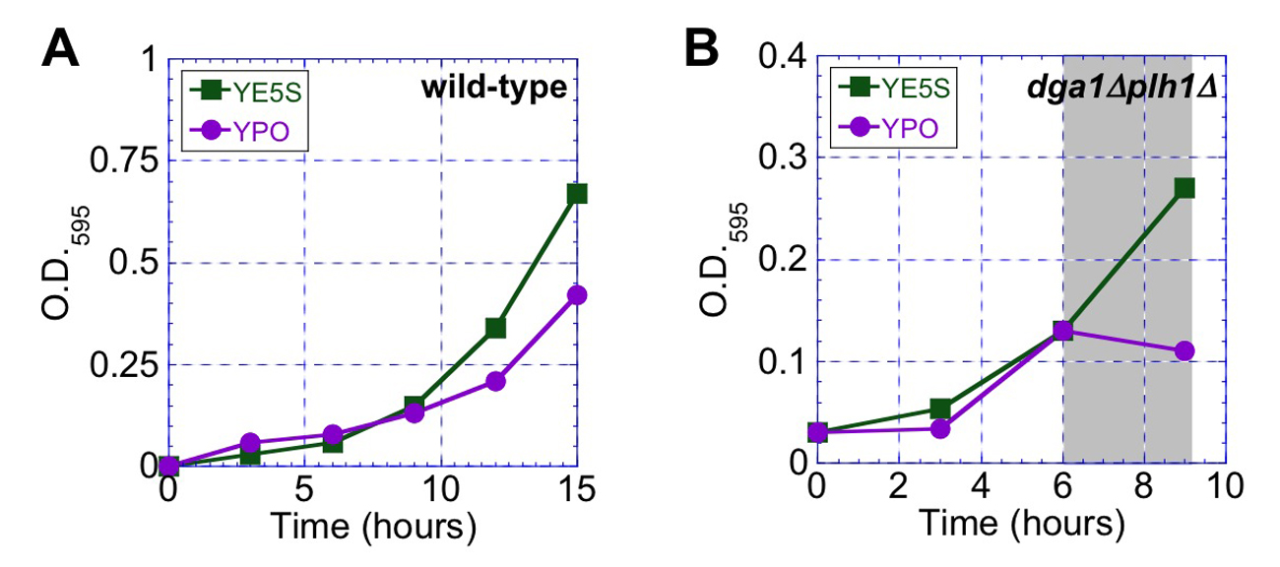

Figure S1. (A) Growth curves of fission yeast cells expressing mCherry-AHDL grown in YE5S (green squares) versus YPO (purple circles). (B) Growth curves of fission yeast cells expressing mCherry-AHDL with dga1Δplh1Δ grown in YE5S (green squares) versus YE5S followed by YPO (purple circles). The switch in media is indicated by the gray rectangle.

CHAPTER 4

INVESTIGATING CROSSTALK BETWEEN KEY GENES RESPONSIBLE FOR DROPLET FORMATION

4-1 Introduction

4-2 Materials and Methods

4-3 Results

4-4 Discussion

4-5 References

CHAPTER 5

MAXIMIZING TRIACYLGLYCEROL PRODUCTION IN THE FISSION YEAST SCHIZOSACCHAROMYCES POMBE FOR BIOFUEL APPLICATIONS

5-1 Introduction

5-2 Materials and Methods

5-3 Results

5-4 Discussion

5-5 References

CHapter 6

CONCLUSION and future work

6-1 Conclusion

6-2 Future work

VITA

Alexander W. Meyers was born. He wrote a thesis. He graduated. This page really is required.

