To the Graduate Council:
I am submitting herewith a dissertation written by Prabhakar Virupaksh Gulgunje entitled “Investigation of the Processing, Structure and Properties of Poly(phenylene sulfide) (PPS) Melt Spun Fibers.” I have examined the final electronic copy of this dissertation for form and content and recommend that it be accepted in partial fulfillment of the requirements for the degree of Doctor of Philosophy, with a major in Polymer Engineering.

Gajanan Bhat, Major Professor

We have read this dissertation
and recommend its acceptance:

Joseph Spruiell

Kevin Kit

Jimmy Mays

Accepted for the Council:

Carolyn R. Hodges, Vice Provost and
Dean of the Graduate School

(Original signatures are on file with official student records.)

Investigation of the processing, structure and properties of poly(phenylene sulfide) (PPS) melt spun fibers

A Dissertation Presented for the
Doctor of Philosophy
Degree
The University of Tennessee, Knoxville

Prabhakar V. Gulgunje
May 2010

Copyright © 2009 by Prabhakar Gulgunje.
All rights reserved.

Dedication

This dissertation is dedicated to my grandfather,
Late Dattatreya Vanungare

Acknowledgements
I express my sincere gratitude to the advisor, Dr. Gajanan Bhat for providing me the great opportunity to work on this dissertation. He has also been a great mentor, both in academic as well as in personal life, since I joined UT, Knoxville. His kind, patient support and guidance when needed have strengthened my analytical abilities that have led to encouraging results from present dissertation as well as have made me a responsible scientizen. I am greatly thankful to Dr. Joseph Spruiell for his expert guidance while carrying out numerous studies using X-ray diffraction, fiber spinning etc., for fruitful discussions on several issues, and for encouragement throughout the research. I am also thankful to Dr. Kevin Kit for his time and guidance over the polymer processing issues and to Dr. Jimmy Mays for providing his expert opinion and guidance on the issues related to molecular weight characterization of polymers under study. I am indebted to all of the above UTK professors for serving on my doctoral committee. I greatly acknowledge the support and guidance provided by Dr. Roberto Benson, Dr. Wei He, Dr. Bin Hu, Dr. David Joy, Dr. Larry Wadsworth and Dr. Randall Bresee, through coursework and while fulfilling the doctoral academic requirements.
I am grateful to Ticona Polymers, a business of Celanese Chemicals for funding this research project, and providing Fortron® resins for study. Especially I would like to thank Dr. Manoj Ajbani (Ticona) for his kind support towards this project in the midst of economic downturn. I acknowledge the guidance provided by Dr. Ke Feng and Lisa Baker (Both from Ticona) through continued interaction and for providing the inputs from customers’ perspectives.
I am thankful to Doug Fielden, Larry Smith and Danny Hackworth for their timely help on machinery aspects, mainly the Fourne extruder, which made it possible to complete the research in given time. I thank Brad Snyder, Stephen Stiner and Gregory Jones for their quick and timely help on several electric and electronic equipment issues. I also thank Frank Holliway and Randy Stooksbury for their prompt help on materials related issues. I also acknowledge the help rendered by MSE office staff Carla Lawrence, Susan Seymour, Sandra Maples, Carolyn Nelson, David Stansbury. I thank Tom Malmgren from the Department of Chemistry, for characterizing the resins for molecular weight by gel permeation chromatography.
I would like to thank my friends, Keyur Desai, Ganesha Kamath, Raghavendra Hegde, Chris Eash, Bruce Fraser and his family, Shambhunath Choudhury, Anoop Samant, Munyarazi Mundawa, Dr. Rohit Uppal, UT Housing staff and several others whom I met in Knoxville for their support throughout the stay in U.S. I acknowledge the help rendered by Hatice Mercimek while carrying out crystallization kinetics of polymers. I am also extremely grateful to Dr. V. B. Gupta, Dr. R. Alagirusamy, other professors at IIT Delhi, numerous teachers in earlier education, and Mr. Debasish Banerjee who mentored me while working in acrylic fiber industry, for their technical guidance and support. I thank my longtime friends Shirish, Vinayak, Amol, Naveen, Sukumar, Chandan, Rajendra, Narendra, Chandrakant and others for their support and guidance over the years.
It is beyond words to express my gratitude towards my father Mr. Virupaksh Gulgunje and mother Mrs. Mahadevi Gulgunje, who have worked hard against all odds to ensure that I pursue the dream of higher education. I am extremely thankful to my brother Prashant, cousins Subhash, Saroj and Surekha, aunt Shanta Miraje and uncle Maruti Miraje, In-laws Mrs. Parvati Mahant and Mr. Sudhakar Mahant, and other relatives for showering unending love and moral support throughout. I am indebted to my grandparents, especially late Dattatreya Vanungare, who has been my greatest mentor on the personal life-front. I sincerely acknowledge my wife, Sarojini for being with me through all the ups and downs, for providing moral support and unconditional love, for understanding and forgiving my mistakes, for taking utmost care of the family and letting me focus on the dissertation. We are thankful to God for blessing us with adorable daughter, Samruddhi, who has made our life most enjoyable, and has strengthened the purpose of our life.

Abstract
The structure and properties relationship in fibers spun from flexible chain polymers, poly(ethylene terephthalate), polypropylene, etc. has been widely studied. Also, considerable amount of work is reported in fibers spun from rigid rod polymers like poly(p-phenylene terephthalamide). However, limited literature is available on the structure-properties relationship in fibers manufactured from PPS, which possesses chain flexibility between above two classes of polymers. A few researchers have studied its crystallization kinetics and the fiber manufacture using capillary rheometers. However, there is a lack of in-depth study of structure-properties development in PPS fibers produced using melt spinning equipment, followed by drawing and annealing.
The purpose of the present research was to systematically study the fiber manufacture from PPS polymers. Four variances of proprietary Fortron® linear PPS resins differing in MW were analyzed for characteristics such as molecular weight (MW) and MW distribution (MWD) using gel permeation chromatography, rheological properties using melt flow indexer and capillary extrusion rheometer, and crystallization kinetics using differential scanning calorimetry (DSC). The fibers were spun on a pilot melt spinning facility, using a multi-hole spinneret, under different processing conditions. As-spun fibers were drawn and annealed subsequently by varying draw-annealing conditions. Thorough characterization of the as-spun and draw-annealed fibers was carried out using various techniques such as tensile testing, DSC, polarized light optical microscopy, wide angle X-ray scattering, and small angle X-ray scattering.
A statistically significant relationship between polymer MW, processing conditions and processing behavior during melt spinning and draw-annealing, fiber tensile properties and morphology is reported herein. Interaction effects of material and process variables in evolving fiber structure and properties are discussed. Through optimal combination of material and process variables, PPS fibers of tenacity close to six gpd were obtained. Probable structural model of high tenacity PPS fibers is proposed by considering the fiber tensile properties and morphology.

Table of Contents
Chapter 1. Introduction 1
Chapter 2. Literature review 3
2.1 What is PPS 3
2.1.1 Chemical structure of PPS 3
2.1.2 Development of PPS polymer: historical perspective 4
2.2 Polymerization of PPS 5
2.2.1 Process details 5
2.2.2 Enhancement of thermal stability 8
2.3 Properties of PPS 9
2.3.1 Physical Properties 9
2.3.2 Chemical and solvent resistance 9
2.3.3 Solubility of PPS 9
2.3.4 Thermal Properties 12
2.3.5 Optical properties 15
2.3.6 Pyrolysis 16
2.4 Applications 17
2.5 Morphological studies of PPS 19
2.5.1 Crystal Structure 19
2.5.2 Density 22
2.5.3 Degree of crystallinity 23
2.5.4 Orientation of molecular chains 25
2.6 Crystallization kinetics 29
2.6.1 Isothermal crystallization kinetics 31
2.6.2 Non-isothermal crystallization kinetics 42
2.7 Effect of MW and molecular architecture on polymer properties 45
2.7.1 Effect on thermal properties 45
2.7.2 Rigid/constrained amorphous phase 47
2.7.3 Effect on morphology 49
2.8 Changes in morphology, structure and properties of PPS upon processing 49
2.8.1 Effect of curing 50
2.8.2 Melt spinning 51
2.8.3 Drawing and Annealing 52
2.8.4 Effect of storage 63
Chapter 3. Materials and experimental methods 65
3.1 Materials 65
3.2 Storage and drying 66
3.3 Experimental methods 66
3.3.1 Polymer Characterization 66
3.3.2 Melt spinning 73
3.3.3 Drawing of as-spun fibers 74
3.3.4 Fiber characterization 79
Chapter 4. Results and discussion 89
4.1 Polymer properties 89
4.1.1 Molecular weight 89
4.1.2 Thermal properties 90
4.1.3 Rheological properties 93
4.1.4 Crystallization kinetics 97
4.2 PPS behavior during melt spinning 115
4.3 As-spun fiber properties 119
4.3.1 Morphology and tensile properties of as-spun fibers 119
4.3.2 Process-structure-properties correlationship 129
4.4 Draw-annealed fiber properties 133
4.4.1 One zone drawn and annealed fibers 134
4.4.3 Effect of annealing 149
4.4.4 Two zone drawn and annealed fibers 151
4.5 Role of molecular orientation on some other aspects of processing and fiber morphology 156
4.5.1 On draw annealing process performance 156
4.5.2 On melting behavior of fibers 158
4.5.3 On crystallizability of the fibers 162
4.6 Steam drawn fibers 163
4.7 Structural model of highly oriented PPS fibers 163
Chapter 5. Conclusions 175
5.1 Polymer characteristics 175
5.2 Material-process-structure-properties relationship in as-spun fibers 176
5.2.1 Process performance 176
5.2.2. Fibers properties 176
5.3 Process-structure-properties relationship in draw-annealed fibers 177
5.3.1 Draw-annealing process 177
5.3.2 Fiber properties 177
5.3.3 Fiber structure 178
Chapter 6. Future scope of work 179
References 180
Appendices 193
Appendix 1. PPS resin makers and brand names 194
Appendix 2. DSC thermogram data for PPS polymers………………………………....196
Appendix 3. Crystallization parameters of isothermal crystallization kinetics of PPS...197
Appendix 4. Properties of as-spun fibers……………………………………………….199
Appendix 5. Morphological properties of as-spun and draw-annealed fibers...………..204
Vita 207

List of tables
Table 2.1. Physical properties of PPS fibers 10
Table 2.2. Chemical and solvent resistance of PPS 11
Table 2.3. Solvents for PPS 13
Table 2.4. Thermal properties of PPS 14
Table 2.5. Strength retention of nonwoven filters made at 232°C 14
Table 2.6. PPS pyrolysis products 17
Table 2.7. Stretching and bending force constants of PPS 22
Table 2.8 Interpretation of Avrami exponent (n) 33
Table 3.1 Various grades of PPS resins 65
Table 3.2 Melt spinning process conditions for various PPS polymers 75
Table 4.1 MFR (gm/10 min) of PPS 94
Table 4.2 Weight and dimension variation between the pellets 118
Table 4.3 Structural properties ofdrawn fibers 148
Table 4.4 Other structural properties of drawn and draw-annealed fibers 151
Table 4.5 Structural properties comparison between 1ZD-A and 2ZD-A fibers 155
Table 4.6 Birefringence of as-spun fibers (Extrusion temperature: 315 °C) 157
Table 4.7 Crystal structure parameters 165

List of figures
Figure 2.1 The chemical structure of PPS. 4
Figure 2.2. Chemical reaction in the synthesis of PPS. 5
Figure 2.3. Early methods of PPS synthesis . 6
Figure 2.4. Degradation curves of PPS by high resolution TGA . 15
Figure 2.5. Dissociation energy of different chemical bonds in PPS . 16
Figure 2.6 PPS crystal structure . 20
Figure 2.7. Typical crystallization exotherm during isothermal study . 32
Figure 2.8 Half time of crystallization vs crystallization temperature . 34
Figure 2.9 Optical micrographs of PPS at 260°C after 30 min. 40
Figure 2.10. PPS melting endotherms at varying shear rates. 42
Figure 2.11. Hoffman-Weeks plots of PPS-1 (Ryton®) and PPS-2 ( Fortron®) . 47
Figure 2.12. Time-Temperature-Transformation curve for PPS fibers . 52
Figure 2.13. a) SEM of drawn fiber surface, b) Longitudinal view of drawn and annealed fiber by TEM . 54
Figure 2.14. Peak shrinkage stress vs birefringence . 57
Figure 2.15. Temperature dependence of shrinkage of various fibers . 58
Figure 3.1. Sensitivity of detectors of Light scattering and Refractometer to high and low molecular weight components in the polymer. 67
Figure 3.2 Melt flow indexer. 69
Figure 3.3. (a) Schematic of ACER-2000 rheometer; (b) capillary rheometry geometry. 71
Figure 3.4. Melt spinning line in operation. 74
Figure 3.5 Picture of the one zone draw-annealing unit. 76
Figure 3.6 Picture of the two zone draw-annealing unit. 78
Figure 3.7. Set up of steam assisted drawing. 78
Figure 3.8 Amorphous film: a) WAXS pin-hole pattern, b) peak fitted curve. 82
Figure 4.1 Number average MW of various pellets. 89
Figure 4.2 DSC thermograms during heating a) pellets, b) flakes. 91
Figure 4.3 WAXS pin-hole patterns (top) and diffractogram (bottom) of 3P and 3F. 92
Figure 4.4 Shear viscosity of various grades of PPS at 325 °C. 95
Figure 4.5 Effect of temperature on shear viscosity of the PPS polymers. 96
Figure 4.6 Effect of capillary l/d on melt pressure (Polymer-2P). 96
Figure 4.7 Fractional crystallinity plots of various grades of PPS. 98
Figure 4.8 Crystallization exotherm of 1P at 240 °C. 99
Figure 4.9 Degree of crystallinity of various grades of PPS at different crystallization temperatures. 100
Figure 4.10 Avrami plots of various grades of PPS. 101
Figure 4.11 Time parameters of isothermal crystallization behavior of PPS. 104
Figure 4.12 Avrami crystallization parameters of PPS.. 104
Figure 4.13 MWD plots of pellets. 105
Figure 4.14 MW distribution plots of various grades of PPS. 105
Figure 4.15 Effect of melt holding temperature on crystallization isotherms of 3P. 108
Figure 4.16 Crystallization isotherms (a) and Avrami plots (b) of 3P at 225 °C.. 108
Figure 4.17 Non-isothermal crystallization behavior of PPS at different cooling rates.. 110
Figure 4.18 Degree of crystallinity in various pellets of PPS. 111
Figure 4.19 Non-isothermal crystallization behavior of PPS1 at various cooling rates.. 111
Figure 4.20 Ozawa plots of non-isothermal crystallization of PPS. 112
Figure 4.21 Effect of cooling rate on T_{1/2} in various grades of PPS.. 113
Figure 4.22 Effect of melt holding temperature on non-isothermal crystallization behavior of various grades of PPS.. 114
Figure 4.23 Degree of crystallinity developed in various pellets during non-isothermal crystallization.. 114
Figure 4.24. Appearance of pellets of different grades. 117
Figure 4.25 Factors influencing fiber denier.. 120
Figure 4.26 Process variables affecting as-spun fiber denier significantly.. 120
Figure 4.27 Effect of MW on (a) fiber tenacity; (b) breaking elongation; c) birefringence and d) crystallinity. 122
Figure 4.28 Effect of MW on tensile modulus.. 122
Figure 4.29 Influence of MW on cold crystallization behavior of as-spun fibers.. 123
Figure 4.30 Effect of melt spinning variables on a) tenacity; b) breaking elongation; c) birefringence; d) crystallinity by DSC.. 123
Figure 4.31 Leverage plots of take-up speed effect on a) fiber tenacity; b) breaking elongation; c) birefringence and d) degree of crystallinity.. 125
Figure 4.32 Effect of take-up speed on cold crystallization of as-spun fibers.. 125
Figure 4.33 WAXS pin-hole patterns: Top: 3P; bottom: 4P.. 126
Figure 4.34. Orientation distribution for plane (110) of as-spun fiber.. 126
Figure 4.35 Effect of throughput on a) tenacity; b) breaking elongation; c)birefringence; d) crystallinity by DSC. 128
Figure 4.36 Influence of extrusion temperature on fiber tenacity. 128
Figure 4.37 Influence of extrusion temperature on a) tenacity; b) breaking elongation; c) birefringence and d) crystallinity.. 130
Figure 4.38 Effect of capillary l/d on a) as-spun fiber tenacity; b) breaking elongation. 130
Figure 4.39 Correlation of fiber tenacity with birefringence (a) and crystallinity (b). 131
Figure 4.40 Effectiveness of material and process variables to govern the fiber structure-properties model.. 131
Figure 4.41 Effect of take-up speed on fiber tenacity and birefringence. 132
Figure 4.42 Effect of draw temperature and polymer MW on draw ratio. 134
Figure 4.43 Effect of polymer MW on drawn fiber tenacity (a) and elongation (b).. 136
Figure 4.44 Tensile modulus of draw annealed fibers from various MW polymers. . 136
Figure 4.45 Effect of polymer MW on structure development in drawn fibers.. 136
Figure 4.46 Influence of polymer MW on draw-annealed fiber morphology.. 137
Figure 4.47 Effect of fiber spinning take-up speed on drawn fiber properties.. 138
Figure 4.48 Effect of draw temperature on fiber properties.. 139
Figure 4.49 Effect of draw temperature on tensile modulus. 140
Figure 4.50 WAXS patterns of drawn fibers as a function of draw temperature. 141
Figure 4.51 Effect of draw temperature on fiber morphological properties. 142
Figure 4.52 WAXS diffractograms of as spun and draw annealed fibers (3P). 142
Figure 4.53 Effect of draw temperature on molecular orientation (a) f_{c}; (b) f_{am}. 144
Figure 4.54 Effect of draw temperature on a) long period; b) SAXS intensity profile. 144
Figure 4.55 Effect of draw temperature on crystal thickness.. 144
Figure 4.56 Effect of morphological properties on fiber tensile modulus.. 147
Figure 4.57 Effect of morphological properties on fiber tenacity.. 147
Figure 4.58 Effect of draw temperature alone on fiber structure and properties. 148
Figure 4.59 Effect of annealing on tensile properties (a) and morphology (b).. 150
Figure 4.60 Fiber structure-properties development upon drawing and annealing. 150
Figure 4.61 Effect of annealing on crystalline morphology development. 150
Figure 4.62 Effect of extended annealing upon fiber tensile properties.. 152
Figure 4.63 Effect of number of draw zones on drawability.. 152
Figure 4.64 Compariosn of fiber structure-properties development by 1ZD-A and 2Zd-A route.. 154
Figure 4.65 Effect of number of draw zones on crystalline morphology development.. 154
Figure 4.66 Role of capillary l/d in properties enhancement in draw annealed fibers. . 155
Figure 4.67. Dynamic mechanical behavior of as-spun fibers a) length response, b) storage moduli.. 157
Figure 4.68. Dynamic mechanical behavior of 1P as-spun fibers a) length response, b) storage moduli.. 157
Figure 4.69 Effect of drawing temperature on thermal behavior of drawn fibers.. 159
Figure 4.70 WAXS pin-hole patterns of fibers (Polymer 3P).. 160
Figure 4.71 WAXS diffractograms of PPS fibers and films. 161
Figure 4.72 Fiber tensile properties upon drawing with dry heat vs steam.. 164
Figure 4.73 Melting behavior of ZD and SD fibers.. 164
Figure 4.74 WAXS reflections of planes (004) and (006) in draw-annealed fibers. 166
Figure 4.75 DSC thermograms of PPS films and fibers. 167
Figure 4.76 Schematic structural model of a) Nylon-6 fibers; b) PET fibers. 170
Figure 4.77 Schematic of structureal model for PE/PP fibers 170
Figure 4.78 Switchboard model visualized in three dimensions. 172
Figure 4.79 Proposed structural model for high tenacity PPS fibers. 172
Figure 4.80 SEM micrograph of two zone draw-annealed fiber.. 173

Introduction
The polymers like poly(ethylene terephthalate) (PET), Nylon, polypropylene, acrylic etc are highly successful as fibers in conventional applications like apparels. Through some modifications in the polymer properties and fiber manufacturing conditions, polymers like PET, Nylon are used to certain extent in the industrial applications such as tire cord and ropes. However there are certain areas, specifically those industrial applications where the environment consists of corrosive chemicals, high temperatures etc. e.g., coal-fired boilers and paper industry, where the above mentioned polymers are not suitable candidates. This leaves the need of some other polymers tailored for such applications that can fill the void. With this aim, the engineering thermoplastic polymers (ETPs), which are suitable in number of areas like automobiles, electronics, aerospace, material handling, and medical devices, have emerged. These areas used metals for centuries, but started using ETPs due to latter’s better performance characteristics along with other benefits like cost, lighter weight, and ease of creating innovative designs as compared to metals. One such ETP is polyphenylene sulfide (PPS). It is a unique high temperature, thermoplastic, semi-crystalline polymer. Also, it exhibits excellent resistance to various chemicals such as acids and alkalies, even at elevated temperatures as compared to the conventional polymers mentioned above. Inspite of PPS fibers’ tenacity falling in the upper range [] of textile grade fibers, around five gpd, due to its chemical and temperature resistance, it sits in the category of high performance fibers.
Although significant amount of PPS produced goes in the form of injection molded components into various applications, its above described properties make it the fitting candidate, in fiber and fibrous product forms, in various applications that need these properties. In the past, researchers have dealt with the structure and morphology of this polymer with many investigators focusing on its crystallization kinetics, mostly in compounded form with glass or carbon fibers. Majority of these studies were carried out at least a decade back, and it is for sure that PPS manufacturers have improved upon the quality of PPS in terms of properties like thermal stability. The scientific community lacks in terms of available knowledge through research publications of recent grades of PPS. Very limited number of publications deals with PPS in its fiber form, and further, very few in fiber processing and its structure development. Besides the starting polymer characteristics, there is no doubt that, the processing conditions during manufacturing of fibers and subsequent operations like drawing and annealing have a bearing on the structure and properties of fibers. This research project was aimed at filling in the present void of knowledge.
The purpose of the research was to study the development of structure and properties of PPS fibers by melt spinning on a pilot melt spinning line using multi-hole spinneret. Four variances of proprietary Fortron® linear PPS resins, differing in MW, supplied by Ticona-Celanese in pellet and flakes (powder) form, were analyzed for their characteristics such as MW and MWD using GPC, rheological properties using MFI and capillary extrusion rheometer, and crystallization kinetics using DSC. Fibers were spun using the pilot melt spinning line, and further drawn and annealed under different processing conditions. Characterization of the as-spun and drawn-annealed fibers was carried out using various characterization techniques such as tensile testing, DSC, POM, WAXS, and SAXS. Relationship between polymer characteristics, process conditions, processing behavior of polymer and structure-properties of the fibers was investigated based upon the results obtained from above described fiber manufacturing experiments and characterization techniques. Through such detailed investigation, we hoped to develop a good understanding of the effect of polymer characteristics such as MW and MWD, and processing conditions on the structure and properties of resulting fibers. Also expected was to unfold the structure-properties relationship in PPS fibers.

Literature review
The aim of this chapter is to review the findings of various researchers on the studies carried out on PPS in its different forms like as-produced polymers, its reinforced categories, films, and fibers. Initial few sections deal with understanding the PPS itself through its chemical structure, its historical development, polymerization process, its typical properties, and some fundamental studies on its morphological structure. Similar to other thermoplastic polymers, behavior of PPS during processing and structure-property development depends upon its crystallization. Hence in the subsequent section, crystallization kinetics, in both isothermal and non-isothermal conditions, is discussed with respect to various parameters. In addition to the effect on crystallization kinetics, since MW, MWD and its architecture have a significant bearing on the structure and properties of PPS fibers and other product forms, the researchers’ findings on this aspect is summarized. In order to have a polymer in some useful form like fiber, film, injection molded parts, processing of the polymer is inevitable. The processing parameters in relevant manufacturing methods also influence the structure-property development in these products. Hence finally a summary of the studies of the effect of these processing variables on structure-property development in PPS is reported. As compared to literature available on fiber form of PPS, majority of earlier published work is available for other forms of PPS. Hence although the present work is dealing with PPS fibers only, because the findings in relation to other processes and product forms are relevant to certain degree in fiber manufacturing, work done in those areas is also summarized herein.

2.1 What is PPS

2.1.1 Chemical structure of PPS
Commercially known as poly(phenylene sulfide) and chemically known as poly(thio-1,4-phenylene), PPS is an important thermoplastic polymer of the poly(arylene sulfide) family []. Its chemical structure is shown in Figure 2.1.
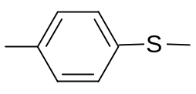 [ ]_{n}
Figure 2.1 The chemical structure of PPS.
The poly(arylene sulfide) consists of repeating aromatic monomer units joined by sulfur bridges (-S-Ar-)_{n}, wherein Ar is arylene and n is the degree of polymerization. In PPS, Ar is a benzene ring.

2.1.2 Development of PPS polymer: historical perspective
In the year 1888, Fridel and Crafts [] and in 1889, Grenvresse [] prepared diphenyl sulfide and related aromatic sulfur compounds. Grenvresse obtained a substance with chemical formula C₆H₄S by heating benzene and sulfur in the presence of aluminum chloride. The product was insoluble with melting point at 295 °C. With the interest of making this polymer commercially viable, in the year 1940, Macallum [] synthesized the PPS polymer from the reaction of sulfur, sodium carbonate and dichlorobenzene in a sealed vessel at temperatures between 275 °C to 360 °C. Lenz et al. [, ] studied the Macallum polymerization process in the late 1950s and early 1960s. They reported that the structure of PPS resulting from Macallum process is branched or lightly cross-linked. A process developed by Lenz and Carrington [] was carried out at 200 °C-250 °C under nitrogen in the solid state. In this process, PPS is obtained by condensation polymerization of alkali metal salts of p-halothiophenols. It is reported that the structure of PPS obtained through this process is linear. But the process was difficult to control. The yield and properties of the polymer obtained were unpredictable.
Thereafter, rapid developments took place in the production of PPS polymer with commercial development made possible by Edmonds and Hill [] at Phillips Petroleum in late 1960s and early 1970s. This process involves reaction of p-dichlorobenzene with sodium sulfide in a polar organic solvent. It has low to moderate molecular weight as determined by dilute solution viscosity. The undergoing reaction is as shown in Figure 2.2. The outline of the early processes mentioned above during the period 1888 to 1970 is shown in Figure 2.3. Phillips petroleum was the first to produce the polymer of sufficiently high molecular weight to manufacture fibers. Although Phillips is the largest single producer of PPS in the world, others are Bayer (1979), BASF (1982), Tosoh Susteel (1986), Kureha (1987), Tohprene (1987) and Toray (through joint venture between Phillips and Toray in 1987), Ticona-Celanese (through joint venture with Kureha). Japanese companies are manufacturing most of the world production of PPS. The various companies manufacturing PPS and selling PPS compounded products, along with their brand names are given in appendix 1.

2.2 Polymerization of PPS

2.2.1 Process details
The production of PPS involves three sections: polymer production, solvent recovery and polymer finishing [10]. In the initial stages of polymerization, sodium hydrosulfide reacts with sodium hydroxide in a vessel blanketed with nitrogen and gives aqueous solution of sodium sulfide. At the end of the reaction, N- methyl 2- pyrrolidone (NMP) is added. Intermittently, sodium sulfide solution is fed to the dehydration vessel to distill out water to maintain the mole ratio of water to sodium sulfide in the mixture to about 1:1. The resulting contents are fed to the polymerization reactor at 233 °C. The
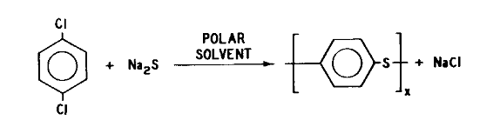
Figure 2.2. Chemical reaction in the synthesis of PPS.
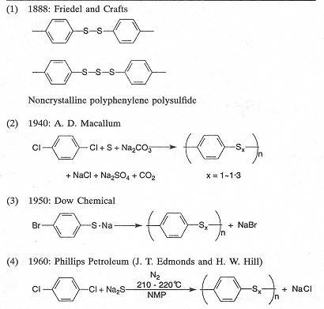
Figure 2.3. Early methods of PPS synthesis [].
polymerization reactor is fed with 1, 4-dichlorobenzene through the heater at 27 °C. The temperature is raised to 274 °C in 100 min. The contents in the reactor are held at that temperature for another 30 min to complete the reaction. After the completion, the vented reactor is heated to evaporate NMP solvent. Subsequently vent is closed and reactor is heated to 282 °C for 30 min. The contents of polymerization i.e. PPS polymer and residual NMP are fed into flash vessel to evaporate NMP. Evaporated NMP goes to the solvent recovery process after filtration. Solid PPS polymer and sodium chloride coming out from the screw conveyor are washed and de-ionized with counter-current flow of water in a three-stage system of vessels and centrifuges. PPS obtained is dried and the batch is cured at elevated temperatures in air.
Since there are many producers of PPS polymers, the procedure may vary in one or more aspect(s) including usage of different raw materials like p-halothiophenols, change in polymerization reaction procedure, use of solvent other than NMP, using different additives in reaction mixture to alter the polymer properties like rheological properties, different catalysts for polymerization and different final treatments, etc.
The molecular weight of PPS obtained in this way as described above by Edmonds and Hill at Phillips is not high, when compared to most commercial polymers []. Solid state curing in air at a temperature near the melting point has been found to lead to increase of the molecular weight. The mechanism of increase in molecular weight is found to be the combination of chain extension and cross-linking []. Solid state curing in air in the range of 175-280 °C and melt state curing in the range of 315-425 °C is reported to increase the molecular weight of the polymer [, ]. It is further reported that in the former curing method, branching/cross-linking dominates chain extension in increasing the molecular weight, whereas, in the latter process of curing, by controlling the temperature and curing time, chain extension is preferred in increasing the molecular weight as observed from the Newtonian behavior of such a polymer. However, at higher temperatures in melt curing, as compared to branching or cross-linking, the contribution of chain extension towards increase in molecular weight decreases.
PPS polymer along with compounding with glass or minerals has become a unique ETP to be used in injection molding and coating applications due to its outstanding properties like dimensional stability, inherent flame retardancy, thermal stability, chemical resistance, excellent electrical properties and ease of processing. However, in order to produce fibers from this polymer, neither low molecular weight polymer nor the thermally cured polymer of high molecular weight as discussed above is suitable [11]. Subsequent research led to the development of the process for preparation of linear high molecular weight polymer suitable for fiber melt spinning []. This developed process uses alkali metal carboxylate as a polymerization modifier and eliminates the need of post-curing to produce the high molecular weight PPS []. The inherent viscosity of uncured polymer produced by earlier process is reported to be 0.16 (measured in 1-chloronaphthalene at 206°C) and melt flow equal to 6000 gm/10 min (315 °C, 5 kg weight []). With the new process, inherent viscosity of PPS obtained is around 0.28 and melt flow is around 250 gm/10 min, which is suitable for melt spinning to produce the fibers.
Lopez and Wilkes [] have reported the occurrence of cross-linking reactions in the melt state of PPS in the temperature range of 315-425 °C. In a study on thermal degradation of PPS, Christopher et al. [] reported that degradation of PPS can take place by chain scission and transfer reactions. Like Lopez and Wilkes [18], they [19] have also reported that the cross-linking reactions play an important part in the degradation of PPS that lead to increase in its MW. The findings from these studies indicate that thermal stability of PPS produced as discussed earlier is poor. PPS polymer produced in the powder (flakes) form will undergo a number of processes like pelletization to convert it into pellets, melt spinning into fibers etc. In each of these processes, the polymer is heated above its T_{m} and then cooled. In order to have PPS of more or less similar MW and MWD as that of the beginning polymer, it is of paramount importance to enhance its thermal stability.

2.2.2 Enhancement of thermal stability
Use of cure retarders and heat stabilizers, based on metal salts of fatty acids to improve the thermal stability of fiber and film grade PPS has been reported []. It is claimed that these heat stabilizers prevent cross-linking or change in PPS properties during heating. Also gel formation of PPS during melting is claimed to be reduced by these compounds, resulting in reduction in the plugging of filters and spinnerets used in fiber manufacturing. Typically 0.5 wt% to 2 wt% of these additives, such as calcium stearate, calcium laurate, calcium caprate, calcium palmitate, calcium arachidate, zinc stearate, zinc laurate, cadmium stearate, cadmium laurate, magnesium stearate, magnesium palmitate, barium stearate, strontium stearate, their mixtures, is added to PPS. To study the heat stability, storage modulus is determined using rheometric dynamic spectrometer (RDS) at 300°C. Without heat stabilizing additives, the storage modulus is reported to be 1890 dynes/cm² after 6 minutes whereas 4960 dynes/cm² after 20 minutes (162% change). Addition of 1 wt percentage of the heat stabilizer to PPS is claimed to decrease the change of storage modulus between 6 min and 20 min period to around 95%.
In yet another patent [], stabilized PPS is claimed to be produced by adding halogenated aromatic compounds that contain electron attracting groups such as –SO₂-, -CO- etc. The stabilized PPS has been claimed to have better resistance to oxidation and weathering, good melt stability, and low corrosive gas emissions.

2.3 Properties of PPS
Although tensile properties of PPS are close to that of commodity categories of polymers such as PET and nylon, PPS is known for its good chemical resistance and strength retention at high temperatures. The typical properties of PPS are summarized below with emphasis on its fiber form.

2.3.1 Physical Properties
Typical physical properties of PPS staple fibers and monofilaments given in Table 2.1 show that these properties fall in the category of conventional textile fibers.

2.3.2 Chemical and solvent resistance
The excellent chemical and solvent resistance of the PPS fibers to various chemicals is listed in Table 2.2. It is due to these properties that PPS fibers fall in the category of high performance fibers. Although it is a condensation polymer, it is hydrolysis resistant as seen from resistance to non-oxidizing acids and hot alkalies. However, due to sulphur in the chain, its resistance to oxidizing agents is poor. The degradation of PPS by HNO₃ occurs through formation of polyarylene sulfoxide [].

2.3.3 Solubility of PPS
Beck [] studied the solubility characteristics of PPS. The presence of crystallinity in the semicrystalline polymers provides an energy barrier for their easy dissolution in solvents and often requires elevated temperatures, and therefore demands thermally stable solvents. Concentrated sulfuric acid may dissolve these polymers but it is more of a reaction than true dissolution. High temperature behavior of PPS requires the solvents that boil at high temperatures, thermally stable and chemically stable. These solvents contain aromatic hydrocarbons or compounds having significant aromatic content. Such compounds are normally solid at room temperature. PPS mixtures in 100 different solvents were prepared by Beck [23] at 270-280 °C.
Table 2.1. Physical properties of PPS fibers [, ]
Property |  | Staple | Monofilament
Denier |  | 3 | 350-400
Tenacity gpd(N/tex) |  | 3-3.5 (0.27-0.47) | 3-4 (0.27-0.37)
Tenacity retention percentage | at 100 °C | 70
Tenacity retention percentage | at 150 °C | 58
Tenacity retention percentage | at 200 °C | 52
Knot strength gpd (N/tex) |  |  | 2-2.5 (0.18-0.23)
Breaking extension % |  | 25-35 | 12-16
Initial Modulus gpd (N/tex) |  | 30-40 (2.7-3.7) | 45-55 (4.1-5.0)
Elastic recovery percentage | at 2% strain | 100
Elastic recovery percentage | at 5% strain | 96
Elastic recovery percentage | at 10% strain | 86
Moisture regain % |  | 0.6
Boiling water shrinkage % |  | 0-5
Density (gm/cc) |  | 1.37 | 1.37
Color |  |  | Gold

Table 2.2. Chemical and solvent resistance of PPS [11]
Property | % strength retained* | Property | % strength retained
Acidsª
48% sulphuric acid | 100 | Conc. phosphoric acid | 100
Conc. sulphuric acid^{b} | 10 | 10% hydrochloric acid | 100
Acetic acidª | 100 | Conc. hydrochloric acid^{b} | 100
Formic acid | 100
Alkaliesª
30% sodium hydroxide |  | 100
Oxidising agentsª
10% nitric acid | 75 | 5% sodium hypochlorite | 20
Conc. nitric acid | 0 | Conc. sulphuric acid | 10
50% chromic acid | 0-10 | Bromine | 0
Organic solvents^{c}
Acetone | 100 | Perchloroethylene | 100
Carbon tetrachloride | 100 | Tolueneª | 75-90
Chloroform | 100 | Xylene | 100
Ethylene dichloride | 100
*: Exposure conditions - for one week
a: at 93 °C, b: 60 °C, c: at the boiling point of the chemical

These solvents are characterized by heterocyclic compounds, compounds containing nitrogen, sulfur, and/or halogens, esters, acids, ketones, phenols etc. Functional groups are important to promote solubility through intermolecular forces of attraction between the compound and the polymers, or they may be simply raising the boiling point, allowing solubility at higher temperatures. The list of various solvents for PPS is tabulated in Table 2.3 alongwith the concentrations possible and temperatures required. Solvent induced crystallization is anticipated in PPS at lower temperatures (eg. 115°C for 4 to 5 days in different solvents). Under these conditions, no crystallization is exhibited in PPS without the presence of solvent.

2.3.4 Thermal Properties
Thermal Properties of PPS are tabulated in Table 2.4. Presence of sulphur in the structure eases the oxidation and hence brings down the limiting oxygen index (LOI) to the range of 34 to 35 from that of the polyphenylene oxide which has LOI around 68. Table 2.5 lists the effect of temperature on different polymers for extended duration. It can be seen that at temperatures as high as 230 °C, the strength retention of PPS is comparable to that of some high performance materials.
When Ryton® PPS and Fotron® PPS were compared for thermal degradation by Day and Budgell [], it was observed that the weight loss begins at around 380 °C in both the cases under N₂ environment with maximum rate reaching at 492 °C and leveling off at 550 °C. Thermal degradation of PPS was also studied by Li et al. [] using high resolution thermal gravimetric analysis (TGA) under four different environments, namely air, nitrogen (N₂), argon (Ar) and helium (He). The heating rate used was 50 °C/min. The behavior is shown in Figure 2.4. Single step degradation was observed in N₂ and Ar environment, two step degradation was observed in He and four step degradation in air. The first step of degradation in all cases occurs beyond 400 °C. The initial thermal degradation temperature and maximum weight loss rate temperature increases in the order, in helium < in nitrogen < in argon < in air. The first stage of degradation consists of loss of sulfur and hydrogen and also breaking of benzene rings to some extent. In the
Table 2.3. Solvents for PPS [23]
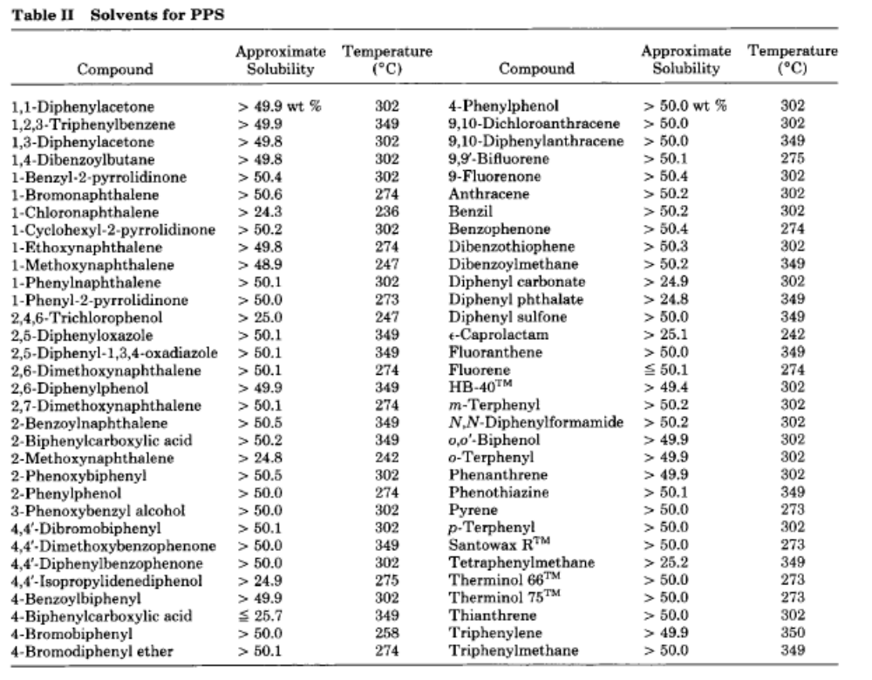
Table 2.4. Thermal properties of PPS
Property | Value
Melting point ( °C) | 285
Glass transition ( °C) | 93
Maximum service temperatures ( °C) | 93 (high stress)
Maximum service temperatures ( °C) | 182-190 (low stress)
Maximum service temperatures ( °C) | 232 (surges)
Limiting oxygen index (LOI) | 34-35
Auto-ignition temperature | 590 °C
Coefficient of thermal expansion 10⁻⁵ in/in/ °C | 3
Shrinkage% 200 °C | 3
Shrinkage% 250 °C | 2
Heat deflection temperature (HDTA) | 117
First five properties are measured on staple fibers [24, 25] whereas remaining are measured on non-reinforced films [10].
Table 2.5. Strength retention of nonwoven filters made at 232°C [11]
Filter material | Percent strength retained after
Filter material | 24 hrs | 2 weeks | 3 weeks | 5 weeks
Nomex® | 111 | 101 | 98 | 95
PBI | 116 | 98 | 105 | 79
Huyglas® | 80 | 88 | 93 | 79
PPS | 95 | 70 | 93 | 79
Polyester | 29 | 27 | 23 | 19
Acrylic | 3 | 1 | - | -
Polypropylene | melts | - | - | -
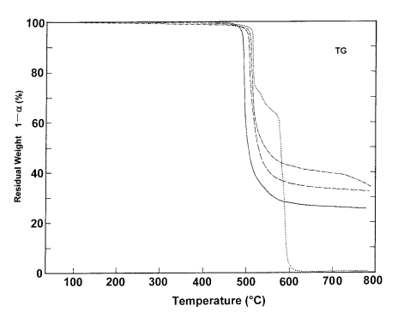
Helium
Nitrogen ------
Argon -.-
Air ……
Figure 2.4. Degradation curves of PPS by high resolution TGA [27].
the first two stages, cross-linking between the residual aromatic rings may also be taking place. In the presence of air, during third and forth stages, aromatic carbon degrades. The dissociation energies of different bonds in PPS are shown in Figure 2.5. As can be seen from the figure, C-S is the weakest bond in PPS.

2.3.5 Optical properties
One of the important optical properties in fibers is its refractive index. By knowing the difference in refractive indices of fibers along its longitudinal and transverse axis, idea on the molecular orientation is obtained. Due to high refractive index of PPS, the usual method, Becke line technique [] that uses immersion liquids to determine the refractive index is difficult to employ for PPS. Hardaker et al. [] determined the refractive index of PPS film using a technique based on prism waveguide coupling. The refractive indices along X, Y and Z directions of the film were found to be 1.6973, 1.7844 and 1.8906 respectively, and the average refractive index was reported as 1.7908. Maemura el al. [] reported the refractive indices of crystalline phases in PPS as 1.6522, 1.8769 and 2.044 along its a, b and c axes respectively. Carr and Ward [] reported the
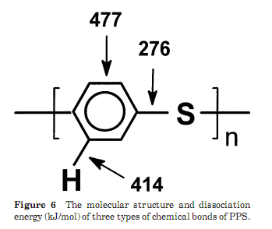
Figure 2.5. Dissociation energy of different chemical bonds in PPS [27].
isotropic refractive index of PPS fibers equal to 1.83. High refractive indices of PPS as determined by several investigators imply that the velocity of light through PPS is much less than that in the vacuum as compared to other polymers such as polypropylene. The probable reason for such high refractive index may lie in the complex structure of PPS with semi-rigid backbone as discussed by Cha and Samuels [] for engineering polymers developed for high temperature, electronic and microelectronic applications.
Stability of PPS to UV exposure was studied by Das et al. [, ]. Cross-linking upon illumination by Xenon arc lamp exhibited coloration of exposed PPS. As compared to air atmosphere, the photo-coloration observed was slower in argon atmosphere.

2.3.6 Pyrolysis
Upon pyrolysis at 700 °C in air, PPS releases various gases as tabulated in Table 2.6. Carbon dioxide is the major off gas released upon pyrolysis with sulfur dioxide and carbon monoxide in lesser amounts.

Table 2.6. PPS pyrolysis products []
Material | CO₂ | SO₂ | CO | COS | C₂H₂
Amount (mg/g of PPS) | 1800 | 425 | 200 | 2.5 | 1.5

2.4 Applications
Although this research is dealing with only PPS fibers, because it is being used in other forms to a great extent right since its inception, such applications of PPS are also summarized here. The area of application of PPS relates to its resistance to high temperature and to various chemicals such as acids, and alkalies, as listed in Table 2.2.
Injection molded components made from PPS compounded with various fillers and fibers, like glass, carbon are used in pump impellers, bale valves, gears, wear rings, electrical sockets, battery and telephone components []. Automotive industry also uses it in the engine compartment components, fuel line systems and in other places where solvent resistance and/or exposure to high temperature is necessary. It is widely used as a matrix for carbon and glass fiber reinforced composites and as a neat resin for chemically resistant coatings and for high temperature resistant electronic components.
It is also used as a conducting polymer through doping with strong oxidizing agents []. It is an ideal polymer [] for electrical connectors, switches and coil bobbins. Besides poly(etheretherketone) (PEEK), it is suitable for permselective membranes too [23]. In the past when tough epoxy resins were not available, the matrix of PPS with carbon fibers as reinforcement has been reported to be used in aircraft interiors [] since it passes the Ohio State University fire safety test required by US Federal Aviation Administration (FAA). In this application, it is a fitting candidate due to its inherent flame resistance, immunity to aircraft fluids, thermoplastic nature (ease of manufacturing various components), higher toughness and low moisture absorption.
In the fiber or more appropriately in the multifilament form, it is used in the filtration of air, fluids, oil, fuel etc., where its good chemical resistance property coupled with high temperature resistance is made use of. It is mainly used as a filter fabric for bag houses in coal fired boilers. The flue gas temperatures under these conditions are 150-200 °C and the flue gases are acidic due to the presence of high-sulfur in coal. Therefore, it is difficult to filter fly ash from these boilers [11]. Needle-punched bags made from PPS fiber are used in pulse jet cleaned bag-houses wherein it is claimed that such bags can withstand brief exposure to 232 °C and prolonged exposure to 190 °C for 3 years []. The reported three years of lifetime under these conditions [], is superior to that of homopolymer acrylic fiber containing filter bags. It is much better than conventionally used woven glass fabrics in terms of high air to cloth ratio requiring less number of bags, less supporting hardware and smaller installation. Needle-punched felts made from PPS fibers can be used in paper industry in pressing operation [11] and battery separators. Also the belts made from monofilament and multifilament PPS can be used in drying operations in the paper, chemical and environmental industry []. The atmosphere in these applications is hot and caustic. PPS staple fibers are used as specialty paper for electrical appliances, where temperature resistance and very low moisture regain of PPS is advantageous [11]. Filters made from PPS needle-punched felt or woven from spun yarns are useful for filtration of hot, corrosive chemicals. It can be used as sewing thread in these applications too [41]. Woven fabrics from monofilament and multifilament yarns are useful as demister in applications where its chemical resistance at high temperatures and competitiveness with other existing demister materials is advantageous. Melt blown PPS nonwovens are reported to be good filters in chemical and industrial plants and power plant bag houses []. Melt blown nonwovens made from PPS that contain micro-fibers are made into cartridge filters that can exhibit good resistance to acids, alkalies and organic solvents at high temperatures [42]. Spunbond PPS nonwovens provide strong backing for filter media []. Automotive industry uses PPS yarns as reinforcement of rubber hoses [42]. Such reinforced rubber hoses are used in the fuel systems, cooling systems and power-steering systems of automobiles and hydraulic systems in industries. Filters made from food grade PPS go as filter screens in food industry. Nonwovens made from PPS are used as insulation materials for thermal and acoustic insulation in areas such as aircrafts. Use of PPS/PET bi-component fibers in core/sheath structure is reported in bonded nonwovens []. Also bi-component fibers with sheath/core structure can be used for filter applications in drying processes. Such fibers cost less since less PPS can be used. Geosynthetics that require resistance against alkalies for longer life span are also a good application for these bicomponent fibers.

2.5 Morphological studies of PPS
In this section, the methods adopted by various researchers and their findings of different morphological features, that are characteristics of PPS, such as crystal structure, density (amorphous and crystalline), degree of crystallinity, heat of fusion of 100 % crystalline PPS, and intrinsic birefringence will be discussed. Effect of different parameters like polymer properties and polymer processing conditions on the morphology, and thereby on the properties of various products such as fiber and films are dealt with in a subsequent section.

2.5.1 Crystal Structure
Tabor et al. [] studied the crystal structure of Ryton® PPS by WAXS, assuming that its crystal structure is similar to that of poly(p-phenylene oxide) (PPO). A compression molded film was stretch-oriented at 90 °C and crystallized by stretching successively at higher temperatures up to 250 °C. The pin-hole pattern of oriented film was obtained by wide angle X-ray scattering (WAXS) using Ni-filtered CuKα radiation. It is reported that the recorded reflections on the pattern could be indexed satisfactorily by assuming that the unit cell is orthorhombic with dimensions a equal to 8.67 Å, b equal to 5.61 Å and c (fiber axis) equal to 10.26 Å. Crystalline density of 1.43 g/cm³ is arrived at by considering four monomeric units in each unit cell. Amorphous density equal to 1.32 g/cm³ and semi-crystalline density equal to 1.35 g/cm³ was reported. All the atoms in S-phenylene-S group are assumed to lie in one plane. The crystal structure of PPS is as shown in Figure 2.6a. The bond length of S-phenylene is assumed to be somewhat shorter than S-C bond. From the accepted bond lengths, the S-S distance is found to be 6.27 Å. Sulphur atoms of one polymeric chain are arranged in a zig-zag manner in (100) plane as shown in Figure 2.6b.
Tabor et al. [46] further reported that the sulfur atoms of each chain lie on the same plane in a zig-zag arrangement and the phenylene rings alternatively form an angle of +/- 45° to this plane. Other features are, separation of S-S along the polymeric chain is 0.627 nm, and the C-S-C bond angle is 110°.
Later on Garbarczyk [] reported C-S-C angle of 103° to 107° from nuclear magnetic resonance (NMR) spectroscopic study of PPS oligomers, and mentioned that the distortion of PPS samples by heat treatment and stretching in the study of Tabor et al. [46] might be the cause for arriving at 110° angle of C-S-C. The work of Jurga [] using NMR spectroscopy on Ryton® PPS agreed with the results of Garbarczyk [47], and suggested a triclinic crystal structure for PPS with the lattice parameters, a equal to 8.67 A°, b equal to 5.61A°, c equal to 10.09 A°, α equal to 79.36°, β equal to 73.43°, and γ equal to 93.20°. Unit cell dimensions are reported to be dependent on the crystallization conditions, such as in PEEK which is another high temperature aromatic polymer [].
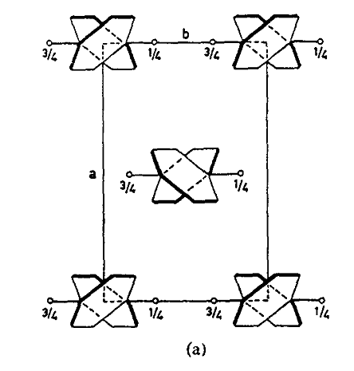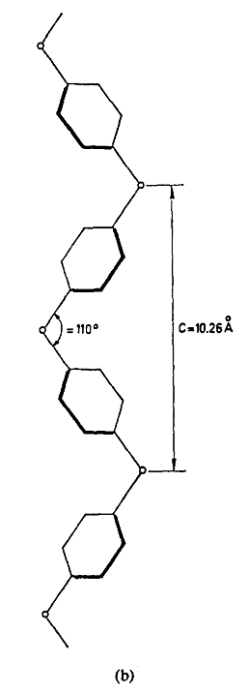
(a)
(b)
Figure 2.6 PPS crystal structure (a) projected on plane ab; (b) conformation of a polymer chain in the crystal of PPS projected on plane bc [46].
Studies carried out by Lovinger et al. [, ] and by Hay and Luck [] reported similar crystal structure dimensions as reported by Tabor et al. [46]. Lovinger et al. [50, 51] employed transmission electron microscopy (TEM) to study the structure of single crystal or single crystal aggregates of Ryton® PPS obtained from solution, and thin films from melt, respectively. The problem of bond distortion due to mechanical drawing was also investigated, and no change in lattice parameters was found upon drawing. Hay and Luck [52] did not observe any change in crystal dimensions on annealing, or by increasing the crystallization temperature, thus ruling out the possibility of any crystal structure distortion upon heat treatment as sugested by Garbarczyk [47]. Umera et al. [] confirmed the structure reported by Tabor et al. [46] using high resolution electron microscopy studies on solution grown crystals. Crystal structure reported by Tabor et al. [46] is further confirmed by Napolitano et al. [] through the use of WAXS on PPS powder from Sigma Aldrich (Toray based polymer).
The unit cell parameters given by above investigators depend very much upon the level of the stress on crystal. Few researchers have studied the elastic modulus of PPS crystal to investigate the effect. Based on the shift of lattice plane (114) upon stress, using WAXS, Unwin and Ward [] reported the longitudinal elastic modulus to be ca. 38 GPa with theoretical maximum to be ca. 43 GPa. Nishino et al. [] reported the longitudinal elastic modulus of PPS based on meridional reflection of (008) lattice plane, to be ca. 28 GPa. Using Treloar’s method [], Nishino et al. [56] calculated longitudinal elastic modulus of PPS and found it to be ca. 26 GPa. The stretching and bending force constants for PPS are given in Table 2.7. The force required to stretch the molecule by 1% is 0.69 X 10⁻⁵ dyn for PPS. The long spacing in the melt grown PPS crystals has been shown to increase with crystallization temperature [, ].
PPS crystals exhibit spherulitic morphology when cooled from melt under quiescent conditions []. Either lamellae or fibril shaped crystals grow outwardly from the primary nucleation site, along the b-axis of the unit cell []. This means that the spherulites exhibit negative birefringence. Thus, the index of refraction in the tangential direction is greater than that in the radial direction of spherulites, and suggests
Table 2.7. Stretching and bending force constants of PPS [56]
Stretching |  |  | Bending
Bond | Bond distance  Å | Force constant  10² (N m) | Bond | Bond angle  degree | Force constant  10² (N m)
C-O | 1.47 | 4.54 | C-O-C | 126.5 | 0.54
C-C | 1.47 | 3.70 | C-C(O)-C | 126.5 | 0.15
C-S | 1.74 | 2.43 | C-S-C | 110 | 0.157
C_{aro}-C_{aro} | 1.39 | 7.62 | C_{aro}-C_{aro}-C_{aro} |  | 0.661
 |  |  | Benzene- |  | 1.06
that the polymer chain axis (c-axis) is normal to the radial direction. This implies that folded chain crystals exist in PPS. In electron diffraction patterns of PPS crystal sheaves, Waddon et al. [] observed that the (020) reflection lies on the meridian implying that the b-axis is aligned preferentially along the long axis of the crystal sheaf.

2.5.2 Density
Tabor et al. [46] obtained 1.43 g/cm³ as the crystalline density of PPS based on crystal lattice parameters (a, b and c) of the unit cell of PPS crystal as discussed above. Suzuki et al. [] measured the density (ρ) of PPS at 23 °C using density gradient column (DGC) prepared from the mixture of CCl₄ and toluene. Maemura et al. [30] determined the density of PPS by using DGC based on sodium bromide-water system at 23 °C. The PPS films drawn to various draw ratios and annealed at different temperatures were used in this study. The value of density obtained varied from 1.32 g/cm³ to 1.37 g/cm³ depending upon the sample history. The heat of fusion (ΔH_{f}) of these samples obtained by DSC was plotted against their specific volumes ($\overline{V}$ = 1/ρ). Upon extrapolating this data to ΔH_{f} = 0, 100% amorphous PPS density was found to be equal to 1.32 g/cm³. Tabor et al. [46] have also reported the amorphous density of PPS equal to 1.32 g/cm³. In yet another experiment, Huo and Cebe [] used DGC made of CaNO₃ in water at room temperature. They found the amorphous density equal to 1.3195 g/cm³, which is very close to above findings of Maemura et al. [30] and Tabor et al. [46]. Brady [] reported PPS amorphous density equal to 1.33 g/cm³.

2.5.3 Degree of crystallinity
Degree of crystallinity can be determined by various techniques such as DGC, DSC, WAXS, fourier transform infrared spectroscopy (FTIR). DSC is one of the widely used tools to estimate it fairly easily. To determine the fraction of crystallinity of a given sample by this technique, heat of fusion of 100% crystalline sample ($ΔH_{f}^{0}$) of that material is necessary. Combination of DGC and DSC, or WAXS and DSC are used by various researchers to estimate the heat of fusion of 100% crystalline sample. The fraction of crystallinity (X) and density (ρ) are related by Eq. 2.1.
$\frac{1}{ρ}=X \left(\frac{1}{ρ_{c}}\right)+ \left(1-X\right)\left(\frac{1}{ρ_{a}}\right)$ (2.1)
where, subscripts c and a refer to 100% crystalline and 100% amorphous samples respectively.
The fraction of crystallinity (X) and heat of fusion (ΔH_{f}) of the sample are related by Eq.2.2.
$ΔH_{f}=X ΔH_{f}^{0}$ (2.2)
Eq. 2.1 and Eq. 2.2 can be combined in Eq. 2.3.
$ΔH_{f}$ = $\frac{{ΔH}_{f}^{0} }{\left(\frac{1}{ρ_{c}}- \frac{1}{ρ_{a}}\right)}\frac{1}{ρ}-\frac{{ΔH}_{f}^{0} \frac{1}{ρ_{a}}}{\left(\frac{1}{ρ_{c}}- \frac{1}{ρ_{a}}\right)}$ (2.3)
The heat of fusion of the samples is plotted against their specific volumes (1/ρ). The data is extrapolated to a specific volume of 0.6993 (based on crystalline density of PPS equal to 1.43 g/cm³, as given by Tabor et al. [46]) and the heat of fusion corresponding to this value is taken as $ΔH_{f}^{0}$.
In a review by Spruiell and Janke [] on PPS and its fiber reinforced composites, it is quoted that the literature values of $ΔH_{f}^{0}$ vary from 50 J/g to 150.4 J/g. Brady [] reported the value of $ΔH_{f}^{0}$ close to 80 J/g. Huo and Cebe [66] reported it to be 103.8 J/g by plotting ΔH_{f} vs specific volume and equal to 112 J/g by plotting ΔH_{f} vs crystallinity determined by WAXS. $ΔH_{f}^{0}$ calculated by Maemura et al. [30] by plotting ΔH_{f} vs specific volume was found to be 146.2 J/g. $ΔH_{f}^{0}$ equal to 150.4 J/g is reported by Ten Cate Advanced Composites [] based on X-Ray data combined with density measurements. In yet another study, Hay and Luck [52] reported $ΔH_{f}^{0}$ equal to 76.5 J/g, based on the plot of ΔH_{f} vs weight fraction crystallinity determined by WAXS. The significant difference in $ΔH_{f}^{0}$ (112 J/g vs 146.2 J/g) between Huo and Cebe [66] and Maemura et al. [30] respectively, was suspected by Cebe [] to the oriented samples of PPS used by latter authors. Oriented samples tend to give higher densities for the same level of fractional crystallinities than unoriented samples. To use the technique for accurate results, it was suggested to use un-oriented samples as was done by Huo and Cebe [66]. The technique of plotting DSC heat of fusion vs crystallinity determined by WAXS is considered to be more appropriate than plotting DSC heat of fusion vs crystallinity determined by DGC. A very good account of the large variation in the values as given above by various researchers is provided by Spruiell and Janke [68]. According to them, accurate determination of $ΔH_{f}^{0}$, and heat of crystallization (ΔH_{c}) by DSC is not possible due to the reasons that crystallization is often spread over a wider temperature range and sometime baseline shift, similar to what happens at Tg, do occur due to the heat capacity change because of crystallization. Hence the choice of baseline produces some error. Also during heating, melting and re-crystallization take place in the polymers including in PPS. Melting point of a crystal depends upon the crystal size. T_{m} decreases with decreasing crystal size. If the crystal formed during melt crystallization or cold crystallization is small enough, then it will undergo melting and recrystallization during heating. At the time of melting, the sample may or may not have original crystalline morphology.
While using WAXS technique to calculate the crystallinity indices of PPS, Brady [69] assumed that the intensities at 2θ values of 11°, 17°, 23°, 30° and 34° are not contributed by crystalline phase. Measurements at these angles were used to determine the background, amorphous PPS and glass. Subsequently the data in the range of 17° to 23° was considered further in the evaluations of crystallinity, which gave patterns in its four components including crystalline content. The crystallinity index they obtained by this technique is reported as high as 62%.

2.5.4 Orientation of molecular chains
In order to enhance the properties of fibers like tensile strength and modulus, they are often stretched under heat, which causes the molecular chains to align in the direction of fiber axis, and annealed further for development of crystallinity under oriented condition. The fibers made from polymers such as PPS are semi-crystalline in nature, i.e., they possess crystalline and amorphous regions. There is no single technique which can give us an idea about the level of orientation in each of these regions besides the overall orientation, but rather combination of techniques is the way here. Widely used combination is that of the polarized light optical microscopy and WAXS.

2.5.4.1 Overall molecular orientation: Birefringence (Δn)
Polymer in the form of fiber and film, usually due to preferred stretching (orientation) in one direction more than the other, exhibits anisotropic nature i.e., it possesses different properties in different directions, along the fiber axis and perpendicular to the fiber axis. Orientation of the molecular chains in the fiber, which is one of the major contributors to fibers’ tensile properties, is determined by polarized light optical microscopy (POM), which takes into consideration the speed of incident light travelling along and perpendicular to the fiber axis. In majority of the cases, the molecular chains are oriented along the fiber axis and hence the light will travel slower in that direction as compared to the transverse direction. By the virtue of it, fiber will exhibit different refractive indices in both the directions. The difference in the refractive indices in the direction parallel and perpendicular to the fiber axis, termed as birefringence (Δn), is a widely used property to understand the overall orientation of the molecular chains in the fiber. In order to determine retardation i.e., the amount by which light lags behind in one direction as compared to other direction, a rotary compensator is placed between the fiber and the observer. The amount of compensation required to bring the fiber to extinction is measured by rotating the compensator. The details of one of such compensator can be found at Olympus website []. The compensator is made of a crystal like calcite and quartz. Birefringence is calculated using the following Eq. 2.4.
$Δn= \frac{Retardation}{Fiber diameter}$ (2.4)
Following discussion is relevant while studying PPS fibers/films for birefringence:
Refractive index of a material depends upon the incident light wavelength, besides other factors. The change in refractive index of a material with change in wavelength of light is called as dispersion of refractive index. Cha and Samuels [32] calculated the degree of dispersion (D_{b}) using Eq. 2.5.
$D_{b}= \frac{Δn_{F}- Δn_{c}}{Δn_{D}}$ (2.5)
where, subscripts F, C and D refer to the monochromatic lights of wavelengths 486 nm, 589 nm and 656 nm respectively.
The compensator as well as the fiber to be characterized for birefringence have certain dispersion of refractive index. So long as the dispersion value of fiber is close to that of the compensator used, the retardation measured is accurate, for eg. D_{b} of isotactic polypropylene film is found to be 0.025(+/-0.023) [32] and that of calcite compensator is 0.042 [].
However, the molecular structure of the engineering polymers developed for high temperature, electronic and microelectronic applications is very complex possessing phenyl rings and semi-rigid backbones [32]. These structures possess high degree of optical dispersion, for eg. D_{b} of Kapton film, which is a polyimide, is found to be 0.148(+/-0.008) [32]. Due to the considerable mismatch of D_{b} between such polymers and compensators used, the retardation value obtained is far from accurate due to considerable fringe jumping. To understand fringe jumping phenomenon, readers may refer to the work of Faust and Marrinan []. Carr and Ward [31] have reported as many as six fringe jumps in draw-annealed PPS fibers in white light. Without correcting the retardation values for fringe jumping, birefringence obtained therefrom will be erroneous, well above the intrinsic birefringence in some cases. To our knowledge, there is no record of exact value of the degree of optical dispersion of PPS. According to Cha and Samuels [32], when sodium D line (589 nm) is used as the incident light, the corrected value of birefringence can be calculated using Eq. 2.6.
$N_{D}=N_{M}- (3.01 X N_{D} X \frac{D_{b}- D_{b}^{*}}{1+3.01 X D_{b}^{*}}$ ) (2.6)
where, N is the number of orders and it is the ratio of retardation to that of the wavelength of light. Subscripts M and D refer to measured (uncorrected) and corrected retardation respectively for the polymer or fiber, D_{b} is the degree of optical dispersion of polymer/fiber, $D_{b}^{*}$ is the degree of optical dispersion of the compensator used.
From N_{D} as calculated above, the corrected retardation ($Γ_{corrected}$) can be calculated using Eq. 2.7.
$Γ_{corrected}= N_{D}$ X 589 (2.7)
From the corrected retardation as calculated above, using Eq. 2.4, corrected birefringence of polymers or fibers can be calculated.

2.5.4.2 Crystalline orientation (f_{c})
WAXS is the extensively used tool to determine the crystalline orientation in fibers, films etc. Stein [] modified original expression for f_{j}, Herman’s orientation factor [, , , ] for crystallographic axes and suggested expression as given by Eq. 2.8.
$f_{j}= \frac{\overline{3\cos^{2}Φ_{j}}-1}{2}$ (2.8)
where, Ф_{j} is the angle between j^{th} crystallographic axis of polymer chain and the direction of fiber axis, where j can be a, b or c.
From the azimuthal intensity distribution of plane (hkl) perpendicular to the crystallographic axis, <cos²Φ_{hkl}> is calculated using Eq. 2.9 [68].
$<\cos^{2}ϕ_{hkl}> = \frac{\int_{0}^{π/2}{I_{hkl}\left(∅\right)\cos^{2}∅\sin{∅ d∅}}}{\int_{0}^{π/2}{I_{hkl}\left(∅\right)\sin{∅ d∅}}}$ (2.9)
In the case of orthorhombic crystals, such as in PPS, $<\cos^{2}ϕ_{hkl}>$ for at least 2 planes is required [] to calculate crystalline orientation factors.

2.5.4.3 Amorphous orientation (f_{am})
It is calculated indirectly from overall orientation as given by birefringence and crystalline orientation obtained from WAXS. Hermans et al. [78], and Stein and Norris [] expressed the overall orientation in terms of crystalline orientation and amorphous orientation as given in Eq. 2.10.
$Δn=Xf_{c}Δ_{c}^{°}+\left(1- X\right)f_{am}Δ_{am}^{°}+ {Δn}_{form}$ (2.10)
where, f is the orientation factor, subscripts c and am stand for crystalline and amorphous regions respectively, and Δ° is the intrinsic or maximum birefringence (wherein all the molecular chains are assumed to be perfectly aligned in the direction of fiber axis).
The form birefringence is usually considered negligible in the case of homopolymers and thus above equation reduces to the form as shown in Eq. 2.11.
$Δn=Xf_{c}Δ_{c}^{°}+\left(1- X\right)f_{am}Δ_{am}^{°}$ (2.11)
Δ° can be determined experimentally as well as theoretically. Maemura et al. [30] estimated the intrinsic birefringence of biaxially stretched PPS films theoretically using the bond polarizabilities of the bonds along a, b and c axes of the unit cell. The unit cell geometry given by Tabor et al. [46] was considered for these calculations. For details of Δ° estimation, one can refer to the original paper of Maemura et al. [30]. The intrinsic birefringence for crystalline phase ($Δ_{c}^{°})$ estimated between b and a axes is 0.2247, between c and a axes is 0.3919, and between c and b axes is 0.1672. The overall intrinsic birefringence (Δ°) is estimated to be equal to 0.2795. From these values, $Δ_{am}^{°}$ was arrived at a value of 0.25805. Carr and Ward [31] obtained the intrinsic birefringence of PPS equal to 0.33, after correcting the calculated value of C-S bond polarizability, to consider the measured refractive index of PPS. The correction was necessary because the measured refractive index of PPS was found to be higher than the refractive index estimated from the originally calculated values of C-S bond polarizabilities.

2.6 Crystallization kinetics
The thermoplastic polymer’s performance, during various stages of processing like melt spinning, film manufacturing, injection molding etc., and the properties of products made therefrom such as the melt spun fibers, films, injection molded parts etc., depend upon the crystallizability of the polymer, in addition to other material and process variables. Crystallization behavior i.e., the nature of crystal growth, rate of crystallization, temperature at which crystallization begins depend upon the polymer characteristics, MW, MWD, degree of branching in the molecular network etc. as well as upon the processing conditions such as temperature, time and stresses employed during processing. Hence it is of paramount importance to study the influence of various polymer properties and time-temperature conditions on crystallization behavior of the PPS polymers. Since mobility of chains is required for crystallization, crystallization generally occurs in the temperature range between T_{g} and T_{m}. Close to both these temperatures, crystallization is slow, and somewhere near the midpoint of T_{g} and T_{m}, fast crystallization occurs. The study of crystallization kinetics has been the major focal area in PPS by many researchers using a number of techniques such as DSC, time resolved FTIR, and POM, with majority of them using DSC.
With reference to fiber processing, since it is the topic of present research, polymers experience non-isothermal and isothermal conditions during spinning and drawing-annealing respectively. Hence, in order to understand the processing behavior, and structure-properties development in the fibers, it is necessary to investigate both isothermal as well as non-isothermal crystallization kinetics. It is important to take a note of the fact that both of these studies do not consider the effect of stress, which is present during processing, and which influences the crystallization process. In the past, investigators [, , , ] have shown by studying isothermal crystallization kinetics of oriented PET, that the crystallization of polymers occur much faster in the oriented state than under quiescent condition. While studying PPS, cold crystallization is reported to be strongly dependent on the degree of orientation []. The temperature of cold crystallization (T_{c}) of PPS fibers decrease after zone drawing treatment, suggesting that the cold crystallization of oriented fibers is easier than that of the as-spun, isotropic fibers. It has also been reported by Ito and Porter [] that T_{c} of PPS fibers decreases with increasing draw ratio.
Two good reviews written by Spruiell and Janke [68], and Cebe [71] summarize the earlier work of various researchers on crystallization kinetics of PPS. The findings of various scientists in this area are given here. Before summarizing the findings of isothermal and non-isothermal crystallization kinetics, some general findings on the crystallizability of PPS will be noted here.
Hoffman et al. [] have shown that most polymers crystallize through heterogeneous nucleation followed by crystal growth. They have further stated that the crystallization will be dominated by secondary nuclei when carried out by cooling the melt. Due to high electron density of sulphur and phenylene groups, PPS is a slow crystallizing polymer as compared to PET [31]. Degree of crystal perfection as observed through melting peak in DSC is found to be less in PPS than in PET []. Double crystallization curves were observed by Menczel and Collins [38] for PPS in non-isothermal as well as isothermal crystallization kinetic studies. Upon cyclic heating and cooling of PPS for eight times to melting temperature of 340°C and 350°C with ten minutes hold at these temperatures, it was found that the two peak melting characteristics disappear. The onset of crystallization decreases from 260°C to 249°C, and peak temperature of crystallization decreases from 243°C to 233°C. The heats of crystallization decrease from 65 J/g to 56 J/g. Even after melting the polymer that had undergone cyclic heating-cooling, to 340°C instead of 350°C, the onset and peak temperatures of crystallization remain at 248°C and 233°C. From these observations it is concluded that the crystallizability of PPS decreases irreversibly. With more and more time spent in the melt state, linear PPS turns into more and more branched structure. Branched structure will produce less perfect crystals than the linear structure.

2.6.1 Isothermal crystallization kinetics
Isothermal crystallization kinetics study is carried out either by melt crystallization i.e., by cooling the melt or by cold crystallization i.e., by heating the solid polymer. In the former case, which is studied by most of the researchers, the polymer is heated to a temperature above its melting point and kept at this temperature for few minutes to ensure that all nuclei are destroyed. At the end of the hold temperature, the melt is cooled at high rates of cooling to a temperature at which the crystallization is to be studied. The rate of cooling employed is such that no crystallization will occur in the melt while cooling until the temperature of study is reached. Cold crystallization is carried out at the temperatures at and below which it is not possible to cool the melt in DSC without occurrence of crystallization during cooling. The temperature of study is maintained until the polymer crystallizes to its full potential. The crystallization exotherm during the isothermal condition is evaluated with respect to the time when the crystallization begins, time required to complete the crystallization, degree of crystallinity, time required to achieve the half of total crystallinity, rate at which crystallization takes place, presence of primary and secondary crystallization, etc. A typical crystallization exotherm is shown in Figure 2.7.
The development of crystallization at a given temperature is deduced by integrating the heat evolved as a function of time in the crystallization exotherm. The fractional crystallinity (X_{t}), which varies from zero to one, is calculated by Eq. 2.12.
$X_{t}= \frac{\int_{0}^{t}{\frac{dH}{dt} dt}}{\int_{0}^{∞}{\frac{dH}{dt} dt}}$ (2.12)
The crystallization kinetic parameters i.e., Avrami exponent (n) and Avrami rate of crystallization (k) are estimated by the use of Avrami equation [, ] which is the
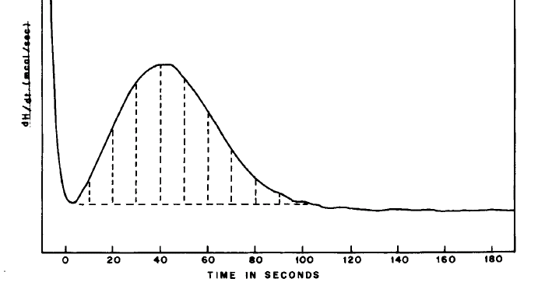
Figure 2.7. Typical crystallization exotherm during isothermal study [36].
modified Avrami equation after specific assumptions such as crystallite growth rate is assumed to be linear and constant []. The modified Avrami equation is expressed as given by Eq. 2.13.
$X_{t}=1-exp⁡(-kt^{n})$ (2.13)
The above equation can be written in the Y = mX + c form as Eq. 2.14.
$\ln\left(-\ln\left(1-X_{t}\right)\right)=n\ln\left(t\right)+ ln⁡(k)$ (2.14)
Thus, the plot of $\ln\left(-\ln\left(1-X_{t}\right)\right)$ as a function of $\ln\left(t\right)$ yields the value of n and k. The value of n depends upon the nucleation and growth rate of the spherulites formed during crystallization. It is reported [38] that n should be ideally 3 or 4 for spherulitic crystallization with heterogeneous or homogeneous nucleation respectively. Depending upon the value of n, nature of crystallization is found out. Most of the investigators have found the value of Avrami exponent (n) to be between 2 and 3 for PPS [36, 60, 62, , , , ]. Values are close to two for cold crystallized and to three for melt crystallized samples. Table 2.8 lists the type of crystallization depending upon the Avrami exponent. Table 2.8 elucidates that as the number of dimensions in which the growth occurs increases, the value of n increases. When all the nucleation occurs at time t equal to 0, since nucleation is not time dependent, the value of n for the same type of growth is less by one as compared to the situation in which the nucleation growth is time dependent as in the case of steady state growth. In steady state growth, the number of nuclei growing
Table 2.8 Interpretation of Avrami exponent (n) [92]
Growth habit | Homogeneous nucleation growth |  |  |  | Heterogeneous nucleation
Growth habit | Linear |  | Diffusion controlled |  | Heterogeneous nucleation
Growth habit | Steady state | t = 0 | Steady state | t = 0 | Linear growth
Sheaflike | 6 | 5 | 7/2 | 5/2 | 5 ≤ n ≤ 6
3 dimensional | 4 | 3 | 5/2 | 3/2 | 4 ≤ n ≤ 3
2 dimensional | 3 | 2 | 2 | 1 | 3 ≤ n ≤ 2
1 dimensional | 2 | 1 | 3/2 | 1/2 | 2 ≤ n ≤ 1
per unit volume at a given time is constant. In the case of sheaflike growth, besides the three dimensions normally visualized, growth occurs through branching [].
Since branching adds to the dimensions of growth, the exponent increases further beyond four. Linear growth indicates that the growth is interface controlled, in which the growth rate is linearly dependent on (t, τ) in one dimension, where t is the time under consideration during crystallization and τ is the time at which the nucleation is initiated [92]. In the case of diffusion controlled growth, the growth dimension will vary as a function of (t- τ)^{1/2}. The non-integer values of n indicate heterogeneous nucleation with growth taking place linearly. It is to be noted that the Avrami exponent does not define a unique nucleation and growth set.

2.6.1.1 Effect of crystallization temperature
In a study on crystallization kinetics of PPS by DSC, Jog and Nadkarni [36] reported the results of crystallization kinetics study performed on glass fiber reinforced and unfilled Ryton® PPS. Study was carried out in the temperature range of 250°C to 215°C by cooling the melt from 350°C at the rate of 160°C/min. To study crystallization below 215°C, amorphous samples, prepared from the original polymers by rapid quenching from the melt, were cold crystallized. From the plot of t_{1/2} vs crystallization temperature as shown in Figure 2.8, the rate of crystallization was found to be maximum around 170 °C. Similar behavior was observed when total crystallization time (t_{max}) was plotted against crystallization temperature. The crystallization time was less than 10 sec in the temperature range of 155 °C to 190 °C. The crystallization half time was found to be lower for glass fiber reinforced category than that for unfilled category. This behavior is due to the influence of glass fibers which act as nucleating agents in the filled PPS. This effect was found to be more significant at higher crystallization temperatures. At higher temperatures of crystallization i.e., lower degree of supercooling, they observed heats of fusion close to that of the annealed samples. This indicates that better crystal perfection and higher crystallinity are achieved at higher temperatures of crystallization because of slower growth of crystals.
The work of Chung and Cebe [] showed that, for the same MW PPS, the plot of t_{max} vs crystallization temperature from cold and melt state is similar to that shown above in Figure 2.8, but the curve was more asymmetrical with rapid drop in t_{max} when carried out from solid state. Comparatively more rapid crystallization when carried out from solid-state i.e., cold crystallization, was supposed to be due to creation of short-range ordered structure that help in crystal nucleation. Such asymmetry is also reported by Hsiao et al. [].
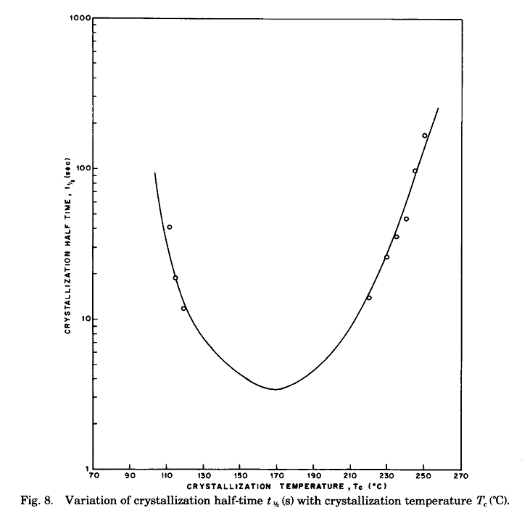
Figure 2.8 Half time of crystallization vs crystallization temperature [36].
Lu and Cebe [] studied the isothermal crystallization kinetics by cold crystallization of amorphous films prepared from the powders of various grades of Fortron® PPS. In the crystallization temperature range of 105°C to 145°C, they reported that, for a given polymer, t_{1/2} decreases with increase in crystallization temperature. The observation is similar to that of other researchers who have dealt with cold crystallization. While studying the kinetics by SAXS, they observed that long period is larger for samples crystallized under the conditions giving lower t_{1/2}.
Menczel and Collins [38] studied isothermal crystallization behavior of Fortron® PPS polymers using DSC. From the Avrami plots as described earlier, it is noted that in the case of low MW PPS polymer, with increase in crystallization temperature the crystallization rate constant decreases. It is also reported that several parallel mechanisms of crystallization are likely to happen as a function of time.
Lovinger et al. [50] studied spherulitic growth rate by measuring the increase in diameter of spherulite with time at a given temperature using hot stage optical microscopy. More or less, symmetry in spherulitic growth rate between melt crystallized and cold crystallized PPS samples is reported. For a given MW, they observed decrease in the spherulitic growth rate with increase in the crystallization temperature.
Yu et al. [37] employed time resolved FTIR to investigate the isothermal crystallization kinetics of PPS in the temperature range of 250°C to 220°C. The IR absorbance intensity of 1073 cm⁻¹ band, corresponding to amorphous fraction, was recorded as a function of time at various crystallization temperatures. Avrami plots revealed primary and secondary crystallization taking place in PPS at all the temperatures studied. The Avrami exponent (n) was found to be decreasing with decrease in the crystallization temperature. During primary crystallization, n decreased from three to one and during secondary crystallization, it decreased from one to 0.43. Decrease in the crystal growth dimensions during secondary crystallization may originate from the spatial obstruction for the crystal growth with the increase of the crystal nuclei as a result of increasing supercooling. During primary as well as secondary crystallization, with decreasing crystallization temperature, crystallization was found to occur faster as indicated by higher crystallization rate constant. At low temperatures like 230°C, i.e., at high degree of supercooling, the induction period was not easily observable.
A comparison of crystallization kinetics by FTIR and DSC carried out by Yu et al. [37], reveals that the induction period is longer in FTIR than in DSC. They observed that mechanism of crystal growth shown by both the techniques is similar but the rate constants obtained by FTIR are higher than that by DSC. These differences are attributed to the fact that crystalline state, ascertained by FTIR is based on molecular conformation, and is more rigorous than the state ascertained by DSC which is based on energetics.

2.6.1.2 Effect of molecular weight and molecular architecture
The effect of molecular weight and its architecture on crystallization kinetics was studied by various researchers [36, 38, 50, 94, 95, 99, ]. It is shown that with increase in molecular weight, crystallization rate of PPS decreases. Jog and Nadkarni [36] found that high MW PPS, cannot achieve higher crystallinities due to the restricted chain mobility. They have further reported that Avrami exponent n was two for the unfilled PPS indicating that crystallization of this polymer may involve homogeneous nucleation. The growth of the crystals could be either one directional or two directional diffusion controlled. In the case of glass fiber filled PPS, n is reported to be between two and three, suggesting occurrence of heterogeneous nucleation with two directional diffusion controlled growth.
Jog et al. [] studied the differences in the crystallization behavior between Ryton® PPS (PPS-R) and Fortron® PPS (PPS-F), which differ in the linearity of the molecular network, latter being more linear. In the isothermal crystallization study, the samples were heated to a temperature, 20°C above their melting point, with 2 min of hold at this temperature. Subsequently the melts were cooled, at the rate of 160°C/min, to the temperature of crystallization to be studied in the range of 240°C-260°C for PPS-R and 255°C-270°C for PPS-F. Since the melting points of these two types of polymers were different by 10°C, the crystallization isotherms were plotted as a function of degree of super-cooling instead of crystallization temperature. It was observed that the induction time and half time of crystallization was lower for PPS-F. This indicates that nucleation and rate of crystallization is faster in PPS-F as compared to PPS-R. These differences were attributed to either difference in MW and/or linearity of the molecular network. At equal degree of supercooling, the difference in crystallization rate was order of magnitude lesser in PPS-R than in PPS-F. Budgell and Day [93] also have shown that t_{1/2} is longer for Ryton® PPS than for Fortron® PPS.
In isothermal crystallization study of Fortron® PPS, Menczel and Collins [38] cooled the melt from 340°C at -80°C/min to the temperature of study. The Avrami plots were linear up to one for low MW polymers but were linear only up to 0.5 for high MW polymers. They reported that for the PPS of lowest MW, n was two implying occurrence of lamellar crystallization. For somewhat high molecular weight PPS, it was 3 indicating spherulitic crystallization with heterogeneous nucleation. When calculated from the linear portions of Avrami plots for high MW polymers, n was always found between two and three. This indicates that in high MW PPS, compressed spherulitic crystallization with heterogeneous nucleation takes place.
Lopez and Wilkes [94] reported that in the weight average MW range of 24,000 to 63,000, the rate of bulk crystallization decreases by a factor of around four at a given crystallization temperature. The spherulitic growth rate was found to be decreasing with increase in MW or increase in branching. They suggested that the effect of branching on crystallization behavior is more prominent than increase in MW. They reported that the overall rate of bulk crystallization is lower by 50% in the case of branched PPS as compared to linear PPS.
Lu and Cebe [101] studied the isothermal crystallization kinetics by cold crystallization of amorphous films prepared from the powders of various grades of Fortron® PPS. In the crystallization temperature range of 105 °C to 145 °C, they observed increase in t_{1/2} with increase in molecular weight indicating that crystallization becomes slower for high MW PPS. Change in temperature to increase the t_{1/2} from 200 sec to 700 sec was found to be 4 °C for low MW PPS, whereas for high MW PPS it was found to be ca. 10 °C. They further analysed isothermal crystallization of PPS using SAXS. In this study, long period, lamellar thickness and linear crystallinity were studied as a function of crystallization time for all the three different MW PPS. When studied at the crystallization temperature at which the t_{1/2} is similar between the samples, they observed quick development of lamellar structure in all the cases. At the end of crystallization, lamellar thickness was observed to be the largest for high MW sample.

2.6.1.3 Effect of melt holding temperature and time
As outlined earlier by various researchers, PPS undergoes chemical changes at high temperatures which will have influence on its crystallization behavior. Menczel and Collins [38] reported that the mechanisms of crystallization do not change, based on their studies of isothermal crystallization of high MW Fortron® PPS polymers, when cooled from the temperatures of 340°C and 350°C. They found that the Avrami exponent was always between two and three for these polymers. However, the crystallization rate constant was found to be decreasing in the case of 350°C as compared to that in the case of 340°C. The linearity of the plots was found to be slightly better in case of T_{f} equal to 350°C than T_{f} equal to 340°C. However, when PPS was heated to 350°C, discoloration occurred in some of the PPS polymers and excessive noise appeared in the DSC curve in the melt. This observation is suspected either due to physical phenomena or due to some chemical reactions happening in the PPS melt as reported by Brady [69]. Based on the non-linearity of Avrami plots, Menczel and Collins [38] stated that isothermal crystallization of PPS is poorly described by Avrami equation.
Studies of Budgell and Day [93] reported that by increasing the melt holding temperature from 320°C to 360°C for varying durations between one to 200 min, the Avrami exponent varied from 1.6 to 2.7 in the case of Ryton® PPS. Work of Auer et al. [61] showed that n decreases from 2.5 to 2.1 with increasing hold time, although very little effect of melt holding temperature was reported. Budgell and Day [93] ascribed changes in crystallization behavior to degradation based on their observations of decrease in the heat of fusion after holding the melt for 200 min, whereas Auer et al. [61] related it to the cross-linking phenomena at high temperatures for longer durations.

2.6.1.4 Effect of shear/stress
In most of the polymer processes, including melt spinning of polymers into fibers, polymer melts are subjected to shear that causes the molecules to orient in the direction of flow. Earlier studies [,,,,] have reported that shear accelerates the crystallization kinetics and changes the crystalline morphology from spherulites to oriented crystallites in the direction of flow. Numerous studies have been carried out for polyolefins in this aspect including above referred papers [104-110]. In one such study, Somani et al. [] studied the structure development in isotactic PP due to shear flow induced crystallization using in-situ SAXS. They concluded that only those molecular chains above a critical value M* get oriented at a given shear rate and serve as the primary nuclei. However these studies cannot be applied directly to the engineering polymers like PPS as mentioned by Zhang et al. [], since polymers like PPS possess semi-rigid chains in their molecular network. The chains in such polymers, unlike the chains in polyolefins, which are much more flexible, are not easy to orient under shear and also once oriented not as easy to relax either. Using hot stage polarized light microscopy, Zhang et al. [112] studied the shear induced crystallization in PPS. The PPS powder samples were heated from room temperature to 340°C and then were cooled to 260°C at a rate of 30°C per min for isothermal crystallization study under quiescent conditions. In shear studies, after reaching the study temperature of 260°C, the PPS melt was sheared for 30 sec at controlled shear rates of 15, 30 and 45 per sec and held at the same temperature of 260°C until the crystallization was completed. At crystallization temperature of 260°C, they observed a spherulitic morphology (Figure 2.9a) under quiescent conditions, and even at low shear rates, 15 per sec. However at high shear rates, 30 and 45 per sec, shish like core structures were observed (Figure 2.9b).
With increase in time, kebab like structure was seen growing epitaxially surrounding the shish like core [112]. As the structures grew, these kebab like lamellae impinge upon each other due to space confinement. Numerous oriented spherulites grow in the direction of flow producing shish-kebab like fibrillar crystals. It is to be noted that unlike the row- nucleated structures dealt by earlier investigators in the case of polymers
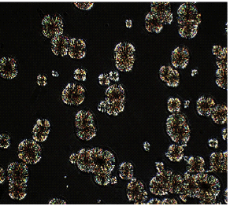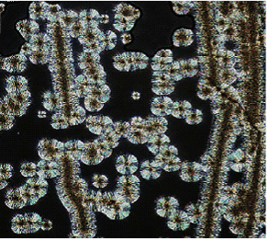
(b)
(a)
Figure 2.9 Optical micrographs of PPS at 260°C after 30 min (a) without shear; (b) after shearing at 30/sec for 30 sec [112].
like polyolefins, the core of oriented crystals in PPS is reported to be not made of extended molecular chains but of numerous nuclei aligning tightly in the direction of flow. This conclusion was made based on the fact that earlier investigators [104-110] showed the dimension of the shish-kebab structure of the order of few microns (even ten micron) with the longest cylindrite not more than 200 micron, but the crystals developed in PPS were of the dimension reaching one mm. Spherulites grown from the fibrillar core did not show Maltese cross, indicating that the lamellar rotation within such spherulites is restricted, i.e., they are grown two dimensionally instead of usual 3-D growth of Maltese-crossing spherulites.
They further reported that, as the rate of shear and shearing time increased, the induction period decreased, indicating that shear accelerates the crystallization. Nucleation rate (density of crystal nuclei) was found increasing with shear rate. All these phenomena were explained by the authors as high orientation of the molecular chains upon shear decrease the free energy of the crystal nucleation. As per the theory of crystallization, nucleation rate is governed by formation of crystal nucleus of critical size. At a constant temperature and pressure, oriented molecular chains make the stable nuclei formation easier. With shear, chains orient and entropy drops causing these chains to go in higher order than un-oriented ones. This result is contradictory to the reports [,] of little influence of shear flow on spherulitic growth rate. Considerable effect of shear flow on the spherulitic crystal growth by these authors is explained as follows. Theoretically, crystal growth rate is the process in which the molecular chains transport from the melt to the crystal surface. Spherulitic growth rate depends upon the velocity of the chains’ transportation which is determined by the configuration of the chains in the melt. Due to shear, oriented chains accelerate the growth front of the crystal. Increase in spherulite growth rate under high shear rates and for higher shear times, flattens after some period. The growth rate of fibrillar crystal and spherulitic crystal is shown to be nearly the same by these authors.
Zhang et al. [112] also studied the melting behavior of the fibrillar crystals of PPS. They reported that upon shear, the melting endotherm recorded by DSC is exhibiting double or triple melting peaks based on the amount of shear exerted as shown in Figure 2.10. At high shear rates three melting peaks were observed. The lower peak corresponds to melting of imperfect crystals developed by faster deposition of the molecular chains to the growing front of the crystal. Increase in intensity of low melting peak with increase in shear indicates that increasing shear rate deteriorates the crystal perfection, producing more number of imperfect crystals. Medium peak corresponds to the normal peak exhibited under quiescent conditions. The higher melting peak was attributed to melting of perfect crystals that have shish-kebab like fibrillar crystal structure. Intensity of this peak also increases with increase in shear. Such phenomenon was also observed by Gahleitner et al. [] who explained the multiple melting peaks in DSC on the basis that initially the outer macro-kebabs melt, and then the inner micro-kebabs melt as temperature increases.
However, Zhang et al. [112] ascribe such phenomena to the molecular orientation that occurs as a result of shear. Generally longer chains form higher order bundles before the shorter chains, and nucleate first. The numerous bundles that align tightly to form the crystal core have higher thermal stability than the kebab like lamellae that develop subsequently.

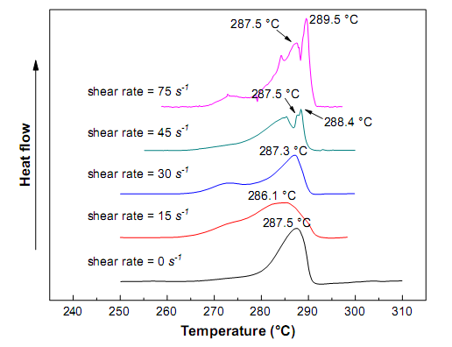
Figure 2.10. PPS melting endotherms at varying shear rates (shear for 30 sec) [112].

2.6.1.5 Effect of fillers
The crystallization kinetic parameters i.e rate constant (k) and Avrami exponent (n) depend upon the MW and MWD, degree of tacticity, polymer structure, presence of impurities etc. Jog and Nadkarni [36] reported the non-integral Avrami exponent values close to two for unfilled grade of PPS and between two and three for filled grades. Mandelkern [92] reported that diffusion controlled growth may cause the n value to be a non-integral value. Avrami exponent did not vary significantly with temperature. Mechanism of nucleation suggested by Jog and Nadkarni [36] in the case of unfilled grade of PPS was homogeneous nucleation with one directional or two directional diffusion controlled growth. In the case of glass fiber filled grade, the mechanism suggested was of heterogeneous nucleation type with two directional diffusion controlled growth in the vicinity of glass fiber surface. They further suggested that homogeneous nucleation may also take place in the filled grades of PPS in the regions not close to the glass fiber surface.

2.6.2 Non-isothermal crystallization kinetics
In non-isothermal crystallization kinetics study, the polymer is heated above its melting point and is held at this temperature for a few minutes to make sure that all the nuclei are destroyed. Subsequently, the melt is cooled at various rates of cooling and crystallization exotherm is recorded as the sample cools. The data is analysed for onset of crystallization, overall rate of crystallization, and crystallizability of the polymer as a function of cooling rate. The findings of various researchers who have studied non-isothermal crystallization kinetics of PPS are summarized below. According to Ozawa [], the potential flaw in applying Avrami equation to analyse non-isothermal crystallization kinetics is that the equation does not consider the effect of cooling rate which is a variable in non-isothermal study. Therefore, he modified the Avrami equation to consider cooling rate effect and provided the modified Eq. 2.15.
ln(1-a) = K’(T)/Φ^{m} (2.15)
where, a is the amorphous fraction, K’(T) is the heating function or temperature dependent parameter, Φ is the cooling rate and m is the Ozawa exponent.
ln(-ln(1-a)) is plotted vs log Φ to calculate Ozawa exponent. For the purpose of plotting, the fractional crystallinities at certain temperatures (degree of supercooling) during the exotherm under different cooling rates are considered.

2.6.2.1 Effect of cooling rate
In a study of non-isothermal crystallization kinetics of PPS, the value of n has been reported [] to be between 3.3 to 3.7 in the temperature range of 195°C-210°C.
Non-isothermal crystallization kinetics study of Fortron® PPS in flakes as well as pelletized forms and Ryton® PPS was carried out by Collins and Menczel [102] using DSC. The PPS samples were cooled from 320°C at different cooling rates in the range of 2°C/min to 320°C/min. With increase in cooling rate, the plot of fractional crystallinity vs supercooling (T_{m}⁰-T) starts at lower temperature and becomes increasingly curved. That means, as the cooling rate increases, crystallization starts at lower temperature and also takes longer time to complete the process. In another publication, Collins and Menczel [38] reported, similar behavior when the PPS melt was cooled from 340°C, that the peak temperature of crystallization decreases with increasing cooling rate.
The plot of log(-ln(1-Vc)) vs log (cooling rate) shows that the slope of the curve decreases from higher temperatures to lower temperature [102]. Vc is the volume fraction of crystalline phase. At higher temperatures, the Avrami exponent as high as six is reported which approached towards one at low temperatures. Above changes in Avrami exponent suggest that the crystal growth geometry changes significantly with changing temperature. The Avrami plots obtained exhibit curvature and deviate from linearity, sometime too much. Hence it is stated that Avrami method has limited utility for studying non-isothermal crystallization kinetics of PPS. Maximum in the crystallization exotherm corresponds to the maximum crystal growth rate. The result is in consonance with research of Hoffman et al [, ] wherein crystalline lamella growth rate is calculated considering the polymer chain behavior and the relationship is given by Eq. 2.16.
G = G₀ exp[K_{g} / T_{c} (T_{m} - T_{c})] X exp [-U/R’(T_{c} - T_{lim})] (2.16)
where, G is the growth rate (length/time), G₀ is the parameter related to number of nuclei, U is the parameter containing activation energy for segmental motion, K_{g} is the parameter containing thermodynamic work required to create crystalline interphase, T_{m} is the equilibrium melting point, T_{c} is the isothermal crystallization temperature studied, and T_{lim} is the temperature below which no segmental motion occurs. From the above equation, it becomes clear that the rate of crystal growth depends upon degree of supercooling (T_{m} - T_{c}) which changes under non-isothermal conditions.
The non-isothermal crystallization behavior differences between Ryton® PPS and Fortron® PPS were studied by Jog et al. [103]. In this study, the samples were heated to 310°C and cooled at different cooling rates ranging between 2.5°C per min to 40°C per min. Degree of supercooling (T_{m}⁰-Tc_{onset}) was plotted as a function of cooling rate where T_{m}⁰ is the equilibrium melting point of PPS. T_{m}⁰ is calculated using Hoffman-Weeks method []. The method of obtaining T_{m}⁰ is discussed in section 2.7. For a given polymer, they observed increase in the onset of crystallization with increase in cooling rate.

2.6.1.2 Effect of molecular weight (MW) and molecular architecture
Jog et al. [103] plotted the degree of supercooling as a function of cooling rate. It was observed that at a given cooling rate, Ryton® PPS starts crystallizing at lower temperature than Fortron® PPS. Hence it was concluded that Ryton® PPS is less crystallizable than Fortron® PPS. This difference was ascribed to differences in the MW and/or linearity of the polymeric chains between these two types of polymers. Similar results are reported by Collins and Menczel [102] between Ryton® PPS and Fortron® PPS by studying the non-isothermal crystallization kinetics with range of cooling rates varying from 2°C/min to 320°C/min.
Employing the Ozawa equation, Lopez and Wilkes [95] showed that the mechanism of crystal growth is similar between branched and linear PPS in the range of cooling rates from 2.5°C/min to 40°C/min.

2.7 Effect of MW and molecular architecture on polymer properties
In this section, the findings on the studies dealing with the effect of polymer MW and molecular architecture on the morphological structure of PPS, on its processing behavior and structure-property of fibers are summarized.

2.7.1 Effect on thermal properties
Fagerburg et al. [, , ] reported production of PPS with MW as high as 131,000 by melt reaction of p-dichlorobenzene with sulfur. With increase in the degree of polymerization (DP) i.e., with increase in MW, they observed increase in T_{g} which levels off at a temperature of 94°C beyond DP of 70. When crystallization is carried out from melt as well as cold state, the difference between T_{c} i.e., temperature of crystallization and T_{g} reduces with increase in DP. They further suggested a fibrillar crystal morphology at DP less than 20 and chain folded lamellar morphology at DP greater than 20. PPS used in the fiber production falls in second category in terms of DP. Cebe [71] also reported similar behavior. With increase in MW, increase in T_{g} and T_{m} of Fortron® PPS is reported whereas crystallization temperature during cooling the melt decreases.
Menczel and Collins [38] studied the dependence of T_{g} on MW of PPS. It was found that T_{g} increases with MW, 79°C for low MW (melt viscosity (MV) at 1200/sec and 300°C was 100 poise), and 92.5°C for high MW PPS (MV at 1200/sec and 300°C was 3500 poise). The equilibrium melting temperature (discussed below), T_{m}⁰ is reported to be 320.5°C to 348.5°C depending upon the MW of PPS in the increasing order.
Various researchers have used Hoffman-Weeks method [120] to determine the infinite melting point or the equilibrium melting point of PPS. In such investigations, the samples studied for isothermal crystallization kinetics are reheated to melt. The observed T_{m} of polymers is plotted as a function of isothermal crystallization temperature. The temperature, at which these curves intersect with the line passing through origin with slope one, is the equilibrium or thermodynamic melting point of the polymer. A few researchers have investigated T_{m}⁰ as a function of MW using the above method. One such plot is shown in Figure 2.11 from the work of Jog et al. [103] for Ryton® and Fortron® PPS. It shows that Fortron® PPS has higher T_{m}⁰ (308°C) than that of Ryton® PPS (298°C). Higher T_{m}⁰ in former case is attributed to its more linear structure. Lovinger and Davies’s [50] work in this regard also shows that T_{m}⁰ increases with MW of the polymer. It increased from 303°C to 315°C and to 335°C for Ryton® PPS of MW 16000, 51000 and 60000 respectively. T_{m}⁰ equal to 340°C is reported for Fortron® of which MW was not reported [93].
Jog et al. [103] cured the Ryton® and Fortron® PPS samples to 385°C in air for time periods between 5 to 45 min. They observed that degree of crystallinity decreases rapidly for Fortron® PPS as compared to Ryton® PPS. Such behavior shows that Fortron® PPS has lesser thermal stability that Ryton® PPS. Brady [69] attributed the decrease in crystallizability to the curing or crosslinking phenomena in PPS. In a study on thermal stability of PPS, Black et al. [] have reported that higher the degree of branching, better is the thermal stability of PPS. TGA studies carried out by Jog et al. [103] under N₂ atmosphere revealed two stage degradation of Ryton® PPS as against to
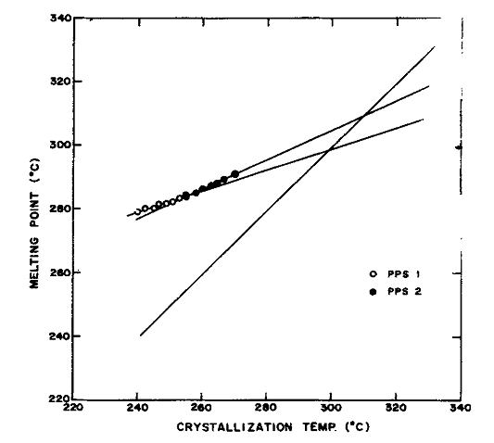
Figure 2.11. Hoffman-Weeks plots of PPS-1 (Ryton®) and PPS-2 ( Fortron®) [103].
one stage degradation of Fortron® PPS. Thus two mechanisms of degradation are suggested in Ryton® PPS, one corresponding to linear and the other corresponding to branched chain structure.

2.7.2 Rigid/constrained amorphous phase
Besides usually understood mobile amorphous phase, work of Wunderlich’s group has shown that the engineering thermoplastics based on phenylene, such as PPS [], PEEK [] possess rigid amorphous phase. The rigid amorphous phase is also shown to be existing in PET []. The amorphous phase in PPS has been reported to have constraints by crystals [66, , ]. Such constraints result in reduction in the mobility of amorphous phase. Extent of chain constraints is determined by the increase in heat capacity, ∆Cp(T) at T_{g} of the polymer. Mobile amorphous phase shows a distinctive step at T_{g} whereas rigid amorphous phase does not.
The mobile amorphous phase fraction is calculated using ∆Cp at T_{g} as per the Eq. 2.17 [].
$χ_{a}= \frac{{C_{p}}^{sc}(T)}{{C_{p}}^{a}(T)}\}_{T=Tg}$ (2.17)
where, χ_{a} is mobile amorphous phase fraction, C_{p}^{sc} is heat capacity of semi-crystalline sample and C_{p}ª is heat capacity of completely amorphous sample.
From the crystalline fractions determined by either DSC or WAXS, the fraction of rigid amorphous phase is then calculated by Eq. 2.18.
χ_{ra = 1-} χ_{c-} χ_{a} (2.18)
Through dielectric relaxation intensity measurements of PPS, Huo and Cebe [] suggested that the rigid amorphous phase has mobility in between that of crystalline phase and mobile amorphous phase.
Lu and Cebe [132] studied the effect of MW on the rigid amorphous phase in Fortron® PPS. Since the rate of formation of crystals have an impact on the creation of rigid amorphous phase, they studied the effect by crystallizing PPS powders, differing in MW, isothermally at a temperature at which the rate of crystallization (t_{1/2}) is identical between the samples. When the samples varying in MW are cold crystallized at same t_{1/2} temperature, although crystalline fraction is almost the same, difference is observed in the fraction of rigid and mobile amorphous phase. Substantial fraction of rigid amorphous phase is observed in all the samples, around 0.4 to 0.5. Lower the MW of sample, higher the constrained amorphous phase fraction observed. Similar results are reported by Huo and Cebe [66] in case of Ryton® PPS.
Cheng et al. [127] showed that T_{g} is a function of the constraints provided by the crystals. Quenched amorphous PPS exhibits T_{g} ca. 90 °C and it increases significantly upon crystallization. With increase in crystallization temperature, T_{g} is shown to be decreasing from 105 °C at T_{c} equal to 170 °C to 92 °C at T_{c} equal to 270 °C. As the cold crystallization temperature increases, the fraction of rigid amorphous phase decreases through relaxation of the chains in the rigid amorphous region making these a part of mobile amorphous phase.

2.7.3 Effect on morphology
Jog et al. [103] studied the spherulitic morphology of Ryton® PPS (R-PPS) and Fortron® PPS (F-PPS) using polarized light microscope under crossed polars. At the same magnification, they observed that the spherulites are larger in R-PPS than in F-PPS. Since the nucleation process was found to be slower in R-PPS than F-PPS through crystallization kinetics, number of nuclei growing at a given crystallization temperature will be less in R-PPS. Hence the spherulites will be larger in dimension for R-PPS. The fine texture of spherulites was observed in F-PPS and was coarser in R-PPS. The coarseness was attributed by Keith and Padden [] to the presence of non-crystalline regions between growing fibrils.
Lu and Cebe [101] reported no appreciable change in mechanical properties of the PPS samples varying in MW that was crystallized at t_{1/2} other than 700 seconds. For the samples crystallized with t_{1/2}=700 sec, low molecular weight PPS shows slightly higher glassy modulus (E’) than that of high molecular weight sample. Both the samples show higher modulus before 100ºC and then drops off, and modulus reaches a plateau at 130ºC for low molecular weight and at 140ºC for high molecular weight sample. The amount of crystals formed during heating is smaller in high molecular weight PPS leading to lower modulus beyond T_{g}. Asymmetric relaxation tan δ loss peak is observed for both the samples. The peak maximum temperature for both the samples is 120 ºC. But the peak height was higher for low molecular weight sample than for high molecular weight sample.

2.8 Changes in morphology, structure and properties of PPS upon processing
In addition to the properties of the base polymer like MW, MWD, its processing plays a vital role to bring the polymer to some kind of useful form, and more importantly, to improve many of the product properties such as tensile properties, and dimensional stability, besides others. Majority of these processes involve thermal treatment of the polymer under stress. Below is the summary of literature dealing with various processes used to convert the polymer into usable products, and structure-properties relationship in fibers, films and injection molded parts.

2.8.1 Effect of curing
Curing of PPS above or slightly below T_{m} in air results in drop in the melt flow rate indicating occurrence of cross-linking [69]. Curing the samples at 260 °C, slightly below melting point did not show any change in the crystallinity even after 24 hours of curing, but showed a considerable influence on crystallizability of the samples since cured samples upon melting exhibited substantial drop in degree of crystallinity, as much as up to 30% from initial value of 60%. This phenomenon indicates decrease in chain mobility which could be due to the occurrence of cross-linking and/or chain extension during curing.
While curing the PPS in air, Hawkins [12] suggested four types of reactions occurring simultaneously, namely chain extension (oligomerization), oxidative cross linking, thermal cross linking and oxygen uptake followed by loss of SO₂. Occurrence of chain extension in PPS during curing, first suggested by Short and Hill [], and Hill and Edmonds [], was confirmed by Hawkins [12] through detection of volatile substances which are low MW products. Thus chain extension leads to increase in MW of PPS.
Scobbo [13, 14] studied the curing of PPS in solid as well as in melt state. It is shown that solid state curing in the temperature range of 255-260 °C results in increase in the viscosity and rate of cure in the presence of oxygen [14]. The behavior deviates further away from Newtonian one. This behavior is ascribed to increase in MW and broader MW distribution, more through branching and cross linking than chain extension. The melt state curing of PPS [13] at 330-335 °C reveals that by controlling the temperature and time of curing, chain extension is preferred in increasing the molecular weight since it retains the Newtonian behavior. However at higher temperatures in melt curing, the contribution of chain extension towards increase in molecular weight decreases as compared to branching/cross-linking.
Collins and Menczel [102] found that the pelletizing process, wherein flakes obtained in polymerization are converted into pellets, lowers the equilibrium melting point, T_{m}⁰ as determined by Hoffman-Weeks method [120].

2.8.2 Melt spinning
Song et al. [] studied melt spinning of three grades of PPS varying in MW, supplied by Phillips Petroleum Company. Instron capillary rheometer was used for the purposes of melt spinning with a capillary of 0.7 mm in diameter and length to diameter (L/D) ratio of 24.5. Spinning was carried out at 290 °C. Draw-down ratios up to 880 were used. The presence of crystallization exotherm in DSC thermogram and the diffuse pattern in pin-hole patterns obtained from WAXS indicate that the melt spun fibers are mostly amorphous in nature with very little crystallinity in them. Crystallinity levels in the fibers decreased with increase in MW. Crystallinity does not vary much until the draw-down ratio reaches 700. The small amount of crystallinity detected in the melt spun fibers in DSC was not observed in WAXS patterns. Increase in the birefringence (∆n) of the melt spun fiber is observed with increase in draw-down ratio. However, the overall level of ∆n, even at high draw-down ratios was found to be around 0.06-0.08, which is very low. At a given draw down ratio, the birefringence decreases with decreasing MW of the samples. As a function of spinline stress, ∆n appears to decrease with increase in MW. This behavior is explained on the basis of crystallinity. Nadella et al. [] have shown that ∆n increases rapidly upon crystallization. The birefringence of crystalline phase is larger than that of the amorphous phase. The crystalline orientation depends upon the spinline stress as shown in the case of polypropylene [138, ] and polyvinyl fluorides []. They have shown that ∆n is a monotonically increasing function of spinline stress, independent of MW. Based on these earlier findings, Song et al. [137] concluded that in case of PPS, with increase in MW, as crystallinity level decreases, the crystalline orientation (∆n_{c}) also decreases causing ∆n to decrease.
To explain above phenomena, Song et al. [137] proposed a Time-Temperature-Transformation (TTT) curve for melt spinning of PPS fibers as shown in Figure 2.12, similar to the TTT curve proposed by Nadella et al. [138] to interpret the melt spinning characteristics of polyolefins. As the draw-down ratio increases, the increase in cooling rate due to decreasing fiber diameter should lead to decrease in crystallinity levels. Contradictory results seen in crystallinity as a function of draw-down in the experiments can be attributed to the effect of stress on the rate of crystallization.

2.8.3 Drawing and Annealing
These are the areas studied comparatively more than fiber spinning of PPS by researchers. Primary objective in these processes is to orient the molecular chains in a preferred dimension and/or increase the crystallinity levels in the polymer.
Song et al. [137] carried out the drawing of melt spun PPS fibers, as discussed above that varied in MW. Drawing was performed over a hot plate at various temperatures, 90 °C, 100 °C and 150 °C with different draw ratios. They observed that at low drawing temperatures, the fibers are still amorphous, and crystallinity development takes place only at high drawing temperatures. With increase in draw ratio, increase in ∆n

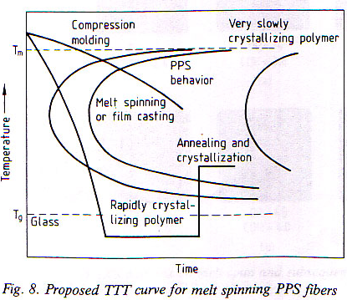
Figure 2.12. Time-Temperature-Transformation curve for PPS fibers [137].
is observed. Over a range of draw ratios between 2.38 to 4.34, Herman’s orientation factor did not vary much for crystalline region (f_{c}) as compared to that for amorphous region (f_{a}). The birefringence of drawn fibers increased from 0.03 to 0.21 with f_{c} varying from 0.5 to 0.75 whereas f_{a} increased significantly from 0.034 to 0.735. The plots of engineering stress-strain curves show that tensile strength and modulus increase with draw ratio whereas elongation to break decreases. Good correlation is found in the fiber tensile properties with birefringence i.e., tensile properties improve with increase in ∆n. With increase in draw ratio, higher crystallinity levels were observed along with better crystallite perfection and increase in the orientation improved the fiber tensile strength.
Xiao and Xu [] studied the morphology of melt spun PPS fibers. Spinning was carried out using melt indexer at 305 °C using capillary of 1 mm diameter and L/D of 10. These fibers were drawn at 98 °C to the draw ratio of 3.9. The drawn fibers were annealed at 200 °C under tension of 0.2 cN/dtex for 5 min. Slight increase in Tg of as-spun, drawn and annealed fibers was observed but the peak melting temperature was found to be similar between three types of fibers. They reported existence of pleated surface morphology with banded texture (Figure 2.13) perpendicular to the fiber axis when studied by scanning electron micrography (SEM) and transmission electron micrography (TEM) which is typically observed in liquid crystalline polymers such as poly(phenylene terephthalamide). Under hot stage, melt exhibited birefringence and nematic structure. Based on these observations, they concluded that PPS has a liquid crystalline nature.
Carr and Ward [31] studied the drawing behavior of PPS as-spun fibers (990 decitex/30 filaments) supplied by Phillips Petroleum Company. One zone drawing was carried out over a heated pin located between the cold draw rolls. Annealing was carried out with 45 cm heated plate that was kept between the heated pin and final draw roll. In the combined drawing and annealing process, the draw ratio was divided between the primary draw at the draw temperature on the hot pin and the secondary draw or hot stretch on the hot plate. Satisfactory drawing performance was observed when pin surface temperatures were between 80 °C and 100 °C. Optimum drawing temperature was found
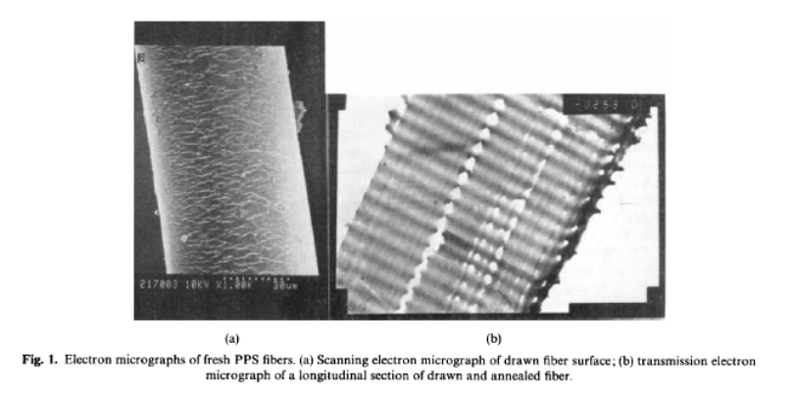
b
a
Figure 2.13. a) SEM of drawn fiber surface, b) Longitudinal view of drawn and annealed fiber by TEM [141].
close to the Tg of the material. Drawing below 80 °C resulted in voids, and above 100 °C, yarn was sticking to the draw rolls. Kitao et al. [] have reported the formation of voids during cold drawing of polypropylene filaments. Draw ratios used in Carr and Ward’s [31] study were 1.26 to 5.0. Annealing temperatures tried were between 140 °C and 220 °C. Although annealing at high temperatures resulted in some increase in tensile strength, initial modulus did not increase. Higher draw ratios could not be achieved with high temperature annealing zone in the drawing process.
The plot of initial modulus as a function of DR of PPS was similar to that of PET at 90 °C [31]. By reducing the draw temperature, the modulus seemed to increase, but the extent of increase was not as high as observed in PET []. Annealed samples showed somewhat higher initial modulus than that of the only drawn samples. The failure stress did not show much change by changing draw temperature but annealing led to as much as 30% increase in the failure stress as compared to drawn but un-annealed fibers. At low draw ratios, drawing at higher temperature seems to result in higher failure stress at a given failure strain. It was shown that PET reaches its maximum birefringence around 0.19 by single stage drawing at temperature slightly above its Tg. After single stage drawing process, ∆n of PPS reached only up to 0.208, much below the maximum attainable birefringence [31]. Birefringence reached close to 0.27 only after annealing. The PPS yarns drawn to low and high DR were annealed at constant length. It was also observed that the increase in ∆n is more upon annealing the PPS yarn drawn to lower draw ratio. With increase in birefringence, initial modulus of PPS did not increase as rapidly as that of PET [].
Free shrinkage study of drawn fibers at 100 °C in silicone oil bath showed that until the DR of 2.6, network extension, i.e., shrinkage, is totally recovered [31]. Up to the birefringence of 0.141, crystallinity is not significant. However, beyond this DR, orientation increases further and the crystallization becomes more significant. The development of crystallization causes rapid drop in subsequent shrinkage. Peak shrinkage stress (σ) was measured by heating the fiber sample at 100 °C in silicone oil bath while maintained at constant length. It was observed that until a birefringence of 0.14 (corresponding to DR of 2.6), the stress optical coefficient (∆n /σ) remained the same. Similar peak shrinkage stress behavior is reported in case of PET [] and PEMT [] up to DR of 1.6, i.e., ∆n of 0.01. Above the birefringence of 0.14, rapid increase in the peak shrinkage stress was recorded beyond DR of 3.0. This indicates that beyond DR of 3.0, the PPS network reaches near to its limiting extensibility and the molecular entanglements become strong enough to prevent further stretching or chain alignment. At the same time, stress induced crystallization at these levels of orientation prevents the chain slippage too. From the shrinkage measurements, it was deduced that crystallization is the primary mechanism that prevents subsequent extension of the network. The rise in peak shrinkage stress near the limiting extensibility is much more rapid in PPS than in PET. It means that upon development of some crystallization, the remaining entanglements in the amorphous network are strong enough to prevent further chain stretching or chain slippage for drawing to occur. At lower drawing temperatures, crystallization is delayed and thus the network can reach much nearer to the limiting extension ratio of the polymer than when drawn at higher temperatures. The highest tensile strength of 740 MPa and initial modulus of 8 GPa was achieved in the case of PPS yarn drawn at a lower temperature (80 °C) and to the highest draw ratio possible.
The above reported values of tensile strength and initial modulus in the case of PPS are lower than that of PET fibers drawn to the same extent [31]. The extent of orientation achieved is similar in both the cases i.e., slightly greater than 80% of the theoretical birefringence of fully aligned molecular chains. Thus the inability to achieve higher strength and modulus in case of PPS was reported to be not because of lack of achieving high orientations. Theoretical crystal modulus of PPS is reported to be ca. 40 GPa [55]. Since straightening of the C-S-C bond angle is reported to be the largest contributor to the crystal modulus of PPS fibers, the presence of zig-zag molecular conformation in the oriented amorphous chains as reported by Tabor et al. [46] is suggested to be the reason behind lower modulus of drawn PPS fibers. Based on the measurements of shrinkage, shrinkage force and the bond polarizabilities of PPS, Carr and Ward [31] deduced that the number of chain segments per unit volume is higher in case of PPS as against that of PET. This means that the entanglement density is comparatively high in the case of PPS. Although these polymers possess similar number of monomers per chain segment between entanglements, PPS monomer unit is smaller than others and does not possess the flexible links either. High electron density of sulphur and phenylene ring restricts free rotation for C-S bond. These factors combinedly make the PPS network more entangled and constrained in rotation. The absence of plateau of shrinkage stress, before its rapid increase against birefringence in PPS as observed in PET (Figure 2.14), indicates that drawing does not modify the PPS network.
Drawing of melt spun fibers produced from Fortron® PPS is reported by Krins et al. []. Use of steam nozzle in the first stage of drawing is reported. It is claimed that the fiber tenacity achieved is close to 60 cN/tex (6 gpd) with elongation to break being ca. 18%. Young’s modulus achieved is claimed to be ca. 400-450 cN/tex (40-45 gpd) at 0.5-2% extension. Bratukhin et al. [] have reported that drawing of fibers under pressurized steam results in the best physico-chemical properties in the fibers. The high coefficient of heat transfer, absence of oxidizing agent, and plasticizing effect produced by water in the vapor form are some of the aspects of steam that help to achieve better properties in the fibers.
Suzuki et al. [65] have reported that zone drawing (ZD) and zone annealing (ZA) treatments are effective in improving the mechanical properties of PPS fibers. The study
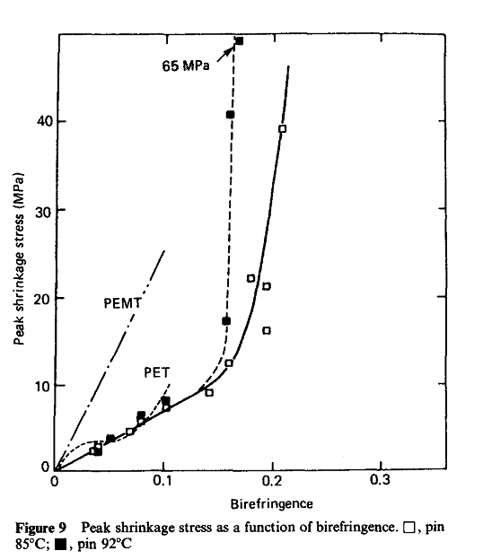
Pin at 92°C
Pin at 85°C
PPS
Figure 2.14. Peak shrinkage stress vs birefringence [31].

was performed, on PPS fibers supplied by Toray, in a small heater coupled with arrangements made to move one end of the fiber for drawing purposes, while the other end fixed. The optimum drawing and annealing conditions are observed at the temperature of 90 °C and 220 °C respectively. Annealing was carried out under a tension of 138 MPa. The fiber thus obtained exhibited the tensile strength of 0.7 GPa and tensile modulus of 8 GPa. These values are similar to those obtained by Carr and Ward [31] reported earlier. The crystalline orientation factor (f_{c}) is reported to be increasing to 0.982 with ZD and further increasing slightly to 0.986 upon ZA.
Suzuki et al. [65] further studied the microstructure of ZD and ZA PPS fibers by its shrinkage behavior. Temperature dependence of shrinkage for PET and various categories of PPS fibers is as shown in Figure 2.15. When heated above T_{g} of the polymer, shrinkage occurs due to chain coiling in the oriented amorphous regions and is dependent on orientation level in the amorphous chains and amount of crystallinity in the sample. While studying the shrinkage behavior of PET ﬁbers [], it was observed that the crystallites are formed by strain-induced crystallization in the temperature range of 70-100 °C during the measurement. The physical network developed through crystallization constrains the additional slippage of the chains above 100 °C. However, the rapid elongation (negative shrinkage) of the original PPS ﬁber even after 100 °C suggests lack of development of network that can prevent ﬂuid-like deformation. This indicates that the strain-induced crystallization does not take place in PPS during the measurements. Compared to the original PPS fiber, the drawn fiber shows increase in shrinkage with temperature which is rapid in the range 100-120 °C, slow in 120-250 °C and again rapid after 250 °C. Initial rapid shrinkage in the range 100 °C to 120 °C is due to the oriented amorphous chains which can coil fairly easily in the absence of crystallinity under these temperatures. Slow down in increase in shrinkage after 120 °C is due to the increased physical cross link density provided by crystallization. Similar observation was made by Desai et al. [84, ] while studying behavior of oriented PET. It was reported that rapid ﬂuid-like deformation occurs in PET under tensile stress and leads to enhanced orientation and thereby to rapid onset of crystallization. Rapid increase in shrinkage of PPS above 250 °C is related to two-fold phenomena. One is substantial increase in segmental motion above this temperature, and the other is above this temperature, crystals start melting, with the imperfect ones melting first, leading to decrease in cross link density.
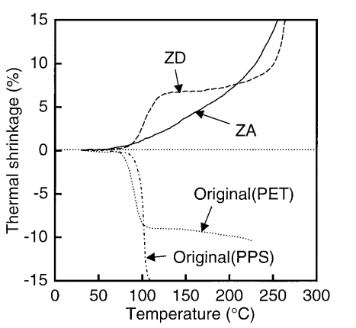
PPS
Figure 2.15. Temperature dependence of shrinkage of various fibers [65].
As compared to ZD fibers, the slow increase in shrinkage in ZA fibers above 70 °C is attributed to higher cross link density provided by crystallinity in annealed fibers. Thus the oriented amorphous chains are resisted from coiling in annealed fibers. It is also shown that the storage modulus increases upon ZD and ZA. The α-relaxation peak in tan δ curve shifts to higher temperature with processing, which indicates increasing constraints on the mobility of amorphous phase, due to increasing cross link density provided by crystallinity.
In yet another study on PPS fibers, Suzuki et al. [86] reported further increase in the tensile strength and tensile modulus of PPS fibers over the above reported values obtained by ZD and ZA experiment. For improvement in the tensile properties beyond the values reported above, i.e., 8 GPa modulus and 0.7 GPa tensile strength, highly oriented amorphous chains are desired. High tension multi-annealing (HTMA) of PPS fibers was performed at 250 °C by subjecting fiber to extremely high tensions, close to its tensile strength. The fiber placed inside electric furnace was stretched at a speed of 10 mm/min, until the tension in the fibers reached the set maximum i.e., 70% of breaking strength. The fiber was held at constant length until tension reduced to the set minimum of 65% of breaking strength. Upon reaching to this lower limit, fiber was further stretched until σ_{max} at 10 mm/min. This was repeated 13 times. The reduction in σ was not attributed to the orientational relaxation due to slippage, but due to improvement of amorphous chain orientation. Fibers thus obtained exhibited tensile modulus of 10.4 GPa, tensile strength of 0.73 GPa, and the breaking elongation of 8.8%. Crystallite size obtained through WAXS was found to be almost 1.5 to 2 times larger than that obtained by application of ZD-ZA technique. The crystallite orientation factor was found to reach 0.988 after HTMA as compared to 0.986 achieved in ZD-ZA technique. It was concluded from these results that due to the stepwise increase, crystallites do not relax during HTMA treatment, but instead amorphous chain orientation increases. However, no data on the amorphous orientation was reported by the authors.
Maemura et al. [30] studied development of crystallinity and orientation in films made from 25 MFI PPS (Pellets from Phillips petroleum). Films were stretched 2-4.6X at the temperatures, 100 °C, 105 °C, 110 °C and 115 °C, and were annealed at 150 °C for various durations between 0.5-48 hours. These samples were further crystallized at 250 °C and 280 °C. The DSC thermograms of these samples revealed that the peak in cold crystallization exotherm moves to lower temperatures as the stretch ratio increases. Also the melting temperature increases with stretch ratio. The data on density by DGC reveals that the structure becomes denser with increase in annealing temperature and time. The pole figures of planes (110) and (112) peaks show increasingly uniaxial texture with increase in the stretch ratio. For a given stretch ratio, birefringence increases with decrease in stretching temperature. With increase in stretch ratio, birefringence increases. Sharp increase in ∆n takes place when stretched beyond DR of 3.5 at 100 °C. This phenomenon was related to stress induced crystallization at DR of 3.5. Film samples stretched to same draw ratios at 100 °C and 110 °C with annealing at 150 °C for one hour showed that % DSC crystallinity level is near about the same but ∆n, f_{c} and f_{am} decrease at 110 °C. When compared between only stretched vs stretched and annealed samples, substantial increase was observed in birefringence in latter case, which was attributed to the increase in crystallinity by annealing under taught condition.
In yet another publication, Maemura et al. [] studied the effect of stretching of PPS films on its mechanical properties by studying the development of crystallinity and orientation. 25 MFI PPS supplied by Phillips Petroleum was extruded into 300μ thick films at 330 °C and quickly quenched onto a chilled roll. These amorphous films were stretched at 600-1500% of initial length per minute in Iwamoto biaxial stretcher. Necking was observed when stretched below 95 °C, whereas above 110 °C, stretching was difficult due to thermally induced crystallization. Taut annealing of the stretched film was carried out at 150 °C for 1 hour. They observed that peak temperature of cold crystallization exotherm in DSC shifts to lower temperature with decrease in stretching temperature, with increase in the stretch ratio, and with increase in the rate of stretching. Slight increase in T_{g} and clear cut increase in T_{m} was observed with increase in stretch ratio. T_{m} increases with decrease in stretching temperature and with increase in rate of stretching. DSC crystallinity of 12% to 18% was observed in these stretched films. Although at low stretching temperature, higher crystallinity was observed, this difference diminished at higher draw ratios.
Substantial increase in crystallinity was reported after annealing of the stretched films at 150 °C due to thermally induced crystallization [151]. A small endotherm was recorded at a temperature slightly higher than annealing temperatures, ca. 160 °C. Occurrence of such minor endothermic peak is reported in the polycondensates too, like PET []. As compared to stretched films, stretched and annealed films exhibit higher T_{g} by as much as 25 °C, from 84-94 °C to 102-110 °C. T_{m} does not seem to vary much upon annealing though the effects of stretched films are preserved upon annealing. At a given stretch ratio, crystallinity of annealed film increases with decrease in stretching temperature.
The study on mechanical properties of these films showed that by increasing TD stretch, the modulus and tensile strength decrease in MD and increase in TD whereas breaking elongation increases in both the directions with larger effect along MD [151]. Annealing increases the moduli, and decreases the elongation to break in all stretching conditions whereas its effect on tensile strength is marginal.
Ito and Porter [87] have studied the drawing of PPS films by solid state co-extrusion at the temperatures of 75 °C, 95 °C and 110 °C. The highest draw ratios achieved at these temperatures were 3.4, 3.6 and 5.6 respectively. The development of crystalline phase in the drawn samples was studied by WAXS pin hole patterns and density. Prominent crystallinity development is observed in the sample drawn at 95 °C. The least crystallinity development in the sample that was drawn to highest DR at 110 °C is suggested to be because of this temperature not being high enough to produce thermally induced crystallization under the applied pressure (ca. 700 atm). When drawn at a temperature slightly above T_{g}, more stress-induced crystals are produced which decreases at higher temperature and results in poor drawing efficiency.
The chain orientation was investigated by Ito and Porter [87] using polarised IR spectroscopy. FTIR spectra of the drawn films showed noticeable dichroism at wave-numbers 1380 cm⁻¹, 1575 cm⁻¹ and 1900 cm⁻¹. The increase in absorbance at 1900 cm⁻¹ and decrease at 1575 cm⁻¹ is ascribed to annealing effect []. The high dichroic ratio at 1575 cm⁻¹ and 1900 cm⁻¹ suggests well developed chain orientation in amorphous and crystalline region respectively. The heat capacity increase at T_{g} evident in the DSC thermogram of the sample drawn at 110 °C is not observed in the samples drawn at 75 °C and 95 °C. Cold crystallization takes place at lower temperatures for the samples drawn at 75 °C and 95 °C. Absence of nuclei due to stress induced crystallization in the undrawn and sample drawn at 110 °C causes the crystallization exothermic peak to appear at higher temperatures in these cases when run in DSC. The cold crystallization exotherm is substantially smaller in samples drawn at 75 °C and at 95 °C which is attributed to the decrease in crystallization rate during DSC run with increasing orientation induced crystallization during drawing due to increase in viscosity at lower draw temperatures. The efficiency of drawing was examined through shrinkage study in which the drawn films are dipped in silicone oil bath at 200 °C for 5 sec. These conditions were found to be not inducing any further crystallization in the samples. Considerable shrinkage (as recorded by elastic recovery) is observed in samples drawn to a DR of up to 2 at 75 °C and 95 °C as compared to undrawn samples and samples drawn at 110 °C. Increase in shrinkage until this DR is attributed to very little increase in crystallinity. As the stretch ratio increases, the recovery decreases noticeably. At high draw ratios, the development of crystallinity restricts the chains in the amorphous regions to relax causing the recovery to drop in samples drawn at temperatures 75 °C and 95 °C. The work of Hadziioannou et al. [] performed on polystyrene has shown that the efficiency of drawing is affine only at low draw temperature. The number of chain entanglements/ network points required to obtain perfect chain orientation in amorphous polymer increases proportionally with MW, above a critical value. On the same lines, Ito et al. [] suspected poor efficiency of drawing at 110 °C due to fewer and/or less effective network points. The largest increase in tensile properties i.e., tensile strength and modulus (6.5 GPa) is observed in samples drawn at 75 °C is ascribed to the fact that drawing below Tg suppresses the chain slippage and relaxation causing better chain orientation to be achieved in both crystalline and amorphous regions.
Work of Judovits et al. [] done on Fortron® PPS, using temperature modulated DSC (TMDSC) shows that the imperfect crystallites formed during melt crystallization become perfect upon reheating when the sufficient segmental chain mobility is achieved for reorganization. Using TMDSC technique, Menczel [] investigated the influence of modulation during cooling the melt of Fortron® PPS. Upon re-melting of the cooled samples, although no considerable change in peak temperature of melting and heat of fusion is observed between conventionally cooled and cooled under modulation for a polymer of given MW, the endpoint of melting observed is considerably higher, around 5-7 °C in the modulated case, indicating better crystal perfection. However, overall endotherm at melting widens for samples cooled under modulation.
Scobbo and Hwang [] studied the effect of annealing on PPS using a dynamic mechanical analyser. Annealing results in secondary crystallization of PPS, which upon heating melts close to the annealing temperature. Extent of secondary crystallization increases with increase in annealing temperature. It results in increase in the storage modulus of PPS up to the annealing temperature, and also in increase in T_{g}.
In a study of Ryton® PPS, Murthy et al. [59] have shown that with increase in annealing temperature from 100 °C to 285 °C, the lamellar spacing determined by SAXS, and crystal size based on (110) and (200) planes determined by WAXS, increases.

2.8.4 Effect of storage
PPS fibers after being stored for 180 days at room temperature exhibited decrease in T_{g} and T_{m} [141]. Decrease in T_{g} of freshly spun fibers seen at 89-92 °C to 86-87 °C after 180 days is attributed to disorientation and increase in entropy of the amorphous region due to relaxation. Temperature at which onset of melting occurs also decreases which is attributed to the same reasons. The Peak temperature of melting also drops from 270 °C to 265 °C for which no reason is given by the authors.
The extensive literature survey indicates that major focus of past investigations was crystallization kinetics of PPS with very limited studies on fiber manufacture and structure-properties development. Also none of these studies were done in the past decade. Focus of following chapters is to discuss the details of fiber manufacture by melt spinning and draw-annealing of four variances of proprietary Fortron® linear PPS resins, and investigating material-process-structure-properties relationship in these polymers.

Materials and experimental methods
In this chapter, categories of PPS polymers used, experiemental details of fiber manufacturing, techniques used to determine polymer and fiber properties are discussed.

3.1 Materials
Four variances of proprietary Fortron® linear (PPS) resins were provided by Ticona polymers. They varied in their MW. All of the polymers were unfilled grades suitable for extrusion spinning into fibers. Resins used are listed in Table 3.1. MWs of PPS polymers having similar chemistry were in the increasing order i.e., 1 < 2 < 3. Polymers of type 1, 2 and 3 were supplied in two forms namely, flakes (F) i.e., as obtained from the polymerization reactor, and pellets (P) made from corresponding flakes through pelletization. Therefore, in general, pellets will be of slightly lower MW than corresponding flakes, since they have gone through one extra stage of thermal processing. Polymer type 4, which had some differences in its chemistry than above three grades, was supplied later on in the form of pellets only. Its MW was between that of 2 and 3. Throughout the dissertation, above material codes are used to identify the base polymers and their forms.
1F, 2F, 3F and 4P were opaque in appearance indicating that in their as-supplied form, those were crystallized. 1P, 2P and 3P were transparent in increasing amount respectively, indicating that those were not fully crystallized, and suggested that the degree of crystallinity in them was in the order of 1P > 2P > 3P.
Table 3.1 Various grades of PPS resins
Pellets | 1P | 2P | 3P | 4P
Flakes | 1F | 2F | 3F

3.2 Storage and drying
Since PPS is sensitive to the ultraviolet (UV) light, all of these materials, and yarns made from them in this study, were stored in a way to avoid their exposure to light.
Although moisture regain of PPS is very low, around 0.6% [25], any trace amount of moisture may be detrimental to stable spinning performance of the polymer. Therefore, all the polymers were oven dried at ca. 120 °C for three to four hours under vacuum of 28 inches of mercury. This procedure was followed for all the samples before using them for characterization and for processing. Upon drying, it was observed that 1P, 2P and 3P which were transparent to begin with turned opaque. It indicates that these samples crystallized during drying.

3.3 Experimental methods

3.3.1 Polymer Characterization
All the polymers were characterized for MW and MWD, melting behavior using DSC, rheological properties like shear viscosity and melt flow rate and crystallization kinetics using DSC. Crystal structure was investigated for few select grades of resins using WAXS. The details of these characterization techniques except WAXS are given below. Details of crystal structure analysis using WAXS are provided in the section of fibers characterization.

3.3.1.1 Molecular weight (MW) and molecular weight distribution (MWD)
High temperature gel permeation chromatography, GPC-220 containing three Polymer Labs PLgel (Polystyrene-Divinylbenzene co-polymer in Toluene) 10 μm MIXED-B columns, was used. The solvent, chloronaphthalene was made to run through the columns at a flow rate of 1 ml/min at 220 °C. A solution, of concentration 1.5 gm/ml, was prepared by dissolving freshly dried PPS polymers in chloronaphthalene. The solution eluting from the GPC columns was detected by two detectors: static light scattering (LS) detector (Precision Detector PD2040 at two angles, 15° and 90° and a refractive index detector (Polymer Labs refractometer). The instrument was calibrated with a set of polystyrene (PS) standards using refractive index (RI) signal. To calculate the MW from LS results, dn/dc, which is specific refractive increment, i.e., change in refractive index with concentration for PPS, used was 0.17. This value for PPS was determined in the Polymer Characterization Laboratory (PCL) in the Department of Chemistry at the University of Tennessee, Knoxville. Stacy [] reported a fairly close value of dn/dc, ca. 0.167 ml/gm, for PPS. For each variety, two readings were taken and the average is reported.
Refractive index (RI) detector and light scattering (LS) detector, have subtle differences in the way they analyze the polymer for its MW. Weight average molecular weight ($\overline{M}$_{w}) analysed by RI detector is relative to the $\overline{M}$_{w} of polystyrene (PS) standards used for calibration purposes, whereas that analyzed by LS detector is absolute. However, since LS detector is insensitive to low molecular weight fractions as shown in Figure 3.1, the overall molecular weight given by it, is somewhat higher than the actual overall $\overline{M}$_{w} of the polymers.
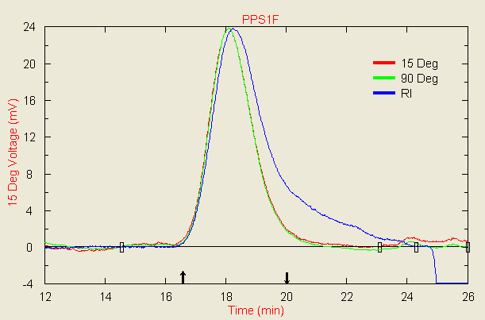
Figure 3.1. Sensitivity of detectors of Light scattering and Refractometer to high and low molecular weight components in the polymer.
Considering the pros and cons of each detector technique, overall MW and MWD, low MW peak determined by RI and high MW fraction given by LS are considered for the purposes of discussion herein. Polydispersity index (PDI) of PPS was obtained using the polystyrene calibration. Number average molecular weight ($\overline{M}$_{n}) was calculated using Eq. 3.1.
$\overline{M}$_{n} = $\overline{M}$_{w}/PDI (3.1)

3.3.1.2 Thermal analysis
Mettler-Toledo DSC 822e was used to study melting and crystallization behavior of dried polymers. DSC was calibrated for temperature and heat flow using standards of Indium and Zinc. The mass of the polymer was kept between 5.0 to 5.5 mg. 100 ml/min flow of pure nitrogen was used for purging. Since flakes and pellets have different thermal history, the second heating cycle was performed to study melting behavior of polymers after erasing the previous thermal history of the samples. Each of these samples was heated from 30 °C to 350 °C at 10 °C/min. After holding at 350 °C for 5 min, melt was cooled at 10 °C/min using liquid nitrogen. Second heating was performed under the conditions similar to first heating. Thermographs were analysed using the Mettler software. After rearranging the terms in Eq. 2.2, degree of crystallinity was calculated. The heat of fusion of 100% crystalline PPS was taken as 112 J/gm [66].

3.3.1.3 Rheological properties

3.3.1.3.1 Melt Flow Rate (MFR)
MFR is defined as the mass of polymer melt in grams that will flow in 10 min under standard conditions. Tinius Olsen’s Extrusion Plastometer MP200, as shown in Figure 3.2, consisting of a barrel with diameter 9.55 mm and length 162 mm, was used. Capillary of diameter 2 mm and length 8 mm as per ASTM standard D1238 [17] was used. The test conditions used were as per ASTM standard for PPS i.e., barrel temperature 315 °C, load 5 kg, and the length of piston travel, for which time is recorded, 25.4 mm.
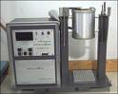
Figure 3.2 Melt flow indexer.
The accuracy of the instrument was first checked with polypropylene (PP) standard of 36 MFR. The MFR of PP at 230 °C under the load of 2.16 kg [17] was found to be fairly close, 35.95. 7 to 8 gram of freshly dried PPS polymer was charged into the barrel. Three readings were taken for each variety and the average is reported. Care was taken during packing so that the extrudate remained free of air bubbles. The extrudate corresponding to 25.4 mm travel of the piston was collected and weighed to determine the melt density. Time for 25.4 mm travel of the piston was recorded by the instrument. Before continuing measurements for each variety, the inside of the barrel was cleaned by extensive scrubbing using copper wire and purged with PP. Melt density of PPS was calculated using Eq. 3.2.
$Melt Density (d) = \frac{Extrudate mass }{1.804}$ (3.2)
where, 1.804 is the volume of the barrel in cc corresponding to the piston travel length of 25.4 mm.
MFR was calculated using Eq. 3.3.
$MFR= \frac{426*L*d}{t}$ (3.3)
where, L is the length of the piston travel (cm) and is equal to 2.54, d is the melt density (gm/cc) of the polymer at test temperature and t is the time (sec) of piston travel for length L. In the above expression, the constant 426, is the mean of areas of piston and cylinder after multiplying it by 600 sec, the time that is equivalent of 10 min.

3.3.1.3.2 Shear Viscosity
MFR gives the estimate of the melt viscosity of the polymer at negligible shear rates. During extrusion spinning, the melt experiences high shear rates too. Majority of the thermoplastic polymers including PPS exhibit shear thinning behavior i.e., the shear viscosity of these polymers decreases with increase in shear rate. Therefore, it is very much necessary to understand the behavior of the PPS at the shear rates close to the ones that are present in the practical extrusion spinning. Advanced Capillary Extrusion Rheometer (ACER-2000) which is capable of producing shear rates over a wider range was used for these evaluations. The test method used to carry out these measurements was ASTM Standard D3835 [].
The schematic of the ACER-2000 is shown in Figure 3.3. Dies with capillary l/d (length to diameter ratio) equal to 5 and 10 were used. Polymer sample was charged into the barrel which was preheated to desired temperature, 315 °C and 325 °C in the current study, with as much packing as possible. Sufficient time was allowed to melt the polymer inside the barrel. This time was kept constant for all the measurements. The computer connected with the rheometer records the pressures via a pressure transducer located just above the entrance of the die. At the end of the time period, ram is moved down manually initially, until it touches the polymer, when small force value is recorded by the software. Subsequently, the ram is made to move down at programmed shear rates ranging from 10/sec to 10000/sec. At a given shear rate, once the pressure reaches the steady state, the reading is recorded and experiment proceeds to the next shear rate. The data is recorded for series of shear rates. From the data recorded, software calculates the shear viscosity using Eq. 3.6. The shear viscosity is plotted as a function of shear rate for each of the sample at a given temperature.
The geometry of capillary rheometry is shown to the right in Figure 3.3. The pressure, P_{d}, is measured in the feeding reservoir by a pressure transducer placed before
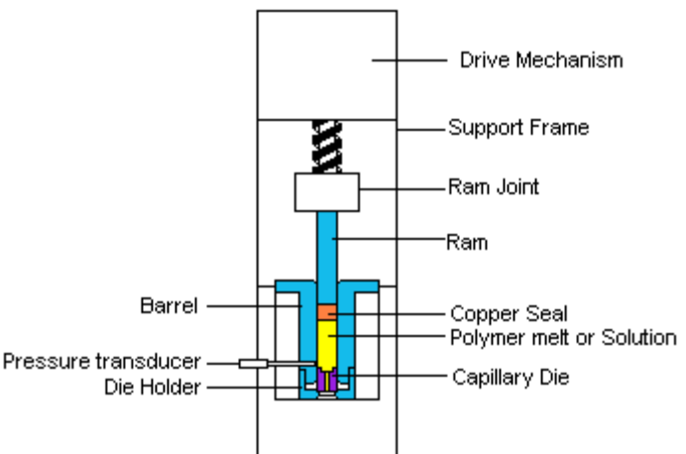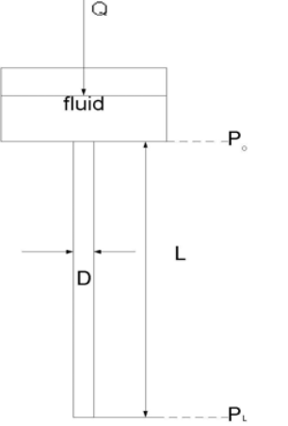
b
a
Figure 3.3. (a) Schematic of ACER-2000 rheometer; (b) capillary rheometry geometry [].
the melt enters the capillary die. Assuming the pressure at the exit of the tube, i.e., at z = L, to be small compared to P_{d}, an apparent wall shear stress (σ_{A}) can be calculated as in Eq. 3.4.
$σ_{A}= \frac{P_{d}R}{2L}$ (3.4)
where, R is the radius of the tube.
The apparent shear rate ($\dot{y_{A}}$) at the wall is given by Eq. 3.5.
$\dot{y_{A}} ≡ \frac{4Q}{π R^{3}}$ (3.5)
The apparent shear viscosity (η_{A}) is calculated by Eq. 3.6.
$η_{A}= \frac{σ_{A}}{\dot{y_{A}}}$ (3.6)

3.3.1.4 Crystallization kinetics
Isothermal crystallization kinetics of PPS, both in pellets and flakes form, was investigated using Mettler DSC 822e. Polymer mass taken for each measurement was kept around 3 +/- 0.05 mg. The sample was heated to 325 °C at the rate of 20 °C/min under N₂ environment. Additionally samples of few select grades of PPS were heated to 340 °C to understand the effect of melt holding temperature on crystallization kinetics. Above temperature was maintained for 10 min to ensure melting of all the crystal nuclei. Subsequently, the melt was cooled rapidly at the rate of -100 °C/min using liquid nitrogen, until the temperature reached to the crystallization temperature ranging from 260 °C to 230 °C. Crystallization exotherm was recorded for 30 min at each of these temperatures. The crystallization exotherm was then analysed using the Mettler software. First order derivative of each of the exotherms was used in determining more accurate onset and endset of crystallization. The data thus obtained was processed as discussed in section 2.6.1 to plot the fractional crystallinity and Avrami parameters as a function of time. Time taken to begin the crystallization after reaching the crystallization temperature, i.e., induction period ($τ_{0})$, was not subtracted from the crystallization time while plotting the fractional crystallinity curves. It was done for easy differentiation between the crystallization behavior of polymers with regards to onset of crystallization. Half-time of crystallization (t_{1/2}), time taken to complete the crystallization (t_{c}), and time corresponding to maximum in the exotherm (t_{ΔHmax}) were calculated by subtracting the induction period. Degree of crystallinity was calculated at each of the crystallization temperatures as discussed earlier in section 3.3.1.2. Avrami plots were constructed from the data of fractional crystallinity vs time, using Eq. 2.14. Avrami exponent (n) and Avrami rate constant (k) were determined from these plots. While using Eq. 2.14, the variable t was taken as the time after subtracting $τ_{0}$ from the time under consideration. Thus Eq. 2.14 takes the form as given in Eq. 3.7.
$\ln\left(-\ln\left(1-X_{t}\right)\right)=n\ln\left(t-τ_{0}\right)+ ln⁡(k)$ (3.7)
Non-isothermal crystallization kinetics of PPS, both in pellets and flakes form, was also investigated using above DSC. Polymer mass taken for each measurement was kept around 3 +/- 0.05 mg. The samples were heated to 325 °C and 340 °C at the rate of 20 °C/min under N₂ environment. Each of these temperatures was maintained for 10 min to ensure melting of all the crystal nuclei. Subsequently, the melt was cooled to room temperature at controlled cooling rates ranging from -5 °C/min to -60 °C/min using liquid nitrogen. The crystallization exotherm recorded during cooling was then analysed using the Mettler software. The fractional crystallinities were calculated as discussed above and plotted against the temperature at various cooling rates. The onset, peak and endset temperature of crystallization, and degree of crystallinity developed were calculated from this data as described above.
Ozawa Eq. 2.15 can be rearranged in the form given by Eq. 3.8.
Log (-ln(1-X(T))) = - n*log a + log χ_{T} (3.8)
where, X(T) is the crystalline fraction, χ_{T} is temperature dependent parameter, a is the cooling rate and n indicates growth dimensionality of the crystallites. To construct the Avrami plots, fractional crystallinities at certain temperature during exotherm under different cooling rates were considered. Plots were constructred of log(-ln(1-X(T))) vs log a.

3.3.2 Melt spinning
Pilot melt spinning facility comprising of Fourne’ single screw extruder was used for the purposes of producing the fibers using a screw with L/D of 24. Freshly dried samples of each polymer were fed to feed hopper. Dry N₂ gas was continuously supplied to the feed hopper. Set extrusion temperatures were 300 °C and 325 °C. All the four zones of extruder were set to same temperatures. It was observed that the actual temperature of the melt, immediately after the outlet of the metering pump, as measured by a thermocouple present in the path was around 15 °C higher than the set temperature. These actual temperatures i.e., 315 °C and 340 °C are reported henceforth. The 12 hole spinnerets with 0.8 mm diameter capillary, and L/D ratio of 10 and 5 were used. The metering pump speed was varied to get two levels of desired throughputs i.e., high level around 12 gm/min/12 holes and low level around 9 gm/min/12 holes. In all the cases, the speed of the extruder screw was adjusted such that the melt pressure before the metering pump remained in the range of 1000 psi to 2000 psi. Figure 3.4 shows the picture of melt spinning line (Figure 3.4a), and the multifilament bundle exiting from the spinneret (Figure 3.4b). The filaments were allowed to cool under room condition while being pulled by a winder downstream. Down the line, spin finish of 10 % concentration was applied to all the yarns under controlled rate so that spin finish pick-up on the yarn was approximately 1 %. Finally, the yarn was wound onto a package using the Leesona high speed winder at various take-up speeds. The spinning process conditions are summarized in Table 3.2. For pellets 1P and 3P, being the lowest and the highest in MW respectively, spinning was carried out at three levels of extrusion temperatures as listed. Additionally, 1P was spun at 600 mpm and 2100 mpm at an extrusion temperature of 340 °C. 3F and 1F were tried to spin at extrusion temperatures of 315 °C using spinneret with capillary l/d equal to 10. Due to the processing issues related with the fiber manufacture from flakes, they were not spun with as many process variables as that of pellets. For the same reasons, the process-structure-properties relationship in the fibers manufactured from flakes was not investigated.

3.3.3 Drawing of as-spun fibers
The as-spun fibers do not have a fully developed structure in terms of achievable orientation and crystallinity. The highest tenacity that has been achieved in the as-spun state is slightly lower than four gpd for fibers spun from high MW polymers. In order to
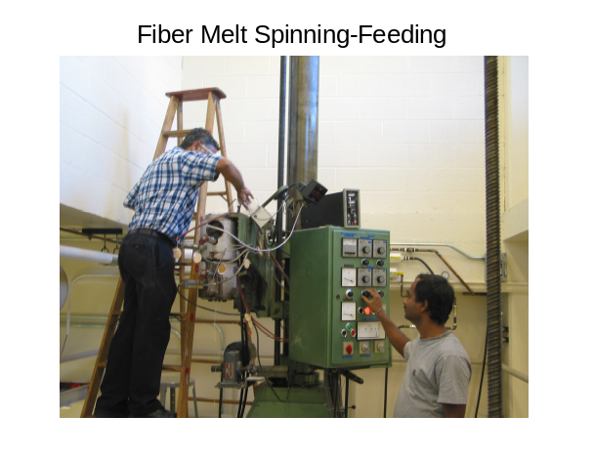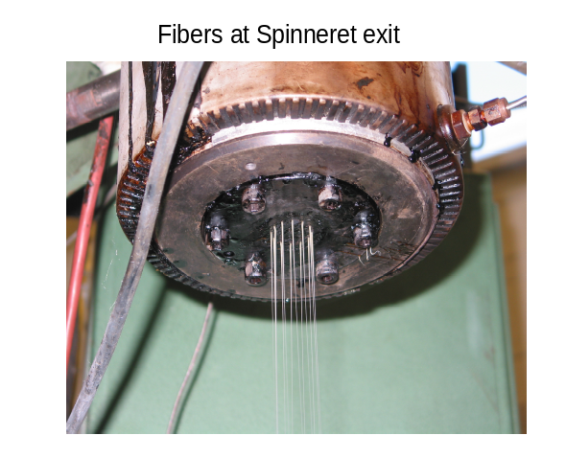
a) Melt spinning –Feeding the polymer. b) PPS fibers at spinneret exit.
Figure 3.4. Melt spinning line in operation.
Table 3.2 Melt spinning process conditions for various PPS polymers
Throughput  (gm/12 holes /min) | Take-up speed (mpm) | Extrusion temperature (°C)
Throughput  (gm/12 holes /min) | Take-up speed (mpm) | 1P | 2P | 3P | 4P
Low- 9 | 600 | 340
Low- 9 | 1025 (low) | 315, 340,  325 | 315, 340 | 315, 340, 355 | 315, 340
Low- 9 | 1750 (medium)
Low- 9 | 2350 (high)
Low- 9 | 2100 | 340
High-12 | 600 | 340
High-12 | 1025 (low) | 315, 340 | 315, 340 | 315, 340, 355 | 315, 340
High-12 | 1750 (medium)
High-12 | 2350 (high)
High-12 | 2100 | 340
push the tenacity to higher levels, as-spun yarns can be stretched since they have peak elongations higher than required in the products. There can be different ways in which stretching of the yarns can be performed. The most commonly used technique adopted in present industrial set-up for PPS fibers is zone drawing. Therefore, major focus of the work related to stretching of PPS as-spun yarns was using this technique. In addition, as an exploratory tool, other method studied was steam assisted drawing, due to the very advantages of this technique over conventional zone drawing method, as mentioned in the literature review section earlier. Following sections illustrate each of these techniques, the instruments that were used for these purposes and the experimental plan.

3.3.3.1 Zone drawing and annealing
In this process, typically the as-spun yarn is drawn to its maximum extent either in one zone, two zone or more than two zone set up at temperatures higher than T_{g} of the polymer. Stretching is followed by heat setting i.e., annealing the yarn to temperatures above drawing temperatures. Annealing fixes the orientation achieved by stretching as the memory of the fibers, improves it further, and also helps in developing the crystallinity in the fibers. It is the combination of molecular chain orientation and crystallinity that enhances the fiber tensile strength and modulus.
The drawing unit used for the purposes of stretching the as-spun yarns using dry heat was supplied by SAHM and is as shown in Figure 3.5. The unit has three pair of rolls making two zones of drawing possible at maximum. Temperature and speed of each of the draw roll pair can be set independently fairly accurately using the control panel. The as-spun yarn was fed to the first pair of draw roll under slight tension using tension assembly in feed zone. The unit was modified to include the annealing zone (four inches long heater) as shown in the picture. In order to avoid the yarn slippage onto the rolls during stretching, the yarn was wrapped for certain number of times, around each of the roll pair. As-spun yarns were stretched to maximum possible draw ratio (DR) that yielded satisfactory processing performance without filament breaks. The drawing temperatures (DT) above Tg, and higher annealing temperatures were used. The annealed yarns were wound on suitable packages using winder at a speed such that the tension on the yarn after annealing zone remained more or less constant.
annealing heater
Figure 3.5 Picture of the one zone draw-annealing unit.

In one zone drawing and annealing set-up, the temperatures of draw rolls 1 and 2 were varied in the range of 85-120 °C in the steps of 5 °C. The maximum possible drawing was achieved between the first two set of draw roll pairs, where speed of second draw roll pair was higher than that of first draw roll pair. Drawn yarn was then annealed at a higher temperature using four inch long annealing heater placed between second and third draw roll pair as shown in Figure 3.5. Referring to earlier work of Carr and Ward [31], initial annealing temperatures (AT) were set. The temperature of annealing heater at its inside surface was maintained such that the air temperature close to the inside surface was around 150 °C. Based on the findings of these studies, few select samples were drawn at optimum DT of 95 °C and annealed at 190 °C using one meter long heater. Around one percent relaxation was allowed during annealing. To maintain uniform annealing time, throughout these experiments, third draw roll pair was set at the speed of 15 mpm. Some select samples were only drawn at a few draw temperatures to isolate the effect of drawing and annealing.
In two zone drawing and annealing set-up, the maximum possible drawing was split between first zone, i.e., the first two set of draw roll pair and the second zone, i.e., second and third draw roll pair (Figure 3.6). During one-zone draw-annealing studies, it was observed that optimum DT is around 95 °C. Hence, in two zone draw-annealing studies, DT of first zone was set at 95 °C and that of second zone was kept at 100 °C. These fibers were then annealed at 190 °C using one meter long annealing heater placed after third draw roll pair as shown in Figure 3.6.

3.3.3.2 Steam assisted drawing
The advantages of steam assisted drawing are high coefficient of heat transfer of steam, absence of oxidizing agent, and plasticizing effect produced by water in the vapor form [148]. To achieve the best results, it is necessary to have super heated steam. However, generation and using pressurized steam makes the system complex. Therefore, steam produced by boiling water in the conventional way was used without pressurizing. Figure 3.7 shows the set up of the steam assisted drawing unit.

Figure 3.6 Picture of the two zone draw-annealing unit.
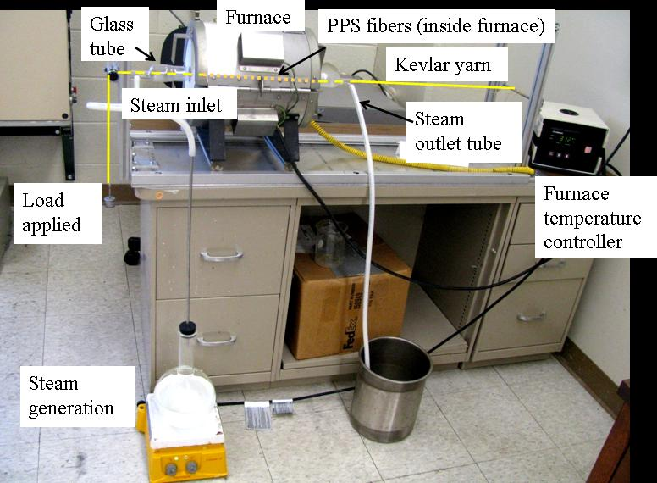
Figure 3.7. Set up of steam assisted drawing.
A glass tube with proper constricted inlets and outlets for steam and fiber was kept inside the cylindrical furnace. Steam generated by boiling water was supplied to the inlet of glass tube and allowed to distribute evenly throughout the volume of glass tube. The furnace itself was heated to 120°C to prevent any condensation of the steam within the tube. A loop of as spun PPS yarns, 3 inches in length (so that even after stretching it 3-4 times, the drawn yarn would still remain completely inside the 12 inch wide furnace), was made with Kevlar® yarn at both ends as shown. The initial actual length of the PPS loop was recorded. The purpose of using Kevlar® yarn was that, under the experimental conditions, i.e., load and temperature, there would be virtually no stretch occurring in it and the stress would be entirely experienced by the PPS yarn. One end of the Kevlar® yarn was fixed to the assembly. The Kevlar® yarn was then passed through the glass tube after the environment inside the tube came to equilibrium with temperatures remaining close to 100°C (along the whole length of the tube). The other end of Kevlar® coming out of glass tube was passed over freely rotating pulley and applied with desired weight to achieve drawing of PPS yarns. Rough estimate of initial weight to be applied was calculated from the total breaking strength of the PPS strand and depending upon the performance, the load applied was varied to achieve satisfactory performance. At the end of one minute inside the furnace, the PPS fiber loop was taken out. The stretched length of the loop was measured. DR was calculated from the length of the loop before and after drawing.

3.3.4 Fiber characterization
The fibers produced, i.e., as-spun, and, drawn and annealed, were characterized for various properties such as denier, tenacity and peak elongation. The morphology of these fibers was investigated by measuring degree of crystallinity using DSC and WAXS, birefringence (overall orientation) using polarized light microscope equipped with tilting compensator, crystalline orientation and crystal size using WAXS, long period using SAXS, and melting behavior using DSC. Fibers were conditioned at least for 24 hours under standard atmosphere of 23 °C and 65% relative humidity (RH) before testing, and were stored in a dark place. The details of these techniques are given below.

3.3.4.1 Fiber denier
One meter length of the multifilament yarn was weighed using a precision balance to the accuracy of 0.01 mg. Number of filaments in the bundle were measured. From these readings denier of each fiber was calculated using eq. 3.9. For each sample, five readings were taken and the average is reported.
$Denier= \frac{9000 X weight (gm)}{length (m)}$ (3.9)

3.3.4.2 Tensile properties
The tensile properties of the as spun fibers were measured using a Thwing-Albert tensile tester equipped with the load cell of 2000 gm. The testing was done on single filaments mounted on specially made tabs, to avoid fiber slippage in the jaws. For each sample, 10 single filaments taken from various portions of the yarn were glued onto the tabs using epoxy resin, and allowed to cure before testing. Gauge length (distance between the tab ends) used was 25.4 mm. Since as-spun fibers had larger extensions, the rate of extension for testing as-spun fibers was kept such that fibers broke in 20+/-3 sec as recommended in ASTM standard D3822 []. Drawn fibers were tested at the traverse speed of one inch per min. Average of 10 readings is reported for tenacity and breaking elongation %. Tensile modulus was calculated from the load-elongation plots in the initial region of up to 2% elongation.

3.3.4.3 Degree of crystallinity
Degree of crystallinity of fibers (X) was evaluated using two different techniques, DSC and WAXS.
To determine X using DSC, Mettler 822e DSC was used. It was calibrated using the standard indium and zinc samples for heat of fusion and temperature lag. Around 4 mg of fibers was packed in the aluminum pan and heated to 325 °C at 20 °C/min under N₂ atmosphere. The Degree of crystallinity was calculated as described in section 3.3.1.2.
As has been reported in literature by various investigators, a good account of which is provided by Jaffe [], that the mode of packing the fibers in DSC pan influences its thermal response. Especially when packed by chopping, the fibers undergo relaxation during heating cycle of DSC, and no longer represent the original sample. Therefore, preventing such relaxation during heating is important to understand thermal and stress history of the original sample. Todoki and Kawaguchi [] have reported that, in the case of nylon 6 fibers, when packed by chopping, the melting enodtherm occurs at lower temperatures than when packed in a manner to prevent the relaxation during heating. Similar observations were made by us in our laboratory for several PPS fiber samples. Among various ways of packing the samples in DSC pan to prevent the relaxation, knotting the fiber samples is quicker and easier, and was therefore used in this study. While preparing the knotted samples, care was taken not to stretch the fibers, which otherwise may change stress history of the samples, and therefore their thermal response.
To evaluate the crystallinity index using X-ray diffraction, pinhole patterns of parallel arrays of multifilament yarn laid on the sample holder were obtained using the Molecular Metrology WAXS system on reusable Fuji image plates. This system produces X-rays of wavelength 1.5418 A° using monochromatic CuKα radiation. It operates at 45 kV and 0.66 mA and the beam size is around 30 µm. The sample to film distance was set at 36.52 mm. Images obtained after enough exposure were subsequently read using the scanner, the FujiX-BAS 1800II image analyzer. Since calculation of crystallinity index by this technique requires the knowledge of contribution due to amorphous fraction, an amorphous film was made from polymer 3P by hot pressing at 325 °C and then was cooled rapidly using ice water bath. Film thus made possessed very little crystallinity when analysed by DSC. Its pin-hole pattern obtained using WAXS showed essentially amorphous structure (Figure 3.8a). Subsequently, these patterns were converted into 2θ vs intensity plots using the Polar software. Using the software Peakfit 4.0, the multiple peaks in diffraction patterns were deconvoluted into peaks at various 2θ values. The peak fitted plot of amorphous film is as shown in Figure 3.8b. Three broad peaks were assigned as contributions due to amorphous fraction and the small narrow peak at 2θ equal to 18.7 as contribution due to crystalline fraction. Unlike commonly perceived one broad peak as contribution due to amorphous fraction, using Rietveld modeling Morton et al. [] reported that in the case of PPS, amorphous fraction exhibits three to four broad peaks. We observed similar multiple peaks in above amorphous PPS films. Therefore, in the case of analyzing crystallinity index of fibers, similar three to four broad peaks were first assigned as amorphous fraction contributions and then the remaining portion of the diffractogram was considered as contribution due to crystalline fraction. Crystallinity index thus obtained using Eq. 3.10 was fairly close to that determined by DSC.
$X= \frac{I_{c}}{I_{c}+I_{a}} X 100$ (3.10)
where, I_{c} is the sum of diffraction intensities due to crystalline fraction and I_{a} is the sum of diffraction intensities due to amorphous fraction.
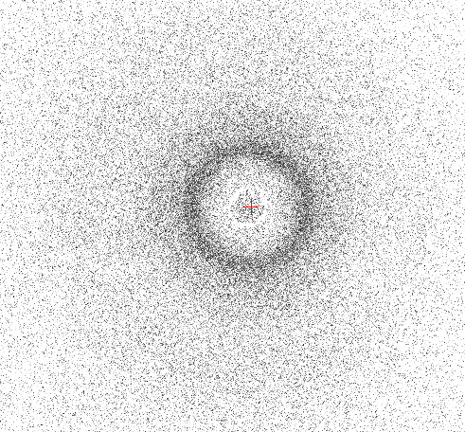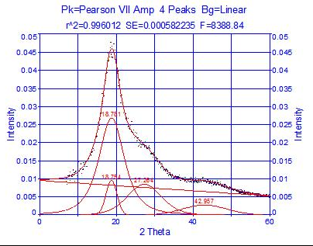
b
a
Figure 3.8 Amorphous film: a) WAXS pin-hole pattern, b) peak fitted curve.

3.3.4.4 Crystalline orientation
Since it is shown by Tabor et al. [46] that the crystal structure of PPS is orthorhombic, a minimum of two planes are required to calculate $<\cos^{2}ϕ_{hkl}>$ []. The pin hole patterns obtained using WAXS as discussed above were evaluated for azimuthal intensities corresponding to 2θ of 18.8°, 20.4°, 20.6° and 25.6° that represent the crystal planes (110), (200), (111) and (112) respectively. From the azimuthal intensity distribution of plane (hkl) perpendicular to the crystallographic axis, Eq. 2.9 was employed to calculate $<\cos^{2}ϕ_{hkl}>$ for any of these two planes depending upon which ones were more visible. Since the crystal planes (200) and (111) are overlapping, Peakfit 4.0 software was used to deconvolute these two peaks. Eq. 3.11 to Eq. 3.14 were derived to calculate $\cos^{2}ϕ_{c, z}$ along the fiber axis based on any of the two planes:
$\cos^{2}ϕ_{c, z}=1.43-2.45 X \cos^{2}ϕ_{111, z}-\frac{\cos^{2}ϕ_{200, z}}{1.2}$ (3.11)
$\cos^{2}ϕ_{c, z}=1-(0.5813 X \cos^{2}ϕ_{200, z}+ {1.4187 X cos}^{2}ϕ_{110, z})$ (3.12)
$\cos^{2}ϕ_{c, z}=5.7454 X \cos^{2}ϕ_{111, z}- {4.7454 X cos}^{2}ϕ_{110, z}$ (3.13)
$\cos^{2}ϕ_{c, z}=2.1863 X \cos^{2}ϕ_{112, z}- {1.1863 X cos}^{2}ϕ_{110, z}$ (3.14)
Using either of above values of $\cos^{2}ϕ_{c, z}$ in Eq. 2.8, Herman’s orientation factor for crystalline region (f_{c}) was calculated.

3.3.4.5 Birefringence
Birefringence was measured using a polarized light optical microscope equipped with a 20 order Ehringhaus compensator. Amount of retardation required for darkest possible extinction of the fiber under crossed polars was measured by rotating the compensator. To determine the extinction with more accuracy, monochromatic light filter of 587 nm was placed above the polarizer. Fiber diameter at the point, where retardation was determined, was measured using the Image-Pro software on the online image of the fiber captured using digital camera. Uncorrected retardation (N_{m}) was calculated as the average of three readings for each sample.
As discussed in chapter 2 (section 2.5.4.1), to take into account the fringe jumping phenomena that occurs in polymers like PPS, corrected retardation (N_{d}) was calculated using Eq. 2.6. In order to apply the correction to N_{m} using Eq. 2.6, degree of dispersion of the compensator used (D_{b}*) and that of the polymer under consideration (D_{b}) were needed to be known. Based on monochromatic lights of three wavelengths, 486 nm, 589 nm and 656 nm, D_{b}* as provided by the compensator manufacturer is 0.0411. Using Eq. 2.5 and monochromatic light filters of above three wavelengths, we calculated D_{b,} and it was found to be 0.1397 for PPS. Using corrected retardation values, Eq. 2.4 was employed to calculate the actual birefringence of the fiber.

3.3.4.6 Amorphous orientation
From the birefringence obtained as discussed in section 3.3.3.5 and crystalline orientation factor discussed in section 3.3.3.4, the amorphous orientation was calculated using Eq. 2.11.
For PPS, Δ° equal to 0.27 was reported by Maemura et al. [30] and 0.333 by Carr and Ward [31]. The values reported by Maemura et al. [30] were based on $Δ_{c}^{°}$ equal to 0.2795 and $Δ_{am}^{°}$ equal to 0.25805. The level of corrected birefringences measured in fibers in the present research were up to 0.31 and hence Δ° reported by Carr and Ward [31] was considered herein. Using Eq. 3.15 [30], Eq. 3.16 [] and Eq. 3.17 [167], $Δ_{c}^{°}$ and $Δ_{am}^{°}$ were calculated to be around 0.3463 and 0.3197 respectively.
$Δ°= \frac{Δ_{c}^{°}+Δ_{am}^{°} }{2}$ (3.15)
$Δ_{c}^{°}=k*ρ_{c}$ (3.16)
$Δ_{am}^{°}=k*ρ_{am}$ (3.17)
where, k is a constant and $ρ_{c}$ and $ρ_{am}$ are densities of 100% crystalline and 100% amorphous regions. $ρ_{c}$ equal to 1.43 and $ρ_{am}$equal to 1.32 as reported by Tabor et al. [46] were considered.

3.3.4.7 Dynamic thermo-mechanical analysis
Thermo-mechanical response of as-spun fibers was evaluated using TA instruments’ dynamic thermo-mechanical analyser (DMA) series Q-800. The multifilament yarn of 8-10 mm length were subjected to fixed tension of 0.05 N and oscillating frequency of 1 Hz. Temperature profile used was 25 °C to 200 °C at the heating rate of 3 °C/min.

3.3.4.8 Crystallite size

3.3.4.8.1 Crystal thickness
From the WAXS pattern, the mean crystallite size was determined using Eq. 3.18, which is the Scherrer equation [, ].
$L_{hkl}= \frac{Kλ}{β_{0}*cos θ}$ (3.18)
where, L_{hkl} is the mean dimension of crystallites perpendicular to the planes (hkl), β₀ is the full width at half maximum (FWHM) in radians of the (hkl) plane in WAXS diffractogram, K is a constant and considered as 0.9 and θ is one-half the diffraction angle of plane (hkl).
To obtain more appropriate value of β₀, the correction due to instrumental broadening (b) was applied to the measured FWHM (B) of plane (hkl). Since the WAXS profiles for polymers are generally broad, Gaussian distribution is supposed to be more appropriate [] than Cauchy distribution. Hence, Eq. 3.19, based on the assumption of Gaussian profile, was used to apply the correction.
$β_{0}^{2}= B^{2}- b^{2}$ (3.19)
In order to obtain FWHM (B) of two strong reflections of planes (110) and (200), the WAXS pin-hole patterns were evaluated using POLAR software for X-axis scans with Y coordinate at center with a line width of 15 pixels where the pixel size was 0.05 mm. Intensity vs 2θ profiles were peak fitted for contribution due to amorphous fraction and then for peaks at 2θ equal to 18.6⁰ and 20.5⁰ corresponding to (110) and (200) planes respectively.
In the absence of availability of PPS polymer sample with considerably larger crystallite size to measure instrumental broadening, it was assumed that the value of b determined based on the Silicon (Si) standard evaluated under same WAXS instrument parameters would be suffice. Based on the Si standard, b was found to be equal to 0.6281⁰.
Above discussed FWHM of (110) and (200) reflections indicate the crystal size perpendicular to the fiber axis. In order to verify the results of long period from SAXS, method of which is discussed below, it was necessary to determine the crystal length, i.e crystal dimension along the fiber axis. FWHM of (00l) reflections indicate the crystal size along the fiber axis. Therefore, few select fiber samples were analysed for (00l) reflections using the Phillips diffractometer in transmission geometry. Based on the crystal structure study of PPS carried out by Tabor et al. [46], (00l) reflections such as (002), (004) and (006), if present, will occur at 2θ equal to 17.28°, 34.98° and 53.59° respectively. CuKα X-rays were used with generator settings at 45kV and 40mA. Fixed divergent slit with 1 mm opening was used. The parallel arrays of multifilament yarn were wound on a specimen holder, and the sample holder was set up in such a way that only (00l) reflections will occur from PPS fibers. 2θ scan in the range of 10° to 60° was carried out with one second per step. WAXS reflections were recorded by the Goniometer. Subsequently, with the help of the X’pert High Score Plus software, the peaks corresponding to (00l) reflections were evaluated for FWHM. In order to consider the effect of instrument broadening, the Si standard was evaluated under same WAXS geometry. The correction due to instrument broadening was applied as discussed earlier using Eq. 3.17.

3.3.4.8.2 Long period
Long period is the mean repeat distance of the crystal lamellae in the direction of the fiber axis, i.e., it is the sum of crystal length and the length of amorphous region followed by it. Assuming that the fiber structure is of two-phase, consisting of crystalline (ordered) and amorhous (non-ordered) phases, long period can be obtained from Lorentz corrected small angle X-ray scattering (SAXS) intensity profiles using Bragg’s law [], using Eq. 3.20.
n λ = 2d sinθ (3.20)
where, d is interplanar spacing, 2θ is scattering angle and λ is the wavelength of X-ray.
In SAXS, the scattering intensity (I) is usually recorded versus scattering vector (q = 4πsinθ/λ). Therefore, an alternative form of Bragg’s law is preferred in the form of Eq. 3.21.
$d= \frac{λ}{2sinθ}= \frac{2π}{4πsinθ/λ}= \frac{2π}{q}$ (3.21)
At the same time of WAXS measurements, X-rays diffracted at smaller angles were detected by 2-D detector for scattering pattern image acquisition. Sample to detector distance was 1.5 m. The MathCAD data treatment program developed by Schreiber [] was used to convert the SAXS patterns into intensity vs scattering vector (q). The long period, L, (corresponding to spacing d in wide angle) was determined from q_{max} using Eq. 3.22, where q_{max} corresponds to the maximum scattering intensity in the Lorentz corrected intensity profiles.
$L= \frac{2π}{q_{max}}$ (3.22)
Assuming two-phase semi-crystalline model, the lamellar thickness (l) was calculated from long period by multiplying crystallinity (X), determined from DSC or WAXS, using Eq. 3.23.
$l=L*X$ (3.23)
It is important to view above values of long period and lamellar thickness with some caution. Since L determined from Lorentz corrected intensity curve is the weighted average of semicrystalline polymer [], the corresponding lamellar thickness is also a weighted average value. In addition to assuming the ideal two-phase model, this method also assumes the homogeneous lamellar structure. However, in real polymer systems from bulk crystallization, there exists transition (or interfacial) zone between crystalline phase and amorphous phase. Thus in reality, there exists distribution of long spacing and lamellar thickness.

3.3.4.8 Scanning electron microscopy (SEM)
Surface morphology of few select fibers was evaluated using LEO SEM. The draw-annealed fiber was carefully cut longitudinally using razor blade to reveal internal structure. Also fiber’s cross section after tensile fracture was analyzed. Gold sputter coating was avoided to reveal the true fiber morphology in SEM. Since samples were not sputter coated, lower beam voltage, 1 kV was used to prevent sample charging.

Results and discussion
In this chapter, the results of the work done so far are reported and discussed. These include investigation of various polymer properties as listed under experimental section, producing fibers by melt spinning of PPS, drawing and annealing of as-spun (AS) fibers, observations on their behavior during melt spinning and draw annealing, and the morphology and properties of fibers manufactured from all the four types of pellets as listed in the experimental section.

4.1 Polymer properties

4.1.1 Molecular weight
The overall weight average MW of PPS resins determined by light scattering detector in GPC is shown in Figure 4.1. Due to the confidentiality agreements with Ticona Polymers, y-axis is plotted in arbitrary units instead of actual MW values. It is clear that the order of overall molecular weight of the polymers is 1 < 2 < 4 < 3. Within the family of polymers with similar chemistry, MW of 2P is slightly higher than 1P, but that of 3P is noticeably higher than 2P.
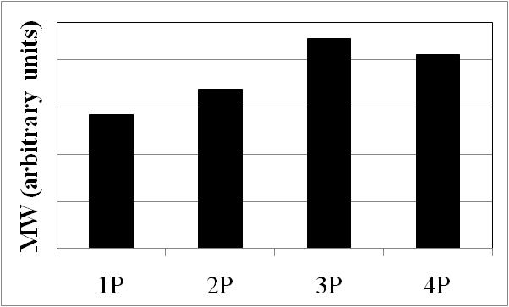
Figure 4.1 Number average MW of various pellets.

4.1.2 Thermal properties
All the seven varieties of PPS were studied for their melting and crystallization behavior using DSC. The DSC thermograms of heating, cooling and second heating are shown in Figure 4.2 for pellets and flakes. There is no significant difference between first and second heating cycle in the case of pellets (Figure 4.2a) except a small endotherm during first heating cycle at around 150 °C before the polymer melts completely in the temperature range of 250-290 °C. This small endotherm may be due to melting of some imperfect crystals formed in the pellets during drying at 120 °C. Change in appearance of the pellets from transparent to opaque, and the sticking tendency between the pellets observed after drying, confirm crystallization of pellets during drying. Small melting endotherm slightly above the annealing temperatures is reported in the case of PPS by Maemura et al. [151] and in the case of PET by Cakmak et al. [152], and was attributed to melting of imperfect crystals formed during annealing.
The thermal behavior of various polymers is summarized quantitatively in appendix 2. In the as-supplied form, flakes show higher degree of crystallinity ranging from 34% to 49%, whereas corresponding pellets possess fraction of this crystallinity ranging from 8% to 19% (except 4P, which was crystallized fully in its as-supplied form). During pelletization, the melt was allowed to crystallize only to the extent so that cutting into pellets became possible. After cutting, the pellets were rapidly quenched and hence only partial crystallization could take place in 1P, 2P and 3P. Change in appearance from transparent to opaque and slight sticking tendency of the pellets observed during drying suggest that crystallization was taking place during drying at the temperature of 120 °C. Occurrence of crystallization during drying is further supported by the data reported in appendix 2. Calculations from the heat of fusion of the pellets after first heating cycle show that the degree of crystallinity in dried pellets is much higher than that present in the as-supplied form. As compared to pellets, the degree of crystallinity of flakes determined after first heating cycle is to the similar level found in as-supplied flakes which suggests that in the as-supplied form, flakes were crystallized close to their maximum crystallization potential.
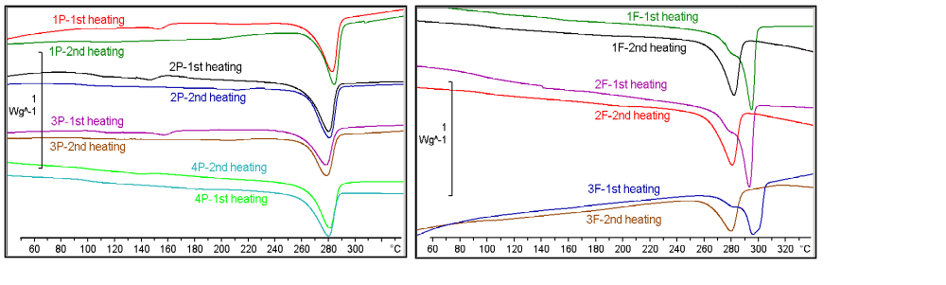
b
a
Figure 4.2 DSC thermograms during heating a) Pellets, b) flakes.
The important observations from DSC thermograms obtained during first heating crycle (Figure 4.2) are discussed here. Within the group of polymers with similar chemistry, the order of onset, peak and endset temperature of melting in pellets is 1 > 2 > 3. Higher the MW, comparatively more chain entanglements may cause formation of somewhat less perfect crystals, and therefore melt earlier. Melting behavior of 4P, which is reported to possess somewhat different chemistry than other pellets, is not noticeably different than other pellets. The onset of melting is at slightly lower temperature in 3P than in 2P than in 1P. If the relative decrease in peak melting temperature from that of the corresponding flakes is observed, polymer 3 shows the maximum decrease of around 17 °C. Referring to MW study, since PPS3 is of higher MW than PPS2 than PPS1, more entanglements due to higher MW and probability of branching and/or cross linking during pelletization may be leading to the formation of comparatively less perfect crystals in pellets causing the melting endotherm to begin at a lower temperature in high MW 3P. 3F melts over a wider temperature range than other flakes indicating wider crystal size distribution in this polymer that can be attributed to its high MW, similar to the discussion above made in the case of pellets. The melting endotherm of flakes seems to be bimodal whereas that of the pellets do not show such behavior. This indicates distinctive differences in the crystal sizes in as-supplied flakes. Higher peak melting temperature (by around 15 °C) and higher degree of crystallinity (by 10-15%) is observed in flakes than in corresponding dried pellets. Different thermal history of pellets vis-à-vis flakes may be the cause behind this phenomenon. After polymerization, flakes are dried for longer durations. Slow drying for longer period may cause enough chain mobility and bring more chains into crystalline order alongwith better crystal perfection (larger crystal size) in flakes, resulting into higher peak melting temperature and higher crystallinity in flakes. Since pellets are quenched rapidly during pelletization and also were dried later on for short duration, time-temperature conditions may not be as conducive in pellets as in flakes for crystallinity and crystal size growth. WAXS pin-hole patterns shown in Figure 4.3 exhibit highly crystalline nature of flakes and diffractograms also reveal presence of sharp peaks corresponding to several crystal planes. Crystallinity determined by DSC/X-ray in pellets and flakes was 30%/35% and 45%/51% respectively. Crystal size based on plane (110) was 124 Å and 64 Å in flakes and pellets respectively. Thus evidence of considerably larger crystals and higher crystallinity is seen by X-ray in the case of flakes.
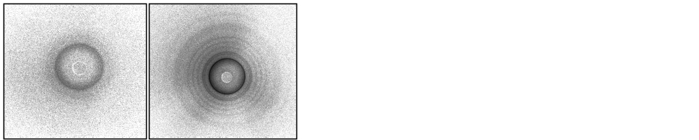
3P
3F
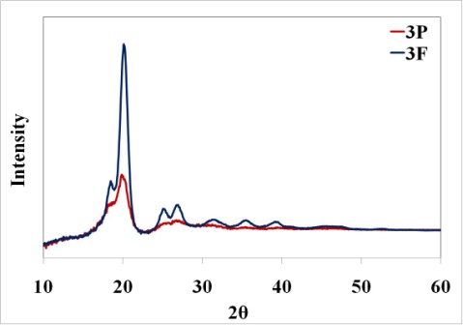
Figure 4.3 WAXS pin-hole patterns (top) and diffractogram (bottom) of 3P and 3F.
The important observations from DSC thermograms obtained during second heating crycle (Figure 4.2) are as follows. With increase in MW of pellets and flakes, melting temperature decreases slightly from 1 to 2 to 3, whereas the degree of crystallinity decreases noticeably. This trend is similar to that observed during first heating cycle, and can be ascribed to the same reasons discussed above. The melting endotherm and degree of crystallinity of each of the pellets in the second heating cycle appear similar to that observed in the first heating cycle. However, there is noticeable difference in the endotherms of flakes between first and second heating cycle. After second heating, the flakes exhibit similar melting behavior as that of the corresponding pellets. As compared to the first heating cycle, during second heating cycle, the peak melting temperature decreases by more than 10 °C. To ensure that the differences in melting endotherm during first heating cycle between pellets and flakes were due to the difference in their previous thermal history, one of the flakes was made to undergo a third heating cycle. The peak melting temperature in the third cycle is similar to that found in the second heating cycle. For the same type of polymer, the degree of crystallinities of flakes are slightly lower than that of the pellets. It may be because flakes have slightly higher MW than corresponding pellets. Degree of crystallinity in as-supplied flakes is much higher (more than 15%) than that obtained in it after it has gone through heating cycle. Also the melting endotherm of as supplied flakes is narrower than that of the flakes undergoing second heating. This may be due to the manner in which crystal development occurs in flakes during polymerization, as discussed earlier.
The observations during cooling of the melt i.e., crystallization behavior of all seven varieties of polymers was extensively studied, and is discussed later in the section 4.1.4 dealing with crystallization kinetics of these polymers.

4.1.3 Rheological properties

4.1.3.1 Melt flow rate (MFR)
The results of MFR analysis are given in Table 4.1. MFR of the polymers is in the order of 1 > 2 > 4 > 3. This suggests the order of MW is 1 < 2 < 4 < 3, and is similar to
Table 4.1 MFR (gm/10 min) of PPS
Polymer type | 1 | 2 | 3 | 4
Pellets (P) | 190 | 150 | 61 | 91
Flakes (F) | 188 | 141 | 57
the order of average MW obtained by GPC. Slightly lower MFR is found for flakes than for corresponding pellets indicating that MW of flakes is somewhat higher than that of the corresponding pellets. DSC analysis of the black-brownish deposition of PPS inside the barrel at the end of the MFR test for one sample, i.e., after approximately 30 min exposure to higher temperature, revealed that the heat of fusion of this material was around 20 J/g compared to 34-54 J/g for the original polymers. This indicates that significant degradation of PPS occurs over prolonged heating. In a study on thermal degradation of PPS, Christopher et al. [19] reported that degradation products can be accounted for by chain scission and transfer reactions. They have also reported that the cross-linking reactions play an important part in the degradation of PPS.

4.1.3.2 Shear viscosity
Shear viscosity of the various grades of PPS was analysed using capillary extrusion rheometer under various conditions. The effect of shear rate on the shear viscosity at the temperature of 325 °C is shown in Figure 4.4. These measurements were carried out using a capillary with l/d equal to 10. All the polymers show shear thinning behavior i.e., the shear viscosity decreases with increase in shear rate. The order of shear viscosity is 1 < 2 < 4 < 3, and follows the same order as that of the MW of these polymers. Flakes exhibit slightly higher shear viscosities than corresponding pellets. This observation is also consistent with that of the MFR results. In comparison with flakes, corresponding pellets are obtained after extrusion processing the flakes. Therefore, slight reduction in the MW of pellets is expected as compared to that of the corresponding flakes. Lower shear viscosity, and higher MFR of the pellets than corresponding flakes,
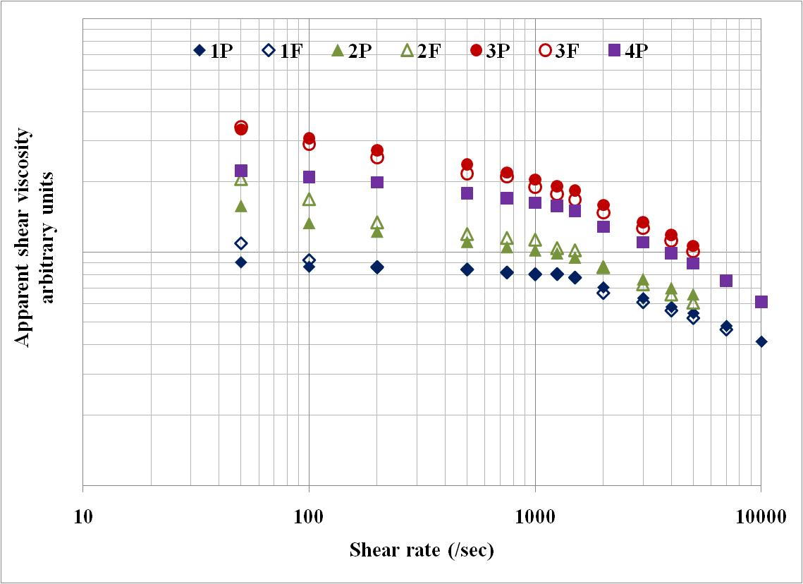
Figure 4.4 Shear viscosity of various grades of PPS at 325 °C.
also indicate lowering of the MW upon thermal processing into pellets. At higher shear rates, the difference in shear viscosities between the polymers is less than that at low shear rates.
To study the effect of temperature on shear viscosity, in addition to above discussed measurements at 325 °C, measurements were carried out at 315 °C for all four pellet types. The shear viscosity results at two temperatures are shown in Figure 4.5. These measurements were carried out using a capillary with l/d equal to 10. Pseudoplastic behavior of all four polymers at both the temperatures can be seen. For the given grade of PPS, the shear viscosity decreases with increase in temperature. Higher level of molecular motions at higher temperatures reduce the resistance to flow, and thereby shear viscosity decreases with increase in temperature.
Effect of capillary l/d on melt pressures at the entry of capillary were studied using capilaries of l/d equal to 5 and 10. The comparison was made for polymer 2P at barrel temperature of 315 °C and results are shown in Figure 4.6 at few select shear rates.
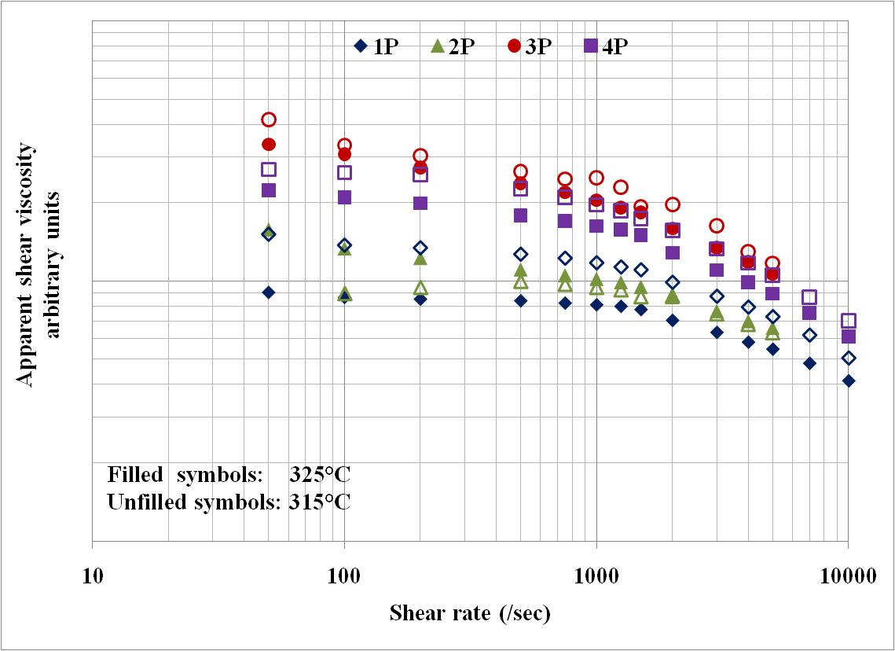
Figure 4.5 Effect of temperature on shear viscosity of the PPS polymers.
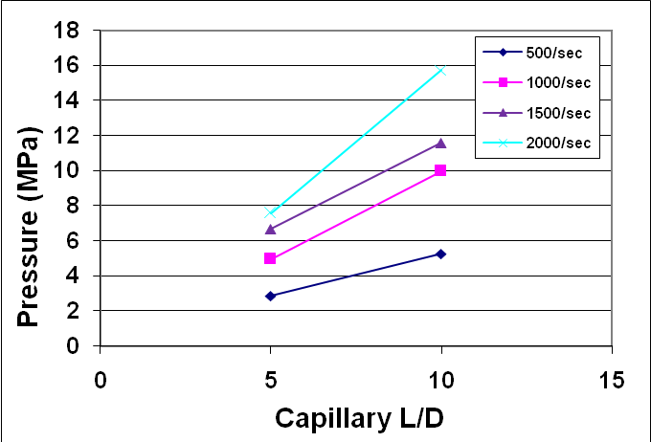
Figure 4.6 Effect of capillary l/d on melt pressure (Polymer-2P).
At all the shear rates studied, pressures at the entry to the capillary increased with increase in capillary l/d. Direct consequence of it will be higher shear stresses during melt flow inside the capillary with higher l/d. At higher shear stresses, more amount of energy supplied is used in orienting the molecular chains in the direction of flow within the capillary and causes lesser relaxation of the melt upon exiting from spinneret. Thus the orientation achieved within the capillary is retained to greater amount in the melt coming out of spinneret when capillary of higher l/d is used. Therefore, fibers produced using higher l/d capillary will be more anisotropic in structure with better chain orientation along the fiber axis, which is desired to improve fiber tenacity.

4.1.4 Crystallization kinetics
The studies carried out on the isothermal and non-isothermal crystallization behavior of various grades of PPS using DSC are discussed in this section. In isothermal as well as in non-isothermal crystallization kinetics studies, under few conditions in the case of high MW polymers, multiple peaks were observed in the exotherm. In such cases, the onset and endset calculated by DSC software were found inaccurate. Therefore, for the entire study on crystallization kinetics, the initiation-point and end-point of crystallization exotherm was determined based on the first order derivative of each of these curves.

4.1.4.1 Isothermal crystallization kinetics
Using the DSC, the isothermal crystallization kinetics of various grades of PPS were studied. The results obtained by melt crystallization are discussed in this section.

4.1.4.1.1 Time-temperature dependence of crystallization
Fractional crystallinity plots for various PPS grades at different crystallization temperatures are shown in Figure 4.7. Melt holding temperature was 325 °C. It is to be noted that time scale is logarithmic. For a given polymer, with decrease in the crystallization temperature, induction period decreases i.e., crystallization starts earlier.
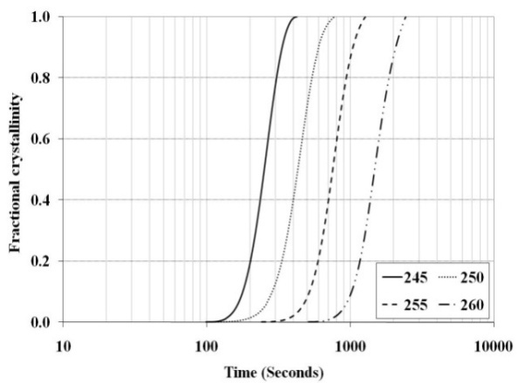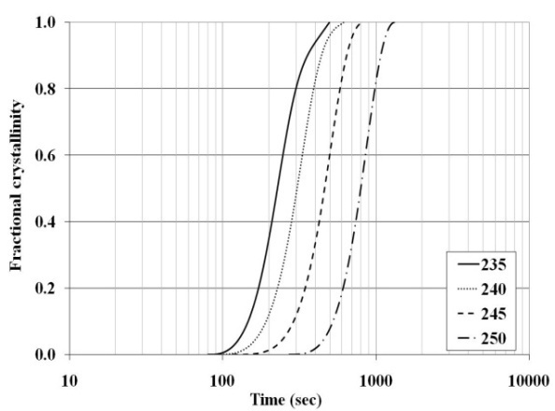
1Pa
1F
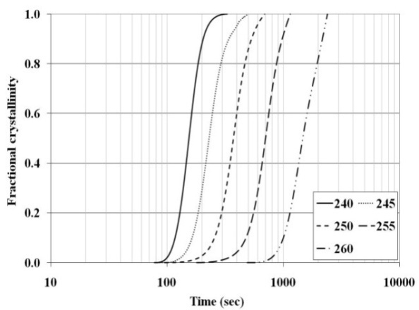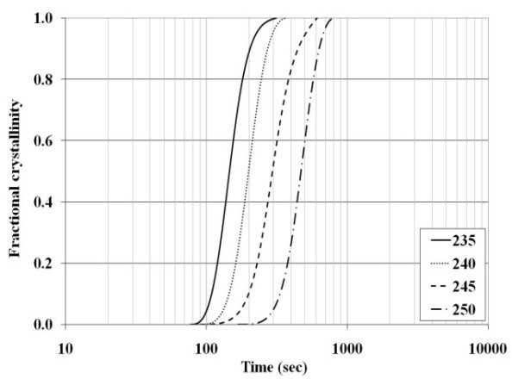
2P
2F
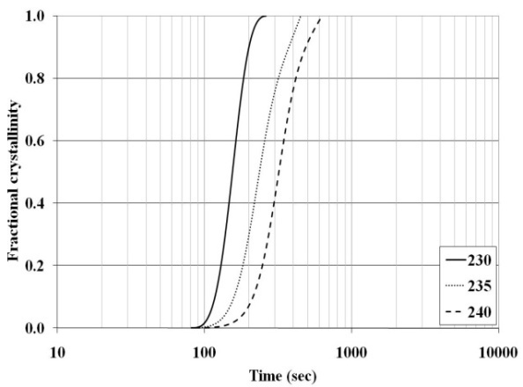
3P
3F
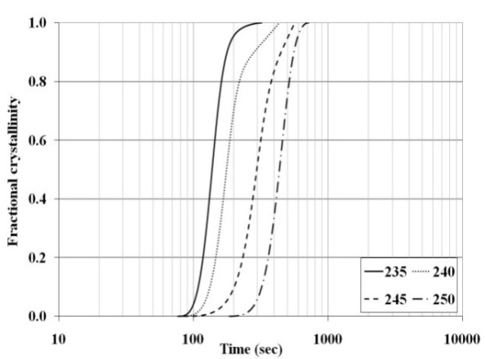
4P
Figure 4.7 Fractional crystallinity plots of various grades of PPS.
Also, t_{1/2} and time to complete the crystallization is lesser at lower crystallization temperatures. These observations are true for all the polymer grades in both the forms i.e.
pellets and flakes. These findings are in agreement with those of earlier investigators [38, 50], and can be explained on the basis of chain mobility. As the crystallization temperature moves away from melting temperature, driving force for crystallization increases. With sufficient molecular mobility, conditions become favorable for enhanced nucleation rate and crystallization, causing lower induction period. At higher chain mobility present at higher crystallization temperatures, the time required for molecular chains to come together sufficiently for crystallization becomes larger and hence induction period increases. Even after the crystallization begins, higher chain mobility at higher crystallization temperature requires longer time to complete the crystallization. In all the cases, below the lowest crystallization temperature for which the plots are reported, crystallization was rapid and happened during cooling the melt before reaching the study temperature. Thermogram for one of the sample (1P) is shown in Figure 4.8. Above the highest temperature reported in Figure 4.7, crystallization was observed after the isothermal segment was over. In few cases, as shown in Figure 4.7, at higher crystallization temperatures, the upper part of S-shaped curve is absent indicating that the process of crystallization was not over during 30 min period. All of the above observations confirm the influence of time and temperature on crystallization behavior of PPS through controlling the molecular chain mobility.
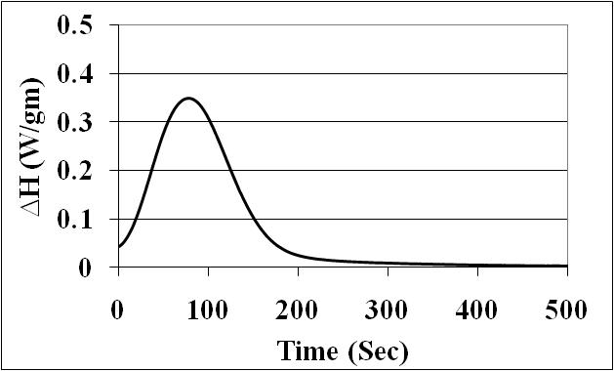
Figure 4.8 Crystallization exotherm of 1P at 240 °C.
The degree of crystallinity is plotted as a function of crystallization temperature in Figure 4.9. For a given polymer, there exists an optimum temperature to achieve higher degree of crystallinity. Above this optimum temperature, higher chain mobility may partially restrict the development of crystallinity during isothermal segment. On the other hand, below optimum temperature, reduced chain mobility may prevent close packing of chains as desired for crystallization.
Avrami plots corresponding to 15% to 75% of fractional crystallinities were plotted using Eq. 3.7. Linear trend lines fitted using regression analyses are shown Figure 4.10. The value of R² for all of these curves is found close to one, and indicates that the data is almost linear at all the temperatures studied. The Avrami exponent (n) i. e. slope of each of these plots, do not vary much as a function of crystallization temperature and varies between two and three with a definitive trend. Similar values of Avrami exponents were reported by Jog and Nadkarni [36], and Menczel and Collins [38]. Appendix 3 lists various parameters of crystallization kinetics for several grades of PPS at different crystallization temperatures.
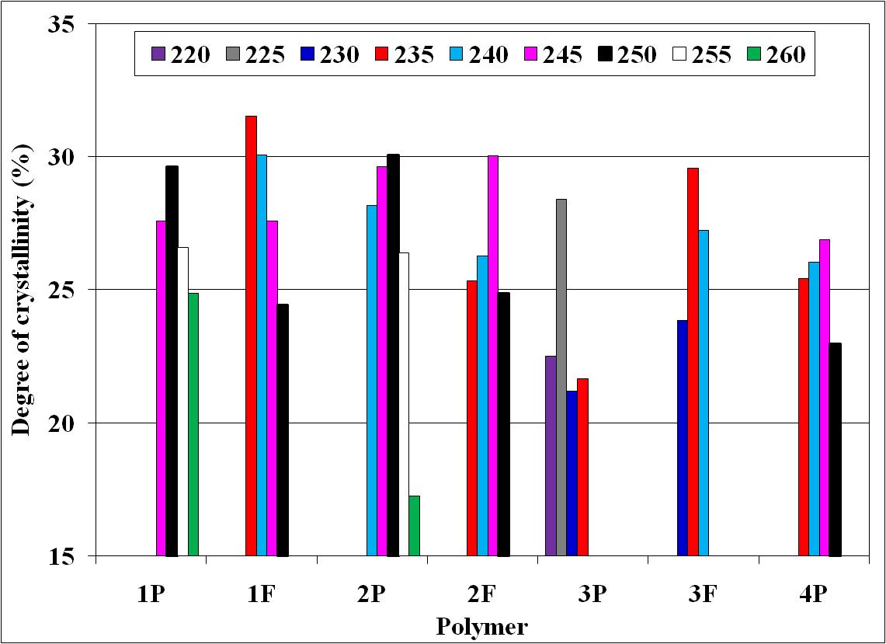
Figure 4.9 Degree of crystallinity of various grades of PPS at different crystallization temperatures.
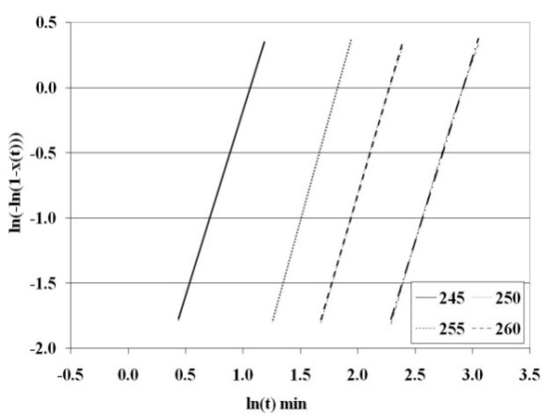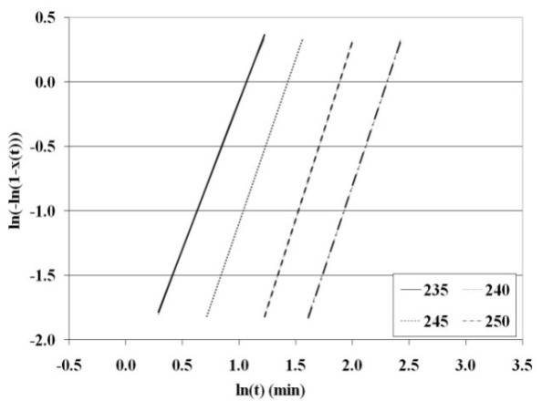
1P
1F
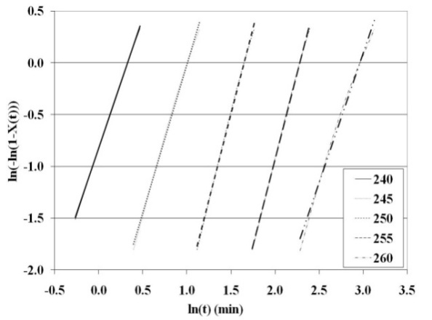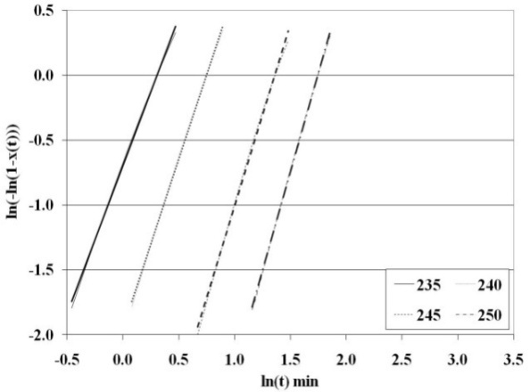
2P
2F
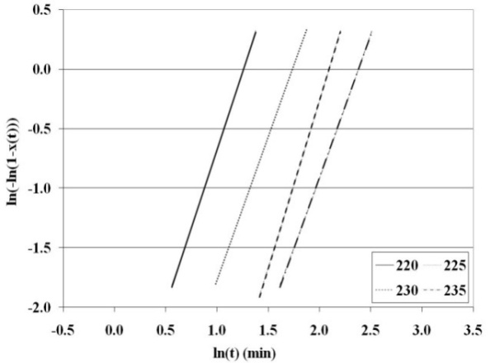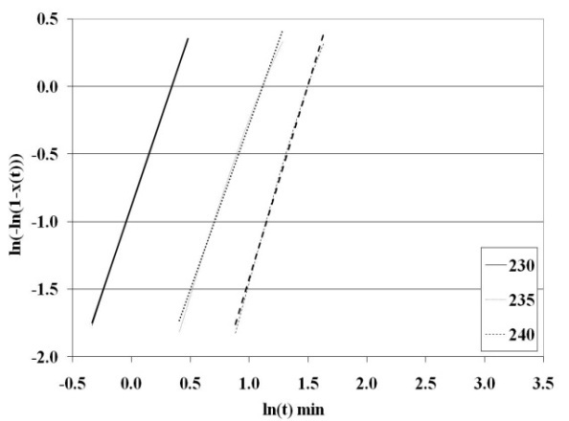
3P
3F
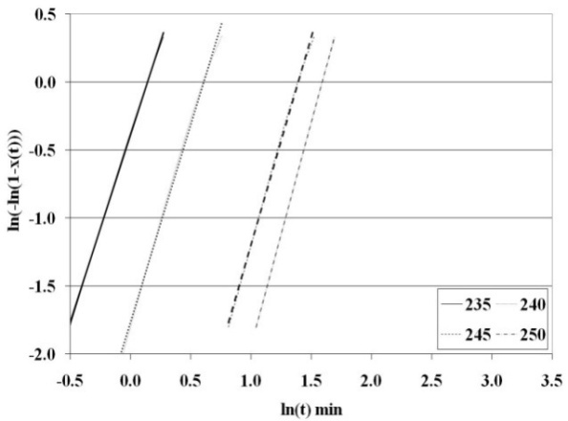
4P
Figure 4.10 Avrami plots of various grades of PPS.
Higher values of Avrami exponent are observed at higher crystallization temperature indicating that the crystal growth dimensions increase with increase in crystallization temperature, may be due to lesser number of nuclei and slower crystallization kinetics, thus providing enough space for crystal growth in more dimensions. Non-integer values of n, in almost all cases, suggest heterogeneous nucleation with linear growth. Avrami exponent (n) equal to two indicates crystal growth in two dimensions and n equal to three indicates growth in three dimensions i.e., spherulitic growth. Y intercept of each of the Avrami plots give the Avrami rate constant (k) and indicates crystallization rate. The values of k under various conditions are also listed in appendix 3. For a given polymer, with increase in crystallization temperature, the rate constant decreases. It implies that the rate of crystallization decreases with increase in temperature, thus taking longer time to complete the crystallization at higher crystallization temperatures.

4.1.4.1.2 MW dependence of crystallization
In order to understand the influence of MW on crystallization kinetics, the data of isothermal crystallization was plotted for all the polymers investigated in terms of several parameters that explain the crystallization behavior. These are shown in Figure 4.11 and Figure 4.12. Melt holding temperatures were 325 °C. The actual values of these parameters are given in appendix 3. Taking note of the fact that all the polymers could not be studied at similar crystallization temperatures, higher the polymer MW, lower is the temperature at which crystallization occurs. Increase in various crystallization time parameters (Figure 4.11) and decrease in crystallization rate constant (Figure 4.12a) suggest that higher the polymer MW, slower is the crystallization. The degree of crystallinity developed at various crystallization temperatures is shown earlier in Figure 4.9. There exists no considerable difference in crystallinity levels between polymers of grade 1 and 2.
Above observations of crystallization behavior of grade 1 and grade 2 may be explained on the basis of their MW and MWD. MWD plots for pellets are shown in Figure 4.13, and indicate noticeable overlap in the low MW region between 1P and 2P. Excluding low MW region, the entire MWD plot of 2P seems to be towards slightly higher MW. Both these observations suggest somewhat wider MWD for 2P than for grade 1P. Similar observation was made between 1F and 2F. Thus wider MWD may have caused grade 2 to crystallize faster than grade 1. It has been reported that wider MWD leads to faster crystallization [].
3P exhibits lower degree of crystallinity (Figure 4.9), crystallization at considerably lower temperatures (Figure 4.11), and slower crystallization rate constant (Figure 4.12a) than 1P and 2P. This behavior can be correlated to their noticeably higher MW than 1P and 2P (Figure 4.13). The MWD plots shown in Figure 4.13 clearly indicate the MW differences of 3P as compared to 1P and 2P. For a given polymer grade of 1 and 2, flakes crystallize slower than corresponding pellets (Figure 4.11 and Figure 4.12a). The reason can again be attributed to somewhat higher MW of flakes over corresponding pellets. Similar crystallization dependence on MW has been reported earlier by several investigators [36, 38, 50, 94, 95, 99, 102]. This behavior can be explained on the basis of chain mobility. At a given temperature, more number of entanglements in high MW polymers reduces the chain mobility, and thereby causes the crystallization to begin after longer time and proceed slowly.
Smaller time parameters of crystallization (Figure 4.11) and higher crystallization rate constants (Figure 4.12a) suggest that 3F crystallizes faster than 3P. MWD plot of 3F is compared with that of 3P in Figure 4.14. Even though the overall MW is higher for 3F, plot in the low MW region suggest that 3F possess higher amount of low MW fractions. Thus higher low MW fraction alongwith wider MWD associated with it may have caused 3F to crystallize earlier than 3P. Lower oligomer content in 3P than in 3F is due to the fact that during pelletization, these low MW fractions volatilize and escape from polymer system upon extrusion. Therefore, faster crystallization behavior of 3F than 3P can be explained in a similar manner as that discussed earlier in a comparison of 2P vs 1P and 2F vs 1F.
The crystallization behavior of 4P, grade that possesses slightly different

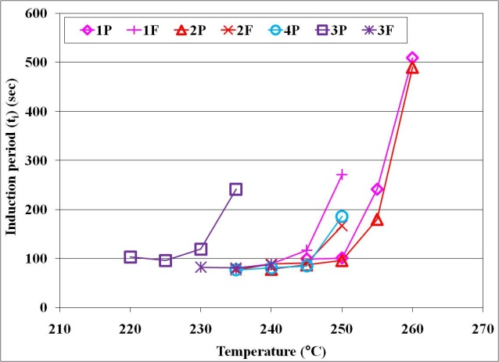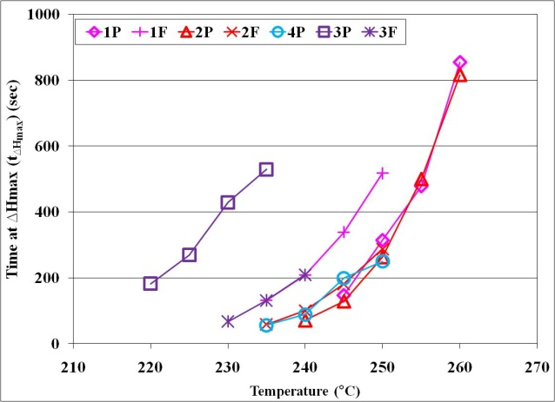
a
b
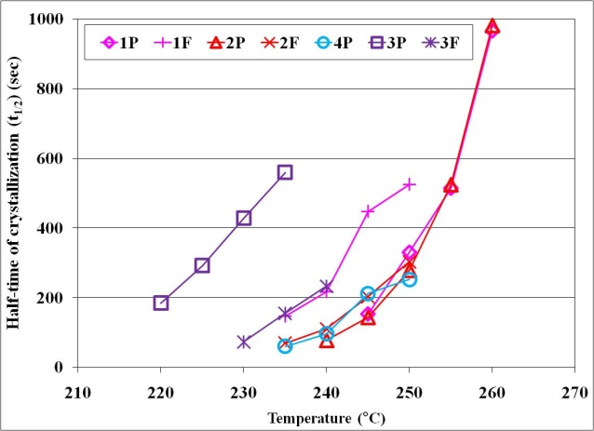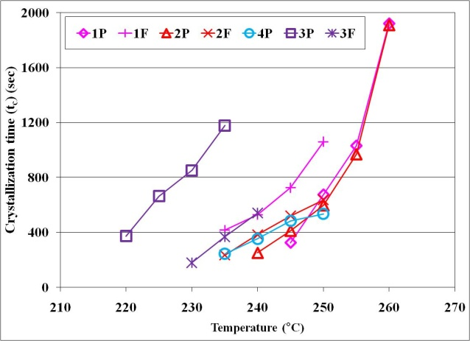
c
d
Figure 4.11 Time parameters of isothermal crystallization behavior of PPS. a) t_{i}, b) t_{∆Hmax}, c) t_{1/2}, d) t_{c}.
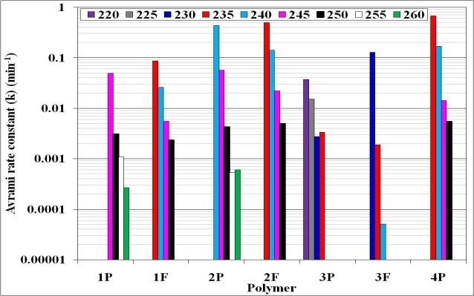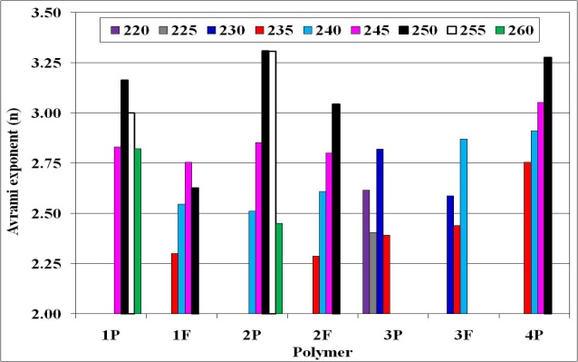
a
b
Figure 4.12 Avrami crystallization parameters of PPS. a) n, b) K.
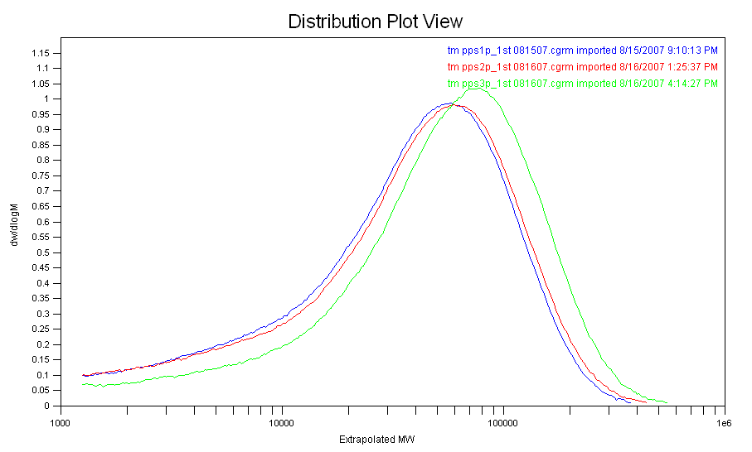
MWD

3P
1P
2P
Figure 4.13 MWD plots of pellets.
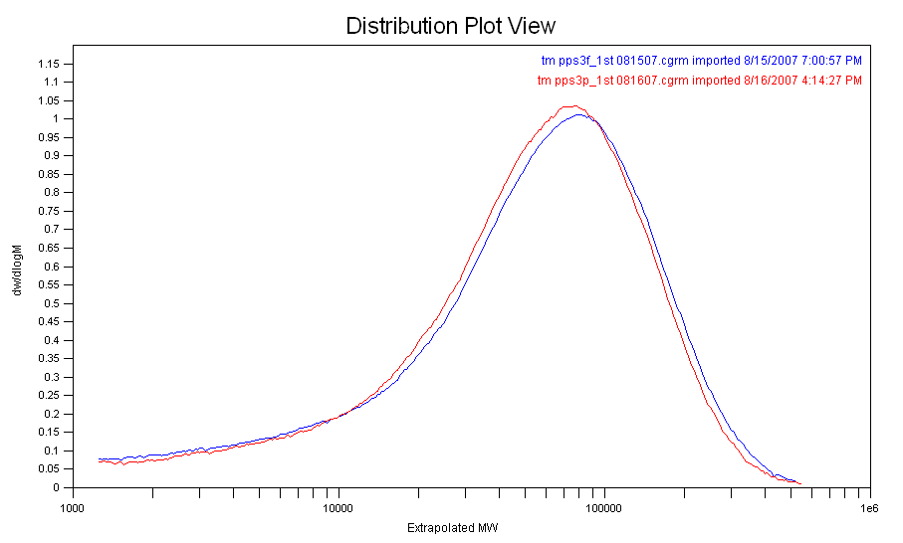
MWD

3F
3P
Figure 4.14 MW distribution plots of various grades of PPS.
chemistry than other polymers, needs special mention here. Degree of crystallinity developed (Figure 4.9) and the temperatures at which crystallization exotherms occur (Figure 4.11) in this polymer are lower than 1P and 2P. This is an expected trend since 4P has higher MW than 1P and 2P. Therefore, hindrance to chain mobility due to higher chain entanglements plays the role in above phenomenon. However, at a given crystallization temperature, the time parameters of 4P are comparable to that of 2F. The exact reasons for this anomaly are not clear, but may be correlated with the results obtained in MW studies. The low MW peak based on RI results is noticeably lower in 4P than in all other polymers, which may be attributable to its different chemistry. Details of the chemistry differences are not known to us. Tying all of the observations together, higher MW components in 4P may be delaying the onset of crystallization than in grades 1 and 2. But once the crystallization begins, comparatively low MW oligomers may be leading to faster crystallization.
At a given crystallization temperature, effect of MW on Avrami exponent is not significantly different. However somewhat higher n is observed consistently in high MW polymers than in low MW polymers (Figure 4.12b). Probable cause for this consistent observation may be associated with comparatively lower chain mobility in high MW polymers, and hence slower crystallization process, providing more dimensional space for crystal growth. The rate constants reported in literature [36, 62] on various grades of PPS are much lower than those obtained in current research studies. The probable reason may be that the past results were obtained using Ryton® PPS which has more branched structure as compared to Fortron® PPS used in current studies. Being more linear, Fortron® PPS may exhibit higher rate constants than Ryton® PPS. For few grades of Fortron® PPS, Menczel et al. [38] have reported the rate constants to be of the order of 10⁻², which are in the range found in the current studies.
At all the temperatures studied, maximum in the crystallization occurs earlier (lower t_{∆Hmax}) (Figure 4.11b) than that at 50% of crystallinity (higher t_{1/2}) (Figure 4.11c). This indicates that the crystallization exotherms are positively skewed. Thus it can be deduced that initially the rate of crystallization is faster and reduces subsequently. Faster crystallization can be termed as primary crystallization and subsequent crystallization can be termed as secondary crystallization. Presence of crystallites formed during primary crystallization reduces the chain mobility, and therefore the rate of crystallization decreases during secondary crystallization. Based on crystallization kinetics by DSC and FTIR, primary and secondary crystallization was reported in PPS by Yu et al. [37].

4.1.4.1.3 Effect of melt holding temperature
Earlier investigators [67, 103, 126] have reported that PPS is susceptible to thermal degradation. Therefore, the temperature at which the given polymer is held above its T_{m}, may also have an influence on the crystallization behavior of the polymers. In order to study this influence, high MW PPS i.e., 3P was studied for crystallization kinetics by heating it in DSC to 340 °C for 10 min. before cooling rapidly to the crystallization temperature of study. Results of these studies were compared with above discussed results for this polymer at melt holding temperature of 325 °C. At a given crystallization temperature, the crystallization exotherms recorded after heating the polymers to 340 °C were significantly slower than those recorded for them after heating to 325 °C (Figure 4.15). Also, the plots of the fractional crystallinity (Figure 4.16a), and decrease in crystallization rate constant (Figure 4.16b) suggest that crystallization happens very slowly after holding the melt at higher temperatures. The slower crystallization kinetics after heating the polymer to higher temperature above T_{m}, suggests either of two reasons. One could be that all the nuclei are completely destroyed at higher temperatures, whereas a few may be remaining at lower temperatures of heating. Since the endset of melting is around 285 °C for polymer 3P, chances of unmolten nuclei at 325 °C after 10 min may be ruled out. Other probable reason could be that thermal degradation of this high MW polymer when heat treated at higher temperatures like 340 °C, which leads to more branching and cross-linking as suggested by Brady [67]. Further studies may need to be done, of remelting at 325 °C and recrystallization, of the samples melted at 340 °C, to understand the causes behind slow isothermal crystallization phenomenon after holding the melt at higher temperatures like 340 °C. Such a study may show if slower crystallization and lower crystallinity are due to degradation or other complexities. Slow crystallization after holding the melt at higher temperatures and/or for longer duration was reported due to degradation in the case of poly(3-hydroxy butyrate) since it is sensitive to higher temperatures [].

4.1.4.2 Non-isothermal crystallization kinetics
The non-isothermal crystallization behavior of various grades of PPS is investigated using DSC. The details of the method are described in section 3.3.1.4. The effect of cooling rate as well as effect of MW on the crystallization behavior of various PPS polymers is discussed herein.
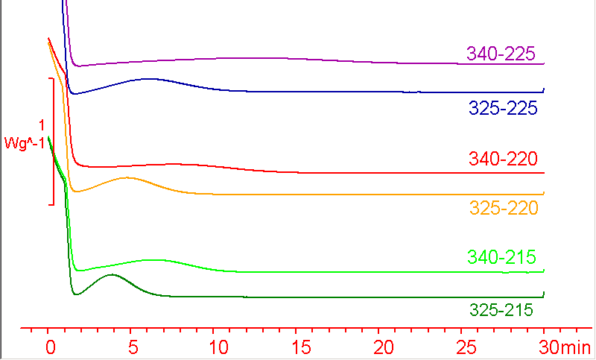
Figure 4.15 Effect of melt holding temperature on crystallization isotherms of 3P.
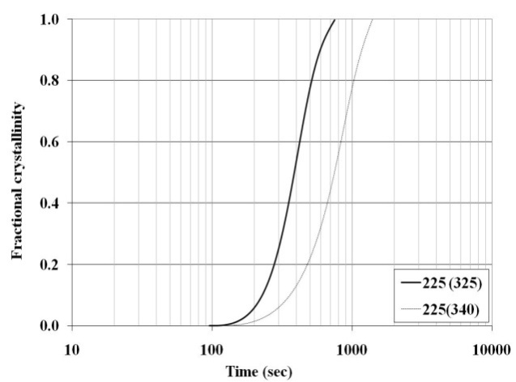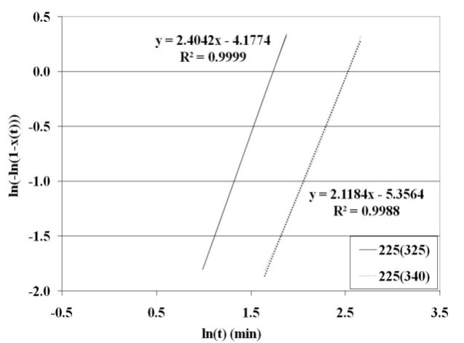
a
b
Figure 4.16 Crystallization isotherms (a) and Avrami plots (b) of 3P at 225 °C. (Melt holding temperatures of 325 °C and 340 °C).

4.1.4.2.1 Effect of MW
In order to compare the MW effect on non-isothermal crystallization kinetics, various grades of pellets of PPS were heated to 325 °C for 10 min., and then cooled at different cooling rates. The fractional crystallinity curves are shown in Figure 4.17. At all the cooling rates studied, temperature at which crystallization begins and ends, is considerably lower in 3P than in 1P and 2P. The degree of crystallinity achieved in 3P is considerably lower than in 1P and 2P (Figure 4.18). Slower crystallization and lower degree of crystallinity in 3P, as compared to that in 1P and 2P can be correlated to considerably higher MW of 3P than that of 1P and 2P. Higher MW causes hinderance to crystallization due to more number of chain entanglements. Therefore, in a given time-temperature profile, high MW polymer develops less crystallinity. This observation is similar to those of earlier investigators. Crystallization occurrs earlier in 2P than in 1P inspite of the fact that former grade possesses higher MW than latter grade. Degree of crystallinity is similar between the two grades. This behavior is similar to that observed between these two grades during isothermal crystallization studies discussed above. Therefore, reasons as discussed earlier of comparable level of low MW fractions and wider MWD in 2P than in 1P may be attributed to this behavior. These changes appear to be worth mentioning since with comaparatively smaller difference in MW between 1P and 1F than that between 1P and 2P, differences in crystallization behavior are observed as per generally expected trends due to the influence of MW (Figure 4.19). It is observed that with similar molecular architecture, due to slightly higher MW, 1F crystallizes slower than 1P.
Crystallization behavior of 4P is close to that of 1P and 2P, even though its MW is higher than either of those grades. Reason may be attributed to its slightly different chemistry. In comparison with other grades, with increase in cooling rate, crystallization behavior of 4P appears moving to right in the fractional crystallinity curves i.e., to higher temperatures (Figure 4.17). This indicates that crystallization behavior of 4P has lesser influence of cooling rate as compared to other polymers. It may be attributed to its different chemistry than other polymers.
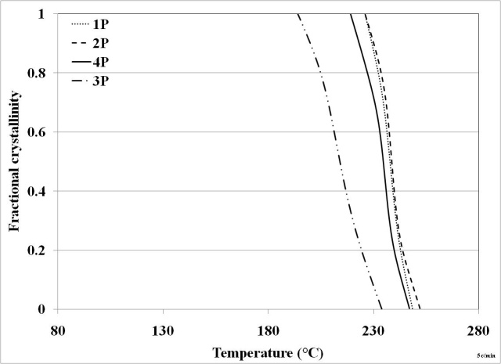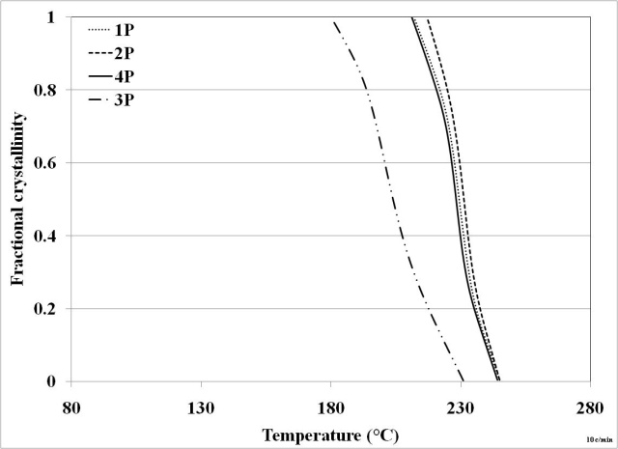
a
b
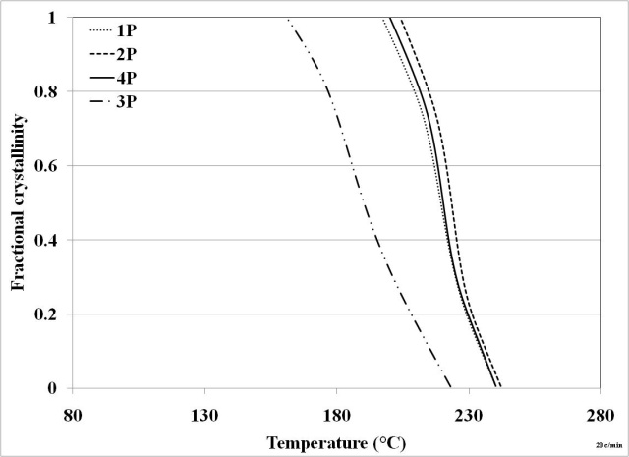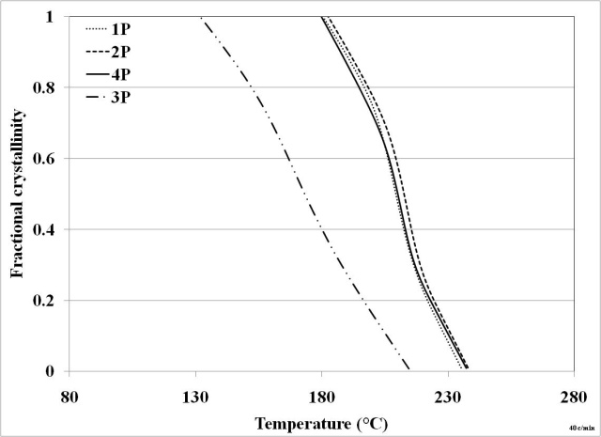
c
d
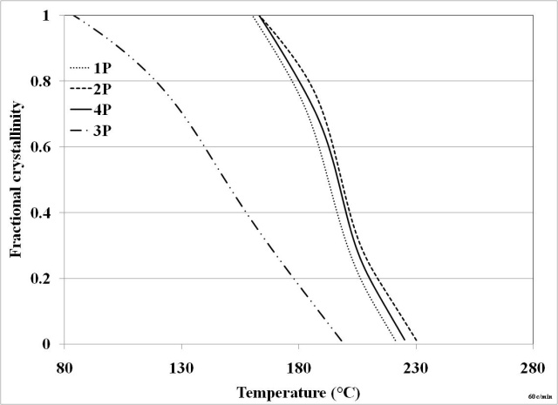
e
Figure 4.17 Non-isothermal crystallization behavior of various grades of PPS. (Melt holding temperature: 325 °C) (a) -5 °C/min; (b) -10 °C/min; (c) -20 °C/min; (d) -40 °C/min; (e) -60 °C/min.

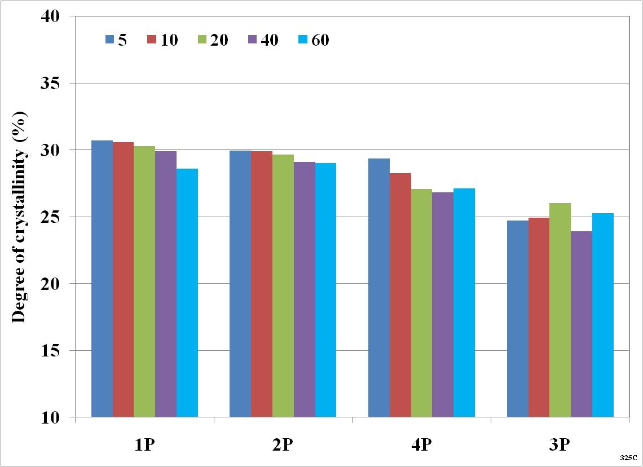
Figure 4.18 Degree of crystallinity in various pellets of PPS.
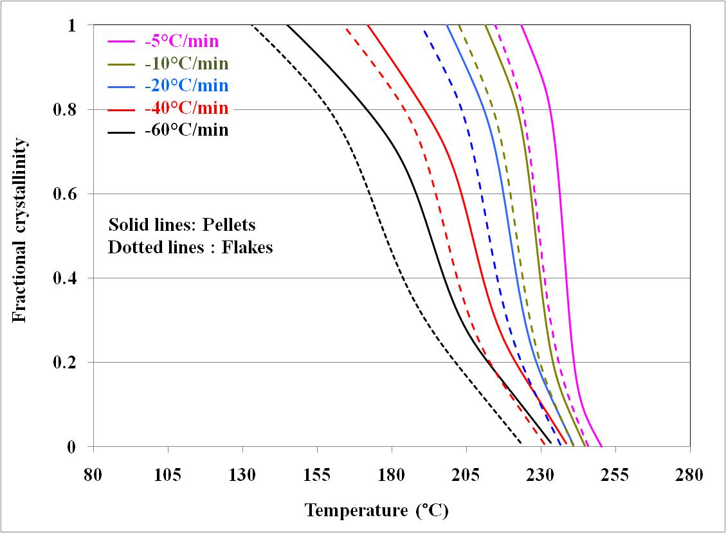
Figure 4.19 Non-isothermal crystallization behavior of polymer 1 at various cooling rates. (Melt holding temperature 325 °C).
Employing Eq. 3.8, plots of log(-ln(1-X(T))) vs log (cooling rate) were constructed, and are shown in Figure 4.20. These plots were non-linear. Similar non-linearity of these plots was reported by Collins and Menczel [102]. Therefore, it can be stated that Ozawa treatment does not explain the non-isothermal crystallization kinetics of PPS.

4.1.4.2.2 Effect of cooling rate
Effect of cooling rate on crystallization behavior of given polymer is shown in Figure 4.17, and its effect on degree of crystallinity developed in each of the pellets is shown Figure 4.18. For better clarity of this effect, the temperature at which 50% of crystallinity develops (T_{1/2}) is plotted in Figure 4.21. It can be seen that for a given polymer, T_{1/2} decreases with increase in cooling rate. It is to be noted that time is also varying as temperature decreases. At faster cooling rates, melt spends lesser time at a particular temperature, and hence the scope available for chain mobility to occur for crystallization lessens, and hence, the process of crystallization slows down with increase in cooling rate.
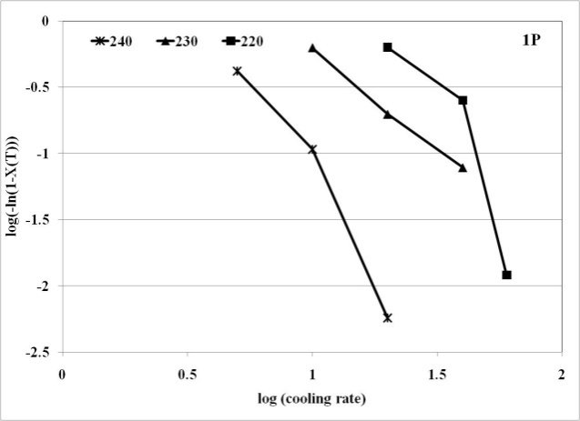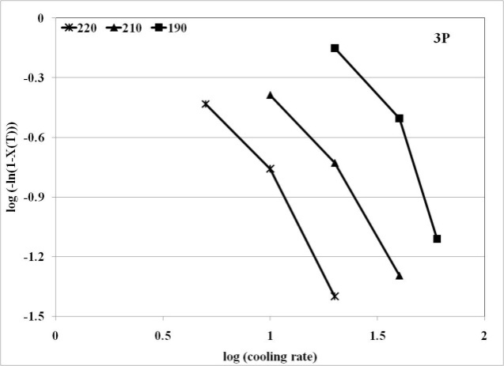
Figure 4.20 Ozawa plots of non-isothermal crystallization of PPS.

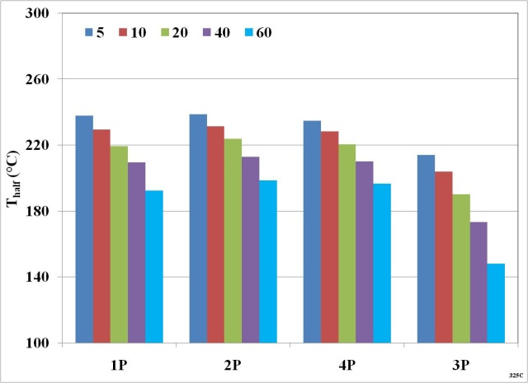
Figure 4.21 Effect of cooling rate on T_{1/2} in various grades of PPS. (Melt holding temperature 325 °C).

4.1.4.2.3 Effect of melt holding temperature
To study the effect of melt holding temperature on crystallization behavior of PPS, non-isothermal crystallization kinetics of each of the pellets and flakes was studied at 340 °C. The fractional crystallinity plots obtained at various cooling rate after holding the melt at 340 °C were compared with that of 325 °C discussed above, and are shown in Figure 4.22. It is apparent that for 1P, 2P and 4P, fractional crystallinity curves corresponding to melt holding temperature 340 °C start very late, so much so that when cooled rapidly from 325 °C at the rate of -60 °C/min, the crystallization occurs slightly earlier than when cooled from 340 °C comparatively slowly at the rate of -20 °C/min. This indicates that melt holding temperature influences the non-isothermal crystallization behavior of low MW grades more than the cooling rates. Contrary to this observation, the non-isothermal crystallization behavior of high MW grade 3P is influenced more by cooling rate than by melt holding temperature.
Comparing the degree of crystallinity developed in the polymers at various cooling rates after holding the melt at 340 °C (Figure 4.23) and 325 °C (Figure 4.18), at a
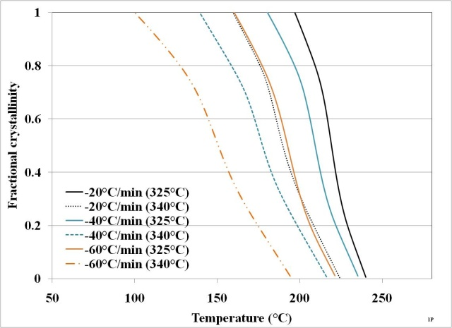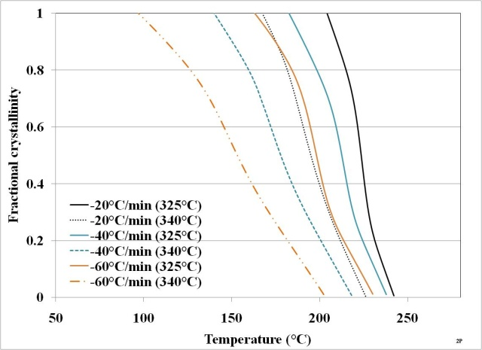
2P
1P
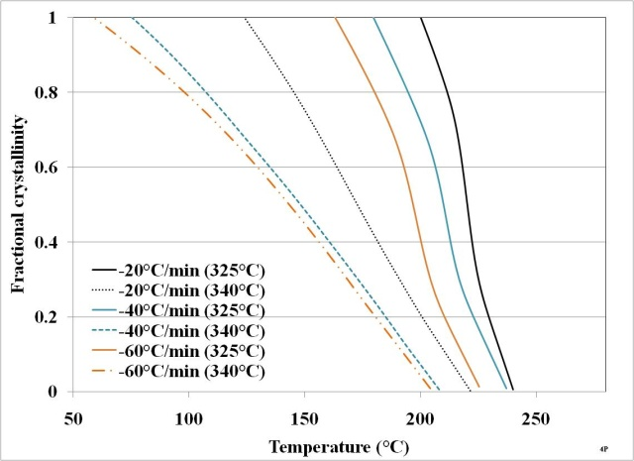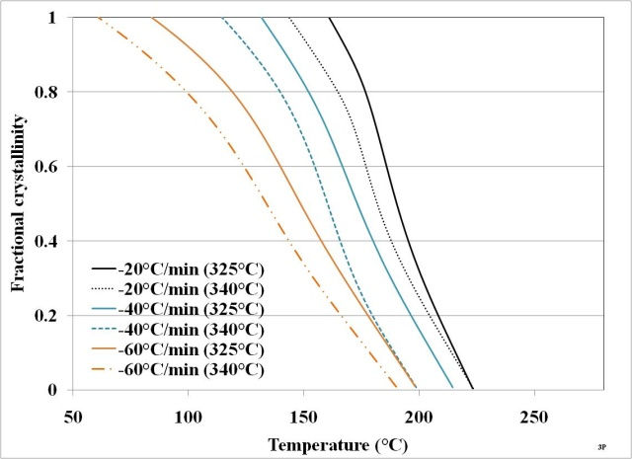
3P
4P
Figure 4.22 Effect of melt holding temperature on non-isothermal crystallization behavior of various grades of PPS. (Solid lines belong to melt holding temperature of 325 °C and dotted lines belong to 340 °C).
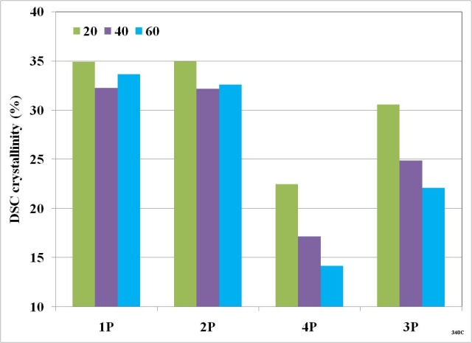
Figure 4.23 Degree of crystallinity developed in various pellets during non-isothermal crystallization. (Melt holding temperature 340 °C).
given cooling rate, the degree of crystallinity developed in the case of 1P and 2P is higher (approximately by 5%) when cooled from 340 °C than when cooled from 325 °C. This and earlier mentioned observation that melt holding temperature has larger effect on their crystallization behavior than cooling rate, may suggest the possibility of thermal degradation, of these two grades of PPS when processed at higher temperatures through the mechanism of chain scission. Such kind of chain scission may lead to narrowing their MWD and slow down the crystallization process as observed in Figure 4.22. Since the overall MW will decrease upon chain scission, total crystallizability of these polymers may go up, resulting into development of higher crystallinity. Degree of crystallinity in high MW polymer, 3P do not show noticeable change after holding the melt at 340 °C vs 325 °C, suggesting better thermal stability of this polymer. Degree of crystallinity in 4P decreases noticeably after holding the melt at 340 °C than at 325 °C, suggesting possibility of degradation mechanism in such a way that it hinders the crystallization. One such mechanism may be degradation by branching or crosslinking. However, to confirm different degradation mechanisms in different polymers in response to melt holding temperature, further studies are warranted.

4.2 PPS behavior during melt spinning
All the polymers, in their pellets form, were spun into fibers. Two levels of extrusion temperatures 315 °C and 340 °C were tried, and satisfactory spinning performance was observed in all the cases. Some other issues of spinning performance observed due to the nature of pellets will be discussed subsequently. Since these issues are of immediate concern for the fiber industry in terms of manufacturing as-spun fibres with uniform properties alongwith controllable spinning process, the observations are discussed herein.
Spinning of 3P was found satisfactory at both the extrusion temperatures, and three different take-up speeds up to 2350 mpm. It indicates that the melt strength for 3P is sufficient to withstand the high spinline stresses at higher take-up speeds. It can be directly attributed to the high MW of this polymer, which results in the melt with higher melt viscosity under given conditions as mentioned in the discussion related to rheological behavior of the polymers. Similar observations were made in the case of 4P and 2P, which are lower in MW than 3P, but may have enough melt strength to withstand the spinline stresses at higher extrusion temperatures and higher take-up speeds. Polymer 1P showed better spinnability at 315 °C at all the three take-up speeds. It could be spun into fibers at 340 °C at lower take-up speeds up to 1750 mpm. However, at 340 °C and higher take-up speed of 2350 mpm, stable threadline could not be obtained in the case of 1P. 1P, being lower in MW than other polymers, may not possess enough melt strength to withstand increased spinline stresses at high take-up speed, especially at higher extrusion temperatures. At a given shear rate, its shear viscosity at 340 °C would be less than that at 325 °C as can be inferred from temperature dependence of viscosity as reported earlier in section 4.1.3.2.
3P was found spinnable even at extrusion temperatures of 355 °C indicating that its melt strength is sufficient even at this high temperature. However, problems in threadline continuity were observed for 3P at higher take-up speeds at 355 °C.
After running the spinline for around 10-12 hours, large number of voids was observed in the extrudate at the exit of spinneret causing problems in the continuity of threadline. Considering the sensitivity of PPS to thermal degradation as discussed in MFR section, over the period of 10-12 hours considerable degradation of PPS may take place inside the extruder, causing the oligomers generated and/or some other chemical reactions to form bubbles in the melt, upon their vaporization. Therefore, the spinning of all of the above polymers was carried out during different runs. The flakes form of the polymers were also tried to melt spin. An attempt to spin fibers from 3F was not successful due to large number of voids observed in the extrudate. The probable cause may be comparatively more low MW fractions in the flakes as compared to those in pellets of this polymer. This is further substantiated by the result that fibers from polymer 1F were spun successfully. 1F was reported to possess comparatively lesser amount of low MW fractions than that in 3F.
Other important observation made during spinning was the melt pressure fluctuation between extruder screw and spin pump. While spinning the polymer 4P, at a given setting of extruder screw and spin pump rpm at which desired throughput with better consistency was achieved, the melt pressure fluctuations observed were within the range of 1000-2000 psi as desired. However, during spinning from the pellets of 1, 2 and 3, wider melt pressure fluctuations were observed, beyond above mentioned range of pressures. It necessitated frequent adjustments of extruder screw rpm, in order to maintain the melt pressure above 500 psi, so that spin pump always received the melt in sufficient quantity without underfeeding, and equipment break down due to very high melt pressures was avoided. The current drawn by the screw to rotate, varied over a much wider range during the pressure fluctuations indicating that there could be some feed problems that restricted screw rotation at times. Upon resuming the screw rotation, feed of excess quantity of melt to the pump caused the melt pressure to increase. The appearance of pellets is shown in
Figure 4.24, and the weight and dimensional variations of the pellets are shown in Table 4.2.
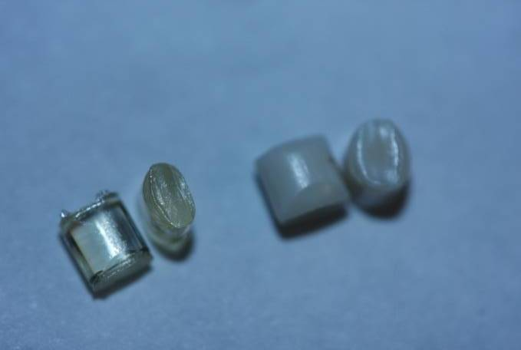
1P, 2P and 3P

4P

Figure 4.24. Appearance of pellets of different grades.
Table 4.2 Weight and dimensional variation between the pellets
Material form | Weight per pellet |  | Dimensions (l*w*t) (mm) | Packing density (g/cm³)
Material form | (mg) | CV% | Dimensions (l*w*t) (mm) | Packing density (g/cm³)
1P | 20.23 | 0.48 | 3.5*3.2*2.3 | 0.88
2P | 19.93 | 0.38 | 3.4*3.1*2.2 | 0.85
3P | 20.30 | 0.75 | 3.5*3.2*2.2 | 0.88
4P | 29.91 | 4.31 | 3.2*3.5*3.1 | 0.96
1F | -- | -- | -- | 0.78
These readings are the average of 5 readings wherein each reading in itself is the average of 5 pellets weighed together. Assuming constant density of pellets, similar variation may exist in the dimensions of the pellets. Possessing higher dimensional variation of 4P, the packing would be much easier within the screw channels for this grade of polymer. Ease of packing is further supported by the observation that packing density of 4P is higher than others (Table 4.2). Lower CV% in case of other pellet types would lead to more competition between the pellets to pack within the screw channel in the feed zone. Such competition would result into some of the pellets getting caught between screw and barrel wall, therefore hindrance to screw rotation and melt pressure fluctuation thereby. Upon installing a newer screw with slightly wider channel width (0.558” vs 0.314” of older screw), the melt pressures were observed fairly consistent for all the four grades of pellets. During feeding the flakes of type 1 and 3, melt pressures were observed quite consistent with old as well as newer screw. Being powdery in nature and particles being smaller in size than the pellets, there exists no feeding problem in the case of flakes. However, there exist different issues of void generation in the extrudate from flaky materials as discussed above.

4.3 As-spun fiber properties

4.3.1 Morphology and tensile properties of as-spun fibers
In the following sections, the influence of several variables on as-spun fiber properties is discussed with the help of leverage plots that were constructed using JMP 8.0 statistical software. In addition to the effect trends (regression fitted solid red line), these plots reveal the statistical significance of the influence using t-test at 95% confidence interval (dotted red lines). The variable is statistically significant in determining the properties when P-value (given below each of the leverage plots) is less than 0.05. The data points in each of these plots were the contributions of a given variable, within the matrix of all variables treated simultaneously, to the fiber property under consideration, as computed by the statistical software. To get an idea of actual fiber properties values, the graphs with actual data points are also provided. While plotting the effects of MW, inverse of MFR was taken as the X-axis to understand direct correlation with MW.

4.3.1.1 Factors influencing fiber denier
Figure 4.25 shows the effect of take-up speed and throughput on denier of fibers spun from polymer 3P at two extrusion temperatures. Denier values are listed in appendix 4. Similar behavior was observed in fibers spun from 1P, 2P and 4P. Increase in take-up speed, and decrease in throughput leads to decrease in the fiber denier. At a given take-up speed, the draw-down ratio increases with decrease in throughput, whereas at a given throughput, the draw-down ratio increases with increase in take-up speed. Increase in draw-down ratio leads to more drawing of the fibers and hence decrease in denier. Figure 4.26 shows that throughput and take-up speed exhibit statistically significant influence on fiber denier (P less than 0.0001).
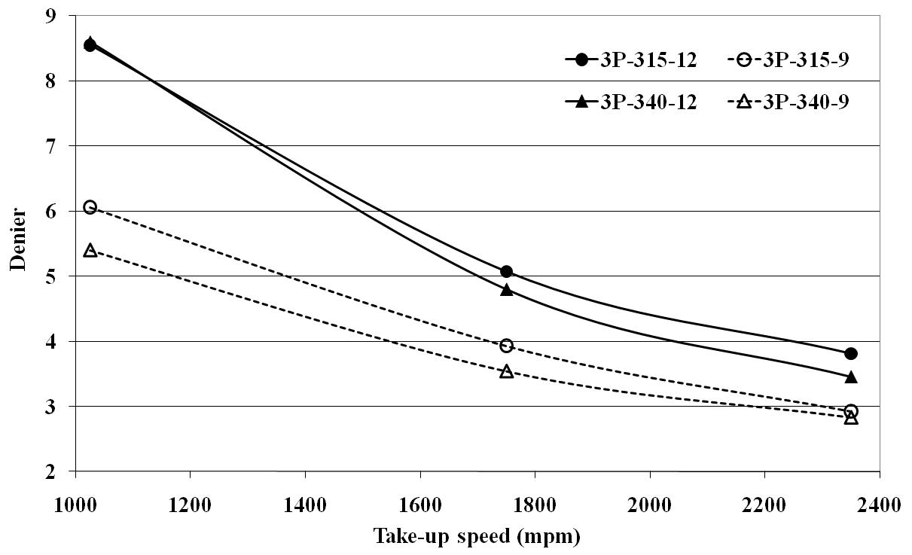
Figure 4.25 Factors influencing fiber denier. (Polymer 3P; Throughput: solid lines-high and dotted lines-low; Extrusion temperature: circle-low and triangle-high).
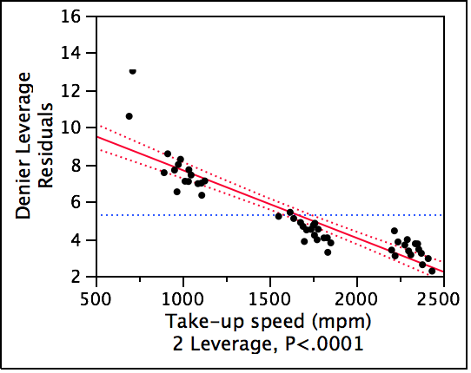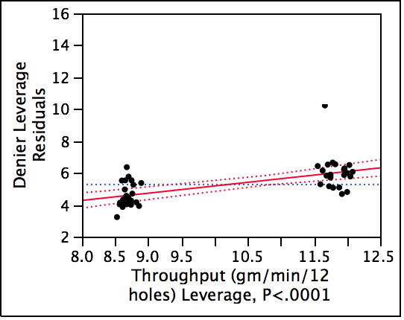
a
b
Figure 4.26 Process variables affecting as-spun fiber denier significantly. (a: take-up speed; b: throughput).

4.3.1.2 Effect of MW on fiber tensile properties and morphology
Effect of 1/MFI on the fiber tensile properties and morphology is shown in Figure 4.27 in terms of leverage plots. The fibers spun from High MW polymer show higher tenacities (Figure 4.27a) and lower breaking elongations (Figure 4.27b) than the fibers spun from low MW polymer. Figure 4.28 indicates that when spun under similar conditions, fibers spun from low MW polymers (1P and 2P) possess lower tensile moduli than the fibers spun from high MW polymers (4P and 3P). These effects can be explained on the basis of molecular orientation. The number of chain defects, i.e., chain ends will be lesser, and chain entanglement will be higher in the case of high MW polymer. Thus viscosity of the polymer at a given extrusion temperature will be higher. Hence, at given take-up speed, spinline stress on the fibers increases, and results into better molecular orientation as seen by increase in birefringence (although not statistically significantly) with increase in polymer MW (Figure 4.27c). As a function of 1/MFI, change in degree of crystallinity is lesser (lower P value in Figure 4.27d) as compared to that of birefringence. Lesser chain ends, and increase in birefringence contributes to increase in fiber tenacity with increasing MW.
The cold crystallization behavior of the as-spun fibers manufactured from all four polymer types is shown in Figure 4.29. Peak of crystallization exotherm appears at lower temperature for fibers spun from high MW polymers than that from low MW polymers. This indicates that higher the polymer MW, crystallization occurs earlier in fibers. This behavior is contrary to the role of MW in crystallization under quiescent conditions as seen earlier. As discussed above, when spun under similar processing conditions, the spinline stress will be higher for fibers of high MW polymers. The fiber structure with higher stress is more favorable for crystallization, and hence crystallizes earlier.

4.3.1.3 Effect of take-up speed on fiber tensile properties and morphology
Effect of take-up speed and throughput on as-spun fiber tensile and morphological properties is shown in Figure 4.30 and leverage plots shown in Figure 4.31. With increase in take-up speed, tenacity (Figure 4.30a and Figure 4.31a), birefringence (Figure 4.30c
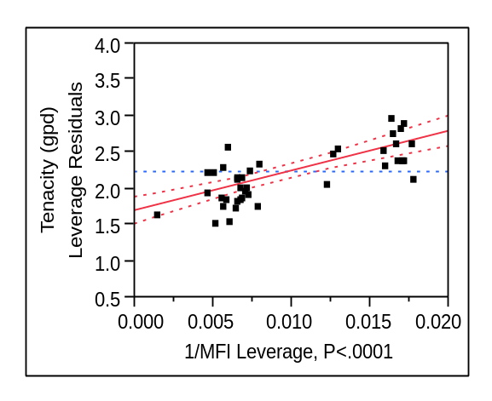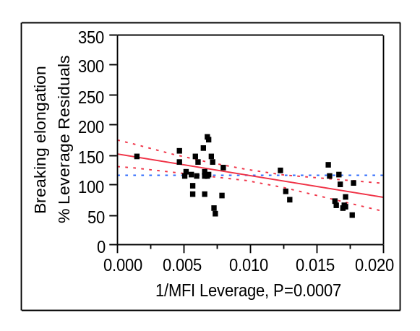
a
b
d
c
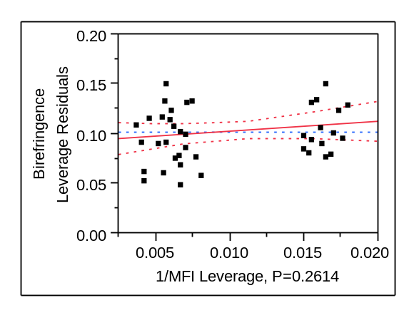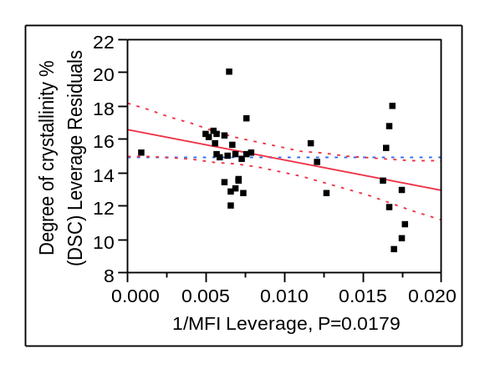
Figure 4.27 Effect of MW on (a) fiber tenacity; (b) breaking elongation; c) birefringence and d) crystallinity. (Sample matrix with all spinning variables for four types of pellets).
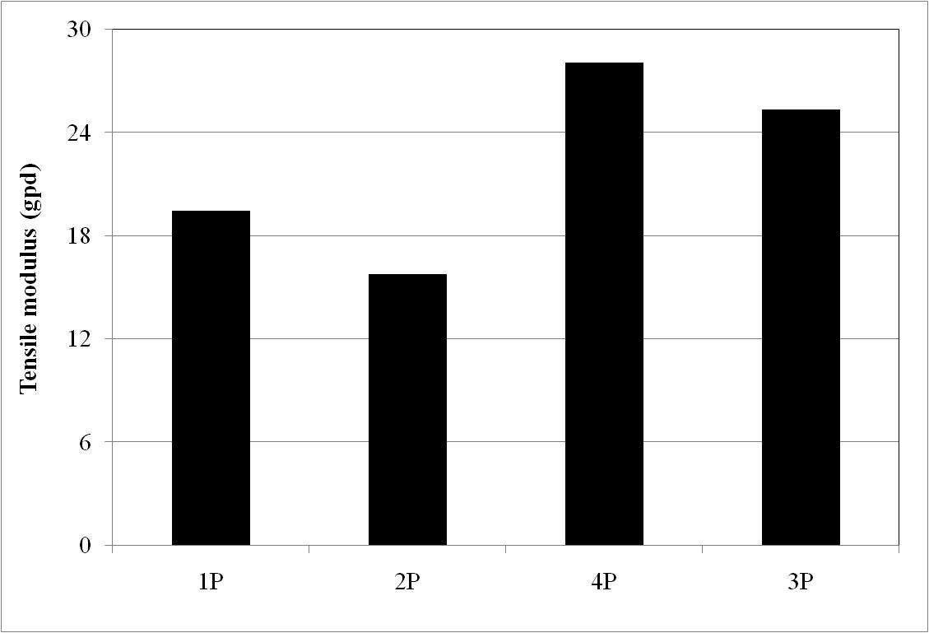
Figure 4.28 Effect of MW on tensile modulus. (Fibers spun at 1750 mpm, extrusion temperature 315 °C, and throughput 12 gm/min/12 holes).

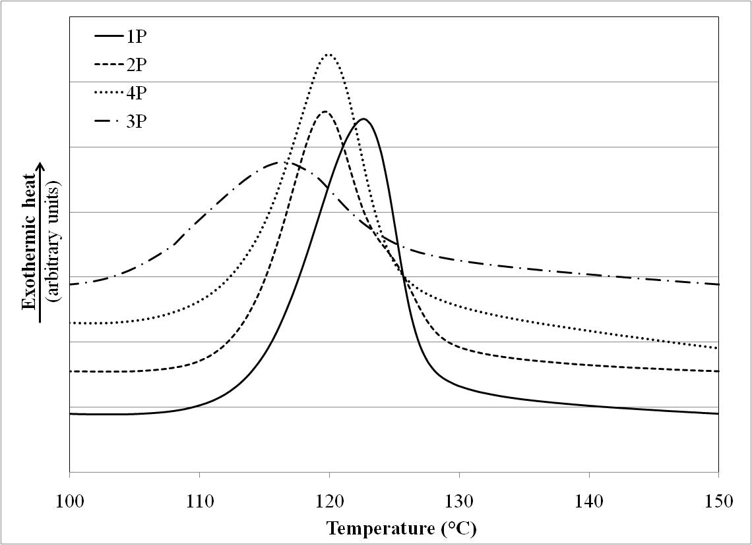
Figure 4.29 Influence of MW on cold crystallization behavior of as-spun fibers. (Take-up speed 1750 mpm, extrusion temperature 315 °C, throughput 12 gm/min/12 holes, and capillary l/d 10).
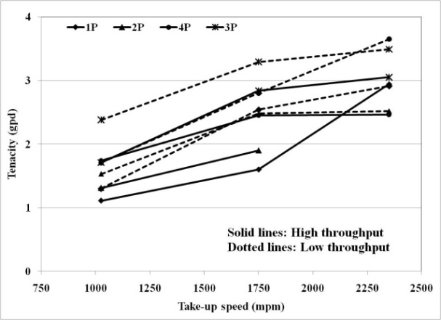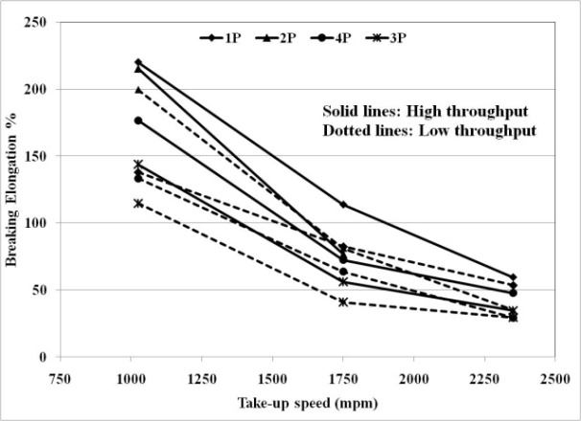
b
a
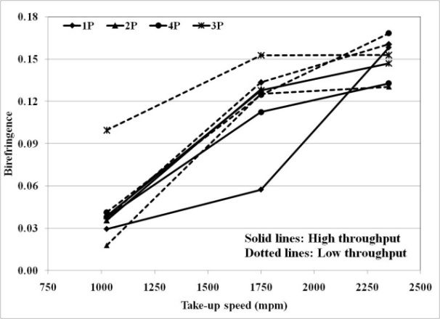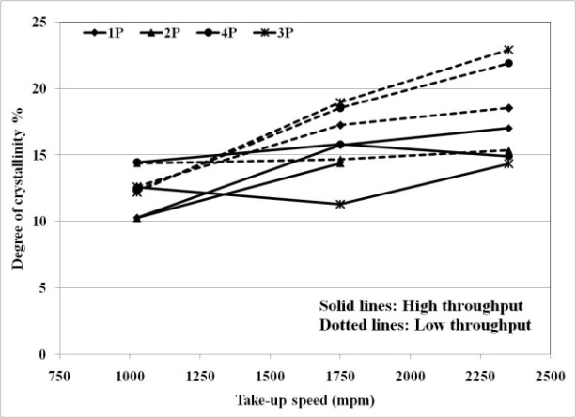
d
c
Figure 4.30 Effect of melt spinning variables on a) tenacity; b) breaking elongation; c) birefringence; d) crystallinity by DSC. (Extrusion temperature: 315 °C).
and Figure 4.31c) and degree of crystallinity (Figure 4.30d and Figure 4.31d) all increase whereas breaking elongation decreases (Figure 4.30b and Figure 4.31b). At higher take-up speeds, the spinline stresses exerted on the filaments will be higher, which lead to improvement in the molecular orientation in the direction of pull i.e., along the fiber axis. Improved orientation as seen by increase in birefringence results in increase in tenacity, and decrease in elongation. Besides its dependence on time and temperature, crystallization is influenced by stresses as well. The time available for the crystallization before the fiber temperature drops below T_{g} may not be significantly different at various take-up speeds. Under these circumstances, increasing spinline stress with increase in take-up speed causes the degree of crystallinity to increase due to stress induced crystallization. Evidence of higher crystallinity in the as-spun fibers with increase in take-up speed is shown Figure 4.32. Degree of crystallinity that develops in as-spun fibers during heating in DSC decreases as the take-up speed at which fibers are spun increases (smaller endotherm at high take-up speed). It also suggests the presence of higher stress level in the fibers spun at higher take-up speed, since the peak temperature of crystallization exotherm appears earlier when the fiber is spun at higher take-up speed. Slow increase in crystallinity with take-up speed up to 4000 mpm was reported by Chen et al. [] in the case of PET melt spun fibers. With increase in take-up speed, better molecular orientation due to higher level of stresses is more favorable to the development of crystallinity. It is to be noted that even at highest take-up speed studied, the degree of crystallinity (close to 20%) was below the crystallization potential of polymers (30-35%) under optimum quiescent conditions as observed in DSC experiments discussed earlier.
Enhancement in fiber tenacity can be further substantiated by studying crystalline structure development using WAXS. WAXS pin-hole patterns of the as-spun fibers spun from polymer 3P and 4P at different take-up speeds are shown in Figure 4.33. As can be seen from the patterns, at low take-up speed, very little crystallinity is developed in the fiber with essentially no crystalline orientation (almost flat orientation distribution for plane (110) at 1000 mpm in Figure 4.34). With increase in take-up speed, appearance of arcs indicates slight increase in crystalline orientation (increased curvature of orientation
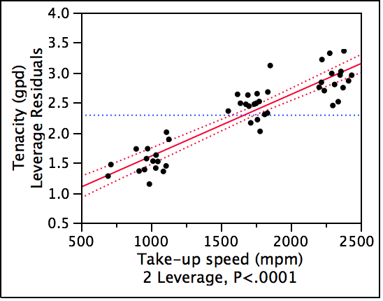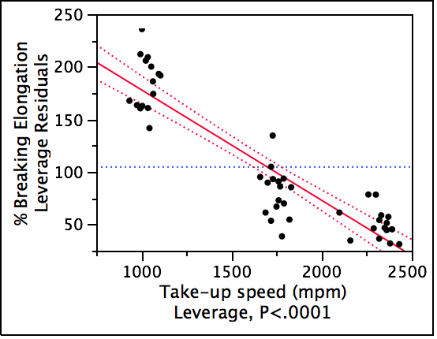
b
a
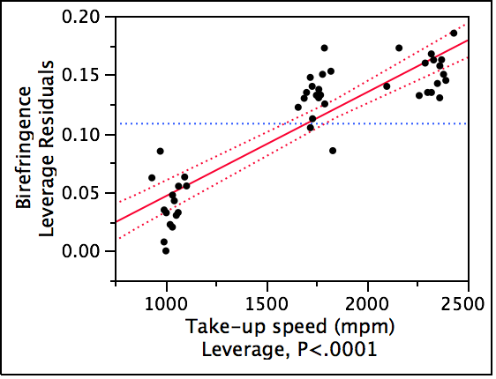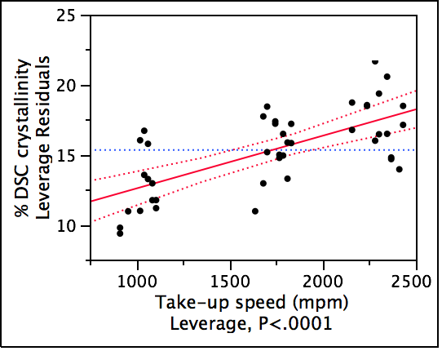
d
c
Figure 4.31 Leverage plots of take-up speed effect on a) fiber tenacity; b) breaking elongation; c) birefringence and d) degree of crystallinity. (Sample matrix with all process variables for all 4 pellets).
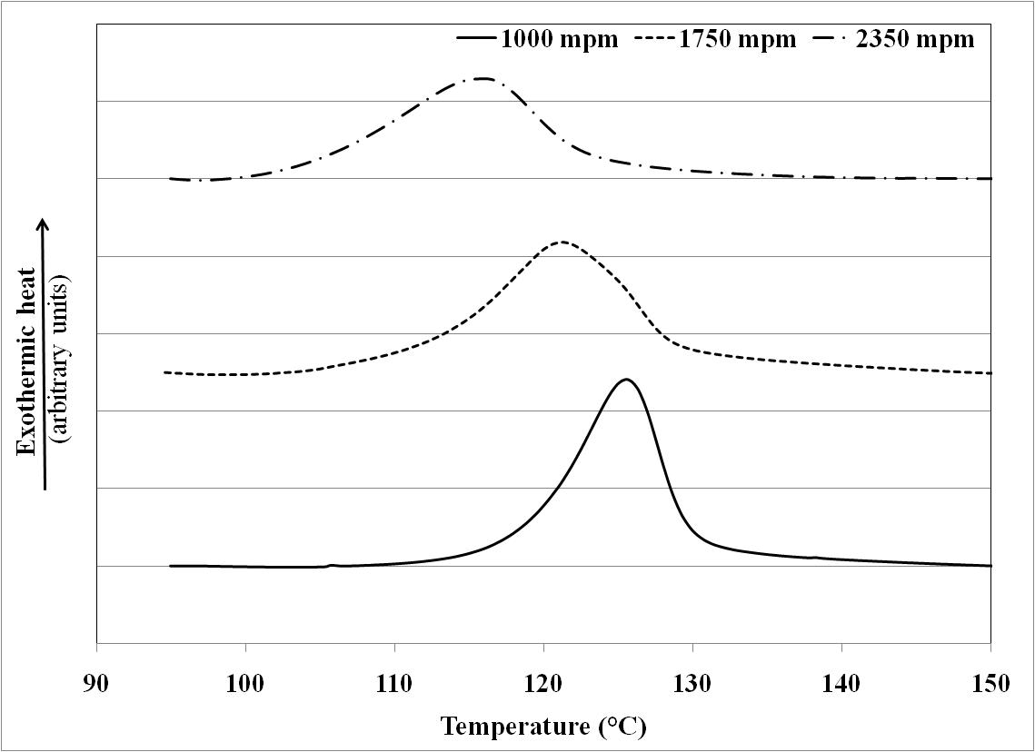
Figure 4.32 Effect of take-up speed on cold crystallization of as-spun fibers. (Polymer 3P, extrusion temperature 315 °C, throughput 12 gm/min/12 holes, and capillary l/d 10).
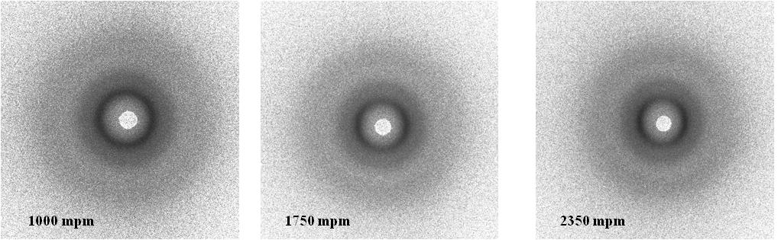
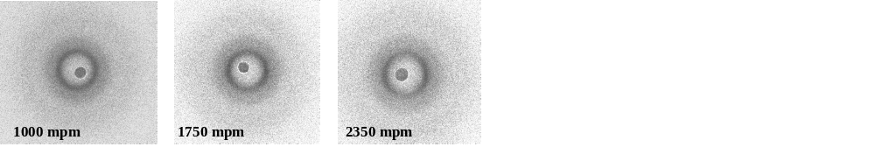
Figure 4.33 WAXS pin-hole patterns: Top: 3P; bottom: 4P. (Fiber axis vertical), (Extrusion temperature: 315 °C; throughput: 12 gm/min/12 holes).
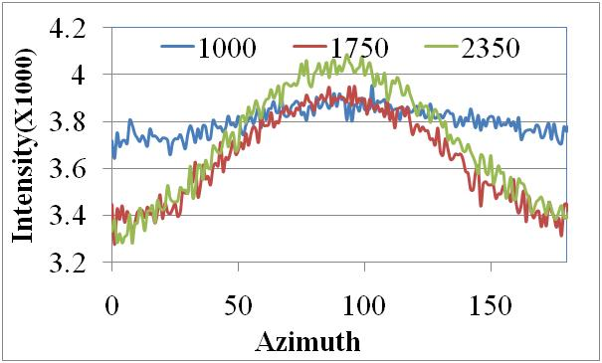
Figure 4.34. Orientation distribution for plane (110) of as-spun fiber. (Polymer 3P, Extrusion temperature: 315 °C; throughput: 12 gm/min/12 holes).
distributions for plane (110) at 1750 mpm and 2350 mpm in Figure 4.34), although the increase is not considerable. Similar observations were made in the case of fibers manufactured from other polymers including PPS by prior investigators [137, , ].

4.3.1.4 Effect of throughput
With increase in throughput, trends in fiber properties changes were found similar to that with decrease in take-up speed. The leverage plots for this variable are shown in Figure 4.35, whereas the actual data of fiber properties vs throughput is shown earlier in Figure 4.30 for tensile and morphological properties respectively. Decrease in draw-down ratio with increase in throughput lowers the spinline stresses on fibers. This explains observed decrease in birefringence (Figure 4.35c) and degree of crystallinity with increase in throughput (Figure 4.35d). Decrease in molecular orientation and crystallinity results in decrease in tenacity (Figure 4.35a), and increase in breaking elongation (Figure 4.35b). Here again, stress level seem to be more contributing factor in determining degree of crystallinity, than time and temperature to enhance crystallinity with increase in throughput.

4.1.3.3 Effect of extrusion temperature
Leverage plots constructed based on two extrusion temperatures of 315 °C and 340 °C indicate that change in the fiber tenacity (Figure 4.36) is negligible with increase in extrusion temperature within this range of temperatures. The leverage plots of effect of extrusion temperature on fiber properties and morphology are plotted in Figure 4.37 for fibers spun from polymer 3P at three levels of extrusion temperatures studied, at 355 °C in addition to 315 °C and 340 °C. With increase in extrusion temperature, fiber tenacity decreases (Figure 4.37a) and elongation increases (Figure 4.37b). These changes can be explained on the basis of morphological developments in the fibers. With increase in extrusion temperature, melt viscosity decreases as discussed earlier in rheology section. Therefore, under given set of processing conditions i.e., take-up speed and throughput, the fiber in the spinline experiences lower level of stress. It results into decrease in birefringence (Figure 4.37c). As has been seen earlier that contribution of stresses to the
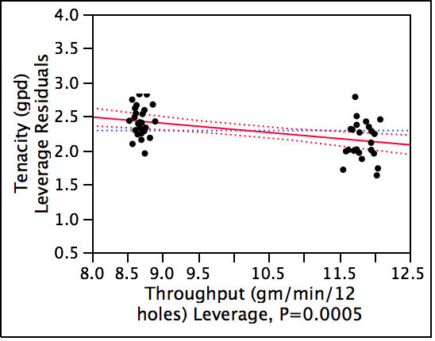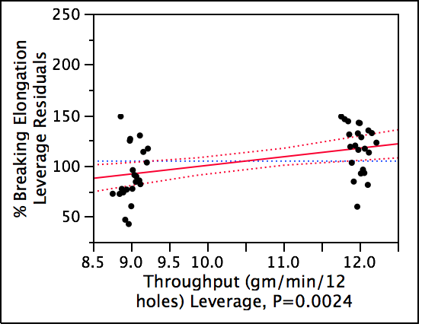
b
a
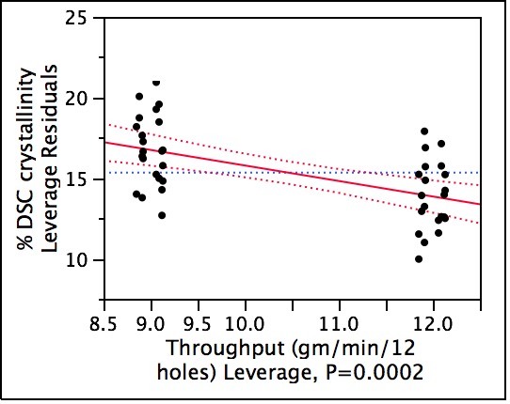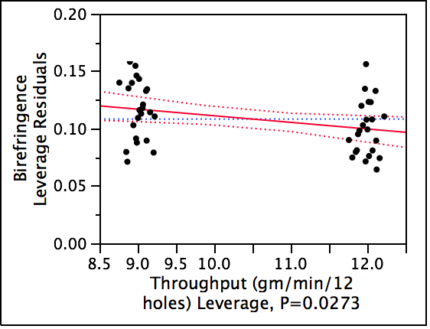
d
c
Figure 4.35 Effect of throughput on a) tenacity; b) breaking elongation; c)birefringence; d) crystallinity by DSC. (Sample matrix with all process variables for all four pellets).
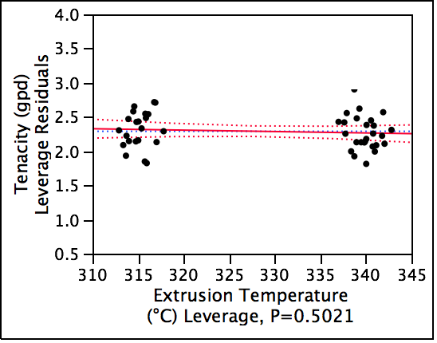
Figure 4.36 Influence of extrusion temperature on fiber tenacity. (Sample matrix with all spinning variables for all four pellets at two levels of extrusion temperature: 315 °C and 340 °C).
development of crystallinity is more than that of time and temperature, degree of crystallinity decreases (Figure 4.37d) with increase in extrusion temperature due to lower stress levels. Therefore, with increase in extrusion temperature over wider range, decrease in crystallinity as well as molecular orientation results in decrease in tenacity, and increase in breaking elongation.

4.1.3.4 Effect of capillary l/d
Trendwise, increase in fiber tenacity (Figure 4.38a) and decrease in breaking elongation (Figure 4.38b) is observed by increasing the capillary l/d from 5 to 10. However, within the range of capillary l/d studied, the effect is not statistically significant. With increase in capillary l/d, the time available for melt to flow through capillary increases, giving more time for the molecular chains to orient in the direction of flow in the presence of shear stresses within the channel. While flowing through capillary, elastic part of the energy will be lesser with longer capillaries resulting into lesser die swell upon capillary exit, and therefore occurs lesser loss of the molecular orientation achieved within the capillary. Higher level of molecular orientation retained in the fiber structure thereby leads to increase in tenacity and decrease in breaking elongation.

4.3.2 Process-structure-properties correlationship
The leverage plots of correlation between as-spun fiber tenacity with birefringence and crystallinity is shown in Figure 4.39. It becomes clear that both of these morphological properties govern the fiber tenacity significantly. However, the influence of birefringence is more pronounced than that of crystallinity (based on the P values). The effectiveness of material and process variables to explain the fiber tenacity and birefringence is shown statistically in Figure 4.40. It becomes clear from the R square (RSq) values that more than 80% of the data is explained by these variables. It suggests that the process-structure-properties model is statistically effective.
Even though the leverage plots discussed above exhibit the overall effect of several variables on fiber properties and morphology, the exent of influence by each level
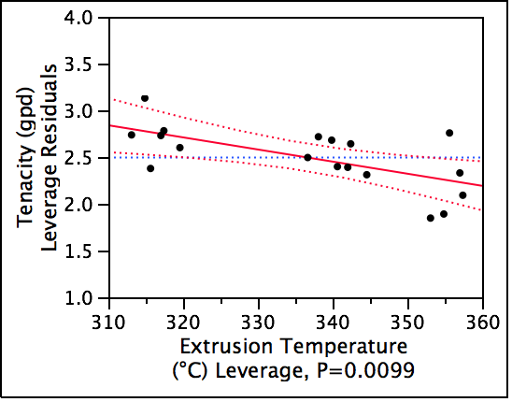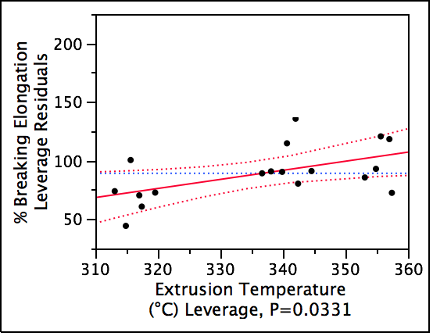
b
a
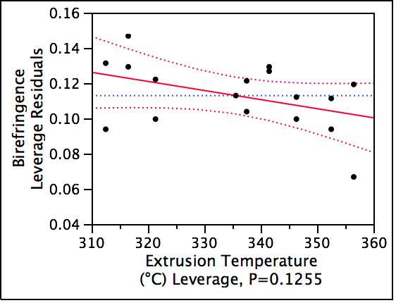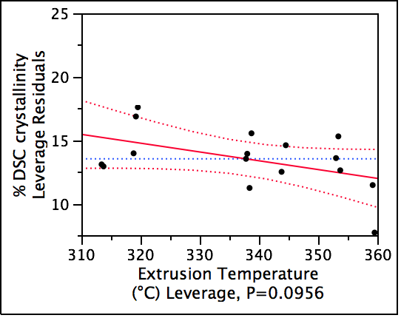
d
c
Figure 4.37 Influence of extrusion temperature on a) tenacity; b) breaking elongation; c) birefringence and d) crystallinity. (Sample matrix at three levels of extrusion temperature with all other spinning process variables for 3P fibers).
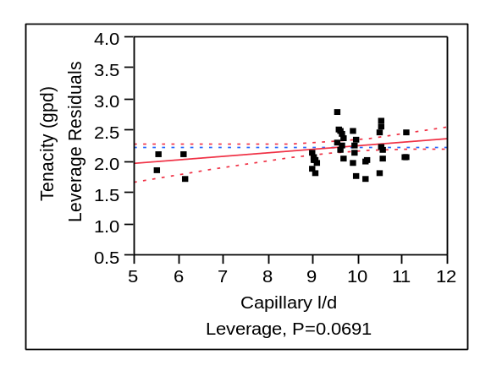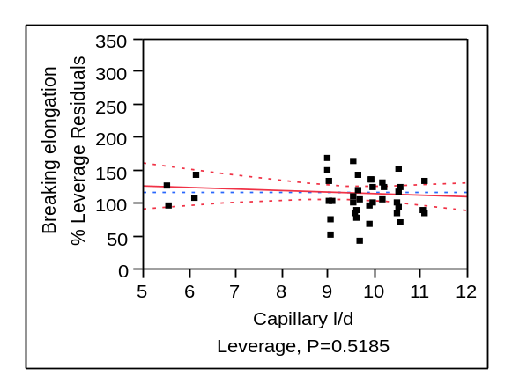
b
a
Figure 4.38 Effect of capillary l/d on a) as-spun fiber tenacity; b) breaking elongation.
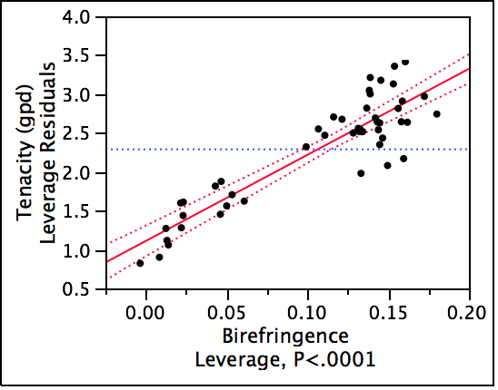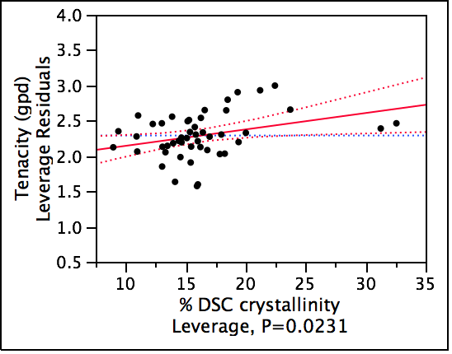
b
a
Figure 4.39 Correlation of fiber tenacity with birefringence (a) and crystallinity (b). (Sample matrix of all spinning variables for four pellets).
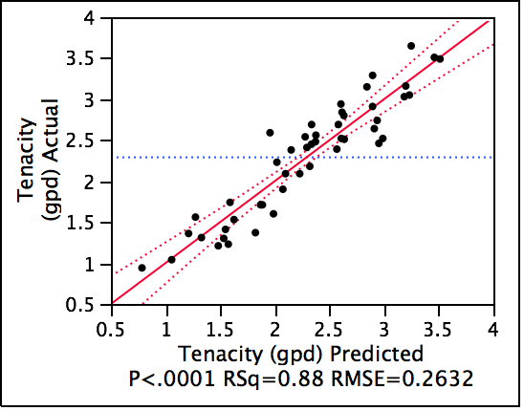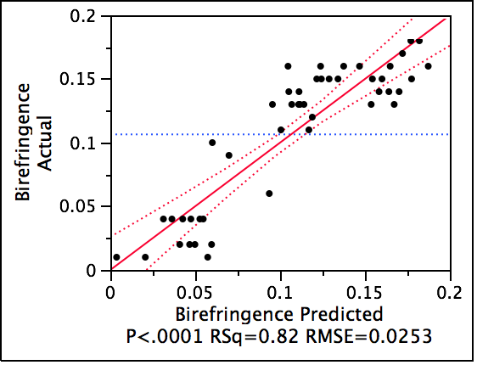
b
a
Figure 4.40 Effectiveness of material and process variables to govern the fiber structure-properties model. (Sample matrix of all spinning variables for four pellets).

of these variables does not become clear. In Figure 4.25, it is seen that the change in the fiber denier is higher initially and lowers as the take-up speed increases further. Tenacity and birefringence also increase rapidly initially with increase in take-up speed, and then the rate of increase decreases at further higher take-up speeds (Figure 4.41). This behavior is observed at high throughputs (Figure 4.41a) as well as at low throughputs (Figure 4.41b). These observations suggest that the amount of change brought by the take-up speed in various fiber properties is not linear but rather decreases with increase in take-up speed. Similar observations were reported in the case of fibers spun from isotactic polypropylene [] and PET []. Ziabicki [] has explained this phenomenon on the basis of the processes which are competing to each other during the fiber spinning, namely crystallization and rapid cooling with increase in take-up speed. With increase in take-up speed, rate of crystallization increases. However, on the opposite side, the time available for the polymer in which crystallization can take place also decreases. Thus the product of available time for crystallization and crystallization rate reaches maximum at critical take-up velocity, and decreases thereafter. This phenomenon seems to be valid in the case of PPS also based on the results of tenacity, birefringence and crystallization discussed herein.
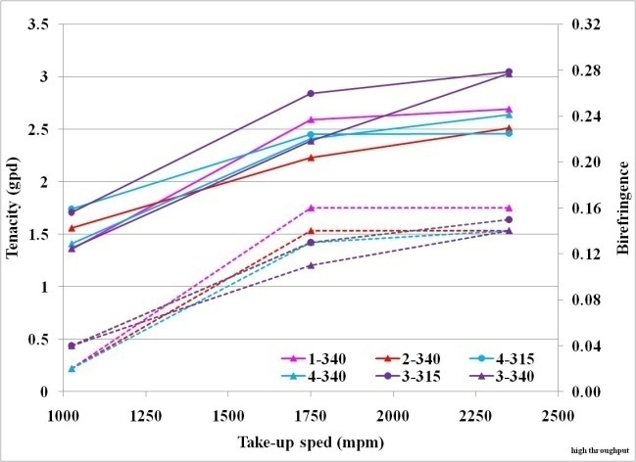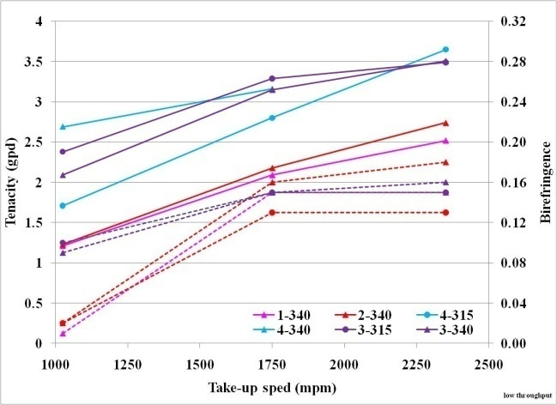
a
b
Figure 4.41 Effect of take-up speed on fiber tenacity (left Y-axis) and birefringence (right Y-axis) (a) high throughput; (b) low throughput.
To conclude, it can be stated that the material and melt spinning process variables govern the fiber structure and properties development. The correlationship between fiber structure and properties indicate that tenacity-birefringence correlation is the strongest one. The fiber breaking elongations in the as-spun fibers spun under various conditions are higher than those required in the fibers suitable for the industrial applications. Also the degree of crystallinity and level of molecular orientation is not developed near to the maximum potential of these polymers. In short, the as-spun fiber structure is immature.
The following section discusses the effects of draw-annealing process variables to in converting immature as-spun fiber structure into mature fiber structure with enhanced properties. Additionally, the interaction effects of these variables with polymer MW and spinning process parameters to govern fiber structure and properties is also discussed.

4.4 Draw-annealed fiber properties
In this section, influence of drawing and annealing on development of tensile and morphological properties in PPS fibers is discussed. Firstly, the results of the experiments of one zone drawing and annealing are discussed followed by the results of effect of annealing. Subsequently, the results of two zone drawing and annealing experiments are compared with that of one zone drawing and annealing. Finally, some preliminary findings of steam drawing experiments are discussed and compared with that of one zone drawing experiments. Besides the influence of the process variables such as draw temperature, annealing temperature and mode of drawing i.e., one zone vs. two zone, dry vs moist heat environment, also discussed are the interaction effects of these variables with that of polymer MW and melt spinning process variables on determining fiber structure and properties. It is to be noted that, as stated in chapter 3, throughout these experiments, fibers were drawn to their maximum potential at satisfactory process performance.

4.4.1 One zone drawn and annealed fibers
For majority of the experiments discussed below, unless otherwise stated specifically, the as-spun fibers were manufactured using capillary l/d equal to 10, medium take-up speed of 1750 mpm, high throughput of 12 gm/min/12 holes and low extrusion temperature of 315 °C. For the purposes of one zone draw-annealing experiments, annealing temperature was kept constant at 150 °C. The abbreviations used are, ET for melt spinning extrusion temperature and DT for draw temperature.

4.4.1.1 Factors influencing drawability
The AS fibers, structure and properties of which are discussed subsequently, were drawn to their maximum extent under given drawing process conditions, in order to yield satisfactory processing without filament breaks during drawing. Since the AS fibers were manufactured from polymers varying in MW, and were drawn at different DTs, the maximum drawability is expected to be different under different conditions. The effect of DT, and polymer MW on draw ratio (DR) that could be achieved in each of the yarns is shown in Figure 4.42. For a given yarn, the overall trend appears to be that of draw ratio

Figure 4.42 Effect of draw temperature and polymer MW on draw ratio.
going through maximum with increase in DT. Due to enhanced thermal mobility with increase in DT, increase in draw ratio with increase in DT is easy to understand. The reasons for decrease in DR at higher DT needed further investigation, and will be discussed lateron. Also, it appears that when melt spun under similar process conditions, at a given DT, maximum attainable DR in a fiber spun from high MW polymer is lower. With increase in MW, more number of entanglements will restrict the drawability, and thereby lower the permissible DR in fibers spun from high MW polymer at similar DT.

4.4.1.2 Factors influencing draw-annealed fiber structure and properties

4.4.1.2.1 Effect of molecular weight
The leverage plot of the influence of MW on draw-annealed fiber tenacity and breaking elongation is shown in Figure 4.43. Higher the polymer MW, fiber tenacity increases and breaking elongation decreases. No significant change is observed in tensile modulus as a function of polymer MW (Figure 4.44), at least in the fibers drawn at similar DT, i.e. 90 °C. Tenacities and tensile moduli of these draw-annealed fibers are substantially higher than their as-spun counterparts (compared with Figure 4.27 and Figure 4.28 respectively). WAXS pin-hole patterns of these fibers are shown in Figure 4.45. Birefringence and degree of crystallinity are plotted in Figure 4.46. Although crystallinity data shown in Figure 4.46 is computed from DSC analysis, crystallinity indices calculated from WAXS for these and other samples that will be dealt further are in close agreement (appendix 5) with that of DSC. Overall molecular orientation (Figure 4.46a) and amorphous orientation (Figure 4.46b) increases with increase in MW whereas changes in degree of crystallinity (Figure 4.46a) are not considerable (30-34%). Therefore, it can be stated that the increase in tenacity and decrease in elongation is mainly due to increase in molecular orientation. Increase in strength of fiber with increase in MW in the case of other polymers was reported by Termonia and Smith []. Stronger dependence of tenacity on birefringence has been reported in other thermoplastic fibers []. Considering the fact that polymer 4P has somewhat different chemistry that other three types, the WAXS patterns in Figure 4.45, and thus decreasing
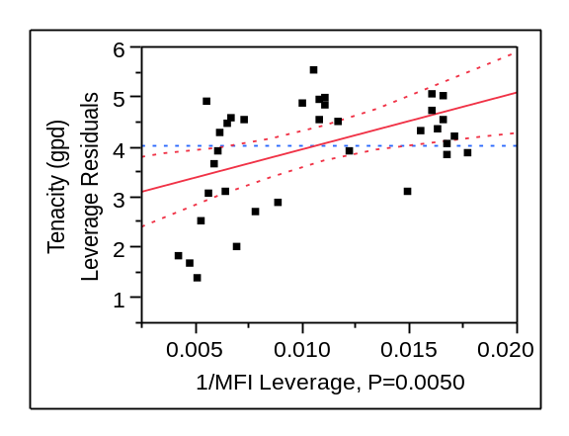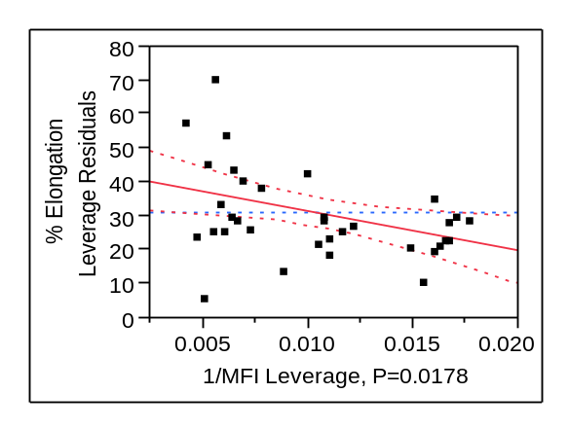
b
a
Figure 4.43 Effect of polymer MW on drawn fiber tenacity (a) and elongation (b). (Draw temperature: 90 °C).
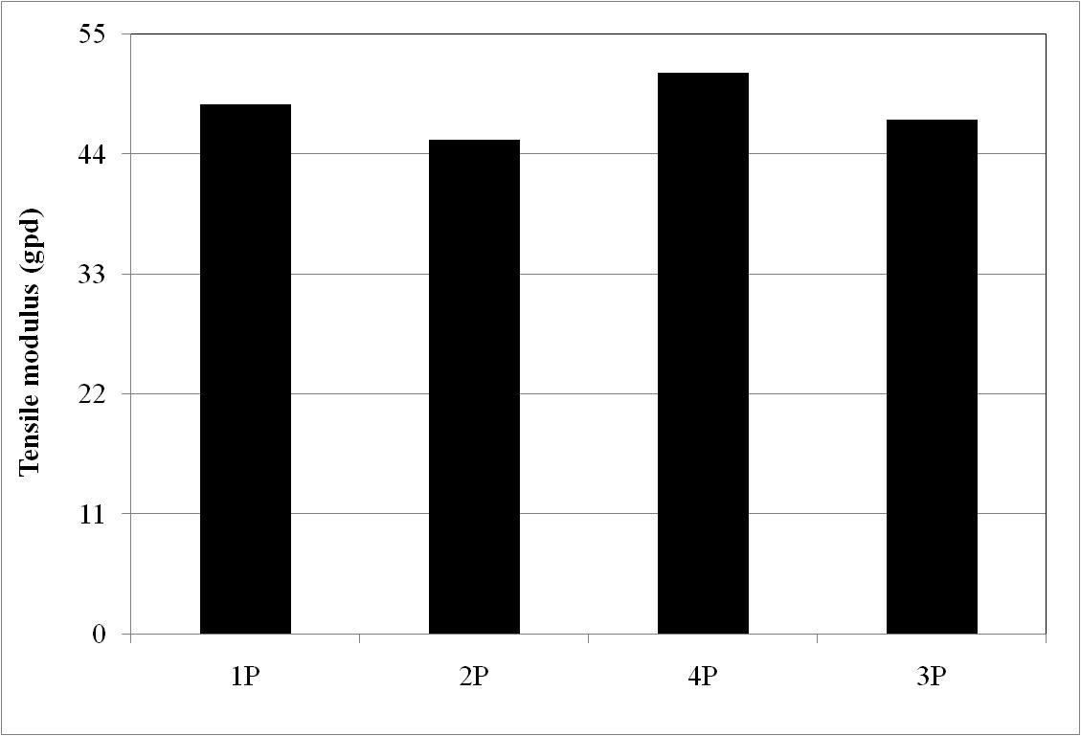
Figure 4.44 Tensile modulus of draw annealed fibers from various MW polymers. (Draw temperature: 90 °C).

Figure 4.45 Effect of polymer MW on structure development in drawn fibers. (Draw temperature: 90 °C).
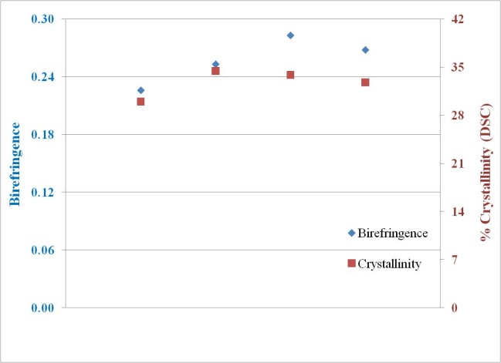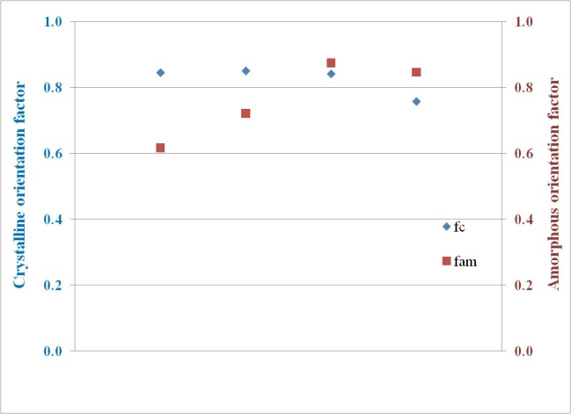
1P 2P 4P 3P
1P 2P 4P 3P
Figure 4.46 Influence of polymer MW on draw-annealed fiber morphology. (Draw Temperature: 90 °C).
trend in crystalline orientation factor with increase in polymer MW indicates that 90 °C is not the optimum draw temperature for all the fibers but higher DT is needed as the polymer MW, from the which the fibers are spun, increases. This can be explained on the fact that higher the polymer MW, sufficient chain mobility required for stretching happens at higher temperatures due to more chain entanglements.

4.4.1.2.2 Effect of melt spinning take-up speed
Figure 4.47 shows the draw-annealed fiber tenacities of as-spun fibers spun at different take-up speeds and corresponding fibers drawn at DT 100 °C. Extrusion temperatures of melt spinning are given below the figures. These fibers were manufactured at high throughput level. In the case of polymer 1P (Figure 4.47a), draw-annealed fiber tenacity is found maximum from the fiber spun at higher take-up speed. For polymer 3P, upon extruding at 315 °C as well as at 340 °C, take-up speeds exhibit an optimum at around 1750 mpm, to achieve maximum fiber tenacity (Figure 4.47b and Figure 4.47c). Similar optimum in spinning take-up speed is observed in the case of fibers spun from 4P upon extruding at 340 °C (Figure 4.47d). This indicates that optimum spinning conditions to achieve higher tenacities in the draw-annealed fibers may be different for polymers with different MWs. This behavior may be a combination
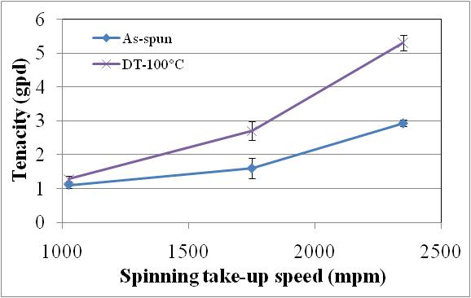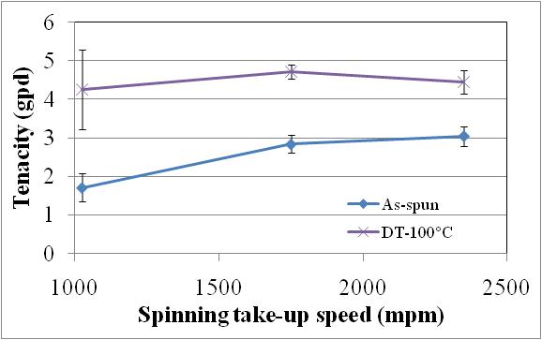
b
a
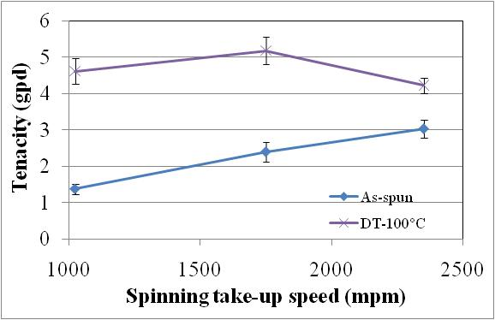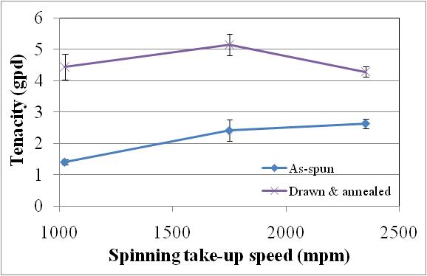
d
c
Figure 4.47 Effect of fiber spinning take-up speed on drawn fiber properties. Polymer-extrusion temperature: (a) 1P-315 °C; (b) 3P-315 °C; (c) 3P-340 °C; (d) 4P-340 °C.
of effect of level of molecular orientation and crystallinity in the as-spun fiber, number of chain entanglements varying due to polymer MW and the relaxation behavior at a given draw temperature as discussed in subsequent section.

4.4.1.2.3 Effect of draw temperature
Effect of draw temperature on tensile properties of draw-annealed fibers spun from four polymer types is shown in Figure 4.48. All of these fibers were melt spun at medium take-up speed, low ET and higher throughput. For a given polymer, as the draw temperature increases above T_{g}, tenacity first increases and then decreases with considerable drop at elevated DT (Figure 4.48a). Until optimum draw temperatures, tenacities of draw-annealed fibers are substantially higher than parent as-spun fiber. However at extreme elevated DT, tenacity decreases and reaches at par with the as-spun
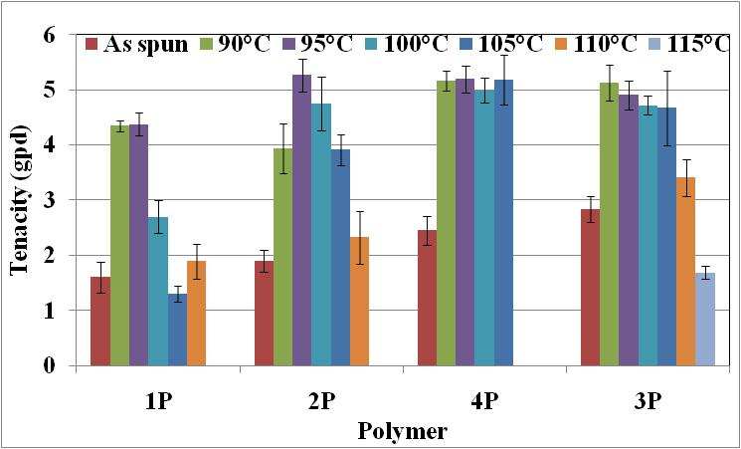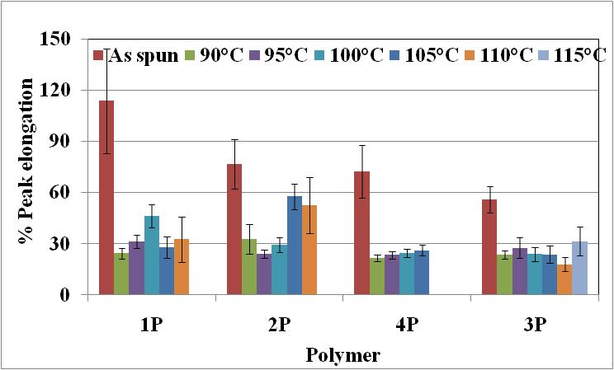
a
b
Figure 4.48 Effect of draw temperature on fiber properties. (a) tenacity; (b) elongation.
fibers, or decreases even further. The temperature at which the maximum occurred shifted towards higher temperature with increase in MW. High MW polymers, 4P and 3P, exhibited better tenacities over a wider draw temperature range than low MW polymers, 1P and 2P. The fiber breaking elongation decreases considerably upon drawing as compared to the as-spun fiber (Figure 4.48b), and do not change much over the range of DTs. This indicates that beyond the optimum draw temperature (around 95 °C), fibers become increasingly weaker. Above the draw temperatures plotted in Figure 4.48, fibers became so weak that they could not be pulled off from first draw roll, thus making drawing very difficult. Carr and Ward [31] have reported inability to draw PPS fibers beyond the draw temperature of 100 °C due to filaments sticking to the draw rolls. In our case, we did not observe the sticking tendency within the range of draw temperatures studied. Figure 4.49 shows that with increase in draw temperature, tensile moduli decrease in all the cases unlike going through maxima as observed in the case of tenacity. These changes in tensile properties can be supported by the draw-annealed fiber morphologies, whereas the drawing behavior can be explained by the as-spun fiber morphology.
For any given polymer, compared to the as-spun fiber, drawn fibers exhibit higher crystallinity and better crystalline orientation as can be inferred from WAXS pin-hole patterns (Figure 4.50), higher overall orientation (Figure 4.51a), and higher crystallinity as determined by DSC (Figure 4.51b). It can be seen from appendix 5 that crystallinities
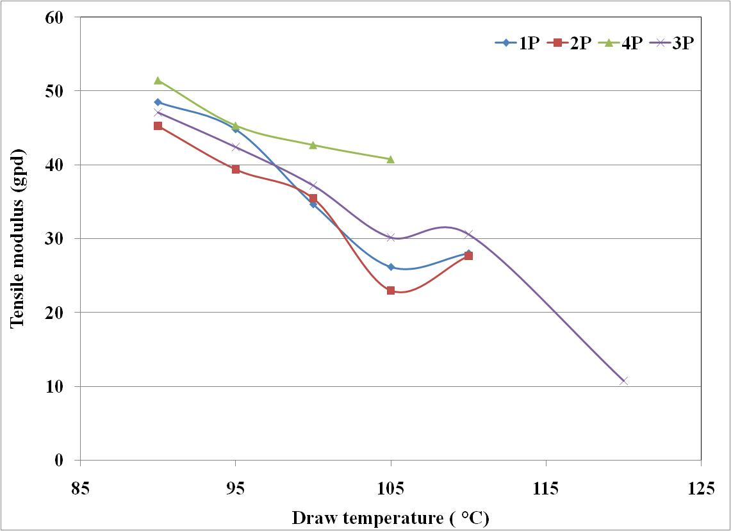
Figure 4.49 Effect of draw temperature on tensile modulus.
determined by DSC and WAXS are in close agreement. It also lists the crystal thickness perpendicular to the fiber axis calculated based on the strong equatorial reflections from planes (110) and (200). Crystal thickness in 3P as-spun fibers is ca. 28Å. The reflections of planes (110) and (200) are merged together in as-spun fiber indicating the absence of better crystalline order, and greater contribution from amorphous phase in diffuse scattering. The draw-annealed fibers drawn at all the draw temperatures show considerable increase in crystal thickness (45 Å to 90 Å). Additionally, diffractograms shown in Figure 4.52 indicate higher degree of crystalline order in the draw annealed fibers over the as-spun fibers. Thus, when compared to as-spun fibers (Figure 4.28), considerable increase in tenacity, tensile modulus and decrease in breaking elongation of draw-annealed fibers up to optimum draw temperature can be attributed to increase in molecular orientation along the fiber axis, degree of crystallinity and crystal perfection.
With increase in draw temperature, birefringence of the draw-annealed fibers goes through maximum (Figure 4.51a) for all the polymers. Comparatively, crystallinity levels do not show considerable changes (Figure 4.51b) at different draw temperatures, although some decrease at elevated draw temperatures is observed. Figure 4.53 shows the
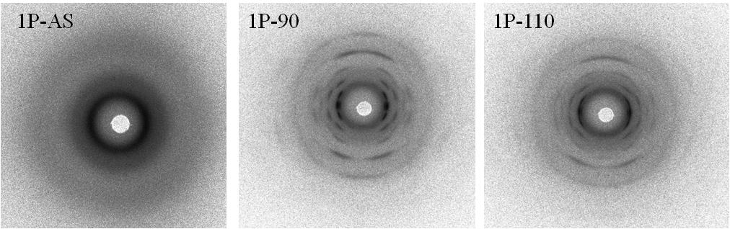
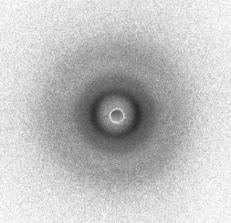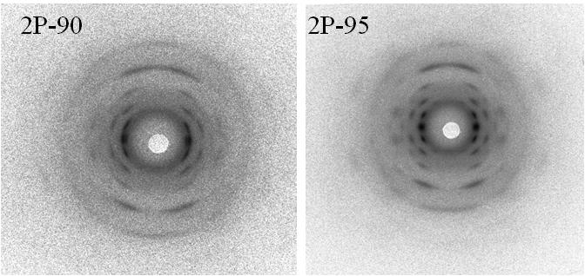
2P-AS
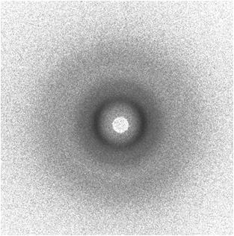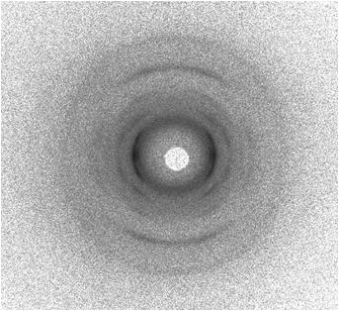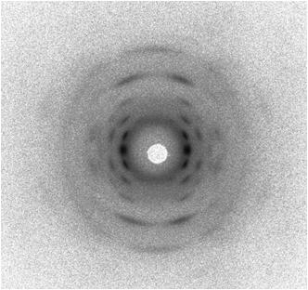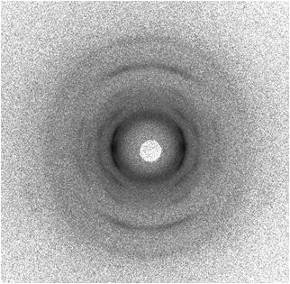
3P-95
3P-115
3P-AS
3P-90
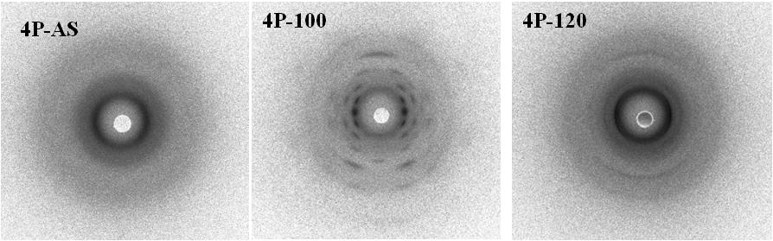
Figure 4.50 WAXS pin-hole patterns of drawn fibers as a function of draw temperature. (Fiber axis vertical) (1P, 2P and 3P fibers spun at 315 °C; 4P spun at 340 °C).
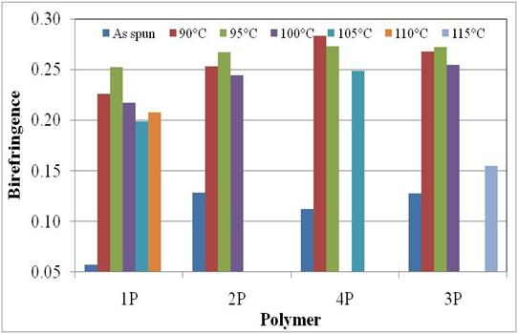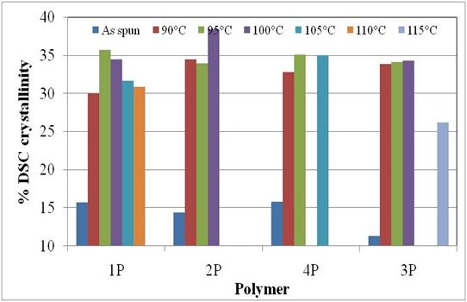
a
b
Figure 4.51 Effect of draw temperature on fiber morphological properties (a) birefringence; (b) crystallinity.
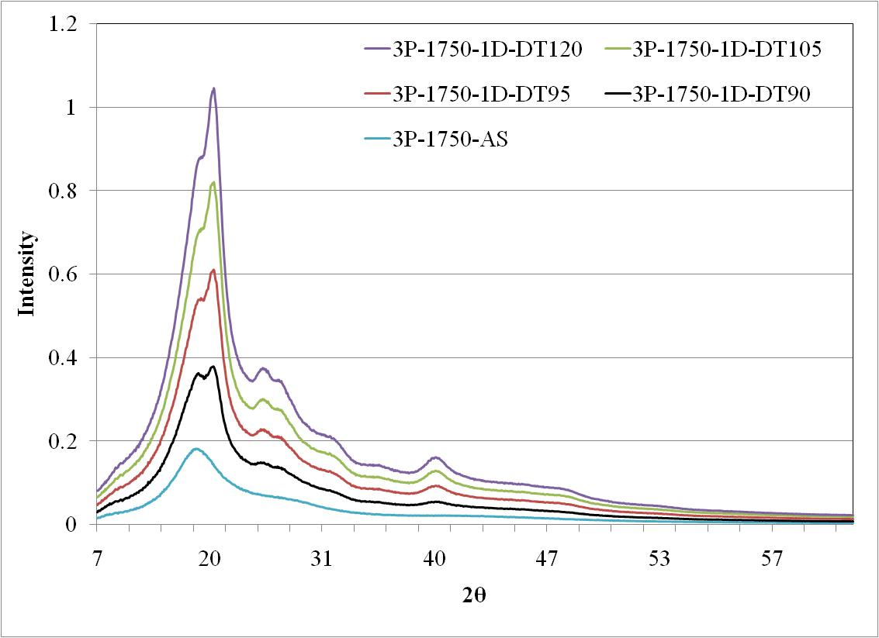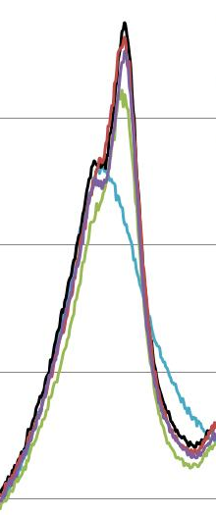
Figure 4.52 WAXS diffractograms of as spun and draw annealed fibers (3P).

crystalline and amorphous orientation factors for various draw-annealed fibers. Crystalline orientation factor (Figure 4.53a) exhibits similar trend as that of birefringence
i.e., it also goes through a maximum. Around optimum DT, amorphous orientation factor (Figure 4.53b) is substantially higher, around 0.8 and then drops considerably at elevated DTs. Up to optimum DT, role of entanglements (tie points) can be clearly seen in developing f_{am}. Both orientation factors, f_{c} and f_{am} are comparably high (around 0.8) in the case of fibers spun high MW polymers (3P and 4P) up to optimum DT, which suggests that during annealing of these fibers, besides improvement in f_{c}, high number of entanglements in high MW polymers may lead to increase in f_{am}. Conversely, in the case of fibers spun from low MW polymers (1P and 2P), up to optimum DT, even though f_{c} improves upon annealing considerably (around 0.8), f_{am} is lower (0.6-0.7). It indicates that with comparatively lesser number of chain entanglements, orientation in non-crystalline region may not reach to very high levels in fibers spun from low MW polymers. Further, long period as well as crystal thickness (crystal size perpendicular to the fiber axis) plots, as shown in Figure 4.54 and Figure 4.55 respectively, indicate that these parameters go through minima with increase in draw temperature. Up to optimum draw temperature, decrease in long period as well as crystal thickness suggest that crystals may be becoming smaller, probably by rupturing of the existing crystals. The data of long period need to be considered with caution since as can be seen from Figure 4.54b, even though maximum is observed in the SAXS pattern, the overall pattern is quite broader. Similar broader SAXS patterns in PPS were reported by Mayatake et al. []. The possible reasons for such broadening will be discussed in the section that deals with proposing the probable structural model in high tenacity PPS fibers. At similar level of crystallinity, smaller crystal thickness and long period may suggest more number of crystals. Thus while getting oriented along the fiber axis highly within crystalline region, inter-crystalline regions also experience high level of stresses, and in the presence of thermal mobility during draw-annealing cause amorphous orientation to reach substantially higher level (f_{am} around 0.8). Peterlin [] described such phenomenon in terms of increasing fraction of microfibrils. Significantly higher f_{am,} around 0.8, may
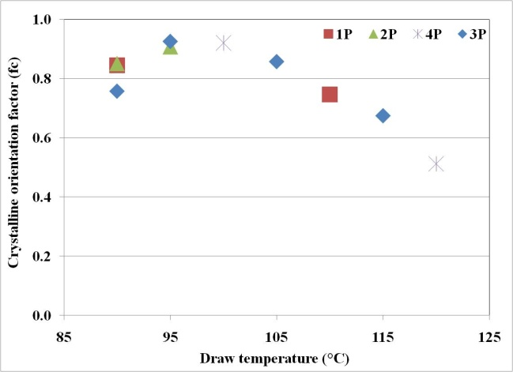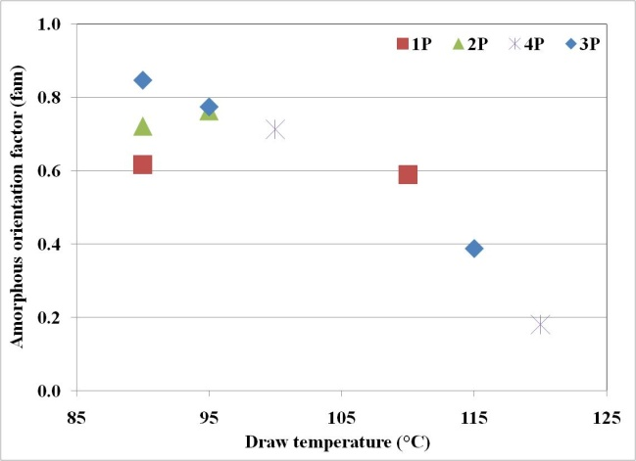
b
a
Figure 4.53 Effect of draw temperature on molecular orientation (a) f_{c}; (b) f_{am}.
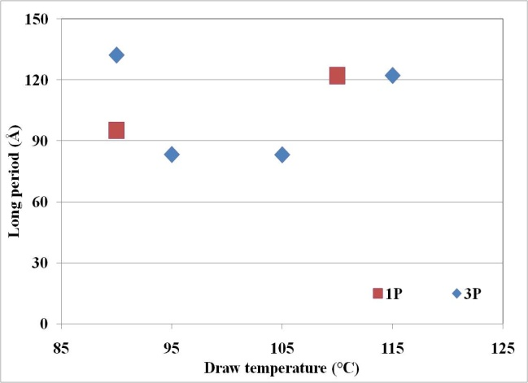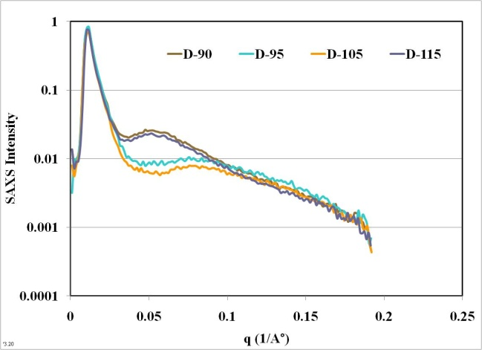
a
b
Figure 4.54 Effect of draw temperature on a) long period; b) SAXS intensity profile of 3P fibers.
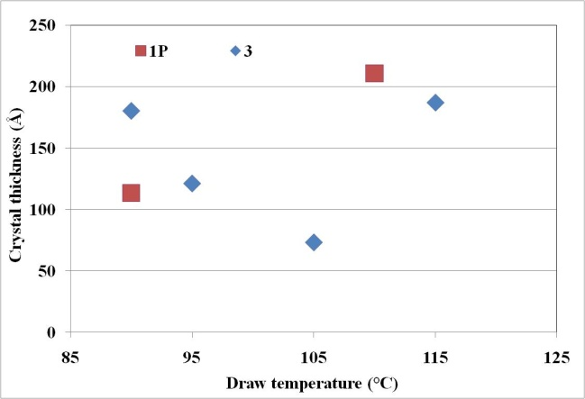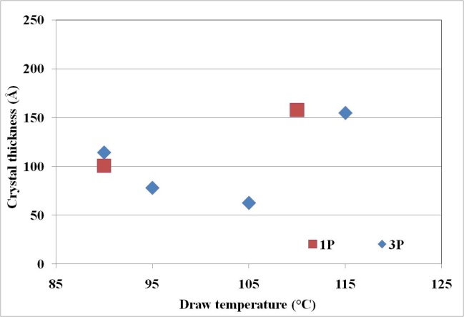
a
b
Figure 4.55 Effect of draw temperature on crystal thickness. (Crystal size perpendicular to fiber axis): (a) Plane (110); (b) Plane (200).
suggest that tie molecules connecting the neighbouring crystals are closer to extended chain conformation along fiber axis. With increasing fraction of microfibrils, fraction of tie molecules also increase, and therefore increase in tenacity and decrease in breaking elongation is expected as elucidated by Peterlin [185]. Thus increase in fiber tenacity up to optimum DT is well explained on the basis of fiber morphology.
Substantial decrease in fiber tenacity at elevated DT can also be explained on the basis of fiber structure. At elevated DT, considerable loss of molecular orientation is observed both in crystalline and amorphous regions (Figure 4.53). Also long periods as well as crystal thicknesses increase with increase in DT (Figure 4.54 and Figure 4.55). At comparable level of crystallinity, increase in crystal thickness suggests development of larger crystals when drawn at DT beyond optimum DT. Larger crystals at similar or somewhat lower degree of crystallinity may indicate larger inter-crystalline region. Thus when orientation in crystalline region decreases at higher DT, molecular relaxation may be occurring to a greater degree in amorhous region, and cause substantial decrease in f_{am}, in the extreme case to around 0.2. Lesser orientation of chain in larger crystals, and also less oriented chain network in amorphous region may be the cause behind considerable decrease in tenacity when drawn above optimum DT. Similar observation of shift in fracture mechanism from ductile to brittle has been reported in undrawn polymers i.e., in less oriented states possessing high crystallinity levels [].
With increase in DT, unlike fiber tenacity which goes through maximum, tensile moduli of the DA fibers decrease continuously with increase in DT. Considerable drop in modulus at DT beyond optimum draw temperature can be attributed to poorly oriented chains in the fiber structure. Figure 4.56 shows the relationhip between tensile modulus and several morphological properties of fibers. The trendlines are shown as solid lines, and regression coefficient for each of the trendline is also shown. In order to fit the crystallinity data on same X-axis, degree of crystallinity was divided by 100. The best relation is observed between modulus and f_{am}. Figure 4.53 shows that f_{am} decreases with increase in DT, even in the region up to optimum DT. Decrease in f_{am} indicates that chains in the inter-crystalline region relax more with increase in DT, and cause lesser resistance to stretching during tensile tests in the initial deformation region. Considering this strong and direct correlationship between tensile modulus and f_{am,} it can be stated that with increase in DT, f_{am} decreases (Figure 4.53b) causing tensile modulus to decrease (Figure 4.49) as well. Similar strong relationship between f_{am} and tensile modulus is reported by Yamada et al. [] in the case of highly oriented polypropylene. Since tensile modulus is determined at low levels of deformation, very high correlation coefficient, 0.998 with f_{am} is as expected. Similar plot of tenacity as a function of same morphological properties is shown in Figure 4.57. The best correlation of tenacity is observed with orientation, especially f_{am}.
In all of the above samples, effect of DT is discussed based on the structure and properties of draw-annealed fibers that were annealed under similar conditions. In order to investigate the influence of drawing alone, as spun fibers of polymer 3P were only drawn at optimum DT of 95 °C and 110 °C without further annealing. The results are shown in Figure 4.58. It is clear that drawing at higher draw temperature of 110 °C causes tenacity and birefringence to decrease whereas elongation seems to increase. Tensile modulus remains fairly unchanged at the level of as-spun fiber. It is clear from Table 4.3 that at DT of 95 °C, there is considerable improvement in f_{c} since increase in crystallinity happens under drawing stresses and slight increase in f_{am} as compared to as-spun fiber. At DT of 110 °C, due to increased chain mobility and approaching closer to cold crystallization temperature, formation of newer crystals happen under oriented state at higher DR and hence f_{c} increases. However, the chains in amorphous region relax due to higher mobility induced at higher DT and causes f_{am} to decrease. Due to fairly low level of amorphous orientation, tensile modulus remains at a level, at par with that of as-spun fibers. These findings confirm the presence of an optimum DT in terms of developing enhanced fiber morhphology that can increase fiber tenacity upon annealing subsequently.
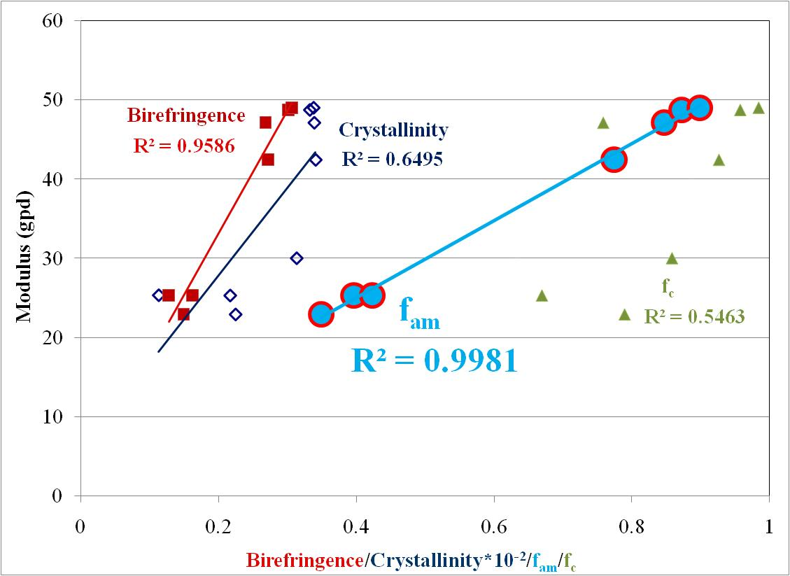
Figure 4.56 Effect of morphological properties on fiber tensile modulus. (Data corresponds to fibers spun from 3P and draw-annealed under different conditions).
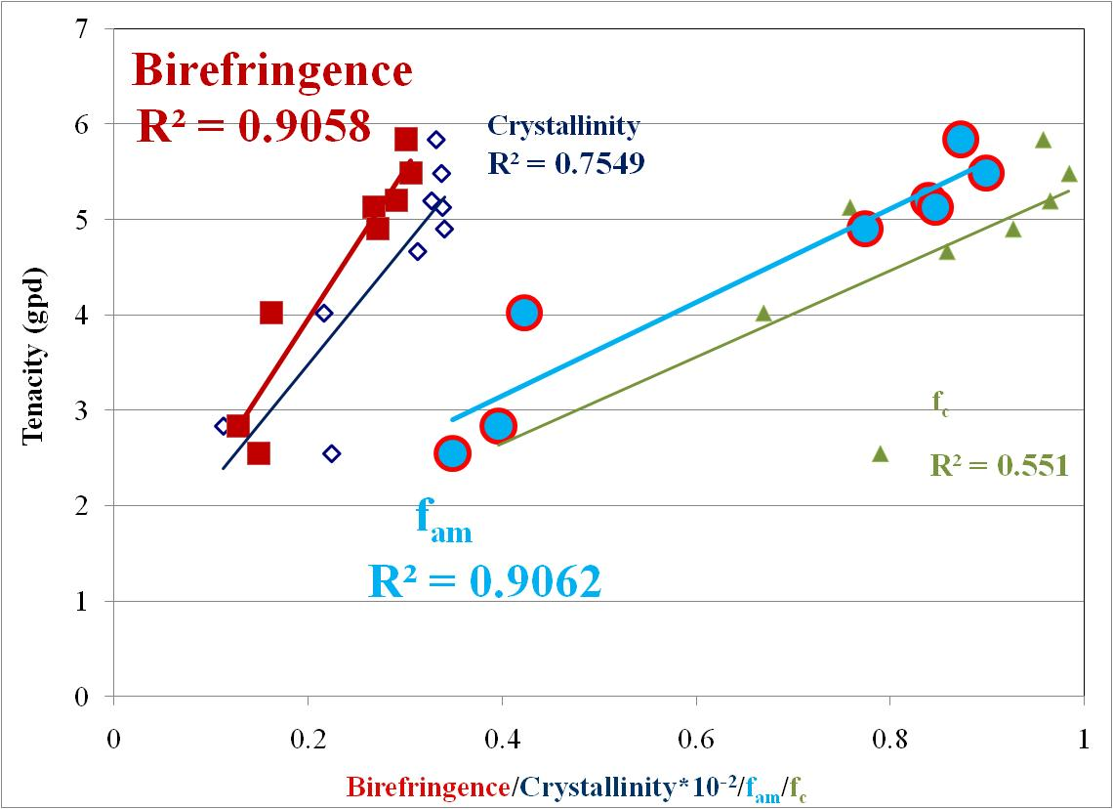
Figure 4.57 Effect of morphological properties on fiber tenacity. (Data corresponds to fibers spun from 3P and draw-annealed under different conditions).

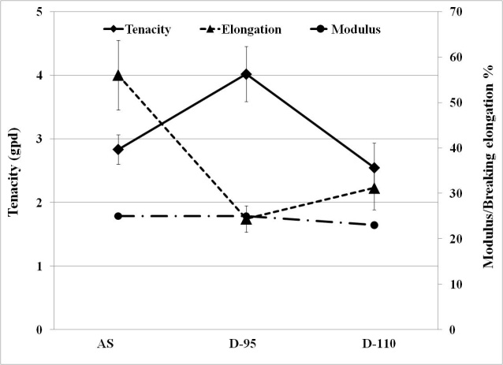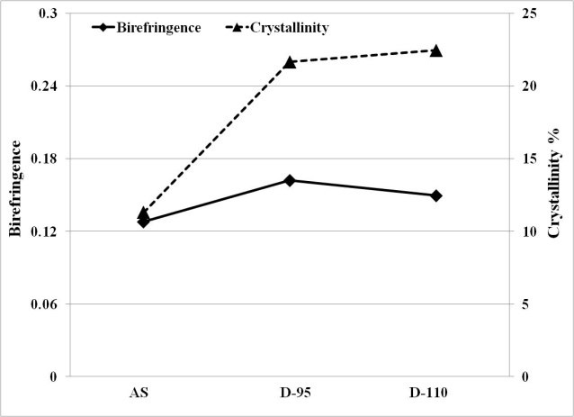
Figure 4.58 Effect of draw temperature alone on fiber structure and properties.
Table 4.3 Structural properties ofdrawn fibers
Sample | f_{c} | f_{am} | Crystal thickness  (Å) (110)
AS | 0.396 | 0.396 | 28
D-95 | 0.669 | 0.423 | 24
D-110 | 0.789 | 0.349 | 29

4.4.3 Effect of annealing
In order to investigate the role of annealing itself upon enhancing the fiber structure and properties, as-spun fiber possessing very little drawability was chosen. The structure of such fiber is far from matured due to lower molecular orientation and lower degree of crystallinity. Upon annealing this fiber at 170ºC without any drawing, tenacity increases from 3.5 gpd to 4.5 gpd with slight decrease in breaking elongation (Figure 4.59a). Such an improvement in tensile properties occurs due to morphological enhancement i.e., increase in molecular orientation and crystallinity (Figure 4.59b).
Contribution of annealing to fiber structure and properties enhancement was studied by comparing the improvements brought in by drawing alone to that of draw-annealing. DT chosen was 95ºC, since it was found to be optimum DT during one zone draw annealing studies. The plots of tensile properties and morphological properties are shown in Figure 4.60. D-A was the sample annealed at 150ºC, and D-A-EA was the sample D-A extended annealed further at 190ºC in a continuous process. It is seen that each additional step is enhancing the fiber tenacity (Figure 4.60a) and birefringence (Figure 4.60b). Degree of crystallinity increases considerably upon annealing and remains at the level upon further extended annealing. WAXS pin-hole patterns for each of these samples, as shown in Figure 4.61, also indicate considerable improvement in crystalline orientation after each stage of processing. As seen from Table 4.4 considerable increase in f_{c} and f_{am} is brought by drawing and draw-annealing. Extended annealing enhances f_{am} more than f_{c}. Also crystal size increases further considerably upon extended annealing. Therefore, increase in tenacity observed after each stage of processing under consideration can be attributed to crystallinity and to molecular orientation. Higher modulus is seen only in the sample that has very high level of f_{am}. These changes in tensile moduli as a function of f_{am} were discussed in earlier section.
Effect of extended annealing was also investigated in the case of fibers spun at higher ET of 340ºC. The tensile properties of these fibers are plotted in Figure 4.62. In this case also it is observed that substantial improvement in tenacity is obtained upon
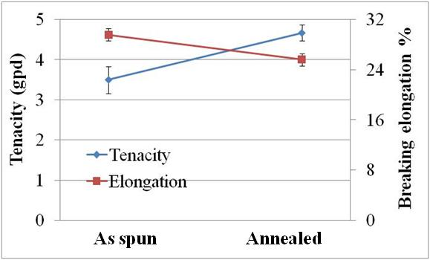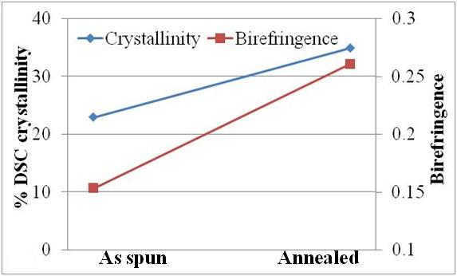
a
b
Figure 4.59 Effect of annealing on tensile properties (a) and morphology (b). (Fiber details: polymer 3P; extrusion temperature: 315 °C; throughput: 9 gm/min/12 holes; take-up speed: 2350 mpm; capillary l/d: 10).
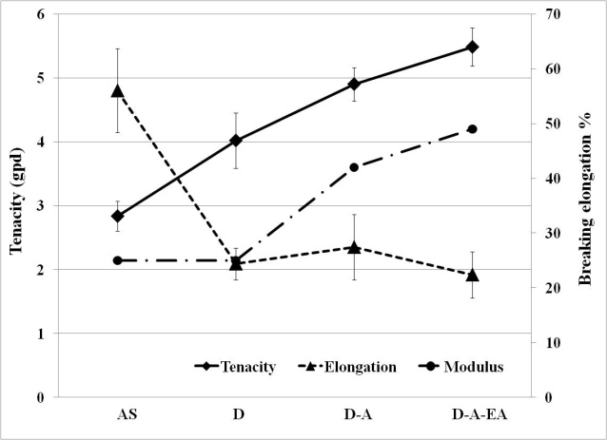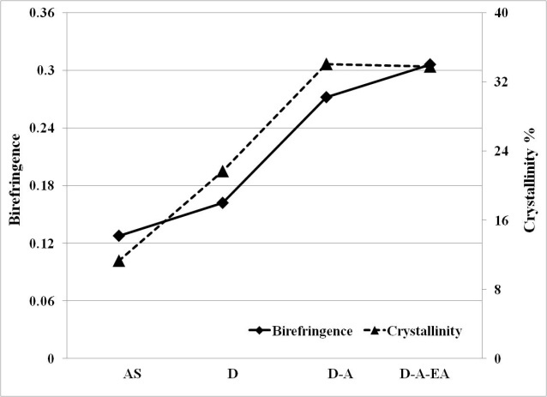
a
b
Figure 4.60 Fiber structure-properties development upon drawing and draw-annealing. (Polymer 3P, spun at 1750 mpm, extrusion temperature: 315 °C, throughput: 12 gm/min/12 holes, capillary l/d:10; DT: 95 °C, AT: 150 °C, EAT:190 °C).
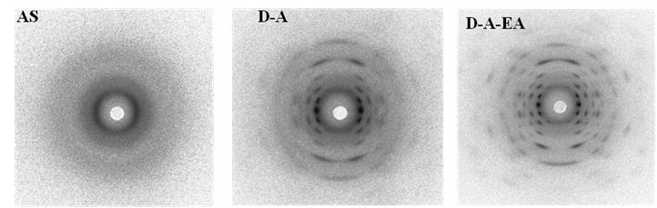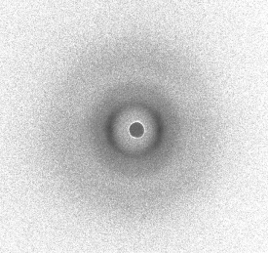
D
Figure 4.61 Effect of annealing on crystalline morphology development.
Table 4.4 Other structural properties of drawn and draw-annealed fibers
Sample | f_{c} | f_{am} | Crystal thickness(Å) (110)
AS | 0.396 | 0.396 | 28
D-95 | 0.669 | 0.423 | 24
D-A | 0.926 | 0.774 | 69
D-A-EA | 0.984 | 0.899 | 111

draw-annealing and it increases marginally further upon extended annealing. As discussed above, the improvement in crystalliny and molecular orientation in crystalline and non-crystalline region may be attributed to these changes in tensile properties.

4.4.4 Two zone drawn and annealed fibers

4.4.4.1 Influence on drawability
For the purpose of comparison, two zone draw annealed fibers (2ZD-A) were produced under the same conditions as that of one zone draw annealed (1ZD-A) fibers except the change in number of draw zones. The as-spun fibers that yielded highest tenacities in 1ZD-A studies were selected. As can be seen from Figure 4.63, for a given as-spun fiber, drawability is higher slightly when drawn in two zones as compared to drawing in one zone. It was true for fibers spun from all three polymer types.

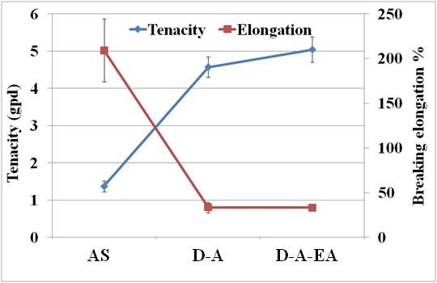
Figure 4.62 Effect of extended annealing upon fiber tensile properties. (Polymer 3P; extrusion temperature: 340 °C; throughput: 12 gm/min/12 holes; take-up speed: 1750 mpm; capillary l/d: 10; draw temperature: 100 °C, AT: 150 °C, EAT: 190 °C).
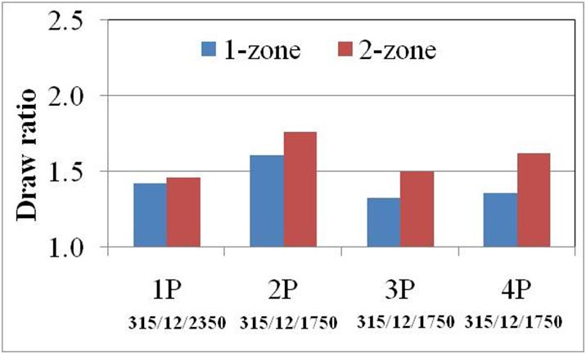
Figure 4.63 Effect of number of draw zones on drawability. (Fiber details: 315/12/2350: extrusion temperature/throughput/take-up speed; capillary l/d: 10, draw temperature: one zone – 95 °C; two zone-95 °C /100 °C, annealing temperature: 190 °C).

4.4.4.2 Influence on fiber structure and properties

4.4.4.2.1 Comparison with one zone draw-annealed fibers
Tenacity and breaking elongations of two zone drawn vs one zone drawn-annealed fibers is given in Figure 4.64. On tenacity plots, the symbols of equal to and not equal to are the results of mean comparisons using t-test. Equal to indicates that the two values are not statistically different whereas not equal to indicates that the two values are statistically different. As can be seen (Figure 4.64a), statistically no difference is observed between the tenacities of fiber spun from low MW polymers, 1P and 2P, when processed by 1ZD-A or 2ZD-A route. However, in the case of fibers spun from high MW polymers, 4P and 3P, 2ZD-A fibers showed higher tenacities than 1ZD-A fibers. Fiber tenacity close to 6 gpd is obtained by adopting 2ZD-A route for the fibers spun from high MW polymers. Figure 4.64c and Figure 4.64d show that no signicifant change in degree of crystallinity and birefringence between 1ZD-A and 2ZD-A fibers. Figure 4.65 shows the WAXS pin-hole patterns of 1ZD-A and 2ZD-A fibers. It appears that there may be some loss of crystalline orientation and crystal size may be larger in 2ZD-A fibers than in 1ZD-A fibers. Table 4.5 lists these structural properties quantitatively. It becomes clear that though f_{c} has not changed much, some increase is observed in f_{am}. This improvement in f_{am} can be attributed to phenomenon that occurs during increase in crystal size as observed in the case of 2ZD-A fibers vs. 1ZD-A fibers. Crystal growth may occur by pulling part of chains in intercrystalline region, adjacent to the crystalline region, into crystalline region. This phenomenon may cause more stresses on the chain in intercrystalline regions during crystal growth and thereby increase f_{am}.

4.4.4.2.2 Influence of capillary l/d during melt spinning
The role of capillary l/d during fiber spinning upon the fiber tensile properties of two zone drawn and annealed fibers is shown in Figure 4.66. It becomes clear that when drawn and annealed under similar conditions, fibers spun from lower l/d capillary exhibit
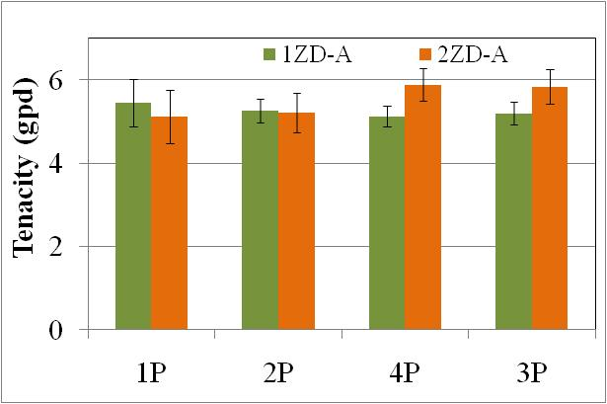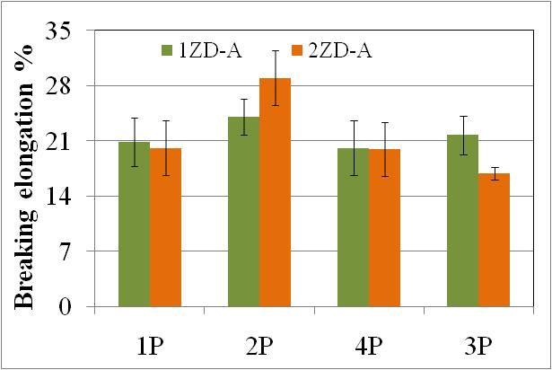
a
b
=
≠
≠
=
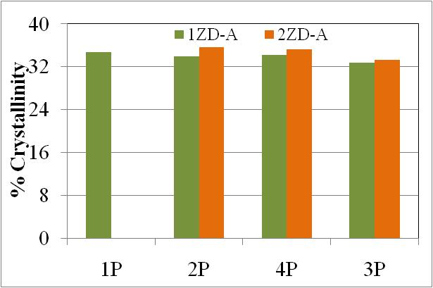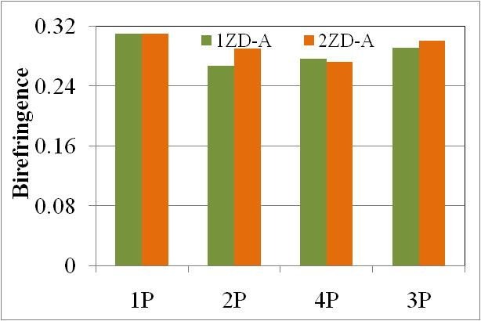
d
c
Figure 4.64 Compariosn of fiber structure-properties development by 1ZD-A and 2Zd-A route. (Fiber details: extrusion temperature: 315 °C; throughput: 12 gm/min/12 holes; take-up speed: 1P: 2350 mpm; 2P, 3P and 4P: 1750 mpm; capillary l/d: 10, draw temperature: one zone – 95 °C; two zone-95 °C /100 °C, annealing temperature: 190 °C).
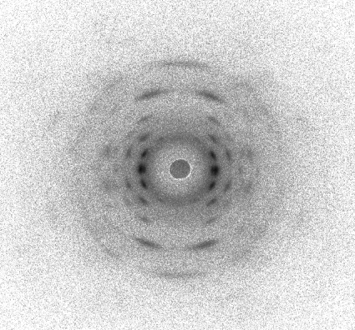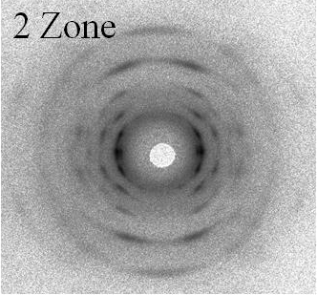
1-Zone
Figure 4.65 Effect of number of draw zones on crystalline morphology development. (Fiber details: Polymer: 3P; other details same as given in Figure 4.64).
Table 4.5 Structural properties comparison between 1ZD-A and 2ZD-A fibers
Sample | f_{c} | f_{am} | Crystal thickness  (Å) (110) | Long period  (Å)
1ZD-A | 0.964 | 0.839 | 76.90 | 91
2ZD-A | 0.957 | 0.872 | 90.73 | 99
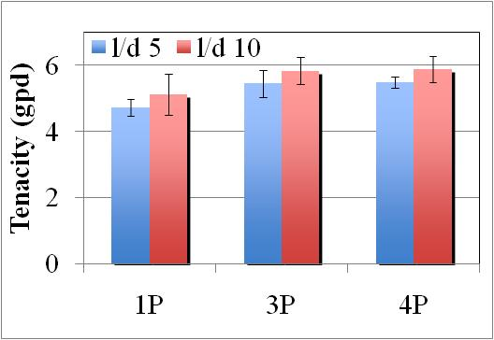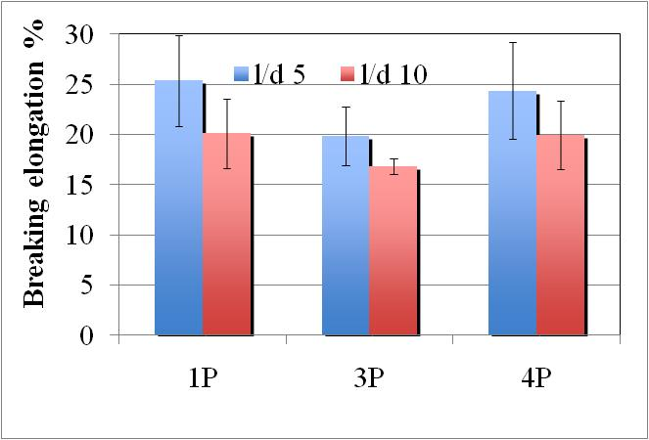
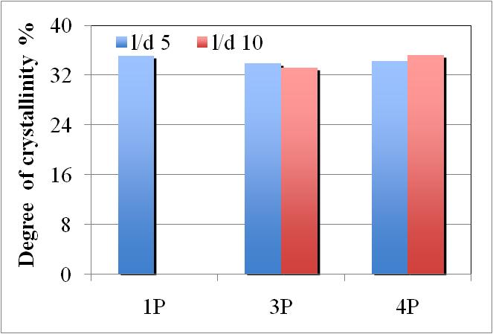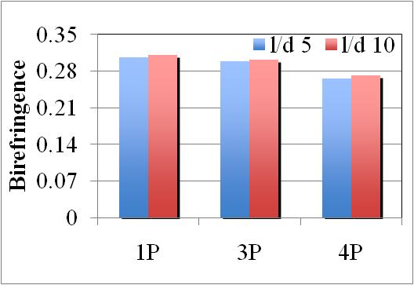
Figure 4.66 Role of capillary l/d in properties enhancement in draw annealed fibers. (Fiber details: extrusion temperature: 315 °C; as-spun fiber denier: 5; take-up speed: 1P-2350 mpm; 3P&4P:1750 mpm; two zone draw temperature: 95 °C /100 °C, annealing temperature: 190 °C).

lower tenacities than the fibers spun from higher l/d capillary. However, the difference is not statistically different within the range of capillary l/d studied. Decreasing trend may be attributed to the fact that the as-spun fibers produced using lower l/d capillary possesses the structure that is not as mature in terms of orientation as that when spun from higher l/d capillary. Such a structural deficiency in the as spun fibers may require different processing conditions i.e., optimum drawing and annealing temperatures may be different for the fibers spun from capillary l/d of 5 to that of 10.

4.5 Role of molecular orientation on some other aspects of processing and fiber morphology

4.5.1 On draw annealing process performance
It was shown earlier that the range of draw temperatures to obtain fair level of fiber tenacities is wider for fibers spun from high MW polymers. This drawing behavior of various as-spun fibers can be explained on the basis of their thermo-mechanical response that was studied using DMA (Figure 4.67 and Figure 4.68). Figure 4.67 shows the dynamic mechanical behavior of as-spun fibers produced from all the four polymers under similar spinning process conditions. It is clear from Figure 4.67a that, higher the polymer MW, the minimum in storage modulus occurs at higher temperature. Corresponding change in length is shown in Figure 4.67b. Above T_{g}, as-spun fibers of 1P show viscous flow like behavior without any shrinkage, whereas, fibers spun from 2P, 4P and 3P shrink increasingly in the order of their MW before exhibiting the viscous flow like behavior. This indicates the absence of stress in 1P as-spun fibers to overcome the pretension during DMA testing, and presence of higher level of stresses in 2P, 4P and 3P in the increasing order of their MW. When spun at similar take-up speed, higher the polymer MW, higher will be the molecular orientation due to more number of chain entanglements. Such trend in birefringence is observed between 1P, 4P and 3P at take-up speed of 1750 mpm as well as for 1P between 1750 mpm and 2350 mpm (Table 4.6). Similar observation was made during DMA testing of the fibers spun from 1P at take-up
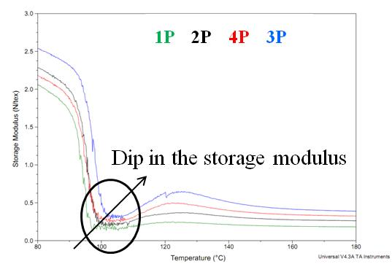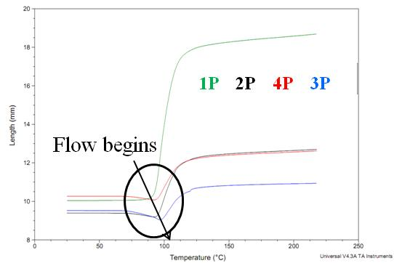
b
a

Figure 4.67. Dynamic mechanical behavior of as-spun fibers a) length response, b) storage moduli. (As-spun fibers spun at 1750 mpm, extrusion temperature: 315 °C, throughput: 12 gm/min/12 holes, capillary l/d 10).
Table 4.6 Birefringence of as-spun fibers (Extrusion temperature: 315 °C)
Take-up speed (mpm) | 1750 |  |  | 2350
Polymer | 1P | 4P | 3P | 1P
Birefringence | 0.057 | 0.110 | 0.128 | 0.158
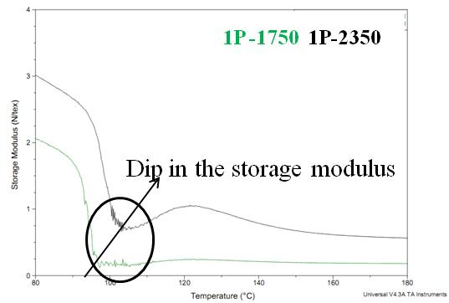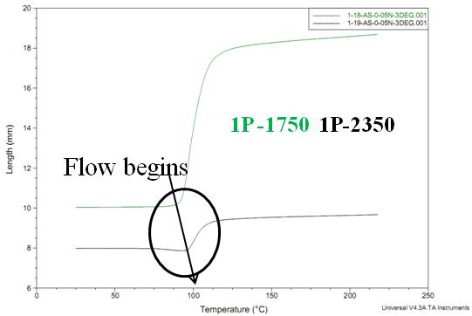
a
b
Figure 4.68. Dynamic mechanical behavior of 1P as-spun fibers a) length response, b) storage moduli. (As-spun fibers spun at extrusion temperature: 315 °C, throughput: 12 gm/min/12 holes, capillary l/d 10).
speed of 1750 mpm and at 2350 mpm. Fibers spun 2350 mpm exhibit minimum in storage modulus at higher temperature (Figure 4.68a), and shrinkage followed by viscous flow like behavior (Figure 4.68b).
In a study on heat treatment of PET fibers, Peszkin and Schultz [] reported that the physical cross links are necessary to produce shrinkage during heating the fibers by preventing free movement of chain through each other. In the absence of physical cross links in the form of chain entanglements, crystallites, oriented chains, etc. due to either lower MW or lower take-up speed during melt spinning, viscous flow in present experiement suggests that the chain mobility induced at higher temperatures may have resulted into chains sliding past each other, instead of chain orientation as desired in the process of drawing. That in turn may have led to fiber breakage by slightest tension at higher temperatures as observed during drawing experiements of PPS fibers. Thus it can be stated that, with increase in stress level in the as-spun fibers, either by increase of MW or by spinning at higher take-up speeds, the viscous flow like behavior and the failure to stretch the fibers due to chain sliding past each other is shifted to higher temperature. This explains the observation of wider process window for fibers spun from high MW polymers.
Carr and Ward [31] reported sticking of PPS as-spun fibers to draw rolls when attempted to draw above the draw temperature of 100 °C. In present experiments, sticking was observed above 115 °C depending upon the as-spun fiber’s history. Between the temperature zone (90-100 °C) of good drawing behavior, and that (above 115 °C) of sticking to draw rolls, there seems to exist a transition temperature zone, wherein fibers exhibit increasingly viscous-flow like behavior with increase in draw temperature, thereby leading to poor tensile properties of fibers and difficulty to stretch eventually.

4.5.2 On melting behavior of fibers
Figure 4.69 shows the melting behavior of fibers drawn at various DT and is compared with that of the as-spun fiber. In the case of as-spun fibers produced under various spinning conditions, peak melting temperature is observed around 280 °C and is
Temperature (°C)
Endotherm
Figure 4.69 Effect of drawing temperature on thermal behavior of drawn fibers. (Polymer: 3P).
similar to that in as-received pellets. Upon drawing up to optimum DT, draw-annealed fibers exhibit very small endotherm at 280 °C and then major endotherm with considerably higher peak melting temperatures of around 295 °C. Also the melting endotherms are much sharper. It is to be recalled that during performing the thermal evaluations using DSC, the fiber samples were carefully knotted, to prevent the stress relaxation at higher temperatures within DSC. As can be seen from Figure 4.69 upon drawing beyond optimum DT, melting endotherm of draw-annealed fibers becomes broader with a peak at around 280 °C again.
In order to investigate if the draw-annealed fibers possess the crystal structure that exhibits higher T_{m} or if the crystal structure reorganizes during heating in DSC, one of these draw-annealed fibers drawn at 95 °C was heated in DSC to 280 °C at the rate of 10 °C/min, and then cooled rapidly at the rate of -100 °C/min. The temperature of 280 °C was chosen since at this temperature, the draw annealed fibers are still not melted. WAXS pin-hole patterns of this heat treated fiber was compared with that of the draw-annealed fibers.
The pin-hole patterns and corresponding diffractograms are shown in Figure 4.70 and Figure 4.71 respectively. For the purposes of comparison, WAXS evaluation of crystalline film produced from polymer 3P by hot pressing is also included in these figures. Corresponding quantitative data of crystallinity and crystal size in given in appendix 5. The level of crystallinity (by WAXS) in the crystalline film, as-spun fiber, DA fiber and DA-HT fiber is around 37%, 11%, 33% and 46% respectively. The peak melting temperature and melting behavior of crystalline film is similar to that of highly amorphous and poorly oriented as-spun fiber. WAXS pin-hole pattern of DA fiber shows highly oriented crystalline structure. However, upon heat treatment, the patterns show some loss in orientation but more important to be noted is the width of the arcs. The difference is more clearly seen from the diffractograms in Figure 4.71. The crystal thickness calculated from the intensity distributions of planes (110) and (200) in DA-HT fiber is 316 Å and 107 Å whereas that in DA fiber is 69 Å and 50 Å respectively. Thus significant increase in crystal size is observed upon heat treatment at 280 °C. Thus it can be deduced that the crystals melting at higher temperatures of 295 °C are primarily formed by crystal rearrangement during heating in DSC. Degree of crystallinity in heat treated DA fiber is around 46% as compared to that of 33% in DA fiber. Hence, it can be deduced that the crystal growth may have taken place to some extent by absorbing molecular chains lying in some of the highly ordered non-crystalline regions adjacent to the existing crystal, and also by combining of the neighbouring crystals.
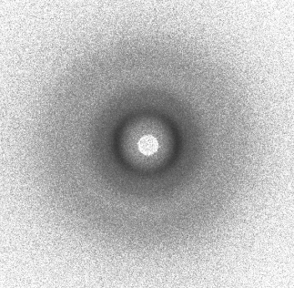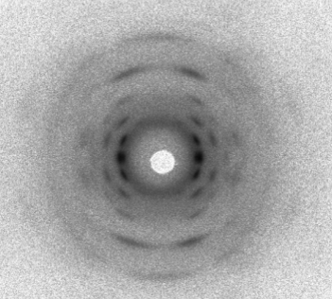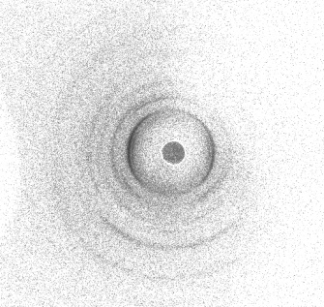
DA-HT
DA
AS
Figure 4.70 WAXS pin-hole patterns of fibers (Polymer 3P). (AS: spun at medium take up speed, lower extrusion temperature, higher throughput; DA: drawn at 95 °C and annealed at 150 °C; DA-HT: DA fiber heat treated in DSC).
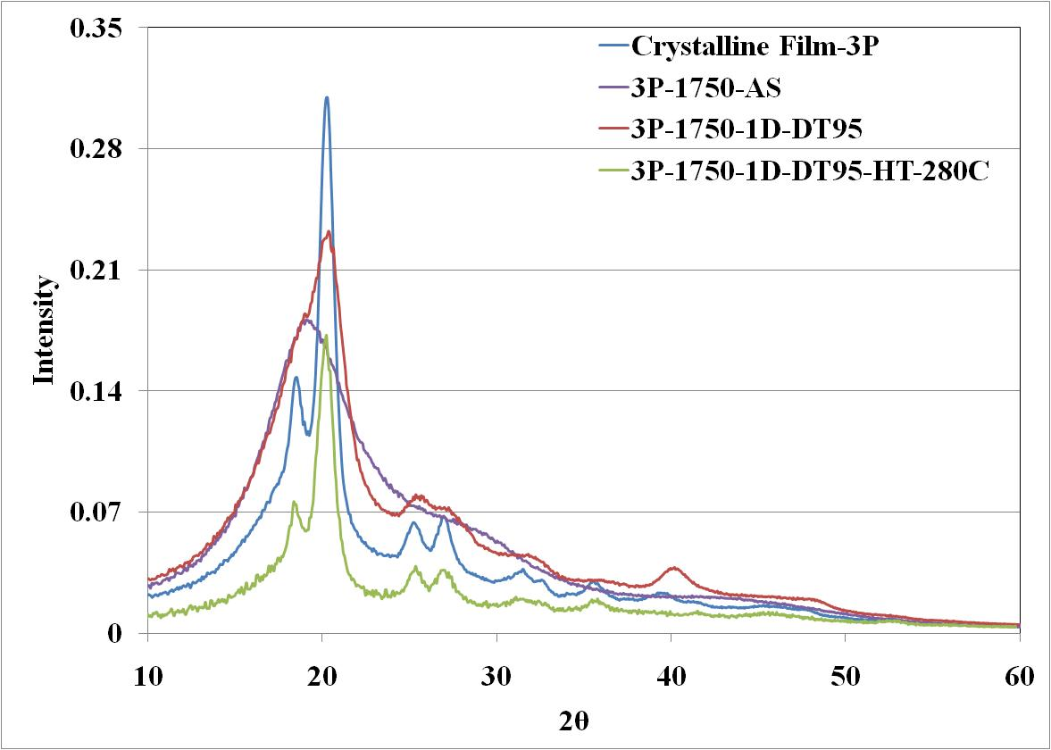
Figure 4.71 WAXS diffractograms of PPS fibers and films. (Sample conditions similar as in Figure 4.70)
Absence of high temperature melting peak in poorly oriented amorphous as-spun fiber, and in unoriented crystalline film suggests that such rearrangement may not have taken place in them in the absence of molecular orientation. This clearly indicates that molecular orientation is playing the role in crystal rearrangement, that subsequently leads to larger crystals in draw annealed fibers, which melt at higher temperatures.
It is not in the entirety that only the larger crystal size is the cause of high melting peak in DSC endotherm. The crystal thickness in the crystalline film is aroud 110 Å based on (110) and (200) planes as compared to 69 Å and 50 Å respectively in draw annealed fiber. Inspite of consisting of larger crystals, peak T_{m} in crystalline film is at around 280 °C. Thus it can be stated that the highly ordered inter-crystalline region is providing hinderance to melting of the crystals and hence require higher temperatures for crystals’ melting. Thus the role of molecular orientation in melting behavior of highly oriented PPS fibers may be two fold, to act as a catalyst for further crystal rearrangement and also to provide resistance to melting of crystals through the presence of highly ordered non-crystalline region. Yamada et al. [187] reported increase in melting temperature of highly oriented isotactic polypropylene films and cause was attributed to increase in the amorphous orientation. Through extensive study on melting behavior of isotactic polypropylene fibers, Samuels [] concluded that the multiple melting endotherms in oriented and restrained fibers are the manifestations of orientation in amorphous regions above certain minimum value of f_{am}. The increase in melting temperature was attributed to decrease in the configurational entropy of molecular chains in oriented amorphous regions. Observed increase in melting temperature of draw-annealed PPS fibers in present research can similarly be attributed to high level of amorphous orientation. One of the probable mechanisms by which highly oriented amorphous domains will contribute to increase in T_{m} is discussed subsequently after discussing the probable structural model for high tenacity PPS fibers.

4.5.3 On crystallizability of the fibers
In the section of crystallization kinetics, it was reported that under most conducive atmospheres for crystallization, the degree of crystallinity achieved is around 30% for low MW polymers and around 25% for low MW polymers. Degree of crystallinity determined by DSC and WAXS in the draw annealed fibers under optimum conditions of draw-annealing is around 35%, i.e., higher than the level that can be achieved under quiescent condions such as during crystallization kinetics studies. The increase in crystallizability can be attributed to molecular orientation which favors crystallization. Faster crystallization has been reported by Smith and Steward [] in oriented PET as compared to crystallization rates in quiescent conditions. Spruiell et al. [] have reported that molecular orientation mainly reduces the nucleation time of crystallization. The reason for faster crystallization in oriented molecular network was attributed by Andrews [] to reduction in the configurational entropy upon molecular orientation. Thus the change in configurational entropy renquired to be brought during crystallization will be lesser, making the process faster. Oriented molecular network can pack closely and thereby increases the crystallizability of the polymers.

4.6 Steam drawn fibers
This section discusses preliminary findings of steam drawing studies compared with those of zone drawn studies discussed until now. Detailed investigation of fiber morphology of Steam drawn (SD) fibers is not carried out. Tensile properties of fibers draw annealed using one zone drawing technique (ZD) are compared with that of steam drawn (SD) fibers in Figure 4.72. It is to be noted that SD fibers were treated at 100 °C for one minute whereas ZD fibers were drawn at 100 °C and annealed at 150 °C. Fiber tenacity of around 5 gpd is obtained in both the cases whereas breaking elongationin of SD fiber is higher than ZD fiber. This indicates better efficiency of steam drawing in development of fiber morphology and hence properties even in the absence of high temperature annealing.
The melting behavior of ZD and SD fibers is shown in Figure 4.73. It becomes very clear that ZD fiber undergoes crystal rearrangement while heating in DSC at high temperature which then subsequently melts at higher temperatures. However, even though not annealed at high temperature of 150 °C, SD fiber do not undergo such rearrangement and exhibit very narrow melting endotherm with peak Tm close to that of AS spun fibers. In light of above tensile results and differences in melting behavior, it appears that presence of steam improves the heat transfer effectively as well as acts as plasticizer to enhance the fiber morphology at considerably lower DT. Further extensive studies on steam drawing of PPS become necessary to investigate the morphological changes in fibers when drawn in steam.

4.7 Structural model of highly oriented PPS fibers
In this section, an attempt is made to visualize the fine structure in oriented PPS fibers. Such visualization is based on the extensive morphological characterization of numerous PPS fibers manufactured in the present dissertation under various processing conditions. The findings of crystal structure from WAXS and SAXS, birefringence, noncrystalline orientation, thermal characterization by DSC, high resolution micrographs
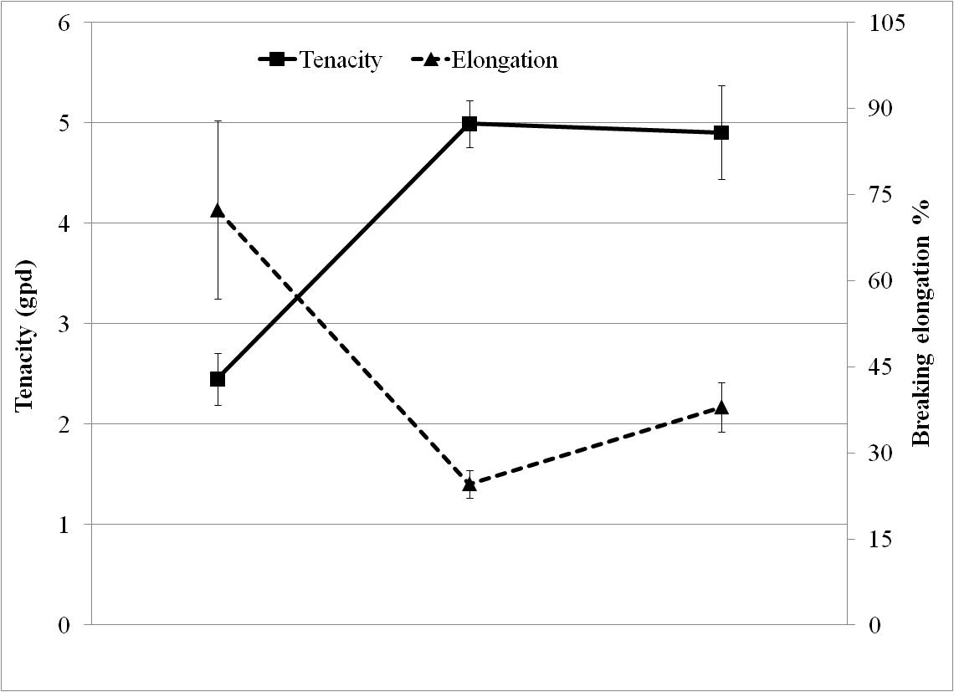
AS ZD SD
Figure 4.72 Fiber tensile properties upon drawing with dry heat vs steam. (Polymer 4P, spun at 1750 mpm, extrusion temperature: 315 °C, throughput: 12 gm/min/12 holes, capillary l/d 10; draw temperature: 100 °C, annealing temperature: zone drawn fibers-150 °C, steam drawn sample ~100 °C).
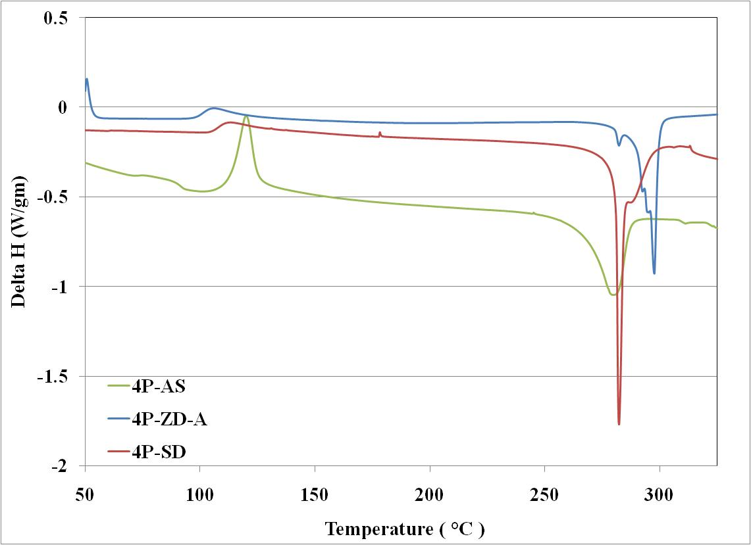
Figure 4.73 Melting behavior of ZD and SD fibers. (Material and fiber manufacturing conditions similar to those given in Figure 4.72).
using SEM, all are taken into consideration to propose the structural model.
As shown earlier in Figure 4.43b, the plots of SAXS intensity as a function of scattering vector q are quite broad. The existence of maxima in these plots suggests that there is some structural periodicity of crystalline and noncrystalline domains along the fiber axis. In a fiber with well defined long period, these profiles are expected to be very sharp. Broader profile in present case indicates the presence of varying lengths of long periods. In order to investigate if the variation in periodicity is due to different lengths of both, crystalline and noncrystalline domains, or due to any one of them, one of the draw-annealed fibers having tenacity higher than 5 gpd was analysed for (00l) reflections using WAXS. Strong reflections from planes (004) and (006) were evaluated for FWHM to calculate the crystal size along the fiber axis.
Crystallite sizes along the fiber axis from WAXS and SAXS are listed in Table 4.7. The sharpness of the reflections from planes (004) and (006) in draw-annealed fiber manufactured in the present research work can be seen from Figure 4.74. Such sharpness indicates that the crystal length along fiber axis is comparatively more uniform in size, unlike large variation in long period. Thus largest contribution to variation in long period may be ascribed to different lengths of non-crystalline domains between the crystallites
Table 4.7 Crystal structure parameters
Sample | Crystal size (Å) |  |  |  | Long period (Å) | Length (Å)
Sample | (110) | (200) | (004) | (006) | Long period (Å) | Crystal | Intercrystalline region
Draw-annealed fiber | 77 | 56 | 80 | 60 | 91 | 31 | 59
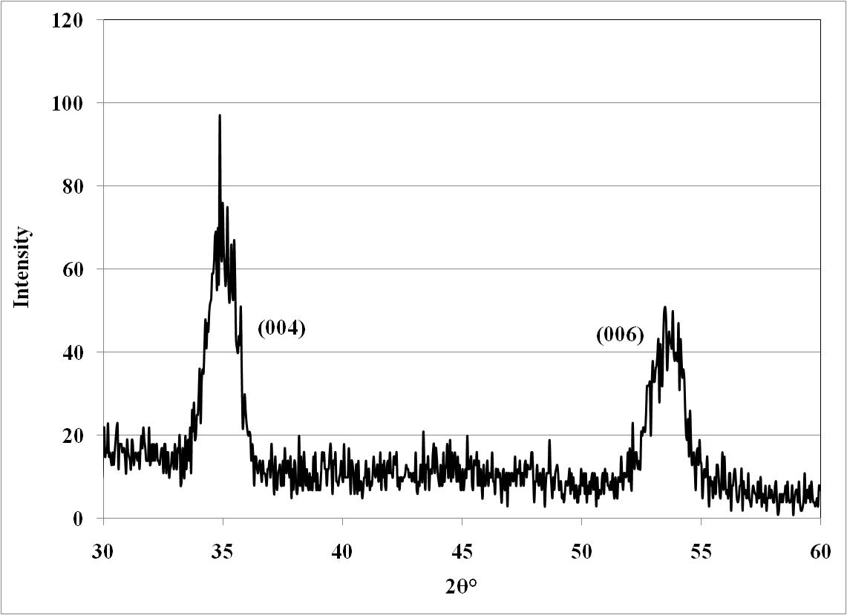
Figure 4.74 WAXS reflections of planes (004) and (006) in draw-annealed fibers.
along the fiber axis. For these reasons, crystal length calculated based on long period data and fraction of crystallinity is less than half of that calculated from (00l) reflections and hence may not be the proper way of determining crystallite dimensions from long period, as is done in the case of fibers possessing highly uniform long period.
It is also observed that the maximum, in SAXS profiles of several fibers, occurs at lower intensity. According to SAXS theory [], the diffraction intensity (I) is proportional to the square of the difference between electron density of crystalline and amorphous regions as given by Eq. 4.1.
$\sqrt{I}= ρ_{c}- ρ_{am}$ (4.1)
The maximum intensity occurs when chains in crystalline region are highly oriented (f_{c} equal to one) and those in amorphous regions are fully relaxed (f_{am} equal to zero) []. As suggested by Samuels [194], for oriented polymers the SAXS intensity is also proportional to the degree of orientation of the regions. When the molecular chains in amorphous regions are highly oriented, their order is closer to the order present in crystals. Such a similarity in order between the phases leads to lowest intensity in SAXS patterns for a given crystallinity level. Intermediate levels of orientations will lead to intermediate intensities in SAXS patterns. Therefore, SAXS intensity will be the function of the amount and degree of molecular orientation.
In line with these observations of earlier investigators, the weak contrast in SAXS intensity profiles in present research could be attributed to the high degree of molecular orientation in non-crystalline regions, at par to that in crystalline regions. Amorphous orientation factors close to 0.9 reported earlier indeed support this analogy. Thus intercrystalline region in PPS fibers manufactured in present research is not really amorphous in nature, as is generally perceived, but is of higher order. Therefore, in the remaining portion of this section, to avoid misunderstanding, this region is referred to as intercrystalline region, rather than amorphous region. At this point, it is not clear, if at all and to what extent, the presence of sulfur atoms that possess high electron density contribute to the weak contrast in SAXS intensity profile.
Presence of rigid amorphous phase in PPS was reported by Wunderlich et al. [127]. DSC thermograms of highly amorphous films prepared from polymer 3P indicate the heat capacity change corresponding to T_{g} (Figure 4.75). However, such a change is not observed in the case of draw-annealed, or even only drawn, samples (Figure 4.75). It suggests that the region between crystallites in the case of drawn and draw-annealed fibers is not mobile as observed in the case of amorphous film. These results further support our earlier observation of highly ordered intercrystalline region.
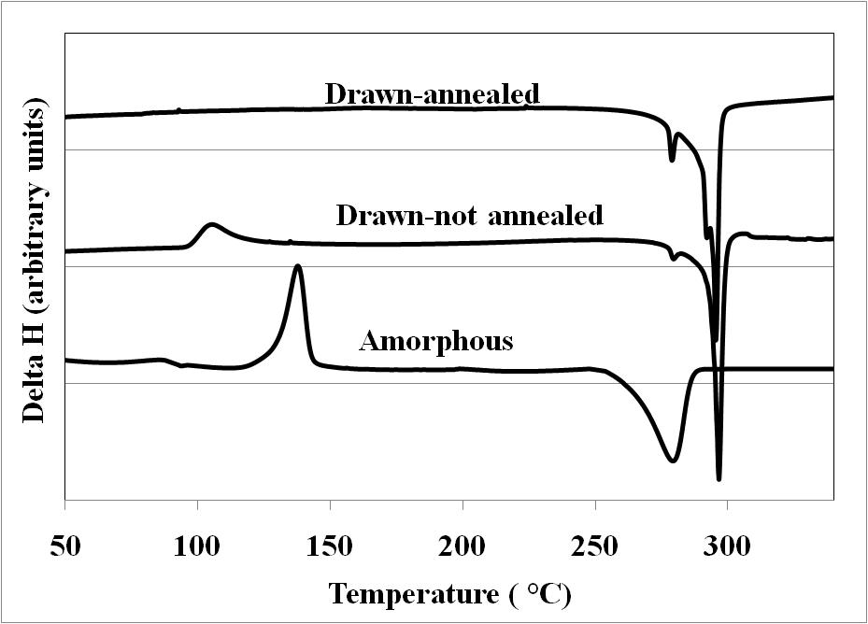
Figure 4.75 DSC thermograms of PPS films and fibers.
In the event of several investigators in the past discussing fiber structure based on chain folded lamellae or fringed micelle or fibrillar models, it will be appropriate at this juncture to visualize what kind of model fits for PPS fibers manufactured in the present research. In the case of highly drawn fibers, a three phase model consisting of crystalline, amorphous and ordered amorphous is generally more accepted than a two phase model that consists of crystalline and amorphous domains, since former explains the fiber properties in a better way. Prevorsek and Sibilia [] have reported that in the case of highly oriented PET fibers, chain folding can not be eliminated completely by conventional drawing techniques. It is believed that chain folds do exist at the edges of crystallites, since absence of it does not leave enough room for existence of amorphous domains that possess lower density than that of crystalline regions. Thus, current understanding of amorphous domains is that it consists of chain ends, chain folds, chain entanglements and tie chains connecting consecutive crystallites. If it is assumed that all chains fold at the edge of crystallite and bury within that crystal, the crystalline and non-crystalline domains will be connected by merely van der Waals forces and the tensile strength will be lower. Higher tensile strength of the fibers than would be provided by van der Waals forces, therefore supports the speculation of presence of tie chains between consecutive crystallites. Since the present study involved the technique of conventional drawing to orient the molecular chains in PPS, in line with these earlier findings, it will be appropriate to assume the presence of some chain folds at crystallite edges and tie chains in high tenacity PPS fibers too. The probable nature of chain folding is discussed later on. Either chain folding and/or entanglements seem apparent since the degree of crystallinity determined by DSC and WAXS is around 35% i.e., fibers consist of around 65% non-crystalline region. Also SAXS patterns exhibit presence of voids in the fibers. In the absence of chain folds and entanglements, presence of voids and higher amount of non-crystalline region is more than unlikely to happen. Presence of tie chains may be supported by the higher degree of orientation as observed in the non-crystalline region.
Based on extensive studies by WAXS, SAXS and dye diffusion, Prevorsek et al. [] proposed a Swiss-Cheese model to be satisfactory structure in the case of highly drawn nylon-6 fibers (Figure 4.76). The characteristic of this model is the presence of microfibrils that contain the crystallites with some amount of noncrystalline phase in between crystallites. It also speculates the presence of highly ordered non-crystalline region between the microfribils. Based on four point SAXS pattern for PET, they proposed similar model but with skewed arrangement of crystallites between neighbouring microfibrils instead of regular arrangement as speculated in the case of Nylon-6.
In the event of possessing around 65% non-crystalline region, even after variation in long period is taken into account, it may be more than unlikely that the non-crystalline domain is situated only between the crystallites along the fiber axis (Figure 4.77). As per this model, fiber structure possessing higher amount of non-crystalline domain need to be placed between the crystalline domains within same microfibril.
Therefore, for the present study of PPS fibers, model somewhat similar to that shown for Nylon-6 and PET fibers may be appropriate with specific variations.
Absence of intensity maximum along the equator in SAXS suggests that there exists no detectable periodicity in structure across the fiber axis. Wider meridional streak in SAXS patterns for PPS fibers, instead of four point pattern as observed by Prevorsek et al. [196] in the case of PET, suggest that the crystallites in neighboring microfribrils in PPS fibers may possess different skewed arrangement than speculated by Prevorsek et al. [196] (Figure 4.76b).
In light of semi-rigid nature of molecular chains in PPS as discussed in the beginning of chapter 2, when compared with PET that possesses comparatively more flexible chains, it is worthwhile to discuss the probable nature of chain folding and surfaces at the crystallite edges in PPS. On one extreme, in the case of fibers spun from flexible chain polymers like PE/PP as depicted by Peterlin [185], and also from PET and Nylon-6 as depicted by Prevorsek et al. [196], regular chain folding is widely accepted at crystallite edges besides tie chains etc. On the other extreme, in the case of fibers spun from rigid rod polymers (liquid crystalline polymers) like poly(p- phenylene terephthalamide) (PPT), no evidence of chain folding or high degree of chain disorder,
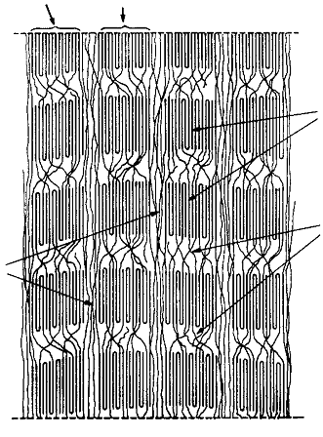 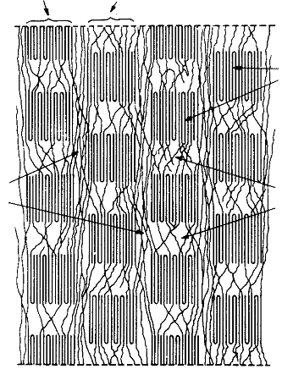Figure 4.76 Schematic structural model of a) Nylon-6 fibers; b) PET fibers (Fiber axis vertical) [196].
Micro-fibrils
Micro-fibrils
Extended noncrystalline molecules
Crystallites
Tie chain
Disordered domain-amorphous
Micro-fibrils

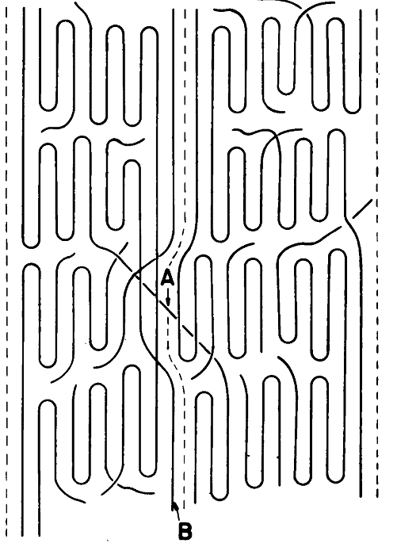
Intercrystalline domain
Crystallites
Figure 4.77 Schematic of structureal model for PE/PP fibers [185]. A: interfibrillar tie molecule, B: intrafibrillar tie molecule. (Fiber axis vertical)
but, rather extended chain molecules was reported by Dobb et al. [] and Norholt []. In a study of the structure of thermotropic copolyesters, Sawyer and Jaffe [] suggested that single structural model may describe the basic structure of all highly oriented polymer systems as that of PPT, thermotropic copolyesters.
The present case of PPS fibers appears to fall between these two extremes. While studying crystallization kinetics in PPS, presence of chain folding in PPS crystals was reported [63, 64]. Marand et al. [] reported that for stiff polymers like PPS, the adjacent re-entry of the chains by folding is unlikely. Flory [] proposed a switchboard model to consider the chain rigidity in semi-rigid polymer molecules. Schematic of such a model is shown in Figure 4.78. Such a model depicts random re-entry of the chains in the crystallites. In the case of PPS, possessing semi-rigid chains, such an arrangement of folds may seem more likely than regular chain folds. The idea about extent of chain rigidity in PPS can be obtained by comparing the persistence lengths of polymers possessing different level of flexibility or rigidity. The persistence length of PET is ca. 13 Å [], that of rigid rod polymers is at least 100 Å [], and that of PEEK is ca. 54 Å []. In the event of unavailability of the persistence length value of PPS in literature, it is fair enough to assume that its persistence length is closer to PEEK, since latter possesses chemical structure that consists of oxygen and ketone groups between benzene rings, instead of sulfur that exists between benzene rings in the case of PPS.
The proposed model shown in Figure 4.79 captures all the points discussed above based on fiber morphological characterization, and provides a picture of probable molecular architecture in high tenacity PPS fibers manufactured by draw-annealing under optimum process conditions.
SEM micrograph shown in Figure 4.80 was taken of fiber having tenacity, ca. 6 gpd after slicing it longitudinally using razor blade. On a macroscopic view, it appears that the cut surface (upper right hand corner of the image) resulted into tearing-off the fiber at remaining portion of the fiber (lower part of the image). Presence of multi-layer structure is evident perpendicular to fiber axis. Careful observation of the surface of each layer exhibits possibility of fibrillar structure in it. One such fibril connecting adjacent
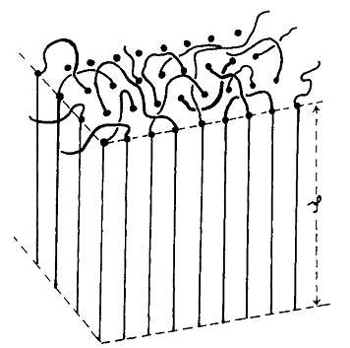
Figure 4.78 Switchboard model visualized in three dimensions [201].
Microfibril
Interfibrillar non-crystalline region
Intrafibrillar non-crystalline region
Crystallite
Intrafibrillar tie-chain

Figure 4.79 Proposed structural model for high tenacity PPS fibers.
layers is also pointed. The dimension of this fibril is around 200 Å, and may be comprising of very few microfibrils since crystal thickness reported in this fiber is around 90 Å (based on (110) reflection) and around 60 Å (based on (200) reflection). Thus presence of fibrillar structure as proposed in the probable structural model seems likely based on the SEM micrographs. Thickness of each layer appears to be equal to few hundred angstroms.
After having proposed probable structural model for PPS fibers, it will be appropriate at this juncture to discuss the probable mechanism of T_{m} increase that was discussed in part earlier. Through WAXS studies, it is seen that crystal thickness increases more than two fold after heat treating the fibers whereas crystallinity increases by around 10%. In a study on thermal contraction of drawn PET fibers, Prevorsek et al. [] reported that up to 10% contraction, only the amorphous domain between crystallites (Figure 4.76b) shrink whereas there is no relative displacement of neighbouring microfibrils. However, at higher level of contraction, 20% and more, based on WAXS, SAXS and IR spectra, they reported that neighbouring microfibrils displace
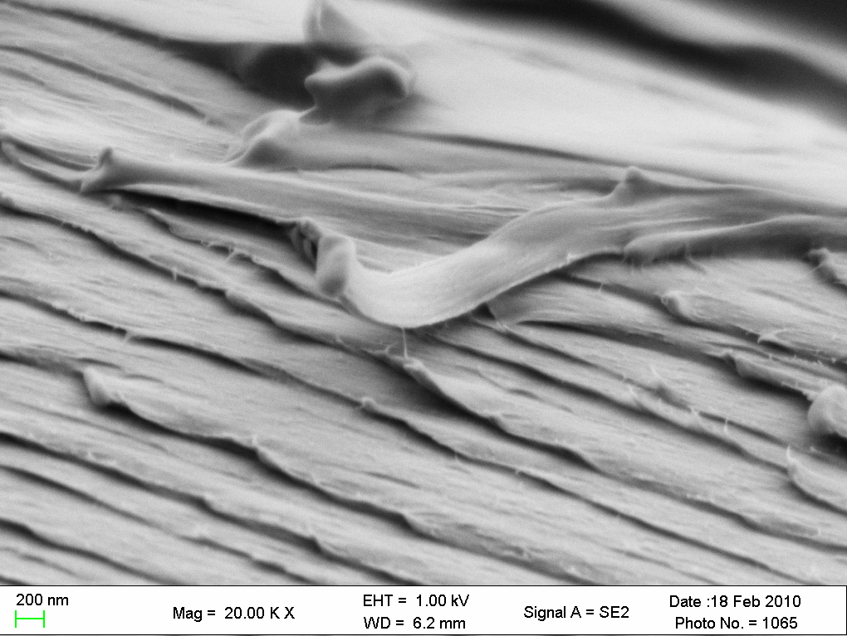
Fibril
Figure 4.80 SEM micrograph of two zone draw-annealed fiber. (Arrow in lower left corner indicates fiber axis), (Polymer 3P, spun at 1750 mpm, ET: 315 °C, capillary l/d: 10; Throughput: 12 gm/min/12 holes, DT:95 °C /100 °C, AT:190 °C).
with respect to each other. Carr and Ward [31] have shown that entanglement density is high in case of PPS as compared to PET. Hence it may be possible that relative displacement of neighbouring microfibrils happen at lower contraction level in the case of PPS. While heat treating PPS samples in DSC in present research, although sample was knotted to provide restraint, some loss of crystalline orientation suggests that contraction may have taken place to a certain degree, and further rearrangement of crystallites may have happened. If the neighbouring microfibrils move relative to each other, one of the possibilities may be crystallites in one micrifibril move and sit next to the neighboring microfibril rather than remaining in skewed arrangement. 10% increase in crystallinity may suggest that some of the interfibrillar region may have been converted to crystalline region. Therefore, without increasing the crystallinity to a large extent, crystal dimension perpendicular to fiber axis increases more than two fold as seen by WAXS. It is important to note that, in order for this phenomenon to occur, chains in interfibrillar domain need to be oriented so that some mobility and minor rearrangement in structure makes them go into crystallites. It may also be possible that some of the crystallites break and join the newly formed crystallites out of interfibrillar domains. Thus the larger crystals formed due to one or more of the above mechanisms will melt at higher melting temperatures. This very well explains the observed increase in T_{m} of PPS fibers in present investigation, and the role of amorphous orientation for this phenomenon to occur.

Conclusions
It has been possible to correlate materials, structure and properties in the PPS fibers through extensive experiments and characterization. Scientific support of several analytical tools such as X-ray diffraction, thermal analysis and polarized light optical microscopy in illucidating the structural changes pertinent to process performance and changes in tensile properties has been well documented.

5.1 Polymer characteristics
The order of MW of various pellets and flakes was found to be 1 < 2 < 4 < 3. One of the key observations from thermal behavior studies was that the melting temperature of the polymers with different MW was similar (around 280ºC). Higher degree of crystallinity, higher melting temperature, and a distinguishable bimodal melting endotherm was observed for flakes during first heating, due to prior thermal history. Higher MW Polymers exhibited lesser degree of crystallinity than the lower MW polymers. Crystallization of flakes was slower than that of the corresponding pellets, even after undergoing similar number of thermal cycles. Upon melt crystallizing under similar conditions, flakes exhibited slightly lower crystallinity than corresponding pellets.
Studies on isothermal as well as non-isothermal crystallization kinetics behavior of various grades of PPS showed that crystallization became slower and degree of crystallinity decreased with increase in polymer MW. Flakes exhibited slower crystallization than corresponding pellets. Under isothermal conditions in the range of temperatures studied, no significant differences were observed in Avrami exponents. There existed an optimum crystallization temperature for maximum crystallinity. Holding the melt at higher temperature slowed down the crystallization behavior but the influence is more complex. Under non-isothermal conditions, lower the cooling rate, higher the crystallinity.

5.2 Material-process-structure-properties relationship in as-spun fibers

Process performance
At high extrusion temperatures (340 °C), 1P could not be spun at higher take up speeds (2350 mpm). Extrudate of 3F contained voids at spinneret exit, so it could not be spun. These observations were attributed to volatilization of higher amount of low MW fractions in high MW polymers. Extrudate of 1F was clear of the voids hence it could be spun. Spinnability of 1F was found to be at par with that of 1P.

5.2.2. Fibers properties
Fiber tenacity increased and breaking elongation decreased with increase in polymer MW, with increase in take-up speed, and with increase in capillary l/d. Tensile modulus increased with increase in polymer MW. Fiber tensile properties did not vary significantly between extrusion temperatures of 315 °C and 340 °C. Only at very high extrusion temperatures (around 355 °C), the fiber properties deteriorated significantly. Material and process variables together explained more than 80% of the fiber properties data. Strong correlation was observed between tenacity and birefringence, with R-square more than 80%. In majority of the cases, 10-15% degree of crystallinity was developed, and increased slightly with increase in take-up speed. Fiber tenacities around 4 gpd with breaking elongations around 30% were obtained by spinning at high take up speeds. Smaller crystal size, and lower molecular orientation was prevalent in the as-spun fibers.

5.3 Process-structure-properties relationship in draw-annealed fibers

Draw-annealing process
Optimum spinning take-up speed to achieve high tenacity draw-annealed fiber was lower for high MW polymer (1750 mpm: 3P and 4P), and was higher for low MW polymer (2350 mpm: 1P). At a given draw temperature, higher MW polymer showed lesser drawability. Optimum drawing temperature was found to be around 95ºC. As compared to low MW polymers, higher MW polymers showed wider processing window during drawing. Annealing was shown to be a significant factor in structure development and mechanical properties enhancement in fibers. Two zone drawing slightly increased the drawability as compared to one zone drawing. Steam drawing seemed to develop fiber morphology somewhat differently than that induced by dry heat drawing.

5.3.2 Fiber properties
At a given draw temperature, higher MW polymers showed higher fiber tenacity. Annealing the fiber spun at higher take up speed increased the fiber tenacity from 3.5 gpd to more than 4.5 gpd. Fibers with tenacities ca. 5 gpd were obtained from all the four polymer types (under different set of fiber spinning and drawing conditions). Fibers with tenacities ca. 6 gpd were obtained from high MW polymers by the use of two zone draw-annealing route. Tensile modulus decreased with increase in draw temperature, which was attributed to loss of orientation in inter-crystalline region. Benefit of two zone drawing was shown to be dependent upon fibers’ processing history. Molecular orientation showed significant influence on fiber tensile properties, crystal structure and thermal behavior of the fibers at elevated temperatures.

Fiber structure
At optimum draw temperature, overall molecular orientation was very high, close to the intrisinc birefringence, along with crystalline orientation factor equal to or more than 0.9, and amorphous orientation factor more than 0.8. Crystal size and long period went through minima with increase in draw temperature. By studying the crystal length and crystal thickness using WAXS, the variation in long period as observed by SAXS was mainly attributed to varying size of non-crystalline domains between the crystallites along the fiber axis. Probable structural model of highly oriented PPS fibers was suggested based on the observed structural parameters.

Future scope of work
It was shown in current dissertation that by adopting proper processing conditions during melt spinning and draw annealing, alongwith selection of polymer of appropriate MW, fiber tenacities in the PPS fibers can be improved to ca. 6 gpd from the current level of 4 to 4.5 gpd achieved by majority of the PPS fiber producers.
The role of molecular orientation in enhancing the crystal structure at elevated temperatures was also reported. One possible scope of the further work can be to study the influence of high temperature tension annealing in PPS fibers upon its tensile properties.
Due to the subtle differences in the melting behavior of fibers drawn in dry heat environment vis-à-vis drawn in steamed environment, it will interesting to carry out further studies of draw annealing in steamed environment, and evaluate the fiber properties and structure thereupon.
MFR of high MW PPS polymer studied in the present dissertation was 60 g/10 min. Other thermoplastic polymers that have been widely studied by melt spinning such as polypropylene possess the MFR equal to around 35. Considering the fact that PPS possesses semi-rigid chains and not as easily flowable as that of polypropylene, it will be of importance to investigate the influence of PPS polymers of further higher MW upon fiber manufacturing and their properties enhancement.

References

References

Appendices
Appendix 1. PPS resin makers and brand names
Manufacturer | Trade name | Products | Applications | Grade details
Toray | Torelina | Plastics |  | PPS resin compounded with glass fibers, inorganic fillers
Toray | Torelina | Films
Ticona | Celstran | Pellets |  | Aramid, Glass fibers as reinforcement
Ticona | Fortron | Pellets and Flakes (powder) | Fibers, food applications, medical applications, dental applications, pharmaceuticals | Unfilled grades for molding, extrusion including melt blowing
Ticona | Fortron | Pellets | Connector, Parts-thin walled, Automotives, rods, pump parts, electronic applications, bearings and gears (PTFE contained), food applications, medical applications, dental applications, pharmaceuticals, | glass fiber, minerals reinforced
Schulman Inc | Comshield | Pellets |  | Carbon, stainless steel fiber reinforcement
Cool Polymers Inc | Coolpoly | Pellets for plastics |  | Electrically conductive, thermally conductive
Vamp Tech | Deniblend | Pellets for Plastics |  | Glass fiber reinforced
Sumikon backelite co. ltd. | Sumikon |  | Metal replacement, radiation shielding | carbon fiber, Organic filler

Appendix 1, continued
Manufacturer | Trade name | Products | Applications | Grade details
Dainippon Ink and Chemicals,  Incorporated | DIC | Pellets for Plastics |  | Glass fiber, PTFE, carbon reinforced
Quadrant engineering plastics | duralast | Pellets for compression/ injection molding |  | Graphite fiber, glass fiber reinforced
PolyOne Corporation | Edgetek | Pellets for injection molding |  | Glass fiber, PTFE, carbon reinforced
Techmer Levloss compounds | Electrafil | Pellets for plastics |  | Carbon fiber filled
LCP Enggineering plastics Inc | Emi X | Pellets for injection molding |  | Carbon fiber reinforced
Ensinger Inc | Ensifide | Plastics |  | Valve and pump components
LNP engineering plastics Inc | Konduit, thermotuf |  | Pellet for injection molding | Proprietary filler, linear polymer structure
GE plastics | Noryl |  |  | Reinforced
Chevron Phillips | Ryton | molding | Rod, sheet, tubing, disc, preformed parts, disc, customizable forms, bearing, sealing, bushings, | Glass, carbon fiber Reinforced
Chevron Phillips | Ryton | Powder for Extrusion | Coating applications, compounding | Different MW and molecular architecture

Appendix 2. DSC thermogram data for PPS polymers
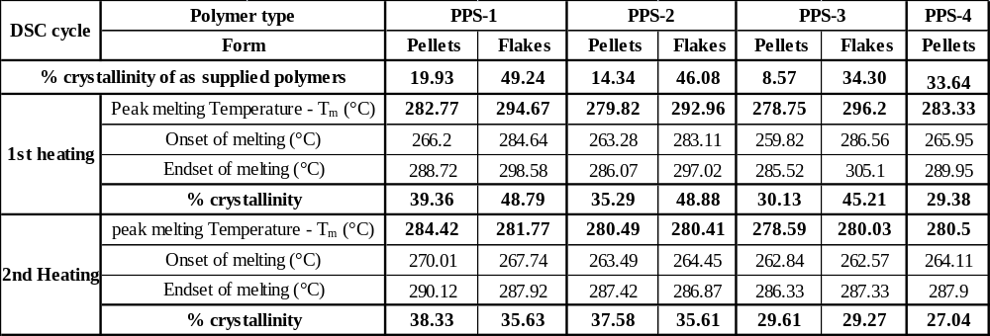

Appendix 3. Crystallization parameters from isothermal crystallization kinetics of PPS
Polymer | Isothermal temperature (°C) | Averami constant (n) | Avrami rate constant (K) (min⁻¹) | Induction period (t_{i})(sec) | t_{1/2} (sec) | Crystallization time (t_{c})(sec) | Degree of crystallinity (%) | t_{∆Hmax} (sec)
1P | 240 | Crystallization begins before reaching the temperature
1P | 245 | 2.8 | 4.9E-02 | 99 | 153 | 325 | 27.59 | 147
1P | 250 | 3.2 | 3.1E-03 | 101 | 330 | 675 | 29.63 | 314
1P | 255 | 3.0 | 1.1E-03 | 241 | 514 | 1031 | 26.60 | 478
1P | 260 | 2.8 | 2.7E-04 | 509 | 966 | 1921 | 24.88 | 854
2P | 235 | Crystallization begins before reaching the temperature
2P | 240 | 2.5 | 4.4E-01 | 78 | 77 | 252 | 28.17 | 71
2P | 245 | 2.9 | 5.6E-02 | 87 | 143 | 413 | 29.63 | 129
2P | 250 | 3.3 | 4.3E-03 | 96 | 278 | 598 | 30.05 | 263
2P | 255 | 3.3 | 5.3E-04 | 180 | 524 | 970 | 26.38 | 500
2P | 260 | 2.4 | 6.1E-04 | 490 | 981 | 1910 | 17.24 | 816
4P | 230 | Crystallization begins before reaching temperature
4P | 235 | 2.8 | 6.8E-01 | 77 | 60 | 245 | 25.43 | 56
4P | 240R | 2.9 | 1.7E-01 | 81 | 96 | 354 | 26.04 | 88
4P | 245R | 3.1 | 1.4E-02 | 85 | 212 | 484 | 26.88 | 199
4P | 250 | 3.3 | 5.4E-03 | 186 | 252 | 535 | 22.97 | 250

Appendix 3, continued
Polymer | Isothermal temperature (°C) | Avrami constant (n) | Avrami rate constant (K) (min⁻¹) | Induction period (t_{i})(sec) | t_{1/2} (sec) | Crystallization time (t_{c})(sec) | Degree of crystallinity (%) | t_{∆Hmax} (sec)
3P | 215 | Crystallization beigns before reaching the temperature
3P | 220 | 2.6 | 3.7E-02 | 103 | 184 | 373 | 22.51 | 182
3P | 225 | 2.4 | 1.5E-02 | 96 | 292 | 664 | 28.41 | 269
3P | 230 | 2.8 | 2.7E-03 | 119 | 428 | 852 | 21.20 | 429
3P | 235 | 2.4 | 3.4E-03 | 241 | 559 | 1178 | 21.67 | 529
1F | 230 | Crystallization begins before reaching the temperature
1F | 235 | 2.3 | 8.6E-02 | 80 | 147 | 417 | 31.52 | 132
1F | 240 | 2.5 | 2.6E-02 | 89 | 217 | 529 | 30.05 | 208
1F | 245 | 2.8 | 5.5E-03 | 117 | 447 | 726 | 27.60 | 338
1F | 250 | 2.6 | 2.3E-03 | 271 | 525 | 1060 | 24.42 | 517
2F | 230 | Crystallization begins before reaching temperature
2F | 235 | 2.3 | 5.0E-01 | 77 | 69 | 236 | 25.35 | 58
2F | 240 | 2.6 | 1.4E-01 | 89 | 110 | 384 | 26.28 | 100
2F | 245 | 2.8 | 2.2E-02 | 91 | 203 | 520 | 30.03 | 181
2F | 250 | 3.0 | 4.9E-03 | 167 | 303 | 638 | 24.88 | 287
3F | 225 | Crystallization begins before reaching the temperature
3F | 230 | 2.6 | 1.3E-01 | 82 | 73 | 180 | 23.86 | 67
3F | 235 | 2.4 | 1.9E-03 | 81 | 155 | 369 | 29.57 | 131
3F | 240 | 2.9 | 5.1E-05 | 87 | 233 | 541 | 27.24 | 209

Appendix 4. Properties of as-spun fibers
Polymer | Extrusion Temperature (°C) | Throughput | Winding speed (mpm) | Denier |  | Tenacity |  | Peak Elongation
Polymer | Extrusion Temperature (°C) | g/12 holes /min | Winding speed (mpm) |  | SD | gpd | SD | % | SD
1P | 315 | 12 | 1025 | 8.46 | 0.08 | 1.11 | 0.08 | 219.98 | 4.47
1P | 315 | 12 | 1750 | 5.56 |  | 1.60 | 0.28 | 113.66 | 30.80
1P | 315 | 12 | 2350 | 3.65 | 0.22 | 2.94 | 0.23 | 59.46 | 5.67
1P | 315 | 9 | 1025 | 6.60 |  | 1.30 | 0.16 | 138.00 | 80.03
1P | 315 | 9 | 1750 | 3.71 | 0.14 | 2.54 | 0.16 | 82.48 | 8.54
1P | 315 | 9 | 2350 | 2.95 | 0.00 | 2.91 | 0.24 | 53.61 | 5.33
1P | 340 | 12 | 612 | 14.34 | 0.17 | 0.94 | 0.12 | 332.09 | 48.02
1P | 340 | 12 | 1025 | 8.42 | 0.48 | 1.36 | 0.19 | 228.50 | 74.54
1P | 340 | 12 | 1750 | 5.09 | 1.05 | 2.59 | 0.22 | 136.06 | 72.07
1P | 340 | 12 | 2100 | 4.39 | 0.16 | 2.69 | 0.30 | 77.12 | 7.17
1P | 340 | 9 | 612 | 10.47 | 0.07 | 1.04 | 0.09 | 312.53 | 31.78
1P | 340 | 9 | 1025 | 6.87 | 0.16 | 1.21 | 0.12 | 246.31 | 24.46
1P | 340 | 9 | 1750 | 3.93 | 0.42 | 2.09 | 0.36 | 145.07 | 53.30
1P | 340 | 9 | 2120 | 3.27 |  | 2.27 | 1.08 | 71.81 | 15.04

Appendix 4, continued
Polymer | Extrusion Temperature (°C) | Throughput | Winding speed (mpm) | Denier |  | Tenacity |  | Peak Elongation
Polymer | Extrusion Temperature (°C) | g/12 holes /min | Winding speed (mpm) |  | SD | gpd | SD | % | SD
1P | 325 | 9 | 1026 | 6.42 | 0.07 | 1.34 | 0.18 | 228.70 | 26.41
1P | 325 | 9 | 1745 | 3.63 | 0.07 | 2.38 | 0.33 | 74.12 | 7.04
1P | 325 | 9 | 2118 | 3.54 | 0.08 | 2.70 | 0.48 | 62.58 | 8.44
1P | 325 | 9 | 2353 | 2.68 | 0.09 | 2.86 | 0.13 | 53.18 | 4.56
2P | 340 | 12 | 1028 | 7.62 | 0.93 | 1.56 | 0.15 | 236.52 | 34.64
2P | 340 | 12 | 1745 | 4.55 | 0.29 | 2.23 | 0.20 | 75.04 | 6.44
2P | 340 | 12 | 2363 | 3.54 | 0.17 | 2.51 | 0.29 | 68.30 | 8.77
2P | 315 | 9 | 1025 | 6.42 | 0.13 | 1.53 | 0.24 | 199.42 | 27.01
2P | 315 | 9 | 1746 | 3.83 | 0.09 | 2.48 | 0.26 | 81.20 | 14.63
2P | 315 | 9 | 2361 | 3.06 | 0.08 | 2.52 | 0.25 | 34.94 | 3.81
2P | 340 | 9 | 1026 | 6.66 | 0.93 | 1.11 | 0.44 | 164.90 | 33.08
2P | 340 | 9 | 1745 | 3.74 | 0.12 | 2.18 | 0.23 | 57.94 | 12.28
2P | 340 | 9 | 2362 | 2.63 | 0.09 | 2.74 | 0.44 | 40.90 | 10.20

Appendix 4, continued
Polymer | Extrusion Temperature (°C) | Throughput | Winding speed (mpm) | Denier |  | Tenacity |  | Peak Elongation
Polymer | Extrusion Temperature (°C) | g/12 holes /min | Winding speed (mpm) |  | SD | gpd | SD | % | SD
4P | 315 | 12 | 1025 | 8.49 | 0.08 | 1.74 | 0.24 | 176.67 | 21.58
4P | 315 | 12 | 1750 | 4.35 | 0.11 | 2.45 | 0.26 | 72.38 | 15.54
4P | 315 | 12 | 2350 | 3.84 | 0.08 | 2.46 | 0.15 | 47.78 | 2.92
4P | 315 | 9 | 1025 | 6.63 | 0.25 | 1.71 | 0.19 | 133.28 | 11.67
4P | 315 | 9 | 1750 | 3.81 | 0.20 | 2.80 | 0.25 | 63.67 | 6.56
4P | 315 | 9 | 2350 | 2.60 | 0.03 | 3.65 | 0.57 | 29.23 | 8.34
4P | 340 | 9 | 1550 | 4.50 |  | 2.56 | 0.39 | 60.43 | 15.68
4P | 340 | 9 | 1750 | 4.02 | 0.20 | 2.69 | 0.14 | 46.00 | 5.27
4P | 340 | 9 | 2350 | 3.02 | 0.20 | 3.16 | 0.26 | 31.00 | 4.78
3P | 355 | 9 | 1025 | 6.61 | 0.15 | 1.07 | 0.26 | 139.49 | 28.54
3P | 355 | 9 | 1750 | 3.47 | 0.11 | 2.60 | 0.39 | 52.71 | 12.57
3P | 355 | 9 | 2350 | 2.53 | 0.03 | 3.87 | 1.01 | 49.76 | 11.29
3P | 355 | 12 | 1025 | 8.20 | 0.12 | 1.31 | 0.18 | 191.83 | 23.69
3P | 355 | 12 | 1750 | 4.97 | 0.23 | 1.60 | 0.21 | 104.69 | 30.00
3P | 355 | 12 | 2350 | 3.28 | 0.14 | 2.16 | 0.34 | 46.24 | 9.74

Appendix 4, continued
Polymer | Extrusion Temp (°C) | Throughput | Winding speed (mpm) | % DSC crystallinity | Birefringence
Polymer | Extrusion Temp (°C) | g/12 holes /min | Winding speed (mpm) | % DSC crystallinity | Birefringence
1P | 315 | 12 | 1025 | 10.28 | 0.03
1P | 315 | 12 | 1750 | 15.73 | 0.06
1P | 315 | 12 | 2350 | 17.01 | 0.16
1P | 315 | 9 | 1025 | 12.60 | 0.04
1P | 315 | 9 | 1750 | 17.25 | 0.13
1P | 315 | 9 | 2350 | 18.55 | 0.16
1P | 340 | 12 | 612 | 17.22 | 0.0074
1P | 340 | 12 | 1024 | 14.43 | 0.0190
1P | 340 | 12 | 1745 | 15.14 | 0.1984
1P | 340 | 12 | 2118 | 17.38 | 0.2046
1P | 340 | 9 | 612 | 14.42 | 0.0099
1P | 340 | 9 | 1023 | 14.81 | 0.0180
1P | 340 | 9 | 1748 | 16.49 | 0.1860
1P | 340 | 9 | 2120 | 18.32 | 0.1855
2P | 340 | 12 | 1028 | 15.34 | 0.0226
2P | 340 | 12 | 1745 | 13.40 | 0.1787
2P | 340 | 12 | 2363 | 13.43 | 0.1825
2P | 315 | 9 | 1025 | 14.35 | 0.0225
2P | 315 | 9 | 1746 | 14.68 | 0.1584
2P | 315 | 9 | 2361 | 15.35 | 0.1646
2P | 340 | 9 | 1026 | 15.08 | 0.0197
2P | 340 | 9 | 1745 | 16.52 | 0.1982
2P | 340 | 9 | 2362 | 16.21 | 0.2253
Appendix 4, continued
Polymer | Extrusion Temp (°C) | Throughput | Winding speed (mpm) | % DSC crystallinity | Birefringence
Polymer | Extrusion Temp (°C) | g/12 holes /min | Winding speed (mpm) | % DSC crystallinity | Birefringence
4P | 315 | 12 | 1025 | 14.45 | 0.0479
4P | 315 | 12 | 1749 | 15.80 | 0.1421
4P | 315 | 12 | 2362 | 14.91 | 0.1678
4P | 315 | 9 | 1027 | 12.30 | 0.0522
4P | 315 | 9 | 1749 | 18.53 | 0.1574
4P | 315 | 9 | 2361 | 21.89 | 0.2127
4P | 340 | 9 | 1550 | 14.32 | 0.1766
4P | 340 | 9 | 1700 | 19.88 | 0.1895
4P | 340 | 9 | 2360 | 20.81 | 0.2215
3P | 355 | 9 | 1024 | 9.37 | 0.0550
3P | 355 | 9 | 1745 | 13.56 | 0.1785
3P | 355 | 9 | 2361 | 13.02 | 0.1859
3P | 355 | 12 | 1024 | 7.91
3P | 355 | 12 | 1745 | 13.50 | 0.0649
3P | 355 | 12 | 2365 | 14.03 | 0.1590

Appendix 5 Morphological properties of as-spun and drawn fibers
Polymer/ ET (°C) |  | Sample details |  | Level of crystallinity |  |  |  | Birefringence |  | Orientation factors |  |  |  | Long period (Å) |  | Crystal thickness (Å)
 |  |  |  | DSC |  | WAXS |  |  |  | Crystalline (f_{c}) |  | Amorphous (f_{am}) |  |  |  | (110) |  | (200)
 | 1P/315 |  | AS |  | 16 |  | 11 |  | 0.057 |  |  |  | ---
 |  |  | D-90 |  | 30 |  | 30 |  | 0.226 |  | 0.845 |  | 0.617 |  | 95 |  | 66 |  | 61
 |  |  | D-100 |  | 34 |  | 32
 |  |  | D-110 |  | 31 |  | 27 |  | 0.207 |  | 0.747 |  | 0.589 |  | 122 |  | 99 |  | 82
 | 2P/315 |  | AS |  | 14 |  | 12 |  | 0.129 |  |  |  | ---
 |  |  | D-90 |  | 34 |  | 35 |  | 0.253 |  | 0.851 |  | 0.722 |  | 99
 |  |  | D-95 |  | 34 |  | 32 |  | 0.267 |  | 0.907 |  | 0.764
 | 3P/315 |  | AS |  | 11 |  | 10 |  | 0.128 |  |  |  | --- |  | ND |  | 28
 |  |  | D-90 |  | 34 |  | 33 |  | 0.268 |  | 0.758 |  | 0.847 |  | 132 |  | 90 |  | 66
 |  |  | D-95 |  | 34 |  | 33 |  | 0.272 |  | 0.926 |  | 0.774 |  | 83 |  | 69 |  | 51
 |  |  | D-105 |  |  |  | 31 |  |  |  | 0.858 |  |  |  | 83 |  | 49 |  | 43
 |  |  | D-115 |  | 26 |  | 28 |  | 0.155 |  | 0.675 |  | 0.388 |  | 122 |  | 92 |  | 81
 |  |  | EA |  | 34 |  | 35 |  | 0.306 |  | 0.984 |  | 0.899 |  | 111 |  | 111 |  | 67

Appendix 5, continued
Polymer/ ET (°C) | Sample details | Level of crystallinity |  | Birefringence | Orientation factors |  | Long period (Å) | Crystal thickness (Å)
Polymer/ ET (°C) | Sample details | DSC | WAXS |  | Crystalline (f_{c}) | Amorphous (f_{am}) | Long period (Å) | (110) | (200)
3P/315 | D-95-HT |  | 46 |  |  |  |  | 316 | 107
3P/315 | 2-ZD | 33 | 42 | 0.301 | 0.957 | 0.872 | 99 | 91 | 58
4P/315 | D-90 | 33 | 29 | 0.283 | 0.842 | 0.875 | 75 | 52 | 54
4P/315 | SD | 37 | 36 |  | 0.829 |  |  | 37 | 37
4P/340 | D-100C | 33 | 35 | 0.260 | 0.921 | 0.713 | ND | 58 | 51
4P/340 | D-120C | 26 | 30 | 0.093 | 0.512 | 0.181 | ND | 64 | 61
Crystalline film |  | 39 | 37 |  |  |  |  | 109 | 116
Amorphous film |  | 8 | 8
3F |  | 45 | 51 |  |  |  |  | 124 | 101
3P |  | 30 | 35 |  |  |  |  | 65 | 60

Appendix 5, continued
ET - extrusion temperature; AS - as-spun fiber; D-90 - drawn at 90 °C; EA - extended annealing, HT - heat treatment in DSC at 280 °C, 2-ZD -two zone drawn at D-95/100 °C; SD - steam drawn at 100 °C.
All the fibers were spun at take-up speed of 1750 mpm, and throughput equal to 12 gm/min/12 holes.
Annealing temperature of one zone draw-annealed fibers was 150 °C, and that of 2-ZD was 190 °C.
Films were produced by hot pressing polymer 3P at 315 °C.
Crystalline film was prepared by slow cooling and amorphous film was produced by quenching the molten film in ice water.
3F and 3P were as received flakes and pellets of polymer type 3 and were characterized after drying at 120 °C for three hours.

Vita
Prabhakar V. Gulgunje was born in 1977 in Ichalkaranji, textile town in the state of Maharashtra (India). He completed his undergraduate studies in Textile Technology from Shivaji University, Kolhapur (India) in the year 1998. He received Masters in Fiber Science and Technology from Indian Institute of Technology (IIT), Delhi (India) in the year 2000. He was the recipient of scholarship from German Academic Exchange Service (DAAD) during 1999-2000 to conduct masters’ thesis at Institute of Textile Technology, RWTH, Aachen (Germany). Subsequently he served as a Customer Technical Services Executive at Vardhman Acrylics Ltd., Gujarat (India) until 2003. During the period 2004-2005, he joined IIT, Delhi (India) as a research assistant in the Department of Textile Technology. In the fall of 2005, he joined as a graduate research assistant at The University of Tennessee, Knoxville to pursue Ph. D. in the Department of Materials Science and Engineering under the guidance of Dr. Gajanan Bhat. He married in 2004, and the couple is blessed with adorable daughter.

Tenacity is defined as the breaking force of the fiber per unit linear density.
Fiber tenacity is expressed as gpd i.e. gm/denier (where, denier is defined as the weight in gms of 9000 m length of the fiber).
Extrusion temperatures of 315 °C and 340 °C are considered as low and high.
Packing density was measured by weighing the amount of polymer in 600 ml beaker after making top filler surface flat.
Orientation factors of AS fibers are calculated after assuming equal contribution to birefringence from crystalline and amorphous regions.
Orientation factors of AS fibers are calculated after assuming equal contribution to birefringence from crystalline and amorphous regions.
Length of crystalline region was calculated from long period using Eq. 3.23. That of inter-crystalline region was calculated by subtracting crystal length from long period.
Draw annealed fiber was spun from polymer 3P at take-up speed: 1750 mpm, high throughput, low ET, capillary l/d: 10, one zone drawn at 95°C and annealed at 190°C.
Mukhopadhay, S. K., Textile progress 1993, 25, 1-185.
In Industrial Polymers Handbook: Products, Processes, Applications; Wilks, E. S., Ed.; Wiley-VCH: New York, 2001, p 1267.
Friedel, C. F.; Crafts, J. M., Annales des Chimie et des Physique 1888, 14, 433-472.
Grenvresse, P., Bulletin de la Societe Chimique de France 1897, 17, 599.
Macallum, A. D., Journal of Organic Chemistry 1948, 13, 154-159.
Lenz, R. W.; Carrington, W. K., Journal of Polymer Science 1959, 41, 333-358.
Lenz, R. W.; Handlovits, C. E., Journal of Polymer Science 1960, 43, 167-181.
Lenz, R. W.; Carrington, W. K., Journal of Polymer Science 1962, 58, 351-367.
Edmonds, J. J. T.; Hill, J. H. W., Phillips Petroleum Company: U.S. patent 3354129, 1967.
Shonaike, G. O., in Handbook of Thermoplastics; Ed.; Marcel Dekker, Inc.: New York, 1997, 799.
Scruggs, J. G.; Reed, J. O., In High Technology Fibers: Part A- Handbook of Fiber Science and Technology, Lewin, M.; Preston, J., Eds.; Marcel Dekker, Inc.: New York, 1985, 335.
Hawkins, R. T., Macromolecules 1976, 9, 189-194.
Scobbo, Jr. J. J., Journal of Applied Polymer Science 1993, 48, 2055-2061.
Scobbo, Jr. J. J., Journal of Applied Polymer Science 1993, 47, 2169-2175.
Hill, J. H. W., Industrial and Engineering Chemistry Product Research and Development 1979, 18, 252.
Cambell, R. W., Phillips Petroleum Company: U.S. patent 3867356, 1975.
ASTM D1238, Standard test method for melt flow rates of thermoplastics by extrusion plastometer, revision-C, 2004.
Lopez, L. C.; Wilkes, G. L., Journal of Macromolecular Science: Reviews in Macromolecular Chemistry and Physics 1989, 29, 83.
Christopher, N. S. J.; Cotter, J. L.; Knight, G. J.; Wright, W. W., Journal of Applied Polymer Science 1968, 12, 863-870.
Reed, J. O.; Mathis, R. D.; Phillips Petroleum Company: U.S. patent 4418029, 1983.
Asakura, T.; Kobayashi, H.; Noguchi, Y.; Toray Industries Inc., U.S. patent 4486578, 1984.
Tanthapanichakoon, W.; Hata, M.; Nitta, K.; Furucchi, M.; Otani, Y., Polymer Degradation and Stability 2006, 91, 2614-1621.
Beck, H. N., Journal of Applied Polymer Science 1992, 45, 1361-1366.
In Datasheets, PPS fiber Torcon, Toray Industries circa, 1990.
In Datasheets, Fortron staple fibers, Hoechst Celanese, 1994.
Day, M.; Budgell, D. R., Thermochimica Acta 1992, 203, 465-474.
Li, X.; Huang, M.; Bai, H.; Yang, Y., Journal of Applied Polymer Science 2002, 83, 2053-2059.
ASTM C1648, Standard guide for choosing a method for determining the index of refraction and dispersion of glass, 2008.
Hardaker, S. S.; Moghazy, S.; Cha, C. Y.; Samuels, R. J., Journal of Polymer Science: Part B- Polymer Physics 1993, 31, 1951-1963.
Maemura, E.; Cakmak, M.; White, J. L., International Polymer Processing III 1988, 2, 79.
Carr, P. L.; Ward, I. M., Polymer 1987, 28, 2070-2076.
Cha, C. Y.; Samuels, R. J., Journal of Polymer Science: Part B- Polymer Physics 1995, 33, 259-267.
DesLauriers, P. J.; Das, P. K.; Fahey, D. R.; Wood, F. K.; Cornforth, F. J., Macromolecules 1993, 26, 5024-5029.
DesLauriers, P. J.; Das, P. K.; Fahey, D. R., ACS Polymer Preprints 1993, 151.
Morimoto, T., Journal of Applied Polymer Science 1976, 20, 1967-1976.
Jog, J. P.; Nadkarni, V. M., Journal of Applied Polymer Science 1985, 30, 997-1009.
Yu, J.; Asai, S.; Sumita, M. J., Journal of Macromolecular Science: Physics 2000, 39, 279-296.
Menczel, J. D.; Collins, G. L., Polymer Engineering and Science 1992, 32, 1264-1269.
Baker, A. A.; Mouritz, A.; Chester, M.; Bannister, M., In Composite materials for aircraft structures; Baker, A.; Dutton, S.; Kelly, D., Eds.; American Institute of Aeronautics and Astronautics Inc., Reston, Varginia, Second Edition 2004, 258.
Pearson, G. L., Third EPA Symposium on the Transfer and Utilization of Particulate Control Technology, Orlando, Florida, US, March 9-12 1981.
In Datasheets, Ryton Sulfur fiber, Phillips Fiber Corporation, April, 1991.
http://tools.ticona.com/tools/search/lit_details.cfm?docid=382.
PPS material ideal for meltblown nonwovens, Filtration+Separation 2003, 15.
Shrinivasan, R.; Ricci, N.; Carr, M.; Ferguson, D., Nonwovens Industry 2002, 33, 72-75.
Houis, S.; Schmid, M.; Luebben, J., Journal of Applied Polymer Science 2007, 106, 1757-1767.
Tabor, B. J.; Magre, E. P.; Boon, J., European Polymer Journal 1971, 7, 1129 -1133.
Garbarczyk, G., Die Makromolecular Chemie 1986, 187, 2489-2495.
Jurga, J., Polymer 1993, 34, 4203-4207.
Hay, J. N.; Langford, J. I.; Lloyd, J. R., Polymer 1989, 30, 489-493.
Lovinger, A. J.; Davies, D. D.; Padden, F. J., Polymer 1985, 26, 1595-1604.
Lovinger, A. J.; Davies, D. D.; Padden, F. J., Polymer 1988, 29, 229-232.
Hay, J. N.; Luck, D. A., Polymer 2001, 42, 8297-8301.
Uemura, A.; Tsuji, M.; Kawaguchi, A.; Katayama, K., Journal of Material Science 1988, 23, 1506-1509.
Napalitano, R.; Pirozzi, B.; Salvione, A., Macromolecules 1999, 32, 7682-7687.
Unwin, A. P.; Ward, I. M., Polymer Communication 1988, 20, 250.
Nishino, T.; Tada, K.; Nakamae, K., Polymer 1992, 33, 736.
Treloar, L. R. G., Polymer 1960, 1, 95, 279-290.
Chung, J. S.; Bodziuch, J.; Cebe, P., Journal of Materials Science 1992, 27, 5609-5619.
Murthy, N. S.; Elsenbaumer, R. L.; Frommer, J. E.; Baughman, R. H., Synthetic Metals 1984, 9, 91-96.
Silvestre, C.; Di Pace, E.; Napalitano, R.; Pirozzi, B.; Cesario, G., Journal of Polymer Science. Part B: Polymer Physics 2001, 39, 415-424.
Auer, C.; Kalinka, G.; Crause, T.; Hinrichsen, G., Journal of Applied Polymer Science 1994, 51, 407-413.
Desio, G. P.; Rebenfeld, L., Journal of Applied Polymer Science 1992, 44, 1989-2001.
Uemura, A.; Isoda, S.; Tsuji, M.; Ohara, M.; Kawaguchi, A.; Katayama, K., Bulletin of the Institute for Chemical research, Kyoto University 1986, 64, 66-77.
Waddon, A. J.; Hill, M. J.; Keller, A.; Blundell, D. J., Journal of Materials Science 1987, 22, 1773-1784.
Suzuki, A.; Kohno, T.; Kunugi, T., Journal of Polymer Science: Part B- Polymer Physics 1998, 36, 1731-1738.
Huo, P.; Cebe, P., Colloid and Polymer Science 1992, 270, 840-852.
Brady, D. G., Journal of Applied Polymer Science: Applied Polymer Symposium, 1981, 231.
Spruiell, J. E.; Janke, C. J., Oak Ridge National Laboratory (ORNL), 2004.
Brady, D. G., Journal of Applied Polymer Science 1976, 20, 2541-2551.
Ten Cate Advanced composites, In CETEX, Nijverdal, Netherlands, 2003, 32.
Cebe, P., Polymers and Polymer Composites 1995, 3, 239-266.
www.olympusmicro.com/primer/techniques/polarized/berekcompensator.html, Polarised microscopy– Berek compensator.
Gifford, J. W., Proceedings of the Royal Society A: Mathematical, Physical and Engineering Sciences 1910, 84, 193-196.
Faust, R. C.; Marrinan, H. J., British Journal of Applied Physics 1955, 6, 351-355.
Stein, R. S., Journal of Polymer Science 1958, 31, 327-334.
Hermans, P. H.; Platzek, P., Kolloid-Zeitschrift & Zeitschrift für Polymere 1939, 88, 68.
Hermans, J. J.; Hermans, P. H.; Vermaas, P.; Weidinger, A., Receuil des Travaux Chimiques 1946, 65, 427.
Hermans, P. H.; Hermans, J. J.; Vermaas, P.; Weidinger, A., Journal of Polymer Science 1948, 3, 1-9.
Hermans, P. H.; Heikens, D., Receuil des Travaux Chimiques 1952, 71, 49.
Cullity, B. D., in Elements of X-ray Diffraction, Addison Wesley Publishing Co., Reading Massachussets, 1978.
Stein, R. S.; Norris, F. H., Journal of Polymer Science 1956, 6, 231.
Smith, F. S.; Steward, R. D., Polymer 1974, 15, 283-286.
Alfonso, G. C.; Verdona, M. P.; Wasiak, A., Polymer 1978, 19, 711-716.
Desai, P.; Abhiraman, A. S., Journal of Polymer Science: Part B- Polymer Physics 1985, 23, 653.
Bourvellec, G. L.; Monnerie, L.; Jarry, J. P. Polymer 1987, 28, 1712-1716.
Suzuki, A.; Kohno, T., Journal of Applied Polymer Science 2000, 75, 1569-1576.
Ito, M. Y.; Porter, R. S., Journal of Polymer Science: Part B- Polymer Physics 1985, 23, 245-252.
Hoffman, J. D.; Davis, G. T.; Lauritzen, J. I., In Treatise on Solid State Chemistry; Hannay, N. B., Ed.; Plenum Press: New York, 1976, 497.
Suzuki, A.; Kohno, T.; Kunugi, T., Journal of Polymer Science: Part B- Polymer Physics 1998, 36, 3, 473-481.
Avrami, M., Journal of Chemical Physics 1939, 7, 1103-1112.
Avrami, M., Journal of Chemical Physics 1940, 8, 212.
Mandelkern, L., in Crystallization of polymers; McGraw-Hill: New York, 1964.
Budgell, D. R.; Day, M., Polymer Engineering and Science 1991, 31, 1271.
Lopez, L. C.; Wilkes, G. L., Polymer 1988, 29, 106-113.
Lopez, L. C.; Wilkes, G. L., Polymer 1989, 30, 882-887.
Desio, G. P.; Rebenfeld, L., Journal of Applied Polymer Science 1992, 45, 2005-2020.
Caminiti, R.; D’llario, L.; Martinelli, A.; Piozzi, A., Macromolecular Chemisty and Physics 2001, 202, 2902-2914.
Morgan, L. B. P., Transactions of Royal Society 1954, 247, 13.
Chung, J. S.; Cebe, P. J., Journal of Polymer Science: Part B- Polymer Physics 1992, 30, 163-176.
Hsiao, B. S.; Chang, I. Y.; Sauer, B. B., 49th SPE ANTEC, 1991, 2084.
Lu, S. X.; Cebe, P., Macromolecules 1997, 30, 6243-6250.
Collins, G.; Menczel, J., Polymer Engineering and Science 2004, 32, 1270-1277.
Jog, J. P.; Bulakh, N.; Nadkarni, V. M., Bulletin of Material Science 1994, 17, 1079-1089.
Kumaraswamy, G.; Issian, A. M.; Kornfield, J. A., Macromolecules 1999, 32, 7537-7547.
Li, Z. M.; Li, L. B.; Shen, K. Z.; Yang, M. B.; Huang, R., Polymer 2005, 46, 5358-5367.
Nogales, A.; Hsiao, B.; Somani, R.; Srinivas, S.; Tsou, A.; Balta-Calleja, F.; Ezquerra, T. A., Polymer 2001, 42, 5247-5256.
Jerschow, P.; Janeschitz-Kriegel, H., International Polymer Processing 1997, 7, 72.
Kornfield, J. A.; Kumaraswamy, G.; Issaian, A. M., Industrial and Engineering Chemistry Research 2002, 41, 6383-6392.
Seki, M.; Thurman, D. W.; Oberhauser, J. P.; Kornfield, J. A., Macromolecules 2002, 35, 2583-2594.
Li, Z. M.; Yang, W.; Li, L. B.; Xie, B. H.; Huang, R.; Yang, M. B., Journal of Polymer Science: Part B- Polymer Physics 2004, 42, 374-385.
Somani, R. H.; Hsiao, B. S.; Nogales, A., Macromolecules 2000, 33, 9385-9394.
Zhang, R.-C.; Xu, Y.; Lu, A.; Cheng, K.; Huang, Y.; Li, Z. M., Polymer 2008, 49, 2604-2613.
Huo, H.; Meng, Y.; Li, H.; Jianga, S.; An, L., European Physics Journal E 2004, 8, 1.
Avila-Ortaa, C. A.; Burgera, C.; Somania, R.; Yanga, L.; Maromb, G.; Medellin, F. J., Polymer 2005, 46, 8859-8871.
Gahleitner, M.; Wolfschwenger, J.; Fiebig, J.; Nerb, W., Macromolecular Symposium, 2002, 185.
Ozawa, T., Polymer 1971, 12, 150-158.
Progress report by Textile Research Institute, Princeton, New Jersey, January 27 1988, n10.
Gornich, F.; Hoffman, J. D.. Industrial Engineering Chemistry 1966, 58, 41-53.
Lauritzen, J. I.; Hoffman, J. D.. Journal of Applied Physics 1973, 44, 4353.
Hoffman, J. D.; Weeks, J. J.. Journal of Research of the National Bureau of Standards 1962, A62, 13.
Fagerburg, D. R.; Watkins, J. J.; Lawrence, P. B.. Macromolecules 1993, 26, 114-118.
Fagerburg, D. R.; Watkins, J. J.; Lawrence, P. B., Journal of Materials Science: Part A- Pure Applied Chemistry 1993, 30, 323.
Rule, M.; Fagerburg, D. R.; Watkins, J. J.; Lawrence, P. B.; Zimmerman, R. L.; Cloyd, J. D., Makromolecular Chemie: Macromolecular Symposium, 1991, 233.
Rule, M.; Fagerburg, D. R.; Watkins, J. J.; Lawrence, P. B., Makromolecular Chemie. Rapid Communications 1991, 12, 221.
Fagerburg, D. R.; Watkins, J. J.; Lawrence, P. B., Polymer Materials Science and Engineering 1992, 67, 470
Black, R. M.; List, C. F.; Wells, R. J., Journal of Applied Chemistry 1967, 17, 269.
Cheng, S. Z. D.; Zu, Z. Q.; Wunderlich, B., Macromolecules 1987, 20, 2802-2810.
Cheng, S. Z. D.; Cao, M. Y.; Wunderlich, B., Macromolecules 1986, 19, 1868-1876.
Schlosser, E.; Schonhals, A., Colloid Polymer Science 1989, 267, 963-969.
Chung, J. S.; Cebe, P., Polymer 1992, 33, 2312-2324.
Chung, J. S.; Cebe, P., Polymer 1992, 33, 2325-2333.
Lu, S. X.; Cebe, P., Journal of Thermal Analysis and Calorimetry 1997, 49, 525-533.
Huo, P.; Cebe, P. J., Journal of Polymer Science: Part B- Polymer Physics 1992, 30, 239-250.
Keith, H. D.; Padden Jr., F. J., Journal of Applied Physics 1963, 34, 2409.
Short, J. N.; Hill jr., H. W., Chemical Technologies 1972, 481.
Hill, J. H. W.; Edmonds Jr., J. T., Advances in Chemistry Series 1973, 80.
Song, S. S.; White, J. L.; Cakmak, M., International Polymer Processing IV 1989, 2, 96.
Nadella, H. P.; Henson, H. M.; Spruiell, J. E.; White, J. L., Journal of Applied Polymer Science 1977, 21, 3003-3022.
Bankar, V. G.; Spruiell, J. E.; White, J. L., Journal of Applied Polymer Science 1977, 21, 2341-2358
Wang, Y.; Cakmak, M.; White, J. L., Journal of Applied Polymer Science 1985, 30, 2615-2632.
Xiao, W.; Xu, X., Polymer International 1994, 34, 19-22.
Kitao, T.; Spruiell, J. E.; White, J. L., Polymer Engineering and Science 1979, 19, 761-773.
Padibjo, S. R.; Ward, I. M., Polymer 1983, 24, 1103-1112.
Brody, H. J. Macromolecular Science: Part B- Physics 1983, 22, 407.
Rietsch, F.; Duckett, R. A.; Ward, I. M., Polymer 1979, 20, 1133-1142.
O’Neill, M. A., Ph. D. Thesis, Leeds University, 1985.
Krins, B.; Feijen, H. H. W.; Heuzeveldt, P.; Vieth, C.; R., E.; Diolen Industrial Fibers Bv Netherlands, Canadian patent 2601751, 2006.
Bratukhin, A. V.; Isaeva, V. I.; Filbert, D. V.; Semenova, T. P., In Khimicheskie Volokna; All-Union Scientific Research Institute for Synthetic Fibres, 1974, 53-55.
Suzuki, A.; Sato, Y.; Kunugi, T., Journal of Polymer Science: Part B- Polymer Physics 1999, 37, 1703-1713
Desai, P.; Abhiraman, A. S., Journal of Polymer Science: Part B- Polymer Physics 1988, 26, 1657-1675.
Maemura, E.; Cakmak, M.; White, J., Polymer Engineering and Science 1989, 29, 140-150.
Cakmak, M.; Spruiell, J. E.; White, J. L., Journal of Polymer Engineering 1986, 6, 291.
Clarke, T. C.; Kanazawa, K. K.; Lee, V. Y.; Rabolt, J. F.; Reynolds, J. R.; Street, G. B., Journal of Polymer Science: Part B- Polymer Physics 1982, 20, 117-130.
Hadziioannou, G.; Wang, L. H.; Stein, R. S.; Porter, R. S., Macromolecules 1982, 15, 880-882.
Ito, M.; Pereira, J. R. C.; Hsu, S. L.; Porter, R. S., Journal of Polymer Science: Part B- Polymer Physics 1983, 21, 389-400.
Judovits, L.; Menczel, J. D.; Leray, A. G., Journal of Thermal Analysis and Calorimetry 1998, 54, 605-622.
Menczel, J. D., Journal of Thermal Analysis and Calorimetry 1999, 58, 517-523.
Scobbo, J. J.; Hwang, C. R., Polymer Engineering and Science 1994, 34, 1744-1749
Stacy, C. J., Journal of Applied Polymer Science 1986, 32, 3959-3969.
ASTM D3835, Standard test method for determination of properties of polymeric materials by means of a capillary rheometer, 2002.
Wang, Y. Ph. D. Thesis, the University of Tennessee, Knoxville, 2004.
ASTM D3822, Standard test method for tensile properties of single textile fibers, 2007.
Jaffe, M., in Thermal Characterization of Polymeric Materials Turi, E. A., Ed.; Academic Press, Inc.: Orlando Florida, 1981, 709-792.
Todoki, M.; Kawaguchi, T., Journal of Polymer Science: Part B- Polymer Physics, 15, 1507.
Morton, R. W.; Simon, D. E.; Geibel, J. E.; Gislason, J. J. and Heald, R. L., International Centre for Diffraction Data 2001, Advances in X-ray analysis, 44, 103-109.
Alexander, L. E., in X-ray diffraction methods in polymer science, Robert E. Krieger Publishing Company Malabar, Florida, Third Edition 1979, 248.
Stein, R. S. in U.S.-Japan Seminar on Polymer Physics, Journal of polymer Science, C15, Stein, R. S.; Onogi, S. Eds., Interscience New York, 1966, 185.
Scherrer, P., Gottinger Nachrichten 1918, 2, 98.
Klug, H. P.; Alexander, L. E., Chapter 9 in X-ray Diffraction Procedures, Wiley, New York, 1954.
Schoening, F. R. L., Acta Crystallographica 1965, 18, 975.
Bragg, W. L., Proceedings of Cambridge Philosophical Society 1913, 17, 43.
Schreiber S.; Phillips P. J., 56th Annual Technical Conference - Society of Plastics Engineers 1998, 2060.
Vonk C. G., Macromolecular Chemistry: Macromolecuar Symposium 1988, 15, 215.
Cecchin, G., Macromolecular Symposium 1994, 78,213-228.
El-Hadi, A.; Schnabel, R.; Straube, E.; Mueller, G.; Riemschneider, M., Macromolecular Materials Engineering 2002, 287, 5, 363-372.
Chen, G. Y.; Cuculo, J. A.; Tucker, P. A., Journal of Applied Polymer Science 1992, 44, 447-458.
Spruiell, J. E.; White, J. L., Polymer Engineering Science 1975, 15, 660.
Ziabicki, A.; Jarecki, L., in High Speed Fiber Spinning-Science and Engineering aspects, Ziabicki, A; Kawai, H. eds., Wiley, New York, 1985, 225.
Shimizu, J.; Okui, N.; Kikutani, T., Sen-i-Gakkaishi. 1979, 35, T-405.
Vassilatos, G; Knox, B. H.; Frankfort, H. R. E., Chapter 14 in High speed fiber spinning, Ziabicki, A; Kawai, H. Eds.; Wiley, New York, 1985.
Ziabicki, A. Fiber world 1984, 1, 8.
Termonia, Y.; Smith, P., Polymer 1986, 21, 1845-1851.
Gupta, V. B.; Kumar, S., Journal of Applied Polymer Science 1981, 26, 1897-1905.
Miyatake, K.; Jikei, M.; Yamamoto, K.; Tsuchida, E., Macromolecular Rapid Communications 1994, 15, 823-827.
Peterlin, A., Textile Research Journal 1972, 42, 20-30.
Rebenfeld, L.; Markarewics, P. J.; Weigmann, H. D.; Wilkes, G. L., Journal of Macromolecular Science. Chemistry 1976, 15, 279.
Yamada, K.; Kamezawa, M.; Takayanagi, M., Journal of Applied Polymer Science 1981, v26, 49-60.
Peszkin, P. N.; Schultz, J. M., Journal od Applied Polymer Science 1985, 30, 2689-2694.
Samuels, R. J., Journal of Polymer Science: Polymer Physics 1975, 13, 1417-1446.
Smith, F. S.; Steward, R. D. Polymer 1974, 15, 283-286.
Spruiell, J. E.; McCord, D. E.; Beuerlein, R. A., Transactions of the Society of Rheology 1972, 16, 535.
Andrews, E. H., Proceedings of the Royal Society 1964, A277, 562.
Vainshtein, B. K., Diffraction of X-rays by Chain Molecules, Elsevier, New York, 1966, 383.
Samuels, R. J., Analysis: Quantitative correlation of polymer structure with end-use properties, in Structured polymer properties: The identification, interpretation, and application of crystalline polymer structure, John Wiley and Sons, Inc. New York 1974, 228-229.
Prevorsek, D. C.; Sibilia, J. P., Journal of Macromolecular Science: Part B-Physics 1971, 5, 3, 617-628.
Prevorsek, D. C.; Kwon, Y. D.; Sharma, R. K., Journal of Materials Science 1977, 12, 2310-2328.
Dobb, M. G,; Johnson, D. J.; Saville, B. P., Journal of Polymer Science: Polymer Symposium 1977, 58, 237-251.
Norholt, M. G., European Polymer Journal 1974, 10, 799.
Sawyer, L. C.; Jaffe, M., Journal of Materials Science 1986, 21, 1897-1913.
Marand, H.; Xu, J.; Srinivas, S., Macromolecules 1998, 31, 8219-29.
Flory, P. J., Journal of the American Chemical Society 1962, 84, 2857-2867.
Imai, M.; Kaji, K.; Kanaya, T.; Sakai, Y., Physical Review: B 1995, 52, 12696-12704.
Eisenbach, C. D.; Fischer, K.; Hoffman, J., Bayer Aktiengesellschaft Germany, U.S. patent 5504157, 1996.
Bishop, M.; Karasz, F.; Russo, P.; Langley, K., Macromolecules 1985, 18, 86-93.
Prevorsek, D. C., Tripak, G. A.; Harget, P. J.; Reimschuessel A. C., Journal of Macromolecular Science-Physics 1974, 9, 733-759.

