The effects of physical and geochemical perturbation on small bacterial communities at a contaminated site with a focus on the model phylum Patescibacteria

A Dissertation Presented for the

Doctor of Philosophy

Degree

The University of Tennessee, Knoxville

Andrew D. Putt

December 2022

Copyright © 2022 by Andrew Putt
All rights reserved.

Dedication
I dedicate this to my parents Dean and Cathy, sister Dr. Allison Latshaw, and my wife Tyler in recognition of their unwavering support.

Acknowledgements
Thank you, Dr. Terry Hazen for your mentorship and support as an academic and research advisor. Thank you for supporting and funding opportunities to collaborate with labs and experts across the ENIGMA program. Thank you for providing opportunities to present my research at national and international meetings and for encouraging me to engage in scientific outreach. Thank you for supporting the service and outreach I consistently found myself involved in at the university and national level.
I would also like to say thank you to my co-advisor Dr. Larry McKay. Thank you for your mentorship in the classroom and in the field. The techniques, knowledge, and skills you taught me are invaluable. Thank you for your support and encouragement. I do not take any of the opportunities I had to learn from you for granted.
Thank you to my committee members Drs. Andrew Steen and Karen Lloyd for their input and support. Thank you each for your challenging coursework and the valuable skills and scientific insight I learned from you both. Thank you for your service on my committee. I am fortunate to have been a part of a supportive and encouraging committee devoted to the promotion of science and student success.
Thank you to the ENIGMA program for their financial and technical support. Being a part of the ENIGMA team was one of the most enriching experiences of my graduate career. A special thank you to Astrid Terry, Jonathan Michael, Drs. Peter Walian, Adam Arkin, and others who supported these projects and provided me with helpful and constructive feedback.
Thank you to the UTK and ORNL lab family! Kenneth Lowe and Miguel Rodriguez, thank you for your constant support and selfless devotion. Dominique Joyner, thank you so much for your constant positivity and support. My next office mate will have some huge shoes to fill! Thank you, Daniel Williams, for your constant support and especially for your patience and mentorship while teaching me laboratory techniques. To the field team and the rest of the Hazen lab, I am grateful to each of you for your support, encouragement, mentorship, and moments of humor. I am blessed to have been a part of such an encouraging and supportive group throughout a global pandemic, crippling power outages, a massive sinkhole by SERF, snowy well drilling, and all the other adventures we’ve weathered together.
I would like to thank my undergraduate mentors at Mansfield University, Drs. Jennifer Demchak, Jeanne Kagle, and Robert Maris for giving me the opportunity to engage in research, teaching, and science outreach. Thank you for your encouragement and for inspiring your students to believe in themselves.
Finally, I would like to thank my family for supporting me and raising me in science and in faith. For all things are possible through the lord our God. A huge thank you to my wife Tyler for her continued support and love and for always being attentive even ten-minutes into a science rant.

Abstract
Small bacteria are often identified as abundant in terrestrial and aquatic environments [1] with many of the small cells identified as members of the diverse candidate phyla radiation (CPR) [2] condensed to the phylum Patescibacteria [3]. This phylum maintains a small cell volume and is highly abundant among the 0.1 µm [micrometer] microcell/ultra-micro cell size fraction [4, 5] in groundwater systems [6-9]. While the abundance of this group has been documented, the dispersal of the population under reducing conditions and in contaminated solid subsurface material remains largely uncharacterized. Therefore, this dissertation assessed the composition of small filterable bacteria including Patescibacteria during stimulated reducing conditions in-situ and in solid media adjacent to uranium-waste disposal ponds. The results support a functional group of Patescibacteria orders associated with reducing conditions and support for syntrophic relationships with sulfate reducers and archaea. The abundance of Patescibacteria order Wolfebacteria was highly correlated with acetate production and sulfate reduction with a high differential enrichment under reducing conditions. The abundance of Patescibacteria is highly stochastic across the solid media at the site but are positively associated with coarse material. In a comparison of wells at the site, the coarse material and fractured saprolite produced the highest proportion of small cell counts. Suggesting that the preferential mobility for this phylum is associated with the presence of macropores and fractures. These data further support the importance of improved subsurface characterization in the interpretation of groundwater communities where local differences in flow and sediment composition can have a discernable impact on community composition. This work also suggests that the presence of small bacteria particularly Patescibacteria may act as a natural indicator for transport mechanisms in the subsurface.

Table of Contents
CHAPTER 1 INTRODUCTION 1
Background and Introduction 2
Dissertation Overview 4
Chapter 1 Introduction 4
Chapter 2 Response of a complete planktonic groundwater community to an in-field electron donor injection 4
Chapter 3 Response of small planktonic groundwater microbes to an in-field electron donor injection 4
Chapter 4 Effects of cone penetrometer testing on shallow hydrogeology at a contaminated site 4
Chapter 5 Characterization of the subsurface microbial community in a geochemically and physically heterogeneous media 5
Chapter 6 Conclusions 5
Appendix A: Figures 6
CHAPTER 2 RESPONSE OF A COMPLETE PLANKTONIC GROUNDWATER COMMUNITY TO AN IN-FIELD ELECTRON DONOR INJECTION 7
Abstract 10
Introduction 10
Materials and Methods 12
Site Selection 12
EVO Injection and Sample Collection 12
Geochemical analysis 13
Transmission electron microscopy 13
16S rRNA gene amplicon library preparation and sequencing 13
16S rRNA gene amplicon sequence processing 14
Statistics and Mapping 14
16S rRNA Analysis 15
Community Dispersion 15
Differential abundance and correlations of asvs to geochemistry 15
Function derived from 16S 16
Results and Discussion 16
Physiochemical response 16
Establishing Phases of the Injection from Geochemistry 16
Identifying Factors of Variance 16
Identifying Phases of the Injection 17
Overview of the Microbial Community 17
Pre-injection Microbial Community 18
Phase 1. Aerobic degradation of EVO 19
Phase 2. Microbially-Mediated Reduction 19
Phase 3. Waning Reduction 20
Abundant Taxa are Influenced by Reductive Processes 23
A Consortia of Responsive Taxa 23
Transmission Electron Micrographs 24
Environmental Implications 24
Appendix B: Figures 26
Supplemental Figures 35
Appendix C: Tables 37
Supplemental Tables 41
CHAPTER 3 RESPONSE OF SMALL PLANKTONIC GROUNDWATER MICROBES TO AN IN-FIELD ELECTRON DONOR INJECTION 43
Abstract 46
Introduction 46
Materials and Methods 47
Site selection 47
EVO injection 47
Sample and field parameter collection 48
Groundwater geochemistry 48
Imaging with transmission electron microscopy 48
16S rRNA gene amplicon library preparation and sequencing 48
16S rRNA gene amplicon sequence processing 49
Statistics and mapping 49
Community dispersion 49
Differential abundance and correlations of asvs to geochemistry 49
Results and Discussion 49
Geochemical assessment 49
Overview of the microbial communities assessed 50
Overlapping microbial community overview 50
The 0.1 µm community response to geochemistry 51
Phase 1. Aerobic degradation of EVO 51
Phase 2. Sulfate, nitrate, and uranium reduction 52
Phase 3. Waning reduction 52
Changes in the 0.1 µm community are indistinguishable by geochemistry 53
Weak trends between the 0.1 µm community and geochemistry 54
Evidence of syntrophic relationships 55
Survey and quantification of small cells 55
Environmental Implications 56
Appendix D: Figures 58
Supplemental Figures 65
Appendix E: Tables 67
CHAPTER 4 EFFECTS OF CONE PENETROMETER TESTING ON SHALLOW HYDROGEOLOGY AT A CONTAMINATED SITE 69
Abstract 71
Introduction (from Putt et al., 2022) 71
Materials and Methods (from Putt et al., 2022) 72
Site selection 72
Penetrometer testing 72
Results and Discussion (from Putt et al., 2020) 74
Geochemistry measurements from above depth of refusal 74
Continuous monitoring geochemistry below depth of refusal 74
Local hydrologic effects 74
Soil behavior type analysis 75
Conclusion and Implications (from Putt et al., 2022) 76
Appendix F: Figures 77
Appendix G: Tables 83
CHAPTER 5 CHARACTERIZATION OF THE SUBSURFACE MICROBIAL COMMUNITY IN A GEOCHEMICALLY AND PHYSICALLY HETEROGENEOUS MEDIA 85
Abstract 88
Introduction 88
Materials and Methods 89
Site selection and assessment 89
Penetrometer testing and interpretation 89
Sediment collection 90
Sediment processing 90
16S rRNA gene amplicon library preparation, sequencing, and processing 91
Well installation and development 91
Groundwater sampling 91
Comparison groundwater cell size 92
Groundwater imaging with transmission electron microscopy 92
Statistics and mapping 92
Results and Discussion 92
Sediment geochemistry 92
Sediment composition 93
Groundwater characterization 94
Assessment of the attached microbial community composition 94
Patescibacteria presence and dispersal 95
Assessment of cells and transport in Area 3 material 96
Environmental Implications 97
Appendix H: Figures 99
Supplementary Figures 106
Appendix I: Tables 107
Supplementary Tables 110
CHAPTER 6 CONCLUSION 111
Conclusions 112
Implications for transport in the subsurface 113
Application to future Patescibacteria studies 113
Implications for the Y-12 subsurface observatory 114
Appendix J: Figures 115
REFERENCES 116
VITA 132

List of Tables
Table 2.1 Field parameters 37
Table 2.2 Geochemical parameters 38
Table 2.3 Multivariate ANOVA of geochemistry 39
Table 2.4 Summary of Phyloseq data objects 39
Table 2.5 Multivariate ANOVA of richness and eveness estimators 40
Table 3.1Summary of Phyloseq data objects 67
Table 3.2 Multivariate ANOVA of richness and evenness estimators 67
Table 3.3 Average cell count per viewing window 68
Table 4.1 CPT borehole specifics and water level change in FW112 83
Table 4.2 Change in hydraulic head based on distance and orientation from FW112 84
Table 4.3 ANOVA test of changes in hydraulic head (m) based on the distance and orientation of each push from FW112. 84
Table 4.4 Tukey HSD test for CPT push orientation from FW112 84
Table 5.1 Sediment geochemistry 107
Table 5.2 Particle size ranges for each sediment sample 108
Table 5.3 Groundwater geochemistry 109
Table 5.4 Quantification of cells by size and by well 109

List of Supplemental Tables
Table S2.1 Tukey post-hoc test results 41
Table S5.1 Alpha diversity by core 110

List of Figures
Figure 1.1 Heatmap of filterable bacteria 6
Figure 2.1 Injection site map 26
Figure 2.2 Changes in physiochemical parameters. 27
Figure 2.3 Geochemistry correlations 27
Figure 2.4 Microbial Abundance Plots 28
Figure 2.5 Functional assessment from 16S rRNA 29
Figure 2.6 Canonical analysis 30
Figure 2.7 Taxonomic and geochemical correlations 31
Figure 2.8 Differentially abundant taxa 32
Figure 3.1 Injection site map 58
Figure 3.2 Taxonomic abundance plots 59
Figure 3.3 Canonical analysis 60
Figure 3.4 Correlations of taxa and geochemistry 61
Figure 3.5 Differential abundance of the 0.1 µm community 62
Figure 3.6 Patescibacteria abundance and composition 63
Figure 3.7 Transmission electron micrographs of putative small bacteria 64
Figure 4.1 Piezocone configuration and application 77
Figure 4.2 Map of CPT test site 78
Figure 4.3 Geochemistry deviation during local shallow penetration activities 79
Figure 4.4 Downward trend in specific conductivity following penetration testing 79
Figure 4.5 Effects of day 8 CPT pushes on geochemistry and water level 80
Figure 4.6 Groundwater response to rainfall and CPT activity 81
Figure 4.7 Local CPT activity influence on local water levels 82
Figure 4.8 Relative abundance of soil behavior types 82
Figure 5.1 Cone penetrometer study site and sediment study site 99
Figure 5.2 Penetrometer logs showing soil behavior types and pore pressures 100
Figure 5.3 Sediment chemistry correlations 101
Figure 5.4 NMDS of sediment geochemistry 102
Figure 5.5 Geochemistry gradients from wells local to sediment cores 103
Figure 5.6 Phylum-level 16S rRNA abundance 104
Figure 5.7 Phylum-level co-occurrence 104
Figure 5.8 Taxonomic and geochemical correlations 105

List of Supplemental Figures
Figure S2.1 Precipitation data from Oak Ridge, TN 35
Figure S2.2 Q-Q Plots of ANOVA residuals for geochemistry 35
Figure S2.3 Changes in abundance of functional families 36
Figure S3.1 Ultramicrobacteria imaged from groundwater 65
Figure S5.1 Order-level Patescibacteria abundance 106
Figure S5.2 Patescibacteria abundance during sample collection for cell size analysis. 106

Introduction

Background and Introduction
Regional groundwater extraction is depleting high-quality groundwater resources at an accelerated pace [10]. The over use and failed protections of this limited and essential resource have resulted in one out of every five U.S. groundwater wells containing a contaminant of concern in excess of federal safe drinking water standards [11]. In the United States major contaminants identified include radium, uranium, arsenic, and nitrate. High radium, uranium, and arsenic primarily originate from the aquifer geology with nitrate attributed to anthropogenic activities. Nitrate and other anthropogenic contaminants are particularly common in shallow karst and high permeability materials which are more vulnerable to human influence [11]. These vulnerable shallow groundwater systems provide surface water baseflow and serve as a gateway for water recharge into regional and principal aquifers. The proximity of these shallow waters to the surface reduces the buffering capacity of the subsurface against significant weather events, pumping, and land use, but makes them an interesting case study for investigating the effects of anthropogenic activities and natural perturbation. The risk imposed on these systems and the potential for understanding native effects to surface and groundwater sources further promotes the importance of research into shallow groundwater systems for the purposes of groundwater security, subsurface ecology, water quality, and remediation.
The recurrence of natural variability in a shallow groundwater system like recharge and drought can ‘prime’ the microbial community response for this and other similar short-term, seasonal, or diurnal events. These events can be critical to nutrient cycling and microbial activity contributing nutrients and ‘fresh’ organic material into the subsurface [12]. Similarly, anthropogenic contamination can perturb the subsurface environment with effects that can persist for days or decades. While contamination events can introduce nutrients, they commonly reduce microbial community diversity and function in lasting and measurable ways [13-15].
With decadal persistence, the fate, transformation, and transport of groundwater contaminants are governed by physical, geochemical, and biological factors. Physical transport is mediated by the advection, longitudinal dispersion, and diffusion of the contaminant along the flow path with the fate of the contaminant determined largely by its reactivity. Contaminants transported by groundwater often flow along the most effective path but can sorb onto sediment surfaces and into the pores of low permeability material via matrix diffusion. The mechanisms of fate and transport associated with materials of varying permeability, porosity, and charge can also influence the transport of colloids and biological material. Differences in material permeability and pore throats can result in a straining or filtering effect in the subsurface dominating the transport of material by size and composition. The physical effect of subsurface media on microbe dispersion may even be the primary factor controlling the detection and occurrence of small cells and viruses.
In an altered or perturbed system, geochemical stressors and contaminant presence can regulate the microbial community structure, cell physiology, and genetic potential [16-19]. The altered community composition may even serve as an indicator of a particular contaminant or environmental condition [13-15]. Genomic, metabolomic, proteomic, and lipidomic assessments of the microbial community have been used to effectively assess changes in community composition and suggest remediation strategies [20]. Gene surveys have been shown to effectively identify a core consortium of functional microbial families associated with environmental geochemistry [13, 21-27]. Geochemical stressors have been further identified as a primary driver of diversity, function, and composition [13, 15, 28] as well as a selective pressure mechanism for cell size and survival strategy [29-31].
These selective pressures have even been identified as a factor in cell minimalization. A potential response of cells undergoing nutrient limitation [32-34], for the evasion of predation and competition [35, 36], or as a long-term strategy for low-energy cell maintenance [5, 24, 37, 38]. While some bacteria have been shown to change size under varying environmental conditions [32, 35, 39], others may consistently maintain a small size [35, 40, 41]. This differentiation is often attributed to survival strategy with oligotrophic bacteria likely maintaining a small cell size and low-maintenance state regardless of conditions as opposed to a boom or bust strategy for copiotrophs [37, 42-44]. However, where positive correlations have been reported between genome size, cell volume and cell growth [45-47], others have failed to conclusively identify a correlation between cell size and a carbon utilization strategy [48].
Terms for small, filterable, and low nucleic acid cells are often used interchangeably to describe bacteria based on a size distinction between 0.1 and 0.45 µm [1, 49-52]. Briefly, small, filterable, and low nucleic acid cells have been identified by filtration using 0.45 µm, 0.3 µm, 0.2 µm, and 0.1µm pore diameter membranes as well as with cell sorting, particle sizing, and electron microscopy [1, 5, 29, 35, 42, 53-55]. Early discoveries of small bacteria identified them as filterable bacteria [52] based on their passage through a 0.45µm filter. With the 0.45 µm size cut-off associated with high and low nucleic acid content by flow cytometry studies [1, 47, 49]. Bacteria filterable at 0.3 µm are commonly identified as Ultramicrobacteria (UMB), a definition which essentially imposes a cell volume limit of ≤0.1 µm³, a genome size of 0.5 – 3.2 megabases, and a recommended collection range as <0.3 µm [35, 40, 41]. Ultra-small cells have since been identified as those able to by-pass a 0.2 µm filter with a diameter ≤0.2 µm, an average volume of 0.009 µm³ with genomes averaging ~0.9 megabases [5]. Small and filterable bacteria have been increasingly discovered in DNA-based environmental surveys and isolations from a variety of environments [5, 9, 56] (see appendix for Figure 1.1).
It has been proposed that the streamlined strategy of small cells increases the effectiveness of their survival and promote their ubiquity. Some back of the envelope estimates suggest twenty-five percent of the global marine microbial community may and up to ninety percent of freshwater bacteria may be small and low nucleic acid bacteria [1, 31, 49, 51, 54, 57, 58]. In uranium and nitrate contaminated groundwater, small bacteria made up over ninety seven percent of the small cell microbial community dominated by members of the candidate phylum radiation (CPR) [5] consolidated to the phylum Patescibacteria.
The low volume and low nucleic acid content Ultramicrobacteria are ubiquitous and active participants in nutrient cycling. With the ubiquity of small bacteria particularly in the candidate radiation phyla (CPR) attributed to their adaptability in stressful environmental conditions [59]. The advantages and survival strategies of small bacteria have been viewed through the lens of simplicity. Wherein large genomes are exchanged for a streamlined version with a simplified metabolism, low-maintenance membranes, and specialized uptake mechanisms [5, 24, 31, 60, 61] potentially advantageous for survival in changing environments [62-64]. Some field studies have even identified a trend towards the smaller cell morphotype as an indicator of contamination or environmental stress [30, 53]. An effect which may influence the accessibility of these organisms to micro niches and may alter the types of physical forces influencing the organism’s transport in the subsurface.
At small cell sizes, the principles of subsurface transport can be dominated by the material pore throat where larger material transport is governed by straining, and transport of particles smaller than the pore throat is governed by sorption and matrix diffusion [65-67]. Small particle sorption and diffusion into the porous matrix can account for a near total loss of small particles like viruses and bacteria [68-70]. Therefore, it is important to consider the media from which these findings originate as transport and flow may be dominant forces in community composition. Few studies comparing small bacterial in the presence of a contaminant exist [30, 53, 64], and the author is unaware of any existing studies to examine the comparisons of cells filterable through a 0.2 µm filter during an emulsified vegetable oil injection.
The objective of this dissertation is to characterize the traits and correlations of small bacteria in association with nitrate, sulfate, and uranium contaminants [11] common in groundwater at the S3 ponds waste disposal site Oak Ridge, TN, USA [25, 71]. Given that small size has been a previously proposed adaptation for survival in contaminated environments this site is likely to be enriched with small organisms. Therefore, this study will focus on the distribution of small cells and the effects of parent material on small bacteria composition. This work will focus on Patescibacteria which have been identified in contaminated groundwater and seeks to better understand the community composition and response of this characteristically active groundwater clade [72]. In total, this dissertation aims to identify abundant small bacteria at a contaminated site with a focus on Patescibacteria. This work was completed in conjunction with a project to identify areas of biological interest for future investigations based on the physical, geochemical, and biological data presented here.

Dissertation Overview

Chapter 1 Introduction
An overview of microbial ecology and shallow groundwater contamination with a focus on small and highly mobile filterable microorganisms.

Chapter 2 Response of a complete planktonic groundwater community to an in-field electron donor injection
Details the microbial community response following an injection of emulsified vegetable oil, a commercially available electron donor. The complete microbial communities are compared from collections on 0.2 µm and 0.1 µm filter membranes. Community changes were compared based on successional changes by day and with the reduction of nitrate, uranium, and sulfate. This study identified responses associated with an unnaturally perturbed system.

Chapter 3 Response of small planktonic groundwater microbes to an in-field electron donor injection
An enrichment of small Patescibacteria emerged during an emulsified vegetable oil injection at a contaminated site. The abundance of this phylum as well as the abundance of others were compared to assess the correlative relationships with geochemistry and bacterial co-occurrence. A subsequent electron microscopy survey of groundwater confirmed that cells from 0.2 to 0.3 µm abundant in the shallow carbonate gravel aquifer.

Chapter 4 Effects of cone penetrometer testing on shallow hydrogeology at a contaminated site
Cone penetrometer testing was used to assess the subsurface physical conditions in a back-filled site bordering the legacy waste ponds at the site. The process of subsurface data collection is explained as well as an assessment of the distinct localized effects of penetration identified in local groundwater wells.

Chapter 5 Characterization of the subsurface microbial community in a geochemically and physically heterogeneous media
Previous work has identified hotspots in sediment with high cell counts and increased concentrations of metals and other contaminants from the plume. This chapter investigates the community dynamics of the attached community in heterogeneous and differentially contaminated soil. Results from this work have been partially published showing a differential abundance and function of Bacillus cereus in the subsurface. This investigation focuses specifically on the dispersal of cells with geochemistry and proposes that transport of planktonic cells is mediated by local heterogeneity and upward flow from fractured bedrock.

Chapter 6 Conclusions
An overview of the conclusions derived from this work and the implications for the shallow subsurface investigation site proposed at Y-12.

Appendix A: Figures

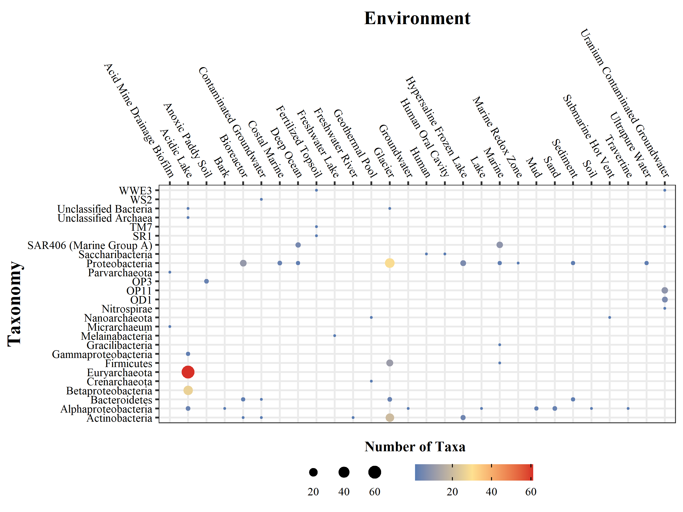
Figure 1.1 Heatmap of filterable bacteria
Heatmap of the identification of isolates and genomes in environmental sample filtrate. Data obtained from a query of the NCBI genome database and literature published on or before July 2020.

RESPONSE OF A COMPLETE PLANKTONIC GROUNDWATER COMMUNITY TO AN IN-FIELD ELECTRON DONOR INJECTION

This is a previously unpublished chapter; however, subsets of these data have been incorporated into two previously accepted theses.

Publications that reference this data:
- McBride, Kathryn R., Microbial Memory Response: Observing History-Dependent Adaptation to Repeated Exposures of Emulsified Vegetable Oil in a Contaminated Aquifer. Master's Thesis, University of Tennessee, 2018.
- Adams, Benjamin Gregory, Hydraulic Response To Emulsified Vegetable Oil Biostimulation: In-Situ Test In A Highly Heterogenous Uranium Contaminated Aquifer. Master's Thesis, University of Tennessee, 2019.
Authors:
Andrew D. Putt¹, Benjamin G. Adams¹, Kathryn R. McBride², Jonathan P. Michael³, Yupeng Fan³, Kenneth A. Lowe⁴, Peter Walian⁵, Daliang Ning³, Jizhong Zhou^{3,6,7}, Larry D. McKay⁸, Terry C. Hazen^{1,2,4,9,10}
Affiliations:
¹Department of Earth and Planetary Sciences, University of Tennessee, Knoxville, TN, USA
²Department of Microbiology, University of Tennessee, Knoxville, TN, USA
³Department of Microbiology, University of Oklahoma, Norman, OK, USA
⁴Biosciences Division, Oak Ridge National Laboratory, Oak Ridge, TN, USA
⁵Lawrence Berkeley National Lab, Berkeley, CA, USA
⁶School of Civil Engineering and Environmental Sciences, University of Oklahoma, Norman, OK, USA
⁷Earth and Environmental Sciences, Lawrence Berkley National Laboratory, Berkeley, CA, USA
⁸Associate Dean for Research and Facilities, University of Tennessee, Knoxville, TN, USA
⁹Department of Civil and Environmental Sciences, University of Tennessee, Knoxville, TN, USA
¹⁰Institute for a Secure and Sustainable Environment, University of Tennessee, Knoxville, TN, USA
Author Contributions:
Sample collection- BGA, KRM, and ADP
Geochemical analysis- ADP and KAL
Sequencing- ADP, YF and JPM
Sequence Post-processing- ADP and JPM
Data analysis- ADP with input from JPM, DN, and TCH.
Electron Microscopy- PW and ADP
Figure generation- ADP
Authored paper- AP with input from LDM and TCH

Abstract
Injections of electron donors can stimulate a native microbial consortium for targeted environmental functions. During an injection of emulsified vegetable oil (EVO) there was a differential enrichment of nitrate and sulfate-reducing bacteria. The microbial community shift was associated with changes in groundwater geochemistry. These geochemically associated changes in community composition were identified from bacteria captured on 0.2 µm pore diameter filters as well as those collected on 0.1 µm pore diameter filters. This dual-filter collection of microbial biomass revealed that the shift in community composition was most pronounced in the first fifty days post-injection with the enrichment of four phyla, Desulfobacterota, Firmicutes, Patescibacteria, and Proteobacteria which collectively accounted for over 80% of the community reads during periods of sulfate reduction. Each filter-fraction contained unique communities with a quarter of the taxa identified from both filter sizes. Approximately 89% of the complete community reads were accounted for by the taxa identified on both the 0.1 and 0.2 µm pore diameter filters. Complete community composition in the monitoring wells differed from the control aligning with reductive geochemical phases based on the reduction of nitrate and sulfate coupled with the production of acetate. This study identified that abundant and informative taxa are capable of passing through 0.2 µm pore diameter filters. The most notable being Patescibacteria which were enriched during sulfate reduction.

Introduction
Bioreduction effectively reduces and transforms contaminants by promoting natural reducing conditions at an accelerated pace. When abundant quantities of an electron donor are injected into an aquifer, it promotes reductive biological activity. Microbial growth and metabolism of the injectate critically results in the reduction of oxygen (O₂) and subsequent reduction of less thermodynamically favorable terminal electron acceptors. In the absence of oxygen, nitrate (NO₃⁻), sulfate (SO₄⁻²) and iron (Fe³⁺) will be reduced [73] and sulfate-reducing bacteria (SRB) are enriched [21, 28, 74-76]. Injectates are highly versatile with formulations targeted for specific contaminants or flow conditions [20]. Commonly injected electron donors include acetate, ethanol, and emulsified vegetable oil but a variety of carbon-rich substrates can be used [21, 26, 76-78]. Light-weight carbon injectates like ethanol and acetate have a limited dispersal and are rapidly degraded [77-79] in contrast to emulsified vegetable oil (EVO) which can have measurable effects on the environment for several months post-injection [26, 75, 80]. EVO can promote the reduction of chlorinated solvents [81, 82], treatment of mine drainage [83], and reduction of uranium (U⁶⁺) [26, 80].
EVO formulations can vary but are comprised of various nutrients suspended in soybean oil. The emulsified vegetable oil used in this study is the 60% SRS-SD small droplet EVO (Terra Systems Inc. Claymont, DE). The 60% SDS formulation of EVO is sixty-percent food-grade soybean oil, four percent food grade sodium or potassium lactate with a blend of proprietary nutrients, emulsifiers, and vitamin B₁₂. Lactate and nutrients are rapidly consumed promoting rapid oxygen depletion while the soybean oil C18 and C16 triglycerides can be hydrolyzed into long-chain fatty acids like linoleic, oleic, and palmitic acids. Long chain fatty acids can be specifically oxidized by sulfate reducing bacteria (SRB) including Desulforegula to produce hydrogen sulfide (HS⁻) and acetate (C₂H₃O⁻²) [84]. Acetate (C₂H₃O⁻²) is also an intermediate byproduct of anaerobic glycerol fermentation by microbial lipases which have been identified in Achromobacter spp., Alcaligenes spp., Arthrobacter spp., Pseudomonas spp., Staphylococcus spp., Chromobacterium spp. and in Pelosinus spp. when introduced to oil [85-87].
The intermediate metabolic by-product, acetate (C₂H₃O⁻²) is a widely accepted electron donor capable of promoting and sustaining dissimilatory sulfate (SO₄⁻²), nitrate (NO₃⁻), iron (Fe³⁺), manganese (Mn⁴⁺) and uranium (U⁶⁺) reduction by sulfate, iron, and metal-reducing members of Geobacteraceae, Comamonadaceae, and Desulfovibrionaceae [23, 84, 88-91]. Biologic processes of uranium reduction include biosorption to the cell surface via ligands [92-94], biomineralization as a uranium-phosphate biomineral facilitated by bacteria and fungi [95-97], or through enzyme-mediated reduction to produce tentatively-soluble non-crystalline U(IV) and uraninite nanoparticles [89-91, 96, 98-100]. Under prolonged anoxic conditions, methane production by methanogenic archaea like Methanosarcinales, Methanomicrobiales, methanococcales, and methanobacteriales can occur by reducing byproducts like carbon dioxide (CO₂), formate, and acetate [101]. However, without a re-injection or nutrient supplementation, the anoxic groundwater will again return to aerobic respiration.
Groundwater influenced by this EVO injection was sampled to account for the collection of small cells prolific in groundwater systems [50]. A 0.1 µm pore-diameter filter membrane was added to increase the resolution of abundant microbes potentially bypassing a 0.2 µm pore diameter filter matrix referred to as 0.2 and 0.1 µm filters throughout [55, 102]. This dual-membrane method resulted in the collection of a ‘complete’ planktonic community. Previously, the filterable microbes able to bypass a 0.2 µm filter membrane have been identified as Ultramicrobacteria [41] or ultra-small bacteria [5] but will be identified as filterable microbes in this context. This ‘complete’ community approach intends to account for the potential loss of abundant organisms and identify the consortia of microbes driving community succession [21, 75]. Here the respondent community is identified during reductive processes identifiable by changes in composition influenced primarily by SRB. Based on the chronic nitrate and heavy metal contamination at the site, the reduction will likely be mediated by reductive processes and the predominant nitrogen cycling processes [71, 103].
The method of groundwater collection used in this survey has the potential to underestimate the total composition of subsurface biomass and activity by sampling predominately planktonic cells and excluding adhered cells [104]. Adhered cells account for up to 98% of the subsurface abundance and a majority of the activity in the subsurface with actual ranges depending on the specific method of cell counting, biomass quantification, or activity estimation [105-109]. Resulting in an under estimation of the total subsurface diversity, activity, and biomass [104]. The preferential sampling of groundwater will selectively identify predominately planktonic taxa like methanogens [110], hydrocarbon-degraders [111], Patescibacteria [5, 42], and some subclasses of Proteobacteria [112] are preferentially mobilized and predominant in the planktonic fraction. In organic-rich groundwater sulfate and metal reducers are comparatively predominant in the planktonic fraction [113] with similar levels of activity and cell counts among the attached and planktonic communities in shallow nutrient-rich groundwater [114]. Suggesting that the addition of nutrient-rich EVO may result in a similar response. Pumping during this injection is likely to preferentially sample the already abundant sulfate and metal-reducing families as well as Proteobacteria and Patescibacteria preferentially enriched in other nutrient amendments of coarse-grained material [5, 21].

Materials and Methods

Site Selection
The injection site is located 300 m down-gradient of the S3 ponds contaminant source at the ENIGMA (https://enigma.lbl.gov/) Area 2 research site located in the Y-12 national security complex, Oak Ridge, TN [71, 103]. Major contaminants of interest are nitrate (NO₃⁻) from deprotonated nitric acid, and mobile uranium U (U⁶⁺). Wastes introduced to the site as a by-product of uranium enrichment activities to dissociate uranium oxide with nitric acid to form uranyl nitrate (UO₂(NO₃)₂). An estimated 10,000,000 L of uranium enrichment waste were pumped into the S3 ponds annually from 1951 until their decommissioning in 1983. In 1984, the pH was neutralized with lime and nitrate reduced with an acetate amendment [71]. The ponds were drained and backfilled with carbonate gravel, before being capped and eventually paved over in 1988 [71]. To this day, the legacy contamination of the S3 ponds contributes nitrate concentrations exceeding 50,000 mg/L, a pH ≤4 and high concentrations of metals and uranium in the local groundwater. This particular study is focused on the moderately contaminated Area 2 research site consisting of backfilled carbonate gravel and re-worked fill down-gradient of the S3 ponds (Figure 2.1). The injection site has a shallow water table about 3 m below ground surface and is immediately upgradient of Bear Creek. The wells are screened into primarily gravelly back-fill along the path of a pre-plant stream channel. The injection site permeability ranges from 0.6 to 5 percent with connections among this set of wells previously identified with bromide and EVO studies [21, 26, 80].

EVO Injection and Sample Collection
A 20% EVO solution was generated by thoroughly mixing 832 L of native groundwater with 208 L of 60% SRS-SD small droplet EVO (Terra Systems Inc. Claymont, DE). The 1040 L EVO injectate solution was then simultaneously injected into FW212, FW213, and FW214 on December 13, 2017 (Figure 2.1). The EVO solution was injected at a rate of 1L/min/well over 5.8 hours. Groundwater samples were collected from monitoring and control wells using a peristaltic pump 6 days prior to the injection. Sampling continued 1, 8, 15, 22, 50, 78, 106, and 134 days following the injection of EVO. Prior to groundwater extraction, water levels were collected using an electric water level tape with weighted probe (Solinst Canada Ltd., Georgetown, ON). Three-times the well volume was purged prior to sample collection. During well purging, a calibrated multiparameter AquaTROLL® 9600 (In-situ, Fort Collins, Co) was affixed to a flow cell to measure temperature (°C), specific conductivity (µS/cm), dissolved oxygen (mg/L), and pH of groundwater pumped peristaltically at ≤ 250 mL/min. After the parameters stabilized, 10L of groundwater were collected in sterile amber glass bottles with no headspace and transported at 4°C for filtration through a polycarbonate (PCTE) 10 µm and nylon 0.2 µm pore-diameter filter membrane (Sterlitech, Kent, WA) using a peristaltic pump. The <0.2 µm filtrate was re-filtered with a sterile laser-drilled PES 0.1 µm pore-diameter filter (ThermoFisher Scientific, Inc., Waltham, MA) sealed to a vacuum manifold with an operating pressure of -80 KPa. All filters were collected aseptically and stored at -80°C in sterile 50 mL tubes. Samples from 0.1 µm filters were not collected six days prior to the injection.

Geochemical analysis
Trace elemental analysis of unfiltered water was conducted inductively coupled plasma mass spectrometry (ICP-MS) on an ELAN 6100 system (PerkinElmer, Inc. Waltham, MA). Ten milliliters of groundwater were collected in trace-clean tubes preserved with 1% nitric acid for measurements of sodium, magnesium, aluminum, potassium, calcium, scandium, iron, manganese, terbium, and uranium as described previously (22).
Anions and Organic acids were analyzed in tandem using a Dionex ICP 5000+ (ThermoFisher Scientific, Inc., Waltham, MA) with a stepwise KOH gradient on an AS-11 column with detection by electrical conductivity. Anions measured included fluoride, chloride, nitrite, bromide, nitrate, phosphate, and sulfate as well as organic acids: lactate, acetate, propionate, formate, butyrate, pyruvate, succinate, oxalate, and citrate. Duplicates and blanks were analyzed every twenty samples with standards run every ten samples. Calibrations and peak detection were performed by Chromeleon Software (ThermoFisher Scientific, Inc., Waltham, MA) with manual peak integration. Instrument performance and final calibrations were calculated using Ioncal (version 1.0.2 https://github.com/putt-ad/ioncal).
Spearman-rank correlation of scaled-centered geochemistry data analyzed using corrplot [115]. All geochemistry with sufficient data coverage (excluding pH) were log₁₀-transformed to meet the assumptions of a normal-distribution for a repeated measures ANOVA. Changes in geochemistry for nitrate, sulfate, uranium, ammonium, and specific conductivity from in-field measurements were tested across days and wells, using an ANOVA with residuals checked for normal distribution with a Shapiro test of normality. Group-significance was then re-tested with a Tukey post-hoc test with least squares mean separation using a Bonferroni method. Geochemistry changes were grouped based on changes in concentration and characterized as phase 1: aerobic degradation of EVO/pre-injection, phase 2: sulfate, nitrate, and uranium reduction, and phase 3: post-reduction.

Transmission electron microscopy
Samples were concentrated to increase the number of cells per viewing window. Briefly, two 40 mL groundwater samples were initially centrifuged at 10,000g for 1 hour. Supernatant was pipetted to leave 1.5 mL per tube. Residual liquid from both tubes was combined and placed into a 50 kDa MWCO spin concentrator (4 ml capacity) and spun at 2000g until the volume approached 300-400 µl (about 25 minutes). Then 4 µl of the concentrated groundwater was applied to a glow-discharged carbon-coated grid (Formvar-carbon, 200 mesh copper, Electron Microscopy Sciences) and rested for five minutes before blotting to leave 1 µl. Cells were negatively stained with 2.5 µl of 2% uranyl acetate for one minute. Grids were blotted to dryness and examined on a JEOL JEM-1200x electron microscope operating at 80 kV imaged with a 2k x 2k pixel CCD camera (UltraScan, Gatan) controlled by the DigitalMicrograph software package.

16S rRNA gene amplicon library preparation and sequencing
Filters were stored at -80°C until DNA was extracted from one half of each 0.2 and 0.1 µm pore-diameter filter using a modified freeze-grind method [116]. Briefly, the 0.1 µm PES filters were pulverized by freeze grinding, the 0.2 µm nylon filters were cut frozen into approximately 2 mm by 2 mm pieces prior to the addition of liquid nitrogen. Filter pieces were successively washed with CTAB DNA extraction buffer, and the DNA was purified using silica columns, solutions, and manufacturer’s protocol provided in the DNeasy PowerSoil DNA isolation kit (Qiagen; bead beating step omitted). Eluted DNA was suspended in MiliQ water with DNA quality assessed by NanoDrop and quantified using a Quant-iT PicoGreen dsDNA Assay Kit (Invitrogen). Day 50 samples from 0.1 µm filters were omitted after failing a quality check during extraction.
Amplicon sequence libraries of the 16S rRNA V4 region were generated using a two-step PCR approach [117]. Briefly, the first PCR step amplifies the V4 region using 515F and 806R primers and was modified slightly to run 12 cycles instead of 10 with a final extension temperature of 72 °C. The second step amplifies the product from the first step for an additional 20 cycles using primers with spacers to increase base diversity and barcode the samples for pooling. Amplified PCR products were pooled together in equal molality, purified and prepared for sequencing using the MiSeq™ Reagent Kit Preparation Guide (Illumina, San Diego, CA) [118]. The V4 region 16S rRNA amplicons were sequenced using 251, 12, and 251 cycles for forward, index, and reverse reads on an Illumina MiSeq with a 500-cycle v2 MiSeq reagent cartridge (Illumina, San Diego, CA) as described previously [117].

16S rRNA gene amplicon sequence processing
Tools from QIIME2 2019.7 [119] and proprietary analysis tools integrated into the IEG Galaxy Pipeline (University of Oklahoma, Norman OK) were used to process sequences. High quality sequences were obtained by removing mismatching and unidentified bases and/or lengths outside of 240-260 base pairs. Paired-end sequences were combined using Flash [120] and then demultiplexed of raw fastq data, primers, and barcodes with an allowable error rate of 0 and denoised using DADA2 in QIIME2 2019.7 on the IEG Galaxy Pipeline. The consensus setting was used to remove chimeras, with samples denoised independently. Forward and reverse truncate positions were set at 190 and 210 respectively with quality and error score set independently to 2. Amplicon sequence variants (ASV) were determined using the QIIME2 2019.7 classifier with trimmed taxonomy assigned using the SILVA 138 small subunit rRNA database (https://www.arb-silva.de/documentation/release-138/). Post-processing removed mitochondrial, chloroplast, and eukaryotic ASVs before alignment with MAFTT and the construction of a consensus phylogenetic tree FastTree V2.1.3, http://www.microbesonline.org/fasttree/). Samples with multiple filters were subsampled to equal depth, and the complete community was generated by merging 0.1 and 0.2 µm samples by well and by day. ASVs unique to the 0.1 and 0.2 µm communities were identified as such and the overlapping ASVs found in both filter types were also subset from the complete community.

Statistics and Mapping
All statistical analyses were completed with R [121] (version 4.1.2) using the RStudio integrated development environment (version 2022.02.3). ASV tables, classification tables, and representative sequences were imported into R (version 4.1.2) for post-processing and further analysis. Visualizations were constructed in ggplot2 [122] and analyses were conducted with vegan (version 2.6-2) [123], Phyloseq (version 1.36.0) [124] and packages on Bioconductor (version 3.14). A full list of packages and code are available at https://github.com/putt-ad/dissertation. Well locations, well construction, and elevation data from the well installers and Y-12 surveyors were used to generate locational data plotted in ggplot2 in R. Static imagery and spatial data for maps were extracted from Google™ maps with a personal API used to directly integrate data from the Google™ static imagery repository using code from the ggmap package [125].

16S rRNA Analysis
The R package Phyloseq [124] (version 1.36.0) was used to agglomerate the ASV abundance, classified taxonomy, phylogenetic trees, and sample data into a single data object. Sample coverage of rarefactions were performed using the methods described by Chao and Jost, [126]. The sample coverage was determined to be between 0.98 and 1. Samples were merged by well and day generating a near-normally distributed abundance of ASVs per sample without rarefying to artificially remove taxa, reduce diversity, and remove rare counts [126, 127]. Abundance plots were constructed using ggplot2 [122] with low abundance ASVs ( <0.05% ) removed for visualizations.

Community Dispersion
Changes in the abundance and genera associated with the injection were tested on an unweighted UniFrac distance matrix calculated using the vegan package. Distance matrices were calculated from unrarefied data for the complete community and 0.1 µm community at genus-level. Subsequent tests were all conducted using functions in vegan (version 2.6-2). Unique and disperse groups were identified from the UniFrac distance matrix using the betadisper function. Iterative beta dispersion tests were completed to identify groups dispersions confirmed visually and with a test of variance (ANOVA). Distinct groups were identified by sample distance to the centroid with corresponding eigen values plotted on a principal component of analysis (PCoA). A multivariate multiple regression distance-based redundancy analysis was performed on the groups using the adonis2 package in R with 999 permutations [123]. The Adonis test also provides an estimate of community variance explained by grouping parameters or a combination of them. Group homogeneity was subsequently tested to identify if the disperse groups share a similar composition using the Anosim function. The unweighted UniFrac distance was also used for a canonical analysis of principle coordinates and subsequent redundancy analyses using the capscale function to determine the effects of covariates on community composition. The effects of covariates are plotted along with the constrained community on a canonical analysis plot with covariate vectors.

Differential abundance and correlations of asvs to geochemistry
All functions in this section were processed by the Bioconductor package MicroViz (version 0.9.3) [128]. Correlations of the abundance data were then tested using a spearman rank correlation [115]. Differential abundance of ASVs were tested with unrarefied, TSS-transformed data in pairwise comparisons using sequential Wilcox tests with the ranked pairs assessed using a linear discriminate analysis model. Wilcox tests have been shown to have a low false discovery rate when used with TSS-normalized data [129], and were constrained by p-value filters and successive tests to further reduce the potential of false positive differentially abundant taxa as discussed previously [130]. The effect of the community response was then assessed using a linear discriminate model to identify the effect of the response of the community in a technique known commonly as LEFSe and implemented in various tools [128, 131-133]. Relative abundance of the ASVs and the effect size of the linear model were extracted to identify ASVs that changed in abundance between conditions. Differentially abundant ASVs were grouped by taxonomic classifier.

Function derived from 16S
Function-based modules were assigned to the 16S using FAPROTAX (v.1.2.4) [134]. FAPROTAX uses function assigned to 30,000 microbes [134] to generate modules of function for known and well-characterized microbes. The standard pipeline was followed where-in ASV counts were TSS-transformed and modules assigned to ASVs identified using the FAPROTAX prokaryote database [134]. Modules were constructed using a spearman ranked-correlation network with a filter level of 0.0001, p-value filter of 0.01, and correlation filter of ≥0.7. The result was output as a table of functional modules. The purpose of this tool is to serve as a supporting element in the discussion regarding the selection of functions by phase and is not intended to serve as an absolute method for determining community function.

Results and Discussion

Physiochemical response
Field parameters including pH, specific conductivity (µS/cm at 25°C), and water table elevation (mAMSL) showed little variability throughout the 140-day study (Table 1). The pH of the site prior to the injection was 7.43 ± 0.14. Post-injection, the average pH in the control well was 6.99 ± 0.45 and the monitoring well pH averaged 6.91 ± 0.28. The specific conductivity pre-injection was 672.52 ±19.32 µS/cm with the monitoring well conductivity increasing to 683.48 ± 68.06 and the control well specific conductivity maintained a slightly lower average at 651.6 ± 50.1. The range of water table elevations differs between wells with a few distinct trends. The control well, and furthest down-gradient wells GP01 and GP03 have lesser water table elevation fluctuations between 0.65 and 0.73 meters. Groundwater fluctuations in FW216 and MLSB3, the two wells closest to the injection (Figure 2.1), had a larger range in water levels calculated to be 2.1 and 1.4 m respectively which may be attributed to the high concentration of EVO in the down-gradient wells [135]. The highest water table elevation in each well occurred on day 78, which corresponded with heavy rainfall measured over several weeks preceding the day 78 sample (Supplementary Figure S2.1).

Establishing Phases of the Injection from Geochemistry
Concentrations of acetate (mg/L), nitrate (mg/L), sulfate (mg/L), uranium (mg/L), and ammonium (mg/L) are used as indicators of microbial activity and subsurface reductive processes (Table 2.2). The production of acetate or reduction of nitrate, sulfate, and uranium was short-lived often lasting only a few days throughout the course of the study (Figure 2.2). Each analyte reported in Table 2 showed variation in concentration throughout the time course study but returned to near pre-injection concentrations by day 106. However, the distinct changes in geochemistry allotted the division of time points into phases of similar geochemistry which will be applied to all additional analyses.

Identifying Factors of Variance
An ANOVA was performed to test the variance in means for log-transformed concentrations of nitrate, sulfate, uranium, ammonium, and specific conductivity (Table 3). The test compared analyte means by whether the sample originated from the control or monitoring wells (well type), sample day, and the specific well. An ANOVA was repeated for all analytes of strongest response with residual distribution tested using a Shapiro test and visualized with Q-Q plots (Supplementary Figure S2.2). Non-normally distributed residuals were excluded for failing to meet the assumptions of the test. Valid tests included nitrate, sulfate, specific conductivity, and uranium which all showed significant variation in means (p<0.05) identified by well type. Well of origin was also identified as a significant factor in the mean variance for sulfate, nitrate, and specific conductivity (p<0.05), but day of sample was highly significant (p<0.001) for all analytes. A Tukey post-hoc test with Bonferroni-Holm corrected p-values (Supplemental Table S1) identified the sample days with the greatest variance from other samples. The Tukey test identified days with the lowest concentrations of nitrate to be days 8, 15, 22, and 50. For sulfate days 22 and 50 had the lowest concentrations with uranium becoming highly reduced on day 50. Specific conductivity also significantly differed with early samples on days 15 and 50 differing from specific conductivity on days 106 and 134. On day 78 the specific conductivity differed from days 1, 8, 15, and 50 and corresponds with a peak in uranium, and sulfate preceded by weeks of intermittent precipitation (Supplemental Figure S2.1).

Identifying Phases of the Injection
Geochemical traits were used to assign three distinct phases post-injection. These phases include multiple time points.
Phase 1, Primed Nitrate Reduction includes the pre-injection, and day 1 samples. Despite the introduction of the injectate, the geochemistry resembles conditions without an amendment.
Phase 2, Reduction occurred from day 8 through day 50 when nitrate and sulfate were <50% of their initial concentration. Average nitrate concentrations dropped to 2 mg/L on day 8 and remained under 50% of the pre-injection concentration for the next 70 days. Sulfate maintained its lowest measured concentration on days 22 and 50 with uranium achieving its lowest concentration on day 50. Weak correlations were identified across most of the geochemical parameters with strong correlative relationships established between nitrate, sulfate, uranium, and acetate (Figure 2.3). Acetate peaked in the monitoring wells during the sulfate reduction phase with an average concentration of 22.5 mg/L. Acetate production was negatively correlated with the reduction of uranium, nitrate, and sulfate based on a rho of -0.6 to -0.7. Sulfate was also highly correlated with uranium (rho= +0.7), and moderately correlated to manganese and nitrate (rho= +0.5). The rapid and high rate of acetate production with the co-occurrence of nitrate, sulfate, and uranium reduction has been previously linked to microbially-mediated reduction [85-87].
Phase 3, Waning Reduction occurred in the final stages of the injection. By day 78 the strong reducing conditions dissipated either because of insufficient nutrients or from precipitation events which occurred following day 50. Nitrate concentrations slowly increased while sulfate and uranium concentrations matched the control. Acetate is detected after day 50, but by day 106 the geochemistry in the monitoring wells did not differ from the control.

Overview of the Microbial Community
ASVs identified on the 0.1 and 0.2 µm filter were identified as overlapping microbes resulting in the creation of three data objects. 1) The complete community of 0.1 and 0.2 µm filters merged by sample (Well + Day), 2) overlapping microbes, and 3) 0.2 µm exclusive (Table 4).
The complete community had a total of 44 samples with 11,990 unique taxa. The sample abundance contained a near-symmetric distribution with a median count of 46,454 ASVs per sample and a mean of 45,864. The 0.2 µm community was the most diverse and accounted for about two-thirds (67%) of the taxa, with a positively skewed abundance suggesting that most of the samples had abundances less than the mean.
Differences in abundance coverage, richness, and evenness were determined from variance in the scores using the non-parametric Abundance-based Coverage Estimator (ACE) index, Shannon-Wiener (Shannon) index of species richness, and inverse Simpson (Inv. Simpson) index of dominance (Table 5). Changes in diversity were compared by well type, day, well type and day, filter size, nitrate, and sulfate concentration using an ANOVA test of variance. All groups exhibited variations in evenness, coverage, and richness by day and by well type.

Complete Community Response to EVO
The microbial community changed in abundance, and taxonomic composition over the course of the injection (Figure 2.4). The pre-injection community had high scores in both ACE, Shannon, and inverse Simpson suggesting a diverse and equally distributed initial community (Table 5). The control ACE scores remained above 1000 throughout the study with an average score of 1816 and a standard error of 191. Shannon index average for the control was 5.4 with a standard error of 0.3 with the inverse Simpson averaging 50.6 and a standard error of 15, based on a wide range of scores from 12 to 157. The phase 1 indices from day 1 and the pre-injection were similar to the control based on the ACE average of 1750 with a standard error of 130 and the Shannon index averaging 5.8 with a standard error of 0.3. The inverse Simpson index average was slightly higher with an average of 93 and a standard error of 38.
The ACE scores of every monitoring well dropped below 660 on days 8-50 except for MLSB3 which had ACE scores around 1000 on days 22 and 50. After day 50, the ACE scores in all of the monitoring wells increased implying the return to a more diverse microbial community. Conversely, the control well maintained a high ACE index (>1000) throughout the entire study. ASVs with an abundance greater than 0.05% of the total abundance were compared across the designated phases post-injection (Figure 2.4).

Pre-injection Microbial Community
In the pre-injection samples, one-third of the microbial abundance was accounted for by cometabolic anammox-supporting and potentially symbiotic Patescibacteria Candidatus Magasanikbacteria [136, 137]. Which has been identified metagenomically as having the ability to reduce ferric iron (FeIII) and oxidize ammonium in anaerobic conditions [138]. Verrucomicrobia abundance was accounted for by the anaerobic methanotrophic groundwater genus Candidatus Omnitrophica (17%) (formerly OP3) [139-142]. Alpha- and Gamma- Proteobacteria, Nitrospirota (formerly Nitrospirae) [140, 143, 144] abundance was entirely accounted for by the genus Thermodesulfovibrionia. Isolates of which are capable of utilizing lactate, hydrogen, formate, and pyruvate as electron donors to reduce sulfate in sludge reactors when grown syntrophically with methanogens [145]. Proteobacteria abundance was largely accounted for by Burkholderiales (5%) the most abundant of which was the non-spore-forming nitrate-reducing Rhodocyclaceae genus Denitratisoma (3%)[146, 147]. The heterotrophic methanogenesis-supporting Nanoarchaeal order Woesearchaeales [148] made up 5% of the total abundance along with methanotrophic Methylomirabilota (5%) [149]. Heterotrophic methanogenesis-supporting Nanoarchaeota (5%) [148] and ammonia-oxidizing Crenarchaeota [148, 150] remained abundant in the control well. The composition suggests a facultatively anaerobic environment with a functional enrichment towards nitrogen-cycling processes.

Phase 1. Aerobic degradation of EVO
On day 1, EVO degradation and nitrate reduction were detectable from the change in microbial community composition. Proteobacteria accounted for 65% of the ASVs in the monitoring wells. Proteobacteria were dominated by the aerobic alkane-degrading mesophilic sulfate and nitrate-reducing Pseudomonadaceae (40%) [87, 151, 152], nitrate-reducing families Rhodocyclaceae (8%), Comamonadaceae (8%), Caulobacteraceae (6%), and the Firmicute family Clostridiaceae (7%) [21]. With composition similar to previous EVO injections [21]. The genus Tumebacillus, a spore-forming facultative sulfur-oxidizing chemolithotroph [153] was also identified among the abundant Firmicutes. The Rhodocyclaceae family composition included the acetate-oxidizing, Fe(III), and nitrate-reducing genus Ferribacterium [154] and nitrate-reducing Denitratisoma [146, 147]. The Comamonadaceae family was divided with compositions of the oil-degrading and nitrate-reducing genera Aquabacterium (3%) [155, 156] and Malikia (2%) isolates of which have been identified as nitrate reducers capable of producing polyhydroxyalkanoates [157]. Patescibacteria made up 10% of the abundance with representatives of the heterotrophic methanogenesis-supporting Woesearchaeales [148], methanotrophic Methylomirabilaceae [149], and Omnitrophaceae which have been identified as potential mediators of nitrate and sulfate reduction in groundwater [158].

Phase 2. Microbially-Mediated Reduction
Phase two encompasses the nearly complete reduction of nitrate on days 8 and 15 with sulfate reduction occurring from days 15 through 50. During this phase, Desulfobacterota, Firmicutes, Patescibacteria, and Proteobacteria account for ≥88% of the microbial community abundance. Acetate production increased steeply and remained high throughout phase 2 as identified in other studies [21, 26]. Patescibacteria were highly abundant during this phase, a trend which has been identified in other acetate-rich environments and in co-occurrence with sulfate-reducing families [85-87]. Acetate and hydrogen which are produced during fermentation are readily accepted electron donors previously identified as capable of promoting the enrichment of the abundant sulfate-reducing families like Comamonadaceae, Geobacteraceae, and Desulfovibrionaceae [88] identified in this phase.
On day 8, nitrate concentrations reached their minimum with a concomitant increase in acetate. Proteobacteria (48%) and Firmicutes (42%) accounted for 90% of the ASVs. Firmicutes were dominated by Oscillospiraceae (34%) which have been identified in denitrifying wastewater operations [159]. Proteobacteria were dominated by nitrous oxide-respiring Rhodocyclaceae Dechloromonas (30%) [160], and the acetate-producing nitrate-reducing Chromobacteraceae (6%) [161, 162]. Proteobacteria Oxalobacteraceae Undibacterium and autotrophic Fe(II)-oxidizing, sulfate-reducing, carbon-dioxide-fixing Comamonadaceae Curvibacter accounted for 12% of the total abundance and are both capable of utilizing the PHAs produced by Pseudomonas during vegetable oil degradation [163] as a carbon source [164, 165]. Increasing acetate concentrations are likely a byproduct of vegetable oil degradation by Pseudomonadaceae and Desulforegulaceae producing linoleic, oleic, and palmitic acids which can be further oxidized by members of the phylum Desulfobacterota [84, 87, 151]. Acetate and hydrogen produced during fermentation are readily accepted electron donors used by sulfate reducing bacterial families like Comamonadaceae and Geobacteraceae [88]. Desulfobacterota abundance was entirely accounted for by the family Geobacteraceae (7%) identified as a sulfate and metal reducers in anaerobic conditions [76, 89, 100, 166].
Ninety-six percent of the total abundance on day 15 was encompassed by Desulfobacterota (29%), Patescibacteria (24%), Proteobacteria (24%), and Firmicutes (19%). Sulfate reducing genera Citrifermentans and Geobacter abundance increased to a combined 28% while primarily nitrate reducers Dechloromonas, Oscillospiraceae, and Sporomusaceae composition decreased to 10, 15, and 2% respectively. Implying a shift from nitrate to sulfate reduction. Autotrophic Fe(II)-oxidizing, sulfate reducing, carbon-dioxide-fixing Comamonadaceae Curvibacter (10%) were abundant along with Gallionellaceae (2%) [167], sulfide and iron oxidizing, carbon-dioxide fixing bacterial families Magnetospirillacaea [168], and nitrate-reducing, sulfur oxidizing Sulfurimonadaceae [169] which collectively attributed to 5% of total abundance. Patescibacteria Candidatus Wolfebacteria accounted for a quarter (24%) of the total ASVs.
On day 22 Patescibacteria (32%), Proteobacteria (31%), Desulfobacterota (19%), and Firmicutes (8%) accounted for 90% of the abundant phyla. Proteobacteria abundance was dominated by the sulfate-reducing iron-oxidizing Comamonadaceae [170-172] and iron-oxidizing Oxalobacteraceae [171]. Desulfobacterota abundance was again accounted for by the family Geobacteraceae (17%) which increased in conjunction with Patescibacteria Candidatus Wolfebacteria while Firmicute composition was primarily comprised of the denitrifying Oscillospiraceae (5%) family.
On day 50, Patescibacteria (35%), Proteobacteria (20%), Desulfobacterota (26%), and Firmicutes (7%) accounted for a combined 88% of the total ASVs. Proteobacteria abundance was dominated by sulfate-reducing Gallionellaceae [167] and denitrifying sulfur-oxidizing Rhodocyclaceae Sulfuritalea [147, 173]. Desulfobacterota were dominated by sulfate reducing Desulfovibrionaceae (10%) and Geobacteraceae (10%) in conjunction with continued abundance of Patescibacteria Candidatus Wolfebacteria which both appear to be co-respondents in other groundwater with high acetate and fermentation end products [76]. Byproducts of oil degradation via lipases [87] such as glycerol phosphate have also been known to stimulate biological reduction of sulfate and uranium in groundwater [87]. The facultative anaerobic Patescibacteria may be capable of producing fermentation byproducts such as lactose and acetate [174] via the glycolysis pathway [174, 175] using glycerol phosphate identified in the genome of Candidatus Wolfebacteria (GenBank Assembly: GCA_001029635.1). A Candidatus Wolfebacteria genome from contaminated groundwater (GenBank Assembly: GCA_001029635.1) also contains genes for a protein structure homologous to a nitroreductase protein (PF00881), but this function has not been assessed.

Phase 3. Waning Reduction
Day 78 marks a transition point for the geochemistry and microbial community. From days 8 to 50 the microbial community was dominated by a few families with an enrichment of sulfate reducing families. From day 78 to the terminus of the study, Proteobacteria remained abundant while community composition as a whole became more evenly distributed. The abundant ASVs transitioned towards taxa associated with the oxidation of sulfate and metals with the re-emergence of common nitrate reducing families.
The abundant phyla contributing to 90% of the ASVs on day 78 pivots as the previously abundant Patescibacteria (13%) and Desulfobacterota (6%) to increases in Proteobacteria (58%) and Campylobacteria (13%). Desulfobacterota abundance was almost entirely attributed to the sulfate-reducing family Desulforegulaceae [84, 176]. Proteobacteria ASVs were identified as iron-oxidizing and denitrifying Caulobacteraceae (11%) [177], Fe(II)-oxidizing Oxalobacteraceae (10%) [171], Fe(II)-oxidizing and sulfate-reducing Gallionellaceae (11%) [167], and denitrifying sulfur-oxidizing Rhodocyclaceae Sulfuritalea (11%) [147, 173]. Campylobacteria abundance was largely attributed to the sulfur-oxidizing genera Sulfurimonas [178] which comprised 10% of the total abundance.
On day 106, Proteobacteria accounted for 41% of the abundance with a near equal distribution of Patescibacteria (13%), Campylobacteria (12%), Desulfobacterota (8%), Firmicutes (5%) and Bdellovibrionota (5%) accounting for 84% of the total community abundance. Proteobacteria were dominated by denitrifying sulfur-oxidizing Rhodocyclaceae genera Sulfuritalea (14%) [147, 173], Fe(II)-oxidizing and sulfate reducing Gallionellaceae (10%). The remaining 10% of Proteobacterial abundance included the nitrate-dependent iron-oxidizing Comamonadaceae family [170-172], facultative anaerobic denitrifying and sulfur-oxidizing genus Sulfuricella [178], and iron-reducing and denitrifying Caulobacteraceae [177] which accounted for a combined 10% of ASV abundances. Desulfobacterota abundance decreased from the phase 2 abundance with Desulforegulaceae accounting for 5% of the total sample abundance. Nitrate-reducing sulfur-oxidizing Campylobacterota genera Sulfurimonas [178] accounted for 8% of total abundance.
Abundant phyla on day 134 were similar to those on days 78 and 106 with the notable absence of Desulfobacterota. A high abundance of Proteobacteria (58%) was observed with Patescibacteria (12%), and Campylobacterota (6%) the next most-abundant phyla. When combined, Desulfobacterota, Nitrospirota, Methylomirabilota, Dependatia, Firmicutes, Spirochaetota, and Bdellovibrionota which were all in low abundance accounted for a collective 15% of the community. Highly abundant Proteobacterial families included Comamonadaceae (17%) which was dominated by the denitrifying genera Acidovorax (17%) [179], nitrous oxide respiring Rhodocyclaceae Dechloromonas (13%) [160], nitrogen-fixing soil bacterium Caulobacteraceae Brevundimonas (10%) [180, 181], Fe(II)-oxidizing Oxalobacteraceae (4%), and Fe(II)-oxidizing and nitrogen-fixing Gallionellaceae Sideroxydans (3%) [182, 183]. Microbial orders of Patescibacteria included Microgenomates and Parcubacteria which accounted for 12% of the abundance. The next most abundant family was the methanotrophic Methylomirabilaceae (2.5%) with all other families accounting for under 2% of ASVs.

Redox processes drive complete community diversity
Changes in abundant taxa for the complete microbial community suggests a shift in terminal electron acceptors nitrate and sulfate (Supplemental Figure S2.3). Changes in the complete community were prominent in the overlapping community as opposed to the exclusively 0.2 µm community (Figure 2.4). The emergence and subsequent disappearance of sulfate reducing families like Comamonadaceae, Geobacteraceae, and Desulfovibrionaceae were associated with reductive processes and signified a geochemical and taxonomic shift post-injection. When the amplicon data were processed using function-based-modules assigned by 16S rRNA (FAPROTAX v.1.2.4), a reduction in functional modules aligned with the selective enrichment of a few taxa in phase 2. A decrease in nitrogen-cycling functions and increase in sulfur-cycling functions were observed during phase 2 (Figure 2.5). Phase 1 had 173 modules identified and the control had 128 taxonomic modules identified. Phase 2 had only 23 taxonomic modules while phase 3 had 78. Additionally, the pre-injection community had the greatest diversity of functional categories at 24. Similar to the geochemistry and ASV data, Phase 3 had 18 functional categories similar to the control with 16 functional categories identified in phase 1 and 2 which only differed slightly in functional category composition.
Groups were assigned and tested for various geochemical parameters described previously as indicators of the injection phases and community response. To assign and test groups, a multivariate test for homogeneity and variance in community composition. Community composition determined from a genus-level unweighted UniFrac distance matrix was assessed with respect to changing geochemistry with homogeneity determined as dissimilarity of the sample from the group median. The result was a set of eigen values which were plotted as principal components of analysis (Figure 2.6). Well type, days, phase, nitrate, sulfate, acetate, and ammonium were tested. Grouping cut-offs were assigned for each parameter based on the dispersion of groups and groupings adjusted to provide maximum coverage and separation. Groups were further subset based on sample distance to the centroid and number of samples. Group dispersion was then tested with an ANOVA. The resulting groups include acetate subset by samples greater than or less than 20 mg/L (F= 5.3, p<0.05), nitrate was assigned ranges from 0-1 mg/L, 1-10 mg/L, 10-20mg/L, and 20-27.47mg/L (F=4.8, p<0.01), days were subset collectively based on the combined variance (F=15, p<0.001). Community-based differences associated with sulfate and ammonium were not identified at a high-level as factors which account for changes in community composition. However, community changes associated with the phase of the injection (F=15, p<0.0001), did represent meaningful variation in the community and in corresponding tests accounting for geochemical and ASV-level variance.
An Adonis permanova test of covariance was performed with 999 permutations using an unweighted UniFrac distance matrix. The test identified similarities in community, and community variance explained by each parameter composition when grouped by concentrations of nitrate (R²= 6.3%, p<0.001), sulfate (R²= 4.8%, p<0.01), acetate (R²= 3.8%, p<0.05), ammonium (R²= 3.8%, p<0.05), well type (R²= 8.8%, p<0.001), and day (F=13.3, p<0.001). The Adonis model accounted for up to 43.5% of the variance within the community (R²=0.435, p=0.001). Given the previously noted changes corresponding with phase of injection an additional Adonis permanova test of covariance was performed with 999 permutations using the unweighted UniFrac distance matrix. When tested against the geochemistry-based model, phase explained an additional 0.7% of the community variance accounting for 18 and 18.7% of the variance respectively (R²= 0.18, F=5.7, p=0.001). When the phase-based model was applied to the community variance, samples within each phase share a high level of homogeneity R = 0.68 (p= 0.001) based on a non-parametric rank-based analysis of similarity. Indicating a high similarity in microbial composition by phase. The collective geochemistry model produced similar results albeit with lower R-values. In the subsequent model, days and acetate were identified as the factors explaining the majority of community similarity based on an R-value of 0.56 (p= 0.001) for days and 0.52 (p= 0.001) for acetate. Days and acetate had individually lesser scores than phase but likely account for the majority of group change.
Groups assigned by injection phase were identified as highly significant and are shaded in the canonical analysis of principal coordinates plot (Figure 2.6) with 95% confidence interval ellipses. Constraints of significance for changes in the microbial community by day, well type, phase, nitrate, sulfate, acetate, and ammonium were tested using a distance-based redundancy correspondence analysis. The vectors associated with each constraint are plotted in Figure 2.6, and the total variance of the model was determined by an ANOVA on 6 degrees of freedom, with an F value of 3.45, and a p-value of 0.001. Total inertia of the constraints was 6.07, with the model accounting for 36% of the microbial community variance.
Covariates ammonium and uranium are highest in the pre-injection and control samples and are oriented away from the late-phase 2 samples. Nitrate and sulfate which were reduced during acetate production are negatively associated with acetate which is highest in the samples collected on days 15 and 22. The phases, shaded in yellow, green and blue show the distinct geochemical and community changes which occurred post-injection. The eigen values for the dispersion for geochemistry phase are plotted in the lower plot in Figure 2.6.

Abundant Taxa are Influenced by Reductive Processes
Correlations between changes in abundance of the top 20 ASVs identified to genus-level were tested against changes in geochemistry (Figure 2.7). The spearman rank correlation analysis identified Citrifermentans in the family Geobacteraceae and NK4A214 in the family Oscillospiraceae as highly positively correlated (rho = +0.7) with acetate and negatively correlated with nitrate (rho = -0.6) and sulfate (rho = -0.5 to -0.6). Citrifermentans was negatively correlated with uranium (rho = -0.5) aligning with assimilatory sulfate reduction and nitrogen fixation to ammonium based on pathways identified in the M00175 KEGG Module (https://www.genome.jp/module/M00175+R05185 ). A pathway also found in common Proteobacterial families from this study including Pseudomonadaceae, Comamonadaceae, Oxalobacteraceae, Sulfuricellaceae, as well as several species of the genus Dechloromonas which had a rho of -0.4 with nitrate. The author is unaware of any pathways or published isolate studies able to identify acetate production by Citrifermentans or NK4A214, but both are capable of utilizing acetate as an electron acceptor or highly correlated with its abundance in reducing conditions [184, 185] and previously associated with reductive processes and sulfur metabolism [185, 186]. Suggesting that their differential abundance with acetate is associated with their utilization of it. Acidovorax abundance was positively correlated with nitrate (rho = +0.5) and negatively correlated with iron (rho = -0.5), a trend also identified in Sideroxydans which was weakly associated with nitrate (rho = +0.2), but moderately negatively correlated with iron (rho = -0.5). Acidovorax and Sideroxydans have been identified as anaerobic nitrate-dependent Fe(II)-oxidizing bacteria [187-189] and abundant in metal-contaminated environments [190]. Dechloromonas abundance which is weakly correlated to reduced nitrate (rho = -0.4) and positively correlated with acetate (rho= +0.5) an electron donor which has been shown to promote Dechloromonas growth [190]. Furthermore, when supplemented with the electron donor acetate, Dechloromonas was able to oxidize iron Fe(II) and reduce nitrate although no correlation with iron or nitrate was established in this work [190]. Candidatus accumulibacter has been shown to have a high affinity for acetate (rho = +0.5) as an electron donor, and has been extensively investigated for its capability to biologically remove phosphate [191]. Accumulibacter is capable of denitrification under oxygen limited conditions using NarG proteins which are phylogenetically similar to those identified in Proteobacterial families including: Comamonadaceae, Pseudomonadaceae, Burkholderiaceae, and Rhodocyclaceae [192].

A Consortia of Responsive Taxa
Discriminant taxa were identified with respect to increasing abundance during nitrate reduction, sulfate reduction, and acetate production (Figure 2.8). Effect size determined using the non-parametric linear discriminate model identified several abundant taxa previously identified by the spearman correlation (Figure 2.7). The genera Candidatus Accumulibacter, Citrifermentans, NK4A214, and Dechloromonas were all correlated with nitrate and sulfate reduction and high acetate (Figure 2.7). Interestingly all four were identified as differentially abundant with acetate, while Citrifermentans and NK4A214 were only identified as differentially abundant during nitrate and sulfate reduction. Taxa previously identified as abundant in phase 2 were identified as differentially abundant including the orders Wolfebacteria and clostridia, the family Oscillospiraceae, and the genus Geobacter. The family Chromobacteraceae and genera Magnetospirillum, Dechloromonas, and Candidatus Accumulibacter were all only differentially abundant with acetate on days 8 and 15. Sulfate reducing families Desulfobacteraceae and Desulfitobacteraceae were both differentially abundant with acetate and sulfate reduction, but not with nitrate. Azoarcus, an aromatic-degrading, nitrogen (N₂)-fixing genera [193] was identified as abundant with acetate and nitrate reduction. Trichlorobacter was also identified as differentially abundant during sulfate reduction enriched from the native community.
Figure 2.8 identied a similar effect size for Patescibacteria and Desulfobacterota during sulfate reduction, nitrate reduction, and acetate production. The clear response of taxonomic abundance for Desulfobacterota and Patescibacteria is shown in Figure 2.9. Both phyla trend positvely with acetate. Patescibacteria were dominated by a single order, Candidatus Wolfebacter and Desulfobacterota abundance primarily consisted of Desulfovibrionaceae and Geobacteraceae. Proteobacteria which remained highly abundant throughout the study showed an oscillating abundance not directly associated with measured geochemical properties. Proteobacterial abundance was however was inversely associated with Bdellovibrio suggesting a potential for predation (Figure 2.9). Proteobacteria abundance fluctuates with high community turn over in the initial post-injection samples and again on day 78 when the site transitions away from sulfate and uranium reduction. The steepest declines in Protebacterial populations occur between days 22 and 50 as well as 78 and 106 which are associated with increases in the saprophytic facultative gram-negative bacteria predator Bdellovibrio [194]. Similar to other injections, Proteobacteria are present and associated with the geochemistry with several of the abundant genera in this study previously identified in the degradation of vegetable oil [87, 151, 152, 163].

Transmission Electron Micrographs
Cells identified in the electron micrographs (Figure 2.10) included cells with nano-wire type structures similar to those identified in the family Geobacteraceae [195]. Some of these nano-wire structures are even seen in associated with metal complexes in the imaged medium (Figure 2.10). Many of the cells were filamentous or vibrioid in shape and some appeared to have internal metal complexes identified by dark internal staining which have been identified previously in Magnetospirillum [196].

Environmental Implications
Changes in microbial community composition from the EVO resulted in the reduction of nitrate, sulfate, and uranium coinciding with an increase in acetate. Wells influenced by the injection experienced changes in geochemistry from days 8 to 50 when nitrate, sulfate and uranium were reduced to their lowest average concentrations. Means for nitrate, sulfate, uranium, and acetate differed from the control throughout this phase with reductive and fermentative processes peaking around day 50. Sulfate, acetate, and uranium returned to pre-injection concentrations around day 78, with a lagging rebound in nitrate concentrations. Likely attributed to a priming or memory effect from the microbial community based on the selective advantage and high abundance of nitrogen cycling traits identified in previous studies of the site [27, 197].
The injection volume was 30% smaller than a previous injection at the site [21], but still resulted in 42 days of highly reducing conditions. After the sulfate and uranium reduction, functional families remained enriched amidst the re-solubilization of uranium minerals and increasing sulfate. Sulfate reducing families in Proteobacteria and Desulfobacterota increased during the reductive phase with Geobacteraceae and Desulfovibrionaceae accounting for the Desulfobacterota abundance. A phylum which shared similar trends in abundance with the Patescibacteria order Candidatus Wolfebacteria.
Moreover, the full community approach expanded the coverage of Patescibacteria which were abundant in this site. When changes in the complete microbial community were aligned with the geochemically derived phases, the communities assigned to each phase were highly similar with the reduction phase 2 community differing most notably from the control. This supports the acceptance of hypothesis one that a functional group can be derived from changes in geochemistry related to community composition further narrowing the conditions and microbial consortium responsible for sustained reduction in this shallow contaminated aquifer. This hypothesis was tested specifically to provide a perspective for the use of microbial community biomarkers and geochemistry to assess the progress and stages of reduction when these methods are applied in other field sites. Community evenness and diversity as well as changes in the dominant families were identifiable at a high-level with sulfate reducing families and a largely uncharacterized order of Patescibacteria among the most highly differentially abundant taxa with acetate and sulfate.
A differential enrichment of sulfate reducers in the phylum Desulfobacterota and Proteobacteria occurred following the injection of the EVO. As discussed in the previous sections, Proteobacteria were highly abundant in the complete community although their abundance extended beyond the phase of reduction. The rapid onset of reducing conditions promoted an abundance of families within Desulfobacterota which were differentially enriched during periods of low sulfate and high acetate. These families remained present for most of the injection, but their dominance was not sustained like it was for Proteobacteria. The community composition did differ between control and monitoring wells during the reductive phase with a promotion of a limited consortium of known sulfate-reducing bacteria.
This study therefore demonstrates an added benefit for assessing 0.2 and 0.1 µm pore diameter filter fractions and demonstrates a clear environmental shift detectable at a high level from geochemistry and 16S rRNA composition. High nitrate and precipitation may limit or curtail sulfate reduction, but even after sulfate and uranium increase sulfate reducing families remain enriched. This phase-based approach can be used to suggest the re-informed addition of amendments or additional injectate to continue promoting reductive processes in the subsurface. It also demonstrates the lasting effect of injections on promoting and supporting the dominant nutrient cycling processes in contaminated media.

Appendix B: Figures

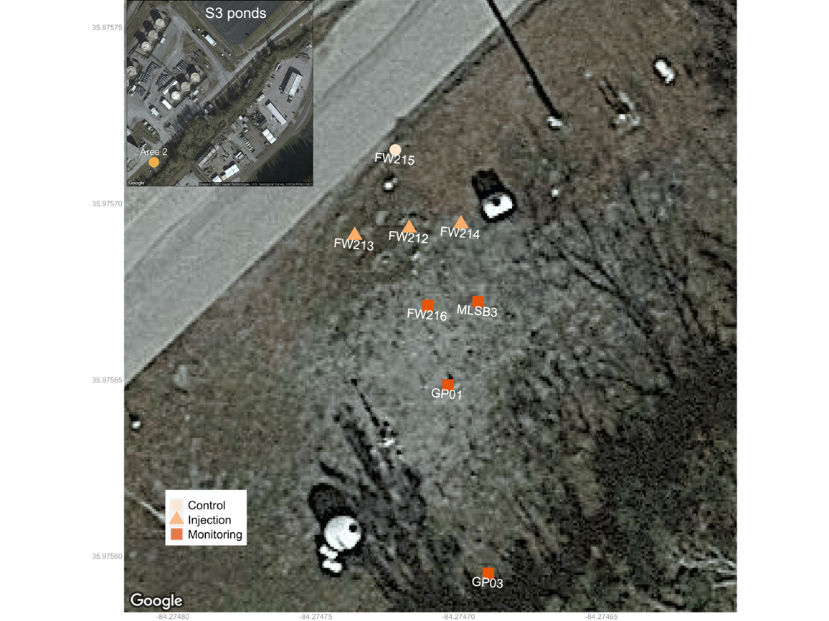
N
Figure 2.1 Injection site map
The control well (circle) is 2.6 m up-gradient of the three injection wells (triangle). Monitoring wells (square) are located 2.6 to 10.5 meters down-gradient of the injection wells. The upper panel shows the location of the Area 2 injection site in-reference to the S3 ponds. Distances and cardinal direction are derived from the WGS 1987 Mercator grid with Google static map imagery coerced using a static map API.

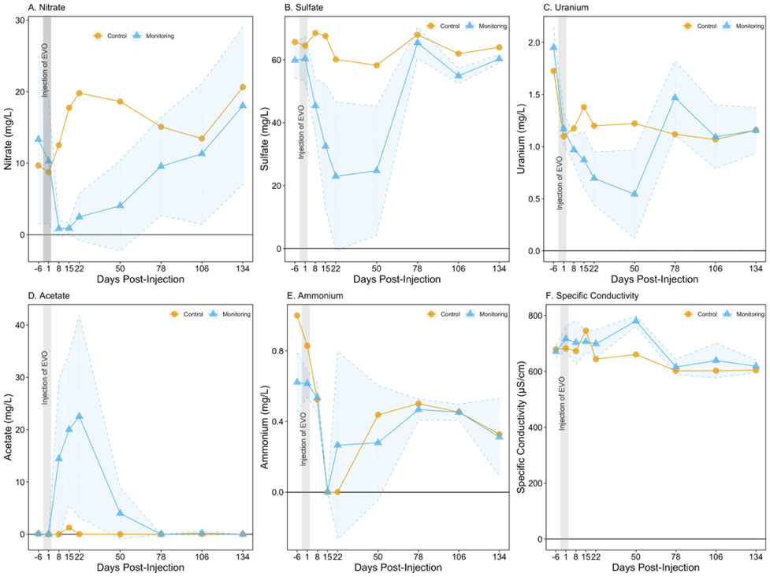
Figure 2.2 Changes in physiochemical parameters.
Commonly measured as indicators of microbially-mediated reduction. Shading represents one standard deviation from the mean.

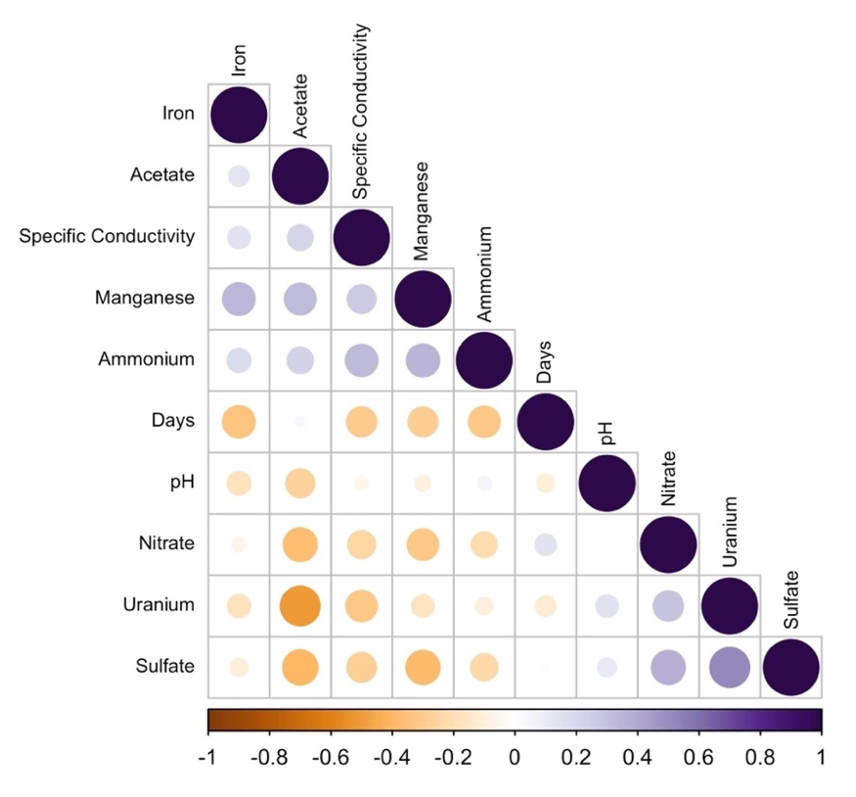
Figure 2.3 Geochemistry correlations
Physiochemical spearman rank correlations identified moderately strong negative associations of nitrate, sulfate, and uranium to acetate.

Figure 2.4 Microbial Abundance Plots
Complete community composition (top) shifted by day clearly identified by the increase and decrease of phyla such as Firmicutes, Desulfobacterota, Patescibacteria, Nitrospira, Verrucomicrobia, and Methylomirabilota. Changes in the most abundant complete community ASVs were absent from the 0.2 µm only community (bottom).

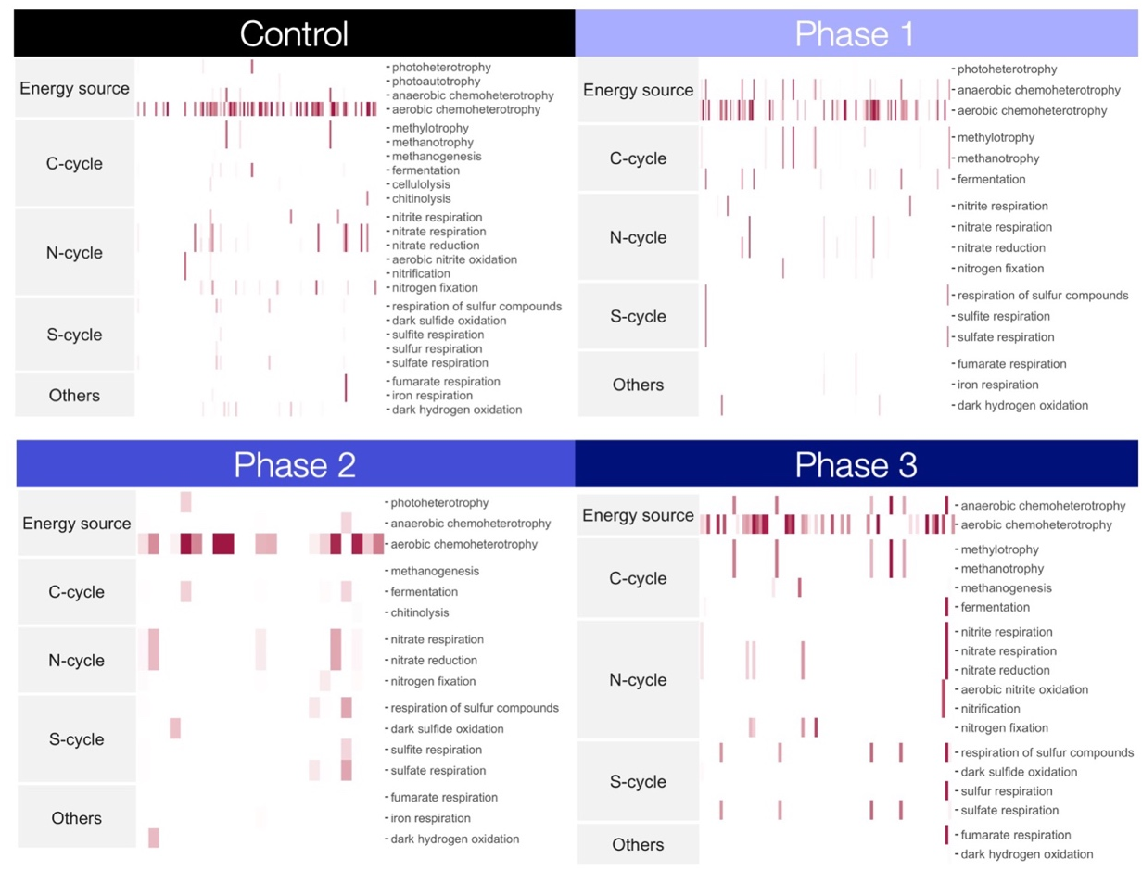
Figure 2.5 Functional assessment from 16S rRNA
Functional assignments for the complete microbial community based on 16S rRNA assigned to functional modules using FAPROTAX.
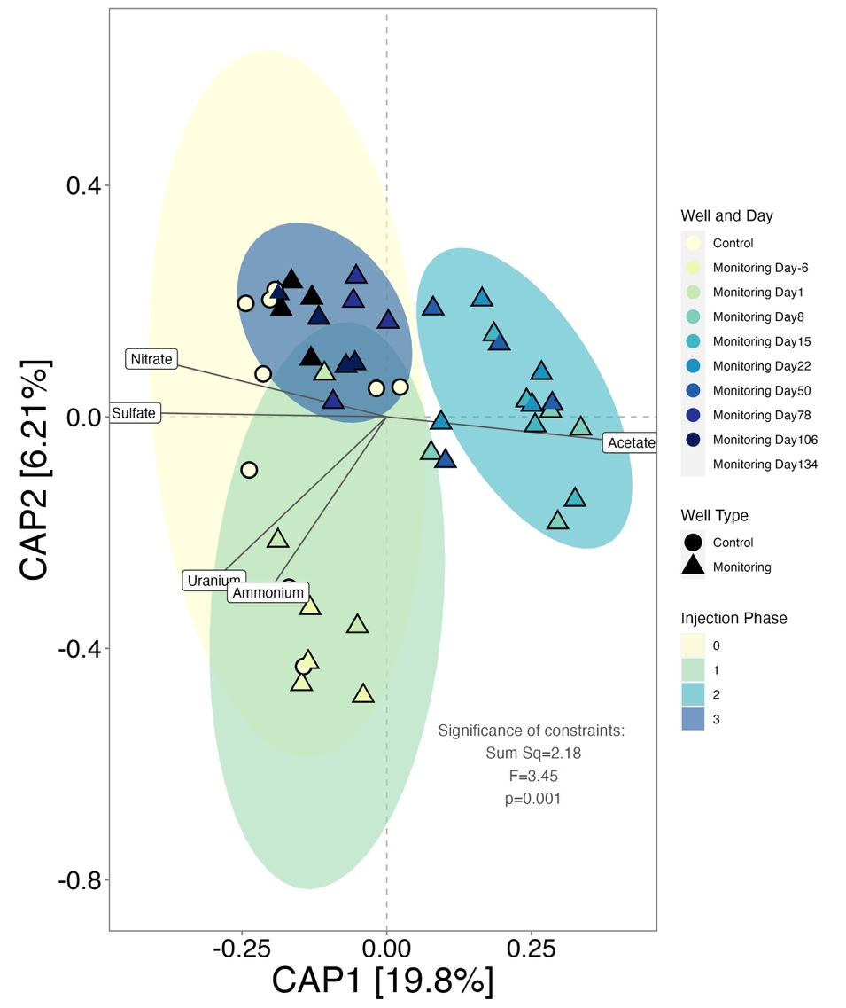
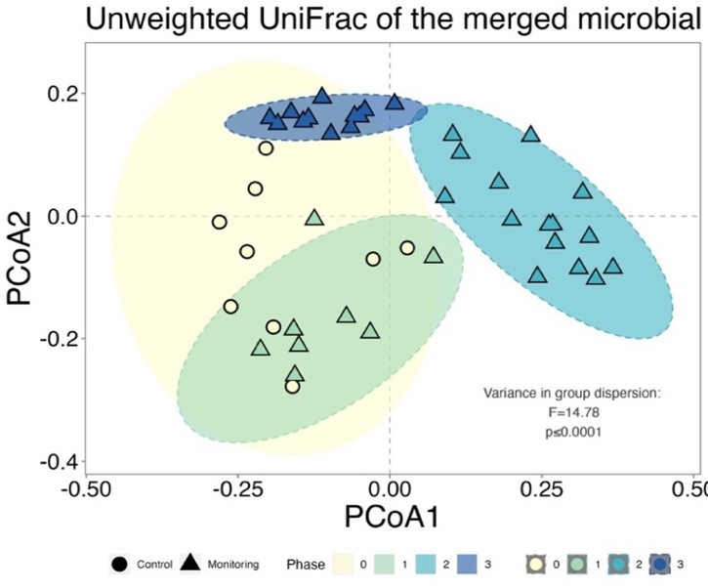
Figure 2.6 Canonical analysis
Changes in community composition with post-injection phase groups shaded by a 95% confidence interval ellipse. Top panel is a canonical analysis of principal coordinates plot used to highlight changes in the community associated with geochemistry and post-injection phases. Beta dispersion eigen values for each phase are plotted in the lower panel.
(Abbreviations: Sum Sq. = Sum of squares).
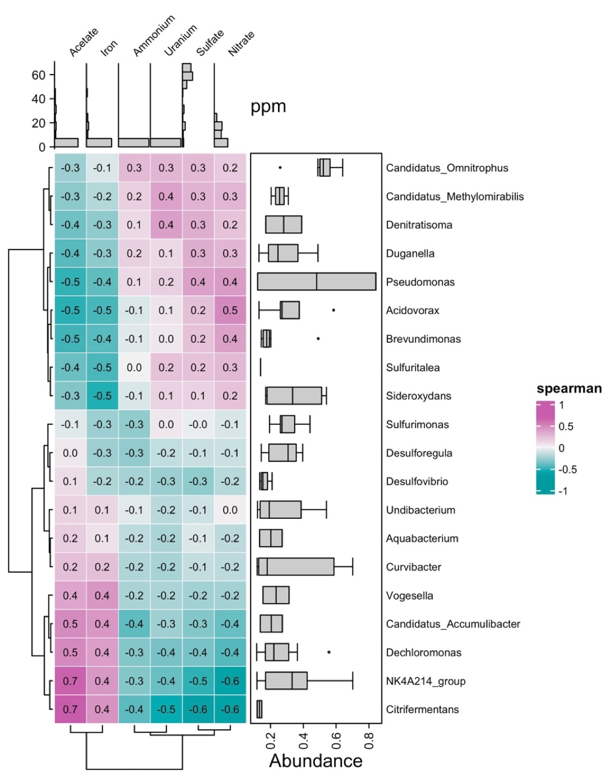
Figure 2.7 Taxonomic and geochemical correlations
Spearman correlation of 20 most-abundant genera in the complete community associated with changes in geochemistry.
- Nitrate B. Sulfate

- Acetate

Figure 2.8 Differentially abundant taxa

Highly differentially abundant taxa associated with the reductive processes identified on days 8-50. Taxa identified in panel A increased in abundance during nitrate reduction. Taxa in panel B increased in abundance during sulfate reduction and panel C identifies taxa which increased in abundance during periods of high acetate.

A. B.
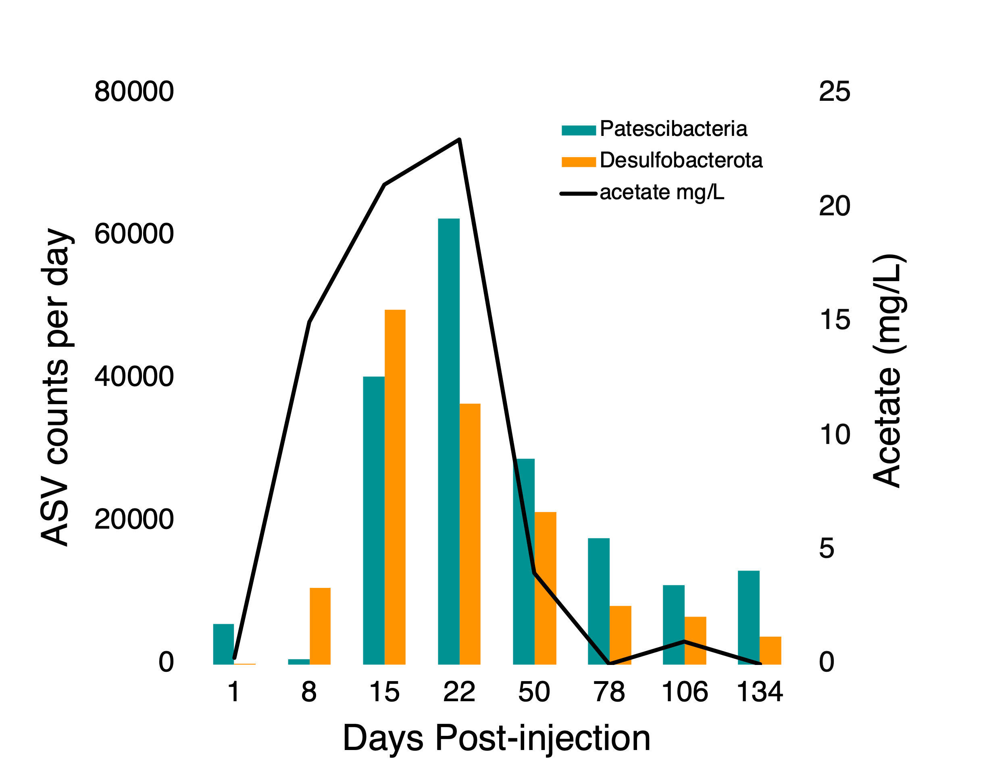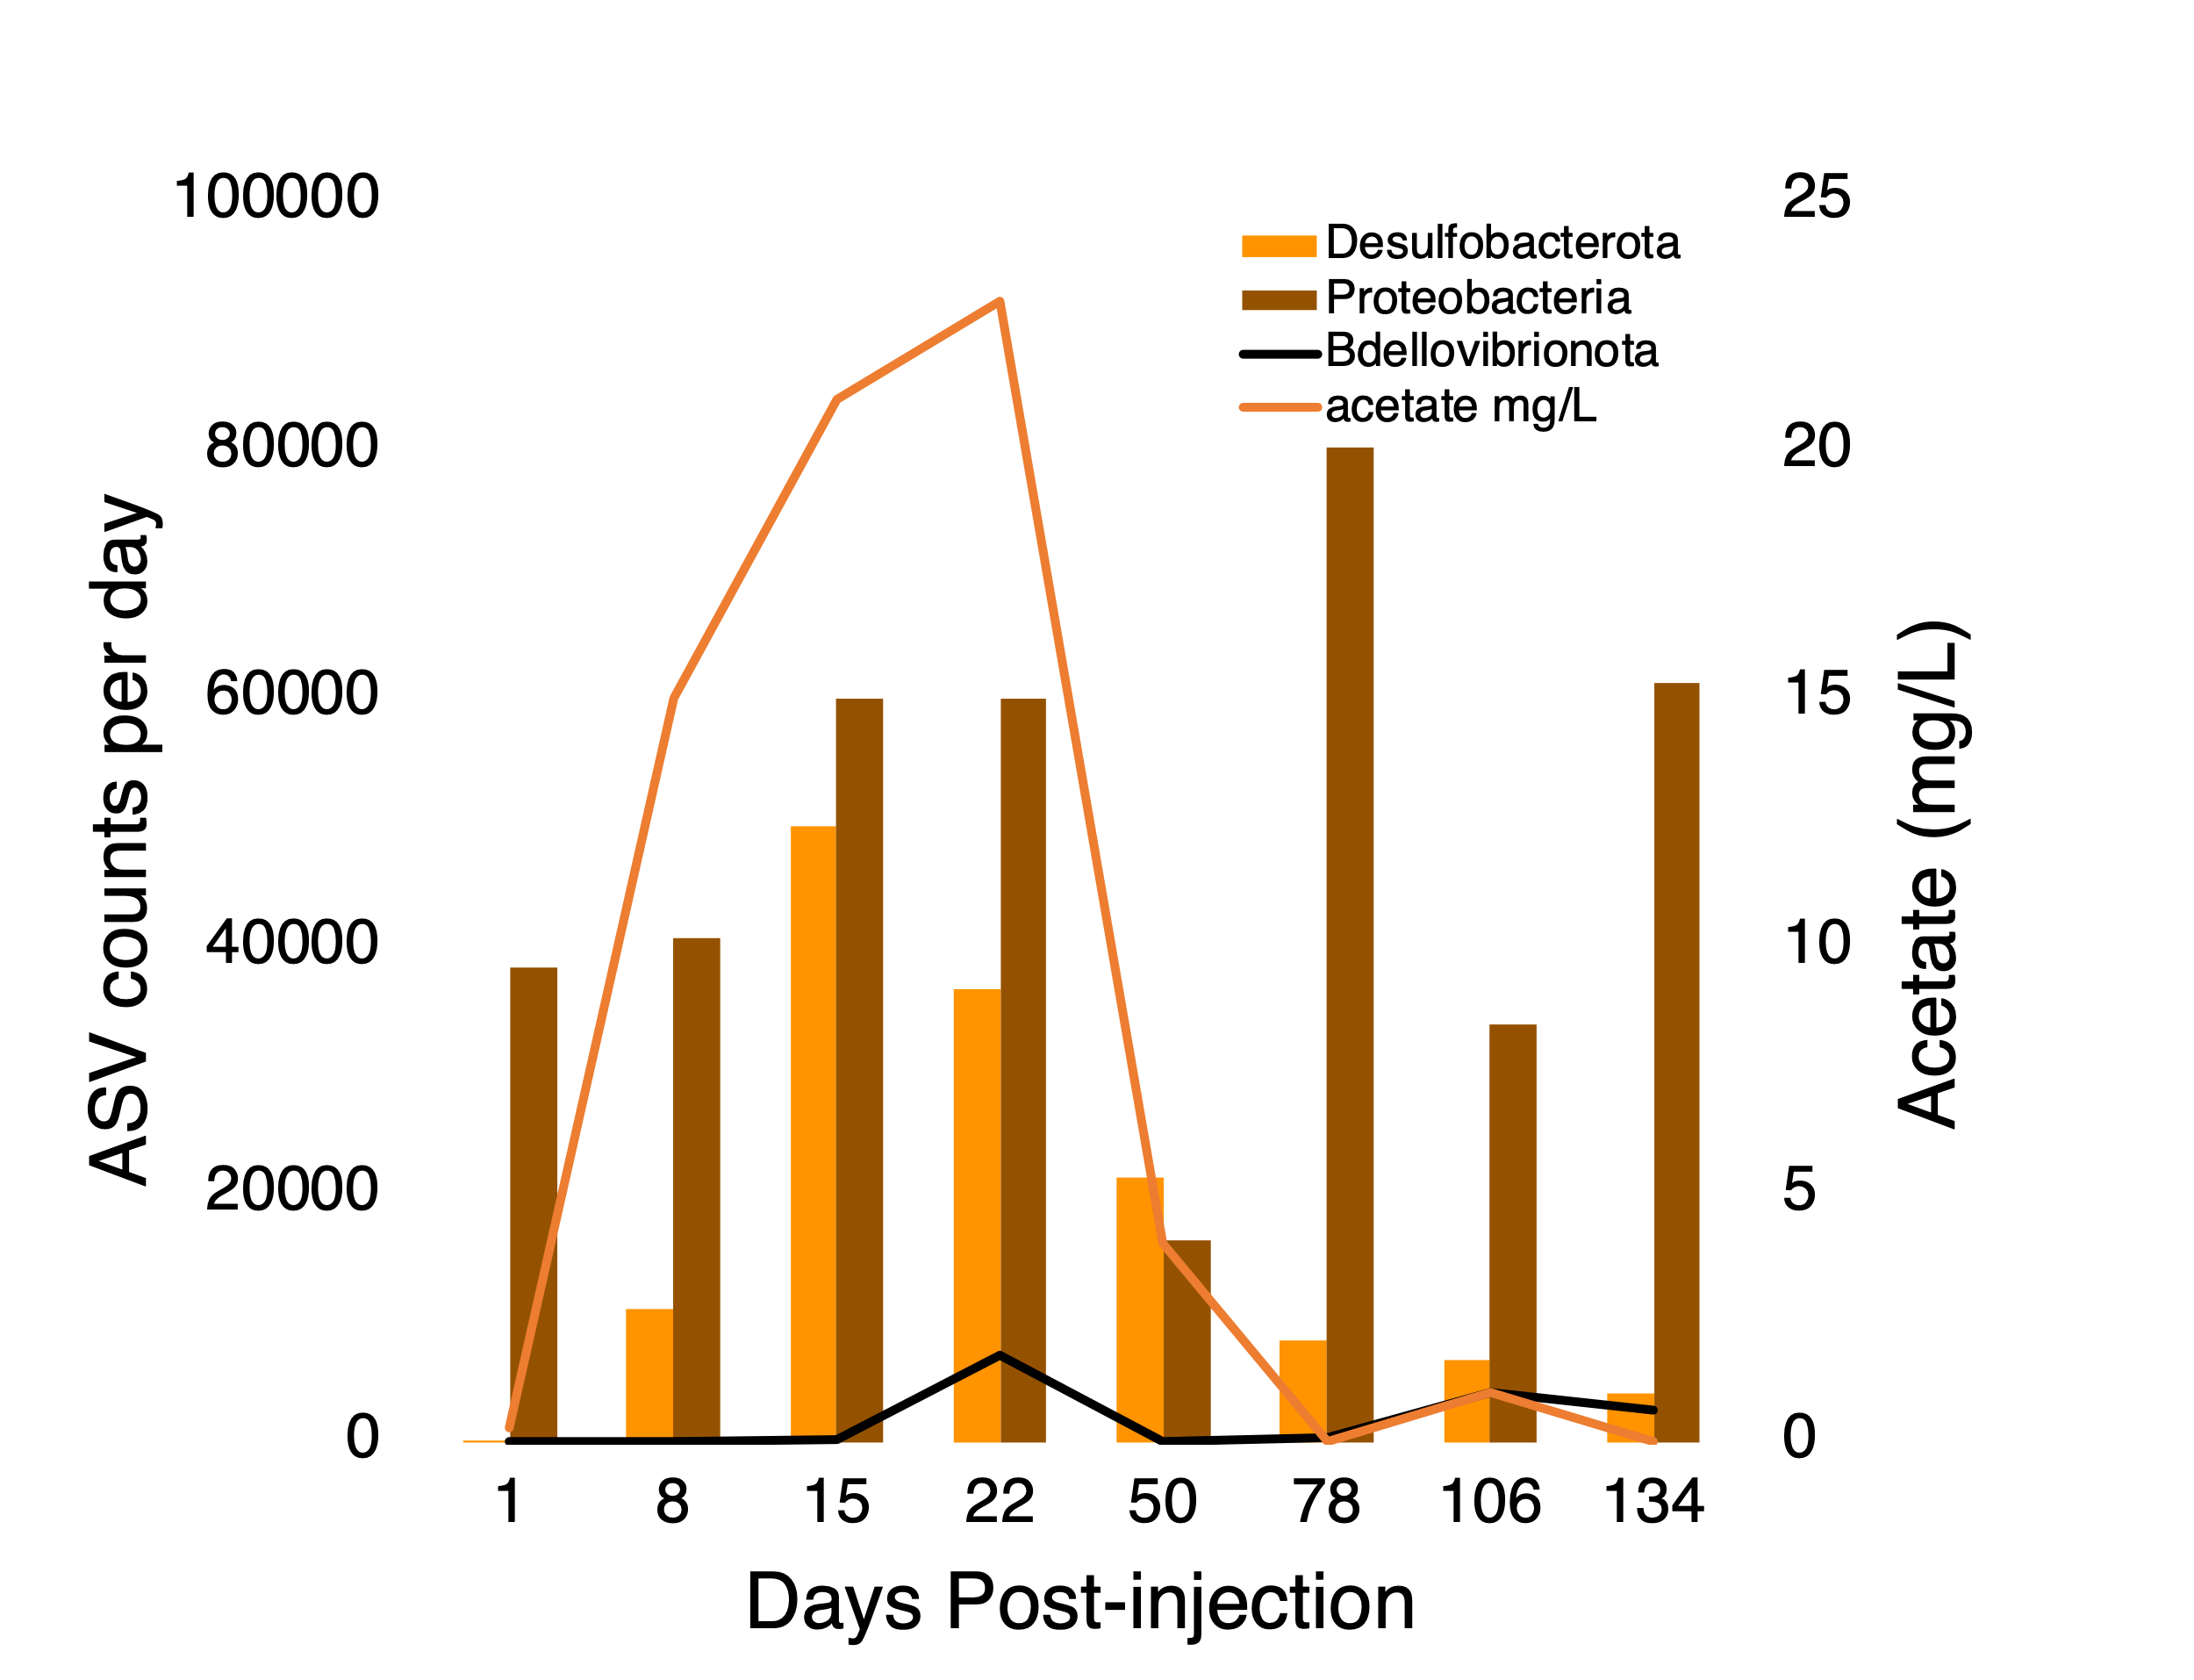

Figure 2.9 Changes in abundance for key phyla
In panel A, Patescibacteria and Desulfobacterota abundance are shown positively trending with acetate during the initial reductive phase of the injection. In panel B, Desulfobacterota and acetate are shown to provide context for community change during sulfate reduction. Proteobacteria is the most abundant phylum and highly active in the degradation of EVO and reduction of sulfate and nitrate. Unlike other phyla which decrease concomitantly with geochemical conditions, proteobacteria abundance is negatively associated with the emergence of a gram-negative predator Bdellovibrio around days 50-78 and day 106.

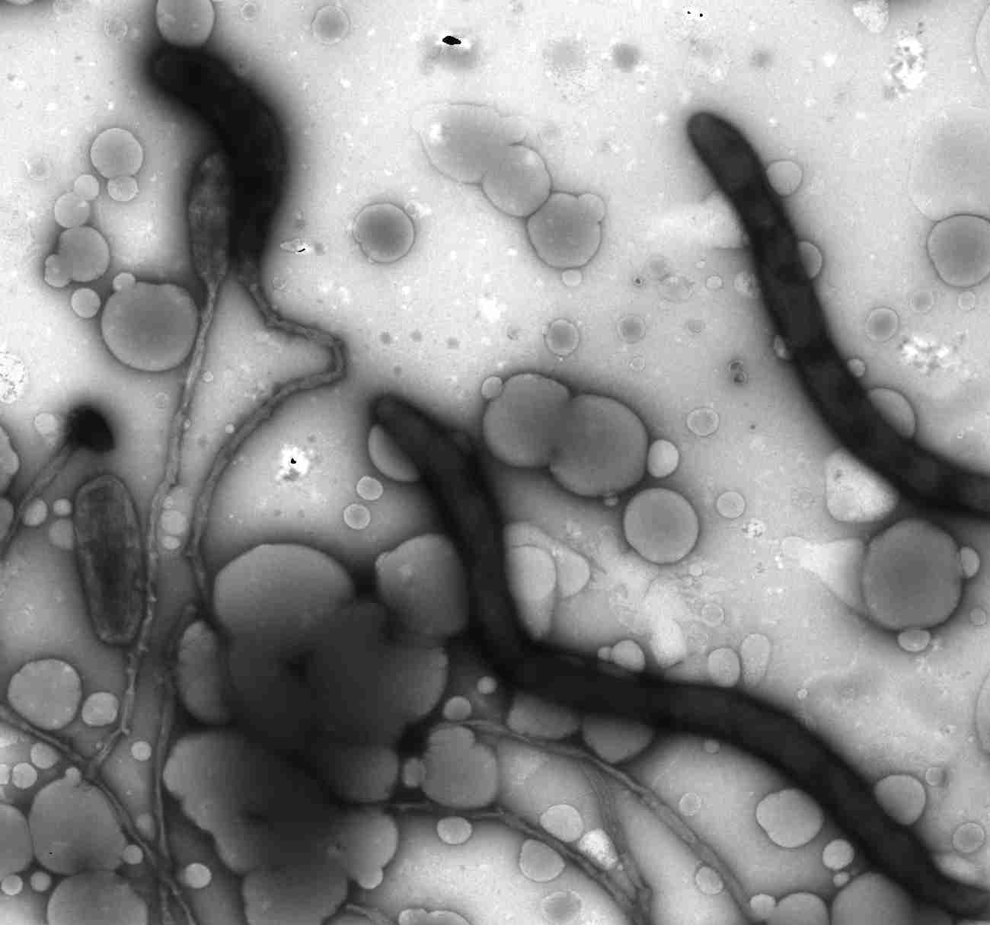
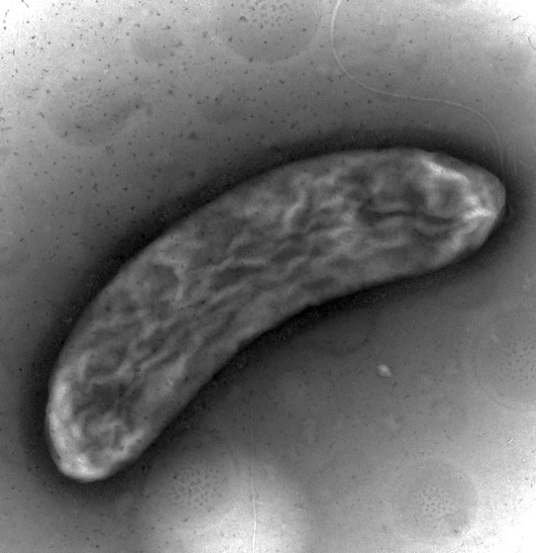
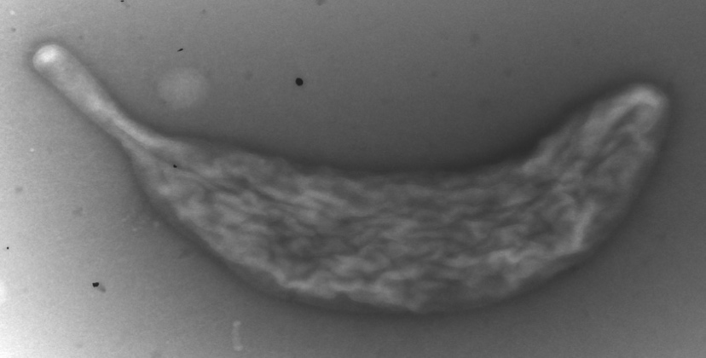
B
A

CONCLUSIONS

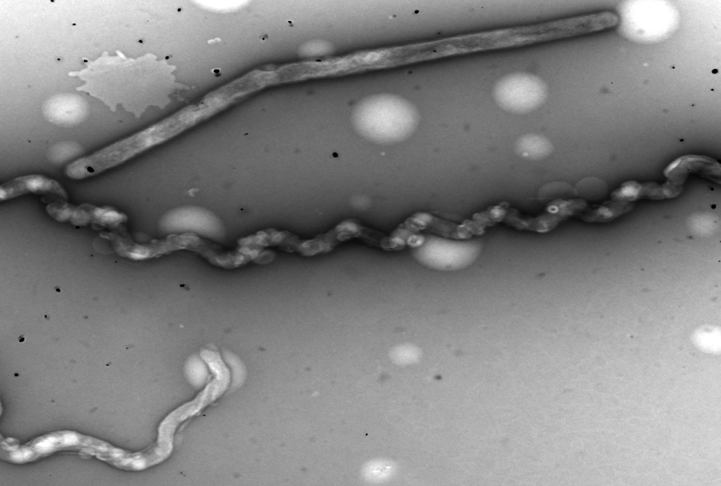
C

D

E
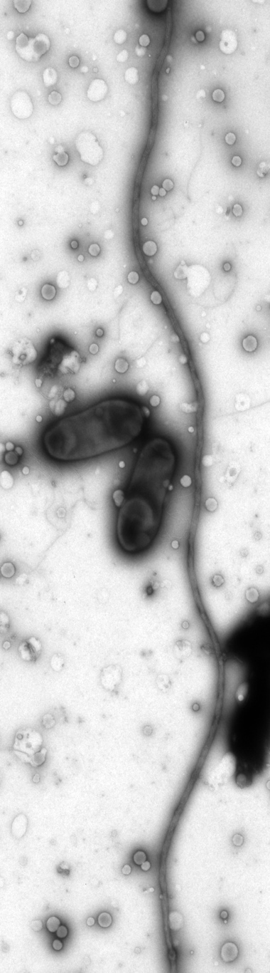
Figure 2.10 Transmission electron micrographs

Assessment of common groundwater organisms collected from monitoring well FW216 and injection well FW213. The cell in panel A is identified as a member of the genus Curvibacter determined by the stalk and textured cell wall identified within this genus by Wein et al. [198]. Panel B shows a likely member of the family Geobacteracaea based on the cell morphology and presence of nanowires (white arrows) [195]. Panel C shows a collection of filamentous bacteria among droplets of vegetable oil. Panel D shows cells among droplets of vegetable oil in the injection well including small vibrioid-shaped cells (potentially Bdellovibrio [199] ) and Magnetospirillum based on the shape and presence of dark metal-like particles [196]. Panel E shows a long filamentous bacterium and two bacteria seemingly entangled or connected by a matrix of nanowires (white arrow) which extend to a metal complex (black arrow).

Supplemental Figures
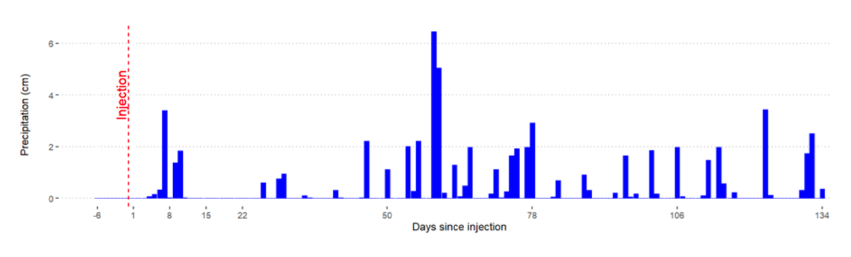
Figure S2.1 Precipitation data from Oak Ridge, TN
Precipitation data collected from an Oak Ridge, TN weather station provided with permission from corresponding author. Figure is from Adams, Benjamin Gregory, Hydraulic Response to Emulsified Vegetable Oil Biostimulation: In-Situ Test in a Highly Heterogenous Uranium Contaminated Aquifer. Master's Thesis, University of Tennessee, 2019.

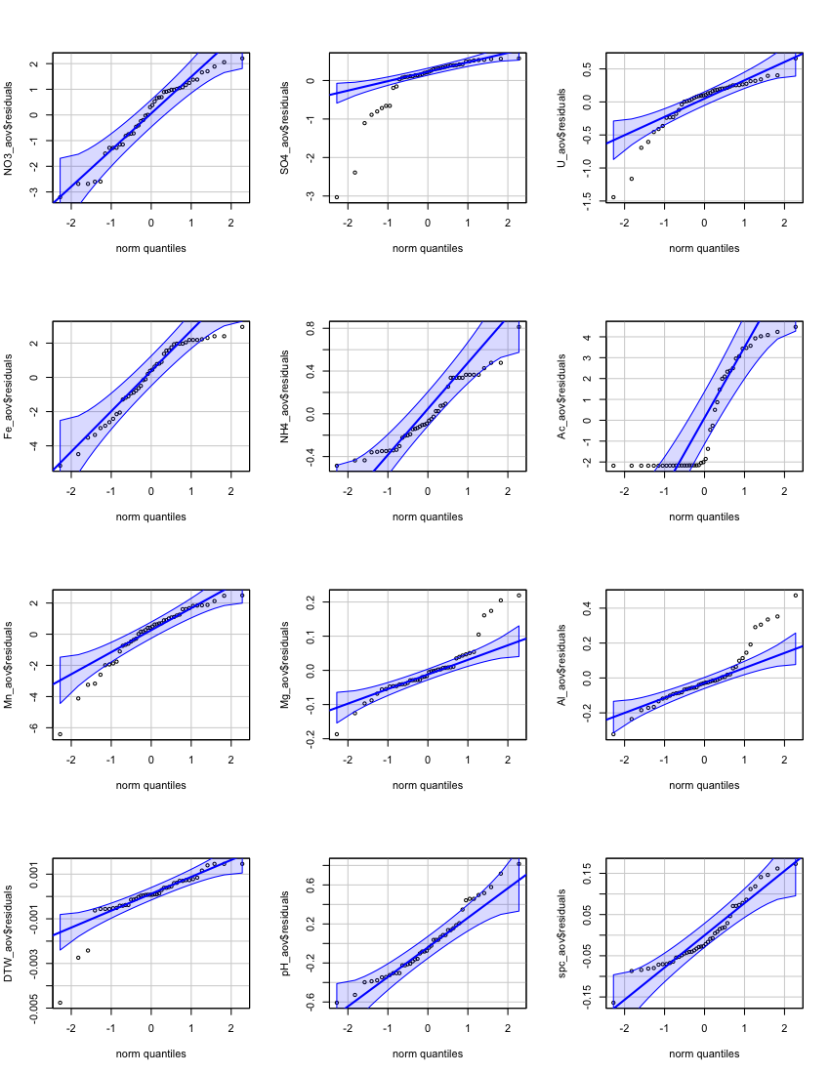
Figure S2.2 Q-Q Plots of ANOVA residuals for geochemistry

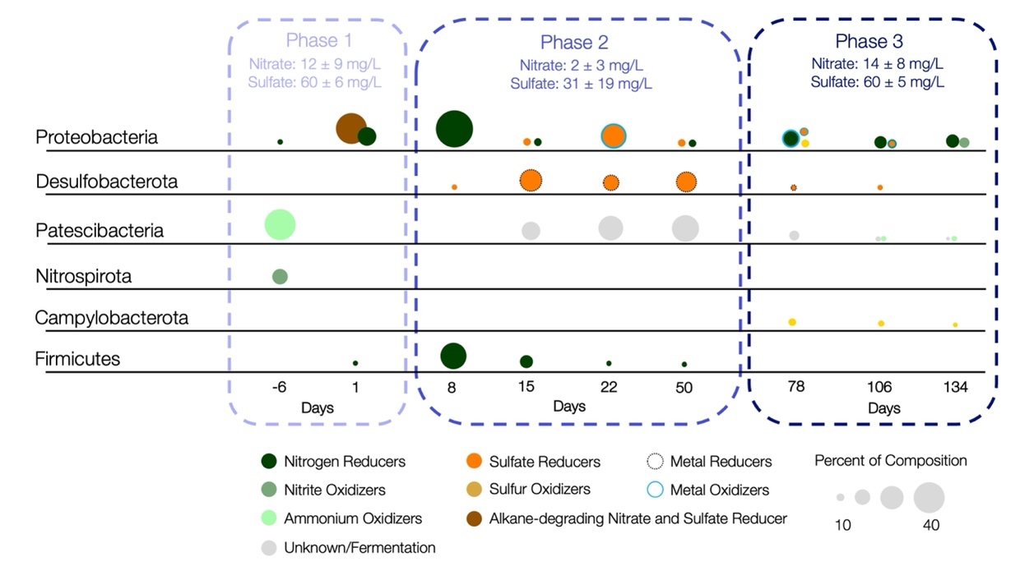
Figure S2.3 Changes in abundance of functional families
Changes in functional microbial families derived from literature-assigned functions for the complete microbial community.

Appendix C: Tables
Table 2.1 Field parameters
Well | Days | pH | Specific Conductivity (uS/cm at 25°C) | Depth to water (mAMSL)
FW215 | -6 | 7.6 | 678.9 | 300.46
 | 1 | 6.41 | 682.2 | 300.42
 | 8 | 6.83 | 672.4 | 300.73
 | 15 | 6.61 | 746 | 300.72
 | 22 | 7.19 | 643.5 | 300.66
 | 50 | 7.14 | 660.3 | 300.64
 | 78 | 7.48 | 601.9 | 301.15
 | 106 | 7.66 | 602.3 | 300.69
 | 134 | 6.62 | 604.2 | 300.74
FW216 | -6 | 7.37 | 661.5 | 300.46
 | 1 | 7.46 | 762.2 | 299.63
 | 8 | 6.91 | 720.7 | 299.05
 | 15 | 6.66 | 669.9 | 300.72
 | 22 | 7.04 | 661.6 | 300.65
 | 50 | 7.02 | 789.1 | 300.64
 | 78 | 7 | 607.7 | 301.15
 | 106 | 6.72 | 617.9 | 300.68
 | 134 | 6.62 | 626.6 | 300.73
GP01 | -6 | 7.48 | 663.5 | 300.45
 | 1 | NA | NA | NA
 | 8 | 6.99 | 713.5 | 300.71
 | 15 | 6.62 | 707.3 | 300.71
 | 22 | 6.84 | 742.7 | 300.64
 | 50 | 7.12 | 798 | 300.63
 | 78 | 7.03 | 655.7 | 301.13
 | 106 | 6.6 | 730.9 | 300.68
 | 134 | 6.85 | 646.6 | 300.73
GP03 | -6 | 7.48 | 703.4 | 300.44
 | 1 | 6.49 | 710.8 | 300.41
 | 8 | 6.93 | 594.1 | 300.66
 | 15 | 6.63 | 757.6 | 300.68
 | 22 | 6.79 | 741 | 300.61
 | 50 | 7.48 | 755.7 | 300.61
 | 78 | 7.05 | 600 | 301.06
 | 106 | 6.62 | 604.6 | 300.65
 | 134 | 7.74 | 599.9 | 300.71
MLSB3 | -6 | 7.23 | 655.3 | 300.47
 | 1 | 6.86 | 676.7 | 300.41
 | 8 | 6.93 | 782.8 | 299.75
 | 15 | 6.8 | 690.1 | 300.71
 | 22 | 6.96 | 647.3 | 300.64
 | 50 | 7.12 | 776.9 | 300.64
 | 78 | 7.05 | 598.4 | 301.15
 | 106 | 6.64 | 601.1 | 300.69
 | 134 | 6.7 | 600.5 | 300.73
Table 2.2 Geochemical parameters
Well | Days | Acetate | Nitrate | Sulfate | Uranium | Ammonium
FW215 | -6 | 0.107 | 9.68 | 65.66 | 0.86 | 1.01
 | 1 | B.D. | 8.74 | 64.49 | 1.09 | 0.83
 | 8 | B.D. | 12.5 | 68.53 | 1.17 | 0.52
 | 15 | 1.266 | 17.74 | 67.56 | 1.38 | B.D.
 | 22 | B.D. | 19.81 | 60.13 | 1.20 | B.D.
 | 50 | B.D. | 18.62 | 58.24 | 1.22 | 0.43
 | 78 | B.D. | 15.08 | 67.98 | 1.12 | 0.50
 | 106 | B.D. | 13.43 | 61.96 | 1.06 | 0.45
 | 134 | B.D. | 20.64 | 63.96 | 1.15 | 0.32
FW216 | -6 | 0.086 | 21.7 | 61.66 | 0.98 | 0.83
 | 1 | B.D. | 9.5 | 63.18 | 1.25 | 0.65
 | 8 | 5.687 | 2.49 | 45.15 | 1.12 | 0.51
 | 15 | B.D. | 1.49 | 60.29 | 1.26 | B.D.
 | 22 | 0.348 | 6.94 | 56.74 | 1.06 | B.D.
 | 50 | B.D. | 13.4 | 52.95 | 1.16 | B.D.
 | 78 | B.D. | 12.06 | 64.72 | 1.11 | 0.45
 | 106 | B.D. | 19.35 | 57.44 | 0.83 | 0.47
 | 134 | B.D. | 27.47 | 62.09 | 1.13 | 0.48
GP01 | -6 | 0.093 | 3.76 | 53.67 | 0.91 | 0.50
 | 1 | NA | NA | NA | NA | NA
 | 8 | 11.390 | B.D. | 52.78 | 1.04 | 0.52
 | 15 | 18.876 | 0.25 | 32.74 | 0.82 | B.D.
 | 22 | 26.832 | 2.96 | 19.75 | 0.59 | 1.06
 | 50 | 5.508 | 2.26 | 19.46 | 0.30 | 0.60
 | 78 | B.D. | 16.79 | 69.01 | 1.32 | 0.49
 | 106 | B.D. | 20.25 | 51.84 | 0.83 | 0.43
 | 134 | B.D. | 27.46 | 60.40 | 0.86 | 0.31
GP03 | -6 | 0.024 | 2.7 | 66.76 | 0.90 | 0.50
 | 1 | B.D. | 19.52 | 52.22 | 0.99 | 0.52
 | 8 | 3.880 | 0.88 | 50.33 | 0.99 | 0.45
 | 15 | 31.509 | 1.59 | 16.29 | 0.77 | B.D.
 | 22 | 46.428 | B.D. | 1.95 | 0.62 | B.D.
 | 50 | 10.232 | 0.32 | 3.98 | 0.23 | B.D.
 | 78 | B.D. | 0.45 | 69.21 | 1.94 | 0.39
 | 106 | 0.860 | 1.76 | 56.12 | 1.35 | 0.41
 | 134 | B.D. | 10.34 | 59.49 | 1.33 | B.D.
MLSB3 | -6 | 0.095 | 25.13 | 57.32 | 1.11 | 0.62
 | 1 | B.D. | 1.87 | 65.57 | 1.27 | 0.66
 | 8 | 36.671 | B.D. | 33.41 | 1.08 | 0.65
 | 15 | 29.698 | 0.23 | 20.56 | 0.64 | B.D.
 | 22 | 16.460 | B.D. | 13.36 | 0.51 | B.D.
 | 50 | 0.147 | 0.19 | 22.49 | 0.48 | 0.51
 | 106 | B.D. | 3.86 | 54.08 | 1.36 | 0.51
 | 78 | B.D. | 8.92 | 58.65 | 1.49 | 0.52
 | 134 | B.D. | 6.85 | 59.21 | 1.31 | 0.45
‘B.D.’ Below detectable limits; ‘NA’ Missing Data; values reported in (mg/L)

Table 2.3 Multivariate ANOVA of geochemistry
 | All wells |  |  | Monitoring only
Test Variables | Well Type | Days | Well | Days | Well
Sulfate | 10.83** | 7.51*** | 6.21** | 8.85*** | 6.25**
Nitrate | 26.27*** | 8.47*** | 6.55*** | 12.41*** | 7.52***
Uranium | 5.52* | 9.55*** | 1.89 | 12.55*** | 1.98
Ammonium | 0.05 | 18.87*** | 0.84 | 15.81*** | 1.1
Specific Conductivity | 4.68* | 12.35*** | 4.51** | 9.65*** | 4.14*
p value: 0 ‘***’ 0.001 ‘**’ 0.01 ‘*’ 0.05 ‘ ’ >0.1 ; F and p-values reported

Table 2.4 Summary of Phyloseq data objects
 | Samples (n) | Taxa | ASV Abundance  per sample |  |  | Description
 | Samples (n) | Taxa | Mean | Median | Total | Description
Complete Community | 44 | 11,990 | 45864 | 46454 | 2018050 | A combination of the 75 complete 0.2 and 0.1 µm filter communities merged by well + day
0.2 µm only | 44 | 8040 | 4590 | 3201 | 201999 | The 0.2 µm community excluding any ASVs also identified in the 0.1 µm
overlapping microbes | 75 | 2927 | 24015 | 24153 | 1801934 | ASVs identified from both the 0.2 and 0.1 µm filters

Table 2.5 Multivariate ANOVA of richness and eveness estimators
 | Complete Community |  |  | 0.2 µm only
Test Variable | Shannon | ACE | Inv. Simpson | Shannon | ACE | Inv. Simpson
Well Type | 12.69** | 70.78*** | 0.03 | 43.31*** | 89.42*** | 75.19***
Day | 11.8*** | 20.23*** | 2.99* | 11.07*** | 15.11*** | 19.24***
Filter | NA | NA | NA | NA | NA | NA
Nitrate | 0.123 | 0.83 | 2.76 | 1.91 | 0.05 | 0.07
Sulfate | 13.01** | 3.33 | 3.05 | 6.17* | 1.97 | 0.38
Day:Well Type | 4.71** | 8.78*** | 2.92* | 1.67 | 9.18*** | 9.17***
p value: 0 ‘***’ 0.001 ‘**’ 0.01 ‘*’ 0.05 ‘ ’ >0.1; F and p-values reported

Supplemental Tables

Table S2.1 Tukey post-hoc test results
Term | Variable | Contrast | BH p-value  (all wells) | BH p-value (monitoring only)
Days | Sulfate | 22: -6 | ** | ***
 |  | 22:1 | *** | ***
 |  | 22:8 | ** | **
 |  | 22:78 | *** | ***
 |  | 22:106 | *** | ***
 |  | 22:134 | *** | ***
 |  | 50: -6 |  | **
 |  | 50:1 | * | **
 |  | 50:8 |  | *
 |  | 50:78 | ** | **
 |  | 50:106 | * | *
 |  | 50:134 | * | ***
 | Nitrate | 8:-6 |  | *
 |  | 8:106 |  | ***
 |  | 8:134 | *** | ***
 |  | 15:-6 | ** | ***
 |  | 15:1 | ** | ***
 |  | 15:106 | *** | ***
 |  | 15:134 | *** | ***
 |  | 15:78 | ** | ***
 |  | 22:106 | * | ***
 |  | 22:134 | * | ***
 |  | 50:106 | * | ***
 |  | 50:134 | *** | ***
Bonferroni-Holm (BH) p value: 0 ‘***’ 0.001 ‘**’ 0.01 ‘*’ 0.05 ‘ ’ >0.1
Table S2.1 Tukey post-hoc test continued.
Term | Variable | Contrast | BH p-value  (all wells) | BH p-value (monitoring only)
Days | Uranium | 15: -6 | * | **
 |  | 22: -6 | ** | **
 |  | 50: -6 | *** | ***
 |  | 50:1 |  | *
 |  | 50:78 | ** | **
 |  | 50:106 |  | *
 |  | 50:134 | * | **
 | Ammonium | 15:8 | ** | **
 |  | 15:78 | *** | **
 |  | 15:106 | *** | **
 |  | 15:134 | *** | **
 |  | 22: -6 |  | *
 |  | 22:8 | ** | ***
 |  | 22:78 | *** | **
 |  | 22:106 | *** | ***
 |  | 22:134 | *** | **
 | Specific Conductivity | 1:78 |  | *
 | Specific Conductivity | 8:78 | *
 | Specific Conductivity | 15:78 | *
 | Specific Conductivity | 15:106 | *
 | Specific Conductivity | 15:134 | *
 | Specific Conductivity | 50:78 | *** | ***
 | Specific Conductivity | 50:106 | ** | **
 | Specific Conductivity | 50:134 | *** | ***
Wells | Sulfate | FW216:GP03 | ***
 | Nitrate | FW216:MLSB3 | **
 | Nitrate | FW216:GP03 | **
 | Specific Conductivity | GP01:MLSB3 | *
 |  | GP01:GP03 | *
Bonferroni-Holm (BH) p value: 0 ‘***’ 0.001 ‘**’ 0.01 ‘*’ 0.05 ‘ ’ >0.1

RESPONSE OF SMALL PLANKTONIC GROUNDWATER MICROBES TO AN IN-FIELD ELECTRON DONOR INJECTION

This is a previously unpublished chapter, although subsets of these data have been incorporated into two previously accepted theses.

Publications that reference this data:
- McBride, Kathryn R., Microbial Memory Response: Observing History-Dependent Adaptation to Repeated Exposures of Emulsified Vegetable Oil in a Contaminated Aquifer. Master's Thesis, University of Tennessee, 2018.
- Adams, Benjamin Gregory, Hydraulic Response To Emulsified Vegetable Oil Biostimulation: In-Situ Test In A Highly Heterogenous Uranium Contaminated Aquifer. Master's Thesis, University of Tennessee, 2019.
Authors:
Andrew D. Putt¹, Benjamin G. Adams¹, Kathryn R. McBride², Jonathan P. Michael³, Yupeng Fan³, Kenneth A. Lowe⁴, Peter Walian⁵, Daliang Ning³, Jizhong Zhou^{3,6,7}, Larry D. McKay⁸, Terry C. Hazen^{1,2,4,9,10}
Affiliations:
¹Department of Earth and Planetary Sciences, University of Tennessee, Knoxville, TN, USA
²Department of Microbiology, University of Tennessee, Knoxville, TN, USA
³Department of Microbiology, University of Oklahoma, Norman, OK, USA
⁴Biosciences Division, Oak Ridge National Laboratory, Oak Ridge, TN, USA
⁵Lawrence Berkeley National Lab, Berkeley, CA, USA
⁶School of Civil Engineering and Environmental Sciences, University of Oklahoma, Norman, OK, USA
⁷Earth and Environmental Sciences, Lawrence Berkley National Laboratory, Berkeley, CA, USA
⁸Associate Dean for Research and Facilities, University of Tennessee, Knoxville, TN, USA
⁹Department of Civil and Environmental Sciences, University of Tennessee, Knoxville, TN, USA
¹⁰Institute for a Secure and Sustainable Environment, University of Tennessee, Knoxville, TN, USA
Author Contributions:
Sample collection- BGA, KRM, and ADP
Geochemical analysis- ADP and KAL
Sequencing- ADP, YF and JPM
Sequence Post-processing- ADP and JPM
Data analysis- ADP with input from JPM, DN, and TCH.
Electron Microscopy- PW and ADP
Figure generation- ADP
Authored paper- AP with input from LDM and TCH

Abstract
Small cells are often abundant in groundwater systems, but the composition and dynamics of this community remain largely unknown. Environmental surveys have suggested a wide dispersal of this community, but changes in the community composition and response to geochemical perturbation remain under-studied. Using the injection of an electron donor shown to differentially enrich nitrate and sulfate reducing microbial families, this work will assess the compositional changes of small microbes. Sampling included filtration with 0.2 µm pore diameter membranes and sequential filtering on 0.1 µm pore diameter membranes. Microbes captured on the 0.1 µm pore membrane filters included only a quarter of the total taxa but accounted for nearly 89% of the total abundance. However, the community identified from the 0.1 µm pore diameter filter showed no dispersion between the control and monitoring wells with composition only differing by day. Potentially driven by a few abundant orders, we identify a clear shift in a Patescibacteria phylum which co-occurs during sulfate reduction and a potentially syntrophic relationship to the phylum Desulfobacterota. Additional surveys of the groundwater cells with electron microscopy identified small cells <0.3 µm to make up 74% of the cells in this groundwater community.

Introduction
Members of the candidate phyla radiation [2] condensed to the phylum Patescibacteria [3] have been identified in abundance across several groundwater systems [6-9]. Highly abundant small bacteria (<0.4 µm) have even accounted for over eighty percent of cells in some groundwater studies [1]. A majority of the small groundwater cells, particularly in the 0.1 µm microcell/ultra-micro cell size fraction have been attributed to the metagenome classified Patescibacteria phylum [4, 5]. Much remains unknown about the dynamics of this community, but orders of this phylum have been associated with nitrogen, sulfur, and iron cycling bacteria and contain an abundance of genes associated with a fermentative lifestyle [42, 174]. The dynamics of this ubiquitous community remains a topic of continued interest as their role in nitrogen, sulfur, carbon, and metal cycling continues to be uncovered. This community has often been discussed when they are abundant, but the environmental constraint of their abundance remains uncharacterized.
The small cell size exhibited by Patescibacteria has been proposed as a survival strategy for low-energy environments where an increased surface to cell volume ratio may optimize nutrient intake [57, 200, 201] a feature also observed in starved bacterial forms [32, 37, 202]. Cell minimalization has also been associated with genome streamlining to conserve only essential genes and traits [9, 14, 38, 61]. In extreme cases, the highly reduced genomes of Candidatus Paceibacteria and Microgenomatia may have even forgone common genes associated with amino acid and nucleotide biosynthesis in favor of a host-dependent lifestyle [9, 203, 204]. Suggesting that associations in the environment might also be based on the presence of potential host cells in addition to geochemistry.
Patterns of Patescibacteria distribution were assessed during an emulsified vegetable oil injection in a contaminated, highly heterogeneous, and unconfined groundwater system. Patescibacteria abundance captured from 0.1 µm and 0.2 µm filters was assessed along with the community of cells able to bypass a 0.2 µm filter matrix [55, 102]. Re-filtering the 0.2 µm filtrate on a 0.1 µm filter is intended to capture small cells abundant [205] and active [72] in shallow groundwater systems. Organisms able to pass through a 0.2 µm membrane are commonly referred to as Ultramicrobacteria [41] or more specific to the 0.2 µm filtrate are termed ultra-small bacteria [5].
Importantly, groundwater community analysis has the potential to underestimate the total composition of biomass and activity in the subsurface by excluding adhered cells in the sampling of the predominately planktonic fraction [104]. Adhered cells account for a majority of the subsurface activity and biomass with up to 98% of the subsurface cells bound to surface [105-109]. This may under estimate the total subsurface diversity and limit the understanding of active cells [104]. The preferential sampling of groundwater has been known to selectively sample Patescibacteria [5, 42] and some subclasses of Proteobacteria [112] as well as planktonic sulfate and metal reducers which are comparatively predominant in organic-rich groundwater [113]. This will result in a sampled subset of preferentially mobile cells including those involved in dissimilatory reductive processes which are the target of this study.
The objective of this chapter is to identify the group of microbes able to preferentially pass through 0.2 µm pores with respect to three critical objectives. (1) Provide a survey of taxa able to pass through a 0.2 µm filter [50]. (2) Identify ultra-small taxa with a focus on Patescibacteria, and (3) identify the effect of the injection on the filterable community during an EVO injection previously identified as capable of driving community succession [21, 75]. The two core hypotheses proposed are:
- Fermentative by-products from the Patescibacteria phylum will result in the co-enrichment of sulfate-reducing bacteria.
- The 0.1 µm community composition will be closely associated with the production of acetate under reducing conditions based on previously published metabolic pathways for acetate production in this group.
- The gravel matrix will have a high composition of filterable Ultramicrobacteria.

Materials and Methods

Site selection
As described in chapter 2, the injection site is contaminated with nitrate and uranium from the S3 ponds and is located 300 m down-gradient of the contaminant source. It is a research site identified by the ENIGMA (https://enigma.lbl.gov/) program as Area 2 (Figure 3.1). Area 2 is highly heterogeneous, but where the injection occurred the site has a shallow water table about 3 m below ground surface and is immediately upgradient of Bear Creek. The wells are screened into primarily carbonate gravel that was backfilled over a portion of Bear Creek before it was re-routed for the construction of the S3 ponds. Permeabilities range from 0.6 to 5% with connections among the wells previously established by bromide and EVO injections [21, 26, 80].

EVO injection
A 20% EVO solution was generated by thoroughly mixing 832 L of native groundwater with 208 L of 60% SRS-SD small droplet EVO (Terra Systems Inc. Claymont, DE). The 1040 L EVO injectate solution was then simultaneously injected into FW212, FW213, and FW214 on December 13, 2017. The EVO solution was injected at a rate of 1L/min/well over 5.8 hours. The date of injection is day zero for all subsequent analyses with samples collected six days prior and immediately one day after the injection from the control and monitoring wells. Sampling continued once a week for four weeks, and then once a month for four months until day 134.

Sample and field parameter collection
Groundwater samples were using peristaltic pumping as described in chapter 2. Briefly, samples were collected 6 days prior to and 1, 8, 15, 22, 50, 78, 106, and 134 days following the injection of EVO. Field parameters like pH, and specific conductivity (µS/cm) were measured using an AquaTROLL® 9600 (In-situ, Fort Collins, Co) multiparameter sonde. After stabilization, 10L of groundwater were collected in sterile amber glass bottles with no headspace and transported at 4°C for filtration through a polycarbonate (PCTE) 10 µm and nylon 0.2 µm pore-diameter filter membrane (Sterlitech, Kent, WA) before being re-filtered with a sterile laser-drilled PES 0.1 µm pore-diameter filter (ThermoFisher). Samples of the 0.1 µm community from 6 days prior to the start of the experiment and day 50 are omitted for sampling error and failed sequence quality respectively. Sixteen-months post-injection additional 1L volumes of groundwater were collected for cell size estimates in MLSB3 and GW821 (35.9412 N, 84.33623 W) using the sampling procedure described without filtration. Samples were collected every two weeks for nine weeks within 24-hours of each other and stored/shipped with no headspace and no preservative. GW821 was selected as a control for native undisturbed saprolite with samples collected from a shallow interval located 5.8 to 6.5 m below ground surface.

Groundwater geochemistry
Cations and trace metals were measured from unfiltered water samples using inductively coupled plasma mass spectrometry (ICP-MS) on an ELAN 6100 system (PerkinElmer, Inc. Waltham, MA) as described previously (22).
Anions and Organic acids were analyzed in tandem using a Dionex ICP 5000+ with a potassium hydroxide gradient on an AS-11 environmental column with detection by electrical conductivity as described in chapter 2. Changes in geochemistry with means and standard deviation calculated using a dplyr summarize function and were plotted in ggplot2 [122].

Imaging with transmission electron microscopy
Groundwater was concentrated and the supernatant imaged as described in chapter 2. Briefly, 80 mL of water were concentrated to a 300-400 µl volume using centrifugation and a cell concentrator. Cells were negatively stained with uranyl acetate and imaged on a JEOL JEM-1200x electron microscope operating at 80 kV with images recorded by a 2k x 2k pixel CCD camera (UltraScan, Gatan) controlled by the DigitalMicrograph software package which provided length and width measurements.

16S rRNA gene amplicon library preparation and sequencing
The extraction process was the same as described in chapter 2. Briefly, biomass from small pieces of filter membrane were extracted using sterile sand and extraction buffer with DNA purified using the DNeasy PowerSoil DNA isolation kit (Qiagen; bead beating step omitted). Amplicon sequence libraries of the 16S rRNA V4 region were generated using a two-step PCR approach as described previously [117]. Amplified PCR products were pooled by molality and purified before preparation and sequenced using 251, 12, and 251 cycles for forward, index, and reverse reads on an Illumina MiSeq with a 500-cycle v2 MiSeq reagent cartridge (Illumina, San Diego, CA) [117].

16S rRNA gene amplicon sequence processing
Amplicon sequence processing was performed as described in chapter 2. The QIIME2 2019.7 [119] tools integrated into the IEG Galaxy Pipeline (University of Oklahoma, Norman OK) were used to process sequences obtained from the MiSeq. Trimmed, denoised, aligned amplicon sequence variants (ASV) were determined using the QIIME2 2019.7 classifier with taxonomy assigned using the SILVA 138 small subunit rRNA database (https://www.arb-silva.de/documentation/release-138/). ASVs unique to the 0.1 and 0.2 µm communities were identified as such and the overlapping ASVs found in both filter types were also subset in post-processing.

Statistics and mapping
All statistical analyses were completed with R [121] (version 4.1.2) using Phyloseq (version 1.36.0), ggplot2 visualizations, vegan (version 2.6-2) [123] and packages on Bioconductor (version 3.14) as described in chapter 2. A full list of packages and code are available at https://github.com/putt-ad/dissertation. Well locations, well construction, and elevation data from Y12 well construction database are plotted using ggplot2. Static imagery and spatial maps data were extracted from google using a personal API to directly import data from the google static imagery repository using code from the ggmap package [125].

Community dispersion
Changes in the abundance and genera associated with the injection were tested as described in chapter 2. To summarize the method, UniFrac unweighted matrices were calculated from unrarefied data for the complete 0.1 µm community. Subsequent tests conducted with vegan functions (version 2.6-2) tested disperse and unique groups using the betadisper function. Iterative beta dispersion tests were tested with an ANOVA. Distinct groups were tested using a multivariate multiple regression distance-based redundancy analysis with group homogeneity identified using the Anosim function. The effects of covariates on community composition were identified using a canonical analysis of principle coordinates and redundancy analyses.

Differential abundance and correlations of asvs to geochemistry
All functions in this section were processed by the Bioconductor package MicroViz (version 0.9.3) [128]. Correlations of the abundance data were tested against the geochemistry using a spearman rank correlation. Dispersions in ASV abundances were tested with unrarefied, TSS-transformed data in pairwise comparisons assessed using a linear discriminate model in a technique known commonly as LEFSe and commonly implemented in various tools [128, 131-133]. The effect size of the linear models are presented to identify ASVs (grouped by classification) that changed between conditions.

Results and Discussion

Geochemical assessment
As highlighted in chapter 2, the geochemistry at the field parameters collected and reported in Table 2.1 include pH, specific conductivity (µS/cm at 25°C), and water table elevation (mAMSL) showed little variation throughout the 140-day study. Changes in reducible anions nitrate and sulfate as well as the production of acetate were highly co-correlated with uranium reduction (Figure 2.2). Chapter 2 also describes the extent to which the geochemistry was highly unique from the control and other daily measurements. These changes were profound enough to establish phases of reductive processes post-injection. In brief, these phases are Phase 1, Primed Nitrate Reduction which began with the aerobic degradation of EVO on day 1. Phase 2, Reduction occurred from day 8 through day 50. This phase includes decreasing nitrate, sulfate, and uranium concentrations during a peak in acetate production previously associated microbially-mediated reduction [85-87]. Phase 3, Waning Reduction which occurred after the waning of strong reducing conditions on day 78 with geochemistry resembling the control for nitrate, sulfate, uranium, and acetate by day 106.

Overview of the microbial communities assessed
ASVs identified as filterable through a 0.2 µm filter were identified as overlapping microbes which comprised a third (32.9%) of the total taxa and accounted for 89% of the total ASVs with a near-symmetric distribution. The 0.1 µm exclusive data object contained only 1,023 unique taxa accounting for only 8.5% of the total taxa. The 0.1 µm data object was positively skewed with a mean abundance of 455 ASVs and median of 199 ASVs per sample (Table 3.1)
Differences in abundance coverage, richness, and evenness were determined from variance in the scores using the non-parametric Abundance-based Coverage Estimator (ACE) index, Shannon-Wiener (Shannon) index of species richness, and inverse Simpson (Inv. Simpson) index of dominance (Table 3.2). Changes in diversity were compared by well type, day, well type and day, filter size, nitrate, and sulfate concentration. There was no identifiable variance in the 0.1 µm community aside from the ACE index. However, the ACE index differs in that it accounts for changes in rare (<10 count per ASV) and non-rare (>10 counts per ASV) and can result in false significance around a threshold of ≤123 ASVs [206].

Overlapping microbial community overview
The shortcomings of filtration as an exact method of separation are apparent given that the overlapping microbes account for almost ninety percent (1801934 out of 20118050 ASVs classified). Other studies have identified the highly abundant bacteria as being able to bypass filtration including Oligoflexia [207], Proteobacteria and Spirochaetota [208] as well as flexible/cell wall lacking organisms including Firmicutes and Bacteroidetes [55, 102]. Despite being identified in the 0.1 µm community, the composition of abundant and overlapping phyla in the 0.1 µm community shares a different composition than the ASVs identified in the 0.2 µm fraction (Figure 3.2). In this case, the presence of highly abundant taxa in the 0.1 µm filter samples are more likely a byproduct of imperfect filtration with a few of the most abundant taxa bypassing the filters rather than a true indicator of cell size or cell structure.
Differences in abundance coverage, richness, and evenness were determined from variance in the scores using the non-parametric Abundance-based Coverage Estimator (ACE) index, Shannon-Wiener (Shannon) index of species richness, and inverse Simpson (Inv. Simpson) index of dominance (Table 3.2). Changes in diversity were compared by well type, day, well type and day, filter size, nitrate, and sulfate concentration. There was no identifiable variance in the 0.1 µm community aside from the ACE index. However, the ACE index differs in that it accounts for changes in rare (<10 count per ASV) and non-rare (>10 counts per ASV) and can result in false significance around a threshold of ≤123 ASVs [206]. All other groups exhibited variations in evenness, coverage, and richness by day and by well type for the 0.2 µm and complete community.

The 0.1 µm community response to geochemistry
The 0.1 µm community reported includes the ASVs identified in the overlapping community on 0.1 µm filters at the time of sampling as well as those specific to the 0.1 µm community. The control well exhibited an ACE score average was 337 with a standard error of 67 and a range of 107 to 574. The Shannon index remained stable with a 2.2-point range from 2.7 to 4.9 with an average of 3.9 and standard error of 0.4. The inverse Simpson index ranged from 3 to 48 with an average of 21 and standard error of 6.
The monitoring wells showed a variation in community composition with stark contrasts between days and wells. On day one scores for MLSB3 and the control well were similar with an ACE score around 550, Shannon of 4.9, and inverse Simpson index of 33 and 16 respectively. However, the ACE, Shannon, and inverse Simpson scores for GP03 were half of those in the control and MLSB3 which resembled the Phase 2 scores for many of the wells. Phase 2 had a wide distribution of ACE scores ranging from 84 to 509 with a mean of 296 and standard error of 46. The Shannon index had a 1.8-point range in scores from 2.3 to 4.1 with a mean index score of 3.6 and standard error of 0.3. The inverse Simpson scores had an 18-point range between 4 and 22 with an average score of 19 and standard error of 6. Phase 3 had similar score ranges and averages to the control based on the ACE average 398 with a standard error of 66 on a 664-point range from 152 to 816. The Shannon index average was 3.9, identical to the control average with a standard error of 0.3. The inverse Simpson scores had a 125-point range from 5 to 71 with an average score of 25 and standard error of 7.
The 0.1 µm fraction of the overlapping community had a total abundance of 703,957 counts across 15 named phyla. The 0.1 µm exclusive community had a total abundance of 11,649 counts across 25 named phyla.

Phase 1. Aerobic degradation of EVO
The overlapping 0.1 µm control community was 77% Proteobacteria, 8% Bacteroidota, and 7% Patescibacteria. The abundant genera of Proteobacteria were Acidovorax, Curvibacter, Brevundimonas, and Undibacterium all identified as abundant in the 0.2 µm community. Half of the Bacteroidota abundance was accounted for by Sediminibacterium, and the Patescibacteria phylum included an abundance of Parcubacteria. The 0.1 µm exclusive control contained A high proportion of Proteobacteria (38%), Patescibacteria (15%), Bdellovibrionota (11%), Bacteroidota (11%), Nanoarchaeota order Woesearchaeales (8%) [148], and Actinobacteriota (5%). The Patescibacteria contain an abundance from the order Candidatus Kaiserbacteria which have been identified as potential to degrade complex carbon and cellulose possibly producing lactose and carbon-dioxide byproducts [204, 209]. Proteobacteria were largely unidentified beyond Class, but the most abundant family was Moraxellaceae made up of the spherical genus Fluvicoccus.
On day 1, the complete 0.1 µm community had a Proteobacteria abundance of 74% with 12% Patescibacteria, 4% Firmicutes, and 4% Nanoarchaeota accounting for 94% of the abundance. The genus Pseudomonas (68%) was the most abundant in the overlapping 0.1 µm community, as it was in the combined community. Parcubacteria were the dominant Patescibacteria class, and the Firmicutes were all within the family Clostridiaceae. The 0.1 µm-exclusive community shared a similar composition, but different distribution of phyla. It was 27% Proteobacteria with the most abundant genera identified as Fluvicoccus (14%) and the oil-degrading [156], nitrate-reducing Aquabacterium (9%) [155]. Patescibacteria were identified to order, the most abundant of which are Candidatus Yanofskybacteria, Candidatus Jorgensenbacteria, Candidatus Woykebacteria, and Candidatus Kaiserbacteria.

Phase 2. Sulfate, nitrate, and uranium reduction
On day 8, nitrate concentrations reached their minimum while acetate production increased with on-going EVO degradation. Proteobacteria (61%), Firmicutes were dominated by the acetate-producing Oscillospiraceae genus NK4A214 (26%) [184] a group which has been previously highly correlated with reductive processes and sulfur metabolism [186]. Proteobacteria were dominated by nitrous oxide respiring Rhodocyclaceae Dechloromonas (30%) [160] and the aromatic-degrading, nitrogen (N₂)-fixing Azoarcus (6%) [193]. Azoarcus most likely uses the benzoyl-CoA pathway with a diazotrophic nitrogen fixation regulon [210, 211]. The total abundance of the 0.1 µm only community was under 100 counts.
The 0.1 µm complete community on day 15 was 50% Patescibacteria made up of the orders Candidatus Yanofskybacteria, Candidatus Jorgensenbacteria, Candidatus Woesebacteria, and Candidatus Curtissbacteria. Nanoarchaeota abundance consisted entirely of the order Woesearchiales (38%) family SCGC_AAA011-D5. The overlapping 0.1 µm community abundance was 48% Patescibacteria order Candidatus Wolfebacteria. The total abundance of Proteobacteria was 32% and the autotrophic Fe(II)-oxidizing, sulfate reducing, carbon-dioxide-fixing Comamonadaceae Curvibacter was 15%.
On day 22, Patescibacteria was 50% of the 0.1 µm composition dominated by Candidatus Wolfebacteria (43%). Proteobacteria (37%) abundance was accounted for by Oxalobacteraceae Undibacterium and autotrophic Fe(II)-oxidizing, sulfate reducing, carbon-dioxide-fixing [164], and nitrous oxide respiring Rhodocyclaceae Dechloromonas (30%) [160]. The 0.1 µm-exclusive community is 80% Patescibacteria and 10% Nanoarchaeota. Sixty percent of the Patescibacteria are Candidatus Wolfebacteria and 10% were Candidatus Woesebacteria. Nanoarchaeota abundance consisted entirely of the order Woesearchiales (10%). Failed extractions resulted in a loss of day 50 samples.

Phase 3. Waning reduction
On day 78 the overlapping 0.1 µm taxa were 62% Proteobacteria and 19% Patescibacteria. The Proteobacteria order Burkholderiales was 33% of the abundance and Caulobacterales accounted for 17% of the 0.1 µm abundance. Fifteen percent of the sequences were identified as the nitrogen-fixing soil bacterium Brevundimonas [180, 181] in Proteobacteria family Caulobacteraceae and Duganella in the family Oxalobacteraceae. On day 78, the 0.1 µm-exclusive community abundance was below 300 counts and not reported here.
The day 106 overlapping composition was 40% Proteobacteria, 18% Patescibacteria order Parcubacteria, 11% Campylobacterota, 11% Bdellovibrionota, and 7% Spirochaetota. Abundant genera include the obligate nitrogen-fixing soil bacterium Caulobacteraceae Brevundimonas (3%) [180, 181], Fe(II)-oxidizing and nitrogen-fixing Gallionellaceae Sideroxydans (11%) [182, 183], obligate parasite and sulfate-reducing genera Bdellovibrio (3%) [194, 212], and nitrate-reducing sulfur-oxidizer Sulfurimonas (10%) [178]. Within the 0.1 µm-exclusive community the was an abundance of unidentified Oligoflexia (32%) in the phylum Bdellovibrionota and unidentified members of the Proteobacteria family Gallionellaceae (11%), spirochetes of the genus Leptospira (5%), and Nanoarchaeota order Woesearchaeales (7%). Patescibacteria of the order Parcubacteria (7%) were also identified to the order of Candidatus Yanofskybacteria.
On day 134, the overlapping 0.1 µm community was 56% Proteobacteria, 18% Patescibacteria, and 11% Spirochaetota. Fourteen percent of the Patescibacteria were in the order Parcubacteria and 4% were Microgenomatia. Proteobacterial orders Burkholderiales (34%) and Caulobacterales (12%) were the most abundant based on the identification of denitrifying genera Acidovorax (21%) [179], nitrous oxide respiring Rhodocyclaceae Dechloromonas (5%) [160], and nitrogen-fixing soil bacterium Caulobacteraceae Brevundimonas (11%) [180, 181]. Spirochaetota were again abundant with total abundance accounted for by the family Leptospiraceae (7%) and Spirochaetaceae (4%).

Changes in the 0.1 µm community are indistinguishable by geochemistry
Groups were assigned and tested for various geochemical parameters described previously as indicators of the injection phases and community response. To assign and test groups, a multivariate test for homogeneity and variance in community composition was performed (Betadisper). Community composition determined from a genus-level unweighted UniFrac distance matrix (Vegan) was assessed with respect to changing geochemistry was identified by calculating the distance to the median from each sample in a group. The result was a set of eigen values which were plotted as principal components of analysis. Well type, days, phase, nitrate, sulfate, acetate, and ammonium were tested. Grouping cut-offs were assigned for each parameter based on the dispersion of groups. Levels assigned by concentration were tested to identify community changes. Groups were further subset based on sample distance to the centroid and number of samples. Group dispersion was then tested with an ANOVA. The only significant group to be identified was days when grouped by days 1 to 22 and days 78 to 134 (F = 6.2, p<0.05). No other factor sufficiently accounted for community-based differences.
An Adonis permanova test of covariance was performed with 999 permutations using a genus-level unweighted UniFrac distance matrix (Vegan). The test identified similarities in community, and percent of community variance explained by each parameter composition when grouped by days (R² =45%, F= 3.44, p=0.001) with a weak response in ammonium (R² = 4%, F=2.1, p<0.5), but did not identify any significant response in community composition with well type (R² =2%, F= 1.04, p>0.1), nitrate (R² = 1%, F=0.7, p>0.5), sulfate (R² = 1%, F=0.5, p>0.5), and acetate (R² = 3%, F=1.3, p>0.1). The Adonis model accounted for up to 56.9% of the variance within the community (ANOVA R²=0.569, p=0.001). The non-parametric rank-based analysis of similarity (ANOSIM) uses an R-statistic to determine group homogeneity. Higher R-values indicate a higher similarity within the microbial group. Like the results of the Adonis test, changes in nitrate, sulfate, and well type were not significant with R values around 0.1, and p-values above 0.05. The community divided by day had the highest similarity with an R-value of 0.57 (p=0.001), acetate had an R-value of 0.15 (p<0.05), and ammonium had and R-value of 0.27 (p<0.01).
Groups assigned by day were identified as highly significant and are shaded in the canonical analysis of principal coordinates plot (Figure 3.3) with 95% confidence interval ellipses added to show group overlap and separation by time with geochemistry ordinated using a canonical correspondence analysis. Constraints of significance for changes in the microbial community by day, well type, phase, nitrate, sulfate, acetate, and ammonium were tested using a distance-based redundancy correspondence analysis. The significance of the constraints were tested with an ANOVA on 6 degrees of freedom, with a sum of squares of 3.73, an F value of 2.25, and a p-value of 0.001. Total inertia of the constraints was 6.2, with the model accounting for 33.4% of the variance. Eigen values for the disperse groups are plotted in a PCoA in Figure 3.2 B identify the groupings for early and late time points. Nitrate and sulfate vectors overlay the community collected on days 78 through 134. Acetate is highest in the samples collected on days 8, 15 and 22 and its vector clearly aligns with the highly clustered community.

Weak trends between the 0.1 µm community and geochemistry
Correlations between changes in abundance of the top 20 ASVs identified to genus and order (Figure 3.4) identified several taxa unique to the 0.1-exclusive and 0.1-overlapping community. Only six of the 0.1-overlapping genera were unique to the 0.1 µm filtrate. These six genera include (1) Massilia brevitalaea, which have been shown to change morphology in response to variable nutrient concentrations [213]. (2) Spirochaetes RBG16-49-21, (3) Facultatively aerobic and potentially hydrocarbon-degrading Sediminibacterium [214, 215] which has been weakly associated with increased nitrate (rho = +0.5) and low acetate (rho = -0.5) in the field and in isolate studies [216, 217]. (4) The genera Caulobacter was weakly correlated with iron reduction (rho = -0.5) and increased nitrate (rho = +0.5). The potential cell parasite and putative hydrocarbon-degrader Bdellovibrio [218, 219] and the PAH-degrading Proteobacteria Novosphingobium [220] were both negatively correlated with acetate and iron (rho = -0.7), and positively correlated with nitrate (rho = +0.6). Three genera were identified in the 0.1-overlapping and 0.1-exclusive community were Spirochaetes RBG16-49-21, Bdellovibrio, and the Betaproteobacteria Aquabacterium which were not highly corelated with a geochemical condition. Importantly, there is a low abundance of identifiable genera in the 0.1-exclusive community with most only identifiable as abundant and not associated with any specific geochemical conditions. Therefore, correlations of order were included and evaluated. Abundant orders in the 0.1-exclusive community include members from phyla such as Patescibacteria, Firmicutes, Nanoarchaeota, and Proteobacteria which are primarily round, slender, or filamentous bacteria found in other studies of 0.2 µm filtrate [35, 221-223]. With some small filterable Patescibacteria and Nanoarchaea identified in other groundwater studies [5, 224]. The composition of the 0.1-overlap and 0.1-exclusive taxa were highly similar at the order-level. Overlapping taxa included Patescibacteria orders Candidatus Jorgensenbacteria, Candidatus Nomurbacteria, Candidatus Kaiserbacteria, Candidatus Woesebacteria, and Candidauts Wolfebacteria which shared a similar relationship with high acetate, low ammonium, low sulfate, and low nitrate as Geobacterales and Oscillospirales orders. Aside from Wolfebacteria, the Patescibacteria orders were weakly correlated with geochemistry along with the small-diameter Chlamydiales order also identified in the 0.1 µm-exclusive community.
Differentially abundant taxa identified in Figure 3.5 show the few taxa associated with high (orange) and low (blue) acetate, nitrate, and sulfate. No unique taxa associated with nitrate or sulfate reduction were identified in the 0.1 µm community when compared against the differential abundance of the complete community. For acetate, eight of the twenty-eight differentially abundant taxa were unique to the 0.1 µm community. The differentially abundant taxa unique to the 0.1 µm community include: Prolixibacteraceae, Chitinimonas in the Chitinimonadaceae family, Azospira, Geotrhix Fermentans, Pseudogulbenkiania, Lachnospirates, Noviherbaspirillium, and the phylum MBNT15. Geothrix Fermentans which is 0.1 µm in diameter, is able to produce acetate during citrate fermentation or utilize acetate as an electron donor in the presence of Fe (III) [225]. Geothrix Fermentans is also capable of degrading hydrocarbons and may have been selectively enriched during the early stages of hydrocarbon degradation following the injection of EVO. Species in the genus Azospira have been identified as capable of utilizing acetate under denitrifying conditions, and Pseudogulbenkiania species have been identified as nitrate dependent Fe(II)-oxidizing bacteria capable of using acetate as an electron donor [226]. The lack of differentially abundant taxa for nitrate and sulfate suggests that the geochemistry has a lesser effect on the composition of the 0.1 µm community.

Evidence of syntrophic relationships
Patescibacteria abundance peaks on day 22 dominated by Wolfebacteria until becoming nearly undetectable in days 78 to 106. Patescibacteria abundance followed the trend of acetate and the bacterial phylum Desulfobacterota. Desulfobacterota orders and genera were correlated with sulfate, nitrate, and acetate and highly differentially abundant with Patescibacteria Wolfebacteria (Chapter 2, Figure 2.10). Patescibacteria composition was accounted for by ASVs identified in the 0.2 µm and 0.1 µm community (Figure 3.6) with several orders abudnant in the 0.1 µm community. Patescibacteria composition also directly aligned with the distinct differences in community composition of the 0.1 µm community between the early and late phases of the injection. In the control well most of the Patescibacteria are unknown, but similar to the monitoring well, Patescibacteria abundance is almost entirely Candidatus Wolfebacteria on days 15-50 with the abundance dominated by Candidatus Magasanikbacteria, and Nomurabacteria on days 78-134. While an abundance of Patescibacteria have been identified in relation to reductive processes, their distribution and abundance is largely considered stochastic associated with flow or natural events like precipitation [42]. The differential abundance of orders within Patescibacteria suggest a unique set of selective pressures may drive the composition of this disperse community.
Patescibacteria abundance peaked on days 15, 22, and 50 accounting for 22, 32, and 35% of the total ASVs respectively. The order Wolfebacteria was the most abundant Patescibacteria and was positively correlated with acetate production and the reduction of nitrate and sulfate. Wolfebacteria was largely abundant in both the 0.2 µm and 0.1 µm communties. After day 50, Wolfebacteria abundance drops to only a fraction of its previous abundance accounting for under 10% of the remaining daily abundance (Figure 3.6). An assessment of proteins from a circularized and annotated Candidatus Wolfebacteria genome from contaminated aquifer sediment (NCBI BioProject PRJNA273161) did not contain any identified proteins for nitrate or sulfate reduction. The genome did contain a nearly complete glycolysis pathway with the capacity to produce acetate from acetyl CoA with multiple pathways for pyruvate metabolism including the presence of D-lactate dehydrogenase identified in Kegg (K03778) resulting in the potential production of lactate. Patescibacteria have been repeatedly associated with acetate and lactate production by community abundance, enzyme assays, and genomic assessments [5, 24, 174]. They have also been associated with reductive and low-oxygen environments [136] with Patescibacteria abundance even associated with the microbial consortia contributing to reductive dechlorination in deep-rock EVO treatments [227].

Survey and quantification of small cells
Transmission electron microscopy (TEM) of groundwater samples imaged without any chemical or physical fixatives yielded images of a variety of cells from groundwater samples during the injection. This method was then re-applied for an additional analysis of transient material without an injection. Several efforts to enumerate field material with cell counters and particle sizers were limited by the contamination of the samples, the limits of detection for available instrumentation, and the limited ability of high-throughput methods to accurately distinguish cells, viruses, and debris.
This method also provided an assessment of the physical characteristics of the cells to better differentiate cells from debris as well as the identification of the most common morphotypes as small round and vibrioid-like cells (Supplemental Figure S3.1). Small cells identified in the 0.2 µm filtrate include examples of putative Patescibacteria (Figure 3.7). Cell identification was conducted based on morphological similarities to pre-existing cells identified in other studies of 0.2 µm filtrate including examples of Patescibacteria with type-IV pili, and filamentous structures [5]. The cell in panel A is 270 by 130 nanometers and exhibits traits associated with the Microgenomates class of Patescibacteria based on the vibrioid shape, s-layer, and long pili associated with genomes of Microgenomates by Luef et al., 2015 [5] and traits identified in unpublished genomes from this site. The survey also identified small spherical putative cells including some that exhibit traits associated with the Parcubacteria class of Patescibacteria. Small spherical cell-like features were identified as putative small cells based on the presence of a thick S-layer, defined edges, and non-uniform shape panels B-D in Figure 3.7. These traits are associated with prokaryotic life as opposed to other biological material and large EVO droplets which were plentiful in the imaged samples (Supplemental Figure S3.2). The S-layer and dense pili glycocalyx-like structure have been identified previously in in genomes of Parcubacteria from this site (Lui and Nielsen unpublished) and in other contaminated groundwater [5]. Putative cells B-D resemble previously published structures [5] with cell B measuring 0.18 µm in diameter and demonstrating a clear s-layer structure. Cells C and D are 0.3 and 0.32 µm in diameter respectively and contain a thick and defined cell boundary with identifiable S-layer structure, but lacks a glycocalyx-like coating. Cell E measures 0.23 x 0.16 µm and is exhibiting asymmetric cell division and a potentially detached sortase-mediated pili (black arrow), a potential anchoring protein, and a glycocalyx-like coating (dashed arrow) also found on cell F. Cell F measures 0.32 x 0.19 µm.
Grid counts were performed on 6 viewing windows per grid with 5-grids per week. Each observation is an average of 30 windows per week with a total of 25 total grids per well resulting in 750 observations per well (Table 3.3). GW821-E and MLBS3 had similar cell counts with 8.6 ± 4 cells per day in GW821-E and 7.0 ± 3 cells per day in MLSB3. The undisturbed saprolite sampled in GW821-E had a higher percentage of large cells with the average cell size identified to be 1 µm but ranged from 0.5 to 5 µm in diameter. This finding directly confirms the preferential mobility of ~0.5 µm colloids determined by field and laboratory tests in the saprolite material [228]. Flow assessments of the injection site had confirmed rapid recharge from shallow groundwater and high flow macropores [25, 71, 229, 230]. Previous cores identified the abundance of large gravel and direct interaction with fractured rock which based on principles of the straining theory may support a higher abundance of smaller cells based on higher rates of dispersion for smaller particles in a gravel matrix [230-232]. In MLSB3 this hypothesis of preferential small cell transport was supported by a daily average of 74% of the cells measuring ≤0.3 µm. Others have similarly identified the primary cell and particle range for fractured media to be 0.2 – 0.4 µm [9, 42] where bacteria <0.4 µm similarly made up nearly 80% of the groundwater microbial community [1].

Environmental Implications
The concomitant changes in Desulfobacterota and Patescibacteria abundance from days 15 to 50 nearly matched the concentration of acetate. These two phyla were most abundant during uranium and sulfate reduction before dropping to less than 10% of the total abundance. The composition of Patescibacteria during days 15, 22, and 50 was dominated by a single order, Candidatus Wolfebacteria which disappeared almost entirely after day 78. There is a clear co-occurrence between the potentially syntrophic Desulfobacterota [233] and Patescibacteria in association with acetate providing support for hypothesis 1. A co-occurrence of Patescibacteria has also been identified in association with syntrophic Nitrospirota in a fractured rock groundwater system [42]. However, the mechanisms and nature of this enrichment of a single Patescibacteria order was completely unexpected and are unclear given that the abundance of this order had a similar trend in the control well. The presence and differential dispersion of a phylum known to maintain small cell volumes may be associated with reductive processes or syntrophic relationships warranting continued investigation.
When the composition of the 0.1 µm community was assessed, there was no discernable overall difference in composition from the control. This suggests that the community changes observed in the monitoring wells were driven primarily by larger bacteria enriched during the reduction of sulfate and uranium and not by those captured in the 0.2 µm filtrate. However, some of the 0.1 µm taxa were identified as differentially abundant during periods of high acetate. These differentially abundant taxa included the genera Azospira, Geotrhix Fermentans, and Pseudogulbenkiania. Small bacteria including Patescibacteria were among the most abundant phyla identified in the 0.1 µm community and were clearly enriched during the study. Patescibacteria abundance was dominated by Candidatus Jorgensenbacteria, Candidatus Nomurbacteria, Candidatus Kaiserbacteria, Candidatus Woesebacteria, and Candidatus Wolfebacteria which was positively correlated with acetate, and negatively correlated with ammonium, sulfate, and nitrate similar to Geobacterales and Oscillospirales. Changes in the abundance of Candidatus Wolfebacteria is the most apparent factor related to the change in the community between the samples before and after day 50. Therefore, this experiment failed to prove that a change in the small microbial community as a whole was driven by processes related to the injection. In rejecting hypothesis two, this work provides a basis for future investigations into the factors of community response for Patescibacteria and small bacteria in the subsurface.
The third hypothesis focused on an assessment of cell size after the injection and did identify the primary composition of cells as 0.2 to 0.3 µm in diameter. The enrichment of small material in the groundwater provides confidence to the assessment of small cells reported here, but also further challenges our understanding of how differences in subsurface material shape microbial community composition. An effect that often overlooked in community diversity and dispersion. The high prevalence of small cells in a gravel and fractured rock matrix matches other assessments of aquifers and further supports the findings of prolific small cells like Patescibacteria in fractured rock aquifers.
While more investigation may be required to understand how cell sizes of this population, this study site identifies small cells as a natural tracer of cell movement in fractured material. The fluctuations in these cells may also explain the changes in community composition which occurred without a direct and discernable distinction in geochemistry.

Appendix D: Figures

N
Figure 3.1 Injection site map
Map of the injection site. The control well (circle) is 2.6 m up-gradient of the triplicate injection wells (triangle). Monitoring wells (square) are located 2.6 to 10.5 meters down-gradient of the injection wells. The location of the Area 2 injection site in-reference to the S3 ponds is identified in the upper panel. Coordinates are derived from the WGS 1987 Mercator grid with Google static map imagery.

Figure 3.2 Taxonomic abundance plots
The overlapping community composition (top) shifted by day with a variable abundance of Firmicutes, Desulfobacterota, Patescibacteria, Nitrospira, Verrucomicrobia, and Methylomirabilota. A high abundance of Patescibacteria were identified in the 0.1 µm community overlap and (lower) 0.1 µm-exclusive community.
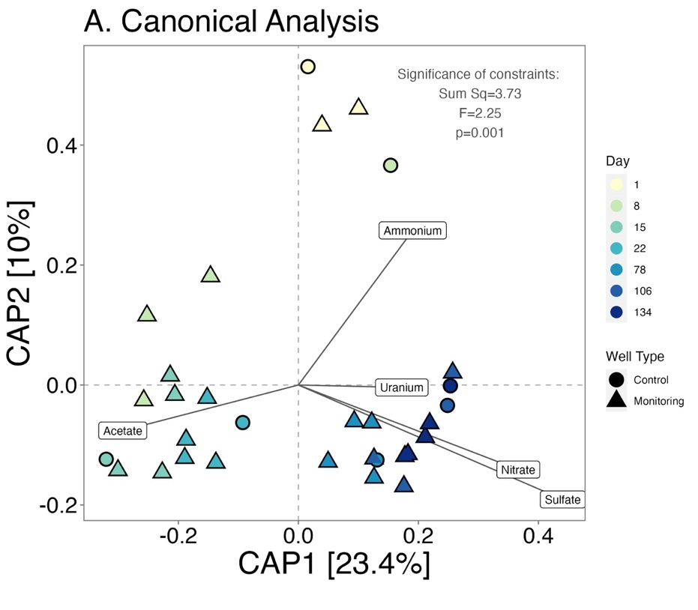
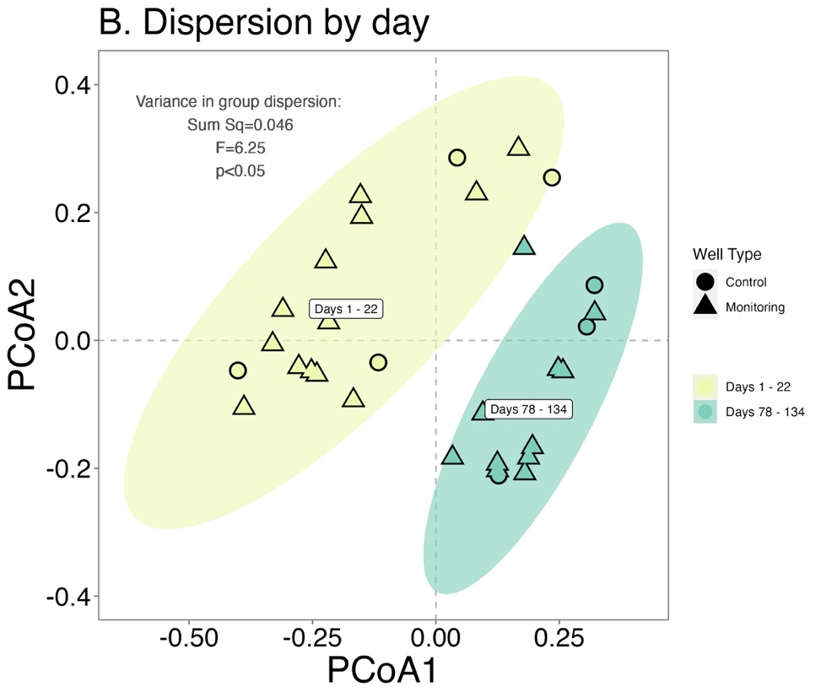
Figure 3.3 Canonical analysis
Subsets of the 0.1 µm community are oriented with acetate, ammonium, nitrate, and sulfate, (Panel A) but neither geochemical parameter accounts for differences in community composition. Eigen values of a beta dispersion test identified group difference by day with a label plotted at the group centroid (Panel B). The shaded ellipse identifies the 95% confidence interval. Abbreviations: Sum Sq. = Sum of Squares.

A. genus-level B. order-level
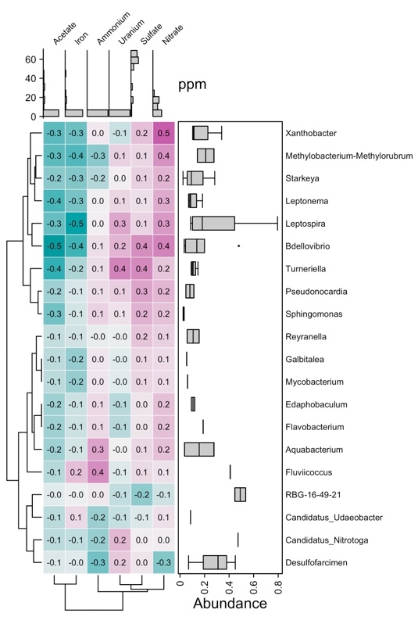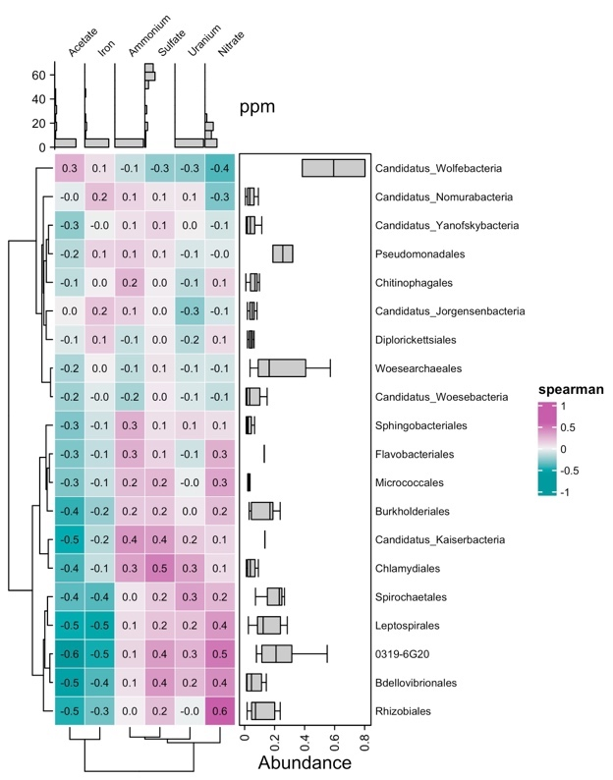
C. genus-level D. order-level
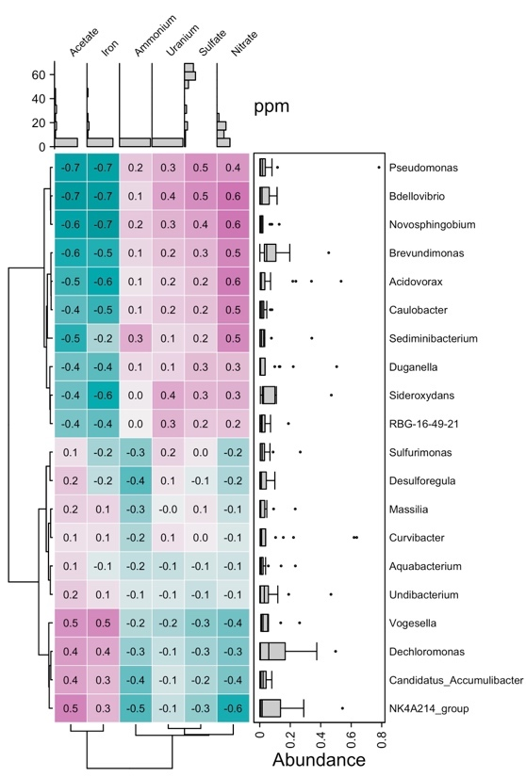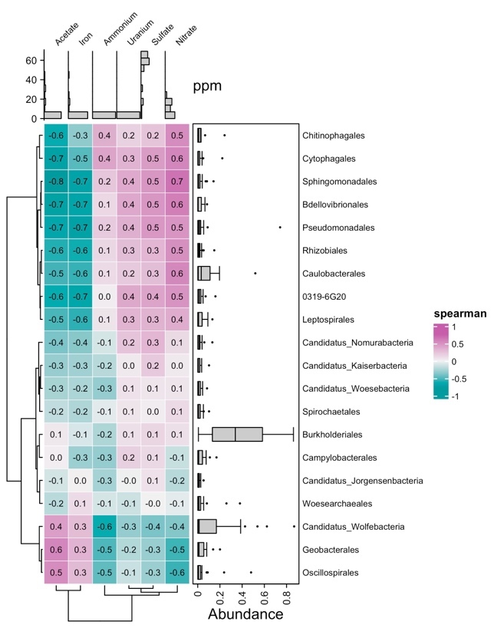
Figure 3.4 Correlations of taxa and geochemistry
Spearman correlations of ASV abundance with chemistry for the 0.1 µm community. (A) genus-level 0.1 µm only, (B) order-level 0.1 µm only, (C) genus-level overlapping 0.1 µm, (D) order-level overlapping 0.1 µm.
- Acetate B. Nitrate C. Sulfate

Figure 3.5 Differential abundance of the 0.1 µm community

The 0.1 µm differential abundance shows the limited effect of changes in sulfate and nitrate on the composition of the 0.1 µm community, and a limited consortia of microbes associated with acetate presence.

B.
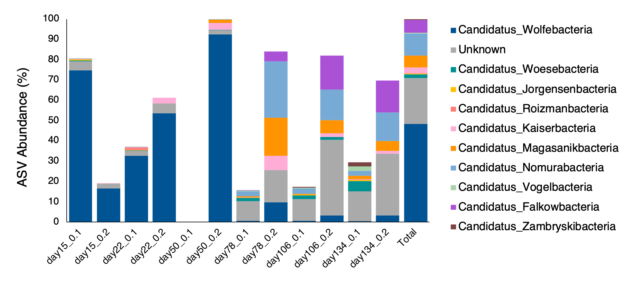
Figure 3.6 Patescibacteria abundance and composition
Plot A demonstrates that Patescibacteria and Desulfobacterota have similar trends in abundance during high acetate concentrations. (B) The composition of Patescibacteria orders on 0.2 and 0.1 µm filters collected from monitoring wells was dominated by Wolfebacteria until the stark disapearance of the order around day 78.

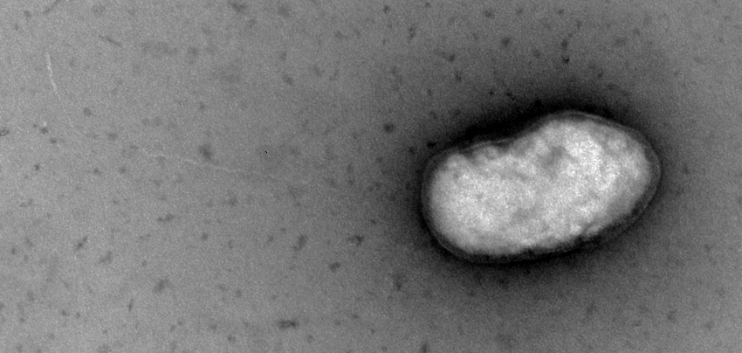
A

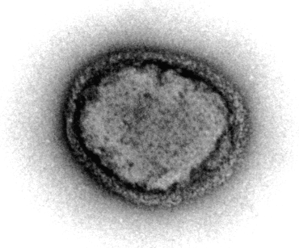
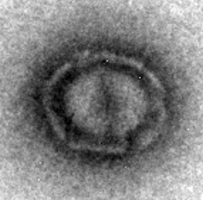
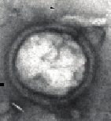
D
C
B

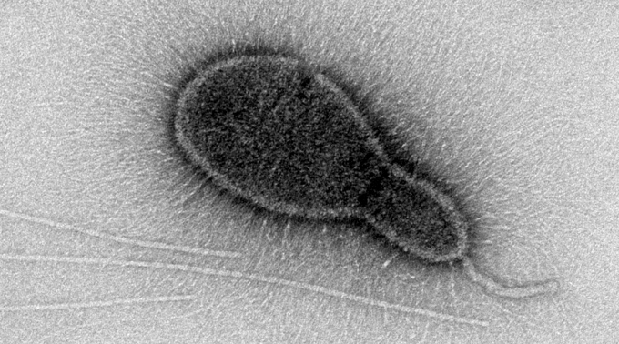
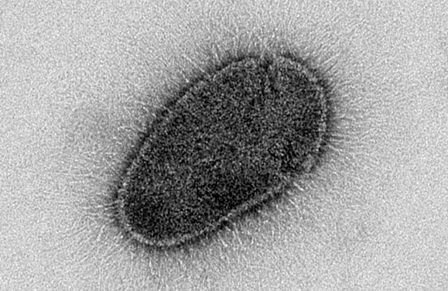
F
E

Figure 3.7 Transmission electron micrographs of putative small cells

Micrographs of putative small cells identified from 0.2 µm filtrate resembling the structures and sizes likely identified in Patescibacteria by the presence of type-IV pili, and filamentous structures. The cell in panel A is 270 by 130 nanometers and exhibits an S-layer membrane and long pili (white arrow) associated with the Microgenomates class of Patescibacteria. Panels B-F represents the traits associated with the Parcubacteria class of Patescibacteria. Including a thick cell wall, S-layer, and dense glycocalyx-like pili structures predicted from genomes of Parcubacteria. Putative cells B-D resemble the thick s-layer and defined edges, and non-uniform dimensions with cell diameters of 0.18, 0.3, and 0.32 µm respectively. Cell E measures 0.23 x 0.16 µm exhibiting asymmetric cell division and a potentially detached sortase-mediated pilus (black arrow), a potential anchoring protein, and a glycocalyx-like coating (dashed arrow) also found on cell F. Cell F measures 0.32 x 0.19 µm.

Supplemental Figures
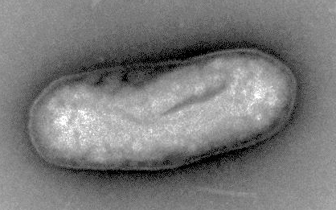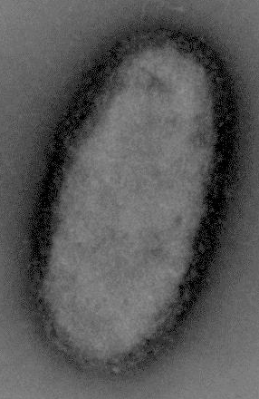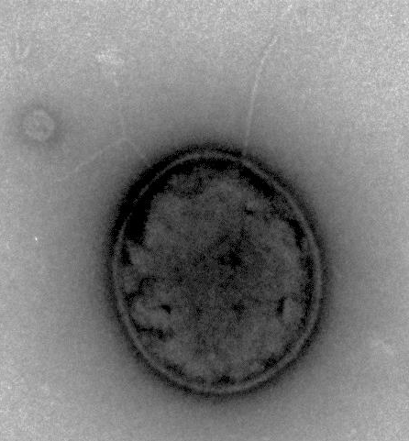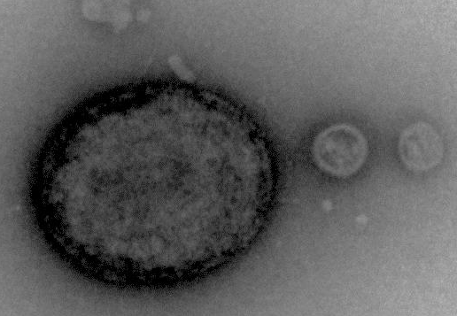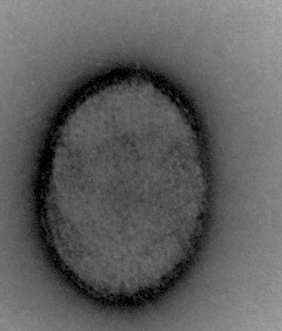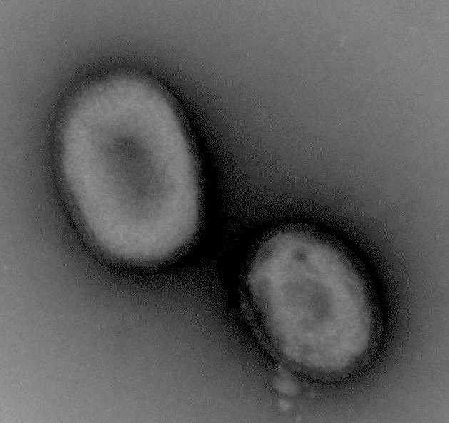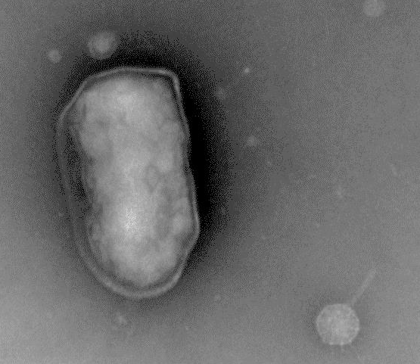
B
A
G
F
E
D
C
Figure S3.1 Putative small cells imaged from groundwater
Panels A-F show putative small cells (<0.3 µm diameter) with an S-layer clearly identified on the organisms pictured in panels A and G. Panels A and B show the common cell shape identified among cells collected at the site. Panels C and D show small spherical microbes with an outer layer membrane and several pili-like structures (white arrows) similar to the cells identified in Figure 3.7. Panels E and F show micrographs of small cells with similar morphology to those in. Panels C and D but without any extraneous structures. Panel G shows what is likely an archaea and a small virus (black arrow).

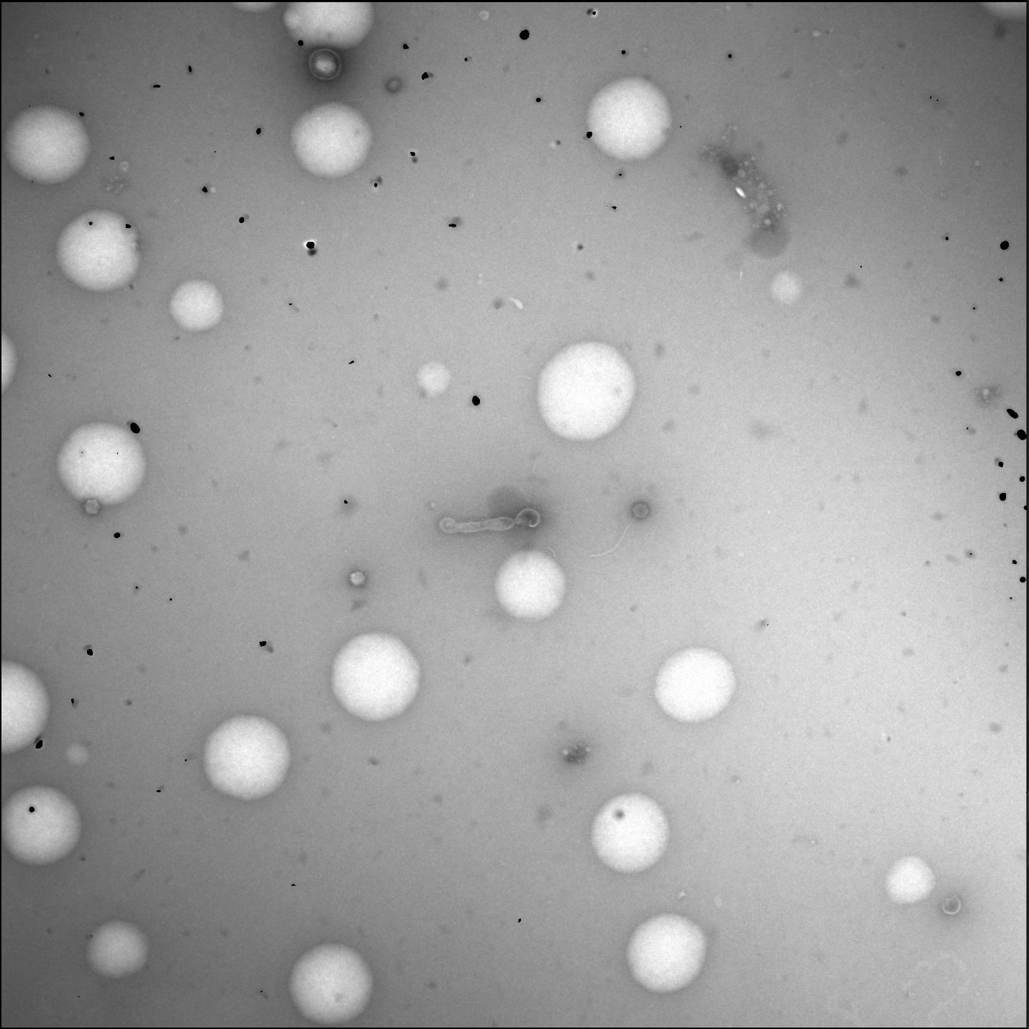
D
B
A
C
Figure S3.2 View field of EVO sample on a transmission electron microscope
Transmission electron microscopy micrographs captured putative small cells like the one in Panels A amidst droplets of vegetable oil (Panel B), viral particles (Panel C) and collections of lipids and vesicles (Panel D).

Appendix E: Tables

Table 3.1 Summary of Phyloseq data objects
 | Samples (n) | Taxa | ASV Abundance  per sample |  |  | Description
 | Samples (n) | Taxa | Mean | Median | Total | Description
All ASVs | 44 | 11,990 | 45864 | 46454 | 2018050 | A complete accounting of ASVs from 0.2 and 0.1 µm filters merged by day and well
overlapping microbes | 75 | 2927 | 24015 | 24153 | 1801934 | ASVs identified from both the 0.2 and 0.1 µm filters
0.1 µm only | 31 | 1023 | 455 | 199 | 14117 | The 0.1 µm community excluding any ASVs also identified in the 0.2 µm

Table 3.2 Multivariate ANOVA of richness and evenness estimators
 | Overlapping taxa |  |  | 0.1 µm taxa
Test Variable | Shannon | ACE | Inv. Simpson | Shannon | ACE | Inv. Simpson
Well Type | 4.55* | 4.05* | 0.14 | 0.41 | 0.95 | 0.15
Day | 9.64*** | 10.92*** | 4.55*** | 3.75 | 3.02* | 0.88
Filter | 21.48*** | 49.87*** | 13.61** | NA | NA | NA
Nitrate | 0.53 | 3.5 | 0.11 | 0.01 | 8.16* | 0.00
Sulfate | 9.53** | 2.28 | 4.11* | 0.12 | 0.07 | 0.65
Day:Well Type | 3.27** | 2.54* | 3.72** | 0.31 | 3.41* | 0.90
p value: 0 ‘***’ 0.001 ‘**’ 0.01 ‘*’ 0.05 ‘ ’ >0.1

Table 3.3 Average cell count per viewing window
Well | Imaged fraction | Week 1 | Week 3 | Week 5 | Week 7 | Week 9 | Mean
GW821-E (pH=6.3) | bacteriophage | 2.4 | 1.5 | 0.5 | 1.3 | 3.6 | 1.86 ± 1.1
GW821-E (pH=6.3) | cells ≤0.3µm | 3.1 | 1.9 | 1.3 | 1 | 1.3 | 1.72 ± 0.8
GW821-E (pH=6.3) | cells >0.3µm | 8.9 | 3.8 | 3.1 | 4 | 5.5 | 5.06 ± 2.3
GW821-E (pH=6.3) | Percent of material ≤0.3 µm | 38% | 47% | 37% | 37% | 47% | 41 ± 6%
MLSB3 (pH=6.8) | bacteriophage | 0.6 | 0.5 | 4.5 | 0.3 | 2.6 | 1.7 ± 1.8
MLSB3 (pH=6.8) | cells ≤0.3µm | 2.3 | 3.5 | 5.1 | 3.3 | 3.3 | 3.5 ± 1
MLSB3 (pH=6.8) | cells >0.3µm | 1.1 | 0.9 | 3 | 1.9 | 2 | 1.78 ± 0.8
MLSB3 (pH=6.8) | Percent of material ≤0.3 µm | 73% | 82% | 76% | 65% | 75% | 74 ± 6%
n= 750 observations per well

EFFECTS OF CONE PENETROMETER TESTING ON SHALLOW HYDROGEOLOGY AT A CONTAMINATED SITE

This chapter was originally published by Andrew D. Putt et al., "Effects of Cone Penetrometer Testing on Shallow Hydrogeology at a Contaminated Site.” Front. Environ. Sci 9 (2022): 821882.

Authors:
Andrew D. Putt¹, Erin R. Kelly¹, Kenneth A. Lowe², Miguel Rodriguez Jr.² and Terry C. Hazen^{1,2,3,4,5*}
Affiliations:
¹Department of Earth and Planetary Sciences, University of Tennessee, Knoxville, TN, USA
²Biosciences Division, Oak Ridge National Laboratory, Oak Ridge, TN, USA
³Department of Microbiology, University of Tennessee, Knoxville, TN, USA
⁴Department of Civil and Environmental Sciences, University of Tennessee, Knoxville, TN, USA
⁵Institute for a Secure and Sustainable Environment, University of Tennessee, Knoxville, TN, USA
*Corresponding author

Author Contributions:
Project planning and data collection- ADP, ERK, and TCH
Field support- ADP, ERK, KAL, MR, and TCH
Data analysis- ADP with input from TCH
Figure generation- ADP with input from TCH
Authored paper- ADP with input from TCH

Abstract
The instantaneous data collection and small diameter of penetration makes cone penetrometer testing ideal for mapping the subsurface. However, little is known regarding the effects of penetration to local shallow groundwater wells and the measurable influence to monitoring devices present in groundwater monitoring wells at contaminated sites. During a recent penetration test, physical and geochemical parameters were measured from shallow groundwater monitoring wells at and below the depth of penetration activities. The physical advancement and retraction of the probe influenced water levels similar to the effect of pumping a neighboring well. However, the response was only detectable within 10 meters of a monitoring wells in this material above the depth of cone refusal. Some variability in specific conductivity during penetration testing was measured but accounted for only a fraction of the natural variation which occurred during precipitation events. Effects of the penetration testing were highly localized and not fully accounted for by soil type but were attributed to fracture pathways identified in the aquifer media. Overall, continuous measurements of specific conductivity and water level demonstrated that the effects of penetration testing may have a limited spatial and temporal distribution without lasting effects.

Introduction (from Putt et al., 2022)
Soil core recovery and penetration testing methods are popular techniques for measuring soil compaction, behavior, stratigraphy, porosity, and permeability for a variety of geotechnical and engineering applications. While soil core recovery requires subsequent processing and compaction corrections; penetration testing provides instant continuous data in-situ with a lower relative cost, lower risk of cross contamination, and high reliability making it a widely used and highly standardized method for subsurface investigations[234, 235].
Cone Penetrometer Testing (CPT) is conducted by advancing a cone penetrometer downward through soft subsurface material at a constant rate while measuring penetration resistance [234, 235]. Cone penetrometers measure the axial force of sediment acting on the cone divided by projected area of the cone which is recorded as cone tip resistance q_{c} (MPa), and total force acting on the friction sleeve divided by the area of the friction sleeve recorded as sleeve friction f_{s} (MPa). Cone penetrometers that measure pore pressure u (kPa), like the one used in this study, are called piezocones and measure soil pressure either in the cone (u₁), between the cone tip and friction sleeve (u₂) like in Figure 1 or above the friction sleeve (u₃). In saturated media, pore pressure provides a measurement of water contained within soil pores which indicate a distinction between granular and porous material. Pore pressure measured between the cone tip and friction sleeve is often applied as a correction for cone tip resistance q_{t} [q_{t} = q_{c} + u₂(1-a_{n})] [236] with the ratio between the diameter of the load cell support (d) and the diameter of the cone (D) calculated as the net area ratio a_{n} [a_{n} = d²/D²] [236]. Interval data from cone penetrometers can be used to determine soil behavior type categories from the friction ratio, R_{f} (%) [R_{f} = (f_{s}/q_{t}) x 100] using the corrected cone resistance q_{t} [237, 238]. Cone penetrometers can also be used with sensors for hydrocarbons, volatile organics, explosives/energetics, toxic metals, and radioactive wastes [239, 240]. CPT methodologies are optimized for various sediment types including the variably compacted soft sediments [236-239, 241, 242] like the residuum and back fill located at this site [235-237, 241, 243, 244], but some may be hesitant to use these techniques since the spatiotemporal effects of penetration on pre-existing monitoring networks are largely unknown.
Continuous monitoring and non-continuous measures were used to assess hydrologic and geochemical changes during a recent penetration study at the Oak Ridge Integrated Field Research Challenge Site within the Y-12 National Security Complex in Oak Ridge, Tennessee, USA. The effects of CPT were quantified from common continuous monitoring parameters such as dissolved oxygen, specific conductivity, pH, suspended solids, salinity, and depth to water measured during penetration and borehole grouting. Responses in water level change were further compared with sediment behavior type to determine if the effect of penetration was related to differences in subsurface material measured by the piezocone.
Penetration testing occurred within a 2,600 square meter site (Figure 4.2 panel A) immediately down-gradient of the former clay-lined S3 transuranic and nitric acid waste ponds [245]. The study site is functionally identified as Area 3 and contains a shallow water table with a relatively flat hydraulic gradient and a southerly flow [243, 245-248]. Area 3 in the Bear creek valley consists primarily of silt and saprolite with a history of excavations, stream relocation, and waste burial [243, 245, 247]. The primary pathway for shallow contaminant transport in Area 3 is fracture mediated flow in weathered saprolite and fill materials [243, 245-248]. The preferential transport pathways interact with FW103, FW024, and FW106 (Figure 4.2 panel A) where high concentrations of contaminants including nitric acid, U, Th-230, Tc-99, sulfate, P, Sr, Cd, Ba, B, Hg, and Cr have been identified [243, 245-248].

Materials and Methods (from Putt et al., 2022)

Site selection
The 255 square meter study site (Figure 2 panel B) is intersected by a previously established pathway for contaminant transport which flows parallel to FW103 and FW024 in Figure 2 panel A [243, 245-248]. The maximum depth of CPT refusal was 11.2 m below ground surface (bgs) effectively dividing wells into those screened above and below the depth of refusal. Two monitoring wells were above the depth of refusal and three wells below. Above the depth of refusal, is FW112 screened 8.5 -to- 10 m bgs which contained a continuous data logger for water level and FW115 screened from 8.7 -to- 9.66 m which was monitored for geochemistry during local CPT activity on day 8 (Figure 2 panel B). FW106, located below the depth of refusal and screened from 10.7 -to- 13.7 m bgs contained a continuous data logger for in-situ geochemistry. Wells FW103 and FW024 both screened from 11.8 -to- 13.7 m bgs and below the depth of refusal contained continuous data loggers for water level.

Penetrometer testing
In October of 2020, a 131-push cone penetrometer grid was completed across a 2,600 square meter site (Figure 2 panel A) with boreholes advancing to 11 m below ground surface. CPT penetration was completed using a 35.7 mm diameter type 2 piezocone advanced through the subsurface at a constant rate of 2 cm/sec from a leveled 25-ton commercial truck-mounted hydraulic ram (Fugro Americas, Houston, TX). During advancement, the piezocone measured soil friction f_{s}, resistance q_{c}, and pore pressure u₂ which are used to interpret soil behavior using the 12-type sediment behavior type classifications previously established and refined [237, 242]. The piezocone was advanced until the axial force of the underlying material resulted in refusal after which the piezocone was retracted. The operator’s standard protocol was to leave boreholes open until the end of daily operations after which each borehole was sealed with a sodium bentonite slurry gravity-fed until level with ground surface. For analyses, soil types above 3.8 m bgs were excluded as unsaturated based on the average depth to water collected during the study period. Similarity in soil behavior type profiles for each CPT log was compared using Euclidean distance and clustered using a complete linkage method in R v 4.1.0 [249] and the R stats package version 3.6.2 [249].

Water levels
Continuous water levels were recorded from three LevelTROLL® 400 water level piezoresistive titanium sensors (In-situ, Fort Collins, CO). The water levels measured depth to water from top of casing recorded in 10-minute intervals with a resolution of 10⁻³ m (+/- 0.005%). Units were deployed in FW103, FW024 and in FW112 (Figure 4.2 panel A). Change in hydraulic head were calculated as the sum of the difference between each 10-minute measurement and reported as a positive integer. Additional depth to water measurements were collected daily prior to penetration testing activities using a Solinst® model 102 electronic water level indicator with a p10 weighted probe (Solinst Canada Ltd, Georgetown, ON) from wells; FW106, FW112, FW115, FW126, FW127, FW128, comprising an 11.8 meter transect from FW106 to FW112 (Figure 4.2 panel B). Water depths were recorded at 1/100th of a foot and referenced against surveyed ground surface elevations [246] to establish a depth of saturation and average depth to water near CPT boreholes.

Continuous geochemistry monitoring below depth of refusal
Continuous geochemistry was measured using an AquaTROLL® 600 multiparameter sonde (In-situ, Fort Collins, Co) measuring groundwater in well FW106, screened from 10.7 -to- 13.7 m below ground surface. Measured parameters include temperature (°C), specific conductivity (µS/cm), pH, and dissolved oxygen (mg/L) with salinity (ppm) and total suspended solids (ppt) calculated from conductivity. The device recorded measurements in ten-minute intervals with probes calibrated at deployment on day one.

Non-continuous measurements of geochemistry above depth of refusal
On day 8, CPT boreholes 43, 47, and 49 were completed in close proximity to FW115 and geochemistry effects were measured from FW115 screened from 8.7 -to- 9.66 m bgs (Figure 4.2). A multiparameter AquaTROLL® 9600 (In-situ, Fort Collins, Co) was calibrated prior to use and measured temperature (°C), specific conductivity (µS/cm), dissolved oxygen (mg/L), and pH of groundwater pumped peristaltically through a flow cell at a low flow rate of 0.67 mL/sec. Three-times the volume of the well was pumped to establish a geochemistry baseline before local penetrometer advancement for CPT boreholes 43, 47, and 49. Measurements were recorded every 500 ml and during significant events like piezocone advancement/retraction and during grouting. On day 11, a non-CPT background measurement of FW115 was completed using the same sensors, pump rate, and total volume as day 8 with measurements recorded every 500 ml. Mean values of specific conductivity (µS/cm), dissolved oxygen (mg/L), and pH from non-CPT measurements on day 11 were referenced against measurements made during CPT activity on day 8 (Figure 4.3).

Statistics and visualization
All statistical analyses were completed with R [121] (version 4.1.2) using the RStudio integrated development environment (version 2022.02.3). Geochemistry means, kurtosis, skew, range, and standard deviation were calculated using the dplyr summarize function in R. Changes in water level, pH, and specific conductivity were tested across days and wells, using an ANOVA with residuals checked for normal distribution and group-significance re-tested with a Tukey post-hoc test with least squares mean separation using a Bonferroni method. Distance-based and hierarchical clustering analyses were conducted with vegan (version 2.6-2) [123]. A full list of packages and code are available at https://github.com/putt-ad/dissertation. Maps were constructed in ArcMap 10.8.1

Results and Discussion (from Putt et al., 2020)

Geochemistry measurements from above depth of refusal
On day 8 the penetrometer testing was conducted within a radius of 10 m of FW115 (Figure 4.2 panel B) at CPT49, 47, and 43 in that order (Figure 4.3). Prior to the advancement of the piezocone in CPT49, the initial stabilized parameter measurements reported as averages with standard deviations indicate a pre-penetration pH of 3.82 ± 0.01, mean dissolved oxygen concentration of 0.12 ± 0.01 mg/L, and mean specific conductivity of 3680 ±15 µs/cm. Figure 3 shows the FW115 day 8 CPT activity parameter means in teal, and the non-CPT background means from day 11 in ash. The means of pH and dissolved oxygen during CPT pushes 49, 47, and 43 on day 8 were not distinct from non-CPT measurements on day 11. Specific conductivity increased during penetration peaking at 3799 µS/cm during the development of CPT47 (Figure 4.3). Monitoring in FW115 continued following the final retraction of the piezocone in CPT43 and during the penetration for CPT 39. CPT 39 was abandoned after three attempts when penetration encountered shallow impenetrable material above 3.8 m. For this reason, the final push of day 8 is considered CPT43 after which a negative trend in specific conductivity was observed (Figure 4). The downward trend in specific conductivity was best-fit by the following second-order polynomial regression, y = 1E-05x² - 0.0906x + 3691.4 with an R-squared value of 0.98 where x = volume pumped (mL) at a rate of 0.67 mL/minute post-CPT and y = specific conductivity (µs/cm). The negative trend in specific conductivity following retraction of the piezocone at CPT49 was unaltered by the addition of sodium bentonite (l₂H₂Na₂O₁₃Si₄) to seal CPT43, 47, and 49 (Figure 4.4).

Continuous monitoring geochemistry below depth of refusal
Figure 4.5 shows that while specific conductivity increased in FW115. In FW106, the underlying well, no clear deviation from the background was identified for dissolved oxygen, specific conductivity, or pH (Figure 4.5). The daily variation in specific conductivity during the CPT activity on day 8 and day 9 was 17µs/cm and 34 µs/cm respectively (Figure 4.6). Following the completion of penetration activities on days 11 and 12, the site received 5.2 and 2.5 cm of rain respectively resulting in an overall daily variation in specific conductivity which was up to five-times greater than the daily variation measured on day 8 (Figure 4.6).

Local hydrologic effects
The act of piezocone advancement/retraction displaced a specific volume of material measured from several penetrations as a displacement of water (Table 4.1). During advancement of the cone, water displacement during retraction was observed as an increase in local water level, and as a decrease during retraction (Figure 4.5). No water level change was measured in FW024 or FW103 but was measurable in FW112. The coarse resolution of 10-minute interval data do not meet proper assumptions to estimate the rate of response but do provide a measure of variability in hydraulic head. During CPT47, continuous monitoring in FW112 measured a 0.066 m change in water level, the largest change in water level recorded during this study (Table 4.2). The 0.066 m range was similar to continuous monitoring data collected during an hour of pumping at a rate of 150 mL/min. as described in the master’s Thesis of Erin Kelly and similar to the water level change following a local rain event (Table 4.2). For water level changes measured in FW112, categories were assigned to the CPT pushes based on measured distance (radius) from FW112: ‘1 to 5 meters,’ ‘5 to 10 meters,’ ‘15 to 20 meters,’ and an additional category for ‘Background’ water levels collected on days without local penetration activities or rain. Initial interpretations of the data suggested a cluster of penetration activities located to the South/Southwest (S/SW) of FW112 resulting in an additional grouping with three categories: ‘southerly’, ‘non-southerly’, and ‘Background.’ A comparison of means in Table 4.2 shows that the highest mean difference in hydraulic head is identified from CPT penetration within 1 to 5 meters and 5 to 10 meters of FW112 with distance range being a significant factor in the measurable response (Table 4.3). The difference in water level response varied significantly between CPT boreholes (Table 4.3) and was highest in a region of the study site located to the South/Southwest of FW112 (Figure 4.7). A Tukey Honest Significant Difference (Tukey HSD) test of the ANOVA results in Table 4.3 identified penetration activities for 5 pushes; CPT43, 45A, 46A, 47, and 49 were significant over background (p<0.01). The location of the boreholes was also confirmed to be significant based on an ANOVA with a post-hoc Tukey HSD (Table 4.4) as identified in Figure 4.6. Water levels during other penetration activities within the same radius of FW112 were not significantly different from background (Figure 4.7). However, water levels did increase and experience high variability during rain events at the site on days 12 and 13. With a higher overall variability and total water elevation change of 0.067 m and 0.04 m for days 12 and 13 respectively (Figure 4.6).

Soil behavior type analysis
The two most abundant soil behavior types were both over consolidated sediment behavior types: very stiff fine grained (CH-CL) composing 39.4% of the total, and sand to clayey sand (SC-SM) which made up 18.2% of the total measured intervals (Figure 4.8). The third and fourth most abundant soil types were sandy silt to clayey silt (ML-MH) accounting for 13.8% and silty sand to sandy silt (SM-ML) accounting for 13% with all other soil types collectively accounting for 15.6% of measured intervals across the saturated subsurface (Figure 8). Similarity in sediment type composition from each CPT log was compared using Euclidean distance and clustered using a complete linkage method (Figure 4.8). Only 3 samples clustered with a neighboring sample demonstrating the high variability of the site. Neighboring sample clusters include CPT38 and 42, CPT43 and 45, and CPT46A and 47. The composition of the two most abundant soil types; very stiff fine grained (CH-CL) and sand to clayey sand (SC-SM) did emerge as a distinguishing characteristic in sample clustering at a high level (Figure 4.8). The composition of very stiff fine grained (CH-CL) and sand to clayey sand (SC-SM) in cluster A was 39.8 +/- 4.7 % and 68.3 +/- 7.3% in cluster B (Figure 4.8). When a linear model was used to compare the water level response for pushes 43, 45A, 46A, 47, 48, and 49 to the relative composition of soil behavior types only very stiff fine-grained sediment (CH-CL) showed a linear response. The linear model produced a multiple R-squared of 0.728, an F-value of 10.74 on 1 and 4 degrees of freedom (p= 0.03).

Conclusion and Implications (from Putt et al., 2022)
The effects of penetration on specific conductivity and water level were only detected above the depth of CPT refusal. A depth which is associated with the depth of material transition from shallow saprolite to weathered bedrock [245]. The physical act of penetration was the only CPT-associated activity in this study that had a measurable effect on specific conductivity. There was no measurable effect to pH or specific conductivity from the application of sodium bentonite despite its high cation exchange potential and a pH between 8.5 and 10 [250, 251]. The effects of penetration on water level and specific conductivity dissipated rapidly following penetration. Water level and specific conductivity changes were respectively equal to and less than the 24-hour measured response from a subsequent rain event which is a common source of perturbation in shallow groundwater systems [252].
The physical act of penetration within 10 m of a monitoring well did displace subsurface volume resulting in small water level fluctuations measured at less than or equal to 66 mm. A cluster analysis of soil behavior profiles indicated local and site-wide heterogeneity in measurements of soil behavior type and no direct relationship between soil types and water level during penetration. During penetration activities, water level responses were not equal in all directions from the monitoring well and suggest that the variable water level response may be related to soil properties like the fractures in fine grained materials and the preferential flow found in this study site [12, 19, 20]. While the resolution of measures in this study are not sufficient to fully determine the characteristics of flow, higher frequency measurements during penetration with a larger diameter device may be a supplement the use of penetration studies to characterize subsurface material or connectivity [21, 22]. Furthermore, the specific use of soil behavior types can provide estimates of aquifer parameters, but these data alone may not be sufficient for identifying areas of preferential flow during characterization.
In summary, the physical act of penetration has a limited effect on local specific conductivity and water levels. The effects of these activities appear to vary based on the physical characteristics of subsurface materials with a minimal effect overall.

Appendix F: Figures
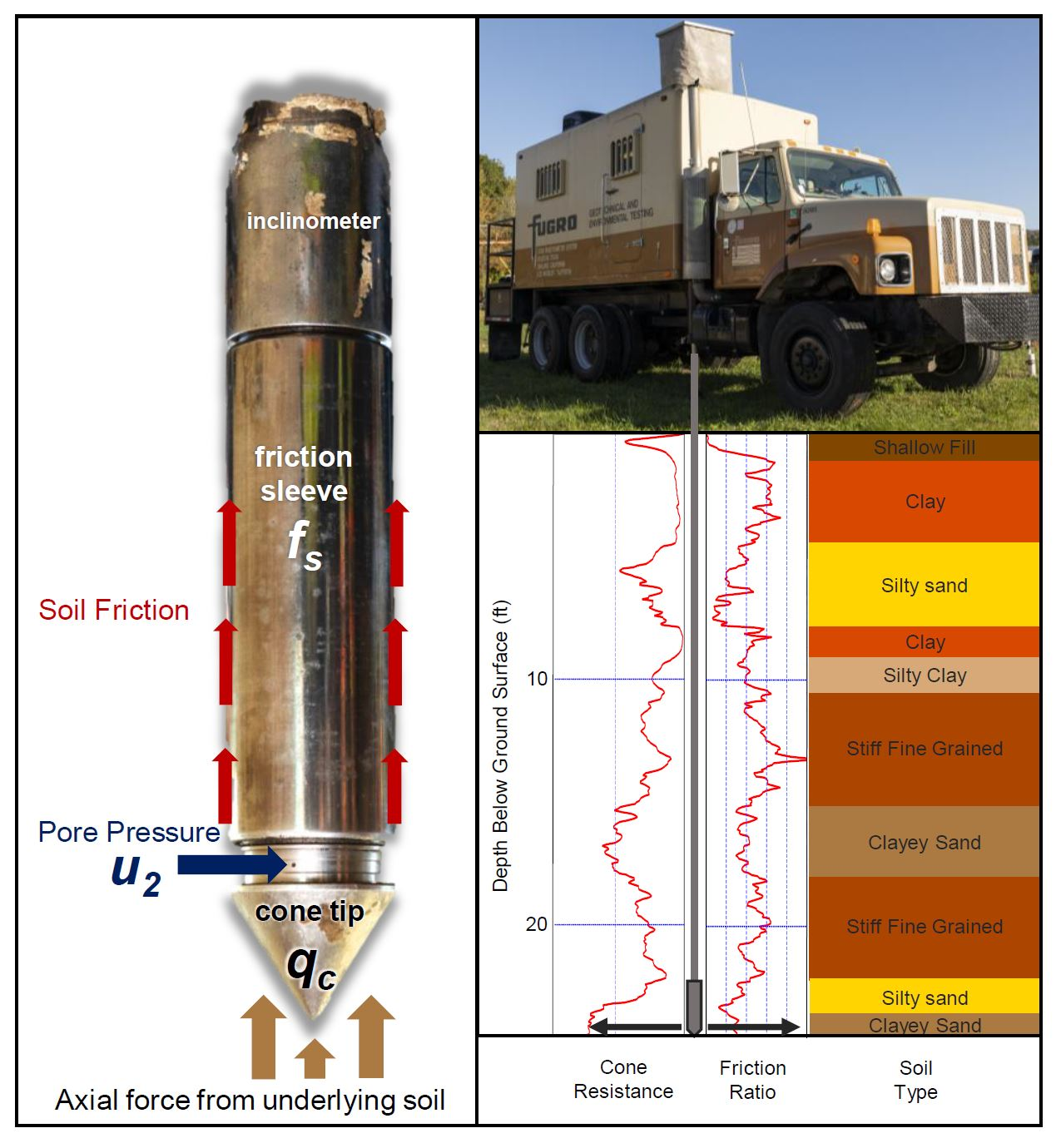
Figure 4.1 Piezocone configuration and application
Type 2 piezocone sensors (left) measure the axial force on the cone, the upward friction, and the inward pore pressure to determine soil behavior which is interpreted during piezocone advancement (right).

Figure 4.2 Map of CPT test site
Cone penetrometer testing was conducted in the 2,600 square meter Area 3 site at the Y-12 complex in Oak Ridge, TN, USA. (A) The cone penetrometer study boreholes are plotted as pink triangles forming parallel transects downgradient of the former S3 waste ponds contaminant source. (B) A subset of CPT bores near shallow groundwater wells were selected to observe the spatial and temporal effects of cone penetrometer testing.

Figure 4.3 Geochemistry deviation during local shallow penetration activities
Geochemistry measured in FW115 during local cone penetrometer activity shows the small variations in dissolved oxygen and conductivity during local cone penetrometer activities. Monitoring continued during grouting around 270 minutes (gray line). Mean values for CPT activity are plotted in the bar charts on the right with CPT activity mean in teal and mean non-CPT geochemistry background in ash gray.

Figure 4.4 Downward trend in specific conductivity following penetration testing
Specific conductivity decreased immediately following the localized cone penetrometer activity including during the addition of the bentonite slurry (gray bar) in CPT 43, 47, and 49.

Figure 4.5 Effects of day 8 CPT pushes on geochemistry and water level
Plot A shows stable geochemistry from the continuous monitoring in FW106 (round points) while the shallow specific conductivity in FW115 (triangles) increased during penetration. Panel B demonstrates that the advancement and retraction the probes caused water level changes measurable by the 10-minute interval data collected in FW112. Note that salinity and total dissolved solids are calculated measurements derived from conductivity and temperature and recorded in ppt.
Figure 4.6 Groundwater response to rainfall and CPT activity
Panel A is the continuous monitoring of specific conductivity in FW106 which shows no change in response based on CPT activity. Rainfall on days and 11 and 12 causes a spike in conductivity that causes ~300 us/cm increases the specific conductivity over 48 hours. Panel B demonstrates a similar trend observed for water level. The solid line in panel B is the mean daily water elevation and the shaded range is the daily standard deviation. Water level variation remains consistently low throughout CPT activity until the rainfall events on days 11 and 12.
Figure 4.7 Local CPT activity influence on local water levels
Changes in water level (ΔH) measured in FW112 during CPT activity are plotted as shaded bars, and distance between the CPT push and FW112 in transparent. Salmon colored bars indicate penetration activities which occurred South/Southwest of FW112, and stars (*) indicate those which were identified to have significant (p<0.01) water level variation from daily values during CPT activity based on an ANOVA test of mean significance.

Figure 4.8 Relative abundance of soil behavior types
Samples are ordered based on Euclidean distance calculated from composition of soil behavior types identified in each CPT log. Letters A and B on the hierarchical dendrogram on the right designate clusters A and B which differentiate primarily in the composition of compacted sediments (designated by *). Similar samples will share a branch at a lower score. Soil classifications are based on Robertson 1986 [242].

Appendix G: Tables
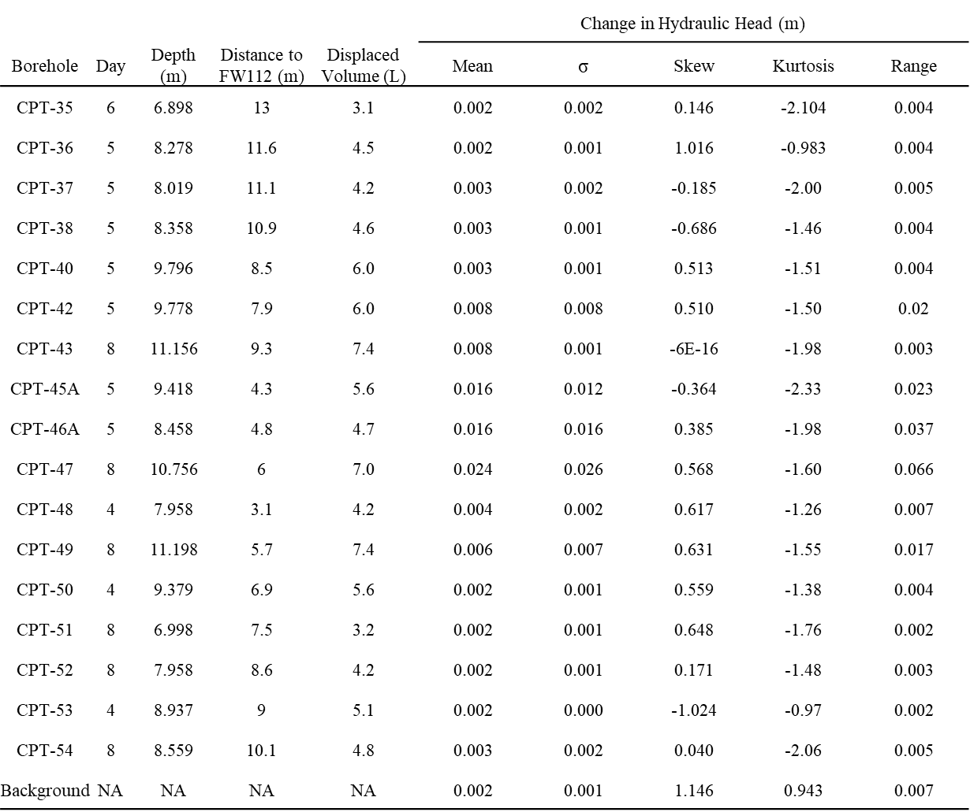
Table 4.1 CPT borehole specifics and water level change in FW112

Table 4.2 Change in hydraulic head based on distance and orientation from FW112
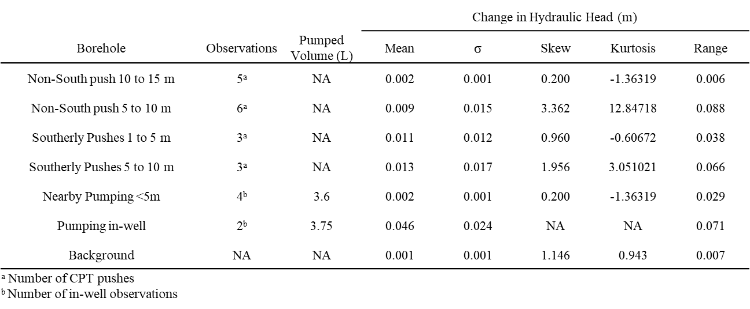

Table 4.3 ANOVA test of changes in hydraulic head (m) based on the distance and orientation of each push from FW112.
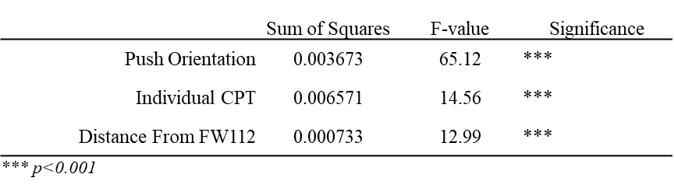

Table 4.4 Tukey HSD test for CPT push orientation from FW112

CHARACTERIZATION OF THE SUBSURFACE MICROBIAL COMMUNITY IN A GEOCHEMICALLY AND PHYSICALLY HETEROGENEOUS MEDIA

Data contained within this chapter have been incorporated into the following publication: Goff, J.L., Szink, E.G., Thorgensen, M.P., Putt, A.D. et al., "Ecophysiological and genomic analyses of a representative isolate of highly abundant Bacillus cereus strains in contaminated subsurface sediments.” Environ. Micro. (2022).
Authors:
Andrew D. Putt¹, Erin Rose Kelly¹, Jennifer L. Goff², Elizabeth G. Szink², Michael P. Thorgersen², Lauren M. Lui³, Yupeng Fan⁴, Jonathan P. Michael⁴, Yajiao Wang⁴, Daliang Ning⁴, Ying Fu⁴, Joy D. Van Nostrand⁴, Kaylee Massey⁵, Farris L. Poole II², John-Marc Chandonia³, Jizhong Zhou^{4,7,8,9}, Matthew W. Fields⁵, Adam P. Arkin^{3,10}, Michael W. Adams², Terry C. Hazen^{1,5,6,11,12}
Acknowledgements:
Kenneth A. Lowe¹¹, Miguel Rodriguez Jr.¹¹, Dominique Cirri Joyner⁶, Daniel Williams¹², Kurt Ash¹², Nathan Cooley¹², Jana Phillips¹¹
Affiliations:
¹Earth and Planetary Sciences, University of Tennessee, Knoxville, TN, USA
²Department of Biochemistry and Molecular Biology, University of Georgia, Athens, GA, USA
³Environmental Genomics and Systems Biology Division, Lawrence Berkeley National Laboratory, Berkeley, CA, USA
⁴Institute for Environmental Genomics, University of Oklahoma, Norman, OK, USA
⁵Center for Biofilm Engineering, Montana State University, Bozeman, MT, USA
⁶Department of Civil and Environmental Engineering, University of Tennessee, Knoxville, TN, USA
⁷Department of Microbiology and Plant Biology, University of Oklahoma, Norman, OK, USA
⁸School of Civil Engineering and Environmental Sciences, University of Oklahoma, Norman, OK, USA
⁹Earth and Environmental Sciences, Lawrence Berkley National Laboratory, Berkeley, CA, USA
¹⁰Department of Bioengineering, University of California at Berkeley, Berkeley, CA, USA
¹¹Biosciences Division, Oak Ridge National Lab, Oak Ridge, TN, USA
¹²Center for Environmental Biotechnology, University of Tennessee, Knoxville, TN, USA

Author Contributions:
Project planning- ADP, ERK, KAL, MR, DCJ, and TCH
Data management and project coordination- ADP, DCJ, JMC, APA, and TCH
Soil core collection- ADP, ERK, KAL, and MR
Penetrometer field support- ADP, ERK, KAL, MR, DCJ, DW, and KA
Well drilling field support- ADP, KAL, JP, DW, and TCH
Groundwater sampling/testing- ADP, ERK, DCJ, DW, NC, and KA
Continuous data monitoring/data collection- ADP, NC, and DW
ICP-MS analysis- JLG, EGS, MPT, FLP, and MWA
16S rRNA extraction and processing- YF, JPM, YW, DN, YF, JDVN, LML, and JZ
Ion chromatography- ADP
Physical soil measurements- ADP
Laboratory flow testing- KM
Transmission electron microscopy- PW
Data analysis- ADP with input from DN, APA, and TCH
Figure generation- ADP with input from TCH
Authored paper- ADP with input from TCH

Abstract
Single continuous cores from previous studies of the Y-12 sediments revealed hotspots for biomass and contaminant retention. These hotspots corresponded with sub sectioned cores near the depth of saturation and several meters below the water table. Continued interest in understanding the microbial and biogeochemical effects have promoted deep investigations of the site. The potential for high activity in and around charged clay and fine-grained sediment layers informed our targeting coring approach. This approach selectively sampled fine-grained materials and those potentially interbedded with sands and silts as identified by a cone penetrometer survey. Nineteen sediment cores analyzed for 53 elements, anions, cell counts, particle size, 16S rRNA, and total organic carbon were compared against local bulk groundwater measurements. Groundwater from three newly drilled wells and eight pre-existing wells were used to assess the homogeneous water quality across the shallow material. Groundwater was analyzed for pH, specific conductivity, anions, organic acids, and 53 elements. The pH of groundwater was highly correlated with uranium, nitrate, sulfate, and thorium with a dominance of Proteobacteria and Firmicutes. Sediment samples with the highest diversity also contained Patescibacteria which were found in low pH contaminated sediments as well as shallow sediments. Their presence was associated with higher pH water, and the presence of larger subsurface substrates. When abundance was correlated with response to geochemistry, Patescibacteria were clustered with a class of Ultramicrobacteria Elusimicrobiota, methanotrophs, and archaea. Micrographs from groundwater and cell counts from sediment collected at the site suggest a low diversity in cell shapes and cell sizes. Shallow groundwater at the site yielded a low daily cell count with the preferential cell size >0.3 µm with only 14% of the cells identified ≤ 0.3 µm in diameter. A high heterogeneity of the soil types, geochemistry, and biodiversity hotspots suggests localized cell distribution and preferential flow may dominate transport in this material.

Introduction
Areas of shallow saturation and clays overlaying fractured bedrock have been identified as areas of high potential for biological activity and contaminant adsorption in contaminated media [230, 253]. Localized spatial variability in subsurface sediment composition and pH can directly influence contaminant transformation as well as differential mobilization of heavy metals in sediment. Contaminant transport and transformation are mediated by diverse populations of microbes which themselves are influenced by a variety of abiotic factors in the subsurface [254]. The physical conditions of subsurface media can make it a source or sink for transient planktonic cells, which are observed as attached to sediment and other solid surfaces in environments with low concentrations of nutrients [22, 255]. Sediment associated microbial communities can be diverse and are thought to play an active role in biogeochemical cycling in groundwater systems [9, 197, 256]. However, the presence and heterogeneity of cells remains a topic of continued interest particularly at shallow contaminated sites where geochemical contaminants have been shown to alter the microbial community composition [13].
Solid interfaces have been proposed as an important substrate for bacterial adherence and growth with the potential to provide community stability even under changing geochemical conditions [22]. However, the extent of community presence may be determined by the physical conditions of subsurface material. Particularly in material overlying the bedrock at the site. For this study, targeted sampling was conducted for materials identified as fine grained in the variably saturated zone and in material overlying the weathered fractured bedrock matrix. Groundwater measurements obtained from pre-existing and newly drilled wells provide an assessment of bulk water parameters and a boundary for the extent of the shallow contamination.
The zone of variable saturation and the bedrock interface have been identified as zones where critical biogeochemical processes are most likely to occur. These zones represent areas where recharge and nutrient exchange occurs. The underlying bedrock is highly fractured and is a primary source of contaminants including nitric acid, U, Th-230, Tc-99, sulfate, P, Sr, Cd, Ba, B, Hg, and Cr [243, 245-248]. Water from the bedrock maintains a pH ≤4 and contributes to the base flow in the overlying material. Previous studies have identified the passage of material and contaminants through this site and into down gradient sites. In addition to nutrients, bacteria are also hypothetically transported along the bedrock and into the down-gradient sites. Therefore, this work will address the function of the shallow media as a source or sink for groundwater bacteria and address the relationships of different bacteria to physical and geochemical data. We will also test if Patescibacteria are abundant during reductive processes as they were in our previous work (chapter 2 and chapter 3). This study will focus on Patescibacteria which are largely abundant in the down-gradient site, and which have been previously identified as able to be mobilized from soil [42]. Here we test the hypothesis that this shallow material is a source for downgradient microbial signatures as well as the hypothesis that Patescibacteria are associated with reductive processes.
Logs collected during penetration testing were used to isolate specific areas of interest for additional study in the shallow material. Cone Penetrometer Testing (CPT) measures the axial force of sediment acting on the cone divided by projected area of the cone which is recorded as cone tip resistance q_{c} (MPa), and total force acting on the friction sleeve divided by the area of the friction sleeve recorded as sleeve friction f_{s} (MPa). Porewater pressure u (kPa), is measured from an open-membrane sensor and applied as a correction for cone tip resistance q_{t} [q_{t} = q_{c} + u₂(1-a_{n})] [236] in the determination of the friction ratio, R_{f} (%) [R_{f} = (f_{s}/q_{t}) x 100] which is interpreted as soil behavior type [237, 238].

Materials and Methods

Site selection and assessment
The 740 square meter study site (Figure 5.1 panel B) has a shallow water table which fluctuates during seasonal events like drought and rainfall but is commonly measured around 3.5 to 3.8 m below ground surface (bgs) or approximately 304 m above mean sea level (m AMSL). Groundwater flows to the southwest with a relatively flat change in elevation measured across the study site to be 4 cm/m (dh/dl) in the direction of a local surface water boundary, Bear Creek [243, 245-248]. A total of 19 sediment samples were collected from the shallow subsurface near existing and newly developed groundwater wells.

Penetrometer testing and interpretation
A 131-push cone penetrometer grid was completed across the 2,600 square meter site identified functionally as Area 3 (Figure 5.1 panel A). the probe was advanced up to 11 m below ground surface. CPT penetration was completed as described previously [257] using a 35.7 mm diameter type 2 piezocone advanced through the subsurface at a constant rate of 2 cm/sec from a leveled 25-ton commercial truck-mounted hydraulic ram until the probe hit refusal. The depth of refusal varied from 1 m due to buried debris near the road to 11.2 m at CPT 47. During advancement, the piezocone measured soil friction f_{s}, resistance q_{c}, and pore pressure u₂ which are interpreted as soil behavior using the 12-type sediment behavior type classifications previously established and refined [237, 242]. In-field logs provided by the rig operators (Fugro Americas, United States) (Figure 5.2) were used to select the depths of sediment sampling in real-time. Sampling was primarily targeted towards depths between the water table and above 600 cm bgs. A single sample was collected from 834-945 cm bgs, and a single shallow vadose sample was collected from 274-320 cm bgs.

Sediment collection
To collect cores from target depths, overlying sediments were displaced using the piezocone and then collecting a 45 cm sample in a plastic-lined 3.8 cm diameter core barrel. Samples were scanned for radioactivity before being aseptically sub sectioned based on identifiable horizons or changes in material density. The core liner was aseptically removed along with the outer 0.5 cm of sediment. The remaining material was homogenized using sterile plastic tools and placed into sterile trace-certified polypropylene tubes for shipment within one week of collection. DNA samples and total organic carbon samples were stored and shipped at -80°C, anion samples were stored at -20°C until extraction and samples for elemental analysis, cell count, and imagery were stored and shipped at 4°C.

Sediment processing
Elemental composition of triplicate 1-gram sediment samples were analyzed using inductively-coupled plasma mass spectrometry (ICP-MS) as described previously [253]. In brief, a microwave digestion of sediment in 10 mL of nitric acid was performed as described in EPA method 3051A. The samples were diluted to a 1:5 and 1:50 (vol./vol.) concentration with nitric acid. A total of 53 elements were analyzed.
Porewater anions and carbon were extracted from sediment and analyzed as described previously [253]. Briefly, pore water was extracted with centrifuge filters to be analyzed on a Dionex ICS 5000+ (Dionex, United States). Anions including fluoride, chloride, sulfate, nitrate, nitrite, bromide, and phosphate were measured using a gradational KOH eluent with anion separation achieved on an AS11 column with conductivity detection. Total organic carbon was analyzed using a water-extraction method with the slurry filtered through a 0.2 µm filter to reduce the detection of cells. Detection was achieved using a TOC-5050A Total Organic Carbon Analyzer (Shimadzu, Japan) as described previously [258] without subsequent carbon fractionation methods.
Acridine orange direct cell counts (AODC) were performed by dissociating cells from solid sediment with direct cell counting performed as described previously [259]. Essentially sediment samples were vortexed with CaCl2, Tween and sodium pyrophosphate to release cells. Sediment was separated with centrifugation (3000xg, 3 min, 4 C) and supernatant was filtered (0.2 mm pore-sized black polycarbonate membrane) to concentrate flocculated cells. The cells were stained on-filter in the dark with 0.25 mM acridine orange and unbound stain rinsed with phosphate buffered saline. Stained cells were enumerated on an epifluorescence microscope (Zeiss Axioskop, Germany) with a fluorescein isothiocyanate filter.
Sediment grain composition was determined using a wet-sieving method to increase shielding from radioactivity and reduce the production or loss of fines as dust. Sediments were processed as described previously [260]. Briefly, dried homogenized and pulverized sediments were weighed and placed in triplicate centrifuge tubes with 3% hexametaphosphate overnight and vortexed for 2 hours at 120 revolutions per minute. Sand was wet sieved using a 0.053 mm sieve and fine material was mixed into 600-800 mL of water and stirred vigorously before settling for 90 minutes (based on stokes law calculations for a 0.002 mm particle) with 0.053 – 0.002 mm material collected from the settled fraction.

16S rRNA gene amplicon library preparation, sequencing, and processing
Soil DNA was extracted using a freeze grind method [261] with DNA purified using the DNeasy PowerSoil DNA isolation kit (Qiagen; bead beating step omitted). DNA quality was assessed using nanodrop and amplicon sequence libraries of the 16S rRNA V4 region were generated using a two-step PCR approach as described previously [117]. Amplified PCR products were pooled by molality and purified before preparation and sequenced using 251, 12, and 251 cycles for forward, index, and reverse reads on an Illumina MiSeq with a 500-cycle v2 MiSeq reagent cartridge (Illumina, San Diego, CA)
Amplicon sequence processing was performed as described [262]. Briefly, DNA was extracted using a freeze-grind method and amplified using the two-step PCR method [117]. Sequences were processed in QIIME2 (v2021.2) with ASV sequence variants identified from trimmed sequences using DADA2. Chimeras were removed using the ‘consensus’ method with independent denoising of sequences. Samples were quality trimmed with a max score and error of 2 for forward and reverse sequence recombination. Taxonomy was assigned to ASVs using QIIME2 pre-fitted sklearn-based taxonomy classifier and Silva 138. ASVs were assigned by a 99% match to reference sequences with a confidence level of 0.7. ASVs unclassified at the Domain level as well as those identified as Chloroplast, Mitochondria, or Eukaryota were removed and rechecked once coerced into Phyloseq objects [124] for additional processing.

Well installation and development
Three new wells, EFPW01, EFPW02, and EFPW03 were installed using a 21.5 cm diameter hollow stem rotary auger on a Geoprobe® 3230DT drill unit one year following the CPT survey. The well bores were drilled to a depth of 7.6 m bgs and a 5-cm diameter PVC well casing was installed with a PVC screen extending from 4.5 to 7.6 m bgs. The remaining bore volume was filled with quartz sand overpacking the well screen with an additional 1 meter of sand. Pelletized bentonite and native material were used to seal the bore with native material overburden placed in the top meter. Wells were finished with a cement pad and developed using surge and variable-speed peristaltic pumping over three weeks until pumping produced 3-well volumes with no visible turbidity.

Groundwater sampling
Water was collected using a low-flow purge and sampling method [13] without filtration. In-situ geochemistry was collected using a multiparameter AquaTROLL® 9600 (In-situ, Fort Collins, Co) calibrated for specific conductivity (µS/cm), and pH. Colloids were settled out of elemental analysis overnight at 4°C with no headspace before pipetting supernatant into nitric acid for analysis on ICP-MS [13].
Unpreserved anion and organic acid samples were filtered, diluted, and analyzed with a multi-level gradient method on an AS11 column as described previously [263] with calibrations and run quality assessed using the peak area calibration function Ioncal (version 1.0.2 https://github.com/putt-ad/ioncal).

Comparison groundwater cell size
Water was collected from FW100-25 in Area 3 screened from 6 to 7.6 m bgs, GW821-E (35.9412 N, -84.33623 W) screened in shallow native undisturbed saprolite from 5.8 to 6.5 m bgs, and from MLSB3 (35.9756N, -84.27469W) screened from 4.8 to 5 m bgs in a downgradient carbonate gravel site described in chapters 2 and 3 (https://public.ornl.gov/orifc/well.cfm). A 5L volume was purged without filtration using a low-flow purge and sampling method [13] with in-situ geochemistry measured on a multiparameter AquaTROLL® 9600 (In-situ, Fort Collins, Co) calibrated for specific conductivity (µS/cm), and pH. A single one-liter volume of unfiltered groundwater was collected from all three wells every two weeks for 9 weeks. Samples were stored/shipped with no headspace at 4°C for manual enumeration of cells and cell sizes with transmission electron microscopy. An additional 10L of groundwater were filtered through 0.2 and 0.1 µm PTFE filters with sequential filtration. Filter DNA was extracted, sequenced and processed from filters collected at FW100-25 and MLSB3 as described previously above.

Groundwater imaging with transmission electron microscopy
Groundwater was filtered through a 20 µm filter and concentrated as described in chapter 2. Briefly, two 40 mL volumes of water were concentrated to 300-400 µl with centrifugation and a cell concentrator. Five grids were negatively stained with uranyl acetate and imaged on a JEOL JEM-1200x electron microscope operating at 80 kV. Cell enumerations were performed for each viewing frame of the grid with sizes, and images recorded by a 2k x 2k pixel CCD camera (UltraScan, Gatan) controlled with the DigitalMicrograph software package which provided length and width measurements.

Statistics and mapping
All statistical analyses were completed with R [121] (version 4.1.2) using the RStudio integrated development environment (version 2022.02.3) and R stats package version 3.6.2 [249]. Geochemistry values were square root transformed and similarities in analytes determined using a Spearman-rank correlation [115]. Sample dissimilarity was assessed from a square-root transformed Euclidean distance matrix calculated using MetaMDS with 999 random re-starts in R. Amplicon data were transformed using centered-log ratio transformation as described [264] prior to the spearman correlation with geochemistry. Taxonomic clusters were assigned from a Euclidean distance of spearman correlations using an optimal leaf ordering method. Means, standard deviation, and standard error were calculated using the dplyr summarize function in R. Visualizations were constructed in ggplot2 [122] and distance-based analyses and data transformations were conducted with vegan (version 2.6-2) [123]. ASV counts, classifiers, trees, and sample data were evaluated using Phyloseq. The site map for figure 5.1 and 5.2 was generated using ArcGIS Pro (version 2.8.0) with base layer imagery Google static maps and USGS. Maps in figure 5.5 were built using ggplot with google static map imagery imported from a private API using code from the ggmaps package [125]. A full list of packages and code are available at https://github.com/putt-ad/dissertation.

Results and Discussion

Sediment geochemistry
Sixteen samples were collected in material from 274 to 595 cm bgs and three from a depth of 883 to 945 cm bgs. Sediment samples were collected from various depths (Figure 5.2) with a primary focus on compacted fine-grained material. A thick clay layer was identified by the CPT in all the cores excluding CPT59 which had a shallow low pore pressure sandy silty material. Pore pressure, which provides a measure of water pressure within sediment pores during the advancement is lowest in granular material, and highest in clays. Pore pressure was highest in CPT56, but often experienced minimal variation within samples. Sediments in CPT52S and CPT59S were two of the shallowest samples collected near the depth of saturation. CPT47 was the deepest core, and the sample was collected in the material overlying the bedrock. Eight samples collected from material between 450 and 600 cm all shared similarly high sum of rare earth elements (∑REE) La, Ce, Pr, Nd, Sm, Eu, Gd, Dy, Ho, Er, Tm, and Yb which were also high in CPT47 collected from 924 to 944 cm bgs (Table 5.1).
Nitrate, sulfate, P, and Mn as well as actinides U and Th increased with depth while Ca was highest in the shallower samples. These compositions mimic the trends identified in ENIGMA borehole 106 collected 2m from CPT 47 [253]. Cd which can inhibit sulfate reduction [265] is positively correlated with sulfate and U suggesting an inhibition of bio reductive processes. Sulfate was strongly positively correlated with U (rho=0.8) and with the composition of fine particles (rho=0.7) (Figure 5.3). Nitrate showed few meaningful correlations likely a result of its variable presence in sediments across the site. Concentrations of U and Th increased with depth with average Th concentrations in CPT47 measuring 155 ± 50 mg/kg which is twenty-five times greater than the 5.8 ± 3.5 mg/kg average for all other samples.
Rare earth elements (La, Ce, Pr, Nd, Pm, Sm, Eu, Gd, Tb, Dy, Ho, Er, Tm, and Yb) which were highly co-correlated and positively associated with U have been known be co-extracted during uranium processing. The high concentration of rare earth elements in this media is attributed to the dispersion of waste by air and water in close proximity to a production site [266]. These elements are likely complexing into local minerology. Rare earth element-containing phosphate minerals monazite or xenotime can release these elements during microwave digestion. The potential presence of these mineral forms is supported by a positive, albeit weak correlation between P and rare earth elements (Figure 5.3). The complexing of rare earth elements has also been demonstrated in shallow recharge areas with an enrichment towards lighter rare earth elements (LREE) [267]. LREE composition at the site includes lanthanides with an atomic mass less than 157 which at this site include La, Ce, Pr, Nd, Sm, and Eu. Heavy rare earth elements (HREE) sampled include Gd, Dy, Ho, Er, Tm, and Yb. In the presence of sulfate, Fe, and Mn ferromanganese oxyhydroxides can form capable of complexing substantial quantities of rare earth elements in shallow groundwater [268]. In the sediments with rare earth elements, highly positive correlations (rho>0.7) were identified between the rare earth element concentrations and Mn supporting the potential formation of these complexes. Rare earth complexes with carbonate are mediated by pH while oxygen content and reductive processes promoted by bacteria have been associated with the instability of the oxyhydroxide complexes [268]. When reduced, oxyhydroxide complexes release of Fe and rare earth elements detectable in groundwater and sediment samples [267, 268]. Rare earth element composition was also negatively correlated with clay content and cell counts.

Sediment composition
Total sediment composition was 7% coarse sand (2 - 4 mm), 36% medium/fine sand (2 - 0.05 mm), 36% silt (0.05 - 0.002 mm) and 20% clay (<0.002 mm). Fine materials less than 0.05 mm made up over half of the site’s composition. Shallow samples collected from 274 to 411 cm bgs consisted of 44.5 ± 15.1% sandy materials 4 – 0.05 mm in diameter and 55.8 ± 15.1% of fine material less than 0.05 mm (Table 5.2). Samples collected between 487 and 595 cm bgs consisted of nearly equal parts of coarse and fine-grained material, 51 ± 9 and 49 ± 9% respectively. Samples from the deepest core, CPT 47 were primarily silt, with 76.7 ± 5.8% of the material diameters below 0.05 mm in diameter.
The composition of coarse granular material was negatively correlated with cells dissociated from the sediment (rho=-0.9). The lesser number of cells extracted from material with a higher granularity suggests less adhesion of cells to granular material as a property of sediment type, charge, or flow conditions. This is best demonstrated by positively correlated association of high cell counts with clay and other fine-grained material. Further suggesting a preferential adherence of the cells.
A square root transformed Euclidean distance matrix of sediment geochemistry and physical composition identified a limited amount of dispersion among sediment samples. The highest similarity in composition was identified among the samples collected from around the 500 cm depth (Figure 5.4). CPT47S-C is highly similar to the geochemistry of CPT69S-B, but is very different than the CPT47S-A and B samples which cluster together near CPT63S-A. Very limited distance was observed between samples with fifty percent of the sediment samples sharing an ecological distance of 0.06. This is further supported by the near-linear fit of 90.9% (R² = 0.909) between ordination distance and observed dissimilarity.

Groundwater characterization
Groundwater was collected from 10 wells including three wells local to the sediment collections (Table 5.3). The bulk groundwater collected around CPT47S core had a pH of 4, while the bulk groundwater collected from newly drilled wells EFPW02 and EFPW03 had a pH around 5. The groundwater survey demonstrates the highly localized plume based on the low pH, high nitrate, U, Th, and ∑REE. Excluding FW023, which was influenced by tanker spills at the site, U, Th, ∑REE, and nitrate are all highest in wells with pH ≤4.0. The pH is lowest in FW115-32 which was screened at the depth of CPT47S. Groundwater geochemistry changed most with distance (Figure 5.5). The highest enrichment of rare earth elements in groundwater are in wells with a pH ≤4.0. Suggesting a high concentration of these elements remain dissolved in the mixed waste plume. The higher concentrations may also be due to the limited ability for scavenging and complexation of these elements at a low pH [267, 268]. Differences in the sediment geochemistry and groundwater at mid-depth has been proposed as a dilution effect of multiple sources in bulk water collection [253]. Given the high concentrations of contaminants particularly nitrate and sulfate which were extracted from sediment pores, it also suggests that bulk water collection underestimates the contaminants held within the pore matrix.

Assessment of the attached microbial community composition
Proteobacteria were the most prolific and abundant phylum accounting for 47% of the total abundance (Figure 5.6). The composition and diversity of samples was non-normally distributed with 19% of the ASVs contained within CPT47S-C and CPT59S-A. CPT47S-C overlies the fractured bedrock pathway and CPT59S-A is in direct contact with overlying soil types identified as primarily silt and sand. The proximity of these samples to areas with potentially high permeability could allow for a greater transport of cells into these samples. Overall, sample abundance was low with fourteen of the nineteen samples accounting for a total abundance under 40,000 ASVs. In samples with high and low ASV counts Proteobacteria remained abundant (Figure 5.6). Trends in Proteobacteria and Firmicute abundance were similar in CPT47S and CPT59S (Figure 5.7). Candidate phyla WPS-2, which was nearly undetected outside of CPT63S, CPT69S, and CPT73S co-occurred with another abundant soil bacterial phylum Acidobacteriota (Figure 5.7).
Sample abundance coverage, richness, and evenness were determined using the non-parametric Abundance-based Coverage Estimator (ACE) index, Shannon-Wiener (Shannon) index of species richness, and inverse Simpson (Inv. Simpson) index of dominance (Supplementary Table 5S.1). Importantly, high ASV counts did not represent more evenly distributed or diverse communities. The high ASV abundances of CPT47S-A, CPT47S-C, CPT56CS, and CPT59S-A resulted in each sample having an ACE score greater than the mean index score (Supplementary Table 5S.1). Shannon index which can be influenced by library size, indicates species diversity by accounting for the evenness and abundance of species within the sampled population. Higher Shannon index scores indicate a more diverse population. Shannon scores for most samples were above the average except for CPT56DS-C, CPT63S-A, CPT63S-B, CPT65S-A, CPT69S-A, and CPT73S-B. The inverse of the Simpson index reported in Supplementary Table 5S.1 quantifies the distribution of taxa within a sample. Low inverse Simpson scores correspond with less evenly distributed populations closely matching the observations of ASV counts in Figure 5.6. The index suggested that sample diversity is unequal in most samples with community composition dominated by a few ASVs.
However, even with their high prevalence, alpha Proteobacteria were identified as positively correlated (rho=+0.7) with U and sulfate (rho=+0.6) indicating a high prevalence of this phylum is correlated with highly contaminated samples (i.e., CPT 47) (Figure 5.8). Unlike the archaea and Patescibacteria which were generally correlated with subsurface particle size, the alpha Proteobacteria community change was dependent on geochemistry. When alpha Proteobacteria abundance was correlated with sediment, the trend was diluted.

Patescibacteria presence and dispersal
Patescibacteria which have been identified as highly abundant in a variety of groundwater studies including previous studies at the Y-12 complex [14, 22] were largely absent from many of the sediment sample communities. In total, Patescibacteria made up 1% of all ASVs sampled with a sparse abundance and variable diversity across shallow, mid-depth, and deep samples. Patescibacteria trend positively with archaea at a pH of 4 and 5 with a high diversity of Patescibacteria in CPT47S-C and CPT59S-A (Figure 5.7), the deepest and shallowest samples respectively. Samples which as previously discussed were found near sediments with high permeability and potentially more permeable material.
Archaea and Patescibacteria share a positive trend in composition with an R-squared of 0.68 (Figure 5.7). A few exceptions in the trend include an increase in archaea in CPT47S-A without a corresponding increase in Patescibacteria and the decrease in archaea during the emergence of Yanofskybacteria in CPT56CS (Supplementary Figure 5S.1). The inverse relationship of Yanofskybacteria abundance and archaea may be attributed in part to the destructive attachment of Candidatus Yanofskybacteria to archaea which may have a deleterious effect on host survival [269]. While their abundance was not conclusively linked to depth, or any specific geochemical parameter, a recuring positive correlation emerged between members of this phylum and pH (Figure 5.8). Multiple clusters were established based on taxonomic abundance and geochemistry. One cluster was identified as containing Patescibacteria and methanotrophs which all shared similar trends in abundance under geochemical stress. Cluster 1 (Figure 5.8) contained the methane oxidizing and potentially di-nitrogen-reducing Ultramicrobacteria Endomicrobia [270] and anaerobic alkane and methane-oxidizing Hadesarchaeota [271] in consortium with the methanotrophic archaea Methanobacteria. Sulfate reducing and poly aromatic-degrading Desulfobulus [272] was identified in the cluster along with unclassified Patescibacteria, Candidatus Schekmanbacteria, Candidatus Omnitrophica and unclassified archaea. The cluster was associated with low TOC and was preferential towards higher pH with a neutral response towards uranium concentrations. This suggests a community cohort thriving in low oxygen and reduced conditions. Members of the Patescibacteria and candidate phylum radiation are known to be abundant in reducing subsurface environments with a high content of methane-metabolism proteins and fermentative pathways identified in candidate phylum genomes [5, 61, 269, 273].
A cumulative trend among members of this cluster to be positively associated with coarse material (2-4 mm) suggests that dispersal of this community may be attributed to physical factors over geochemistry. While the community is undoubtedly influenced by pH, the dispersal of this cohort seems to be clearly influenced by the physical subsurface properties. While not directly correlated with pore pressure, there is a slightly negative correlation in prevalence and clay content.

Assessment of cells and transport in Area 3 material
The ASV abundance indicated a low abundance of small-diameter Patescibacteria in the Area 3 sediment. This is in stark contrast to the identification of this phylum as a major component of the down-gradient subsurface groundwater community (Figure 5S.2) (chapter 2, chapter 3, [14]). With limited correlations to geochemistry and a potential association with material type, an electron microscopy assessment of cells in groundwater was conducted. Samples were collected on alternating weeks over 9 weeks and imaged to assess the number of cells in the fractured native saprolite (GW821-E), contaminated fine-grained back-filled Area 3 (FW100-25), and the down-gradient gravel and fractured bedrock site (Area 2). Five grids were imaged from each sample to enumerate the cells from all three wells with counts from 6 viewing windows per grid. Each observation is an average of 30 windows per week with a total of 25 total grids per well (n=750 observation per well).
Critically, the assessment of groundwater and sediment have been shown to represent different types of biological material with a majority of biomass, diversity, and activity associated with the sediment as opposed to groundwater [104]. However, Patescibacteria are one of a handful of taxa that have been identified as preferentially mobilized in groundwater over sediment [5, 42] particularly in fractured and high-flow media [42].
FW100-25 in Area 3 had a very low proportion of cells ≤0.3 µm and a lower abundance of cell counts per day when compared to GW821-E. FW100-25 had a daily mean of 3.6 ± 1 cells per grid per day which is nearly half of the 8.6 ± 3 cells per grid identified in GW821-E. Unlike GW821-E and MLSB3, the water in FW100-25 had no measurable daily average for bacteriophage (Table 5.4) suggesting a selective transport of larger material and ‘loss’ of small material in the porous media [69, 228].
The samples collected from FW100-25 in this study site had a nearly complete absence of small cells and bacteriophage suggesting that transport is mediated by the porous matrix with high loss of small colloids to the porous matrix or a limited ability for small colloids to be effectively transported through the material. As opposed to the clear transport of small material in cells by high averages of these cells in the downgradient MLSB3. Additionally, an assessment of ASVs from FW100-25 and down-gradient MLSB-3 revealed that Patescibacteria abundance was nearly undetected in FW100-25, and only identifiable on the 0.1 µm filters. While Patescibacteria were highly abundant in MLSB-3 with a majority of the ASVs also identified from the 0.1 µm filters.
Upward flow column-based studies using similar water formulations to this site and similar particle size material were designed to emulate site material with a silica substrate [104]. When microspheres ≤0.3 µm were added the packed bed reactors the bulk mass of microspheres were impeded within the first few mm of the core. The small particles became trapped in the pores and were unable to flow through the matrix unlike larger lab-grown proteobacteria [274]. The results identified that the material largely impeded the flow of small particles and suggests that this material physically down-selects small particle transport. In fact, the less than 0.3 µm microspheres further clogged pores leading to back pressure and reduced flow and ultimately an early termination of the batch column reactor. At termination, the less than 0.3 µm diameter microsphere dispersal was limited to the first few millimeters of the fine-grained material in the packed bed reactors.
This agrees with similar findings from fine grained material that colloid filtration and straining can mediate the dispersion of biological material and colloids through subsurface media based on colloid size and pore throat diameter [65, 67, 69]. In addition to the effects of spatial geochemical and heterogeneity which can directly influence microbial activity, this is offered as an additional explanation for the highly variable composition of 16S rRNA abundances, and low number of cells identified across the site. Further supporting the theory that interbedded low porosity material may act as a local sink resulting in the previously assessed ‘hotspots’ of cells [253].

Environmental Implications
This chapter aimed to investigate the association of subsurface microbes within a physically and chemically heterogeneous subsurface environment. Contaminants previously identified in the plume were present in all sediments collected in the study site. The disparity of high and low anion concentrations particularly from pore-water extracts suggests that bulk water collection may underestimate the subsurface contamination in porous media at the site. Elemental signatures indicate the potential formation of ferromanganese oxyhydroxides and complexation with P. An enrichment toward light rare earth elements was observed as is generally associated with reducing environments. However, the high concentrations of U, Th, and rare earth elements in water with a pH ≤ 4 suggests a decreased ability for these elements to be complexed and less negatively charged surfaces in the amorphic material when the pH is below 5. Variable pore pressures and CPT-derived sediment types in the subsurface suggest a wide variety of fine material compositions, but the sediment analysis suggest a nearly equal composition of coarse and fine-grained material over the samples collected. Physical and chemical parameters of the sediments were largely similar, but the microbial community was highly variable with ASV abundance dominated by a few taxa.
Alpha Proteobacteria were ubiquitous and positively correlated with the U and sulfate, a trend not exhibited by other ASVs identified in this study but demonstrated by other studies at this site. The most commonly co-correlated parameter among bacteria was the pH of the water. Patescibacteria were among those identified as positively associated with higher pH although they were also identified in the deep, low pH cores (CPT47S). Patescibacteria abundance trended positively with archaea which were both abundant and diverse in samples collected near the depth of refusal (CPT47S-C and CPT73S-B). Classes of archaea identified in co-occurrence with Patescibacteria were clustered with methanotrophs, methane oxidizers, and degraders of polyaromatic hydrocarbons and alkanes. This cluster was associated with low total organic carbon, and members of this group were positively associated with the presence of coarse sediment. Similar to previous findings during an EVO injection, Patescibacteria were again associated with reducing conditions although not correlated with sulfate or nitrate specifically.
The co-occurrence of Patescibacteria in association with anaerobic bacteria and archaea suggests this cohort is likely influenced by transport within the bedrock as opposed to dispersal into the sediment from the ground surface. This finding is further supported by the lack of Patescibacteria in the sediment overall with higher overall compositions of archaea and Patescibacteria in samples closer to the bedrock interface (CPT47S-C and CPT73S-B). Patescibacteria abundance was also high in CPT63S-A, a sample which is in potential contact with shallow higher permeability material. The low composition of groundwater cells and bacteriophage in the size-range of Patescibacteria in Area 3 vs. the down-gradient and undisturbed site further supports the hypothesis that Area 3 is a sink for material transported through bedrock or from other sources rather than a source. When small microspheres were applied to similar material, their passage was impeded by small pores and their dispersal highly limited. These field-based observations suggest that the study site material in Area 3 is unlikely to act as a source of small cells and the small biological material identified in down-gradient wells. Moreover, the effect of material pore throats and porosity is capable of controlling the dispersion of material based on size further supporting the importance of subsurface material in controlling the population dynamics of the microbial community, and its importance in mediating the planktonic microbes identifiable during groundwater sampling.

Appendix H: Figures
Figure 5.1 Cone penetrometer study site and sediment study site
The 131-push penetrometer survey site in panel A was subset to a 740 square meter study site identified by a black perimeter. Samples from eleven groundwater wells and nineteen sediment samples in the subsite were compared with local penetration logs and wells identified by the white polygons (Panel B).
Figure 5.2 Penetrometer logs showing soil behavior types and pore pressures
Water levels were determined from local wells and sampling intervals identified with dashed lines and letters corresponding to the specific subcore. Cores are aligned vertically under their local corresponding well. The map identifies the spatial location of each core to local wells and other CPT penetration locations. Well EFPW03, installed near CPT 73, produced highly saturated clay material above a thick clay layer within 1m bgs. Soil behavior type from Robertson et al., 1986.
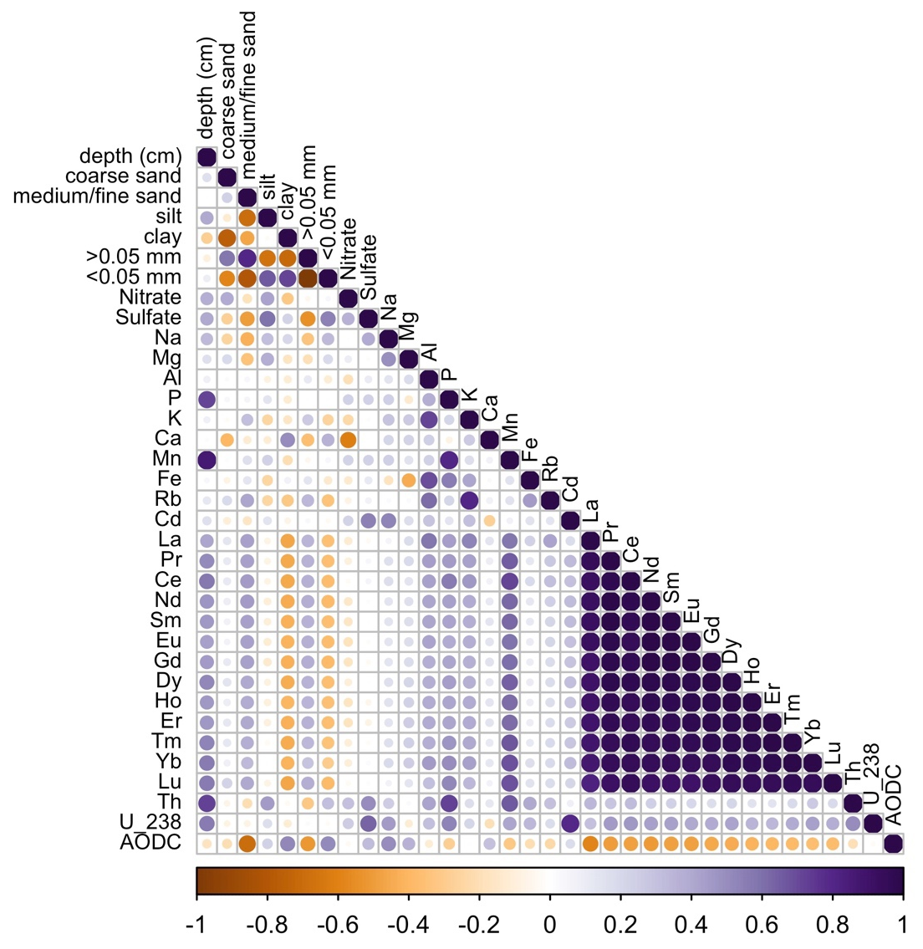
Figure 5.3 Sediment chemistry correlations
Spearman rank correlations for sediment particle size, geochemistry, and cell counts (AODC). The highly co-correlated rare earth elements are among the most visible trends corresponding positively with depth and Mn.
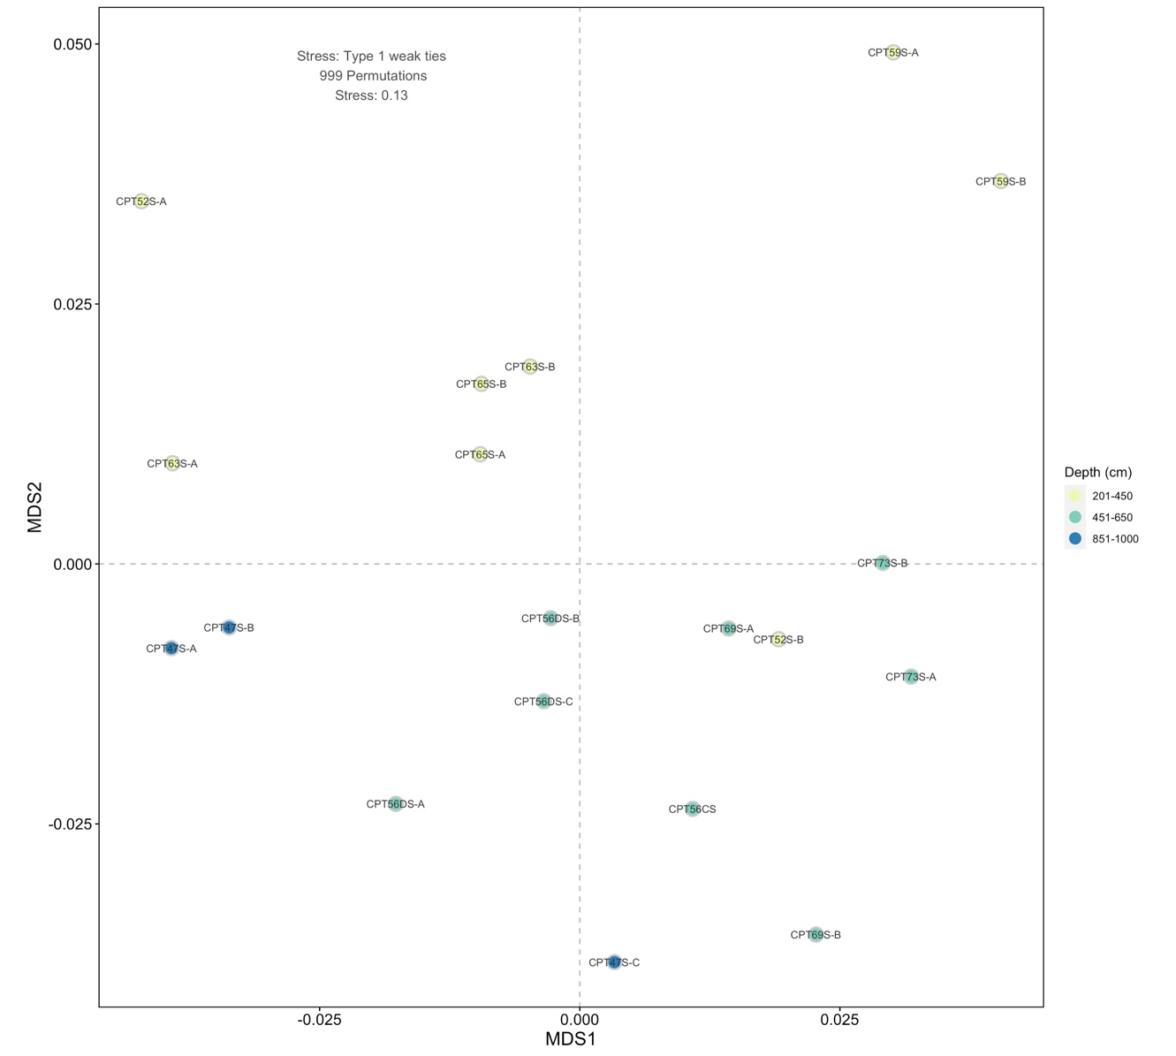
Figure 5.4 NMDS of sediment geochemistry
A limited dispersion was identified across sediment sample geochemistry and particle size distribution with samples collected from 451 to 650 cm bgs sharing the highest similarity.

i. Aqueous anion concentrations
ii. Field parameters
Figure 5.5 Geochemistry gradients from wells local to sediment cores
Groundwater geochemistry changed across the study site with high nitrate, sulfate, and specific conductivity measured from wells with low pH. Wells with low pH were highly localized to the regions near CPT47.
Figure 5.6 Phylum-level 16S rRNA abundance
At the phylum-level, 16S rRNA abundance demonstrates the low diversity of ASVs and the uneven distribution across samples.

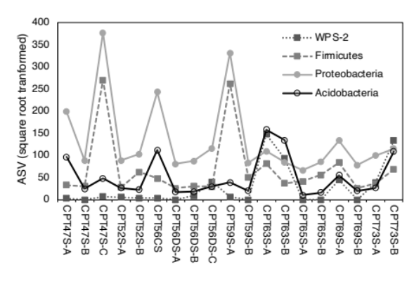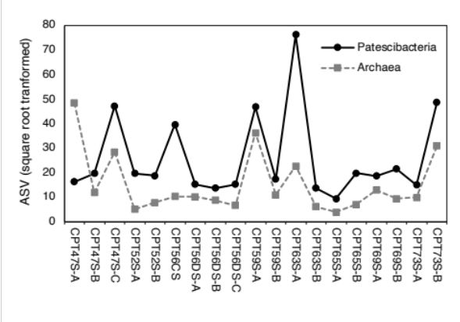
Figure 5.7 Phylum-level co-occurrence
Trends in phylum-level co-occurrence identified for six highly abundant phyla show the close association between Proteobacteria and Firmicute abundance particularly in shallowest (CPT 59-A) and deepest (CPT47S-C) samples (left). WPS-2 and Acidobacteriota also shared similar trends in abundance particularly in CPT63S and CPT73S (left). The panel on the right demonstrates the shared trends in read counts between Archaea and Patescibacteria.
A. Chemistry correlations (all samples)
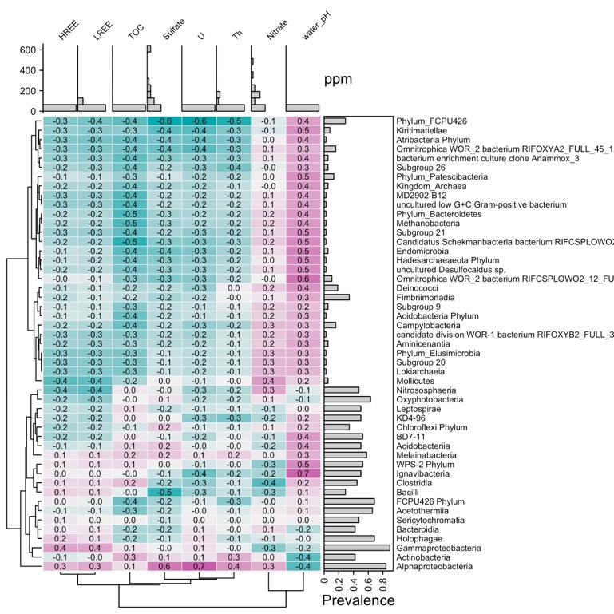
1

B. Physical correlations (all samples)
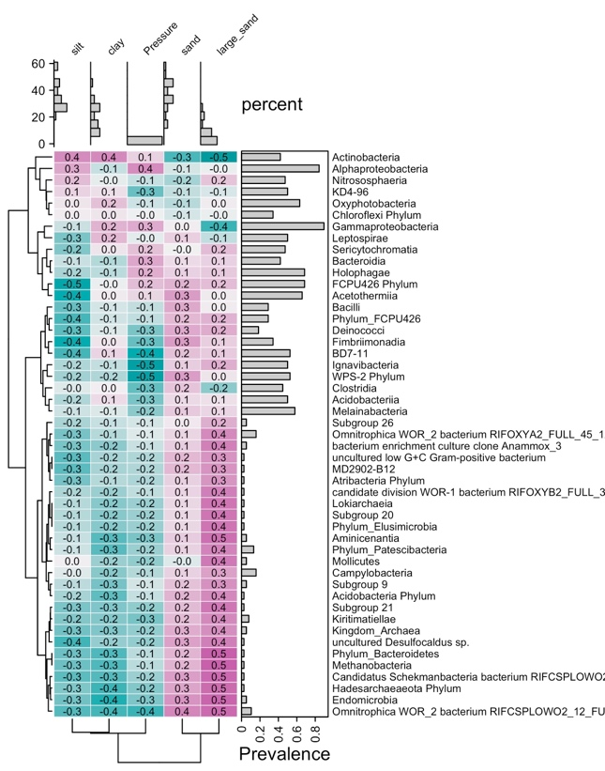
Figure 5.8 Taxonomic and geochemical correlations
Taxonomic abundance of most microbial classes demonstrated weak correlations overall with geochemistry. Some ASVs did show a positive association with groundwater pH (water_pH). The overall abundance of archaea and Patescibacteria classes increase in coarse-grained material.

Supplementary Figures

Figure S5.1 Order-level Patescibacteria abundance
Patescibacteria abundance and community composition was highly variable with high abundance identified in CPT63S-A with a similar community composition identified in CPT73S-B.

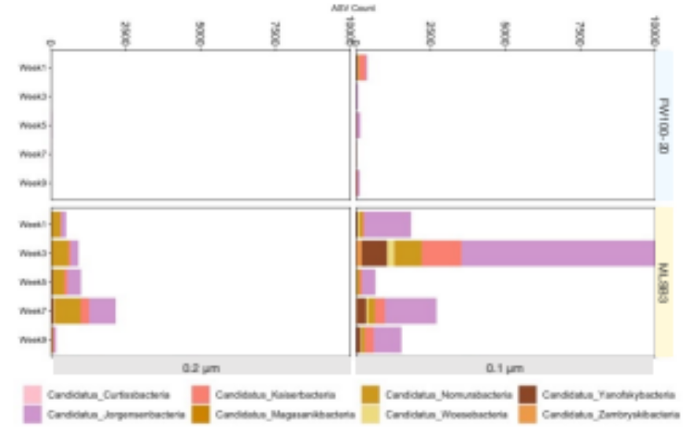
Figure S5.2 Patescibacteria abundance during sample collection for cell size analysis.

Appendix I: Tables

Table 5.1 Sediment geochemistry
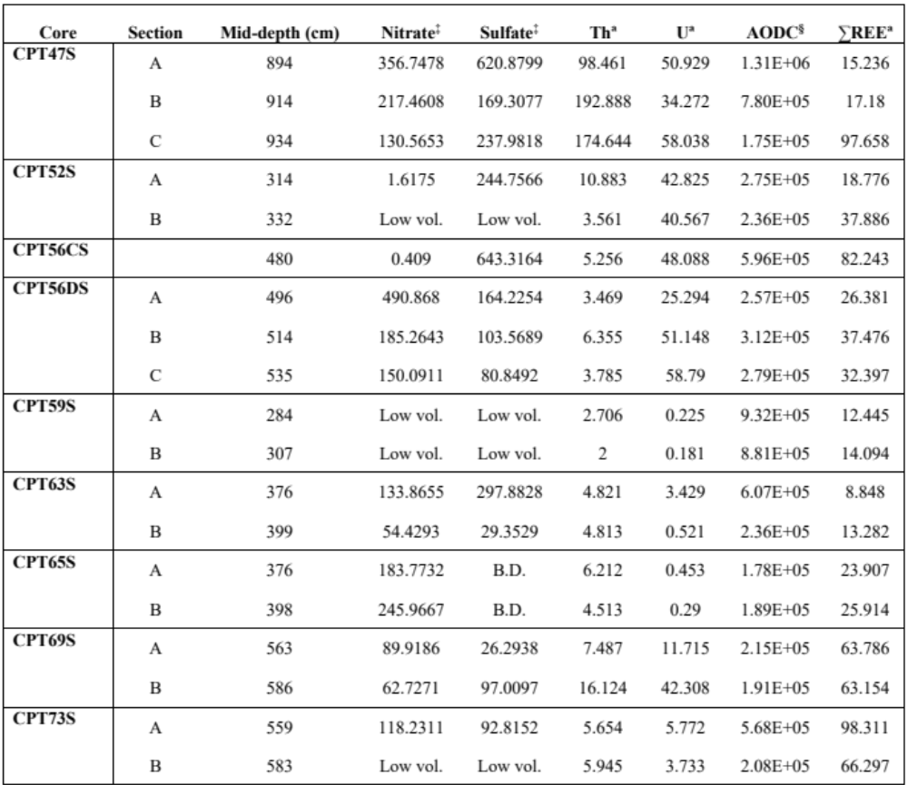
∑REE = sum of rare earth elements
Low vol. = samples with insufficient volumes for analysis
B.D. = samples with concentrations below detectable limits
ªConcentrations are reported in mg/kg
‡Porewater extracts reported in mg/L
§Cell counts are reported as cells/gram

Table 5.2 Particle size ranges for each sediment sample
Core | Section |  | Mid-depth (cm) | 4-2 mm | 2-0.05 mm | 0.05-0.002 mm | <0.002 mm | ∑Coarse | ∑Fine
CPT47S | A | 894 |  | 3 | 14 | 59 | 24 | 17 | 83
CPT47S | B | 914 |  | 2 | 14 | 57 | 27 | 16 | 84
CPT47S | C | 934 |  | 1 | 36 | 48 | 15 | 37 | 63
CPT52S | A | 314 |  | 0 | 35 | 30 | 35 | 35 | 65
CPT52S | B | 332 |  | 0 | 61 | 19 | 19 | 62 | 38
CPT56CS |  | 510 |  | 1 | 30 | 45 | 24 | 31 | 69
CPT56DS | A | 496 |  | 7 | 40 | 37 | 16 | 47 | 53
CPT56DS | B | 514 |  | 25 | 34 | 34 | 7 | 59 | 41
CPT56DS | C | 535 |  | 19 | 41 | 27 | 13 | 60 | 40
CPT59S | A | 284 |  | 0 | 19 | 34 | 47 | 19 | 81
CPT59S | B | 307 |  | 8 | 31 | 29 | 32 | 39 | 61
CPT63S | A | 376 |  | 2 | 30 | 43 | 25 | 32 | 68
CPT63S | B | 399 |  | 10 | 46 | 30 | 13 | 56 | 44
CPT65S | A | 376 |  | 18 | 32 | 38 | 11 | 51 | 49
CPT65S | B | 398 |  | 10 | 49 | 30 | 11 | 59 | 41
CPT69S | A | 563 |  | 2 | 46 | 25 | 27 | 48 | 52
CPT69S | B | 586 |  | 8 | 43 | 30 | 19 | 51 | 49
CPT73S | A | 559 |  | 15 | 43 | 31 | 11 | 58 | 42
CPT73S | B | 583 |  | 9 | 45 | 35 | 10 | 54 | 46

Table 5.3 Groundwater geochemistry
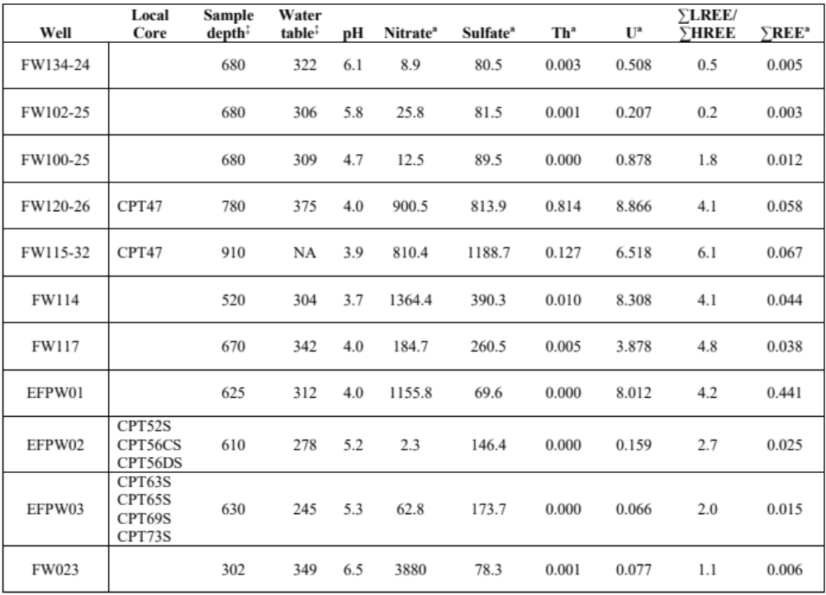
‡cm below ground surface ªReported in mg/L ∑REE = sum of rare earth elements

Table 5.4 Quantification of cells by size and by well
Well | Imaged fraction | Week 1 | Week 3 | Week 5 | Week 7 | Week 9 | Mean
FW100-25 (pH=4.7) | bacteriophage | 0 | 0 | 0 | 0 | 0 | 0 ± 0
FW100-25 (pH=4.7) | cells ≤0.3µm | 1 | 0.1 | 1 | 0.9 | 0 | 0.6 ± 0.5
FW100-25 (pH=4.7) | cells >0.3µm | 4.5 | 1 | 3.1 | 4 | 2.5 | 3.02 ± 1.3
FW100-25 (pH=4.7) | Percent of material ≤0.3 µm | 18% | 9% | 24% | 18% | 0% | 14 ± 10%
GW821-E (pH=6.3) | bacteriophage | 2.4 | 1.5 | 0.5 | 1.3 | 3.6 | 1.86 ± 1.1
GW821-E (pH=6.3) | cells ≤0.3µm | 3.1 | 1.9 | 1.3 | 1 | 1.3 | 1.72 ± 0.8
GW821-E (pH=6.3) | cells >0.3µm | 8.9 | 3.8 | 3.1 | 4 | 5.5 | 5.06 ± 2.3
GW821-E (pH=6.3) | Percent of material ≤0.3 µm | 38% | 47% | 37% | 37% | 47% | 41 ± 6%
MLSB3  (pH=6.9) | bacteriophage | 0.6 | 0.5 | 4.5 | 0.3 | 2.6 | 1.7 ± 1.8
MLSB3  (pH=6.9) | cells ≤0.3µm | 2.3 | 3.5 | 5.1 | 3.3 | 3.3 | 3.5 ± 1
MLSB3  (pH=6.9) | cells >0.3µm | 1.1 | 0.9 | 3 | 1.9 | 2 | 1.78 ± 0.8
MLSB3  (pH=6.9) | Percent of material ≤0.3 µm | 73% | 82% | 76% | 65% | 75% | 74 ± 6%
n=750 observations per well

Supplementary Tables

Table S5.1 Alpha diversity by core
Core | Section | Mid-depth (cm) | ACEª | Shannon (H) | Inverse Simpson
CPT47S | A | 894 | 2126 ± 20 | 6.10 | 25.83
CPT47S | B | 914 | 525 ± 11 | 5.66 | 132.70
CPT47S | C | 934 | 2212 ± 16 | 5.01 | 18.83
CPT52S | A | 314 | 476 ± 10 | 5.52 | 114.56
CPT52S | B | 332 | 502 ± 11 | 4.84 | 29.39
CPT56CS |  | 510 | 1010 ± 16 | 4.90 | 29.86
CPT56DS | A | 496 | 427 ± 10 | 5.20 | 67.03
CPT56DS | B | 514 | 426 ± 10 | 4.92 | 41.45
CPT56DS | C | 535 | 478 ± 10 | 4.79 | 33.64
CPT59S | A | 284 | 1630 ± 10 | 4.87 | 16.15
CPT59S | B | 307 | 498 ± 11 | 5.16 | 44.55
CPT63S | A | 376 | 472 ± 11 | 3.66 | 10.28
CPT63S | B | 399 | 428 ± 10 | 3.14 | 5.75
CPT65S | A | 376 | 275 ± 8 | 4.13 | 18.64
CPT65S | B | 398 | 547 ± 12 | 5.21 | 51.46
CPT69S | A | 563 | 566 ± 12 | 4.51 | 30.56
CPT69S | B | 586 | 471 ± 10 | 5.57 | 118.72
CPT73S | A | 559 | 545 ± 12 | 4.97 | 49.23
CPT73S | B | 583 | 702 ± 13 | 3.86 | 8.30
Meanª |  |  | 753 ± 132 | 4.84 ± 0.16 | 44.5 ± 8.7
Median |  |  | 502 | 4.92 | 30.5
ªincludes standard error

CONCLUSION

Conclusions
Based on the common assertion that small cells are highly abundant in contaminated media, this dissertation focused on the community of native small microbial biomass in the shallow contaminated subsurface. This work aimed to elucidate presence, absence, and associations of small microbes particularly Patescibacteria within the context of geochemistry and physical properties of the subsurface.

Chapters two and three address the full and Ultramicrobacterial community during an emulsified vegetable oil injection. A limited reduction of sulfate and bio-immobilization of U occurred over 42-days while nitrate was reduced for almost100 days. During the reductive phase, Firmicutes, sulfate reducing Comamonadaceae in the Proteobacteria phylum and Desulfobacterota Geobacteraceae, and Desulfovibrionaceae increased in abundance. Desulfobacterota shared a similar trend in abundance with Patescibacteria Candidatus Wolfebacteria which were enriched during acetate production. A substantial proportion (89%) of the total community abundance was accounted for by only 24% of the total taxa. These 2,927 taxa were all identified on both 0.1 and 0.2 µm filters suggesting that signal loss is possible using a 0.2 µm filter membrane. This substantial overlap in community composition on filters may be due to factors related to the filter medium and the filtration process but may also be a product of the high prevalence of small cells measured in groundwater at the site. In a 10-week survey of groundwater material, 74% of the biological material identified in the injection site had a diameter less than 0.3 µm in diameter. Primarily consisting of bacteriophages and small cells.
Acetate production was a key indicator of EVO degradation and a primary factor related to the microbial community response. Acetate presence resulted in differential abundance of the complete community and the 0.1 µm community. However, the overall changes in 0.1 µm community abundance observed between the monitoring and control samples was minimal. Suggesting that the community changes observed in the monitoring wells during sulfate and uranium reduction were driven primarily by larger bacteria than by those captured on the 0.1 µm filter. The results of the injection suggest that the 0.1 µm community is driven by non-geochemically dependent factors. This could include recharge following precipitation or dissociation/transport of cells from local material.

Chapter four details a survey of local subsurface material conducted to provide an improved subsurface characterization for the shallow material directly down-gradient of the S3 ponds. However, a limited amount of information is available regarding the effects of this type of testing on the subsurface geochemistry during and following borehole testing and sealing. It was determined that the effects of this method on groundwater quality were limited spatially and temporally with the effects of penetration only discernable within 10 m of a monitoring well. Penetration revealed unequal responses in water level which may be attributed to fractures and the preferential flow found in this study site [12, 19, 20]. When the highly responsive samples were compared, soil type did have a weak positive linear relationship with compacted/cemented fine-grained material. A soil type of additional focus in chapter 5.
In total, the physical act of penetration produced a limited effect on local specific conductivity and water levels that was only a fraction of a natural weather event. The extent to which penetration activities affect local groundwater wells appears to vary by the physical characteristics of subsurface materials with a minimal overall effect.
The final chapter explores the association of subsurface bacteria within the highly heterogeneous subsurface environment. Geochemically, the site had a wide range and dispersal of contaminants identified in shallow and deep sediment samples which are underestimated in bulk water collections. Elemental signatures indicate the potential formation of ferromanganese oxyhydroxides although suggests that rare earth elements may not be as readily complexed at pH ≤ 4. Variable pore pressures and sediment types in the subsurface suggest a wide variety of localized high and low pore pressures but sediment analysis suggests a nearly equal composition of sandy coarse material and fine material like silt and clay.
Alpha Proteobacteria were positively correlated with contaminants U and sulfate, a trend not exhibited by any other sediment-associated taxa. However, most of the taxa were co-correlated or positively associated with the local well pH. Including the small bacteria Patescibacteria which were also identified in the low pH cores (CPT47S-C). Patescibacteria abundance trended positively with archaea. Both shared similar trends in abundance with changes in geochemistry. A Patescibacteria cohort cluster was identified as including methanotrophs, methane oxidizers, and degraders of polyaromatic hydrocarbons and alkanes. These taxa were associated with low total organic carbon, and positively associated with the presence of larger sediment.
The inclusion of anaerobic methane-cycling bacteria and archaea in the Patescibacteria cohort suggests transport into the site from deeper bedrock sources as opposed to dispersal into the sediment from the ground surface. This finding is further supported by the checkered abundance of Patescibacteria in the sediment with higher overall compositions of archaea and Patescibacteria in samples closer to the bedrock interface (CPT47) and in sediments underlying thick layers of fine-grained sediment (CPT73).

Implications for transport in the subsurface
Patescibacteria 16S rRNA composition was highest in samples with larger proportions of ultramicrobacteria-sized biological material. A trend which was directly associated with the subsurface sediment properties inherently selected for by colloid straining and filtration theory. The conclusions of this work promote that small cell transport is mediated by and primarily driven by transport in coarse and fractured material. Here we propose that much of the material collected and identified in the shallow subsurface has been transported into the material via transport in bedrock as opposed to originating in the local sampled material. This suggests that small bacteria are among the most highly mobile particularly in coarse and fractured media as demonstrated by the prevalence and abundance of Patescibacteria. Here we found that Patescibacteria may even serve as a ‘natural tracer’ for the sizes of material commonly transported at a site.

Application to future Patescibacteria studies
Patesciabcteria were repeatedly identified in association with a consortium of methanotrophs and others associated with microaerophilic conditions. Patescibacteria which have been identified in association with archaea previously were positively associated with archaeal abundance in sediments collected at the site. Additionally, the Patescibacteria order Candidatus Wolfebacteria was enriched during the reduction of sulfate and in co-consortia with sulfate reducing bacteria. However, these results suggest that Patescibacteria abundance is attributed less to the geochemistry and more closely associated with proximity to coarse material, and methanotrophs or other sulfate reducing taxa. The abundance and distribution of this phylum suggests that future studies should fully consider the flow conditions and lithology of sample origin since this work demonstrates the effect that changes in the physical media can have on the microbial community composition. The occurrence of this phylum with microaerophilic and reducing conditions and the potential for a syntrophic or host-associated relationship with archaea may improve the design and effectiveness of efforts to culture Patescibacteria.

Implications for the Y-12 subsurface observatory
Overall, this dissertation provides context to small bacteria distribution suggesting a larger distribution and preferential transport in fractured or coarse media. This dissertation demonstrated that small cells are abundant in coarse media and are associated with reductive processes. The information provided in this dissertation gives context to the subsurface investigations of material near the S-3 ponds. The spatial and temporal data identified have actively contributed to and informed the design of the planned subsurface observatory at the Y-12 site (Figure 6.1). This work asserts that community diversity is influenced by the presence of contaminants, but that the community is largely transient transported and implanted by fractured media. Targeting investigations in ranges of variable permeability within the shallow material will provide a diverse and functionally and a relevant assessment of the microbial community.

Appendix J: Figures

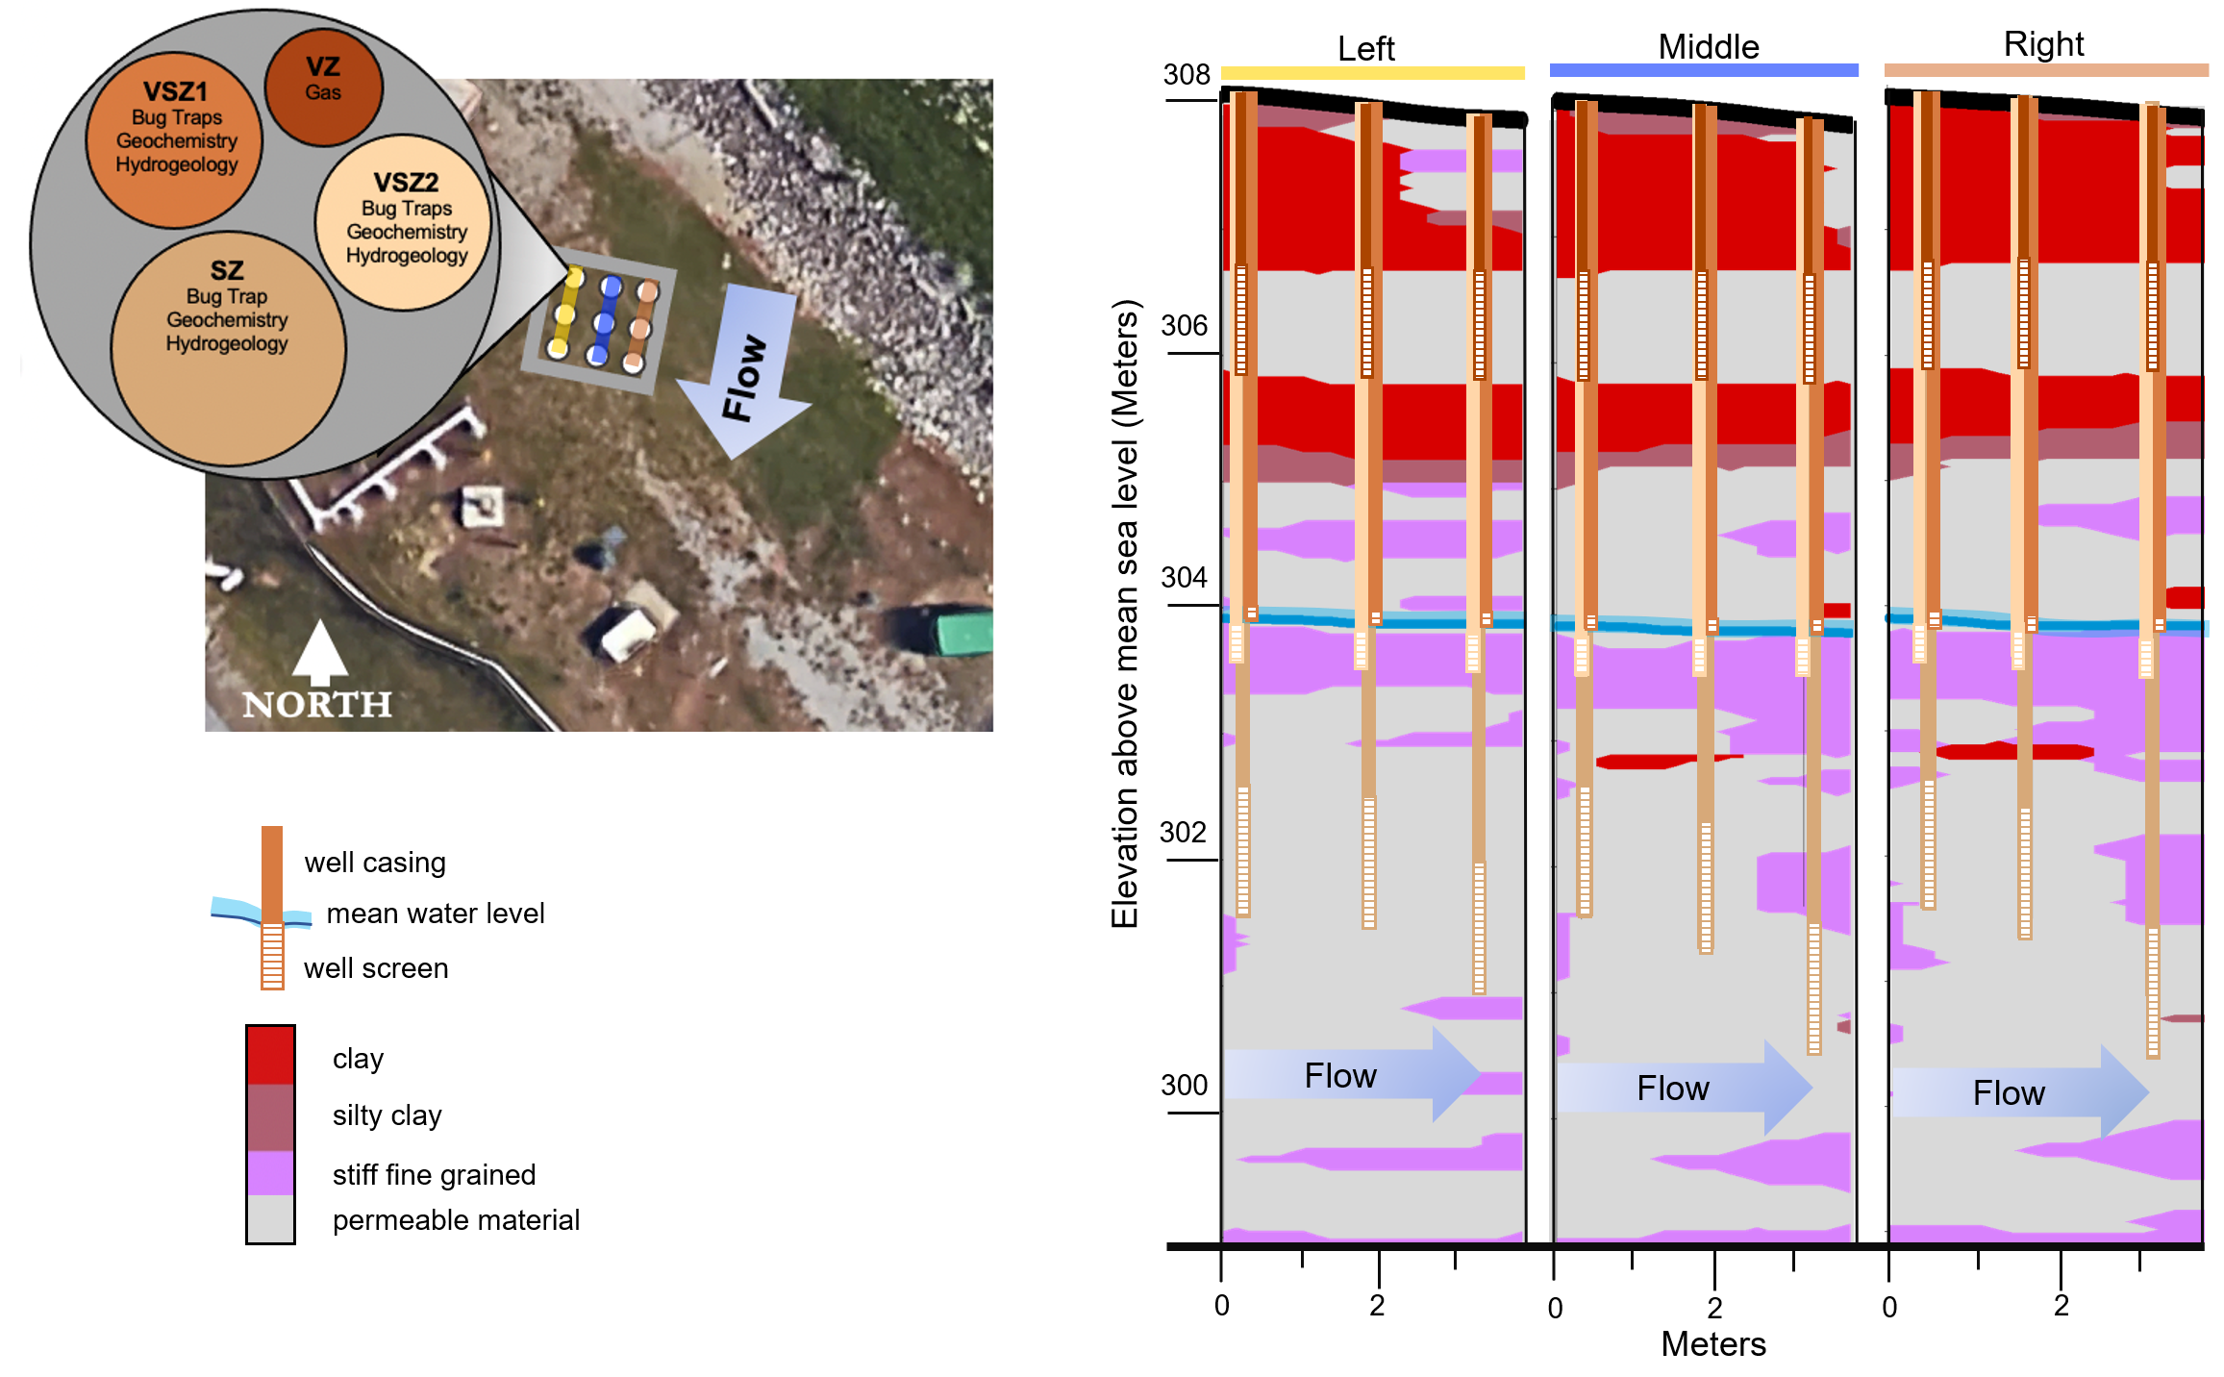
Figure 6.1 Configuration of the subsurface observatory to investigate material transport from groundwater base flow and surface-level infiltration. The multi-well approach provides an assessment of the shallow and deep saturated environments. The multi-well design allows for a deeper understanding of the localized effects of heterogeneity within subregions of the site.

REFERENCES
1. Proctor, C.R., et al., Phylogenetic clustering of small low nucleic acid-content bacteria across diverse freshwater ecosystems. The ISME journal, 2018. 12(5): p. 1344-1359.
2. Hug, L.A., et al., A new view of the tree of life. Nature Microbiology, 2016. 1(5).
3. Parks, D.H., et al., A standardized bacterial taxonomy based on genome phylogeny substantially revises the tree of life. Nature biotechnology, 2018. 36(10): p. 996-1004.
4. Miyoshi, T., T. Iwatsuki, and T. Naganuma, Phylogenetic characterization of 16S rRNA gene clones from deep-groundwater microorganisms that pass through 0.2-micrometer-pore-size filters. Applied and environmental microbiology, 2005. 71(2): p. 1084-1088.
5. Luef, B., et al., Diverse uncultivated ultra-small bacterial cells in groundwater. Nature Communications, 2015. 6.
6. Schwab, V.F., et al., C-14-Free Carbon Is a Major Contributor to Cellular Biomass in Geochemically Distinct Groundwater of Shallow Sedimentary Bedrock Aquifers. Water Resources Research, 2019. 55(3): p. 2104-2121.
7. Bruno, A., et al., Exploring the under-investigated "microbial dark matter" of drinking water treatment plants. Scientific Reports, 2017. 7.
8. Kumar, S., et al., Nitrogen loss from pristine carbonate-rock aquifers of the Hainich Critical Zone Exploratory (Germany) is primarily driven by chemolithoautotrophic anammox processes. Frontiers in microbiology, 2017. 8: p. 1951.
9. Brown, C.T., et al., Unusual biology across a group comprising more than 15% of domain Bacteria. Nature, 2015. 523(7559): p. 208-U173.
10. de Graaf, I.E., et al., Environmental flow limits to global groundwater pumping. Nature, 2019. 574(7776): p. 90-94.
11. Leslie A. DeSimone, P.B.M., Michael R. Rosen, The quality of our Nation's waters: Water quality in principal aquifers of the United States, 1991-2010, USGS, Editor. 2015, National Water Quality Assessment Program.
12. Kuzyakov, Y., Priming effects: Interactions between living and dead organic matter. Soil Biology & Biochemistry, 2010. 42(9): p. 1363-1371.
13. Smith, M.B., et al., Natural Bacterial Communities Serve as Quantitative Geochemical Biosensors. Mbio, 2015. 6(3).
14. Tian, R.M., et al., Small and mighty: adaptation of superphylum Patescibacteria to groundwater environment drives their genome simplicity. Microbiome, 2020. 8(1).
15. Wu, Y.C., et al., pH is the primary determinant of the bacterial community structure in agricultural soils impacted by polycyclic aromatic hydrocarbon pollution. Scientific Reports, 2017. 7.
16. Carrey, R., et al., Combining multi-isotopic and molecular source tracking methods to identify nitrate pollution sources in surface and groundwater. Water Research, 2021. 188.
17. Hazen, T.C., et al., Deep-Sea Oil Plume Enriches Indigenous Oil-Degrading Bacteria. Science, 2010. 330(6001): p. 204-208.
18. Kim, H., Comparison of PCR Primers for Analyzing Denitrifying Microorganisms in the Hyporheic Zone. Applied Sciences-Basel, 2020. 10(12).
19. Vadde, K.K., et al., Quantification of Microbial Source Tracking and Pathogenic Bacterial Markers in Water and Sediments of Tiaoxi River (Taihu Watershed). Frontiers in Microbiology, 2019. 10.
20. Putt, A.D., S.a.A.A. Rafie, and T.C. Hazen, Large-Data Omics Approaches in Modern Remediation. Journal of Environmental Engineering, 2022. 148(9): p. 02522001.
21. Gihring, T.M., et al., A Limited Microbial Consortium Is Responsible for Extended Bioreduction of Uranium in a Contaminated Aquifer. Applied and Environmental Microbiology, 2011. 77(17): p. 5955-5965.
22. King, A.J., et al., Temporal Dynamics of In-Field Bioreactor Populations Reflect the Groundwater System and Respond Predictably to Perturbation. Environmental Science & Technology, 2017. 51(5): p. 2879-2889.
23. Lovley, D.R., et al., Microbial reduction of uranium. Nature, 1991. 350(6317): p. 413-416.
24. Tian, R., et al., Small and mighty: adaptation of superphylum Patescibacteria to groundwater environment drives their genome simplicity. Microbiome, 2020. 8(1): p. 1-15.
25. Watson, D.B., G. R. Moline, P. M. Jardine, S. K. Holladay, T. L. Mehlhorn, B. Gu, A. V. Palumbo, B. P. Spalding, C. C. Brandt and W. E. Doll Natural and Accelerated Bioremediation Research (NABIR) Field Research Center (FRC) Site Characterization Plan. 2001: Oak Ridge National Laboratory.
26. Watson, D.B., et al., In Situ Bioremediation of Uranium with Emulsified Vegetable Oil as the Electron Donor. Environmental Science & Technology, 2013. 47(12): p. 6440-6448.
27. Zhou, J.Z., et al., Stochasticity, succession, and environmental perturbations in a fluidic ecosystem. Proceedings of the National Academy of Sciences of the United States of America, 2014. 111(9): p. E836-E845.
28. Hwang, C.C., et al., Bacterial community succession during in situ uranium bioremediation: spatial similarities along controlled flow paths. Isme Journal, 2009. 3(1): p. 47-64.
29. Suzuki, S., et al., Unusual metabolic diversity of hyperalkaliphilic microbial communities associated with subterranean serpentinization at The Cedars. Isme Journal, 2017. 11(11): p. 2584-2598.
30. Sharuddin, S.S., et al., Shift of low to high nucleic acid bacteria as a potential bioindicator for the screening of anthropogenic effects in a receiving river due to palm oil mill effluent final discharge. Ecological Indicators, 2018. 85: p. 79-84.
31. Liu, J., et al., Geographic distribution pattern of low and high nucleic acid content bacteria on a river-catchment scale. Marine and Freshwater Research, 2017. 68(9): p. 1618-1625.
32. Lappin-Scott, H.M. and J.W. Costerton, Ultramicrobacteria and their biotechnological applications. Current Opinion in Biotechnology, 1992. 3(3): p. 283-285.
33. Cusack, F., et al., Enhanced Oil-Recovery - 3-Dimensional Sandpack Simulation of Ultramicrobacteria Resuscitation in Reservoir Formation. Journal of General Microbiology, 1992. 138: p. 647-655.
34. Ross, N. and G. Bickerton, Application of biobarriers for groundwater containment at fractured bedrock sites. Remediation Journal, 2002. 12(3): p. 5-21.
35. Duda, V.I., et al., Ultramicrobacteria: Formation of the concept and contribution of ultramicrobacteria to biology. Microbiology, 2012. 81(4): p. 379-390.
36. Obayashi, Y. and S. Suzuki, High growth potential of transiently 0.2-mu m-filterable bacteria with extracellular protease activity in coastal seawater. Plankton & Benthos Research, 2019. 14(4): p. 276-286.
37. Cavicchioli, R., et al., Life under nutrient limitation in oligotrophic marine environments: An eco/physiological perspective of Sphingopyxis alaskensis (formerly Sphingomonas alaskensis). Microbial Ecology, 2003. 45(3): p. 203-217.
38. Giovannoni, S.J., et al., Genome streamlining in a cosmopolitan oceanic bacterium. Science, 2005. 309(5738): p. 1242-1245.
39. Haller, C.M., et al., Investigation of 0.2 mu m filterable bacteria from the Western Mediterranean Sea using a molecular approach: dominance of potential starvation forms. Fems Microbiology Ecology, 2000. 31(2): p. 153-161.
40. Cavicchioli, R. and M. Ostrowski, Ultramicrobacteria. eLS, 2003.
41. Torrella, F. and R.Y. Morita, Microcultural Study of Bacterial Size Changes and Microcolony and Ultramicrocolony Formation by Heterotrophic Bacteria in Seawater. Applied and Environmental Microbiology, 1981. 41(2): p. 518-527.
42. Herrmann, M., et al., Predominance of Cand. Patescibacteria in Groundwater Is Caused by Their Preferential Mobilization From Soils and Flourishing Under Oligotrophic Conditions. Frontiers in Microbiology, 2019. 10.
43. Ishida, Y. and H. Kadota, Growth-Patterns and Substrate Requirements of Naturally-Occurring Obligate Oligotrophs. Microbial Ecology, 1981. 7(2): p. 123-130.
44. Zhao, X.W., et al., Three-Dimensional Structure of the Ultraoligotrophic Marine Bacterium "Candidatus Pelagibacter ubique". Applied and Environmental Microbiology, 2017. 83(3).
45. DeLong, J.P., et al., Shifts in metabolic scaling, production, and efficiency across major evolutionary transitions of life. Proceedings of the National Academy of Sciences, 2010. 107(29): p. 12941-12945.
46. West, G.B. and J.H. Brown, The origin of allometric scaling laws in biology from genomes to ecosystems: towards a quantitative unifying theory of biological structure and organization. Journal of experimental biology, 2005. 208(9): p. 1575-1592.
47. Schattenhofer, M., et al., Phylogenetic characterisation of picoplanktonic populations with high and low nucleic acid content in the North Atlantic Ocean. Systematic and Applied Microbiology, 2011. 34(6): p. 470-475.
48. Westoby, M., et al., Cell size, genome size, and maximum growth rate are near‐independent dimensions of ecological variation across bacteria and archaea. Ecology and Evolution, 2021. 11(9): p. 3956-3976.
49. Eswaran, R. and L. Khandeparker, Ecological relevance of high and low nucleic acid content bacteria in a monsoon influenced tropical estuary: implications on the β-glucosidase activity. Acta Oecologica, 2021. 110: p. 103697.
50. Hu, W., et al., Characteristics, biodiversity, and cultivation strategy of low nucleic acid content bacteria. Frontiers in Microbiology, 2022: p. 2186.
51. Liu, J., et al., Occurrence and fate of ultramicrobacteria in a full-scale drinking water treatment plant. Frontiers in microbiology, 2018. 9: p. 2922.
52. Tabor, P.S., K. Ohwada, and R.R. Colwell, Filterable marine bacteria found in the deep sea: distribution, taxonomy, and response to starvation. Microbial Ecology, 1981. 7(1): p. 67-83.
53. Santos, M., et al., Flow cytometry analysis of low/high DNA content (LNA/HNA) bacteria as bioindicator of water quality evaluation. Ecological Indicators, 2019. 103: p. 774-781.
54. Wang, Y.Y., et al., Isolation and characterization of low nucleic acid (LNA)-content bacteria. Isme Journal, 2009. 3(8): p. 889-902.
55. Wang, Y.Y., et al., Influence of size, shape, and flexibility on bacterial passage through micropore membrane filters. Environmental Science & Technology, 2008. 42(17): p. 6749-6754.
56. Giovannoni, S.J., SAR11 Bacteria: The Most Abundant Plankton in the Oceans. Annual Review of Marine Science, Vol 9, 2017. 9: p. 231-255.
57. Rappe, M.S., et al., Cultivation of the ubiquitous SAR11 marine bacterioplankton clade. Nature, 2002. 418(6898): p. 630-633.
58. Vila-Costa, M., et al., Community analysis of high- and low-nucleic acid-containing bacteria in NW Mediterranean coastal waters using 16S rDNA pyrosequencing. Environmental Microbiology, 2012. 14(6): p. 1390-1402.
59. Ramseier, M.K., et al., Kinetics of membrane damage to high (HNA) and low (LNA) nucleic acid bacterial clusters in drinking water by ozone, chlorine, chlorine dioxide, monochloramine, ferrate (VI), and permanganate. Water Research, 2011. 45(3): p. 1490-1500.
60. Anantharaman, K., et al., Thousands of microbial genomes shed light on interconnected biogeochemical processes in an aquifer system. Nature Communications, 2016. 7.
61. Kantor, R.S., et al., Small Genomes and Sparse Metabolisms of Sediment-Associated Bacteria from Four Candidate Phyla. Mbio, 2013. 4(5).
62. Jochem, F., P. Lavrentyev, and M. First, Growth and grazing rates of bacteria groups with different apparent DNA content in the Gulf of Mexico. Marine Biology, 2004. 145(6): p. 1213-1225.
63. Longnecker, K., B.F. Sherr, and E. Sherr, Activity and phylogenetic diversity of bacterial cells with high and low nucleic acid content and electron transport system activity in an upwelling ecosystem. Applied and environmental microbiology, 2005. 71(12): p. 7737-7749.
64. Zubkov, M.V., et al., Comparison of cellular and biomass specific activities of dominant bacterioplankton groups in stratified waters of the Celtic Sea. Applied and environmental microbiology, 2001. 67(11): p. 5210-5218.
65. Bradford, S.A., J. Schijven, and T. Harter, Microbial Transport and Fate in the Subsurface Environment: Introduction to the Special Section. Journal of Environmental Quality, 2015. 44(5): p. 1333-1337.
66. Bales, R.C., et al., Virus and Bacteria Transport in a Sandy Aquifer, Cape-Cod, Ma. Ground Water, 1995. 33(4): p. 653-661.
67. Harvey, R.W. and S. Garabedian, Use of Colloid Filtration Theory in Modeling Movement of Bacteria through a Contaminated Sandy Aquifer - Reply. Environmental Science & Technology, 1992. 26(2): p. 401-402.
68. Clifton, L.A., et al., Effect of divalent cation removal on the structure of gram-negative bacterial outer membrane models. Langmuir, 2015. 31(1): p. 404-412.
69. McKay, L.D., et al., A field example of bacteriophage as tracers of fracture flow. Environmental science & technology, 1993. 27(6): p. 1075-1079.
70. Corapcioglu, M.Y. and A. Haridas, Microbial Transport in Soils and Groundwater - a Numerical-Model. Advances in Water Resources, 1985. 8(4): p. 188-200.
71. Watson, D., Kostka J., Fields M., Jardine P., The Oak Ridge Field Research Center Conceptual Model, in Oak Ridge National Laboratory. 2004, Oak Ridge National Laboratory.
72. Couradeau, E., et al., Probing the active fraction of soil microbiomes using BONCAT-FACS. Nature communications, 2019. 10(1): p. 1-10.
73. Chapelle, F.H., The significance of microbial processes in hydrogeology and geochemistry. Hydrogeology Journal, 2000. 8(1): p. 41-46.
74. Sani, R.K., et al., Reduction of uranium (VI) under sulfate-reducing conditions in the presence of Fe (III)-(hydr) oxides. Geochimica et Cosmochimica Acta, 2004. 68(12): p. 2639-2648.
75. Zhang, P., et al., Dynamic succession of groundwater sulfate-reducing communities during prolonged reduction of uranium in a contaminated aquifer. Environmental science & technology, 2017. 51(7): p. 3609-3620.
76. Anderson, R.T., et al., Stimulating the in situ activity of Geobacter species to remove uranium from the groundwater of a uranium-contaminated aquifer. Applied and Environmental Microbiology, 2003. 69(10): p. 5884-5891.
77. Chang, Y.J., et al., Microbial incorporation of C-13-labeled acetate at the field scale: Detection of microbes responsible for reduction of U(VI). Environmental Science & Technology, 2005. 39(23): p. 9039-9048.
78. Paradis, C.J., et al., In situ mobility of uranium in the presence of nitrate following sulfate-reducing conditions. Journal of Contaminant Hydrology, 2016. 187: p. 55-64.
79. Paradis, C.J., et al., Sustained Ability of a Natural Microbial Community to Remove Nitrate from Groundwater. Groundwater, 2022. 60(1): p. 99-111.
80. Xu, M., et al., Responses of microbial community functional structures to pilot-scale uranium in situ bioremediation. The ISME journal, 2010. 4(8): p. 1060-1070.
81. Borden, R.C., S.D. Richardson, and A.A. Bodour, Enhanced reductive dechlorination of trichloroethene in an acidic DNAPL impacted aquifer. Journal of environmental management, 2019. 237: p. 617-628.
82. Harkness, M.R. and A.S. Fisher, Use of emulsified vegetable oil to support bioremediation of TCE DNAPL in soil columns. Journal of contaminant hydrology, 2013. 151: p. 16-33.
83. Lindow, N.L. and R.C. Borden, Anaerobic bioremediation of acid mine drainage using emulsified soybean oil. Mine Water and the Environment, 2005. 24(4): p. 199-208.
84. Rees, G.N. and B. Patel, Desulforegula conservatrix gen. nov., sp. nov., a long-chain fatty acid-oxidizing, sulfate-reducing bacterium isolated from sediments of a freshwater lake. International journal of systematic and evolutionary microbiology, 2001. 51(5): p. 1911-1916.
85. Moe, W.M., et al., Pelosinus defluvii sp. nov., isolated from chlorinated solvent-contaminated groundwater, emended description of the genus Pelosinus and transfer of Sporotalea propionica to Pelosinus propionicus comb. nov. International journal of systematic and evolutionary microbiology, 2012. 62 Pt 6: p. 1369-76.
86. Sardessai, Y.N. and S. Bhosle, Industrial potential of organic solvent tolerant bacteria. Biotechnology Progress, 2004. 20(3): p. 655-660.
87. Veerapagu, M., et al., Screening selection identification production and optimization of bacterial lipase from oil spilled soil. Asian J Pharm Clin Res, 2013. 6(3): p. 62-67.
88. Lovley, D.R., et al., Humic substances as electron acceptors for microbial respiration. Nature, 1996. 382(6590): p. 445-448.
89. Lovley, D.R., et al., Geobacter metallireducens gen. nov. sp. nov., a microorganism capable of coupling the complete oxidation of organic compounds to the reduction of iron and other metals. Archives of microbiology, 1993. 159(4): p. 336-344.
90. Lovley, D.R. and E.J. Phillips, Reduction of uranium by Desulfovibrio desulfuricans. Applied and environmental microbiology, 1992. 58(3): p. 850-856.
91. Lovley, D.R., et al., Enzymatic iron and uranium reduction by sulfate-reducing bacteria. Marine Geology, 1993. 113(1-2): p. 41-53.
92. Alessi, D.S., et al., The product of microbial uranium reduction includes multiple species with U (IV)–phosphate coordination. Geochimica et Cosmochimica Acta, 2014. 131: p. 115-127.
93. Haas, J.R. and A. Northup, Effects of aqueous complexation on reductive precipitation of uranium by Shewanella putrefaciens. Geochemical Transactions, 2004. 5(3): p. 1-8.
94. Hufton, J., et al., The importance of the bacterial cell wall in uranium (vi) biosorption. Physical Chemistry Chemical Physics, 2021. 23(2): p. 1566-1576.
95. Liang, X., et al., Uranium phosphate biomineralization by fungi. Environmental microbiology, 2015. 17(6): p. 2064-2075.
96. Macaskie, L.E., et al., Enzymically mediated bioprecipitation of uranium by a Citrobacter sp.: a concerted role for exocellular lipopolysaccharide and associated phosphatase in biomineral formation. Microbiology, 2000. 146(8): p. 1855-1867.
97. Newsome, L., et al., Biostimulation by glycerol phosphate to precipitate recalcitrant uranium (IV) phosphate. Environmental Science & Technology, 2015. 49(18): p. 11070-11078.
98. Bernier-Latmani, R., et al., Non-uraninite products of microbial U (VI) reduction. Environmental science & technology, 2010. 44(24): p. 9456-9462.
99. Mondani, L., et al., Influence of uranium on bacterial communities: a comparison of natural uranium-rich soils with controls. PLoS One, 2011. 6(10): p. e25771.
100. Shelobolina, E.S., et al., Importance of c-type cytochromes for U (VI) reduction by Geobacter sulfurreducens. BMC microbiology, 2007. 7(1): p. 1-15.
101. Kleikemper, J., et al., Activity and diversity of methanogens in a petroleum hydrocarbon-contaminated aquifer. Applied and environmental microbiology, 2005. 71(1): p. 149-158.
102. Liu, J., et al., Passage and community changes of filterable bacteria during microfiltration of a surface water supply. Environment International, 2019. 131.
103. Engineering, L., Results of Groundwater Monitoring Studies. 1983, Retrieved From.
104. Smith, H.J., et al., Impact of hydrologic boundaries on microbial planktonic and biofilm communities in shallow terrestrial subsurface environments. FEMS microbiology ecology, 2018. 94(12): p. fiy191.
105. Hazen, T.C., et al., Comparison of bacteria from deep subsurface sediment and adjacent groundwater. Microbial Ecology, 1991. 22(1): p. 293-304.
106. Goldscheider, N., D. Hunkeler, and P. Rossi, Microbial biocenoses in pristine aquifers and an assessment of investigative methods. Hydrogeology Journal, 2006. 14(6): p. 926-941.
107. Harvey, R.W., R.L. Smith, and L. George, Effect of organic contamination upon microbial distributions and heterotrophic uptake in a Cape Cod, Mass., aquifer. Applied and Environmental Microbiology, 1984. 48(6): p. 1197-1202.
108. Kölbel-Boelke, J., E.-M. Anders, and A. Nehrkorn, Microbial communities in the saturated groundwater environment II: diversity of bacterial communities in a Pleistocene sand aquifer and their in vitro activities. Microbial ecology, 1988. 16(1): p. 31-48.
109. Godsy, E.M., Methanogenic biodegradation of creosote-derived contaminants in natural and simulated ground water ecosystems. 1993: Stanford University.
110. Lehman, R.M., Microbial distributions and their potential controlling factors in terrestrial subsurface environments, in The spatial distribution of microbes in the environment. 2007, Springer. p. 135-178.
111. Holm, P., et al., Importance of unattached bacteria and bacteria attached to sediment in determining potentials for degradation of xenobiotic organic contaminants in an aerobic aquifer. Applied and Environmental Microbiology, 1992. 58(9): p. 3020-3026.
112. Lehman, R.M., F.S. Colwell, and G.A. Bala, Attached and unattached microbial communities in a simulated basalt aquifer under fracture-and porous-flow conditions. Applied and Environmental Microbiology, 2001. 67(6): p. 2799-2809.
113. Anneser, B., et al., High resolution analysis of contaminated aquifer sediments and groundwater—what can be learned in terms of natural attenuation? Geomicrobiology Journal, 2010. 27(2): p. 130-142.
114. Harvey, R.W. and L.H. George, Growth determinations for unattached bacteria in a contaminated aquifer. Applied and Environmental Microbiology, 1987. 53(12): p. 2992-2996.
115. Wei, T., et al., Package ‘corrplot’. Statistician, 2017. 56(316): p. e24.
116. Zhou, J., M.A. Bruns, and J.M. Tiedje, DNA recovery from soils of diverse composition. Applied and environmental microbiology, 1996. 62(2): p. 316-322.
117. Wu, L., et al., Phasing amplicon sequencing on Illumina Miseq for robust environmental microbial community analysis. BMC microbiology, 2015. 15(1): p. 1-12.
118. Caporaso, J.G., et al., Ultra-high-throughput microbial community analysis on the Illumina HiSeq and MiSeq platforms. The ISME Journal, 2012. 6(8): p. 1621-1624.
119. Bolyen, E., et al., QIIME 2: Reproducible, interactive, scalable, and extensible microbiome data science. 2018, PeerJ Preprints.
120. Magoč, T. and S.L. Salzberg, FLASH: fast length adjustment of short reads to improve genome assemblies. Bioinformatics, 2011. 27(21): p. 2957-2963.
121. Team, R.C., R: A language and environment for statistical computing. 2013.
122. Wickham, H., W. Chang, and M.H. Wickham, Package ‘ggplot2’. Create elegant data visualisations using the grammar of graphics. Version, 2016. 2(1): p. 1-189.
123. Oksanen, J., et al., Package ‘vegan’. Community ecology package, version, 2013. 2(9): p. 1-295.
124. McMurdie, P.J. and S. Holmes, phyloseq: an R package for reproducible interactive analysis and graphics of microbiome census data. PloS one, 2013. 8(4): p. e61217.
125. Kahle, D.J. and H. Wickham, ggmap: spatial visualization with ggplot2. R J., 2013. 5(1): p. 144.
126. Chao, A. and L. Jost, Coverage‐based rarefaction and extrapolation: standardizing samples by completeness rather than size. Ecology, 2012. 93(12): p. 2533-2547.
127. McMurdie, P.J. and S. Holmes, Waste not, want not: why rarefying microbiome data is inadmissible. PLoS computational biology, 2014. 10(4): p. e1003531.
128. Barnett, D.J., I.C. Arts, and J. Penders, microViz: an R package for microbiome data visualization and statistics. Journal of Open Source Software, 2021. 6(63): p. 3201.
129. Mallick, H., et al., Multivariable association discovery in population-scale meta-omics studies. PLoS computational biology, 2021. 17(11): p. e1009442.
130. Nearing, J.T., et al., Microbiome differential abundance methods produce different results across 38 datasets. Nature communications, 2022. 13(1): p. 1-16.
131. Paulson, J.N., et al., Differential abundance analysis for microbial marker-gene surveys. Nature methods, 2013. 10(12): p. 1200-1202.
132. Segata, N., et al., Metagenomic biomarker discovery and explanation. Genome biology, 2011. 12(6): p. 1-18.
133. Cao, Y., et al., microbiomeMarker: an R/Bioconductor package for microbiome marker identification and visualization. Bioinformatics, 2022. 38(16): p. 4027-4029.
134. Louca, S., L.W. Parfrey, and M. Doebeli, Decoupling function and taxonomy in the global ocean microbiome. Science, 2016. 353(6305): p. 1272-1277.
135. Adams, B.G., Hydraulic Response To Emulsified Vegetable Oil Biostimulation: In-Situ Test In A Highly Heterogenous Uranium Contaminated Aquifer, in Earth and Planetary Sciences. 2019, University of Tennessee.
136. Hosokawa, S., et al., Cometabolism of the superphylum patescibacteria with anammox bacteria in a long-term freshwater anammox column reactor. Water, 2021. 13(2): p. 208.
137. Paul, B.G., et al., Retroelement-guided protein diversification abounds in vast lineages of Bacteria and Archaea. Nature microbiology, 2017. 2(6): p. 1-7.
138. Hu, Y., et al., Simultaneous Feammox and anammox process facilitated by activated carbon as an electron shuttle for autotrophic biological nitrogen removal. Frontiers of Environmental Science & Engineering, 2022. 16(7): p. 1-13.
139. Glöckner, J., et al., Phylogenetic diversity and metagenomics of candidate division OP3. Environmental microbiology, 2010. 12(5): p. 1218-1229.
140. Anantharaman, K., et al., Expanded diversity of microbial groups that shape the dissimilatory sulfur cycle. The ISME journal, 2018. 12(7): p. 1715-1728.
141. Janssen, P.H., et al., Novel anaerobic ultramicrobacteria belonging to the Verrucomicrobiales lineage of bacterial descent isolated by dilution culture from anoxic rice paddy soil. Applied and Environmental Microbiology, 1997. 63(4): p. 1382-1388.
142. Op den Camp, H.J., et al., Environmental, genomic and taxonomic perspectives on methanotrophic Verrucomicrobia. Environmental Microbiology Reports, 2009. 1(5): p. 293-306.
143. Daims, H., et al., Complete nitrification by Nitrospira bacteria. Nature, 2015. 528(7583): p. 504-509.
144. Frank, Y.A., et al., Characterization and genome analysis of the first facultatively alkaliphilic Thermodesulfovibrio isolated from the deep terrestrial subsurface. Frontiers in microbiology, 2016. 7: p. 2000.
145. Sekiguchi, Y., et al., Thermodesulfovibrio aggregans sp. nov. and Thermodesulfovibrio thiophilus sp. nov., anaerobic, thermophilic, sulfate-reducing bacteria isolated from thermophilic methanogenic sludge, and emended description of the genus Thermodesulfovibrio. International journal of systematic and evolutionary microbiology, 2008. 58(11): p. 2541-2548.
146. Fahrbach, M., et al., Denitratisoma oestradiolicum gen. nov., sp. nov., a 17β-oestradiol-degrading, denitrifying betaproteobacterium. International Journal of Systematic and Evolutionary Microbiology, 2006. 56(7): p. 1547-1552.
147. Kojima, H. and M. Fukui, Sulfuritalea hydrogenivorans gen. nov., sp. nov., a facultative autotroph isolated from a freshwater lake. International journal of systematic and evolutionary microbiology, 2011. 61(7): p. 1651-1655.
148. Liu, X., et al., Insights into the ecology, evolution, and metabolism of the widespread Woesearchaeotal lineages. Microbiome, 2018. 6(1): p. 1-16.
149. Versantvoort, W., et al., Comparative genomics of Candidatus Methylomirabilis species and description of Ca. Methylomirabilis lanthanidiphila. Frontiers in microbiology, 2018. 9: p. 1672.
150. Liu, X., Y. Wang, and J.-D. Gu, Ecological distribution and potential roles of Woesearchaeota in anaerobic biogeochemical cycling unveiled by genomic analysis. Computational and structural biotechnology journal, 2021. 19: p. 794-800.
151. Ji, Y., et al., Structural insights into diversity and n-alkane biodegradation mechanisms of alkane hydroxylases. Frontiers in microbiology, 2013. 4: p. 58.
152. Heylen, K., et al., Cultivation of denitrifying bacteria: optimization of isolation conditions and diversity study. Applied and environmental microbiology, 2006. 72(4): p. 2637-2643.
153. Steven, B., et al., Tumebacillus permanentifrigoris gen. nov., sp. nov., an aerobic, spore-forming bacterium isolated from Canadian high Arctic permafrost. International Journal of Systematic and Evolutionary Microbiology, 2008. 58(6): p. 1497-1501.
154. Cummings, D.E., et al., Ferribacterium limneticum, gen. nov., sp. nov., an Fe (III)-reducing microorganism isolated from mining-impacted freshwater lake sediments. Archives of Microbiology, 1999. 171(3): p. 183-188.
155. Kalmbach, S., et al., Aquabacterium gen. nov., with description of Aquabacterium citratiphilum sp. nov., Aquabacterium parvum sp. nov. and Aquabacterium commune sp. nov., three in situ dominant bacterial species from the Berlin drinking water system. International Journal of Systematic and Evolutionary Microbiology, 1999. 49(2): p. 769-777.
156. Jeong, S.-W. and J. Kim, Aquabacterium olei sp. nov., an oil-degrading bacterium isolated from oil-contaminated soil. International journal of systematic and evolutionary microbiology, 2015. 65(Pt_10): p. 3597-3602.
157. Spring, S., et al., Malikia granosa gen. nov., sp. nov., a novel polyhydroxyalkanoate-and polyphosphate-accumulating bacterium isolated from activated sludge, and reclassification of Pseudomonas spinosa as Malikia spinosa comb. nov. International Journal of Systematic and Evolutionary Microbiology, 2005. 55(2): p. 621-629.
158. Perez‐Molphe‐Montoya, E., K. Küsel, and W.A. Overholt, Redefining the phylogenetic and metabolic diversity of phylum Omnitrophota. Environmental Microbiology.
159. Dueholm, M.K.D., et al., MiDAS 4: A global catalogue of full-length 16S rRNA gene sequences and taxonomy for studies of bacterial communities in wastewater treatment plants. Nature communications, 2022. 13(1): p. 1-15.
160. Chourey, K., et al., Environmental proteomics reveals early microbial community responses to biostimulation at a uranium‐and nitrate‐contaminated site. Proteomics, 2013. 13(18-19): p. 2921-2930.
161. Bazylinski, D.A., et al., Denitrification by Chromobacterium violaceum. Applied and environmental microbiology, 1986. 52(4): p. 696-699.
162. Alves, J.A., et al., The MarR family regulator OsbR controls oxidative stress response, anaerobic nitrate respiration, and biofilm formation in Chromobacterium violaceum. BMC microbiology, 2021. 21(1): p. 1-14.
163. Song, J.-H., et al., Polyhydroxyalkanoate (PHA) production using waste vegetable oil by Pseudomonas sp. strain DR2. Journal of microbiology and biotechnology, 2008. 18(8): p. 1408-1415.
164. Morohoshi, T., et al., Identification and characterization of a novel extracellular polyhydroxyalkanoate depolymerase in the complete genome sequence of Undibacterium sp. KW1 and YM2 strains. Plos one, 2020. 15(5): p. e0232698.
165. Wang, J. and L. Chu, Biological nitrate removal from water and wastewater by solid-phase denitrification process. Biotechnology advances, 2016. 34(6): p. 1103-1112.
166. Wilkins, M.J., et al., Proteogenomic Monitoring of Geobacter Physiology during Stimulated Uranium Bioremediation. Applied and Environmental Microbiology, 2009. 75(20): p. 6591-6599.
167. Jakus, N., et al., Presence of Fe (II) and nitrate shapes aquifer-originating communities leading to an autotrophic enrichment dominated by an Fe (II)-oxidizing Gallionellaceae sp. FEMS Microbiology Ecology, 2021. 97(11): p. fiab145.
168. Geelhoed, J.S., et al., Microbial sulfide oxidation in the oxic–anoxic transition zone of freshwater sediment: involvement of lithoautotrophic Magnetospirillum strain J10. FEMS microbiology ecology, 2009. 70(1): p. 54-65.
169. Han, Y. and M. Perner, The globally widespread genus Sulfurimonas: versatile energy metabolisms and adaptations to redox clines. Frontiers in microbiology, 2015. 6: p. 989.
170. Zhang, X., et al., Improvement of biological nitrogen removal with nitrate-dependent Fe (II) oxidation bacterium Aquabacterium parvum B6 in an up-flow bioreactor for wastewater treatment. Bioresource technology, 2016. 219: p. 624-631.
171. Gülay, A., et al., Diversity of iron oxidizers in groundwater-fed rapid sand filters: evidence of Fe (II)-dependent growth by Curvibacter and Undibacterium spp. Frontiers in microbiology, 2018. 9: p. 2808.
172. Willems, A., The family comamonadaceae. The prokaryotes: Alphaproteobacteria and betaproteobacteria, 2014: p. 777-851.
173. Watanabe, T., H. Kojima, and M. Fukui, Complete genomes of freshwater sulfur oxidizers Sulfuricella denitrificans skB26 and Sulfuritalea hydrogenivorans sk43H: genetic insights into the sulfur oxidation pathway of betaproteobacteria. Systematic and applied microbiology, 2014. 37(6): p. 387-395.
174. Wrighton, K.C., et al., Fermentation, Hydrogen, and Sulfur Metabolism in Multiple Uncultivated Bacterial Phyla. Science, 2012. 337(6102): p. 1661-1665.
175. Nelson, W.C. and J.C. Stegen, The reduced genomes of Parcubacteria (OD1) contain signatures of a symbiotic lifestyle. Frontiers in microbiology, 2015. 6: p. 713.
176. Schadt, C., et al. Microbial Dynamics During a Temporal Sequence of Bioreduction Stimulated by Emulsified Vegetable Oil. in AGU Fall Meeting Abstracts. 2011.
177. Cai, H., et al., Aquidulcibacter paucihalophilus gen. nov., sp. nov., a novel member of family Caulobacteraceae isolated from cyanobacterial aggregates in a eutrophic lake. Antonie van Leeuwenhoek, 2017. 110(9): p. 1169-1177.
178. Takai, K., et al., Sulfurimonas paralvinellae sp. nov., a novel mesophilic, hydrogen-and sulfur-oxidizing chemolithoautotroph within the Epsilonproteobacteria isolated from a deep-sea hydrothermal vent polychaete nest, reclassification of Thiomicrospira denitrificans as Sulfurimonas denitrificans comb. nov. and emended description of the genus Sulfurimonas. International Journal of Systematic and Evolutionary Microbiology, 2006. 56(8): p. 1725-1733.
179. Willems, A. and M. Gillis, Acidovorax. Bergey's Manual of Systematics of Archaea and Bacteria, 2015: p. 1-16.
180. Naqqash, T., et al., First report of diazotrophic Brevundimonas spp. as growth enhancer and root colonizer of potato. Scientific reports, 2020. 10(1): p. 1-14.
181. Sun, Y., et al., Assessing key microbial communities determining nitrogen transformation in composting of cow manure using illumina high-throughput sequencing. Waste Management, 2019. 92: p. 59-67.
182. Zhou, N., G.W. Luther, and C.S. Chan, Ligand effects on biotic and abiotic Fe (II) oxidation by the microaerophile Sideroxydans lithotrophicus. Environmental Science & Technology, 2021. 55(13): p. 9362-9371.
183. Mühling, M., et al., Reconstruction of the metabolic potential of acidophilic Sideroxydans strains from the metagenome of an microaerophilic enrichment culture of acidophilic iron-oxidizing bacteria from a pilot plant for the treatment of acid mine drainage reveals metabolic versatility and adaptation to life at low pH. Frontiers in Microbiology, 2016. 7: p. 2082.
184. Rey, F.E., et al., Dissecting the in vivo metabolic potential of two human gut acetogens. Journal of Biological Chemistry, 2010. 285(29): p. 22082-22090.
185. Aklujkar, M., et al., The genome of Geobacter bemidjiensis, exemplar for the subsurface clade of Geobacter species that predominate in Fe (III)-reducing subsurface environments. BMC genomics, 2010. 11(1): p. 1-18.
186. Pacífico, C., et al., Unveiling the bovine epimural microbiota composition and putative function. Microorganisms, 2021. 9(2): p. 342.
187. Klueglein, N., et al., Potential role of nitrite for abiotic Fe (II) oxidation and cell encrustation during nitrate reduction by denitrifying bacteria. Applied and environmental microbiology, 2014. 80(3): p. 1051-1061.
188. Byrne-Bailey, K.G., et al., Completed genome sequence of the anaerobic iron-oxidizing bacterium Acidovorax ebreus strain TPSY. Journal of bacteriology, 2010. 192(5): p. 1475-1476.
189. Liu, J., et al., Identification and characterization of MtoA: a decaheme c-type cytochrome of the neutrophilic Fe (II)-oxidizing bacterium Sideroxydans lithotrophicus ES-1. Frontiers in microbiology, 2012. 3: p. 37.
190. Fabisch, M., et al., Surprising abundance of Gallionella-related iron oxidizers in creek sediments at pH 4.4 or at high heavy metal concentrations. Frontiers in microbiology, 2013. 4: p. 390.
191. Martin, H.G., et al., Metagenomic analysis of two enhanced biological phosphorus removal (EBPR) sludge communities. Nature biotechnology, 2006. 24(10): p. 1263-1269.
192. Camejo, P.Y., et al., Integrated omic analyses provide evidence that a “Candidatus Accumulibacter phosphatis” strain performs denitrification under microaerobic conditions. Msystems, 2019. 4(1): p. e00193-18.
193. Fernandez, H., et al., Azoarcus sp. CIB, an anaerobic biodegrader of aromatic compounds shows an endophytic lifestyle. PLoS One, 2014. 9(10): p. e110771.
194. Bratanis, E., et al., Biotechnological potential of Bdellovibrio and like organisms and their secreted enzymes. Frontiers in Microbiology, 2020: p. 662.
195. Lovley, D.R. and D.J. Walker, Geobacter protein nanowires. Frontiers in microbiology, 2019. 10: p. 2078.
196. Murat, D., et al., Opposite and coordinated rotation of amphitrichous flagella governs oriented swimming and reversals in a magnetotactic spirillum. Journal of bacteriology, 2015. 197(20): p. 3275-3282.
197. He, Z.L., et al., GeoChip 3.0 as a high-throughput tool for analyzing microbial community composition, structure and functional activity. Isme Journal, 2010. 4(9): p. 1167-1179.
198. Wein, T., et al., Carrying capacity and colonization dynamics of Curvibacter in the Hydra host habitat. Frontiers in microbiology, 2018. 9: p. 443.
199. Fenton, A.K., et al., Manipulating each MreB of Bdellovibrio bacteriovorus gives diverse morphological and predatory phenotypes. Journal of bacteriology, 2010. 192(5): p. 1299-1311.
200. Sowell, S.M., et al., Transport functions dominate the SAR11 metaproteome at low-nutrient extremes in the Sargasso Sea. The ISME journal, 2009. 3(1): p. 93-105.
201. Morris, R.M., et al., SAR11 clade dominates ocean surface bacterioplankton communities. Nature, 2002. 420(6917): p. 806-810.
202. Young, K.D., The selective value of bacterial shape. Microbiology and molecular biology reviews, 2006. 70(3): p. 660-703.
203. Hug, L.A., et al., Aquifer environment selects for microbial species cohorts in sediment and groundwater. Isme Journal, 2015. 9(8): p. 1846-1856.
204. Castelle, C.J. and J.F. Banfield, Major New Microbial Groups Expand Diversity and Alter our Understanding of the Tree of Life. Cell, 2018. 172(6): p. 1181-1197.
205. Proctor, C.R., et al., Phylogenetic clustering of small low nucleic acid-content bacteria across diverse freshwater ecosystems. Isme Journal, 2018. 12(5): p. 1344-1359.
206. Willis, A.D., Rarefaction, alpha diversity, and statistics. Frontiers in microbiology, 2019. 10: p. 2407.
207. Nakai, R., et al., Oligoflexus tunisiensis gen. nov., sp. nov., a Gram-negative, aerobic, filamentous bacterium of a novel proteobacterial lineage, and description of Oligoflexaceae fam. nov., Oligoflexales ord. nov. and Oligoflexia classis nov. International journal of systematic and evolutionary microbiology, 2014. 64(Pt 10): p. 3353.
208. Hahn, M.W., Broad diversity of viable bacteria in ‘sterile’(0.2 μm) filtered water. Research in Microbiology, 2004. 155(8): p. 688-691.
209. Vigneron, A., et al., Ultra‐small and abundant: candidate phyla radiation bacteria are potential catalysts of carbon transformation in a thermokarst lake ecosystem. Limnology and Oceanography Letters, 2020. 5(2): p. 212-220.
210. Zamarro, M.T., et al., Engineering a bzd cassette for the anaerobic bioconversion of aromatic compounds. Microbial Biotechnology, 2017. 10(6): p. 1418-1425.
211. Martín-Moldes, Z., et al., Whole-genome analysis of Azoarcus sp. strain CIB provides genetic insights to its different lifestyles and predicts novel metabolic features. Systematic and applied microbiology, 2015. 38(7): p. 462-471.
212. Qiu, L., et al., Inhibition effect of Bdellovibrio bacteriovorus on the corrosion of X70 pipeline steel induced by sulfate-reducing bacteria. Anti-Corrosion Methods and Materials, 2016.
213. Zul, D., G. Wanner, and J. Overmann, Massilia brevitalea sp. nov., a novel betaproteobacterium isolated from lysimeter soil. International Journal of Systematic and Evolutionary Microbiology, 2008. 58(5): p. 1245-1251.
214. Wilson, F.P., et al., Nocardioides, Sediminibacterium, Aquabacterium, Variovorax, and Pseudomonas linked to carbon uptake during aerobic vinyl chloride biodegradation. Environmental Science and Pollution Research, 2016. 23(19): p. 19062-19070.
215. Poi, G., et al., Large scale treatment of total petroleum-hydrocarbon contaminated groundwater using bioaugmentation. Journal of environmental management, 2018. 214: p. 157-163.
216. Kang, H., et al., Sediminibacterium goheungense sp. nov., isolated from a freshwater reservoir. International Journal of Systematic and Evolutionary Microbiology, 2014. 64(Pt_4): p. 1328-1333.
217. Kim, Y.-J., et al., Sediminibacterium ginsengisoli sp. nov., isolated from soil of a ginseng field, and emended descriptions of the genus Sediminibacterium and of Sediminibacterium salmoneum. International journal of systematic and evolutionary microbiology, 2013. 63(Pt_3): p. 905-912.
218. Li, L. and R. Goel, Biodegradation of naphthalene, benzene, toluene, ethyl benzene, and xylene in batch and membrane bioreactors. Environmental Engineering Science, 2012. 29(1): p. 42-51.
219. Stolp, H. and M. Starr, Bdellovibrio bacteriovorus gen. et sp. n., a predatory, ectoparasitic, and bacteriolytic microorganism. Antonie Van Leeuwenhoek, 1963. 29(1): p. 217-248.
220. Gupta, S.K., D. Lal, and R. Lal, Novosphingobium panipatense sp. nov. and Novosphingobium mathurense sp. nov., from oil-contaminated soil. International journal of systematic and evolutionary microbiology, 2009. 59(1): p. 156-161.
221. Duda, V.I., et al., A cytological characterization of the parasitic action of ultramicrobacteria NF1 and NF3 of the genus Kaistia on chemoorganotrophic and phototrophic bacteria. Fems Microbiology Ecology, 2009. 69(2): p. 180-193.
222. Suzina, N.E., et al., Novel ultramicrobacteria, strains NF4 and NF5, of the genus Chryseobacterium: Facultative epibionts of Bacillus subtilis. Microbiology, 2011. 80(4): p. 535-548.
223. Nakai, R., Size matters: ultra-small and filterable microorganisms in the environment. Microbes and environments, 2020. 35(2): p. ME20025.
224. Comolli, L.R., et al., Three-dimensional analysis of the structure and ecology of a novel, ultra-small archaeon. Isme Journal, 2009. 3(2): p. 159-167.
225. Coates, J.D., et al., Geothrix fermentans gen. nov., sp. nov., a novel Fe (III)-reducing bacterium from a hydrocarbon-contaminated aquifer. International journal of systematic and evolutionary microbiology, 1999. 49(4): p. 1615-1622.
226. Weber, K.A., et al., Physiological and taxonomic description of the novel autotrophic, metal oxidizing bacterium, Pseudogulbenkiania sp. strain 2002. Applied microbiology and biotechnology, 2009. 83(3): p. 555-565.
227. Underwood, J.C., et al., Microbial community response to a bioaugmentation test to degrade trichloroethylene in a fractured rock aquifer, Trenton, NJ. FEMS Microbiology Ecology, 2022. 98(7): p. fiac077.
228. McKay, L., W. Sanford, and J. Strong, Field‐scale migration of colloidal tracers in a fractured shale saprolite. Groundwater, 2000. 38(1): p. 139-147.
229. Phillips, D.H., et al., Mineralogical characteristics and transformations during long-term operation of a zerovalent iron reactive barrier. Journal of Environmental Quality, 2003. 32(6): p. 2033-2045.
230. Moon, J.W., et al., Physicochemical and mineralogical characterization of soil–saprolite cores from a field research site, Tennessee. Journal of environmental quality, 2006. 35(5): p. 1731-1741.
231. Flynn, R.M., et al., Characterizing Aquifer Heterogeneity Using Bacterial and Bacteriophage Tracers. Journal of Environmental Quality, 2015. 44(5): p. 1448-1458.
232. Phillips, D.H., et al., Performance evaluation of a zerovalent iron reactive barrier: Mineralogical characteristics. Environmental Science & Technology, 2000. 34(19): p. 4169-4176.
233. Ozuolmez, D., et al., Methanogenic archaea and sulfate reducing bacteria co-cultured on acetate: teamwork or coexistence? Frontiers in microbiology, 2015. 6: p. 492.
234. Standard Practice for Using the Electronic Piezocone Penetrometer Tests for Environmental Site Characterization and Estimation of Hydraulic Conductivity.
235. Standard Test Method for Electronic Friction Cone and Piezocone Penetration Testing of Soils.
236. Robertson, P.K. Soil behaviour type from the CPT: an update. in 2nd International symposium on cone penetration testing. 2010.
237. Robertson, P., Soil classification using the cone penetration test. Canadian Geotechnical Journal - CAN GEOTECH J, 1990. 27: p. 151-158.
238. Schmertmann, J.H., Guidelines for cone penetration test : performance and design. 1978.
239. Doskey, P.V. and E.R. Cespedes, Cone-penetrometer-deployed Samplers and Chemical Sensors. Encyclopedia of Analytical Chemistry, 2006.
240. Malone, P.G., et al., Cone Penetrometer Surveys of Soil Contamination. Environmental Geotechnology, 1992: p. 251-257.
241. Campanella, R.G., et al., Evaluation of Cone Pressuremeter Tests in Soft Cohesive Soils. Pressuremeters, 1990: p. 125-135.
242. Robertson, P.K., Insitu testing and its application to foundation engineering. Canadian Geotechnical Journal, 1986. 23(4): p. 573-594.
243. Hatcher, R.D., Jr., et al., Status report on the geology of the Oak Ridge Reservation. 1992: United States. p. 271.
244. Sutton Jr, G. and S. Field, Distribution of anthropogenic fill material within the Y-12 Plant Area, Oak Ridge, Tennessee. 1995, Oak Ridge Y-12 Plant, TN (United States).
245. Watson, D., et al., The Oak Ridge Field Research Center conceptual model. 2004.
246. Integrated Field-scale Subsurface Research Challenge. January 28, 2001 [cited 2021; Available from: https://www.esd.ornl.gov/orifrc/.
247. Oak Ridge Y-12 Plant, T.N., Calendar year 1994 groundwater quality report for the Bear Creek hydrogeologic regime, Y-12 Plant, Oak Ridge, Tennessee 1994 Groundwater quality data interpretations and proposed program modifications. 1995: United States. p. 300.
248. Revil, A., et al., Hydrogeophysical investigations of the former S-3 ponds contaminant plumes, Oak Ridge Integrated Field Research Challenge site, Tennessee. Geophysics, 2013. 78(4): p. En29-En41.
249. R Core Team, R: A language and environment for statistical computing. 2021, R Foundation for Statistical Computing: Vienna, Austria.
250. Barcelona, M.J., J.P. Gibb, and R.A. Miller, A guide to the selection of materials for monitoring well construction and ground-water sampling. Vol. 327. 1983: Illinois State Water Survey.
251. Enforcement, U.S.O.o.W.P., RCRA Ground-water Monitoring Technical Enforcement Guidance Document (TEGD). 1986: U.S. Environmental Protection Agency, Office of Waste Programs Enforcement, Office of Solid Waste and Emergency Response.
252. Christensen, G.A., et al., Use of in-field bioreactors demonstrate groundwater filtration influences planktonic bacterial community assembly, but not biofilm composition. Plos One, 2018. 13(3).
253. Moon, J.-W., et al., Characterization of subsurface media from locations up-and down-gradient of a uranium-contaminated aquifer. Chemosphere, 2020. 255: p. 126951.
254. Ning, D., et al., A quantitative framework reveals ecological drivers of grassland microbial community assembly in response to warming. Nature communications, 2020. 11(1): p. 1-12.
255. Griebler, C. and T. Lueders, Microbial biodiversity in groundwater ecosystems. Freshwater biology, 2009. 54(4): p. 649-677.
256. Hemme, C.L., et al., Comparative metagenomics reveals impact of contaminants on groundwater microbiomes. Frontiers in microbiology, 2015. 6: p. 1205.
257. Putt, A., et al., Effects of Cone Penetrometer Testing on Shallow Hydrogeology at a Contaminated Site. Front. Environ. Sci, 2022. 9: p. 821882.
258. Wu, X., et al., Microbial interactions with dissolved organic matter drive carbon dynamics and community succession. Frontiers in microbiology, 2018. 9: p. 1234.
259. Sinclair, J. and W. Ghiorse, Distribution of aerobic bacteria, protozoa, algae, and fungi in deep subsurface sediments. Geomicrobiology Journal, 1989. 7(1-2): p. 15-31.
260. Kettler, T., J.W. Doran, and T. Gilbert, Simplified method for soil particle‐size determination to accompany soil‐quality analyses. Soil Science Society of America Journal, 2001. 65(3): p. 849-852.
261. Zhou, J.Z., M.A. Bruns, and J.M. Tiedje, DNA recovery from soils of diverse composition. Applied and Environmental Microbiology, 1996. 62(2): p. 316-322.
262. Goff, J.L., et al., Ecophysiological and genomic analyses of a representative isolate of highly abundant Bacillus cereus strains in contaminated subsurface sediments. Environmental Microbiology, 2022.
263. Campa, M.F., et al., Geochemistry and Multiomics Data Differentiate Streams in Pennsylvania Based on Unconventional Oil and Gas Activity. Microbiology spectrum, 2022: p. e00770-22.
264. Gloor, G.B., et al., Microbiome datasets are compositional: and this is not optional. Frontiers in microbiology, 2017. 8: p. 2224.
265. Gonzalez-Silva, B.M., et al., Inhibition of sulfate reduction by iron, cadmium and sulfide in granular sludge. Journal of Hazardous Materials, 2009. 172(1): p. 400-407.
266. Tang, S., et al., Geobiochemistry characteristics of rare earth elements in soil and ground water: a case study in Baotou, China. Scientific reports, 2020. 10(1): p. 1-12.
267. Tang, J. and K.H. Johannesson, Controls on the geochemistry of rare earth elements along a groundwater flow path in the Carrizo Sand aquifer, Texas, USA. Chemical Geology, 2006. 225(1-2): p. 156-171.
268. Liu, H., et al., Role of manganese oxyhydroxides in the transport of rare earth elements along a groundwater flow path. International journal of environmental research and public health, 2019. 16(13): p. 2263.
269. Kuroda, K., et al., Symbiosis between Candidatus Patescibacteria and Archaea Discovered in Wastewater-Treating Bioreactors. Mbio, 2022: p. e01711-22.
270. Méheust, R., et al., Groundwater Elusimicrobia are metabolically diverse compared to gut microbiome Elusimicrobia and some have a novel nitrogenase paralog. The ISME journal, 2020. 14(12): p. 2907-2922.
271. Wang, Y., et al., Methyl/alkyl‐coenzyme M reductase‐based anaerobic alkane oxidation in archaea. Environmental Microbiology, 2021. 23(2): p. 530-541.
272. Wolfson, S.J., et al., Sulfate-reducing naphthalene degraders are picky eaters. Microorganisms, 2018. 6(3): p. 59.
273. Wrighton, K.C., Fermentation, hydrogen, and sulfur metabolism in multiple uncultivated bacterial phyla (vol 337, pg 1661, 2012). Science, 2012. 338(6108): p. 742-742.
274. Massey, K.F., Biofilm distribution in a porous medium environment emulating shallow subsurface conditions. 2021, Montana State University-Bozeman, Norm Asbjornson College of Engineering.

VITA
Andrew Dean Putt grew up in Pennsylvania where he attended Mansfield University. In 2016 he graduated with a B.S. degree in Environmental Biology and B.S. in Watershed Management Geosciences. Andrew was selected to complete a two-year internship with the state central office on water quality standards for the PA Department of Environmental Protection. As an intern, Andrew assessed state-wide water quality and participated in a large-river study of small mouth bass population decline. He was selected to be an American Society of Microbiologists Undergraduate Research Fellow and developed a plasmid construct for the detection of triclosan in environmental waters with a concomitant assessment of gene profiles to identify hotspots for antibiotic resistance from hundreds of wastewater metagenomes. Andrew has given numerous presentations at various meetings across the United States and has been invited to lead and contribute to workshops on bioremediation and other water quality topics. He has been awarded several research and presentation awards including being a finalist in the University of Tennessee Three Minute Thesis competition, and awarded first place poster, and first place oral presentation at separate regional meetings. Andrew also had the top-scoring oral presentation at the Commonwealth of Pennsylvania University Biologists Annual meeting in 2016. Andrew completed his Ph.D. in Earth and Planetary Sciences under the co-advisement of Dr. Terry Hazen and Dr. Larry McKay at the University of Tennessee Knoxville. During his Ph.D., Andrew served as a junior scientist in the Department of Energy’s ENIGMA program at the Y-12 Superfund site in Oak Ridge, TN. He was an Oak Ridge National Laboratory Graduate Research Fellow and was the primary hydrogeologist contributing to field measurements and well development for the placement and design of the ENIGMA Shallow Subsurface Observatory. Andrew plans to continue his work studying and implementing remediation strategies in contaminated media.

