The Development of Tailored Amphiphilic Copolymers for Detergent-Free Integral Membrane Protein Extraction

A Dissertation Presented for the

Doctor of Philosophy

Degree

The University of Tennessee, Knoxville

Cameron Edward Workman

May 2023
Copyright © 2023 by Cameron Edward Workman
All rights reserved.

DEDICATION

Dedications are weird things, aren’t they? You’re essentially passing the blame to someone for encouraging you to endure the many sleepless nights and many frustrating years of hard work, knowing that it’s mostly your own fault. That being said, I’d like to dedicate this dissertation to my late grandfather, Jerry Workman. Grandad had a profound impact on my life by encouraging me from a very young age to be endlessly curious about the world, to not only learn things but to explore and understand the science behind these principles, and to make sure to experience the amazing things in this world while you’re here. These are lessons that have driven every action of my entire life in one way or another and I couldn’t be more grateful. I’m happy to have shared as many of my scientific pursuits with him as I did.

ACKNOWLEDGEMENTS

First and foremost, I absolutely need to thank my wife, Victoria. You’re the cornerstone to all of my success throughout my graduate school experience and career, and I’m excited to see where the future takes us. Thank you for always being my emotional crutch and for listening to my insane sounding rants and complications in my life as a chemist. I’ve been able to dedicate myself to my work and interests in a way that wouldn’t be possible without you in my life.
Secondly, I want to thank my PI, Professor Brian Long. Who would’ve thought on that first day of Chem 490 back in the Fall of 2017 that just over 5 years later we’d be here? Thank you for your mentorship and for always believing in me as a scientist, no matter the number of times I insist on inquiring about the true nature of Ghost Pirates… or are they Pirate Ghosts? I’m grateful for the opportunity to take my project and help evolve it into the insane web of collaborations and ideas that we have spun, and I can’t wait to see where it goes under your future leadership. I hope you’re as proud of our work as I am.
I want to thank Dr. Chris Maroon, Dr. Lauren Anderson, Dr. Justin Burroughs, Dr. Elizabeth O’Connell, Dr. Xinyi Wang, Dr. Nathan Brady, Trevor Wilson, Maggie Powell, Nick Shawver, Bridgie Cawthon Jr., Nick Legaux, and many, many others for the years of mentorship, competitive spirit, friendship, and banter. It has been a tough journey but having the privilege to share my time with such amazing scientists and genuinely great people has been one of the highlights of these last 5 years. When I ask myself “was it worth it?”, you are easily in the top reasons why the answer is a definitive “yes”.
Next, I want to thank the members of dissertation committee, Professor Bin Zhao, Professor Michael Best, and Professor Barry Bruce. I have had the semi-unique privilege to have a great deal of interactions and shared history with all of the members of my committee, which I do not take for granted. Dr. Zhao, I have had the opportunity to take four of my classes with you throughout my time here at UTK, including my very first Chemistry class here, Chem 130 in the Fall of 2015. Thank you for crafting your courses with so much care. They had a larger impact on my life than you may ever fully appreciate. Dr. Best, I’m not sure if I ever properly thanked you for allowing me to spend a couple of years doing undergraduate research in your lab. The synthetic skills I learned through that experience had a great impact on the work I’ve done over the course of my dissertation research. I always enjoyed our chats about the video games we were currently playing and hope to catch up in my future visits to UTK. Dr. Bruce, thank you for helping to get my project started in the first place. Without your lab, research, and ideas my polymers would just be white powder in some vials. Thank you for always indulging in my crazy ideas and asking questions that helped me develop into a stronger scientist.
I want to close out by giving a special thank you to all friends, family, my cat Shadow, and any others that followed my journey and supported me throughout what is without a doubt the busiest and most stressful period of my life (hopefully ever). It’s very easy to just get lost in the grind of graduate school, so having you to anchor me to the normal aspects of life keep you grounded in sanity and happiness. I owe my success to all of you.

ABSTRACT

Integral membrane proteins are prolific targets for the design, development, and delivery of pharmaceuticals. In fact, over 60% of all currently available drugs target these proteins to accomplish their therapeutic effect. However, integral membrane proteins remain the least characterized class of all proteins, accounting for only ~2% of all solved protein structures. One of the primary reasons for this low number of solved protein structures is that many membrane proteins lose their native conformation when extracted using conventional methods (e.g. detergents), convoluting accurate structure determination. In contrast, amphiphilic styrene-maleic acid copolymers (SMAs) were recently discovered to readily isolate membrane proteins via the formation of stable “nanodiscs” that retain an annulus of native lipids. These nanodiscs, commonly referred to as styrene-maleic acid lipid particles (SMALPs), have been shown to retain the proteins native conformation and facilitate precise structural characterization.
Following this discovery, researchers quickly discovered that various other amphiphilic copolymers and related SMA analogues also exhibit the ability to aid in the extraction of membrane proteins. The studies have shown that various polymer characteristics (e.g. molecular weight, monomer incorporation ratio, subunit identity, etc.) play a crucial role in this process, seemingly dictating many aspects of the protein extraction process, such as extraction efficiency, protein selectivity, etc. Herein, I present my contributions to the world’s understanding of amphiphilic copolymer-facilitated protein extraction and expound upon our efforts to promote the efficient and selective extraction of target membrane proteins in their native, or native-like, state.
My first project (Chapter II) explores the modification of a commercial styrene-maleic anhydride copolymer with alkoxyethoxylate sidechains leading to both the selectivity and efficiency of protein extraction being improved. We found that specific sidechains improved both the selectivity and efficiency of the extraction of chlorophyll-containing pigment protein complexes from Thermosynechococcus elongatus. Chapter III focused on the proper storage and preparation of these functionalized polymers to minimize degradation and subsequent protein extraction inconsistencies. The final project discussed (Chapter IV) explores the development of a highly tailorable class of materials that are not susceptible to saponification and retain the ability to efficiently extract trimeric photosystem I from Thermosynechococcus elongatus.

TABLE OF CONTENTS

CHAPTER I: AN INTRODUCTION TO THE DETERGENT-FREE ISOLATION OF INTEGRAL MEMBRANE PROTEINS 1
1.1 Introduction to Membrane Proteins 2
1.2 Detergent-Free Integral Membrane Protein Isolation 4
1.2.1 Amphipols 5
1.2.2 Membrane Scaffold Proteins 8
1.2.3 Styrene-Maleic Acid Copolymers 10
1.3 Conclusions and Outlook 16
References 18
CHAPTER II: PROTEIN EXTRACTION EFFICIENCY AND SELECTIVITY OF ESTERIFIED STYRENE-MALEIC ACID COPOLYMERS IN THYLAKOID MEMBRANES 23
2.1 Abstract 24
2.2 Introduction 25
2.3 Results and Discussion 27
2.3.1 Synthesis and Characterization of SMA Derivates 27
2.3.2 Determination of pH Sensitivity 30
2.3.3 Determination of Divalent Cation Sensitivity 30
2.3.4 Determination of Critical Aggregation Concentration 33
2.3.5 Solubilization of Pigment-Protein Complexes from Te 38
2.3.6 Characterization of Pigment-Protein Complexes Isolated from Te 45
2.4 Conclusions 55
2.5 Acknowledgements 56
2.6 Experimental 57
2.6.1 General Materials and Methods 57
2.6.2 General Synthesis of Alkoxy Ethoxylates 57
2.6.3 Esterification of PRO 59
2.6.4 Determination of Esterification Percentage 59
2.6.5 Solubilization of Prepared SMA Derivatives 60
2.6.6 Determination of pH and Divalent Cations Sensitivity in Aqueous Media 60
2.6.7 Critical Aggregation Concentration (CAC) Determination 62
2.6.8 Preparation of Thylakoid Membranes 62
2.6.9 Membrane Solubilization and Protein Isolation using SMALPs 63
2.6.10 Sucrose Density Gradient Ultracentrifugation 63
2.6.11 Protein Analyses 64
2.6.12 Transmission Electron Microscopy 64
References 66
CHAPTER III: EFFECTS OF ESTERIFIED STYRENE-MALEIC ACID COPOLYMER DEGRADATION ON INTEGRAL MEMBRANE PROTEIN EXTRACTION 68
3.1 Abstract 69
3.2 Introduction 70
3.3 Results and Discussion 72
3.3.1 Esterification Loss as a Function of Solubilization Time and Temperature 72
3.3.2 Additional Impact of Light Exposure and Elevated Temperature During Solubilization 79
3.3.3 Esterification Loss During SMA Storage in Basic Aqueous Media. 81
3.3.4 Effect of Free Alcohols on Protein Solubilization 81
3.3.5 Effect of Free Alcohols on Protein-Chlorophyll Content. 88
3.4 Conclusions 91
3.5 Acknowledgements 92
3.6 Experimentals 93
3.6.1 General Materials and Methods 93
3.6.2 SMA Solubilization and Quantification of Esterification 93
3.6.3 Determination of Critical Aggregation Concentration 94
3.6.4 Solubilization and Isolation of Photosystem I From Thylakoid Membranes 94
References 96
CHAPTER IV: SOLUBILIZING MEMBRANE PROTEINS INTO NANODISCS USING COPOLYMERS OF MALEIC ACID AND LINEAR α-OLEFINS 98
4.1 Abstract 99
4.2 Introduction 100
4.3 Results and Discussion 104
4.3.1 Synthesis and Characterization of αMA Copolymers 104
4.3.2 Determination of Polymer pH and Divalent Cation Sensitivity 111
4.3.3 Determination of Critical Aggregation Concentration and UV Absorbance 113
4.3.4 Solubilization of thylakoid membranes from Te 113
4.3.5 Pigment composition and the functional property of the PSI-t nano discs 122
4.3.6 Protein composition and Structural Properties of PSI-t nanodiscs 122
4.3.7 Investigating αMA-Facilitated Protein Extraction in Other IMP Systems 130
4.4 Conclusions 132
4.5 Acknowledgements 134
4.6 Experimental 134
4.6.1 General Methods and Materials 134
4.6.2 General Synthesis of αMAhs 135
4.6.3 Hydrolysis of αMAhs to αMAs 135
4.6.4 Determination of pH and Divalent Cation Sensitivity in Aqueous Media 135
4.6.5 Critical Aggregation Concentration Determination 136
4.6.6 UV Absorbance Determination 137
4.6.7 Thylakoid membrane Isolation 137
4.6.8 Thylakoid solubilization Using αMAs 138
4.6.9 Determination of Solubilization Efficiency 139
4.6.10 Sucrose Density Gradient Ultracentrifugation 139
4.6.11 SDS-PAGE and Silver Staining 139
4.6.12 Blue Native (BN)-PAGE 140
4.6.13 Low Temperature Fluorescence. 140
4.6.14 Dynamic Light Scattering 141
4.6.15 Transmission Electron Microscopy 141
References 142
CHAPTER V: CONCLUSIONS AND OUTLOOK 145
5.1 Conclusions 146
5.2 Future Outlook 149
References 150
APPENDICES 152
Appendix A: Supporting Information for Chapter II 153
Appendix B: Supporting Information for Chapter III 163
Appendix C: Supporting Information for Chapter IV 166
VITA 185

LIST OF TABLES
Table 2.1. Average measured diameters of derivatized PSI-SMALPsª 51
Table 4.1. Polymerization data for C₈MA polymers synthesized at various monomer feed ratios. 107
Table 4.2. The raw data used in calculating the reactivity ratios of 1-octene and maleic anhydride (MAh) via the Fineman-Ross determination method. 108
Table 4.3. The raw data used in calculating the reactivity ratios of 1-octene and maleic anhydride (MAh) via the Kelen-Tüdös determination method. 109
Table 4.4. Characterization data for the polymers synthesized in this study. 112
Table 4.5. Summary of nanodisc size as compared to the results of the lipidomics study. 128

LIST OF FIGURES
Figure 1.1. The general structure of the cellular membrane. Image adapted from literature.⁴ 3
Figure 1.2. General method of using amphipols to solubilize proteins in an aqueous environment. This figure was adapted from literature.²³ 6
Figure 1.3. General method of using MSPs to solubilize proteins in an aqueous environment. This figure was adapted from literature.²³ 9
Figure 1.4. General method of using amphipols to solubilize proteins in an aqueous environment. This figure was adapted from literature.²³ 11
Figure 1.5. Examples of the polymer characteristics that can be tuned during SMA synthesis. 13
Figure 1.6. Examples of reported amphiphilic copolymers that have been shown to extract IMPs from cellular membranes and solubilize them into xMALPs.^{33, 66-68} 15
Figure 2.1. Representative example of how ¹H NMR spectroscopy was used to calculate of extent of esterification (%) for the acid precursor form of But-(46). The extent of esterification was determined using the equation below. This specific sample was determined to be 46% esterified with 2-butoxyloxyethanol. 29
Figure 2.2. Bar graphs showing the a) pH below which and b) concentration of MgCl₂ above which each polymer aggregates and precipitates from solution. *TEG-(62) remained soluble at a concentration of 100 mM of Mg²⁺. 31
Figure 2.3. Graph showing pH value below which each polymer became insoluble in aqueous solution. Above these pH values, the polymers remained soluble. *These polymers did not precipitate out of solution, even at the lowest pH tested (pH = 5). 32
Figure 2.4. Graph showing the minimum concentration of MgCl₂ that caused each polymer to become insoluble in aquoues solution. *These polymers did not crash out of solution, even at the highest concentration tested (100 mM). 34
Figure 2.5. Plot of fluorescence emission wavelength maxima as a function of polymer concentration. Data was fit using a sigmoidal curve to represent each sample’s critical aggregation concentration. 35
Figure 2.6. Fluorescence emission spectra (fit to sum of gaussians) of Nile Red at various concentrations of PRO and modified SMA copolymers. 36
Figure 2.7. Quantified extent of Nile Red emission blue shift after the critical aggregation concentration was surpassed. 37
Figure 2.8. Absorbance spectra of supernatant following thylakoid membrane solubilization with SMA copolymers Eth(a), Prop(b), But(c), Hex(d), Oct(e), Dec(f), and Dodec(g). 39
Figure 2.9. Absorbance spectra of supernatant following thylakoid membrane solubilization with SMA copolymers DEG(a), TEG(b), SMA 1440 (c, black), n-dodecyl-β-D-maltoside (c, blue), 4-dimethylaminopyridine (c, red). 41
Figure 2.10. Comparison of percent solubilization efficiency (SE) of chlorophyll and chlorophyll-containing complexes as a function of percent esterification for (a) SMA-based copolymers Eth-Dodec that are functionalized with alkoxy ethoxylate sidechains, (b) polymers But and DEG and (c) polymer samples Dec and TEG. 42
Figure 2.11. Percent solubilization efficiency as a function of sidechain carbons per carboxylate as a metric reflecting relative hydrophobicity of polymers Eth-Dodec. 44
Figure 2.12. Percent solubilization efficiency of esterified SMA copolymers at a) low degrees of esterification and b) high degrees of esterification and measured as percent chlorophyll in the supernatant following thylakoid membrane solubilization and high-speed sedimentation. 46
Figure 2.13. Sucrose density gradients of PSI-SMALPs following solubilization with alkoxy functionalized SMA copolymers. The black dashed box indicates the trimeric PSI band. Numbers to the right indicate the band number discussed in the text. 47
Figure 2.14. TEM of derivatized SMALPs formed by the solubilization of PSI from Te using Dodec-(52). The red and blue bars depicted in the micrograph inset represent distances measured to determine average diameters, wherein the blue bar depicts measurement across the face of a SMALP and the red bar represents measurement along the side of a SMALP. 49
Figure 2.15. Negative stain TEM images of trimeric PSI particles. A) Hex-(53); B) Oct-(59); C) Dec-(60); D) SMA 1440; E) DDM. 50
Figure 2.16. SDS-PAGE of PSI-SMALP trimer bands following solubilization with various alkoxy-functionalized SMA copolymers. Shown here are Hex-(63) (lane 1), Oct-(48) (lane 2), Dec-(43) (lane 3), Dec-(48) (lane 4), Dodec-(52) (lane 5), MW standard (lane 6), SMA 1440 (lane 7), and DDM (lane 8). Subunits are labeled at right. Regions marked with an asterisk contain unknown contaminants, (PsaA+B) denotes the undissociated heterodimer, whereas PsaA/B represents their respective monomers, and the black arrow denotes the missing PsaF band in lane 7. 53
Figure 2.17. Normalized chlorophyll fluorescence emission spectra for trimeric PSI containing SMALPs isolated using alkoxy ethoxylate functionalized SMA copolymers following sucrose density gradient ultracentrifugation. Shown here are But-(69) (black, solid line), Hex-(63) (blue), Oct-(48) (red), Dec-(48) (orange), Dodec-(52) (green), SMA 1440 (black, dashed line), and DDM (black, dotted line). 54
Figure 2.18. Quantification styrene:maleic anhydride mole ratio in commercial PRO by ¹H NMR spectroscopy. Solvent is DCM-D₂. The ratio was determined using the same equation below, where I_{a}, I_{bc}, and x are the same variables as discussed in Figure 2.1. This results in a sytenes:maleic anhydride ratio of 1:0.825, or 1.21:1 when normalized, for this commercial sample of PRO. 58
Figure 2.19. DOSY NMR spectrum used to confirm attachment of the 2-ethoxyethanol sidechain to PRO. The specific sample examined was Eth-(77). All non-solvent peaks, including the peak at 1.05 corresponding to the terminal methyl hydrogens of the ethoxylated alcohol, are shown to have similar diffusion coefficients. This suggests the sidechain was successfully attached. 61
Figure 3.1. Monitoring SMA 1440 esterification percentage as a function of solubilization time at 80 °C (red circles) and 40 °C (blue triangles), in the presence of aqueous NH₄OH. 73
Figure 3.2. ¹H NMR spectra for SMA 1440 samples subjected to base-catalyzed saponification at 80 °C for increasing lengths of time (indicated to the right of each spectrum). The peaks at 2.5 and 2.54 are residual DMSO solvent peaks and the peak at 3.3 is the residual H₂O peak. The peak at 0.85 was used to determine extent of esterification of the samples, which is reported to the right of each spectrum. 75
Figure 3.3. ¹H NMR spectra for SMA 1440 samples subjected to base-catalyzed saponification at 40 °C for increasing lengths of time (indicated to the right of each spectrum). The peaks at 2.5 and 2.54 are residual DMSO solvent peaks and the peak at 3.3 is the residual H₂O peak. The peak at 0.85 was used to determine extent of esterification of the samples, which is reported to the right of each spectrum. 76
Figure 3.4. Percent solubilization efficiency of SMA 1440 polymers with varying degrees of esterification, resulting from increased reaction times. 77
Figure 3.5. Sucrose density gradients of PSI-SMALPs following solubilization with degraded SMA 1440 samples. Labels on each tube indicate remaining monoester content of butoxyethanol sidechains. Black dashed box indicates the band of trimeric PSI. 78
Figure 3.6. SMA 1440 samples heated for 168 h at a) 80 °C (shown inverted), b) 80 °C while shielded from light, c) 40 °C, and d) 40 °C while shielded from light. 80
Figure 3.7. Absorbance spectra of SMA 1440 samples heated for 168 h at 80 °C (blue), 80 °C while shielded from light (green), 40 °C (black), and 40 °C while shielded from light (purple). 80
Figure 3.8. ¹H NMR spectra for solubilized SMA 1440 samples stored at room temperature, while covered, for increasing amounts of time. The peaks at 2.5 and 2.54 are residual DMSO solvent peaks and the peak at 3.3 is the residual H₂O peak. The peak at 0.85 was used to determine extent of esterification of the samples. 82
Figure 3.9. Effect of free 2-butoxyethanol on the SE of chlorophyll-containing proteins from thylakoids. Polymer solutions prepared in the following ratios (in wt%): 15% SMA 1440, 5% NH₄OH solution (30% in H₂O), x% 2-butoxyethanol, and (80-x)% H₂O. After preparation, each solution was diluted tenfold to arrive at the final 2-butoxyethanol concentrations plotted on the x-axis. 84
Figure 3.10. Monitoring the blueshift of Nile Red emission as a function of increasing polymer concentration as an indicator of each sample’s CAC. Plot of the peaks of Gaussian curves fit to the fluorescence emission maxima of Nile Red in solutions of SMA 1440 and 2-butoxyethanol. Data labels in the legend refer to concentration of 2-butoxyethanol (wt%) in the original polymer solution. 86
Figure 3.11. Plot of the peaks of Gaussian curves fit to the emission spectra of Nile Red in solutions of degraded SMA 1440 samples and 2-butoxyethanol. 87
Figure 3.12. (a) The amount of chlorophyll remaining after incubation with 2-butoxyethanol, as compared to previously isolated PSI-DDM. (b) Sucrose density gradients of PSI-DDM, that had been previously isolated using DDM-facilitated protein extraction and purification via sucrose destiny gradient, followed by incubation with 2-butoxyethanol. The labels at the top of the gradients refer to the total percent of the final solution that was 2-butoxyethanol. The bands marks with the dashed box are free-chlorophyll and the bands marked with the solid box are trimeric PSI-DDM. 89
Figure 3.13. (a) The amount of chlorophyll remaining after incubation with 2-butoxyethanol, as compared to previously isolated PSI-SMA. (b) Sucrose density gradients of PSI-SMA, that had been previously isolated using SMA-facilitated protein extraction and purification via sucrose destiny gradient, followed by incubation with 2-butoxyethanol. The labels at the top of the gradients refer to the total percent of the final solution that was 2-butoxyethanol. The bands marks with the dashed box are free-chlorophyll and the bands marked with the solid box are trimeric PSI-SMA. 90
Figure 4.1. A comparison of the materials used in this manuscript and previously reported amphiphilic copolymers capable of detergent-free protein extraction. 102
Figure 4.2. The terminal model of polymer propagation used to define reactivity ratios. (r₁ = maleic anhydride, r₂ = 1-octene) 105
Figure 4.3. Graphical depiction of monomer feed ratio versus monomer incorporation ratio in the resulting C₈MAh copolymers. Dashed line represents the χMAh for a perfectly alternating copolymerization system. 108
Figure 4.4. A graph of the Fineman-Ross variables G vs. F, as used to determine reactivity ratios (r₁ = slope, r₂ = -intercept). 109
Figure 4.5. A graph of the Kelen-Tüdös variables η vs. ξ, as used to determine reactivity ratios. The equation of this function is used to find r₁ and r₂. When x=1, r₁ = y. When x=0, -r₂/α = y. 110
Figure 4.6. Graph showing pH value below which each polymer became insoluble in aqueous solution. Above these pH values, the polymers remained soluble. 112
Figure 4.7. Graph showing the minimum concentration of MgCl₂ that caused each polymer to become insoluble in aqueous solution. At lower MgCl₂ concentrations, the polymers remained soluble. 114
Figure 4.8. Plot of the peaks of Gaussian curves fit to the emission spectra of Nile Red in solutions of αMA polymers with increasing sidechain length. 114
Figure 4.9. Plot of the peaks of Gaussian curves fit to the emission spectra of Nile Red in solutions of C₁₄MA polymers with increasing molecular weight. 115
Figure 4.10. The UV absorbance of shown as A) intensity at equal sample w%, B) molar absorptivity as a function of polymer concentration, and C) molar absorptivity as a function of total monomer concentration. 116
Figure 4.11. Sucrose density gradients of Te membranes solubilized with DIBMA. The black box indicates PSI t. 118
Figure 4.12. Initial protein extraction efficiency results based on polymer concentration. 118
Figure 4.13. The solubilization efficiency of each polymer extracting chlorophyll-containing pigment-protein complexes from Te. *these samples were tested in duplicate. All others were in triplicate. 120
Figure 4.14. Sucrose density gradients of extracted protein complexes, following incubation and protein solubilization with αMA copolymers. 121
Figure 4.15. Characterization of the trimeric PSI band from the sucrose density gradients using A) UV/Vis Spectroscopy, B) low-temperature fluorescence, C) SDS-PAGE, and D) BN-PAGE. 121
Figure 4.16. Characterization of the trimeric PSI band from the sucrose density gradients using A) UV/Vis Spectroscopy, B) low-temperature fluorescence, C) SDS-PAGE, and D) BN-PAGE. 123
Figure 4.17. The size of trimeric PSI-containing nanodiscs as determined by dynamic light scattering. 126
Figure 4.18. The type and concentration of each lipid type found by characterization of isolated PSI-t nanodiscs via lipidomics. 127
Figure 4.19. Trimeric PSI-nanodisc solubilized with C₁₄MA^{5.6} as imaged by transmission electron microscopy. 128
Figure 4.20. Negative stain TEM images of trimeric PSI particles. A) C₁₄MA^{1.8}, B) C₁₄MA^{3.9}, and C) C₁₄MA^{4.8} 129
Figure 4.21. A) SDG of the species extracted from TS-821 using C₁₄MA samples and B) isolated tetrameric PSI-nanodiscs solubilized with C₁₄MA^{3.9} as imaged by transmission electron microscopy. 131
Figure A1. Gel permeation chromatogram of PRO. This spectrum was obtained using an EcoSEC GPC system from Tosoh Bioscience using THF as the solvent, operating at room temperature, and molecular weights are reported relative to polystyrene standards. 153
Figure A2. ¹H NMR spectra for the acid form precursors of all Eth polymer samples. The peaks at 2.5 and 3.3 are residual DMSO and H₂O solvent peaks, respectively. The peak at 1.05 was used to determine extent of esterification of the samples, which is reported to the right of each spectrum. 154
Figure A3. ¹H NMR spectra for the acid form precursors of all Prop polymer samples. The peaks at 2.5 and 3.3 are residual DMSO and H₂O solvent peaks, respectively. The peak at 0.81 was used to determine extent of esterification of the samples, which is reported to the right of each spectrum. 155
Figure A4. ¹H NMR spectra for the acid form precursors of all But polymer samples. The peaks at 2.5 and 3.3 are residual DMSO and H₂O solvent peaks, respectively. The peak at 0.84 was used to determine extent of esterification of the samples, which is reported to the right of each spectrum. 156
Figure A5. ¹H NMR spectra for the acid form precursors of all Hex polymer samples. The peaks at 2.5 and 3.3 are residual DMSO and H₂O solvent peaks, respectively. The peak at 0.83 was used to determine extent of esterification of the samples, which is reported to the right of each spectrum. 157
Figure A6. ¹H NMR spectra the acid form precursors of all Oct polymer samples. The peaks at 2.5 and 3.3 are residual DMSO and H₂O solvent peaks, respectively. The peak at 0.83 was used to determine extent of esterification of the samples, which is reported to the right of each spectrum. 158
Figure A7. ¹H NMR spectra the acid form precursors of all synthesized Dec polymer samples. The peaks at 2.5 and 3.3 are residual DMSO and H₂O solvent peaks, respectively. The peak at 0.83 was used to determine extent of esterification of the samples, which is reported to the right of each spectrum. 159
Figure A8. ¹H NMR spectra for the acid form precursors of all Dodec polymer samples. The peaks at 2.5 and 3.3 are residual DMSO and H₂O solvent peaks, respectively. The peak at 0.83 was used to determine extent of esterification of the samples, which is reported to the right of each spectrum. 160
Figure A9. ¹H NMR spectra for the acid form precursors of all DEG polymer samples. The peaks at 2.5 and 3.3 are residual DMSO and H₂O solvent peaks, respectively. The peak at 3.2 was used to determine extent of esterification of the samples, which is reported to the right of each spectrum. 161
Figure A10. ¹H NMR spectra for the acid form precursors of all TEG polymer samples. The peaks at 2.5 and 3.3 are residual DMSO and H₂O solvent peaks, respectively. The peak at 3.2 was used to determine extent of esterification of the samples, which is reported to the right of each spectrum. 162
Figure B1. Gel permeation chromatogram of SMA 1440. This spectrum was obtained using an OMNISEC REVEAL from Malvern Panalytical using THF as the solvent, operating at room temperature, and molecular weights are determined via triple detection (Refractive index, low angle scattering, and viscometry). 163
Figure B2. Determination of the extent of esterification of our SMA 1440 sample. The calculation below shows this polymer’s maleate groups are around 48% monoesterified with 2-butoxyethanol, assuming a 1.5:1 ratio of styrene:maleic anhydride. 164
Figure B3. Emission spectra of SMA 1440 samples heated for 168 h at 80 °C (blue), 80 °C while shielded from light (green), 40 °C (black), and 40 °C while shielded from light(purple). 165
Figure B4. The peaks of Gaussian fits plotted to the emission spectra of Nile Red in solutions of 2-butoxyethanol. 165
Figure C1. An example of how the incorporation ratio of each monomer was determined via ¹H NMR spectroscopy. The solvent is DMSO-D₆. The ratio was determined using the equation below. For this example, this results in a 1-octene:maleic anhydride ratio of 0.71:1, or 1:1.4 when normalized. 166
Figure C2: ¹H NMR Spectra of C₈MA. The peaks at 2.5 and 3.3 are residual DMSO and H₂O, respectively. The H₂O peak was subtracted out of the maleic anhydride backbone proton integration before incorporation ratio calculation. This sample has a 1-octene:maleic anhydride incorporation ratio of 1:1.1. 167
Figure C3. ¹H NMR Spectra of C₁₀MA. The peaks at 2.5 and 3.3 are residual DMSO and H₂O, respectively. The H₂O peak was subtracted out of the maleic anhydride backbone proton integration before incorporation ratio calculation. This sample has a 1-decene:maleic anhydride incorporation ratio of 1:1.1. 168
Figure C4. ¹H NMR Spectra of C₁₂MA. The peaks at 2.5 and 3.3 are residual DMSO and H₂O, respectively. The H₂O peak was subtracted out of the maleic anhydride backbone proton integration before incorporation ratio calculation. This sample has a 1-dodecene:maleic anhydride incorporation ratio of 1:1.1. 169
Figure C5. ¹H NMR Spectra of C₁₄MA The peaks at 2.5 and 3.3 are residual DMSO and H₂O, respectively. The H₂O peak was subtracted out of the maleic anhydride backbone proton integration before incorporation ratio calculation. This sample has a 1-tetradecene:maleic anhydride incorporation ratio of 1:1. 170
Figure C6. ¹H NMR Spectra of C₁₄MA^{1.8}. The peaks at 2.5 and 3.3 are residual DMSO and H₂O, respectively. The H₂O peak was subtracted out of the maleic anhydride backbone proton integration before incorporation ratio calculation. This sample has a 1-tetradecene:maleic anhydride incorporation ratio of 1:1. 171
Figure C7. ¹H NMR Spectra of C₁₄MA^{3.9}. The peaks at 2.5 and 3.3 are residual DMSO and H₂O, respectively. The H₂O peak was subtracted out of the maleic anhydride backbone proton integration before incorporation ratio calculation. This sample has a 1-tetradecene:maleic anhydride incorporation ratio of 1:1. 172
Figure C8. ¹H NMR Spectra of C₁₄MA^{4.8}. The peaks at 2.5 and 3.3 are residual DMSO and H₂O, respectively. The H₂O peak was subtracted out of the maleic anhydride backbone proton integration before incorporation ratio calculation. This sample has a 1-tetradecene:maleic anhydride incorporation ratio of 1:1. 173
Figure C9. ¹H NMR Spectra of C₁₄MA^{5.6}. The peaks at 2.5 and 3.3 are residual DMSO and H₂O, respectively. The H₂O peak was subtracted out of the maleic anhydride backbone proton integration before incorporation ratio calculation. This sample has a 1-tetradecene:maleic anhydride incorporation ratio of 1:1. 174
Figure C10. Full DLS spectra used to determine the size of PSI-t nanodiscs. 174
Figure C11. Control DLS spectra of a sample taken from an empty SDG. 175
Figure C12. Characterization of the tetrameric PSI bands, after protein extraction from TS-821, from the sucrose density gradients using A) UV/Vis Spectroscopy, B) low-temperature fluorescence, 175
Figure C13. Gel permeation chromatogram of C₈MA. 176
Figure C14. Gel permeation chromatogram of C₁₀MA. 176
Figure C15. Gel permeation chromatogram of C₁₂MA. 177
Figure C16. Gel permeation chromatogram of C₁₄MA. 177
Figure C17. Gel permeation chromatogram of C₁₄MA^{1.8}. 178
Figure C18. Gel permeation chromatogram of C₁₄MA^{3.9}. 178
Figure C19. Gel permeation chromatogram of C₁₄MA^{4.8}. 179
Figure C20. Gel permeation chromatogram of C₁₄MA^{5.6}. 179
Figure C21. Gel permeation chromatogram of SMA 1000. 180
Figure C22. Gel permeation chromatogram of SMA 2000. 180
Figure C23. Gel permeation chromatogram of SMA 3000. 181
Figure C24. An example of how the incorporation ratio of each monomer was determined via ¹H NMR spectroscopy for the commercial SMA samples. The solvent is dry DCM-D₂. The ratio was determined using the equation below. For this example (SMA 1000), this results in a styrene:maleic anhydride ratio of 1.01:1. 182
Figure C25. Determination of monomer incorporation in SMA 2000 using ¹H NMR spectroscopy. The solvent is dry DCM-D₂. This results in a styrene:maleic anhydride ratio of 1.44:1. 183

LIST OF SCHEMES
Scheme 1.1. General synthesis of SMA copolymers using free-radical polymerization. 13
Scheme 2.1. Synthesis of esterified SMA derivatives 28
Scheme 3.1. Preparation of SMA 1440 via the aqueous solubilization of SMA 1440f and the hypothesized saponification of SMA 1440. 73
Scheme 4.1. Synthesis of αMA Copolymers 105

CHAPTER I: AN INTRODUCTION TO THE DETERGENT-FREE ISOLATION OF INTEGRAL MEMBRANE PROTEINS

1.1 Introduction to Membrane Proteins
Cellular membranes, sometimes referred to as plasma membranes, are the barriers that separates the inside of all biological cells from the outside environment.¹ The composition of these cellular membranes has proven to be incredibly complex and is comprised of many types of molecules such as lipids, proteins, and carbohydrates (Figure 1.1). The cellular membrane is mainly held together by weak hydrophobic interactions, and as such, the molecular components are able to constantly shift and migrate through the lipid bilayer in a fluid-like fashion. This dynamic nature makes identifying and isolating any one specific species present in the cellular membrane challenging.
Proteins associated with the cellular membrane, or membrane proteins, regulate and perform innumerable key biological process, such as intercellular communication, energy production, and the movement of molecules across the cellular membrane.^{1, 2} This has made membrane proteins prolific targets for pharmaceutical action, with over 60% of all approved therapeutic drugs aiming to manipulate membrane protein functionality to achieve their intended effect.³ Because of these staggering numbers, a broad understanding of membrane proteins’ characteristics and structures is required to advance fundamental biology and to enable the development of future therapeutic drugs.
Not all membrane proteins are incorporated into their respective cellular membranes in the same fashion. There are two primary membrane protein classifications that are based on their specific association with the cellular membrane. The first subclass is commonly referred to as peripheral membrane proteins. This refers to membrane proteins that are not embedded in the membrane itself, but that are loosely connected to another membrane protein or the hydrophilic
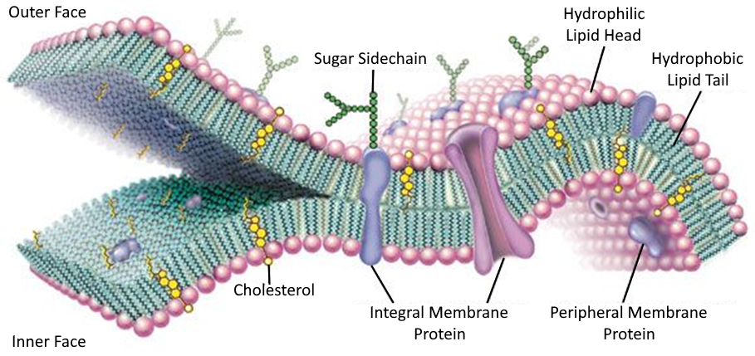
Figure 1.1. The general structure of the cellular membrane. Image adapted from literature.⁴

surface of the cellular membrane.¹ These proteins are commonly water soluble and can be easily cleaved from the membrane surface, making them easy targets of structural characterization studies.^{5, 6} The second subclass of membrane proteins are fully embedded in the cellular membrane and are referred to as integral membrane proteins (IMPs).¹
Since IMPs are embedded within cellular membranes they can be much more difficult to study via conventional methods.⁷ Complex relationships between an IMP and the cellular membrane directly influence the protein’s shape. Therefore, if the plasma membrane is disrupted and an IMP is isolated from its native environment using common methods (i.e., detergents) the isolated protein will likely lose its native conformation.^{6, 8, 9} Since a protein’s biological activity is directly linked to its structure, this structure must be retained in order for the information to be useful for future applications, such as drug development.¹⁰ As such, a method is needed that can simultaneously isolate IMPs from their cellular membranes, keep them soluble in an aqueous environment, retain their native conformation, and enable purification without deleterious degradation or loss of structure and function.¹¹

1.2 Detergent-Free Integral Membrane Protein Isolation
Historically, few examples can be found in which detergents have been used to isolate IMPs from their native environment via micellular encapsulation while successfully retaining their native state for structural characterization.¹²⁻¹⁴ However, there are numerous reported instances of detergent-based isolation methods leading to large-scale loss of native lipids and/or the denaturation and unfolding of the isolated proteins during the protein extraction process.¹⁵⁻¹⁹ Further embodying how difficult it is to isolate and structurally characterize these proteins, IMPs only account for ~2% of all solved and reported protein structures.²⁰ In order to fill this gap in knowledge and advance our ability to characterize IMPs in their native structure, various new methods have been developed to retain a more native-like state in extracted IMPs, usually by employing detergent alternatives as protein solubilizing agents.

1.2.1 Amphipols
One of the first alternatives to detergent-facilitated protein extraction was reported by Tribet et al. in 1996,²¹ in which they described the synthesis of polyacrylic acid polymers that have been partially functionalized using octylamine and/or isopropylamine to form various amphiphilic polymer samples. These polymers solubilized membrane proteins into aqueous solution from prepared lipid vesicles while keeping the protein more stable, and in a more native-like conformation, than when isolated using detergent-based reagents.^{21, 22} This feat is hypothesized to be due to the functionalized polyacrylate’s higher affinity for the hydrophobic domains of the protein complex and subsequent higher degrees of interaction.²³ Amphiphilic copolymers that can form small IMP complexes in aqueous solution have since been termed “amphipols” in an attempt to differentiate these polymers from other amphiphilic copolymers used in the field.⁶
The process of using amphipols to solubilize proteins in aqueous solution is fairly straightforward, and thus can be applied to many different IMP systems (Figure 1.2).²² Membrane proteins are first extracted from cellular membranes using detergents and purified to isolate the specific protein species being studied. Amphipols are then added to displace the detergent and keep the IMP solubilized in aqueous solution. Once the detergent has been displaced, it is then removed from the solution through methods such as dialysis or size-exclusion chromatography.²³
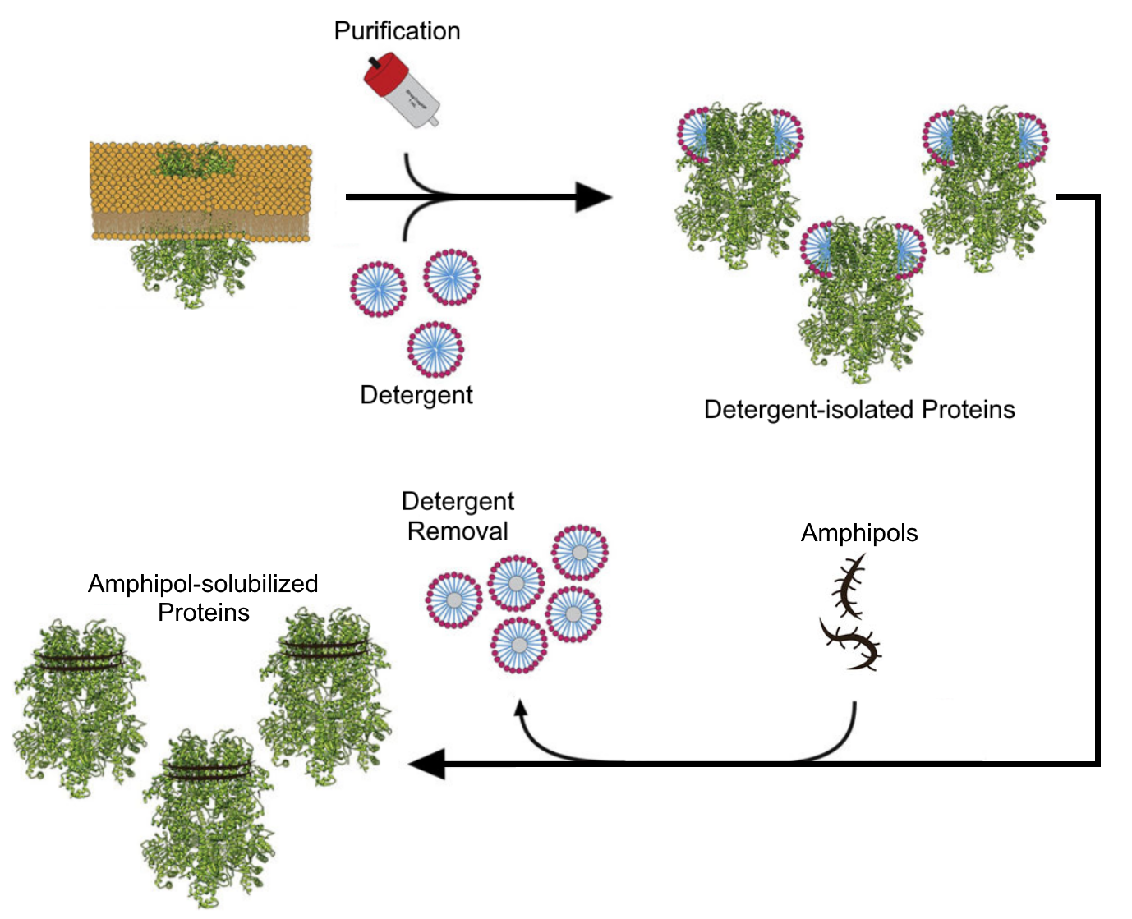
Figure 1.2. General method of using amphipols to solubilize proteins in an aqueous environment. This figure was adapted from literature.²³

Though amphipols have enabled progress in the structural characterization of many IMPs, many have one major flaw: they are generally ineffective at solubilizing proteins directly from biological membranes.²² This means IMPs must be isolated from biological membranes first using detergents, purified, and any remaining lipids or detergent molecules have to be displaced with amphipols. This process can not only be time-consuming, but prolonged interactions between isolated IMPs and detergents can lead to partial denaturation of the protein.²³ Though some amphipols have been found to assist a misfolded protein back into regaining a more native-like conformation under certain conditions,²² amphipol-solubilized IMPs are generally believed to not retain a perfectly native conformation.²⁴
The most commonly studied amphipol is an analog of a polyacrylic acid polymer that has been partially functionalized with octylamine (25% of carboxylates) and isopropylamine (40% of carboxylates) and is typically referred to as A8-35.²⁵ This sample identifier follows a naming convention in which the “8” refers to the linear octyl pendant chain of the octylamide and the “35” refers to the percent of unfunctionalized carboxylate groups. This polymer is sold commercially by Anatrace and is advertised to have a number average molecular weight of around 4.3 kg/mol.²⁶ However, many other types of amphipols have been synthesized and used to solubilize proteins, including those decorated with glucose-like units, phosphorylcholine units, and sulfonated units.⁶
The most notable amphipols reported in the recent literature are commonly referred to as C₆-C₂-50 and C₈-C₀-50.²⁷ These amphipols feature bulky, hydrophobic cyclic groups that, when appended to an acrylic acid polymer, allow for the solubilization of IMPs directly from E. coli membranes without the need for an initial detergent-facilitated protein extraction step. These polymers are promising but will need to be studied in additional membrane protein systems to ensure this behavior is consistent.

1.2.2 Membrane Scaffold Proteins
Another method of isolating IMPs in a native-like state uses amphiphilic α-helical proteins, termed “membrane scaffold proteins” (MSPs), and was first reported by Sligar and coworkers.^{28, 29} These researchers synthesized modified versions of the apolipoprotein A1 that, under specific conditions, could be incubated with lipids to self-organize into lipid nanodiscs surrounded by the MSP. When this process was done in the presence of previously detergent-isolated IMPs, these lipid nanodiscs would also incorporate the proteins (Figure 1.3).^{30, 31} This technique has been used to isolate and characterize a number of different IMPs.³¹
The assembled MSP-protein-lipid nanodiscs can more closely mimic the interactions experienced by IMPs in their native environment.³¹ This often results in the isolation of stable, more native-like IMPs and enables a variety of characterization techniques to be used in ways that were previously not possible. For instance, various MSP-solubilized IMPs have been characterized using techniques such as NMR spectroscopy, Raman spectroscopy, small angle x-ray and neutron scattering techniques, and electron microscopy.³¹ Finally, the size distribution of the formed nanodiscs can be controlled by altering the ratio of MSP to lipid introduced to the extracted proteins, allowing for even more control over the size and composition of a IMP’s new environment.²⁹
While MSPs have enabled progress in the field of IMP structural characterization, this method still has many pitfalls. The first step of this technique still requires IMPs to be previously
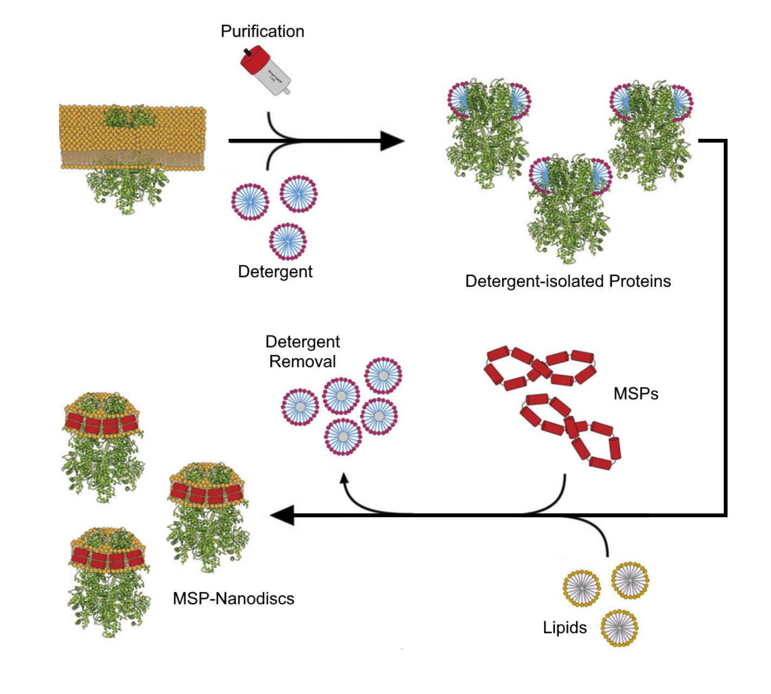
Figure 1.3. General method of using MSPs to solubilize proteins in an aqueous environment. This figure was adapted from literature.²³

isolated with detergent that, as previously mentioned, can lead to the denaturation the target IMPS or remove cofactors associated with these proteins.²³ As such, a variety of detergents and conditions must be screened to isolate targeted IMP-containing MSPs without altering their native activity. Further, though the newly constructed lipid environment does more closely resemble an IMP’s native environment, it will not be a perfect match without determining the exact lipid composition of the original cellular membrane and introducing this specific lipid content to the IMP. These processes can be very time-consuming and expensive.

1.2.3 Styrene-Maleic Acid Copolymers
In 2009, a new method of detergent-free protein extraction was reported by Overduin and coworkers,³² in which incubating amphiphilic styrene-maleic acid copolymers (SMAs) with IMP-containing liposomes resulted in the formation of protein nanodiscs. The resulting styrene-maleic acid lipid particles (SMALPs) retain an annulus of boundary lipids from the liposome and resulted in a native-like conformation of the entrapped IMP. This IMP solubilization method has notable advantages over other methods, like amphipol solubilization, which doesn’t form lipid-containing complexes. A graphic comparing the differences in structures formed using different methods of IMP solubilization can be seen in Figure 1.4.
SMAs were quickly found to not only extract IMPs from liposomal environments but also directly from cellular membranes.^{20, 33} This ability completely eliminates the need for an initial detergent-facilitated protein extraction step, protecting the target IMPs from any potential unfolding or denaturation associated with previously discussed IMP solubilization techniques. In addition, the native-like environment presented by the water-soluble SMALPs allows for a wide
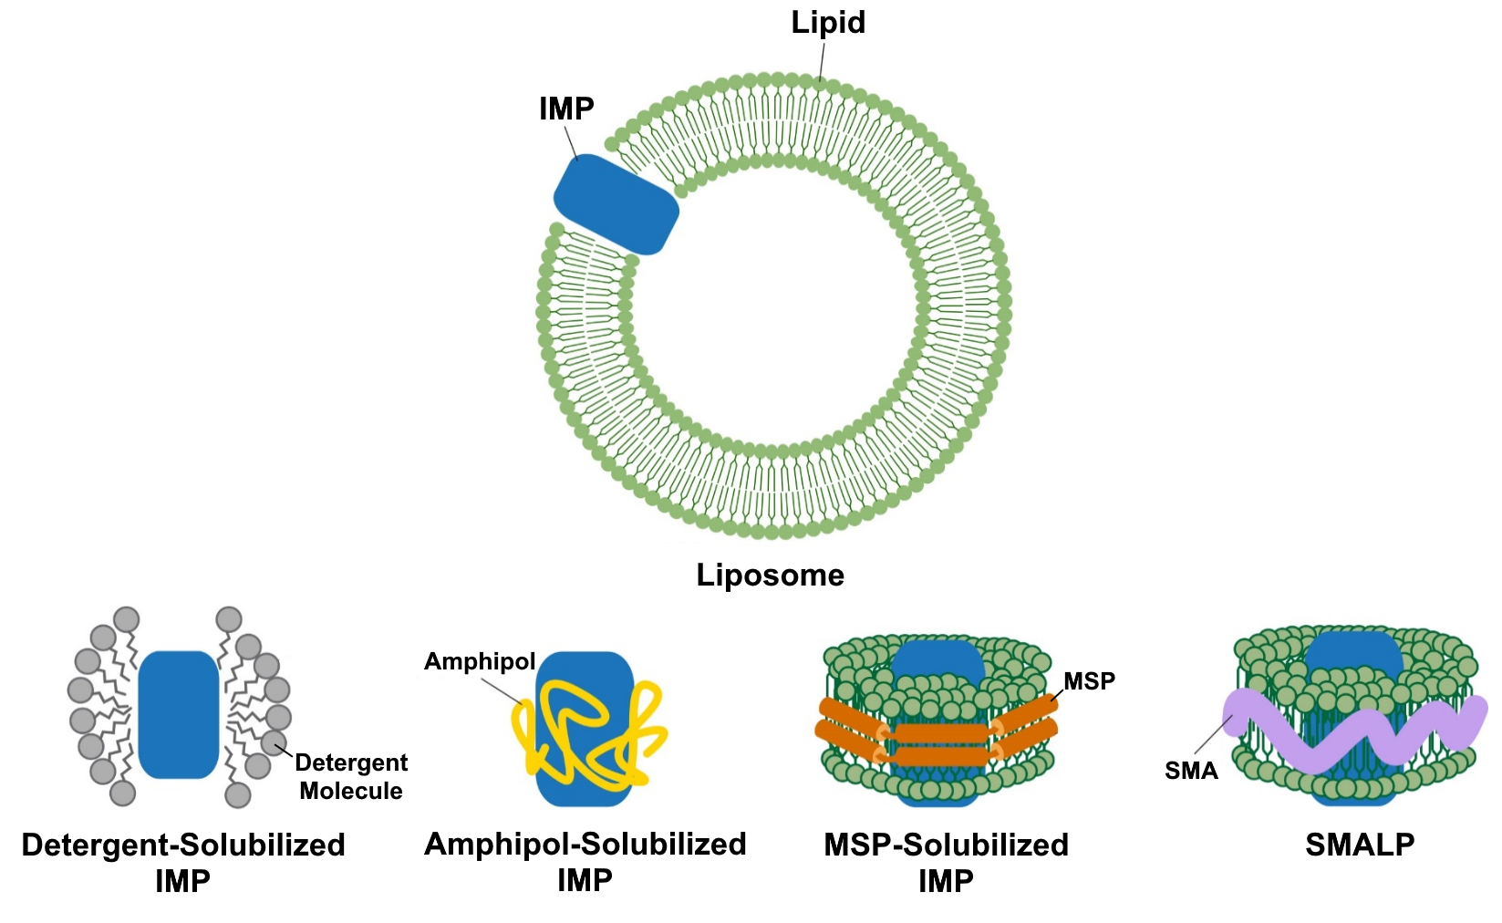
Figure 1.4. General method of using amphipols to solubilize proteins in an aqueous environment. This figure was adapted from literature.²³

variety of characterization techniques to be performed, including lipidomics,^{17, 34} various protein activity determination studies,³⁵⁻³⁸ NMR,³⁹⁻⁴³ EPR,^{44, 45} SAXs/SANs,^{17, 46-49} and Cryo-EM.^{8, 23, 50} These properties have led to the extraction and characterization of over 40 proteins,³⁴ with the number of studies using SMAs to extract proteins seeing a significant increase year over year.⁸
SMA copolymers are traditionally synthesized via the hydrolysis of their respective styrene-maleic anhydride (SMAh) copolymer precursors (Scheme 1.1). These polymers can have various characteristics tuned depending on the synthetic conditions under which they were prepared. Some examples include varying monomer incorporation ratios and polymer molecular weights (Figure 1.5). Many studies have exhibited changes in protein solubilization efficiency when using SMAs with different incorporations of each monomer subunit.^{8, 51, 52} Typically, a ratio of styrene:maleic acid of 2-3:1 has been reported to elicit the highest amount of IMP extracted from many membrane systems. Likewise, many studies have shown that the length, or molecular weight, of a SMA seems to impact its ability to extract IMPs, with polymer number-average molecular weights of less than 10,000 g/mol typically showing the highest performance.^{20, 51, 53}
Since the initial discovery of SMA-facilitated IMP extraction and solubilization, many analogues have been synthesized to instill a variety of chemical properties to the materials and combat shortcomings of this technique.^{34, 54} For instance, because their negatively charged maleate groups promote SMA solublility in aqueous solutions, protonation or chelation of the carboxylates can cause SMAs to crash out of solution. As such, these materials are sensitive to low pH environments or the presence of divalent cations. Some groups have utilized the inherent reactivity of the precursor SMAh’s anhydride groups to install zwitterionic moeities,⁵⁵ maleimide groups,⁵⁶

Scheme 1.1. General synthesis of SMA copolymers using free-radical polymerization.

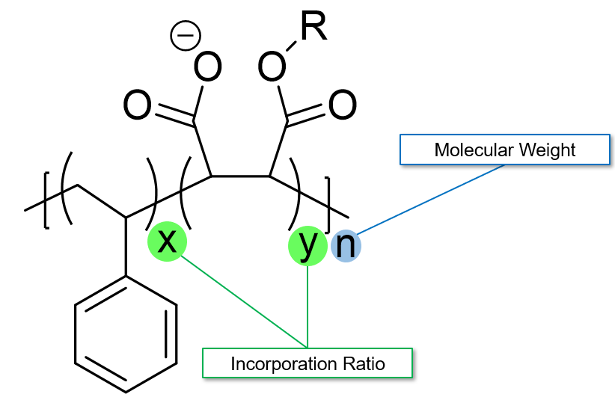
Figure 1.5. Examples of the polymer characteristics that can be tuned during SMA synthesis.

and other polar functional groups⁵⁷ to improve these materials’ tolerance to such conditions. Examples of modified SMA analogs can be seen in Figure 1.6.
A few SMA analogs that substitute the styryl unit for other hydrophobic units have also been synthesized. By far the widely studied analog would be the diisobutylene-co-maleic acid (DIBMA) copolymer.⁵⁸ This polymer was originally reported in 2017 by Keller and coworkers, and it has since been studied by various groups.⁵⁸⁻⁶⁰
Interestingly, DIBMA seems to be more tolerant of divalent cations than commonly used SMAs, which may be attributed to the higher incorporation of maleic acid units in the DIBMA polymer.⁶⁰ It also resulted in the formation of larger nanodiscs than SMA when extracting the ZipA and BmrA proteins from E. coli. Further, DIBMA has been shown to have much less UV absorbance than SMAs, enabling additional protein characterization techniques.⁵⁸ The success seen by DIBMA sparked a trend of new amphiphilic SMA-alternatives to be designed and synthesized by many groups in the field. Examples of reported amphiphilic copolymers that form protein-containing lipid nanodiscs (xMALPS) are shown in Figure 1.6.
Current literature suggests that there will likely never be a single polymer that will be able to efficiently extract IMPs from all types of membrane systems. For example, there have been numerous reports of polymers do not work well in certain membrane systems, but that have previously shown high IMP extraction efficiencies for other IMP systems.^{61, 62} Further, there have been other reports that observe partial loss of protein function potentially due to conformation restrictions imparted by the limited nanodisc size.^{63, 64} These observations have led to concerted efforts to design amphiphilic polymers that could be more applicable to a wide variety of membrane systems, such as inulin-based polymers.⁶⁵ However, without understanding the direct
Figure 1.6. Examples of reported amphiphilic copolymers that have been shown to extract IMPs from cellular membranes and solubilize them into xMALPs.^{33, 66-68}

.

mechanisms by which amphiphilic copolymer-facilitated IMP extraction occurs, or how these polymers interact with xMALPs, these sorts of goals could prove to be very difficult.

1.3 Conclusions and Outlook
The ability to isolate and study IMPs in their native state is becoming increasingly important for the design of future therapeutic drugs and other biotechnologies.^{3, 69, 70} The discovery of amphiphilic copolymer-facilitated IMP extraction has allowed for the isolation and study of numerous IMPs in a more native-like conformation, through a variety of characterization techniques. Over a decade of research has resulted in a wide understanding of the aspects of the polymer that can impact the efficiency and selectivity of the protein extraction process, but more work is required to fully understand and predict these processes.
Many amphiphilic polymers have been synthesized in order to investigate the protein extraction process. Until recently, the majority of these studies were performed with commercially available SMA polymers, significantly limiting the variability of materials and trends observed from these experiments. The work in this dissertation outlines how we leveraged our synthetic expertise to help expand the knowledge and understanding of the principles driving amphiphilic polymer-facilitated IMP extraction. Herein, we use this expertise to design and synthesize multiple series of samples by altering four main characteristics of the amphiphilic polymers: the polymer’s molecular weight, the incorporation ratio of the polymers, the functionalization of the polymers’ hydrophilic units, and the alteration of the polymers’ hydrophobic units. This work has added key insights into the structural design elements of amphiphilic copolymers that are critical to the isolation of IMPs from cyanobacterial systems. We hypothesize that these newfound understandings may be able to be applied the larger protein extraction field and help progress the development of a toolbox of amphiphilic copolymers for the efficient and selective extraction of a wide range of IMPs from different membrane systems.

References

1. Reece, J. U., L.; Cain, M.; Wasserman, S.; Minorsky, P.; Jackson, R., Campbell Biology. 10th ed.; Pearson Education: 2014.
2. Mbaye, M. N.; Hou, Q.; Basu, S.; Teheux, F.; Pucci, F.; Rooman, M., A comprehensive computational study of amino acid interactions in membrane proteins. Sci Rep 2019, 9, 12043.
3. Yin, H.; Flynn, A. D., Drugging Membrane Protein Interactions. Annu Rev Biomed Eng 2016, 18, 51-76.
4. Rogers, K., Cell: The Cell Membrane. In Encyclopaedia Britannica [Online] https://www.britannica.com/science/cell-membrane.
5. Cooper, G., The Cell: A Molecular Approach. 2nd ed.; Sinauer Associated Inc: 2000.
6. Popot, J.-L.; Althoff, T.; Bagnard, D.; Banères, J.-L.; Bazzacco, P.; Billon-Denis, E.; Catoire, L. J.; Champeil, P.; Charvolin, D.; Cocco, M. J.; Crémel, G.; Dahmane, T.; Maza, L. M. d. l.; Ebel, C.; Gabel, F.; Giusti, F.; Gohon, Y.; Goormaghtigh, E.; Guittet, E.; Kleinschmidt, J. H.; Kühlbrandt, W.; Bon, C. L.; Martinez, K. L.; Picard, M.; Pucci, B.; Sachs, J. N.; Tribet, C.; Heijenoort, C. v.; Wien, F.; Zito, F.; Zoonens, M., Amphipols From A to Z. Annual Review of Biophysics 2011, 40, 379-408.
7. Unger, L.; Ronco-Campaña, A.; Kitchen, P.; Bill, R. M.; Rothnie, A. J., Biological insights from SMA-extracted proteins. Biochem. Soc. Trans. 2021, 49, 1349-1359.
8. Simon, K. S.; Pollock, N. L.; Lee, S. C., Membrane protein nanoparticles: the shape of things to come. Biochem. Soc. Trans. 2018, 46, 1495-1504.
9. Wheatley, M.; Charlton, J.; Jamshad, M.; Routledge, Sarah J.; Bailey, S.; La-Borde, Penelope J.; Azam, Maria T.; Logan, Richard T.; Bill, Roslyn M.; Dafforn, Tim R.; Poyner, David R., GPCR–styrene maleic acid lipid particles (GPCR–SMALPs): their nature and potential. Biochem. Soc. Trans. 2016, 44, 619-623.
10. Bolje, A.; Gobec, S., Analytical Techniques for Structural Characterization of Proteins in Solid Pharmaceutical Forms: An Overview. Pharmaceutics 2021, 13.
11. Sanders, C. R.; Kuhn Hoffmann, A.; Gray, D. N.; Keyes, M. H.; Ellis, C. D., French Swimwear for Membrane Proteins. ChemBioChem 2004, 5, 423-426.
12. Anandan, A.; Vrielink, A., Detergents in Membrane Protein Purification and Crystallisation. In The Next Generation in Membrane Protein Structure Determination, Moraes, I., Ed. Springer International Publishing: Cham, 2016; pp 13-28.
13. Newstead, S.; Ferrandon, S.; Iwata, S., Rationalizing α-helical membrane protein crystallization. Protein Science 2008, 17, 466-472.
14. Newstead, S.; Hobbs, J.; Jordan, D.; Carpenter, E. P.; Iwata, S., Insights into outer membrane protein crystallization. Molecular Membrane Biology 2008, 25, 631-638.
15. Bae, H. E.; Gotfryd, K.; Thomas, J.; Hussain, H.; Ehsan, M.; Go, J.; Loland, C. J.; Byrne, B.; Chae, P. S., Deoxycholate-Based Glycosides (DCGs) for Membrane Protein Stabilisation. ChemBioChem 2015, 16, 1454-1459.
16. Bowie, J. U., Stabilizing membrane proteins. Current Opinion in Structural Biology 2001, 11, 397-402.
17. Brady, N. G.; Qian, S.; Nguyen, J.; O'Neill, H. M.; Bruce, B. D., Small angle neutron scattering and lipidomic analysis of a native, trimeric PSI-SMALP from a thermophilic cyanobacteria. Biochim. Biophys. Acta, Bioenerg. 2022, 1863, 148596.
18. Yang, Z.; Wang, C.; Zhou, Q.; An, J.; Hildebrandt, E.; Aleksandrov, L. A.; Kappes, J. C.; DeLucas, L. J.; Riordan, J. R.; Urbatsch, I. L.; Hunt, J. F.; Brouillette, C. G., Membrane protein stability can be compromised by detergent interactions with the extramembranous soluble domains. Protein Science 2014, 23, 769-789.
19. Crichton, P. G.; Lee, Y.; Ruprecht, J. J.; Cerson, E.; Thangaratnarajah, C.; King, M. S.; Kunji, E. R. S., Trends in Thermostability Provide Information on the Nature of Substrate, Inhibitor, and Lipid Interactions with Mitochondrial Carriers*. J. Biol. Chem. 2015, 290, 8206-8217.
20. Dörr, J. M.; Scheidelaar, S.; Koorengevel, M. C.; Dominguez, J. J.; Schäfer, M.; van Walree, C. A.; Killian, J. A., The styrene-maleic acid copolymer: a versatile tool in membrane research. Eur Biophys J 2016, 45, 3-21.
21. Tribet, C.; Audebert, R.; Popot, J. L., Amphipols: polymers that keep membrane proteins soluble in aqueous solutions. Proc Natl Acad Sci U S A 1996, 93, 15047-50.
22. Zoonens, M.; Popot, J. L., Amphipols for each season. J Membr Biol 2014, 247, 759-96.
23. Autzen, H. E.; Julius, D.; Cheng, Y., Membrane mimetic systems in CryoEM: keeping membrane proteins in their native environment. Current Opinion in Structural Biology 2019, 58, 259-268.
24. Klöpfer, K.; Hagn, F., Beyond detergent micelles: The advantages and applications of non-micellar and lipid-based membrane mimetics for solution-state NMR. Progress in Nuclear Magnetic Resonance Spectroscopy 2019, 114-115, 271-283.
25. Le Bon, C.; Marconnet, A.; Masscheleyn, S.; Popot, J. L.; Zoonens, M., Folding and stabilizing membrane proteins in amphipol A8-35. Methods 2018, 147, 95-105.
26. Anatrace Products, L. A835 - Amphipol A8-35. https://www.anatrace.com/Products/Specialty-Detergents-Products/AMPHIPOL/A835 (accessed February 2, 2023).
27. Marconnet, A.; Michon, B.; Le Bon, C.; Giusti, F.; Tribet, C.; Zoonens, M., Solubilization and Stabilization of Membrane Proteins by Cycloalkane-Modified Amphiphilic Polymers. Biomacromolecules 2020, 21, 3459-3467.
28. Bayburt, T. H.; Grinkova, Y. V.; Sligar, S. G., Self-Assembly of Discoidal Phospholipid Bilayer Nanoparticles with Membrane Scaffold Proteins. Nano Letters 2002, 2, 853-856.
29. Denisov, I. G.; Grinkova, Y. V.; Lazarides, A. A.; Sligar, S. G., Directed Self-Assembly of Monodisperse Phospholipid Bilayer Nanodiscs with Controlled Size. Journal of the American Chemical Society 2004, 126, 3477-3487.
30. Bayburt, T. H.; Sligar, S. G., Membrane protein assembly into Nanodiscs. FEBS Lett 2010, 584, 1721-7.
31. Denisov, I. G.; Sligar, S. G., Nanodiscs for structural and functional studies of membrane proteins. Nature Structural & Molecular Biology 2016, 23, 481-486.
32. Knowles, T. J.; Finka, R.; Smith, C.; Lin, Y.-P.; Dafforn, T.; Overduin, M., Membrane Proteins Solubilized Intact in Lipid Containing Nanoparticles Bounded by Styrene Maleic Acid Copolymer. Journal of the American Chemical Society 2009, 131, 7484-7485.
33. Stroud, Z.; Hall, S. C. L.; Dafforn, T. R., Purification of membrane proteins free from conventional detergents: SMA, new polymers, new opportunities and new insights. Methods 2018, 147, 106-117.
34. Overduin, M.; Esmaili, M., Native Nanodiscs and the Convergence of Lipidomics, Metabolomics, Interactomics and Proteomics. Applied Sciences 2019, 9.
35. Cherepanov, D. A.; Brady, N. G.; Shelaev, I. V.; Nguyen, J.; Gostev, F. E.; Mamedov, M. D.; Nadtochenko, V. A.; Bruce, B. D., PSI-SMALP, a Detergent-free Cyanobacterial Photosystem I, Reveals Faster Femtosecond Photochemistry. Biophys. J. 2020, 118, 337-351.
36. Yu, J.; Zhu, H.; Lape, R.; Greiner, T.; Du, J.; Lü, W.; Sivilotti, L.; Gouaux, E., Mechanism of gating and partial agonist action in the glycine receptor. Cell 2021, 184, 957-968.e21.
37. Long, A. R.; O’Brien, C. C.; Malhotra, K.; Schwall, C. T.; Albert, A. D.; Watts, A.; Alder, N. N., A detergent-free strategy for the reconstitution of active enzyme complexes from native biological membranes into nanoscale discs. BMC Biotechnology 2013, 13, 41.
38. Komar, J.; Alvira, S.; Schulze, R. J.; Martin, R.; Lycklama a Nijeholt, J. A.; Lee, S. C.; Dafforn, T. R.; Deckers-Hebestreit, G.; Berger, I.; Schaffitzel, C.; Collinson, I., Membrane protein insertion and assembly by the bacterial holo-translocon SecYEG–SecDF–YajC–YidC. Biochem. J. 2016, 473, 3341-3354.
39. Radoicic, J.; Park, S. H.; Opella, S. J., Macrodiscs Comprising SMALPs for Oriented Sample Solid-State NMR Spectroscopy of Membrane Proteins. Biophys. J. 2018, 115, 22-25.
40. Ravula, T.; Ramadugu, S. K.; Di Mauro, G.; Ramamoorthy, A., Bioinspired, Size-Tunable Self-Assembly of Polymer–Lipid Bilayer Nanodiscs. Angew Chem Int Edit 2017, 56, 11466-11470.
41. Craig, A. F.; Clark, E. E.; Sahu, I. D.; Zhang, R.; Frantz, N. D.; Al-Abdul-Wahid, M. S.; Dabney-Smith, C.; Konkolewicz, D.; Lorigan, G. A., Tuning the size of styrene-maleic acid copolymer-lipid nanoparticles (SMALPs) using RAFT polymerization for biophysical studies. Biochim. Biophys. Acta, Biomembr. 2016, 1858, 2931-2939.
42. Vargas, C.; Arenas, R. C.; Frotscher, E.; Keller, S., Nanoparticle self-assembly in mixtures of phospholipids with styrene/maleic acid copolymers or fluorinated surfactants. Nanoscale 2015, 7, 20685-20696.
43. Hall, S. C. L.; Tognoloni, C.; Price, G. J.; Klumperman, B.; Edler, K. J.; Dafforn, T. R.; Arnold, T., Influence of Poly(styrene-co-maleic acid) Copolymer Structure on the Properties and Self-Assembly of SMALP Nanodiscs. Biomacromolecules 2018, 19, 761-772.
44. Bali, A. P.; Sahu, I. D.; Craig, A. F.; Clark, E. E.; Burridge, K. M.; Dolan, M. T.; Dabney-Smith, C.; Konkolewicz, D.; Lorigan, G. A., Structural characterization of styrene-maleic acid copolymer-lipid nanoparticles (SMALPs) using EPR spectroscopy. Chem. Phys. Lipids 2019, 220, 6-13.
45. Colbasevici, A.; Voskoboynikova, N.; Orekhov, P. S.; Bozdaganyan, M. E.; Karlova, M. G.; Sokolova, O. S.; Klare, J. P.; Mulkidjanian, A. Y.; Shaitan, K. V.; Steinhoff, H.-J., Lipid dynamics in nanoparticles formed by maleic acid-containing copolymers: EPR spectroscopy and molecular dynamics simulations. Biochim. Biophys. Acta, Biomembr. 2020, 1862, 183207.
46. Bjørnestad, V. A.; Orwick-Rydmark, M.; Lund, R., Understanding the Structural Pathways for Lipid Nanodisc Formation: How Styrene Maleic Acid Copolymers Induce Membrane Fracture and Disc Formation. Langmuir 2021.
47. Jamshad, M.; Grimard, V.; Idini, I.; Knowles, T. J.; Dowle, M. R.; Schofield, N.; Sridhar, P.; Lin, Y.; Finka, R.; Wheatley, M., Structural analysis of a nanoparticle containing a lipid bilayer used for detergent-free extraction of membrane proteins. Nano Research 2015, 8, 774-789.
48. Cuevas Arenas, R.; Danielczak, B.; Martel, A.; Porcar, L.; Breyton, C.; Ebel, C.; Keller, S., Fast Collisional Lipid Transfer Among Polymer-Bounded Nanodiscs. Sci Rep 2017, 7, 45875.
49. Brady, N. G.; Qian, S.; Bruce, B. D., Analysis of styrene maleic acid alternating copolymer supramolecular assemblies in solution by small angle X-ray scattering. Eur. Polym. J. 2019, 111, 178-184.
50. Parmar, M.; Rawson, S.; Scarff, C. A.; Goldman, A.; Dafforn, T. R.; Muench, S. P.; Postis, V. L. G., Using a SMALP platform to determine a sub-nm single particle cryo-EM membrane protein structure. Biochim Biophys Acta Biomembr 2018, 1860, 378-383.
51. Swainsbury, D. J. K.; Scheidelaar, S.; Foster, N.; van Grondelle, R.; Killian, J. A.; Jones, M. R., The effectiveness of styrene-maleic acid (SMA) copolymers for solubilisation of integral membrane proteins from SMA-accessible and SMA-resistant membranes. Biochim Biophys Acta Biomembr 2017, 1859, 2133-2143.
52. Morrison, K. A.; Akram, A.; Mathews, A.; Khan, Z. A.; Patel, J. H.; Zhou, C.; Hardy, D. J.; Moore-Kelly, C.; Patel, R.; Odiba, V.; Knowles, T. J.; Javed, M.-u.-H.; Chmel, N. P.; Dafforn, T. R.; Rothnie, A. J., Membrane protein extraction and purification using styrene–maleic acid (SMA) copolymer: effect of variations in polymer structure. Biochem. J. 2016, 473, 4349.
53. Domínguez Pardo, J. J.; Koorengevel, M. C.; Uwugiaren, N.; Weijers, J.; Kopf, A. H.; Jahn, H.; van Walree, C. A.; van Steenbergen, M. J.; Killian, J. A., Membrane Solubilization by Styrene-Maleic Acid Copolymers: Delineating the Role of Polymer Length. Biophys. J. 2018, 115, 129-138.
54. Orekhov, P. S.; Bozdaganyan, M. E.; Voskoboynikova, N.; Mulkidjanian, A. Y.; Karlova, M. G.; Yudenko, A.; Remeeva, A.; Ryzhykau, Y. L.; Gushchin, I.; Gordeliy, V. I.; Sokolova, O. S.; Steinhoff, H. J.; Kirpichnikov, M. P.; Shaitan, K. V., Mechanisms of Formation, Structure, and Dynamics of Lipoprotein Discs Stabilized by Amphiphilic Copolymers: A Comprehensive Review. Nanomaterials (Basel) 2022, 12.
55. Fiori, M. C.; Jiang, Y.; Altenberg, G. A.; Liang, H., Polymer-encased nanodiscs with improved buffer compatibility. Sci Rep 2017, 7, 7432.
56. Ravula, T.; Hardin, N. Z.; Ramadugu, S. K.; Cox, S. J.; Ramamoorthy, A., Formation of pH-Resistant Monodispersed Polymer-Lipid Nanodiscs. Angew Chem Int Ed Engl 2018, 57, 1342-1345.
57. Burridge, K. M.; Harding, B. D.; Sahu, I. D.; Kearns, M. M.; Stowe, R. B.; Dolan, M. T.; Edelmann, R. E.; Dabney-Smith, C.; Page, R. C.; Konkolewicz, D.; Lorigan, G. A., Simple Derivatization of RAFT-Synthesized Styrene–Maleic Anhydride Copolymers for Lipid Disk Formulations. Biomacromolecules 2020, 21, 1274-1284.
58. Oluwole, A. O.; Danielczak, B.; Meister, A.; Babalola, J. O.; Vargas, C.; Keller, S., Solubilization of Membrane Proteins into Functional Lipid-Bilayer Nanodiscs Using a Diisobutylene/Maleic Acid Copolymer. Angew Chem Int Edit 2017, 56, 1919-1924.
59. Ball, L. E.; Riley, L. J.; Hadasha, W.; Pfukwa, R.; Smith, C. J. I.; Dafforn, T. R.; Klumperman, B., Influence of DIBMA Polymer Length on Lipid Nanodisc Formation and Membrane Protein Extraction. Biomacromolecules 2021, 22, 763-772.
60. Gulamhussein, A. A.; Uddin, R.; Tighe, B. J.; Poyner, D. R.; Rothnie, A. J., A comparison of SMA (styrene maleic acid) and DIBMA (di-isobutylene maleic acid) for membrane protein purification. Biochim. Biophys. Acta, Biomembr. 2020, 1862, 183281.
61. Brady, N. G.; Li, M.; Ma, Y.; Gumbart, J. C.; Bruce, B. D., Non-detergent isolation of a cyanobacterial photosystem I using styrene maleic acid alternating copolymers. RSC Adv. 2019, 9, 31781-31796.
62. Korotych, O.; Mondal, J.; Gattás-Asfura, K. M.; Hendricks, J.; Bruce, B. D., Evaluation of commercially available styrene-co-maleic acid polymers for the extraction of membrane proteins from spinach chloroplast thylakoids. Eur. Polym. J. 2019, 114, 485-500.
63. Szundi, I.; Pitch, S. G.; Chen, E.; Farrens, D. L.; Kliger, D. S., Styrene-maleic acid copolymer effects on the function of the GPCR rhodopsin in lipid nanoparticles. Biophys. J. 2021, 120, 4337-4348.
64. Grime, R. L.; Logan, R. T.; Nestorow, S. A.; Sridhar, P.; Edwards, P. C.; Tate, C. G.; Klumperman, B.; Dafforn, T. R.; Poyner, D. R.; Reeves, P. J.; Wheatley, M., Differences in SMA-like polymer architecture dictate the conformational changes exhibited by the membrane protein rhodopsin encapsulated in lipid nano-particles. Nanoscale 2021, 13, 13519-13528.
65. Ravula, T.; Ramamoorthy, A., Synthesis, Characterization, and Nanodisc Formation of Non-ionic Polymers**. Angew Chem Int Edit 2021, 60, 16885-16888.
66. Farrelly, M. D.; Martin, L. L.; Thang, S. H., Polymer Nanodiscs and Their Bioanalytical Potential. Chemistry – A European Journal 2021, 27, 12922-12939.
67. Kopf, A. H.; Lijding, O.; Elenbaas, B. O. W.; Koorengevel, M. C.; Dobruchowska, J. M.; van Walree, C. A.; Killian, J. A., Synthesis and Evaluation of a Library of Alternating Amphipathic Copolymers to Solubilize and Study Membrane Proteins. Biomacromolecules 2022, 23, 743-759.
68. Kopf, A. H.; Lijding, O.; Elenbaas, B.; Koorengevel, M. C.; Walree, C.; Killian, J. A., Synthesis and Evaluation of a Novel Library of Alternating Amphipathic Copolymers to Solubilize and Study Membrane Proteins. bioRxiv 2021.
69. Iwuchukwu, I. J.; Vaughn, M.; Myers, N.; O'Neill, H.; Frymier, P.; Bruce, B. D., Self-organized photosynthetic nanoparticle for cell-free hydrogen production. Nature Nanotechnology 2010, 5, 73-79.
70. Taylor, T. M.; Davidson, P. M.; Bruce, B. D.; Weiss, J., Liposomal nanocapsules in food science and agriculture. Crit Rev Food Sci Nutr 2005, 45, 587-605.

CHAPTER II: PROTEIN EXTRACTION EFFICIENCY AND SELECTIVITY OF ESTERIFIED STYRENE-MALEIC ACID COPOLYMERS IN THYLAKOID MEMBRANES

A version of this chapter was originally published by Nathan G. Brady, Cameron E. Workman, and Bridgie Cawthon:
Brady, N. G. †; Workman, C. E. †; Cawthon, B.; Bruce, B. D. *; Long, B. K. *, Protein Extraction Efficiency and Selectivity of Esterified Styrene–Maleic Acid Copolymers in Thylakoid Membranes. Biomacromolecules 2021, 22, 2544-2553.
† Indicates equal contributions, * corresponding author

In this article, I was responsible for designing and synthesizing all polymers studied. I also performed all polymer characterization. Nathan Brady and I performed all of the experiments to determine polymer critical aggregation concentrations, pH tolerance tests, and divalent cation tolerance tests. Nathan Brady and Bridgie Cawthon performed all of the protein extraction and characterization studies together. Dr. Brian Long and Dr. Barry Bruce organized this project and facilitated the writing of the manuscript.

2.1 Abstract
Amphiphilic styrene-maleic acid copolymers (SMAs) have been shown to effectively extract membrane proteins surrounded by an annulus of native membrane lipids via the formation of nanodiscs. Recent reports have shown that 2-butoxyethanol functionalized SMA derivatives promote the extraction of membrane proteins from thylakoid membranes, whereas unfunctionalized SMA was essentially ineffective. However, it is unknown how the extent of functionalization and identity of the sidechain impacts protein solubilization and specificity. Herein, we show that monoesterification of an SMA polymer with hydrophobic alkoxy ethoxylate side-chains leads to increased solubilization efficiency of trimeric Photosystem I (PSI) from membranes of the cyanobacterium Thermosynechococcus elongatus. The specific SMA polymer used in this study, PRO 10235, is unable to encapsulate single PSI trimers from this cyanobacterium; however, as it is functionalized with alkoxy ethoxylates of increasing alkoxy chain length, a clear increase in trimeric PSI solubilization efficiency is observed. Furthermore, an exponential increase in solubilization efficiency is observed when >50% of the maleic acid repeat units are monoesterified with long alkoxy ethoxylates, suggesting that the PSI extraction mechanism is highly dependent on both the number and length of the attached side-chains.

2.2 Introduction
Over the past decade, styrene-maleic acid copolymers (SMAs) have become widely used for the solubilization of membrane proteins. Their unique ability to form styrene-maleic acid lipid particles (SMALPs), which are polymer bound nanodiscs comprised of protein within an annulus of retained native lipids, has made these amphiphilic copolymers the subject of numerous investigations.¹ Salient reports include studies designed to understand how various SMA molecular characteristics play into SMALP formation and efficacy of these polymers in protein extraction. For example, it has been shown that both the molecular weight of the polymer² and the incorporation ratio of the monomeric units³ are both crucial parameters in this process.
Despite these advances, little is known about the mechanism of SMA-facilitated protein extraction and solubilization. Many studies designed to probe this mechanism have shown that altering the chemical composition of SMA can result in characteristic changes in nanodisc formation. Examples of such investigations include studies by Ramamoorthy and coworkers in which the maleic anhydride repeating units of SMA copolymers were converted into maleimides bearing quaternary ammonium pendant groups, increasing the polymer’s tolerance to divalent cations and low pH.⁴ In another study, Konkolewicz and Lorigan achieved a similar result by performing esterification and amidation reactions on SMAs using a variety of moieties, ranging from glucose to 2-aminoethanol.⁵ Overduin and coworkers showed that SMA functionalization can be used to manipulate the size of resulting SMALPs, further highlighting how functionalized SMA samples can be utilized to alter various aspects of the protein extraction process.⁶ Though all of these studies demonstrate the effects of SMA functionalization, they did not investigate how SMA functionalization alters extraction efficiency or selectivity in specific protein solubilization trials. An understanding of the fundamental relationships between specific SMA derivitization and the resultant extraction selectivity and/or efficiency could facilitate the selection and design of SMAs with enhanced extraction yields, as well as the potential to target specific proteins.
Bruce and coworkers have recently shown that certain commercially available SMA-based copolymers exhibit the ability to form SMALPs from chloroplast thylakoid membranes,⁷ which is of note due to a lack of studies investigating galactolipid rich membranes. Further, their investigations in cyanobacterial thylakoid membranes showed that commercially available SMA 1440 (Total Cray Valley), a 1.5:1 styrene:maleic acid copolymer that is 72% monoesterified with butoxyethanol, appears to selectively extract the PSI trimer from the thylakoid membranes of Thermosynechococcus elongatus (Te), whereas the most widely used SMA copolymers, those containing a 2:1 ratio of styrene:maleic acid, are ineffective.⁸ This is of interest as the non-esterified version of the same SMA, PRO 10235, shows very little activity in the extraction of PSI from thylakoid membranes in Te.⁹ In addition, PRO 10235 demonstrated the lowest extraction activity of the five tested SMAs using thylakoids from pea and spinach chloroplasts,⁷ suggesting a generally lower activity with galactolipid-rich membranes. We hypothesized that the butoxyethanol esterification of SMA 1440 must be critical for polymer insertion into the galactolipid-rich thylakoid membranes of cyanobacteria. To probe this possibility, we herein present a series of derivatized SMA copolymers that are functionalized to various extents with alkoxy ethoxylates of increasing chain lengths to test the impact that alkyl sidechains have on protein extraction efficiency and selectivity from Te.

2.3 Results and Discussion
2.3.1 Synthesis and Characterization of SMA Derivates
In this study, PRO 10235 (PRO), a commercially available copolymer of styrene and maleic anhydride, was functionalized with various alkoxy ethoxylates using DMAP-catalyzed esterification to yield polymers Eth-Dodec (Scheme 2.1). Additionally, two control polymers were functionalized with either diethylene glycol or tetraethylene glycol moieties to produce polymers DEG and TEG, respectively, so as to probe the role that hydrophobicity of the alkoxy ethoxylates has on the extraction process. For each esterification reaction, aliquots were taken as a function of reaction time to obtain polymer samples with increasing amounts of attached sidechains. These aliquots were purified by washing and dried in a vacuum oven to remove unreacted reagents and solvent. ¹H NMR spectroscopy was used to determine the extent of esterification for each sample (Figures 2.1 and A2-A10). As a note, individual polymer identifiers will be used herein to identify a specific degree of esterification for each polymer sample. For example, polymer Eth with 16% monoesterified acid groups will be referred to as Eth-(16).
Scheme 2.1. Synthesis of esterified SMA derivatives

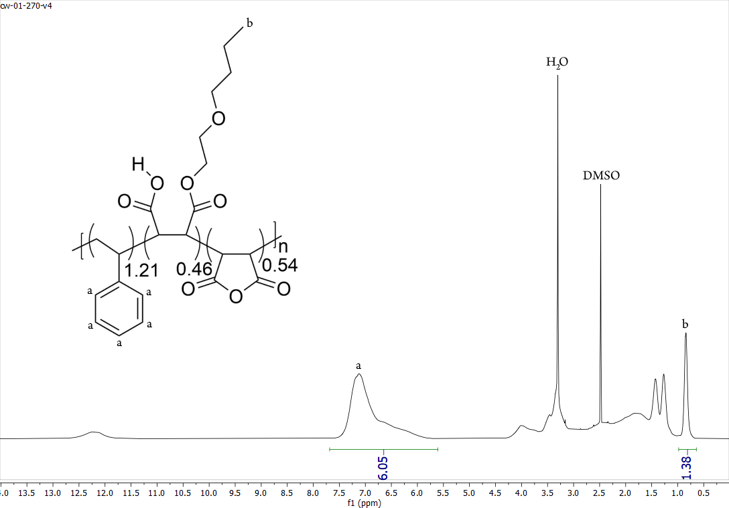
Figure 2.1. Representative example of how ¹H NMR spectroscopy was used to calculate of extent of esterification (%) for the acid precursor form of But-(46). The extent of esterification was determined using the equation below. This specific sample was determined to be 46% esterified with 2-butoxyloxyethanol.

y = $\frac{6.05*I_{b}}{3*I_{a}}$
y = Extent of esterification
I_{a} = Integration of the aryl peaks (a)
I_{bc} = Integration of the peaks corresponding to the terminal methyl group protons of the attached sidechains (b)

2.3.2 Determination of pH Sensitivity
To determine how sidechain functionalization affects polymer solubility as a function of pH, each polymer was introduced to a series of BR-buffers ranging from pH = 4.5 to 10, in half unit increments. As pH becomes more acidic, the polymers studied convert from their carboxylate forms to their carboxylic acid forms, thereby becoming insoluble in aqueous media, and aggregation is observed. Thus, polymer aggregation can be quantified by measuring the increase in optical density at 350 nm (Figure 2.2a). Our results show that unmodified PRO remained soluble at all pH values tested, as was expected from prior literature reports.¹⁰ For SMA derivatives Eth-Dodec, their low pH tolerance decreased as a function of increasing percent esterification. As expected, this effect is amplified when functionalized with more hydrophobic moieties (e.g. Eth-Dodec) as compared to more hydrophilic DEG/TEG substituted polymers, which remain soluble at lower pH values, even as esterification percentage increased. All solubility data as a function of pH can be found in Figure 2.3.

2.3.3 Determination of Divalent Cation Sensitivity
Another important characteristic is how well the synthesized SMA derivatives tolerate divalent cations. For this assay, each polymer was subjected to a series of pH = 9.5 tris buffers containing increasing concentrations of MgCl₂ (Figure 2.2b). Polymers Eth-Dodec were each found to be sensitive to divalent ions, with most beginning to aggregate in the presence of ≤10 mM MgCl₂. Furthermore, divalent ion sensitivity increases with increasing percent esterification. In contrast, DEG and TEG polymer samples show a reverse trend, becoming more divalent ion tolerant as degree of esterification in increased, and with TEG-(44) and TEG-(62) remaining
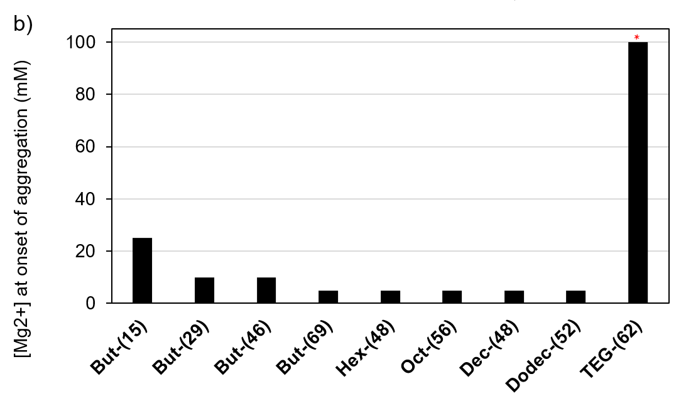
Figure 2.2. Bar graphs showing the a) pH below which and b) concentration of MgCl₂ above which each polymer aggregates and precipitates from solution. *TEG-(62) remained soluble at a concentration of 100 mM of Mg²⁺.

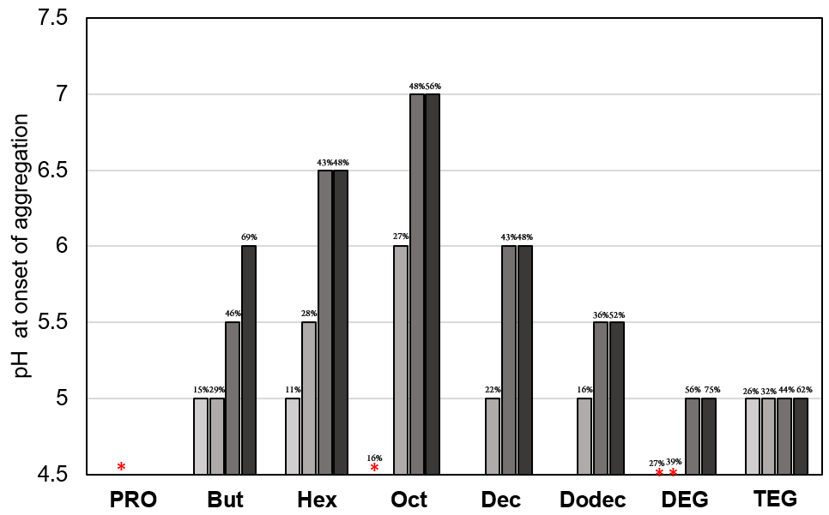
Figure 2.3. Graph showing pH value below which each polymer became insoluble in aqueous solution. Above these pH values, the polymers remained soluble. *These polymers did not precipitate out of solution, even at the lowest pH tested (pH = 5).

soluble at 100 mM MgCl₂, the highest concentration tested. These sidechains contain ethereal units that are known to complex cations and promote solubility in aqueous environments.¹¹ All solubility data as a function of divalent cation concentration can be found in Figure 2.4.

2.3.4 Determination of Critical Aggregation Concentration
To determine the polymer concentration at which aggregation occurs, which is often referred to as critical aggregate concentration (CAC), we employed a previously described method using fluorescence spectroscopy and Nile Red as a reporter.¹⁰ Upon excitation at 550 nm, the fluorescence emission maximum of Nile Red blue shifts as it partitions into a hydrophobic environment. Therein, the extent of emission maximum blue shift corresponds to increased hydrophobicity in solution, which arises due to aggregation of the polymers in solution. Plots of fluorescence wavelength maxima as a function of concentration yields a sigmoidal relationship that reveals aggregation for the highest percent esterified SMA copolymers occurs between ~20-100 μg/mL, with the exception of TEG-(62) that aggregates around 0.6 to 3 mg/mL (Figures 2.5 and 2.6). Interestingly, we also observed that SMA derivatives functionalized with hydrophobic sidechains (Hex-Dodec) exhibited larger fluorescence maxima blue shifts than more hydrophilic polymers PRO and TEG-(62) (Figure 2.7), agreeing with our hypothesis that aggregation of Hex-Dodec will generate a more hydrophobic environment for Nile Red partitioning.

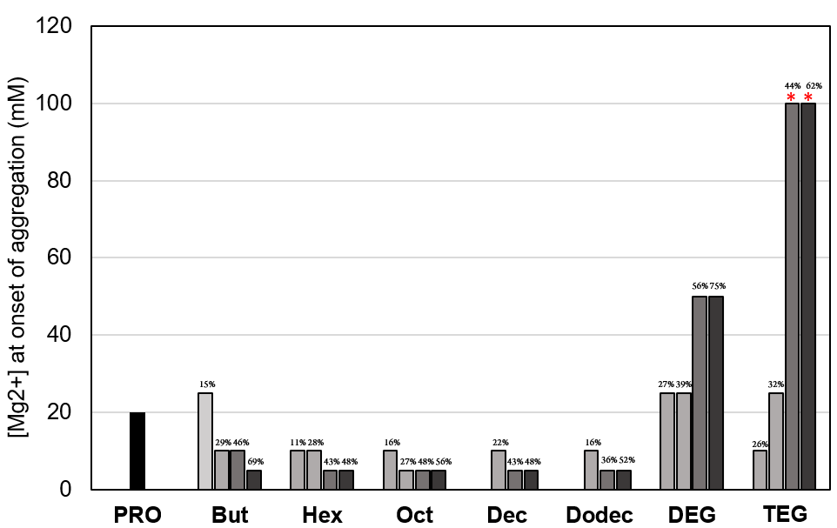
Figure 2.4. Graph showing the minimum concentration of MgCl₂ that caused each polymer to become insoluble in aquoues solution. *These polymers did not crash out of solution, even at the highest concentration tested (100 mM).

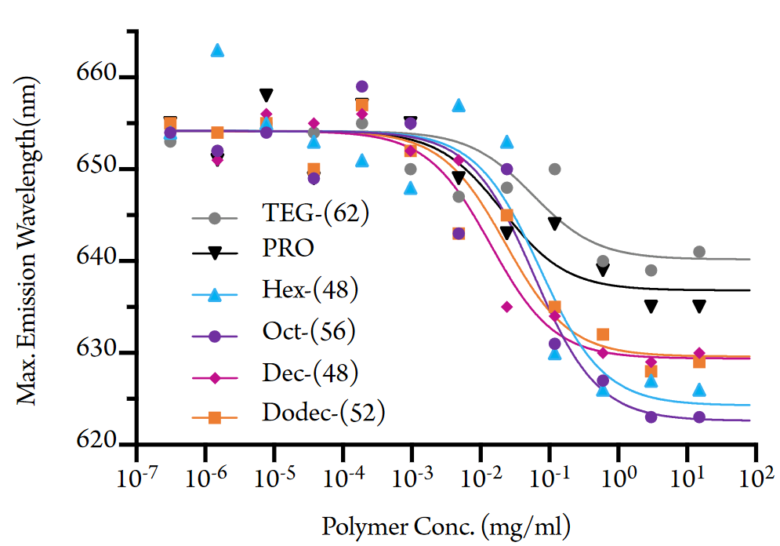
Figure 2.5. Plot of fluorescence emission wavelength maxima as a function of polymer concentration. Data was fit using a sigmoidal curve to represent each sample’s critical aggregation concentration.

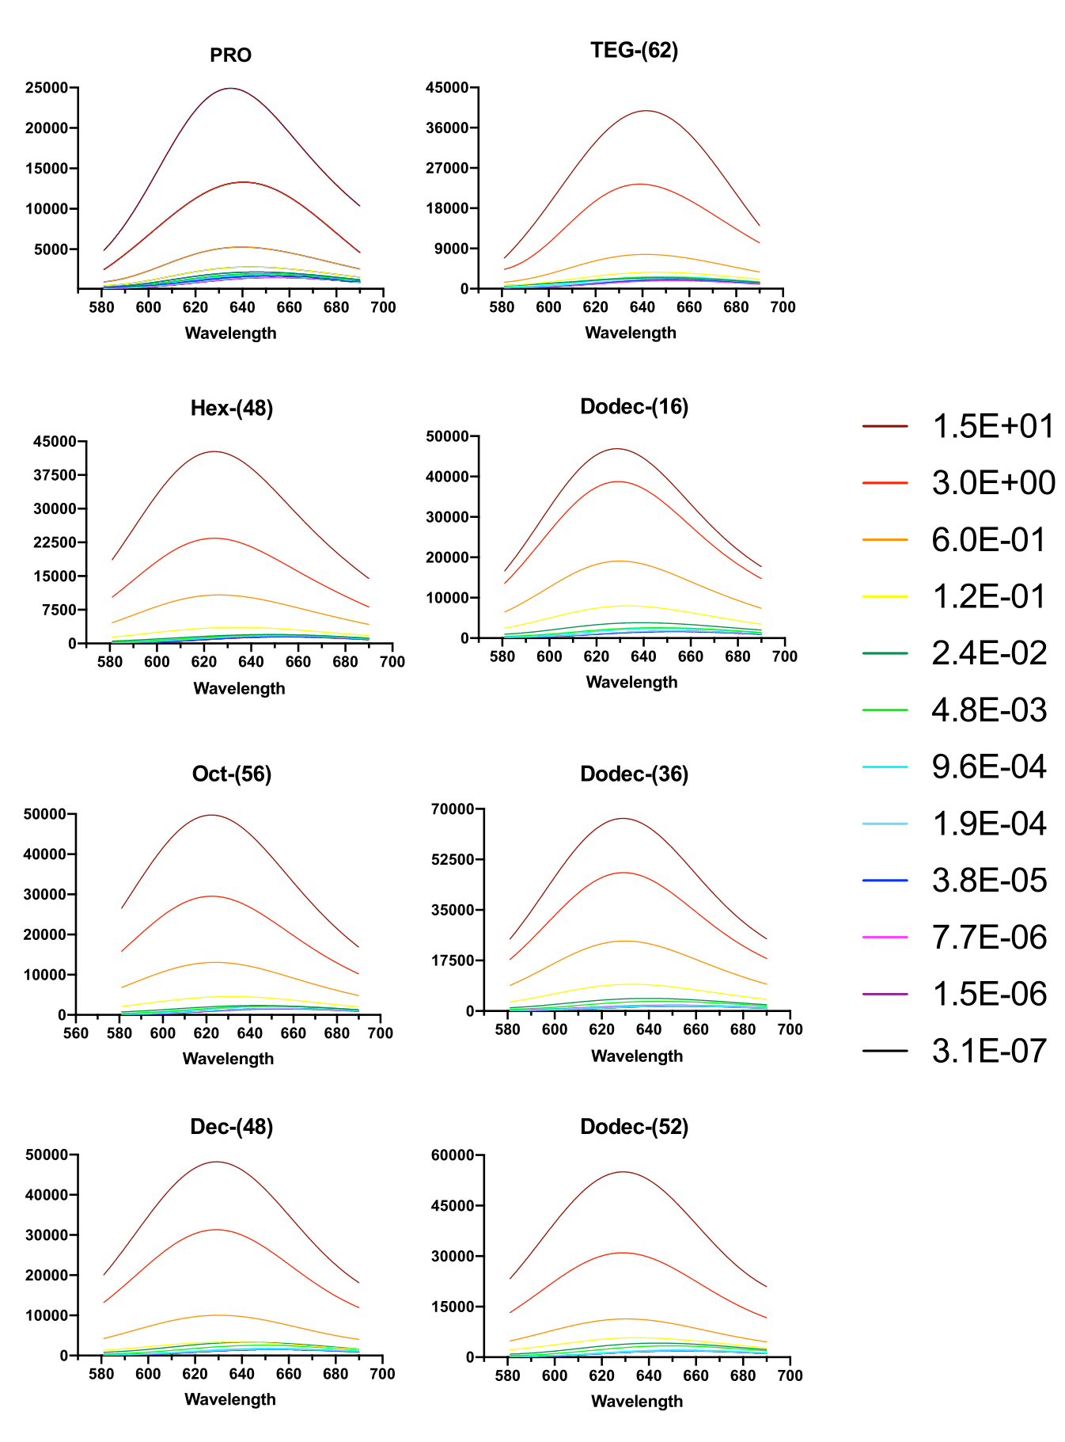
Figure 2.6. Fluorescence emission spectra (fit to sum of gaussians) of Nile Red at various concentrations of PRO and modified SMA copolymers.

Figure 2.7. Quantified extent of Nile Red emission blue shift after the critical aggregation concentration was surpassed.

2.3.5 Solubilization of Pigment-Protein Complexes from Te
To investigate protein extraction efficiency and selectivity, each alkoxy functionalized SMA copolymer derivative was incubated with isolated Te thylakoid membranes. This resulted in the solubilization of PSI, in similarity to our previous works.^{8, 12} Following centrifugation, the solubilized PSI-complexes, which are pigmented with carotenoids and chlorophyll, remained in the supernatant while un-solubilized material sedimented. The supernatant was then analyzed using visible absorbance spectroscopy to qualitatively determine carotenoid and chlorophyll content. The peaks arising from carotenoids overlap in the spectral region between 425 – 550 nm, overlaying the Soret band for chlorophyll that is centered at 440 nm. Traces of phycocyanin (λ_{MAX} = ~625 nm) and a prominent chlorophyll absorbance peak at ~680 nm were also observed (Figure 2.8).¹³
The alkoxy ethoxylate functionalized SMAs Prop-Dodec displayed an increasing qualitative trend of carotenoid release as a function of increasing percent esterification, as evidenced by an increase in absorbance (Figure 2.8). A similar qualitative trend is observed with regards to the amount of chlorophyll being liberated (Figure 2.8). While these absorbance spectra are not fully quantitative, they enable us to make qualitative observations as to the effect that polymer functionalization has on their ability to liberate PSI, albeit while retaining the profiles of both carotenoids and chlorophyll within the complex. The increasing absorbances of both carotenoids and chlorophyll as a function of increasing polymer functionalization suggests that the amount of PSI extracted increases similarly, and that these complexes retain their associated pigments following removal from the thylakoid membrane.
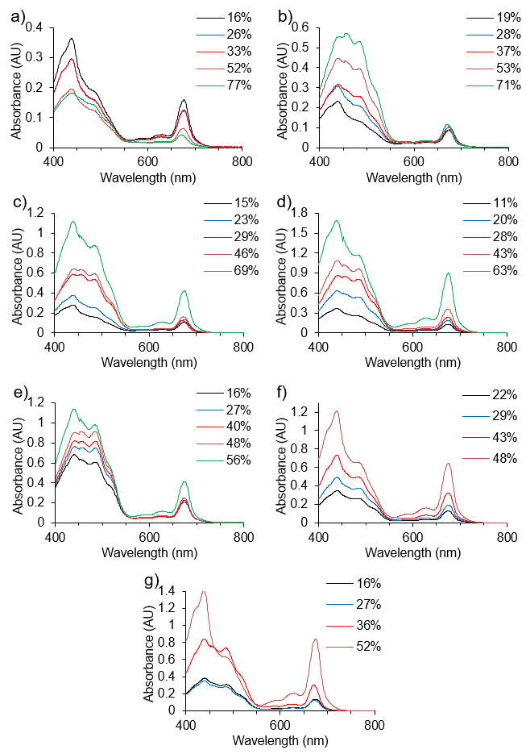
Figure 2.8. Absorbance spectra of supernatant following thylakoid membrane solubilization with SMA copolymers Eth(a), Prop(b), But(c), Hex(d), Oct(e), Dec(f), and Dodec(g).

Control polymer DEG displayed the opposite qualitative trend in the solubilization of chlorophyll-containing proteins, wherein higher percentages of esterification appear to decrease the amount of chlorophyll-containing proteins being liberated from the membrane. Furthermore, control polymer TEG showed no discernible solubilization trend at all (Figure 2.9a and 2.9b). Absorbance profiles for the supernatants of SMA 1440 and DDM were also measured as controls to ensure consistency across all trials. Lastly, the absorbance profile for the supernatant resulting from membrane extraction with DMAP showed very little absorbance between 400-800 nm (Figure 2.9c), suggesting that potential for trace amounts of this reagent remaining in the synthesized polymer samples did not artificially impact our results.
To quantify the percent solubilization efficiency (SE) of extracted chlorophyll proteins of each SMA formulation, we compared extracted chlorophyll in the supernatant to the 1 mg/mL chlorophyll of the starting thylakoid membrane and reported this as a percentage (Figure 2.10a). Quantification of this data confirms what was qualitatively observed: the longer alkoxy ethoxylate sidechains tend to elicit a higher solubilization efficiency than shorter alkoxy ethoxylates, especially as percent esterification increases. Furthermore, these trends suggest that sidechain length alone is not the primary factor resulting in increased solubilization efficiency. Rather, the increased hydrophobicity of the sidechain appears to have the most notable impact. This can be seen by comparing alkoxy ethoxylate sidechains to ethylene glycol sidechains of similar lengths (Figure 2.10b-2.10c). For instance, polymers But and DEG both have six-atom sidechains. However, DEG is much more hydrophilic due to the additional ethereal units present. The same observation holds true for polymers Dec and TEG, which both containing sidechains thirteen atoms long, albeit TEG is more hydrophilic due to the attached tetraethylene glycol moiety.
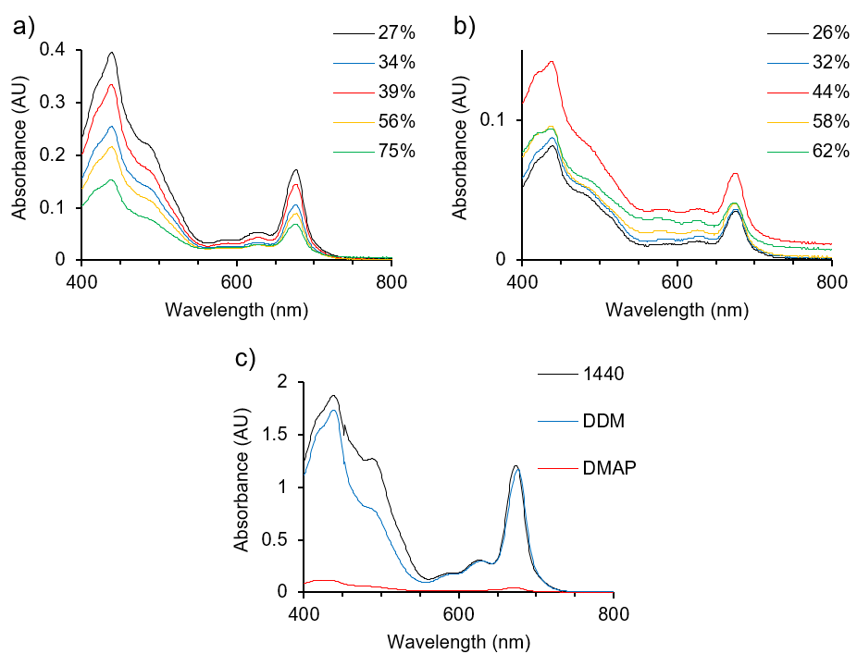
Figure 2.9. Absorbance spectra of supernatant following thylakoid membrane solubilization with SMA copolymers DEG(a), TEG(b), SMA 1440 (c, black), n-dodecyl-β-D-maltoside (c, blue), 4-dimethylaminopyridine (c, red).

Figure 2.10. Comparison of percent solubilization efficiency (SE) of chlorophyll and chlorophyll-containing complexes as a function of percent esterification for (a) SMA-based copolymers Eth-Dodec that are functionalized with alkoxy ethoxylate sidechains, (b) polymers But and DEG and (c) polymer samples Dec and TEG.

In both instances, the more hydrophilic polymer exhibits a markedly higher percent solubilization efficiency in the extraction of PSI from Te, particularly at high degrees of esterification.
Though the trends observed in Figure 2.10 are informative, it is difficult to draw direct comparisons relating hydrophobicity and SE when the polymers studied bear varying extents of esterification as well as different length alkoxy moieties. As such, a simple method to normalize the relative hydrophobicity of polymers Eth-Dodec was needed. To accomplish this, we chose to compare these polymers based upon their number of side-chain carbons per the average number of carboxylate moieties present in the polymeric repeat unit. Therein, the average number of carboxylates per repeat unit was calculated based upon a) percent esterification and b) knowing that unfunctionalized maleic acid units contain two carboxylates whereas monoesterified maleic acid units contain only one carboxylate. The number of carbons per alkoxylated ester (e.g. decyloxyethoxy units contain 14 carbons) was then divided by the average number of carboxylates per repeat unit to obtain a new metric that relates hydrophobic sidechain content to hydrophilic carboxylate content. Solubilization efficiency was then plotted as a function of the average number of carboxylates per maleic acid (Figure 2.11).
The data in Figure 2.11 indicate that both longer alkoxy ethoxylates and higher extents of esterification lead to higher solubilization efficiencies. As an example, though Oct-(56) and Dodec-(52) bearing octyloxy and dodecyloxy substituents, respectively, have very similar degrees of esterification, the latter features a solubilization efficiency that is ~400% higher than that of the former. We hypothesize that this is indicative of increased interactions between longer alkoxy ethoxylate sidechains and the tails of the galactolipids present in the thylakoid membrane of Te. Unfortunately, attaching longer alkoxy chains to PRO also leads to a large decrease in aqueous

Figure 2.11. Percent solubilization efficiency as a function of sidechain carbons per carboxylate as a metric reflecting relative hydrophobicity of polymers Eth-Dodec.

solubility. This became problematic for polymers Oct, Dec, Dodec, which gelate in water when functionalized beyond ~55% esterification, as attempts to solubilize membrane proteins require water-soluble polymers. This suggests that though increasing chain length and degree of esterification appear to favor higher solubilization efficiencies, polymer samples functionalized with hydrophobic sidechains will eventually become too hydrophobic to remain in solution.
Another striking feature observed in Figure 2.11, is that an empirical threshold of esterification was observed at ~50%, beyond which a drastic increase in percent SE is observed for polymers Hex, Dec, and Dodec. This effect is amplified as the length of the attached alkoxy ethoxylate increases, as illustrated by comparing polymer samples functionalized at both low and high degrees of esterification (Figure 2.12). When comparing samples featuring ~30% esterification of different alkoxy sidechains, the samples with longer sidechains exhibit slightly higher SE (Figure 2.12a). In contrast, SE increases significantly between samples as the degree of esterification is pushed past the empirical threshold of 50% esterification. For example, while the dodecyloxy substituted Dodec-(27) elicits an 80% increase in SE compared to the hexyloxy substituted Hex-(28), Dodec-(52) achieves a SE of 243% higher than Hex-(63) (Figure 2.12b).

2.3.6 Characterization of Pigment-Protein Complexes Isolated from Te
To determine whether the chlorophyll extracted using the SMA derivatives reported herein is bound to protein complexes or free in solution, the supernatant following membrane solubilization was purified using a sucrose density gradient (Figure 2.13). As can be seen in Figure 2.13, the top orange band contains free carotenoids (band 1). Further down the gradient is a diffuse green band containing free chlorophyll, and, in the case of DDM, monomeric PSI

Figure 2.12. Percent solubilization efficiency of esterified SMA copolymers at a) low degrees of esterification and b) high degrees of esterification and measured as percent chlorophyll in the supernatant following thylakoid membrane solubilization and high-speed sedimentation.

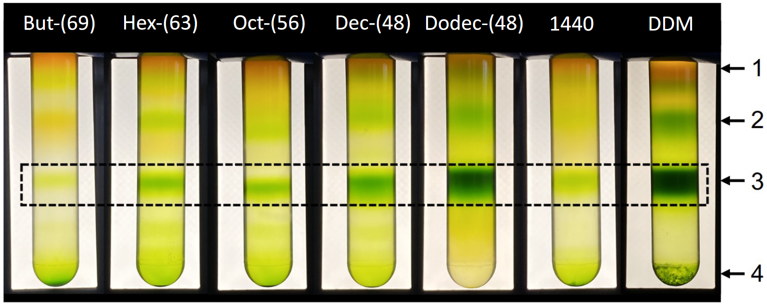
Figure 2.13. Sucrose density gradients of PSI-SMALPs following solubilization with alkoxy functionalized SMA copolymers. The black dashed box indicates the trimeric PSI band. Numbers to the right indicate the band number discussed in the text.

and PSII (band 2).¹⁴ The trimeric PSI band is highlighted in the black, dashed box (band 3) and larger PSI particles (aggregates in the case of DDM) can be seen at the bottom of the gradient (band 4). Interestingly, samples with longer alkoxy ethoxylates resulted in the formation of more SMALPs containing single PSI trimers, rather than larger, high-density chlorophyll-containing fractions. We previously reported that these larger sections of high-density thylakoid membrane are found near the bottom of the sucrose gradient and contain PSI (presumably in trimeric form).⁸ In the case of polymer Dodec, the larger chlorophyll-containing complexes are completely absent.
It should also be noted that some aggregated chlorophyll-containing protein complexes can be seen on the 50% sucrose (w/v) cushion at the bottom of the DDM gradient, as additional DDM was not included in this sucrose gradient buffer to maintain the dynamic equilibrium between DDM micelles and DDM bound the PSI toroid. However, for the purposes of this control, trimeric PSI is shown to be the dominant species arising from DDM isolation. Therefore, we consider this control to be acceptable. Lastly, this side-by-side comparison allows us to observe that the SMALPs do not seem to require excess SMA in solution to maintain the integrity of the formed nanodiscs.
The trimeric PSI containing band 3 was harvested from each sucrose density gradient and was imaged using transmission electron microscopy (TEM) and a negative stain, with the exception of But-(69) due to low yield, to provide evidence of derivatized SMALP formation. A representative micrograph of Dodec-(52) is shown in Figure 2.14, along with other examples shown in Figure 2.15, which provide clear evidence of derivatized SMALP formation. The average diameter of the SMALPs (n=10) are listed in Table 2.1, wherein Oct-(59) was found to form the largest discs, followed by Hex-(53), Dodec-(52), and Dec-(60). Interestingly this pattern seems to
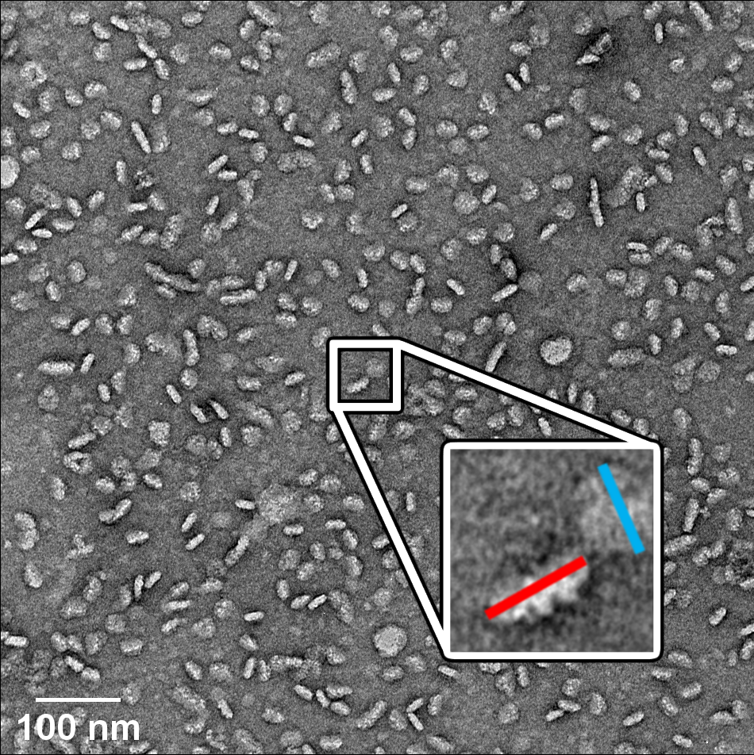
Figure 2.14. TEM of derivatized SMALPs formed by the solubilization of PSI from Te using Dodec-(52). The red and blue bars depicted in the micrograph inset represent distances measured to determine average diameters, wherein the blue bar depicts measurement across the face of a SMALP and the red bar represents measurement along the side of a SMALP.

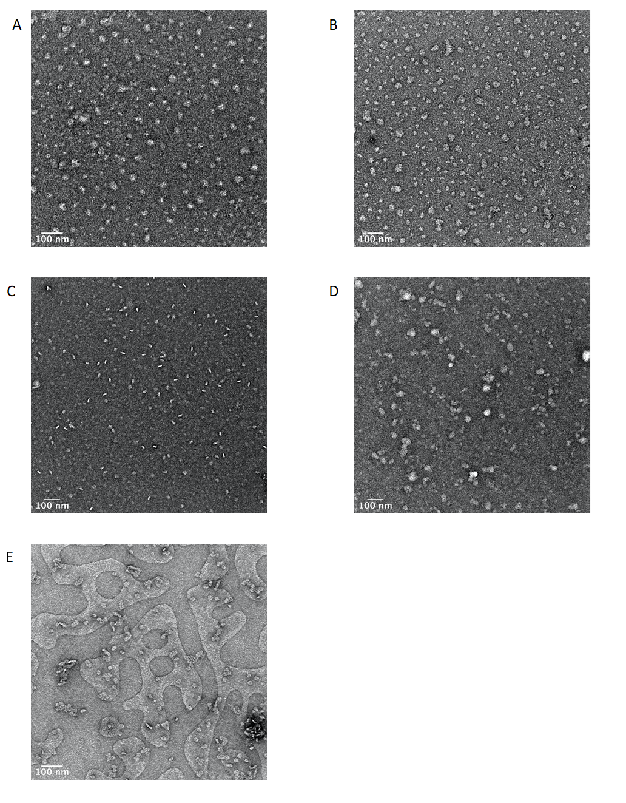
Figure 2.15. Negative stain TEM images of trimeric PSI particles. A) Hex-(53); B) Oct-(59); C) Dec-(60); D) SMA 1440; E) DDM.
Table 2.1. Average measured diameters of derivatized PSI-SMALPsª
Solubilizing Agent | Avg. Diameter (nm) |  | Standard Deviation (nm) | Standard Error (nm)
DDM | 21.5 |  | 2.5 | 0.8
1440 | 34.7 |  | 5.4 | 1.7
Hex-(53%) |  | 31.2 | 4.3 | 1.4
Oct-(59%) |  | 35.4 | 6.1 | 1.9
Dec-(60%) |  | 26.8 | 2.2 | 0.7
Dodec-(52%) |  | 28.4 | 6.8 | 2.2
ªDeviation and error are calculated based upon measurement of 10 SMALPs using ImageJ software.

correlate with the pH stability study and the maximum blue shifts recorded in Figure 2.6. These data may suggest that an optimum hydrophobicity may be achieved using SMA derivative Oct-(59), which allows this copolymer to stabilize larger lipid annuli around the trimeric PSI-SMALPs, while at the same time narrowing the solubility conditions of the polymer itself.
The trimeric PSI fractions were collected and separated using SDS-PAGE to determine their polypeptide profiles (Figure 2.16). As we hypothesized, the typical PSI profile was observed across all SMA copolymers tested. Interestingly, the peripherally associated PsaF subunit seems to be missing in the SMA 1440 control but not in the alkoxy functionalized SMAs synthesized herein or DDM. We have previously reported that PsaF can be lost over time in PSI-SMALPs formed with the commercially synthesized SMA 1440 copolymer.⁸ It was posited in this work that the hydrophobic interaction between the peripheral subunit PsaF and the outer edge of PsaB core subunit, facilitated by a carotenoid molecule, may create a dynamic equilibrium in vivo between a PsaF bound state and a pool of free and unbound PsaF that has been previously reported in cyanobacterial thylakoids.¹⁵ While this may also be the case observed here, our results suggest that PsaF may not be lost simply due to the ability to dissociate from the core complex within the confines of the lipid annulus, but rather, the disruption of this PsaF to PsaB interaction may be more complicated and require further investigations.
Low-temp fluorescence emission scans at 77 K of the presumed PSI trimer containing fractions were performed to further confirm the formation of PSI containing SMALPs (Figure 2.17). Following excitation at 430 nm, free chlorophyll in solution exhibited a fluorescence at <680 nm, as well as a very minor peak at 695 nm signifying minimal extraction of PSII .¹⁶ The bulk of

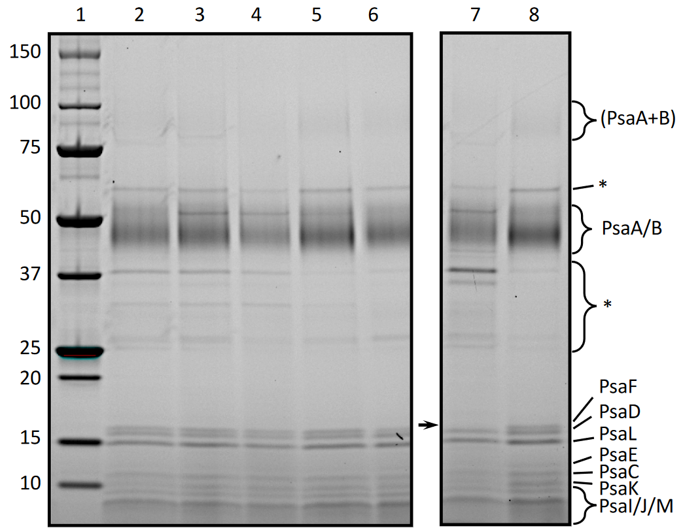
Figure 2.16. SDS-PAGE of PSI-SMALP trimer bands following solubilization with various alkoxy-functionalized SMA copolymers. Shown here are Hex-(63) (lane 1), Oct-(48) (lane 2), Dec-(43) (lane 3), Dec-(48) (lane 4), Dodec-(52) (lane 5), MW standard (lane 6), SMA 1440 (lane 7), and DDM (lane 8). Subunits are labeled at right. Regions marked with an asterisk contain unknown contaminants, (PsaA+B) denotes the undissociated heterodimer, whereas PsaA/B represents their respective monomers, and the black arrow denotes the missing PsaF band in lane 7.

Figure 2.17. Normalized chlorophyll fluorescence emission spectra for trimeric PSI containing SMALPs isolated using alkoxy ethoxylate functionalized SMA copolymers following sucrose density gradient ultracentrifugation. Shown here are But-(69) (black, solid line), Hex-(63) (blue), Oct-(48) (red), Dec-(48) (orange), Dodec-(52) (green), SMA 1440 (black, dashed line), and DDM (black, dotted line).

the fluorescence signal stems from chlorophyll-bound to PSI with a characteristic F_{MAX} red-shifted to ~730 nm. All functionalized PSI-SMALPs showed very little free chlorophyll/PSII and display F_{MAX} of 728-729 nm, with the exceptions of But and Oct functionalized SMALPs (Figure 2.8). In the case of polymer But, this may be due to the low concentration of PSI-SMALP in the sample, decreasing the signal of the characteristically red-shifted absorbance of chlorophyll in Te PSI, therefore resulting in a blue-shift in the fluorescence emission maximum. For polymer Oct, we suspect that this observation is due to an aberrant spike in one triplicate scan, artificially skewing the average F_{MAX} for this triplicate average, however the peak centers around 729 nm.

2.4 Conclusions
Little is known about how altering the chemical composition of SMAs and SMA derivatives effects the efficiency and selectivity of membrane protein extraction. Herein, we report evidence that alkoxy ethoxylate esterified SMAs can be used to promote the solubilization of trimeric PSI from Te via formation of derivatized SMALPs. We observed that increasing the relative hydrophobicity of the amphiphilic copolymer leads to an overall increase in the amount of trimeric PSI extracted from cyanobacterium Te membranes. From these results, two main characteristics of functionalized SMA copolymers were identified to have large impacts on protein extraction. First, SMA derivatives bearing longer alkoxy ethoxylate sidechains, such as dodecyloxy substituted Dodec, tend to elicit higher solubilization efficiencies as compared to polymers bearing shorter alkoxy ethoxylate sidechains; however, our data also suggests that the length of the sidechain is not the only factor to be considered. Second, the number of attached sidech ains appears to be an even more important factor regarding efficient protein solubilization.
To highlight this feature, we observed a drastic increase in solubilization efficiency as the extent of polymer monoesterification surpassed 50%, an effect which is more apparent when studying longer alkoxy ethoxylate sidechains.
These two discoveries provide fundamental insight into the mechanism of SMA-facilitated protein solubilization in Te. We hypothesize that the aliphatic chains aid in SMALP formation by anchoring into the acyl chain region of the membrane, similar to the action of the styrene moiety of SMAs utilized in previous studies.¹⁷ Other groups have noted the possibility of a amphiphilic polymers utilizing functionalized sidechains to intercalate within the acyl chains present in the tails of membrane lipids.¹⁸ We suspect that our alkoxy ethoxylates are functioning in a similar manner, wherein longer alkyl chains may be able to more effectively anchor due to favorable interactions with the tails of the galactolipids composing the membrane. Finally, we hypothesize that polymers featuring higher degrees of esterification may drive preferential insertion into the lipid bilayer and initiate SMALP formation. This could explain the steep increase in solubilization observed when esterification percentages surpass the empirically observed 50% esterification threshold. This suggests a critical equilibrium between aqueous solubility of the modified polymers and the increased partitioning into the lipid bilayer, further work will be needed to see how this process is affected by fatty acid composition, lipid headgroup composition, and temperature.

2.5 Acknowledgements
We would like to acknowledge Mr. Joytirmoy Mondal and Ms. Katrina Micin for the maintaining the cyanobacteria and growing the 125-liter cultures of T. elongatus. The PRO 10235 powder was a generous gift from Mr. Ryan Beer at TOTAL Petrochemicals USA. We would like to thank Dr. Jaydeep Kolape for his assistance and guidance with TEM. We would also like to thank Dr. Michael Best for his fruitful insights to this project.

2.6 Experimental
2.6.1 General Materials and Methods
All chemical reagents were obtained from commercial sources and used without further purification, unless otherwise noted. 2-Octyloxyethanol, 2-decyloxyethanol, and 2-dodecyloxyethanol were synthesized using a modified literature procedure.^{16, 19} PRO 10235 was obtained from Cray Valley (now Polyscope). One important note is that the specific batch of PRO used in this study was experimentally found to have a 1.21:1 ratio of styrene:maleic anhydride using ¹H NMR spectroscopy (Figure 2.18). THF was dried using an Innovative Technology Pure Solv solvent purification system. Water was purified using a MilliQ Biocel reverse osmosis system with a resistance of >18 MΩ to mitigate impact of trace ions. ¹H NMR spectroscopy was performed using a Varian 500 MHz NMR spectrometer and chemical shifts are reported with respect to residual solvent peaks.

2.6.2 General Synthesis of Alkoxy Ethoxylates
In a typical procedure, a mixture of KOH (9.26 g, 165 mmol) in ethylene glycol (42 mL, 750 mmol) was added to 1,4-dioxane (90 mL), Bu4NBr (2.9 g, 9 mmol), and a 1-bromoalkane (150 mmol). The reaction mixture was then heated to 105 °C for 5 h. The mixture was cooled to room temperature and extracted with CHCl3 (×3). The organic layer was separated, washed with
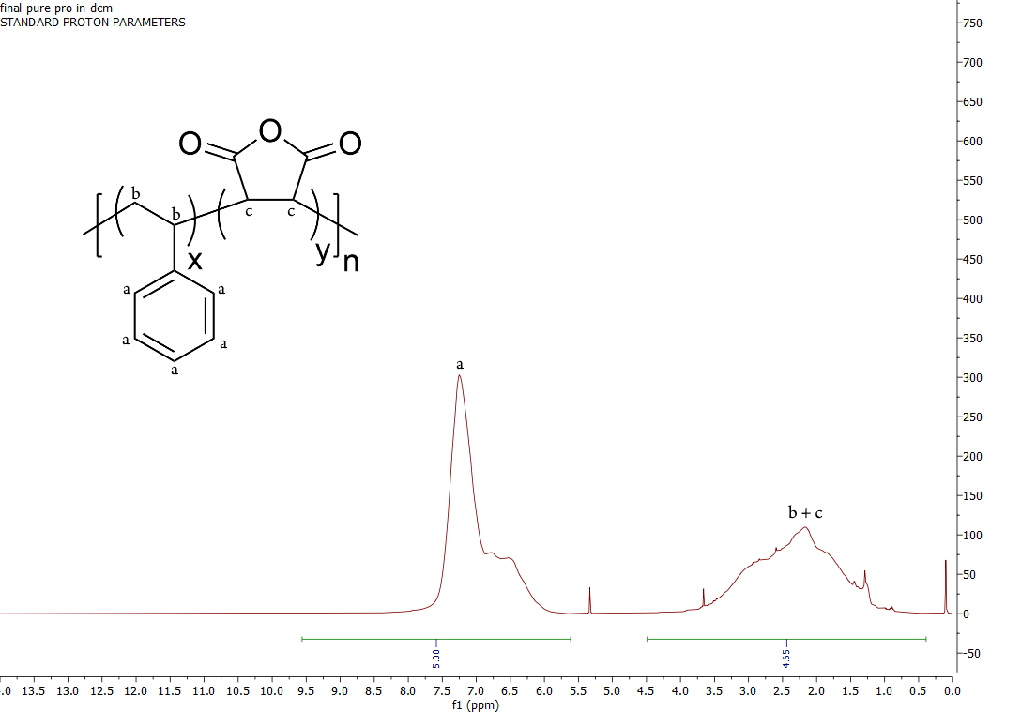

Figure 2.18. Quantification styrene:maleic anhydride mole ratio in commercial PRO by ¹H NMR spectroscopy. Solvent is DCM-D₂. The ratio was determined using the same equation below, where I_{a}, I_{bc}, and x are the same variables as discussed in Figure 2.1. This results in a sytenes:maleic anhydride ratio of 1:0.825, or 1.21:1 when normalized, for this commercial sample of PRO.
x = $\frac{\left(5*I_{bc}-3*I_{a}\right)}{2*I_{a}}$

water (×3), concentrated under vacuum, and the remaining residue purified via vacuum distillation to provide each product as a clear oil. Yields for 2-octyloxyethanol, 2-decyloxyethanol, and 2-dodecyloxyethanol were 60%, 64%, and 73%, respectively. Characterization of each product agreed with prior literature reports.^{16, 19}

2.6.3 Esterification of PRO
Esterification was performed using a modified literature procedure.²⁰ PRO (2.5 g, 9.8 mmol) was dissolved in dry THF (45 mL), followed by the addition of a 4-dimethylaminopyridine (DMAP) (0.06 g, 0.05 mmol) solution in dry THF (5 mL). The target alcohol (80 mmol) was then added to the polymer solution. The reaction was stirred under constant reflux for prescribed time intervals. Therein, ~8 mL aliquots were taken at various time points in order to achieve varying extents of esterification. To each aliquot was added HCl solution (10 mL, 0.001M). The organic layer was decanted, concentrated under vacuum, and dried in a vacuum oven at 80 °C for a minimum of 24 h.

2.6.4 Determination of Esterification Percentage
Utilizing the experimentally determined incorporation ratio of 1.21:1 styrene:maleic anhydride in PRO, the extent of esterification was determined via ¹H NMR spectroscopy by comparing the integration of the aryl region to the proton signal corresponding to the methyl protons of the attached sidechain (Figure 2.1). All NMR spectra for modified SMAs can be seen in Figures A2-A10. DOSY NMR spectroscopy was also used to confirm functionalization of the polymer backbone with the desired alcohol, rather than free alcohol remaining in solution (Figure 2.19).

2.6.5 Solubilization of Prepared SMA Derivatives
Solubilization of the SMA derivatives was performed by placing the target SMA (15% w/v) in water (80% w/v) and adding a solution of 30% NH₄OH in water (5% w/v). Each solution was heated at 80 °C for ≥ 30 min, until a non-turbid solution was obtained.

2.6.6 Determination of pH and Divalent Cations Sensitivity in Aqueous Media
The solubility of each polymer sample as a function of pH was determined using a modified literature procedure.¹⁰ Therein, each polymer sample was diluted into a standard Britton-Robinson (BR)¹⁰ buffer containing 150 mM NaCl for a final concentration of 0.15% (w/v). The prepared buffers ranged from pH 4.5 to 10, in half unit increments. The samples were then mixed via orbital shaking for 10 min and the optical density was measured at 350 nm using a UV spectrometer. Optical density values above the baseline were interpreted as an indicator of polymer aggregation and precipitation from solution.
Divalent cation sensitivity was also determined using a modified literature procedure.⁵ Each polymer sample was diluted into a 9.5 pH tris buffer containing various concentrations of MgCl₂, ranging from 1 mM to 100 mM. The final concentration of each polymer solution was 0.15% (w/v). These solutions were then mixed via orbital shaking for 10 min and the optical density was measured at 350 nm using a UV spectrometer. Optical density values above the baseline were interpreted as an indicator of polymer aggregation and precipitation from solution.
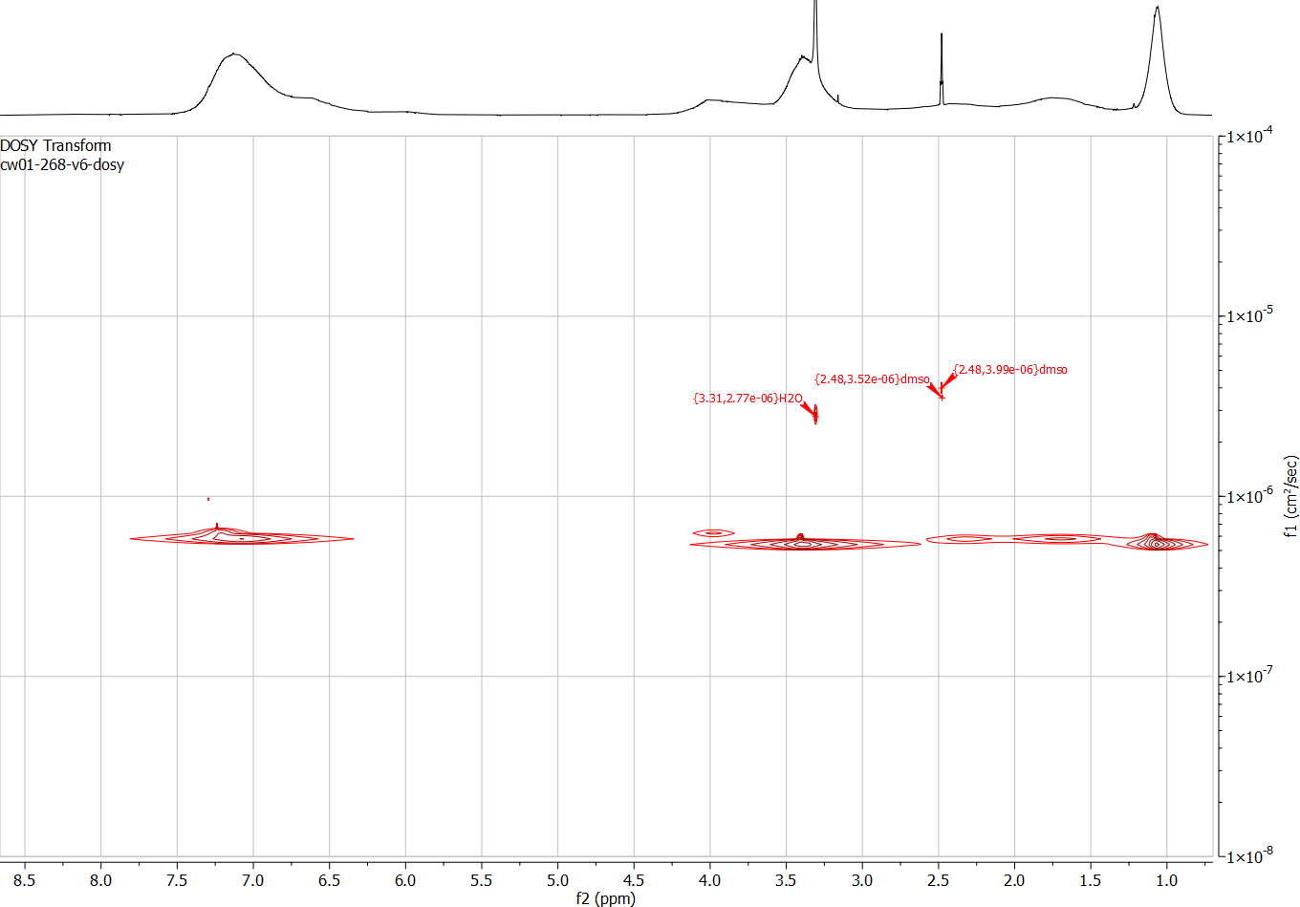
Figure 2.19. DOSY NMR spectrum used to confirm attachment of the 2-ethoxyethanol sidechain to PRO. The specific sample examined was Eth-(77). All non-solvent peaks, including the peak at 1.05 corresponding to the terminal methyl hydrogens of the ethoxylated alcohol, are shown to have similar diffusion coefficients. This suggests the sidechain was successfully attached.

2.6.7 Critical Aggregation Concentration (CAC) Determination
The critical aggregation concentration for the tested polymer samples was determined following a previous literature procedure.¹⁰ Therein, each polymer sample was diluted to 0.15% (w/v) in a standard BR-buffer at a pH of 9.5. These polymer solutions were placed into a 96-well plate and each sample diluted 5-fold (×12) across the wells. A Nile Red solution was added to each well at a concentration of 1 µM. Each plate was excited at 550 nm and the emission was measured between 550-700 nm in 1 nm increments. The wavelength of the highest emission intensity was plotted versus concentration for each polymer sample. The CAC was determined by fitting sigmoidal curves to the blue shifting fluorescence spectra as polymer concentration increased.

2.6.8 Preparation of Thylakoid Membranes
Thylakoid membranes were isolated following established protocols. Briefly, Te cells were grown in BG-11 media, in an air lift, flat panel bioreactor at 45 °C (Photon Systems Instruments, Brno, Czech Republic). The cells were irradiated with ~50 μmol photons·mol-1·cm-2 of light from red and white LEDs, respectively, and aerated with compressed air. Cells were harvested at late log phase, pelleted at 6,000g and re-suspended in Tris-Cl (50 mM, pH 9.5, at room temperature), with KCl (125 mM) (Buffer S) to yield 1 mg/mL chlorophyll (Chl a) solutions. The cells were then incubated at 40 °C in Buffer S with 0.0025% (w/v) lysozyme (Gold Bio, United States) for 1 h in the dark, at 250 rpm on an orbital shaker. The intact cells were then pelleted at ~10,000g for 10 min, re-suspended in Buffer S, and Dounce homogenized. The cells were then mechanically lysed (×10) using a benchtop LM10 microfluidizer (Microfluidics, Westwood, MA) at 23,000 psi. Intact cells and debris material were pelleted at ~10,000g for 10 min and discarded. The thylakoid membranes contained in the supernatant were then pelleted at ~190,000g. This pellet was re-suspended using a brush and was Dounce homogenized in Buffer S (×3) to remove membrane associated proteins.⁸ The resultant thylakoid membranes were then diluted to 1 mg/mL chlorophyll and stored at -20 °C prior to solubilization.

2.6.9 Membrane Solubilization and Protein Isolation using SMALPs
Thylakoid membrane aliquots (500 μL) were incubated with an alkoxy functionalized SMA copolymer in the dark at a final concentration of 1.5% (w/v) for 3 h at 40 °C, while shaking (250 rpm, orbital shaker). The samples were centrifuged at ~190,000g for 15 min and the supernatant was removed using a flame drawn Pasteur pipette. These supernatants, which contain PSI-SMALPs, were then analyzed directly or were further purified using sucrose density gradients and ultracentrifugation.

2.6.10 Sucrose Density Gradient Ultracentrifugation
The PSI-SMALP containing supernatants were then purified using a sucrose density gradient centrifugation (SDGC) using a linear gradient of 10 – 30% (w/v) on a 50% (w/v) sucrose cushion. Next, 1 mL of SMA solubilized supernatant was loaded on top of the gradient and centrifuged in a SW-32 swinging bucket rotor for 20 h at ~150,000g. The lowest green band was harvested using a needle syringe. This band has been shown to be PSI-SMALP.

2.6.11 Protein Analyses
Absorbance spectroscopy was performed using a dual-beam benchtop spectrophotometer (Evolution 300, Thermo Scientific). Following solubilization and high-speed sedimentation, the supernatants were diluted (×20) prior to absorbance measurements. Chlorophyll was extracted with 90% methanol at 65 °C for 2 min, as previously described,²¹ and absorbance was taken at 665 nm to determine chlorophyll concentration.
SDS-PAGE was performed using a sample solubilization buffer containing ~350 mM dithiothreitol and 4% SDS. Samples were heated in a 65 °C water bath for 9 min prior to loading onto a Bio-Rad TGX stain-free Criterion pre-cast gel. The gel was then illuminated and fixed prior to imaging of the TGX fluorochrome using a Bio-Rad ChemiDoc MP gel imaging system.
Low temperature fluorescence was performed at 77 K on presumed trimeric PSI bands following sucrose density gradient ultracentrifugation using previously reported methods.¹² These analyses were performed using a PTI Quantamaster dual-channel fluorimeter (HORIBA, Kyoto, Japan). Spectra are averaged over three measurements following background subtraction and normalized to the maximum fluorescence.

2.6.12 Transmission Electron Microscopy
SMALPS were isolated using sucrose density gradient ultracentrifugation. The isolated SMALP samples were diluted (×10-50) into Buffer S. A copper coated grid was placed in a 20 µL drop of the sample solution for 1 min. Excess sample was removed via filter paper absorption and the grid was washed by dipping it in distilled water. Excess distilled water was removed via filter paper absorption. The grid was then immediately stained by placing it in a 20 µL drop of 1% uranyl acetate for 1 min. The grid was allowed to dry and imaged using a JEOL 1440-Flash TEM at 200 kV.

References
1. Dörr, J. M.; Koorengevel, M. C.; Schäfer, M.; Prokofyev, A. V.; Scheidelaar, S.; van der Cruijsen, E. A. W.; Dafforn, T. R.; Baldus, M.; Killian, J. A., Detergent-free isolation, characterization, and functional reconstitution of a tetrameric K+ channel: The power of native nanodiscs. Proc. Natl. Acad. Sci. U. S. A. 2014, 111, 18607.
2. Domínguez Pardo, J. J.; Koorengevel, M. C.; Uwugiaren, N.; Weijers, J.; Kopf, A. H.; Jahn, H.; van Walree, C. A.; van Steenbergen, M. J.; Killian, J. A., Membrane Solubilization by Styrene-Maleic Acid Copolymers: Delineating the Role of Polymer Length. Biophys. J. 2018, 115, 129-138.
3. Morrison, K. A.; Akram, A.; Mathews, A.; Khan, Z. A.; Patel, J. H.; Zhou, C.; Hardy, D. J.; Moore-Kelly, C.; Patel, R.; Odiba, V.; Knowles, T. J.; Javed, M.-u.-H.; Chmel, N. P.; Dafforn, T. R.; Rothnie, A. J., Membrane protein extraction and purification using styrene–maleic acid (SMA) copolymer: effect of variations in polymer structure. Biochem. J. 2016, 473, 4349.
4. Ravula, T.; Hardin, N. Z.; Ramadugu, S. K.; Ramamoorthy, A., pH Tunable and Divalent Metal Ion Tolerant Polymer Lipid Nanodiscs. Langmuir 2017, 33, 10655-10662.
5. Burridge, K. M.; Harding, B. D.; Sahu, I. D.; Kearns, M. M.; Stowe, R. B.; Dolan, M. T.; Edelmann, R. E.; Dabney-Smith, C.; Page, R. C.; Konkolewicz, D.; Lorigan, G. A., Simple Derivatization of RAFT-Synthesized Styrene–Maleic Anhydride Copolymers for Lipid Disk Formulations. Biomacromolecules 2020, 21, 1274-1284.
6. Esmaili, M.; Acevedo-Morantes, C.; Wille, H.; Overduin, M., The effect of hydrophobic alkyl sidechains on size and solution behaviors of nanodiscs formed by alternating styrene maleamic copolymer. Biochim. Biophys. Acta, Biomembr. 2020, 1862, 183360.
7. Korotych, O. I.; Nguyen, T. T.; Reagan, B. C.; Burch-Smith, T. M.; Bruce, B. D., Poly(styrene-co-maleic acid)-mediated isolation of supramolecular membrane protein complexes from plant thylakoids. Biochim. Biophys. Acta, Bioenerg. 2021, 1862, 148347.
8. Brady, N. G.; Li, M.; Ma, Y.; Gumbart, J. C.; Bruce, B. D., Non-detergent isolation of a cyanobacterial photosystem I using styrene maleic acid alternating copolymers. RSC Adv. 2019, 9, 31781-31796.
9. Phan, M. D.; Korotych, O. I.; Brady, N. G.; Davis, M. M.; Satija, S. K.; Ankner, J. F.; Bruce, B. D., X-ray and Neutron Reflectivity Studies of Styrene-Maleic Acid Copolymer Interactions with Galactolipid-Containing Monolayers. Langmuir 2020, 36, 3970-3980.
10. Scheidelaar, S.; Koorengevel, M. C.; van Walree, C. A.; Dominguez, J. J.; Dörr, J. M.; Killian, J. A., Effect of Polymer Composition and pH on Membrane Solubilization by Styrene-Maleic Acid Copolymers. Biophys. J. 2016, 111, 1974-1986.
11. Gokel, G. W.; Leevy, W. M.; Weber, M. E., Crown Ethers: Sensors for Ions and Molecular Scaffolds for Materials and Biological Models. Chem. Rev. 2004, 104, 2723-2750.
12. Cherepanov, D. A.; Brady, N. G.; Shelaev, I. V.; Nguyen, J.; Gostev, F. E.; Mamedov, M. D.; Nadtochenko, V. A.; Bruce, B. D., PSI-SMALP, a Detergent-free Cyanobacterial Photosystem I, Reveals Faster Femtosecond Photochemistry. Biophys. J. 2020, 118, 337-351.
13. Kennis, J. T. M.; Gobets, B.; van Stokkum, I. H. M.; Dekker, J. P.; van Grondelle, R.; Fleming, G. R., Light Harvesting by Chlorophylls and Carotenoids in the Photosystem I Core Complex of Synechococcus elongatus: A Fluorescence Upconversion Study. The Journal of Physical Chemistry B 2001, 105, 4485-4494.
14. Rögner, M.; Nixon, P. J.; Diner, B. A., Purification and characterization of photosystem I and photosystem II core complexes from wild-type and phycocyanin-deficient strains of the cyanobacterium Synechocystis PCC 6803. J. Biol. Chem. 1990, 265, 6189-6196.
15. Dühring, U.; Ossenbühl, F.; Wilde, A., Late assembly steps and dynamics of the cyanobacterial photosystem I. Journal of Biological Chemistry 2007, 282, 10915-10921.
16. Lamb, J. J.; Rokke, G.; Hohmann-Marriott, M. F., Chlorophyll fluorescence emission spectroscopy of oxygenic organisms at 77 K. Photosynthetica 2018, 56, 105-124.
17. Jamshad, M.; Grimard, V.; Idini, I.; Knowles, T. J.; Dowle, M. R.; Schofield, N.; Sridhar, P.; Lin, Y.; Finka, R.; Wheatley, M., Structural analysis of a nanoparticle containing a lipid bilayer used for detergent-free extraction of membrane proteins. Nano Research 2015, 8, 774-789.
18. Ball, L. E.; Riley, L. J.; Hadasha, W.; Pfukwa, R.; Smith, C. J. I.; Dafforn, T. R.; Klumperman, B., Influence of DIBMA Polymer Length on Lipid Nanodisc Formation and Membrane Protein Extraction. Biomacromolecules 2021, 22, 763-772.
19. Kharlamov, A. V.; Artyushin, O. I.; Bondarenko, N. A., Synthesis of some acyclic quaternary ammonium compounds. Alkylation of secondary and tertiary amines in a two-phase system. Russ. Chem. Bull. 2014, 63, 2445-2454.
20. Francisco Martinez, G. N., Manuel Torres, Monoesterification of Styrene-Maleic Anhydride Copolymers with Aliphatic Alcohols. Bol. Soc. Chil. Quim. 2001, 46, 137-141.
21. Iwamura, T.; Nagai, H.; Ichimura, S.-E., Improved Methods for Determining Contents of Chlorophyll, Protein, Ribonucleic Acid, and Deoxyribonucleic Acid in Planktonic Populations. Int. Rev. Gesamten Hydrobiol. Hydrogr. 1970, 55, 131-147.

CHAPTER III: EFFECTS OF ESTERIFIED STYRENE-MALEIC ACID COPOLYMER DEGRADATION ON INTEGRAL MEMBRANE PROTEIN EXTRACTION

A version of this chapter was originally published by Cameron E. Workman, Bridgie Cawthon, and Nathan G. Brady:
Workman, C. E.; Cawthon, B.; Brady, N. G.; Bruce, B. D.*; Long, B. K.*, Effects of Esterified Styrene–Maleic Acid Copolymer Degradation on Integral Membrane Protein Extraction. Biomacromolecules 2022, 23, 4749-4755.
* Corresponding author

In this article, I was responsible for designing and performing all polymer solubilization, characterization, and degradation experiments. I also performed all of the experiments to determine polymer critical aggregation concentrations. Nathan Brady and Bridgie Cawthon performed all of the protein extraction and characterization studies together. Dr. Brian Long and Dr. Barry Bruce organized this project and facilitated the writing of the manuscript.

3.1 Abstract
The detergent-free extraction of integral membrane proteins using styrene-maleic acid copolymers (SMAs) has shown promise as a potentially effective technique to isolate proteins in a more native-like conformation. As the field continues to develop, the protein selectivity and extraction efficiency of many analogs of traditional SMAs are being investigated. Recently, we discovered that the monoesterification of SMAs with alkoxy ethoxylate sidechains drastically affects the bioactivity of these copolymers in the extraction of Photosystem I from the cyanobacterium Thermosynechococcus elongatus. However, subsequent investigations also revealed that the conditions under which these esterified SMA polymer analogues are prepared, purified, and stored can alter the structure of the alkoxy ethoxylate-functionalized SMA and perturb the protein extraction process. Herein, we demonstrate that the basic conditions required to solubilize SMA analogs may lead to deleterious saponification side-reactions, cleaving the sidechains of an esterified SMA and dramatically decreasing its efficacy for protein extraction. We found that this process is highly dependent on temperature, with polymer samples being prepared and stored at lower temperatures exhibiting significantly fewer saponification side-reactions. Furthermore, the effects of small molecule impurities and exposure to light were also investigated, both of which are shown to have significant effects on the polymer structure and/or protein extraction process.

3.2 Introduction
The field of detergent-free, integral membrane protein isolation using styrene-maleic acid copolymers (SMAs) has grown rapidly over the last decade.¹ SMAs have enabled the isolation of membrane proteins and their surrounding lipids into discrete styrene-maleic acid lipid particles (SMALPs).² Compared to proteins isolated via detergent-facilitated extraction, integral membrane proteins incorporated into SMALPs have been proposed to retain a more native conformation and have enabled researchers to probe their structures using techniques like Cryo-EM.³ As this field continues to advance, a better understanding of how structural alterations of the SMA copolymer scaffold impact the protein extraction process will be required to design next-generation SMA copolymers, and derivatives thereof. This goal will be aided by in-depth SMA structure-property relationship studies and mechanistic investigations.
Prior structure-property relationship studies have shown that both the molecular weight⁴ and styrene:maleic anhydride incorporation ratio⁵ of an SMA can each affect the selectivity and the efficiency of the protein extraction process. It has also been shown that alternative monomer designs in SMA copolymer analogues may also impact the protein extraction process. For example, amphiphilic copolymers with hydrophobic moieties other than styrene, such as diisobutylene,⁶ naphthalene,⁷ and stilbene,⁸ have been examined and shown to form lipid nanoparticles. Other studies have focused on altering the hydrophilic maleate groups, wherein SMA analogues have been synthesized via the esterification of the maleates with different chemical moieties, including ammonium functionalities and cyclohexyl groups.^{9, 10} These modifications have been shown to alter properties such as pH and divalent cation tolerance of the resulting polymers. We recently reported the synthesis of esterified SMA analogs, prepared via an esterification with alkoxy ethoxylate functionalities of various lengths, and highlighted how the inclusion of these sidechains can improve the extraction efficiency and selectivity for trimeric Photosystem I (PSI) in the cyanobacteria, Thermosynechococcus elongatus (Te).¹¹
During subsequent studies investigating the use of alkoxy ethoxylate functionalized SMA analogs, we discovered variation in activity between multiple samples of these polymers. Though the polymers used were identical prior to solubilization, ¹H NMR spectroscopy revealed a difference in the quantity of attached ester sidechains after polymer solubilization into aqueous solution at elevated temperatures (80 °C). We hypothesized that this difference in esterification percentage resulted from undesirable saponification that occurs during solubilization (Scheme 3.1), and that the conditions in which the polymers are prepared and/or stored likely contribute to the overall extent of saponification. With the growing interest in esterified SMAs and other SMA analogs, it is essential to understand how copolymer synthesis, solubilization, and storage conditions impact the copolymer structure, and subsequently, the protein extraction process.
To probe the relationship between various reaction conditions and the degradation of esterified SMAs, we present a fundamental study designed to investigate how the exposure of SMA 1440 (an SMA partially esterified with 2-butoxyethanol) to temperatures approaching 80 °C and ambient light impact polymer purity, structure, and bioactivity. Furthermore, we will differentiate the effect of SMA 1440 losing esterification with the concomitant effect(s) that the released, free alcohols in solution may have on protein solubilization and/or functional properties such as PSI-chlorophyll retention. Together, this work suggests that polymer synthesis, solubilization, and storage are each critical factors dictating the reproducibility of SMA copolymer protein extraction activity and suggest that impurities in the polymer sample may have a deleterious effect on the protein extraction process and protein structure/function.

3.3 Results and Discussion
3.3.1 Esterification Loss as a Function of Solubilization Time and Temperature
In these studies, SMA 1440f was subjected to hydrolysis at various temperatures for increasing reactions times to investigate possible degradation (Scheme 3.1). This polymer has a molecular weight (M_{n}) of 6.3 kg/mol and a dispersity (Đ) of 1.8 (Figure B1). Furthermore, it has a 1.5:1 ratio of styrene:maleic anhydride and is partially esterified with 2-butoxyethanol, according to the manufacturer. It was experimentally determined that the specific batch of SMA 1440f used in this study has ~48% of the maleate groups monoesterified with 2-butoxyethanol, as shown in Figure B2. The solubilization of SMA and related analogs in aqueous base (NH₄OH) is commonly performed at temperatures as high as 100 °C;¹² however, we have routinely performed this task at 80 °C in previous studies.¹¹ We hypothesized that the combination of basic conditions and high temperatures used to solubilize the polymer may lead to the deleterious saponification of the esterified maleates. To test this hypothesis, the loss of esterification as a function of solubilization time was investigated (Figure 3.1). Therein, SMA 1440f samples were reacted with NH₄OH at
Scheme 3.1. Preparation of SMA 1440 via the aqueous solubilization of SMA 1440f and the hypothesized saponification of SMA 1440.

Figure 3.1. Monitoring SMA 1440 esterification percentage as a function of solubilization time at 80 °C (red circles) and 40 °C (blue triangles), in the presence of aqueous NH₄OH.

either 40 °C or 80 °C for times ranging from 1 h to 168 h, before being purified and characterized via ¹H NMR spectroscopy (Figures 3.2-3.3).
Figures 3.1-3.2 show that solubilization of SMA 1440f at 80 °C results in a loss of 2.7%, 12%, and 60% of its esterified maleate groups over a solubilization times of 1 h, 6 h, and 168 h, respectively. This result demonstrates that esterification loss at 80 °C may be significant, and that reaction times at this temperature should be minimized to prevent esterified polymer degradation.
In contrast, we have routinely found that many SMA derivatives may be readily solubilized at lower temperatures, such as 40 °C, yet will require slightly longer solubilization times. To probe how lower temperatures affect esterification loss, a sample of SMA 1440f was solubilized at 40 °C in aqueous NH₄OH solution and the loss of esterification was quantified via ¹H NMR spectroscopy (Figure 3.3). As seen in Figure 3.1, only ~5% of the sample’s total esterified sidechains are lost after solubilization times of 168 h at 40 °C, an order of magnitude lower than the 60% percent loss observed when solubilization is carried out at 80 °C.
Following degradation at 80 °C, each polymer sample discussed above was lyophilized and purified via precipitation to remove any sidechains cleaved via saponification. These samples were solubilized into aqueous solution at room temperature to prevent further degradation and used to isolate PSI from Te (Figure 3.4) to highlight how this loss of esterification can affect the protein extraction process. These results suggest that the solubilization of esterified SMA analogs at high temperature, and subsequent loss of sidechains from the sample, significantly impacts the extraction process, lowering the yield to 50% of the chlorophyll extracted compared to a polymer sample with no degradation. The extracted proteins were separated on sucrose gradients to illustrate the large loss of trimeric PSI solubilized during this process (Figure 3.5).

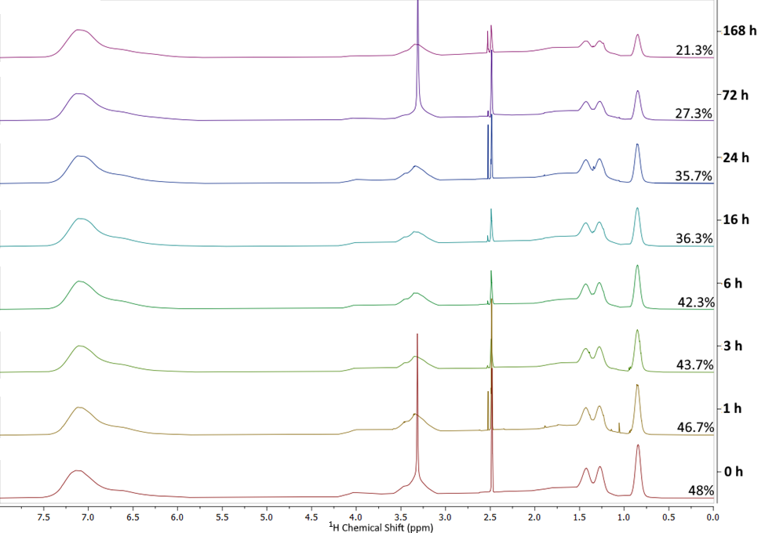
Figure 3.2. ¹H NMR spectra for SMA 1440 samples subjected to base-catalyzed saponification at 80 °C for increasing lengths of time (indicated to the right of each spectrum). The peaks at 2.5 and 2.54 are residual DMSO solvent peaks and the peak at 3.3 is the residual H₂O peak. The peak at 0.85 was used to determine extent of esterification of the samples, which is reported to the right of each spectrum.

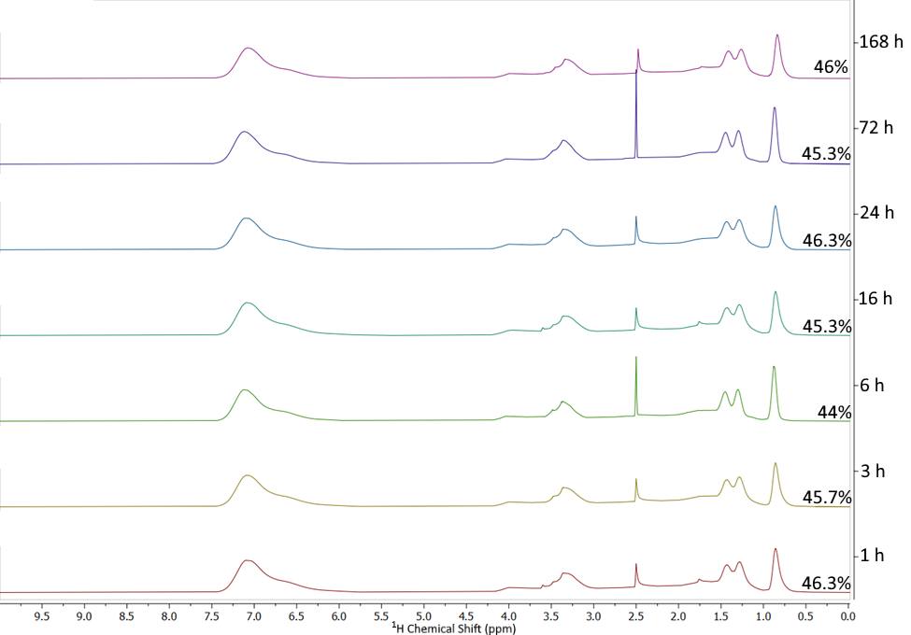
Figure 3.3. ¹H NMR spectra for SMA 1440 samples subjected to base-catalyzed saponification at 40 °C for increasing lengths of time (indicated to the right of each spectrum). The peaks at 2.5 and 2.54 are residual DMSO solvent peaks and the peak at 3.3 is the residual H₂O peak. The peak at 0.85 was used to determine extent of esterification of the samples, which is reported to the right of each spectrum.

Figure 3.4. Percent solubilization efficiency of SMA 1440 polymers with varying degrees of esterification, resulting from increased reaction times.

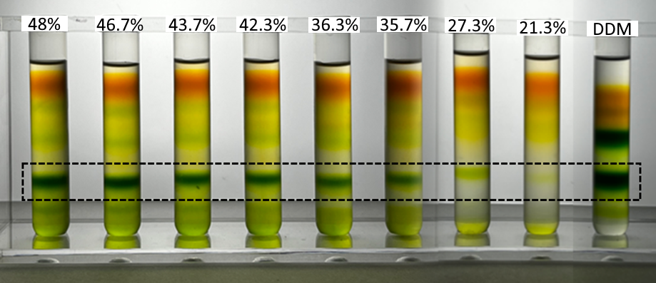
Figure 3.5. Sucrose density gradients of PSI-SMALPs following solubilization with degraded SMA 1440 samples. Labels on each tube indicate remaining monoester content of butoxyethanol sidechains. Black dashed box indicates the band of trimeric PSI.

3.3.2 Additional Impact of Light Exposure and Elevated Temperature During Solubilization
In addition to the loss of esterification discussed above, we also noticed gelation and a yellowing of our samples that increased as the SMA 1440f samples were solubilized at elevated temperatures for increasing lengths of time. Prior literature suggests that SMA copolymers can undergo photodegradation and subsequent crosslinking,¹³ which we hypothesized could explain our observations regarding yellowing and vitrification. To probe this observation, four SMA 1440f samples were solubilized for 168 h each, two at 80 °C and two at 40 °C. Additionally, one sample at each temperature was shielded from light in an attempt to decouple the role of heat and light in this degradative process. These four samples, post-heating, can be seen in Figure 3.6.
Qualitatively, the sample of SMA 1440f heated for 168 h at 80 °C while uncovered experienced the greatest yellowing and fully vitrified, despite starting as a clear solution with low viscosity (Figure 3.6a). When heated at 80 °C for 168 h and shielded from light, the solution still turned yellow in color, but did not vitrify or exhibit a notable increase in viscosity (Figure 3.6b). The observed yellowing of these samples was also examined by UV-visible spectroscopy, wherein an increase in absorbance was observed between 225-245 nm (Figure 3.7). This observation is consistent with the photodegradation of similar polymers reported in previous literature studies.^{13, 14}
In contrast to the samples solubilized at 80 °C, both samples heated for 168 h at 40 °C did not appear to visibly change in color or experience any vitrification, irrespective of light exposure (Figure 3.6c and 3.6d). While these results do not provide direct evidence of SMA 1440 degradation and crosslinking at elevated temperatures (i.e. 80 °C), they do indicate that both temperature and light exposure may play a critical role in the SMA degradation process. Furthermore, these results strongly suggest that SMA copolymers and their analogues, regardless
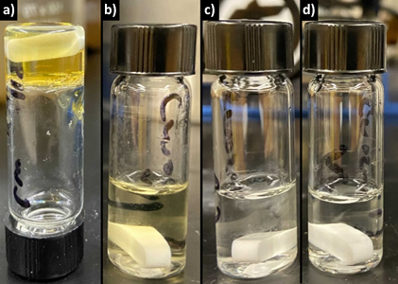
Figure 3.6. SMA 1440 samples heated for 168 h at a) 80 °C (shown inverted), b) 80 °C while shielded from light, c) 40 °C, and d) 40 °C while shielded from light.

Figure 3.7. Absorbance spectra of SMA 1440 samples heated for 168 h at 80 °C (blue), 80 °C while shielded from light (green), 40 °C (black), and 40 °C while shielded from light (purple).

of their identity, should be prepared, solubilized, and stored in a way that limits exposure to light and elevated temperatures.

3.3.3 Esterification Loss During SMA Storage in Basic Aqueous Media.
Not only are SMA polymers solubilized under basic conditions, but they are also often stored as basic aqueous solutions. To investigate the potential of further esterification loss during storage, a sample of SMA 1440f was solubilized (15 wt%) in water (80 wt%) with an aqueous solution of 30% NH₄OH in water (5 wt%) at 80 °C for 1 h. This solution was then stored at room temperature and shielded from light. Once a month, an aliquot was taken from the solution, lyophilized, purified via precipitation into hexanes, and characterized via ¹H NMR spectroscopy to determine its extent of esterification, and hence quantify any loss in esterification percent (Figure 3.8). Interestingly, after 10 months of storage at ambient conditions, no noticeable loss of overall esterification was observed. This result confirms that while esterified SMA analogs are susceptible to esterification loss during solubilization at elevated temperatures, they appear to be stable in basic aqueous solution at room temperature for extended periods of time.

3.3.4 Effect of Free Alcohols on Protein Solubilization
The data described in this report, and in the existing literature,¹¹ have shown that the degree of esterification is crucial to the overall efficiency of the protein extraction process. Deleterious saponification reactions can cleave esterified sidechains during polymer solubilization, not only lowering the overall ester content of the SMA copolymer, but also resulting in the release of free 2-butoxyethanol in the polymer solution. To determine if these released small molecule alcohols impact the protein extraction process, a systematic series of SMA 1440 solutions were spiked with
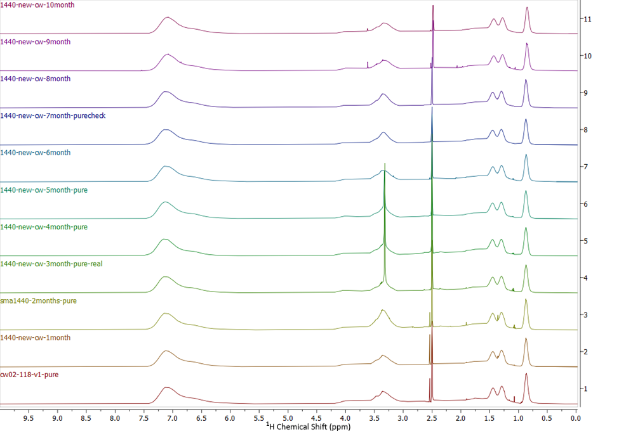
Figure 3.8. ¹H NMR spectra for solubilized SMA 1440 samples stored at room temperature, while covered, for increasing amounts of time. The peaks at 2.5 and 2.54 are residual DMSO solvent peaks and the peak at 3.3 is the residual H₂O peak. The peak at 0.85 was used to determine extent of esterification of the samples.

varying amounts of 2-butoxyethanol prior to protein extraction. Each of the samples in this experiment were solubilized at room temperature to prevent any unwanted saponification side reactions that might occur at elevated temperatures. Each SMA 1440 solution (15 wt%) was prepared using an aqueous 30% NH₄OH solution (5 wt%), 2-butoxyethanol (x wt%) and H₂O ((80 – x) wt%). These polymer solutions were then diluted tenfold using a standard Tris-Cl (pH = 9.5, at room temperature) buffer to a final concentration of 1.5 wt% SMA and used to extract PSI from Te thylakoids. As a note, these extractions were performed using a separate batch of Te membranes than were used for the study outlined in Figure 3.4, which accounts for the slight SE discrepancy observed between these two experimental data sets.
The impact of added 2-butoxyethanol, which mimics free small molecule alcohols released into the polymer solution during solubilization at elevated temperatures, is shown in Figure 3.9. These results suggest that while SE percentages are relatively consistent (50-60% SE) for samples spiked with ≤4 wt% 2-butoxyethanol, large amounts of free 2-butoxyethanol in solution (≥5 wt%) significantly impacts SE. For example, only ~10% SE was observed for extractions containing 6 wt% 2-butoxyethanol, becoming largely ineffective at isolating PSI from Te (Figure 3.9).
Previous literature has suggested that the first step of SMA-based protein solubilization is that the SMA copolymer chains shift from a globular, random-coil structure to an extended chain conformation.¹⁵ We hypothesized that small molecules, such as 2-butoxyethanol, may interact with SMA 1440 molecules or aggregates thereof in solution, potentially disrupting this conformational change and resulting in a lower SE, as we observed at higher 2-butoxyethanol concentrations. While previous studies suggest that the critical aggregation concentration (CAC) of SMA 1440 should be orders of magnitude lower than the concentrations used during the protein extraction

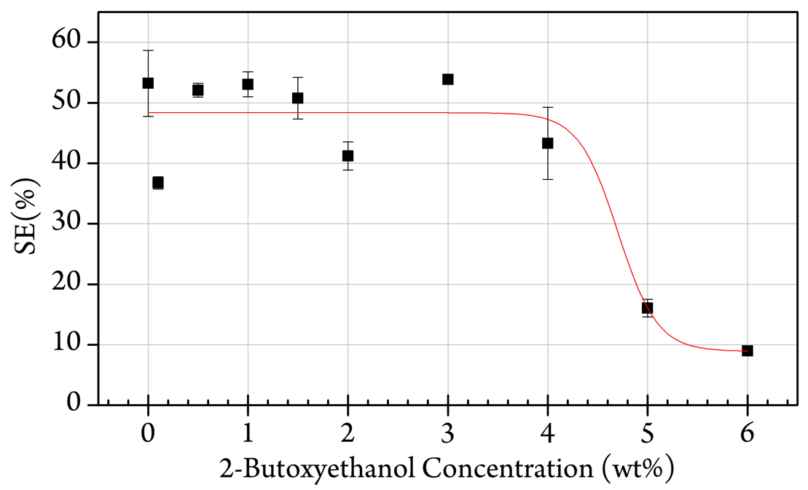
Figure 3.9. Effect of free 2-butoxyethanol on the SE of chlorophyll-containing proteins from thylakoids. Polymer solutions prepared in the following ratios (in wt%): 15% SMA 1440, 5% NH₄OH solution (30% in H₂O), x% 2-butoxyethanol, and (80-x)% H₂O. After preparation, each solution was diluted tenfold to arrive at the final 2-butoxyethanol concentrations plotted on the x-axis.

studies described herein,¹¹ any observed changes in SMA 1440 CAC may provide some indication of interaction(s) between free 2-butoxyethanol and the polymer.
Indeed, our studies revealed that the addition of free 2-butoxyethanol to a solution of SMA 1440 generally increases the CAC of this polymer. Therein, we found that in all SMA 1440 solutions with any amount of free 2-butoxyethanol present, Nile Red doesn’t fully blue shift until a polymer concentration of 0.06 wt% (Figure 3.10). For comparison, Nile Red exhibits a full blueshift in pure SMA 1440 solution at a concentration of 0.012 wt%. While the protein extraction studies are performed at polymer concentrations (1.5 wt%) well above the increased CAC, these findings suggest that free 2-butoxyethanol may interact with SMA 1440 in aqueous solution. Additionally, control experiments showed that 2-butoxyethanol alone did not provide a sufficiently hydrophobic environment for the blue shift of Nile Red’s fluorescence (Figure B4). Based on these experimental results, we hypothesize that interactions between free 2-butoxyethanol and SMA 1440 may potentially be linked to the reduction in SE observed in Figure 3.9.
To further investigate the effects that undesired saponification has on the CAC, all SMA 1440 polymer samples that were solubilized at 80 °C, which underwent varying degrees of saponification, were purified to remove small molecule byproducts. These purified polymers were then subjected to similar CAC studies, but with no free small molecule 2-butoxyethanol added (Figure 3.11). The resulting data shows that in the absence of 2-butoxyethanol, sidechain density has a minimal impact on the CAC of this polymer. This observation further supports the potential that free 2-butoxyethanol may interact with solubilized SMA 1440.

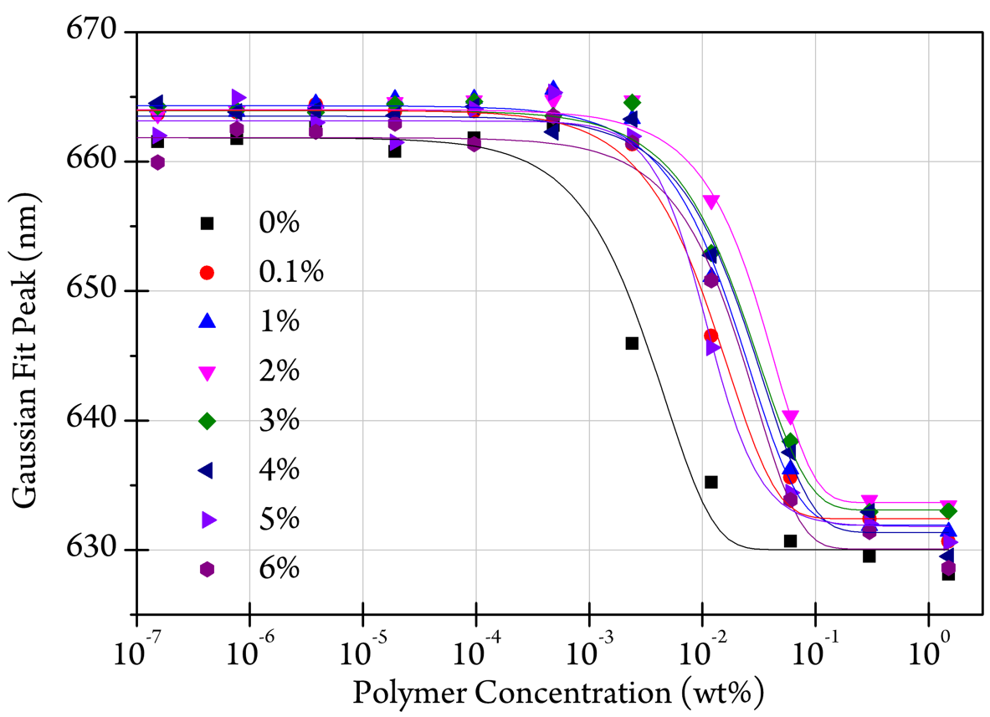
Figure 3.10. Monitoring the blueshift of Nile Red emission as a function of increasing polymer concentration as an indicator of each sample’s CAC. Plot of the peaks of Gaussian curves fit to the fluorescence emission maxima of Nile Red in solutions of SMA 1440 and 2-butoxyethanol. Data labels in the legend refer to concentration of 2-butoxyethanol (wt%) in the original polymer solution.

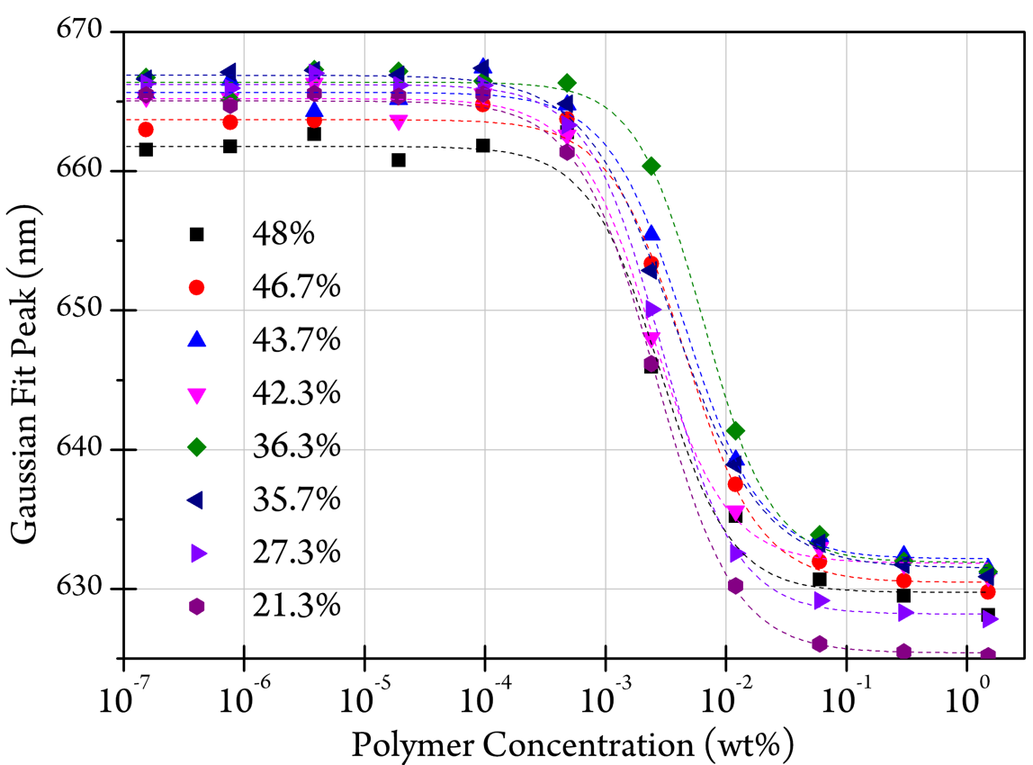
Figure 3.11. Plot of the peaks of Gaussian curves fit to the emission spectra of Nile Red in solutions of degraded SMA 1440 samples and 2-butoxyethanol.

3.3.5 Effect of Free Alcohols on Protein-Chlorophyll Content.
Finally, we also hypothesized that free 2-butoxyethanol may interact with proteins within the Te membrane, potentially releasing free chlorophyll into solution, rather than remaining coordinated within PSI. To investigate this relationship, previously isolated PSI-DDM (Figure 3.12) and PSI-SMA (Figure 3.13) samples were added to buffer solutions and spiked with varying amounts of 2-butoxyethanol. These solutions were then incubated for 3 h at 40 °C and subjected to centrifugation (190,000 × g). At this point some material had formed a green pellet, resulting in an overall loss of chlorophyll as seen for some samples in Figure 3.12b and Figure 3.13b. This effect is especially pronounced in PSI-DDM solutions exceeding 6 wt% added 2-butoxyethanol. We hypothesize that the addition of 2-butoxyethanol could be disrupting the DDM micelle, causing the trimeric PSI complexes to aggregate and crash out of solution. Further, the pre-existing SMA polymer belt surrounding PSI² may protect the complex by either preserving the protein complexes in the more native environment or preventing self-association due to the charged maleate groups on the polymer chain.
The resulting mixture was separated via sucrose density gradient to qualitatively investigate how trimeric PSI and free-chlorophyll concentrations change when free 2-butoxyethanol is present in solution. Both Figures 3.12a and 3.13a show a qualitative decrease in PSI trimer concentration and an increase in free chlorophyll. This observation suggests that high 2-butoxyethanol concentrations may cause the non-covalently bound chlorophyll to be released from isolated PSI trimeric complexes.
b)
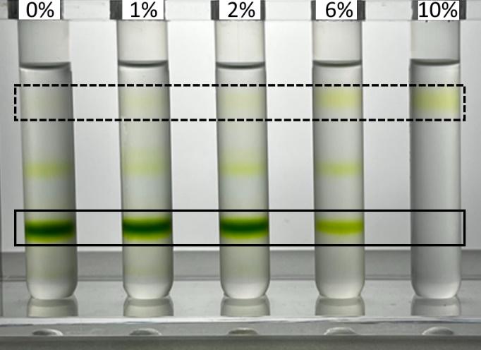
Figure 3.12. (a) The amount of chlorophyll remaining after incubation with 2-butoxyethanol, as compared to previously isolated PSI-DDM. (b) Sucrose density gradients of PSI-DDM, that had been previously isolated using DDM-facilitated protein extraction and purification via sucrose destiny gradient, followed by incubation with 2-butoxyethanol. The labels at the top of the gradients refer to the total percent of the final solution that was 2-butoxyethanol. The bands marks with the dashed box are free-chlorophyll and the bands marked with the solid box are trimeric PSI-DDM.
b)
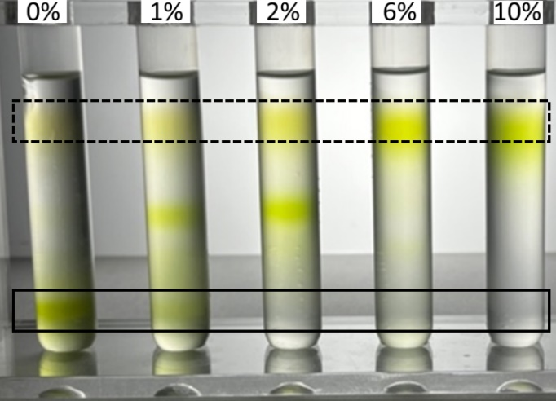
Figure 3.13. (a) The amount of chlorophyll remaining after incubation with 2-butoxyethanol, as compared to previously isolated PSI-SMA. (b) Sucrose density gradients of PSI-SMA, that had been previously isolated using SMA-facilitated protein extraction and purification via sucrose destiny gradient, followed by incubation with 2-butoxyethanol. The labels at the top of the gradients refer to the total percent of the final solution that was 2-butoxyethanol. The bands marks with the dashed box are free-chlorophyll and the bands marked with the solid box are trimeric PSI-SMA.

3.4 Conclusions
As functionalized SMA analogs gain popularity as materials for protein extraction,³ it is increasingly important to establish and understand proper protocols to prepare and store these materials. Improper handling procedures may lead to deleterious polymer degradation, potentially affecting the protein extraction process. In this paper we showed how two common environmental conditions, temperature and light, could each lead to the deleterious degradation of an ester functionalized SMA derivative.
First, we observed that esterified SMA analogs are susceptible to base-catalyzed saponification side reactions at high temperatures, with a sample of SMA 1440f losing nearly 60% of its overall sidechains when solubilized at 80 °C for 168 h. In contrast, we found that solubilizing the same esterified polymer at lower temperature (40 °C, also for 168 h) decreases the number of sidechains lost (only ~5%). While SMA 1440 is only one example of a functionalized SMA that is commercially available, a growing number of manuscripts have appeared in the recent literature in which additional functionalized SMA copolymers, and analogues thereof, are used for protein extraction. We anticipate that this study will highlight the need for precise protocols for the preparation, solubilization, and storage of similar polymers containing other hydrolysis-susceptible moieties so as to more accurately measure each polymer’s protein extraction efficacy.
Next, we discovered that exposure of SMA polymer solutions to light can also result in the degradation of SMA copolymers, an effect that is amplified at higher temperatures. For example, SMA 1440f samples that were heated at elevated temperatures turned yellow and began to gel due to the formation of strongly absorbing side products (in the visible spectrum) and potential crosslinking, respectively, each of which are suggestive of SMA oxidation.¹³ We found that the formation of discolored and crosslinked polymer solutions can be reduced by shielding the samples from light and solubilizing at lower temperatures (i.e. 40 °C). These findings further support that all SMA samples, regardless of identity, should be solubilized into aqueous solution while protected from light.
Finally, because saponification of esterified SMA 1440 units results in the release of free 2-butoxyethanol molecules into solution, we investigated the effect that added 2-butoxyethanol has on the protein extraction process. Our data indicate that free 2-butoxyethanol in solution decreases the protein solubilization efficiency of SMA 1440, especially in solutions containing > 4 wt% 2-butoxyethanol. Investigations of SMA 1440 CAC suggest that the decreased solubilization efficiency of partially saponified polymer samples may potentially be linked to interactions between free 2-butoxyethanol and the polymer chains, though further studies will be required to fully elucidate the mechanistic rationale for this behavior. Lastly, we showed that increasing concentrations of free 2-butoxyethanol lead to the release of non-covalently bound chlorophyll from PSI-SMALPS, further convoluting the quantification of protein extraction process. While it is currently unknown how specific this process may be to specific small molecule present in solution (e.g. 2-butoxyethanol), these findings highlight the importance of using high-purity, functionalized SMA materials to ensure consistent, reliable, and broadly comparable protein extraction data.

3.5 Acknowledgements
Partial support of this research was provided by the University of Tennessee Research Foundation’s Maturation Grant Program. CEW acknowledges partial support from the University of Tennessee Office of Research, Innovation, & Economic Development’s Summer Graduate Research Assistantship Fund. We also acknowledge Mr. Joytirmoy Mondal and Ms. Katrina Micin for maintaining and growing the cyanobacterial cultures of T. elongatus used in this study. The SMA 1440 flake used in this study was provided as a generous gift from Mr. Ryan Beer of TOTAL Petrochemicals USA.

3.6 Experimentals
3.6.1 General Materials and Methods
SMA 1440 flake (SMA 1440f) was obtained as a gift from Total Cray Valley (Exton, PA) and was purified via precipitation into MeOH (×3). NH₄OH was obtained from Fisher Scientific and used as received. Water was purified using a MilliQ Biocel reverse osmosis system with a resistance of >18 MΩ to mitigate the impact of trace ions. ¹H NMR spectroscopy was performed using a Varian 500 MHz NMR spectrometer, with 10 seconds between scans. Chemical shifts are reported with respect to residual solvent peaks.

3.6.2 SMA Solubilization and Quantification of Esterification
The solubilization of SMA 1440f was performed by combining the polymer sample (15 wt%), water (80 wt%), and a solution of 30% NH₄OH in water (5 wt%). This solution was then stirred at temperatures ranging from 40 °C to 80 °C for reaction times between 1 h and 168 h while sealed in vials. The samples were then lyophilized to remove water, redissolved in THF, and purified via precipitation into hexanes. This precipitation process removes any cleaved alcohol sidechains from the polymer sample. The degree of esterification for each sample was quantified using ¹H NMR, as described in a previous report.¹¹

3.6.3 Determination of Critical Aggregation Concentration
The critical aggregation concentration for different polymers samples were measured by adapting a previously reported procedure.¹⁶ Briefly, each polymer sample was diluted to 1.5 wt% using a standard Tris-Cl (pH = 9.5, at room temperature) buffer. These solutions were placed into a 96-well plate and diluted fivefold across each column of the plate (×12). Nile Red solution was added to each well at a final concentration of 1 µM. Then, each plate was excited at 550 nm, and the fluorescence emission was measured between 580-700 nm in 1 nm increments. The resultant emission spectra were fit to a Gaussian function using OriginPro 8.1, and the peak emission value from the Gaussian fit was plotted against polymer concentration for each specific sample. Each resulting data series was then fit using a standard sigmoidal line of best fit without locking any variables, also using OriginPro 8.1.

3.6.4 Solubilization and Isolation of Photosystem I From Thylakoid Membranes
Te membranes were prepared as 1 mg/mL chlorophyll solutions using established protocols.¹⁷ The prepared membrane suspension was separated into aliquots (500 µL) and incubated with a solubilized SMA 1440 sample (1.5 wt%) for 3 h at 40 °C, while shaking (250 rpm, orbital shaker) in the dark. The resulting samples were centrifuged (190,000 × g) to pellet the remaining insoluble thylakoid membrane fragments. After 15 min, the supernatant was carefully removed with a flame drawn Pasteur pipette for analysis.
The solubilization efficiency (SE) of this protein extraction was determined as previously reported.¹¹ Isolated supernatants were diluted (×100) and chlorophyll was extracted with 90% methanol at 65 °C for 2 minutes. The absorbance of the extracted chlorophyll was measured at 665 nm, using a dual-beam benchtop spectrophotometer (Evolution 300, Thermo Scientific) to determine the chlorophyll concentration. SE was calculated based on the recovered chlorophyll concentration as compared to the starting thylakoid chlorophyll concentration (1 mg/mL).

References
1. Simon, K. S.; Pollock, N. L.; Lee, S. C., Membrane protein nanoparticles: the shape of things to come. Biochem. Soc. Trans. 2018, 46, 1495-1504.
2. Brady, N. G.; Qian, S.; Nguyen, J.; O'Neill, H. M.; Bruce, B. D., Small angle neutron scattering and lipidomic analysis of a native, trimeric PSI-SMALP from a thermophilic cyanobacteria. Biochim. Biophys. Acta, Bioenerg. 2022, 1863, 148596.
3. Dörr, J. M.; Scheidelaar, S.; Koorengevel, M. C.; Dominguez, J. J.; Schäfer, M.; van Walree, C. A.; Killian, J. A., The styrene-maleic acid copolymer: a versatile tool in membrane research. Eur Biophys J 2016, 45, 3-21.
4. Domínguez Pardo, J. J.; Koorengevel, M. C.; Uwugiaren, N.; Weijers, J.; Kopf, A. H.; Jahn, H.; van Walree, C. A.; van Steenbergen, M. J.; Killian, J. A., Membrane Solubilization by Styrene-Maleic Acid Copolymers: Delineating the Role of Polymer Length. Biophys. J. 2018, 115, 129-138.
5. Morrison, K. A.; Akram, A.; Mathews, A.; Khan, Z. A.; Patel, J. H.; Zhou, C.; Hardy, D. J.; Moore-Kelly, C.; Patel, R.; Odiba, V.; Knowles, T. J.; Javed, M.-u.-H.; Chmel, N. P.; Dafforn, T. R.; Rothnie, A. J., Membrane protein extraction and purification using styrene–maleic acid (SMA) copolymer: effect of variations in polymer structure. Biochem. J. 2016, 473, 4349.
6. Oluwole, A. O.; Danielczak, B.; Meister, A.; Babalola, J. O.; Vargas, C.; Keller, S., Solubilization of Membrane Proteins into Functional Lipid-Bilayer Nanodiscs Using a Diisobutylene/Maleic Acid Copolymer. Angew Chem Int Edit 2017, 56, 1919-1924.
7. Kopf, A. H.; Lijding, O.; Elenbaas, B. O. W.; Koorengevel, M. C.; Dobruchowska, J. M.; van Walree, C. A.; Killian, J. A., Synthesis and Evaluation of a Library of Alternating Amphipathic Copolymers to Solubilize and Study Membrane Proteins. Biomacromolecules 2022, 23, 743-759.
8. Esmaili, M.; Brown, C. J.; Shaykhutdinov, R.; Acevedo-Morantes, C.; Wang, Y. L.; Wille, H.; Gandour, R. D.; Turner, S. R.; Overduin, M., Homogeneous nanodiscs of native membranes formed by stilbene–maleic-acid copolymers. Nanoscale 2020, 12, 16705-16709.
9. Burridge, K. M.; Harding, B. D.; Sahu, I. D.; Kearns, M. M.; Stowe, R. B.; Dolan, M. T.; Edelmann, R. E.; Dabney-Smith, C.; Page, R. C.; Konkolewicz, D.; Lorigan, G. A., Simple Derivatization of RAFT-Synthesized Styrene–Maleic Anhydride Copolymers for Lipid Disk Formulations. Biomacromolecules 2020, 21, 1274-1284.
10. Hawkins, O. P.; Jahromi, C. P. T.; Gulamhussein, A. A.; Nestorow, S.; Bahra, T.; Shelton, C.; Owusu-Mensah, Q. K.; Mohiddin, N.; O'Rourke, H.; Ajmal, M.; Byrnes, K.; Khan, M.; Nahar, N. N.; Lim, A.; Harris, C.; Healy, H.; Hasan, S. W.; Ahmed, A.; Evans, L.; Vaitsopoulou, A.; Akram, A.; Williams, C.; Binding, J.; Thandi, R. K.; Joby, A.; Guest, A.; Tariq, M. Z.; Rasool, F.; Cavanagh, L.; Kang, S.; Asparuhov, B.; Jestin, A.; Dafforn, T. R.; Simms, J.; Bill, R. M.; Goddard, A. D.; Rothnie, A. J., Membrane protein extraction and purification using partially-esterified SMA polymers. Biochim. Biophys. Acta, Biomembr. 2021, 1863, 183758.
11. Brady, N. G.; Workman, C. E.; Cawthon, B.; Bruce, B. D.; Long, B. K., Protein Extraction Efficiency and Selectivity of Esterified Styrene–Maleic Acid Copolymers in Thylakoid Membranes. Biomacromolecules 2021, 22, 2544-2553.
12. Kopf, A. H.; Koorengevel, M. C.; van Walree, C. A.; Dafforn, T. R.; Killian, J. A., A simple and convenient method for the hydrolysis of styrene-maleic anhydride copolymers to styrene-maleic acid copolymers. Chem. Phys. Lipids 2019, 218, 85-90.
13. Kaczmarek, H.; Felczak, A.; Szalla, A., Studies of photochemical transformations in polystyrene and styrene–maleic anhydride copolymer. Polym. Degrad. Stab. 2008, 93, 1259-1266.
14. Dinoop lal, S.; Sunil Jose, T.; Rajesh, C.; Anju Rose Puthukkara, P.; Savitha Unnikrishnan, K.; Arun, K. J., Accelerated photodegradation of polystyrene by TiO2-polyaniline photocatalyst under UV radiation. Eur. Polym. J. 2021, 153, 110493.
15. Bjørnestad, V. A.; Orwick-Rydmark, M.; Lund, R., Understanding the Structural Pathways for Lipid Nanodisc Formation: How Styrene Maleic Acid Copolymers Induce Membrane Fracture and Disc Formation. Langmuir 2021, 37, 6178-6188.
16. Scheidelaar, S.; Koorengevel, M. C.; van Walree, C. A.; Dominguez, J. J.; Dörr, J. M.; Killian, J. A., Effect of Polymer Composition and pH on Membrane Solubilization by Styrene-Maleic Acid Copolymers. Biophys. J. 2016, 111, 1974-1986.
17. Brady, N. G.; Li, M.; Ma, Y.; Gumbart, J. C.; Bruce, B. D., Non-detergent isolation of a cyanobacterial photosystem I using styrene maleic acid alternating copolymers. RSC Adv. 2019, 9, 31781-31796.

CHAPTER IV: SOLUBILIZING MEMBRANE PROTEINS INTO NANODISCS USING COPOLYMERS OF MALEIC ACID AND LINEAR α-OLEFINS

In this chapter, I was responsible for designing and synthesizing all polymers studied. I also performed all polymer characterization, reactivity ratio studies, pH/divalent cation tolerance studies, transmission electron microscopy, dynamic light scattering, UV absorbance studies, and critical aggragation studies. Pushan Bag, Nathan Brady, and Bridgie Cawthon performed all of the protein extraction and characterization studies together on the Te samples, while Fidda Ali performed all of studies on TS-821.

4.1 Abstract
While styrene-maleic acid copolymers (SMAs) are effective tools for isolating and studying membrane native-like proteins, they do not exhibit this ability universally. Numerous reports have found SMAs and related amphiphilic copolymers show little to no efficiency when extracting specific membrane proteins. Recently, we have discovered that the functionalization of commercial SMAs can increase the ability of these materials to selectively extract trimeric Photosystem I (PSI) from the thylakoid membranes of a thermophilic cyanobacterium, Thermosynechococcus elongatus (Te). However, these new polymers are susceptible to saponification, leading to concerns about preparation, storage, and consistent usage. Herein, we explore the synthesis of more stable α-olefin-maleic acid copolymers (αMAs) to extract trimeric PSI from the membranes of Te with the highest extraction efficiencies seen in this membrane protein system to date, including those seen when using diisobutylene-co-maleic acid or functionalized SMA samples. In addition, we provide evidence that αMAs facilitate the formation of nanodiscs containing an annulus of native lipids that retain a native-like conformation of the solubilized photosystem I. We also highlight how these materials allow for the creation of highly tailorable series of samples with controllable polymer molecular weight and monomer incorporation while addressing several shortcomings in previously reported SMAs and other amphiphilic copolymers.

4.2 Introduction
Most integral membrane proteins (IMPs) are composed of one or more helices that traverse the membrane lipid bilayer. It is estimated that 20-30% of proteins in all known genomes share this common transmembrane architecture.¹ IMPs control and regulate innumerable cellular processes, including mediating metabolism, molecular transport, signal transduction, lipid and membrane biogenesis, and many other functions required for cellular life. Both the number and diversity of IMPs have led them to be the target of a diverse range of biotechnological applications over the last few decades. This includes applications in pharmacology where nearly 60% of all available drugs target membrane proteins,² in the development of semi-biohybrid electronics (e.g. biological photovoltaic cells),³ and in food science.⁴
The local environment of IMPs is fundamentally different from that of water-soluble proteins, with an IMP’s structure being directly influenced by lateral exposure to a chemically and physically complex lipid environment and by surface exposure to an aqueous environment.⁵ Despite this heterogeneous native state, most successful biotechnological applications strive to isolate IMPs in native or near-native conditions to preserve their functional activity. However, historically most protein isolation approaches, such as detergent-facilitated extraction, often result in the loss of a protein’s native conformation and its subunits.⁶ Alternative solubilization methods, such as the use of amphipols and membrane scaffold proteins (MSPs), can retain a more native-like IMP structure, but often still require an IMP to be exposed to a detergent for some period of time.⁷⁻¹⁰
More recently, some amphiphilic copolymers (Figure 4.1) were discovered to have the unique ability to solubilize membrane protein complexes and native lipids into a nanodisc.¹¹ Unlike MSPs and amphipols, these polymers extract proteins directly from cellular membranes, eliminating the need for initial detergent-facilitated isolation.^{10, 12} This new technology has led to dozens of solved protein structures, in conjunction with techniques like CryoEM.^{13, 14}
Styrene-maleic acid copolymers (SMAs) are the most commonly used materials for amphiphilic copolymer-facilitated protein extraction. Previous studies have determined that a variety of polymer characteristics, such as monomer incorporation ratio,¹⁵ molecular weight,¹⁶ and alterations to the styryl unit^{17, 18} all play an important role in the protein extraction process, though the impact seems to change based on the target membrane system. Traditional SMAs contain aromatic groups which can interfere with protein characterization studies due to their ability to absorb UV light.⁶ One solution proposed by Keller and coworkers is a diisobutylene-co-maleic acid copolymer (DIBMA, Figure 4.1) that can also extract and solubilize IMP-containing nanodiscs directly from cellular membranes, while absorbing much less UV light than traditional SMA copolymers.¹⁹ Other studies have used DIBMA to extract proteins from different systems, but have highlighted its limited extraction yield when compared to traditional SMAs.²⁰
Other studies have focused on the alteration of the hydrophilic maleic acid unit, demonstrating how functionalizing commercially available SMA copolymers with various amine species can lead to increased tolerance of divalent cation and/or lower pH environments.^{21, 22} Similarly, our previous reports have shown how esterifying SMA copolymers with various alkoxy
Figure 4.1. A comparison of the materials used in this manuscript and previously reported amphiphilic copolymers capable of detergent-free protein extraction.

ethoxylate sidechains can alter both the efficiency and selectivity of the extraction of Photosystem I (PSI) from the cyanobacteria Thermosynechococcus elongatus (Te).²³ However, further studies indicated that while these esterified SMA analogs can extract many times more trimeric PSI from Te, they are also susceptible to degradation via saponification.²⁴ We also observed a large loss of some peripheral PSI subunits during protein extraction with these materials.
The next generation of amphiphilic materials would ideally be able to extract proteins directly from cellular membranes in high yields, form nanodiscs that promote more native-like protein conformations, have little UV absorption, have limited susceptibility to degradation, and could be easily synthesized with known monomer incorporation ratios and tailorable molecular weights. We hypothesized that copolymers of linear α-olefins and maleic anhydride (αMAs) may meet many of these constraints. The hydrophobic units (i.e. 1-octene, 1-decene, etc.) of αMAs have a similar structure to the terminal linear alkyl moieties present in the alkoxy ethoxylate sidechains utilized in our previous studies.²³ This functionality could allow for efficient insertion into the lipid membrane while being attached to the polymeric backbone via carbon-carbon bonds, which are much more stable than the ester linkages utilized previously. Finally, since αMAs don’t feature styrene units they should have little impact on any spectroscopic measurements in the UV region.²⁵ To probe this hypothesis, we herein present a series of αMA copolymers to test their protein extraction efficiency and selectivity on the membranes of Te.

4.3 Results and Discussion
4.3.1 Synthesis and Characterization of αMA Copolymers
Taking inspiration from our previous study where longer alkyl sidechains led to higher solubilization efficiencies and selectivity towards trimeric PSI,²³ 1-octene, 1-decene, 1-dodecene, and 1-tetradecene were all copolymerized with maleic anhydride to synthesize various copolymers (αMAhs) via conventional free-radical polymerization. After synthesis, purification, and characterization, the prepared αMAh copolymers were then subjected to base-catalyzed hydrolysis to convert them to the respective αMA copolymers (Scheme 4.1).
It is well known that the incorporation ratio of styrene and maleic anhydride can widely vary in SMA copolymers depending on the conditions under which the polymerization occurs, where polymerizations that occur in a maleic anhydride-rich environment form heavily alternating copolymers.^{26, 27} However, as the feed ratio of styrene increases, higher ratios of styrene are incorporated into the polymer chain. The incorporation ratios of the two monomers has been shown to alter how well these polymers facilitate the extraction of membrane proteins.¹⁵ As such, we decided that our own reactivity ratio studies should be performed to accurately inform not only the overall ratios of monomer incorporation in our polymers, but also an understanding of how alternating the resulting polymer samples are.
Reactivity ratios are descriptors of how alternating a polymerization is likely to be.²⁸ This concept is visualized using 1-octene and maleic anhydride in Figure 4.2 below. As the chain propagates, a radical is formed on the last monomeric unit on the growing chain. Based on the identity of this unit, it may be more or less likely to homopropogate with another monomer of the same identity, rather than cross-propagate with the other monomer. For example, if the chain end
Scheme 4.1. Synthesis of αMA Copolymers

Figure 4.2. The terminal model of polymer propagation used to define reactivity ratios. (r₁ = maleic anhydride, r₂ = 1-octene)

is a maleic anhydride with a radical, its reactivity ratio will be an indicator if it’s more likely to attack another maleic anhydride or a 1-octene monomer.
A number of different experiments can be used to determine a set of reactivity ratios under certain polymerization conditions. Similar studies have used the Fineman-Ross method,²⁹⁻³¹ so we determined that this method should allow us to accurately investigate the reactivity ratios of our monomers. The Fineman-Ross method requires a series of polymerizations comparing different feed ratios of each monomer and, subsequently, the incorporation ratio of each monomer into the resultant polymer. We chose the polymerization of maleic anhydride and 1-octene to serve as a representative polymerization for all the αMA polymers in this study. Results of the feed ratios vs. incorporation ratios are summarized in Table 4.1.
If the polymerization of 1-octene and maleic anhydride was perfectly alternating the incorporation ratio of each monomer in the polymer would be 50%, independent of the monomer feed. However, as seen in Table 4.1 and Figure 4.3, even at high loadings of 1-octene, the copolymer is comprised predominantly of maleic anhydride. This data was then used to calculate the reactivity ratios of both monomers (r₁ = maleic anhydride, r₂ = 1-octene) using the Fineman-Ross method (Figure 4.4 and Table 4.2). Using this method, it was found that r₁ = 0.38 and r₂ = 0.012.
The Fineman-Ross method is often used in conjunction with the Kelen-Tüdős method. The Kelen-Tüdős uses the same set of data but introduces a constant which works to account for inherent biases of low and high monomer concentrations in the Fineman-Ross method.³² Using the Kelen-Tüdős method (Figure 4.5 and Table 4.3), it was calculated that r₁ = 0.42 and r₂ = 0.04, in close agreement with the values calculated using the Fineman-Ross method. These values reveal
Table 4.1. Polymerization data for C₈MA polymers synthesized at various monomer feed ratios.
sample | feed ratio  (MAh:Oct) | incorporation ratio (MAh:Oct) | M_{n} (kg/mol) | Đ
C₈MAh^{1.8} | 70:30 | 65:35 | 1.8 | 1.3
C₈MAh^{2.4} | 60:40 | 63:37 | 2.4 | 1.3
C₈MAh^{3.0} | 50:50 | 59:41 | 3.0 | 1.3
C₈MAh^{4.8} | 40:60 | 54:46 | 4.8 | 1.2
C₈MAh^{5.0} | 30:70 | 52:48 | 5.0 | 1.2

Figure 4.3. Graphical depiction of monomer feed ratio versus monomer incorporation ratio in the resulting C₈MAh copolymers. Dashed line represents the χMAh for a perfectly alternating copolymerization system.

Table 4.2. The raw data used in calculating the reactivity ratios of 1-octene and maleic anhydride (MAh) via the Fineman-Ross determination method.
Fineman-Ross Method Raw Data
Vial | 1 | 2 | 3 | 4 | 5
Molar Ratio (mix) (MAh) (x) | 2.33 | 1.50 | 1.00 | 0.67 | 0.43
Molar Ratio (Poly) (MAh) (y) | 1.86 | 1.64 | 1.42 | 1.16 | 1.07
x(1-y)/y (G) | 1.08 | 0.59 | 0.29 | 0.09 | 0.03
x²/y (F) | 2.93 | 1.37 | 0.71 | 0.38 | 0.17

Figure 4.4. A graph of the Fineman-Ross variables G vs. F, as used to determine reactivity ratios (r₁ = slope, r₂ = -intercept).

Table 4.3. The raw data used in calculating the reactivity ratios of 1-octene and maleic anhydride (MAh) via the Kelen-Tüdös determination method.
Kelen-Tüdös Method Raw Data
Vial | 1 | 2 | 3 | 4 | 5
sqrt(F_{min} * F_{max)} α | 0.71
G/(α+F) η | 0.30 | 0.28 | 0.21 | 0.08 | 0.03
F/(α+F) ξ | 0.80 | 0.66 | 0.50 | 0.35 | 0.20

Figure 4.5. A graph of the Kelen-Tüdös variables η vs. ξ, as used to determine reactivity ratios. The equation of this function is used to find r₁ and r₂. When x=1, r₁ = y. When x=0, -r₂/α = y.

that the resulting polymers are highly alternating since both r₁ and r₂ are much less than 1. However, since r₁ is much larger than r₂, maleic anhydride is more likely to homopropogate than 1-octene, leading to the larger maleic anhydride content described in Figure 4.3.
Now that the microstructure of these polymers is better understood, C₈MA, C₁₀MA, C₁₂MA, and C₁₄MA samples of similar molecular weights were synthesized, as seen in Table 4.4. It has also been well documented that the molecular weight of SMA samples can drastically affect the protein extraction process.¹⁶ To investigate if this applies to αMAs a series of C₁₄MA copolymers of varying molecular weights were synthesized (Table 4.4). Henceforth, any polymer identifiers with superscripts refer to the number-average molecular weight (kg/mol) of that particular sample. All polymers in Table 4.4 were found to have incorporation ratios of 1-1.2:1 maleic anhydride:1-octene (Figures D1-D9).

4.3.2 Determination of Polymer pH and Divalent Cation Sensitivity
Because of the various conditions protein extractions and protein characterization assays require, it is important to understand the conditions under which a polymer sample will remain soluble in aqueous solution. As a solution becomes more acidic, the maleate groups on each αMA begin to be protonated into carboxylate acids, decreasing the polymer’s solubility in water. To investigate how pH affects each αMA samples’ solubility, each polymer was introduced to a series of BR-buffers with varying pH values (Figure 4.6). As expected, the αMA’s containing longer, more hydrophobic sidechains are less tolerant to lower pHs. This data also shows that as a C₁₄MA sample’s molecular weight increases it is also more susceptible to lower pH environments.

Table 4.4. Characterization data for the polymers synthesized in this study.
sample | M_{n} (kg/mol) | Đ | sample | M_{n} (kg/mol) | Đ
C₈MA | 3.6 | 1.5 | C₁₄MA^{1.8} | 1.8 | 1.6
C₁₀MA | 3.4 | 1.6 | C₁₄MA^{3.9} | 3.9 | 1.3
C₁₂MA | 3.7 | 1.2 | C₁₄MA^{4.8} | 4.8 | 1.4
C₁₄MA | 3.7 | 2.1 | C₁₄MA^{5.6} | 5.6 | 1.5

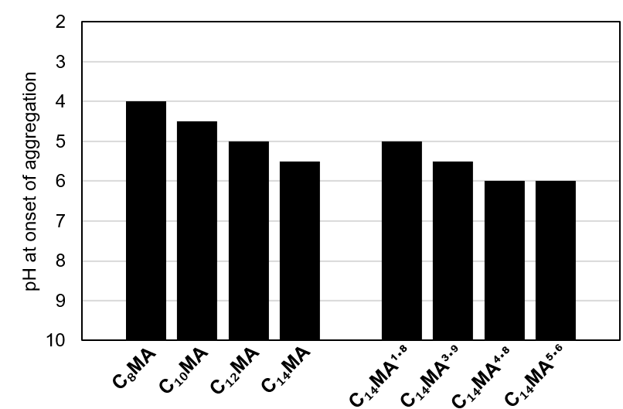
Figure 4.6. Graph showing pH value below which each polymer became insoluble in aqueous solution. Above these pH values, the polymers remained soluble.

In addition to low pH environments, SMAs have been shown to be susceptible to the presence of divalent cations. To investigate how tolerant each of the αMA samples are to divalent cations, each sample was introduced to a series of tris buffers (pH = 9.5) containing increased concentrations of MgCl₂ (Figure 4.7). Once again, the samples with longer sidechains, and thus more hydrophobic character, are more susceptible to precipitating out of solution. In addition, as a sample’s molecular weight increases, they appear to be less tolerant to the presence of the cations.

4.3.3 Determination of Critical Aggregation Concentration and UV Absorbance
The approximate CAC of each αMA was determined by adapting a previously reported method utilizing Nile Red’s characteristic fluorescence.³³ In the presence of a hydrophobic environment, Nile Red’s fluorescence blue shifts. As such, Nile Red’s fluorescent maxima can be plotted against polymer concentration to estimate a sample’s CAC (Figures 4.8 and 4.9). As the αMA samples increase in sidechain length, they provide a more sufficiently hydrophobic environment for Nile Red. Due to a similar increase in hydrophobic character, C₁₄MA samples provide a more hydrophobic environment for Nile Red as their molecular weight increases.
As expected, C₁₄MA absorbs much less light in the UV region than standard SMA samples (Figure 4.10). This will allow these materials to be used in the extraction of additional membrane proteins whose characterization relies on spectroscopic methods in this wavelength range.¹⁹

4.3.4 Solubilization of thylakoid membranes from Te
To compare our αMA copolymers to the established aliphatic copolymer for detergent-free protein extraction, we first investigated how well DIBMA solubilized PSI from Te. Based on
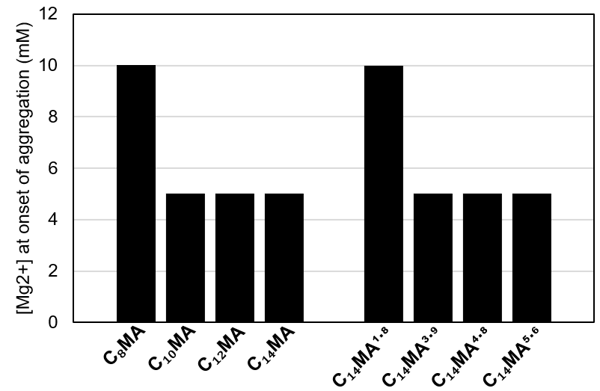
Figure 4.7. Graph showing the minimum concentration of MgCl₂ that caused each polymer to become insoluble in aqueous solution. At lower MgCl₂ concentrations, the polymers remained soluble.

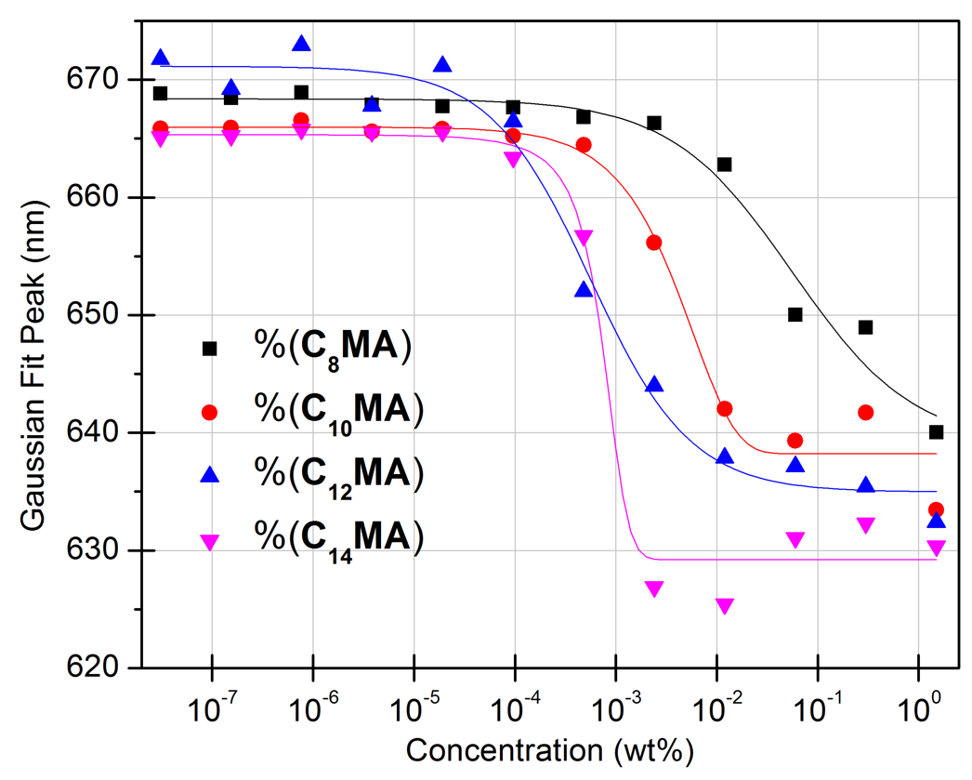
Figure 4.8. Plot of the peaks of Gaussian curves fit to the emission spectra of Nile Red in solutions of αMA polymers with increasing sidechain length.

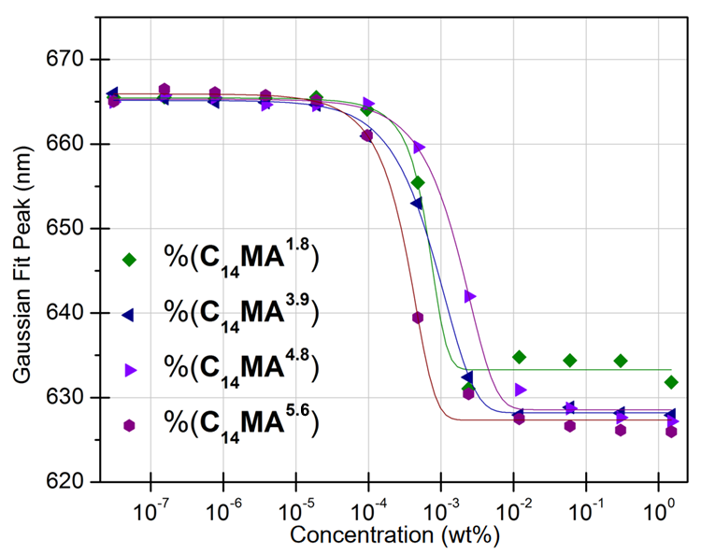
Figure 4.9. Plot of the peaks of Gaussian curves fit to the emission spectra of Nile Red in solutions of C₁₄MA polymers with increasing molecular weight.

Figure 4.10. The UV absorbance of shown as A) intensity at equal sample w%, B) molar absorptivity as a function of polymer concentration, and C) molar absorptivity as a function of total monomer concentration.
previous studies where we found polymers containing long hydrophobic sidechains to be efficient at extracting this membrane protein, we initially hypothesized that DIBMA would also be highly efficient at this process as it had proven to be able to form native lipid-containing protein nanodiscs in previous literature studies. ^{12, 21, 22}
Since the majority of the thylakoid membrane proteins are chlorophyll-containing pigment-protein complexes, we can measure the absorbance of chlorophyll before and after extraction to determine how efficiently each polymer can solubilize these protein complexes from Te. Initial studies quickly showed that DIBMA extracted very little (~20%) chlorophyll-containing protein from Te, almost none of which was the native trimer of PSI (Figure 4.11). Following this study, we hypothesized that replacing the diisobutylene with longer, linear α-olefins might elicit similar bioactivity to our previously esterified SMAs, while maintaining a resistance to degradation.
We have previously found that polymer concentration can have a large effect on the protein extraction process, where protein extraction efficiency generally increases with polymer concentration until an upper concentration limit is hit, where the amount of protein solubilized sharply drops. As such, a series of initial protein solubilizations at various polymer concentration were performed to find the optimal polymer concentration (Figure 4.12). This data shows that the highest solubilization efficiencies (SEs) are obtained when the polymer solutions have a concentration of 2.5 wt%.
In addition to being performed at a polymer concentration of 2.5 wt%, all further SEs reported are normalized with respect to the amount of protein isolated by the control, DDM. This allows for more reliable comparisons between protein extractions performed on different batches of Te membranes. With the exception C₁₀MA, all of the tested αMAs were found to extract
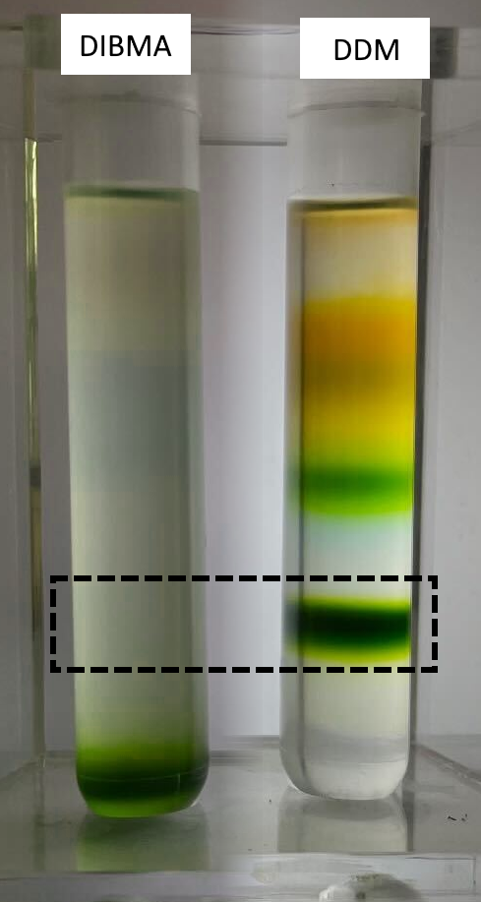
Figure 4.11. Sucrose density gradients of Te membranes solubilized with DIBMA. The black box indicates PSI t.

Figure 4.12. Initial protein extraction efficiency results based on polymer concentration.
chlorophyll-containing pigment-protein complexes more effectively than DIBMA (Figure 4.13). Most importantly, we found C₁₄MA gave a SE of over 80%, by far the highest SE of any polymer tested in this system to date.
With this information, we went on to solubilize the Te membranes with different C₁₄MA samples to investigate if a polymer’s molecular weight had any effect on this result (Figure 4.13). Four C₁₄MA samples were synthesized, with number-average molecular weights ranging from 1.8 kg/mol to 5.6 kg/mol. We determined that among all the different C₁₄MA polymers the low molecular weight polymer, C₁₄MA^{1.8}, resulted in the extraction of the fewest number of pigment-protein complexes, while the other three samples all performed similarly, on average eliciting a SE of over 80%.
After protein solubilization, the extracted membranes were purified on sucrose density gradients (SDGs) to isolate and identify the different protein complex species obtained. It is well established that upon SDG with DDM solubilized Te membranes, two types of PSI particles are released, i.e., PSI-monomer (PSI-m) and PSI-trimer (PSI-t) (Figure 4.14).^{23, 34} In line with the reduced SEs seen in Figure 4.15, SDG with C₈MA, C₁₀MA and C₁₂MA released only negligible amounts of PSI-t, meaning these PSI-t nanodiscs couldn’t be biochemically characterized. Interestingly, however, all C₁₄MA samples did appear to solubilize discrete PSI-t nanodiscs, with C₁₄MA^{3.9} and C₁₄MA^{4.8} showing an especially high level of selectivity towards the formation of these species.

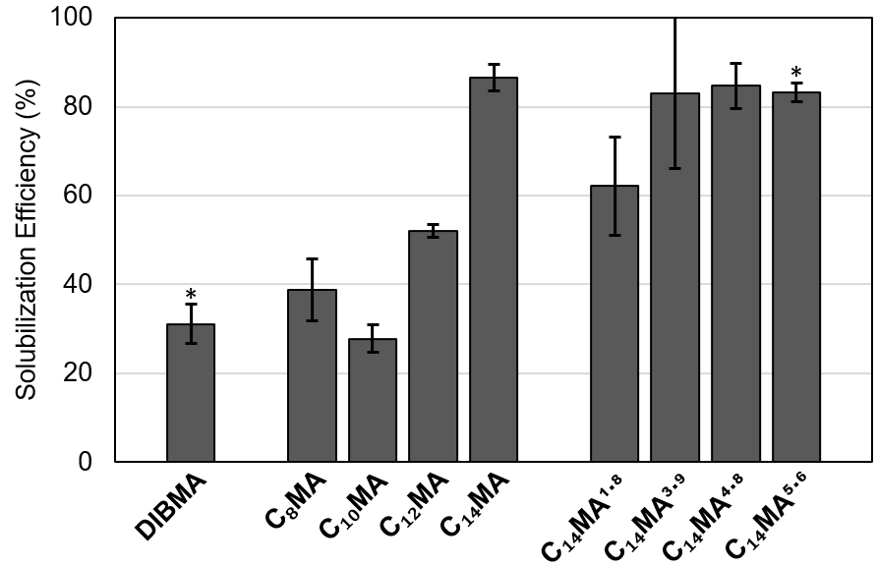
Figure 4.13. The solubilization efficiency of each polymer extracting chlorophyll-containing pigment-protein complexes from Te. *these samples were tested in duplicate. All others were in triplicate.

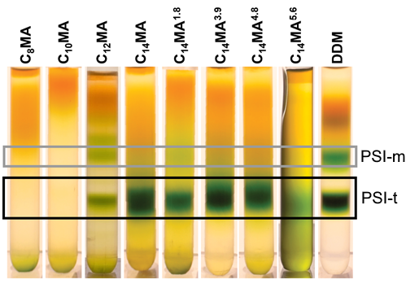
Figure 4.14. Sucrose density gradients of extracted protein complexes, following incubation and protein solubilization with αMA copolymers.

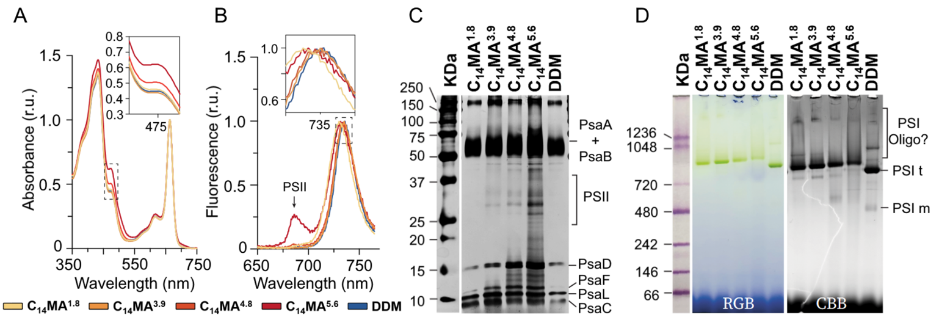
Figure 4.15. Characterization of the trimeric PSI band from the sucrose density gradients using A) UV/Vis Spectroscopy, B) low-temperature fluorescence, C) SDS-PAGE, and D) BN-PAGE.

4.3.5 Pigment composition and the functional property of the PSI-t nano discs
To investigate the pigment composition of the isolated PSI-t, we isolated total pigments in 90% methanol and recorded absorption spectra from 350-750 nm. Compared to samples prepared from DDM, C₁₄MA^{1.8}, and C₁₄MA^{3.9}, PSI-t released from C₁₄MA, C₁₄MA^{4.8}, and C₁₄MA^{5.6} showed a more pronounced absorbance around 475 nm (Figures 4.15A and 4.16A). This 475 nm shoulder could be attributed to any carotenoids present in the total pigment fraction, suggesting some of these samples may retain higher carotenoid content.
The carotenoid to chlorophyll charge transfer upon excitation causes the fluorescence properties of PSI-t to vary significantly.³⁵ Therefore, we performed low temperature fluorescence spectroscopy (LTF) at 77k and recorded the spectra from 650-760 nm. LTF showed that all C₁₄MA PSI-t had similar, albeit slightly blue-shifted, fluorescence patterns around the 735 nm region (Figure 4.15B). Comparing the absorption spectra, one would expect the LTF spectra of PSI-t from C₁₄MA^{5.6} to be more red shifted compared to DDM since more carotenoid retention leads to charge transfer from carotenoid to low energy red chlorophylls within PSI.³⁴ However, this discrepancy was resolved since the C₁₄MA^{5.6} trimers also showed a pronounced peak around 680 nm – a region generally attributed to Photosystem II (PSII).³⁶ The PSII peak maxima in 134 was almost 25% of the PSI maxima, hence contributed significantly to shift the whole spectra towards the blue region.

4.3.6 Protein composition and Structural Properties of PSI-t nanodiscs
After spectroscopy was used to probe the functional properties of the isolated PSI-t nanodiscs, the composition was investigated using SDS-PAGE (Figure 4.15C). These experiments showed that PSI-t extracted with all tested C₁₄MA samples and DDM had similar protein
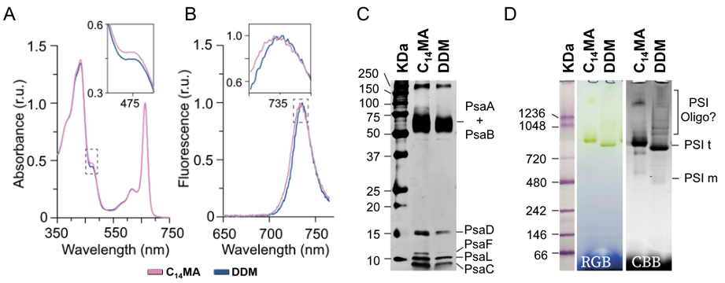
Figure 4.16. Characterization of the trimeric PSI band from the sucrose density gradients using A) UV/Vis Spectroscopy, B) low-temperature fluorescence, C) SDS-PAGE, and D) BN-PAGE.

composition. Interestingly, the nanodiscs made using all C₁₄MA samples appear to retain PSI’s native subunits better than those extracted with DDM. The PSI-t samples made using C₁₄MA and DDM have a visually similar amounts of PsaA and B, whereas the C₁₄MA PSI-t appears to retain much more PsaC, PsaD, and PsaL. The most intriguing feature of C₁₄MA samples was that they retained PsaF far better than DDM, considering our previous studies have shown that many SMA-derivatives result in the loss of this subgroup completely.^{23, 34} In line with LTF, we observed significant presence of PSII bands in C₁₄MA^{5.6} solubilized PSI-t nanodics.
After confirming the physiological and functional properties of PSI-t nanodiscs, we investigated their structural properties. First, we concentrated the samples ×5 and performed BN-PAGE (Figure 4.15D). Both DDM and C₁₄MA PSI-t nanodiscs showed intense green band around 700 KDa region. It is worth noting that during this experiment, all PSI-t nanodiscs formed with the C₁₄MA samples appeared to have slightly hindered mobility, suggesting that the size of the nanodiscs could be different.
Interestingly, the BN-PAGE shows three higher order bands for the DDM PSI-t samples, whereas the C₁₄MA PSI-t samples appear to only form a single higher order band (Figure 4.15D). Since the PSI-t nanodiscs are concentrated before performing BN-PAGE to achieve suitable chlorophyll concertation, minor fractions of the trimers are likely to aggregate into higher order species of PSI (i.e. hexamers). However, two of the three higher order bands in the DDM samples are of much lower molecular weight than a PSI-hexamer is expected to be. This suggested that the DDM PSI-t could lose their trimeric structure and aggregate to form random distributions of oligomers. Therefore, DDM-isolated PSI-t are less suitable for further processing after isolation. This data suggests that the C₁₄MA polymer samples are better to use to isolate PSI-t, if the goal is to use these nanodiscs in biotechnological applications requiring more native-like protein complexes.
To investigate the size of the isolated PSI-t particles, we performed dynamic light scattering (DLS). If the polymers are forming nanodiscs as expected, the formed PSI-t particles will also contain an annulus of native lipids resulting in larger particle sizes. This theory was confirmed by DLS, as seen in Figure 4.17. We have previously reported DDM to form PSI-t particles with an average size of around 20 nm,²³ whereas all of the PSI-t nanodiscs formed using C₁₄MA polymers were found to be closer to 30-40 nm in size. These results suggest that the C₁₄MA PSI-t nanodiscs contain a large amount of lipids. It is worth noting that in the full DLS spectra, small peaks were seen around 1 nm that we believe may be an artifact of the leftover SDG solution, as supported by a similar peak appearing in the DLS spectra of a sample harvested from an empty gradient. (Figures D10-D11).
To further confirm the formation of a nanodisc, we had our isolated PSI-t samples analyzed with lipidomics. The lipid composition of these samples was found to be consistent with what we have previously reported (Figure 4.18).³⁷ Further, the total lipid concentration was at least three times higher in all tested αMA-extracted samples than the DDM-extracted sample. With the exception of C₁₄MA^{4.8}, as the measured nanodisc size increased the lipid concentration also increased (Table 4.5).
Finally, the purified PSI-t samples were analyzed using transmission electron microscopy (TEM) with a negative stain. Figure 4.19 shows a representative micrograph where the trimeric structure of PSI can be directly seen. Other micrograph examples can be seen in Figure 4.20. It is worth noting that the particle sizes appear to be smaller in the TEM micrographs potentially due

Figure 4.17. The size of trimeric PSI-containing nanodiscs as determined by dynamic light scattering.

Figure 4.18. The type and concentration of each lipid type found by characterization of isolated PSI-t nanodiscs via lipidomics.

Table 4.5. Summary of nanodisc size as compared to the results of the lipidomics study.
 | average (nm) | std. dev. (nm) | lipid (nmol/g)
C₁₄MA^{1.8} | 38.8 | 21.7 | 473.1
C₁₄MA^{3.9} | 35.2 | 18.6 | 113.5
C₁₄MA^{4.8} | 28.8 | 12.6 | 103.9
C₁₄MA^{5.6} | 33.1 | 11.6 | 218.5
C₁₄MA | 34.0 | 15.8 | -

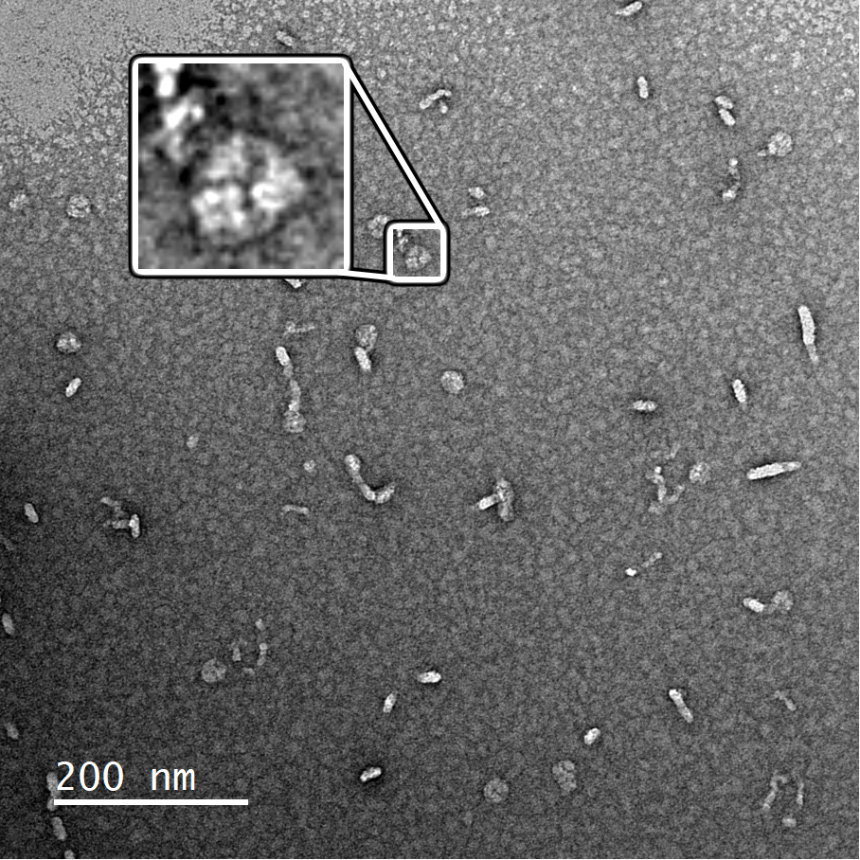
Figure 4.19. Trimeric PSI-nanodisc solubilized with C₁₄MA^{5.6} as imaged by transmission electron microscopy.

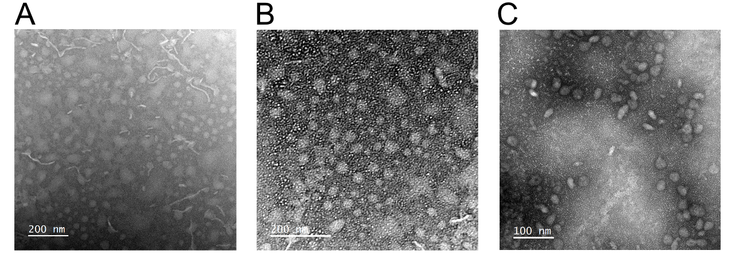
Figure 4.20. Negative stain TEM images of trimeric PSI particles. A) C₁₄MA^{1.8}, B) C₁₄MA^{3.9}, and C) C₁₄MA^{4.8}

to DLS measurements being slightly exaggerated, as has been previously observed.38 Between the large particle size seen with DLS, the largely increased lipid concentrations observed with lipidomics, and the structure imaged with TEM, it is clear that all C14MA samples are solubilizing trimeric PSI into lipid-containing nanodiscs directly from the cellular membrane of Te.

4.3.7 Investigating αMA-Facilitated Protein Extraction in Other IMP Systems
Previous reports have shown the native PSI structure in another cyanobacterium, Chroococcidiopsis sp TS-821(TS-821), to be tetrameric.³⁹ However, attempts at extracting native tetrameric PSI (PSI-q) fromTS-821 with various commercial SMAs or related analogs have been unsuccessful. While conducting our PSI-t extraction and characterization on Te, we wanted to also probe if any C₁₄MA samples could extract PSI-q from the thylakoid membranes of TS-821. These initial studies provide insight into the range of IMP systems αMAs could extract and solubilize into nanodiscs.
Figure 4.21A depicts the SDGs performed after an initial incubation between TS-821 and the C₁₄MA samples or increasing molecular weight. An extraction was also attempted with SMA 1440, a commercially available SMA that has been partially monoesterified with 2-butoxyethanol. This polymer has been shown to successfully extract PSI t from Te,³⁴ making it a logical control for this experiment. Interestingly, C₁₄MA^{3.9}, C₁₄MA^{4.8}, C₁₄MA^{5.6} all visually show distinct PSI-q bands, whereas the SMA 1440 control and C₁₄MA^{1.8} does not appear to extract any PSI-q. Of note, C₁₄MA^{3.9} qualitatively extracts the most PSI-q of all samples tested, while C₁₄MA^{4.8} and C₁₄MA^{5.6} seem to more selectively extract PSI-m and PSI dimers (PSI-d) in higher yields.

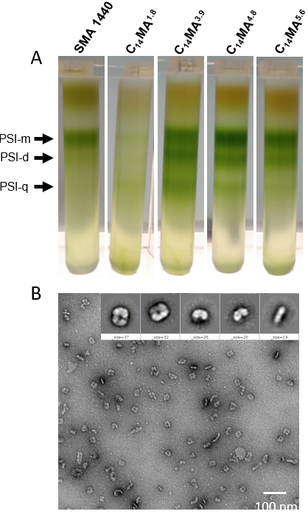
Figure 4.21. A) SDG of the species extracted from TS-821 using C₁₄MA samples and B) isolated tetrameric PSI-nanodiscs solubilized with C₁₄MA^{3.9} as imaged by transmission electron microscopy.

Following the harvesting of the PSI-q bands, absorbance was performed on the samples (Figure D12). The αMA polymers exhibit an increase in absorbance for chlorophyll (~430 nm), indicating that more PSI is extracted and that the pigments associated with these complexes are preserved even after removal from the thylakoid membrane. Compared to SMA 1440, αMA polymers released a greater amount of carotenoid, as evidenced by an increase in absorbance around ~465 nm. Additional LTF experiments were performed that show that the very minimal PSII species were extracted with all samples (Figure D12), in contrast to C₁₄MA^{5.6} extracting a significant amount of PSII from Te. The characteristic fluorescence at ∼719 nm confirms the presence of PSI-bound chlorophyll. Finally, TEM confirms the presence of tetrameric PSI (Figure 4.21B).

4.4 Conclusions
As integral membrane proteins are studied for implementation into more biotechnological applications, it is becoming increasingly important to understand how to isolate these proteins in their native conformation. Herein, we report evidence that we have developed a new series of amphiphilic copolymers that can help expand these efforts. These linear α-olefin-co-maleic acid copolymers have been found to be highly selective and efficient at extracting trimeric PSI from the thylakoid membranes, with most of our C₁₄MA samples exhibiting upward of a threefold increase of solubilization efficiency of chlorophyll-containing pigment protein complexes from the thylakoid membranes of Te when compared to the commonly employed DIBMA polymer. We hypothesize that this increased efficiency could be seen when studying other membrane protein systems, something we plan to investigate in future studies. While the C₁₂MA, C₁₀MA, and C₈MA samples examined in this study weren’t effective in our specific membrane protein system, we also expect these materials to exhibit different behavior in other systems (i.e. phospholipid membranes), as seen with previously studied SMA and DIBMA samples.^{20, 34}
Characterization of the isolated PSI-t samples showed that αMAs appear to not only have the ability to retain the native trimeric structure of PSI from Te, but also help retain subunits of PSI to a greater extent than other amphiphilic polymers and detergents do not retain.^{23, 34} Furthermore, the increased size of the formed particles and analysis of the lipid content both suggest that these polymers are forming nanodiscs containing both the extracted PSI-t and native lipids from the membrane of Te. Finally, LTF studies elicited native-like emissions from the solubilized PSI-t, suggesting it is retaining a large extent of its native conformation in the αMA lipid-nanodiscs. It is also worth noting that the C₁₄MA samples explored herein exhibited the unique ability to extract tetrameric PSI from TS-821, a protein structure that no other examined amphiphilic copolymer to date can isolate. This leads us to believe these polymers may be able to be applied to a variety of different membrane systems for efficient, selective protein extraction.
The αMA platform allows for the creation of highly tailorable subsets of amphiphilic polymers where the polymer’s molecular weight and monomer incorporation ratio can both be controlled, while still maintaining a fairly low dispersity. Even more promising, these polymers can easily be produced and purified on a multi-gram scale, allowing for a single batch to be used for numerous experiments. These materials absorb very little UV light allowing for more protein characterization and do not feature functional groups that are more susceptible to saponification, leading to more stable materials overall. All of these highlighted features make αMAs incredibly versatile and promising tools for the future of detergent-free protein extraction.
4.5 Acknowledgements
Partial support of this research was provided by the University of Tennessee Research Foundation’s Maturation Grant Program. CEW acknowledges partial support from the University of Tennessee Office of Research, Innovation, & Economic Development’s Summer Graduate Research Assistantship Fund. We also acknowledge Mr. Joytirmoy Mondal and Ms. Katrina Micin for maintaining and growing the cyanobacterial cultures of T. elongatus used in this study. We would like to thank Dr. Jaydeep Kolape for his assistance and guidance with TEM.

4.6 Experimental
4.6.1 General Methods and Materials
All chemicals were purchased from chemical suppliers and used as received, unless otherwise noted. Azobisisobutyronitrile (AIBN) was purified via recrystallization from methanol. All water was purified using a MilliQ Biocel reverse osmosis system (>18 MΩ). ¹H NMR spectroscopy was performed using a Varian 500 MHz NMR spectrometer, with a delay time of 25 sec, and chemical shifts are reported with respect to residual solvent peaks. Gel permeation chromatography (GPC) was performed using a Malvern Panalytical Omnisec Reveal and Resolve, at room temperature, with THF as the eluent, and with triple-detection (refractive index, low-angle scattering, and viscometry). All lipidomics studies were performed by the Kansas Lipidomics Research Center (Kansas State University).

4.6.2 General Synthesis of αMAhs
αMAs were synthesized by a modified literature procedure.⁴⁰ Briefly, the α-olefin (31 mmol), maleic anhydride (3.04 g, 31 mmol), and AIBN (0.166 g, 1 mmol) were added to a mixture of toluene (40 mL) and acetone (8 mL). The entire mixture was then degassed via freeze-pump-thaw cycles (×3). Then, the reaction was heated at 70 °C for 12 h. The polymers were purified via precipitation into MeOH, redissolved in THF, and precipitated a second time into hexanes. All purified polymers were then dried under high vacuum for >12 h. Polymer molecular weights were measured using GPC (Figures D13-D20) and the incorporation ratio of the monomers was found using ¹H NMR spectroscopy (Figures D1-D9). To attain a series of different polymer molecular weights, the amounts of AIBN (21 mg – 166 mg) and toluene (10 mL – 40 mL) were varied.

4.6.3 Hydrolysis of αMAhs to αMAs
Each αMAh polymer (15 wt%) was combined with purified water (75 wt%) and a solution of 30% NH₄OH (10 wt%). This solution was then heated at 80 °C for <1 h, or until the polymer had completely dissolved into aqueous solution, as indicated by non-turbid solution. These solutions were stored at room temperature and shielded from light until tested.

4.6.4 Determination of pH and Divalent Cation Sensitivity in Aqueous Media
Each polymer’s tolerance of pH was determined using a modified literature procedure.³³ Briefly, each 15% (wt%) αMA solution was diluted tenfold into a standard Britton-Robinson (BR) buffer, containing 150 mM NaCl. The prepared buffers had pH values ranging from 4-10, in 0.5-pH increments. The samples were mixed on an orbital shaker for 10 min, analysis using optical density measurements at 350 nm via an ultraviolet spectrometer. Optical density values above the measured baseline were interpreted as an indicator of polymer aggregation/precipitation.
Similarly, divalent cation sensitivity was determined using a previously reported literature procedure.²¹ Each 15 wt% αMA sample was diluted ×10 into a Tris buffer (9.5 pH), containing various concentrations of MgCl₂ ₍1 to 25 nM). The solutions were mixed via orbital shaking for 10 min and analyzed via UV spectroscopy to measure optical density at 350 nm. Optical density values above the baseline were indicative of polymer aggregation/precipitation.

4.6.5 Critical Aggregation Concentration Determination
The critical aggregation concentration (CAC) for each sample was determined by adapting a previously reported procedure.³³ Briefly, each 15% (w/w) αMA sample was diluted tenfold into a standard tris buffer (9.5 pH). These solutioned were placed into a 96-well plate and diluted fivefold across each well (×12). A Nile Red solution was added to each well for a final concentration of 1 µM. Each well was excited at 550 nm, and the solution’s emissions were measured between from 575 nm – 700 nm in 1 nm increments. The resultant emission spectra were fit to a Gaussian function using OriginPro 8.1, and the peak emission value from the Gaussian fit was plotted against polymer concentration for each specific sample. Each resulting data series was then fit using a standard sigmoidal line of best fit without locking any variables, also using OriginPro 8.1.

4.6.6 UV Absorbance Determination
All polymer samples tested were solubilized (20 mg) using a standard 0.06% NH₄OH solution in water (40 mL). The UV absorbances of these solutions were then measured (220 – 400 nm) using a Persee T7DS UV/Vis Spectrometer. The resulting spectra for each polymer was plotted as a function of intensity vs. wavelength (Figure 4.10A), as a function of molar absorptivity with respect to polymer concentration (Figure 4.10B), and as a function of molar absorptivity with respect to total monomer subunit concentration (Figure 4.10C). GPC was used to measure commercial SMA sample molecular weight (M_{n}) to determine the molar concentration of those polymer samples (Figures D21-D23). ¹H NMR was used to determine monomer ratios for commercial SMA samples in order to calculate total monomer subunit concentration in each sample (Figures D24-D26).

4.6.7 Thylakoid membrane Isolation
Thylakoid membrane isolation and solubilization was performed as reported previously.³⁴ Briefly, Te cultures were grown at 45 °C (PSI, Brno, Czech Republic) in BG-11 media with∼50 μmol photons m⁻²·s⁻¹ of light and aerated with compressed air, in an air lifted flat panel bioreactor. Late log phase cells were centrifuged at 6000 g, and resuspended in Tris-Cl (50 mM, pH 9.5, at room temperature) with KCl (125 mM) (Buffer S) to a final chlorophyll (Chl a) concentration of 1 mg/mL. The cells were then incubated at 40 °C for 1 h in dark in Buffer S with 0.0025% (w/v) lysozyme (Gold Bio, United States) on an orbital shaker at 250 rpm. The cells were then centrifuged at∼10,000 x g for 10 min, resuspended in Buffer S, and Dounce-homogenized. Then cells were mechanically lysed (×10) at 23,000 psi in a LM10 microfluidizer (Microfluidics, Westwood, MA). The homogenate was centrifuged at∼10,000 x g for 10 min to remove intact cells and cell debris. The supernatant containing thylakoid membranes was then centrifuged at∼190,000 x g. The pellet was again resuspended in Buffer S to 1 mg/mL chlorophyll and flash frozen in liquid N₂ and stored at −80 °C prior to solubilization.
TS-821 cultures were grown using a similar procedure. However, after growth, the cells were diluted to a chlorophyll concentration of 1/mg/mL in a lysis buffer (50 mM Tris-HCl, pH 9.5, 150 mM KCl, and 500 mM sorbitol), followed by mechanical lysing through a microfluidizer (×10) at 22,000 psi. The resulting lysate was centrifuged at 10,000 x g for 10 minutes to remove unbroken cells, and the supernatant, enriched in thylakoid membranes, was pelleted by a subsequent spin at 180,000 x g for 30 minutes. The thylakoid membrane pellets were washed three times by resuspension in wash buffer (50 mM Tris-HCl, pH = 9.5, 150 mM KCl) and homogenized using a Dounce ground glass before solubilization.

4.6.8 Thylakoid solubilization Using αMAs
For solubilization, frozen thylakoid membranes were first thawed on ice and vortexed at 200 rpm to remove any clumps. For Te cultures, 1-2 ml of thylakoid membrane was mixed with respective polymers and n-dodecyl-beta-D-maltoside (DDM) to a final polymer/detergent concentration of 2.5% (w/v). Then, the mixture was incubated at 40 °C for 3 h (Te) or 4 h (TS-821). Subsequently, the Te solutions were centrifuged at ~190,000 g for 15 min at 4 °C and TS-821 solutions were centrifuged at ~160,000 g for 30 min, in order to remove insolubilized material. The supernatants could then be used for further characterization.

4.6.9 Determination of Solubilization Efficiency
SE of the extraction of PSI-t from Te was determined as previously described.³⁴ Each supernatant was diluted (×20) and total chlorophyll was extracted with 90% methanol and incubated at 65 °C, for 2 min. The chlorophyll concentration was determined using a dual-beam benchtop spectrophotometer (Evolution 300, Thermo Scientific) and compared to the starting concentration of 1 mg/mL to determine SE.

4.6.10 Sucrose Density Gradient Ultracentrifugation
The solubilized supernatant was then loaded on top of a sucrose density gradient. Sucrose density gradients were prepared using a linear gradient of 10-30% (w/v) sucrose above a 50% (w/v) sucrose cushion. 1 mL of the supernatants were placed on the top of the gradients and the entire system was subjected to centrifugation (150,000 × g) in a SW-32 swinging bucket rotor for 20 h at 4 °C. Then, the tubes were taken out and imaged and the trimeric PSI band (PSI-t) was collected in 2 ml Eppendorf tubes using a canonical 5 ml syringe and stored at -80 °C for further use.

4.6.11 SDS-PAGE and Silver Staining
The protein contents of the isolated PSI-t nanodiscs were determined by a 10-21% gradient sodium-dodecyl-sulphate (SDS) poly acrylamide running gel with 4% linear stacking gel on top (PAGE). PSI-t isolated with each polymer and DDM (all samples corresponding to 0.4 µg of chlorophyll) was solubilized in Lamelli sample buffer with 100 mM DTT and incubated 60 °C for 15 mins and then centrifuged for 5 min (5000 x g) to remove insolubilized materials and loaded on the wells and run at 75 V for 15 min followed by 150 V in a running buffer (25 mM tris, 192 mM glycine, 0.1% (w/v) SDS) until the dye front reached the bottom of the gel. After run was complete, the gel was fixed (50% methanol and 5% acetic acid) for 2 h and stained with silver stain according to manufacturer’s instructions (Thermo Fischer).

4.6.12 Blue Native (BN)-PAGE
BN-PAGE was performed as described previously with slight modifications.⁴¹ Briefly, all PSI-t isolated with polymer and DDM (all samples corresponding to 2 µg of chlorophyll) were loaded on a Bis-tris 3-12% gradient native gel (Bis-tris NU-PAGE, Life Technologies). Prior loading samples were mixed (10:1) with native loading buffer (50% glycerol, 50 mM Bis-tris pH 7.5, 50 mM tricine, 5% (w/v) Coomassie brilliant Blue G-250). Cathode (50 mM Bis-tris pH 7.5, 50 mM tricine and 0.1% Coomassie brilliant Blue G-250) and anode buffer (50 mM Bis-tris pH 7.5, 50 mM tricine) were used for running the gel at 60 V for 15 h at 4 °C. Gels were then RGB scanned and then stained with Coomassie G-250.

4.6.13 Low Temperature Fluorescence.
The harvested PSI-t from the sucrose gradient was diluted to 1 µg of chlorophyll ml⁻¹ in buffer S and 0.5 ml was loaded in 0.5 mm NMR tubes and frozen by slowly immerging the tubes in in liquid N₂. Then the tubes were placed in a holder containing liquid N₂ and fluorescence was recorded by JASCO 150 fluorimeter. Excitation wavelength was 472 nm and emission were recorded from 300-800 nm with a slit width of 0.2 nm and integration of 10 measurements. Each sample was measured ×3 and data represented as average.

4.6.14 Dynamic Light Scattering
The harvested trimeric-PSI sucrose gradient bands were diluted (×8) with Buffer S and passed through a 0.2 μM filter. The size of the nanodiscs in solution were measured using light scattering (DLS). The Anton Paar Litesizer 100 Particle Analyzer was used to perform these studies over the course of ten 1 min scans.

4.6.15 Transmission Electron Microscopy
The trimeric-PSI nanodiscs isolated using sucrose density gradient ultracentrifugation were diluted (×50) into Buffer S. A copper coated carbon grid was place on top of a drop of sample for 1 min. Excess sample was removed by touching the edge of the grid to filter paper and the grid was placed on a drop of DI water for 5 sec to wash it. Excess DI water removed by absorption to filter paper and the grid was placed upon a drop of 1% uranyl acetate solution for another minute. The grids were allowed to dry for 3 days and imaged using a JEOL 1440-FLASH TEM at 120 kV.

References
1. Almén, M. S.; Nordström, K. J. V.; Fredriksson, R.; Schiöth, H. B., Mapping the human membrane proteome: a majority of the human membrane proteins can be classified according to function and evolutionary origin. BMC Biology 2009, 7, 50.
2. Yin, H.; Flynn, A. D., Drugging Membrane Protein Interactions. Annu Rev Biomed Eng 2016, 18, 51-76.
3. Iwuchukwu, I. J.; Vaughn, M.; Myers, N.; O'Neill, H.; Frymier, P.; Bruce, B. D., Self-organized photosynthetic nanoparticle for cell-free hydrogen production. Nature Nanotechnology 2010, 5, 73-79.
4. Taylor, T. M.; Davidson, P. M.; Bruce, B. D.; Weiss, J., Liposomal nanocapsules in food science and agriculture. Crit Rev Food Sci Nutr 2005, 45, 587-605.
5. Levental, I.; Lyman, E., Regulation of membrane protein structure and function by their lipid nano-environment. Nat Rev Mol Cell Biol 2022.
6. Lee, S. C.; Knowles, T. J.; Postis, V. L. G.; Jamshad, M.; Parslow, R. A.; Lin, Y.-p.; Goldman, A.; Sridhar, P.; Overduin, M.; Muench, S. P.; Dafforn, T. R., A method for detergent-free isolation of membrane proteins in their local lipid environment. Nature Protocols 2016, 11, 1149-1162.
7. Tribet, C.; Audebert, R.; Popot, J. L., Amphipols: polymers that keep membrane proteins soluble in aqueous solutions. Proc Natl Acad Sci U S A 1996, 93, 15047-50.
8. Gorzelle, B. M.; Hoffman, A. K.; Keyes, M. H.; Gray, D. N.; Ray, D. G.; Sanders, C. R., Amphipols Can Support the Activity of a Membrane Enzyme. Journal of the American Chemical Society 2002, 124, 11594-11595.
9. Popot, J. L.; Berry, E. A.; Charvolin, D.; Creuzenet, C.; Ebel, C.; Engelman, D. M.; Flötenmeyer, M.; Giusti, F.; Gohon, Y.; Hong, Q.; Lakey, J. H.; Leonard, K.; Shuman, H. A.; Timmins, P.; Warschawski, D. E.; Zito, F.; Zoonens, M.; Pucci, B.; Tribet, C., Amphipols: polymeric surfactants for membrane biology research. Cell Mol Life Sci 2003, 60, 1559-74.
10. Autzen, H. E.; Julius, D.; Cheng, Y., Membrane mimetic systems in CryoEM: keeping membrane proteins in their native environment. Current Opinion in Structural Biology 2019, 58, 259-268.
11. Simon, K. S.; Pollock, N. L.; Lee, S. C., Membrane protein nanoparticles: the shape of things to come. Biochem. Soc. Trans. 2018, 46, 1495-1504.
12. Sligar, S. G.; Denisov, I. G., Nanodiscs: A toolkit for membrane protein science. Protein Science 2021, 30, 297-315.
13. Knowles, T. J.; Finka, R.; Smith, C.; Lin, Y.-P.; Dafforn, T.; Overduin, M., Membrane Proteins Solubilized Intact in Lipid Containing Nanoparticles Bounded by Styrene Maleic Acid Copolymer. Journal of the American Chemical Society 2009, 131, 7484-7485.
14. Dörr, J. M.; Scheidelaar, S.; Koorengevel, M. C.; Dominguez, J. J.; Schäfer, M.; van Walree, C. A.; Killian, J. A., The styrene-maleic acid copolymer: a versatile tool in membrane research. Eur Biophys J 2016, 45, 3-21.
15. Morrison, K. A.; Akram, A.; Mathews, A.; Khan, Z. A.; Patel, J. H.; Zhou, C.; Hardy, D. J.; Moore-Kelly, C.; Patel, R.; Odiba, V.; Knowles, T. J.; Javed, M.-u.-H.; Chmel, N. P.; Dafforn, T. R.; Rothnie, A. J., Membrane protein extraction and purification using styrene–maleic acid (SMA) copolymer: effect of variations in polymer structure. Biochem. J. 2016, 473, 4349.
16. Domínguez Pardo, J. J.; Koorengevel, M. C.; Uwugiaren, N.; Weijers, J.; Kopf, A. H.; Jahn, H.; van Walree, C. A.; van Steenbergen, M. J.; Killian, J. A., Membrane Solubilization by Styrene-Maleic Acid Copolymers: Delineating the Role of Polymer Length. Biophys. J. 2018, 115, 129-138.
17. Kopf, A. H.; Lijding, O.; Elenbaas, B.; Koorengevel, M. C.; Walree, C.; Killian, J. A., Synthesis and Evaluation of a Novel Library of Alternating Amphipathic Copolymers to Solubilize and Study Membrane Proteins. bioRxiv 2021.
18. Esmaili, M.; Brown, C. J.; Shaykhutdinov, R.; Acevedo-Morantes, C.; Wang, Y. L.; Wille, H.; Gandour, R. D.; Turner, S. R.; Overduin, M., Homogeneous nanodiscs of native membranes formed by stilbene–maleic-acid copolymers. Nanoscale 2020, 12, 16705-16709.
19. Oluwole, A. O.; Danielczak, B.; Meister, A.; Babalola, J. O.; Vargas, C.; Keller, S., Solubilization of Membrane Proteins into Functional Lipid-Bilayer Nanodiscs Using a Diisobutylene/Maleic Acid Copolymer. Angew Chem Int Edit 2017, 56, 1919-1924.
20. Gulamhussein, A. A.; Uddin, R.; Tighe, B. J.; Poyner, D. R.; Rothnie, A. J., A comparison of SMA (styrene maleic acid) and DIBMA (di-isobutylene maleic acid) for membrane protein purification. Biochim. Biophys. Acta, Biomembr. 2020, 1862, 183281.
21. Burridge, K. M.; Harding, B. D.; Sahu, I. D.; Kearns, M. M.; Stowe, R. B.; Dolan, M. T.; Edelmann, R. E.; Dabney-Smith, C.; Page, R. C.; Konkolewicz, D.; Lorigan, G. A., Simple Derivatization of RAFT-Synthesized Styrene–Maleic Anhydride Copolymers for Lipid Disk Formulations. Biomacromolecules 2020, 21, 1274-1284.
22. Ravula, T.; Hardin, N. Z.; Ramadugu, S. K.; Ramamoorthy, A., pH Tunable and Divalent Metal Ion Tolerant Polymer Lipid Nanodiscs. Langmuir 2017, 33, 10655-10662.
23. Brady, N. G.; Workman, C. E.; Cawthon, B.; Bruce, B. D.; Long, B. K., Protein Extraction Efficiency and Selectivity of Esterified Styrene–Maleic Acid Copolymers in Thylakoid Membranes. Biomacromolecules 2021, 22, 2544-2553.
24. Workman, C. E.; Cawthon, B.; Brady, N. G.; Bruce, B. D.; Long, B. K., Effects of Esterified Styrene–Maleic Acid Copolymer Degradation on Integral Membrane Protein Extraction. Biomacromolecules 2022, 23, 4749-4755.
25. Dörr, J. M.; Koorengevel, M. C.; Schäfer, M.; Prokofyev, A. V.; Scheidelaar, S.; van der Cruijsen, E. A. W.; Dafforn, T. R.; Baldus, M.; Killian, J. A., Detergent-free isolation, characterization, and functional reconstitution of a tetrameric K+ channel: The power of native nanodiscs. Proc. Natl. Acad. Sci. U. S. A. 2014, 111, 18607.
26. Craig, A. F.; Clark, E. E.; Sahu, I. D.; Zhang, R.; Frantz, N. D.; Al-Abdul-Wahid, M. S.; Dabney-Smith, C.; Konkolewicz, D.; Lorigan, G. A., Tuning the size of styrene-maleic acid copolymer-lipid nanoparticles (SMALPs) using RAFT polymerization for biophysical studies. Biochim. Biophys. Acta, Biomembr. 2016, 1858, 2931-2939.
27. Klumperman, B.; O'Driscoll, K. F., Interpreting the copolymerization of styrene with maleic anhydride and with methyl methacrylate in terms of the bootstrap model. Polymer 1993, 34, 1032-1037.
28. Odian, G., Principle of Polymerization, Fourth Edition. John Wiley & Sons, Inc.: 2004.
29. Soga, K.; Yanagihara, H.; Lee, D.-h., Evaluation of olefin reactivity ratios over highly isospecific Ziegler-Natta catalyst. Die Makromolekulare Chemie 1989, 190, 37-44.
30. Kucharski, M.; Sanecka, B., Reactivity ratios of styrene-N-iso-butylmaleimide and methyl methacrylate-N-iso-butylmaleimide. Polymer 1982, 23, 146-148.
31. Baruah, S. D.; Laskar, N. C., Styrene-maleic anhydride copolymers: Synthesis, characterization, and thermal properties. Journal of Applied Polymer Science 1996, 60, 649-656.
32. Debnath, D.; Baughman, J. A.; Datta, S.; Weiss, R. A.; Pugh, C., Determination of the Radical Reactivity Ratios of 2-(N-Ethylperfluorooctanesulfonamido)ethyl Acrylate and Methacrylate in Copolymerizations with N,N-Dimethylacrylamide by in Situ 1H NMR Analysis As Established for Styrene–Methyl Methacrylate Copolymerizations. Macromolecules 2018, 51, 7951-7963.
33. Scheidelaar, S.; Koorengevel, M. C.; van Walree, C. A.; Dominguez, J. J.; Dörr, J. M.; Killian, J. A., Effect of Polymer Composition and pH on Membrane Solubilization by Styrene-Maleic Acid Copolymers. Biophys. J. 2016, 111, 1974-1986.
34. Brady, N. G.; Li, M.; Ma, Y.; Gumbart, J. C.; Bruce, B. D., Non-detergent isolation of a cyanobacterial photosystem I using styrene maleic acid alternating copolymers. RSC Adv. 2019, 9, 31781-31796.
35. Polívka, T.; Frank, H. A., Molecular Factors Controlling Photosynthetic Light Harvesting by Carotenoids. Accounts of Chemical Research 2010, 43, 1125-1134.
36. Bos, P. R.; Schiphorst, C.; Kercher, I.; Buis, S.; de Jong, D.; Vunderink, I.; Wientjes, E., Spectral diversity of photosystem I from flowering plants. Photosynthesis Research 2023, 155, 35-47.
37. Brady, N. G.; Qian, S.; Nguyen, J.; O'Neill, H. M.; Bruce, B. D., Small angle neutron scattering and lipidomic analysis of a native, trimeric PSI-SMALP from a thermophilic cyanobacteria. Biochim. Biophys. Acta, Bioenerg. 2022, 1863, 148596.
38. Orekhov, P. S.; Bozdaganyan, M. E.; Voskoboynikova, N.; Mulkidjanian, A. Y.; Karlova, M. G.; Yudenko, A.; Remeeva, A.; Ryzhykau, Y. L.; Gushchin, I.; Gordeliy, V. I.; Sokolova, O. S.; Steinhoff, H. J.; Kirpichnikov, M. P.; Shaitan, K. V., Mechanisms of Formation, Structure, and Dynamics of Lipoprotein Discs Stabilized by Amphiphilic Copolymers: A Comprehensive Review. Nanomaterials (Basel) 2022, 12.
39. Semchonok, D. A.; Mondal, J.; Cooper, C. J.; Schlum, K.; Li, M.; Amin, M.; Sorzano, C. O. S.; Ramírez-Aportela, E.; Kastritis, P. L.; Boekema, E. J.; Guskov, A.; Bruce, B. D., Cryo-EM structure of a tetrameric photosystem I from Chroococcidiopsis TS-821, a thermophilic, unicellular, non-heterocyst-forming cyanobacterium. Plant Communications 2022, 3, 100248.
40. Martínez, F.; Uribe, E.; Olea, A. F., Copolymerization of Maleic Anhydride with Styrene and α‐Olefins. Molecular and Thermal Characterization. Journal of Macromolecular Science, Part A 2005, 42, 1063-1072.
41. Bag, P.; Schröder, W. P.; Jansson, S.; Farci, D., Solubilization Method for Isolation of Photosynthetic Mega- and Super-complexes from Conifer Thylakoids. Bio-protocol 2021, 11, e4144.

CHAPTER V: CONCLUSIONS AND OUTLOOK

5.1 Conclusions
Integral membrane proteins (IMPs) have been studied for implementation in various applications, like drug development¹ and the creation of semi-biohybrid electronics, such as more efficient solar cells² or stochastic sensors enabling the detection of specific analytes.³ As such, it is becoming increasingly important to find ways to isolate and study IMPs’ structure and function in their native conformation.¹ The first chapter of this dissertation provides a historical perspective of the isolation of IMPs and outlines many of the most recently developed methodologies to study IMP structure and function, while retaining a more native-like conformation. The first two methods discussed require prior detergent-facilitated isolation of the membrane proteins before replacing the detergent molecules with either amphipols or MSPs.^{4, 5} While these methods have both led to significant progress in the field, each has its own limitations and challenges. For example, the initial detergent protein extraction steps required when using either amphipols and MSPs can still lead to complete or partial denaturation or unfolding of the isolated IMPs.
To address these limitations, SMAs were recently discovered to not only solubilize membrane proteins from liposomal environments, but more importantly, solubilize IMPs directly from native cellular membranes into nanodiscs without the need of detergents.⁶⁻⁸ In addition, SMAs not only extract the IMP but also an annulus of the native membrane lipids, leading to formation of protein-containing lipid nanodiscs with a much more native-like environment.^{7, 8} The ability to isolate IMPs directly from biological membranes into more native environments, without the use of detergents, decreases the risk of protein unfolding and denaturation.
As the field of SMA-facilitated IMP protein extraction has progressed, new SMA analogues and other amphiphilic copolymers have been developed that readily form protein-containing lipid nanodiscs.⁹⁻¹² These new materials exhibit many benefits over traditional SMA samples, such as increased tolerance to divalent cations, the ability to stay water-soluble in a wider range of pHs, a lack of moieties that absorb UV light, and increased protein extraction efficiency and/or selectivity in certain IMP systems.
While there is a growing toolbox of materials capable of solubilizing IMPs into nanodiscs, there are still many instances where commonly available amphiphilic polymers elicit little to no IMP extraction from some membrane systems. Because of this, further insight into the mechanistic processes behind amphiphilic polymer-facilitated protein extraction is needed to aid the design and development of future polymers that can efficiently and selectively target specific proteins. To help fill this gap in knowledge, we leveraged our expertise in synthetic polymer chemistry to design and synthesize multiple series of copolymers to systematically investigate which structural characteristics could and should be tuned to alter the IMP extraction process. The thylakoid membranes of Thermosynechococcus elongatus (Te) provided the perfect environment for these tests as commonly utilized, commercially available SMAs are essentially ineffective at isolating trimeric PSI from this membrane.¹³
Chapter II outlines our first studies that focused on the esterification of commercial SMA materials. We found that when the commercial SMA, PRO, was partially monoesterified with alkoxyethoxylate sidechains the IMP extraction efficiency and selectivity can be drastically altered, in certain cases allowing for an order of magnitude increase in protein extraction ability. Interestingly, our results show that the longest sidechains produced highest extraction efficiencies for the native PSI trimer of Te, whereas the shorter sidechains appeared to favor the extraction of larger patches of membrane containing multiple PSI groups. The extraction efficiency also seemed to generally increase with increasing amounts of sidechain functionalization. Further, we found that by monoesterifying PRO with diethylene glycol and tetraethylene glycol sidechains these materials’ tolerance of divalent cations can be drastically improved, albeit while lowering the ability of these materials to extract trimeric PSI from Te. We hypothesize that this modification can be done to almost any amphiphilic copolymer with anhydride units to attain a similar effect, while retaining higher solubilization efficiencies in other IMP systems.
While the materials discussed in Chapter II gave us a great amount of insight into the importance of long, hydrophobic moieties in the IMP extraction process, they also introduced a new challenge. As explored in Chapter III, these materials are prone to degradation in the presence of a base, heat, and/or light. We found that this loss of sidechain functionalization can lead to drastically lower solubilization efficiencies and that the resulting free 2-butoxyethanol chains likely lead to disruptions in the structure of the extracted trimeric PSI. We also managed to develop a preparation protocol that allows for these materials to be synthesized and solubilized while minimizing the extent of polymer degradation. This study shows the importance of having both stable and pure materials to ensure consistent and reliable protein extraction results.
Chapter IV outlines how we used the experimental results obtained in Chapters II and III to design and synthesize amphiphilic polymers to address many issues previously encountered. The new α-olefin-co-maleic acid copolymers (αMAs) substitute the typical styrene units of SMA copolymers with long, linear alkane units, similar to the pendant chains of the alkoxy ethoxylate-functionalized SMAs. These αMAs can elicit extremely high efficiencies and selectivity towards the extraction of trimeric PSI from Te and are not susceptible to degradation via saponification during preparation. They are also easy to synthesize at a variety of molecular weights and dispersities, making them promising materials for not only extracting IMPs from various biological systems, but also for investigations into the fundamentals driving the IMP extraction process.

5.2 Future Outlook
Our work has demonstrated how collaborations between experts in synthetic polymer chemistry and biochemistry can work together to push forward the field’s understanding of detergent-free extraction and solubilization of IMPs. We have used our collaborative expertise and efforts to design several series of copolymers that offer highly tailorable materials for future investigations. These polymers have proven to be some of the most highly efficient materials for extracting PSI from the cyanobacterium Te, thought we anticipate that our copolymers can be used across a wide variety of IMP systems. For example, initial studies using our αMA copolymer platform have revealed that these polymers can extract proteins from some phospholipid systems.
Despite the success of our αMA copolymer series, they are not without some shortcomings. We have observed that when extracting proteins from phospholipid systems some IMPs can partially lose some of their activity. We hypothesize that this may be due to constricted conformational changes of the extracted protein, a phenomena has been previously reported.^{14, 15} In order to combat this, we hypothesize that installing bulky, hydrophobic groups, such as cyclohexyl moieties commonly seen in some detergents,¹⁶ could lead to reduce interactions between the polymer and membrane. This may lead to formation of larger and/or less restrictive nanodiscs that can allow certain IMPs to undergo conformational changes and allow for studies surrounding the different conformations these proteins experience in their native environment.

References
1. Yin, H.; Flynn, A. D., Drugging Membrane Protein Interactions. Annu Rev Biomed Eng 2016, 18, 51-76.
2. Iwuchukwu, I. J.; Vaughn, M.; Myers, N.; O'Neill, H.; Frymier, P.; Bruce, B. D., Self-organized photosynthetic nanoparticle for cell-free hydrogen production. Nature Nanotechnology 2010, 5, 73-79.
3. Bayley, H.; Jayasinghe, L., Functional engineered channels and pores (Review). Molecular Membrane Biology 2004, 21, 209-220.
4. Popot, J.-L.; Althoff, T.; Bagnard, D.; Banères, J.-L.; Bazzacco, P.; Billon-Denis, E.; Catoire, L. J.; Champeil, P.; Charvolin, D.; Cocco, M. J.; Crémel, G.; Dahmane, T.; Maza, L. M. d. l.; Ebel, C.; Gabel, F.; Giusti, F.; Gohon, Y.; Goormaghtigh, E.; Guittet, E.; Kleinschmidt, J. H.; Kühlbrandt, W.; Bon, C. L.; Martinez, K. L.; Picard, M.; Pucci, B.; Sachs, J. N.; Tribet, C.; Heijenoort, C. v.; Wien, F.; Zito, F.; Zoonens, M., Amphipols From A to Z. Annual Review of Biophysics 2011, 40, 379-408.
5. Autzen, H. E.; Julius, D.; Cheng, Y., Membrane mimetic systems in CryoEM: keeping membrane proteins in their native environment. Current Opinion in Structural Biology 2019, 58, 259-268.
6. Knowles, T. J.; Finka, R.; Smith, C.; Lin, Y.-P.; Dafforn, T.; Overduin, M., Membrane Proteins Solubilized Intact in Lipid Containing Nanoparticles Bounded by Styrene Maleic Acid Copolymer. Journal of the American Chemical Society 2009, 131, 7484-7485.
7. Lee, S. C.; Knowles, T. J.; Postis, V. L. G.; Jamshad, M.; Parslow, R. A.; Lin, Y.-p.; Goldman, A.; Sridhar, P.; Overduin, M.; Muench, S. P.; Dafforn, T. R., A method for detergent-free isolation of membrane proteins in their local lipid environment. Nature Protocols 2016, 11, 1149-1162.
8. Dörr, J. M.; Scheidelaar, S.; Koorengevel, M. C.; Dominguez, J. J.; Schäfer, M.; van Walree, C. A.; Killian, J. A., The styrene-maleic acid copolymer: a versatile tool in membrane research. Eur Biophys J 2016, 45, 3-21.
9. Stroud, Z.; Hall, S. C. L.; Dafforn, T. R., Purification of membrane proteins free from conventional detergents: SMA, new polymers, new opportunities and new insights. Methods 2018, 147, 106-117.
10. Farrelly, M. D.; Martin, L. L.; Thang, S. H., Polymer Nanodiscs and Their Bioanalytical Potential. Chemistry – A European Journal 2021, 27, 12922-12939.
11. Kopf, A. H.; Lijding, O.; Elenbaas, B.; Koorengevel, M. C.; Walree, C.; Killian, J. A., Synthesis and Evaluation of a Novel Library of Alternating Amphipathic Copolymers to Solubilize and Study Membrane Proteins. bioRxiv 2021.
12. Brady, N. G.; Workman, C. E.; Cawthon, B.; Bruce, B. D.; Long, B. K., Protein Extraction Efficiency and Selectivity of Esterified Styrene–Maleic Acid Copolymers in Thylakoid Membranes. Biomacromolecules 2021, 22, 2544-2553.
13. Brady, N. G.; Li, M.; Ma, Y.; Gumbart, J. C.; Bruce, B. D., Non-detergent isolation of a cyanobacterial photosystem I using styrene maleic acid alternating copolymers. RSC Adv. 2019, 9, 31781-31796.
14. Mosslehy, W.; Voskoboynikova, N.; Colbasevici, A.; Ricke, A.; Klose, D.; Klare, J. P.; Mulkidjanian, A. Y.; Steinhoff, H.-J., Conformational Dynamics of Sensory Rhodopsin II in Nanolipoprotein and Styrene–Maleic Acid Lipid Particles. Photochemistry and Photobiology 2019, 95, 1195-1204.
15. Pitch, S. G.; Yao, W.; Szundi, I.; Fay, J.; Chen, E.; Shumate, A.; Kliger, D. S.; Farrens, D. L., Functional integrity of membrane protein rhodopsin solubilized by styrene-maleic acid copolymer. Biophys. J. 2021, 120, 3508-3515.
16. Lu, Z.; Van Horn, W. D.; Chen, J.; Mathew, S.; Zent, R.; Sanders, C. R., Bicelles at low concentrations. Mol Pharm 2012, 9, 752-761.

APPENDICES

Appendix A: Supporting Information for Chapter II

Figure A1. Gel permeation chromatogram of PRO. This spectrum was obtained using an EcoSEC GPC system from Tosoh Bioscience using THF as the solvent, operating at room temperature, and molecular weights are reported relative to polystyrene standards.

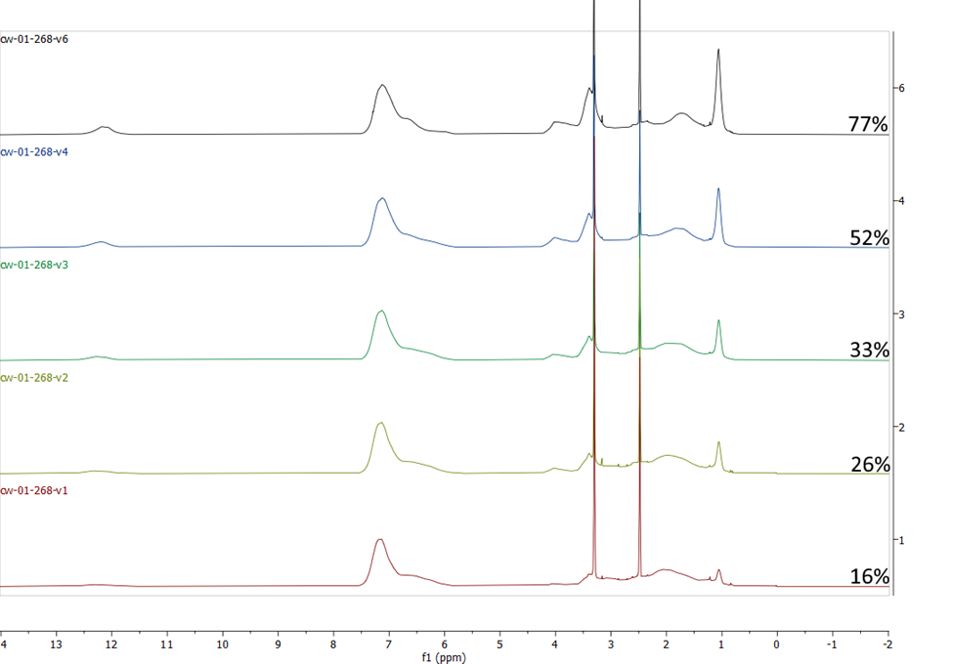
Figure A2. ¹H NMR spectra for the acid form precursors of all Eth polymer samples. The peaks at 2.5 and 3.3 are residual DMSO and H₂O solvent peaks, respectively. The peak at 1.05 was used to determine extent of esterification of the samples, which is reported to the right of each spectrum.

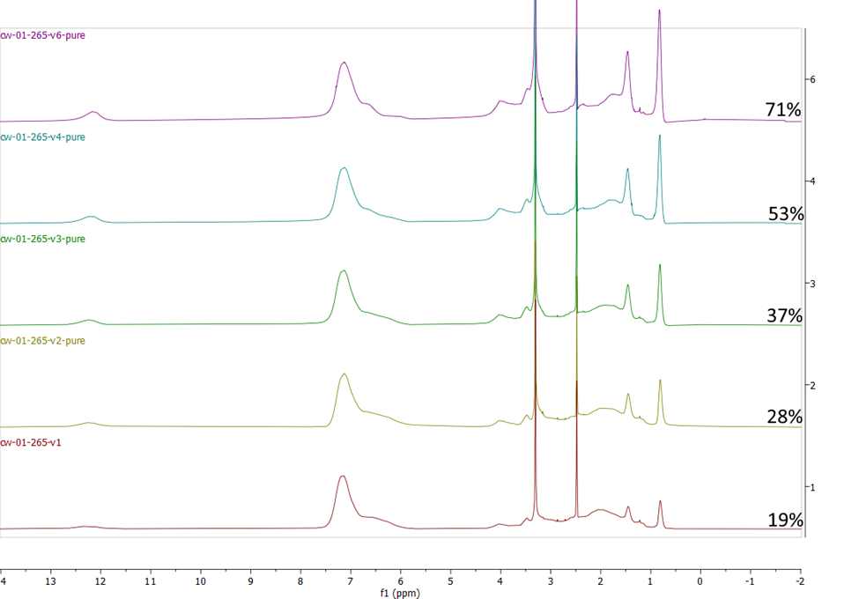

Figure A3. ¹H NMR spectra for the acid form precursors of all Prop polymer samples. The peaks at 2.5 and 3.3 are residual DMSO and H₂O solvent peaks, respectively. The peak at 0.81 was used to determine extent of esterification of the samples, which is reported to the right of each spectrum.

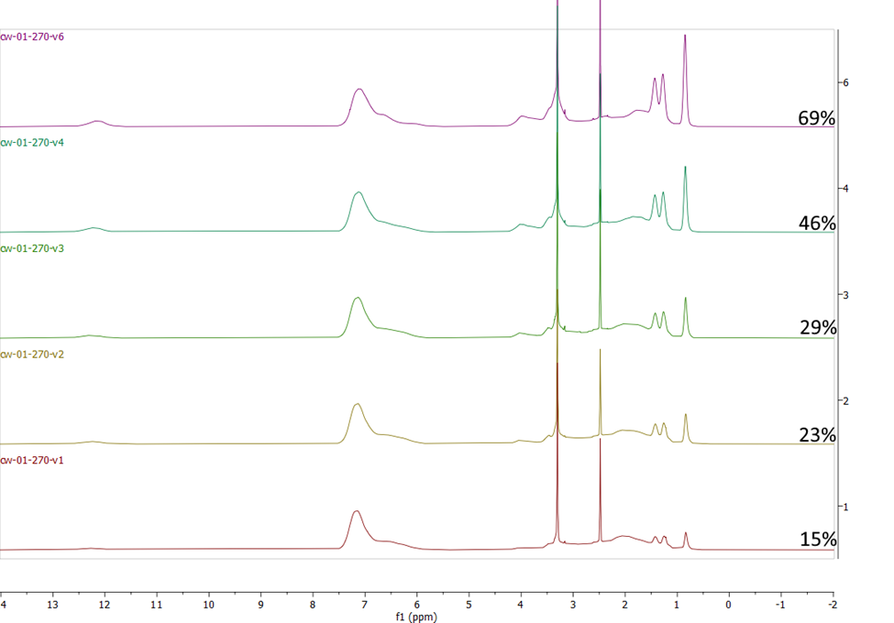

Figure A4. ¹H NMR spectra for the acid form precursors of all But polymer samples. The peaks at 2.5 and 3.3 are residual DMSO and H₂O solvent peaks, respectively. The peak at 0.84 was used to determine extent of esterification of the samples, which is reported to the right of each spectrum.

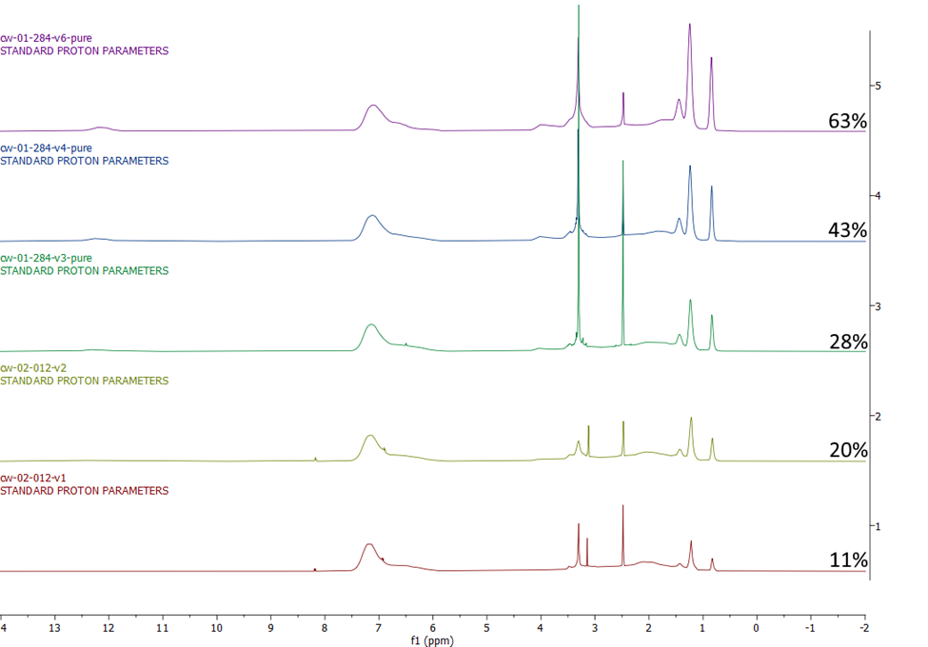

Figure A5. ¹H NMR spectra for the acid form precursors of all Hex polymer samples. The peaks at 2.5 and 3.3 are residual DMSO and H₂O solvent peaks, respectively. The peak at 0.83 was used to determine extent of esterification of the samples, which is reported to the right of each spectrum.

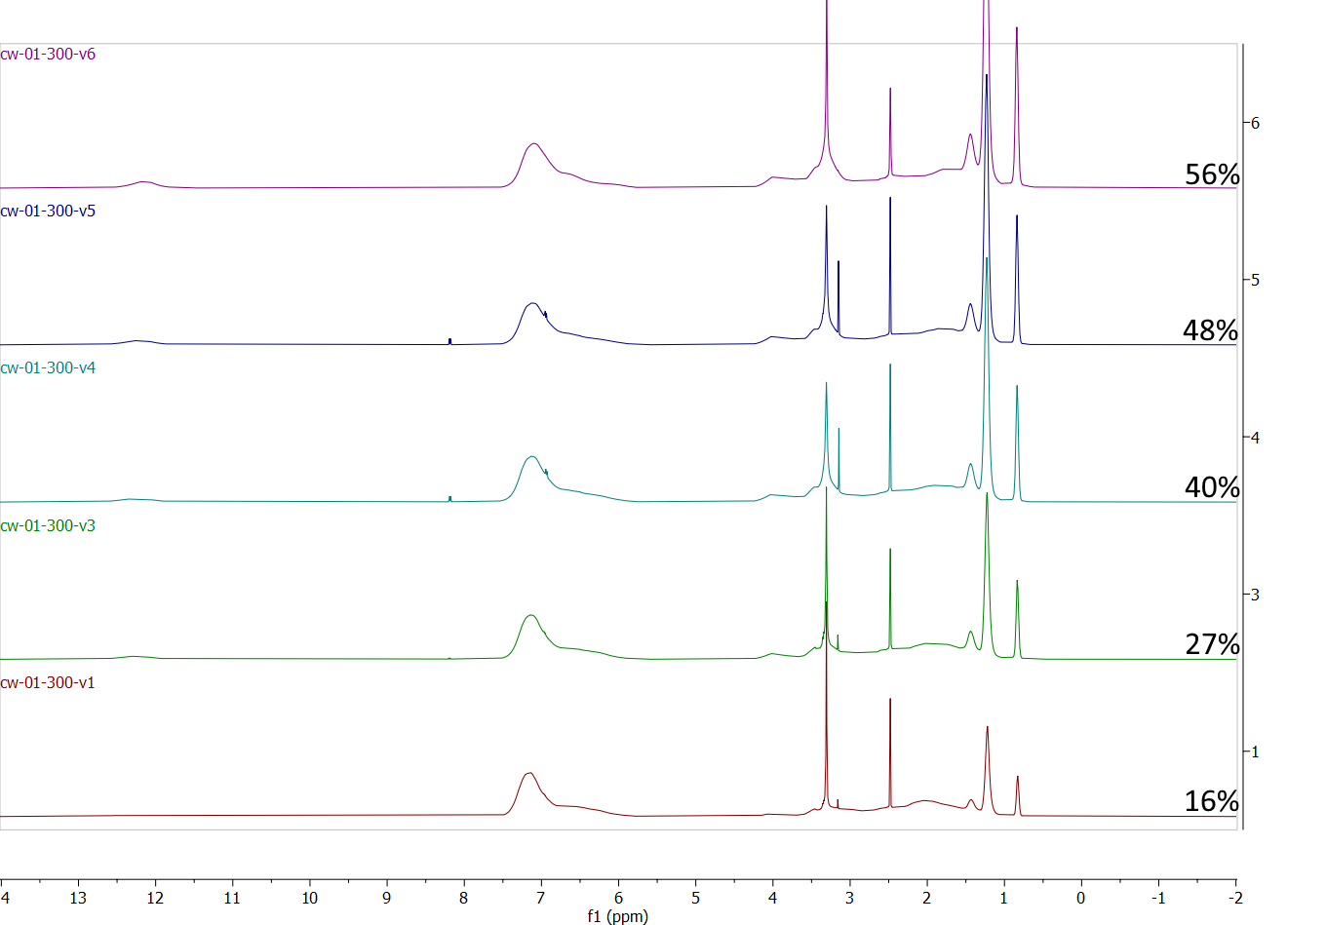

Figure A6. ¹H NMR spectra the acid form precursors of all Oct polymer samples. The peaks at 2.5 and 3.3 are residual DMSO and H₂O solvent peaks, respectively. The peak at 0.83 was used to determine extent of esterification of the samples, which is reported to the right of each spectrum.

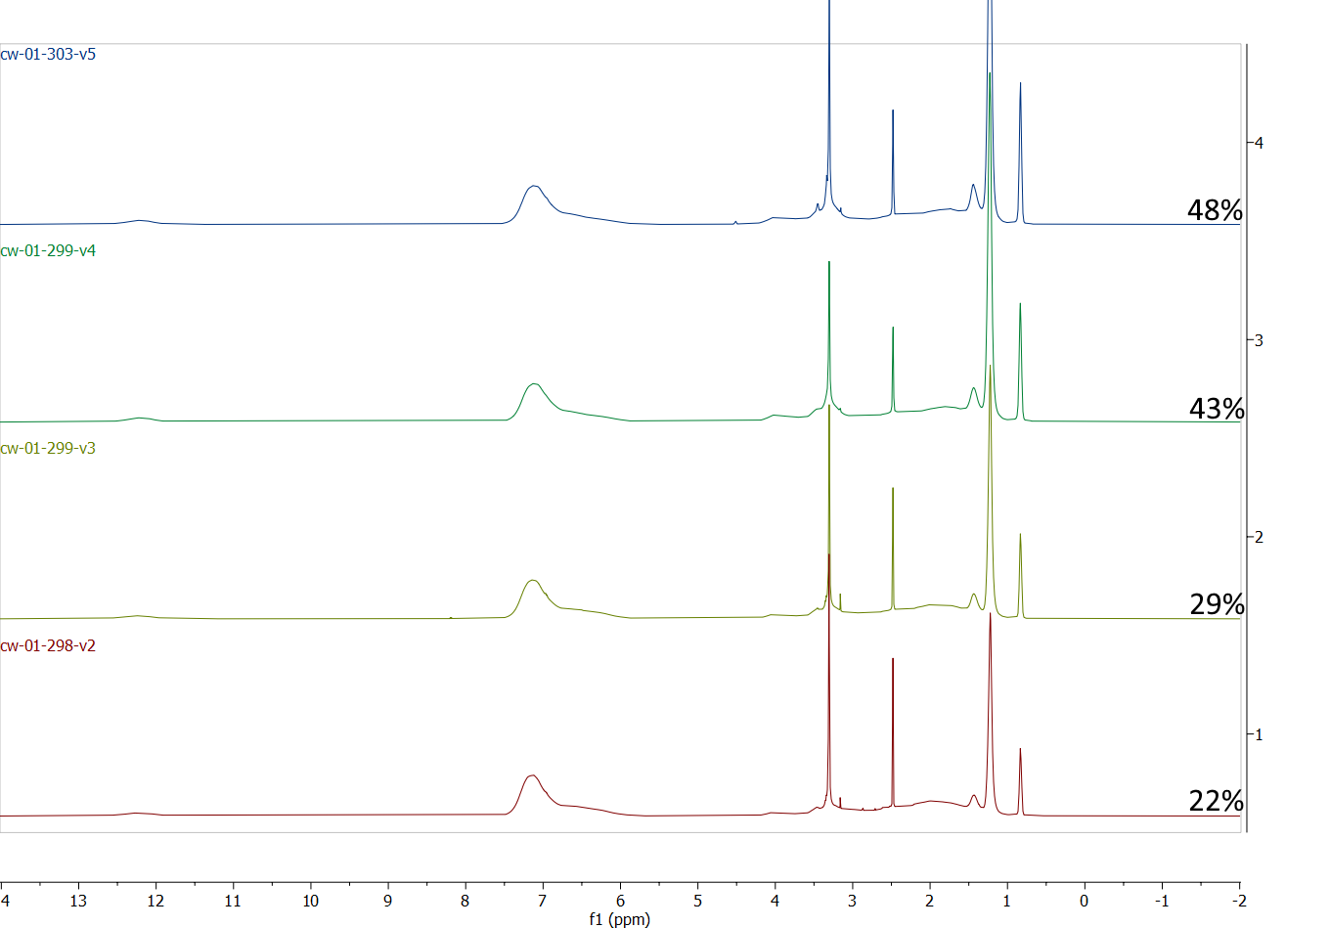

Figure A7. ¹H NMR spectra the acid form precursors of all synthesized Dec polymer samples. The peaks at 2.5 and 3.3 are residual DMSO and H₂O solvent peaks, respectively. The peak at 0.83 was used to determine extent of esterification of the samples, which is reported to the right of each spectrum.

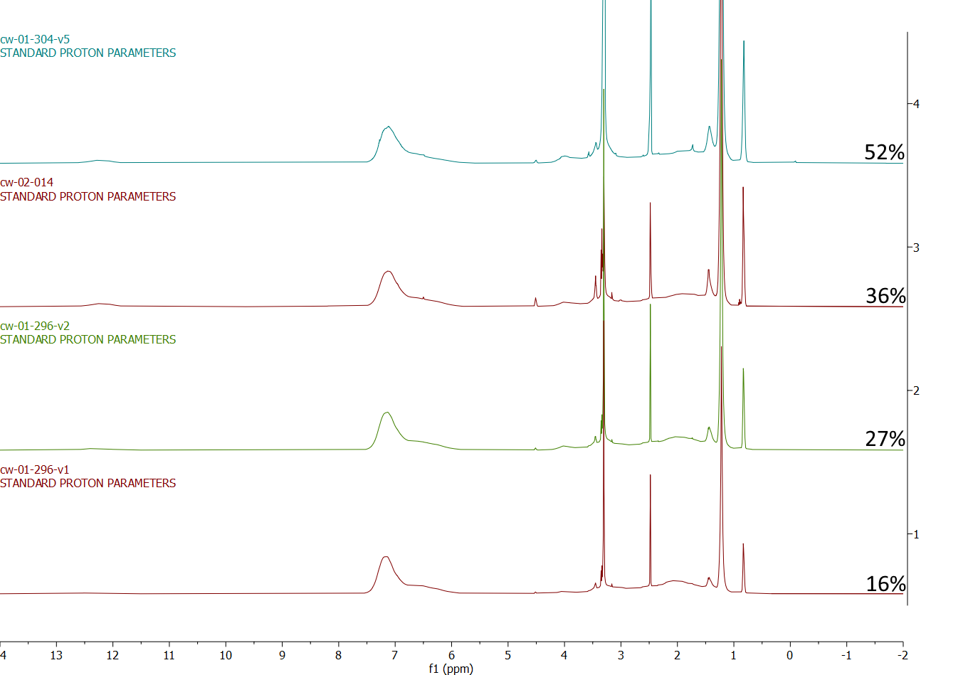

Figure A8. ¹H NMR spectra for the acid form precursors of all Dodec polymer samples. The peaks at 2.5 and 3.3 are residual DMSO and H₂O solvent peaks, respectively. The peak at 0.83 was used to determine extent of esterification of the samples, which is reported to the right of each spectrum.

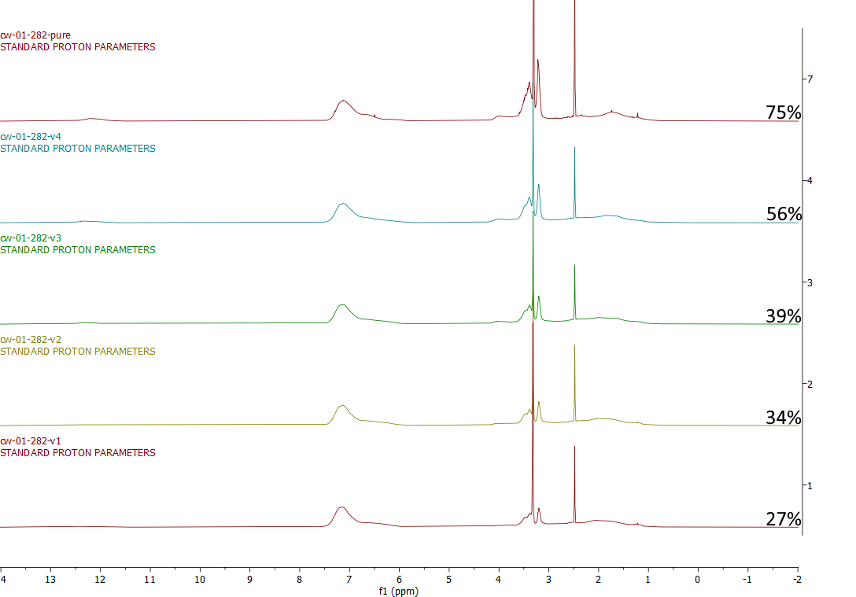

Figure A9. ¹H NMR spectra for the acid form precursors of all DEG polymer samples. The peaks at 2.5 and 3.3 are residual DMSO and H₂O solvent peaks, respectively. The peak at 3.2 was used to determine extent of esterification of the samples, which is reported to the right of each spectrum.

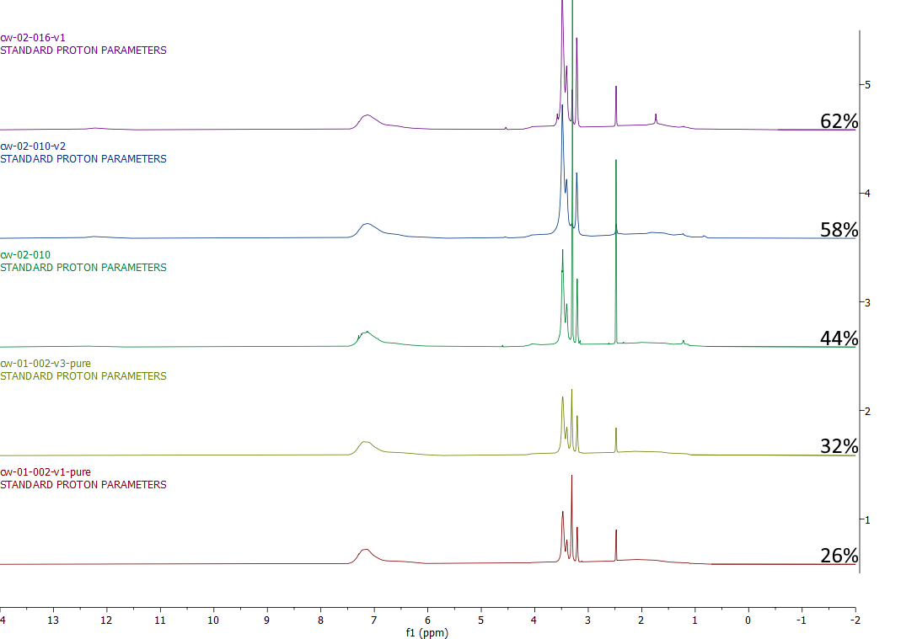

Figure A10. ¹H NMR spectra for the acid form precursors of all TEG polymer samples. The peaks at 2.5 and 3.3 are residual DMSO and H₂O solvent peaks, respectively. The peak at 3.2 was used to determine extent of esterification of the samples, which is reported to the right of each spectrum.

Appendix B: Supporting Information for Chapter III

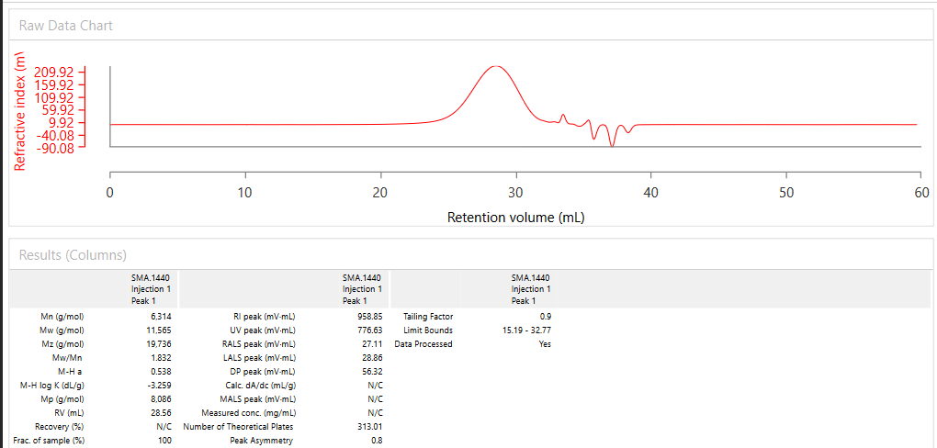
Figure B1. Gel permeation chromatogram of SMA 1440. This spectrum was obtained using an OMNISEC REVEAL from Malvern Panalytical using THF as the solvent, operating at room temperature, and molecular weights are determined via triple detection (Refractive index, low angle scattering, and viscometry).

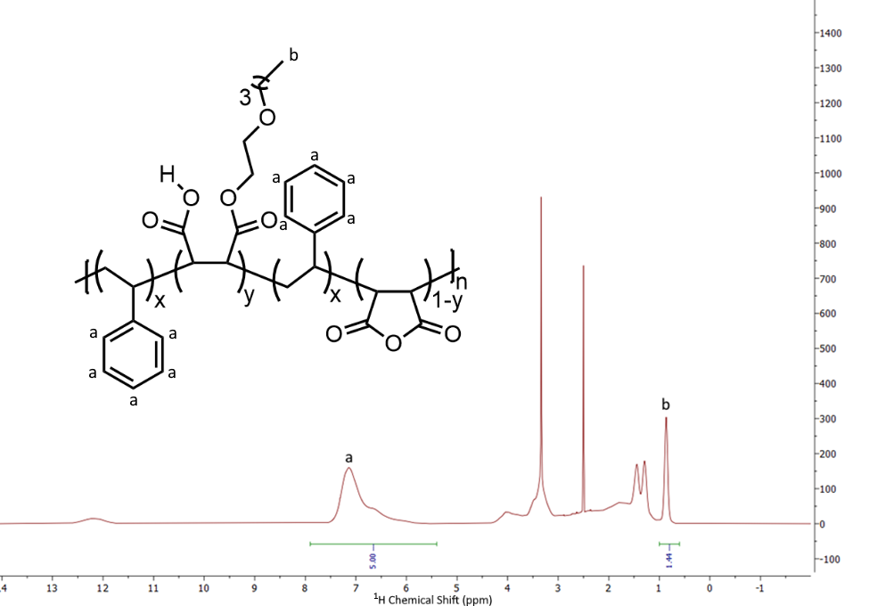
Figure B2. Determination of the extent of esterification of our SMA 1440 sample. The calculation below shows this polymer’s maleate groups are around 48% monoesterified with 2-butoxyethanol, assuming a 1.5:1 ratio of styrene:maleic anhydride.

y = $\frac{5*I_{b}}{3*I_{a}}$
y = Extent of esterification
Ia = Integration of the aryl peaks (a)
Ibc = Integration of the peaks corresponding to the terminal methyl group protons of the attached sidechains (b)

Figure B3. Emission spectra of SMA 1440 samples heated for 168 h at 80 °C (blue), 80 °C while shielded from light (green), 40 °C (black), and 40 °C while shielded from light(purple).

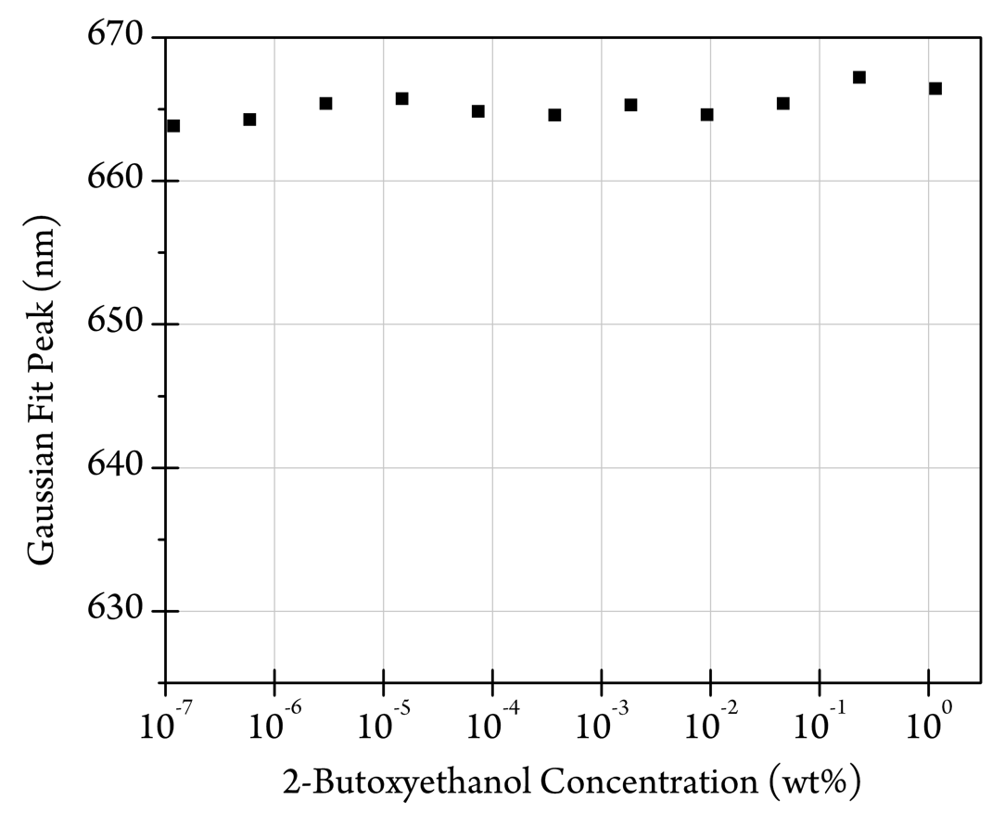

Figure B4. The peaks of Gaussian fits plotted to the emission spectra of Nile Red in solutions of 2-butoxyethanol.
Appendix C: Supporting Information for Chapter IV

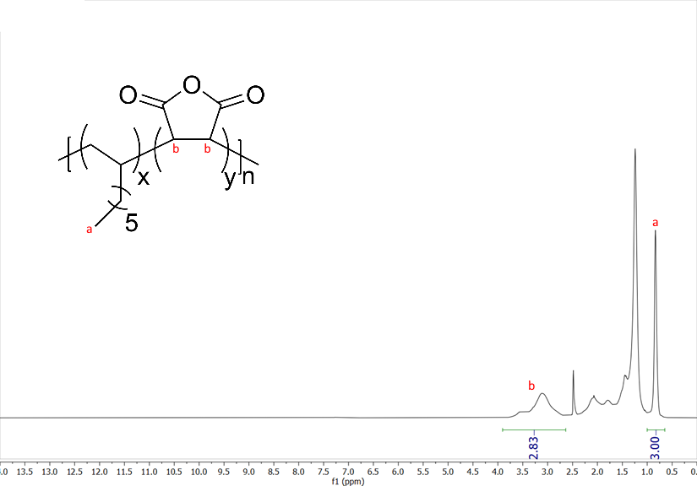
Figure C1. An example of how the incorporation ratio of each monomer was determined via ¹H NMR spectroscopy. The solvent is DMSO-D₆. The ratio was determined using the equation below. For this example, this results in a 1-octene:maleic anhydride ratio of 0.71:1, or 1:1.4 when normalized.
x = $\frac{2*I_{b}}{3*I_{a}}$
x = Maleic anhydride repeat units per styrene unit
I_{a} = Integration of the methyl peaks of the linear alkene unit (a)
I_{b} = Integration of the peaks corresponding to maleic anhydride backbone protons (b)

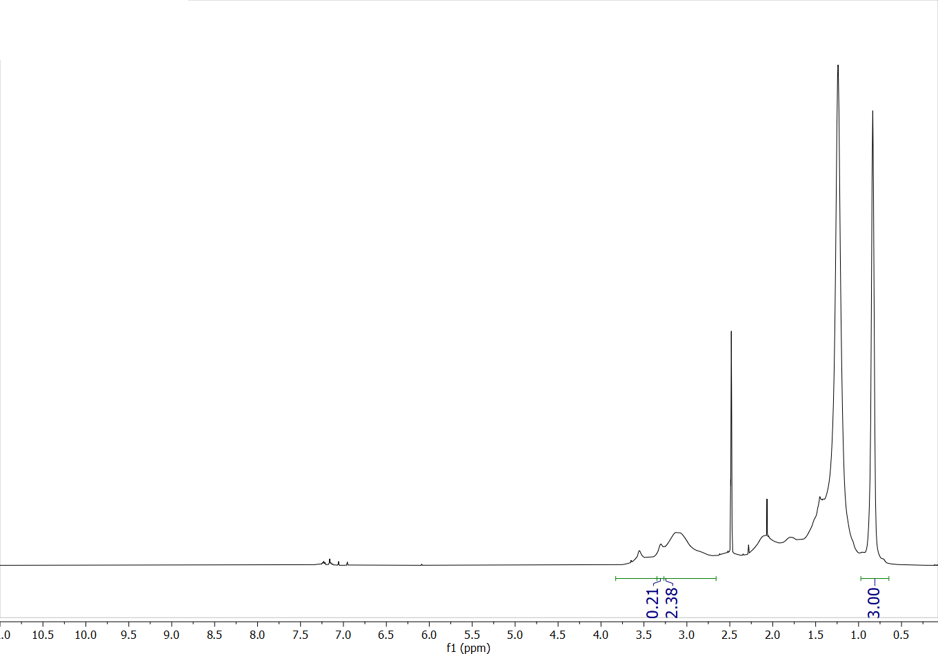
Figure C2: ¹H NMR Spectra of C₈MA. The peaks at 2.5 and 3.3 are residual DMSO and H₂O, respectively. The H₂O peak was subtracted out of the maleic anhydride backbone proton integration before incorporation ratio calculation. This sample has a 1-octene:maleic anhydride incorporation ratio of 1:1.1.

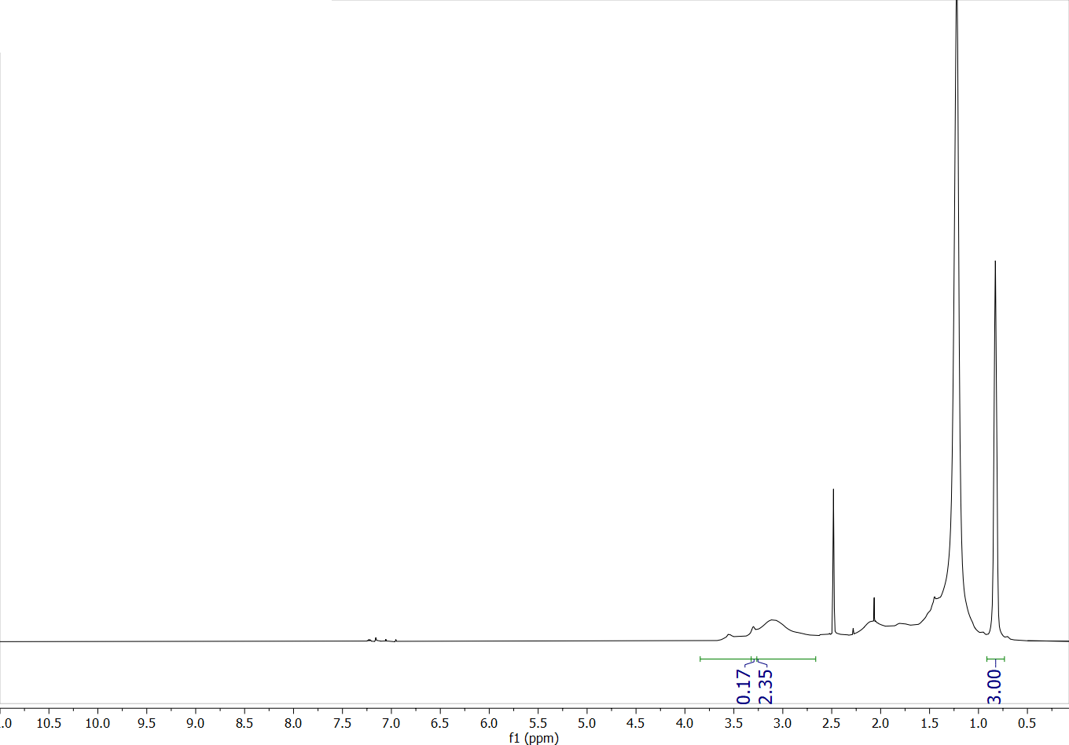
Figure C3. ¹H NMR Spectra of C₁₀MA. The peaks at 2.5 and 3.3 are residual DMSO and H₂O, respectively. The H₂O peak was subtracted out of the maleic anhydride backbone proton integration before incorporation ratio calculation. This sample has a 1-decene:maleic anhydride incorporation ratio of 1:1.1.
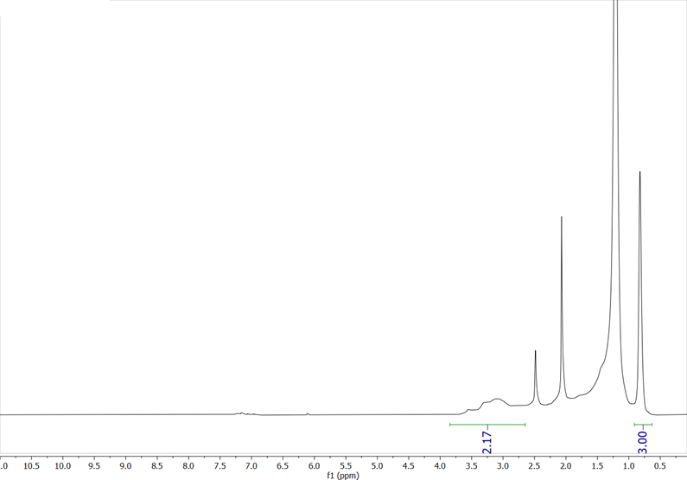
Figure C4. ¹H NMR Spectra of C₁₂MA. The peaks at 2.5 and 3.3 are residual DMSO and H₂O, respectively. The H₂O peak was subtracted out of the maleic anhydride backbone proton integration before incorporation ratio calculation. This sample has a 1-dodecene:maleic anhydride incorporation ratio of 1:1.1.

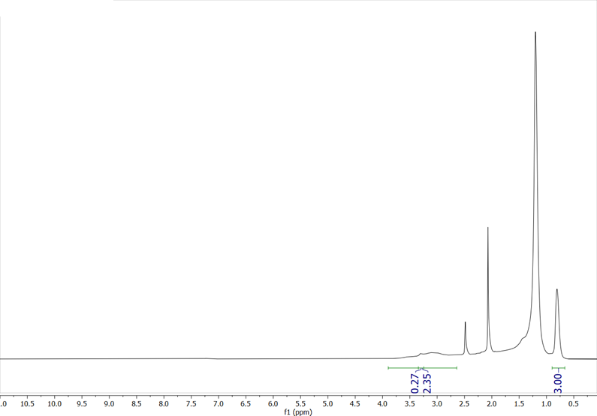
Figure C5. ¹H NMR Spectra of C₁₄MA The peaks at 2.5 and 3.3 are residual DMSO and H₂O, respectively. The H₂O peak was subtracted out of the maleic anhydride backbone proton integration before incorporation ratio calculation. This sample has a 1-tetradecene:maleic anhydride incorporation ratio of 1:1.

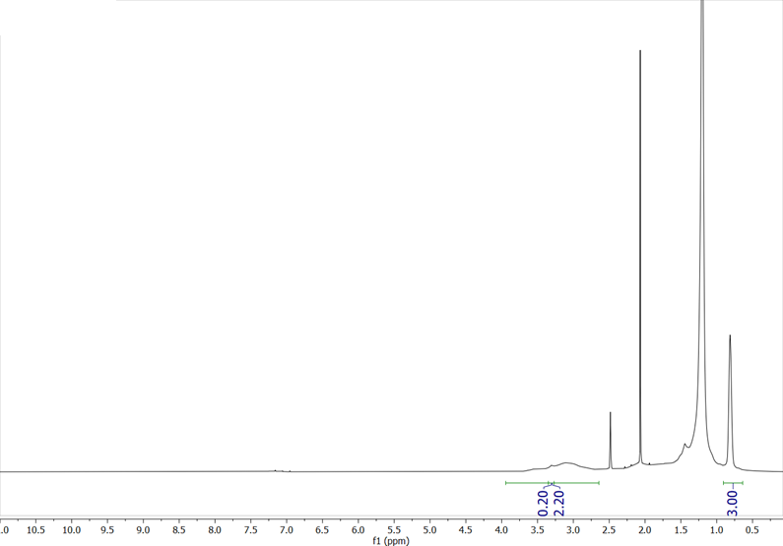
Figure C6. ¹H NMR Spectra of C₁₄MA^{1.8}. The peaks at 2.5 and 3.3 are residual DMSO and H₂O, respectively. The H₂O peak was subtracted out of the maleic anhydride backbone proton integration before incorporation ratio calculation. This sample has a 1-tetradecene:maleic anhydride incorporation ratio of 1:1.

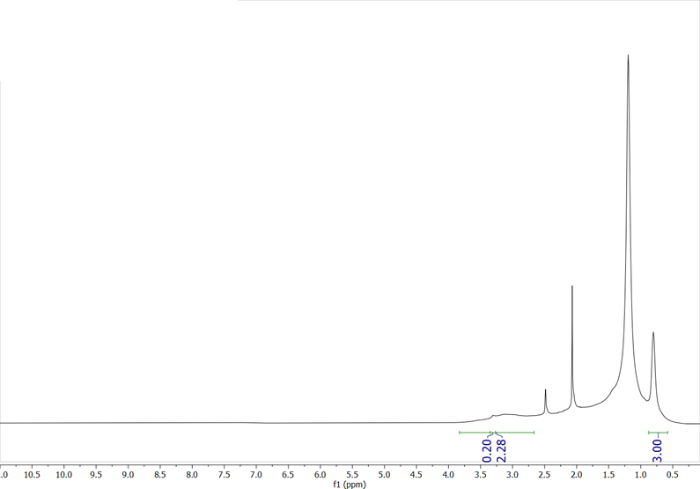
Figure C7. ¹H NMR Spectra of C₁₄MA^{3.9}. The peaks at 2.5 and 3.3 are residual DMSO and H₂O, respectively. The H₂O peak was subtracted out of the maleic anhydride backbone proton integration before incorporation ratio calculation. This sample has a 1-tetradecene:maleic anhydride incorporation ratio of 1:1.

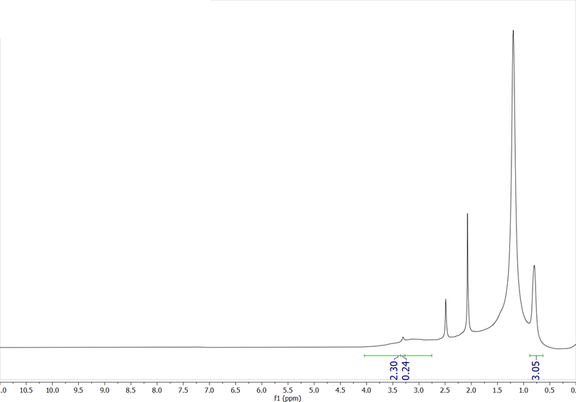
Figure C8. ¹H NMR Spectra of C₁₄MA^{4.8}. The peaks at 2.5 and 3.3 are residual DMSO and H₂O, respectively. The H₂O peak was subtracted out of the maleic anhydride backbone proton integration before incorporation ratio calculation. This sample has a 1-tetradecene:maleic anhydride incorporation ratio of 1:1.

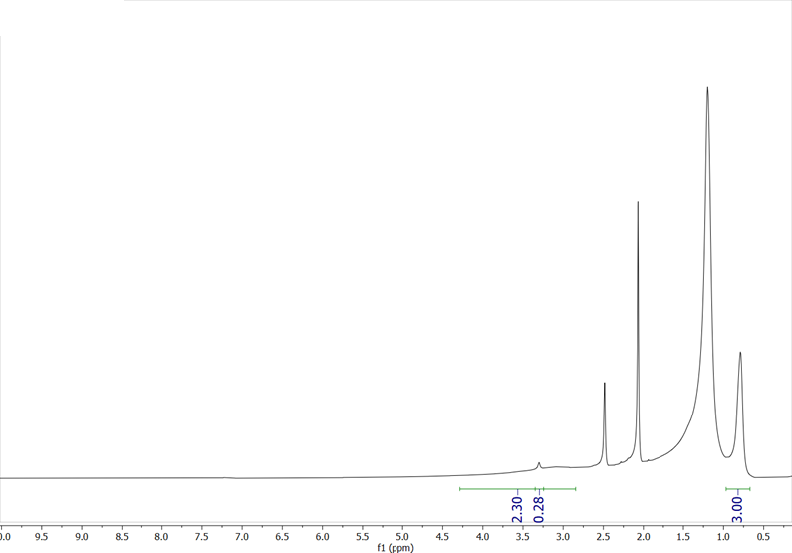
Figure C9. ¹H NMR Spectra of C₁₄MA^{5.6}. The peaks at 2.5 and 3.3 are residual DMSO and H₂O, respectively. The H₂O peak was subtracted out of the maleic anhydride backbone proton integration before incorporation ratio calculation. This sample has a 1-tetradecene:maleic anhydride incorporation ratio of 1:1.

Figure C10. Full DLS spectra used to determine the size of PSI-t nanodiscs.

Figure C11. Control DLS spectra of a sample taken from an empty SDG.

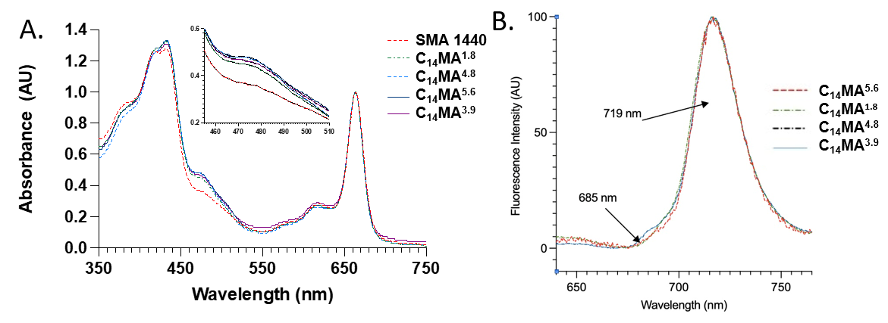
Figure C12. Characterization of the tetrameric PSI bands, after protein extraction from TS-821, from the sucrose density gradients using A) UV/Vis Spectroscopy, B) low-temperature fluorescence,

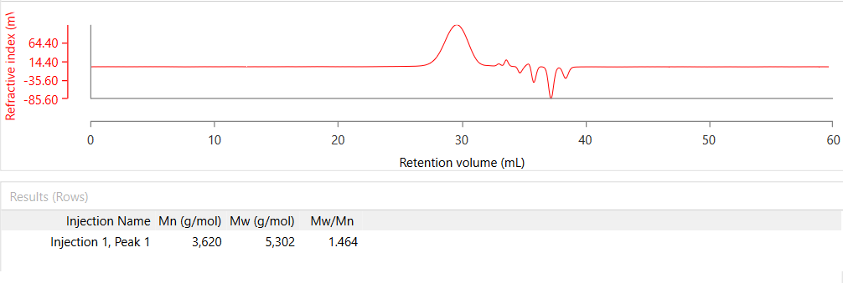
Figure C13. Gel permeation chromatogram of C₈MA.

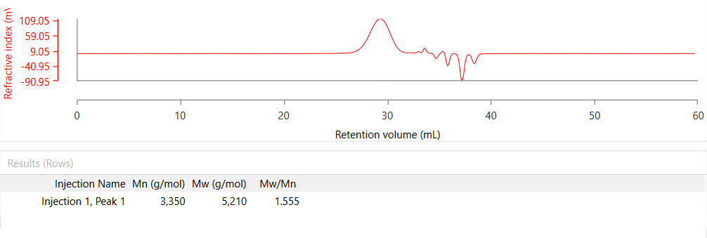
Figure C14. Gel permeation chromatogram of C₁₀MA.

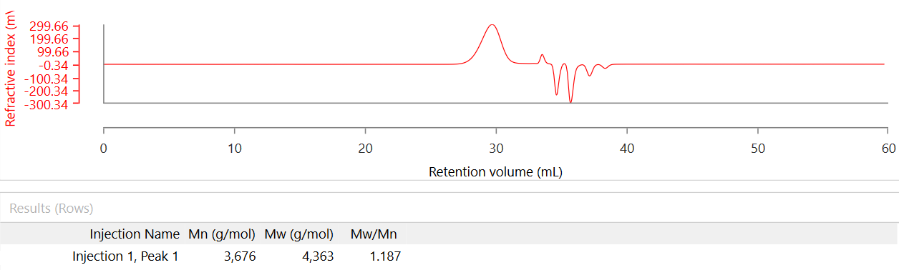
Figure C15. Gel permeation chromatogram of C₁₂MA.

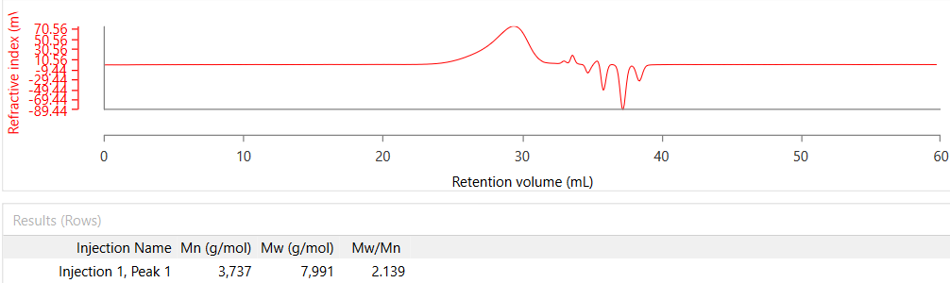
Figure C16. Gel permeation chromatogram of C₁₄MA.

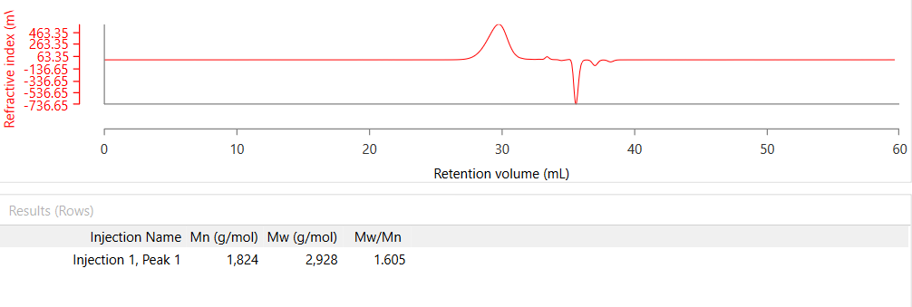
Figure C17. Gel permeation chromatogram of C₁₄MA^{1.8}.

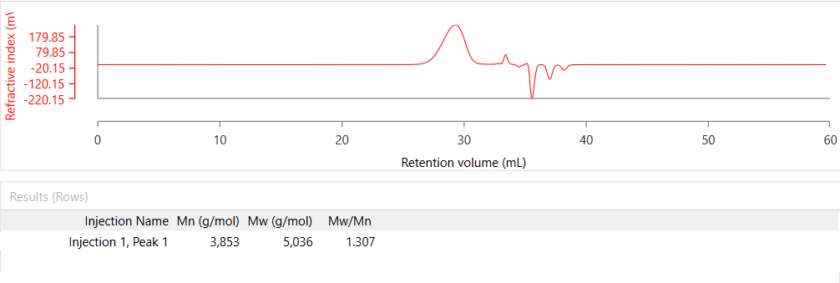
Figure C18. Gel permeation chromatogram of C₁₄MA^{3.9}.

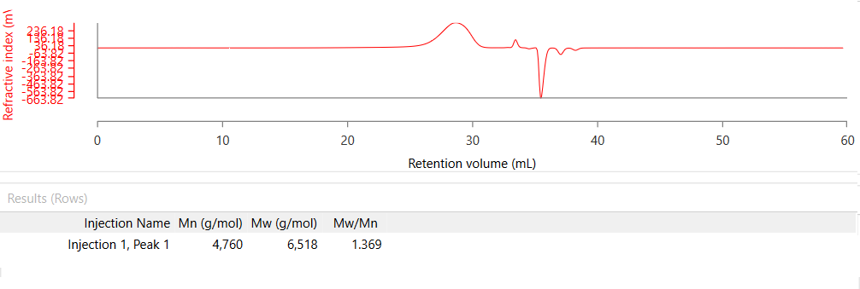
Figure C19. Gel permeation chromatogram of C₁₄MA^{4.8}.

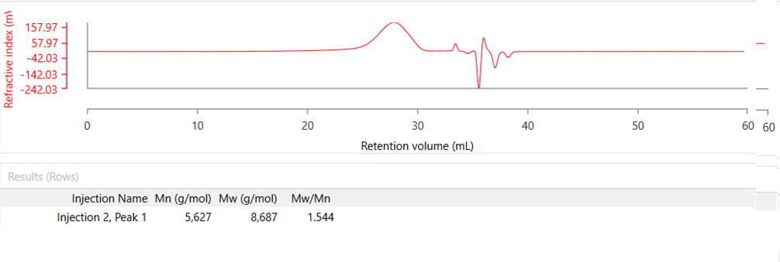
Figure C20. Gel permeation chromatogram of C₁₄MA^{5.6}.

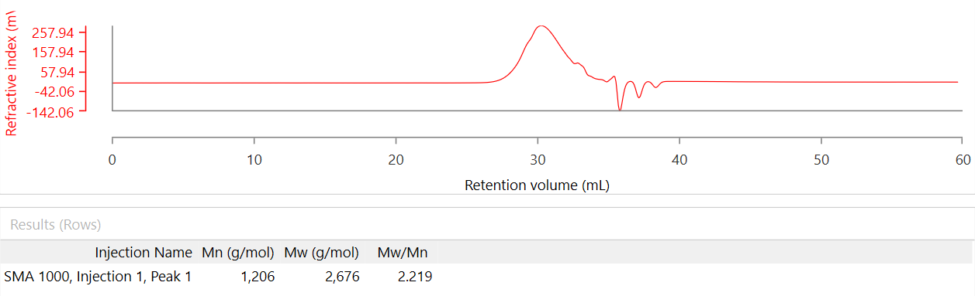
Figure C21. Gel permeation chromatogram of SMA 1000.

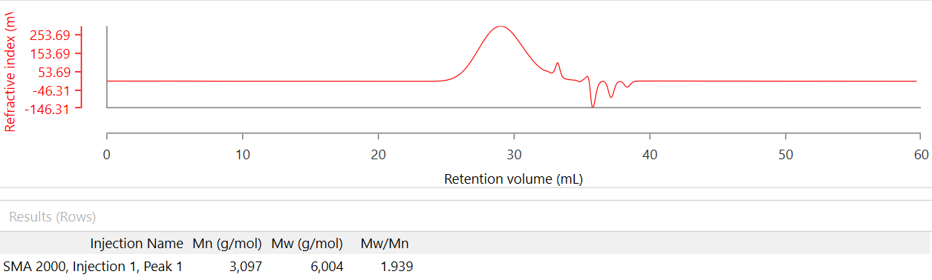
Figure C22. Gel permeation chromatogram of SMA 2000.

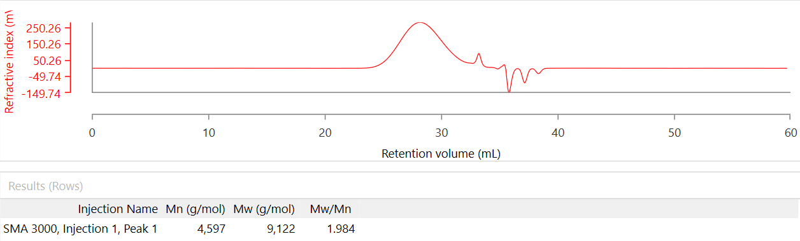
Figure C23. Gel permeation chromatogram of SMA 3000.

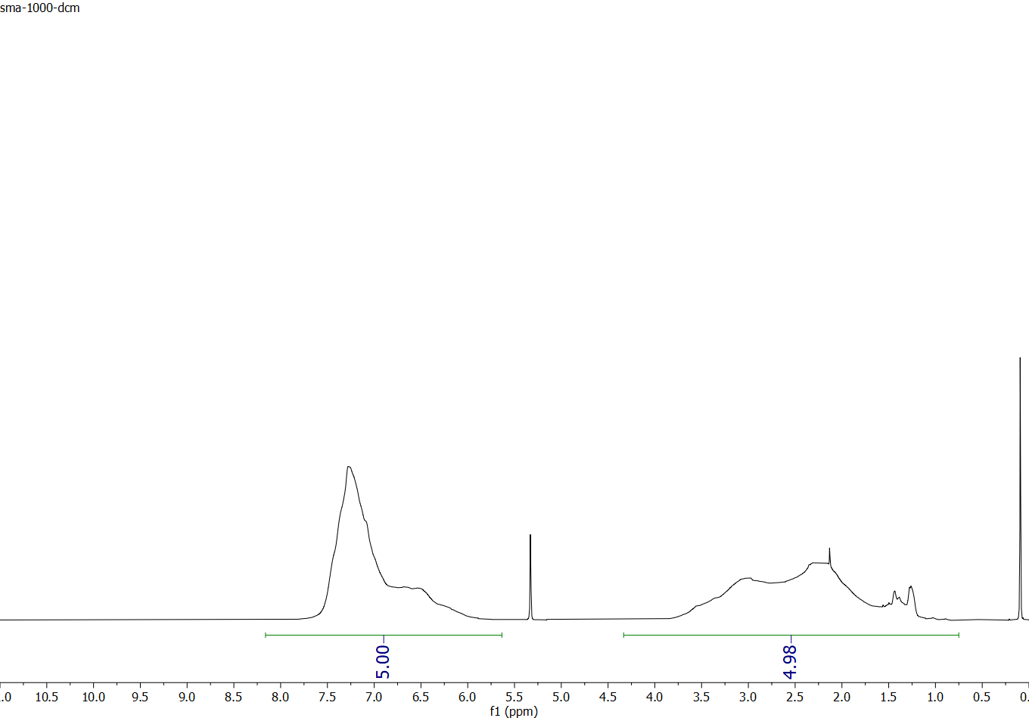
Figure C24. An example of how the incorporation ratio of each monomer was determined via ¹H NMR spectroscopy for the commercial SMA samples. The solvent is dry DCM-D₂. The ratio was determined using the equation below. For this example (SMA 1000), this results in a styrene:maleic anhydride ratio of 1.01:1.

x = $\frac{\left(5*I_{bc}-3*I_{a}\right)}{2*I_{a}}$

x = Maleic anhydride repeat units per styrene unit
I_{a} = Integration of the aryl peaks (a)
I_{bc} = Integration of the peaks corresponding to the styrene and maleic anhydride backbone protons (b+c)

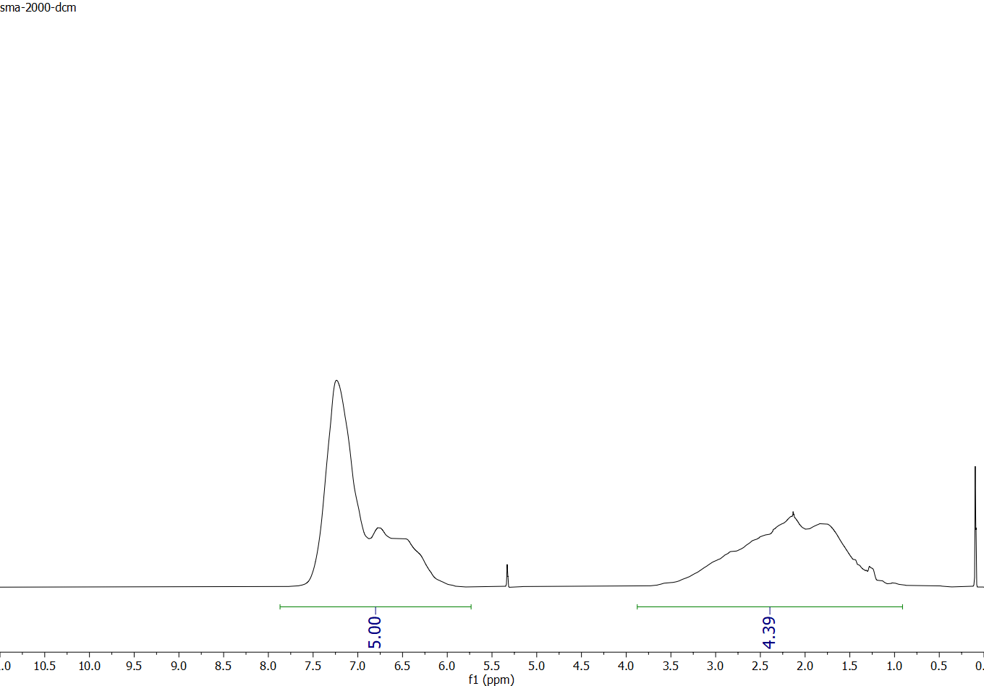
Figure C25. Determination of monomer incorporation in SMA 2000 using ¹H NMR spectroscopy. The solvent is dry DCM-D₂. This results in a styrene:maleic anhydride ratio of 1.44:1.

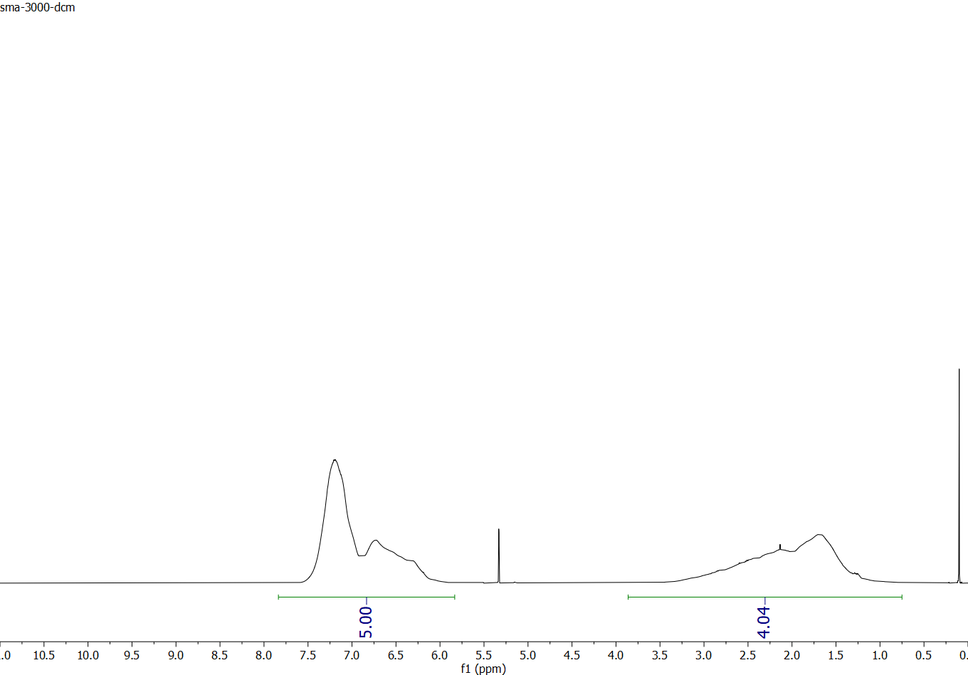
Figure C26. Determination of monomer incorporation in SMA 3000 using ¹H NMR spectroscopy. The solvent is dry DCM-D₂. This results in a styrene:maleic anhydride ratio of 1.92:1.

VITA
Cameron Edward Workman was raised in Sevierville, Tennessee. In the spring of 2015, he graduated from Sevier County High School, while also attaining an Associate’s Degree in Chemistry from Walter’s State Community College. The following fall, Cameron started his studies at the University of Tennessee, Knoxville, where he would graduate with a B.S. in Chemistry in the Spring of 2018. Cameron decided to stay at the University of Tennessee, Knoxville to pursue a PhD in polymer chemistry. Under the guidance of Professor Brian Long, Cameron published several peer-reviewed manuscripts, spoke at national and international conferences, and mentored undergraduate students. In addition, Cameron served a term representing the Association of Graduate Students on the student-faculty interaction committee where he worked to ensure a safe and fun environment for the student body and faculty alike. In his free time, Cameron enjoys listening to and playing heavy metal music, doughnut burgers, hockey, and video games (especially Destiny).

