Stiffness-Driven Design and Interface Debonding Study of
FRP Sandwich Structures for Bridges

A Dissertation
Presented for the
Doctor of Philosophy
Degree
The University of Tennessee, Knoxville

Wenchao Song

December 2012

Dedication
I dedicate this dissertation to my parents, Guochen Song and Chunlan Yang, for their unending love and encouragement.

Acknowledgements
Thanks be to God for bringing me to the University of Tennessee Knoxville. Because of His grace, I had the chance to pursue my doctorate degree in this university and enrich my personal life with wonderful experiences.
My sincere appreciation goes to my advisor, Dr. Zhongguo John Ma, for offering me the chance to study in his research group. Without his trust and encouragement, it is impossible for me to finish my dissertation.
My wholehearted thanks also go to all my committee members, Dr. Edwin G. Burdette, Dr. Richard M. Bennett, Dr. John Landes and Dr. Dayakar Penumadu, for serving as my committee members and offering help to the accomplishment of this dissertation.
My special thanks are given to Dr. Akawut Siriruk for his altruistic help in my experiment. He spent a lot time in helping me with the setup of some tests and advising me how to run them.
My appreciation also goes to Mr. Ken Thomas and Larry Roberts for their technical supports and material preparation.
I would also like to thank my colleagues and friends, Dr. Lungui Li, Dr. Peng Zhu, Dr. Qi Cao, Mr. Xin Jiang, Mr. John Cabage, Mr. Anupont Thaicharoenporn and Ms. Jing Song for their help and friendship.
Finally, my profound thanks are given to KSCI, INC for the donation of FRP sandwich panels in this study. The financial support provided by the National Science Foundation – NSF CAREER program (CMS – 0550899) is gratefully acknowledged as well.
Abstract
Bridge decks entirely made of fiber reinforced polymer (FRP) materials are a potential solution to fast construction in bridge engineering. This study mainly focuses on the stiffness-driven design of FRP decks for short-span slab bridges and the interface debonding of an FRP sandwich structure with honeycomb cores. As is evidenced by the analytical and experimental results in this study, these two topics are closely related to the application of FRP materials in bridge deck construction. The design verification of an FRP slab bridge showed that its design should be controlled by stiffness rather than strength. The tests of the FRP sandwich panels at cold temperatures indicated that interface debonding might occur even at the service load level. In order to facilitate the stiffness-driven design of typical FRP slab bridges in practice, this study proposed equivalent strip width expressions which allow them to be designed by Timoshenko beam theory. The key factors for the expressions were identified and a design procedure was recommended in this study as well. Finally, this study investigated the application of tilted sandwich debond (TSD) tests to the interface debonding study of the sandwich structure. This study showed that TSD tests with proper modifications could be used to measure interfacial fracture toughness at different mixed-mode ratios. Recommendations concerning experimental setups and the data reduction method associated with TSD tests were also suggested in this study.
Table of Contents
Chapter 1 : Introduction 1
Chapter 2 : Design Verification and Experimental Study of FRP Sandwich Panels 6
2.1 Design Verification of an FRP Sandwich Slab Bridge 7
2.1.1 Introduction 7
2.1.2 Preliminary Analysis of the FRP Superstructure 8
2.1.3 Finite Element Analysis of the FRP Superstructure 14
2.1.4 Verification of FEA by Field Load Testing Results 17
2.1.5 Conclusions 18
2.2 Behaviors of HFRP Sandwich Panels at Cold Temperatures 18
2.2.1 Introduction 18
2.2.2 Finite Element Analysis 21
2.2.3 Service Load Condition in the Experiment 26
2.2.4 Experimental Setup and Procedure 29
2.2.5 Experimental Results and Discussion 31
2.2.6 Conclusions 38
Chapter 3 : Theoretical Study of Specially Orthotropic FRP Plates 39
3.1 The Governing Differential Equation of Specially Orthotropic Plates 40
3.2 The Bending of SOPs under Constant Edge Moment and Displacement 42
3.2 Equivalent Strip Width for FRP Slab Bridges 47
Chapter 4 : Interface Debonding Study of HFRP Sandwich Panels 62
4.1 Introduction 64
4.2 Experimental Study and Results 69
4.2.1 Specimen Preparation 69
4.2.2 Experimental Setup 72
4.2.2 Experimental Results and Discussion 75
4.3 Finite Element Analysis and Parametric Study 79
4.3.1 Finite Element Analysis and Its Verification 79
4.3.2 Specimen Lengths for Future Tests 84
4.3.3 Parametric Study by FEA 85
4.4 Data Reduction Method for the Experimental Study 91
4.5 Conclusions 94
Chapter 5 : Conclusions and Future Work 96
5.1 Conclusions 96
5.2 Future Work 98
References 99
Vita 111

List of Tables

Table Page
Table 2.1 Properties of Constituent Materials 10
Table 2.2 Properties of a Lamina 10
Table 2.3 Laminate Lay-ups 11
Table 2.4 Material Properties of Face Sheets 12
Table 2.5 Truck Loads Used in Field Tests 17
Table 2.6 Material Properties of Face Sheets and Cores 23
Table 2.7 Critical Interfacial Stress States at 14.2 kN (3.2 kip) 28
Table 3.1 Material Properties of the Plates 46
Table 3.2 Rotations at Different Points along the Edge at x=0 (w=25.4 mm) 46
Table 3.3 Rotations at Different Points along the Edge at x=0 (M_{x}=1.36 kN-m) 46
Table 3.4 The Deflections at the Centers of FRP Slabs 52
Table 4.1 Material Properties of a Face Sheet 72
Table 4.2 K_{I}/K_{II} from FEA 82
Table 4.3 P_{cr} at Different Crack Lengths 84
Table 4.4 P_{cr} Comparisons from Specimen 1 85

List of Figures
Figure Page
Figure 1.1 An FRP Deck with Honeycomb Cores 2
Figure 1.2 An FRP Deck with Corrugated Cores 3
Figure 2.1 The Wheel Loads of A DB-24 Truck 13
Figure 2.2 Cross Section of the FRP Sandwich Superstructure (Unit: mm) 16
Figure 2.3 The Model for FEA 16
Figure 2.4 HFRP Sandwich Structure (Unit: mm) 23
Figure 2.5 Lay-up of the Laminate for a Face Sheet 23
Figure 2.6 FE Model of a HFRP Specimen 25
Figure 2.7 Setup of the Trial Test 25
Figure 2.8 Experimental and Theoretical Load-Strain Curves 25
Figure 2.9 The Experimental Setup (Unit: mm) 29
Figure 2.10 Slopes of Load-Strain Curves for Specimen 1 (Mid-span) 32
Figure 2.11 Slopes of Load-Strain Curves for Specimen 1 (Quarter-span) 32
Figure 2.12 Slopes of Load-Strain Curves for Specimen 2 (Mid-span) 33
Figure 2.13 Slopes of Load-Strain Curves for Specimen 2 (Quarter-span) 33
Figure 2.14 Slopes of Load-Strain Curves for Specimen 3 (Mid-span) 34
Figure 2.15 Slopes of Load-Strain Curves for Specimen 3 (Quarter-span) 34
Figure 2.16 Stiffness Ratios at Different Temperatures 36
Figure 2.17 Interface Debonding at One Free End 37
Figure 3.1 Equivalent Single-layer SOP 40
Figure 3.2 Geometry of a Slab Bridge 48
Figure 3.3 Deflections of FRP Slabs with Different Shear Moduli 53
Figure 3.4 Deflections of One-lane FRP Slabs under a Design Truck 56
Figure 3.5 Deflections of Two-lane FRP Slabs under Two Design Tandems 56
Figure 3.6 Deflections of FRP Slabs with Different In-plane Properties 57
Figure 3.7 Flowchart of the Design Procedure 61
Figure 4.1 Pure Mode Loading 63
Figure 4.2 A Honeycomb Core Cell 69
Figure 4.3 Specimen’s Cross Section 70
Figure 4.4 A Precracked Specimen 71
Figure 4.5 A Schematic Illustration of a TSD Test 73
Figure 4.6 An Experimental Setup 74
Figure 4.7 Loads Vs. Displacements 75
Figure 4.8 Compliances Vs. Crack Lengths 76
Figure 4.9 G_{c} Vs. a 77
Figure 4.10 Fiber Bridging at an Interface 78
Figure 4.11 FE Model of a TSD Specimen 80
Figure 4.12 Compliance Comparisons 83
Figure 4.13 G_{II}/G_{I} with Different t_{Al} and Crack Lengths 88
Figure 4.14 G_{II}/G_{I} with Different t_{Al} and Tilt Angles 89
Figure 4.15 G_{II}/G_{I} with Different Crack Lengths and Tilt Angles 90
Figure 4.16 A Plate-on-Elastic-Foundation Model 91
Figure 4.17 dC/da vs. Crack Lengths 94

: Introduction
Fiber reinforced polymer (FRP) composite materials are now rapidly making their way into civil engineering, especially in bridge deck construction. Currently several FRP bridges whose decks are entirely made of FRP materials are in service (Plunkett 1997, Alampalli et al. 2002, Ji et al. 2010). The Federal Highway Administration (FHWA) lists 40 bridges nationwide in which FRP composite decks and superstructures have been used. The popularity of FRP materials can be largely attributed to their superior material properties, such as light weight, good durability and fatigue resistance, and ease of installation. Therefore, FRP materials are suitable for bridge deck construction, especially for accelerated bridge constructions (Li et al. 2010).
As indicated by the name, FRP composite materials are made of fibers and matrix materials like polymers. For bridge decks entirely made of FRP composite materials, which are termed as FRP decks in this study, the fibers and matrices are predominantly glass fibers and polyester/vinyl ester resins. Glass fibers are lightweight, flexible, and inexpensive. Therefore they are widely used in low-cost industrial applications and suitable for the construction of FRP decks (Barbero 2010). The glass fibers can be further divided into several categories such as E-glass fibers (E for electrical), S-glass fibers (S for strength), C-glass fibers (C for corrosion) and so on. The matrix materials for FRP decks are mainly polyester and vinyl ester. Polyester and vinyl ester are the thermoset matrices which are formed by the irreversible chemical transformation of a resin system into cross-linked polymer matrices. Polyester is widely applied in the construction of FRP bridge decks because it has moderate physical properties and relatively low cost. Compared to polyester, vinyl ester has higher elongation and better corrosion properties. The cost of vinyl ester is between polyester and high-performance epoxy resins. The typical mechanical properties of glass fibers and polyester/vinyl ester can be found in the work by Barbero (2010).
Glass fibers and polyester/vinyl ester are the constituent materials of a lamina or laminae. A laminate may be fabricated by stacking several laminae. The laminae in a laminate may possess different material properties and/or fiber orientations so that the laminate can be customized to meet certain requirements. FRP bridge decks are made up of different laminates. In current practice, the laminates are often varied to form the cross sections of FRP decks. The FRP decks with two cross sections which are manufactured by different commercial fabricators are shown in Figure 1.1 and Figure 1.2 (Ji et al. 2010, Song and Ma 2011).

Figure 1.1 An FRP Deck with Honeycomb Cores
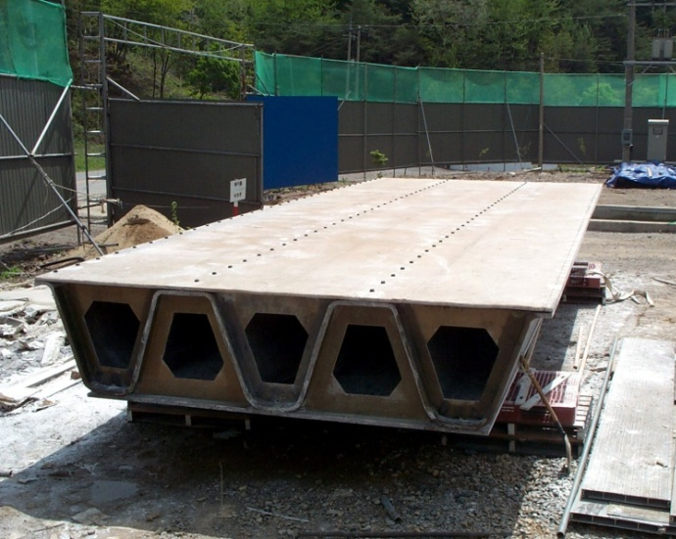
Figure 1.2 An FRP Deck with Corrugated Cores

The modeling of structural components made of FRP composite materials usually consists of three levels: the microscopic level, the macroscopic level, and the structural level (Altenbach et al. 2004). At the microscopic level, the average mechanical properties of a lamina are estimated from its constituents like the fibers and matrices described above. At this stage, besides material properties of fibers and matrices, fiber volume fraction and fiber arrangement are also important to the estimation of the material properties of a lamina. The fiber volume fraction usually lies between 0.3 and 0.7. The potential fiber arrangement in a lamina includes unidirectional fibers, bidirectional fibers, randomly oriented short fibers and so on. At the macroscopic level, a lamina will be treated as a homogeneous ply for the lay-up of a laminate. At this level, the average material properties of a laminate will be estimated from the average material properties and stacking sequence of the laminae in it. Once the average material properties of a laminate containing several laminae are obtained, the whole laminate will be treated as an equivalent single-layer structural component with homogeneous anisotropic material properties. Finally, at the structural level, the mechanical behavior of structural members like FRP decks are analyzed using the results from the analysis at the macroscopic level. Examples of the analysis conducted at the three levels may be found in the research by Davalos et al. (1996) and Davalos et al. (2001). This study mainly focuses on the behavior of FRP decks at the structural level. At the structural level, a FRP deck may be idealized as an equivalent single-layer orthotropic plate with its principal material directions aligned with global directions.
Although FRP composite materials are gaining popularity and showing promising prospects in bridge engineering, several issues may require further investigation before they can be widely applied in bridge deck construction. First, FRP’s low moduli of elasticity lead to a deflection driven design which does not allow a designer to fully capitalize on the FRP's strength (FHWA 2011). Moreover, a thorough analysis of the material's behavior requires a finite element model. In practice, bridge designers may not always have access to finite element analysis (FEA). Therefore, it is necessary to propose some methods so that the deflections of FRP decks can be predicted without resorting to FEA. Second, some FRP decks in current practice are sandwich structures like the one in Figure 1.1. In FRP sandwich decks, one of the major failure modes is the debonding of the interfaces between face sheets and the cores sandwiched between them (Alagusundaramoorthy et al. 2006, Kalny et al. 2003). This failure mode, which is called interface debonding in this study, should be studied by fracture mechanics instead of strength-based criteria (Wang 2004). Although the interface debonding of sandwich structures with solid cores has been studied in previous research (Carlsson and Kardomateas 2011), the investigation of FRP sandwich structures with honeycomb cores (HFRP sandwich structures hereinafter) with explicit considerations of the actual core geometry is sparse. Further research is required to evaluate if the analytical and experimental methods for the interface debonding of sandwich structures with solid cores are also valid for HFRP sandwich structures.
The two topics described above are vital to the application of FRP decks in practice and are of interest to this study. Therefore, this study concentrates on these two topics and is outlined as follows. First, design verification and experimental study of FRP sandwich deck panels are introduced to highlight the importance of these two topics. By verifying the design of an FRP slab bridge (Ji et al. 2010), this study shows its design should be controlled by stiffness and it is essential to develop equivalent strip width for deflection prediction. The experimental study provides the justification for the necessity of investigating the other topic concerning interface debonding. Then, the analytical study of a couple of specially orthotropic plates under bending is discussed. The results from the analytical study are used to facilitate the deflection prediction of FRP slab bridges and justify some assumptions in fracture toughness tests. Finally, the tilted sandwich debond (TSD) tests are examined for the study of the interface debonding of HFRP sandwich panels. The TSD tests in this study were designed and/or modified based on several interfacial fracture toughness tests conducted by Siriruk et al. (2009) and Siriruk et al. (2011). The potential influences of several parameters on the measurement of interfacial fracture toughness are discussed based on the results from experiment and a parametric study by finite element analysis (FEA).

: Design Verification and Experimental Study of FRP Sandwich Panels
In recent years, the renewal of deteriorated bridges with rapid construction and minimum disruption to public traffic has been a nationwide concern. Bridges with FRP decks are considered as a potential solution to the problem due to the material’s superior properties as described above. FRP decks in practice have various cross sections and structural configurations which are designed to meet the strength and stiffness requirement. This chapter first discusses the analysis of an FRP slab bridge which consists of two sandwich deck panels with corrugated cores. The FRP slab bridge was constructed and opened to the public in South Korea in 2002. Based on the discussion of the FRP slab bridge, this chapter shows that the design of the FRP slab bridge should be controlled by stiffness rather than strength. Although a preliminary analysis of the FRP slab bridge could be performed by beam theory, the detailed design and analysis was still accomplished through FEA.
The stiffness of FRP decks is vital to their design. The behavior of FRP materials and structures subjected to environmental effects should also be an important concern when they are applied in bridge deck construction. Currently the application of FRP materials to bridge deck construction in cold regions has not received much attention from scientific and engineering communities. (Karbhari et al 2003, Liu and Karbhari 2007). According to the literature available, when temperature is the only variable which is varied in the study, cold temperatures are generally beneficial to the stiffness and strength of FRP materials (Dutta and Hui 1996, Dutta and Porter 2004, Robert and Benmokrane 2010). However, when cold temperatures are coupled with moisture effects, the combined effects may potentially damage the stiffness and strength of FRP materials (Karbhari et al. 2002). It is also experimentally observed that cold temperature is detrimental to fracture toughness of FRP specimens (Ural et al. 2003, Dutta 2001). It is noted that most of the study concerning the effects of cold temperatures is at the material coupon level. Research concerning this topic at the structural level is relatively sparse. In this chapter, the behavior of several HFRP sandwich panels at different cold temperatures was experimentally investigated, and the results are discussed here. The experiment aimed to study the influences of cold temperatures on the stiffness of the HFRP sandwich panels and examine whether or not potential interface debonding may occur due to the combined effects of cold temperatures and service load. The experimental results indicated that for the HFRP sandwich panels used in this study the stiffness increased as the temperature decreased at least up to the service load level. Although there was no stiffness degradation in the tests, the interface debonding did occur at one as-received end of one specimen. The experimental results from this study serve as a supplement to the conclusion from some material coupon-level tests and show the necessity of investigating the interface debonding of the HFRP sandwich panels.

2.1 Design Verification of an FRP Sandwich Slab Bridge

2.1.1 Introduction
FRP composites are a potential solution to rapid construction and renewal of bridge decks. Currently, there are already a number of bridges with FRP decks that are in service. In the United States, there are more than 40 slab bridges with FRP composites (Triandafilou and O’Connor 2009). Several applications of FRP composites in slab bridges can be found in the literature (Plunkett 1996, Alampalli 2002).
The research on FRP decks indicated that their design was controlled by stiffness rather than strength (Hayes et al. 2000, Triandafilou and O’Connor 2009). This study verified the conclusion by analyzing the FRP sandwich structure with corrugated cores in Figure 1.2. This FRP sandwich structure was applied as the superstructure of a short-span slab bridge. When this FRP slab bridge was subjected to field load testing, the original design truck loads were not applied in the actual tests (Ji et al. 2010). Even though the experimental results from field load testing indirectly confirmed that the design of this FRP superstructure should be stiffness-oriented, it is still necessary to perform some analysis to verify this conclusion with the actual design loads.
By presenting the verification of the design of the FRP superstructure, this study first explains the analysis of the sandwich structure at the three levels as described above. Then, the behavior of the FRP superstructure is further discussed according to FEA results. Finally, FEA results are correlated with those from field load testing. This study indicates that the design of the FRP superstructure should be stiffness-oriented and satisfies the requirement for both strength and stiffness.

2.1.2 Preliminary Analysis of the FRP Superstructure
As discussed above, the design and/or analysis of structures with FRP materials are usually conducted at the microscopic or lamina level, the macroscopic or laminate level, and structural level. The following discussion will illustrate the preliminary analysis at each level.
Microscopic-Level Analysis The analysis at the microscopic level is to predict the average material properties of FRP laminae by their constituent materials. The FRP laminae in this study were mainly unidirectional. They could be considered as transversely isotropic materials. The average material properties related to this study were E₁, E₂, υ₁₂ and G₁₂. The subscript 1 denotes the direction parallel to fiber reinforcement and the subscript 2 denotes the in-plane direction perpendicular to fiber reinforcement. The goal of the analysis at this level was to obtain these properties. These properties could be obtained based on two simple rules of mixture (Altenbach et al. 2004). Equation (2.1) to Eq. (2.4) show the calculation of these properties from the material properties of fibers and matrices.
(2.1)
(2.2)
(2.3)
(2.4)
Where E, G, υ denotes the Young’s modulus, shear modulus and Poisson’s ratio of constituent materials. The subscript f denotes fibers and the subscript m denotes matrices. V_{f} is the volume fraction of fibers.
The FRP superstructure in this study used E-glass fibers and vinyl ester as the reinforcement and matrix for laminae. The properties of the constituent materials are given in Table 2.1 (Ji et al. 2010). The V_{f} in this study was approximately 0.393. Using the properties in Table 2.1 and Eq. (2.1) to Eq. (2.4). The predicted material properties of a lamina are shown in Table 2.2.
Table 2.1 Properties of Constituent Materials
 | E (GPa) | G (GPa) | υ
E-glass fiber | 72.4 | 27.6 | 0.22
Vinyl ester | 3.91 | 1.38 | 0.37

Table 2.2 Properties of a Lamina
E₁ (GPa) | E₂ (GPa) | G₁₂ (GPa) | υ₁₂
30.8 | 6.22 | 2.20 | 0.311

Macroscopic-Level Analysis The analysis at the macroscopic level is mainly to calculate the average material properties of a laminate based on the lay-up of FRP laminae in it. The laminates in this study were used to construct the face sheets and corrugated core walls in the FRP sandwich superstructure. The lay-ups of the FRP laminates in this study are shown in Table 2.3 (Ji et al. 2010). In Table 2.3, when the orientation of a lamina is 0°, the direction of its fiber reinforcement is parallel to the span direction.
In the FRP sandwich superstructure, its face sheets were the major components to resist flexure. As a result, the average material properties of the laminates for face sheets should be the main concern at the preliminary analysis stage. The FRP sandwich superstructure was 940 mm (37 in.) thick. Compared to the thickness of the sandwich structure, the thickness of the face sheets in Table 2.3 was relatively small. As a result, this study assumed that the face sheets were mainly subjected to in-plane loads when the whole cross section of the superstructure was under bending. Then, Eq. (2.5) and Eq. (2.6) were applied to predict the average material properties of the laminates for face sheets (Barbero 2010).
Table 2.3 Laminate Lay-ups
Components | Lay-ups of Laminae | Ply’s Thickness | Number  of Plies
Top Face Sheet |  | 0.5 mm | 60
Corrugated Cores |  | 0.5 mm | 80
Bottom Face Sheet |  | 0.5 mm | 60

, , , (2.5)
, , , (2.6)
Where the superscript f denotes face sheets, the superscript k denotes the k^{th} lamina. The subscript i is 1 if the k^{th} lamina is oriented at 0° and 2 if the k^{th} lamina is oriented at 90°. The subscript j is 1 if the k^{th} lamina is oriented at 90° and 2 if the k^{th} lamina is oriented at 0°. t^{k} is the thickness of the k^{th} lamina. t_{f} is the thickness of face sheets.
Eq. (2.5) and Eq. (2.6) were applicable in this study because the orientations of the FRP laminae in the face sheets in Table 2.3 were either 0° and 90°. When the average material properties of the laminates for face sheets were calculated, the material properties in Table 2.2 and the laminate lay-ups in Table 2.3 were used in Eq. (2.5) and Eq. (2.6). The predicted average material properties of the laminates for face sheets are given in Table 2.4.

Table 2.4 Material Properties of Face Sheets
E₁^{f} (GPa) | E₂^{f} (GPa) | G₁₂^{f} (GPa) | υ₁₂^{f}
18.7 | 18.7 | 2.20 | 0.105

Structural-Level Analysis The analysis at the structural level in this study aims to verify whether the design of the FRP sandwich superstructure can satisfy the design requirement for stiffness. According to the AASHTO LRFD (2010), the stiffness of a bridge superstructure is sufficient if the maximum deflection due to design live loads does not exceed 1/800 of the bridge span length. This criterion is used to perform the structural-level analysis.
The original design live load for the FRP sandwich superstructure was not the standard truck specified by the AASHTO LRFD (2010). Instead, a so-called DB-24 truck was used as the design live load (MOCT 2000, Ji et al. 2010). A DB-24 truck was approximately 1.3 times heavier than the HL-93 truck. The wheel loads from a DB-24 truck multiplied by the impact factor of 1.3 are shown in Figure 2.1 (Ji et al. 2010).
In this study, the FRP sandwich superstructure was simply supported with one single span and two traffic lanes. It was 10.0 m (32.8 ft.) long by 8.0 m (26.3 ft.) wide. Two DB-24 trucks were considered in the verification of its design. The placement location of the DB-24 trucks in the span direction, which maximizes the bending moment at mid-span, is shown in Figure 2.1 (Ji et al. 2010).
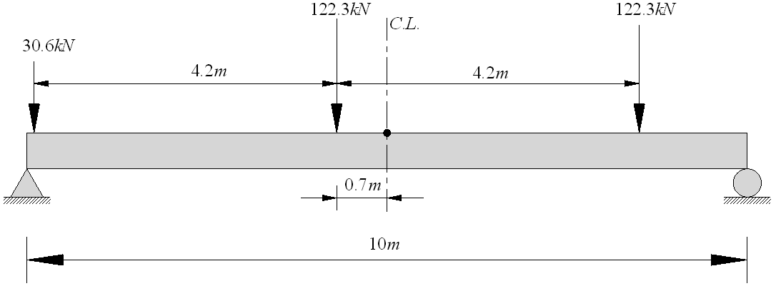
Figure 2.1 The Wheel Loads of A DB-24 Truck
At the preliminary analysis stage, the FRP sandwich superstructure was considered to be a simply-supported beam. Then the deflection at mid-span of the FRP sandwich superstructure could be calculated using Eq. (2.7). Eq. (2.7) resulted from elastic superposition of mid-span deflection due to two axle loads at the i^{th} position in Figure 2.1. It is noteworthy that in this case the load at the i^{th} position in Eq. (2.7) should be equal to four times that in Figure 2.1.

(2.7)

Where δ is the deflection at mid-span due to the design live load, P_{i} is the load at the i^{th} position in Figure 2.1.b_{i} is the distance between P_{i} and the closest support. EI is the flexural rigidity of the FRP sandwich superstructure in the longitudinal direction. L is the span length.
In this study, EI was determined using the average material properties of the laminates for face sheets and the thickness of the face sheets and whole cross section. It was calculated using Eq. (2.8). Eq. (2.8) was based on parallel axis theorem and assumed that the contribution of the corrugated core walls to EI could be neglected.
(2.8)
Where W is the width of the whole cross section, h is the thickness of the whole cross section.
Once EI was obtained, it was implemented in Eq. (2.7) to calculate the δ. The calculated δ was 7.76 mm (0.31 in.) and was less than the deflection limit which in this case was 12.5 mm (0.49 in.). Based on the preliminary structural-level analysis, the design of the FRP sandwich superstructure satisfied the design requirement for stiffness.

2.1.3 Finite Element Analysis of the FRP Superstructure
Although the preliminary analysis indicated that the design of the FRP sandwich superstructure satisfied the design requirement for stiffness, it was still necessary to perform refined analysis for two reasons. First, the deflection due to out-of-plane shear deformation was not considered in the preliminary analysis. For FRP decks, the deflection due to out-of-plane shear deformation is usually significant and cannot be neglected in design. Second, in the preliminary analysis, the FRP sandwich superstructure was treated as a 1-D beam and its actual width was utilized in the deflection calculation. However, the FRP sandwich superstructure might behave like a 2-D plate and equivalent strip width should be used to predict mid-span deflection. In this section, refined analysis was conducted by FEA. The equivalent strip width for FRP superstructures or slab bridges will be discussed later.
The FEA for refined analysis of the FRP sandwich superstructure was performed using the commercial software package ABAQUS. In the FEA, the face sheets and corrugated core walls were modeled by shell elements. The material properties in Table 2.2 were used to model individual laminae. The laminae were assigned to the shell elements for the face sheets and corrugated core walls according to the lay-ups in Table 2.3. The dimensions of the cross section of the FRP sandwich superstructure in the FEA are shown in Figure 2.2 (Ji et al. 2010). Since shell elements were applied in the FEA, the total thickness of the model was equal to the actual thickness of the FRP superstructure less the thickness of one face sheet. In the actual construction of the FRP superstructure, the face sheets and the flat parts of the corrugated core walls were connected by bolts. In the FEA, they were tied together to model the structural integrity of the FRP sandwich superstructure.
Two DB-24 trucks were considered as the loads in the FEA. In the span direction, the placement location of each DB-24 truck was determined according to Figure 2.1. In the width or transverse direction, the wheel loads of each DB-24 truck were symmetric about the centerline of each lane. The wheel loads in Figure 2.1 were applied as uniform pressure on the corresponding tire contact areas. The tire contact area for the load of 30.6 kN (6.88 kip) in Figure 2.1 was 120 mm (4.72 in.) by 290 mm (11.4 in.). The tire contact area for the load of 122.3 kN (27.5 kip) in Figure 2.1 was 230 mm (9.06 in.) by 580 mm (22.8 in.). Simply-supported boundary conditions were applied on the two edges of the bottom face sheet parallel to the transverse direction. The whole FEA model is shown in Figure 2.3.

Figure 2.2 Cross Section of the FRP Sandwich Superstructure (Unit: mm)

Figure 2.3 The Model for FEA

The maximum deflection from the FEA was 11.4 mm (0.45 in.). It was still less than the deflection limit 12.5 mm (0.49 in.). As a result, this study concluded that the design of the FRP sandwich superstructure satisfied the design requirement for stiffness. In terms of the strength requirement, the maximum strain under service loads should be limited to 20% of the ultimate strain. In this study, the maximum strain from the bottom face sheet in the FEA was 373 με which was much less than 20% of the ultimate strain 19317 με (Ji et al.). Therefore, the design of the FRP sandwich superstructure satisfied the design requirement for strength as well. Further, the results above indicated that the FRP sandwich structure was likely to reach its deflection limit first. Consequently, the design of the FRP sandwich structure should be controlled by stiffness rather than strength.

2.1.4 Verification of FEA by Field Load Testing Results
Field load testing was conducted on the FRP sandwich superstructure and the results were reported by Ji et al. (2010). The FRP sandwich superstructure was tested using loaded dump trucks as shown in Table 2.5. The target field load to simulate DB-24 trucks, which were utilized in the original design and the FEA above, could not be reached due to the truck size and load limitations. For a dump truck, the spacing between the front axle and the middle axle was 3.3 m (10.8 ft). The spacing between the middle axle and the rear axle was 1.3 m (4.3 ft). In the field load testing, the distance between the middle axle and mid-span of the superstructure was 9 cm (3.5 in.).
Table 2.5 Truck Loads Used in Field Tests
Truck | Front Axle | Middle Axle | Rear Axle | Total Axle Weight
Truck-A | 56.2 (kN) | 96.4 (kN) | 98.0 (kN) | 250.6 (kN)
Truck-B | 55.5 (kN) | 94.6 (kN) | 100.7 (kN) | 250.8 (kN)

In the field load testing, strain values and mid-span deflections from the bottom face sheet were collected from static tests. In one static test, a dump truck was placed in the left lane of the FRP superstructure. In this case, the deflection measured at the center of the superstructure was 1.22 mm (0.048 in.) (Ji et al 2010). The deflection at the same position predicted by FEA was 1.36 mm (0.054 in.). In another static test, a dump truck was placed in the center lane of the FRP superstructure. The strain value measured from this case was 102 με (Ji et al. 2010). The strain value predicted by FEA was 94 με. The results above verify the FEA in this study. It should be mentioned that the experimental material properties of the FRP laminae reported by Ji et al. (2010) were applied in the FEA discussed here.

2.1.5 Conclusions
Based on the discussions above, the conclusions are briefly summarized as follows. The design of the FRP sandwich superstructure in this study satisfied the requirement for both strength and stiffness. Further, this study showed that its design should be controlled by stiffness rather than strength.

2.2 Behaviors of HFRP Sandwich Panels at Cold Temperatures

2.2.1 Introduction
When FRP decks are designed based on the stiffness requirement, the effects of cold temperatures are usually not taken into account. When temperature is the only variable which is varied in a study, cold temperatures are generally beneficial to the stiffness and strength of FRP materials. This conclusion is mainly based on the coupon-level tests of FRP materials. However, at the structural level, it was reported that even a relatively small load like the service load might cause stiffness degradation of an FRP sandwich panel at low temperatures (Ma et al. 2007). Therefore, further research needs to be conducted before applying the conclusion from FRP material coupon tests to the actual structures made of FRP laminates.
This study concentrates on the behavior of a specific sandwich structure under the combined effects of cold temperatures and service load. This sandwich structure has a structural configuration quite similar to that in the study of Ma et al. (2007). The flexural stiffness of FRP sandwich structures depends primarily on the stiffness of their face sheets, the geometry of face sheets and cores, and the shear transferability of the cohesive interfaces between them. Because the geometry of face sheets and cores is relatively stable, the stiffness degradation mentioned above can be attributed to either the material failure of face sheets or the damage on the interfaces. Several material coupon tests showed that the FRP laminae in the face sheets of the FRP sandwich panel in the study by Ma et al. (2007) did not fail under the combined effects of cold temperatures and service load (Nordin et al. 2010). Therefore, it is reasonable to assume the interface debonding might affect the structural integrity and cause stiffness degradation before any material failure of face sheets. As indicated by previous research, the interface debonding is one of the major failure modes of HFRP sandwich panels at room temperature (Alagusundaramoorthy et al. 2006, Kalny et al. 2003). The influences of low temperatures may cause this premature failure to occur at a lower load level because of the embrittlement of the interfaces.
Since the design of FRP decks is stiffness-oriented, this study would like to know whether the deflection limit of L/400 (L = span length) is acceptable in terms of indirectly considering the stiffness degradation due to the interface debonding at the structural level. The deflection limit L/400 is the least conservative in current practice. If this deflection limit is acceptable in terms of indirectly addressing stiffness degradation, it will help reduce the manufacture cost of FRP decks and promote their application. Besides, this study also tries to determine whether the interface debonding can occur under the combined effects of service load and low temperatures cycling. It is expensive to conduct full-scale panel tests under low temperature cycles where a full-scale cold room facility is typically required (Ma et al. 2007). This study has come up with a reduced-scale testing approach where the depth of specimens is full-scale (“as-received” from suppliers) while the span is reduced (by water-cutting) to fit into an environmental chamber. Since load levels have a significant impact on stiffness degradation based on the material coupon-level tests (Nordin et al. 2010), the determination of service load was believed to be vital to the design of the reduced-scale experiments. Efforts were made in this study to identify the service load and to demonstrate the reduced-scale experiment can effectively study the actual conditions of a full-scale deck panel at the service condition. The potential interface debonding at the service load condition combined with low temperature cycling specific to bridge engineering has rarely been studied (Ma et al. 2007).
In this study, FEA was first conducted to determine the service load in the experiment. Then three specimens, with the same depth as the full-size “as-received” HFRP sandwich panel but a shorter length, were tested at four different temperatures (24°C, 0°C, -20°C, -35°C and then 24°C again) up to the load level from the FEA. Considering the fact that strains were more sensitive to the stiffness degradation (Ma et al. 2007) and the convenience of the experimental setup, the load-strain curves were obtained to evaluate the flexural stiffness and its potential change. Because the whole experiment was designed with reference to ASTM C393/C393M-06 (ASTM Standard C393/C393M 2006), it was also used to investigate whether the corrugated cores of the sandwich specimens might fail due to shear stress in this study. The experimental results in this study demonstrate that the deflection limit L/400 can potentially be adopted in practice without incurring stiffness degradation due to interface debonding. If this deflection limit is accepted as a design criterion, the material cost of FRP deck panels will be reduced. The experimental results also show that the cracks or defects introduced to the interfaces during the manufacturing process may become significant and develop interface debonding at low temperatures. Besides, this study confirms the conclusion from material tests that the stiffness of the HFRP sandwich panels will increase when the temperatures are decreased at least up to the service limit state. Finally, previous research about the stress distribution at the interfaces considering the skin effects demonstrated that significant tensile stress might be produced at the interfaces and played a vital role in the debonding initiation under certain loading conditions (Chen and Davalos 2004, Chen and Davalos 2007). This study verifies the conclusion above and suggests that the tests according to ASTM C393/C393M-06 may underestimate the actual shear strength of the interfaces.

2.2.2 Finite Element Analysis
The experimental specimens in this study were water-cut from a 1.73 m (68.0 in.) long HFRP sandwich panel manufactured by the Kansas Structural Composites, Inc. (KSCI). The specimen’s dimensions were 406 mm (16.0 in.) long, 248 mm (9.75 in.) wide and 121 mm (4.75 in.) deep. The HFRP sandwich structure had two face sheets and corrugated cores sandwiched between them. The thickness of the face sheets was 12.7 mm (0.5 in.). The corrugated cores contained five flat cores and five sinusoidal cores. The average thickness of the core walls was 1.27 mm (0.05 in.). These thickness values were used in the FEA instead of the nominal values (Davalos et al. 2001) because they were close to the actual measured ones. For the sinusoidal cores, each cell had a width of 102 mm (4.0 in.) and a height of 50.8 mm (2.0 in.). The geometry and dimensions of the HFRP sandwich structure with corrugated cores are shown in Figure 2.4. The resin matrix and glass fibers used in the specimens were polyester and E-glass, respectively. The E-glass fiber mats were applied in several different kinds of fiber architecture for different components. The bidirectional (0°/90°) stitched fabric with a balanced number of fibers running in an orthogonal direction (denoted as CM3205) and unidirectional (0°) fiberglass mats (denoted as UM1810) were combined to laminate the face sheets in Figure 2.5. The randomly oriented short fibers were used to fabricate the corrugated cores. Because the E-glass fibers in the cores were randomly oriented, the cores were modeled as isotropic materials (Kalny et al. 2003). The face sheets, however, were modeled as equivalent single-layer orthotropic materials. The 1.73 m (68.0 in.) HFRP sandwich panel was originally constructed to be part of the bridge deck replacement in Crawford County, Kansas in 1999. The material properties of the face sheet laminates and cores of this HFRP sandwich panel from the experimental tests by Kalny et al. (2003) are listed in Table 2.6.
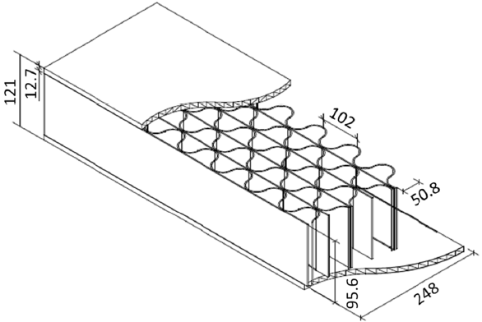
Figure 2.4 HFRP Sandwich Structure (Unit: mm)

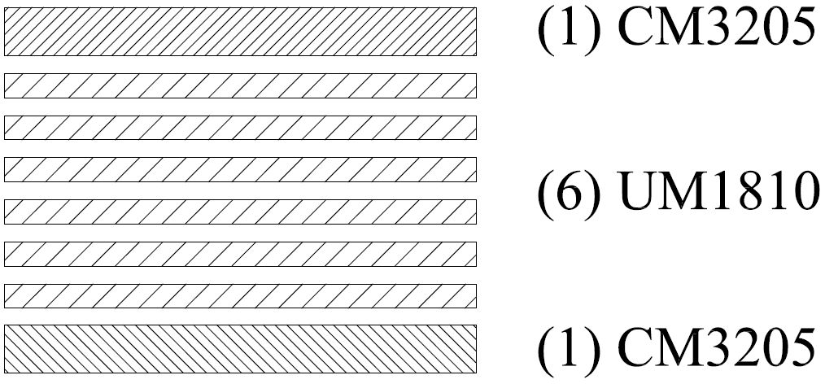
Figure 2.5 Lay-up of the Laminate for a Face Sheet

Table 2.6 Material Properties of Face Sheets and Cores
Property | Core | Face Sheet 0°  (longitudinal direction) | Face Sheet 90°  (transverse direction)
E (GPa) | 8.11 | 19.3 | 15.0
υ | 0.312 | 0.278 | 0.196

The commercial package ABAQUS was used to perform the finite element analysis in this study. Because the face sheets and cores had different material properties, three different parts were set up to model them. The FE model of a specimen is shown in Figure 2.6. The face sheets and cores were modeled by the 3-D solid elements C3D8R and C3D6. The mesh of the interfaces from the face sheets was identical to that from the corrugated cores. Besides, both the face sheets and cores had a very fine mesh and the aspect ratio of the solid elements was less than 10.
One preliminary trial test (up to 4.4 kN) was conducted to verify the FE model above. The experimental setup is shown in Figure 2.7. The specimen used in the trial test was later utilized in the real tests. In this test, two rollers were applied as the supports so that the boundary conditions in the FEA could be modeled as simple supports along two lines. The rollers had the length of 178 mm (7.0 in.) and did not cover the whole width of the specimen. The actual support conditions in the trial test were taken into account in the FEA. The strain values at the mid-span and the place 76.2 mm (3.0 in.) away from the mid-span (This place was close to the quarter-span and will be called the quarter-span hereinafter) were collected and compared with the values predicted by FEA. The tests were repeated for three cycles. Figure 2.8 shows the comparisons between typical experimental load-strain curves and theoretical ones. When the load is 4.4 kN (1.0 kip), the average strain values at the mid-span and quarter-span were 136 microstrain and 105 microstrain. The results from the FEA were 127 microstrain and 97 microstrain. Because of the good agreement between the FEA and experimental results, the FE model was later applied to determine the service load in the experiment.
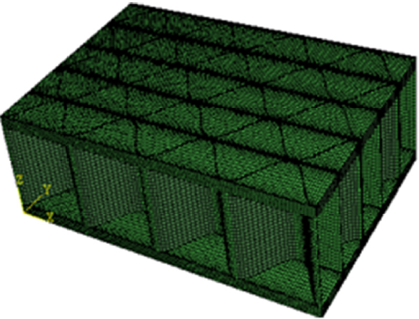
Figure 2.6 FE Model of a HFRP Specimen
Figure 2.7 Setup of the Trial Test
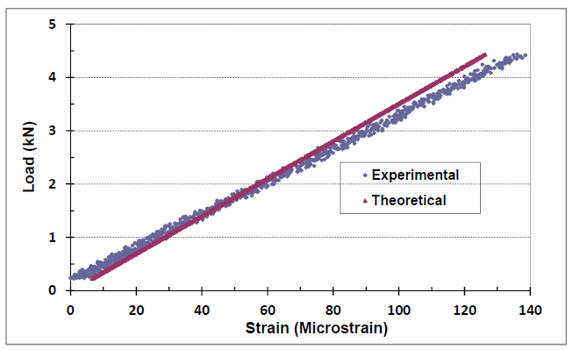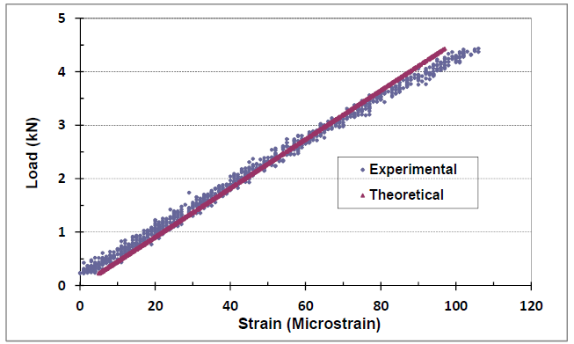
Figure 2.8 Experimental and Theoretical Load-Strain Curves (Left for Mid-span and Right for Quarter-span)

2.2.3 Service Load Condition in the Experiment
As discussed earlier, one of the main research interests in this study was to investigate the potential interface debonding at the service limit state. The service load condition in the experimental study should induce the same stress states at the interfaces as that in design. According to the design sheet provided by the Kansas Department of Transportation (KSDOT), the HFRP sandwich structure used in the experiment could span 1.22 m (48.0 in.) and was originally designed to deflect L/400 at the service limit state. As a consequence, the 1.22 m (48.0 in.) long HFRP sandwich panel was considered as the practical full-scale deck panel in this study.
In this study, the equivalent strip width method was used to determine the service load for the full-scale HFRP deck panel. Currently, the equations for equivalent strip width of FRP materials are not available according to the AASHTO LRFD (2010). However, Liu et al. (2008) concluded that the equivalent width for FRP decks can be obtained for deflection calculations and it should be mainly a function of girder spacing, similar to that for stress-laminated wood. For the HFRP deck panel in this study, the equivalent strip width for stress-laminated wood was utilized. Applying the equation from Table 4.6.2.1.3-1 in AASHTO LRFD (2010) for stress-laminated wood spanning perpendicular to the traffic direction in this case, the equivalent strip width for the HFRP deck panel with the span of 1.22 m (48.0 in.) was calculated as 1.63 m (64.0 in.). The full-scale deck panel with the equivalent strip width should be designed for one wheel load from the rear axle of the design truck 71.2 kN (16.0 kip) multiplied by the impact factor 1.33. In this study the full-scale deck panel only had a width of 248 mm (9.75 in.), so the service load for the full-scale deck panel would be 14.2 kN (3.2 kip). Under the load of 14.2 kN (3.2 kip) the maximum deflection of a full-scale HFRP deck panel obtained from FEA was L/432 and close to the original design criterion. It is reasonable to consider 14.2 kN (3.2 kip) as the service load for the full-scale HFRP sandwich panel.
The service load condition in the tests of experimental specimens should be determined based on the critical interfacial stress state from the case of full-scale deck panels. When evaluating the critical interfacial stress state, the criterion in Eq. (2.9) was applied. This equation is capable of predicting the onset of delamination in composite laminates (Camanho and Davila 2002).

(2.9)

where and are the normal and shear stresses at the interfaces; and and are the tensile strength and shear strength of the interfaces, respectively. In this study, the interfaces were considered to be resin-rich and the properties of the polyester were utilized here. The was 62.0 MPa (9.0 ksi) and was 17.9 MPa (2.59 ksi). The symbol is the Macaulay brackets. The polyester used in the specimens was Altek H834-R series polyester resin (Nordin 2008). The value of its tensile strength was obtained from the datasheet provided by the manufacturer. The shear strength was calculated according to the experimental values about the shear flow capacity of a unit cell of honeycomb cores (Kalny et al. 2003). The average shear flow capacity of a unit cell is 90.8 N/mm (0.52 kip/in.). A unit cell in this case has four walls (Davalos et al. 2001) and the thickness of each wall is 1.27 mm (0.05 in.). Consequently the shear strength was calculated as 17.9 MPa (2.59 ksi).
Eq. (2.9) above recognizes the coupled impacts of tensile stress and shear stress on the initiation of debonding. The stress combinations critical to the onset of interface debonding in both a full-scale deck panel and an experimental specimen can be determined from this equation. Based on the FEA results, the critical combinations of the interfacial stresses from a full-scale HFRP deck panel and an experimental specimen at 14.2 kN (3.2 kip) are listed in Table 2.7. From Table 2.7, the service load condition in the experiment was determined to be 22.2 kN (5.0 kip) for two reasons. First of all, the effect of shear stress has more contribution to the values calculated from Eq. (2.9) in Table 2.7. Tensile stress does not contribute much to these values. However, tensile stress is usually more vital to the interface debonding than shear stress. In order to recognize the importance of tensile stress, 22.2 kN (5.0 kip) was used as the service load in the experiment. The tensile stress in the critical stress combination of an experimental specimen under 22.2 kN (5.0 kip) is 7.5 MPa (1.08 ksi), which is almost the same as that of a full-scale deck panel at its service load condition. Second, the interfacial stress state indexed by Eq. (2.9) for an experimental specimen under 22.2 kN (5.0 kip) is more unfavorable than that for a full-scale deck panel at the service load condition. To investigate the feasibility of the deflection limit L/400 as a design criterion in terms of interfacial debonding, it is more convincing to use a larger load in the experiment to demonstrate its potential application.
Table 2.7 Critical Interfacial Stress States at 14.2 kN (3.2 kip)
 | τ_{n} | τ_{s}
Experimental Specimen | 4.8 MPa | 7.8 MPa | 0.197
Full-Scale Panel | 7.2 MPa | 7.7 MPa | 0.199

2.2.4 Experimental Setup and Procedure
The experimental setup was designed with reference to ASTM C393/C393M-06. In the experiment, the specimens were subjected to three-point bending and loaded by the test apparatus shown in Figure 2.9. The apparatus was placed in an MTS 810.25 Material Testing System equipped with an Applied Test Systems (series 3710) environmental chamber with connections to a liquid nitrogen injector assembly using a cryogenic solenoid. To improve the force transducer data resolution, a 49.0 kN (11.0 kip) load cell was piggybacked to the standard 244 kN (54.8 kip) cell. The load was applied from the MTS system to the specimens through a steel block with a V-groove on top of it. The supports were provided by two steel blocks and the effective span between the supports was 330 mm (13.0 in.). The 25.4 mm (1.0 in.) wide neoprene pads were placed between the specimens and steel blocks.
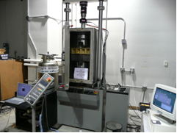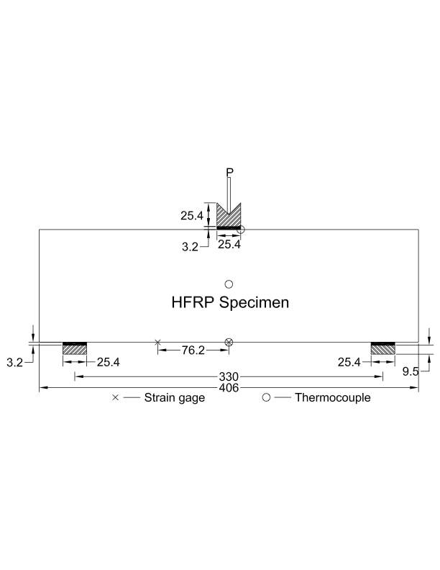
Figure 2.9 The Experimental Setup (Unit: mm)

During each test, the applied loads were recorded by the MTS system. The strains at the mid-span and quarter-span were recorded by a National Instrument (NI) SCXI 1317. Four Copper-Constantan T-type thermocouples were used to measure the specimen’s temperatures. One thermocouple was placed 12.7 mm (0.5 in.) away from the mid-span at the top surface of a top face sheet. One was placed at mid-span at the bottom surface of a bottom face sheet. Two thermocouples were also used to measure the temperatures on both the front side and back side of the cores at the mid-span. The instrumentation of strain gages and thermocouples is also shown in the Figure 2.9.
The experiment consisted of the tests of three specimens at four different temperatures. The four temperatures are 24°C, 0°C, -20°C and -35°C. After the test at -35°C, each specimen was conditioned at 24°C for one day and then re-tested to study if there was any stiffness degradation compared to the test results obtained at the initial 24°C. At each temperature a specimen sustained three loading cycles and the maximum load in each cycle was equal to 22.2 kN (5.0 kip). Within each cycle, the load applied on a specimen gradually increased from zero to the maximum load under the displacement control mode in roughly 10 to 15 minutes. Then the load was held constant for 10 minutes to study the coupled influences of the sustained load and low temperatures. After that, the specimens were unloaded and the applied load went back to zero in roughly 10 to 15 minutes. The load was held at zero for another three minutes. After three minutes, the specimens were loaded again and the process described above was repeated for another two times. During the tests, the strains and loads were recorded every one second. These data were later used to evaluate the specimen’s stiffness. Besides, the temperatures at four different locations of a specimen were also monitored and recorded to make sure that they were the same as the target temperatures.

2.2.5 Experimental Results and Discussion
Because the load-strain curves were more sensitive to stiffness degradation and have stronger statistical correlation than the load-deflection curves, their slopes were used to indicate the stiffness of the HFRP sandwich panels. The load-strain curves for three specimens were obtained to study their behavior under the combinations of different temperatures and service load condition. The results are shown in Figure 2.10 to Figure 2.15. After the experiment was conducted, the specimens were subjected to a visual inspection and interface debonding was found in one of the specimens. The specimen that experienced the interface debonding has the “as-received” end. The other end of this particular specimen has the “water-cut” end. The interface debonding occurred at the “as-received” end during the tests at low temperatures cycles. It should be noted that at room temperature no interface debonding was observed. The other two specimens with both “water-cut” ends showed no sign of debonding. After examining the three specimens, no crushing or any other local failure was found at the places close to the loading point and supports.
Figure 2.10 Slopes of Load-Strain Curves for Specimen 1 (Mid-span)

Figure 2.11 Slopes of Load-Strain Curves for Specimen 1 (Quarter-span)

Figure 2.12 Slopes of Load-Strain Curves for Specimen 2 (Mid-span)

Figure 2.13 Slopes of Load-Strain Curves for Specimen 2 (Quarter-span)

Figure 2.14 Slopes of Load-Strain Curves for Specimen 3 (Mid-span)
Figure 2.15 Slopes of Load-Strain Curves for Specimen 3 (Quarter-span)

Figures 2.10 – 2.15 show that the stiffness of the HFRP sandwich panels will increase as the temperature decreases at the service load condition. Figure 2.16 shows the ratios of stiffness at different temperatures to initial stiffness at 24 °C. The data used to generate Figure 2.16 are from Figure 2.10, Figure 2.12 and Figure 2.14. The observation above demonstrates that the conclusion concerning low temperatures from material coupon tests (Nordin et al. 2010) is also applicable at the structural level at least up to the service load level. All the load-strain curves which were used to generate the data in Figures 2.10 – 2.15 were linear and had R squared values larger than 0.98. Essentially there was no nonlinear behavior during the whole experiment. The discussions above show that under the combined effects of service load and low temperatures the stiffness degradation due to the interface debonding did not occur. Together with visual inspection, this study concludes that no failure of corrugated cores due to shear stress actually occurred during the whole experiment. The sandwich structure used in this study was designed to span L/400 at the service limit state at room temperature. In current practice, the deflection limit at the service load condition ranges from L/400 to L/1000. Although the L/400 is the least conservative, the experiment in this study suggests that it is still potentially acceptable as the design criterion in terms of stiffness degradation and interface debonding due to low temperatures.
Figure 2.16 Stiffness Ratios at Different Temperatures

Although the interface debonding causing stiffness degradation did not occur, it did develop at the free end of one specimen, as shown in Figure 2.17. As discussed earlier, this specimen had one “as-received” end and one “water-cut” end. The interface debonding occurred at the “as-received” end during the tests at low temperatures. The other two specimens whose ends were water-cut did not experience the interface debonding. This experimental observation may be attributed to the influences of the cracks or defects which were inevitably introduced during the construction of the FRP sandwich structure. The interface debonding was not found for the damaged specimen during the test at room temperature and it only occurred during the tests at low temperatures. The reason for this result can be explained as follows. The significance of a crack or defect, from the viewpoint of fracture mechanics, is closely related to the fracture toughness. Cold temperatures generally reduce material’s fracture toughness. Hence, one crack or defect may become more significant and influential at low temperatures than at room temperature. Further, the interface debonding at the free end should be ascribed to tensile stress. The cores and face sheets in the sandwich structure usually have different thermal coefficients. Tensile stress in this case might arise from the non-uniform contraction of the cores and face sheets when temperatures were lowered (Wang 1989). As is known, tensile stress plays a more important role in the delamination or interface debonding than shear stress (Wang 1989, Anderson 2005). In fact, the experimental results in this study indirectly verified this conclusion. The most significant interfacial shear stress due to mechanical loading in an experimental specimen was found within the span between two supports and it was larger than the tensile stress according to Table 2.7. However the interface debonding occurred at the free end outside the supports instead of some place within the span. Therefore the interface debonding at the free end of one specimen was mainly attributed to tensile stress. At the same time, this conclusion justifies the determination of service load in the experiment based on the tensile stress.

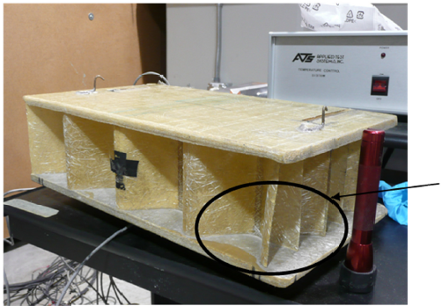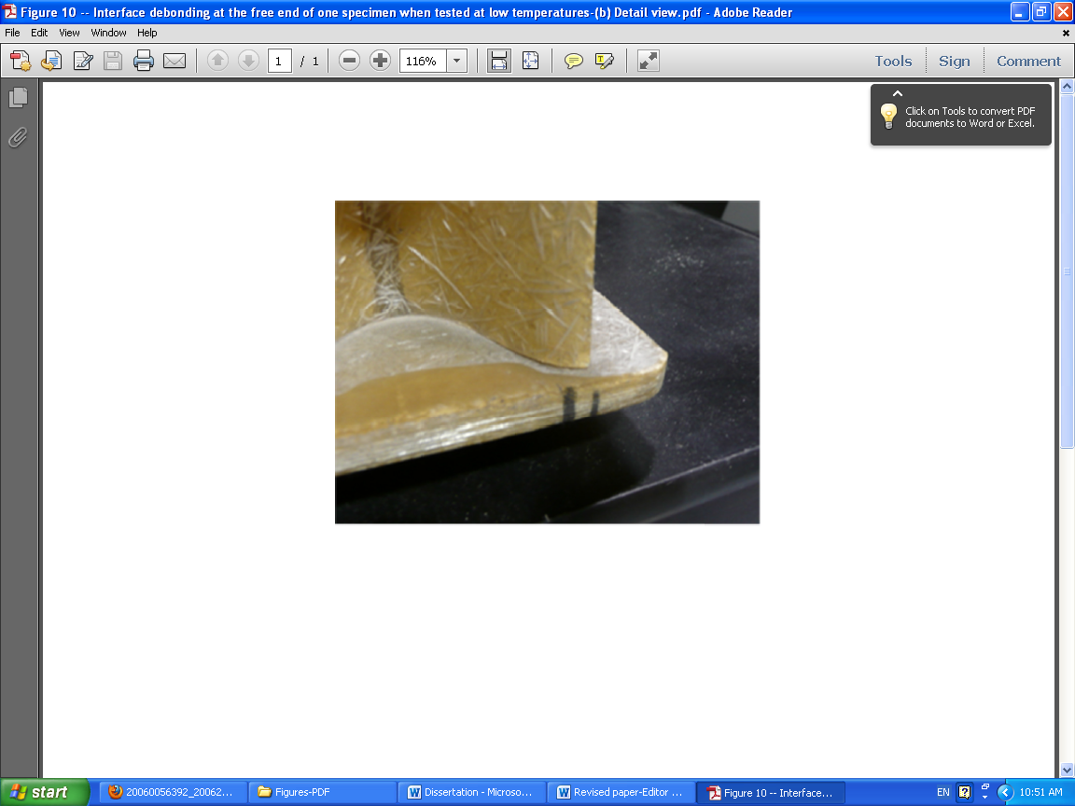
Figure 2.17 Interface Debonding at One Free End

As is previously described, the experiment in this study was designed with reference to ASTM C393/C393M-06. According to the FEA results in Table 2.7, significant tensile stress at the interfaces within the span could be induced during the tests. Because of the important effect of tensile stress, if ASTM C393/C393M-06 and the experiment in this study were used to obtain the shear strength of the interfaces, the results would be inaccurate and underestimated. In the future analysis of the interface debonding consideration should be given to the impact of tensile stress.

2.2.6 Conclusions
Based on the reduced-scale experimental study described above, the following conclusions can be made:
- The experiment in this study confirms that the stiffness of the HFRP sandwich panels at the service load level will increase when the temperatures are decreased (down to -35°C), although the percentage of the increase is quite small.
- In current practice, there is no agreement in terms of design criteria for FRP decks. This study shows that the maximum deflection at the service limit state as L/400 may still be applicable when the effects of low temperatures are considered. However before this criterion is completely accepted and applied in design, the tolerable defect size at the interfaces should be studied in the future research.
- This study substantiates that significant tensile stresses will arise at the interfaces and impact the interface debonding. This study suggests that enough consideration should be given to the effect of tensile stress in the experiment designed with reference to the ASTM C393/C393M-06.

: Theoretical Study of Specially Orthotropic FRP Plates
In this chapter, a theoretical study is conducted to analyze several orthotropic plates under different loading conditions and boundary conditions. The orthotropic plates studied here are the so-called specially orthotropic plates (SOPs) (Altenbach et al. 2004). For the SOPs, the principal material directions are aligned with the global reference directions. In practice, although FRP decks may have various cross sections and structural configurations like those shown in Figure 1.1 and Figure 1.2, they can often be idealized as single-layer SOPs under some circumstances, and the idealization process is illustrated in Figure 3.1 (Zhou 2002). Likewise, when laminates used as the face sheets of sandwich structures are studied, they can also be considered as SOPs. When idealizing FRP laminates and/or FRP decks, it is necessary to calculate their equivalent material properties. Some predictions of the equivalent material properties have been discussed in previous research (Shi et al. 1995, Burton et al. 1997, Xu et al. 2001, Qiao et al. 2005, Cai et al. 2009).
The analytical study concerning SOPs is mainly based on the classical laminate plate theory (CLPT). In this chapter, the governing differential equation for SOPs is derived first by the variational method. The natural boundary conditions associated with the governing differential equation are also discussed. Then, the governing differential equation is used to study two problems which are closely related to the topics of interest in this study. One problem is relevant to interfacial fracture toughness tests. The other one is utilized to derive the expressions of the equivalent strip width for FRP slab bridges.

Figure 3.1 Equivalent Single-layer SOP

3.1 The Governing Differential Equation of Specially Orthotropic Plates
The FRP laminates and decks in bridge engineering usually have construction symmetric about their mid-planes. Therefore, when these plates are analyzed, they may be idealized as equivalent single-layer SOPs. For these SOPs, there is no bending-stretching coupling and bending-twisting coupling. For the cases discussed here, the constraint boundary conditions for the deflection w(x,y) given in Eq. (3.1) are of interest in this study. In addition to Eq. (3.1), this study also considers that the edge at y=0 is supported by a one-parameter elastic foundation and a constant moment m₀ is applied along the edge at x=0. Only bending problems of SOPs are investigated in this study. Then the functional which should be minimized to derive the Euler equation according to CLPT is given in Eq. (3.2) (Vinson 2005).
at x=0; at x=L; (3.1)
(3.2)
The commas in Eq. (3.2) denote the partial derivatives with respect to the independent variables. The D₁₁, D₂₂, D₁₂ and D₆₆ are defined in the Eq. (3.3).
, , , (3.3)
Where E₁ and E₂ are the moduli of elasticity in two orthogonal directions, is the major in-plane Poisson’s ratio, and G₁₂ is the in-plane shear modulus. h is the thickness of a specially orthotropic plate. k is the extensional modulus of the elastic foundation as is defined by Li and Carlsson. (2000).
To minimize Eq. (3.2), its first variation, which is given in Eq. (3.4), should be stationary. After being repeatedly integrated by parts with the assistance of Eq. (3.5), Eq. (3.4) can be simplified as expressed in Eq. (3.6).
(3.4)
at x=0 and x=L (3.5)
(3.6)
The Euler equation, which is the governing differential equation of specially orthotropic plates under bending, is given in Eq. (3.7).
(3.7)
To solve this governing differential equation, eight boundary conditions at four edges should be provided. The constraint boundary conditions are already given in Eq. (3.1). The natural boundary conditions will be determined from the following Eq. (3.8).
at x=L (3.8a)
=0 at x=0 (3.8b)
=0 at y=y_{w} (3.8c)
=0 at y=0 (3.8d)
=0 at y=0 (3.8e)
=0 at y= y_{w} (3.8f)

3.2 The Bending of SOPs under Constant Edge Moment and Displacement
One problem studied in this section is the bending of SOPs under constant edge moment and displacement. This problem is related to some assumption verification in fracture toughness tests later. Assume the SOPs considered in this section have the boundary conditions expressed in Eq. (3.1) and Eq. (3.9). Then according to Eq. (3.8a) and Eq. (3.8b), Eq. (3.9) may be rewritten as Eq. (3.10).
at x=0; at x=L; (3.9)
at x=0; =0 at x=L (3.10)
An approximate solution to the governing differential equation with equal to zero and boundary conditions described above can be formulated by the Galerkin-Kantorovich method (Mura and Koya, 1992). Based on Eq. (3.7), the Galerkin-Kantorovich method requires that the trial function expressed in Eq. (3.11) satisfy Eq. (3.12).
(3.11)
(3.12)
Since has to satisfy the boundary conditions in Eq. (3.10) and f_{i}(x) has to satisfy the homogeneous boundary conditions, the trial functions for and f_{i}(x) are chosen as follows.
(3.13)
(3.14)
Combining Eq. (3.13) and Eq. (3.14) with Eq. (3.11) and Eq. (3.12), the governing differential equation in Eq. (3.7), which is a partial differential equation, may be simplified as an ordinary differential equation in Eq. (3.15).
(3.15)
For most of FRP bridge decks in current practice, their material properties satisfy the relationship in Eq. (3.16). Then the roots of the characteristics equation of Eq. (3.15) are four distinct complex numbers. As a result, the solution to Eq. (3.15) takes the form of Eq. (3.17).
(3.16)
(3.17)
Where to are four constants that should be determined for the trial function . The parameters and in Eq. (3.17) are given in Eq. (3.18)
, (3.18)
It should be noted that thus far the four boundary conditions at the edges y=0 and y=y_{w} have not been applied yet. They should be used to determine the coefficients to . In this study, it is assumed that the edge at y=0 is supported by a one-parameter elastic foundation and have zero rotation and the edge at y=y_{w} is free. Then the natural boundary conditions in Eq. (3.8c) to Eq. (3.8f) can be rewritten in Eq. (3.19).
At y=0:
(3.19a)
(3.19b)
At y=:
(3.19c)
(3.19d)
(3.19e) (3.19f)
Due to the orthotropy of SOPs, explicit expressions of the coefficients to are quite lengthy though they can be conveniently obtained through some computer programs like Matlab. However, for the analysis problems in which the equivalent material properties of SOPS are already known beforehand, Eq. (3.19) still remains a practical way to calculate these constants. Once these constants are known, Eq. (3.11), Eq. (3.13), Eq. (3.14) and Eq. (3.17) together will yield the solution to deflection.
To illustrate the method discussed above, several examples will be studied here and their results will be compared to those from FEA. The plates in the examples have the material properties as shown in Table 3.1. The length of these plates is 76.2 mm (3.0 in.) and the width-to length ratios of these plates vary from 0.5 to 1.5 in the examples. The thickness of these plates h is 12.7 mm (0.5 in.). In the examples, the numerical value of the extensional modulus of the elastic foundation k is taken as 4E₁₁I. I is defined as the moment of inertia of the cross section of a plate in this study, though this definition is quite uncommon in the plate analysis. Table 3.2 and Table 3.3 show several analytical results concerning rotations at the edge x=0 with the ones from FEA given in parentheses. In Table 3.2, a uniform displacement is applied on the edge at x=0. In Table 3.3, M_{x} equal to 1.36 kN-m (1 kip-ft) is applied on the edge at x=0. According to Table 3.2, the analytical solutions agree very well with those from FEA.

Table 3.1 Material Properties of the Plates
E₁ | E₂ | G₁₂ | υ₁₂
19.6 (GPa) | 12.8 (GPa) | 3.76 (GPa) | 0.3

Table 3.2 Rotations at Different Points along the Edge at x=0 (w=25.4 mm)
 | At y=0.2W | At y=0.4W | At y=0.6W | At y=0.8W
0.5 | 1.0658  (1.0678) | 0.9371  (0.9379) | 0.8386  (0.8392) | 0.7719  (0.7726)
0.75 | 1.0714  (1.0726) | 0.8338  (0.8346) | 0.6774  (0.6780) | 0.5788  (0.5792)
1 | 1.035  (1.036) | 0.7267  (0.7275) | 0.5545  (0.5550) | 0.4575  (0.4581)
1.25 | 0.9752  (0.9765) | 0.6341  (0.6347) | 0.4722  (0.4725) | 0.3935  (0.3936)
1.5 | 0.9070  (0.9082) | 0.5591  (0.5595) | 0.4184  (0.4186) | 0.3606  (0.3609)

Table 3.3 Rotations at Different Points along the Edge at x=0 (M_{x}=1.36 kN-m)
 | At y=0.2W | At y=0.4W | At y=0.6W | At y=0.8W
0.5 | -0.1898  (-0.1896) | -0.2111  (-0.2110) | -0.2354  (-0.2352) | -0.2626  (-0.2624)
0.75 | -0.1903  (-0.1901) | -0.2342  (-0.2340) | -0.2761  (-0.2760) | -0.3164  (-0.3162)
1 | -0.1968  (-0.1966) | -0.2594  (-0.2592) | -0.3089  (-0.3088) | -0.3502  (-0.3500)
1.25 | -0.2078  (-0.2076) | -0.2835  (-0.2834) | -0.3327  (-0.3326) | -0.3675  (-0.3674)
1.5 | -0.2215  (-0.2213) | -0.3051  (-0.3050) | -0.3494  (-0.3494) | -0.3765  (-0.3756)

3.2 Equivalent Strip Width for FRP Slab Bridges
The governing differential equation derived in Eq. (3.7) can also be used to study the equivalent strip width for FRP slab bridges. By using the equivalent strip width, the 2-D slab bridge design problems may be simplified as 1-D Timoshenko beam problems. As discussed above, FRP decks are designed according to stiffness rather than strength. To calculate the deflections at points of interest, this study first presents a “tractable and accurate” analytical solution to Eq. (3.7) under certain symmetry. The equivalent strip width can then be obtained by equating the flexural deflection of Timoshenko beams to the analytical solution. For FRP decks, the deformation due to out-of-plane shear may not be neglected in design. The equivalent strip width obtained in this study is based on the classical laminate plate theory (CLPT) instead of the first-order shear deformation theory (FSDT). However parametric study indicates the equivalent strip width presented in this study may also be used in the Timoshenko beam theory to consider the deflection due to shear deformation. The details concerning the derivation of the equivalent strip width for FRP slab bridges and several examples which utilize the equivalent width are explained as follows.
When deriving the equivalent strip width for FRP slab bridges, practical cases are considered in this study. Currently, the spans of slab bridges typically range from 7.3 m (24 ft) to 18.3 m (60 ft). The aspect ratio W/L is less than 1.5. For FRP slabs, the span-to-depth ratios are usually larger than or close to 12. An FRP slab bridge in practice is usually simply-supported on two opposite edges and free on the other two opposite edges, as is shown in Figure 3.2. The design vehicular live loads including design tandems, design trucks and design lane loads are specified according to AASHTO LRFD Bridge Design Specifications (2010). In the span or traffic direction, the live loads should be placed to maximize the deflection at mid-span. In the transverse direction, a practically reasonable assumption for live load placement is that the vehicles travel in the middle of each lane. This assumption will lead to a loading condition symmetric about the centerline of an FRP slab bridge in the transverse direction regardless of the number of traffic or design lanes. As for the material properties of the equivalent single-layer orthotropic plates, the ratio of the two in-plane moduli of elasticity E_{x}/E_{y} varies between 0.1 and 0.9. The in-plane major Poisson’s ratio changes from 0.2 to 0.4. The ratio of the in-plane shear modulus G_{xy} to the modulus of elasticity E_{x} is between 0.1 and 0.4. The ratio of the out-of-plane shear modulus G_{xz} to the modulus of elasticity E_{x} and the ratio of the out-of-plane shear modulus G_{yz} to the modulus of elasticity E_{y} are at least 0.025. In this study, the subscript x and y follows the notations in Figure 3.2. It should be noted that in this figure the 1-direction of the FRP slab is aligned with the y-direction. Therefore the expressions of some parameters will be different from those in the previous section.
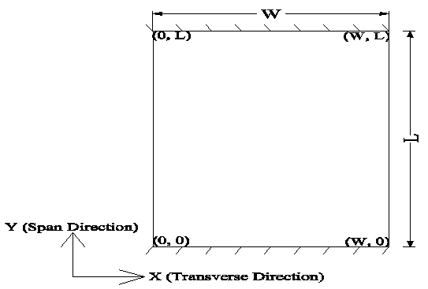
Figure 3.2 Geometry of a Slab Bridge
For the cases studied here, an exact solution to the governing differential equation Eq. (3.7) may be obtained by elastic superposition of two direct methods called the Navier solution and Lévy solution (Vinson 2005). The procedure of obtaining the solution consists of two steps. In the first step, the FRP slab shown in Figure 3.2 may be considered to be simply supported on all four edges. Then, the deflection of the FRP slab can be expressed as Eq. (3.20).
(3.20)
The x and y are the coordinates of a point of interest in the transverse direction and span direction, respectively. The A_{mn} in Eq. (3.20) is a function of p(x, y) which is related to the loading type and position. For the design live loads specified according to AASHTO LRFD (2010), A_{mn} for a given m and n has a general form of Eq. (3.21).
(3.21)
Where a and b are the positions of the pressure’s center in the transverse direction and in the span direction, respectively. p is the value of the pressure. w_{p} and l_{p} are the pressure’s width and length, respectively. The Eq. (3.21) may be used to calculate the reactions at the edges at x=0 and x=W. They will be later used as the boundary conditions at the two free edges. The reactions can be calculated according to the Kirchhoff assumption concerning the shear forces at free edges. This assumption is expressed in Eq. (3.22). Based on Eq. (3.22), the reactions are given in Eq. (3.23).
(3.22)
(3.23)
In the second step, the FRP slab in Figure 3.2 will be considered to be simply supported at the edges y=0 and y=L and free at the edges x=0 and x=W. Additionally the reactions from the Eq. (3.23) will be applied to the free edges. Then the classical Lévy solution may be obtained to calculate the deflection w₂ in this step. Because in this step there is no p(x, y), the Lévy solution will only have the homogeneous solution. For the FRP decks which are of interest in this study, their material properties satisfy the inequality in Eq. (3.16). As a result, for a given m and n, w₂ can be expressed as Eq. (3.24) (Zhou 2002, Altenbach et al. 2004).
(3.24)
, (3.25)
Where is the distance from the point of interest to the axis x=W/2 in the transverse direction. Once again, C₁, C₂, C₃ and C₄ are four constants that can be determined from the boundary conditions at the edges x=0 and x=W, which are expressed in the Eq. (3.26) and Eq. (3.27). The definitions of and in the equation above are slightly different from those in Eq. (3.18). As is explained above, the differences come from the fact that the 1-direction of the FRP slab is aligned with the y-direction. Otherwise, Eq. (3.25) will be the same as Eq. (3.18). Besides, it is also noted that Eq. (3.11) will be similar to Eq. (3.24) if f(x) is zero in Eq. (3.11).
(3.26)
(3.27)
Because the cases of interest in the design of FRP slab bridges usually have symmetric loadings and boundary conditions with respect to the axis x=W/2, the constants C₂ and C₃ in Eq. (3.24) will be zero. Further, if C₁ and C₄ in Eq. (3.24) have the non-zero values, the index i has to be equal to the index n and the index m can only be odd numbers. Then Eq. (3.24) can be simplified as Eq. (3.28).
(3.28)
Substitute the Eq. (3.28) into the Eq. (3.26) and Eq. (3.27), the constants C₁ and C₄ are determined as follows:
(3.29)
(3.30)
Then, the deflection of an FRP slab bridge under the design live loads w_{a} can be calculated by the elastic superposition of the two analytical solutions from the two steps as is shown in Eq. (3.31).
(3.31)
The analytical solution presented in this study is simple and accurate for the design of FRP slab bridges based on CLPT. It can be directly calculated in a spreadsheet without resorting to some complex analysis techniques (Harik and Salamoun 1986, Sun and Harik 2010). In design, the deflections at mid-span of FRP slab bridges are usually calculated and compared with the design criteria. From Eq. (3.31), the deflections at the centers (W/2, L/2) of several FRP slabs are obtained and compared with the FEA results in Table 3.4. The FRP slabs in Table 3.4 have a fixed span 7.3 m (24 ft) and depth 0.61 m (24 in.). The width-to-span ratios W/L vary from 0.5 to 1.5. The FRP slabs in Table 3.4 are similar to that in Figure 3.2. They are simply supported on edges y=0 and y=L. One design tandem specified according to AASHTO LRFD (2010) is applied in each case. It is placed so that the distribution of its four wheel loads is symmetric with respect to both x=W/2 and y=L/2. The commercial package ABAQUS was used to perform FEA and the FRP slabs were modeled by the shell element STRI3. This shell element is consistent with CLPT and analytically satisfies the Kirchhoff constraint. The material properties relevant to the analytical solution and FEA are listed as follows. E_{y} is arbitrarily taken as 27.6 GPa (4000 ksi) and E_{x}/E_{y} is taken as 0.5. The in-plane major Poisson’s ratio is 0.3 and G_{xy}/E_{x} is equal to 0.1. Based on the results listed in Table 3.4, the analytical solutions are well-correlated with the results from FEA.

Table 3.4 The Deflections at the Centers of FRP Slabs
Aspect Ratio | W/L=0.5 | W/L=0.75 | W/L=1 | W/L=1.25 | W/L=1.5
Analytical Solution (mm) | 0.8827 | 0.6040 | 0.5047 | 0.4760 | 0.4689
FEA Result (mm) | 0.8834 | 0.6012 | 0.5047 | 0.4765 | 0.4689
Difference | 0.1% | 0.5% | ≤0.1% | 0.1% | ≤0.1%

The analytical solution w_{a} is obtained based on CLPT. For FRP slab bridges shear deformation is sometimes significant and cannot be neglected in design. In fact, FSDT is more appropriate to study the deflections of FRP slab bridges. The FSDT and Timoshenko beam theory have similar kinematics. Both of them assume that the out-of-plane shear strains are constant through the depth. Hence, the Timoshenko beam theory should be utilized when the deflection solution based on FSDT is approximated by 1-D beam equation together with equivalent strip width. Figure 3.3 shows the parametric study of the deflection at the center of several FRP slab bridges by FEA. The FRP slabs in Figure 3.3 have the same in-plane material properties, loading and boundary conditions as those in Table 3.4. Different values are assigned to the two out-of-plane shear moduli G_{yz} and G_{xz}. To include the shear deformation in the analysis, the element S8R which is formulated based on FSDT is utilized in the finite element modeling.

Figure 3.3 Deflections of FRP Slabs with Different Shear Moduli

According to Figure 3.3, the deflections are not significantly influenced by G_{xz}. When the in-plane material properties are held as constants, the deflections have a linear relationship with respect to 1/ G_{yz}. The intercepts of the lines in Figure 3.3 are close to the corresponding analytical solutions in Table 3.4. Figure 3.3 shows that it is reasonable to simplify the 2-D FRP slabs as 1-D beams by using the Timoshenko beam theory. The deflection due to shear deformation in the Timoshenko beam theory is also proportional to 1/ G_{yz}. Besides, the flexural deflection of the beam should be equal to the analytical solution presented in this study. Assuming that one equivalent strip width is applicable to both the flexural deflection and the deflection due to shear deformation, the equivalent strip width can be calculated by equating the analytical solution in Eq. (3.31) to the flexural deflection of Timoshenko beams. Then, the expressions of equivalent strip width for mid-span deflection prediction are given in Eq. (3.32).
or (3.32)
Where EW is the equivalent strip width, b is the distance from the center of a pressure to the closest support in the span direction. P is the concentrated wheel load from the design tandems or trucks applied at the place b, q is the design lane load applied along the whole span, L is the span length and h is the depth of the orthotropic plate. Because the term w_{a} is related to the type and position of one load, the EW should be calculated for each load separately and the total deflection can be obtained from elastic superposition. In practice, symmetry can be utilized to facilitate the design.
In order to verify the assumption that the equivalent strip width expressed in Eq. (3.32) is sufficient for the Timoshenko beam theory, the deflections from several cases were calculated and compared with the results from FEA. The results are shown in Figure 3.4 and Figure 3.5 and the FRP slab in each case is simply supported on the edges y=0 and y=L. The FRP slabs in Figure 3.4 have the same width 6.1 m (20 ft.), but their spans change from 12.2 m (40 ft) to 18.3 m (60 ft). One design truck is applied on the FRP slab in each case and the deflection at the center (W/2, L/2) is calculated by both methods. The spacing between the axles of the design truck is fixed as 4.3 m (14 ft) and the distance between the middle axle of the design truck and mid-span of a FRP slab is 1.52 m (5 ft). The FRP slabs in Figure 3.5 have the same width 9.1 m (30 ft), but their spans change from 7.3 m (24 ft) to 11.0 m (36 ft). Two design tandems are applied at mid-span with a transverse spacing of 4.6 m (15 ft). in each case and the deflection at (W/4, L/2) is calculated by both methods. The span-to-depth ratio of these FRP slabs is 12 and the in-plane material properties are the same as those in Table 3.4 except E_{x}/E_{y} which is considered as a variable in both figures. The out-of-plane shear moduli G_{xz} and G_{yz} are 1/40 of E_{x} and E_{y}, respectively. To be consistent with FEA, the shear correction factor used in the Timoshenko beam theory is 5/6. The deflections due to shear deformation in these cases are more than 20% of the total deflection and cannot be neglected in design. According to Figure 3.4 and Figure 3.5, the Timoshenko beam theory with the equivalent strip width from Eq. (3.32) can predict the deflections quite close to those from FEA. Therefore, it can be applied to calculate the deflections at mid-span with enough accuracy.

Figure 3.4 Deflections of One-lane FRP Slabs under a Design Truck

Figure 3.5 Deflections of Two-lane FRP Slabs under Two Design Tandems

The Timoshenko beam theory with the equivalent strip width obtained based on the analytical solution in this study is tractable comparing with a direct application of FSDT in FRP slab bridges. It is sufficient for deflection calculation when the equivalent material properties of a SOP are known. However, at the design stage of an FRP slab bridge, its equivalent material properties as a single-layer SOP may not be known beforehand. To facilitate practical design, the calculation of equivalent strip width is further simplified in this study by only considering key parameters. The parametric study was used to identify key parameters and a typical result is shown in Figure 3.6. In Figure 3.6, the FRP slab is 7.3 m (24 ft) in both the span and transverse direction. The depth of the FRP slab is 0.61 m (2 ft). The loading and boundary conditions are the same as those in Table 3.4. For each E_{x}/E_{y}, the υ_{yx} changes from 0.2 to 0.4 and the G_{xy}/E_{x} varies between 0.1 and 0.4. According to Figure 3.6, for a given E_{x}/E_{y} and aspect ratio W/L, the in-plane shear modulus G_{xy} and major Poisson’s ratio υ_{yx} have relatively small impacts on the equivalent strip width and deflections. As discussed above, the two out-of-plane shear moduli do not significantly affect the equivalent strip width as well. Therefore the parameters vital to the equivalent width calculation are the two ratios E_{x}/E_{y} and W/L.
Figure 3.6 Deflections of FRP Slabs with Different In-plane Properties
The analytical solution w_{a} converges extremely fast with respect to the subscript n, so it is sufficient to only consider n=1 in the calculation. Combining the simplified w_{a} with Eq. (3.32), the equivalent width can be calculated with the single infinite series in Eq. (3.33).
(3.33)
Where w_{p} is the width of a pressure in the transverse direction.
The term in Eq. (3.33) can be further simplified by only considering the key parameters E_{x}/E_{y} and W/L. The calculation of a simplified is given in Eq. (3.34) to Eq. (3.40). In these equations, the parameters which is not sensitive to are replaced by some constants. The constants are calibrated by parametric study so that the difference between the simplified and the actual for all the SOPs considered in this study is less than 10%. Besides, it is noteworthy how the E_{x}/E_{y} and W/L are redefined in Eq. (3.34).
, , , (3.34)
(3.35)
(3.36)
(3.37)
(3.38)
The coefficients and in the equations above are purely functions of the material ratio n₁ and the aspect ratio n₂. They are independent of the index m and given as follows.
(3.39)
(3.40)
The Eq. (3.34) – Eq. (3.40) give a direct expression of the equivalent strip width for FRP slab bridges and are ready to be input in a spreadsheet without any further manipulation. In order to guarantee the convergence, the first 15 terms are recommended for the solution. As discussed above, it is quite demanding to know the material properties of an equivalent single-layer SOP beforehand during its design. Nevertheless, this practical difficulty can be overcome by applying the simplified equivalent strip width calculation. According to Eq. (3.33) – Eq. (3.40), the simplified equivalent strip width is only a function of n₁, n₂ and υ_{yx}. n₂ can be directly determined from the geometry of slab bridges. For υ_{yx}, 0.3 is usually a reasonable value to start with for most of FRP slabs. Consequently n₁ is the only parameter that requires a proper assumption at the beginning of design. To use the Timoshenko beam theory in design, another assumption about the out-of-plane shear modulus G_{yz} should also be made though this assumption has no impacts on the simplified equivalent width calculation. When Eq. (3.32) or Eq. (3.33) – Eq. (3.40) are used to calculate the equivalent width, they can be implemented in a spreadsheet and perform parametric study to optimize FRP slabs. To get design started, this study recommends that the material ratio n₁ be taken as 10 and the major in-plane Poisson’s ratio υ_{yx} be taken as 0.3 at the very beginning. For the one-lane FRP slab bridges, this study suggests studying the deflection at the point of (W/2, L/2). For the multi-lane FRP slab bridges, this study suggests studying the deflection at the center of each lane and using the maximum value for design.
Finally, based on the design recommendations described above, a flowchart which shows the procedure of applying the equivalent strip width expressions to the design of FRP slab bridges is given in Figure 3.7. Whenever it is possible, Eq. (3.32) should be applied to calculate the equivalent strip width. As an alternative, Eq. (3.33) – Eq. (3.40) are also sufficient for the SOPs discussed in this study. If the material properties’ ratios are independent of the depth, it is unnecessary to invoke the iteration. When the iteration is inevitably required in the design, the procedure above can still be conveniently applied in a spreadsheet. Comparing to other methods like FEA, the method proposed in this study is quite suitable to perform parametric study with low computation costs. Once the spreadsheet for one case is set up, very minor modification is required for the same spreadsheet to study any other cases. It does not require much computational effort for design optimization as well.
Figure 3.7 Flowchart of the Design Procedure

: Interface Debonding Study of HFRP Sandwich Panels
Interface debonding is one of the major failure modes for FRP sandwich structures (Alagusundaramoorthy et al. 2006, Chen and Davalos 2007, Carlsson and Kardomateas 2011). Once it occurs, it may damage the integrity of FRP sandwich structures and lead to stiffness degradation. In this study, the interface debonding of a specific FRP sandwich structure is experimentally and theoretically studied. The FRP sandwich structure used in this study is the same as the one shown in Figure 1.1. As discussed above, one panel of this FRP sandwich structure experienced interface debonding when it was subjected to the service load at cold temperatures.
Interface debonding of FRP sandwich structures can be compared to delamination of FRP laminates, though it may have some unique characteristics. The principles of fracture mechanics are often used to characterize the onset and propagation of interface debonding and/or delamination (Krueger and O’Brien 2001, Krueger 2010). To predict interface debonding, it is necessary to calculate strain energy release rates at interfaces under certain loads and then compare them with their critical values. A strain energy release rate has three components: the Mode I or the opening mode, the Mode II or the sliding mode, and the Mode III or the tearing mode. Correspondingly, its critical value, which is also called the interfacial fracture toughness or G_{c} hereinafter, also result from the three modes as described above. The three basic modes are illustrated in Figure 4.1.
Figure 4.1 Pure Mode Loading

Strain energy release rate’s components can sometimes be calculated by FEA techniques such as the virtual crack closure technique (VCCT). Its critical value from a basic mode or a mode mixed of the three basic modes (usually Mode I/Mode II) can often be obtained from some standard tests. For delamination in FRP laminates, the experimental tests include double cantilever beam (DCB) tests, end notched flexure (ENF) tests and mixed-mode bending (MMB) tests. For FRP sandwich structures with foam cores, the experimental tests include double cantilever beam (DCB) tests, mixed-mode bending (MMB) tests and tilted sandwich debond (TSD) tests. However, for the FRP sandwich structure with honeycomb cores shown in Figure 1.1, the experimental tests specifically designed to measure its interfacial fracture toughness considering different mixed-mode ratios are sparse.
This study aims to investigate the potential interfacial fracture toughness tests for the FRP sandwich structure mentioned above. TSD tests modified based on the study by Siriruk et al. (2009) and Siriruk et al. (2011) were considered in this study. The main difference between the TSD tests considered in this study and those in the literature is that the TSD tests in this study become DCB tests when tilt angle is 0°.
In this study, experiment was first carried out to measure G_{c}. Three specimens were tested and tilt angle equal to 0° was applied in these tests. The experimental results were utilized to study the behavior of G_{c} and verify the FEA later. After being calibrated by an analytical solution (Suo and Hutchinson 1990) and the experimental results, FEA was applied to perform a parametric study. The purpose of the FEA was to investigate if different mode-mixities could be achieved in the TSD tests and G_{c} as a function of mode-mixities could be experimentally established. The TSD tests with tilt angles equal to 0° and several other values were modeled in FEA. The influences of several parameters on mode-mixities achieved in TSD tests are discussed based on the results from the parametric study. According to the results from experiment and FEA, this study discusses some recommendations for the TSD tests of the FRP sandwich structure.

4.1 Introduction
FRP sandwich structures with honeycomb cores or HFRP sandwich structures have the advantages of excellent combinations of strength and stiffness for minimum weight and are suitable for the construction of bridge decks (Plunkett 1997, Davalos et al. 2001). For general FRP sandwich structures including HFRP sandwich structures, their functions as structural members rely on the bonding between face sheets and cores. If debonding of the interfaces between face sheets and cores occurs, the stress transfer between face sheets and cores will be compromised and the structural integrity will be damaged. Interface debonding in FRP sandwich structures may be represented as cracks. The propagation of cracks or the interface debonding should be studied by the principles of fracture mechanics (Carlsson and Kardomateas 2011).
Like the study of the delamination in FRP laminates, the interface debonding in FRP sandwich structures is often predicted by comparing the calculated strain energy release rates under certain loading with their critical values. This concept of studying the interface debonding can be implemented in FEA through several techniques such as virtual crack closure technique (VCCT) and cohesive zone modeling (CZM) (Allix and Corigliano 1996, Goswami and Becker 2000, Alfano and Crisfield 2001, Krueger and O’Brien 2001, Camanho et al. 2003, Harper and Hallett 2008, Krueger 2010, Gustafson and Waas 2011). The VCCT is based on linear elastic fracture mechanics and its formulation in FEA has been discussed in previous research (Rybicki and Kanninen 1977, Krueger 2002). In VCCT, it is assumed that the strain energy released when a crack is extended by a certain amount is equal to the energy required to close the crack by the same amount. Once strain energy release rates reach their critical values, cracks at interfaces will grow and interface debonding will start to propagate. The VCCT is applicable when brittle crack propagation occurs and the nonlinearity at crack tips can be neglected. It can explicitly determine fracture mode separation (Krueger 2002). The CZM is based on the Dudgale-Barenblatt cohesive zone approach (Dugdale 1960, Camanho and Davila 2002, Wang 2004). In this model, it is assumed that there may be plastic zones near crack tips. The CZM enables the combination of strength criteria and fracture mechanics to study the onset and propagation of cracks at interfaces. The constitutive relationship between traction and separation at interfaces can often be characterized by several different curves such as bilinear curves, linear-exponential curve and so on (Needleman 1987, Mi at al. 1998, Alfano and Crisfield 2001, Turon et al. 2006). Strength criteria are used to specify the transition from linear elastic behaviors to softening behaviors for cohesive zones. The area under a constitutive relationship curve is equal to the interfacial fracture toughness. The final crack propagation or interface debonding is determined by some failure criteria based on fracture mechanics.
In both VCCT and CZM, the failure criteria based on fracture mechanics play a vital role in the prediction of crack propagation. The bi-material interfaces in FRP laminates and sandwich structures are likely subjected to mixed-mode loadings (Hutchinson and Suo 1992). The failure criteria based on fracture mechanics are generally functions of strain energy release rates and their critical values from the three modes in Figure 4.1. The power law given in Eq. (4.1) and the Benzeggagh-Kenane law given in Eq. (4.2) are often used as the failure criteria based on fracture mechanics (Benzeggagh and Kenane 1996, Reeder 2006). It is implicit in Eq. (4.1) and explicit in Eq. (4.2) that interfacial fracture toughness G_{c} is a function of mode-mixities. The α, β, γ in Eq. (4.1) and η in Eq. (4.2) determine how mode-mixities may impact G_{c}. Although empirical values may be suggested for these parameters, they should generally be determined by curve-fitting of G_{c} at different mode-mixities. As a result, experimental tests of Gc at different mode-mixities are vital to the determination of the failure criteria based on fracture mechanics. Once the failure criteria based on fracture mechanics are obtained, they can be implemented in the VCCT and CZM to predict crack propagation.
(4.1)
(4.2)
Where G_{I}, G_{II} and G_{III} are the strain energy release rates from the Mode I, Mode II and Mode III, respectively. G_{Ic}, G_{IIc} and G_{IIIc} are the critical values for G_{I}, G_{II} and G_{III}, respectively.
Currently, there are some standard tests of G_{c} measurement at different mode-mixities for FRP laminates and sandwich structures. The G_{c} tests for FRP laminates include double cantilever beam (DCB) tests, end notched flexure (ENF) tests and mixed-mode bending (MMB) tests (Reeder and Crews Jr. 1990, Krueger and O’Brien 2001, Davidson and Sun 2006). The G_{c} tests for FRP sandwich structures with foam cores include double cantilever beam (DCB) tests, mixed-mode bending (MMB) tests and tilted sandwich debond (TSD) tests (Li and Carlsson 1999, Quispitupa et al. 2009, Carlsson and Kardomateas 2011).
For FRP sandwich structures with honeycomb cores in bridge engineering, which are of interest in this study, the experimental tests specifically designed to measure interfacial fracture toughness at different mode-mixities in these structures are sparse (Wang 2004). It is necessary to investigate the applicability of some tests mentioned above to the HFRP sandwich structures in bridge engineering for two reasons. First, traditionally the specimens in the tests above are either directly or indirectly idealized as 2-D models. In FRP sandwich structures with foam cores, their cores are solid and as wide as face sheets. For HFRP sandwich structures in fields other than bridge engineering, their honeycomb core cells are usually small in size and core walls are dense enough to be homogenized as solid cores as wide as face sheets. In these cases, FRP sandwich structures can be idealized as 2-D models (Ural et al. 2003, Berkowitz and Johnson 2005, Grau et al. 2006). However, the honeycomb cores of FRP sandwich structures in bridge engineering like the one in Figure 1.1 possess large cells. When subjected to some interface debonding tests, the experimental specimens cut from the sandwich structures may contain few core walls. Due to the number of the core walls, the cores in the experimental specimens may not be treated as solid cores which are as wide as face sheets. Therefore, it is important to consider the difference in the interfacial fracture toughness tests of the HFRP sandwich structures in bridge engineering. Second, the mode-mixities of interfacial fracture toughness tests is important to determine crack propagation criteria in Eq. (4.1) or Eq. (4.2). Although this topic has been discussed in previous research, the conclusions may depend on the geometric and material properties of the experimental specimens used. Both geometric and material properties of the HFRP sandwich structures in bridge engineering can be different from those of other sandwich structures. Some additional research effort is required for the HFRP sandwich structures in bridge engineering.
The discussion above shows that it is significant to study interfacial fracture toughness tests for the HFRP sandwich structures in bridge engineering. This study investigates the applicability of TSD tests to the HFRP sandwich structure in Figure 1.1. TSD tests are chosen because they can be conveniently implemented in experimental setups. The TSD tests considered in this study were modified based on the study by Siriruk et al. (2009) and Siriruk et al. (2011). The main difference between the TSD tests in the literature and the one in this study is that TSD tests and DCB tests are the same at 0° tilt angle.
In this study, experiment was first carried out to measure G_{c}. Three specimens were tested and tilt angle equal to 0° was applied in these tests. The experimental results were utilized to study the behavior of G_{c} and verify FEA later. After being calibrated by an analytical solution available and the experimental results, FEA was applied to perform a parametric study. The purpose of the FEA was to investigate if different mode-mixities could be achieved in the TSD tests and G_{c} as a function of mode-mixities could be experimentally established. The TSD tests with tilt angles equal to 0° and several other values were modeled in FEA. The influences of several parameters on mode-mixities achieved in TSD tests are discussed based on the results from the parametric study. According to the results from experiment and FEA, this study discusses some recommendations for the TSD tests of the FRP sandwich structure.

4.2 Experimental Study and Results

4.2.1 Specimen Preparation
This study investigates the measurement of interfacial fracture toughness of the HFRP sandwich structure shown in Figure 1.1. The HFRP sandwich structure has honeycomb cores like the one in Figure 4.2. In practice, cracks after propagation seldom stop at the same position along the width direction of a specimen. The presence of multiple core walls in a specimen for a fracture toughness test prevents observing individual crack front positions. Besides, the sinusoidal core walls may potentially lead to discontinuities in the evaluation of interfacial fracture toughness (Wang 2004).
Figure 4.2 A Honeycomb Core Cell

Based on the discussion above, only one flat core wall was kept for each specimen in this study to facilitate measurement of crack lengths. The flat core wall was located at the midpoints of face sheets in the width direction. As a result, the cross section of a specimen was like an I-section as shown in Figure 4.3. In the experimental study, three specimens were prepared for fracture toughness tests. The total length of each specimen was 406.4 mm (16.0 in.). The thickness of their face sheets or t_{f} in Figure 4.3 were 11.4 mm (0.45 in.) on average. t_{c} for these specimens were 1.52 mm (0.06 in.) on average. Except the first specimen whose W was 31.75 mm (1.25 in.) wide, the other two specimens had the value of W equal to 25.4 mm (1.0 in.). h for these specimens was 120.6 mm (4.75 in.). Initial cracks cut by band saw were introduced at the interfaces between top face sheets and cores. The length of the initial cracks was 76.2 mm (3.0 in.). The illustration of one pre-cracked specimen is shown in Figure 4.4.

Figure 4.3 Specimen’s Cross Section

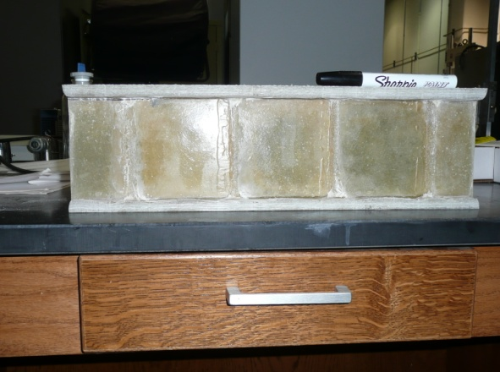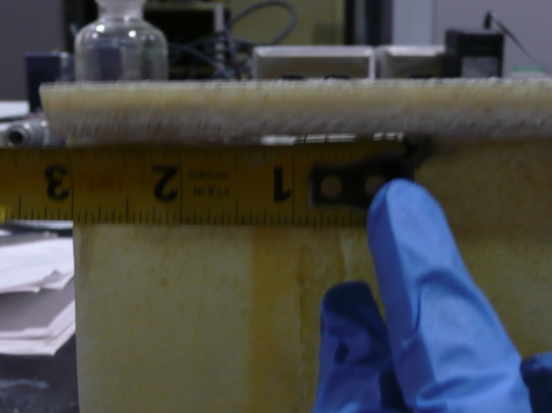
Figure 4.4 A Precracked Specimen

The face sheets of the specimens were considered as specially orthotropic materials and their material properties are shown in Table 4.1. The Young’s Moduli and υ₁₂ in Table 4.1 were experimentally determined from tests of several face sheet coupons. The testing setup and procedure were the same as those utilized in Nordin et al. (2010). The laminates of the face sheets in this study were similar to those in Davalos et al. (2001). Since the experimentally determined E₁, E₂, and υ₁₂ were close to the values in Davalos et al. (2001), G₁₂ from Davalos et al. (2001) were used in this study. The flat core walls in this study were considered as isotropic materials. Their Young’s modulus and Poisson’s ratio from coupon tests were 8.29 GPa (1202 ksi) and 0.29, respectively. Aluminum was also utilized later in this study. Its Young’s modulus and Poisson’s ratio were assumed as 68.9 GPa (10000 ksi) and 0.33, respectively.

Table 4.1 Material Properties of a Face Sheet
E₁ | E₂ | υ₁₂ | G₁₂*
23.57 GPa (3419 ksi) | 10.27 GPa (1489 ksi) | 0.22 | - Pa (546 ksi)
* From Davalos et al. (2001).

4.2.2 Experimental Setup

The experimental setup in this study was designed with reference to the fracture toughness tests used in the study by Siriruk et al. (2009) and Siriruk et al. (2011). TSD tests were originally developed to measure the interfacial fracture toughness or G_{c} of FRP sandwich structures with foam cores at different mode-mixities (Li and Carlsson 1999, Viana and Carlsson 2003). In this study, it was implemented to measure the interfacial fracture toughness of the specimens with the I-section in Figure 4.3.
A schematic illustration of a TSD test is given in Figure 4.5. TSD tests are mainly concerned with the influences of Mode I loading, Mode II loading and their combinations on interfacial fracture toughness or G_{c}. Ideally, the mixed-mode ratios equal to G_{II} over G_{I} in TSD tests are varied with different tilt angles. According to Figure 4.5, a pure peeling load is achieved when the tilt angle α is equal to 0° and a pure sliding shear is achieved when the tilt angle α is 90°. The combinations of peeling load and sliding shear can be achieved when α is between 0° and 90°.

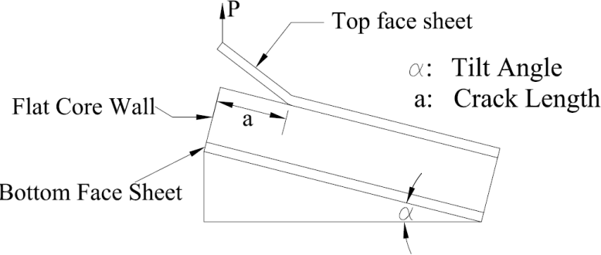
Figure 4.5 A Schematic Illustration of a TSD Test

In this study, only TSD tests with α equal to 0° were performed in the experimental study. In order to conduct the TSD test illustrated in Figure 4.5, each specimen was glued by epoxy to a testing fixture. The testing fixture consisted of one aluminum T-section beam and an aluminum rectangular plate. The T-section beam was 406.4 mm (16.0 in.) long and a specimen was directly glued to it. The rectangular plate was utilized to facilitate the grip of the testing fixture by an MTS testing machine. The whole experimental apparatus placed on an MTS testing machine is shown in Figure 4.6. The testing fixture was gripped by the bottom actuator of the MTS testing machine. During the tests, experimental specimens were loaded in a displacement-controlled mode. The bottom actuator was displaced downward while the position of the top actuator was unchanged during the whole test of each specimen. In order to keep the applied load aligned with the actuators, a piano hinge was glued to the top face sheet in each specimen. The experimental setup in Figure 4.6 could also be considered as a setup for DCB tests. However, since the aluminum T-beam could provide considerable stiffness to the bottom face sheet, this setup was called a TSD test setup with α equal to 0° in this study.

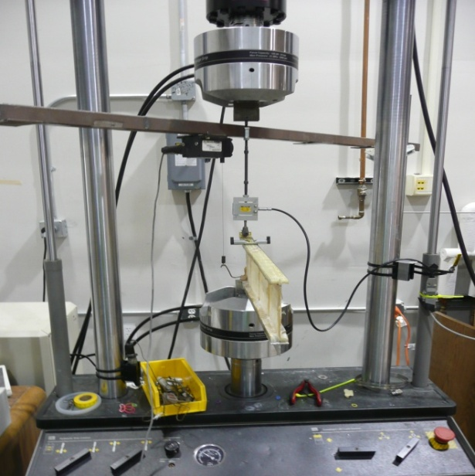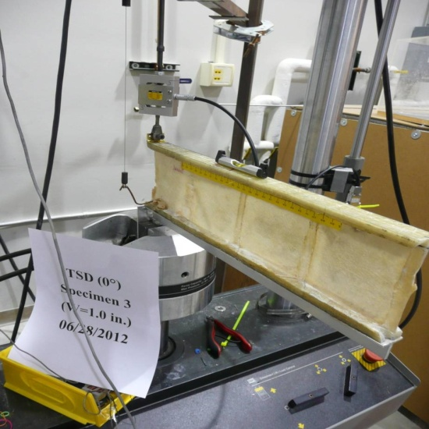
Figure 4.6 An Experimental Setup

The experimental tests in this study were mainly used to obtain the interfacial fracture toughness when the tilt angle was 0°. The data concerning loads, displacements and crack lengths were obtained from the tests. Since the expected failure loads at different crack lengths for each specimen were small, an external load cell were placed between the piano hinge and the top actuator of the MTS testing machine to record load values. An external load cell with a capacity of 3336 N (750 lbs) was used for Specimen 1 and an external load cell with a capacity of 444.8 N (100 lbs) for Specimen 2 and 3. The displacement data were recorded from both the MTS machine and an external LVDT whose string was hooked to a point on the bottom face sheet of each specimen which was above the bottom actuator. Both loads and displacements were recorded at a frequency of one second.
The test of one specimen included several subtests and each subtest was loaded at a rate between 1 mm/min (0.04 in./min) and 2 mm/min (0.08 in./mm). Each subtest was stopped when sudden load drop and/or crack propagation was noticed. Then, after crack propagation, the crack lengths were achieved from visual inspection. It should be mentioned that this crack length was also the initial crack length for the next subtest. For each specimen, it was subjected to the subtests described above until the length of the uncracked interface of a specimen was shorter than 101.6 mm (4.0 in.).

4.2.2 Experimental Results and Discussion

The main objective of the experimental study was to obtain interfacial fracture toughness or G_{c} from the relationships between loads and displacements. Typical load-versus-displacement relationships at different crack lengths were plotted in Figure 4.7. The experimental data in Figure 4.7 were from the tests of Specimen 2. According to this figure, loads did not drop obviously or they even increased when crack lengths were within a certain range. As a result, G_{c} might be a function of crack lengths and a rising R-curve behavior was expected for the specimens used in this study.

Figure 4.7 Loads Vs. Displacements

In this study, Eq. (4.3) was utilized to obtain G_{c} from the experimental data. The critical load for crack propagation at a given crack length, which is denoted by P_{cr} in Eq. (4.3), was obtained at the point where sudden load drop, sudden compliance increase or gradual 5% compliance increase occurred (ASTM D5528 2001). The expression dC/da was evaluated by taking the derivative of a function relating compliances (denoted by C hereinafter) to crack lengths (denoted by a hereinafter). This function could be determined by curve-fitting of the experimental data about compliances at different crack lengths. A typical C versus a relationship which was ready for curve-fitting is given in Figure 4.8. Compliances in Figure 4.8 were obtained from the linear parts of the load-displacement relationships in Figure 4.7 at different crack lengths. The details about the curve-fitting are discussed later.
(4.3)
Figure 4.8 Compliances Vs. Crack Lengths

As discussed above, G_{c} for the specimens in this study were expected to be dependent upon a when a was within a certain range. This conclusion can also be drawn based on Figure 4.9 which shows the relationship between G_{c} and a. Figure 4.9 clearly indicates a rising R-curve behavior and G_{c} as a function of a. Since the rising R-curve behavior is observed, it is desirable to obtain G_{c} corresponding to the steady state of the R-curve behavior. The mean value and standard deviation of G_{c} from the last four data in Figure 4.9 are 7650 J/m² (43.7 lb/in) and 490 J/m² (2.8 lb/in), respectively. Consequently, the last four data may represent the plateau part of the relationship between G_{c} and a. 7650 J/m² (43.7 lb/in) is considered as the G_{c} corresponding to the steady state of the R-curve behavior in Figure 4.9. The R-curve behavior in this study was mainly attributed to fiber bridging at the interfaces. Figure 4.10 illustrates fiber bridging at an interface.

Figure 4.9 G_{c} Vs. a
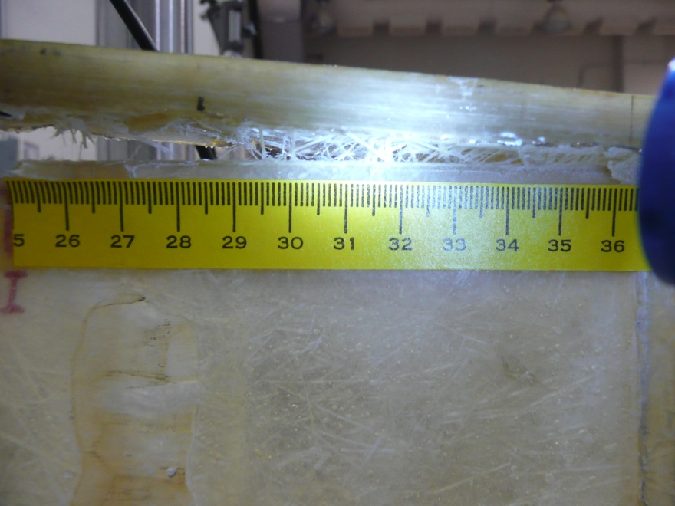
Figure 4.10 Fiber Bridging at an Interface

To sum up, the experimental investigation in this study measured G_{c} at different crack lengths and showed a rising R-curve behaviors in the specimens. It also indicated that the testing setup discussed here can obtain G_{c} corresponding to the steady state of the R-curve behavior. Because of the rising R-curve behavior, experimental specimens should be long enough to observe its steady state. As a result, for the HFRP sandwich structure in this study, the length of specimens for future G_{c} tests should be properly selected. Further, the rising R-curve behavior indicates that it is necessary to use some testing setups for G_{c} measurement in which the mixed-mode ratio G_{II}/G_{I} is approximately constant as cracks propagate. Otherwise, the coupling of the R-curve behavior and mixed-mode ratio change will make it difficult to quantify the contribution of each observation to the variation of G_{c}. The potential experimental setups satisfying these requirements were investigated by FEA in the following discussion.

4.3 Finite Element Analysis and Parametric Study
The FEA in this study was to investigate the mixed-mode ratio G_{II}/G_{I} that can be achieved by modifying the experimental setup in Figure 4.6. The potential modifications included tilting experimental specimens by welding aluminum T-beams at different angles to the rectangular plates gripped by the bottom actuator and stiffening top face sheets by aluminum strips (Berggreen and Carlsson 2010). The FEA was first verified by analytical solution available and experimental results. Then it was used to study the influences of tilt angles, stiffening strip and crack lengths on the mixed-mode ratio G_{II}/G_{I}.

4.3.1 Finite Element Analysis and Its Verification
The FEA in this study was performed using the commercial FEA software package ABAQUS. It modeled an experimental specimen by several parts shown in Figure 4.11. The shell/3D modeling technique explained by Krueger and O’Brien (2001) was utilized in FEA. Two parts were used to model the vicinity of a crack front at the interface between a top face sheet and a core by 3-D solid elements. The length of the vicinity on either side of the crack front was at least 3t_{f}. The solid elements around the vicinity of the crack front were C3D8I (Krueger and O’Brien 2001, Krueger and Goetze 2006). The VCCT technique was used to investigate the energy release rates at the interface. For the convenience of the application of VCCT, the interface between the top face sheet and the flat core wall had matched mesh. The remaining parts of the top face sheet and the core, which were distant from the crack front, were meshed by shell elements S4. The shell elements were coupled with the solid elements by a shell-solid coupling technique provided by ABAQUS. Besides the parts described above, two parts meshed by the elements S4 were utilized for the modeling of the bottom face sheet and T-beam. The bottom face sheet was tied to the T-beam. The tie-type multiple point constraints were applied to connect the core wall to the bottom face sheet and the top face sheet which is in front of the crack tip and modeled by S4 shell elements.
In order to verify the model described above, this study first considered a case in which an analytical solution was available. In this case, a model like the one in Figure 4.11 was subjected to uniform bending moment at the edge of the top face sheet behind the crack front. It had the same geometric properties as the model for Specimen 2 and Specimen 3 except those described as follows. The thickness of the flat core wall was assumed as 0.98 times the W in Figure 4.3 for Specimen 2 and Specimen 3 instead of its actual thickness. The total height of the specimen in the case was 2 times that of the specimens in the experimental tests. All the parts in the model had the material properties of the flat core wall described above.

Figure 4.11 FE Model of a TSD Specimen

The analytical solution to stress intensity factors for the case above is given in Eq. (4.4) (Suo and Hutchinson 1990). In this case, ε in Eq. (4.4) was considered as zero because the same homogeneous isotropic material properties were assigned in the whole model. ε equal to 0 also implied that K₁ and K₂ in Eq. (4.4) were the same as the conventionally defined K_{I} and K_{II}, respectively. Because t_{f} was considerably small comparing to the height of the remaining part, it was reasonable to consider γ to be 0. As a result, Eq. (4.4) could be simplified as Eq. (4.5).
(4.4)
(4.5)
Where M was the uniform bending moment at the edge of the top face sheet behind the crack front, p in this case was equal to 1. The determination of other parameters was given in Suo and Hutchinson (1990).
According to Eq. (4.5), the mixed-mode ratio K_{I}/K_{II} is purely a function of. It is also noted that the K_{I}/K_{II} is independent of crack lengths. In this case, is approximately 52.1° and K_{I}/K_{II} from the analytical solution is approximately 1.28. Correspondingly, K_{I}/K_{II} from the modified model at different crack lengths are given in Table 4.2. The K_{I}/K_{II} in this table was calculated as the square root of G_{I}/G_{II} which was obtained using the VCCT in FEA. According to Table 4.2, the K_{I}/K_{II} from the FEA was close to that from the analytical solution and was almost constant at different crack lengths.

Table 4.2 K_{I}/K_{II} from FEA
Crack Lengths (mm) | 127 | 178 | 229 | 279
K_{I}/K_{II} | 1.38 | 1.38 | 1.39 | 1.39

After comparing the FEA results above to the analytical solution available, this study utilized the FEA to model the testing in this study and to correlate the theoretical results with the experimental data. The geometric and material properties for the experimental specimens discussed before were applied in the model in Figure 4.11 to collect theoretical results. When performing the FEA, this study applied uniform peeling pressure to top face sheets to simulate the testing in this study. The displacements at the loading edges of top face sheets were obtained from the FEA at several crack lengths. The crack lengths in the FEA were close to the ones observed in the tests. The loads and displacements from the FEA were then applied to obtain the theoretical values for C. A comparison between the theoretical compliances and experimental compliances is given in Figure 4.12. According to Figure 4.12, the FEA in this study could reasonably predict the compliances.

Figure 4.12 Compliance Comparisons

The FEA in this study was also used to predict the P_{cr} at several crack lengths. The comparisons of the theoretical and experimental P_{cr} are shown in Table 4.3. The crack lengths and experimental P_{cr} in Table 4.3 were obtained from the tests of Specimen 3. Considering the R-curve behavior observed in the experiment, only the G_{c} and crack lengths from the steady state of the R-curve behavior were considered in the FEA to predict the P_{cr} in Table 4.3. The mean value and standard deviation of G_{c} corresponding to the steady state of the R-curve behavior in Specimen 3 were 6995 J/m² (39.9 lb/in) and 687 J/m² (3.9 lb/in), respectively. It was noted that the G_{c} corresponding to the steady-state of the R-curve behavior from Specimen 3 was close to that from Specimen 2. According to Table 4.3, the FEA in this study could reasonably predict the P_{cr} as well.

Table 4.3 P_{cr} at Different Crack Lengths
Crack Lengths (mm) | 250 | 278 | 302
Experimental P_{cr} (N) | 107 | 96 | 84
Theoretical P_{cr} (N) | 108 | 99 | 78

4.3.2 Specimen Lengths for Future Tests
As mentioned above, a specimen should be long enough to measure the G_{c} corresponding to the steady state of the R-curve behavior. In Specimen 2, the steady state of the R-curve behavior was observed when the crack length was approximately 228 mm (9.0 in). In Specimen 3, the steady state of the R-curve behavior was observed when the crack length was about 250 mm (10.0 in).
In order to determine the least crack length in the experimental specimens to observe the steady state of the R-curve behavior, this study performed FEA to predict the P_{cr} at several crack lengths observed in Specimen 1 and compared the theoretical values with the experimental ones. The G_{c} used in the FEA was the average value of 6995 J/m² (39.9 lb/in) and 7650 J/m² (43.7 lb/in) which were the G_{c} corresponding to the steady state of the R-curve behavior from Specimen 2 and Specimen 3. The comparisons are shown in Table 4.4. If the steady state of the R-curve behavior was achieved at a crack length in Table 4.4, the predicted P_{cr} should be close to the experimental one like the comparisons in Table 4.3. However, according to Table 4.4, the predicted P_{cr} at a crack length was larger than the experimental one. As a result, it was not likely that the steady state of the R-curve behavior was achieved at the crack lengths shown in Table 4.4 from Specimen 1.

Table 4.4 P_{cr} Comparisons from Specimen 1
Crack Lengths (mm) | 153 | 203 | 235
Experimental P_{cr} (N) | 129 | 120 | 98
Theoretical P_{cr} (N) | 187 | 145 | 128

According to the experimental and FEA results above, a crack length which results from propagation of the initial crack length and is longer than 250 mm (10.0 in.) is suggested for future tests to observe the steady state of the R-curve behavior. It should be emphasized that this conclusion is specific to the experimental specimens in this study. The experimental specimens in this study were 406.4 mm (16.0 in.) long with an initial crack equal to 76.2 mm (3.0 in). In future tests, longer specimens like 508 mm (20 in.) long specimens with the same initial crack length should be considered to collect more data about the G_{c} corresponding to the steady state of the R-curve behavior.

4.3.3 Parametric Study by FEA
Since the FEA discussed above has been verified by some analytical solution and experimental results, it was used to perform a parametric study about the influences of several parameters on the mixed-mode ratio G_{II}/G_{I} in the TSD tests. The parameters considered in the parametric study were the thickness of aluminum strips which could stiffen top face sheets, tilt angles and crack lengths. The study by Berggreen and Carlsson (2010) showed that the mode-mixities could be effectively changed when the top face sheets of sandwich structures with foam cores were stiffened by some external materials. It is not clear how stiffening top face sheets of the specimens in this study can vary the mixed-mode ratio G_{II}/G_{I}. It is also not clear how tilt angles may impact the G_{II}/G_{I} in the specimens considered in this study. Finally, it is important to investigate how crack lengths can affect G_{II}/G_{I} if the R-curve behavior of G_{c} is expected in the tests. As discussed above, it is desirable to have some experimental setups in which G_{II}/G_{I} approximately remain constant as cracks propagate.
In the parametric study, Specimen 2 or Specimen 3 with a length of 508 mm (20 in.) instead of 406.4 mm (16.0 in.) was modeled in the FEA. When investigating the cases in which aluminum strips were used to stiffen top face sheets, the aluminum strips modeled by shell elements were tied to the top face sheet in Figure 4.11. The vicinity of a crack front, which was at least three times the total thickness of a top face sheet and an aluminum strip long on either side of the crack front, was modeled by solid elements. The modeling of the remaining part was similar to that in Figure 4.11. When tilt angles were considered, this study applied both peeling loads and sliding shears on the shell elements which modeled the aluminum strips. The ratios of sliding shears to peeling loads were equal to the tangent of tilt angles. Because shell elements were used to model the aluminum strips, the edge moments equal to sliding shears times one half of the thickness of the aluminum strips were also applied in the model.
Before the results about the mixed-mode ratio G_{II}/G_{I} from the parametric study are discussed, it should be mentioned that the interfaces between two elastic layers might show oscillatory behaviors when ε in Eq. (4.4) is not zero. If ε in Eq. (4.4) is not zero, the discussions concerning the G_{II}/G_{I} should include some length scales (Hutchinson and Suo 1992). As a result, the lengths of the elements at the interfaces play a vital role in the determination of the G_{II}/G_{I}. For FRP sandwich structures, ε is generally not zero. However, it has been argued that the ε is small and can be considered as zero in practical cases (Berggreen and Carlsson 2010, Carlsson and Kardomateas 2011). This assumption was also applied in the parametric study in this study. In the parametric study, the length of the elements at the interfaces was 1.27 mm (0.05 in.). This element length was applied to achieve the convergent results in Table 4.2.
Thickness of Aluminum Strips Figure 4.13 shows the effect of the thickness of aluminum strips on the mixed-mode ratio G_{II}/G_{I}. The thickness of the aluminum strips which stiffen top face sheets is denoted by t_{Al} in Figure 4.13. t_{Al} considered in Figure 4.13 are 0, 12.7 mm (0.5 in.) and 25.4 mm (1.0 in.). The tilt angle in Figure 4.13 is equal to zero. The crack lengths in Figure 4.13 are between 203 mm (8.0 in.) and 305 mm (12.0 in.).
Figure 4.13 illustrates that pure Mode I loading is achieved at interfaces when t_{Al} is equal to 0 or no aluminum strips are used. It also shows that the G_{II}/G_{I} increases as the t_{Al} increases. Therefore, applying aluminum strips to stiffen top face sheets can effectively vary G_{II}/G_{I}. Moreover, it is interesting to notice that at a given t_{Al} the G_{II}/G_{I} does not change much at the crack lengths considered in Figure 4.13. This conclusion is important to the determination of the G_{c} corresponding to the steady state of the R-curve behavior observed in the experimental specimen because it avoids the coupled effect of the R-curve behavior and mode-mixity’s change on the variation of G_{c} as cracks propagate.

Figure 4.13 G_{II}/G_{I} with Different t_{Al} and Crack Lengths

Tilt Angles Figure 4.14 demonstrates the effect of tilt angles on mixed-mode ratios. A constant crack length of 254 mm (10.0 in.) was used to generate the data in Figure 4.14 from the FEA. In Figure 4.14, the negative tilt angles correspond to the positive values of α in Figure 4.5. When the tilt angles in Figure 4.14 are negative, negative shear stress is promoted at crack tips.
Figure 4.14 shows that the mixed-mode ratios G_{II}/G_{I} at this specific crack length monotonically increase when the tilt angles increase from -45° to 45°. This observation indicates that the positive shear stress at the bi-material interfaces of this study due to the peeling load in Figure 4.5 is significant and cannot be fully counterbalanced by the negative shear stress considered in Figure 4.14. When t_{Al} is equal to 0, the G_{II}/G_{I} is close to 0 regardless of the tilt angles. The range of the G_{II}/G_{I} at different tilt angles is expanded when t_{Al} gets larger. The effect of tilt angles on G_{II}/G_{I} becomes more significant when top face sheets are stiffer. This observation is consistent with the conclusion from the study by Berggreen and Carlsson (2010) in which stress intensity factors K_{I} and K_{II} were used to denote mode-mixities.
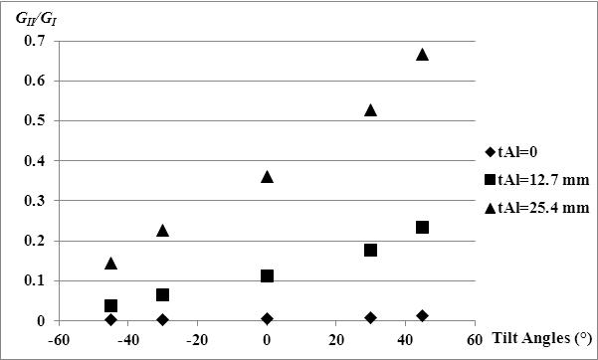
Figure 4.14 G_{II}/G_{I} with Different t_{Al} and Tilt Angles

Crack Lengths G_{II}/G_{I} as functions of crack lengths with several tilt angles are shown in Figure 4.15. The discussions above show how the pure Mode I loading or G_{II}/G_{I} equal to zero can be achieved in the G_{c} tests. Figure 4.14 shows that positive tilt angles are more effective to increase G_{II}/G_{I} if G_{II}/G_{I} is varied in experiment. As a result, negative tilt angles are not included in Figure 4.15. The cases in Figure 4.15 have the t_{Al} equal to12.7 mm (0.5 in.).
According to Figure 4.15, the G_{II}/G_{I} will decrease as crack lengths increase. A constant G_{II}/G_{I} independent of crack lengths cannot be achieved in the cases investigated in Figure 4.15 except those with tilt angles equal to zero. As is expected, the G_{II}/G_{I} in the cases with tilt angles equal to 30° and 45° approaches the G_{II}/G_{I} in the cases with tilt angles equal to zero as cracks propagate. This observation indicates that the mode-mixities resulted from peeling loads becomes more dominant when cracks grow in these cases. It should be emphasized again that the positive tilt angles in Figure 4.15 are negative α in Figure 4.5.
Figure 4.15 G_{II}/G_{I} with Different Crack Lengths and Tilt Angles

Based on the results from the FEA, this study concluded that longer specimens should be utilized in future tests if more data concerning the G_{c} corresponding to the steady state of the R-curve behavior would be collected from experiment. Due to the existence of the R-curve behavior, experimental tests for the G_{c} measurement should be designed to vary G_{II}/G_{I} and at the same time keep G_{II}/G_{I} independent of crack lengths. The parametric study results from the FEA indicated that the TSD tests in this study with tilt angles equal to zero might satisfy the requirements above. In these TSD tests, G_{II}/G_{I} could be changed by stiffening top face sheets with aluminum strips of different thickness. When crack lengths were within a certain range, the G_{II}/G_{I} approximately remained constant. The FEA results also indicated that the change of tilt angles could affect G_{II}/G_{I}, especially when top face sheets were stiffened by aluminum strips. However, when tilt angles were not zero, crack lengths also had direct influences on G_{II}/G_{I}. In the tests with tilt angles not equal to zero, it is difficult to attribute the variation of G_{c} as cracks propagate to either the R-curve behavior or mode-mixity change.

4.4 Data Reduction Method for the Experimental Study
In this study, G_{c} was obtained from experimental data using Eq. (4.3). An underlying assumption about Eq. (4.3) is that the top face sheet in Figure 4.3 behaves like a beam rather than a plate. Before applying Eq. (4.3), it is necessary to check the validity of this assumption.
In order to address this concern, the top face sheet may be temporarily idealized as an orthotropic plate and the core wall as a one-parameter elastic foundation. The orthotropic plate is supported by the elastic foundation only along its centerline in the width direction. When the tilt angle is 0° and the crack length is reasonably large, the loading conditions in Figure 4.5 are equivalent to those shown in Figure 4.16. If the symmetry in Figure 4.16 is taken into account, then the boundary conditions on the edge AB and CD are the same as is described by Eq. (3.8c) to Eq. (3.8f).
Figure 4.16 A Plate-on-Elastic-Foundation Model

When the orthotropic plate behaves like a beam, the distribution of deflection and rotation along any edges parallel to the loaded edge should be uniform. If P at the edge AE is replaced by a uniform displacement, then the variational formulation in Eq. (3.11) to Eq. (3.19) can be used to verify if a relatively uniform rotation distribution along the width of the orthotropic plate can be achieved. It should be mentioned that typical material properties of face sheets and core walls allow the application of CLPT. Although the one-parameter elastic foundation is an oversimplification of a core wall, the variational formulation in Eq. (3.11) to Eq. (3.19) is sufficient for the purpose of the study here.
For the experimental specimens in this study, when the width of their top face sheets is less than or equal to 31.75 mm (1.25 in.), the top face sheets do behave like beams according to Eq. (3.11) to Eq. (3.19). As a result, it is appropriate to use Eq. (4.3) to determine G_{c}. It should also be mentioned that when the top face sheets behave like beams according to Eq. (3.11) to Eq. (3.19), their behaviors are not sensitive to a reasonable variation of G₁₂ in Table 4.1 if E₁, E₂ and υ₁₂ are accurately determined. Consequently a representative value of G₁₂ is sufficient to the analysis in this study. This conclusion justifies the application of the G₁₂ in Table 4.1.
Since the top face sheets in the experimental specimens behave like beams, Eq. (4.3) can be used to determine G_{c} from the experimental data. According to Eq. (4.3), C as a function of a is required to calculate dC/da. According to the one-parameter elastic foundation analysis (Li and Carlsson 2000, Li and Carlsson 2001), C can be expressed as a polynomial of a if the length of the uncracked interface satisfies Eq. (4.6). Then C as a polynomial generally has the form shown in Eq. (4.7). Eq. (4.6) and Eq. (4.7) are based on the assumption that the core in a sandwich structure can be idealized as a one-parameter elastic foundation. For the experimental specimens in this study, this assumption may oversimplify the flat core wall. Therefore, m, n and p in Eq. (4.7) may not be obtained from the one-parameter elastic foundation analysis in the previous research. Nevertheless, it is still suitable to use Eq. (4.7) as a general form to determine C as a function of a from experimental data.
(4.6)
(4.7)
Where l_{u} is the length of the uncracked interface, E_{c} is the Young’s modulus of the core in a sandwich structure. t_{c} and h_{c} are the thickness and the height of the core, respectively. I_{f} is the moment of inertia of the top face sheet. E₁ is the Young’s modulus of the top face sheet in the direction of crack propagation.
In this study, when C as a function of a was determined, this study first subtracted a³/3E₁I_{f} from the experimental C. Then, the data resulted from the subtraction were utilized in curve-fitting to determine the m, n and p in Eq. (4.7). When C as a function of a was determined in the way described above, the dC/da resulted from the experimental data was quite close to that from the FEA and the Gc corresponding to the steady state of the R-curve behavior from Specimen 2 and Specimen 3 was relatively consistent. The comparisons of the experimental and theoretical dC/da are shown in Figure 4.17. The experimental dC/da in Figure 4.17 was determined based on all the data except the one at the fourth crack length in Figure 4.8.

Figure 4.17 dC/da vs. Crack Lengths

Due to limited data in this study, it is premature to conclude that the data reduction method described above can indeed be used to determine G_{c} from experimental tests. In the future, more experimental data and/or rigorous analysis should be used to verify the data reduction method discussed here

4.5 Conclusions
This study investigates the potential application of TSD tests to an FRP sandwich structure with honeycomb cores. It shows that specimens with I-sections made from the FRP sandwich structure can be used to obtain G_{c} in the TSD tests discussed in this study. Based on the experimental study and FEA, the following conclusions are made:
- The experimental investigation in this study measured G_{c} at different crack lengths and showed a rising R-curve behavior in the specimens. It also measured the G_{c} corresponding to the steady state of the R-curve behavior under pure Mode I loading. Although the length of the experimental specimens in this study was sufficient to observe the steady state of the R-curve behavior, it is recommended that longer specimens should be used in future tests.
- Due to the existence of the R-curve behavior, experimental TSD tests for the G_{c} measurement should be designed to vary G_{II}/G_{I} and at the same time keep G_{II}/G_{I} independent of crack lengths. In terms of changing G_{II}/G_{I}, it could be realized in the TSD tests by both stiffening top face sheets with aluminum strips and tilting specimens at different angles. However, when tilt angles were not zero, G_{II}/G_{I} showed apparent dependence on crack lengths. As a consequence, the TSD tests with tilt angles equal to zero are recommended for future study. The variation of G_{II}/G_{I} can be achieved by using aluminum strips of different thickness to stiffen top face sheets of specimens.
- A data reduction method was tentatively proposed for the TSD tests discussed in this study. Based on the limited data available and FEA, this method can be used to obtain the G_{c} corresponding to the steady state of the R-curve behavior.

: Conclusions and Future Work
This chapter summarizes the accomplishments of this study along with conclusions and recommendations for future research.

5.1 Conclusions
The stiffness-driven design of FRP slab bridges and the application of the TSD tests to the interface debonding study of an FRP sandwich structure with honeycomb cores are conducted in this study. Based on the experimental study and theoretical investigation, the following conclusions are made:
- For the FRP sandwich superstructure in Chapter 1, it was likely to reach its deflection limit first. Therefore, its design should be based on stiffness rather than strength. This conclusion is consistent with the recommendation from the Federal Highway Administration (FHWA 2011).
- The test results in this study indicated that at service load level, cold temperatures could increase the stiffness of the FRP sandwich structure. No structural-level stiffness degradation was observed in the tests.
- Under the combined effects of cold temperatures and service load, the interface debonding was observed at one end of a specimen. Although it did not affect the stiffness of the specimen, it should be a design concern in the future application of the sandwich structure.
- For the bi-material interfaces in this study, both tensile and shear stress should be included in the interface debonding study even when the sandwich structure is subjected to some tests which aim to measure the shear strength.
- For typical FRP slab bridges which are made of glass fibers and polyester or vinyl ester, they can be designed by the equivalent strip width expressions proposed in this study. The equivalent width expressions were derived based on classical laminate plate theory. When they were implemented in design with the Timoshenko beam theory, the predicted deflections were close enough to those predicted by first-order shear deformation theory.
- The analysis of FRP slabs requires knowledge of various parameters, most of which are not available at the design stage. This study shows that it is possible to consider only a few key parameters to perform the preliminary design of a FRP slab bridge. The key factors were identified in this study, and the recommended design procedure was illustrated by a flow chart.
- The TSD tests in this study measured G_{c} at different crack lengths and showed a rising R-curve behavior in the specimens. It also measured the G_{c} corresponding to the steady state of the R-curve behavior under pure Mode I loading. Although the length of the experimental specimens in this study was sufficient to observe the steady state of the R-curve behavior, it is recommended that longer specimens should be used in future tests.
- This study showed that in the TSD tests the mixed-mode ratio G_{II}/G_{I} could be changed by both stiffening top face sheets with aluminum strips and tilting specimens at different angles. However, when tilt angles were not zero, G_{II}/G_{I} did not remain constant at different crack lengths. In these tests, it will be difficult to attribute the variation of G_{c} as cracks propagate to either the R-curve behavior or mode-mixity change. As a result, this study recommends the TSD tests with tilt angles equal to zero for future study. In these tests, the variation of G_{II}/G_{I} can be achieved by using aluminum strips of different thickness to stiffen top face sheets of specimens.
- A data reduction method was tentatively proposed for the TSD tests discussed in this study. Based on the limited data available and FEA, this method could be used to obtain the G_{c} corresponding to the steady state of the R-curve behavior.

5.2 Future Work
Equivalent strip width expressions for FRP decks supported by steel and prestressed concrete girders should be derived in the future. Besides, the conclusions concerning the TSD tests of the FRP sandwich structure investigated in this study should be utilized in experiment to measure G_{c} at different mode-mixities. The experimentally-determined G_{c} at different mode-mixities can be applied in curve-fitting to determine crack propagation criteria based on Eq. (4.1) or Eq. (4.2). Once crack propagation criteria are available, they can be implemented in CZM to predict crack propagation. Further, more data concerning G_{c} should be obtained to verify the data reduction method proposed in this study as well.

References

American Association of State Highway and Transportation Officials (AASHTO) (2010), AASHTO LRFD bridge design specifications, 5th Ed., American Association of State Highway and Transportation Officials, Washington, D.C.
Alagusundaramoorthy, P., Harik, I. E., and Choo, C. C. (2006), “Structural behavior of FRP composite bridge deck panels,” Journal of Bridge Engineering, V. 11, No. 4, pp. 384-393.
Alampalli, S., O’Conner, J., and Yannotti, A. P. (2002), “Fiber Reinforced Polymer Composites for the Superstructure of a Short-Span Rural Bridge,” Composite Structures, V. 58, No.1, pp. 21-27.
Alfano, G., and Crisfield, M. A. (2001), “Finite Element Interface Models for the Delamination Analysis of Laminated Composites: Mechanical and Computational issues,” International Journal for Numerical Methods in Engineering, V. 50, No. 7, January, pp. 1701-1736.
Allix O., and Corigliano A. (1996), “Modeling and Simulation of Crack Propagation in Mixed-Modes Interlaminar Fracture Specimens,” International Journal of Fracture, V. 77, No. 2, June, pp. 111-140.
Altenbach, H., Altenbach, J., and Kissing, W. (2004), Mechanics of Composite Structural Elements, Springer-Verlag, New York, 468 pp.
Anderson, T. L. (2005), Fracture Mechanics: Fundamentals and Applications, 3rd Ed., CRC Press, Taylor & Francis Group, 621 pp.
ASTM Standard C393/C393M (2006), “Standard Test Method for Core Shear Properties of Sandwich Constructions by Beam Flexure”, ASTM International, West Conshohocken, PA, DOI: 10.1520/C0393_C0393M-06, www.astm.org.
ASTM Standard D5528 (2001), “Standard Test Method for Mode I Interlaminar Fracture Toughness of Unidirectional Fiber-Reinforced Polymer Matrix Composites”, ASTM International, West Conshohocken, PA, DOI: 10.1520/D5528-01R07E03, www.astm.org.
Bank, L. C. (2006), Composites for Construction: Structural Design with FRP Materials, John Wiley & Sons, NY. ISBN: 0-471-68126-1.
Benzeggagh, M. L., and Kenane, M. (1996), “Measurement of Mixed-Mode Delamination Fracture Toughness of Unidirectional Glass/Epoxy Composites with Mixed-Mode Bending Apparatus,” Composites Science and Technology, V. 56, No. 4, April, pp. 439-449.
Berggreen, C., Andreasen, J. H., Jakobsen, J., Carlsson, L. A., Thomsen, O. T. (2009), “Mixed Mode Fracture Toughness Characterization of Sandwich Interfaces Using the Modified TSD Specimen,” Proceedings of 17th International Conference on Composite Materials, Edinburgh, UK, July.
Berggreen, C. and Carlsson, L. A. (2010), “A Modified TSD Specimen for Fracture Toughness Characterization – Fracture Mechanics Analysis and Design,” Journal of Composite Materials, V. 44, No. 15, July, pp. 1893-1912.
Berggreen, C., Simonsen, B. C., and Borum, K. K. (2007), “Experimental and Numerical Study of Interface Crack Propagation in Foam-Cored Sandwich Beams,” Journal of Composite Materials, V. 41, No. 4, pp. 493-520.
Berkowitz, C. K., and Johnson, W. S. (2005), “Fracture and Fatigue Tests and Analysis of Composite Sandwich Structure,” Journal of Composite Materials, V. 39, No. 16, August, pp. 1417-1431.
Bhaskar, K., and Kaushik, B. (2004), “Simple and Exact Series Solutions for Flexure of Orthotropic Rectangular Plates with Any Combination of Clamped and Simply Supported Edges,” Composite Structures, V. 63, No. 1, Jan., pp. 63-68.
Burton, W. S., and Noor A. K. (1997), “Assessment of Continuum Models for Sandwich Panel Honeycomb Cores,” Computer Methods in Applied Mechanics and Engineering, V. 145, No. 3-4, June, pp. 341-360.
Cai, C. S., Oghumu, S. O., and Meggers, D. A. (2009), “Finite Element Modeling and Development of Equivalent Properties for FRP Bridge Panels,” Journal of Bridge Engineering, V. 14, No. 2, March-April, pp. 112-121.
Camanho, P. P., and Davila, C. G. (2002), “Mixed-Mode Decohesion Finite Elements for the Simulation of Delamination in Composite Materials,” NASA/TM-2002–211737, pp. 1–37.
Camanho, P. P., Dávila, C. G., and de Moura, M. F. (2003), “Numerical Simulation of Mixed-Mode Progressive Delamination in Composite Materials,” Journal of Composite Materials, V. 37, No. 16, pp. 1415-1438.
Carlsson, L. A., and Kardomateas, G. A. (2011), Structural and Failure Mechanics of Sandwich Composites, 1st Edition, Springer Netherlands, May, 386 pp.
Chen, A., and Davalos, J. F. (2004), “Behavior of Honeycomb FRP Sandwich Sinusoidal Core Panels with Skin Effect,” Proceedings of 9th ASCE Aerospace Division International Conference on Engineering, Construction and Operations in Challenging Environments, March, pp. 625-632.
Chen, A., and Davalos, J. F. (2007), “Transverse Shear Including Skin Effect for Composite Sandwich with Honeycomb Sinusoidal Core,” Journal of Engineering Mechanics, V. 133, No. 3, March, pp. 247 – 256.
Davalos, J. F., Salim, H. A., Qiao, P., and Lopez-Anido, R. (1996), “Analysis and Design of Pultruded FRP Shapes under Bending,” Composites Part B: Engineering, V. 27, No. 3-4, pp. 295-305.
Davalos, J. F., Qiao, P., Xu, X. F., Robinson J., and Barth, K. E. (2001), “Modeling and Characterization of Fiber-Reinforced Plastic Honeycomb Sandwich Panels for Highway Bridge Applications,” Composite Structures, V. 52, No. 3-4, May-June 2001, pp. 441-452.
Davidson, B. D., and Sun, X. (2006), “Geometry and Data Reduction Recommendations for a Standardized End Notched Flexure Test for Unidirectional Composites,” Journal of ASTM International, V. 3, No. 9, October.
Dugdale, D. S. (1960), “Yielding of Steel Sheets Containing Slits,” Journal of the Mechanics and Physics of Solids, V. 8, No. 2, May, pp. 100-104
Dutta, P. K., and Hui, D. (1996), “Low-Temperature and Freeze-Thaw Durability of Thick Composites” Composites Part B: Engineering, V. 27, No. 3-4, June, pp. 371-379.
Dutta, P. K. (2001), “The Fracturing Processes of Freezing Composites,” Proceedings of the 11th International Offshore and Polar Engineering Conference, Stavanger, Norway, June, pp.118-123.
Dutta, P. K., and Porter, M. L. (2004), “Effects of Cold Regions Climate on the Tensile Strengths of Aged Composite Reinforcing Bars,” Proceedings of the Fourth International Offshore and Polar Engineering Conference, Toulon, France, May, pp. 263-268.
Farhey, D. N. (2005), “Long-Term Performance Monitoring of the Tech 21 All-Composite Bridge,” Journal of Composites for Construction, V. 9, No. 3, May-June, pp. 255-262.
Federal Highway Administration (FHWA) (2011), “Current Practices in FRP Composites Technology FRP Bridge Decks and Superstructures,” <https://www.fhwa.dot.gov/ bridge/frp/deckprac.cfm>.
Grau, G. L., Qiu, X. S., and Sankar, B. V. (2006), “Relation Between Interfacial Fracture Toughness and Mode-Mixity in Honeycomb Core Sandwich Composites,” Journal of Sandwich Structures and Materials, V. 8, May, pp. 187-203.
Goswami, S., and Becker, W. (2000), “Analysis of Debonding Fracture in a Sandwich Plate with Hexagonal Core,” Composite Structures, V. 49, No. 4, August, pp. 385 – 392.
Gustafson, P. A., and Waas, A. M. (2011), “Experiments and Cohesive Zone Model Parameters for T650/AFR-PE-4/FM680-1 at High Temperatures,” Journal of Aerospace Engineering, V. 24, No. 3, July, pp. 285-297.
Harper, P. W., and Hallett, S. R. (2008), “Cohesive Zone Length in Numerical Simulations of Composite Delamination,” Engineering Fracture Mechanics, V. 75, No. 16, November, pp. 4774-4792.
Hayes, M. D., Lesko, J. J., and Cousins, T. E. (2000), “Laboratory and Field Testing of Composite Bridge Superstructure,” Journal of Composites for Construction, V. 4, No. 3, August, pp. 120-128.
Hosur, M. V., Jain, K., and Jeelani S. (2005), “Low-Velocity Impact Response of Carbon/Epoxy Laminates Subjected to Temperature and Moisture Conditioning,” Proceedings of The Fifteenth (2005) International Offshore and Polar Engineering Conference, Seoul, Korea, June, pp. 503-508.
Hutchinson, J. W., and Suo, Z. (1992), “Mixed Mode Cracking in Layered Materials,” Advances in Applied Mechanics, V. 29, pp. 63-191.
Ji, H. S., Song, W., and Ma, Z. (2010), “Design, Test and Field Application of a GFRP Corrugated-core Sandwich Bridge,” Engineering Structures, Vol. 32, Issue 9, pp. 2814 – 2824.
Kalny, O., Peterman, R. J., Ramirez, G., Cai, C. S., and Meggers, D. (2003),”Structural Performance of Fiber-Reinforced Polymer Honeycomb Sandwich Panels: Evaluation of Size Effect and Wrap Strengthening,” Journal of the Transportation Research Board, V. 1845, pp. 191-199.
Karbhari, V. M., Chin, J. W., Hunston, D., Benmokrane, B., Juska, T., Morgan, R., Lesko, J. J., Sorathia, U., and Reynaud, D. (2003), “Durability Gap Analysis for Fiber-Reinforced Polymer Composites in Civil Infrastructure,” Journal of Composites for Construction, V. 7, No. 3, August, pp. 238-247.
Karbhari, V. M., Rivera, J., and Zhang, J. (2002), “Low-Temperature Hygrothermal Degradation of Ambient Cured E-Glass/Vinylester Composites,” Journal of Applied Polymer Science, V. 86, March, pp. 2255-2260
Krueger, R., and O’Brien, T. K. (2001), “A Shell/3D Modeling Technique for the Analysis of Delaminated Composite Laminates,” Composites Part A: Applied Science and Manufacturing, V. 32, No.1, January, pp. 25-44.
Krueger, R. (2002), “The Virtual Crack Closure Technique: History, Approach and Applications,” NASA/CR-2002-211628, May, 59 pp.
Krueger, R., and Goetze, D. (2006), “Influence of Finite Element Software on Energy Release Rates Computed Using the Virtual Crack Closure Technique,” NASA/CR- 2006-214523, October, 49 pp.
Krueger, R. (2010), “Development of a Benchmark Example for Delamination Fatigue Growth Prediction,” NASA/CR-2010-216723, July, 46 pp.
Li, X., and Carlsson, L. A. (1999), “The Tilted Sandwich Debond (TSD) Specimen for Face/Core Interface Fracture Characterization,” Journal of Sandwich Structures and Materials, Vol. 1, January, pp. 60-75.
Li, X., and Carlsson, L. A. (2000), “Elastic Foundation Analysis of Tilted Sandwich Debond (TSD) Specimen,” Journal of Sandwich Structures and Materials, Vol. 2, No.1, January, pp. 3-32.
Li, X., Carlsson, L. A. (2001), “Fracture Mechanics Analysis of Tilted Sandwich Debond (TSD) Specimen,” Journal of Composite Materials, V. 35, No. 23, pp. 2145-2168.
Liu, J., and Karbhari, V. M. (2007), “Performance and Design of Fibre-Reinforced Polymer Composites at Cold Temperatures – Current Status and Future Needs,” International Journal of Materials and Product Technology, V. 28, No. 1/2, pp. 1-7.
Liu, Z., Cousins, T. E., Lesko, J. J., and Sotelino, E. D. (2008), “Design Recommendations for a FRP Bridge Deck Supported on Steel Superstructure,” Journal of Composites for Construction, V. 12, No. 6, pp. 660-668.
Ma, Z., Choppali, U., and Li, L. (2007), “Cycling Tests of a Fibre-Reinforced Polymer Honeycomb Sandwich Deck Panel at Very Cold Temperatures,” International Journal of Materials And Product Technology, V. 28, No. ½, pp. 178-197.
Mi, Y., Crisfield, M.A., Davies, G. A. O. and Hellweg, H. B. (1998), “Progressive Delamination Using Interface Elements,” Journal of Composite Materials, V. 32, No. 14, pp. 1246-1272.
Ministry of Construction and Transportation (MOCT), (2010), Standards Specifications for Highway Bridges, 2nd Ed., Korea.
Mura, T., and Koya, T. (1992), Variational Methods in Mechanics, Oxford University Press, New York, 244 pp.
Needleman, A. (1987), “A Continuum Model for Void Nucleation by Inclusion Debonding,” Journal of Applied Mechanics, V.54, No.3, September, pp. 525-531.
Nordin, C. P. (2008), “Effect of Combined Loading and Low-Temperature on the Stiffness of GFRP Laminates,” Master Thesis, The University of Tennessee Knoxville, Knoxville, TN.
Nordin, C., Ma, Z., and Penumadu, D. (2010), “Combined Effect of Loading and Cold Temperature on the Stiffness of Glass Fiber Composites,” Journal of Composites for Construction, V. 14, No. 2, pp. 224-230.
Plunkett, Jerry D. (1997), “Fiber-Reinforced Polymer Honeycomb Short Span Bridge for Rapid Installation,” IDEA Project Final Report, Contract NCHRP-96-ID030, June.
Qiao, P., and Wang, J. (2005), “Mechanics of Composite Sinusoidal Honeycomb Cores,” Journal of Aerospace Engineering, V. 18, No. 1, Jan., pp. 42-50.
Quispitupa, A., Berggreen, C., and Carlsson, L. A. (2009), “On the Analysis of a Mixed Mode Bending Sandwich Specimen for Debond Fracture Characterization,” Engineering Fracture Mechanics, V. 76, No. 4, March, pp. 594-613.
Quispitupa, A., Berggreen, C., and Carlsson, L. A. (2011), “Face/Core Interface Fracture Characterization of Mixed Mode Bending Sandwich Specimens,” Fatigue & Fracture of Engineering Materials & Structures, V. 34, No. 11, November, pp. 839-853.
Reeder, J. R., and Crews Jr, J. H. (1990), “Mixed-Mode Bending Method for Delamination Testing,” The AIAA Journal, V. 28, No. 7, July, pp. 1270-1276.
Reeder J. R. (2006), “3D Mixed Mode Delamination Fracture Criteria – an Experimentalist’s Perspective,” Proceedings of American Society for Composites, 21st Annual Technical Conference, Dearborn, MI, September.
Robert, M., and Benmokrane, B. (2010), “Behavior of GFRP Reinforcing Bars Subjected to Extreme Temperatures,” Journal of Composites for Construction, V. 14, No. 4, August, pp. 353-360.
Rybicki, E. F., and Kanninen, M. F. (1977), “A Finite Element Calculation of Stress Intensity Factors by a Modified Crack Closure Integral,” Engineering Fracture Mechanics, V.9, No. 4, pp. 931-938.
Shi, G., and Tong, P. (1995), “Equivalent Transverse Shear Stiffness of Honeycomb Cores,” International Journal of Solids and Structures, V. 32, No. 10, May, pp. 1383-1393.
Singh, A. K., and Davidson, B. D. (2011), “Effects of Temperature, Seawater and Impact on the Strength, Stiffness and Life of Sandwich Composites,” Journal of Reinforced Plastics and Composites, V. 30, No. 3, February, pp. 269-277.
Siriruk, A., and Penumadu, D., and Weitsman, Y. J. (2009), “Effect of Sea Environment on Interfacial Delamination Behavior of Polymeric Sandwich Structures,” Composites Science and Technology, V. 69, No. 6, May, pp. 821-828.
Siriruk, A., and Penumadu, D., and Thomas, K. G. (2011), “Mixed Mode Fracture Behavior of Cellular Foam Cores Used in Sandwich Structures,” Proceedings of 18th International Conference on Composite Materials, Korea.
Suo, Z., and Hutchinson J. W. (1990), “Interface Crack between Two Elastic Layers,” International Journal of Fracture, V. 43, No. 1, pp. 1-18.
Song, W., and Ma, Z. J. (2011), “Behavior of Honeycomb FRP Sandwich Structure under Combined Effects of Service Load and Low Temperatures,” Journal of Composites for Construction, V. 15, No. 6, November/December, pp. 985-991.
Song, W., Ma, Z. J., and Ji, H. (2012), “Equivalent Strip Width for FRP Slab Bridges,” Journal of Engineering Mechanics, under review.
Travesa, A. T. (2006), “Simulation of Delamination in Composites under Quasi-static and Fatigue Loading Using Cohesive Zone Models,” Ph.D. Dissertation, Universitat de Girona, Girona, Spain.
Turon A., Camanho, P. P., Costa, J., and Dávila, C. G. (2006), “A Damage Model for the Simulation of Delamination under Variable-Mode Loading,” Mechanics of Materials, V. 38, No. 11, November, pp. 1072-1089.
Ural, A., Zehnder, A. T., Ingraffea, A. R. (2003), “Fracture Mechanics Approach to Facesheet Delamination in Honeycomb: Measurement of Energy Release Rate of the Adhesive Bond,” Engineering Fracture Mechanics, V. 70, No. 1, January, pp. 93 – 103.
Viana, G. M., and Carlsson, L. A. (2002), “Mode Mixity and Crack Tip Yield Zones in TSD Sandwich Specimens with PVC Foam Core,” Journal of Sandwich Structures and Materials, V. 4, No. 2, April, pp. 141-155
Viana, G. M., and Carlsson, L. A. (2003), “Influences of Foam Density and Core Thickness on Debond Toughness of Sandwich Specimens with PVC Foam Core,” Journal of Sandwich Structures and Materials, V. 5, No. 2, April, pp. 103-118.
Vinson, J. R. (2005), Plate and Panel Structures of Isotropic, Composite and Piezoelectric Materials, Including Sandwich Construction, Springer, 424 pp.
Wang, A. S. D. (1989), “An Overview of the Delamination Problem in Structural Composites”, Key Engineering Materials, V. 37, pp. 1-20.
Wang, W. (2004), “Cohesive Zone Model for Facesheet-Core Interface Delamination in Honeycomb FRP Sandwich Panels,” Ph.D. Dissertation, West Virginia University, Morgantown, West Virginia.
Weitsman, Y. J. (2012), Fluid Effects in Polymers and Polymeric Composites, Springer, 2012 Ed., 191 pp.
Xu, X. F., Qiao, P., and Davalos, J. F. (2001), “Transverse Shear Stiffness of Composite Honeycomb Core with General Configuration,” Journal of Engineering Mechanics, V. 127, No. 11, November, pp. 1144-1151.
Zhou, A. (2002), Stiffness and Strength of Fiber Reinforced Polymer Composite Bridge Deck Systems, Ph.D. Dissertation, Virginia Polytechnic Institute and State University, Blacksburg, VA.

Vita
Wenchao Song was born in Shanxi, China in March, 1985. He received a B.S degree in Civil Engineering and a B.A degree in Business Administration from University of Science and Technology Beijing, China in 2007.
Wenchao is currently pursuing his doctorate degree in Civil Engineering at the University of Tennessee, Knoxville.

