Identifying and Assessing Bacterial Contamination in Stormwater Runoff and Receiving Streams

A Dissertation Presented for the
Doctor of Philosophy
Degree
The University of Tennessee, Knoxville

Songyi Liu
May 2021

Copyright © 2021 by Songyi Liu
All rights reserved

ACKNOWLEDGEMENTS
I owe my deepest gratitude to my supervisor, Dr. Qiang He, for his continuous support, encouragement, inspiration, and guidance in my research work. Without him, I would not have made it through my PhD degree.
I would like to extend my sincerest gratitude to my committee numbers, Dr. John Schwartz, Dr. Shuai Li, and Dr. Jun Lin for their excitement and interest in my projects. Their advice and perspective helped me develop an in-depth understanding of my research topic.
I would also like to express my gratitude to my colleagues in the PhD program, Dr. Liu Cao, Dr. Yabing Li, Dr. Si Chen, Dr. Kristen Wyckoff, Dr. Lu Yang, Dr. Yongfeng Wang, Charles Cianciolo, Clifford Swanson, Kailong Ye, and Cole Emmett, for their companionship and assistance during this PhD adventure.
I also thank my cooperators, Dr. Adrian Gonzalez from Water Quality Core Facility; Da Hu and Yifang Xu from Dr. Li’s lab; Daniel Williams from the Center for Environmental Biotechnology; Yongchao Xie and Yanchen Sun from Dr Loffler’s lab, for their generous help in my research.
Lastly, I’d like to thank my wife and my parents, for their love, patience, and continuous support.

ABSTRACT
Pollution of water bodies is responsible for significant ecological and public health impacts through non-point sources, which are particularly challenging with control and regulation. In the non-point sources, microbial pollutants are major concerns in the contamination of water bodies. Fecal indicator bacteria (FIB) are typically used to assess the microbial water quality and the degree of fecal contamination in receiving waters.
With the widespread use of FIB, the efficacy of a culture-based coliform method was tested. A variety of environmental matrices were used to confirm the performance of the coliform testing method through a comparison with high-throughput 16s rRNA amplicon sequencing.
With the efficacy of FIB culture-based detection being validated, this method was used to more generally determine the impact that stormwater runoff had on receiving water bodies. It was shown that while there was a moderate relationship between storm characteristics and FIB levels in stormwater runoff, FIB levels were more related to site characteristics and seasonal impacts.
Recent studies have shown that FIB populations are capable of survival for a prolonged period of time in natural habitats. To further explore this, the survival of E. coli was investigated at various, relevant environmental conditions. It was found that environmental strains of E. coli could survive for a prolonged period of time, indicating concerns with using FIB as an indicator of fecal contamination and water quality.
With the concerns that FIB might not actually be an indication of microbial contamination, the microbial water quality was assessed utilizing 16S rRNA amplicon sequencing for a more in-depth microbial community analysis. This approach was applied to unimpaired streams, it was found that this approach led to a better understanding of microbial changes and patterns than what could be observed with culture-based FIB approaches.
Last but not least, the impact of stormwater runoff onto receiving waters was investigated with 16S rRNA amplicon sequencing. This approach identified the intrusive bacteria sourced from the stormwater runoff, which was not determined with culture-based FIB methods used earlier, as well as identifying the overall impact that stormwater runoff had on the microbial water quality of streams.

TABLE OF CONTENTS
Chapter 1 1
Introduction and Literature Review 1
1. Runoff impact 1
2. Microbial contamination 3
3. Persistence and Decay of FIB 4
3.1 Sunlight 5
3.2 Temperature 5
3.3 Alternative Habitats 5
3.4 sources of the FIB 6
4. Microbial community analyses to diagnose pollution conditions 6
References 9
Chapter 2 25
Evaluating the Accuracy of EPA Method 1604 for E. coli and Total Coliform Enumeration by 16S rRNA Gene Sequencing 25
Abstract 25
1. Introduction 25
2. Materials and Methods 27
2.1 Environmental matrices selection 27
2.2 Isolate collection 27
2.3 DNA Extraction and High-Throughput 16s rRNA Amplicon Sequencing 28
2.4 Sequence Analysis 28
2.5 Estimation of method effectiveness 29
3. Results and Discussions 29
3.1 Diversity of Putative TC isolates 29
3.2 Bacterial isolates responsible in E. coli 30
3.3 Bacterial isolates responsible in non- E. coli TC 32
3.4 Effectiveness of the culture-based testing method 34
4. Conclusions 36
References 37
Chapter 3 40
Spatial and Temporal Variability of Fecal Indicator Bacteria and Turbidity in Stormwater Runoff 40
Abstract 40
1. Introduction 40
2. Materials and Methods 41
2.1 Sample Collection 41
2.2 Sample Analysis 42
2.3 Statistical analysis 42
3. Results and Discussion 44
3.1 The impact of rainfall characteristics 44
3.2 Seasonal variations 47
3.3 The impact of site features 47
3.4 Correlation among water quality parameters 48
4. Conclusions 52
References 53
Chapter 4 57
Persistence of Environmental E. coli Strains from Stormwater Runoff 57
Abstract 57
1. Introduction 57
2. Materials and Methods 59
2.1 Study site 59
2.2 Preparation of bacterial strains and inoculum 59
2.3 Bacterial Inoculation 60
2.4 Controlled environmental chamber 60
2.5 Microbial recovery and enumerating 60
2.6 Statistical analysis and data modeling 61
3. Results and Discussion 62
3.1 The low persistence conditions 62
3.2 Desiccation resistance and persistence of E. coli on surfaces 62
3.3 Persistence of E. coli in sufficient water 66
4. Conclusions 69
References 71
Chapter 5 76
Natural Stabilities and Dynamics in Bacterioplankton Communities in the Unimpaired Streams within an Ecoregion 76
Abstract 76
1. Introduction 76
2. Materials and Methods 78
2.1 Sites selection 78
2.2 Fecal indicator bacteria test 78
2.3 DNA extraction and high-throughput 16s rRNA amplicon sequencing 78
2.4 Bioinformatic and statistical analyses. 80
3. Results and Discussions 80
3.1 Fecal indicator bacteria in the unimpaired streams 80
3.2 Species abundance distributions for the bacterioplankton communities 81
3.3 Short period fluctuations in bacterioplankton community structure within a season 84
3.4 Short period fluctuations in the abundances of individual ASVs within a season 86
3.5 Seasonal shifts in bacterioplankton community compositions at each site. 86
3.6 Habitat associations for bacterioplankton 91
4. Conclusions 93
References 94
Chapter 6 97
Microbial Diversity in Unimpaired Streams across Ecoregions 97
Abstract 97
1. Introduction 97
2. Materials and Methods 98
2.1 Sites selection 98
2.2 Fecal indicator bacteria test 99
2.3 DNA extraction and high-throughput 16s rRNA amplicon sequencing 99
2.4 Bioinformatic and statistical analyses. 99
3. Results and Discussions 100
3.1 Fecal indicator bacteria in the ecoregion streams 100
3.2 Habitat filtering by stream order level, and not ecoregion, is the major driver shaping microbial structures. 101
3.3 The abundances of individual ASVs across stream sites 102
3.4 Putative source environments for microbial community in the reference stream water 104
3.5 spatial factors related with microbial community composition. 105
4. Conclusions 108
References 109
Chapter 7 112
The Impact of Storm Events on Receiving Stream Water Bacterial Community 112
Abstract 112
1. Introduction 112
2. Materials and Methods 114
2.1 Sites selection 114
2.2 FIB and turbidity test 114
2.3 DNA extraction and high-throughput 16s rRNA amplicon sequencing 114
2.4 Bioinformatic and statistical analyses. 115
3. Results and Discussions 116
3.1 FIB and Turbidity in stormwater runoff and receiving stream water 116
3.2 Bacterial community structure in the receiving stream baseflow, wetflow, and stormwater runoff 117
3.3 The abundances of individual ASVs in the receiving stream baseflow, wetflow, and stormwater runoff 119
3.4 Sourcetracker analysis 126
4. Conclusions 126
References 128
Conclusion 132
VITA 134

Chapter 1

Introduction and Literature Review

1. Runoff impact
Stormwater runoff may be responsible for serious ecological impacts, especially for roadway runoff which contains suspended solids, metal elements, pathogens, organic and inorganic compounds (Barrett et al. 1998; Han et al. 2006; Lau et al. 2009; Stotz 1987). As a significant non-point source of pollution, runoff is mainly discharged into the receiving water. For example, streams, lakes, and coastal beaches were frequently reported for contaminants after storm events (Arnold and Gibbons 1996; Flint and Davis 2007; Gnecco et al. 2005; Kayhanian et al. 2008; Klimaszewska et al. 2007).
The first flush of runoff is a mass flushing of pollutants in the initial period, which may contain higher concentrations of pollutants than those observed during the latter stages of the stormwater runoff (Deletic 1998; Kayhanian and Stenstrom 2005; Kayhanian and Stenstrom 2008; Mangani et al. 2005; Sansalone and Buchberger 1997; Vorreiter and Hickey 1994). Therefore, numerous researches focused on the first flush effects over seasons or based on individual storm events. In general, the first flush impacted by numerous parameters, such as, impervious area, a watershed area, rainfall intensity, antecedent dry period (Kayhanian et al. 2003; Kayhanian et al. 2008; Shinya et al. 2003; Westerlund et al. 2003); and first flush effect with high concentrations has been studied for water quality, chemical constituents, solid particle size distribution and toxicity (Kayhanian and Stenstrom 2005; Maniquiz et al. 2010) .
In the United States, the Clean Water Act (CWA) regulation established in 1972 due to water pollution concerns, which require all states to control the discharge of stormwater runoff and reduce the pollutant loading before releasing into receiving water bodies (Athayde et al. 1983). To conform to discharge regulations, the total maximum daily load (TMDL) of impaired water bodies and water quality standards were required to compute the pollutant loading (Bickford et al. 1999). A decrease of stormwater contamination can be accomplished by source control. In any case, source control alone may not wipe out the discharged contamination loading, and information on water quality of stormwater runoff is required to accomplish cost-effective treatments of

contamination decreasing (Abrishamchi et al. 2010; Jiang 2004; Kay et al. 2004; Kayhanian et al. 2004; Lloyd et al. 2002).
Conventional water quality parameters, metal constituents, toxicity, polycyclic aromatic hydrocarbons (PAHs) and nutrients in stormwater runoff were studied frequently (Andrews and Sutherland 2004; Aryal et al. 2005; Bickford et al. 1999; Bourcier and Hindin 1979; Cabelli et al. 1982; Davis and Birch 2010; Gnecco et al. 2005; Haile et al. 1999; Lau et al. 2009; Makepeace et al. 1995; Stenstorm et al. 1984). Conventional water quality parameters including total suspended solids (TSS), volatile suspended solids (VSS), total organic carbon, chemical oxygen demand (COD), total dissolved solids (TDS), dissolved organic carbon (DOC), biochemical oxygen demand (BOD), oil and grease (O&G), hardness as CaCO3, temperature, and pH (Campos et al.). Some variations of water quality parameters were observed among different researches, and the inconsistency might be related to many factors including rain intensity, land use, sample collection methods and analytical methods (Bertrand-Krajewski et al. 1998; Deletic and Maksimovic 1998; Driscoll et al. 1990; Helsel and Cohn 1988; Stotz 1987; Thomson et al. 1997).
Metal constituents include aluminum (Al), lead (Pd) the metalloid arsenic (As), cadmium (Cd), chromium (Cr), nickel (Ni), iron (Fe), and zinc (Zn), copper (Cu) (Bäckström et al. 2003; Bourcier and Hindin 1979; Hallberg et al. 2007; Kayhanian and Stenstrom 2005; Lau and Stenstrom 2005; Roger et al. 1998; Sansalone et al. 1998; Wu et al. 1998). One important observation is the inconstancy of these metal concentrations. For example, the concentrations of Cu, Pb and Zn in North America were lower than European countries (Pagotto et al. 2000).
Nutrients monitored from different studies include total nitrogen (TN), nitrates (NO₃⁻), nitrites (NO₂⁻), ammonium (NH₄⁺), total Kjeldahl nitrogen (TKN), total phosphorus (TP), and phosphate (PO₄³⁻) (Barrett et al. 2006; Han et al. 2006). Nitrogen and phosphorus constituents can be changed within the environment different forms, with a considerable effect (Berhanu Desta et al. 2007; Eriksson et al. 2007; Mangani et al. 2005; White and Boswell 2006). Overall, the sources of N and P in runoff may be from traffic and non-traffic sources, and the non-traffic sources like soil and vegetations from surrounding land uses are the major contributions (Flint and Davis 2007; Maniquiz et al. 2010; Yufen et al. 2008). Pathogens, herbicides, and pesticides were less frequently tested in stormwater runoff, though they are the important parameters and studied regularly in receiving water bodies (An et al. 2002; Federigi et al. 2019).
Finding solid connections among water quality parameters and constituents would decrease the number of monitoring parameters and save analytical expenses. Based on previous studies, there are huge variants for the correlations between the water quality parameters and constituents (Davis and Birch 2010; Lau et al. 2009). Under some specific conditions and certain management programs, the higher correlations (R²>0.8) among parameters can potentially decrease analytical costs, for example, M. Kayhanian showed four parameters (TSS, TDS, Fe, TOC) may be monitored to serve as other 13 water quality parameters (turbidity, TKN, O&G, TPH, Cu, DOC, Ni, Pb, Zn, EC, Cd, Cl, Cr) (Kayhanian et al. 2007).

2. Microbial contamination
Microbial contaminants, such as pathogenic bacteria, viruses, protozoa and antibiotic resistant gene, have been concerned in contamination of water bodies (Ashbolt and Bruno 2003; Federigi et al. 2019). Those contaminations can be found in runoff and subsequently transported to environmental water bodies, and studies have reported a high prevalence of microbial contaminants in sewer overflows, defective septic systems, roof-harvested rainwater, and agricultural runoff. However, the studies of microbial contamination in roadway stormwater runoff were rarely (Ahmed et al. 2018; Boehm et al. 2018; Hamilton et al. 2019; Jiang et al. 2001; Saget et al. 1996; Thurston et al. 2001).
It is impossible to monitor all pathogens in water bodies for the determination of microbial contamination because of the great diversity of pathogens. Therefore, fecal indicator bacteria (FIB), like total coliform, fecal coliforms, Escherichia coli, and enterococci, were selected to assess the microbial quality, due to high levels in feces and likely presence of potential pathogens (Sidhu et al. 2012).
High concentrations ( >3 log10 CFU/100 mL Escherichia coli, and >4 log10 CFU/100 mL total coliform) of FIB are frequently found in stormwater runoff and receiving waters (Chong et al. 2013; Olds et al. 2018; Steele et al. 2018). And of course, most of the concentrations were exceed the threshold value of FIB for the water quality standards by one or more orders of magnitude (Murphy et al. 2017). Moreover, studies have reported that the loading of FIB over wet weather conditions in receiving waters were higher than base flow over dry weather conditions (Boehm et al. 2018; Tseng and Jiang 2012). Sources of stormwater FIB are believed nonhuman unless sewer or septic system contaminating the stormwater with FIB of human origin. domestic and wildlife animals deposit feces that wash off soils or paved surfaces (Ahmed et al. 2008a; Ahmed et al. 2008b; Brownell et al. 2007; Davies et al. 2008; Field and Samadpour 2007; Hörman et al. 2004; McQuaig et al. 2009; Noble et al. 2006; Parker et al. 2010; Rajal et al. 2007; Stoeckel and Harwood 2007).
Urban or high-density residential areas are found that FIB levels in receiving waters over wet weather conditions are higher compared to rural or sparsely residential areas, due to high concentrations of FIB in runoff from sewer and septic overflows, commercial markets and impervious cover (Haile et al. 1999; Lloyd et al. 2002; McCarthy et al. 2006; Page et al. 2010; Soller et al. 2010; Struck et al. 2008; Stumpf et al. 2010; Thurston et al. 2001; Young and Thackston 1999). For example, Young and Thackston's (1999) showed that E. coli and fecal coliform in streams were related to the densities of development, housing, population, impervious area, and domestic animals (Young and Thackston 1999).

3. Persistence and Decay of FIB
FIB can be used to present fecal contamination based on the assumption that FIB could not survive for a prolonged period of time once discharged into the environment (An et al. 2002). Therefore, the presence of live FIB would be indicative of recent fecal contamination. However, it has recently been reported that FIB populations were found in environments with no recent exposure to fecal materials, suggesting the capability of certain FIB populations to survive for a prolonged period of time in the environment (England et al. 1993; Hoff and Akin 1986; Sjogren 1994). Understanding the extent to FIB which can survive in natural environments is essential to estimating the impacts of fecal contamination events.
The characteristics of natural habitats can contribute to rapid decay or extended survival or even growth of FIB, including sunlight, nutrients, temperature, and environmental types (e.g., liquid types and solid surfaces) (Bergholz and Whittam 2007; Buchanan and Edelson 1999; Franz et al. 2005; Himathongkham et al. 1999; Ihssen and Egli 2004; Ihssen et al. 2007; Large et al. 2005; Rozen and Belkin 2001; Semenov et al. 2007; Sidhu et al. 2015; Tabe et al. 2008; Tao et al. 1999; Vital et al. 2008). Moreover, different types of FIB are shown variant survival abilities under the same environmental conditions (Fisher and Meakins 2006; Girvan et al. 2005; Large et al. 2005; Sidhu et al. 2015; Taylor 2008).

3.1 Sunlight
FIB that in natural environments are faced with numerous environmental pressures including sunlight and associated electromagnetic radiation. The mechanisms of bacterial inactivation by sunlight including UVA (315 to 400 nm) -induced photo-oxidative damage by free radicals and reactive oxygen species, and UVB (280 to 315 nm) -induced mutations of pyrimidine dimers (Boyle et al. 2008). Photo-oxidative damage can be either exogenous or endogenous scenarios. In the exogenous mechanism, the source of free radicals is present in the natural habitats; on the opposite, in the endogenous scenario, the radiations were absorbed by internal cellular components, which make damaging compounds inside the cell (Ahmed et al. 2014; Forte Giacobone and Oppezzo 2015).
Numerous studies found the effect of sunlight is significant for FIB, but the magnitude of the effect likely depends on other parameters, such as habitat types and the source of the FIB (Zhou et al. 2015).

3.2 Temperature
FIB are commonly mesophiles, and the optimal growth temperatures are from 20°C to 40°C, which consistent with the temperature characteristic of gastrointestinal tracts in warm-blood animals (Savageau 1983). In many natural systems, the temperature fluctuates on a daily and seasonal basis. In nutrient-rich environments, higher temperatures result in elevated metabolic activities, but the survival of FIB tends to be prolonged at low temperatures when nutrients are poor (Buchanan and Edelson 1999; Klein and Alexander 1986; Semenov et al. 2007; Tao et al. 1999).

3.3 Alternative Habitats
The many types of microbial habitats differ widely in terms of benefits and stressors, thereby affecting the persistence of FIB. In solid surface, moisture content or water activity can be one of the key parameters for the survival of FIB, extreme drought might result in cell death (Bach et al. 2005; Gagliardi and Karns 2000; Jiang et al. 2002; Natvig et al. 2002; Rozen and Belkin 2001; Sang Ho et al. 2000; Topp et al. 2003).
In liquid habitats, nutrients are generally detrimental to the survival of FIB (Klein and Alexander 1986; Rozen and Belkin 2001). For example, in eutrophic aquatic environments, FIB can survive longer or even facilitate proliferation (Ihssen and Egli 2004). However, nutrient scarcity in habitats have been suggested as factors or strategies that reduce the chances of survival of FIB or pathogens (Klein and Alexander 1986). Furthermore, the salinity and the associated ionic content of marine and estuarine waters can induce osmotic shock and negatively impact the survival of FIB (Rozen and Belkin 2001).

3.4 sources of the FIB
The diversity and variability of FIB, even within a species, cause the complicate comparison of the effects of a given environmental stressor (Ihssen and Egli 2004; Schubert et al. 2004). Moreover, culturable FIB are defined by the growth of colonies on selective differential media, which provides even greater potential for phylogenetic variability and diversity within the group (Ihssen and Egli 2005).
In previous studies. FIB isolated from feces (dog, bovine, deer, or goose feces) or sewage and human feces typically decayed more rapidly than those from natural environments, like surface water, soil, and sediments (Bergholz and Whittam 2007; Habteselassie et al. 2008; Harwood et al. 2014; Large et al. 2005; Oladeinde et al. 2014; Oliver et al. 2007; Saleh-Lakha et al. 2008; Tabe et al. 2008).

4. Microbial community analyses to diagnose pollution conditions
Although, FIB monitoring in stormwater is a common practice, one of the limitations of FIB is that they rarely correlate well with the presence of pathogens in environmental waters (Sidhu et al. 2013). This may be expected as FIB in environmental samples are sourced from feces including human and other animals, but human pathogens mainly derived from human feces (Bichai and Ashbolt 2017; Steele et al. 2018). Moreover, the decay rates of FIB may be significantly different than other pathogens. Even selective media showed somewhat incorrect rates for presenting the culturable FIB (Federigi et al. 2019). Hence, monitoring of FIB in terms of pathogenic pollutions may not yield meaningful outcomes.
The rapid improvement of nucleic acid sequencing technologies has improved the capacity to characterize the microbiomes in complex environmental matrices (Kumar et al. 2013; Loman et al. 2012; Salipante et al. 2013; Sinclair et al. 2015; Sunagawa et al. 2013). Advances in next-generation sequencing have potential shown new opportunities for pathogenic contamination assessment through analysis of microbial communities (Ashbolt 2015; Claesson et al. 2010; Eren et al. 2015; Federigi et al. 2019; Kim and Bae 2011; Lazarevic et al. 2009; Madoui et al. 2015; McLellan et al. 2010; Nshimyimana et al. 2015; Shendure et al. 2005; Wang et al. 2007).
The high-throughput 16s rRNA amplicon sequencing is one of the culture-independent methods used for alternative microbiome analysis (Kennedy et al. 2014; Liu et al. 2007; Logares et al. 2014; Schloss et al. 2015; Sinclair et al. 2015). Most bacteria contain 16S rRNA gene which is made up of nine hypervariable regions flanked by conserved sequences. It provides an opportunity to identify the bacterial taxonomy of the species associated with different environmental matrices based on designing generic PCR primers to amplify and sequence the hypervariable regions(Chakravorty et al. 2007; Humblot and Guyot 2009; Liu et al. 2008).
One of the advantages of utilizing the high-throughput 16s rRNA amplicon sequencing approach is that the numerous bioinformatic tools can be available for free and easy operating, including MOTHUR and QIIME, which are the two most used software packages. Based on the nucleotide sequence similarity, the sequences are clustered into Operational Taxonomic Units (OTU) by bioinformatic tools; or based on exact amplicon sequence variant was observed in each sample, the end result can be an amplicon sequence variant (ASV) table, which is a higher-resolution than the OTU table (Caporaso et al. 2010; Schloss et al. 2009; Unno et al. 2010). ASVs or OTUs are then identify the microorganisms compared against databases (Quast et al. 2013).
For microbial quality assessment, the microbial compositions analyses have been used to yield insights potential biological risk. A recent study of bacterial contamination environment samples applied the high-throughput 16s rRNA amplicon sequencing approach is to track sources and proportions of contamination in marker-gene based on a Bayesian approach, which is called SourceTracker (Knights et al. 2011). The method takes contamination sources as entire source communities into the contaminated communities, which are the sink communities, where the mixing proportions are trying to be determined.
Although NGS-based approaches have the potential to be an alternative microbial quality assessment, current frameworks heavily rely upon FIB measurements (Federigi et al. 2019; Harmel et al. 2016; Sales-Ortells and Medema 2015). More further studies will be needed to assess NGS-based methods for pollution detection.

References
Abrishamchi A, Massoudieh A, Kayhanian M (2010) Probabilistic modeling of detention basins for highway stormwater runoff pollutant removal efficiency. Urban Water Journal 7:357-366
Ahmed W, Hamilton KA, Lobos A, Hughes B, Staley C, Sadowsky MJ, Harwood VJ (2018) Quantitative microbial risk assessment of microbial source tracking markers in recreational water contaminated with fresh untreated and secondary treated sewage. Environment International 117:243-249
Ahmed W, Huygens F, Goonetilleke A, Gardner T (2008a) Real-time PCR detection of pathogenic microorganisms in roof-harvested rainwater in Southeast Queensland, Australia. Applied and Environmental Microbiology 74:5490-5496
Ahmed W, Richardson K, Sidhu JPS, Jagals P, Toze S (2014) Inactivation of faecal indicator bacteria in a roof-captured rainwater system under ambient meteorological conditions. Journal of Applied Microbiology 116:199-207
Ahmed W, Stewart J, Powell D, Gardner T (2008b) Evaluation of Bacteroides markers for the detection of human faecal pollution. Letters in Applied Microbiology 46:237-242
An YJ, Kampbell DH, Peter Breidenbach G (2002) Escherichia coli and total coliforms in water and sediments at lake marinas. Environmental Pollution 120:771-778
Andrews S, Sutherland RA (2004) Cu, Pb and Zn contamination in Nuuanu watershed, Oahu, Hawaii. Science of the Total Environment 324:173-182
Arnold CL, Gibbons CJ (1996) Impervious Surface Coverage: The Emergence of a Key Environmental Indicator. Journal of the American Planning Association 62:243-258
Aryal RK, Furumai H, Nakajima F, Boller M (2005) Dynamic behavior of fractional suspended solids and particle-bound polycyclic aromatic hydrocarbons in highway runoff. Water Research 39:5126-5134
Ashbolt NJ (2015) Microbial Contamination of Drinking Water and Human Health from Community Water Systems. Current environmental health reports 2:95-106
Ashbolt NJ, Bruno M (2003) Application and refinement of the WHO risk framework for recreational waters in Sydney, Australia. Journal of Water and Health 1:125-131
Athayde DN, Shelley PE, Driscoll ED, Gaboury D, Boyd G (1983) "Results of the nationwide urban runoff program". Results of the Nationwide Urban Runoff Program
Bach SJ, Stanford K, McAllister TA (2005) Survival of Escherichia coli O157:H7 in feces from corn- and barley-fed steers. FEMS Microbiology Letters 252:25-33
Bäckström M, Nilsson U, Håkansson K, Allard B, Karlsson S (2003) Speciation of heavy metals in road runoff and roadside total deposition. Water, Air, and Soil Pollution 147:343-366
Barrett ME, Irish Jr LB, Malina Jr JF, Charbeneau RJ (1998) Characterization of highway runoff in Austin, Texas, area. Journal of Environmental Engineering 124:131-137
Barrett ME, Kearfott P, Malina Jr JF (2006) Stormwater quality benefits of a porous friction course and its effect on pollutant removal by roadside shoulders. Water Environment Research 78:2177-2185
Bergholz TM, Whittam TS (2007) Variation in acid resistance among enterohaemorrhagic Escherichia coli in a simulated gastric environment. Journal of Applied Microbiology 102:352-362
Berhanu Desta M, Bruen M, Higgins N, Johnston P (2007) Highway runoff quality in Ireland. Journal of Environmental Monitoring 9:366-371
Bertrand-Krajewski JL, Chebbo G, Saget A (1998) Distribution of pollutant mass vs volume in stormwater discharges and the first flush phenomenon. Water Research 32:2341-2356
Bichai F, Ashbolt N (2017) Public health and water quality management in low-exposure stormwater schemes: A critical review of regulatory frameworks and path forward. Sustainable Cities and Society 28:453-465
Bickford G, Toll J, Hansen J, Baker E, Keessen R (1999) Aquatic ecological and human health risk assessment of chemicals in wet weather discharges in the Sydney region, New South Wales, Australia. Marine Pollution Bulletin 39:335-345
Boehm AB, Graham KE, Jennings WC (2018) Can We Swim Yet? Systematic Review, Meta-Analysis, and Risk Assessment of Aging Sewage in Surface Waters. Environmental Science and Technology 52:9634-9645
Bourcier DR, Hindin E (1979) Lead, iron, chromium and zinc in road runoff at Pullman, Washington. Science of the Total Environment, The 12:205-215
Boyle M, Sichel C, Fernández-Ibáñez P, Arias-Quiroz GB, Iriarte-Puña M, Mercado A, Ubomba-Jaswa E, McGuigan KG (2008) Bactericidal effect of solar water disinfection under real sunlight conditions. Applied and Environmental Microbiology 74:2997-3001
Brownell MJ, Harwood VJ, Kurz RC, McQuaig SM, Lukasik J, Scott TM (2007) Confirmation of putative stormwater impact on water quality at a Florida beach by microbial source tracking methods and structure of indicator organism populations. Water Research 41:3747-3757
Buchanan RL, Edelson SG (1999) Effect of pH-dependent, stationary phase acid resistance on the thermal tolerance of Escherichia coil O157:H7. Food Microbiology 16:447-458
Cabelli VJ, Dufour AP, McCabe LJ, Levin MA (1982) Swimming-associated gastroenteritis and water quality. American Journal of Epidemiology 115:606-616
Campos CJA, Avant J, Gustar N, Lowther J, Powell A, Stockley L, Lees DN (2015) Fate of Human Noroviruses in Shellfish and Water Impacted by Frequent Sewage Pollution Events. Environmental Science and Technology 49:8377-8385
Caporaso JG, Kuczynski J, Stombaugh J, Bittinger K, Bushman FD, Costello EK, Fierer N, Pẽa AG, Goodrich JK, Gordon JI, Huttley GA, Kelley ST, Knights D, Koenig JE, Ley RE, Lozupone CA, McDonald D, Muegge BD, Pirrung M, Reeder J, Sevinsky JR, Turnbaugh PJ, Walters WA, Widmann J, Yatsunenko T, Zaneveld J, Knight R (2010) QIIME allows analysis of high-throughput community sequencing data. Nature Methods 7:335-336
Chakravorty S, Helb D, Burday M, Connell N, Alland D (2007) A detailed analysis of 16S ribosomal RNA gene segments for the diagnosis of pathogenic bacteria. Journal of Microbiological Methods 69:330-339
Chong MN, Sidhu J, Aryal R, Tang J, Gernjak W, Escher B, Toze S (2013) Urban stormwater harvesting and reuse: A probe into the chemical, toxicology and microbiological contaminants in water quality. Environmental Monitoring and Assessment 185:6645-6652
Claesson MJ, Wang Q, O'Sullivan O, Greene-Diniz R, Cole JR, Ross RP, O'Toole PW (2010) Comparison of two next-generation sequencing technologies for resolving highly complex microbiota composition using tandem variable 16S rRNA gene regions. Nucleic Acids Research 38
Davies CM, Mitchell VG, Petterson SM, Taylor GD, Lewis J, Kaucner C, Ashbolt NJ (2008) Microbial challenge-testing of treatment processes for quantifying stormwater recycling risks and management Water Science and Technology. vol 57, p 843-847
Davis B, Birch G (2010) Comparison of heavy metal loads in stormwater runoff from major and minor urban roads using pollutant yield rating curves. Environmental Pollution 158:2541-2545
Deletic A (1998) The first flush load of urban surface runoff. Water Research 32:2462-2470
Deletic AB, Maksimovic ČT (1998) Evaluation of water quality factors in storm runoff from paved areas. Journal of Environmental Engineering 124:869-879
Driscoll ED, Shelley PE, Strecker EW (1990) Pollutant Loadings and Impacts From Highway Stormwater Runoff Volume III: Analytical Investigation and Research Report. Pollutant Loadings and Impacts from Highway Stormwater Runoff Vol III: Analytical Investigation and Research Report
England LS, Lee H, Trevors JT (1993) Bacterial survival in soil: Effect of clays and protozoa. Soil Biology and Biochemistry 25:525-531
Eren AM, Morrison HG, Lescault PJ, Reveillaud J, Vineis JH, Sogin ML (2015) Minimum entropy decomposition: Unsupervised oligotyping for sensitive partitioning of high-throughput marker gene sequences. ISME Journal 9:968-979
Eriksson E, Baun A, Scholes L, Ledin A, Ahlman S, Revitt M, Noutsopoulos C, Mikkelsen PS (2007) Selected stormwater priority pollutants - a European perspective. Science of the Total Environment 383:41-51
Federigi I, Verani M, Donzelli G, Cioni L, Carducci A (2019) The application of quantitative microbial risk assessment to natural recreational waters: A review. Marine Pollution Bulletin 144:334-350
Field KG, Samadpour M (2007) Fecal source tracking, the indicator paradigm, and managing water quality. Water Research 41:3517-3538
Fisher IS, Meakins S (2006) Surveillance of enteric pathogens in Europe and beyond: Enter-net annual report for 2004. Euro surveillance : bulletin européen sur les maladies transmissibles = European communicable disease bulletin 11
Flint KR, Davis AP (2007) Pollutant mass flushing characterization of highway stormwater runoff from an ultra-urban area. Journal of Environmental Engineering 133:616-626
Forte Giacobone AF, Oppezzo OJ (2015) Survival of Pseudomonas aeruginosa exposed to sunlight resembles the phenom of persistence. Journal of Photochemistry and Photobiology B: Biology 142:232-236
Franz E, Van Diepeningen AD, De Vos OJ, Van Bruggen AHC (2005) Effects of cattle feeding regimen and soil management type on the fate of Escherichia coli O157:H7 and Salmonella enterica serovar typhimurium in manure, manure-amended soil, and lettuce. Applied and Environmental Microbiology 71:6165-6174
Gagliardi JV, Karns JS (2000) Leaching of Escherichia coli O157:H7 in diverse soils under various agricultural management practices. Applied and Environmental Microbiology 66:877-883
Girvan MS, Campbell CD, Killham K, Prosser JI, Glover LA (2005) Bacterial diversity promotes community stability and functional resilience after perturbation. Environmental Microbiology 7:301-313
Gnecco I, Berretta C, Lanza LG, La Barbera P (2005) Storm water pollution in the urban environment of Genoa, Italy. Atmospheric Research 77:60-73
Habteselassie M, Bischoff M, Blume E, Applegate B, Reuhs B, Brouder S, Turco RF (2008) Environmental controls on the fate of Escherichia coli in soil. Water, Air, and Soil Pollution 190:143-155
Haile RW, Witte JS, Gold M, Cressey R, McGee C, Millikan RC, Glasser A, Harawa N, Ervin C, Harmon P, Harper J, Dermand J, Alamillo J, Barrett K, Nides M, Wang GY (1999) The health effects of swimming in ocean water contaminated by storm drain runoff. Epidemiology 10:355-363
Hallberg M, Renman G, Lundbom T (2007) Seasonal variations of ten metals in highway runoff and their partition between dissolved and particulate matter. Water, Air, and Soil Pollution 181:183-191
Hamilton KA, Reyneke B, Waso M, Clements T, Ndlovu T, Khan W, GiGiovanni K, Rakestraw E, Montalto F, Haas CN, Ahmed W (2019) A global review of the microbiological quality and potential health risks associated with roof-harvested rainwater tanks. NPJ Clean Water 2
Han Y, Lau SL, Kayhanian M, Stenstrom MK (2006) Characteristics of highway stormwater runoff. Water Environment Research 78:2377-2388
Harmel RD, Hathaway JM, Wagner KL, Wolfe JE, Karthikeyan R, Francesconi W, McCarthy DT (2016) Uncertainty in monitoring E. coli concentrations in streams and stormwater runoff. Journal of Hydrology 534:524-533
Harwood VJ, Staley C, Badgley BD, Borges K, Korajkic A (2014) Microbial source tracking markers for detection of fecal contamination in environmental waters: Relationships between pathogens and human health outcomes. FEMS Microbiology Reviews 38:1-40
Helsel DR, Cohn TA (1988) Estimation of descriptive statistics for multiply censored water quality data. Water Resources Research 24:1997-2004
Himathongkham S, Bahari S, Riemann H, Cliver D (1999) Survival of Escherichia coli O157:H7 and Salmonella typhimurium in cow manure and cow manure slurry. FEMS Microbiology Letters 178:251-257
Hoff JC, Akin EW (1986) Microbial resistance to disinfectants: Mechanisms and significance. Environmental Health Perspectives Vol. 69:7-13
Hörman A, Rimhanen-Finne R, Maunula L, Von Bonsdorff CH, Torvela N, Heikinheimo A, Hänninen ML (2004) Campylobacter spp., Giardia spp., Cryptosporidium spp., Noroviruses, and Indicator Organisms in Surface Water in Southwestern Finland, 2000-2001. Applied and Environmental Microbiology 70:87-95
Humblot C, Guyot JP (2009) Pyrosequencing of tagged 16S rRNA gene amplicons for rapid deciphering of the microbiomes of fermented foods such as pearl millet slurries. Applied and Environmental Microbiology 75:4354-4361
Ihssen J, Egli T (2004) Specific growth rate and not cell density controls the general stress response in Escherichia coli. Microbiology 150:1637-1648
Ihssen J, Egli T (2005) Global physiological analysis of carbon- and energy-limited growing Escherichia coli confirms a high degree of catabolic flexibility and preparedness for mixed substrate utilization. Environmental Microbiology 7:1568-1581
Ihssen J, Grasselli E, Bassin C, Fraçois P, Piffaretti JC, Köster W, Schrenzel J, Egli T (2007) Comparative genomic hybridization and physiological characterization of environment isolates indicate that significant (eco-)physiological properties are highly conserved in the species Escherichia coli. Microbiology 153:2052-2066
Jiang S (2004) Is Urban Runoff a Source of Human Pathogenic Viruses to Recreational Beach Waters? Technical Completion Report, Project No. W-943.
Jiang S, Noble R, Chu W (2001) Human adenoviruses and coliphages in urban runoff-impacted coastal waters of Southern California. Applied and Environmental Microbiology 67:179-184
Jiang X, Morgan J, Doyle MP (2002) Fate of Escherichia coli O157:H7 in manure-amended soil. Applied and Environmental Microbiology 68:2605-2609
Kay D, Bartram J, Prüss A, Ashbolt N, Wyer MD, Fleisher JM, Fewtrell L, Rogers A, Rees G (2004) Derivation of numerical values for the World Health Organization guidelines for recreational waters. Water Research 38:1296-1304
Kayhanian M, Regenmorter LC, Tsay K (2004) Characteristics of snowmelt runoff from highways in the Tahoe basin and treatment investigations for improving runoff quality Transportation Research Record. National Research Council, p 112-122
Kayhanian M, Singh A, Suverkropp C, Borroum S (2003) Impact of annual average daily traffic on highway runoff pollutant concentrations. Journal of Environmental Engineering 129:975-990
Kayhanian M, Stenstrom MK (2005) Mass loading of first flush pollutants with treatment strategy simulations Transportation Research Record. p 133-143
Kayhanian M, Stenstrom MK (2008) First flush highway runoff characterization: for stormwater runoff treatment. Stormwater 9:32-45
Kayhanian M, Stransky C, Bay S, Lau SL, Stenstrom MK (2008) Toxicity of urban highway runoff with respect to storm duration. Science of the Total Environment 389:386-406
Kayhanian M, Suverkropp C, Ruby A, Tsay K (2007) Characterization and prediction of highway runoff constituent event mean concentration. Journal of Environmental Management 85:279-295
Kennedy K, Hall MW, Lynch MDJ, Moreno-Hagelsieb G, Neufeld JD (2014) Evaluating bias of Illumina-based bacterial 16S rRNA gene profiles. Applied and Environmental Microbiology 80:5717-5722
Kim KH, Bae JW (2011) Amplification methods bias metagenomic libraries of uncultured single-stranded and double-stranded DNA viruses. Applied and Environmental Microbiology 77:7663-7668
Klein TM, Alexander M (1986) Bacterial inhibitors in lake water. Appl Environ Microbiol 52:114-118
Klimaszewska K, Polkowsla Z, Namieśnik J (2007) Influence of mobile sources on pollution of runoff waters from roads with high traffic intensity. Polish Journal of Environmental Studies 16:889-897
Knights D, Kuczynski J, Charlson ES, Zaneveld J, Mozer MC, Collman RG, Bushman FD, Knight R, Kelley ST (2011) Bayesian community-wide culture-independent microbial source tracking. Nature Methods 8:761-763
Kumar NV, Menon T, Pathipati P, Cherian KM (2013) 16S rRNA sequencing as a diagnostic tool in the identification of culture-negative endocarditis in surgically treated patients. The Journal of heart valve disease 22:846-849
Large TM, Walk ST, Whittam TS (2005) Variation in acid resistance among shiga toxin-producing clones of pathogenic Escherichia coli. Applied and Environmental Microbiology 71:2493-2500
Lau SL, Han Y, Kang JH, Kayhanian M, Stenstrom MK (2009) Characteristics of highway stormwater runoff in Los Angeles: Metals and polycyclic aromatic hydrocarbons. Water Environment Research 81:308-318
Lau SL, Stenstrom MK (2005) Metals and PAHs adsorbed to street particles. Water Research 39:4083-4092
Lazarevic V, Whiteson K, Huse S, Hernandez D, Farinelli L, Østerås M, Schrenzel J, François P (2009) Metagenomic study of the oral microbiota by Illumina high-throughput sequencing. Journal of Microbiological Methods 79:266-271
Liu Z, Desantis TZ, Andersen GL, Knight R (2008) Accurate taxonomy assignments from 16S rRNA sequences produced by highly parallel pyrosequencers. Nucleic Acids Research 36
Liu Z, Lozupone C, Hamady M, Bushman FD, Knight R (2007) Short pyrosequencing reads suffice for accurate microbial community analysis. Nucleic Acids Research 35
Lloyd SD, Wong THF, Porter B (2002) The planning and construction of an urban stormwater management scheme Water Science and Technology. vol 45, p 1-10
Logares R, Sunagawa S, Salazar G, Cornejo-Castillo FM, Ferrera I, Sarmento H, Hingamp P, Ogata H, de Vargas C, Lima-Mendez G, Raes J, Poulain J, Jaillon O, Wincker P, Kandels-Lewis S, Karsenti E, Bork P, Acinas SG (2014) Metagenomic 16S rDNA Illumina tags are a powerful alternative to amplicon sequencing to explore diversity and structure of microbial communities. Environmental Microbiology 16:2659-2671
Loman NJ, Misra RV, Dallman TJ, Constantinidou C, Gharbia SE, Wain J, Pallen MJ (2012) Performance comparison of benchtop high-throughput sequencing platforms. Nature Biotechnology 30:434-439
Madoui MA, Engelen S, Cruaud C, Belser C, Bertrand L, Alberti A, Lemainque A, Wincker P, Aury JM (2015) Genome assembly using Nanopore-guided long and error-free DNA reads. BMC Genomics 16
Makepeace DK, Smith DW, Stanley SJ (1995) Urban Stormwater Quality: Summary of Contaminant Data. Critical Reviews in Environmental Science and Technology 25:93-139
Mangani G, Berloni A, Bellucci F, Tatàno F, Maione M (2005) Evaluation of the pollutant content in road runoff first flush waters. Water, Air, and Soil Pollution 160:213-228
Maniquiz MC, Lee S, Kim LH (2010) Multiple linear regression models of urban runoff pollutant load and event mean concentration considering rainfall variables. Journal of Environmental Sciences 22:946-952
McCarthy D, Mitchell VG, Deletic A (2006) Escherichia coli levels in urban stormwater. Paper Presented to the Urban Drainage Modelling and International Water Sensitive Urban Design Conference, Melbourne, 4–6 April 2006
McLellan SL, Huse SM, Mueller-Spitz SR, Andreishcheva EN, Sogin ML (2010) Diversity and population structure of sewage-derived microorganisms in wastewater treatment plant influent. Environmental Microbiology 12:378-392
McQuaig SM, Scott TM, Lukasik JO, Paul JH, Harwood VJ (2009) Quantification of human polyomaviruses JC virus and BK Virus by TaqMan quantitative PCR and comparison to other water quality indicators in water and fecal samples. Applied and Environmental Microbiology 75:3379-3388
Murphy HM, Meng Z, Henry R, Deletic A, McCarthy DT (2017) Current Stormwater Harvesting Guidelines Are Inadequate for Mitigating Risk from Campylobacter during Nonpotable Reuse Activities. Environmental Science and Technology 51:12498-12507
Natvig EE, Ingham SC, Ingham BH, Cooperband LR, Roper TR (2002) Salmonella enterica serovar typhimurium and Escherichia coli contamination of root and leaf vegetables grown in soils with incorporated bovine manure. Applied and Environmental Microbiology 68:2737-2744
Noble RT, Griffith JF, Blackwood AD, Fuhrman JA, Gregory JB, Hernandez X, Liang X, Bera AA, Schiff K (2006) Multitiered approach using quantitative PCR to track sources of fecal pollution affecting Santa Monica Bay, California. Applied and Environmental Microbiology 72:1604-1612
Nshimyimana JP, Freedman AJE, Shanahan P, Chua LCH, Thompson JR (2015) "Variation of Bacterial Communities and Pathogen Taxa as a Function of Land Use and Water Quality in an Urban Tropical Catchment of Singapore". Proceedings of the 115th General Meeting of American Society for Microbiology
Oladeinde A, Bohrmann T, Wong K, Purucker, Bradshaw K, Brown R, Snyder B, Molina M (2014) Decay of fecal indicator bacterial populations and bovine-associated source-tracking markers in freshly deposited cow pats. Applied and Environmental Microbiology 80:110-118
Olds HT, Corsi SR, Dila DK, Halmo KM, Bootsma MJ, McLellan SL (2018) High levels of sewage contamination released from urban areas after storm events: A quantitative survey with sewage specific bacterial indicators. PLoS Medicine 15
Oliver DM, Clegg CD, Heathwaite AL, Haygarth PM (2007) Preferential attachment of Escherichia coli to different particle size fractions of an agricultural grassland soil. Water, Air, and Soil Pollution 185:369-375
Page D, Dillon P, Vanderzalm J, Bekele E, Barry K, Miotlinski K, Levett K (2010) Managed aquifer recharge case study risk assessments. CSIRO Water for A Healthy Country Flagship Report
Pagotto C, Legret M, Le Cloirec P (2000) Comparison of the hydraulic behaviour and the quality of highway runoff water according to the type of pavement. Water Research 34:4446-4454
Parker JK, McIntyre D, Noble RT (2010) Characterizing fecal contamination in stormwater runoff in coastal North Carolina, USA. Water Research 44:4186-4194
Quast C, Pruesse E, Yilmaz P, Gerken J, Schweer T, Yarza P, Peplies J, Glöckner FO (2013) The SILVA ribosomal RNA gene database project: Improved data processing and web-based tools. Nucleic Acids Research 41:D590-D596
Rajal VB, McSwain BS, Thompson DE, Leutenegger CM, Wuertz S (2007) Molecular quantitative analysis of human viruses in California stormwater. Water Research 41:4287-4298
Roger S, Montrejaud-Vignoles M, Andral MC, Herremans L, Fortune JP (1998) Mineral, physical and chemical analysis of the solid matter carried by motorway runoff water. Water Research 32:1119-1125
Rozen Y, Belkin S (2001) Survival of enteric bacteria in seawater. FEMS Microbiology Reviews 25:513-529
Saget A, Chebbo G, Bertrand-Krajewski JL (1996) The first flush in sewer systems. Water Science and Technology 33:101-108
Saleh-Lakha S, Shannon KE, Goyer C, Trevors JT, Zebarth BJ, Burton DL (2008) Nitric oxide reductase gene expression and nitrous oxide production in nitrate-grown Pseudomonas mandelii. Applied and Environmental Microbiology 74:6876-6879
Sales-Ortells H, Medema G (2015) Microbial health risks associated with exposure to stormwater in a water plaza. Water Research 74:34-46
Salipante SJ, Sengupta DJ, Rosenthal C, Costa G, Spangler J, Sims EH, Jacobs MA, Miller SI, Hoogestraat DR, Cookson BT, McCoy C, Matsen FA, Shendure J, Lee CC, Harkins TT, Hoffman NG (2013) Rapid 16S rRNA Next-Generation Sequencing of Polymicrobial Clinical Samples for Diagnosis of Complex Bacterial Infections. PLoS ONE 8
Sang Ho C, Baumler DJ, Kaspar CW (2000) Contribution of dps to acid stress tolerance and oxidative stress tolerance in Escherichia coli O157:H7. Applied and Environmental Microbiology 66:3911-3916
Sansalone JJ, Buchberger SG (1997) Partitioning and first flush of metals in urban roadway storm water. Journal of Environmental Engineering 123:134-143
Sansalone JJ, Koran JM, Smithson JA, Buchberger SG (1998) Physical characteristics of Urban Roadway solids transported during rain events. Journal of Environmental Engineering 124:427-440
Savageau MA (1983) Escherichia coli habitats, cell types, and molecular mechanisms of gene control. American Naturalist 122:732-744
Schloss PD, Westcott SL, Jenior ML, Highlander SK (2015) Sequencing 16S rRNA gene fragments using the PacBio SMRT DNA sequencing system. PeerJ PrePrints 3
Schloss PD, Westcott SL, Ryabin T, Hall JR, Hartmann M, Hollister EB, Lesniewski RA, Oakley BB, Parks DH, Robinson CJ, Sahl JW, Stres B, Thallinger GG, Van Horn DJ, Weber CF (2009) Introducing mothur: Open-source, platform-independent, community-supported software for describing and comparing microbial communities. Applied and Environmental Microbiology 75:7537-7541
Schubert S, Dufke S, Sorsa J, Heesemann J (2004) A novel integrative and conjugative element (ICE) of Escherichia coli: The putative progenitor of the Yersinia high-pathogenicity island. Molecular Microbiology 51:837-848
Semenov AV, Van Bruggen AHC, Van Overbeek L, Termorshuizen AJ, Semenov AM (2007) Influence of temperature fluctuations on Escherichia coli O157:H7 and Salmonella enterica serovar Typhimurium in cow manure. FEMS Microbiology Ecology 60:419-428
Shendure J, Porreca GJ, Reppas NB, Lin X, McCutcheon JP, Rosenbaum AM, Wang MD, Zhang K, Mitra RD, Church GM (2005) Molecular biology: Accurate multiplex polony sequencing of an evolved bacterial genome. Science 309:1728-1732
Shinya M, Tsuruho K, Konishi T, Ishikawa M (2003) Evaluation of factors influencing diffusion of pollutant loads in urban highway runoff Water Science and Technology. vol 47, p 227-232
Sidhu J, Gernjak W, Toze S (2012) Health risk assessment of urban stormwater. Urban Water Security Research Alliance Technical Report No 102
Sidhu JPS, Ahmed W, Gernjak W, Aryal R, McCarthy D, Palmer A, Kolotelo P, Toze S (2013) Sewage pollution in urban stormwater runoff as evident from the widespread presence of multiple microbial and chemical source tracking markers. Science of the Total Environment 463-464:488-496
Sidhu JPS, Toze S, Hodgers L, Barry K, Page D, Li Y, Dillon P (2015) Pathogen decay during managed aquifer recharge at four sites with different geochemical characteristics and recharge water sources. Journal of Environmental Quality 44:1402-1412
Sinclair L, Osman OA, Bertilsson S, Eiler A (2015) Microbial community composition and diversity via 16S rRNA gene amplicons: Evaluating the illumina platform. PLoS ONE 10
Sjogren RE (1994) Prolonged survival of an environmental Escherchia coli in laboratory soil microcosms. Water, Air, & Soil Pollution 75:389-403
Soller JA, Schoen ME, Bartrand T, Ravenscroft JE, Ashbolt NJ (2010) Estimated human health risks from exposure to recreational waters impacted by human and non-human sources of faecal contamination. Water Research 44:4674-4691
Steele JA, Blackwood AD, Griffith JF, Noble RT, Schiff KC (2018) Quantification of pathogens and markers of fecal contamination during storm events along popular surfing beaches in San Diego, California. Water Research 136:137-149
Stenstorm MK, Silverman GS, Bursztynsky TA (1984) Oil and grease in urban stormwaters. Journal of Environmental Engineering (United States) 110:58-72
Stoeckel DM, Harwood VJ (2007) Performance, design, and analysis in microbial source tracking studies. Applied and Environmental Microbiology 73:2405-2415
Stotz G (1987) Investigations of the properties of the surface water run-off from federal highways in the FRG. Science of the Total Environment, The 59:329-337
Struck SD, Selvakumar A, Borst M (2008) Prediction of effluent quality from retention ponds and constructed wetlands for managing bacterial stressors in storm-water runoff. Journal of Irrigation and Drainage Engineering 134:567-578
Stumpf CH, Piehler MF, Thompson S, Noble RT (2010) Loading of fecal indicator bacteria in North Carolina tidal creek headwaters: Hydrographic patterns and terrestrial runoff relationships. Water Research 44:4704-4715
Sunagawa S, Mende DR, Zeller G, Izquierdo-Carrasco F, Berger SA, Kultima JR, Coelho LP, Arumugam M, Tap J, Nielsen HB, Rasmussen S, Brunak S, Pedersen O, Guarner F, De Vos WM, Wang J, Li J, Doré J, Dusko Ehrlich S, Stamatakis A, Bork P (2013) Metagenomic species profiling using universal phylogenetic marker genes. Nature Methods 10:1196-1199
Tabe ES, Oloya J, Doetkott DK, Bauer ML, Gibbs PS, Khaitsa ML (2008) Comparative effect of direct-fed microbials on fecal shedding of Escherichia coli O157:H7 and Salmonella in naturally infected feedlot cattle. Journal of Food Protection 71:539-544
Tao H, Bausch C, Richmond C, Blattner FR, Conway T (1999) Functional genomics: Expression analysis of Escherichia coli growing on minimal and rich media. Journal of Bacteriology 181:6425-6440
Taylor CM (2008) Enterohaemorrhagic Escherichia coli and Shigella dysenteriae type 1-induced haemolytic uraemic syndrome. Pediatric Nephrology 23:1425-1431
Thomson NR, McBean EA, Snodgrass W, Monstrenko IB (1997) Highway stormwater runoff quality: Development of surrogate parameter relationships. Water, Air, and Soil Pollution 94:307-347
Thurston JA, Gerba CP, Foster KE, Karpiscak MM (2001) Fate of indicator microorganisms, giardia and cryptosporidium in subsurface flow constructed wetlands. Water Research 35:1547-1551
Topp E, Welsh M, Tien YC, Dang A, Lazarovits G, Conn K, Zhu H (2003) Strain-dependent variability in growth and survival of Escherichia coli in agricultural soil. FEMS Microbiology Ecology 44:303-308
Tseng LY, Jiang SC (2012) Comparison of recreational health risks associated with surfing and swimming in dry weather and post-storm conditions at Southern California beaches using quantitative microbial risk assessment (QMRA). Marine Pollution Bulletin 64:912-918
Unno T, Jang J, Han D, Kim JH, Sadowsky MJ, Kim OS, Chun J, Hur HG (2010) Use of barcoded pyrosequencing and shared OTUs to determine sources of fecal bacteria in watersheds. Environmental Science and Technology 44:7777-7782
Vital M, Hammes F, Egli T (2008) Escherichia coli O157 can grow in natural freshwater at low carbon concentrations. Environmental Microbiology 10:2387-2396
Vorreiter L, Hickey C Incidence of the first flush phenomenon in catchments of the Sydney region. In: National Conference Publication - Institution of Engineers, Australia, 1994. vol 3. p 359-364
Wang Q, Garrity GM, Tiedje JM, Cole JR (2007) Naïve Bayesian classifier for rapid assignment of rRNA sequences into the new bacterial taxonomy. Applied and Environmental Microbiology 73:5261-5267
Westerlund C, Viklander M, Bäckström M (2003) Seasonal variations in road runoff quality in Luleå, Sweden Water Science and Technology. vol 48, p 93-101
White SS, Boswell M (2006) Planning for water quality: Implementation of the NPDES phase II stormwater program in California and Kansas. Journal of Environmental Planning and Management 49:141-160
Wu JS, Allan CJ, Saunders WL, Evett JB (1998) Characterization and pollutant loading estimation for highway runoff. Journal of Environmental Engineering 124:584-592
Young KD, Thackston EL (1999) Housing density and bacterial loading in urban streams. Journal of Environmental Engineering 125:1177-1180
Yufen R, Xlaoke W, Zhiyun O, Hua Z, Xiaonan D, Hong M (2008) Stormwater runoff quality from different surfaces in an urban catchment in Beijing, China. Water Environment Research 80:719-724
Zhou J, Wang XC, Ji Z, Xu L, Yu Z (2015) Source identification of bacterial and viral pathogens and their survival/fading in the process of wastewater treatment, reclamation, and environmental reuse. World journal of microbiology &amp; biotechnology 31:109-120

Chapter 2

Evaluating the Accuracy of EPA Method 1604 for E. coli and Total Coliform Enumeration by 16S rRNA Gene Sequencing

Abstract
This study utilized high-throughput 16s rRNA amplicon sequencing to explore the positive identification of the U.S. Environmental Protection Agency-approved culture-based coliform testing method based on phylogenetic affiliation. The enumeration method on the four types of environmental matrices were tested, including stream water, stormwater runoff, sewage, and stream sediments. The results showed detecting true-positive (TP) of non-E. coli coliforms is more challenging than detecting TP of E. coli. The missed E. coli caused false-positive (FP) results in stream water and sewage non-E. coli TC isolates, but the major FP groups of storm runoff and sediment non- E. coli TC isolates were the Aeromonas and Bacillus non-coliform groups. Sensitivity of the E. coli testing method was the lowest for the stream water medium (75.0%), but was respectable for other mediums, exhibiting values of 93.7%, 98.9% and 100% for sewage, sediment, and stormwater runoff, respectively. Furthermore, specificity of the test was above 95.6% for all environmental metrices in this study, and the average rate of the overall agreement was 81.2%, 96.5%, 98.5% and 97.7% for stream water, sewage, sediment, and stormwater runoff, respectively. The results suggested that this method was accurate at correctly identifying E. coli. Overall, the high-throughput 16s rRNA Amplicon Sequencing was shown to be a useful approach to confirm the positive colonies of the coliform-testing method. Assessment of performance of other traditional enzyme-based bacterial testing methods will be conducted in future studies.

1. Introduction
Escherichia coli (E. coli) and Total coliforms (TC), as fecal indicators, are commonly used to assess the potential presence of pathogenic microorganisms in environment. EPA Method 1604 for enumerating TC and E. coli is a universally accepted method for quantifying the presence of these organisms in surface water and treated wastewaters (EPA 2002). The method utilizes selective dyes and the specific enzyme activities of TC and E. coli to isolate and differentiate E. coli and non-E. coli TC. After plating, E. coli are distinguishable as blue colored colonies through the action of b-glucuronidase(GUD) enzyme on 5-Bromo-4-Chloro-3-Indolyl-Beta-D-glucuronide (BCIG), and non- E. coli TC are recognized as red colored colonies through the action of 2,3,5-Triphenoltetrazolium Chloride (TTC) (Grant 1997). Due to the relatively low cost of implementation, use of this method has expanded to include a variety of different ecosystems, such as stream water (Hamilton, Kim et al. 2005), stormwater runoff (Simon and Makarewicz 2009), sewage(Crane, Jackson et al. 2006), and stream sediments (Boutilier, Jamieson et al. 2009) . However, the microbial communities in these ecosystems are highly diverse, and non-coliform bacterial strains may cause false-positive (FP) results (Bernasconi, Volponi et al. 2006, Olstadt, Schauer et al. 2007, Maheux, Huppé et al. 2008), which execute an unnecessary burden for panic and remediation. And FP results may vary in different environmental matrices (Dunling and FIESSEL 2008, McLain and Williams 2008) due to the distinct bacteria in each ecosystem. Furthermore, while some non-coliform bacteria may result in FP results, some strains of TC and E. coli may not respond to the testing method, subsequently causing false-negative (FN) results, which could make ecosystems less impaired than it actually is and thus introducing a public health risk (Cahoon and Thompson 1987, Feng, Lum et al. 1991, Feng 1995).
Various methods of true identification for colonies resulting from EPA method 1604 have been reported, including API 20E, VITEK2 and Sanger sequencing systems (Aldridge and Hodges 1981, Sanders, Peyret et al. 2000, Zhang, Hong et al. 2015). These methods require selecting individual colonies for verification, which can be extremely time-consuming if the accuracy of testing requires numerous colonies to be verified.
High-throughput 16s rRNA amplicon sequencing is revolutionizing phylogenetic identification of microorganisms. The amplification of 16S rRNA gene regions is a powerful strategy for identifying bacterial populations, and this tool can be used to garner information about the genetic composition of a microbial community as a whole as opposed to bacterial monocultures. This study proposes the use of 16s rRNA sequencing as a faster, more cost-effective method of identifying the positive results in EPA Method 1604 by analyzing the genetic makeup of all colonies present.
To test the positive results of the EPA method, E. coli and non- E. coli TC colonies were isolated from stream water, stormwater runoff, sewage, and stream sediments, and then characterized by the high-throughput 16s rRNA amplicon sequencing method. Results from the sequencing analysis indicated that, for each sample type, the vast majority of positive detections were actually E. coli and non-E. coli TC. Moreover, a limited number of non-coliform groups, such as Bacillus, Enterococcus, Brevibacillus, Stenotrophomonas, Lactococcus, Streptococcus, Flavobacterium, Aeromonas, and Pseudomonas, were also detected and caused false-positive (FP) results. The overall results suggested that the EPA method was accurate at correctly identifying E. coli and total coliforms.

2. Materials and Methods

2.1 Environmental matrices selection
A total of 12 environmental samples from sewage, stream water, stream sediment, and stormwater runoff in East Tennessee, USA, were collected between 2017 and 2018. Untreated sewage samples were collected from three different municipal wastewater treatment plants at the inlet under dry weather conditions without any impact of recent storm events.
Stream water samples were collected by submerging a sterile 1 L bottle below the stream surface according to standard methods (Lurry and Kolbe 2000) from three sampling locations in a local stream. All samples represented typical base flow for the stream, meaning at least three days without precipitation were required prior to sampling. Stream sediment samples were collected at each stream water sampling location. A sterile acrylic tube (115mm length) was pressed approximately 15 cm deep into the sediment, and the core was pulled with a gloved hand.
Stormwater runoff samples were collected from three different pavement sites. Sampling was conducted using Nalgene™ Storm Water Samplers, which were installed immediately prior to the anticipated storms. Each sampler collected a full one-liter grab sample representing first-flush stormwater runoff.
After collection, all samples were transported using a cooler with ice and delivered to the laboratory within 6 hours, thus satisfying holding time requirements.

2.2 Isolate collection
The TC and E. coli colonies were obtained following the protocol provided by the manufacturer (Hach, Loveland, CO). Briefly, to extract TC and E. coli from sediment samples, 10 g of wet sediment was mixed with 100 mL of sterile Phosphate-buffered saline (PBS) and shaken for 5 min to make a sediment slurry. Water and sediment slurry samples were diluted and filtered to trap TC and E. coli on the membrane surface (MilliporeSigma™ HAWG047S6), and then incubated at 36±2℃ for 22±2 hours. The appropriate number of colonies in one membrane is 50-100.
Approximately 200 individual putative E. coli colonies from the same sample were picked and transferred to a single membrane using sterile needles. Similarly, 200 individual putative non-E. coli TC colonies from the same sample were transferred to a single membrane. Each membrane was ideally composed of a monoculture of each bacterial group: E. coli, and non-E. coli TC. The membranes were stored at −80°C until DNA extraction.

2.3 DNA Extraction and High-Throughput 16s rRNA Amplicon Sequencing
DNA from the colony isolates was extracted by the FastDNA Spin Kit for Soil (MP Biomedicals) following the manufacturer’s protocol.
High-Throughput 16s rRNA Amplicon Sequencing was performed as previously described(Wyckoff, Chen et al. 2017). The PCR amplification used primers 515-F and 806-R to target the V4 region of the 16S rRNA gene(Caporaso, Lauber et al. 2012). PCR products were purified using the Wizard SV Gel and PCR Clean-Up system (Promega) and paired-end sequencing was completed using the Illumina MiSeq platform.

2.4 Sequence Analysis
Analysis of sequence reads was conducted using QIIME 2 (Bolyen, Rideout et al. 2019). Amplicon sequence variants (ASVs) enumeration was performed using the DADA2 pipeline (Callahan, McMurdie et al. 2016). In contrast to the traditional cluster-based methods based on 97% sequence identity, DADA2 is an error model that can differentiate ASVs based on as little as a single nucleotide. This method is preferred for this study because the 16S V4 region amplicon is short, and some TC species differ at only one position. If traditional 97% identification methods were used, these taxa may be mistakenly grouped together. The obtained ASVs were then matched to the Greengenes 13.8 database.
Sequence alignment and construction of phylogenetic trees were conducted using the EMBL-EBI (Madeira, Lee et al. 2019) and iTOL online tools (Letunic and Bork 2016).

2.5 Estimation of method effectiveness
Effectiveness of the EPA 1604 method was quantified by calculating specificity, sensitivity, , and overall agreement (equations 1-3) for each sample (Snedecor and Cochran 1989).
$Specificity= \left[\frac{TN}{TN + FP}\right] x 100\%$ (1)
$Sensitivity = \left[\frac{TP}{TP + FN}\right] x 100\%$ (2)
$Overall agreement = \left[\frac{TP+TN}{Overall}\right] x 100\%$ (3)
In these equations, TN stands for true negative, TP stands for true positive, FN stands for false negative, FP stands for false positive, and Overall is the total of TN, TP, FN and FP.

3. Results and Discussions

3.1 Diversity of Putative TC isolates
A phylogenetic tree was constructed with the high-throughput 16s rRNA amplicon sequencing data. ASVs making up less than 0.2% relative abundance in each sample were filtered out because there were approximately 200 colonies in each sequencing sample, so any ASVs with extremely low proportions were most likely due to contamination during sample processing, not from the colonies themselves. In total, 69 ASVs were obtained in this study, including 49 Enterobacteriaceae clusters and 20 non- Enterobacteriaceae clusters (Figure 2.1). Although the definitions of coliform bacteria vary between different detection methods, the lactose-fermenting Enterobacteriaceae is currently widely used to define TC (Zhang, Hong et al. 2015). Obviously, the genera within the family Enterobacteriaceae, including Citrobacter, Cronobacter, Enterobacter, Erwinia, Escherichia, Klebsiella, Kosakonia, Pantoea, Pseudescherichia, Raoultella, Salmonella, Serratia, and Trabulsiella, are genetically distinct organisms. However, the similarity between the two clusters with the largest phylogenetic variance in Enterobacteriaceae is still 92.07%. In the 11 different Escherichia genera, the lowest similarity is 99.12%.
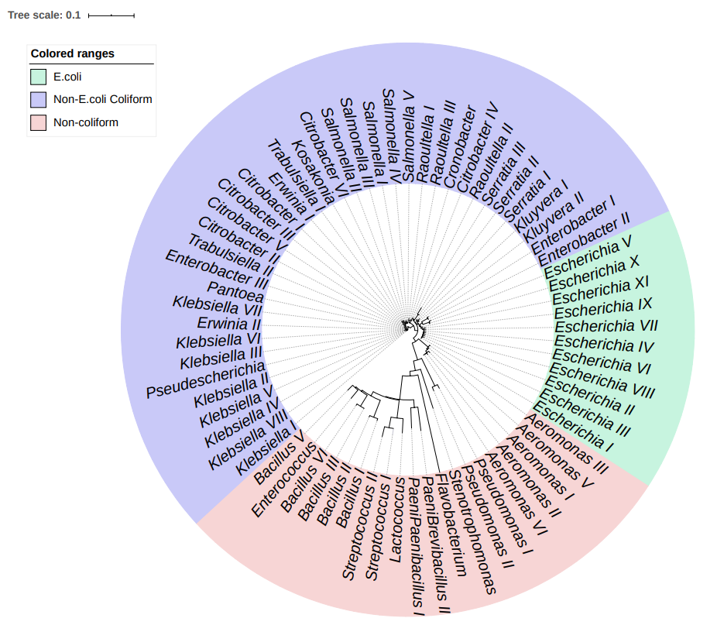
Figure 2.1. Phylogenetic tree of ASVs using 16S rRNA sequencing following DADA2 Pipeline obtained from the putative E. coli and non-E. coli TC colonies inferred by Neighbor-Joining. The total 69 ASVs included 20 non-coliform, 37 non-E. coli coliform, and 12 E. coli ASVs.
Among the 20 non-TC ASVs, Streptococcus, Flavobacterium, Aeromonas and Pseudomonas have been observed as common causes of FP results (Frampton and Restaino 1993, Grant 1997). However, Bacillus, Enterococcus, Brevibacillus, Stenotrophomonas, and Lactococcus were the first reported in this study.

3.2 Bacterial isolates responsible in E. coli
Among the putative E. coli isolates in the 4 different environmental matrices, a total of 15 ASVs were identified (Figure 2.1). Four of these ASVs belonged to the Escherichia genera, and these ASVs made up greater than 95.3% of the community in all samples (Figure 2.2).
Although the stormwater runoff showed highest variability of the isolates, including 12 different ASVs, other sample types contained only 3 or 4 ASVs. The Escherichia_I was the most abundant ASV across all samples. Moreover, in sediment and stream water samples, it was the only Escherichia ASV present.
There are 11 non-Escherichia ASVs that caused false positives, and the relative abundances of these ASVs ranged from 0.12% to 1.35% (Figure 2.2). Of ASVs that resulted in FP for E. coli, 3 belonged to the Enterobacteriaceae group (non-E. coli TC), including Salmonella_V, Raoultella_II, and Klebsiella_VIII. Non-TC groups that caused FP were Aeromonas, Bacillus, Enterococcus, Flavobacterium, Brevibacillus, Pseudomonas, and Stenotrophomonas.
Although FP results were found to be present using EPA Method 1604, the impacts were minor. Additionally, numerous previous studies have confirmed this method for E. coli quantification in the upper 90% range (Pearez, Berrocal et al. 1986, Sarhan and Foster 1991, Grant 1997, Hamilton, Kim et al. 2005, Olstadt, Schauer et al. 2007, Zhang, Hong et al. 2015).

3.3 Bacterial isolates responsible in non- E. coli TC
Non-TC groups caused the FP results for both E. coli and non-E. coli TC tests. E. coli that was not registered by the EPA method caused both FP of non-E. coli TC, as well as FN of E. coli. The primary true positive (TP) genera found in all samples were Klebsiella, Citrobacter, Enterobacter, Raoultella, Salmonella, Serratia, and Trabulsiella (Figure 2.3). The overall relative abundances of true non-E. coli TC results in sediment, stormwater runoff, sewage, and stream water were 78.4%, 91.9%, 91.8% and 61.7%, respectively.
No missed E. coli was found in in stormwater runoff non-E. coli TC isolates, and only 1.1% missed E. coli was found in sediment non-E. coli TC isolates. The FP results present in stormwater runoff and sediment non-E. coli TC isolates were primarily caused by non-TC groups.

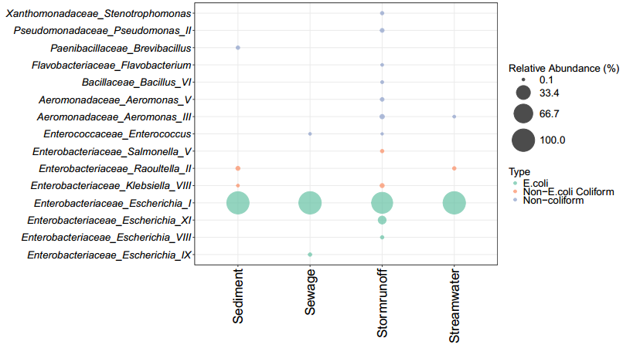
Figure 2.2. Relative abundances of ASVs got from putative E. coli colonies. The percentages of true E. coli were 98.0%, 99.9%, 95.3% and 99.4% in sediment, sewage, stormwater runoff and stream water respectively.

The Aeromonas genus was a common instigator of FP results, and it was found in all samples. Aeromonas abundance was especially high in sediment non-E. coli TC isolates (14.2%). Bacillus was another common genus resulting in FP results in non-E. coli TC isolates, and it was found in high abundance in sediment and stormwater runoff samples (5.2% and 4.7%, respectively). Although Enterococcus, Citrobacter, Lactococcus, Pseudomonas, and Stenotrophomonas also occurred in non-E. coli TC isolates, the abundances of these genera were all lower than 0.4%.
An overall rate of FP results was calculated by combining missed E. coli rates with the frequency of FP results in non-E. coli TC isolates due to non-TC groups. The overall frequency of FP results in sediment, stormwater runoff, sewage, and stream water were 7.6%, 8.1%, 21.2% and 38.4%, respectively. The FP frequency in non-E. coli TC isolates was much higher than for solely E. coli isolates. Therefore, the method for quantifying non-E. coli TC is not as accurate as the method for quantifying only E. coli.
Some ASVs were shown in both E. coli TC isolates and non-E. coli TC isolates, including Aeromonas_III, Aeromonas_V, Bacillus_VI, Escherichia_I, Klebsiella_VIII, Raoultella_II, Salmonella_V, Enterococcus, and Stenotrophomonas. The reason for this discrepancy may be that the 16s rRNA Amplicon Sequencing only sequences a fraction of the microbial genes, and the short reads may not have the resolution necessary to be classified as a separate ASV (Franzosa, Hsu et al. 2015). Therefore, there can be multiple different strains in the same ASV, and the different strains may have different responses for the culture-based TC testing. For example, 31 GUD-negative E. coli strains have been reported to avoid identification in the culture-based testing method (Feng, Lum et al. 1991).

3.4 Effectiveness of the culture-based testing method
The performance of the culture-based E. coli testing method was evaluated for specificity, sensitivity, and overall agreement for various environmental mediums. Specificities were above 95.6% for all mediums, and the sewage medium reported 99.9% specificity, indicating that nearly all positive detections are the correct coliform classification (Figure 2.4). Numerous previous studies have evaluated the specificities of this method for E. coli quantification based on different confirmed methods, and the ranges were above 85% (Grant 1997, Hamilton, Kim et al. 2005, Olstadt, Schauer et al. 2007, Zhang, Hong et al. 2015).
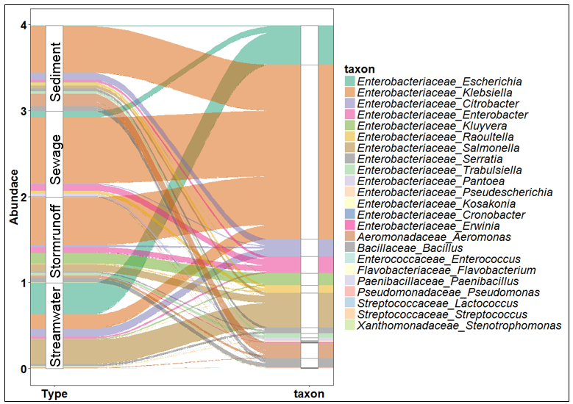
Figure 2.3. Relative abundance of ASVs from putative non-E. coli TC. 78.7%, 92.5%, 91.9% and 61.6% true non-E. coli TC, 1.1%, 7.1%, 0% and 37.4% missed E. coli, and 20.2%, 0.4%, 8.1% and 1.0%non-TC in sediment, sewage, stormwater runoff, and stream water respectively.

Sensitivity was high for stormwater runoff, sediment, and sewage (Figure 2.5). The sensitivity of the method for stormwater runoff was especially high (100%) due to a complete lack of FN results. Sensitivity of the method for sewage and sediment mediums was 93.7% and 98.9%, respectively. However, the culture-based method exhibited the lowest sensitivity for the stream water medium at 75.0% due to numerous undetected E. coli in non-E. coli TC isolates. Additionally, the standard deviation for the stream water samples was 12.7%, indicating that the triplicates were quite variable.
In general, the overall agreement exhibited by the culture-based E. coli testing for sewage, sediment and stormwater runoff samples was higher than 96.5% for each, suggesting that this method is highly accurate at correctly identifying E. coli in these mediums based on the 16S rRNA gene sequencing conformation (Figure 2.6). Although high specificity for stream water was shown in this study, the low sensitivity caused the overall agreement to decrease to a final value of 81.2%.

4. Conclusions
The EPA 1604 culture-based method for quantifying the presence of E. coli and total coliforms in aquatic ecosystems has become widely used due to its ease of implementation and relatively low cost. It is important to confirm the positive results of the method for various environmental matrices, and advances in the high-throughput 16s rRNA amplicon sequencing allow this tool to be used to explore the results of this culture-based test. In this study, the high specificity exhibited by the enumeration method on the four types of ecosystems indicate that the method is highly accurate in identifying E. coli colonies. However, elevated levels of FP results were found for the non-E. coli TC test, indicating that the method may decrease in accuracy when attempting to identify a taxonomically larger subset of bacteria. Overall, the high-throughput 16s rRNA Amplicon Sequencing was found to be an effective method of verifying the accuracy of The EPA coliform testing method. It should be also mentioned that, due to the limited samples in this study, observations need to be validated with more samples from different environmental matrices. Moreover, further efforts will extend the use of 16s rRNA sequencing to assessing the performance of other traditional enzyme-based bacterial testing methods.

Figure 2.4. Specificity of putative E. coli. The average rates of 99.0%, 99.9%, 98.0%, and 95.6% for stream water, sewage, sediment, and stormwater runoff, respectively.

Figure 2.5. Sensitivity of putative E. coli. The average rates of 75.0%, 93.7%, 98.9% and 100% for stream water, sewage, sediment, and stormwater runoff, respectively.

Figure 2.6. The overall agreement of putative E. coli. The average rates of 81.2%, 96.5%, 98.5% and 97.7% for stream water, sewage, sediment, and stormwater runoff, respectively.

References
Aldridge, K. E. and R. L. Hodges (1981). "Correlation studies of entero-set 20, API 20E and conventional media systems for Enterobacteriaceae identification." Journal of clinical microbiology 13(1): 120-125.
Bernasconi, C., G. Volponi and L. Bonadonna (2006). "Comparison of three different media for the detection of E. coli and coliforms in water." Water science and technology 54(3): 141-145.
Bolyen, E., J. R. Rideout, M. R. Dillon, N. A. Bokulich, C. C. Abnet, G. A. Al-Ghalith, H. Alexander, E. J. Alm, M. Arumugam and F. Asnicar (2019). "Reproducible, interactive, scalable and extensible microbiome data science using QIIME 2." Nature biotechnology 37(8): 852-857.
Boutilier, L., R. Jamieson, R. Gordon, C. Lake and W. Hart (2009). "Adsorption, sedimentation, and inactivation of E. coli within wastewater treatment wetlands." Water research 43(17): 4370-4380.
Cahoon, F. E. and J. S. Thompson (1987). "Frequency of Escherichia coli 0157: H7 isolation from stool specimens." Canadian journal of microbiology 33(10): 914-915.
Callahan, B. J., P. J. McMurdie, M. J. Rosen, A. W. Han, A. J. A. Johnson and S. P. Holmes (2016). "DADA2: high-resolution sample inference from Illumina amplicon data." Nature methods 13(7): 581.
Caporaso, J. G., C. L. Lauber, W. A. Walters, D. Berg-Lyons, J. Huntley, N. Fierer, S. M. Owens, J. Betley, L. Fraser and M. Bauer (2012). "Ultra-high-throughput microbial community analysis on the Illumina HiSeq and MiSeq platforms." The ISME journal 6(8): 1621.
Crane, R., C. B. Jackson, R. Sedlacek and D. Walker (2006). "EPA approves new test procedures for the analysis of microbiological pollutants in wastewater and sludge." Loveland, CO: Hach Company. Available online at http://www. hach. com/fmmimghach.
Dunling, W. and W. FIESSEL (2008). "Evaluation of media for simultaneous enumeration of total coliform and Escherichia coli in drinking water supplies by membrane filtration techniques." Journal of Environmental Sciences 20(3): 273-277.
EPA, U. (2002). Method 1604: Total Coliforms and Escherichia coli in Water by Membrane Filtration Using a Simultaneous Detection Technique, EPA-821-R-02–023 US Environmental Protection Agency.
Feng, P. (1995). "Escherichia coli serotype O157: H7: novel vehicles of infection and emergence of phenotypic variants." Emerging infectious diseases 1(2): 47.
Feng, P., R. Lum and G. W. Chang (1991). "Identification of uidA gene sequences in beta-D-glucuronidase-negative Escherichia coli." Appl. Environ. Microbiol. 57(1): 320-323.
Frampton, E. and L. Restaino (1993). "Methods for Escherichia coli identification in food, water and clinical samples based on beta‐glucuronidase detection." Journal of Applied Bacteriology 74(3): 223-233.
Franzosa, E. A., T. Hsu, A. Sirota-Madi, A. Shafquat, G. Abu-Ali, X. C. Morgan and C. Huttenhower (2015). "Sequencing and beyond: integrating molecular'omics' for microbial community profiling." Nature Reviews Microbiology 13(6): 360.
Grant, M. (1997). "A new membrane filtration medium for simultaneous detection and enumeration of Escherichia coli and total coliforms." Appl. Environ. Microbiol. 63(9): 3526-3530.
Hamilton, W. P., M. Kim and E. L. Thackston (2005). "Comparison of commercially available Escherichia coli enumeration tests: Implications for attaining water quality standards." Water Research 39(20): 4869-4878.
Letunic, I. and P. Bork (2016). "Interactive tree of life (iTOL) v3: an online tool for the display and annotation of phylogenetic and other trees." Nucleic acids research 44(W1): W242-W245.
Lurry, D. L. and C. M. Kolbe (2000). Interagency field manual for the collection of water-quality data, US Department of the Interior, US Geological Survey.
Madeira, F., J. Lee, N. Buso, T. Gur, N. Madhusoodanan, P. Basutkar, A. Tivey, S. C. Potter, R. D. Finn and R. Lopez (2019). "The EMBL-EBI search and sequence analysis tools APIs in 2019." Nucleic acids research.
Maheux, A. F., V. Huppé, M. Boissinot, F. J. Picard, L. Bissonnette, J.-L. T. Bernier and M. G. Bergeron (2008). "Analytical limits of four β-glucuronidase and β-galactosidase-based commercial culture methods used to detect Escherichia coli and total coliforms." Journal of microbiological methods 75(3): 506-514.
McLain, J. E. and C. F. Williams (2008). "Seasonal variation in accurate identification of Escherichia coli within a constructed wetland receiving tertiary-treated municipal effluent." Water research 42(15): 4041-4048.
Olstadt, J., J. J. Schauer, J. Standridge and S. Kluender (2007). "A comparison of ten USEPA approved total coliform/E. coli tests." Journal of water and health 5(2): 267-282.
Pearez, J., C. I. Berrocal and L. Berrocal (1986). "Evaluation of a commercial β‐glucuronidase test for the rapid and economical identification of Escherichia coli." Journal of applied bacteriology 61(6): 541-545.
Sanders, C. C., M. Peyret, E. S. Moland, C. Shubert, K. S. Thomson, J.-M. Boeufgras and W. E. Sanders (2000). "Ability of the VITEK 2 Advanced Expert System To Identify β-Lactam Phenotypes in Isolates of Enterobacteriaceae andPseudomonas aeruginosa." Journal of Clinical Microbiology 38(2): 570-574.
Sarhan, H. and H. Foster (1991). "A rapid fluorogenic method for the detection of Escherichia coli by the production of β‐glucuronidase." Journal of applied bacteriology 70(5): 394-400.
Simon, R. D. and J. C. Makarewicz (2009). "Storm water events in a small agricultural watershed: Characterization and evaluation of improvements in stream water microbiology following implementation of Best Management Practices." Journal of Great Lakes Research 35: 76-82.
Snedecor, G. W. and W. G. Cochran (1989). "Statistical methods, 8thEdn." Ames: Iowa State Univ. Press Iowa.
Wyckoff, K. N., S. Chen, A. J. Steinman and Q. He (2017). "Impact of Roadway Stormwater Runoff on Microbial Contamination in the Receiving Stream." Journal of environmental quality 46(5): 1065-1071.
Zhang, Y., P.-Y. Hong, M. W. LeChevallier and W.-T. Liu (2015). "Phenotypic and phylogenetic identification of coliform bacteria obtained using 12 coliform methods approved by the US Environmental Protection Agency." Appl. Environ. Microbiol. 81(17): 6012-6023.

Chapter 3

Spatial and Temporal Variability of Fecal Indicator Bacteria and Turbidity in Stormwater Runoff

Abstract
Stormwater runoff from urban impervious surface presents a high potential risk of non-point source contaminations. In this study, Escherichia coli (E. coli), total coliform (TC), and turbidity in stormwater runoff from roadway pavement and culvert were evaluated over 23 storm events in east Tennessee. First flush grab samples were collected from 6 sites, including a rural minor collector road, a rural minor arterial road, an urban minor collector road, an urban minor arterial road, a rural interstate divided highway, and an urban interstate divided highway in 2016-2017. Turbidity and fecal indicator bacteria (FIB) in runoff showed great variances across different sites and different storm events, but the elevated pollutant levels present a potential public health hazard. Analyses suggested that the turbidities were similar in pavement runoff and culvert runoff on the same site from the same storm event, but fecal indicator bacteria (FIB) were not. Moreover, results showed turbidities in runoff were highly correlated with precipitation intensity (PI) and antecedent dry period (ADP), but poor correlated between FIB and storm weather conditions. However, seasonal differences for FIB were noted, and FIB concentrations in winter are lower than other seasons. Further, the impact of site features was analyzed in this study, the FIB concentrations are higher at the urban minor collector than the rural minor collector, and higher at urban minor arterial than the rural minor arterial. Higher annual average daily traffic (AADT) road sites, higher FIB concentrations in this study. Overall, two different indicator bacteria are shown great correlation, but there are different distribution patterns compared with turbidity.

1. Introduction
Urbanization development has increased the presence of impervious surface (e.g., roadways and parking lots), so that stormwater runoff passes overland carrying pollutants to receiving water bodies(Stotz 1987). Compared with other runoff, the roadway runoff presents a high potential risk of non-point source contaminations (Athayde et al. 1983; Driscoll et al. 1990). And the contaminants in the runoff depend on numerous factors, such as seasonality, precipitation intensity (PI), antecedent dry period (ADP), traffic characteristic, and watershed features (Hallberg et al. 2007; Han et al. 2006a; Han et al. 2006b; Kayhanian et al. 2003; Li and Barrett 2008; Thomson et al. 1997; Westerlund et al. 2003). Thus, remarkable spatial and temporal variations were shown in both compositions and concentrations. Conventional water quality parameters (turbidity, pH, temperature, and total suspended solids), metal constituents, toxicity, polycyclic aromatic hydrocarbons (PAHs) and nutrients in stormwater runoff were studied frequently (Kayhanian and Paytan 2011; Kayhanian et al. 2007; Thomson et al. 1997). However, microbial contaminations are poorly understood. In this study, fecal indicator bacteria (FIB), including E. coli and total coliforms (TC), in stormwater runoff were evaluated.
Pollutants in roadway runoff may exhibit a “first flush” effect, which is a mass flushing of pollutants in the initial period and may contain the higher concentration of pollutants than those observed during the latter stages of the stormwater runoff (Bertrand-Krajewski et al. 1998; Deletic 1998; Kayhanian and Stenstrom 2005; Kayhanian and Stenstrom 2008; Sansalone and Buchberger 1997b). Therefore, first flush grab samples were collected in the initial rain period in order to eliminate intra-event variability in the study.
Typically, there are two types of runoff from transportation facilities, one is pavement runoff which is exclusively from pavement, another is culvert runoff which is including pollutants generated from pavement and surrounding land uses (Wemple and Jones 2003). Few studies compared water quality of the two types of runoff. Our main objectives were: (1) evaluating the presence of first flush runoff from pavement and culvert for FIB and turbidity; (2) examining the effect factors for the contaminants in the runoff, including precipitation intensity, ADP, traffic characteristic, watershed features, seasonal effects; (3) comparing results for spatial and temporal variability FIB and turbidity.

2. Materials and Methods

2.1 Sample Collection
Stormwater runoff samples were collected from 6 roadway sites in east Tennessee, USA, including a rural minor collector road, a rural minor arterial road, an urban minor collector road, an urban minor arterial road, a rural interstate divided highway, and an urban interstate divided highway (Figure 3.1 and Table 3.1).
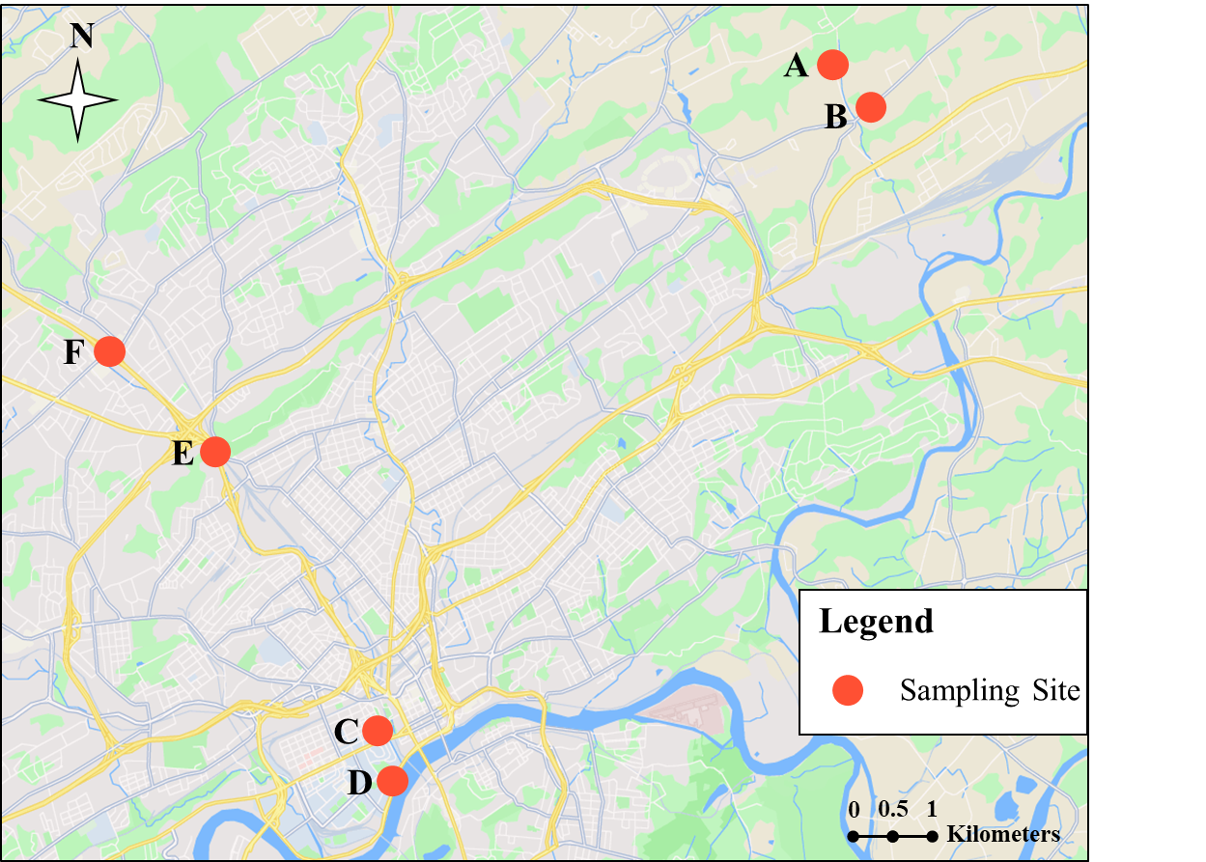
Figure 3.1. Sampling sites. Each sampling site includes both pavement runoff and culvert runoff.

Table 3.1. Summary of sampling locations
Site ID | Road Class | annual average daily traffic | Surrounding land use description
A | Minor Collector | 1409 | Forest and rural low density agricultural and residential areas
B | Minor Arterial | 6721 | Forest and rural low density agricultural and residential areas
C | Minor Collector | 5473 | Developed area of school and residential housing
D | Minor Arterial | 16209 | Developed area of school and residential housing
E | Interstate divided highway | 60852 | Forest and low density commercial and residential areas
F | Interstate divided highway | 87092 | busy commercial area
At each site, culvert runoff and pavement runoff were collected by Nalgene™ Storm Water Samplers, which were installed on sampling sites one day before the rain. The bottles were washed, rinsed with deionized water, and autoclaved; EPDM gasket, polypropylene ball valve and closure were washed by 70% ethanol for sterilization. The sampler collects a full liter of first flush storm water into a Nalgene™ sample bottle, and a floating ball valve automatically closes the bottle when it is full, preventing sample dilution. After sample collection, bottles were transported using cooler with ice to laboratory within 6 hours. 23 storm events were monitored from November 2016 to October 2017. ADP and PI at the first hour were recorded through weather history. (https://www.wunderground.com/history/daily/us/tn/knoxville/KTYS)

2.2 Sample Analysis
Sample analyses were generally performed within 8 hours of sample collection. Turbidity was measured by the turbidity meter following the manufacturer instrument (Thermo Scientific™ AQ3010). FIB, including E. coli and total coliforms, were determined by growth on the selective and differential membrane filtration m-Coliblue24® broth (Hach Co., Loveland, CO) following the manufacturer instrument. Briefly, one hundred milliliters of each water sample and appropriate dilutions were filtered, and the filter was placed on a pad soaked with 2 ml of the Coliblue24® broth. The filters were incubated at 37 °C and growth was observed at 24 ± 2 hours.

2.3 Statistical analysis
All statistical analyses were performed using R 3.50 (Team 2017). A Kruskal–Wallis test was performed to determine statistical differences between spatial and temporal different samples (Breslow 1970). Spearman Correlation were utilized to explore correlations between water quality parameters and climate factors (Wissler 1905).

3. Results and Discussion
Overall, 23 storm events were monitored FIB and turbidity between November 2016 and October 2017, at 6 roadway sites in Knoxville, TN,USA, including A -- a rural minor collector road, B -- a rural minor arterial road, C -- an urban minor collector road, D -- an urban minor arterial road, E -- a rural interstate divided highway, and F -- an urban interstate divided highway (Figure 3.1 and Table 3.1). The two rural local roads, two urban local roads, and two divided highway are closed and within 3 kilometers, respectively. Moreover, the geographical distances between each two of sites are all less than 15 kilometers.
The variations of water quality parameters were huge, the E. coli concentrations were from below limit of detection ( 10 CFU/100mL) to more than 10⁵ CFU/100 mL, the concentrations of TC are from 50 CFU/100 mL to more than 10⁶ CFU/100 mL, and the turbidities were from 5 NTU to 120 NTU.

3.1 The impact of rainfall characteristics
In this study, Pearson correlations were used to figure out the relationship between rainfall characteristics and water quality parameters. Rainfall characteristics were including PI and ADP.
Due to high variances of the water quality parameters across sites even in the same storm events (Figure 3.2 and Figure 3.S1), we tested the Pearson correlation site by site. The results showed both PI and ADP were more positively correlated with turbidities of each sites than FIB; lack of correlations were found between FIB and rainfall characteristics. However, the degrees of correlations of rainfall characteristics and turbidities were different at each site. The reason may be that the PI and ADP data were collected from online weather history, and the exact rainfall characteristics varied by sites.
The multiple regression model was also performed to analyze the combined effect of PI and ADP for turbidity (Table 3.2). Although the turbidity of runoff from different sites showed varied significant degrees of PI and ADP, all coefficient of determination (R²) for this model were higher than 0.38 with p value less than 0.01. Moreover, the culvert runoff and pavement runoff from the same site were shown the similar significant levels and coefficients of PI and ADP, this is further explained that the pavement runoff and culvert runoff are both impacted by rainfall features which were the highly similar in the same storm event at the same site.
Although turbidities between sites were shown significant correlations, no significant correlations between FIB levels at any sites, even the pavement runoff and culvert runoff from the same site could not be found the correlations of FIB (Figure 3.S2). This further supports the assertion that the rainfall features may not impact the FIB transport patterns.

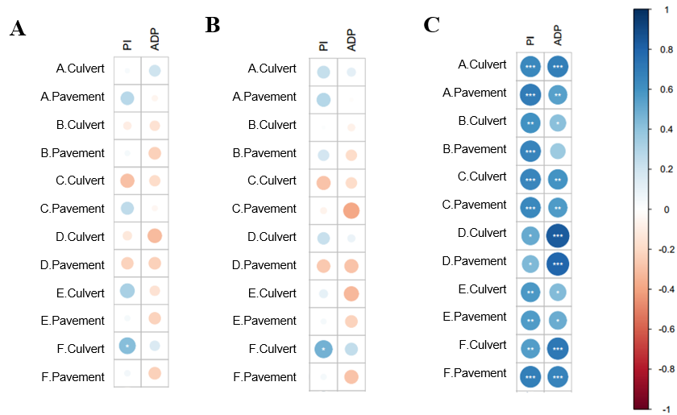
Figure 3.2. Correlation of weather conditions and water quality parameters. (A) E. coli, (B)Total coliform, (C) turbidity with PI and ADP at each site. *,P < 0.05; **,P < 0.01; ***,P < 0.001.

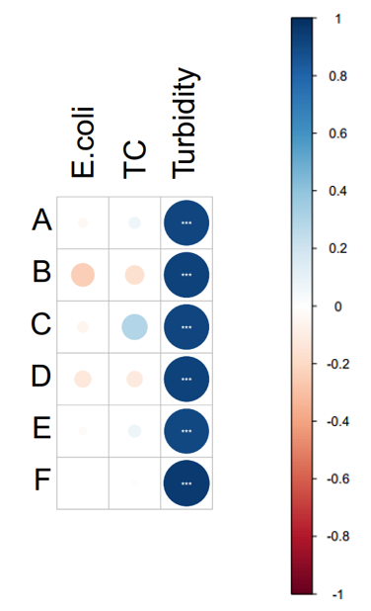
Figure 3.3. Correlation of E. coli, Total coliform, and turbidity between pavement runoff and culvert runoff at each site. *,P < 0.05; **,P < 0.01; ***,P < 0.001.
Table 3.2. Multiple Regression of Turbidity.
site | Runoff type | Variable 1 -- PI |  | Variable 2 -- ADP |  | Overall
 |  | Coef | P-value | Coef | P-value | R-Squared | P-value
A | Culvert | 74.558 | 0.00631 | 4.344 | 0.00228 | 0.6344 | 0.00004266
 | Pavement | 103.007 | 0.00171 | 3.034 | 0.04899 | 0.5768 | 0.0001844
B | Culvert | 95.484 | 0.01051 | 2.029 | 0.25209 | 0.4105 | 0.005068
 | Pavement | 111.689 | 0.00266 | 1.172 | 0.48781 | 0.452 | 0.00244
C | Culvert | 95.08 | 0.00449 | 3.851 | 0.01913 | 0.5733 | 0.0001999
 | Pavement | 98.102 | 0.00688 | 3.719 | 0.03624 | 0.53 | 0.0005256
D | Culvert | 41.648 | 0.09893 | 7.349 | 0.00000718 | 0.7332 | 0.000001826
 | Pavement | 29.562 | 0.2468 | 6.466 | 0.000051 | 0.6548 | 0.00002405
E | Culvert | 113.482 | 0.0218 | 3.141 | 0.191 | 0.3825 | 0.008059
 | Pavement | 114.094 | 0.0256 | 4.16 | 0.0992 | 0.4123 | 0.00492
F | Culvert | 57.512 | 0.045714 | 5.309 | 0.000961 | 0.6013 | 0.0001014
 | Pavement | 119.649 | 0.00214 | 5.703 | 0.00356 | 0.6532 | 0.00002513

3.2 Seasonal variations
Seasonal variations in FIB are shown in Figure 3.4. Cumulative probability plots showed huge variations of FIB within winter, the range of E. coli concentrations was from below limit of detection ( 10 CFU/100mL) to more than 10³ CFU/100 mL, and the range of TC concentrations was from 50 CFU/100mL to more than 10⁴ CFU/100 mL, but E. coli and TC both had the lowest concentrations during winter compared to other seasons based on the results of the Kruskal-Wallis test.
Although FIB concentrations in winter were significantly lower than spring, summer and fall, there is no significant difference among spring, summer and fall, except slightly significant difference between spring and summer, which may be because early spring or icy spring showed the similar FIB patterns with winter. Previous studies also showed FIB concentrations in stormwater runoff were lowest in winter (Krometis et al. 2010; McCarthy et al. 2006; Selvakumar and Borst 2006). However, there is no seasonal difference for turbidity.

3.3 The impact of site features
To identify the impact of site features for water quality of runoff, we analyzed the water quality in two potential forces: surrounding land use pattern and annual average daily traffic (AADT). Surrounding land use pattern were including rural and urban. Both surrounding land use pattern and AADT were reported for the impact on water quality: the urban sites that had higher human activities might increase pollutants concentration in runoff, and higher AADT caused higher probability to transport contamination into runoff (Aryal et al. 2005; Deletic and Maksimovic 1998; Kayhanian et al. 2012; Kayhanian et al. 2003; Sansalone and Buchberger 1997a; Shinya et al. 2000). In this study, the FIB concentrations are higher at the urban minor collector than the rural minor collector, and higher at urban minor arterial than the rural minor arterial, but no significant difference between rural and urban highway (Figure 3.6 – 3.9).
The relationships between AADT and FIB were also analyzed (Figure 3.6 –3.9). Table 3.1 was shown AADT in each site, from lowest to highest, the rank is A, C, B, D, E and F. In this study, the sites with higher AADT appeared higher FIB concentrations in runoff, although there were a few exceptions.
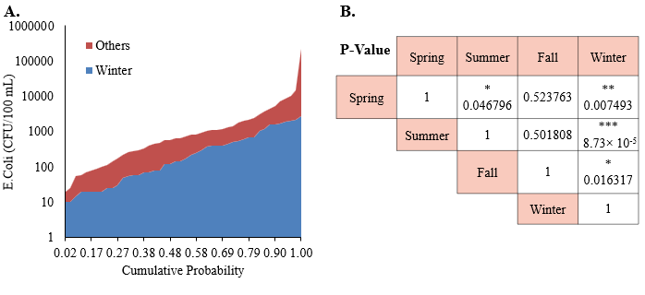Figure 3.4. Seasonality of E. coli concentrations; (A) Cumulative probability plots for Winter and other seasons; (B) P values for two-group comparisons done by T-Test. *,P < 0.05; **,P < 0.01; ***,P < 0.001.

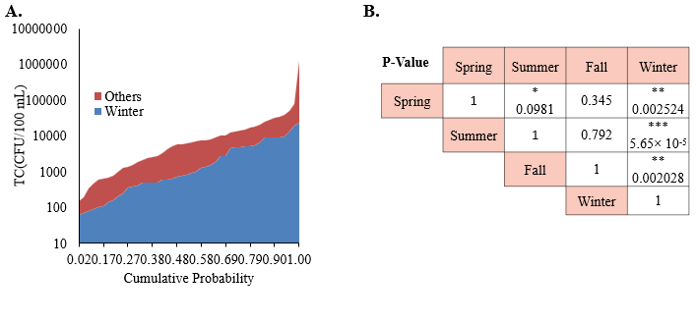Figure 3.5. Seasonality of total coliform concentrations; (A) Cumulative probability plots for Winter and other seasons; (B) P values for two-group comparisons done by T-Test. *,P < 0.05; **,P < 0.01; ***,P < 0.001
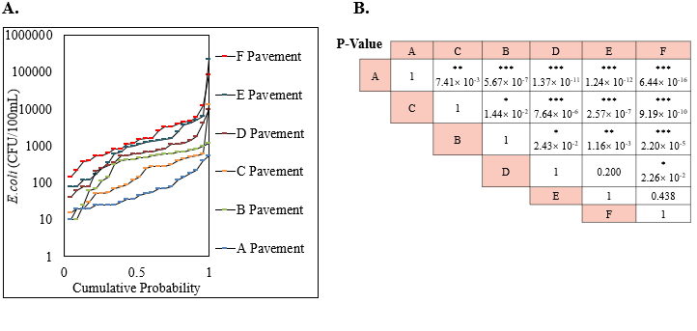 Figure 3.6. The relationship between E. coli concentrations in pavement runoff and road features. (A) Cumulative probability plots for each site; (B) P values for two-group comparisons done by T-Test. *,P < 0.05; **,P < 0.01; ***,P < 0.001

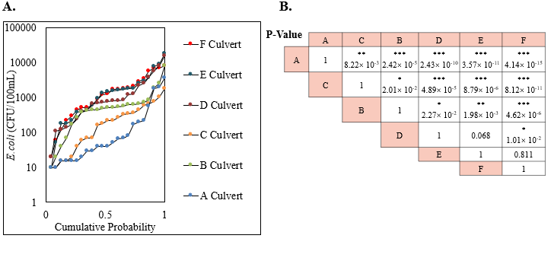Figure 3.7. The relationship between E. coli concentrations in culvert runoff and road features; (A) Cumulative probability plots for each site; (B) P values for two-group comparisons done by T-Test. *,P < 0.05; **,P < 0.01; ***,P < 0.001
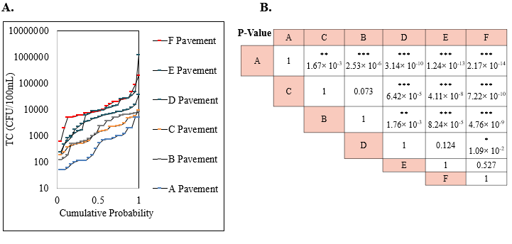 Figure 3.8. The relationship between total coliform concentrations in pavement runoff and road features. (A) Cumulative probability plots for each site; (B) P values for two-group comparisons done by T-Test. *,P < 0.05; **,P < 0.01; ***,P < 0.001.

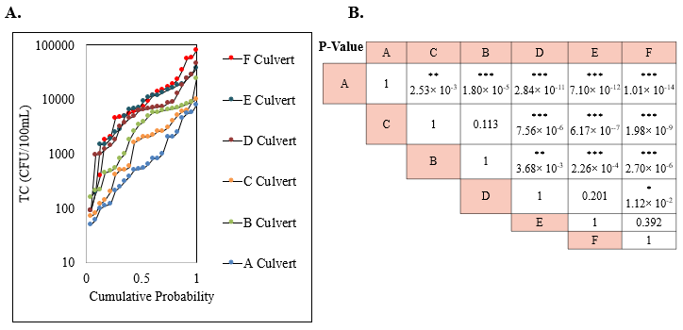 Figure 3.9. The relationship between total coliform concentrations in culvert runoff and road features. (A) Cumulative probability plots for each site; (B) P values for two-group comparisons done by T-Test. *,P < 0.05; **,P < 0.01; ***,P < 0.001
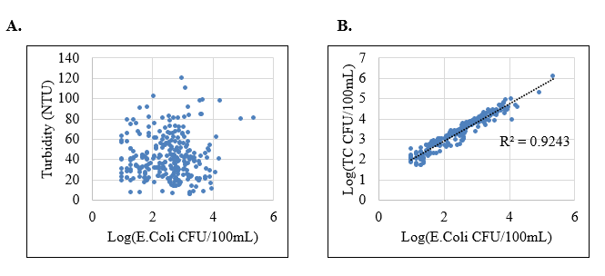 Figure 3.10. Correlations among water quality parameters. (A) The correlation between E. coli and turbidity; (B) The correlation between E. coli and total coliform.

There is no significant difference of FIB in runoff between D and E sites, and E and F sites, but a significant difference showed between D and F sites. The FIB concentrations seemed increasing limited in the runoff from the higher AADT sites, like D, E, and F, the reason may be the AADT could not affect FIB concentrations after it arrived a certain high level, more sites need to be studied in future to determine the hypothesis. Although we found the relationships between site features and FIB, surrounding land use pattern and AADT seemed no impact for the turbidity in runoff.

3.4 Correlation among water quality parameters
Correlations among FIB and turbidity were shown in figure 3.10. E. coli and TC were not only correlated highly, but also followed linear regression (R-squared is 0.92). But no matter E. coli or TC, they were both no correlation with turbidity. The reason may because the factors impacted FIB and turbidity were different: FIB were affected with seasonality, site features; turbidity were correlated with PI and ADP.

4. Conclusions
Stormwater runoff including pavement runoff and culvert runoff were monitored over 23 storm events at 6 sites for E. coli, TC and turbidity. All first flush grab samples were collected in the initial rain period for all storm events in order to eliminate intra-event variability. Results showed great variations of these parameters among different sites and different storm events. But there were still some factors appeared to affect the parameters, including PI, ADP, seasonality, surrounding land use patterns, and AADT.
Previous studies showed correlations between FIB and turbidity were variable. For water samples, more and more studies found poor correlations, although widely known that FIB attached to particles and they were transported together (Coulliette and Noble 2008; Kayhanian et al. 2012; Paule-Mercado et al. 2016).
The Pearson correlation and multiple linear regression both showed turbidity had significant relationships with the rainfall features (PI and ADP), though not all sites shared the same significant levels. It is possible that the dust may accumulate on the surface, so that the longer ADP causes higher turbidity in runoff; the higher PI has the stronger power to wash off dust and soil from surface and then the turbidity in runoff was getter greater. However, FIB, both E. coli and TC, were found no relationship with PI and ADP, it is possible that FIB may not be persistent and accumulate on surface with dust and soil.
Seasonal differences for FIB were noted in this study. Although the variations of FIB concentration were great in each season, winter FIB concentrations were lowest compared other seasons based on the results of the Kruskal-Wallis test. According to other similar studies, these seasonal variations of FIB are significant and should be considered for the storm-water best management in future (Hallberg et al. 2007; Selvakumar and Borst 2006).
Surrounding land use patterns, and AADT were also related with FIB concentrations in runoff. The results in this study suggest FIB concentrations may increase in urban and high AADT sites. Previous studies also showed surrounding land use patterns and AADT affected other water quality parameters, like heavy metals, PAHs and nutrients (Andrews and Sutherland 2004; Gnecco et al. 2005; Kayhanian 2012; Kayhanian and Paytan 2011; Klimaszewska et al. 2007; Maniquiz et al. 2010). Thus, public health risks may increase in urban and high AADT sites, future studies about pathogen contaminations in runoff should more focus on these sites.
There is no correlation between FIB and turbidity, and all these parameters should be monitored in the storm-water best management programs. This study only monitored 6 sites in one city, further study is needed to confirm the findings in this study for other places.

References
Andrews S, Sutherland RA (2004) Cu, Pb and Zn contamination in Nuuanu watershed, Oahu, Hawaii. Science of the Total Environment 324:173-182
Aryal RK, Furumai H, Nakajima F, Boller M (2005) Dynamic behavior of fractional suspended solids and particle-bound polycyclic aromatic hydrocarbons in highway runoff. Water Research 39:5126-5134
Athayde DN, Shelley PE, Driscoll ED, Gaboury D, Boyd G (1983) "Results of the nationwide urban runoff program". Results of the Nationwide Urban Runoff Program
Bertrand-Krajewski JL, Chebbo G, Saget A (1998) Distribution of pollutant mass vs volume in stormwater discharges and the first flush phenomenon. Water Research 32:2341-2356
Breslow N (1970) A generalized Kruskal-Wallis test for comparing K samples subject to unequal patterns of censorship. Biometrika 57:579-594
Coulliette AD, Noble RT (2008) Impacts of rainfall on the water quality of the Newport River Estuary (Eastern North Carolina, USA). Journal of Water and Health 6:473-482
Deletic A (1998) The first flush load of urban surface runoff. Water Research 32:2462-2470
Deletic AB, Maksimovic ČT (1998) Evaluation of water quality factors in storm runoff from paved areas. Journal of Environmental Engineering 124:869-879
Driscoll ED, Shelley PE, Strecker EW (1990) Pollutant Loadings and Impacts From Highway Stormwater Runoff Volume III: Analytical Investigation and Research Report. Pollutant Loadings and Impacts from Highway Stormwater Runoff Vol III: Analytical Investigation and Research Report
Gnecco I, Berretta C, Lanza LG, La Barbera P (2005) Storm water pollution in the urban environment of Genoa, Italy. Atmospheric Research 77:60-73
Grant M (1997) A new membrane filtration medium for simultaneous detection and enumeration of Escherichia coli and total coliforms. Appl Environ Microbiol 63:3526-3530
Hallberg M, Renman G, Lundbom T (2007) Seasonal variations of ten metals in highway runoff and their partition between dissolved and particulate matter. Water, Air, and Soil Pollution 181:183-191
Han Y, Lau SL, Kayhanian M, Stenstrom MK (2006a) Characteristics of highway stormwater runoff. Water Environment Research 78:2377-2388
Han YH, Lau SL, Kayhanian M, Stenstrom MK (2006b) Correlation analysis among highway stormwater pollutants and characteristics. Water Science and Technology 53:235-243
Kayhanian M (2012) Trend and concentrations of legacy lead (Pb) in highway runoff. Environmental Pollution 160:169-177
Kayhanian M, Fruchtman BD, Gulliver JS, Montanaro C, Ranieri E, Wuertz S (2012) Review of highway runoff characteristics: Comparative analysis and universal implications. Water research 46:6609-6624
Kayhanian M, Paytan A (2011) Isotopic fingerprinting approach for nutrient source identification. Proceedings of 10th Annual StormCon Conference, August 21-25, Anaheim, CA
Kayhanian M, Singh A, Suverkropp C, Borroum S (2003) Impact of annual average daily traffic on highway runoff pollutant concentrations. Journal of Environmental Engineering 129:975-990
Kayhanian M, Stenstrom MK (2005) Mass loading of first flush pollutants with treatment strategy simulations Transportation Research Record. p 133-143
Kayhanian M, Stenstrom MK (2008) First flush highway runoff characterization: for stormwater runoff treatment. Stormwater 9:32-45
Kayhanian M, Suverkropp C, Ruby A, Tsay K (2007) Characterization and prediction of highway runoff constituent event mean concentration. Journal of Environmental Management 85:279-295
Klimaszewska K, Polkowsla Z, Namieśnik J (2007) Influence of mobile sources on pollution of runoff waters from roads with high traffic intensity. Polish Journal of Environmental Studies 16:889-897
Krometis LAH, Characklis GW, Drummey PN, Sobsey MD (2010) Comparison of the presence and partitioning behavior of indicator organisms and Salmonella spp. in an urban watershed. Journal of Water and Health 8:44-59
Li MH, Barrett ME (2008) Relationship between antecedent dry period and highway pollutant: Conceptual models of buildup and removal processes. Water Environment Research 80:740-747
Maniquiz MC, Lee S, Kim LH (2010) Multiple linear regression models of urban runoff pollutant load and event mean concentration considering rainfall variables. Journal of Environmental Sciences 22:946-952
McCarthy D, Mitchell VG, Deletic A (2006) Escherichia coli levels in urban stormwater. Paper Presented to the Urban Drainage Modelling and International Water Sensitive Urban Design Conference, Melbourne, 4–6 April 2006
Paule-Mercado M, Ventura J, Memon S, Jahng D, Kang J-H, Lee C-H (2016) Monitoring and predicting the fecal indicator bacteria concentrations from agricultural, mixed land use and urban stormwater runoff. Science of the total environment 550:1171-1181
Sansalone JJ, Buchberger SG (1997a) Characterization of solid and metal element distributions in urban highway stormwater. 36:155-160
Sansalone JJ, Buchberger SG (1997b) Partitioning and first flush of metals in urban roadway storm water. Journal of Environmental Engineering 123:134-143
Selvakumar A, Borst M (2006) Variation of microorganism concentration in urban stormwater runoff with land use and seasons. Journal of Water and Health 4:109-124
Shinya M, Tsuchinaga T, Kitano M, Yamada Y, Ishikawa M (2000) Characterization of heavy metals and polycyclic aromatic hydrocarbons in urban highway runoff. vol 42. Int Water Assoc, United Kingdom, p 201-208
Stotz G (1987) Investigations of the properties of the surface water run-off from federal highways in the FRG. Science of the Total Environment, The 59:329-337
Thomson NR, McBean EA, Snodgrass W, Monstrenko IB (1997) Highway stormwater runoff quality: Development of surrogate parameter relationships. Water, Air, and Soil Pollution 94:307-347
Wemple BC, Jones JA (2003) Runoff production on forest roads in a steep, mountain catchment. Water Resources Research 39
Westerlund C, Viklander M, Bäckström M (2003) Seasonal variations in road runoff quality in Luleå, Sweden Water Science and Technology. vol 48, p 93-101
Wissler C (1905) The Spearman correlation formula. Science 22:309-311

Chapter 4

Persistence of Environmental E. coli Strains from Stormwater Runoff

Abstract
Escherichia coli has been used as an indicator for fecal contamination, based on the assumption that E. coli could not survive for a prolonged period of time once discharged into the environment. Therefore, the presence of live E. coli would be indicative of recent fecal contamination. However, it has recently been reported that E. coli populations were found in environments with no recent exposure to fecal contamination, suggesting the capability of certain E. coli populations to survive for a prolonged period of time in the environment. The objective of this study was to evaluate the survival of E. coli strains isolated from stormwater runoff under environmentally relevant conditions. One laboratory E. coli strain (MG1655) was tested as a control. The E. coli strains were exposed to four environmental factors: (i) presence or absence of sunlight; (ii) solid surface versus liquid media for growth; (iii) different temperatures, including 4 ℃, 20 ℃, and 35 ℃; (iv) different levels of relative humidity, i.e. 13%, 50%, and 100%. All environmental strains isolated from stormwater runoff persisted for a longer period of time than the lab strain under all environmental conditions tested. As expected, all E. coli strains survived longer at lower temperature. On the solid surface, the lab strain completely lost viability in less than 1 hour at the relative humidity of 13% and 50%. In comparison, the environmental strains were able to remain viable for a prolonged period with the maximum T_{99.9} of 15 days, which is congruent with the persistence of these strains in natural environments. Additionally, it was found that sunlight exposure resulted in the rapid inactivation of all strains tested in this study. Findings from this study could provide insight into the interpretation of environmental monitoring data using E. coli as the fecal indicator.

1. Introduction
Stormwater runoff is a concern as a non‐point source of fecal contamination in receiving water bodies (Cabelli et al. 1982; Jiang 2004; Marsalek and Rochfort 2004; McCarthy et al. 2006; Surbeck et al. 2006). As rainfall washes over land, it picks up and transports a variety of pollutants including human and animal fecal waste (Athayde et al. 1983). To measure potential fecal contamination and pathogens of enteric origins, Escherichia coli (E. coli) as an indicator organism for fecal contamination has been used to indicate the potential for the presence of pathogens of fecal origin (Grant 1997; Haile et al. 1999).
E. coli has been chosen as a fecal indicator based on the assumptions that E. coli normally lives in the gastrointestinal system of humans and animals and would not survive for a prolonged period of time once discharged into the environment (Savageau 1983). However, it has recently been reported that E. coli populations were found in environments with no recent exposure to fecal materials, suggesting the capability of certain E. coli strains to survive for a prolonged period of time in the environment (England et al. 1993; Hoff and Akin 1986; Sjogren 1994).
The environmental factors that contribute to the persistence of E. coli include temperature, sunlight exposure, moisture content, and nutrients (Bergholz and Whittam 2007; Buchanan and Edelson 1999; Franz et al. 2005; Himathongkham et al. 1999; Ihssen and Egli 2004; Ihssen et al. 2007a; Large et al. 2005; Rozen and Belkin 2001; Semenov et al. 2007; Sidhu et al. 2015; Tabe et al. 2008; Tao et al. 1999; Vital et al. 2008). Furthermore, different types of E. coli strains have been shown to have different survival capabilities in the same environmental conditions (Perkins et al. 2016).
E. coli strains that were found in pavement runoff as wild-type E. coli may become inactivate rapidly due to harsh environmental conditions such as high temperatures, sunlight exposure and the loss of moisture on the surface (Gilpin et al. 2013; Oliver et al. 2007; Rozen and Belkin 2001; Sinton et al. 2002). However, certain conditions like low temperature, the shade portion avoiding sunlight, and receiving water body providing water content, may prolong the survival of E. coli. Perhaps, the wild-type E. coli could evolve to stand the harsh environmental conditions and then survive in a prolong period (Kiefer et al. 2012). However, very little has been documented about the persistence of wild-type E. coli strains from stormwater runoff on environmental surfaces, in the runoff water, and in the receiving water body.
The objective of this study was to evaluate the survival of wild-type E. coli strains isolated from stormwater runoff under environmentally relevant conditions. One laboratory E. coli strain (MG1655) was used as a control. The E. coli strains were exposed to four environmental factors: (i) different temperatures, including 4 ℃, 20 ℃, and 35 ℃; (ii) presence or absence of sunlight; (iii) solid surface versus liquid matrices for growth; (iv) different levels of relative humidity (RH), i.e. 13%, 50%, and 100%. Our results show that (i) wild-type strains isolated from stormwater runoff are better adapted for survival than the lab strain, (ii) E. coli strains survive longer at lower temperature, (iii) strong sunlight exposure results in the rapid inactivation of all strains, and (iv) E. coli strains survive longer under higher water content than more arid conditions.

2. Materials and Methods

2.1 Study site
Stormwater runoff samples were collected from three different pavement sites. Sampling was conducted using Nalgene™ Storm Water Samplers, which were installed immediately prior to the anticipated storms. Each sampler collected a full one-liter grab sample representing first-flush stormwater runoff. The runoff sample was the source of wild-type strains and the stormwater runoff matrix for growth.
the stream-water matrix for growth was from the runoff receiving stream, which was collected by submerging a sterile 1 L bottle below the stream surface according to standard methods (Lurry and Kolbe 2000) after at least three antecedent dry days for represented typical base flow. The water samples were stored in the dark at 4 °C and used 4 months after collection.

2.2 Preparation of bacterial strains and inoculum
The persistence of E. coli was tested with wild-type and control (lab strain, MG1655) strains of E. coli. Due to the background levels of E. coli in raw water being too low to quantify during inactivation experiments, additional E. coli was seeded in these matrices.
Wild-type strains of E. coli were isolated from roadway runoff using m-Coliblue 24 ® media following the protocol provided by the manufacturer (Hach, Loveland, CO). Five E. coli colonies were then aseptically picked. In order to get pure strains, the colonies were diluted with phosphate buffer saline (PBS) and cultivated on m-Coliblue 24 ® media, with the resulting pure colonies being further cultivated in tryptic soy broth (TSB) for 12 hours at 37℃. The media were autoclaved prior to use.
Before seeding the strains, 1 mL of the bacterial cultures were centrifuged at 12000g for 5 min, and then the supernatant was discarded, followed by the washing of the pellets in PBS twice to remove culture media. All these colonies were confirmed as E. coli by the high-throughput 16s rRNA amplicon sequencing method as described previously (Wyckoff et al. 2017).

2.3 Bacterial Inoculation
In order to test the effect of different environmental matrices for the E. coli persistence, asphalt pavement, polystyrene plastic, stormwater runoff, and stream water were used as environmental matrices. The asphalt pavement was compacted to approximately an air void content 4% using a Superpave gyratory compactor (SGC). The asphalt binder was performance grade (PG) 64-22 and the asphalt content is 6.2%. Limestone aggregates were used in the asphalt concrete with a nominal maximum aggregate size 9.5 mm (Brown et al. 2009). The asphalt pavement test surfaces had a 15cm diameter, and the polystyrene plastic test surfaces had a 6cm diameter. The polystyrene plastic surface served as a neutral material, while the asphalt contained metals and hydrocarbons that may be harmful for E. coli survival (McConkey et al. 1997). Before testing bacterial persistence on these surfaces, the asphalt pavement and polystyrene plastic were sterilized with 70% ethanol for 10 min and then rinsed with distilled water. After evaporation, the surface was marked into two semicircles using a sterile knife. Each sector was inoculated with 0.1 ml of runoff bacteria suspension and evenly spread to nearly 1 cm².
Stormwater runoff and stream water were used as raw water matrices. The E. coli pellets that were collected from the previous steps were seeded into 10mL raw field water samples placed in a 20 mL sterile colorless and transparent glass tube, resulting in a concentration of 10⁶ ~ 10⁷ CFU/mL. The stormwater runoff with the seeded strains acts as runoff bacteria suspension for the test for bacteria survival on the previously described surfaces.

2.4 Controlled environmental chamber
After bacterial inoculation, the control treatments were placed in an environmental growth chamber (EGC C3) to determine the effect of temperature, humidity, and light intensity. The different temperatures, included 4 ℃, 20 ℃, and 35 ℃; the different levels of RH, included 13%, 50%, and 100%; the light control includes 0 and 675 μmoles/m²/sec. Before experiments, the chamber was operated at least 1 hour to reach desired condition levels.

2.5 Microbial recovery and enumerating
Bacterial samples from asphalt pavement surfaces and polystyrene plastic surfaces were collected by a swabbing method that has previously been described (Bokulich et al. 2013). Briefly, each sector was swabbed horizontally and vertically three times using sterile polyester-tipped applicators. Prior to swabbing the surface, the tip was soaked in a sterile PBS solution to facilitate the removal of organic matter present on the inoculated surface. After swabbing, swab tips were cut off using sterilized scissors and placed in tubes containing 10 ml of PBS. Tubes were vortexed twice for 1 min each, with a waiting time in between of 1 min. By doing this, cells trapped in the swab tip are released into the PBS, making them available to be enumerated by m-Coliblue24 via membrane filtration (Grant 1997).
The water samples also used m-Coliblue24 media to enumerate E. coli, with the appropriate water volumes used for filtration. The first sampling time (T₀) immediately followed inoculation, and that count is the initial E. coli concentration (N₀). The following sampling time was the 1st hour, if the number of bacteria was below detection limit, the sampling was stopped, if the count was lower than a half N₀, which means bacteria inactivated rapidly, and the sampling continued at the 2nd hour, 3rd hour, or stopped if the number of bacteria fell below detection limit. If the count at 1st hour was more than a half N₀, the sampling continued at the 1st day, 3rd day, 5th day, 7th day, or stopped if the number of bacteria fell below detection limit. If the bacteria still survived after 7 days, the final sampling time would be on the 10th day.

2.6 Statistical analysis and data modeling
If the time when the number of bacteria was below detection limit was more than 3 hours, a decay model would be chosen to fit the experimental data. All models were fitted to data by using the curve fitting toolbox provided by the GInaFiT (Geeraerd et al. 2006), including
the first order decay model which is a commonly used primary classic linear model (Bigelow and Esty 1920):
$C\left(t\right)=C_{0}e^{-kt}$ (1)
where t is time (day), C (CFU/mL or CFU/cm²) is the measured concentration at time t, C₀ is the measured concentration at time 0, and k [hour⁻¹ or day^{–1}] is the rate constant.
The Weibull survival model when the curves did not follow log-linear kinetics and showed asymptotic tails (Mafart et al. 2002):
$C\left(t\right)=C_{0}{\log_{10}}^{{-(\frac{t}{α})}^{β}}$ (2)
$α$ (scale parameter) represents the time of first decimal reduction (days) and $β$ (shape parameter). For $β$ >1, a convex curve is obtained, while for n<1, a concave curve is obtained.
Model performance was assessed by calculating the regression coefficient (R²) For data analysis. Based on the model, T₉₀ , T₉₉ and T_{99.9} were calculated, which were the time to reduce the initial inoculum (C₀) 10-, 100-, and 1,000-fold respectively.

3. Results and Discussion
To identify the persistence of E. coli strains, 5 potential ecological selective forces were tested: strain types, temperatures, sunlight intensities, habitat matrices, and relative humidities. Treatments where bacterial counts dropped below the detection limit within the first day are considered the low persistence conditions (Table 4.1), while if the bacterial count of the treatment was detectable after more than 1 day, the treatment was considered as the higher persistence conditions (Table 4.2 and 4.3).

3.1 The low persistence conditions
As expected, all E. coli strains survived for a shorter time at higher temperatures, especially at 35℃, where the counts of bacteria were below detection limit within 1 hour (Table 4.1). While E. coli strains survived longer at lower temperatures, RH and sunlight exposure were also factors that restricted the persistence of E. coli strains (Hacker and Carniel 2001; Sinton et al. 2002; Sjogren 1994). At both 20℃ and 4℃, with a sunlight exposure of 675 μmoles/m²/sec, T_{99.9}s were less than 3 hours for both sets of E. coli strains, and less than 1 hour for the E. coli strains that were tested on the solid surfaces with 13% and 50% RH.
At lower temperatures, and without sunlight exposure, the factor that influenced the persistence of E. coli strains was the RH. The lab strain of E. coli could not survive with 13% and 50% RH for both asphalt and polystyrene surfaces. This is consistent with previous studies, where it was shown that E. coli strain MG1655 had high decay rates on soil, glass, peanut butter, and wood under arid conditions (Byappanahalli et al. 2006; He et al. 2013; Ihssen et al. 2007b; Zhang and Yan 2012).

3.2 Desiccation resistance and persistence of E. coli on surfaces
Although lab strain E. coli could not persist at lower humidity, the wild-type strains could be detected for more than 7 days under these conditions.
Table 4.1. The low persistence conditions
Strain Type | Temperature  (℃) | Media Matrix | Relative Humidity  (%) | Light  (μmoles/m²/sec) | T_{99.9}
Lab strain | 35 | Runoff | -- | 0 | Less than 1 hour
Lab strain | 35 | Streamwater | -- | 0 | Less than 1 hour
Lab strain | 35 | Polystyrene | 50% | 0 | Less than 1 hour
Lab strain | 35 | Asphalt | 50% | 0 | Less than 1 hour
Lab strain | 20 | Polystyrene | 50% | 0 | Less than 1 hour
Lab strain | 20 | Asphalt | 50% | 0 | Less than 1 hour
Lab strain | 4 | Polystyrene | 50% | 0 | Less than 1 hour
Lab strain | 4 | Asphalt | 50% | 0 | Less than 1 hour
Lab strain | 35 | Polystyrene | 13% | 0 | Less than 1 hour
Lab strain | 35 | Asphalt | 13% | 0 | Less than 1 hour
Lab strain | 20 | Polystyrene | 13% | 0 | Less than 1 hour
Lab strain | 20 | Asphalt | 13% | 0 | Less than 1 hour
Lab strain | 4 | Polystyrene | 13% | 0 | Less than 1 hour
Lab strain | 4 | Asphalt | 13% | 0 | Less than 1 hour
Lab strain | 20 | Streamwater | -- | 675 | Less than 1 hour
Lab strain | 20 | Runoff | -- | 675 | Less than 2 hours
Lab strain | 4 | Streamwater | -- | 675 | Less than 1 hour
Lab strain | 4 | Runoff | -- | 675 | Less than 2 hours
Wild-type strain | 35 | Runoff | -- | 0 | Less than 1 hour
Wild-type strain | 35 | Streamwater | -- | 0 | Less than 1 hour
Wild-type strain | 35 | Polystyrene | 50% | 0 | Less than 1 hour
Wild-type strain | 35 | Asphalt | 50% | 0 | Less than 1 hour
Wild-type strain | 20 | Polystyrene | 50% | 675 | Less than 1 hour
Wild-type strain | 20 | Asphalt | 50% | 675 | Less than 1 hour
Wild-type strain | 4 | Polystyrene | 50% | 675 | Less than 1 hour
Wild-type strain | 4 | Asphalt | 50% | 675 | Less than 1 hour
Wild-type strain | 35 | Polystyrene | 13% | 0 | Less than 1 hour
Wild-type strain | 35 | Asphalt | 13% | 0 | Less than 1 hour
Wild-type strain | 20 | Polystyrene | 13% | 675 | Less than 1 hour
Wild-type strain | 20 | Asphalt | 13% | 675 | Less than 1 hour
Wild-type strain | 4 | Polystyrene | 13% | 675 | Less than 1 hour
Wild-type strain | 4 | Asphalt | 13% | 675 | Less than 1 hour
Wild-type strain | 20 | Streamwater | -- | 675 | Less than 3 hours
Wild-type strain | 20 | Runoff | -- | 675 | Less than 3 hours
Wild-type strain | 4 | Streamwater | -- | 675 | Less than 3 hours
Wild-type strain | 4 | Runoff | -- | 675 | Less than 3 hours

Figure 4.1. E. coli strains on solid surfaces at 20℃ and 50% RH without sunlight exposure

Table 4.2. The persistence conditions with the Weibull survival model
Strain Type | Temperature | Media | Relative Humidity | α | β | R² | T99.9
 | (℃) | Matrix | (%) | (days) |  |  | days
Wild-type strain | 20 | Polystyrene | 50 | 0.11 | 0.25 | 0.98 | 8.91
Wild-type strain | 20 | Asphalt | 50 | 0.17 | 0.26 | 0.94 | 11.63
Wild-type strain | 20 | Polystyrene | 13 | 0.02 | 0.17 | 0.91 | 12.81
Wild-type strain | 20 | Asphalt | 13 | 0.01 | 0.16 | 0.97 | 9.59
Wild-type strain | 4 | Polystyrene | 50 | 0.25 | 0.27 | 0.95 | 14.62
Wild-type strain | 4 | Asphalt | 50 | 0.21 | 0.26 | 0.94 | 14.36
Wild-type strain | 4 | Polystyrene | 13 | 0.04 | 0.19 | 0.91 | 12.98
Wild-type strain | 4 | Asphalt | 13 | 0.04 | 0.19 | 0.89 | 12.98

The decay revealed a concave curve which did not follow log-linear kinetics and showed asymptotic tails, and so the Weibull survival model was used to fit the persistent data (Figure 4.1).
No surprise, at the lower temperature (4 ℃), the wild-type strains survived longer under the same humidity conditions than at 20 ℃. On asphalt pavement with 50% RH, T₉₀ (α) and T_{99.9} was 0.17 and 11.6 days at 20℃, respectively, while T₉₀ and T_{99.9} was 0.21 and 14.4 days, respectively, at 4℃. On polystyrene plastic, with 50% RH, T₉₀ and T_{99.9} was 0.11 and 8.9 days at 20℃ respectively, while T₉₀ and T_{99.9} is 0.25 and 14.6 days at 4℃, respectively. With 13% RH, T₉₀ and T_{99.9} was 0.02 and 12.8 days at 20℃ respectively, while T₉₀ and T_{99.9} is 0.04 and 13.0 days at 4℃respectively (Table 4.2).
Although we hypothesized that E. coli strains survived longer on polystyrene plastic than asphalt pavement, because polystyrene plastic is a neutral material and the metals and hydrocarbons in asphalt may be harmful for E. coli survival, the results showed the surface materials did not affect the persistence of E. coli strains, other environmental conditions, such as temperature, sunlight exposure, and RH are the essential factors that restrict E. coli survival (Figure 4.2).
Compared with 13% and 50% RH, T₉₀s are all smaller in 13% RH than 50% when other controlled conditions were the same, such as 20℃-without sunlight exposure- polystyrene plastic-13% RH VS 20℃-without sunlight exposure- polystyrene plastic-50% RH, 20℃-without sunlight exposure- asphalt pavement -13% RH VS 20℃-without sunlight exposure- asphalt pavement -50% RH, 4℃-without sunlight exposure- polystyrene plastic-13% RH VS 4℃-without sunlight exposure- polystyrene plastic-50% RH, and 4℃-without sunlight exposure- asphalt pavement -13% RH VS 4℃-without sunlight exposure- asphalt pavement -50% RH. However, the different RHs did not affect T_{99.9}. This pattern illustrates that RH only impacts the wild-type strains soon after inoculation, with the lower RH inactivating intolerant bacteria, but the lower RH does not affect the rest of populations showing the ability of low humidity resistance.
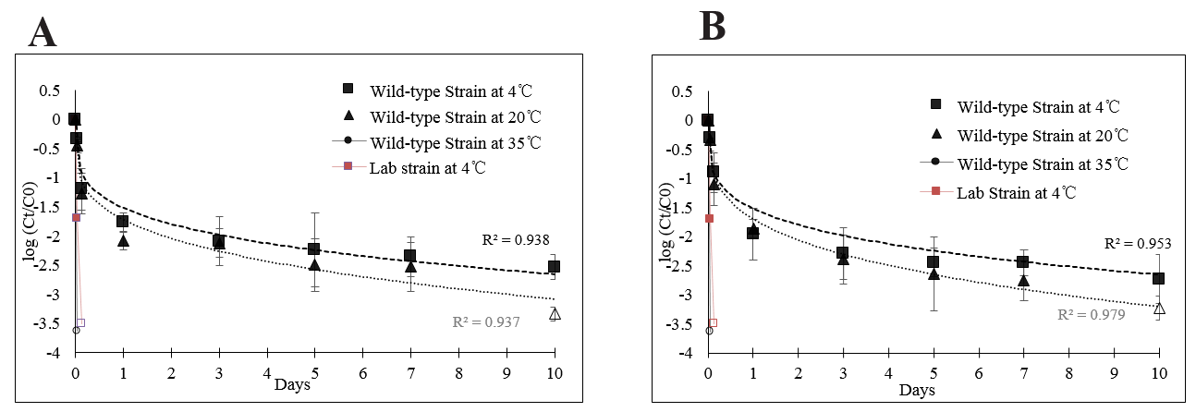
Figure 4.2. E. coli strains at 50% RH without sunlight exposure and at different temperatures on surfaces. (A) asphalt surfaces; (B) plastic surfaces.

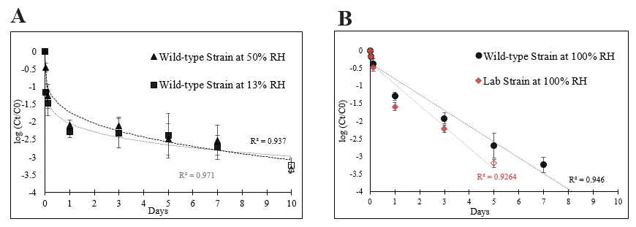
Figure 4.3. E. coli strains on asphalt at 20℃ without sunlight exposure and under different relative humidities. (A) 13% and 50% relative humidities; (B) 100% relative humidity.

Table 4.3. The persistence conditions with the first-order decay model
Strain Type | Temperature | Media | Relative Humidity | K | R² | T90 | T99.9
 | (℃) | Matrix | (%) | day⁻¹ |  | days | days
Lab strain | 20 | Runoff | -- | 0.95 | 0.95 | 2.43 | 7.28
Lab strain | 20 | Streamwater | -- | 1.30 | 0.94 | 1.76 | 5.29
Lab strain | 20 | Polystyrene | 100 | 1.58 | 0.96 | 1.45 | 4.36
Lab strain | 20 | Asphalt | 100 | 1.60 | 0.93 | 1.44 | 4.33
Lab strain | 4 | Runoff | -- | 0.17 | 0.95 | 13.46 | 40.38
Lab strain | 4 | Streamwater | -- | 0.31 | 0.99 | 7.34 | 22.01
Lab strain | 4 | Polystyrene | 100 | 0.68 | 0.92 | 3.37 | 10.12
Lab strain | 4 | Asphalt | 100 | 0.67 | 0.93 | 3.45 | 10.35
Wild-type strain | 20 | Runoff | -- | 0.79 | 0.93 | 2.91 | 8.72
Wild-type strain | 20 | Streamwater | -- | 1.15 | 0.99 | 2.00 | 6.01
Wild-type strain | 20 | Polystyrene | 100 | 1.21 | 0.91 | 1.90 | 5.70
Wild-type strain | 20 | Asphalt | 100 | 1.18 | 0.95 | 1.95 | 5.84
Wild-type strain | 4 | Runoff | -- | 0.18 | 0.92 | 13.04 | 39.11
Wild-type strain | 4 | Streamwater | -- | 0.26 | 0.97 | 9.02 | 27.05
Wild-type strain | 4 | Polystyrene | 100 | 0.46 | 0.94 | 5.04 | 15.12
Wild-type strain | 4 | Asphalt | 100 | 0.46 | 0.94 | 4.98 | 14.95

3.3 Persistence of E. coli in sufficient water
When the RH was increased to 100%, the survival time was increased from less than 1 hour to more than 5 days (Table 4.3). This indicates that water availability is an essential factor to prolong the lab strain survival. Although wild-type strains showed resistance to low humidity, the persistence patterns in higher water content were different from the persistence patterns of low humidity resistance. Instead of the Weibull survival model, the first order decay model was more appropriate to fit the persistence data which followed log-linear kinetics (Figure 4.4).
Besides the survival of the lab strain on solid surface with 100% RH, the stormwater runoff and stream water also showed prolong persistence of the lab strain. Moreover, the lab strain showed lowest decay rate in the runoff habitat under the same temperatures. Without doubt, at lower temperature (4 ℃), the lab strain survived longer than at 20 ℃ under the same other conditions. On asphalt pavement with 100% RH, T₉₀ and T_{99.9} was 1.45 and 4.36 days at 20℃ respectively, while T₉₀ and T_{99.9} is 3.45 and 10.3 days at 4℃ respectively. On polystyrene plastic with 100% RH, T₉₀ and T_{99.9} was 1.45 and 4.36 days at 20℃ respectively, while T₉₀ and T_{99.9} is 3.37 and 10.1 days at 4℃ respectively. In stormwater runoff, T₉₀ and T_{99.9} was 2.43 and 7.28 days at 20℃ respectively, while T₉₀ and T_{99.9} is 13.5 and 40.4 days at 4℃ respectively. In stream water, T₉₀ and T_{99.9} was 1.76 and 5.29 days at 20℃ respectively, while T₉₀ and T_{99.9} is 7.34 and 22 days at 4℃ respectively.
Although the surface materials did not affect the persistence of E. coli strains, the lab strain showed lowest decay rate in the runoff habitat and the highest decay rate on the solid surfaces with 100% RH. The reason may be that the nutrients in runoff support E. coli survival, and the stream water and solid surfaces are more oligotrophic (Solecki et al. 2011; Unc et al. 2006; Vital et al. 2008).
Although the higher water content (i.e. high RH and water matrices) prolonged the survival of lab strain, wild-type strains persisted for an even longer period of time than the lab strain under all the same conditions. On asphalt pavement with 100% RH, the mean T₉₀ and T_{99.9} of wild-type strains was 1.95 and 5.84 days at 20℃ respectively, while T₉₀ and T_{99.9} was 4.98 and 14.95 days at 4℃ respectively. On polystyrene plastic with 100% relative humidity, T₉₀ and T_{99.9} was 1.45 and 4.36 days at 20℃ respectively, while T₉₀ and T_{99.9} was 3.37 and 10.1 days at 4℃ respectively. On stormwater runoff, T₉₀ and T_{99.9} was 2.43 and 7.28 days at 20℃ respectively, while T₉₀ and T_{99.9} was 13.5 and 40.4 days at 4℃ respectively. In stream water, T₉₀ and T_{99.9} was 1.76 and 5.29 days at 20℃ respectively, while T₉₀ and T_{99.9} was 7.34 and 22 days at 4℃ respectively. In these conditions, lower temperature also showed the prolonged survival of wild-type strains. Moreover, the same with lab strain, the wild-type strains showed lowest decay rate in the runoff habitat.
Compared with the low RH conditions, the T₉₀s of wild-type strains in sufficient water content conditions were longer, which means the most population was intolerant with desiccation. However, T_{99.9}s in low RH conditions at 20℃ were longer than the sufficient water content conditions, the reason may be that the dehydration-tolerant species are in dormant state for survival but no metabolic activity (Schill et al. 2009). The lower temperature also could decrease the metabolic activity of bacteria or even make it into dormant state, so that prolong the persistence of the bacteria (Semenov et al. 2007).

4. Conclusions
In this study, the results provide clues for the persistence of E. coli originating from stormwater runoff in relevant environmental conditions. We examined the decay patterns of lab strain and wild-type strains E. coli in four environmental factors: temperature, sunlight exposure, habitats, and RH. Findings indicate that the wild-type strains isolated from runoff persisted for a longer period of time than the lab strain under all environmental conditions tested, expect that the counts of all the strains were below detection limit within a few hours with high temperature or sunlight exposure.
Although a few of populations of the wild-type strains showed the ability of desiccation resistance and might go into dormant state for prolonged survival, the counts were limited, therefore, if high concentrations of E. coli in pavement runoff were found, these bacteria would have a low probability for the persistence on pavement. All E. coli strains could survive prolonged period in liquid habitats, which means the survival of E. coli in shaded water pit may cause unnecessary burdens of high E. coli concentrations detected. Moreover, the persistence of E. coli in receiving streams may mislead the recent fecal contamination, especially in winter due to the prolonged persistence at lower temperature. Findings from this study could provide insight into the interpretation of environmental monitoring data using E. coli as the fecal indicator.

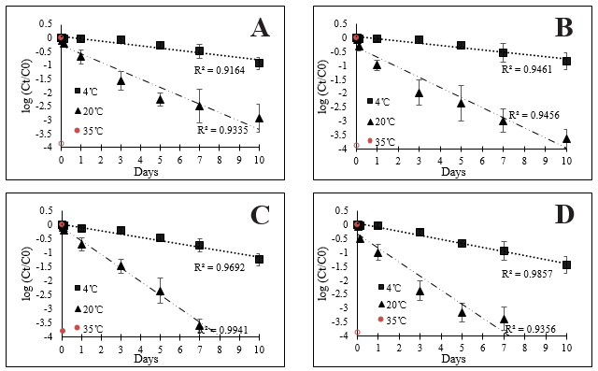 Figure 4.4. E. coli strains in liquid matrices. (A) wild-type strain in stormwater; (B) wild-type strain in river water; (C) lab strain in stormwater; (D) lab strain in river water

References
Athayde DN, Shelley PE, Driscoll ED, Gaboury D, Boyd G (1983) "Results of the nationwide urban runoff program". Results of the Nationwide Urban Runoff Program
Bergholz TM, Whittam TS (2007) Variation in acid resistance among enterohaemorrhagic Escherichia coli in a simulated gastric environment. Journal of Applied Microbiology 102:352-362
Bigelow W, Esty J (1920) The thermal death point in relation to time of typical thermophilic organisms. The Journal of Infectious Diseases:602-617
Brown ER, Kandhal PS, Roberts FL, Kim YR, Lee D-Y, Kennedy TW (2009) Hot mix asphalt materials, mixture design, and construction. NAPA Research and Education Foundation
Buchanan RL, Edelson SG (1999) Effect of pH-dependent, stationary phase acid resistance on the thermal tolerance of Escherichia coil O157:H7. Food Microbiology 16:447-458
Byappanahalli MN, Whitman RL, Shively DA, Sadowsky MJ, Ishii S (2006) Population structure, persistence, and seasonality of autochthonous Escherichia coli in temperate, coastal forest soil from a Great Lakes watershed. Environmental microbiology 8:504-513
Cabelli VJ, Dufour AP, McCabe LJ, Levin MA (1982) Swimming-associated gastroenteritis and water quality. American Journal of Epidemiology 115:606-616
England LS, Lee H, Trevors JT (1993) Bacterial survival in soil: Effect of clays and protozoa. Soil Biology and Biochemistry 25:525-531
Franz E, Van Diepeningen AD, De Vos OJ, Van Bruggen AHC (2005) Effects of cattle feeding regimen and soil management type on the fate of Escherichia coli O157:H7 and Salmonella enterica serovar typhimurium in manure, manure-amended soil, and lettuce. Applied and Environmental Microbiology 71:6165-6174
Geeraerd A, Valdramidis V, Van Impe J (2006) Erratum to “GInaFiT, a freeware tool to assess non-log-linear microbial survivor curves”[Int. J. Food Microbiol. 102 (2005) 95–105]. International Journal of Food Microbiology 3:297
Gilpin BJ, Devane M, Robson B, Nourozi F, Scholes P, Lin S, Wood DR, Sinton LW (2013) Sunlight inactivation of human polymerase chain reaction markers and cultured fecal indicators in river and saline waters. Water Environment Research 85:743-750
Grant M (1997) A new membrane filtration medium for simultaneous detection and enumeration of Escherichia coli and total coliforms. Appl Environ Microbiol 63:3526-3530
Hacker J, Carniel E (2001) Ecological fitness, genomic islands and bacterial pathogenicity. EMBO Reports 2:376-381
Haile RW, Witte JS, Gold M, Cressey R, McGee C, Millikan RC, Glasser A, Harawa N, Ervin C, Harmon P, Harper J, Dermand J, Alamillo J, Barrett K, Nides M, Wang GY (1999) The health effects of swimming in ocean water contaminated by storm drain runoff. Epidemiology 10:355-363
He Y, Li Y, Salazar JK, Yang J, Tortorello ML, Zhang W (2013) Increased water activity reduces the thermal resistance of Salmonella enterica in peanut butter. Appl Environ Microbiol 79:4763-4767
Himathongkham S, Bahari S, Riemann H, Cliver D (1999) Survival of Escherichia coli O157:H7 and Salmonella typhimurium in cow manure and cow manure slurry. FEMS Microbiology Letters 178:251-257
Hoff JC, Akin EW (1986) Microbial resistance to disinfectants: Mechanisms and significance. Environmental Health Perspectives Vol. 69:7-13
Ihssen J, Egli T (2004) Specific growth rate and not cell density controls the general stress response in Escherichia coli. Microbiology 150:1637-1648
Ihssen J, Grasselli E, Bassin C, Fraçois P, Piffaretti JC, Köster W, Schrenzel J, Egli T (2007a) Comparative genomic hybridization and physiological characterization of environment isolates indicate that significant (eco-)physiological properties are highly conserved in the species Escherichia coli. Microbiology 153:2052-2066
Ihssen J, Grasselli E, Bassin C, François P, Piffaretti J-C, Köster W, Schrenzel J, Egli T (2007b) Comparative genomic hybridization and physiological characterization of environmental isolates indicate that significant (eco-) physiological properties are highly conserved in the species Escherichia coli. Microbiology 153:2052-2066
Jiang S (2004) Is Urban Runoff a Source of Human Pathogenic Viruses to Recreational Beach Waters? Technical Completion Report, Project No. W-943.
Kiefer LA, Shelton DR, Pachepsky Y, Blaustein R, Santin-Duran M (2012) Persistence of Escherichia coli introduced into streambed sediments with goose, deer and bovine animal waste. Letters in Applied Microbiology 55:345-353
Large TM, Walk ST, Whittam TS (2005) Variation in acid resistance among shiga toxin-producing clones of pathogenic Escherichia coli. Applied and Environmental Microbiology 71:2493-2500
Lurry DL, Kolbe CM (2000) Interagency field manual for the collection of water-quality data. US Department of the Interior, US Geological Survey
Mafart P, Couvert O, Gaillard S, Leguérinel I (2002) On calculating sterility in thermal preservation methods: application of the Weibull frequency distribution model. International journal of food microbiology 72:107-113
Marsalek J, Rochfort Q (2004) Urban wet-weather flows: Sources of fecal contamination impacting on recreational waters and threatening drinking-water sources. Journal of Toxicology and Environmental Health - Part A 67:1765-1777
McCarthy D, Mitchell VG, Deletic A (2006) Escherichia coli levels in urban stormwater. Paper Presented to the Urban Drainage Modelling and International Water Sensitive Urban Design Conference, Melbourne, 4–6 April 2006
McConkey BJ, Duxbury CL, Dixon DG, Greenberg BM (1997) Toxicity of a PAH photooxidation product to the bacteria Photobacterium phosphoreum and the duckweed Lemna gibba: Effects of phenanthrene and its primary photoproduct, phenanthrenequinone. Environmental Toxicology and Chemistry: An International Journal 16:892-899
Oliver DM, Clegg CD, Heathwaite AL, Haygarth PM (2007) Preferential attachment of Escherichia coli to different particle size fractions of an agricultural grassland soil. Water, Air, and Soil Pollution 185:369-375
Rozen Y, Belkin S (2001) Survival of enteric bacteria in seawater. FEMS Microbiology Reviews 25:513-529
Savageau MA (1983) Escherichia coli habitats, cell types, and molecular mechanisms of gene control. American Naturalist 122:732-744
Semenov AV, Van Bruggen AHC, Van Overbeek L, Termorshuizen AJ, Semenov AM (2007) Influence of temperature fluctuations on Escherichia coli O157:H7 and Salmonella enterica serovar Typhimurium in cow manure. FEMS Microbiology Ecology 60:419-428
Sidhu JPS, Toze S, Hodgers L, Barry K, Page D, Li Y, Dillon P (2015) Pathogen decay during managed aquifer recharge at four sites with different geochemical characteristics and recharge water sources. Journal of Environmental Quality 44:1402-1412
Sinton LW, Hall CH, Lynch PA, Davies-Colley RJ (2002) Sunlight inactivation of fecal indicator bacteria and bacteriophages from waste stabilization pond effluent in fresh and saline waters. Applied and Environmental Microbiology 68:1122-1131
Sjogren RE (1994) Prolonged survival of an environmental Escherchia coli in laboratory soil microcosms. Water, Air, & Soil Pollution 75:389-403
Solecki O, Jeanneau L, Jardé E, Gourmelon M, Marin C, Pourcher AM (2011) Persistence of microbial and chemical pig manure markers as compared to faecal indicator bacteria survival in freshwater and seawater microcosms. Water Research 45:4623-4633
Surbeck CQ, Jiang SC, Ahn JH, Grant SB (2006) Flow fingerprinting fecal pollution and suspended solids in stormwater runoff from an urban coastal watershed. Environmental Science and Technology 40:4435-4441
Tabe ES, Oloya J, Doetkott DK, Bauer ML, Gibbs PS, Khaitsa ML (2008) Comparative effect of direct-fed microbials on fecal shedding of Escherichia coli O157:H7 and Salmonella in naturally infected feedlot cattle. Journal of Food Protection 71:539-544
Tao H, Bausch C, Richmond C, Blattner FR, Conway T (1999) Functional genomics: Expression analysis of Escherichia coli growing on minimal and rich media. Journal of Bacteriology 181:6425-6440
Unc A, Gardner J, Springthorpe S (2006) Recovery of Escherichia coli from soil after addition of sterile organic wastes. Applied and Environmental Microbiology 72:2287-2289
Vital M, Hammes F, Egli T (2008) Escherichia coli O157 can grow in natural freshwater at low carbon concentrations. Environmental Microbiology 10:2387-2396
Zhang Q, Yan T (2012) Desiccation Resistance of Soil Escherichia coli Populations Correlates to Intracellular Trehalose Concentration. Applied and Environmental Microbiology:AEM. 01904-12

Chapter 5

Natural Stabilities and Dynamics in Bacterioplankton Communities in the Unimpaired Streams within an Ecoregion

Abstract
Bacterioplankton in freshwater streams plays a critical role in the assessment of aquatic ecological health. Recent studies have addressed bacterioplankton community dynamics in streams with major anthropogenic impacts, however, the natural dynamics of low impact streams is under studied. The understanding of this natural variation of the bacterioplankton communities in low impact streams is needed before assessing the stream ecological conditions utilizing microbial community indicators. In this study, three unimpaired streams spanning first, second, and fourth order within an ecoregion were utilized to characterize the temporal dynamics through bacterioplankton community analysis. The results showed that the bacterioplankton community compositions were stable within a short sampling period length of one month at each site. Although the species abundance distributions were all followed by Poisson lognormal model and the dominated taxa in the three sites were typical freshwater taxa that were well documented, different streams harbored distinct communities, especially for the fourth order stream compared with the first and second order streams. In the fourth order stream, the microbial community was enriched with known freshwater associated bacteria, while the lower order streams hosted more sediment and soil associated taxa. Moreover, these streams were monitored over two seasons, where pronounced seasonal shifts in community compositions for all the three streams were observed. The streams closed to headwater revealed elevated alpha diversities in spring, but the highest order stream showed a reversed seasonal pattern. In the Spring, more diverse sources of bacteria enter the lower order streams but enrichment processes for select taxa were enhanced in the higher-order stream. Overall, this study shows that the delimitation of stream types and sampling periods is an important step for defining the reference conditions of bacterioplankton communities within an ecoregion.

1. Introduction
Within ecological regions, or ecoregions, the contiguous landscape units that have regional similarities in soil, land surface form, land use and dominant vegetation . The use of the unimpaired stream sites as references has long been a key component to assess the aquatic ecological conditions at other sites within ecoregions for the last 3 decades (Hughes, Larsen et al. 1986, Attrill and Depledge 1997, Dale and Beyeler 2001, Martins, Ligeiro et al. 2018). Metrics and indices were developed from the physical, chemical, and biological characteristics and were used as a basis against other sites (Aazami, Esmaili Sari et al. 2015). bacterioplankton-based index of biotic integrity provided a useful measurement since high-throughput sequencing techniques were rapidly developed recently (Simonin, Voss et al. 2019, Laperriere, Hilderbrand et al. 2020). One of the techniques is 16S rRNA amplicon sequencing which enables researchers to identify the entire microbial community within a sample (Sinclair, Osman et al. 2015). However, the natural variations of these bacterioplankton communities in the unimpaired streams, must be understood before we can fully assess the potential applicability of microbial community index as assessment of stream ecological conditions (Dale and Beyeler 2001). A challenge for stream ecologists is to determine the extent to which Pelagic stream communities are structured by the natural variability.
Recent studies have addressed bacterioplankton community diversity in streams within a watershed (Staley, Gould et al. 2014, Hassell, Tinker et al. 2018, Teachey, McDonald et al. 2019). While these studies indicate that taxonomic shifts closely related to seasonality and hydrological conditions, less is understood about the natural range and variation of microbial groups. Moreover, few investigators have examined how stable the bacterioplankton communities are over time within an ecological region.
In this study, temporal dynamics of bacterioplankton communities were quantified at 3 unimpaired streams within an ecoregion. This work spanned independent streams of 1st, 2nd, 4th order for covering different order types. Measurements of bacterioplankton communities were made in spring and fall to evaluate seasonal shifts in community composition at each stream site. We hypothesized that bacterioplankton communities within each stream would exhibit temporal community composition patterns, community structure fluctuated around a relatively stable state with communities sampled closely and pronounced seasonal shifts in composition with those communities sampled many months apart. Furthermore, in the three streams, the species abundance distributions (SADs) followed the same model and the dominated taxa were typical freshwater bacteria that were well documented, while the microbial communities in the two streams closed to headwater showed high diversity levels and hosted elevated sediment and soil-associated bacteria.

2. Materials and Methods

2.1 Sites selection
The study was conducted in East Tennessee, USA. Three stream sites were selected within an ecoregion – 67f The Southern Limestone/Dolomite Valleys and Low Rolling Hills (Griffith, Omernik et al. 1997), including Clear Creek, White Creek, and Powell Creek, which were named as stream I, stream II, and stream III respectively (Figure 5.1). Water samples were collected by dipping a sterile 1 L bottle below the stream surface following Standard Method (Lurry and Kolbe 2000). Five samples at each stream site were collected in September 2018, and three samples at each site were collected in May 2019. After collection, all samples were transported using cooler with ice and delivered to the laboratory within 6 hours. For high-throughput sequencing, the water samples were filtered through 0.45 µm filters (MilliporeSigma™ HAWG047S6), and the filters were stored at -80˚C until DNA extraction.

2.2 Fecal indicator bacteria test
Fecal indicator bacteria (E. coli and total coliforms) tests were performed within 8 hours of sample collection. E. coli and total coliforms were determined by m-Coliblue 24 ® media following the protocol provided by the manufacturer (Hach Co., Loveland, CO). Briefly, one hundred milliliters of each water sample and appropriate dilutions were filtered, and then the filters were incubated at 37 °C and growth was observed at 24 h.

2.3 DNA extraction and high-throughput 16s rRNA amplicon sequencing
DNA from the colony isolates was extracted by the FastDNA Spin Kit for Soil (MP Biomedicals) following the manufacturer’s protocol. High-throughput 16s rRNA Amplicon Sequencing was performed as previously described (Wyckoff, Chen et al. 2017). The PCR amplification used primers 515-F and 806-R to target the V4 region of the 16S rRNA gene(Caporaso, Lauber et al. 2012). PCR products were purified using the Wizard SV Gel and PCR Clean-Up system (Promega) and paired-end sequencing was completed using the Illumina MiSeq platform.
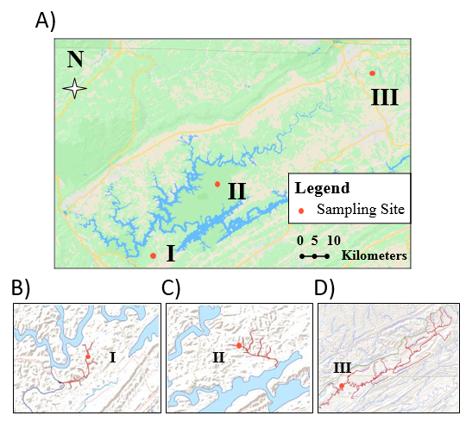
Figure 5.1. The maps of the three streams from 67f eco-region East TN. (A) sampling sites of three streams; (B) The sampling site of stream I; (C) The sampling site of stream II; (D) The sampling site of stream III. A total of 24 water samples were collected in September 2018 and May 2019.

2.4 Bioinformatic and statistical analyses.
Analysis of sequence reads was conducted using QIIME 2 (Bolyen, Rideout et al. 2019). Amplicon sequence variants (ASVs) enumeration was performed using the DADA2 pipeline (Callahan, McMurdie et al. 2016). The obtained ASVs were then matched to the Greengenes 13.8 database.
Statistical analysis and data visualization were carried out using R version 3.50 (Team 2017). PERMANOVA was applied to assess the difference of community composition, α-diversity indix (the Shannon index), and Bray–Curtis (abundance-based) dissimilarity was calculated to represent the taxonomic β-diversity using the vegan R package (Oksanen, Blanchet et al. 2013).
The “sads” package in R was used to fit the species abundance distribution (SAD) models of samples based on the ASV level composition. Three SAD models, including log-series, Poisson lognormal, and Zipf were used to fit the raw data in this study. The R-squared was applied to determine the goodness of model fit based on previous study (Shoemaker, Locey et al. 2017).
The sequence count table of 16S rRNA gene amplicon studies from the EMP was downloaded (Thompson, Sanders et al. 2017), and EMP samples from freshwater, freshwater sediment, and soil were selected and merged with our stream water samples. The proportions of each stream water microbiota attributable to freshwater, sediment, and soil at the genus level were estimated using Sourcetracker (Knights, Kuczynski et al. 2011), a computational tool that performs Bayesian inference which was using stream water microbiota as the sink and those in soil as sources.

3. Results and Discussions

3.1 Fecal indicator bacteria in the unimpaired streams
Based on State of Tennessee water quality standards, a geometric mean concentration of E. coli shall not exceed 126 CFU/100mL with at least 5 sampling time points (TDEC 2007). The three streams showed low levels of E. coli, the average concentrations of E. coli across the three sampling sites were from 52 to 80 CFU/100mL, meanwhile the average concentrations of total coliforms were from 728 CFU/100mL to1428 CFU/100mL (Figure 5.2).
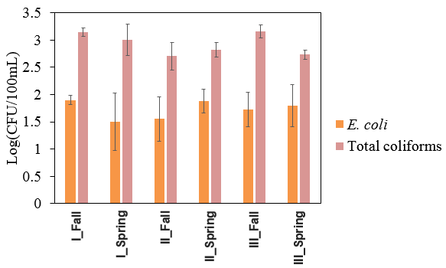
Figure 5.2. E. coli and total coliforms in ecoregion streams. FIB showed relatively stable concentrations across sampling locations and times (there is no significant difference across sampling locations and times).

The levels of FIB, including E. coli and total coliforms, in the three unimpaired streams were similar across sampling locations, and the concentrations were not significantly different between seasons at each site (P > 0.05). The natural variations of FIB in unimpaired streams were limited in this study.

3.2 Species abundance distributions for the bacterioplankton communities
The species abundance distribution (SAD) is one of the most important patterns in ecology and biodiversity and widely used in macroecological studies, but it has been neglected in microbial ecology until recently (Shoemaker, Locey et al. 2017). SAD curves for each stream in two different seasons were plotted (Figure 5.3). we tested common SAD models, including log-series, Poisson lognormal, and Zipf. In all the three streams and two seasons, Poisson lognormal clearly provide the best fit. It explained more than 90% of the variation of the bacterioplankton SADs (Table 5.S1). Previous studies also reported Poisson lognormal model gave the best fit for other freshwater ecosystems (Tang, Xie et al. 2020). Although numerous models were used to predict SADs, lognormal has been more commonly observed with microorganism in natural habitats (Shoemaker, Locey et al. 2017). The log-series distribution was well for fitting macroecological SADs; the Zipf model was successfully used to explain extremely uneven abundances (Shoemaker, Locey et al. 2017).
Although Poisson lognormal model was the best model for all samples in this study, the data set exhibited different patterns among streams within a season, especially for steam III which showed lower ASVs numbers and higher individuals of common ASVs. In spring, stream III only contained 258 ASVs, meanwhile the highest individual number of common ASVs was 777; however, stream II contained 1341 ASVs, and the highest individual number of common ASVs was 123. Moreover, at each site, the two different seasons exhibited different ASVs numbers and different numbers of individuals of common ASVs. Although Zipf model did not fit the raw data well, ASVs in Stream III fitted Zipf model (30.1% in Fall and 37.9% in Spring) better than stream I (23.8% in Fall and 20.5% in Spring) and II (15.5% in Fall and 13.1% in Spring), which may be explained by enhanced enrichment processes for freshwater-associated taxa in stream III as high order downstream (Teachey, McDonald et al. 2019). The patterns revealed the different bacterioplankton diversities in different streams and seasons.
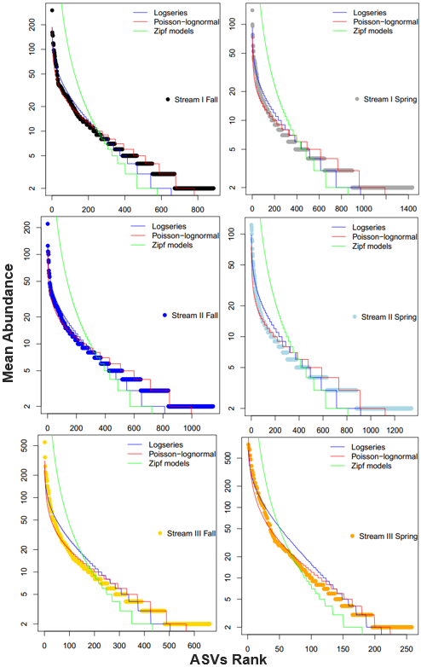
Figure 5.3. Predicting SADs of Bacterioplankton communities at each site. Each model was fit to the observed SAD. Table 5.S1 shows the variations of the SADs explained, by each model, indicating the best performance of the Poisson lognormal model for all the three streams in both Spring and Fall.

3.3 Short period fluctuations in bacterioplankton community structure within a season
In September 2018, five time points at each stream site were examined for bacterioplankton community diversity and composition. The results showed relatively stable alpha and beta bacterioplankton diversities within one-month sampling period at each site (Figure 5.4). Principal-coordinate-analysis (PCoA) showed nearly overlapped sample dots for the same stream (Figure 5.4A), and the mean bray-Curtis dissimilarities were less than 0.5 within the same stream (Figure 5.4B). The Shannon indices were also showed stabilities within the same stream, the Shannon indices were from 5.23 to 6.25, from 5.97 to 6.61, from 4.37 to 5.30 for stream I, II, and III respectively (Figure 5.4C).
Although the levels of FIB did not show significant across sampling locations, distinguished alpha and beta bacterioplankton diversities were observed (Figure 5.4). PCoA showed a clear separation of stream III from stream I and II, while samples from the two streams clustered together (Figure 5.4A). Bray-Curtis dissimilarity analyses revealed the dissimilarities among streams were higher than the dissimilarities within each stream (Figure 5.4B). Moreover, the dissimilarities between stream III and the other two streams are considerably higher than the dissimilarity between stream I and II. Alpha diversity also showed the significant differences from stream III and the other two streams. stream III was the least diverse versus stream I and II (Shannon index, P<0.05). The differences in alpha diversities of microbial communities between stream I and II were smaller and not statistically significant.
Actually, several studies found headwater hosted higher microbial diversity than higher-order downstream in a stream network (Teachey, McDonald et al. 2019). The three independent streams also showed the similar microbial diverse patterns, stream I and II as small streams are closed to the headwater, and stream III is the highest-order stream (Figure 5.1B-D).

3.4 Short period fluctuations in the abundances of individual ASVs within a season
Top 10 ASVs in Fall at each stream site were showed in figure 5.5. These taxonomy names of dominated ASVs in the three sites were typical freshwater bacteria that were well documented (Newton, Jones et al. 2011), especially for the taxa named as Flavobacterium and Comamonadaceae which were found across all the three streams. Moreover, most top 10 ASVs at each site were at similar levels of relative abundance across 5 sampling time points within the month. These analyses show temporal stabilities in bacterioplankton community over short time periods.
Decreases in alpha diversities in the stream III were accompanied by increases in the relative abundances of top 10 ASVs. All 5 samples from stream III hosted the ASVs that were more than 5% relative abundance, but none of ASVs was more than 5% in samples from stream I and II. Some top 10 ASVs, such as ASV3 Flavobacterium, ASV9 Flavobacterium, ASV10 Rhodoferax, ASV11 Rhodoferax, ASV12 Hydrogenophaga, and ASV16 Arcicella were found both in stream I and stream II, but none of top 10 ASVs in stream I and II was found in stream III. This suggests that the distinct bacterioplankton community in stream III compared to stream I and II, although the taxonomy names of the ASVs were commonly found in freshwater ecosystems.

3.5 Seasonal shifts in bacterioplankton community compositions at each site.
Although all streams in this study showed stable community compositions within a month, Bray-Curtis dissimilarities between seasons were higher than the dissimilarities within seasons for all the three streams (Figure 5.6A). Further, PCoA revealed a clear separation of spring from fall at each site (Figure 5.6B-D). Meanwhile, though not all top 10 ASVs in spring showed seasonal dynamics, all the three streams contained some of the top 10 ASVs that showed pronounced seasonal different abundance patterns (Figure 5.6A-C).
There are limited researches about specific taxa of seasonal preferences, but in stream III the first and second dominant ASVs are Sporichthyaceae, which were reported increased in spring and Summer in other freshwater ecosystems (Fisher, Newton et al. 2015, Li, Zhang et al. 2019, Ozbayram, Koker et al. 2020).
There were just 3 ASVs and 5 ASVs that were higher than 1% relative abundances in spring at stream I and II respectively, but all top 10 ASVs were higher than 1% in fall at both the two stream sites. Meanwhile, elevated alpha diversities (Shannon indices) in spring were accompanied by the decreased relative abundances of top 10 ASVs at the stream I and II sites (Figure 5.7A). However, stream III showed a reversed seasonal pattern. No doubt, Bray-Curtis dissimilarities between stream I/II and III were sharper in spring than fall (Figure 5.7B).
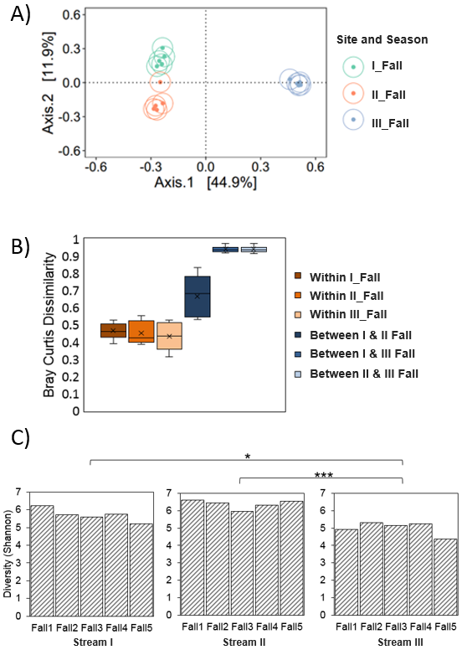
Figure 5.4. Microbial diversity and community structure within a month. (A) PCoA plot; (B) Bray–Curtis dissimilarity within each stream and between streams in Fall; (C) Alpha diversity (Shannon index) for each of the three selected sites in Fall. Fall1, Fall2 , Fall3 , Fall4 , and Fall5 presented the sampling time in September 6th ,11th ,19th ,21st , and 30th respectively. *,P < 0.05; **,P < 0.01; ***,P < 0.001
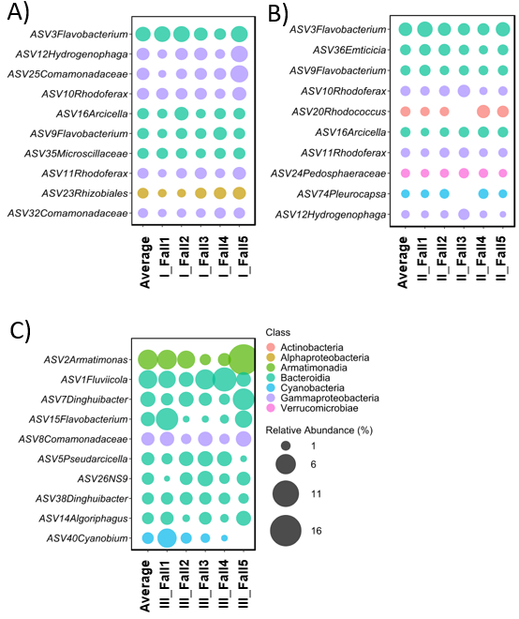
Figure 5.5. Top 10 ASVs in Fall at each sampling site; (A) The sampling site of stream I; (B) The sampling site of stream II; (C) The sampling site of stream III

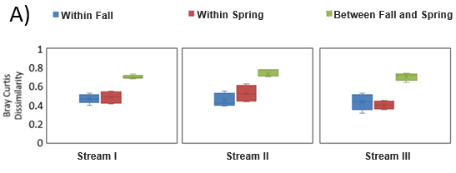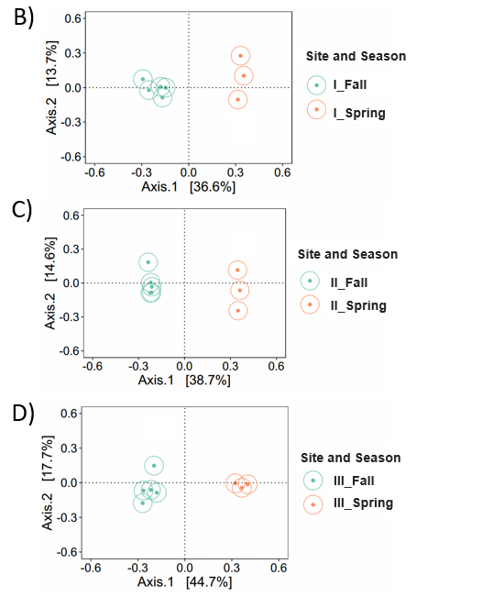
Figure 5.6. Beta-diversity showed samples from Fall and Spring at each site. (A) Bray–Curtis dissimilarity between seasons and within seasons at each site. (B) PCoA plot for samples at the sampling site of stream I; (C) PCoA plot for samples the sampling site of stream II; (D) PCoA plot for samples the sampling site of stream III.
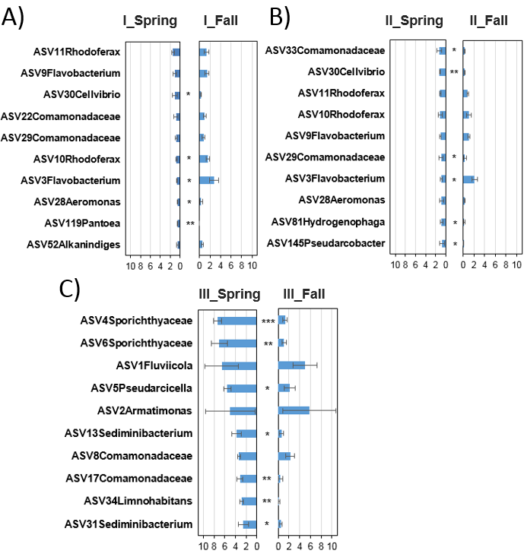
Figure 5.7. The relative abundance (%) of Top 10 ASVs in Spring at each site compared to Fall season; (A) The sampling site of stream I; (B) The sampling site of stream II; (C) The sampling site of stream III. *,P < 0.05; **,P < 0.01; ***,P < 0.001
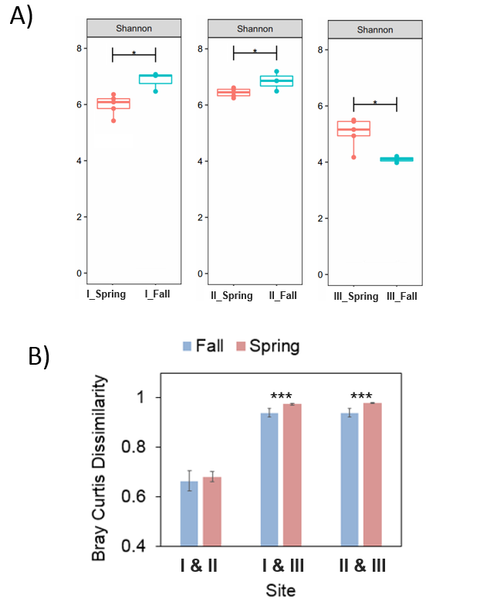
Figure 5.8. Microbial diversity and community structure between fall and spring at each site. (A) Alpha diversity (Shannon index) at each site; (B) Bray-Curtis dissimilarities among sites comparisons for Fall and Spring. *,P < 0.05; **,P < 0.01; ***,P < 0.001

3.6 Habitat associations for bacterioplankton
The different bacterioplankton structures among sites and between seasons may be explained by the interactions of the potential microbial sources. In order to explore habitat associations for bacterioplankton in the three streams, a Bayesian method was used to determine putative source environments of bacterioplankton communities at genus level (Figure 5.9). No doubt, the most dominant known source was freshwater, and stream III showed highest representation of freshwater microbial communities, especially in spring -- attributing on average 74% of genera. However, microbial communities of stream I and II were high representation of soil and sediment-associated genera, which may explain the compositionally diverse structure. soil and sediment-associated genera may enter the freshwater ecosystems from headwater, therefore stream I and II as low order streams and were closed to headwater contained higher soil and sediment-associated microbial populations. Meanwhile, enhanced enrichment processes for freshwater-associated taxa in stream III as high order downstream.
Sediment and soil as the potential sources were significantly more dominant in fall than spring across all streams in this study (P < 0.05). In stream III, freshwater-associated taxa were significantly higher in Spring than Fall, the enrichment processes may be amplified in Spring compared Fall. In both stream I and II sites, there is no significant difference of freshwater-associated genera between spring and fall, but the attributions of unknown sources were significantly increased in Spring, which means taxa from more potential sources into the freshwater ecosystems besides sediment and soil. It is difficult to infer the reasons about the seasonal shifts of bacterioplankton communities, because of too many impact factors, such as precipitation, temperature, growth of vegetation, and sunlight intensity. The influence of each factor should be determined in the future.

4. Conclusions
Bacterioplankton communities in three unimpaired streams within an ecoregion were studied. The SADs were all followed by Poisson lognormal model, which was consistent with other freshwater ecosystems in previous study. Meanwhile, the dominated taxa in the three sites were typical freshwater taxa that were well documented (Newton, Jones et al. 2011).
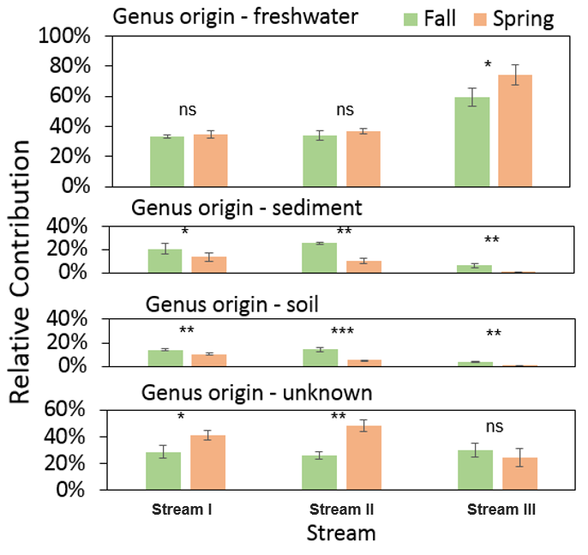
Figure 5.9. The contributions of potential sources of genera (%) in spring and fall at each stream. *,P < 0.05; **,P < 0.01; ***,P < 0.001

In this work, although concentrations of FIB and relative abundances of some dominant taxa showed relatively stable levels across sampling times at each site, the two streams closed to headwater were distinct from the highest-order stream. The streams closed to headwater host elevated sediment and soil-associated bacteria and diversity levels compared to the highest-order stream in which the microbial community enriches repeatedly for select taxa.
Although relatively stable bacterioplankton community compositions within one-month sampling period at each unimpaired stream, there were pronounced seasonal shifts for all the three sites. In spring, more potential bacterial sources other than sediment and soil enter into the stream headwaters and the streams closed to headwater showed higher diversity levels than Fall, meanwhile the highest-order stream showed enhanced enrichment processes for select taxa and decreased diversity levels in Spring compared to Fall.
Overall, this work suggests that delimitation of stream types and sampling periods is an important step for defining reference conditions of bacterioplankton communities within an ecoregion. It should be also mentioned that, due to the limited sampling stream sites in this study, observations need to be validated in different streams and ecoregions.

References
Aazami, J., A. Esmaili Sari, A. Abdoli, H. Sohrabi and P. J. Van den Brink (2015). "Assessment of Ecological Quality of the Tajan River in Iran Using a Multimetric Macroinvertebrate Index and Species Traits." Environmental Management 56(1): 260-269.
Attrill, M. J. and M. H. Depledge (1997). "Community and population indicators of ecosystem health: Targeting links between levels of biological organisation." Aquatic Toxicology 38(1-3): 183-197.
Bolyen, E., J. R. Rideout, M. R. Dillon, N. A. Bokulich, C. C. Abnet, G. A. Al-Ghalith, H. Alexander, E. J. Alm, M. Arumugam and F. Asnicar (2019). "Reproducible, interactive, scalable and extensible microbiome data science using QIIME 2." Nature biotechnology 37(8): 852-857.
Callahan, B. J., P. J. McMurdie, M. J. Rosen, A. W. Han, A. J. A. Johnson and S. P. Holmes (2016). "DADA2: high-resolution sample inference from Illumina amplicon data." Nature methods 13(7): 581.
Caporaso, J. G., C. L. Lauber, W. A. Walters, D. Berg-Lyons, J. Huntley, N. Fierer, S. M. Owens, J. Betley, L. Fraser and M. Bauer (2012). "Ultra-high-throughput microbial community analysis on the Illumina HiSeq and MiSeq platforms." The ISME journal 6(8): 1621.
Dale, V. H. and S. C. Beyeler (2001). "Challenges in the development and use of ecological indicators." Ecological Indicators 1(1): 3-10.
Fisher, J. C., R. J. Newton, D. K. Dila and S. L. McLellan (2015). "Urban microbial ecology of a freshwater estuary of Lake Michigan." Elementa (Washington, DC) 3.
Griffith, G., J. Omernik and S. Azevedo (1997). "Ecoregions of Tennessee: US Environmental Protection Agency National Health and Environmental Effects Research Laboratory EPA."
Hassell, N., K. A. Tinker, T. Moore and E. A. Ottesen (2018). "Temporal and spatial dynamics in microbial community composition within a temperate stream network." Environmental Microbiology 20(10): 3560-3572.
Hawkins, C. P., J. R. Olson and R. A. Hill (2010). "The reference condition: predicting benchmarks for ecological and water-quality assessments." Journal of the North American Benthological Society 29(1): 312-343.
Hughes, R. M., D. P. Larsen and J. M. Omernik (1986). "Regional reference sites: a method for assessing stream potentials." Environmental Management 10(5): 629-635.
Knights, D., J. Kuczynski, E. S. Charlson, J. Zaneveld, M. C. Mozer, R. G. Collman, F. D. Bushman, R. Knight and S. T. Kelley (2011). "Bayesian community-wide culture-independent microbial source tracking." Nature Methods 8(9): 761-763.
Laperriere, S. M., R. H. Hilderbrand, S. R. Keller, R. Trott and A. E. Santoro (2020). "Headwater stream microbial diversity and function across agricultural and urban land use gradients." Applied and Environmental Microbiology 86(11).
Li, Y., J. Zhang, J. Zhang, W. Xu and Z. Mou (2019). "Microbial Community Structure in the Sediments and Its Relation to Environmental Factors in Eutrophicated Sancha Lake." International journal of environmental research and public health 16(11): 1931.
Lurry, D. L. and C. M. Kolbe (2000). Interagency field manual for the collection of water-quality data, US Department of the Interior, US Geological Survey.
Martins, I., R. Ligeiro, R. M. Hughes, D. R. Macedo and M. Callisto (2018). "Regionalisation is key to establishing reference conditions for neotropical savanna streams." Marine and Freshwater Research 69(1): 82-94.
Newton, R. J., S. E. Jones, A. Eiler, K. D. McMahon and S. Bertilsson (2011). "A guide to the natural history of freshwater lake bacteria." Microbiology and molecular biology reviews 75(1): 14-49.
Oksanen, J., F. G. Blanchet, R. Kindt, P. Legendre, P. R. Minchin, R. B. O'Hara, G. L. Simpson, P. Solymos, M. H. H. Stevens and H. Wagner (2013). "Vegan: Community Ecology Package. R package version 2.0-10." Vegan: Community Ecology Package.
Ozbayram, E. G., L. Koker, R. Akçaalan, F. Aydın, A. Ertürk, O. Ince and M. Albay (2020). "Contrasting the Water Quality and Bacterial Community Patterns in Shallow and Deep Lakes: Manyas vs. Iznik." Environmental Management: 1-7.
Shoemaker, W. R., K. J. Locey and J. T. Lennon (2017). "A macroecological theory of microbial biodiversity." Nature ecology & evolution 1(5): 1-6.
Simonin, M., K. A. Voss, B. A. Hassett, J. D. Rocca, S. Y. Wang, R. L. Bier, C. R. Violin, J. P. Wright and E. S. Bernhardt (2019). "In search of microbial indicator taxa: shifts in stream bacterial communities along an urbanization gradient." Environmental Microbiology 21(10): 3653-3668.
Sinclair, L., O. A. Osman, S. Bertilsson and A. Eiler (2015). "Microbial community composition and diversity via 16S rRNA gene amplicons: Evaluating the illumina platform." PLoS ONE 10(2).
Staley, C., T. J. Gould, P. Wang, J. Phillips, J. B. Cotner and M. J. Sadowsky (2014). "Bacterial community structure is indicative of chemical inputs in the Upper Mississippi River." Frontiers in Microbiology 5(OCT).
Tang, X., G. Xie, K. Shao, Y. Hu, J. Cai, C. Bai, Y. Gong and G. Gao (2020). "Contrast diversity patterns and processes of microbial community assembly in a river-lake continuum across a catchment scale in northwestern China." Environmental Microbiome 15: 1-17.
Teachey, M. E., J. M. McDonald and E. A. Ottesen (2019). "Rapid and stable microbial community assembly in the headwaters of a third-order stream." Applied and Environmental Microbiology 85(11).
Team, R. C. (2017). "R Foundation for Statistical Computing; Vienna, Austria: 2016. R: A language and environment for statistical computing." URL http://www. R-project. org/[Google Scholar].
Thompson, L. R., J. G. Sanders, D. McDonald, A. Amir, J. Ladau, K. J. Locey, R. J. Prill, A. Tripathi, S. M. Gibbons and G. Ackermann (2017). "A communal catalogue reveals Earth’s multiscale microbial diversity." Nature 551(7681): 457-463.
Wu, L., D. Ning, B. Zhang, Y. Li, P. Zhang, X. Shan, Q. Zhang, M. Brown, Z. Li and J. D. Van Nostrand (2019). "Global diversity and biogeography of bacterial communities in wastewater treatment plants." Nature microbiology 4(7): 1183-1195.
Wyckoff, K. N., S. Chen, A. J. Steinman and Q. He (2017). "Impact of Roadway Stormwater Runoff on Microbial Contamination in the Receiving Stream." Journal of environmental quality 46(5): 1065-1071.

Chapter 6

Microbial Diversity in Unimpaired Streams across Ecoregions

Abstract
With the development of the high-throughput 16s rRNA Amplicon Sequencing techniques, the use of microorganisms for the ecological assessment of natural water bodies has greatly increased. Typically, this sort of assessment is done with streams that have major anthropomorphic impacts, without significant understanding of the unimpaired stream dynamics. The understanding of natural spatial variation of the microbial diversities in these unimpaired streams is important to identify reference bacterial composition prior to the assessment of stream ecological conditions. In this study, microbial community composition was utilized to characterize the spatial variations among 15 streams across three different ecoregions, where these streams corresponded to two stream types: low-order streams (i.e. closest to the headwater) and high-order streams. The results indicated that culture-based fecal indicator bacteria (FIB) showed low concentrations and relatively stable across these unimpaired streams, but the microbial communities revealed spatial variation. It was revealed that the microbial communities were distinct between low-order streams and high-order streams, which corresponded to low-order streams having elevated sediment and soil-associated bacteria, as well as higher community diversity levels, whereas freshwater-associated bacteria were more prevalent in high-order streams. Moreover, microbial communities in both low-order streams and high-order streams exhibited significant distance-decay patterns, where this trend was stronger in low-order streams. These results show impacts of stream size and order have on the microbial community structure, as well as the geographical variability in streams with virtually no anthropomorphic impact.

1. Introduction
More recent studies have used microorganisms to assess the ecological conditions of freshwater ecosystems due to the rapid development of the high-throughput 16s rRNA Amplicon Sequencing techniques in microbial community analyses (Lau, Washington et al. 2015, Li, Li et al. 2017, Niu, Li et al. 2018, Simonin, Voss et al. 2019, Hilderbrand, Keller et al. 2020). The use of natural water microbial community as background bacterial composition has been a key component to identify deviations from the high ecological quality in the absence of anthropogenic stresses at other stream sites (Hägglund, Bäckman et al. 2018, Breton-Deval, Sanchez-Flores et al. 2019). However, the microbial characteristics of streams vary according to their biogeographic features (Tolkkinen, Mykrä et al. 2016, Vilmi, Karjalainen et al. 2016, Hosen, Febria et al. 2017, Teachey, McDonald et al. 2019). Moreover, even within a stream network, bacterial compositions were different between headwater and higher-order downstream (Hassell, Tinker et al. 2018, Teachey, McDonald et al. 2019). Thus, spatial and order-type-specific variations of reference conditions of microorganisms in the streams with high ecological status must be understood.
Some recent studies have used local stream water samples with low fecal indicator bacteria (FIB) counts from the same watershed as background bacterial composition (Hägglund, Bäckman et al. 2018, Breton-Deval, Sanchez-Flores et al. 2019). However, the low and stable levels of FIB were not able to present the stability of microbial community, meanwhile few studies described the natural variation of background bacterial composition. In this way, strong variations may occur for characterizing the ecological condition of freshwater streams based on sequence-based microorganism approaches.
This study aimed to evaluate spatial and order-type-specific variations of microbial community compositions in reference streams. This work spanned independent streams of different order types across three ecoregions. We hypothesized that FIB showed low concentrations and relatively stable across sampling locations while the microbial communities revealed spatial variation. Furthermore, Habitat filtering by stream order level, and not ecoregion, was the major driver shaping bacterioplankton communities.

2. Materials and Methods

2.1 Sites selection
The study was conducted in East Tennessee, USA. 15 reference streams across three ecoregions were selected (Figure 6.1) – 67f The Southern Limestone/Dolomite Valleys and Low Rolling Hills, 68a Cumberland Plateau, and 71g Eastern Highland Rim ((Griffith, Omernik et al. 1997). The stream names, order levels, and Geographical distance from headwater were shown in table 6.S1. The sampling streams with 1 or 2 order were defined as low order streams closed to head water, and 3 or 4 order streams were defined as high order streams. Water samples were collected by dipping a sterile 1 L bottle below the stream surface following Standard Method (Lurry and Kolbe 2000) from May to June 2019 within 30 days in order to exclude temporal variations. After collection, all samples were transported using cooler with ice and delivered to the laboratory within 6 hours. For high-throughput sequencing, the water samples were filtered through 0.45 µm filters (MilliporeSigma™ HAWG047S6), and the filters were stored at -80˚C until DNA extraction.

2.2 Fecal indicator bacteria test
Fecal indicator bacteria (E. coli and total coliforms) tests were performed within 8 hours of sample collection. E. coli and total coliforms were determined by m-Coliblue 24 ® media following the protocol provided by the manufacturer (Hach Co., Loveland, CO) as described in previous chapters.

2.3 DNA extraction and high-throughput 16s rRNA amplicon sequencing
DNA from the colony isolates was extracted by the FastDNA Spin Kit for Soil (MP Biomedicals) following the manufacturer’s protocol.
High-Throughput 16s rRNA Amplicon Sequencing was performed as previously described(Wyckoff, Chen et al. 2017). The PCR amplification used primers 515-F and 806-R to target the V4 region of the 16S rRNA gene(Caporaso, Lauber et al. 2012). PCR products were purified using the Wizard SV Gel and PCR Clean-Up system (Promega) and paired-end sequencing was completed using the Illumina MiSeq platform.

2.4 Bioinformatic and statistical analyses.
Analysis of sequence reads was conducted using QIIME 2 (Bolyen, Rideout et al. 2019). Amplicon sequence variants (ASVs) enumeration was performed using the DADA2 pipeline (Callahan, McMurdie et al. 2016). The obtained ASVs were then matched to the Greengenes 13.8 database.
Statistical analysis and data visualization were carried out using R version 3.50 (Team 2017) . PERMANOVA was applied to assess the difference of community composition, α-diversity indices (the Shannon index, the Simpson index and Pielou’s evenness), and Bray–Curtis (abundance-based) dissimilarity was calculated to represent the taxonomic β-diversity using the vegan R package (Oksanen, Blanchet et al. 2013).
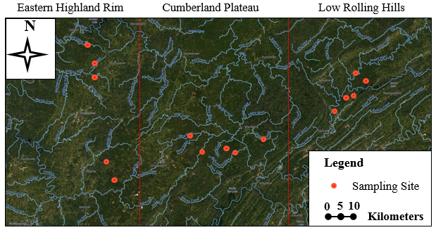
Figure 6.1. The maps of the 15 streams across three ecoregions in East TN -- 67f The Southern Limestone/Dolomite Valleys and Low Rolling Hills, 68a Cumberland Plateau, and 71g Eastern Highland Rim 67f eco-region .

The sequence count table of 16S rRNA gene amplicon studies from the EMP was downloaded (Thompson, Sanders et al. 2017) , and EMP samples from freshwater, freshwater sediment, and soil were selected and merged with our stream water samples. The proportion of each stream water microbiota attributable to freshwater, sediment, and soil at the genus level were estimated using Sourcetracker (Knights, Kuczynski et al. 2011), which was using stream water microbiota as the sink and those in soil as sources.

3. Results and Discussions

3.1 Fecal indicator bacteria in the ecoregion streams
All 15 streams in this study showed the average concentrations of E. coli were from 20 to 102 CFU/100mL, meanwhile the average concentrations of total coliforms were from 377 CFU/100mL to 1452 CFU/100mL (Figure 6.2). The levels of E. coli in the 15 streams were all less than 126 CFU/100mL, which is the threshold of State of Tennessee water quality standards (TDEC 2007).
The levels of FIB, including E. coli and total coliforms, in the reference streams were not significantly different across sampling locations (P > 0.05). The natural spatial variations of FIB in streams were limited in this study.

3.2 Habitat filtering by stream order level, and not ecoregion, is the major driver shaping microbial structures.
Although the levels of FIB were not significantly different across these unimpaired streams, distinguished alpha and beta microbial diversities were observed between different stream order levels (Figure 6.3 and Figure 6.4). Principal-coordinate-analysis (PCoA) showed a clear separation of low-order streams and high-order streams, while the same order streams clustered together even though they were from different ecoregions (Figure 6.3A). Cluster Dendrogram (Figure 6.3B) also showed the similar patterns, low-order streams and high-order streams were clustered as two groups. Moreover, Bray-Curtis similarity analyses revealed the similarities between the two type streams are considerably lower than the similarities within the same order level streams (Figure 6.3C).
Alpha diversity (the Shannon index, the Simpson index, and Pielou’s evenness) also showed the significant difference between low-order streams and high-order streams. The group of high-order streams was significantly less richness, evenness, and Shannon diverse than the group of low-order
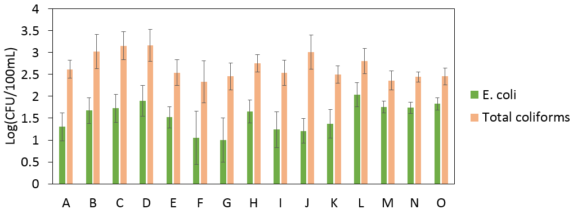
Figure 6.2. E. coli and total coliforms in ecoregion streams. FIB levels were relatively low and stable across sampling locations.

streams (P<0.001). Several studies found headwater hosted higher microbial diversity than the high-order downstream in a stream network (Hassell, Tinker et al. 2018, Teachey, McDonald et al. 2019), the independent streams in this study also showed the similar microbial diverse patterns.

3.3 The abundances of individual ASVs across stream sites
Decreases in alpha diversities in the high-order streams were accompanied by increases in the relative abundance of top ASVs (Figure 6.5). All samples from high-order streams hosted the ASVs that were more than 7% relative abundances, even some of ASVs were higher than 20%, however, none of ASVs was more than 5% in samples from low-order streams.
All abundant ASVs in the high-order streams were also found in low-order streams, though the relative abundances might be less in the low-order streams. This phenomenon may result by enriching the microbial community repeatedly for select taxa across high-order freshwater ecosystems. Meanwhile, the high abundant taxonomies in the high-order streams, like Flavobaterium, Comamonadaceae, Planktophila, Rhodoluna, Pseudarcicella, Sporichthyaceae, Polynucleobacter, and Fluviicola, were also generally found in other freshwater ecosystems (Newton, Jones et al. 2011).

3.4 Putative source environments for microbial community in the reference stream water
In order to explore habitat associations for microbial community in the reference streams, a Bayesian method was used to determine putative source environments of bacterioplankton communities at the genus level (Figure 6.6), including soil, sediment, and freshwater, based on the Earth Microbiome Project (EMP) datasets (Thompson, Sanders et al. 2017). No doubt, the most dominant known source was fresh water, attributing from 27% to 81%, especially for high-order streams where the representations of freshwater microbial communities were higher than 63%. However, the representations of freshwater microbial communities in low-order streams were less than 45%. Further, higher representations of sediment-associated genera (8% -- 18%) in low-order streams than high-order streams (less than 1%) were found in this study, as the similar as sediment-associated genera patterns, higher representations of soil-associated genera (4% -- 11%) in low-order streams than high-order streams (less than 0.7%).
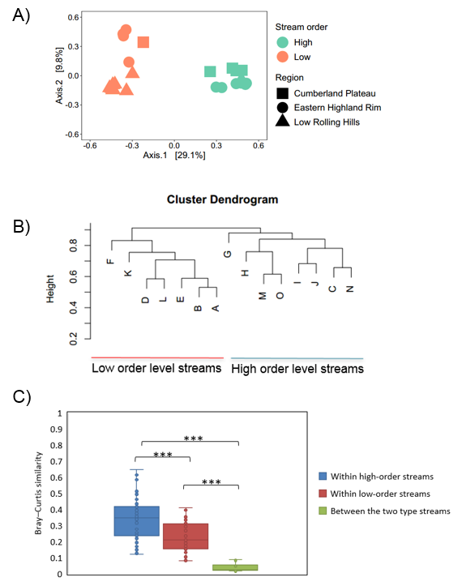
Figure 6.3. Beta-diversity showed Habitat filtering by stream order level, and not ecoregion, is the major driver shaping bacterioplankton communities. (A) PCoA; (B) Cluster Dendrogram; (C) Bray–Curtis similarity. *,P < 0.05; **,P < 0.01; ***,P < 0.001
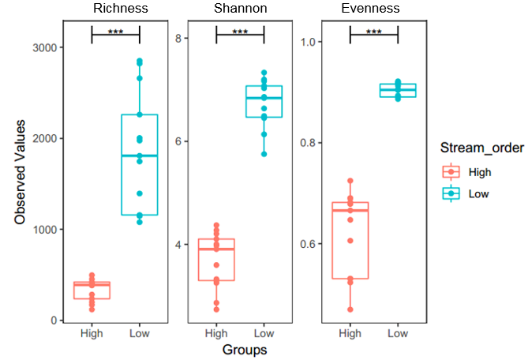
Figure 6.4. Alpha diversities (the Shannon index, the Simpson index, and Pielou’s evenness) for low-order streams and high-order streams. *,P < 0.05; **,P < 0.01; ***,P < 0.001.

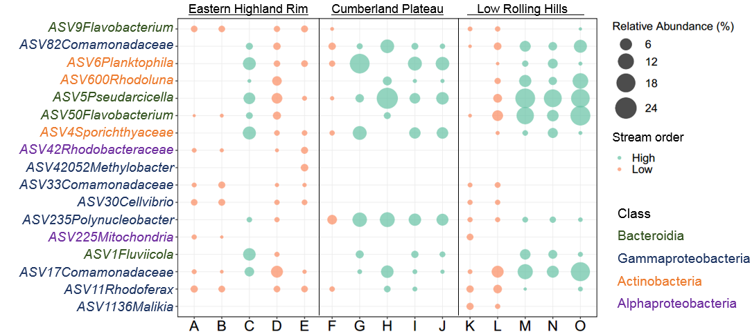
Figure 6.5. Balloon plot showing the relative abundance of the ASVs found in different streams. The top 3 most abundant ASVs in each stream are displayed.

Low-order streams are closed to headwater that acts as a primary entry point for soil and sediment associated microorganisms into freshwater ecosystems, which may explain the compositionally diverse structure. Meanwhile, high-order streams, as downstream in a river network, enriched the selected freshwater-associated taxa and showed a reduction in microbial diversity.

3.5 spatial factors related with microbial community composition.
Actually, Bray-Curtis similarity analyses (Figure 6.3C) not only showed the similarities between the two order-type streams are considerably lower than the similarities within the same order level streams, but also showed the similarities within the low-order streams were significantly lower than the high-order streams. Meanwhile, Figure 6.5 showed ASV42 Rhodobacteraceae was exclusively positive in the low-order streams from the Eastern Highland Rim ecoregion, and ASV1136 Malikia was exclusively positive in the low-order streams from the Low Rolling Hills ecoregion. These results indicated the spatial variations within the low-order streams across the three ecoregions.
Although all abundant ASVs in the high-order streams can be found across different ecoregions, some of them showed different relative abundances between different regions. For example, the relative abundances of ASV235 Polynucleobacter were significant higher in the streams from Cumberland Plateau ecoregion than others, and the relative abundances of ASV50 Flavobacterium were significant higher in the streams from the Low Rolling Hills ecoregion than others. These patterns illustrated the local specific contribution may be a driven factor to shape the distribution of microorganisms in high-order freshwater ecosystems.
The spatial predictors (Figure 6.7) of microbial community compositions showed similar results. Significantly negative relationships between the Bray–Curtis similarity of microbial communities and the geographical distance were found in both low-order streams and high-order streams (P<0.01). This was not surprising because multiple studies found niche partitioning processes to microbial communities in freshwater ecosystems ( Febria et al. 2017, Teachey, McDonald et al. 2019). Moreover, the low-order streams showed stronger correlations between spatial distances and microbial communities than the high-order streams, the reason may be that the enrichment process of the selected freshwater-associated microbes in high-order streams offset spatial heterogeneity at the east Tennessee geographical scale in this study.
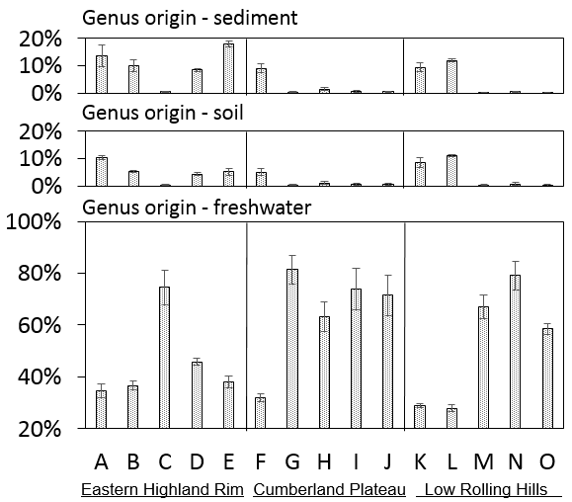
Figure 6.6. Percentage of stream water bacterial genera attributable to sediment, soil, and freshwater ecosystems as determined by Sourcetracker.
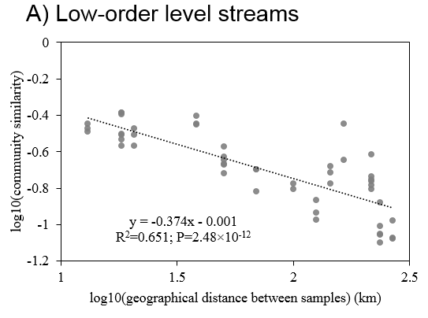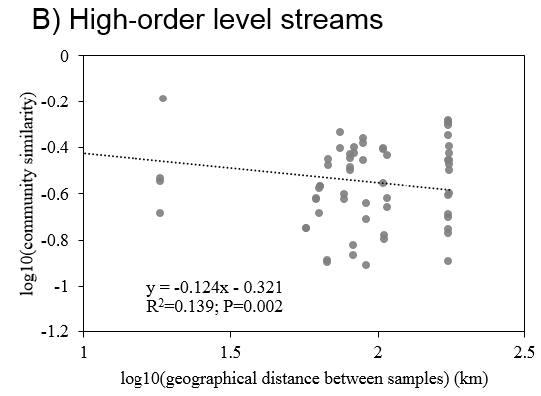
Figure 6.7. Distance-decay relationships between the bacterial community similarity; (A) samples from low-order level streams; (B) samples from high-order level streams. The bacterial communities in two types of streams showed significant distance decay across ecoregions (the slope of the distance–decay relationship estimated by least squares regression models were significantly less than zero), the distance-decay slopes of bacterial communities in low-order level streams (slope = -0.374, P < 0.0001) were significantly steeper than high-order level streams (slope = -0.124, P < 0.002).

4. Conclusions
Recent a few years, various microbial community-based methods have been developed, tested and suggested for the assessment of the freshwater ecological health. However, challenges were imposed by the spatial variability of microbial community in these ecosystems. This study investigated microorganisms in 15 reference streams across three ecoregions. The results showed that low and relatively stable concentrations of FIB across sampling locations, but the microbial communities revealed spatial variation patterns. While there was spatial variation observed, the stream order level was the larger driver for stream microbial community. The low-order streams closed to headwater host elevated sediment and soil-associated bacteria and diversity levels compared to the high-order streams in which the microbial community enriches repeatedly for freshwater-associated taxa. Moreover, microbial communities in both low-order streams and high-order streams exhibited significant distance-decay patterns, but the communities had a stronger distance-decay relationship in low-order streams. Overall, this work suggests a selection of nearby and similar order type reference streams is important for establishment of reference microbial conditions.

References
Bolyen, E., J. R. Rideout, M. R. Dillon, N. A. Bokulich, C. C. Abnet, G. A. Al-Ghalith, H. Alexander, E. J. Alm, M. Arumugam and F. Asnicar (2019). "Reproducible, interactive, scalable and extensible microbiome data science using QIIME 2." Nature biotechnology 37(8): 852-857.
Breton-Deval, L., A. Sanchez-Flores, K. Juárez and R. Vera-Estrella (2019). "Integrative study of microbial community dynamics and water quality along The Apatlaco River." Environmental Pollution 255: 113158.
Callahan, B. J., P. J. McMurdie, M. J. Rosen, A. W. Han, A. J. A. Johnson and S. P. Holmes (2016). "DADA2: high-resolution sample inference from Illumina amplicon data." Nature methods 13(7): 581.
Caporaso, J. G., C. L. Lauber, W. A. Walters, D. Berg-Lyons, J. Huntley, N. Fierer, S. M. Owens, J. Betley, L. Fraser and M. Bauer (2012). "Ultra-high-throughput microbial community analysis on the Illumina HiSeq and MiSeq platforms." The ISME journal 6(8): 1621.
Grant, M. (1997). "A new membrane filtration medium for simultaneous detection and enumeration of Escherichia coli and total coliforms." Appl. Environ. Microbiol. 63(9): 3526-3530.
Griffith, G., J. Omernik and S. Azevedo (1997). "Ecoregions of Tennessee: US Environmental Protection Agency National Health and Environmental Effects Research Laboratory EPA."
Hägglund, M., S. Bäckman, A. Macellaro, P. Lindgren, E. Borgmästars, K. Jacobsson, R. Dryselius, P. Stenberg, A. Sjödin and M. Forsman (2018). "Accounting for bacterial overlap between raw water communities and contaminating sources improves the accuracy of signature-based microbial source tracking." Frontiers in microbiology 9: 2364.
Hassell, N., K. A. Tinker, T. Moore and E. A. Ottesen (2018). "Temporal and spatial dynamics in microbial community composition within a temperate stream network." Environmental Microbiology 20(10): 3560-3572.
Hilderbrand, R. H., S. R. Keller, S. M. Laperriere, A. E. Santoro, J. Cessna and R. Trott (2020). "Microbial communities can predict the ecological condition of headwater streams." PloS one 15(8): e0236932.
Hosen, J. D., C. M. Febria, B. C. Crump and M. A. Palmer (2017). "Watershed urbanization linked to differences in stream bacterial community composition." Frontiers in Microbiology 8(AUG).
Knights, D., J. Kuczynski, E. S. Charlson, J. Zaneveld, M. C. Mozer, R. G. Collman, F. D. Bushman, R. Knight and S. T. Kelley (2011). "Bayesian community-wide culture-independent microbial source tracking." Nature Methods 8(9): 761-763.
Lau, K. E. M., V. J. Washington, V. Fan, M. W. Neale, G. Lear, J. Curran and G. D. Lewis (2015). "A novel bacterial community index to assess stream ecological health." Freshwater Biology 60(10): 1988-2002.
Li, J., Y. Li, B. Qian, L. Niu, W. Zhang, W. Cai, H. Wu, P. Wang and C. Wang (2017). "Development and validation of a bacteria-based index of biotic integrity for assessing the ecological status of urban rivers: A case study of Qinhuai River basin in Nanjing, China." Journal of Environmental Management 196: 161-167.
Lurry, D. L. and C. M. Kolbe (2000). Interagency field manual for the collection of water-quality data, US Department of the Interior, US Geological Survey.
Newton, R. J., S. E. Jones, A. Eiler, K. D. McMahon and S. Bertilsson (2011). "A guide to the natural history of freshwater lake bacteria." Microbiology and molecular biology reviews 75(1): 14-49.
Niu, L., Y. Li, P. Wang, W. Zhang, C. Wang, J. Li and H. Wu (2018). "Development of a microbial community-based index of biotic integrity (MC-IBI) for the assessment of ecological status of rivers in the Taihu Basin, China." Ecological Indicators 85: 204-213.
Oksanen, J., F. G. Blanchet, R. Kindt, P. Legendre, P. R. Minchin, R. B. O'Hara, G. L. Simpson, P. Solymos, M. H. H. Stevens and H. Wagner (2013). "Vegan: Community Ecology Package. R package version 2.0-10." Vegan: Community Ecology Package.
Simonin, M., K. A. Voss, B. A. Hassett, J. D. Rocca, S. Y. Wang, R. L. Bier, C. R. Violin, J. P. Wright and E. S. Bernhardt (2019). "In search of microbial indicator taxa: shifts in stream bacterial communities along an urbanization gradient." Environmental Microbiology 21(10): 3653-3668.
Teachey, M. E., J. M. McDonald and E. A. Ottesen (2019). "Rapid and stable microbial community assembly in the headwaters of a third-order stream." Applied and Environmental Microbiology 85(11).
Team, R. C. (2017). "R Foundation for Statistical Computing; Vienna, Austria: 2016. R: A language and environment for statistical computing." URL http://www. R-project. org/[Google Scholar].
Thompson, L. R., J. G. Sanders, D. McDonald, A. Amir, J. Ladau, K. J. Locey, R. J. Prill, A. Tripathi, S. M. Gibbons and G. Ackermann (2017). "A communal catalogue reveals Earth’s multiscale microbial diversity." Nature 551(7681): 457-463.
Tolkkinen, M. J., H. Mykrä, R. Virtanen, M. Tolkkinen, T. Kauppila, L. Paasivirta and T. Muotka (2016). "Land use impacts on stream community composition and concordance along a natural stress gradient." Ecological Indicators 62: 14-21.
Vilmi, A., S. M. Karjalainen, T. Nokela, K. Tolonen and J. Heino (2016). "Unravelling the drivers of aquatic communities using disparate organismal groups and different taxonomic levels." Ecological Indicators 60: 108-118.
Wyckoff, K. N., S. Chen, A. J. Steinman and Q. He (2017). "Impact of Roadway Stormwater Runoff on Microbial Contamination in the Receiving Stream." Journal of environmental quality 46(5): 1065-1071.

Chapter 7

The Impact of Storm Events on Receiving Stream Water Bacterial Community

Abstract
Advances in next-generation sequencing have potential shown new opportunities for bacterial contamination assessment of the impact of stormwater runoff on receiving stream water through analysis of microbial communities. The objectives of this study were to investigate the microbial community composition-based method for assessment of the impacts of stormwater runoff to receiving stream water at three sites in East Tennessee, USA. No doubt, the higher Turbidity and FIB levels in the wetflow of receiving creeks than baseflow in this study, and the 16S rRNA amplicon sequencing method more thoroughly highlights the impact that stormwater runoff has on general water quality. The dominated taxa in baseflow water samples were typical freshwater taxa that were also found in nearby unimpaired reference streams, but the runoff-associated microorganisms that were rare in baseflow were dramatically increased in wetflow. The Sourcetracker analysis revealed stormwater runoff and the receiving stream baseflow were the major contributors for the overall microbial community in wetflow across the three study sites. In general, this approach gave a clearer understanding of microbial contamination caused by non-point sources of pollution.

1. Introduction
Microbial contaminants have been concerned in pollution of water bodies (Ashbolt and Bruno 2003, Federigi, Verani et al. 2019). Those contaminations can be found in runoff and subsequently transported to environmental water bodies, and studies have reported a high prevalence of microbial contaminants in sewer overflows, defective septic systems, roof-harvested rainwater, and agricultural runoff. However, the studies of microbial contamination in stormwater runoff from impervious area were rarely (Saget, Chebbo et al. 1996, Jiang, Noble et al. 2001, Thurston, Gerba et al. 2001, Ahmed, Hamilton et al. 2018, Boehm, Graham et al. 2018, Hamilton, Reyneke et al. 2019). It is impossible to monitor all pathogens in water bodies for the determination of microbial contamination because of the great diversity of pathogens. Therefore, fecal indicator bacteria (FIB), like Escherichia coli and total coliforms, were selected to assess the microbial quality, due to high levels in feces and likely presence of potential pathogens (Sidhu, Gernjak et al. 2012). However, FIB cannot estimate the relative contributions of microorganisms from multiple sources to the receiving environmental water bodies.
Advances in next-generation sequencing have potential shown new opportunities for pathogenic contamination assessment through analysis of microbial communities (Shendure, Porreca et al. 2005, Wang, Garrity et al. 2007, Lazarevic, Whiteson et al. 2009, Claesson, Wang et al. 2010, McLellan, Huse et al. 2010, Kim and Bae 2011, Ashbolt 2015, Eren, Morrison et al. 2015, Madoui, Engelen et al. 2015, Nshimyimana, Freedman et al. 2015, Federigi, Verani et al. 2019). The high-throughput 16s rRNA amplicon sequencing is one of the culture-independent methods used for alternative microbiome analysis (Liu, Lozupone et al. 2007, Kennedy, Hall et al. 2014, Logares, Sunagawa et al. 2014, Schloss, Westcott et al. 2015, Sinclair, Osman et al. 2015). It provides an opportunity to identify the bacterial taxonomy of associated with different environmental matrices based on designing generic PCR primers to amplify and sequence the hypervariable regions (Chakravorty, Helb et al. 2007, Liu, Desantis et al. 2008, Humblot and Guyot 2009). Moreover, the sequencing data with computational models, like Sourcetracker, take contamination sources as entire source communities into the contaminated communities, which are the sink communities, where the mixing proportions are trying to be determined (Knights, Kuczynski et al. 2011).
The objectives of this study were to investigate microbial community composition-based methods for assessment of the impacts of stormwater runoff to receiving stream water. Three sites in East Tennessee were selected. the stormwater runoff, receiving stream baseflow prior storm events, and receiving stream wetflow water samples were sampled at each site. Turbidity, FIB and microbial communities were analyzed to address following questions: (1) Does storm events impact turbidity, FIB and microbial communities in the receiving streams across the study sites? (2)What are the relationships of bacteria among stormwater runoff, receiving stream baseflow, and wetflow at the three sampling sites? (3) What are the relative contributions of stormwater runoff and receiving stream baseflow in contributing the microbes in wetflow?

2. Materials and Methods

2.1 Sites selection
The study was conducted in East Tennessee, USA (Figure 7.1). Three types of water samples, including storm runoff, the receiving stream baseflow and storm flow at the immediate downstream of runoff effluent were collected from in October 2018 and February 2020.
Stream-water samples were collected by dipping a sterile 1 L bottle below the stream surface following Standard Method (Lurry and Kolbe 2000) . The baseflow water samples were collected prior to the anticipated storms.
Stormwater-runoff sampling was conducted using Nalgene™ Storm Water Samplers installed prior to the anticipated storms, and the sampler collected a full one-liter grab sample of first flush storm water runoff. Meanwhile, the receiving stream wetflow water samples were collected following the same sampling methods of baseflow.
After collection, all samples were transported using cooler with ice and delivered to the laboratory within 6 hours.

2.2 FIB and turbidity test
FIB and turbidity analyses were generally performed within 8 hours of sample collection. Turbidity was measured by the turbidity meter following the manufacturer instrument (Thermo Scientific™ AQ3010). E. coli and total coliforms were determined by growth on the selective and differential membrane filtration m-Coliblue24® broth (Hach Co., Loveland, CO). The filters were incubated at 37 °C and growth was observed at 24 h.

2.3 DNA extraction and high-throughput 16s rRNA amplicon sequencing
DNA from the colony isolates was extracted by the FastDNA Spin Kit for Soil (MP Biomedicals) following the manufacturer’s protocol.

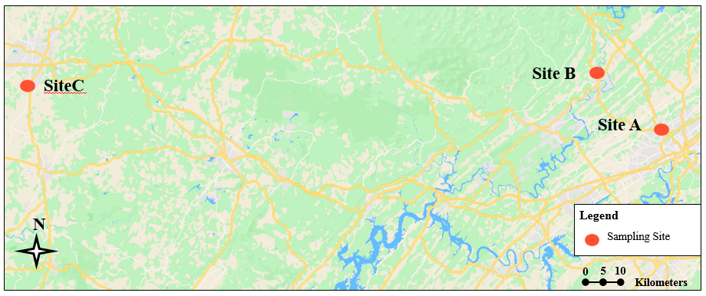
Figure 7.1. The map of sampling sites. Three sites, including Site A, Site B, and Site C were chosen for this study. At each site, three types of water samples, including storm runoff, the receiving stream baseflow and wetflow at the immediate downstream of runoff effluent were collected.

High-Throughput 16s rRNA Amplicon Sequencing was performed as previously described (Wyckoff, Chen et al. 2017). The PCR amplification used primers 515-F and 806-R to target the V4 region of the 16S rRNA gene(Caporaso, Lauber et al. 2012). PCR products were purified using the Wizard SV Gel and PCR Clean-Up system (Promega) and paired-end sequencing was completed using the Illumina MiSeq platform.

2.4 Bioinformatic and statistical analyses.
Analysis of sequence reads was conducted using QIIME 2 (Bolyen, Rideout et al. 2019). Amplicon sequence variants (ASVs) enumeration was performed using the DADA2 pipeline (Callahan, McMurdie et al. 2016). In contrast to the traditional cluster-based methods based on 97% sequence identity, DADA2 is an error model that can differentiate ASVs based on as little as a single nucleotide. This method is preferred for this study because the 16S V4 region amplicon is short, and some TC species differ at only one position. If traditional 97% identification methods were used, these taxa may be mistakenly grouped together.
Statistical analysis and data visualization were carried out using R version 3.50 (Team 2017). Bray–Curtis (abundance-based) dissimilarity was calculated to represent the taxonomic β-diversity using the vegan R package.
Sourcetracker was used to determine the relative importance of stormwater runoff versus receiving stream baseflow in contributing the microbes in wetflow (Knights, Kuczynski et al. 2011). Wetflow water samples were considered as sinks, while the receiving stream baseflow and nearby stormwater runoff were considered as sources of microbes.

3. Results and Discussions

3.1 FIB and Turbidity in stormwater runoff and receiving stream water
FIB (E. coli and total coliforms) and Turbidity results across the three sites were shown in figure 7.2, and the pairwise t-test results were shown in table 7.S1. FIB and Turbidity in receiving stream baseflow water samples were significantly lower than runoff and wetflow water samples (P < 0.01), although they show huge variations in each type of water samples. Numerous researches also reported FIB and turbidity were significantly higher in impaired streams after storm events (Makepeace, Smith et al. 1995). There is no doubt that storm events were highly impact the levels of FIB and Turbidity for the receiving streams in this study.
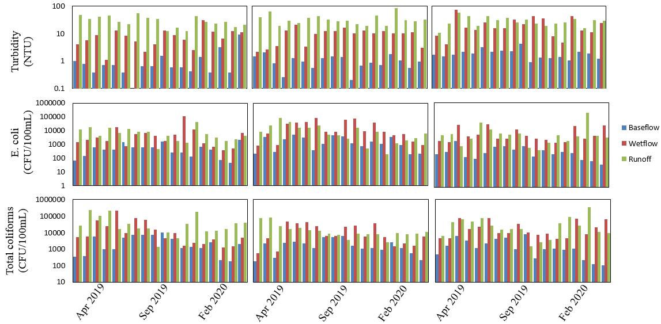
Figure 7.2. FIB and Turbidity in stormwater runoff and receiving stream water across the three study sites.

The average of turbidities was 1.4 NTU in baseflow, 9.6 NTU in wetflow, and 28.4 NTU in runoff across the three streams, respectively. Not only turbidities in receiving stream baseflow were significantly lower than wetflow, but also turbidities in wetflow were significantly lower than runoff at Site A and Site B.
There is no significant difference of FIB between stormwater runoff and receiving stream wetflow water samples across the three sites. The ranges of E. coli concentrations were huge, from 10 to 2400 CFU/100mL in baseflow, from 240 to 120000 CFU/100mL in wetflow, and from 60 to 180000 CFU/100mL in Runoff. Meanwhile, the ranges of total coliforms concentrations were also huge, from 70 to 12000 CFU/100mL in baseflow, from 380 to 210000 CFU/100mL in wetflow, and from 850 to 240000 CFU/100mL in Runoff. Although the variations of FIB concentrations were high, pairwise t-test showed the significant lower concentrations in baseflow, which means the concentrations of FIB were always higher in the wetflow and runoff after the storm events compared to the prior baseflow sampling points.

3.2 Bacterial community structure in the receiving stream baseflow, wetflow, and stormwater runoff
Non-metric Multi-dimensional Scaling analysis (NMDS) showed a clear separation of stormwater runoff and receiving stream baseflow, while samples from receiving stream wetflow placed in the middle of baseflow and runoff (Figure 7.1A). Meanwhile, both stormwater runoff and stream wetflow water from different sampling sites clustered together, but samples of baseflow from the Site C separated from Site A and Site B. The dissimilarity among baseflow samples may be resulted in the geographical distances, and Site C is far away from Site A and Site B; The geographical distance between A and B sampling site is 37 km, while the distance between A and C is 238 km and the distance between B and C is 249 km. Multiple studies reported the significant distance decay relationships of bacterial communities in freshwater ecosystems (Tolkkinen, Mykrä et al. 2016, Vilmi, Karjalainen et al. 2016, Hosen, Febria et al. 2017, Teachey, McDonald et al. 2019).

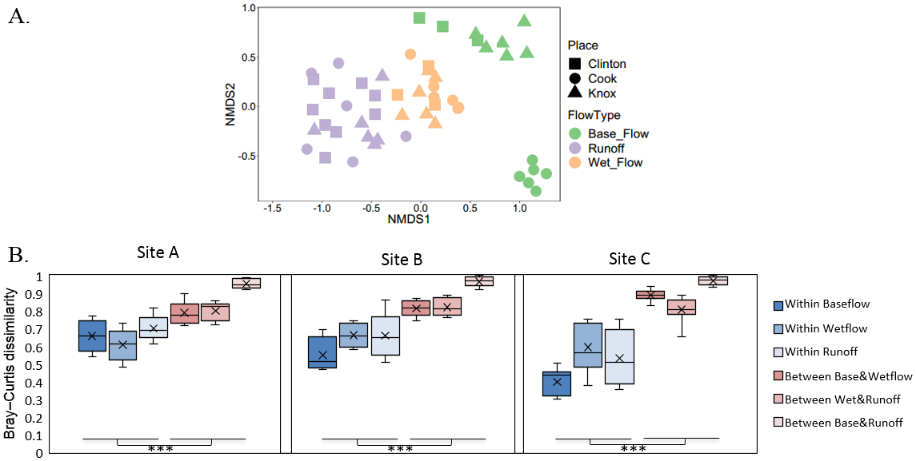
Figure 7.3. Beta-diversity of the microbial community in this study. (A) Non-metric Multi-dimensional Scaling analysis (NMDS) of samples based on Bray–Curtis distance from the microbe cluster by water types(color) and sampling sites; (B) Bray–Curtis dissimilarities within water types and among water types at each site. Two-group comparisons were done by Permutation T-Test. *,P < 0.05; **,P < 0.01; ***,P < 0.001.

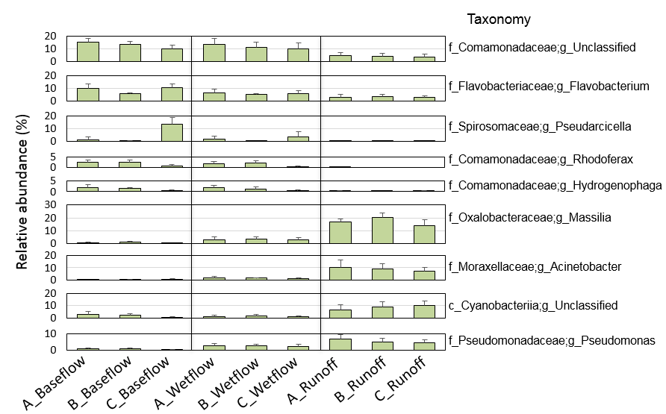
Figure 7.4. Relative abundances of top taxonomies at the genus level found in different water types at each site.
Bray-Curtis dissimilarity analyses revealed the dissimilarities among water types were significantly higher than within each water type (P<0.001), meanwhile the dissimilarities between stormwater runoff and receiving stream baseflow were highest at each site. However, the dissimilarities between baseflow and wetflow were not found significant difference compared to the dissimilarities between wetflow and runoff at each site. The results illustrated both stormwater runoff and receiving stream baseflow influenced the wetflow in this study.
The relative abundances of top taxonomies at the genus level among different water types also showed similar patterns with Beta-diversity of the microbial community (Figure 7.4). The dominant genera like Massilia, Acinetobacter, and Pseudomonas were rarely found in the receiving stream baseflow, but they were increased in the wetflow. Meanwhile, the dominant genera in runoff were abundant across the three sample sites. However, the dominant genera in baseflow showed high variant across the three streams, for example, the mean relative abundance of Psedarcicella was 13.4% in stream C, but 1.2% and 0.1% in stream A and stream B, respectively. Moreover, the dominant genera in both runoff and receiving stream baseflow, were all found in wetflow.

3.3 The abundances of individual ASVs in the receiving stream baseflow, wetflow, and stormwater runoff
Figure 7.5 showed the top 10 ASVs in the receiving stream baseflow compared to wetflow, runoff and nearby unimpaired reference streams. As expected, most of the ASVs were not found in stormwater runoff, or the relative abundances of them were much smaller in runoff than baseflow. However, a few of the ASVs, like ASV17 Comanomadaceae, ASV12 Hydrogenophaga, ASV22 Comanomadaceae, and ASV28 Aeromonas, were found similar relative abundances in baseflow and runoff. These ASVs also presented in nearby unimpaired refenrece streams, which means they may exist in different habitats in this region. The results denied the hypothesis that these ASVs in baseflow were introduced from runoff and then persist in the streams.
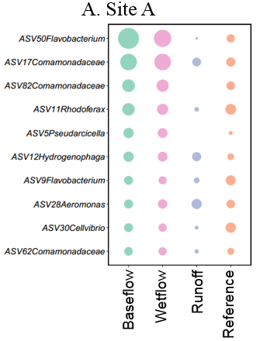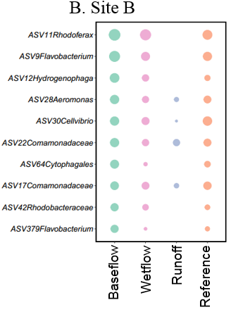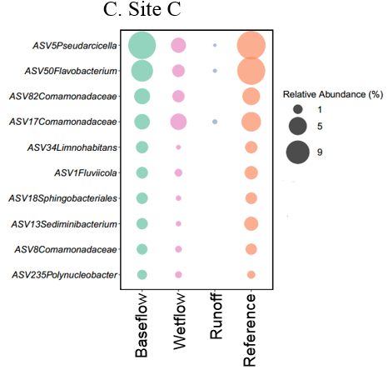
Figure 7.5. Top 10 ASVs in the receiving stream baseflow compared to wetflow, runoff and nearby unimpaired reference streams at each sampling site. (A) The sampling site A; (B) The sampling site B; (C) The sampling stream C
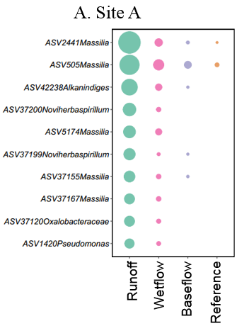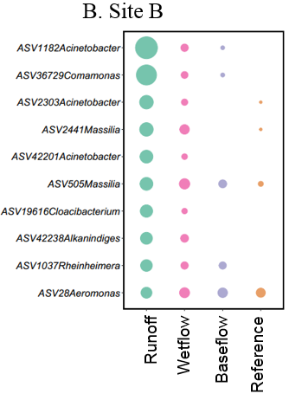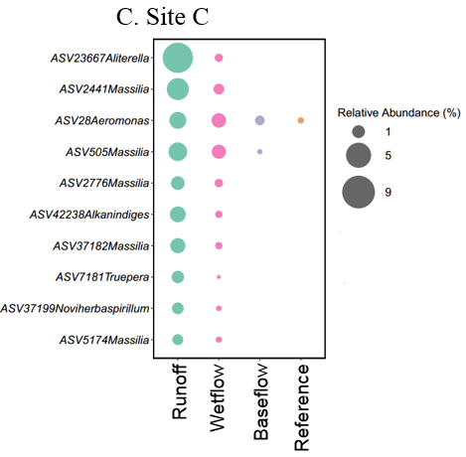
Figure 7.6. Top 10 ASVs in the receiving stream wetflow compared to baseflow, runoff and nearby unimpaired reference streams at each sampling site. (A) The sampling site A; (B) The sampling site B; (C) The sampling stream C

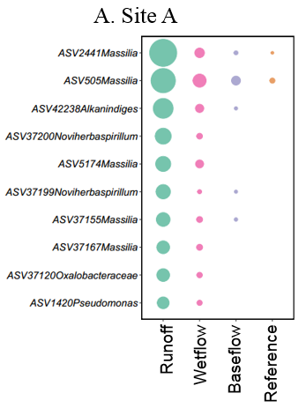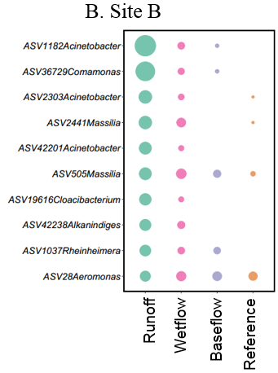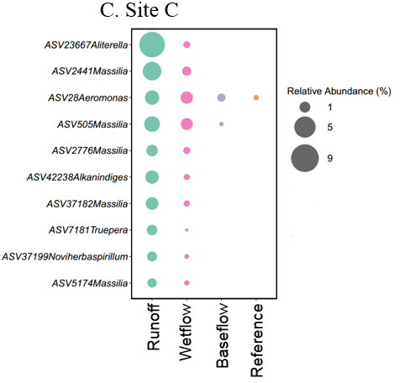
Figure 7.7. Top 10 ASVs in the runoff, compared to the receiving stream baseflow, wetflow, and nearby unimpaired reference streams at each sampling site. (A) The sampling site A; (B) The sampling site B; (C) The sampling stream C
All top 10 ASVs in baseflow at each site were also found in wetflow, and most of them showed similar relative abundances across dry and wet weather condtions. Meanwhile, most of the top 10 ASVs in the receiving stream wetflow revealed the similar abundances in baseflow (Figure 7.6). ASV505 Massilia and ASV2441 Massilia are the only two ASVs were abundant in Wetflow and runoff, while low relative abundances in baseflow. The results illustrated the impacts of storm events for the top 10 populations in stream water were limited.
However, the dominant populations in stormwater runoff dramaticly increased in stream water wetflow, while they were rare in baseflow (Figure 7.7). For example, ASV5174 Massilia as one of top 10 ASVs in runoff at both Clinton and Cook, whose mean relative abundance was 2.2% and 0.75% in Clinton runoff and Cook runoff respectively; meanwhile, the mean relative abundance of ASV5174 Massilia was 0.48% and 0.11% in Clinton wetflow and Cook wetflow respectively, but this taxa did not exist in baseflow and reference stream water samples.
All top 10 ASVs in runoff at each site were also found in wetflow, even though some of them did not exist in baseflow. ASV1037 Rheinheimera was the only one population which showed similar relative abundances in baseflow and wetflow, but nonexistent in reference streams. The results demonstrated the stormwater runoff heavily influenced wetflow of receiving streams as exogenous microbial communities, while almost of the exogenous microorganisms could not persistent in stream water.
Ternary plots showed denser nearby the triangle sides and thin in the middle of the graphics, which further illustrated that the most of microbiomes in the receiving stream wetflow samples were either from baseflow or runoff samples (Figure 7.8). Meanwhile, A few of dominant ASVs presented across the three types of water, which belonged to Proteobacteria mostly.
Interestingly, a few of dominant ASVs were found on the triangle points, which means they uniquely presented in one type of water. Figure 7.9 was further revealed the pattern. ASV440 Hydrogenophaga was the only dominant ASV that uniquely present in receiving stream wetflow samples, which illustrated baseflow and runoff are the major contributors for microorganisms in wetflow and the contributions of other unknown sources were limited.
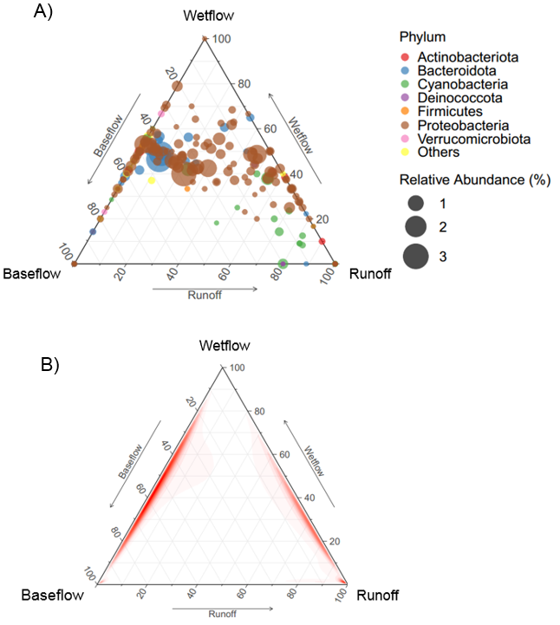
Figure 7.8. Ternary plots of dominant ASVs across the three types of water. (A)Ternary plots showing the distributions of dominant ASVs (> 1% in at least one sample, total number is 219) among baseflow, wetflow, and runoff. (B)The density pattern of ternary plots.

There are 19 dominant ASVs were unique in runoff, and 6 dominant ASVs were unique in baseflow; meanwhile, the unique ASVs that were in runoff or baseflow showed high variant across sites and events, and there is no unique ASV that was found across all sites and events in each type of water. These results revealed that both receiving stream baseflow and stormwater runoff existed some of dominant ASVs that showed susceptibility and could not be detected after receiving runoff.
Moreover, the evenness of microbial structure in receiving stream wetflow were significantly higher than baseflow and runoff (P<0.001) (Figure 7.10), which is reasonable due to dilution process in both baseflow and runoff. However, the richness in wetflow did not significantly increase compared to baseflow, even though wetflow received exogenous microbes from runoff. This phenomenon further explained that some of susceptible ASVs in stream water could not be detected after receiving runoff.

3.4 Sourcetracker analysis
Sourcetracker, a Bayesian method, was used to determine putative source environments of microbial communities in receiving stream wetflow. Wetflow water samples was considered as sinks, while baseflow and stormwater runoff were considered as sources of microbes (Figure 7.11). Based on the results, baseflow and stormwater runoff were the major sources that contributed to the microbes in wetflow, and they are significantly higher than other unknown sources. The baseflow with the average values of the relative contributions were higher than 49% and the microbes in runoff accounted for higher than 24% in wetflow, while the mean contributions of the unknown sources were less than 16% across stream sites.
Although the methods identified the intrusive bacteria sourced from the stormwater runoff, the relative contributions showed high variations across stream sites and sampling events. The range of baseflow contributions was from 32% to 66%, and the range of baseflow contributions was from 14% to 59%. Although the means of the relative contributions of stormwater runoff were less than baseflow across the three sites, there is no significant difference due to high variations. The contributions of runoff associated stream features and weather conditions need to be determined based on more sampling efforts in future.
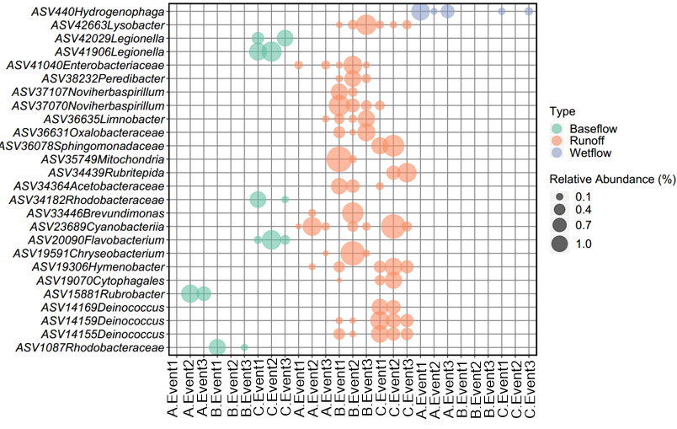 Figure 7.9. The unique dominant ASVs (> 1% in at least one sample) in each type of water.

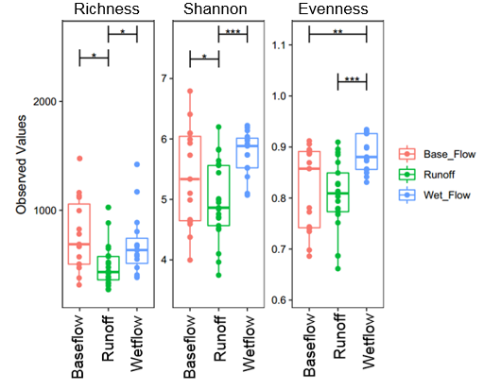
Figure 7.10. Compared alpha diversity (Richness, Shannon index , and Evenness) of microbial structures among three types of water samples.
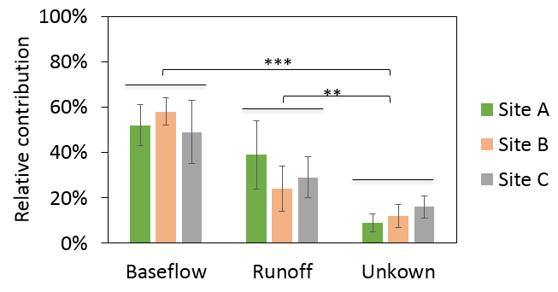
Figure 7.11. Sourcetracker analysis showing the relative contributions of stormwater runoff and receiving stream baseflow to the overall microbial community of wetflow water samples at each site. *,P < 0.05; **,P < 0.01; ***,P < 0.001.

4. Conclusions
Turbidity, FIB and Bacterial communities in the receiving stream baseflow, wetflow, and stormwater runoff were studied at three sites. The high Turbidity and FIB levels in the wetflow of receiving creeks likely resulted from nonpoint runoff sources. The dominated taxa in baseflow water samples were typical freshwater taxa that were also found in nearby unimpaired reference streams, but the runoff-associated microorganisms that were rare in baseflow were dramatically increased in wetflow. The Sourcetracker analysis also revealed the stormwater runoff as the major source for the intrusive bacteria. Overall, the microbial community composition-based method gave a clearer understanding of microbial contamination in receiving streams caused by non-point sources of pollution.

References
Ahmed, W., K. A. Hamilton, A. Lobos, B. Hughes, C. Staley, M. J. Sadowsky and V. J. Harwood (2018). "Quantitative microbial risk assessment of microbial source tracking markers in recreational water contaminated with fresh untreated and secondary treated sewage." Environment International 117: 243-249.
Ashbolt, N. J. (2015). "Microbial Contamination of Drinking Water and Human Health from Community Water Systems." Current environmental health reports 2(1): 95-106.
Ashbolt, N. J. and M. Bruno (2003). "Application and refinement of the WHO risk framework for recreational waters in Sydney, Australia." Journal of Water and Health 1(3): 125-131.
Boehm, A. B., K. E. Graham and W. C. Jennings (2018). "Can We Swim Yet? Systematic Review, Meta-Analysis, and Risk Assessment of Aging Sewage in Surface Waters." Environmental Science and Technology 52(17): 9634-9645.
Bolyen, E., J. R. Rideout, M. R. Dillon, N. A. Bokulich, C. C. Abnet, G. A. Al-Ghalith, H. Alexander, E. J. Alm, M. Arumugam and F. Asnicar (2019). "Reproducible, interactive, scalable and extensible microbiome data science using QIIME 2." Nature biotechnology 37(8): 852-857.
Callahan, B. J., P. J. McMurdie, M. J. Rosen, A. W. Han, A. J. A. Johnson and S. P. Holmes (2016). "DADA2: high-resolution sample inference from Illumina amplicon data." Nature methods 13(7): 581.
Caporaso, J. G., C. L. Lauber, W. A. Walters, D. Berg-Lyons, J. Huntley, N. Fierer, S. M. Owens, J. Betley, L. Fraser and M. Bauer (2012). "Ultra-high-throughput microbial community analysis on the Illumina HiSeq and MiSeq platforms." The ISME journal 6(8): 1621.
Chakravorty, S., D. Helb, M. Burday, N. Connell and D. Alland (2007). "A detailed analysis of 16S ribosomal RNA gene segments for the diagnosis of pathogenic bacteria." Journal of Microbiological Methods 69(2): 330-339.
Claesson, M. J., Q. Wang, O. O'Sullivan, R. Greene-Diniz, J. R. Cole, R. P. Ross and P. W. O'Toole (2010). "Comparison of two next-generation sequencing technologies for resolving highly complex microbiota composition using tandem variable 16S rRNA gene regions." Nucleic Acids Research 38(22).
Eren, A. M., H. G. Morrison, P. J. Lescault, J. Reveillaud, J. H. Vineis and M. L. Sogin (2015). "Minimum entropy decomposition: Unsupervised oligotyping for sensitive partitioning of high-throughput marker gene sequences." ISME Journal 9: 968-979.
Federigi, I., M. Verani, G. Donzelli, L. Cioni and A. Carducci (2019). "The application of quantitative microbial risk assessment to natural recreational waters: A review." Marine Pollution Bulletin 144: 334-350.
Hamilton, K. A., B. Reyneke, M. Waso, T. Clements, T. Ndlovu, W. Khan, K. GiGiovanni, E. Rakestraw, F. Montalto, C. N. Haas and W. Ahmed (2019). "A global review of the microbiological quality and potential health risks associated with roof-harvested rainwater tanks." NPJ Clean Water 2(7).
Humblot, C. and J. P. Guyot (2009). "Pyrosequencing of tagged 16S rRNA gene amplicons for rapid deciphering of the microbiomes of fermented foods such as pearl millet slurries." Applied and Environmental Microbiology 75(13): 4354-4361.
Jiang, S., R. Noble and W. Chu (2001). "Human adenoviruses and coliphages in urban runoff-impacted coastal waters of Southern California." Applied and Environmental Microbiology 67(1): 179-184.
Kennedy, K., M. W. Hall, M. D. J. Lynch, G. Moreno-Hagelsieb and J. D. Neufeld (2014). "Evaluating bias of Illumina-based bacterial 16S rRNA gene profiles." Applied and Environmental Microbiology 80(18): 5717-5722.
Kim, K. H. and J. W. Bae (2011). "Amplification methods bias metagenomic libraries of uncultured single-stranded and double-stranded DNA viruses." Applied and Environmental Microbiology 77(21): 7663-7668.
Knights, D., J. Kuczynski, E. S. Charlson, J. Zaneveld, M. C. Mozer, R. G. Collman, F. D. Bushman, R. Knight and S. T. Kelley (2011). "Bayesian community-wide culture-independent microbial source tracking." Nature Methods 8(9): 761-763.
Lazarevic, V., K. Whiteson, S. Huse, D. Hernandez, L. Farinelli, M. Østerås, J. Schrenzel and P. François (2009). "Metagenomic study of the oral microbiota by Illumina high-throughput sequencing." Journal of Microbiological Methods 79(3): 266-271.
Liu, Z., T. Z. Desantis, G. L. Andersen and R. Knight (2008). "Accurate taxonomy assignments from 16S rRNA sequences produced by highly parallel pyrosequencers." Nucleic Acids Research 36(18).
Liu, Z., C. Lozupone, M. Hamady, F. D. Bushman and R. Knight (2007). "Short pyrosequencing reads suffice for accurate microbial community analysis." Nucleic Acids Research 35(18).
Logares, R., S. Sunagawa, G. Salazar, F. M. Cornejo-Castillo, I. Ferrera, H. Sarmento, P. Hingamp, H. Ogata, C. de Vargas, G. Lima-Mendez, J. Raes, J. Poulain, O. Jaillon, P. Wincker, S. Kandels-Lewis, E. Karsenti, P. Bork and S. G. Acinas (2014). "Metagenomic 16S rDNA Illumina tags are a powerful alternative to amplicon sequencing to explore diversity and structure of microbial communities." Environmental Microbiology 16(9): 2659-2671.
Lurry, D. L. and C. M. Kolbe (2000). Interagency field manual for the collection of water-quality data, US Department of the Interior, US Geological Survey.
Madoui, M. A., S. Engelen, C. Cruaud, C. Belser, L. Bertrand, A. Alberti, A. Lemainque, P. Wincker and J. M. Aury (2015). "Genome assembly using Nanopore-guided long and error-free DNA reads." BMC Genomics 16(1).
Makepeace, D. K., D. W. Smith and S. J. Stanley (1995). "Urban Stormwater Quality: Summary of Contaminant Data." Critical Reviews in Environmental Science and Technology 25(2): 93-139.
McLellan, S. L., S. M. Huse, S. R. Mueller-Spitz, E. N. Andreishcheva and M. L. Sogin (2010). "Diversity and population structure of sewage-derived microorganisms in wastewater treatment plant influent." Environmental Microbiology 12(2): 378-392.
Nshimyimana, J. P., A. J. E. Freedman, P. Shanahan, L. C. H. Chua and J. R. Thompson (2015). ""Variation of Bacterial Communities and Pathogen Taxa as a Function of Land Use and Water Quality in an Urban Tropical Catchment of Singapore"." Proceedings of the 115th General Meeting of American Society for Microbiology.
Saget, A., G. Chebbo and J. L. Bertrand-Krajewski (1996). "The first flush in sewer systems." Water Science and Technology 33(9): 101-108.
Schloss, P. D., S. L. Westcott, M. L. Jenior and S. K. Highlander (2015). "Sequencing 16S rRNA gene fragments using the PacBio SMRT DNA sequencing system." PeerJ PrePrints 3.
Shendure, J., G. J. Porreca, N. B. Reppas, X. Lin, J. P. McCutcheon, A. M. Rosenbaum, M. D. Wang, K. Zhang, R. D. Mitra and G. M. Church (2005). "Molecular biology: Accurate multiplex polony sequencing of an evolved bacterial genome." Science 309(5741): 1728-1732.
Sidhu, J., W. Gernjak and S. Toze (2012). "Health risk assessment of urban stormwater." Urban Water Security Research Alliance Technical Report No. 102.
Sinclair, L., O. A. Osman, S. Bertilsson and A. Eiler (2015). "Microbial community composition and diversity via 16S rRNA gene amplicons: Evaluating the illumina platform." PLoS ONE 10(2).
Team, R. C. (2017). "R Foundation for Statistical Computing; Vienna, Austria: 2016. R: A language and environment for statistical computing." URL http://www. R-project. org/[Google Scholar].
Thurston, J. A., C. P. Gerba, K. E. Foster and M. M. Karpiscak (2001). "Fate of indicator microorganisms, giardia and cryptosporidium in subsurface flow constructed wetlands." Water Research 35(6): 1547-1551.
Wang, Q., G. M. Garrity, J. M. Tiedje and J. R. Cole (2007). "Naïve Bayesian classifier for rapid assignment of rRNA sequences into the new bacterial taxonomy." Applied and Environmental Microbiology 73(16): 5261-5267.
Wyckoff, K. N., S. Chen, A. J. Steinman and Q. He (2017). "Impact of Roadway Stormwater Runoff on Microbial Contamination in the Receiving Stream." Journal of environmental quality 46(5): 1065-1071.

Conclusion
As a significant source of microbial pollution, stormwater runoff is mainly discharged into receiving waters and may be responsible for serious ecological impacts. For this dissertation, Culture-based enumeration of FIB and sequencing-based microbial community served as the microbial analysis for stormwater runoff and streams.
With the widespread use of FIB, the efficacy of culture-based coliform testing was assessed. A variety of environmental matrices, including stream water, stormwater runoff, sewage, and stream sediments, were used to confirm the performance of the coliform testing method through a comparison with high-throughput 16s rRNA amplicon sequencing. The results suggested that this method was generally accurate at correctly identifying FIB.
With the efficacy of FIB culture-based detection being validated, this method was used to monitor stormwater runoff including pavement runoff and culvert runoff over 23 storm events at 6 sites. It was revealed that while there was moderate relationship between storm characteristics and FIB levels in stormwater runoff, FIB levels were more related with site characteristics and seasonal impacts.
This study also evaluated the survival of E. coli strains isolated from stormwater runoff under environmentally relevant conditions. Findings indicate that the wild-type strains isolated from runoff persisted for a longer period of time than the lab strain under all environmental conditions tested, but with high temperature or sunlight exposure the counts of the wild-type strains were below detection limit within a few hours. Moreover, the persistence of E. coli in receiving streams may mislead the recent fecal contamination, especially in winter due to the prolonged persistence at lower temperature.
With the concerns that FIB might not actually be an indication of fecal contamination, the microbial water quality was assessed utilizing 16S rRNA amplicon sequencing for a more in-depth microbial community analysis. The understanding of natural variation of the bacterioplankton communities in the streams where the absence of anthropogenic sources is needed before assessing the potential applicability of microbial community as assessment of stream ecological conditions. It was revealed that while there was spatial and temporal variation observed, the stream sizes and characteristics were larger drivers for stream microbial community.
This study also investigated microbial community composition-based methods for assessment of the impacts of stormwater runoff to receiving stream water where the impacts of stormwater runoff were highlighted by FIB culture-based approaches. The results showed that the dominated taxa in baseflow water samples were typical freshwater taxa that were also found in nearby unimpaired reference streams, and no doubt distinct with the bacterial community in stormwater runoff. It indicated that the potential applicability of microbial community as assessment of the impact of runoff on receiving stream water. Moreover, the methods identified the intrusive bacteria sourced from the stormwater runoff, as well as identifying the overall impact that stormwater runoff had on the microbial water quality of streams.

Appendix

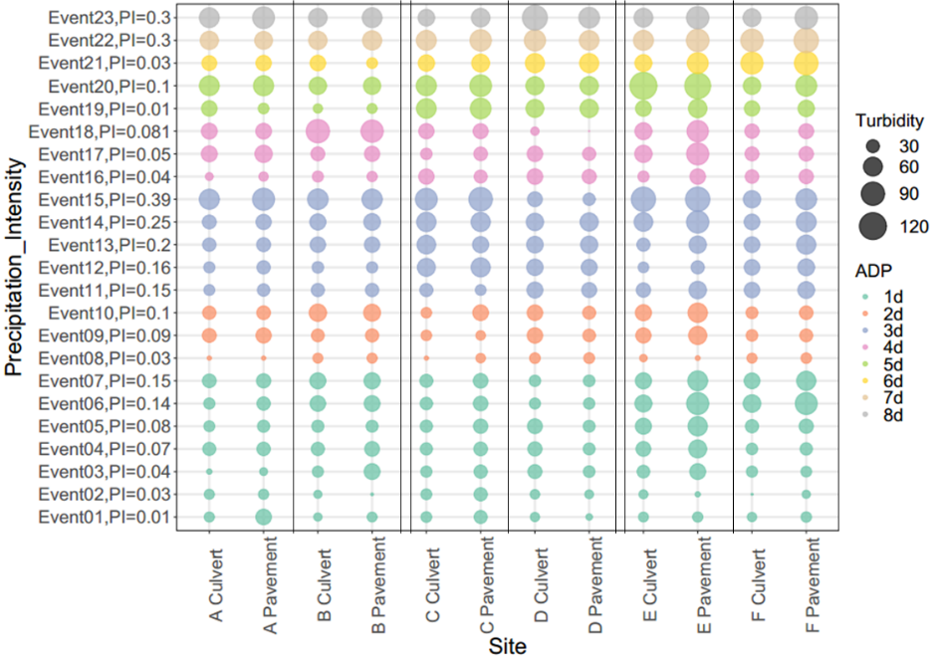
Figure 3.S1. Turbidity in runoff ranked by PI and ADP

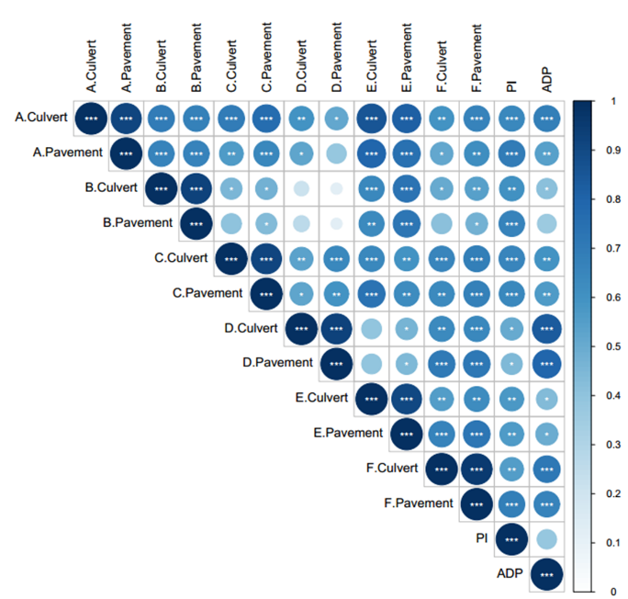
Figure 3.S2. Turbidity distribution and Correlation with rainfall characteristics

Table 5.S1. Comparison of the performance of SAD models for the bacterioplankton communities at each site.
The model types | R-squared
The model types | Stream I Fall | Stream I Spring | Stream II Fall | Stream II Spring | Stream III Fall | Stream III Spring
Lognormal | 0.914 | 0.934 | 0.968 | 0.967 | 0.946 | 0.991
Log-series | 0.785 | 0.675 | 0.522 | 0.506 | 0.628 | 0.786
Zipf | 0.238 | 0.205 | 0.155 | 0.131 | 0.302 | 0.379

Table 6.S1. Stream Features.
Ecoregion | Stream ID | Stream Name | Stream order | Geographical distance from headwater (km)
67f The Southern Limestone/ Dolomite Valleys and Low Rolling Hills | A | White Creek | 1 | 0.5
 | B | Clear Creek | 2 | 1.1
 | C | Powell River | 4 | 75.8
 | D | Big Barren Creek | 2 | 6.2
 | E | Blairs Creek | 1 | 1.5
68a Cumberland Plateau | F | Island Creek | 2 | 2.8
68a Cumberland Plateau | G | Daddy’s Creek | 3 | 16.2
68a Cumberland Plateau | H | Crab Orchard Creek | 3 | 17.6
68a Cumberland Plateau | I | Clear Creek | 3 | 41.6
 | J | Emory River | 4 | 54.4
71g Eastern Highland Rim | K | Hurricane Creek | 1 | 0.5
71g Eastern Highland Rim | L | Post Oak Creek | 1 | 5.8
71g Eastern Highland Rim | M | Spring Creek | 3 | 14.4
71g Eastern Highland Rim | N | Roaring River | 3 | 16.2
 | O | Flat Creek | 3 | 11.2

Table 7.S1. Statistical analysis of flow type differences in water quality (P values based on pairwise T-test)
Parameters | Site A |  |  | Site B |  |  | Site C
Parameters | Base-Wet | Base-Runoff | Wet-Runoff | Base-Wet | Base-Runoff | Wet-Runoff | Base-Wet | Base-Runoff | Wet-Runoff
Turbidity | 6.91×10⁻⁹ | 2.57×10⁻¹⁶ | 7.56×10⁻¹³ | 5.60×10⁻⁹ | 3.83×10⁻¹⁵ | 1.63×10⁻¹² | 3.43×10⁻⁴ | 5.09×10⁻⁹ | 7.66×10⁻²
E. coli | 2.61×10⁻³ | 6.53×10⁻⁴ | 3.26×10⁻¹ | 5.44×10⁻⁵ | 1.70×10⁻⁵ | 4.22×10⁻¹ | 1.21×10⁻³ | 7.21×10⁻³ | 2.47×10⁻¹
Total coliforms | 2.45×10⁻³ | 8.99×10⁻⁴ | 1.05×10⁻¹ | 2.51×10⁻⁵ | 1.14×10⁻⁵ | 1.17×10⁻¹ | 9.35×10⁻⁴ | 1.46×10⁻³ | 1.50×10⁻¹

VITA
Songyi Liu was born in August 1990 in Ganzhou, China. He received his B. S. in Environmental Engineering from Beijing University of Chemical Technology in 2012. After graduation, He worked as a Research Assistant in Beijing DQY Agriculture Technology Co., Ltd. After two years of work experience, he started his master study in Civil and Environmental Engineering at Missouri University of Science and Technology. After graduation, he started his Ph.D. study at the University of Tennessee, Knoxville under the direction of Dr. Qiang He in May 2016. His research is focused on Microbial Source Tracking for Detection of Fecal Contamination in Environmental Waters and Differential Decay of Fecal Indicator Bacteria Originating from different Sources.

