The Impact of Utilitarian Product Reviews on Brand Perception

A Thesis Presented for the
Master of Science
Degree
The University of Tennessee, Knoxville

Benjamin Libon
December 2023
Copyright © 2023 by Benjamin Libon.
All rights reserved.

ACKNOWLEDGEMENTS

Thank you to my beautiful wife Kaitlyn and my parents for all their love and support. And a special thank you to all 3 of my committee members for all their help on this project and my academic journey.

Dr. Eric Haley (Chair)
University of Tennessee, Knoxville
ADPR

Dr. Matthew Pittman
University of Tennessee, Knoxville
ADPR

Dr. Annika Abell
University of Tennessee, Knoxville
Marketing

PREFACE

This thesis is an original work by Benjamin Libon. No part of this thesis has been previously published.

ABSTRACT

The impact of online reviews on consumer behavior has been increasingly studied as online retail platforms have grown exponentially, and internet research used prior to purchasing products has become more common. However, limited research has examined the impact of those product reviews on the overall perception of the brands selling these products. This study exclusively looked at product reviews for high and low-involvement utilitarian products and analyzed how those reviews affect consumers' perception of a brand. Taking a sample of 301 participants, findings showed that star ratings had a drastic effect on consumers' perception of a brand, associating a low star-rated review with poor brand perception and vice versa. The research also found that low-involvement utilitarian products were highly affected by star ratings, especially concerning purchases of future products from that brand. Those findings suggest that for products associated with a low involvement thought process, consumers are willing to purchase different products from that brand purely from seeing a high-rated star review. However, for products associated with a higher involvement thought process, consumers will conduct more future research before deciding to purchase different products from that brand. Additionally, the findings strengthen the importance of a brand building its image and following, as they showcase how one visual review can deter consumers from wanting to buy not only a specific product but any other products from that brand.

Keywords: Utilitarian Products, FCB Grid, Online Reviews, EWOM, Brand Perception

Table of Contents

CHAPTER ONE INTRODUCTION AND GENERAL INFORMATION 1
Research Question 2
Hypotheses 2
CHAPTER TWO LITERATURE REVIEW 4
Fcb Grid 4
Hedonic & Utilitarian Product Reviews 4
Visual Heuristics & Product Reviews 5
Ewom & Product Reviews 6
Ewom & Brand Perception 6
CHAPTER THREE MATERIALS AND METHODS 9
Research Design 9
Sample & Sampling 9
Data Collection & Instrument Procedure 9
Data Analysis 10
CHAPTER FOUR RESULTS AND DISCUSSION 15
Results 15
Demographics 15
Star Rating 15
Star Rating & Involvement Level 15
Review Frequency & Purchase Intentions 16
Discussion 16
CHAPTER FIVE CONCLUSIONS AND RECOMMENDATIONS 19
Implications 19
Limitations & Implications For Future Research 19
LIST OF REFERENCES 21
APPENDIX 23
VITA 31

LIST OF TABLES

Table 1: Summarizing the hypotheses status 18

LIST OF FIGURES

Figure 1 : FCB Grid conceptual designed 3
Figure 2 : FCB Grid, taken from Haley & Pittman (2022) 8
Figure 3. Breakdown of the 2x2 experimental design 12
Figure 4: Example of a review showed during the survey (Hong & Pittman, 2020) 12
Figure 5: All four stimulis that were used in the survey 13
Figure 6: Semantic Differential Scales used to gage attitude 13
Figure 7: Likert Scale used to gage opinion 14
Figure 8: Graph showcasing involvement level & star rating 18

Introduction and General Information
Word of mouth (WOM) has always been a key factor in consumers' decision-making process regarding purchases and brand perception (Qi & Kuik, 2022). For years businesses and marketers have taken advantage of WOM to create successful promotional campaigns. Furthermore, the rise of the internet and e-commerce platforms has enabled the creation of electronic word of mouth (EWOM), which spreads incredibly faster and to a much larger scale than traditional WOM. EWOM can be seen through various avenues, such as social media, online content (articles, blogs), reviews, etc. In this study, the focus will be on the EWOM created by reviews.
Although EWOM is extremely common nowadays, it is met with its own set of challenges. The biggest challenge is that WOM is so efficient due to its credibility, with information mostly coming from friends and family (Huete-Alcocer, 2017). EWOM does not benefit from this credibility, and in the case of online reviews, the reviewers have no affiliation with other consumers. Because of this, many factors go into online reviews' perceived credibility and effectiveness, and when a larger number of reviews are mostly one-sided, it increases the reviews perceived credibility (Mudambi & Schuff, 2010).
Moreover, in the last decade, countless studies have been conducted on the impact of reviews on consumers purchasing decisions. However, none of those studies examined the effect of product reviews on a consumer’s perception of the brand itself. Therefore, this research project really aims to fill in the current knowledge gap. Additionally, most of those studies have looked at specific products, and limited information is available on how the significance of product reviews varies across different product categories.
Looking at the FCB grid (Vaughn, 1980) and focusing on two distinct product categories: Hedonic & Utilitarian. We can develop a conceptual framework that assigns products and brands into one of four categories (pictured in figure 1). Hedonic High Involvement, Hedonic Low Involvement, Utilitarian High Involvement, Utilitarian Low involvement.
Hedonic products are more emotional products purchased for personal satisfaction, compared to utilitarian products that aim to fill a purpose and are usually necessities. High VS Low involvement is mostly defined by the thought process going into a purchasing decision. Most of the time, an increased thought process (higher involvement) is linked with a higher cost.
Those differences heavily influence the marketing approaches strategists take to promote their products. Hedonic products are more emotional. Thus, hedonic marketing uses much more sensory advertising than utilitarian products, for which advertising is more factual. Because of the sheer size of products available, this study only focuses on utilitarian products and compares the impact reviews have on utilitarian products associate with high or low involvement. Researchers hypothesize that reviews for utilitarian products that are associated with a low involvement decision will have more effect on consumers' brand perception because high-involvement products typically have a higher cost associated with them (a car VS soap, for ex.). Therefore, more research is conducted before purchasing high-involvement utilitarian products, meaning consumers will be less likely to be influenced by just one review and will conduct more research before purchasing that product.
Additionally, the researchers hypothesize that because of the strong effect WOM (in this case EWOM) has on influencing people and the power that visual heuristics play on people, the products who have higher star ratings (reviews) will have better outcomes in terms of brand perception and purchase intentions. Similarly, the researchers hypothesize that participants who frequently look at online reviews before making a purchasing decision will be more influenced by reviews. Because they consider reviews a key part of making a purchase and value that information.

Research Question: How do utilitarian product reviews affect consumers' perception of a brand?

Hypotheses:
H1: Higher number of stars will result in more positive brand perception and a higher purchasing intent.
H2: Low involvement utilitarian + high star rating will have more positive brand perception and a higher purchasing intent.
H3: Participants who frequently look at online reviews before making a purchase will be more influenced by the product reviews.

Learning more about the impact online reviews have on brand perception will help marketers better understand the importance EWOM can have on their brand's image. As well as help them know if EWOM is more significant for certain types of products (high vs. low involvement utilitarian).
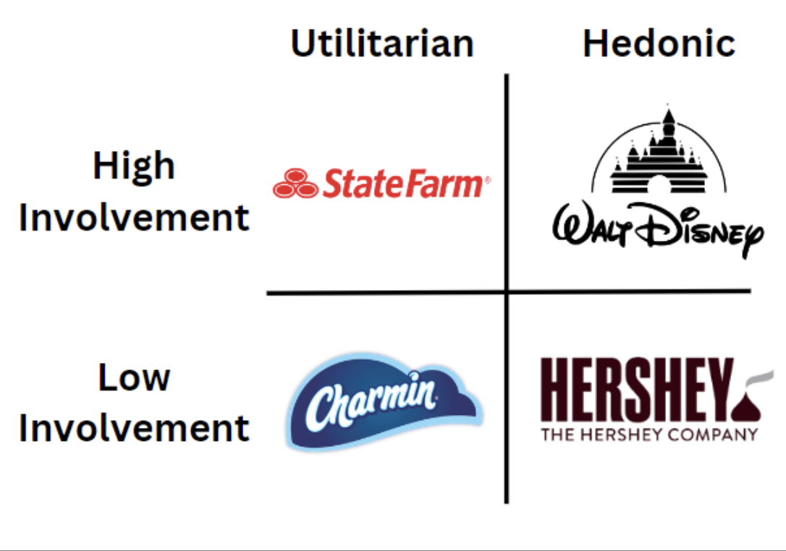

Figure 1: FCB Grid conceptual designed

Literature Review

In order to answer the research question and specific hypotheses, this research study identified 5 specific themes in the literature: Looking at the differences between hedonic and utilitarian products, the FCB grid as a theory and conceptual framework, visual heuristics and products reviews, and finally EWOM and product reviews as well as EWOM and brand perception.

Hedonic & Utilitarian Products
Products can be categorized into two key categories: Hedonic & Utilitarian. Hedonic products are more emotional and focus on the feeling aspect, while utilitarian products serve a purpose and are more of a necessity (Lu, Liu & Fang, 2016). Those product categories highly define the perceived experience customers have when purchasing a specific type of product. According to Bettiga et al. (2020), consumers showed higher levels of involvement and feelings of physiologic arousal when looking at hedonic products compared to utilitarian products.
Information on the type of product advertised is key to marketers; utilitarian products will be advertised completely differently than hedonic products. Similarly, marketers will take different advertising & messaging approaches by taking a hedonic or utilitarian approach. A study by Huettl & Gierl (2012) showed different messaging used for a suitcase ad. The utilitarian ad's wording focused on the utility aspect "Secure travelling with the TravelCompany suitcase, extremely solid lightweight suitcase, extra-large volume, safety lock." In contrast, the Hedonic ad focused on the experience linked with the suitcase as well as its design "Good holidays with the TravelCompany suitcase, exclusive design with polish coating, inline-skate wheels for comfort handling, available in many colors."

FCB Grid
The FCB (Foote, Cone, and Belding model) grid is a tool developed by Vaugh in 1980 (pictured in figure 2). According to Haley & Pittman (2022), the tool helps marketers make decisions based on two factors, emotions (thinking/feeling) and involvement level (high or low). The grid enables marketers to better understand consumers' thought processes for different product categories.
The FCB grid decision model shows that decisions associated with high-involvement products are led by emotional actions first. Thinking Hight-Involvement starts by learning (Learn-Feel-Do), while feeling High-Involvement starts by feeling (Feel-Learn-Do).
Theoretically, this means that in High-Involvement situations, consumers would either learn about a product or try to feel it before making a purchasing decision. In comparison, Low-Involvement products are always led by actions and then emotional behavior. Thinking Low-Involvement (Do-Learn-Feel) and Feeling Low-Involvement (Do-Feel-Learn). This means that in Low-Involvement situations, consumers will make a purchase before learning about a product and experiencing it. This can be explained by the fact that low-involvement items are usually less costly (food, household items); therefore, less thought is usually involved with their purchase.
Despite the FCB grid being over 40 years old, recent studies, such as Cheong & Cheong (2021), do say that the FCB grid is still relevant nowadays and can be applied to current advertising campaigns, no matter if advertisers are using new or traditional media. Additionally, recent research by Huang & Lin (2021) shows that consumers' internet purchasing behavior patterns follow the theories developed in the FCB grid. Consumers spend more time researching High-Involvement products before making a purchase compared to Low-Involvement products.
Using the previous literature regarding hedonic & utilitarian products as well as the FCB grid we can support the rationale behind H2: “Low involvement utilitarian + high star rating will have more positive brand perception and a higher purchasing intent.” As discussed in the literature, products linked with a higher involvement thought process are typically associated with a stronger thought process and therefore a review might be taken into consideration but will only be one piece of the thought process. Whereas for products associated with less thought process that decision can be made more instantly thus influencing consumers brand perception or purchasing intentions more.

Visual Heuristics & Products Reviews
An important variable in product reviews has become visual heuristics. A large majority of e-commerce platforms have adopted a rating system next to the products they sell. Particularly a star system, which makes it easy for consumers to associate the product with a certain rating. A 2017 study by Nazlan et al. found that for food reviews, when a star rating was added to a text, consumers had more favorable opinions of a restaurant.
Similar findings were found in a 2023 study by Godden et al. that strengthened the idea that visual heuristics affected consumers' decision process. In the study, a color-coded nutritional label going from A to E was used to indicate the nutritional value of specific packaged food and drinks. The findings showed that for consumers concerned about health outcomes, the nutritional label was highly effective at affecting purchasing decisions. This means consumers valued heuristic visuals over other factors (such as nutritional content, labels, etc.).
The idea that visual heuristics were an essential part of the consumer's decision-making process was initially disproven by a 2006 study by Chevalier and Mayzlin, who found that consumers weighed text reviews more heavily than visual heuristics such as ratings. However, a 2021 study by Filieri et al. found that "Performance visual heuristics (i.e., customer ratings) are found to strongly affect intention to visit and actual visit of a destination and its attractions." Visual heuristics are a quick way to catch a consumer's attention and convey a message instantly. This is something that a text review cannot do, and consumers are overloaded with promotional messages. Visuals make it easier for consumers to differentiate products.

EWOM & Product Reviews
As mentioned above, EWOM and product reviews have become more prevalent in recent years. According to Kaemingk’s 2020 Qualtrics data review, over 97% of consumers will use the internet to conduct research prior to making a purchase. In addition, over 93% of consumers will adjust their purchasing decisions depending on online reviews. Those statistics show the magnitude of importance associated with online reviews, as they have become an essential part of the consumer's decision-making process.
Many factors go into the effectiveness and influential aspect of online reviews. One key factor is the volume of online reviews. According to Chong et al. (2015), the volume of reviews is one of the most important variables consumers look at when reading consumer reviews. The higher the volume of reviews, the more the overall product rating is believed to be accurate. Furthermore, this is dependent on the majority of reviews being relatively homogeneous. Additional findings even showed that consumers would take significantly less time to make a decision for products with a high volume of reviews (Liu et al., 2011).
Another big factor consumers weigh when looking at product reviews is valence. Valence can be considered as the star rating of a review, for example. Baek & Choe’s 2020 study found that review valence was the most significant factor consumers considered before picking a restaurant to dine in. Their research also found that the importance of review valence was closely linked to the amount consumers were going to spend. Review valence was weighted more heavily for expensive products compared to cheaper products.
However, in some situations, the views expressed in a review were more critical than the actual valence of the reviews. For positive reviews, consumers trusted star ratings, whereas in negative reviews the star rating had less credibility (Hong & Pittman, 2019). Additional research by Shihab & Putri (2018) found that “positive attitude to popular products decreased as the proportion of negative online reviews increased.” Negative reviews are also seen as more useful in high-risk scenarios (Casaló et al., 2015).
The balance of those reviews has also been proven to have an impact; contrary to popular belief, having too good or too bad of reviews could actually be a problem and has been shown to have the opposite of the intended effect. In 2015, Purnawirawan et al. found that “consumers perceive extremely negative reviews as less useful than more balanced negative reviews.”

EWOM & Brand Perception
With consumers being able to share their experience about a brand within seconds on countless different platforms, brands have realized that EWOM is of strong importance to their brand's image. Communicating directly to their consumers has become more important than ever. Research from Brunner et al. (2018) shows that brands responding to consumer reviews positively affects consumers purchasing decisions.
Consumers' publicly available online content also influences online brand perceptions. Positive brand-related content has a strong positive effect on a brand's perception, improving a brand's image. However, that relationship does not go both ways, as negative brand-related content does not seem to negatively affect a brand's perception (Siamagka, et al., 2015).
Brand perception is also affected differently depending on the type of products a brand sells. Functional brands, such as Dewalt, are more affected by EWOM compared to luxury brands, such as Gucci (Hu & Xu, 2017). This can be justified by the fact that functional products are usually purchased because of their ability to accomplish a task. Whereas luxury goods are a lot more subjectively judged. People could be unhappy about the style of a new clothing collection, but for functional products like a drill, appearance would not be as important. This difference is also explicitly shown in the brand's responses to customer reviews. Most brand responses to consumer reviews will come from functional brands like Dell or LG, for example (Bhandari & Rogers). However, there are very few instances where luxury brands respond to customers' online reviews, making their EWOM interactions one-sided.
The literature above is used as a rational to support the creation of H1: “Higher number of stars will result in more positive brand perception and a higher purchasing intent.” and H3: “Participants who frequently look at online reviews before making a purchase will be more influenced by the product reviews.” Previous studies have shown the power that visual heuristics and how those can trump other factors. When looking at online reviews, the visual of the rating itself will be the first thing consumers see and what they will weigh more heavily when making their decision. Additionally, literature has shown how frequently people look at online reviews before making a purchase and how consumers weigh reviews in their decision making process, therefore, the more frequently people use reviews as a decision matrix the more they will be influenced by those reviews.
Additionally, the literature above also re-enforces the rational for H2: “Low involvement utilitarian + high star rating will have more positive brand perception and a higher purchasing intent.” As it showcases that because of the power of visual heuristics consumers have less elaboration for low involvement products, thus, the heuristic judgment is more impactful.

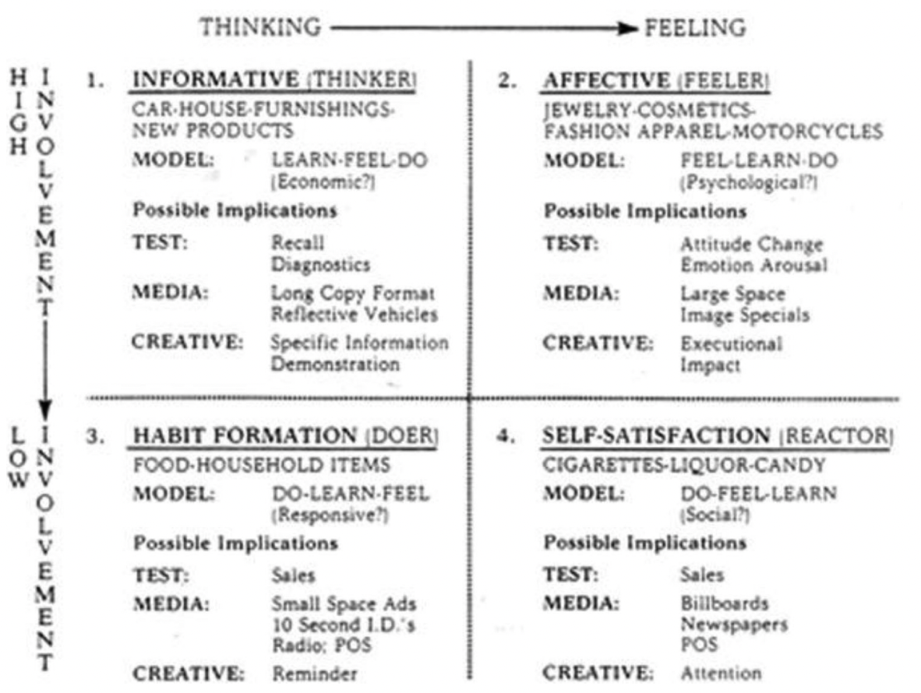
Figure 2. FCB Grid, taken from Haley & Pittman (2022)

Materials and Methods
Research Design
In order to answer the proposed research question and hypotheses outlined below this study took a quantitative approach and used a survey to collect data. Although there is a case to be made for this study to benefit from a qualitative approach and get more user experience-related data. The main goal is to see trends and patterns from online consumers. Focusing on a quantitative approach and obtaining a larger amount of data will enable the researchers to conduct various statistical analyses and find potential correlations.
In addition, the study only focuses on a specific product category by focusing on brands selling utilitarian products. In the future, a lot more data could be collected to see how utilitarian product reviews compare to hedonic product reviews in changing a consumer's brand perception. Collecting this study's data through a survey could ensure that this study's findings can supplement future studies on the matter.

Research Question: How do utilitarian product reviews affect consumers' perception of a brand?
Hypotheses:
H1: Higher number of stars will result in more positive brand perception and a higher purchasing intent.
H2: Low involvement utilitarian + high star rating will have more positive brand perception and a higher purchasing intent.
H3: Participants who frequently look at online reviews before making a purchase will be more influenced by the product reviews.

Sample and Sampling
This study used a convenience sampling to get survey participants and made the the survey available through Prolific (a platform offering paid survey opportunities to individuals, similar to Amazon’s Mechanical Turk). The only criteria for eligibility was for participants to be over the age of 18. The survey collected data from as many various people as possible. In the hopes of collecting data from people that do not have any experience reading online reviews, as there is a benefit to see if those individuals were more heavily influenced by online reviews. Thus, not limiting the criteria for participation.
The study collected data from over 300 participants which is what the research team considered to be the minimum amount of individual responses needed to get an accurate representation of participants and see general trends and patterns.

Data Collection: Instruments and Procedures
As mentioned above, the main instrument used for data collection was a survey. The survey was made available through Prolific and Qualtrics, and the data was only considered usable if the full survey is completed. The survey itself was relatively short and consisted of some basic demographic questions (taken from the United States Census Bureau's Household Pulse Survey), some general questions looking at the participant's online shopping habits as well as how frequently they look at online reviews.
This study employed a 2 (star rating: low vs high) X 2 (involvement level: low vs high) between-subjects experiment (pictured in figure 3). Each participant had an equal probability of getting assigned one of the 4 conditions.
Condition #1: High Star Rating & High Involvement
Condition #2: High Star Rating & Low Involvement
Condition #3: Low Star Rating & High Involvement
Condition #4: Low Star Rating & Low Involvement
The survey used a similar stimuli to what Hong & Pittman (2020) used (pictured in figure 4). Participants were shown a stimuli that corresponded to one of the four prongs listed above (stimuli pictured in figure 5). As stated previously in the case of this study no number of reviews was showed, only a star rating as the number of reviews would be an additional factor that could affect a buyers decision making process.
Additionally because of the pre-existing affinity a consumer can have with a brand, the stimuli used a fictious brand. The same brand name was used for both types of products (high & low involvement associated products). The design was the exact same for all 4 stimulus and the website the review came from was fictitious as well “productreview.com”. The goal was to really limit the amount of outside factors that could influence a participants answers, and have them solely focus on the product itself and the star rating. Concerning the reasoning for the choice of products used: insurance and toilet paper. A 2022 study from Youn et al. identified that insurance is a utilitarian product that is often associated with a lot of thought process (high involvement). Whereas toilet paper is a utilitarian product associated with minimal/lower though process (low involvement).
In order to see the initial effect a review has on brand perception semantic differential scales out of 7 focusing on positive/negative feeling and favorable/unfavorable emotions were used (pictured below in figure 6). To gage people’s opinion of the brand as well as their potential purchase intent another Likert scale out of 7 was used going from strongly agree to strongly disagree (picture below in figure 7).

Data Analysis
Before the initial data analysis, three questions were used as attention checks, asking participants to confirm the product displayed in the review, the name of the brand used in the stimuli, and finally, a final question asking them to pick a specific answer in order to receive their payment for completing the survey. Once the data was filtered, both Excel & SPSS were used to analyze the data. Looking at the data in Excel & SPSS enabled the researchers to answer the research questions and confirm or reject the hypothesis by seeing if there were any movements on the brand perception chart after participants saw positive and negative reviews. Additionally, in Excel, the data was divided into more categories through some of the demographic questions asked. For example, looking at whether demographics (such as age, gender, etc.) determine how much participants are influenced by online reviews. Finally, with SPSS, more in-depth statistical analysis was run, such as a 2-way ANOVA, independent-samples t-test, and a bivariate correlation.

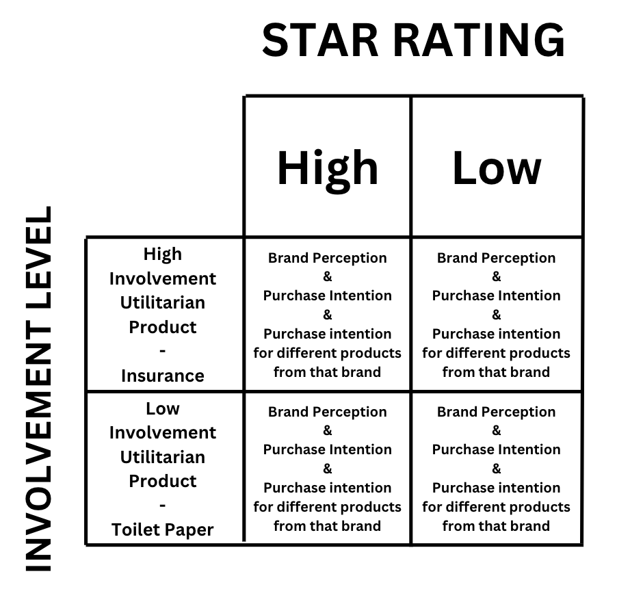
Figure 3. Breakdown of the 2x2 experimental design


Figure 4. Example of a review showed during the survey (Hong & Pittman, 2020)

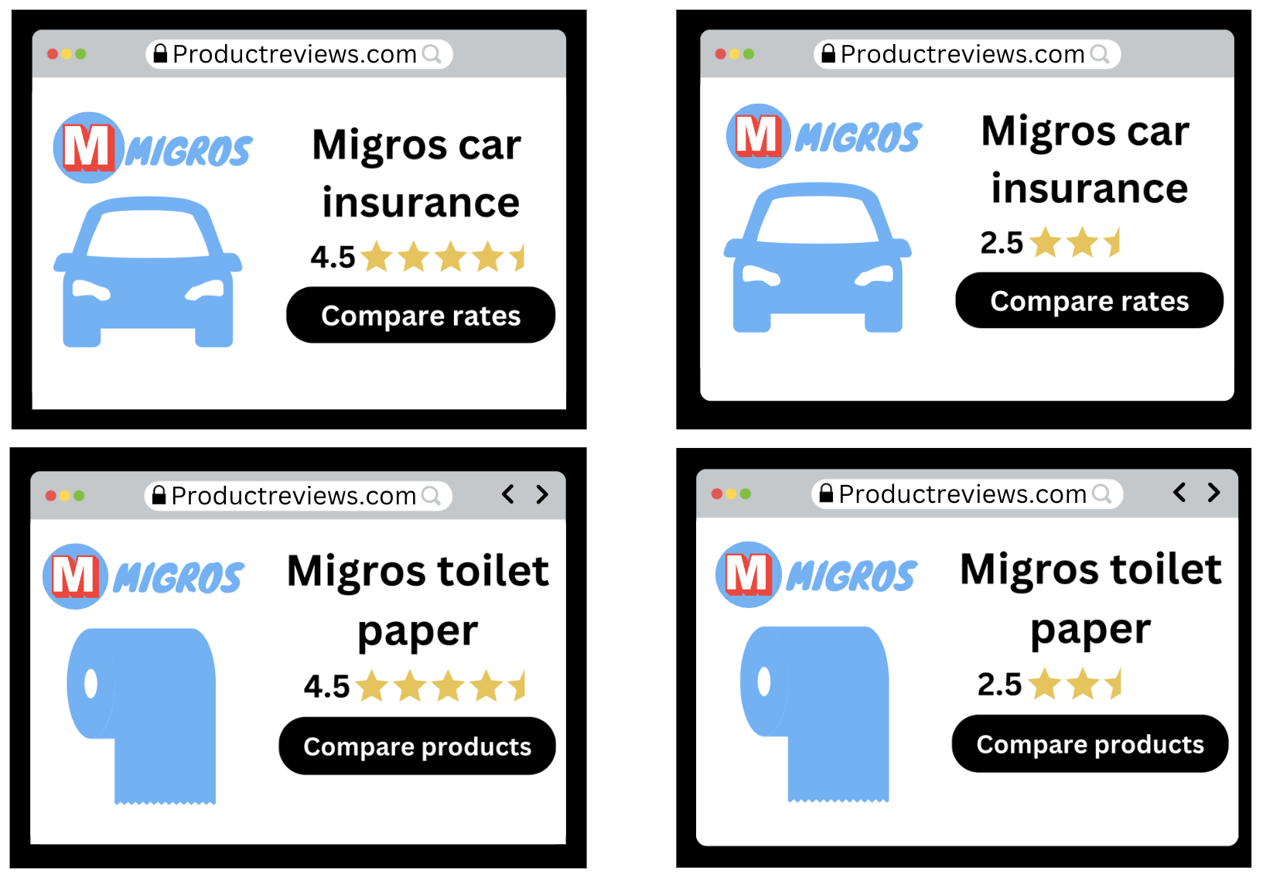
Figure 5: All four stimulis that were used in the survey

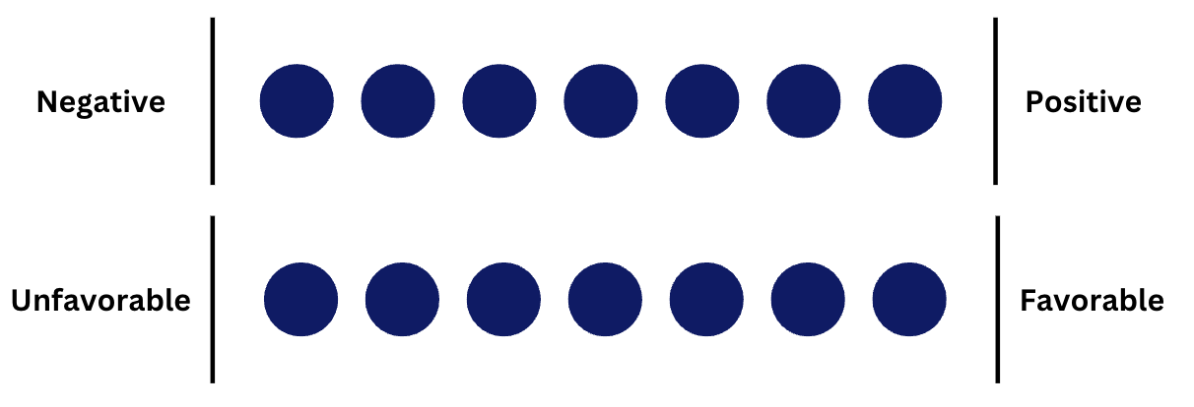
Figure 6. Semantic Differential Scales used to gage attitude


Figure 7. Likert Scale used to gage opinion

Results and Discussion
Results

Demographics
After the survey was run through Prolific, a total of 310 responses were collected. In total, 9 of those responses were either incomplete or did not pass all three attention checks that were part of the survey—leaving a data set of 301 total responses. The participants' average age was 36 years old, with 55% of participants identifying as male, 43% as female and 2% as non-binary. Regarding household income, 33% stated they made less than $50,000, 39% made between $50,000 and $100,000, 16% made between $100,00 and $150,000, and the remaining 13% made above $150,000.
Star Rating
Two independent-sample t-tests were conducted to compare brand perception outcomes for product reviews with high-star and low-star rating conditions. Test 1 showed there was a significant difference in the scores for high star reviews (M=4.48, SD=1.28) and low star reviews (M=3.08, SD=1.2) conditions; t (299)=9.8, p = <.001. Test 2 showed there was a significant difference in the scores for high star reviews (M=4.45, SD=1.37) and low star reviews (M=2.93, SD=1.19) conditions; t (299)=10.25, p = <.001. These results suggest that the star rating of a review has a significant effect on brand perception and that a review with a higher star rating results in higher brand perception.
An additional independent-sample t-test was conducted to compare purchase intentions of the product in the review for product reviews with high star and low star rating conditions. Test 3 found there was a significant difference in the scores for high star reviews (M=3.46, SD=1.64) and low star reviews (M=2.05, SD=1.14) conditions; t (299)=8.68, p = <.001. These results suggest that the star rating of a review has a significant effect on purchasing intentions and that a review with a higher star rating is more likely to result in a purchase.
All the findings support H1, finding a correlation between star rating and brand perception as well as purchasing intentions.
Star Rating & Involvement Level
A two-way ANOVA was performed to analyze how star rating and involvement level affect brand perception. The results revealed that there was no statistically significant interaction between the effects of star ratings and involvement level (F(1, 297) = .343, p = .559). Simple main effects analysis showed that star rating did have a statistically significant effect on brand perception (p = <0.001). Simple main effects analysis showed that involvement level did not have a statistically significant effect on brand perception (p = .087).
A second two-way ANOVA was performed to analyze how star rating and involvement level affect purchasing intention. The results revealed that there was no statistically significant interaction between the effects of star ratings and involvement level (F(1, 297) = .507, p = .477). Simple main effects analysis showed that star rating did have a statistically significant effect on purchasing intention (p = <0.001). Simple main effects analysis showed that involvement level did not have a statistically significant effect on purchasing intention (p = .807).
A final two-way ANOVA was performed to analyze how star rating and involvement level affect purchasing intention for different products from that brand. The results revealed that there was no statistically significant interaction between the effects of star ratings and involvement level (F(1, 297) = 3.01, p = .084). Simple main effects analysis showed that star rating did have some statistically significant effect on purchase intent for other brand products (p = .056). Simple main effects analysis showed that involvement level did have a statistically significant effect on purchase intent for other brand products (p = .012).
All the findings fail to support H2, finding no specific correlation between star rating and involvement and no evidence that a product associated with a low involvement thought process and a high star rating will have a more positive brand perception and purchasing intent. However, the results did show that in purchasing intent for a different product, low involvement + star rating did score significantly higher.
Review Frequency & Purchase intentions
A bivariate correlation was conducted to see if there was a relationship between how frequently consumers looked at online reviews before making a purchase and their purchase intention of the specific product and of a different product from that brand. Both relationships were positive and not statistically significant. Purchasing that product, r=0.039, n=301, (p =.504). Purchasing a different product from that brand, r=0.074, n=301, (p =.198). Both those findings fail to support H3, finding no correlation between review frequency and purchasing intentions.
Discussion
The findings of this research strongly support previous study findings regarding the power of visual heuristics. Reviews with higher star ratings ranked significantly higher in brand perception and purchasing intention. However, it is important to note that low-involvement products ranked better in purchase intentions of different products from that brand, regardless of star rating. This finding can be justified through literature by the fact that consumers will be more likely to try out a product associated with a low-involvement thought process. This is compared to a product associated with a higher involvement thought process for which consumers are likely to conduct additional research before making a purchase.
Interestingly, the findings showed no correlation between star rating and involvement, implying that consumers do not value star ratings more for a high-involvement product compared to a low-involvement product, and reviews are viewed in the same way regardless of the product advertised.
There was also no statistical significance based on demographic patterns (age, gender, income level). In the same way, how frequently consumers purchased items online or looked at online reviews prior to making a purchase did not have a statistical significance on brand perception or purchasing intention.

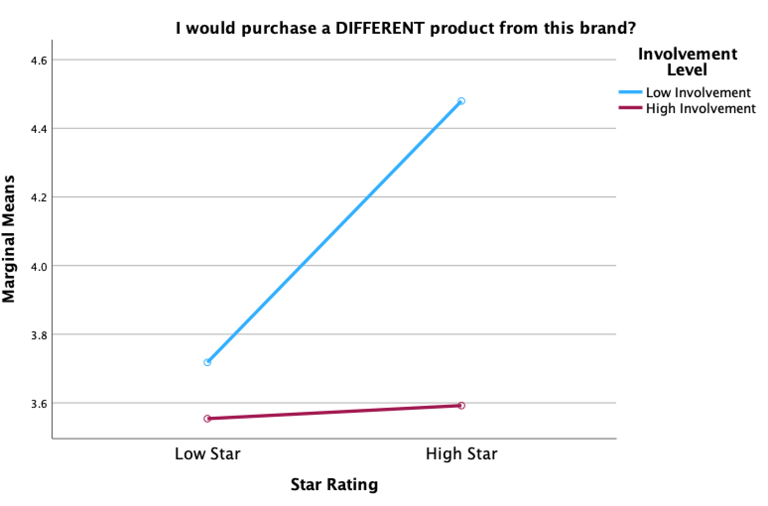
Figure 8: Graph showcasing involvement level & star rating

Table 1: Summarizing the hypotheses status
Hypotheses | Status
H1:Higher number of stars will result in more positive brand perception and a higher purchasing intent. | Supported
H2: Low involvement utilitarian + high star rating will have more positive brand perception and a higher purchasing intent. | Failed to support
H3: Participants who frequently look at online reviews before making a purchase will be more influenced by the product reviews. | Failed to support

Conclusions and Recommendations
The main objective of this research was to answer the following questions: How do utilitarian product reviews affect consumers' perception of a brand? Through the results, we can conclude that utilitarian product reviews do affect brand perception. High-star reviews do lead to better brand perception, while low-star reviews lead to a worsened brand perception. This research also found findings similar to most studies related to purchase intention, with results showing that star ratings played a significant role in creating positive or negative purchasing intentions. Additional findings showed that when a product was associated with a low involvement thought process and a high star rating, consumers were highly more likely to want to purchase a different product from that brand.

Implications
This study highlighted multiple key implications that translate into the way consumers interact and perceive EWOM and how businesses address those aspects. The strongest implication is the support of how significant the concept of brands is. According to a Statista report published by J. G. Navarro in 2023, “It was calculated that the total advertising expenditure in North America in 2021 amounted to about 297.5 billion U.S. dollars”. A lot of that spending is not to cause an instant purchase by consumers but more to strengthen that brand as a purchase option when it comes time for the consumer to make that purchase. This is especially applicable to marketing for car manufacturers. The findings in this research show that when a fictitious brand is created, and there is no prior affinity for that brand, the perception of that brand is typically average or not highly positive. Strengthening the logic that brands need to keep spending money on marketing to prime consumers and to create a strong affinity for a brand so consumers can think of only one brand as a purchasing option.
Additionally, this study also showed the impact that just a review can have. There are obviously a lot of additional layers that would typically go into a consumer's thought process, such as the site they use, the text of those reviews, and more. However, consumers' purchasing intentions drastically changed solely due to the visual heuristics shown (the star rating). Their perception of the brand selling those products also increased or decreased. For brand managers reading this study, this would be an indication to make sure they monitor reviews regarding their products and act on those accordingly, as they could have a strong impact on not just the sales numbers of one product but their entire brand.

Limitations and future research
Although the study aimed to understand people’s attitudes, a few limitations were linked to the survey and data collection. The survey itself was relatively short and very easy to complete, with most questions consisting of a Likert scale. Because of this, it was easy for participants to breeze through the questions and not answer truthfully and pay full attention to the questions that were asked. Another important limitation is the diversity in the sample of participants. It is stated above that the only exclusion criteria are for people under 18 and that even participants without much online review knowledge are encouraged to participate. However, with the survey only being accessible online and distributed through Prolific and social media, most participants had a more advanced knowledge of technology. Therefore, this limits the amount of data coming from consumers with low expertise on e-commerce platforms.
Despite those limitations, this study offers a lot of possibilities for future research. This study focused exclusively on utilitarian products because of the lack of research done on those products. However, future research could be made exclusively on hedonic products. Or comparing product reviews of hedonic & utilitarian products in a high & low involvement setting to see if there are any key differences in brand perception and purchasing intentions. EWOM is growing in symbiosis with the use of digital technologies, and the way EWOM is communicated is ever-changing. Therefore, continuing to research the topic will be key to understanding how it has evolved and how it is currently working.

List of References
Baek, & Choe, Y. (2020). Differential effects of the valence and volume of online reviews on customer share of visits: The case of US casual dining restaurant brands. Sustainability (Basel, Switzerland), 12(13), 5408–. https://doi.org/10.3390/su12135408
Bettiga, D., Bianchi, A. M., Lamberti, L., & Noci, G. (2020). Consumers Emotional Responses to Functional and Hedonic Products: A Neuroscience Research. Frontiers in psychology, 11, 559779. https://doi.org/10.3389/fpsyg.2020.559779
Brunner, Ullrich, S., & De Oliveira, M. J. (2019). The most optimal way to deal with negative consumer review: Can positive brand and customer responses rebuild product purchase intentions? Internet Research, 29(1), 104–122. https://doi.org/10.1108/IntR-08-2017-0307
Casaló, Flavián, C., Guinalíu, M., & Ekinci, Y. (2015). Avoiding the dark side of positive online consumer reviews: Enhancing reviews’ usefulness for high risk-averse travelers. Journal of Business Research, 68(9), 1829–1835. https://doi.org/10.1016/j.jbusres.2015.01.010
Chong, Li, B., Ngai, E. W. T., Ch’ng, E., & Lee, F. (2016). Predicting online product sales via online reviews, sentiments, and promotion strategies: A big data architecture and neural network approach. International Journal of Operations & Production Management, 36(4), 358–383. https://doi.org/10.1108/IJOPM-03-2015-0151
Eric Haley & Matthew Pittman (2022): Remembering the FCB Grid: Thinking, Feeling, and Involvement in the Age of Social Media, Journal of Advertising, DOI: 10.1080/00913367.2022.2026845
Filieri, Lin, Z., Pino, G., Alguezaui, S., & Inversini, A. (2021). The role of visual cues in eWOM on consumers’ behavioral intention and decisions. Journal of Business Research, 135, 663–675. https://doi.org/10.1016/j.jbusres.2021.06.055
Godden, Thornton, L., Avramova, Y., & Dens, N. (2023). High hopes for front-of-pack (FOP) nutrition labels? A conjoint analysis on the trade-offs between a FOP label, nutrition claims, brand and price for different consumer segments. Appetite, 180, 106356–106356. https://doi.org/10.1016/j.appet.2022.106356
Hong, & Pittman, M. (2020). eWOM anatomy of online product reviews: interaction effects of review number, valence, and star ratings on perceived credibility. International Journal of Advertising, 39(7), 892–920. https://doi.org/10.1080/02650487.2019.1703386
Huang, & Lin, Y.-H. (2021). Exploring consumer online purchase and search behavior: An FCB grid perspective. Asia Pacific Management Review. https://doi.org/10.1016/j.apmrv.2021.10.003
Huete-Alcocer. (2017). A literature review of word of mouth and electronic word of mouth: Implications for consumer behavior. Frontiers in Physiology, 8, 1256–1256. https://doi.org/10.3389/fpsyg.2017.01256
Huettl, V., Gierl, H. Visual art in advertising: The effects of utilitarian vs. hedonic product positioning and price information. Mark Lett 23, 893–904 (2012). https://doi.org/10.1007/s11002-012-9196-z
Kaemingk, D. (2020, October 30). https://www.qualtrics.com/blog/online-review-stats/.
Liu, Hu, J., & Xu, B. (2017). Does eWOM matter to brand extension?: An examination of the impact of online reviews on brand extension evaluations. Journal of Research in Interactive Marketing, 11(3), 232–245. https://doi.org/10.1108/JRIM-02-2016-0012
Liu, Mo, Z., & Gao, H. (2021). The effect of reviewer’s review volumes on online consumer reviews’ perceived usefulness: An event-related potential study. Neuroscience Letters, 762, 136139–136139. https://doi.org/10.1016/j.neulet.2021.136139
Lu, Liu, Z., & Fang, Z. (2016). Hedonic products for you, utilitarian products for me. Judgment and Decision Making, 11(4), 332–341.
Manu Bhandari & Shelly Rodgers (2018) What does the brand say? Effects of brand feedback to negative eWOM on brand trust and purchase intentions, International Journal of Advertising, 37:1, 125-141, DOI: 10.1080/02650487.2017.1349030
Mudambi, Susan M., and David Schuff. “Research Note: What Makes a Helpful Online Review? A Study of Customer Reviews on Amazon.Com.” MIS Quarterly, vol. 34, no. 1, 2010, pp. 185–200. JSTOR, https://doi.org/10.2307/20721420. Accessed 4 Dec. 2022.
Navarro, J.G., (2023) Advertising spending in North America 2000-2024. Statista. https://www.statista.com/statistics/429036/advertising-expenditure-in-north-america/
Nazlan, Tanford, S., & Montgomery, R. (2018). The effect of availability heuristics in online consumer reviews. Journal of Consumer Behaviour, 17(5), 449–460. https://doi.org/10.1002/cb.1731
Purnawirawan, N., Eisend, M., De Pelsmacker, P., & Dens, N. (2015). A Meta-analytic Investigation of the Role of Valence in Online Reviews. Journal of Interactive Marketing, 31(1), 17–27. https://doi.org/10.1016/j.intmar.2015.05.001
Qi, X.; Kuik, S. Effect of Word-of-Mouth Communication and Consumers’ Purchase Decisions for Remanufactured Products: An Exploratory Study. Sustainability 2022, 14, 5963. https://doi.org/10.3390/ su14105963
Shihab, & Putri, A. P. (2019). Negative online reviews of popular products: understanding the effects of review proportion and quality on consumers’ attitude and intention to buy. Electronic Commerce Research, 19(1), 159–187. https://doi.org/10.1007/s10660-018-9294-y
Siamagka, Christodoulides, G., & Michaelidou, N. (2015). The impact of comparative affective states on online brand perceptions: a five-country study. International Marketing Review, 32(3/4), 438–454. https://doi.org/10.1108/IMR-10-2013-0237
United States Census Bureau. (2022). Household Pulse Survey. [Data set]. https://www.census.gov/data/experimental-data-products/household-pulse-survey.html
Youn, Pittman, M., & Haley, E. (2023). Using the FCB grid to understand privacy concerns in social media advertising. International Journal of Advertising, 1–29. https://doi.org/10.1080/02650487.2023.2242020

Appendix

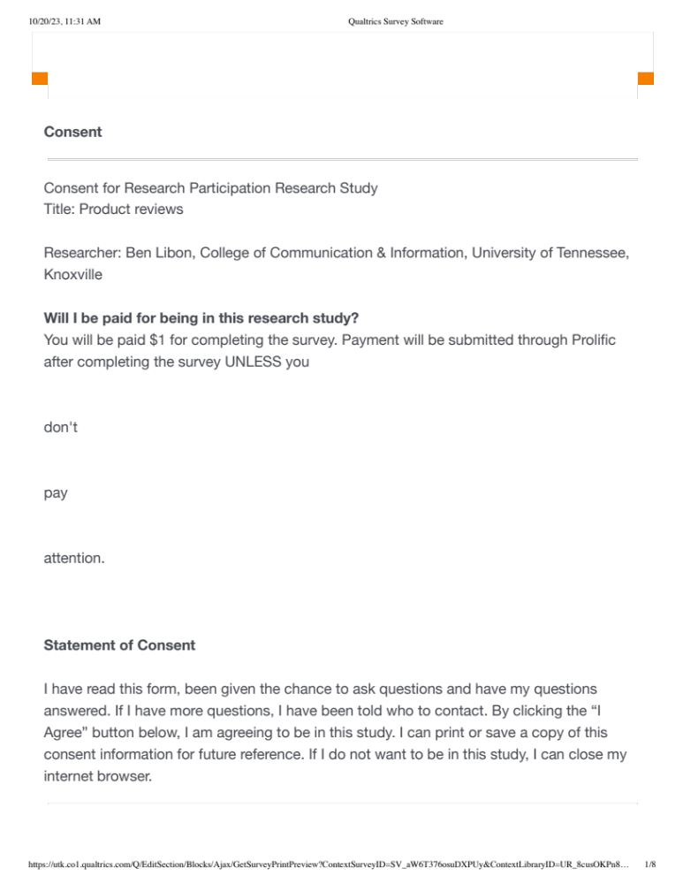

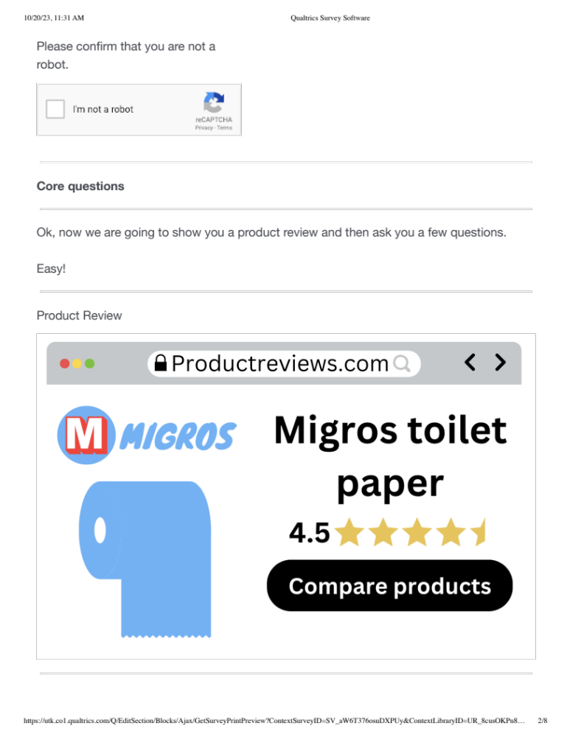




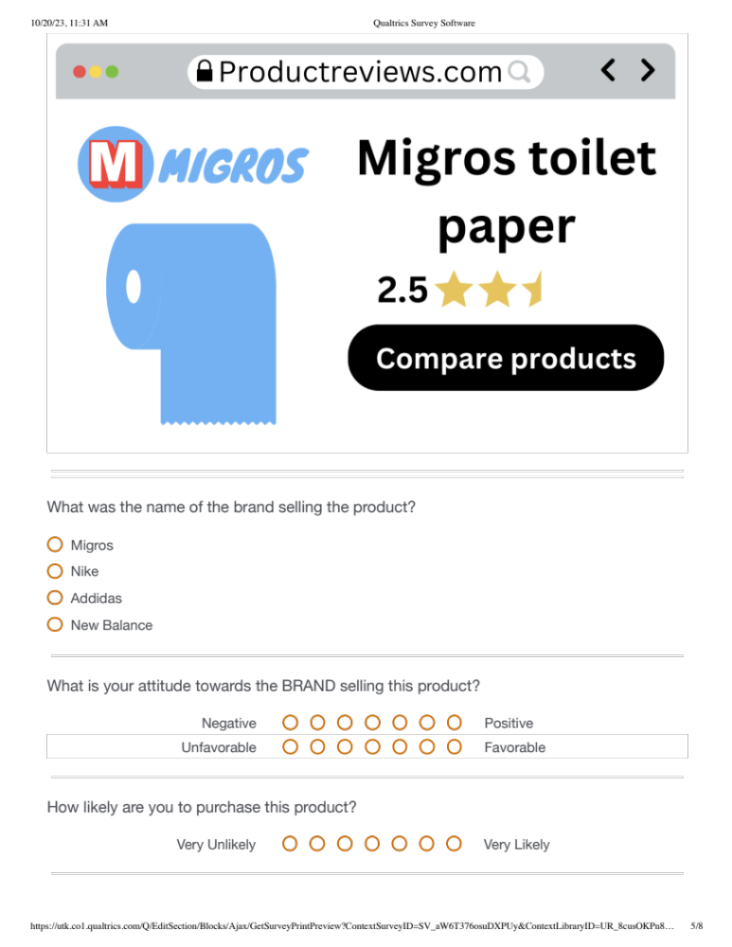

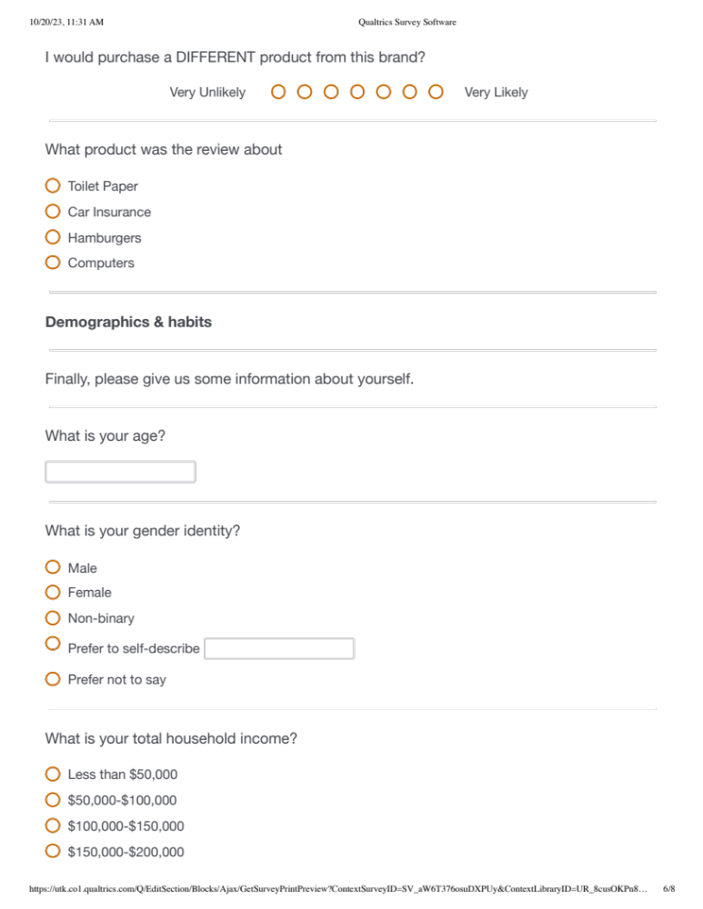

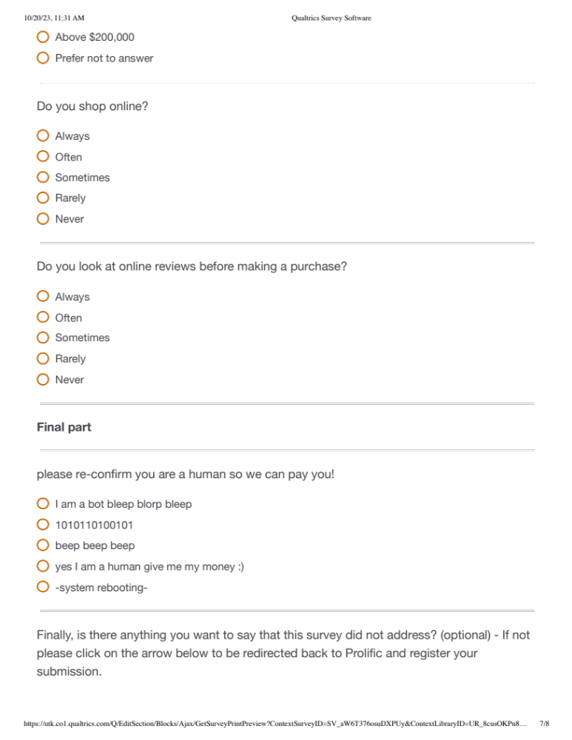



Vita
Benjamin Libon is a 2nd year master’s student in Communication and Information with a focus in Advertising at the University of Tennessee, Knoxville. His goal is to complete his Ph.D. in Communication (Advertising focus) and continue in academia, teaching, and researching. His research interests are centered around consumer behavior and emerging platforms. Hoping to answer the following broad question from an Advertising/Communication lens: Why do people behave the way they do?

