Innovation of Driving Gear Train System for Developer Unit of Lexmark Home Printers
Final Report

Submitted By
Jay Crist
Sarah Gore
Michael Mixon
Kun Xie
Seniors in Mechanical Engineering
University of Tennessee, Knoxville

Submitted To
Dr. Boulet
Associate Professor & Associate Head of Undergraduate Programs
University of Tennessee, Knoxville
209 Dougherty Engineering Building
1512 Middle Drive
Knoxville, TN 37996

Date Submitted
December 2, 2016
Table of Contents
I. Problem and Objective 2
II. Design Review 2
III. Experimental Setup 4
A. Test 1: Load Reduction due to Agitator Shaft Paddle Shape Test 4
B. Test 2: Gear Failure Test 5
C. Test 3: Gear Failure Test with Reduced Deflection 6
D. Test 4: Final Design Assembly Test 7
E. Additional Testing 7
IV. Procurement, Fabrication, and Assembly 8
A. Procurement 8
B. Fabrication 8
C. Assembly 8
V. Results and Discussion 9
A. Test 1: Load Reduction due to Agitator Shaft Paddle Shape Test 9
B. Test 2: Gear Failure Test 9
C. Test 3: Gear Failure Test with Reduced Deflection 12
D. Test 4: Final Design Assembly Test and Additional Testing 14
VI. Conclusions 16
VII. Future Work 16
VIII. Appendices 17
Appendix A: Original Test Data 17
Appendix B: Gantt Chart Comparison 36
Theoretical Gantt Chart 36
Actual Gantt Chart 37

I. Problem and Objective
Lexmark presented a problem in the design of their printers concerning the gear train that drives the agitator shaft in the developer unit. This unit is the housing for the toner that is used to create the print on the paper; this setup can be seen in Figure 1. The problem was further investigated and was determined to be that the resistance load provided by highly compacted toner in the developer unit was much too high at around 350 mN-m, leading to both tooth disengagement, or cogging, and teeth breaking off of the agitator driving gear and off of the small gear of the compound idler gear. This was defined to only occur during initial startup as the agitator shaft stirred the compacted toner, which would greatly reduce the load.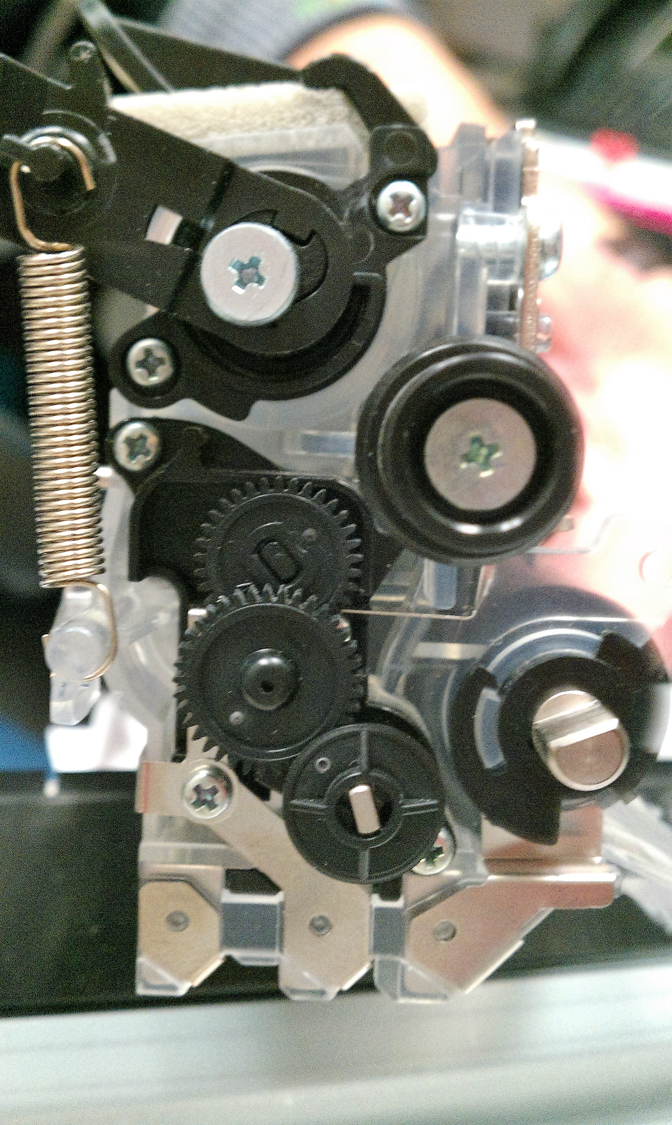

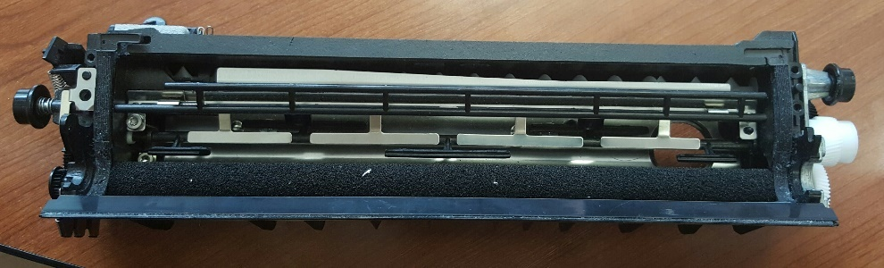
F
C
A
D
G
H
E
B

Figure 1 Setup of Developer Unit with (A) Agitator Driving Gear (B) Compound Idler Gear (C) Agitator Driving Gear Train Input Gear (D) Gear Face Plate and Agitator Shaft Bearing (E) Agitator Shaft (F) Auxiliary Paddle (G) Toner Roller (H) Input Driving Gear
The objective of this project was defined as innovating the gear train such that the system would be able to accomplish ten startups with a resistive torque of up to 420 mN-m – where each startup was defined as ten complete revolutions of the agitator shaft – while maintaining the original functionality.

II. Design Review
To eliminate both gear failure methods, a two-part design was proposed. First, the face width of the gears was increased from 1.75 mm to 6.75 mm to increase the failure limit of the gears from approximately 72 mN-m to approximately 291 mN-m. Since the required load was still higher than this new maximum load, the agitator shaft was also innovated by changing the shape of the stirring paddles to be more aerodynamic to reduce the maximum load required. The paddle shape change was estimated to reduce the load to as low as 112 mN-m of torque based on calculations using coefficient of drag. The final design can be seen in Figure 2; the total factor of safety of the final design if the load was reduced completely was 2.6 and if the load was reduced half as much as expected due to incorrect assumptions was 1.1.
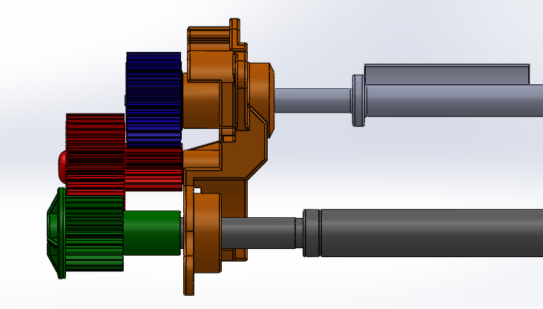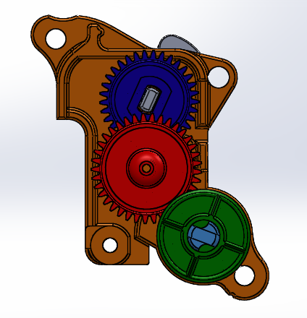
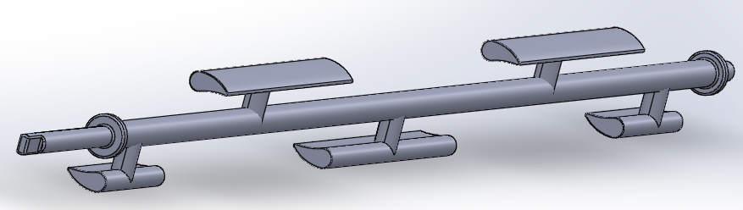
Figure 2 Final CAD Assembly Front View, Side View, and Paddle View for Increased Gear Face Width and New Paddle Shape
The length of the input shaft was left unchanged as it was a part of other systems within the assembly. The post attached to the gear face plate that supported the idler, or idler post, was determined to be a potential point of failure due to the elongation of the gears and the higher maximum load necessary, so the plastic molded post was replaced with a pressed in steel pin. The agitator shaft length was originally elongated to fill the length of the increased gear face width, but, due to manufacturing issues, the internal hub of the gear and length of the agitator shaft were reduced to be the same length as the original gear, as is shown in Figure 3. Note that this would also reduce the overall shaft deflection and the gear would have to be molded this way to keep a constant wall thickness.
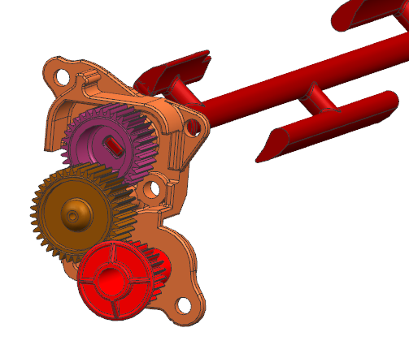
Figure 3. Final Design Adjustments: Reducing the Internal Hub and Agitator Shaft Length

III. Experimental Setup

A. Test 1: Load Reduction due to Agitator Shaft Paddle Shape Test
The first test conducted was designed to determine the actual reduction in load provided by the change in shape of the agitator shaft. To save money and ease testing difficulty, compact flour was used as to represent toner in the system in conjunction with the test apparatus seen in Figure 4. The agitator shaft was submerged in 740 grams of flour sealed in the plastic cylinder, which was 214 mm long and had a diameter of 101.6 mm. The ends of the shaft went through molded gear faceplates as bearings, similar to in the actual system. The powder was compacted in the system by tapping the entire apparatus on the table sixty times.
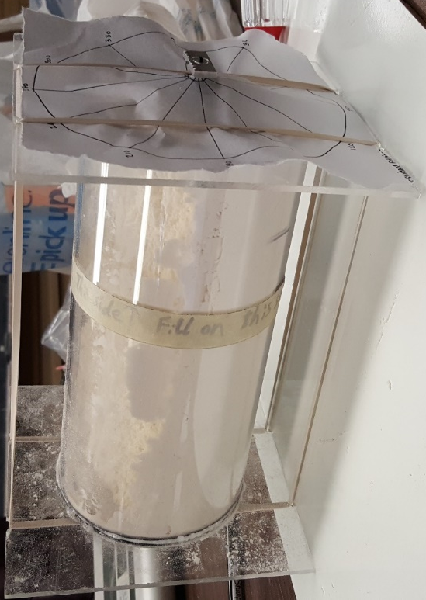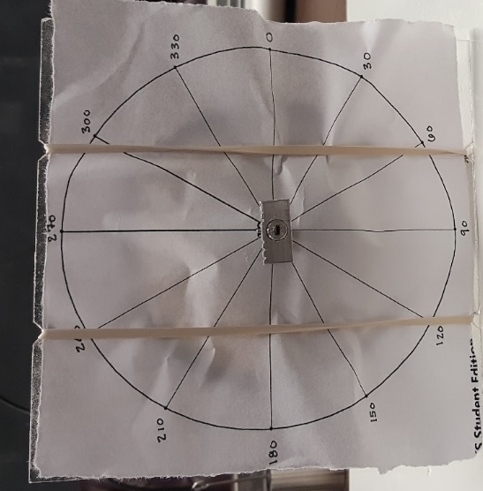
Figure 4. Load Reduction due to Agitator Shaft Paddle Shape Test Apparatus and Notched Loading Beam
The end of the agitator shaft was equipped with a loading beam with notches cut at 4.5 mm, 7 mm and 9.5 mm from the center of rotation to allow for various loads to be added to the system by hanging known weights at the specified notches with high strength fishing line to provide a known input torque. The loading beam was attached to the shaft by an insert that was made to mate with the end of the agitator shaft by Lexmark and held in place with a set screw. The flour was compacted and the system incrementally loaded 10 g at a time starting at the closest position and proceeding to the farthest position then increasing the load until the agitator shaft rotated 30°. This process began with the agitator shaft starting at an orientation of 0° – which was defined as all the paddles being parallel to the table – and was done with the agitator shaft starting at every 30° increment up to 360°. Between each angle, the apparatus would be flipped 180° and the flour would be compacted again to ensure that the rotation of the previous test did not reduce the required load. This process was repeated for all four machined agitator shafts with the old paddle design and all four machined agitator shafts with the new design to ensure that the machining process was independent of the results.

B. Test 2: Gear Failure Test
The second test conducted was designed to determine the actual impact the change in gear face width had on the system by independently testing the gears. The paddle farthest from the gear train was tied with high strength twine to fix the agitator shaft, as can be seen in Figure 5. The developer unit without the front plate was used to represent the real system and allow for the assembly of the gear train. The developer unit was locked into place with a fixture designed to prohibit any movement or rotation of the housing. This fixture was stabilized by rubber feet to reduce any vibrations in the system. Similar to the first test, a flywheel was designed with a radius of 9.5 mm to attach to the input shaft with an insert made by Lexmark. Since the angle of the flywheel was irrelevant, the insert was glued in for more security than a set screw. Weights were tied to the flywheel with fishing line locked into the flywheel by a small hole. A 0.932 mN-m torque was incrementally loaded using the flywheel until failure occurred. A camera was set up to record the gears to attempt to measure the deflection in the system based on known measurements at different weights.
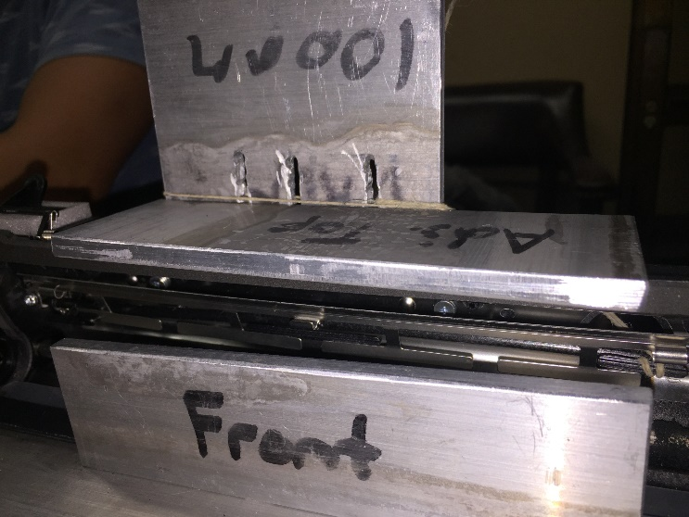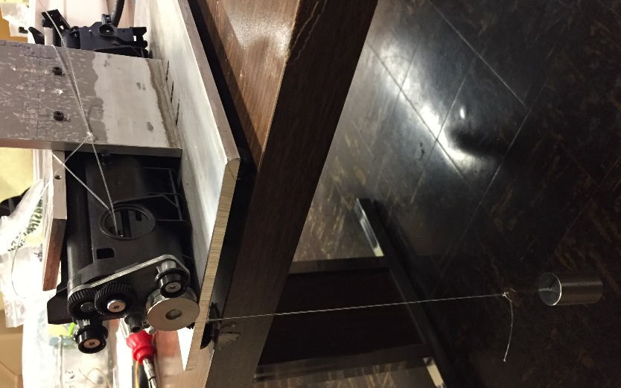
Figure 5. Gear Failure Test Apparatus and Loading Flywheel

C. Test 3: Gear Failure Test with Reduced Deflection
The third test conducted was designed to determine the strength of the gears if the deflection was greatly reduced by changing the end of the agitator shaft and the idler post from cantilevered beams to simply supported beams by using lathed aluminum pins attached to the fixture, as can be seen in Figure 6. A 1 mm hole was drilled into the agitator shafts to allow the agitator support pin to engage with the shaft; the idler support pin was inserted into the hole of the idler gear to provide support. The test procedures for this experiment were the same as the second test with the agitator shaft tied at the farthest paddle and the system in the developer unit locked by the same fixture was loaded incrementally by the flywheel.
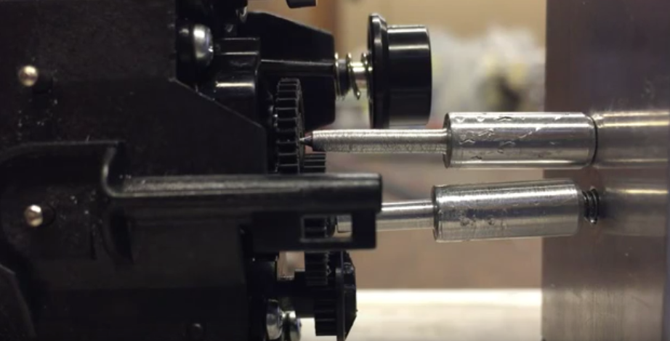
Figure 6. Fixture for Reducing Deflection in the Gears for the Alternative Gear Failure Test

D. Test 4: Final Design Assembly Test
The fourth test conducted was designed to determine if the design changes were successful in overcoming the startup problem. A block testing method was developed to attempt to understand how the change in gear and paddle designs affected the actual system loaded with approximately 100 g of toner into the same fixture as the second test. Note that the new gear face plates with the pressed steel pins were used for the new gear systems and molded gear face plates with the old molded posts were used for the old gear systems to support the correct lengths of the idler gears. The developer unit was tapped 100 times vertically on the ground with the input shaft hitting the ground, compacting the toner toward the paddle farthest from the driving gear train. The system was loaded from the input shaft with by the flywheel and weight system, as in the other tests. Again, the foam was removed from the input shaft to reduce the noise supplied by needing to rotate the foam through the toner to begin to turn the gears.

E. Additional Testing
Upon completing the first four designed tests, an additional test was developed. The final design assembly test was redone with the metal “T’s” within the developer unit removed; these “T’s” are highlighted in Figure 7. This was done to attempt to discover the actual load of the toner alone without any potential interference from this alternative part of the system. Other additional tests were discussed but were not able to be run due to time constraints.

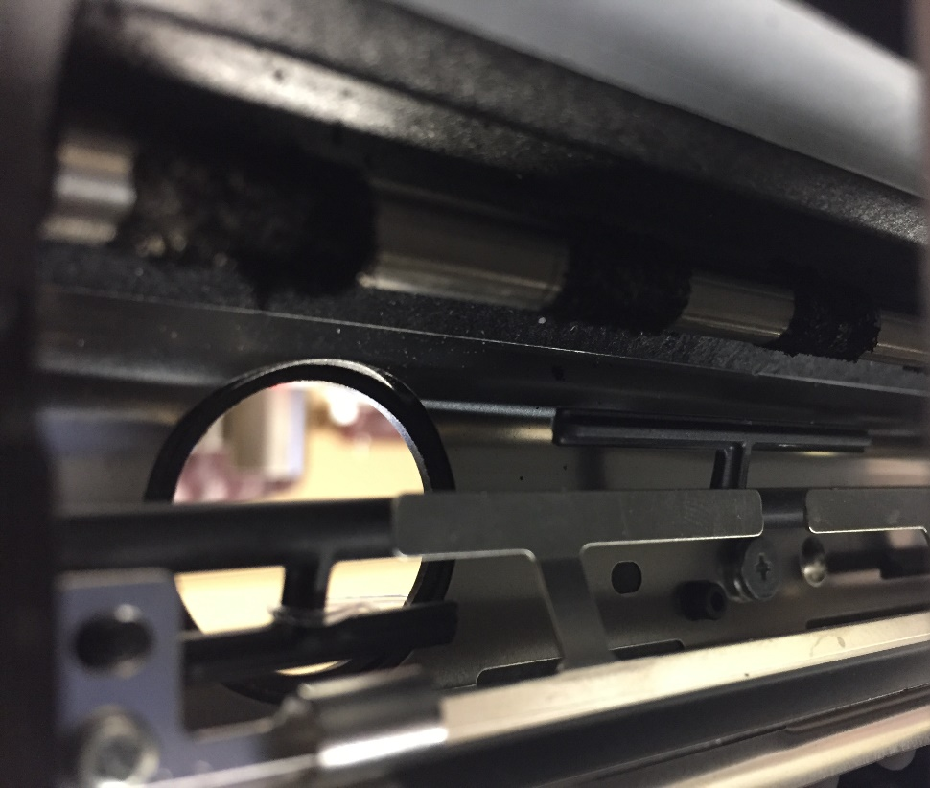
Figure 7. Developer Unit with Metal “T’s” Highlighted to Show What was Removed for the Alternative Test 4: Final Design Assembly Test

IV. Procurement, Fabrication, and Assembly

A. Procurement
Lexmark supplied all of the developer unit parts needed. This included the old gear face plate, new gear face plate with a pressed steel pin, old paddle (injection molded), old paddle (machined), new paddle (machined), old gear design (injection molded), old gear design (machined), and new gear design (machined). Lexmark also provided the loading beam insert. For Test 1, parts ordered from McMaster-Carr included the acrylic ends of the fixture, O-rings, pan head screws, and hex nuts. The acrylic tubing, loading weights, and scale were provided by the University of Tennessee. The flour and rubber bands used were purchased at Walmart. For Tests 2 and 3, all developer unit parts were supplied by Lexmark and supplies ordered from McMaster-Carr included: raw 6061 aluminum, socket head cap screws, and Adhesive-Back Polyurethane legs. For Test 4, Lexmark supplied toner. The only procurement issue was that the pressed steel pin in the new gear face plate was out of specification and had to be remanufactured by Lexmark.

B. Fabrication
The University of Tennessee machined the Acrylic tube and endcaps for the fixture for Test 1. The loading beam was machined using an end mill, drill press, band saw, grinder, hand saw, metal file, and tapping set. Machining the loading beam manually was very difficult to do to specification, so four of them were made and the most accurate one used throughout experimentation. For fabrication of the fixture for Tests 2 and 4 was done with the same tools as before. The original tap broke off in one of the drilled holes and another had to be ordered. Lubrication was used when tapping from that point on and there were no problems. It was decided that the holes for this fixture should be ellipses to the parts to be adjusted for a tight hold on the developer unit. Creating these ellipse-shaped holes in the fixture with the available tools proved to be difficult and multiple methods were attempted. This resulted in one the holes of the adjustable back plate not lining up correctly with its corresponding hole of the adjustable top plate. However, two screws proved to be enough to hold the developer unit in place and the misaligned hole could be ignored. Finally, the fixture for Test 3 was made with the same tools and was also made adjustable. The holding pins were made by the University of Tennessee machine shop using a lathe.

C. Assembly
For Test 1, originally the screws used to hold the gear plates in place restricted the paddle from completely rotating. Their ends were then cut off to allow full rotation. The O-rings were glued to the acrylic ends using a light layer of super glue, but after a few tests they were no longer secure. Once they were glued again using a large layer of super glue there were no issues. While tapping the fixture to compact the flour, the ends of the tubing would slip off of the O-rings and leak flour. Rubber legs that were originally purchased for the Test 2 fixture were placed around the tubing to hold it in place. For Test 2, the fixture was assembled with no problems due to the adjustable holes. There was a problem with deflection and torsion of the agitator shaft due to only the final paddle being fixed, but this was determined to be a preload of the system and was left unchanged. Also, the loading beam was originally attempted to be used for Test 2, but the aforementioned preloading required the input shaft to rotate more than 90° so the flywheel was made to allow for multiple rotations at the same weight. Test 3 had no assembly issues thanks to the adjustable parts. For Test 4, the original amount of toner was unable to be compacted through the original tapping methods, so more toner was added up to the final 100 g and the tapping procedure was adjusted to the final procedure of 100 times vertically.

V. Results and Discussion

A. Test 1: Load Reduction due to Agitator Shaft Paddle Shape Test
The first test was completed for all four machined agitator shafts with the old paddle design and all four machined agitator shafts with the new paddle design; the complete collection of data can be found in Appendix A. A summary of the data is presented in Figure 8. Statistical analysis done by Herman Smith and Kevin Kennedy from Lexmark was able to conclude that the new design of the agitator paddle reduced the load by 10% with 98% statistical confidence for the flour based systems. It was assumed that this load reduction was the same for a toner based system due to the similarity in compacting characteristics. The starting angle was also determined to play a noticeable role in the resistance of the flour due to the difference in moment of inertia for rotation based on the orientation.

Figure 8. Load Reduction due to Agitator Shaft Paddle Shape Test Comparison Results for Old and New Paddle Shape Design

B. Test 2: Gear Failure Test
The second test was first conducted with molded gears with the original design specifications, then with machined gears with the original design specifications, and finally with machined gears with the new design specifications; a summary of the results can be seen in Table 1. Multiple observations were found during the initial runs of this experiment that were explored.
Table 1. Summary of Gear Failure Test Results for Each System Tested
Tested System | Failure Torque (mN-m) | Failure Mode
Molded Gears | 98 | Gear Disengagement and Broken Teeth
Old Design Machined Gears + Agitator Shaft | 102 | Broken Agitator Shaft
New Design Machined Gears + Agitator Shaft | 103 | Broken Agitator Shaft
Old Design Machined Gears + Steel Shaft | 162 | Broken Idler Post
Old Design Machined Gear + Steel Shaft | 196 | No Failure, Ran out of weights

First, the molded gears were found to fail under the original setup at about 98 mN-m which was 26 mN-m more than predicted; this failure is depicted in Figure 9. Second, both systems with machined gears and shafts were found to exhibit a preloading phenomenon that manifested itself as a 90° to 120° visible rotation of the end of the agitator shaft that engaged with the agitator gear, along with a large vertical deformation of the central portion of the agitator shaft of about roughly 3.5 mm, calculated from images. Furthermore, the first new failure mode was discovered: shearing of the ends of the agitator shaft at the point of stress concentration where the shaft engages with the gear. This failure was found to occur in other tests and was explored further when combining all the shaft failures at the end of the final test. The second new failure mode was also discovered: shearing of the idler post from the gear face plate. This failure was found to occur more often in other tests and was explored further later.
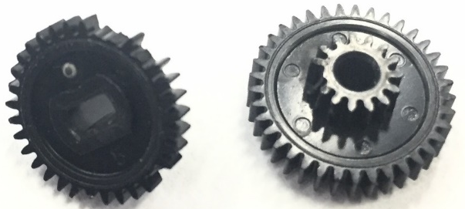
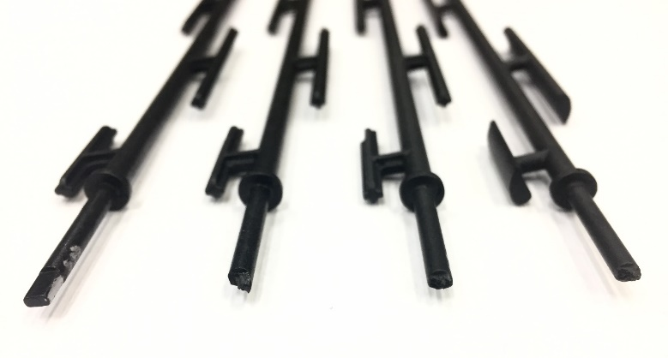
(B)
(A)
Figure 9. Gear Failure Test Failure Modes with (A) Molded Gear Failure and (B) Molded, Old Design Machined, and New Design Machined Agitator Shaft Failure
Next, the agitator shaft deflection led to another unforeseen problem in the interaction of the system: after a load of 23 mN-m was applied to the system, at least one of the five agitator paddles became engaged with the metal “T’s” fixture within the system. By 46 mN-m, all of the paddles facing toward the front of the agitator shaft had engaged with the metal “T’s” fixture, depending on starting orientation. This provided a significant new problem because interference with this metal fixture drastically increased the torque required to turn the agitator shaft because the shaft would not be able to rotate through this metal fixture. In fact, it was predicted that the agitator shaft would have to deflect away from this fixture to be able to move past it, which would require a load much higher than was capable before reaching the new failure mode of the shaft failure.
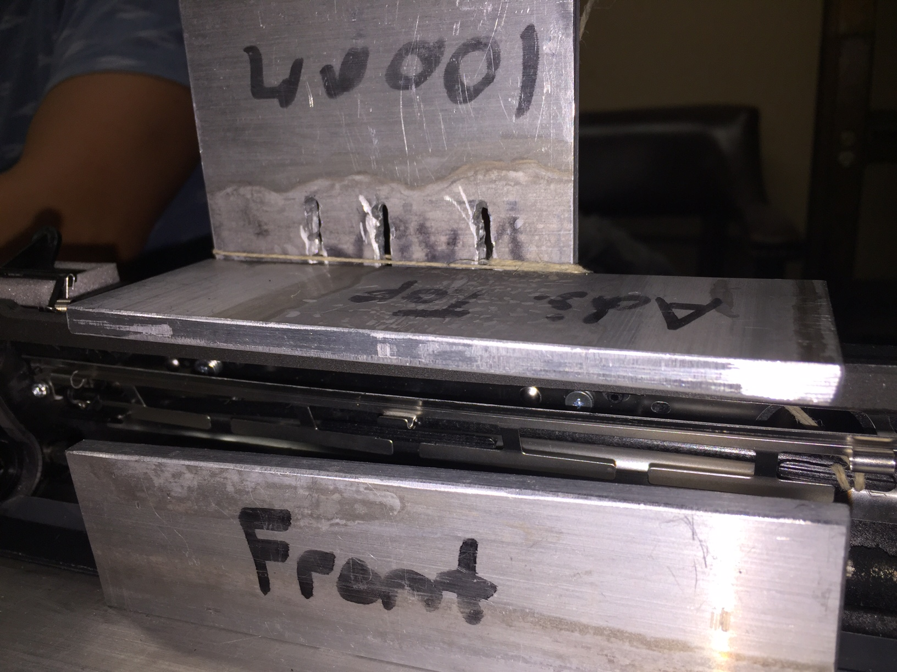
Figure 10. Additional Problem: Interference with Metal “T’s” Due to Extreme Deflection of Agitator Shaft (Marked by Red Zones)
Finally, the deflection of the gears was observed for both the old and new design as is depicted in Figure 11. Note that the images for the deflection of the new gear train design were taken during a test run where the input gear was improperly assembled on the input shaft, resulting in a reduction of tooth engagement. However, these images clearly depict the observations made that the input gear had a low deflection in only the vertical direction; the idler gear had a high deflection in the vertical direction, horizontal direction, and rotationally about the vertical axis – around 1.1 mm, the horizontal was too small to be accurately measured, and 2 mm (8.5°), respectively; and the output gear had a moderate deflection in the vertical direction, around 0.6 mm (5.9°), and a large rotational deflection across the horizontal axis of about 1.5 mm (8.4°). Furthermore, it was observed that the outer surface of the output gear would get caught on the inner surface of the larger compound idler gear. This problem has been identified in gear trains before, and the solution would be to include a thin ring on the outer surface in the design for all gear surfaces to ensure that this contact never results in rotational failure.
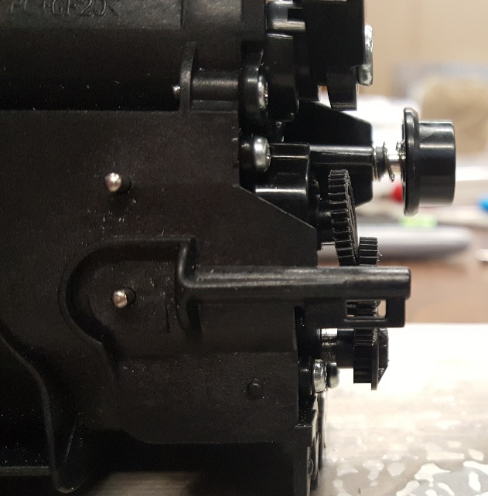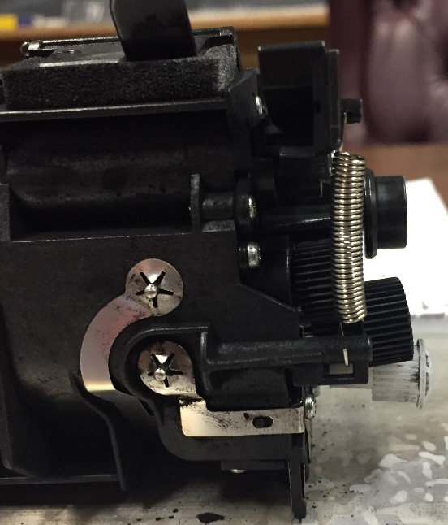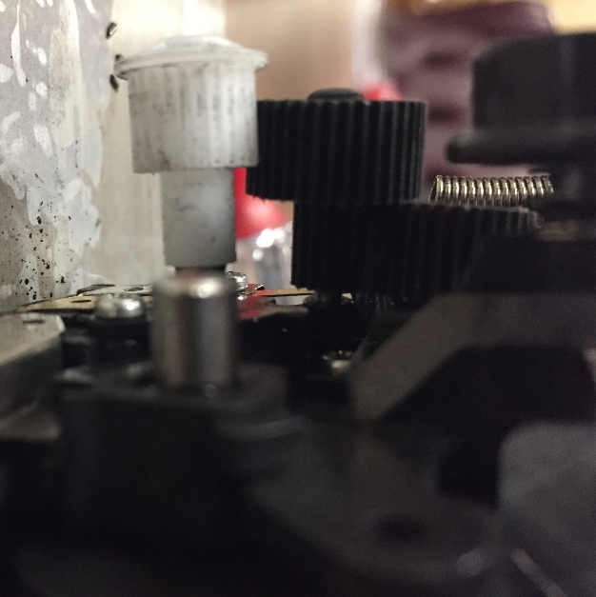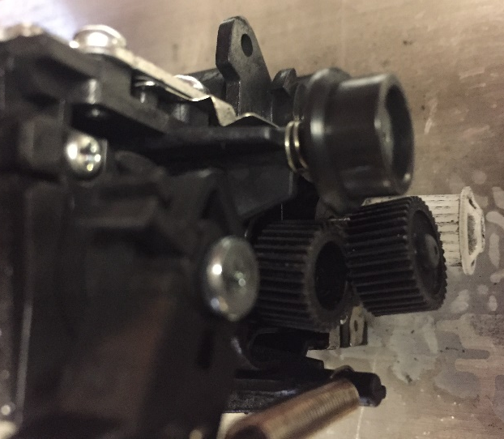
(A)
(B)
(D)
(C)
Figure 11. Example Deflection for (A) Original Design Output Gear at 137 mN-m, (B,C, and D) New Design Idler Gear at 158 mN-m

C. Test 3: Gear Failure Test with Reduced Deflection
The third test was also conducted with molded gears of the original design, machined gears of the original design, and machined gears of the new design. However, to avoid the agitator shaft failure found previously, a steel shaft was machined to fit in place of the agitator shaft and fixed from rotation; due to the increased strength of this shaft, deflection of this shaft was predicted to decrease greatly, so only one of the aluminum support pins was used, as can be seen in Figure 12. Note that the deflection of the system was significantly less than the original system, as intended.
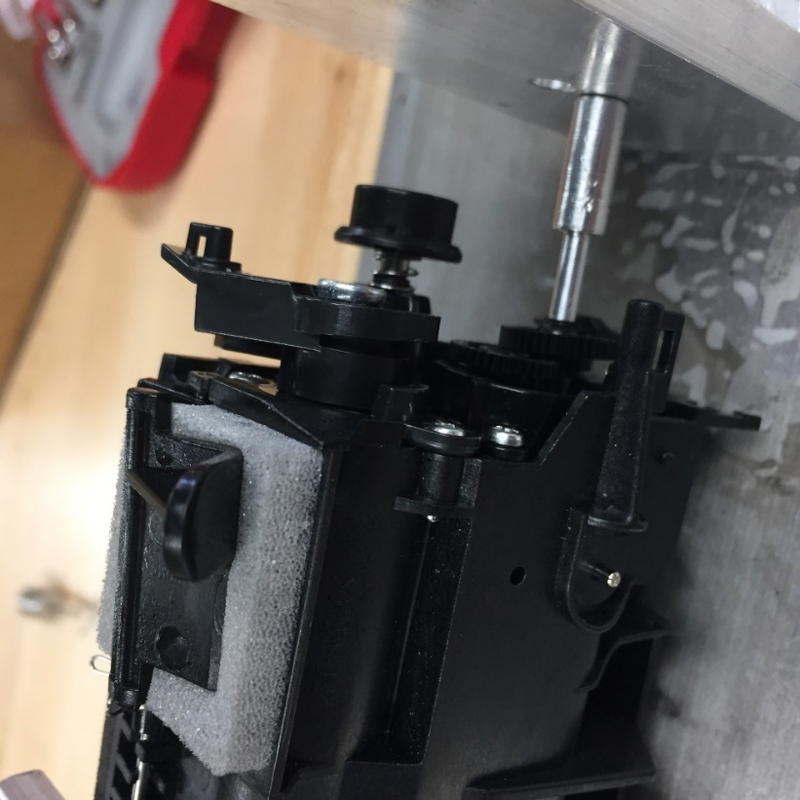
Figure 12. Gear Failure Test with Reduced Deflection Trial Run with Steel Shaft and One Aluminum Support Pin at 112 mN-m Load
Only two runs were done of this test due to time constraints and lack of extra parts; the results can be seen in Table 2. Two important observations were made from this experiment. First, the machined gears appeared to be significantly stronger than the molded gears having not failed at up to over 195 mN-m or torque, whereas every molded gear had failed by at most 153 mN-m of torque, which is an increase in strength of over 27 %. It is predicted that the reason behind this is that the machining both increases the strength of the gears and causes them to act like brittle parts. This phenomenon was qualitatively seen in that the molded teeth would show signs of plastic deformation before teeth failure, while the molded parts, even at the maximum load achieved had barely if any plastic deformation.
Table 2. Summary of Results for Gear Failure Test with Reduced Deflection
 |  | Molded | Machined old | Machined new
Run 1 | Torque (mN.m) | 127.5 | 181.5 | 158.3
Run 1 | Failure part | Broken gear teeth | Broken post | Broken post
Run 2 | Torque (mN.m) | 152.7 | 195.5 | 195.5
Run 2 | Failure part | Broken gear teeth | No failure, ran out of weights | No failure, ran out of weights

The second observation was that another new failure mode was discovered: the base of the post attached to the gear face plate snapped in both the old and new systems, as is shown in Figure 13. The idler post was not expected to fail from initial estimations. However, the multi-dimensional loading of the idler gear shown by the deflection from the second test was not specifically accounted for; so, the forces on the idler post were greater than the initial assumptions. Furthermore, both the old and new design visually appear to have broken at the connection between the idler post and gear face plate due to the bending moment; it can be reasonably concluded that this connection provided an impactful stress concentration that propagated failure.
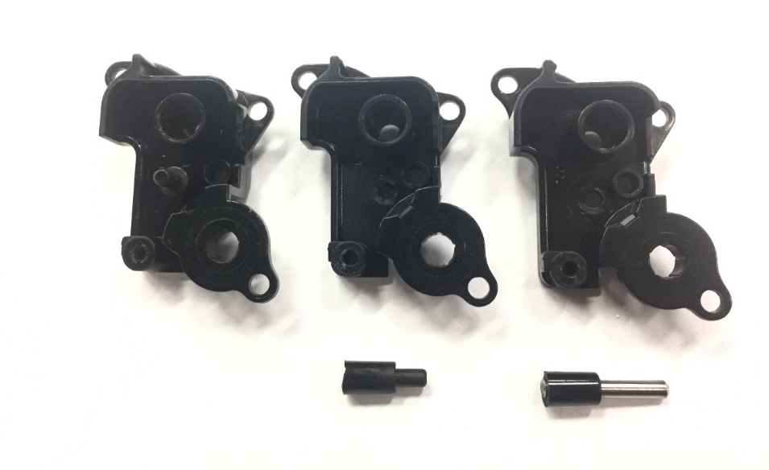
(C)
(A)
(B)
Figure 13. Depiction of Idler Post Failure with (A) Original Gear Face Plate Without Failure, (B) Original Gear Face Plate with Idler Post Failure, and (C) New Gear Face Plate With Idler Post Failure

D. Test 4: Final Design Assembly Test and Additional Testing
The fourth test was conducted with a combination of molded gears and a molded agitator shaft along with the block testing of all machined parts discussed previously. In order to attempt to isolate the load from the toner without the metal “T’s”, this test was also run with the metal fixture removed; a summary of the results can be seen in Table 3. Because this test utilized the entire developer unit loaded with toner as close to the real system as possible, an analysis of the failure modes for the system was conducted to define the new problems as technically as possible. It was found that the agitator shaft failure occurred at 140 mN-m ±38 mN-m and the idler post failure occurred at 127 mN-m ±35 mN-m. The load of the compact toner was determined to be above 174 mN-m; however, due to the multiple failure modes below this level of loading, the final load of the toner was never reached.
Table 3. Summary of Final Design Assembly Test Results with Metal Fixture Removed
Failure Mode | Failure Number | Average Torque (mN.m) | Standard Deviation
Gear Deflection | 1 | 90.4 | N/A
Idler Post | 3 | 139.8 | 37.6
Agitator Shaft | 3 | 127.4 | 34.9
Pseudo-Success | 1 | 99.7 | N/A

Two abnormal test runs revealed additional possibilities in the system. First, the engagement between the input gear and larger idler gear was lost during one run, leading to gear deflection failure. This was determined to have occurred due to the input gear being improperly assembled by not being locked onto the input shaft. Second, at a load of 99.7 mN-m in the new gear design and new paddle design system, the gears showed a large rotation indicating a success in stirring the toner. However, after about 90°, the rotation was halted because the outer surface of the output gear was caught on the inner surface of the larger gear of the compound idler gear; this was identified as an understood issue in gears as discussed earlier. This appeared to occur because the output gear’s deflection was decreasing rapidly as the load from the toner decreased, meaning that, without this surface interaction, this test would have been a success. Since this pseudo-success was not repeatable, it was determined that the toner had not been compacted enough.
Another observation made was in the described preloading of the system. As the load incrementally increased in the system, the visible end of the agitator shaft visibly engaged with the output gear would rotate along with the each of the gears within the gear train; a depiction of a load and angle measurement comparison can be seen in Figure 14. Similar to the second test, a rotation of between 90° and 150° was found to be a maximum rotation before shaft failure. However, this preloading rotation occurred incrementally and at higher loads compared to the second test. In attempting to understand this loading, the system was compared to a mass-spring system with multiple springs connected in parallel. A specific load, for example about 50 mN-m, was required to load the first spring to the point where the second spring would become loaded, and so on, leading to tiers of movement at higher loads. Different parts of the system that could be understood as spring resistances in the system were the rotation of the input shaft through the toner, the rotation of the paddle closest to the gear train, the rotation of the second paddle, and so on. This theory would need to be further tested in future work to determine its validity.

Figure 14. Example Rotational Loading Increments Used to Understand Preloading that Failed at 174 mN-m

VI. Conclusions
Overall, the objective to innovate the gear train such that the system would be able to accomplish ten startups with a resistive torque of up to 420 mN-m – where each startup was defined as ten complete revolutions of the agitator shaft – while maintaining the original functionality was not accomplished. The system was found to have three additional problems: the agitator shaft was found to shear at the point of stress concentration at a load 127 mN-m of torque ± 35 mN-m, the idler post was found to shear at the point that it connected to the gear face plate at a load of 140 mN-m of torque ± 38 mN-m, and the agitator shaft was shown to be deflecting to the point that it would interfere with the metal “T’s” fixture under a load of as low as 23 mN-m.
It was estimated that the change in paddle shape would reduce the maximum torque required to drive through the toner by about 10%. The load of the toner was defined to be greater than 174 mN-m, with the maximum load not reached. Furthermore, it was found that the machined gears were at least 27 % stronger than the original molded gears. With this increase in strength, the machined gears were not able to reach failure due to the new failure modes being very close behind the original gear failure mode presented – around 30 mN-m – so the impact of the gear design change was not directly determined. Finally, a preloading phenomenon was identified within the system.

VII. Future Work
Much work is needed to be done in order to solve this problem. First, the agitator shaft and idler post failure modes should be analyzed using a finite element analysis and eliminated by design. Finite element analysis is suggested because the complexity of the loading of this system is too high for traditional calculation methods to produce accurate results. Second, the interference with the metal “T’s” fixture must be eliminated to ensure that the agitator shaft does not experience an increased load. Third, the total load of compact toner should be determined and possibly reduced by design to accurately understand what the maximum load requirements in the system. Fourth, the change in the gear design should be further investigated with molded parts of the new gear design to be able to determine if the alteration to the design eliminated the gear failure mode. Finally, the preloading phenomenon could be further investigated and understood in order to allow for a new area of design space to be able to handle this extreme loading condition.

VIII. Appendices

Appendix A: Original Test Data
Test 1
Test 1 | Initial Weight (kg) | Final Weight (kg) | Initial Weight Time | Final Weight Time | Tester
Old Paddle 1 | 1.15 | 1.15 | 11:20 | 13:42 | JC
New Paddle 1 | 1.15 | 1.14 | 13:52 | 14:10 | JC
Old Paddle 2 | 1.15 | 1.14 | 9:34 | 10:33 | SG
New Paddle 2 | 1.15 | 1.14 | 15:23 | 16:21 | SG
Old Paddle 3 | 1.15 | 1.14 | 9:50 | 11:50 | KX
New Paddle 3 | 1.15 | 1.15 | 12:00 | 3:10 | KX
Old Paddle 4 | 1.15 | 1.15 | 11:55 | 14:15 | MM
New Paddle 4 | 1.15 | 1.14 | 11:28 | 13:35 | MM

Old Paddle 1:
Angle | Initial Movement Weight (g) | Initial Movement Position | Added Weight (For 30 degree rotation) (g) | Added Weight (mN) | Weight Position (for 30 degree rotation) | Weight Position (m) | Torque (mN-m) | Tester | Time of Test | Date of Test
0 | 70 | 3 | 80 | 784.8 | 3 | 0.0095 | 7.4556 | JC | 11:55 | 28-Oct
30 | 50 | 3 | 50 | 490.5 | 3 | 0.0095 | 4.65975 | JC | 12:03 | 28-Oct
60 | 70 | 3 | 100 | 981 | 2 | 0.007 | 6.867 | JC | 12:10 | 28-Oct
90 | 100 | 3 | 100 | 981 | 3 | 0.0095 | 9.3195 | JC | 12:15 | 28-Oct
120 | 70 | 3 | 90 | 882.9 | 2 | 0.007 | 6.1803 | JC | 12:21 | 28-Oct
150 | 50 | 3 | 60 | 588.6 | 3 | 0.0095 | 5.5917 | JC | 12:28 | 28-Oct
180 | 50 | 2 | 50 | 490.5 | 3 | 0.0095 | 4.65975 | JC | 12:32 | 28-Oct
210 | 110 | 3 | 100 | 981 | 3 | 0.0095 | 9.3195 | JC | 12:40 | 28-Oct
240 | 50 | 3 | 120 | 1177.2 | 3 | 0.0095 | 11.1834 | JC | 13:05 | 28-Oct
270 | 60 | 3 | 100 | 981 | 3 | 0.0095 | 9.3195 | JC | 12:51 | 28-Oct
300 | 80 | 3 | 100 | 981 | 3 | 0.0095 | 9.3195 | JC | 13:18 | 28-Oct
330 | 70 | 1 | 70 | 686.7 | 2 | 0.007 | 4.8069 | JC | 13:32 | 28-Oct
360 | 70 | 1 | 70 | 686.7 | 3 | 0.0095 | 6.52365 | JC

New Paddle 1:
Angle | Initial Movement Weight (g) | Initial Movement Position | Added Weight (For 30 degree rotation) (g) | Added Weight (mN) | Weight Position (for 30 degree rotation) | Weight Position (m) | Torque (mN-m) | Tester | Time of Test | Date of Test
0 | 50 | 3 | 60 | 588.6 | 3 | 0.0095 | 5.5917 | JC | 13:58 | 28-Oct
30 | 70 | 3 | 90 | 882.9 | 3 | 0.0095 | 8.38755 | JC | 14:09 | 28-Oct
60 | 60 | 3 | 110 | 1079.1 | 2 | 0.007 | 7.5537 | JC | 14:18 | 28-Oct
90 | 70 | 3 | 80 | 784.8 | 3 | 0.0095 | 7.4556 | JC | 14:25 | 28-Oct
120 | 60 | 2 | 60 | 588.6 | 3 | 0.0095 | 5.5917 | JC | 14:28 | 28-Oct
150 | 50 | 3 | 50 | 490.5 | 3 | 0.0095 | 4.65975 | JC | 14:32 | 28-Oct
180 | 60 | 2 | 60 | 588.6 | 3 | 0.0095 | 5.5917 | JC | 14:37 | 28-Oct
210 | 100 | 3 | 110 | 1079.1 | 3 | 0.0095 | 10.25145 | JC | 14:49 | 28-Oct
240 | 80 | 3 | 100 | 981 | 3 | 0.0095 | 9.3195 | JC | 14:43 | 28-Oct
270 | 50 | 3 | 60 | 588.6 | 3 | 0.0095 | 5.5917 | JC | 14:52 | 28-Oct
300 | 60 | 2 | 60 | 588.6 | 3 | 0.0095 | 5.5917 | JC | 14:55 | 28-Oct
330 | 50 | 3 | 60 | 588.6 | 3 | 0.0095 | 5.5917 | JC | 14:57 | 28-Oct
360 | 50 | 3 | 60 | 588.6 | 3 | 0.0095 | 5.5917 | JC | 15:05 | 28-Oct

Old Paddle 2:
Angle | Initial Movement Weight (g) | Initial Movement Position | Added Weight (For 30 degree rotation) (g) | Added Weight (mN) | Weight Position (for 30 degree rotation) | Weight Position (m) | Torque (mN-m) | Tester | Time of Test | Date of Test
0 | 50 | 2 | 60 | 588.6 | 3 | 0.0095 | 5.5917 | SG | 9:34 | 3-Nov
30 | 60 | 3 | 120 | 1177.2 | 3 | 0.0095 | 11.1834 | SG | 9:39 | 3-Nov
60 | 70 | 3 | 100 | 981 | 3 | 0.0095 | 9.3195 | SG | 9:43 | 3-Nov
90 | 90 | 3 | 110 | 1079.1 | 3 | 0.0095 | 10.25145 | SG | 9:47 | 3-Nov
120 | 90 | 3 | 100 | 981 | 3 | 0.0095 | 9.3195 | SG | 9:52 | 3-Nov
150 | 60 | 3 | 90 | 882.9 | 3 | 0.0095 | 8.38755 | SG | 9:56 | 3-Nov
180 | 70 | 3 | 100 | 981 | 3 | 0.0095 | 9.3195 | SG | 10:00 | 3-Nov
210 | 80 | 3 | 110 | 1079.1 | 3 | 0.0095 | 10.25145 | SG | 10:05 | 3-Nov
240 | 80 | 3 | 120 | 1177.2 | 3 | 0.0095 | 11.1834 | SG | 10:13 | 3-Nov
270 | 70 | 3 | 110 | 1079.1 | 3 | 0.0095 | 10.25145 | SG | 10:18 | 3-Nov
300 | 70 | 3 | 90 | 882.9 | 3 | 0.0095 | 8.38755 | SG | 10:21 | 3-Nov
330 | 80 | 3 | 120 | 1177.2 | 3 | 0.0095 | 11.1834 | SG | 10:28 | 3-Nov
360 | 50 | 2 | 60 | 588.6 | 3 | 0.0095 | 5.5917 | SG | 10:33 | 3-Nov

New Paddle 2:
Angle | Initial Movement Weight (g) | Initial Movement Position | Added Weight (For 30 degree rotation) (g) | Added Weight (mN) | Weight Position (for 30 degree rotation) | Weight Position (m) | Torque (mN-m) | Tester | Time of Test | Date of Test
0 | 80 | 2 | 50 | 490.5 | 3 | 0.0095 | 4.65975 | SG | 15:28 | 29-Oct
30 | 70 | 3 | 80 | 784.8 | 3 | 0.0095 | 7.4556 | SG | 15:33 | 29-Oct
60 | 50 | 2 | 80 | 784.8 | 3 | 0.0095 | 7.4556 | SG | 15:37 | 29-Oct
90 | 70 | 3 | 80 | 784.8 | 3 | 0.0095 | 7.4556 | SG | 15:42 | 29-Oct
120 | 70 | 3 | 100 | 981 | 3 | 0.0095 | 9.3195 | SG | 15:45 | 29-Oct
150 | 50 | 2 | 70 | 686.7 | 3 | 0.0095 | 6.52365 | SG | 15:49 | 29-Oct
180 | 50 | 3 | 60 | 588.6 | 3 | 0.0095 | 5.5917 | SG | 15:54 | 29-Oct
210 | 70 | 3 | 80 | 784.8 | 3 | 0.0095 | 7.4556 | SG | 15:57 | 29-Oct
240 | 90 | 2 | 100 | 981 | 3 | 0.0095 | 9.3195 | SG | 16:02 | 29-Oct
270 | 50 | 3 | 60 | 588.6 | 3 | 0.0095 | 5.5917 | SG | 16:06 | 29-Oct
300 | 50 | 3 | 60 | 588.6 | 3 | 0.0095 | 5.5917 | SG | 16:10 | 29-Oct
330 | 60 | 2 | 70 | 686.7 | 3 | 0.0095 | 6.52365 | SG | 16:14 | 29-Oct
360 | 50 | 2 | 50 | 490.5 | 3 | 0.0095 | 4.65975 | SG | 16:19 | 29-Oct

Old Paddle 3:
Angle | Initial Movement Weight (g) | Initial Movement Position | Added Weight (For 30 degree rotation) (g) | Added Weight (mN) | Weight Position (for 30 degree rotation) | Weight Position (m) | Torque (mN-m) | Tester | Time of Test | Date of Test
0 | 50 | 3 | 90 | 882.9 | 3 | 0.0095 | 8.38755 | KX | 10:04 | 31-Oct
30 | 70 | 3 | 120 | 1177.2 | 3 | 0.0095 | 11.1834 | KX | 10:12 | 31-Oct
60 | 70 | 3 | 150 | 1471.5 | 3 | 0.0095 | 13.97925 | KX | 10:36 | 31-Oct
90 | 120 | 2 | 160 | 1569.6 | 3 | 0.0095 | 14.9112 | KX | 10:48 | 31-Oct
120 | 50 | 3 | 70 | 686.7 | 3 | 0.0095 | 6.52365 | KX | 10:57 | 31-Oct
150 | 80 | 3 | 100 | 981 | 3 | 0.0095 | 9.3195 | KX | 11:02 | 31-Oct
180 | 70 | 3 | 140 | 1373.4 | 3 | 0.0095 | 13.0473 | KX | 11:11 | 31-Oct
210 | 60 | 2 | 80 | 784.8 | 3 | 0.0095 | 7.4556 | KX | 11:20 | 31-Oct
240 | 80 | 2 | 120 | 1177.2 | 2 | 0.007 | 8.2404 | KX | 11:26 | 31-Oct
270 | 70 | 2 | 100 | 981 | 3 | 0.0095 | 9.3195 | KX | 11:32 | 31-Oct
300 | 70 | 3 | 120 | 1177.2 | 3 | 0.0095 | 11.1834 | KX | 11:28 | 31-Oct
330 | 50 | 3 | 70 | 686.7 | 3 | 0.0095 | 6.52365 | KX | 11:43 | 31-Oct
360 | 50 | 3 | 100 | 981 | 3 | 0.0095 | 9.3195 | KX | 11:48 | 31-Oct

Comments: at 30 degrees, tested multiple times, but still very high

New Paddle 3:
Angle | Initial Movement Weight (g) | Initial Movement Position | Added Weight (For 30 degree rotation) (g) | Added Weight (mN) | Weight Position (for 30 degree rotation) | Weight Position (m) | Torque (mN-m) | Tester | Time of Test | Date of Test
0 | 50 | 3 | 70 | 686.7 | 3 | 0.0095 | 6.52365 | KX | 12:08 | 1-Nov
30 | 50 | 3 | 90 | 882.9 | 3 | 0.0095 | 8.38755 | KX | 12:12 | 1-Nov
60 | 70 | 2 | 110 | 1079.1 | 3 | 0.0095 | 10.25145 | KX | 12:19 | 1-Nov
90 | 70 | 3 | 120 | 1177.2 | 3 | 0.0095 | 11.1834 | KX | 12:26 | 1-Nov
120 | 80 | 3 | 110 | 1079.1 | 3 | 0.0095 | 10.25145 | KX | 12:31 | 1-Nov
150 | 70 | 2 | 130 | 1275.3 | 3 | 0.0095 | 12.11535 | KX | 12:36 | 1-Nov
180 | 70 | 3 | 120 | 1177.2 | 3 | 0.0095 | 11.1834 | KX | 12:41 | 1-Nov
210 | 70 | 3 | 120 | 1177.2 | 3 | 0.0095 | 11.1834 | KX | 12:46 | 1-Nov
240 | 90 | 3 | 130 | 1275.3 | 3 | 0.0095 | 12.11535 | KX | 12:50 | 1-Nov
270 | 100 | 3 | 140 | 1373.4 | 3 | 0.0095 | 13.0473 | KX | 12:54 | 1-Nov
300 | 50 | 3 | 70 | 686.7 | 3 | 0.0095 | 6.52365 | KX | 12:59 | 1-Nov
330 | 50 | 3 | 70 | 686.7 | 3 | 0.0095 | 6.52365 | KX | 13:02 | 1-Nov
360 | 50 | 3 | 80 | 784.8 | 3 | 0.0095 | 7.4556 | KX | 13:07 | 1-Nov

Old Paddle 4:
Angle | Initial Movement Weight (g) | Initial Movement Position | Added Weight (For 30 degree rotation) (g) | Added Weight (mN) | Weight Position (for 30 degree rotation) | Weight Position (m) | Torque (mN-m) | Tester | Time of Test | Date of Test
0 |  |  | 60 | 588.6 | 3 | 0.0095 | 5.5917 | MM | 12:11 | 1-Nov
30 | 50 | 3 | 70 | 686.7 | 3 | 0.0095 | 6.52365 | MM | 12:19 | 1-Nov
60 | 50 | 3 | 90 | 882.9 | 3 | 0.0095 | 8.38755 | MM | 12:27 | 1-Nov
90 | 70 | 3 | 140 | 1373.4 | 3 | 0.0095 | 13.0473 | MM | 12:38 | 1-Nov
120 |  |  | 120 | 1177.2 | 3 | 0.0095 | 11.1834 | MM | 12:46 | 1-Nov
150 | 60 | 3 | 90 | 882.9 | 3 | 0.0095 | 8.38755 | MM | 12:55 | 1-Nov
180 | 60 | 3 | 90 | 882.9 | 3 | 0.0095 | 8.38755 | MM | 13:05 | 1-Nov
210 | 50 | 3 | 90 | 882.9 | 3 | 0.0095 | 8.38755 | MM | 13:13 | 1-Nov
240 | 50 | 3 | 120 | 1177.2 | 3 | 0.0095 | 11.1834 | MM | 13:31 | 1-Nov
270 |  |  | 130 | 1275.3 | 3 | 0.0095 | 12.11535 | MM | 13:45 | 1-Nov
300 |  |  | 120 | 1177.2 | 3 | 0.0095 | 11.1834 | MM | 13:56 | 1-Nov
330 |  |  | 60 | 588.6 | 3 | 0.0095 | 5.5917 | MM | 14:02 | 1-Nov
360 | 50 | 3 | 70 | 686.7 | 3 | 0.0095 | 6.52365 | MM | 14:10 | 1-Nov

Comments: at 0 degrees, no initial movement; at 120 degrees, no initial movement; at 270 degrees, no initial movement; at 300 degrees, no initial movement; at 330 degrees, no initial movement.

New Paddle 4:
Angle | Initial Movement Weight (g) | Initial Movement Position | Added Weight (For 30 degree rotation) (g) | Added Weight (mN) | Weight Position (for 30 degree rotation) | Weight Position (m) | Torque (mN-m) | Tester | Time of Test | Date of Test
0 | 50 | 3 | 100 | 981 | 3 | 0.0095 | 9.3195 | MM | 11:54 | 3-Nov
30 | 50 | 3 | 120 | 1177.2 | 3 | 0.0095 | 11.1834 | MM | 12:04 | 3-Nov
60 | 50 | 3 | 110 | 1079.1 | 3 | 0.0095 | 10.25145 | MM | 12:12 | 3-Nov
90 | 50 | 3 | 110 | 1079.1 | 3 | 0.0095 | 10.25145 | MM | 12:20 | 3-Nov
120 | 70 | 3 | 90 | 882.9 | 3 | 0.0095 | 8.38755 | MM | 12:27 | 3-Nov
150 | 50 | 3 | 70 | 686.7 | 3 | 0.0095 | 6.52365 | MM | 12:34 | 3-Nov
180 | 50 | 2 | 80 | 784.8 | 3 | 0.0095 | 7.4556 | MM | 12:44 | 3-Nov
210 | 70 | 2 | 100 | 981 | 3 | 0.0095 | 9.3195 | MM | 12:52 | 3-Nov
240 | 80 | 3 | 110 | 1079.1 | 3 | 0.0095 | 10.25145 | MM | 13:07 | 3-Nov
270 |  |  | 100 | 981 | 3 | 0.0095 | 9.3195 | MM | 13:16 | 3-Nov
300 | 50 | 3 | 60 | 588.6 | 3 | 0.0095 | 5.5917 | MM | 13:20 | 3-Nov
330 | 50 | 3 | 60 | 588.6 | 3 | 0.0095 | 5.5917 | MM | 13:24 | 3-Nov
360 | 50 | 3 | 90 | 882.9 | 3 | 0.0095 | 8.38755 | MM | 13:30 | 3-Nov

Test 2
Test 2 | Load (g) | Failure | Time of Test
Molded Gear | 1050 | Gear Disengagement | 14-Nov
Old Gear | 1090 | Broken Agitator Shaft | 14-Nov
New Gear | 1110 | Broken Agitator Shaft | 14-Nov
Old Gear +Steel Shaft | 500
 | 1740 | Broken Idler Post | 21-Nov
New Gear +Steel Shaft | 500
 | 2100 | No Failure, Ran out of weights

Tested System | Failure Torque (mN-m) | Failure Mode
Molded Gears | 98 | Gear Disengagement
Old Design Machined Gears + Agitator Shaft | 102 | Broken Agitator Shaft
New Design Machined Gears + Agitator Shaft | 103 | Broken Agitator Shaft
Old Design Machined Gears + Steel Shaft | 162 | Broken Idler Post
Old Design Machined Gear + Steel Shaft | 196 | No Failure, Ran out of weights

Test 3
Test 3 | Load (g) | Failure | Time of Test
Old Gear | 500 |  | 18-Nov
 | 600
 | 1000
 | 1350 | Big Deflection
 | 1950 | Broken Post
Old Gear | 500
 | 2100 | No failure, ran out of weights
New Gear | 500
 | 1300
 | 1700 | Broken Post
New Gear | 500
 | 1900
 | 2100 | No failure, ran out of weights

Test 4
Test 4, No T’s | Load (g) | Torque (mN-m) | Movement | Angle
New Paddle (2), New Gears (1) | 150 | 13.97925 | Slight | 30˚
 | 250 | 23.299 | Slight
Time of Test/Tester | 300 | 27.959
16:05 Nov-16, JC | 350 | 32.618 | Slight
 | 400 | 37.278 | Slight
Failure | 450 | 41.938 | Big
Teeth cogging, Success | 500 | 46.598 | Slight
Teeth cogging, Success | 590 | 54.985 | Slight
 | 650 | 60.577 | Slight
 | 670 | 62.441 | Slight
 | 700 | 65.237 | Slight
 | 830 | 77.352 | Big
 | 1070 | 99.719

Test 4, No T’s | Load (g) | Torque (mN-m) | Movement | Angle
Old Paddle (2), Old Gears (2) | 750 | 69.896 | Slight | 90°
 | 890 | 82.944 | Slight
Time of Test/ Tester | 900 | 83.876 | Big
16:30 Nov-16, JC | 1000 | 93.195 | Slight
 | 1070 | 99.719 | Slight
Failure | 1220 | 113.698 | Big
Idler Post Broke | 1560 | 145.384 | Big | 120˚

Test 4, No T’s | Load (g) | Torque (mN-m) | Movement | Angle
New Paddle (2), Old Gears (3) | 450 | 41.938 | Slight | 30˚
 | 500 | 46.598 | Slight
Time of Test/Tester | 520 | 48.461 | Slight
17:18 Nov-16, KX | 600 | 55.917 | Slight
 | 700 | 65.237 | Slight
Failure | 820 | 76.420 | Slight
Agitator Shaft Broke | 930 | 86.671 | Slight
 | 1100 | 102.515 | Slight
 | 1150 | 107.174 | Slight | 120˚
 | 1270 | 118.358

Test 4, No T’s | Load (g) | Torque (mN-m) | Movement | Angle
Old Paddle (2), New Gears (2) | 300 | 27.959 | Slight | 30˚
 | 400 | 37.278 | Slight
Time of Test/Tester | 500 | 46.598 | Slight
17:40 Nov-16, KX | 520 | 48.461 | Slight
 | 670 | 62.441 | Slight | 40˚
Failure | 780 | 72.692 | Slight
Agitator Shaft Broke | 820 | 76.420 | Slight | 60˚
 | 1050 | 97.855 |  | 100˚

Test 4, No T’s | Load (g) | Torque (mN-m) | Movement | Angle
New Paddle, New Gears | 200 | 18.639 | Slight, Transition from 100g to 200g | 270˚
 | 300 | 27.959 | Slight
Time of Test/Tester | 400 | 37.278 | Slight, Transition from 300g to 400g
10:35 Nov-22, SG | 450 | 41.938 | Slight
 | 500 | 46.598 | Hairline Movement
Failure | 590 | 54.985 | Big | 290˚
Post Broke and Idler Flew Off | 790 | 73.624 | Big | 320˚
Post Broke and Idler Flew Off | 880 | 82.012 | Big | 340˚
 | 1000 | 93.195 | Hairline Movement
 | 1020 | 95.059 | Hairline Movement
 | 1090 | 101.583 |  | 25˚
 | 1100 | 102.515 | Big | 45˚
 | 1300 | 121.154 | Slight
 | 1340 | 124.881 | Big | 75˚
 | 1470 | 136.997 | Slight
 | 1480 | 137.929 | Hairline Movement
 | 1570 | 146.316 | Big | 100˚
 | 1740 | 162.159 | Noise Made
 | 1800 | 167.751 | Slight
 | 1870 | 174.275

Test 4, No T’s | Load (g) | Torque (mN-m) | Movement | Angle | The input gear was put back on and tried to add weight again. Gear popped and turned
New Paddle (1), New Gears (1) | 250 | 23.299 | Slight | 270˚
 | 800 | 74.556 | Slight |  | Determined there was enough deflection and labeled it as a failure. Test was repeated.
Time of Test/Tester | 950 | 88.535 | Flinch
19:14 Nov-16, SG | 1000 | 93.195 | Slight
 | 1100 | 102.515 | Slight
Failure | 1110 | 103.446
Input gear started spinning on its own and flew off

Test 4, No T’s | Load (g) | Torque (mN-m) | Movement | Angle
Old Paddle (3), New Gears (3) | 450 | 41.938 | Slight | 250˚
 | 520 | 48.461 | Big | 270˚
Time of Test/Tester | 550 | 51.257 | Big | 290˚
19:42 Nov-16, SG | 590 | 54.985 | Slight
 | 660 | 61.509 | Slight
Failure | 580 | 54.053 | Big | 300˚
Deflected to make the idler and input gear separate and spin | 720 | 67.100 | Slight
Deflected to make the idler and input gear separate and spin | 790 | 73.624 | Slight
 | 870 | 81.080 | Noise
 | 970 | 90.399

Test 4, No T’s | Load (g) | Torque (mN-m) | Movement | Angle
New Paddle (3), Old Gears (2) | 250 | 23.299 | Slight | 30˚
 | 300 | 27.959 | Slight
Time of Test/Tester | 500 | 46.598 | Slight
20:24 Nov-16, SG | 530 | 49.393 | Hairline Movement
 | 600 | 55.917 | Slight
Failure | 630 | 58.713 | Slight
Deflection and Broken Shaft | 1190 | 110.902 | Slight
Deflection and Broken Shaft | 1220 | 113.698 | Big | 50˚
 | 1290 | 120.222 | Slight
 | 1340 | 124.881 | Slight
 | 1420 | 132.337 | Slight
 | 1490 | 138.861 | Slight
 | 1750 | 163.091 | Slight
 | 1780 | 165.887

Test 4, No T’s | Load (g) | Torque (mN-m) | Movement | Angle
Old Paddle (3), Old Gears (3) | 300 | 27.959 | Slight | 0˚
 | 350 | 32.618 | Slight
Time of Test/Tester | 400 | 37.278 | Slight
20:55 Nov-16, SG | 450 | 41.938 | Big | 10˚
 | 500 | 46.598 | Big | 20°
Failure | 550 | 51.257 | Slight
Idler Post Broke | 590 | 54.985 | Slight
 | 630 | 58.713 | Slight
 | 700 | 65.237 | Slight
 | 840 | 78.284 | Slight
 | 1000 | 93.195 | Slight, but gears popped when unloading to place the 1kg weight
 | 1070 | 99.719

Appendix B: Gantt Chart Comparison

Theoretical Gantt Chart

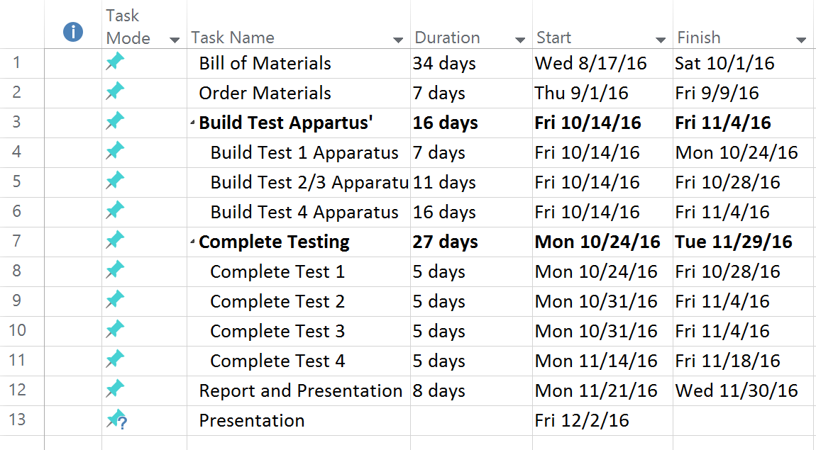

Actual Gantt Chart

