Scope and Influence of Enhanced Triazine Degradation in U.S. Soils

A Dissertation Presented for the

Doctor of Philosophy

Degree

The University of Tennessee, Knoxville

Ethan Trent Parker

May 2017

DEDICATION

This manuscript is dedicated to my wife, Rachel, and daughter, Henley, whom I love with all I have.

ACKNOWLEDGEMENTS

I want to first thank my Lord and Savior Jesus Christ. Without the transforming power of the gospel, and His presence as the cornerstone of all I do, all my work would be in vain.
I am also forever indebted to my wife, Rachel. She has been such an inspiration to me through my graduate career and her kind spirit and unwavering support is always a comfort when school and work are especially demanding. I am thankful to my parents and all my family for their upbringing and support in everything I have done. I am also grateful to my friends, coworkers, and church family for their companionship in both work and life.
Finally, I am very appreciative of all that Dr. Tom Mueller has done for me. He was the man who believed in me and assisted me in becoming a successful graduate student. His guidance has helped by shaping me for a successful career in research. Finally, I am thankful to my graduate committee for their allowing me to share in their vast knowledge of our field and also guiding me through my time as a student at The University of Tennessee.

ABSTRACT

The triazines are one of the most widely used herbicide classes ever developed, and play a role in managing herbicide-resistant weed populations in sustainable agricultural production systems. The triazines are traditionally valued for their persistence and season-long weed control in over 50 crops including corn, soybeans, wheat, and vegetables. The literature suggests that atrazine, the most widely used triazine, may no longer remain persistent in soils due to enhanced microbial degradation. Experiments examined the rate of degradation of atrazine and two other triazine herbicides: simazine and metribuzin in both atrazine adapted and non-adapted soils from across the United States. Additional studies examined the rate of atrazine dissipation in flooded and non-flooded soils, as well as soils with varying history of atrazine use. In soils with a history of atrazine use, the t_{1/2} [half-life] of atrazine was up to 40 times more rapid than in soils with no history of atrazine use. Simazine t_{1/2} was at least 2.4-15 times more rapid in history soils than non-history soils, and metribuzin was degraded at 0.6, 0.9, and 1.9 times the rate in the same soils. These results indicate cross-enhancement of the symmetrical triazine simazine, but not for metribuzin, an asymmetrical triazine. In soils with 3, 5, and 10 years of previous atrazine use, atrazine t_{1/2} was 2.66, 4.44, and 2.14 respectively, indicating that atrazine adapted soils may develop rapidly. Finally, atrazine dissipation in flooded and non-flooded soils appears rapid, indicating that soybeans are a viable option when replanting production con fields previously treated with atrazine.

TABLE OF CONTENTS

PROPOSAL 1
Introduction 1
Objectives and Hypotheses 4
Materials and Methods 5
Literature Cited 7
CHAPTER I Enhanced Atrazine Degradation is Widespread Across the United States 10
Abstract 13
Introduction 14
Materials and Methods 15
Results 18
Discussion 19
Literature Cited 24
Appendix 29
CHAPTER II Evolution of Atrazine Adapted Soils is Rapid 37
Abstract 38
Introduction 40
Materials and Methods 41
Results and Discussion 43
Literature Cited 47
Appendix 50
CHAPTER III Enhanced Degradation of Simazine and Metribuzin 57
Abstract 58
Introduction 60
Materials and Methods 62
Results and Discussion 64
Literature Cited 67
Appendix 72
CHAPTER IV Atrazine Behavior in Flooded and Non-Flooded Soils and Its Effect on Soybean Injury and Yield 80
Abstract 81
Introduction 82
Materials and Methods 83
Results and Discussion 85
Literature Cited 88
Appendix 92
CHAPTER V Atrazine Dissipation Bioassay in Three Midwestern Soils 94
Abstract 95
Introduction 97
Materials and Methods 97
Results and Discussion 99
Literature Cited 101
Appendix 103
CONCLUSION 105
VITA 108
LIST OF TABLES

Table 1. Correlation and p values of soil parameters. 29
Table 2: Atrazine t_{1/2}, soil enhancement factors (EF), and other soil variables.……........30
Table 3. Locations and half-lives of all soil samples analyzed. 50
Table 4: Regression equations, coefficients, and R² values of atrazine and metabolites 51
Table 5. Atrazine half-lives in fortified soils of various exposure. 50
Table 6: LC-MS methods for metribuzin and simazine 72
Table 7. Locations and half-lives of soil samples analyzed. 73
Table 8: Atrazine dose and measured concentration, soybean injury, and yield from a field site in Knoxville, TN in 2012 92
Table 9. Atrazine dose and measured concentration, soybean injury, and yield from a field site in Knoxville, TN in 2014. 93
Table 10: Cucumber and soybean germination counts and visual injury ratings 104
Table 11. Cucumber and soybean combined aboveground biomass. 105

LIST OF FIGURES

Figure 1. A map showing locations where soil samples were collected. 34
Figure 2. A map showing locations receiving 5+ consecutive years of atrazine treatment. 35
Figure 3. A map showing locations receiving no atrazine treatment the previous 10+ years. 36
Figure 4. Exponential decay of atrazine concentration as a function of years of atrazine exposure. 53
Figure 5. Pattern of degradation of atrazine, deethylatrazine, deisopropylatrazine, and hydroxyatrazine. 55
Figure 6. Exponential decay of atrazine concentration as a function of atrazine history. 74
Figure 7. Exponential decay of simazine concentration as a function of atrazine history. 76
Figure 8. Exponential decay of metribuzin concentration as a function of atrazine history. 78

PROPOSAL
Introduction
The triazine herbicides are undoubtedly one of the most important classes of agricultural chemicals ever developed. Since their initial introduction over 60 years ago, the triazines have been a vital component of weed control programs in more than 50 crops worldwide including corn, soybeans, and small grains. The selectivity of these herbicides along with their soil persistence helped pave the way for no-till sustainable agriculture in North America, and also contributed to the rise in crop yields in the past half century (Lebaron et al., 2008). The triazines also have a flexible range of application timings from PRE to POST, and may also be tank mixed with a variety of other herbicides to ensure broad spectrum weed control (Shaner, 2014). Triazines act as photosystem II inhibitors and have been used PRE to aid in the management of herbicide resistant weeds in recent years, proving that this herbicide family is as important today as it was decades ago. Scrutiny over the environmental fate of the triazines, particularly atrazine, has made many question their registration status (Barbash et al., 2001; Belluck et al., 1991; Dabrowski et al., 2014; Hayes et al., 2002; Hayes et al., 2010). As a result, atrazine is no longer sold in the European Union, and is often the subject of special investigations by the EPA and other organizations. Many studies involving triazine risks to the environment have been heavily challenged, resulting in their continued use worldwide.
The discovery and initial development of the triazine herbicides took place from the 1950s to 70s in the labs of J.R. Geigy, Ltd. These compounds were built around a triazine ring since it had previously been shown to offer weed control potential. The triazine herbicides work to inhibit photosystem II within organisms with oxygen-evolving complexes (including plants) by displacing plastoquinone from a specific binding site on the D1 protein subunit which is encoded on the psbA gene. By shutting down the flow of electrons within the plant, the triazines result in eventual plant death. Of the early triazines, simazine (now marketed as Princep® and several others) was the first to be registered in the United States in 1957, with atrazine following shortly thereafter in 1958 (Lebaron et al., 2008). The original registrations for the early triazines such as atrazine and simazine listed control of broadleaf weeds in non-crop areas and corn. There are now more than 15 triazines (including triazinones) labeled for use in more than 50 crops and controlling countless weed species. The widespread use of these triazines is likely a result of their selectivity, flexibility of use, as well as their persistence in soils. This persistence allows one or two applications to provide season-long weed control of many otherwise difficult to control weeds such as Palmer amaranth (Amaranthus palmeri), kochia (Kochia scoparia), and the morningglories (Ipomoea sp.). This makes the triazines an important part of modern production agriculture as they are a vital tool in combatting the rise of herbicide-resistant weeds (Norsworthy et al., 2008).
Along with arguments for the importance of triazines, and despite the numerous studies confirming the safety of the triazines, many critics have also worked to illuminate the risks involved with widespread use of the triazines, namely atrazine. Early in the twentieth century, published studies concerning the effect of atrazine on the reproductive development of frogs were a major point of focus for the EPA (Hayes et al., 2002; Hayes et al., 2010). Since atrazine has been so heavily used in the Mississippi River watershed, new concerns were raised about levels of chronic exposure to triazines and their subsequent health effects on humans and other organisms. Despite numerous studies on the effects of atrazine found in surface water, the amounts detected were not shown to pose a human health risk, or disruption of aquatic ecosystems in the Mississippi River basin (Soloman et al., 1996). With the addition of early reports of atrazine degradation by numerous microbial species, it appears that atrazine comes with far more benefits than risks (Mandelbaum et al., 1995; Radosevich et al., 1995).
Beginning in the 1960s, it was recognized that triazines were degraded by microbes as well as by photolysis and hydrolysis (Armstrong et al., 1967; Skipper et al., 1967). As early as 1963, it was known that soil microorganisms were capable of degrading simazine in a number of soils (Kaufman et al., 1963). In the mid-1990s, the classification of a number of triazine-degrading bacteria began to surge (Mandelbaum et al., 1995; Radosevich et al., 1995). Anecdotal reports about the reduction of triazine persistence continued through the late 1990s and early 2000s, but in the last decade have again risen to the forefront of research efforts.
With the waning of the glyphosate era, it seems that enhanced atrazine degradation is again in the spotlight. Studies by (Krutz et al., 2010a; Krutz et al., 2010b; Shaner and Henry, 2007; Shaner et al., 2007) have shown enhanced triazine degradation in Colorado and Mississippi. It is likely that reduced residual weed control of the triazines was simply covered up by the introduction of broad spectrum weed control with glyphosate. As glyphosate resistance has increased in the last decade, producers are more likely to notice that the triazines are not controlling weeds as long as they remember. This could also be due to producers and researchers having higher expectations for the triazines after experiencing the remarkable weed control provided by glyphosate. Regardless of the mechanism, it is clear that in many parts of the U.S., producers are going to need to rely on multiple modes of action, including the triazines, to manage herbicide-resistant weeds. It is important to understand not only the breadth of enhanced triazine degradation, but also the practical implications that this phenomenon holds for sustainable production agriculture in the future.

Objectives and Hypotheses
A diversity of studies were designed to address questions regarding triazine degradation in soils. The focus is primarily on the phenomenon known as enhanced triazine degradation – a process by which the repeated application of triazines builds up populations of microorganisms capable of more rapid degradation of the herbicides, thereby, impeding the ability of triazines to provide residual weed control. Soils with this characteristic degradation are referred to as ‘triazine-adapted soils’ (Krutz et al., 2009; Krutz et al., 2008; Zablotowicz et al., 2007 ). The aim of the first study is to determine how widespread atrazine (a triazine) degradation is across the United States by sampling soils from 16 states. The next study will utilize similar methods to quantify atrazine metabolites in the soil and answer the question of how many repeat applications of atrazine are required before enhanced degradation is observed. A third study will sample soils from three states to determine if simazine and metribuzin (other triazines) are more rapidly degraded in triazine adapted soils. A final study will attempt to analyze the dissipation of atrazine in flooded soils.
Our hypothesis in regard to the first study is that enhanced atrazine degradation will be widespread across all states tested, primarily due to the large quantities of atrazine used in those regions. For the second study, we propose that enhanced atrazine degradation will occur after only one or two prior applications of atrazine are made. We hypothesize that simazine will degrade more rapidly in adapted soils due to a similar chemical structure to atrazine, while metribuzin will not be degraded more rapidly due to the difference in the position of nitrogen within the triazine ring.

Materials and Methods
Laboratory experiments will be conducted in the Weed Science Lab located in the Plant Biotechnology Building at the University of Tennessee, Knoxville. Field experiments will be conducted at the East Tennessee Research and Education Center (ETREC) located in Knoxville, Tennessee. Results from all studies will be collected and analyzed using Statistical Analysis Systems (SAS) and Sigmaplot 13.2
The first project will examine soil from fields with either 0 or 5 or more continuous years of atrazine (ATZ) use. The objective of the study is to determine if enhanced ATZ degradation is a widespread phenomenon.
The factor of interest is the microbial population and activity in the soil, so the guiding principle for the sampling process is to maintain microbial populations. Field cooperators throughout the corn-growing regions of the U.S. will be asked to collect soil samples. The field selection criteria involves collecting soil specifically from producer’s fields. Two types of soil samples will be requested. The paired field sites have either continuous ATZ use in the previous five years (denoted as “history” soil), or no ATZ use in the previous 10 to 20 years (denoted as “no-history”). The soil sample collection procedure will involve standardized forms for all cooperators and a chain of custody to be maintained through the entire sample collection, shipping, processing, and lab analysis. Soil samples from the field cooperators will be dried and shipped to MidWest Labs in Omaha, Nebraska for characterization of various soil parameters, including nutrient levels, OM, and texture.
A portion of each soil sample (~ 400 g) will be saturated and drained to simulate field capacity prior to beginning the experiment. To conduct the assay 5 grams of each soil will be placed into 20-mL glass vials (16 for each soil) for later ATZ fortification.
The lab assay methods to be used are adapted from (Mueller et al., 2010). Soils will be fortified with a field rate of ATZ and allowed to equilibrate. Samples will be placed into a freezer at -1, 0, 3, 7, 14, 21, 28 and 42 DAT (days after treatment). Samples within an experiment will be analyzed by adding methanol, shaking, filtration, and analysis via LC-MS. Once the concentration of each sample is determined, the ATZ concentration in µg kg⁻¹ will be regressed against DAT using first-order kinetics by Sigmaplot v12.5. A first-order rate constant will be determined and a half-life in days (t_{1/2}) will be calculated using the equation 0.693/k = t_{1/2.} ATZ history soils will be compared to those with no previous ATZ history.
The second project will utilize the same methods previously described on soils from three states, and with atrazine use histories of 0, 3, 5, and 10 years in order to determine the speed at which adapted soils develop. ATZ metabolites will also be examined to determine the process by which ATZ is being degraded.
Similarly, the third experiment will utilize the same methods as previously described, with the exception that simazine and metribuzin analytical standards will be degraded and quantified. The aim here is to compare atrazine degradation to that of simazine and metribuzin in adapted soils.
The fourth experiment will aim to determine the effect of flooding on the dissipation of atrazine in soils. A 2x3 factorial split-plot design will be used with two levels of flooding (flooded and not flooded) with three atrazine rates (0, 2.2, and 4.5 kg/ha). Berms will be built to contain the water for the flooding treatments for 5 days, and all plots will receive 2.5 cm via irrigation to activate atrazine applications. After the berms have been removed, soybeans will be planted into all plots and crop injury, yield, and soil concentration of atrazine will be measured.

Literature Cited
Armstrong DE, Chesters G, Harris RF (1967) Atrazine Hydrolysis in Soil. Soil Science Society of America Journal 31:61-66
Barbash JE, Thelin GP, Kolpin DW, Gilliom RJ (2001) Major herbicides in ground water: results from the National Water-Quality Assessment. Journal of environmental quality 30:831-45
Belluck DA, Benjamin SL, Dawson T (1991) Groundwater contamination by atrazine and its metabolites. Pesticide Transformation Products: Fate and Significance in the Environment 459:254-273
Dabrowski JM, Shadung JM, Wepener V (2014) Prioritizing agricultural pesticides used in South Africa based on their environmental mobility and potential human health effects. Environment International 62:31-40
Hayes T, Haston K, Tsui M, Hoang A, Haeffele C, Vonk A (2002) Atrazine-Induced Hermaphroditism at 0.1 ppb in American Leopard Frogs (Rana pipiens): Laboratory and Field Evidence. Environmental Health Perspectives 111:568-575
Hayes TB, Khoury V, Narayan A, Nazir M, Park A, Brown T, Adame L, Chan E, Buchholz D, Stueve T, Gallipeau S (2010) Atrazine induces complete feminization and chemical castration in male African clawed frogs (Xenopus laevis). Proceedings of the National Academy of Sciences 107:4612-4617
Kaufman DD, Kearney PC, Sheets TJ (1963) Simazine: Degradation by Soil Microorganisms. Science 142:405-406
Krutz JL, Shaner DL, Weaver Ma, Webb RM, Zablotowicz RM, Reddy KN, Huang Y, Thomson SJ (2010a) Agronomic and environmental implications of enhanced s-triazine degradation. Pest Management Science 66:461-481
Krutz LJ, Burke IC, Reddy KN, Zablotowicz RM, Price AJ (2009) Enhanced Atrazine Degradation: Evidence for Reduced Residual Weed Control and a Method for Identifying Adapted Soils and Predicting Herbicide Persistence. Weed Science 57:427-434
Krutz LJ, Shaner DL, Accinelli C, Zablotowicz RM, Henry WB (2008) Atrazine Dissipation in s-Triazine–Adapted and Nonadapted Soil from Colorado and Mississippi: Implications of Enhanced Degradation on Atrazine Fate and Transport Parameters All rights reserved. No part of this periodical may be reproduced or transmitted in any form or by any means, electronic or mechanical, including photocopying, recording, or any information storage and retrieval system, without permission in writing from the publisher. Journal of Environmental Quality 37:848-857
Krutz LJ, Shaner DL, Zablotowicz RM (2010b) Enhanced Degradation and Soil Depth Effects on the Fate of Atrazine and Major Metabolites in Colorado and Mississippi Soils. Journal of Environment Quality 39:1369-1369
Lebaron HM, Mcfarland JE, Burnside OC (2008) The Triazine Herbicides. First Edit edn. San Deigo: Elsevier. Pp. 355-355
Mandelbaum RT, Allan DL, Wackett LP (1995) Isolation and Characterization of a Pseudomonas sp that Mineralizes the s-triazine Herbicide Atrazine. Applied and Environmental Microbiology 61:1451-1457
Mueller TC, Steckel LE, Radosevich M (2010) Effect of Soil pH and Previous Atrazine Use History on Atrazine Degradation in a Tennessee Field Soil. Weed Science 58:478-483
Norsworthy JK, Griffith GM, Scott RC, Smith KL, Oliver LR (2008) Confirmation and Control of Glyphosate-Resistant Palmer Amaranth (Amaranthus palmeri) in Arkansas. Weed Technology 22:108-113
Radosevich M, Traina SJ, Hao YL, Tuovinen OH (1995) Degradation and mineralization of atrazine by a soil bacterial isolate. Applied and Environmental Microbiology 61:297-302
Shaner DL, Henry WB (2007) Field history and dissipation of atrazine and metolachlor in Colorado. Journal of Environment Quality 36:1-5
Shaner DL, Henry WB, Krutz LJ, Hanson B (2007) Rapid Assay for Detecting Enhanced Atrazine Degradation in Soil. Weed Science 55:528-535
Shaner, DL (2014) Herbicide Handbook. 10th edn. Lawrence, KS: Weed Science Society of America. Pp. 54-55
Skipper HD, Gilmour CM, Furtick WR (1967) Microbial Versus Chemical Degradation of Atrazine in Soils. Soil Science Society of America Journal 31:653-656
Soloman K, Baker D, Richards P, Dixon K, Klaine S, Point T, Kendall R (1996) Ecological Risk Assessment of Atrazine in North American Surface Waters. Environmental Toxicology and Chemistry 15:31-76
Zablotowicz RM, Krutz JL, Reddy KN, Weaver MA, Koger CH, Locke MA (2007 ) Rapid Development of Enhanced Atrazine Degradation in a Dundee Silt Loam Soil under Continuous Corn and in Rotation with Cotton. Journal of Agricultural and Food Chemistry 55:852-859

CHAPTER I
Enhanced atrazine degradation is widespread across the united states

A version of this chapter was originally published by Thomas C. Mueller and Ethan T. Parker in Pest Management Science:

Mueller, TC, ET Parker, LE Steckel, SA Clay, MD Owen, WS Curran, R Currie, R Scott, C Sprague, D Stephenson, D Miller, E Prostko, J Grichar, J Martin, LJ Krutz, K Bradley, M Bernards, P Dotray, S Knezevic, VM Davis, R Klein (2017) Enhanced atrazine degradation is widespread across the United States. Pest Manag Sci In Press.

Enhanced Atrazine Degradation is Widespread Across the United States
Running title: Widespread Atrazine Degradation in U.S. Soils
Thomas C. Mueller¹*, Ethan T. Parker¹, Larry Steckel², Sharon A. Clay³, Micheal D.K. Owen⁴, William S. Curran⁵, Randall Currie⁶, Robert Scott⁷, Christy Sprague⁸, Daniel O. Stephenson⁹, Donnie K. Miller¹⁰, Eric P. Prostko¹¹, W. James Grichar¹², James Martin¹³, L. Jason Kruz¹⁴, Kevin Bradley¹⁵, Mark L. Bernards¹⁶, Peter Dotray¹⁷, Stevan Knezevic¹⁸, Vince Davis¹⁹, Robert Klein²⁰

Affiliations:
¹University of Tennessee, 2431 Joe Johnson Dr., Knoxville, TN 37996
²University of Tennessee West TN Research and Education Center, 605 Airways Blvd., Jackson, TN 38301
³South Dakota State University, Plant Science Box 2140C, Brookings, SD 57007
⁴Iowa State University, 3218 Agronomy Hall, Ames, IA 50011
⁵Penn State University, 423 Agricultural Sciences and Industries Building, University Park, PA 16802
⁶Kansas State University, 2004 Throckmorton Plant Sciences Center 1712 Claflin Rd., Manhattan, KS 66506
⁷University of Arkansas, Lonoke Agricultural Center Box 357, Lonoke, AR 72086
⁸Michigan State University, 1066 Bogue St. Room 466, East Lansing, MI 48824
⁹LSU AgCenter, 8208 Tom Bowman Dr., Alexandria, LA 71301
¹⁰ LSU AgCenter, P. O. Box 438, St. Joseph, LA 71366
¹¹University of Georgia, 2360 Rainwater Rd., Tifton, GA 31793
¹²Texas A&M AgriLife Research, 3507 Hwy. 59E, Beeville, TX 78102
¹³University of Kentucky, 1205 Hopkinsville St., Princeton, KY 42445
¹⁴Mississippi State University, 82 Stoneville Rd., Stoneville, MS 38776
¹⁵University of Missouri, 201 Waters Hall, Columbia, MO 65211
¹⁶Western Illinois University, Knoblauch Hall 227, Macomb, IL 61455
¹⁷Texas Tech University, 2911 15th St., Lubbock, TX 79409
¹⁸University of Nebraska, HAL 57905 866 Rd., Concord, NE 68728
¹⁹University of Wisconsin, 1575 Linden Dr., Madison, WI 53706
²⁰University of Nebraska, 402 West State Farm Rd., North Platte, NE 69101

Abstract
BACKGROUND: Atrazine (ATZ) has been a key herbicide for annual weed control in corn, with both a soil and postemergence vegetation application period. Although enhanced ATZ degradation in soil with a history of ATZ use has been reported, the extent and rate of degradation in the U.S. Corn Belt is uncertain. We show that enhanced ATZ degradation exists across much of the country. RESULTS: Soils from 15 of 16 surveyed states had enhanced ATZ degradation. The average ATZ half-life was only 2.3 days in ATZ history soils compared with an average 14.5 days in soils with no previous ATZ use, meaning ATZ degrades an average of 6 times faster in soils with previous ATZ use. CONCLUSION: When ATZ is used for several years, enhanced degradation will undoubtedly change the way ATZ is used in agronomic crops and also its ultimate environmental fate.

KEYWORDS: atrazine, ATZ, enhanced degradation, environmental fate

Introduction
During the past 50 years, the herbicide atrazine [6-chloro-N-(1-methylethyl)-1,3,5-triazine-2,4-diamine] (ATZ) has been used worldwide in corn production for broad spectrum control of annual weeds and is second only to glyphosate (e.g., Roundup®) in the amount of active ingredient applied in the United States (U.S.) each year. ¹ With nearly 32 million kg applied annually in the U.S. and a net economic benefit of over $2.9 billion annually, ATZ has been the subject of numerous intensive studies.^{2, 3} These studies have often focused on its effectiveness as an herbicide as well as addressing putative environmental and toxicological risks associated with ATZ use.^{1, 4-8} These risks include contamination of water on every continent except Antarctica, endocrine disruption in animals from frogs to fish, and human exposure.^{4-6, 9-20}
ATZ is recognized as an effective herbicide that provided season-long weed control with a half-life of up to 60 days after treatment (DAT) within the soil. ²¹⁻²³ Current ATZ labels warn against planting sensitive crops until the following year after ATZ application, suggesting the continued persistence of ATZ in some fields.^{24, 25} Alternatively, current peer-reviewed literature indicates that repeated use of ATZ over successive crop seasons can result in reduced weed control.^{26, 27} This effect is believed to be caused primarily by a more rapid ATZ degradation via soil microbes.²⁸⁻³¹ The ability of microbes to use ATZ and other s-triazines as a carbon or nitrogen source has long been known. It is often the composition of microbial species as well as total microbial biomass in soils and water that dictates the rate of ATZ degradation.³⁰⁻³⁷ Due to the widespread and nearly continuous use of ATZ since the 1950’s, the potential exists for ATZ to degrade more rapidly in soil than when first introduced. If ATZ degradation is enhanced in most regions where corn is produced, residual activity will not be as long and the potential for environmental pollution from ATZ will be reduced. This could benefit production agriculture by providing greater flexibility in use, as well as reduce environmental concerns associated with ATZ. Alternatively, if no enhancement exists, then environmental risks remain present in some circumstances, which is also valuable information. The question, posed by Krutz et al.³⁸, “how widespread is enhanced s-triazine degradation?” remains to be answered. Moreover, what are the potential benefits and consequences if ATZ is no longer as persistent within soils? The objective of this study was to conduct a national survey of U.S. corn-producing states where ATZ is used to determine the scope and extent of enhanced ATZ degradation due to previous ATZ use.

Materials and Methods
This project examined only soil from fields with either 0 or 5 or more continuous years of ATZ use. The objective of the study was to determine if enhanced ATZ degradation is a widespread phenomenon, and not to determine how many years of exposure are needed for the enhancement. Another factor not considered is the ATZ use rate, which varies depending on the region of the country, soil type, and crop rotation. We hypothesize that the farther north the field site, the less likely is ATZ degradation enhancement. This would conceivably be due to greater ATZ persistence, cooler soils, different microbial species or populations, or other factors.
The actual factor of interest is the microbial life in the soil, so the guiding principle for the sampling process was to maintain the microbial populations. Field cooperators throughout the corn-growing regions of the U.S. were contacted to collect soil samples. The field selection criteria involved collecting soil only from farmer’s fields. Two types of soil samples were requested. The “paired” field sites had either continuous ATZ use in the previous five years (denoted as “history” soil), or no ATZ use in the previous 10-20 years (denoted as “no-history”). These paired sites were less than 5 miles from one another to limit confounding factors. The soil sample collection procedure involved standardized forms for all cooperators and a chain of custody was maintained through the entire sample collection, shipping, processing, and lab analysis. Steps were taken in field sampling to avoid artifacts due to sampling error and samples were collected in the surface 0 to 8 cm soil depth zone. Once collected, samples were stored at ~ 4C prior to analysis. All soils were shipped overnight to Knoxville, TN for analyses. Once soil samples from the field cooperators were received, a sub-sample of each soil was dried and shipped to MidWest Labs in Omaha, Nebraska for characterization of various soil parameters, including nutrient levels, OM, and texture.
The antecedent soil moisture varied widely among the soil samples that were received. Some were very dry, and others were saturated. Given the importance of soil moisture on ATZ degradation, the following procedure to “normalize” soil moisture was used. A portion of each soil sample (~ 400 g) was placed into a 500 mL Styrofoam Squat cup in which 5 holes had been placed in the bottom of the cup. Water (~200 mL) was added to each sample to saturate the soil, and then the soil was allowed to drain for 24 hours. To conduct the assay ~5 grams of each soil was placed into 20 mL glass vials (16 for each soil) for later ATZ fortification. This procedure established each soil at a moist, near field-capacity status. There was no supplemental nitrogen added to each soil, since nitrogen status in the soil can affect the subsequent ATZ degradation.³⁹ Since the soils were sampled prior to ATZ application (> 200 d since last ATZ application), the concentrations in each soil were low or not present at all.
The lab assay used methods previously described.⁴⁰ Soil fortification began with ~5 g soil placed into a 20 mL vial and then fortified with an aqueous ATZ solution. The vial was then incubated at a 22 C. The ATZ concentration at the time of fortification was 2200 ppb, which approximates the concentration from a 1.0 kg ha⁻¹ normal field use rate. Duplicate samples were placed into a freezer at -1, 0, 3, 7, 14, 21, 28 and 42 DAT (days after treatment). The -1 DAT sample was not fortified with ATZ so as to quantify any residual ATZ or metabolites. Each vial was stored and all samples within an experiment were analyzed at the same time by adding methanol, shaking, filtration, and analysis via LC-MS.⁴⁰ The lab analysis quantified ATZ parent and the three major metabolites [hydroxyatrazine (HA), deethylatrazine (DEA), and deisopropylatrazine (DIA)] simultaneously, with adequate ATZ recoveries (> 85%). Given that all soils were loaded with identical amounts of ATZ, any recovery issues for the parent would be readily apparent. Once the concentration of each sample was determined, the ATZ concentration in ppb was regressed against DAT using first-order kinetics by Sigmaplot v13.2. The analysis determined a first order rate constant, and a half-life in days (t_{1/2}) was calculated using the equation 0.693/k = t_{1/2}. After determination of ATZ half-lives, the t_{1/2} of ATZ history soils was compared to those with no previous ATZ history. The formula: t_{1/2} (no-history) / t_{1/2} (history) = EF yielded an enhancement factor (EF). This EF is used to determine the level of enhanced ATZ degradation when compared to no-history soils. Enhancement factor ranges of <1.7, 1.7-3.5, and >3.5 were established to provide an idea of where enhanced ATZ degradation was most apparent. These ranges were based on the assumption that a soil with an EF of >3.5 has a microbial population which will rapidly degrade ATZ, therefore ATZ residual will be minimal or non-existent. Soils with an EF of >1.7 (70% or more decrease in residual ATZ) may have noticeable enhanced degradation, but ATZ still maintains some of the original activity.^{24, 25} Statistics were conducted using PROC CORR in SAS v9.4 to relate the t_{1/2} of ATZ herbicide back to previous ATZ use on a given soil. All correlations tested are shown, but only those which were of interest based upon previous ATZ behavior in soil are discussed.

Results
Soil samples were collected from multiple locations in 16 states across the U.S. Corn Belt (Fig. 1) to determine the half-life of the herbicide ATZ based upon previous ATZ use (either no use or use for 5+ consecutive years). Results show that the half-life of ATZ in soils is correlated (r = -0.56, p < 0.0001) with previous ATZ use (Table 1). All other parameters tested had weak correlations (r ≤ 0.3). Enhanced degradation is present in nearly all tested soils with previous ATZ use. This is in agreement with previous research.^{26, 27, 38, 41-43} The average half-life of ATZ is only 2.3 DAT in soils with a history of ATZ use compared with 14.5 DAT in soils with no previous ATZ use (Table 2). This translates to ATZ degrading at a rate of more than 6 times faster in soils with previous ATZ use. The level of enhancement nationwide varies greatly. For example, degradation in Berrien County, GA increased by a factor of 40 in ATZ history soils compared with no-history soils (Fig. 2). Alternatively, degradation in ATZ history soils in Hitchcock County, NE increased only by a factor of 2 (Fig. 3). The level of enhanced degradation shows no specific pattern based on location in the U.S., soil type, or other soil characteristics. Previous research has indicated that soil type, soil organic matter, pH, soil temperature, soil moisture, and various agriculture practices such as rotations and crops planted can alter the degradation patterns of triazine (including ATZ) degrading microbes.^{41, 44-48} The large amount of variability in ATZ half-life described in these studies may explain the range of enhancement factors reported in this study. For those pair-wise comparisons where EF < 1.7, the ATZ t_{1/2} was still low (usually < 3d), so ATZ dissipation would still be rapid in those fields.

Discussion
Atrazine Efficacy.
The widely used herbicide ATZ may no longer be as effective for residual weed control in many regions of the country, particularly in soils where there is a history of ATZ use. This is especially true in soils where half-lives were reduced by a factor of more than 3.5 (Fig. 1). Since ATZ applied to history soils is often less persistent than in no-history soils, the current plant-back restrictions for sensitive crops may not be accurate.^{24, 25, 49} Due to the complexity of factors contributing to enhanced ATZ degradation, it is difficult to say how ATZ persistence will change from field to field. For example, low pH, low soil oxygen content, high organic matter, low soil moisture content, and low temperatures can all slow down the degradation of ATZ. These factors are generally recognized as those which inhibit microbial metabolism and therefore ATZ will likely persist longer under these conditions.⁵⁰ Our data show, however, that even in no-history soils, ATZ half-lives averaged only 14.5 DAT, which is less than those found in the literature.^{23, 51} However, our lab test conditions (moisture and temperature) were optimized to encourage microbial degradation. Additional field studies are needed to aid in the evaluation of future ATZ use patterns. For instance, the current label could be revised to allow producers to double crop wheat after a corn crop, or plant sensitive cover crops earlier than previously possible due to the reduced risk of ATZ injury. Even with reduced persistence, ATZ will continue to play an important role in corn and sorghum, particularly as a postemergence applied herbicide for the management of many herbicide resistant weeds. As a tank-mix or pre-mix herbicide partner, ATZ will continue to offer significant value, particularly as a synergist to 4-hydroxyphenylpyruvate dioxygenase (HPPD) inhibitor herbicides.⁵²
The primary reason for crop tolerance to ATZ and other triazines lies in the ability of tolerant plants to either conjugate or metabolize the parent herbicide. This is done through glutathione S-transferase, hydroxylation, or de-alkylation of the parent triazine such as ATZ. ^{53, 54} These transformations result in the previously mentioned ATZ metabolites which are inactive in plants.^{49, 55} Therefore, once ATZ is degraded to one of these metabolites, it will no longer inhibit plant growth and will be safe for crops that are sensitive to ATZ.
Environmental Fate of Atrazine and Metabolites.
While ATZ may no longer be as effective when soil applied for pre-emergence weed control in many portions of the U.S., enhanced degradation may have less effect on surface and groundwater contamination. Most of the ATZ found in surface and ground water is lost from fields shortly after applications and following a significant rainfall event.^{56, 57} So even with a decreased half-life in enhanced soils of only 2-5 DAT, a rainfall event soon after ATZ application could result in surface waters containing ATZ and its metabolites. The half-life of ATZ in water can be more than 300 days, which can place groundwater at risk for contamination if surface waters contain ATZ.⁵¹ Levels of ATZ detected in groundwater, however, are generally well below established exposure and safety standards.^{58, 59} Although most surface and groundwater contamination results from rainfall events shortly after ATZ applications, some groundwater contamination can occur at up to 2 months after ATZ treatment.^{60, 61} Taking these timelines into account, our findings suggest that ATZ applications to enhanced soils could have less associated surface and groundwater contamination, and therefore less environmental risk, particularly if applications are not followed by heavy rains. Due to the large number of factors that contribute to offsite movement of ATZ, groundwater contamination, and subsequent exposure to organisms and non-target ecosystems, future research should focus on relating the reduction of ATZ persistence by enhanced microbial degradation to realized environmental risk.⁶²
All major ATZ metabolites including DEA, DIA, and HA have been found in surface and groundwaters.^{63, 64} In fact, nearly 60% of the total ATZ load found in surface waters can be attributed to these metabolites.⁶⁵ Therefore, it is important to determine the activity of ATZ metabolites in regard to environmental risk. If found to be herbicidally or toxicologically active, the concentration at which these metabolites are found within previously treated soils could alter how ATZ is used.
Current research shows that ATZ metabolites have either no effect, or mildly toxic effects even when an organism’s (such as rats, frogs, or snails) exposure level is more than 3 times greater than actual detected levels in contaminated water bodies.^{10,} ⁶⁶ This indicates that metabolites of ATZ including HA, DEA, and DIA pose less risk than the parent compound and are therefore of little concern in surface and groundwater.^{67, 68} Current ATZ environmental fate simulations may not account for enhanced ATZ degradation and are therefore based on inaccurate data. Future simulations and assessments should account and adjust for enhanced degradation when assessing the environmental risk of ATZ.
Atrazine Degrading Microbes.
A large number of microbes are capable of degrading ATZ.^{33, 44, 49, 50} An unanswered question regarding ATZ regards the relative recent recognition of widespread enhanced degradation. The answer is likely a combination of multiple factors. It has long been known that enhanced degradation of triazines in previously treated soils could be a potential issue.⁶⁹ A number of studies have shown that ATZ degradation is increased with the use of organic fertilizers and the adoption of no-till farming (due to increased microbial population from added substrates), while ATZ degradation is slowed when nitrogen is added (due to preferential nitrogen source consumption instead of available ATZ.).^{39, 70, 71}
Yet another possibility stems from the increased evolution of various genes which code for ATZ degradation in microbial populations. Krutz et al.²⁷ proposed that genes coding for enzymes which rapidly convert ATZ to HA were partially responsible for departure from the traditional theory of ATZ degradation which holds that HA primarily arises from chemical hydrolysis. It could be that the evolution of newer mechanisms of degradation found in the atzA and trzN genes are resulting in more rapid and complete degradation of ATZ than previously observed. This is one possible explanation for the shift in the amounts of HA (71%) recovered in ATZ history soils tested by Krutz et al. compared to previous models (10% HA). Krutz et al.²⁷ also proposed that lower concentrations of n-dealkylated ATZ metabolites (DEA and DIA) in history soils may be due to the rapid conversion of n-dealkylated metabolites to HA derivatives. It is also likely given the large body of evidence, that many if not all ATZ degradation genes have evolved since the introduction of the triazine herbicides to agriculture in the 1950s.^{49, 72} It is plausible then, that many species of bacteria are currently and will continue to evolve pathways by which to degrade ATZ and its metabolites within soils. As the diversity of microbes capable of ATZ degradation increases, and their populations selected for, it can be expected that ATZ degradation will continue to be rapid, especially in soils with previous ATZ use.

Conclusions
Enhanced ATZ degradation is variable across the U.S., but present in 15 out of 16 states tested. From a weed control perspective, increased use of other herbicides due in part to the evolution of herbicide resistant weeds may have masked the decreasing efficacy of ATZ in producer’s fields. The widespread adoption of glyphosate- and glufosinate-resistant corn may also have contributed to masking decreased weed control provided by ATZ. The average half-life for ATZ in history soils is only 2.3 DAT compared to 14.5 DAT in no-history soils. Our results for history soils are similar to the findings in previous literature, but our findings regarding ATZ half-life in no-history soils is significantly shorter than previously reported.^{27, 40, 73}
It is important to note that these studies were conducted in a lab setting at optimal temperatures and moisture content for microbial degradation. These conditions will not always be present in field soils, and some variation in ATZ half-life is to be expected. Therefore, field studies are needed to determine the rate of enhanced ATZ degradation under various field conditions. A better understanding of the microbes which degrade ATZ may also provide insight into the future of ATZ use patterns in production agriculture, as well as the use of these microbes for tasks such as soil remediation. Future research should aim to determine if this microbial mediated enhancement persists even with intermediate ATZ use or after ceasing applications altogether in the same way mineralization of ATZ does.^{41, 74} Cross-enhancement, the ability of microbes in ATZ history soils to rapidly degrade other triazine herbicides including metribuzin and simazine, should also be assessed. If these herbicides are also rapidly degraded, then information on their persistence also needs to be reevaluated. Finally, newer metabolic pathways for ATZ degradation should be studied in greater depth, and a system developed to relate the presence of specific microorganisms and their abundance to the rate of enhanced ATZ degradation.

Acknowledgements
The authors would like to express their thanks to Alinna Umphres-Lopez and Dennis Edralin for their assistance with this research. The authors would also like to express our appreciation of the support staff from the many field cooperators involved in collecting the soil samples used in this research.

Literature Cited
1. Soloman K, Baker D, Richards P, Dixon K, Klaine S, Point T and Kendall R, Ecological risk assessment of atrazine in North American surface waters. Environ Toxicol and Chem 15(1): 31-76 (1996).
2. Grube A, Donaldson D, Timothy Kiely A and Wu L, Pesticides industry sales and usage: 2006 and 2007 market estimates. USEPA pp. 41 (2011).
3. Mitchell PD, Market-level assessment of the economic benefits of atrazine in the United States. Pest Manage Sci 70(11): 1684-1696 (2014).
4. Jin Y, Wang L, Chen G, Lin X, Miao W and Fu Z, Exposure of mice to atrazine and its metabolite diaminochlorotriazine elicits oxidative stress and endocrine disruption. Environ toxicol and pharmacol 37(2): 782-790 (2014).
5. Rohr JR and McCoy Ka, A qualitative meta-analysis reveals consistent effects of atrazine on freshwater fish and amphibians. Environ Health Perspect 118(1): 20-32 (2010).
6. Shaw M, Furnas MJ, Fabricius K, Haynes D, Carter S, Eaglesham G and Mueller JF, Monitoring pesticides in the Great Barrier Reef. Mar Pollut Bull 60(1): 113-122 (2010).
7. Pereira AES, Grillo R, Mello NFS, Rosa AH and Fraceto LF, Application of poly(epsilon-caprolactone) nanoparticles containing atrazine herbicide as an alternative technique to control weeds and reduce damage to the environment. J. Hazard Mater 268: 207-215 (2014).
8. Recker RA, Lauer JG, Stoltenberg DE, Mitchell PD and Davis VM, Does timing influence the utility of reduced atrazine rates for proactive resistance management? Weed Technol 29(3): 464-471 (2015).
9. Akkanen J, Penttinen S, Haitzer M and Kukkonen JVK, Bioavailability of atrazine, pyrene and benzo[a]pyrene in European river waters. Chemosphere 45(4-5): 453-462 (2001).
10. Dabrowski JM, Shadung JM and Wepener V, Prioritizing agricultural pesticides used in South Africa based on their environmental mobility and potential human health effects. Environ Int 62: 31-40 (2014).
11. Douglass JF, Radosevich M and Tuovinen OH, Molecular analysis of atrazine-degrading bacteria and catabolic genes in the water column and sediment of a created wetland in an agricultural/urban watershed. Ecol Eng 83: 405-412 (2015).
12. Gustafson KD, Belden JB and Bolek MG, The effects of the herbicide atrazine on freshwater snails. Ecotoxicol 24(5): 1183-1197 (2015).
13. Hayes T, Haston K, Tsui M, Hoang A, Haeffele C and Vonk A, Atrazine-induced hermaphroditism at 0.1 ppb in American Leopard Frogs (Rana pipiens): Laboratory and field evidence. Environ Health Perspect 111(4): 568-575 (2002).
14. Hayes TB, Khoury V, Narayan A, Nazir M, Park A, Brown T, Adame L, Chan E, Buchholz D, Stueve T and Gallipeau S, Atrazine induces complete feminization and chemical castration in male African clawed frogs (Xenopus laevis). Proc Nat Acad Sci 107(10): 4612-4617 (2010).
15. Jin R and Ke J, Impact of atrazine disposal on the water resources of the Yang river in Zhangjiakou area in China. Bull Environ Contam Toxicol 68(6): 893-900 (2002).
16. Kroon FJ, Hook SE, Jones D, Metcalfe S and Osborn HL, Effects of atrazine on endocrinology and physiology in juvenile barramundi, Lates calcarifer (Bloch). Environ Toxicol Chem 33(7): 1607-1614 (2014).
17. Laabs V, Amelung W, Pinto Aa, Wantzen M, da Silva CJ and Zech W, Pesticides in surface water, sediment, and rainfall of the northeastern Pantanal basin, Brazil. J Environ Qual 31(5): 1636-1648 (2002).
18. Moore MT, Bennett ER, Cooper CM, Smith S, Shields FD, Milam CD and Farris JL, Transport and fate of atrazine and lambda-cyhalothrin in an agricultural drainage ditch in the Mississippi Delta, USA. Agric Ecosyst Environ 87(3): 309-314 (2001).
19. Webb RMT, Sandstrom MW, Krutz LJ and Shaner DL, Simulation of branched serial first-order decay of atrazine and metabolites in adapted and nonadapted soils. Environ Toxicol Chem 30(9): 1973-1981 (2011).
20. Wirbisky SE, Weber GJ, Sepúlveda MS, Li T-l, Jannasch AS and Freeman JL, An embryonic atrazine exposure results in reproductive dysfunction in adult zebrafish and morphological alterations in their offspring. Sci Rep February: 1-13 (2016).
21. Ghadiri H, Patrick J, Wicks GA and Haderlie LC, Atrazine dissipation in conventional-till and no-till sorghum. J Environ Qual 13(4): 549-552 (1984).
22. Krutz LJ, Burke IC, Reddy KN, Zablotowicz RM and Price AJ, Enhanced atrazine degradation: evidence for reduced residual weed control and a method for identifying adapted soils and predicting herbicide persistence. Weed Sci 57(4): 427-434 (2009).
23. Wauchope RD, Buttler TM, Hornsby AG, Augustijn-Beckers PWM and Burt JP. Reviews of Environmental Contamination and Toxicology: Continuation of Residue Reviews, ed. by Ware GW. Springer New York: New York, NY, pp. 1-155 (1992).
24. Anonymous. AAtrex® Nine-O Product Label. Syngenta Crop Protection, LLC Publication SCP 497A-L38TT 1112 4021678, Syngenta Crop Protection, LLC P. O. Box 18300 Greensboro, North Carolina 27419-8300.
25. Anonymous. AAtrex® 4L Product Label. Syngenta Crop Protection, LLC Publication SCP 497A-L38TT 1112 4021678, Syngenta Crop Protection, LLC P. O. Box 18300 Greensboro, North Carolina 27419-8300.
26. Shaner DL and Henry WB, Field history and dissipation of atrazine and metolachlor in Colorado. J Environ Qual 36: 1-5 (2007).
27. Krutz LJ, Shaner DL and Zablotowicz RM, Enhanced degradation and soil depth effects on the fate of atrazine and major metabolites in Colorado and Mississippi soils. J Environ Qual 39(4): 1369-1369 (2010).
28. Donnelly PK, Entry Ja and Crawford DL, Degradation of atrazine and 2,4-dichlorophenoxyacetic acid by mycorrhizal fungi at 3 nitrogen concentrations invitro. Appl Environ Microbiol 59(8): 2642-2647 (1993).
29. Ghosh D, Roy K, Srinivasan V, Mueller T, Tuovinen OH, Sublette K, Peacock A and Radosevich M, In-situ enrichment and analysis of atrazine-degrading microbial communities using atrazine-containing porous beads. Soil Biol Biochem 41(6): 1331-1334 (2009).
30. Radosevich M, Traina SJ, Hao YL and Tuovinen OH, Degradation and mineralization of atrazine by a soil bacterial isolate. Appl Environ Microbiol 61(1): 297-302 (1995).
31. de Souza ML, Seffernick J, Martinez B, Sadowsky MJ and Wackett LP, The atrazine catabolism genes atzABC are widespread and highly conserved. J Bacteriol 180(7): 1951-1954 (1998).
32. Cook AM and Huetter R, s-Triazines as nitrogen sources for bacteria. J Agric Food Chem 29(6): 1135-1143 (1981).
33. Grossenbacher H, Horn C, Cook AM and Hütter R, 2-Chloro-4-amino-1,3,5-triazine-6(5H)-one: a new intermediate in the biodegradation of chlorinated s-triazines. Applied and environmental microbiology 48(2): 451-453 (1984).
34. Jordan LS, Farmer WJ, Goodin JR and Day BE, Nonbiological detoxication of the s-triazine herbicides. Residue reviews 32: 267-286 (1970).
35. Kaufman DD and Kearney PC, Microbial degradation of s-triazine herbicides. Residue Rev 32: 235-265 (1970).
36. Singh B and Singh K, Microbial degradation of herbicides. Crit Rev Microbiol 42(422): 245-261 (2016).
37. Verma JP, Jaiswal DK and Sagar R, Pesticide relevance and their microbial degradation: a-state-of-art. Rev Environ Sci Bio/Technol 429-466 (2014).
38. Jason Krutz L, Shaner DL, Weaver Ma, Webb RM, Zablotowicz RM, Reddy KN, Huang Y and Thomson SJ, Agronomic and environmental implications of enhanced triazine degradation. Pest Manage Sci 66(5): 461-481 (2010).
39. Alvey S and Crowley DE, Influence of organic amendments on biodegradation of atrazine as a nitrogen source. J Environ Qual 24(6): 1156-1156 (1995).
40. Mueller TC, Steckel LE and Radosevich M, Effect of soil ph and previous atrazine use history on atrazine degradation in a tennessee field soil. Weed Sci 58(4): 478-483 (2010).
41. Ostrofsky EB, Traina SJ and Tuovinen OH, Variation in atrazine mineralization rates in relation to agricultural management practice. J Environ Qual 26(3): 647-647 (1997).
42. Vanderheyden V, Debongnie P and Pussemier L, Accelerated degradation and mineralization of atrazine in surface and subsurface soil materials. Pestic Sci 49(3): 237-242 (1997).
43. Shaner DL, Henry WB, Krutz LJ and Hanson B, Rapid assay for detecting enhanced atrazine degradation in soil. Weed Sci 55(5): 528-535 (2007).
44. Feakin SJ, Gubbins B, McGhee I, Shaw LJ and Burns RG, Inoculation of granular activated carbon with s-triazine-degrading bacteria for water treatment at pilot-scale. Water Res 29(7): 1681-1688 (1995).
45. Brouwer WWM, Boesten JJTI and Siegers WG, Adsorption of transformation products of atrazine by soil. Weed Res 30(2): 123-128 (1990).
46. Smith AE and Walker A, Prediction of the persistence of the triazine herbicides atrazine, cyanazine, and metribuzin in Regina heavy clay. Can J Soil Sci 69(3): 587-595 Number (1989).
47. Gallaher K and Mueller TC, Effect of crop presence on persistence of atrazine, metribuzin, and clomazone in surface soil. Weed Sci 44(3): 698-703 (1996).
48. Entry JA, Donnelly PK and Emmingham WH, Atrazine and 2,4-D mineralization in relation to microbial biomass in soils of young-, second-, and old-growth riparian forests. Appl Soil Ecol 2(2): 77-84 (1995).
49. The Triazine Herbicides. Elsevier, San Deigo, (2008).
50. Yanze-Kontchou C and Gschwind N, Mineralization of the herbicide atrazine in soil inoculated with a pseudomonas strain. J Agric Food Chem 43: 2291-2294 (1995).
51. Herbicide Handbook. Weed Science Society of America, Lawrence, KS, (2014).
52. Walsh MJ, Stratford K, Stone K and Powles SB, Synergistic effects of atrazine and mesotrione on susceptible and resistant wild radish (Raphanus raphanistrum) populations and the potential for overcoming resistance to triazine herbicides. Weed Technol 26(2): 341-347 (2012).
53. Shimabukuro RH, Frear DS, Swanson HR and Walsh WC, Glutathione conjugation: an enzymatic basis for atrazine resistance in corn. Plant Physiol 47(1): 10-14 (1971).
54. Shimabukuro RH, Walsh WC, Lamoureux GL and Stafford LE, Atrazine metabolism in sorghum. Chloroform-soluble intermediates in the N-dealkylation and glutathione conjugation pathways. J Agric Food Chem 21(6): 1031-1036 (1973).
55. Gronwald JW. Resistance to photosystem II inhibiting herbicides, ed. Powles SB and Holtum JAM. CRC Press: Boca Raton, FL, pp. 27-60 (1994).
56. Gilliom RJ, Barbash JE, Crawford CG, Hamilton PA, Martin JD, Nakagaki N, Nowell LH, Scott JC, Stackelberg PE, Thelin GP and Wolock DM. Pesticides in the nation's streams and ground water 1992-2001, Circular 1291, pp. 12 (2007).
57. Shipitalo MJ and Owens LB, Tillage system, application rate, and extreme event effects on herbicide losses in surface runoff. J Environ Qual 35(6): 2186-2186 (2006).
58. Richards RP, Baker DB, Creamer NL, Kramer JW, Ewing DE, Merryfield BJ and Wallrabenstein LK, Well water quality, well vulnerability, and agricultural contamination in the Midwestern United States. J Environ Qual 25(3): 389-389 (1996).
59. Barbash JE, Thelin GP, Kolpin DW and Gilliom RJ, Major herbicides in ground water: results from the National Water-Quality Assessment. J Environ Qual 30(3): 831-845 (2001).
60. Thurman EM, Goolsby DA, Meyer MT and Kolpin DW, Herbicides in surface waters of the midwestern United States: the effect of spring flush. Environ Sci Technol 25(10): 1794-1796 (1991).
61. Thurman EM, Goolsby DA, Meyer MT, Mills MS, Pomes ML and Kolpin DW, A reconnaissance study of herbicides and their metabolites in surface water of the midwestern United States using immunoassay and gas chromatography/mass spectrometry. Environ Sci Technol 26(12): 2440-2447 (1992).
62. Fenner K, Canonica S, Wackett LP and Elsner M, Evaluating pesticide degradation in the environment: blind spots and emerging opportunities. Sci 341: 752-758 (2013).
63. Lerch RN, Donald WW, Li YX and Alberts EE, Hydroxylated atrazine degradation products in a small Missouri stream. Environ Sci Technol 29(11): 2759-2768 (1995).
64. Spalding RF, Snow DD, Cassada DA and Burbach ME, Study of pesticide occurrence in two closely spaced lakes in Northeastern Nebraska. J Environ Qual 23(3): 571-578 (1994).
65. Lerch RN, Blanchard PE and Thurman EM, Contribution of hydroxylated atrazine degradation products to the total atrazine load in midwestern streams. Environ Sci Technol 32(1): 40-48 (1998).
66. Stoker TE, Hallinger DR, Seely JC and Zorrilla LM, Evaluation of hydroxyatrazine in the endocrine disruptor screening and testing program's male and female pubertal protocols. Birth Defects Res Part B: Dev Reprod Toxicol 98(5): 428-435 (2013).
67. Kross BC, Vergara A and Raue LE, Toxicity assessment of atrazine, alachlor, and carbofuran and their respective environmental metabolites using microtox. J Toxicol Environ Health 37(1): 149-159 (1992).
68. Scialli AR, DeSesso JM and Breckenridge CB, Developmental toxicity studies with atrazine and its major metabolites in rats and rabbits. Birth Defects Res Part B: Dev Reprod Toxicol 101(3): 199-214 (2014).
69. Scudder WT, Persistence of simazine in Florida mineral and organic soils. Florida Exp Stn Tech Bull 657(1963).
70. McCormick LL and Hiltbold AE, Microbiological decomposition of atrazine and diuron in soil. Weeds 14(1): 77-77 (1966).
71. Hance RJ, The effect of nutrients on the decomposition of the herbicides atrazine and linuron incubated with soil. Pestic Sci 4(6): 817-822 (1973).
72. Shapir N, Mongodin EF, Sadowsky MJ, Daugherty SC, Nelson KE and Wackett LP, Evolution of catabolic pathways: genomic insights into microbial s-triazine metabolism. J Bacteriol 189(3): 674-682 (2007).
73. Zablotowicz RM, Weaver MA and Locke MA, Microbial adaptation for accelerated atrazine mineralization/ degradation in Mississippi Delta soils. Weed Sci 54(3): 538-547 (2006).
74. Horswell J, Hodge A and Killham K, Influence of plant carbon on the mineralisation of atrazine residues in soils. Chemosphere 34(8): 1739-1751 (1997).

Appendix

Table 1. SAS v9.4 table showing correlation (r values) and p values of all soil parameters tested.
The interaction of interest (Atrazine history x half-life) is shaded near the bottom right of the table.
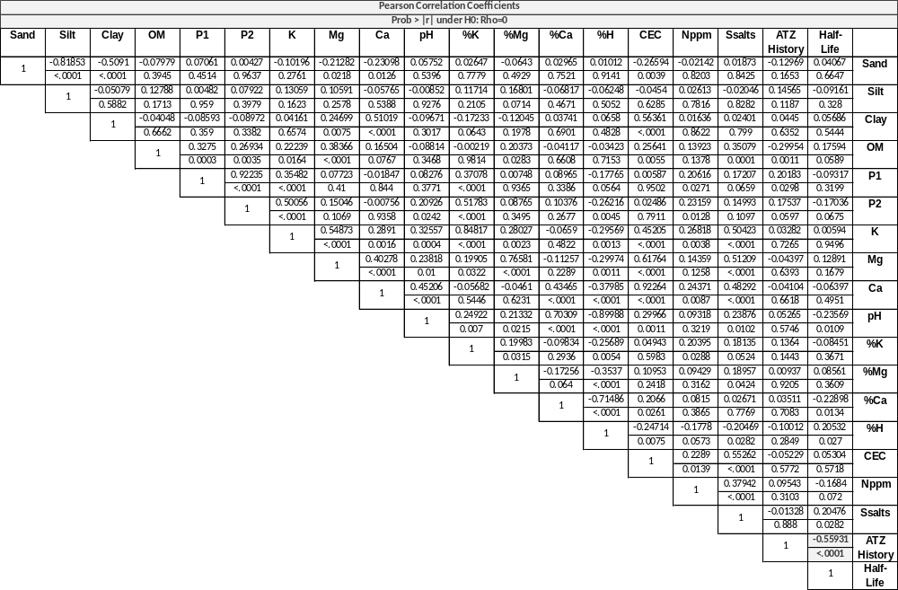
Table 2. Table containing soil information such as sample location, previous crop, atrazine history with years of sequential application, atrazine dose, surface residue, and half-life (t_{1/2}). Enhancement factor was calculated using the formula: t_{1/2} (no history) / t_{1/2} (history) = EF.

State | Previous Crop | History | Years (History) | Dose | Residue | County | t_{1/2} | Enhanced? | EF
 |  |  |  | (lbs a.i./A)
AR | Soybeans | N | 0 | 0 | Low | Phillips | 7.55
AR | Corn | Y | 4 | 2 | Low | Phillips | 1.77 | YES | 4.26
GA | Cotton | N | 0 | 0 | Low | Berrier | 22.9
GA | Corn | Y | 5 | 2 | High | Berrien | 1.73 | YES | 13.24
IA | Permanent Pasture | N | 0 | 0 | N/A | Wapello | 25.6
IA | Corn | Y | 5 | 1.5 | High | Wapello | 1.7 | YES | 15.1
IA | Sod | N | 0 | 0 | High | Cedar | 4.97
IA | Corn | Y | 8 | 2 | Medium | Cedar | 2.7 | NO | 1.84
IA | Corn | Y | 5 | 1.5 | High | Winneshick | 2.5 | YES | 9.4
IA | Permanent Pasture | N | 0 | 0 | N/A | Winneshick | 23.5
IL | N/A | N | 0 | 0 | High | Washington | 12.7
IL | Corn | Y | 5 | 1.5 | Medium | Washington | 0.8 | YES | 15.9
IL | N/A | N | 0 | 0 | High | Clinton | 7.5
IL | Corn | Y | 5 | 1.5 | Low | Clinton | 2.1 | YES | 3.6
IL | Corn | Y | 5 | 1.5 | Low | Clinton | 3 | YES | 3.75
IL | Turf | N | 0 | 0 | High | Douglas | 11.9
IL | N/A | Y | 7 | 0.5 | Low | Douglas | 5.2 | YES | 3.9
IL | Pasture | N | 0 | 0 | High | Douglas | 20.3
IL | Corn | Y | 15 | 1.5 | Medium | Pike | 0.7 | YES | 2.28
IL | Turf | N | 0 | 0 | N/A | Pike | 1.6
IL | Corn | Y | 7 | 1.7 | High | Henderson | 2.1 | YES | 5.52
IL | Corn | Y | 7 | 0.5 | Low | Champaign | 3.4 | YES | 7.9
IL | Turf | N | 0 | 0 | N/A | Champaign | 26.9
IL | Turf | N | 0 | 0 | High | Carroll | 17.8
IL | Corn | Y | 15 | 1.75 | High | Carroll | 2.9 | YES | 6.13
IL | Turf | N | 0 | 0 | High | Henderson | 11.6
KS | Wheat | N | 0 | 0 | Low | Hodgeman | 16.4
KS | Corn | Y | 8 | 1 | High | Hodgeman | 2.1 | YES | 7.8
KY | Dry Lot for Dairy | N | 10 | 0 | Low | Warren | 13.5
KY | Wheat/Corn | Y | 10 | 2 | High | Warren | 1.87 | YES | 7.1
KY | Fallow Grass | N | 0 | 0 | High | Warren | 12.5
KY | Corn | Y | 5 | 2 | High | Warren | 2.1 | YES | 5.95

Table 2. (Cont.)

State | Previous Crop | History | Years (History) | Dose | Residue | County | t_{1/2} | Enhanced? | EF
 |  |  |  | (lbs a.i./A)
LA | Corn | Y | 9 | 1 | Low | Franklin | 1.64 | YES | 43.4
LA | N/A | N | 0 | 0 | High | Franklin | 71.1
LA | Corn | Y | 5 | 2.5 | Low | Rapides | 1.37 | YES | 3.26
LA | N/A | N | 0 | 0 | High | Rapides | 4.47
LA | N/A | N | 0 | 0 | Medium | Rapides | 3.07
LA | Corn | Y | 10 | 2.5 | Low | Rapides | 0.9 | YES | 3.43
LA | Corn | Y | 10 | 2.5 | Low | Rapides | 1.47 | YES | 2.18
LA | N/A | N | 0 | 0 | High | Rapides | 3.2
LA | N/A | N | 0 | 0 | High | Tensas | 13.5
LA | Corn | Y | 5 | 1 | Medium | Tensas | 3.6 | YES | 3.75
MI | N/A | Y | 5 | 1 | Low | Kalamazoo | 2.4 | NO | 1.67
MI | N/A | N | 0 | 0 | N/A | Kalamazoo | 4
MI | N/A | Y | 5 | 1.25 | Low | Kalamazoo | 1.8 | YES | 6.44
MI | N/A | N | 0 | 0 | N/A | Kalamazoo | 11.6
MI | N/A | Y | 5 | 1.25 | Low | Kalamazoo | 1.8 | YES | 11.7
MI | N/A | N | 0 | 0 | N/A | Kalamazoo | 21.1
MI | N/A | Y | 5 | 1.25 | Low | Clinton | 1.9 | YES | 7.58
MI | N/A | N | 0 | 0 | N/A | Clinton | 14.4
MO | Corn | Y | 5 | 2 | High | Chariton | 1 | YES | 3.5
MO | N/A | N | 0 | 0 | High | Livingston | 37
MO | N/A | N | 0 | 0 | High | Chariton | 3.5
MO | Corn | Y | 22 | 2 | Medium | Livingston | 2.4 | NO | 1.04
MO | Corn | Y | 5 | 2 | High | Livingston | 2.3 | YES | 16
MO | Turf | N | 0 | 0 | High | Livingston | 2.5
MS | Corn | Y | 7 | 2 | N/A | Coahoma | 1.27 | YES | 38.1
MS | N/A | N | 0 | 0 | N/A | Coahoma | 48.4

Table 2. (Cont.)
State | Previous Crop | History | Years (History) | Dose | Residue | County | t_{1/2} | Enhanced? | EF
 |  |  |  | (lbs a.i./A)
NE | N/A | Y | 5 | N/A | N/A | Polk | 3.3 | YES | 2.72
NE | Corn | Y | 5 | 0.5 | Low | Hitchcock | 1.6 | YES | 5.63
NE | N/A | N | 0 | 0 | N/A | Polk | 9
NE | N/A | Y | 5 | N/A | N/A | Polk | 2.1 | YES | 12.38
NE | N/A | N | 0 | 0 | N/A | Dixon | 26
NE | N/A | N | 0 | 0 | N/A | Polk | 8
NE | Corn | Y | 5 | N/A | N/A | Polk | 2.2 | YES | 3.6
NE | Corn | N | 0 | 0 | Low | Keith | 11.3
NE | Corn | Y | 5 | 1.7 | None | Keith | 1.6 | YES | 7.06
NE | Corn | Y | 5 | 1.7 | High | Keith | 1.6 | YES | 7.06
NE | Corn | Y | 5 | 1 | Low | Keith | 1.8 | NO | 1.77
NE | Soybeans | N | 0 | 0 | Low | Keith | 3.2
NE | N/A | Y | 5 | N/A | N/A | Polk | 1.6 | YES | 2.75
NE | Grass | N | 0 | 0 | High | Hitchcock | 4.4
NE | Corn | Y | 5 | 0.5 | Medium | Hitchcock | 1.98 | NO | 1.82
NE | Grass | N | 0 | 0 | High | Hitchcock | 3.62
PA | Alfalfa | N | 0 | 0 | N/A | Berks | 3
PA | Corn Silage | Y | 4 | 6.5 | Medium | Berks | 2.1 | NO | 1.43
PA | Pasture | N | 0 | 0 | High | Lancaster | 6.7
PA | Corn & Rye | Y | 5 | 1.25 | High | Lancaster | 2.3 | YES | 2.91
PA | Corn Silage | Y | 20 | 1 | None | Bradford | 3.8 | YES | 3.13
PA | Corn Silage | Y | 20 | 1 | None | Bradford | 3.5 | YES | 6.26
PA | Pasture | N | 0 | 0 | High | Bradford | 11.9
PA | Alfalfa | N | 0 | 0 | N/A | Centre | 16.9
PA | Corn Grain | Y | 5 | 1.5 | High | Centre | 2.4 | YES | 7.04
PA | N/A | N | 0 | 0 | High | Bradford | 21.9
PA | Corn | Y | 6 | 1.5 | Medium | Erie | 2.5 | YES | 3.76
PA | Orchard grass/ Alfalfa | N | 0 | 0 | N/A | Erie | 9.4
PA | Hay/Grass | N | 0 | 0 | High | Lancaster | 8.7
PA | Silage | Y | 6 | 1 | High | Lancaster | 2 | YES | 4.35
PA | Pasture | N | 0 | 0 | High | Centre | 8.9
PA | Corn - alfalfa rotation | Y | 4 | 1.5 | Low | Centre | 2.1 | YES | 4.24

Table 2. (Cont.)
State | Previous Crop | History | Years (History) | Dose | Residue | County | t_{1/2} | Enhanced? | EF
 |  |  |  | (lbs a.i./A)
SD | Corn | Y | 5 | N/A | Medium | Brown | 2.6 | YES | 18.9
SD | Pasture | N | 0 | 0 | High | Brown | 49.2
SD | Pasture | N | 0 | 0 | Medium | Lincoln | 9.9
SD | Corn | Y | 9 | 0.5 | low | Lincoln | 1.4 | YES | 7.07
TN | Corn | N | 0 | 0 | High | Gibson | 21.9
TN | Corn | Y | 5 | 2 | Medium | Gibson | 2.31 | YES | 9.48
TN | Corn | Y | 11 | 2 | Medium-High | Obion | 1.73 | YES | 12.66
TN | Corn | Y | 4 | 2 | Medium High | Obion | 2.1 | YES | 10.43
TX | Fallow | N | 0 | 0 | Low | Williamson | 1.57
TX | Corn | Y | 8 | 1.5 | Medium | Williamson | 1.14 | NO | 1.38
TX | Corn | Y | 10 | 0.89 | Medium | Castro | 1.74 | NO | 0.9
TX | Wheat | N | 0 | 0 | High | Castro | 1.58
WI | Sod | N | 0 | 0 | High | Clark | 18.9
WI | Sod | N | 0 | 0 | High | Clark | 15.7
WI | Corn | Y | 4 | 1 | Low | Clark | 9.3 | YES | 2.03
WI | Corn | Y | 10 | 1 | Medium | Clark | 6.2 | YES | 2.53
WI | Alfalfa | N | 0 | 0 | Low | Door | 6.4
WI | Field Corn | Y | 14 | 0.5 | Low | Door | 3 | YES | 2.13
WI | N/A | Y | 3 | N/A | N/A | Waukesha | 1.7 | YES | 3.11
WI | N/A | N | 0 | 0 | N/A | Waukesha | 5.3
WI | Grass | N | 0 | 0 | Medium | Green Lake | 8.2 | YES | 2.79
WI | Pasture | N | 0 | 0 | Medium | Waukesha | 22.9
WI | Pasture | N | 0 | 0 | None | La Cross | 24.1
WI | Corn | Y | 5 | N/A | Medium | La Cross | 1.5 | YES | 16.07
WI | Corn | Y | 2 | N/A | Medium | Walworth | 2 | YES | 12.05
WI | Corn | Y | 4 | N/A | N/A | Green Lake | 2.7 | YES | 8.9

Figure 1. A map showing locations where soil samples were collected.
Enhancement factors (EF) are color coded with red representing locations where enhanced atrazine degradation was most apparent, green representing locations where ATZ maintains original persistence, and yellow representing locations where decrease in ATZ persistence is agronomically significant, but short-term weed control is possible.

Figure 2. A map showing locations receiving 5+ consecutive years of atrazine treatment.
Half-life values are color coded with blue representing locations where enhanced ATZ degradation was very rapid, gray representing locations where limited enhanced degradation was detected, and orange or red representing levels of degradation in between.

Figure 3. A map showing locations receiving no atrazine treatment the previous 10+ years. Half-life values are color coded with blue representing locations where enhanced ATZ degradation was very rapid, gray representing locations where limited enhanced degradation was detected, and orange or red representing levels of degradation in between.

CHAPTER II
Evolution of atrazine adapted soils is rapid

A version of this chapter was prepared for publication in Weed Technology by Ethan T. Parker:

Evolution of Atrazine Adapted Soils is Rapid
Ethan T. Parker, Michael D. Owen, Mark L. Bernards, William S. Curran, Mark Radosevich, and Thomas C. Mueller*
* First and sixth authors: Graduate Research Assistant and Professor, Department of Plant Sciences, University of Tennessee, Knoxville, TN 37996; Second author: Professor, Agronomy Department, Iowa State University, Ames, IA 50011; Third author: Assistant Professor, School of Agriculture, Western Illinois University, Macomb, IL 61455; Fourth author: Professor, Department of Plant Science, Penn State University, University Park, PA 16802; Fifth author: Professor, Biosystems Engineering and Soil Science Department, University of Tennessee, Knoxville, TN 37996; Corresponding author’s E-mail: T^{mueller@utk.edu}
Abstract
The triazines are one of the most widely used herbicide classes ever developed, and play a role in managing herbicide-resistant weed populations. While these herbicides are traditionally valued for their persistence and season-long weed control, the literature suggests that these chemicals may no longer remain persistent in soils due to enhanced triazine degradation. Many questions remain regarding triazine adapted soils, one of which is the dose of herbicide or number of applications required before enhanced degradation will be observed. Studies were designed to quantify atrazine (an s-triazine) and related metabolites in soils with 0, 3, 5, or 10+ years of sequential atrazine applications. Regardless of how many sequential atrazine applications a soil received, enhanced atrazine degradation was detected. Only in soils with no previous atrazine use did atrazine retain its persistence as an herbicide.

Nomenclature: Atrazine.

Keywords: Deethylatrazine, deisopropylatrazine, enhanced degradation, environmental fate, hydroxyatrazine, s-triazine.
The triazine herbicides are one of the most influential classes of agricultural chemicals ever produced. They are desired for their selectivity, flexibility in use, and persistent weed control in more than 50 crops worldwide (Lebaron et al., 2008). Of the triazines, atrazine is the most widely used in the United States (U.S.), second only to glyphosate. Even in the current era of widespread reliance on transgenic crops in the U.S., atrazine continues to be an important tool in weed management, used on 57% of U.S. corn acres in 2009 (Mitchell, 2014). Atrazine is also commonly used on sorghum, sweet corn, and sugar cane in the United States. Over the past two decades, many studies and anecdotal reports have confirmed the existence of triazine adapted soils (Krutz et al., 2008, 2010a, 2010b; Shaner and Henry, 2007; Shaner et al., 2007; Vanderheyden et al., 1997; Webb et al., 2011; Zablotowicz et al., 2006, 2007). Many of these studies show that triazine degradation in adapted soils is primarily biologically mediated, and that the degradation of atrazine in these soils may be rapid. However the question remains as to how many atrazine applications must be made before enhanced degradation is observed (Krutz et al., 2010b). As public perception and concern over atrazine risk in the environment grows, it is imperative that work continues to better understand the fate of atrazine under common field management practices (Inoue-Choi et al., 2016; Solomon et al., 2013). The objective of this study was to determine the number of consecutive years of atrazine exposure required before enhanced atrazine degradation is observed, and to quantify the accumulation profile over time of atrazine metabolites within those soils.

Materials and Methods

Soil Sample Collection.
This experiment consisted of analyses of soils from Iowa, Illinois, and Pennsylvania (Table 3). Since the degradation of atrazine was dependent upon the microbial population and activity within the soil, all soil sample collection and processing was conducted in a way to maintain soil microbial populations and activity. Field co-operators from the three previously mentioned states were asked to collect soil samples following an established protocol. Soils were only collected from producer’s fields, with sets of paired soils including either 0, 3, 5, or 10 years of consecutive atrazine application. Soils were collected on the surface 0- to 8-cm soil depth zone, and stored at 4 C until analysis. All soils were shipped overnight to Knoxville, TN for analysis, where a subsample of each soil was collected and shipped to MidWest Labs of Omaha, Nebraska for characterization of soil nutrient levels, organic matter content, and texture. All other procedures and analyses were performed under controlled conditions in Knoxville, TN.
Laboratory Procedures.
Prior to atrazine fortification, 200 mL of DI water was added to 400 g of each soil and allowed to drain for 24 h. Adequate soil moisture is essential for soil microbial degradation of atrazine, and this procedure allowed for a stabilization of moisture across each soil. After draining, 5 g of each soil was placed in a 20-mL glass vial for atrazine fortification. Fortification began with 250 µL of 1000 µg kg⁻¹analytical atrazine (Chem Service Inc., P.O. Box 599, West Chester, PA 19381) aqueous solution being placed directly onto the soil within each vial to simulate a field rate of 1.0 kg ha⁻¹. Samples were placed into an incubator at 22 C. After the full incubation period was complete, samples were placed into a freezer at -1, 0, 3, 7, 14, 21, 28, and 42 days after treatment (DAT) where the -1 sample received no atrazine so any residual atrazine in field soils could be quantified. For extraction, 12.0 mL of methanol was added to each vial, vials were then shaken for 1.5 h and filtered using 0.45-µm PTFE filters. Atrazine was quantified by liquid chromatography-mass spectrometry (LC-MS) according to previous methods (Mueller et al., 2010). The lab analysis quantified atrazine and the three major metabolites [deethylatrazine (DEA), deisopropylatrazine (DIA), and hydroxyatrazine (HA)] simultaneously, with > 85% atrazine recoveries. DAT 0 concentrations were 875 µg kg⁻¹ ± 30.4, indicating similar recoveries of atrazine in all soils. Retention times for atrazine, DEA, DIA, and HA were 1.92, 3.85, 4.94, and 7.55 minutes, respectively. Selected ion monitoring values used for detection of atrazine, DEA, DIA, and HA were 198, 188, 174, and 216 respectively.
Statistical Analysis.
Peaks detected via LC-MS were converted to a soil concentration in µg kg⁻¹. Concentrations were analyzed using SAS PROC GLIMMIX (SAS® Institute Inc., v. 9.4) to compare DAT and years of sequential atrazine exposure. Means were regressed as concentration in µg kg⁻¹ against DAT using first-order kinetics by Sigmaplot v 13.2 (SYSTAT Software Inc.). A half-life (t_{1/2}) was determined using the resulting first order rate constant in the equation 0.693/k=t_{1/2} (Kruger et al., 1993). Atrazine metabolite data were also analyzed using SAS PROC GLIMMIX to compare DAT to atrazine history. Means were separated by means of a log normal peak line fitted using Sigmaplot (R² = 0.99) (Table 4).

Results and Discussion

Enhanced Atrazine Degradation.
Degredation data were pooled as states were not significantly different (P > 0.05). In soils across all states with 3, 5, or 10 years of previous atrazine exposure, atrazine concentration decreased rapidly from 0 to 14 DAT (Figure 4, Table 4). Atrazine t_{1/2} values for soils with 3, 5, and 10 years of exposure were calculated to be 2.6, 4.4, and 2.1 d respectively (Table 5). When compared with a t_{1/2} of 17 d for soils with no previous atrazine use, it is clear that as few as three years of atrazine exposure is enough to observe an adapted soil where atrazine degradation is five times more rapid (Figure 4). Data suggest that atrazine degradation occurs more rapidly than previously reported, with >75% atrazine degradation at 7 DAT, and > 89% atrazine degradation at 14 DAT in all soils with at least 3 years of previous atrazine exposure (Zablotowicz et al., 2007 ). However, this study was conducted at 22 C in moist soil conditions which favor rapid degradation, so t_{1/2} observed in the field will likely be greater.
For producers, this means that residual weed control may be reduced in fields that see atrazine use for 3 years. These results explain the many reports of reduced residual weed control with atrazine, but are by no measure the only factor to be considered (Krutz et al., 2008; Shaner and Henry, 2007; Shaner et al., 2007). Atrazine use rates have decreased considerably in the last two decades (Anonymous, 2017; Solomon et al. 1996). By lowering use rates, weed escapes or early breaks in residual control will be more noticeable to producers. It is also possible that years of reliance on the complete control offered by glyphosate, producers have higher expectations of weed control products, including atrazine. These higher expectations then are not met when producers are pressured by herbicide resistance to revert to reliance upon atrazine for residual weed control. It is likely that enhanced atrazine degradation has been present for decades, only to be masked by the use of other herbicides. As more modes of action fall victim to herbicide resistance, products such as atrazine will be expected to provide season-long weed control of hard-to-manage weeds, when in reality it will likely degrade too rapidly to provide such control. From an environmental safety standpoint, decreased residual concentration will offer some promise for the continued use of atrazine throughout the corn growing regions of the U.S. While the residual weed control may be decreased, atrazine still offers an extra mode of action both PRE and POST in a complete weed management strategy for difficult-to-control weeds.
Atrazine Metabolites in Soil.
Metabolite data were pooled as states and number of years of atrazine exposure were not significantly different (P>0.05). Regression models shown in table 4 were chosen for their best fit of metabolite concentration increase and decline. Data are presented to different concentration scales for ease of viewing (Figure 5). Pre-treatment concentrations of DEA, DIA, and HA of 5.4 ± 0.7, 1.7 ± 0.8, and 5.0 ± 0.4 µg kg⁻¹ respectively in -1 DAT soil samples (data not shown).
Concentrations of DEA were lower than both DIA and HA concentrations detected (Figure 5). DEA concentrations within non-history soils increased gradually from 0 to 42 DAT. Alternatively, DEA concentrations in history soils declined gradually over the course of the experiment. This pattern, along with the persistence of DIA and HA in non-history soils indicate that degradation of atrazine secondary metabolites into tertiary metabolites were affected by prior atrazine use history. DIA was found in soils at concentrations of <60µg kg⁻¹ in all samples tested. At 7 DAT, the amount of DIA detected was not significantly different among soils. However, by 14 DAT, DIA concentrations were reduced in atrazine history compared to non-history soils. Regression analysis showed clear differences between history and non-history for coefficient A for both DIA and HA, and also coefficient B for DIA. Hydroxyl derivatives of triazines (including HA) are understood to be biologically inactive, particularly at rates detected in water and soil (Laws et al., 2003; Lebaron et al., 2008). This doesn’t, however, prevent concern about the fate of DEA, DIA, and HA within soil and surface waters worldwide. When comparing atrazine history and non-history soils, HA concentrations are not significantly different until 7 DAT and after, when it appears microbial populations continue rapidly breaking down HA into other compounds.
A positive viewpoint of these data for atrazine and its derivatives is that rapid degradation will improve their environmental profile. These results are also in agreement with previous research, which indicates that the atrazine metabolites DEA, DIA, and HA are usable substrates for atrazine-degrading microbes and will be degraded more rapidly in soils that also rapidly degrade the parent compound (Krutz et al., 2010b; Seffernick et al., 2000; Shapir et al., 2007; Shapir et al., 2005). Our results further support the suggestion by Krutz et al. that precise model predictions concerning triazine and metabolite fate are reliant on accurate herbicide persistence estimates.
Moving forward, it is important to make a clear distinction between triazine adapted and non-adapted soils when estimating the environmental fate of triazine herbicides. More work must follow to carefully examine the effect of soil amendments such as fertilizers and other pesticides on the persistence of the triazines and derivatives. In the future, methods of using this enhanced degradation to the advantage of the producer should also be explored. Marketing bio-products or even transgenic plants to aid in degradation of pesticides and bioremediation of contaminated soils could offer producers, governmental agencies, and the public some peace of mind while maintaining much needed flexibility for the control of herbicide-resistant weeds (Chirnside et al. 2009, Crawford et al. 1998, Fan and Song 2014, Newcombe and Crowley 1999, Topp 2001).

Acknowledgements

The authors would also like to thank the technical staff at Iowa State University, Penn State University, and Western Illinois University for their assistance in obtaining soil samples.

Literature Cited
Anonymous (2017) AAtrex® 4L Product Label. Syngenta Crop Protection, LLC P. O. Box 18300 Greensboro, North Carolina 27419-8300: Syngenta Crop Protection, LLC Publication SCP 497A-L38TT 1112 4021678. 24 p
Chirnside, AEM, WF Ritter, M Radosevich (2009) Biodegradation of aged residues of atrazine and alachlor in a mix-load site soil. Soil Biol Biochem 41:2484–2492
Crawford, JJ, GK Sims, RL Mulvaney, M Radosevich (1998) Biodegradation of atrazine under denitrifying conditions. Appl Microbiol Biotechnol 49:618–623
Fan, X, F Song (2014) Bioremediation of atrazine: recent advances and promises. J Soils and Sediments 14:1727-1737
Inoue-Choi M, Weyer PJ, Jones RR, Booth BJ, Cantor KP, Robien K, Ward MH (2016) Atrazine in public water supplies and risk of ovarian cancer among postmenopausal women in the Iowa Women's Health Study. Occup and Environ Med 73:582-587
Kruger EL, L Somasundaram, JR Coats, RS Kanwar (1993) Persistence and degradation of [¹⁴C]atrazine and [¹⁴C]deisopropylatrazine as affected by soil depth and moisture conditions. Environ Toxicol and Chem 12:1959-1967
Krutz LJ, DL Shaner, C Accinelli, RM Zablotowicz, WB Henry (2008) Atrazine Dissipation in s-Triazine–Adapted and Nonadapted Soil from Colorado and Mississippi: Implications of Enhanced Degradation on Atrazine Fate and Transport Parameters. J Environ Qual 37:848-857
Krutz JL, DL Shaner, MA Weaver, RM Webb, RM Zablotowicz, KN Reddy, Y Huang, SJ Thomson (2010a) Agronomic and environmental implications of enhanced s -triazine degradation. Pest Manag Sci 66:461-481
Krutz LJ, DL Shaner, RM Zablotowicz (2010b) Enhanced Degradation and Soil Depth Effects on the Fate of Atrazine and Major Metabolites in Colorado and Mississippi Soils. J Environ Qual 39:1369-1369
Laws SC, JM Ferrell, TE Stoker, RL Cooper (2003) Pubertal developement in female wistar rats following exposure to propazine and atrazine biotransformation by-products, diamino-s-chlorotriazine and hydroxyatrazine. Toxicol Sci 76:190-200
Lebaron HM, JE Mcfarland, OC Burnside (2008) The Triazine Herbicides. First edition. San Deigo: Elsevier. Pp. 1-355
Mitchell PD (2014) Market-level assessment of the economic benefits of atrazine in the United States. Pest Manag Sci 70:1684-1696
Mueller TC, LE Steckel, M Radosevich (2010) Effect of Soil pH and Previous Atrazine Use History on Atrazine Degradation in a Tennessee Field Soil. Weed Sci 58:478-483
Newcombe, DA, DE Crowley (1999) Bioremediation of atrazine-contaminated soil by repeated applications of atrazine-degrading bacteria. Appl Microbiol Biotechnol 51:877–882
Seffernick JL, G Johnson, MJ Sadowsky, LP Wackett (2000) Substrate Specificity of Atrazine Chlorohydrolase and Atrazine-Catabolizing Bacteria. Appl Environ Microbiol 66:4247-4252
Shaner DL, WB Henry (2007) Field history and dissipation of atrazine and metolachlor in Colorado. J Environ Qual 36:1-5
Shaner DL, WB Henry, LJ Krutz, B Hanson (2007) Rapid Assay for Detecting Enhanced Atrazine Degradation in Soil. Weed Sci 55:528-535
Shapir N, EF Mongodin, MJ Sadowsky, SC Daugherty, KE Nelson, LP Wackett (2007) Evolution of Catabolic Pathways: Genomic Insights into Microbial s-Triazine Metabolism. J Bacteriol 189:674-682
Shapir N, C Rosendahl, G Johnson, M Andreina, MJ Sadowsky, LP Wackett (2005) Substrate specificity and colorimetric assay for recombinant TrzN derived from Arthobacter aurescens TC1. Appl Environ Microbiol 71:2214-2220
Solomon KR, DB Baker, RP Richards, KR Dixon, SJ Klaine, TW LaPoint, RJ Kendall, CP Weisskopf, JM Giddings, JP Giesy, LW Hall, WM Williams (1996) Ecological risk assesment of atrazine in North American surface waters. Environ Toxicol Chem 15:31-76
Solomon KR, JP Giesy, TW LaPoint, JM Giddings, RP Richards (2013) Ecological risk assessment of atrazine in North American surface waters. Environ Toxicol and Chem 32:10-11
Topp, E (2001) A comparison of three atrazine-degrading bacteria for soil bioremediation. Biol Fertil Soils 33:529–534
Vanderheyden V, P Debongnie, L Pussemier (1997) Accelerated Degradation and Mineralization of Atrazine in Surface and Subsurface Soil Materials. Pestic Sci 49:237-242
Webb RMT, MW Sandstrom, LJ Krutz, DL Shaner (2011) Simulation of branched serial first-order decay of atrazine and metabolites in adapted and nonadapted soils. Environ Toxicol and Chem 30:1973-1981
Zablotowicz RM, JL Krutz, KN Reddy, MA Weaver, CH Koger, MA Locke (2007) Rapid Development of Enhanced Atrazine Degradation in a Dundee Silt Loam Soil under Continuous Corn and in Rotation with Cotton. J Agric Food Chem 55:852-859
Zablotowicz RM, MA Weaver, MA Locke (2006) Microbial adaptation for accelerated atrazine mineralization/ degradation in Mississippi Delta soils. Weed Sci 54:538-547

Appendix

Table 3. Locations and half-lives of all soil samples analyzed.
Stateª | County | Years Exposure | pH | Soil Texture | OM % | Sand | Silt | Clay | t_{1/2} | EF^{b}
 |  |  |  |  | ----------------%--------------- |  |  |  | t_{1/2} | EF^{b}
IA | Cedar | 0 | 7.1 | SiL | 4.3 | 23 | 57 | 20 | 20.45 | -
IA | Cedar | 5 | 6.8 | SiL | 4.4 | 17 | 60 | 23 | 1.83 | 11.2
IA | Wapello | 0 | 5.7 | SiCL | 2.8 | 5 | 55 | 40 | 47.66 | -
IA | Wapello | 5 | 7.2 | SiL | 3.4 | 15 | 65 | 20 | 1.41 | 33.8
IA | Wapello | 3 | 7.5 | SiCL | 3 | 14 | 57 | 29 | 1.71 | 27.9
IA | Winneshiek | 0 | 7.2 | SiL | 2.9 | 23 | 60 | 17 | 19.76 | -
IA | Winneshiek | 5 | 7.1 | SiL | 2.7 | 16 | 64 | 20 | 5.43 | 3.64
IA | Winneshiek | 5 | 7.3 | SiL | 3.2 | 20 | 56 | 24 | 4.65 | 4.2
IA | Winneshiek | 5 | 7.4 | SiL | 2.6 | 22 | 61 | 17 | 6.03 | 3.3
IL | Carroll | 0 | 7.1 | L | 4.7 | 26 | 60 | 14 | 8.36 | -
IL | Carroll | 10 | 7.1 | SiL | 4.1 | 22 | 62 | 16 | 2.01 | 4.2
IL | Carroll | 3 | 6.3 | SiL | 2.7 | 20 | 68 | 12 | 2.12 | 3.9
IL | Carroll | 5 | 7.3 | SiL | 4.1 | 15 | 67 | 18 | 2.47 | 3.4
IL | Carroll | 3 | 6.4 | SiL | 1.5 | 11 | 65 | 24 | 3.31 | 2.5
IL | Champaign | 0 | 6.4 | L | 7.9 | 40 | 43 | 17 | 33.13 | -
IL | Champaign | 3 | 4.9 | SiL | 6.3 | 30 | 50 | 20 | 10.35 | 3.9
IL | Champaign | 5 | 4.9 | SiCL | 3.7 | 20 | 48 | 32 | 2.66 | 12.4
IL | Douglas | 0 | 6.9 | SiL | 6 | 20 | 65 | 15 | 9.86 | -
IL | Douglas | 5 | 6 | SiL | 4.8 | 27 | 51 | 22 | 10.71 | 0.9
IL | Pike | 0 | 6 | SiL | 5.3 | 20 | 56 | 24 | 33 | -
IL | Pike | 5 | 6 | SiL | 1.7 | 10 | 70 | 20 | 2.1 | 15.7
IL | Pike | 10 | 6.1 | SiL | 3 | 13 | 65 | 22 | 2.26 | 14.6
IL | Bureau | 3 | 6 | SiL | 3.2 | 16 | 62 | 22 | 2.48 | 13.3
PA | Bradford | 0 | 4.2 | L | 6.6 | 40 | 40 | 20 | 14.65 | -
PA | Bradford | 3 | 5.5 | L | 3.1 | 40 | 44 | 16 | 3.04 | 4.8
PA | Bradford | 3 | 5.8 | L | 2.3 | 44 | 44 | 12 | 2.48 | 5.9
PA | Centre | 0 | 6.4 | SiL | 3.9 | 34 | 49 | 17 | 24.03 | -
PA | Centre | 5 | 4.3 | L | 4.6 | 34 | 46 | 20 | 3.5 | 6.9
PA | Lancaster | 0 | 7.4 | L | 7 | 50 | 33 | 17 | 17.05 | -
PA | Lancaster | 3 | 7 | SiL | 4.4 | 30 | 57 | 13 | 2.43 | 7.0
ªAbbreviations: t_{1/2}, half-life in d; EF, Enhancement Factor; IA, Iowa; IL, Illinois; L, loam; OM, organic matter; PA, Pennsylvania; SiCL, silty clay loam; SiL, silty loam.
^{b}Enhancement factor calculated using the formula: t_{1/2} non-history soil/ t_{1/2} history soil.

Table 4. Regression equations, coefficients, and R² values of atrazine and metabolites.ª
Molecule | ATZ^{b} History | Equation | Coefficient A | SE | Coefficient B | SE | R²
ATZ | No | f = a*exp(-b*x) | 830.09 | 23.06 | 0.04 | 0.002 | 0.99
 | Yes | f = a*exp(-b*x) | 875.24 | 106.18 | 0.20 | 0.03 | 0.95
DEA | No | f = a*exp(-.5*((x-x0)/b)^2) | 12.81 | 0.86 | 32.24 | 8.72 | 0.85
 | Yes | f = a*exp(-.5*((x-x0)/b)^2) | 10.88 | 0.83 | 56.20 | 22.43 | 0.89
DIA | No | f = a*exp(-.5*((x-x0)/b)^2) | 59.06 | 7.68 | 15.59 | 2.76 | 0.83
 | Yes | f = a*exp(-.5*((x-x0)/b)^2) | 320.36 | 11.12 | 1.36 | 0.04 | 0.99
HA | No | f = a*exp(-.5*((x-x0)/b)^2) | 21.36 | 0.82 | 25.35 | 2.77 | 0.97
 | Yes | f = a*exp(-.5*((x-x0)/b)^2) | 6.04 | 0.47 | 31.48 | 13.97 | 0.84
ªAbbreviations: ATZ, atrazine; DAT, days after treatment; SE, standard error

Table 5. Atrazine half-lives in soils fortified with 250 µL of 1000 µg kg⁻¹ analytical atrazine.ª
Years ATZ^{b} exposure | No. of soils | t_{1/2}
0 | (n)  10 | d  17.05
3 | 8 | 2.66
5 | 10 | 4.44
10 | 2 | 2.14
ª State effect was not significant, therefore data were pooled across states. A two-way interaction of years exposure and t_{1/2}
was significant (P < 0.001)
^{b}Abbreviations: ATZ, atrazine; t_{1/2}
, half-life in days
^{c}Means sharing a letter are not different according to Fisher's protected LSD_{(0.05)}

Figure 4. Exponential decay of atrazine concentration (µg kg⁻¹) in IA, IL, and PA soils as a function of number of years of previous atrazine exposure and days after atrazine fortification. Error bars indicate one standard deviation, and all R² values were > 0.94.

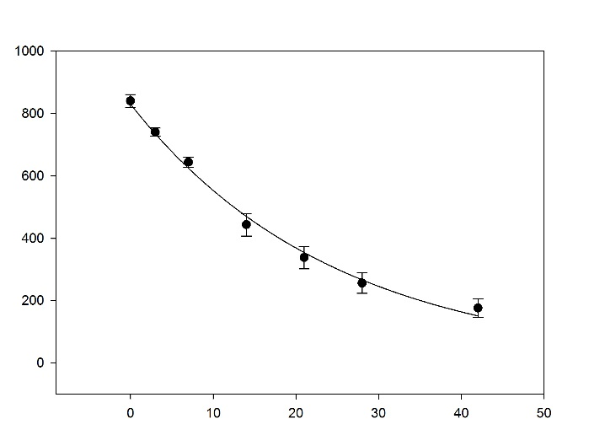
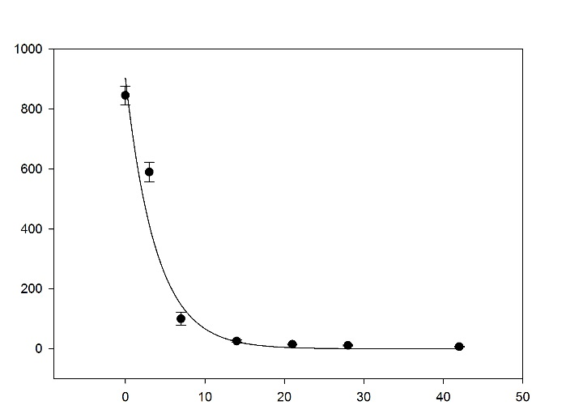
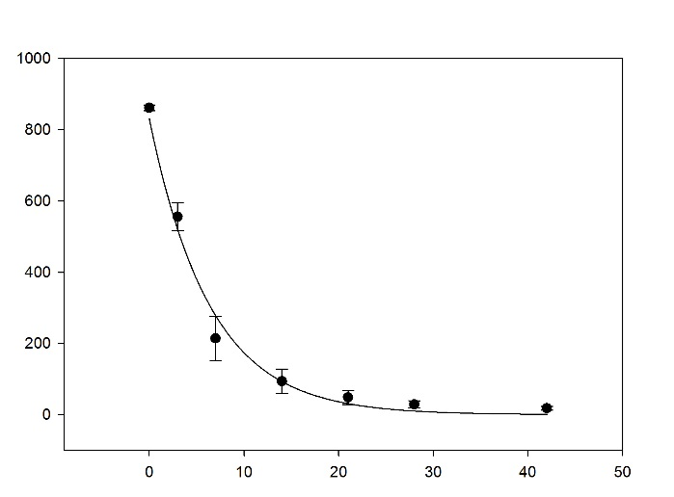
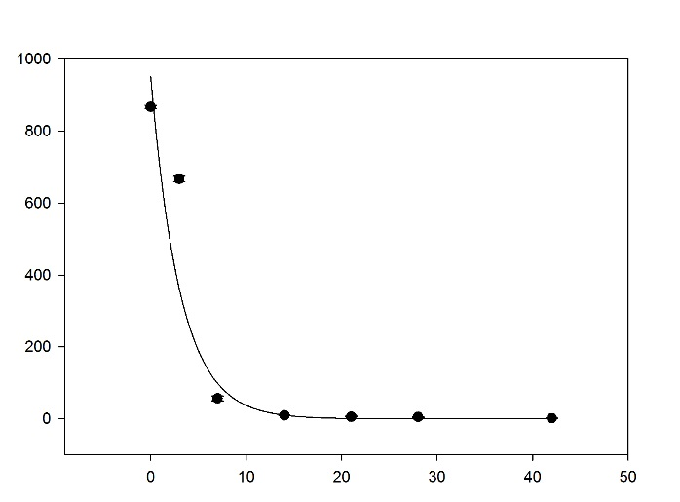
Atrazine concentration in soil (µg kg⁻¹)
Days after treatment
0 years
t_{1/2} – 17.1 d
3 years
t_{1/2} – 2.66 d
5 years
t_{1/2} – 4.44 d
10 years
t_{1/2} – 2.14 d

N=10

N=10

N=8

N=2

Figure 4 cont.
Figure 5. Pattern of degradation of atrazine (ATZ), deethylatrazine (DEA), deisopropylatrazine (DIA), and hydroxyatrazine (HA) in IA, IL, and PA soils as a functions of adapted and non-adapted soils and days after atrazine fortification. Error bars indicate one standard deviation and all R² values were > 0.95.

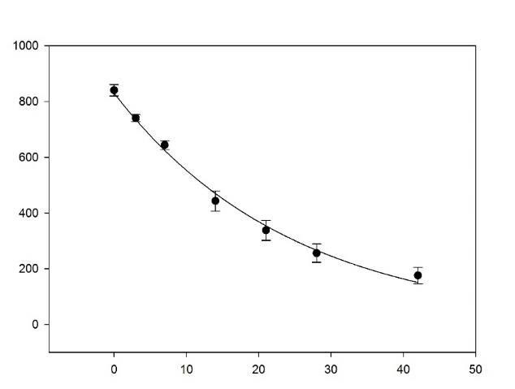
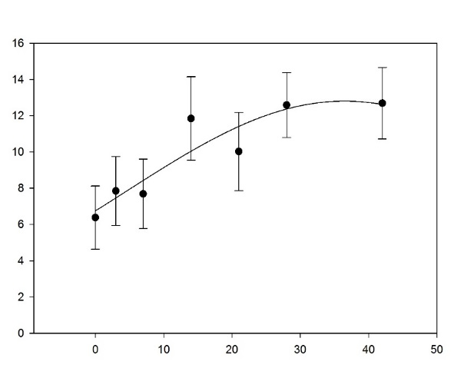
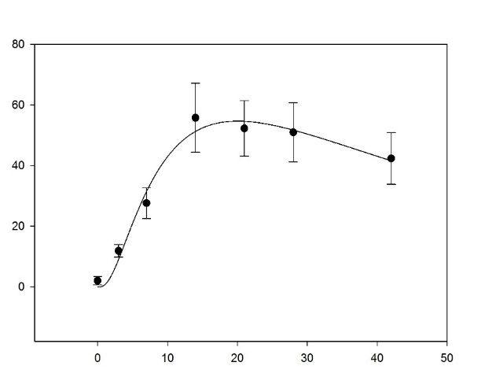
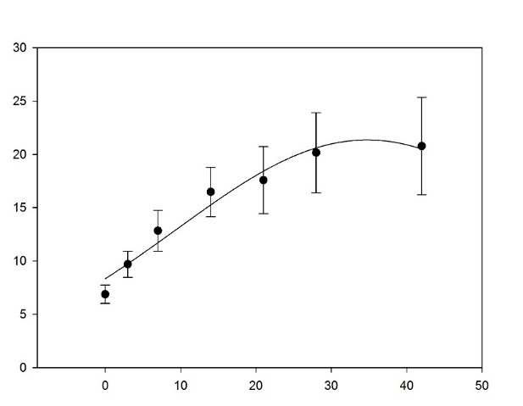
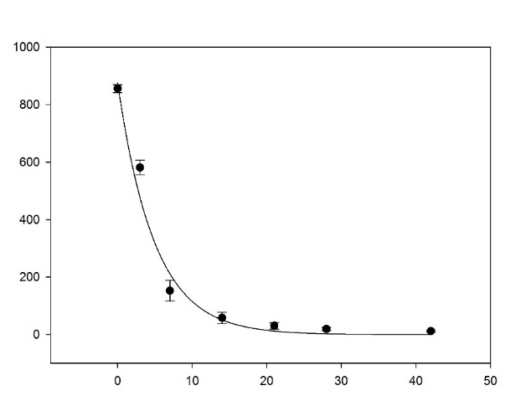
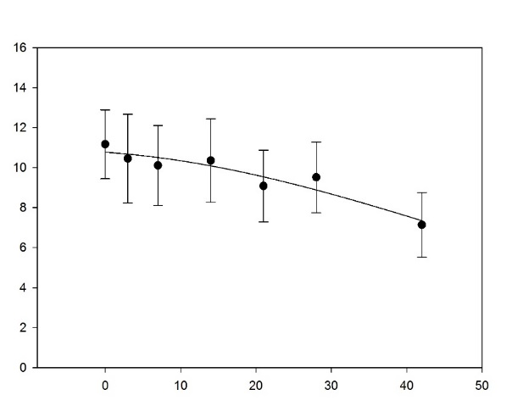
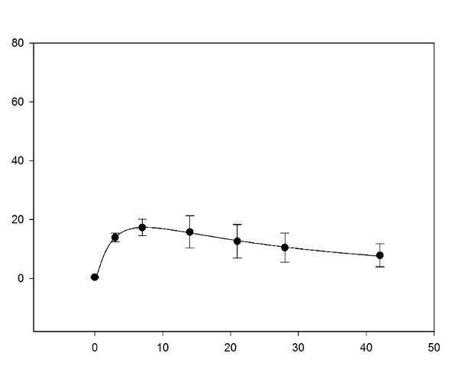
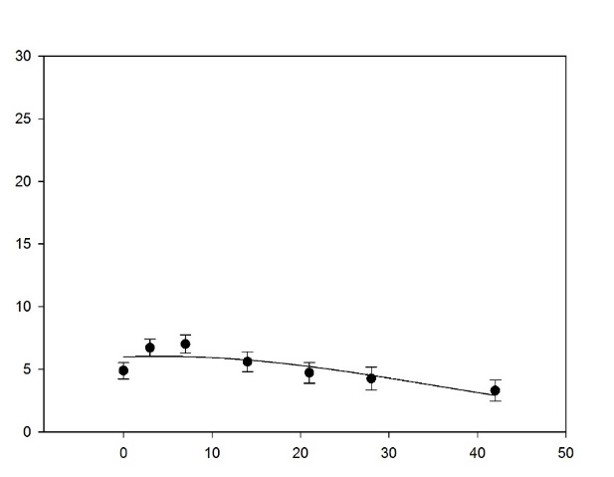
Concentration in soil (µg kg⁻¹)
Days after treatment
History
Non-History
HA
HA
DIA
DIA
DEA
DEA
ATZ
ATZ

Figure 5 cont.

CHAPTER III
Enhanced degradation of atrazine, simazine, and metribuzin in three midwestern soils

A version of this chapter was prepared for publication in Weed Science by Ethan T. Parker:

Enhanced Degradation of Atrazine, Simazine, and Metribuzin in Three Midwestern Soils
Ethan T. Parker, Michael D. Owen, Mark L. Bernards, William S. Curran, Lawrence E. Steckel, and Thomas C. Mueller*
* First and sixth authors: Graduate Research Assistant and Professor, Department of Plant Sciences, University of Tennessee, Knoxville, TN 37996; Second author: Professor, Agronomy Department, Iowa State University, Ames, IA 50011; Third author: Assistant Professor, School of Agriculture, Western Illinois University, Macomb, IL 61455; Fourth author: Professor, Department of Plant Science, Penn State University, University Park, PA 16802; Fifth author: Professor, Department of Plant Sciences, University of Tennessee, West TN Research and Education Center, 605 Airways Blvd., Jackson, TN 38301; Corresponding author’s E-mail: T^{mueller@utk.edu}

Abstract
The triazines are one of the most widely used herbicide classes ever developed, and play a critical role in managing herbicide resistant weed populations. These herbicides are traditionally valued for their persistence and season-long weed control in over 50 crops. The literature suggests that atrazine, the most widely used triazine, may no longer remain persistent in soils due to enhanced microbial degradation. Experiments examined the rate of degradation of two other triazine herbicides: simazine and metribuzin in both atrazine adapted and non-adapted Midwestern soils. In soils with a history of atrazine use, the t_{1/2} of atrazine was at least 4 times more rapid than in soils with no history of atrazine use. Simazine t_{1/2} was at least 2.4-15 times more rapid in history soils than non-history soils, and metribuzin was degraded at 0.6, 0.9, and 1.9 times the rate in the same soils. These results indicate cross-enhancement of the symmetrical triazine simazine, but not for metribuzin, an asymmetrical triazine.
Nomenclature: Atrazine; metribuzin; simazine.
Keywords: Enhanced degradation, environmental fate, s-triazine.
The triazine herbicides are one of the most influential classes of agricultural chemicals ever produced. They are desired for their selectivity, flexibility in use, and persistent weed control in more than 50 crops worldwide (Anonymous 2017a, 2017b, 2017c, LeBaron et al. 2008). Atrazine is the most widely used herbicide in the United States, second only to glyphosate. Even in the current era of widespread reliance on transgenic crops in the U.S., triazines continue to be an important tool in weed management, with atrazine used on 57% of U.S. corn acres in 2009 (Mitchell 2014).
Since their initial use for selective weed control, the fate of triazine herbicides has been closely monitored (Harris 1967, Kaufman and Kearney 1970). The persistent nature of many of these triazine compounds along with their widespread use and mobility has led to concern over the ecological risk that these compounds present (Barbash et al. 2001, Harman-Fetcho et al. 1999, Hayes et al. 2002, 2010, Kroon et al. 2014, McConnell et al. 2004, Solomon et al. 1996, Toccalino et al. 2014). Half-lives of triazines range from 20 to over 400 d depending on a wide array of environmental field conditions (Shaner 2014). The primary mechanism for triazine breakdown is microbially-facilitated degradation (Krutz et al. 2010a, Radosevich et al. 1995). A number of microorganisms have been isolated that partially transform triazines, with few reported that entirely mineralize these compounds. Both oxidation of the alkyl side chains of atrazine and the dehalogenation of atrazine can provide the source of C and/or energy available to microorganisms (Behki and Khan 1986, Radosevich et al. 1995, Yanze-Kontchou and Gschwind 1994, 1995). Side-chain and aromatic ring nitrogen atoms can also be utilized by some microbes as a nitrogen source (Cook and Huetter 1981, Radosevich et al. 1997).
Over the past decade, many reports have described the phenomena known as enhanced atrazine degradation, which results in a reduction of atrazine persistence (Anonymous 2017a, Krutz et al. 2010a, Mueller et al. 2010, Shaner 2014, Shaner and Henry 2007). This soil condition results when applications of atrazine to the soil cause an increase in microbial populations capable of rapidly metabolizing and degrading atrazine as a substrate (Ghosh et al. 2009, Radosevich et al. 1995, Rhine et al. 2003). It has been reported that not only atrazine, but also simazine is susceptible to this enhanced degradation mediated by microbes, likely due to its structural similarities to atrazine (Cook and Huetter 1981, Kaufman and Kearney 1970, Krutz et al. 2010a). While microbes are capable of degrading metribuzin and other triazines, there are no published reports from field observations indicating that the degradation of simazine and metribuzin follows a similar pattern to atrazine enhanced degradation (Kaufman and Kearney 1970, Ladlie et al. 1976).
Due to the continued concern over triazines in the environment (Hayes et al. 2002, Husak et al. 2016, Kroon et al. 2014, Lawrence et al. 1993), and the importance of triazine herbicides to weed control, it is important to understand the way that triazine use patterns affect their fate. Studies were conducted to examine the rate of atrazine, simazine, and metribuzin degradation in three Midwestern soils by comparing their behavior in atrazine history and non-history soils. Our hypothesis is that the s-triazines atrazine and simazine will degrade more rapidly in history soils compared to non-history soils, while the asymmetrical triazine metribuzin will degrade similarly independent of previous atrazine use history.

Materials and Methods

Soil Sample Collection.
This experiment utilized soils from three Midwestern states (Table 6). Since degradation of triazines is reliant upon microbial populations and their activity within the soil, sample collection and handling was conducted in a way to preserve soil microbial population and activity. Co-operators from IA, IL, and PA collected soil samples following a well-defined protocol. Soils were only taken from producer’s fields, with field edges and research sites being avoided, and sets of paired soils including either 0 or 5+ years of consecutive atrazine application. Soils were collected from a depth of 0 to 8 cm, and stored at 4 C until treatment. All soils were shipped overnight to Knoxville, TN for examination under controlled laboratory conditions, where a subsample of each soil was boxed and sent to MidWest Labs of Omaha, Nebraska for analysis of soil nutrient levels, organic matter content, pH, texture, and other characteristics.
Laboratory Analysis.
Prior to triazine fortification, 300 g of each soil was saturated using 200 mL deionized water and allowed to drain for 24 h to simulate field capacity. This was done because of the importance of soil moisture in the process of soil microbial degradation, and to allow for an equilibration of soil moisture in each soil. After draining, 5 g of each soil was placed in a 20-mL glass vial for fortification with one of three triazines. Fortification began with either 250 µL of 1000 µg kg⁻¹analytical atrazine, metribuzin, or simazine (Chem Service Inc., P.O. Box 599, West Chester, PA 19381) solution being placed directly onto the soil within each vial to simulate a field rate of 1.0 kg ha⁻¹. Samples were placed into a dark incubator at 22 C. Samples were removed from the incubator and placed into a freezer at -1, 0, 3, 7, 14, 21, 28, and 42 days after treatment (DAT) where the -1 sample received no treatment so that any residual triazine in field soils could be quantified. Using a Calibrex 525 pump (Socorex Isba S.A.), 12.0 mL of methanol was added to each vial. Vials were then shaken for 1.5 h, and filtered using 0.45-µm PTFE filters. Atrazine was quantified using liquid chromatography-mass spectrometry (LC-MS) according to previous methods (Mueller et al. 2010). Simazine and metribuzin methods used a C¹⁸ 150 x 4.6-mm diameter that included a 3 µm Phenomenex column, a 2-µL injection volume and 70:30 v:v acetonitrile:water mobile phase that included 0.1% formic acid. Operating parameters for MS (Agilent Model 6100) appear in Table 6. Atrazine, metribuzin, and simazine, were determined to have 94, 82, and 92% recoveries respectively.
Statistical Analysis.
Peaks detected by LC-MS were converted to a soil concentration in µg kg⁻¹. Concentrations were analyzed using SAS PROC GLIMMIX (SAS® Institute Inc., v. 9.4) to compare DAT and atrazine exposure history. Means were then regressed as concentration in µg kg⁻¹ against DAT using first-order kinetics by Sigmaplot v 13.2 (SYSTAT Software Inc.). A half-life (t_{1/2}) was determined using the resulting first order rate constant in the equation 0.693/k=t_{1/2}
(Kruger et al. 1993). An enhancement factor (EF) was calculated to quantify enhanced degradation using the formula t_{1/2} non-history soil / t_{1/2} history soil. This was possible because all field soil samples were collected in matched pairs of previous atrazine history (history) and non-atrazine history (non-history) fields. Each EF provides a quick metric by which the rate of triazine degradation in different soils can be assessed and compared to other soils.

Results and Discussion

All atrazine history soils exhibited signs of enhanced atrazine degradation, which was consistent with previous research (Krutz et al. 2010a, 2009, 2010b, Mueller et al. 2010, 2017). Atrazine non-history soils from Wapello County, IA had an average atrazine half-life of 47.6 d compared to only 1.4 d in atrazine history soils, with an enhancement factor of 33.8 (Table 7). Of all soils tested, Wapello County, IA soils had the largest disparity in rate of degradation between history and non-history soils (Figure 6). Atrazine non-history soils from Carroll County, IL had an average half-life of 8.3 d compared to only 2.4 d in atrazine history soils. Atrazine non-history soils from Centre County, PA had an average half-life of 24.0 d compared to only 3.5 d in history soils.
Simazine half-life in Wapello County, IA non-history soils was 53.7 d compared to 3.4 d in atrazine history soils (Table 7). Enhanced simazine degradation was also observed in IL history soils with a half-life of 6.9 d compared to 17 d in non-history soils. In PA history soils simazine had a 5.7 d half-life compared to 22.2 d in non-history soils. These results are strikingly similar to the effect of enhanced atrazine degradation (Figure 7), likely due to the similarities between simazine and atrazine molecular structure. Simazine is not as widely used as atrazine in row crop systems, and therefore enhanced degradation may have greater impact on weed control in managed turfgrass (McElroy et al. 2012, Yu and McCullough 2016). Simazine also lacks the flexibility of POST use and thus reduced soil persistence will decrease potential utility for weed control compared to atrazine, which can be used POST (Anonymous 2017b).
Metribuzin half-life in IA non-history soils was 26.8 d and 14.3 d in history soils. Though metribuzin degradation was 1.9 times more rapid in IA soils, it was not more rapid in soils from other states (Table 7, Figure 8). This lack of enhanced metribuzin degradation is likely due to the differences in both ring and substituent structures compared to the s-triazines. The reason for the more rapid metribuzin degradation in IA is unknown and no soil variable tested was able to adequately explain the differences. One hypothesis is that microbes capable of rapidly degrading metribuzin may be present in our IA field soil samples (Ladlie et al. 1976, Zhang et al. 2014). Another possibility is that metribuzin use may have occurred in these soils prior to sample collection. Although metribuzin degradation was not enhanced in the same way as the s-triazines, metribuzin degradation was more rapid than previously reported (Zhang et al. 2014). It is possible that metribuzin behaves differently than either atrazine or simazine because of the lack of a chlorine molecule available for dehalogenation. This different degradation pattern is by no means a guarantee that metribuzin is immune to the effects of enhanced degradation, but the development of cross-enhanced metribuzin degradation is not indicated by this research. It is important to note that our test system was under conditions that favor rapid microbial degradation, and expected t_{1/2} in crop fields are expected to be longer.
While atrazine will remain a viable POST option for producers in the fight to control herbicide resistant weeds, the residual control once afforded by this herbicide has been diminished. Enhanced degradation could, however, alleviate some concern regarding the fate of atrazine within non-target environments. In adapted soils, simazine will no longer provide a viable option for PRE weed control. Alternatively, it is encouraging that metribuzin remains a viable option for PRE weed control, as the advance of ALS- and PPO-resistant weeds have severely limited the ability of producers to effectively control glyphosate-resistant weeds, particularly in soybeans (Salas et al. 2016, Wuerffel et al. 2015). Going forward, metribuzin should be considered as a viable option when looking to incorporate a PSII herbicide into a resistance-management plan. Given the large number of variables that play a role in determining biologically-mediated herbicide degradation, future research should focus on better understanding of the degradation of triazines under a variety of field conditions. Factors including irrigation, fertilization, other pesticide use, and tillage should all be examined carefully to aid in decision making regarding how best to adapt to enhanced triazine degradation as many of these factors are known to play a role in preferential microbial degradation (Krutz et al. 2010a, Rhine et al. 2003, Shaner 2014).

Acknowledgements

The authors would like to thank the technical staff at the University of Tennessee, Iowa State University, Penn State University, and Western Illinois University for their assistance in collecting and processing soil samples. Technical assistance by Anna Ekene Davis Tharpe and Stephen Nassan is appreciated. This experiment was funded by the Tennessee Agricultural Experiment Station.

Literature Cited
Anonymous (2017a) AAtrex® 4L Product Label. Syngenta Crop Protection, LLC P. O. Box 18300 Greensboro, North Carolina 27419-8300: Syngenta Crop Protection, LLC Publication SCP 497A-L38TT 1112 4021678. 24 p
Anonymous (2017b) Princep® 4L Product Label. Syngenta Crop Protection, LLC P. O. Box 18300 Greensboro, North Carolina 27419-8300: Syngenta Crop Protection, LLC Publication SCP 526A-L58S 1212 4044257. 20 p
Anonymous (2017c) Sencor® 75 Product Label. Bayer CropScience LP 2 T. W. Alexander Drive Research Triangle Park, NC 27709: Bayer Environmental Science 427709 3408063C 100209AV1. 6 p
Barbash, JE, GP Thelin, DW Kolpin, RJ Gilliom (2001) Major herbicides in ground water: results from the National Water-Quality Assessment. J Environ Qual 30:831–45
Behki, RM, SU Khan (1986) Degradation of atrazine by Pseudomonas: N-dealkylation and dehalogenation of atrazine and its metabolites. J Agric Food Chem 34:746–749
Cook, AM, R Huetter (1981) s-Triazines as nitrogen sources for bacteria. J Agric Food Chem 29:1135–1143
Ghosh, D, K Roy, V Srinivasan, T Mueller, OH Tuovinen, K Sublette, A Peacock, M Radosevich (2009) In-situ enrichment and analysis of atrazine-degrading microbial communities using atrazine-containing porous beads. Soil Biol Biochem 41:1331–1334
Harman-Fetcho, JA, LL McConnell, JE Baker (1999) Agricultural pesticides in the Patuxent River, a tributary of the Chesapeake Bay. J Environ Qual 28:928
Harris, CI (1967) Decomposition in soil fate of 2-chloro-s-triazine herbicides in soil. J Agric Food Chem 15:157–162
Hayes, T, K Haston, M Tsui, A Hoang, C Haeffele, A Vonk (2002) Atrazine-induced Hermaphroditism at 0.1 ppb in American Leopard Frogs (Rana pipiens): Laboratory and field evidence. Environ Health Perspect 111:568–575
Hayes, TB, V Khoury, A Narayan, M Nazir, A Park, T Brown, L Adame, E Chan, D Buchholz, T Stueve, S Gallipeau (2010) Atrazine induces complete feminization and chemical castration in male African clawed frogs (Xenopus laevis). Proc Natl Acad Sci 107:4612–4617
Husak, V V., NM Mosiichuk, I V. Maksymiv, JM Storey, KB Storey, VI Lushchak (2016) Oxidative stress responses in gills of goldfish, Carassius auratus, exposed to the metribuzin-containing herbicide Sencor. Environ Toxicol Pharmacol 45:163–169
Kaufman, DD, PC Kearney (1970) Microbial degradation of s-triazine herbicides. Residue Rev 32:235–265
Kroon, FJ, SE Hook, D Jones, S Metcalfe, HL Osborn (2014) Effects of atrazine on endocrinology and physiology in juvenile barramundi, Lates calcarifer (Bloch). Environ Toxicol Chem 33:1607–1614
Kruger, EL, L Somasundaram, JR Coats, RS Kanwar (1993) Persistence and degradation of [ ¹⁴ C]atrazine and [ ¹⁴ C]deisopropylatrazine as affected by soil depth and moisture conditions. Environ Toxicol Chem 12:1959–1967
Krutz, LJ, IC Burke, KN Reddy, RM Zablotowicz, AJ Price (2009) Enhanced Atrazine Degradation: Evidence for reduced residual weed control and a method for identifying adapted soils and predicting herbicide persistence. Weed Sci 57:427–434
Krutz, JL, DL Shaner, MA Weaver, RM Webb, RM Zablotowicz, KN Reddy, Y Huang, SJ Thomson (2010a) Agronomic and environmental implications of enhanced s-triazine degradation. Pest Manag Sci 66:461–481
Krutz, LJ, DL Shaner, RM Zablotowicz (2010b) Enhanced degradation and soil depth effects on the fate of atrazine and major metabolites in Colorado and Mississippi Soils. J Environ Qual 39:1369
Ladlie, JS, WF Meggitt, D Pennerr (1976) Effect of soil pH on microbial degradation, Adsorption, and Mobility of Metribuzin. Weed Sci 24:477–481
Lawrence, JR, M Eldan, WC Sonzogni (1993) Metribuzin and metabolites in Wisconsin (U.S.A.) well water. Water Res 27:1263–1268
LeBaron, HM, JF McFarland, OC Burnside, eds. (2008) The Triazine Herbicides 1st Ed. San Deigo: Elsevier. 355 p
McConnell, LL, JA Harman-Fetcho, JD Hagy (2004) Measured concentrations of herbicides and model predictions of atrazine fate in the Patuxent river estuary. J Environ Qual 33:594-604
McElroy, JS, JD McCurdy, ML Flessner (2012) Seedling centipedegrass response to mesotrione plus simazine mixtures. Hort Technol 22:627–630
Mitchell, PD (2014) Market-level assessment of the economic benefits of atrazine in the United States. Pest Manag Sci 70:1684–1696
Mueller, TC, ET Parker, LE Steckel, SA Clay, MD Owen, WS Curran, R Currie, R Scott, C Sprague, D Stephenson, D Miller, E Prostko, J Grichar, J Martin, LJ Krutz, K Bradley, M Bernards, P Dotray, S Knezevic, VM Davis, R Klein (2017) Enhanced atrazine degradation is widespread across the United States. Pest Manag Sci In Press
Mueller, TC, LE Steckel, M Radosevich (2010) Effect of soil pH and previous atrazine use history on atrazine degradation in a Tennessee field soil. Weed Sci 58:478–483
Radosevich, M, SJ Traina, YL Hao, OH Tuovinen (1995) Degradation and mineralization of atrazine by a soil bacterial isolate. Appl Environ Microbiol 61:297–302
Radosevich, M, SJ Traina, OH Tuovinen (1997) Atrazine mineralization in laboratory-aged soil microcosms inoculated with s-triazine-degrading bacteria. J Environ Qual 26:206
Rhine, ED, JJ Fuhrmann, M Radosevich (2003) Microbial community responses to atrazine exposure and nutrient availability: Linking degradation capacity to community structure. Microb Ecol 46:145–160
Salas, RA, NR Burgos, PJ Tranel, S Singh, L Glasgow, RC Scott, RL Nichols (2016) Resistance to PPO-inhibiting herbicide in Palmer amaranth from Arkansas. Pest Manag Sci 72:864–869
Shaner, D, ed. (2014) Herbicide Handbook. 10th ed. Lawrence, KS: Weed Science Society of America. 54-55 p
Shaner, DL, WB Henry (2007) Field history and dissipation of atrazine and metolachlor in Colorado. J Environ Qual 36:1–5
Solomon, K, D Baker, P Richards, K Dixon, S Klaine, T Point, R Kendall (1996) Ecological risk assessment of atrazine in North American surface waters. Environ Toxicol Chem 15:31–76
Toccalino, PL, RJ Gilliom, BD Lindsey, MG Rupert (2014) Pesticides in groundwater of the United States: Decadal-scale changes, 1993-2011. Groundwater 52:112–125
Wuerffel, RJ, JM Young, JL Matthews, BG Young (2015) Characterization of PPO-inhibitor–resistant waterhemp (Amaranthus tuberculatus) Response to soil-applied PPO-Inhibiting herbicides. Weed Sci 63:511–521
Yanze-Kontchou, C, N Gschwind (1994) Mineralization of the herbicide atrazine as a carbon source by a Pseudomonas strain. Appl Environ Microbiol 60:4297–4302
Yanze-Kontchou, C, N Gschwind (1995) Mineralization of the herbicide atrazine in soil inoculated with a Pseudomonas strain. J Agric Food Chem 43:2291–2294
Yu, J, PE McCullough (2016) Efficacy and fate of atrazine and simazine in doveweed (Murdannia nudiflora). Weed Sci 64:379–388
Zhang, H, Y Zhang, Z Hou, X Wu, H Gao, F Sun, H Pan (2014) Biodegradation of triazine herbicide metribuzin by the strain Bacillus sp. N1. J Environ Sci Heal Part B 49:79–86

Appendix

Table 6. Liquid chromatography – mass spectrometry methods for metribuzin and simazine.
Parameters | Metribuzin |  |  |  | Simazine
Mobile phase flow | 0.7 mL min⁻¹ |  |  |  | 0.6 mL min⁻¹
Mode of Operation | Positive |  |  |  | Positive
Gas Flow | 6.0 L min⁻¹ |  |  |  | 6.0 L min⁻¹
Nebulizer pressure | 207 kPa |  |  |  | 241 kPa
Drying gas temp | 250 C |  |  |  | 250 C
Vaporizer temp | 250 C |  |  |  | 250 C
SIMª @ | 202 |  |  |  | 215.1
Frag | 110 |  |  |  | 120
Capillary Voltage | 1600 |  |  |  | 1600
Corona current | 0 |  |  |  | 0
Charging voltage | 0 |  |  |  | 0
Limit of detection | 10 µg kg⁻¹ |  |  |  | 10 µg kg⁻¹
Retention time (min) | 3.93 |  |  |  | 3.95
3-µm particle size C¹⁸ Phenomenex column (150 x 4.6 mm)
70:30 Acetonitrile:Water with 0.1% formic acid
ªAbbreviations: SIM, selected ion monitoring

Table 7. Locations, soil characteristics, and half-lives of soil samples analyzed.ª
State | County | Adapted | pH | Soil Texture | OM^{b} % | Sand | Silt | Clay | Atrazine |  | Metribuzin |  | Simazine
 |  |  |  |  | ---------------%-------------- |  |  |  | t_{1/2}^{c} | EF^{d} | t_{1/2} | EF | t_{1/2} | EF
IA | Wapello | No | 5.7 | SiCL | 2.8 | 5 | 55 | 40 | 47.8 | 34 | 53.7 | 1.9 | 26.8 | 16
IA | Wapello | Yes | 7.5 | SiCL | 3 | 14 | 57 | 29 | 1.4 |  | 3.4 |  | 14.3
IL | Carroll | No | 7.1 | L | 4.7 | 26 | 60 | 14 | 8.4 | 3.4 | 17 | 0.9 | 12.4 | 2.4
IL | Carroll | Yes | 7.3 | SiL | 4.1 | 15 | 67 | 18 | 2.5 |  | 6.9 |  | 13.2
PA | Centre | No | 6.4 | SiL | 3.9 | 34 | 49 | 17 | 24.1 | 6.9 | 22.2 | 0.6 | 7.1 | 3.9
PA | Centre | Yes | 4.3 | L | 4.6 | 34 | 46 | 20 | 3.5 |  | 5.7 |  | 11.6
ª A two-way interaction of state and history was significant (P < 0.001)
^{b}Abbreviations: t_{1/2}, half-life in d; EF, Enhancement Factor; IA, Iowa; IL, Illinois; L, loam; OM, organic matter; PA, Pennsylvania; SiCL, silty clay loam; SiL, silty loam
^{c}t_{1/2} values were calculated using the formula 0.693/k=t_{1/2}
^{d}Enhancement factor calculated using the formula: t_{1/2} non-history soil/ t_{1/2} history soil.

Figure 6. Exponential decay of atrazine concentration (µg kg⁻¹) in IA, IL, and PA soils as a function of atrazine history and days after atrazine fortification. Error bars indicate one standard deviation, and all R² values were > 0.94.

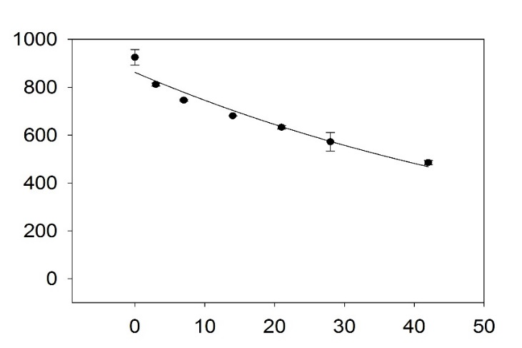
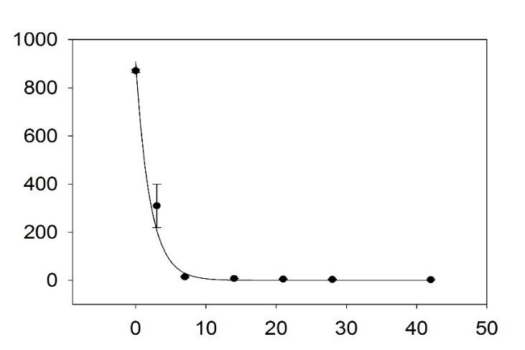
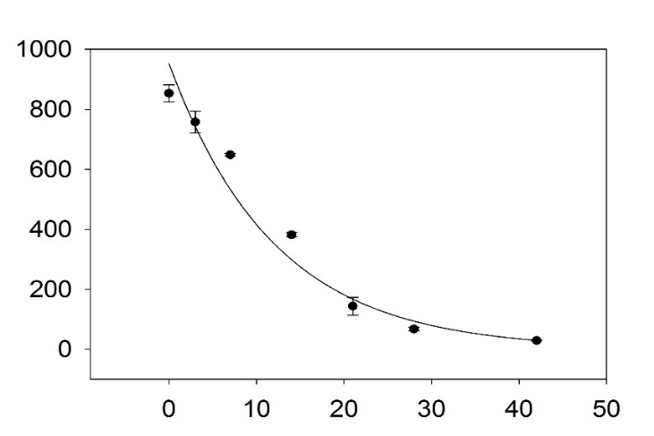
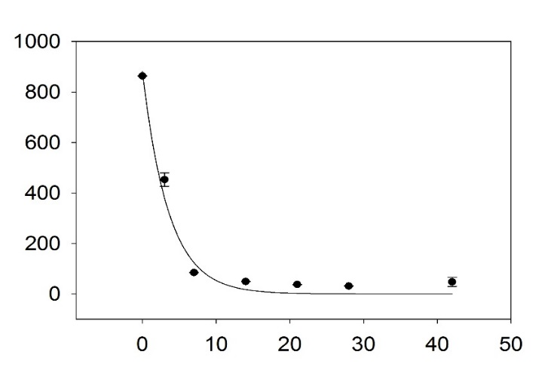
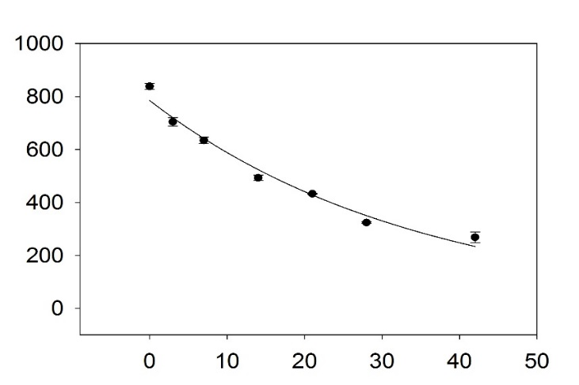
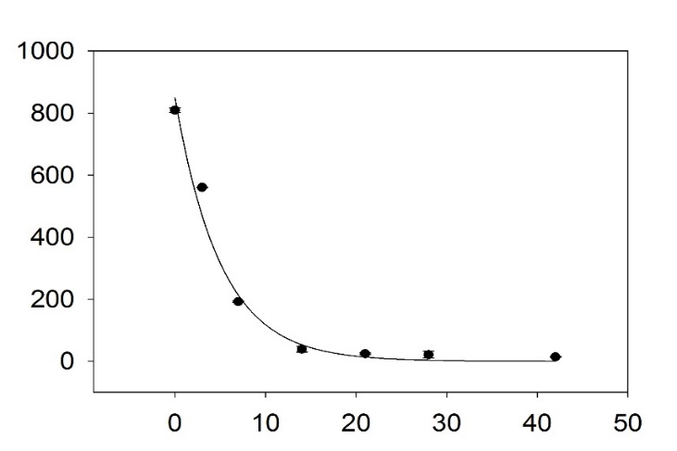
Atrazine concentration in soil (µg kg⁻¹)
Days after treatment
IA
IA
IL
PA
IL
PA
History
Non-history
t_{1/2} – 24.1 d
t_{1/2} – 3.5 d
t_{1/2} – 2.5 d
t_{1/2} – 8.4 d
t_{1/2} – 47.8 d
t_{1/2} – 1.4 d

Figure 6 cont.
Figure 7. Exponential decay of simazine concentration (µg kg⁻¹) in IA, IL, and PA soils as a function of atrazine history and days after simazine fortification. Error bars indicate one standard deviation, and all R² values were > 0.96.

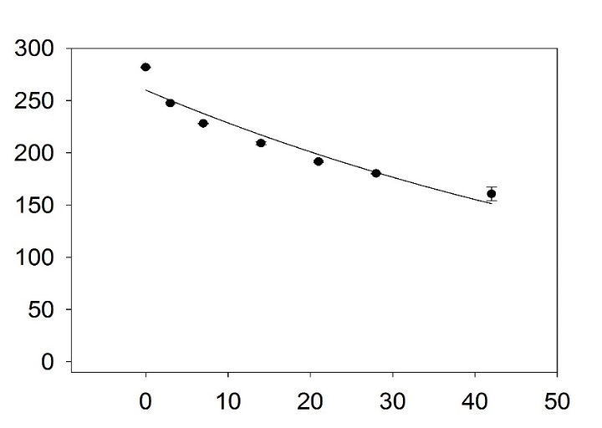
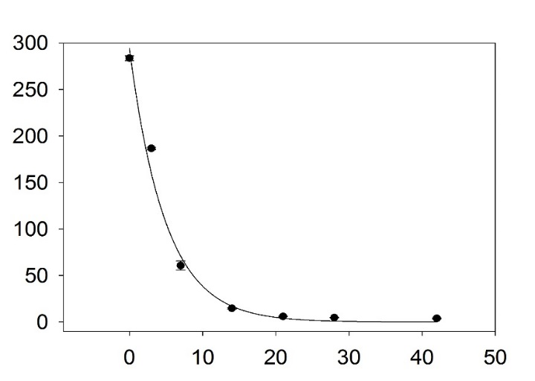
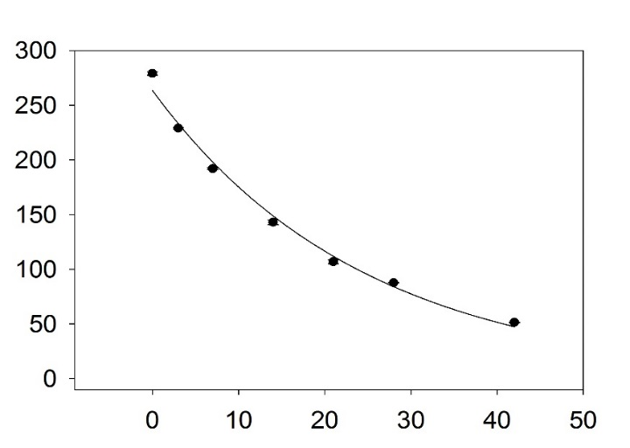
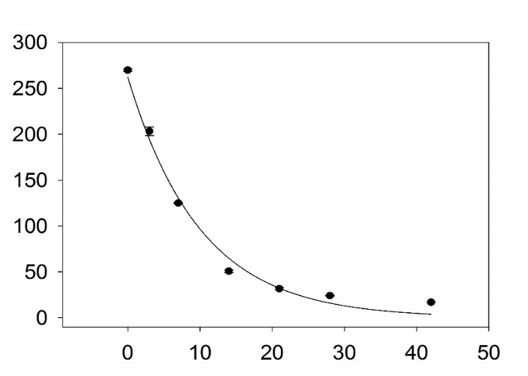
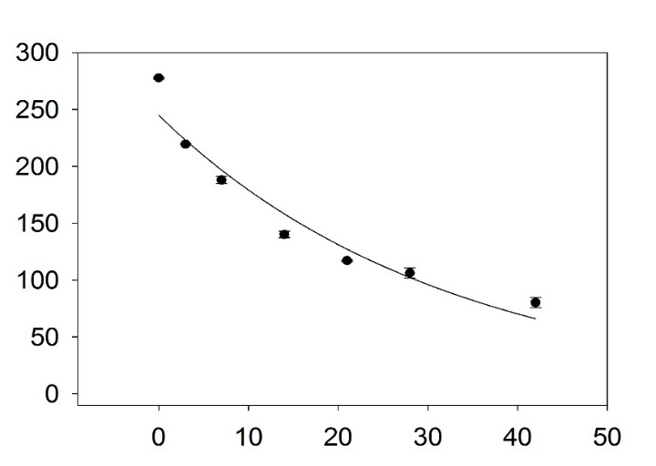
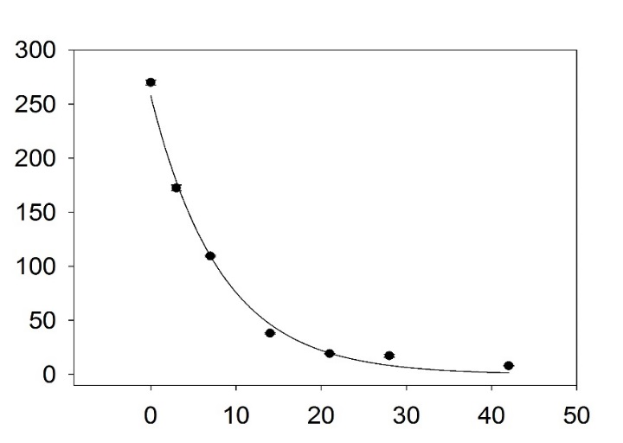
Simazine concentration in soil (µg kg⁻¹)
IA
IA
IL
PA
IL
PA
History
Non-history
t_{1/2} – 53.7 d
t_{1/2} – 17.0 d
t_{1/2} – 22.2 d
t_{1/2} – 3.4 d
t_{1/2} – 6.9 d
t_{1/2} – 5.7 d
Days after treatment

Figure 7 cont.
Figure 8. Exponential decay of metribuzin concentration (µg kg⁻¹) in IA, IL, and PA soils as a function of atrazine history and days after metribuzin fortification. Error bars indicate one standard deviation, and all R² values were > 0.91.

Figure 8 cont.
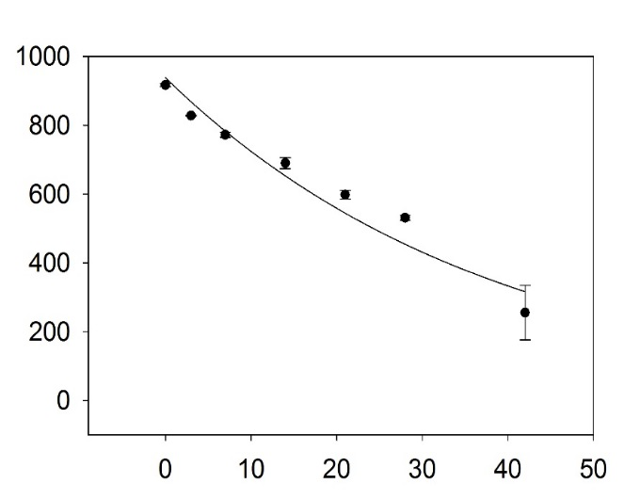
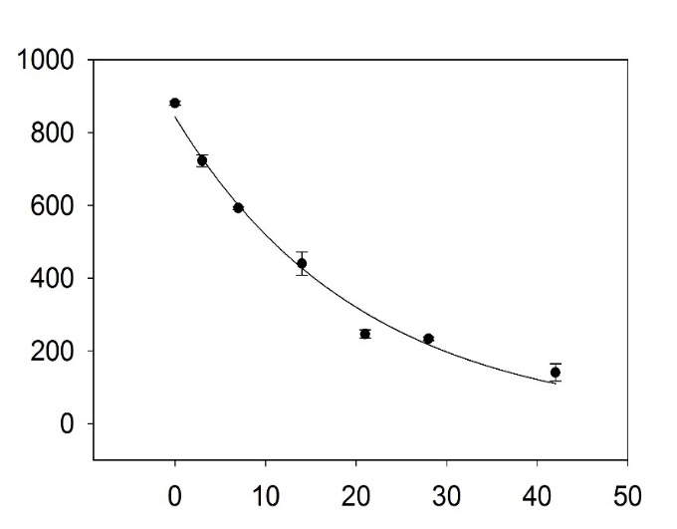
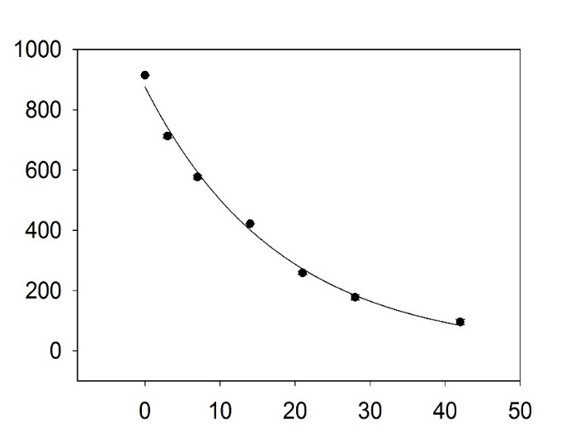
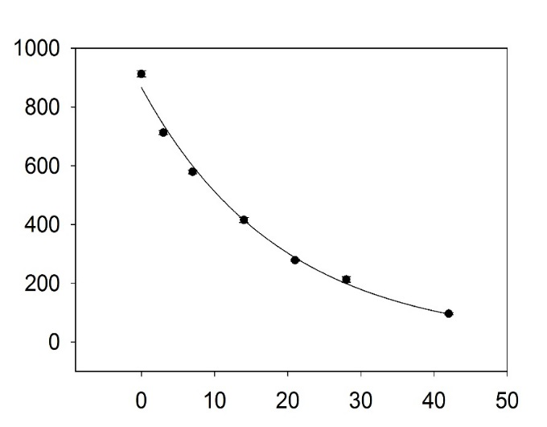
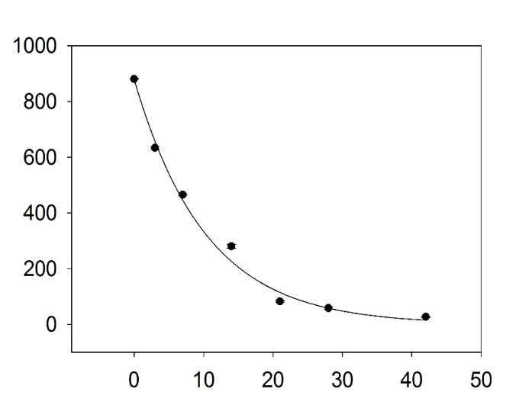
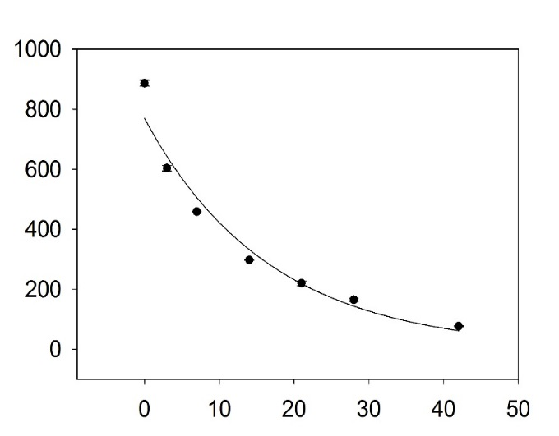
Metribuzin concentration in soil (µg kg⁻¹)
Days after treatment
IA
IA
IL
PA
IL
PA
History
Non-history
t_{1/2} – 7.1 d
t_{1/2} – 12.4 d
t_{1/2} – 26.8 d
t_{1/2} – 14.3 d
t_{1/2} – 13.2 d
t_{1/2} – 11.6 d

CHAPTER iv
atrazine behavior in flooded and non-flooded soils and its effect on soybean Injury and yield

A version of this chapter was prepared for publication in Weed Technology by Ethan T. Parker:

Atrazine Behavior in Flooded and Non-flooded Soils and Its Effect on Soybean Injury and Yield

Ethan T. Parker, David R. Kincer, Thomas C. Mueller*

First, second, and third authors: Graduate Research Assistant, Research Associate I, and Professor, Department of Plant Sciences, University of Tennessee, 2431 Joe Johnson Drive, Knoxville, Tennessee 37996-4561; Corresponding author’s Email: tmueller@utk.edu

Abstract
Atrazine is the second most used herbicide globally for weed control in corn. Given the increase of flooding in the United States over the past decade, producers need information to determine the best course of action after fields are flooded that have been treated with atrazine. Studies were designed to understand the effect of flooding on atrazine residual activity, including atrazine concentration, soybean injury, and soybean yield. In 2012, in flooded treatments, soybean yield was significantly affected by prior atrazine use. In 2014, soybean injury was < 10% in all plots and non-flooded atrazine treated soils had yields equal to the nontreated control. This reduction in atrazine persistence within treated fields may be due to enhanced atrazine degradation. The data indicates that it is possible for producers to consider replanting soybeans after atrazine application.
Nomenclature: Atrazine, Glycine max L. Merr., Zea mays L.
Key words: Atrazine, flooding, enhanced degradation
Atrazine is one of the most widely used herbicides globally, second only to glyphosate (Mitchell 2014). Atrazine provides both PRE and POST weed control in corn, sorghum, and sugarcane. Historically, atrazine longevity in soils has been a critical component for good weed control. This persistence has also led to concern over residual atrazine both within crop fields and within surface waters (Brecke et al. 1981, Burnside and Wicks 1980, Burnside et al. 1971, Hall et al. 1972, Kelly and Wilson 2000, Laroche et al. 1996, Richards et al. 1987, 1996, Toccalino et al. 2014).
From 2010 to 2016, eight notable flooding events occurred in the southeastern U.S. alone, including the 2010 Nashville flood, the 2016 Houston flood, and most recently, the fall 2016 Louisiana flood (Fournier et al. 2016, Martin et al. 2016, Vahedifard et al. 2016, Wang et al. 2016, van der Wiel et al. 2017). With these recent flooding events across the southern U.S., producers have questions about how to manage fields previously treated with atrazine prior to flooding. Besides flooding, late frosts, hail damage, wildlife damage, or other factors may force producers to consider replanting a field in soybean after a PRE atrazine application has already been made. Simply replanting corn will often result in reduced corn yield due to late planting, therefore other alternatives are needed (Benson 1990, Olson 2009, Yin et al. 2012). The first objective of this experiment was to quantify the persistence of atrazine in flooded soils. Next, the recorded atrazine concentration is related to soybean visual injury at 28 and 42 days after planting (DAP) and final soybean yield. No current literature is published examining the effects of atrazine on soybeans replanted under diverse flooding conditions. While Pawlak et al. (1987) described soybean injury from carryover in no-till systems, no definitive answer can be given in regard to the effect of flooding on atrazine carryover. These results aim to inform producers with the best course of action to replant soybeans in atrazine-treated fields.
Materials and Methods
Flooding Plots. Experiments were carried out in the summer of 2012, 2013, and 2014 at the East Tennessee Research and Education Center in Knoxville, TN. Studies were conducted in Sequatchie silt loam soil with a pH of 6.2, CEC of 10.4 meq 100 g⁻¹, and OM content of 1.7%. The 2013 field experiment was invalid due to prolific rainfall resulting in the flooding of all treated plots. Main plots were created by building soil berms around 12 m x 12 m plots containing three 9 m x 3 m sub-plots. Glyphosate was applied as a burndown to prevent weed contamination of plots. Atrazine treatments of 0, 2.2, and 4.5 kg ha⁻¹ were applied within berms prior to flooding using atrazine 4L and a six-nozzle handheld boom spraying at 190 L ha⁻¹. Applications were made on May 18, 2012 and May 19, 2014. All plots received 2.5 cm of overhead irrigation, and then non-flooded treatments were allowed to dry. Flood treatments were applied using large pipes to dispense water into the main plots, with care taken to minimize soil disturbance. The source for flooding treatments was the Tennessee River, which was not expected to contain any atrazine (Richards et al. 1996). Depth of flood was 5-15 cm in depth and was maintained for 5 d. At that time, berms were opened and plots were allowed to dry. After drying for 7 d, berms were leveled with tillage and all plots were no-till planted with commercial equipment, at a 2.5-cm depth and 76-cm row spacing. Seeding rate of Asgrow 4532 RR soybean was 50 kg ha⁻¹. Soybean planting was done on May 31, 2012 and June 6, 2014. Plots were maintained weed free using glyphosate applied POST as no glyphosate resistant weeds were present at this location.
Data Collection. At 13 and 17 d after flooding in 2012 and 2014 respectively, soil samples from individual plots were collected prior to planting at a depth of 0- to 8-cm using a turf cup-cutter. These soil samples were transported in coolers to the lab and stored at -20 C until extraction. Extraction was performed by adding methanol to collected soil samples, shaking, filtration, and quantified by liquid chromatography – mass spectrometry (LC-MS) according to previous methods (Mueller et al. 2010). Concentrations of atrazine quantified were converted to concentration in µg kg⁻¹ for later statistical analysis.
At 28 and 42 DAP, soybean injury was visually evaluated using a scale of 0 to 100%, with 0% being no injury and 100% representing complete plant necrosis. The aim was to record soybean injury symptoms for comparison to effect on overall soybean yield (Anderson 1970, Pawlak et al. 1987). At 120 DAP in both studies, two center rows of soybeans were mechanically harvested and yield data were collected.

Experimental Design and Data Analysis. A completely randomized block 2 x 3 factorial split-plot design was used with two levels of flooding (flooded and not flooded) across three atrazine rates. Atrazine rates of 0, 2.2, and 4.5 kg ha⁻¹ were used to examine both average and twice the normal use rates (Anonymous 2017).
Data from flooding studies were subjected to ANOVA in SAS (SAS® Institute Inc., v. 9.2) using PROC GLIMMIX to test for significance of atrazine rate and flooding treatment on atrazine concentration in soils, soybean injury, and yield. Experimental run and replication were considered random effects with flooding and atrazine rate being considered fixed effects. All visual evaluation data were transformed for statistical analysis using a square root transformation then back transformed for presentation. Means were separated using Fisher’s protected least significant difference (LSD) at the P ≤ 0.05 level.

Results and Discussion
Atrazine Concentration. In 2012, atrazine concentration within a given atrazine treatment was similar in both flooded and non-flooded soils (Table 8). Atrazine concentration was greatest in soils treated with the higher rate of atrazine, with about 35% less atrazine recovered in soils treated with the lower rate. Low atrazine concentrations in nontreated control plots suggest that atrazine movement in surface water was minimal. In 2014, atrazine concentrations were much higher in non-flooded soils compared to flooded soils (Table 9). This observation may be due to movement of atrazine in surface waters in flooded plots (Barbash et al. 2001, Belluck et al. 1991, Hall et al. 1972, Solomon et al. 1996, Toccalino et al. 2014). Another contributing factor may be enhanced microbial degradation of atrazine within flooded soils (Krutz et al. 2010, Mueller et al. 2017, Shaner et al. 2007). Enhanced atrazine degradation occurs when soils previously treated with this product (atrazine) experience an increase in the population of microbes capable of metabolizing atrazine (Mueller et al. 2010, Shaner and Henry 2007, Shaner et al. 2007). Non-flooded soils may have lacked the moisture required to support microbial populations capable of metabolizing atrazine within surface soils, receiving only 7.4 and 11.9 mm of rainfall during the experiment in 2012 and 2014, respectively.

Soybean Injury. In 2012 at both 28 and 42 DAP, soybean injury was the same as the nontreated check within non-flooded soils, regardless of atrazine use rate. There were large differences when comparing flooded and non-flooded soils at both atrazine rates. This greater injury in 2012 within flooded soils is possibly due to the higher half-life of atrazine in water-logged soils, however our test system did not allow for capture of water samples (Comber 1999, Shaner 2014). This greater persistence and increased availability of atrazine for uptake likely explains the observed soybean injury compared to non-flooded soils.
In 2014, soybean injury from atrazine was lower (<10%). All atrazine treatments caused injury compared to the nontreated check. The reduced soybean response may be due to the previously mentioned enhanced microbial degradation of atrazine.

Soybean Yield. In 2012, there were no differences between soybean yields when comparing flooded and non-flooded soils at the same atrazine use rate. There were, however, differences across atrazine rates within flooding treatments. Within flooded atrazine soils, yield decreased significantly at both 2.2 and 4.5 kg ha⁻¹ from over 3.56 Mg ha⁻¹ to under 2.42 Mg ha⁻¹. The increased half-life of atrazine in water and greater chances of uptake in moist soil conditions may have contributed to the yield losses observed in flooded atrazine soils 2012 (Comber 1999, Shaner 2014). However, no water samples were collected in this study because maintaining plot integrity was an issue. In 2014, there were no differences in yield across all treatment factors (Table 9). The observed yield uniformity is most likely due to the previously explained effect of enhanced atrazine degradation that is known to appear within as little as three to five years of consecutive atrazine application (Krutz et al. 2009, 2010, Mueller et al. 2010, 2017, Shaner et al. 2007).
These data indicate that it is possible to plant back soybeans after flooding in atrazine treated fields with no yield loss. Situations other than flooding, including late freezes, hail damage, and herbicide drift scenarios often occur when producers may wish to replant soybeans. These data also indicates that planting soybeans after atrazine may be possible in non-flooded soils as well. While some minor soybean injury may occur, it will not be unlike injury thresholds that producers experience when utilizing PPO herbicides such as fomesafen in soybeans (Cieslik et al. 2014). The observed injury also did not affect overall soybean yield. These results show that current atrazine replanting restrictions may be too long (Anonymous 2017)
Given the increased possibility of flooding, late freezes, hail damage, and herbicide drift continuing to impact crop production across the southeast, producers should aim to better understand available options when replanting an affected field. Future research should target the effects of enhanced atrazine degradation on plant-back intervals of atrazine-sensitive crops. More research should also address the impact of rainfall amount, tillage system, and other pesticide use on the success of replanted corn and soybeans after a flooding event.

Acknowledgements
The authors would like to thank the Tennessee Soybean Promotion Board and the Tennessee Agricultural Experiment Station for their support of this research. The authors would also like to thank D. Hopkins, J. Beeler, and D. Edralin for their insight and technical assistance in these studies.

Literature Cited
Anderson, R (1970) Influence of soybean seed size on response to atrazine. Weed Sci 18:162–164
Anonymous (2017) AAtrex® 4L Product Label. Syngenta Crop Protection, LLC P. O. Box 18300 Greensboro, North Carolina 27419-8300: Syngenta Crop Protection, LLC Publication SCP 497A-L38TT 1112 4021678. 24 p
Barbash, JE, GP Thelin, DW Kolpin, RJ Gilliom (2001) Major herbicides in ground water: results from the National Water-Quality Assessment. J Environ Qual 30:831–845
Belluck, DA, SL Benjamin, T Dawson (1991) Groundwater contamination by atrazine and its metabolites. Pestic Transform Prod Fate Significance Environ 459:254–273
Benson, GO (1990) Corn replant decisions: A review. J Prod Agric 3:180-184
Brecke, BJ, WL Currey, DH Teem (1981) Atrazine persistence in a corn-soybean doublecropping system. Agron J 73:534-537
Burnside, OC, CR Fenster, GA Wicks (1971) Soil persistence of repeated annual applications of atrazine. Weed Sci 19:290–293
Burnside, OC, GA Wicks (1980) Atrazine carryover in soil in a reduced tillage crop production system. Weed Sci 28:661–666
Cieslik, LF, RA Vidal, MM Trezzi (2014) Fomesafen toxicity to bean plants as a function of the time of application and herbicide dose. Acta Sci Agron 36:329-334
Comber, SDW (1999) Abiotic persistence of atrazine and simazine in water. Pestic Sci 55:696–702
Fournier, S, JT Reager, T Lee, J Vazquez-Cuervo, CH David, MM Gierach (2016) SMAP observes flooding from land to sea: The Texas event of 2015. Geophys Res Lett 43:338–346
Hall, JK, M Pawlus, ER Higgins (1972) Losses of atrazine in runoff water and soil sediment. J Environ Qual 1:172-176
Kelly, WR, SD Wilson (2000) Movement of bromide, nitrogen-15, and atrazine through flooded soils. J Environ Qual 29:1085-1094
Krutz, LJ, IC Burke, KN Reddy, RM Zablotowicz, AJ Price (2009) Enhanced atrazine degradation: evidence for reduced residual weed control and a method for identifying adapted soils and predicting herbicide persistence. Weed Sci 57:427–434
Krutz, LJ, DL Shaner, RM Zablotowicz (2010) enhanced degradation and soil depth effects on the fate of atrazine and major metabolites in Colorado and Mississippi Soils. J Environ Qual 39:1369
Laroche, A-M, J Gallichand, R Lagacé, A Pesant (1996) Simulating atrazine transport with HSPF in an agricultural watershed. J Environ Eng 122:622–630
Martin, NC, JW Felton, DA Cole (2016) Predictors of youths’ posttraumatic stress symptoms following a natural disaster: The 2010 Nashville, Tennessee, Flood. J Clin Child Adolesc Psychol 45:335–347
Mitchell, PD (2014) Market-level assessment of the economic benefits of atrazine in the United States. Pest Manag Sci 70:1684–1696
Mueller, TC, ET Parker, LE Steckel, SA Clay, MD Owen, WS Curran, R Currie, R Scott, C Sprague, D Stephenson, D Miller, E Prostko, J Grichar, J Martin, LJ Krutz, K Bradley, M Bernards, P Dotray, S Knezevic, VM Davis, R Klein (2017) Enhanced atrazine degradation is widespread across the United States. Pest Manag Sci In Press
Mueller, TC, LE Steckel, M Radosevich (2010) effect of soil pH and previous atrazine use history on atrazine degradation in a Tennessee field soil. Weed Sci 58:478–483
Olson, K (2009) Impacts of 2008 flooding on agricultural lands in Illinois, Missouri, and Indiana. J Soil Water Conserv 64:167-171
Pawlak, J, J Kells, M Barrett, W Meggitt (1987) Effect of atrazine residue on soybean growth under three tillage systems and various herbicides. Weed Technol 1:140–144
Richards, RP, JW Kramer, DB Baker, KA Krieger (1987) Pesticides in rainwater in the northeastern United States. Nature 327:129–131
Richards, RP, DB Baker, NL Creamer, JW Kramer, DE Ewing, BJ Merryfield, LK Wallrabenstein (1996) Well water quality, well vulnerability, and agricultural contamination in the Midwestern United States. J Environ Qual 25:389
Shaner, D, ed. (2014) Herbicide Handbook. 10th ed. Lawrence, KS: Weed Science Society of America. 54-55 p
Shaner, DL, WB Henry (2007) Field history and dissipation of atrazine and metolachlor in Colorado. J Environ Qual 36:1–5
Shaner, DL, WB Henry, LJ Krutz, B Hanson (2007) rapid assay for detecting enhanced atrazine degradation in soil. Weed Sci 55:528–535
Solomon, K, D Baker, P Richards, K Dixon, S Klaine, T Point, R Kendall (1996) Ecological risk assessment of atrazine in North American surface waters. Environ Toxicol Chem 15:31–76
Toccalino, PL, RJ Gilliom, BD Lindsey, MG Rupert (2014) Pesticides in groundwater of the United States: Decadal-Scale Changes, 1993-2011. Groundwater 52:112–125
Vahedifard, F, A AghaKouchak, NH Jafari (2016) Compound hazards yield Louisiana flood. Science 353:1374–1374
Wang, S-YS, L Zhao, RR Gillies (2016) Synoptic and quantitative attributions of the extreme precipitation leading to the August 2016 Louisiana flood. Geophys Res Lett 43:805–814
van der Wiel, K, SB Kapnick, G Jan van Oldenborgh, K Whan, S Philip, GA Vecchi, RK Singh, J Arrighi, H Cullen, C to, K van der Wiel wiel (2017) Rapid attribution of the August 2016 flood-inducing extreme precipitation in south Louisiana to climate change. Hydrol Earth Syst Sci 21:897–921
Yin, X, RM Hayes, MA McClure, HJ Savoy (2012) Assessment of plant biomass and nitrogen nutrition with plant height in early- to mid-season corn. Sci and Food of Agric 92:2611-2617

Appendix

Table 8. Atrazine dose and measured concentration, soybean injury, and yield from a field site in Knoxville, TN in 2012ª
Flooded | Atrazine dose | Soybean Injury |  |  |  | Soybean yield |  | Atrazine conc.
Flooded | Atrazine dose | 28 DAP |  | 42 DAP |  |  |  | 0 DAP
Flooded | kg ha⁻¹ | ----------------------%---------------------- |  |  |  | Mg ha⁻¹ |  | µg kg⁻¹
Yes | 0 | 6.8 | b | 4 | b | 3.60 | a | 91.3 | cd
Yes | 2.2 | 70 | a | 75 | a | 2.40 | c | 503 | bc
Yes | 4.5 | 73.8 | a | 75.5 | a | 2.35 | c | 873 | ab
No | 0 | 4.3 | b | 2 | b | 3.15 | ab | 14.5 | d
No | 2.2 | 5.8 | b | 3.5 | b | 2.72 | bc | 696 | ab
No | 4.5 | 12.5 | b | 9 | b | 2.81 | bc | 1039 | a
LSD |  | 12.6 |  | 14.1 |  | 0.77 |  | 420
ªA two-way interaction of flooding and atrazine rate was significant (P < 0.05)
^{b}Abbreviations: DAP, days after planting; Mg, megagrams
^{c}Means sharing a letter within columns are not different according to Fisher's protected LSD_{(0.05)}

Table 9. Atrazine dose and measured concentration, soybean injury, and yield from a field site in Knoxville, TN in 2014ª
Flooded | Atrazine dose | Soybean Injury |  |  |  | Soybean yield |  | Atrazine conc.
Flooded | Atrazine dose | 28 DAP |  | 42 DAP |  |  |  | 0 DAP
Flooded | kg ha⁻¹ | ----------------------%---------------------- |  |  |  | Mg ha⁻¹ |  | µg kg⁻¹
Yes | 0 | 0 | d | 0 | c | 3.6 | a | 98 | c
Yes | 2.2 | 7 | b | 4 | b | 3.5 | a | 249 | c
Yes | 4.5 | 8 | b | 5.5 | b | 3.6 | a | 346 | c
No | 0 | 0 | d | 0 | c | 3.5 | a | 4 | c
No | 2.2 | 5 | c | 4 | b | 3.4 | a | 1297 | b
No | 4.5 | 9.5 | a | 7 | a | 3.3 | a | 3989 | a
LSD |  | 1.4 |  | 2.2 |  | 0.56 |  | 605
ªA two-way interaction of flooding and atrazine rate was significant (P < 0.05)
^{b}Abbreviations: DAP, days after planting; Mg, megagrams
^{c}Means sharing a letter within columns are not different according to Fisher's protected LSD_{(0.05)}

CHAPTER V
Atrazine Dissipation bioassay in three midwestern soils

A version of this chapter was prepared for publication in Weed Technology by Ethan T. Parker:

Atrazine Dissipation Bioassay in Three Midwestern Soils

Ethan T. Parker and Thomas C. Mueller*

First and second authors: Graduate Research Assistant and Professor, Department of Plant Sciences, University of Tennessee, 2431 Joe Johnson Drive, Knoxville, Tennessee 37996-4561; Corresponding author’s Email: tmueller@utk.edu

Abstract
Atrazine is the second most used herbicide globally for weed control in corn. Recently, reports that atrazine no longer offers consistent residual weed control have increased. A greenhouse study was designed to evaluate the effect of enhanced atrazine degradation on cucumber and soybean germination and injury. Details of atrazine persistence as it relates to the injury of sensitive crops is of great value to producers as they seek information to aid in decision making. There were no differences of visual injury, germination rate, or total plant biomass between atrazine history and non-history soils. Time allowed (d) for microbial degradation was significant for soybean and cucumber injury and above ground biomass, which was expected. It is likely that the lack of difference in atrazine history and non-history soils was due to experimental error, including over-irrigation of soils after herbicide applications or cross-contamination of microbes when preparing the experiment. Future research should utilize wicking irrigation to avoid both over- and under-watering of pots, and more strict standard operating procedures to ensure cross-contamination does not occur.
Nomenclature: Atrazine, Glycine max L. Merr., Zea mays L.
Key words: Atrazine, flooding, enhanced degradation

Atrazine is one of the most widely used herbicides globally, second only to glyphosate. It provides both PRE and POST weed control in corn, sorghum, and sugarcane. The longevity of atrazine in soil is a primary attribute that allows persistent weed control for producers. This persistence has also led to concern of atrazine carryover within crop fields causing injury and yield loss (Anderson 1970, Burnside and Wicks 1980, Frank 1966, Wu 1980). In the last decade, reports of enhanced atrazine degradation have increased. This soil condition, brought about by repeat applications of atrazine, reduces the persistence of atrazine by as much as 40 times compared to non-adapted soils (Krutz et al. 2010a, 2010b, Mueller et al. 2010, 2017, Shaner et al. 2007, Shaner and Henry 2007). This enhanced degradation has resulted in less residual weed control from atrazine, but little work has been done to associate enhanced degradation with reduced atrazine carryover. Greenhouse studies were designed to examine the effect of atrazine dissipation in history and non-history soils on soybean and cucumber injury. The objective of this research is to provide producers with information on the possibility of planting sensitive species after atrazine applications

Materials and Methods
Soil Sample Collection. This experiment utilized soils from three Midwestern states (Iowa, Illinois, and Pennsylvania) (Table 10). The study was designed as a completely randomized design with 4 replications of each treatment. Since degradation of triazines is reliant upon microbial populations and activity within the soil, soil sample collection and handling was conducted in a way to preserve soil microbial population and activity. Co-operators from IA, IL, and PA collected soil samples following a well-defined protocol. Soils were only taken from producer’s fields, with field edges and research sites being avoided. Sets of paired soils including either 0 or 5+ years of consecutive atrazine application were used. Soils were collected from a depth of 0 to 8 cm, and stored at 4 C until treatment. All soils were shipped overnight to Knoxville, TN for analysis. Subsamples of each soil were then boxed and sent to MidWest Labs of Omaha, Nebraska for analysis of soil nutrient levels, OM, pH, texture, and other characteristics. Soils were then placed into Styrofoam cups and irrigated until field capacity was reached. This was to prevent differences in moisture content from affecting the herbicide application. Pots were allowed to drain for 24 hours prior to atrazine application.

Application and Storage. Preceding atrazine application, untreated checks were placed into a freezer at -15 C. Aatrex 4L was then applied at 4.68 L ha⁻¹. Applications were made using a half rate and spraying across pots twice, once from either side, to ensure optimal coverage of the soil surface. Atrazine applications were made using a 4-nozzle CO₂ handheld boom spraying at 187 L ha⁻¹. After atrazine applications were made, all pots were placed on a greenhouse table and irrigated (2.54 cm) for activation of the herbicide. Treated pots were then either placed into the freezer at -15 C, or on a greenhouse table. At intervals of 0, 7, 14, and 28 days after treatment (DAT), treated pots were removed from the freezer, allowed to thaw, and placed in the greenhouse under irrigation to maintain a moist soil environment. This was to allow the microbes to become active and begin to degrade any atrazine present within pots. At 29 DAT, all pots including untreated controls were planted with 5 of each cucumber and soybean seeds to act as a biological indicated for atrazine within soils (Camper 1986, Conklin and Lym 2013). Planting depth was 1.27 cm for both cucumber and soybean.

Data Collection and Analysis. At 7 days after planting, germination rate was counted and crop injury ratings were taken on a 0 to 100% basis with 0% indicating no injury and 100% indicating complete plant necrosis. All ratings were taken compared to a non-treated control. At 14 DAP, visual ratings of cucumber and soybean were again taken, then total aboveground biomass in g was collected for each pot. All data was analyzed using SAS PROC GLIMMIX (SAS® Institute Inc., v. 9.4) to compare atrazine history, state, and DAT to crop injury.

Results and Discussion
Soybean Germination and Injury. Atrazine history main effect was not different for all soils examined (P > 0.05). DAT main effect was different when examining soybean injury for all soils examined (P < 0.02) (Table 10). At 7 DAP, all treatments had > 80% of soybeans emerge. Visual ratings confirm that injury to soybean plants that emerged varied across time. Pots removed from the freezer immediately prior to planting showed > 20% visual injury with symptoms typical of PSII herbicides such as interveinal chlorosis and yellowing (Ashton 1965). Injury in pots given 7 to 28 d for microbial degradation ranged from 7 to 9%. At 14 DAP, injury in 0 DAT pots increased to over 36% while injury in 7 and 14 DAT pots remained the same. Pots removed from the freezer at 28 DAT had already begun to recover by 14 DAP with only 3% visual injury recorded. All soybean injury was < 20% with the exception of 0 DAT pots, and measurable yield loss would not be expected (Browde et al. 1994).

Cucumber Germination and Injury. Again atrazine history main effect was not different for any variables examined (P > 0.05). The DAT main effect was significant for cucumber injury at both 7 and 14 DAP. At 7 DAP, all treatments had > 80% germination of cucumber plants. Only 0 DAT pots had noticeable cucumber injury by 7 DAP at <10%. All other pots had no detectible injury to cucumber plants at 7 DAP. At 14 DAP, again only 0 DAP pots had significant injury, this time at > 50%, which could lead to potentially large yield losses (Gilreath et al. 2001). Overall combined fresh plant biomass for 0 DAT pots was significantly lower than all other timings (Table 11). This was expected as microbial degradation should be limited under frozen conditions.
The lack of differences between history and non-history soils in regard to cucumber and soybean germination, injury, and biomass may be due to experimental error, including over-irrigation of soils after herbicide applications or cross-contamination of microbes when preparing the experiment. By irrigating too much, atrazine may have been leached deep enough into the pots that bioassay species were not able to access it. Cross contamination of soils during experiment prep, spraying, or transporting may have resulted in atrazine degrading microbial populations being transferred between history and non-history pots (Sylvia et al. 2005). Future research should utilize wicking irrigation to avoid both over- and under-watering of pots, and more strict standard operating procedures to ensure cross-contamination does not occur. This experiment was able to show that though the freezing of soils, microbial activity can be inhibited, which will in turn affect the rate of atrazine dissipation in soil.

Acknowledgements
The authors would like to Anna Ekene Davis Tharpe and Stephen
Nassan for their technical assistance with this research.

Literature Cited
Anderson, R (1970) Influence of soybean seed size on response to atrazine. Weed Sci 18:162–164
Ashton, FM (1965) Relationship between light and toxicity symptoms caused by atrazine and monuron. Weeds 13:164-168
Browde, JA, LP Pedigo, MDK Owen, GL Tylka (1994) Soybean yield and pest management as influenced by nematodes, herbicides, and defoliating insects. Agron J 86:601-608
Burnside, OC, GA Wicks (1980) Atrazine carryover in soil in a reduced tillage crop production system. Weed Sci 28:661–666
Camper, ND, ed. (1986) Research Methods in Weed Science. Champaign, IL: Southern Weed Sci Society. 202-288 p
Conklin, KL, RG Lym (2013) Effect of temperature and moisture on aminocyclopyrachlor soil half-life. Weed Technol 27:552–556
Frank, R (1966) Atrazine carryover in production of sugar beets in Southwestern Ontario. Weeds 14:82-85
Gilreath, JP, CA Chase, SJ Locascio (2001) Crop injury from sublethal rates of herbicide. II. cucumber. Hort Sci 36:674–676
Krutz, JL, DL Shaner, M a Weaver, RM Webb, RM Zablotowicz, KN Reddy, Y Huang, SJ Thomson (2010a) Agronomic and environmental implications of enhanced s -triazine degradation. Pest Manag Sci 66:461–481
Krutz, LJ, DL Shaner, RM Zablotowicz (2010b) Enhanced degradation and soil depth effects on the fate of atrazine and major metabolites in Colorado and Mississippi soils. J Environ Qual 39:1369-1377
Mueller, TC, ET Parker, LE Steckel, SA Clay, MD Owen, WS Curran, R Currie, R Scott, C Sprague, D Stephenson, D Miller, E Prostko, J Grichar, J Martin, LJ Krutz, K Bradley, M Bernards, P Dotray, S Knezevic, VM Davis, R Klein (2017) Enhanced atrazine degradation is widespread across the United States. Pest Manag Sci In Press
Mueller, TC, LE Steckel, M Radosevich (2010) Effect of soil pH and previous atrazine use history on atrazine degradation in a Tennessee field soil. Weed Sci 58:478–483
Shaner, DL, WB Henry (2007) Field history and dissipation of atrazine and metolachlor in Colorado. J Environ Qual 36:1–5
Shaner, DL, WB Henry, LJ Krutz, B Hanson (2007) Rapid assay for detecting enhanced atrazine degradation in soil. Weed Sci 55:528–535
Sylvia, D, J Fuhrmann, G Hartel, D Zuberer (2005) Principles and Applications of Soil Microbiology 2nd ed. Upper Saddle River, NJ: Prentice Hall. 224-229 p
Wu, TL (1980) Dissipation of the herbicides atrazine and alachlor in a Maryland corn field. J Environ Qual 9:459-465

Table 10. Cucumber and Soybean germination counts and injury ratings.ª
 | DAT^{b} | Germination |  | Visual Injury
 | DAT^{b} |  |  | 7 DAP |  | 14 DAP
 |  | (n) |  | ----------%----------
Cucumber | UTC | 4 | a | 0 | b | 0 | b
 | 0 | 4 | a | 9 | a | 51 | a
 | 7 | 4 | a | 0 | b | 0 | b
 | 14 | 4 | a | 0 | b | 1 | b
 | 28 | 4 | a | 0 | b | 0 | b
Soybean | UTC | 4 | a | 0 | c | 0 | d
 | 0 | 4 | a | 21 | a | 36 | a
 | 7 | 4 | a | 11 | b | 10 | b
 | 14 | 4 | a | 7 | b | 6 | bc
 | 28 | 4 | a | 9 | b | 3 | cd
ªMeans sharing a letter within columns are not significantly different according to Fisher's protected LSD (P < 0.05)
^{b}Abbreviations: DAP, days after planting; DAT, days after treatment; UTC, untreated control
Appendix

Table 11. Cucumber and soybean combined aboveground biomass.
DAT | Biomass
 | (g)
Untreated Control | 7.1 | a
0 | 5.3 | b
7 | 7 | a
14 | 7.2 | a
28 | 7.4 | a
ªMeans sharing a letter are not significantly different according to Fisher's protected LSD (P < 0.05)
^{b}Abbreviations: DAT, days after treatment; UTC, untreated control

CONCLUSION

Enhanced atrazine degradation was variable across the U.S., but present in 15 out of 16 states tested. From a weed control perspective, increased use of other herbicides due in part to the evolution of herbicide resistant weeds may have masked the decreasing efficacy of atrazine in producer’s fields. The widespread adoption of glyphosate- and glufosinate-resistant corn may also have contributed to masking decreased weed control provided by atrazine. The average half-life for atrazine in history soils is only 2.3 DAT compared to 14.5 DAT in non-history soils. Our results for history soils are similar to the findings in previous literature, but our findings regarding atrazine half-life in no-history soils is significantly shorter than previously reported.
While atrazine will remain a viable POST option for producers in the fight to control herbicide resistant weeds, the residual control once afforded by this herbicide has been diminished. Enhanced degradation could, however, alleviate some concern regarding the fate of atrazine within non-target environments. In adapted soils, simazine will no longer provide a viable option for PRE weed control. Alternatively, it is encouraging that metribuzin remains a viable option for PRE weed control, as the advance of ALS- and PPO-resistant weeds have severely limited the ability of producers to effectively control glyphosate resistant weeds, particularly in soybeans. Going forward, metribuzin should be considered as a viable option when looking to incorporate a PSII herbicide into a resistance management plan. Given the large number of variables that play a role in determining biologically-mediated herbicide degradation, future research should focus on better understanding the degradation of triazines under a variety of field conditions. Factors including irrigation, fertilization, other pesticide use, and tillage should all be examined carefully to aid in decision making regarding how best to adapt to enhanced triazine degradation as many of these factors are known to play a role in preferential microbial degradation.
A better understanding of the microbes which degrade atrazine may also provide insight into the future of atrazine use patterns in production agriculture, as well as the use of these microbes for tasks such as soil remediation. Newer metabolic pathways for atrazine degradation should be studied in greater depth, and a system developed to relate the presence of specific microorganisms and their abundance to the rate of enhanced atrazine degradation.
Data from atrazine flooding experiments indicate that it is possible to plant back soybeans after flooding in atrazine treated fields with no yield loss. Situations other than flooding, including late freezes, hail damage, and herbicide drift scenarios often occur when producers may wish to replant soybeans. This data also indicates that planting soybeans after atrazine may be possible in non-flooded soils as well. While some minor soybean injury may occur, it will not be unlike injury thresholds that producers experience when utilizing PPO herbicides such as fomesafen in soybeans. The observed injury also did not affect overall soybean yields. These results show that current atrazine replanting restrictions may be too long.
The absence of differences between history and non-history soils in regard to cucumber and soybean germination, injury, and biomass in bioassay studies is likely due to experimental error, including over-irrigation of soils after herbicide applications or cross-contamination of microbes when preparing the experiment. By irrigating too much, atrazine may have been leached deep enough into the pots that bioassay species were not able to access it. Cross contamination of soils during experiment prep, spraying, or transporting may have resulted in atrazine degrading microbial populations being transferred between history and non-history pots. Future research should utilize wicking irrigation to avoid both over- and under-watering of pots, and more strict standard operating procedures to ensure cross-contamination does not occur. This experiment was able to show that though the freezing of soils, microbial activity can be inhibited, which will in turn affect the rate of atrazine dissipation in soil.

VITA

Ethan T. Parker was born and raised on a small family farm near Decatur, Alabama. After his extensive involvement in the FFA organization at Speake High School, he attended two years of junior college at Northwest Shoals CC. After that, he decided to pursue a degree in Agronomy and Soils at Auburn University where he was active as an undergraduate research and in the agronomy club. He continued at Auburn University to study the absorption and fate of synthetic auxin herbicides, during which time he earned his Masters of Science degree and married his lovely wife Rachel. After completing his master’s degree, he chose to further his education as a graduate student at the University of Tennessee at Knoxville and welcomed his first child Henley Knox. His PhD project focused on enhanced triazine degradation and the associated environmental impacts. Throughout the course of his PhD, he won several awards for his presentations at the Southern Weed Science Society, and gave multiple presentations at extension meetings and UTIA field days. He also authored and co-authored several abstracts and peer-reviewed publications in multiple journals. After completing his PhD, he accepted a position as a Research and Development Scientist at Syngenta Crop Protection in Vero Beach, Florida.

