An Occupant-Based Dynamic Simulation Tool for Predicting Residential Power Demand and Quantifying the Impact of Residential Demand Response

A Thesis Presented for the
Master of Science
Degree
The University of Tennessee, Knoxville

Brandon Jeffrey Johnson
December 2013
Copyright © 2013 by Brandon Jeffrey Johnson
All rights reserved.

DEDICATION

To my parents, Jeff and Karen Johnson, my sister, Brittney Johnson, and all of my family and friends for their love and support.
ACKNOWLEDGEMENTS

First, I would like to thank my major professor, Dr. Leon Tolbert, for his advice and guidance while completing this thesis and throughout my graduate studies. I would also like to thank my advisor at Oak Ridge National Laboratory, Dr. Michael Starke, for all of his support. Without him, this research would not have been possible and I will be forever grateful for the opportunities I have been given while working with him.
Additionally, I would like to thank my committee members, Dr. Fangxing “Fran” Li and Dr. Kai Sun, for reviewing my work and providing invaluable suggestions and comments. Finally, special thanks are also extended to Dr. Omar Abdelaziz of Oak Ridge National Laboratory for lending his knowledge and expertise when requested.
ABSTRACT

With their large impact on the power system and widespread distribution, residential loads provide vast resources that if utilized correctly have the potential to help reduce both electricity cost and demand throughout the day. Previous research in this area has been primarily focused on building more energy efficient homes and improving the efficiencies of appliances and lighting technologies. Far less attention has been given to the ability of residential loads to provide various demand response services. Residential loads with demand response capabilities have the potential to be very useful in both peak shifting and regulation applications and could be utilized in the future to help maintain power system stability and security. Before this can become a reality, however, the effect residential loads providing demand response services can have on the power system must be understood. One method for determining the overall impact residential demand response can have on the power system is through modeling.
In this thesis, the development of a dynamic simulation tool capable of predicting residential power demand on a one second time scale is discussed. To produce the most accurate results, a bottom-up modeling approach is utilized in which the characteristics of the household, its individual loads, and the behavior of its occupants are modeled. Using this technique, the contribution of each residential load towards the total aggregate demand of the residential sector can be identified. Occupant behavior models are developed using data collected in the American Time Use Survey to create a statistically accurate representation of how occupants interact with major residential loads. These models are simulated using a Markov Chain Monte Carlo method and predict occupant behavior based on the time of the day and day of the week. To predict residential power demand, dynamic models of the most common residential loads are developed and used in conjunction with these occupant behavior models and environmental input data. Finally, several demand response strategies are applied to this simulation tool to quantify the potential impact residential demand response programs can have on the power system and illustrate the importance of understanding their overall effects.
TABLE OF CONTENTS

CHAPTER 1 Introduction and Overview 1
1.1 Residential Sector 1
1.2 Demand Response 4
1.3 Motivation 6
1.4 Summary 8
CHAPTER 2 Literature Review 10
2.1 Occupant Behavior Modeling 10
2.1.1 Time Use Data 10
2.1.2 Markov Chain Monte Carlo Method 11
2.1.3 Bootstrap Sampling Method 12
2.2 Residential Modeling 13
2.2.1 Thermostatically Controlled Loads 14
2.2.2 Deferrable Loads 20
2.2.3 Uninterruptible Loads 22
2.3 Demand Response with Residential Loads 25
2.4 Chapter Summary 27
CHAPTER 3 Modeling Methodology 28
3.1 Occupant Behavior Model 28
3.1.1 American Time Use Survey 28
3.1.2 Markov Chain Behavior Model 30
3.1.3 Time Varying Markov Chain Matrix 32
3.2 Dynamic Residential Load Models 33
3.2.1 Thermostatically Controlled Loads 34
3.2.2 Deferrable Loads 62
3.2.3 Uninterruptible Loads 66
3.3 Chapter Summary 71
CHAPTER 4 Results and Discussion 72
4.1 Occupant Modeling Results 72
4.1.1 Simulation of Individual Occupants 72
4.1.2 Aggregation of Multiple Occupant Simulations 75
4.1.3 American Time Use Survey Limitations 77
4.1.4 Markov Chain Modeling Limitations 78
4.2 Residential Modeling Results 79
4.2.1 MATLAB based Simulation Tool 79
4.2.2 Power Demand Simulations 84
4.2.3 Demand Response Simulations 93
4.3 Chapter Summary 98
CHAPTER 5 Conclusions and Recommendations 99
5.1 Conclusions 99
5.2 Recommendations 100
LIST OF REFERENCES 102
APPENDIX 109
VITA 112

LIST OF TABLES

Table 1.1: 2010 U.S. residential sector energy consumption (in quadrillion Btu) [2]. 3
Table 3.1: Activities (Markov states) and corresponding residential loads. 31
Table 3.2: Time varying Markov chain matrix. 33
Table 3.3: ETP model parameters [14]. 38
Table 3.4: Residential load heat fractions. 39
Table 3.5: HVAC sizing parameters [14]. 40
Table 3.6: Coefficient of performance and capacity adjustment factors [14]. 42
Table 3.7: Hot water demand by end-use. 57
Table 3.8: Lighting model parameters. 67
Table 4.1: Average distribution error vs. number of simulated occupants. 77
Table 4.2: Number of occupants per home [41]. 81
Table 4.3: Percentage of each occupant type [42]. 81
Table 4.4: Overall stock of loads within single-family detached homes [16][23]. 82
Table 4.5: Average power demand of residential loads. 83
Table 4.6: Power factors of residential loads. 83
Table A.1: Home input parameters. 110
Table A.2: HVAC input parameters. 110
Table A.3: Water heater input parameters. 110
Table A.4: Refrigerator/freezer input parameters. 111
Table A.5: Deferrable load input parameters. 111
Table A.6: Uninterruptible load input parameters. 111

LIST OF FIGURES

Figure 1.1: 2010 U.S. electricity consumption by building sector [2]. 1
Figure 1.2: 2010 U.S. residential sector electricity consumption by end-use [2]. 3
Figure 2.1: Two-state Markov chain. 11
Figure 2.2: Vapor compression cycle of central air conditioning system. 15
Figure 2.3: Conventional electric water heater. 18
Figure 2.4: U.S. residential lighting market share by lighting type [23]. 23
Figure 3.1: Nonworking female expected activity distribution. 29
Figure 3.2: Nonworking female expected activity distribution (filtered). 30
Figure 3.3: A visual representation of a Markov chain. 31
Figure 3.4: ETP model of a home [14]. 35
Figure 3.5: ETP model electrical circuit representation [14]. 36
Figure 3.6: Relationship between air density and temperature [35]. 37
Figure 3.7: Central air conditioning model heat transfer and power demand. 43
Figure 3.8: Central air conditioning model indoor air and mass temperature. 44
Figure 3.9: Central air conditioning model coefficient of performance. 44
Figure 3.10: Heat pump model heat transfer and power demand. 45
Figure 3.11: Heat pump model indoor air and mass temperature. 45
Figure 3.12: Heat pump model coefficient of performance. 46
Figure 3.13: Resistance heating model heat transfer and power demand. 46
Figure 3.14: Resistance heating model indoor air and mass temperature. 47
Figure 3.15: Nonelectric heating model heat transfer and power demand. 47
Figure 3.16: Nonelectric heating model indoor air and mass temperature. 48
Figure 3.17: One-node water heater model. 49
Figure 3.18: Relationship between water density and temperature [36]. 50
Figure 3.19: Water heater hot water demand (from Campbell Creek control home). 51
Figure 3.20: One-node water heater model power demand. 52
Figure 3.21: One-node water heater model water temperature. 52
Figure 3.22: Two-node water heater model. 53
Figure 3.23: Two-node water heater model power demand. 55
Figure 3.24: Two-node water heater model water temperature. 56
Figure 3.25: Refrigerator model power demand. 60
Figure 3.26: Refrigerator model interior air temperature. 61
Figure 3.27: Freezer model power demand. 61
Figure 3.28: Freezer model interior air temperature. 62
Figure 3.29: Washer model power demand. 63
Figure 3.30: Dryer model power demand. 64
Figure 3.31: Dishwasher model power demand. 65
Figure 3.32: Lighting model power demand. 68
Figure 3.33: Cooking model power demand. 69
Figure 3.34: Television model power demand. 70
Figure 3.35: Computer model power demand. 71
Figure 4.1: Monte Carlo method used for determining activity transitions [4]. 72
Figure 4.2: Working male occupant simulation (case 1). 73
Figure 4.3: Working male occupant simulation (case 2). 73
Figure 4.4: Nonworking male occupant simulation (case 1). 74
Figure 4.5: Nonworking male occupant simulation (case 2). 74
Figure 4.6: Average distribution error vs. number of simulated occupants. 75
Figure 4.7: Working male occupant expected activity distribution. 76
Figure 4.8: Activity distribution of 10,000 simulated working male occupants. 76
Figure 4.9: Residential Power Demand Simulation Tool GUI. 80
Figure 4.10: Total HVAC power demand (2,000 homes) (summer). 84
Figure 4.11: Total HVAC power demand (2,000 homes) (winter). 85
Figure 4.12: Total water heater power demand (2,000 homes). 85
Figure 4.13: Total refrigerator power demand (2,000 homes). 86
Figure 4.14: Total freezer power demand (2,000 homes). 86
Figure 4.15: Total washer power demand (2,000 homes). 87
Figure 4.16: Total dryer power demand (2,000 homes). 87
Figure 4.17: Total dishwasher power demand (2,000 homes). 88
Figure 4.18: Total lighting power demand (2,000 homes) (summer). 88
Figure 4.19: Total lighting power demand (2,000 homes) (winter). 89
Figure 4.20: Total cooking power demand (2,000 homes). 89
Figure 4.21: Total television power demand (2,000 homes). 90
Figure 4.22: Total computer power demand (2,000 homes). 90
Figure 4.23: Total real power demand (2,000 homes) (summer). 91
Figure 4.24: Total reactive power demand (2,000 homes) (summer). 91
Figure 4.25: Total real power demand (2,000 homes) (winter). 92
Figure 4.26: Total reactive power demand (2,000 homes) (winter). 92
Figure 4.27: HVAC load shedding (2,000 homes). 94
Figure 4.28: HVAC thermostat adjustment (2,000 homes). 95
Figure 4.29: HVAC thermostat adjustment (2,000 homes). 96
Figure 4.30: Washer/dryer defer load (2,000 homes). 97

Introduction and Overview

1.1 Residential Sector
Energy use within the residential sector is a key area of research for both power systems and power electronics engineers. The residential building sector is composed of all single-family, multi-family (apartment), and mobile home households. Within the residential sector, natural gas and electricity are the primary energy sources utilized [1]. Natural gas is most commonly used for space and water heating while electricity is used for a number of different purposes including space heating and cooling, lighting, and powering home appliances such as refrigerators, dishwashers, and computers [1]. In terms of electricity consumption, the residential sector is the nation’s largest, consuming more electricity than the commercial, industrial, and transportation sectors. According to the Office of Energy Efficiency and Renewable Energy (EERE), in 2010 the residential sector accounted for 38.70 % of all the electricity consumed in the United States [2].

Figure 1.1: 2010 U.S. electricity consumption by building sector [2].
Single-family households represent the largest component of residential sector energy consumption. In 2005, single-family households accounted for 80.49 % of the total energy consumed within the residential sector [2]. Overall, the energy consumption of an individual household is dependent upon a number of different factors. These factors include the climate in which the home is located and the types and number of energy consuming devices present within the home [1]. Homes located in regions with cooler climates, such as the Northeast and Midwest, typically consume more energy in the winter months when space heating needs are at their highest. Conversely, homes located in regions with warmer climates, like those found in the Southern United States, require more energy in the summer months for space cooling.
In addition to environmental conditions, variations in household size and construction also have a major impact on residential energy consumption. Over the last few decades, the trend for newly constructed single-family residences has been towards larger home sizes [2]. Improvements in construction practices have had a large effect on residential sector energy consumption as well. Newly constructed homes typically have more energy efficient heating and cooling systems and are much better insulated than older homes, which often times have little to no insulation [2]. A home’s appliance make-up and the number of occupants living in the home also have a large impact on a household’s overall energy consumption. Some of the most common end-uses of residential energy include space heating and cooling, water heating, lighting, operating household appliances, and powering electronic devices. End-uses of residential energy, measured as a percentage of the total energy and total electricity consumption of a home, are shown in Table 1.1 and Figure 1.2 on the following page.
Table 1.1: 2010 U.S. residential sector energy consumption (in quadrillion Btu) [2].
Residential End-Use | Total Energy Consumption¹ | Percentage of Total | Total Electricity Consumption | Percentage of Total
Space Heating | 5.23 | 27.8 % | 0.44 | 8.83 %
Water Heating | 1.92 | 12.9 % | 0.45 | 9.03 %
Space Cooling | 1.08 | 15.1 % | 1.08 | 21.79 %
Lighting | 0.69 | 9.7 % | 0.69 | 13.91 %
Refrigeration | 0.45 | 6.4 % | 0.45 | 9.18 %
Electronics | 0.54 | 7.6 % | 0.54 | 10.98 %
Wet Cleaning | 0.38 | 4.8 % | 0.33 | 6.58 %
Cooking | 0.43 | 3.7 % | 0.18 | 3.69 %
Computers | 0.17 | 2.4 % | 0.17 | 3.47 %
Other | 0.37 | 3.6 % | 0.20 | 4.13 %
Adjust to SEDS² | 0.42 | 5.8 % | 0.42 | 8.40 %

¹Total energy consumption includes energy produced from natural gas, oil, liquefied petroleum gas, kerosene, coal, wood, solar, geothermal, and electricity.
²“Adjust to SEDS” refers to energy attributable to the residential buildings sector, but not directly to specific residential end-uses.

Figure 1.2: 2010 U.S. residential sector electricity consumption by end-use [2].
These end-uses correspond to the largest and most common residential loads within a household. These loads include a home’s HVAC system, water heater, lighting, refrigerator, freezer, clothes washer, dryer, dishwasher, and other electronic devices.
Research in this area has been primarily focused on building more energy efficient homes and improving the efficiency of household appliances. Over the last 30 years, U.S. population has grown by 30 %, and the number of homes has grown by approximately 40 % [1]. This growth, however, has not been seen in residential energy consumption, which has increased at a much slower rate. According to the EERE, homes built between 2000 and 2005 use 14 % less energy per square foot than homes built in the 1980s and 40 % less energy per square foot than homes built before 1950 [2]. While efficiency improvements have had a large impact on residential sector energy consumption, many of these gains have been offset by increases in homes sizes [2]. The types and number of residential loads used has risen dramatically as well. In the United States, cooling systems, clothes washers, dryers, and dishwashers are now much more common in residential homes [1]. Consumer electronics devices, such as televisions, computers, digital video recorders, and cell phones are also more widespread as the population demands more power in an increasingly connected world.

1.2 Demand Response
While improvements in home construction, insulation, and appliances efficiencies have succeeded in curtailing residential electricity demand, many utilities are interested in diminishing power system peak demand and improving load factor. Peak demand refers to the time of the day when the largest amount of power is demanded by the customer. Because transmission and distribution systems are typically designed for peak conditions, decreasing peak demand can help to reduce transmission line ratings and, as a result, costs for the utilities. Peak demand is often easily predictable, as it follows clear diurnal patterns that typically coincide with heating and cooling needs. In the summer months, for instance, residential peak demand can be expected to occur during the warmest part of the day when cooling needs are greatest. Conversely, in the winter months, residential peak demand typically occurs during night and early morning hours.
By decreasing peak demand, utilities are able to improve power system load factor. Load factor is a measure of the ratio of the average power demand to the peak power demand over a given period of time (1.1).
$Load Factor=\frac{Average Power Demand}{Peak Power Demand}$ (1.1)
Load factor, when measured over a full day, gives an indication of how ‘flat’ the overall power demand is. A load factor of one, for example, would mean that the load demanded a constant amount of power over the entire day. Because power demand is not constant, when operating under peak conditions, utilities must use expensive generating units to supply the demanded power [3]. These units are not utilized over the entire day and are typically more expensive to operate than regular generating units [3]. While the widespread adoption of more energy efficient appliances can help to decrease residential peak demand, efficiency improvements have little to no impact on the system’s load factor. By shifting loads from peak hours to off-peak hours, utilities can simultaneously decrease peak demand and improve power system load factor.
Another concern, and ultimately the chief concern of utility companies, is power system stability. Losing system stability can lead to transmission line trips, loss of generating units, and system wide blackouts. To maintain the stability of the power system, utilities must constantly match power generation with demand [3]. Utilities are able to accomplish this by adjusting their generation throughout the day to meet the overall demand. This ultimately puts more stress on generation units and can decrease their operating lifetime. By allowing loads to participate in this balancing process, utilities can reduce the stress placed on generating units. This can be accomplished through residential demand response programs.
Demand response refers to the ability of the load to respond to a request from the utility. These requests can include consuming more power, consuming less power, deferring consumption to a later time, or shutting down all together. Different loads have different capabilities when it comes to providing these services. Residential loads are particularly well suited for these applications as they are widely distributed and vary greatly with regards to their component make-up [3]. Residential loads that include variable speed drives such as washers and dryers have the ability to adjust their power consumption levels. Other loads which may not require power immediately, such as dishwashers, can have their operation deferred to off-peak hours when power demand is at its lowest. Loads with thermal storage capabilities, such as HVACs and water heaters, can be shut down for extended periods of time while having minimal impact on the comfort of a home’s residents. Utilities can encourage customers to participate in demand response programs by offering incentives that can help to decrease electricity bills.

1.3 Motivation
With its large impact on the power system, the residential sector provides vast resources that if utilized correctly have the potential to help reduce both electricity cost and demand throughout the day. Currently, the residential sector and its loads play only a passive role with regards to maintaining power system stability and security. Residential loads with demand response capabilities have the potential to be very useful in both peak shifting and regulation applications. Before this can become a reality, however, the effect residential loads providing demand response services can have on the power system must be understood. With many residential loads adjusting their power consumption levels or switching on and off, utilities may encounter new issues within the power system. For instance, the simultaneous switching of power electronic devices can create harmonics in the power system. Power quality can also be affected by large a number of devices simultaneously changing their consumption levels. As new and more active technologies and programs are implemented throughout the residential sector, understanding residential power demand will become increasingly more important.
One method for determining the overall impact the control of residential loads can have on the power system is modeling. Although various power system modeling software packages are already used to model the power grid, the dynamic characteristics of residential loads are typically ignored. More detailed modeling techniques are required to model these dynamic characteristics. One technique includes using a top-down approach in which models utilize estimates of the total residential sector power consumption along with other variables relating to the characteristics of the housing sector to model residential power consumption [4]. This type of modeling, however, does not produce much detail with regards to the contribution of specific loads to the total power consumption of the residential sector.
A bottom-up modeling approach, on the other hand, includes the modeling of individual loads. Using this modeling technique, one is able to identify the contribution of each load toward the aggregate power consumption of the entire residential sector [4]. Along with the characteristics of a household and its loads, the behavior of a home’s occupants also has a significant impact on its total power consumption [5]. Ultimately, to model the dynamic characteristics of residential sector power demand, occupant behavior models must be used in conjunction with both residential load models and environmental input data. By developing a detailed model of a residential household, which accurately models occupant behavior and major residential loads, utilities and researchers will be able to more precisely predict the effects residential loads participating in demand response programs can have on the power system.

1.4 Summary
In this thesis, a dynamic simulation tool for predicting residential sector power demand will be presented. This tool combines occupant behavior models with traditional residential load modeling techniques to produce a high-resolution representation of residential power demand. In Chapter 2, various methods of modeling residential power demand will be investigated. Specific emphasis will be placed on modeling the behavior of household occupants. Methods for modeling the dynamic characteristics of residential loads will also be reviewed, with a detailed analysis of the operation and make-up of the largest and most common residential loads. Chapter 3 will focus on the occupant behavior and residential load models that were developed through the course of this work. Transparent explanations of how the real world components of residential loads are modeled will be given. Additionally, the reasoning behind why each model was chosen, and any changes or improvements made will be discussed.
The overall results of this work will be presented, in Chapter 4. First, the strengths and weakness of using occupant behavior models to predict power demand will be examined. Next, the combination of the occupant behavior and residential load models to produce the dynamic simulation tool will be explained. Simulations of this tool under various conditions will be conducted; with emphasis placed on the impact various loads have on the overall demand profile of an aggregate number of residential households. Next, this tool will be subjected to various demand response schemes to quantify the potential impact these programs can have on the power system and illustrate the importance of understanding their overall effects. Finally, in Chapter 5, a summary of the work completed and the conclusions that can be drawn from this thesis will be given. Recommendations for areas of future research will also be provided.

Literature Review

2.1 Occupant Behavior Modeling
Household power consumption is dependent upon four primary factors: environmental conditions (weather), the set of appliances in the home, the individual power rating of each appliance, and the use of the each appliance [6]. The use of each appliance is dependent upon the behavioral patterns of a household’s occupants. These patterns can vary significantly based the time of day and the day of the week that is observed and as such should be modeled to reflect these variations. Many different occupant behavior models have been developed for estimating power demand within the residential sector [4][6][7][8][9][10]. These models typically employ time use data and stochastic processes to model the behavior of a household’s occupants.

2.1.1 Time Use Data
Time use data is available from multiple sources and is normally collected through surveys in which individuals self report the various activities they participate in throughout the day. These surveys, often conducted by universities and governmental organizations, aim to provide researchers with a reliable source of data describing how individuals utilize their time. Data collected varies, but typically includes the start and end times of each activity as well as demographic information on the individual being surveyed. Professional researchers in multiple disciplines have employed time use data in many different studies, ranging from investigations on vehicular accident risk to examinations on family and work-life balance [11]. Research based on time use data has identified work hours, marital status, and parenthood as factors having a major impact on how an individual spends his or her time [10]. Additionally, factors such as gender, age, and education have also been seen to have a significant impact on time use while race, income, occupation, geographic location, and season have been found to have little to no impact on how an individual spends his or her time [10]. By analyzing time use data, researchers studying residential power demand can identify the impact occupant behavior has on the overall consumption within the residential sector.

2.1.2 Markov Chain Monte Carlo Method
Along with time use data, stochastic methods are utilized to model occupant behavior. One common method used to model an occupant’s behavior is the Markov Chain Monte Carlo method. Markov chains are a random process in which the next state depends only upon the current state. Markov chains utilize the transition probabilities (i.e. the probability of transitioning from one state to another) associated with each state to determine what state to transition to next. A diagram for a two-state Markov chain is shown in Figure 2.1, where P_{ij} represents the probability of transitioning from State i to j.
Figure 2.1: Two-state Markov chain.
To model occupant behavior using Markov chains, time use data is preprocessed to determine the probability of an individual transitioning from one behavior to another at various times throughout the day. Occupant behaviors are typically categorized based on the location of the occupant (home or away) and the activities in which they participate (ex. sleeping, cooking, working, etc.) [7]. These behaviors can be defined based upon the overall goal of the study being conducted and the amount of detail provided by the time use data. In addition, to model different segments of the overall population, demographic data can be utilized [4][10]. Once these Markov chain based occupant behavior models have been developed, a Monte Carlo simulation (i.e. a repeated random sampling to determine the properties of a behavior) can be used to generate occupant behavior profiles that follow the statistical patterns of the time use data being utilized.

2.1.3 Bootstrap Sampling Method
Another method, which does not require the preprocessing of time use data, is the Bootstrap sampling method outlined in [10]. In this method, larges sets of data are generated from repeated random draws of samples (i.e. if a 35 year old male is to be simulated, a randomly selected behavior profile for a 35 year old male would be used to generate a behavior schedule). This method has both its advantages and disadvantages. One of the advantages of using this method is the ease in which one is able to adjust the types of demographics being analyzed. In the Markov Chain Monte Carlo method, an adjustment to the types of occupants being modeled would require a complete reprocessing of the time use data to produce new occupant behavior models. Additionally, each demographic of the population needing to be analyzed will require its own distinct Markov chain occupant behavior model, while the Bootstrap sampling approach only requires the original time use data.
Disadvantages of the Bootstrap sampling method include the inability to simulate occupant behaviors on time scales lower than those recorded by the time use data. For instance, if the time use data being utilized is recorded on a 10-minute time step, simulations can only be run on 10-minute time steps. By using the Markov Chain Monte Carlo simulation method, models can be interpolated to generate occupant behavior models for much more higher resolution time scales without sacrificing the overall integrity of the models. Additionally, and as will be discussed in an upcoming section, self reported time use data is not always as accurate as one might hope. In the time use data analyzed in this thesis, survey respondents showed the tendency to report activity start and end times to the nearest 30 minutes. By utilizing the Bootstrap sampling method to predict residential power demand, these inaccuracies in the reported data would be present in the overall power demand simulations. These issues can be mitigated by using the Markov chain modeling approach and applying a moving average filter to the models developed (see Chapter 3.1.1).

2.2 Residential Modeling
Accurately modeling residential power demand is a complex task. Households contain a multitude of diverse loads that vary in both size and function. Washers, dryers, and heating ventilation and air conditioning (HVAC) systems use electric machines to convert electrical energy from the utility into mechanical energy that can be used to clean clothes or circulate air throughout a home. Water heaters, on the other hand, use resistive heating elements to convert electricity into heat and produce hot water. Other loads such as televisions and computers use power electronic devices to convert electricity provided by utilities into electricity suitable for use by these loads. Ultimately, creating an accurate model of residential power demand requires the development of many different residential load models as well as a characterization of the overall residential stock.

2.2.1 Thermostatically Controlled Loads
Thermostatically controlled loads (TCLs) are loads that are directly controlled by temperature and indirectly controlled by environmental factors and occupant behavior. In the residential sector, the largest and most common TCLs are a home’s HVAC system, water heater, refrigerator, and freezer. To accurately model these loads, their thermal properties must be considered. This is often accomplished by using first order differential equations to relate changes in the internal temperature to, the temperature of the surroundings, the thermal properties of the load, and the amount of heat added or removed from the system. As mentioned previously, these loads are particularly well suited for demand response applications as their inherent thermal storage capabilities allow them to be shut off for extended periods of time without having a noticeable impact on the comfort of a home’s occupants.

2.2.1.1 Home/HVAC System
Residential space heating and cooling are the largest energy consuming end-uses in the residential sector [2]. In terms of electricity consumption, space heating is the sixth largest residential end-use while space cooling is the largest [2]. Space heating and cooling in a home is typically provided by an HVAC system. HVAC systems can be grouped into three categories: furnaces, central air conditioners, and heat pumps [12]. Each of these devices operates in a similar manner, providing heated or cooled air through a home’s ductwork to the conditioned space [12]. Furnaces operate by using a blower (a large fan) to force circulated air over the outside of a heat exchanger, transferring heat from the exchanger to the cool circulated air [12]. In these systems heat is produced either through the combustion of fossil fuels (natural gas, oil, or liquefied petroleum gas) or electrically using a resistive heating element.
Central air conditioning systems consist of a refrigerant, compressor, condenser, expansion valve, evaporator, and blowers. These components operate in a vapor compression cycle in which the circulating refrigerant absorbs and removes heat from the home. This cycle is shown below in Figure 2.2.
Figure 2.2: Vapor compression cycle of central air conditioning system.
In this cycle, a blower is used to force circulated air over the evaporator, transferring heat from the warm room air to the cool refrigerant [12]. The cooled air is distributed to the conditioned space while the compressor is used to raise the temperature of the refrigerant [12]. Finally, the central air conditioner completes the vapor compression cycle by using the condenser to transfer heat to the outside air [12]. Heat pumps utilize the same components as central air conditioners, adding a reversing valve [12]. This valve reverses the direction of the refrigerant flow, allowing the system to provide heat to the interior of the home [12]. Because both central air conditioners and heat pumps move heat and do not produce it, they are able to operate very efficiently, transferring more heat than electrical power consumed.
Modeling a home’s HVAC system, not only involves modeling the components and processes mentioned previously, but also modeling the overall thermal characteristics of the home. Unlike most other residential loads, the load profile of an HVAC system is affected not only by a home’s occupants, but also by the outside environment. While an occupant can control the HVAC system by setting the thermostat, the frequency with which the HVAC system consumes electricity is primarily dependent upon the outdoor air temperature and the thermal characteristics of the home. Multiple models of varying complexity have been developed for modeling the home and its HVAC system [4][13][14]. In these models, parallel heat flow paths and series thermal mass elements are lumped into a few parameters [14]. This greatly simplifies the modeling process and allows for faster simulations while still maintaining the dynamic characteristics of the overall load. The model outlined in [13] is the simplest, modeling all of the home’s thermal properties with only a few parameters. The models developed in [4] and [14] are much more robust, allowing residential building parameters such as the wall, roof, and window insulation values to be explicitly defined.

2.2.1.2 Water Heater
Water heating is the second largest end-use in the residential sector in terms of energy consumption and the fifth largest in terms of electricity consumption [2]. Water heaters are used in homes to increase the temperature of the water received from the utility to temperatures typically between 120 °F and 140 °F [3]. In the residential sector, hot water is used for a number of purposes but is most commonly used for showering, bathing, cooking, and cleaning. Water heaters can be classified by the type of fuel they consume with non-electric water heaters (natural gas, oil, and liquefied petroleum gas) making up 62 % of the market and electric water heaters making up 38 % [15][16].
A conventional electric water heater consists of an insulated hot water storage tank, hot and cold water connections, two resistive heating elements, and two thermostats [15]. The tank’s water is heated by the heating elements whose input power is controlled separately via a thermostat. When in use, hot water is drawn from the upper portion of the tank and is replaced in the bottom portion of the tank with cold water from the utility. Typically, only one heating element is allowed to operate at a given time [3]. The upper element is utilized when almost all of the hot water has been depleted from the tank so as to heat the water as it leaves the tank [15]. The lower heating element is used to heat the majority of the water in the tank and also heats the cold water as it enters the tank [15]. The basic construction of an electric water heater is shown in Figure 2.3.
Figure 2.3: Conventional electric water heater.
Many methods for modeling the thermal characteristics of a residential water heater in various levels of detail have been developed [17][18][19][20][21]. Each of these models is composed of first order differential equations relating the change in water temperature to the ambient temperature outside the tank, the thermal conductance of the tank, the temperature of the water entering the tank, and the overall power rating of the water heater. Two different methods for modeling a residential water heater were evaluated: the one-node temperature model and the two-node temperature model. The one-node temperature model is the most common and is utilized in [17][18][19][20]. In this model, all of the water in the tank is represented as a single mass at a uniform temperature [20]. The temperature of the water changes as hot water is drawn from the upper portion of the tank and is replaced with cold water at the bottom. The heating of the water is modeled using a single resistive heating element. In the two-node temperature model, the water in the tank is represented as two separate masses at different temperatures [20][21]. In this model, the upper layer temperature is kept relatively stable near the water heater’s thermostat setting while the lower layer temperature varies much more with respect to the temperature of the water entering the tank [20]. As in an actual water heater, two separate resistive heating elements are utilized in this model.

2.2.1.3 Refrigerator/Freezer
Refrigeration is the fourth largest residential end-use in terms of electricity consumption, accounting for 9.18 % of the overall consumption [2]. Refrigeration is typically used in homes to prolong the lifetime of foods and to reduce spoilage. Appliances most commonly used for this purpose are refrigerators and freezers. Refrigerators and freezers operate much in the same way as a home’s central air conditioning system, and are composed of a refrigerant, compressor, condenser, expansion valve, evaporator, and a thermally insulated compartment [3]. These components operate in a vapor compression cycle where the circulating refrigerant absorbs and removes heat from the thermally insulated compartment. This heat is transferred to the external environment in order to cool the temperature of the thermally insulated compartment to a temperature below the ambient temperature [3]. The primary difference between refrigerators and freezers are the temperature at which they operate. Refrigerators maintain an internal temperature just above the freezing point of water, typically between 34 °F and 40 °F, while freezers maintain much lower internal temperatures, typically at or below 0 °F [22].
A dynamic model of the thermal characteristics of residential refrigeration units was developed in [20]. One of the main benefits of this model is that by altering only a few parameters, it can be used to model both refrigerators and freezers. As with HVACs and water heaters, these devices are modeled using a first order differential equation. This equation relates the change in the internal air temperature of the refrigeration unit with: the ambient temperature outside the unit, the thermal conductance of the unit, the thermal conductance of the food/air, and the unit’s overall cooling rate.

2.2.2 Deferrable Loads
A deferrable load refers to any electrical load that requires a specific amount of power but allows for flexibility on when this power must be supplied. Residential loads that can be placed into this category include washers, dryers, and dishwashers. These devices correspond to the EERE category of wet cleaning and account for 6.58 % of the overall electricity consumption within the residential sector [2]. Because of their overall flexibility, each of these devices can be filled with clothes or dishes before an occupant leaves for work or goes to bed, and run at a later time when electricity prices and demand are low. This allows residential customers to directly participate in power system peak shifting while having little impact on their daily lives.

2.2.2.1 Washer
A clothes washer is made up of three basic components: solenoid valves for water control, a motor/pump for wash and spin cycles, and a timer motor [3]. These components work in tandem to fill and spin the washer’s stainless steel drum. Two methods for modeling a clothes washer are outlined in [4] and [6]. In each of these models, a residential clothes washer is defined as a timed load. The first, and most commonly used method to model washer power demand is to approximate it as a constant value [4]. The main problem with this method is that the power consumption of a washer is not typically constant, and can vary greatly depending on the current cycle of the washer (wash, rinse, or spin). The second method, described in [6] involves approximating these fluctuations with a piecewise linear function.

2.2.2.2 Dryer
A dryer is very similar to a washer in that it employs a motor and timer to spin a stainless steel drum. In addition to these components, a dryer utilizes resistive heating coils to speed up the drying process [3]. A dryer can be modeled much in the same way as a clothes washer, as a timed load demanding a constant amount of power over its entire cycle [4]. Because dryers typically operate along with washers, a dryer cycle can be modeled to begin immediately after a wash cycle ends [4].

2.2.2.3 Dishwasher
The operation of a residential dishwasher involves three distinct cycles. First, hot water and detergent is mixed together by a pump. In the wash cycle, this mixture is sprayed through the dishwasher’s rotating arms to clean the dishes. Following the wash cycle the water and detergent mixture is drained from the dishwasher and the rinse cycle begins. In the rinse cycle, hot water is sprayed through the rotating arms to remove any remaining detergent residue from the dishes. Finally, in the drying cycle, the water is again drained from the dishwasher and a heating element heats the air to dry the dishes. As with a washer and dryer, a dishwasher can be modeled as a timed load, with a defined cycle duration. Dishwasher power demand can be approximated as a constant [4] or by using a piecewise linear function [6].

2.2.3 Uninterruptible Loads
Uninterruptible loads include those that demand power continuously while in operation and have little demand response potential. Lighting, cooking appliances, and electronic loads like televisions and computers can be considered uninterruptible. While these loads may not be as capable at providing demand response as thermostatically controlled and deferrable loads, they have a significant impact on residential sector power demand and as such should be considered when developing a residential model.

2.2.3.1 Lighting
Lighting is the fourth largest end-use in the residential sector in terms of energy consumption and the second largest in terms of electricity consumption, accounting for 13.91 % of the overall consumption [2]. Lighting power demand can vary greatly throughout the day depending upon the number occupants in the home and the amount of natural light available. In addition to these variables, the type of lighting present in the home also has a major affect on lighting power demand. The most common lighting technologies utilized within the residential sector include: incandescent, compact fluorescent, linear fluorescent, halogen, and light emitting diode (LED) [23]. The overall market share of residential lighting in the United States by type is shown in Figure 2.4.

Figure 2.4: U.S. residential lighting market share by lighting type [23].
These lighting types differ greatly with respect to their operation and overall efficiency. Incandescent and halogen lighting are the least efficient and operate by passing an electrical current through a fixed filament [3]. This high resistance filament is surrounded by an inert gas and emits light as its atoms are excited [3]. Because of their inefficiencies and recent government regulations, these lighting types are largely being replaced within the residential sector. Fluorescent lighting technologies are much more efficient, and employ magnetic or electronic ballasts along with a fluorescent tube [3]. Electronic ballasts are composed of rectifiers, converters, and filters used to limit the amount of current carried through the fluorescent tube [3]. This current excites mercury vapor, causing the tube’s phosphor coating to fluoresce and produce light. LED lighting is the most efficient residential lighting technology utilized today. LEDs are semiconductor devices capable of converting electricity directly into light [3]. For power, LEDs utilize various power electronics stages to convert AC to DC [3]. Although this type of lighting has not yet seen widespread adoption within the residential sector, future advancements promise to decrease the costs of LED lighting technologies.
Modeling residential lighting power demand can be accomplished in many different ways. One method involves using estimated lighting levels for specific rooms in a home and combining these estimates with occupant behavior to simulate lighting demand for each specific room in the home [10][24]. This method is somewhat complex and requires a much more detailed characterization of the home. The lighting model outlined in [25] also involves tying lighting demand directly to occupant behavior. In this model, lighting levels are adjusted based on whether an occupant is in the home and awake, in the home and asleep, or away from the home. To account for the affect of natural lighting on overall lighting demand, solar irradiance data is used to limit the lighting level demanded by each individual occupant.

2.2.3.2 Cooking
Cooking is the eighth largest residential sector end-use in terms of electricity consumption, accounting for 3.69 % of the overall consumption. Cooking is a very broad activity, which involves many different residential appliances including conventional ovens, ranges, stoves, microwave ovens, and toaster ovens. Modeling each of these appliances would require either extremely detailed time use data with information on individual appliance use or assumptions relating to the probability of each appliance being used while cooking [6]. In [26] it is shown that assuming a constant power demand for cooking ultimately produces sufficiently accurate results.

2.2.3.3 Electronic Loads
Electronic devices and computers account for approximately 14.5 % of the electricity consumption within the residential sector [2]. These devices typically consume DC voltages and must employ rectifiers and DC-DC converter stages to convert the AC received from the grid [3]. As with cooking, modeling all of the various consumer electronic devices would require either detailed time use data or many assumptions with regards to the use of these devices. Additionally, because many of these devices typically consume only a small amount of power, modeling many different electronic devices is unnecessary. For this reason, only the most common and power demanding electronic devices need to be modeled to produce an accurate residential demand profile. One method for modeling these devices involves assuming a constant power demand while they are in use and a constant standby power demand while they are not in use [6].

2.3 Demand Response with Residential Loads
Residential demand response can be split into two basic categories: direct load control (DLC), in which utilities send signals directly to loads instructing them to alter their operation, and indirect load control (ILC), in which time-of-use and real time pricing information is used to influence consumer behavior and power demand [27][28]. DLC can be accomplished in many different ways. One method is to send signals to individual loads commanding them to turn on or off. Using this control strategy, many loads can be shed at once to quickly reduce demand in the event of a system wide emergency or strategically turned on and off to provide balancing services such as regulation and load following [21][29]. Another method is for utilities to directly control the thermostat settings of individual loads [30]. In this method, utilities act on behalf of residential customers, adjusting thermostat settings based on a customer’s desired temperature range and current market conditions. Finally, another method of DLC is to send signals instructing the load to increase or decrease its current level of power consumption. This type of residential demand response can be implemented with dimmable lighting [31]. Consumer acceptance is the primary hurdle preventing the implementation of DLC within the residential sector. Because of this, utilities must offer strong financial incentives to customers in exchange for control of various loads [29].
Indirect load control is accomplished through various pricing mechanisms. Customers are given pricing information either the day ahead or in real-time, and power consumption can be controlled manually by the customer or automatically using smart loads and smart home energy management systems [29]. Smart loads and smart home energy management systems are becoming increasingly more viable, providing many benefits while offering customers ease of use. These technologies include: HVAC systems, which adjust thermostat settings based on the current price of electricity; electric water heaters, which preheat water during early morning hours when power demand is low; and washers, dryers, and dishwashers, which are programmed to operate at the most economically feasible time given the latest time their operation should be completed [27]. Using these technologies, residential customers can reduce power consumption on their own without the need for utility intervention. Utilities, although not directly controlling residential loads, can see benefits as residential customers and smart loads help to decrease peak demand and shift demand to off-peak hours. Unlike with DLC, ILC does not face the large hurdles associated consumer acceptance.

2.4 Chapter Summary
In this chapter, various methods of modeling residential power demand were investigated. First, time use data, which has been used by researchers in many different fields to simulate occupant behavior, was discussed. An analysis of previous research showed that demographic factors, such as work hours, marital status, and parenthood, have a major impact on how an individual spends his or her time. Next, two approaches for modeling occupant behavior were examined: the Markov Chain Monte Carlo method and the Bootstrap Sampling method. By analyzing both the advantages and disadvantages of each of these approaches, a determination was made to use the more robust Markov Chain Monte Carlo method for this research. Following this examination, a detailed investigation of the operation and make-up of the largest and most common residential loads was conducted. Through this analysis, three distinct residential load categories were identified and several techniques for modeling the dynamic characteristics of each residential load were reviewed. Finally, a brief discussion of both direct load control and indirect load control demand response strategies was provided.

Modeling Methodology

In the following chapter, the methodologies used to develop the occupant behavior and residential load models utilized by the dynamic simulation tool are presented. Clear explanations with regards to how the real world components of each residential load are modeled will be given. Finally, the reasoning behind why each model was chosen, and any changes or improvements made will also be discussed.

3.1 Occupant Behavior Model

3.1.1 American Time Use Survey
To produce an occupant behavior model for an average individual in the United States, data from the American Time Use Survey (ATUS) was utilized. This yearly survey, sponsored by the Bureau of Labor Statistics and conducted by the U.S. Census Bureau, measures the amount of time people spend doing various activities such as working, watching television, and sleeping [32]. The primary purpose of this survey is to develop nationally representative estimates of how people spend their time [32]. Information collected by the ATUS includes the start and end times of each activity (in minutes), where each activity occurred, and whether the activity was completed for one’s job. Additional information on each respondent including age, sex, occupation, martial status, number of children, and region of residence is also available.
ATUS data collected from 2003-2011 was used to create statistically driven occupant behavior models. This data includes survey results from 124,517 respondents with a total of 2,462,919 activities recorded [11]. By analyzing the ATUS data, patterns relating to the activities respondents reported participating in and their demographic information begin to emerge. Because of this, information relating to a respondent’s sex, age, and employment status are used to separate respondents into the five distinct occupant types: working male, nonworking male, working female, nonworking female, and child (ages 15-17). These occupant categories are the same as those defined in [4] and produce distinctive activity patterns. Occupants can be further separated into categories based on their marital status and the number of children living in their home [10]. For simplicity, however, these distinctions were ultimately ignored.
Analyzing the ATUS data, based on the probability of an occupant performing various activities throughout the day on Sunday and Monday, produces the following distribution for a nonworking female (Figure 3.1).
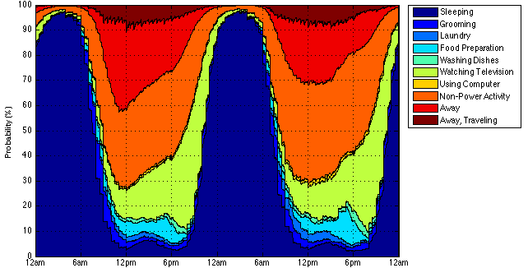
Figure 3.1: Nonworking female expected activity distribution.
Due to the tendency of those surveyed by the ATUS to report the start and end time of each activity to the nearest 30 minutes (ex. 12:00, 12:30), large probability changes occur at each 30-minute interval. These appear as discontinuities in Figure 3.1. To correct for these surveying inaccuracies, a moving average filter was used to smooth the expected distributions and produce a more realistic result. The effect of using a moving average filter over a 60-minute time span can be seen in Figure 3.2.
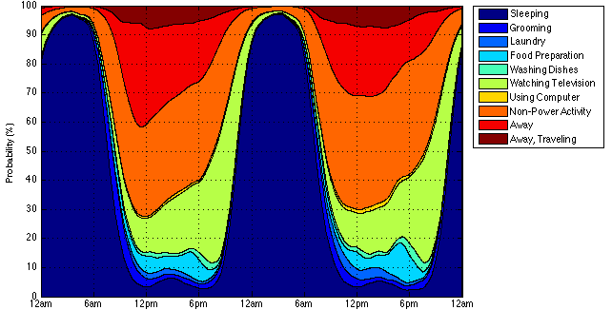
Figure 3.2: Nonworking female expected activity distribution (filtered).

3.1.2 Markov Chain Behavior Model
To model the behavior of household occupants, an approach utilizing Markov chains was employed. As mentioned previously, Markov chains are used to model transition probabilities, or the probability of transitioning from the current state to the next. These transition probabilities depend solely upon the current state and are not at all dependent upon the sequence of states preceding the current state. A visual representation of a Markov chain is shown in Figure 3.3, with each state drawn as a circle and the probability of transitioning from one state to another drawn as an arrow between the two states (ex. the probability of a person transitioning from sleeping to grooming is 3.5 %).
Figure 3.3: A visual representation of a Markov chain.
To model an occupant’s behavior, ten states, or activities, are defined. An occupant is always assumed to be participating in one of these ten activities at any given time. These activities are listed in Table 3.1 below.
Table 3.1: Activities (Markov states) and corresponding residential loads.
Activity (Markov State) | Related Residential Load
1. Sleeping | Lighting
2. Grooming | Water Heater
3. Laundry | Washer, Dryer, Water Heater
4. Food Preparation | Cooking, Refrigerator, Freezer, Water Heater
5. Dishwashing | Dishwasher, Water Heater
6. Watching Television | Television
7. Computer Usage | Computer
8. Non-Power Activity | N/A
9. Away | Lighting
10. Away, Traveling | Lighting, Electric Vehicle, Plug-in Hybrid

Six of these activities: Grooming, Laundry, Food Preparation, Dishwashing, Watching Television, and Computer Usage are chosen because they correspond to the largest and most common energy consuming loads in the residential sector (water heater, washer, dryer, cooking, refrigerator, freezer, dishwasher, television, and computer). The activities of Sleeping and Non-Power Activity are defined to allow for information to be known as to whether an occupant is present in the home but not using a load. Away and Away, Traveling, are defined to allow knowledge of when an occupant is away from the home or away from the home and traveling in a car. Finally, the need for lighting in the home (needed: activities 2-8, unneeded: activities 1, 9, 10) is also characterized.

3.1.3 Time Varying Markov Chain Matrix
As the probability of performing each activity varies throughout the day, a time varying Markov chain should be developed to model the dynamic behavior of a home’s occupants. This is done on a one-minute time scale for each day of the week using the data collected in the ATUS. First, each of the activities recorded by the ATUS is assigned to one of the ten activity categories mentioned previously. The probability of transitioning from one activity at time $t$, to another at time $t+1$, can be represented mathematically as $P_{i, j}^{d, m}$, where $i$ is the current activity state, $j$ is the next activity state, $d$ is the current day of the week, and $m$ is the current minute [4]. Finally, the transition probabilities of a time varying Markov chain at any given time can be expressed as a $n×n$ matrix, where $n$ is the number of possible states.
In Table 3.2, transition probabilities for an activity change occurring between 6:59 pm and 7:00 pm on a Sunday are shown. Each row represents the current activity state of an occupant while the columns represent the next activity state. The bolded diagonal transition probabilities correspond to the probability that an occupant’s activity state will remain unchanged, while the off-diagonal elements represent the probability of transitioning from one activity state to another.
Table 3.2: Time varying Markov chain matrix.
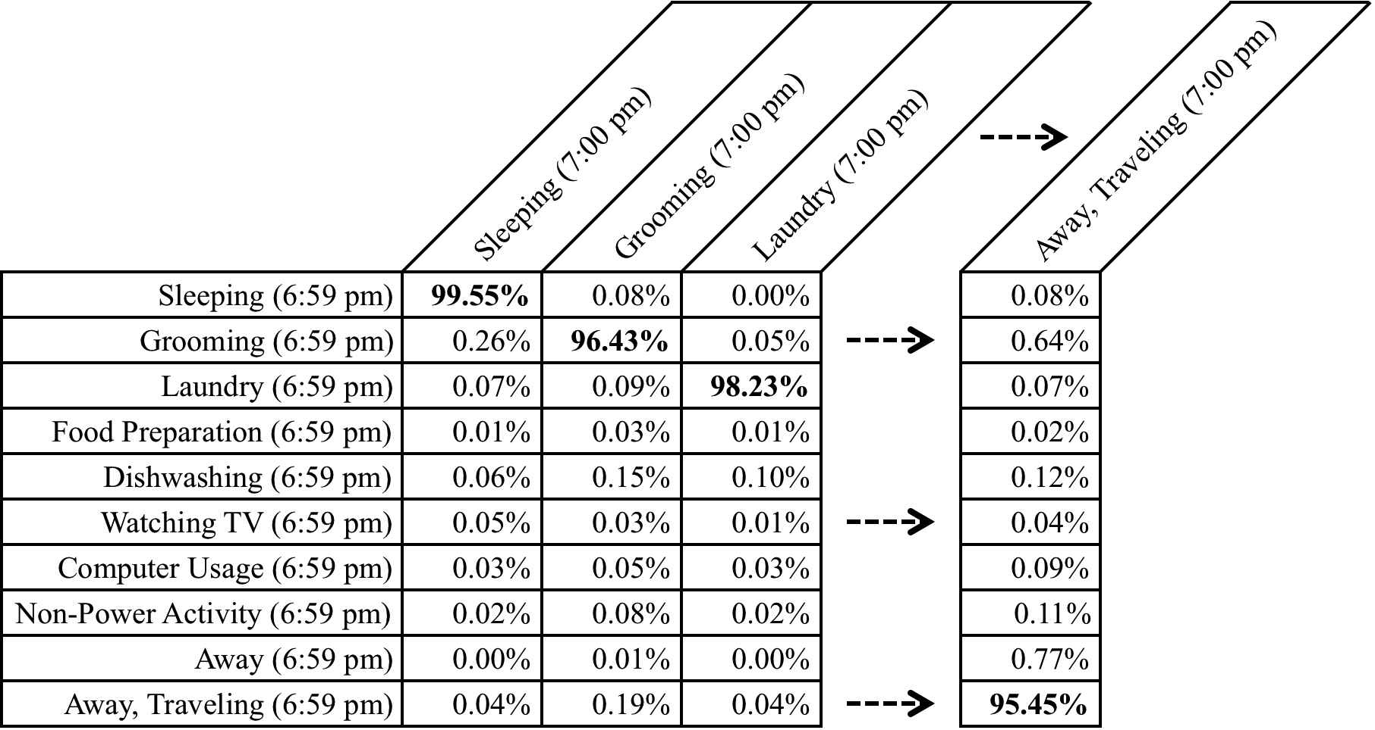

3.2 Dynamic Residential Load Models
Dynamic load models were created for a home’s HVAC system, water heater, refrigerator, freezer, washer, dryer, dishwasher, lighting, cooking, television, and computer. Together, these loads represent approximately 87.5 % of the electricity consumption within the residential sector [2]. To validate these models, three different resources were utilized. Environmental data recorded by the Oak Ridge National Laboratory rotating shadowband radiometer was used as an input for both the HVAC and lighting models [33]. Residential load power consumption data collected from the control house in TVA’s Campbell Creek Energy Efficient Homes Project was used to validate individual load models. The Campbell Creek control house represents a typical home currently built in the Tennessee Valley, incorporating local building codes and many construction practices commonly used by contractors [34]. Additionally, daily power consumption profiles for various appliances in an occupied home in Atlanta, Georgia were also used to assist in the model validation process.

3.2.1 Thermostatically Controlled Loads
TCLs are governed by two primary inputs: thermostat setting, $T_{setting}$, and deadband setting, $T_{deadband}$. The state of a TCL is determined by these temperature settings and can be modeled by (3.1) and (3.2), where $T$ is the temperature to be controlled and $T_{max}$ and $T_{min}$ are the upper and lower temperature limits of the system.
$State of a Heating Load=\left\{\begin{matrix}Heating, & T≤T_{min} \\ Off, & T≥T_{max}\end{matrix}\right.$ (3.1)
$State of a Cooling Load=\left\{\begin{matrix}Off, & T≤T_{min} \\ Cooling, & T≥T_{max}\end{matrix}\right.$ (3.2)
The upper and lower temperature limits are determined by the thermostat setting and deadband setting as shown in (3.3) and (3.4).
$T_{min}=T_{setting}-{T_{deadband}}/2$ (3.3)
$T_{max}=T_{setting}+{T_{deadband}}/2$ (3.4)
The most common TCLs in the residential sector are a home’s heating ventilation and air conditioning (HVAC) system, water heater, refrigerator, and freezer. In the following sections, dynamic models relating the thermal properties of these residential loads to the temperature of their surroundings are presented.

3.2.1.1 Home/HVAC Model
To model the thermal characteristics of the home and its HVAC system, the equivalent thermal parameter (ETP) model developed in [14] was used. In this model, parallel heat flow paths and series thermal mass elements are lumped into a few parameters and can be represented by a simple DC electrical circuit [14]. Using this approach decreases the number of building design details that must be specified while also reducing memory requirements and model simulation time [14]. Sources of heating and cooling captured by the ETP model include: the internal heating gains (from lighting, appliances, and occupants), heating gains from solar irradiance, heat added or removed by the HVAC system, and the gains/losses to the ambient air and the mass of the home. An illustration of the ETP model of a home can be seen in Figure 3.4.
Figure 3.4: ETP model of a home [14].
Because the thermal parameters of temperature, thermal conductance, thermal mass, and heat flow are equivalent to the electrical parameters of voltage, conductance, capacitance, and current flow, the ETP model can be redrawn as a simple electrical circuit. This is shown below in Figure 3.5, where $T_{out}$ is the temperature outside the home, $T_{in}$ is the temperature inside the home, $T_{mass}$ is the temperature of the mass of the home, ${UA}_{insul}$ is the thermal conductance of the envelope of the home, ${UA}_{mass}$ is the thermal conductance of the mass of the home, $C_{air}$ is the thermal mass of the air in the home, $C_{mass}$ is the thermal mass of the home, $Q_{air}$ is the heat transferred to the air, and $Q_{mass}$ is the heat transferred to the mass of the home.
Figure 3.5: ETP model electrical circuit representation [14].
By using Kirchhoff’s current law and writing nodal equations for $T_{in}$ and $T_{mass}$, (3.5) and (3.6) can be obtained, relating the change in temperature of the air inside the home and the change in temperature of the overall mass of the home to the thermal conductivities, thermal masses, and heat transfers in the system.
$C_{air}\frac{{dT}_{in}}{dt}=Q_{air}-{UA}_{insul}\left(T_{in}-T_{out}\right)-{UA}_{mass}\left(T_{in}-T_{mass}\right)$ (3.5)
$C_{mass}\frac{{dT}_{mass}}{dt}=Q_{mass}-{UA}_{mass}\left(T_{mass}-T_{in}\right)$ (3.6)
Since the thermal masses of both the air in the home and of the home itself are dependent upon air density, their values vary with respect to temperature. The relationship between air density and temperature is shown in Figure 3.6.
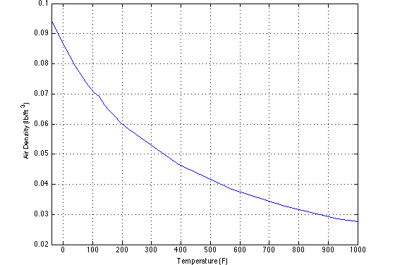
Figure 3.6: Relationship between air density and temperature [35].
The thermal mass of the air in the home and of the home itself can be calculated as shown in (3.7) and (3.8) where $V_{home}$ is the overall volume of the home, $ρ_{air}$ is density of the air in the home, $c_{p}$ is the specific heat of air, $A_{home}$ is the overall square footage of the home, and $m_{f}$ is the total thermal mass per floor area, defined to be a constant 2.0 Btu/°F×ft².
$C_{air}=3∙V_{home}∙ρ_{air}∙c_{p}$ (3.7)
$C_{mass}=m_{f}∙A_{home}-2∙V_{home}∙ρ_{air}∙c_{p}$ (3.8)
The thermal conductance of the envelope of the home and of the mass of the home itself can be calculated as shown in (3.9) and (3.10) on the following page.
${UA}_{insul}=\frac{A_{wall}}{R_{wall}}+\frac{A_{floor}}{R_{floor}}+\frac{A_{roof}}{R_{roof}}+\frac{A_{window}}{R_{window}}+\frac{A_{door}}{R_{door}}+I∙V_{home}∙ρ_{air}∙c_{p}$ (3.9)
${UA}_{mass}=h_{s}\left(\frac{A_{wall}}{EWF}+\frac{A_{gross wall}}{IEWR}+\frac{A_{roof}∙N_{floors}}{ECF}\right)$ (3.10)
These equations take into account the insulation of the walls, $R_{wall}$, the floor, $R_{floor}$, the roof, $R_{roof}$, the windows, $R_{window}$, and the doors, $R_{door},$ as well as the infiltration volumetric air exchange rate, $I$, and the interior surface heat transfer coefficient, $h_{s}$, defined to be a constant 1.46 Btu/hr×°F×ft². Additional parameters defined and used in the ETP model are summarized in Table 3.3 below.
Table 3.3: ETP model parameters [14].
Parameter | Value/Equation | Description
$$WWR$$ | 0.15 | Window/Exterior Wall Area Ratio
$$IEWR$$ | 1.5 | Interior/Exterior Wall Surface Ratio
$$EWF$$ | 1.0 | Exterior Wall Fraction of Total
$$ECF$$ | 1.0 | Exterior Ceiling Fraction of Total
$$EFF$$ | 1.0 | Exterior Floor Fraction of Total
$$A_{gross wall}$$ | $$2∙N_{floors}∙Ceiling Height∙\left(1+R\right)∙\sqrt{{A_{home}}/{(N_{floors}∙R)}}$$ | Gross Exterior Wall Area
$$A_{wall}$$ | $$(A_{gross wall}-\left(A_{window}+A_{door}\right))∙EWF$$ | Net Exterior Wall Area
$$A_{floor}$$ | $$(A_{home}/N_{floors})∙EFF$$ | Net Exterior Floor Area
$$A_{roof}$$ | $$(A_{home}/N_{floors})∙ECF$$ | Net Exterior Roof Area
$$A_{window}$$ | $$WWR∙A_{gross wall}∙EWF$$ | Gross Window Area
$$A_{door}$$ | $$19.5 {ft}^{2}∙N_{doors}$$ | Gross Door Area
$$R$$ | $${Home Depth}/{Home Width}$$ | Aspect Ratio of Home
$$N_{floors}$$ | - | Number of Floors
$$N_{doors}$$ | - | Number of Doors

The heat transferred to the air and the mass of the home are calculated using (3.11) and (3.12), where $Q_{HVAC}$ is the heat transferred to the home by the HVAC system, $Q_{solar}$ is the heat gain from solar radiation, $Q_{internal}$ is the internal heat gain (from appliances and occupants), and $f_{solar}$ and $f_{internal}$ are the mass solar and mass internal gain fractions, defined as 0.5 (i.e. assuming the solar and internal heating gains are equally split between the air and the mass of the home).
$Q_{air}=Q_{HVAC}+(1-f_{solar})∙Q_{solar}+(1-f_{internal})∙Q_{internal}$ (3.11)
$Q_{mass}=f_{solar}∙Q_{solar}+f_{internal}∙Q_{internal}$ (3.12)
To calculate the solar heating gains, the process is simplified by only taking into account the diffuse irradiance component. This is done because use of the direct component would require assumptions with regards to the orientation of the home and location of its windows. Heating gains due to solar radiation are calculated using (3.13), where ${SHGC}_{glazing}$, is the solar heat gain coefficient due to window glazing, set to 0.67, and $WETC$, is the window/exterior transmission coefficient, set to 0.60.
$Q_{solar}=I_{diffuse}∙A_{window}∙{SHGC}_{glazing}∙WETC$ (3.13)
The internal heating gains in the home are equal to the sum of all the heating gains from the loads and occupants present in the home (3.14). The internal heating gains from residential loads are calculated by multiplying their current power demand by a defined heat fraction (Table 3.4). Additionally, heating gains due to the occupants present in the home are assumed to be 400 Btu/hr per occupant.
$Q_{internal}=\sum{\left({Heat Fraction}_{load}∙P_{load}\right)}+N_{occupants}∙400 Btu/hr$ (3.14)
Table 3.4: Residential load heat fractions.
Residential Load | Heat Fraction | Residential Load | Heat Fraction
HVAC Fan | 1.0 | Dryer | 0.15
Water Heater | 0.5 | Dishwasher | 1.0
Refrigerator | 1.0 | Cooking | 0.8
Freezer | 1.0 | Lighting | 0.9
Washer | 1.0 | Plug Loads | 0.9

The heat transferred to the home by the HVAC system is calculated differently depending on the type of HVAC system in the home. In the model, a home’s cooling and heating systems are sensibly sized using the same method outlined in [14]. The method used for sizing the home’s heating and cooling systems for a central air conditioning, heat pump, resistive heating, and nonelectric heating system are shown on the following pages and the values used are explained in Table 3.5 below.
Table 3.5: HVAC sizing parameters [14].
Parameter | Value/Equation | Description
$$LLF$$ | 30 % | Latent Load Fraction
$$T_{cool}$$ | 95 °F | Cooling Design Temperature
$$T_{cool,set}$$ | 75 °F | Cooling Design Thermostat Set Point
$$T_{heat}$$ | 0 °F | Heating Design Temperature
$$T_{heat,set}$$ | 70 °F | Heating Design Thermostat Set Point
$$Q_{dig}$$ | $$167.09∙\left({A_{home}}^{0.442}\right)$$ | Design Internal Gains
$$I_{dps}$$ | 195 Btu/hr×ft² | Design Peak Solar Irradiance
$$SHGF$$ | $$A_{window}∙{SHGC}_{glazing}∙WETC$$ | Solar Heat Gain Fraction

The design cooling capacity of a central air conditioning system, $Q_{DCC}$, is sized using (3.15). Additionally, the resulting value is rounded up to the nearest 6,000 Btu/hr in order to represent commercially available HVAC sizes.
$Q_{DCC}=\left(1+LLF\right)∙{UA}_{insul}∙\left(T_{cool}-T_{cool,set}\right)+Q_{dig}+(I_{dps}∙SHGF)$ (3.15)
Because a heat pump is essentially a central air conditioning system with a reversing valve, its design heating capacity, $Q_{DHC}$, is equal to the design cooling capacity of the home’s central air conditioning system (3.16).
$Q_{DHC}=Q_{DCC}$ (3.16)
Additionally for a home using a heat pump, an auxiliary heating system is defined. This auxiliary heating system is used whenever the temperature in the home drops below the home’s auxiliary heating limit. The heat pump’s auxiliary heating system is needed because of the device’s reduced output under very cold conditions. Because a heat pump is sized to meet the peak cooling requirement, under very cold conditions it may not have enough capacity to maintain the internal temperature of the home [14]. The auxiliary heating limit, $T_{min, aux}$, and the design auxiliary heating capacity, $Q_{DAHC}$, of a heat pump are calculated as shown in (3.17) and (3.18). Additionally, the design auxiliary heating capacity is rounded up to the nearest 10,000 Btu/hr.
$T_{min, aux}=T_{setting}-{T_{deadband}}/2-{T_{aux, deadband}}/2$ (3.17)
$Q_{DAHC}={UA}_{insul}∙\left(T_{heat}-T_{heat,set}\right)$ (3.18)
The design heating capacity for both a resistive heating system and a nonelectric heating system is calculated as shown in (3.19). Similar to a central air conditioning and heat pump, this value is rounded up to the nearest 10,000 Btu/hr.
$Q_{DHC}={UA}_{insul}∙\left(T_{heat}-T_{heat,set}\right)$ (3.19)
For residential central air conditioning, heat pump, and nonelectric heating systems, the power consumed by the blower (or fan) is calculated as shown in the following equations, where the cooling supply air temperature, $T_{cool,supply}$, is set to 50 °F, the heating supply air temperature, $T_{heat,supply}$, is set to 150 °F, and the duct pressure drop is assumed to be $1/2 in$. Additionally, a fan efficiency of 42 % and a motor efficiency of 88 % are assumed in these calculations.
$Design Cool Airflow=\frac{{Q_{DCC}}/{\left(1+LLF\right)}}{{\left(ρ_{air}∙c_{p}∙\left(T_{cool,set}-T_{cool,supply}\right)\right)}/{60}}$ (3.20)
$Design Heat Airflow=\frac{max⁡\left(Q_{DHC}, Q_{DAHC}\right)}{{\left(ρ_{air}∙c_{p}∙\left(T_{heat,supply}-T_{heat,supply}\right)\right)}/{60}}$ (3.21)
$P_{fan}=\frac{0.117∙Pressure Drop∙max⁡\left(Design Cool Airflow, Design Heat Airflow\right)}{{0.42}/{745.7}}∙\frac{745.7}{0.88}$ (3.22)
To model the operating efficiencies of an HVAC system, its coefficient of performance (COP) is calculated. An HVAC’s COP is the ratio of the total heat transferred to the home to the total power consumed (3.23).
$COP=\frac{Q_{HVAC}}{P_{HVAC}}$ (3.23)
For both resistance heating and nonelectric heating systems, the COP is assumed to remain constant at 1.0. The COP for both central air conditioners and heat pumps, however, varies depending on the temperature. For instance, on a warm day it is more difficult for a central air conditioning system to cool a home than it is on a cool day, because the system only moves cool air and does not create it. Because of this phenomenon, both the COP and capacity of central air conditioning systems and heat pumps vary depending on the environmental conditions. A system’s COP and capacity adjustment factor can be calculated as shown in (3.24) and (3.25), where ${COP}_{standard}$ is 3.5 for central air conditioning systems and 2.5 for heat pumps. The coefficients used in these equations for both cooling and heating can be seen in Table 3.6.
$COP=\frac{{COP}_{standard}}{\left(K_{0}+K_{1}∙T_{out}+K_{2}∙T_{out}^{2}+K_{3}∙T_{out}^{3}\right)}$ (3.24)
$Capacity Adjustment Factor=K_{0}+K_{1}∙T_{out}+K_{2}∙T_{out}^{2}+K_{3}∙T_{out}^{3}$ (3.25)
Table 3.6: Coefficient of performance and capacity adjustment factors [14].
COP Factor | $$K_{0}$$ | $$K_{1}$$ | $$K_{2}$$ | $$K_{3}$$ | Limit
$${COP}_{cooling}$$ | -0.01363961 | 0.01066989 | 0 | 0 | 40 °F
$${COP}_{heating}$$ | 2.03914613 | -0.03906753 | 0.00045617 | -0.00000203 | 80 °F
$$Cooling Capacity$$ | 1.48924533 | -0.00514995 | 0 | 0 | -
$$Heating Capacity$$ | 0.34148808 | 0.00894102 | 0.00010787 | 0 | -
Finally, the heat transferred to the home and the overall power demanded by the HVAC system can be calculated for central air conditioning systems, heat pumps, resistance heating systems, and nonelectric heating systems. These equations and the resulting model simulations are shown on the following pages.
$Q_{HVAC,air conditioning}=Capacity Adjustment Factor∙Q_{DCC}$ (3.26)
$P_{HVAC, air conditioning}=\frac{Q_{HVAC,air conditioning}}{{COP}_{cooling}}+P_{fan}$ (3.27)
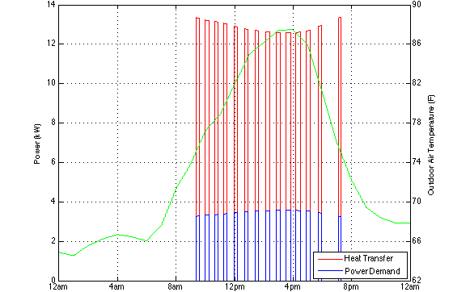
Figure 3.7: Central air conditioning model heat transfer and power demand.
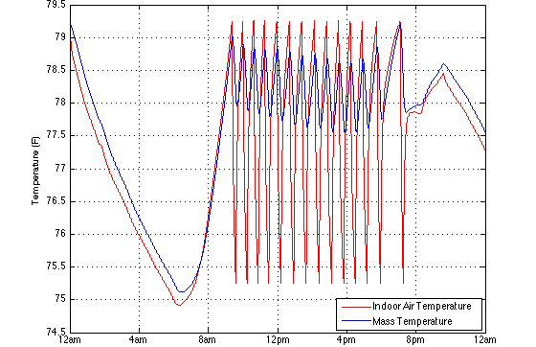
Figure 3.8: Central air conditioning model indoor air and mass temperature.
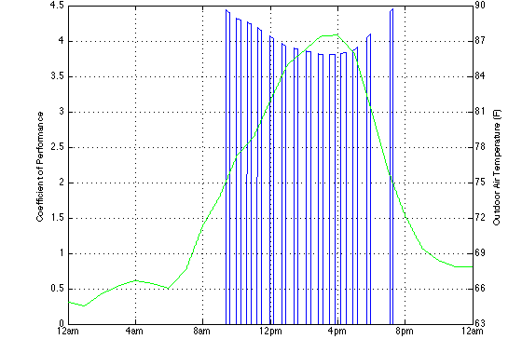
Figure 3.9: Central air conditioning model coefficient of performance.
$Q_{HVAC,heat pump}=Capacity Adjustment Factor∙Q_{DHC}$ (3.28)
$P_{HVAC, heat pump}=\frac{Q_{HVAC,heat pump}}{{COP}_{heating}}+P_{fan}$ (3.29)
$Q_{HVAC,auxilary heat pump}=Q_{DAHC}$ (3.30)
$P_{HVAC,auxilary heat pump}=\frac{Q_{HVAC,auxilary heat pump}}{1.0}+P_{fan}$ (3.31)
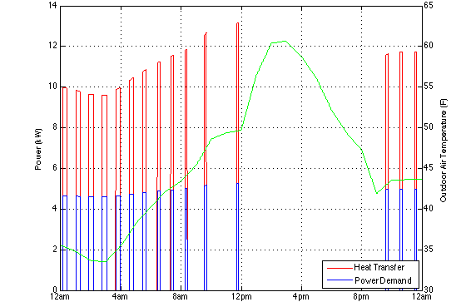
Figure 3.10: Heat pump model heat transfer and power demand.
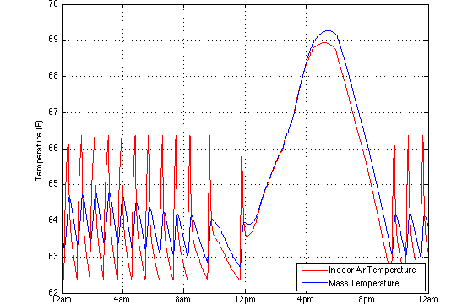
Figure 3.11: Heat pump model indoor air and mass temperature.
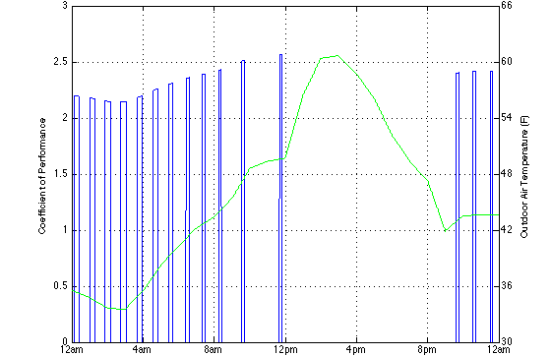
Figure 3.12: Heat pump model coefficient of performance.
$Q_{HVAC,resistive heating}=Q_{DHC}$ (3.32)
$P_{HVAC,resistive heating}=\frac{Q_{HVAC,resistive heating}}{1.0}$ (3.33)
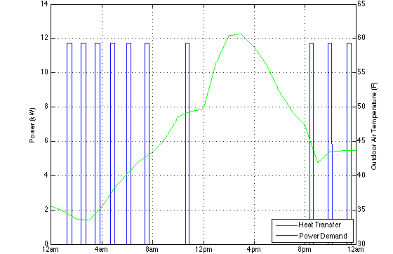
Figure 3.13: Resistance heating model heat transfer and power demand.
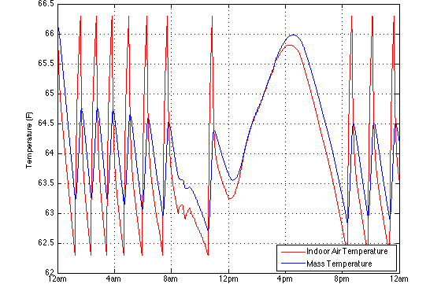
Figure 3.14: Resistance heating model indoor air and mass temperature.
$Q_{HVAC,nonelectric heating}=Q_{DHC}$ (3.34)
$P_{HVAC,nonelectric heating}=P_{fan}$ (3.35)
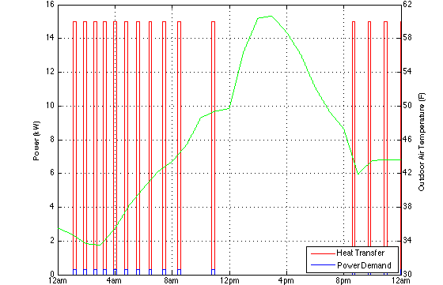
Figure 3.15: Nonelectric heating model heat transfer and power demand.
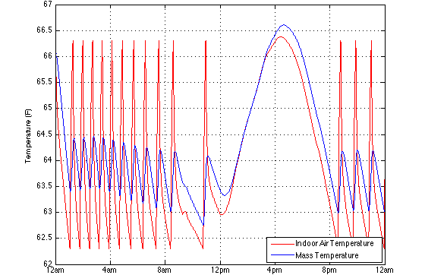
Figure 3.16: Nonelectric heating model indoor air and mass temperature.

3.2.1.2 Water Heater Model
To develop a model of a residential water heater, the models outlined in [20] and [21] were utilized. These models were chosen because they are both robust and accurate, while maintaining a reasonable level of simplicity. In [20] and [21], two different methods for modeling a residential water heater are described: the one-node temperature model and the two-node temperature model. Each of these models is composed of first order differential equations relating the change in water temperature to the ambient temperature outside the tank, the thermal capacity of the tank, the temperature of the water entering the tank, and the power rating of the water heater. In the following sections, these models and their simulation results are compared and validated against water heater electricity consumption data obtained from the control home in TVA’s Campbell Creek Energy Efficient Homes Project [34].

3.2.1.2.1 One-Node Model
In the one-node temperature model, all of the water in the tank is modeled as a single mass of water at a uniform temperature, $T_{w}$ [20]. The temperature of the water changes as hot water is drawn from the upper portion of the tank and is replaced with cold water at the bottom. The heating of the water is modeled by a single resistive heating element. A schematic of the one-node water heater model is shown in Figure 3.17.
Figure 3.17: One-node water heater model.
The change in temperature of the water is equal to the flow of water entering the tank, the heat losses to ambient air, and the amount of power consumed by the resistive heating element. The primary differential equation used to model this is given in (3.36), where $C_{w}$ is the heat capacity of water, $Q_{e}$ is the power supplied to the resistive heating element, $m_{flow}$ is the flow rate of the water entering the tank, $C_{p}$ is the specific heat of water, $T_{in}$ is the temperature of the water entering the tank, $T_{amb}$ is the temperature of the air surrounding the tank, and $UA$ is the thermal conductance of the tank.
$C_{w}\frac{dT_{w}}{dt}=Q_{e}-m_{flow}C_{p}\left(T_{w}-T_{in}\right)-UA(T_{w}-T_{amb})$ (3.36)
The thermal conductance of the tank can be calculated using (3.37), where $V$ is the volume, $h$ is the height, and $R$ is the insulation value of the tank.
$UA={\left(2π\left(\frac{V}{πh}\right)+2πh\sqrt{\frac{V}{πh}}\right)}/R$ (3.37)
Because the heat capacity of water is dependent upon the density of water, its value varies with respect to temperature. The relationship between water density and temperature is shown in Figure 3.18.
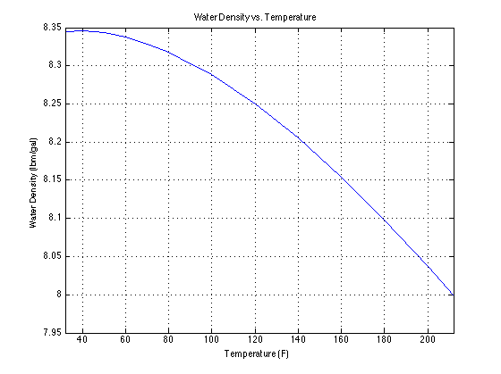
Figure 3.18: Relationship between water density and temperature [36].
From TVA’s Campbell Creek research home, the following data was recorded: the overall water heater electricity consumption, the rate of water flow into the tank, and the temperature of the water entering the tank. An example of the recorded water heater water flow data, or hot water demand, is shown in Figure 3.19.
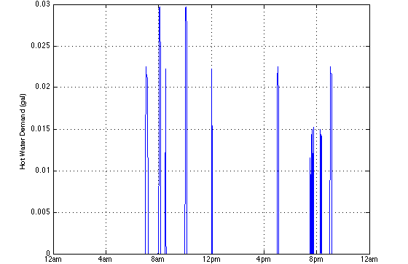
Figure 3.19: Water heater hot water demand (from Campbell Creek control home).
To validate the one-node temperature model, a tank volume of 50 gallons was used, matching the volume of the Campbell Creek control home’s water heater. To ensure that the one-node model accurately models the thermal characteristics of a residential water heater, the measured water flow rate and temperature data was used as inputs for $m_{flow}$ and $T_{in}$. Various parameters that were unknown were chosen to best match the one-node water heater model with the measured results. These parameters include: tank insulation value, tank dimensions, and water heater power consumption. As shown in Figure 3.20 on the following page, it can be seen that the one-node model matches the measured water heater power consumption data. Additionally, the water temperature of the one-node water heater model is shown in Figure 3.21.
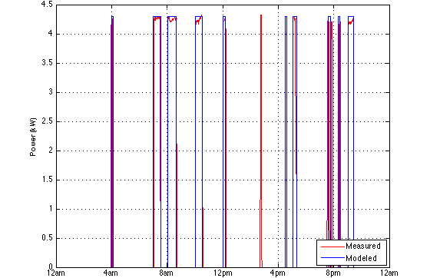
Figure 3.20: One-node water heater model power demand.
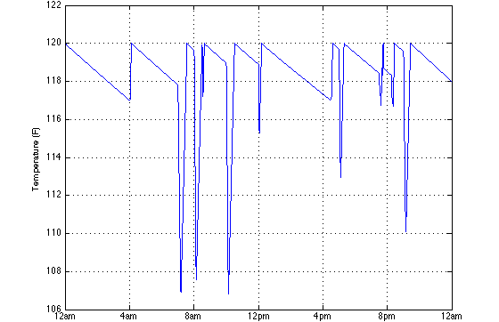
Figure 3.21: One-node water heater model water temperature.

3.2.1.2.2 Two-Node Model
For the two-node temperature model, the water in the tank is modeled as two separate masses of water at different temperatures [20]. This model is much more representative of how an actual water heater operates, as the upper layer temperature is kept relatively stable near the water heater’s thermostat setting while the lower layer temperature varies much more with respect to the temperature of the water entering the tank [20]. As in an actual water heater, two separate resistive heating elements are utilized. A schematic of the two-node water heater model is shown below.
Figure 3.22: Two-node water heater model.
To model the water heater using the two-node temperature model, a hybrid approach combining the models presented in [20] and [21] is utilized. For the two-node model, modified differential equations based upon (3.36) must be used for each layer of water. These are shown below in (3.38) and (3.39).
$C_{w_{U}}\frac{dT_{w_{U}}}{dt}=Q_{e_{U}}-UA\left(T_{w_{U}}-T_{amb}\right)+\frac{C_{w_{L}}(T_{w_{L}}-T_{w_{U}})}{τ}$ (3.38)
$C_{w_{L}}\frac{dT_{w_{L}}}{dt}=Q_{e_{L}}-m_{flow}C_{p}\left(T_{w_{L}}-T_{in}\right)-UA\left(T_{w_{L}}-T_{amb}\right)-\frac{C_{w_{L}}(T_{w_{L}}-T_{w_{U}})}{τ}$ (3.39)
As with the one-node temperature model, the flow of water entering the tank, the heat losses to the ambient air, and the amount of power consumed by the resistive heating element are considered. Additionally, the heat losses/gains between the upper water layer and lower water layer are also considered as ${C_{w_{L}}(T_{w_{L}}-T_{w_{U}})}/τ$, where $τ$ is a time constant of 120 hours as determined in [21]. To simplify this model, the following assumptions, based upon those found in [21] are made:
- The upper and lower water layers are modeled with fixed volumes. (The upper layer volume is 2/5 of the total water heater volume and the lower layer volume is 3/5 of the total water heater volume).
- The water temperature within each layer is considered uniform, and the upper layer temperature is always greater than or equal to the lower layer temperature.
- The upper thermostat monitors the upper layer temperature, and the lower thermostat monitors the lower layer temperature.
- The upper resistive heating element heats only the upper layer.
- The lower resistive heating element heats only the lower layer when the upper layer temperature is greater than the lower layer temperature, and heats both layers when the upper and lower layer temperatures are equal.
In this model, both the one-node and two-node temperature models are used depending upon the current state of the water heater. When $T_{w_{U}}>T_{w_{L}}$ or $m_{flow}>0$, the two-node temperature model is used, and when $T_{w_{U}}=T_{w_{L}}$, the one-node temperature model is used. Because only one of the water heater’s heating elements can be operated at any given time, the thermostat control settings must be modified to properly control the model. This is accomplished by always giving priority to the upper heating element whenever the two-node model is being used.
To validate the two-node temperature model, the same parameters described in the validation of the one-node temperature model were used. As shown in Figure 3.23, the two-node model matches the measured power consumption data more closely than the one-node model, particularly for instances of low water consumption.
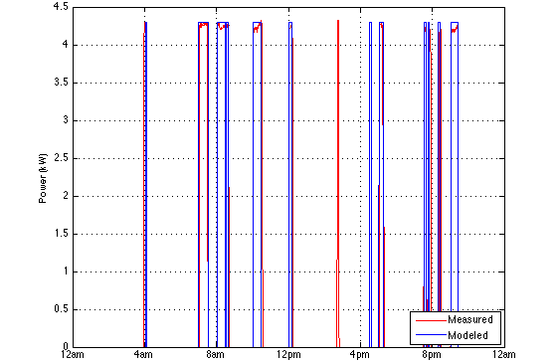
Figure 3.23: Two-node water heater model power demand.
The water temperatures of the two-node water heater model for both the upper and lower layers of water are shown in Figure 3.24.
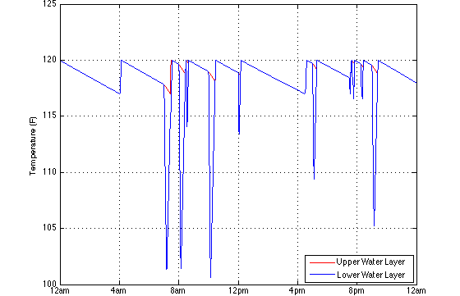
Figure 3.24: Two-node water heater model water temperature.

3.2.1.2.3 Hot Water Model
To model hot water demand, occupant behavior models are used. The primary problem with this method is that the time use data utilized to create the occupant behavior model is very general with regards to activities requiring hot water. In [26] a method for modeling residential power and hot water demand using an occupant behavior model is discussed. Although a realistic demand curve can be produced, extremely accurate results are impossible to obtain because of all of the assumptions that must be made pertaining to the hot water demand of different activities. To avoid having to make a large number of assumptions, the only residential end-uses modeled to demand hot water are the shower, bath, clothes washer, and dishwasher. These end-uses correspond to the grooming, laundry, and dishwashing activities present in the occupant behavior model. The amount of hot water demanded by these end-uses, the duration of the demand, and the overall duration of each end-use are shown in Table 3.7.
Table 3.7: Hot water demand by end-use.
End-Use | Hot Water Demand [37] | Demand Duration | End-Use Duration
Shower | 30 gal | 10 min | 30 min
Bath | 20 gal | 5 min | 45 min
Washer | 20 gal | 7 min | 45 min
Dishwasher | 15 gal | 9 min | 90 min

When each end-use begins, hot water is demanded immediately and continues until the demand duration time has passed. The demand duration and end-use duration times for both the washer and dishwasher are defined to correspond with the recorded Campbell Creek data for both washer and dishwasher hot water demand and power demand respectively. Additionally both the washer and dishwasher models are assigned a 50 % probability of demanding hot water at the beginning of each cycle.
The showering and bathing end-uses occur whenever an occupant is in the grooming activity, with showers occurring 80 % of the time and baths occurring 20 % of the time. The demand duration times for showering and bathing were estimated to best represent the average amount of time a person spends in the shower and the average amount of time required to fill a bath tub [38]. Because both showering and bathing fall under the grooming activity, which includes the majority of residential bathroom end-uses, the end-use duration times for showering and bathing are included to avoid over estimating the occurrence of these end-uses. Additionally, the probability of an occupant taking a shower or bath while in the grooming activity is defined as 3.33 % each minute. This is again used to avoid over estimating the occurrence of showering and bathing.

3.2.1.3 Refrigerator/Freezer Models
The modeling of the thermal characteristics of a residential refrigeration unit is based upon the model outlined in [20]. This model relates the change in the internal air temperature of the refrigeration unit with: the ambient temperature outside the unit, the thermal conductance of the unit, the thermal conductance of the food/air, and the unit’s overall cooling rate. The primary differential equation used to model this is given in (3.40), where $C_{f}$ is the heat capacity of the food in the refrigeration unit, ${UA}_{r}$ is the thermal conductance of the insulated compartment, ${UA}_{f}$ is the thermal conductance of the food/air, and $Q_{r}$ is the cooling rate of the refrigeration unit.
$\frac{C_{f}}{{UA}_{r}+{UA}_{f}}\frac{dT_{air}}{dt}=T_{amb}-T_{air}-\frac{Q_{r}}{{UA}_{r}}$ (3.40)
The parameters of $C_{f}$ and $Q_{r}$ are both directly tied to the volume of the refrigerator (measured in cubic feet) and can be calculated as shown in (3.41) and (3.42), where $ρ_{w}$ is the density of water, and $C_{p}$ is the specific heat of water.
$C_{f}=0.05∙Volume∙ρ_{w}C_{p}$ (3.41)
$Q_{r}=Volume\left(10\frac{Btu}{{ft}^{3}}\right)$ (3.42)
These equations correspond to the assumptions that 5 % of a refrigerator’s volume is water (or food) and that the cooling rate of a refrigeration unit can be approximated as $10 \frac{Btu}{{ft}^{3}}$. The thermal conductance of the food/air, ${UA}_{f}$, is defined to be a constant $1.0 \frac{Btu}{hr∙℉}$ while the thermal conductance of the insulated compartment, ${UA}_{r}$, varies depending on the volume of the refrigeration unit and whether the unit is a refrigerator or freezer. These formulas are given in (3.43) and (3.44) for a refrigerator and freezer respectively.
${UA}_{r}=1.2\frac{Btu}{hr∙℉}+\frac{Volume}{20}$ (3.43)
${UA}_{r}=0.3\frac{Btu}{hr∙℉}+\frac{Volume}{20}$ (3.44)
In (3.43) and (3.44) the volume component is used as a scaling factor to increase and decrease the thermal conductivity of the insulated compartment depending on size of the refrigeration unit. The constants of $1.2 \frac{Btu}{hr∙℉}$ and $0.3 \frac{Btu}{hr∙℉}$ correspond to the insulation differences between residential refrigerators and freezers, with freezers requiring a better insulated compartment due to their lower operating temperatures.
While this model considers the thermal properties of a refrigeration unit with regards to its losses to the ambient air, it does not consider losses associated with the opening and closing of the refrigeration unit’s door. When opened by an occupant, cool air in a refrigeration unit spills out of the insulated compartment and, as a result, the temperature of the interior of the unit increases. This results in the refrigeration unit consuming more power for a longer period of time to cool the contents of the unit. To model this change in temperature, a simple step change of 5 °F is used whenever an occupant opens the refrigerator/freezer door. Additionally, a maximum internal temperature of 10 °F above the refrigeration unit’s thermostat setting is defined to avoid the possibility of the internal temperature rising out of control. The likelihood of an occupant opening the refrigerator/freezer door is assigned based on probabilities. For the refrigerator, the probability of opening the door each minute is 5 % if the occupant is in the food preparation activity and 0.1 % if the occupant is active and in the home (excluding grooming). Similarly, for the freezer, the probability of opening the door each minute is 1.25 % if the occupant is in the food preparation activity and 0.025 % if the occupant is active and in the home (excluding grooming). These probabilities were chosen analytically to best match the model with the available power consumption data.
Finally, power demand is modeled for two specific functions. The compressor, which is the refrigeration unit’s most significant load, consumes 120 W of power when the unit’s interior air temperature reaches its upper temperature limit and cooling is required. The automatic defrost function of a refrigeration unit is modeled as a timed load. In this model the automatic defroster is scheduled to turn on once every 8 hours, defrosting for 10 minutes and consuming 550 W of power in the process. The resulting power demand and interior air temperature for both the refrigerator and freezer models are shown in Figures 3.25-3.28 on the following pages.
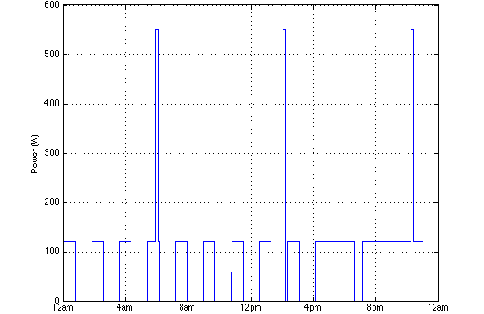
Figure 3.25: Refrigerator model power demand.
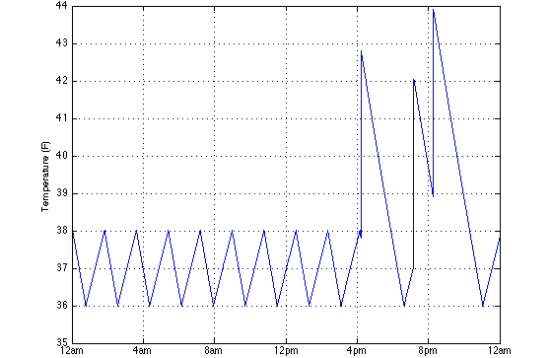
Figure 3.26: Refrigerator model interior air temperature.
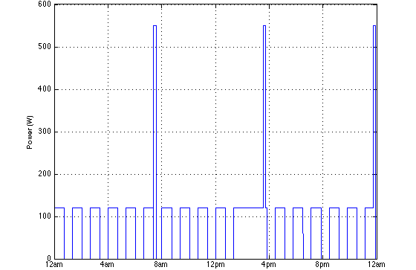
Figure 3.27: Freezer model power demand.
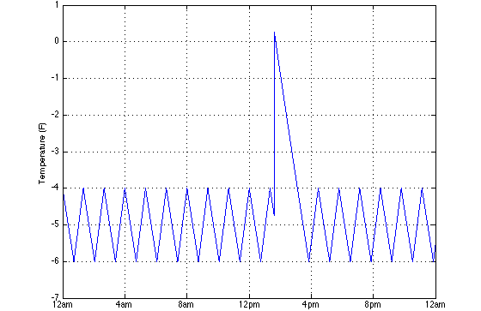
Figure 3.28: Freezer model interior air temperature.

3.2.2 Deferrable Loads
Within the residential sector, the most common deferrable loads are clothes washers, dryers, and dishwashers. The methods used to model each of these loads are discussed in detail in the following sections.

3.2.2.1 Washer Model
To model the power demand of a residential clothes washer, two different methods were considered [4][6]. In each of these models, a washer is defined as a timed load. From the Campbell Creek and Atlanta data, an average wash cycle of 45-50 minutes was observed, and as a result a wash cycle is defined to last 45 minutes. In an attempt to approximate the cyclical fluctuations in washer power demand, the method presented in [6], involving the use of a piecewise linear function, was examined. This generalization, however, was found to be inconsistent with the data collected from the Campbell Creek and Atlanta homes. While an individual washer’s power consumption was seen to follow a predictable pattern, these patterns varied greatly depending on the washer manufacturer, loading, and user input [3]. Ultimately, for the purpose of simplicity, washer power demand was modeled as a constant and tied to the laundry activity. A wash cycle begins whenever an occupant transitions into this activity and is not allowed to begin again until after a full laundry cycle is completed (one wash cycle and one dry cycle). An example of the typical power demand of the washer model is shown in Figure 3.29.
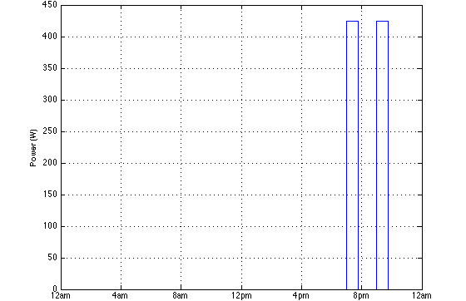
Figure 3.29: Washer model power demand.

3.2.2.2 Dryer Model
The dryer model works identically to the washer model in that it is a timed load with a constant power demand. From the Campbell Creek power consumption data, an average drying cycle of 70 minutes was observed and is defined as the drying cycle time. The constant power approximation for the dryer model proved to be much more accurate than for the washer model. The power consumption data analyzed showed that dryer power demand is much more constant with cyclical changes having a relatively small impact on the dryer’s overall consumption. The dryer model operates in tandem with the washer model and begins immediately after a wash cycle ends. An example of the typical power demand of the dryer model is shown in Figure 3.30.
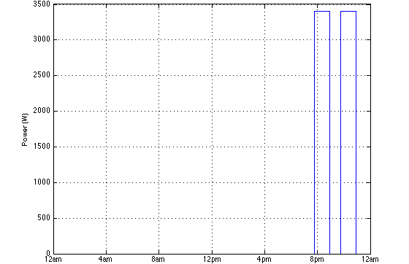
Figure 3.30: Dryer model power demand.

3.2.2.3 Dishwasher Model
As with the washer and dryer models, a dishwasher is defined as a timed load. From both the Campbell Creek and Atlanta data, an average dishwashing cycle of 90 minutes was observed and is defined as the dishwasher model’s cycle time. Unlike the washer power consumption data, the dishwasher power consumption data followed a very predictable pattern corresponding to a dishwasher’s three cycles (wash, rinse, and dry). To model the power demand of a dishwasher, these predictable fluctuations are approximated using a piecewise linear function similar to that described in [6]. The function used to model dishwasher power demand is shown in (3.45), where $t$ is the amount of time passed in the current dishwashing cycle (in minutes).
$P_{dishwasher}=\left\{\begin{matrix}120 W & t≤20, 40<t≤50 \\ P_{rated} & 20<t≤40, 50<t≤70 \\ {P_{rated}}/3 & t>70\end{matrix}\right.$ (3.45)
Here, the 120 W demand corresponds to the power demand of the pump used to mix the hot water and detergent before the wash cycle and flush the mixture from the system before the rinse cycle. Additionally, the $P_{rated}$ component corresponds to the power demanded by the dishwasher during both the wash and rinse cycles while ${P_{rated}}/3$ corresponds to the power demanded by the heating element during the drying cycle. A dishwashing cycle begins whenever an occupant transitions into the dishwashing activity and is not allowed to begin again until after a full cycle is completed. The resulting power demand of the dishwasher model is shown in Figure 3.31.
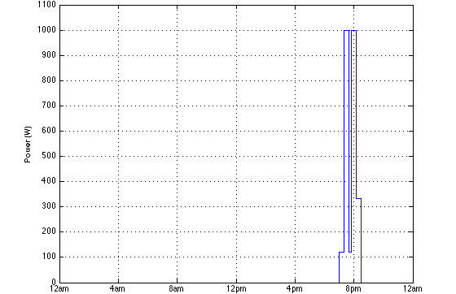
Figure 3.31: Dishwasher model power demand.

3.2.3 Uninterruptible Loads
Uninterruptible loads within the residential sector include: lighting, cooking, and electronics. In the following sections, models developed for these loads are presented.

3.2.3.1 Lighting Model
Lighting power demand is modeled using the approach outlined in [25]. This method involves tying residential lighting demand directly to an occupant behavior model. In this model, three different lighting states are defined: $P_{active}$, for when an occupant is present in the home and awake, $P_{inactive}$, for when an occupant is present in the home and asleep, and $P_{absent}$, for when an occupant is away. Constant power demand is assumed for both the inactive and absent states while power demand in the active state is defined as shown in (3.46), where $P_{min}$ and $P_{max}$ are the minimum and maximum power levels demanded by a home’s occupants, $L$ is the current diffuse horizontal illuminance, and $L_{limit}$ is a constant limiting factor of 10,000 lux.
$P_{active}=\left\{\begin{matrix}P_{min}\frac{L}{L_{limit}}+P_{max}\left(1-\frac{L}{L_{limit}}\right) & L≤L_{limit} \\ P_{min} & L>L_{limit}\end{matrix}\right.$ (3.46)
Using this approach, the overall demand for lighting in a home is limited by the current level of daylight. For instance, in the middle of the day when the sky is brightest, occupants will demand less lighting than in the evening hours when natural lighting levels are minimal. Because occupants do not adjust the lighting levels in their homes immediately following a change in daylight levels, lighting power demand is adjusted incrementally based on an adjustment probability, $Q_{adjust}$. This probability assumes that a home’s lighting levels are checked and adjusted once every 10 minutes. While an occupant is in an active state, lighting levels are only altered if an incremental adjustment of $∆P$ will bring the current lighting power level closer to an occupant’s desired lighting power level. Instantaneous lighting level adjustments only occur when an occupant transitions from an active state to an inactive or absent state, or vice versa (this corresponds to an immediate change in lighting levels whenever an occupant goes to sleep, wakes up, leaves, or returns home). A summary of the values used with this model is given in Table 3.8. These values are assigned on an occupant-by-occupant basis and the percentage of occupants assigned a specific value is shown in parentheses.
Table 3.8: Lighting model parameters.
Parameter | Values
$$L_{limit}$$ | 10,000 lux
$$P_{absent}$$ | 0 W (60 %), 40 W (40 %)
$$P_{inactive}$$ | 0 W (60 %), 40 W (40 %)
$$P_{min}$$ | 40 W (80 %), 80 W (20 %)
$$P_{max}$$ | 160 W (60 %), 200 W (40 %)
$$Q_{adjust}$$ | 10 % per minute
$$∆P$$ | 40 W incandescent equivalent

To estimate diffuse horizontal illuminance from the available solar irradiance data, various methods for calculating solar luminous efficacy (a measure of how well a light source produces visible light) were considered. One of the most robust and accurate methods involves using the model developed in [39]. In this model, measures of the current solar zenith angle, sky clearness, sky brightness, and atmospheric perceptible water content are used to convert solar irradiance to illuminance based on current weather conditions. While this model has been validated extensively and used by numerous researchers in the past, it is both complex and computationally intensive. In [40], it is explained that assuming a constant value for luminous efficacy can be used to produce reasonably accurate results for most situations. For this reason, a constant solar luminous efficacy of 130 lm/W is assumed. In comparing the results of the model developed in [39] to those obtained using this assumption, only minimal differences were seen. Finally, as in [25], a standard window transmittance of 0.74 is also assumed.
To improve upon the model presented in [25] the ability to model different lighting types was added. This is accomplished by determining the average lighting output of a standard 40 W incandescent bulb (approximately 500 lumens) and the average power required by additional lighting types to produce this output (approximately 29 W for halogens, 8 W for linear fluorescents, 11 W for compact fluorescents, and 6 W for LEDs). Lighting is then assigned in a home on a light-by-light basis for each occupant and adjusted in these 40 W incandescent equivalent increments. An example of the typical power demand of this lighting model is shown in Figure 3.32.
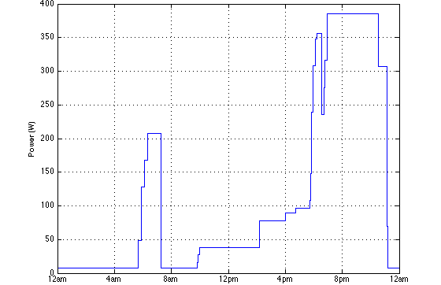
Figure 3.32: Lighting model power demand.

3.2.3.2 Cooking Model
Cooking involves many different residential appliances including conventional ovens, ranges, stoves, microwave ovens, and toaster ovens. Rather than modeling each of these loads individually (which would require either extremely detailed time use data or assumptions relating to the probability of each appliance being used), cooking is modeled as a constant power instantaneous load and demands power whenever an occupant is in the food preparation activity. This was shown to be a sufficiently accurate approximation in [26]. In Figure 3.33, an example of the typical power demand for cooking is shown.
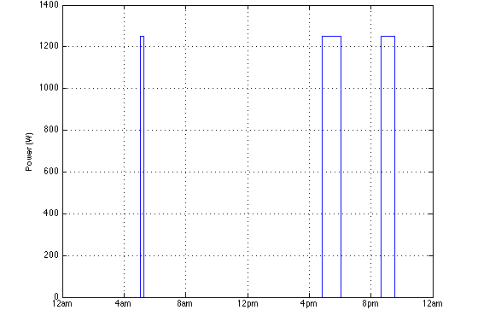
Figure 3.33: Cooking model power demand.

3.2.3.3 Electronic Load Models
As with cooking, modeling every electronic load would require either extremely detailed time use data or many different assumptions with regards to the use of each load. Additionally, because many electronic loads have a relatively small impact on the overall power demand of the residential sector, only the most common electronic devices need to be modeled. Televisions and computers are modeled as constant power instantaneous loads. Whenever an occupant is engaged in these activities the rated power is demanded. When these devices are not in use, they are assumed to be in standby mode [6]. As a result, the power demand of these electronic loads can be modeled using (3.47).
$P_{demand}=\left\{\begin{matrix}P_{rated} & In Use \\ P_{standby} & Not In Use\end{matrix}\right.$ (3.47)
While in standby mode, televisions are assumed to demand 10 W and computers are assumed to demand 20 W. A maximum of three televisions and two computers are allowed to be active in a home at any given time. Examples of the resulting power demand for both the television and computer models are shown in Figures 3.34 and 3.35.
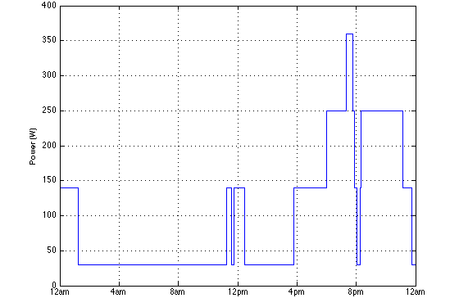
Figure 3.34: Television model power demand.
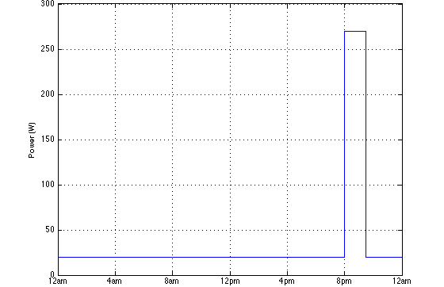
Figure 3.35: Computer model power demand.

3.3 Chapter Summary
In this chapter, each of the models developed for use in the dynamic simulation tool were presented. First, an examination of that data collected in the American Time Use Survey was conducted. From this data, ten different activities, corresponding to the largest residential loads, were defined to govern occupant behavior. These activities were utilized to develop the time varying Markov chain matrices used to model occupant behavior. Next, methods for modeling the dynamic characteristics of residential loads were presented. Models were created for residential HVAC, water heater, refrigerator, freezer, washer, dryer, dishwasher, lighting, cooking, television, and computer loads. Each of these models was developed to take into account both occupant behavior and the environmental factors of outdoor air temperature and solar irradiance. Finally, examples of the typical power demand profiles for each of these models were shown.

Results and Discussion

The strengths and weakness associated with using occupant behavior models to predict power demand are examined in the following chapter. Methods and statistics used to combine these models with residential load models and develop the simulation tool are also discussed. Finally, simulation results showing the impact of residential loads on the overall demand and the impact of several demand response schemes are presented.

4.1 Occupant Modeling Results

4.1.1 Simulation of Individual Occupants
Using the time varying Markov chains developed from the ATUS data, occupants can be simulated based on the various transition probabilities. The approach for accomplishing this was based upon the Monte Carlo method outlined in [4]. At each time step a uniformly distributed pseudorandom number, $x$, is generated. This number is then compared to the cumulative distribution of the activity transition probabilities to determine which activity transition occurs. This technique is illustrated in Figure 4.1 (ex. a uniformly distributed pseudorandom number, $x$, which is located in interval 7, will cause the simulated occupant to transition from activity $i$ to activity 7).
Figure 4.1: Monte Carlo method used for determining activity transitions [4].
Since an occupant’s activity transitions are chosen based upon uniformly distributed pseudorandom numbers, each simulation yields a distinctive occupant behavior pattern. In Figures 4.2-4.5, the results of the simulations of two working male occupants and two nonworking male occupants simulated on a Monday are presented.
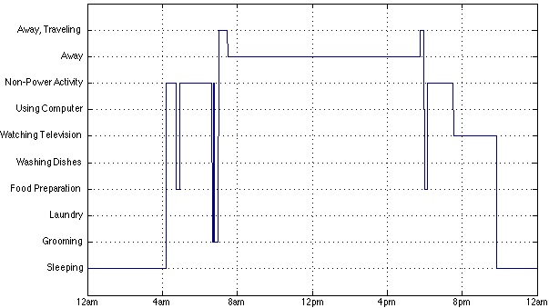
Figure 4.2: Working male occupant simulation (case 1).
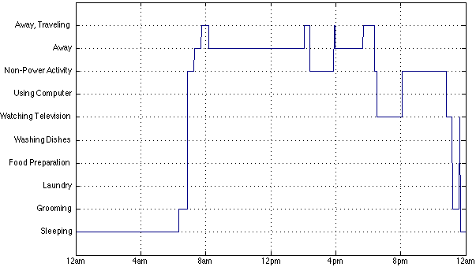
Figure 4.3: Working male occupant simulation (case 2).
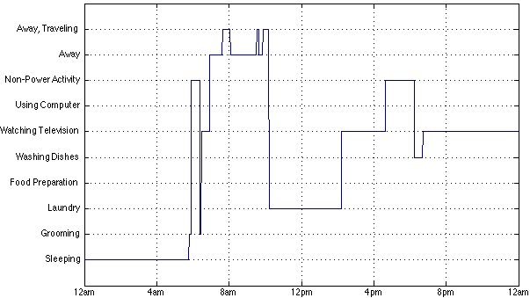
Figure 4.4: Nonworking male occupant simulation (case 1).
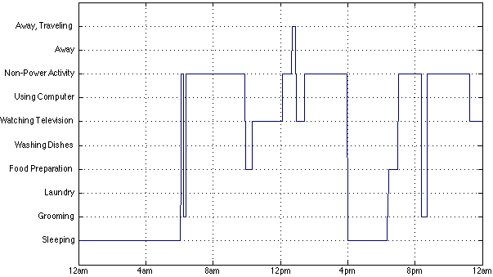
Figure 4.5: Nonworking male occupant simulation (case 2).
As seen, these simulations can produce very different results; however, common activity patterns, such as grooming between the hours 6:00 and 7:00 am and preparing food between the hours of 6:00 and 7:00 pm, are also present.

4.1.2 Aggregation of Multiple Occupant Simulations
By simulating multiple occupants and aggregating their behaviors together with respect to time, a distribution matching that of the data taken directly from the ATUS begins to appear. For each activity ($i$), the distribution error, $D_{i, Error}$, between the expected activity distribution, $D_{i, Expected}$, and the activity distribution of simulated occupants, $D_{i, Simulated}$, can be calculated for each minute using (4.1).
$D_{i, Error}(t)=\left|D_{i,Expected}(t)-D_{i,Simulated}(t)\right|$ (4.1)
From this, the average activity distribution error, $D_{i, Average Error}$, can be calculated using (4.2), where $n$ is the total number of minutes simulated.
$D_{i,Average Error}=\frac{\sum_{t=1}^{n}{\left(D_{i,Error}(t)\right)}}{n}$ (4.2)
By calculating the average activity distribution error for a particular occupant type with respect to the number of occupants simulated, it can be seen that as the number of occupants simulated increases, the average activity distribution error decreases. This is shown below in Figure 4.6 for 1 to 100 simulated working male occupants.
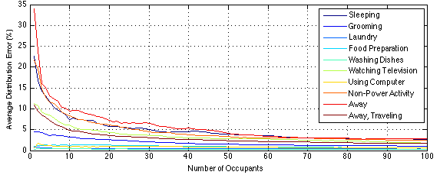
Figure 4.6: Average distribution error vs. number of simulated occupants.
As seen in Figure 4.6, as the number of occupants simulated increases, the average activity distribution error decreases. By simulating 10,000 working male occupants from Sunday to Monday and comparing the resulting activity distribution with the expected activity distribution taken directly from the ATUS data, near identical distributions can be seen. These results are shown in Figures 4.7 and 4.8 below.
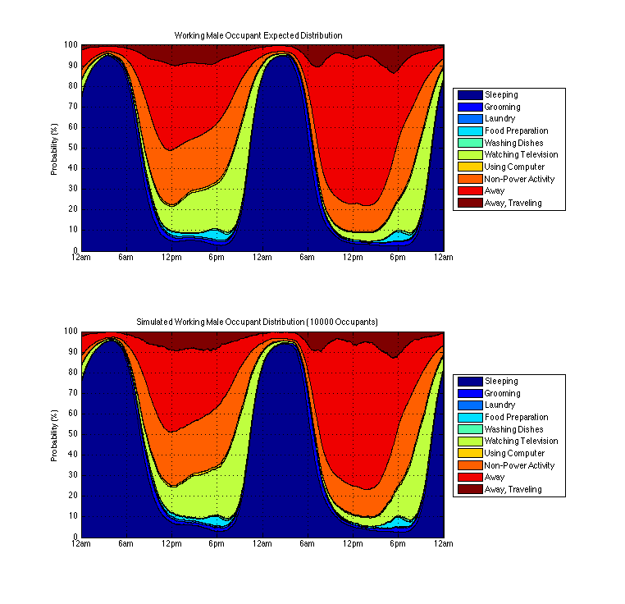
Figure 4.7: Working male occupant expected activity distribution.
Figure 4.8: Activity distribution of 10,000 simulated working male occupants.
The average distribution error of each activity for 10, 100, 1,000, and 10,000 working male occupants simulated over a full week is shown in Table 4.1.
Table 4.1: Average distribution error vs. number of simulated occupants.
Activity | 10 Occ. | 100 Occ. | 1,000 Occ. | 10,000 Occ.
1. Sleeping | 7.64% | 2.69% | 1.72% | 1.62%
2. Grooming | 2.99% | 1.09% | 0.41% | 0.23%
3. Laundry | 0.57% | 0.32% | 0.11% | 0.04%
4. Food Preparation | 1.59% | 0.66% | 0.21% | 0.08%
5. Dishwashing | 0.29% | 0.26% | 0.09% | 0.03%
6. Watching Television | 6.54% | 1.83% | 0.65% | 0.39%
7. Computer Usage | 1.01% | 0.66% | 0.19% | 0.07%
8. Non-Power Activity | 8.10% | 2.70% | 0.94% | 0.44%
9. Away | 9.07% | 2.81% | 1.47% | 1.09%
10. Away, Traveling | 5.09% | 1.76% | 0.57% | 0.29%

From these results, it can be determined that approximately 100 occupants, or 40 households (assuming an average of 2.5 occupants per household), must be simulated to produce a reasonably accurate representation of residential activity patterns using the Markov Chain Monte Carlo method to simulate occupant behavior.

4.1.3 American Time Use Survey Limitations
Although it has been shown that time use data and Markov chains can be used to simulate occupant behavior, various factors should be considered with the application of this method. One consideration is with the time use data itself. In the American Time Use Survey, many of the defined activity categories are very broad and not directly related to power consumption. For instance, the activity category grooming, as defined by the ATUS, includes the activities of showering, bathing, shaving, putting on make up, etc. [11]. For the purposes of using the occupant behavior models to estimate residential power demand, grooming is used to model hot water usage from showering and bathing. Similarly, the category of food preparation, which is used as an input for the cooking, refrigerator, and water heater models, does not make any distinction as to whether the respondent is cooking or simply slicing vegetables. These issues are also present in the activity categories of laundry and dishwashing. To produce the most accurate residential power demand profile, further statistical methods must be employed to limit the use of residential loads associated with these categories (see Chapter 3.2).
Another consideration with the occupant behavior models developed is that secondary activities cannot be taken into account. Because secondary activities were not recorded by the ATUS, these models are only able to place occupants into one activity at any given time. As a result, activities commonly done together, such as laundry and watching television, cannot be simulated by these models. If secondary activity data had been available and used, the complexity of the Markov chain matrices would be greatly increased. The number of Markov states required to model an occupant if combinations of all activities are allowed is shown in (4.3), where $r$ is the number activities an occupant is allowed to participate in at one time and $n$ is the number of distinct activities.
$Markov States=\frac{n!}{r!\left(n-r\right)!}+n$ (4.3)
The number of required Markov states is further increased if an occupant is allowed to participate in three or even four activities at the same time.

4.1.4 Markov Chain Modeling Limitations
As observed by [7] and discussed in previous sections, this type of modeling cannot be considered accurate beyond a certain level. Simulating individual occupants can reveal atypical and unrealistic patterns. For example, while a typical person may wake up and leave for work at the same time throughout the week, these patterns are not present for a simulated occupant. This is a result of using the Markov Chain Monte Carlo method to simulate occupant behavior, as each activity is randomly selected based upon transition probabilities, which are only dependent on the previous activity.
Occupant activities are also entirely independent of one another [7]. Because of this, activities that household members would typically participate in at the same time, such as eating (non-power activity), do not occur for each occupant in a household at the same time. Similarly, overlap between activities that occupants would typically participate in at separate times also occurs. In reality the probability of an individual participating in an activity at a given time is related to a number of factors. These include when they last participated in the activity, when they normally participate in the activity, and what activity other members of the household are currently participating in. Ultimately, these characteristics cannot be captured using the generalized Markov chain occupant behavior modeling approach presented in this thesis.

4.2 Residential Modeling Results

4.2.1 MATLAB based Simulation Tool
Ultimately, each of the previously developed models were combined into a MATLAB based simulation tool capable of predicting residential power demand for individual or multiple households on a one second time scale. The primary benefit of this tool is that it is easily modifiable, allowing the user to define various parameters such as the average square footage of homes, average insulation of homes, and average power demand of various residential loads. This tool requires hourly temperature and solar irradiance data and provides a very flexible framework that can be used for future studies of residential power demand and demand response. The graphical user interface (GUI) built for this tool is shown in Figure 4.9 and additional information regarding the parameters used for each simulation is provided in this section.
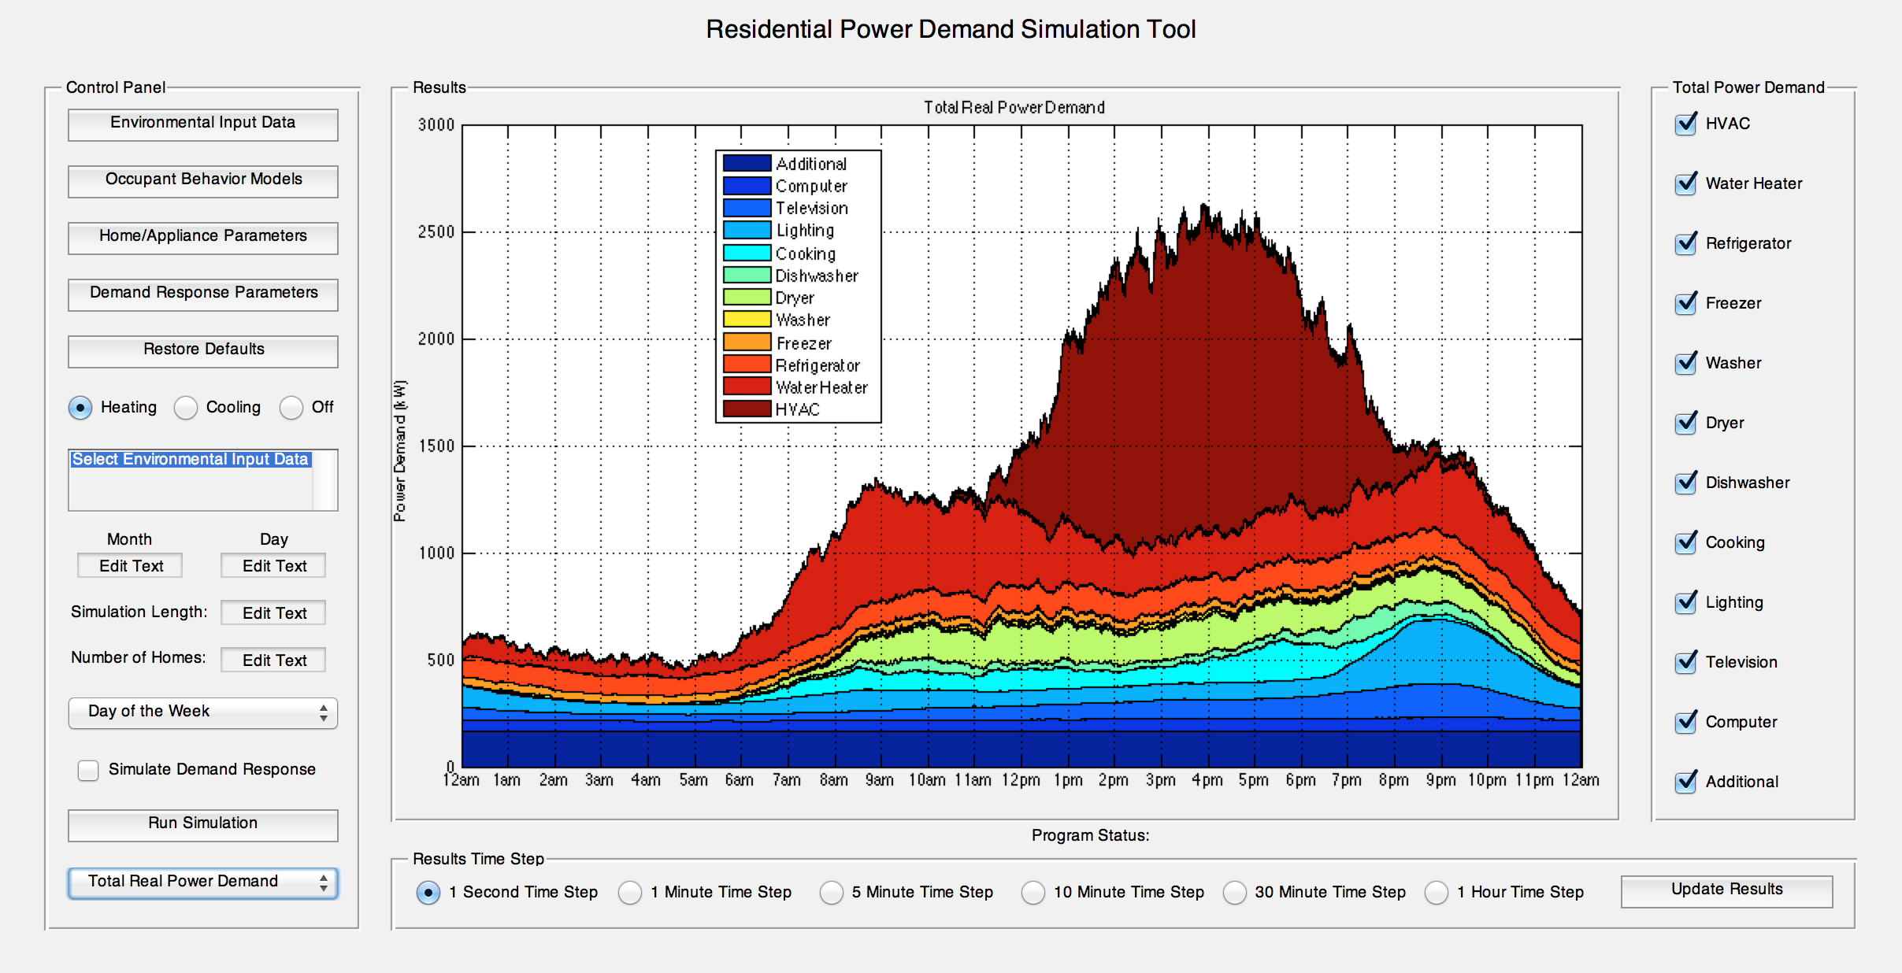
Figure 4.9: Residential Power Demand Simulation Tool GUI.
Occupants are randomly assigned according to various statistical parameters so as to accurately represent the overall composition of the U.S. population. The number of occupants per home is allowed to vary between one and seven. This is based on data collected by the U.S. Census Bureau [41]. Additionally, the percentage of each occupant type (i.e. working male, nonworking male, working female, nonworking female, and child) is defined according to data obtained from the U.S. Bureau of Labor Statistics [42]. The percentages used for determining the number of occupants in a home and the distribution of occupant types are summarized in Tables 4.2 and 4.3 respectively.
Table 4.2: Number of occupants per home [41].
Number of Occupants | Percentage
One Occupant | 27.41 %
Two Occupants | 33.85 %
Three Occupants | 15.89 %
Four Occupants | 13.25 %
Five Occupants | 6.00 %
Six Occupants | 2.26 %
Seven Occupants | 1.33 %

Table 4.3: Percentage of each occupant type [42].
Occupant Type | Percentage
Working Male Occupant | 24.82 %
Nonworking Male Occupant | 11.90 %
Working Female Occupant | 26.61 %
Nonworking Female Occupant | 12.75 %
Child Occupant | 23.92 %

To accurately model the overall stock of residential loads for single-family detached homes, data collected in the 2009 Residential Energy Consumption Survey and 2010 U.S. Lighting Market Characterization is utilized [16][23]. The distribution of residential loads as a percentage of the overall stock is shown in Table 4.4 on the following page. These percentages are based upon the entire U.S. and can vary greatly depending on the geographical region being studied. As a result, these values should be modified if a more regional analysis of residential power demand is desired. In the simulation tool, homes are populated with various residential loads based upon these percentages (ex. the probability of a home having a second refrigerator is 32.45 % and the probability of that refrigerator having a built-in automatic defroster is 94.56 %).
Table 4.4: Overall stock of loads within single-family detached homes [16][23].
Residential Load | Percentage of Overall Stock
Central Air Conditioning | 68.52 %
Heat Pump | 23.12 %
Resistive Heating | 2.65 %
Nonelectric Heating | 66.30 %
Electric Water Heater | 37.88 %
Refrigerator (with Automatic Defrost) | 99.86 % (94.56 %)
Second Refrigerator (with Automatic Defrost) | 32.45 % (94.56 %)
Freezer (with Automatic Defrost) | 40.81 % (44.03 %)
Second Freezer (with Automatic Defrost) | 3.76 % (44.03 %)
Washer | 96.66 %
Dryer | 73.40 %
Dishwasher | 67.83 %
Incandescent Lighting | 62.50 %
Halogen Lighting | 4.46 %
Linear Fluorescent Lighting | 9.94 %
Compact Fluorescent Lighting | 22.94 %
LED Lighting | 0.16 %

The power demand of a home’s HVAC system, refrigerator, freezer, and lighting are explicitly defined in their respective load models (see Chapter 3). The power demands of the remaining residential loads (i.e. water heater, washer, dryer, dishwasher, television, and computer) are defined based on the typical wattages reported in [43]. Additionally, cooking power demand is approximated as a constant 1250 W, similar to that used in [4]. Although the largest and most common residential loads are modeled in this tool, it is both impossible and unnecessary to model every load. For this reason, some level of residential power demand will remain unaccounted for. To correct for this, an additional power demand of 53 W per occupant is defined [26]. This demand is assumed to remain constant over the entire day and is not affected by occupant behavior. A summary of the average power demand used for each residential load is given in Table 4.5.
Table 4.5: Average power demand of residential loads.
Residential Load | Power Demand
Water Heater | 5000 W
Washer | 425 W
Dryer | 3400 W
Dishwasher | 1800 W
Cooking | 1250 W
Television (Standby) | 120 W (10 W)
Computer (Standby) | 270 W (20 W)
Additional | 53 W per Occupant

The amount of reactive power demanded by a load can be determined using (4.4), where $P$ is the load’s real power demand and $pf$ is its power factor.
$Q=\sqrt{{\left(P/{pf}\right)}^{2}-P^{2}}$ (4.4)
To approximate reactive power demand, constant power factors are defined for each residential load. These are derived from [44] and shown in Table 4.6.
Table 4.6: Power factors of residential loads.
Residential Load | Power Factor | Residential Load | Power Factor
HVAC | 0.97 | Incandescent | 1.00
Water Heater | 1.00 | Halogen | 1.00
Refrigerator | 0.90 | Linear Fluorescent | 0.95
Freezer | 0.90 | Compact Fluorescent | 0.92
Washer | 0.90 | LED | 0.90
Dryer | 0.99 | Television | 0.90
Dishwasher | 0.98 | Computer | 0.90
Cooking | 0.85 | Additional | 0.90

Finally, to simulate diversity between households, various parameters are allowed to vary around a defined mean. Parameters are varied using a normalized random number, or scaling factor. A scaling factor gives the number of standard deviations a parameter is away from the mean and is allowed to vary by a maximum of ±3 standard deviations. The simulation tool uses three different scaling factors for each home, assuming certain parameters are correlated. These scaling factors affect the following parameter types: square footage and power demand, insulation values, and thermostat settings. Additionally minimum and maximum bounds for each parameter are hard coded into the models to avoid simulating unrealistically small or large values. In Tables A.1-A.6 in the appendix, input parameters used for each load model including all of the mean values, standard deviations, minimum bounds, and maximum bounds are summarized.

4.2.2 Power Demand Simulations
By simulating multiple households and combining the results, the contribution of each residential load to the total aggregate demand can be seen. Simulations were conducted for 2,000 homes from Sunday to Monday. The resulting aggregate demand of each residential load and the overall demand are shown in Figures 4.10-4.26.
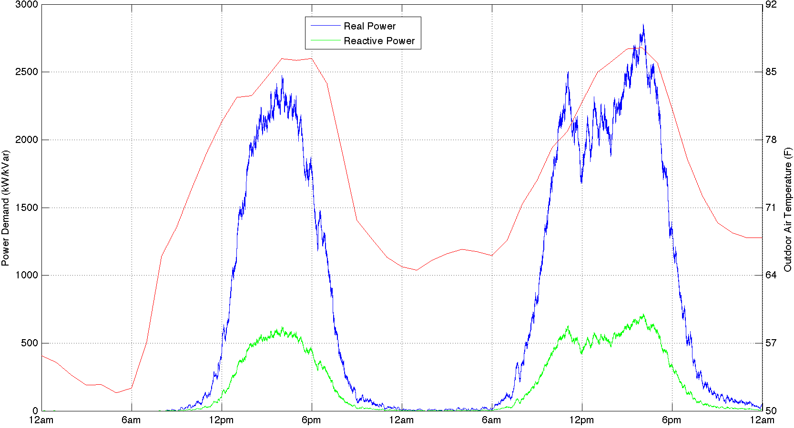
Figure 4.10: Total HVAC power demand (2,000 homes) (summer).
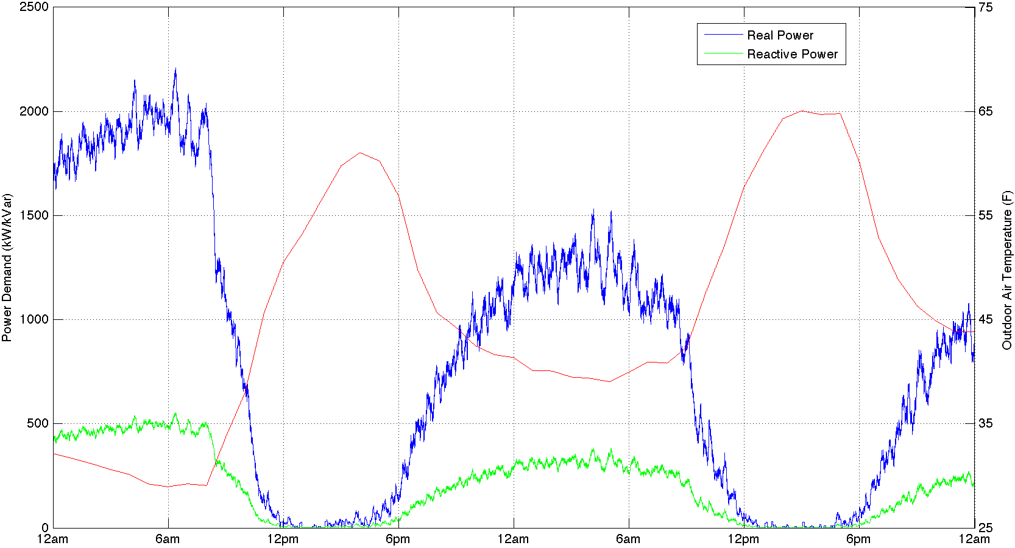
Figure 4.11: Total HVAC power demand (2,000 homes) (winter).
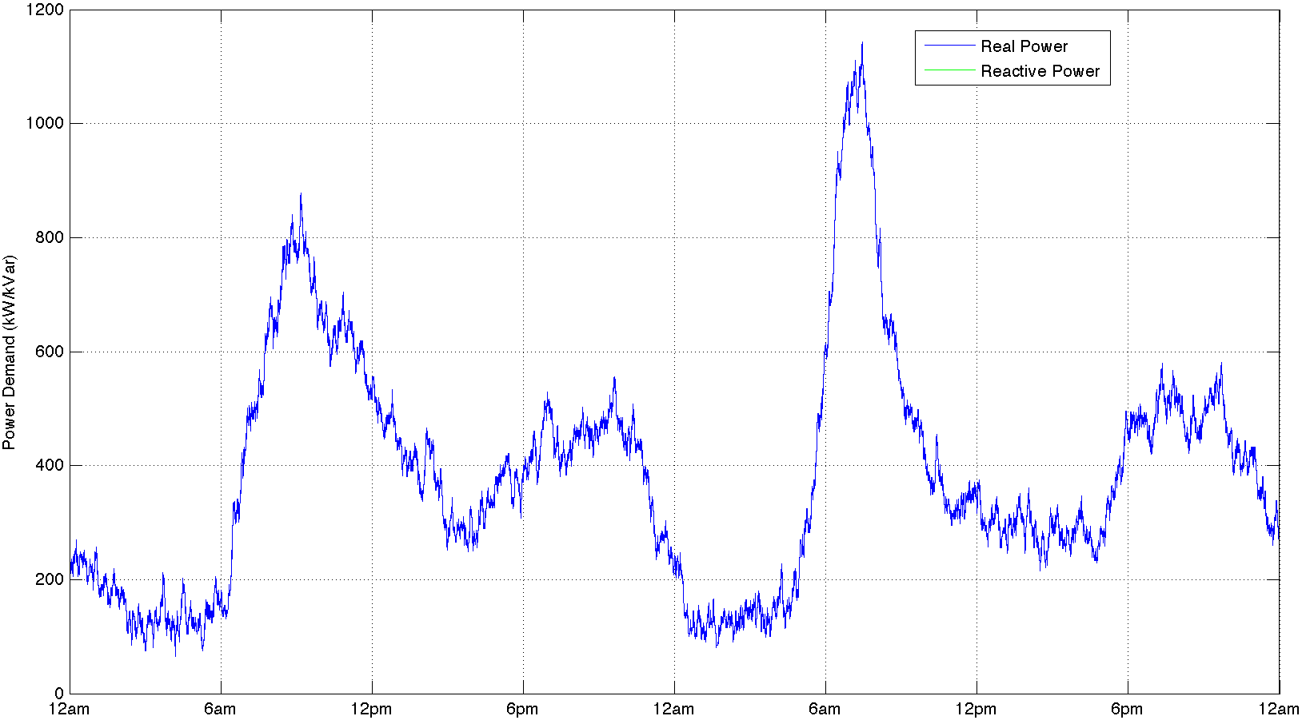
Figure 4.12: Total water heater power demand (2,000 homes).
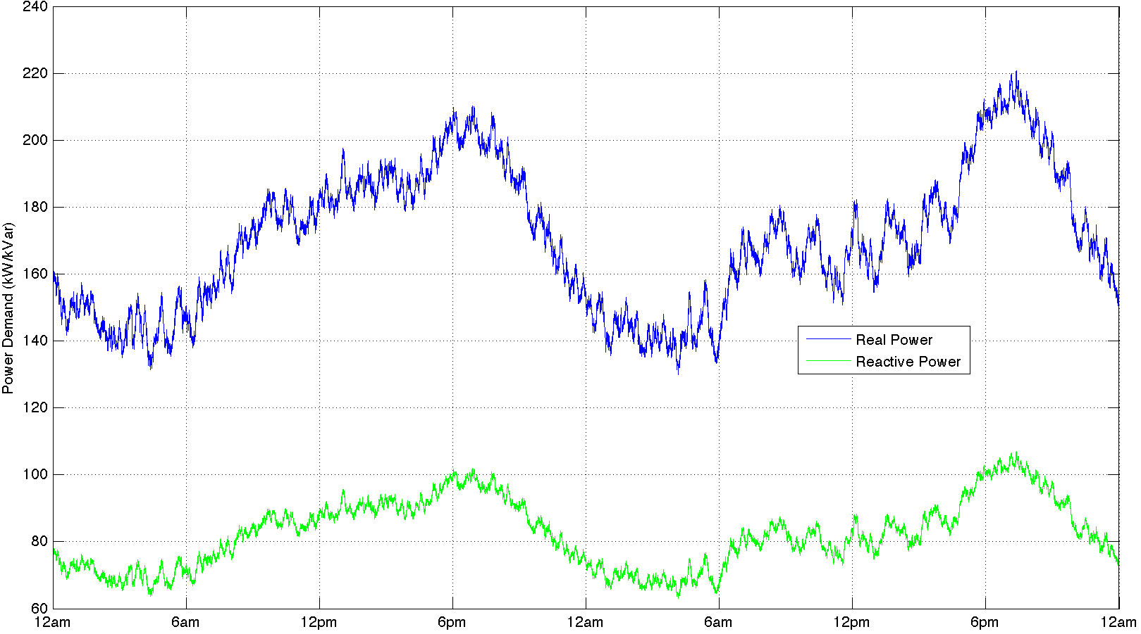
Figure 4.13: Total refrigerator power demand (2,000 homes).
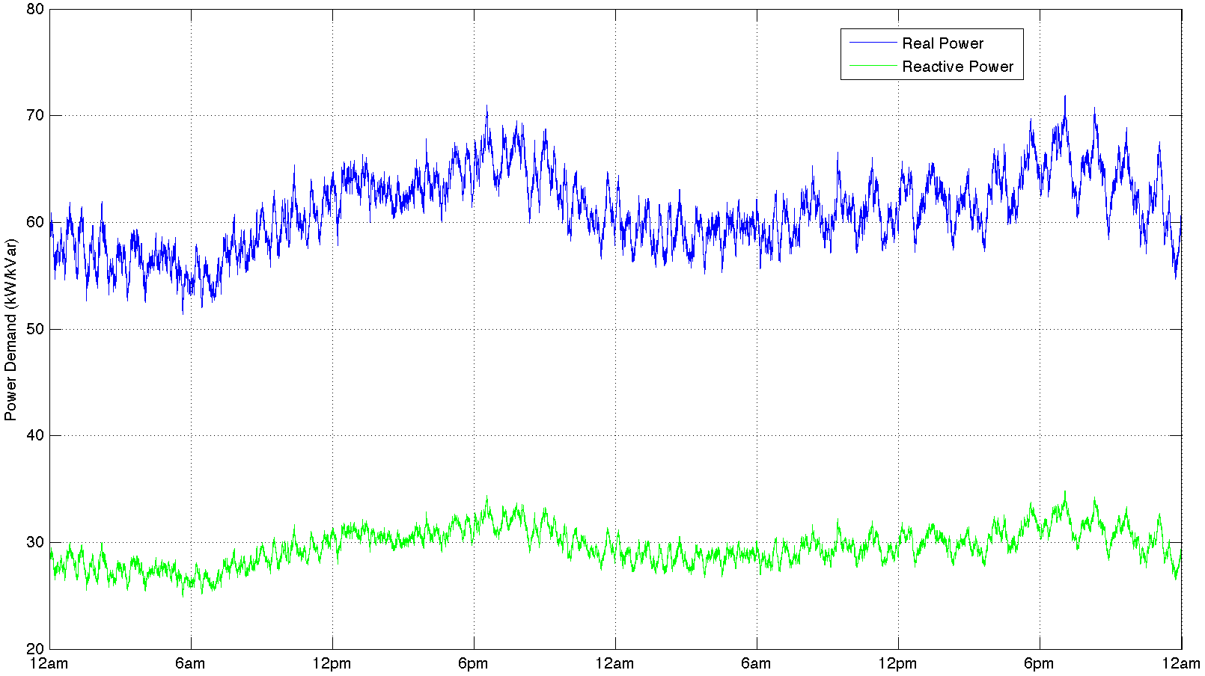
Figure 4.14: Total freezer power demand (2,000 homes).
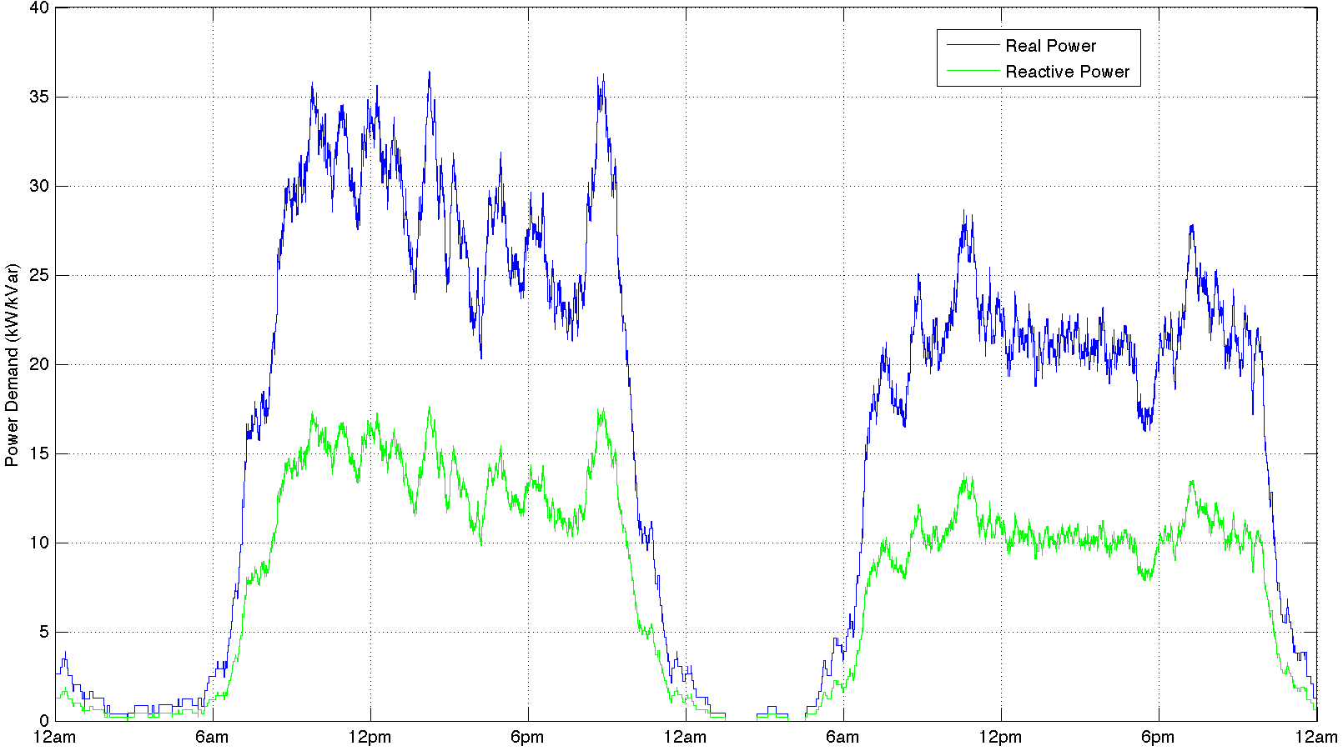
Figure 4.15: Total washer power demand (2,000 homes).
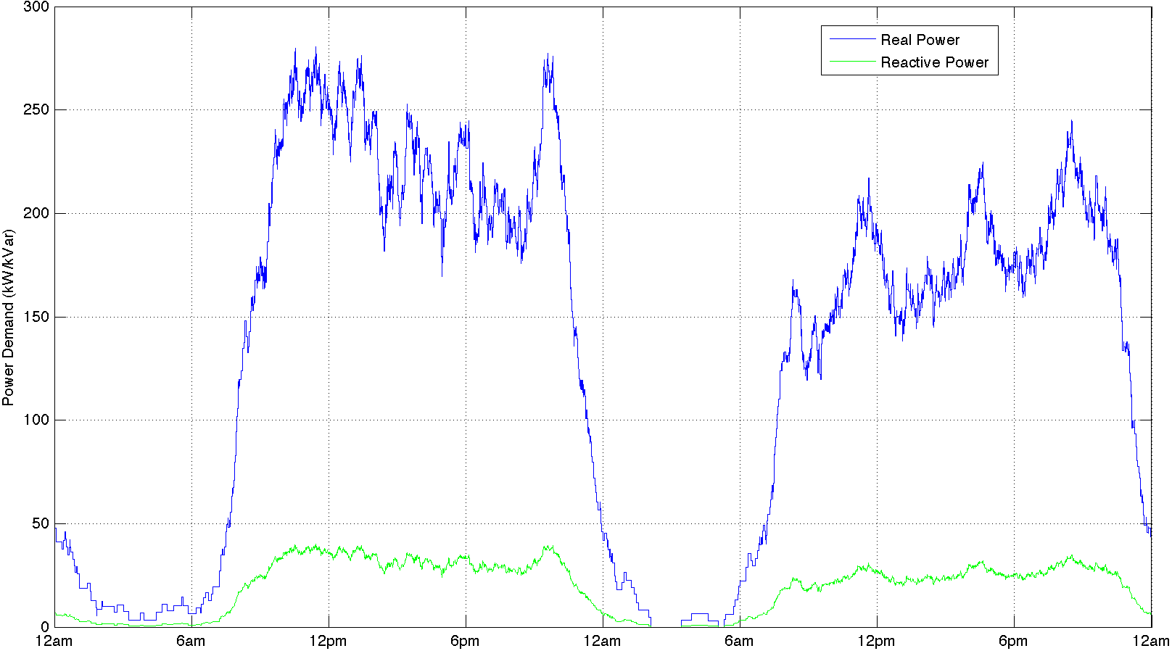
Figure 4.16: Total dryer power demand (2,000 homes).
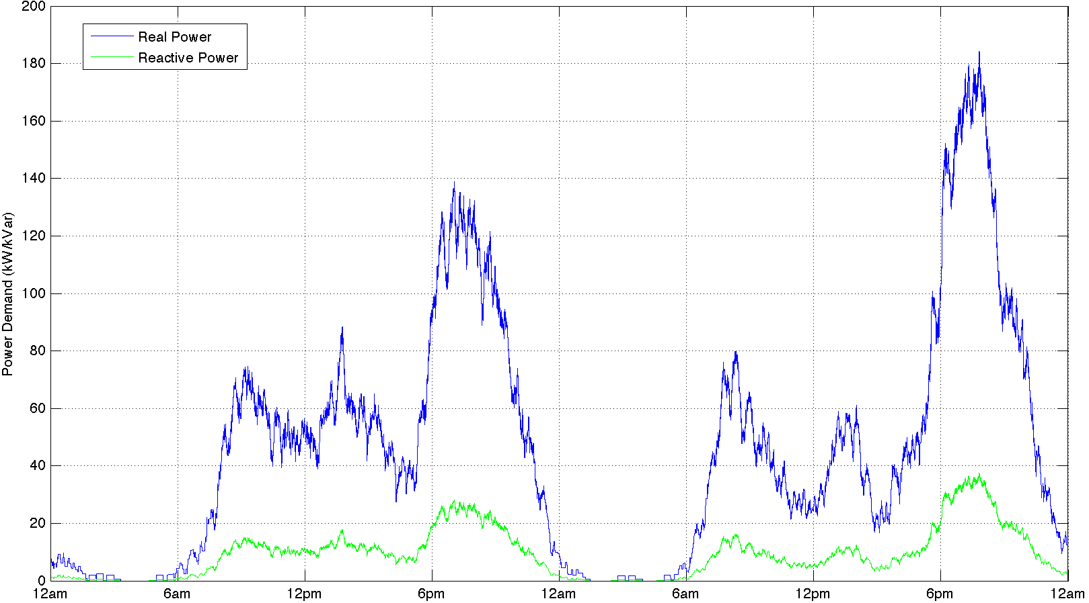
Figure 4.17: Total dishwasher power demand (2,000 homes).
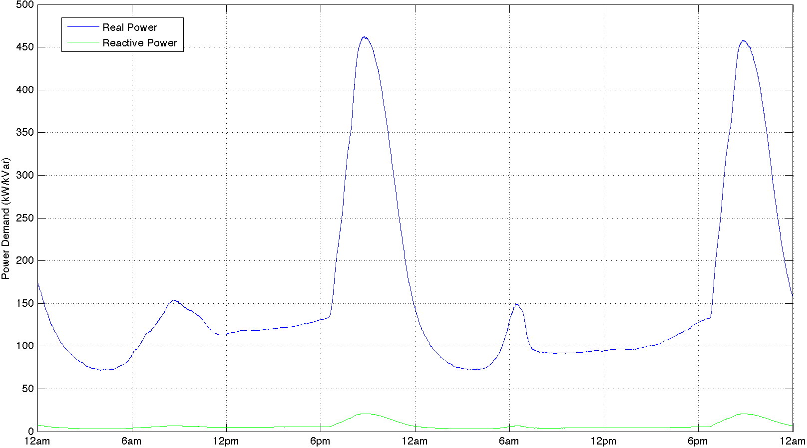
Figure 4.18: Total lighting power demand (2,000 homes) (summer).
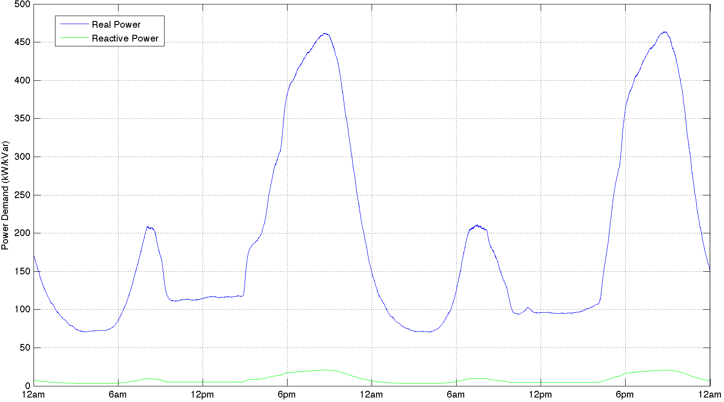
Figure 4.19: Total lighting power demand (2,000 homes) (winter).
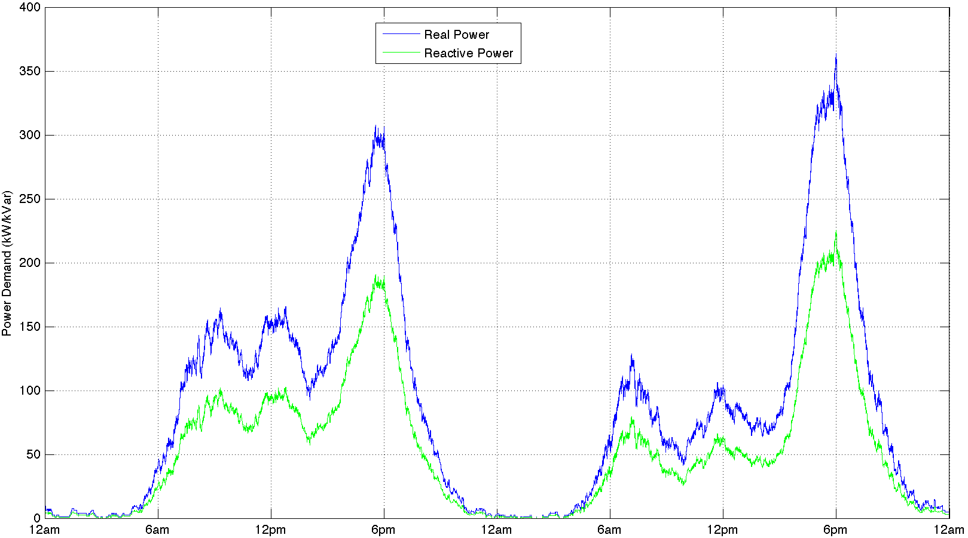
Figure 4.20: Total cooking power demand (2,000 homes).
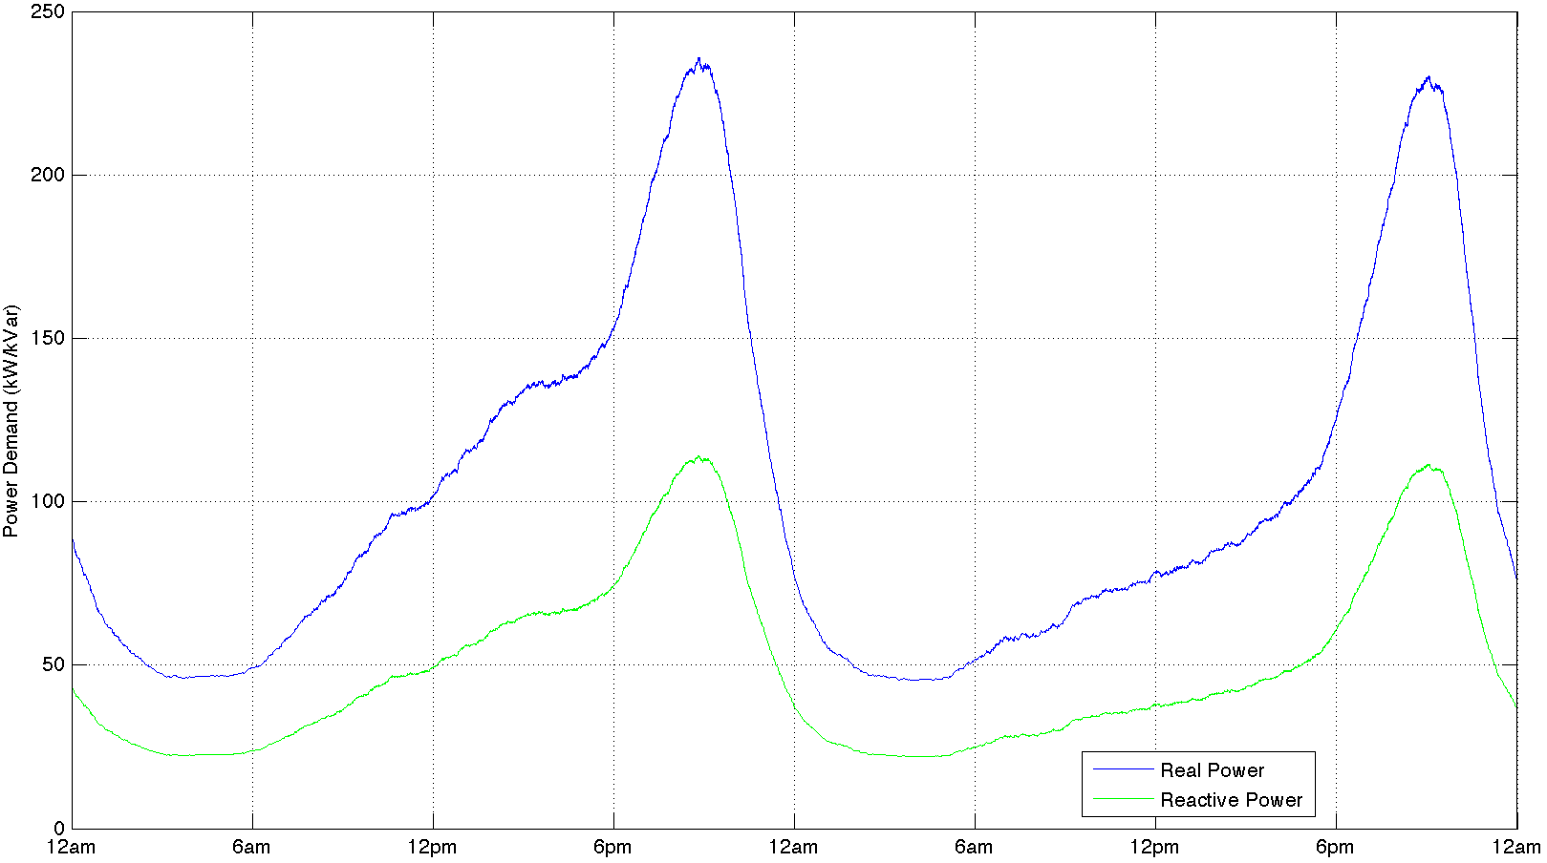
Figure 4.21: Total television power demand (2,000 homes).
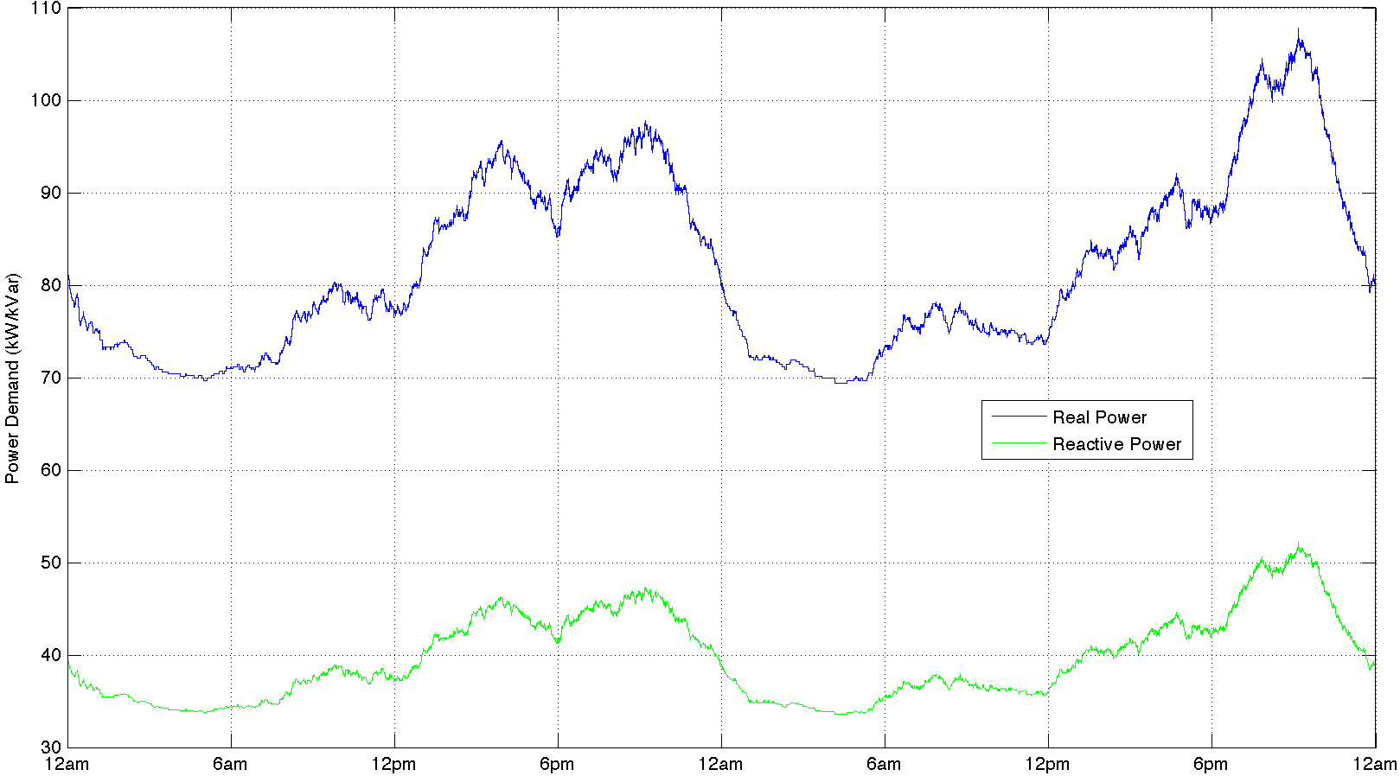
Figure 4.22: Total computer power demand (2,000 homes).
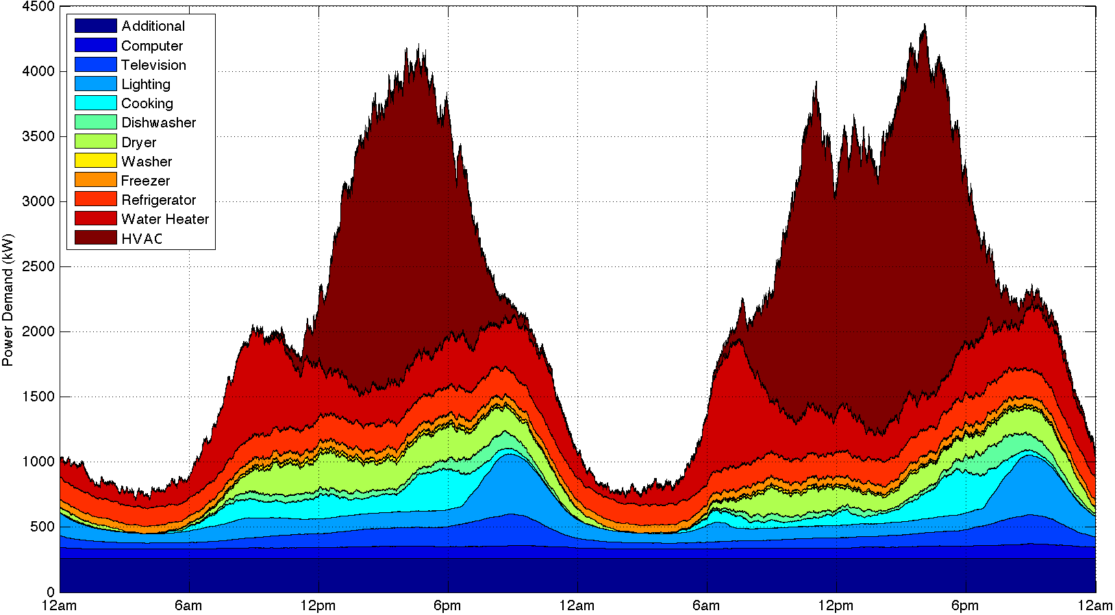
Figure 4.23: Total real power demand (2,000 homes) (summer).
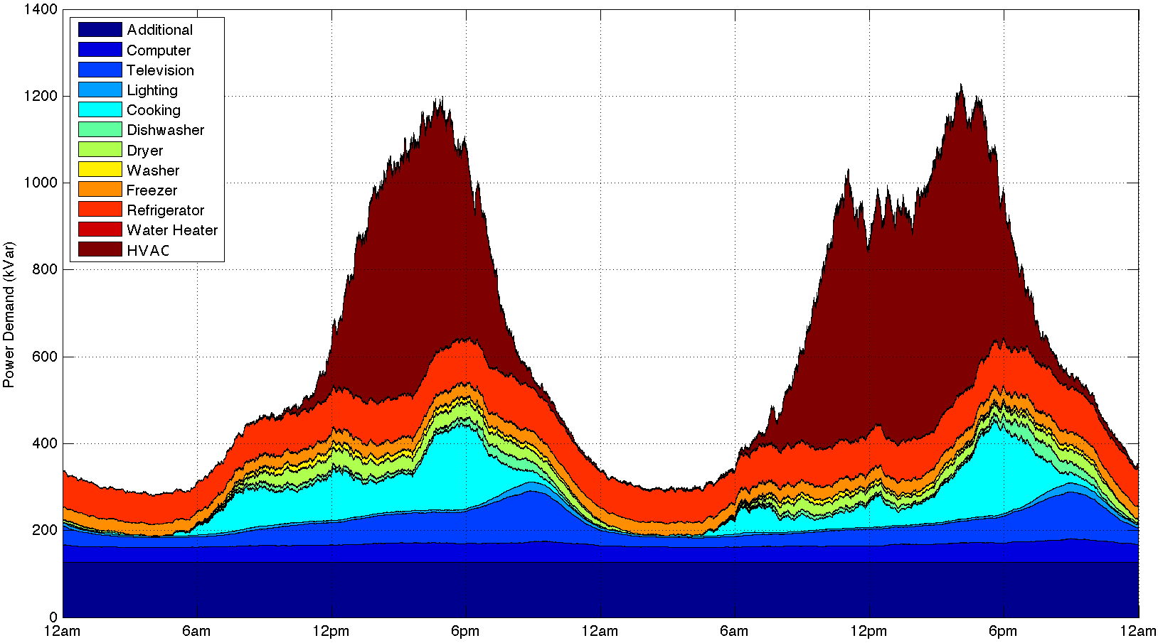
Figure 4.24: Total reactive power demand (2,000 homes) (summer).
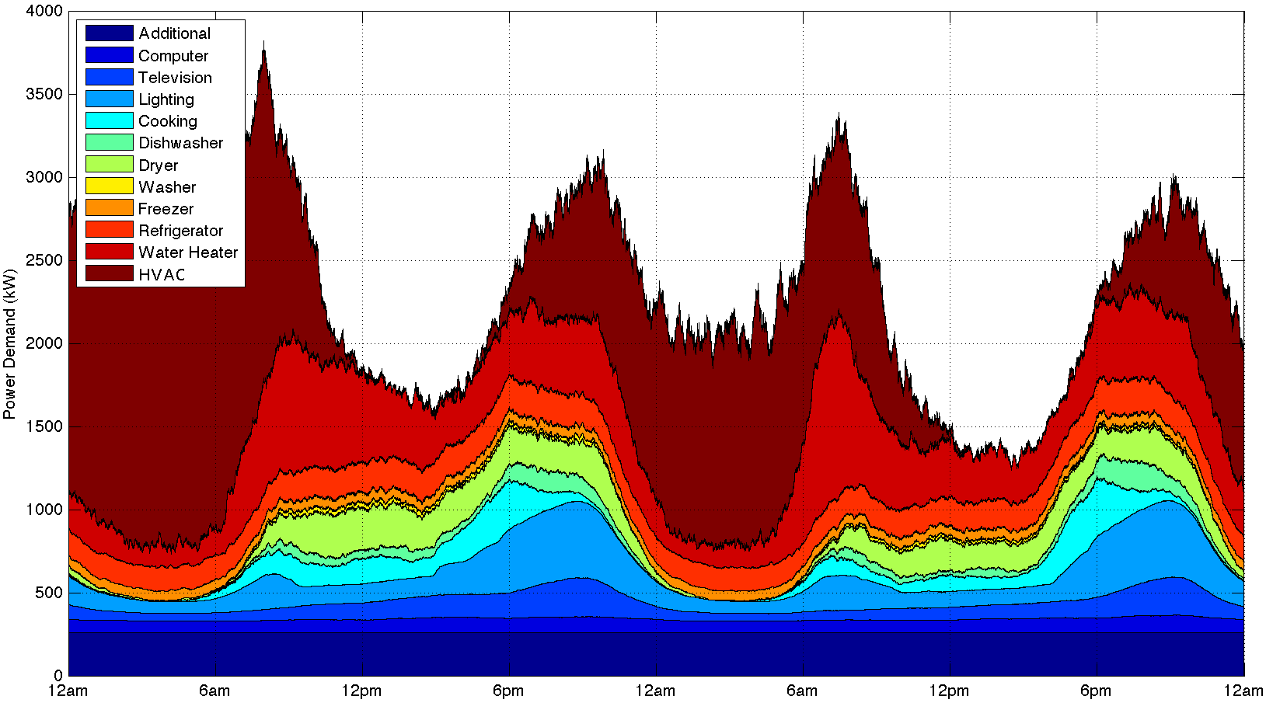
Figure 4.25: Total real power demand (2,000 homes) (winter).
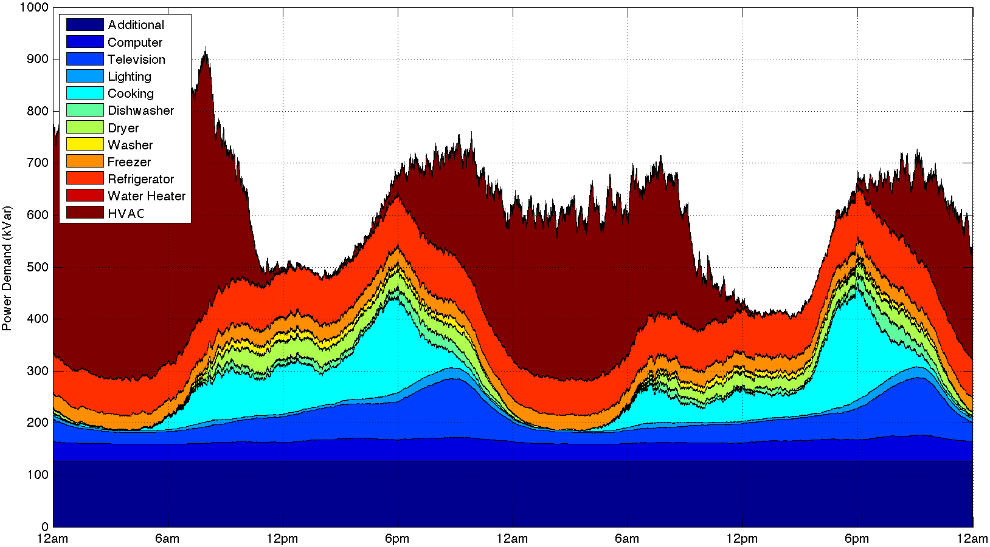
Figure 4.26: Total reactive power demand (2,000 homes) (winter).
As can be seen in Figures 4.10 and 4.11, seasonal differences in the power demand of residential heating and cooling systems are captured in this tool. Additionally, the impact that the length of the day (or the total amount of daylight) has on lighting power demand is also apparent (Figures 4.18 and 4.19). These results are very similar to the lighting demand profiles found in [24] and accurately portray the dynamic characteristics of residential lighting demand. The dynamic changes in power demand are also well represented for other loads. Water heater peak demand can be seen to occur in the early morning hours when occupants are most likely to shower and bathe, while the peak power demands of cooking correspond to breakfast, lunch, and dinner. Differences between the amount of power demanded by occupants on weekends and weekdays are also well defined. As occupants are more likely to be home during the day on weekends, residential power demand is much more distributed throughout the day on Sunday than on Monday. Another important aspect to note is the smoothness of both the lighting and television demand profiles. This is a result of their higher probabilities of being used and lower power demands compared to other residential loads. Finally, the power demand profiles shown in Figures 4.12-4.22 very closely match the shape of the demand profiles presented in [26]. These results are based upon residential power demand in Sweden and further show that occupant behavior, and consequently residential power demand, follows the same recognizable patterns regardless of the region or even the country studied.

4.2.3 Demand Response Simulations
By implementing various demand response startegies into this tool, the potential impact residential demand response programs may one day have on the power system can be observed. Three different types of residential demand response were investigated. First, one of the simpliest forms of demand response involving the shedding of residential HVAC systems was studied. This type of demand response is unique in that it has no affect on either the behavior or comfort of a home’s occupants (i.e. the home’s temperature will never leave the occupant’s desired temperature deadband). In the following simulation, 50 % of all HVAC systems are sent a signal to shed at 4:00 pm. Only those HVAC systems which are operating at the time are shed, and those shed are allowed to begin operating again as they normally would based on the thermostat settings of the home. The results of this simulation are shown in Figure 4.27 below.
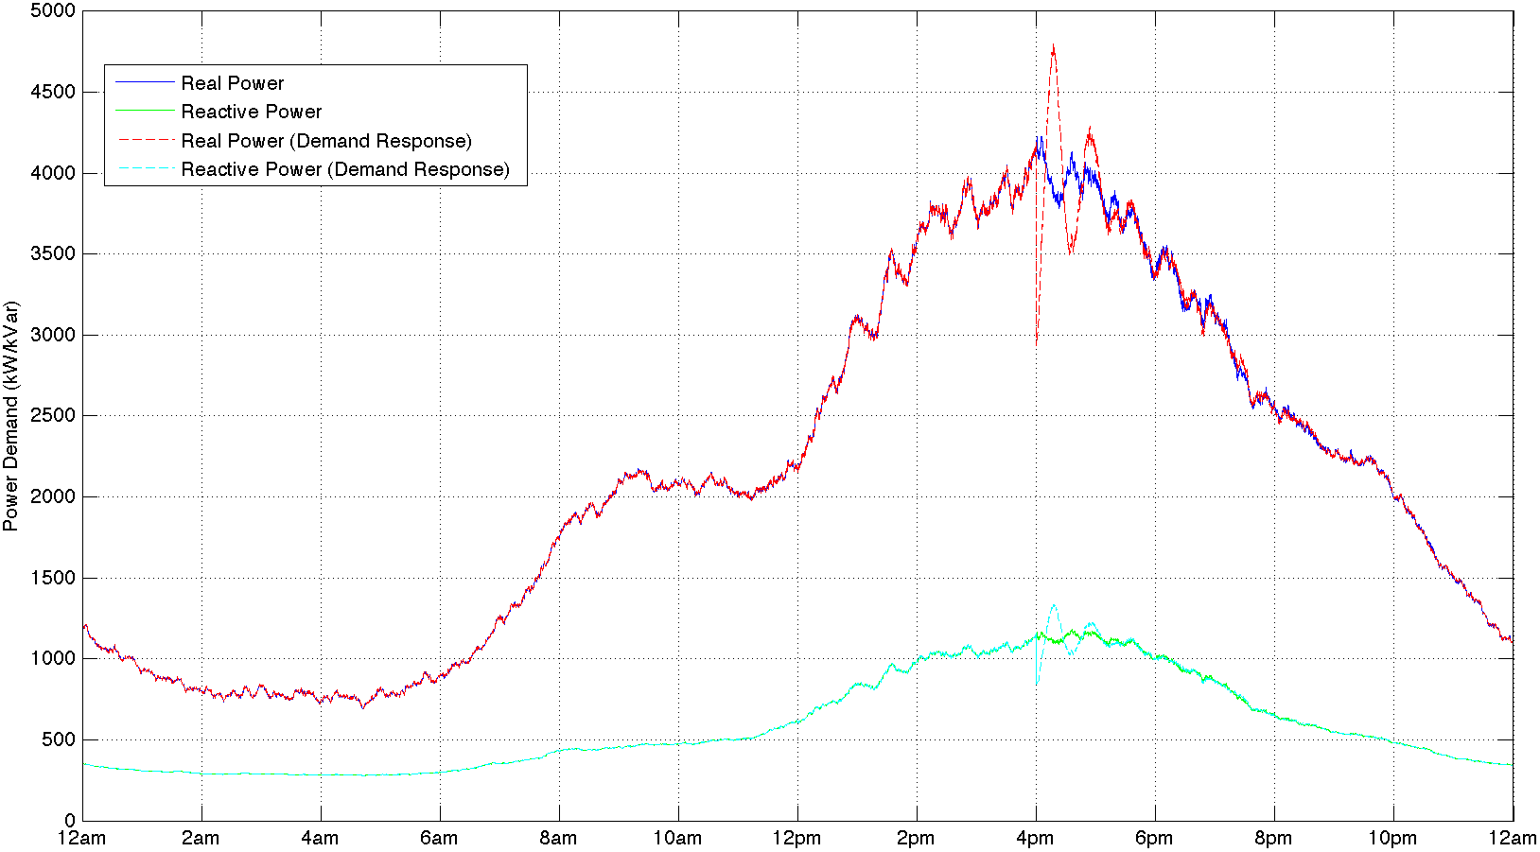
Figure 4.27: HVAC load shedding (2,000 homes).
These results show that shedding 50 % of all HVAC systems during summer peak demand can decrease residential power demand by a maximum of 1260 kW or 30 %. Furthermore, power demand remains decreased for approximately 9.5 minutes following the initial signal to shed HVAC loads. The trade-off for this decrease in demand, however, is dramatic. In this scenario, none of the settings of the HVAC systems are modified. As a result, residential power demand can be seen to oscillate, as many HVAC systems turn back on at the same time causing a substantial increase in demand. In this simulation, residential power demand was found to increase by 876 kW or 18.3 %. This increase in demand lasts for approximately 18 minutes. These results can vary greatly depending on the current time of day and environmental conditions.
Next, a more advanced demand response strategy involving the adjustment of the thermostat settings of residential HVAC systems was studied [30]. Unlike residential HVAC load shedding, this type of demand response does have an effect on the comfort of a home’s occupants, as their desired thermostat settings are altered. In this scenario, 50 % of all HVAC systems are sent a signal to raise their thermostat setting by 2 °F at 2:00 pm. Thermostats are later returned to their original settings between 6:00 and 7:00 pm. The results of this demand response strategy are shown in Figure 4.28.
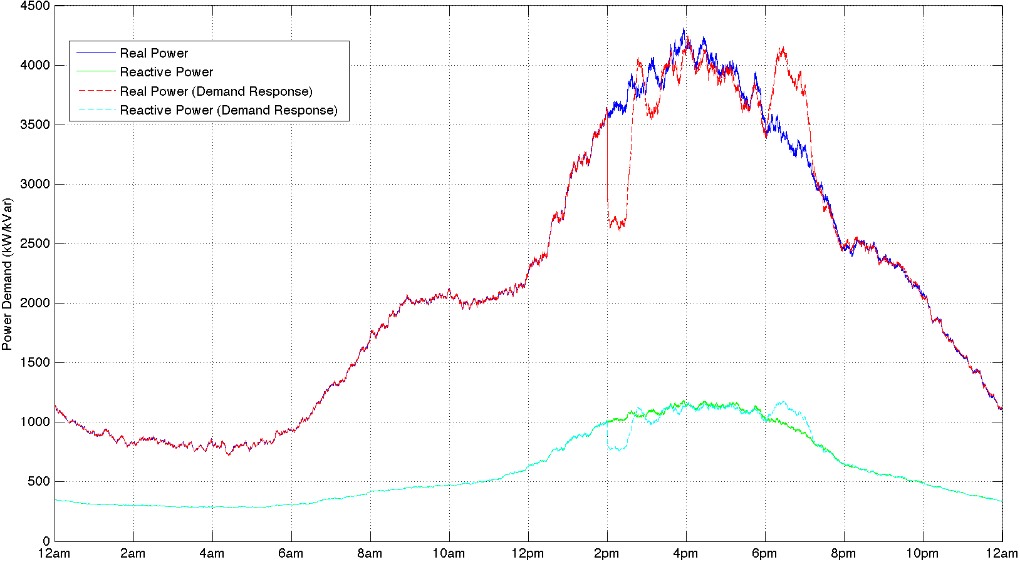
Figure 4.28: HVAC thermostat adjustment (2,000 homes).
As seen in Figure 4.28, adjusting thermostat settings can have a much greater impact on residential power demand than load shedding. Using this strategy, power demand is decreased by a maximum of 1008 kW or 27.9 % for approximately 42.5 minutes. This sustained decrease in demand ultimately comes at the cost of affecting occupant comfort. As with load shedding, a substantial increase in residential power demand, caused by returning the thermostat settings of each HVAC system to their original settings, can be seen. In this simulation, residential power demand was shown to increase by a maximum of 710 kW or 17.2 %. Additionally, this increase in demand was found to last for approximately 77.8 minutes. By spreading the signals to return HVAC thermostats to their original settings over a longer period of time, the increase in residential demand can be greatly diminished. In the simulation shown in Figure 4.29, HVAC thermostats are returned to their original settings between 3:00 and 7:00 pm.
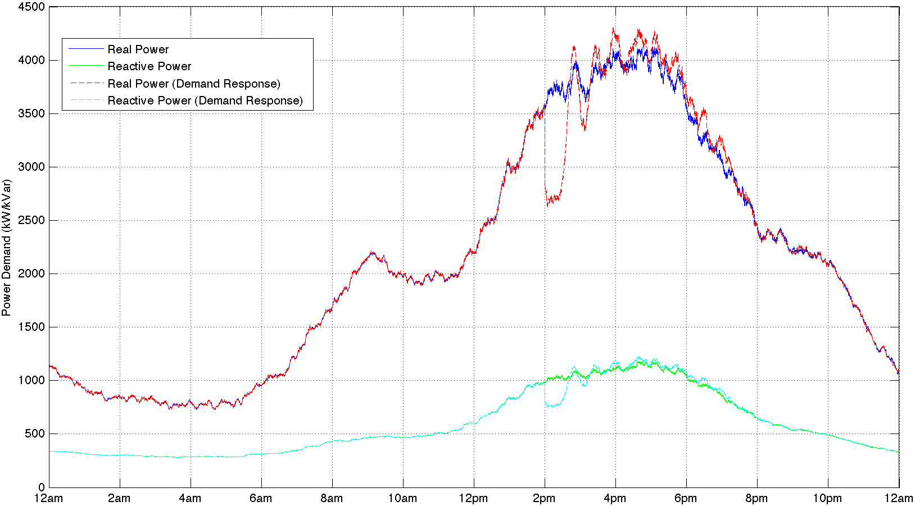
Figure 4.29: HVAC thermostat adjustment (2,000 homes).
As shown, spreading these signals over a longer period of time can virtually eliminate the increase in demand seen previously. This shows the benefit of having a simulation tool capable of testing these methods under various conditions. Each of these demand response strategies can also be implemented using water heaters, refrigerators, and freezers; however, the impact on residential power demand is greatly reduced.
Finally, deferring the operation of various residential loads was also studied. In the simulation below, 50 % of all washers and dryers are sent signals from 1:00 to 7:00 pm to defer their operation to a later time. The results are shown in Figure 4.30.
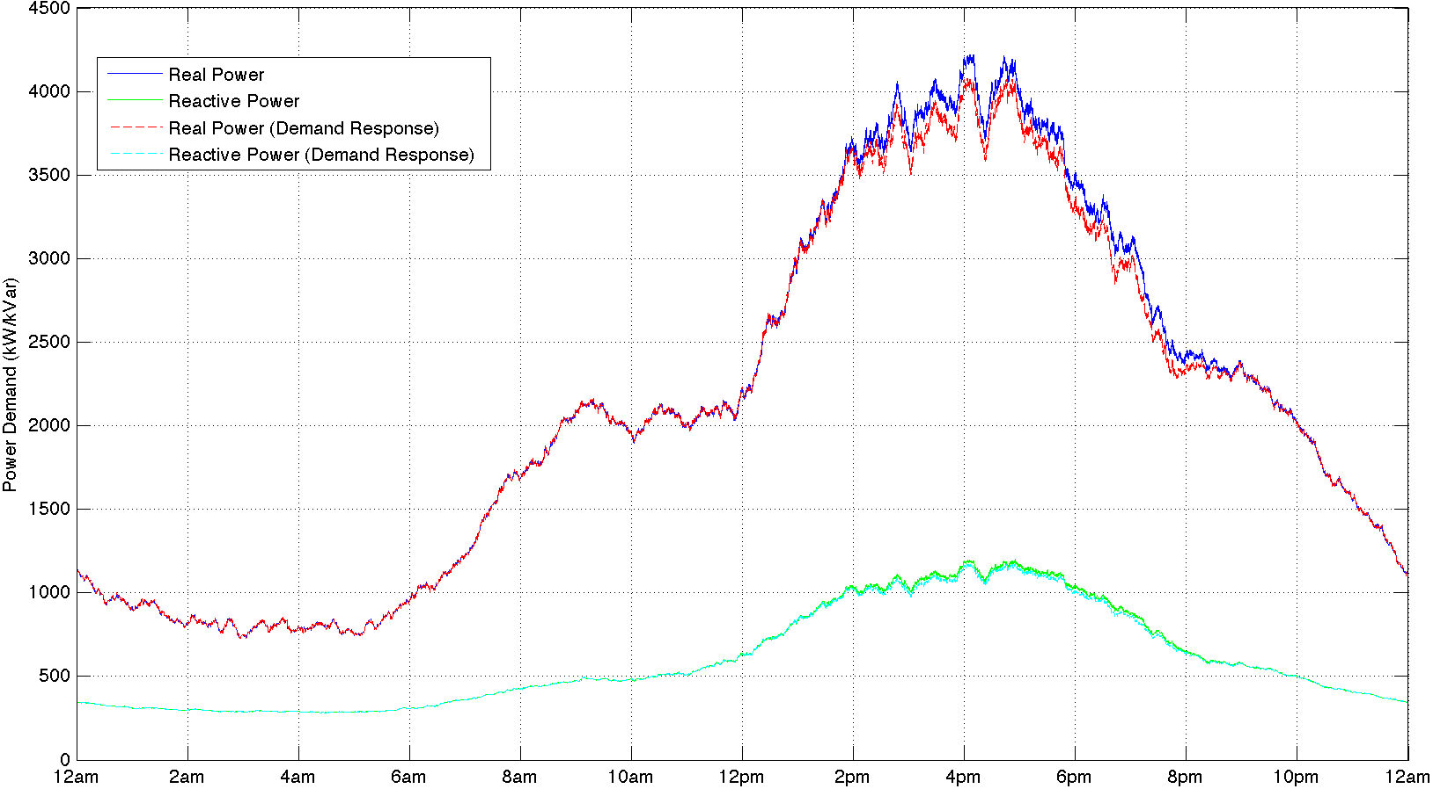
Figure 4.30: Washer/dryer defer load (2,000 homes).
In this scenario, residential power demand is decreased by a maximum of 155 kW or 3.7 % for approximately 8 hours. Although not shown, this demand would ultimately need to be shifted to a later time. All of these simulations show the usefulness of this tool, which can be easily modified and expanded upon for future demand response studies.

4.3 Chapter Summary
In this chapter, simulation results for the occupant behavior models developed through the course of this work were presented. From these results, the minimum number of occupants, and consequently the minimum number of multiple occupant households, needing to be simulated to produce a statistically accurate representation of aggregate residential behavior was determined. Next, the methods and statistics utilized to combine these occupant behavior models with the developed residential load models were explained. The resulting combination of these models was used to produce a dynamic simulation tool capable of predicting residential power demand on a one second time scale. Using this tool, simulations were conducted for multiple households to show the contribution of each residential load to the total aggregate demand. Finally, by implementing various demand response startegies into this tool, the potential impact of residential demand response programs was observed. Three different types of residential demand response were investigated: load shedding, thermostat adjustment, and defering load operation. Each of these strategies were simulated and their results were presented to show the usefulness of this tool for future demand response studies.

Conclusions and Recommendations

5.1 Conclusions
In the future, residential sector demand response programs promise to have a large impact on the power system. By using the dynamic simulation tool developed in this thesis, utilities and power system researchers will be able to better understand the effects of residential demand response on the overall grid. One of the primary benefits of this tool is that it combines both occupant behavior and residential load models to produce an accurate prediction of residential power demand on a one second time scale. While the behaviors and needs of occupants are typically ignored in power system studies, their importance cannot be understated. By utilizing the Markov Chain Monte Carlo statistical method to simulate occupant behavior, researchers can better predict how occupants interact with major residential loads throughout the day. This can ultimately help power system planners and researchers understand when to offer various incentives to customers so that residential demand response programs have the greatest impact.
Through the development of this tool, a bottom-up modeling approach in which the characteristics of each household and its individual loads are modeled and simulated was utilized. While this modeling approach is computationally intensive, the results derived from this method are much more meaningful than those obtained using high-level estimates. By analyzing the contributions of each residential load to the total aggregate demand, researchers can better understand how different technologies may impact the residential sector. Additionally, the dynamic characteristics associated with the aggregate demand of each type of residential load are also captured using this approach. Understanding how these characteristics vary throughout the day is extremely important, and will allow power system researchers to more effectively quantify the number of residential loads available for demand response during each part of the day.
Finally, by implementing various demand response strategies into this tool, simulation results were able to show both the benefits and trade-offs associated with residential demand response programs. While the simulations conducted in this research utilized relatively simple demand response strategies, the ability of this tool to be modified and expanded upon ensures that more complex types of demand response can be implemented in the future. Additionally, because statistical processes govern the occupant behavior models used by this tool, researchers can easily modify these models to reflect the socioeconomic impacts of real-time pricing and incentive programs on residential sector power demand. Smart grid equipment manufacturers and researchers can also utilize this simulation tool to further develop and understand various control strategies for residential loads with demand response capabilities. Ultimately, the research conducted in this thesis has resulted in a powerful simulation tool which will allow future researchers to develop a much more complete representation of residential power demand and preform more robust power system studies.

5.2 Recommendations
Although every effort was made to validate each residential load model against recorded power consumption data, further validation of the residential load models presented in this thesis should be conducted. In particular, the mean power demands and standard deviations defined for each load should be optimized so as to accurately match the aggregate power demand profiles produced by this simulation tool with recorded power consumption data. Additionally, models should be tuned in such a way that by simulating residential sector power demand over a full year, the contributions of each residential load type toward the total aggregate demand closely correspond to the percentages cited by the EIA. These further improvements and validations of this simulation tool will only increase its value to future research studies.
Additional areas of research should include the development of dynamic load models for residential solar panels and electric vehicles. While these particular loads are not currently widely distributed within the residential sector, this is likely to change in the future. By accurately modeling the potential impact of these residential loads, studies can be conducted on the various challenges associated with their future penetration of the residential market. Additionally, the inclusion of real-time pricing and incentive program components into this simulation tool could be extremely beneficial. As mentioned previously, because the occupant behavior models utilize statistical processes to predict residential power demand, their properties can be easily modified to simulate the affects of utility sponsored incentive programs on occupant behavior. Ultimately, the addition of these capabilities will open up numerous possibilities for future research.

LIST OF REFERENCES
- Use of Energy in the United States Explained [Online]. Available: http://www.eia.gov/energyexplained/index.cfm?page=us_energy_homes
- 2011 Buildings Energy Data Book, Energy Efficiency and Renewable Energy: Building Technologies Program, U.S. Department of Energy, Washington, D.C., Mar. 2012.
- M. Starke et al., “Key Residential Building Equipment Technologies for Control and Grid Support – Part I (Residential),” Oak Ridge National Laboratory (ORNL), Oak Ridge, TN, Rep. ORNL/TM-2011/143, Aug. 2011.
- M. Muratori et al., “A highly resolved modeling technique to simulate residential power demand,” Appl. Energy, vol. 107, pp. 465-473, Jul. 2013, doi: 10.1016/j.apenergy.2013.02.057.
- O. G. Santin et al., “The effect of occupancy and building characteristics on energy use for space and water heating in Dutch residential stock,” Energy and Buildings, vol. 41, no. 11, pp. 1223-1232, Nov. 2009, doi: 10.1016/j.enbuild.2009.07.002.
- J. Widén and E. Wäckelgård, “A high-resolution stochastic model of domestic activity patterns and electricity demand,” Appl. Energy, vol. 87, no. 6, pp. 1880-1892, Jun. 2010, doi: 10.1016/j.apenergy.2009.11.006.
- Y. Yamaguchi et al., “Occupant Behavior Model for Households to Estimate High-temporal Resolution Residential Electricity Demand Profile,” in 12th Conf. Int. Building Performance Simulation Assoc.: Proc. of Building Simulation (BS 2011) Sydney, Australia, Nov. 2011, pp. 1548-1555.
- I. Richardson et al., “Domestic electricity use: A high-resolution energy demand model,” Energy and Buildings, vol. 42, no. 10, pp. 1878-1887, Oct. 2010, doi: 10.1016/j.enbuild.2010.05.23.
- J. Tanimoto et al., “Validation of probabilistic methodology for generating actual inhabitants' behavior schedules for accurate prediction of maximum energy requirements,” Energy and Buildings, vol. 40, no. 3, pp. 316–322, Mar. 2008, doi: 10.1016/j.enbuild.2007.02.032.
- Y. S. Chiou, “An Occupant-Driven Integrative Household System For Residential Building Energy Simulation,” Ph.D. dissertation, School of Architecture, Carnegie Mellon Univ., Pittsburgh, PA, 2009.
- American Time Use Survey [Online]. Available: http://www.bls.gov/tus/
- HVAC: Chapter 3. Market and Technology Assessment, Energy Efficiency and Renewable Energy: Building Technologies Office, U.S. Department of Energy, Washington, D.C.
- S. Bashash and H. K. Fathy, “Modeling and Control Insights into Demand-side Energy Management through Setpoint Control of Thermostatic Loads,” in American Control Conf., San Francisco, CA, Jun. 2011. pp. 4546-4553.
- GridLAB-D: Residential Module User’s Guide [Online]. Available: http://sourceforge.net/apps/mediawiki/gridlab-d/index.php?title=Residential_module_user%27s_guide
- Water Heater: Chapter 3. Market and Technology Assessment, Energy Efficiency and Renewable Energy: Building Technologies Office, U.S. Department of Energy, Washington, D.C.
- 2009 Residential Energy Consumption Survey (RECS) [Online]. Available: http://www.eia.gov/consumption/residential/index.cfm
- C. Y. Chong and A. S. Debs, “Statistical Synthesis of Power System Functional Load Models,” in 18th IEEE Conf. Decision and Control (CDC 1979), Fort Lauderdale, FL, Dec. 1979, pp. 264-269.
- J. C. Laurent and R. P. Malhamé, “A Physically-Based Computer Model of Aggregate Electric Water Heating Loads,” IEEE Trans. Power Syst., vol. 9, no. 3, pp. 1209-1217, Aug. 1994.
- IEEE Task Force on Load Representation for Dynamic Performance, “Bibliography on Load Models for Power Flow and Dynamic Performance Simulation,” IEEE Trans. Power Syst., vol. 10, no. 1, pp. 523-538, Feb. 1995.
- Z. T. Taylor et al., “GridLAB-D Technical Support Document: Residential End-Use Module Version 1.0,” Pacific Northwest National Laboratory (PNNL), Richland, WA, Rep. PNNL-17694, Jul. 2008.
- J. Kondoh et al., “An Evaluation of the Water Heater Load Potential for Providing Regulation Service,” IEEE Trans. Power Syst., vol. 26, no. 3, pp. 1309-1316, Aug. 2011.
- Refrigerated and Freezer Storage [Online]. Available: http://food.unl.edu/web/safety/refrigerator-freezer
- 2010 U.S. Lighting Market Characterization, Energy Efficiency and Renewable Energy: Building Technologies Program, U.S. Department of Energy, Washington, D.C., Jan. 2011.
- Building America House Simulation Protocols, Energy Efficiency and Renewable Energy: Building Technologies Program, U.S. Department of Energy, Washington, D.C., Oct. 2010.
- J. Widén et al., “A combined Markov-chain and bottom-up approach to modeling of domestic lighting demand” Energy and Buildings, vol. 41, no. 10, pp. 1001-1012, Jan. 2009, doi: 10.1016/j.enbuild.2009.05.002.
- J. Widén et al., “Constructing load profiles for household electricity and hot water from time-use data-Modeling approach and validation,” Energy and Buildings, vol. 41, no. 7, pp. 753-768, Feb. 2009, doi: 10.1016/j.enbuild.2009.02.013.
- S. Annala et al., “Demand Response from Residential Customers’ Perspective,” in 9th Int. Conf. European Energy Market (EEM 2012), Florence, Italy, May 2012, pp. 1-7, doi: 10.1109/EEM.2012.6254651.
- Z. Wang et al., “Residential Demand Response: An Overview of Recent Simulation and Modeling Applications,” in 26th Annu. IEEE Canadian Conf. Elect. and Comput. Eng. (CCECE 2013), Regina, Saskatchewan, May 2013, pp. 1-6, doi: 10.1109/CCECE.2013.6567828.
- N. Lu, “An Evaluation of the HVAC Load Potential for Providing Load Balancing Service,” IEEE Trans. Smart Grid, vol. 3, no. 3, pp. 1263-1270, Sep. 2012, doi: 10.1109/TSG.2012.2183649.
- K. Kalsi et al., “Development and Validation of Aggregated Models for Thermostatic Controlled Loads with Demand Response,” in 45th Hawaii Int. Conf. Syst. Sci. (HICSS 2012), Maui, HI, Jan. 2012, pp. 1959-1966, doi: 10.1109/HICSS.2012.212.
- F. Rubinstein et al., “Using Dimmable Lighting for Regulation Capacity a Non-Spinning Reserves in the Ancillary Services Market: A Feasibility Study,” Lawrence Berkeley National Laboratory (LBNL), Berkeley, CA, Rep. LBNL-4190E, Dec. 2010.
- American Time Use Survey User’s Guide: Understanding ATUS 2003 to 2011, U.S. Census Bureau, Washington, D.C., Aug. 2012, pp. 1-107.
- Oak Ridge National Laboratory Rotating Shadowband Radiometer [Online]. Available: http://www.nrel.gov/midc/ornl_rsr/
- TVA Campbell Creek Energy Efficient Homes Project [Online]. Available: http://www.tva.gov/campbellcreekresearchhomes/
- Air – Density and Specific Weight [Online]. Available: http://www.engineeringtoolbox.com/air-density-specific-weight-d_600.html
- Water – Density and Specific Weight [Online]. Available: http://www.engineeringtoolbox.com/water-density-specific-weight-d_595.html
- HVAC and Chemical Resistance Handbook for the Engineer and Architect, BCT Inc., Lexington, KY, 1994, pp. 17-26.
- American Standard Bathroom Habits Survey Shows We’re Multitasking, Even In the Bath [Online]. Available: http://www.americanstandard-us.com/pressroom/american-standard-bathroom-habits-survey-shows-we-are-multitasking-even-in-the-bath/
- R. Perez et al., “Modeling Daylight Availability and Irradiance Components from Direct and Global Irradiance,” Solar Energy, vol. 44, no. 5, pp. 271-289, 1990.
- T. Muneer, “Hourly Horizontal Irradiation and Illuminance,” in Solar Radiation and Daylight Models, 2nd ed. Oxford, England: Elsevier Ltd., 2004, ch. 3, sec. 1-9, pp. 61-142.
- America’s Families and Living Arrangements: 2012 [Online]. Available: http://www.census.gov/hhes/families/data/cps2012.html
- Bureau of Labor Statistics: Employment Situation Summary [Online]. Available: http://www.bls.gov/news.release/empsit.nr0.htm
- Estimating Appliance and Home Electronic Energy Use [Online]. Available: http://energy.gov/energysaver/articles/estimating-appliance-and-home-electronic-energy-use
- GridLAB-D [Online]. Available: http://sourceforge.net/apps/mediawiki/gridlab-d/index.php?title=Main_Page

APPENDIX
Table A.1: Home input parameters.
Parameter | Mean Value | Standard Deviation | Minimum Bound | Maximum Bound
Square Footage | 2400 ft² | 400 ft² | 1200 ft² | 4800 ft²
Ceiling Height | 8 ft | N/A | 7 ft | 12 ft
Number of Floors | 2 | N/A | 1 | 3
Number of Doors | 4 | N/A | 1 | 6
Aspect Ratio (Depth/Width) | 1.5 | N/A | 0.5 | 2
Wall Insulation Value | R-19 | R-9/3 | R-4 | R-22
Roof Insulation Value | R-30 | R-18.5/3 | R-11 | R-48
Floor Insulation Value | R-22 | R-13/3 | R-4 | R-30
Window Insulation Value | R-2.13 | R-1.25/3 | R-0.75 | R-3.25
Door Insulation Value | R-5 | R-4/3 | R-3 | R-11
Infiltration Volumetric Air Exchange Rate | 0.5/hr | (0.5/3)/hr | 0.5/hr | 1.5/hr

Table A.2: HVAC input parameters.
Parameter | Mean Value | Standard Deviation | Minimum Bound | Maximum Bound
Heating Thermostat Setting | 70 °F | 4 °F | 60 °F | 85 °F
Cooling Thermostat Setting | 75 °F | 4 °F | 60 °F | 85 °F
Thermostat Deadband | 4 °F | N/A | 2 °F | 6 °F
Auxiliary Deadband | 2 °F | N/A | 2 °F | 6 °F

Table A.3: Water heater input parameters.
Parameter | Mean Value | Standard Deviation | Minimum Bound | Maximum Bound
Water Heater Volume | 50 gal | 10 gal | 30 gal | 80 gal
Water Heater Height | 5 ft | N/A | 5 ft | 5 ft
Water Heater Power Demand | 5000 W | 200 W (Nearest 100 W) | 4500 W | 5500 W
Tank Insulation Value | R-13 | R-2 | R-6 | R-20
Thermostat Setting | 130 °F | 5 °F | 100 °F | 160 °F
Thermostat Deadband | 5 °F | N/A | 1 °F | 10 °F
Shower Hot Water Demand | 30 gal | N/A | 0 gal | 40 gal
Bath Hot Water Demand | 20 gal | N/A | 0 gal | 30 gal
Washer Hot Water Demand | 20 gal | N/A | 0 gal | 30 gal
Dishwasher Hot Water Demand | 15 gal | N/A | 0 gal | 20 gal

Table A.4: Refrigerator/freezer input parameters.
Parameter | Mean Value | Standard Deviation | Minimum Bound | Maximum Bound
Refrigerator Volume | 21.5 ft³ | 2.5 ft³ | 10 ft³ | 35 ft³
Second Refrigerator Volume | 17.5 ft³ | 2.5 ft³ | 10 ft³ | 35 ft³
Thermostat Setting | 37 °F | 1 °F | 34 °F | 40 °F
Thermostat Deadband | 2 °F | N/A | 2 °F | 3 °F
Freezer Volume | 16.5 ft³ | 1 ft³ | 10 ft³ | 25 ft³
Second Freezer Volume | 15 ft³ | 1 ft³ | 10 ft³ | 25 ft³
Thermostat Setting | -5 °F | 2 °F | -10 °F | 0 °F
Thermostat Deadband | 2 °F | N/A | 2 °F | 3 °F

Table A.5: Deferrable load input parameters.
Parameter | Mean Value | Standard Deviation | Minimum Bound | Maximum Bound
Washer Power Demand | 425 W | 25 W (Nearest 15 W) | 350 W | 500 W
Dryer Power Demand | 3400 W | 550 W (Nearest 100 W) | 1800 W | 5000 W
Dishwasher Power Demand | 1800 W | 200 W (Nearest 100 W) | 1200 W | 2400 W

Table A.6: Uninterruptible load input parameters.
Parameter | Mean Value | Standard Deviation | Minimum Bound | Maximum Bound
Cooking Power Demand | 1250 W | 50 W (Nearest 25 W) | 1100 W | 1400 W
Number of Televisions per Home | 3 | N/A | 0 | 4
Television Power Demand | 120 W | 10 W (Nearest 5 W) | 65 W | 170 W
Television Standby Power Demand | 10 W | N/A | 0 W | 20 W
Number of Computers per Home | 2 | N/A | 0 | 3
Computer Power Demand | 270 W | 10 W (Nearest 5 W) | 240 W | 300 W
Computer Standby Power Demand | 20 W | N/A | 0 W | 40 W
Additional Power Demand | 53 W/Occupant | N/A | 0 W | 150 W

VITA

Brandon Johnson was born in Knoxville, Tennessee. He graduated from the University of Tennessee, Knoxville in May 2012 with a Bachelor of Science degree in Electrical Engineering. Continuing his education, he attended graduate school at the University of Tennessee, Knoxville, where he graduated in December 2013 with a Master of Science degree in Electrical Engineering concentrating in Power Electronics. While in graduate school he was a research assistant in the Power and Energy Systems group at Oak Ridge National Laboratory where he completed the research for this thesis. He plans to pursue a career working within a power engineering field.

