Using Novel Phenotypes to Understand and Predict Fertility in Beef Cows

A Thesis Presented for the
Master of Science
Degree
The University of Tennessee, Knoxville

Cassidy Catrett
August 2023
ACKNOWLEDGEMENTS
Thank you to my family and friends who have supported me throughout this degree. To my parents, thank you for all the love, support, and, almost, daily phone calls over the last two years. I would not be the person I am today without you and certainly would not have found myself on this path without your guidance and encouragement. To my sister, Cameron, thank you for always being there when I needed a listening ear. I am so proud of you and excited to see where you go on your academic journey.
To my fellow graduate students, you all welcomed me with open arms when I began this journey and quickly became the group I turned to when I needed advice or to vent. I am so thankful for the friendships formed these last two years and know you are all destined for great things.
Thank you to my committee members, Dr. Jon Beever and Dr. Sarah Moorey. I am grateful for your support, guidance, and willingness to answer all my questions throughout this project.
To my mentor, Dr. Troy Rowan, thank you for taking a chance on me. I could not have asked for a better mentor and am thankful for the opportunities you’ve afforded me throughout this degree.
ABSTRACT
Reproduction plays a major role in the production efficiency of livestock species. However, cow-centric reproductive traits are lowly heritable and are not expressed until later in an animal’s lifetime, making phenotypic selection ineffective at generating genetic gain. We can generate genetic progress by focusing selection on the genetic component of reproductive traits using Expected Progeny Differences (EPDs). We used the American Simmental Association’s performance and Total Herd Enrollment data, made up of 533,155 calving records from 303,158 females (132,403 cows and 170,755 heifers), 33,732 of which are genotyped, to develop two continuous and two discrete phenotypes focused on quantifying early and sustained fertility in beef cows. We analyzed calving interval (days between calves), calving date (cow’s calving date relative to the start of the calving season), heifer pregnancy (did animal calve as 2-year-old), and discrete early calving (did animal calve in the first 30 days of the calving season) as distinct, but correlated measures of fertility. This dataset provides insight into population-wide trends related to cow attrition, calving season lengths, and phenotypic variation in fertility. We used pedigree and genomic REML to estimate the genetic, permanent environment, and temporary environmental variance components of these four phenotypes. Pedigree estimated heritabilities were 0.02 (±0.000003) for calving date, 0.08 (±0.000026) for calving interval, 0.05 (±0.000095) for discrete early calving, and 0.23 (±0.000105) for heifer pregnancy, consistent with other fertility traits across beef and dairy cattle. The incorporation of genomics increased the heritability estimates for heifer pregnancy (0.24 ±0.000098) and calving date (0.03 ±0.000003) and decreased for calving interval (0.07 ±0.000005). All measured phenotypes had positive genetic correlations with each other (r_{G} = 0.11-0.96). indicating that selection for any of these phenotypes will positively impact the others. These results call for further research into the genetic architecture of cow rebreeding phenotypes through genome-wide studies.
TABLE OF CONTENTS

Chapter One Literature Review 1
Introduction 2
Economics of Cow Rebreeding 3
Physiology of Cow Rebreeding 7
Genetics of Cow Rebreeding 9
Conclusion 19
Chapter Two Using Novel Phenotypes to Understand and Predict Fertility in Beef Cows 20
Abstract 21
Introduction 21
Materials and Methods 25
Dataset 25
Development of Phenotypes 27
Contemporary Groups 29
Heritabilities, Correlations, and Estimated Breeding Values 31
Results 32
Phenotypic Observations 32
Heritability Estimates 36
Genetic Correlations 41
Discussion 43
Conclusions and Recommendations 46
Literature Cited 47
Vita 51

LIST Of TABLES

Table 2.1. Genotyping assays 28
Table 2.2. Genetic variance (V_{g}), environmental variance (V_{p}), error variance (V_{e}), and heritability (h²) estimates with ±standard errors for all phenotypes 40
Table 2.3. Direct genetic correlations (r_{g}) with ± standard errors (SE) 42

LIST OF FIGURES

Figure 2.1. The Number of animals enrolled each year in the ASA THE program. 26
Figure 2.2. Calculation of cow-centric phenotypes. 30
Figure 2.3. Distribution of calving intervals in ASA dataset. 33
Figure 2.4. Distribution of calving dates for heifers. 34
Figure 2.5. Distribution of calving dates for cows. 35
Figure 2.6. Calving season lengths for each contemporary group. 37
Figure 2.7. Changes in productivity by age. 38
Figure 2.8. Changes in the calving interval length due to age. 39

Literature Review

Introduction
Reproductive efficiency plays a major role in the economic success of cow-calf operations worldwide. Sustained cow fertility can be defined as a female’s ability to be bred back each year after calving as a heifer until the end of her payback period. In general, it is expected that beef females should have their first calf at 24 months of age and then produce a calf every 365 days until they are removed from the herd (Diskin and Kenny, 2014). Many environmental and genetic factors impact the success of a female in meeting these standards. However, because reproductive traits are lowly heritable, improvement for these has largely relied on improving management practices rather than changing selection criteria (Gutiérrez et al., 2002). This, coupled with a relatively small number of measured phenotypes for reproductive traits, has meant that developing selection tools for female productivity has been slower than for other traits. Dairy genetic evaluations and selection indexes have included phenotypes related to multiple measures of fertility for decades, a function of their extensive breeding records (Veerkamp and Beerda, 2007). Taken together, this underlines the need for new ways to measure fertility in beef cattle. Effective measurement of these traits at the population level will be essential for the development of selection tools.
Cow longevity is essential to ensure that females remain productive enough to recover the costs incurred during their development and yearly maintenance (Snelling et al., 1995). Currently, feed prices and other inputs are increasing. As a result, the need to breed and manage more productive and long-lived females is imperative to minimizing herd turnover. If producers can select females that are more likely to be productive year after year, then the costs associated with developing replacement females will be greatly reduced.

Economics of Cow Rebreeding
Typically, calves are the main output from beef cattle operations worldwide (Diskin and Kenny, 2014). This makes it essential that producers have productive females that calve each year and with minimal turnover. When managing a cowherd, culling cows and choosing replacing females are two of the most important and complex decisions producers make, especially from an economic perspective (Melton, 1980). When sourcing new replacement females, producers have two main options: either to raise and develop their heifers or to purchase replacements as open or bred animals. Both of these options have their advantages and disadvantages (Clark et al., 2005). When developing their replacements, producers have greater knowledge of an animal’s background and potential performance due to previous generations of maternal performance on their farm. However, depending on the makeup of the herd, genetic progress may be slower when replacing females with animals from the same herd, especially when only a handful of heifers are developed and retained each year. Additionally, proper female development is a costly process that, if not done properly, can reduce the value of females as both heifers and later in life from a productivity standpoint. When a producer chooses to purchase replacements, the new genetics introduced into the herd can generate rapid genetic progress. Bull selection is another consideration when purchasing or developing replacement heifers. Small, one-bull operations that retain heifers are likely to run into issues with sire-daughter matings during the lifetime of a single bull. Introducing new females into a herd may also involve introducing a new bull via artificial insemination or natural service so that these new females are mated with a bull who will improve the potential performance of their offspring.
Identifying which females to cull is also a complex decision. The economic value of a trait is defined as the effect of change in the total flow of an individual’s residual earnings due to changes in the expression of a trait (Melton, 1980). Using this to determine an annual value for performance, it has been found that the annual rate of economic growth is mainly dependent upon the age of females when they are culled and replaced. Beef cows are most productive from age four to age nine. After this point, productivity may be reduced, and rebreeding each year becomes more challenging. This does not mean that there is a standard age for when to cull females because not every animal experiences the same changes in performance or fertility. For genetically superior animals, an older culling age may be more appropriate than for genetically inferior animals. Underperforming animals should be culled sooner to bring in higher-performing females. Market conditions also play an important role in deciding which cows to cull. Because of herd liquidations in the United States, due to the COVID-19 pandemic and recent droughts, there is a projected decline in the number of cull cows being sold currently (Johnston, 2023). However, there is high demand for ground beef, which will increase the market value for cull cows.
Infertility is one of the main reasons that a female is removed from the cowherd. In many cases infertility is a delayed phenotype, meaning that it is not expressed until later in an animal’s life. This makes phenotypic selection for long-term selection challenging. A cow may have multiple daughters in the herd before we observe its propensity for infertility. Missing a reproduction opportunity is one of the most common reasons that mature cows are culled from herds. A study by Mathews and Short (2001) evaluated the economic cost of missing reproductive opportunities in both spring- and fall-calving herds. The changes in net present value (NPV) were significant enough to warrant culling females after one missed reproductive opportunity. This was further investigated for cattle in the Southeastern U.S. for both spring- and fall-calving cows by Boyer et al. (2020). Using calving and breeding records spanning from 1990-2008, animals were split into groups based on spring (478 cows with 1,534 calving records) and fall (474 cows with 1,727 calving records) calving dates. Based on different cow production costs for the two calving seasons, the NPV was calculated for females missing zero, one, and two calves. As expected, females who missed zero calves had the highest NPV for both the spring- and fall-calving herds with values of $671 and $683, respectively. Cows who missed one calf throughout their lifetime still had a positive NPV with values of $199 for spring calvers and $200 for fall calvers. Even though the NPV remained positive, the payback period for these females who miss one calf is elongated, requiring her to remain in the herd for a longer period. This extended payback period also provides more opportunities for cows to be culled due to factors not related to fertility. The payback period for females varies in the production of six, nine, or ten calves for females who miss zero, one, or two reproductive opportunities, respectively (Boyer et al., 2020). Further, as inputs have continued to increase since the publication of Boyer’s work, the annual costs associated with keeping a cow have likely elongated this payback period further. This elongated payback period underlines the importance of culling cows after their first reproductive failure, and making breeding and management decisions that increase overall herd fertility.
The calving distribution within a season also plays a major role in the economic success of an operation. Calves that are born earlier in the calving season are typically heavier and older when weaned, resulting in increased revenue (Funston et al., 2012; Cushman et al., 2013). Further, tighter calving distributions increase calf crop uniformity, a factor that also aids in marketing. The distribution of when calves are born is directly tied to when in the breeding season cows conceive. Variation in environmental conditions, cattle prices, and management practices have made it difficult to pinpoint an optimal calving season length. A simulation study by Boyer and Griffith (2020) estimated how net returns changed between spring- and fall-calving herds with 45-, 60-, and 90-day calving seasons. They found that a 45-day calving season with and without improved reproductive management yielded calves who were heavier at weaning for both spring- and fall calving. Net returns were higher for fall-calving and spring-calving herds that utilize improved reproductive management practices and for fall-calving herds that do not utilize improved reproductive management practices. Spring-calving herds with no improved reproductive management experienced negative net returns because of lower calving rates, resulting in fewer calves being marketed. Overall, it was found that a 60-day calving season, regardless of reproductive management strategies, resulted in positive net returns and increased weaning weights when compared to a 90-day calving season. Taken together, we can conclude that traits that help animals rebreed sooner and calve earlier in the season are economically important beyond driving cow attrition.

Physiology of Cow Rebreeding
Reproduction is largely influenced by an animal’s development, environment, and management. Optimally, each female in the herd will have one calf per year. To accomplish this, females must be able to have a calf and then be bred back for the next year around eighty days after calving (Moorey et al., 2022). The postpartum anestrus period makes this rebreeding challenging. Postpartum anestrus is the period after calving when females are non-cyclic and cannot be bred. This period typically lasts approximately sixty days post-parturition (Cushman et al., 2007). Considering the bovine gestation period is 283 days, that leaves only about twenty days for females to begin cycling and rebreed for the next year to achieve the desired 365-day calving interval.
One management practice that allows females to minimize their postpartum interval and breed back in a timely manner is for producers to breed females to calve early in the calving season. Calving early in the season allows females to have more time to resume cyclicity after calving and before the beginning of the next breeding season. Animals that fail to conceive at first service will have a reduced period to resume cyclicity before the following breeding season. Not only do females who calve earlier in the season have more time to recover prior to rebreeding, but they also typically raise calves who are heavier at weaning (Cushman et al., 2013). A study by Burris and Priode (1958) found that only seven percent of females who calve in the first twenty days of the season fail to become pregnant and calve the next year. In contrast, eighteen percent of females fail to rebreed after calving between 61-80 days after the beginning of the calving season. Other studies have reported that females who calve earlier as heifers breed back earlier in the season as cows and are more productive throughout their productive lifetime (Lesmeister et al., 1973; Cushman et al., 2013).
Nutrition and body condition play important roles in managing the length of the postpartum interval. Nutrient intake, both before and after calving, will affect the length of the postpartum interval, postpartum anestrus, and pregnancy rates (Diskin and Kenny, 2014). Hess et al. (2005) found that nutrition during gestation and before calving has a greater impact on the length of postpartum anestrus than nutrient intake postpartum. This work also found that energy is the nutrient that plays the greatest role in regulating reproduction. As such, to maximize their ability to rebreed, females must have adequate amounts of energy when supplemented before and after calving.
Heifer development and the timing of puberty both play a role in successful breeding both as a heifer and in subsequent years. Roberts and others (2019) conducted a study that compared pregnancy rates in heifers based on how many estrous cycles each female experienced before first breeding. In this study, heifers were split into groups based on the number of cycles and then further split to deliver different diets for comparing the effects of nutrition on heifer pregnancy. They found that heifers who had not had their first cycle before initial breeding (pre-pubertal heifers) were six days younger than the heifers who had at least one cycle before first breeding and 10 days younger than heifers who had cycled at least four times. The heifers who cycled at least once had a higher pregnancy rate compared with the pre-pubertal heifers. Additionally, more heifers calved earlier in the season (within the first 21 days) when they had gone through at least two estrous cycles compared with the females who had never cycled or only cycled once before breeding. Additionally, they found that females who cycled more than three times had higher pregnancy rates for their second breeding season. These females were also the oldest in the study indicating that age at first breeding affects a female’s long-term ability to rebreed. This work underlines the importance of early calving on maintaining a 365-day calving interval throughout an animal’s lifetime.

Genetics of Cow Rebreeding
While management strategies can impact a cow’s ability to rebreed quickly and efficiently, opportunities exist to leverage genetic selection to drive permanent improvements. Genetic selection in beef cattle populations has historically focused on traits that are easy to measure, such as pre-weaning growth or birth weight (Garrick, 2011). Calf performance traits are frequently measured, making genetic evaluations straightforward and accurate. Fewer records exist for traits that are expressed later in an animal’s life. This has led to genetic predictions for many important traits, such as mature size, stayability, lifetime reproductive performance, and disease resistance, having lower accuracies or no selection tools at all. Even as reproductive and nutritional management strategies have improved, genetic progress for reproductive traits has remained flat or declined over time (Veerkamp and Beerda, 2007). The challenge with developing a selection tool for reproduction, and rebreeding specifically, is that the phenotypes associated with these traits are difficult to measure and collect and require complete and repeated observations on individual animals and their contemporaries. Developing selection tools for novel reproduction phenotypes can improve the ability to predict these traits and drive genetic progress for long-term cow fertility.
Novel phenotypes are new methods for quantifying hard-to-measure traits, like those associated with reproduction and feed efficiency (Pollak et al., 2012). Genetic selection tools developed for these novel phenotypes can lead to more accurate selection at the population level, and ultimately more rapid genetic progress. Novel selection tools can be challenging to develop because a large number of animals must be phenotyped to accurately estimate heritabilities and generate accurate genetic predictions. Beef cattle breeds each run genetic evaluations, as such each population must have sufficient numbers of phenotypes to implement novel traits evaluations throughout the seedstock industry. This creates another challenge as most commercial cattle herds are made up of unregistered crossbred animals, meaning that regular phenotypic recording does not usually flow into genetic evaluations.
Accurately evaluating novel measures of fertility requires that full contemporary groups of females have breeding records reported, regardless of their calf’s registration status. There has been a delay in reporting and gathering reproductive phenotypes in the beef industry since not every calf born must be reported or registered. However, the implementation of whole or total herd reporting programs has begun to change this. Whole herd reporting (WHR) is an inventory-based system that requires producers to record all calving and weaning information from their entire cow inventory (BIF Guidelines, 2023). This means that all cows, regardless of calf performance, will have a record each year, regardless of whether the calf was registered. WHR programs allow for more unbiased information about reproductive performance to be recorded (Giess et al., 2021). In turn, this allows for more accurate contemporary grouping and less bias within since all calves are being recorded and not just the best calves from a given year or season. Further, it offers multiple opportunities to develop novel fertility and reproduction phenotypes. However, as associations mandate that more information is collected, producers may become hesitant to continue to enroll all of their animals. Further, as more data is required to be reported and recorded the likelihood of inaccurate information being reported increases in comparison to when WHR is optional. There is a balance between maximizing the amount of information collected and making it agreeable to the operations responsible for generating records.
Many phenotypes have been proposed as indicators for female fertility and rebreeding that can be derived from whole-herd calf reporting. These phenotypes include calving interval (number of days between calves), calving dates (an animal’s calving date relative to the start of the management group’s calving season), and discrete pregnancy measures (did animal calve in that year). Each of these traits has a genetic component, though studies have reported a wide range of heritabilities. For example, calving date heritabilities in the literature range from low (h² = 0.091) (Morris et al., 2000) to moderate (0.21) (Gutierrez et al., 2002). While the magnitude of these differences is substantial, they are not unexpected, as h² estimates are largely functions of the populations in which they are estimated. Estimates of heritability for heifer pregnancy show a similar range of magnitudes, from 0.138 in a Hereford population (Evans et al., 1999), to 0.21 in an Angus population (Doyle et al., 2000). Despite some variability in the heritabilities of these traits across multiple beef cattle populations, all tended to be lowly heritable (h² < 0.25).
Multiple measurements have been explored for quantifying heifer pregnancy and fertility phenotypes. Age at first calving is a common heifer fertility measure and is genetically correlated with both calving date and calving interval (Gutiérrez et al., 2002). In this population of Asturian Valley cattle, age at first calving showed a low negative correlation with calving date (r_{G} = -0.085) but positively correlated with calving interval (r_{G} = 0.233). Age at first calving is indicative of a heifer conceiving during its first breeding opportunity (Lesmeister et al., 1973). Animals with a younger age at first calving are more likely to rebreed as young cows and have more productive lives. Like other reproductive phenotypes, age at first calving is lowly heritable with estimates that range from 0.08 to 0.235 (Martínez-Velázquez et al., 2003). Other anatomical measures of heifer puberty have also been identified as useful measures of early-life fertility. Earlier maturing heifers are more likely to be cycling and conceive when exposed to their first service, jumpstarting their reproductive abilities. Estimates for the heritability of age at puberty are extremely varied and have been reported as being as low as 0.07 to as high as 0.67 (Martin et al., 1992). Martin and colleagues showed that age at puberty was a good indicator of lifetime productivity, as females who reached puberty sooner and are bred to calve earlier in the season, allowing them more time to recover and rebreed for their second calf (1992).
Reliably collected whole herd reporting data can be used to calculate multiple phenotypes, particularly related to the fertility and longevity of cows. When developing selection tools for these phenotypes, it is essential to account for differences in environmental and management practices from operation to operation. Contemporary groups are used to account for these environmental factors that impact animal phenotypes (Van Vleck, 1987). In the context of reproductive phenotypes, contemporary groups usually include things like herd, year, season, registration status, cow age group, management group, and other factors that can account for differences in management or expected performance. Contemporary groups can be modeled as fixed or random effects. When considering contemporary groups to be fixed, any bias due to effects that can be tied to contemporary groups is removed. However, if they are considered to be random, then there will be more effective records involved in a study with potential bias (Van Vleck, 1987).
Bull selection plays a major role in advancing the productivity of commercial herds. Bulls from seedstock producers are marketed to commercial operations to improve genetics and performance. Bull selection is responsible for most of the genetic gain within these herds, as bulls have larger genetic footprints compared with cows. Bulls are selected based on multiple traits depending on the herd’s unique needs and industry trends. For operations that retain replacement females, selecting bulls that improve daughter fertility can substantially impact the overall profitability of the herd (Boyer et al., 2020). This selection is challenging because bulls do not express the phenotypes of interest (i.e., calving date or heifer pregnancy). Expected Progeny Differences (EPDs) allow us to predict future daughter performance for bulls. The challenge that this presents is that the records for those EPDs must come from daughters in production. Given that heifers are two years old at first calving, a time lag is created between a bull entering production and his offspring’s phenotypes entering a genetic evaluation.
Most fertility traits are measured based on calving and breeding records (Berglund, 2008). Until the implementation of WHR, beef cattle breed associations could not capture unbiased reproductive records because a producer may not register every calf born in a herd in a season or year. As a result, it was impossible to distinguish reproductive failures from skipped registrations. The implementation of this recording system for producers has enabled the development of selection tools for reproductive traits in the form of EPDs (BIF Guidelines, 2023). Some EPDs that have been developed through WHR records include Heifer Pregnancy (HP), Stayability (STAY), 30-month Pregnancy (PG30), and Sustained Cow Fertility (SCF).
Heifer Pregnancy compares the expected genetic differences between individuals by estimating the percentage of daughters of individuals who will calve as a two-year-old (BIF Guidelines, 2023). HP is commonly implemented as a binary trait and is recorded as a female either did or did not calve as a two-year-old. Heritabilities for heifer pregnancy have been estimated to range from 0.14 to 0.21 (Evans et al., 1999; Doyle et al., 2000). Several breeds publish an HP EPD, including Angus, Brangus, Gelbvieh, Red Angus, and Santa Gertrudis. Similarly, the Beefmaster breed reports an Age at First Calving EPD that enables selection for females who will be younger when they have their first calf. This phenotype cumulatively accounts for age at puberty and for the ability of females to become pregnant.
Stayability (STAY) predicts the percentage of daughters who will remain in production through at least six years of age without missing a calf (BIF Guidelines, 2023). Since STAY measures productivity through six years of age, it is not collected until later in a female’s life, resulting in a delay in phenotypes entering genetic evaluations (Boldt et al., 2018). Recent work has demonstrated that random regression models can use earlier (incomplete) and later (extended) STAY records to improve EPD accuracies (Sánchez-Castro et al., 2019). STAY is a direct measure of cow longevity and regularity of production, not a direct measure of fertility. For example, a female may be a STAY failure if she were culled at age four for poor foot and leg structure, regardless of her fertility. The STAY EPD assumes that every animal can stay in the herd through six years of age, the end of her payback period, and will be able to generate enough income to cover costs associated with her management during that time. Whole herd reporting is particularly important for STAY phenotypes, as cows with unregistered offspring may still meet the criteria to be a success.
PG30 is an EPD reported by the American Gelbvieh Association and is defined as the rebreeding ability of a female who calves as a two-year-old (BIF Guidelines, 2023). PG30 is focused directly on cows rebreeding after their first calf, which is the most difficult rebreeding throughout a cow’s life. PG30 is modeled in a binary fashion where a successful observation would occur when a female calves as a two-year-old and is confirmed bred to calve as a three-year-old (i.e., pregnant at 30 months).
These EPDs enable producers to genetically select for multiple measures of heifer and cow fertility. The accuracies associated with these EPDs may be lower than for growth traits due to a reduced number of phenotypes and an inability to measure them on bulls. Information for the development of these EPDs is collected on females who produce a calf, so sires do not directly have phenotypes collected on their behalf until their daughters enter production (Boldt et al., 2018). Calculating these EPDs would not be possible without WHR. Even with WHR records, the beef industry still trails the dairy industry in collecting high-information breeding records (AI or natural service) that would help create more precise and granular measures of these traits. The development of selection tools has been slower in beef cattle compared with dairy cattle due to several factors, including widespread commercial crossbreeding, a lack of artificial insemination breeding date records entering genetic evaluations, and generally low levels of phenotyping in the commercial herd.
Another factor that has slowed the development of selection tools for rebreeding and fertility phenotypes stems from how these types of traits impact other economically relevant traits, like weaning weight and carcass traits. In a population of crossbred cattle, Berry and Evans (2014) found that age at first calving had a slight negative genetic correlation to direct weaning weight (-0.08) but a larger positive genetic correlation to maternal weaning weight (0.35). On the other hand, calving interval has a negative genetic correlation with maternal weaning weight (-0.21) but a positive genetic correlation with direct weaning weight (0.39). These correlations have made it difficult to select reproductive traits since there is an unclear impact on other economically relevant traits.
Most commercial operations purchase and use unproven bulls with moderate-to-lowly accurate EPDs. Genomic-enhanced predictions have enabled young, unproven bulls to receive increases in EPD accuracy before siring a calf crop (Meuwissen et al., 2001). Further innovations in genomic prediction allow us to better take advantage of records from animals who were not genotyped using of Single-Step Genomic BLUP (ssGBLUP), where pedigree information can be integrated with the genomic information available to make more accurate predictions (Legarra et al., 2009). ssGBLUP includes more information than a standard BLUP or GBLUP by including phenotypic, pedigree, and genotypes from all animals regardless of whether they are genotyped or not (Aguilar et al., 2010).
Along with innovations in modeling, many genetic evaluations have begun including multiple traits in prediction models. In dairy cattle, it was found that recurrent selection for milk production led to a decrease in female fertility (Liu et al., 2008). As a result, increased weights were placed on fertility-related traits in selection indexes. This allowed for selection to improve fertility while also maintaining milk-producing abilities. Fertility traits included a non-return rate to 56 days (NR), interval from first to successful insemination (FS), and days open (DO). NR and FS were broken down into heifer and cow status so that five phenotypes were analyzed in total. In their model, all the fertility traits had low heritability estimates, less than 0.04. The authors found that all the fertility traits analyzed were negatively correlated with the milk production traits. However, there was a positive correlation between fertility traits and cow longevity. This positive correlation in longevity led to the conclusion that including these fertility traits in genetic evaluations is warranted despite the antagonistic correlation between fertility and milk production traits. Even if similar correlations exist in beef cattle, fertility and longevity are of such substantial economic importance that they should be included in beef breed selection indexes.
Understanding the genetic correlations between traits enables the creation of selection indexes for various breeding objectives. A selection index is a tool that weights multiple traits by their relative importance to a breeding objective and provides a single aggregate value to select (Hazel, 1943). In practice, these indexes combine the values from multiple EPDs and weigh them by their economic importance. This allows them to be combined into an aggregate value that predicts the overall profitability of an animal’s offspring. These are important for helping producers balance selection on traits that affect end-product productivity (e.g., calf weight or carcass characteristics) and replacement female traits (e.g., fertility and longevity). For example, the American Angus Association calculates a Maternal Weaned Calf Value ($M) index that reports at differences in profitability due to the genetics of calves from conception to weaning when replacement females are retained. This figure accounts for the development of replacement females while assuming all other female offspring and all males will be sold. This one index combines calving ease (direct and maternal), weaning weight, milk, heifer pregnancy, docility, mature weight, and foot scores (angle and claw). Other major genetic evaluations publish at least one economic selection index depending on how their bulls are used. For breeds with maternal applications, a maternal or composite (maternal & terminal) index will include some measure or measures of cow fertility, heifer fertility, or longevity.

Conclusion
Reproductive efficiency is the cornerstone of the success and sustainability of commercial beef cattle operations. Reproduction can significantly impact the bottom line for cow-calf operations as calves are the main output from operations. Since reproductive traits are heavily influenced by the environment and management practices, breeding females who will be more productive regardless of the environment is imperative to ensure the success of operations. Many dairy cattle genetic evaluations include fertility and longevity traits already so the adaptation of these types of evaluation for beef cattle will aid in the selection of more productive females. The development of selection tools for rebreeding will not only aid in the selection of more productive females but will also allow for the selection of bulls who may sire more productive daughters and continue a positive trend for sustained cow fertility.

Using Novel Phenotypes to Understand and Predict Fertility in Beef Cows

Abstract
Reproduction plays a major role in the production efficiency of livestock species. However, cow-centric reproductive traits are lowly heritable and are not expressed until later in an animal’s lifetime, making phenotypic selection ineffective at generating genetic gain. We can generate genetic progress by focusing selection on the genetic component of reproductive traits using Expected Progeny Differences (EPDs). We used the American Simmental Association’s performance and Total Herd Enrollment data, made up of 533,155 calving records from 303,158 females (132,403 cows and 170,755 heifers), 33,732 of which are genotyped, to develop two continuous and two discrete phenotypes focused on quantifying early and sustained fertility in beef cows. We analyzed calving interval (days between calves), calving date (cow’s calving date relative to the start of the calving season), heifer pregnancy (did animal calve as 2-year-old), and discrete early calving (did animal calve in the first 30 days of the calving season) as distinct, but correlated measures of fertility. This dataset provides insight into population-wide trends related to cow attrition, calving season lengths, and phenotypic variation in fertility. We used pedigree and genomic REML to estimate the genetic, permanent environment, and temporary environmental variance components of these four phenotypes. Pedigree estimated heritabilities were 0.02 (±0.000003) for calving date, 0.08 (±0.000026) for calving interval, 0.05 (±0.000095) for discrete early calving, and 0.23 (±0.000105) for heifer pregnancy, consistent with other fertility traits across beef and dairy cattle. The incorporation of genomics increased the heritability estimates for heifer pregnancy (0.24 ±0.000098) and calving date (0.03 ±0.000003) and decreased for calving interval (0.07 ±0.000005). All measured phenotypes had positive genetic correlations with each other (r_{G} = 0.11-0.96). indicating that selection for any of these phenotypes will positively impact the others. These results call for further research into the genetic architecture of cow rebreeding phenotypes through genome-wide studies.

Introduction
Reproduction plays a major role in the production efficiency of livestock species. For beef cow-calf operations, calves serve as the main source of output and economic returns for beef cow-calf operations (Diskin and Kenny, 2014). The goal for cow productivity is for females to have their first calf at 24 months of age and then produce a calf every 365 days until that animal is removed from production. Cow longevity is the chief driver of economic success in cow-calf operations. An inability to breed back is the most common reason that beef cows are culled from herds (Diskin and Kenny, 2014). Phenotypes associated with increased cow fertility and longevity are known to be under low levels of genetic control. As such, selection tools can help accelerate progress on cow fertility. A major impediment to the development of these selection tools is that phenotypes associated with cow fertility and productivity are difficult to measure and collect. Further, they often take multiple years to be fully expressed.
Many phenotypes have been proposed as ways to measure cow fertility including calving date, age at first calving, heifer pregnancy, and calving interval. However, a lack of comprehensive breeding records in the beef industry has made the collection of these phenotypes difficult. Whole herd reporting (WHR) is an inventory-based reporting system in which all female production records and calving information are recorded (Giess et al., 2021). This type of reporting framework has allowed breed associations to collect complete and unbiased reproductive and performance phenotypes from entire herds.
These genetic selection tools are reported to producers in the form of Expected Progeny Differences (EPDs). EPDs are statistical estimates of an animal’s genetic merits. They predict the average difference in offspring performance. EPDs for fertility traits are particularly useful, as bulls do not directly express the economically-relevant phenotypes in question, and fertility and longevity phenotypes may take years to be realized in offspring. The two most commonly reported EPDs for female productivity in current genetic evaluations are Heifer Pregnancy and Stayability. Heifer Pregnancy predicts the difference in the percentage of daughters of individuals who will calve as two-year-olds (BIF Guidelines, 2023). Stayability is a comprehensive measure of cow longevity and fertility that predicts the proportion of daughters who will remain in a herd through at least six years of age without missing a calf. Limited whole-herd reporting throughout beef cattle breeds means that these EPDs are less accurate than for other traits with easily-collected phenotypes (e.g., weaning weight, birth weight).
Reproductive traits are lowly heritable and historical improvements have largely relied on changes to management practices rather than genetic progress (Gutiérrez et al., 2002). This, coupled with delayed expression for reproductive phenotypes and limited information collected on behalf of sires, presents a need for the collection of other economically important reproductive phenotypes. The goal of this project was to determine the heritabilities and genetic correlations for multiple cow fertility traits. We used the American Simmental Association’s (ASA) Total Herd Enrollment (THE) dataset to calculate four phenotypes associated with heifer pregnancy and sustained cow fertility.

Materials and Methods

Dataset
Producer-collected enrollment records came from the American Simmental Association’s (ASA) Total Herd Enrollment (THE) program. Enrollment records for each animal consisted of enrollment year, season, breeder, and productivity & status codes (Geiss et al., 2021). The ASA Herdbook is open, meaning that not all animals are purebred Simmentals, and a wide range of breed compositions are present within. Animals are enrolled in THE annually and are placed in either spring (January 1 – June 30) or fall (July 1 – December 31) calving seasons. Animals are eligible for enrollment once they are 2 years old. Status codes include information for enrollment to differentiate between cows and heifers, embryo transfer donors and recipients, and to identify females not exposed or bred to be moved to another year or season. Productivity codes include information about calving as well as disposal. In 2009, compliance for THE was implemented so that all females had to be enrolled with a productivity or disposal code based on set deadlines for each enrollment season. Because of this, only records for animals enrolled in 2009 and after were used (n = 1,606,815). All enrollments for embryo transfer donors and recipients and all females enrolled after 2021 were removed from the dataset. Breeding records, such as the breeding season start date or date of artificial insemination, are not collected by ASA. Figure 2.1 illustrates the number of females enrolled from the years 2012-2020 whose phenotypic information was included in the study. We paired THE records with
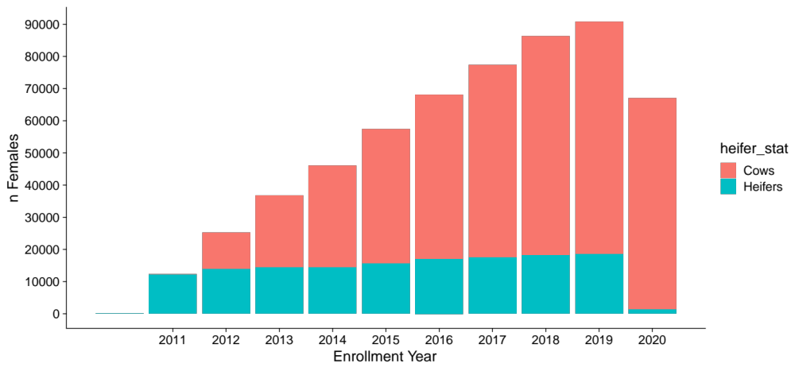
Figure 2.1. The Number of animals enrolled each year in the ASA THE program.
Heifer and cow enrollments are colored in blue and red, respectively. We restricted enrollments plotted to those after 2011 when codes became mandatory to report.

performance records for all animals registered with ASA to create calving records (n = 2,568,200) in R using various packages in the tidyverse (Grolemund and Wickham, 2011; Wickham et al., 2019).
Genotypes were provided by International Genetic Solutions (IGS) and collected from twelve different assays. Table 2.1 shows the different assays and the number of SNPs and animals on each assay. Using PLINK 1.9, autosomal variants were extracted and SNPs with a call rate of 90% or less were filtered and removed (Chang et al., 2015; Purcell and Chang, 2015), as were variants with Hardy-Weinburg p-values <1x10⁻⁵⁰. Genotypes were then merged on equal positions. We then extracted 22,179 remaining variants that were shared across all assays to be used in downstream genomic analyses. After removing individuals with > 10% missing SNPs, we retained a total of 33,732 genotypes for phenotyped animals. Genomic analyses retained 25,000 random genotypes were retained for heritability estimation due to software constraints.

Phenotypes
Total herd enrollment records and contemporary groups were used to calculate four measures of reproductive efficiency: two continuous and two discrete. Continuous phenotypes were calving interval (CI, days between consecutive calves for each animal) and calving date (CD, day cow calved relative to the beginning of the calving season). Discrete phenotypes include discrete early calving (DEC, did cow calve in the first 30 days of contemporary group’s calving season) and heifer pregnancy (HP, did cow calve as a 2-year-old). Phenotypes were calculated in R using various packages in the tidyverse
Table 2.1. Genotyping assays
Assay | n Filtered SNPs | n Animals
BovineHD | 675,501 | 8
Bovine 100k A1 | 83,310 | 31,379
Bovine 50k B | 40,297 | 25,073
Bovine 50k C | 40,450 | 36,003
Bovine 50k R | 41,732 | 9,419
Dairy 9k | 8,025 | 6
F250 | 177,638 | 841
HDv2 B | 126,653 | 346
HDv3 C | 120,787 | 7805
Simmental uLD | 26,552 | 1,258
Simmental uLD R | 22,776 | 14,529
SuperLDv4 C | 24,524 | 391

(Grolemund and Wickham, 2011). Calving intervals were determined to be biologically impossible and were removed if they were less than 250 days (n = 533,155). To better estimate the true start of a calving period and avoid sporadic starts, we began counting relative to the date that the third calf was born. Calves born previous to this point were considered to have a calving date of zero. This phenotype was then broken into three discrete classes: early calving with calves being born in the first 30 days as early (1), days 31-60 as middle (2), and days 61-90 as late (3). Females who calved outside of a 90-day calving season were included to indicate calving outside of a 90-day season (4). The calculation for each phenotype is further explained in Figure 2.2. Heifers were determined to be females whose first enrollment year was their birth year plus two. For females who fell into this category, they were given a score of 1 for having a calf or a 2 for not having a calf.

Contemporary Groups
Animals were separated into contemporary groups to account for environmental differences and management differences. Groups were made based on the ASA owner number at the time of enrollment, enrollment year, enrollment season, and heifer status. We removed contemporary groups with less than five animals to allow for increased variation within groups (n = 18,383). Of the total number of contemporary groups, 12,556 groups were made up of cows and 5,827 were made up of heifers. Groups were separated into cows versus heifers so that differences in management for the two groups could be

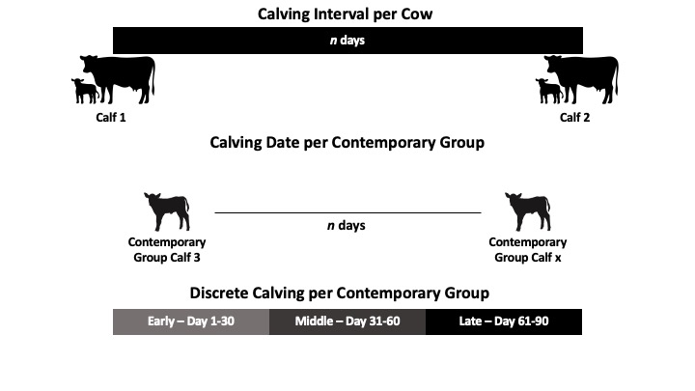
Figure 2.2. Calculation of cow-centric phenotypes.
Calving interval is the number of days between each calf for each female. Calving date is the number of days between the birth date of the third calf of the contemporary group and a female’s calf. Discrete Calving categorizes Calving Date with calves born between day 1-30 as early, day 31-60 as middle, and day 61-90 as late.

accounted for in CD and DEC phenotypes. We used the same contemporary groups for all analyzed phenotypes.

Heritabilities, Correlations, and Estimated Breeding Values
We used the BLUPF90 family of programs to calculate variance components and estimate breeding values (Misztal et al., 2014). We used a mixed linear model to estimate variance components for each of these four traits. Additive genetic and environmental variances were estimated using the AI-REML option in BLUPF90+ for continuous phenotypes (CD and CI) and GIBBSF90+ for discrete phenotypes (DEC and HP). Cow traits leveraged repeated records to capture information from multiple calving seasons and estimate a permanent environmental effect. We fit the contemporary group as a single fixed effect that captured herd, year, and seasonal variation.
We performed univariate pedigree and single-step analyses to estimate variance components for our four phenotypes of interest. The general statistical model used was as follows:
y = Xβ + Za + e
y was a vector of observations for the phenotype of interest; X is a design matrix relating records to their fixed effect estimates (β). We fit the contemporary group as the lone fixed effect in this model. Z is a design matrix for random animal effects (a). For pedigree analyses, animal effects were distributed as a ~ N(0, Aσ²_{a}) where A is an additive relationship matrix. Genomic analyses had animal effects distributed as a ~ N(0, Hσ²_{a}) where H is a combined pedigree & genomic covariance matrix (Legarra et al., 2009). For all traits but HP, we fit a permanent environmental effect p that is distributed as p ~ N(0, Iσ²_{p}).
To estimate genetic correlations between the four traits, we performed pairwise bivariate analyses for each of our four traits in the BLUPF90 software. As with the univariate analyses, BLUPF90+ was used for continuous phenotypes and GIBBSF90+ was used for analyses involving at least one discrete phenotype. We used POSTGIBBSF90 to determine model convergence criteria and variance and co-variance component estimates for these analyses with discrete phenotypes.

Results

Phenotypic Observations
We used calculated phenotypes to quantify population-level trends in reproductive phenotypes in the ASA population. The average calving interval for the dataset was 396 days with a minimum of 300 days and a maximum of 3,300 days. Most females maintain a calving interval close to 365 days (Figure 2.3). That said, the distribution is bimodal with a small increase in calving interval observations near the 2-year, or 730-day, mark. This suggests that many females (5.7%) are retained in herds following a missed breeding. For both groups, most records fall within the early category (day 1-30). The mean calving day for heifers was day 22 with a median of 11 days (Figure 2.4), while the mean for cows was day 37 with a median of 23 days (Figure 2.5). A greater proportion of heifers (60.3%) calve
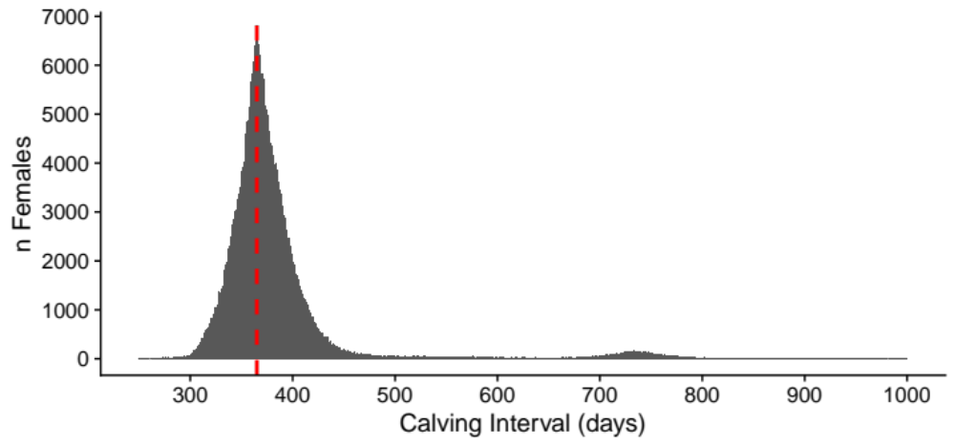
Figure 2.3. Distribution of calving intervals in ASA dataset.
Calving intervals are visualized from 250 to 1000 days. The dashed red line represents a 365-day interval.

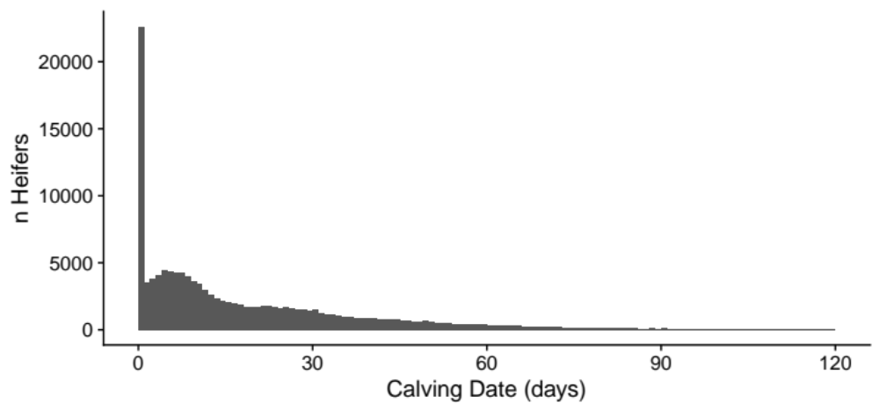
Figure 2.4. Distribution of calving dates for heifers.
Calving dates represent the number of days between the start of the calving season and when a heifer calves.

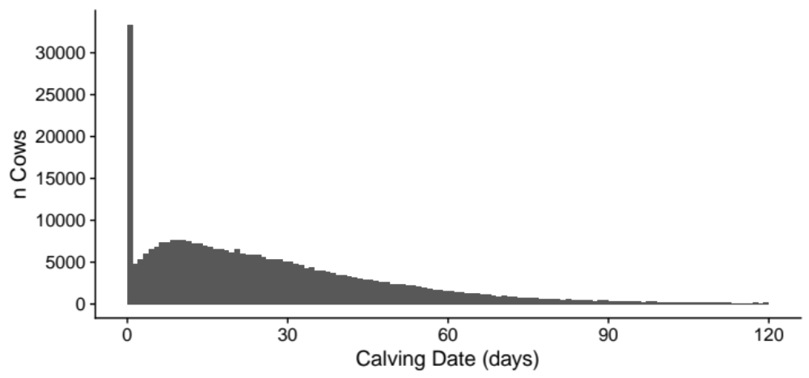
Figure 2.5. Distribution of calving dates for cows.
Calving dates represent the day a cow calves relative to the beginning of the calving season.

early in the calving season in comparison to cows (37.9%) This is seen as we compared middle and late calvers for heifers and cows with 12.9% and 3.4% of heifers and 15.8% and 4.6% of cows being classified as middle or late calvers, respectively. From a contemporary group perspective, the majority of groups (85.4%), regardless of cow or heifer status, have calving seasons that last for six months (Figure 2.6). This was expected since THE breaks down calving as either spring or fall with six months included for both seasons.
We further looked to see how productivity changes the longer females are in production. Most females in the dataset (88.9%) were under 7 years old. (Figure 2.7). There are females enrolled in THE who have been productive through age 12 (n = 69). These females show increased longevity and productivity beyond their breakeven point. These changes in productivity led us to look at how the median calving interval length changes as females age (Figure 2.8). Ages 3 to 4 show the most significant change in the duration of calving interval from 380 days to 368 days, respectively. This decrease in calving interval length indicates how calving intervals are indirectly elongated due to the management of heifers to calve earlier when they first enter production. The next major change occurred between 11- and 12 years of age where calving interval changes from being centered at the 365-day mark to increasing up to 376 days.

Heritability Estimates
We estimated low-to-moderate heritabilities for each of the phenotypes of interest. Table 2.2 reports the full set of variance components and heritability estimates with
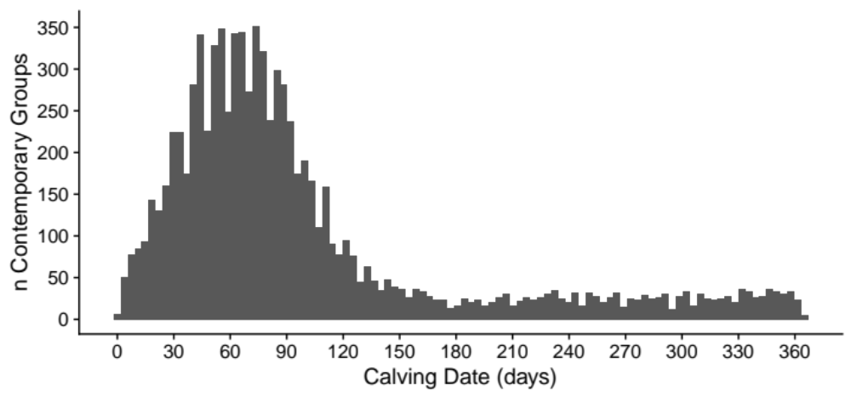
Figure 2.6. Calving season lengths for each contemporary group.
Calving season lengths indicate the day that the last calf for a contemporary group was born.

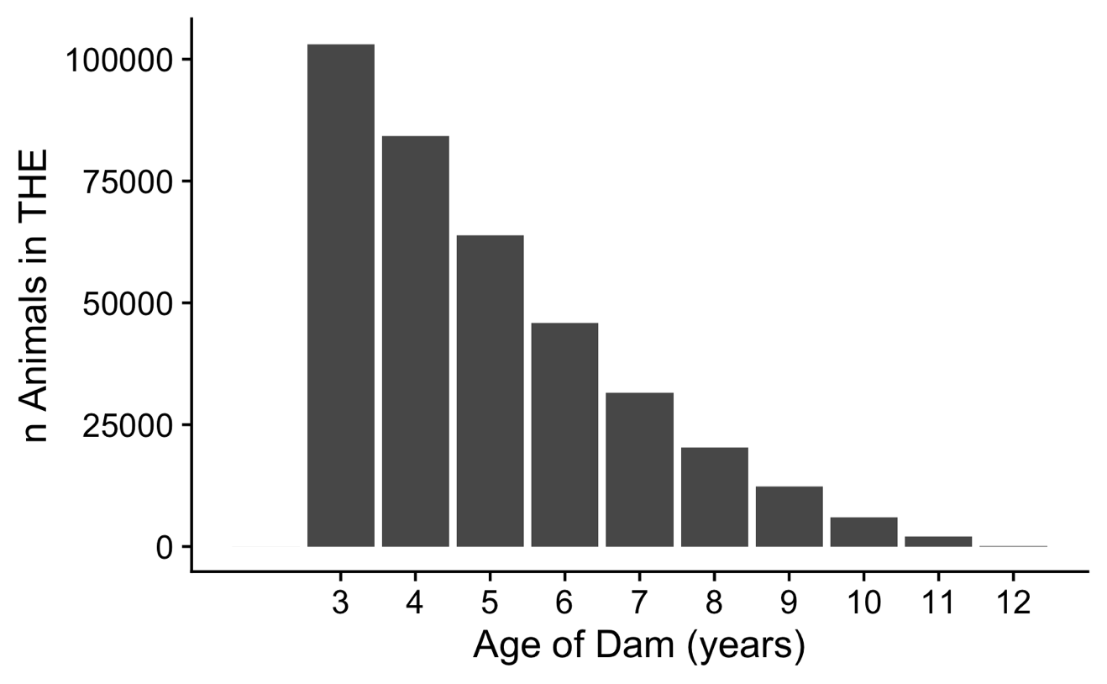
Figure 2.7. Changes in productivity by age.
Each bar is made up of the number of females with calf information reported from 3 to 12 years of age.

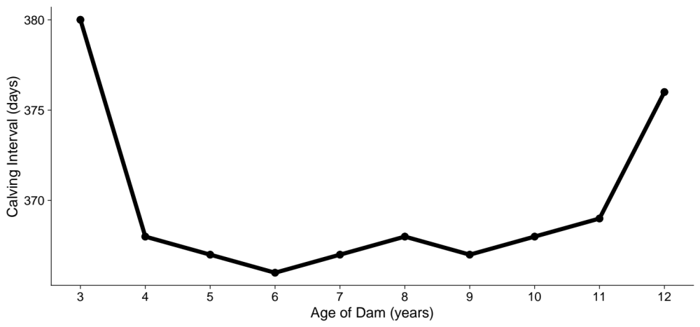
Figure 2.8. Changes in the calving interval length due to age.
Each point indicates the median length of calving intervals for females ages 3-12.

Table 2.2. Genetic variance (V_{g}), environmental variance (V_{p}), error variance (V_{e}), and heritability (h²) estimates with ±standard errors for all phenotypes
Phenotype | Method | V_{g} | V_{p} | V_{e} | h²
Calving Date | Pedigree | 24.88 ±2.3002 | 205.84 ±2.7219 | 946.74 ±2.2269 | 0.02 ±0.000003
Calving Date | Genomic | 37.496 ±2.6216 | 197.24 ±2.7535 | 946.40 ±2.2259 | 0.03 ±0.000003
Calving Interval | Pedigree | 852.09 ±25.767 | 0.11172 ±0.20451 | 10906.0 ±30.742 | 0.08 ±0.000026
Calving Interval | Genomic | 998.80 ±44.859 | 2110.6 ±41.390 | 11805.0 ±33.330 | 0.07 ±0.000005
Discrete Early Calving | Pedigree | 0.25411 ±0.00002 | 0.65131 ±0.00004 | 4.1691 ±0.00087 | 0.05 ±0.000095
Discrete Early Calving | Genomic | 0.23635 ±0.00002 | 0.67149 ±0.00004 | 4.1629 ±0.00087 | 0.05 ±0.000009
Heifer Pregnancy | Pedigree | 0.29821 ±0.00021 | NA | 1.0112 ±0.00001 | 0.23 ±0.000105
Heifer Pregnancy | Genomic | 0.32576 ±0.00002 | NA | 1.0110 ±0.00001 | 0.24 ±0.000098

standard errors based on pedigree information or genomic information. HP was the most highly heritable reproductive phenotype with h² values of 0.23 and 0.24 for pedigree and genomic estimates, respectively. The heritability estimates for CD were very low in the analysis (h²_{pedigree} = 0.02 and h²_{genomic} = 0.03). The inclusion of genomic information in REML analyses for CI decreased h² from 0.08 to 0.07. Due to the size of the dataset, standard errors were quite low (0.0000026-0.000104) for all heritability estimates. For cow-focused phenotypes, CI was the most heritable trait followed by DEC and CD, respectively. CD and DEC are the most similar phenotypes in this study since the calculation for one is based on the other. Despite DEC being derived directly from CD, heritabilities for these phenotypes were quite different. The genomic heritability for DEC (h² = 0.05) was nearly twice as high as for CD (h² = 0.03)

Genetic Correlations
All phenotypes of interest in this work were positively correlated with each other (Table 2.3). The strongest genetic correlation existed between CD and DEC (r_{G} = 0.96). This was expected, as the calculation of these phenotypes was based on one another. Correlations with CI tended to be the lowest across traits of interest (r_{G} = 0.11-0.19). CD and DEC were similarly correlated to HP (r_{G} = 0.27-0.39). The majority of heifers (60.3%). within the dataset were early calvers, with a lower calving date, this was expected due to how heifers are managed to calve earlier. Each correlation value had a small standard error value associated with it (0.000117-0.000292) because of the size of the dataset.

Table 2.3. Direct genetic correlations (r_{G}) with ± standard errors (SE)
Phenotypes | r_{G}
Calving Date and Calving Interval | 0.11 ±0.000174
Calving Date and Discrete Early Calving | 0.96 ±0.000117
Calving Date and Heifer Pregnancy | 0.39 ±0.000272
Calving Interval and Discrete Early Calving | 0.19 ±0.000214
Calving Interval and Heifer Pregnancy | 0.11 ±0.000250
Discrete Early Calving and Heifer Pregnancy | 0.27 ±0.000292

Discussion
Phenotypic observations were largely in line with expectations. For example, with the average calving interval being 396 days and the median being 371 days, we observed that the majority of females present in the dataset were each producing one calf per year throughout their time in enrollment. This indicates that producers are limiting the number of open females in their cow herds and only retaining the productive females each year.
The challenge with analyzing these phenotypes comes from how the data is collected. The collection of reproductive phenotypes in the beef industry did not come to fruition until inventory-based reporting was implemented. Even with the implementation of WHR, the beef industry lags behind the dairy industry in collecting more granular breeding records (e.g., breeding dates, service type) that would allow for more precise measurements for these phenotypes. At the simplest level, attaching a breeding date, or even the start of the breeding season to each THE entry would be useful for calculating more precise and accurate records related to calving date. Further, if detailed breeding records were collected, CD could account for potential differences in conception from natural service versus AI versus fixed-time AI. We expect that with the ability to differentiate animals with breeding records would show which animals respond best to each type of service and change the distribution of CD. Calving date distributions in natural service settings would likely appear the most similar to the distributions observed in this work. We would expect that AI protocols would shift CD closer to day 0 and increase the number of early calving records. As beef cattle breed associations look at ways to improve data collection, the inclusion of breeding records and dates for inventory-based reporting would allow for a more detailed investigation of the cow productivity phenotypes.
We observed low-to-moderate heritability estimates for all phenotypes in the study. CD was the least heritable trait for this population of cattle. Previous studies have reported a broad range of heritability estimates for this trait. However, most of them are low. Morris and colleagues (2000) calculated heritability to be 0.091 ±0.036 in a population of Angus cattle while Buddenberg and others (1990) estimated a wide heritability range from 0.13-0.39 in a population of Hereford cattle. This low heritability CD makes phenotypic selection nearly impossible, despite the clear economic relevance of having an early CD. This economic signal is driven by the fact that calves born early in the season are typically heavier at weaning (Cushman et al., 2013). DEC was also lowly heritable in this population, which was to be expected due to the nature of this phenotypic calculation being based on CD. Interestingly, we found that DEC was slightly more heritable than CD.
HP was the most heritable trait in this study, falling into the moderately heritable range with h² values of 0.23 and 0.24 for pedigree and genomic information, respectively. In two samples of Angus cattle, heritability was estimated to be 0.27 and 0.21 (Doyle et al., 2000). However, other studies have estimated heritability to be more variable, ranging from 0.12 to 0.53 in various populations (Van Melis et al., 2010; McAllister et al., 2011; Boldt et al., 2018). HP has typically been studied as a binary observation (i.e., Did a female calve as a 2-year-old?). Other work has used continuous phenotypes such as age at first calving or age at puberty. Heritability estimates for these two measures of heifer productivity are similar to HP heritability estimates from this study, with estimates ranging from 0.08 to 0.24 for age at first calving and 0.07 to 0.67 for at age puberty (Martin et al., 1992; Gutiérrez et al., 2002; Martínez-Velázquez et al., 2003).
All phenotypes were positively correlated with one another, ranging in values from 0.11 to 0.96. This wide range in correlations indicates that while these phenotypes are all associated with cow fertility, they may be controlled by quite different genetic architectures. Correlations between CI and other phenotypes were the lowest, ranging from 0.11-0.19. CI and CD were the least correlated with a value of 0.11. The key difference between these two phenotypes is that a favorable CD can be the result of a reproductive failure and a female is shifted to calve in a different season or year (i.e., calving date could be zero but CI could be 730). CI can capture this information because this phenotype will be elongated (>365 days) and this record will have a negative impact on the female’s projected productivity. CI and HP were lowly genetically correlated, but it is worth mentioning a HP phenotype does not have a matched a CI observation. Because of how heifers are managed to calve earlier in the season, indirectly, calving interval is impacted by heifer calving records since most occur early in the calving season. This management practice, although beneficial for the assurance of a successful rebreeding, can indirectly elongate calving intervals since heifers are managed to calve earlier than mature cows but then bred back for the next season at the same time as the mature cows.

Conclusions and Recommendations
We explored four novel phenotypes that are indicators of cow fertility. Each of these phenotypes was lowly to moderately heritable and positively correlated with each other. This indicates that genetic improvement is possible for these traits if breed associations develop genetic evaluations and genetic selection tools for them. Breed associations will need to develop strategies for collecting more granular breeding records for these tools to be effective. We intend to continue working with ASA to discuss opportunities to further utilize their THE data to define new economically relevant traits. Follow-up analyses will explore the genetic architectures of these phenotypes using genome-wide association studies (GWAS) with imputed SNP genotypes.

Literature Cited

Aguilar, I., I. Misztal, D. L. Johnson, A. Legarra, S. Tsuruta, and T. J. Lawlor. 2010. Hot topic: a unified approach to utilize phenotypic, full pedigree, and genomic information for genetic evaluation of Holstein final score. J. Dairy Sci. 93:743–752. doi:10.3168/jds.2009-2730.
Berglund, B. 2008. Genetic improvement of dairy cow reproductive performance. Reprod. Domest. Anim. 43 Suppl 2:89–95. doi:10.1111/j.1439-0531.2008.01147.x.
Berry, D. P., and R. D. Evans. 2014. Genetics of reproductive performance in seasonal calving beef cows and its association with performance traits. J. Anim. Sci. 92:1412–1422. doi:10.2527/jas.2013-6723.
BIF Guidelines. 2023. Guidelines for uniform beef improvement programs. Beef Improvement Federation Wiki. http://guidelines.beefimprovement.org/index.php?title =Guidelines_for_Uniform_Beef_Improvement_Programs&oldid=2679.
Boldt, R. J., S. E. Speidel, M. G. Thomas, and R. M. Enns. 2018. Genetic parameters for fertility and production traits in Red Angus cattle. J. Anim. Sci. 96:4100–4111. doi:10.1093/jas/sky294.
Boyer, C. N., and A. P. Griffith. 2020. Improving beef cattle profitability by changing calving season length. Journal of Applied Farm Economics. Available from: https://core.ac.uk/display/322318326?utm_source=pdf&utm_medium=banner&utm_campaign=pdf-decoration-v1
Boyer, C. N., A. P. Griffith, K. L. DeLong, C. N. Boyer, A. P. Griffith, and K. L. DeLong. 2020. Reproductive failure and long-term profitability of spring- and fall-calving beef cows. doi:10.22004/AG.ECON.298435.
Buddenberg, B. J., C. J. Brown, and A. H. Brown. 1990. Heritability estimates of calving date in Hereford cattle maintained on range under natural mating. J. Anim. Sci. 68:70–74. doi:10.2527/1990.68170x.
Burris, M. J., and B. M. Priode. 1958. Effect of calving date on subsequent calving performance. J. Anim. Sci. 17:527–533. doi:10.2527/jas1958.173527x.
Chang, C. C., C. C. Chow, L. C. Tellier, S. Vattikuti, S. M. Purcell, and J. J. Lee. 2015. Second-generation PLINK: rising to the challenge of larger and richer datasets. Gigascience. 4:7. doi:10.1186/s13742-015-0047-8.
Clark, R., K. Creighton, H. Patterson, and T. N. Barrett. 2005. Symposium Paper: Economic and tax implications for managing beef replacement heifers1,2. 21:164–173.

Cushman, R. A., M. F. Allan, R. M. Thallman, and L. V. Cundiff. 2007. Characterization of biological types of cattle (Cycle VII): influence of postpartum interval and estrous cycle length on fertility. J. Anim. Sci. 85:2156–2162. doi:10.2527/jas.2007-0136.
Cushman, R. A., L. K. Kill, R. N. Funston, E. M. Mousel, and G. A. Perry. 2013. Heifer calving date positively influences calf weaning weights through six parturitions1. doi:10.2527/jas2013-6465.
Diskin, M. G., and D. A. Kenny. 2014. Optimising reproductive performance of beef cows and replacement heifers. Animal. 8 Suppl 1:27–39. doi:10.1017/S175173111400086X.
Doyle, S. P., B. L. Golden, R. D. Green, and J. S. Brinks. 2000. Additive genetic parameter estimates for heifer pregnancy and subsequent reproduction in Angus females. J. Anim. Sci. 78:2091–2098. doi:10.2527/2000.7882091x.
Evans, J. L., B. L. Golden, R. M. Bourdon, and K. L. Long. 1999. Additive genetic relationships between heifer pregnancy and scrotal circumference in Hereford cattle. J. Anim. Sci. 77:2621–2628. doi:10.2527/1999.77102621x.
Funston, R. N., J. A. Musgrave, T. L. Meyer, and D. M. Larson. 2012. Effect of calving distribution on beef cattle progeny performance. J. Anim. Sci. 90:5118–5121. doi:10.2527/jas.2012-5263.
Garrick, D. J. 2011. The nature, scope and impact of genomic prediction in beef cattle in the United States. Genet. Sel. Evol. 43:17. doi:10.1186/1297-9686-43-17.
Giess, L. K., M. G. Thomas, S. E. Speidel, M. M. Culbertson, W. R. Shafer, S. C. McGuire, and R. M. Enns. 2021. Whole herd reporting data from the American Simmental Association as a data source for heifer pregnancy phenotypes. Trans Anim Sci. 5:S199–S203. doi:10.1093/tas/txab152.
Grolemund, G., and H. Wickham. 2011. Dates and times made easy with lubridate. J. Stat. Softw. 40:1–25. doi:10.18637/jss.v040.i03.
Gutiérrez, J. P., I. Alvarez, I. Fernández, L. J. Royo, J. Dı́ez, and F. Goyache. 2002. Genetic relationships between calving date, calving interval, age at first calving and type traits in beef cattle. Livestock Production Science. 78:215–222. doi:10.1016/S0301-6226(02)00100-8.
Hazel, L. N. 1943. The genetic basis for constructing selection indexes. Genetics. 28:476–490. doi:10.1093/genetics/28.6.476.
Johnston, G. 2023. 2023 could bring record cattle prices, CattleFax experts say. Successful Farming. Available from: https://www.agriculture.com/news/livestock/good-year-ahead-for-cattle-cattlefax-market-experts-say
Legarra, A., I. Aguilar, and I. Misztal. 2009. A relationship matrix including full pedigree and genomic information. J. Dairy Sci. 92:4656–4663. doi:10.3168/jds.2009-2061.
Lesmeister, J. L., P. J. Burfening, and R. L. Blackwell. 1973. Date of first calving in beef cows and subsequent calf production. J. Anim. Sci. 36:1–6. doi:10.2527/jas1973.3611.
Liu, Z., J. Jaitner, F. Reinhardt, E. Pasman, S. Rensing, and R. Reents. 2008. Genetic evaluation of fertility traits of dairy cattle using a multiple-trait animal model. J. Dairy Sci. 91:4333–4343. doi:10.3168/jds.2008-1029.
Martin, L. C., J. S. Brinks, R. M. Bourdon, and L. V. Cundiff. 1992. Genetic effects on beef heifer puberty and subsequent reproduction. J. Anim. Sci. 70:4006–4017. doi:10.2527/1992.70124006x.
Martínez-Velázquez, G., K. E. Gregory, G. L. Bennett, and L. D. Van Vleck. 2003. Genetic relationships between scrotal circumference and female reproductive traits. J. Anim. Sci. 81:395–401. doi:10.2527/2003.812395x.
Mathews, K. H., Jr, and S. D. Short. 2001. The beef cow replacement decision. Journal of Agribusiness. 19:191–211. Available from: https://ageconsearch.umn.edu/record/14695/
McAllister, C. M., S. E. Speidel, D. H. Crews Jr, and R. M. Enns. 2011. Genetic parameters for intramuscular fat percentage, marbling score, scrotal circumference, and heifer pregnancy in Red Angus cattle. J. Anim. Sci. 89:2068–2072. doi:10.2527/jas.2010-3538.
Melton, B. E. 1980. Economics of beef cow culling and replacement recisions under genetic progress. Western Journal of Agricultural Economics. 5:137–147.
Meuwissen, T.H., B.J.Hayes, and M.E. Goddard. 2001. Prediction of total genetic value using genome-wide dense marker maps. Genetics. 157:1819-1829. doi: 10.1093/genetics/157.4.1819.
Misztal, I., S. Tsuruta, D. Lourenco, and Y. Masuda. 2014. BLUPF90 family of programs. Available from: http://nce.ads.uga.edu/wiki/lib/exe/fetch.php?media=blupf90_all8.pdf
Moorey, S. E., G. A. Perry, and M. F. Smith. 2022. Management decisions to improve the reproductive performance of your herd from calving to rebreeding.
Morris, C. A., J. A. Wilson, G. L. Bennett, N. G. Cullen, S. M. Hickey, and J. C. Hunter. 2000. Genetic parameters for growth, puberty, and beef cow reproductive traits in a puberty selection experiment. New Zealand Journal of Agricultural Research. 43:83–91. doi:10.1080/00288233.2000.9513411.
Pollak, E. J., G. L. Bennett, W. M. Snelling, R. M. Thallman, and L. A. Kuehn. 2012. Genomics and the global beef cattle industry1. Anim. Produc. Sci. 52:92–99. doi:10.1071/AN11120.
Purcell, S., and C. Chang. 2015. PLINK 1.9. Available from: www. cog-genomics. org/plink/1.9.
Roberts, A. J., J. N. Ketchum, and R. N. Funston. 2019. Developmental and reproductive characteristics of beef heifers classified by number of estrous cycles experienced by start of first breeding. Transl Anim Sci. 3:541–548. doi:10.1093/tas/txy118.
Sánchez-Castro, M. A., M. G. Thomas, R. M. Enns, and S. E. Speidel. 2019. Stability of genetic predictions for stayability using random regression models that include end points beyond 6 yr of age. Transl Anim Sci. 3:1678–1682. doi:10.1093/tas/txz056.
Snelling, W. M., B. L. Golden, and R. M. Bourdon. 1995. Within-herd genetic analyses of stayability of beef females. J. Anim. Sci. 73:993–1001. doi:10.2527/1995.734993x.
Van Melis, M. H., J. P. Eler, G. J. M. Rosa, J. B. S. Ferraz, L. G. G. Figueiredo, E. C. Mattos, and H. N. Oliveira. 2010. Additive genetic relationships between scrotal circumference, heifer pregnancy, and stayability in Nellore cattle. J. Anim. Sci. 88:3809–3813. doi:10.2527/jas.2009-2127.
Van Vleck, L. D. 1987. Contemporary groups for genetic evaluations. J. Dairy Sci. 70:2456–2464. doi:10.3168/jds.S0022-0302(87)80309-0.
Veerkamp, R. F., and B. Beerda. 2007. Genetics and genomics to improve fertility in high producing dairy cows. Theriogenology. 68 Suppl 1:S266-73. doi:10.1016/j.theriogenology.2007.04.034.
Wickham, H., M. Averick, J. Bryan, W. Chang, L. McGowan, R. François, G. Grolemund, A. Hayes, L. Henry, J. Hester, M. Kuhn, T. Pedersen, E. Miller, S. Bache, K. Müller, J. Ooms, D. Robinson, D. Seidel, V. Spinu, K. Takahashi, D. Vaughan, C. Wilke, K. Woo, and H. Yutani. 2019. Welcome to the tidyverse. J. Open Source Softw. 4:1686. doi:10.21105/joss.01686.

Vita

Cassidy Catrett grew up in Luverne, AL on her family’s farm where they raised purebred Shorthorn cattle alongside a commercial cattle herd. After graduating from Brantley High School in 2016, she attended Mississippi State University in Starkville, MS. While there, she obtained dual Bachelor of Science degrees in Animal and Dairy Science and Poultry Science while participating in a variety of organizations, internships, and undergraduate research. Cassidy began working on her Master of Science degree in animal science in 2021 at the University of Tennessee, Knoxville. She worked with Dr. Troy Rowan and completed her Master of Science degree in Summer 2023.

