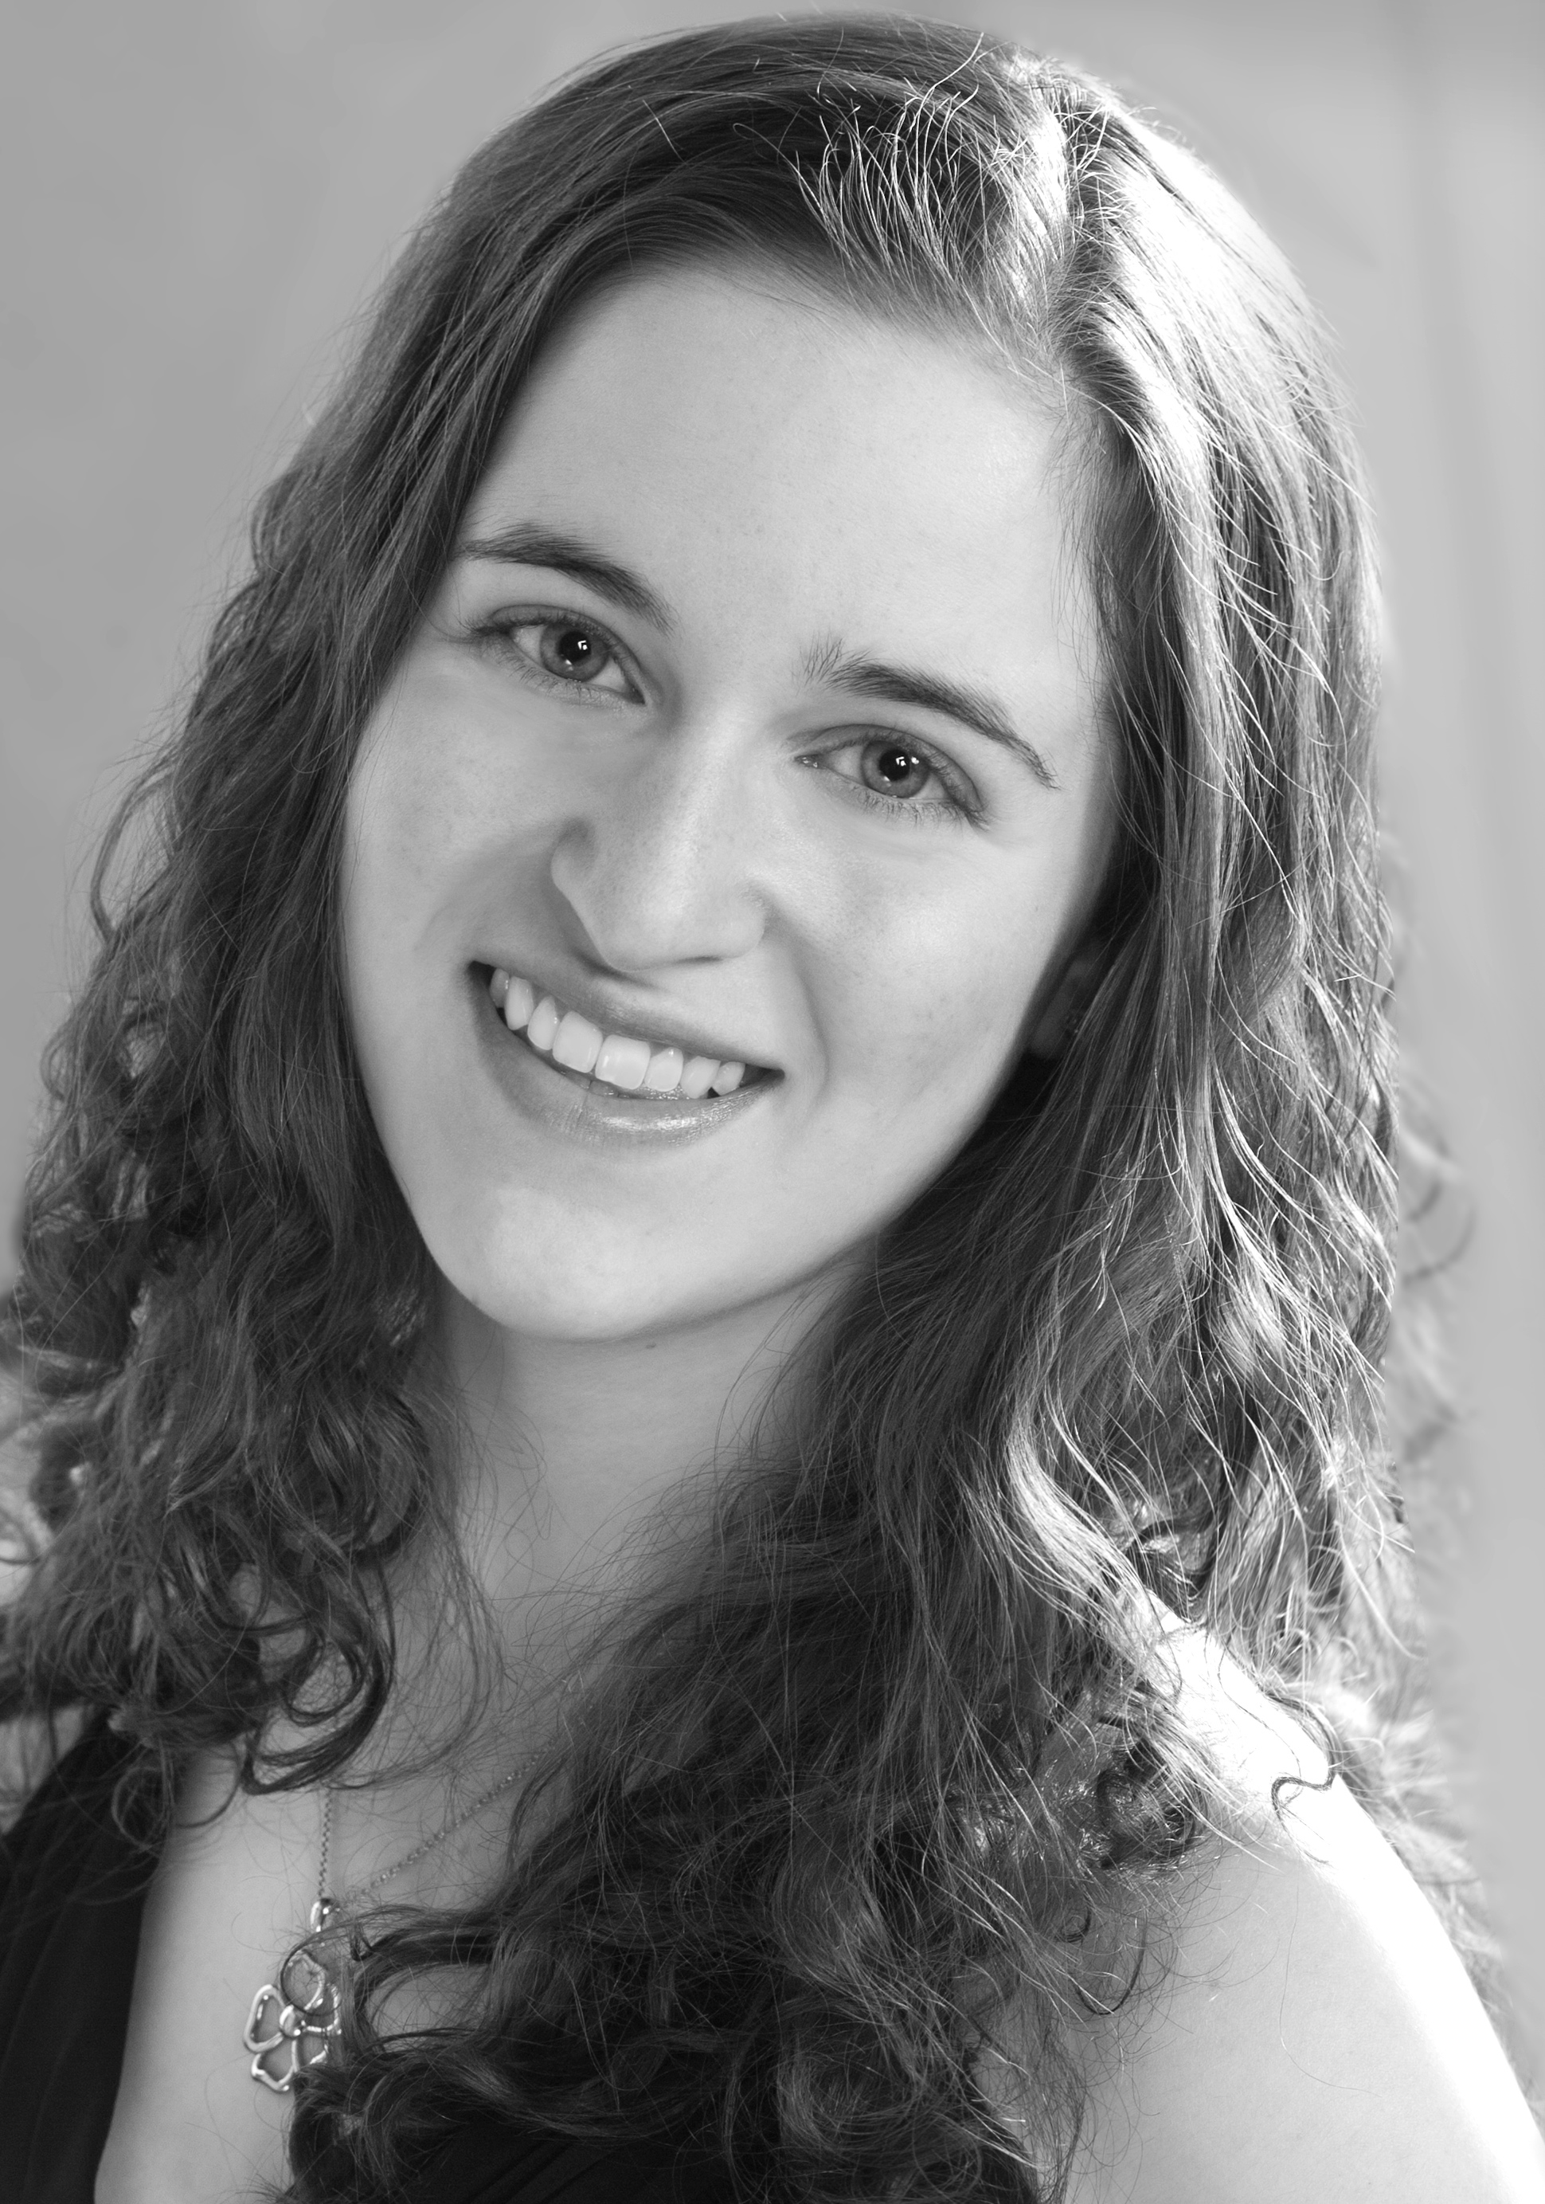

RACHEL BROWN, mezzo-soprano
Susan Shorr Brown, piano

Jewish Liturgy in Music
A UT Honors Thesis Recital

Sunday, December 6, 2015
5:00 p.m.
Heska Amuna Synagogue
3811 Kingston Pike
Knoxville, Tennessee

