Assessing the Effect of Relocation Control on Psychological Well-being
of Assisted Living Residents

A Dissertation Presented for
The Doctor of Philosophy Degree
The University of Tennessee, Knoxville

Young Sook Kim
December 2012

DEDICATION
I dedicate this dissertation to my husband, Mike, and my son, Phillip. You always believed in me and seemed to know I would get to this point, even when I was not certain. Your support and encouragement has made me want to be a better writer and teacher every day. I carry you in my heart always.

ACKNOWLEDGEMENTS
I want to thank all those who have helped make possible my completion of a Doctorate of Philosophy in Social Work. I would first like to thank my dissertation advisor, Dr. Sherry Cummings. You have provided me with guidance every step of the way on this path to a doctoral degree, inspired my passion for research and gerontology, helped me refine my own skills, and believed in my ability throughout this journey. I could not have had a better mentor or dissertation committee chair. Second, Dr. William Nugent was not only a committee member, but also my role model as an esteemed scholar ever since my first year in the doctoral program. Thank you for patiently helping me remain focused on achieving my goals and providing helpful statistical suggestions throughout this process. I want to thank Dr. Robert Ladd for contributing his priceless expertise in structural equation modeling. Your comments on my data analyses for my dissertation were pivotal in getting this project off the ground. Thank you, Dr. Janet Brown, whose previous research studies led to the development of my dissertation. Your willingness to listen and provide support when needed throughout my doctoral program will never be forgotten. My work with you on grounded theory research has also been enormously rewarding. Finally, I wish to say thank you to Dr. Cindy Davis for giving me useful advice that encouraged me to start moving in the right direction. All of your comments, critiques, and suggestions have helped me to form a stronger understanding of the results of my dissertation.
Completing this degree would not have been possible without the love and support of my best friends and colleagues. Particularly, I cannot thank enough Courtney Conley, Phillip Green, Bo-young Lee, Jina Sang, Yukyung Choi, and Jun-sung Hong. Without their supportive recommendations and great help, I could not have made it through the numerous challenges of graduate school. I am truly grateful to have met each of you, and will always remember how you made my time here in Knoxville so much more enjoyable.
I also wish to thank my parents, Sangchul Kim and Jung heui Cho, who have always told me I could be or do whatever I wanted in this life and offered me the love and guidance I needed to do so. To my brothers Yongtae and Geungtae Kim, thank you for memories of Atlanta travel and Korean food and for reminding me that I’m more productive when I take time to rest. This dissertation also would not have been possible without the continuous encouragement and sacrifice by my mother-in-law, Soon-ja Kim. Most importantly, I cannot thank my husband, Mike, and my son, Phillip, enough for their support and sacrifices. They put up with an unavailable wife and mom throughout my Ph.D. years. Phillip still may not understand why mom was away from him so much. I look forward to his hugs and smiles at home.
Lastly, I would like to thank the National Institute of Mental Health (NIMH) Underrepresented Mental Health Research Fellowship Program (UMHRFP) and the University of Tennessee’s College of Social Work, both of which made the completion of my doctoral education possible. Thank you, all of the East Tennessee assisted living (AL) administrators for allowing me to conduct my research and for providing any assistance requested. Thank you also to all of the participating AL residents—your words, interest in, and commitment to this project and ways of being in the world have changed me. This project would not have happened without your willingness to help. I also thank Shannon Wallace, Mike Brown, Jennifer Rubenstein, James Bennett, Sarah Callaghan, and Carol Jayne Rains, my MSW research assistants along the journey—for traveling 7,000 miles across East Tennessee in my car and sharing the fun, stress, laughter, embarrassments, and joys of data collection, which only we have shared with each other.

ABSTRACT
This study investigated

However, little empirical research has been clearly investigated the interrelationship among major factors and their impact on mental health outcomes with respect to AL residents: relocation control, mediators of stress (i.e. social support, self-reported health, and functional impairment) and psychological well-being.
The study had two aims : (1) to investigate the relationship between relocation control and psychological well-being (i.e. depression, anxiety, and life satisfaction) among Assisted Living (AL) residents, controlling for sociodemographic factors; and (2) to evaluate whether social support from family and friends, self-reported health and functional impairment (i.e. ADLs and IADLs) mediate the relationship between the perceived relocation controls and psychological well-being (i.e. depression, anxiety, and life satisfaction).
Guided by the stress process perspective,
Using a cross-sectional design, 336 relocated individuals were purposefully sampled from 19 Assisted Living Facilities in East Tennessee.
Structural equation modeling analyses revealed that
a)
b);
c)
Limitations, implications from the study findings for social work practice, policy, and future directions were also presented.

TABLE OF CONTENTS

Chapter 1. Introduction……………………………………………………………………………1
Problem statement…………………………………………………………………………3
Study purpose……………………………………………………………………………...5
Significance of the study…………………………………………………………………..6
Organization of the dissertation…………………………………………………………...8

Chapter 2. Literature Review………………………………………………………………….....15
Assisted Living…………………………………………………………………………..15
Relocation Stress Syndrome……………………………………………………………..15
Relocation Process………………………………………………………………….........15
Outcomes of Relocation Stress…………………………………………………………..15
Practical Recommendation of Relocation Stress………………………………………...15
Control Over Relocation…………………………………………………………………15
Impact of Involuntary Relocation on Psychological Well-being………………………...15
Relocation Control and Social Support………………………………………………..…15
Relocation Control and Self-reported health……………………………………….……15
Relocation Control and Functional Impairment................................................................15
Social Support and Psychological Well-being……………………………………...……15
Self-reported Health and Psychological Well-being……………………………………..15
Functional Impairment and Psychological Wellbeing………………………………..….15
Summary…………………………………………………………………………………15

Chapter 3. Theoretical Framework
The Stress process model…………………………………………………………...……15
Main Concepts and Assumptions………………………………………………...15
Background and Context of Stress……………………………………………….15
Stressors………………………………………………………………………….15
Mediators………………………………………………………………...………15
Outcomes………………………………………………………………………...15
Specific aims and hypotheses…………………………………………………………....15
Research Aim 1………………………………………………………………..…15
Research Aim 2…………………………………………………………………..15

Chapter 4. Method……………………………………………………………………………………………………
Design and Sampling………………………………………………………………………………………………………
Data Collection………………………………………………………………………………………………………………….
Measures…………………………………………………………………………………………………………………….
Data Analysis………………………………………………………………………………………………………......
Bivariate Analysis……………………………………………………………………………………
Mediation Analysis……………………………………………………………
Treatment of missing data ………………………………………………………………………………………………

Chapter 5. Results………………………………………………………………………………………………………………………..
Description of the Sample………………………………………………………………………………………………
Mediation Hypotheses……………………………………………………………………………………………………
Research aim 1……………………………………………………………………………………………………
Hypothesis 1……………………………………………………………………………………………………
Measurement model…………………………………………………………………………………
Structural model……………………………………………………………………………………….

Research aim 2…………………………………………………………………………………………………………………
Hypothesis 2………………………………………………………………………………………………………….
Measurement model………………………………………………………………………………….
Structural model……………………………………………………………………………………..

Chapter 6. Discussion……………………………………………………………………………………………………………
Summary of Findings……………
Overall Discussion………………………………………………………
Limitations……………………………………
Implications
Implications for Social Work Practice
Implications for Social Work Policy
Implications for Social Work Research

References……………………………………………………………………………………………………………………………….85
Appendices………………………………………………………………………………………………………………………………96
Vita………………………………………………………………………………………………………………………………………….97

LIST OF TABLES
Table 1. Defining Characteristics of Relocation Stress Syndrome……………………………………………15
Table 2.
Table 3.
Table 4.
Table 5.
Table 6.
Table 7.
Table 8.
Table 9.

LIST OF FIGURES
Figure 1. The stress process model………………………………………………………............15
Figure 2. Stress-Process among ALF residents.............................................................................15
Figure 3.
Figure 4.
Figure 5.
Figure 6.
Figure 7.
Figure 8.
Figure 9.
Figure 10.
Figure 11.
Figure 12.
Figure 13.
Figure 14.
Figure 15.
Figure 16.
Figure 17.
Figure 18.
Figure 19.
Figure 20.
Figure 21.
Figure 22.
Figure 23.
Figure 24.

CHAPTER 1: INTRODUCTION

Studies have consistently documented that moving to a new residence late in life can place elderly people at increased risk for emotional and mental health problems (Anthony, Proctor, Silverman, & Murphy, 1987; Dube, 1982; Johnson, 1996; Thomas, 1979; Thomasma, Yeaworth, & McCabe, 1990). Although early studies reported that elderly individuals moving into long-term care homes were expected to experience emotional distress, because of the loss of former environment, social support from the neighborhood, and independence (Harkulich & Brugler, 1991), little is known of the actual transition experience and its effect on elderly individuals’ psychological well-being (Tracy & DeYoung, 2004).
Assisted living facilities (ALFs) are the most rapidly growing nationwide residential care choice for older adults who need help with daily activities but do not need to enter nursing homes (Assisted Living Federation of America, 2012a). To date, one area that lacks attention is the influence that the control over the decision to relocate has on an assisted living resident’s psychological well-being. In general, assisted living residents do not have control over relocation decisions for themselves; it is the family members, physicians, home health nurses, and discharge planners that serve as the decision makers (Reinardy & Kane, 2003).
This study investigated the relationship between relocation control, mediators of stress (e.g., social support, self-reported health, and functional impairment), and psychological well-being of ALF residents, and a causal ordering of these constructs. In this chapter, problem statement, purpose of the study, significance of the study, and organization of the dissertation are described.
Problem Statement

Demographic trends in the United States reflect the rapid growth of the aging population. In 2010, 40 million Americans were estimated to be over 65 years old, and by 2020 the senior population is expected to reach 55 million, and 72.1 million by 2030. The oldest seniors (those over 85) are the fastest-growing age group (expected to total nearly 6.6 million by 2020) (Administration on Aging, 2011). Chronic health conditions such as high blood pressure, diabetes, and cancer are common among older adults (Centers for Disease Control and Prevention and The Merck Company Foundation, 2007). Older adults are experiencing one (80%) or more (50%) chronic conditions (National Center for Chronic Disease Prevention and Health Promotion, 2009). As a result, the number of older adults living in ALF is increasing as well. ALF is currently the most preferred and fastest-growing area of long-term care for older adults (Stevenson & Grabowski, 2010). People who need assistance in performing activities such as bathing, eating, or dressing prefer to receive supportive services in the least institutional and most homelike setting possible (Brodie & Blendon, 2001). ALFs offer dining, housekeeping, communal activities, 24-hour supervision, assistance with activities of daily living (ADLs), administration of medications, access to transportation, and health-related services (National Center for Assisted Living, 2012a). A typical ALF resident is a woman (74%) whose mean age is 86.9 years and who needs assistance with an average of 1.6 activities of daily living (ADLs), most commonly bathing, dressing, or toileting (National Center for Assisted Living, 2012b).
As of 2010, there were approximately 31,100 licensed ALFs in the United States with more than 733,400 residents (National Center for Assisted Living, 2012c). Therefore, more recently researchers have recognized the importance of examining late-life transition (Hertz, Rosseti, Koren, & Roberston, 2007). Studies are inconsistent in their findings regarding the effects of relocation on older adults’ psychological health. Regardless, many researchers reported that relocation has negative consequences for older adults, such as a sense of devaluated self and poor self-rated health, including increased depression and anxiety levels (Rossen, 2007; Rossen & Knafl, 2003, 2007). Other researchers, however, have failed to find negative and debilitating effects attributable to relocation (Bekhet, Zauszniewski, & Nakhla, 2009; Reed & Payton, 1996; Rossen, 2007).
Schultz and Brenner (1977) identified voluntary and involuntary aspects of relocation and provided profitable lenses to examine the differences in the relocation literature. Schultz and Brenner (1977), for instance, postulated that voluntary relocatees might experience better outcomes than involuntary relocatees. Also, according to Schultz and Brenner (1977), “The controllability variable maps directly onto the voluntary-involuntary dimension in the relocation literature” (p. 324). Relocation control, which refers to the degree of personal control a person can exercise over the move (Lutgendorf, Vittaliano, Reimer, Harvey, & Lubaroff, 1999; Tesch, Nehrke, & Whitbourne, 1989) and the ability to manipulate environmental aspects (Schultz & Brenner, 1977), has been conceptualized as a significant factor in transition. Researchers have been investigating the effect of involuntary relocation to nursing homes for more than 40 years, with much of the early work focused on mortality and morbidity (Danermark & Ekstrom, 1990). However, little is currently known about the effect of relocation control on the psychological well-being of older adults moving from their own home to an ALF.
The effect of relocation control on the psychological well-being of ALF residents is of particular interest in this study. Previous research in this area has sometimes shown mixed results, and consequently, the pathways through which this relationship develops were not clearly understood. First, some researchers suggested that relocation control was a significantly influential factor and was associated with positive or negative psychological outcomes of older adults. For instance, elderly individuals who have been forced to move have generally been found to have elevated levels of psychological distress (Chen, Zimmerman, Sloane, & Barrick, 2007; Chentiz, 1983; Dimond, McCance, & King, 1987; Johnson, 1996; Johnson & Hlava, 1994; Thomasma, Yeaworth, & McCabe, 1990), as compared with those who move voluntarily (Armer, 1993, 1996; Capezuti, Boltz, Renz, Hoffman, & Norman, 2006; Chentiz, 1983; Deborah, Rutman, & Jonathan, 1988; Johnson & Hlava, 1994; Porter & Clinton, 1992; Rossen & Knafl, 2007). Prior literature also suggests that older adults not involved in the decision to relocate face a greater risk of depression and anxiety (Kasl & Rosenfield, 1980) and declines in life satisfaction (Brand & Smith, 1974). Chentiz (1983) also found that if elders have little or no input in the decision-making process, they may feel hurt, abandoned, frustrated, or angry or feel as though they were being punished or dumped. Furthermore, in a study conducted by Rossen and Knafl (2007), the person’s perception about choice to move and preparation are the most important determinants of a successful adjustment and positive physical, emotional, and social well-being.
On the other hand, other researchers produced conflicting results regarding the overall effects of relocation control. It seems unclear whether low relocation control is a predictor of higher distress as shown above, or whether there might be no potential effect of a relocation control variable affecting an increase in psychological distress among older adults. For example, Bowsher and Gerlach (1990) reported negative effects of control in older adults who had control but lacked the ability to exercise it. For instance, an older woman who has always relied on her family to make important decisions may feel distress if they are to make a decision on her future living arrangement. Similarly, research suggested that effects associated with involuntary relocation among older adults did not show significant changes in mortality rate among hospital patients (Harwood & Ebrahim, 1992), degree of dependency among residential home residents (Hallewell, Morris, & Jolley, 1993), and functional activities among nursing home residents (Rogers, Stuart, Sheffield, Swee, & Formica, 1990). Findings also indicated no significant changes in behavioral functioning (Storandt & Wittels, 1975) and mortality rate (Lawton & Yaffe, 1970; Wittels & Botwinick, 1974) between healthy voluntary elderly movers as compared with non-movers.
Despite the contributions made by existing studies, little research has been conducted with residents of ALFs, including research on the relocation decision-making process to enter into ALFs (Ball, Perkins, Hollingsworth, Whittington, & King, 2009). Moreover, there is a paucity of research related to the emotional effects of relocation (Krout & Wethington, 2003). Previous research literature has primarily focused on control over the decision to relocate to predict post-admission outcomes in the long-term care environment such as adjustment within the congregate housing (Armer, 1993), satisfaction with nursing home services (Chenitz, 1983), psychological discomfort (Shapiro, Schwartz, & Astin, 1996), anxiety (Thomasma, Yeaworth & McCabe, 1990), morbidity within the senior care facility (Rodin, 1986), and life satisfaction within a retirement home and a retirement-type village (Wolk & Telleen, 1976).
Little research, however, has focused on effects of mediators (e.g. social support, self-reported health, and functional impairment) on the relationship between relocation control. The influence of a resource (e.g., social support, self-reported health, and functional impairment) after admission rests first on its function as an independent predictor of psychological well-being and second as a mediating factor that captures significant variance between relocation control and psychological well-being. No examination has been made to identify whether social support, self-reported health, and functional impairment are mediators and elucidate the mechanism underlying the established relationship between relocation control and psychological well-being (e.g., depression, anxiety, and life satisfaction). Understanding the context of relocation control that influences psychological well-being among ALF residents throughout the course of adjustment in ALFs will extend the knowledge of important needs among ALF relocatees, thereby helping to inform the development of effective ALF relocation support programs that strengthen the ALF residents’ ties to emotional and practical staff supports during transition as well as improving psychological well-being (e.g., depression, anxiety, and life satisfaction) after admission.
Study Purpose
Drawing on the studies of psychological well-being associated with relocation control among older adults, this study examined (a) the effect of relocation control on psychological well-being (e.g., depression, anxiety, and life satisfaction) among aging adults living in ALFs, and (b) whether social support from family and friends, self-reported health, and functional impairment mediate the relationship between the relocation control and psychological well-being (e.g. depression, anxiety, and life satisfaction). A cross-sectional design was chosen to address these research questions.
Significance of the Study
Older Americans prefer to stay in their home as they age (Bayer, & Harper, 2000). The transition out of one’s home and into a long-term care setting is recognized as a stressful experience (Schultz & Brenner, 1977) with the most severe stress occurring immediately after the move (Brook, 1989; Mikhail, 1992). The pre-institutional stage involves the loss of their residence and belongings, and those older adults are generally susceptible to the feelings of loss, grief, depression, and powerlessness (Kao, Travis & Acton, 2004). More older adults enter long-term care upon experiencing impaired functioning, a chronic health problem (e.g., stroke), death of a spouse or caregiver, and cognitive decline (e.g., dementia) (Jones, 2002). The increasing numbers of the elderly and the growing psychological distress facing many older relocatees have profound implications for extending preparation and control over ALF relocation before a move.
ALF staffs and administrators working with residents and their family members need to address the needs and complex challenges confronting potential ALF residents and their families. To effectively help these residents, a clear understanding of the stressors, resources, and outcomes experienced in the process of ALF relocation is necessary. The current study of older adults moving from home into an institutional setting can contribute to enhancing the lives of ALF residents and their families in several ways. First, the current study expands the body of knowledge about the effects of voluntary or involuntary relocation by using recently collected data, which to date is the largest of its kind from Southeastern United States. Also, this study allows the effect of relocation to be credibly investigated for ALF residents of different ages, genders, education, income, marital status, and length of residence.
Second, this study holds implications for health care policy. Given the absence of health care legislation and lack of attention on the effect of resident involvement in relocation on psychological well-being of relocated ALF residents, the result from this study can be used to determine the degree to which ALF relocation preparation support programs before and after a move are necessary. The findings from this study may provide the evidence needed to initiate policy legislation.
Third, the results can be used to better understand the ALF residents’ relocation context and the psychological effects of a stressor associated with resident involvement and preparation before an ALF move. Depression, anxiety, and life satisfaction can affect the quality of life for the older adults and their families, as well as the continuity and quality of care provided to the ALF residents.
Finally, the study may contribute to improving the lives of older adults by suggesting social work practice that will more effectively meet the needs of ALF residents and their family members. For example, if the study findings confirm that relocation control is a significant stressor among ALF residents, ALF programs could be aimed at relocation support programs that focus on care for ALF relocatees with psychological distress and counseling services for both residents and their family members. If a social support system is found to be a significant mediator of stress in this population, additional intervention programs could be aimed at alleviating emotional distress by facilitating the availability of social support from other ALF residents or families, or providing comprehensive information on ALF activity program options, and helping them obtain a higher quality of relationships with the members of their network.
Organization of the Dissertation
This dissertation is made up of six chapters. Chapter 1 begins with the problem statement, objectives of the study, and significance of the study. In Chapter 2, a theoretical framework that builds this study, the Stress Process Model (SPM) (Pearlin, 1999), is described. Chapter 2 also provides a review of the literature on key variables including assisted living, relocation stress syndrome, relocation control, psychological well-being, social support, self-rated health, and functional impairment among long-term care residents. Chapter 3 provides statements of two research aims and related hypotheses. Chapter 4 provides statistical methods of the study. It describes the study design, the sample used in the study, data collection methods, measures of variables, and analytical strategies. Chapter 5 describes the results of the study, and consists of two sections: (a) description of the sample and treatment of missing data, and (b) hypothesis-testing results. The results are interpreted based on the results of Structural Equation Modeling (SEM) with regard to measurement model and structural model. Chapter 6 concludes with a discussion of the major findings and the limitations of this dissertation study. It also presents implications for social work practice and policy and suggestions for future areas of research.

CHAPTER 2: LITERATURE REVIEW
Assisted Living
Public financing of the long-term care market in the United States has historically gone to the nursing home sector. Since the advent of Medicare and Medicaid, federal and state policies and a range of political and practical factors have contributed to an “institutional bias “in long- term care service delivery, favoring nursing home care over community-based alternatives(Kane, Kane, & Ladd, 1998). In the mid-1980s and early 1990s, assisted living became popular among older adults and politicians in the United States, partly as the result of the publication of the The Regulation of Board and Care Homes (Hawes, Wildfire, & Lux, 1991), which was based upon a national study of this population (Wilson, 2007). Oregon was the first state to license ALFs, beginning in 1990 (Kane, Chan, & Kane, 2007). Nationally, there were approximately 975,000 older adults living in 38,000 ALFs nationwide in 2007(NCAL, 2012a). In principle their core philosophy is to promote autonomy, privacy, dignity, and independence (ALFA, 2012b). In addition, for some people with less intensive care needs, it may be possible to purchase assisted living care at half prices relative to nursing home care. Industry survey (Genworth Financial, 2009) estimates average annual ALF cost for residents at $34,000 (a private room) compared to $74,000(a shared room) for nursing home residents in 2009.
ALFs are regulated and licensed by states (Kane & Mach, 2007; Park, Zimmerman, Sloane, Gruber-Baldini, & Eckert, 2006) and vary with regard to names, services, and settings within and between states (Zimmerman & Sloane, 2007). For instance, ALFs are referred to as residential care, boarding homes, enriched housing programs, home for aged, personal care homes, and others (Polzer, 2010). The average resident-to-staff ratio in the ALFs is 14:1 and ALF staff members help with state regulated personal care (e.g. medication administration, vital checks, doing range of motion, and glucometer check)(Hawes, Phillips, and Rose, 2000; Munroe, 2003). This care is delivered most often by ALF care staff (Unlicensed assistive personel) on a daily basis, and the ALF nurse supervises the practices (Mitty, Resnick, Allen, Bakerjian, Hertz, Gardner, Rapp, Reinhard, Young, & Mezey, 2010). The average length of stay is 28.3 months, with most people entering from their own home (70%) and leaving to go to a nursing facility (59%) or due to death (33%) (NCAL, 2012b). AL residents are vulnerable to mental illness. It is estimated that between 13% to 24% of ALF residents have depression (Chapin, Reed, & Dobbs, 2004; Watson, Lehmann, Mayer, Samus, Baker, Brandt, Steele, Rabins, Rosenblatt, & Lyketsos, 2006; Watson, Garrett, Sloane, Gruber-Baldini, & Zimmerman, 2003). Rao, Spiro, Samus, Steele, Baker, Brandt, Mayer, Lyketsos, & Rosenblatt (2008) has found that ALF residents have anxiety (26%) and sleep disturbances (59%). Rates of mild to moderate dementia among ALF residents are estimated at 68% (Boustani, Zimmerman, Williams, Gruber-Baldini, Watson, Reed, Sloane, 2005; Rosenblatt, Samus, Steele, Baker, Harper, Brandt, Rabins, & Lyketsos, 2004). Research (Gruber-Baldini, Boustani, Sloane, & Zimmerman, 2004) has found that 56% of ALF residents with dementia experience behavioral symptoms (Gruber-Baldini, Boustani, Sloane, & Zimmerman, 2004). In a study of 198 residents of ALFs in central Maryland, two thirds were found to have dementia, of which 69% was Alzheimer’s Disease (Rosenblatt, Samus, Steele, Baker, Harper, Brandt, Rabins, & Lyketsos, 2004). Wagenaar, Mickus, Luz, Kreft, and Sawade (2003) found that the most prevalent mental health symptoms recognized by 94 ALF administrators in Michigan were dementia (56 facilities), depression (24 facilities), hallucination or delusion (4 facilities), anxiety (3 facilities), and alcohol abuse (1 facility). About 30% of ALFs residents perceived their overall health condition as poor or fair (Jang, Bergman, Schonfeld, & Molinari, 2006). AL residents experience declines in functional health over time (Resnick, & Jung, 2006; Zimmerman, Sloane, Eckert, Gruber-Baldini, Morgan, Hebel, Magaziner, Stearns, & Chen, 2005; Golant, 2004), and they are one of the most physically inactive groups (Resnick, Galik, Gruber-Baldini, & Zimmerman, 2009). Nationally, public programs that provide funding for ALFs are scarce, and so, coupled with a short supply of affordable ALFs, low and moderate income older adults have minimal access to AL (Hernandez & Newcomer, 2007). The average number of units in each ALF is typically 54 (NCAL, 2012a). The most representative housing types of ALFs are single rooms (57%) or apartments (43%). Private bathrooms are included in 42% of the single rooms, and 41% of the apartments were one bedroom apartments (Hawes, Phillips, Rose, Holan, & Sherman, 2003).
Hawes, Phillips, & Rose (2000) reported that about 80 percent of ALF residents moved into ALFs from their own homes. The simultaneous experiences of moving from an independent setting to an institution and losing independence could compound the stress of relocation among ALF residents (Tracy & DeYoung, 2004). However, it appears to be unclear if the relocation itself was a primary factor of stress, or if there might be other factors other than relocation affecting negative effects of moves. For instance, Borup (1983) reported that mortality following relocation was determined by prior physical health status not by relocation. Furthermore, Rossen and Knafl (2007) reported that negative consequences of relocation were likely to have been offset by the adequate preparation prior to move and the degree of control older adults had over their relocation.
Relocation stress syndrome
Relocation stress syndrome is defined as “a state in which an individual experiences psychological disturbances as a result of a transfer from one environment to another” (Carpenito, 2000, p.715). The North American Nursing Diagnostic Association (NANDA) formally approved relocation stress syndrome (RSS) was as a new nursing diagnosis in 1992(NANDA, 2007). Literature has tended to refer to stress associated with relocation in many ways, such as “relocation stress”, “transplantation shock”, “transfer trauma”, “pure relocation effect”, “admission stress”(Castle, 2001; Mitchell, 1999; Smith & Crome, 2000). Reported major consequences of RSS include anxiety, depression, apprehension, loneliness, and increased confusion. Of those affected, 50% to 70% are believed to exhibit sad affect, withdrawl, sleep disturbances, weight loss and gastrointestinal upsets(Jackson, Swanson, Hicks, Prokop, & Laufhlin, 2000). Relocated individuals are greater risk of suffering many of the psychological symptoms listed above after relocation. Older involuntary institutional relocatees are more likely to experience the most negative consequences (Mikhail, 1992). Characteristics of RSS are described in Table1 (Manion & Rantz, 1995).
Relocation process
Kao, Travis and Action (2004) posit that relocation is a process consisting of three distinct stages, each with its own dynamics: (1) preinstitutionalization (before relocation), (2) transition (the first three months), (3) postinstitutionalization (the first year). The first step should be to identify the most appropriate long-term care services, legal decisions, and power of attorney appointment based on the older adults’ need. The difficulties which potential residents and family members experience before placement in a long term care, depression, powerlessness, grief, overwhelming, and sense of loss at this time, have been described by Melrose (2004). Once an older adult selects the preferred long term care setting, they face increased vulnerability to RSS up to three months in the transitional period. Melrose (2004) highlighted the importance of staff members in acknowledging and dealing with residents ‘emotional reactions (e.g. helplessness, abandonment, vulnerability, anger, and sense of injustice) and working with family members to facilitate problem solving. In the postinstitutionalization stage, Melrose (2004) suggested to help residents to create a sense of control over the new environment, facilitate family communication, and draw upon family members’ knowledge and expertise in planning and implementing care for the residents.
Studies have specifically addressed that the presence of relocation stress syndrome varied with the older adults being relocated into nursing homes (Mikhail, 1992). For example, Chenitz (1983) identified two different types of psychological distress associated with nursing home transfer: “resigned resistors”, and “forced resistors”. “Resigned resistors” experienced mild distress such as withdrawl, crying, and sadness to more profound expressions of hopelessness and helplessness. “Forced resistors” demonstrated anger, distrust, noncompliance, aggressiveness, and physical or verbal abuse to staffs.
Table 1.
Defining Characteristics of relocation stress syndrome (Manion & Rantz, 1995)

Characteristics | Specific Responses
Major characteristics  (occurring 80% to 100% of cases) | Anxiety, apprehension, increased confusion,  depression, loneliness
Minor characteristics  (occurring 50% to 79% of cases) | Verbalization of unwillingness to relocate,  change in former sleep patterns, restlessness,  change in former eating habits, sad affect,  demonstration of dependency, vigilance,  gastrointestinal disturbances, weight change,  increased verbalization of needs, withdrawal  demonstration of insecurity, demonstration of lack of trust,  unfavorable comparison of post to pretransfer staff,  verbalization of being concerned/upset about transfer.

Outcomes of relocation Stress
A frequently reported outcome measure of relocation is mortality rates. Some investigators have found no change in mortality among older adults after relocation (Lawton & Yaffe, 1970; Nirenberg, 1983), or decrease in mortality follow relocation (Thorson & Davis, 2000; Amenta, Weiner, & Amenta, 1984). However, Castle (2001, p.304) found from 0% to 43% of death rate following transfer. It has also been shown that relocation disrupts friendships and autonomy (Castle, 2001), which may cause increased risk of depression (Cummings, 2002; Cummings & Cockerham, 2004; Fiori, Antonucci, & Cortina, 2006; Gurung, Taylor, & Seeman, 2003), self-harm (Dennis, Wakefield, Molloy, Andrews, & Friedman, 2005), and cognitive decline (Lyyra & Heikkinen, 2006) in older adults. Generally the stress from relocation process resulted in depression, decreased social support, decreased sense of coherence, and poor self-reported health (Johnson, 2006).
Practical recommendations for relocation stress
Studies have provided useful suggestions and information that the stress associated with relocation can be minimized. Voluntary relocation was associated with no difference in mortality among with older mentally ill patients (Meehan, Robertson, Stedman, & Byrne, 2004). Thorson & Davis (2000) reported no changes in mortality, particularly if the nursing home resident had preparation for the relocation. Practical recommendations for successful relocation to nursing home included arranging orientation program for residents and their family, fostering communication between staff members and family, modifying environment to assist adjustment, understanding resident’s history (e.g. health and functioning), desires, and preferences (Kao, Travis and Action, 2004).

Control Over Relocation
Control involves “the ability to manipulate some aspect of the environment” (Schultz & Brenner, 1977, p. 324). For the purposes of this study relocation control is defined as residents’ control over their choice and decision in the process of move (Lutgendorf, Vitaliano, Reimer, Harvey, & Lubaroff, 1999; Tesch, Nehrke, & Whitbourne, 1989). The term control has often utilized to describe involuntary and/or voluntary aspects of move in relocation literature (Schultz & Brenner, 1977). Studies find that ALF residents vary in the extent to which they think they had relocation control; for example, Hawes, Phillips, & Rose (2000) found that, 52% felt like they had control; and 25% felt that they had little or no influence over the relocation. Those elderly who had alternate choice available and could predict the new environment experienced better outcomes (Schulz & Brenner, 1977; Armor, 1993).
Impact of Involuntary Relocation on Psychological Well-being
Prior research suggests that perceived control in relocation influence outcomes of nursing home residents following transition (Davidson & O’Connor, 1990; Nay, 1995; Renardy, 1992, 1995). Only a handful studies have reported that relocation control has positive impact on psychological well-being (depression, anxiety, and life satisfaction) among long term care residents. There are three studies, which demonstrate the positive effects of decisional control. Chen (2007), for example, concluded that the more AL residents were involved in the decision-making process for programs, policies, meal plans, family visits, interior design, and selection of new residents and staff members, the fewer depressive symptoms were found among them. In a study by Kampfe (1999), results showed that older adults who experienced positive relocation and have control (over relocation and current living situation) demonstrated higher levels of life satisfaction in comparison to the counterpart. Harel and Noelker (1982) studied 125 nursing home residents for two years. Findings indicated that the more choice a resident has about being relocated prior to admission, the higher satisfaction with treatment and life satisfaction will have on the resident.
In addition, three studies have demonstrated that involuntary relocation tended to have a negative effect on psychological functioning. Thomasma, Yeaworth, & McCabe (1990), reported an increase in anxiety among elderly who were involuntarily relocated into a dependent residential care facility. One qualitative study conducted by Johnson (1996) described the experiences of involuntary transition from a retirement facility to a newly renovated assisted living facility among 12 nuns. He found that those who had not been involved in the relocation process and had unpredictability of new living arrangement expressed feeling of loneliness, isolation, powerlessness, and anxiety. In this regard, some prior studies reported that lack of control over relocation was associated with depression, anger, withdrawal, aggression toward the family or staff (Chen, Zimmerman, Sloane, & Barrick, 2007; Chentiz, 1983).
Relocation Control and Social Support
Little empirical research is available regarding how ALF residents’ perception of relocation control is related to the degree of social support from family, friends, and neighbors, but three previous studies reported consistent results.
Johnson, Popejoy, & Radina (2010) studied a group of 16 older adults aged 60 and older newly moving into a nursing home using mixed methods and descriptive design. The findings indicated that nursing home residents who fully engaged in relocation decision making were more likely to report strong social support.
Another study conducted by Earle (1980) on 750 retired South Australian older adults living in cottage flats, own homes, or other accommodations. The purpose of that study was whether there would be changes in social interaction following involuntary housing relocation. The author concluded that involuntary relocatees demonstrated lack of social interaction, loneliness, and increase use of electronic devices (e.g. television) to overcome social isolation from reliable family and peers.
Similarly, Jones (1991) conducted a prospective study to examine changes in behavior and mortality following unexpected interhospital transfer. The author studied 24 displaced chronic psychiatric patients in one psychiatric hospital that closed on short notice. Patients were moved to a similar psychiatric hospital and the transfer was based on the patients’ residential proximity rather than choice or clinical condition. The results also indicated that there was a decrease in social functioning at 6 months, but no differences in mortality.
In one of the few qualitative studies on the impact of relocation control, Rossen and Knafl (2003) used a case study approach in a sample of 31 female congregate living facility (CLF) residents. The researchers note that CLF residents who have experienced voluntary relocation report higher level of perceived competence (i.e. adjusting to a new circumstance), social competence (i.e. activity participation), connections (i.e. social support), and residential satisfaction than those are forced or less voluntary to move.
Relocation Control and Self-reported health
To date, there are no published ALF studies of self-reported health in relation to relocation control. While a few studies have only reported general health perception to describe ALF sample characteristics, little research has been used the self-reported health as an outcome variable. On exception was the study by Dimond, McCance, and King (1987). They investigated the impact of forced community relocation due to mining company expansion on the physical and emotional well-being in a sample of 37 elders in Utah. Results indicate that involuntary relocation is associated with poorer physical functioning, self-rated health, higher levels of depression, and poor life satisfaction. This lends support to the notion that relocation control is related with self-reported health and deserves further attention. Furthermore, no studies that address relocation control (e.g. voluntary versus involuntary) as a predictor of self-reported health have been found. Armer (1993), for example, reported that perceived choice in relocation may have mediated the relationship between self-reported health and adjustment after relocation among congregate housing residents.
Relocation Control and Functional Impairment
Studies have identified the effects of relocation control on functional impairment (ability to perform ADLs). In prior literature, limited and inconsistent research findings exist on how the voluntary or involuntary nature of the move determines functional outcomes among older adults. Generally functional impairment is referred to both as a cause and an effect of relocation control. As Kadushin and Kulys (1994) note in their study of hospital patients, the physical impairment leads to a low level of involvement in discharge planning. Some researchers reported that the involuntary nature of the move is the important determinants of a negative health outcome among community residents (Danermark & Ekstrom, 1990; Ferraro, 1982). Heisler, Evans, & Moen (2004) also found that those who were more involved in the process of congregate housing relocation reported less health decline and a higher level of and well-being and adjustment compared with those who did not. These findings support the value of relocation control. However, other studies reviewed demonstrated no change in functional impairment in relation to relocation control. Findings from four studies showed no changes over time for older relocates.
Castle & Engberg (2011) used a control model to investigate the effects that relocation following Hurricane Katrina would have on physical and mental health functioning of nursing home residents. They studied 439 residents relocated due to Hurricane Katrina and 31,414 all other residents in South Region of U.S. matched for similar physical health, psychological health, and demographic characteristics. The researchers reported increase in mortality among relocated residents compared to non-relocated residents. However, they found no differences in the degree of ADL, depression, falls, walking independence, and behavioral health issues among relocated residents.
Capezuti, Boltz, Renz, Hoffman, & Norman (2006) conducted a longitudinal, prospective, quasi-experimental, and qualitative study to examine changes in physical and mental health. They studied 120 residents in one nursing home. Residents were discharged to 23 different institutions involuntarily. They found an increase in fall incidents during post-relocation (76.9%) compared to the pre-relocation (51.2%), but no differences in the degree of physical or mental health status three months following involuntary relocation when compared with their pre-relocation status.
Reinardy (1992) investigated the impact of deciding and wanting to make the move on well-being and adjustment of 512 skilled nursing facility residents who were relocated. The researcher measured physical social, psychological functioning, social interaction, activity, satisfaction with services, and discharge within four weeks of admission, and then three and 12 months following baseline. Findings indicated that perceived relocation control appears to influence ADLs (i.e. bathing, toileting, feeding, dressing, continence, transferring, and moving in bed) at three months after relocation but does not affect ADLs significantly in the long term.
Chen and Wilmoth (2004) examined the impact residential relocation had on the functioning of 7,512 community residents aged 70 and older. The group included movers and non movers matched for demographic, social support, health status, and social integration characteristics. The researcher investigated outcomes related to ADL and IADL. Findings indicated that ADL and IADL may decline over the relocation period or shortly thereafter, but then stabilizes over time. The researcher concluded that ADL and IADL among movers were not significantly different from that of nonmovers over the long term.
Social Support and Psychological Well-being
Countless studies have reported the important role of social support systems in meeting the psychological need (e.g. life satisfaction and depression) among older adults, and the beneficial effects of the social support with regard to life satisfaction has been well-documented for various type of social support from friendship network (Street, Burge, Quadagno, & Barrett, 2007; Aday, Kehoe, & Farney, 2006; Payne, Mowen, & Montoro-Rodriguez, 2006), as well as from ALF staff members (Cummings, 2002; Mitchell & Kemp, 2001; Street, Burge, Quadagno, & Barrett, 2007). One of the insightful studies related to the benefits of social support among AL residents is the study by Port, Zimmerman, Williams, Dobbs, Preisser, & Williams (2005). In this study, Individuals with supportive family caregivers who intervene on their behalf maintained more positive relationships with staff members and other residents, compared with residents more isolated from or lacking family support(Port, Zimmerman, Williams, Dobbs, Preisser, & Williams, 2005).
The researchers observed that individuals with greater social support from family, friends, and staff members are protected from developing symptoms of depression in ALFs. For example, in a study conducted by Cummings & Cockerham (2004), results indicated that AL residents who lack social interaction and were dissatisfied with social support had higher levels of depression and decreased life satisfaction. Moreover, Lee, Besthorn, Bolin, & Jun (2012) found that strong social support and spirituality were important predictors in reducing depression and increasing the life satisfaction among ALF residents. The findings of Watson, Garrett, Sloane, Gruber-Baldini, & Zimmerman (2003) supported the proposition that socially isolated ALF residents were more likely to be depressed (12%) than socially active ALF residents (6%). In one of the few qualitative studies on ALF relocation conducted by Saunders & Heliker (2008), findings indicate that continuous social support from family, friends and AL residents is of particular importance in buffering a sense of loneliness. In a similar qualitative study, Armer (1996) reports that social interaction and perceived social support of family, neighbors, and friends are found to correlate significantly with elders’ relocation adjustment in the community. The state of art in research on social support regarding ALF residents, unfortunately, is not sophisticated. Even further understudied, compared to research on the impact of social support on depression and life satisfaction, is the relationship of social support to anxiety in the samples of ALF residents. There are two exceptional studies, which examined anxiety among community residents. Aday (2006) and Besser & Priel (2007), for example, found that poor social relations were significantly associated with increased risk of death anxiety among senior center participants. In addition, one ALF study found a significant mediating function of social support on the relationship between depression and life satisfaction (Cummings, 2002). To date, no study has examined social support as a mediator or moderator of the relationship between relocation control and psychological well-being.
Self-reported Health and Psychological Well-being
Research has consistently shown a significant relationship between health perception and psychological well-being among ALF residents (Cuijpers & Van Lammeren, 1999; Watson, Garrett, Sloane, Gruber-Baldini, & Zimmerman, 2003). For example, in a study conducted by Jang, Bergman, Schonfeld, and Molinari (2007), it was found that poor self-rated health exerts negative effects on depressive symptoms among ALF residents. Their finding is congruent with the literature suggesting that poor self-rated health is a strong predictor of depression(Cummings & Cockerham, 2004) and low levels of life satisfaction(Cummings, 2002 ; Cummings & Cockerham, 2004) among ALF residents. In addition, research examining psychological well-being of elderly community residents has been relatively limited but consistent in documenting the link between low health perception and psychological distress among this population. Fair to poor self-rated health have been found to be a strong predictor of depressive symptoms among older emergency room patients (Raccio-robak, Mcerlean, Fabacher, Milano, Verdile, 2001). In contrast, other study has suggested that high self-esteem and positive perceptions of health status are significant in minimizing undesirable effects of relocating among community-dwelling elders (King, Dimond, & McCance, 1987).
Functional Impairment and Psychological Well-being

Previous study on residential care and assisted living have largely focused on the general functional impairment (e.g.ADLs) (Kerse, Butler, Robinson, & Todd, 2004; Zimmerman, Sloane, Eckert, Gruber-Baldini, Morgan, Hebel, Magaziner, Stearns, & Chen, 2005). Relatively limited information has been available about the relationship between functional impairment and psychological well-being (e.g. depression, anxiety, and life satisfaction) among ALF residents, although much research has shown that functional impairment has been associated with increased anxiety(Strahan, 1990, 1991), and greater depressive symptoms among nursing home residents(Nanna, Lichtenberg, Buda-Abela, & Barth, 1997; Parmelee, Katz, & Lawton, 1992; Yu, Johnson, Kaltreider, Craighead, & Hu, 1993). Only a handful studies provided evidence that functional disability is strongly associated with depression or life satisfaction. Jang et al. (2006, 2007) found that physical impairment predicted depression among older adults aged over 60(mean age = 82.8). Cummings & Cockerham (2004) found that impairment of physical functioning was strongly related to depression and low life satisfaction among ALF residents. Similarly, depressive symptoms are more strongly associated with physical disability than assisted living facility policies (Chen, Zimmerman, Sloane, & Barrick, 2007). It is noteworthy that little is known about how functional impairment affects anxiety or life satisfaction among ALF residents. This is a gap of knowledge in ALF research.
Summary
Consistent with the research literature, this study focuses on relocation control as a crucial factor in the psychological well-being among elderly individuals in ALFs. Research examining the effects of involuntary relocation has been relatively inconsistent in documenting the detrimental effects related to psychological distress among older adults. In addition, little has been written as to the role that social support, self-reported health, functional impairment play in the psychological well-being among ALF residents. The results from this study can be used to better understand the impact of involuntary relocation on psychological health among ALF residents.

CHAPTER 3: THEORETICAL FRAMEWORK

Among various conceptual frameworks that could be useful in studying the psychological effect of relocation control on older adults, this study uses the stress-process model (SPM) (Pearlin, 1999). This model provides a particularly useful tool for understanding the processes of relocation control, mediators of stress (e.g., social support, functional impairment, and self-reported health), and psychological well-being, while also taking into account larger contextual factors (e.g., age, gender, education, income, marital status, length of residence), and ultimately informing the central hypotheses.
The Stress Process Model
Main Concepts and Assumptions
The SPM describes eventful or chronic stressors and daily life strains as a sequence of interrelated factors and examines the effects of such stresses on physical and mental health outcomes. Also central to this framework is the mediating role of coping capacities and social resources (e.g., mastery, social support, and self-esteem) in limiting the negative effects of stressors on psychological outcomes (Pearlin, 1999). The SPM (Pearlin, 1999) is based on the broader stress and coping literature (Cannon, 1932; Lazarus, 1970; Lazarus & Folkman, 1984; Selye, 1976). Hans Selye conceptualized stress in 1976 as “the nonspecific response of the body to any demand” (p.1). Regarding the inherent limitation of the theory, it has been criticized primarily because of its unidimensional focus on an individual’s physiological reaction to the stressors (Sharp, 1996). The link between psychological reaction and stressors had not been well established in Selye’s work (Leducq, 1996). One of the broadest definitions of stress is provided by Lazarus and Folkman (1984). They explain stress as “a particular relationship between the person and the environment that is appraised by the person as taxing or exceeding his or her resources and endangering his or her well-being” (p. 19). This model focuses on physiological and psychological factors in affecting stressors (Byers & Smyth, 1997). This perspective also pays attention to the interplay between humans with the environment in affecting stressors (Leducq, 1996). Examples of its application in the social sciences include discussion of how unemployment is related to individual and family stress (Pearlin, Lieberman, Menaghan, & Mullan, 1981). In the 1990s, Pearlin and associates proposed the caregiver stress process model and applied it to the chronic caregiving stress associated with providing in-home care to elders with Alzheimer’s disease (Pearlin, Mullan, Semple, & Skaff, 1990). The SPM includes four major components: (a) background and context of stress, (b) stressors, (c) the mediators of stress, (d) the outcomes (Pearlin, 1999). By offering operationalization
of the key constructs, the SPM provides a starting point for exploring the stress process of relocation control from the point of view of the AL residents. A brief description of each component is presented next.
Background and context of stress. Background and context of stress refers to sociodemographic characteristics (e.g., gender, age, race, ethnicity, marital status, health status, and living arrangement) that may either directly or indirectly influence the primary and secondary stressors, the mediators, or the outcome of individual stresses (Pearlin, 1999). A central point of this model is that stress is embedded in a larger personal, social, and economic structure of ALF residents. Pearlin, Mullan, Semple, and Skaff (1990) describe stress thus: “The kinds and intensities of stressors to which people are exposed, the personal and social resources available to deal with the stressors, and the way stress is expressed are all subject to the effects of these statuses” (p. 585).
Stressors. Stress results from two different kinds of stressors, primary and secondary. Primary stressors result directly from discrete events and relatively enduring problems or life strains (e.g., chronic illness). Primary stressors include objective (e.g., medical diagnosis) or subjective (e.g., self-reported health) indicators. By contrast, secondary stressors are generated as a result of the primary stressors (e.g., job loss). They are termed “secondary” because they appear after the primary stressors. They do not imply less effect or importance than primary stressors (Pearlin, 1999).The notable aspect of stress process theory is that primary stressors contribute to secondary stressors and both stressors directly and indirectly influence outcomes (e.g., depression, and anxiety).
Mediators. The mediators of stress are the various social and personal resources (e.g., coping techniques, sense of mastery, and social support) that reduce or buffer the effects of the stressors on the outcomes (e.g., depression, anxiety). Various coping capacities and social resources help to reduce the effects of various stressors (Pearlin et al., 1990).
Outcomes. Manifestations of stress include multiple outcomes, which are affected by sources of stress and contextual factors (Pearlin, 1999). Outcomes of the stress process may include psychological symptoms such as depression, anxiety, and life satisfaction.

Social and Economic Status

Neighborhood Ambient Stressors

Mental Health Outcomes
Primary Stressors
Secondary Stressors

Moderating Resources

Figure 1. The stress process model

Although the original SPM has provided a theoretical basis for understanding stress process among family caregivers (Cohen, Auslander, & Chen, 2010; Dal Santo, Scharlach, Nielsen, & Fox, 2007; Gonyea, Paris, & De Saxe Zerden, 2008; Kramer & Vitaliano, 1994; Reid, Stajduhar, & Chappell, 2010; Waldrop, Kramer, Skretny, Milch, & Finn, 2005), more recent work has expanded the SPM to explain various caregiving experiences on bereavement outcomes among caregivers of lung cancer patients (Kramer, Kavanaugh, Trentham-dietz, Walsh, Yonker, 2010), and hospice caregivers (Burton et al., 2008), cognitive outcomes among older female caregivers (Bertrand, Mezzcappa, Ensrud, & Fredman, 2012), older caregivers of community residents with cognitive impairment (Blieszner & Roberto, 2009), and decision-making involvement of older adults with dementia (Menne & Whitlatch, 2007). Pearlin and colleagues (1990) suggested that the SPM can be modified and applied to examine similar life stressors, psychosocial resources, and individual well-being. However, despite the breadth of the literature, very little has been reported about the effects of relocation control on psychological well-being among long-term care residents.
Relocation is a major life change for any individual (Armer, 1993). However, it has been considered particularly more stressful for the elderly, because they may lack coping capacities (Hertz, Koren, Rossetti, & Robertson, 2008), may experience loss of independence (Tracy & DeYoung, 2004), and have pre-existing stressors, such as the death of spouse or friends, decline in physical health, financial problems, loss of support systems, and psychological functioning (Biren, 1995; Brand & Smith, 1974; Mikhail, 1992; Nay, 1995). Killian (1970) notes that the involuntary and unexpected natures of the move are considered primary components of stress. Finally, depression, anger, withdrawal, and aggression toward family members or staff may be manifestations of the stress associated with involuntary relocation (Chen, Zimerman, Sloane, & Barrick, 2007; Chentiz, 1983). Finally, involuntary relocation is associated with an increased risk of mortality (Laughlin, Parsons, Kosloski, & Bergman-Evans, 2007).
Concepts from the original model are adapted and simplified for use in the current research with a population of elders in ALFs (Figure 2). In this model, the sociodemographic variables (age, gender, education, income, marital status, and length of residence) are used to control for their effect on outcome variables. This study also integrated primary and secondary stressors into one source of stressor (relocation controllability) to avoid complicated associations in data analysis. In addition, social support from family and friends, self-reported health, and functional impairment present as mediators that modify the relationship between sources of stressors and psychological outcomes in this study. Finally, manifestation of stress encompasses the psychological symptoms such as depression, anxiety, and life satisfaction among AL residents.
In summary, although previous studies have applied stress process theory to various research on caregiving and relocation among community-dwelling older adults (Bradley & Willigen, 2010), this study expands the body of knowledge to the effect of relocation control on psychological well-being of ALF residents within a stress process conceptual framework. This study also builds on the model in ways that examines the mediating effect of social support, self-reported health, and functional impairment between relocation controllability and psychological outcomes among ALF residents.
Specific Aims and Hypotheses
The specific aims of the current study are as follows.
Research Aim 1
The first aim is to examine the relationship between relocation control and psychological well-being (e.g., depression, anxiety, and life satisfaction) among ALF residents controlling for sociodemographic factors. Research hypotheses are as follows:

Hypothesis 1A: Higher levels of perceived relocation control will be associated with lower levels of depression among ALF residents.

Hypothesis 1B: Higher levels of perceived relocation control will be associated with lower levels of anxiety among ALF residents.

Hypothesis 1C: Higher levels of perceived relocation control will be associated with higher level of life satisfaction among ALF residents.

Research Aim 2
The second aim is to evaluate whether social support from family and friends, self-reported health, and functional impairment (e.g., Activities of daily living (ADLs) , Instrumental activities of daily living (IADLs)) mediate the relationship between the perceived relocation control and psychological well-being (e.g., depression, anxiety, and life satisfaction). The research hypotheses are as follows:

Hypothesis 2A: Less relocation control leads to less social support which leads to higher levels of depression, anxiety, and life satisfaction among ALF residents

Hypothesis 2B: Less relocation control leads to more negative self-reported health, which leads to higher levels of depression, anxiety, and lower life satisfaction among ALF residents.

Hypothesis 2C: Less relocation control leads to lower functional impairment which leads to higher levels of depression, anxiety, and lower life satisfaction among ALF residents.

Control Variables
- Age
- Gender
- Education
- Income
- Marital status
- Length of residence

Manifestation of Stress
Psychological well-being after admission
- Depression
- Anxiety
- Life satisfaction

Sources of Stress
- Perceived relocation control prior to admission

Mediators of Stress
Resources after admission
- Social support
- Self- reported health
- Functional impairment

Figure 2. Stress-Process among ALF residents

CHAPTER 4: METHOD
Design and Sampling
The purpose of present study was to investigate the effects of relocation control on psychological well-being among AL residents and to examine if and how these effects are mediated by social support from family and friends, self-reported health, and functional impairment. A cross-sectional design was used and all variables of interest were measured at one point in time.
A total of 336 study participants were included in the study. Participants were recruited from 19 licensed ALFs located in Tennessee derived from the Department of Health licensed facilities list. The list included ALF administrators’ contact information, number of beds, licensure, and ownership. The researcher screened out ALFs who primarily care for residents with dementia or Alzheimer’s disease to eliminate diagnosed cases of AL residents with cognitive deficit. Participants included who met the following criteria by the ALF administrators’ judgment based upon the personal information (i.e. age, current address, and primary language) and medical diagnosis in the ALF record: 1) Living in Knox County, Tennessee; 2) 65 years or older; 3) English speaking; 4) No impaired cognitive functioning (i.e. no diagnosis of dementia); and 5) No significant communication problems (i.e. stroke, hearing impairment, and expressive aphasia). If the ALF administrators were willing to participate, they informed the researcher via e-mail and telephone. The researcher and the ALF administrators scheduled on-site meetings to discuss purpose of the study, inclusion criteria, research timeline, facility IRB, and recruitment procedure in detail and provided a copy of the University of Tennessee IRB document to participating ALF administrators.
To maximize sample number and variance, multiple recruitment methods were used. First, the ALF administrators were asked to screen out residents who did not meet inclusion criteria and to identify the potential participants’ room numbers. Second, the researcher posted invitation fliers in their public areas (i.e. restaurant, and community room). The invitation fliers explained the purpose and a brief description of the study procedures. Third, potential residents were given the flyers individually by the ALF administrators. Fourth, the research team visited eligible AL residents door to door and ask if they were willing to participate in a 60 minute interview about their relocation experiences. If they agreed to an interview, the research team collected signed consent form and conduct the interviews at a time and location selected by the participant (i.e. his/her room at the ALF).
The research assistants attended three hour training in the researcher’s office in which the researcher introduced the dissertation research project and explain the work plan, interviewing skills, confidentiality, informed consent, and safety. After reviewing all interview questionnaires, the research assistants received mock interview training. In addition, the interviewers and the PI debriefed regarding their mock interviews and discussed possible challenges and mistakes they might face in actual interviews. The research assistants received $13 for each interview that they completed. The researcher and two trained graduate MSW students conducted interviews at a time and location of the AL residents’ choice. During the interview, the interviewers clearly explained and discussed the nature of the study and reviewed the consent form with each AL resident to explain the purpose, procedure, risks, benefits, and confidentiality. Approval for this study was obtained from the University of Tennessee Institutional Review Board (IRB) and research personnel at each ALF. Copies of the signed consent forms including the description of the study and PI contact information were given to all participants.
Data Collection
Data was collected through face-to-face interviews by the two trained master’s-level social work students at each ALF over a 4 month period. To ensure each participant’s privacy, interviews were conducted in a private setting determined by the interviewee. Often, a participant’s room, or another place where the interviewee felt comfortable and where the researcher could be reasonable confident that the conversation was not overheard was used. The interview consisted of the completion of a demographic questionnaire (see Appendix A ), a measure of self-reported health (see Appendix B), the Perceived Control Measure (PCM; Davidson & O’Connor, 1990) (see Appendix C ) the Center for Epidemiological Study Depression (CES-D 20; Radloff, 1977) (see Appendix D ), the Brief Symptom Inventory (BSI-6; Derogatis, 2000) (see Appendix E ), the Life Satisfaction Index Z (LSI-Z 13; Wood, Wylie, & Sheafor, 1969) (see Appendix F), the Perceived Social Support Scale (Cutrona, Russell, & Rose, 1986) (see Appendix G), a modified measure of the Katz Index of Independence in Activities of Daily Living (Katz, Down, Cash, & Grotz, 1970) and Instrumental Activities of Daily Living Scale (Lawton & Brody, 1969) (see Appendix H ). All of the combined measures included a total of 85 questions, and took 1 hour to complete. In some cases, senior participants were tired out before the completion of the interview. Participants who give permission to reschedule the interviews were revisited by the same interviewers, at a time and location convenient to the participants, to complete the interviews. All research participants were aware of the studies’ voluntary nature and there was no compensation for their participation.

Measures
To examine the conceptual model as illustrated in Figure 1, this study used eight measures to assess key independent variables (relocation control), control variables (demographic information), dependent variables (depression, anxiety, life satisfaction), and mediating variables (perceived social support, self-reported health, and functional impairment).
Key Independent Variables
- Relocation control: The Perceived Control Measure (PCM; Davidson & O’Connor, 1990) was used to measure relocation control.
- The Perceived Control Measure consists of four items designed to examine the perception of an older adult regarding choice of an ALF and control over the transfer. Responses are rated on a three point scale, 1 = no, 2 = decided with someone else, and 3 = yes (for question 1), 1 = not at all, 2 = a little bit, 3 = yes. Quite a bit (for question 2), 1 = not at all, 2 = had some say, 3 = made the decision mostly on my own (for question 3), and 1 = none, 1 = a little bit, 3 = a great deal (for question 4). The overall scores range from 4 -12. Higher scores indicate greater levels of relocation control. The four questions include the following: 1) was it your decision to come live in an assisted living facility?; 2) did others consult with you much about the decision to come stay in an assisted living facility?; 3) did you feel that you influenced the decision to come to an assisted living facility?; 4) how much input would you say that you had in the decision to come live in an assisted living facility?. It has been tested with nursing home residents and internal consistency for the items on the PCM was α = .85 (Davidson & O’Connor, 1990). Internal consistency reliability of the scale in this study was high (α =).
Control Variables
Demographic Factors: Demographic questionnaire was used to collect demographic, health and background characteristics. Table 2 shows a brief description of the demographic measure.
TABLE 1. Measures of Key Variables
Variables | Instruments |  | Item  (N) | Total  Score  (Range) | Level of  Instrument | Internal  Consistency
Dependent variables: Psychological well-being after admission
Depression | The Center for Epidemiological  Study Depression  (Radloff, 1977) |  | 20 | 0 - 60 | Continuous  Scores | α =
Anxiety | The Brief Symptom Inventory  (Derogatis, 2000) |  | 6 | 0 - 24 | Continuous  Scores | α =
Life  Satisfaction | The Life Satisfaction Index Z  (Wood, Wylie, & Sheafor, 1969) |  | 13 | 13- 26 | Continuous  Scores | α =
Independent variable: Sources of stress prior to admission
Relocation  control | The Perceived Control Measure  (Davidson & O’Connor, 1990) |  | 4 | 4 - 12 | Continuous  Scores | α =
Mediating Variables: Resources after admission
Social  support | The Perceived Social  Support Scale  (Cutrona, Russell, & Rose, 1986) |  | 20 | 0 - 20 | Continuous  Scores | α =
Self- reported  health | Self - reported Health Scale |  | 1 | 1 - 5 | Continuous  Scores | α =
Functional  impairment | A Combined measure of  - The Katz Index of  Independence in Activities  of Daily Living  (Katz, Down, Cash, & Grotz, 1970)  - Instrumental Activities of  Daily Living Scale  (Lawton & Brody, 1969) |  | 14 | 0 -14 | Continuous  Scores | α =
Control Variables: Demographic factors
Demographics |  | Definition |  |  | Level of Instrument
Age |  | The AL resident’s date of birth |  |  | Continuous variable
Gender |  | Female and male |  |  | Categorical variable
Race |  | Caucasian, African American, and other |  |  | Categorical variable
Marital Status |  | Married, widowed, divorced/separated, single/never married |  |  | Categorical variable
Education |  | Years of school education |  |  | Continuous variable
Income |  | AL resident’s annual income, ranging from  <$10,000, (2)$10,000-24,999, (3)$25,000-$34,999, (4)$35,000-$49,999, (5) $50,000-74,999, and (6)$75,000 and over |  |  | Continuous variable
Length of  residence |  | Months |  |  | Continuous variable

Dependent Variables
- Depression: The Center for Epidemiological Study Depression (CES-D 20; Radloff, 1977) was used..
- The 20 item (standard version) CES-D (Radloff, 1977) consists of self-report questions about emotional and behavioral symptoms of older adults experience during the past week (Mahard, 1988). Each item is scored on a four-point likert scale. The total score range from 0 to 60. Higher scores indicate more severe symptoms. The cutoff point for the CES-D is 16. Scores 16 or greater suggest depression. The 20-item CES-D has an acceptable internal consistency (α = .77) from a study with AL residents (Cummings, 2002). In the present study, internal consistency of this instrument was acceptable (α = ).
- Anxiety: The anxiety scale from The Brief Symptom Inventory (BSI-6) (Derogatis, 2000) was used.
- The BSI-18 is a brief measure used to measure depression (6 items), anxiety (6 items), and somatization (6 items). For the current study, for the 6 item anxiety scale was used to assess how much in the past 7 days participants felt: (1) nervousness, (2) tense, (3) scared, (4) panicked, (5) restless, and (6) fearful. Each item was answered using a five-point likert scale (0= not at all to 4 =extremely) and total scores ranged from 0 to 24. A higher score reflects a higher level of distress (Derogatis, 2000). There is an established internal consistency(alpha) of .81 for the anxiety scale (Gum, Petkus, McDougal, Present, King-Kallimanis and Schonfeld, 2009). For this study internal consistency alpha of the scale was acceptable (α =).
- Life Satisfaction: The Life Satisfaction Index Z (LSI-Z 13; Wood, Wylie, & Sheafor, 1969) was used.
- The LSI-Z contains 13 dichotomous self-report items that are summed to yield a total life satisfaction score. The questions ask for respondents’ perception of well-being and satisfaction in their lives. The original LSI-Z rating scale response categories are 0= not sure, 1= disagree, and 2= agree. To avoid complexity of scoring, a dichotomous response format (1 = disagree, and 2 = agree) will be used for this study. Total scores range from 13 to 26. Higher scores indicate higher levels of life satisfaction. Originally developed and validated with older persons, established internal consistency of the instrument is acceptable (α = .79) (Wood, Wylie, & Sheafor, 1969). For the present study, the Internal consistency of this scale was an acceptable (α =.).
Mediating Variables
- Perceived Social Support: Data for this variable was collected using The Perceived Social Support Scale (Cutrona, Russell, & Rose, 1986).
- A modified version of The Perceived Social Support Scale (Cutrona, Russell, & Rose, 1986) measures the degree to which an individual perceives his or her social relationship and support are fulfilled by friends, family, neighbors and community members. It is a 20 item scale consisting of five dimensions: attachment, social integration, reassurance of worth, reliable alliance and guidance. Each subscale includes 4 items rated on a yes/no response format. Total scores range from 0 to 20. Higher scores reflect greater social support. Reported coefficient alphas is .71(Cummings and Cockerham, 2004). The internal consistency alpha was satisfactory in the present sample (α = ).
- Self - reported Health:
- To assess residents’ subjective health conditions, a single item will be used. Responses measure the overall physical health during the past one months and are rated on a five point Likert scale (1=very bad, 2 = poor, 3= fair, 4=good and 5= excellent).
- Functional Impairment: Data for this variable will be collected using the Katz Index of Independence in Activities of Daily Living (Katz, Down, Cash, & Grotz, 1970) and Instrumental Activities of Daily Living Scale (Lawton & Brody, 1969).
- A combined instrument of 14 items, from the Katz Index of Independence in Activities of Daily Living (Katz et al., 1970) and Instrumental Activities of Daily Living Scale (Lawton and Brody, 1969) will be administered to measure the level of functional impairment. Respondents are asked whether they are able to perform six ADLs (bathing, dressing, toileting, transferring, continence, and feeding) and eight IADLs(using the telephone, shopping, preparing meals, housework, laundry, getting to places out of walking distance, managing money, and taking medication). Response options include yes (1) and no (0). Responses are summed, creating a score that ranges from 0(dependent) to 14 (independent). The Katz Index of Independence in Activities of Daily Living demonstrated good internal consistency (α = 0.87) (Ciesla, Shi, Stoskopf, & Samuels, 1993). High interrator reliability (α = .85) was reported to indicate strong internal reliability of Instrumental Activities of Daily Living Scale (Lawton & Brody, 1969). Internal consistency reliability in the present sample was satisfactory (α =).
Pilot Study
Prior to the actual interviews, a pilot test was performed. Preliminary interviews were conducted to determine feasibility of the survey items. 17 older assisted living residents were recruited from a local ALF. Language used in the surveys was tested to see whether it was understandable for ALF residents. In addition, average interview time was estimated. After the pre-test, font size of the surveys was corrected from 12 to 14 to ensure readability for the older adults. Finally, a few items were corrected its spelling errors and a few questions were rephrased in order to enhance intended meanings based on the pilot-test.
Data Analysis
Quantitative data will be analyzed and interpreted. Structural Equation Modeling (SEM) will be utilized for quantitative data. SEM is the appropriate analytic method to test the research questions because the researcher is interested in testing the relationships among variables in the conceptual model. SEM can show the adequacy of a model, the strength of relationships among variables, the amount of variance accounted for by the independent variables when predicting the dependent variable, and the reliability of all measured variable scores. SEM will be able to compare model fit using various fit indices (i.e. GFI, RMR, RMSEA, NFI, TLI, AGFI, and AIC).
Preliminary data analysis for the quantitative data will be conducted in three ways. First, frequency distributions, and descriptive statistics will be run using SPSS 19 (SPSS Inc., 2010). Second, correlation analyses will be used for bivariate analyses to test the extent of relationships between all main study variables in order to avoid multicollinearity. Finally, tolerance values will be also tested for all of the variables in a basic regression model (i.e. low tolerance values mean high multicollinearity).
In the SEM analysis, two models will be tested for each dependent variable (depression, anxiety, and life satisfaction). Model 1 includes perceived relocation control while controlling for socio-demographic variables. Model 2 includes moderators of stress (i.e. social support, self-reported health, and functional impairment) in addition to perceived relocation control, while controlling for sociodemographic variables.
Research Question 1 and Hypotheses A-C: To test hypothesis of model 1 that higher levels of perceived relocation control will be associated with lower levels of depression, lower levels of anxiety, and better life satisfaction among ALF residents, SEM will be used.
For the SEM analysis, Analysis of Moment Structure (AMOS) version 19 (James L. Arbuckle, 2010) will be employed. More specifically, an Amos Graphics will be employed to perform model specification by diagram drawing. The Amos graphic will also enable the researcher to investigate the standard errors and, confidence intervals of predictor v
ariables relationships to the outcome, and maximum likelihood of the overall model (Lei & Wu, 2007).
Maximum likelihood (ML) will be used to estimate parameters of this study. Three assumptions of SEM need to be considered before proceeding to the maximum likelihood (ML) method: (1) large sample size, (2) multivariate normal distribution of the observed variables, and (3) validity of the hypothesized model (West, Finch, & Curran, 1995).
There are two submodels of general SEM: a measurement model and a path model. The researcher first tests the measurement model and examines the adequacy of individual items and variables as indicators for the measurement of latent variables. Measures of latent variables cannot be gauged directly (i.e. relocation control, social support, self-reported health, functional impairment, depression, anxiety, and life satisfaction) and are inferred by measurement error and variance among observed variables (i.e. demographic variables). By comparing model fit and the coefficients of the individual items, the measurement model will be tested. If one item is not loading strongly, the researcher will drop it. Because the measurement model evaluates whether all indicators reflect their intended factors, it is known as the best method for analyzing convergent validity.
Based on the results of the measurement model analysis, the path model analyses will be performed to determine the relationship among the latent variables by evaluating how and to what extent to the observed data are consistent with the hypothesized model(s). The path model allows the researcher to evaluate structural relationships among latent factors and to specify measurement model simultaneously.
Multiple fit indices have been developed to assess overall goodness-of-fit in models (Arbuckle, 2003; Kline, 2005). The Following conventional recommendations will be used to assess whether or not the hypothesized models fit the data: (1) higher value than .90 for Comparative Fit Index (CFI), (2) lower value than .08 for the Standardized Root Mean Square Residual (SRMR), (3) low values than .10 for the Root Mean Square Error of Approximation (RMSEA), (4) non-significant value for a chi-square test (Kline, 2010).
Research Question 2 and Hypotheses A-C: To test the second hypothesis which predicts that ALF residents who have had less relocation control, but have higher social supports, positive self-reported health, and less functional impairment will have less depression, anxiety or the highest levels of life satisfaction, confirmatory factor analysis (CFA) or development of measurement model will be conducted.
CFA allows the testing of factor loading to determine whether the indicator variables (observed variables) are loaded on all latent factors adequately. A Cronbach’s alpha of .70 for the internal consistency of the test scores is generally considered acceptable. When observed variables contain errors and factor loadings are inadequate, variables require modification to minimize discrepancy between data and model.
In addition, the CFA will include the preliminary intercorrelation analysis to estimate the degree of structural relations among the latent constructs. This step helps the researcher to examine whether the structural patterns among the latent factors, as measured by the factor intercorrelations, are sustained the same way after path analyses. Next, the measurement model will be evaluated whether theoretical model is corresponding to the data collected based on the fit indices.
Finally, the path model will analyze the hypothesized theoretical model for this study. The mediator functions will be examined by estimating the effects of perceived relocation control on psychological well-being while controlling for moderators of stress. This will be tested when the value of 0 is set at the path between moderators of stress (i.e. social support, self-reported health, and functional impairment) and psychological well-being. If perceived relocation control does make a greater change in the psychological well-being than with moderators of stress, it suggests that mediators of stress serve as moderating variables in prediction of psychological well-being.

CHAPTER 5: RESULTS
Demographic Characteristics of Sample

The sample included 336 assisted living residents from 19 ALFs across East Tennessee. Demographic data for the total sample are presented in Table 1. The average age of participating residents was 86.32 years old (SD= 6.97years). Approximately 6.8 % were aged 65-74(the young-old), with a 28.3% aged 75-84(the old-old), and the remaining 64.9% over 85(the oldest-old) years and older. All respondents identified as White/Caucasian. The majority were women (77.1 %) and widowed (72.6%). 14.9% were married, and the other (12.5%) were either divorced, separated, or single (never married). Income level was not available for all 336 cases on the grounds of “don’t know”, or “refusal to answer”. However, from the vast majority cases (71.7 %) in which income level was reported, most of the older adults in this sample reported having adequate or more than enough incomes. Annual personal income fell predominantly in the $10, 000 to $49,999 range (73.4%). Only small portion of the sample (12%) reported incomes of less than $10,000 per year and (14.6%) reported incomes over $50,000 per year. It was generally an educated group. Approximately one-third (31.3 %) were high school graduates. Just over one-quarter (26.5 %) of respondents had at least some college education, and almost one-third (30.7 %) had college or postgraduate degree. The average length of stay at the ALFs was 2.16 years (SD = 2.29) at the time of data collection.
A majority (72.7%) rated their overall health status either fair or good (M = 3.5, SD = .95). Overall, the respondents reported moderate levels of functional independence ( M = 9.98, SD = 3.28). Approximately half of the respondents in this sample rated dependent in IADLs such as shopping (58.6%), housekeeping (50.9%), using public transportation (49.7%), money management (41.7%), and cooking meals (40.5%). Over One- third of respondents also indicated some impairment in ADLs such as doing the laundry (37.8%), taking medications (32.7%), and bathing (31.3%). Respondents reported having sufficient social support, M = 18.94(SD = 1.98). While very few residents (3.9%) indicated having lack of social support (scores of ≤ 14), the majority of residents (96.1%) perceived having ample social support (scores of >14).
Scores on the CESD indicated low levels of depression among respondents, M = 8.12 (SD=7.18). Using a cutoff score of ≥ 16(Radloff, 1977), just over 12.5% of the sample had probable major depression. Low levels of anxiety was exhibited on BSI, M = 1.18(SD = 2.27). Most of the sample (60.7%) displayed none of the anxiety symptoms identified in the BSI. Overall, respondents also expressed significantly high levels of life satisfaction, M = 21.78(SD = 2.56).
Table 5-1. Descriptive statistics for Assisted Living Resident (N = 336)
Descriptive Statistics | N | %
Age
65-74 | 23 | 6.8
75-84 | 95 | 28.3
85 < | 218 | 64.9
Mean(years) | 336 | 86.32
S.D. |  | 6.97
Range |  | 65-103
Gender
Female | 259 | 77.1
Male | 77 | 22.9
Education
< high school graduate | 39 | 11.6
High school graduate | 105 | 31.3
Some college | 89 | 26.5
4-year College graduate | 57 | 17
Postgraduate | 46 | 13.7
Income
<$10,000 | 29 | 8.6
$10,000-$24,999 | 73 | 21.7
$25,000-$34,999 | 56 | 16.7
$35,000-$49,999 | 48 | 14.3
$50,000-$74,999 | 17 | 5.1
$75,000 ≤ | 18 | 5.4
Missing | 95 | 28.3
Marital Status
Married | 50 | 14.9
Widowed | 244 | 72.6
Divorced | 27 | 8.0
Separated | 1 | .3
Single(never married) | 14 | 4.2
Length of residence (years)
Mean | 337 | 2.16
S.D. |  | 2.29
Range |  | .02 - 24

Table 5 - 2. Key Study Variables
Variables | M | SD | Range
Independent Variable
Relocation Controlª | 9.35 | 2.25 | 4 - 12
Mediator Variables
Social supportᵇ | 18.94 | 1.99 | 6 - 20
Self-reported healthᶜ | 3.50 | .95 | 1 - 5
Functional impairment | 9.98 | 3.28 | 0 - 14
ADL(s)ᵈ | 5.17 | 1.33 | 0 - 6
IADL(s)ᵉ | 4.81 | 2.40 | 0 - 8
Dependent Variables
Depressionᶠ | 8.12 | 7.18 | 0 - 36
Anxietyᶢ | 1.18 | 2.27 | 0 - 16
Life Satisfaction ͪ | 21.78 | 2.56 | 13-26

ªTotal score range from 4 to 12 with higher scores reflecting greater levels of relocation control.
ᵇTotal score range from 0 to 20 with higher score reflecting greater social support.
ᶜRated on Rated on a five point Likert scale (1 = very bad, 2 = poor, 3 = fair, 4 = good, and 5 = excellent).
ᵈTotal score on the ADLs range from 0 to 6 with higher score reflecting higher independence
ᵉTotal score the IADLs range from 0 to 8 with higher score reflecting higher independence
ᶠTotal score range from 0 to 60 with higher score reflecting more severe depressive symptoms.
ᶢTotal score range 0 to 24 with higher score reflecting increased anxiety.
ͪ Total score range 13 to 26 with higher scores reflecting higher levels of life satisfaction.

Treatment of Missing Data
Selective non-response causes biased results and decreases the statistical power of the findings. To adequately control the effects of the possible selective non-response in the sample, a missing data analysis of the relocation control data was conducted before testing SEM. There were limited missing item responses. A total of 27 out of 336 (12%) cases had missing values (MVs) on at least one variable. The variables of interest that included MVs in the datasets were education and length of residence measured by demographic questionnaire, life satisfaction measured by LSI-Z 13 (Wood, Wylie, & Sheafor, 1969), depression measured by CES-D (CES-D 20; Radloff, 1977), and social support measured by The Perceived Social Support Scale (Cutrona, Russell, & Rose, 1986). Multiple imputation procedure was used for recording the MVs with a “best guess” via the Estimation-Maximization (Dempster, Laird,, & Rubin, 1977) and iterative data augmentation procedures. First-order imputation was conducted for all of the scales where AL residents did not respond to a particular item. No item of any scales exceeded 4% in missing item responses. Second-order imputation was also conducted for the composites of @#.

5.2 Preliminary Analyses
Bivariate Results
Correlations
As shown in Table 5-3, a correlation analysis was performed to measure the strength or degree of linear association among control variables, sources of stress, mediators of stress, and manifestation of stress. The value of Pearson correlation coefficient among dependent variables was .590(depression and anxiety), -.263(anxiety and life satisfaction), and -.542(depression and life satisfaction) indicating moderate correlations. Several demographic variables were significantly correlated with anxiety and life satisfaction but not with depression in this sample of AL residents. Education(r = .136, p < .05) and marital status(r = .120, p < .05) were positively correlated with anxiety. Age (r = -.207, p < .01) also negatively associated with anxiety. Length of residence (r = .103, p < .05) showed positive relationship with life satisfaction.
Regarding sources of stress, relocation control was associated with increased level of psychological well-being among AL residents. Relocation control was negatively associated with depression (r = -.152, p < .01) and anxiety(r = -.108, p < .05). In addition, relocation control was significantly positively associated with life satisfaction(r = .222, p < .01).
Regarding proposed mediators and the measure of psychological well-being among the AL residents, social support(r = -.152, p < .01), self-reported health(r = -.152, p < .01), and functional impairment(r = -.152, p < .01) were negatively related to depression. Negative correlations were also found between both self-reported health(r = -.152, p < .01) and functional impairment(r = -.152, p < .01) and anxiety. On the other hand, statistically significant and positive correlations were found between life social support(r = -.152, p < .01), self-reported health(r = -.152, p < .01), and functional impairment(r = -.152, p < .01) and life satisfaction.
Regarding relocation control and demographic variables, a significant correlation was found for income alone. Positive correlation resulted between income and relocation control(r = .170, p < .01). Finding suggested that ALF residents with higher income had more control about being relocated.
Finally, the two measures of proposed mediators had significantly positive relationship with relocation control. Relocation control was positively correlated with social support(r = .356, p < .01), indicating that AL residents with strong social support had more control about being relocated. Moreover, AL residents with more relocation control had less functional disability (r = .107, p < .05).

Table 3: Means and Zero-Order Correlations among 13 observed variables (N = 336),
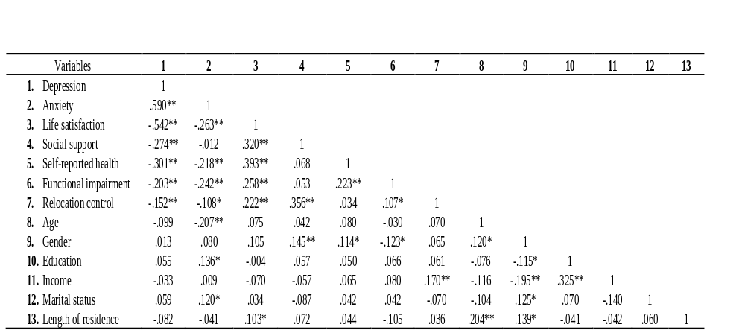
Note: * p < 0.05 level (2-tailed), ** p < 0.01 level (2-tailed).

5.3 Hypothesis Testing

Hypothesis 1A: Relationships between relocation control and depression

Figure 5-1 presents a measurement model of relocation control and depression. The measurement model consists of two latent variables (Relocation Control and Depression) and 8 measured variables (DC1, DC2, DC3, DC4, Interpersonal Relationship, Somatic Symptoms, Positive Affect, and Depressive Affect). A latent variable of relocation control is constructed by four measured variables (DC1, DC2, DC3, and DC4). DC1 is the item 1 of the Perceived Control Measure (Davidson & O’Connor, 1990) which is a question of “was it your decision to come live in an assisted living facility?”; DC2 is the item 2 of the Perceived Control Measure which is a question of “ did others consult with you much about the decision to come stay in an assisted living facility?; DC3 is the item 3 of the Perceived Control Measure which is a question of did you feel that you influenced the decision to come to an assisted living facility?; DC4 is the item 4 of the Perceived Control Measure which is a question of “how much input would you say that you had in the decision to come live in an assisted living facility?” On the other hand, a latent variable of relocation control is constructed by four measured sub-dimensions following the four factor model of the Center for Epidemiological Study Depression (CES-D 20; Radloff, 1977). The four sub-dimensions are Depressive Affect (sum score of 7 items in CES-D), Positive Affect (sum score of 4 items), Somatic Symptoms (sum score of 7 items), and Interpersonal Relationship (sum score of 2 items).
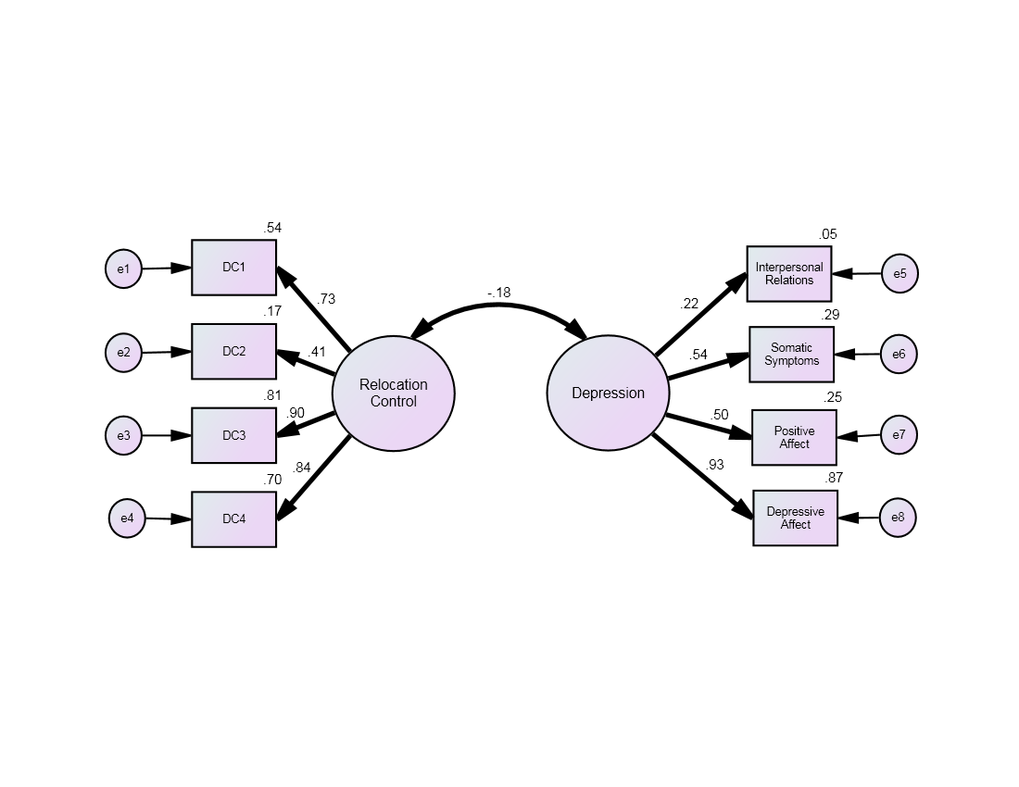
Figure 5-1. Estimated measurement model of testing the relationship between relocation control and depression.
Note ¹. Model fit indices: χ² (19, N = 336) = 44.995, P =.001, RMSEA = .064, TLI = .950, and CFI =.966. Note². Bold solid lines are statistically significant and all estimates are standardized.

The measurement model was tested to evaluate the empirically validity of the two latent variables (relocation control and depression). It fits to the data very well (χ² (l9, N=336) = 44.995, P =.001, RMSEA = .064, TLI = .950, and CFI =.966) and all the loadings of the measured variables on the latent variables were statistically significant (p < .001). These results support the use of the latent variables to test the study hypothsis1A. All parameter estimates of the measurement model are presented in Table 5-4. A zero order factor correlation between relocation control and depression was statistically significant (r = -.184 , p < .01).

Table 5-4. Parameter estimates in the measurement model of relocation control and depression.
Latent variable | Observed variable | B | β | SE | C.R
Relocation control | DC1 | .481 | .732 | .032 | 14.846***
Relocation control | DC2 | .317 | .411 | .043 | 7.431***
Relocation control | DC3 | .667 | .901 | .034 | 19.607***
Relocation control | DC4 | .571 | .839 | .032 | 17.751***
Depression | Interpersonal relations | .105 | .222 | .028 | 3.803***
Depression | Somatic symptoms | 1.888 | .540 | .217 | 8.709***
Depression | Positive affect | 1.157 | .497 | .142 | 8.135***
Depression | Depressive affect | 2.960 | .934 | .234 | 12.662***
Correlation among variables |  | r |  | SE | C.R.
Relocation control <---> depression |  | -.184 |  | .061 | -3.047**
** p < .01, * **p < .001
Figure 5-2 shows results of testing a structural model of the study hypothsis1A. The goodness-of –fit indices for the structural model was satisfied with acceptable levels (χ² (19) = 44.995, CFI= .966, NFI= .950, RMSEA= .064, TLI= .950). This model shows that relocation control is a significant predictor of depression among AL residents (β = -.184, p =.003), supporting the study hypothsis1A. In the zero order factor correlations between relocation control and depression in the measurement model, relocation control was expected to have negative effects on the depression. As expected, individuals who have higher level of relocation control in entering an ALF were more likely to report lower levels of depression. The squared multiple correlations (R²smc) of the model were .034. Based on the given results, relocation control explained 3.4% of the variance in the squared root of the depression. The path coefficients and standard errors of the parameter, as well as the p-values, are summarized in Table 5- 5.

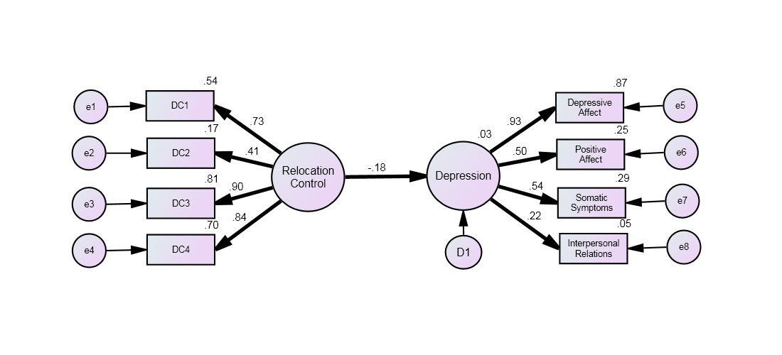Figure 5-2. Structural model of testing the effect of relocation control on depression.
Note ¹. Model fit indices: χ² (19, N = 336) = 44.995, p =.001, RMSEA = .064, TLI = .950, and CFI =.966. Note². Bold solid lines are statistically significant and all estimates are standardized.

Table 5 - 5. Parameter estimates in the structural model of the effect of relocation control on depression
Path | B | β |  | S.E. | C.R.
Relocation control → depression | -.957 | -.184 |  | .317 | -3.014**
** p < .01.
Note ¹. Estimated parameters of factor loadings are not presented because they are very similar to those in the measurement model.

The effect of relocation control on depression is held when controlling for the sample’s demographic characteristics (age, gender, education, income, marital status, and length of residence). This controlled structural model is presented in Figure 5-3 and a path coefficient, standard error of the parameter, critical ratio, as well as p-value of the controlled model is presented in Table 5-6. As seen in Table 5-6, the significant path from relocation control on depression (β = -.173, p =.005), indicating that the study hypothesis 1A is well supported by the data. Only gender (β = .118, SE = .082, p =.05) and income (β = .187, SE = .030, p =.009) predict significantly relocation control while any demographic characteristic variable does not predict significantly depression.
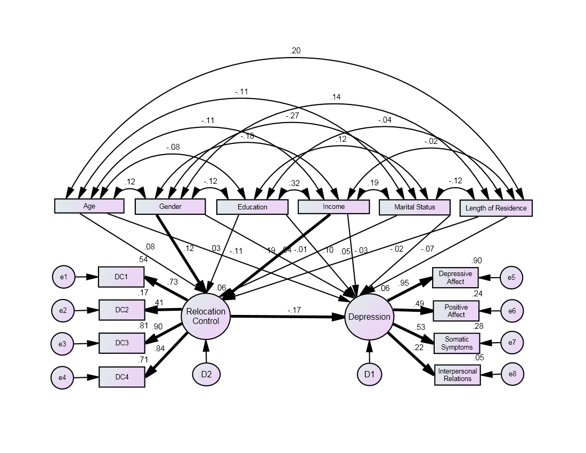
Figure 5-3. Structural model of testing the effect of relocation control on depression controlling for the sample’s demographic characteristics
Note ¹. Model fit indices: χ² = 91.581(55, N = 336); p = 001; CFI = .958; RMSEA = .045; TLI = .919. Note². Bold solid lines are statistically significant and all estimates are standardized.

Table 5-6. Parameter estimates in the controlled structural model of the effect of relocation control on depression.

Path | B | β |  | SE | C.R.
Relocation control → depression | -.912 | -.173 |  | .325 | -2.808**
** p < .01.
Note ¹. Estimated parameters of paths for the sample’s demographic characteristics and of factor loadings are not presented because they are not of interests.

Hypothesis 1B: Relationships between relocation control and anxiety controlling for demographic factors
Figure 5-4 presents a measurement model of relocation control and anxiety. The measurement model consists of two latent variables (Relocation Control and Anxiety) and 10 measured variables (DC1, DC2, DC3, DC4, BSI3, BSI6, BSI9, BSI12, BSI15, and BSI18). As described in a previous section, a latent variable of relocation control is constructed by four measured variables (see detail in the section of Hypothesis 1A). A latent variable of anxiety consists of 6 items in the Brief Symptom Inventory (BSI; Derogatis, 2000). BSI3 refers to nervousness; BSI6 refers to feeling tense; BSI9 refers to feeling scared; BSI12 refers to feeling panicked; BSI15 refers to feeling restless; and BSI18 refers to feeling fearful.
The measurement model in Figure 5-4 fits to the data marginally (χ² (34, N=336) = 126.027, P =.000, RMSEA = .090, TLI = .882, and CFI =.911). All the loadings of the measured variables on the latent variables were statistically significant (p < .001) while a zero order factor correlation between relocation control and anxiety was not statistically significant (r = -.089, p = .172). These results could support the use of the latent variables to test the study hypothsis1B. All parameter estimates of the measurement model are presented in Table 5-7.

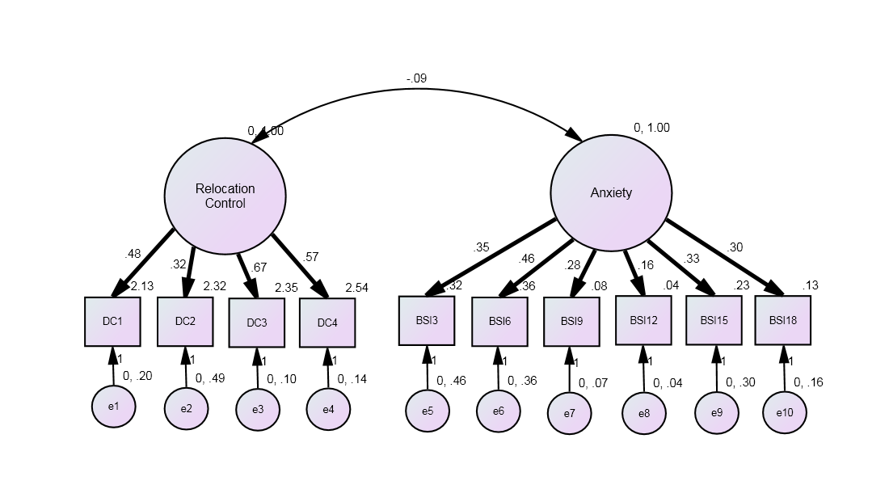Figure 5-4. Estimated measurement model of testing the relationship between relocation control and anxiety.
Note ¹. Model fit indices: : χ² (34, N = 336) = 126.027, P =.000, RMSEA = .090, CFI =.911 and TLI = .882. Note². Bold solid lines are statistically significant and all estimates are standardized.

Table 5-7. Parameter estimates in the measurement model of relocation control and anxiety.
 | Observed variables | B | β | SE | C.R
Relocation control | DC1 | .480 | .731 | .032 | 14.813***
Relocation control | DC2 | .318 | .413 | .043 | 7.460***
Relocation control | DC3 | .666 | .899 | .034 | 19.536***
Relocation control | DC4 | .572 | .841 | .032 | 17.783***
Anxiety | BSI3 | .350 | .459 | .045 | 7.833***
Anxiety | BSI6 | .461 | .607 | .043 | 10.806***
Anxiety | BSI9 | .283 | .721 | .021 | 13.259***
Anxiety | BSI12 | .165 | .639 | .014 | 11.475***
Anxiety | BSI15 | .334 | .518 | .037 | 8.987***
Anxiety | BSI18 | .297 | .598 | .028 | 10.611***
Correlations among variables |  | r |  | SE | C.R.
Relocation control <­-> anxiety |  | -.089 |  | -.065 | -1.366

Figure 5-5 shows results of testing a structural model of the study hypothsis1B. The goodness-of –fit indices for the structural model fitted to the data marginally (χ² (34, N = 336) = 126.027, p =.000, RMSEA = .090, TLI = .882, and CFI =.911) and the path from relocation control to anxiety was not significant (β = -.055, SE = .041, p =.179). In addition, the path from relocation control to anxiety was not significant either (β = -.095, SE = .042, p =.155) when controlling for the sample’s demographic characteristics (Figure 5-6). These results indicate that the data does not support the study hypothsis1B. The path coefficients and standard errors of the parameter, as well as the p-values, are summarized in Table 5- 8.

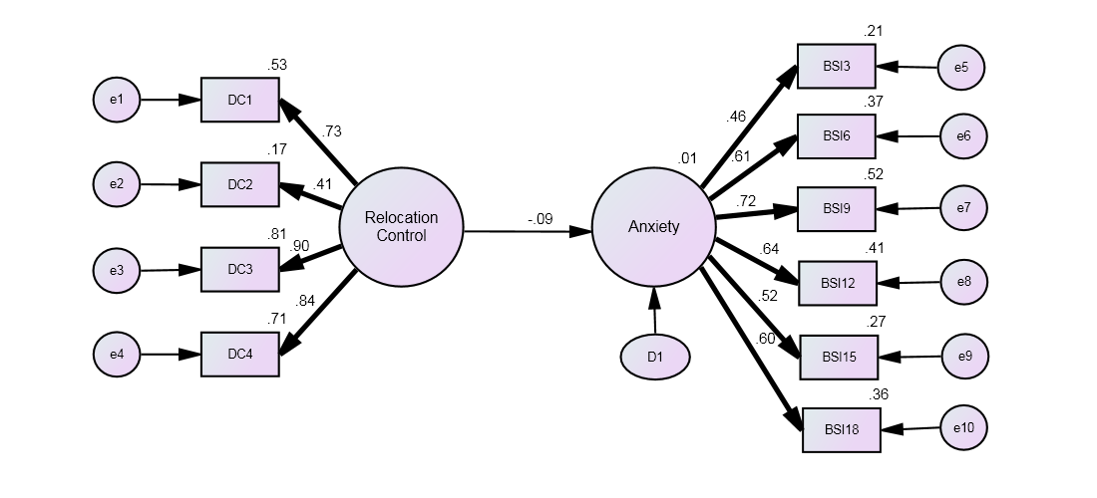Figure 5-5. Structural model of testing the effect of relocation control on anxiety.
Note ¹. Model fit indices: χ² (34, N = 336) = 126.027, p =.000, RMSEA = .090, TLI = .882, and CFI =.911. Note². Bold solid lines are statistically significant and all estimates are standardized.

Table 5- 8. Parameter estimates in the structural models of the effect of relocation control on anxiety
 | Path | B | β | SE | C.R.
Structural model | Relocation control → anxiety | -.089 | -.055 | .041 | -1.342
Controlled  structural model | Relocation control → anxiety | -.060 | -.095 | .042 | 1.422
Note ¹. Estimated parameters of factor loadings are not presented because they are very similar to those in the measurement model. Note ². Estimated parameters of paths for the sample’s demographic characteristics are not presented because they are not of interests.

Gender, age, and education were significant predictors of anxiety in the controlled structural model presented in Figure 5-6. More specifically, female gender (β = .116, p =.040), younger age (β = -.211, p=.002), and more education (β =.156, p =.019) is significantly related with higher level of anxiety. Female gender (β = .118, p =.050) also was significantly associated with the higher level of relocation control. However these results should be carefully interpreted because the controlled structural model does not fit to the data very well.
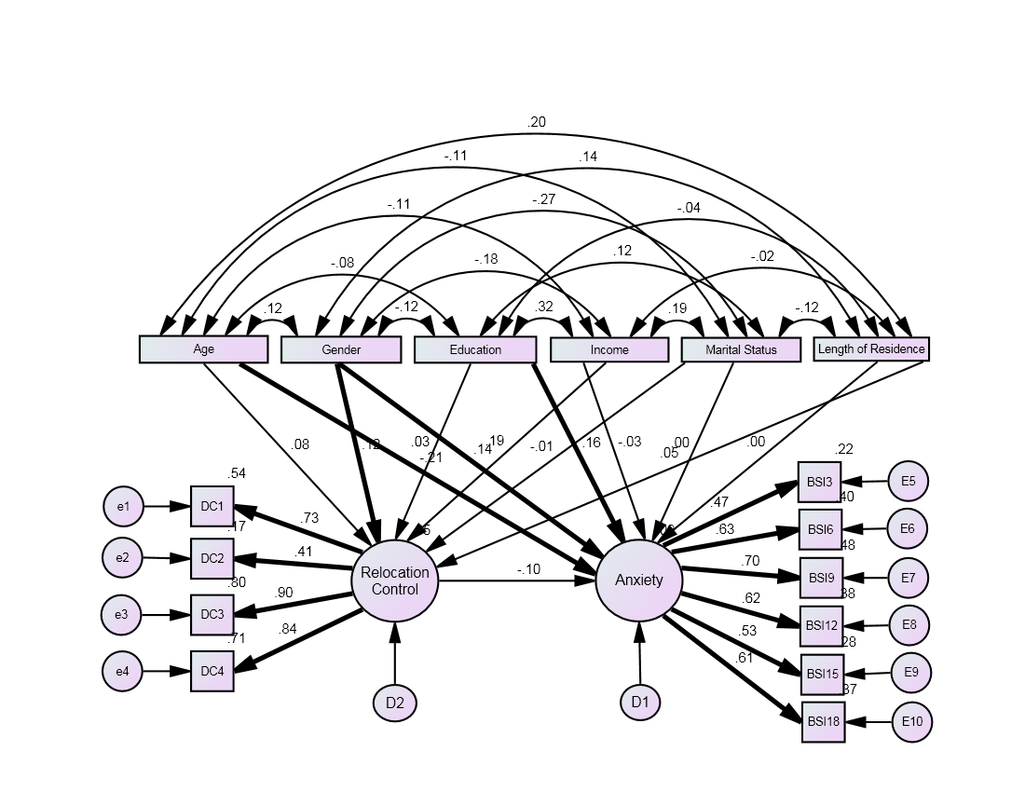Figure 5-6. Structural model of testing the effect of relocation control on anxiety controlling for the sample’s demographic characteristics.
Note ¹. Model fit indices: χ² = 218.207(82, N = 336); p = 000; CFI = .883; RMSEA = .070; TLI= .806. Note². Bold solid lines are statistically significant and all estimates are standardized.

Hypothesis 1C: Relationships between relocation control and life satisfaction

Figure 5-7 presents a measurement model of relocation control and anxiety. The measurement model consists of two latent variables (Relocation Control and Life Satisfaction) and 7 measured variables (DC1, DC2, DC3, DC4, BSI3, BSI6, BSI9, BSI12, BSI15, and BSI18). As described in a previous section, a latent variable of relocation control is constructed by four measured variables (see detail in the section of Hypothesis 1A). Another latent variable of life satisfaction is constructed by three sub-dimensions following the three factor model of
the Life Satisfaction Index (Wood, Wylie, & Sheafor, 1969). The three sub-dimensions are Zest (sum score of 5 items), Mood (sum score of 4 items), and Congruence (sum score of 4 items).

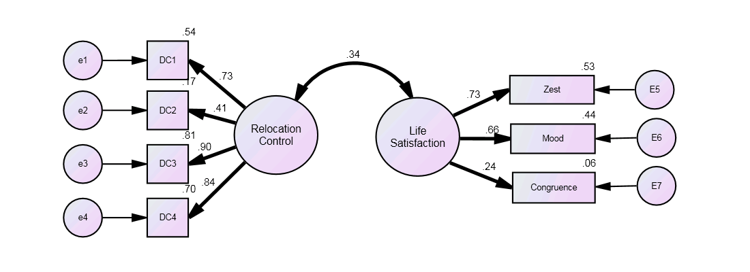
Figure 5-7. Estimated measurement model testing the relationship between relocation control and life satisfaction.
Note ¹. Model fit indices: χ² (13, N = 336) = 32,690, P =.002, RMSEA = .067, TLI = .954, and CFI =.971. Note². Bold solid lines are statistically significant and all estimates are standardized.

The measurement model in Figure 5-7 was tested to evaluate the empirically validity of the two latent variables (relocation control and Life Satisfaction). It fits to the data very well (χ² (13, N = 336) = 32,690, P =.002, RMSEA = .067, TLI = .954, and CFI =.971) and all the loadings of the measured variables on the latent variables were statistically significant (p < .001). These results support the use of the latent variables to test the study hypothsis1C. All parameter estimates of the measurement models are presented in Table 5-9. A zero order factor correlation between relocation control and life satisfaction was statistically significant (r = -.340, p < .001).

Table 5- 9. Parameter estimates in the measurement model of relocation control and life satisfaction.

Latent variable | Observed variables | B | β | SE | C.R.
Relocation control | DC1 | .481 | .733 | .032 | 17.798***
Relocation control | DC2 | .314 | .408 | .034 | 19.668***
Relocation control | DC3 | .667 | .901 | .043 | 7.373***
Relocation control | DC4 | .571 | .839 | .032 | 17.798***
Life satisfaction | Zest | 1.015 | .527 | .127 | 8.389***
Life satisfaction | Mood | .850 | .442 | .102 | 8.072***
Life satisfaction | Congruence | .825 | .056 | .062 | 3.591***
Correlations among variables |  | r |  | SE | C.R.
Relocation control <­-> life satisfaction |  | .340 |  | .066 | 5.183***
* **p < .001

Figure 5-8 shows results of testing a structural model of the study hypothsis1C. As hypothesized, relocation control was a significant predictor, contributing to the variance in life satisfaction being accounted for by the model. The overall goodness-of-fit indices of the structural model showed that the models fit the data well, with high values of CFI of .971 and TLI of .954, and low scores of RMSEA of .067. The squared multiple correlations (R²smc) of the model was .116. In other words, relocation control accounted for at least 11.6% of the variance in life satisfaction among AL residents. The path coefficients and standard errors of each parameter, as well as p-values, are summarized in Table 5-10.
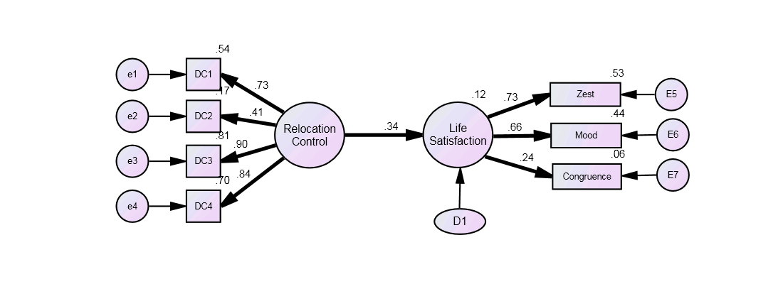
Figure 5-8. Structural model of testing the relationship between relocation control and life satisfaction. Note ¹. Model fit indices: χ² (13, N = 336) = 32.690, p =.002, RMSEA = .067, TLI = .954, and CFI =.971. Note². Bold solid lines are statistically significant and all estimates are standardized.

Table 5-10. Parameter estimates in the structural model of the effect of relocation control on life satisfaction
 | Path | B | β | SE | C.R.
Structural model | Relocation control → life satisfaction | .635 | .340 | .141 | 4.486***
Controlled  structural model | Relocation control → life satisfaction | .651 | .350 | .142 | 4.575***
Note ¹. Estimated parameters of factor loadings are not presented because they are very similar to those in the measurement model. Note ². Estimated parameters of paths for the sample’s demographic characteristics are not presented because they are not of interests.

The effect of relocation control on life satisfaction is held (β = .350, p < .001), when controlling for the sample’s demographic characteristics (age, gender, education, income, marital status, and length of residence). This result indicates that the study hypothesis 1C is well supported by the data. The controlled structural model is presented in Figure 5-9 and a path coefficient, standard error of the parameter, critical ratio, as well as p-value of the controlled model is presented in Table 5-10. In the controlled structural model seen in Figure 5-9, only gender (β = .118, p =.05) and income (β = .187, p =.010) predict significantly relocation control while any demographic characteristic variable does not predict significantly life satisfaction.

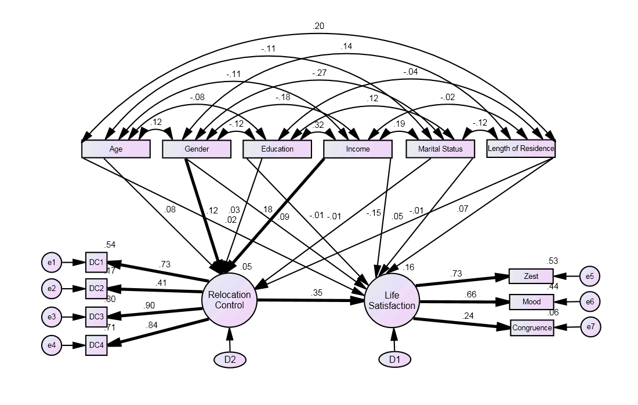
Figure 5-9. Structural model of testing the effect of relocation control on life satisfaction controlling for the sample’s demographic characteristics
Note ¹. Model fit indices: χ² = 77.686(43, N = 336); p = 001; CFI = .956; RMSEA = .049; TLI = .906. Note². Bold solid lines are statistically significant and all estimates are standardized.

Chapter 6. Discussion

Summary of Findings

Overall Discussion

Implications for Practice
There are several strategies that ALF staffs can use to provide them with a sense of relocation control and to help older adults to maintain psychological well-being when relocation is expected. For instance, one-on-one counseling, support group, and outreach program would be beneficial. ALF staff members typically provide brief consultation with caregivers regarding room selection, facility tour, medical information, and facility pamphlet and payment options prior to admission. A specialized form of relocation support programs for older adults was difficult to find in this study. The data collected provided evidence that older adults were particularly vulnerable to psychological distress when they had no relocation control. ALF staff members could hold one-on-one relocation support counseling that offered opportunities for older adults to share feelings, concerns, and to exchange information about ALF relocation planning (i.e. time of the move, floor plan, and belongings such as furniture). These sessions could also involve support group with current ALF residents who had been successful in relocation to tell their stories about how to cope with emotional distress and concerns and available resources. Older adults who suffer from physical or mental illness (i.e. hospitalization) might be unable to seek relocation support services at ALFs. Outreach efforts (i.e. home, or hospital visit) of ALF staff is important in order to assist older adults have as many placement options as possible with the relocation using facility pictures prior to admission. All of above strategies would help older adults to further their understanding of facility environment and benefit, and to enhance sense of control over relocation. Assessing new residents’ needs, concerns, and characteristics are also crucial in order to have effective care plans (i.e. dining table arrangement, activity program planning, and stress management) and minimize psychological distress with the relocation.
Another practical implication for programs suggested by this study concerns social support from family and friends in promoting ALF residents’ psychological well-being. The findings of this study suggest that ALF residents’ social support systems were an important predictor of psychological outcome. Better family cooperation is likely to result in more adequate relocation plans, promote continuity of care, and reduce psychological distress. One way to achieve this is to encourage involvement of family and friends via frequent phone calls and visits after relocation. Continuity of care could also be accomplished through continuous family contact (i.e. email and phone call) that receives information regarding resident characteristics (i.e. stress management, diet, medication, and sleep). Again, ALFs could prepare separate counseling programs for family of ALF residents to assist them in coping with their sense of loss upon their family members’ move and coping skills with which to handle their parents’ psychological difficulties(i.e. depression, anxiety) after the move. An additional practice implication coming from this study is the importance of relationship building with other residents. Many older adults who had to move their private residences would need to create a new friends and relationships. New ALF residents might feel difficulties in developing relationship with other residents. ALF residents called ‘wellness coordinator’ could be important partners in this task. From a practice perspective, ALF residents who had high physical and cognitive functioning with appropriate occupational background(i.e. teacher and pastor) to take care of residents could be more actively engaged in accompanying residents, thus providing more time for residents to interact with another ALF residents and further enhance their psychological well-being.
In addition, continuous mental health counseling may be an important and needed service by AL relocates after relocation. Relocation support and mental health treatment program are not federal mandate at ALFs. Given the higher rates of depression and anxiety prevalence among AL relocates, It may be useful for ALF staff members to provide one-on-one counseling to understand stressors and explore how these concerns may be associated with their psychological well-being. Conducting group sessions might be effective in improving coping skills and managing stress. Case management could be also beneficial to educate ALF residents about the existing resources available to them. In addition, depression and anxiety measures could be incorporated into evaluation protocols to enable ALF staff members to identify the mentally at-risk AL residents, monitor the scores regularly, and to refer ALF residents to local mental health service agencies if necessary. If funding was allowed, staffing on-site mental health treatment team that could monitor mental health outcomes among residents monthly and prescribe psychiatric medication would be ideal for early detection of symptoms and increase service access.
Implication for policy
The findings of this study have important implications for social policy. Mental health and relocation support programs and policies for ALF residents currently are not state or federal mandates. The majority of ALF residents typically do not receive appropriate relocation support and mental health treatment services at ALFs. In addition, depressive symptoms and anxiety among ALF relocates are often undetected which often lead to inadequate treatment following relocation. Availability of mental health clinic within ALF could increase accessibility so that ALF staff members could effectively screen and treat psychological distress associated with relocation among ALF relocates. In this regard, ALF staff members and administrators should play an important role in development and implementation of relocation support programs, advocacy of ALF residents for on-site mental health services and petition of policy makers to increase funding support. Policy makers may consider providing mandated relocation support programs, policies and, financial support for relocation support services (e.g. individual counseling, support group, and outreach program) to enhance relocation control and psychological well-being in this population. Finally, ALF information fliers or on-line websites including the local long-term care options and retirement plan (i.e. long-term care insurance and pension) should be distributed to community residents to have the older adults a sense of control over their late life transition based on federal funding and state implementation even when relocation was not expected. Early discussion and planning about long-term care could increase relocation control and help older adults’ psychological wellbeing after admission.
Implications for Social Work Research

To advance our knowledge about the origins of and contributing factors to psychological distress among ALF residents, several issues need to be addressed in future research. First, future study should be replicated with longitudinal data that assess causality. Causality could not be inferred from the cross-sectional data from this study. Longitudinal was desirable because it provided consistent relationship linking relocation control and psychological well-being and enables researchers to develop interventions and strategies to support relocation process and prevent psychological distress in this population.
Second, additional research is needed to elucidate additional relationship factors that moderate the influence of relocation control in psychological well-being among ALF residents. The moderation model may be re-specified to examine if spirituality moderate the relationship between relocation and psychological well-being, or if this is moderated by social support, self-reported health, and functional impairment. The moderation model may also be refined to evaluate if social support or functional impairment moderate the relationship between relocation control and overall resident quality of life. Testing various moderation models has the potential to help test and develop theory, and to investigate influential variables in ALF programs so that they can be adapted and optimized to increase efficacy and cost-effectiveness.
Third, the mixed-method design using qualitative techniques would provide richer data and improve insights as to barriers that potential residents and family members face in securing successful relocation and the role ALF staff members as they interact with potential residents. The quantitative data could highlight factors not as clearly evident in the qualitative data and the qualitative data could make clear the importance of factors that did not emerge as significant in the quantitative analysis. Ultimately, using both quantitative and qualitative methods would provide in-depth understanding of older adult’s transition into a new ALF and its impact on psychological well-being.
Forth, future research that uses richer measures of relocation control would also enhance this study. While the four–item scale appeared to perform well, there were no standardized scales that specifically measure relocation control among ALF residents. Future research that includes more elaborate measure of relocation control is needed to expand our understanding of the role of relocation control in influencing psychological well-being among ALF residents. In addition, findings from this study would suggest taking matched resident-family member responses, so that their results could be contrasted. Comparisons family data with ALF residents’ perception would help discovering how much gaps exist between them.
Fifth, this study should include more diverse sub-samples to examine the effect of ethnicity and other cultural factors. All participants were white. It was impossible to test whether subgroups differently interpreted items or differed in factor loadings. Future studies might examine these problems using statistics such as multiple invariance testing. Potential subgroup of particular importance would be those based on ethnicity, length of residence, and psychosocial functioning level. For example, researchers should attempt to investigate the influence of gender on the relationship between relocation control and psychological well-being. Although all respondents were Caucasian in this study, it should be noted that there could be African American, Latino, or Asian ALF residents. Given paucity of information about how ethnic minority residents differ from Caucasian residents regarding relocation control and psychological well-being, future research is needed to explore this issue. Assessing the differences among the groups will enrich social work knowledge and develop culturally competent relocation support programs.
Finally, in the future research, it would be important to conduct a need assessment among potential ALF residents and family members to develop new programs that better address their needs. ALF residents may need services to prepare relocation, to increase relocation control, and to deal with their psychological well-being. Future research is needed to explore whether the preliminary ALF tour, meal time participation, and, staff home visit, or counseling services meet their needs or which alternative services would better address their needs. In addition, future research that explores the reasons why some community residents were reluctant to utilize ALF services or existing programs is essential. Qualitative studies are ideally suited to address these questions and to enrich understanding of ALF residents and their family members. Such efforts can potentially inform the development of relocation support programs to increase service access to ALFs.
Limitations and Suggestions for Further Studies

There are some limitations of this study that need to be recognized. First, while this study helps to establish relationship between the variables under examination, like other cross-sectional investigations, the directional and causal nature of these relationships cannot be determined. For instance, it is difficult to determine the direction of causality between relocation control and psychological well-being. For example, involuntary relocation may lead to depression or anxiety, it is also possible that ALF residents who suffer from emotional distress may be more like to have low relocation control because they may be less likely to participate in the decision making process than ALF residents who had better mental and emotional health. In addition, the passage of time can have negative effects on the psychological well-being of ALF residents. It may be difficult to separate which effects are from relocation control and which are strictly the result of passage of time. Therefore, longitudinal follow-ups are desirable to address dynamic differences that might occur over time with changes in depression, anxiety, and life satisfaction through the course of the adjustment in ALFs.
Similarly, although this study assumed that mediating variables would influence the psychological distress among ALF residents, it is equally plausible that greater psychological distress influences the degree of mediators (i.e. social support, self-reported health and anxiety). Without longitudinal data collected at multiple time points, the causal and reciprocal relationships among relocation control, social support, and psychological well-being could not be disentangled.
Moreover, this cross-sectional study relied exclusively on the ALF residents’ retrospective reports of their relocation control prior to admission and concurrent reports of psychological well-being. The HIPPA privacy regulations made it difficult to review the chart of ALF residents. Most of the ALFs requested the researcher to obtain consent from residents’ power of attorney or family members. The researcher did not consult the family or resident records to determine accuracy. Therefore, recall bias may have affected relocation control scale score. For instance, participants might have responded that their relocation experiences were positive or negative, even when specific details about the decisions could not be recalled due to circumstances (i.e. hospitalization) or psychological difficulties(i.e. depression). Future studies should examine the longitudinal relationships between relocation control and change in psychological well-being which will allow for establishing more viable causal relationships.
This study consisted of a sample of convenience obtained from residents and sites who agreed to be interviewed. Upon agreeing to participate, the ALFs were then invited to participate. AL administrators referred to the researcher those whom they identified as eligible participants. This was necessitated by problems of access to respondents, as well as the respondents’ cognitive and physical ability and willingness to participate in the study. A self-selection bias might occur between participants and non-participants. For example, when a survey interview is conducted to ALF residents, those who participated may have been more motivated or suffered from fewer or more functional and psychological problems or differed in other important ways from those who did not agree to participate. It is also possible that non-participants may have more insights about relocation control and in evaluating psychological well-being. Thus, the subjects in this study may not be a representative of ALF residents. The findings can only apply to ALF residents with similar characteristics and backgrounds.
More diverse samples are clearly needed. The composition of the study population was predominantly of Caucasian women (77.1%) aged 65 or above living in 19 ALFs in Tennessee. Underrepresentation of ethnic persons of color in one county limits within and across group comparisons (i.e. men or other race groups). The study sites also were mostly for-profit corporations. Majority of residents paid with private funds. The study results cannot generalize to AL residents whose payment sources were public funds. Also, attention should be given to ALF residents with significant cognitive impairments. While it is likely that results can be generalized to relatively cognitively intact older adults, result may not apply to the entire population of ALF residents. For example, results may have differed if residents with early stage dementia have been interviewed. Additional studies conducted in a variety of settings and on more varied sample of ALF residents in terms of ethnicity, gender, age, socioeconomics, cognitive functioning and geographic region status are needed to confirm the study’s generalizability.
Given the fact that data were collected during face-to- face interviews, social desirability may have influenced how elders responded to questionnaire items. Residents may have a social desirability tendency and may present their relocation experiences and psychological status in a positive light. Residents may also have had fear of reprisal by facility staff, although the confidentiality of residents was maintained throughout the study.
Finally, results from the study may have lacked precision due to missing variables. The study intended to include several controlling variables as covariates. The researcher had relatively low response rate to income variable, largely because of cognitive impairment or privacy among respondents. Most ALF residents were not willing to report financial status with outsiders. Multiple imputation techniques was used to impute values in these cases, but as with all imputation techniques, some bias may be included through the methods used to impute.

References
References

Aday, R. H., Kehoe, G. C., Farney, L.A. (2006). Impact of senior center friendships on aging women who live alone. Journal of Women & Aging, 18(1), 53-73.
Administration on Aging (2011). A profile of older Americans: 2011. Retrieved from http://www.aoa.gov/AoARoot/Aging_Statistics/Profile/2011/4.aspx
Aldrich, G., & Mendkoff, E. (1963). Relocation of the aged and disabled: A mortality study. Journal of the American Geriatrics Society, 11(3), 185-194.
Amenta, K., Protecter, A., Silvermna, A., & Murphy, E. (1987). Mood and behavior problems following the relocation of elderly patients with mental illness. Age & Aging, 16(6), 355-365.
Assisted Living Federation of America (2012a). Assisted living today - a brief overview of senior living care. Retrieved October 21, 2012, from
http://www.alfa.org/alfa/What_is_Assisted_Living1.asp
Assisted Living Federation of America (2012b). What is Assisted Living? Retrieved October 21, 2012, from http://www.alfa.org/alfa/Assisted_living_information.asp?SnID=240990163.
Anthony, K., Protector, A.W., Silverman, A.M., Murphy, E. (1987). Mood and behavior problems following the relocation of elderly patients with mental illness. Age Ageing, 16(6), 355-365.
Armer, J.M. (1993). Elderly relocation to a congregate setting: factors influencing adjustment. Issues in Mental Health Nursing, 14(2), 157.
Arbuckle, J.L. (2003). AMOS 5.0 Update to the Amos User’s Guide. Chicago: Smallwaters Corportation, Inc.
Armer, J.M. (1993). Elderly relocation to a congregate setting: Factors influencing adjustment. Issues in Mental Health Nursing, 14(2), 157-172.
Armer, J.M. (1996). An exploration of factors influencing adjustment among relocating rural elders. Image: Journal of Nursing Scholarship, 28(1), 5-8.
Ball, M. M., Perkins, M. M., Hollingsworth, C., Whittington, F. J., & King, S.V. (2009). Pathways to Assisted Living: The Influence of Race and Class. Journal of Applied Gerontology, 28 (1), 81-108.
Barbara, M.B. (2001). Structural equation modeling. Mahwah: Lawrence Erlbaum Associates, Inc.
Bayer, A.H., & Harper, L. (2000). Fixing to stay: A national survey on housing and home modification issues. Retrieved October 31, 2012, from http://assets.aarp.org/rgcenter/il/home_mod.pdf
Bekhet, A. K. & Zauszniewski, J.A. & Nakhla, W. E. (2009). Reasons for relocation to retirement communities: A qualitative approach. Western Journal of Nursing Research, 31 (4), 462-479.
Besser, A., & Priel, B. (2007). Attachment, depression, and fear of death in older adults: The roles of neediness and perceived availability of social support. Personality and Individual Differences, 44(8), 1711-1725.
Bertrand, R.M., Mezzcappa, C., Ensrud, K., Fredman, L. (2012). Caregiving and cognitive function in older women:evidence for the healthy caregiver hypothesis. Journal of Aging and Helath, 24 (1), 48-66.
Birren, J.E. (1995). Reactions to loss and the process of aging: Interrelations of environmental changes, psychological capacities, and physiological status. In M. A. Berezin & S.H. Cath (Eds.), Geriatric psychiatry: Grief, loss, and emotional disorders in the aging process. New York: International Universities Press.
Blieszner, R., & Roberto, K.A. (2009). Care partner responses to the onset of mild cognitive impairment. The Gerontologist, 50(1), 11-22.
Brand, F. N., & Smith, R.T. (1974). Life adjustment and relocation of the elderly. Journal of Gerontology, 29(3), 336-340.
Bradley, D. E., & Willigen, M.V. (2010). Migration and psychological well-being among older adults: a growth curve analysis based on panel data from the health and retirement study, 1996 -2006. Journal of Aging and Health, 22(7), 882-913.
Brodie, M., & Blendon, R. (2001). National survey on nursing homes. Menlo Park, CA: Kaiser Family Foundation/ Newshour with Jim Lehrer; 2001.
Brooke, V. (1989). How elders adjust. Geriatric Nursing, 10(2), 66-68.
Borup, J. (1983). Relocation mortality research: Assessment, reply, and the need to refocus on the issues. The Gerontologist, 23(3), 235-242.
Boureston, N., & Tars, S. (1974). Alterations in life patterns following nursing home relocation. The Gerontologist, 14(6), 506-510.
Boustani, M., Zimmerman, S., Williams, C.S., Gruber-Baldini, A.L., Watson, L., Reed, P.S., Sloane, P.D. (2005). Characteristics associated with behavioral symptoms related to dementia in longterm care residents. The Gerontologist, 45 Spec No 1(1), 56-61.
Bowsher, J.E., & Gerlach, M.J. (1990). Personal control and other determinants of psychological well-being in nursing home elders. Scholarly Inquiry for Nursing Practice: An International Journal, 4(2), 91-102.
Brugler, C., Titus, M., & Nypaver, J. (1993). Relocation stress syndrome. Journal of Nursing Administration, 23(1), 45-50.
Burton, A. M., Haley, W. E., Small, B. J., Finley, M. R., Dillinger-Vasille, M., &
Schonwetter, R. (2008). Predictors of well-being in bereaved former hospice caregivers:
The role of caregiving stressors, appraisals, and social resources. Palliative
and Supportive Care, 6, 149-158.
Byers, J. F., & Smyth, K. A. (1997). Application of a transactional model of stress and coping with critically ill patients. Dimensions of Critical Care Nursing, 16(6), 292-300.
Cannon, W.B. (1932). The wisdom of the body. New York: Norton.
Capezuti, E., Boltz, M., Renz, S., Hoffman, D., Norman, R. (2006). Nursing home involuntary relocation: Clinical outcomes and perceptions or residents and families. Journal of the American Medical Directors Associations, 7(8), 486-492.
Carpenito, L. J. (2000). Nursing Diagnosis. Application to Clinical Practice, 8th edn. J. B. Lippincott, Philadelphia.
Castle, N.G. (2001). Relocation of the elderly. Medical Care Research and Review. 58(3), 291-333.
Castle, N. G. & Engberg, J. B. (2011). The health consequences of relocation for nursing home residents following hurricane Katrina, Research on Aging, 33(6), 661-687.
Centers for Disease Control and Prevention and The Merck Company Foundation (2007).
The State of Aging and Health in America 2007.Whitehouse Station, NJ: The Merck Company Foundation
Chapin, R., Reed, C.J., & Dobbs, D. (2004). Mental health needs and service use of older adults in assisted living settings: A mixed methods study. Journal of mental health and Aging, 10(4), 351-365.
Chen, P., & Wilmoth, J. M. (2004). The effect of residential mobility on ADL and IADL limitations among the very old living in the community. Journal of Gerontology, 59B(3), S164- S172.
Chen, C. K., Zimmerman, S., Sloane, P. D., & Barrick, A. L. (2007). Assisted living policies promoting autonomy and their relationship to resident depressive symptoms. American Journal of Geriatic Psychiatry, 15(2), 122–129.
Chenitz, W.C. (1983). Entry into a nursing home as a status passage: A theory to guide nursing practice. Geriatric Nursing, 4(2), 92-97.
Choi, N.G. (1996). Older persons who move: reasons and health consequences. The Journal of Applied Gerontology, 15(3), 325-344.
Ciesla, J.R., Shi, L., Stoskopf, C.H., & Samuels, M.E. (1993). Reliability of Katz’ Activities of Daily Living Scale when used in telephone interviews. Evaluation & the Health Professions, 16(2), 190-203.
Cohen, C. J., Auslander, G., Chen, Y. (2010). Family caregiving to hospitalized end-of –life and acutely ill geriatric patients. Journal of Gerontological Nursing, 36(8), 42-50.
Cuijpers, P., & Van Lammeren, P. (1999). Depressive symptoms in chronically ill elderly people in residential homes. Aging and Mental Health, 3(3), 221-226.
Cummings, M. S. (2002). Predictors of psychological wellbeing among assisted living residents. Health & Social Work, 27(4), 293–302.
Cummings, M. S., & Cockerham, C. (2004). Depression and life satisfaction in assisted living residents: Impact of health and social support. Clinical Gerontologist, 27(1/2), 25–42.
Cutrona, C.E., Russell, D., & Rose, J. (1986). Social support and adaptation to stress by the elderly. Journal of Psychology and Aging, 1, 47-54.
Dal Santo, T.S., Scharlach, A.E., Nielsen, J., Fox, P.J. (2007). A stress process model of family caregiver service utilization: factors associated with respite and counseling service use. Journal of Gerontological Social Work, 49(4), 29-49.
Danermark, B.D., & Ekstrom, M.E. (1990). Relocation and Health Effects on the
Elderly: A Commented Research Review. Journal of Sociology and Social Welfare, 17(1),
25–49.
Davidson, H.A., & O’Connor, B.P. (1990). Perceived control and acceptance of the decision to enter a nursing home as predictors of adjustment. International Journal of Aging and Human Development, 31(4), 307-318.
Deborah, L., Rutman, M.A., & Jonathan, L. (1988). Anticipating relocation: Coping strategies and the meaning of home for older people. Canadian Journal on Aging, 7(1), 17-31.
Dennis, M., Wakefield, P., Molloy, C., Andrews, H., Friedman, T. (2005). Self-harm in older people with depression: Comparison of social factors, life events and symptoms. The British Journal of Psychiatry, 186(6), 538-539.
Dempster, A. P., Laird, N. M., & Rubin, D.B. (1977). Maximum likelihood estimation from incomplete data via the EM algorithm(with discussion). Journal of the Royal Statistical Society, B39, 1-38.
Derogatis, L. (2000). Brief Symptom Inventory (BSI) 18: Administration, Scoring, and Procedures Manual. National Computer Systems: Minneapolis, MN.
Dillman, D. (2000). Mail and internet surveys: The tailored design method. (2nd ed.). New York, NY: John Wiley & Sons.
Dimond, M., McCance, K., & King, K. (1987). Forced residential relocation: Its impact on the well-being of older adults. Western Journal of Nursing Research, 9(4), 445-464.
Dube, A. (1982). The impact of moving a geriatric population: mortality and emotional aspects. Journal of Chronic Disease, 35(1), 61-64.
Earle, L. (1980). Housing relocation of the aged: effects on social interaction. Australian Social Work, 33(3), 23-38.
Fiori, K. L., Antonucci, T. C., & Cortina, K. S. (2006). Social network typologies and mental health among older adults. The Journals of Gerontology Series B: Psychological Sciences and Social Sciences, 61(1), 25-32.
Friedman, S.M., Williamson, J. D., Lee, B. H., Ankrom, M. A., Ryan, S. D., & Denman, S. J. (1995). Increased fall rates in nursing home residents after relocation to a new facility. Journal of the American Geriatrics Society, 43(11), 1237-1242.
Ferraro, K. F. (1982). The health consequences of relocation among the aged in the community. Journal of Gerontology, 38(1), 90-96.
Fiori, K. L., Antonucci, T. C., & Cortina, K. S. (2006). Social network typologies and mental health among older adults. The Journals of Gerontology Series B: Psychological Sciences and Social Sciences, 61(1), 25-32.
Gall, J., Gall, M., & Borg, W. (2005). Applying educational research: A practical guide (5th ed.). New York, NY: Longman.
Gass, K. A., Gaustad, G., Oberst, M. T., & Hughes, S. (1992). Relocation appraisal, functional independence, morale, and health of nursing home residents. Issues in Mental Health Nursing, 13, 239-253.
Genworth Financial (2009). 2009 cost of care survey: nursing homes, assisted living facilities, and home care providers. Wellesley, MA: Genworth Financial.
Glaser, B.G. (1978). Theoretical sensitivity advances in the methodology of grounded theory. Mill Valley, CA: The Sociology Press.
Golant, S.M. (2004). Do impaired older persons with health care needs occupy U.S. assisted living facilities? An analysis of six national studies. Journals of Gerontology. Series B, Psychological Sciences and Social Sciences, 59(2), S68-S79.
Gonyea, J.G., Paris, R., & De Saxe Zerden, L. (2008). Adult daughters and aging mothers: The role of guilt in the experience of caregiver burden. Aging & Mental Health, 12(5), 559-567.
Gruber-Baldini, A.L., Boustani, M., Sloane, P.D., & Zimmerman, S. (2004). Behavioral symptoms in residential care/assisted living facilities: Prevalence, risk factors, and medication management. Journal of the American Geriatrics Society, 52(10), 1610-1617.
Gum, A.M., Petkus, A., McDougal, S.J., Present, M., King-Kallimanis, B., & Schonfeld, L. Behavioral health needs and problems recognition by older adults receiving home-based aging services (2009). International Journal of Geriatric Psychiatry, 24, 400-408.
Gurung, R. A., Taylor, S. E., Seeman, T. E. (2003). Accounting for changes in social support among married older adults: Insights from the MacArthur studies of successful aging. Psychology and Aging, 18(3), 487-496.
Hallewell, C., Morris, J., & Jolley, D. (1993). The closure of residential homes: What happens to residents. Age and Ageing, 23(2), 158-161.
Harel, Z., & Noelker, L. (1982). Social integration, health, and choice. Research on Aging, 4(1), 97-111.
Harkulich, J. & Brugler, C. (1991). Relocation and the resident. Activities, adaptation, & aging, 15(4), 51-60.
Harwood, R., & Ebrahim, S. (1992). Is relocation harmful to institutionalized elderly people?, Age and Ageing, 21(1), 61-66.
Hawes, C., Phillips, C. D., & Rose, M. (2000). High service or high privacy assisted living facilities, their residents and staff: Results from a national survey. Washington, DC: United States Department of Health and Human Services. Retrieved March 5, 2012, from http://aspe.hhs.gov/daltcp/reports/hshp.htm
Hawes, C., Phillips, C. D., Rose, M., Holan, S., & Sherman, M. (2003). A national survey of assisted living facilities, The Gerontologist, 43 (6), 875-882.
Hawes, C., Wildfire, J., & Lux, L. J. (1991). The regulation of board and care homes: Result of a 50-state survey. Research Triangle Park, NC: RTI International.
Heisler, E., Evans, G., & Moen, P. (2004). Health and social outcomes of moving to a continuing care retirement community. Journal of Housing for the Elderly, 18(1), 5-23.
Hernandez, M., & Newcomer, R. (2007). Assisted living and special populations: What do we know about differences in use and potential access barriers, The Gerontologist, 47 (Special Issue Ⅲ), 110-117.
Hertz, J. E, Koren, M. E., Rossetti J., & Robertson, J. F. (2008). Early identification of relocation risk in older adults with critical illness. Critical Care Nursing Quarterly, 31(1), 59-64.
Hertz, J. E, Koren, M. E., Rossetti J., & Robertson, J. F. (2007). Management of relocation in cognitively intact older adults. Journal of Gerontological Nursing, 33(11), 12-18.
Jackson, B., Swanson, C., Hicks, L. E., Prokop, L., & Laufhlin, J. (2000). Bridge of continuity from hospital to nursing home-Part I: A proactive approach to relocation stress syndrome in the elderly. Continuum (Society for Social Work Leadership in Health Care), 20(1), 3-8.
James L. Arbuckle (2010). IBM SPSS Amos 19 User's Guide. Amos Development Corporation, Crawfordville, FL.
Jang, Y., Bergman, E., Schonfeld, L., & Molinari, V. (2006). Depressive symptoms among older residents in assisted living facilities. International Journal of Aging and Human Development, 63(4), 299–315.
Jang, Y., Bergman, E., Schonfeld, L., & Molinari, V. (2007). The mediating role of health perceptions in the relation between physical and mental health: A study of older residents in Assisted Living Facilities, Journal of Aging and Health, 19(3), 439–452.
Jones, A. (2002). The national nursing home survey: 1999 summary, Vital and Health Statistics, 152(13), 1-116.
Jones, E. M. (1991). Interhospital relocation of long-stay psychiatric patients: a prospective study. Acta Psychiatrica Scandinavica, 83(3), 214-216.
Johnson, R.A. (1996). The meaning of relocation among elderly religious sisters, Western Journal of Nursing Research, 18(2), 172-185.
Johnson, R.A. (2006). Relocation stress. In E.Capezuti, E. L. Siegler, & M. Mezey(Eds.), The encyclopedia of elder care: The comprehensive resource on geriatric and social care. New York, NY: Springer, 679-683.
Johnson, R.A. & Hlava, C. (1994). Translocation of elders: Maintaining the spirit. Geriatric Nursing, 15(4), 209-212.
Johnson, R. J., Popejoy, L. L., & Radina, M . E. (2010). Older adults’ participation in nursing home placement decisions. Clinical Nursing Research, 19(4), 358-375.
Kadushin, G., & Kulys, R. (1994). Patient and family involvement in discharge planning. Journal of Gerontological Social Work, 22(3/4), 171-199.
Kane, A. R., Chan, J., & Kane, L. R. (2007). Assisted living literature through May 2004: Taking stock. The Gerontologist, 47 (Special issue 3), 125–140.
Kane, R.A., Kane, R.L., Ladd, R.C. (1998). The heart of long-term care. New York, NY: Oxford University Press.
Kane, R.L., & Mach, J.R. (2007). Improving health care for assisted living residents. Gerontologist, 47(Special issue Ⅲ), 100-109.
Kasl, S. V., & Rosenfield, S. (1980). The residential environment and its impact on the mental health of the aged. In J. Birren & R. Sloane (Eds.), Handbook of mental health and aging (pp.468-498). Englewood Cliffs, New Jersey: Prentice-Hall.
Katz, S., Down, T.D., Cash, H.R., & Grotz, R.C. (1970). Progress in the development of the index of ADL. Gerontologist, 10(1), 20-30.
Kao, H.F., Travis, S.S., & Acton, G.J. (2004). Relocation to a long-term care facility: Working with patients and families before, during, and after. Journal of Psychological Nursing and Mental Health Services. 42(3), 10-16.
Kedia, S., & Willigen, J.V. (2001). Effects of forced displacement on the mental health of older people in North India. Journal of Aging, 3(1), 81-93.
Kerse, N., Butler, M., Robinson, E., & Todd, M. (2004). Fall prevention in residential care: A cluster, randomized, controlled trial. Journal of the American Geriatrics Society. 52(4), 524-531.
Killian, E. (1970). Effects of geriatric transfers on mortality rates. Social Work, 15(1), 19-26.
King, K.S., Dimond, M., & McCance, K.L. (1987). Coping with relocation, Geriatric Nursing, 8(5), 258-261.
Kline, R.B.(2010). Principles and practice of structural equation modeling, New York, NY: The Guilford Press.
Kramer, B. J., & Vitaliano, P. P. (1994). Coping: A review of the theoretical frameworks
and the measures used among caregivers of individuals with dementia. Journal of
Gerontological Social Work, 23(1/2), 151-174.
Kramer, B. J., Kavanaugh, M., Trentham-dietz, A., Walsh, M., Yonker, J. A. (2010). Complicated grief symptoms in garegivers of persons with lung cancer: the role of family conflict, intrapsychic strains, and hospice utilization. Journal of Death and Dying, 62(3), 2011.
Krout, J.A., & Wethington, E. (2003). Residential choices and experiences of older adults: pathways to life quality, New York, NY: Springer Publishing Company.
Lawton, M. P., & Brody, E. M. (1969). Assessment of older people: self-maintaining and instrumental activities of daily living. Gerontologist, 9, 179-186.
Lawton, P., Yaffe, S. (1970). Mortality, morbidity and voluntary change of residence by older people. Journal of the American Geriatric Society, 18(10), 823-831.
Lazarus, R.S. (1970). The concepts of stress and disease. In L. Levi (Ed.), Society, stress, and disease (pp.53-58). London: Oxford University Press.
Lazarus, R.S., & Folkman, S. (1984). Stress, appraisal, and coping. New York: Springer.
Laughlin, A., Parsons, M., Kosloski, K. D., & Bergman-Evans, B. (2007). Predictors of mortality following involuntary interinstitutional relocation. Journal of Gerontological Nursing, 33(9), 20-26.
Leducq, M. (1996). Non-physical needs. In Nursing the Critically Ill (Viney C., ed.). Bailliere Tindall, Loudon, pp.294-315.
Lee, K. H., Besthorn, F. H., Bolin, B. L., Jun, J. S. (2012). Stress, spiritual, and support coping, and psychological well-being among older adults in assisted living, Journal of Religion & Spirituality in Social Work, 31(4), 328-347.
Leedy, D., & Ormrod, E. (2001). Practical research: Planning and design (7th ed.) Upper Saddle River, NJ: Merrill Prentice Hall.
Lei, P.W., & Wu, Q. (2007). Introduction to structural equation modeling: issues and practical considerations. Educational Measurement: Issues and Practice,26(3), 33-43.
Love K., Zimmerman S., & Cohen L. (2009). A manual for community-based participatory research: Using research to improve practice and inform policy in assisted living. Chapel Hill, NC: CEAL-UNC Collaborative.
Love K., Zimmerman S., Cohen Lthe CEAL-UNC Collaborative (2009). A manual for community-based participatory research: Using research to improve practice and inform policy in assisted living. Retrived October, 2012, from http://www.theceal.org/reports.php.
Lutgendorf, S. K., Vitaliano, P.P., Reimer, T.T., Harvey, J.H., & Lubaroff, D.M. (1999). Sense of coherence moderates the relationship between life stress and natural killer cell activity in healthy older adults. Psychology and Aging, 14(4), 552-563.
Lyyra, T. M., & Heikkinen, R. L. (2006). Perceived social support and mortality in older people. The Journals of Gerontology Series B: Psychological Sciences and Social Sciences, 61(3), S147-S152.
Mahard, R. E. (1988). The CES-D as a measure of depressive mood in the elderly Puerto Rican population. Journal of Gerontology, 43(1), 24–25.
Manion, P.S., Rantz, M.J. (1995). Relocation stress syndrome: A comprehensive plan for long-term care admissions. Geriatric Nursing, 16(3), 108-112.
Marlowe, R. A. When they closed the doors at Modesto. Presented at National Institute of Mental Health Conference on the closure of state hospitals. In R. Shultz & G. Brenner (Eds.). Relocation of the aged: A review and theoretical analysis. Journal of Gerontology, 32(3), 323-333.
Meehan, T., Robertson, S., Stedman, T., & Byrne, G. (2004). Outcomes for elderly patients with mental illness following relocation from a stand-alone psychiatric hospital to community-based extended care units. Australian and New Zealand Journal of Psychiatry, 38(11-12), 948-952.
Menne, H. L., & Whitlatch, C. J. (2007) Decision making involvement of individuals with dementia. The Gerontologist, 47(6), 810-819.
Melrose, S. (2004). Reducing relocation stress syndrome in long term care facilities. Journal of Practical Nursing, 54(4), 15-17.
Mikhail, M.L. (1992). Psychological responses to relocation to a nursing home. Journal of Gerontological Nursing. 18(3), 35-39.
Mitchell, M. G. (1999). The effects of relocation on the elderly. Perspectives, 23(1), 2-7.
Mitty,E., Resnick, B., Allen, J., Bakerjian,D., Hertz, J., Gardner,W., Rapp, M.P., Reinhard,S., Young, H., & Mezey, M. (2010). Nursing delegation and medication administration in assisted living. Nursing Administration Quarterly,34(2), 162-171.
Mollica, R., & Johson-Lemarche, H. (2005). States Residential Care and Assisted Living Policy: 2004. Retrived March 4, 2012, from www.aspe.hhs.gov/daltcp/reports/2005/04alcom.htm.
Munroe, D.J. (2003). Assisted living issues for nursing practice. Geriatric Nursing, 24(2), 99-105.
Morse, D.L. (2000). Relocation stress syndrome is real. American Journal of Nursing, 100(8), 24-30.
Nanna, M. J., Lichtenberg, P.A., Buda-Abela, M., & Barth, J.T. (1997). The role of cognition and depression in predicting functional outcome in rehabilitation patients. Journal of Applied Gerontology, 16(1), 120-132.
Nay, R. (1995). Nursing home residents’ perceptions of relocation. Journal of Clinical Nursing, 4(5), 319-325.
National Center for Assisted Living (2012c). Assisted living state regulatory review: 2012. Washington, DC: National Center for Assisted Living.
National Center for Assisted Living (2012a). Assisted Living Resident profile. Retrived October 21, 2012, from http://www.ahcancal.org/ncal/resources/Pages/ALFacilityProfile.aspx.
National Center for Assisted Living (2012b). Assisted Living Resident profile. Retrieved October 21, 2012, from www.ahcancal.org/ncal/resources/Pages/ResidentProfile.aspx.
National Center for Chronic Disease Prevention and Health Promotion (2009). Healthy aging improving and extending quality of life among older Americans. Retrived October 20, 2012, from http://www.cdc.gov/nccdphp/publications/aag/pdf/healthy_aging.pdf.
Nirenberg, T. (1983). Relocation of institutionalized elderly. Journal of Consulting & Clinical Psychology, 15(5), 693-701.
North America Nursing Diagnosis Association (2007). Nursing Diagnosis: Definitions and Classification, 2007-2008. Philadelphia, PA: NANDA International.
Park, N. S., Zimmerman, S., Sloane, P. D., Gruber-Baldini, A. L., Eckert, J. K. (2006). An empirical typology of residential care/assisted living based on a four state study. The Gerontologist, 46(2), 238-248.
Parmelee, P. A., Katz, I. R., & Lawton, M. P. (1992). Depression and mortality among institutionalized aged. Journal of Gerontology, 47(1), P3-P10.
Payne, L. L., Mowen, A. L., Montoro-Rodriguez, J. (2006). The role of leisure style in maintaining the health of older adults with arthritis. Journal of Leisure Research, 38(1), 20-45.
Pearlin, L. I., Lieberman, M.A., Menaghan, E.G., & Mullan, J.T. (1981). The stress process. Journal of Health and Social Behavior, 22(4), 337-356.
Pearlin, L. I., Mullan, J. T., Semple, S. J., & Skaff, M. M. (1990). Caregiving and the stress process: An overview of concepts and their measures. The Gerontologist, 30(5), 583-594.
Pearlin, L. (1999). The stress process revisited: Reflections on concepts and their interrelationships. In C. S. Aneshensel & J. C. Phelan (Eds.), Handbook of the sociology of mental health (pp.395-415). New York: Kluwer Academic.
Pino, C., Rosica, L., & Carter, T. (1978). The differential effects of relocation on nursing home patients. The Gerontologist, 18, 167-172.
Polzer, K. (2010). Assisted living regulatory review 2010. Retrived March 4, 2012, from www.ahcancal.org/ncal/resources/Documents/2010AssistedLivingRegulatoryReview.pdf
Port, C. L., Zimmerman, S., Williams, C.S., Dobbs, D., Preisser, J.S., & Williams, S.W. (2005).Families filling the gap: Comparing family involvement for assisted living and nursinghome residents with dementia [Special Issue 1], The Gerontologist, 45(1), 87-95.
Porter, E.J., & Clinton, J.F. (1992). Adjusting to the nursing home. Western Journal of Nursing Research, 14(4), 464-477.
Procidano, M.E., & Heller, K. (1983). Measures of perceived social support from friends and from family: Three validation studies. American Journal of Community Psychology, 11, 1-24.
Raccio-robak, N., Mcerlean, M. A., Fabacher, D. A., Milano, P. M., Verdile, V. P. (2002). Socioeconomic and health status differences between depressed and nondepressed ED elders. The American Journal of Emergency Medicine, 20(2), 71-73.
Radloff, L. S. (1977). The CESD scale: A self-report depression scale for research in the general population. Applied Psychological Measurement, 1, 385–410.
Rao, V., Spiro, J., Samus, Q. M., Steele, C., Baker, A., Brandt, J., Mayer, L., Lyketsos, C.G., & Rosenblatt, A. (2008). Insomnia and daytime sleepiness in people with dementia residing in assisted living: Findings from the Maryland Assisted Living Study. International Journal of Geriatric Psychiatry, 23(2), 199-206.
Reed, J., & Payton, V. R. (1996). Challenging the institution. Journal of Psychiatric and Mental Helath Nursing, 3(4), 274-277.
Reid, R. C., Stajduhar, K. I., & Chappell, N. L. (2010). The impact of work interferences on family caregiver outcomes. Journal of Applied Gerontology, 29(3), 267-289.
Reinardy, J. (1992). Decisional control in moving to a nursing home: postadmission adjustment and well-being. The Gerontologist. 32(1), 96-103.
Reinardy, J. (1995). Relocation to a new environment: Decisional control and the move to a nursing home. Health & Social Work, 20(1), 31-38.
Reinardy, J., & Kane, R.A. (2003). Anatomy of a choice: deciding on assisted living or nursing home care in Oregon. The Journal of Applied Gerontology, 22(1), 152-174.
Resnick, B., Galik, E., Gruber-Baldini, A.L., Zimmerman, S. (2009). Implementing a restorative care philosophy of care in assisted living: Pilot testing of Res-Care-AL. Journal of the American Academy of Nurse Practitioners, 22(1), 123-133.
Resnick, B., & Jung, D. (2006). Utility of the Maryland assisted living functional assessment tool for directing environmental interventions and care. Journal of Housing for the Elderly, 20(3), 109-121.
Rodin, J. (1986). Aging and health: effects of the sense of control. Science. 233, 1271-1276.
Rosenblatt, A., Samus, Q.M., Steele, C.D., Baker, A.D., Harper, M.G., Brandt, J., Rabins, P.V., Lyketsos, C. G. (2004). The Maryland Assisted Living Study: prevalence, recognition, and treatment of dementia and other psychiatric disorders in the assisted living population of central Maryland. Journal of American Geriatric Society, 52(10), 1618-1625.
Rogers, J.C., Stuart, M.R., Sheffield, P., Swee, D.E., & Formica, P. (1990). Functional health status of relocated nursing home residents. The Journal of the American Board of Family Practice, 3(3), 157-162.
Rossen, E.K. (2007). Assessing older persons readiness to move to independent congregate living. Clinical Nurse Specialist. 22(7), 292-296.
Rossen, E.K., & Knafl, K.A. (2003). Older women’s response to residential relocation: description of transition styles. Qualitative Health Research. 13(1), 20-36.
Rossen, E.K., & Knafl, K.A. (2007). Women’s well-being after relocation to independent living communities. Western Journal of Nursing Research. 29(2), 183-199.
Rubin, A. & Babbie, E. (2007). Research methods for social work (6th ed.). United States: Thomson-Brooks/Cole.
Saunders, J.C., & Heliker, D. (2008). Lessons learned from 5 women as they transition into Assisted Living. Geriatric Nursing, 29(6), 369-375.
Schulz, R., & Brenner, G. (1977). Relocation of the aged: a review and theoretical analysis. Journal of Gerontology, 32(3), 323-333.
Selye, H. (1976). The stress of life. New York: McGraw-Hill.
Shapiro, D.H., Schwartz, C.E., & Astin, J.A. (1996). Controlling ourselves, controlling our world: Psychology’s role in understanding positive and negative consequences of seeking and gaining control. American Psychologist, 51, 1213-1230.
Sharp, S. (1996). Understanding stress in the ICU setting. British Journal of Nursing, 5(6), 369-373.
SPSS Inc. (2010). IBM SPSS Statistics 19 Core System User’s Guide. SPSS Inc., Chicago IL.
Shapiro, D.H., Schwartz, C.E., & Astin, J.A. (1996). Controlling ourselves, controlling our world: Psychology’s role in understanding positive and negative consequences of seeking and gaining control. American Psychologist, 51, 1213-1230.
Smith, A. E. & Crome, P. (2000). Relocation mosaic – A review of 40 years of resettlement literature. Reviews in Clinical Gerontology, 10(1), 81-95.
Stevenson, D., & Grabowski, D. (2010). Sizing up the market for assisted living. Health Affairs, 29(1), 35-43.
Storandt, M., & Wittels, I. (1975). Maintenance of function in relocation of community-dwelling older adults. Journal of Gerontology, 30(5), 608-612.
Street, D., Burge, S., Quadagno, J.& Barrett, A. (2007). The salience of social relationships for resident well being in assisted living. The Journals of Gerontology Series B: Psychological Sciences and Social Sciences, 62(2), S129-S134.
Strokes, S., & Gordon, S. (1988). Development of an instrument to measure stress in the older adults. Nursing Research, 37(1), 16-29.
Tabachnick, B. G., & Fidell, L. S. (2001). Using multivariate statistics (4th ed). Boston: Allyn & Bacon.
Tesch, S.A., Nehrke, M.F., Whitbourne, S. K. (1989). Social relationships, psychosocial adaptation, and an institutional relocation of elderly men. Gerontologist, 29(4), 517-523.
Thomas, E.G. (1979). Morbidity patterns among recently relocated elderly. In: P.S.Manion, & M.J. Rantz (EDs.). (1995). Relocation stress syndrome. Geriatric Nursing, 16(3), 108-112.
Thomasma, M., Yeaworth, R.C., & McCabe, B.W. (1990). Moving day: relocation and anxiety in institutional elderly. Gerontology Nursing, 16(7), 18-25.
Thorson, J., & Davis, R. (2000). Relocation of the institutionalized aged. Journal of Clinical Psychology, 56(1), 131-138.
Tracy, J.P., DeYoung, S. (2004). Moving to an assisted living facility: exploring the transitional experience of elderly individuals. Journal of Gerontological Nursing, 30(10), 26-33.
Wagenaar, D. B., Mickus, M., Luz, C., Kreft, M., & Sawade, J. (2003). An administer’s perspective on mental health in assisted living, Psychiatric Services, 54(12), 1644–1646.
Waldrop, D. P., Kramer, B, J., Skretny, J.A., Milch, R.A., Finn, W. (2005). Final transitions: family caregiving at the end of life. Journal of Palliative Medicine, 8(3), 623-638.
Watson, L., Lehmann, S., Mayer, L., Samus, Q., Baker, A., Brandt, J., Steele, C., Rabins, P., Rosenblatt, A., & Lyketsos, C. (2006). Depression in assisted living is common and related to physical burden. American Journal of Geriatric Psychology, 14(10), 876-883.
Watson, L.C., Garrett, J.M., Sloane, P.D., Gruber-Baldini, A.L., & Zimmerman, S. (2003). Depression in assisted living: Results from a four-state study. American Journal of Geriatric Psychiatry, 11(5), 534-542.
West, S.G., Finch, J.K., & Curran, P.J. (1995). Structural equation models with nonnormal variables: Problems and remedies. In R. H. Hoyle (Ed.), Structural equation modeling: Concepts, issues, and applications (p.56-75). Thousand Oaks, CA: Sage.
Wilson, K. B. (2007). Historical evolution of assisted living in the United States, 1979 to the present, The Gerontologist, 47 (Special issue 3), 8–22.
Wittels, I., & Botwinick, J. (1974). Survival in relocation. Journal of Gerontology, 29(4), 440-443.
Wolk, S., & Telleen, S. (1976). Psychological and social correlates of life satisfaction as a function of residential constraint. Journal of Gerontology, 31(1), 89-98.
Wood, V., Wylie, M. L., & Sheafor, B. (1969). An analysis of a short self-report measure of life satisfaction: Correlation with rater judgment. Journal of Gerontology, 24, 465-469.
Yu, L. C., Johnson, K. L., Kaltreider, D. L., Craighead, W. E., & Hu, T. (1993). The relationship between depression, functional status, and cognitive status among institutionalized elderly women. Behavior, Health, and Aging, 3(1), 23-32.
Zimmerman, S., & Sloane, P.D. (2007). Definition and classification of assisted living, The Gerontologist, 47(Special Issue Ⅲ), 33-39.
Zimmerman, S., Sloane, P. D., Eckert, J.K., Gruber-Baldini, A, L., Morgan, L. A., Hebel, J. R, Magaziner, J., Stearns, S. C., Chen, C. K. (2005). How good is assisted living? Findings and implications from an outcomes study. Journal of Gerontology Series B: Psychological Sciences and Social Sciences, 60(4), S195-S204.
Zweig, J., & Csank, J. (1975). Effects of relocation on chronically ill geriatric patients of a medical unit: Mortality rates. Journal of the American Geriatrics Society, 23(3), 132-136.

Appendices

Appendix A. Consent Form (Front)
Consent Form
Assessing the Impact of Relocation Control on
Psychological Well-being among Assisted Living Residents

You are invited to participate in this research study being conducted by a doctoral student at the University of Tennessee, which will explore relocation experiences of older adults. The purpose of the study is to obtain information that will help healthcare professionals better understand: 1) how older adults make the decision to relocate to Assisted Living Facilities; and 2) the impact of the relocation control on residents’ psychological well-being. This study may lead to the development of interventions which can support relocation adjustment among assisted living residents.
If you do choose to participate in the study, you will be asked to share some of your experiences about moving to an Assisted Living Facility and emotional and physical health status. The interview could be conducted in your apartment or another area of the ALF if you’d prefer. The interview will take approximately 60 minutes to complete. Everything you tell the interviewer will be kept in the strictest confidence. Your name will not be associated with your individual responses. No individual resident’s responses will be shared with anyone other than the researcher and research assistants. Assisted Living Facility staff will not have access to your responses.
You are under no obligation to participate in this study, and you can withdraw any time you want. The Assisted Living Facility staff has been informed that your participation in this study is voluntary. You will not lose your current or future assisted living services for not participating. There will be no personal benefit for your participation in this research. Your participation in the study will contribute to enhanced knowledge of the impact of relocation control on psychological well-being (i.e. depression, life satisfaction, and anxiety).
Risks from participating in this study are minimal. Some individuals may feel uncomfortable answering some of the questions. Support and referrals will be provided, if needed. In some cases, participants may tire before the completion of
Appendix A. Consent Form (Back)
the interview. Participants who give permission to reschedule the interview will be revisited by the same interviewers, at a location and time convenient to the participants, to complete the interviews.
If you have any questions and suggestions about this study or the procedures, please let me know. I can be reached at (865) 974-9134. If you have questions about your rights as a participant, contact the University of Tennessee, Knoxville, Compliance Section of the Office of Research at (865) 974-3466.
Principal Investigator:
Young Sook Kim, LMSW
Doctoral Student
University of Tennessee, Knoxville
College of Social Work
Phone: (865) 974-9134

I have read the above information and agree to participate in this study. I have had the study explained to me, and I have been given an opportunity to ask questions. I understand that I may ask further questions at anytime in the future by contacting the investigator. I can withdraw from this study at any time. I have received a copy of this consent form.
Participant’s signature ______________________________________
Date / / 2012

Appendix B. Letter of Support Template

June 05, 2012
Young Sook Kim, LMSW
Doctoral Student
College of Social Work
The University of Tennessee
#4 Henson Hall
Knoxville, TN 37996

Subject: Assessing the Impact of Relocation Control on Psychological Well-being among Assisted Living Residents
Dear Young Sook Kim:
Thank you for your letter requesting us to collaborate in your study. We are honored and will gladly support your research project. We will do our best for you to be able to recruit residents to participate in the study. We will permit you to contact potential participants as needed and will allow you to interview them in our facility if they volunteer to participate.
We look forward to working with you.
Sincerely yours,
Signature:

Administrator:
Agency Name:
Phone Number:

Appendix C. Quantitative Data Instruments
Research ID# Date Completed: / / 2012
1 - Self-Rated Health Questionnaire
- How would you rate your physical health during the last 6 months?

- Very Bad (2) Poor (3) Fair (4) Good (5) Excellent

2 - Functional Impairment Scale (ADL/IADL)

Now I’m going to ask you some questions about daily living activities and which of them you need help with.
Activities of Daily Living(ADL) and Instrumental Activities of Daily Living(IADL) | Help needed?
Do you need assistance with any of the following? | Yes(1) | No (0)
- Using the telephone.

- Shopping.

- Cooking meals.

- Housekeeping.

- Laundry.

- Taking medications.

- Using public transportation.

- Bathing (sponge bath, tub bath, or shower).

- Dressing – gets clothes and dresses without any assistance except for trying shoes.

- Going to the bathroom.

Do you need assistance with any of the following? | Yes(1) | No(0)
- Getting in and out of bed and chair without assistance (may use cane and walker).

- Eating.

- Continence.

- Money management.

3 - The Life Satisfaction Index Z
Thank you. Now I’m going to ask you about your sense of well-being of life satisfaction. Please let me know if you agree or disagree with each of the following statements.
Item | Agree  (2) | Disagree  (1)
- As I grow older, things seem better that I thought they would be.
- I have had more chances in life than most of the people I know.
3. This is the dreariest time of my life.
4. I am just as happy as when I was young.

5. These are the best years of my life.
6. Most things I do are boring or monotonous.
7. The things I do are as interesting to me as they ever were.
8. As I look back on my life, I am fairly well satisfied.
9. I have made plans for the things I'll be doing in a month from now
Item | Agree  (2) | Disagree  (1)
10. When I think back over my life, I didn't get most of the important things I wanted.
11. Compared to other people, I get down in the dumps too often.
12. I've got pretty much what I expect out of life.
13. In spite of what people say, the life of the average person is getting worse, not better.

4 - Perceived Social Support Scale
In answering the next set of questions, I am going to ask you to think about your current relationships with friends, family members, neighbors, community members, and so on. Would you say:
 |  | NO | YES
1 | There are people you can depend on to help you if you really need it. | 0 | 1
2 | You feel that you do not have close personal relationships with other people. | 1 | 0
3 | There is no one you can turn to for guidance in times of stress. | 1 | 0
4 | There are people who enjoy the same social activities you do. | 0 | 1
5 | Other people do not view you as a competent person. | 1 | 0
6 | You feel part of a group of people who share your attitudes and beliefs. | 0 | 1
 |  | No | Yes
7 | You do not think others respect your skills and abilities. | 1 | 0
8 | If something went wrong, no one would come to your assistance. | 1 | 0
9 | You have close relationships that provide you with a sense of emotional security and well-being. | 0 | 1
10 | There is someone you could talk to about important decisions in your life. | 0 | 1
11 | You have relationships where your competence and skills are recognized. | 0 | 1
12 | There is no one who shares your interest and concerns. | 1 | 0
13 | There is at least one trustworthy person you could turn to for advice if you were having problems. | 0 | 1
14 | You feel a strong emotional bond with at least one other person. | 0 | 1
15 | There is no one you can depend on for help if you really need it. | 1 | 0
16 | There is no one you feel comfortable talking with about your problems. | 1 | 0
17 | There are people who admire your talents and abilities. | 0 | 1
18 | You lack a feeling of intimacy with another person. | 1 | 0
 |  | No | Yes
19 | There is no one who likes to do the things you do. | 1 | 0
20 | There are people you can count on in an emergency. | 0 | 1

TOTAL SCORE __________
5 -The Center for Epidemiological Study Depression
Below is a list of some of the ways you may have felt or behaved. Please indicate how often you’ve felt this way during the past week. Respond to all items.
Place a check mark (V) in the appropriate column. During the past week. |  | Rarely or none of the time  (less than1 day) | Some or a little of the time  (1-2 days) | Occasionally or a moderate amount of time  (3-4 days) | All of the time  (5-7 days)
- I was bothered by things that
usually don’t bother me.
- I did not feel like eating;
my appetite was poor.
- I felt that I could not shake off
the blues even with
help from my family.
- I felt that I was just as good
as other people.
- I had trouble keeping my mind
on what I was doing.
- I felt depressed.

 | Place a check mark (V) in the appropriate column. During the past week. | Rarely or none of the time  (less than1 day) | Some or a little of the time  (1-2 days) | Occasionally or a moderate amount of time  (3-4 days) | All of the time  (5-7 days)
 | - I felt that everything I did was an effort.
 | - I felt hopeful about the future.
- I thought my life had been a
failure.
 | - I felt fearful.
 | - My sleep was restless.
 | - I was happy.
 | - I talked less than usual.
 | - I felt lonely.
 | - People were unfriendly.
 | - I enjoyed life.
 | - I had crying spells.
 | - I felt sad.
 | - I felt that people disliked me.
 | - I could not "get going."

6 - Perceived Decisional Control Measure
Thank you. Now I’m going to ask you about your decision to move to an ALF.
- Was it your decision to come live in an assisted living facility?

1 (No) 2 (Decided with someone else) 3 (Yes)
- Did others consult with you much about the decision to come stay in an assisted living facility?

1 (Not at all) 2 (A little bit) 3 (Yes. Quite a bit)
- Did you feel that you influenced the decision to come here?

1 (Not at all) 2 (Had some say) 3 (Made the decision mostly on my own)
- How much input would you say that you had in the decision to come live in an assisted living facility?

1 (None) 2 (A little bit) 3 (a great deal)
7 - Demographic Questionnaire

Thank you. Now I’m going to ask about your background information.

1. What is your date of birth? ___________________ (month/day/year)

2. What is your Gender?
- Female (2) Male

3. What is your race?
- Caucasian
- African American
- Other, please specify_______________________

4. What is your Marital Status?
- Married (2) Widowed (3) Divorced (4) separated (5) Single
(Never married)

5. How many years of school have you completed? __________years

6. What was your income last year?
- Less than $10,000
- $10,000-24,999
- $25,000-$34,999
- $35,000-$49,999
- $50,000-74,999
- $75,000 and over

7. How many years have you lived in ____________? __________years

8 - Brief Symptom Inventory (BSI-18)
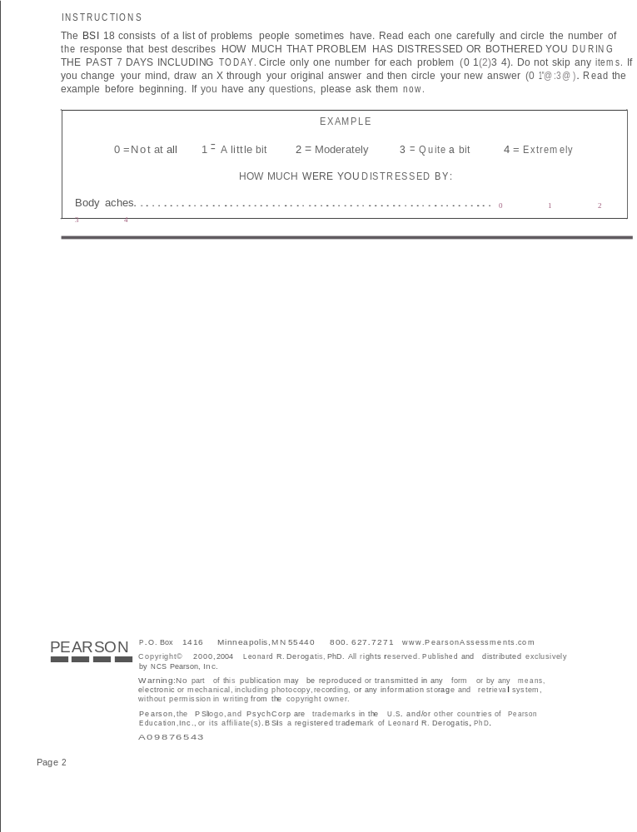

Thank you for participating in this survey today. We are very grateful for your input. If you have any questions about this study, you can contact Ms. Young Sook Kim directly at (865) 974-9134.

Vita
Young Sook Kim did her BA in Child Welfare at Sookmyung Women’s University in Korea, in 2002, and received an MSW from Columbia University in 2005. After graduate school, she began working at the Adult Day Health Care (ADHC) center in California. At the ADHC center, she assessed 60 out of 180 elderly clients every six months and oversaw the clinical case management for each client. These clients were mainly low-income elderly Korean immigrants who suffered from physical health issues, mental illness, cognitive deficit, and social isolation. In working with elderly women with depression for two years, she found that they needed professional help in coping with their physical and mental health problems. She did a doctoral degree in social work in the hopes of finding workable solutions to their problems. Her primary research interest is the treatment of depression and anxiety in elderly with mental illness within assisted living facilities. In addition, she is interested in cross-cultural research between Korea and the United States.

