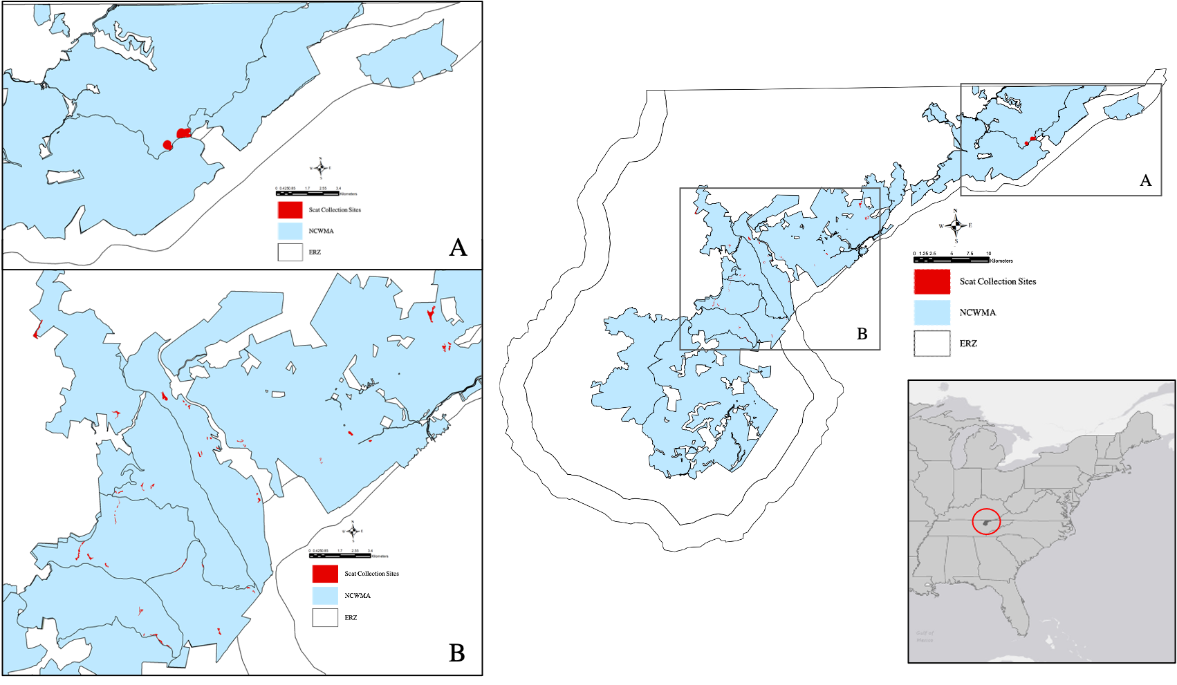
Figure 1.1. The study area with the 65 scat collection sites within the North Cumberland Wildlife Management Area (NCWMA; 79,318-ha) in the Elk Restoration Zone (ERZ) in the Cumberland Mountains, Tennessee, USA. Elk food habits evaluated using a next-generation sequencing protocol with feces collected from NCWMA from February through April 2019.

