Agrobacterium-mediated transformation of Hemp (Cannabis sativa L.).

A Thesis Presented for the
Master of Science
Degree
The University of Tennessee, Knoxville

Carthel Tyler Newton
January 2024

Copyright © 2024 by Carthel Tyler Newton.
All rights reserved.

Dedication
This is dedicated to my son, Israel, and to my wonderful partner, Rachel, without whom I would have never finished writing the darn thing to begin with.
Acknowledgement
I would like to express my sincere appreciation to Dr. C. Neal Stewart, Jr. for giving me the opportunity to work in his lab. His experience, guidance and support were vital to the planning, development and completion of this research work.
I would also like to thank the other members of my thesis committee, Dr. Feng Chen, Dr. Reginald Millwood and Dr. Kimberly Gwinn for their advice, insight, and encouragement.
Additionally, I would like to offer my special thanks to Jessica Stockdale and Lana Howe for their assistance and support for designing and conducting my experiments. I would like to offer my gratitude to Robert Sears for helping with molecular cloning and construct design. I would also like to thank the rest of the members of the Neal Stewart lab for their continued encouragement and support.
Finally, I would like to thank the Department of Plant Sciences at the University of Tennessee for giving me the opportunity to pursue my master’s degree. I would also like to thank the USDA for financial support.

Abstract
Agrobacterium-mediated transformation has long been utilized as a method of producing stably-transformed plants. This project describes an attempt to develop a system of producing stably-transformed hemp (C. sativa (L.)) plants. Because of its recalcitrance to in vitro tissue culture and regeneration, transformation studies of hemp have been severely limited. In this study, I combined media components that have been shown to improve tissue culture health and regeneration. Additionally, I used hemp cultivars and explant sources that have been reported to function well in in vitro systems. The results showed that the improved media components did not have a significant effect on plantlet regeneration. They did, however, show that the cultivars ‘Futura 75’ and ‘USO 31’ outperformed ‘Fedora 17’ in both the number of explants with shoots (responding explants) and the number of shoots per explant. Explant source was shown to have a significant effect on both the proportion of responding explants and the proportion of shoots per explant, with approximately 51% of hypocotyl explants producing shoots at a rate of 1.32 shoots per explant. Also noted was novel organogenesis in cotyledon explants. Finally, I transformed Cannabis with a chimeric growth regulator shown to improve in vitro regeneration across several other plant species. This growth regulator was introduced into a transformation vector which also contained mGFP5-ER as a reporter gene. While no regenerated plants were verified to have been transformed, several tissues in culture expressed GFP, with cotyledons exhibiting a low transformation rate of 6%. While these results were unfavorable (as no transformed plant was regenerated), I do believe that these experiments have laid important guidelines for future work in developing a stable transformation system for C. sativa (L.).

Table of Contents
Abstract v
Table of Contents vi
List of Tables viii
List of Figures x
Chapter 1 Introduction 1
Background 2
Agrobacterium-mediated transformation 2
Optimizing in vitro media components for Cannabis plant regeneration 4
Transcription factors, growth regulators and plant regeneration 5
References 7
Chapter 2 Utilizing improved media components and over-expression of the chimeric growth regulator, GRF-GIF, to improve de novo regeneration in hemp (Cannabis sativa (L.)). 1
Abstract 2
Introduction 2
Materials and Methods 5
Creation of cloning expression constructs and cloning into vectors. 5
Seed sterilization and germination. 6
Agrobacterium-mediated transformation. 7
Direct organogenesis and improved media components for hemp regeneration. 8
Verification of Agrobacterium-mediated plant transformation via polymerase chain reaction detection of mGFP5-ER and fluorescence spectroscopy. 10
Data Analyses 11
Results 12
Effect of media, explant source and cultivar on in vitro tissue culture of C. sativa. 12
Effect of Agrobacterium-mediated transformation and growth regulating factors on an in vitro tissue culture transformation system. 13
Discussion 15
Conclusion 20
Chapter 3 Conclusions and recommendations 21
List of References 24
Appendix 33

List of Tables

Table 1. Hypocotyl media tested to compare effects of improved media components. All media was pH-adjusted to 5.7 using sodium hydroxide. Media used in control treatments did not contain antibiotics. Abbreviations: ACS: acetosyringone; MES: 2-(N-morpholino)ethanesulfonic acid; GA: gibberellic acid; PEO-IAA: 2-(1H-Indol-3-yl)-4-oxo-4-phenyl-butyric acid; PPM: Plant Preservative Mixture; KAN: kanamycin; CFT: cefotaxime; CRB: carbenicillin; TIM: timentin; IAA: indole-3-acetic acid; ZTN RBS: zeotin riboside; NAA: 1-naphthaleneacetic acid 36
Table 2. Cotyledon media tested to compare effects of improved media components. All media was pH-adjusted to 5.7 using sodium hydroxide. Media used in control treatments did not contain antibiotics. Abbreviations: ACS: acetosyringone; MES: 2-(N-morpholino)ethanesulfonic acid; GA: gibberellic acid; PEO-IAA: 2-(1H-Indol-3-yl)-4-oxo-4-phenyl-butyric acid; PPM: Plant Preservative Mixture; KAN: kanamycin; CFT: cefotaxime; CRB: carbenicillin; TIM: timentin; IAA: indole-3-acetic acid; ZTN RBS: zeotin riboside; NAA: 1-naphthaleneacetic acid; TDZ: thidiazuron 37
Table 3. Effect of media on in vitro shoot regeneration. Displayed is the proportion of responding explants (explants with shoots) to total explants and the proportion of the number of shoots to responding explants. In vitro C. sativa hypocotyl and cotyledon explants were cultured on their respective media. Standard error is included. Non-parametric Kruskal-Wallis and pairwise Wilcoxon tests were used to determine significant differences (p<0.05). Different letters indicate significant differences between factors. 40
Table 4. Effect of cultivar on in vitro shoot regeneration. Displayed is the proportion of responding explants (explants with shoots) to total explants and the proportion of the number of shoots to responding explants. In vitro C. sativa hypocotyl and cotyledon explants were cultured on their respective media. Standard error is included. Non-parametric Kruskal-Wallis and pairwise Wilcoxon tests were used to determine significant differences (p<0.05). Different letters indicate significant differences between factors. *indicates a proportion below 0.01 ± 0.01 43
Table 5. Effect of explant source on in vitro shoot regeneration. Displayed is the proportion of responding explants (explants with shoots) to total explants and the proportion of the number of shoots to responding explants. In vitro C. sativa hypocotyl and cotyledon explants were cultured on their respective media. Standard error is included. Non-parametric Kruskal-Wallis and pairwise Wilcoxon tests were used to determine significant differences (p<0.05). Different letters indicate significant differences between factors. 44
Table 6. Effect of explant source, media, cultivar, and transformation vector on Agrobacterium contamination (Agro-contaminated) and transformation rate. Displayed is the proportion of contaminated explants (explants with residual Agrobacterium overgrowth) to total explants and the proportion of the explants showing expression of mGFP5-ER to responding explants. In vitro, C. sativa hypocotyl and cotyledon explants were cultured on their respective media. Standard error is included. Non-parametric Kruskal-Wallis and pairwise Wilcoxon tests were used to determine significant differences (p<0.05). Different letters indicate significant differences between factors. * indicates a proportion below 0.01 ± 0.01. 48
Table 7. Oligonucleotide primers designed for verification of stable, Agrobacterium-mediated transformation of C. sativa. All primers were designed via Primer3 (v. 4.1.0) and verified in silico via Snapgene. 50

List of Figures

Figure 1. A list of expression constructs used in Agrobacterium-mediated transformation experiments. (A) The test vector used a chimeric GRF3-GIF1 protein 2xCaMV 35s promoter::GRF3GIF1::OcsT; Ocs terminator. (B) The positive control vector used a green fluorescent protein reporter LAT59 promoter::mEmerald::OcsT. All plasmids are binary vectors and harbor a green, fluorescent reporter 2xCaMV 35S::mGFP5-ER::MasT; Mas terminator. Vectors also contain a kanamycin resistance gene for bacterial selection. 34
Figure 2. Sterilization, germination, and explant preparation. (A) Germinated seed 72 h. after liquid media germination. (B) Three-day-old seedlings after having seed coats removed and placed onto solid germination media, epicotyl indicated. (C) Seven-day-old seedlings with fully expanded first pair of true leaves. (D) Close-up of an individual seven-day-old seedling, arrows indicate dissection points. (E) Example of prepared hypocotyl explants, placed on co-cultivation media. (F) Example of prepared cotyledon explants, placed on co-cultivation media. Scale bars: 1 mm. 35
Figure 3. Cannabis sativa on rooting media in Magenta boxes. (A) A newly transferred cotyledonary node explant, with several novel shoots. (B) Shoots regenerated from a hemp hypocotyl explant. (C) Hypocotyl-derived hemp shoots with newly formed roots.. (D) Hypocotyl-derived hemp shoot with fully female flower structure. Note the pistils, structures with an ovule, and two protruding styles capped with stigmas extending beyond the bract. 38
Figure 4. Different plant regeneration patterns, derived from C. sativa hypocotyl and cotyledon explants. All photos were taken after 28 days on their respective shoot induction media (SIM). Scale bars: 1 mm. (A) Shoots regenerated from a hypocotyl explant cultured on MT1. Note two shoots growing in opposite pattern. (B) A single shoot regenerated from a hypocotyl explant cultured on MT2. (C) Multiple shoots regenerated from a cotyledon explant cultured on MT1. (D) A single shoot regenerated from a cotyledon explant cultured on MT2 39
Figure 5. Different tissue culture response patterns derived from C. sativa hypocotyl and cotyledon explants. All photos were taken after 28 days on their respective shoot induction media (SIM). Scale bars: 1 mm. (A) Hypocotyl explants cultured on MT1. Explants cultured on MT1 were observed to be generally healthier than those cultured on MT2. (B) Hypocotyl explants cultured on MT2. Arrows indicate tissue necrosis. (C) Cotyledon explants cultured on MT1. Cotyledon explants on MT1 exhibited induced callus, indicated by red arrows. Blue arrows indicate multiple shoots originating from callus. (D) Cotyledon explants cultured on MT2. Arrows indicate explants exhibiting necrosis. 41
Figure 6. Spontaneous root induction on C. sativa hypocotyl explants. All photos were taken after 14 days on their respective shoot induction media (SIM). Scale bars: 1 mm. (A) Hypocotyl explants cultured on MT1. Hypocotyl explants cultured on MT1 were observed to show spontaneous rooting. Shoots regenerated on MT1 were also observed to show more healthy, green growth when visually compared to those cultured MT2 (B) Hypocotyl explants cultured on MT2. Explants cultured on MT2 were, in general, not observed to exhibit spontaneous rooting. 42
Figure 7. Shoot development patterns observed in C. sativa hypocotyl explants. Scale bars: 1 mm. All photos are from the control group. (A) View of shoot primordia from hypocotyl explant, displaying opposite growth pattern. Photo taken after 7 days on MT1 (B) A single shoot, derived from hypocotyl explant. Note growth originating from the pith of explant, as opposed to growth originating from the cortex, as displayed in photo A. Photo taken after 14 days on MT1 (C) two shoots shoot originating from a hypocotyl explant. Arrows indicate shoots displaying opposite growth pattern. Photo taken after 28 days on MT1 (D) Hypocotyl explants showing single shoot growth pattern. Photo taken after 28 days on MT1. 45
Figure 8. Shoot development patterns observed in C. sativa cotyledon explants. Scale bars: 1 mm. All photos are from the control group. (A) Single shoot originating from a cotyledonary node on a cotyledon explant. Photo taken after 14 days on MT2. (B) Single shoot originating from callus derived from a cotyledon explant. Photo taken after 14 days on MT2 (C) Red arrows indicate multiple shoots originating from callus derived from a cotyledon explant. Green arrow indicates meristematic tissue in D. Photo taken after 14 days on MT2. (D) Close-up of meristematic tissue originating from cotyledon-derived callus. (E) Arrows indicate several, novel shoots originating from callus derived from cotyledon explant. Photo taken after 28 days on MT1. (F) The same cotyledon explant, shown in E, exhibiting continued novel shoot production. Photo taken after 42 days on MT1. 46
Figure 9. Green fluorescent protein (GFP) fluorescence in transformed C. sativa callus. Scale bars: 1 mm. Samples are labeled accordingly with explant source, media treatment and vector. Callus was photographed using an epifluorescent microscope. Column FL (fluorescence light conditions) was photographed using a GFP filter set (emission 509 nm). Column WL was photographed using the same epifluorescent under white light. 47
Figure 10. Verification of expression of transgene in C. sativa explants treated with Agrobacterium co-cultivation. (A) Fluorimetric measurement of agroinfiltrated leaves of C. sativa plant indicating expression of mGFP5-ER. Red arrow indicates expression, i.e., emission occurring at approximately 510 nm. This plant was used as a positive control. (B) Fluorimetric measurement of leaves regenerated from C. sativa explants treated with Agrobacterium co-cultivation. Blue arrow indicates where the emission should be measured. (C) Polymerase chain reaction (PCR) detection of GRFGIF chimeric gene (top) and mGFP5-ER (bottom). Red arrows indicate where amplicon is expected to appear (1421 bp and 756 bp, respectively). Blue arrows indicate the 1400 bp landmark in the ladder. Abbreviations: L: Hi-lo ladder; PC: positive control; WT: wild type; NC: negative control (water). 51
Figure 11. Verification of expression of transgene in C. sativa explants treated with Agrobacterium co-cultivation. (A) Hypocotyl-derived hemp shoots, cultured on MT1, exhibit tissue necrosis from kanamycin toxicity. (B) Hypocotyl-derived hemp shoots, cultured on MT2, exhibit bleaching from kanamycin toxicity. (C) Hypocotyl-derived hemp shoots, cultured on RIM, exhibit bleaching from kanamycin toxicity. (D) Abnormal growth pattern observed in hypocotyl-derived hemp shoots, cultured on MT2. 52

Chapter 1
Introduction

Background
Industrial hemp, Cannabis sativa L., is a crop that originates from eastern Asia. Since the passing of the 2018 Farm Bill that legalized low-THC hemp, it is now considered an agricultural commodity of high interest in the United States. Hemp has several industrial applications, including textiles, food, paper, bioplastics, insulation, and biofuel. There has also been increasing pharmacological interest in cannabinoids, the secondary metabolites produced in the leaves and flowers of hemp. The global industrial hemp market size was estimated at USD 4.13 billion in 2021 and is expected to grow at a compound annual growth rate of 16.8% from 2022 to 2030 (Grand View Research, 2022). The total value for US planted hemp in 2021 was approximately $824 million and the total acreage planted in 2021 totaled to 54.2 thousand acres (National Hemp Report, 2022). Because of its growing adoption rate as an agronomic crop, genetic engineering will likely be pursued for crop improvement (Andre et al., 2016). Therefore, an efficient method of generating genetically modified hemp plants is needed.

Agrobacterium-mediated transformation
Agrobacterium-mediated transformation is a cornerstone of plant biotechnology (Tzfira & Citovsky, 2006). Plant genetic transformation is most often performed using the plant pathogen Agrobacterium tumefaciens as method to deliver transgenes into a host plant (Hinchee et al., 1988). This is method of transformation integrates a reduced number of transgene copies into plants compared to the biolistic method and has become the industry standard for accomplishing stable expression of transgenes and avoiding transgene silencing (Joyce et al., 2010; Ramesh et al., 2004). Within the nucleus, genomic integration allows for possible inheritance of the DNA construct (containing selectable marker, a reporter gene, and the genes of interest) to the next generation (i.e., stable transformation). This is process is facilitated a set of virulence or vir genes on the Ti plasmid of Agrobacterium tumefaciens, which is used by the bacteria to infect plants (Schrammeijer et al., 2000). The activity of these genes contributes to the precise excision of the T-DNA from the Ti plasmid. This is a key step in the transfer of DNA from A. tumefaciens to the genomes of higher plants (Baker et al., 2005). Additionally, it is believed that, while natural exudates of wounded plants may be enough to activate vir genes, the addition of exogenous acetosyringone stimulates Agrobacterium to more effectively transfer T-DNA to host cells (Ali et al., 2007; Sheikholeslam & Weeks, 1987). The efficiency of this complex process can be highly dependent on several factors including explant orientation, explant source i.e., plant genotype and Agrobacterium strain (Frary & Earle, 1996; Horlemann et al., 2003; Jin et al., 2005; Ślusarkiewicz-Jarzina et al., 2005). Recent studies have shown success with agroinfiltration—a transient leaf-infiltration assay using engineered Agrobacterium— in various cultivars of hemp and transient expression of the GUS reporter (Deguchi, Bogush, et al., 2020). These experiments also showed the effects of Agrobacterium strain and cultivar on agroinfiltration in hemp utilizing vacuum infiltration. Previous studies have shown Agrobacterium-mediated transformation of hemp callus is possible, although shoot regeneration and transgenic plant recovery were unsuccessful (Feeney & Punja, 2003). More recent studies have established stable transformation of hemp, however with these studies reported regeneration rates of less than 1% (Zhang et al., 2021). Given the lack of publications regarding robust transformation systems, there is a need for an improved, high-throughput transformation protocol for use in genetic engineering.

Optimizing in vitro media components for Cannabis plant regeneration
Plant regeneration is a vital component to Agrobacterium-mediated transformation. Traditional, tissue-culture based methods of regeneration are based on the manipulation of plant growth regulators on responsive explants (Sugiyama, 2015). Unlocking the correct growth conditions and combinations of specific growth regulators to facilitate successful regeneration is a time consuming and laborious process that often fails. While many hemp regeneration protocols have been published, many of these protocols focus on nodal propagation as a method of maintaining in vitro germplasm (Lata et al., 2017; Richez-Dumanois et al., 1986). Proliferation of shoots, primarily from meristematic tissue, provide a dependable method of maintaining the genetic fidelity of elite lines and/or tissue-culture responsive lines. However, these methods are of limited use for biotechnological applications, as de novo regeneration is a primary pathway to produce stably transformed plants (de Almeida et al., 2012; Deo et al., 2010; Rai & Shekhawat, 2014). De novo shoot organogenesis of hemp, be it direct or indirect, has been the focus of many published studies. However, recalcitrance to regeneration has been shown in much of the existing literature (Feeney & Punja, 2003; Galán-Ávila et al., 2020; Mandolino & Ranalli, 1999; Wielgus et al., 2008). In addition to general recalcitrance, successful regeneration of hemp depends on a range of factors, including genotype, explant source, and media inputs (Galán-Ávila et al., 2021; Lata et al., 2009; Zhang et al., 2021). As researchers continue to examine the factors determining plant regeneration of in vitro cultivated hemp, new media inputs have emerged that demonstrate the ability to improved regeneration and help to overcome recalcitrance (Monthony et al., 2021). Therefore, there is a need to test how a combination of these factors might improve the regeneration rates of both “wild type” and transformed hemp tissues into complete, healthy hemp plants.

Transcription factors, growth regulators and plant regeneration
Overcoming the hurdle of recalcitrance has led many researchers to turn to manipulation of transcription factors involved in the signaling responsible for cell reprogramming, determining cell fate and differentiation. These transcription factors, referred to as developmental regulators, control the organized, spatial distribution of cells during the development of organs and embryos (Duclercq et al., 2011; Gaillochet & Lohmann, 2015; Gordon et al., 2007; Ikeuchi et al., 2013; Perez-Garcia & Moreno-Risueno, 2018). Overexpression of these developmental regulators has been shown to improve the regeneration rates of several monocot and dicot plant species (Boutilier et al., 2002; Kong et al., 2020; Lotan et al., 1998; Lowe et al., 2018; Stone et al., 2001; Zuo et al., 2002). While overexpression of these growth regulators can improve plant regeneration efficiency, the increased regeneration rate can come at the cost of negative pleiotropic effects (G. Luo & Palmgren, 2021; Srinivasan et al., 2007). Recent studies have shown that overexpression of GROWTH-REGULATING FACTORs (GRFs), either alone or in chimeras with GRF-INTERACTING FACTOR (GIF), significantly increases the regeneration efficiency of a broad range of species with limited pleiotropic effects that can easily be segregated out (Debernardi et al., 2020; Kong et al., 2020). One of the primary roadblocks present in hemp biotechnology is the relative recalcitrance of the plant. Previous experiments have shown hemp regeneration to be dependent on cultivar, tissue, plant age and growth regulator combination (Boonsnongcheep & Pongkitwitoon, 2020; Chaohua et al., 2016; Galán-Ávila et al., 2020). Because of these dependent factors, a reliable regeneration protocol has to be established (Monthony, Kyne, et al., 2021; Salentijn et al., 2019). Recently, a dicot GRF3-GIF1 chimera was shown to be effective in increasing the regeneration rate of hemp by 1.7-fold over the empty vector control (Zhang et al., 2021). The recent research concerning the GRF-GIF chimeric protein provides new opportunities for overcoming recalcitrance in all hemp varieties.
The goal of the research presented in this thesis was to develop a robust and high-throughput method of stable hemp transformation. There were two objectives for the research: 1) To transform two types of hemp explants with a construct containing the chimeric protein GRF3-GIF1 and utilizing the CaMV 35S promoter and NOS terminator to control expression. The construct contains a quantitative fluorescent marker (mGFP5-ER) for estimation of transformation efficiency. 2) To compare the effect of improved media components on de novo indirect organogenesis to the regeneration rates of a published protocol.

References

Adhikary, D., Kulkarni, M., El-Mezawy, A., Mobini, S., Elhiti, M., Gjuric, R., Ray, A., Polowick, P., Slaski, J. J., Jones, M. P., & Bhowmik, P. (2021). Medical Cannabis and industrial hemp tissue culture: Present status and future potential. Frontiers in Plant Science, 12, 627240. https://doi.org/10.3389/FPLS.2021.627240
Ali, S., Xianyin, Z., Xue, Q., Hassan, M. J., & Qian, H. (2007). Investigations for improved genetic transformation mediated by Agrobacterium tumefaciens in two rice cultivars. Biotechnology, 6(1), 138–147. https://doi.org/10.3923/biotech.2007.138.147
Andre, C. M., Hausman, J. F., & Guerriero, G. (2016). Cannabis sativa: The plant of the thousand and one molecules. Frontiers in Plant Science, 7, 174167. https://doi.org/10.3389/fpls.2016.00019
Baker, C. J., Mock, N. M., Whitaker, B. D., Roberts, D. P., Rice, C. P., Deahl, K. L., & Aver’yanov, A. A. (2005). Involvement of acetosyringone in plant–pathogen recognition. Biochemical and Biophysical Research Communications, 328(1), 130–136. https://doi.org/10.1016/j.bbrc.2004.12.153
Benková, E., & Hejátko, J. (2009). Hormone interactions at the root apical meristem. Plant Molecular Biology, 69, 383–396. https://doi.org/10.1007/S11103-008-9393-6
Boonsnongcheep, P., & Pongkitwitoon, B. (2020). Factors affecting micropropagation of Cannabis sativa L.: A review. Pharmaceutical Sciences Asia, 47(1), 21–29. https://doi.org/10.29090/psa.2020.01.019.0030
Boutilier, K., Offringa, R., Sharma, V. K., Kieft, H., Ouellet, T., Zhang, L., Hattori, J., Liu, C. M., Van Lammeren, A. A. M., Miki, B. L. A., Custers, J. B. M., & Van Lookeren Campagne, M. M. (2002). Ectopic expression of BABY BOOM triggers a conversion from vegetative to embryonic growth. Plant Cell, 14(8), 1737–1749. https://doi.org/10.1105/tpc.001941
Chaohua, C., Gonggu, Z., Lining, Z., Chunsheng, G., Qing, T., Jianhua, C., Xinbo, G., Dingxiang, P., & Jianguang, S. (2016). A rapid shoot regeneration protocol from the cotyledons of hemp (Cannabis sativa L.). Industrial Crops and Products, 83, 61–65. https://doi.org/10.1016/j.indcrop.2015.12.035
de Almeida, M., de Almeida, C. V., Graner, E. M., Brondani, G. E., & de Abreu-Tarazi, M. F. (2012). Pre-procambial cells are niches for pluripotent and totipotent stem-like cells for organogenesis and somatic embryogenesis in the peach palm: A histological study. Plant Cell Reports, 31(8), 1495–1515. https://doi.org/10.1007/S00299-012-1264-6
Debernardi, J. M., Tricoli, D. M., Ercoli, M. F., Hayta, S., Ronald, P., Palatnik, J. F., & Dubcovsky, J. (2020). A GRF–GIF chimeric protein improves the regeneration efficiency of transgenic plants. Nature Biotechnology, 38(11), 1274–1279. https://doi.org/10.1038/s41587-020-0703-0
Degenhardt, F., Stehle, F., & Kayser, O. (2017). The Biosynthesis of Cannabinoids. In Handbook of Cannabis and Related Pathologies: Biology, Pharmacology, Diagnosis, and Treatment (pp. 13–23). Academic Press. https://doi.org/10.1016/B978-0-12-800756-3.00002-8
Deguchi, M., Bogush, D., Weeden, H., Spuhler, Z., Potlakayala, S., Kondo, T., Zhang, Z. J., & Rudrabhatla, S. (2020). Establishment and optimization of a hemp (Cannabis sativa L.) agroinfiltration system for gene expression and silencing studies. Scientific Reports, 10(1), 3504–3516. https://doi.org/10.1038/s41598-020-60323-9
Deguchi, M., Dhir, S., Potlakayala, S., Dhir, S., Curtis, W. R., & Rudrabhatla, S. (2022). In planta female flower agroinfiltration alters the cannabinoid composition in industrial hemp (Cannabis sativa L.). Frontiers in Plant Science, 13, 921970. https://doi.org/10.3389/FPLS.2022.921970
Deguchi, M., Kane, S., Potlakayala, S., George, H., Proano, R., Sheri, V., Curtis, W. R., & Rudrabhatla, S. (2020). Metabolic engineering strategies of industrial hemp (Cannabis sativa L.): A brief review of the advances and challenges. Frontiers in Plant Science, 11, 580621. https://doi.org/10.3389/FPLS.2020.580621
Deo, P. C., Tyagi, A. P., Taylor, M., Harding, R., & Becker, D. (2010). Factors affecting somatic embryogenesis and transformation in modern plant breeding. The South Pacific Journal of Natural and Applied Sciences, 28(1), 27–40. https://doi.org/10.1071/SP10002
Dreger, M., Szalata, M., & Górska-Paukszta, M. (2020). Effect of auxin transport inhibitors on shoot organogenesis of hemp (Cannabis sativa L.) epicotyl explants. The 1st International Electronic Conference on Plant Sciences. https://sciforum.net/paper/view/conference/8843
Duclercq, J., Sangwan-Norreel, B., Catterou, M., & Sangwan, R. S. (2011). De novo shoot organogenesis: From art to science. Trends in Plant Science, 16(11), 597–606. https://doi.org/10.1016/j.tplants.2011.08.004
Engler, C., Kandzia, R., & Marillonnet, S. (2008). A one pot, one step, precision cloning method with high throughput capability. PLoS One, 3(11), e3647. https://doi.org/10.1371/JOURNAL.PONE.0003647
Feeney, M., & Punja, Z. K. (2003). Tissue culture and Agrobacterium-mediated transformation of hemp (Cannabis sativa L.). In Vitro Cellular and Developmental Biology - Plant, 39(6), 578–585. https://doi.org/10.1079/IVP2003454
Feeney, M., & Punja, Z. K. (2017). The role of agrobacterium-mediated and other gene-transfer technologies in cannabis research and product development. Cannabis Sativa L. - Botany and Biotechnology, 343–363. https://doi.org/10.1007/978-3-319-54564-6_16
Frary, A., & Earle, E. D. (1996). An examination of factors affecting the efficiency of Agrobacterium-mediated transformation of tomato. Plant Cell Reports, 16(3–4), 235–240. https://doi.org/10.1007/bf01890875
Gaillochet, C., & Lohmann, J. U. (2015). The never-ending story: From pluripotency to plant developmental plasticity. Development, 142(13), 2237–2249. https://doi.org/10.1242/dev.117614
Galán-Ávila, A., García-Fortea, E., Prohens, J., & Herraiz, F. J. (2020). Development of a direct in vitro plant regeneration protocol from Cannabis sativa L. seedling explants: Developmental morphology of shoot regeneration and ploidy level of regenerated plants. Frontiers in Plant Science, 11, 534467. https://doi.org/10.3389/fpls.2020.00645
Galán-Ávila, A., Gramazio, P., Ron, M., Prohens, J., & Herraiz, F. J. (2021). A novel and rapid method for Agrobacterium-mediated production of stably transformed Cannabis sativa L. plants. Industrial Crops & Products, 170, 113691. https://doi.org/10.1016/J.INDCROP.2021.113691
Gordon, S. P., Heisler, M. G., Reddy, G. V., Ohno, C., Das, P., & Meyerowitz, E. M. (2007). Pattern formation during de novo assembly of the Arabidopsis shoot meristem. Development, 134(19), 3539–3548. https://doi.org/10.1242/dev.010298
Grand View Research. (2022). Legal Cannabis Market Size, Share & Trends Analysis Report by Source (Marijuana, Hemp), by Derivative (CBD, THC), by End Use (Medical Use, Recreational Use, Industrial Use), by Region, and Segment Forecasts, 2022-2030. https://www.grandviewresearch.com/industry-analysis/legal-cannabis-market
Hennink, S. (1994). Optimisation of breeding for agronomic traits in fibre hemp (Cannabis sativa L.) by study of parent-offspring relationships. Euphytica, 78, 69–76. https://doi.org/10.1007/BF00021399
Hinchee, M. A. W., Connor-Ward, D. V., Newell, C. A., McDonnell, R. E., Sato, S. J., Gasser, C. S., Fischhoff, D. A., Re, D. B., Fraley, R. T., & Horsch, R. B. (1988). Production of transgenic soybean plants using agrobacterium-mediated DNA transfer. Bio/Technology, 6(8), 915–922. https://doi.org/10.1038/nbt0888-915
Honig, L. (2022). National Hemp Report Executive Summary.
Horlemann, C., Schwekendiek, A., Höhnle, M., & Weber, G. (2003). Regeneration and Agrobacterium-mediated transformation of hop (Humulus lupulus L.). Plant Cell Reports, 22(3), 210–217. https://doi.org/10.1007/s00299-003-0676-8
Ikeuchi, M., Sugimoto, K., & Iwase, A. (2013). Plant callus: Mechanisms of induction and repression. Plant Cell, 25(9), 3159–3173. https://doi.org/10.1105/tpc.113.116053
Ingvardsen, C. R., & Brinch-Pedersen, H. (2023). Challenges and potentials of new breeding techniques in Cannabis sativa. Frontiers in Plant Science, 14, 1154332. https://doi.org/10.3389/FPLS.2023.1154332
Ishida, T., Adachi, S., Yoshimura, M., Shimizu, K., Umeda, M., & Sugimoto, K. (2010). Auxin modulates the transition from the mitotic cycle to the endocycle in Arabidopsis. Development, 137(1), 63–71. https://doi.org/10.1242/DEV.035840
Jin, S., Zhang, X., Liang, S., Nie, Y., Guo, X., & Huang, C. (2005). Factors affecting transformation efficiency of embryogenic callus of Upland cotton (Gossypium hirsutum) with Agrobacterium tumefaciens. Plant Cell, Tissue and Organ Culture, 81(2), 229–237. https://doi.org/10.1007/s11240-004-5209-9
Joyce, P., Kuwahata, M., Turner, N., & Lakshmanan, P. (2010). Selection system and co-cultivation medium are important determinants of Agrobacterium-mediated transformation of sugarcane. Plant Cell Reports, 29(2), 173–183. https://doi.org/10.1007/s00299-009-0810-3
Kong, J., Martin-Ortigosa, S., Finer, J., Orchard, N., Gunadi, A., Batts, L. A., Thakare, D., Rush, B., Schmitz, O., Stuiver, M., Olhoft, P., & Pacheco-Villalobos, D. (2020). Overexpression of the Transcription Factor GROWTH-REGULATING FACTOR5 Improves Transformation of Dicot and Monocot Species. Frontiers in Plant Science, 11, 572319. https://doi.org/10.3389/fpls.2020.572319
Krishna Vrundha, C. P., Aswathi, N. V., & Thomas, T. D. (2021). The Role of Meta-topolin in Plant Morphogenesis In Vitro. Meta-Topolin: A Growth Regulator for Plant Biotechnology and Agriculture, 93–118. https://doi.org/10.1007/978-981-15-9046-7_10
Lata, H., Chandra, S., Khan, I. A., & Elsohly, M. A. (2016). </i>In vitro</i> propagation of Cannabis sativa L. and evaluation of regenerated plants for genetic fidelity and cannabinoids content for quality assurance. In Protocols for In Vitro Cultures and Secondary Metabolite Analysis of Aromatic and Medicinal Plants, Second Edition (pp. 275–288). Humana Press Inc. https://doi.org/10.1007/978-1-4939-3332-7_19
Lata, H., Chandra, S., Khan, I. A., & ElSohly, M. A. (2017). Micropropagation of Cannabis sativa L.-An update. In Cannabis sativa L. - Botany and Biotechnology (pp. 285–297). Springer International Publishing. https://doi.org/10.1007/978-3-319-54564-6_13
Lata, H., Chandra, S., Khan, I., & ElSohly, M. A. (2009). Thidiazuron-induced high-frequency direct shoot organogenesis of Cannabis sativa L. In Vitro Cellular and Developmental Biology - Plant, 45, 12–19. https://doi.org/10.1007/s11627-008-9167-5
Lata, H., Chandra, S., Techen, N., Khan, I. A., & ElSohly, M. A. (2016). In vitro mass propagation of Cannabis sativa L.: A protocol refinement using novel aromatic cytokinin meta-topolin and the assessment of eco-physiological, biochemical and genetic fidelity of micropropagated plants. Journal of Applied Research on Medicinal and Aromatic Plants, 3(1), 18–26. https://doi.org/10.1016/J.JARMAP.2015.12.001
Lee, R. D. W., & Cho, H. T. (2013). Auxin, the organizer of the hormonal/environmental signals for root hair growth. Frontiers in Plant Science, 4, 65033. https://doi.org/10.3389/FPLS.2013.00448
Li, L., Yu, S., Chen, J., Cheng, C., Sun, J., Xu, Y., Deng, C., Dai, Z., Yang, Z., Chen, X., Tang, Q., Su, J., & Zhang, X. (2022). Releasing the Full Potential of Cannabis through Biotechnology. Agronomy, 12(10), 2439. https://doi.org/10.3390/AGRONOMY12102439
Lotan, T., Ohto, M. A., Matsudaira Yee, K., West, M. A. L., Lo, R., Kwong, R. W., Yamagishi, K., Fischer, R. L., Goldberg, R. B., & Harada, J. J. (1998). Arabidopsis LEAFY COTYLEDON1 is sufficient to induce embryo development in vegetative cells. Cell, 93(7), 1195–1205. https://doi.org/10.1016/s0092-8674(00)81463-4
Lowe, K., La Rota, M., Hoerster, G., Hastings, C., Wang, N., Chamberlin, M., Wu, E., Jones, T., & Gordon-Kamm, W. (2018). Rapid genotype “independent” Zea mays L. (maize) transformation via direct somatic embryogenesis. In Vitro Cellular and Developmental Biology - Plant, 54(3), 240–252. https://doi.org/10.1007/s11627-018-9905-2
Lubell-Brand, J. D., Kurtz, L. E., & Brand, M. H. (2021). An In Vitro–Ex Vitro Micropropagation System for Hemp. HortTechnology, 31(2), 199–207. https://doi.org/10.21273/HORTTECH04779-20
Luo, G., & Palmgren, M. (2021). GRF-GIF Chimeras Boost Plant Regeneration. Trends in Plant Science, 26(3), 201–204. https://doi.org/10.1016/j.tplants.2020.12.001
Luo, X., Reiter, M. A., d’Espaux, L., Wong, J., Denby, C. M., Lechner, A., Zhang, Y., Grzybowski, A. T., Harth, S., Lin, W., Lee, H., Yu, C., Shin, J., Deng, K., Benites, V. T., Wang, G., Baidoo, E. E. K., Chen, Y., Dev, I., … Keasling, J. D. (2019). Complete biosynthesis of cannabinoids and their unnatural analogues in yeast. Nature, 567(7746), 123–126. https://doi.org/10.1038/s41586-019-0978-9
Mandolino, G., & Ranalli, P. (1999). Advances in biotechnological approaches for hemp breeding and industry. In Advances in hemp research, 9 (pp. 185–212).
Mechoulam, R. (2012). Cannabis—A Valuable Drug That Deserves Better Treatment. Mayo Clinic Proceedings, 87(2), 107–109. https://doi.org/10.1016/J.MAYOCP.2011.12.002
Monthony, A. S., Kyne, S. T., Grainger, C. M., & Jones, A. M. P. (2021). Recalcitrance of Cannabis sativa to de novo regeneration; a multi-genotype replication study. PLoS One, 16(8), e0235525. https://doi.org/10.1371/JOURNAL.PONE.0235525
Monthony, A. S., Page, S. R., Hesami, M., & Jones, A. M. P. (2021). The Past, Present and Future of Cannabis sativa Tissue Culture. Plants 2021, Vol. 10, Page 185, 10(1), 185. https://doi.org/10.3390/PLANTS10010185
Movahedi, M., Ghasemiomran, V., & Torabi, S. (2016a). Effect of explants type and plant growth regulators on in vitro callus induction and shoot regeneration of Cannabis sativa L. Iranian Journal of Medicinal and Aromatic Plants Research, 32(1), 83–97. https://doi.org/10.22092/IJMAPR.2016.106139
Movahedi, M., Ghasemiomran, V., & Torabi, S. (2016b). In vitro callus induction and regeneration of medicinal plant Cannabis sativa L. Iranian Journal of Medicinal and Aromatic Plants Research, 32(5), 758–769. https://doi.org/10.22092/IJMAPR.2016.107859
National Hemp Report. (2022).
Perez-Garcia, P., & Moreno-Risueno, M. A. (2018). Stem cells and plant regeneration. Developmental Biology, 442(1), 3–12. https://doi.org/10.1016/j.ydbio.2018.06.021
Rai, M. K., & Shekhawat, N. S. (2014). Recent advances in genetic engineering for improvement of fruit crops. Plant Cell, Tissue and Organ Culture (PCTOC), 116, 1–15. https://doi.org/10.1007/S11240-013-0389-9
Ramesh, S., Nagadhara, D., Reddy, V. D., & Rao, K. V. (2004). Production of transgenic indica rice resistant to yellow stem borer and sap-sucking insects, using super-binary vectors of Agrobacterium tumefaciens. Plant Science, 166(4), 1077–1085. https://doi.org/10.1016/j.plantsci.2003.12.028
Ren, M., Tang, Z., Wu, X., Spengler, R., Jiang, H., Yang, Y., & Boivin, N. (2019). The origins of cannabis smoking: Chemical residue evidence from the first millennium BCE in the Pamirs. Science Advances, 5(6), 1391–1403. https://doi.org/10.1126/SCIADV.AAW1391/SUPPL_FILE/AAW1391_SM.PDF
Richez-Dumanois, C., Braut-Boucher, F., Cosson, L., & Paris, M. (1986). Multiplication végétative in vitro du chanvre (Cannabis sativa L.). Application à la conservation des clones sélectionnés. Agronomie, 6(5), 487–495. https://doi.org/10.1051/AGRO:19860510
Rodziewicz, P., Loroch, S., Marczak, Ł., Sickmann, A., & Kayser, O. (2019). Cannabinoid synthases and osmoprotective metabolites accumulate in the exudates of Cannabis sativa L. glandular trichomes. Plant Science, 284, 108–116. https://doi.org/10.1016/j.plantsci.2019.04.008
Russo, E. B., Jiang, H.-E., Li, X., Sutton, A., Carboni, A., del Bianco, F., Mandolino, G., Potter, D. J., Zhao, Y.-X., Bera, S., Zhang, Y.-B., Lü, E.-G., Ferguson, D. K., Hueber, F., Zhao, L.-C., Liu, C.-J., Wang, Y.-F., & Li, C.-S. (2008). Phytochemical and genetic analyses of ancient cannabis from Central Asia. Journal of Experimental Botany, 59(15), 4171–4182. https://doi.org/10.1093/jxb/ern260
Salentijn, E. M. J., Petit, J., & Trindade, L. M. (2019). The complex interactions between flowering behavior and fiber quality in hemp. Frontiers in Plant Science, 10, 444741. https://doi.org/10.3389/fpls.2019.00614
Schrammeijer, B., Beijersbergen, A., Idler, K. B., Melchers, L. S., Thompson, D. V., & Hooykaas, P. J. J. (2000). Sequence analysis of the vir-region from Agrobacterium tumefaciens octopine Ti plasmid pTi15955. Journal of Experimental Botany, 51(347), 1167–1169. https://doi.org/10.1093/jexbot/51.347.1167
Sheikholeslam, S. N., & Weeks, D. P. (1987). Acetosyringone promotes high efficiency transformation of Arabidopsis thaliana explants by Agrobacterium tumefaciens. Plant Molecular Biology, 8(4), 291–298. https://doi.org/10.1007/BF00021308
Shiels, D., Prestwich, B. D., Koo, O., Kanchiswamy, C. N., O’Halloran, R., & Badmi, R. (2022). Hemp Genome Editing—Challenges and Opportunities. Frontiers in Genome Editing, 4, 823486. https://doi.org/10.3389/FGEED.2022.823486
Shoyama, Y., Yagi, M., Nishioka, I., & Yamauchi, T. (1975). Biosynthesis of cannabinoid acids. Phytochemistry, 14(10), 2189–2192. https://doi.org/10.1016/S0031-9422(00)91096-3
Simiyu, D. C., Jang, J. H., & Lee, O. R. (2022). Understanding Cannabis sativa L.: Current Status of Propagation, Use, Legalization, and Haploid-Inducer-Mediated Genetic Engineering. Plants, 11(9), 1236. https://doi.org/10.3390/PLANTS11091236
Ślusarkiewicz-Jarzina, A., Ponitka, A., & Kaczmarek, Z. (2005). Influence of cultivar, explant source and plant growth regulator on callus induction and plant regeneration of Cannabis sativa L. Acta Biologica Cracoviensia Series Botanica, 47(2), 145–151.
Smýkalová, I., Vrbová, M., Cvečková, M., Plačková, L., Žukauskaitė, A., Zatloukal, M., Hrdlička, J., Plíhalová, L., Doležal, K., & Griga, M. (2019). The effects of novel synthetic cytokinin derivatives and endogenous cytokinins on the in vitro growth responses of hemp (Cannabis sativa L.) explants. Plant Cell, Tissue and Organ Culture, 139(2), 381–394. https://doi.org/10.1007/S11240-019-01693-5
Srinivasan, C., Liu, Z., Heidmann, I., Supena, E. D. J., Fukuoka, H., Joosen, R., Lambalk, J., Angenent, G., Scorza, R., Custers, J. B. M., & Boutilier, K. (2007). Heterologous expression of the BABY BOOM AP2/ERF transcription factor enhances the regeneration capacity of tobacco (Nicotiana tabacum L.). Planta, 225(2), 341–351. https://doi.org/10.1007/s00425-006-0358-1
STEWART, C. N., & VIA, L. E. (1993). A rapid CTAB DNA isolation technique useful for RAPD fingerprinting and other PCR applications. BioTechniques, 14(5), 748–751.
Stone, S. L., Kwong, L. W., Yee, K. M., Pelletier, J., Lepiniec, L., Fischer, R. L., Goldberg, R. B., & Harada, J. J. (2001). LEAFY COTYLEDON2 encodes a B3 domain transcription factor that induces embryo development. Proceedings of the National Academy of Sciences of the United States of America, 98(20), 11806–11811. https://doi.org/10.1073/pnas.201413498
Sugiyama, M. (2015). Historical review of research on plant cell dedifferentiation. Journal of Plant Research, 128(3), 349–359. https://doi.org/10.1007/s10265-015-0706-y
Tahir, M. N., Shahbazi, F., Rondeau-Gagné, S., & Trant, J. F. (2021). The biosynthesis of the cannabinoids. Journal of Cannabis Research, 3(1), 1–12. https://doi.org/10.1186/S42238-021-00062-4
Takato, S., Kakei, Y., Mitsui, M., Ishida, Y., Suzuki, M., Yamazaki, C., Hayashi, K. I., Ishii, T., Nakamura, A., Soeno, K., & Shimada, Y. (2017). Auxin signaling through SCFTIR1/AFBs mediates feedback regulation of IAA biosynthesis. Bioscience, Biotechnology, and Biochemistry, 81(7), 1320–1326. https://doi.org/10.1080/09168451.2017.1313694
Türkölmez, N., Kılıç, G. Ç., Arslan, N., Tilkat, E. A., Tilkat, E., & Çiftçi, Y. Ö. (2023). Production of cannabinoids by biotechnological methods including synthetic biology. Türk Bilimsel Derlemeler Dergisi, 16(1), 75–91.
Tzfira, T., & Citovsky, V. (2006). Agrobacterium-mediated genetic transformation of plants: biology and biotechnology. Current Opinion in Biotechnology, 17(2), 147–154. https://doi.org/10.1016/j.copbio.2006.01.009
Weber, E., Engler, C., Gruetzner, R., Werner, S., & Marillonnet, S. (2011). A modular cloning system for standardized assembly of multigene constructs. PloS One, 6(2). https://doi.org/10.1371/JOURNAL.PONE.0016765
Wielgus, K., Luwanska, A., Lassocinski, W., & Kaczmarek, Z. (2008). Estimation of Cannabis sativa L. tissue culture conditions essential for callus induction and plant regeneration. Journal of Natural Fibers, 5(3), 199–207. https://doi.org/10.1080/15440470801976045
Willow, J., Silva, A. I., Taning, C. N. T., Smagghe, G., & Veromann, E. (2023). Towards dsRNA-integrated protection of medical Cannabis crops: considering human safety, recent- and developing RNAi methods, and research inroads. Pest Management Science, 79(4), 1267–1272. https://doi.org/10.1002/PS.7323
Wróbel, T., Dreger, M., Wielgus, K., & Słomski, R. (2022). Modified Nodal Cuttings and Shoot Tips Protocol for Rapid Regeneration of Cannabis sativa L. Journal of Natural Fibers, 19(2), 536–545. https://doi.org/10.1080/15440478.2020.1748160
Zarei, A., Davis, B., Feyissa, B. A., Dinani, E. T., & Simons, B. (2023). Improvement of mineral nutrition and rooting efficiency of Cannabis sativa L. for in vitro large-scale propagation. In Vitro Cellular and Developmental Biology - Plant, 59(1), 95–105. https://doi.org/10.1007/S11627-022-10320-6/FIGURES/4
Zhang, X., Xu, G., Cheng, C., Lei, L., Sun, J., Xu, Y., Deng, C., Dai, Z., Yang, Z., Chen, X., Liu, C., Tang, Q., & Su, J. (2021). Establishment of an Agrobacterium-mediated genetic transformation and CRISPR/Cas9-mediated targeted mutagenesis in Hemp (Cannabis Sativa L.). Plant Biotechnology Journal, 19(10), 1979–1987. https://doi.org/10.1111/PBI.13611
Žukauskaitė, A., Saiz-Fernández, I., Bieleszová, K., Iškauskienė, M., Zhang, C., Smýkalová, I., Dzedulionytė, K., Kubeš, M. F., Sedlářová, M., Pařízková, B., Pavlović, I., Vain, T., Petřík, I., Malinauskienė, V., Šačkus, A., Strnad, M., Robert, S., Napier, R., Novák, O., & Doležal, K. (2023). New PEO-IAA-Inspired Anti-Auxins: Synthesis, Biological Activity, and Possible Application in Hemp (Cannabis Sativa L.) Micropropagation. Journal of Plant Growth Regulation, 7547-7563. https://doi.org/10.1007/S00344-023-11031-X
Zuo, J., Niu, Q. W., Frugis, G., & Chua, N. H. (2002). The WUSCHEL gene promotes vegetative-to-embryonic transition in Arabidopsis. Plant Journal, 30(3), 349–359. https://doi.org/10.1046/j.1365-313X.2002.01289.x

Chapter 2
Utilizing improved media components and over-expression of the chimeric growth regulator, GRF-GIF, to improve de novo regeneration in hemp (Cannabis sativa (L.)).

Abstract
Since the passing of the 2018 Farm Bill that legalized low-THC hemp, Cannabis sativa has become a species of interest for genetic engineering. Cannabis produces many secondary metabolites of pharmacological interest, the most important of these being cannabinoids. The recently mapped genome, as well as the elucidation of cannabinoid biosynthetic pathways, has created increased need for a robust system for the stable transformation of Cannabis. However, publications outlining successful protocols for the regeneration and stable transformation of Cannabis are few and have not shown functional transgenic plant recovery rates, likely because of the reported recalcitrance of the plant. In this study, I attempted to combine “improved” media components and an auxin antagonist with the overexpression of the GRF-GIF chimera, have all shown to improve shoot regeneration Cannabis sativa. However, I was unable to show any effect of the improved media components and was unable to regenerate any transgenic plantlets.

Introduction
Cannabis sativa is perhaps the most well-known member of the Cannabaceae family, having a well-documented history as being an illicit drug source. Historical usage of the plant, not only as a psychoactive compound source, but as a textile, medicine and food, dates as far back as 2700 BCE (Russo et al., 2008). In the past decade, Cannabis has seen a resurgence in interest as an agronomic crop (Honig, 2022; Mechoulam, 2012; Ren et al., 2019). Mass breeding, as a method of selecting for preferred traits, has created divergent genotypes, differentiated by phytochemical composition (Hennink, 1994). Drug types of Cannabis (marijuana) contain high amounts of the psychoactive cannabinoid Δ 9-tetrahydrocannabinol (Δ9-THC). Hemp types are grown to produce seed, oil and fiber, and contain low amounts of Δ9-THC. Hemp types also produce higher amounts of cannabidiol (CBD), a non-psychoactive secondary metabolite. Both cannabinoids, as well as the entire cannabinoid suite produced by the plant, are of great interest as potential therapeutics. Researchers have identified several of the genes functioning the cannabinoid biosynthesis pathway (Degenhardt et al., 2017; X. Luo et al., 2019; Rodziewicz et al., 2019; Shoyama et al., 1975; Tahir et al., 2021). These genes, as well as the cannabinoid biosynthesis pathway, must be more carefully understood if hemp and its cannabinoids are to be fully utilized (Willow et al., 2023). Thus, there is a need for an effective method of performing Cannabis genetic engineering.
However, genetic engineering for crop improvement in hemp has had a somewhat difficult time with functional validation of these genes. This is due to the lack of a published, efficient Agrobacterium-mediated transformation and regeneration protocol. Few reports of stable transformation of hemp exist, due largely to the plant’s recalcitrance to in vitro regeneration when compared to other model plants. (Chaohua et al., 2016; Galán-Ávila et al., 2020; Lata, Chandra, Khan, et al., 2016; Shiels et al., 2022; Wielgus et al., 2008). De novo regeneration in hemp has shown to be dependent on a range of factors, including genotype, explant source, and media inputs (Adhikary et al., 2021; Li et al., 2022). These studies helped to identify several cultivars (‘USO 31’, ‘Futura 75’ and ‘Fedora 17’) that seem to respond favorably in in vitro tissue cultures systems, as well as some positively responding explant sources (hypocotyls and cotyledonary node) (Chaohua et al., Deguchi et al., 2020, 2016; Galán-Ávila et al., 2020, 2021). Few of these publications, however, have addressed the entirety of these factors in pursuit of developing a functional hemp tissue culture system, be it through direct or indirect organogenesis (Deguchi et al., 2020; Lata et al., 2009; Monthony et al., 2021). Some studies have produced methods that increase the efficiency of shoot regeneration through modification of media components and explant source selection. The synthetic cytokinin meta-Topolin can improve shoot induction in various genotypes of hemp (Vrundha et al., 2021; Lata et al., 2016a). Use of PEO-IAA, an auxin antagonist, has shown to overcome the higher levels of endogenous auxin that likely produces apical dominance in hemp explants (Smýkalová et al., 2019; Žukauskaitė et al., 2023). Hypocotyl- and cotyledonary node-derived explants have shown promising results when utilized in both direct and indirect organogenesis regeneration systems(Chaohua et al., 2016; Zhang et al., 2021). Increased levels of plant tissue culture media micronutrients, also known as mesovitamins, have been shown to reduce the occurrence of tissue hyperhydricity, increase shoot number, and improve shoot elongation in hemp micropropagation systems (Lubell-Brand et al., 2021; Zarei et al., 2023). These studies have provided keen insights into how hemp tissue culture efficiency might be increased through utilization of improved media components and explant sources shown to be responsive to in vitro tissue culture.
Agrobacterium-mediated transformation, an integral tool utilized in genetic engineering, has also shown to have reduced effectiveness when working with Cannabis sativa L. (Deguchi, Bogush, et al., 2020; Feeney & Punja, 2017; Zhang et al., 2021). Methods of transformation through agroinfiltration have proven effective to produce transient expression (Deguchi, Bogush, et al., 2020; Türkölmez et al., 2023). These studies provided results vital to optimization of Cannabis transformation protocols through selection of Agrobacterium strain and explant source. Stable hemp transformation through whole plant regeneration has proven more elusive. Some published protocols have shown promise. Researchers have utilized manipulation of transcription factors functioning as developmental regulators to overcome the general recalcitrance of Cannabis. Overexpression of the growth regulator GROWTH-REGULATING FACTOR 3 (GRF3), in chimeric transcriptional complex with GRF-INTERACTING FACTOR (GIF), was shown to improve hemp indirect organogenesis. Researchers in that study verified stable transformation but were only able to recover and acclimatize a single plant from 3500 explants (Zhang et al., 2021). Another protocol showed potential for a high-throughput system of creating stably transformed hemp plants, derived through direct organogenesis (Galán-Ávila et al., 2021). Unfortunately, this study did not attempt to root and acclimatize transformed plants for verification of stably transformed hemp plants. Thus, a functional protocol for the stable transformation of Cannabis remains to be fully elucidated. These issues, as well as those associated with de novo regeneration, have prevented the development of a robust and high-throughput Agrobacterium-mediated transformation and regeneration protocol for Cannabis sativa L.
In this research, I attempted to develop a functional Agrobacterium-mediated transformation and regeneration protocol. In that pursuit, I investigated the effect of improved media components that have shown to improve de novo regeneration in hemp tissue culture. Thus, I compared selected explants cultivated on regeneration media containing increased meso-vitamins, meta-Topolin, and PEO-IAA. Results of these experiments were compared with those of a proposed rapid and high-throughput hemp transformation and regeneration system published in 2021 (Galán-Ávila et al., 2021).

Materials and Methods

Creation of cloning expression constructs and cloning into vectors.
An effective hemp GRF3-GIF1 chimera has been previously elucidated (Zhang et al., 2021). The GRF3/GIF1 gene sequence was assembled, using Snapgene, from publicly available DNA sequences and synthesized by Integrated DNA Technologies (Coralville, Iowa). For the test vector, the GRF-GIF chimera was driven under the 2x35S promoter of the cauliflower mosaic virus (CaMV) for constitutive expression. For the positive control vector, the late anther tomato promoter, LAT59, was used to drive the green fluorescent protein mEmerald. The neomycin phosphotransferase II gene (NPTII) was used to confer resistance to kanamycin for antibiotic selection in both vectors. Additionally, both vectors contained a green fluorescent protein mGFP5-ER, as well as right and left borders to enable Agrobacterium-mediated insertion into the genome (Figure 1). All vectors were assembled using Golden Gate assembly method of molecular cloning (Engler et al., 2008). Expression cassettes were verified at each level of Golden Gate reaction with both PCR and sequencing. These expression cassettes were cloned into the pAGM4723 binary vector from the lab of Dr. Marillonnet (Weber et al., 2011). Verified final vectors were then transformed into Agrobacterium tumefaciens strain (AGL1) using the heat-shock method.

Seed sterilization and germination.
Mature hemp seeds from three cultivars (‘Futura 75’, ‘Fedora 17’, and ‘USO 31’) were chemically scarified a solution of 70% (v/v) sulfuric acid for 20 minutes, under agitation. Seeds were then rinsed three times with water and placed into a solution of 50% (v/v) sodium hypochlorite for 1 hour, under agitation. Sterile seeds were washed three times with sterilized water and placed in 250 ml flasks (Figure 2A). Flasks were filled with 60 ml of half-strength Murashige and Skoog (MS) basal salts-based liquid media containing 15 g/L sucrose, 3% (v/v) H₃O₃ and 2% (v/v) Plant Preservative Mixture (Plant Cell Technology, Washington, DC), pH 5.7. All media was pH adjusted using 0.1 M NaOH. Flasks were placed on a shaker at 100 RPM and were germinated at 24° C with a 16/8-hour photoperiod. The germination media was changed daily. After 3 days, the germinated seedlings were then placed on sterile germination media containing half-strength Murashige and Skoog (MS) basal salts-based liquid media containing 15 g/L sucrose, 2% (v/v) Plant Preservative Mixture and 3 g of Gelzan (MillaporeSigma, Burlington, MA), pH 5.7 (Figure 2B). Seedlings were then allowed to grow for 7 days at 22° C with a 16/8-hour photoperiod (Figure 2C).

Agrobacterium-mediated transformation.
Cultures of Agrobacterium tumefaciens, containing plasmid constructs, were grown in 50 ml of yeast extract and peptone (YEP) broth with 500 mg/L of rifampicin and 50 mg/L of kanamycin. Cultures were then incubated at 27˚ C until reaching an optical density of 0.6-0.7. Cultures were centrifuged at 4000 rpm for 10 minutes and then resuspended in 15 ml of inoculation media (IM) containing ½ MS basal medium with vitamins and 15 g/L sucrose. This media was pH adjusted to 5.7 using 0.1 M NaOH and autoclaved before adding 39.2 mg/L acetosyringone and 500 mg/L meta-Topolin (MET). The A. tumefaciens/IM was then used for plant transformation experiments.
For explants to be used in transformation experiments, an excision is made just below the apical meristem to remove the shoot apical meristem (SAM) and cotyledons. Another excision is made above the root meristem to remove the meristem and radicle (Figure 2D). The hypocotyl explants were then selected away from the cotyledons, radical, and meristem tissues (Figure 2E). Cotyledon explants were separated from the cotyledonary node (Figure 2F). Both cotyledons and hypocotyls were retained for transformation experiments. Explants were placed into IM solution and incubated at 22° C for 40 minutes. After 40 minutesA. tumefaciens inoculum was removed and explants were placed on sterile absorbent material for 30 minutes to removed excess A. tumefaciens inoculum. Explants to be used as a control were not treated with Agrobacterium and instead were placed directly on to either MT1 or MT2 media containing no antibiotics for selection or Agrobacterium control.

Direct organogenesis and improved media components for hemp regeneration.
To test the effect of improved media components, Agrobacterium-treated explants were given one of two media treatments (Table 1,2). Media treatment 1 (MT1) utilized the published, direct organogenesis regeneration protocol developed by Dr. Galán Avila. (Galán-Ávila et al., 2020, 2021). Media treatment 2 (MT2) was developed by combining published improvements of several hemp tissue culture papers. Cotyledon explants given MT1 media were placed on ½ MS-based basal media with vitamins, solid co-cultivation medium (MT1-C-CCM) containing 15 g/L sucrose, 3 g/L Gelzan, 39.2 mg/L acetosyringone, 0.4 mg/L thidiazuron (TDZ), and 0.2 mg/L 1-naphthaleneacetic acid (NAA). Hypocotyl explants in MT1 media were placed on solid co-cultivation medium (MT1-H-CCM) containing ½ MS-based basal media with vitamins, 15 g/L sucrose, 39.2 mg/L acetosyringone and 3 g/L Gelzan. All explants given MT2 media were placed on solid co-cultivation medium (MT2-CCM) containing MS-based basal media with vitamins, 5 g/L sucrose, 3 g/L Gelzan, 39.2 mg/L acetosyringone (ACS), .0.5 mg/L MET, 0.1 mg/L gibberellic acid (GA) and 0.29 mg/L PEO-IAA four days. In addition, All MT2 media contained increased concentrations of plant vitamins, as well as vitamins plus added “mesos” [calcium chloride (anhydrous), magnesium sulfate (anhydrous), and potassium phosphate (monobasic) nutrients] (Table 1,2). All explants on both treatments were maintained under light (16 hr day/8 hr dark, 22 °C) for four days.
After 4 days, after four days explants were removed from co-cultivation media and allowed to dry on sterile paper towels in laminar flow hood for 30 minutes. Explants were then treated with liquid MS media solution containing 6 mg/L timentin and 2% (v/v) Plant Preservative Mixture. Explants in this solution were lightly agitated for 10 minutes before being rinsed three times in sterile water and allowed to dry for an additional 30 minutes on paper towels in laminar flow hood. Once dried, explants were immediately moved to the shoot induction media correlated with its media treatment (Tables 1 and 2). Hypocotyl and cotyledon explants receiving MT1 were placed on MT1-H-SIM and MT1-C-SIM, respectively. Explants treated with Agrobacterium were placed on media containing 100 mg/l kanamycin (KAN) and treatment-specific combinations of antibiotics to be used to control Agrobacterium overgrowth (Table 1,2). Both hypocotyl and cotyledon explants receiving MT2 were placed on MT2-SIM. All explants on both treatments were maintained under light (16 hr day/8 hr dark, 22 °C) for 28 days. Explants were placed on new media every 14 days. Observation of organogenesis, as well as instances of selection-induced tissue death and Agrobacterium overgrowth, were recorded every 14 days. Explants were also screened for expression of GFP. New shoots, evidence of organogenesis, and GFP expression were documented using an epifluorescent microscope (Olympus stereo microscope model SZX12, Olympus America, Center Valley, PA) using a GFP filter set (emission 509 nm) and QCapture 10 imaging software, and an Olympus Q-colour 5.
After 28 days, shoots were counted and documented before being excised from explants and moved to rooting media. As the Galán-Avila protocol (MT1) did not test examine root induction, all explants were moved to sterilized Magenta boxes containing previously tested rooting media (RIM). During this portion of the experiment, the only difference between the two media treatments was the combination and concentrations of antibiotics used to control Agrobacterium overgrowth. To encourage root induction and to reduce selection pressure, the concentration of kanamycin in this media was reduced from 100 mg/L to 50 mg/L. Explants used as a control were moved to RIM containing no antibiotics for selection or Agrobacterium control. All explants on both treatments were maintained under light (16 hr day/8 hr dark, 22 °C) for 28 days (Figure 3). Explants were placed on new media every 14 days. Explants were also screened for expression of GFP via UV lamp excitation. After 28 days, rooted shoots were moved to potting mix in temperature-controlled growth chamber and maintained under light (16 hr day/8 hr dark, 22 °C) for 14 days. Rooted shoots were also maintained under humidity control to acclimatize to ex vitro conditions. Acclimatized, rooted plants were moved to greenhouse conditions and maintained under similar light and temperature controls. Explants that showed healthy tissue growth that did not root were maintained on media in in vitro conditions for another 14 days.

Verification of Agrobacterium-mediated plant transformation via polymerase chain reaction detection of mGFP-ER and fluorescence spectroscopy.
Approximately 74 days after explant transformation, samples (leaves or newly developed meristems) were taken from the top of regenerated plants and genomic DNA was extracted following the CTAB method (STEWART & VIA, 1993). Integrity and quality of extracted genomic DNA were quantified via agarose gel electrophoresis and Nanodrop spectrophotometer (Thermo Scientific, Waltham, MA, USA). DNA templates were diluted to 100 ng/μL where appropriate. Primers were designed via Primer3 (v. 4.1.0) and verified in silico via Snapgene. To verify the integration of the T-DNA in the plant genome, transgene-specific primers were designed, and transgene fragments were amplified via polymerase chain reaction (PCR). Genomic DNA extracted from E. coli harboring the binary vector used for transformations was used as a positive control. Nuclease-free water was used as a negative control. PCR reactions were performed utilizing GreenTaq (Thermo Scientific, Waltham, MA, USA). PCR amplifications were performed in a volume of 50 μL including 22 μL nuclease-free water, 25 μL 2 × DreamTaq Master Mix, 1 μL of each primer 10 μM, 1 μL DNA template 100 ng/μL. The PCR protocol accompanying the master mix was the following: 95 °C for 3 min for DNA denaturation, 35 cycles of 30 s at 95 °C, followed by 30 s at 62°C and of 60 s at 72 °C. A final extension was performed at 72 °C for 15 min. PCR amplicons were measured via agarose gel electrophoresis.

Data Analyses
For the majority of the experiments analyzed, the number of explants with shoots ("responding explants”), as well as the number of shoots per responding explants were compared for the various, evaluated factors, i.e., cultivar, explant, and media type. For root induction experiments, responding explants with roots, as well as root number, were compared for media types. Transformation experiments were compared for transformation rates, as well as cultivar, explant, and media type.
The experimental unit for each experiment consisted of a single petri dish containing 6 explants. Explants were excised from 6 different seedlings from a single cultivar per plate. For each experimental treatment, every cultivar/explant combination was repeated at least 4 times. All data was evaluated for homogeneity of variances (Levene’s test) and normality (Shapiro-Wilk test). Subsequently, significant differences between factors were evaluated via pairwise Wilcoxon test (P<0.05) and Kruskal–Wallis non-parametric test (P<0.05). Statistical analysis was carried out using the SPSS statistical package (version 29.0; SPSS Inc., Chicago, IL).

Results

Effect of media, explant source and cultivar on in vitro tissue culture of C. sativa.
Shoot regeneration was observed in both types of media used, in all cultivars, and explant sources (Figure 4). However, media was not shown to have a significant effect on explant response or shoot regeneration (Table 3). Observationally, the media treatments produced different morphological responses across explant sources. In control experiments, the MT1 treatment was observed to have induced healthier, more robust shoots in both cotyledons and hypocotyls, as well as callus in cotyledons (Figure 5). Shoot organogenesis produced from MT2-treated hypocotyls did not undergo a callus phase (Figure 5B). While explants produced from MT1-treated hypocotyls did produce callus, the shoots did not originate from said callus (Figure 5A). Shoots originating from cotyledons cultured on MT1 did undergo a callus phase, with cotyledons receiving this treatment often producing several shoots per explant (Figure 5C). Shoots induced from cotyledons cultured on MT2 did not exhibit a callus phase, often inducing single shoots (Figure 5D). Though not statistically analyzed, the MT1 control group exhibited spontaneous rooting across almost all plates containing hypocotyls, while this was not observed at the same rate in MT2-hypocotyls (Figure 6). Given that media had no significant effect on shoot regeneration, media treatments were grouped together for data analysis of the effect of cultivar, explant source, and co-cultivation treatment.
Regarding the factor of cultivar, analysis showed significant differences between hypocotyls and cotyledons, in both the number of explants with regenerated shoots (responding explants) as well as the number of shoots regenerated per responding explants (Table 4). In the control hypocotyls, ‘Futura 75’ was shown to have the highest proportion of responding explants (0.58 ± 0.04), while ‘USO 31’ had the highest rate of shoots per responding explant (1.52 ± 0.07) (Table 4). In cotyledons treated with co-cultivation and selection, ‘Futura 75’ was shown to have the highest rate of shoots per responding explant (0.18 ± 0.05). Across all treatments (control, co-cultivation with selection) ‘Fedora 17’ performed the poorest across explant source in both the proportion of responding explants and the proportion of shoots per responding explants (Table 4). Analysis of the factor of explant source showed significant differences, with hypocotyls exhibiting the highest proportion of responding explants (0.42 ± 0.02), as well as the highest rate of shoots per responding explant (1.07 ± 0.04) (Table 5). Observationally, different explant sources exhibited varied tissue regeneration patterns. Shoot organogenesis observed in hypocotyls was typically observed as either a single shoot (Figure 7B, D), or two shoots grown oppositely (Figure 7A, C). Shoots regenerated in cotyledons either exhibited a single shoot (Figure 8A, B) or several shoots (Figure 8C-F).

Effect of Agrobacterium-mediated transformation and growth regulating factors on an in vitro tissue culture transformation system.
Shoots were regenerated from all explants, as well as from all cultivars and media treatments. Additionally, shoots were regenerated from both transformation treatments. Ultimately, of the 2,051 explants treated with co-cultivation, 27 samples survived tissue culture to be analyzed for evidence of transgenes or GFP expression. Callus expressing GFP was observed across explant source, cultivar, media and transformation treatment (Figure 9, Table 6). However, no shoots expressing GFP were observed. To verify, plants that survived acclimatization were measured for GFP expression via Fluorolog fluorescence spectroscopy. As a control, hemp plants showing transient expression were used (Figure 10A). Again, no GFP expression was observed (Figure 10B). Finally, PCR was run to determine the presence of the transgene via partial insertion. Primers were designed to amplify a 1421 bp fragment of the GRFGIF transgene, as well as a 756 bp fragment of mGFP5-ER (Table 7). In the explants treated with Agrobacterium co-cultivation, no amplicon was detected (Figure 10C).
Regarding the effect of media on transformation of explants, MT2 had the highest transformation rate in hypocotyls (0.02 ± 0.01), as no hypocotyls cultured on MT1 expressed GFP (Table 6). Media was not shown to influence responding explants or shoot regeneration (Table 3), however effect of abiotic selection on shoot regeneration was observed (Figure 11A-C). Though not statistically analyzed, abnormal regeneration patterns, such as elongated petioles and single-blade leaves, were observed in plants treated with Agrobacterium co-cultivation (Figure 11D). Explant source was shown to have an effect on the number of explants expressing GFP (Table 6). Although hypocotyls treated with MT1 had the highest proportion of responding explants and the high proportion of shoot number in explants treated with co-cultivation (Table 6), cotyledons showed a significantly higher proportion of explants expressing GFP (0.06 ± 0.01) (Table 6). Cotyledons cultured on MT1 showed the highest transformation rate, at 0.09 ± 0.02. Also observed were higher rates of Agrobacterium contamination in MT1 vs MT2. Cultivar was not shown to have an effect on transformation rate, though it was shown to have an effect on Agrobacterium contamination. However, the higher rates of Agrobacterium contamination were shown to be localized to explants cultured on MT1 (Table 6). Finally, cotyledons cultured on MT1 and treated with co-cultivation with the GRFGIF vector, had the highest rate of transformation (0.12 ± 0.02), indicating that transformation vector (GRFGIF versus Lat59) influenced transformation rate. However, it is unclear is this effect can be contributed to the vector itself or to the explant source, as cotyledons showed a higher transformation rate in general (Table 6). Transformation vector did not show a significant effect on the proportion of Agrobacterium-contaminated explants to total explants (Table 6).

Discussion
Cannabis sativa is a globally important agroeconomic crop that, in recent years, has become the focus of gene engineering studies. Much work has been published on the myriad of factors affecting stable transformation and plant regeneration, two of most the important tools available to plant biotechnology. In recent years, reports of stable transformation have been published, giving new insights into avenues of advancement. These studies not only provided two avenues for shoot regeneration (direct and indirect organogenesis) (Galán-Ávila et al., 2021), but also provided a tested growth regulator (the GRF-GIF chimera) that could improve regeneration rate (Zhang et al., 2021). Unfortunately, these studies reported relatively low rates of transformation. Several studies have focused on in vitro regeneration by testing individual aspects of plant regeneration media (Monthony, Page, et al., 2021; Žukauskaitė et al., 2023). These studies have produced exciting possibilities for overcoming recalcitrance and improving shoot regeneration (Simiyu et al., 2022). Other studies have shown the effect of cultivar and explant source on regeneration (Adhikary et al., 2021; Li et al., 2022). However, a robust and high-throughput protocol for stable transformation and regeneration has yet to be published (Ingvardsen & Brinch-Pedersen, 2023). Therefore, there is a need for continued research into how these studies may provide insight to further advance the Agrobacterium-mediated transformation of hemp.
In the present work, I combined improved media components with an existing rapid, in vitro, direct organogenesis protocol (Galán-Ávila et al., 2021). I then transformed hemp cultivars reported to be favorable to tissue culture and regeneration with a growth regulator shown to improve shoot regeneration. Unfortunately, I was unable to regenerate stably transgenic Cannabis sativa plants, nor was I able to show that the combination of improved media components increased the rate of plantlet/shoot regeneration. However, these experiments provided insight into previous studies by validating experimental results indicating tissue culture-responsive cultivars and explant sources, while also potentially invalidating previous transformation protocols. In addition, these experiments provided possibilities for continued work towards the goal of high-throughput, stable transformation.
In my experiments, I utilized several published media components that researchers have proposed to improve hemp shoot regeneration. The synthetic cytokinin, meta-Topolin, has been shown to improve shoot regeneration, health, and number in hemp node explants (Krishna Vrundha et al., 2021; Lata, Chandra, Techen, et al., 2016). A 2020 study showed that the auxin antagonist PEO-IAA can used in media to improve shoot regeneration and number in hemp node explants, as it works to antagonistically to endogenous auxin (Dreger et al., 2020; Smýkalová et al., 2019). Increased meso-nutrients, or plant media micronutrients, have been shown to provide improved shoot extension and leaf lamina development while reducing hyperhidrosis, a common problem in plant tissue culture (Lubell-Brand et al., 2021). These components were combined in a single media (MT2) and tested against a plant media system, reported by Dr. Galán-Ávila in 2020 (MT1). These media were used in all transformation experiments, in both co-cultivation and control groups. No significant difference between media was reported for the proportion of responding explants/total explants, or for the rate of shoots regenerated/responding explants (Table 3). There were, however, significant differences between media when analyzing the number of explants with Agrobacterium contamination, with explants cultured on MT1 seeing a 1.3-fold increase in contamination over explants cultured on MT2 (Table 6). There was no mention of issues with Agrobacterium contamination in the publication of this protocol and plant medium were sourced from (Galán-Ávila et al., 2021). Media type also had an effect on transformation efficiency, as cotyledons cultured on MT1 had a 1.8-fold increase in the percentage of explants expressing GFP, when compared to MT2 (Table 6). This rate is difficult to compare to previous hemp transformation studies, as Zhang et al., 2021 did not attempt to transform cotyledons, and Galán-Ávila et al., 2021 did not statistically analyze the transformation rate of treated cotyledons, as the number of explants expressing the transgene was low. It is worth mentioning that no hypocotyls cultured on MT1 were observed to show expression of GFP. Although not analyzed, MT1 was observed to have an apparently higher number of spontaneously induced roots, which has been previously observed (Galán-Ávila et al., 2020, 2021). The reduced number of roots observed in MT2 could be explained by the presence of PEO-IAA, an auxin antagonist that has been shown to cause transient reduction in auxin signaling, downregulation of the expression of root cell genes, as well as increased auxin accumulation, in Arabidopsis root meristems (Ishida et al., 2010; Takato et al., 2017). Auxin homeostasis is a vital factor in root development and root growth is adapted through the modulation of endogenous auxin levels (Benková & Hejátko, 2009; Lee & Cho, 2013). As such, the presence of PEO IAA in the media could be responsible for the reduced occurrence of spontaneous rooting. Moving forward, it would be worthwhile to test the combinations of the various media components piecewise to determine any interactions that might be negatively affecting shoot regeneration. Finally, although not statistically analyzed, shoots transferred to Magenta boxes for rooting regularly exhibited premature flowering (Figure 3D). This could be attributed to stress-induced flowering, which has been documented to cause in vitro flowering (Ramanayake et al., 2001). Alternatively, it is possible that the premature flowering is being induced by the 16 hr/8 hr photoperiod. Cannabis flowering has been shown to be dependent on photoperiod (Avci, 2022). Future experiments should be performed to determine optimal growth conditions to prevent in vitro flowering.
Cultivar was shown to have a significant effect on both the proportion of responding explants to total explants and the number of shoots per responding explant. ‘Futura 75’ and ‘USO 31’ produced higher numbers of shoots in cotyledons and hypocotyls, respectively (Table 4). These cultivars also had higher rates of explant response compared with ‘Fedora 17’. The results confirm findings from previous studies that showed these cultivars (‘Futura 75’ and ‘USO 31’) responding more favorably to tissue culture when compared to ‘Fedora 17’ (Galán-Ávila et al., 2020, 2021). These results also confirm previous findings that shoot regeneration is dependent on cultivar (Ślusarkiewicz-Jarzina et al., 2005; Wielgus et al., 2008; Wróbel et al., 2020; Zhang et al., 2021a). Given the poor performance of ‘Fedora 17’ (Table 4) in these experiments, future work could focus on testing other cultivars, or focusing on either ‘USO 31’ or ‘Futura 75’. Cultivar was not shown to have a significant effect on transformation rate, which was unexpected. Previous studies have shown otherwise, indicating an effect amongst the cultivars tested here (Deguchi et al., 2022). There was also evidence that cultivar influenced the number of Agrobacterium-contaminated explants (Table 6). However, as all significant differences were exhibited in cultivars cultured on MT1 media, this was likely an effect of media, not cultivar.
Significant differences were observed in both the proportion of responding explants to total explants and the number of shoots per responding explant when analyzing for the effect of explant source. Hypocotyls showed the highest response rate, as well as the highest number of shoots regenerated. This was observed in both the control and co-cultivation treatment groups (Table 5). These results were similar to those previously reported in studies published by Dr. Galán-Ávila in 2020 and 2021. Although cotyledons showed lower rates of shoot regeneration, instances of true organogenesis were observed in these explants. Whereas hypocotyl shoots could have been the result of lingering meristematic tissue, some cotyledonary node explants exhibited indications of indirect organogenesis, producing multiple novel shoots (Figure 8C-E). This behavior has been shown in previous studies (Chaohua et al., 2016; Galán-Ávila et al., 2020), indicating the need for continued focus on this explant source. Additionally, cotyledons showed the highest rates of transformation, exhibiting a 6-fold rate increase over hypocotyls (Table 6).
Despite having such a positive response to tissue culture, hypocotyls produced no transformed shoots and very little GFP-expressing callus (Table 6). This contradicts the 2021 Galán-Ávila transformation study that reported the highest transformation rate in hypocotyls, recovering seven transformed plants. It is possible this difference could be explained by two elements. First, it is possible that in these studies, shoots originating from axillary buds or shoot apical meristems are being mistaken for direct organogenesis. In both Galán-Ávila studies, as well as in my experiments, hypocotyl explants were excised from seedlings by making an excision just below the apical meristem to remove the shoot apical meristem (SAM) and cotyledons. As observed in both Galán-Ávila studies, I observed shoots from the center of the hypocotyl, as well as shoots originating from the side of the hypocotyl explant, often in an opposite arrangement (Figure 7). These shoots may originate from meristems that have not been fully excised. Other studies have shown hypocotyls to be a viable explant source for hemp regeneration (Mandolino & Ranalli, 1999; Movahedi et al., 2016b, 2016a). These studies, unlike the Galán-Ávila studies, reported indirect organogenesis of shoot form hypocotyl-derived callus. It is also possible that Agrobacterium contamination could explain the difference in results in my experiments and other studies. As previously mentioned, MT1 (developed and tested in the Galán-Ávila studies) showed a significantly higher rate of Agrobacterium contamination in my studies. This type of contamination is common and can occur in defiance of the antibiotics that are often added to the media to control it. Typically, to prevent the reporting of false positives, a PCR assay is performed, utilizing a set of primers that bind outside of the borders of the expression cassette, running inward. However, there is no indication that this PCR assay was performed in the 2021 Galán-Ávila study. As such, it is possible that the transformations reported in that study were a combination of transient expression and Agrobacterium contamination. Future work will need to account for the possibility of improperly excised explants, as well as account for the possibility of Agrobacterium contamination.
Finally, since no transformed shoots were observed or confirmed, there is no way to accurately interpret the effect of the GRFGIF chimera on shoot regeneration. However, this growth regulator has shown promising results in previous experiments, both in hemp and in other crop species (Debernardi et al., 2020; G. Luo & Palmgren, 2021; Zhang et al., 2021). As such, future experiments should continue to examine the usefulness of this growth regulator in overcoming recalcitrance in hemp.

Conclusion
The present study was unable to demonstrate the establishment of a high throughput, stable transformation system for Cannabis sativa. Unfortunately, this study provided results that raised more questions than it did provide answers, with some results being contradictory to published studies reporting plant transformation and regeneration. However, I was able to confirm some previously reported findings, as well as some weaknesses in previous studies. Finally, our findings provided pathways for continued experiments in the pursuit of high throughput stable hemp transformation.

Chapter 3
Conclusions and recommendations

As perceptions and values surrounding the viability of Cannabis sativa as a source for medicines, products, and recreation change, there will be increasing interest in the value of the plant as an economically important crop. With this interest will rise the need for study of the various cannabinoids produced by the plant. As discoveries, such as genomic mapping and biosynthesis pathways, are illuminated, there will be a continued need for Cannabis genetic engineering. To meet this need, a robust system for the regeneration of stably transformed plants will continue to be necessary.
Although I was unable to recover stably regenerated plants in this study, I was able to make observations that can help further the pursuit of the creation of such a system. The cultivars ‘Futura 75’ and ‘USO 31’ responded well to in vitro tissue culture and should be utilized in the future. Functional vectors were created, containing the GRFGIF chimera and the mGFP5-ER reporter gene. Cotyledonary node explants, although having lower rates of shoot regeneration compared with hypocotyl segment explants, were more amenable for transformation. Cotyledonary node explants appeared to develop indirect organogenesis of shoots. Utilizing this information, further experiments should be performed that could increase both shoot regeneration rate and transformation rate. Robust systems for cotyledonary node transformation have been developed for other species such as tomato and soybean. These systems could be used a reference point to further develop the system for Cannabis. Utilizing inputs that have been shown to improve transformation in cotyledons, such as surfactants or sonification, could provide such improvements for a Cannabis transformation system. Ultimately, what may be required is a “ground up” approach to developing this system. This could include transient assays to determine which promoters and terminators work best in transformation vectors used for genetic engineering of hemp. Further experiments could include assays to determine the best antibiotic resistance markers to be used for selection. Regardless of which future experiments are performed, it is obvious that continued work is needed to develop a high throughput system for the stable transformation of Cannabis sativa.

List of References

Adhikary, D., Kulkarni, M., El-Mezawy, A., Mobini, S., Elhiti, M., Gjuric, R., Ray, A., Polowick, P., Slaski, J. J., Jones, M. P., & Bhowmik, P. (2021). Medical Cannabis and industrial hemp tissue culture: Present status and future potential. Frontiers in Plant Science, 12, 627240. https://doi.org/10.3389/FPLS.2021.627240
Ali, S., Xianyin, Z., Xue, Q., Hassan, M. J., & Qian, H. (2007). Investigations for improved genetic transformation mediated by Agrobacterium tumefaciens in two rice cultivars. Biotechnology, 6(1), 138–147. https://doi.org/10.3923/biotech.2007.138.147
Andre, C. M., Hausman, J. F., & Guerriero, G. (2016). Cannabis sativa: The plant of the thousand and one molecules. Frontiers in Plant Science, 7, 174167. https://doi.org/10.3389/fpls.2016.00019
Baker, C. J., Mock, N. M., Whitaker, B. D., Roberts, D. P., Rice, C. P., Deahl, K. L., & Aver’yanov, A. A. (2005). Involvement of acetosyringone in plant–pathogen recognition. Biochemical and Biophysical Research Communications, 328(1), 130–136. https://doi.org/10.1016/j.bbrc.2004.12.153
Benková, E., & Hejátko, J. (2009). Hormone interactions at the root apical meristem. Plant Molecular Biology, 69, 383–396. https://doi.org/10.1007/S11103-008-9393-6
Boonsnongcheep, P., & Pongkitwitoon, B. (2020). Factors affecting micropropagation of Cannabis sativa L.: A review. Pharmaceutical Sciences Asia, 47(1), 21–29. https://doi.org/10.29090/psa.2020.01.019.0030
Boutilier, K., Offringa, R., Sharma, V. K., Kieft, H., Ouellet, T., Zhang, L., Hattori, J., Liu, C. M., Van Lammeren, A. A. M., Miki, B. L. A., Custers, J. B. M., & Van Lookeren Campagne, M. M. (2002). Ectopic expression of BABY BOOM triggers a conversion from vegetative to embryonic growth. Plant Cell, 14(8), 1737–1749. https://doi.org/10.1105/tpc.001941
Chaohua, C., Gonggu, Z., Lining, Z., Chunsheng, G., Qing, T., Jianhua, C., Xinbo, G., Dingxiang, P., & Jianguang, S. (2016). A rapid shoot regeneration protocol from the cotyledons of hemp (Cannabis sativa L.). Industrial Crops and Products, 83, 61–65. https://doi.org/10.1016/j.indcrop.2015.12.035
de Almeida, M., de Almeida, C. V., Graner, E. M., Brondani, G. E., & de Abreu-Tarazi, M. F. (2012). Pre-procambial cells are niches for pluripotent and totipotent stem-like cells for organogenesis and somatic embryogenesis in the peach palm: A histological study. Plant Cell Reports, 31(8), 1495–1515. https://doi.org/10.1007/S00299-012-1264-6
Debernardi, J. M., Tricoli, D. M., Ercoli, M. F., Hayta, S., Ronald, P., Palatnik, J. F., & Dubcovsky, J. (2020). A GRF–GIF chimeric protein improves the regeneration efficiency of transgenic plants. Nature Biotechnology, 38(11), 1274–1279. https://doi.org/10.1038/s41587-020-0703-0
Degenhardt, F., Stehle, F., & Kayser, O. (2017). The Biosynthesis of Cannabinoids. In Handbook of Cannabis and Related Pathologies: Biology, Pharmacology, Diagnosis, and Treatment (pp. 13–23). Academic Press. https://doi.org/10.1016/B978-0-12-800756-3.00002-8
Deguchi, M., Bogush, D., Weeden, H., Spuhler, Z., Potlakayala, S., Kondo, T., Zhang, Z. J., & Rudrabhatla, S. (2020). Establishment and optimization of a hemp (Cannabis sativa L.) agroinfiltration system for gene expression and silencing studies. Scientific Reports, 10(1), 3504–3516. https://doi.org/10.1038/s41598-020-60323-9
Deguchi, M., Dhir, S., Potlakayala, S., Dhir, S., Curtis, W. R., & Rudrabhatla, S. (2022). In planta female flower agroinfiltration alters the cannabinoid composition in industrial hemp (Cannabis sativa L.). Frontiers in Plant Science, 13, 921970. https://doi.org/10.3389/FPLS.2022.921970
Deguchi, M., Kane, S., Potlakayala, S., George, H., Proano, R., Sheri, V., Curtis, W. R., & Rudrabhatla, S. (2020). Metabolic engineering strategies of industrial hemp (Cannabis sativa L.): A brief review of the advances and challenges. Frontiers in Plant Science, 11, 580621. https://doi.org/10.3389/FPLS.2020.580621
Deo, P. C., Tyagi, A. P., Taylor, M., Harding, R., & Becker, D. (2010). Factors affecting somatic embryogenesis and transformation in modern plant breeding. The South Pacific Journal of Natural and Applied Sciences, 28(1), 27–40. https://doi.org/10.1071/SP10002
Dreger, M., Szalata, M., & Górska-Paukszta, M. (2020). Effect of auxin transport inhibitors on shoot organogenesis of hemp (Cannabis sativa L.) epicotyl explants. The 1st International Electronic Conference on Plant Sciences. https://sciforum.net/paper/view/conference/8843
Duclercq, J., Sangwan-Norreel, B., Catterou, M., & Sangwan, R. S. (2011). De novo shoot organogenesis: From art to science. Trends in Plant Science, 16(11), 597–606. https://doi.org/10.1016/j.tplants.2011.08.004
Engler, C., Kandzia, R., & Marillonnet, S. (2008). A one pot, one step, precision cloning method with high throughput capability. PLoS One, 3(11), e3647. https://doi.org/10.1371/JOURNAL.PONE.0003647
Feeney, M., & Punja, Z. K. (2003). Tissue culture and Agrobacterium-mediated transformation of hemp (Cannabis sativa L.). In Vitro Cellular and Developmental Biology - Plant, 39(6), 578–585. https://doi.org/10.1079/IVP2003454
Feeney, M., & Punja, Z. K. (2017). The role of agrobacterium-mediated and other gene-transfer technologies in cannabis research and product development. Cannabis Sativa L. - Botany and Biotechnology, 343–363. https://doi.org/10.1007/978-3-319-54564-6_16
Frary, A., & Earle, E. D. (1996). An examination of factors affecting the efficiency of Agrobacterium-mediated transformation of tomato. Plant Cell Reports, 16(3–4), 235–240. https://doi.org/10.1007/bf01890875
Gaillochet, C., & Lohmann, J. U. (2015). The never-ending story: From pluripotency to plant developmental plasticity. Development, 142(13), 2237–2249. https://doi.org/10.1242/dev.117614
Galán-Ávila, A., García-Fortea, E., Prohens, J., & Herraiz, F. J. (2020). Development of a direct in vitro plant regeneration protocol from Cannabis sativa L. seedling explants: Developmental morphology of shoot regeneration and ploidy level of regenerated plants. Frontiers in Plant Science, 11, 534467. https://doi.org/10.3389/fpls.2020.00645
Galán-Ávila, A., Gramazio, P., Ron, M., Prohens, J., & Herraiz, F. J. (2021). A novel and rapid method for Agrobacterium-mediated production of stably transformed Cannabis sativa L. plants. Industrial Crops & Products, 170, 113691. https://doi.org/10.1016/J.INDCROP.2021.113691
Gordon, S. P., Heisler, M. G., Reddy, G. V., Ohno, C., Das, P., & Meyerowitz, E. M. (2007). Pattern formation during de novo assembly of the Arabidopsis shoot meristem. Development, 134(19), 3539–3548. https://doi.org/10.1242/dev.010298
Grand View Research. (2022). Legal Cannabis Market Size, Share & Trends Analysis Report by Source (Marijuana, Hemp), by Derivative (CBD, THC), by End Use (Medical Use, Recreational Use, Industrial Use), by Region, and Segment Forecasts, 2022-2030. https://www.grandviewresearch.com/industry-analysis/legal-cannabis-market
Hennink, S. (1994). Optimisation of breeding for agronomic traits in fibre hemp (Cannabis sativa L.) by study of parent-offspring relationships. Euphytica, 78, 69–76. https://doi.org/10.1007/BF00021399
Hinchee, M. A. W., Connor-Ward, D. V., Newell, C. A., McDonnell, R. E., Sato, S. J., Gasser, C. S., Fischhoff, D. A., Re, D. B., Fraley, R. T., & Horsch, R. B. (1988). Production of transgenic soybean plants using agrobacterium-mediated DNA transfer. Bio/Technology, 6(8), 915–922. https://doi.org/10.1038/nbt0888-915
Honig, L. (2022). National Hemp Report Executive Summary.
Horlemann, C., Schwekendiek, A., Höhnle, M., & Weber, G. (2003). Regeneration and Agrobacterium-mediated transformation of hop (Humulus lupulus L.). Plant Cell Reports, 22(3), 210–217. https://doi.org/10.1007/s00299-003-0676-8
Ikeuchi, M., Sugimoto, K., & Iwase, A. (2013). Plant callus: Mechanisms of induction and repression. Plant Cell, 25(9), 3159–3173. https://doi.org/10.1105/tpc.113.116053
Ingvardsen, C. R., & Brinch-Pedersen, H. (2023). Challenges and potentials of new breeding techniques in Cannabis sativa. Frontiers in Plant Science, 14, 1154332. https://doi.org/10.3389/FPLS.2023.1154332
Ishida, T., Adachi, S., Yoshimura, M., Shimizu, K., Umeda, M., & Sugimoto, K. (2010). Auxin modulates the transition from the mitotic cycle to the endocycle in Arabidopsis. Development, 137(1), 63–71. https://doi.org/10.1242/DEV.035840
Jin, S., Zhang, X., Liang, S., Nie, Y., Guo, X., & Huang, C. (2005). Factors affecting transformation efficiency of embryogenic callus of Upland cotton (Gossypium hirsutum) with Agrobacterium tumefaciens. Plant Cell, Tissue and Organ Culture, 81(2), 229–237. https://doi.org/10.1007/s11240-004-5209-9
Joyce, P., Kuwahata, M., Turner, N., & Lakshmanan, P. (2010). Selection system and co-cultivation medium are important determinants of Agrobacterium-mediated transformation of sugarcane. Plant Cell Reports, 29(2), 173–183. https://doi.org/10.1007/s00299-009-0810-3
Kong, J., Martin-Ortigosa, S., Finer, J., Orchard, N., Gunadi, A., Batts, L. A., Thakare, D., Rush, B., Schmitz, O., Stuiver, M., Olhoft, P., & Pacheco-Villalobos, D. (2020). Overexpression of the Transcription Factor GROWTH-REGULATING FACTOR5 Improves Transformation of Dicot and Monocot Species. Frontiers in Plant Science, 11, 572319. https://doi.org/10.3389/fpls.2020.572319
Krishna Vrundha, C. P., Aswathi, N. V., & Thomas, T. D. (2021). The Role of Meta-topolin in Plant Morphogenesis In Vitro. Meta-Topolin: A Growth Regulator for Plant Biotechnology and Agriculture, 93–118. https://doi.org/10.1007/978-981-15-9046-7_10
Lata, H., Chandra, S., Khan, I. A., & Elsohly, M. A. (2016). </i>In vitro</i> propagation of Cannabis sativa L. and evaluation of regenerated plants for genetic fidelity and cannabinoids content for quality assurance. In Protocols for In Vitro Cultures and Secondary Metabolite Analysis of Aromatic and Medicinal Plants, Second Edition (pp. 275–288). Humana Press Inc. https://doi.org/10.1007/978-1-4939-3332-7_19
Lata, H., Chandra, S., Khan, I. A., & ElSohly, M. A. (2017). Micropropagation of Cannabis sativa L.-An update. In Cannabis sativa L. - Botany and Biotechnology (pp. 285–297). Springer International Publishing. https://doi.org/10.1007/978-3-319-54564-6_13
Lata, H., Chandra, S., Khan, I., & ElSohly, M. A. (2009). Thidiazuron-induced high-frequency direct shoot organogenesis of Cannabis sativa L. In Vitro Cellular and Developmental Biology - Plant, 45, 12–19. https://doi.org/10.1007/s11627-008-9167-5
Lata, H., Chandra, S., Techen, N., Khan, I. A., & ElSohly, M. A. (2016). In vitro mass propagation of Cannabis sativa L.: A protocol refinement using novel aromatic cytokinin meta-topolin and the assessment of eco-physiological, biochemical and genetic fidelity of micropropagated plants. Journal of Applied Research on Medicinal and Aromatic Plants, 3(1), 18–26. https://doi.org/10.1016/J.JARMAP.2015.12.001
Lee, R. D. W., & Cho, H. T. (2013). Auxin, the organizer of the hormonal/environmental signals for root hair growth. Frontiers in Plant Science, 4, 65033. https://doi.org/10.3389/FPLS.2013.00448
Li, L., Yu, S., Chen, J., Cheng, C., Sun, J., Xu, Y., Deng, C., Dai, Z., Yang, Z., Chen, X., Tang, Q., Su, J., & Zhang, X. (2022). Releasing the Full Potential of Cannabis through Biotechnology. Agronomy, 12(10), 2439. https://doi.org/10.3390/AGRONOMY12102439
Lotan, T., Ohto, M. A., Matsudaira Yee, K., West, M. A. L., Lo, R., Kwong, R. W., Yamagishi, K., Fischer, R. L., Goldberg, R. B., & Harada, J. J. (1998). Arabidopsis LEAFY COTYLEDON1 is sufficient to induce embryo development in vegetative cells. Cell, 93(7), 1195–1205. https://doi.org/10.1016/s0092-8674(00)81463-4
Lowe, K., La Rota, M., Hoerster, G., Hastings, C., Wang, N., Chamberlin, M., Wu, E., Jones, T., & Gordon-Kamm, W. (2018). Rapid genotype “independent” Zea mays L. (maize) transformation via direct somatic embryogenesis. In Vitro Cellular and Developmental Biology - Plant, 54(3), 240–252. https://doi.org/10.1007/s11627-018-9905-2
Lubell-Brand, J. D., Kurtz, L. E., & Brand, M. H. (2021). An In Vitro–Ex Vitro Micropropagation System for Hemp. HortTechnology, 31(2), 199–207. https://doi.org/10.21273/HORTTECH04779-20
Luo, G., & Palmgren, M. (2021). GRF-GIF Chimeras Boost Plant Regeneration. Trends in Plant Science, 26(3), 201–204. https://doi.org/10.1016/j.tplants.2020.12.001
Luo, X., Reiter, M. A., d’Espaux, L., Wong, J., Denby, C. M., Lechner, A., Zhang, Y., Grzybowski, A. T., Harth, S., Lin, W., Lee, H., Yu, C., Shin, J., Deng, K., Benites, V. T., Wang, G., Baidoo, E. E. K., Chen, Y., Dev, I., … Keasling, J. D. (2019). Complete biosynthesis of cannabinoids and their unnatural analogues in yeast. Nature, 567(7746), 123–126. https://doi.org/10.1038/s41586-019-0978-9
Mandolino, G., & Ranalli, P. (1999). Advances in biotechnological approaches for hemp breeding and industry. In Advances in hemp research, 9 (pp. 185–212).
Mechoulam, R. (2012). Cannabis—A Valuable Drug That Deserves Better Treatment. Mayo Clinic Proceedings, 87(2), 107–109. https://doi.org/10.1016/J.MAYOCP.2011.12.002
Monthony, A. S., Kyne, S. T., Grainger, C. M., & Jones, A. M. P. (2021). Recalcitrance of Cannabis sativa to de novo regeneration; a multi-genotype replication study. PLoS One, 16(8), e0235525. https://doi.org/10.1371/JOURNAL.PONE.0235525
Monthony, A. S., Page, S. R., Hesami, M., & Jones, A. M. P. (2021). The Past, Present and Future of Cannabis sativa Tissue Culture. Plants 2021, Vol. 10, Page 185, 10(1), 185. https://doi.org/10.3390/PLANTS10010185
Movahedi, M., Ghasemiomran, V., & Torabi, S. (2016a). Effect of explants type and plant growth regulators on in vitro callus induction and shoot regeneration of Cannabis sativa L. Iranian Journal of Medicinal and Aromatic Plants Research, 32(1), 83–97. https://doi.org/10.22092/IJMAPR.2016.106139
Movahedi, M., Ghasemiomran, V., & Torabi, S. (2016b). In vitro callus induction and regeneration of medicinal plant Cannabis sativa L. Iranian Journal of Medicinal and Aromatic Plants Research, 32(5), 758–769. https://doi.org/10.22092/IJMAPR.2016.107859
National Hemp Report. (2022).
Perez-Garcia, P., & Moreno-Risueno, M. A. (2018). Stem cells and plant regeneration. Developmental Biology, 442(1), 3–12. https://doi.org/10.1016/j.ydbio.2018.06.021
Rai, M. K., & Shekhawat, N. S. (2014). Recent advances in genetic engineering for improvement of fruit crops. Plant Cell, Tissue and Organ Culture (PCTOC), 116, 1–15. https://doi.org/10.1007/S11240-013-0389-9
Ramesh, S., Nagadhara, D., Reddy, V. D., & Rao, K. V. (2004). Production of transgenic indica rice resistant to yellow stem borer and sap-sucking insects, using super-binary vectors of Agrobacterium tumefaciens. Plant Science, 166(4), 1077–1085. https://doi.org/10.1016/j.plantsci.2003.12.028
Ren, M., Tang, Z., Wu, X., Spengler, R., Jiang, H., Yang, Y., & Boivin, N. (2019). The origins of cannabis smoking: Chemical residue evidence from the first millennium BCE in the Pamirs. Science Advances, 5(6), 1391–1403. https://doi.org/10.1126/SCIADV.AAW1391/SUPPL_FILE/AAW1391_SM.PDF
Richez-Dumanois, C., Braut-Boucher, F., Cosson, L., & Paris, M. (1986). Multiplication végétative in vitro du chanvre (Cannabis sativa L.). Application à la conservation des clones sélectionnés. Agronomie, 6(5), 487–495. https://doi.org/10.1051/AGRO:19860510
Rodziewicz, P., Loroch, S., Marczak, Ł., Sickmann, A., & Kayser, O. (2019). Cannabinoid synthases and osmoprotective metabolites accumulate in the exudates of Cannabis sativa L. glandular trichomes. Plant Science, 284, 108–116. https://doi.org/10.1016/j.plantsci.2019.04.008
Russo, E. B., Jiang, H.-E., Li, X., Sutton, A., Carboni, A., del Bianco, F., Mandolino, G., Potter, D. J., Zhao, Y.-X., Bera, S., Zhang, Y.-B., Lü, E.-G., Ferguson, D. K., Hueber, F., Zhao, L.-C., Liu, C.-J., Wang, Y.-F., & Li, C.-S. (2008). Phytochemical and genetic analyses of ancient cannabis from Central Asia. Journal of Experimental Botany, 59(15), 4171–4182. https://doi.org/10.1093/jxb/ern260
Salentijn, E. M. J., Petit, J., & Trindade, L. M. (2019). The complex interactions between flowering behavior and fiber quality in hemp. Frontiers in Plant Science, 10, 444741. https://doi.org/10.3389/fpls.2019.00614
Schrammeijer, B., Beijersbergen, A., Idler, K. B., Melchers, L. S., Thompson, D. V., & Hooykaas, P. J. J. (2000). Sequence analysis of the vir-region from Agrobacterium tumefaciens octopine Ti plasmid pTi15955. Journal of Experimental Botany, 51(347), 1167–1169. https://doi.org/10.1093/jexbot/51.347.1167
Sheikholeslam, S. N., & Weeks, D. P. (1987). Acetosyringone promotes high efficiency transformation of Arabidopsis thaliana explants by Agrobacterium tumefaciens. Plant Molecular Biology, 8(4), 291–298. https://doi.org/10.1007/BF00021308
Shiels, D., Prestwich, B. D., Koo, O., Kanchiswamy, C. N., O’Halloran, R., & Badmi, R. (2022). Hemp Genome Editing—Challenges and Opportunities. Frontiers in Genome Editing, 4, 823486. https://doi.org/10.3389/FGEED.2022.823486
Shoyama, Y., Yagi, M., Nishioka, I., & Yamauchi, T. (1975). Biosynthesis of cannabinoid acids. Phytochemistry, 14(10), 2189–2192. https://doi.org/10.1016/S0031-9422(00)91096-3
Simiyu, D. C., Jang, J. H., & Lee, O. R. (2022). Understanding Cannabis sativa L.: Current Status of Propagation, Use, Legalization, and Haploid-Inducer-Mediated Genetic Engineering. Plants, 11(9), 1236. https://doi.org/10.3390/PLANTS11091236
Ślusarkiewicz-Jarzina, A., Ponitka, A., & Kaczmarek, Z. (2005). Influence of cultivar, explant source and plant growth regulator on callus induction and plant regeneration of Cannabis sativa L. Acta Biologica Cracoviensia Series Botanica, 47(2), 145–151.
Smýkalová, I., Vrbová, M., Cvečková, M., Plačková, L., Žukauskaitė, A., Zatloukal, M., Hrdlička, J., Plíhalová, L., Doležal, K., & Griga, M. (2019). The effects of novel synthetic cytokinin derivatives and endogenous cytokinins on the in vitro growth responses of hemp (Cannabis sativa L.) explants. Plant Cell, Tissue and Organ Culture, 139(2), 381–394. https://doi.org/10.1007/S11240-019-01693-5
Srinivasan, C., Liu, Z., Heidmann, I., Supena, E. D. J., Fukuoka, H., Joosen, R., Lambalk, J., Angenent, G., Scorza, R., Custers, J. B. M., & Boutilier, K. (2007). Heterologous expression of the BABY BOOM AP2/ERF transcription factor enhances the regeneration capacity of tobacco (Nicotiana tabacum L.). Planta, 225(2), 341–351. https://doi.org/10.1007/s00425-006-0358-1
STEWART, C. N., & VIA, L. E. (1993). A rapid CTAB DNA isolation technique useful for RAPD fingerprinting and other PCR applications. BioTechniques, 14(5), 748–751.
Stone, S. L., Kwong, L. W., Yee, K. M., Pelletier, J., Lepiniec, L., Fischer, R. L., Goldberg, R. B., & Harada, J. J. (2001). LEAFY COTYLEDON2 encodes a B3 domain transcription factor that induces embryo development. Proceedings of the National Academy of Sciences of the United States of America, 98(20), 11806–11811. https://doi.org/10.1073/pnas.201413498
Sugiyama, M. (2015). Historical review of research on plant cell dedifferentiation. Journal of Plant Research, 128(3), 349–359. https://doi.org/10.1007/s10265-015-0706-y
Tahir, M. N., Shahbazi, F., Rondeau-Gagné, S., & Trant, J. F. (2021). The biosynthesis of the cannabinoids. Journal of Cannabis Research, 3(1), 1–12. https://doi.org/10.1186/S42238-021-00062-4
Takato, S., Kakei, Y., Mitsui, M., Ishida, Y., Suzuki, M., Yamazaki, C., Hayashi, K. I., Ishii, T., Nakamura, A., Soeno, K., & Shimada, Y. (2017). Auxin signaling through SCFTIR1/AFBs mediates feedback regulation of IAA biosynthesis. Bioscience, Biotechnology, and Biochemistry, 81(7), 1320–1326. https://doi.org/10.1080/09168451.2017.1313694
Türkölmez, N., Kılıç, G. Ç., Arslan, N., Tilkat, E. A., Tilkat, E., & Çiftçi, Y. Ö. (2023). Production of cannabinoids by biotechnological methods including synthetic biology. Türk Bilimsel Derlemeler Dergisi, 16(1), 75–91.
Tzfira, T., & Citovsky, V. (2006). Agrobacterium-mediated genetic transformation of plants: biology and biotechnology. Current Opinion in Biotechnology, 17(2), 147–154. https://doi.org/10.1016/j.copbio.2006.01.009
Weber, E., Engler, C., Gruetzner, R., Werner, S., & Marillonnet, S. (2011). A modular cloning system for standardized assembly of multigene constructs. PloS One, 6(2). https://doi.org/10.1371/JOURNAL.PONE.0016765
Wielgus, K., Luwanska, A., Lassocinski, W., & Kaczmarek, Z. (2008). Estimation of Cannabis sativa L. tissue culture conditions essential for callus induction and plant regeneration. Journal of Natural Fibers, 5(3), 199–207. https://doi.org/10.1080/15440470801976045
Willow, J., Silva, A. I., Taning, C. N. T., Smagghe, G., & Veromann, E. (2023). Towards dsRNA-integrated protection of medical Cannabis crops: considering human safety, recent- and developing RNAi methods, and research inroads. Pest Management Science, 79(4), 1267–1272. https://doi.org/10.1002/PS.7323
Wróbel, T., Dreger, M., Wielgus, K., & Słomski, R. (2022). Modified Nodal Cuttings and Shoot Tips Protocol for Rapid Regeneration of Cannabis sativa L. Journal of Natural Fibers, 19(2), 536–545. https://doi.org/10.1080/15440478.2020.1748160
Zarei, A., Davis, B., Feyissa, B. A., Dinani, E. T., & Simons, B. (2023). Improvement of mineral nutrition and rooting efficiency of Cannabis sativa L. for in vitro large-scale propagation. In Vitro Cellular and Developmental Biology - Plant, 59(1), 95–105. https://doi.org/10.1007/S11627-022-10320-6/FIGURES/4
Zhang, X., Xu, G., Cheng, C., Lei, L., Sun, J., Xu, Y., Deng, C., Dai, Z., Yang, Z., Chen, X., Liu, C., Tang, Q., & Su, J. (2021). Establishment of an Agrobacterium-mediated genetic transformation and CRISPR/Cas9-mediated targeted mutagenesis in Hemp (Cannabis Sativa L.). Plant Biotechnology Journal, 19(10), 1979–1987. https://doi.org/10.1111/PBI.13611
Žukauskaitė, A., Saiz-Fernández, I., Bieleszová, K., Iškauskienė, M., Zhang, C., Smýkalová, I., Dzedulionytė, K., Kubeš, M. F., Sedlářová, M., Pařízková, B., Pavlović, I., Vain, T., Petřík, I., Malinauskienė, V., Šačkus, A., Strnad, M., Robert, S., Napier, R., Novák, O., & Doležal, K. (2023). New PEO-IAA-Inspired Anti-Auxins: Synthesis, Biological Activity, and Possible Application in Hemp (Cannabis Sativa L.) Micropropagation. Journal of Plant Growth Regulation, 7547-7563. https://doi.org/10.1007/S00344-023-11031-X
Zuo, J., Niu, Q. W., Frugis, G., & Chua, N. H. (2002). The WUSCHEL gene promotes vegetative-to-embryonic transition in Arabidopsis. Plant Journal, 30(3), 349–359. https://doi.org/10.1046/j.1365-313X.2002.01289.x

Appendix
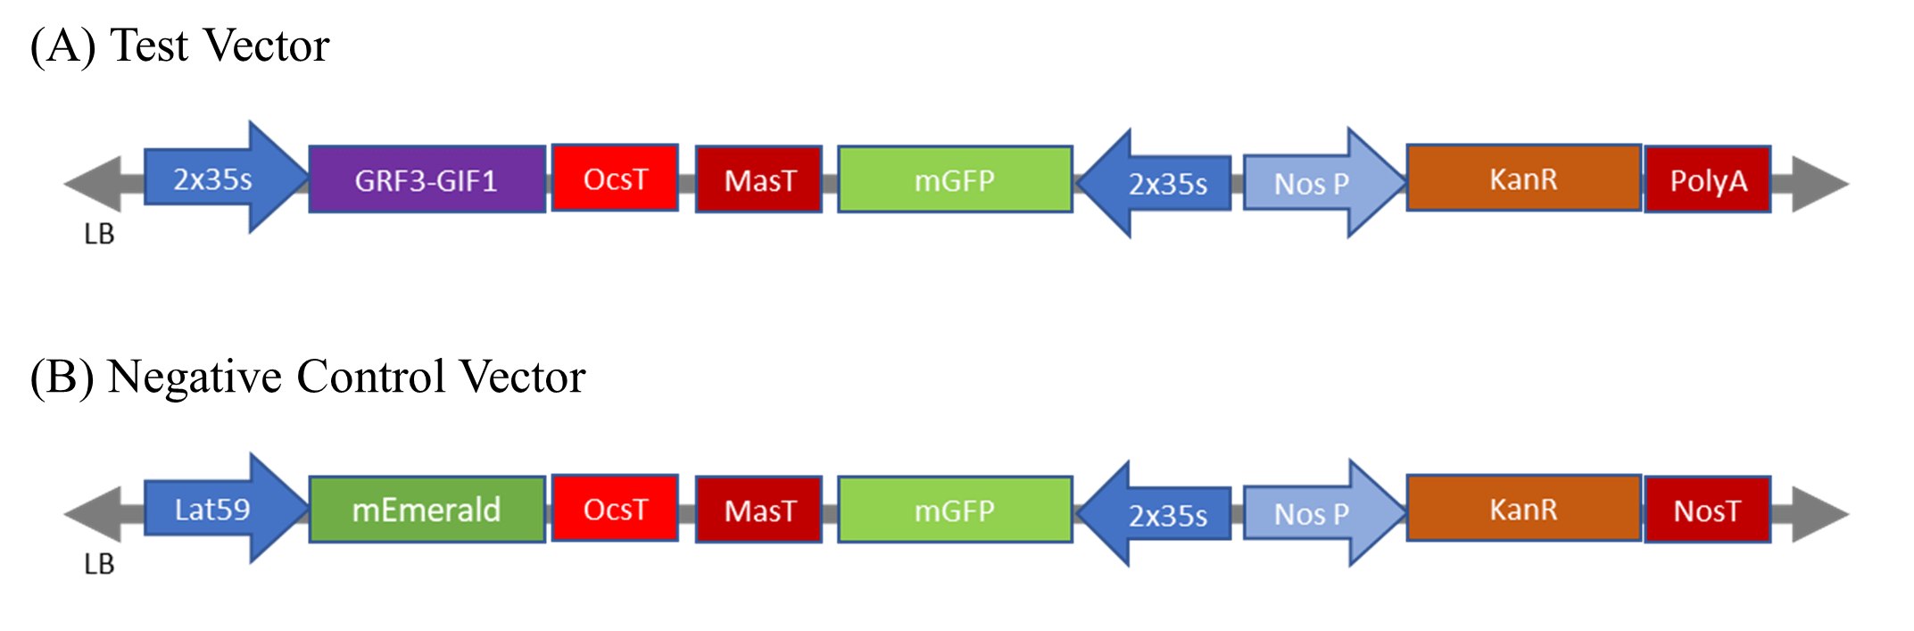
Figure 1. A list of expression constructs used in Agrobacterium-mediated transformation experiments. (A) The test vector used a chimeric GRF3-GIF1 protein 2xCaMV 35s promoter::GRF3GIF1::OcsT; Ocs terminator. (B) The positive control vector used a green fluorescent protein reporter LAT59 promoter::mEmerald::OcsT. All plasmids are binary vectors and harbor a green, fluorescent reporter 2xCaMV 35S::mGFP5-ER::MasT; Mas terminator. Vectors also contain a kanamycin resistance gene for bacterial selection.
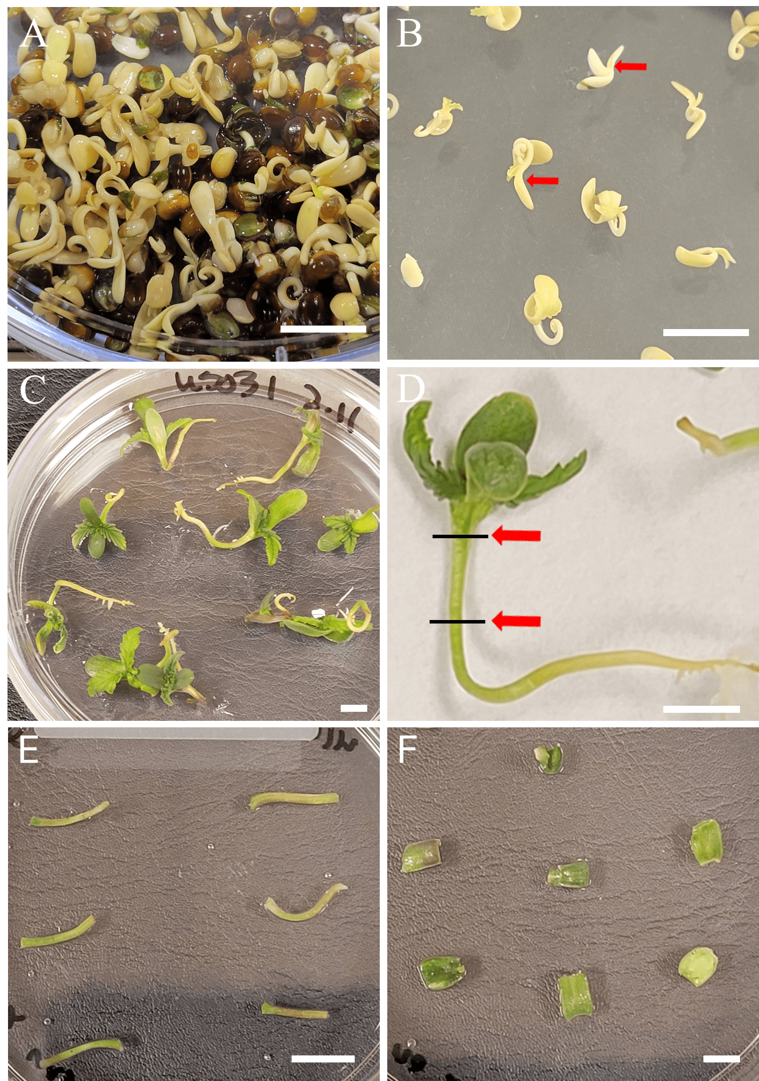

Figure 2. Sterilization, germination, and explant preparation. (A) Germinated seed 72 h. after liquid media germination. (B) Three-day-old seedlings after having seed coats removed and placed onto solid germination media, epicotyl indicated. (C) Seven-day-old seedlings with fully expanded first pair of true leaves. (D) Close-up of an individual seven-day-old seedling, arrows indicate dissection points. (E) Example of prepared hypocotyl explants, placed on co-cultivation media. (F) Example of prepared cotyledon explants, placed on co-cultivation media. Scale bars: 1 mm.

Table 1. Hypocotyl media tested to compare effects of improved media components. All media was pH-adjusted to 5.7 using sodium hydroxide. Media used in control treatments did not contain antibiotics. Abbreviations: ACS: acetosyringone; MES: 2-(N-morpholino)ethanesulfonic acid; GA: gibberellic acid; PEO-IAA: 2-(1H-Indol-3-yl)-4-oxo-4-phenyl-butyric acid; PPM: Plant Preservative Mixture; KAN: kanamycin; CFT: cefotaxime; CRB: carbenicillin; TIM: timentin; IAA: indole-3-acetic acid; ZTN RBS: zeotin riboside; NAA: 1-naphthaleneacetic acid

Media Treatment 1 (MT1-1)
Media Treatment 2 (MT2)
Inoculation media
(IM)
Co-cultivation media
(CCM)
Shoot induction media
(SIM)
Root induction media
(RIM)
½ MS basal medium with vitamins, 15 g/L sucrose, 39.2 mg/L ACS and 3.5 g/L Gelzan.
MS basal medium with increased meso-vitamins, 30 g/L sucrose, 3 g/L Gelzan, 39.2 mg/L ACS, 0.5 g/L MES, 0.1 mg/L GA and 0.29 mg/L PEO-IAA
½ MS basal medium with vitamins, 15 g/L sucrose, 39.2 mg/L ACS and 0.5 g/L MES.
½ MS basal medium with vitamins, 15 g/L sucrose, 39.2 mg/L ACS and 0.5 g/L MES.
½ MS basal medium with vitamins, 15 g/L sucrose, 3.5 g/L Gelzan, 100 mg/L KAN, 250 mg/L CFT and 250 mg/L CRB
MS basal medium with increased meso-vitamins, 30 g/L sucrose, 3 g/L Gelzan, 0.1 mg/L GA, 0.29 mg/L PEO-IAA, 1 mL/L PPM, 100 mg/L KAN, 200 mg/L CFT, 200 mg/L CRB, and 150 mg/L TIM
MS basal medium with increased meso-vitamins, 30 g/L sucrose, 3 g/L Gelzan, 0.2 mg/L NAA, 0.5 mg/L IAA, and 0.01 mg/L ZTN RBS, 100 mg/L KAN, 200 mg/L CFT, 200 mg/L CRB, and 150 mg/L TIM
MS basal medium with increased meso-vitamins, 30 g/L sucrose, 3 g/L Gelzan, 0.2 mg/L NAA, 0.5 mg/L IAA, and 0.01 mg/L ZTN RBS, 100 mg/L KAN, 200 mg/L CFT, 200 mg/L CRB, and 150 mg/L TIM
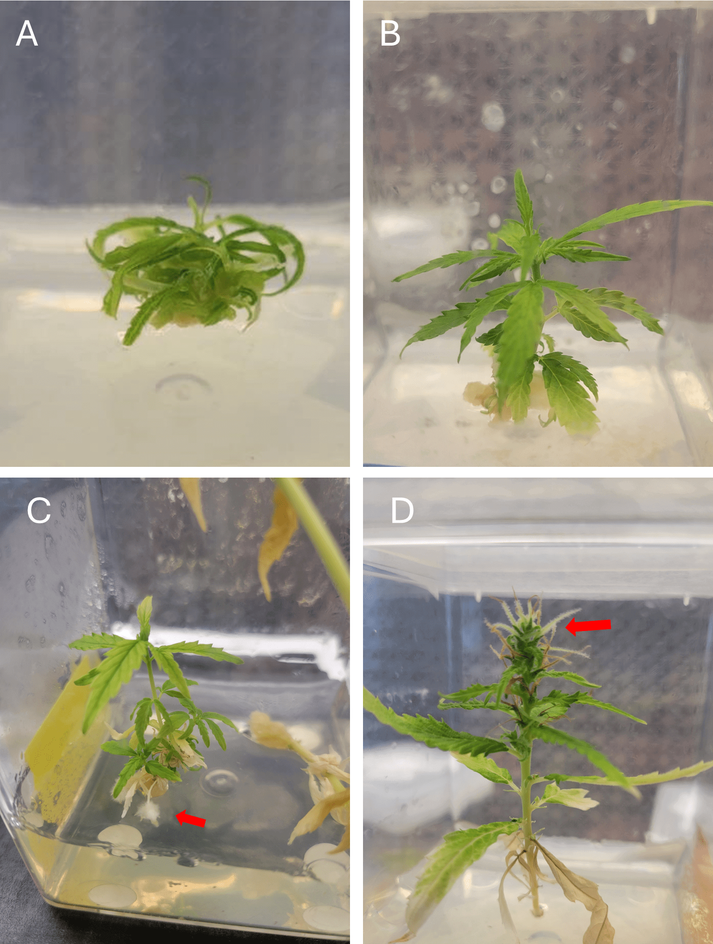
Media Treatment 1 (MT1)
Media Treatment 2 (MT2)
Inoculation media
(IM)
Co-cultivation media
(CCM)
Shoot induction media
(SIM)
Root induction media
(RIM)
½ MS basal medium with vitamins, 15 g/L sucrose .4 mg/L TDZ, 0.2 mg/L NAA, 39.2 mg/L ACS and 3.5 g/L Gelzan.
MS basal medium with increased meso-vitamins, 30 g/L sucrose, 3 g/L Gelzan, 39.2 mg/L ACS, 0.5 g/L MET, .1 mg/L GA and 0.29 mg/L PEO-IAA
½ MS basal medium with vitamins, 15 g/L sucrose, 39.2 mg/L acetosyringone and 0.5 g/L MET.
½ MS basal medium with vitamins, 15 g/L sucrose, 39.2 mg/L acetosyringone and 0.5 g/L MET.
½ MS basal medium with vitamins, 15 g/L sucrose .4 mg/L TDZ, 0.2 mg/L NAA, 3.5 g/L Gelzan, 100 mg/L KAN, 250 mg/L CFT and 250 mg/L CRB
MS basal medium with increased meso-vitamins, 30 g/L sucrose, 3 g/L Gelzan, 0.1 mg/L GA, 0.29 mg/L PEO-IAA, 1 mL/L PPM, 100 mg/L KAN, 200 mg/L CFT, 200 mg/L CRB, and 150 mg/L TIM
MS basal medium with increased meso-vitamins, 30 g/L sucrose, 3 g/L Gelzan, 0.2 mg/L NAA, 0.5 mg/L IAA, 0.01 mg/L ZTN RBS, 50 mg/L KAN, 200 mg/L CFT, 200 mg/L CRB, and 150 mg/L TIM
MS basal medium with increased meso-vitamins, 30 g/L sucrose, 3 g/L Gelzan, 0.2 mg/L NAA, 0.5 mg/L IAA, 0.01 mg/L ZTN RBS, 50 mg/L KAN, 200 mg/L CFT, 200 mg/L CRB, and 150 mg/L TIM
Table 2. Cotyledon media tested to compare effects of improved media components. All media was pH-adjusted to 5.7 using sodium hydroxide. Media used in control treatments did not contain antibiotics. Abbreviations: ACS: acetosyringone; MES: 2-(N-morpholino)ethanesulfonic acid; GA: gibberellic acid; PEO-IAA: 2-(1H-Indol-3-yl)-4-oxo-4-phenyl-butyric acid; PPM: Plant Preservative Mixture; KAN: kanamycin; CFT: cefotaxime; CRB: carbenicillin; TIM: timentin; IAA: indole-3-acetic acid; ZTN RBS: zeotin riboside; NAA: 1-naphthaleneacetic acid; TDZ: thidiazuron

Figure 3. Cannabis sativa on rooting media in Magenta boxes. (A) A newly transferred cotyledonary node explant, with several novel shoots. (B) Shoots regenerated from a hemp hypocotyl explant. (C) Hypocotyl-derived hemp shoots with newly formed roots.. (D) Hypocotyl-derived hemp shoot with fully female flower structure. Note the pistils, structures with an ovule, and two protruding styles capped with stigmas extending beyond the bract.

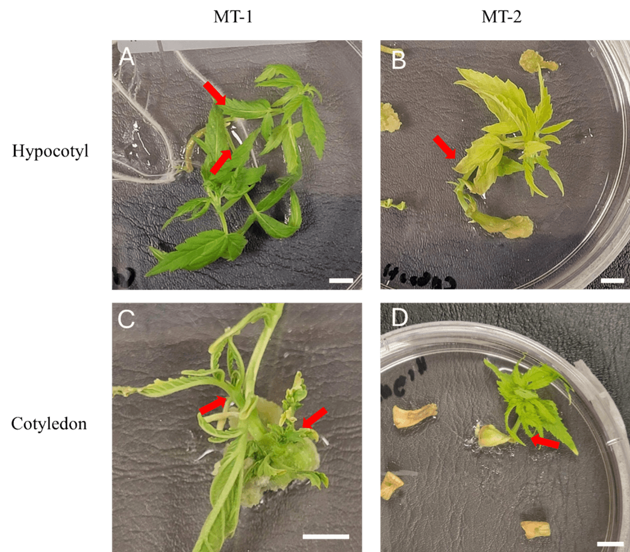
Figure 4. Different plant regeneration patterns, derived from C. sativa hypocotyl and cotyledon explants. All photos were taken after 28 days on their respective shoot induction media (SIM). Scale bars: 1 mm. (A) Shoots regenerated from a hypocotyl explant cultured on MT1. Note two shoots growing in opposite pattern. (B) A single shoot regenerated from a hypocotyl explant cultured on MT2. (C) Multiple shoots regenerated from a cotyledon explant cultured on MT1. (D) A single shoot regenerated from a cotyledon explant cultured on MT2
Table 3. Effect of media on in vitro shoot regeneration. Displayed is the proportion of responding explants (explants with shoots) to total explants and the proportion of the number of shoots to responding explants. In vitro C. sativa hypocotyl and cotyledon explants were cultured on their respective media. Standard error is included. Non-parametric Kruskal-Wallis and pairwise Wilcoxon tests were used to determine significant differences (p<0.05). Different letters indicate significant differences between factors.

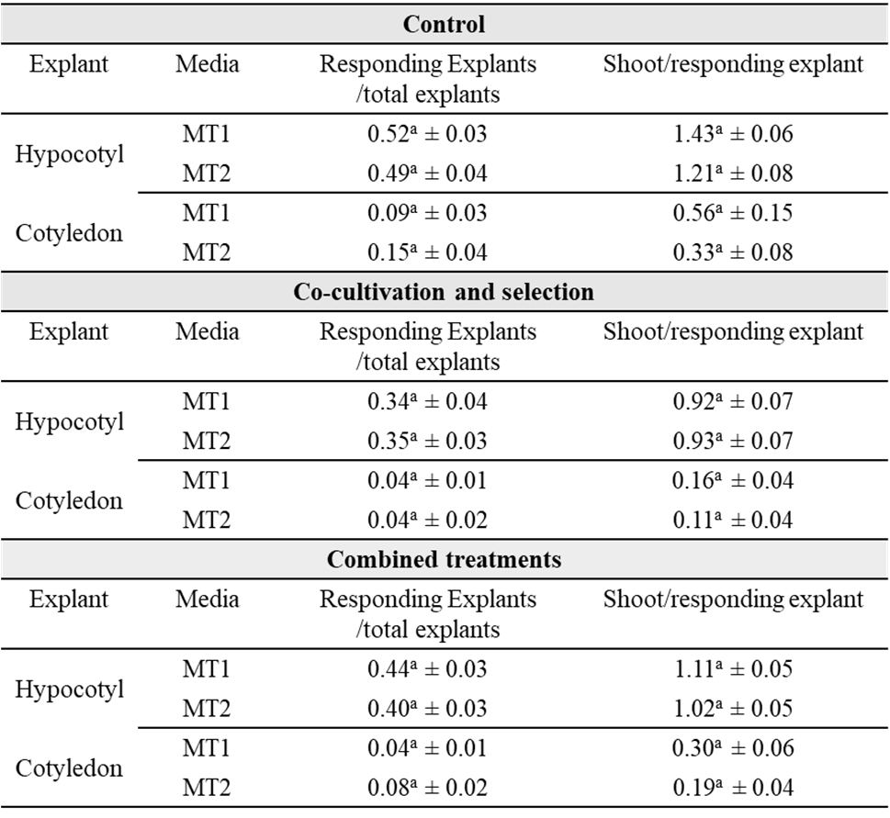
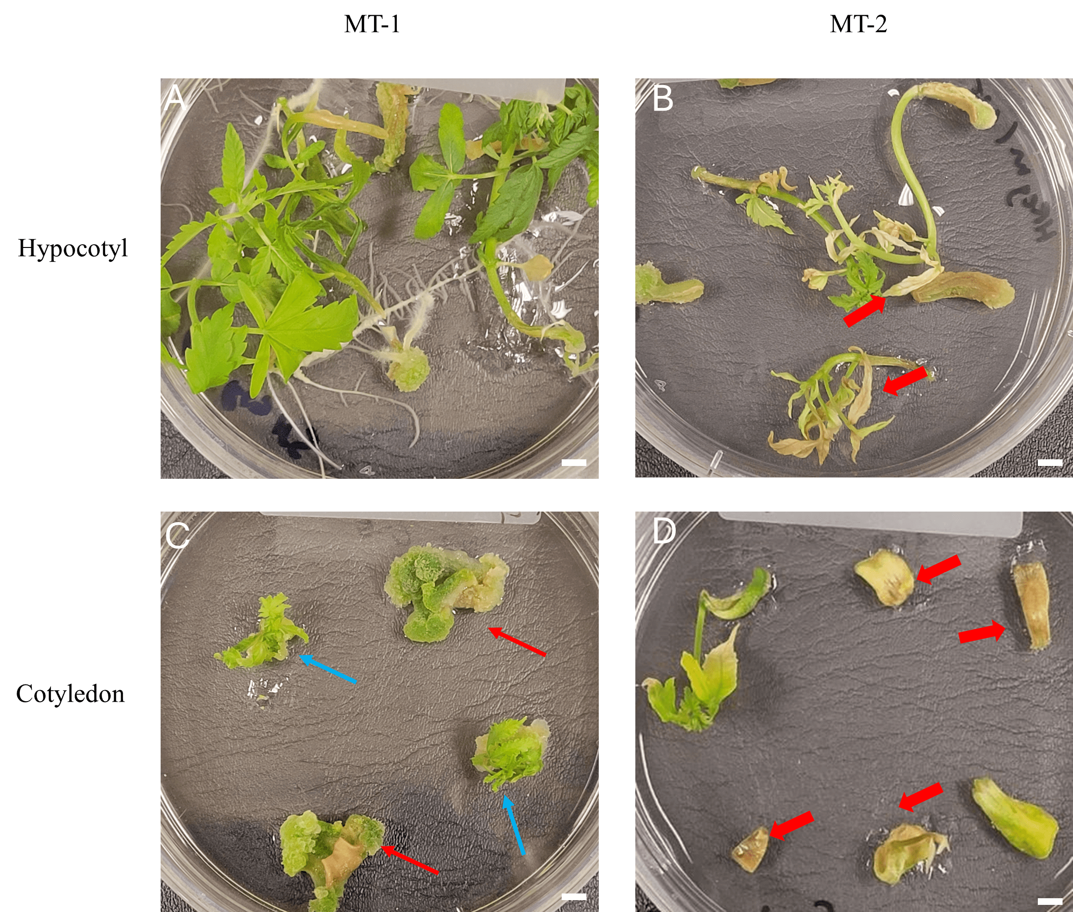
Figure 5. Different tissue culture response patterns derived from C. sativa hypocotyl and cotyledon explants. All photos were taken after 28 days on their respective shoot induction media (SIM). Scale bars: 1 mm. (A) Hypocotyl explants cultured on MT1. Explants cultured on MT1 were observed to be generally healthier than those cultured on MT2. (B) Hypocotyl explants cultured on MT2. Arrows indicate tissue necrosis. (C) Cotyledon explants cultured on MT1. Cotyledon explants on MT1 exhibited induced callus, indicated by red arrows. Blue arrows indicate multiple shoots originating from callus. (D) Cotyledon explants cultured on MT2. Arrows indicate explants exhibiting necrosis.

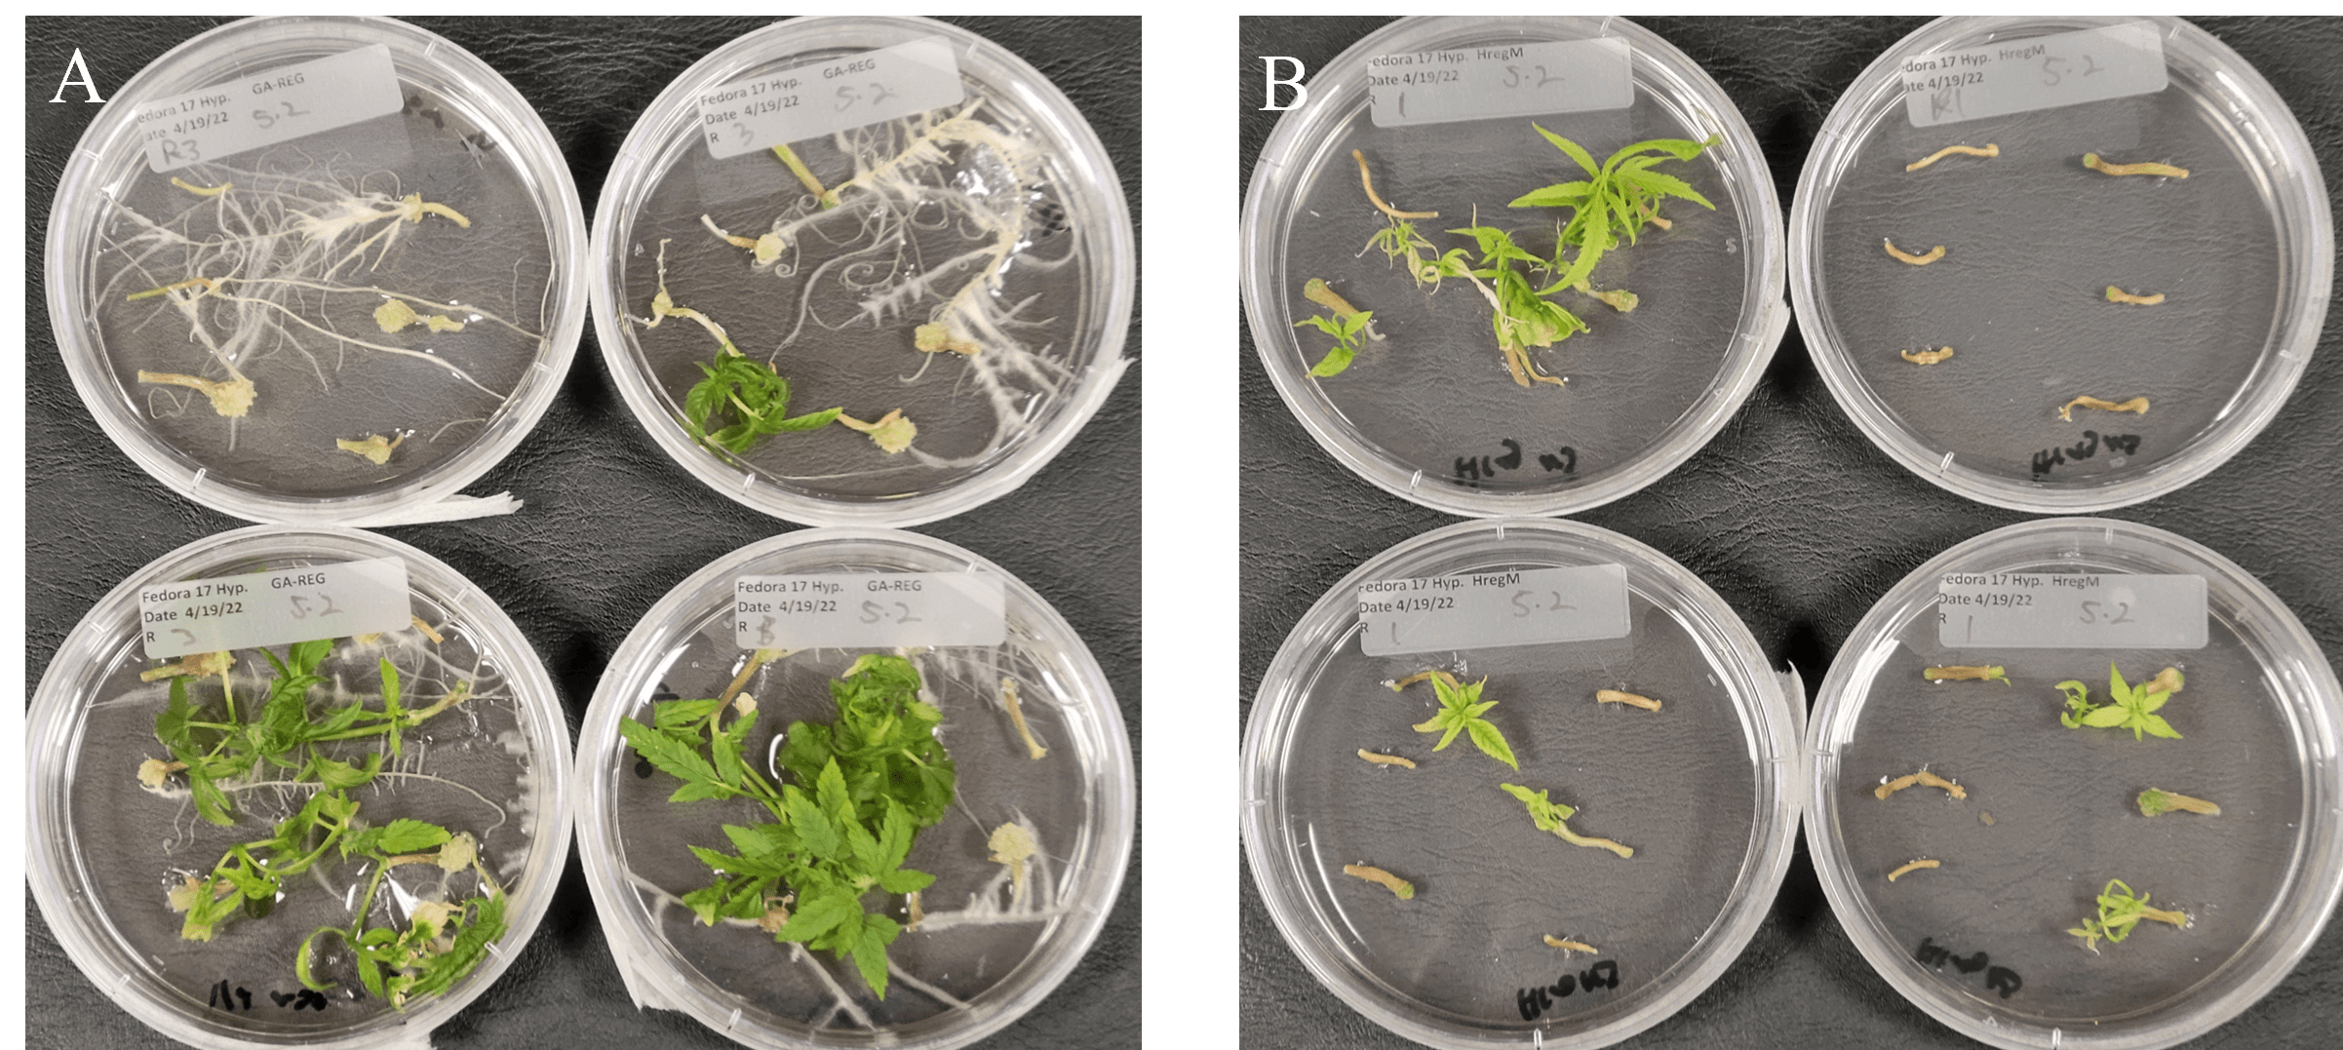
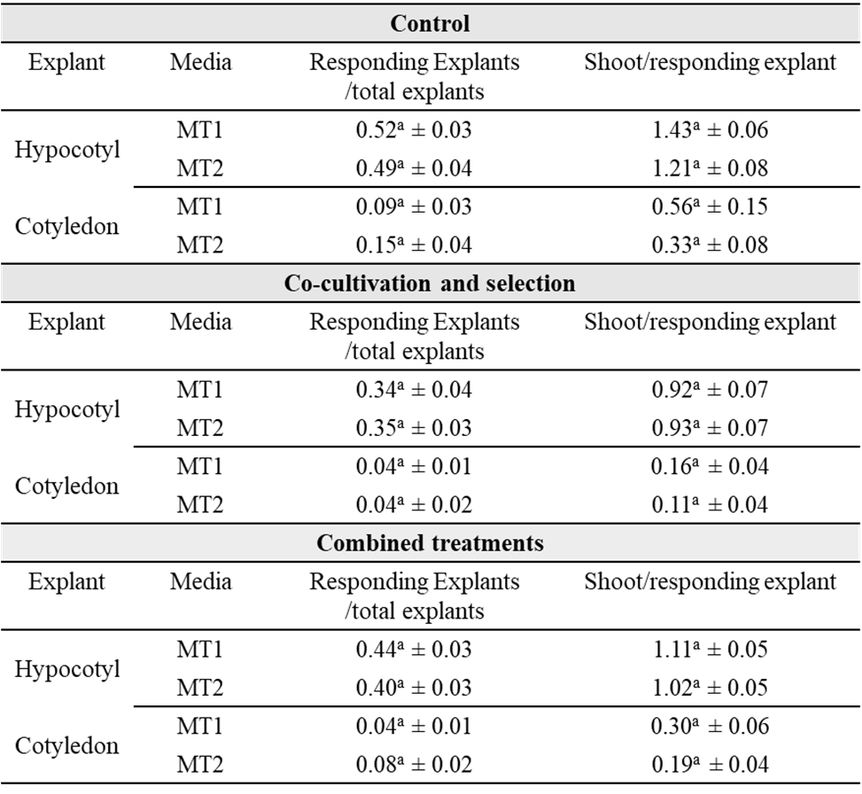
Figure 6. Spontaneous root induction on C. sativa hypocotyl explants. All photos were taken after 14 days on their respective shoot induction media (SIM). Scale bars: 1 mm. (A) Hypocotyl explants cultured on MT1. Hypocotyl explants cultured on MT1 were observed to show spontaneous rooting. Shoots regenerated on MT1 were also observed to show more healthy, green growth when visually compared to those cultured MT2 (B) Hypocotyl explants cultured on MT2. Explants cultured on MT2 were, in general, not observed to exhibit spontaneous rooting.
Table 4. Effect of cultivar on in vitro shoot regeneration. Displayed is the proportion of responding explants (explants with shoots) to total explants and the proportion of the number of shoots to responding explants. In vitro C. sativa hypocotyl and cotyledon explants were cultured on their respective media. Standard error is included. Non-parametric Kruskal-Wallis and pairwise Wilcoxon tests were used to determine significant differences (p<0.05). Different letters indicate significant differences between factors. *indicates a proportion below 0.01 ± 0.01

Table 5. Effect of explant source on in vitro shoot regeneration. Displayed is the proportion of responding explants (explants with shoots) to total explants and the proportion of the number of shoots to responding explants. In vitro C. sativa hypocotyl and cotyledon explants were cultured on their respective media. Standard error is included. Non-parametric Kruskal-Wallis and pairwise Wilcoxon tests were used to determine significant differences (p<0.05). Different letters indicate significant differences between factors.
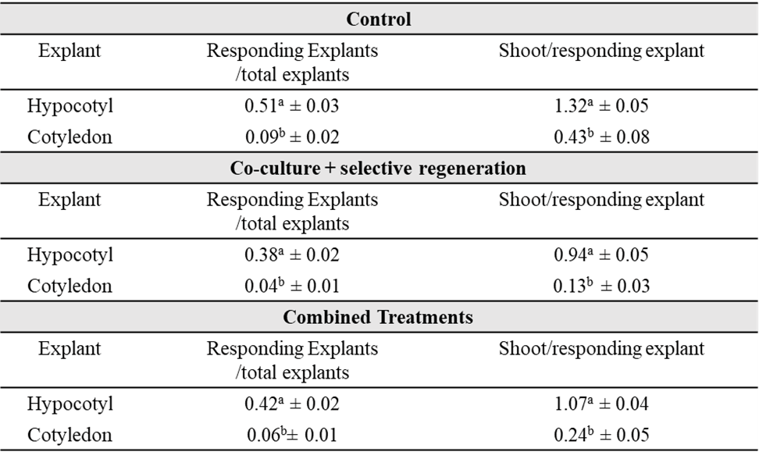
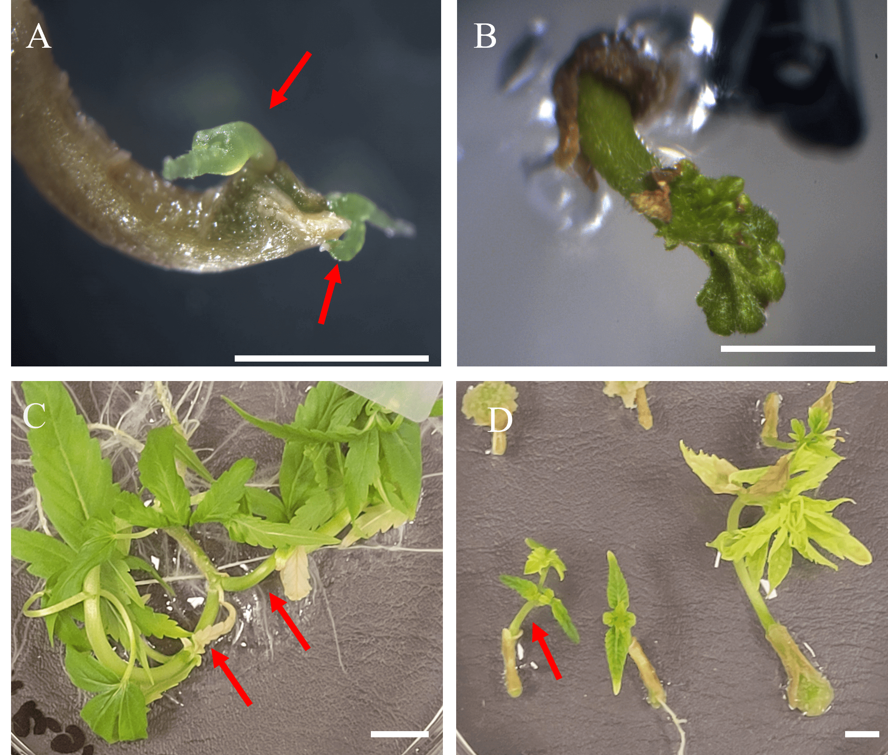
Figure 7. Shoot development patterns observed in C. sativa hypocotyl explants. Scale bars: 1 mm. All photos are from the control group. (A) View of shoot primordia from hypocotyl explant, displaying opposite growth pattern. Photo taken after 7 days on MT1 (B) A single shoot, derived from hypocotyl explant. Note growth originating from the pith of explant, as opposed to growth originating from the cortex, as displayed in photo A. Photo taken after 14 days on MT1 (C) two shoots shoot originating from a hypocotyl explant. Arrows indicate shoots displaying opposite growth pattern. Photo taken after 28 days on MT1 (D) Hypocotyl explants showing single shoot growth pattern. Photo taken after 28 days on MT1.

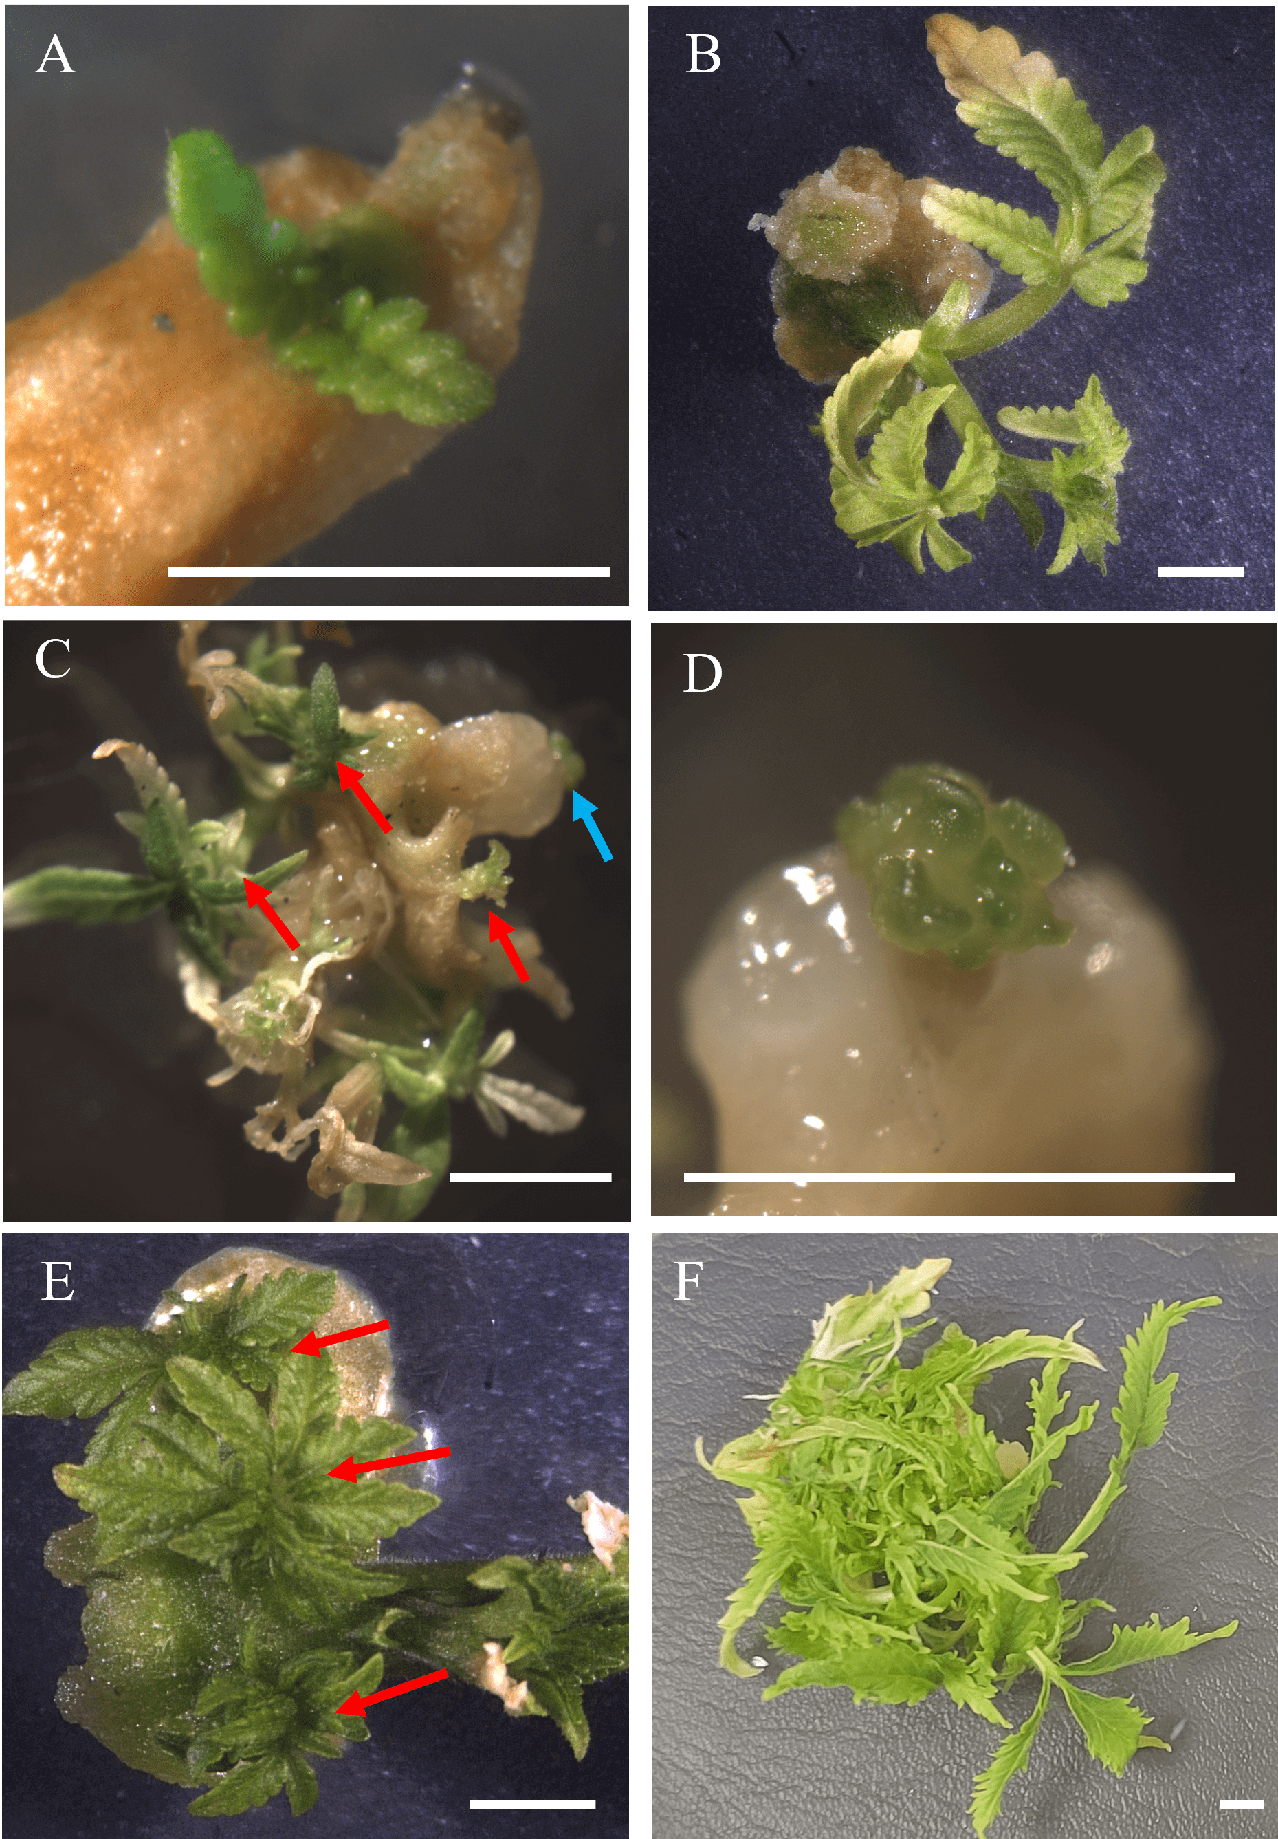
Figure 8. Shoot development patterns observed in C. sativa cotyledon explants. Scale bars: 1 mm. All photos are from the control group. (A) Single shoot originating from a cotyledonary node on a cotyledon explant. Photo taken after 14 days on MT2. (B) Single shoot originating from callus derived from a cotyledon explant. Photo taken after 14 days on MT2 (C) Red arrows indicate multiple shoots originating from callus derived from a cotyledon explant. Green arrow indicates meristematic tissue in D. Photo taken after 14 days on MT2. (D) Close-up of meristematic tissue originating from cotyledon-derived callus. (E) Arrows indicate several, novel shoots originating from callus derived from cotyledon explant. Photo taken after 28 days on MT1. (F) The same cotyledon explant, shown in E, exhibiting continued novel shoot production. Photo taken after 42 days on MT1.

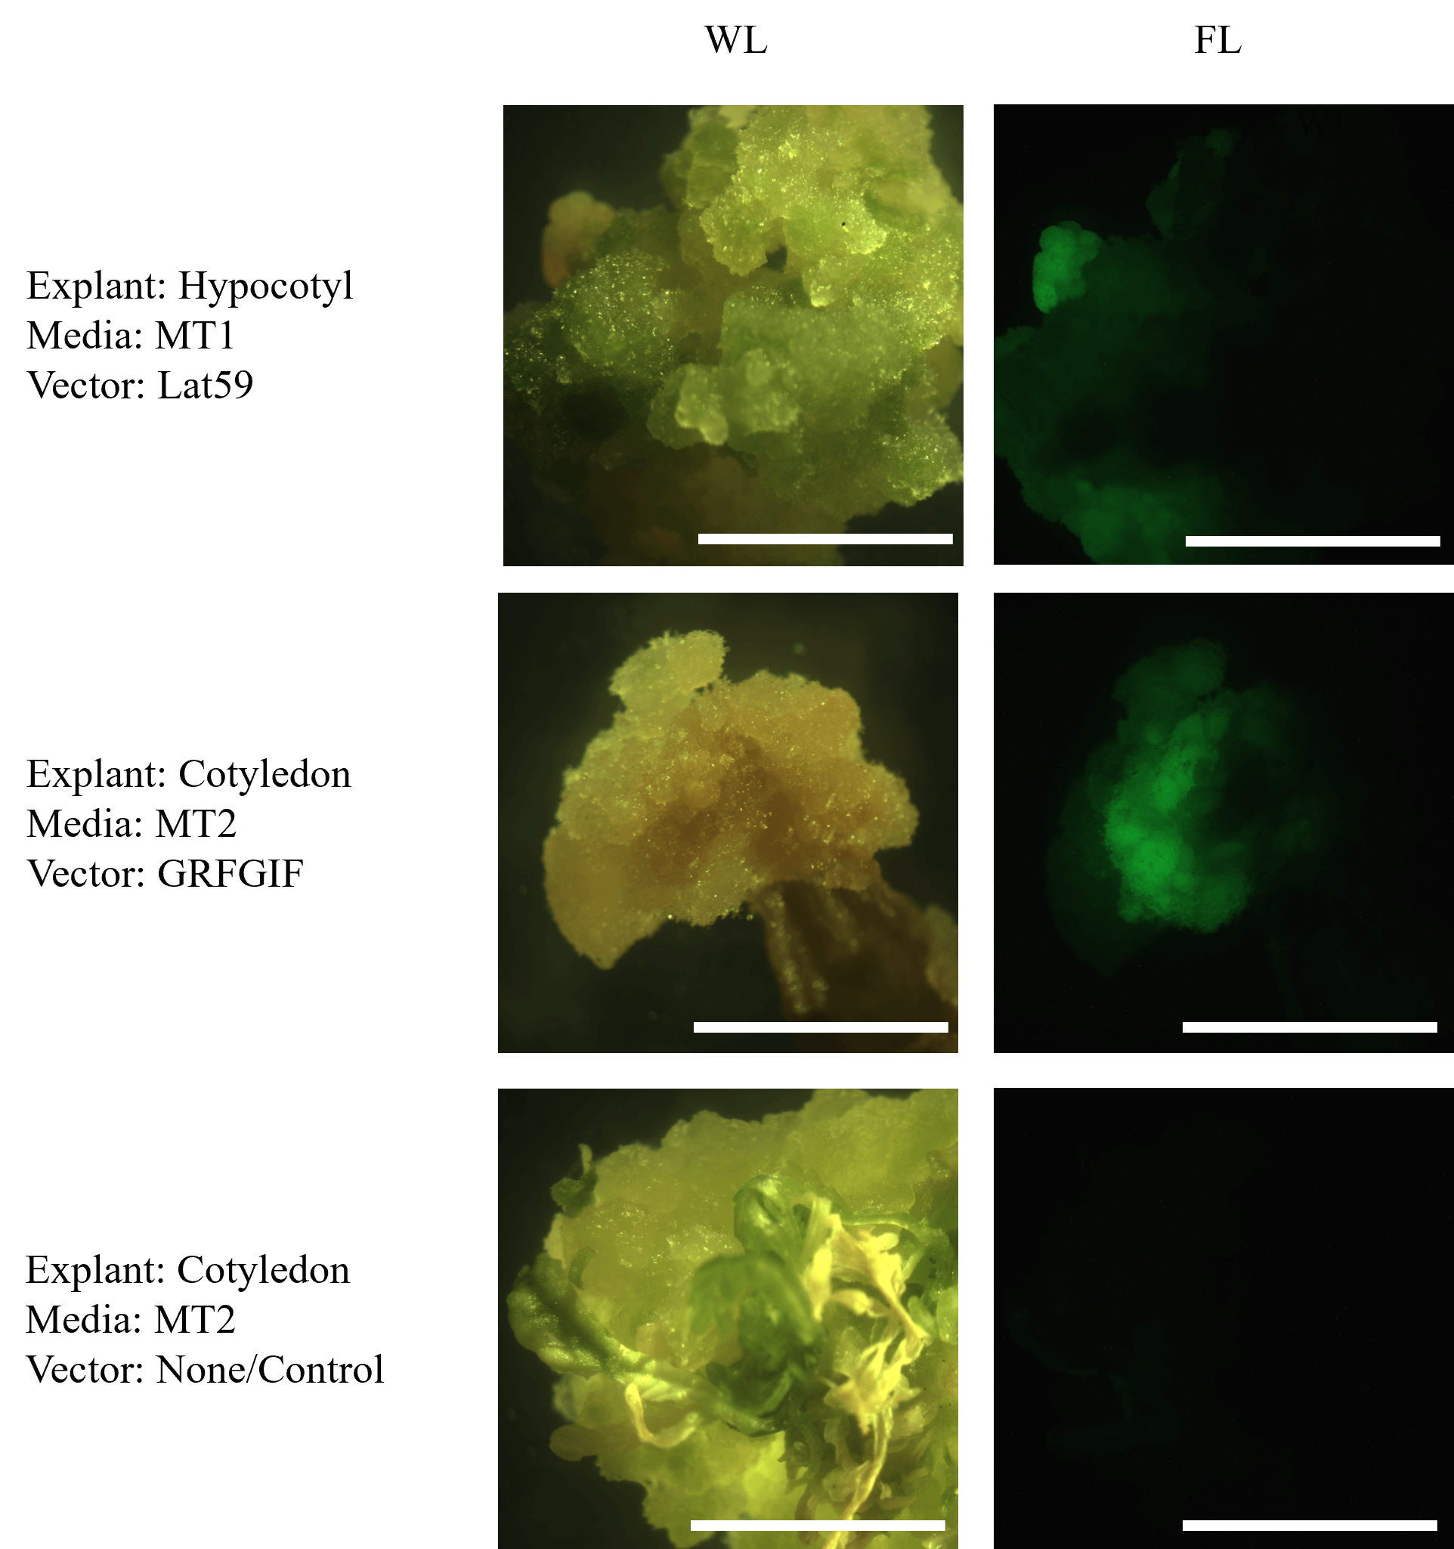
Figure 9. Green fluorescent protein (GFP) fluorescence in transformed C. sativa callus. Scale bars: 1 mm. Samples are labeled accordingly with explant source, media treatment and vector. Callus was photographed using an epifluorescent microscope. Column FL (fluorescence light conditions) was photographed using a GFP filter set (emission 509 nm). Column WL was photographed using the same epifluorescent under white light.

Table 6. Effect of explant source, media, cultivar, and transformation vector on Agrobacterium contamination (Agro-contaminated) and transformation rate. Displayed is the proportion of contaminated explants (explants with residual Agrobacterium overgrowth) to total explants and the proportion of the explants showing expression of mGFP5-ER to responding explants. In vitro, C. sativa hypocotyl and cotyledon explants were cultured on their respective media. Standard error is included. Non-parametric Kruskal-Wallis and pairwise Wilcoxon tests were used to determine significant differences (p<0.05). Different letters indicate significant differences between factors. * indicates a proportion below 0.01 ± 0.01.
** indicates that no instances were observed for that category.

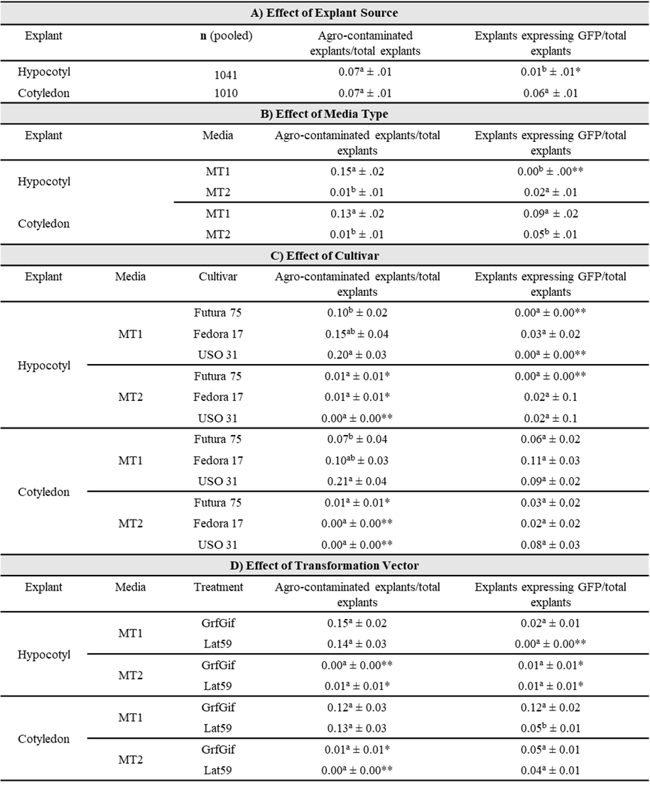

Table 7. Oligonucleotide primers designed for verification of stable, Agrobacterium-mediated transformation of C. sativa. All primers were designed via Primer3 (v. 4.1.0) and verified in silico via Snapgene.

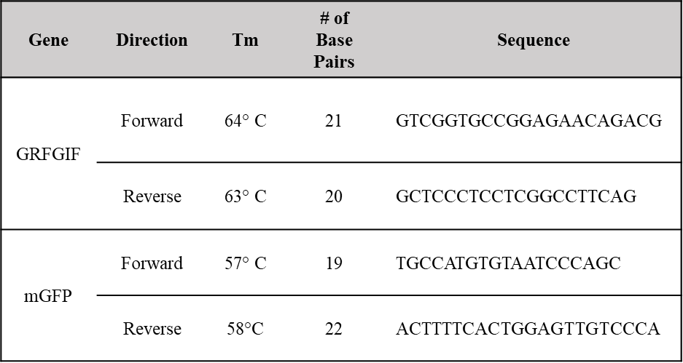
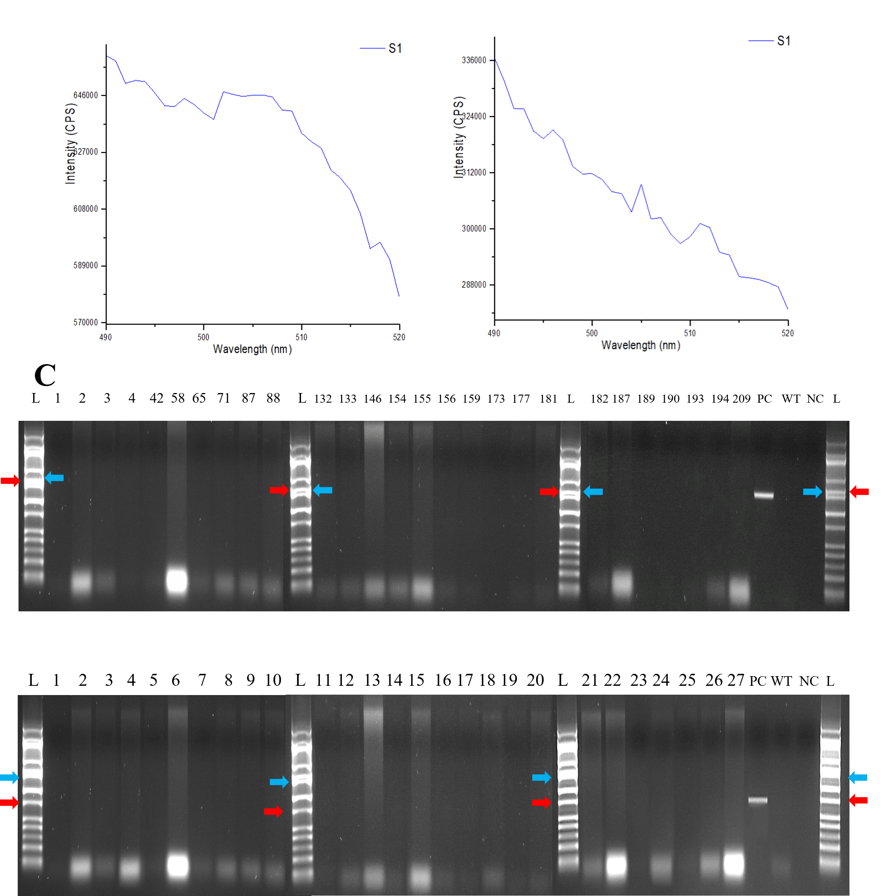
Figure 10. Verification of expression of transgene in C. sativa explants treated with Agrobacterium co-cultivation. (A) Fluorimetric measurement of agroinfiltrated leaves of C. sativa plant indicating expression of mGFP5-ER. Red arrow indicates expression, i.e., emission occurring at approximately 510 nm. This plant was used as a positive control. (B) Fluorimetric measurement of leaves regenerated from C. sativa explants treated with Agrobacterium co-cultivation. Blue arrow indicates where the emission should be measured. (C) Polymerase chain reaction (PCR) detection of GRFGIF chimeric gene (top) and mGFP5-ER (bottom). Red arrows indicate where amplicon is expected to appear (1421 bp and 756 bp, respectively). Blue arrows indicate the 1400 bp landmark in the ladder. Abbreviations: L: Hi-lo ladder; PC: positive control; WT: wild type; NC: negative control (water).

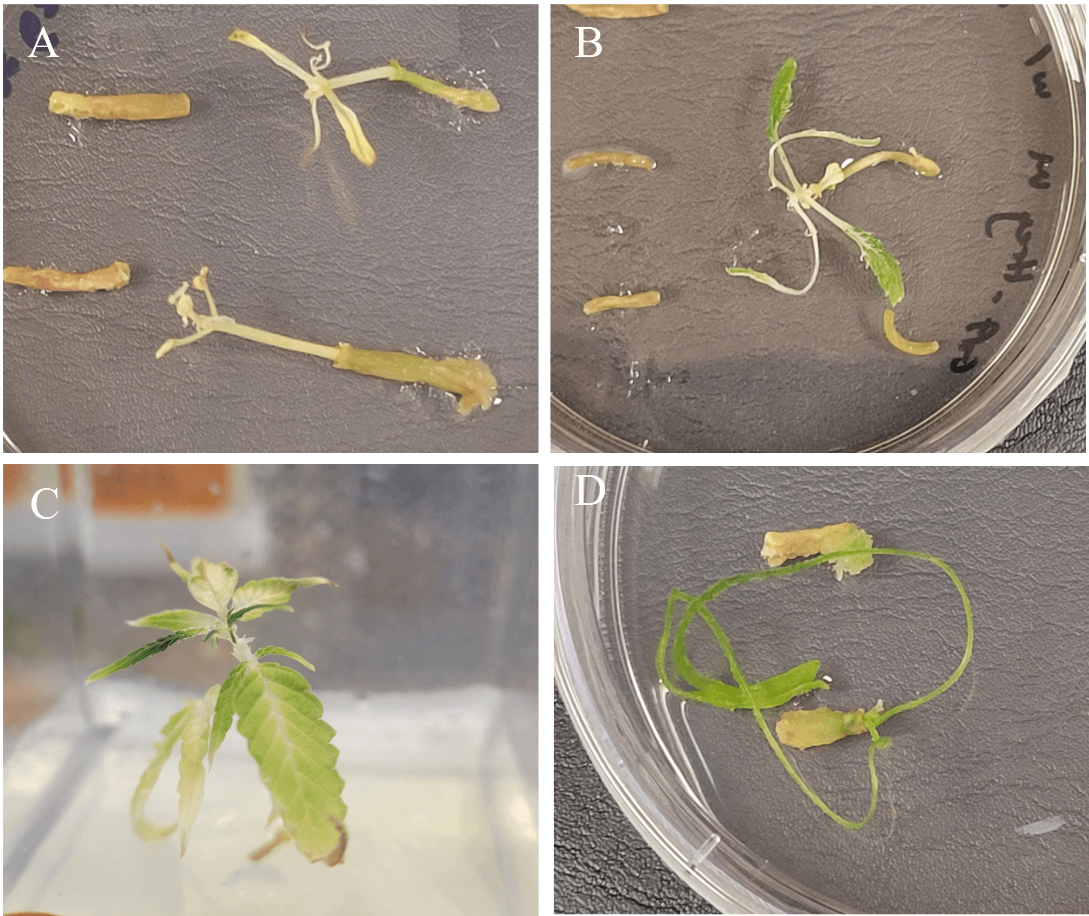
Figure 11. Verification of expression of transgene in C. sativa explants treated with Agrobacterium co-cultivation. (A) Hypocotyl-derived hemp shoots, cultured on MT1, exhibit tissue necrosis from kanamycin toxicity. (B) Hypocotyl-derived hemp shoots, cultured on MT2, exhibit bleaching from kanamycin toxicity. (C) Hypocotyl-derived hemp shoots, cultured on RIM, exhibit bleaching from kanamycin toxicity. (D) Abnormal growth pattern observed in hypocotyl-derived hemp shoots, cultured on MT2.

