Modeling Interventions in the
Owned Cat Population in
Knox County, TN

A Thesis Presented for the
Master of Science
Degree
The University of Tennessee, Knoxville

Evan P. Lancaster
July 2012
Copyright © 2012 by Evan P. Lancaster
All rights reserved.

DEDICATION

This work is dedicated to my wife, Tammy. Without you, I would not have had the stamina to endure the lows so that I could cherish the highs. I love you!

ACKNOWLEDGEMENTS

I would like to gratefully acknowledge the contributions of the National Institute of Mathematical and Biological Synthesis (NIMBioS) to this work. Their Research Experience for Undergraduates and Veterinary Students during the summer of 2010 started my thesis off on the right foot.

During that summer, I was teamed with a stellar group of young scientists. Special thanks go out to Steve Rekant, Janelle Scott, and John Ojogbo for their help on finding literature to develop our parameters, their help in the development and analysis of the precursors of our model, and for their patience with my coding deficiencies and poor arithmetic.

This work was further bolstered by the expertise of Heidi Weimer from the Young Williams Animal Center of Knox County and Dr. John New of the Department of Biomedical and Diagnostic Sciences in the College of Veterinary Medicine at the University of Tennessee. Ms. Weimer’s knowledge of the area as it pertains to felines is unrivaled, while Dr. New always had insights and perspectives we hadn’t considered that made our model more accurate.

Most of all, however, I wish to thank my advisor and mentor, Dr. Suzanne Lenhart. She took a chance on a lowly high school teacher who had dreams of going back to school. She patiently listened to my worries and taught me not to worry. She had faith in me when I didn’t have faith in myself. She inspired me to desire to become a better teacher. Without a doubt, I could not have done this without her.

Evan Lancaster
ABSTRACT

The rapid growth of cat populations in many communities across the United States has resulted in overpopulation and an increase in euthanasia procedures. To combat these challenges, communities have instituted spay/neuter programs as a preventative strategy. In particular, Knox County, Tennessee, has developed and implemented a program, called the Spay Shuttle, which offers free spays and neuters for owned cats throughout the county.

We develop a discrete time, age-structured model of owned female cats in Knox County to investigate the effects of implementing extra spaying intervention strategies to the population over the course of 5 years. We determine that a 50% increase in spay surgeries per two month time step for each age class capable of reproducing will result in a 33% decrease in the population. Also, the number of surgeries performed during those five years will also drop. Analysis of the cumulative number of surgeries performed reveals a sharp increase in surgeries during the first two years, followed by a decrease in surgeries in the following years. We also examine other scenarios, by which we target different age groups for extra spay interventions. We determine that the most impact is seen when extra spaying of cats ages 4-6 months is included in the intervention.

TABLE OF CONTENTS

CHAPTER I Introduction 1
CHAPTER II Formulation of Model 3
Overview/Assumptions 3
Model Equations 4
Initial Conditions 5
Estimating Parameters 6
Birth Rates 8
Death Rates 9
Spay Rates 9
Calculation of Expected Population Growth 10
CHAPTER III Results, Discussion, and Conclusions 11
LIST OF REFERENCES 19
Vita 22

LIST OF TABLES

Table 1. Explanation of variables. 3
Table 2. Number of cats in initial population by age class. 7
Table 3. Death rate parameters. 7
Table 4. Spay rate parameters. 7
Table 5. Selected intervention scenarios (cases) and projected population and number of spays over five years. 17

LIST OF FIGURES

Figure 1. Dynamics of model from birth through age classes and with subclasses of spayed females. 4
Figure 2. No extra interventions. 12
Figure 3. Spaying 50% more females age 2-4mo, 4-6mo, 6mo-5yr, 5-10yr 12
Figure 4. Spaying 50% more females age 4-6mo, 6mo-5yr 12
Figure 5. Spaying 50% More Females Age 2-4 Months and 4-6 Months. 13
Figure 6. Spaying 50% More Females Age 4-6 Months. 13
Figure 7. Spaying 50% More Females Age 6 Mo – 5 Yrs. 13
Figure 8. Cumulative surgeries with no extra intervention. 15
Figure 9. Cumulative surgeries with 50% increase in 2-4mo, 4-6 mo, 6mo-5yr, 5-10yr 15
Figure 10. Cumulative surgeries with 50% increase in 4-6mo and 6mo-5yr. 15
Figure 11. Cumulative surgeries with 50% increase in 2-4mo and 4-6mo. 16
Figure 12. Cumulative surgeries with 50% increase in 4-6mo. 16
Figure 13. Cumulative surgeries with 50% increase in 6mo-5yr. 16

CHAPTER I
Introduction

The imbalance between companion animal population and number of available homes has significant consequences for communities across the country (Scarlett, 2004). As the number of homeless cats and dogs exceeds that of adopting families, shelters operate at capacity and euthanasia becomes a necessity to allow room for new animals; there is a high correlation between shelter intake and euthanasia rates (Marsh, 2010). Surplus cats and dogs represent direct and indirect costs to most communities (Rowan, 1992). Direct costs include the expense of animal control, including staffing and facilities. In addition, there are animal bites and other injuries, responses to nuisance complaints, and destruction of property and other animals (e.g., feral cats and wildlife) (Frank and Carlisle-Frank, 2007). Another rarely considered cost is the biomass of animal carcasses that must be dealt with after euthanasia. In Knox County, TN, based on the numbers of cats and dogs that were euthanized in 2007 through 2009, and an estimation of body weight (i.e., 8-10 lbs for cats and 30-45 lbs for dogs), an average of 129 tons (average annual range of 120 to 134 tons) of biomass had to be disposed of each year. In addition, there are emotional costs when animals end up at shelters. These costs are borne by the relinquishers (DiGiacomo et al., 1998) and shelter staff (White & Shawhan, 1996).

Across the country, a variety of spay and neuter programs have been implemented to help control the growing cat and dog populations and offset these consequences. One such example is in Hillsboro County, FL, where a spay/neuter subsidy program was successfully implemented that specifically targeted lower income pet-owning households (Marsh, 2010). Another example is in Knox County, TN, where a program called the Spay Shuttle is in place to supplement spay and neuter surgeries already performed at shelters and private veterinary clinics. It is a mobile unit that travels throughout communities in Knox County, performing spay and neuter surgeries on cats and dogs at no cost to the owners.

Mathematical modeling is one useful tool to investigate control strategies, resulting population levels, and corresponding costs. Models of cat and dog populations would be constructed separately, and we choose to concentrate on modeling a cat population first. Others have modeled cat populations for various purposes. Auger and Pontier (1998) used a system of ordinary differential equations with a game matrix and density dependent growth rate (and without age structure) to look at the interaction of competition for resources and population density in a domestic cat population. Their study indicated that tactics change with density of population. Their model agreed with observations that high-density populations for domestic cats are mainly doves (reduced aggressiveness over resources such as food and mates) while low-density populations are mainly hawks (more time spent fighting to defend resources than in mating or feeding).

Budke and Slater (2009) used matrix models with juvenile and adult age classes to compare the effect of no intervention, a traditional trap-neuter-return (TNR) approach and a nonsurgical contraception program on a hypothetical feral cat population. Their models estimated the percentage of the adult population that would have to be sterilized surgically or non-surgically in order to achieve zero population growth. Andersen et al. (2004) used a matrix model with juvenile and adult age classes to analyze data from the literature on the biology of cat populations. They looked at individual and combinations of interventions and concluded that trapping and euthanizing free-roaming cats was more effective in reducing populations than TNR. However, the focus of these studies was free-roaming cats which likely consisted primarily of feral cats and not owned cats.

Feral cats were specifically excluded for the model described in this paper so that we could first develop a simpler model of owned cats, due to more data available for owned cats. For any model of cat populations in a community to have maximum usefulness, it must include the feral cat component. We note that our model has more detailed age structure than these three papers.

When modeling a large population over time, it is important to remember that complete accuracy is often almost impossible to achieve, or at the very least, verify. Parameters and initial conditions must be estimated from previous studies and data, and certain assumptions must be made about the population. These estimations and assumptions will likely affect the final values of the model. However, the general dynamics of the population (how subsets of the population interact based on their relative sizes, or how adjusting a parameter affects the size of a subset of the population, for example) can still be quite useful.

In this study, we build an age-structured discrete time model for the population of owned female cats in Knox County using data that is as particular to Knox County as possible. Our goal is to use the model to investigate the effects of additional spaying interventions on the growth of the population.

In Chapter II, we develop the structure and explain the derivation of parameters and initial conditions of the model. In Chapter III, we show the results of the model, looking at the population after five years under different scenarios of spaying interventions. We will also look at the number of surgeries performed over those five years under the various scenarios to determine the possible impact our interventions may have on shelters and clinics. Our conclusions are given in Chapter III.

CHAPTER II
Formulation of Model

Overview/Assumptions
To model the owned cat population in Knox County, we concentrate on the dynamics of female cats. We assume that the number of male cats is not a limiting factor in births. We also assume no immigration or emigration within our population. Considering the possible age structure and breeding patterns, we construct a system of difference equations with discrete time steps. Cats breed more at certain times of the year; more pregnancies reliably happen during certain months of the year. See the data in Figure 1 of Nutter et al (2004) regarding breeding season and subsequent pregnancies. Our model uses two-month time steps, beginning on January 1st. The owned female cat population was divided into six classes using these age divisions: 0-2 months, 2-4 months, 4-6 months, 6 months to 5 years, 5-10 years, and 10 years and greater.

The events happening in our model are births, deaths, spaying and transition to other classes. In a discrete time model, the order of events within a time step is crucial. In a time step, spays occur first, then deaths and finally the transition to the next age class. The transitions in age and in being spayed can be seen in our model flowchart (Figure 1).

This model investigates the effect of spaying at various ages and at different levels on long-term population growth. The assumption is made that no female older than 10 years can have a litter and no neonatal or geriatric females receive spay surgery. Separate counts of spayed and intact geriatric females are kept for analysis purposes, but the geriatric intact and geriatric spayed groups do not contribute to the births. In our model, we use the number of female cats in each of ten classes at time t. Table 1 gives the classes and corresponding age structure.

Table 1. Explanation of variables.
Variable | Name of Class | Age
N_{t} | Neonatal | 0-2 months
P1_{t} | First Pre-Estrus | 2-4 months
P2_{t} | Second Pre-Estrus | 4-6 months
A1_{t} | First Adult | 6 months-5 years
A2_{t} | Second Adult | 5-10 years
G_{t} | Geriatric | > 10 years
PS_{t} | Pre-Estrus Spayed | 4-6 months
AS1_{t} | First Adult Spayed | 6 months-5 years
AS2_{t} | Second Adult Spayed | 5-10 years
GS_{t} | Geriatric Spayed | > 10 years
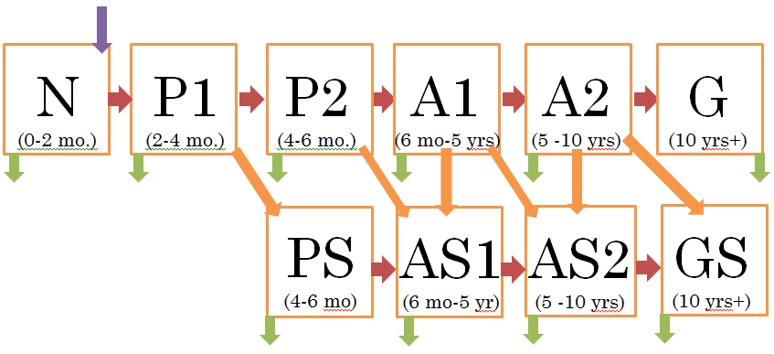
Figure 1. Dynamics of model from birth through age classes and with subclasses of spayed females.

This model is represented in Figure 1 with colored arrows representing births (yellow), deaths (red), spays (gray), and age class transitions (blue).

Model Equations
The following difference equations are used to describe our model. The explanations of the terms and the initial conditions are given below.

N_{t+1} = b_{1t}A1_{t} +b_{2t} A2_{t}
P1_{t+1} = (1-dN)N_{t}
P2_{t+1} = (1-(1+h₁)s₁)(1-dP)P1_{t}
PS_{t+1} = (1+h₁)(s₁)(1-dP)P1_{t}
A1_{t+1} = (1-(1+h₂)s₂)(1-dP)P2_{t} + (26/27)(1-dA₁)(1-(1+h₃)s₃) A1_{t}
A2_{t+1} = (1/27)(1-dA₁)(1-(1+h₃)s₃) A1_{t} + (29/30)(1-(1+h₄)s₄)(1-dA₂)A2_{t}
AS1_{t+1} = (1+h₂)(s₂)(1-dP)P2_{t} + (1-dP)PS_{t} + (26/27)(1+h₃)(s₃)(1-dA₁)A1_{t}
+ (26/27)(1-dA₁)AS1_{t}
AS2_{t+1} = (29/30)(1+h₄)(s₄)(1-dA₂)A2_{t} + (29/30)(1-dA₂)AS2_{t} + (1/27)(1+h₃)(s₃)(1-dA₁)A1_{t} + (1/27)(1-dA₁)AS1_{t}
G_{t+1} = (1/30)(1-(1+h₄)s₄)(1-dA₂)A2_{t} + (1-dG)G_{t}
GS_{t+1} = (1/30)(1-dA₂)AS2_{t} + (1/30)(1+h₄) (s₄)(1-dA₂)A2_{t} + (1-dG)GS_{t}

Initial Conditions
To choose the initial conditions for the model, we used estimates from the U.S. Pet Ownership and Demographics Sourcebook (Center for Information Management of the AVMA, 2001, 2006) for the number of cats per household and U.S. Census data from 2000 and 2006 (US Census Bureau, 2009) estimates of the number of Knox County households. These two numbers and methodology from the U.S. Pet Ownership and Demographics Sourcebook yield an initial estimated total county cat population of 109,981 with around half that number (55,000) assumed to be female. This number – 55,000 – is used as the initial population total for the model.

To decide how to divide the initial number of cats between spayed and non-spayed classes, we used the American Pet Products Association (APPA) national survey, which stated approximately 82% of all cats are spayed or neutered (APPA, 2009-2010). It is assumed that 82% of all female cats are in the spayed classes at the beginning for model analyses.

Cats are in the neonatal age class for one time step, and this class comprises a relatively small proportion of the population. Unpublished data from the Spay Shuttle indicates this class should comprise 3% of the model’s initial total population.

The pre-estrus period is also relatively short with only two time steps. The females in this group are composed of those surviving the neonatal class and those not advancing to the first adult class. Since only a small fraction of the lifespan is spent in this class, this group makes up a small proportion of the total population. Both the neonatal and pre-estrus classes have high survival rates (Baldock et al., 2003), so we assume the pre-estrus classes combined contain about twice the population as the neonatal class, i.e., 6% of the model’s initial population. Approximately 3% of all spays performed by the Spay Shuttle are performed on cats in the two pre-estrus age classes (Spay Shuttle, 2007-2010). We assume that 82% of all female cats are spayed (APPA citation,2009-2010); consequently, 2.46% of all females fall into the pre-estrus spayed class.

Baldock et al. (2003) in a survey of Australian cat-owning households determined that approximately 26% of the total population was at least ten years old. Data from the Spay Shuttle program supported adjusting this slightly higher to reflect the population in Knox County. The geriatric class makes up 31% of the model’s initial population.

After the above choices, the two adult classes encompass 60% of the initial population. The first class includes cats six months to five years old (30 months or 27 time steps) and the second class includes cats five to ten years old (60 months or 30 time steps). The two classes together have 57 time steps, so the initial population proportion (of adults) for the first class is 27/57 and the initial proportion for the second class is 30/57. This assumes the adult population is evenly distributed across the age spectrum.

Spayed adult females make up 50% of the initial population and spayed geriatric females make up 29.54% of the initial population. The proportions of adult and geriatric spayed females are consistent with the 82% APPA survey value and biology inherent in our model.

Table 2 gives the initial number of cats in each class.

Estimating Parameters
We list the parameters used in this model in Table 3 and Table 4 and then give more explanation of their derivations. All rates are for each two month time step.

The changes to the spay rate investigated in the scenarios below are represented in these coefficients:

h₁ = percentage to increase s₁
h₂ = percentage to increase s₂
h₃ = percentage to increase s₃
h₄ = percentage to increase s_{4.}

If, for example, h₂ = 0.50, then the (1+ h₂)s₂ coefficient increases s₂, the spay rate of the second pre-estrus class, by 50%.

Only intact females produce offspring. Adults in A1 have a slightly higher birth rate than those in A2. Only surviving neonatal females make it to the first pre-estrus class. To enter the second pre-estrus class, a female from the first pre-estrus class must be intact and must survive. Females in the first pre-estrus class can be spayed. Those spayed and surviving the time step move into the pre-estrus spayed class.

The first adult class consists of two groups: surviving intact females from the second pre-estrus class and surviving intact females already in the first adult class. Since the length of time in the first adult class is 27 time steps, 26/27 of females remain in this class per time step. The second adult class is composed of the 1/27 of intact surviving females from A1 and those remaining in the second adult class. Since this time in this class is 30 time steps, 29/30 of females remain in this class.

Table 2. Number of cats in initial population by age class.
Class | % of Population | # of Cats | Sub-class | % of Population | # of Cats
Neonatal | 3 | 1,650 | N_{t} | 3 | 1650
Pre-Estrus | 6 | 3,300 | P1_{t} | 1.8 | 990
Pre-Estrus | 6 | 3,300 | P2_{t} | 1.7 | 935
Pre-Estrus | 6 | 3,300 | PS_{t} | 2.5 | 1375
Adult | 60 | 33,000 | A1_{t} | 4.7 | 2585
Adult | 60 | 33,000 | A2_{t} | 5.3 | 2915
Adult | 60 | 33,000 | AS1_{t} | 23.7 | 13035
Adult | 60 | 33,000 | AS2_{t} | 26.3 | 14465
Geriatric | 31 | 17,050 | G_{t} | 1.5 | 825
Geriatric | 31 | 17,050 | GS_{t} | 29.5 | 16225
Total |  | 55,000 |  | 100 | 55,000

Table 3. Death rate parameters.
Parameter | Meaning | Value
dN | Death rate of Neonatal | 0.075
dP | Death rate of Pre-Estrus | 0.0525
dA₁ | Death rate of First Adults | 0.0075
dA₂ | Death rate of Second Adults | 0.015
dG | Death rate of Geriatric | 0.0675

Table 4. Spay rate parameters.
Parameter | Meaning | Value
s₁ | Spay rate of First Pre-Estrus | 0.33
s₂ | Spay rate of Second Pre-Estrus | 0.528
s₃ | Spay rate of First Adults | 0.1485
s₄ | Spay rate of Second Adults | 0.033

The first adult spayed class is composed of four different sub-populations: spayed, surviving females moving from the second pre-estrus class; surviving females moving from the spayed pre-estrus class; the fraction of spayed, surviving females that have not transitioned to the second adult spayed class; and surviving females from the first adult class who are newly spayed. Since the amount of time in this class is 27 time steps, this fraction is 26/27.

The second adult spayed class is also composed of four different sub-populations: newly spayed, surviving females from the first adult class; surviving females from the first adult spayed class; the fraction of spayed, surviving females that have not transitioned to the geriatric spayed class; and surviving females from the second adult class who are newly spayed. Since the amount of time in this class is 30 time steps, this fraction is 29/30.

Intact females who survive from the second adult class enter the geriatric class. There are 30 time steps, so 1/30 of surviving intact females move into the geriatric class at each time step. All surviving geriatric females remain in this class.

The geriatric spayed class is composed of three different sub-populations: the 1/30 of females who survive from the second spayed adult class who are old enough to transition; the 1/30 of females from the second adult class who are spayed, survive, and transition to the geriatric spayed class; and; and all previously spayed surviving geriatric females.

Birth Rates
New et al. (2004) estimated a national birth rate for cats in 1996 and used the same methodology to estimate a birth rate of 10.5 kittens per 100 cats in U.S. households during 2006 (J. C. New, Jr., personal communication June, 2006). This estimated birth rate of 10.5% was assumed for a population of owned cats. We used the relative proportion of pregnant and lactating females in each two-month period to estimate birth rates based on seasonality data from Nutter et al. (2004), which showed a peak in the birth rate during the fifth and sixth months of each year. To calculate our seasonal birth rates, we let b₁ represent the birth rate in the first time step of a given year, b₂ represent the birth rate in the second time step, etc.

b₁ = 0.18
b₂ = 0.21
b₃ = 0.81
b₄ = 0.66
b₅ = 0.36
b₆ = 0.30

Because the birth rate for young adults is slightly higher than the birth rate for older adults, we multiplied these values by 1.1 to obtain seasonal birth rates for A1, and by 0.9 to obtain seasonal birth rates for A2. Thus, the birth rates for A1 and A2 are b_{1t} and b_{2t}, respectively, where t = 1, …, 6. In the model, as time proceeds, one uses b_{1t} and b_{2t}, in the t-th time step in each year. For example, we use b₁₁ and b₂₁ in the first time step of each year.

Death Rates
New et al. (2004) estimated a national death rate for cats in 1996 and used the same methodology to estimate a death rate of 7.1 deaths per 100 cats in U.S. households during 2006 (J. C. New, Jr., personal communication June, 2010). We needed to adjust those rates to our time steps and to our age classes. We used data from Nutter et al. (2004) to find the relative sizes of the death rates for the neonatal and the two pre-estrus classes. Since their data were for feral cats and we are focused on owned cats, we adjusted the death rates to be lower for our owned cat classes. The probability of surviving through each of the first three time-steps of a feral cat’s life can be expressed as
$P_{survival (0-6 months)}=\left(1-dN\right)\left(1-dP\right)\left(1-dP\right)$.
We used a slightly lower death rate for pre-estrus aged cats than neonatal aged cats.

Survey data from Baldock et al (2003) was used to calculate the relative sizes of the adult and geriatric death rates. This study from Australia included survival rates from year to year for cats at every age, as well as population distribution by age for female cats. For a cat to survive an entire year, it would have to survive 6 two month time steps. Thus, annual survival rates were converted to bi-monthly death rates using the formulas
$$P_{survival (1 yr as adult)}={(1-dA)}^{6}$$
$$P_{survival (1yr as geriatric)}={(1-dG)}^{6}$$
for adult and geriatric cats. We wanted to achieve an overall death rate of about 7.1% per year and used Nutter et al. (2004) and Baldock et al. (2003) only to give some guidance to relative sizes since their estimates were different types of populations (feral, Australian).

Spay Rates
Data on spay status (Spay Shuttle unpublished data, 2007-2010) of the initial population indicate that 2.46% of all females fall into the pre-estrus spayed class and 6% fall into the pre-estrus age class. This means that approximately 40% of pre-estrus aged cats are spayed, and the spay rates, s₁ and s₂, for the first and second pre-estrus classes are 0.33 and 0.528, respectively. To maintain a long-term spay rate of 82%, values of 0.1485 and 0.033 were chosen for the spay rates of the first and second adult classes, s₃ and s₄.

Calculation of Expected Population Growth
As stated earlier, we estimated a birth rate to be 10.5% annually and a death rate to be 7.1% annually. Our initial population is 55,000 owned female cats, and expected population growth is calculated to be the difference between the birth and death rates, or approximately 3.4% annually. We used this to plot the exponential function
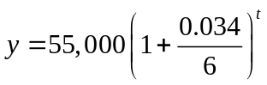
which we used for comparison between the baseline expected growth and our model’s growth. (Note that this expected growth function has no seasonal fluctuation in births.)

CHAPTER III
Results, Discussion, and Conclusions

We analyzed many possible scenarios to calculate the effect on the total population and graphed the results in terms of population and number of surgeries performed after five years. The scenarios were based on the percentage of additional spays performed per time step for P1, P2, A1, and A2 classes (h_{i}). Scenarios included: no additional spays; 50% more spays in the P1, P2, A1, and A2 classes; 50% more spay surgeries in the P2 and A1 classes; 50% more spay surgeries in P1 and P2 classes, 50% more spay surgeries in the P2 class; and 50% more spays in the A1 class.

The following graphs depict each scenario, plotting the change in the population over the course of five years from the model simulation. On the same set of axes, we plotted the baseline expected growth curve which was based on New et al. (2004) survey data for comparison purposes.

Figure 2 depicts the population over five years with no extra spaying. We see a growth from 55,000 to around 64,000.

Figure 3 demonstrates what happens to the population after five years of targeting cats of ages 2-4 months, 4-6 months, 6 months to 5 years, and 5-10 years. These are all the age classes that are capable of reproducing. If 50% more of each of these age classes was spayed each time step, then the population would start to decrease in the second year. By the end of the fifth year, the population would be down to around 35,000.

In Figure 4, we see the effects of targeting only the 4-6 month old and 6 month to 5 year old cats. We still see a dramatic decrease in the population after five years, with the final size of the population (approximately 40,000) being only slightly higher than that in Figure 3. This represents possibly the most realistic scenario, based on Spay Shuttle data, which shows that cats in P1 and A2 are rarely spayed.

Figure 5 shows the effects of spaying 50% more cats of ages 2-4 months and 4-6 months. Again, the reduction in the population is pronounced (the final population is around 42,000), but the intervention is slightly less effective than the previous strategies.

Figure 6 indicates the effects of spaying 50% more cats of ages 4-6 months. There is still a reduction in the population (the final population is around 44,000), but the intervention is less effective than the previous strategies. It takes more time for the population to start to decline than in previous scenarios.

In Figure 7, we see the effects of spaying 50% more cats of ages 6 months to 5 years old. There is a reduction in the population, but it is not nearly as dramatic, with the population after five years being around 50,000. This makes sense, as most cats in this age class may have already had at least one litter of kittens by the time they have been spayed.

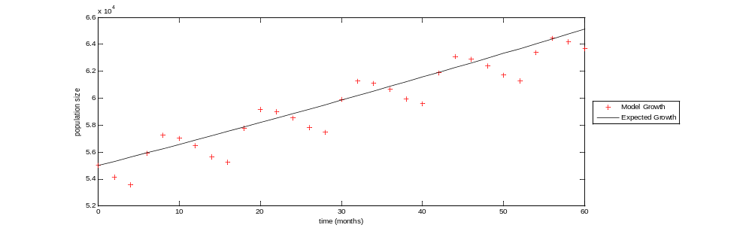
Figure 2. No extra interventions.

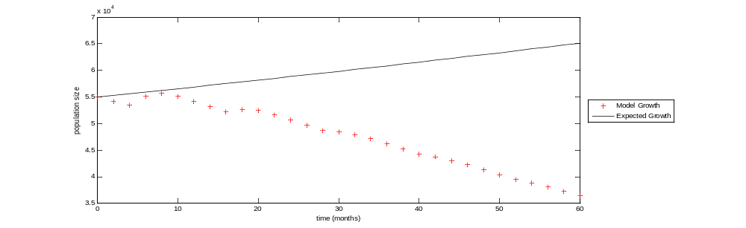
Figure 3. Spaying 50% more females age 2-4mo, 4-6mo, 6mo-5yr, 5-10yr

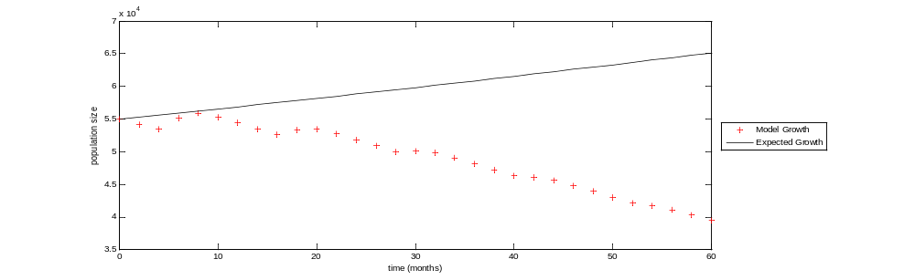
Figure 4. Spaying 50% more females age 4-6mo, 6mo-5yr
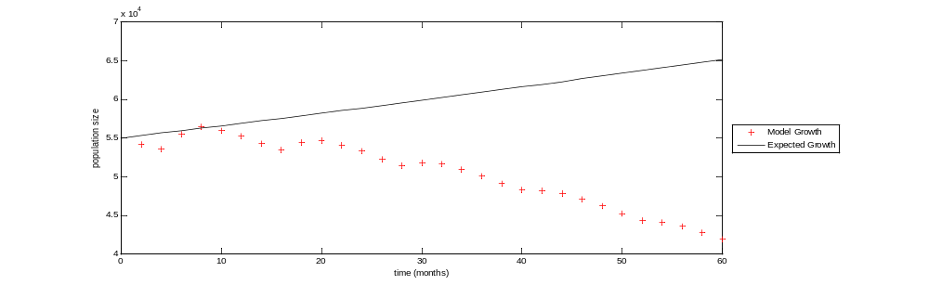
Figure 5. Spaying 50% More Females Age 2-4 Months and 4-6 Months.

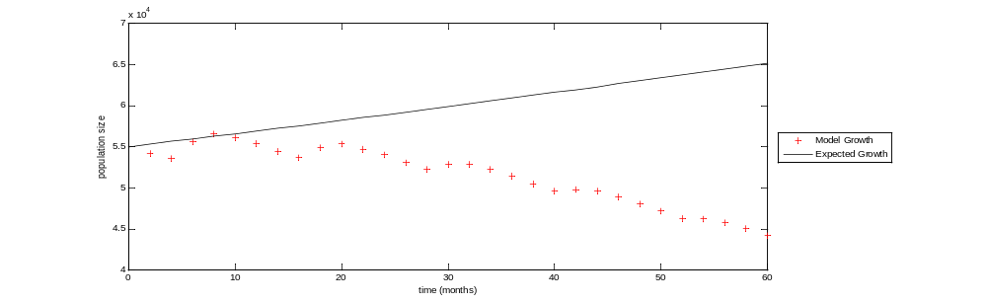
Figure 6. Spaying 50% More Females Age 4-6 Months.

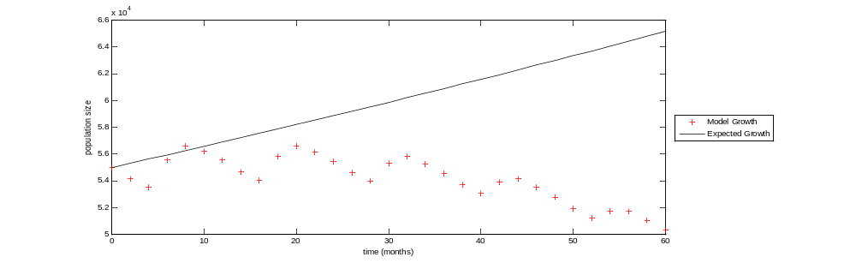
Figure 7. Spaying 50% More Females Age 6 Mo – 5 Yrs.

The following graphs depict the cumulative number of surgeries performed in each scenario; we only count effective surgeries. We note that oscillations occur in the graphs of the cumulative surgeries in these scenarios. These are the indirect result of the seasonality of births. As time goes on, the number of cats in a particular class will surge and wane. Because the number of surgeries performed in a particular two month period is calculated as a percentage of the number of cats in that class at that time, the number of surgeries will surge and wane, as well.

In Figure 8, we see the cumulative number of surgeries performed after five years, given no extra interventions. The cumulative number of surgeries performed over five years is near 47,000.

In Figure 9, we see the effect of spaying 50% of ages 2-4 months, 4-6 months, 6 months to 5 years, and 5-10 years has on the cumulative number of surgeries performed. We note the decline in surgeries per time step toward the end of the five years, depicted by the slight leveling off of the curve around the second year. The cumulative number of surgeries performed is around 25,000.

In Figure 10, we see the effect spaying 50% of ages 4-6 months and 6 months to 5 years has on the cumulative number of surgeries performed. We again note the decline in surgeries per time step toward the end of the five years, depicted by the slight leveling off of the curve around the second year (albeit less pronounced than Figure 9). The cumulative number of surgeries performed is around 27,000.

In Figure 11, we see the effect spaying 50% of ages 2-4 months and 4-6 months has on the cumulative number of surgeries performed. We note the decline in surgeries per time step toward the end of the five years is even less dramatic than the scenarios depicted by Figure 9 or Figure 10. The cumulative number of surgeries performed is right around 30,000.

In Figure 12, we see the effect spaying 50% of ages 4-6 months has on the cumulative number of surgeries performed. We note that the leveling off of the curve seen in previous scenarios is even less dramatic, indicating that the number of surgeries per time step is not decreasing as quickly as in other scenarios. The cumulative number of surgeries performed is around 32,000.

In Figure 13, we see the effect spaying 50% of ages 6 months to 5 years has on the cumulative number of surgeries performed. We note very little decline in surgeries per time step toward the end of the five years. The cumulative number of surgeries performed is around 37,000.

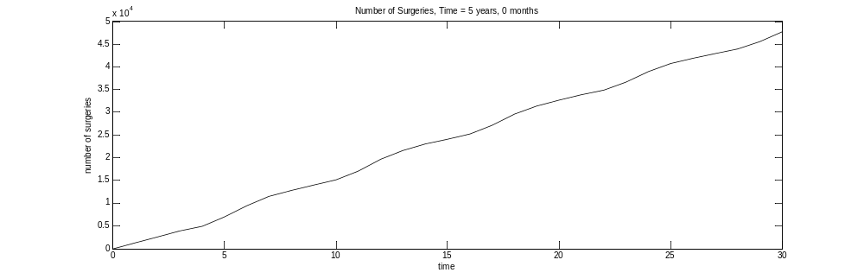
Figure 8. Cumulative surgeries with no extra intervention.

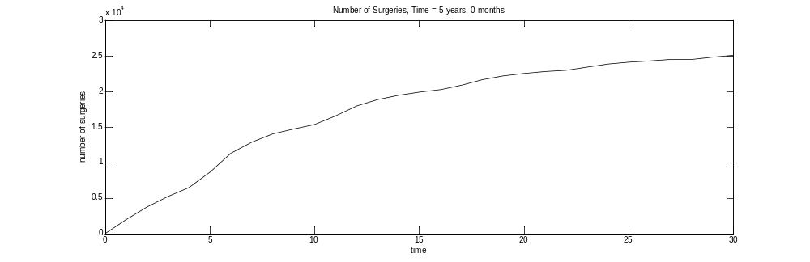
Figure 9. Cumulative surgeries with 50% increase in 2-4mo, 4-6 mo, 6mo-5yr, 5-10yr

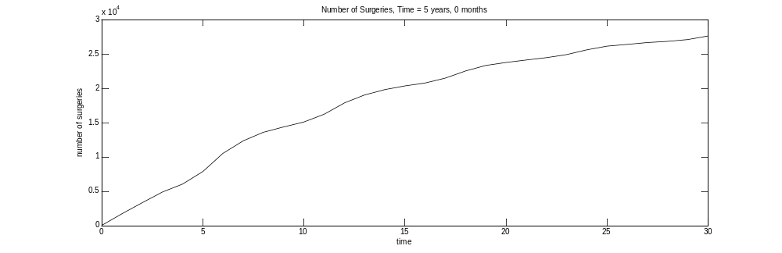
Figure 10. Cumulative surgeries with 50% increase in 4-6mo and 6mo-5yr.

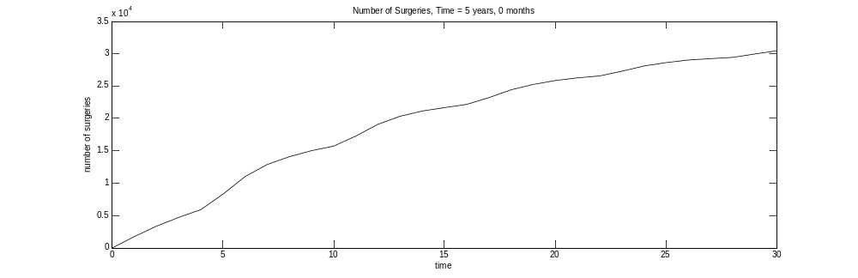
Figure 11. Cumulative surgeries with 50% increase in 2-4mo and 4-6mo.

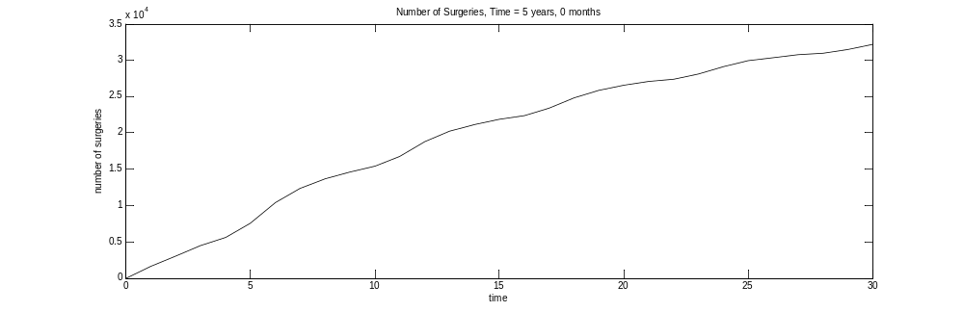
Figure 12. Cumulative surgeries with 50% increase in 4-6mo.

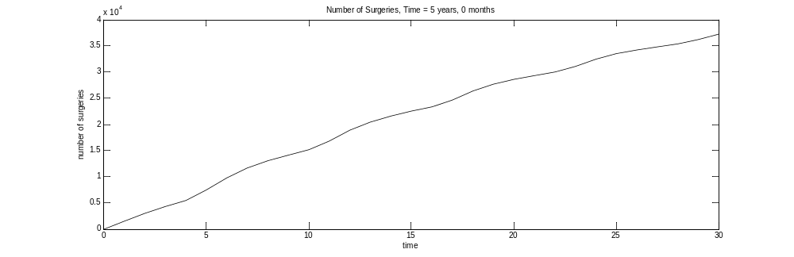
Figure 13. Cumulative surgeries with 50% increase in 6mo-5yr.

Table 5. Selected intervention scenarios (cases) and projected population and number of spays over five years.
Case | Population after 5 yrs. | Total # Spays
No extra intervention | 63,679 | 47,770
50% more of 2-4mo, 4-6mo, 6mo-5yrs, 5-10yrs | 36,382 | 25,037
50% more of 4-6mo and 6mo – 5yrs | 39,462 | 27,566
50% more of 2-4mo and 4-6mo | 41,905 | 30,471
50% more of 4-6 months | 44,196 | 32,208
50% more of 6mo – 5yrs | 50,314 | 37,285

Table 5 summarizes the results of each scenario on the population of owned female cats after five years.

Without looking at the graphs of the cumulative surgeries performed, it might seem paradoxical for a higher percentage of surgeries per time step for a particular segment of the population to result in fewer overall surgeries by the end of five years. But the graphs reveal the reason behind this. We notice that in examining, for instance, the scenario in which 50% more of each age class (except for neonatal and geriatric) are spayed, the first year (time steps 0-6) sees a more intense effort on spaying than under the scenario in which no extra interventions take place. But by the beginning of year 3 (time step 13), the pace has slackened considerably. Indeed, by the end of the fifth year, the number of new surgeries added per time step is quite small.

The reason for fewer surgeries near the final time is the success of the first two years in decreasing the number of intact animals. By the end of the second year, there are fewer female cats to spay. Even though the percentage is constant, the actual number of surgeries needed to be performed is smaller. More work in the beginning leads to less work toward the end.

Using a low final population level and a low number of surgeries as performance criteria, we find that the best scenario to spay 50% more in all the classes (except neonatal and geriatric). But this scenario may not be realistic for actual implementation, especially due to the difficulty of bringing in more cats at the P1 and A2 levels for spaying, as mentioned previously. We would conclude that increasing spaying at P2 and A1 would seem the best practical scenario to choose; in this case, more cats would be targeted before their first estrus cycle.

We have built a modeling tool that is flexible and can be adapted to the owned cat situations in different counties. We only showed results for increasing spaying rates by 50%, but other rates of increase can be easily included and may be more appropriate depending on a budget to find more cats to spay.

We note that our model has some simplifying assumptions, especially the omission of interactions with feral cats and the arrival and adoption of stray cats. Cats that disappear are a potential confounder in death rate estimates. Also, the data supplied by the Spay Shuttle may not be truly representative of the population of Knox County. More data on our specific cat population could help to make more accurate parameter estimates. Since our model considers only female cats, spay/neuter rates should be implemented on both males and females in an actual population. Also, calculating the number of surgeries at the beginning of the time step (before application of the death rate) yields a conservatively high estimate of the amount of surgeries.

We also note that this study is designed to examine the dynamics of the population over a relatively short period of time (5 years). When we rewrite the system of difference equations (without extra interventions) in matrix form, we find that the dominant eigenvalue is 0.9311, which would indicate long term decay instead of long term growth. Indeed, when we run this model for 10 years, we see the population start to decrease. To examine the dynamics of the population for a period of time longer than five years, it would be necessary to modify the rate parameters. Another consequence of the short time period is that our results are highly dependent on the initial population distribution.

LIST OF REFERENCES

Andersen, M. C., Martin, B. J., Roemer, G. W., 2004. Use of matrix population models to estimate the efficacy of euthanasia versus trap-neuter-return for management of free-roaming cats, Journal of the American Veterinary Medicinal Association. 225, 1871-1876.

American Pet Products Association National Pet Owners Survey 2009-2010. Greenwich, CT. Print.

American Veterinary Medical Association. U.S. Pet Ownership & Demographics Sourcebook. Schaumburg, IL: AVMA, 2001, 2006. Print.

Auger, P., and Pontier, D., 1998. Fast game theory coupled to slow population dynamics: the case of domestic cat populations, Mathematical Bioscience. 148, 65-82.

Baldock F. C., Alexander L., More J.S., 2003. Estimated and predicted changes in the cat population of Australian households from 1979 to 2005. Aust. Vet. J. Volume 81. Issue 5: 289-292. Print.

Budke, C. M., and Slater, M. R., 2009. Utilization of Matrix Population Models to Assess a 3-Year Single Treatment Nonsurgical Contraception Program Versus Surgical Sterilization in Feral Cat Populations, Journal of Applied Animal Welfare Science. 12(4), 277-292.

DiGiacomo, N, Arluke, A, Patronek, G, 1998. Surrendering pets to shelters: The relinquisher’s perspective. Anthrozoos. 11, 41-50.

Frank, J. M., & Carlisle-Frank, P. L., 2007. Analysis of programs to reduce overpopulation of companion animals: Do adoption and low-cost spay/neuter programs merely cause substitution of sources? Ecological Economics. 62, 740-746.

Marsh, P., 2010. Replacing Myth With Math: Using Evidence-Based Programs to Eradicate Shelter Overpopulation. Concord, NH: Town and Country Reprographics, Inc.. Print.

Marsh, P. Phone conversation, Knoxville, TN, July 7, 2010 .

New J.C., Kelch W.J., 2006. Dog and cat birth and death rate estimates Unpublished data.

New, Jr., J. C., Kelch, W. J., Hutchison, J. M., Salman, M. D., King, M., Scarlett, J. M., Kass, P. H., 2004. Birth and Death Rate Estimates of Cats and Dogs in U.S. Households and Related Factors, Journal of Applied Animal Welfare Science. 7(4), 229-241.

Nutter F.B., Levine J.F., Stoskopf M.K., 2004. Reproductive capacity of free-roaming domestic cats and kitten survival rate. J. Am. Vet. Med. Assoc. Volume 225. Issue 9: 1399-1402. Print.

Rowan, A. N., 1992. Shelter and Pet Overpopulation: A Statistical Black Hole, Anthrozoos. 5(3), 140-143.

Scarlett, J, 2004. Pet population dynamics and shelter animal medicine issues, Shelter Medicine for Veterinarians and Staff. Ed. Lila Miller and Stephen Zawistowski. Ames: Blackwell Publishing. 11-23. Print.

Spay Shuttle Data 2007-2010 (unpublished), Spay Shuttle Program, Knoxville, TN. Used with permission.

U.S. Census Bureau, 2009. Population Finder: Knox County,Tennessee. Retrieved July 30, 2010 from http://factfinder.census.gov/

White, D.J., & Shawhan, R., 1996. Emotional responses of animal shelter workers to euthanasia. J. Am. Vet. Med. Assoc. Volume 208: 846-849.

Vita

Evan P. Lancaster grew up in Lewisburg, Tennessee, and graduated near the top of his class from Marshall County High School in 1996. He started his undergraduate work at the University of Tennessee in engineering, but soon transferred to Middle Tennessee State University to pursue a bachelor’s degree in professional mathematics, which he obtained in May of 2000. He earned some graduate credits while working full-time in various fields until he found his true passion: teaching mathematics. He taught high school mathematics for six years. He participated in a research experience at MTSU under the guidance of Dr. Wandi Ding. This research led him to pursue another passion: research. As a result of his work with Dr. Ding, he was inspired to go back to school full-time and obtain his master’s degree in mathematics, which he will obtain in July of 2012. He will become a math instructor with the Department of University Studies at MTSU starting in the fall of 2012.

