The Development and Implementation of a Testing Regime for a Laser Spectroscopy Sample Chamber

A Thesis Presented for the
Master of Science
Degree
The University of Tennessee, Knoxville

Jonathan Daniel Hartman
December 2021

Copyright © 2021 by Jonathan Daniel Hartman
All rights reserved.

ACKNOWLEDGEMENTS
I would first like to acknowledge some of the people that were instrumental in helping me complete this thesis. I would like to thank Dr. Howard Hall for first giving me the opportunity to be a graduate research assistant for him. He has been an incredible mentor and professor and I have enjoyed learning so much about nuclear security, safeguards, and forensics from him. Numerous career paths have been opened up to me due to his generosity and desire to train up the next generation of nuclear security experts. I would also like to thank Dr. Leigh Martin for being my official NSSC lab mentor and providing me with great support on this thesis over the past year and answering any questions that I had regarding the LISA-UE project. Moreover, I would like to extend my sincerest gratitude to both Dr. Lawrence Heilbronn and Dr. Ondrej Chvala for their flexibility to supply so much informative feedback to this thesis project and for their contributions to my nuclear engineering education.
I would additionally like to thank the following mentors and collaborators that made notable contributions to both my research and graduate education. Dr. Matt Cook has been an additional advisor and mentor since I joined Dr. Howard Hall’s research group, and time after time has gone above and beyond what is required of him and consistently provided feedback and assistance throughout these past three years even though he wasn’t even funded on this project. I would also like to thank Dr. Zhili Zhang for his assistance in answering any of my laser related questions and for providing his expertise a few times as we worked to fix and repair our laser last year. Further thanks are necessary for the collaborative and constructive work and contributions that Ben Jordan,
Jana Starks, Dean Forrest, and Eli Rosenburg made to this project. They are all terrific fellow students and took time out of own their schedules to assist me in conducting each of the experiments for this thesis. Please know that none of your many collective contributions have gone unnoticed, and all are greatly appreciated.

Funding Information: This material is based upon work supported by the Department of Energy National Nuclear Security Administration through the Nuclear Science and Security Consortium under Award Number ​DE-NA0003180​.

This report was prepared as an account of work sponsored by an agency of the United States Government. Neither the United States Government nor any agency thereof, nor any of their employees, makes any warranty, express or limited, or assumes any legal liability or responsibility for the accuracy, completeness, or usefulness of any information, apparatus, product, or process disclosed, or represents that its use would not infringe privately owned rights. Reference herein to any specific commercial product, process, or service by trade name, trademark, manufacturer, or otherwise does not necessarily constitute or imply its endorsement, recommendation, or favoring by the United States​ ​Government or any agency thereof. The views and opinions of the author expressed herein do not necessarily state or reflect those of the United States Government or any agency thereof.

Abstract
This thesis is divided into two main sections. The first component will be on the creation and implementation of a testing regime for the sample chamber that may be employed in a field-deployable laser spectroscopy system for nuclear safeguards measurement applications. The testing regime will consist of various benchmarks that comprehensively characterize sample chamber performance. The second part of this thesis will culminate with a novel comparison of the Ultraviolet-Visible spectrum (300-500 nm) of the Laser Induced Breakdown Spectroscopy (LIBS) of trace elements in synthetic (radioactive and non-radioactive) nuclear melt glass and authentic trinitite with a Femtosecond (Fs) laser. Sixteen unique characteristic peaks for all ten primary elements which make up trinitite (Al, Ca, Fe, K, Mg, Mn, Na, O, Si, Ti) were found in each of the non-radioactive/radioactive nuclear melt glass and trinitite samples and subsequently cross referenced through use of the U.S. National Institute of Standards and Technology (NIST) LIBS database and past published Fs-LIBS literature. Additionally, the novel temporal evolution of Fs-LIBS spectra of uranium in radioactive nuclear melt glass and Trinitite with the spectrometer centered around 421nm and 424nm were compared. Throughout this thesis, the challenges of developing fs-LIBS to the rigorous standards that are required for this analytical technique to be employed as a nuclear safeguards technology for environmental sampling or other similar applications within the nuclear fuel cycle will be foreshadowed.
Table of Contents
Chapter One - INTRODUCTION 1
Chapter Two - Literature Review 4
Overview of Analytical Measurement Processes in the Nuclear Fuel Cycle 4
Overview of Nuclear Safeguards in Uranium Enrichment Facilities 6
Laser-Induced Breakdown Spectroscopy (LIBS) of UF₆ 8
Overview of LIBS 8
Nuclear Applications of LIBS 11
LIBS of UF₆ 11
How Femtosecond Lasers Will Advance Field-Deployable LIBS 14
Sample Chamber Considerations for UF₆ 17
Chapter Three – Sample Chamber benchmarks 20
Equipment and General Lab Setup in SERF108 21
Experiments 23
Chapter Four - CONCLUSIONS AND FUTURE WORK 88
List of References 93
APPENDices 104
APPENDIX A 105
APPENDIX B 113
APPENDIX C 122
APPENDIX D 124
VITA 132

LIST OF TABLES
Table 3.1: Various Parameters (unless otherwise specified) of the primary equipment used for fs-LIBS experiments. 22
Table 3.2: Transmission properties of scotch tape observed during experiments. 36
Table 3.3: Gating parameters used for temporal characterization of Al atomic lines. Taken from [53]. 44
Table 3.4: Comparison of Non-Radioactive Elemental Composition of Trinitite vs. UTK Synthetic Nuclear Melt Glass [54]. 52
Table 3.5: Interference free analytical lines for analysis of trace elements in radioactive/non-radioactive nuclear melt glass and Trinitite [52]. 52
Table 3.6: List of optimized gating parameters found from fs-LIBS experiments of synthetic nuclear melt glass (non-radioactive and radioactive) and Trinitite. 62
Table 3.7: 16 Interference free analytical lines for analysis of trace elements in radioactive/non-radioactive nuclear melt glass and Trinitite. 70
Table A.1: List of wet air in-leakage times for different leak rates. 108
Table B.1: Properties of Sapphire Windows and fs-laser [69, 70]. 115
Table B.2: Incremental Benchmark Testing Goals for Operation of fs-laser to Test Thermal Damage in Sapphire Windows [for 1kHz/pulse] {320 Total min}. 120

LIST OF FIGURES
Figure 2.1 (above): Main analytical needs for laser spectroscopy in the nuclear fuel cycle [2]. 5
Figure 2.2 (above): Typical Setup for a Laser-Induced Breakdown Spectroscopy System [14]. 10
Figure 2.3 (above): Example of portable LIBS system developed by Yamamoto et al. [38]. 12
Figure 2.4 (above): Illustration of the setup of LISA-UE [44]. 16
Figure 2.5 (above): Laser ablation and optical emission for nanosecond and femtosecond laser-produced plasmas (LPP) [46]. 16
Figure 2.6 (above): Chamber designed by Martin et al. to assay UF₆ for LISA-UE project [47]. 18
Figure 2.7 (above): Schematic diagram of the sample chamber’s safety features as designed by Martin et al. [47]. 18
Figure 3.1 (above): Configuration of fs-laser lab setup in SERF108 22
Figure 3.2 (above): Transmission spectrum of optically clear adhesive tape 25
Figure 3.3 (above): Transmission spectrum of UO₂F₂ [50] 27
Figure 3.4 (above): Sample chamber configuration for Scotch tape experiment 27
Figure 3.5 (left) & 3.6 (right): Configuration for the two Scotch tape experiments 29
Figure 3.7 (above): fs-LIBS of oxygen peak in air for scotch tape experiments 31
Figure 3.8 (above): Decay of the fs-LIBS oxygen emission peak in air as pieces of tape are placed above the sample chamber (collection side) sapphire window to simulate degradation to the window. 32
Figure 3.9 (above): Decay of the fs-LIBS oxygen emission peak in air as pieces of tape are placed directly onto the sample chamber (collection side) window to simulate degradation to the window. 33
Figure 3.10 (above): Comparison of how many pieces of scotch tape were necessary to completely block out the fs-LIBS emission peak of oxygen in air. 34
Figure 3.11 (above): Configuration of Vacuum Pressure Test experiment 39
Figure 3.12 (above): Fs-LIBS of Argon gas data acquisition 41
Figure 3.13 (above): Modification of sample chamber to allow mounting of solid samples 41
Figure 3.14 (above): Setup used for the mixing of the epoxy samples 43
Figure 3.15 (left) & 3.16 (right): Un-sanded Aluminum samples appear on the left while one of the sanded samples is shown in the photo on the right. 43
Figure 3.17 (above): Temporal evolution of atomic aluminum lines (at 394.4 and 396.1 nm) using 100 fs-laser pulses in air at atmospheric pressure, on pure aluminum target. Delay times and gate times are listed in Table 4.1. Taken from Drogoff et al. [53]. 46
Figure 3.18 (left) & 3.19 (right): fs-LIBS of Aluminum samples used in this experiment 47
Figure 3.20 (above): Replicated temporal evolution of atomic aluminum lines (at 394.40 nm) 48
Figure 3.21 (above): Replicated temporal evolution of atomic aluminum lines (at 396.15 nm) 49
Figure 3.22 (above): The reduced self-absorption in solid samples technique employed in the fs-LIBS of Aluminum experiments 50
Figure 3.23 (above): Non-radioactive nuclear melt glass sample used in the fs-LIBS experiments 54
Figure 3.24 (Left) & 3.25 (Right): Variations in how the radioactive nuclear melt glass samples used in the fs-LIBS experiments were oriented 56
Figure 3.26 (Left) & 3.27 (Right): Comparison of the two Trinitite samples that were used in the fs-LIBS experiments. 56
Figure 3.28 (above): Ns-LIBS of Trinitite spectrum between 235-350 nm found in the appendix of the Handbook of LIBS textbook by Cremers et al. [55] 58
Figure 3.29 (above) continued: Ns-LIBS of Trinitite spectrum between 390-600nm found in the appendix of the Handbook of LIBS textbook by Cremers et al. [55] 59
Figure 3.30 (above) continued: Ns-LIBS of Trinitite spectrum between 600-800nm found in the appendix of the Handbook of LIBS textbook by Cremers et al. [55] 60
Figure 3.31 (above): fs-LIBS of non-radioactive nuclear melt glass 63
Figure 3.32 (left) & 3.33 (right): fs-LIBS of radioactive nuclear melt glass 63
Figure 3.34 (left) & 3.35 (right): fs-LIBS of radioactive nuclear melt glass 64
Figure 3.36 (above): fs-LIBS of Trinitite 64
Figure 3.37 (left) & 3.38 (right): Smeared sapphire windows in the sample chamber as a result of the initial decontamination procedure that used “RadiacWash” to safely clean the sample chambers. 67
Figure 3.39 (left) & 3.40 (right): Post fs-laser ablation of non-radioactive nuclear melt glass samples 67
Figure 3.41 (left) & 3.42 (right): Post fs-laser ablation of radioactive nuclear melt glass samples 68
Figure 3.43 (left) & 3.44 (right): Post fs-laser ablation of Trinitite samples 68
Figure 3.45 (left) & 3.46 (right): Post fs-laser ablation of Trinitite samples 69
Figure 3.47 (above): Comparison of Na found in the synthetic nuclear melt glass (both non-radioactive and radioactive) and Trinitite samples 71
Figure 3.48 (above): Comparison of Fe and Mg found in the synthetic nuclear melt glass (both non-radioactive and radioactive) and Trinitite samples 72
Figure 3.49 (above): Comparison of Fe found in the synthetic nuclear melt glass (both non-radioactive and radioactive) and Trinitite samples 73
Figure 3.50 (above): Comparison of Si found in the synthetic nuclear melt glass (both non-radioactive and radioactive) and Trinitite samples 74
Figure 3.51 (above): Comparison of O found in the synthetic nuclear melt glass (both non-radioactive and radioactive) and Trinitite samples 75
Figure 3.52 (above): Comparison of Al and Ca found in the synthetic nuclear melt glass (both non-radioactive and radioactive) and Trinitite samples 76
Figure 3.53 (above): Comparison of Mn found in the synthetic nuclear melt glass (both non-radioactive and radioactive) and Trinitite samples 77
Figure 3.54 (above): Comparison of K found in the synthetic nuclear melt glass (both non-radioactive and radioactive) and Trinitite samples 78
Figure 3.55 (above): Comparison of Ca found in the synthetic nuclear melt glass (both non-radioactive and radioactive) and Trinitite samples 79
Figure 3.56 (above): Comparison of Ti found in the synthetic nuclear melt glass (both non-radioactive and radioactive) and Trinitite samples 80
Figure 3.57 (above): Temporal evolution of atomic uranium lines in radioactive nuclear melt glass (spectrometer centered at 421.4nm) 82
Figure 3.58 (above): Temporal evolution of atomic uranium lines in radioactive nuclear melt glass (spectrometer centered at 424.4nm) 83
Figure 3.59 (above): Temporal evolution of atomic uranium lines in Trinitite (spectrometer centered at 421.0nm) 84
Figure 3.60 (above): Temporal evolution of atomic uranium lines in Trinitite 85
Figure 3.61 (above): Temporal evolution of atomic uranium lines in Trinitite 86
Figure B.1 (above): Overall schematic diagram of the fs-laser beam as it is focused after passing through a 75 mm plano convex lens and passes through the sapphire window as it is focused into the center of the sample chamber for fs-LIBS experiments. 116
Figure B.2 (above): Cutaway schematic diagram of the fs-laser beam as it is focused after passing through a 75 mm plano convex lens and passes through the sapphire window as it is focused into the center of the sample chamber for fs-LIBS experiments. 116
Figure B.3 (above): Cutaway schematic diagram of the fs-laser beam as it is focused after passing through a 75 mm plano convex lens and passes through the sapphire window as it is focused into the center of the sample chamber for fs-LIBS experiments. 118

- INTRODUCTION
In 2017, a study funded by the National Nuclear Security Agency (NNSA) within the United States (US) Department of Energy (DOE) sought to recommend alternative analytical techniques that would be comparable and much more field-deployable than the current world-standard of mass spectrometry for nuclear safeguards assay of nuclear material by the International Atomic Energy Agency (IAEA) at declared facilities around the world [1]. One of the recommended techniques, Laser Induced Spectrochemical Assay for Uranium Enrichment (LISA-UE), is a derivation of Laser Induced Breakdown Spectroscopy (LIBS) that is being co-developed by research teams at University of Tennessee Knoxville (UTK), Oak Ridge National Laboratory (ORNL), and Lawrence Berkeley National Laboratory (LBNL) [1]. This thesis will focus on designing and implementing a testing regime to determine the effective lifetime for the nearly identical sample chamber that is currently being developed for the LISA-UE project. The remainder of this chapter will provide an overview of the content in subsequent chapters within this thesis.
Chapter 2 will contain the literature review for this thesis and consist of a background on an overview of analytical measurements within the nuclear fuel cycle, the enrichment of uranium and why uranium hexafluoride (UF₆) was chosen as the form of uranium for enrichment techniques, as well as the challenges that come with effectively safeguarding enrichment facilities through the International Atomic Energy Agency (IAEA). Further background will be provided with a review of Laser Induced Breakdown Spectroscopy (LIBS), how LIBS has been used in various nuclear applications over the past few years, why LIBS was chosen as an analytical method to assay uranium hexafluoride, how the use of a femtosecond (fs) laser will advance the state of the art technology for field-deployable derivations of LIBS systems for nuclear safeguard measurements, in addition to sample chamber considerations for uranium hexafluoride in such a field-deployable unit.
In Chapter 3, the experimental methodology and setup that will be utilized to examine and characterize the effective lifetime of the sample chamber to determine if any optimization should occur before its use in a field-deployable laser spectroscopy system for safeguards assay of nuclear material will be discussed in further detail. Experiment analytical benchmarks will include: the determination of whether the limiting rate for the sample chamber will either be the in-leakage of air outside the chamber versus the chemical reaction rate of uranium hexafluoride with water moisture in the air, simulating degradation on the sample chamber sapphire windows to assess how the collected LIBS emission signal is affected over time, use a fs-laser to diagnose any thermal effects, opacity changes, visual changes in the color and uniformity of the sapphire windows, and impacts on vacuum integrity over time, demonstrate the capability of the sample chamber to achieve and maintain vacuum pressure to ensure safe usability with hazardous/radioactive materials, determine and optimize various initial parameters of LIBS setup for subsequent LIBS experiments, and finally, bombard three different sample types of synthetic nuclear melt glass (non-radioactive and radioactive) and authentic trinitite with fs-LIBS. This last experiment of fs-LIBS of synthetic nuclear melt glass and trinitite will be very important in providing guidance for future fs-LIBS assay of UF₆ to resolve the isotopic shift of the U II line near 424nm that will be undertaken at UTK later this year. Results and analysis of the experimental benchmarks for this thesis will be illustrated and discussed within each subsection in Chapter 3 in addition to certain Appendices.
Chapter 4 will include a conclusive assessment of the implemented testing regime that was used to characterize the effective performance of the sample chamber for its nuclear safeguard applications and further provide any optimization recommendations for future work at UTK and the nuclear safeguards community.

- Literature Review

Overview of Analytical Measurement Processes in the Nuclear Fuel Cycle
The Nuclear Fuel Cycle (Figure 1) offers many different opportunities for analytical measurement processes [2]. Uranium undergoes numerous chemical processes as it is transformed from a mined ore into a gaseous hexafluoride (UF₆) for enrichment of U-235 before it is converted back to a dioxide (UO₂) where it is formed into fuel for power plants [2]. After the fuel is used to produce power, it will either be reprocessed or sent away for disposal in a geological repository at a later time. All of these processes require specific analytical needs from assaying the material during harsh radioactive environments to wanting to have in-situ real-time analysis [2]. Beyond developing better analytical methods for improving the efficiency of the nuclear fuel cycle, laser spectroscopy can also support the growing need to assist the International Atomic Energy Agency (IAEA) within its Nuclear Safeguards and Environmental Sampling Division as more nuclear facilities are built around the world. Developing field-deployable laser spectroscopy systems with analytical measurement capabilities for isotopic/molecular assay or trace detection has the potential to be of great importance to aid IAEA inspectors.

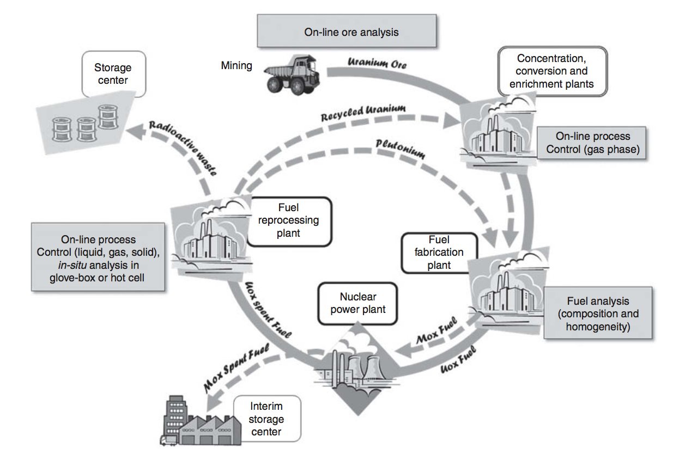
Figure 2.1 (above): Main analytical needs for laser spectroscopy in the nuclear fuel cycle [2].

Overview of Nuclear Safeguards in Uranium Enrichment Facilities
One of the IAEA’s foundational goals is to promote the peaceful use of nuclear technology around the world [3]. With the growing demand for nuclear power, there has been a demand for additional enrichment in order to meet the demands for reactor-grade LEU. Any nation that desires enriched uranium is currently utilizing or developing gas centrifuges. Gas centrifuge technology is simple, demonstrated, and has already been proliferated on a global scale. Since revelations of Iran (2002) and North Korea (2010), there are now at least nine Non-Nuclear Weapons States (NNWS) (Argentina, Brazil, Germany, India, Japan, the Netherlands, and Pakistan) in addition to the five Nuclear Weapons States (NWS) that possess enrichment capabilities. The Treaty on the Nonproliferation of Nuclear Weapons (NPT), which entered into force in 1970, first introduced the designations of NWS and NNWS which remain to this day [4]. It is worth noting that four additional countries (Israel, India, Pakistan, and North Korea) have obtained nuclear weapons and are considered states with nuclear weapons despite not being included in the original NWS designation through the NPT [4].
Safeguards are very important at uranium enrichment facilities because the same technologies used for civilian purposes can also be used for malicious ones. Civilian facilities can be used to enrich material beyond declared values or to enrich undeclared material, both of which can be subsequently diverted. The expansion of enrichment, especially to NNWS with Comprehensive Safeguards Agreements (CSA) under INFCIRC-153 [5], has created a need to develop a method of safeguarding enrichment facilities.
Uranium hexafluoride (UF₆) is the typical form of uranium that is utilized to enrich uranium for nuclear fuel or nuclear weapons. UF₆ was chosen since it is in a gaseous state at an acceptable operating temperature and because fluorine doesn’t contribute to the weight difference when separating U-235 and U-238 since it only has one naturally occurring isotope [6]. Gaseous diffusion was initially chosen as the preferred commercial method to enrich uranium during the Manhattan Project in World War 2 since it was a proven technology at the time [7]. However, as time went on, they became obsolete as gaseous centrifuges proved that they could separate uranium in a much more efficient process and at a much lower cost [6]. Today, Gas Centrifuge Enrichment Plants (GCEPs) have remained the “gold” standard for commercially enriching uranium with the nuclear fuel cycle.
Gas Centrifuge Enrichment Plants offer a few challenges for obtaining useful, accurate, and real-time analytical measurements of UF₆ for nuclear safeguards applications. The foremost challenge is that each GCEP facility around the world is privately owned and its technology is therefore proprietary. Additionally, with the small number of countries that possess these enrichment capabilities, there is a strong desire to maintain a competitive edge on the uranium enrichment market which furthers motivates those countries to keep their respective GCEP equipment hidden from foreign eyes. This is why certain countries that possess these capabilities will not allow certain IAEA inspectors of particular nationalities to inspect their GCEPs. Several other complications in obtaining enrichment measurements of UF₆ include unknown values of: temperature, pressure, mass flow rate, and enrichment of the gas; thickness and material of the pipe; thickness, age, and composition of wall deposits (hold-up); as well as background radiation and power supply of the GCEP itself.
At present, there is a large need for rapid analysis safeguards verification instrumentation to support the IAEA’s short- and no-notice inspections in order to provide inspectors with the ability to make timely and comprehensive conclusions so that further action can be decided upon for inspected sites. Additionally, there is the potential application for the development of a laser spectroscopy system as an unattended, continuous enrichment monitor that can be installed within a GCEP to continually measure the enrichment level of UF₆ production. Such an instrument would also benefit the enrichment facility operators as this would offer them a real-time, complimentary technique to their other quality assurance tests such as mass spectrometry and other destructive analysis methods.

Laser-Induced Breakdown Spectroscopy (LIBS) of UF₆

Overview of LIBS
Laser-Induced Breakdown Spectroscopy (LIBS) is an atomic emission spectroscopic technique that typically consists of a nanosecond neodymium-doped yttrium aluminum garnet (Nd:YAG) laser [8] that fires ultrafast, high-energy pulses into samples to elicit an ionized plasma [9,10]. Regardless of the sample’s state (gas, solid, or liquid), the induced plasma will emit light spectra that is characteristic of the ablated sample’s constitution of elements and respective concentrations [10]. Additionally, any sample can be analyzed both quantitatively and qualitatively at the same since the sensitivity of LIBS allows it to simultaneously measure almost all chemical elements [11]. While the analytical measurement industry standard has been Mass Spectrometry (MS) since its invention shortly after World War I [12], LIBS has made tremendous progress over the past 15 years in closing the gap in performance [13].
The typical setup for LIBS includes a pulsed laser, a focusing lens, a sample chamber or device to hold the sample while it is ablated in atmosphere, an optical fiber that sends the emitted light signal to the spectrometer, and a computer that processes the signal from the spectrometer and gives the LIBS user means to control a time control device that can synchronize the laser pulses with the detector in order to optimize the analytical results. Such a setup can be seen in Figure 2.2 [14]. The standard equipment that is utilized by the LIBS community for detecting the emitted light after the sample’s ablation is either a charge-coupled device (CCD), a photodiode array (PDA), or a photomultiplier tube (PMT) [10].

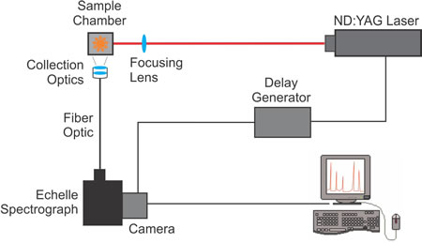
Figure 2.2 (above): Typical Setup for a Laser-Induced Breakdown Spectroscopy System [14].

Nuclear Applications of LIBS
In 1983, Radziemski was the first individual to employ LIBS for applied nuclear research in detecting Be in air [15]. Many other research groups have since utilized LIBS to assay uranium and other nuclear material in a variety of forms including uranium ore [16-19], uranium oxide/fuel [20-23], fission products [24-26], and spent fuel [27-33]. Other isotopic analysis research of uranium has been conducted by Doucet et al. [34] and by Cremers et al. [35]. Both investigated the shape of the U II line at 424.437 nm and tried to resolve the shift at that wavelength of U235 and U238 [34,35].
In addition to the promising results by the portable and field-deployable LIBS device of Cremers et al. [35], Shattan et al. [36] was the first to use a hand-held LIBS system to multi-element map both the exterior and an interior cross-section of surrogate nuclear debris for nuclear forensic applications. LIBS was also utilized to analytically measure environmental swipes taken by IAEA inspectors in Chinni et al. [37]. Figure 2.3 on the following page illustrates the portable LIBS system that was developed by Yamamoto et al. [38].

LIBS of UF₆
In 2017, there was an NNSA-funded report that published the comprehensive state-of-the-art and the respective applicability for various types of laser (optical) spectroscopy to be used by the nuclear safeguards community to assay UF₆ in a “rapid, accurate, and precise” manner [1]. The current process consists of UF₆ samples collected at declared facilities which are then sent off to
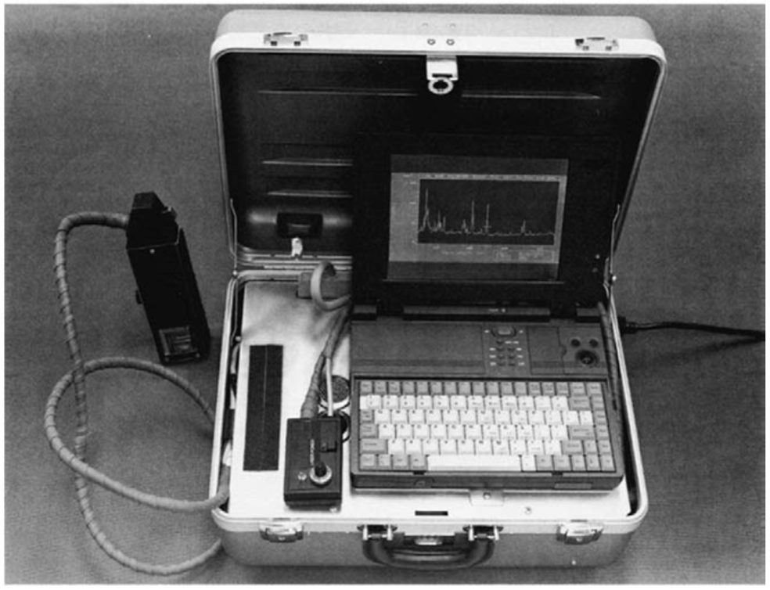
Figure 2.3 (above): Example of portable LIBS system developed by Yamamoto et al. [38].

be analyzed at one of the IAEA’s Network of Analytical Labs (NAL) in addition to the IAEA laboratories at Seibersdorf, Austria. Due to cumbersome logistics, costly analysis, and a long turnaround for results, there is a great need to develop an alternative technology to mass spectrometry, the current technique of choice [1]. While mass spectrometry is highly accurate and precise, it is impractical to be deployed and operated on-site at declared safeguarded facilities since it is way too costly and requires an experienced operator working in very controlled conditions [1]. According to the report [1], the “ideal instrument for UF₆ isotopic assay should be one that excels in five areas: fast temporal response, accuracy, precision, sensitivity, and field-deployability or portability.” The IAEA publishes International Target Values (ITVs) [39] every ten years which were used to benchmark the precision and analytical accuracy of the various spectroscopic techniques that were investigated in the report [1]. Of the reviewed techniques, Gas Source Mass Spectrometry (GSMS), Thermal Ionization Mass Spectrometry (TIMS), Multi-Collector Inductively Coupled Plasma Mass Spectrometry (MC-ICP-MS), and COMbined Procedure for Uranium Concentration and Enrichment Assay (COMPUCEA) were utilized as benchmark methods to assay UF₆ [1].
Upon completion of the study [1], three of the five recommended techniques to the nuclear safeguards community were laser (optical) spectroscopic including one method that shared similarities to laser-induced breakdown spectroscopy. These three emerging optical methods included Laser Ablation Absorbance Ratio Spectrometry (LAARS) [40-42], laser ablation – diode laser – Atomic Absorption Spectrometry (AAS) [43], and Laser Induced Spectrochemical Assay for Uranium Enrichment (LISA-UE) [1]. AAS was developed by Smith et al. in 1998 [43] and is the predecessor technique to LAARS that is currently being developed at Pacific Northwest National Laboratory (PNNL) [40-42]. Both atomic absorption methods require at least three lasers, but the AAS, despite its somewhat degraded analytical performance when compared to LAARS, does not need an optical grating or spectrometer because of its angle-offset approach [1]. LISA-UE is an atomic emission technique very similar to LIBS and is currently being jointly developed by Lawrence Berkeley National Laboratory (LBNL) and Oak Ridge National Laboratory (ORNL), along with some supportive collaboration from the University of Tennessee Knoxville (UTK). One advantage over both AAS and LAARS is that LISA-UE only requires one laser [1]. LISA-UE measures both U235 and U238 emission lines at the same time which reduces the opportunity for error bias in the U235/U238 ratios [1]. As an extension of LIBS, no sample preparation is necessary for LISA-UE so it can directly be connected to a cylinder or a filling station in a declared enrichment facility [1].

How Femtosecond Lasers Will Advance Field-Deployable LIBS
As mentioned in a previous section of this chapter, Cremers et al. [35] and Shattan et al. [36] have already demonstrated successful application of field-deployable LIBS systems for nuclear applications. Presently, field-deployable LIBS devices only contain nanosecond lasers due to their compactness, overall design, and cost. As part of the current LISA-UE project, LBNL and ORNL are jointly developing a field-deployable LIBS system to analytically measure UF₆ at a declared enrichment facility as depicted on the following page in Figure 2.4 [44]. The research team at UTK that is led by Dr. Howard Hall will use its own femtosecond laser to advance the deployment of a femtosecond LIBS (fs-LIBS) in supportive collaboration to the LISA-UE project at LBNL and ORNL. At this time, field-deployable LIBS systems have not been designed for gaseous samples, but modification of existing technology is easily attainable [1].
In pursuit of an improved LIBS device, femtosecond lasers (fs-lasers) offer the advantages of higher sensitivity, low continuum emission, improved detection precision, minimal sample destruction, and a lower ablation energy threshold [45]. Additionally, the full energy of the fs-laser pulse is completely deposited into the target since there is no interaction of the beam with the laser induced plasma [46]. This lack of laser plasma interaction (LPI) with a fs-laser eliminates the loss of any interrogated material before the emitted light can be collected and is depicted in Figure 2.5 [46]. Demonstrations of improvements in the use of non-gated detectors for analysis and the Limit Of Detection (LOD) for primary and trace elements in the sample have already been proven by the utilization of fs-lasers [46]. Current disadvantages of fs-lasers include the necessity of a highly controlled operating environment in addition to being larger, more expensive, and more complex than a ns-laser [45].
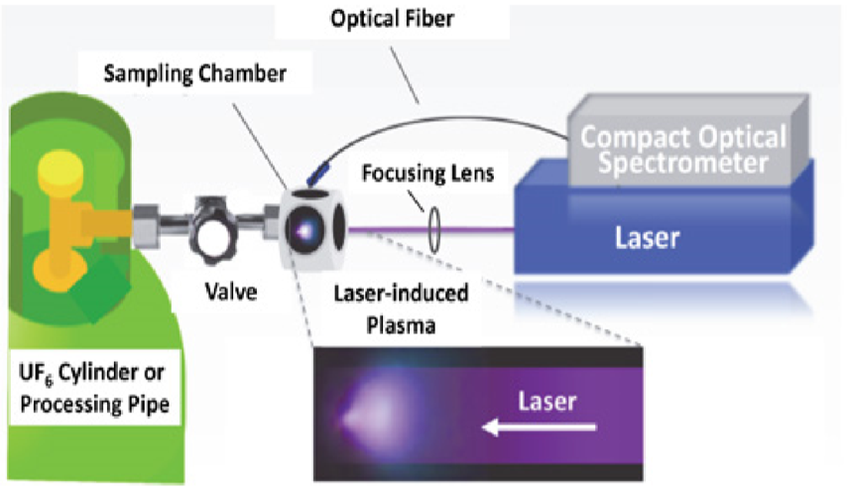
Figure 2.4 (above): Illustration of the setup of LISA-UE [44].

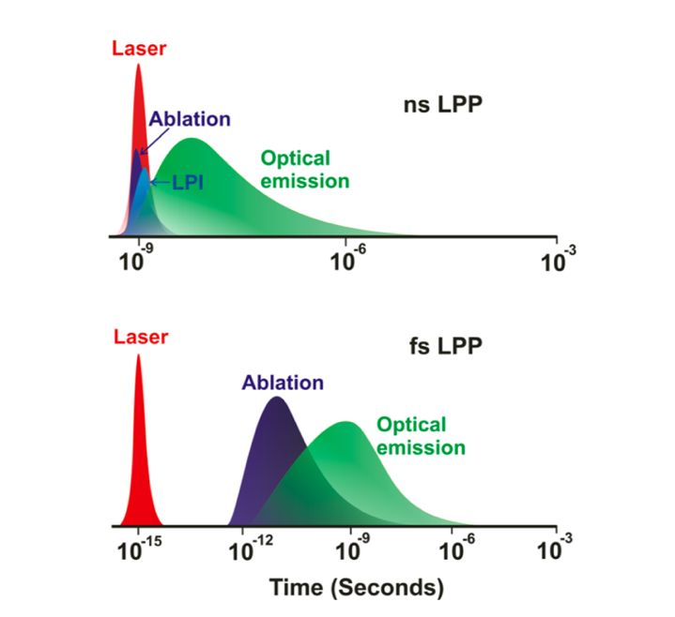
Figure 2.5 (above): Laser ablation and optical emission for nanosecond and femtosecond laser-produced plasmas (LPP) [46].

Sample Chamber Considerations for UF₆
Recent work on the LISA-UE project by Martin et al. [47] at ORNL and LBNL has demonstrated the capabilities of a robust sample chamber (Figure 2.6) that was designed to assay gaseous UF₆ for nuclear safeguards. Uranium hexafluoride is highly reactive with both organic and inorganic matter. It is extremely sensitive to moisture in any medium which leads it to undergo the reaction below in Equation 1 below, resulting in a potentially hazardous hydrogen fluoride (HF) gas at high enough concentrations.
$UF_{6}+2 H_{2}O →UO_{2}F_{2}\left(s\right)+4 HF(g)$ (Eq. 1)
Due to this chemical safety concern, the sample chamber designed by Martin et al [47] never contained more than around one gram of UF₆, as any leak would have been diluted enough by the environment around the sample chamber.
Other safety considerations for the sample chamber included the passivation of every internal component with fluorine gas that reduces the potential for UF₆ to react with any internal part of the chamber [47]. Another requirement for the optical cell was the ability to control the partial pressure of UF₆ within the sample chamber. This was accomplished through the use of a cold plate [47]. Additional constraints (Figure 2.7) for the sample chamber were that the testing of the design requirements be more rigorous in the lab with relation to time to further validate its potential application in the field [47]. After extensive testing of the optical cell over many months, there were no reported issues regarding the integrity or function of the sample chamber [47]. This work
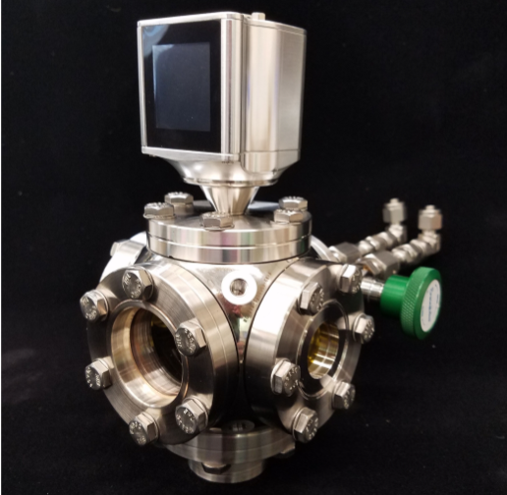
Figure 2.6 (above): Chamber designed by Martin et al. to assay UF₆ for LISA-UE project [47].

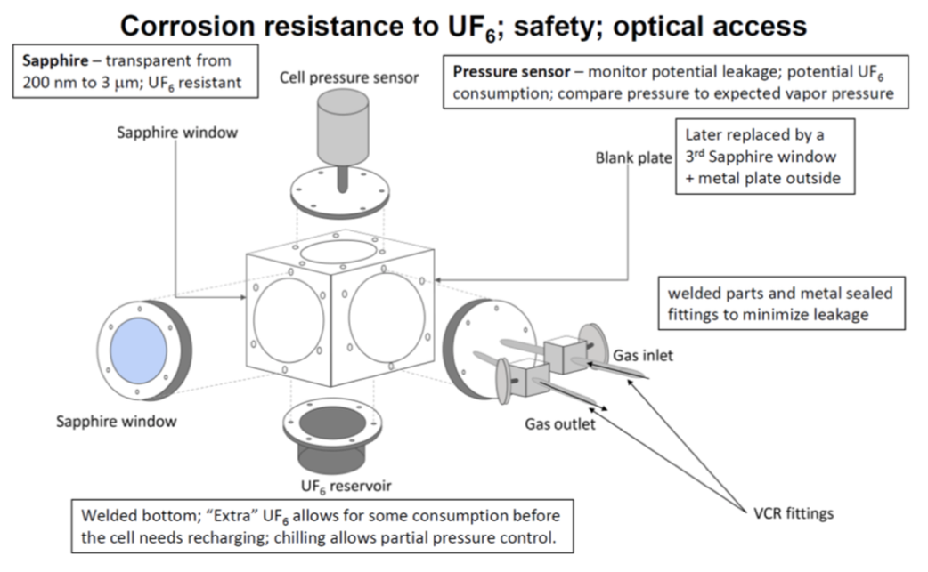
Figure 2.7 (above): Schematic diagram of the sample chamber’s safety features as designed by Martin et al. [47].

was done to alleviate any initial concerns over potential in-leakage of air into sample chamber, optical window fogging from build-up of reaction products, and dissociation in the laser plasma leading to subsequent consumption of UF₆ [47].

– Sample Chamber benchmarks
Over the course of this chapter, the methodology and experimental setup that will be used to investigate and benchmark the effective lifetime of the sample chamber to determine its applicability and if optimization is required before its use in a field-deployable laser spectroscopy system for safeguards assay of nuclear material will be discussed in further detail. The benchmarks within the testing regime will include: safety analysis of UF₆ to determine if the in-leakage of air outside the chamber versus the chemical reaction rate of uranium hexafluoride with water moisture in the air is the limiting rate for the sample chamber (located in Appendix A), assess how the collected emission light spectrum is affected over time through the novel use of scotch tape to simulate window degradation on the sample chamber, determine any thermal effects, opacity changes, visual changes in the color and uniformity of the window, and impacts on vacuum integrity over time as a consequence of using a femtosecond laser, demonstrate the safe usability of the sample chamber for analysis of hazardous and/or radioactive materials by achieving and maintaining a vacuum pressure, perform a set of basic LIBS measurements to determine and then optimize various parameters that will be needed for more advanced LIBS experiments later in this thesis, and ultimately conduct novel fs-LIBS analysis on three different samples of synthetic nuclear melt glass (non-radioactive and radioactive) and authentic trinitite to compare the primary trace elements found in
these compounds and characterize the temporal evolution of uranium in the radioactive melt glass and trinitite with our fs-LIBS system.

Equipment and General Lab Setup in SERF108
The primary equipment that was used for this research included a Ti:Sapphire (Solstice-ACE-Prime-Plus) laser, ultrafast mirrors and a periscope (Thorlabs), sample chamber (Kimball Physics and KJ Lesker), a 70mm plano convex lens used to focus the laser inside the sample chamber (Thorlabs), two additional plano convex lenses (100mm and 25mm) for the collection optics assembly (Thorlabs), a reflective collimator (Thorlabs), fiber optic cable (Horiba), a 1250M-Series II spectrometer (Horiba), and a gateable Intensified Charge-Coupled Device (ICCD) (Andor). Parameters for this setup are located in Table 3.1. An Oscilloscope and photo diode detector were used to determine that it takes 83 nanoseconds for the laser to reach the sample chamber. This time delay value of 83 nanoseconds was utilized to accurately reflect gating delays and widths for each experiment. Figure 3.1 illustrates the equipment setup that was primarily used for the thesis experiments.
Once the shutter was opened, the laser beam first took a ninety degree turn to the right as it traveled along the optics table and then traversing up the ultrafast mirrored periscope as it took one last ninety degree turn to proceed in a direct line before it was focused through a 70 mm plano convex lens to a single point in the center of the sample chamber. The emitted light from a plasma would then travel orthogonal through the sample chamber as it was then collimated
Table 3.1: Various Parameters (unless otherwise specified) of the primary equipment used for fs-LIBS experiments.
Laser Fundamental Wavelength | 800 nm
Laser Rep Rate | 1 kHz
Laser Pulse Width | 98 fs
Beam Diameter | 11 mm
Maximum laser beam pulse energy | 6 mJ
Focus lens (plano convex) | 75 mm
Spectrometer Focal length | 1.25 m
Spectrometer Slit Width | 20 μm
Spectrometer Grating | 3,600 grooves/mm
Spectrometer Resolution | 0.006 nm
Time for Laser to Reach Sample Chamber | 83 ns
Change in Sample Chamber Position via Stage Knob | 0.37mm/Half turn

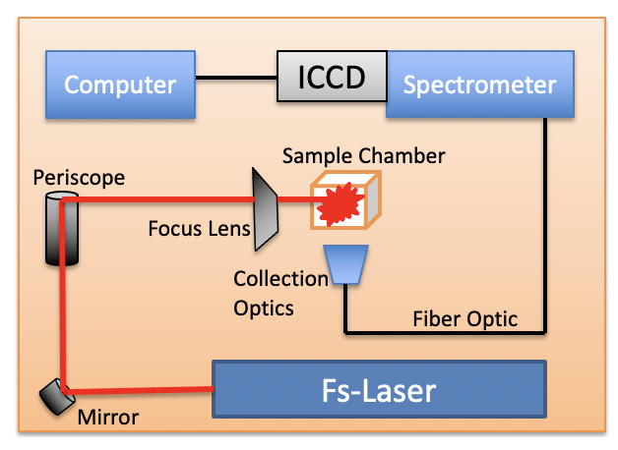
Figure 3.1 (above): Configuration of fs-laser lab setup in SERF108

along the collection optics assembly. A 100mm lens and 25mm lens were used in the collection optics setup to produce a collimated beam of light that is 1/4 of its original size. The curved sides of the two plano convex lenses were oriented to faced away from each other towards the outside. At the end of the collection optics assembly was the centered reflective collimator that coupled directly to the fiber optic cable which sent the collected laser induced plasma emission light into the spectrometer. Then the collected light passed through a 3,600 grooves/mm grating before finally entering the ICCD where it was visualized on a laptop via a usb cable.

Experiments
In order to properly characterize the lifetime of the sample chamber that will be later filled with chemically/hazardous UF₆ and its enrichment levels subsequently assayed, the following experiments were conducted to benchmark the sample chamber. Results and analysis for each of the following experiments are located within their respective subsections with additional results located in various appendices.
Air In-leakage Rate vs. Chemical Reaction Rate Calculations
The first benchmark was to determine whether the limiting rate for the sample chamber will either be the in-leakage of air outside the chamber versus the chemical reaction rate of UF₆ with water moisture in air. After taking many factors into account and conducting a variety of calculations for each respective rate, it was determined that the chemical reaction rate for 0.25 grams of UF₆ of 19 milliseconds was much faster than the in-leakage rate that the sample chamber was tested for at Centrus (see Appendix C). This meant that the in-leakage rate was found to be the limiting rate factor for the sample chamber. The comprehensive methodology and results for these benchmark calculations can be found in Appendix A.
Scotch Tape (Signal Degradation) Experiment
The very first experiment used the spare sample chamber to simulate degradation of the sapphire windows to assess how the signal was affected over time. Scotch “Magic” tape was employed for this benchmark due to its accessibility and versatility for this degradation simulation. Before conducting the experiment, the transmission spectrum of regular scotch tape was not found in any past literature or open-source resources. However, the transmission spectrum of optically clear adhesive tape (OCA8146-3) from the Thor Labs website was found to have a transmission around 85-93% between 300-500nm in Figure 3.2 [48]. Since scotch tape was created for use in the office supplies industry, it will be assumed that the transmission of scotch tape will be less than that of the clear adhesive tape specifically intended for optical applications. An initial assumption for the transmission value of scotch tape is between 50-85%. The actual transmission value of scotch tape will not be known until a few experiments have been conducted as described in a later section of this scotch tape experiment. A representative from the Scotch Brand company was also contacted to see if they could provide the optical properties of Scotch “Magic”
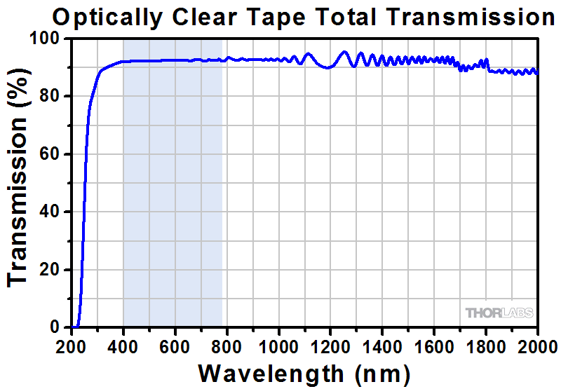
Figure 3.2 (above): Transmission spectrum of optically clear adhesive tape
(OCA8146-3) from Thor Labs [48].

tape, but they were unable to provide any helpful information. Additionally, the thickness of one piece of Scotch “Magic” tape was found to be 0.0625mm (i.e. 16 pieces is 1mm thick) [49]. This thickness value will be used for this experiment in determining how much scotch tape will be needed to block the light collected through the sapphire window in LIBS of air measurements.
A molecular transmission spectrum for UO₂F₂ (what will most likely plate out on the sapphire optical windows when UF₆ is ablated during LIBS) that covers 340 to 480 nm was found in past work by Skrodzki et al. and is shown in Figure 3.3 [50]. This was all of the spectrum within our 300 to 500 nm range of interest (and spectrometer limitation) that was available from literature and is informative, nonetheless. Scotch Magic Tape was elected to behave as a degradation surrogate material since it was out of scope for this thesis to create a simulated UO₂F₂ that mimicked the photon transmitted transmission characteristics that it possesses. Furthermore, it was desired to determine the gross effects of a reduction in transmission of the collected LIBS signal and whether it would cause broadening or aliasing or reduce the signal to the extent that the peak would be indistinguishable from the background noise.
The intensity of the 800 nm laser signal was examined over time as more layers of scotch tape were added to the outside of the light collection sapphire window as seen in Figure 3.4. Two different experiments were carried out with the Scotch tape. The first one involved placing scotch tape slightly above the sapphire window by attaching either end of the tape onto the slightly raised
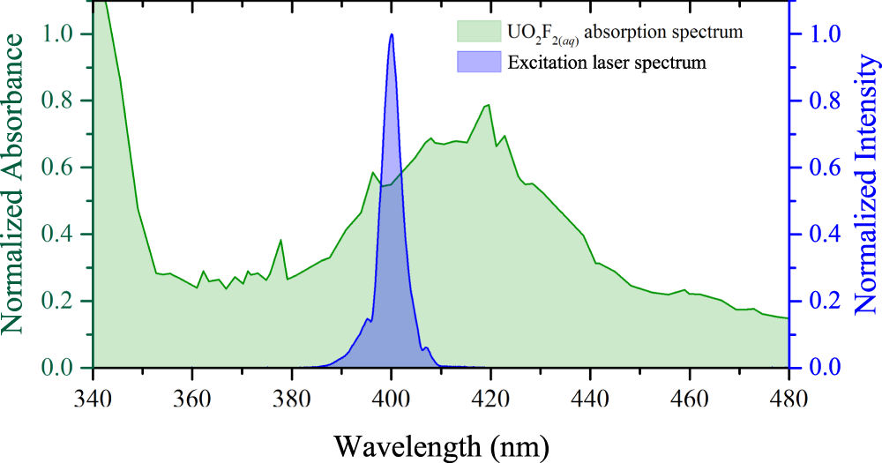
Figure 3.3 (above): Transmission spectrum of UO₂F₂ [50]

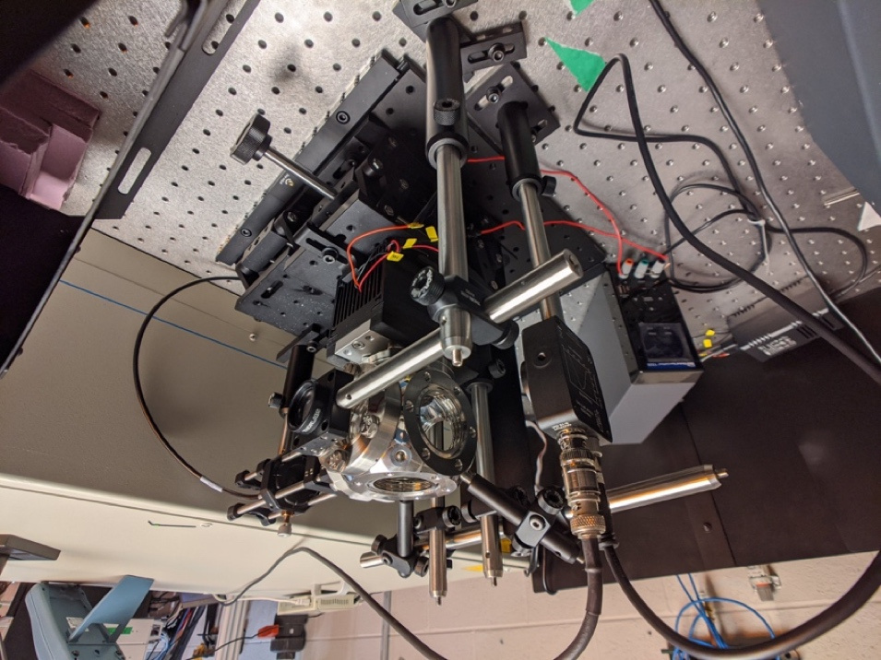
Figure 3.4 (above): Sample chamber configuration for Scotch tape experiment

aluminum cell wall that went around the sapphire window. The second configuration investigated how the intensity of the collected spectrum would change after placing the Scotch tape directly onto the window. The similar configurations for both experiments are shown in Figures 3.5 and 3.6, respectively.
A background spectrum was first collected with the laser shutter closed for removal later in post processing. Then the laser shutter was opened so that the plasma in air was visually verified to be located in the center of the sample chamber. After that, three spectrums of Oxygen in air (with the spectrometer centered at 395nm) were collected as baseline signals. Next, a single piece of scotch tape was placed either directly onto the light collection sapphire window (side port) or it was placed on the edges of the view port itself just raised slightly above the sapphire window. Three more spectrums of Oxygen in air (with the spectrometer centered at 395nm) were then collected with one piece of scotch tape attached to the sample chamber side port (light collection side). The previous two steps were repeated by adding another piece of scotch tape for each round of the LIBS measurements until no more light was transmitted (Oxygen peak in air at 394.7nm was equal to the background noise) through the “scotch taped” emission light collection window. After both experiments (scotch tape directly on and scotch tape suspended just above the sapphire window) were conducted, the collected LIBS spectrums were processed with a Savistky-Golay filter in MATLAB to smooth out the background noise [51].
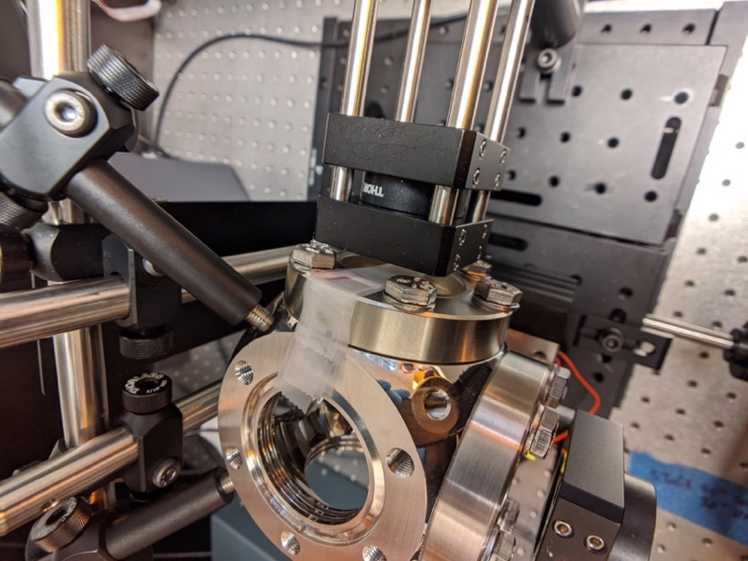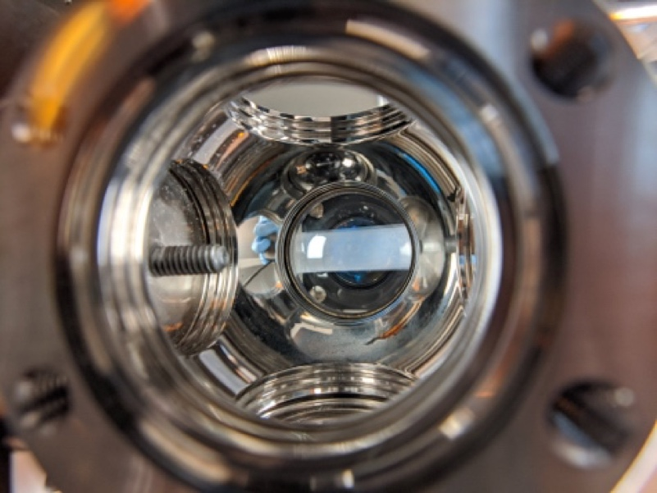
Figure 3.5 (left) & 3.6 (right): Configuration for the two Scotch tape experiments

Figure 3.7 shows the fs-LIBS plasma of oxygen in air that was used for these two experiments. Two different orientations in the placement location of the scotch tape in relation to the sapphire windows resulted in similar, yet slightly different results. Figures 3.8 and 3.9 respectively show how many pieces of scotch tape are necessary to completely block out the oxygen peak in air when tape is placed either above the window (Figure 3.8) or it is placed directly onto the sapphire window (Figure 3.9). It was discovered that four more pieces of tape are required to completely eliminate the oxygen plasma in air signal when the tape is placed just above the sapphire window (collection side port). Figure 3.10 is a comparison plot of the two experiment tape location variations for signal degradation. It can be inferred from the results of the two experiments that an average combined total tape thickness of 0.25 mm (4 pieces) is sufficient to completely block out the analyte emission signal from the laser induced plasma. Including observations from other thesis experiments (Leak Rate Calculation in Appendix A plus other fs-LIBS experiments of nuclear debris discussed later in Chapter 3), it can be concluded that when conducting future fs-LIBS of UF₆ research (using around 0.25 grams of UF₆ per sample chamber), even in the event of complete failure of vacuum pressure (resulting in approximate reactant
product creation of 0.22 grams of UO₂F₂ in solid form), the potential signal interreference of UO₂F₂ is unlikely to affect the collection of the UF₆ emission
signal since the observed sample material build-up on sapphire windows was primarily found on just the top sapphire window of the sample chamber.
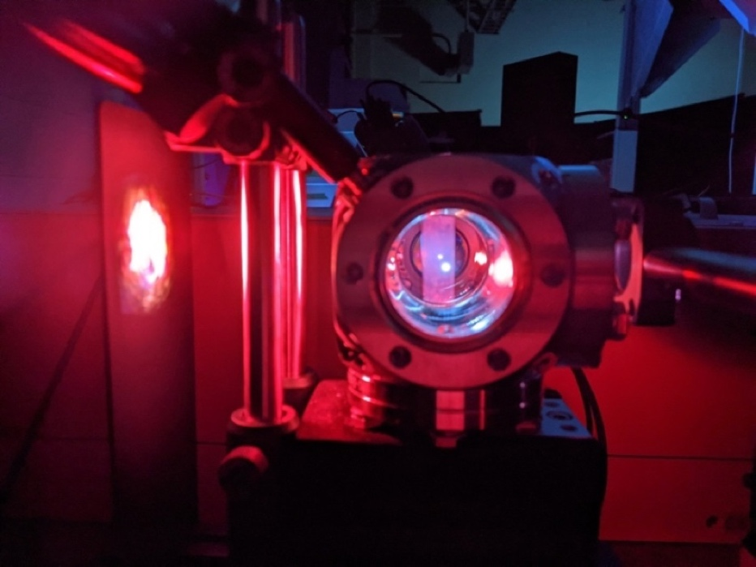
Figure 3.7 (above): fs-LIBS of oxygen peak in air for scotch tape experiments

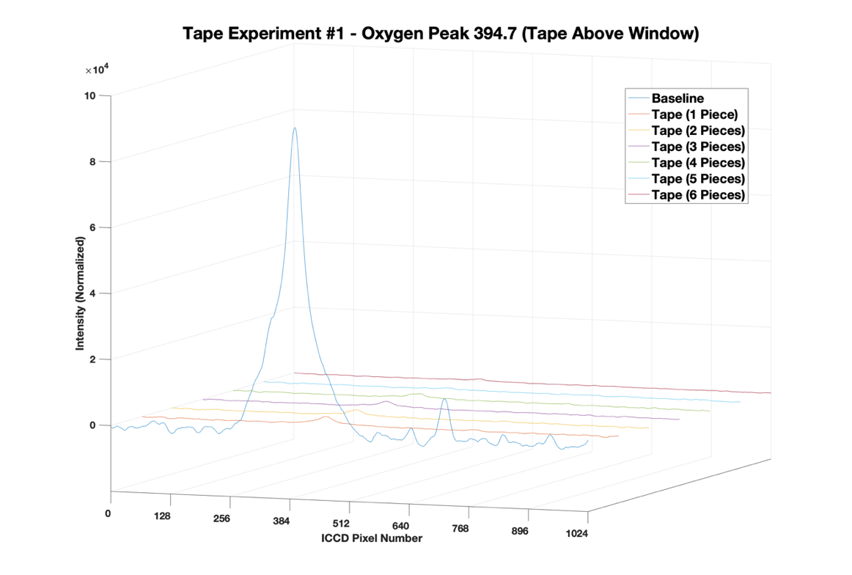
Figure 3.8 (above): Decay of the fs-LIBS oxygen emission peak in air as pieces of tape are placed above the sample chamber (collection side) sapphire window to simulate degradation to the window.

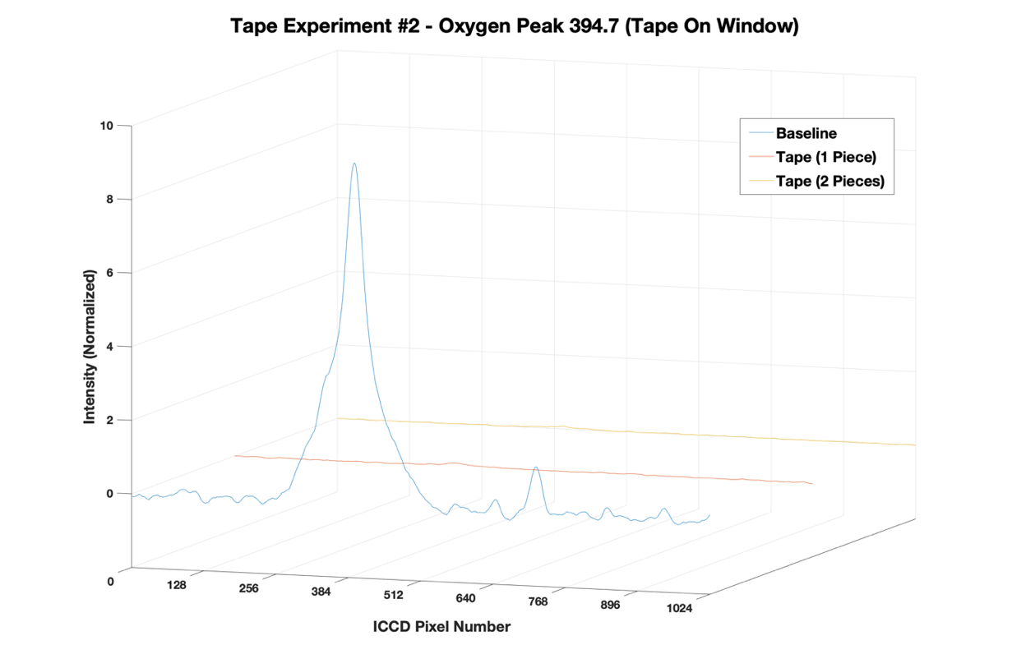
Figure 3.9 (above): Decay of the fs-LIBS oxygen emission peak in air as pieces of tape are placed directly onto the sample chamber (collection side) window to simulate degradation to the window.

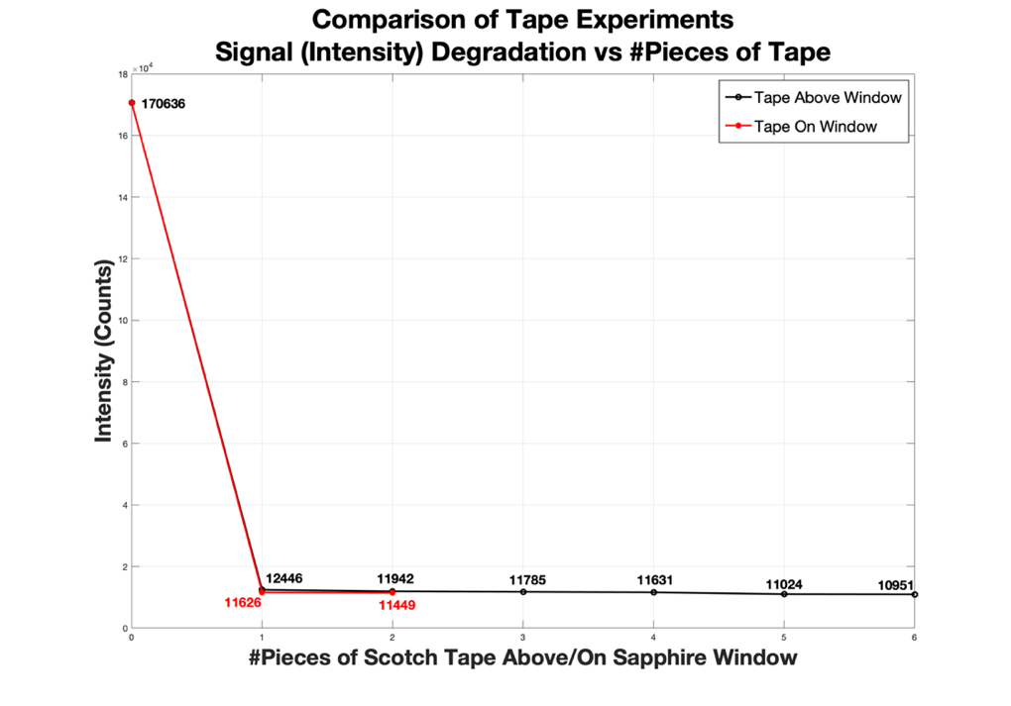
Figure 3.10 (above): Comparison of how many pieces of scotch tape were necessary to completely block out the fs-LIBS emission peak of oxygen in air.

Table 3.2 contains the transmission properties of the two scotch tape orientations. Although the collected background for the tape directly on the window experiment could have been slightly higher (thus allowing the oxygen plasma peak in air to disappear quicker), it is more likely that the transmission properties of scotch tape are more noticeable when placing the tape directly adheres onto the window. The first piece of tape for both experiments only allowed roughly seven percent of the oxygen plasma signal to pass into the collection optics and subsequently the spectrometer and ICCD.
10,000,000+ Laser Shots (Thermal Degradation) Experiment
The next experiment was to test the thermal degradation effects on the sapphire window set within the sample chamber. It was proposed to fire ten million plus laser shots (pulses) through the sapphire window and observe if damage would affect the window after a certain quantity of laser shots. The results of this potential mechanical failure of laser misalignment could be very dangerous if a hazardous/radioactive sample was set within the sample chamber while the integrity of the sapphire window was compromised. It was determined to set up the experiment in the same laser beam alignment where the laser would be focused to a central point in the middle of the sample chamber (same as past and future LIBS experiments) since the ability to drill a hole in the sapphire window would be easily achievable if the laser beam was directly focused onto the window. In light of this experimental setup, the focus had shifted to see if any noticeable defects would occur within the sapphire window.
Table 3.2: Transmission properties of scotch tape observed during experiments.
Pieces of Scotch Tape On/Above Window | Tape above window (Signal Intensity) - Counts | % of Intensity (Signal) Absorbed | Tape on window (Signal Intensity) - Counts | % of Intensity (Signal) Absorbed
0 | 170,636 | 0 | 170,636 | 0
1 | 12,446 | 93 | 11,626 | 93.2
2 | 11,942 | 96 | 11,449 | 100
3 | 11,785 | 98 | N/A | N/A
4 | 11,631 | 98.6 | N/A | N/A
5 | 11,024 | 99 | N/A | N/A
6 | 10,951 | 100 | N/A | N/A

A laser power meter would be placed directly (behind the sample chamber) in the fs-laser beam path behind a sapphire window set within the sample chamber to measure the change in the laser beam power if a hole was successfully drilled through the window. Before attempting this experiment, a series of calculations were carried out regarding the sapphire window characteristics (optical, thermal, mechanical properties) with the properties of the fs-laser. The calculations affirmed that it was impossible to damage the window when using it as intended. This lack of damage was verified after completing each of the thesis experiments. In total, no observable damage was found in the sapphire windows after operating the fs-laser for over 90 hours (300 million plus laser shots compared to the proposed 10 million laser shots in roughly 3 hours of continued use). This far exceeded the experimental testing plan detailed in Appendix B and further demonstrates the resilience of the sample chamber for use in laser spectroscopy applications.
Vacuum Pressure Test Experiment
The next benchmark in the sample chamber testing regime was to demonstrate the capability of the sample chamber to achieve and maintain vacuum pressure. The motivation behind this experiment was to attempt to verify the leak rate Centrus provided was still valid with the instruments at UTK, to ensure that no hazardous/radioactive samples would leak from the sample chamber once the chamber was pumped down to vacuum pressure, and to improve the accuracy of LIBS experiments with the absence of an atmosphere within the sample chamber. The procedure began by connecting the chamber to a vacuum pump and measuring its initial pressure. The Initial reading on the pressure gauge was approximately 660 Torr which was about as low as the gauge could read (Atmosphere is 780 torr). Once the initial vacuum pressure was established, the chamber was allowed to fill with air at atmosphere before it was then pumped back down to the lowest pressure readable on the gauge (660 Torr) for 30 min, after which the sample chamber was closed off and disconnected from the vacuum pump. One week later, the chamber was reconnected to the vacuum pump and gauge and found that no change in the vacuum pressure had occurred. This entire procedure was then repeated a second time over the course of a second consecutive week to see if it maintains this level of vacuum for enough time to safely make an analytical measurement in the field (for example at an enrichment facility). 24 hours is way more time than would be necessary for multiple analytical measurements at a nuclear facility so the fact that it went two weeks with no significant leakage of air has demonstrated confidence in reliably using this in a field deployable system. The experimental setup is depicted in Figure 3.11.
Fs-LIBS of Aluminum
The initial testing plan for the sample chamber was to fill the sample chamber with argon gas directly after pumping down the sample chamber to vacuum. This setup can also be seen in Figure 3.11. After conducting a literature review consulting the NIST LIBS database, however, it was discovered that
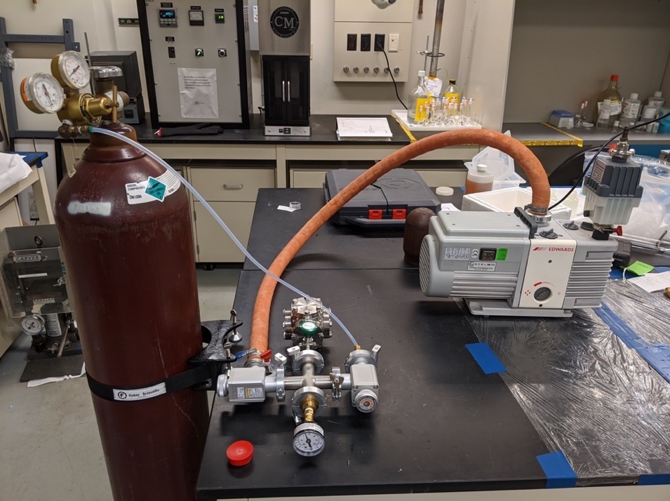
Figure 3.11 (above): Configuration of Vacuum Pressure Test experiment

argon does not have any fs-laser induced plasma emission lines with distinguishable intensities above the background signal within the range of the spectrometer (300-500nm) used for this thesis [52]. An attempt to acquire fs-LIBS of argon gas data is shown in Figure 3.12.
Once efforts to obtain discernible fs-LIBS spectra of Argon gas had been exhausted, other sample alternatives with characteristically high intensity plasma emission lines were explored. Drogoff et al. conducted a study that examined Aluminum emission lines with a fs-laser [53]. In the study, they created a graph that depicts the two primary emission lines for Aluminum at 394.4 and 396.2nm and illustrated how these two peaks evolved over varied gate delays and gate widths [53]. It was then proposed to replicate this portion of their research to benchmark the sample chamber and gain the necessary competence in fine-tuning various parameters for LIBS (gate delays, gate width, etc.) for future experiments in addition to conducting similar analysis with some of the uranium emission lines spectrums in surrogate radioactive nuclear melt glass and Trinitite. These various parameters were optimized to obtain the best experimental LIBS results [Maximize Signal to Noise Ratio (SNR) and minimize Relative Standard Deviation (RSD)]. The sample chamber first had to be modified for a solid aluminum sample to be mounted inside. This modification is shown in Figure 3.13.
The sample holder was built using spare optics parts and was fashioned in the machining shop at UTK. Once the sample holder was constructed, a method
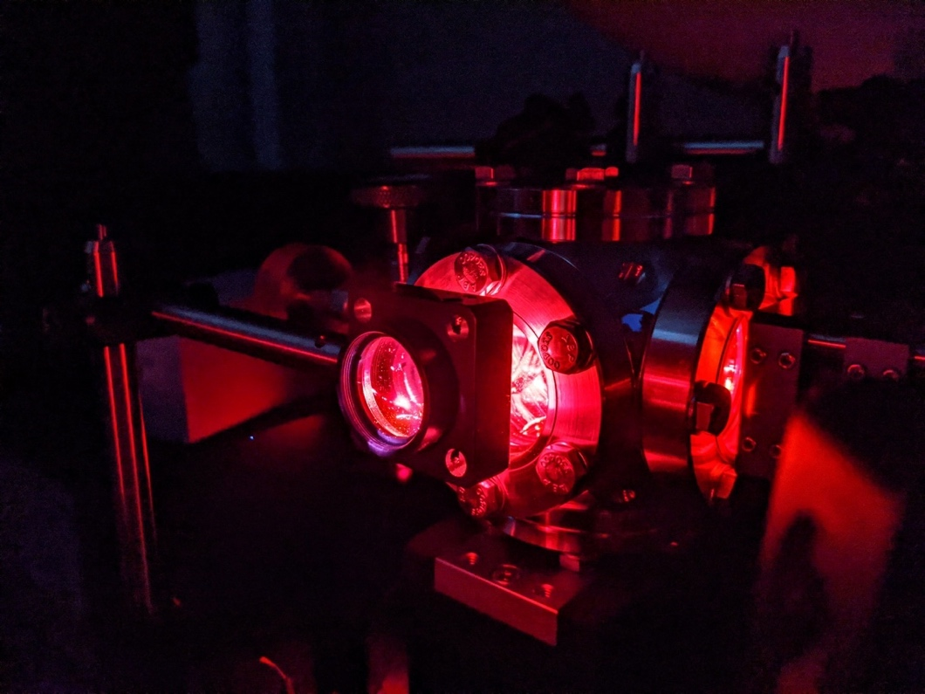
Figure 3.12 (above): Fs-LIBS of Argon gas data acquisition

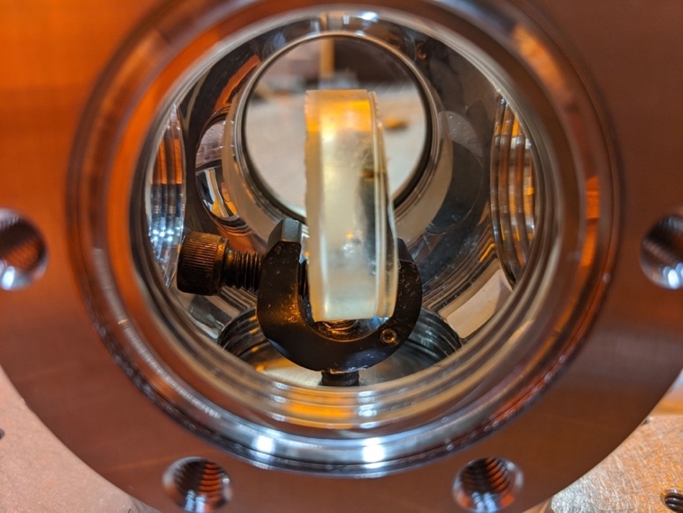
Figure 3.13 (above): Modification of sample chamber to allow mounting of solid samples
to mount pure Aluminum pellet samples within epoxy was determined. An epoxy resin and hardener mixture were used to create an epoxy disc that the aluminum pellets would be set inside with part of the pellet exposed on one side of the epoxy disk for use in LIBS experiments. While mixing the epoxy and resin, it was discovered that the mixture wouldn’t properly set without a certain amount of vigorous mixing. The epoxy mixing setup is shown in Figure 3.14.
Since the aluminum pellets were quite dense, they would sink to the bottom of the epoxy after placing them on top of the partially set epoxy mixture after a few hours. This challenge was overcome by filling the epoxy mold with only half of the necessary epoxy mixture, letting it completely set after about six hours, and then placing a small dollop of fresh epoxy mixture on top of the first half of hardened epoxy. The aluminum pellet was then placed onto the small dollop of fresh epoxy mixture, and a small amount of additional fresh epoxy mixture was carefully poured around the aluminum pellet to secure it within the epoxy, but not enough to completely cover the sample. Some of the aluminum samples that were used in the fs-LIBS experiments are seen in Figures 3.15 and 3.16. The reason for the irregularity in epoxy thickness and aluminum pellet appearance stems from having to manually sand down some of the epoxy samples by hand in order to completely reveal a layer of the aluminum sample that was not covered in epoxy. The small lines that appear on one of the samples in Figure 3.16 illustrate where it was ablated by the fs-laser. Table 3.3 lists the various gating parameters that were utilized in the work by Drogoff et al. and in
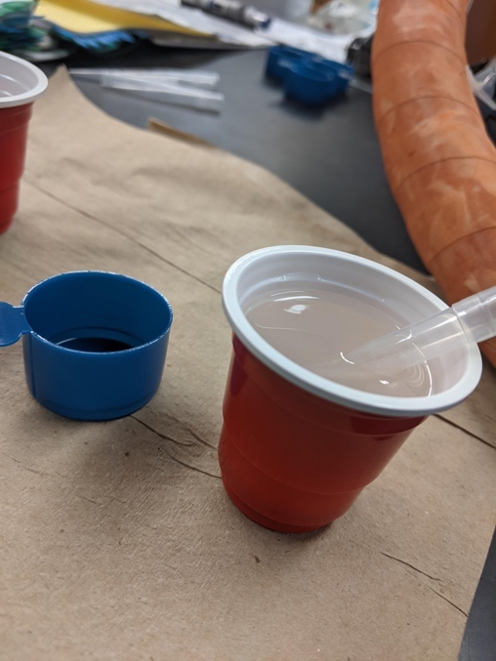
Figure 3.14 (above): Setup used for the mixing of the epoxy samples

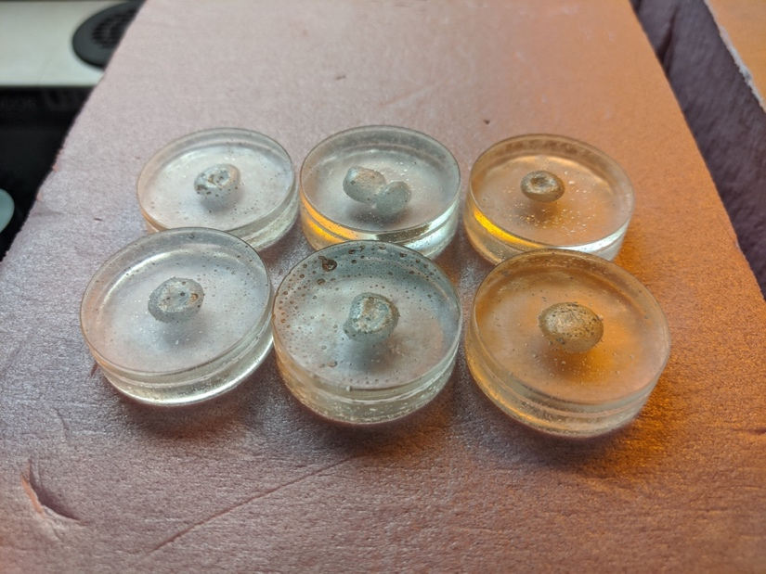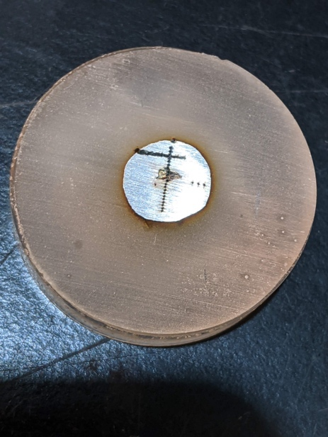
Figure 3.15 (left) & 3.16 (right): Un-sanded Aluminum samples appear on the left while one of the sanded samples is shown in the photo on the right.

Table 3.3: Gating parameters used for temporal characterization of Al atomic lines. Taken from [53].
t_{d} (μs) | t_{g} (μs)
0 < … < 0.8 | 0.2
1 < … < 4.5 | 0.5
5 < … < 9.5 | 1
10 < … < 25 | 5
30 < … < + | 10

the attempt to replicate this research [53]. Figure 3.17 illustrates the temporal evolution of atomic Aluminum emission lines that were obtained by Drogoff et all. [53]. The optimized procedure for this replicated experiment will be used in the final set of experiments for this thesis in conducting the novel temporal evolution of uranium atomic emission lines in radioactive nuclear melt glass and Trinitite. Figures 3.18 and 3.19 illustrate Fs-LIBS of Aluminum samples performed for this experiment and figures 3.20 and 3.21 depict the replicable temporal evolution of the 394.40 and 396.15nm atomic emission lines for the solid Aluminum samples.
An interesting observation that occurred while collecting the Aluminum spectra was that the expected self-absorption suddenly disappeared when collecting one of the spectra. It was determined that the stage, that the sample chamber sat atop, wheel had not been rotated and thus the position of the Aluminum sample had not been changed. The resulting spectra was one that was surprisingly absent of any self-absorption and was quite narrow. It was discovered that fs-LIBS emission peaks from solid samples that suffered from self-absorption could be resolved by keeping the sample in the same position and then collecting an additional spectrum of the solid sample. The repeatability of this technique in future experiments with synthetic nuclear melt glass and Trinitite samples was successfully attempted although some solid samples were less successful than others due to their smaller thickness. Figure 3.22 demonstrates how well this technique resolves the self-absorption that is known to plague certain elemental emission lines. It is believed that this phenomenon
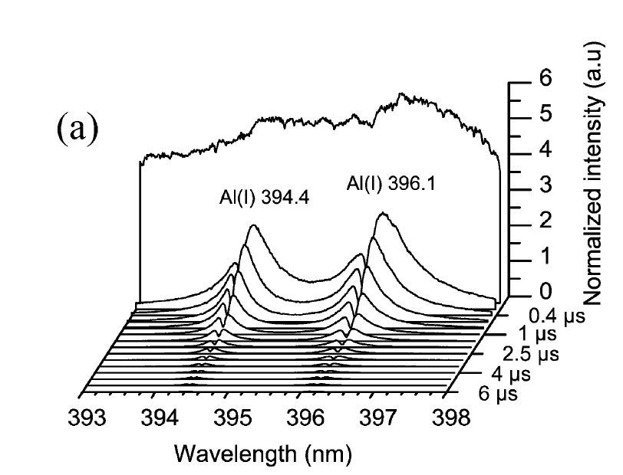
Figure 3.17 (above): Temporal evolution of atomic aluminum lines (at 394.4 and 396.1 nm) using 100 fs-laser pulses in air at atmospheric pressure, on pure aluminum target. Delay times and gate times are listed in Table 4.1. Taken from Drogoff et al. [53].

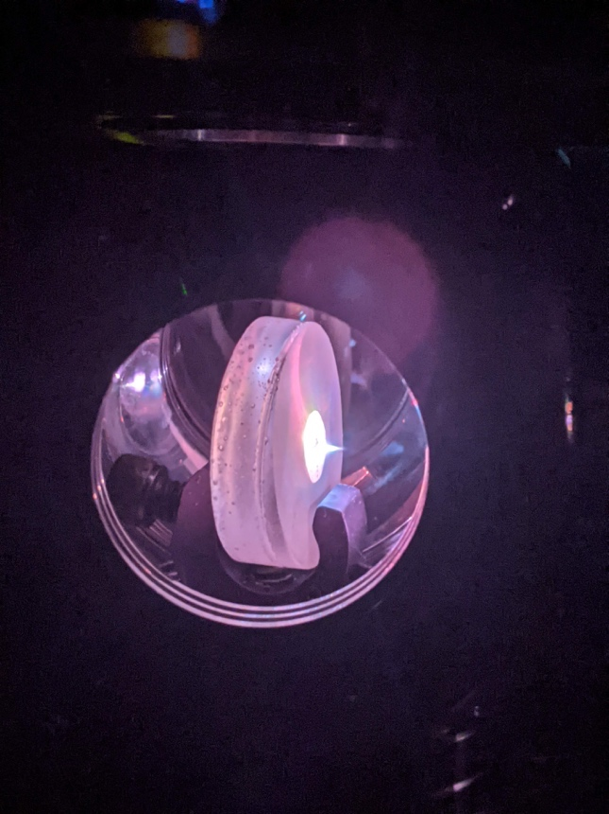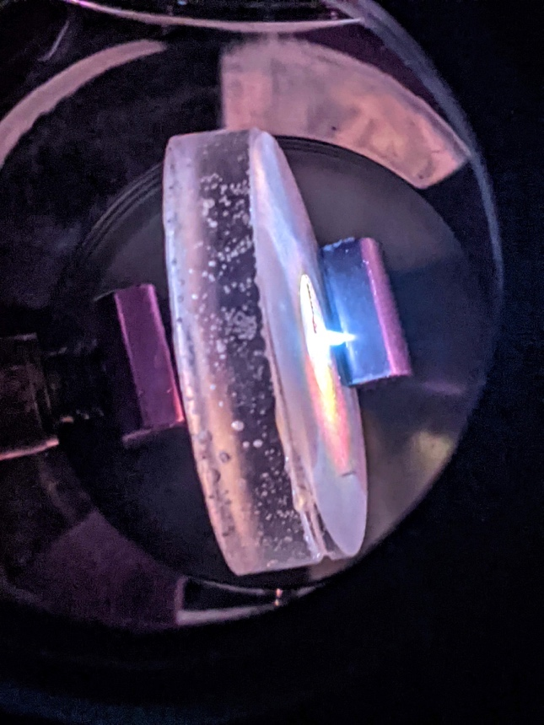
Figure 3.18 (left) & 3.19 (right): fs-LIBS of Aluminum samples used in this experiment

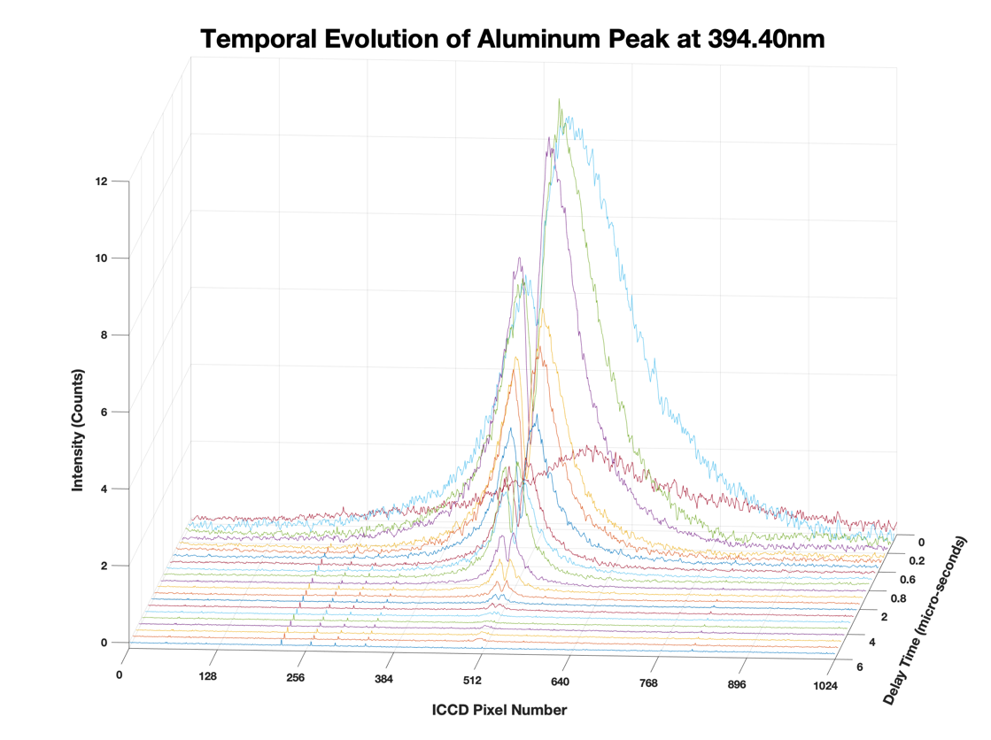
Figure 3.20 (above): Replicated temporal evolution of atomic aluminum lines (at 394.40 nm)

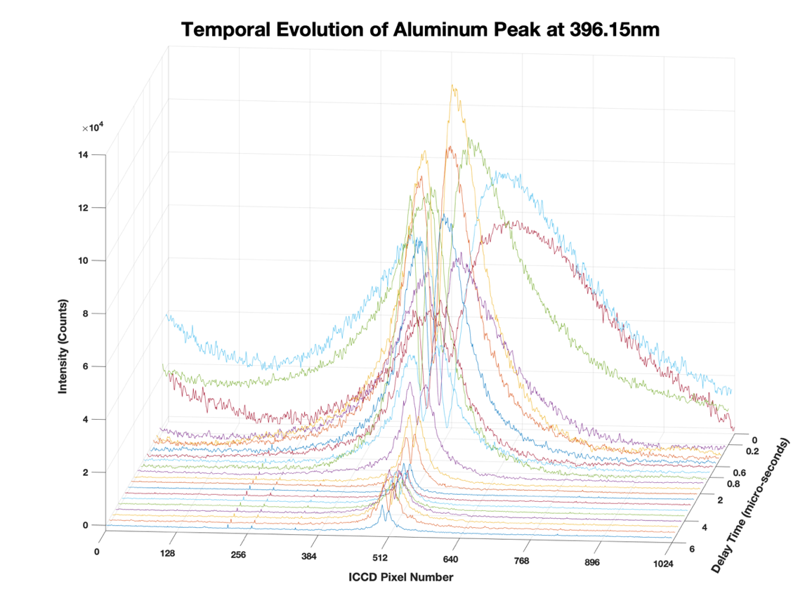
Figure 3.21 (above): Replicated temporal evolution of atomic aluminum lines (at 396.15 nm)

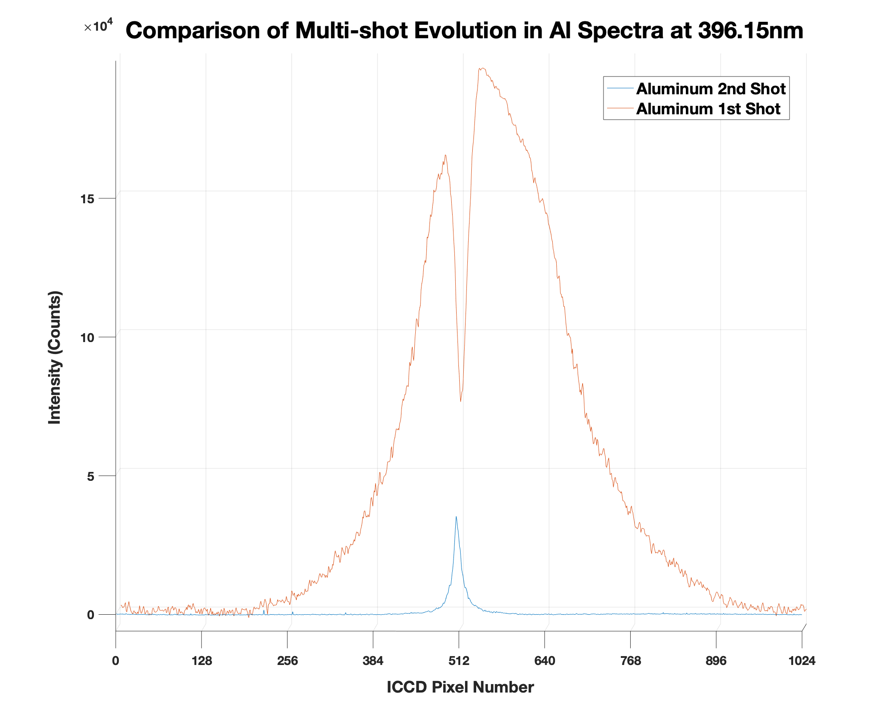
Figure 3.22 (above): The reduced self-absorption in solid samples technique employed in the fs-LIBS of Aluminum experiments

occurred due to the oxidized surface layer. It is worth noting again that the solid Aluminum samples were pure Aluminum so the intensity will be much greater than those seen in the collected nuclear debris LIBS data. This self-absorption reduction technique was successfully repeated a couple of times with various types of the nuclear debris. One limiting factor that influenced the success of this technique was the thickness of the solid sample.
Fs-LIBS of Non-Rad Nuclear Melt Glass
After gaining sufficient confidence in fine-tuning the epoxy sample preparation techniques and the various LIBS parameters to maximize SNR and minimize RSD, attention was turned to conducting novel fs-LIBS of surrogate nuclear melt glass and authentic Trinitite. These optimizations were extremely important since the quantity and thickness of the non-radioactive nuclear melt glass samples were quite small. Surrogate non-radioactive nuclear melt glass samples had been synthesized at UTK by Molgaard et al. and were already set within epoxy samples so no further sample preparation was necessary [54]. The recipe for the Standard Trinitite Formation (STF) was developed by Molgaard et al. to replicate the average elemental composition of Trinitite from the Trinity Test in 1945 [54].
Table 3.4 illustrates the close resemblance of the two sample elemental compositions of non-radioactive analytes [54]. The NIST LIBS database were then cross-examined with Table 3.4 to predict what peaks of interest should be investigated in the experiment. Table 3.5 contains each of the expected fs-LIBS
Table 3.4: Comparison of Non-Radioactive Elemental Composition of Trinitite vs. UTK Synthetic Nuclear Melt Glass [54].
Average Trinitite Data |  | Standard Trinitite Formation (STF)
Compound | Mass fraction | Compound | Mass fraction
SiO₂ | 0.642 | SiO₂ | 0.642
Al₂O₃ | 0.143 | Al₂O₃ | 0.143
CaO | 0.0964 | CaO | 0.0964
FeO | 0.0197 | FeO | 0.0197
MgO | 0.0115 | MgO | 0.0115
Na₂O | 0.0125 | Na₂O | 0.0125
K₂O | 0.0513 | K₂O | 0.0612
MnO | 0.000505 | MnO | 0.000505
TiO₂ | 0.00427 | TiO₂ | 0.00427
Total | 0.981 | Total | 0.991

Table 3.5: Interference free analytical lines for analysis of trace elements in radioactive/non-radioactive nuclear melt glass and Trinitite [52].
{* denotes highest peak for each element listed below}
Element | Peak (nm)
Si | 390.55*
O | 394.74*
Al | 394.40, 396.15*
Ca | 396.84, 422.673*
Fe | 382.44, 385.99*
Mg | 382.935, 383.230, 383.830*
Na | 330.237*
K | 404.414*, 404.722
Mn | 403.075*, 403.306, 403.448
Ti | 466.889*
Only Potential interference at 421.02, 421.46, 424.4122, & 424.437nm (U lines of interest): Ca (422.7nm)

emissions lines from each of the non-radioactive analytes in nuclear melt glass and Trinitite that should be interference free [52].
The sample chamber was opened up, and the bottom port of the chamber that houses the sample holder, and a non-radioactive nuclear melt glass sample were secured before closing and sealing the sample chamber. Figure 3.23 shows the configuration of one of the non-radioactive nuclear melt glass samples set within the sample chamber. Three different (identical composition) non-radioactive nuclear melt glass samples were used in the fs-LIBS experiments. This was done to ensure that distinct fs-LIBS emission lines for each of the trace elements could be collected. After each of the experiments were successfully completed, the interior of the sample chamber was cleaned according to the procedures outlined in Appendix D.
Fs-LIBS of Rad Nuclear Melt Glass
The procedure for conducting fs-LIBS on non-radioactive nuclear melt glass as outlined in the previous subsection was then replicated using three different (identical composition) radioactive nuclear melt glass samples. As mentioned in previous subsections, sample preparation for the radioactive melt glass and Trinitite had to be developed according to the guidelines and procedures for radiation safety and is located in Appendix D. As the radioactive nuclear melt glass samples were being placed on top of the half-finished epoxy molds, there was slight variation in how the rad melt glass samples were placed
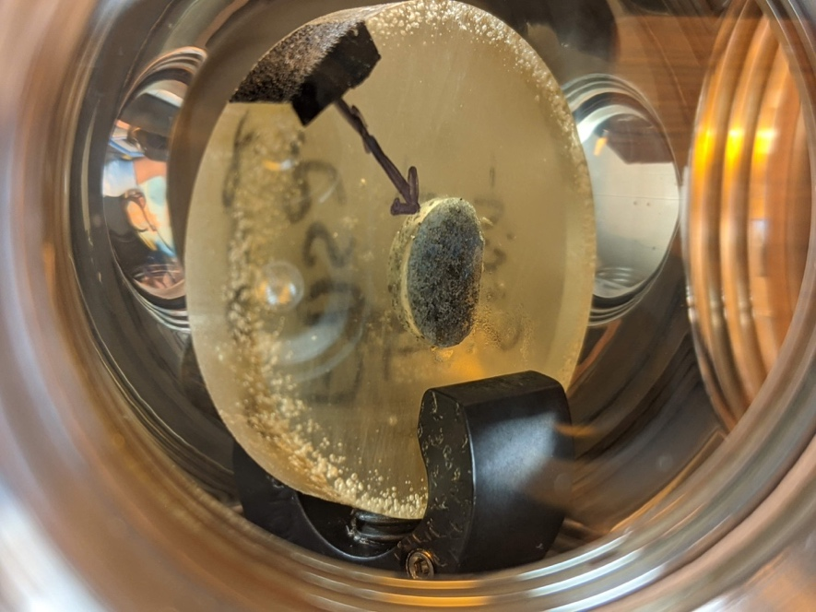
Figure 3.23 (above): Non-radioactive nuclear melt glass sample used in the fs-LIBS experiments

in the epoxy since one of the first two samples had slipped out of the precepts and landed curved side facedown (resulting in the flat side facing upwards).
The other of the two first rad melt glass samples had correctly landed curved side facing upwards as originally intended. Due to this variation, the other four remaining (out of six total) rad melt glass samples were prepared according to both sample placements in the epoxy so that there were three variations of each sample orientation in the epoxy discs. The variation in how the radioactive nuclear melt glass samples were set within the sample chamber for fs-LIBS experiments is illustrated in Figures 3.24 and 3.25.
Fs-LIBS of Trinitite
Procedures for conducting fs-LIBS on Trinitite as outlined in the previous subsections were then replicated using two different (identical composition) Trinitite samples. Six Trinitite samples were prepared and placed in epoxy according to Appendix D, but only two samples were ablated with the fs-laser since one of the samples that was utilized was quite large in size when compared to previous melt glass samples. Additionally, all of the 16 interference free atomic emission lines as well as the temporal evolution of uranium atomic lines were found in the first two Trinitite samples so the other four samples were reserved for future experiments as outlined in the Future Work subsection in the Conclusion. The two Trinitite samples that were ablated with the fs-laser in these experiments are shown in Figures 3.26 and 3.27.

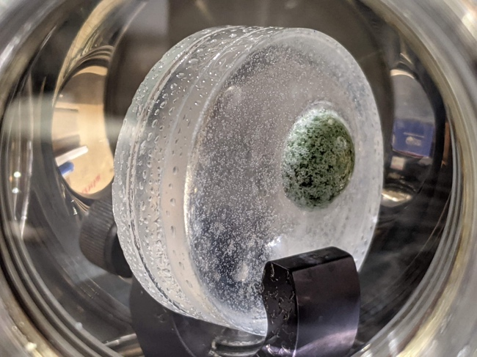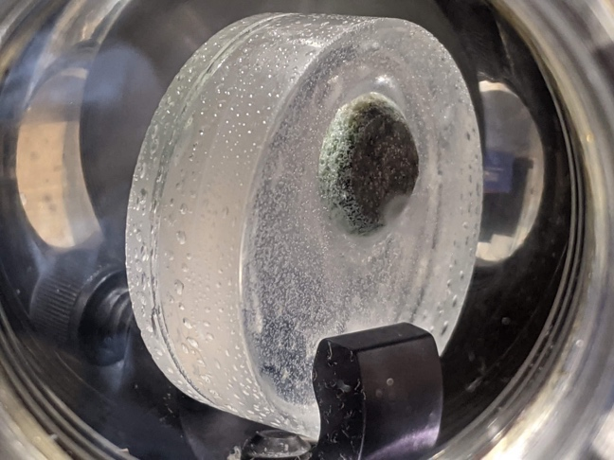

Figure 3.24 (Left) & 3.25 (Right): Variations in how the radioactive nuclear melt glass samples used in the fs-LIBS experiments were oriented

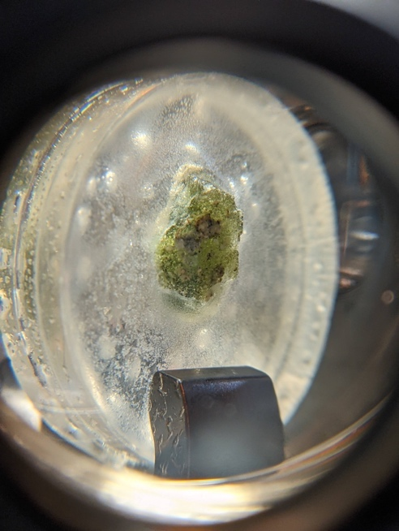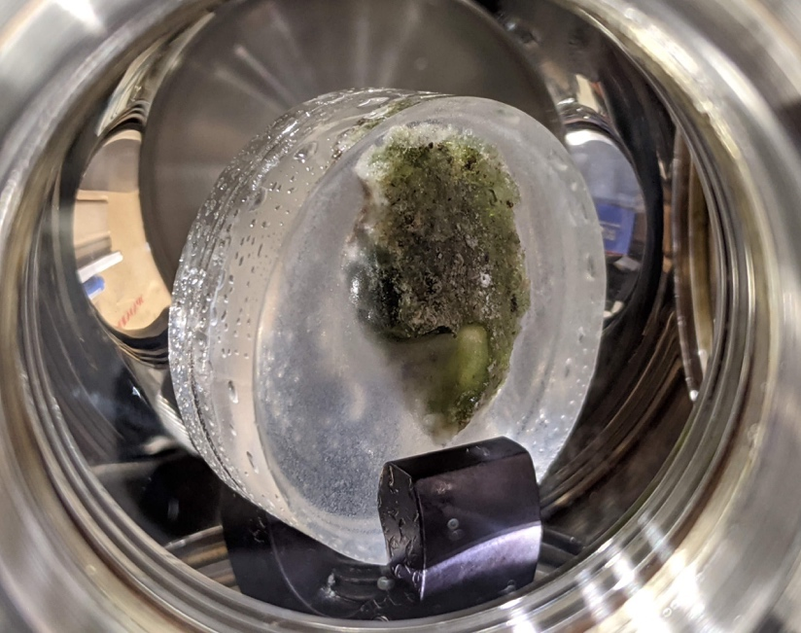
Figure 3.26 (Left) & 3.27 (Right): Comparison of the two Trinitite samples that were used in the fs-LIBS experiments.

Comparison of Fs-LIBS of Nuclear Debris
Following the successful fs-LIBS of Aluminum replication of Drogoff et al., fs-LIBS of the primary trace elements found in the synthetic nuclear melt glass (both non-radioactive and radioactive) and authentic Trinitite was conducted [53]. The only previous LIBS of Trinitite or synthetic nuclear melt glass was found in the appendix of a LIBS textbook by Cremers et al. [55]. Little information besides a few parameters for the ns-LIBS of Trinitite experiment were included in that textbook appendix and no origins for that ns-LIBS research could be found anywhere in open literature. The parameters for the ns-LIBS of Trinitite experiment were a laser beam energy of 54 mJ per pulse, delay time of 1.0 μs, gate width of 1.1 ms, 100 averaged spectra, and the use of a 75mm focal length lens [55]. The ns-LIBS spectrum from the Cremers et al. LIBS textbook appendix is shown in Figures 3.28-3.30. It is worth noting that the elements in the range of 235-800nm found by that work were Si, Mg, Al, Ca, Ti, Na, H, N, K, and O, but only Al, Ca, Ti, and Na are within our spectrometer range of 300-500nm [55].
The NIST LIBS database was then consulted to compare the ns-LIBS spectrum found in the Cremers et al. textbook to validate that such an elemental spectrum would be expected if a Trinitite sample were ablated with a ns-laser [55]. Each of the elements found in this ns-LIBS of Trinitite work were found to be accurately represented in the NIST LIBS database [55]. It is hypothesized that Al and Ca will be the predominantly present elements seen in the Trinitite spectrum based on past trinitite LIBS experiments [55]. It is also postulated that the
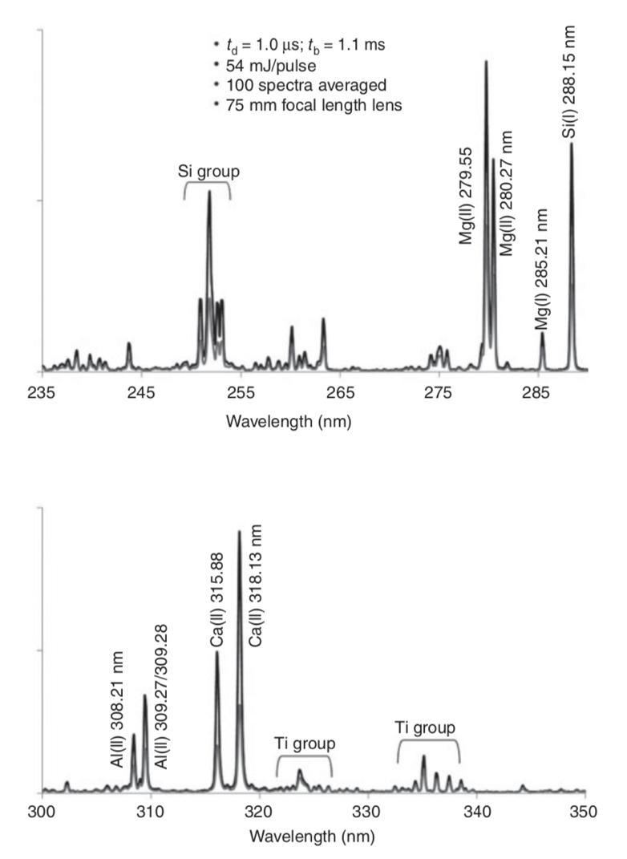
Figure 3.28 (above): Ns-LIBS of Trinitite spectrum between 235-350 nm found in the appendix of the Handbook of LIBS textbook by Cremers et al. [55]

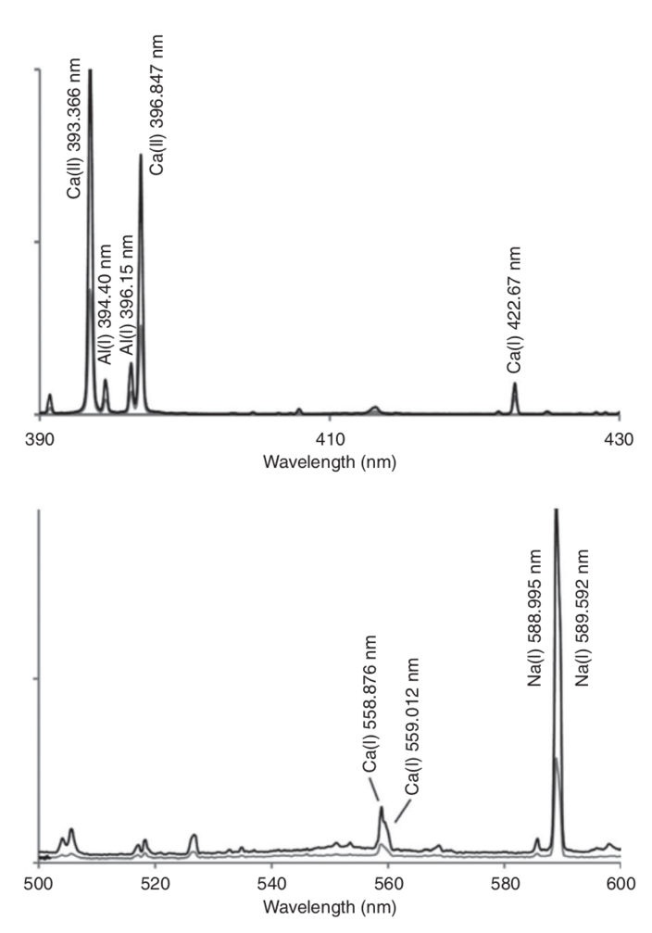
Figure 3.29 (above) continued: Ns-LIBS of Trinitite spectrum between 390-600nm found in the appendix of the Handbook of LIBS textbook by Cremers et al. [55]

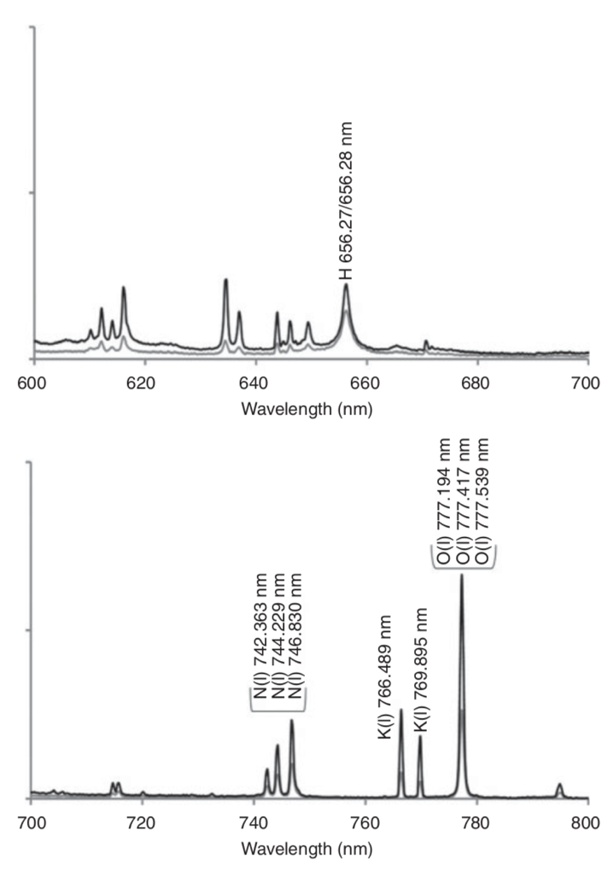
Figure 3.30 (above) continued: Ns-LIBS of Trinitite spectrum between 600-800nm found in the appendix of the Handbook of LIBS textbook by Cremers et al. [55]

presence of uranium will be most reliably found in the radioactive nuclear melt glass samples since it has a known quantity of uranium while the Trinitite samples have some unknown variance.
As mentioned in the earlier subsections of this chapter that covered the methods for the nuclear debris experiments, the sample preparation, transportation, and decontamination procedures for the synthetic nuclear melt glass (both non-radioactive and radioactive) and authentic Trinitite can be found in Appendix D. Due to laser system limitations, it was not possible to leave the laser shutter open and subsequently fire a set amount of laser pulses to interrogate a sample as had been described in countless past LIBS literature. The procedure was to instead open and close the laser shutter rapidly (~ 1 sec) with one hand while simultaneously using the Andor software to acquire gated LIBS spectra with the use of the other hand. This LIBS acquisition technique was practiced, developed, and optimized from the very first experiments for this thesis so that this experimental limitation would be minimized when collecting fs-LIBS data from the nuclear melt glass and Trinitite samples. The optimized gating parameters listed in Table 3.6 for each of the ten primary trace elements found in the surrogate nuclear melt glass and Trinitite samples were obtained by consulting past literature in addition to trial and error as many of the elements investigated in these experiments had little to no past published literature with fs-lasers in the range of interest for our spectrometer. Figures 3.31 (nonradioactive nuclear melt glass), 3.32-3.35 (radioactive nuclear melt glass), and 3.36 (Trinitite)
Table 3.6: List of optimized gating parameters found from fs-LIBS experiments of synthetic nuclear melt glass (non-radioactive and radioactive) and Trinitite.
Analyte | t_{d} (ns) | t_{g} (ns)
Na I | 150 | 200
Fe I | 100 | 200
Mg I | 200 | 200
Si I | 250 | 200
Al I | 400 | 200
O I | 275 | 200
Ca I | 180 | 200
Ca II | 400 | 200
Mn I | 100 | 200
K I | 180 | 200
Ti I | 100 | 200

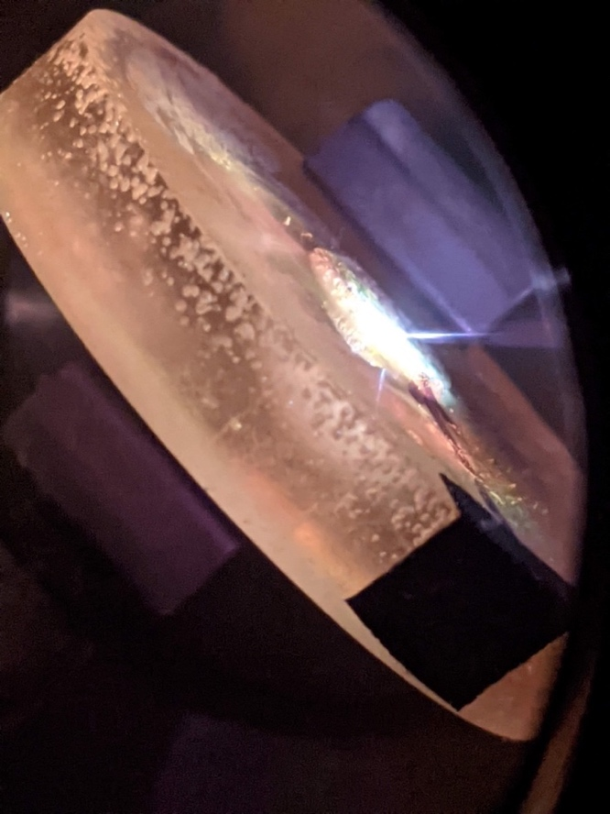
Figure 3.31 (above): fs-LIBS of non-radioactive nuclear melt glass

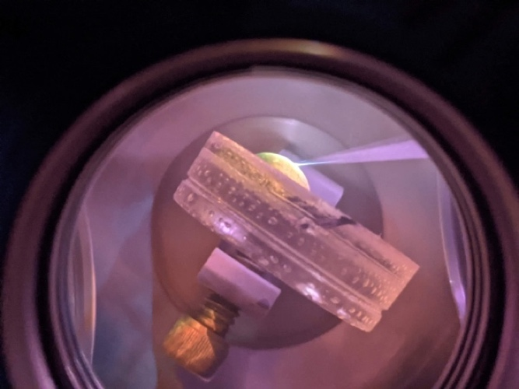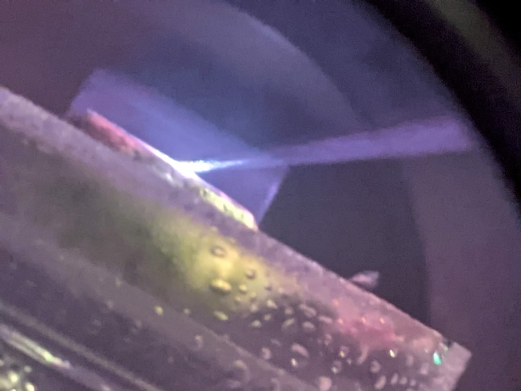
Figure 3.32 (left) & 3.33 (right): fs-LIBS of radioactive nuclear melt glass

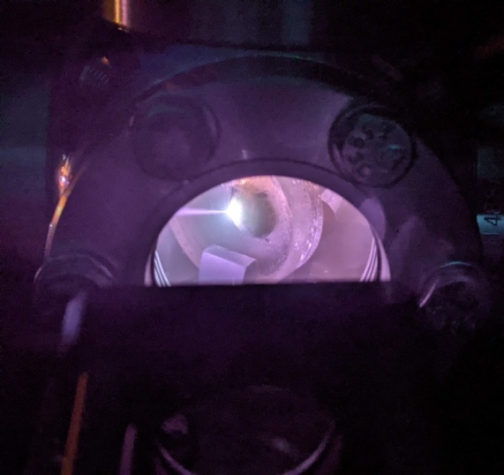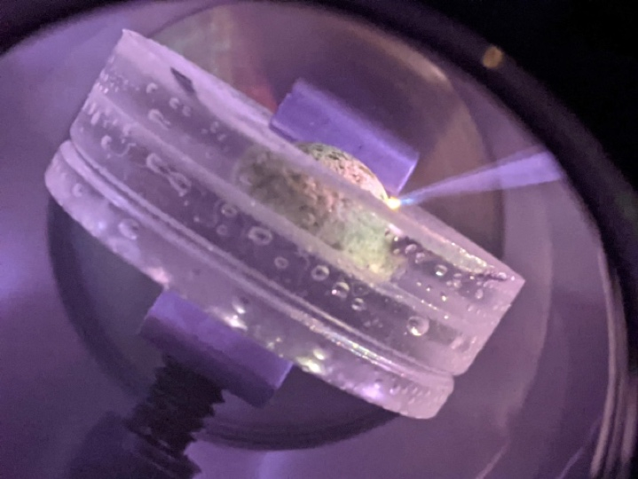
Figure 3.34 (left) & 3.35 (right): fs-LIBS of radioactive nuclear melt glass

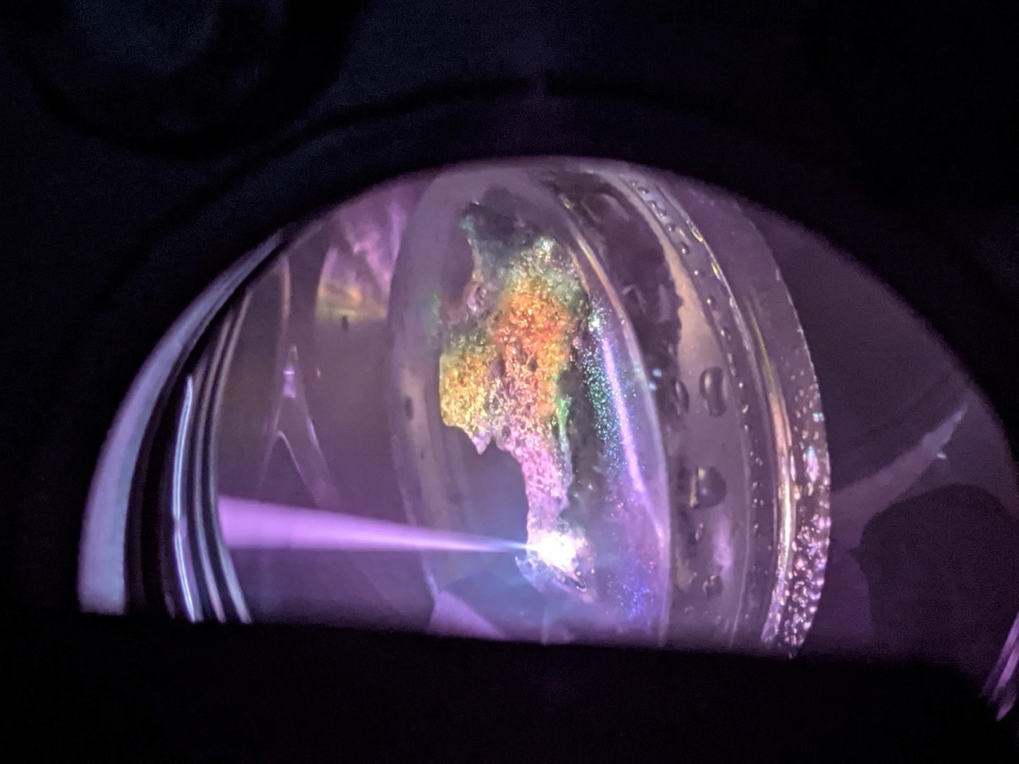
Figure 3.36 (above): fs-LIBS of Trinitite

demonstrate fs-LIBS of these respective sample types.
Additional considerations for window degradation (fogging) as a result of the ablated radioactive sample plating-out within the sample chamber were hypothesized and then observed throughout the fs-LIBS experiments of the three different nuclear debris. The angle of the epoxy part of the sample as it was set inside the sample holder ended up being the largest contributor to whether or not any window degradation (fogging) occurred. Ensuring that the epoxy part of the samples was fully in an upright orientation almost completely negated any fogging on the sapphire windows. The other biggest factor that didn’t necessarily fog up any of the sample chamber windows as much as it just filled the sample chambers with smoke was the age of the epoxy in the samples. Samples that had been prepared three plus years ago (all of the non-radioactive nuclear melt glass samples) produced much larger quantities of smoke when ablated by the fs-laser than the fresher epoxy samples that were prepared in the fall of 2020 for this thesis research.
Another observation from these nuclear debris experiments was a particular challenge in cleaning the sample chamber during the decontamination procedure (Appendix D) that occurred after each ablated sample was safely removed and the chamber then cleaned before a new sample was inserted as a replacement. The initial decontamination plan involved wiping down the entire sample chamber with “RadiacWash” and kim wipes to safely remove any radioactive particles. Then the sample chamber would be wiped down with Isopropyl alcohol and kim wipes once a swipe analysis was completed and returned no contamination from the swipes. This resulted in smeary windows and sample chamber surface as is shown in Figures 3.37 and 3.38. The solution was to add an intermediate step between the “RadiacWash” and the Isopropyl alcohol where the entire sample chamber was wiped down with Windex and kim wipes to remove any non-radioactive residue leftover from the “RadiacWash” cleaning. Although this Windex solution was not developed until after the fs-LIBS acquisition of the second radioactive nuclear melt glass sample, there were no observed effects in the acquired LIBS data from that sample. The Windex method was then used in decontaminating the second radioactive nuclear melt glass sample and all future radioactive samples, so this challenge was no longer a concern. Photos of the fs-laser ablated nuclear debris samples can be seen in Figures 3.39-3.40 (non-radioactive nuclear melt glass), 3.41-3.42 (radioactive nuclear melt glass), and 3.43-3.46 (Trinitite). Table 3.7 lists the 16 interference free atomic line of trace elements found in the nuclear debris.
As predicted in Table 3.7, 16 interference free atomic lines of trace elements were identified in the surrogate nuclear melt glass and Trinitite samples (Figures 3.47-3.56). Small deviations were found in the spectra comparison where some intensities of certain trace elements were either slightly higher or lower than their respective counterparts in other sample types due to non-heterogeneity of trace element distribution within the samples as well as some of
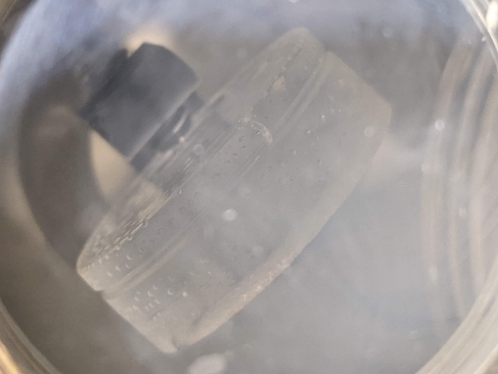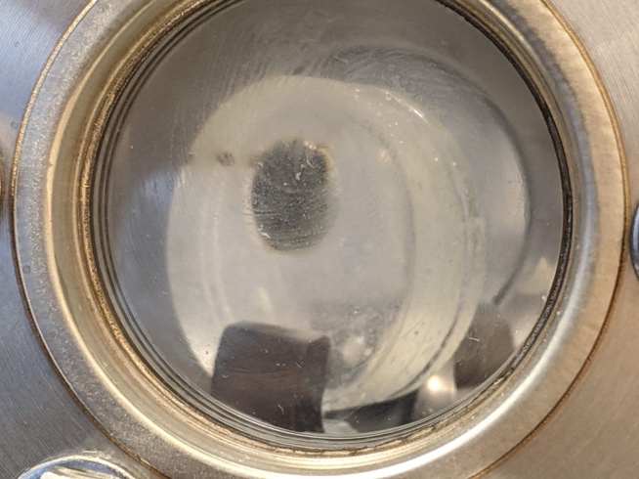
Figure 3.37 (left) & 3.38 (right): Smeared sapphire windows in the sample chamber as a result of the initial decontamination procedure that used “RadiacWash” to safely clean the sample chambers.

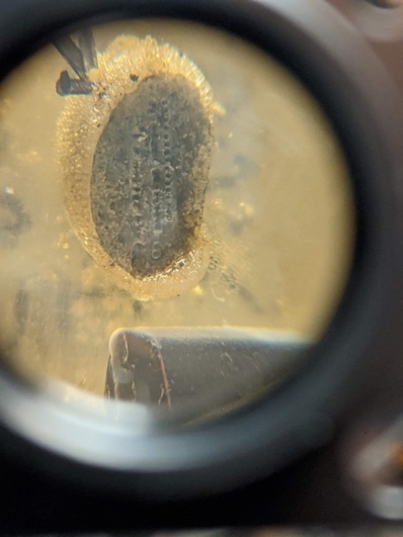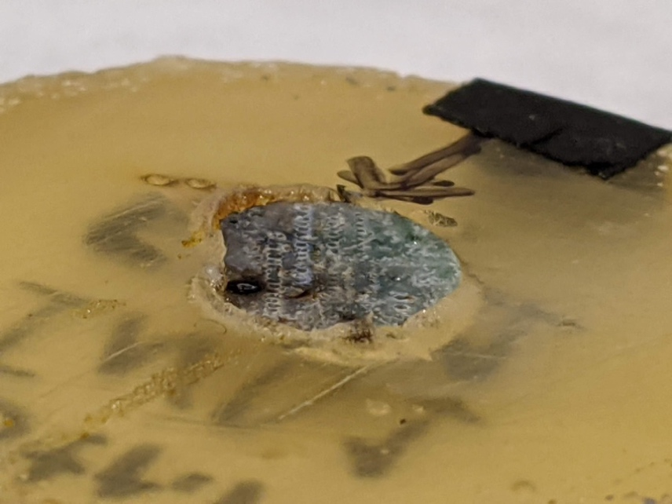
Figure 3.39 (left) & 3.40 (right): Post fs-laser ablation of non-radioactive nuclear melt glass samples

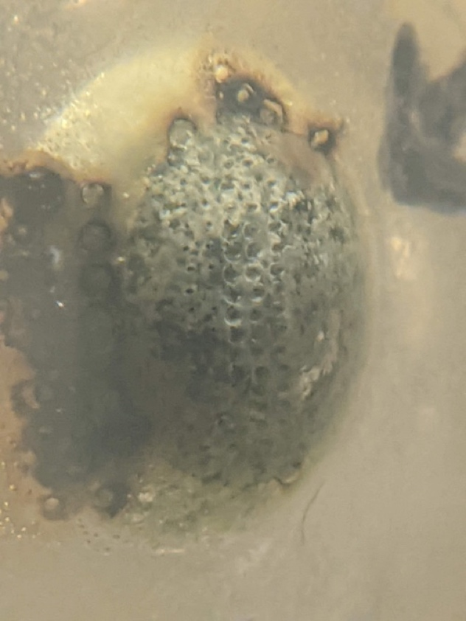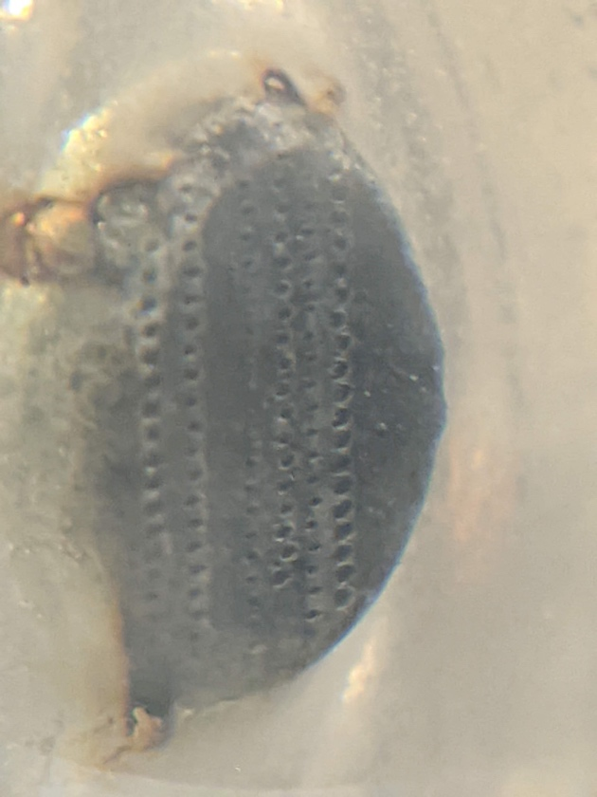
Figure 3.41 (left) & 3.42 (right): Post fs-laser ablation of radioactive nuclear melt glass samples

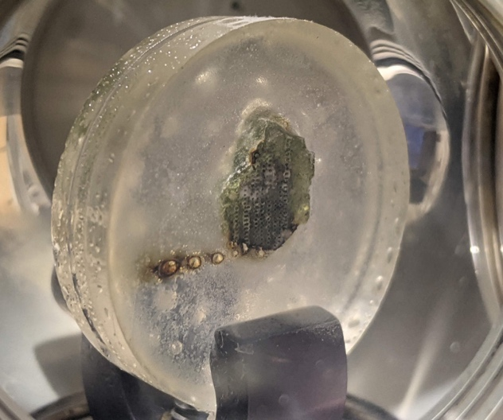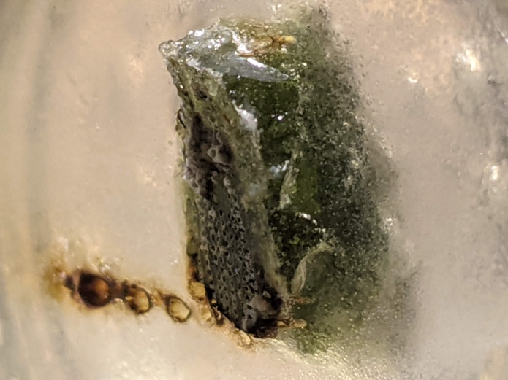
Figure 3.43 (left) & 3.44 (right): Post fs-laser ablation of Trinitite samples

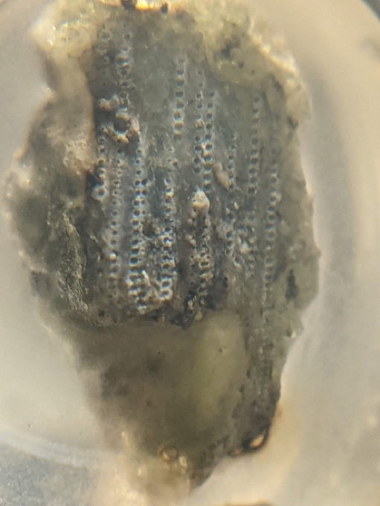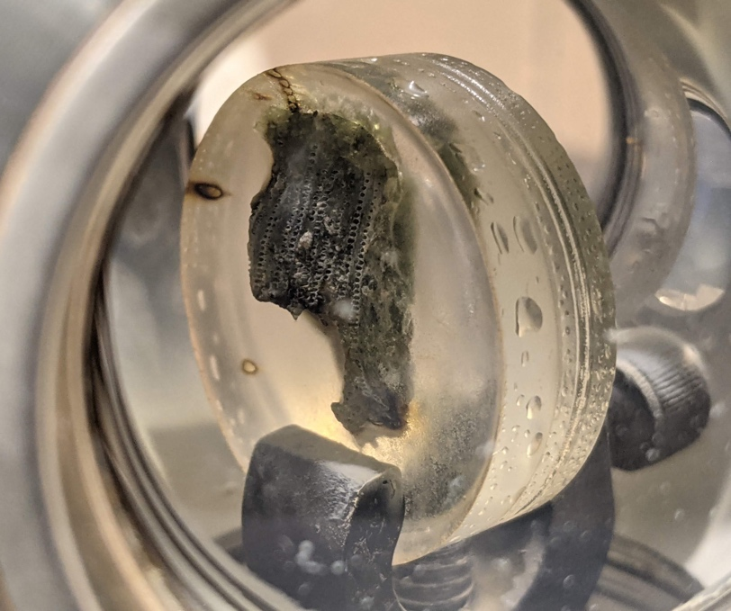
Figure 3.45 (left) & 3.46 (right): Post fs-laser ablation of Trinitite samples

Table 3.7: 16 Interference free analytical lines for analysis of trace elements in radioactive/non-radioactive nuclear melt glass and Trinitite.
Peak (nm) | Analyte
330.237 | Na I
382.444 | Fe I
382.935 | Mg I
383.230 | Mg I
383.829 | Mg I
385.991 | Fe I
390.552 | Si I
394.741 | O I
396.152 | Al I
396.847 | Ca II
403.075 | Mn I
403.306 | Mn I
403.448 | Mn I
404.414 | K I
422.672 | Ca I
466.758 | Ti I

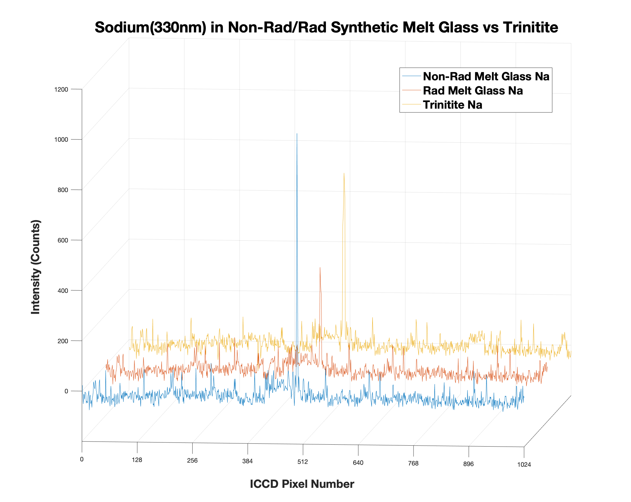
330.24 nm
Figure 3.47 (above): Comparison of Na found in the synthetic nuclear melt glass (both non-radioactive and radioactive) and Trinitite samples

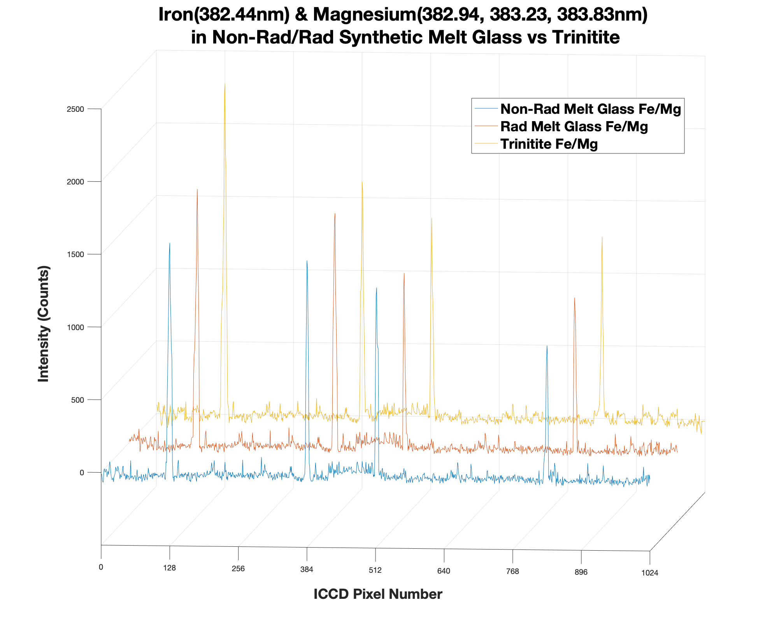
383.83 nm
382.44 nm
382.94 nm
383.23 nm
Figure 3.48 (above): Comparison of Fe and Mg found in the synthetic nuclear melt glass (both non-radioactive and radioactive) and Trinitite samples

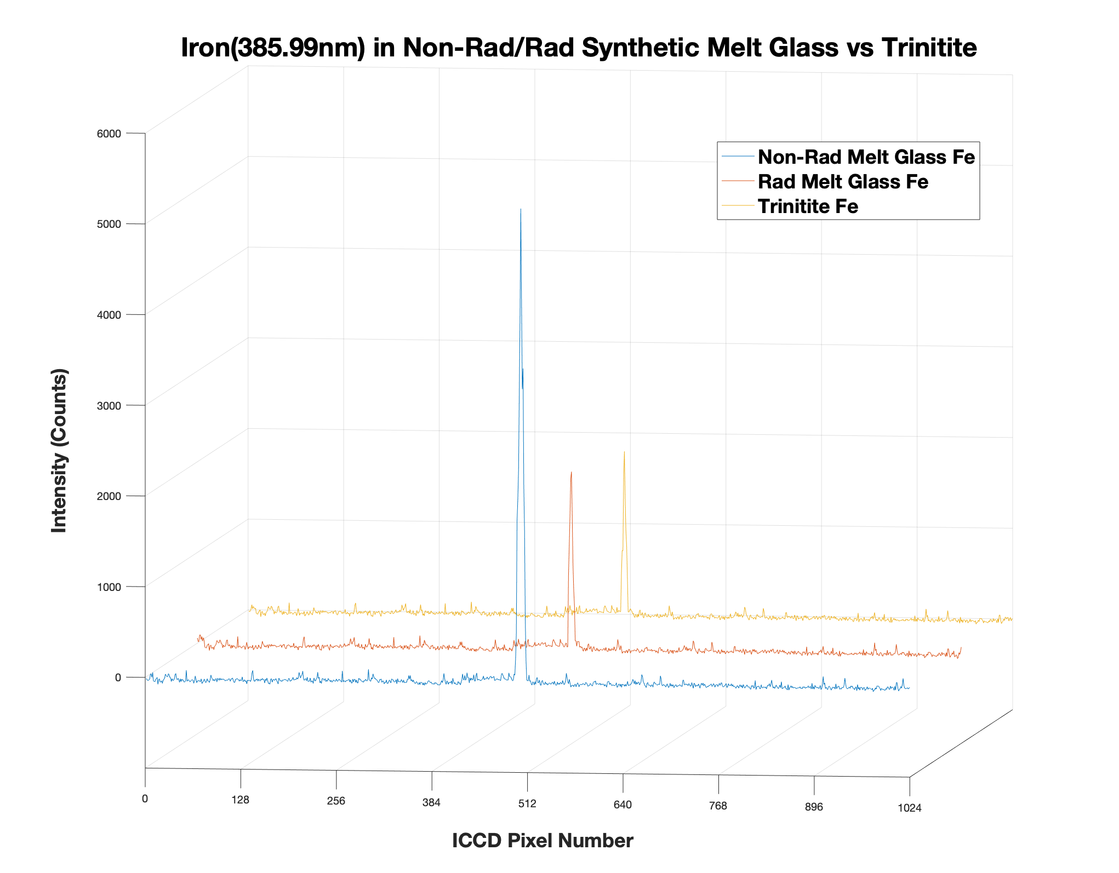
385.99 nm
Figure 3.49 (above): Comparison of Fe found in the synthetic nuclear melt glass (both non-radioactive and radioactive) and Trinitite samples

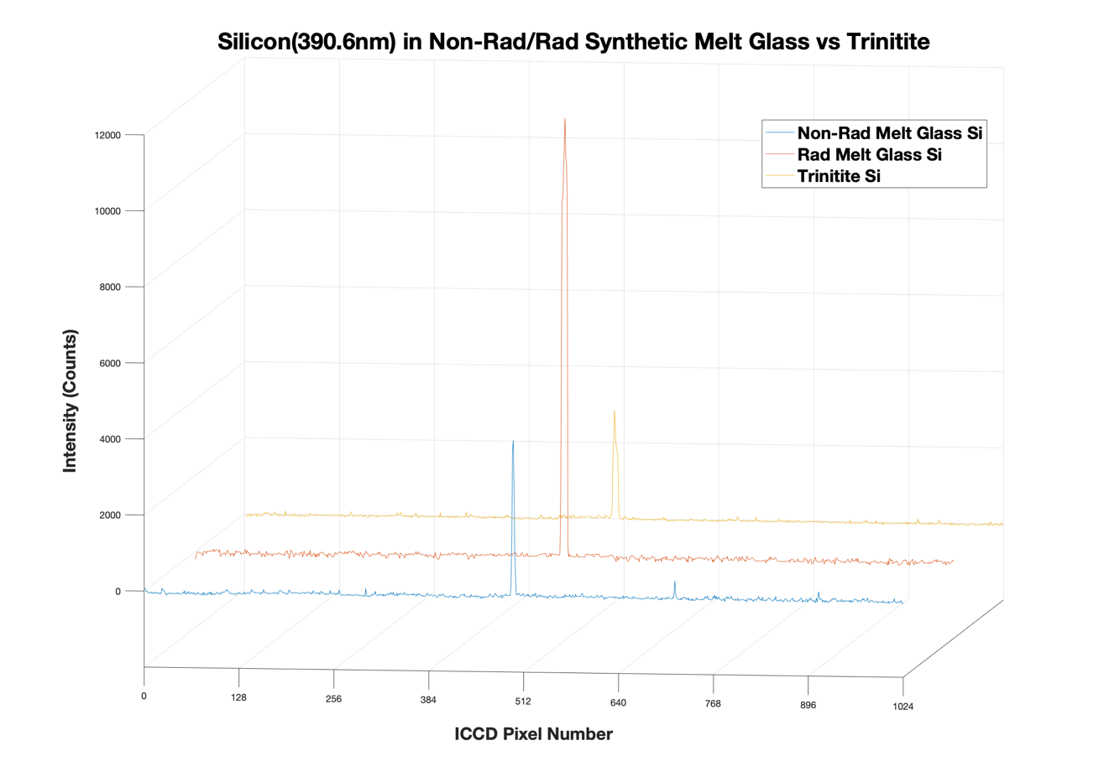
390.55 nm
Figure 3.50 (above): Comparison of Si found in the synthetic nuclear melt glass (both non-radioactive and radioactive) and Trinitite samples

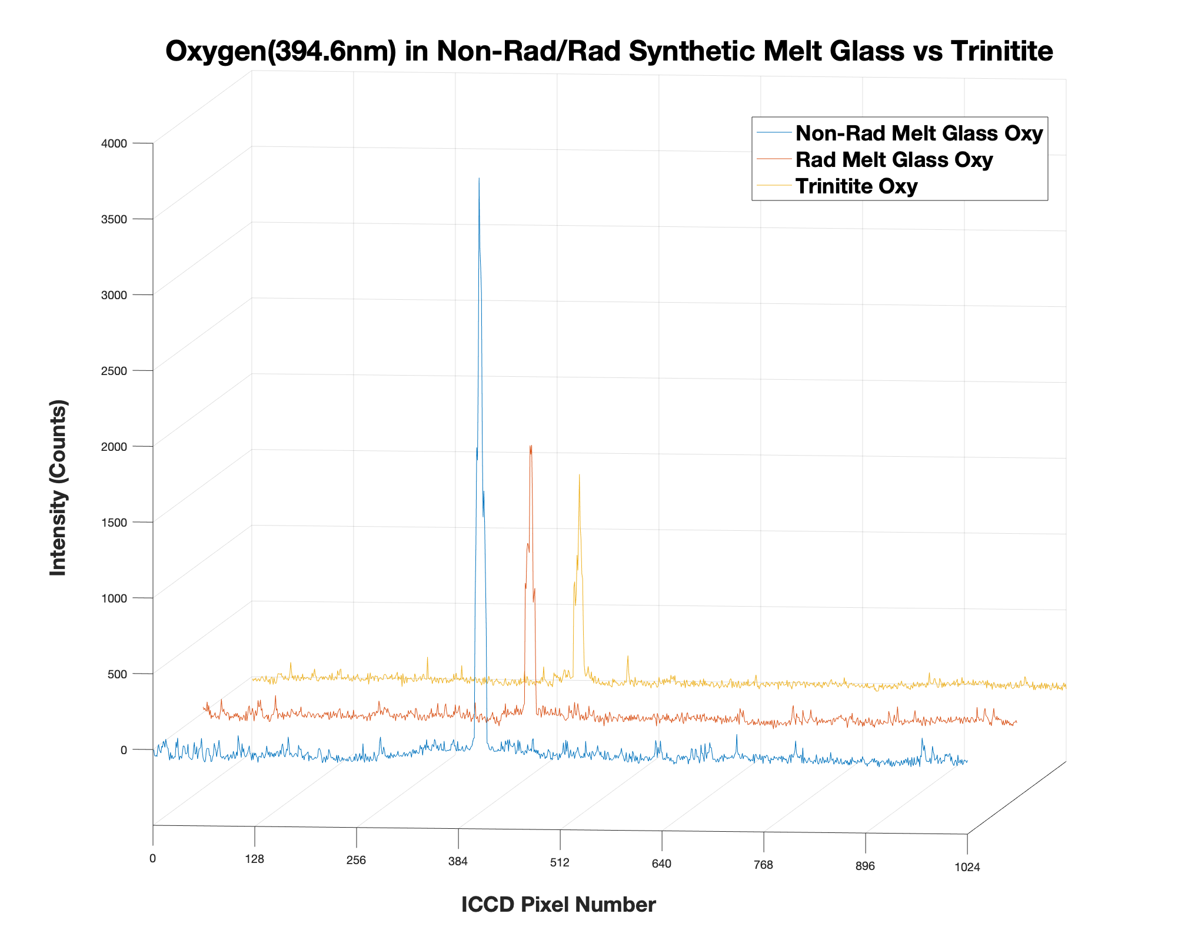
394.64 nm
Figure 3.51 (above): Comparison of O found in the synthetic nuclear melt glass (both non-radioactive and radioactive) and Trinitite samples

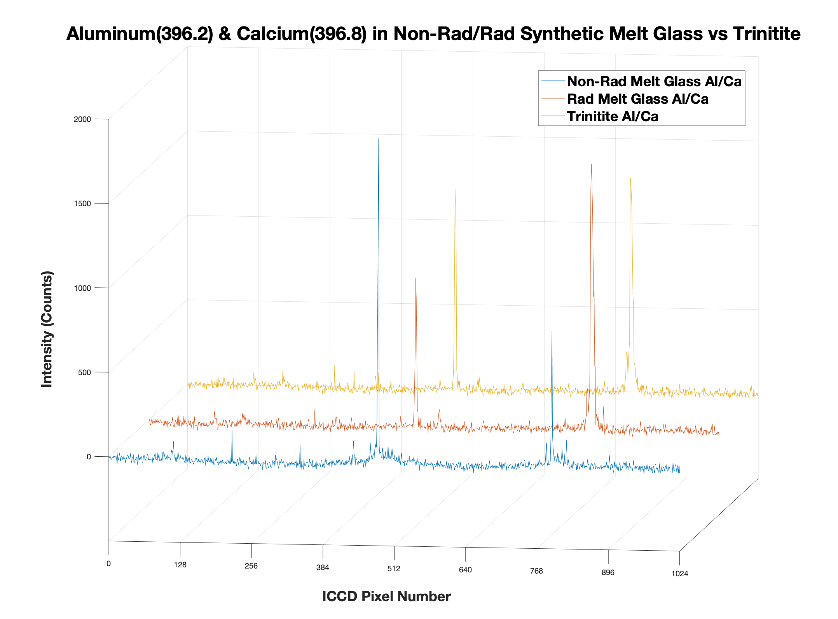
396.84 nm
396.15 nm
Figure 3.52 (above): Comparison of Al and Ca found in the synthetic nuclear melt glass (both non-radioactive and radioactive) and Trinitite samples

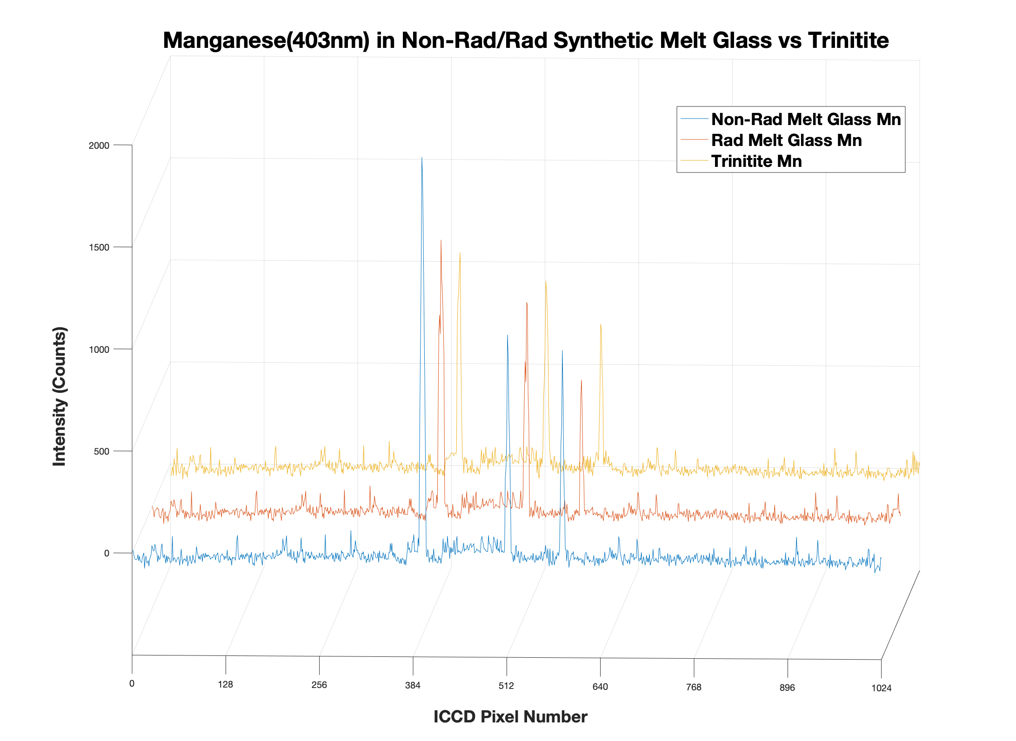
403.45 nm
403.07 nm
403.31 nm
Figure 3.53 (above): Comparison of Mn found in the synthetic nuclear melt glass (both non-radioactive and radioactive) and Trinitite samples

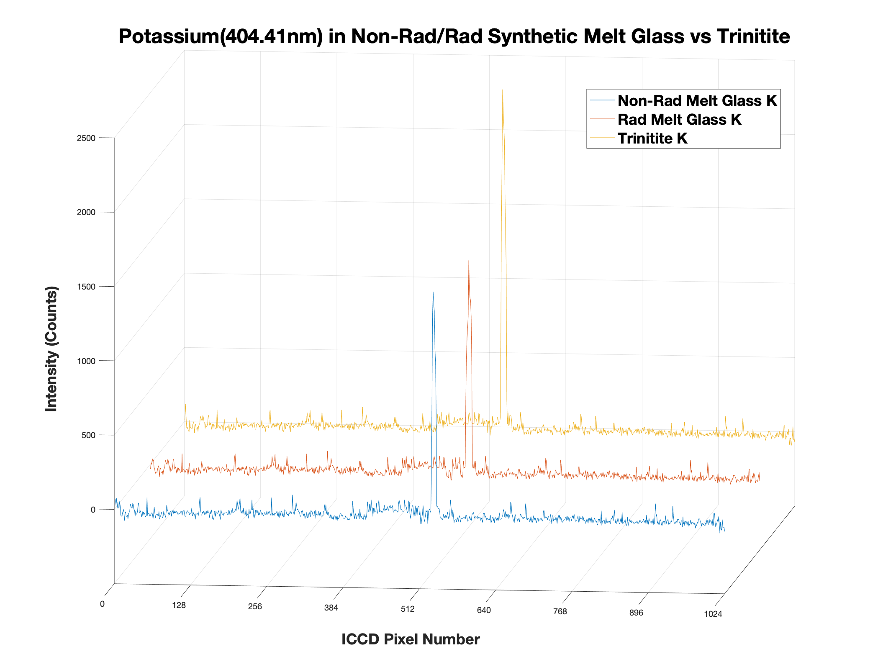
404.41 nm
Figure 3.54 (above): Comparison of K found in the synthetic nuclear melt glass (both non-radioactive and radioactive) and Trinitite samples

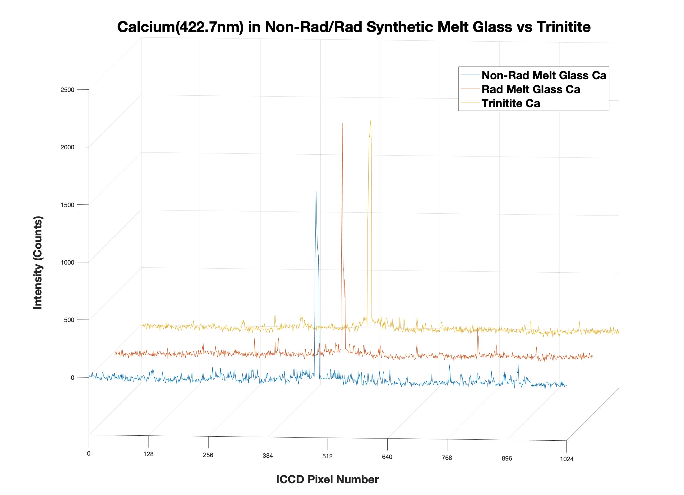
422.67 nm
Figure 3.55 (above): Comparison of Ca found in the synthetic nuclear melt glass (both non-radioactive and radioactive) and Trinitite samples

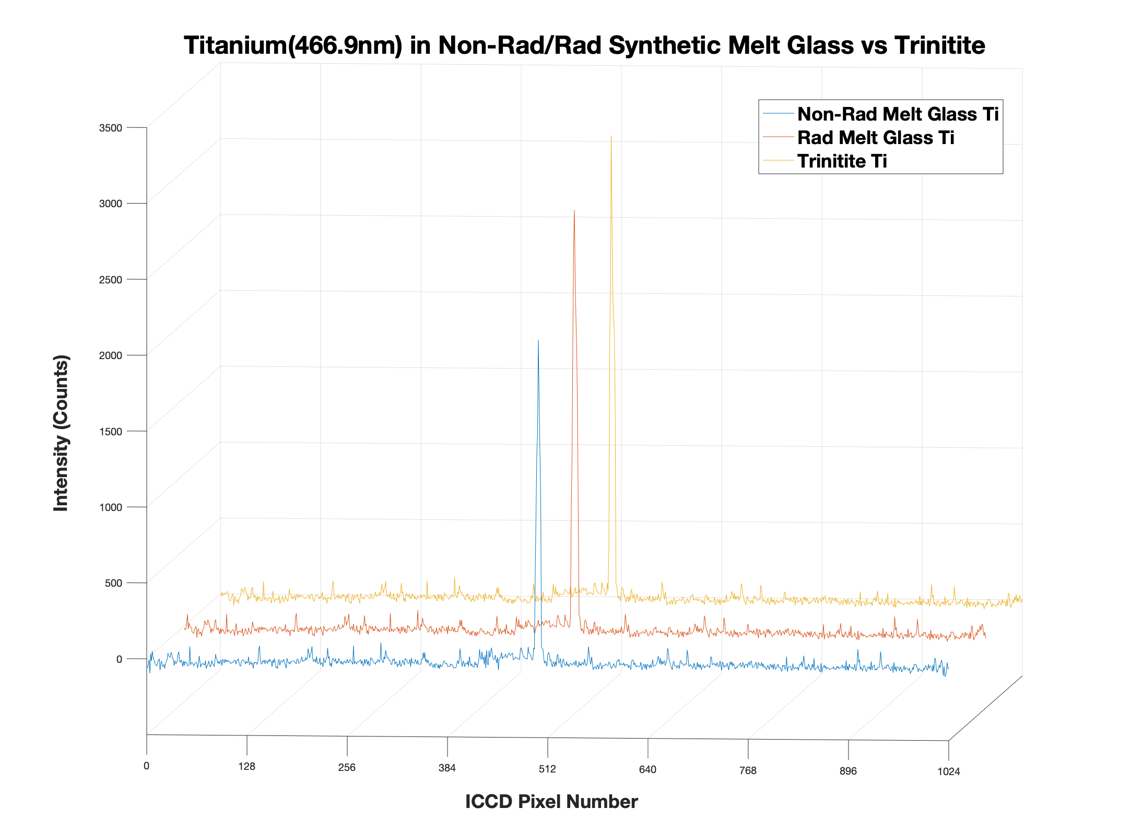
466.75 nm
Figure 3.56 (above): Comparison of Ti found in the synthetic nuclear melt glass (both non-radioactive and radioactive) and Trinitite samples

the previously described data collection methods. No emission lines for any trace element were found between 340-380 nm.
Comparison of Temporal Evolution of Atomic Uranium Emission Lines
The last experiment investigating fs-LIBS of Nuclear Debris focuses on the novel comparison of the temporal evolution of atomic uranium lines that are observed in radioactive synthetic nuclear melt glass and authentic Trinitite. A similar approach to the methods utilized to characterize the temporal evolution of the atomic aluminum lines was employed for this experiment. Figures 3.57 and 3.60 illustrate the temporal evolution of uranium emission lines with the spectrometer centered at 421.4nm (Figure 3.59 is centered at 421.0nm) for both radioactive nuclear melt glass and Trinitite respectively while Figures 3.58 and 3.61 demonstrate the temporal evolution of uranium emission lines with the spectrometer centered at 424.4nm for both the radioactive nuclear melt glass and authentic Trinitite.
Since natural Uranium was used in the Tamper Device inside the Trinity atomic bomb, the little amount of U235 would be lower following the Trinity Test Detonation due to the fission of U235 atoms. As a result, it was deemed highly unlikely that U235 peaks could be found in either the radioactive nuclear melt glass or Trinitite Samples. After consulting past LIBS of Uranium spectra for U235 peaks and conducting the fs-LIBS experiments, this hypothesis was found to be accurate. Since Uranium was very trace in both the Radioactive Nuclear Melt Glass and Trinitite Samples, there were limitations in confidently acquiring
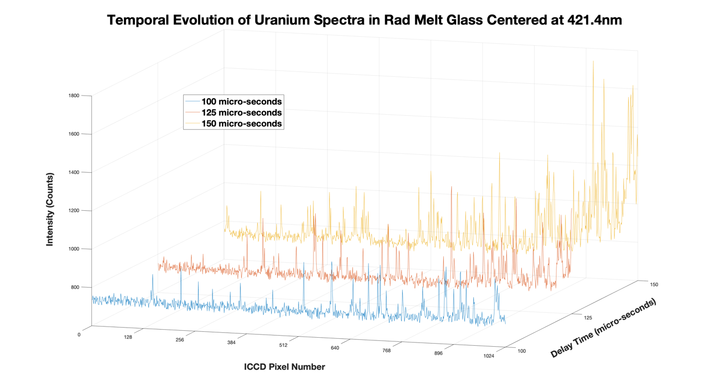
Figure 3.57 (above): Temporal evolution of atomic uranium lines in radioactive nuclear melt glass (spectrometer centered at 421.4nm)

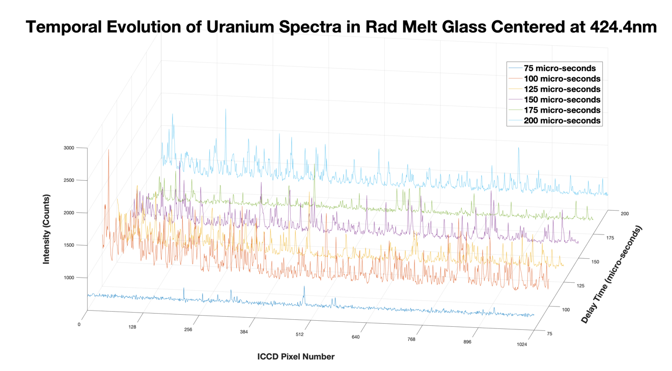
Figure 3.58 (above): Temporal evolution of atomic uranium lines in radioactive nuclear melt glass (spectrometer centered at 424.4nm)

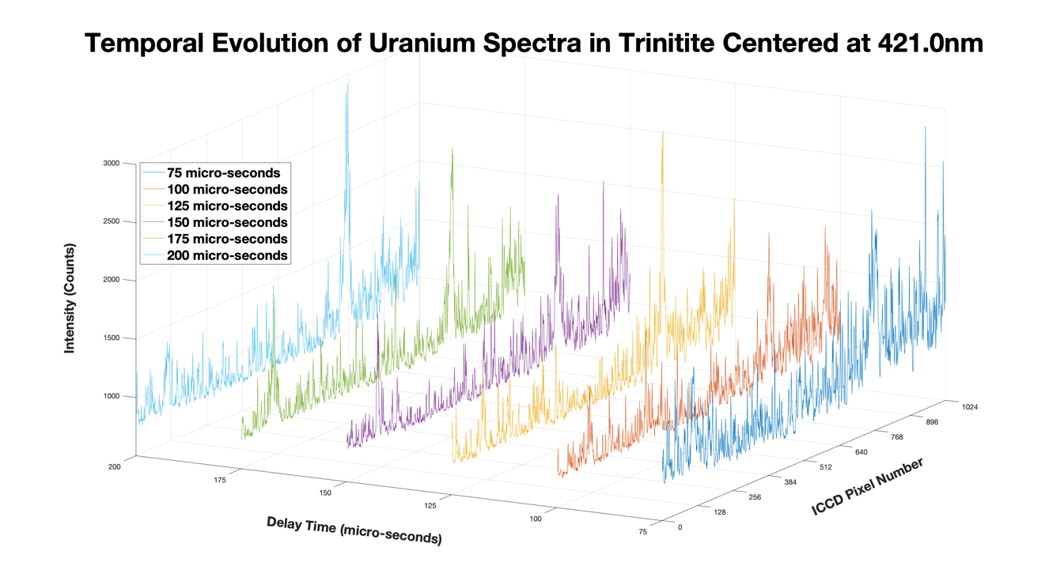
Figure 3.59 (above): Temporal evolution of atomic uranium lines in Trinitite (spectrometer centered at 421.0nm)

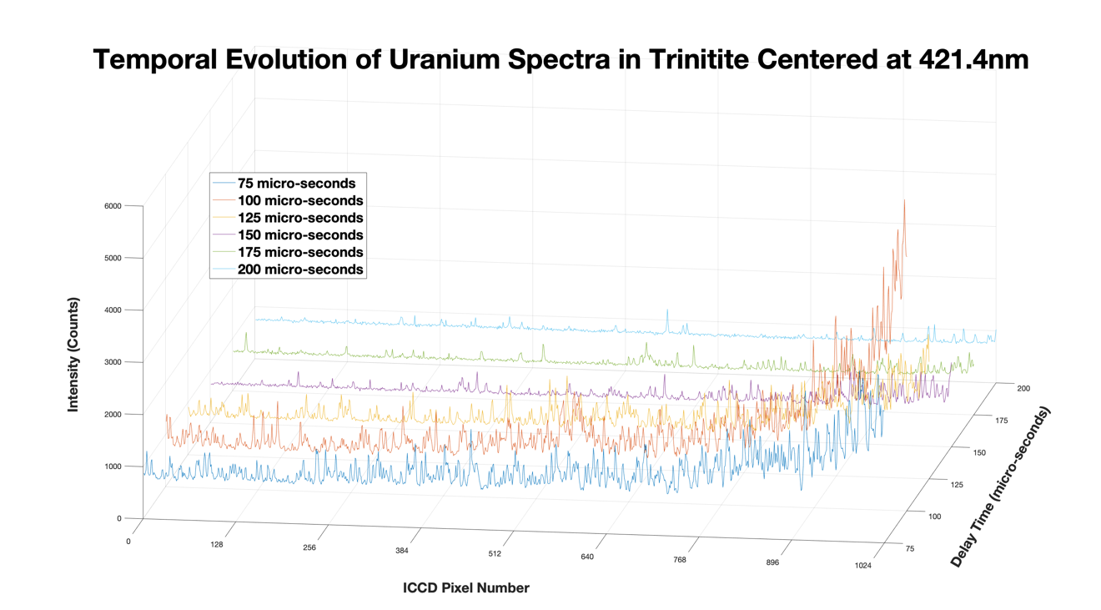
Figure 3.60 (above): Temporal evolution of atomic uranium lines in Trinitite
(spectrometer centered at 421.4nm)

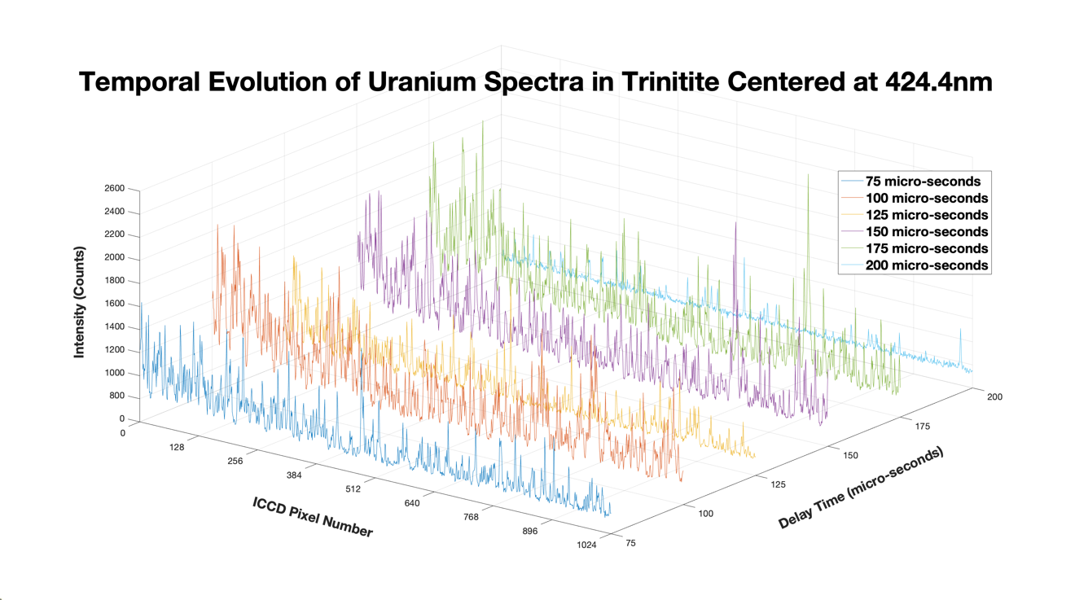
Figure 3.61 (above): Temporal evolution of atomic uranium lines in Trinitite
(spectrometer centered at 424.4nm)

Uranium isotopic data of varying enrichment levels would be required to confidently attribute emission peaks to specific isotopes of Uranium and conduct isotopic shift measurements. Complicated calibration of the uranium spectra needs to be undertaken, and the types of peaks that were found in radioactive melt glass and Trinitite were either so low that they could not be separated from the noise floor or they were so broad that they could not be used for calibration. Current calibration methods for Uranium spectra require at least three relatively sharp peaks present in the spectral window of the ICCD.

- CONCLUSIONS AND FUTURE WORK
Conclusions
To meet these persisting nuclear safeguards challenges, continual research and development of equipment and techniques remains critical. This research of laser spectroscopy systems would be an important extension of the capabilities of international safeguards inspectors, allowing better measurement and monitoring of GCEP mass balance, among other nuclear fuel cycle processes. The demonstrated research on the development and implementation of a testing regime for a laser spectroscopy sample chamber will enable further advancements in developing new nuclear safeguards technologies. This testing regime will ensure the safety of all the system users as well as enable and enhance the optimization of the experimental design of whichever laser spectroscopy method is employed. Furthermore, a novel comparison of the fs-LIBS spectra of trace elements found in radioactive/non-radioactive nuclear melt glass and Trinitite has been demonstrated. 16 interference free atomic emission lines of trace elements (besides uranium) were found in each of the surrogate nuclear debris and Trinitite, and the temporal evolution of atomic uranium lines present in radioactive synthetic nuclear melt glass and Trinitite around 421nm and 424nm were obtained.

Future Work
Intensity & Wavelength Calibrations of fs-LIBS Data
Since multiple spectra windows from the ICCD were utilized in the data acquisition of fs-LIBS spectrums for trace elements found in the compounds of surrogate nuclear melt glass and Trinitite, the data will need to be calibrated for both intensity and wavelength as the ICCD reports its x-axis in units of pixel numbers. Although it is not ideal to calibrate data after it has been acquired, the calibration is accurate, nonetheless. It is planned to calibrate the intensity of the data acquired within this thesis research by use of a UV-VIS deuterium-halogen light source. Intensity of the collected LIBS spectrums will need to be calibrated first in order for plasma physical properties such as the plasma temperature or electron density to be accurate.
The wavelength calibration is more time intensive as past research has shown that individual spectral windows that cover the entire spectral range on the spectrometer must be acquired and then stitched together in post-processing [56]. For a spectrometer range of 200nm where the spectral window of the ICCD is roughly 2nm, this will be a lengthy process. Alternative wavelength calibrations are currently being investigated such as taking a scan of the entire spectrometer range of interest and then formulating a calibration line base on this spectrum. A NIST traceable Mercury pencil lamp will be used for the wavelength calibration.

Limit of Detection of Trace Elements in Nuclear Debris
Once the fs-LIBS data collected in this thesis research has been calibrated for intensity and wavelength, the next step would be to use the slope of the wavelength calibration line to calculate the Limit of Detection (LOD) for each of the trace elements found in the radioactive/non-radioactive nuclear melt glass and trinitite samples. Past LIBS research has yielded LODs in the parts per billion (ppb) range which is highly comparable to mass spectrometry whose LODs have resulted in the range of parts per trillion (ppt) [57,58].
Fs-LIBS of Activation & Fission Products in Trinitite
From the work of Cook et al., it was demonstrated that while past research on gamma spectroscopy had yielded gamma-ray emission peaks for Ba-133, Cs-137, Eu-152, Eu-154, Eu-155, Pu-239, Pu-241, Am-241, and Co-60 in Trinitite, the Cs-137 gamma emission peak was the only comparable peak between Trinitite and thermal neutron irradiated (at High Flux Isotope Reactor (HFIR) at ORNL) nuclear melt glass that could be found today due to the half-lives of these radioisotopes of interest and the lack of high enriched uranium or plutonium in the surrogate samples [59]. Further investigation for the activation and fission products in Trinitite is warranted since no previous research has probed Trinitite with fs-LIBS, and the only elements examined with ns-LIBS are Al, Ca, Na, and Ti, as mentioned earlier in this research [55].

Comparison of ns-LIBS vs fs-LIBS of Nuclear Debris
The current inventory of non-radioactive and radioactive surrogate nuclear melt glass at UTK needs to be replenished with additional synthesized samples with preparation techniques and elemental composition from past work such as ones developed by Molgaard et al [54]. Moreover, additional Trinitite samples should be purchased from a variety of authorized online retailers. Acquiring more of each of these three samples will allow for additional comparative LIBS analysis with ns- and fs-lasers. There are presently enough samples at UTK to reproduce similar analysis demonstrated in this research with a ns-laser. Additional samples of the three different varieties will be needed to further explore additional elements that could be found in surrogate nuclear melt glass or Trinitite. Furthermore, new sample preparation methods could be developed to include enriched uranium or plutonium to more accurately compare the distribution of activation and fission products as well as improving the accuracy of determining interference free isotopic lines of the uranium in surrogate nuclear debris and Trinitite.
An additional method that could be employed in this comparative LIBS analysis is to couple a lower resolution spectrometer with the ns-Laser so that training data for lower and higher resolution LIBS could be combined and with the use of a neural network, be developed and optimized to aid efforts in using a handheld or field deployable LIBS system for environmental sampling that will not be able to replicate the higher resolution equipment found in a laboratory due to its need for ruggedness in a variety of harsh field conditions.
Comparison of ns-LIBS vs fs-LIBS of UF6
Additional research at UTK is currently being developed and optimized to assay UF₆ of varying U-235 enrichment levels with fs-LIBS in support of the LISA-UE nuclear safeguards research efforts at LBNL and ORNL. Recent LISA-UE work by Chan et al. has demonstrated successful multi-variate nonlinear spectral fitting to obtain direct isotopic analysis of uranium emission lines in gaseous UF₆ with a ns-laser [60]. As outlined in the previous subsection, the ability to compare LIBS measurements of UF₆ with ns- and fs-lasers will further validate and improve efforts to utilize a field deployable LIBS-systems for use in environmental sampling or an assortment of other similar assay applications within the nuclear fuel cycle.

List of References

[1] Chan, CYG, Valentine, JD, & Russo, RE. (2017). Scoping study to expedite development of a field deployable and portable instrument for UF6 enrichment assay. In Scoping study to expedite development of a field deployable and portable instrument for UF6 enrichment assay. Lawrence Berkeley National Laboratory. Report #: LBNL-2001050. Retrieved from https://escholarship.org/uc/item/6k47p04z.
[2] Mauchien, P., Pailloux, A. and Vercouter, T. (2014). Laser for spectroscopy sensing: Fundamentals, techniques and applications. 1st ed. Saclay, France: Woodhead Publishing, pp.522-543.
[3] Overview of IAEA by former IAEA Director General Hans Blix on “The Peaceful and Safe Uses of Nuclear Energy,” April 25, 1996, Vienna, Austria. {https://www.iaea.org/newscenter/statements/peaceful-and-safe-uses-nuclear-energy} Feb. 24, 2018.
[4] Treaty on the Non-Proliferation of Nuclear Weapons (NPT) https://www.un.org/disarmament/wmd/nuclear/npt/text
[5] INFCIRC-153 is available, courtesy of the IAEA, at https://www.iaea.org/sites/default/files/publications/documents/infcircs/1972/infcirc153.pdf
[6] https://www.nrc.gov/materials/fuel-cycle-fac/ur-enrichment.html Accessed on 02/11/2020. Website last updated on 04/15/2019.
[7] Whitaker, J. M. Uranium enrichment plant characteristics: A training manual for the IAEA (International Atomic Energy Agency). No. K/ITP-310; ISPO--310. Oak Ridge Gaseous Diffusion Plant, TN (USA), 1990.
[8] W. Koechner, Solid-State Laser Engineering, Springer, 2006.
[9] B. Kearton and Y. Mattley, “Laser-induced breakdown spectroscopy: sparking new applications,” Nature Photonics, vol. 2, no. 9, pp. 537–540, 2008.
[10] D. A. Cremers, L. J. Radziemski, and J. Wiley, Handbook of Laser-Induced Breakdown Spectroscopy, John Wiley & Sons, 2006.
[11] Mauchien, P., Pailloux, A. and Vercouter, T. (2014). Laser for spectroscopy sensing: Fundamentals, techniques and applications. 1st ed. Saclay, France: Woodhead Publishing, pp.522-543.
[12] Mass Spectrometer (F. W. Aston). Accessed February 10, 2020. http://chemed.chem.purdue.edu/genchem/history/isotope.html.
[13] J. D. Winefordner, I. B. Gornushkin, T. Correll, E. Gibb, B. W. Smith, and N. Omenetto, “Comparing several atomic spectrometric methods to the super stars: special emphasis on laser induced breakdown spectrometry, LIBS, a future super star,” Journal of Analytical Atomic Spectrometry, vol. 19, no. 9, pp. 1061–1083, 2004.
[14] “Solutions Using the SE and EMU Echelle Spectrographs.” Catalina Scientific. Accessed February 10, 2020. http://www.catalinasci.com/solutions.cfm.
[15] Radziemski L.J. (1983), ‘Detection of beryllium by laser-induced breakdown spectroscopy’, Spectrochimica Acta Part B-Atomic Spectroscopy, 38, 349–355.
[16] Kim Y S, Han B Y, Shin H S, Kim H D, Jung E C, Jung J H and Na S H 2012 Determination of uranium concentration in an ore sample using laser-induced breakdown spectroscopy Spectrochim. Acta B 74–5 190–3.
[17] Judge E J, Barefield J E, Berg J M, Clegg S M, Havrilla G J, Montoya V M, Le L A and Lopez L N 2013 Laser-induced breakdown spectroscopy measurements of uranium and thorium powders and uranium ore Spectrochim. Acta B 83–4 28–36.
[18] Barefield J E, Judge E J, Campbell K R, Colgan J P, Kilcrease D P, Johns H M, Wiens R C, McInroy R E, Martinez R K and Clegg S M 2016 Analysis of geological materials containing uranium using laser-induced breakdown spectroscopy Spectrochim. Acta B 120 1–8.
[19] Klus J, Mikysek P, Prochazka D, Pořízka P, Prochazková P, Novotný J, Trojek T, Novotný K, Slobodník M and Kaiser J 2016 Multivariate approach to the chemical mapping of uranium in sandstone-hosted uranium ores analyzed using double pulse laser-induced breakdown spectroscopy Spectrochim. Acta B 123 143–9.
[20] Sirven J-B, Pailloux A, M’Baye Y, Coulon N, Alpettaz T and Gossé S 2009 Towards the determination of the geographical origin of yellowcake samples by laser-induced breakdown spectroscopy and chemometrics J. Anal. At. Spectrom. 24 451–9.
[21] Campbell K R, Wozniak N R, Colgan J P, Judge E J, Barefield J E, Kilcrease D P, Wilkerson M P, Czerwinski K R and Clegg S M 2017 Phase discrimination
of uranium oxides using laser-induced breakdown spectroscopy Spectrochim. Acta B 134 91–7.
[22] Sarkar A, Alamelu D and Aggarwal S K 2009 Laser-induced breakdown spectroscopy for determination of uranium in thorium-uranium mixed oxide fuel materials Talanta 78 800–4.
[23] Fichet P, Mauchien P and Moulin C 1999 Determination of impurities in uranium and plutonium dioxides by laser-induced breakdown spectroscopy Appl. Spectrosc 53 1111–7.
[24] Campbell K R, Judge E J, Barefield J E, Colgan J P, Kilcrease D P, Czerwinski K R and Clegg S M 2017 Laser-induced breakdown spectroscopy of light water reactor simulated used nuclear fuel: main oxide phase Spectrochim. Acta B 133 26–33.
[25] Singh M, Sarkar A, Banerjee J and Bhagat R K 2017 Analysis of simulated high burnup nuclear fuel by laser-induced breakdown spectroscopy Spectrochim. Acta B 132 1–7.
[26] Williams A N and Phongikaroon S 2016 Elemental detection of cerium and gadolinium in aqueous aerosol via laser-induced breakdown spectroscopy Appl. Spectrosc. 70 1700–8.
[27] Wachter J R and Cremers D A 1987 Determination of uranium in solution using laser-induced breakdown spectroscopy Appl. Spectrosc. 41 1042–8.
[28] Sarkar A, Alamelu D and Aggarwal S K 2008 Determination of thorium and uranium in solution by laser-induced breakdown spectrometry Appl. Opt. 47 G58–64.
[29] Sarkar A, Telmore V M, Alamelu D and Aggarwal S K 2009 Laser-induced breakdown spectroscopic quantification of platinum group metals in simulated high-level nuclear waste J. Anal. At. Spectrom. 24 1545.
[30] Williams A N and Phongikaroon S 2017 Laser-induced breakdown spectroscopy (LIBS) in a novel molten salt aerosol system Appl. Spectrosc. 71 744–9.
[31] Sarkar A, Mishra R K, Kaushik C P, Wattal P K, Alamelu D and Aggarwal S K 2014 Analysis of barium borosilicate glass matrix for uranium determination by using ns-IRLIBS in air and Ar atmosphere Radiochim. Acta 102 805–12.
[32] Jung E C, Lee D H, Yun J I, Kim J G, Yeon J W and Song K 2011 Quantitative determination of uranium and europium in glass matrix by laser-induced breakdown spectroscopy Spectrochim. Acta B 66 761–4.
[33] Lang A et al 2018 Analysis of contaminated nuclear plant steel by laser-induced breakdown spectroscopy J. Hazard. Mater. 345 114–22.
[34] Doucet F R, Lithgow G, Kosierb R, Bouchard P and Sabsabi M 2011 Determination of isotope ratios using laser-induced breakdown spectroscopy in ambient air at atmospheric pressure for nuclear forensics J. Anal. At. Spectrom. 26 536.
[35] Cremers D A, Beddingfield A, Smithwick R, Chinni R C, Jones C R, Beardsley B and Karch L 2012 Monitoring uranium, hydrogen, and lithium and their isotopes using a compact laser-induced breakdown spectroscopy (LIBS) probe and high-resolution spectrometer Appl. Spectrosc. 66 250–61.
[36] Shattan, M. B., Gragston, M., Zhang, Z., Auxier, J. D., McIntosh, K. G., & Parigger, C. G. (2019). Mapping of Uranium in Surrogate Nuclear Debris Using Laser-Induced Breakdown Spectroscopy (LIBS). Applied Spectroscopy, 73(6), 591–600. https://doi.org/10.1177/0003702819842871.
[37] R. Chinni, D.A. Cremers, R. Multari. ‘‘Analysis of Material Collected
on Swipes Using Laser-Induced Breakdown Spectroscopy’’. Appl. Opt.
2010. 49(13): C143–C152.
[38] Karen Y. Yamamoto, David A. Cremers, Monty J. Ferris, and Leeann E. Foster, "Detection of Metals in the Environment Using a Portable Laser-Induced Breakdown Spectroscopy Instrument," Appl. Spectrosc. 50, 222-233 (1996).
[39] International Atomic Energy Agency, International target values 2010 for measurement uncertainties in safeguarding nuclear materials, STR-368, International Atomic Energy Agency (IAEA), (2010).
[40] B.A. Bushaw, N.C. Anheier Jr, Isotope ratio analysis on micron-sized particles in complex matrices by laser ablation-absorption ratio spectrometry, Spectrochim. Acta Part B 64 (2009) 1259-1265.
[41] NNSA Safeguards Technology Factsheet, Laser ablation absorption ratio spectroscopy (LAARS), PNNL-SA-116387, (2016).
[42] NNSA Safeguards Technology Factsheet, Laser ablation absorption ratio spectroscopy (LAARS), PNNL-SA-123926, (2017).
[43] A. Quentmeier, M. Bolshov, K. Niemax, Measurement of uranium isotope ratios in solid samples using laser ablation and diode laser-atomic absorption spectrometry, Spectrochim. Acta Part B 56 (2001) 45-55.
[44] G. C.-Y. Chan, J. D. Valentine, and R. E. Russo, “Towards novel field-deployable instrumentation for UF6 enrichment assay – an overview of existing and emerging technologies,” ESARDA BULLETIN, no. 54, pp. 31 - 43, June 2017, 2017.
[45] F.J. Fortes, J.J. Laserna, The development of fieldable laser-induced breakdown spectrometer: No limits on the horizon, Spectrochimica Acta Part B: Atomic Spectroscopy, Volume 65, Issue 12, 2010, Pages 975-990, ISSN 0584-8547, https://doi.org/10.1016/j.sab.2010.11.009.
[46] Verhoff, B., Harilal, S. S., J. R. Freeman, P. K. Diwakar, and A. Hassanein. “Dynamics of Femto- and Nanosecond Laser Ablation Plumes Investigated Using Optical Emission Spectroscopy.” AIP Publishing. American Institute of Physics, November 1, 2012. https://aip.scitation.org/doi/10.1063/1.4764060.
[47] Martin, Leigh, Trowbridge, Lee, Richards, Jason, and Fugate, Glenn. "Design and application of an online reactive gas cell for safeguards measurements of UF6." In ABSTRACTS OF PAPERS OF THE AMERICAN CHEMICAL SOCIETY, vol. 257. 1155 16TH ST, NW, WASHINGTON, DC 20036 USA: AMER CHEMICAL SOC, 2019.
[48] https://www.thorlabs.com/newgrouppage9.cfm?objectgroup_ID=4973
[49] https://www.tedpella.com/technote_html/114-9,%20114-91,%20114-92%20TN.pdf
[50] Skrodzki, P.J., Burger, M., Finney, L.A. et al. Ultrafast Laser Filament-induced Fluorescence Spectroscopy of Uranyl Fluoride. Sci Rep 8, 11629 (2018). https://doi.org/10.1038/s41598-018-29814-8
[51] MATLAB (sgolay) Savitzky-Golay filter design https://www.mathworks.com/help/signal/ref/sgolay.html
[52] https://physics.nist.gov/PhysRefData/ASD/LIBS/libs-form.html
[53] https://www.sciencedirect.com/science/article/abs/pii/S0584854701001872
[54] Molgaard, Joshua J et al. “Production of Synthetic Nuclear Melt Glass.” Journal of visualized experiments: JoVE 107 (2016): n. pag. Web.
[55] Appendix D: Examples of LIBS Spectra - Handbook of Laser‐Induced Breakdown Spectroscopy - Wiley Online Library. https://onlinelibrary.wiley.com/doi/pdf/10.1002/9781118567371.app4
[56] Gaigalas, A.K. et al., J. Res. Natl. Inst. Stand. Technol. 114, 215-228 (2009)
[57] He, Yage et al. “Lithium ion detection in liquid with low detection limit by laser-induced breakdown spectroscopy.” Applied optics vol. 58,2 (2019): 422-427. doi:10.1364/AO.58.000422
[58] Arnquist, Isaac J et al. “Mass Spectrometric Determination of Uranium and Thorium in High Radiopurity Polymers Using Ultra Low Background Electroformed Copper Crucibles for Dry Ashing.” Analytical chemistry vol. 89,5 (2017): 3101-3107. doi:10.1021/acs.analchem.6b04854
[59] Cook, M.T., Auxier, J.D., Giminaro, A.V. et al. A comparison of gamma spectra from trinitite versus irradiated synthetic nuclear melt glass. J Radioanal Nuclear Chem 307, 259–267 (2016). https://doi.org/10.1007/s10967-015-4266-3.
[60] Chan, George C.-Y., Martin, Leigh R., Trowbridge, Lee D., Zhu, Zhenli, Mao, Xianglei, Russo, Richard E., Analytical characterization of laser induced plasmas towards uranium isotopic analysis in gaseous uranium hexafluoride, Spectrochimica Acta Part B: Atomic Spectroscopy, Volume 176, 2021, 106036, ISSN 0584-8547, https://doi.org/10.1016/j.sab.2020.106036.
[61] Eagle Rock Enrichment Facility - Chemical Process Safety., Safety Analysis Report, Rev. 3, US Nuclear Regulatory Commission (NRC) Documents
[62] Fuel Cycle Processes - 03 Uranium Conversion – US NRC Technical Training Center Documents
[63] Excerpt from Document on Chemical Reactions and Quick Dispersions of UF6, LAndelijk Kernenergie Archief - National Nuclear Energy Archive in Amsterdam, Netherlands
[64] Uranium Hexafluoride - Safe Handling, Processing, and Transporting Conference Proceedings, May 24-26, 1988, Oak Ridge, TN, USA
[65] Final Report on Chemical Toxicity of Uranium Hexafluoride Compared to Acute Effects of Radiation, US NRC, 1991, S.A. McGuire
[66] McGuire, April 1990, p.2.
[67] https://courses.lumenlearning.com/boundless-chemistry/chapter/reaction-mechanisms/
[68] Richards, Jason M., et al. Kinetic Investigation of the Hydrolysis of Uranium Hexafluoride Gas. 18 Sept. 2020, doi.org/10.1039/D0RA05520D.
[69] https://www.lesker.com/viewports/viewports-cf-flanged-sapphire/part/vpzl-275sw
[70] https://www.guildoptics.com/sapphire-properties/sapphire-properties/

APPENDices

APPENDIX A

Sample Chamber Leak Rate & Chemical Reaction Rate Calculations
Assumptions for Leak Rate Calculations:
- UF₆ is in gaseous form and is approximately 1 gram
- Air outside of the sample chamber is at room temp ~ 298 K (25 C = 77 F) and at atmospheric (atm) pressure of 14.7 psi
- Molar mass of dry air = 28.9647 g/mol and molar mass of water is 18.02 g/mol
- Avg indoor humidity (relative) = 40%
- C_H20 = 1.48E-6 g/cc {density of H20 in indoor air}
- Total V_108 = 584.4597137 m³ {Total Volume inside SERF108 lab}
- Total mass of H20 in SERF108 = 8,658 g = 9 liters or kg
- Sample Chamber Leakage Rate rated & tested (by Centrus) = 1.99E-9 std. cc/sec

First, the molar mass (M) of the wet air in the SERF108 lab was found. From the assumptions above,
$$\frac{8,658g H_{2}O}{700,600 total g (wet air in SERF108)}=0.01235797 \frac{g H_{2}O}{g wet air}$$

$$\left(0.01235797\right)*\left(18.02\right)=0.22269077923=x$$
$$\left(0.98764202113\right)*\left(28.9647\right)= 28.6067548494=y$$
$x+y=28.8294456286g/{mol}= M_{SERF108}$ (molar mass of wet air in SERF108)
Below is the Mass Flow rate equation, where $∆m$ is the change in mass (grams), $Δt$ is the change in time (seconds), $Q_{L}$ is the leakage rate (std. cc/sec), M is the molar mass (g/mol), R is the ideal gas constant (83.14 mbar-liter/mol-K), and T is the gas temperature (Kelvin). Additionally, a conversion factor of 1.013 (mbar-liter/1 std. cc/sec) was used to balance the overall equation and obtain units of grams/sec for the mass flow rate.
$$\frac{∆m}{Δt}= \frac{\left(Q_{L}\right)*(M)}{\left(R\right)*(T)}$$

In the table below, the time that it takes to completely in-leak the wet air outside the sample chamber to completely react the 1 gram of UF₆ was calculated. The last column shows how much UF₆ would have reacted after one month given a certain leakage rate.

Table A.1: List of wet air in-leakage times for different leak rates.
Leakage Rate (std. cc/sec) | Leakage Time for 1 gram (sec) | Amount Leaked After 1 month (grams)
1.99E-9 | 4.236E+11 (~13,518 years) | 6.08E-6
1.99E-7 | 4.263E+9 (~135.18 years) | 6.08E-4
1.99E-5 | 4.263E+7 (~ 500 days) | 6.08E-2
1.99E-3 | 4.263E+5 (~ 5 days) | 6.08
1.99E-1 | 4.263E+3 (~ 70 min) | 6.08E+2
1.99 | 4.263E+2 (~ 7 min) | 6.08E+4
1.99E+1 | 42 (< 1 min) | 6.08E+6

Chemical Toxicity of Uranium Hexafluoride and its products:
Uranium hexafluoride is highly volatile (reactive) with both organic and inorganic matter. It is extremely sensitive to moisture in any medium which leads it to undergo the reaction below, resulting in a deadly hydrogen fluoride (HF) gas at high enough concentrations.
$$UF_{6} \left(gas\right)+2H_{2}O(vapor) UO_{2}F_{2} \left(solid\right)+4HF \left(gas\right)+{heat}^{*}$$
Notes about this reaction:
- * Denotes that this is an exothermic (heat producing) reaction
- Heat produced by this reaction is 288.4 kJ/kg [61] or {52.2 kcal/mol [62] or 156.8 kJ/mol [63]}
- UO₂F₂ is formed as a solid particulate material & HF is a corrosive acid vapor
- Heated UF₆ represents only significant release hazard [62]
  - Although risk is much lower, it is still applicable to UF₆ in a cold trap [62]
- N₂, O₂, & H₂ are unreactive with UF₆ at room temperature [64]
- Reaction occurs rapidly and should last no more than 10 seconds (if even that long) for release of several tons of UF₆ from cylinder storage at enrichment facility [65]
  - Infers that complete failure of sample chamber at UTK with 0.25 g of UF₆ will completely react almost instantaneously should there be complete failure in vacuum system
- Plume of reactants created rises (are very buoyant) since reaction produces heat [65]

Reaction Rate of UF₆ with H₂O: Δ = final – initial value; t = time

$$-\frac{∆[UF_{6}]}{∆t}=-\frac{1}{2}\frac{∆[H_{2}O]}{∆t}= \frac{∆[UO_{2}F_{2}]}{∆t}= \frac{1}{4}\frac{∆[HF]}{∆t}$$

An example of UF₆ reacting with H₂O with known quantities is shown below [66]. The second and third reactions with known quantities are derived from the first reaction with known quantities and scaled down to reflect quantity of UF₆ that will be housed in the sample chambers and used for various experiments at UTK.

$$1 kg UF_{6} \left(g\right)+0.1 kg 2H_{2}O\left(v\right) 0.88 kg UO_{2}F_{2} \left(s\right)+ 0.23 kg 4HF \left(g\right)+{heat}^{*} [66]$$
Divide quantities by 1,000 to change units from kilograms (kg) to grams (g)
$$1 g UF_{6} \left(g\right)+0.1 g 2H_{2}O\left(v\right) 0.88 g UO_{2}F_{2} \left(s\right)+ 0.23 g 4HF \left(g\right)+{heat}^{*}$$
Divide quantities by 4 to change to amount of UF₆ that will used in UTK experiments
$$0.25 g UF_{6} \left(g\right)+0.025 g 2H_{2}O\left(v\right) 0.22 g UO_{2}F_{2} \left(s\right)+ 0.0625 g 4HF \left(g\right)+{heat}^{*}$$

Determining Rate Limiting Step within UF₆ & H₂O Chemical Reaction:
$UF_{6}+H_{2}O UOF_{4}+2HF$ (slow) Rate = $k_{1}{[{UF}_{6}]}^{0.5}{[H_{2}O]}^{2}$
$U{OF}_{4}+H_{2}O UO_{2}F_{2}+2HF$ (fast) Rate = $k_{2}{[{UOF}_{4}]}^{1}{[H_{2}O]}^{1}$
_____________________________
$U6+{2H}_{2}O UO_{2}F_{2}+4HF$ Overall Rate = $k{[{UF}_{6}]}^{0.5}{[H_{2}O]}^{2}$

    - In reaction with a slow initial step, the rate law will simply be determined by stoichiometry of reactants [67]

From Richards et al. we find the value of k for this reaction [68].
K = 1.19 ± 0.22 /Torr^{3/2}-sec
Converting this reaction rate constant to units of cm³ atoms⁻¹ sec⁻¹
K = $\left(1.19 {Torr}^{-3/2} \sec^{-1}\right)x\left(760 \frac{Torr}{atm}\right)x\left(82.057\frac{{cm}^{3}-atm}{mol-K}\right)x\left(298.15K\right)$
K = $[1.0129 x {10}^{-15}\frac{{cm}^{3}}{atoms-sec} ]$
Reaction Rate = $[1.0129 x {10}^{-15}\frac{{cm}^{3}}{atoms-sec} ]{[{UF}_{6}]}^{0.5}{[H_{2}O]}^{2}$

Assume ${[{UF}_{6}]}^{0.5}$ is quantity of UF₆ per volume [195cm³] within sample chamber and assume air outside sample chamber is equal to air inside sample chamber at complete failure so ${[H_{2}O]}^{2}$ is equal to amount of water within SERF108 per volume [5.85 x 10⁸ cm³] of SERF108.
[UF₆] = [0.25g UF₆ x $\frac{0.0002841 mol}{1g {UF}_{6}} x \frac{6.022 x {10}^{23} atoms}{1 mol}=4.277 x {10}^{19} atoms UF_{6}$]
[H₂O] = [8,658g H₂O x $\frac{1mol H_{2}O}{18.02 g H_{2}O} x \frac{6.022 x {10}^{23} atoms}{1 mol}=2.89 x {10}^{26} atoms H_{2}O$]
Rate = $\left[1.0129 x {10}^{-15}\frac{{cm}^{3}}{atoms-sec} \right]\left[\frac{4.277 x {10}^{19} atoms UF_{6}}{195 {cm}^{3}}\right][\frac{2.89 x {10}^{26} atoms H_{2}O}{5.85 x {10}^{8}{ cm}^{3}}]$
Then convert from units of atoms back to grams.
Rate = $1.0987 x {10}^{20}\frac{atoms}{{cm}^{3}-sec} x \frac{1 mol}{6.022 x {10}^{23} atoms}$ x $\frac{370.03 g ({UF}_{6}+H_{2}O)}{1 mol}=0.06751\frac{g}{{cm}^{3}-sec}$
Next, multiply by the volume [195cm³] within the sample chamber
to obtain the chemical reaction rate in units of grams/sec.
$$Rate =13.165 \frac{grams}{sec}$$
0.25 grams / (13.165 grams/sec) = 18.989 milliseconds for 0.25 grams UF₆ to react

The chemical reaction rate for 0.25 grams of UF₆ of 19 milliseconds is much faster than the in-leakage rate that the sample chamber was tested for at Centrus which means that the in-leakage rate is the limiting rate factor for the sample chamber.

APPENDIX B

10,000,000+ Laser Shots (Thermal Degradation) Experiment
This appendix contains the calculations that were conducted regarding the characteristics (optical, thermal, mechanical properties) of the sapphire windows in relation to the properties of the fs-laser. Table B.1 contains a list of useful properties for both the fs-laser and the sapphire windows that were used in the following outlined calculations [69, 70]. From the sapphire window manufacturer (KJ Lesker), the sapphire window should not be damaged unless it undergoes a temperature change of greater than of 2-3 ⁰C in under one minute [69]. The fluence (energy per unit area) and beam size (slightly focused as it passes through the front sapphire window as it enters the sample chamber) of the laser were calculated below and then compared to the specific heat capacity of the sapphire window to obtain confidence in whether the window could be thermally damaged from the proposed fs-LIBS experimental setup. Figures B.1-B.3 illustrate the fs-laser beam as it is focused through a plano convex lens before passing through the front-facing sapphire window as it is focused into the center of the sample chamber.

Table B.1: Properties of Sapphire Windows and fs-laser [69, 70].
Sapphire Window Thickness | 2 mm
Sapphire Window Transmission | 800nm (laser pulse entering sample chamber): ~84%
Sapphire Window Transmission | 300-500nm (spectrometer light collection range): ~76-80%
Sapphire Window Melting Point | ~ 2343 degrees Kelvin
Sapphire Window Specific Heat Capacity | ~ 750 Joules/Kelvin
fs-laser max beam pulse energy | 6 mJ
fs-laser beam diameter (unfocused) | 11 mm

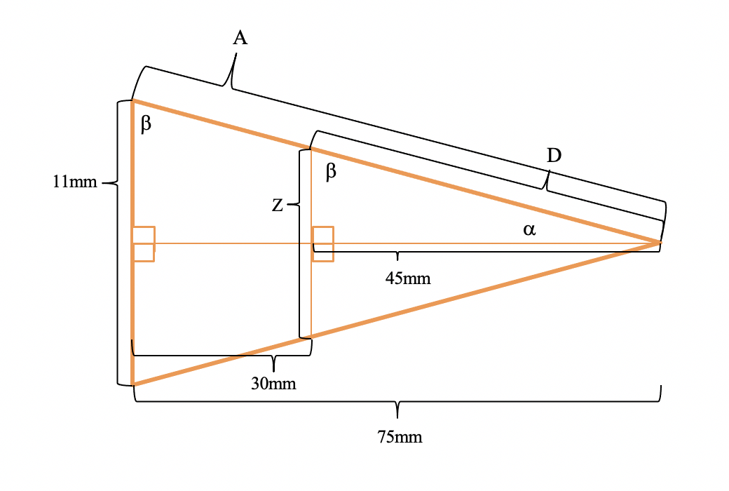
Figure B.1 (above): Overall schematic diagram of the fs-laser beam as it is focused after passing through a 75 mm plano convex lens and passes through the sapphire window as it is focused into the center of the sample chamber for fs-LIBS experiments.

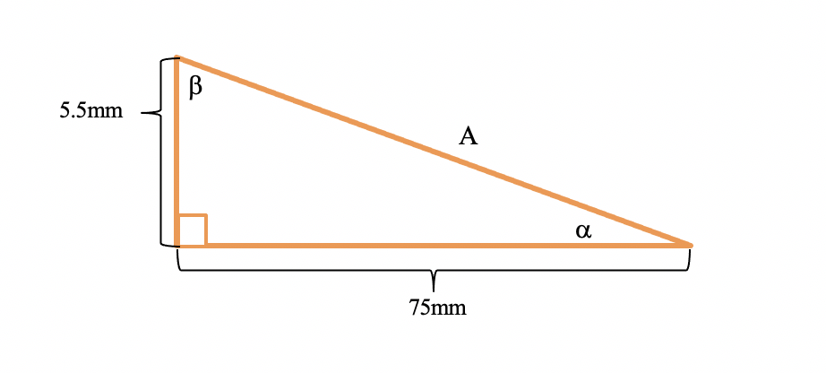
Figure B.2 (above): Cutaway schematic diagram of the fs-laser beam as it is focused after passing through a 75 mm plano convex lens and passes through the sapphire window as it is focused into the center of the sample chamber for fs-LIBS experiments.

Obtain A using the law of cosines (Figure B.2):
$A^{2}=B^{2}+C^{2}-2BC\cos{90}$ ∴ $A^{2}={5.5}^{2}+{75}^{2}-0$ ∴ A = 75.20 mm
Then use the law of sines to find α:
$\frac{\sin{α}}{5.5}= \frac{\sin{90}}{A}$ ∴ $\sin^{-1}\left(0.07313\right)= {4.194}^{°}=$
∴ β = 90 - α = 85.8058° = β

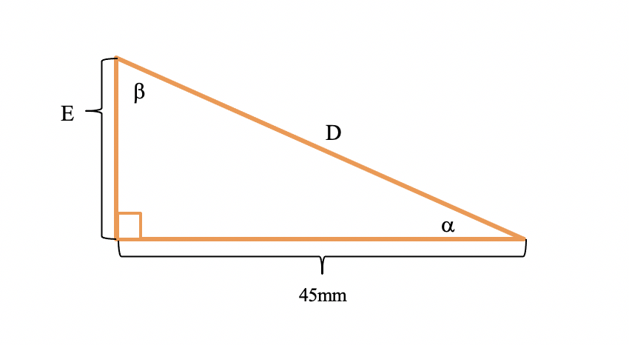
Figure B.3 (above): Cutaway schematic diagram of the fs-laser beam as it is focused after passing through a 75 mm plano convex lens and passes through the sapphire window as it is focused into the center of the sample chamber for fs-LIBS experiments.

Next obtain D using the law of sines (Figure B.3):
$\frac{\sin{}}{45}= \frac{\sin{90}}{D}$ ∴ D = 45.12 mm
Then use the law of sines to find E:
$\frac{\sin{α}}{E}= \frac{\sin{}}{45}$ ∴ E = 3.30 mm
∴ Z = 6.60 mm (diameter of laser beam entering the sapphire window – Figure B.1)

A Fs-laser max beam pulse energy of 6 mJ will yield an unfocused laser beam fluence of 0.545 mJ/mm² while the slightly focused laser beam will impart only 0.909 mJ/mm² fluence onto the sapphire window. This fluence is far below what is necessary to cause thermal failure in the sapphire window so the following outlined experimental plan in Table B.2 does not need to be conducted in addition to the other experiments already proposed within this thesis.

Table B.2: Incremental Benchmark Testing Goals for Operation of fs-laser to Test Thermal Damage in Sapphire Windows [for 1kHz/pulse] {320 Total min}.
Shots Before Failure | # Laser Pulses | Time
1,000 | 1 | 1 sec
5,000 | 5 | 5 sec
10,000 | 10 | 10 sec
25,000 | 25 | 25 sec
50,000 | 50 | 50 sec
75,000 | 75 | 75 sec
100,000 | 100 | 100 sec
250,000 | 250 | 4.2 min
500,000 | 500 | 8.5 min
1,000,000 | 1,000 | 17 min
2,000,000 | 2,000 | 34 min
5,000,000 | 5,000 | 84 min
10,000,000 | 10,000 | 167 min

After completing each of the experiments contained within this thesis, it was observed that no observable damage was found in the sapphire windows after operating the fs-laser for over 90 hours (300 million plus laser shots compared to the proposed 10 million laser shots in roughly 3 hours of continued use). This far exceeded the experimental testing plan in Table B.2 and further demonstrates the resilience of the sample chamber for use in laser spectroscopy applications. The only thermal damage that was observed in the experimental setup was within the plano convex lens used to focus the laser into the sample chamber for fs-LIBS. While the focusing lens never reached complete failure, small defects were observed within the lens. The result of this damage is probably due to user error in improper laser beam alignment (laser beam is potentially traveling at very small angle from the previous ultrafast mirror). Additional time could be spent to further optimize the beam path of the laser to reduce any angle whatsoever in the beam path as it enters the focusing lens as well as investigate other optical lenses that could be utilized in a laser spectroscopy system that would reduce internal reflection and minimize laser damage in the focus lens.

APPENDIX C

Sample Chamber Leak Test Report from Centrus
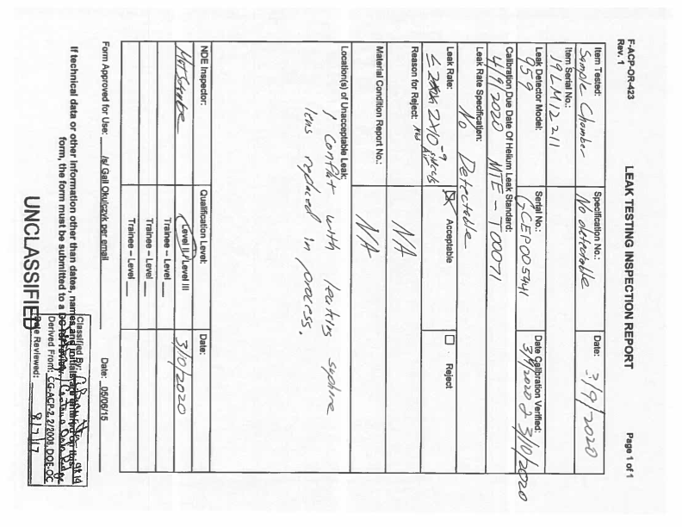

APPENDIX D

Procedure for Handling Radioactive Melt-Glass & Trinitite Samples:

Preparing Rad Melt Glass and Trinitite Samples:
- Put on necessary Personal Protective Equipment (PPE)
- Bring half-finished epoxy samples to SERF531
- Bring a cup with epoxy mixture (ready-to-pour) to SERF531
- Prepare a station on a counter space in 531 to finish prepping the samples
- Once in SERF531, take a background measurement with handheld GM-counter
- Open up drawer that contains various melt glass samples and select which radioactive melt glass samples will be placed in epoxy for future LIBS experiments
- Scan rad melt glass samples during selection to note their radiation level (counts)
- After selecting rad melt glass samples, set them down within working station on counter space in 531 (if possible, keep samples in current container until ready to place within epoxy)
- Pour tiny amount of epoxy onto half-finished epoxy samples and place a single piece of radioactive melt glass on top of epoxy samples
- After all samples have been prepped in this matter, pour tiny amounts of epoxy mixture around melt glass samples to ensure they adhere to the epoxy
- Once samples have been fully prepped, let them sit within station on counter space to fully harden (epoxy) overnight
- Place containers of unused radioactive melt glass back in drawer where it came from
- Take a quick scan around workstation on counter space to note number of counts on handheld GM-counter
- Conduct rad Survey for entire room by taking swipe samples as directed on rad survey pamphlet within SERF531
- Change PPE before transferring swipe samples to SERF522
- After taking swipe samples, analyze each of the samples in the Gas Proportional Counter in SERF522
- After completing rad survey analysis, contact appropriate individuals if there are any hot spots in SERF531
- Upon completion of rad survey, change PPE and clean up before leaving SERF531 for day

Transporting Rad Melt Glass and Trinitite Samples to and from SERF531 and SERF108:
- Put on necessary PPE
- Once in SERF531, take a background measurement with handheld GM-counter
- Then scan samples of radioactive melt glass/trinitite that hardened overnight in epoxy
- After inspection of rad samples, remove from plastic molds carefully so as not to damage the rad sample set within the epoxy
- Throw away plastic mold trash in designated (yellow) radioactive waste trash can in 531
- Select rad sample to place within sample chamber
- Secure selected rad sample in sample holder that is fastened to interior of blank flange (bottom of sample chamber)
- Insert attached rad sample (held within sample holder) into the sample chamber and make sure that sample is aligned within sample chamber before fully sealing the (bottom) blank flange to the sample chamber
- Tighten all nuts and bolts on exterior of sample chamber to ensure that chamber is airtight as possible (without putting it under vacuum)
- Place sample chamber within designated cardboard box that has label of radioactive melt glass on side of the box
- Change PPE and take rad survey with swipes of exterior of sample chamber to ensure that exterior of sample chamber is not contaminated
- Change PPE and take swipes to SERF522 to use gas proportional counter for rad survey
- After finishing swipe analysis in SERF522, return to SERF531
- Change PPE and carry cardboard box with sample chamber with rad sample inside on freight elevator in SERF and take it down to SERF108 where laser lab is located
- After taking sample chamber (with rad sample inside) down to SERF108, place box with sample chamber inside it inside the fume hood in 108 with Vent on Open
- Then place sample chamber in laser setup after connecting it to necessary optics attachments to mount it in path of laser beam
- Perform laser induced breakdown spectroscopy measurements on rad sample inside sample chamber, take background measurement with handheld GM-counter at least every 30 min to ensure no radiation has been leaking from sample chamber
- Do not open sample chamber in SERF108, instead put it back in designated rad transportation box, and carry it on freight elevator up to SERF531
- Change PPE and prepare to decontaminate sample chamber in SERF531
- NOTE: When last experiment is finished at end of day, perform necessary aforementioned procedures to take the contaminated sample chamber with the rad sample inside up to SERF531 for overnight storage

Decontaminating Sample Chamber with Rad Melt Glass and Trinitite Samples Inside:
- Put on necessary PPE
- Once in SERF531, take a background measurement with handheld GM-counter
- Make sure fume hood light and vents are On
- Place cardboard box with sample inside it inside fume hood in 531
- Take sample chamber out of cardboard box and set box to side inside the fume hood
- Take a measurement (counts) with handheld GM-counter to determine if any particular port on sample chamber is reading Hotter (radioactive) than the others
- Then carefully open one of the ports on the sample chamber and take another measurement with the handheld GM-counter to determine the level of radiation inside the sample chamber
- If reading on GM-counter is still low, proceed with taking apart the entire sample chamber inside the fume hood and place each of the components with the inside part lying face up
- Then take swipes for the interior of the sample chamber on various components
- Place swipes in sealed plastic bag and place bag inside cardboard box
- Change PPE and take box with bag of swipes inside over to SERF522
- Once in 522, use the GPC to analyze the swipes for the interior of the sample chamber
- After analysis, dispose of swipes in radioactive waste bin in 531
- Once back in 531, go back to the fume hood and use “RadiacWash” and kim wipes to clean the entire sample chamber
- After it is clean, perform another swipe analysis using aforementioned procedure in 522
- After that swipe analysis, return to 531, if analysis is clean, the sample chamber is no longer contaminated
- Then proceed to wipe down entire sample chamber (inside and outside) with Windex and kim wipes to ensure that all of the “RadiacWash” residue has been cleaned off and finally finish the cleaning by wiping the entire samples chamber down with kim wipes and Isopropyl alcohol
- Next, take sample chamber back over to the workspace on the countertop where the radioactive melt glass/trinitite samples were prepped in 531 and set next to remaining samples
- Follow aforementioned procedure on placing a new rad sample inside the sample chamber
- Change PPE and take rad survey with swipes of exterior of sample chamber to ensure that exterior of sample chamber is not contaminated
- If swipe analysis is clean, follow aforementioned procedure to safely transport the sample chamber with the new sample inside it in a cardboard box back down to serf108 using the freight elevator as before
- Throw away any trash in the (yellow) radioactive waste bin in 531
- Use Gm-counter to survey hands and feet before leaving serf531 each time rad material is handled and/or transported

VITA

Daniel Hartman is a Nuclear Science and Security Consortium (NSSC) graduate research fellow at the University of Tennessee Knoxville (UTK), currently working towards a PhD in Energy Science and Engineering (ESE) through the joint UTK-ORNL Bredesen Center for Interdisciplinary Research and Graduate Education with current research focuses on nuclear nonproliferation and nuclear security policy. During the 2018-2019 academic year, Daniel served as the president of the Institute of Nuclear Materials Management (INMM) student chapter at UTK and is now serving on the Central Regional Chapter (CRC) of the INMM Executive Committee as a Member-At-Large. He has also participated in the International Nuclear Facilities Experience in Europe through the Center for Nuclear Security Science and Policy Initiatives (NSSPI) at Texas A&M University and Argonne National Laboratory (ANL) as well as the Public Policy and Nuclear Threats (PPNT) Bootcamp at UC San Diego.

