Study of Colloquial Place Names through Geotagged Social Media Data

A Thesis Presented for the
Master of Science
Degree
The University of Tennessee, Knoxville

Yuan Liu
December 2014

Copyright © 2014 by Yuan Liu.
All rights reserved.

.

Acknowledgements

I am grateful to the continuous and patient guidance from my advisor, Dr. Shih-Lung Shaw. The research idea of my thesis originally came from Dr. Shaw, and I further explored the idea in the past two years with his dedicated instructions. Although my work is still not perfect, Dr. Shaw has led me to the right track of academic research. His passion in research and rigorous academic attitudes are impressive, and will influent me in my entire life.
Many thanks go to Dr. Hyun Kim, not only for the knowledge I have gained from him during last two years, but also for always being patient, encouraging and helpful with my various questions. I appreciate Dr. Han Lee for taking his value times to serve on my committee. His valuable insights and inspiring suggestions greatly helped me in my thesis research.
I would also like to thank my beloved fiancé, Jianjiang Yang, and my kitten, Maomao, for their unfailing company and support.
Abstract

Place is a rich but vague geographic concept. Much work has been done to explore the collective understanding and perceived location of place. The last few decades have seen rapid expansion in the use of online social media and data sharing services, which provide a large amount of valuable data for research of colloquial place names. This study explores how geotagged social media data are used to understand geographic place names and delimit the perceived geographic extent of a place. The author proposes a probabilistic method to map the perceived geographic extent of a place using Kernel Density Estimation (KDE) based on the cognition of people uploading the data. The author also uses spatio-temporal analysis methods in GIS to explore characteristics, hidden patterns and trends of the place. Flickr, a popular online social networking service featuring image hosting and sharing, was selected as the main data source for this project. The results show that results of KDE with different functions and parameters differ from each other and it is especially crucial to select proper KDE bandwidth in order to get appropriate resulting geographic extent. Official boundary and reference boundaries are usually used to justify the geographic extents. Google Maps Street View is also a useful tool to examine the visual characteristics of the place. Spatio-temporal analysis on time-series of snapshots of perceived geographic extents reveals signification location change of the places composed of structures built by humans. Other than names and variations of names of the place, related colloquial terms are also useful sources when delimiting the place. Several examples are analyzed and discussed. Results and discussion of this research can improve our understanding of geotagged OSN data in the study of colloquial place names as well as provide a temporal perspective.

Table of Contents

Chapter 1 Introduction 1
1.1 Research Background 1
1.2 Research Objectives 7
1.3 Organization of the Thesis 8
Chapter 2 Literature Review 9
2.1 Place and colloquial place names 9
2.2 Extent generation from fuzzy point sets 11
2.3 Kernel density estimation 14
2.4 Spatio-temporal analysis 16
Chapter 3 Data and Methods 18
3.1 Data Acquisition 18
3.1.1 Data Source 18
3.1.2 Preliminary Boundary 20
3.1.3 Data Processing 23
3.2 Perceived Geographic extent 25
3.2.1 Data selection 25
3.2.2 Density estimation and probability map 28
3.2.3 Spatio-temporal analysis 31
Chapter 4 Results and Discussion 34
4.1 Geographic Extent of Colloquial Place Names 35
4.1.1 The Great Smoky Mountains National Park 35
4.1.2 Manhattan Chinatown 42
4.1.3 Taipei Shilin Night Market 48
4.2 Related terms of colloquial place names 56
4.3 Spatio-temporal analysis 62
Chapter 5 Conclusion 69
5.1 Conclusions 69
5.2 Limitations and Further Research 73
Vita 82

List of Tables

Table 1 Geotagged social media data quantity and quality from several most popular online social networking platforms 20
Table 2 Annual numbers of effective images and images tagged with place name variations of each case study 33
Table 3 Numbers of total images and effective images of the three places 35
Table 4 Grid cells in resulting geographic extents of probability level 5% with different bandwidth selecting algorithms falling within and outside of the official boundary of the Great Smoky Mountains National Park 41

List of Figures

Figure 1 Location points of Taipei Shilin Night Market in Google Map versus Bing Map 2
Figure 2 Geographic extents of Manhattan Chinatown in Google Map versus Zillow 3
Figure 3 Preliminary boundary and data subset of the Great Smoky Mountains National Park 23
Figure 4 Preliminary boundary of Manhattan Chinatown 23
Figure 5 Preliminary boundary of Taipei Shilin Night Market 24
Figure 6 Duplicate images example at the Great Smoky Mountains National Park area 25
Figure 7 KDE results of image points tagged as the Great Smoky Mountains National Park using SCV, plug-in, LSCV, CVh, BCV or BCV2 as bandwidth selecting algorithm 31
Figure 8 Geographic extents of the Great Smoky Mountains National Park of probability >5% using LSCV, BCV, BCV2, SCV, plug-in, or CVh as KDE bandwidth selectors 39
Figure 9 Probability map of the Great Smoky Mountains National Park based on images tagged with names and name variations 43
Figure 10 Geographic extents of Manhattan Chinatown of probability >5% using SCV, plug-in, LSCV, CVh, BCV or BCV2 as KDE bandwidth selecting algorithm 46
Figure 11 Comparing perceived geographic extents of Manhattan Chinatown from bandwidth selector plug-in, CVh, SCV, LSCV and BCV using Google Maps Street View at six sample areas 47
Figure 12 Probability map of Manhattan Chinatown based on images tagged with names and name variations 49
Figure 13 Geographic extent results of Taipei Shilin Night Market at probability >5% using six different bandwidth selecting algorithms 50
Figure 14 Comparing differences of resulting perceived geographic extents of Teipei Shilin Night Market with six different bandwidth selectors on Google Maps 52
Figure 15 Snapshots of Google Maps Street View at ① on Dabei Road and ② on Xiaobei Road 53
Figure 16 Snapshot of Google Maps Street View at ④ on Lane 195, Chengdu Road and at ⑤ on a side street across Jihe Road from Chengdu Road 54
Figure 17 Snapshots of Google Maps Street View at ③ on cross of Jiantan Road and Jihe Road 55
Figure 18 Snapshot of Google Maps Street View at ⑥ on Danan Road between Jihe Road and Shishang Road 56
Figure 19 Probability map of Taipei Shilin Night Market based on images tagged with names and name variations 57
Figure 20 Geographic extent of images tagged about “trail” at the Great Smoky Mountains National Park 59
Figure 21 Geographic extent of images tagged about "cabin" at the Great Smoky Mountains National Park 60
Figure 22 Geographic extent of images tagged about "cherokee" at the Great Smoky Mountains National Park 61
Figure 23 Geographic extent of images tagged about "cadescove" at the Great Smoky Mountains National Park 62
Figure 24 Geographic extent of images tagged about food at Taipei Shilin Night Market 63
Figure 25 Geographic extents of Taipei Shilin Night Market at different times 66
Figure 26 Geographic extents of Manhattan Chinatown at different times 69

Chapter 1
Introduction

1.1 Research Background
Digital technology has become a dominant information transmission approach in the twenty-first century, where only rigorously structured information, translated into binary data, can be shared, analyzed, and effectively used in various ways [1]. In particular, the development of geographic information systems [2] has had profound effects on all aspects of geographic data production and research. It offers geographical measurement and presentation based on coordinates. However, place is a vague concept developed through peoples’ interactions and experiences with surrounding environments. For geographers, place indicates “the space within which humans carry out habitual aspects of their lives, such as shopping, work, recreation, and sleeping” (Goodchild 2011, p.28). Thus, the definition and geographic extent of places are specific to the individual and depend on time, which is subjective and fuzzy. On one hand, people may use a variety of colloquial terms to describe or identify a place. On the other hand, even though people have an idea of where a place is located and whether a certain area is part of the place, it is hard to define a sharp boundary for it. Furthermore, notions and descriptions of places may evolve over time. Methods and rules are required to translate informally generated information about places into GIS.
For example, the Taipei Shilin Night Market is a street market famous with tourists that starts at around 2 p.m. [3]. It is composed of a traditional market containing hundreds of food vendors and small restaurants as well as surrounding businesses and shops. However, “Shilin Traditional Market” is sometimes used to refer to the night market in informal conversation. “Shilin Temporary Market” and “Xilin Market” are also commonly used names of the night market in vernacular language. The market has no location identification or explicit boundary. Usually, people use an approximate location point in the vicinity of the Ji He Road and the 6th Avenue to roughly locate and represent it (Figure 1).

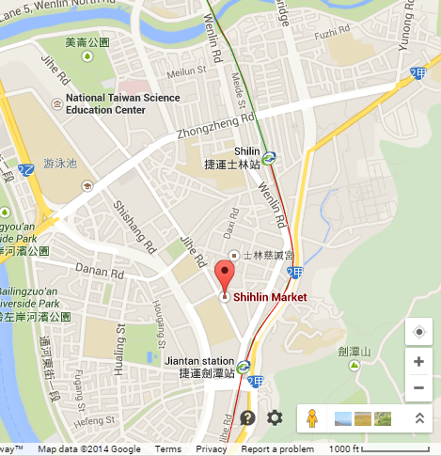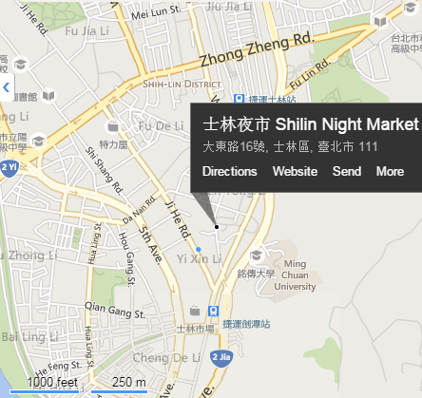
Google Map
Bing Map
Figure 1 Location points of Taipei Shilin Night Market in Google Map versus Bing Map

Similarly, Manhattan Chinatown, or the Chinatown in Manhattan District, is in the borough of Manhattan in New York City, usually described as bordering the Lower East Side to the east and Little Italy to the north. However, no authoritative geographic extent is defined for it. It is indicated differently in different map services such as Google Map (https://maps.google.com) and Zillow (http://www.zillow.com) as shown in Figure 2. More interestingly, descriptions of its general extent in Wikipedia (https://www.wikipedia.org) and Wikitravel (http://wikitravel.org) are neither the same as the map services, nor do they agree with each other. The Manhattan Chinatown has several names among the Chinese community there such as “唐人街” and “华埠.” People may also refer to it as “NYC Chinatown” or simply “Chinatown” in daily conversation.

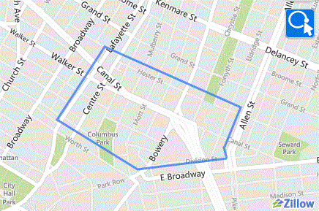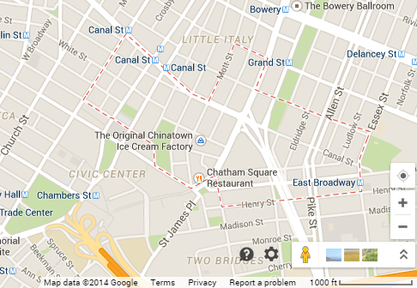
Google Map
Zillow
Figure 2 Geographic extents of Manhattan Chinatown in Google Map versus Zillow

For places with official name and administrative boundaries, publicly perceived information of the place can also be useful. A case in point is the Great Smoky Mountains National Park. The “Great Smoky Mountains National Park” is the official administrative name of the national park. However, people usually refer to it as some abbreviations of its official name for convenience, such as “Smokies,” “Smoky Mountains,” and “Great Smoky NP.” “Cades Cove,” one of the most famous tourist attractions in the national park, is sometimes used to refer to the national park in vernacular language. Its official boundary is mainly used for administration purposes and is not of much use for ordinary visitors’ tour activities. What visitors care about, in terms of its geographic extent, are locations of accessible tourist attractions within and around the national park area.
Thus, colloquial place names are colloquial terms, maybe official or informal, used by people in daily life to refer to a place. Some of the colloquial place names may not be used in written language and not be recognized in formal occasions, even not correct. But through them, people are able to uncover much more data about the place than simply using the formal name, especially in user-generated geographic information. Studying on colloquial place names helps people obtain more thorough understanding on the place and human activities, and helps researchers apply GIS functionalities to research of places.
The geographic extent of the place generated based on user-generated geographic data is defined as perceived geographic extent in this study. Perceived geographic extent of colloquial place names delimits the place according to people who uploaded the geographic data. It may be different from the official boundary, if exists. Perceived geographic extent of colloquial place names would not only be valuable for tourists but also for human behavior research and commercial location-based services.
The Great Smoky Mountains National Park, Manhattan Chinatown, and Taipei Shilin Night Market are selected as case studies. Shilin Night Market and Manhattan Chinatown both have various colloquial place names with no official boundary. Manhattan Chinatown is a good example of places that are composed of structures built by humans with high accessibility. It has a relatively large amount of data. The marginal areas of Shilin Night Market are delimited by street vendors and small storefronts. So its perceived geographic extent is more flexible and likely to change over time. The Great Smoky Mountains National Park has official name and boundary. But it is more referred to using its colloquial names, and its perceived geographic extent may differ from the official boundary. Exploring these three cases, the author hopes to understand how user-generated geographic data can be used to delimit specific place-scale geographic objects and propose a method to map perceived geographic extents of various probability levels.
Large collections of geotagged online social network (OSN) data are publicly accessible nowadays, presenting an opportunity to acquire information about locations of places as well as their colloquial names. More and more OSN users are able to share geographical information online due to the popularity of portable smart devices and development of location-based services. By February 2009, more than one hundred million geotagged images were uploaded to Flickr, which were about 3 percent of all images [3]. According to the Verge report (2013), more than 3.5 million new images are uploaded daily [4]. On Twitter, nearly one-in-five tweets reveals user location and time through geotagging or metadataWu and Boston [5]. A survey [6] from the Pew Research Center (2013) showed that about 30 percent of adult social media users had automated location tagging on at least one of their account.
Geotagged OSN data are contextually rich, combining geographic information with text information of the place where the image is taken. Using geotagged images as an example, the geographic information is mainly reflected by geotagging information and metadata of the image, while the text information includes the titles, tags and descriptions given by the person uploading the image, as well as comments by people viewing the image. The author is not considering image recognition in this study, even though it is also a practical method to extract information of geotagged images. This is a useful resource for analysis of places and human behavior, and distinguishes geotagged OSN data from traditional geographic information supplied by authoritative or commonly used commercial mapping agencies and corporations such as United States Census Bureau and Google Maps. Several interesting studies have been conducted using this data resource: detecting unusual global and local events [7, 8], spatial pattern and demographic indicators of event-related social media content [9], geographical visualization of geotagged OSN data [10], discovering preference of certain area [11], and offering personalized travel recommendation [12].
User-generated text information represents the perceived cognition of people uploading the images, and it contains various colloquial terms referring to the place. By combining these fuzzy colloquial expressions with explicit geographical information, researchers are able to collect, handle, store, and analyze information about the place with computer-based technology. If sufficient information is available, spatio-temporal trends and patterns will be revealed for colloquial place names. Using the three aforementioned places as case studies, this study explores perceived identification and location of places through geotagged Flickr images, and proposes a probability method to map the perceived geographic extent of the place. It is, in this case, percentage of the images of a place geotagged within the perceived geographic extent of this place. Spatio-temporal characteristics and patterns in terms of geographic extents of case study places are analyzed.

1.2 Research Objectives
This study demonstrates how geotagged OSN data can be used to explore colloquial terms about the place, generate perceived geographic extents of colloquial place names, and analyze spatio-temporal characteristics of perceived geographic extents.
For this study, a proper data source must be selected from the many OSN services available. It needs to have abundant users, extensive influence, large amounts of data, and long time span. Processing and filtering methods need to be conducted on the massive, complex data in order to get reliable and representative data subsets that are indicating colloquial place names of each case study for the generation of perceived geographic extent. With the data subsets of each place, the author will propose a probabilistic method to map the perceived geographic extent of places according to people uploading the images. Considering the fuzziness and complexity of colloquial terms for place, the author will analyze the distribution of some related colloquial terms about each case study place, and compare them with their generated probable geographic extents. These colloquial terms are far from thoroughly utilizing information of places but offering an inspiring example for further studies. Spatio-temporal characteristics, hidden patterns, and trends of case study places that are mainly composed of structures built by humans will be demonstrated and interpreted.

1.3 Organization of the Thesis
This thesis is organized into five chapters. The next chapter reviews the literature relevant to this study, including place and colloquial place names, extent generation from fuzzy point set, kernel density estimation, and spatio-temporal analysis. Chapter 3 is devoted to the methodology of data acquisition, data processing, and perceived geographic extent generation. In this chapter, the author defines the methods used to remove data redundancy to accomplish more reliable analysis and results. The process designed to extract preliminary research boundaries and target image data subsets is also discussed in Chapter 3. This chapter also addresses the method used to generate perceived geographic extent of colloquial place names based on probability levels as well as the routine used to conduct a spatio-temporal analysis on it. Chapter 4 presents results and discusses of perceived geographic extent generation and analysis. In this chapter, the author verifies and selects appropriate density estimation results of colloquial place names, and then maps the geographic extent of probability levels accordingly. It further explores expansion of colloquial terms of places as well as their contribution to geographic extent generation. This chapter also demonstrates spatio-temporal analysis results. Chapter 5 concludes this thesis with limitations and opportunities for future research.

Chapter 2
Literature Review

2.1 Place and colloquial place names
Place is a rich but vague concept. Goodchild [1] discusses the definition of place under several different circumstances and shows how GIS techniques can be used to operationalize place in specific areas of research. Studies in the field of common-sense geography, also known as “Naïve Geography” [13] provide a framework to captures and reflects humans’ perceived understandings of geographic space and time. Naïve stands for instinctive or spontaneous (Egenhofer and Mark, 1995, p. 4). Formal models created to represent, manage, and analyze common-sense geographic concepts in GIS would be helpful in delivering temporal and spatial information to the public, especially the user communities with little or no training [14]. A research initiative entitled “Formal Models of Common-Sense Geographic Worlds” was approved by the National Center for Geographic Information and Analysis in 1996, to identify basic elements of common-sense conceptualizations of geographic space, entities, and processes, and develop an integrating framework [15]. Formalizing the representation and analysis of common-sense geographic concepts is drawing more interests, and some place-based versions of well-known GIS functionalities, such as join and buffer, are developed and applied [16]. Yao and Jiang [17] proposed the concept “qualitative location”, which means the spatial location that is referred to using linguistic terms such as “town center”, “southeast region” and “nearby”, and the method to visualize the qualitative locations in GIS. This is an inspiring study aiming to formalize the naïve geographic concepts in GIS. However, little research has been specifically conducted for colloquial place names.
The rise of volunteered geographic information provides great opportunity for research about colloquial place names. Pasley et al. [18] extracted geographic information from the web to generate informal places that are referred to in daily life but with no entry in official geographical resources like gazetteers. Jones et al. [19] believes that vague place names are frequently accompanied by the names of some more precise co-located places, which lie within certain distances to the case study place, therefore they proposed a model to generate approximate crisp boundaries of the place through co-occurrence frequency. Based on these studies, the author proposes methods to automatically obtain geographic features and associated footprints from pubic Internet sources and generate regional gazetteers [20, 21].
The last few decades have seen a rapid expansion in the usage of social media and data sharing services. They have generated large volumes of geotagged social media data, which are potentially a valuable and more accurate source of knowledge about social phenomena [22]. As the first online social networking service that features image and video sharing, Flickr has provided a large integrated data source for research of colloquial place names. Flickr’s research and development team analyzed the photo tags and generated aggregate knowledge in the form of prominent tags for arbitrary areas all over the world[23]. Keßler et al. [24] proposed a bottom-up gazetteer building approach by clustering and filtering Flickr geotagged photos. Thomee and Rae [25] applied scale-space theory to generating boundary for locally characterized regions, though the regions were also extracted by generally detecting prominent tag occurrences. Hollenstein and Purves [26], narrowing the research objects to finer granularity, explored the terms used in vernacular language to describe city core areas. They also looked at the nature of error and imprecision in tagging and georeferencing. Li and Goodchild [27] generated collective views of places’ geographic extents and inclusion relations using a similar methodology, in order to reveal the hierarchic relationship among them and further develop place-based concepts and applications. Along with the rapid development of supercomputing, high performance geoprocessing workflow was developed to harvest crowd-sourced gazetteer entries for automatic general bottom-up gazetteer construction [28].
Much work has been done to describe and define the geographic extent of colloquial place names using user generated geographic data, especially geotagged online social media data. Nevertheless, place is usually vague and diversified, especially those that appear in the vernacular, created by informal consensus. Most studies have focused on large-scale general extraction of identification and geographic extent from the clusters of geotagged data records, instead of on distinguished individual places. More specific and precise analysis for place-scale colloquial geographic objects, such as city core areas [26, 29], is necessary to further understand applications of user generated geographic data on the collective understanding and locating of places.

2.2 Extent generation from fuzzy point sets
Functionalities for processing fuzzy geographic feature sets in GIS arose out of the need to handle uncertainty and give soft computing technology the ability to support vague information processing [30]. One big challenge of using fuzzy sets in GIS problems is to specify membership and then define the border. Defining a vague object using any kind of threshold always has weakness, because vague geographic objects are Sorites susceptible, a definition of vagueness derived from Sorites Paradox, and there is no single threshold value that genuinely distinguishes the object from non-object [31]. However, mapping geographic extent of colloquial place names can be very useful for both scientific research purposes and daily life.
Several methods of generating polygonal representation of places using point sets have been published. For example, several membership functions of fuzzy-set-based classification method [28, 30] were introduced to extract geographic footprints of certain polygonal places. Liu et al. Liu, Yuan [32] proposed similar point-set-based region (PSBR) models to approximate areal objects, especially vague areal objects, and manage their spatial relationships. These two approaches offer practical and effective methods to estimate polygonal geographic extent using fuzzy point set data, but several issues remain when applying them in this research. First, these methods expect the point set to be well clustered and unimodal, which means only one central hotspot exists. This will yield an outline of all points within the point set or its subset, which will not reveal any multimodal features. Nevertheless, in real-world cases, areal places often appear to be multimodal, which means they have more than one hotspot, and it is important to demonstrate subtle distribution features in order to generate more precise perceived geographic extents. Second, these are not convenient methods for analyzing probability levels of perceived boundary. Researchers must calculate and extract a corresponding subset using the threshold membership score, and then generate boundary for each result of a certain probability level is needed. Third, these methods do not perform smoothly on sparse point sets or sparse areas of the point distribution. Though continuous threshold scores can be obtained, the corresponding point subsets are discrete, as are the corresponding generated boundaries. In sparse point sets or sparse areas of the point distribution, each individual data record may greatly affect the resulting boundary or even determine the geometry. Thus, the result has very low tolerance for error of each data record and one data point with semantic or geographic error, which is quite common for volunteered geographic information data; this may greatly change the result. When the point set is not very densely populated, reasonable corresponding geographic extents for every probability level may be hard to obtain.
There is another approach apart from the point-set-based methods discussed above. Keßler, C., et al. [24] demonstrated a method using Delaunay triangulation to find clusters within point clouds. This method did not restrict geometry of places. In order to classify the points and edges into polygonal regions of density value (edge length), an edge length threshold was selected. Kernel density estimation combined with density threshold filter is a widely used method to generate approximate polygonal extent [19, 26, 27, 33]. These two methods share certain similarities and both solve the first two issues that arise from the aforementioned point-set-based methods. The multimodal feature of point sets is revealed. These methods also simplify the generation process of perceived geographic extents at different probability levels into a single step once the triangular network or kernel density surface is composed. However, for the Delaunay triangulation method, the third issue above still remains. The boundary of this method is discrete and directly affected by each point location. Thus the author chooses Kernel density estimation method with density threshold filter to construct perceived geographic extents from user generated geographic data sets.

2.3 Kernel density estimation
Density estimation is the construction of an estimate, based on observed data, of an unobservable underlying probability density function [34]. Applied in geographic research, it interpolates a point data set into a continuous density surface, which is usually represented as a raster. Basic density estimation method is to sum all point values within a certain circle, then divide by the area of this circle [35]. Subsequently, kernel density estimation (KDE) is proposed to generate a smoother density estimation surface and estimate probability function [36]. KDE is applied to various sectors [37], such as social and economic study [38], agriculture [39] and public health [40]. In geographic study, it is a commonly used spatial analysis technique to transform a geographically distributed set of points into a density surface in a GIS environment [41]. Given a set of independent points, s₁ …s_{n}, the point distribution probability density function can be estimated using kernel density estimator:
$$f\left(x,y\right)= \frac{1}{nh^{2}}\sum_{i=1}^{n}{K(\frac{d_{i}(x,y)}{h})}$$
where $f\left(x,y\right)$ is the estimated density value at location$\left(x,y\right)$, $n$ is the total number of input points, $h$ is a measure of the window width and is called bandwidth (e.g., for a circular kernel it is the radius of the circle), $d_{i}(x,y)$ is the distance between event point $i$ and location $\left(x,y\right)$, and $K$ is a density function characterizing how the contribution of point $i$ varies as a function of $d_{i}(x,y)$ [42]. Based on KDE results, density maps are proposed as a mean to summarize selected image data so that the distribution of image records can be overviewed without visual cluttering and occlusion issues [43].
In order to get fitting KDE result, kernel function, grid cell size and bandwidth have to be appropriately selected. Some literature states that kernel function is less important than bandwidth for determining the most appropriate density surface [36, 44]. Choice of bandwidth controls the degree of smoothness for the resulting density surface. When smoothing is insufficient, the resulting density is too rough to fully analyze the data set; when smoothing is excessive, small but important features of the density distribution may be smoothed out [45]. Several studies have discussed bandwidth determination issue [45-47] and concluded two basic approaches: a fixed bandwidth for the whole distribution and an adaptive bandwidth, which may become another dimension of KDE in the end [37]. For fixed bandwidth selection method, the most important task is to define the right value. Jones et al. defined main methods for fixed bandwidth choosing into two generations: the first group like least performance rules of thumb, least square cross validation and biased cross validation; the second group such as superior performance, solve equation plug-in and smoothed bootstrap methods [45].
Least-squares cross-validation (LSCV) bandwidth matrix selector [48, 49] is used to minimize the expansion of the Integrated Square Error (ISE) and has become a commonly used algorithm [50]. Biased cross-validation (BCV) bandwidth matrix selector is only available for bivariate data [51]. To some extent, it is a hybrid of cross-validation and plug-in [50]. Two types of BCV algorithm with slight differences is demonstrated by Sain, Baggerly and Scott [51]. The optimal asymptotic choice of the bandwidth can be obtained from minimizing the Mean Integrated Square Error (MISE) [52]. Smoothed cross-validation (SCV) bandwidth selector [53] is based on explicit estimation of the exact integrated squared bias and the asymptotic integrated variance [54]. Plug-in bandwidth selector [55] uses pilot bandwidths to estimate some values of the unknown density, and the estimates are plugged in to the equation for the ideal bandwidth [56]. LSCV, BCV, SCV, CVh, and plug-in bandwidth selecting algorithms are used and compared for optimized estimation results in this research.

2.4 Spatio-temporal analysis
Most of the aforementioned studies consider and handle colloquial identifications and geographic extent of places as static. However, place is the space within which humans carry out habitual aspects of their lives that are largely unique to the individual. The identification and geographic extent of places are likely to vary through time as habits change, spaces are learned, or people migrate [1]. Achievements in spatio-temporal analysis have offered powerful analytical approaches to explore their temporal features. In 1970, Hägerstrand [57] first introduced the concept of time geography, where time is considered as a third dimension. Despite that, most of current GIS analyses are based on static modeling, “a growing number of researches in temporal GIS are being performed, which may dominate GIS market in the near future.” (Nadi and Delavar, 2003, p. 1). Langran [59] described a taxonomy of all available access methods of spatio-temporal data in a temporal GIS through partitioning and indexing. Cheylan and Lardon [60] further discussed the conceptual and practical problems in a more systematical way when constructing spatio-temporal data and formalizing spatio-temporal research questions, such as concepts and formalization of temporal factors and dynamic behaviors as well as spatial and temporal analysis methods. The efficient management of continuously changing geographical data and the discovery of hidden patterns in the change of objects in large data sets are challenging but popular research topics [61, 62]. Erwig et al. [63] proposed an approach to extract changing regions into digital representation as 3D (2D space and 1D time) entities. With increasing abilities to represent, visualize and manage geographic data with time dimension, spatio-temporal analysis has been widely applied to research in GI Science. Yu and Shaw [64] designed a space-time GIS to represent and analyze spatio-temporal activity data in both physical and virtual space at the individual level. In a study about crowd behavior and special social events using cell-phone data, Calabrese et al. [65] performed spatio-temporal analysis of time series of stops to detect users’ moving pattern around event time, and predict their destinations. Versichele et al. [66] conducted spatio-temporal analysis to distribution of the crowd in festivities, though it is still using short time intervals like hour and day. Spatio-temporal visualization and analysis can be applied to explore urban expansion during certain transitional time period [67, 68], and to map and interpret land cover/land use transitions and landscape changes [69, 70] using GIS and satellite images. The aforementioned studies are in various topics, but supply valuable concepts and approaches for spatio-temporal analysis that can be adopted to explore perceived geographic extents of colloquial place names.

Chapter 3
Data and Methods

3.1 Data Acquisition

3.1.1 Data Source
Flickr is a popular image and video hosting website created in 2004. It offers a set of well supported APIs to outside developers, as well as App Garden and developer mailing lists to encourage various usages of Flickr data. On the contrary, Snapchat (https://www.snapchat.com/), another popular image and video hosting website, does not permit legal access to the data it hosts [71]. Flickr started to support image geotagging feature in 2004, predating corresponding features of most other popular online social networking services such as Twitter, Instagram (http://instagram.com/) and Sina Weibo (http://weibo.com/). For this reason, Flickr’s data covers a long span of time. Unlike the approximate location information captured by Facebook, Flickr images are geotagged at 1 to 16 precision levels, where 1 denotes country level and 16 denotes street level. 16 is the default option. Though accuracy of these spatial information cannot be guaranteed due to the natural characteristics of volunteered geographic information, the vast majority of images are geotagged at the highest location precision level of 16 [72]. Flickr had a total of 87 million registered members by 2013 and more than 3.5 million new images are uploaded daily [3]. Hundreds of millions of images in their 10-year image data archive are geotagged, creating an appropriate data resource for this research [73].

Table 1 Geotagged social media data quantity and quality from several most popular online social networking platforms
OSN Platform | Time Range | Data Quality
Flickr | Since 2004 | Large amount, high precision level of spatial information
Facebook | Since 2004 | Large amount, approximate spatial information
Twitter | Since 2006 | Large amount, high precision level of spatial information
Foursquare | Since 2009 | Medium amount, high precision level of spatial information
Sina Weibo | Since 2009 | Launched and mainly used by Chinese, high precision level of spatial information
Instagram | Since 2010 | Relatively large amount, quickly increasing

Flickr images are stored with a variety of information that includes mandatory fields such as the original Exchangeable Image File Format (Exif) files, image ID, contributing user ID, and uploading time, as well as some optional information set by users, such as title, tag, description, and restriction of usage. Exif is a “standard that specifies the formats for images, sound, and ancillary tags used by digital cameras (including smartphones), scanners and other systems handling image and sound files recorded by digital cameras” [74]. Spatial reference information is stored in coordinates of latitude and longitude. It is either extracted from the Exif file of the image or manually located by the user through a Flickr map interface called Organizr. Then, a precision level is automatically assigned to the image depending on the precision of GPS coordinates in the Exif file or the zoom level of Flickr Organizr when uploading. Image “tags”, which are a set of unstructured text-based annotations, are used to reveal the cognition on the image along with its location from the person uploading the image. On Flickr, tag is a keyword or category label of the image used to help users to find images that have something in common [75]. Since tags of an image are usually a set of case-insensitive words or short phrases that are easy to understand, semantic analysis is not necessary for this research.
Flickr APIs were used to download publicly available image data. Images downloaded for this research are uploaded between January 1st, 2004 and March 1st, 2014 with accuracy level of 16. As discussed in the Introduction, the author chooses the Great Smoky Mountains National Park, Taipei Shilin Night Market, and Manhattan Chinatown for this study. In case the results deviated due to incomplete data, the author downloaded images from much larger geographic extents covering all possible area of these three places for further trimming and processing.
Besides Flickr image data, common boundary or location information of the three places are also needed. For the Great Smoky Mountains National Park, whose official administrative boundary is already defined, the author downloaded the park boundary in shapefile format from the United States Geological Survey (http://www.usgs.gov/). For Manhattan Chinatown and Taipei Shilin Night Market, the author used the boundary maps, location points, or descriptions of from some of the most commonly-used online resources, such as Google Maps, Bing Maps, Zillow and Wikitravel. The author also downloaded the World Street Map from ESRI as a base map for better visualization.

3.1.2 Preliminary Boundary
In order to reduce computational expenses, a preliminary boundary for each place according to its approximate location, physical barriers, and distribution of images tagged with colloquial place names is selected. Then the image data locating outside of the preliminary boundaries are trimmed to get the preliminary data set to be used as the foundation for further analysis. Since only rough preliminary boundaries and data set are selected at the current stage, some approximate values, features and text description are considered. For different types of places, different standards to select the preliminary boundaries are applied.
For places with an official boundary, which is the case for the Great Smoky Mountains National Park, the official boundary that already exists is fully utilized. Since the boundary is a long polygon, shown highlighted in Figure 3, the approximate width in the middle is measured, which is about 30 km, in order to get a scale reference of its size. Considering this scale reference, the distribution of image data tagged as “greatsmokymountainsnationalpark” (the red dots shown on Figure 3), and the location of other places with obvious image clusters, such as the city of Knoxville, a buffer polygon of the official boundary with buffer distance of 15 km is chosen as the preliminary boundary of the Great Smoky Mountains National Park.

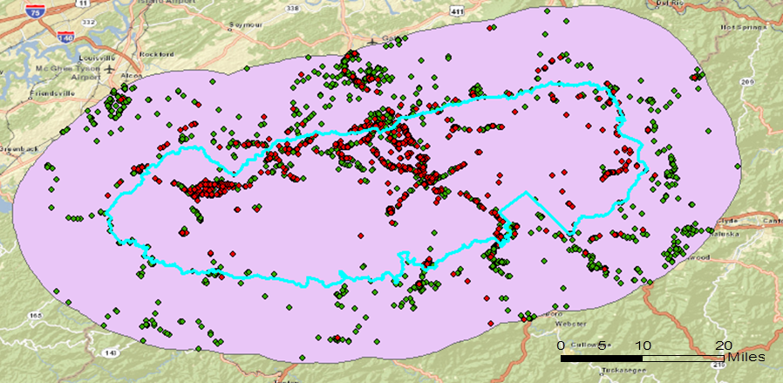
30km
Figure 3 Preliminary boundary of the Great Smoky Mountains National Park
Manhattan Chinatown has different boundaries in different resources, such as Google Maps, Zillow, and Wikitravel. Its approximate extent from several of the most commonly used resources, the distribution of image data tagged as “chinatown” (red dots shown in Figure 4), and the physical barrier of rivers are considered when selecting the preliminary boundary. The area in the south end of Manhattan extending north to 14th Street is chosen as the preliminary boundary.

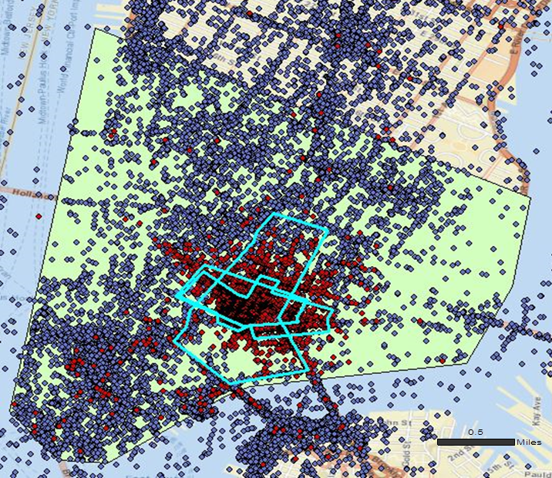
Figure 4 Preliminary boundary of Manhattan Chinatown

Because Taipei Shilin Night Market has only some rough location points but no official boundaries, the preliminary boundary is selected according to its rough location points, distribution of images, and physical barriers such as elevated road and river. Thus, we selected the area between Keenlung River, Xinsheng Elevated Road, and Zhongzheng Road. This area excludes disturbing places, such as other market-type places, or other significant image hotspots like Shilin Presidential Residence as shown in Figure 5. The Shilin Presidential Residence hosts annual flower expos.

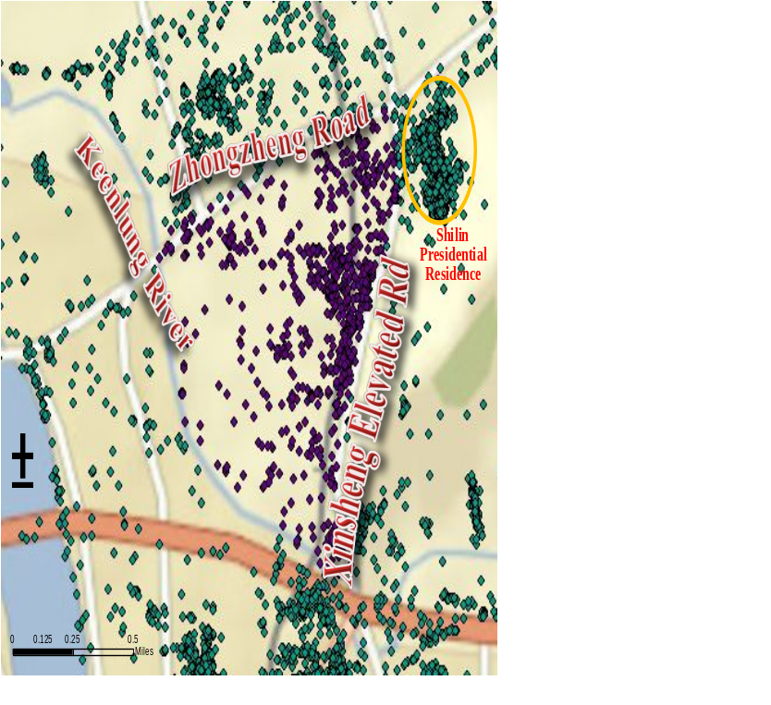
Figure 5 Preliminary boundary of Taipei Shilin Night Market

3.1.3 Data Processing
There are tens or hundreds of images with exactly the same coordinates and date uploaded by the same user in the data set, due to various reasons such as the batch geotagging feature of Flickr. For instance, the user with user ID “****5900@N00” uploaded 17 images of the same coordinates “35.564925, -83.331062” in the Great Smoky Mountains National Park area at around 9:00 am on 2006.11.23, all tagged with “camping”, “smokies”, “greatsmokymountainsnationalpark”, and “smokemont”, as shown in Figure 6. Many interesting research topics about spatio-temporal human activity pattern and user generated geographic information can be conducted using these data. However, this research is addressing publicly perceived geographic extent of colloquial place names by using as many peoples’ input as possible. These duplicated image records from one single user improperly increase the weight of several individual users and will lead to bias in the research results. These should be identified as redundancies and removed before conducting analysis. Therefore, when more than two images from the same uploading person with the same coordinates and same tags are uploaded within six hours with each other, they are considered as redundant and keep only the first image record. The final effective image set of the place is composed of images geotagged in the preliminary boundary of the place without redundancy.

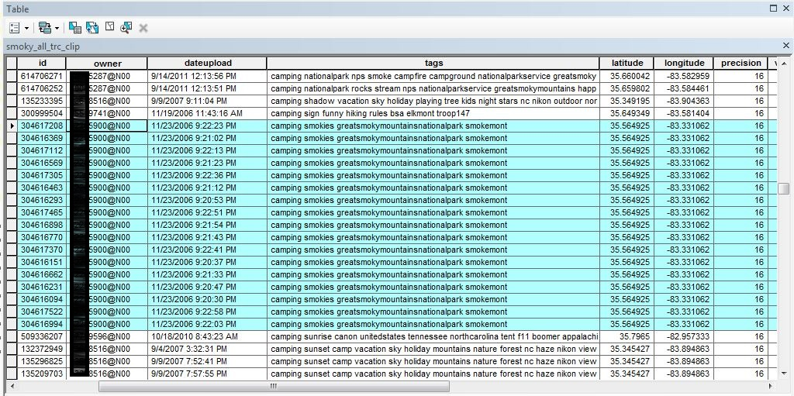
Figure 6 Duplicate images example at the Great Smoky Mountains National Park area

3.2 Perceived Geographic extent

3.2.1 Data selection
In order to explore the perceived geographic extent of colloquial place names, tags from images geotagged within preliminary boundaries are counted. There are 3,776 different tags from the non-redundant images geotagged in the preliminary study area of Taipei Shilin Night Market, though 1,224 images do not have any tags. When analyzing images of this place, tags in the local native language, Traditional Chinese, are critical. As an illustration, 87 images are tagged with name of Taipei Shilin Night Market, “shilinnightmarket,” while 286 images are tagged with its Chinese name “士林夜市.” Besides Chinese and English names, some tags are aliases, such as “士林臨時市場” (“Shilin Temporary Market” in Chinese) and “士林觀光市場” (“Shilin Tourist Market” in Chinese). Since this preliminary study area excludes any other market-type places and some users may split words of the name, tags like “market,” “nightmarket” and “傳統市場” (“Traditional Market” in Chinese) should also be considered as referring to the Shilin Night Market, as should some variations and combinations of these words, such as “shilinnightmarket士林夜市” and “xilinnightmarket.” By filtering out images that are tagged with at least one of these tags, 595 images about Taipei Shilin Night Market are extracted, which is about seven times of the results from using only its complete English name.
In the study area of the Great Smoky Mountains National Park, 4,979 of the 24,225 non-redundant images have no tags. Meanwhile, those remaining contain 17,252 unique tags. If searching for images using its name “greatsmokymountainsnationalpark,” 2,116 images are filtered out. However, it is known that the Great Smoky Mountains National Park has many abbreviations and aliases in daily oral expression, such as “Smokey,” “Smokies,” and “Smoky Mountains.” Moreover, according to the U.S. National Park Service (http://www.nps.gov/findapark) there is no other National Parkss within 100 km of zip code 37738 region, which is the location point of the Great Smoky Mountains National Park in Google Maps. Variations of key words such as “thesmokies,” “nationalpark,” “greatsmokymountainsnp,” “grsm,” and “greatsmokynp” can all be considered tags for the Great Smoky Mountains National Park. In addition, some tags with combinations of the name and a certain time like “greatsmokymountainsinthefall” are also considered as referring to this place, based on their meanings. By applying these rules to select tags for filtering, the number of images for the Great Smoky Mountains National Park expands to 7,834.
The selection of tags for Manhattan Chinatown is similar to the aforementioned two study areas. Manhattan Chinatown has 49,496 images with no tags and as many as 130,430 unique tags, among which are tags like “chinatown,” “chinatownnyc,” “manhattanchinatown,” “neighborhoodmanhattanchinatown.” They are selected for analysis of Manhattan Chinatown. It is noteworthy that Manhattan, as a famous international tourist attraction, has a large number of image tags in languages other than English. There are not only Chinese tags like “纽约市唐人街” (“Chinatown of New York City” in Chinese), “华埠” (“Chinatown” in Chinese), and “中国城” (“Chinatown” in Chinese), but also “中国のクオーター” (“Quarter of China” in Japanese), “quartierchinois” (“Chinatown” in French), “차이나타운” (“Chinatown” in Korean) and so on. Translating and understanding these tags increases the complexity of adequate analysis. Additionally, tags like “chinaown” are obviously typing errors of “chinatown” and can also be used to select images about Manhattan Chinatown. It is interesting to note that 6,300 images have at least one of the tags selected above, whereas 6,129 images are tagged with “chinatown.” Most of the images that are about Manhattan Chinatown and geotagged for this area use the tag “chinatown,” including images using mainly non-English tags.
However, colloquial names of a specific place, or how people refer to it in daily speech, are much fuzzier and more complicated. Taking Taipei Shilin Night Market as example, it is famous for featured food vendors and small restaurants. Though surrounding businesses and shops selling nonfood items are also part of the night market, distribution of images tagged with all kinds of food provides a perspective into Shilin Night Market. Another good example is the Great Smoky Mountains National Park. Cades Cove, one of the most famous tourist attractions there, is sometimes used to refer to the national park itself. Sometimes users may also tag an image with the name of a trail or cabin they visited instead of name of the national park. Smoky Mountain was historically an important haitation of the Cherokee, and there are still many sites and activities about Cherokee culture at that area. In addition, the town of Cherokee, North Carolina, is located at the east entrance of the national park [76]. Because of this, it is expected that the geographic extent of images tagged with “cherokee” is related to that of the national park.

3.2.2 Density estimation and probability map
We use the spatial density estimation method to represent the distribution of geotagged images and generate perceived geographic extent of the case study place. Kernel density estimation, a widely used spatial analysis technique, is selected for this study to generate a smoother density estimation surface. Selection of kernel function, grid cell size, and bandwidth is important for appropriate KDE analysis. Some easy-to-use KDE tools integrated with bandwidth selection methods are already available in not only widely-used GIS software, like Spatial Analyst Extension for ArcGIS (ESRI®) but also spatial analysis and modeling platforms such as Geospatial Modeling Environment (GME)[77]. The KDE tool in GME links ArcGIS to the “ks”[78] library in statistical software package R. If grid size of output estimation surface is too large, the details of characteristics of estimation result will not be properly displayed, while grid size that is too small will waste computational efforts. Thus a series of grid sizes are tried and compared. When the grid size reaches a value that output raster surfaces with smaller grid size are not significantly more detailed for the specific case study, this value is selected. After testing and comparing, the grid size selecting method of ArcMap is selected, which is the shorter of the width or height of the output extent in the output spatial reference, divided by 250 [2] is used. For its default and recommended kernel type, Gaussian, several bandwidth estimation algorithms are available including the plug-in estimator (PLUGIN), smoothed cross validation (SCV), likelihood cross validation (CVh), biased cross validation (BCV), a second BCV algorithm (BCV2), and least squares cross validation (LSCV) [77]. All these bandwidth selecting methods are tried and choose the most appropriate one among them by visualizing and comparing the results. Detailed selecting discussion is in Chapter 4. Figure 7 demonstrates resulting density surfaces of KDE for points of images tagged with names or name variations of Manhattan Chinatown using different bandwidth selecting algorithms including SCV, plug-in, LSCV, CVh, BCV and BCV2. The boundary of Manhattan Chinatown on Zillow map is also displayed as reference for visualization.
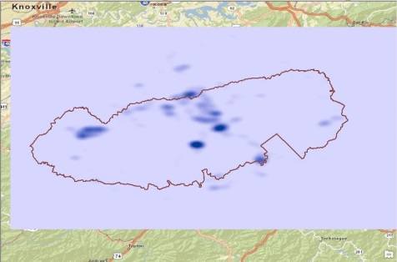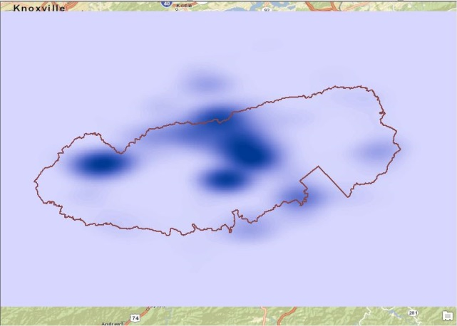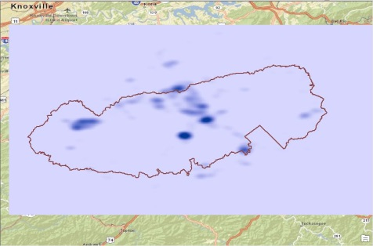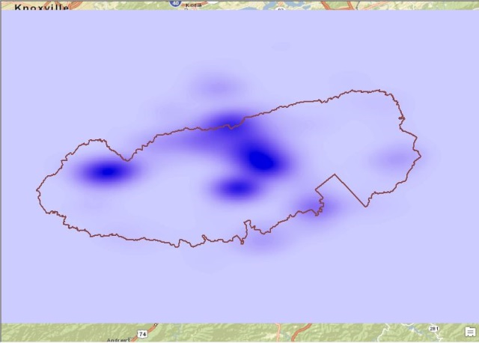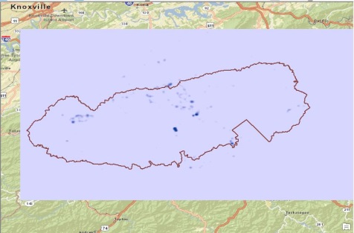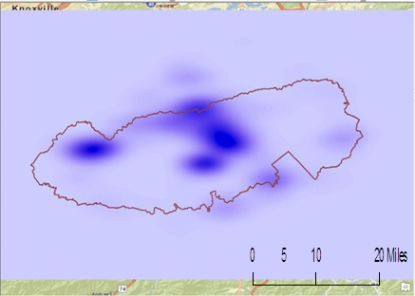
a) SCV
b) PLUGIN
c) LSCV
d) CVh
e) BCV
f) BCV2
Figure 7 KDE results of image points tagged as the Great Smoky Mountains National Park using SCV, plug-in, LSCV, CVh, BCV or BCV2 as bandwidth selecting algorithm
The density value of each grid cell in the resulting density estimation surface can obviously be used as a measurement of probability level of which this area unit can be considered as part of the case study place. In other words, density value of the study area can be used to delimit the probable geographic extent of the case study place at different probability levels, according to the opinion of corresponding image data providers. However, the raw density raster file is not convenient for visualizing or for further analysis. If the density surface is reclassified using interval of 5% of the maximum density value, areas of different percentage value ranges, 0-5%, 5%-10% … 95%-100%, are generated. That is to say, probable geographic extents of the place are generated at a series of probability levels.

3.2.3 Spatio-temporal analysis
Based on the probable perceived geographic extents of the case study places generating method above, we conduct a spatio-temporal analysis. As discussed in Introduction, perceived geographic extent of colloquial place names usually change over time. This is especially true of places formed by aggregation of human activities based on constructed structures and complexes like Manhattan Chinatown and Taipei Shilin Night Market. Migration, reconstruction and extension of infrastructure and other structures built by humans serve as important reasons. Images of each place during the whole time period (2004 - 2014) are divided into several subsets using appropriate time interval, which can be one year for this research.

Table 2 Annual numbers of effective images and images tagged with place name variations of each case study
 | The Great Smoky Mountains National Park |  | Taipei Shilin Night Market |  | Manhattan Chinatown
 | Effective | Tagged | Effective | Tagged | Effective | Tagged
2004 | 9 | 2 | 0 | 0 | 555 | 29
2005 | 234 | 172 | 8 | 5 | 3,189 | 89
2006 | 529 | 222 | 39 | 23 | 11,336 | 311
2007 | 1,454 | 589 | 91 | 24 | 14,835 | 518
2008 | 1,670 | 518 | 134 | 44 | 22,293 | 646
2009 | 2,147 | 657 | 473 | 100 | 26,986 | 849
2010 | 2,571 | 818 | 649 | 139 | 32,699 | 852
2011 | 4,513 | 1,534 | 681 | 83 | 52,582 | 838
2012 | 4,568 | 1,526 | 802 | 104 | 59,587 | 1,058
2013 | 5,787 | 1,695 | 1,470 | 52 | 62,039 | 957
2014 | 563 | 124 | 378 | 21 | 8,731 | 153

Longitudinal consistency of these colloquial place names over time at certain probability levels can be examined in terms of location, geographic extents, and approximate area. To reduce possible bias from datasets that are too small and improve reliability of the probability maps of each data subset, time windows may need to be adjusted to assign proper amounts of data images into data subsets. For example, there are either no or very few images of Shilin Night Market from 2004 to 2008 and 2013 to 2014. The images from 2005 to 2008 are combined into one data subset and those from 2013 to 2014 are combined into another subset, creating a time series of data subsets of 2005-2008, 2009, 2010, 2011, 2012 and 2013-2014. Additionally, images of 2004 and 2005 are combined for Manhattan Chinatown, leaving the remaining data as single year subsets. After conducting density estimation and generating a probability map from each data subset, a time series of geographic extent snapshots is created. Through preliminary visualization, geographic extent of Manhattan Chinatown at low probability level was expanding and migrating northeast, although the area of high probability level did not change much. Changes will be visualized, detected, and interpreted like this for Manhattan Chinatown and Shilin Night Market in order to reveal characteristics, hidden patterns, and trends of the collective cognition of these places.

Chapter 4
Results and Discussion
The numbers of images geotagged within the preliminary boundary of the place without redundancy for each of the three case studies are shown in the Effective column of Table 3. However, if the duplicated tags are ignored and more than two images from the same uploading user with the same coordinates that are uploaded within six hours with each other are considered as redundant, the amount of redundancy does not differ much (as shown in column Redundancy Ignoring Tags). The proportion of redundant images uploaded within a short time have exactly the same tags for the Great Smoky Mountains National Park (84.6%), for Manhattan Chinatown (81.4%) and for Shilin Night Market (87.7%). That is to say that, interestingly, users uploading and geotagging a batch of images together for one location tend to give them the same tags. This phenomenon agrees with our common knowledge and experience that images geotagged at the same location usually represent the same place, same activity, and similar stories. When users give different tags to some of the images in a batch, these images usually have different content, which should be considered in this study. Thus duplicate tag is considered as one of the rules when defining redundant data.

Table 3 Numbers of total images and effective images of the three places
 | Total | Effective | Redundancy | Redundancy Ignoring Tags
The Great Smoky Mountains National Park | 46,318 | 24,225 | 22,093 | 26,109
Manhattan Chinatown | 509,928 | 294,959 | 214,969 | 264,152
Taipei Shilin Night Market | 10,428 | 4,725 | 5,704 | 6,500

4.1 Geographic Extent of Colloquial Place Names

4.1.1 The Great Smoky Mountains National Park
The Great Smoky Mountains National Park is part of the Blue Ridge Mountains and full of old growth forests. Elevations in the national park range from 876 feet to 6,643 feet [79]. Most areas in the national park have limited physical accessibility to common visitors. Their areas of activity mainly include tourist attractions, trails, cabins and roads. Some areas with low accessibility may not be considered part of the national park by common visitors in daily life, even though these areas are within the official boundary of the park. Additionally, most of these areas have no cell phone signals or wireless Internet connection for portable electronics. There are usually few images geotagged within these areas. Thus, perceived geographic extent of colloquial place names of the national park may be located at roads, trails and tourist attractions and be different from the official administrative boundary of the park.
As discussed in Data and Methods, based on the approximate area of the national park’s official boundary, an output grid cell size of 300m is selected to obtain detailed enough results while controlling computational cost at the same time. Consequently, the official geographic extent in the resulting raster covers 34,707 grid cells. After conducting KDE using different bandwidth selecting algorithms, six resulting density estimation raster files are generated with the percentage value of probability for each grid cell. The density surface is reclassified using interval of 5% of the maximum density value for better visualization and interpretation. The geographic extents of the Great Smoky Mountains National Park of probability larger than 5% using SCV, plug-in, LSCV, CVh, BCV and BCV2 as KDE bandwidth selecting algorithm are shown in Figure 8. The national park has its official boundary, which is a useful reference when selecting the most appropriate KDE result for generating a reliable probability map.

Figure 8 Geographic extents of the Great Smoky Mountains National Park of probability >5% using LSCV, BCV, BCV2, SCV, plug-in, or CVh as KDE bandwidth selectors

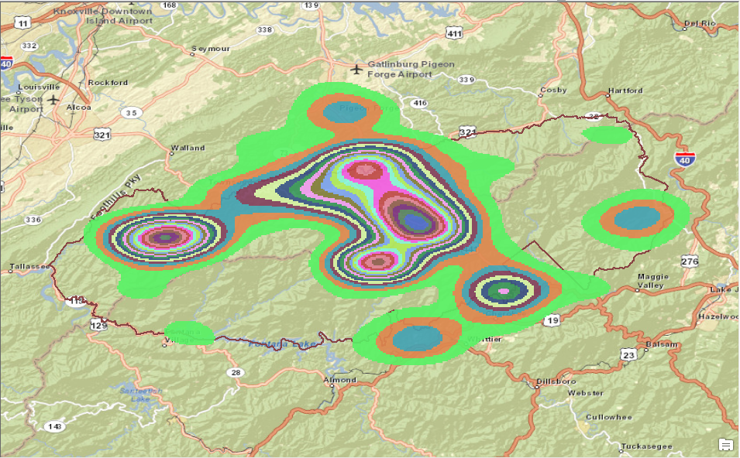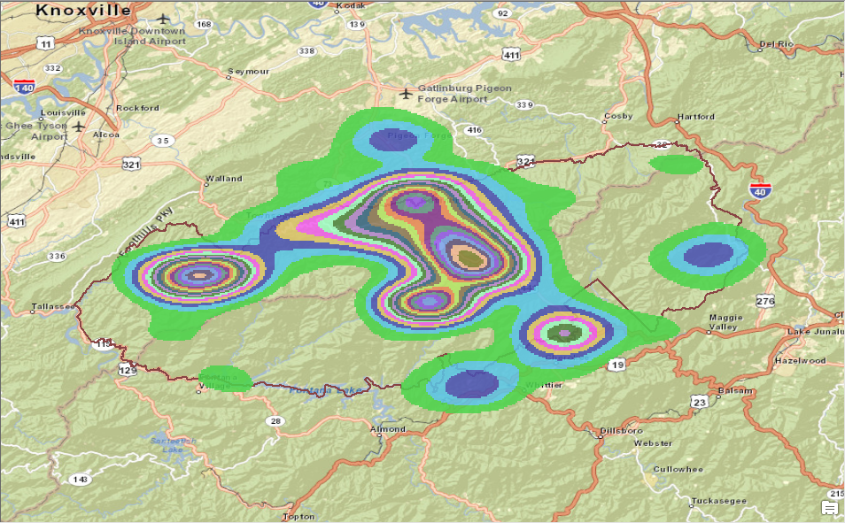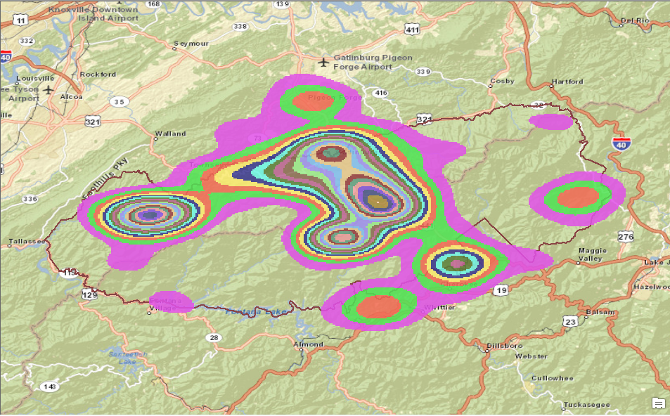
LSCV
BCV
BCV2
Figure 8. Continued
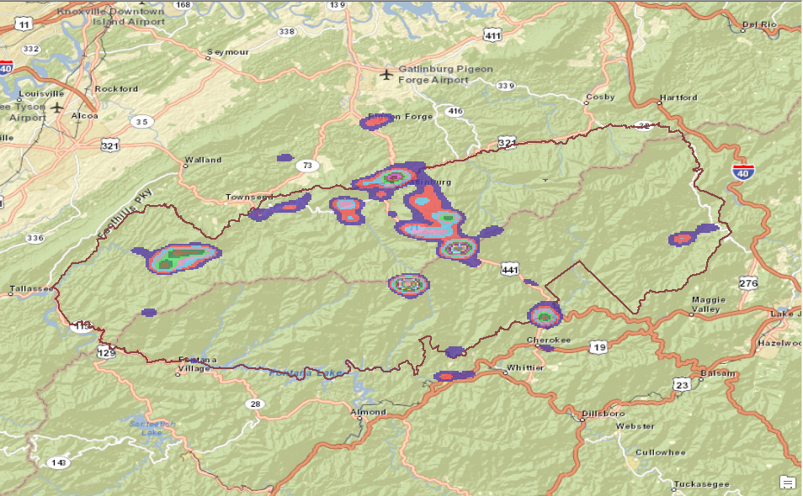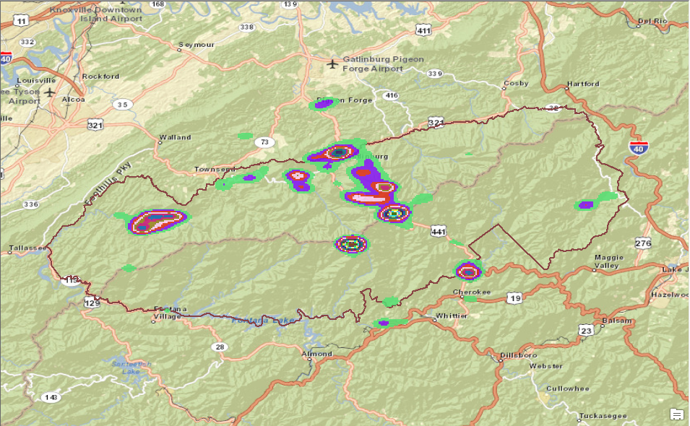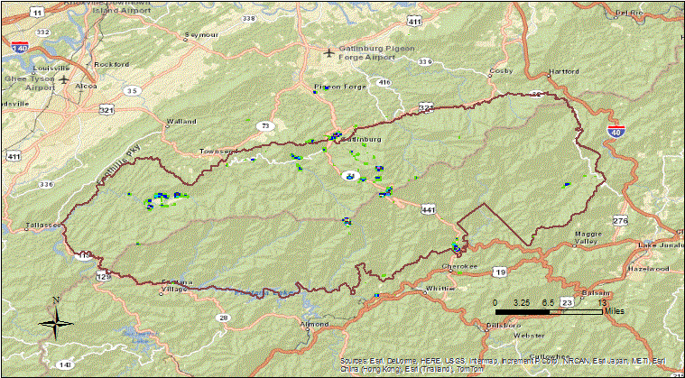
SCV
Plug-in
CVh
Figure 8. Continued

The geographic extents from SCV and plug-in bandwidth selectors cover some of the most popular and accessible areas, and clearly demonstrate the characteristics and hotspots of geotagged images. These results show that there is a hotspot of images tagged with colloquial place names of the national park at Pigeon Forge, away from the official boundary. However, these geographic extents are small and scattered. For example, these extents only cover several segments of the road from Highway Interstate 40 to Cades Cove, while it is obvious that those missing segments are also considered within the national park by visitors. The CVh extent is even smaller. On the contrary, the results from BCV, BCV2, and LSCV smooth the boundaries and cover much larger areas. The areas of high probability levels present similar distributing features with the other three results though missing a lot details. The geographic extents from BCV, BCV2, and LSCV basically include all areas that should be considered within the national park, but may also cover some extra. By taking geographic extents of higher probability levels in these three results, more accurate extents may be created. Thus, the geographic extents from using BCV, BCV2, or LSCV may be more appropriate.
In order to verify the consistency between official boundary and perceived geographic extents, two indices are defined. The parts of perceived geographic extent that fall within the official boundary can be considered as correct, and the proportion this occupies in the entire official extent is coverage rate:
$$C= \frac{N_{c}}{S}$$
where $C$ is coverage rate, $N_{c}$ is the number of grid cells in the resulting geographic extent that fall within the official boundary, and $S$ is the number of grid cells in the official boundary. The ratio of the part that falls outside of the official boundary in the entire resulting geographic extent is out rate:
$$O= \frac{N_{e}}{(N_{e}+ N_{c})}$$
where $O$ is out rate, $N_{e}$ is the number of grid cells in the resulting geographic extent that fall outside of the official boundary, and $N_{c}$ is the number of grid cells in the resulting extent that fall within the official boundary. The geographic extent with high coverage rate and low out rate is closer to the official boundary. Extract by Mask tool in ArcGIS is used to extract within and outside part of resulting geographic extents.
If the area of probability value larger than the lowest level, 5%, is selected as the resulted geographic extent, the numbers of grid cells in the geographic extent falling within and outside of the official boundary, as well as the coverage rates and out rates, are listed in Table 4.

Table 4 Grid cells in resulting geographic extents of probability level 5% with different bandwidth selecting algorithms falling within and outside of the official boundary of the Great Smoky Mountains National Park
 | LSCV | BCV | BCV2 | SCV | Plug-in | CVh
Out | 9,923 | 10,168 | 10,168 | 759 | 799 | 107
In | 18,655 | 19,130 | 19,130 | 3,546 | 3,670 | 524
Coverage Rate | 53.75% | 55.12% | 55.12% | 10.22% | 10.57% | 1.51%
Out Rate | 34.72% | 34.71% | 34.71% | 17.63% | 17.88% | 16.96%

Perceive geographic extents that result from using BCV and BCV2 have the same coverage rate and out rate, which are very similar to the results from using LSCV, especially out rate. The coverage rate is slightly greater than LSCV. On the other hand, both coverage rates and out rates from BCV/BCV2 and LSCV are much larger than the rest three results. Increased coverage rates leads to higher out rates as well.
Therefore, the areas that result from using BCV/BCV2 are used to map perceived geographic extent of the Great Smoky Mountains National Park. For better visualization, probability levels are merged into five classes: 0-5%, 5%-10%, 10%-20%, 20%-50% and 50%-100%; the area of 0-5% is ignored. Figure 9 shows the geographic extent map of the Great Smoky Mountains National Park at different probability levels.
Official boundary of the place is useful when justifying the quality of geographic extent, but greatly differs from it. The perceived geographic extent with a high probability level generally distributes along roads and tourist attractions, especially areas with relatively strong cell phone signal. This pattern reveals the crucial effect of accessibility, both physical and electronic, on perceived geographic extent using geotagged OSN data.
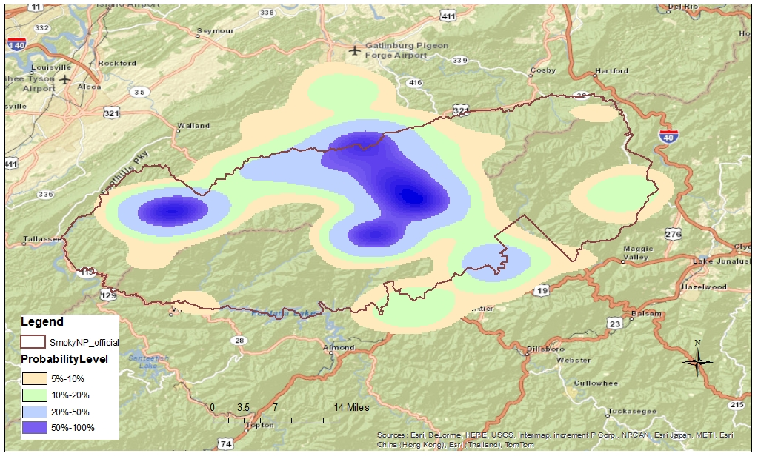
Figure 9 Probability map of the Great Smoky Mountains National Park based on images tagged with names and name variations

4.1.2 Manhattan Chinatown
Unlike the Great Smoky Mountains National Park, Manhattan Chinatown has several definitions and maps of its geographic extent from various sources. While these sources have many differences, they do have the central core area in common. There is no well-defined boundary as a standard to evaluate these resulting extents. The borough of Manhattan is home to the largest enclave of Chinese people in the Western Hemisphere[80]. One characteristic to distinguish it from surrounding areas is the concentration of Chinese-featured stores and residence buildings with Chinese signs. In this case, evaluating the visual characteristics of the controversial areas can be an effective method to verify geographic extent of Manhattan Chinatown. We used Google Maps Street View to examine the visual characteristics here.
Figure 10 shows geographic extents of Manhattan Chinatown from different KDE bandwidth selectors where probability value is greater than 5%. Figure 11 shows the six resulted geographic extents overlaid according to ascending orders of size. The geographic extents from BCV/BCV2 and LSCV are smoother and cover larger area, while the results from SCV, CVh and plug-in performs better at demonstrating details. The last three results do not only display more detailed boundaries but also capture the discontinuous areas with low probability values within the Manhattan Chinatown area, such as the area among Manhattan Bridge, Bowery, and Division Street (marked as ⑦ in Figure 11).
BCV and BCV2 yield the same results, which are similar to the result from LSCV. Shapes of the remaining three results resemble each other, but the SCV shape is slightly larger than CVh and plug-in. To verify the correctness of these geographic extents, seven sample areas are selected: ① Baxter Street between Grand Street and Hester Street, ② Elizabeth Street at south of Broome Street, ③ cross of Ludlow Street and Division Street, ④ Madison Street close to Catherine Street, ⑤ cross of Saint James Place and James Street, ⑥ Canal Street between Broadway and Cortlandt Alley, and ⑦ the block among Manhattan Bridge, Bowery, and Division Street. The geographic extents from bandwidth selector CVh, SCV and plug-in covers part of sample area ⑥ but do not cover areas ① to ⑤ and ⑦; the geographic extents from BCV/BCV2 and LSCV are similar and cover all seven areas, and the south edge of the extent from LSCV is located right at the Saint James Place and James Street while the one from BCV/BCV2 slightly exceeds this cross around area ⑤.
According to Google’s street views, sample areas ① to ⑤ (shown by green arrows in Figure 11) all seem to have more Chinese signboards compared to other streets in New York, and most of them are in residential areas. Sample area ⑦ is a large complex of Confucius Plaza with fewer visitors. Thus even though there are fewer geotagged images, this area is considered part of the Chinatown. However, there are few Chinese signs or Chinese featured stores in sample area ⑥ on Canal Street (shown by a red arrow in Figure 11), though it is a relatively prosperous street with many and varied stores along it. In fact, even though the area of Canal Street between Mercer Street and Cortlandt Alley are classified within the geographic extent of Manhattan Chinatown using all six bandwidth selectors, there is no clear indication that it is part of the Chinese enclave. The westernmost appearance of Chinese signs starts at the cross of Canal Street and Cortlandt Alley. The concentration of Chinese signs extends southwest to around Saint James Place and James Street area, which locates at the resulting boundary when using LSCV. Nevertheless, Chinese signs seem to extend north to East Houston Street and east to the Pitt Street area, which are two or three blocks further than the largest resulting geographic extent of LSCV. Of course, not all these areas should be considered as part of Chinatown because it is difficult to define a clear boundary at its marginal areas with sparse Chinese signs. Thus, though the resulted area from LSCV demonstrates less details of the boundary, it better represents the geographic extent of Manhattan Chinatown on the whole.
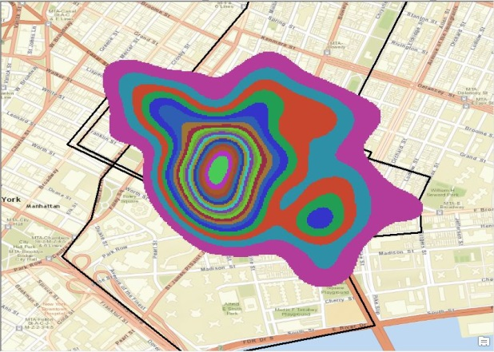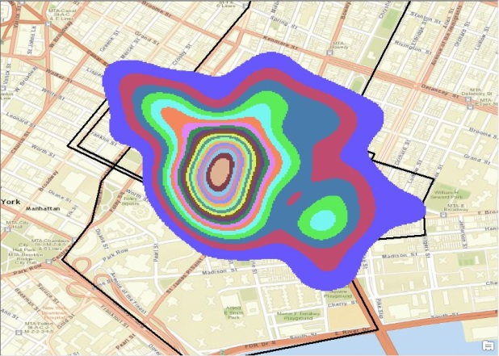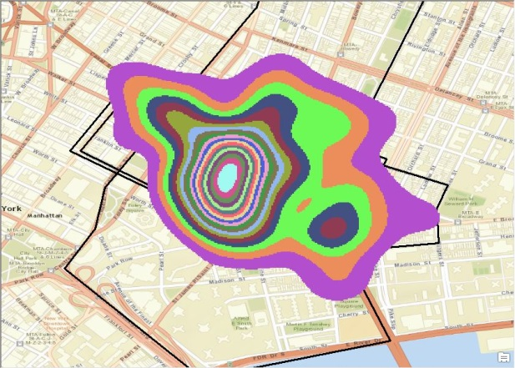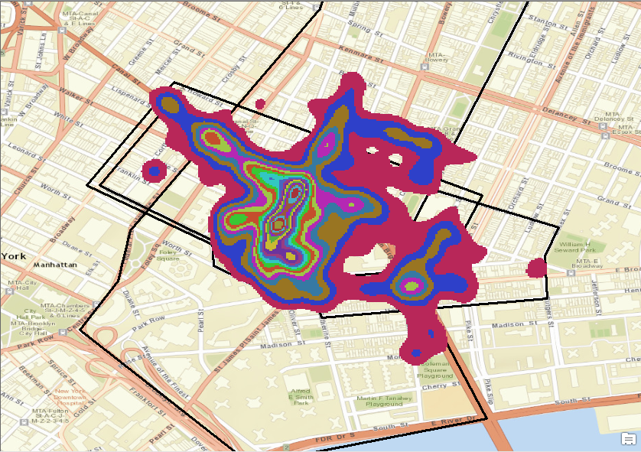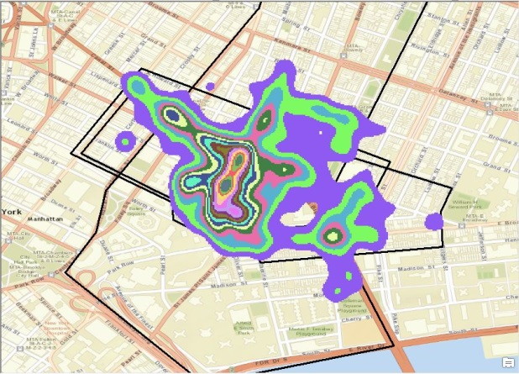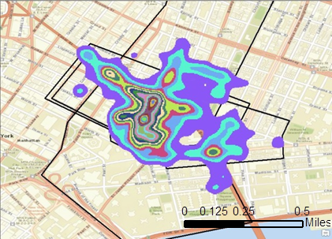
1) LSCV
2) BCV
3) BCV2
4) Plug-in
5) SCV
6) CVh
Figure 10 Geographic extents of Manhattan Chinatown of probability >5% using SCV, plug-in, LSCV, CVh, BCV or BCV2 as KDE bandwidth selecting algorithm
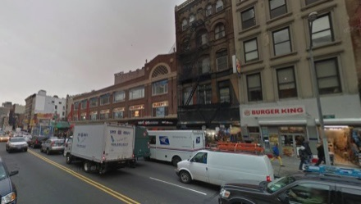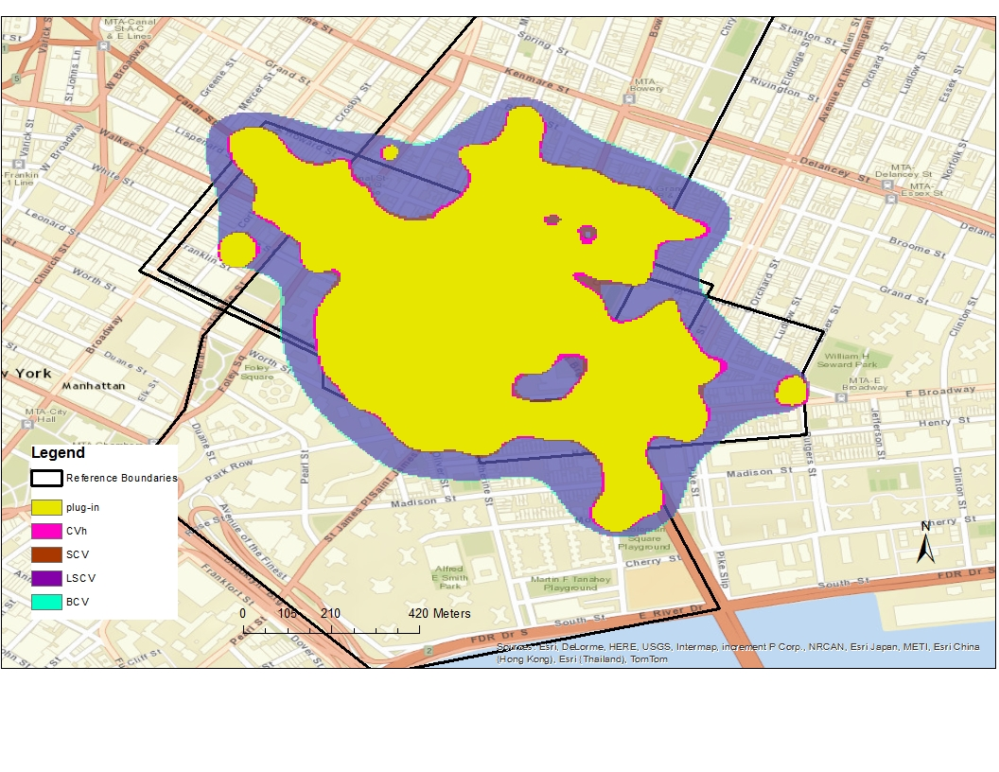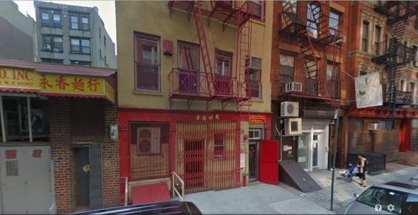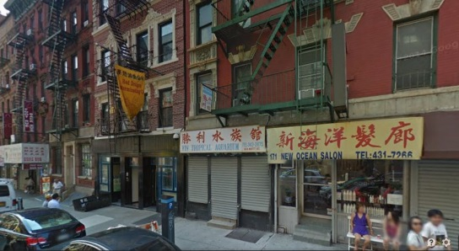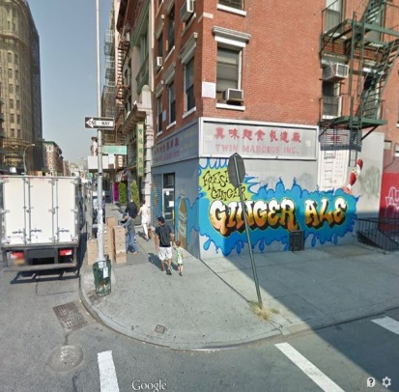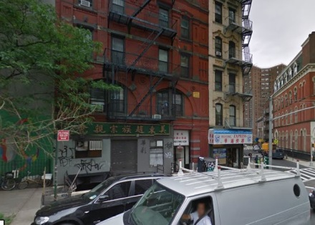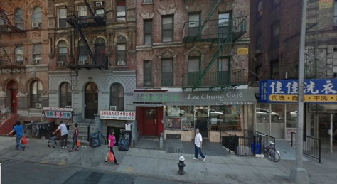
①
⑥
②
③
④
⑤
⑦
Figure 11 Comparing perceived geographic extents of Manhattan Chinatown from bandwidth selector plug-in, CVh, SCV, LSCV and BCV using Google Maps Street View at six sample areas

Based on the mapping method discussed above, the KDE result using bandwidth selector LSCV is considered the geographic extent of Manhattan Chinatown. Figure 12 shows the perceived geographic extent of Manhattan Chinatown of various probability levels.
For places with obvious characteristics in appearance, Google Maps Street View is a useful source to justify the quality of perceived geographic extent. Though this place is in urban area and has generally good accessibility and full cell phone signal, the perceived geographic extent still tends to distribute along roads at edging areas. Comparing with the reference boundaries from different sources, the perceived geographic extent with probability level larger than 50% mainly falls in the shared area of all reference boundaries. The area with probability level smaller than 50% and larger than 5% exceeds boundaries of the place from Google Maps and Zillow on south and east, while does not cover all the extent on west Thus the perceived geographic extent using geotagged Flickr images shares the core area with other reference boundaries but does not agree with any of them.
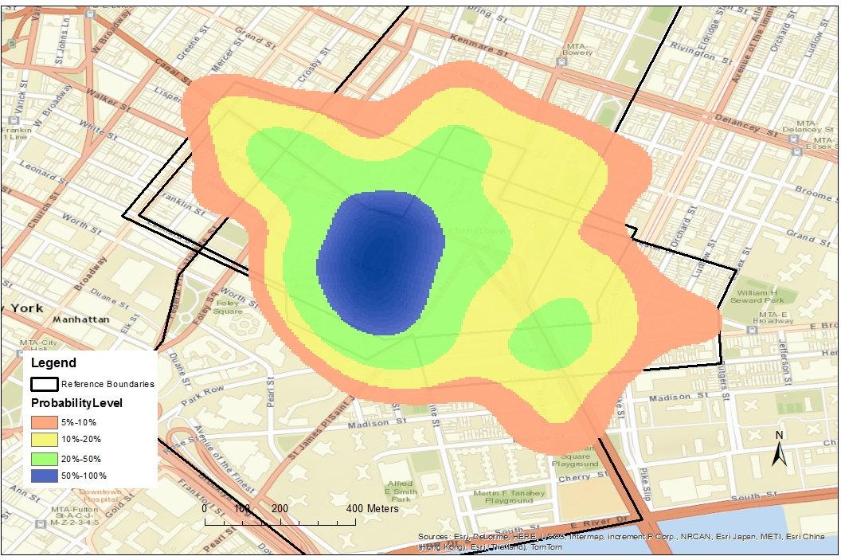
Figure 12 Probability map of Manhattan Chinatown based on images tagged with names and name variations

4.1.3 Taipei Shilin Night Market
Using the same methods, Figure 13 shows the geographic extent results of Taipei Shilin Night Market using six different bandwidth selecting algorithms. All these resulting extents have a smaller separated area several blocks away from the major one around Shilin Station of MRT, indicated by a red circle. There are several storefronts and food stands for passengers around the station. Although it is obviously far from the general location of the night market and not part of it, there are still some geotagged images tagged with the name or name variations of Shilin Night Market. This may be because of its name and large passenger flow as a traffic node. This area is removed from further geographic extent analysis.

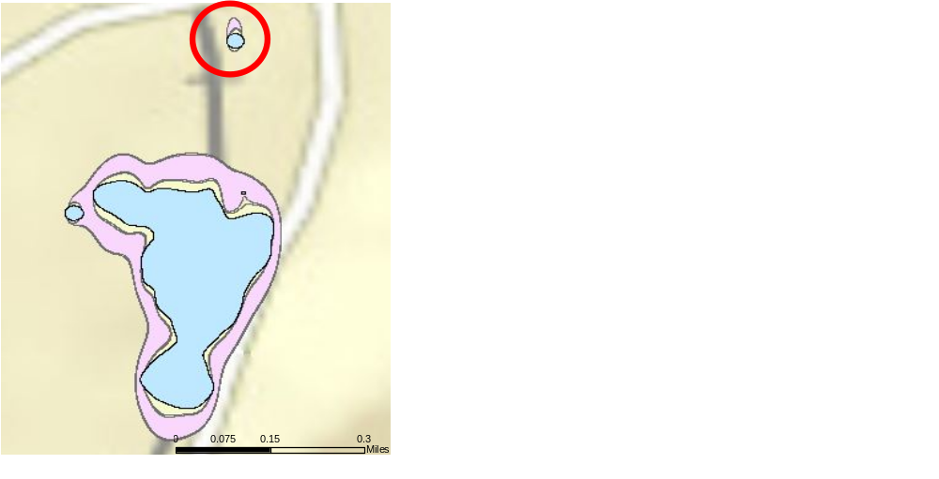
Figure 13 Geographic extent results of Taipei Shilin Night Market at probability >5% using six different bandwidth selecting algorithms

Taipei Shilin Night Market does not have any reference boundaries from commonly used online sources available, such as Google Maps, Bing Maps, and Wiki Travel. The night market encompasses a food court, some storefronts, and roadside stands distributed in surrounding area, such as cinemas, video arcades and karaoke bars. Some small side streets feature retractable roofs and vendors. Larger open streets are usually full of storefronts on both sides of the road that form the night market. The formation of night markets requires high pedestrian accessibility, so streets full of roadside automobile or bicycle parking, are not good potential night market areas. Google Maps Street View can be used to verify these geographic extents of Shilin Night Market. Symmetric Difference and Merge tool of ArcGIS are conducted to get the controversial areas of these resulting geographic extents as shown in Figure 14. As in the case of Manhattan Chinatown, the result of BCV and BCV2 are the same, so only BCV is considered. Due to lack of detailed data at this area on the World Street base map, Google Fusion Tables (https://www.google.com/drive/using-drive/#fusiontables) instead is used as the base map and location reference. Shape Escape (http://shpescape.com/) tool is used to import shapefile to Google Fusion Tables directly. Six sample areas are selected: ③ and ⑥ are included in all the results, ① and ⑤ are in results of using SCV or plug-in but not in LSCV and BCV, ② and ④ are only in results of LSCV and BCV.

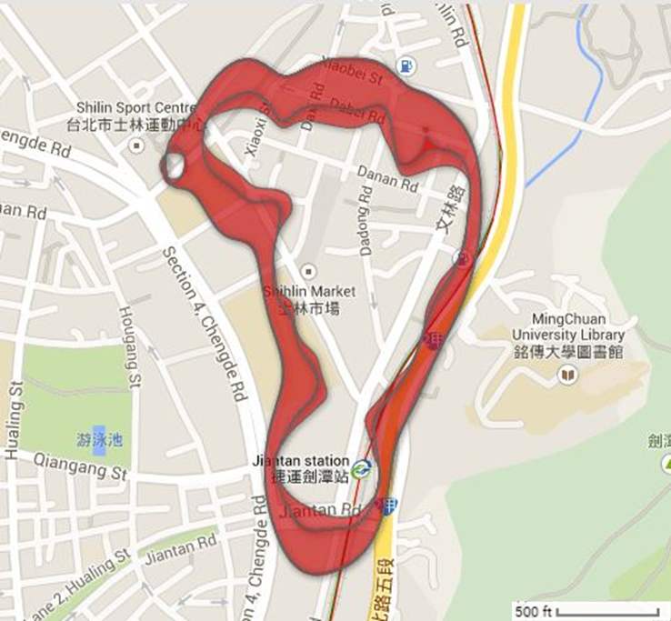
①
②
③
④
⑤
⑥
Figure 14 Comparing differences of resulting perceived geographic extents of Teipei Shilin Night Market with six different bandwidth selectors on Google Maps

Google’s street view at ① on Dabei Road shows many storefronts with food, clothes, and small items as well as traces of temporary vendors, which obviously has potential for night market area. On the contrary, area ② on Xiaobei Road is mostly residential area with only a clinic, an alterations and tailoring shop, and a barber shop. Parked motorcycles and cars occupy the sides of the streets, leaving no space for street vendors. Its potential as a night market area is low.

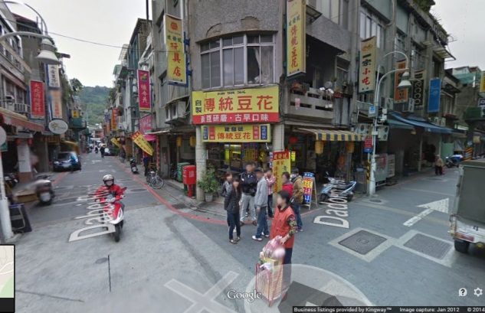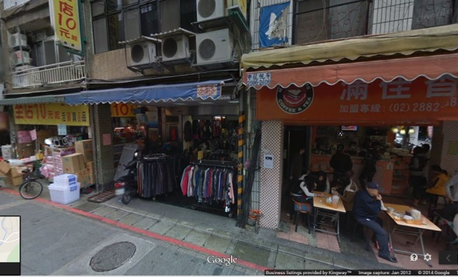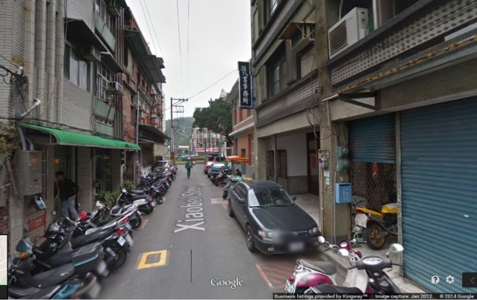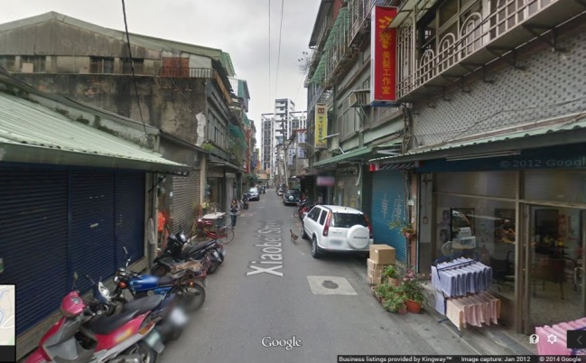
Snapshots of street views at ① on Dabei Rd
Snapshots of street views at ② on Xiaobei Rd
Figure 15 Snapshots of Google Maps Street View at ① on Dabei Road and ② on Xiaobei Road

Similarly, as shown in Figure 16, area ④ on Lane 195, Chengdu Road is a relatively big road with an aquarium and tall residence buildings on both sides. There seem to be no space for street vendors. However area ⑤ cross Jihe Road from ④ is on a small side street full of small food stores. Even though they appear to be closed during the day time on Google’s street views, they are very likely part of the night market.
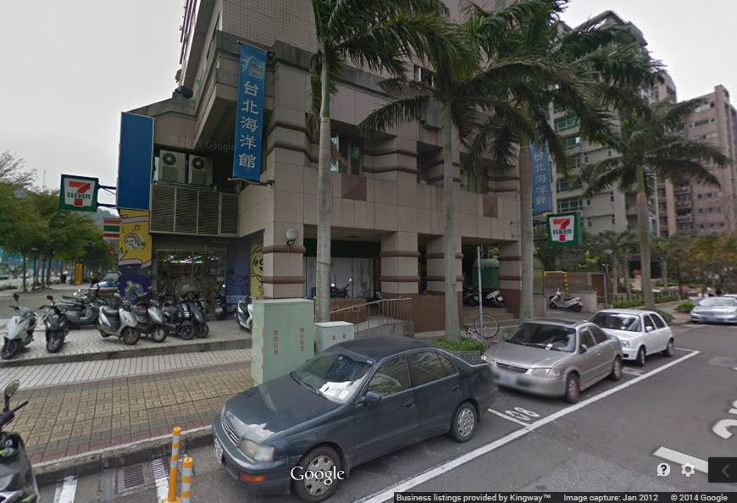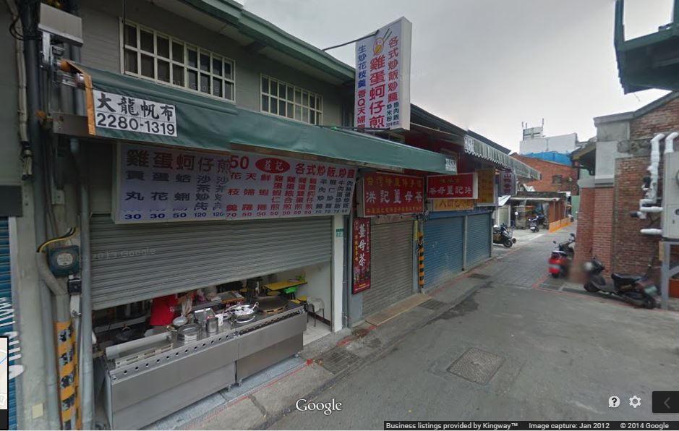
Snapshot of street view at ④ on Lane 195, Chengdu Rd

Snapshot of street view at ⑤ on a side street across Jihe Rd from Chengdu Rd
Figure 16 Snapshot of Google Maps Street View at ④ on Lane 195, Chengdu Road and at ⑤ on a side street across Jihe Road from Chengdu Road

Google’s street view shows that the side of Jihe Road between Jiantan Road and Wenlin Road is a construction site, and there seems to be no space for street vendors. A few posters outside the construction site advertise Shilin Public Market. Simply by observing this area using Google Maps Street View, it does not appear to have high potential as a night market area. However, this area is covered by all resulting extents of the aforementioned bandwidth selectors as part of Shilin Night Market. The most current street views of this area were taken in January 2012. One speculation is that this area had been a night market before and was demolished before 2012. If so, this area should have a great number of geotagged images before 2012, but the number should diminish after that. This illustrates the uncertainty of using Google Maps Street View to verify geographic extent of places.

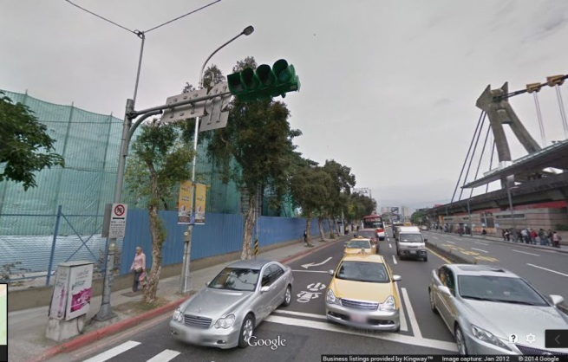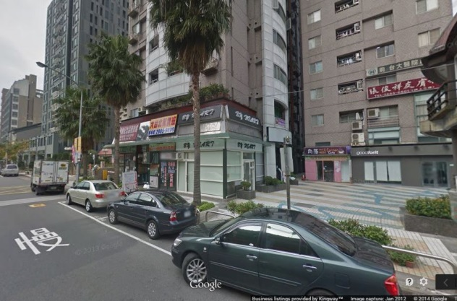
Figure 17 Snapshots of Google Maps Street View at ③ on cross of Jiantan Road and Jihe Road

Area ⑥ is located on Danan Road between Jihe Road and Shishang Road, and it is within the geographic extents of all six KDE bandwidth selectors. The remainder of this road segment is mostly covered by extents of only BCV and LSCV. However, based on Goolge’s street views, it is a wide and open road with a tall sport center and residential buildings on one side and a park on the other. The whole road segment seems not to have any potential as a night market. One possible reason of the dense geotagged images here is the parking lot with a large visitor flow.
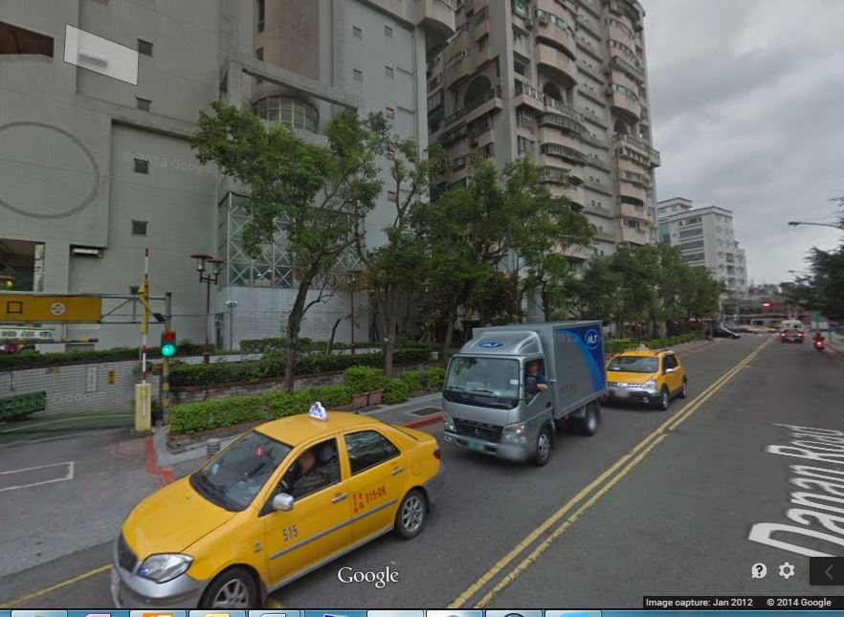
Figure 18 Snapshot of Google Maps Street View at ⑥ on Danan Road between Jihe Road and Shishang Road

Hence, the geographic extent that results from using the plug-in bandwidth selecting algorithm is the most accurate among all six results, despite of some minor inaccuracies. Using the methods discussed above, Figure 19 shows the probability map of Taipei Shilin Night Market. With outer area composed by street vendors and small businesses, Taipei Shilin Night Market is a good example of places whose geographic extent has relatively high flexibility and hardly any reference boundary. The probability mapping method of perceived geographic extent using geotagged OSN data provides a practical and interesting way to delimit this kind of places. Though there is no reference boundary, Google Maps Street View can be used to verify the quality of perceived geographic extents based on some characteristics, for example side parking.
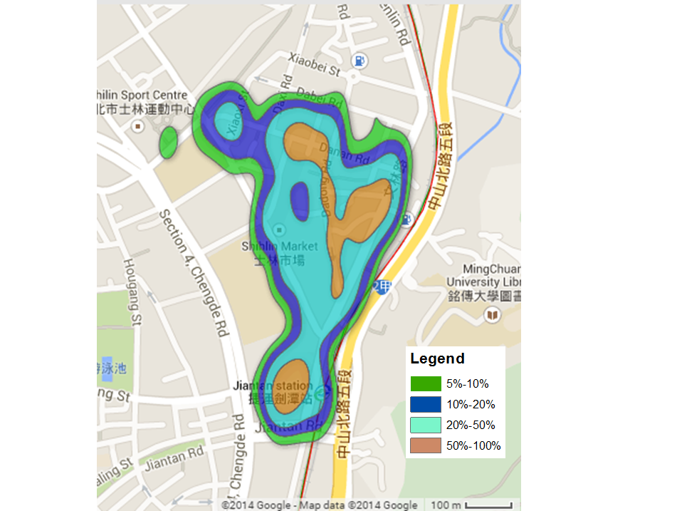
Figure 19 Probability map of Taipei Shilin Night Market based on images tagged with names and name variations

4.2 Related terms of colloquial place names
Colloquial names for a place are usually fuzzy. As discussed in Data and Methods, the names of some famous tourist attractions in the Great Smoky Mountains National Park are sometimes used to refer to the national park itself, such as Cades Cove, Mont Le Conte and Laurel Falls. Because of the historical living areas of Cherokee Indians [81], images tagged with Cherokee are assumed to be highly related to the national park. Additionally, because cabins and trails are important components of tourism activities, those terms also appear frequently in image tags about the national park and sometimes can be considered colloquial terms for it.
Images tagged about “trail” “cabin” “cherokee” or “cadescove”, along with their variations, are selected separately from the preliminary dataset. The distribution of these images is mapped using the KDE method discussed above with bandwidth selector BCV and then take the boundary of probability value greater than 5% as the geographic extent. The geographic extent of images tagged about “trail” (Figure 20) is obviously even more consistent with the official boundary than images tagged with names. The out rate is 33.46% and coverage rate is 84.74%, while for the resulting extent of name variations using BCV bandwidth selector, out rate is 34.71% and coverage rate 55.12%. Basically, these tags can be considered as colloquial terms of the national park when filtering geotagged images. However, the Great Smoky Mountains National Park is part of the Blue Ridge Mountains and adjacent to several tourist attracting forests and parks that also supply some beautiful trails, such as the protruding area on the northeast and the two smaller areas on southwest Thus redundancy may be brought in when using variations and phrases about “trail” as a colloquial term for the Great Smoky Mountains National Park.
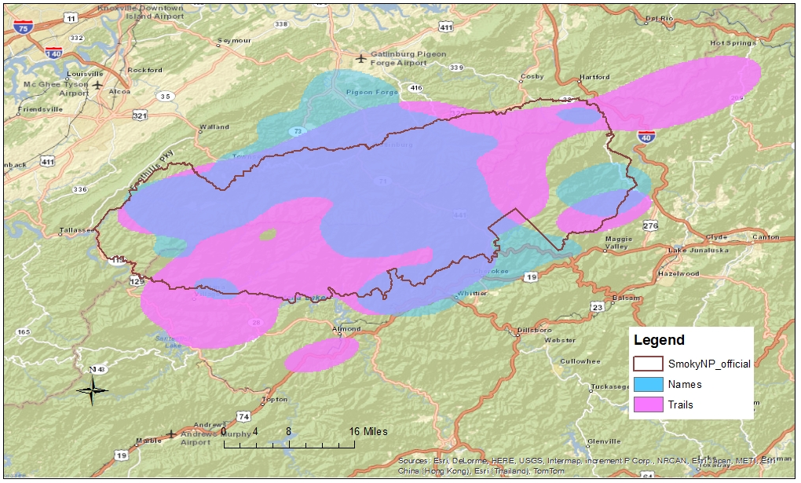
Figure 20 Geographic extent of images tagged about “trail” at the Great Smoky Mountains National Park

On the other hand, images tagged about “cabin” are mainly outside the national park in populated areas, such as Gatlinburg, Pigeon Forge, and Cherokee. It is expected because the Great Smoky Mountains National Park does not permit commercial activities. Besides, mountain cabins are mostly constructed on relatively flat, hilly areas with high accessibility—except for a few featured cabin hotels—while a large part of the national park is located in the dense forests and high mountains. The coverage rate of the geographic extent of images tagged about “cabin” is 62.89%, but the out rate is as high as 57.27%. Thus even though cabin is an important colloquial term used by people, especially tourists, to indicate their activities at the Great Smoky Mountains National Park, the distribution of related image tags is much different from the national park boundary.

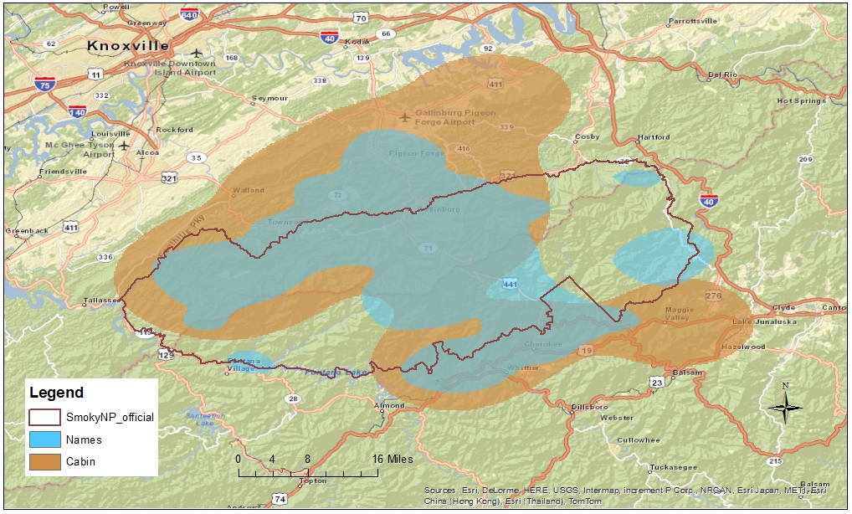
Figure 21 Geographic extent of images tagged about "cabin" at the Great Smoky Mountains National Park

Similarly, it has been known the term “cherokee” is highly related to the Great Smoky Mountains National Park in tourism activities in and around this area. However, the distribution of images tagged about “cherokee” is not consistent with the official boundary. As shown in Figure 22, these images are mainly distributed near the town of Cherokee with famous museum and casino. A small portion of the images is geotagged at some historic sites of Cherokee culture within the national park.
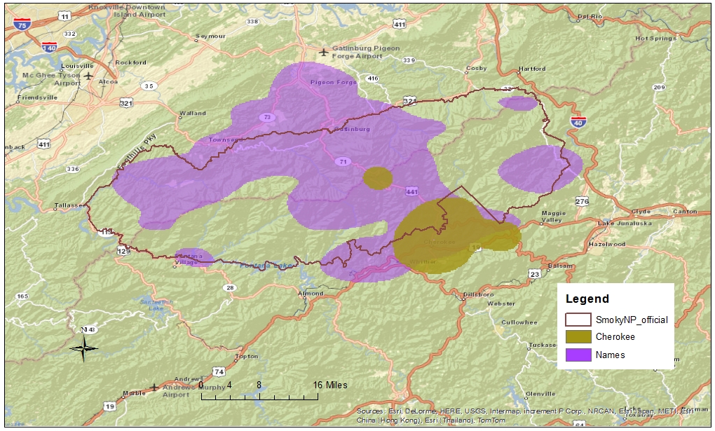
Figure 22 Geographic extent of images tagged about "cherokee" at the Great Smoky Mountains National Park

Cades Cove, one of the most famous tourist attractions in the park, is sometimes used to refer to the national park itself. Images tagged about it mainly distribute at the Cades Cove area and the road leading to it. The geographic extent of these images is completely within the national park boundary. Thus some tourist attractions within the Great Smoky Mountains National Park like Cades Cove well supplement image tag terms when analyzing colloquial place names of the national park.
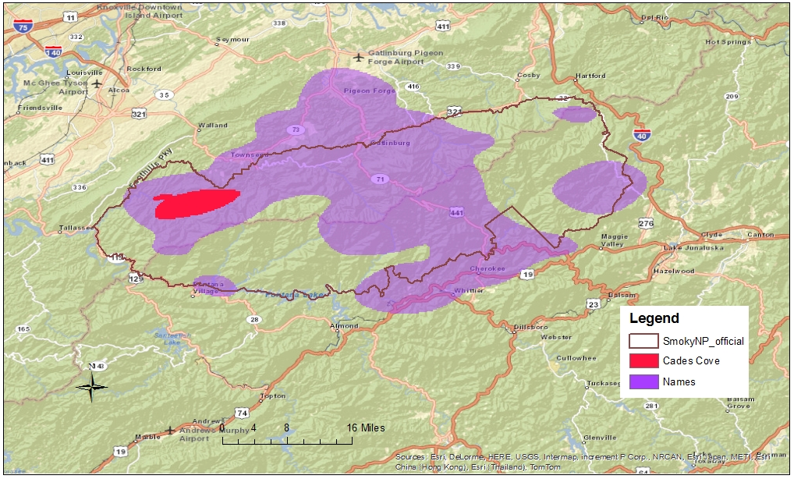
Figure 23 Geographic extent of images tagged about "cadescove" at the Great Smoky Mountains National Park

Shilin Night Market is famous for its various eateries and street vendors selling authentic Taiwanese snacks. Among the most famous snacks are deep-fried chicken breast, pan-fried dumplings, grilled Taiwanese sausages, and pearl milk tea. To a great extent, these snacks can be considered as trademarks or brands of night markets in Taiwan. Though there are over one hundred night markets in Taiwan, Shilin Night Market is the one of the most famous and largest ones [82]. It also is the only night market within and around our preliminary study boundary. The distribution of images tagged about these snacks is consistent with the geographic extent of Shilin Night Market but covers a larger area, as shown in Figure 24. This comparison result agrees with common sense. Those snack vendors and storefronts are not located only in night markets but may also be scattered on other suitable areas such as areas around the Shilin Station of MRT. Even though featured snacks are commonly used colloquial terms for night markets, using images with these tags to generate geographic extent of the night market brought in a certain redundancy that is hard to eliminate.

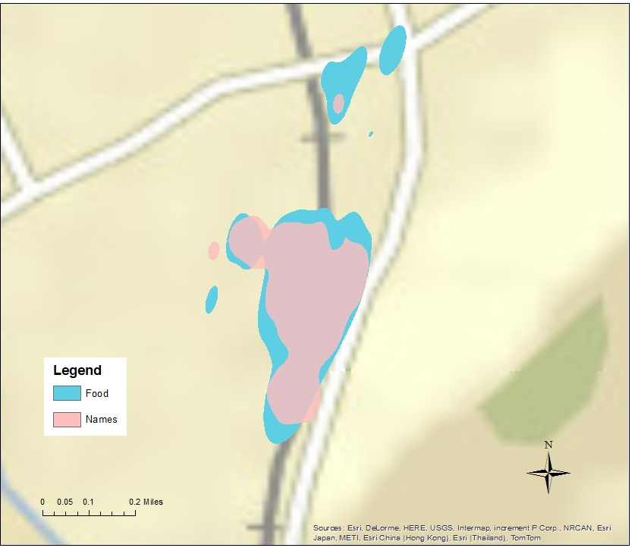
Figure 24 Geographic extent of images tagged about food at Taipei Shilin Night Market

4.3 Spatio-temporal analysis
Shilin Night Market utilizes the Shilin Public Market, which was purposely built to be a marketplace, and also occupies sidewalks adjacent to streets or entire streets that are normally thoroughfares by day. The extent greatly depends on locations of storefronts and mobile vendors. Based on discussion result above, the resulting geographic extent from plug-in bandwidth selector with probability value greater than 5% is used as boundary of the night market. The number of selected images for each of the 11 years (from 2004 to March 1st, 2014) is: 0, 5, 23, 24, 44, 100, 139, 83, 104, 52 and 21. In order to get more reliable density estimation results, images from 2005 to 2008 and from 2013 to 2014 are combined respectively. Figure 25 shows the resulting geographic extents of each time period, after processing. The geographic extents from 2005 to 2012 are similar but with small differences, while the extent of 2013 and 2014 is not consistent. The reason for the unusual result of the last two years is not clear. According to these resulting extents, the night market has been expanding northwest since 2010. Even though there was already a relatively small number of images geotagged at northwest before 2008, the expansion trend was from 2010 to 2012.
It is interesting to note the density change of the area on Jihe Road between Jiantan Road and Wenlin Road, which is at south of the night market. This area was obviously part of the geographic extent with high probability from 2005 to 2010 and gradually expanded. Its extent reached a peak in 2010. However, it started to shrink in 2011, and almost disappeared by 2013 and 2014. As shown in Google’s street views in Figure 17, this area was a construction site in January, 2012. This result confirms our speculation that this area used to be an important part of Shilin Night Market, but was torn down some time in 2011.

Figure 25 Geographic extents of Taipei Shilin Night Market at different times

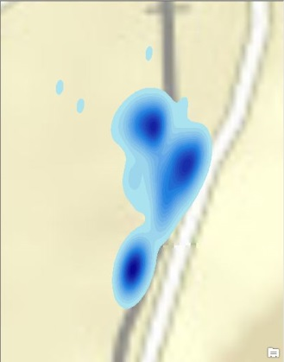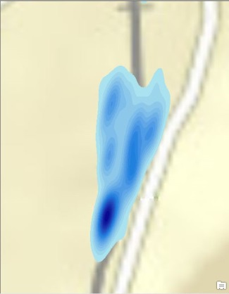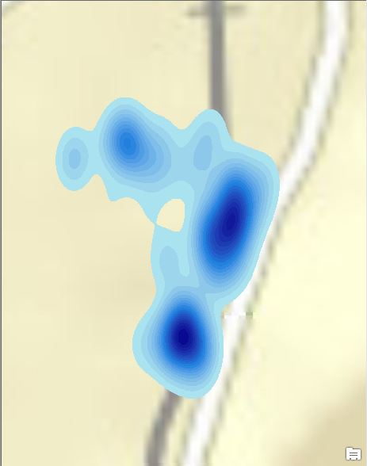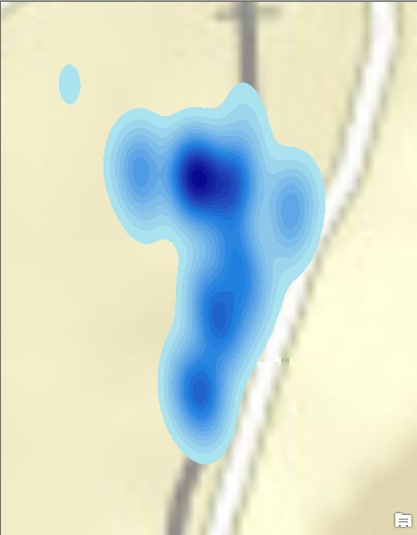
2005 - 2008
2009
2010
2011
Figure 25. Continued
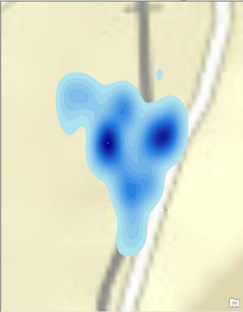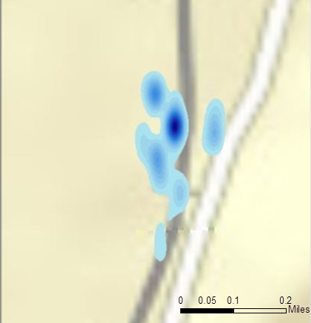
2012
2013 - 2014
Figure 25. Continued

Manhattan Chinatown is also composed of some infrastructure built by humans. Reconstruction and extension of the infrastructure complexes, as well as migration of residence and business activities, can all change its geographic extent according to peoples’ cognition. KDE result of images tagged with its name and name variations using LSCV bandwidth selecting algorithm with probability level greater than 5% is used as the geographic extent of Manhattan Chinatown. Since the number of images in 2004 is too small to generate a reliable geographic extent, the images from 2004 to 2005 are combined and the rest of the images are grouped in one year time windows. The numbers of images from 2004 plus 2005 to 2014 are 118, 311, 518, 646, 849, 852, 838, 1058, 957 and 153. The resulting geographic extents for each year are shown in Figure 26.
According to the time series of geographic extents, the core area of Chinatown with the highest probability level has been consistently in Canal Street, Bowery, Worth Street, and Baxter Street with only minor differences through the years. However, Chinatown’s south boundary shrank by one or two blocks in the first few years. The geographic extent of 2004 to 2005 reached south of the cross road of Saint James Place and Madison Street, but shrank about 200 meters in 2006 and 2007. Then the south edge moved a little north and located around the cross of Saint James Place and James Street during 2008 to 2012. Even though the geographic extent expanded slightly south across Madison Street again in 2013, the whole trend of the south boundary was shrinking north.
On the contrary, the north and east sides of the geographic extent has trended toward expansion. The west boundary was one or two blocks away from Essex Street from 2004 to 2010, and only reached it in 2006. However, the geographic extents from 2011 to 2013 already exceeded the Essex Street. Similarly, the north side of the geographic extents experienced an expanding trend from 2004 to 2010, but gradually shrank from 2011 to 2012. Its north boundary even crossed Kenmare Street in 2010. It peaked in 2013 and reached Sprint Street

Figure 26 Geographic extents of Manhattan Chinatown at different times

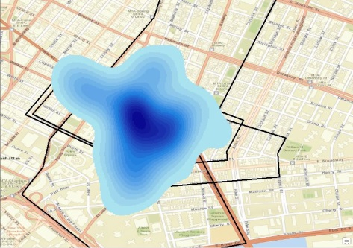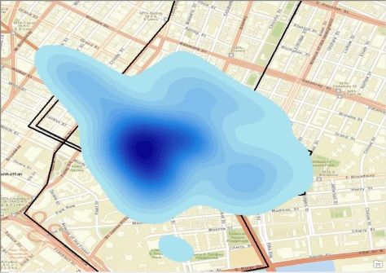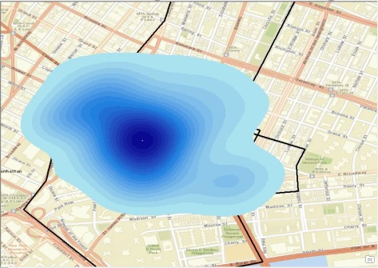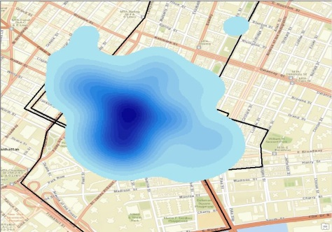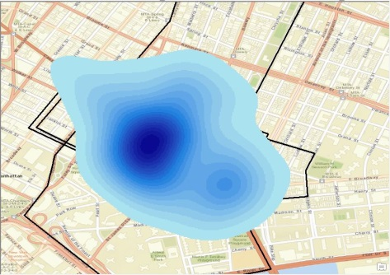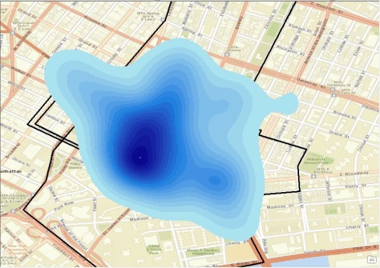
2004 - 2005
2006
2007
2008
2009
2010
Figure 26. Continued
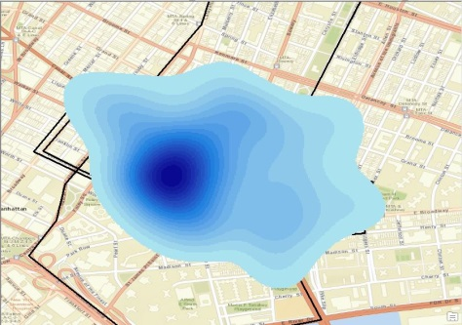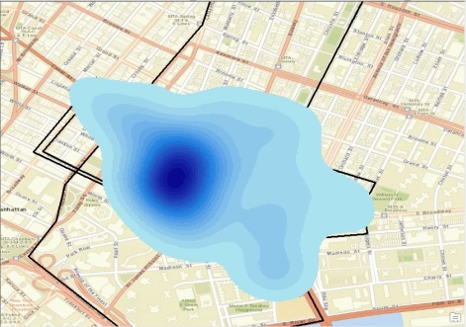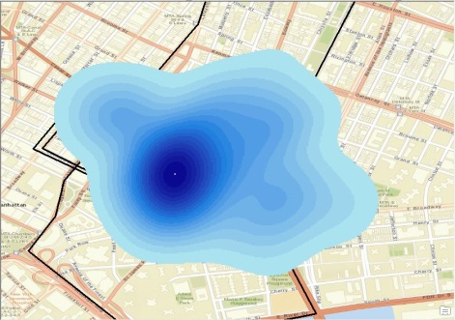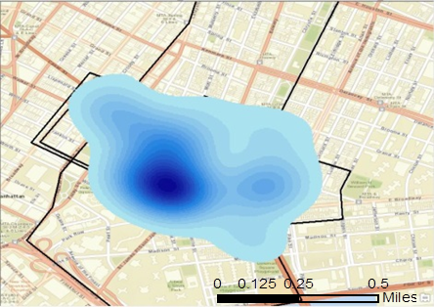
2011
2012
2013
2014
Figure 26. Continued

Chapter 5
Conclusion

5.1 Conclusions
Place, having various functions in different settings, is most likely used by geographers to define the context of geographic area within which humans conduct certain activities, such as residing, shopping, and entertaining. The sense and identity of place depends more on human and social attributes than on geometry. Thus, place usually has an ambiguous boundary. Online social network platforms have developed greatly in recent decades, and generated large volumes of geotagged data associated with time, location, and sometimes users’ perceptions. Indicating spatio-temporal footprints of their contributors, these geotagged OSN data are a valuable source of knowledge about perceived understanding of places.
This empirical study proposes a probabilistic method to map perceived geographic extent of colloquial place names of the place: select images tagged with the colloquial place names, conduct density estimation on the image set, and map perceived geographic extent of a series of probability levels based on the appropriate density surface. Kernel density estimation tool with Gaussian kernel function in Geospatial Modeling Environment software is used to generate density surfaces. All six commonly used KDE bandwidth selecting algorithms supported in GME are tried, which are plug-in estimator, smoothed cross validation, likelihood cross validation, two algorithms of biased cross validation, and least squares cross validation. Values of grid cells in density surface are used as a measurement of probability to delimit the geographic extent of the case study place for a series of probability levels. Resulting density surfaces are reclassified with an interval of 5% of the maximum density value, and each new class is considered as a probability level. Using this method, the author generates perceived geographic extents of colloquial place names for three case studies through geotagged Flickr images.
When processing the data, in order to reduce computational cost and save time, preliminary boundaries for each case study are selected according to data distribution, physical barriers, and referral locations of each place. Aiming to generate reliable and representative geographic extents, the author consider as many peoples’ opinions as possible. Thus, if several images uploaded by the same person with the same coordinates and tags are uploaded within six hours, they are considered redundant and only one is retained as effective data. To filter images indicating colloquial names of the place, image tags of the complete names, aliases, name abbreviations, and name variations of each place are selected. The image subset tagged with colloquial place names of the Great Smoky Mountains National Park contains 24,225 images, the subset of Manhattan Chinatown contains 294,959 images, and there are 4,725 images for Taipei Shilin Night Market.
Different methods are used to validate resulted geographic extents according to characteristics of the case studies in order to select the appropriate one. The Great Smoky Mountains National Park has its official name and boundary. Two indices: coverage rate and out rate, are defined to measure the consistency between perceived geographic extents and the official boundary. Higher coverage rates generally come along with higher out rates. Due to the nature characteristics of the national park, the perceived geographic extent is mainly located at areas with high accessibility, both physical and electronical. The BCV/BCV2 result of low probability level basically covers all areas that should be within the national park according to common visitors, but it may lose some details and also contain extra areas, comparing to the results from SCV, plug-in, and CVh. On the other hand, it has slightly larger coverage rate than LSCV while sharing similar out rates. Manhattan Chinatown and Taipei Shilin Night Market do not have an official boundary; instead, they have several distinguished referral boundaries or location points. Manhattan Chinatown is home to the largest enclave of Chinese people in the Western Hemisphere and has an intuitive characteristic from the surrounding areas, which is a concentration of Chinese-featured stores and residence buildings with Chinese signs. Similarly, Taipei Shilin Night Market is composed of a traditional market and several surrounding streets that are full of roadside stands and small storefronts. The streets in the night market area usually do not have their roadsides occupied by automobile or bicycle parking. Thus, the Street View service of Google Maps is used to visualize the sample areas and validate whether resulting geographic extents of the last two case study places are appropriate. Consequently, the density estimation surface using bandwidth selector LSCV is selected for Manhattan Chinatown, while the relatively appropriate result of Shilin Night Market uses plug-in bandwidth selector. The perceived geographic extents of the three places at different probability levels are mapped respectively.
Taking the fuzziness of colloquial terms used in daily life to refer to places, distribution of images with some related tags are analyzed to see their relationship with perceived geographic extent of places and possible contribution. Tags about “trail”, “cabin”, “cherokee” and “cadescove” are analyzed for the Great Smoky Mountains National Park while tags about Taiwanese snacks are explored for Shilin Night Market. The tags analyzed in this research are inspiring, but insufficient. Many further studies are needed to more comprehensively understand colloquial terms to delimit colloquial place names.
Spatio-temporal characteristics, patterns and trends are analyzed for perceived geographic extents of Manhattan Chinatown and Taipei Shilin Night Market, which are formed by aggregation of constructed structures. Time-series of geographic extent snapshots at different times are generated using aforementioned methods and parameters. According to the analyzed results, the south part of Shilin Night Market, the block among Chengde Road, Jihe Road, Jiantan Road and Wenlin Road, was torn down around 2011 and under construction after that, which agrees with the Google’s street views taken there in 2012. By 2013 and 2014, this area could not be considered part of Shilin Night Market at high probability any more. From 2004 to 2010, Manhattan Chinatown seemed to be shrinking on the south side but expanding on the north and west sides. However this trend seemed to stop in 2011. This study demonstrates some interesting findings of spatio-temporal analysis on the case studies, and brings temporal perspective to the research of perceived geographic extents of places.

5.2 Limitations and Further Research
The concept of place has fundamental vagueness in terms of identity and exact location. For this reason, perfect results are difficult to achieve even though appropriate methods and large amounts of data from widely used data source are applied. The data used in this study is from Flickr, a popular online social network platform with a vast amount of image data. However, many studies indicate that the socioeconomic characteristics of OSN data contributors may affect the validity and accuracy of sociological research results[22]. This is the inherent weakness of geotagged OSN data with current social economic conditions and limitations of technology. The race, degree of education, income level, and working field biases of data contributors may impair the representativeness of the perceived geographic extent of colloquial place name when it is used to serve a broader user community.
Furthermore, even though the total number of geotagged images within the preliminary study boundaries of each place is large, effective images tagged with colloquial place names are not abundant. The data subsets of certain time period contain even fewer images. Insufficient image records used for density estimation may increase uncertainty and decrease reliability of the probable maps of perceived geographic extent of places.
To avoid being plagued by image recognition and comprehensive semantic analysis, the research is simplified by assuming the tags of an image reveal the location where the image is geotagged. In fact, though that is the case for most of the times, there are some images tagged with either the major content of the trip or content of the image, sometimes even something not related. For example, an image taken on the way to Shilin Night Market may still be tagged by the person uploading the image as “shilinnightmarket” for personal image classification; people may take a geotagged picture of the beautiful scenic view when the Great Smoky Mountains National Park appears in horizon and tag it as “greatsmokymountains” despite it not being in the extent of the national park. Besides, insufficient knowledge of the place may lead to errors wen generating geographic extents. For example, it is controversial whether “Shilin Traditional Market” is an alias of Shilin Night Market or a different place. Other than image tags, titles, and descriptions, viewers’ comments of an image may also supply information about the place. Such information should be taken into consideration in further research.
Even though this research took many names, aliases, and variations of names of the place being considered, some colloquial names may still have been left out. Exploring related colloquial terms of the place, as well as the relationship of their distribution with geographic extent of places, is an initial attempt to delimit perceived geographic extent of colloquial place names and inspire potential further study direction.

LIST OF REFERENCES

1. Goodchild, M.F., Formalizing place in geographic information systems, in Communities, Neighborhoods, and Health. 2011, Springer. p. 21-33.
2. Kernel Density (Spatial Analyst). Esri Kernel Density (Spatial Analyst) 2014 [cited 2014 April 5]; Available from: http://resources.arcgis.com/en/help/main/10.1/index.html#//009z0000000s000000.
3. Jeffries, A. The man behind Flickr on making the service 'awesome again'. The Verge The man behind Flickr on making the service 'awesome again' 2013 [cited 2014 March 16]; Available from: http://www.theverge.com/2013/3/20/4121574/flickr-chief-markus-spiering-talks-photos-and-marissa-mayer.
4. Flickr. Wikipedia Flickr 2014 [cited 2014 June 6]; Available from: http://en.wikipedia.org/wiki/Flickr.
5. Wu, S. and M. Boston. Twitter and Privacy: Nearly one-in-five Tweets divulge user location through geotagging or metadata. Twitter and Privacy: Nearly one-in-five Tweets divulge user location through geotagging or metadata 2013 [cited 2014 September]; Available from: https://pressroom.usc.edu/twitter-and-privacy-nearly-one-in-five-tweets-divulge-user-location-through-geotagging-or-metadata/.
6. Zickuhr, K. Location-Based Services. Location-Based Services 2013 [cited 2014; Available from: http://www.pewinternet.org/2013/09/12/location-based-services/.
7. Lee, R., S. Wakamiya, and K. Sumiya, Discovery of unusual regional social activities using geo-tagged microblogs. World Wide Web, 2011. 14(4): p. 321-349.
8. Rattenbury, T., N. Good, and M. Naaman. Towards automatic extraction of event and place semantics from flickr tags. in Proceedings of the 30th annual international ACM SIGIR conference on Research and development in information retrieval. 2007. ACM.
9. Kent, J.D. and H.T. Capello Jr, Spatial patterns and demographic indicators of effective social media content during theHorsethief Canyon fire of 2012. Cartography and Geographic Information Science, 2013. 40(2): p. 78-89.
10. Kennedy, L., et al. How flickr helps us make sense of the world: context and content in community-contributed media collections. in Proceedings of the 15th international conference on Multimedia. 2007. ACM.
11. Jankowski, P., et al., Discovering landmark preferences and movement patterns from photo postings. Transactions in GIS, 2010. 14(6): p. 833-852.
12. Majid, A., et al., A context-aware personalized travel recommendation system based on geotagged social media data mining. International Journal of Geographical Information Science, 2013. 27(4): p. 662-684.
13. Egenhofer, M.J. and D.M. Mark, Naive geography. 1995: Springer.
14. Mark, D.M. and M.J. Egenhofer. Common-sense geography: foundations for intuitive geographic information systems. in GIS LIS-INTERNATIONAL CONFERENCE-. 1996.
15. Mark, D., M. Egenhofer, and K. Hornsby, Formal models of commonsense geographic worlds: Report on the specialist meeting of research initiative 21. Santa Barbara, California: National Center for Geographic Information and Analysis, 1997. 21(97-2).
16. Gao, S., et al. Towards Platial Joins and Buffers in Place-Based GIS. in Proceedings of the 1st ACM SIGSPATIAL International Workshop on Computational Models of Place (COMP’2013). 2013.
17. Yao, X. and B. Jiang, Visualization of qualitative locations in geographic information systems. Cartography and Geographic Information Science, 2005. 32(4): p. 219-229.
18. Pasley, R.C., P.D. Clough, and M. Sanderson. Geo-tagging for imprecise regions of different sizes. in Proceedings of the 4th ACM workshop on Geographical information retrieval. 2007. ACM.
19. Jones, C.B., et al., Modelling vague places with knowledge from the Web. International Journal of Geographical Information Science, 2008. 22(10): p. 1045-1065.
20. Goldberg, D.W., J.P. Wilson, and C.A. Knoblock, Extracting geographic features from the internet to automatically build detailed regional gazetteers. International Journal of Geographical Information Science, 2009. 23(1): p. 93-128.
21. Goodchild, M.F. and L.L. Hill, Introduction to digital gazetteer research. International Journal of Geographical Information Science, 2008. 22(10): p. 1039-1044.
22. Li, L., M.F. Goodchild, and B. Xu, Spatial, temporal, and socioeconomic patterns in the use of Twitter and Flickr. Cartography and Geographic Information Science, 2013. 40(2): p. 61-77.
23. Ahern, S., et al. World explorer: visualizing aggregate data from unstructured text in geo-referenced collections. in Proceedings of the 7th ACM/IEEE-CS joint conference on Digital libraries. 2007. ACM.
24. Keßler, C., et al., Bottom-up gazetteers: Learning from the implicit semantics of geotags, in GeoSpatial semantics. 2009, Springer. p. 83-102.
25. Thomee, B. and A. Rae. Uncovering locally characterizing regions within geotagged data. in Proceedings of the 22nd international conference on World Wide Web. 2013. International World Wide Web Conferences Steering Committee.
26. Hollenstein, L. and R. Purves, Exploring place through user-generated content: Using Flickr tags to describe city cores. Journal of Spatial Information Science, 2010(1): p. 21-48.
27. Li, L. and M.F. Goodchild. Constructing places from spatial footprints. in Proceedings of the 1st ACM SIGSPATIAL International Workshop on Crowdsourced and Volunteered Geographic Information. 2012. ACM.
28. Gao, S., et al., Constructing gazetteers from volunteered Big Geo-Data based on Hadoop. Computers, Environment and Urban Systems, 2014.
29. Montello, D.R., et al., Where's Downtown?: Behavioral Methods for Determining Referents of Vague Spatial Queries. Spatial Cognition & Computation, 2003. 3(2-3): p. 185-204.
30. Robinson, V.B., A perspective on the fundamentals of fuzzy sets and their use in geographic information systems. Transactions in GIS, 2003. 7(1): p. 3-30.
31. Fisher, P., Sorites paradox and vague geographies. Fuzzy Sets and Systems, 2000. 113(1): p. 7-18.
32. Liu, Y., et al., A point-set-based approximation for areal objects: A case study of representing localities. Computers, Environment and Urban Systems, 2010. 34(1): p. 28-39.
33. Grothe, C. and J. Schaab, Automated footprint generation from geotags with kernel density estimation and support vector machines. Spatial Cognition & Computation, 2009. 9(3): p. 195-211.
34. Density Estimation. Wikipedia Density Estimation 2014 2014.9]; Available from: http://en.wikipedia.org/wiki/Density_estimation.
35. Silverman, B.W. and M.C. Jones, E. Fix and JL Hodges (1951): An important contribution to nonparametric discriminant analysis and density estimation: Commentary on Fix and Hodges (1951). International Statistical Review/Revue Internationale de Statistique, 1989: p. 233-238.
36. Silverman, B.W., Density estimation for statistics and data analysis. Vol. 26. 1986: CRC press.
37. Danese, M., M. Lazzari, and B. Murgante, Kernel density estimation methods for a geostatistical approach in seismic risk analysis: The case study of potenza hilltop town (Southern italy), in Computational Science and Its Applications–ICCSA 2008. 2008, Springer. p. 415-429.
38. Worswick, C., Adaptation and inequality: children of immigrants in Canadian schools. Canadian Journal of Economics/Revue canadienne d'économique, 2004. 37(1): p. 53-77.
39. Wolf, C.A. and D.A. Sumner, Are farm size distributions bimodal? Evidence from kernel density estimates of dairy farm size distributions. American Journal of Agricultural Economics, 2001. 83(1): p. 77-88.
40. Portier, K., J. Keith Tolson, and S.M. Roberts, Body weight distributions for risk assessment. Risk analysis, 2007. 27(1): p. 11-26.
41. Nakaya, T. and K. Yano, Visualising Crime Clusters in a Space‐time Cube: An Exploratory Data‐analysis Approach Using Space‐time Kernel Density Estimation and Scan Statistics. Transactions in GIS, 2010. 14(3): p. 223-239.
42. Shi, X., Selection of bandwidth type and adjustment side in kernel density estimation over inhomogeneous backgrounds. International Journal of Geographical Information Science, 2010. 24(5): p. 643-660.
43. Zeng, W., et al. Visualizing interchange patterns in massive movement data. in Computer Graphics Forum. 2013. Wiley Online Library.
44. Sacks, J. and D. Ylvisaker, Asymptotically optimum kernels for density estimation at a point. The Annals of Statistics, 1981: p. 334-346.
45. Jones, M.C., J.S. Marron, and S.J. Sheather, A brief survey of bandwidth selection for density estimation. Journal of the American Statistical Association, 1996. 91(433): p. 401-407.
46. Chiu, S.-T., A comparative review of bandwidth selection for kernel density estimation. Statistica Sinica, 1996. 6(1): p. 129-145.
47. Hall, P., et al., On optimal data-based bandwidth selection in kernel density estimation. Biometrika, 1991. 78(2): p. 263-269.
48. Bowman, A.W., An alternative method of cross-validation for the smoothing of density estimates. Biometrika, 1984. 71(2): p. 353-360.
49. Rudemo, M., Empirical choice of histograms and kernel density estimators. Scandinavian Journal of Statistics, 1982: p. 65-78.
50. Zambom, A.Z. and R. Dias, A review of kernel density estimation with applications to econometrics. arXiv preprint arXiv:1212.2812, 2012.
51. Sain, S.R., K.A. Baggerly, and D.W. Scott, Cross-validation of multivariate densities. Journal of the American Statistical Association, 1994. 89(427): p. 807-817.
52. Parzen, E., On estimation of a probability density function and mode. The annals of mathematical statistics, 1962: p. 1065-1076.
53. Jones, M., J.S. Marron, and B.U. Park, A simple root n bandwidth selector. The Annals of Statistics, 1991: p. 1919-1932.
54. Duong, T. and M.L. Hazelton, Cross‐validation Bandwidth Matrices for Multivariate Kernel Density Estimation. Scandinavian Journal of Statistics, 2005. 32(3): p. 485-506.
55. Wand, M. and M. Jones, Multivariate plug-in bandwidth selection. Computational Statistics, 1994. 9(2): p. 97-116.
56. Gitzen, R.A., J.J. Millspaugh, and B.J. Kernohan, Bandwidth selection for fixed-kernel analysis of animal utilization distributions. Journal of Wildlife Management, 2006. 70(5): p. 1334-1344.
57. Hägerstraand, T., What about people in regional science? Papers in regional science, 1970. 24(1): p. 7-24.
58. Nadi, S. and M.R. Delavar. Spatio-Temporal Modeling of Dynamic Phenomena in GIS. in ScanGIS. 2003.
59. Langran, G. Accessing spatiotemporal data in a temporal GIS. in Proc. Autocarto. 1989.
60. Cheylan, J.-P. and S. Lardon, Towards a conceptual data model for the analysis of spatio-temporal processes: the example of the search for optimal grazing strategies, in Spatial Information Theory A Theoretical Basis for GIS. 1993, Springer. p. 158-176.
61. Wolfson, O., et al. Moving objects databases: Issues and solutions. in Scientific and Statistical Database Management, 1998. Proceedings. Tenth International Conference on. 1998. IEEE.
62. Laube, P., S. Imfeld, and R. Weibel, Discovering relative motion patterns in groups of moving point objects. International Journal of Geographical Information Science, 2005. 19(6): p. 639-668.
63. Erwig, M., et al., Spatio-temporal data types: An approach to modeling and querying moving objects in databases. GeoInformatica, 1999. 3(3): p. 269-296.
64. Yu, H. and S.L. Shaw, Exploring potential human activities in physical and virtual spaces: a spatio‐temporal GIS approach. International Journal of Geographical Information Science, 2008. 22(4): p. 409-430.
65. Calabrese, F., et al., The geography of taste: analyzing cell-phone mobility and social events, in Pervasive computing. 2010, Springer. p. 22-37.
66. Versichele, M., et al., The use of Bluetooth for analysing spatiotemporal dynamics of human movement at mass events: A case study of the Ghent Festivities. Applied Geography, 2012. 32(2): p. 208-220.
67. Yin, J., et al., Monitoring urban expansion and land use/land cover changes of Shanghai metropolitan area during the transitional economy (1979-2009) in China. Environmental Monitoring and Assessment, 2011. 177(1-4): p. 609-621.
68. Herold, M., N.C. Goldstein, and K.C. Clarke, The spatiotemporal form of urban growth: measurement, analysis and modeling. Remote sensing of Environment, 2003. 86(3): p. 286-302.
69. Mallinis, G., et al., Mapping and interpreting historical land cover/land use changes in a Natura 2000 site using earth observational data The case of Nestos delta, Greece. Applied Geography, 2011. 31(1): p. 312-320.
70. Xiubin, L., A review of the international researches on land use/land cover change [J]. Acta Geographica Sinica, 1996. 6.
71. Perez, S. Snapchat Is Now The #3 Social App Among Millennials. Snapchat Is Now The #3 Social App Among Millennials 2014 Aug 11, 2014 Aug 15, 2014]; Available from: http://techcrunch.com/2014/08/11/snapchat-is-now-the-3-social-app-among-millennials/.
72. Liu, S., Online Social Network Friends and Spatio-temporal Proximity of Their Geotagged Photos – A Case Study of Flickr Data. 2012, University of Tennessee.
73. Catt, R.D. 100,000,000 geotagged photos (plus). 100,000,000 geotagged photos (plus) 2009 [cited 2014 June 10]; Available from: http://code.flickr.net/2009/02/04/100000000-geotagged-photos-plus/.
74. Exchangeable image file format. Wikipedia Exchangeable image file format 2014 June 25, 2014]; Available from: http://en.wikipedia.org/wiki/Exchangeable_image_file_format.
75. Explore/Tag. Flickr Explore/Tag 2014 Aug 15, 2014]; Available from: https://www.flickr.com/photos/tags/.
76. Cherokee. Wikipedia Cherokee 2014 [cited 2014/09/25; Available from: http://en.wikipedia.org/wiki/Cherokee.
77. Beyer, H.L., Geospatial Modelling Environment 2012.
78. Duong, T., Kernel smoothing. 2014. p. Kernel smoothers for univariate and multivariate data.
79. Great Smoky Mountains National Park. Wikipedia Great Smoky Mountains National Park 2014 [cited 2014; Available from: http://en.wikipedia.org/wiki/Great_Smoky_Mountains_National_Park.
80. Manhattan/Chinatown. Wikitravel Manhattan/Chinatown 2014 [cited 2014 Apr. 10]; Available from: http://wikitravel.org/en/Manhattan/Chinatown.
81. Cherokee - Great Smoky Mountains. National Park Service Cherokee - Great Smoky Mountains 2014 [cited 2014/9/25; Available from: http://www.nps.gov/grsm/historyculture/cherokee.htm.
82. Night markets in Taiwan. Wikipedia Night markets in Taiwan 2014 [cited 2014/09/25; Available from: http://en.wikipedia.org/wiki/Night_markets_in_Taiwan.

Vita
Yuan Liu was born in Tangshan, China. She received her Bachelor of Engineering degree in Geographic Information Science and Technology from Tongji University in 2012, and then entered the Geography Department of the University of Tennessee, Knoxville the same year to pursue a Master’s Degree. She has been studying space-time GIS and GIS-Transportation under the guidance of Dr. Shih-Lung Shaw. She will graduate in the Spring of 2015.

