Comparison of Seed Yield, Oil and Phenotypic Traits Among Crosses of Niger

A Thesis Presented for the
Master of Science
Degree
The University of Tennessee, Knoxville

Victoria Grace Benelli
August 2015
Copyright © 2015 by Victoria G. Benelli
All rights reserved.

DEDICATION

I dedicate this thesis to my husband and family. Your love and encouragement is my inspiration for success.

Take up one idea. Make that one idea your life - think of it, dream of it, live on that idea. Let the brain, muscles, nerves, every part of your body, be full of that idea, and just leave every other idea alone. This is the way to success.
-Swami Vivekananda
ACKNOWLEDGEMENTS
Jesse Benelli, thank you for your constant love and support. My success would not have been possible without your advice and willingness to listen.
Mom and Dad, thank you for believing in my abilities as a student. I have no doubt that your encouragement over the years has led me here.
A special thanks to Dr. Fred Allen and Dr. Vince Pantalone for the opportunity to initially work in their labs when I transferred to the University of Tennessee as an undergraduate. That experience only confirmed my decision to pursue a career in plant breeding.
Dr. Fred Allen, thank you for guidance, kindness, and understanding over the years. I would also like to express my gratitude to my graduate committee. A special thanks to Dr. Hem Bhandari, Dr. Carl Sams, Dr. Arnold Saxton, and Dr. Dennis West for all of your time, guidance, and expertise.
To my colleagues: Matthew Bobbitt, Ali DeSantis, Eifion Hughes, and Virginia Sykes, Graduate School would certainly not have been the same without all of you. I sincerely thank you for all of your helping hands, listening ears, and friendship.
A very special thanks to Douglas Renfro, Karah Renfro, Evan Wilson, and Alex Wilson for their assistance with the field experiments. Your hard work is greatly appreciated.
Dr. Ming Li Wang and Rachel Fulton, thank you for your help with the fatty acid analysis.
Lastly, I would like to thank the Department of Plant Sciences; ETREC, HRREC, and PREC farm crews; and Agronomic Variety Testing Program and UT AgResearch for funding this research.
ABSTRACT

Niger (Guizotia abyssinica (L.f) Cass.) is primarily marketed as favorite seed among American goldfinches (Carduelis tristis) as well as pine siskin, redpoll, house finches, and ground feeding birds like quail and dove. As a part of a balanced diet, it is crucial for these species to consume a higher percentage of fats than other bird species. Fourteen niger accessions of Indian, Ethiopian, and American origin were obtained from USDA/ ARS germplasm collection at Pullman, WA and planted in August 2012 at the East Tennessee Research & Education Center. Five of these accessions were crossed to form different populations that were evaluated for genetic variation and heritability of seed yield, oil and agronomic traits to determine the feasibility of future breeding efforts in increasing total plant yield and oil content. A randomized complete block design with replication was used for this experiment. Each of four blocks consisted of 5 parent accessions (3 replications per block), 6 F₁’s (5 replications per block), 6 F₂’s (25 replications per block), and 8 backcrosses (5 replications per block). Two years of data were collected at the Research and Education Centers at Knoxville (2013 and 2014), Springfield (2013 and 2014), and Crossville (2014), TN (Appendix A). Traits, including seed yield, seed plant⁻¹, branches plant⁻¹, capitula plant⁻¹, average seed capitulum⁻¹, maturity, plant height, days to full bloom, seed oil, and fatty acid content were recorded. Parent accessions, F₁’s, F₂’s, and backcrosses were analyzed separately with ANOVA using SAS 9.3 (Cary, NC) statistical software to determine genetic variance and broad sense heritability estimates, and gene effects. In addition, the aforementioned traits were analyzed for correlations of seed yield with yield component traits as well as seed oil using SAS 9.3.

TABLE OF CONTENTS

Introduction xi

Objectives are to determine xii

Chapter I: Literature review 1
a. Botanical Description 2
b. Uses 2
c. Production 4
d. Chemical Composition 5
e. Planting Date 7
f. Conditions for Optimal Growth 7
g. Flowering 9
h. Harvesting 9
i. Yield and Quality 10
j. Self-Incompatibility 10
k. Genetic Variability 13
l. Heritability 13
m. Heterosis 16
n. Generation Means Analysis 16
o. Correlation 18
p. Literature Cited 19

Chapter II: Evaluation of plant introductions, mean analysis of families of selected parents, and self-incompatibility of selected F1 crosses 26
a. Abstract 27
b. Introduction 28
c. Materials and Methods 31
d. Results 37
e. Conclusion 47
f. Literature Cited 49
g. Appendix 51

Chapter III: Fatty Acid Analyses 70
a. Abstract 71
b. Introduction 72
c. Materials and Methods 74
d. Results 77
e. Conclusion 80
f. Literature Cited 82
g. Appendix 83

Chapter IV: Generation means analysis of seed yield seed number, branches, capitula, and fatty acids among crosses of niger 91
a. Abstract 92
b. Introduction 93
c. Materials and Methods 94
d. Results 100
e. Conclusion 104
f. Literature Cited 106
g. Appendix 107

Chapter V: Correlations between seed yield and yield component traits as well as seed yield, and fatty acid traits 126
a. Abstract 127
b. Introduction 128
c. Materials and Methods 130
d. Results 131
e. Conclusion 134
f. Literature Cited 136
g. Appendix 137

Chapter VI: Conclusions and Recommendations 138

Appendix 139

VITA 144

LIST OF TABLES

Chapter II:

Table 1. List of niger parents, F₁’s, and F₂’s with codes† used to designate each in this study 51

Table 2. Mean comparisons† (n=5) of phenotypic traits among 14 niger accessions evaluated at the East Tennessee Research and Education Center, Knoxville in 2012 52

Table 3. Comparison of average estimated versus actual seed number values for 10 random plants each of niger parents (P), F₁’s, F₂’s, and backcrosses (BC) at East Tennessee Research and Education Center (ETREC) in 2013 and the Plateau Research and Education Center (PREC) in 2014 53

Table 4. Self-Incompatibility (SI) † among selected niger parents and F₁ progeny evaluations at the East Tennessee Research and Education Center (ETREC), Knoxville in 2013 and 2014 54

Chapter IV:
Table 1. Estimates of genetic variance and broad sense heritability for seed yield plant⁻¹ (g) among five niger parents and the six sets of F₁, F₂, and BC progeny evaluated at the East Tennessee (E) (2013 and 2014), Highland Rim (H) (2013), and Plateau (P) (2014) Research and Education Centers 107

Table 2. Estimates of genetic variance and broad sense heritability for total seed plant⁻¹ among five niger parents and the six sets of F₁, F₂, and BC progeny evaluated at the East Tennessee (E) (2013 and 2014), Highland Rim (H) (2013), and Plateau (P) (2014) Research and Education Centers 108

Table 3. Estimates of genetic variance and broad sense heritability for total branches plant⁻¹ among five niger parents and the six sets of F₁, F₂, and BC progeny evaluated at the East Tennessee (E) (2013 and 2014), Highland Rim (H) (2013 and 2014), and Plateau (P) (2014) Research and Education Centers 109

Table 4. Estimates of genetic variance and broad sense heritability for total capitula plant⁻¹ (n) among five niger parents and the six sets of F₁, F₂, and BC progeny evaluated at the East Tennessee (E) (2013) and Highland Rim (H) (2013) Research and Education Centers 110

Table 5. Estimates of genetic variance and broad sense heritability for linoleic fatty acid (%) among five niger parents and the six sets of F₁, F₂, and BC progeny evaluated at the East Tennessee (E) and Plateau (P) Research and Education Centers in 2014 111

Table 6. Estimates of genetic variance and broad sense heritability for oleic fatty acid (%) among five niger parents and the six sets of F₁, F₂, and BC progeny evaluated at the East Tennessee (E) and Plateau (P) Research and Education Centers in 2014 112

Table 7. Estimates of genetic variance and broad sense heritability for palmitic fatty acid (%) among five niger parents and the six sets of F₁, F₂, and BC progeny evaluated at the East Tennessee (E) and Plateau (P) Research and Education Centers in 2014 113

Table 8. Mean estimates of gene effects for four crosses for total seed yield plant⁻¹ (g) at the East Tennessee (E) (2013 and 2014), Highland Rim (H) (2013), and Plateau (P) (2014) Research and Education Centers 114

Table 9. Mean estimates of gene effects for four crosses for total seed plant⁻¹ (n) at the East Tennessee (E) (2013 and 2014), Highland Rim (H) (2013), and Plateau (P) (2014) Research and Education Centers 115

Table 10. Mean estimates of gene effects for four crosses for total branches plant⁻¹ (n) at the East Tennessee (E) (2013 and 2014), Highland Rim (H) (2013 and 2014), and Plateau (P) (2014) Research and Education Centers 116

Table 11. Mean estimates of gene effects for four crosses for total capitula plant⁻¹ (n) at the East Tennessee (E) and Highland Rim (H) Research and Education Centers in 2013 only 117

Table 12. Mean estimates of gene effects for four crosses for linoleic fatty acid (%) at the East Tennessee (E) and Plateau (P) Research and Education Centers in 2014 only 118

Table 13. Mean estimates of gene effects for four crosses for oleic fatty acid (%) at the East Tennessee (E) and Plateau (P) Research and Education Centers in 2014 only 119

Table 14. Mean estimates of gene effects for four crosses for palmitic fatty acid (%) at the East Tennessee (E) and Plateau (P) Research and Education Centers in 2014 only 120

Chapter V:
Table 1. Correlation coefficients between yield traits and agronomic traits for parents, F1’s, and F2’s at the East Tennessee (ETREC) and Highland Rim (HRREC) Research and Education Centers in 2013, and ETREC, HRREC, and Plateau Research and Education Center (PREC) in 2014 137

LIST OF FIGURES

Chapter II:
Fig. 1. Scatter plot of estimated versus actual seed number of niger plants obtained at the East Tennessee Research and Education Center, Knoxville (2013) (r=0.90; P<0.05) (A) and Plateau Research and Education Center, Crossville, TN (2014) (r=0.49; P<0.05) (B) 55
Fig. 2. Average seed yield plant-1 (g) of five niger parents (P) and six F1 crosses in 2013 at the East Tennessee (ETREC) and Highland Rim (HRREC) Research and Education Centers (A), and in 2014 at ETREC and Plateau Research and Education Center (PREC) (B) 56
Fig. 3. Boxplots of seed yield plant-1 (g) for F2 progeny of six niger crosses pooled across the East Tennessee (E) and Highland Rim Research and Education Centers in 2013 (A), and in 2014 at ETREC and the Plateau (P) Research and Education Center (B) 57
Fig. 4. Average seed plant-1 (n) of five niger parents (P) and six F1 crosses at East Tennessee (ETREC) and Highland Rim (HRREC) Research and Education Centers in 2013 (A), and in 2014 at ETREC and Plateau Research and Education Center (PREC) (B) 58
Fig. 5. Boxplots of seed plant-1 (n) for F2 progeny of six niger crosses pooled across the East Tennessee (E) and Highland Rim Research and Education Centers in 2013 (A), and in 2014 at ETREC and Plateau Research and Education Center (P) (B) 59
Fig. 6. Average branches plant-1 (n) for five niger parents (P) and six F1 crosses at the East Tennessee (ETREC) and Highland Rim (HRREC) Research and Education Centers in 2013 (A), and in 2014 at ETREC, HRREC, and Plateau Research and Education Center (PREC) (B) 60
Fig. 7. Boxplots of branches plant-1 (n) for F2 progeny of six niger crosses combined across the East Tennessee (ETREC), Highland Rim (HRREC), and Plateau (PREC) Research and Education Centers in 2014 61
Fig. 8. Average capitula plant-1 (n) of five niger parents (P) and six F1 crosses at the East Tennessee (ETREC) and Highland Rim (HRREC) Research and Education Centers in 2013 62
Fig. 9. Average seed capitulum-1 (n) of five niger parents (P) and six F1 crosses at the East Tennessee (ETREC) and Highland Rim (HRREC) Research and Education Centers in 2013 63
Fig. 10. Average maturity by harvest (%) of five niger parents (P) and six F1 crosses at the East Tennessee (ETREC) and Highland Rim (HRREC) Research and Education Centers in 2013 64
Fig. 11. Boxplots of maturity by harvest (%) for F2 progeny of six niger crosses in 2013 at the East Tennessee (E) and Highland Rim (H) Research and Education Centers 65
Fig. 12. Average height of five niger parents (P) and six F1 crosses at the East Tennessee (ETREC) and Highland Rim (HRREC) Research and Education Centers in 2013 (A), and in 2014 at ETREC, HRREC, and the Plateau Research and Education Center (B) 66
Fig. 13. Boxplots of height for F2 progeny of six niger crosses at the East Tennessee (ETREC) and Highland Rim (HRREC) Research and Education Centers in 2013 (A), and in 2014 at ETREC, HRREC, and Plateau Research and Education Center (PREC) (B) 67
Fig. 14. Average full bloom measured in days after planting (DAP) showing variation of five niger parents (P) and six F1 crosses at the East Tennessee (ETREC) and Highland Rim (HRREC) Research and Education Centers in 2013 (A), and in 2014 at ETREC, HRREC, and the Plateau Research and Education Center (B) 68
Fig. 15. Boxplots of full bloom measured in days after planting (DAP) for F2 progeny of six niger crosses at the East Tennessee (E) and Highland Rim (H) Research and Education Centers in 2013 (A), and at E, H, and the Plateau (P) Research and Education Center in 2014 (B) 69

Chapter III:
Fig. 1. Mean comparison of seed oil content of 12 niger accessions evaluated at the East Tennessee Research and Education Center, Knoxville in 2012 83
Fig. 2. Linoleic, oleic, palmitic, and stearic fatty acid percentages using the mean of two different gas chromatograph models for seed collected from the East Tennessee Research and Education Center, Knoxville in 2012 84
Fig. 3. Average linoleic fatty acid (%) for parents (P) and F₁ progeny in 2014 at the East Tennessee (ETREC) and Plateau (PREC) Research and Education Centers 85
Fig. 4. Average oleic fatty acid (%) for P and F₁ progeny in 2014 at the East Tennessee (ETREC) and Plateau (PREC) Research and Education Centers 86
Fig. 5. Average palmitic fatty acid (%) for P and F₁ progeny in 2014 at the East Tennessee (ETREC) and Plateau (PREC) Research and Education Centers 87
Fig. 6. Boxplots showing linoleic fatty acid (%) variation of F₂’s in 2014 at the East Tennessee (ETREC) and Plateau (PREC) Research and Education Centers 88
Fig. 7. Boxplots showing oleic fatty acid (%) variation of F₂’s in 2014 at the East Tennessee (ETREC) and Plateau (PREC) Research and Education Centers 89
Fig. 8. Boxplots showing palmitic fatty acid (%) variation of F₂’s in 2014 at the East Tennessee (ETREC) and Plateau (PREC) Research and Education Centers 90

Chapter IV:
Fig. 1. Boxplot showing variation among F₁ progeny for four niger crosses for total seed yield plant⁻¹ (g) (A), total seed plant⁻¹ (n) (B), and total branches plant⁻¹ (C) in 2013 and 2014; and total capitula plant⁻¹ (D) in 2013 only 121
Fig. 2. Average total seed yield plant⁻¹ (g) variation of eight backcrosses (BC) 2014 at the East Tennessee (ETREC) and the Plateau (PREC) Research and Education Centers 123
Fig. 3. Average total seed plant⁻¹ (n) for eight backcrosses (BC) at the East Tennessee (ETREC) and Highland Rim (HRREC) Research and Education Centers in 2013 (A), and in 2014 at ETREC and the Plateau (PREC) Research and Education Center (B) 124
Fig. 4. Average total branches plant⁻¹ (n) for eight backcrosses (BC) in 2014 at East Tennessee (ETREC), Highland Rim (HRREC), and Plateau Research and Education Center (PREC) 125

Introduction

Niger (Guizotia abyssinica (L.f) Cass.), a member of the Asteraceae family, is a minor oilseed crop that is native to Africa from Ethiopia through Malawi (Quinn, 2012). The plant first became known to Europe in 1774 on an expedition led by explorer, James Bruce. Niger was first given the botanical description of Polymnia abyssinica L (Getinet and Sharma, 1996), but was given a taxonomic revision in 1974 by Baagoe, thus resulting in its current classification. Besides G. abyssinica, there exists five other species within the genus, including G. scabra; G. villosa; G. zavattarii; G. arborescens; and G. jacksoni (Pestros et al., 2008). Of all six species, niger is the only one to occur outside of Africa (Payasi et al., 1987).
Originally thought to have been domesticated as far back as 3000 BC in the Ethiopian Highlands, niger (Pestros et al., 2008) is believed to be the product of crossing large sized achenes of G. scabra ssp. schimperi. Niger is still being grown today in India, Pakistan, Nepal, Myanmar, Singapore (Yadav et al., 2012), even thru parts of North America including Canada and the US (USDA, 2013).

OBJECTIVES ARE TO DETERMINE
1) Mean yields (g) (n), yield components (capitula plant⁻¹ (n), average seed capitulum⁻¹(n), and plant maturity (%) (percent), and phenotypic traits (branches plant⁻¹ (n), height (cm) (centimeter), lodging (1-5), and full bloom (days after planting) within and among niger populations. Self-incompatibility within and among niger accessions.
HYPOTHESIS 1- Significant differences in mean yield and yield components exist among niger as well as crosses between them. 100% self-incompatibility exists within and among niger accessions.
2) Variation in total seed oil (%) and fatty acid profiles among niger accessions.
HYPOTHESIS 2- Significant differences in total seed oil (%) and fatty acid profiles exist among niger accessions.
3) Genetic variance for yield and yield components (height, number of capitula plant⁻¹, number of seeds capitulum ⁻¹, and number of branches plant⁻¹ among niger accessions
HYPOTHESIS 3- Significant additive genetic variation and dominant genetic variation for yield and yield components exist within and among niger populations
4) Correlations between seed yield and yield component traits as well as seed yield, seed oil and fatty acid traits
HYPOTHESIS 4- Moderate to strong correlations exist between seed yield and yield components as well as seed yield, seed oil and fatty acid traits in niger

CHAPTER I
Literature Review

Botanical Description
Niger is a dicotyledonous herbaceous annual. After seed germination and cotyledon emergence, the first true leaves emerge. Older leaves are oppositely arranged with newer leaves in alternate arrangement. Leaf color may vary from light to dark green, as does stem color which varies from dark purple to light green. Leaf dimensions vary with lengths 10-20 cm and widths at 3-5 cm. Leaf margin morphology also vary from serrated to entire depending on accession(Getinet and Sharma, 1996).
Stems are typically 1.5 cm in diameter at the collar and are hollow, making them susceptible to breaking. Once source claims the number of primary branches varied from plant to plant but usually averages five to twelve (Getinet and Sharma, 1996). Another source states total branches range from 8.5-19.3 (Adda et al., 1994). Likewise, variation is evident in plant height. One study found height ranging between 100-197 (Sharma et al., 1994), while other sources report height ranging from 50-150 cm (Sarin et al., 2009) and 155-170 cm (Adda et al., 1994). As expected, environmental conditions, pests, and stresses play a significant role in determining an individual plant’s overall performance (Getinet and Sharma, 1996).
Niger flowers are yellow and in rare cases, light yellow with heads 15-50 mm (millimeter) in diameter. Each head, or capitulum, is hermaphroditic; containing six to eight ray florets and forty to sixty disk florets, each 5-20 mm in length (Getinet and Sharma, 1996).
The forty or so achenes, or dried fruit, are produced per capitula are black on the exterior and each contain a white embryo (Seegeler, 1983).
Uses
In Ethiopia, niger seed accounts for 50-60% of total vegetable oil production (FAO Corporate Document Repository, 2005). In India, niger accounts for 3% of the country’s edible oil requirement (Riley and Belayneh, 1989). Traditionally, the oil is used for cooking whereas pressed seeds are used to make cakes for human and livestock consumption. Ethiopian methods of oil extraction include both traditional methods of warming, grinding, and mixing with hot water and centrifugation (Getinet and Sharma, 1996) as well as the utilization of mills located in major cities (Ramadan and Morsel, 2002). In Indian cities, oil is extracted from the seed using mechanized expellers and hydraulic presses. Dehulling niger seeds results in higher oil and protein content and a reduction in crude fiber (Ramadan, 2012).
Niger’s high Vitamin K and high linoleic and oleic fatty acid content make it not only nutritious for humans, but animals as well. In the United States, niger seed is primarily marketed as a birdseed for American goldfinch and other songbirds including house finches, pine siskins, and redpolls (Wild Bird Direct, 2011), though while in the pre-flowering stage the entire plant can be used as livestock feed, green manure (Ramadan, 2012) as well as an attractant for bees and other pollinating insects.
Niger’s high saponification value indicates that the oil contains acceptable levels of triglycerides and is therefore useful in the production of liquid soap and shampoo (Yadav et. al. 2012). While high linoleic acid content from Ethiopian accessions give rise to superior quality paints, other industrial purposes list niger as a constituent for perfumes (Pestros et al. 2008), cosmetics, lamp oil, and lubrication, (Hosalli, 2005) as well as a potential source of biodiesel.
In 2007, an amended version of the Clean Energy Act, was passed in response to President Bush’s “Twenty in Ten” challenge to reduce gasoline consumption by 20% in ten years. Known as the Energy Independence and Security Act, this bill requires an increase biofuel production from 4.7 billion US gallons in 2007 to 36 billion US gallons by 2022. Further specifications state that 21 billion gallons of the total amount of biofuel must be derived from non-corn sources (Energy Independence and Security Act, 2007). Attention has therefore been focused on production of high yielding oilseed crops including soybean, oil palm, coconut, rapeseed, canola, peanut, and sunflower. A 2012 study was conducted through the National Bureau of Plant Genetic Resources and the Division of Seed Science & Technology of New Delhi, India to test niger oil methyl ester potential as a biofuel. Results of an oil content and fatty acid profile showed that its composition is comparable to that of sunflower, safflower, and linseed. After a further investigation was conducted using Saponification value (SV), Iodine value (IV) and Cetane number (CN) as predictors of biofuel potential, it was found that niger produces a high quality fuel (Yadav et al. 2012).
Production
The main producers of niger seed are India, Ethiopia, Myanmar, and Singapore (Hosalli, 2005) though South Africa, East Africa, the West Indies, and Zimbabwe are also listed as top cultivators (Kumar, 2008). Productivity changes by location. As of 2003, Ethiopia produced between 200,000 to 250,000 tons. India is the next largest producer at 80,000 to 100,000 tons (Hosalli, 2005). By 2007, India as a whole was producing 281 kg (kilogram) ha (hectare) ⁻¹ annually. Karnataka, India reportedly produced a large percentage of this output with yields at 182 kg ha⁻¹(Kumar, 2008).
This low production in these countries is due to the farming methods. Due to scarce resources, niger is grown under rain fed situations on infertile soils during the Asian monsoon season, kharif. Higher yields can be expected with improved production technology and breeding efforts.
In the United States, research and production efforts have been limited. Niger was grown in the late 1970s under the direction of R. Robinson from the University of Minnesota to evaluate its potential. Robinson’s results concluded that in order to have better seed set, niger should be grown in the southern and central states (Weiss, 2000). In 1999 a trial for agronomic potential was conducted in Indiana via the Jefferson Institute. Two Ethiopian seed types were obtained through the Teff Seed Company and grown throughout 1999 and 2000. Low yields were reported in 1999 due to drought and other environmental factors. In 2000, management practices were altered, resulting in successful flowering and seed set (Quinn and Myers, 2002). Today, niger is grown in Ontario, California, Kansas, Maryland, Tennessee, Virginia, and most northeast states (USDA, 2013).
The demand for niger grown in the US is expected to increase due to its high cost at $1.10/1000 g (gram) in comparison to sunflower’s cost at $0.26/ 1000 g and the bird food industry’s annual growth rate at 5-10% annually (Quinn and Myers, 2002).
Chemical Composition
The total oil content found in niger seed has been found to be highly variable over the years. A study by Ramadan and Mörsel (2003a, 2003b) showed that dry niger seed contained 27 to 47% oil and with a mean of 35%. A study by Bhatnagar and Gopala Krishna revealed the cold pressed seeds resulted in 28.3% oil, whereas hexane and ethanol extractions resulted in 38.3% and 29.7 % oil (2014). In studies comparing the variability of 35 accessions for oil quality, results showed that the total oil content ranged 35-40% with a mean of 38% (Yadav, 2012; Yadav et al., 2012).
Ramadan and Mörsel reported that total oil content consisted of 75-80% fatty acids, 97% of which was composed of linoleic, oleic, stearic, and palmitic acids. Linoleic fatty acid, an essential polyunsaturate, was found to constitute 70% of total fatty acid content. The ratio of saturated to unsaturated fatty acids was reportedly 25:75. They also reported the presence of neutral lipids, polar lipids, and sterols. Whereas neutral lipids account for 93-97% of the total lipids, glycolipids and phospholipids, which are both polar lipids, contain more saturated fat and less unsaturated fat than neutral lipids. They make up 4.9% and 0.6% total lipid content, respectively. Minor lipid components included tocopherols, a stabilizer of oil during the oxidation process, Vitamin K1, β-carotene, and phenolic compounds (Ramadan, 2012).
Previous studies have analyzed variation in fatty acid profiles. Oleic acid, a monounsaturated fatty acid, ranges 24- 53% with linoleic acid ranging from 32-58%. Palmitic acid, the primary source of saturated fat, ranged 8-9%. Stearic acid, a secondary source of saturated fat, ranged 7-9% (Yadav, 2012; Yadav et al., 2012). Ramadan and Mӧrsel found the major fatty acids were linoleic (up to 63%), along with oleic (11%), palmitic (17%), and stearic (7%) fatty acids (2003a). Bockisch (1998) stated that niger oil may contain up to 1% arachidic and 3% linolenic fatty acid.
In a study by Geleta, Styme, and Bryngelsson (2011), 153 niger populations were analyzed in order to determine the extent of variation among Ethiopian niger populations as well as the heritability of high oil and oleic acid contents. It was concluded that there is a highly significant variation in both oil and fatty acid composition in niger populations. Results also showed 30-50% oil content where only 7% of the population exceeded 50%.
Diets rich in linoleic acid are known to prevent cardiovascular disorders like coronary heart diseases, atherosclerosis, and high blood pressure. Linoleic acid also serves as a structural component of the plasma membrane and a precursor of metabolic regulatory compounds. In addition, high linoleic and oleic acid stabilizes the oil to make niger oil nutritionally valuable (Yadav, 2012).
Planting Date
A study was performed in 2004 in at the Main Agricultural Research Station, University of Agricultural Sciences in Dharwad, India to test the effect of planting date on individual plant yield. The optimal sowing date was found to fall between mid-June and the first week of July. (Kivadasannavar et al. 2007).
A similar study was performed at the Main Agricultural Research Station, University of Agricultural Sciences, Dharwad in 2007 thru 2008. Between the two varieties tested, results showed that planting niger in the first fortnight of June both resulted in significantly higher height and yield in comparison to various planting dates through the second fortnight of July (Kumar, 2008).
Priya (2007) concluded that planting niger on 1 July resulted in the highest plant height, number of primary and secondary branches, and leaf area when compared to other sowing dates.
Conditions for Optimal Growth
Environmental factors such as light duration, light intensity, soil type, and temperature have significant impacts on a plant’s overall phenotype. Providing favorable growing conditions may ultimately improve total yield and reduce noise in breeding studies.
Getinet and Sharma (1996) reported niger’s optimum seeding rates for Ethiopian and Indian accessions were 5-10 kg ha⁻¹ and 5-8 kg ha⁻¹, respectively. Bhagwan (2002) recorded optimum row spacing at 15 cm. No dormancy requirements for niger seeds were reported.
A study was conducted in Thief River Falls (2003) by the University of Minnesota to test the effects of seeding rate and nitrogen fertilizer applications on niger stand, bloom, height, yield, and test weight. When seeding rates of 3363g ha⁻¹, 6726g ha⁻¹, and 10086g ha⁻¹ were tested using 15.24 cm row widths, results showed that the 6726g treatment caused an earlier bloom. No significant difference in yield was recorded. Nitrogen fertilizer was added at rates of 0, 22417, 44832, and 67250 g ha⁻¹. The field was tilled in the fall after a previous crop of soybeans were grown. Results showed that adding 67250 g of N reduced yield when compared with the 0 g treatment. The study concluded that niger is a low nitrogen input crop (Mehrkens and Mehrkens, 2004), thereby supporting the conclusions of other studies stating niger’s ability to grow in conditions considered too harsh for other crops (Kumar, 2008; Teklewold and Almeayehu, 2002).
An experiment studying the effects of weather conditions on floral phenology showed that a maximum temperature of 24.5°C (degree Celsius) to 25.0°C and a minimum temperature of 12.5°C to 14.0°C resulted in maximum flower opening. Full sun and a higher percentage of foliage moisture were also connected to maximum flowering (Kumari and Prasad, 2009). Sowing time exploits the full genetic potential of the plant and thereby determines the amount of time available for vegetative growth before anthesis, plant height, number of branches, flowering, and capitula habits (Kumar, 2008).
Flowering
In a study by Nayakar, the number of capitula plant⁻¹ ranged between 34 and 170 (1976). Sowing dates between the first fortnight of June and the second fortnight of July resulted in the best results; 37-40 capitula plant⁻¹ (Mohan Kumar et al., 2011). They also found that when seed was planted during these times it took between 37 and 67 days for plants to reach 50% flowering. Although little research analyzing the number of days to reach full flowering has been conducted, there have been multiple studies concerning days to maturity. One study from 1994 found that maturity took 90-111 days (Sharma), while another stated maturity occurred between 132 and 168 days (Alemaw and Wold, 1995). Niger is a short day plant; flowering best in conditions where daylight does not exceed 12 hours. Flowering is delayed when daylight exceeds 12 hours (Getinet and Sharma, 1996; Petros et al. 2008). In Ethiopia, flower buds open 2 months after the sowing date. According to Seegeler (1983), niger is affected by dichogamy, or a temporal difference between the maturity of stamens and pistils. This system favors cross-pollination.
Harvesting
Quinn and Myers (2002) attempted to combine (platform head) a crop of niger 133 days after planting. They found that accessions PI509436, PI511305, and W618860 were not dried well enough and capitula were reportedly passing through the combine without releasing their seed. Also, the plant material was not passing through the combine easily. A second harvesting attempt was made at 145 days. The capitula were sufficiently dry even though the stems were green in color. The harvested plants were stored in ventilation until “cleaning” occurred two weeks later.
Yield and Quality
Yields of niger seed have been reported from 250-1255 kg ha⁻¹ (Quinn and Myers, 2002; Ramadan, 2012). Bhardwaj and Gupta found seed yield between 1000-1200 kg ha⁻¹ are possible when grown on Himalayan soils (1977). Still, another source states seed yield can average between 130 and 600 kg ha⁻¹ (Mohan Kumar et al., 2011). Number of seed capitulum⁻¹ ranges between 28 and 51 (Adda et al., 1994).
Differences in yield can be attributed to multiple factors. Limiting abiotic factors including irrigation, light duration and intensity, and humidity have been known to affect overall yield. Indeterminate growth habit, low yielding varieties, and pests are also attributing factors. Stalk boring weevil larvae, bumble flower beetle, aphids, and striped cucumber beetle are listed as pests to niger (Quinn and Myers, 2002). Lodging has also been known to affect plants during vegetative growth (Adda et al., 1994).
Self-Incompatibility
Self-incompatibility can be both an advantage and disadvantage to breeders. An advantage of self-incompatibility comes with knowing one genotype can discriminate against self-pollen. If plants from one genotype are grown in isolation from another group of genotype, and both groups are homozygous, a hybrid will be the result of cross pollination (Hinata et al., 1994). However, if the two genotypes are not homozygous, segregation will occur in the F1 progeny. Due to these conditions, breeders have contrasting hopes of either breaking self-incompatibility to create pure lines, or reduce self-compatibility to lower the rate of self-contamination.
Over time, many flowering plant species have evolved from being self-incompatible to predominantly self-compatible. These occur by the replacement of self-incompatible alleles at the S locus with self-compatible alleles. It has been proposed that pseudo-self-fertility, or well developed seed with aborted endosperm and embyro, is essential in the transition from self-sterility to self-fertility (Levin, 1996).
In a niger study by Nemomissa, SI was thought to be, in most cases, controlled by a single S-locus (1999). Cytology reports showed evidence that incompatible pollen grains failed to germinate on receptive stigmas, and incompatible pollen grains may germinated but fail to penetrate receptive stigma. This was thought to be due to a homomorphic sporophytic SI I system. Pseudocompatibility is common in niger. Pseudo-seeds are in most cases indistinguishable from viable seed. Self-compatibility was fairly common in parents, but further crossing revealed that the progeny were self-incompatible. It is recommended that intensive selection procedures be implemented so as to obtain completely self-compatible quality genotypes.
Self-incompatibility (SI) in angiosperms is defined as the inability of a fertile hermaphroditic plant containing functional male and female gametes to fertilize after pollen-pistil interactions (Shivanna and Johri 1985, Castric and Vekemans, 2004). SI systems are typically categorized by either sporophytic SI (SSI) or gametophytic SI (GSI) and are controlled by a single gene in a region of the DNA known as the “S-locus” (Geleta and Bryngelsson, 2010).
Geleta and Bryngelsson (2010) conducted an experiment to analyze the population genetics of self-incompatibility in niger and develop self-compatible germplasm. Results showed that niger is a strictly self-incompatible crop of sporophytic nature, though 9 plants out of the 340 tested showed some degree of compatibility. Geleta and Byrngelsson suggest that in breeding programs, a population of interest should be derived from parents containing different S-alleles.
It was also discovered that the mean percentage of overall compatibility within full-sib families, within populations, and between populations was 37, 74, 75%, respectively. There were no significant differences between compatibility within populations and between populations. It was also reported that the phenotype of pollen is determined by dominant (62%) and codominant (38%) allelic interactions. Plants became increasingly self-incompatible in the following generations and therefore may explain niger’s low yield (Geleta and Bryngelsson, 2010). Riley and Belayneh (1989) reported that niger has a small degree of self-compatibility though the plants may not necessarily be truly self-compatible.
A study was conducted by Hosalli (2005) to understand the influence of variability among genotype on self-incompatibility. When an analysis of variance was conducted over genotypes during kharif 2004 and summer 2005, results showed significant differences among genotypes for self-fertility. Higher self-fertility was reported when pollinations were manually conducted.
Genetic Variability
Thus far genetic analysis of niger has been limited, especially where molecular markers were used (Petros et al. 2007). Despite this limitation, several studies have found high genotypic and phenotypic variability between different niger genotypes (Channarayappa, 1987; Payasi et al., 1987). In an analysis of 153 niger populations, Geleta (2008) found that within population genetic diversity is higher than among population genetic diversity. It was later found that high variation occurred in oleic acid content between populations (Geleta, 2011). A genetic divergence study of 35 niger accessions found that test weight and total oil content had low variability though high variability was found in fatty acid content (Yadav, 2012).
Despite such genetic variation, no aneuploid accessions have been discovered as of yet. All niger accessions in the diploid state contain a chromosome number of 2n=30 (Dagne and Heneen, 1992; Dagne, 1994; Dagne, 1995; Dagne at al., 2000; Hiremath and Murthy, 1988; Murthy et al., 1993).
Heritability
Heritability of a trait within a population can be simply defined as the importance of genetic and nongenetic factors in observable differences between individuals of a population. Broad sense heritability (H²) is defined as the ratio of the genotypic variance (σ²_{g}) to the phenotypic variance (σ²_{p}): h²= σ²_{g}/σ²_{p}. This equation can be further broken down, where genotypic variance is the sum of additive (σ²_{A}), dominance (σ²_{D}) and epistatic (σ²_{I}) variances. Phenotypic variance is equal to the sum of environmental variance (σ²_{e}), genotypic-environmental interaction (σ²_{ge}), and genotypic variance. Genotypic-environmental interaction is caused by the failure of genotypes to perform equally to each other when evaluated across different locations and/or years: σ²_{ge}= σ²_{gl}+ σ²_{gy}+ σ²_{gyl} (Fehr, 1987).
Narrow sense heritability (h²) is defined as the ratio of additive genetic variance to the phenotypic variance: h²= σ²_{A}/ σ²_{p}. Narrow sense heritability is useful for estimating how much additive variance is transferred from parent to offspring (Fehr, 1987).
The equation for computing heritability on a single-plant basis when selection is based on plants of an entire population is:
h²= σ²_{g}/ σ²_{w}+ σ²+ σ²_{ge}+ σ²_{g}
Where
h²= heritability
σ²_{g}= genetic variance
σ²_{w}=variance among plants within a plot
σ²= variance among plots or blocks
σ²_{ge}= genotypic-environment interaction
(Fehr, 1987). The equation for computing heritability on a single-plant basis when selection is based on plants within a plot is:
h²= σ²_{g}/ σ²_{w}+σ²_{ge}+ σ²_{g}
Where
h²= heritability
σ²_{g}= genetic variance
σ²_{w}= variance among plants within a plot
σ²_{ge}= genotypic-environment interaction
(Fehr, 1987). The equation for computing heritability on a plot basis is:
h²= σ²_{g}/ (σ²_{w}/n)+ σ ²+σ²_{ge}+ σ²_{g} = σ²_{g}/ σ²_{e}+σ²_{ge}+ σ²_{g}
Where
h²= heritability
σ²_{g}= genetic variance
σ²_{w}= variance among plants within a plot
n=number of plants within a plot or block
σ ²=variance among plots or blocks
σ²_{e}=experimental error
σ²_{ge}= genotypic-environment interaction
(Fehr, 1987).
A study by Yadav (2012) estimates high broad-sense heritability (>87%) for niger test weight, total oil content, palmitic acid, stearic acid, and oleic acid.
Heterosis
The performance of hybrid relative to its parents can be expressed using mid-parent heterosis and high-parent heterosis. Mid-parent heterosis compares the hybrid with the average of its parents whereas high-parent heterosis compares the hybrid with the best parent in the cross:
Mid-parent heterosis (%)= (F₁-MP)/MP x 100
High-parent heterosis (%)= (F₁-HP)/HP x 100
Where
F₁= performance of hybrid
MP= average performance of parents
HP= performance of best parent
(Fehr, 1987).
Generation Means Analysis
Generation means analysis is a method that estimates mean effects, additive, dominance, additive x additive, additive x dominance, and dominance x dominance gene effects of a trait of interest (Piepho and Möhring, 2010). The statistical model for generation means analysis is:
µi=m+(a)x_{i1}+(d)x_{i2}+(aa)x²_{i1}+(dd)x²_{i2}+(ad)x_{i1}x_{i2}
Where
m= intercept
(a)= additive effect
(d)= dominance effect
(aa), (dd), (ad)= digenic epistatic interactions
x_{i1}, x_{i2}= corresponding coefficients
Within-plot variances can be analyzed within each generation to find estimations of genetic variance components. Generation means analysis requires 6 generation components from each parent combination made, thus producing P1, P2, F₁, F₂, P1 F₁, and P2 F₁ populations. Estimates of the gene effects can be obtained by using the following relationships:
m=F₂ mean
a=(P1 F₁ mean)-(P2 F₁ mean)
d=-.5(P1 mean)-.5(P2 mean)+( F₁ mean)-4(F₂ mean)+2(P1 F₁ mean)
+2(P2 F₁ mean)
aa=-4(F₂ mean)+2(P1 F₁ mean)+2(P2 F₁ mean)
ad=-.5(P1 mean)+.5(P2 mean)+(P1 F₁ mean)+(P2 F₁ mean)
dd=(P1 mean)+(P2 mean)+2(F₁ mean)+4(F₂ mean)-4 (P1 F₁ mean)
-4(P2 F₁ mean)
Randomized complete block design is used as the experimental design, where each generation is assigned its own plot in the field. Plot size also differs between generations to optimize precision of genetic variance component estimates. P1, P2, and F₁ plots therefore contain less individual plants than P1 F₁and P2 F₁ plots. Likewise, the plot size for the F₂ generation is greater than all other plots. Multiple blocks are recommended where each block contains all six generations. (Gamble, 1961a, 1961b; Piepho and Möhring, 2010). Segregating generations (F₂’s and backcrosses) are represented by fewer plants than non-segregating generations (parents and F₁’s) to compensate for greater error variance (Hallauer and Miranda, 1988).
Correlation
A correlation study among various traits was conducted for oil, palmitic, stearic, oleic, linoleic, oleic to linoleic acid ratio, total saturated fatty acids, total unsaturated fatty acid, Saponification number, iodine value, cetane number, and degree of unsaturation. Results showed a strong negative correlation (-1.00) between linoleic and oleic acid. Palmitic acid was negatively correlated with oleic acid (-0.82) and positively correlated with linoleic acid (0.80). Also, stearic acid had a positive correlation with linoleic acid (0.79) and a negative correlation with oleic acid (-0.82) (Yadav et al., 2012).

Literature Cited
Adda, S., T.P. Reddy, and K. Kishor. 1994. Androclonal variation in niger (Guizotia abyssinica Cass). Euphytica 79(1-2):59-64.
Alemaw, G. and A.T. Wold. 1995. An agronomic and seed-quality evaluation of noug (Guizotia abyssinica Cass.) germplasm in Ethiopia. Plant Breeding 114(4):175-176.
Bachlava, E., S.X. Tang, G. Pizzaro, G.F. Schuppert, R.K. Brunick, D. Draeger, A. Leon, V. Hahn, and S.J. Knapp. 2010. Pleiotropy of the branching locus (B) masks linked and unlinked quantitative trait loci affecting seed traits in sunflower. Theoretical and Applied Genetics 120, 829–842.
Bhardwaj, S.P. and R.K. Gupta. 1977. Tilangi, a potential righ yielding oil seed crop. Indian Farming 27(6):18–19.
Bhagwan, S., A.L. Rajput, and S.R. Adhar. 2002. Effect of nitrogen and row spacing on growth, yield, and economics of niger (Guizotia abyssinica). Indian J. of Agron 47(4):541-543.
Bhatnagar, A.S., and A.G. Gopala Krishna. 2014. Lipid classes and subclasses of cold-pressed and solvent-extracted oils from commercial Indian niger (Guizotia abyssinica (L.f.) Cass.) seed. J. Am. Oil Chem. Soc. 91:1205-2016.
Bockisch M. 1998. Vegetable fats and oils. In Fats and Oils Handbook, Bockisch M (ed.). AOCS: Champaign, IL; 301-303.
Casler, M.D. 1982. Genotype x environment interaction bias to parent-offspring regression heritability estimates. Crop Sci.22:540-542.
Channarayappa. 1987, Response to selection, correlation and path analysis in niger (Guizotia abyssinica Cass.). Mysore J. of Agric.Sci. 21(1):92-93.
Dagne, K. 1994. Meiosis in interspecific hybrids and genomic interrelationships in Guizotia Cass. (Compositae). Hereditas 121:119-129.
Dagne, K. 1995a. Karyotypes, C-banding and nucleolar numbers in Guizotia (Compositae). Plant Systematics and Evolution 195:121-135.
Dagne, K., B. Cheng, and W.K. Heneen. 2000. Number and sites of rDNA loci of Guizotia abyssinica (L.f) Cass. as determined by fluorescence in situ hybridization. Hereditas 132:63- 65.
Dagne, K. and W.K. Heneen. 1992. The karyotypes and nucleoli of Guizotia abyssinica (Compositae). Hereditas 117:73-83.
Dagne, K. and A. Jonsson. 1997. Oil content and fatty acid composition of seeds of Guizotia Cass. (Compositae). J. of the Sci. of Food and Agriculture 73:274-278.
Dempewolf, H., N.C. Kane, K.L. Ostevik, M.Geleta, M.S. Barker, Z. Lai, M.L. Stewart, E. Bekele, J.M.M. Engels, Q.C.B. Cronk, and L.H. Rieseberg. 2010. Establishing genomic tools and resources for Guizotia abyssinica (L.f.) Cass.- the development of a library of expressed sequence tags, microsatellite loci, and the sequencing of its chloroplast genome. Molecular Ecology Resources 10:1048-1058.
Energy Independence and Security Act of 2007. One Hundred Tenth Congress of the United States of America.
Fehr, W. 1987. Principles of Cultivar Development. Macmillan Publishing Company, New York, NY.
FAO Corporate Document Repository. 2005. Bird food grains with potential for the tropics and semi-tropics. Agriculture and Customer Protection. http://www.fao.org/docrep/008/y5831e/y5831e06.htm (accessed 12 March 2013).
Fernandez, G.C.J. and J.C. Miller, Jr. 1985. Estimation of heritability by parent-offspring regression. Theor Appl Genet 70:650-654.
Gamble, E.E. 1961a. Gene Effects in Corn (Zea mays L.)-Relative importance of gene effects for plant height and certain component attributes for plant height and certain component attributes of yield. Canadian Journal of Plant Science 42:349-357.
Gamble, E.E. 1961b. Gene Effects in Corn (Zea mays L.) Separation and relative importance of gene effects for yield. Canadian Journal of Plant Science 42:339-348.
Geleta, M. and T. Bryngelsson. 2010. Population genetics of self-incompatibility and developing self-compatible genotypes in niger (Guizotia abyssinica). Euphytica 176(3):417-430.
Geleta, M., T. Bryngelsson, E. Bekele, and K. Dagne. 2008. Assessment of genetic diversity of Guizotia abyssinica (L.f) Cass. (Asteraceae) from Ethiopia using amplified fragment length polymorphism (AFLP). Plant Genetic Resources 6:41-51.
Geleta, M., S. Stymne, and T. Bryngelsson. 2011. Variation and inheritance of oil content and fatty acid composition in niger (Guizotia abyssinica). J Food Comp. Anal 24(7): 95- 1003.
Getinet, A. and S.M. Sharma. 1996. Niger. Guizotia abyssinica (L.f) Cass. Promoting the conservation and use of underutilized and neglected crops. International Genetic Resources Institute. Gatersleben, Germany.
Hallauer, A.R. and J.B. Miranda, 1988. Quantitative genetics in maize breeding. Iowa State University Press, Ames, IA, U.S.A.
Hiremath, S.C. and H.N. Murthy. 1988. Domestication of niger (Guizotia abyssinica). Euphytica 37:225-228.
Hosalli, S. 2005. Studies on self-fertility and autogamy in niger (Guizotia abyssinica Cass.). M.S. thesis, Dharwad University of Agricultural Sciences, Karnataka, India.
Kivadasannavar, P., V.P. Deshpande, and B.S. Vyakarnal. 2007. Effect of sowing time, spacing and fungicidal spray on crop growth and seed yield of niger. Karnataka J. Agric. Sci. 20(4):848-850.
Kumar B.N., M. 2008. Studies on maximizing seed yield and quality in niger (Guizotia abyssinica Cass.) M.S. thesis, Dharwad University of Agricultural Sciences, Karnataka, India.
Kumari, V. and R. Prasad. 2009. Weather relations on floral phenology and autogamy in niger [Guizotia abyssinica (L.f.) Cass] under north- western Himalayas. Journal of Agrometeorology 11(1):59-63.
Mehrkens, K. and C. Mehrkens. 2004. Niger seeding rates and nitrogen evaluation-Pennington County. University of Minnesota Extension Service. http://www.nwroc.umn.edu/prod/groups/cfans/@pub/@cfans/@nwroc/documents/asset/c fans_asset_343861.pdf (accessed 12 March 2013).
Mohan Kumar, B.N., B.S. Basavegowda, B.S. Vyakaranahal, V.K. Deshpande, and P.V. Kenchanagoudar. 2011. Influence of sowing dates on production of seed yield in niger (Guizotia abyssinica Cass.). Karnataka J. Agric. Sci. 24( 3):289 – 293.
Murthy, H.N., S.C. Hiremath, and S.S. Salimath. 1993. Origin, evolution and genome differentiation in Guizotia abyssinica and its wild species. Theoretical and Applied Genetics 87:587-592.
Nayakar. 1976. Genetic variability and heritability for six quantitative characters in
niger (Guizotia abyssinica Cass). Mysore J. Agric. Sci. 10:553-558.
Payasi, S.K., Y. Mishra, G.K. Koutu, S.K. Bilaiya, and L.N. Yadav. 1987. Character association and component analysis in niger. J. of Oilseeds Res. 4(1):70-74.
Petros, Y. 2008. Genetic Diversity and Oil Quality of Guizotia Cass. (Asteraceae). Ph.D dissertation. Swedish University of Agricultural Sciences, Alnarp, Sweden.
Petros Y., A.S. Carlsson, S. Stymne, H. Zeleke, A.S. Falt, and A. Merker. 2009. Developing high oleic acid in Guizotia abyssinica (L.f.) Cass. by plant breeding. Plant Breeding 128:691–695.
Petros Y., A. Merker, and H. Zeleke. 2007. Analysis of genetic diversity of Guizotia abyssinica from Ethiopia using inter-simple sequence repeat markers. Hereditas 144:18–24.
Piepho, H.P. and J. Möhring. 2010. Generation means analysis using mixed models. Crop Sci.50:1674-1680.
Quinn, J. and R.L. Myers. 2002. Nigerseed: Specialty Grain Opportunity for Midwestern US. ASAH Press, Alexandria, VA.
Ramadan, M.F. 2012. Functional properties, nutritional value, and industrial applications of niger oilseeds (Guizotia abyssinica Cass.). Critical Rev. in Food Sci.and Nutr. 52(1):1-8.
Ramadan, M.F. and J.T Mörsel. 2002. Proximate neutral lipid composition of niger. Czech J.of Food Sci. 20:98-104.
Ramadan, M.F. and J.T. Mörsel. 2003a. Determination of the lipid classes and fatty acid profile of niger (Guizotia abyssinica Cass.) seed oil. Phytochemical Analysis 14:366-370.
Ramadan, M.F. and J.T. Mörsel. 2003b. Phospholipid composition of niger (Guizotia abyssinica Cass.) seed oil. LWT- Food Sci. and Tech. 36(2):273-276.
Riley, K.W. and H. Belayneh. 1989. Niger – In: Oil crops of the world. McGraw-Hill Publishing Company, New York. pp 394-403.
Sarin, R., M. Sharma, and A.A. Khan. 2009. Studies on Guizotia abyssinica L. oil: Biodiesel synthesis and process optimization. Bioresource Technology 100(18):4187-4192.
Sharma, S.M., G. Nagaraj and R. Balakrishnan. 1994. Niger genetic resources: Evaluation and analysis. Directorate of Oilseeds Research (ICAR), Rajendranagar, Hyderabad.
Seegeler, C.J.P. 1983. Oil plants in Ethiopia - Their taxonomy and agricultural significance. Centre for Agricultural Publication and Documentation, PUDOC, Wageningen.
Teklewold, A. and N. Alemayehu. 2002. Studies on the floral characteristics of niger seed (Guizotia abyssinica (L.f.) Cass.). Journal of Applied Botany 76:163-167.
USDA. 2013. Guizotia abyssinica (L. f.) Cass. ramtilla. Plants Profile. http://plants.usda.gov/java/profile?symbol=GUAB (accessed 12 March 2013).
Weiss, E.A. 2000. Oilseed crops (2nd ed.). Blackwell Science, Inc. Malden, MA. p. 259–273.
Wild Bird Direct. 2011. Niger Seed. http://www.wildbirddirect.com/products/niger-seed/ (accessed 12 March 2013).
Yadav, S. 2012. Genetic divergence studies in niger (Guizotia abyssinica) germplasm. Biomass and Bioenergy 44:64-69.
Yadav, S., S. Kumar, Z. Hussain, P. Suneja, S.K. Yadav, M.A. Nizar, and M. Dutta. 2012. Guizotia abyssinica (L.f.) Cass.: An untapped oilseed resource for the future. Biomass and Bioenergy 43:72-78.

CHAPTER II

EVALUATION OF MEAN YIELDS, YIELD COMPONENTS, PHENOTYPIC TRAITS, AND SELF-INCOMPATIBILITY WITHIN AND AMONG NIGER POPULATIONS

Abstract

In the United States, niger (Guizotia abyssinica (L.f) Cass.) is primarily marketed as a seed of choice for American goldfinch (Spinus tristis) as well as other song and ground feeding birds because of its high oil content. In countries such as Ethiopia and India, niger is grown as an edible oilseed crop. The objectives of this study were to determine: (i) the phenotypic trait variation that exists among niger germplasm accessions from the USDA/ARS collection and (ii) determine the degree of self-incompatibility of selected parents and F₁ crossses. The traits analyzed included seed yield plant⁻¹, seed plant⁻¹, branches plant⁻¹, capitula plant⁻¹, average seed capitulum⁻¹, plant maturity, plant height, lodging, and full bloom. Fourteen niger plant introductions (PIs) of Indian, Ethiopian, and American origin were obtained from USDA/ARS germplasm collection at Pullman, WA. Ten replications of the fourteen PIs were planted under field and greenhouse conditions at the East Tennessee Research & Education Center in Knoxville in August, 2012 using a completely randomized design. After initial assessments were made, five of the PIs were then selected for further evaluation, and crosses were made to produce six F1, eight BC, and six F₂ populations. Seed were planted at the East Tennessee (2013 and 2014), Highland Rim (2013 and 2014), and Plateau (2014) Research and Education Centers. Results showed significant differences (P<.05) among the fourteen PIs for all traits. Results from 2013 and 2014 showed that P2 was the highest yielding parent accession.

Introduction
Quantitative traits such as yield are either the direct or indirect result of many physiological processes. Selecting for variation among genotypes via indirect selection may therefore enhance selection for yield. Greater variation indicates larger allelic diversity to make selections (Fehr, 1987). Determining the adaptability of accessions is important if new and improved varieties of niger are to be released in the United States. This is especially important for states like Tennessee that are located in a transition zone between the northern and southern U.S.
When evaluating quantitative traits in an outcrossing species, a representative sample is analyzed from a population. Since not all plants in the sample are genetically identical, inferences should only apply to the plants sampled. It is also important to note that any selections of genotypes within a population will thereby change the performance of the population (Fehr, 1987). For these reasons, it is the breeder’s prerogative to choose an effective population size that shows the same dispersion of allelic frequencies as the original population.
Niger, along with other members of the Asteraceae family, is influenced by sporophytic self-incompatibility (SI) (Nemomissa et al., 2004). Sporophytic self incompatibility (SSI) occurs when the outcome of the interaction between the pollen tube and the style is determined by the sporophytic dipoid tissue. Here, pollen grains failed to germinate at receptive stigmas. The pollen-stigma reaction results in callose production (Takayama ans Isogai, 2005). Evidence from cytology reports also show pollen grains germinate but fail to penetrate receptive stigmas (Nemoomissa et al. 1999).
In dicots, SI is mapped to a single genetic locus called the S-locus. The S-locus consists of multiple, tightly linked genes that depend on a kinase–mediated signaling cascade. Thus far, a minimum of ten SI alleles and one self-compatibility allele have been reported on the S-locus. It was also found that approximately two thirds of the allelic interactions between the pistil and stamen were dominant-recessive, while one third was codominant. Furthermore, although the pollen grain only carries one allele, it expresses both paternal alleles. This along with dominant-recessive allelic interaction makes SSI a complex system (Geleta et al., 2010).
An advantage of self-incompatibility comes with knowing one genotype can discriminate against self-pollen. If plants from one genotype are grown in isolation from another group of genotypes, and both groups are homozygous, a hybrid will be the result of cross-pollination (Hinata et al., 1994). Unfortunately, if the two genotypes are not homozygous, segregation will occur in the F1 progeny. Due to these conditions, breeders have contrasting hopes of either breaking self-incompatibility to create pure lines, or reduce self-compatibility to lower the rate of self-contamination.
This is not the only problem that breeders face with SI species. As long as there are many pollinators, seed yield is not a problem, but where there are few pollinators, yield suffers greatly. It is theorized that this is the problem with niger seed production. For these reasons, it is critical to manage SI in niger in order for crop improvement to occur (Getinet and Sharma, 1996).
Over time, many flowering plant species have evolved from being self-incompatible to predominantly self-compatible. These occur by the replacement of self-incompatible alleles at the S locus with self-compatible alleles. It has been proposed that pseudo-self-fertility, or well developed seed with aborted endosperm and embryo, is an essential stepping in the transition from self-sterility to self-fertility (Levin, 1996). Since pseudocompatible seed is commonly found in niger, it is likely that breeding efforts could propel its natural evolution towards self compatibility.
It is clear that more research a need to be conducted that aims at reducing SI in niger. Only then, will it be possible to pursue hybrid cultivar development. The objectives of this study were to determine the variation that exists among the majority of USDA niger germplasm collection, within and among families of selected parents for seed yield, yield components, and phenotypic traits, and to determine self-incompatibility among selected F1 crosses.

Materials and Methods
Preliminary evaluation of plant introductions
A preliminary field trial was conducted in 2012 with seed obtained from USDA/ARS germplasm collection at Pullman, WA. Fourteen accessions (sixty seeds each) were planted in a greenhouse at the University of Tennessee, Knoxville on 20 July 2012. Three of these accessions were from India (PI 422242, PI 509436, and PI 511305), nine were from Ethiopia (PI 508070, PI 508072 - PI 508077, PI 508079, PI 508080), and one accession was from the U.S. (W 18860). Ten seedlings were randomly selected from each accession and transplanted to a field site at East Tennessee Research and Education Center (ETREC) (35.53°N 83.57°W) in Knoxville, TN on 21 August 2012. The soil type at the Knoxville location was classified as an Etowah loam (Fine-loamy, siliceous, semiactive, thermic Typic Paleudults). The field was tilled, but no pesticide was applied prior to planting.
On 26 September 2012, five plants of each accession were selected and transplanted into a greenhouse located at ETREC in order to avoid a killing frost. The selections were based on height, number of branches, and overall plant vigor. At plant maturity, plant height, capitula plant⁻¹, seed capitulum⁻¹, primary branches plant⁻¹, and estimated seed plant⁻¹ were recorded. Harvesting occurred between 10 December 2012 and 21 January 2013.
Evalulation of selected parents and crosses
Based on evaluations of the fourteen accessions in 2012, five were chosen for use as parents in crosses. Parent accessions, PI 422242, PI 511305, PI 508075, PI 508076, and W6 18860, were coded as P1, P2, P3, P4, and P5; respectively. The F₁’s and F₂’s from the six cross combinations, were also coded. F₁(15) and F₁(51), for example, are the reciprocal F₁ crosses. F₁(15) shows that P1 was the maternal parent plant and P5 was the paternal parent. F₂(15), for example, is an F₂ created from crossing different plants of F₁(15). All parents, crosses, reciprocals, and F₂ progeny evaluated in this study are listed in Table 1. Choice of parents was based on plant height, number of branches, and plant vigor. The U.S. accession, W6 18860, was used either as a female or male parent in all six cross combinations.
This study was conducted over 2013 and 2014 at the three locations across Tennessee. The first field location was ETREC in Knoxville, TN (35.53°N 83.57°W) (2013 and 2014). The soil at this location was classified as an Etowah loam (Fine-loamy, siliceous, semiactive, thermic Typic Paleudults). The second field location was at the Highland Rim Research & Education Center (HRREC) in Springfield, TN (36.28°N 86.51°W) (2013 and 2014). The soil type at HRREC is classified as either a Dickson silt loam (2013) (Fine-silty, siliceous, semiactive, thermic Glossic Fragiudults) or a Sango silt loam (2014) (Coarse-silty, siliceous, semiactive, thermic Glossic Fragiudults). The third site was at the Plateau Research & Education Center (PREC; 2014 only) in Crossville, TN (36.01°N 86.13°W) on a soil type classified as Ramsey-Rock outcrop complex (loamy, siliceous, active, mesic Lithic Dystrudepts).
Seed of F₁ and F₂ progeny for each of the six crosses evaluated were produced in a greenhouse at the University of Tennessee, Knoxville. Crosses among the give parents (USDA source) were made from October thru November, 2012. F₁ seed were harvested December thru January, 2013 and a portion was planted in the greenhouse to produce F₂ and backcross (BC) progeny (BC results are presented in Chapter IV, page 103). Pollen was collected and bulked among plants within each cross [e.g. F₁(15)], and the bulked pollen was used to pollinate individual capitula (flowers) on several plants within the cross [e.g. F₁(15), F₁(51), etc.]. The BC seed were produced by crossing each F₁ [F₁(15), F₁(51), F₁(25), and F₁(52)] and its reciprocal to both respective parents [e.g. BC151, BC155, etc.]. Mature F₂ and BC seed were harvested in June, 2013. Several F₁ border plants were used to produce F₂ seed for the 2014 harvest season. In order to produce F₂ progeny for the 2014 season, two or more F₁ plants of the same cross from border plots were covered with an insect-proof mesh netting cage and a colony of honey bees (Apis mellifera) was placed in. each cage to allow for cross pollination between plants. Once the seeds began to mature, the colonies of bees were removed. BC seed for the 2014 growing season was produced by covering F₁ and parent plants with the netting. Pollen was bulked from each parent and used to fertilize each F₁, and seed was harvested in February, 2013.
Seed of parents, F₁, F₂, and BC progeny were planted in a greenhouse at the University of Tennessee on 5 July 2013 and 21 April 2014 for the 2013 and 2014, for all three locations, respectively. Seed were sown in germination trays (50 cells tray⁻¹) filled with FafordTM germination mix. Germination occurred 3 to 5 days after planting, and on 22 July 2013 and 19 May 2014, once the seedlings reached approximately 12-18 cm in height, they were transplanted to their respective field locations.
A space planted nursery utilizing a randomized complete block design with replication was used at each location each year. Each location contained four blocks. In 2013, the space planted nurseries at ETREC and HRREC consisted of measured 2 m between rows and 2.5 m within rows. In 2014, the space planted nursery at ETREC consisted of 3 m between rows and 3.5 m within rows. At HRREC and PREC in 2014, the spacing was 4 m between rows and 4 m within rows. Within each block, each parent was replicated 3 times, and F₁’s and BC’s were replicated five times. Each block contained 25 F₂ plants in sets of five for each cross. Thus at each location there was a total of 12 plants of each parent, 20 F₁ and BC plants per cross, and 100 F₂ plants per cross for a grand total of 940 plants per location.
Prior to transplanting the plants to each field location, 75g of Peter’s 20N-20P₂O₅-20K₂O was applied to all plants in the greenhouse on 18 July 2013 and 19 May 2014. Prior to transplanting at ETREC, the site was tilled and sprayed with 1.680 kg a.i. (active ingredient) ha⁻¹ of Treflan (Trifluralin 4EC) on 6 July 2013. On 15 August 2013, the field at ETREC was sprayed with Select (Clethodim) at 0.053 kg a.i. ha⁻¹. On 3 July 2014, the site at ETREC was sprayed with .336 kg a.i. ha⁻¹ of Basagran (sodium salt of bentazon) and 1.228 kg a.i. ha⁻¹ of Roundup Max (Glyphosate). Prior to transplanting at HRREC, sites were plowed and sprayed with 1.754 kg a.i. ha⁻¹ of Treflan (Trifluralin 4EC) on 24 July 2013 and 19 May 2014. Prior to transplanting, the site at PREC was sprayed with 0.028 kg a.i. ha⁻¹ of Sandea on 17 May 2014. On 21 June 2014, the site at PREC was sprayed with .355 kg a.i. ha⁻¹ of Basagran (Bentazon) and 1.169 kg a.i. ha⁻¹ of Roundup Max (Glyphosate).
Yield was estimated from plant collected in the 2013 growing at ETREC and HRREC season due to seed immaturity and threshing problems. These estimations were determined by multiplying total capitula plant⁻¹, average seed capitulum⁻¹, plant maturity (%), and seed weight 100 seed⁻¹, then dividing by 100. In 2014, actual yield was only recorded at ETREC and PREC due to widespread plant loss to disease at HRREC. A hand thresher, air separator (Seed Tech Systems), and electronic seed counter (Seedburo 801 Count-A-Pak) was used to determine actual yield. Whole plants were placed into the thresher, where seed and chaff were separated from the branches. The seed-chaff material was then separated using sifting pans and a vacuum air separator. Once the seed was thoroughly cleaned, it was counted using the electronic seed counter. Paired observation t-tests were run on 10 parents, 10 F₁s, 10 F₂s and 10 backcrosses in both 2013 and 2014 to determine whether the aforementioned estimations were statistically different from actual seed yield. Pearson’s correlation test (SAS 9.3) was also run on the same 80 samples to test the strength and direction between estimated and actual seed yield.
Full bloom (days after planting) was recorded at ETREC in 2013, and at ETREC, HRREC, and PREC in 2014. Flower and average seed capitulum ⁻¹ data were recorded in 2013 only at ETREC and HRREC. All other traits were recorded in 2013 at ETREC and HRREC, and in 2014 at ETREC, HRREC, and PREC.

Statistical Analyses
Data were collected on: total seed yield plant⁻¹ (g) (2013 and 2014), total seed plant⁻¹ (n) (2013 and 2014), total branches plant⁻¹ (2013 and 2014), total flower plant⁻¹ (2013), average seed plant⁻¹ (2013), maturity (%)(2013), height (cm) (2013 and 2014), lodging (2013 and 2014), and days to full bloom (days after planting) (2013 and 2014). Seed yield plant⁻¹ (g) and total seed plant⁻¹ (n) (number) were analyzed separately by year due to the potential of making a Type II error while comparing estimated yield (2013) and actual yield (2014). Seed yield, total seed, branches, flowers, average seed head⁻¹, maturity, height, and lodging were collected from ETREC and HRREC in 2013, whereas full bloom was recorded at ETREC only. In 2014, branches, average height, lodging, and full bloom were collected from ETREC, HRREC, and PREC, whereas seed yield and total seed data were only collected from ETREC and PREC.
ANOVA mixed model analysis of variance and Fisher’s LSD (P<0.05), SAS 9.3 (Cary, NC) were used to evaluate selected parents, F₁, and F₂ crosses across all years and locations. Parents and F₁’s data were analyzed together, while F₂ data was analyzed separately. For traits analyzed across multiple years and locations, plant material (parents and F₁; F₂), plant material x year interaction, and plant material x location interaction were included as fixed effects. If significant plant material x year interaction was found, years were analyzed separately. Likewise, if significant plant material x location interaction was found, locations were analyzed separately. For traits analyzed by individual years and multiple locations, plant material, and plant material x location interaction were included as fixed effects. In all analyzes, year, location, block and plant material x block interaction were included as random effects. If an analysis showed insignificant plant material differences, years/and or locations were pooled. If results still showed insignificance, no figure was made.
Self-incompatibility
Of the original fourteen niger parent accessions, three (PI 422242, PI 511305 and W6 18860) were selected to include in a self-incompatibility study. Choices of parents were based on plant height, number of branches and plant vigor. The following four F₁’s were included in the study: PI 422242/W6 18860 and reciprocal W6 18860/PI 422242; PI 511305/W6 18860 and reciprocal W6 18860/PI 511305. This study was conducted in 2013 and 2014 at the ETREC.
Fifty capitula of each parent and selected F₁ crosses were hand pollinated with pollen from the same plant, and covered with transparent pollination bags. Viable seed from each capitulum was contrasted with total potential seed bearing achenes of the capitulum. Self-incompatibility (SI) was calculated as: 100 –[(average number of seed capitulum⁻¹/average number of potential achenes capitulum-1) x 100].
Results
Preliminary evaluation of plant introductions
Parent height, number of seeds per capitulum, number of primary branches per plant, estimated seed per plant, and capitula per plant were significantly different (P<0.05) among niger accessions (Table 2). PI 508079 had a significantly greater number of capitula (678), seed capitulum⁻¹ (24), and estimated seed plant⁻¹ (16417) than other accessions. Ranges of traits for all other accessions were 354–654 capitula, 4-21 seed capitula⁻¹, and 1,800-12,486 seed plant⁻¹ (Table 2). The accessions of Ethiopian origin performed better as a whole for every trait than the three accessions from India and the single accession from the United States. W6 18860 from the United States was the shortest in height, while the three accessions from India, PI 422242, PI 509436, and PI 511305, had the fewest number of branches. Ethiopian accessions accounted for the greatest and least estimated seed plant⁻¹ (1,755-17,102), capitula plant⁻¹ 354-678), and average number of seed capitulum⁻¹ (4-24).
Evaluation of selected parents and crosses
Roughly 85% of the plants at the HRREC location were affected by Southern Blight (Sceroltium rolfsii) in 2014. This soil-borne disease first infects the lower stems, then caused dieback and death. The blight was most active in the middle of the season (July and August), causing the capitula to senesce before they had time to pollinate and produce seed. Total seed yield (g) and total seed number were thereby affected, and the entire location was not included for these traits.
Seed number per plant is an indirect reflection of seed mass yield. Paired observation t-tests from 2013 and 2014 show that estimated seed number and actual seed number were not significantly different (P<0.05) when averaged across ten plants each of parents, F₁, F₂, and backcross progeny (Table 3). The number of seed for parents and F₂’s were overestimated by 12% and 35%, respectively; whereas F1’s were underestimated by 15%. The BC’s were overestimated by 30% in 2013, and underestimated by 37% in 2014. Overall, seed number was overestimated by 21%. Simple linear regression between estimated seed yield and actual seed yield showed a slope of .90 (P<0.05) at ETREC in 2013 (Fig. 1A) and 0.59 (P<0.05) at PREC in 2014 (Fig. 1B). Although generally higher, the estimated seed numbers were reasonable predictions of actual seed numbers, but year/location and type of progeny affected the accuracy.
Each year at each location several plants did not survive after transplanting to the field. Many others did not survive the growing season due to damage by wildlife, weed pressure, and disease of individual plants. In 2014 at HRREC, except for measurements on plant height, branches per plant, and full bloom the experiment was lost due to a widespread infestation of Southern Blight that occurred near the onset of flowering.
Seed Yield Plant⁻¹ (g)
Since seed yields could not be obtained from HRREC in 2014, and because PREC was not included in 2013, data from each year was analyzed across only two locations each year. In both years, the plant materials (parents and F₁) x location interaction was significant (P<0.05); therefore the data are presented by location in 2013 and 2014 (Fig. 2A and B). In general, the yields of F1’s tended to be higher than that of the parents, except for P2 in 2013 and P1 in 2014 (Fig. 2A and B). The average yields of the parents at ETREC in 2013 and 2014 were 7.0 and 3.1 g plant⁻¹ respectively; whereas the yields of the F1’s at ETREC for the same years were 17.6 and 7.2 g plant⁻¹ respectively (Fig. 2A and B). The average yields of the parents compared to the F1’s at HRREC in 2013 were 4.3 and 10.2 g plant⁻¹ respectively (Fig. 2A). The yield values for the same comparisons at PREC in 2014 were 3.7 and 11.2 g plant⁻¹ respectively (Fig. 2B). Yield at ETREC tended to be greater than HRREC and PREC. Previous studies of seed yield have reported 250-1255 kg ha⁻¹ (Quinn and Myers, 2002; Ramadan, 2012). Bhardwaj and Gupta found seed yield between 1000-1200 kg ha⁻¹ are possible when grown on Himalayan soils (1977). Still, another source states seed yield can average between 130 and 600 kg ha⁻¹ (Mohan Kumar et al., 2011).
F₁(15) and F₁(51) showed high-parent heterosis across all years and locations. F₁(25) showed high parent heterosis in 2013 at both locations. There was evidence for reciprocal effects on seed yield. In the cross of P1 (P1 422242) x P5 (W6 18860), using P5 as the female parent [F₁(51)] gave better yields (Fig. 2A and B); whereas for the cross of P2 (PI 511305) x P5 in 2013, using P5 as the male parent gave better results (Fig. 2A).
Because of location inconsistency, the F₂ seed yield data for the six crosses were analyzed separately by year. In 2013, F₂ results showed significant cross effects but cross x location interaction was not significant (P<0.05); therefore the data were combined across locations (Fig. 3A). F₂(35) and F₂(45) had the lowest yields and distributions in 2013. The other crosses (including reciprocal) had similar means and distributions. In 2014, F₂ results revealed that cross and cross x location interaction were significant (Fig. 3B). ETREC resulted in greater yield and distributions of progeny than PREC. Average seed yield across all F2 populations was slightly greater in 2013 (8.6) than 2014 (6.7). From these results, it appears that the cross of parent 1 (PI 422242) and parent 5 (W6 18860) had the highest yield and produced the greatest diversity from which selection for yield could be made.
Seed Plant⁻¹ (n)
Since seed plant⁻¹ data were not recorded at HRREC in 2014, and because PREC was not included in 2013, data were analyzed separately by year. Results from 2013 showed that plant material (parents and F₁) x location interactions were not significant (P<0.05), therefore data from ETREC and HRREC were pooled together (Fig. 4A). In 2014, the plant materials x location interaction was significant (P<0.05); therefore the data are presented by location (Fig. 4B). In general, seed plant⁻¹ was greater in 2013 than in 2014 (Fig. 4A and B), and F1’s tended to have greater number of seed plant⁻¹ than that of the parents, except for P2 in 2013 (Fig. 4A). In 2014, ETREC showed that F₁’s produced 2,776 seeds while parents only produced 1,494. At PREC, F₁’s produced 1,948 seed while parents produced 1,227. In 2013, the average across all F₁ crosses was greater than the average across all parents (5,125 and 3,069 seeds plant⁻¹ respectively) (Fig. 4A). ETREC resulted in a greater number of seed than PREC in 2014 (Fig. 4B).
The F₂ progeny data for seed plant⁻¹ were then analyzed separately by year because of locations being different each year. In 2013, F₂ results showed that cross x location interactions were insignificant (P<0.05), therefore data from ETREC and HRREC were pooled (Fig. 5A). In 2014, F₂’s resulted in significant cross effects and cross x location interaction (Fig. 5B). In general, F₂ progeny at ETREC performed better than at PREC; having an average of 4,711 and 1,410 seeds, respectively. The mean number of seed plant⁻¹ in 2013 (averaged across ETREC and HRREC) and 2014 (averaged across ETREC and PREC) were 9,398 and 2,140, respectively (Fig. 5A and B). In 2013, F₂(25) had the greatest amount of variation, whereas all other were similar (Fig. 5A). In 2014, E-F₂(15) and E-F₂(51) had the greatest amount of variation (Fig. 5B). Reciprocal distribution effects were observed between F₂(25) and F₂(52) in 2013 (Fig. 5A), and F₂(15) and F₂(51) in 2014 (Fig. 5B). All other F2 populations were similar in both years.
Total Branches Plant⁻¹ (n)
Since plant material (parents and F₁) x year interactions were significant (P<0.05), 2013 and 2014 were analyzed separately. In both years, plant material x location interaction was significant; therefore data was presented by location separately. ETREC resulted in greater number of branches plant⁻¹ in 2013 and HRREC resulted in a greater number of branches in 2014 (Fig. 6A and B). PREC resulted in higher number of branches plant⁻¹ than ETREC in 2014 (Fig. 6B). Parents averaged 25 branches in each year at ETREC, and 15 branches in each year HRREC (Fig. 6A and B). At ETREC, F₁’s averaged 28 branches in 2013 and 19 branches in 2014. At HRREC, F₁’s averaged 20 branches in 2013 and 27 in 2014 (Fig. 6A and B). The average branches of the parents compared to the F₁’s were 20 and 29 (Fig. 6A). In 2014, the same comparison resulted in 25 and 23 branches, respectively (Fig. 6B). The cross F₁(45) produced more branches than the two parents in 2013 but not in 2014 (Fig. 6A). Getinet and Sharma claim the number of primary branches varied from plant to plant but usually averages five to twelve (1996). Another source states total branches range from 8.5-19.3 (Adda et al., 1994).
The population F₂ results from 2013 showed that neither cross effects nor cross x location were significant. After pooling, cross was still insignificant. The F₂(25) and reciprocal F₂(52) tended to produce the least number of branches compared to the other crosses (Fig. 7). Populations F₂(15) and F₂(35) exhibited the largest distributions for branches plant⁻¹. The mean number of branches among F₂’s was 26, and no reciprocal effects were evident (Fig. 7).
Total Capitula Plant⁻¹ (n)
Data for total number of capitula plant⁻¹ were only collected in 2013 (ETREC and HRREC) for seed yield estimation purposes. Results showed significant differences for plant material (parents and F₁) x location interaction (P<0.05, Fig. 8). Both the parents and the F₁ progeny produced more capitula plant⁻¹ at ETREC consistently grew a greater number of capitula plant⁻¹ than HRREC. The mean capitula for parents and F1’s at ETREC were 392 and 650, respectively, whereas HRREC resulted in 204 and 371, respectively. In a study by Nayakar, the number of capitula plant⁻¹ ranged between 34 and 170 (1976). Sowing dates between the first fortnight of June and the second fortnight of July resulted in 37-40 capitula plant⁻¹ (Mohan Kumar et al., 2011). F₁(25), F₁(35), and F₁(45) produced more capitula plant⁻¹ than their respective parents at ETREC only (Fig. 8).
Average Seed Capitulum⁻¹ (n)
Data for number of seeds capitulum ⁻¹ were only collected in 2013 for seed yield estimation purposes The only plant material (parents and F₁) x location interaction was significant (P<0.05), therefore data are presented for each location. On average, parents and F₁’s at ETREC produced more seed capitulum⁻¹ than at HRREC with the exception of F₁(15) (Fig. 9). The mean seed head ⁻¹ of parents and F1’s at ETREC were 14 and 17, respectively. The mean seed head ⁻¹ of parents and F1’s at HRREC were 11 and 16, respectively. A study by Adda in 2011 showed the number of seed capitulum⁻¹ ranging between 28 and 5. A reciprocal effect was observed for F₁(15) vs. F₁(51) at HRREC only. When P1 (PI 422242) was used as the female and P5 (W6 18860) was used as the male parent, seed capitulum⁻¹ was greater than the reciprocal arrangement (Fig. 9)
Plant Maturity (%)
Plant maturity (%) data were only collected in 2013 (for seed yield estimation purposes. Due to late transplanting (early July) not all plants of parents and F₁’s were mature prior to a killing frost. Thus individual plants were rated for full maturity just prior to a killing frost at each location, and harvest followed within a week. Maturity was determined as the as the average percent of the plants within each parent line or cross that were fully mature at the time of rating. Except for F₁’s (35) and (45), approximately 80+% of the F₁’s were mature at harvest at ETREC and HRREC (Fig. 10). The parents exhibited greater variability. Whereas parents P1, P2, and P5 were about 80% mature at both locations at harvest time, P3 was only 22% and P4 was 34% prior to killing frosts. The influence of the lateness of P3 and P4 was evident in the crosses involving them [F1(35) and F1(45)]. Plant material x location interaction was significant (P<0.05) therefore data are presented by location. The average maturity of parents and F1’s at ETREC were 67 and 79%. Parents and F1’s were 56% and 80% mature at HRREC. A higher percentage of plants reached maturity by harvest at HRREC than at ETREC (Fig. 10).
The F₂ population results showed that cross x location interaction was significant (P<0.05) thus data are presented by location (Fig. 11). The overall F₂ mean across locations was 77% mature. E-F₂(35) and E-F₂(45) had significantly later maturity than other F₂ populations and had a greater distribution than later maturing plants.
Plant Height (cm)
Since plant material x location interaction was significant in 2013 but not in 2014 (P<0.05); data are presented displayed by location in 2013 and averaged across location in 2014 (Fig. 12A and B). In 2013, ETREC showed the average height of parents and F₁’s were 69 and 70cm. In 2013 at HRREC, they measured 42 and 41cm, respectively. In 2014, heights were even lower at 38 and 37cm, respectively. No reciprocal effects or hybrid vigor were evident in either year, nor did the plant heights of the parents or F₁’s collectively clearly differ either year. In 2013, all populations at ETREC were taller than populations grown at HRREC. The plant heights at HRREC in 2013, closely parallel the averages across the three locations in 2014 (Fig. 12A and B). Results for 2014 data showed that P5 was significantly shorter than other parents.
Since cross x year interaction was significant (P<0.05), F₂’s were analyzed separately by year. In 2013 and 2014, F₂ were pooled by location due to there being no significant cross x location interaction (Fig. 13A and B). The overall mean for 2013 was greater (66 cm) than the overall mean from 2014 (36 cm). The F₂(15) population and its reciprocal F₂(51) tended to have taller plants than the other F2 populations in both years (Fig. 13).
Plant Lodging Score (1-5)
Analyses for plant lodging showed no significance for parents, F₁’s, or F₂’s, or plant material x location interaction (P<0.05). Lodging was determined by the position of the plant’s growth habit in relation to the ground, and given a score between one and five. A one was recorded if the plant was completely upright, and a five was given if the plant lay prostrate on the ground. Lodging averaged between 3.5 and 4.9 (data not shown). A study by Adda states that lodging has been known to affect plants during vegetative growth (1994).
Fullbloom (Days After Planting)
Full bloom data for P’s and F₁’s were analyzed together by year because plant material x year interaction was significant (P<0.05). In 2013, locations were pooled because there was no significant plant material x location interaction. In 2014, this interaction was significant; therefore data was presented by location. In general, it took less time for plants to reach full bloom in 2013 than in 2014 (Fig. 14A and B). In 2013, both parents and F1’s averaged 91 and 88 days to reach full bloom, whereas the same comparison resulted in 134 and 129 days respectively, in 2014 (Fig. 14A and B). In 2014, plants grown at ETREC took longer to reach full bloom than those grown at PREC or HRREC (Fig. 14B). Likewise, plants grown at PREC took longer to reach full bloom than those from HRREC (Fig. 14B). Mohan Kumar found that when seed was planted during these times it took between 37 and 67 days for plants to reach 50% flowering (2011).
F₂’s were analyzed separately by year due to the significant cross x year interaction. In 2013, no significant cross x location interactions were found (P<0.05); therefore locations were pooled (Fig. 15A). In 2014, significant cross x location interaction was detected (P<0.05); therefore data are shown by individual locations (Fig. 15B). The overall mean in 2013 was 88 days, but 125 days in 2014; further illustrating the differences in full bloom between years. In general, F₂ populations at ETREC took longer to reach full bloom than those at PREC or HRREC (Fig. 15B). Similarly, plants grown at PREC took longer to reach full bloom than those grown at HRREC. F₂(35) and F₂(45) took the longest amount of time to reach full bloom in 2013 (Fig. 15A). In 2014, reciprocal effects are shown (Fig. 15B). When P2 is used as the female and P5 is used as the male parent, it takes longer to reach full bloom than if P5 was used as the female and P2 was used as the male.
Self-incompatibility
Data from 2013 revealed that the self-incompatibility of niger accessions from the USDA/ARS germplasm collection ranged from 91.1% (W6 18860) to 96.9% (PI511305/W6 18860) (Table 4). The three parents in this study, PI 422242, PI 511305, and W6 18860 resulted in 95.4%, 95.0%, and 91.1% SI, respectively. PI 422242/ W6 18860 (95.4%) had similar SI to PI 422242 (95.4%). PI 511305/W6 18860 (96.9%) and its reciprocal W6 18860/PI 511305 (93.7%) very similar SI values (Table 4).
Data from 2014 showed that SI ranged from 93.6% (PI 422242) to 100.00% (W6 18860) (Table 4). PI 422242, PI 511305, and W6 18860 resulted in 93.6%, 99.9%, and 100.0% SI, respectively. Furthermore the F₁’s tested exhibited a high amount of SI (96.8-99.6%).
A previous study found that niger is a strictly self-incompatible crop of sporophytic nature, though 9 plants out of the 340 tested showed some degree of compatibility. It was also discovered that the mean percentage of overall compatibility within full-sib families, within populations, and between populations was 37, 74, 75%, respectively. Plants became increasingly self-incompatible in the following generations and therefore may explain niger’s low yield (Geleta and Bryngelsson, 2010). Riley and Belayneh (1989) reported that niger has a small degree of self-compatibility though the plants may not necessarily be truly self-compatible. A study was conducted by Hosalli (2005) to understand the influence of variability among genotype on self-incompatibility. When an analysis of variance was conducted over genotypes during kharif 2004 and summer 2005, results showed significant differences among genotypes for self-fertility. Higher self-fertility was reported when pollinations were manually conducted.

Conclusion
Mean analysis of selected parents.
Results from the paired observation t-tests and Pearson’s correlation test indicate it is reasonable to compare 2013 estimated seed yield with actual seed in 2014.
Results showed that P2 performed better than other P2 was the best performing P total seed yield (g) (n), average seed capitulum ⁻¹, and maturity. P2 lodged more than other P’s. P3 and P4 resulted in lower seed yield (g) (n); fewer branches, capitula, seed capitulum ⁻¹; and required more to than other P’s to reach full bloom. P5 was shorter than other P’s.
F₁(25) produced greater seed yield (g) (n) and reached greater maturity than other F₁’s. F₁(15) was taller and produced the most capitula and average seed capitulum ⁻¹, but lodged more than other F₁’s. F₁(45) produced the lowest amount of seed and average seed capitulum ⁻¹, but produced more branches than other F₁’s. F₁(35) was most upright of all F₁’s. F₁(35) and F₁(45) resulted in the lowest plant maturity, and took more time than other F₁’s to reach full bloom.
BC525 was lowest yielding and was shorter than other BC’s. BC511 produced more seed than other BC’s. BC522 was taller than other BC’s.
F₂(15) and was highest yielding when measured in grams, but F₂(25) was greater than other F₂’s when measuring in number of seed. F₂(45) was consistently the lowest yielding and had the lowest maturity ratings.
2013 appeared to result in greater total seed yield (g) (n) than 2014. Plants also took longer to reach full bloom in 2014 than in 2013. ETREC resulted in greater yield (g) (n) and taller plants than HRREC and PREC. Interestingly, plants at ETREC lodged with greater frequency and took longer to mature than the other two locations. Plants grown at HRREC reached full bloom in the least amount of time.
Self-incompatibility
Overall, the SI was very high in both 2013 and 2014 (Table 4). Countries of origin did not appear to have an effect on the outcome of the SI values. There were also no visible trends between parents and F₁ crosses in the data. Still, in 2013 greater amounts of self-compatibility were present when self-pollination was performed on W6 18860, W6 18860/PI 422242, and W6 18860/ PI 511305. In 2014, W6 18860/PI 511305 also had greater SC than both parents, which could indicate cytoplasmic inheritance. Furthermore, the presence of high-parent and mid-parent heterosis indicates the presence of dominant gene effects.
It is recommended for this study to be replicated in a greenhouse setting. Despite using pollination bags to exclude insects from cross-pollinating the capitula, several insects were found feeding through the mesh of the bag, most likely affecting the results. Wind and rain also affected the outcome of the study by reducing the amount of pollen that was produced. With fewer pollen grains available to hand-pollinate, it is likely that fewer stigmas received pollen than others.
For future breeding programs involving cross-pollination of niger, it may be beneficial to choose parents with high SI to better ensure that the desired paternal plant was what actually pollinated the maternal plant. Continued study of W6 18860 is recommended because of the vast difference between 2013 and 2014 performance.

Literature Cited

Adda, S., T.P. Reddy, and K. Kishor. 1994. Androclonal variation in niger (Guizotia abyssinica Cass). Euphytica 79(1-2):59-64.
Bhardwaj, S.P. and R.K. Gupta. 1977. Tilangi, a potential righ yielding oil seed crop. Indian Farming 27(6):18–19.
Fehr, E.L. and H.J. Jessen. 1987. Principles of cultivar development. Vol. 1. Macmillan Pub. Co., NY.
Geleta, M. and T. Bryngelsson. 2010. Population genetics of self-incompatibility and developing self-compatible genotypes in niger (Guizotia abyssinica). Euphytica 176(3):417-430.
Getinet, A. and S.M. Sharma. 1996. Niger (Guizotia abyssinica (L.f.) Cass. Promoting the conservation and use of underutilized and neglected crops. 5th ed. Institute of Plant
Hosalli, S. 2005. Studies on self-fertility and autogamy in niger (Guizotia abyssinica Cass.). M.S. thesis, Dharwad University of Agricultural Sciences, Karnataka, India.
Mohan Kumar, B.N., B.S. Basavegowda, B.S. Vyakaranahal, V.K. Deshpande, and P.V. Kenchanagoudar. 2011. Influence of sowing dates on production of seed yield in niger (Guizotia abyssinica Cass.). Karnataka J. Agric. Sci. 24( 3):289 – 293.
Nayakar. 1976. Genetic variability and heritability for six quantitative characters in
niger (Guizotia abyssinica Cass). Mysore J. Agric. Sci. 10:553-558.
Nemomissa, Sileshi, Endashaw Bekele, and Kifle Dagne. Self-incompatibility system in the Ethiopian populations of Guizotia abyssinica (LF) Cass.(niger). Sinet: Ethiopian J. of Sci. 22.1 (2004): 67-88.
Quinn, J. and R.L. Myers. 2002. Nigerseed: Specialty Grain Opportunity for Midwestern US. ASAH Press, Alexandria, VA.
Ramadan, M.F. 2012. Functional properties, nutritional value, and industrial applications of niger oilseeds (Guizotia abyssinica Cass.). Critical Rev. in Food Sci.and Nutr. 52(1):1-8.
Riley, K.W. and H. Belayneh. 1989. Niger – In: Oil crops of the world. McGraw-Hill Publishing Company, New York. pp 394-403.
Sarin, R., M. Sharma, and A.A. Khan. 2009. Studies on Guizotia abyssinica L. oil: Biodiesel synthesis and process optimization. Bioresource Technology 100(18):4187-4192.
Sharma, S.M., G. Nagaraj and R. Balakrishnan. 1994. Niger genetic resources: Evaluation and analysis. Directorate of Oilseeds Research (ICAR), Rajendranagar, Hyderabad.
Takayama, S. and A. Isogai. 2005. Self-incompatibility in plants. Ann. Rev. Plant Biol. 56:467- 489.

Yadav, S., S. Kumar, Z. Hussain, P. Suneja, S.K. Yadav, M.A. Nizar, and M. Dutta. 2012. Guizotia abyssinica (L.f.) Cass.: An untapped oilseed resource for the future. Biomass and Bioenergy 43:72-78.

Appendix
Table 1. List of niger parents, F₁’s, and F₂’s with codes† used to designate each in this study.
P Code | F₁ Code | F₂ Code
P1=PI 422242 | F₁(15)=PI 422242/W6 18860 | F₂(15)=PI 422242/W6 18860 // PI 422242/W618860
P2=PI 511305 | F₁(51)=W6 18860/PI 422242 | F₂(51)= W6 18860/PI 422242 // W6 18860/PI 422242
P3=PI 508075 | F₁(25)=PI 511305/W6 18860 | F₂(25)= PI 511305/W6 18860 // PI 511305/W6 18860
P4=PI 508076 | F₁(52)=W6 18860/PI 511305 | F₂(52)= W6 18860/PI 511305 // W6 18860/PI 511305
P5=W6 18860 | F₁(35)=PI 508075/W6 18860 | F₂(35)=PI 508075/W6 18860 // PI 508075/W6 18860
 | F₁(45)=PI 508078/W6 18860 | F₂(45)=PI 508078/W6 18860 // PI 508078/W6 18860
† Example: F₁(15) is a cross between parent 1(PI 422242) and parent 5 (W6 18860). F₁(51) is the reciprocal cross.

Table 2. Mean comparisons† (n=5) of phenotypic traits among 14 niger accessions evaluated at the East Tennessee Research and Education Center, Knoxville in 2012.
Accessions | Height | Branches | Capitula | Seed |  | Est. Total Seed
 |  | plant ⁻¹ | plant ⁻¹ | capitulum ⁻¹ |  | plant⁻¹
 | cm | ---------------------------------number---------------------------------
Ethiopia
PI 508070 | 125ab | 28ab | 520abcd | 8efg | 4,025efg
PI 508072 | 122ab | 26abc | 593ab | 18abc | 10,571bc
PI 508073 | 121ab | 26abc | 354d | 5fg | 1,717g
PI 508074 | 128ab | 28ab | 597a | 21ab | 12,232b
PI 508075 | 111bc | 29ab | 647a | 19abc | 12,147b
PI 508076 | 124ab | 24bc | 552abc | 14cde | 8,606bcd
PI 508077 | 135a | 30ab | 548abcd | 15bcd | 8,354bcde
PI 508078 | 121abcd | 25abcd | 409abcd | n/a‡ | n/a
PI 508079 | 121ab | 24bc | 678a | 24a | 17,102 a
PI 508080 | 117abc | 31a | 514abcd | 4g | 1,755g
India
PI 422242 | 81e | 17d | 654a | 11def | 6,331cdef
PI 509436 | 97cde | 15d | 387bcd | 9defg | 4,002defg
PI 511305 | 90de | 17d | 386cd | 10defg | 3,454fg
United States
W6 18860 | 58f | 21cd | 555abc | 6fg | 3,966fg
† Means within a column followed by a letter in common are not significantly different based on Fisher’s Least Significant Difference (P< 0.05)
‡ n/a = not available

Table 3. Comparison of average estimated versus actual seed number values for 10 random plants each of niger parents (P), F₁’s, F₂’s, and backcrosses (BC) at East Tennessee Research and Education Center (ETREC) in 2013 and the Plateau Research and Education Center (PREC) in 2014.
Parent or Progeny | Year | Actual  Seed Number | Estimated  Seed Number | Difference
P | 2013 | 50,623 | 53,887 | -3,264ns†
 | 2014 | 16,388 | 21,170 | -4,782ns
F₁ | 2013 | 31,133 | 28,322 | 2,811ns
 | 2014 | 20,785 | 15,788 | 4,997ns
F₂ | 2013 | 19,851 | 23,902 | -4,051ns
 | 2014 | 21,818 | 32,216 | -10,398ns
BC | 2013 | 10,701 | 11,026 | -3,254ns
 | 2014 | 20,957 | 13,101 | 7,855ns
All (n=40) | 2013 | 28,077 | 29,284 | -7,758ns
(n=40) | 2014 | 19,987 | 20,568 | -2,328ns
† ns= Not significant based on Paired t-test (P< 0.05)

Table 4. Self-Incompatibility (SI) † among selected niger parents and F₁ progeny evaluations at the East Tennessee Research and Education Center (ETREC), Knoxville in 2013 and 2014.
 |  | 2013 |  |  |  | 2014
Parent or F₁ | Mean (n=50) |  | Range |  | Mean (n=50) |  |  | Range
 |  | --------------------------------------------%-----------------------------------
PI 422242 |  | 95.4 |  | 84.6-100.0 |  |  | 93.6 |  | 47.1-100.0
PI 511305 |  | 95.0 |  | 65.3-100.0 |  |  | 99.9 |  | 97.3-100.0
W6 18860 |  | 91.1 |  | 58.7-100.0 |  |  | 100.0 |  | 100.0
PI 422242/W6 18860 |  | 95.4 |  | 82.8-100.0 |  |  | n/a |  | n/a
W6 18860/PI 422242 |  | 93.2 |  | 65.0-100.0 |  |  | n/a |  | n/a
PI 511305/W6 18860 |  | 96.9 |  | 84.9-100.0 |  |  | 99.6 |  | 91.7-100.0
W6 18860/PI 511305 |  | 93.7 |  | 50.0-100.0 |  |  | 96.8 |  | 75.0-100.0
† Each year, 50 random capitula from each parent or F₁ combination were chosen, and pollinated with pollen from the same source plant. SI= 100- [(Average number of seed capitulum⁻¹/ number of potential achenes capitulum⁻¹) x 100].
‡ n/a = not available in 2014.

A
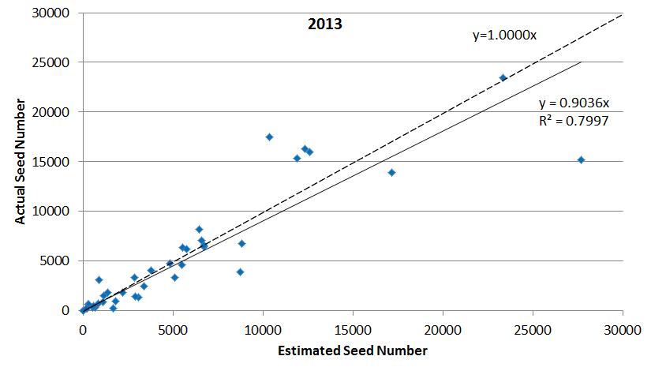

B
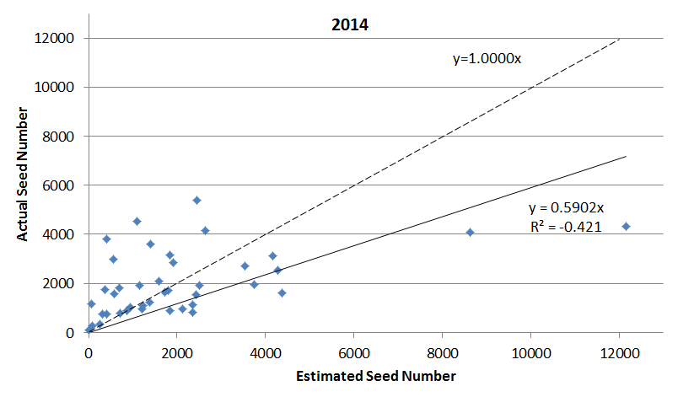
Fig. 1. Scatter plot of estimated versus actual seed number of niger plants obtained at the East Tennessee Research and Education Center, Knoxville (2013) (r=0.90; P<0.05) (A) and Plateau Research and Education Center, Crossville, TN (2014) (r=0.49; P<0.05) (B). Seed yield was estimated for ten parents, ten F₁’s, ten F₂’s, and ten backcrosses, and compared to actual seed yields for each plant. Estimated seed number was calculated by multiplying the total number of capitula x the average number of seeds capitulum⁻¹ x the percent of capitula that bore seed. Fig. 1A and 1B show that the slope is significantly different from 1, and Fig. 1B shows the y intercept is significantly different from 0.

A
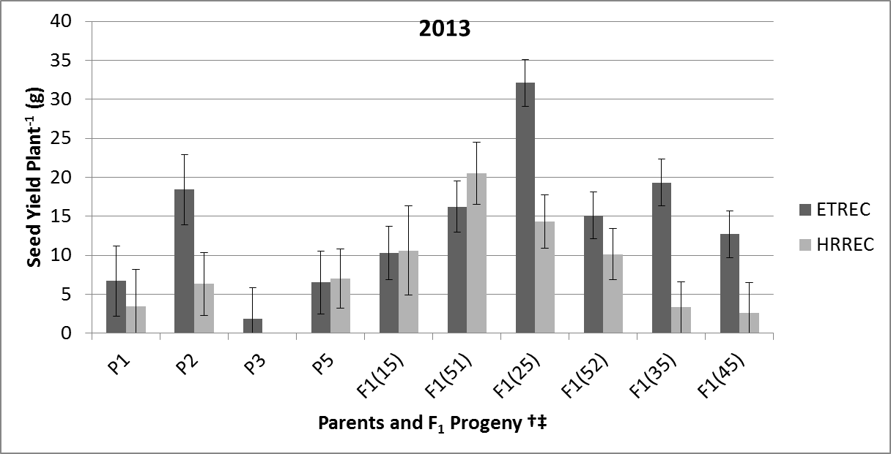
B
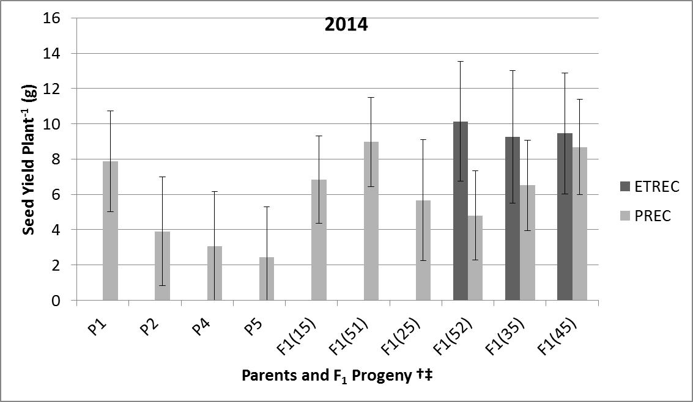
Fig. 2. Average seed yield plant⁻¹ (g) of five niger parents (P) and six F₁ crosses in 2013 at the East Tennessee (ETREC) and Highland Rim (HRREC) Research and Education Centers (A), and in 2014 at ETREC and Plateau Research and Education Center (PREC) (B). There was significant plant material x location interaction in both years; therefore the data are shown for each location. P1, P2, P3, P5, F₁(15), F₁(51), F₁(25), F₁(52), F₁(35), and F₁(45) had 8, 9, 6, 10, 16, 16, 18, 18, 19, and 19 observations, respectively, at ETREC, and 7, 10, 0, 11, 5, 10, 14, 16, 11, and 7 at HRREC in 2013 (A). P1, P2, P4, P5, F₁(15), F₁(51), F₁(25), F₁(52), F₁(35), and F₁(45) had 0, 0, 0, 0, 0, 0, 0, 7, 5, and 6 observations, respectively, at ETREC, and 10, 8, 8, 10, 16, 15, 6, 15, 14, and 12 at PREC in 2013.
† Parents and F₁’s differ significantly at P< 0.05.
‡ P1, P2, P3, P4, and P5 are parent accessions (PI 422242, PI 511305, PI 508075, PI 508076, and W6 18860, respectively). F₁(15) and F₁(51), for example, are reciprocal crosses. F₁(15) indicates that P1 was the maternal and P5 was the paternal parent.
§ P4 was missing from (A) and P3 was missing from (B) due to poor germination and disease.

A
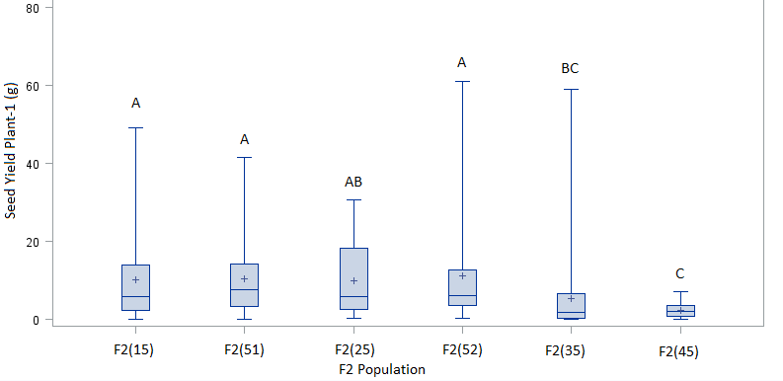
2013
B
2014
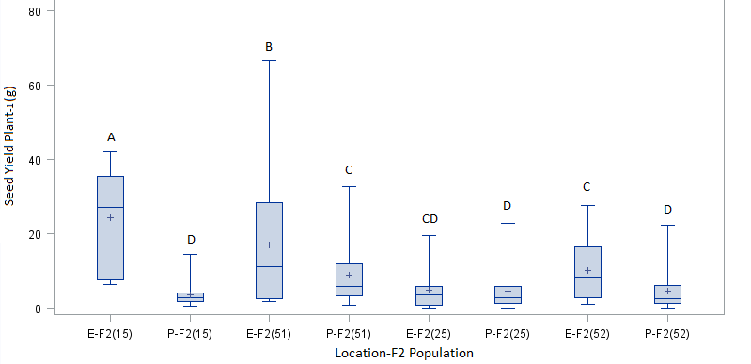
Fig. 3. Boxplots of seed yield plant⁻¹ (g) for F₂ progeny of six niger crosses pooled across the East Tennessee (E) and Highland Rim Research and Education Centers in 2013 (A), and in 2014 at ETREC and the Plateau (P) Research and Education Center (B). There was a significant plant material x location interaction in 2014; therefore the data are shown for each location. F₂(15), F₂(51), F₂(25), F₂(52), F₂(35), and F₂(45) had 87, 95, 17, 77, 64, and 42 observations, respectively (A). F₂(15), F₂(51), F₂(25), F₂(52), F₂(35), and F₂(45) had 6, 15, 16, and 23 observations, respectively, in 2014 at ETREC, and 24, 24, 72, and 88 at PREC (B).
† Bars with a letter in common are not significantly different based on Fisher’s LSD (P< 0.05).
‡ P1, P2, P3, P4, and P5 are parent accessions (PI 422242, PI 511305, PI 508075, PI 508076, and W6 18860, respectively). F₂(15) and F₂(51), for example, are reciprocal crosses. F₂(15) indicates that P1 was the maternal and P5 was the paternal parent.
§ F₂(35) and F₂(45) from PREC were missing in (B) due to poor germination and disease.

A
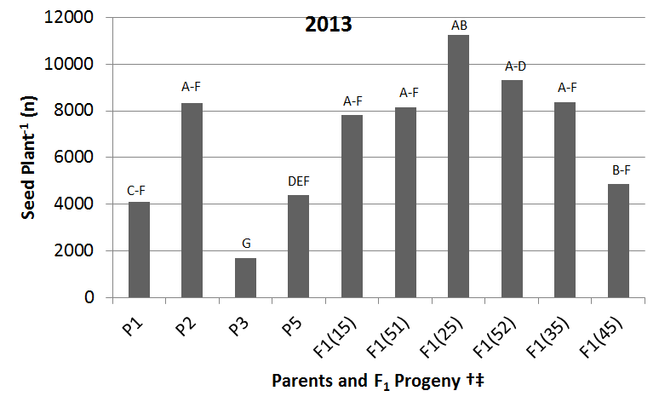
Parent Mean
F1 Mean
B
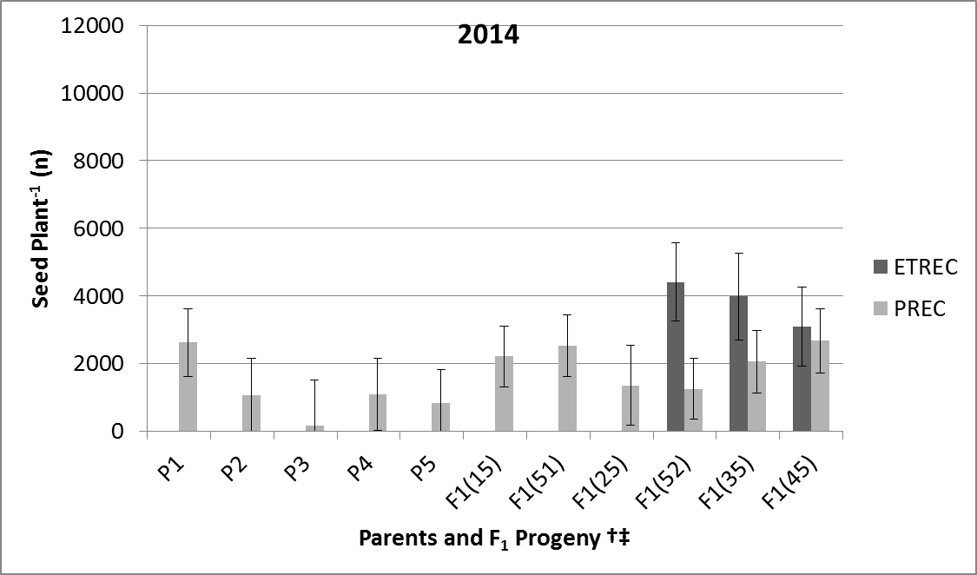
Fig. 4. Average seed plant⁻¹ (n) of five niger parents (P) and six F₁ crosses at East Tennessee (ETREC) and Highland Rim (HRREC) Research and Education Centers in 2013 (A), and in 2014 at ETREC and Plateau Research and Education Center (PREC) (B). There was a significant plant material x location interaction in 2014; therefore the data are shown for each location. P1, P2, P3, P5, F₁(15), F₁(51), F₁(25), F₁(52), F₁(35), and F₁(45) had 8, 9, 6, 10, 16, 16, 18, 18, 19, and 19 observations, respectively, at ETREC, and 7, 10, 2, 11, 5, 10, 14, 16, 11, and 7 at HRREC in 2013 (A). P1, P2, P3, P4, P5, F₁(15), F₁(51), F₁(25), F₁(52), F₁(35), and F₁(45) had 0, 0, 0, 0, 0, 0, 0, 0, 7, 5, and 6 observations at ETREC, and 10, 8, 8, 10, 16, 15, 6, 15, 14, and 12 at PREC in 2014 (B).
† Bars with a letter in common are not significantly different based on Fisher’s LSD (P< 0.05).
‡ P1, P2, P3, P4, and P5 are parent accessions (PI 422242, PI 511305, PI 508075, PI 508076, and W6 18860, respectively). F₁(15) and F₁(51), for example, are reciprocal crosses. F₁(15) indicates that P1 was the maternal and P5 was the paternal parent.
§ P4 was missing from (A) due to poor germination and disease.

A
2013
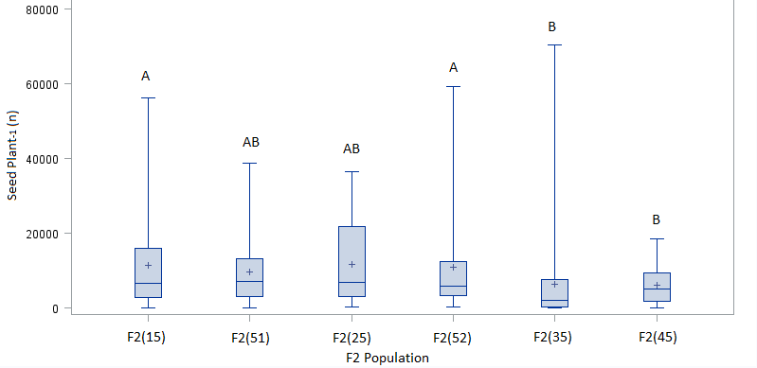
B
2014
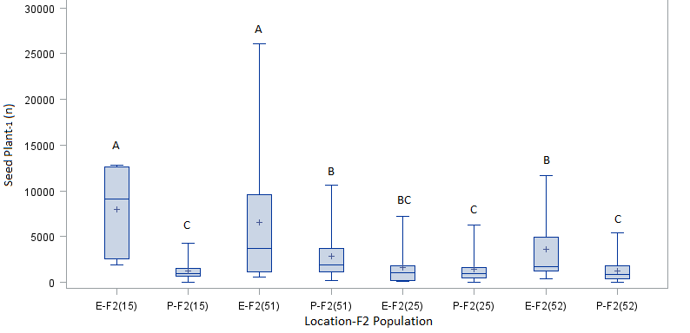
Fig. 5. Boxplots of seed plant⁻¹ (n) for F₂ progeny of six niger crosses pooled across the East Tennessee (E) and Highland Rim Research and Education Centers in 2013 (A), and in 2014 at ETREC and Plateau Research and Education Center (P) (B). There was a significant plant material x location interaction in 2014; therefore the data are shown for each location. F₂(15), F₂(51), F₂(25), F₂(52), F₂(35), and F₂(45) had 87, 95, 17, 77, 64, and 42 observations, respectively, in Figure 4A. F₂(15), F₂(51), F₂(25), F₂(52), F₂(35), and F₂(45) had 6, 15, 16, and 23 observations, respectively, in 2014 at ETREC, and 24, 24, 72, and 88 at PREC (B).
† Bars with a letter in common are not significantly different based on Fisher’s LSD (P< 0.05).
‡ P1, P2, P3, P4, and P5 are parent accessions (PI 422242, PI 511305, PI 508075, PI 508076, and W6 18860, respectively). F₂(15) and F₂(51), for example, are reciprocal crosses. F₂(15) indicates that P1 was the maternal and P5 was the paternal parent.
§ F₂(35) and F₂(45) from ETREC and PREC were missing in (B) due to poor germination and disease.
A

B

Fig. 6. Average branches plant⁻¹ (n) for five niger parents (P) and six F₁ crosses at the East Tennessee (ETREC) and Highland Rim (HRREC) Research and Education Centers in 2013 (A), and in 2014 at ETREC, HRREC, and Plateau Research and Education Center (PREC) (B). There was a significant plant material x location interaction in 2013 and 2014; therefore the data are shown for each location. P1, P2, P3, P4, P5, F₁(15), F₁(51), F₁(25), F₁(52), F₁(35), and F₁(45) had 8, 9, 11, 5, 10, 17, 16, 18, 17, 19, and 18 observations, respectively, at ETREC, and 10, 10, 10, 1, 12, 5, 13, 14, 16, 21, and 16 at HRREC in 2013 (A). P1, P2, P3, P4, P5, F₁(15), F₁(51), F₁(25), F₁(52), F₁(35), and F₁(45) had 2, 3, 3, 3, 4, 2, 4, 1, 10, 7, and 8 observations, respectively, at ETREC, 11, 11, 11, 12, 8, 12, 14, 3, 18, 16, and 16 at HRREC, and 12, 11, 9, 11, 12, 18, 18, 6, 18, 18, and 16 at PREC in 2014 (B).
† Parents and F1’s with overlapping error bars are not significantly different at P< 0.05.
‡ P1, P2, P3, P4, and P5 are parent accessions (PI 422242, PI 511305, PI 508075, PI 508076, and W6 18860, respectively). F₁(15) and F₁(51), for example, are reciprocal crosses. F₁(15) indicates that P1 was the maternal and P5 was the paternal parent.

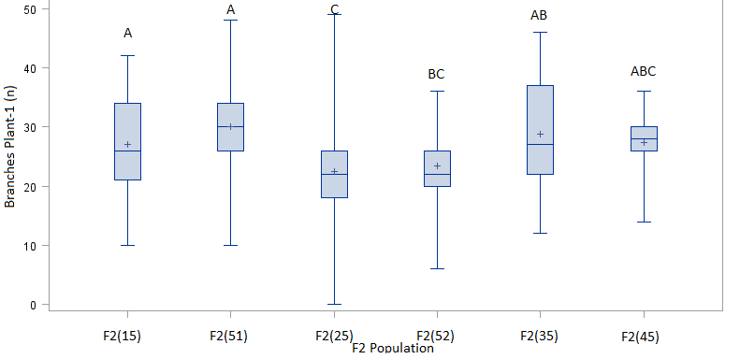
Fig. 7. Boxplots of branches plant⁻¹ (n) for F₂ progeny of six niger crosses combined across the East Tennessee (ETREC), Highland Rim (HRREC), and Plateau (PREC) Research and Education Centers in 2014. F₂(15), F₂(51), F₂(25), F₂(52), F₂(35), and F₂(45) had 86, 96, 35, 101, 77, and 49 observations, respectively.
† Bars with a letter in common are not significantly different based on Fisher’s LSD (P< 0.05).
‡ P1, P2, P3, P4, and P5 are parent accessions (PI 422242, PI 511305, PI 508075, PI 508076, and W6 18860, respectively). F₂(15) and F₂(51), for example, are reciprocal crosses. F₂(15) indicates that P1 was the maternal and P5 was the paternal parent.

Fig. 8. Average capitula plant⁻¹ (n) of five niger parents (P) and six F₁ crosses at the East Tennessee (ETREC) and Highland Rim (HRREC) Research and Education Centers in 2013. There was a significant plant material x location interaction; therefore the data are shown for each location. P1, P2, P3, P4, P5, F₁(15), F₁(51), F₁(25), F₁(52), F₁(35), and F₁(45) had 8, 9, 11, 4, 10, 17, 16, 18, 18, 19, and 19 observations, respectively, at ETREC, and 10, 10, 3, 0, 12, 5, 12, 14, 16, 21, and 16 at HRREC.
† Parents and F1’s with overlapping error bars are not significantly different at P<0.05.
‡ P1, P2, P3, P4, and P5 are parent accessions (PI 422242, PI 511305, PI 508075, PI 508076, and W6 18860, respectively). F₁(15) and F₁(51), for example, are the reciprocal F₁ crosses. F₁(15) indicates that P1 was the maternal and P5 was the paternal parent.

Fig. 9. Average seed capitulum⁻¹ (n) of five niger parents (P) and six F₁ crosses at the East Tennessee (ETREC) and Highland Rim (HRREC) Research and Education Centers in 2013. There was a significant plant material x location interaction; therefore the data are shown for each location. P1, P2, P3, P4, P5, F₁(15), F₁(51), F₁(25), F₁(52), F₁(35), and F₁(45) had 8, 9, 6, 4, 10, 16, 16, 18, 18, 19, and 19 observations, respectively, at ETREC, and 8, 11, 0, 0, 11, 5, 10, 14, 16, 11, and 8 at HRREC.
† Parents and F1’s with overlapping error bars are not significantly different at P<0.05.
‡ P1, P2, P3, P4, and P5 are parent accessions (PI 422242, PI 511305, PI 508075, PI 508076, and W6 18860, respectively). F₁(15) and F₁(51), for example, are reciprocal crosses. F₁(15) indicates that P1 was the maternal and P5 was the paternal parent.

Fig. 10. Average maturity by harvest (%) of five niger parents (P) and six F₁ crosses at the East Tennessee (ETREC) and Highland Rim (HRREC) Research and Education Centers in 2013. There was a significant plant material x location interaction; therefore the data are shown for each location. P1, P2, P3, P4, P5, F₁(15), F₁(51), F₁(25), F₁(52), F₁(35), and F₁(45) had 8, 9, 6, 4, 10, 16, 16, 18, 18, 19, and 19 observations, respectively, at ETREC, and 8, 11, 0, 0, 11, 5, 10, 14, 16, 11, and 7 at HRREC.
† Parents and F1’s with overlapping error bars are not significantly different at P<0.05.
‡ P1, P2, P3, P4, and P5 are parent accessions (PI 422242, PI 511305, PI 508075, PI 508076, and W6 18860, respectively). F₁(15) and F₁(51), for example, are reciprocal crosses. F₁(15) indicates that P1 was the maternal and P5 was the paternal parent.
§ Harvest occurred in mid to late October in 2013 following a killing frost.

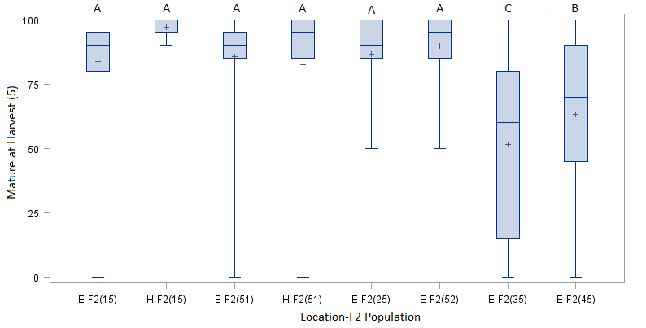
Fig. 11. Boxplots of maturity by harvest (%) for F₂ progeny of six niger crosses in 2013 at the East Tennessee (E) and Highland Rim (H) Research and Education Centers. There was a significant plant material x location interaction; therefore the data are shown for each location. F₂(15), F₂(51), F₂(25), F₂(52), F₂(35), and F₂(45) had 81, 80, 15, 74, 63, and 42 observations, respectively, at ETREC, and 7, 15, 0, 0, 0, and 0 at HRREC.
† Bars with a letter in common are not significantly different based on Fisher’s LSD (P< 0.05).
‡ P1, P2, P3, P4, and P5 are parent accessions (PI 422242, PI 511305, PI 508075, PI 508076, and W6 18860, respectively). F₂(15) and F₂(51), for example, are reciprocal crosses. F₂(15) indicates that P1 was the maternal and P5 was the paternal parent.
§ F₂(45) from HRREC was missing from the figure due to poor germination and disease.

A

B
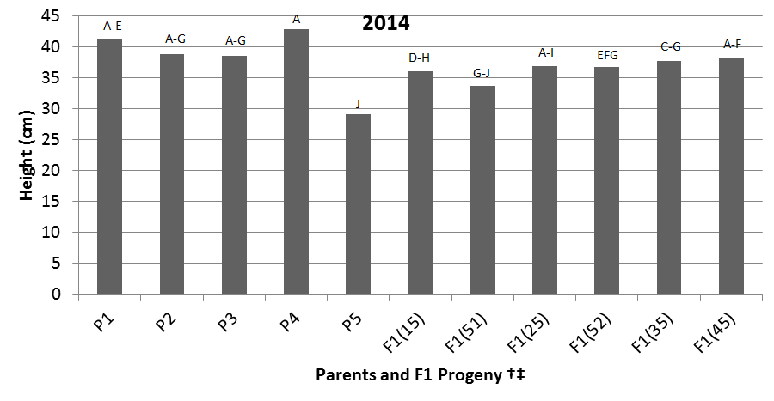
Fig. 12. Average height of five niger parents (P) and six F₁ crosses at the East Tennessee (ETREC) and Highland Rim (HRREC) Research and Education Centers in 2013 (A), and in 2014 at ETREC, HRREC, and the Plateau Research and Education Center (B). There was a significant plant material x location interaction in 2013; therefore the data are shown for each location. P1, P2, P3, P4, P5, F₁(15), F₁(51), F₁(25), F₁(52), F₁(35), and F₁(45) had 8, 9, 11, 5, 10, 17, 15, 18, 18, 18, and 19 observations, respectively, at ETREC, and 10, 12, 12, 3, 12, 5, 13, 15, 17, 21, and 16 at HRREC in 2013 (A). P1, P2, P3, P4, P5, F₁(15), F₁(51), F₁(25), F₁(52), F₁(35), and F₁(45) had 25, 25, 23, 26, 24, 33, 36, 10, 46, 41, and 40 observations, respectively, in 2014 (B).
† Parents and F1’s with overlapping error bars or shared letters (based on Fisher’s LSD) are not significantly different at P<0.05.
‡ P1, P2, P3, P4, and P5 are parent accessions (PI 422242, PI 511305, PI 508075, PI 508076, and W6 18860, respectively). F₁(15) and F₁(51), for example, are reciprocal crosses. F₁(15) shows that P1 was the maternal and P5 was the paternal parent.
A
2013
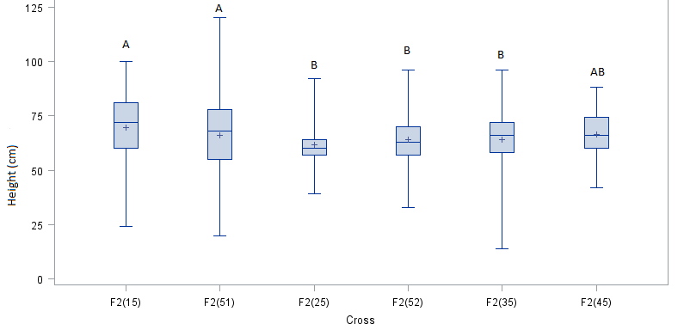
F₂ Popualtion
B
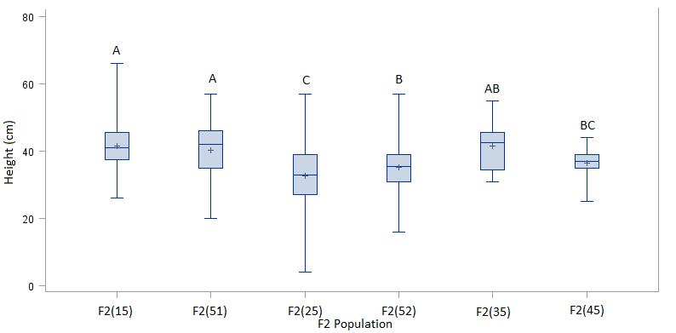
2014
Fig. 13. Boxplots of height for F₂ progeny of six niger crosses at the East Tennessee (ETREC) and Highland Rim (HRREC) Research and Education Centers in 2013 (A), and in 2014 at ETREC, HRREC, and Plateau Research and Education Center (PREC) (B). F₂(15), F₂(51), F₂(25), F₂(52), F₂(35), and F₂(45) had 87, 100, 17, 76, 83, and 48 observations, respectively, in 2013 (A). F₂(15), F₂(51), F₂(25), F₂(52), F₂(35), and F₂(45) had 44, 65, 175, 212, 8, and 9 observations, respectively, in 2014 (B).
† Bars with a letter in common are not significantly different based on Fisher’s LSD (P< 0.05).
‡ P1, P2, P3, P4, and P5 are parent accessions (PI 422242, PI 511305, PI 508075, PI 508076, and W6 18860, respectively). F₂(15) and F₂(51), for example, are reciprocal crosses. F₂(15) shows that P1 was the maternal and P5 was the paternal parent.

A
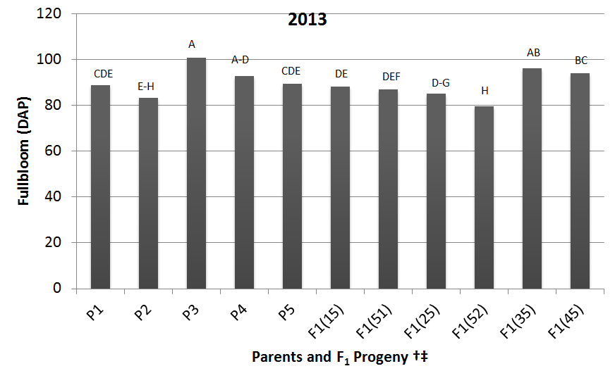
B

Fig. 14. Average full bloom measured in days after planting (DAP) showing variation of five niger parents (P) and six F₁ crosses at the East Tennessee (ETREC) and Highland Rim (HRREC) Research and Education Centers in 2013 (A), and in 2014 at ETREC, HRREC, and the Plateau Research and Education Center (B). There was a significant plant material x location interaction in 2014; therefore the data are shown for each location. P1, P2, P3, P4, P5, F₁(15), F₁(51), F₁(25), F₁(52), F₁(35), and F₁(45) had 11, 12, 13, 5, 9, 18, 17, 18, 18, 18, and 19 observations, respectively, in 2013 (A). P1, P2, P3, P4, P5, F₁(15), F₁(51), F₁(25), F₁(52), F₁(35), and F₁(45) had 1, 3, 3, 3, 4, 2, 4, 1, 10, 7, and 9 observations, respectively, at ETREC, 11, 11, 11, 12, 7, 12, 14, 3,18, 16, and 15 at HRREC, and 12, 11, 8, 11, 12, 18, 18, 6, 18, 18, and 16 at PREC in 2014 (B).
† Parents and F₁’s with a letter in common are not significantly different based on Fisher’s LSD (P< 0.05).
‡ P1, P2, P3, P4, and P5 are parent accessions (PI 422242, PI 511305, PI 508075, PI 508076, and W6 18860, respectively). F₁(15) and F₁(51), for example, are reciprocal crosses. F₁(15) indicates that P1 was the maternal and P5 was the paternal parent.
A
2013
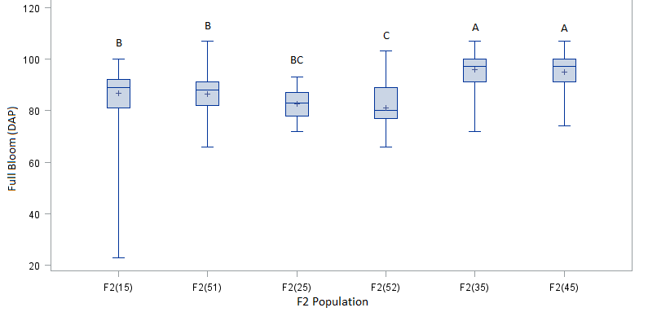
B
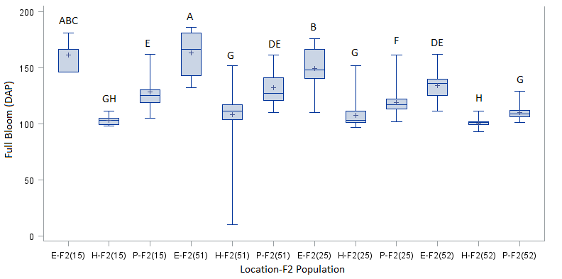
2014
Fig. 15. Boxplots of full bloom measured in days after planting (DAP) for F₂ progeny of six niger crosses at the East Tennessee (E) and Highland Rim (H) Research and Education Centers in 2013 (A), and at E, H, and the Plateau (P) Research and Education Center in 2014 (B). There was a significant plant material x location interaction in 2014; therefore the data are shown for each location. F₂(15), F₂(51), F₂(25), F₂(52), F₂(35), and F₂(45) had 89, 92, 15, 79, 87, and 51 observations, respectively, in (A). F₂(15), F₂(51), F₂(25), F₂(52), F₂(35), and F₂(45) had 7, 15, 20, 27, 4, and 2 observations, respectively, at ETREC, 11, 22, 71, 89, 3, and 5 at HRREC, and 26, 28, 82, 96, 1, and 2 at PREC in 2014.
† Bars with a letter in common are not significantly different based on Fisher’s LSD (P< 0.05).
‡ P1, P2, P3, P4, and P5 are parent accessions (PI 422242, PI 511305, PI 508075, PI 508076, and W6 18860, respectively). F₂(15) and F₂(51), for example, are reciprocal crosses. F₂(15) indicates that P1 was the maternal and P5 was the paternal parent.

CHAPTER III

FATTY ACID ANALYSIS USING GAS CHROMATOGRAPHY

Abstract

American Goldfinches and other songbirds such as house finches, pine siskins, and redpolls choose niger seed for its high oil content. The objective of this study was to determine total seed oil (%) and fatty acid composition on plant introductions and progeny of crosses from selected parents from the USDA/ARS germplasm collection at Pullman, WA. Ten replications of the fourteen PIs were planted under field and greenhouse conditions at the East Tennessee Research & Education Center in Knoxville in August of 2012 using a completely randomized design. After initial assessments were made, five of these PIs were then selected for further evaluation, and crosses were made to produce six F1’s, eight BC’s, and six F₂’s. Seed were planted at the East Tennessee (2013 and 2014), Highland Rim (2013 and 2014), and Plateau (2014) Research and Education Centers in a randomized complete block design with replication. Preliminary data showed seed oil ranging from 32.87 to 37.89% (PI508076 and PI509436, respectively). Major fatty acids included stearic, palmitic, oleic, and linoleic; with linoleic acid in greatest amount. PI508079 had the best combination of seed yield, seed oil, and linoleic acid content. Results from 2013 and 2014 showed PI 422242 and PI 508076 had the greatest linoleic and lowest oleic fatty acid, whereas PI 511305 and W6 18860 had the lowest linoleic but greatest oleic fatty acid. W6 18860/PI 422242//W6 18860/PI 422242 had the greatest linoleic fatty but lowest oleic fatty acid, whereas W6 18860/PI 511305//W6 18860/PI 511305 had the greatest oleic but lowest linoleic fatty acid.

Introduction
Niger’s excellent oil quality makes it suitable for many purposes. Its most common purpose is as an oilseed crop for human and avian consumption. In Ethiopia, niger accounts for roughly 50-60% of the country’s edible oil requirement (Quinn and Myers, 2002). In the United States, niger is primarily marketed as a birdseed primarily for the American goldfinch, pine siskin, common redpoll, finches, and other songbirds (Wild Delight, 2015). Niger has been used as feedstock; has been incorporated in paints, perfumes, and soaps; and has the potential for use as a biodiesel (Demirbas, 2008). Fatty acid methyl esters from niger oil have been touted as an environmentally safe, nontoxic, and suitable biodiesel source from its saponification value, cetane number, and iodine value (Yadav et al., 2012).
Fatty acids are major components of cellular membranes, and therefore have the ability to influence cellular processes such as transporter, receptor, and other membrane bound protein activities (Ruthig and Mechling-Gill, 1999). The majority of fatty acids comprising niger seed oil are unsaturated; predominantly linoleic (C18:2) and oleic (C18:1). Primary saturated fatty acids include palmitic (C16:0) and stearic (C18:0) (Ramadan and Morsel, 2002). Linoleic fatty acid is a polyunsaturated omega-6 fatty acid found in abundance in many nuts and oilseeds. This essential fatty acid must be consumed for proper health. Without such, research has discovered negative effects such as hair loss, mild scaling of skin (Cunnane and Anderson, 1997), and poor wound healing (Ruthig and Mechling-Gill, 1999). Oleic fatty acid is monounsaturated fat common in the human diet that has been associated with the reduction of LDL cholesterol and possible the increase of HDL cholesterol (Mensink et al., 2003). Oleic acid is also associated with the reduction of adrenoleukodystrophy (ALD), blood pressure, and risk of breast cancer. Palmitic and stearic fatty acids are saturated fats needed to maintain proper health, but if consumed in large quantities, result in negative health effects. Together, they has been linked to an increased risk of vascular disease, reduced insulin activity (Benoit et al., 2009), and increase risk of Alzheimer's disease (Patil and Chan, 2005).
While a previous study indicated that the fatty acid differentiation between taxa was insignificant (Dagne and Jonsson, 1997), it is possible that the USDA/ARS germplasm collection contains plant introductions that are significantly different. The objective is to determine variation of four major fatty acids in seed of niger accessions and progeny (F₁ and F₂) from crosses of selected accession used as parents.

Materials and Methods

Preliminary evaluation of plant introductions

Fourteen accessions were received from the USDA/ARS germplasm collection in Pullman, WA. Thirteen accessions (sixty seeds each) were planted in the central greenhouse located at the University of Tennessee on 20 July 2012. Three of these accessions were from India (PI 422242, PI 509436, and PI 511305). Nine were from Ethiopia (PI 508070, PI 508072 - PI 508077, PI 508079, PI 508080), and one accession was from the U.S. (W 18860). Ten replications of each PI were planted under field and greenhouse conditions at the East Tennessee Research & Education Center in Knoxville in August of 2012.
Seed from all available plants were bulked within each accession due to seed scarcity and sent to the USDA-ARS Plant Genetic Resources Conservation Unit in Griffin, GA for analysis of seed oil and fatty acid composition using Time Domain Nuclear Magnetic Resonance (TD-NMR) and Gas Chromatography (Agilent 7890A). Afterwards, the same seed were analyzed University of Tennessee’s gas chromatograph (Agilent 7683). Two replications of were analyzed with both the Agilent 7890A (Griffin, GA) and Agilent 7683 (Knoxville, TN) Gas Chromatographs.
After these initial assessments were made, five of these PIs were then selected as parents (PI 422242, PI 511305, PI 508075, PI 508076, and W6 18860) and used for crossing. Parents were given codes P1, P2, P3, P4, and P5, respectively, and crosses were made to produce six different F₁ progeny [F₁(15), F₁(51), F₁(25), F₁(52), F₁(35), and F₁(45)]. Each F₁ was then pollinated with pollen from plants of the same cross to produce six different F₂ progeny. Seed were then planted at the East Tennessee (2013 and 2014), Highland Rim (2013 and 2014), and Plateau (2014) Research and Education Centers in a randomized complete block design with replication.
Oil and Fatty Acid Analyses
Total oil percentage was measured using TD-NMR (Bruker mq10 minispec NMR analyzer, Resonance Instruments, Whitney Oxfordshire, UK). The operating resonance frequency was set at 9.95 MHx and maintained at 40° C. For each signal acquisition, spin echo parameters consisted of a 90 pulse of 10.44 μs and reading at 50 μs followed by a 180 pulse of 21.38 μs and reading at 7 ms. A 2 second recycle delay between scans was used, and a total of 16 scans were collected for each sample. Bulk seed measurements were made in a 40 mm glass sample tube, and NMR signals were compared to oil and moisture calibration curves, generated by sample weight. Each of the fourteen accessions was measured twice then averaged to report the value of oil content in this study. Oil standards were generated using extracted oils.
Fatty acid content was estimated using Gas Chromotography. The fatty acid composition analysis was adopted and modified from a previously published method. Three to five niger seeds were ground to a fine powder. Oil from a small amount (∼50−75 mg) of meal was extracted in 5.0 mL of heptane (Fisher Scientific) and converted to FAMEs with 500 μL of 0.5 N sodium methoxide (NaOCH3) in methanol. Water was added to separate the organic layer containing fatty acids from the niger meal, and a portion of this layer was transferred to a vial for injection. Fatty acid composition was determined on an Agilent 7890A gas chromatograph (GC) with a flame ionization detector (FID). Peak separation was performed on a DB-225 capillary column (15 m × 0.25 mm i.d. with a 0.25 μm film) from Agilent Technologies. The inlet and detector temperatures were set to 280 and 300 °C, respectively. The carrier gas was helium set to a flow rate of 1.0 mL/min. One microliter of sample was injected at a 60:1 split ratio onto the column with the following thermal gradient: 195 °C for 3 min, 195 to 200 °C at 2.5 °C min, 200 to 230 °C at 5 °C min, and 230 to 235 °C at 1.5 °C min for a total run time of 14 min. A fatty acid methyl ester (FAME) standard mix RM-3 plus four additional FAMES (all from Sigma) were mixed and used to establish peak retention times. Fatty acid composition was determined by identifying and calculating relative peak areas. The O/L ratio was determined by % oleic acid /% linoleic acid.
Fatty acids were measured using gas chromatography. Two samples of approximately 117 seed from each of the 13 accessions were crushed and transferred to a test tube via a funnel where 2.5mL extraction solvent (8 parts chloroform (CHCl₃), 5 parts hexane (C₆H₁₄), and 2 parts methanol (CH₃OH)) was added in a hood. The tubes were capped and left in the hood to sit with the labeled end facing out. The next day 100μL of extract from each tube was transferred to a corresponding vial with a pipette. 750μL of hexane and 75μL of methylation reagent was added to each vial. The vials were capped and transferred to autosampler trays and analyzed via the Agilent 7683 Gas Chromatograph.
In 2014, parent, F₁, F₂, and backcross (BC) seed from ETREC and PREC were analyzed. Each sample was dried for 5 hours , and was lightly crushed using a mortar and pestle. The samples were transferred to a 15 ml (16x100 mm) test tube where the sample was weighed. 5 ml of extraction solvent (5:8:2 mixture of hexane, chloroform, methane, respectively) was added to the crushed seed. The mixture was allowed to sit for at least 6 hours so the oil fraction would separate from the solvent solution and niger hulls. The oil sample was derivitized to find the fatty acid profiles. 150 uL of extract was transferred to vial to which 75uL methylation reagent and 0.75 mL Hexane was added to each vial. The samples were analyzed via an Agilent 7683 Series gas chromatograph.
Statistical Analyses
The preliminary oil and fatty acid data of niger accessions and the fatty acid analysis from 2014 were analyzed with ANOVA mixed model analysis of variance and Fisher’s LSD (P<.05) using SAS 9.3 (Cary, NC). The preliminary evaluation of oil and fatty acids (both methods) used a completely randomized design, where different sub-samples of seed were used as replications. The 2014 fatty acid analysis used a randomized complete block design with replication. Parents and F₁’s were analyzed in the same data set, while F₂’s were analyzed separately. Location, plant material (parents and F₁; F₂), and plant material x location interaction were considered fixed effects, while block and block x plant material interaction were considered random effects. Since plant material x location interaction was insignificant, data were pooled across locations.

Results

Percent total oil content and all fatty acids showed significant differences among accessions for the study in 2012 (P<.0001). Total oil (%) was greatest in PI 422242 (38%) and PI 509436 (38%), and lowest in PI 508076 (33%) (Fig. 1). A study by Ramadan and Mörsel (2003a, 2003b) showed that dry niger seed contained 27 to 47% oil and with a mean of 35%. A study by Bhatnagar and Gopala Krishna revealed the cold pressed seeds resulted in 28% oil, whereas hexane and ethanol extractions resulted in 38% and 30 % oil (2014). In studies comparing the variability of 35 accessions for oil quality, results showed that the total oil content ranged 35-40% with a mean of 38% (Yadav, 2012; Yadav et al., 2012).
Significant differences were found between testing methods for determining mean separation for linoleic , oleic, and palmitic fatty acids (Fig. 3-5, respectively) (P<0.05), but not for stearic acid. Still, results between both methods were very similar, so the methods were pooled. Results for linoleic, oleic, palmitic, and stearic fatty acid compositions showed significant variation among the USDA niger accessions (P<0.05). PI 508079 contained the most linoleic acid (82%) and W6 18860 had the least (53%). W6 18860 had the most oleic acid (30%) while PI 508079 contained the least (3%). Palmitic fatty acid was greatest in W6 18860 (9%) and lowest in PI 508073 (8%). Results showed that PI 508072 contained the most stearic acid (8%) whereas PI 508079 had the least (5%). Arachidic fatty acid was less than 1%, and linolenic fatty acid was less than 0.40% (not shown in figure). Additional fatty acids included sapienic (less than .20%), behenic (1%), and lignoceric (less than 1%) (not shown in figure).
Previous studies have analyzed variation in fatty acid profiles. Oleic acid, a monounsaturated fatty acid, ranged from 24- 53% with linoleic acid ranging from 32-58% (Yadav, 2012; Yadav et al., 2012). Palmitic acid, the primary source of saturated fat, ranged 8-9%, and stearic acid, a secondary source of saturated fat, ranged 7-9%. Ramadan and Mӧrsel found the major fatty acids in niger were linoleic (up to 63%), along with oleic (11%), palmitic (17%), and stearic (7%) fatty acids (2003a). Bockisch (1998) stated that niger oil may contain up to 1% arachidic and 3% linolenic fatty acid. These studies, along with the preliminary evaluation of niger accessions in this study, indicate the possibility of future breeding efforts to improve seed yield, increase oil content, and increase linoleic fatty acid content for niger grown in the United States.
Significant differences (P<0.05) were found among P’s and F₁’s for linoleic, oleic, and palmitic fatty acid for data collected in 2014. Since there were no significant location or plant material (parents and F₁) x location interaction, data from each fatty acid was pooled across locations. No significant differences were found for stearic acid (P<0.05). P1 and P4 contained the greatest amount of linoleic fatty acid (60% and 61%, respectively), whereas P2 and P5 contained the least (47% and 49%, respectively) (Fig. 3). Parents and F₁’s both averaged 54% percent linoleic fatty acid (Fig. 3). P1 and P4 had the least oleic fatty acid (15% and 15%, respectively), whereas P2 and P5 had the most (25% and 26%, respectively) (Fig. 4). Parents and F₁’s both averaged 20% oleic fatty acid. F1(45) had the greatest amount of palmitic fatty acid (16%) (Fig. 5). Parents and F1’s showed slight differences in average percent palmitic fatty acid, 11% and 12%, respectively.
Significant differences (P<0.05) were found among F₂’s in linoleic, oleic, and palmitic fatty acids, but not in stearic fatty acid. Since plant material (parents and F₁) x location interaction was not significant, data were pooled across locations for linoleic, oleic, and palmitic fatty acid (Fig. 6-8). The mean for linoleic acid across all F2 crosses was 53% (Fig. 6). Boxplots show that F₂(51) contained the greatest amount of linoleic acid (61%), whereas F₂(52) contained the least (49%) (Fig. 6). Contrastingly, F₂(51) contained the least amount of oleic fatty acid (13%), and F₂(52) contained the greatest (26%) (Fig. 7). The mean for oleic fatty acid was 22% across all F₂ crosses (Fig. 7), whereas palmitic fatty acid averaged 11% (Fig. 8). F₂(25) and F₂(52) showed significantly lower palmitic fatty acid (11% and 11%, respectively) than F₂(15) and F₂(51) (13% and 13%, respectively). F₂(35) and F₂(45) were missing from the analyses due to poor germination and disease.
Conclusions

Of the 12 accessions analyzed in 2012, total oil was greatest in PI 422242 and PI 509436 (38% and 38%, respectively) and lowest in PI 508076 (33%). Linoleic acid was greatest in PI 508079 (82%) and lowest in W6 18860 (53%), whereas PI 508079 had the least (3%) and W6 18860 had the greatest (30%) amount of oleic acid. PI 508073 resulted in the least amount of palmitic acid (8%) whereas W6 18860 resulted in the greatest (9%). Stearic acid was greatest in PI 508072 (8%) and lowest in PI 508079 (5%).
In conclusion, correlations were medium (palmitic) to strong (stearic, oleic, and linoleic) between both machines when analyzing fatty acid content of niger seeds. This indicates that both methods statistically similar. Since the Agilent 7890A Chromatographer had a standard error of 0.081 and the Agilent 7683 Chromatographer had a standard error of 0.084, it can be assumed that either technique will report similar results.
Seed quality is retained longer in seeds with high oleic fatty acid content than seeds high in linoleic fatty acid. This is due to oleic acid’s lower susceptibility to oxidation (Miller et al., 1987). The syntheses of unsaturated fatty acids are controlled by several genes and are a part of a complex metabolic pathway. Breeding efforts would therefore be most effective using marker assisted selection.
In 2014, linoleic acid of parents ranged from 47% (P2) to 61% (P4) (Fig. 3). F₁ progeny ranged from 50% [F₁(52)] to 58% [F₁(15) and F₁(25)] (Fig. 3), and F₂ progeny ranged from 49% [F₂(52)] to 61% [F₁(51)] (Fig. 6). Overall, there was not much variation in the F₂ progeny for linoleic, oleic, or palmitic acid (Fig. 6-8). F₁(25) and F₁(52) resulted in high parent heterosis in linoleic fatty acid (Fig. 3), but low parent heterosis in oleic fatty acid (Fig. 4). These results are expected because oleic acid is the precursor fatty acid to linoleic acid (Alemaw and Wold, 1995). Furthermore, a strong negative correlation of -0.83 was found between oleic and linoleic acid. A previous study also found a strong negative correlation between these two fatty acids (Geleta et al., 2011). Oleic acid of parents ranged from 15 (P1 and P4) and 26% (P5) (Fig. 4). F₁ progeny ranged from 17% [F₁(45) and F₁(25)] to 24% [F₂(52)] (Fig. 4), while F₂ progeny ranged from 16% [F₂(15)] to 26% [F₂(52)] (Fig. 7). F₂(25) and F₂(52) showed high-parent heterosis in oleic fatty acid (Fig. 7).
Palmitic acid for parents ranged from 11% (P2 and P5) to 13% (P4) while F₁ progeny ranged from 10% [F₁(52)] to 16% [F₁(45)] (Fig. 5). F2 progeny ranged from 11% [F₂(25) and F₂(52)] to 13% [F₂(15) and F₂(51)] (Fig. 8). F₁(15), F₁(25), and F₁(45) showed high parent heterosis for palmitic fatty acid (Fig. 5). The mean for stearic acid across all locations and populations was 7%.

Literature Cited

Alemaw, G. and A.T. Wold. 1995. An agronomic and seed-quality evaluation of noug (Guizotia abyssinica Cass.) germplasm in Ethiopia. Plant Breeding 114(4):175-176.
Benoit, S., C. Kemp, C.F. Elias, W. Abplanalp, J.P. Herman, S. Migrenne, A. Lefevre, C. Cruciani-Gulielmacci, C. Magnan, F. Yu, K. Niswender, B.G. Irani, W.L. Holland, and D. Clegg. 2009. Palmitic acid mediates hypothalamic insulin resistance by altering PKC- θ subcellular localization in rodents. J. Clin. Invest., 119(9):2577-2589.

Cunnane, S.C. and M.J. Anderson. 1997. Pure linoleate deficiency in the rat: influence on growth, accumulation of n-6 polyunsaturates, and [ 1⁻¹⁴ C] linoleate oxidation. J. of Lipid Research, 38:805-812.

Dagne, K. and A. Jonnson. 1997. Oil content and fatty acid composition of seeds of Guizotia Cass (Compositae). J Sci Food Agric, 73:274-278.

Demirbas, A. 2008. Biodiesel: A realistic fuel alternative for diesel engines. Spring, London, UK.

Geleta, M., S. Stymne, and T. Bryngelsson. 2011. Variation and inheritance of oil content and fatty acid composition in niger (Guizotia abyssinica). J Food Comp. Anal 24(7): 95- 1003.
Mensink R., P. Zock, A. Kester, and M. Katan. 2003. Effects of dietary fatty acids and carbohydrates on the ratio of serum total to HDL cholesterol and on serum lipids and apolipoproteins: a meta-analysis of 60 controlled trials. Am. J. Clin. Nutr., 77:1146-55.

Miller, J. F., D. C. Zimmerman, and B. A. Vick. 1987. Genetic control of high oleic acid content in sunflower oil. Crop Sci., 27:923–926.

Patil, S. and C. Chan. 2005. Palmitic and stearic fatty acids induce Alzheimer-like hyperphosphorylation of tau in primary rat cortical neurons. Neurosci Lett., 384(3):288- 293.

Quinn, J. and R.L. Myers. 2002. Nigerseed: Specialty Grain Opportunity for Midwestern US. ASAH Press, Alexandria, VA.
Ramadan, M.F. and J.T. Morsel. 2002. Proximate neutral lipid composition of niger (Guizotia abyssinica Cass.) seed. Czech J. Food Sci., 20: 98–104.

Wild Delight. 2015. Nyjer Seed. D & D Commodities Ltd. http://www.wilddelight.com/products/nyjer-seed/ (accessed 23 March 2015).

Appendix

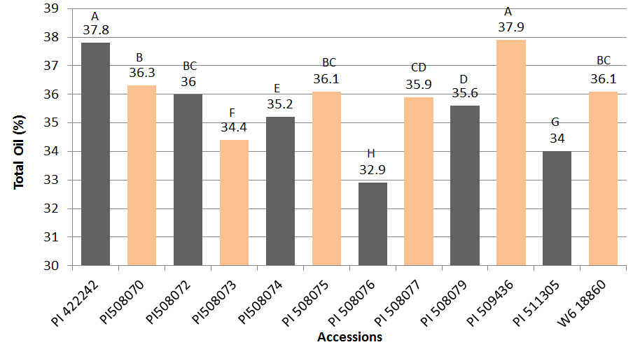
Fig. 1. Mean comparison of seed oil content of 12 niger accessions evaluated at the East Tennessee Research and Education Center, Knoxville in 2012. Seed was analyzed at the USDA-ARS Plant Genetic Resources Conservation Unit in Griffin, GA (Dr. Ming Li Wang) using a Bruker mq10 minispec NMR analyzer (Resonance Instruments, Whitney Oxfordshire, UK).
† Bars with a letter in common are not significantly different based on Fisher’s LSD (P< 0.05).

Fig. 2. Linoleic, oleic, palmitic, and stearic fatty acid percentages using the mean of two different gas chromatograph models for seed collected from the East Tennessee Research and Education Center, Knoxville in 2012. Seed was analyzed at the USDA-ARS Plant Genetic Resources Conservation Unit in Griffin, GA (Dr. Ming Li Wang) using Aglient 7890A. Different samples of the same seed were later analyzed at the University of Tennessee using Agilent 7683. Means were averaged from both tests and ranked by accession according.

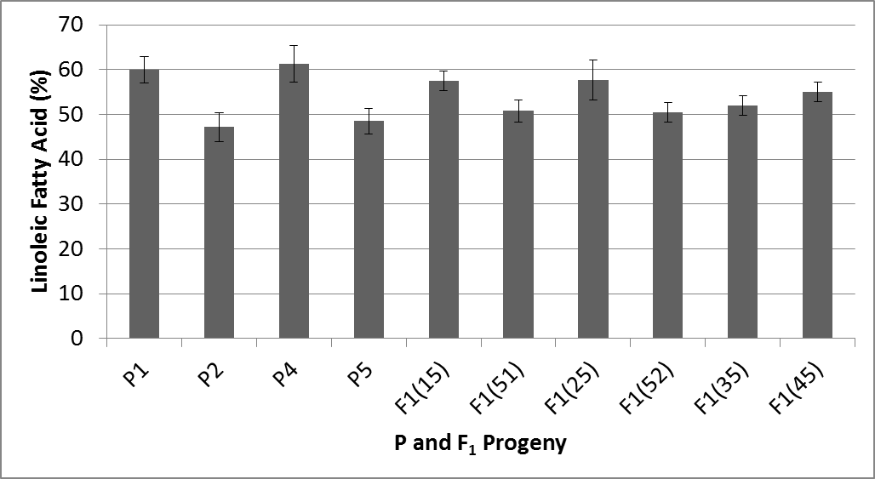
Fig. 3. Average linoleic fatty acid (%) for parents (P) and F₁ progeny in 2014 at the East Tennessee (ETREC) and Plateau (PREC) Research and Education Centers. P1, P2, P3, P4, P5, F₁(15), F₁(51), F₁(25), F₁(52), F₁(35), and F₁(45) had 12, 10, 7, 12, 20, 16, 7, 22, 23, and 22 observations, respectively.
† Parents and F1’s with overlapping error bars are not significantly different at P<0.05.
‡ P1, P2, P3, P4, and P5 are parent accessions (PI 422242, PI 511305, PI 508075, PI 508076, and W6 18860, respectively). F₁(15) and F₁(51), for example, are the reciprocal F₁ crosses. F₁(15) shows that P1 was the maternal parent plant and P5 was the paternal parent plant.
§ P3 was missing due to poor germination and disease.

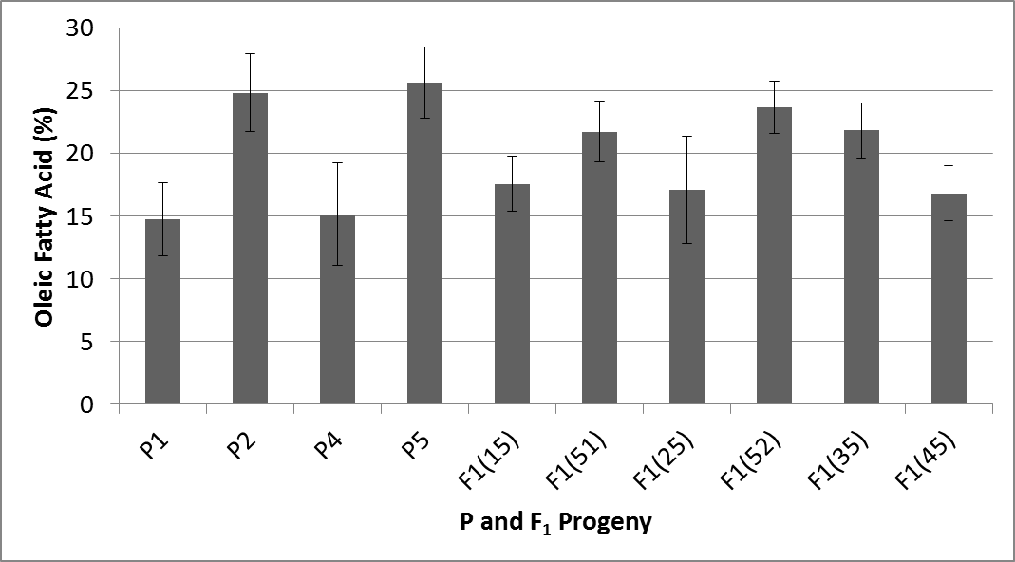
Fig. 4. Average oleic fatty acid (%) for P and F₁ progeny in 2014 at the East Tennessee (ETREC) and Plateau (PREC) Research and Education Centers. P1, P2, P3, P4, P5, F₁(15), F₁(51), F₁(25), F₁(52), F₁(35), and F₁(45) had 12, 10, 7, 12, 20, 16, 7, 22, 23, and 21 observations, respectively.
† Parents and F1’s with overlapping error bars are not significantly different at P<0.05.
‡ P1, P2, P3, P4, and P5 are parent accessions (PI 422242, PI 511305, PI 508075, PI 508076, and W6 18860, respectively). F₁(15) and F₁(51), for example, are the reciprocal F₁ crosses. F₁(15) shows that P1 was the maternal parent plant and P5 was the paternal parent plant.
§ P3 was missing due to poor germination and disease.

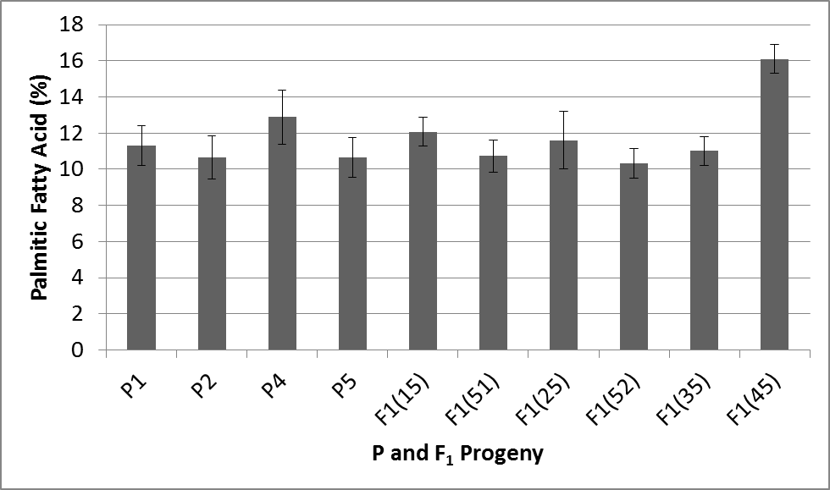
Fig. 5. Average palmitic fatty acid (%) for P and F₁ progeny in 2014 at the East Tennessee (ETREC) and Plateau (PREC) Research and Education Centers. P1, P2, P3, P4, P5, F₁(15), F₁(51), F₁(25), F₁(52), F₁(35), and F₁(45) had 12, 10, 7, 12, 20, 16, 7, 22, 23, and 22 observations, respectively.
† Parents and F1’s with overlapping error bars are not significantly different at P<0.05.
‡ P1, P2, P3, P4, and P5 are parent accessions (PI 422242, PI 511305, PI 508075, PI 508076, and W6 18860, respectively). F₁(15) and F₁(51), for example, are the reciprocal F₁ crosses. F₁(15) shows that P1 was the maternal parent plant and P5 was the paternal parent plant.
§ P3 was missing due to poor germination and disease.

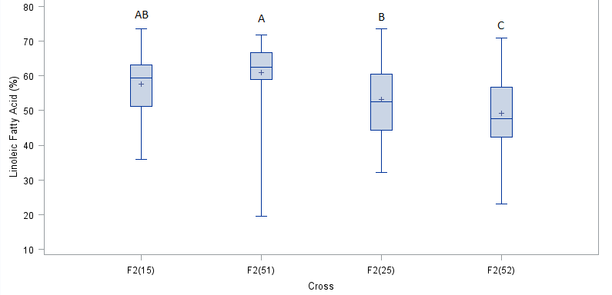
Fig. 6. Boxplots showing linoleic fatty acid (%) variation of F₂’s in 2014 at the East Tennessee (ETREC) and Plateau (PREC) Research and Education Centers. F2(15), F2(51), F2(25), F2(52), F2(35), and F2(45) had 29, 41, 89, and 114 observations, respectively.
† Bars with a letter in common are not significantly different based on Fisher’s LSD (P< 0.05).
‡ P1, P2, P3, P4, and P5 are parent accessions (PI 422242, PI 511305, PI 508075, PI 508076, and W6 18860, respectively). F₁(15) and F₁(51), for example, are the reciprocal F₁ crosses. F₁(15) shows that P1 was the maternal parent plant and P5 was the paternal parent plant. F₂(15) shows that two F₁(15) plants were crossed with one another.
§ F₂(35) and F₂(45) from were missing due to poor germination and disease.

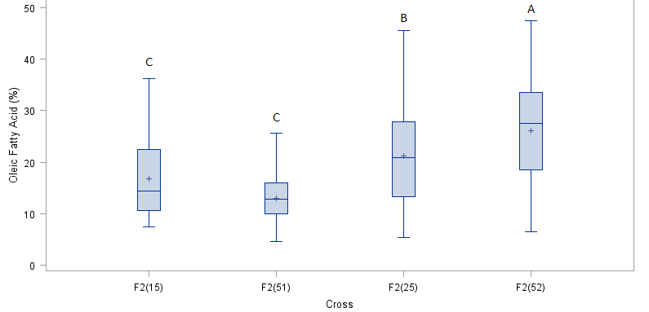
Fig. 7. Boxplots showing oleic fatty acid (%) variation of F₂’s in 2014 at the East Tennessee (ETREC) and Plateau (PREC) Research and Education Centers. F2(15), F2(51), F2(25), F2(52), F2(35), and F2(45) had 29, 41, 89, and 114 observations, respectively.
† Bars with a letter in common are not significantly different based on Fisher’s LSD (P< 0.05).
‡ P1, P2, P3, P4, and P5 are parent accessions (PI 422242, PI 511305, PI 508075, PI 508076, and W6 18860, respectively). F₁(15) and F₁(51), for example, are the reciprocal F₁ crosses. F₁(15) shows that P1 was the maternal parent plant and P5 was the paternal parent plant. F₂(15) shows that two F₁(15) plants were crossed with one another.
§ F₂(35) and F₂(45) from were missing due to poor germination and disease.

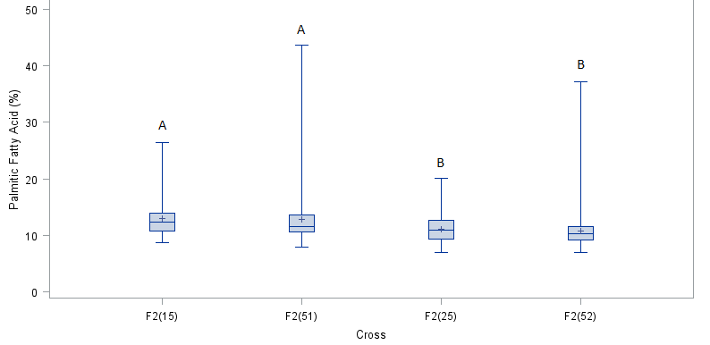
Fig. 8. Boxplots showing palmitic fatty acid (%) variation of F₂’s in 2014 at the East Tennessee (ETREC) and Plateau (PREC) Research and Education Centers. F2(15), F2(51), F2(25), F2(52), F2(35), and F2(45) had 29, 41, 89, and 114 observations, respectively.
† Bars with a letter in common are not significantly different based on Fisher’s LSD (P< 0.05).
‡ P1, P2, P3, P4, and P5 are parent accessions (PI 422242, PI 511305, PI 508075, PI 508076, and W6 18860, respectively). F₁(15) and F₁(51), for example, are the reciprocal F₁ crosses. F₁(15) shows that P1 was the maternal parent plant and P5 was the paternal parent plant. F₂(15) shows that two F₁(15) plants were crossed with one another.
§ F₂(35) and F₂(45) from were missing due to poor germination and disease.

CHAPTER IV

GENERATION MEANS ANALYSIS OF SEED YIELD, SEED NUMBER, BRANCHES, CAPITULA, AND FATTY ACIDS AMONG CROSSES OF NIGER

Abstract
In the United States, niger (Guizotia abyssinica (L.f) Cass.) is primarily marketed as a seed of choice for American goldfinch (Spinus tristis) as well as other song and ground feeding birds because of its high oil content. In countries such as Ethiopia and India, niger is grown as an edible oilseed crop. The objectives of this study were to determine: (i) genetic variance, (ii) broad sense heritability, (iii) and gene effects using generation mean analysis of selected F₁ crosses. The traits analyzed included seed yield plant⁻¹, seed plant⁻¹, branches plant⁻¹, capitula plant⁻¹, linoleic acid, oleic acid, and palmitic acid content. Fourteen niger plant introductions (PIs) of Indian, Ethiopian, and American origin were obtained from USDA/ARS germplasm collection at Pullman, WA. Ten replications of the fourteen PIs were planted under field and greenhouse conditions at the East Tennessee Research & Education Center in Knoxville in August, 2012 using a completely randomized design. After initial assessments were made, three of the PIs were then selected for further evaluation, and crosses were made to produce four F1, eight BC, and four F₂ populations. Seed were planted at the East Tennessee (2013 and 2014), Highland Rim (2013 and 2014), and Plateau (2014) Research and Education Centers. With the exception of seed yield, all traits had the greatest genetic variance in the F₂ population. Results showed low to moderate (0.00-0.44) broad sense heritability for all traits. Dominance gene effects were most influential on all traits. Epistatic gene effects were significant and had equal influence on traits as additive gene effects.

Introduction

Quantitative traits such as yield are controlled by multiple genes. This makes it difficult to separate individuals of a population into discreet classes. Populations can be expressed by the amount and type of genetic variability it contains. These components include: phenotypic, genotypic, additive, dominance, interaction, and environmental (Fehr, 1987). Estimating the relative magnitude of these components determines the genetic properties of the population as well as the degree of relatedness between relatives. Genetic variance among individuals of a population is the function of the additive, dominance, epistatic interaction, and gene frequency. The level of genetic variance is therefore unique to the population from which the components were obtained (Falconer, 1960). In this study the components of genetic variance will be estimated using ANOVA and generation means analysis. Gene effects and heritability are also reported. A study involving 35 niger accessions analyzed the heritability for linoleic, oleic, palmitic, and stearic fatty acid resulted in high broad sense heritability (>0.90) for all traits except linoleic (0.79) (Yadav et al., 2014). No gene effect research has been conducted thus far on niger. A 2006 study of gene effects on hectoliter mass of sunflower showed significant additive, dominant, and epistatic interaction (Marinković et al.). Dominance effects most influential of all gene effects in both years. The objective of this study is to determine genetic variance for yield and yield components (height, number of capitula plant⁻¹, number of seeds capitulum ⁻¹, and number of branches plant⁻¹) as well as fatty acids (linoleic, oleic, palmitic, and stearic) among niger accessions as well as crosses among five accessions.

Materials and Methods

Based on evaluations of the fourteen accessions in 2012 (Chapter 2, page 31), five were chosen for use as parents in crosses. Crosses among the five parents (USDA source) were made from October thru November, 2012. The U.S. accession, W6 18860, was used either as a female or male parent in cross combinations producing six F₁ and six F₂ progeny. Information on parents, F₁, and F₂ crosses and the mean data can be seen in Chapter 2, page 31. BC progeny were also produced so that mean information could be included in the generation means analysis to estimate gene effects. Parent accessions used to produce BC progeny were PI 422242, PI 511305, and W6 18860; coded as P1, P2, and P5, respectively. F₁ seed were harvested December thru January, 2013 and a portion was planted in the greenhouse to produce backcross (BC) progeny (BC results are presented in Chapter IV, pages 103). Pollen was collected and bulked among plants within each cross [e.g. F₁(15)], and the bulked pollen was used to pollinate individual capitulum (flowers) on several plants within the cross [e.g. F₁(15), F₁(51), etc.]. The BC seed were produced by crossing four F₁ crosses [F₁(15), F₁(51), F₁(25), and F₁(52)] and its reciprocal to both respective parents. The eight resulting backcrosses were used in the generation means analysis [e.g. BC151, BC155, etc.]. Mature F₂ and BC seed were harvested in June, 2013.
Seed of parents, F1, F2, and BC progeny were planted in a greenhouse at the University of Tennessee on 5 July 2013 and 21 April 2014 for the 2013 and 2014, for all three locations, respectively. Seed were sown in germination trays (50 cells tray-1) filled with FafordTM germination mix. Germination occurred 3 to 5 days after planting, and on 22 July 2013 and 19 May 2014, once the seedlings reached approximately 12-18 cm in height, they were transplanted to their respective field locations.
A space planted nursery utilizing a randomized complete block design with replication was used at each location each year. Each location contained four blocks. In 2013, the space planted nurseries at ETREC and HRREC consisted of measured 2 m between rows and 2.5 m within rows. In 2014, the space planted nursery at ETREC consisted of 3 m between rows and 3.5 m within rows. At HRREC and PREC in 2014, the spacing was 4 m between rows and 4 m within rows. Within each block, each parent was replicated 3 times, and F1’s and BC’s were replicated five times. Each block contained 25 F2 plants in sets of five for each cross. Thus at each location there was a total of 12 plants of each parent, 20 F1 and BC plants per cross, and 100 F2 plants per cross for a grand total of 940 plants per location. The perimeters of each space planted nursery at each location were bordered by extra parent and F₁ plants.
Prior to transplanting the plants to each field location, 75g of Peter’s 20N-20P2O5-20K2O was applied to all plants in the greenhouse on 18 July 2013 and 19 May 2014. Prior to transplanting at ETREC, the site was tilled and sprayed with 1.68 kg a.i. ha-1 of Treflan (Trifluralin 4EC) on 6 July 2013. On 15 August 2013, the field at ETREC was sprayed with Select (Clethodim) at 0.053 kg a.i. ha-1. On 3 July 2014, the site at ETREC was sprayed with .336 kg a.i. ha-1 of Basagran (sodium salt of bentazon) and 1.228 kg a.i. ha-1 of Roundup Max (Glyphosate). Prior to transplanting at HRREC, sites were plowed and sprayed with 1.754 kg a.i. ha-1 of Treflan (Trifluralin 4EC) on 24 July 2013 and 19 May 2014. Prior to transplanting, the site at PREC was sprayed with 0.028 kg a.i. ha-1 of Sandea on 17 May 2014. On 21 June 2014, the site at PREC was sprayed with .355 kg a.i. ha-1 of Basagran (Bentazon) and 1.169 kg a.i. ha-1 of Roundup Max (Glyphosate).
Several F₁ border plants were used to produce F₂ seed for the 2014 harvest season. In order to produce F₂ progeny for the 2014 season, two or more F₁ plants of the same cross from border plots were covered with an insect-proof mesh netting cage and a colony of honey bees (Apis mellifera) was placed in each cage to allow for cross pollination between plants. Once the seed began to mature, the colonies of bees were removed. BC seed for the 2014 growing season was produced by covering F₁ and parent plants with the netting.
Each P was replicated 3 times in each block (3 plants * 4 blocks/location = 12 plants/location). Each F₁ and BC were replicated 5 times in each block (5 plants * 4 blocks/location = 20 plants/location). Each F₂ was replicated in five rows. Each row containing five plants (5 plants/row * 39 rows/block * 4 blocks/location = 780 plants/location).
This study was conducted over 2013 and 2014 at the three locations across Tennessee. The first field location was ETREC in Knoxville, TN (35.53°N 83.57°W) (2013 and 2014). The soil at this location was classified as an Etowah loam (Fine-loamy, siliceous, semiactive, thermic Typic Paleudults). The second field location was at the Highland Rim Research & Education Center (HRREC) in Springfield, TN (36.28°N 86.51°W) (2013 and 2014). The soil type at HRREC is classified as either a Dickson silt loam (2013) (Fine-silty, siliceous, semiactive, thermic Glossic Fragiudults) or a Sango silt loam (2014) (Coarse-silty, siliceous, semiactive, thermic Glossic Fragiudults). The third site was at the Plateau Research & Education Center (PREC; 2014 only) in Crossville, TN (36.01°N 86.13°W) on a soil type classified as Ramsey-Rock outcrop complex (loamy, siliceous, active, mesic Lithic Dystrudepts).
Yield was estimated from plants collected in the 2013 growing at ETREC and HRREC season due to seed immaturity and threshing problems. These estimations were determined by multiplying total capitula plant⁻¹, average seed capitulum⁻¹, plant maturity (%), and 100 seed weight, then dividing by 100. In 2014, actual yield was only recorded at ETREC and PREC due to widespread plant loss to disease at HRREC. Capitula were hand threshed, and seed were separated from chaff via an air separator (Seed Tech Systems), and counted in an electronic seed counter (Seedburo 801 Count-A-Pak). Whole plants were placed into the hand thresher, where seed and chaff were separated from the branches. The seed-chaff material was then separated using sifting pans and a vacuum air separator. Once the seed were thoroughly cleaned, it was counted using the electronic seed counter. Paired observation t-tests were run on actual vs. estimated yield on 10 parents, 10 F₁s, 10 F₂s and 10 backcrosses in both 2013 and 2014 to determine whether estimated yield from 2013 would have been statistically similar to actual yield, and if actual yield from 2014 would have been statistically similar to estimated yield. Pearson’s correlation test (SAS 9.3) was completed the same 80 samples to test the strength and direction between estimated and actual seed yield.
Statistical Analysis
Data were collected on: seed yield plant⁻¹ (g) (2013 and 2014), seed plant⁻¹ (n) (2013 and 2014), total branches plant⁻¹ (2013 and 2014), total flower plant⁻¹ (2013), and linoleic, oleic, palmitic, and stearic fatty acids (2014). Seed yield plant⁻¹ (g) and total seed plant⁻¹ (n) were analyzed separately by year due to the potential of making a Type II error while comparing estimated yield (2013) and actual yield (2014). Seed yield, seed plant⁻¹, branches, and flowers were collected from ETREC and HRREC in 2013. In 2014, data for branches were collected from ETREC, HRREC, and PREC, whereas seed yield, seed plant⁻¹, and fatty acid data were only collected from ETREC and PREC.
BC Means
Mixed model analysis of variance and Fisher’s LSD (P<0.05), SAS 9.3 (Cary, NC) were used to evaluate selected backcrosses across all years and locations using a randomized complete block design with replication. Branch data were analyzed across multiple years and locations, year, location, plant material (backcross), plant material x year interaction, and plant material x location interaction were included as fixed effects. If significant plant material x year interaction was found, years were analyzed separately. Likewise, if significant plant material x location interaction was found, locations were analyzed separately. For traits analyzed by individual years and multiple locations, location, plant material, and plant material x location interaction were included as fixed effects. In all analyzes, block and plant material x block interaction were included as random effects. If an analysis showed insignificant plant material differences, analyses were conducted across locations and/or years.
Genetic Variance
A mixed model analysis of variance using SAS 9.3 (Cary, NC) determined genetic variance for combined P’s, combined F₁’s, combined F₂’s, combined BC’s, as well as all populations combined together. Genetic variance was reported directly from the covariance parameter estimate output, “cross”, using proc mixed (SAS 9.3). Other variables in the proc mixed statement included location and cross*location interaction since years were analyzed individually. The “cross” covariance parameter estimate was divided by the sum of all covariance parameter estimates in the model to calculate broad sense heritability for combined F₂’s.
Gene Effects
Generation means analysis was used to estimate gene effects. Estimates were taken from contrast statements using mixed model analysis of variance in SAS 9.3, and recorded for each F₁ and related generations (P1, P2, F₂, P2F₁, and P2F₁) to obtain estimates of gene effects of the mean (m), additive (a), dominance (d), and epistasis (aa, ad, dd). Estimates of the above effects were computed for each cross as follows:
m=F₂
a=P₁F₁-P₂F₁
d=-1/2P₁-1/2P₂+F₁-4F₂+2P₁F₁+2P₂F₁
aa=-4F₂+2P₁F₁+2P₂F₁
ad=-1/2P₁+1/2P₂+P₁F₁-P₂F₁
dd=P₁+P₂+2F₁+4F₂-4P₁F₁-P₂F₁
where:
F₂= F₂ mean
P1= Female parent mean
P2= Male parent mean
F₁= F₁ mean
P1F₁= Backcross mean (backcross F₁ mean to female parent)
P2F₁= Backcross mean (backcross F₁ mean to male parent)
(Gamble, 1961).
Results

Roughly 85% of the plants at the HRREC location were affected by Southern Blight (Sceroltium rolfsii) in 2014. This soil-borne disease first infects the lower stems, then caused dieback and death. The blight was most active in the middle of the season (July and August), causing the capitula to senesce before they had time to pollinate and produce seed. Total seed yield (g) and total seed number were thereby affected, and the entire location was not included for these traits. Results for parents, F₁’s, and F₂’s can be found in Chapter 2 starting on page 38.
BC Means
Seed Yield Plant⁻¹ (g)
BC’s were analyzed separately by year. In 2013, BC results showed no significant cross or cross*location effects, but did show significant location differences. After pooling, cross remained insignificant. In 2014, BC results showed that cross and location were significant, and cross*location interaction was not (Fig. 2). Yield ranged from 5.9 g (BC525) to 20.3 g (BC511). BC515 and BC255 were not included in the figure due to poor germination and disease. The average total seed yield plant⁻¹ was 12.7 g.
Seed Plant⁻¹ (n)
BC’s were analyzed separately by year. In 2013, BC results showed significant location and cross*location effects. Cross effects were insignificant (Fig. 3A). BC populations at ETREC resulted in a greater number of seed than populations at HRREC. BC255-E was the highest yielding population. In 2014, BC’s resulted in significant cross, location, and cross*interaction effects (Fig. 3B). Plants grown at ETREC resulted in more seed (7,268 seed) than those grown at PREC (2,014 seed). BC511-E had significantly more seed (14,996) than all other BC populations.
Branches Plant⁻¹ (n)
BC’s were analyzed separately by year. In 2013, BC’s showed that cross and cross*location were not significant, but location was. After pooling, cross was still insignificant. In 2014, BC’s resulted in significant cross and location effects (Fig. 4). BC525 had significantly fewer branches than the other BC’s. BC’s were then analyzed with year (2013 and 2014) and location (ETREC and HRREC) effects. BC’s showed that cross was the only significant fixed effect (Fig. 5). BC522 had the greatest number of branches.
Capitula Plant⁻¹(n)
Capitula notes were only taken in 2013. BC’s resulted in no significant fixed effects. After pooling, cross was still insignificant. Overall, means ranged from 279 (BC151) to 883 (BC515) capitula plant⁻¹.
Linoleic, Oleic, Palmitic, and Stearic Fatty Acid (%),
Results showed no significant differences among BC’s for any of the fatty acids. There were no significant location or cross*location effects. Linoleic and oleic acid ranged from 47-57% and 17-25%, respectively. Palmitic and stearic acid ranged from 11-13% and 7-8% respectively.
Genetic Variance
In 2014, all F₁’s showed no genetic variance for seed yield plant⁻¹ (Table 1) across locations. This indicates that variation among F₁’s was due the environment. Data combined over both years showed no genetic variance or broad sense heritability for P’s, F₁’s, BC’s, and F₂’s. The greatest genetic variance existed in 2013 among the parent generation at ETREC (38.7). As a whole, the F₁’s resulted in the greatest genetic variance in 2013 in comparison to parents, F₂, or backcrosses. In 2014, broad sense heritability of F₂’s ranged from 0 to 0.19. In 2014, broad sense heritability was greatest at ETREC in comparison to the other locations.
Results for total seed plant⁻¹ (n) can be seen in Table 2. P’s showed the greatest genetic variance. In 2013, all BC’s resulted in no genetic variance. Genetic variation was greatest overall in 2013 from the parent population at ETREC (17,019,745). The F2 population had the greatest genetic variance overall in both years, ranging from 291,483 to 4,519,130. In 2013, broad sense heritability ranges from 0.03 to 0.15, and ranged from 0.04 to 0.17 in 2014. Broad sense heritability was greatest at HRREC in 2013, and ETREC in 2014.
Results for total branches plant⁻¹ (n) can be seen in Table 3. P’s showed the greatest genetic variance of all populations. Genetic variance of P’s was 0 in when years were combined. Genetic variance was overall greatest in the parent population in 2014. Genetic variance ranged from 6.4 to 17.3. Broad sense heritability ranges from 0 to 0.22. Broad sense heritability was greatest at ETREC in 2014.
Results for total capitula plant⁻¹ (n) can be seen in Table 4. P’s, F₁’s, BC’s, and F₂’s had no genetic variance when locations were combined. Genetic variance was greatest in the F1 population at ETREC (24,956). Broad sense heritability was greatest at HRREC, 0.44.
Results for linoleic fatty acid (%) genetic variance and broad sense heritability can be seen in Table 5. The F₁’s showed a lower genetic variance than P’s, F₂’s, and BC’s. Broad sense heritabilities at E+P (0.03) and E (0.01) were relatively lower than at P (0.27). Results for oleic fatty acid (%) can be seen in Table 6. The F₁’s showed a lower genetic variance than P’s, F₂’s, and BC’s. Broad sense heritabilities were lower at E+P (0.11) and E (0.01) than at P (0.32). Genetic variance was lower for palmitic fatty acid (%) (Table 7) than oleic and linoleic fatty acids. Broad sense heritabilities ranged from 0 (E) to 0.10 (P).
Gene Effects
Dominance gene effects are the most important in the inheritance for total seed yield plant⁻¹ (g) (Table 8). With the exception of P5xP1, additive gene effects are negative; having a diminishing effect on seed yield. Of all three types of digenic epistasis, additive x additive gene effects are in greatest magnitude.
Dominance gene effects are the most important in the inheritance for total seed plant⁻¹ (n) (Table 9). Epistatic gene effects are great enough to consider important in seed yield inheritance. Additive x additive gene effects appear to be revealed with greater frequency than additive x dominance and dominance x dominance gene effects.
Additive, dominance, and epistatic gene effects have roughly equal positive and negative estimates for total branches plant⁻¹ (n) inheritance (Table 10). Dominance gene effects appear to have a greater magnitude than additive gene effects. Additive x additive and dominance x dominance epistatic gene effects appear to be equally important in branch inheritance.
Dominance gene effects appear to be more important than additive gene effects in the inheritance of total capitula plant⁻¹ (n) (Table 11). Additive x additive gene effects are the most influential of all three digenic epistatic gene effects.
The cross, P1xP5, had the greatest mean effects of all crosses for linoleic fatty acid (%) (Table 12). P2xP5 had the greatest additive effects. Values for d and dd were not available.
The cross, P2xP5, had the greatest mean effects of all crosses for oleic fatty acid (%) (Table 13). P5xP2 had the greatest additive effects. Values for d and dd were not available.
P1xP5 and P5xP2 had the greatest mean effects of all crosses for palmitic fatty acid (%) (Table 14). Values for d and dd were not available.
Conclusion
Estimates of genetic variance, gene effects, and heritability may be used to assist plant breeders with answering critical questions about their program. The first question is how extensively (in terms of years, locations, replications) must the breeding material be tested to: a) identify superior genetic populations or b) identify superior parents within these populations (Dudley, 1969)?
The genetic variance for total seed yield (g) were relatively high in 2013 and in 2014, but were 0 when years were combined (Table 2). The relative magnitude of genetic variance for total seed plant⁻¹ (n) (Table 3) and total branches were also high in 2013 and 2014. Genetic variance of total capitula (Table 4) was considerable at ETREC and HRREC. F₁’s showed lower genetic variance than P’s F₂’s, and BC’s for linoleic and oleic fatty acid (Table 6 and 7).
F₁(52) appeared to have the greatest mean (specify traits) performance and dominance effects for all traits examined (Table 9-15).
Another important question that should be answered is whether genetic variance is great enough within the germplasm pool to allow primary character improvement (Dudley, 1969). Broad sense heritability estimates of F₁ crosses indicate that dominance makes up a conderable amount of genetic variance.
Which breeding procedure will most rapidly and efficiently produce an acceptable level of improvement in the important characters?
What type of variety (hybrid, pure line, synthetic, blend, etc.) is the most appropriate goal? (Dudley, 1969).
Some assumptions were necessary while estimating genetic variance, gene effects, and heritability….limitations

Literature Cited
Dudley, J.W. and R.H. Moll. 1969. Interpretation and Use of Estimates of Heritability and Genetic Variances in Plant Breeding. Crop Sci. 9(3):257-262.
Falconer, D.S. 1960. Introduction to quantitative genetics. Robert MacLehose and Company Limited, Glasgow.
Fehr, E.L. and H.J. Jessen. 1987. Principles of cultivar development. Vol. 1. Macmillan Pub. Co., NY.
Gamble, E.E. 1961. Gene effects in corn (Zea Mays L.)- II. Relative importance of gene effects for plant height and certain component attributes of yield. Canadian J. of Plant Sci. 42:349-358.
Marinković, R., D. Jovanović, and J. Joksimović. 2006. Gene action for hectoliter mass in sunflower (Helianthus annuus L.). Helia 29(44):95-100.
Warner, J.N. 1952. A method for estimating heritability. Agron. J. 44: 427-430.
Wright, S.1968. Evolution and genetic of population. Volume I. Genetic and Biometric
Foundation. University of Chicago Press, Chicago. pp. 371-420.
Yadav, S. Z. Hussain, P. Suneja, M.A. Nizar, S.K. Yadav, and M. Dutta. 2014. Genetic divergence studies in niger (Guizotia abyssinica) germplasm. Biomass and Bioenergy 44:64-69.

Appendix
Table 1. Estimates of genetic variance and broad sense heritability for seed yield plant⁻¹ (g) among five niger parents and the six sets of F₁, F₂, and BC progeny evaluated at the East Tennessee (E) (2013 and 2014), Highland Rim (H) (2013), and Plateau (P) (2014) Research and Education Centers.
 |  | Genetic Variance |  |  |  | Broad Sense Heritability
Parameter |  | Population †
Year | Location | Parents | F₁ | F₂ | BC | F₂
2013 | E+H | 8.8 | 14.9 | 11.8 | 18.3 | 0.09
 | E | 38.7 | 38.0 | 10.7 | 22.5 | 0.09
 | H | 0.8 | 35.8 | 1.6 | 0 | 0.10
2014 | E+P | 4.6 | 0 | 0 | 1.6 | 0
 | E | 6.6 | 0 | 32.6 | 0 | 0.19
 | P | 4.5 | 0 | 2.3 | 0 | 0.073
† Number of observations:
2013; E+H; Parents= 67; F₁=169; F₂=381; BC=118.
2013; E; Parents= 37; F₁=106; F₂=354; BC=83.
2013; H; Parents= 30; F₁=63; F₂=27; BC=35.
2014; E+P; Parents= 44; F₁=101; F₂=274; BC=103.
2014; E; Parents= 4; F₁=23; F₂=65; BC=31.
2014; P; Parents= 40; F₁=78; F₂=209; BC=72.

Table 2. Estimates of genetic variance and broad sense heritability for total seed plant⁻¹ among five niger parents and the six sets of F₁, F₂, and BC progeny evaluated at the East Tennessee (E) (2013 and 2014), Highland Rim (H) (2013), and Plateau (P) (2014) Research and Education Centers.
 |  | Genetic Variance |  |  |  | Broad Sense Heritability
Parameter |  | Population †
Year | Location | Parents | F₁ | F₂ | BC | F₂
2013 | E+H | 3,305,165 | 0 | 4,519,130 | 0 | 0.03
 | E | 17,019,745 | 4,578,166 | 4,099,575 | 0 | 0.03
 | H | 0 | 6,330,327 | 2,862,336 | 0 | 0.15
2014 | E+P | 585,917 | 42,592 | 465,409 | 2,086,820 | 0.04
 | E | 1,855,584 | 0 | 3,999,983 | 4,218,523 | 0.17
 | P | 451,374 | 8293 | 291,483 | 0 | 0.11
† Number of observations:
2013; E+H; Parents= 67; F₁=169; F₂=381; BC=118.
2013; E; Parents= 37; F₁=106; F₂=354; BC=83.
2013; H; Parents= 30; F₁=63; F₂=27; BC=35.
2014; E+P; Parents= 44; F₁=101; F₂=274; BC=103.
2014; E; Parents= 4; F₁=23; F₂=65; BC=31.
2014; P; Parents= 40; F₁=78; F₂=209; BC=72.

Table 3. Estimates of genetic variance and broad sense heritability for total branches plant⁻¹ among five niger parents and the six sets of F₁, F₂, and BC progeny evaluated at the East Tennessee (E) (2013 and 2014), Highland Rim (H) (2013 and 2014), and Plateau (P) (2014) Research and Education Centers.
 |  | Genetic Variance |  |  |  | Broad Sense Heritability
Parameter |  | Population †
Year | Location | Parents | F₁ | F₂ | BC | F₂
2013 | E+H | 15.1 | 4.0 | 0 | 0 | 0
 | E | 11.5 | 1.8 | 2.9 | 0.1 | 0.04
 | H | 5.6 | 12.2 | 0 | 0 | 0
2014 | E+H+P | 9.8 | 3.2 | 9.8 | 8.1 | 0.17
 | E | 13.0 | 14.6 | 11.1 | 9.8 | 0.19
 | H | 6.4 | 0 | 11.9 | 3.5 | 0.18
 | P | 17.3 | 1.6 | 9.8 | 6.8 | 0.22
2013/2014 | E+H | 0 | 0 | 0.5 | 2.7 | 0.01
 | E | 0 | 2.0 | 2.6 | 2.0 | 0.04
 | H | 0 | 6.9 | 0 | 1.5 | 0
† Number of observations:
2013; E+H; Parents= 86; F₁=190; F₂=407; BC=122.
2013; E; Parents= 43; F₁=105; F₂=370; BC=82.
2013; H; Parents= 43; F₁=85; F₂=37; BC=40.
2014; E+H+P; Parents= 123; F₁=205; F₂=512; BC=194.
2014; E; Parents= 15; F₁=32; F₂=75; BC=35.
2014; H; Parents= 53; F₁=79; F₂=203; BC=66.
2014; P; Parents= 55; F₁=94; F₂=234; BC=93.
2013 and 2014; E+H; Parents= 154; F₁=301; F₂=685; BC=223.
2013 and 2014; E; Parents= 58; F₁=137; F₂=445; BC=117.
2013 and 2014; H; Parents= 96; F₁=164; F₂=240; BC=106.

Table 4. Estimates of genetic variance and broad sense heritability for total capitula plant⁻¹ (n) among five niger parents and the six sets of F₁, F₂, and BC progeny evaluated at the East Tennessee (E) (2013) and Highland Rim (H) (2013) Research and Education Centers.
 |  | Genetic Variance |  |  |  | Broad Sense Heritability
Parameter |  | Population
Year | Location | Parents | F₁ | F₂ | BC | F₂
2013 | E+H | 0 | 0 | 0 | 0 | 0
 | E | 3613.8 | 24956 | 0 | 0 | 0
 | H | 1035.2 | 0 | 3181.6 | 413.27 | 0.44
† Number of observations:
2013; E+H; Parents= 77; F₁=191; F₂=407; BC=121.
2013; E; Parents=42; F₁=107; F₂=373; BC=83.
2013; H; Parents= 35; F₁=84; F₂=34; BC=38.

Table 5. Estimates of genetic variance and broad sense heritability for linoleic fatty acid (%) among five niger parents and the six sets of F₁, F₂, and BC progeny evaluated at the East Tennessee (E) and Plateau (P) Research and Education Centers in 2014.
 |  | Genetic Variance |  |  |  | Broad Sense Heritability
Parameter |  | Population
Year | Location | Parents | F₁ | F₂ | BC | F₂
2014 | E+P | 17.4 | 0 | 3.4 | 6.2 | 0.03
 | E | 0 | 4.3 | 2.08 | 33.3 | 0.01
 | P | 41.1 | 4.2 | 28.3 | 6.2 | 0.27
† Number of observations:
2014; E+P; Parents= 45; F₁=109; F₂=280; BC=110.
2014; E; Parents=3; F₁=23; F₂=65; BC=29.
2014; P; Parents= 42; F₁=86; F₂=215; BC=81.

Table 6. Estimates of genetic variance and broad sense heritability for oleic fatty acid (%) among five niger parents and the six sets of F₁, F₂, and BC progeny evaluated at the East Tennessee (E) and Plateau (P) Research and Education Centers in 2014.
 |  | Genetic Variance |  |  |  | Broad Sense Heritability
Parameter |  | Population
Year | Location | Parents | F₁ | F₂ | BC | F₂
2014 | E+P | 10.8 | 0 | 12.2 | 6.8 | 0.11
 | E | 0 | 0 | 0.8 | 18.4 | 0.01
 | P | 35.3 | 3.5 | 35.9 | 6.8 | 0.32
† Number of observations:
2014; E+P; Parents= 45; F₁=108; F₂=280; BC=110.
2014; E; Parents= 3; F₁=22; F₂=65; BC=29.
2014; P; Parents= 42; F₁=86; F₂=215; BC=81.

Table 7. Estimates of genetic variance and broad sense heritability for palmitic fatty acid (%) among five niger parents and the six sets of F₁, F₂, and BC progeny evaluated at the East Tennessee (E) and Plateau (P) Research and Education Centers in 2014.
 |  | Genetic Variance |  |  |  | Broad Sense Heritability
Parameter |  | Population
Year | Location | P | F1 | F2 | BC | F2
2014 | E+P | 0.1 | 2.8 | 0.8 | 0.4 | 0.05
 | E | 2.0 | 19.9 | 0 | 0 | 0
 | P | 0.1 | 0.3 | 0.4 | 0.4 | 0.10
† Number of observations:
2014; E+P; Parents= 45; F₁=109; F₂=280; BC=110.
2014; E; Parents= 3; F₁=23; F₂=65; BC=29.
2014; P; Parents= 42; F₁=86; F₂=215; BC=81.

Table 8. Mean estimates of gene effects for four crosses for total seed yield plant⁻¹ (g) at the East Tennessee (E) (2013 and 2014), Highland Rim (H) (2013), and Plateau (P) (2014) Research and Education Centers.
Gene Effects
Year | Loc. | Cross | m | a | d | aa | ad | dd
2013 | E+H | P1xP5 | 7.79 | -14.07 | 18.88 | 16.00 | -13.08 | -31.15
 |  | P5xP1 | 7.99* | -8.30 | 13.78 | 2.47 | -9.30 | 9.41
 |  | P2xP5 | 7.31 | -6.84 | 52.62** | 38.20** | -9.42 | -38.77
 |  | P5xP2 | 8.17* | -15.69** | 57.87** | 54.86** | -13.12** | -98.39**
 | E | P1xP5 | 10.40** | -13.69 | 19.36 | 15.66 | -13.80 | -39.09
 |  | P5xP1 | 11.42** | -9.09 | 13.34 | 3.80 | -8.98 | -7.71
 |  | P2xP5 | 10.06** | -13.02* | 69.27** | 49.58** | -18.97** | -50.24
 |  | P5xP2 | 11.46** | -17.19** | 54.75** | 52.14** | -11.24 | -95.11**
 | H | P1xP5 | 6.47 | -8.05 | n/a | 0.52 | -8.05 | n/a
 |  | P5xP1 | 0.79 | 12.29** | n/a | 34.45 | 12.29** | n/a
 |  | P2xP5 | 3.36 | 9.09 | n/a | 7.61 | 9.09 | n/a
 |  | P5xP2 | 6.35* | -0.03 | n/a | 25.08 | -0.03 | n/a
2014 | E+P | P1xP5 | 4.79** | -2.57 | n/a | 10.53 | n/a | n/a
 |  | P5xP1 | 7.40** | 8.42** | n/a | 16.55** | n/a | n/a
 |  | P2xP5 | 11.04** | -10.68** | n/a | 15.52 | n/a | n/a
 |  | P5xP2 | 11.57** | -5.45 | n/a | -11.65 | n/a | n/a
 | E | P1xP5 | 4.91 | -3.39 | n/a | 9.64 | n/a | n/a
 |  | P5xP1 | 10.19** | 15.58* | n/a | 25.69 | n/a | n/a
 |  | P2xP5 | 11.04 | -16.14 | n/a | 41.01 | -16.14 | n/a
 |  | P5xP2 | 22.10** | -5.78 | n/a | -44.45 | -5.78 | n/a
 | P | P1xP5 | 4.68** | -1.75 | n/a | 11.43* | n/a | n/a
 |  | P5xP1 | 4.61** | 1.25 | n/a | 7.41 | n/a | n/a
 |  | P2xP5 | 1.04 | -5.21 | n/a | 30.01 | n/a | n/a
 |  | P5xP2 | 7.57** | -5.12 | n/a | -4.96 | n/a | n/a
† Significant at P≤0.01 and P≤0.05 is indicated by ** and *, respectively.
‡ P1, P2, P3, P4, and P5 code for the following accessions: PI 422242, PI 511305, PI 508075, PI 508076, and W6 18860, respectively.
§ m= mean effects, a= additive, d= dominance, aa=additive x additive, ad= additive x dominance, and dd= dominance x dominance
¶ n/a indicates the value was not able to be calculated due to missing plants caused by poor germination and disease.

Table 9. Mean estimates of gene effects for four crosses for total seed plant⁻¹ (n) at the East Tennessee (E) (2013 and 2014), Highland Rim (H) (2013), and Plateau (P) (2014) Research and Education Centers.
Gene Effects
Year | Loc. | Cross | m | a | d | aa | ad | dd
2013 | E+H | P1xP5 | 8926.36** | -7322.51 | -12156 | -14529 | -7072.26 | 13118.00
 |  | P5xP1 | 7973.52** | -1041.50 | 5897.73 | 2681.40 | -1291.75 | -13773.00
 |  | P2xP5 | 9934.40** | -4431.06 | 6303.43 | 1149.35 | -6250.42 | -6398.20
 |  | P5xP2 | 8705.31** | -932.52 | 4342.31 | 1413.89 | 886.84 | -6462.25
 | E | P1xP5 | 11918** | -6692.94** | -13246** | -16122** | -7300.74** | 9669.59**
 |  | P5xP1 | 10670** | -1609.36** | 4978.25** | 2632.45** | -1001.56** | -23907**
 |  | P2xP5 | 11989** | -8125.54** | 14378** | 7134.82** | -12208** | -14498**
 |  | P5xP2 | 11107** | -2145.31** | 1811.12** | -1018.38** | 1937.11** | -3488.37**
 | H | P1xP5 | 6264.70* | -6309.84* | n/a | -5908.21 | -6309.84* | n/a
 |  | P5xP1 | 942.37 | 5834.24** | n/a | 17574.00 | 5834.24** | n/a
 |  | P2xP5 | 2719.63 | 5520.81 | n/a | 2236.26 | 5520.81 | n/a
 |  | P5xP2 | 4278.74* | 58.34 | n/a | 13776.00 | 58.34 | n/a
2014 | E+P | P1xP5 | 1496.70** | -525.74 | n/a | 3920.69 | n/a | n/a
 |  | P5xP1 | 2450.04** | 2999.54** | n/a | 4835.37* | n/a | n/a
 |  | P2xP5 | 3358.67* | -6341.66** | n/a | 10999.00 | n/a | n/a
 |  | P5xP2 | 2729.00 | -1127.79 | n/a | 600.27 | n/a | n/a
 | E | P1xP5 | 1590.94 | -551.37 | n/a | 4090.18 | n/a | n/a
 |  | P5xP1 | 3614.83** | 5525.75 | n/a | 7308.20 | n/a | n/a
 |  | P2xP5 | 3358.67 | -11304** | n/a | 25701* | -11304** | n/a
 |  | P5xP2 | 5109.00 | -1025.09 | n/a | -4597.03 | -1025.09 | n/a
 | P | P1xP5 | 1402.47** | -500.12 | n/a | 3751.21** | n/a | n/a
 |  | P5xP1 | 1285.26** | 473.33 | n/a | 2362.54 | n/a | n/a
 |  | P2xP5 | 349.00 | -1379.03 | n/a | 8334.94 | n/a | n/a
 |  | P5xP2 | 2640.10** | -1230.50 | n/a | -2966.83 | n/a | n/a
† Significant at P≤0.01 and P≤0.05 is indicated by ** and *, respectively.
‡ P1, P2, P3, P4, and P5 code for the following accessions: PI 422242, PI 511305, PI 508075, PI 508076, and W6 18860, respectively.
§ m= mean effects, a= additive, d= dominance, aa=additive x additive, ad= additive x dominance, and dd= dominance x dominance
¶ n/a indicates the value was not able to be calculated due to missing plants caused by poor germination and disease.

Table 10. Mean estimates of gene effects for four crosses for total branches plant⁻¹ (n) at the East Tennessee (E) (2013 and 2014), Highland Rim (H) (2013 and 2014), and Plateau (P) (2014) Research and Education Centers.
Gene Effects
Year | Location | Crosses | m | a | d | aa | ad | dd
2013 | E+H | P1xP5 | 23.39** | -10.81 | -22.06 | -20.26 | -13.06 | 29.88
 |  | P5xP1 | 24.09** | 8.58 | 11.92 | 10.45 | 10.83 | -27.51
 |  | P2xP5 | 19.58** | -3.09 | 27.38** | 24.06** | -3.29 | -41.22**
 |  | P5xP2 | 20.24** | -0.70 | 11.25 | 7.32 | -0.51 | -9.15
 | E | P1xP5 | 27.49** | -10.76 | -23.74 | -20.45 | -14.34 | 33.03
 |  | P5xP1 | 28.69** | 8.27 | 7.83 | 8.69 | 11.85 | -25.17
 |  | P2xP5 | 23.40** | 0.18 | 26.30* | 21.04* | -0.13 | -29.53
 |  | P5xP2 | 24.12** | -2.32 | 7.86 | 4.59 | -2.01 | -3.50
 | H | P1xP5 | 19.33** | 11.69* | n/a | 10.04 | n/a | n/a
 |  | P5xP1 | 17.86** | -1.97 | n/a | 12.06 | n/a | n/a
 |  | P2xP5 | 23.00** | 10.71 | n/a | -10.57 | n/a | n/a
 |  | P5xP2 | 17.70** | 0.93 | n/a | 6.49 | n/a | n/a
2014 | E+H+P | P1xP5 | 26.22** | 3.72* | -0.37 | 1.24 | 1.69 | -13.99
 |  | P5xP1 | 29.93** | 1.23 | -24.48* | -22.20* | 3.26 | 16.69
 |  | P2xP5 | 21.95** | -6.28 | 17.17 | 19.65 | -6.20 | -43.92
 |  | P5xP2 | 23.40** | -6.28** | -10.22* | -9.07* | -6.36** | 10.33
 | E | P1xP5 | 28.00** | -0.86 | n/a | -6.29 | n/a | n/a
 |  | P5xP1 | 20.25** | 0.00 | n/a | 39** | n/a | n/a
 |  | P2xP5 | 22.96** | -1.71 | n/a | 0.72 | n/a | n/a
 |  | P5xP2 | 27.50** | -1.33 | n/a | -32.67* | n/a | n/a
 | H | P1xP5 | 34.17** | -3.13 | n/a | -28.45** | n/a | n/a
 |  | P5xP1 | 25.14** | -7.19 | n/a | 3.83 | n/a | n/a
 |  | P2xP5 | 26.00** | -2.71 | n/a | 10.57 | n/a | n/a
 |  | P5xP2 | 36.00** | -8.93** | n/a | -46.13** | n/a | n/a
 | P | P1xP5 | 27.63** | -3.17 | n/a | -14.19* | n/a | n/a
 |  | P5xP1 | 20.46** | -6.67* | n/a | 6.67 | n/a | n/a
 |  | P2xP5 | 21.25** | -4.40 | n/a | 10.20 | n/a | n/a
 |  | P5xP2 | 12.00* | -8.56** | n/a | 30.46 | n/a | n/a
2013/2014 | E+H | P1xP5 | 27.69** | 2.50 | -6.00 | -4.74 | 0.10 | -7.85
 |  | P5xP1 | 28.12** | 7.87 | -1.05 | -1.57 | 10.27 | -12.35
 |  | P2xP5 | 22.73** | -2.88 | 18.14** | 16.41** | -3.29 | -32.35**
 |  | P5xP2 | 24.57** | -4.57** | -1.04 | -2.28 | -4.17** | -3.30
 | E | P1xP5 | 25.18** | 2.05 | 7.00 | 9.40 | -0.12 | -25.64
 |  | P5xP1 | 27.26** | 4.79 | 2.66 | 4.14 | 6.96 | -21.58
 |  | P2xP5 | 21.87** | -0.79 | 22.23* | 17.52* | -0.22 | -25.37
 |  | P5xP2 | 22.92** | -1.86 | -0.46 | -0.80 | -2.42 | -1.63
 | H | P1xP5 | 26.40** | -2.86 | n/a | -9.90 | n/a | n/a
 |  | P5xP1 | 20.93** | -6.88 | n/a | 4.41 | n/a | n/a
 |  | P2xP5 | 21.85** | -6.34* | n/a | 17.58* | n/a | n/a
 |  | P5xP2 | 24.98** | -3.46 | n/a | -7.97 | n/a | n/a
† Significant at P≤0.01 and P≤0.05 is indicated by ** and *, respectively.
‡ P1, P2, P3, P4, and P5 code for the following accessions: PI 422242, PI 511305, PI 508075, PI 508076, and W6 18860, respectively.
§ m= mean effects, a= additive, d= dominance, aa=additive x additive, ad= additive x dominance, and dd= dominance x dominance
¶ n/a indicates the value was not able to be calculated due to missing plants caused by poor germination and disease.

Table 11. Mean estimates of gene effects for four crosses for total capitula plant⁻¹ (n) at the East Tennessee (E) and Highland Rim (H) Research and Education Centers in 2013 only.
Gene Effects
Year | Loc. | Cross | m | a | d | aa | ad | dd
2013 | E+H | P1xP5 | 441.35** | -508.96 | -383.4 | -366.25 | -494.28 | 161.34
 |  | P5xP1 | 428.34** | 280.85 | 379.69 | 621.38 | 266.18 | -1509.76
 |  | P2xP5 | 554.71** | -138.3 | 599.31 | 279.5 | -161.54 | -656.77
 |  | P5xP2 | 372.65* | -50.10 | 819.59* | 631.68 | -26.86 | -896.69
 | E | P1xP5 | 629.2** | -524.24 | -353.52 | 352.34 | -546.16 | -87.20
 |  | P5xP1 | 599.59** | 259.59 | 602.95 | 612.44 | 281.52 | -1914.94
 |  | P2xP5 | 703.20** | -155.5 | 868.06 | 399.2 | -206.3 | -670.69
 |  | P5xP2 | 528.30** | -36.17 | 844.76* | 670.46 | 54.63 | -1102.73
 | H | P1xP5 | 280.67* | 127.6 | n/a | 242.13 | n/a | n/a
 |  | P5xP1 | 206.17* | 126.48 | n/a | 691.71 | n/a | n/a
 |  | P2xP5 | 550** | 472.83* | n/a | -1050.33 | 472.83* | n/a
 |  | P5xP2 | 177.30** | 7.61 | n/a | 592.43 | 7.61 | n/a
† Significant at P≤0.01 and P≤0.05 is indicated by ** and *, respectively.
‡ P1, P2, P3, P4, and P5 code for the following accessions: PI 422242, PI 511305, PI 508075, PI 508076, and W6 18860, respectively.
§ m= mean effects, a= additive, d= dominance, aa=additive x additive, ad= additive x dominance, and dd= dominance x dominance
¶ n/a indicates the value was not able to be calculated due to missing plants caused by poor germination and disease.

Table 12. Mean estimates of gene effects for four crosses for linoleic fatty acid (%) at the East Tennessee (E) and Plateau (P) Research and Education Centers in 2014 only.
Gene Effects
Year | Loc. | Crosses | m | a | d | aa | ad | dd
2014 | E+P | P1xP5 | 60.94** | 2.06 | n/a | -16.35 | n/a | n/a
 |  | P5xP1 | 56.71** | -0.32 | n/a | 5.26 | n/a | n/a
 |  | P2xP5 | 51.84** | 13.31 | n/a | -13.28 | n/a | n/a
 |  | P5xP2 | 56.99** | -7.38* | n/a | -25.12 | n/a | n/a
 | E | P1xP5 | 62.61** | 8.62 | n/a | -24.58 | 8.62 | n/a
 |  | P5xP1 | 56.17** | 3.155 | n/a | 26.59 | 3.16 | n/a
 |  | P2xP5 | 56.99** | 1.205 | n/a | 15.10 | 1.21 | n/a
 |  | P5xP2 | 65.35** | -16.07* | n/a | -44.39 | -16.07* | n/a
 | P | P1xP5 | 60.96** | 3.65 | n/a | -33.02** | n/a | n/a
 |  | P5xP1 | 50.81** | 3.60 | n/a | 11.83 | n/a | n/a
 |  | P2xP5 | 47.50** | 7.12 | n/a | -8.34 | n/a | n/a
 |  | P5xP2 | 51.86** | 1.32 | n/a | -18.75 | n/a | n/a
† Significant at P≤0.01 and P≤0.05 is indicated by ** and *, respectively.
‡ P1, P2, P3, P4, and P5 code for the following accessions: PI 422242, PI 511305, PI 508075, PI 508076, and W6 18860, respectively.
§ m= mean effects, a= additive, d= dominance, aa=additive x additive, ad= additive x dominance, and dd= dominance x dominance
¶ n/a indicates the value was not able to be calculated due to missing plants caused by poor germination and disease.

Table 13. Mean estimates of gene effects for four crosses for oleic fatty acid (%) at the East Tennessee (E) and Plateau (P) Research and Education Centers in 2014 only.
Gene Effects
Year | Loc. | Crosses | m | a | d | aa | ad | dd
2014 | E+P | P1xP5 | 12.80** | -1.99 | n/a | 15.35 | n/a | n/a
 |  | P5xP1 | 18.76** | -3.40 | n/a | -15.18 | n/a | n/a
 |  | P2xP5 | 22.80** | -3.17 | n/a | -6.85 | n/a | n/a
 |  | P5xP2 | 22.59** | 2.20 | n/a | 1.21 | n/a | n/a
 | E | P1xP5 | 14.85** | -5.08 | n/a | -1.93 | -5.08 | n/a
 |  | P5xP1 | 17.25** | -1.96 | n/a | -27.03* | -1.96 | n/a
 |  | P2xP5 | 22.59** | 4.05 | n/a | -46.78* | 4.05 | n/a
 |  | P5xP2 | 10.28 | 8.28 | n/a | 35.26 | 8.28 | n/a
 | P | P1xP5 | 13.15** | -3.63 | n/a | 33.89** | n/a | n/a
 |  | P5xP1 | 22.67** | -6.17 | n/a | -7.74 | n/a | n/a
 |  | P2xP5 | 28.35** | 3.42 | n/a | -15.88 | n/a | n/a
 |  | P5xP2 | 28.83** | -3.89 | n/a | -8.51 | n/a | n/a
† Significant at P≤0.01 and P≤0.05 is indicated by ** and *, respectively.
‡ P1, P2, P3, P4, and P5 code for the following accessions: PI 422242, PI 511305, PI 508075, PI 508076, and W6 18860, respectively.
§ m= mean effects, a= additive, d= dominance, aa=additive x additive, ad= additive x dominance, and dd= dominance x dominance
¶ n/a indicates the value was not able to be calculated due to missing plants caused by poor germination and disease.

Table 14. Mean estimates of gene effects for four crosses for palmitic fatty acid (%) at the East Tennessee (E) and Plateau (P) Research and Education Centers in 2014 only.
Gene Effects
Year | Loc. | Crosses | m | a | d | aa | ad | dd
2014 | E+P | P1xP5 | 13.46** | 1.13 | n/a | -2.99 | n/a | n/a
 |  | P5xP1 | 11.81** | 1.56 | n/a | 9.78* | n/a | n/a
 |  | P2xP5 | 11.57** | 2.76 | n/a | -7.28 | n/a | n/a
 |  | P5xP2 | 12.12** | 1.53 | n/a | -0.12 | n/a | n/a
 | E | P1xP5 | 12.90** | -10.05** | n/a | 21.74* | -10.05** | n/a
 |  | P5xP1 | 12.98** | 1.37 | n/a | 9.13 | 1.37 | n/a
 |  | P2xP5 | 12.12** | -4.98 | n/a | 9.94 | -4.98 | n/a
 |  | P5xP2 | 14.17** | 3.79 | n/a | -0.44 | 3.79 | n/a
 | P | P1xP5 | 11.48** | 1.00 | n/a | 0.01 | n/a | n/a
 |  | P5xP1 | 10.72** | 1.97 | n/a | 5.10* | n/a | n/a
 |  | P2xP5 | 10.16** | 1.78 | n/a | -3.62 | n/a | n/a
 |  | P5xP2 | 12.00** | -0.74 | n/a | -7.54 | n/a | n/a
† Significant at P≤0.01 and P≤0.05 is indicated by ** and *, respectively.
‡ P1, P2, P3, P4, and P5 code for the following accessions: PI 422242, PI 511305, PI 508075, PI 508076, and W6 18860, respectively.
§ m= mean effects, a= additive, d= dominance, aa=additive x additive, ad= additive x dominance, and dd= dominance x dominance
¶ n/a indicates the value was not able to be calculated due to missing plants caused by poor germination and disease.

A
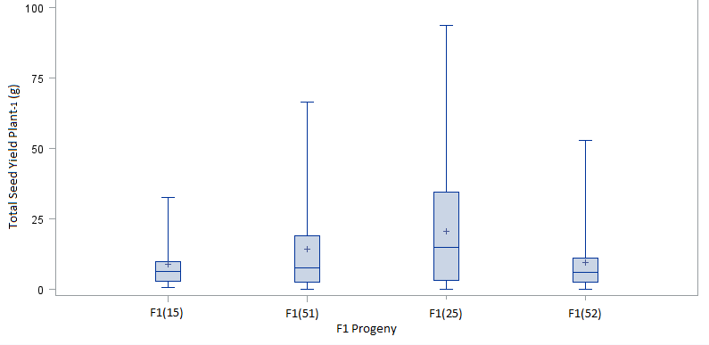
B

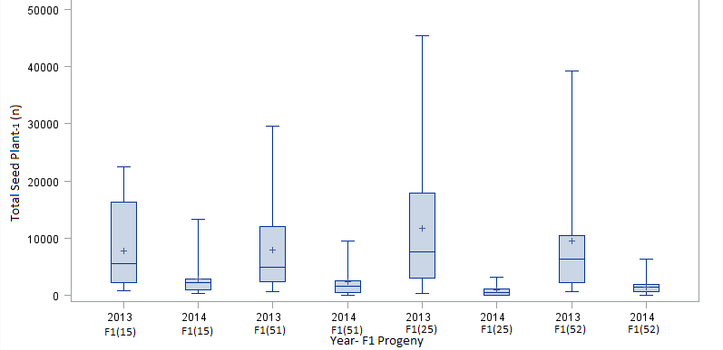

C
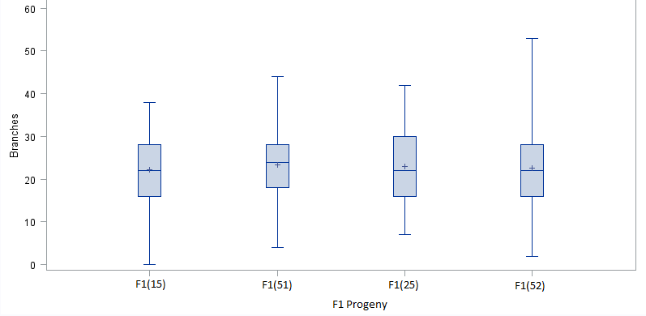
D
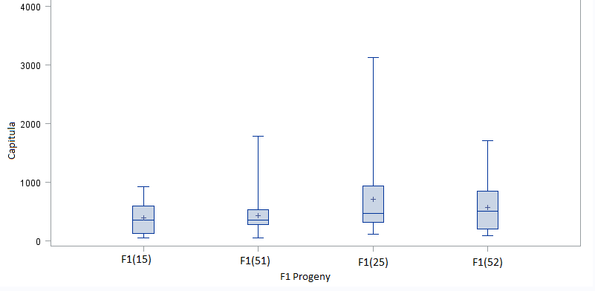
Fig. 1. Boxplot showing variation among F₁ progeny for four niger crosses for total seed yield plant⁻¹ (g) (A), total seed plant⁻¹ (n) (B), and total branches plant⁻¹ (C) in 2013 and 2014; and total capitula plant⁻¹ (D) in 2013 only. F₁(15), F₁(51), F₁(25), and F₁(52) had 19, 25, 32, and 33 observations, respectively, for seed yield (g) in 2013, and 18, 17, 7, and 22 in 2014. F₁(15), F₁(51), F₁(25), and F₁(52) had 37, 42, 39, and 55 observations, respectively, for total seed plant⁻¹ (n) combined over both years. F₁(15), F₁(51), F₁(25), and F₁(52) had 54, 65, 42, and 79 observations, respectively, for total branches over both years. F₁(15), F₁(51), F₁(25), and F₁(52) had 22, 28, 32, and 34 observations, respectively, for total capitula.

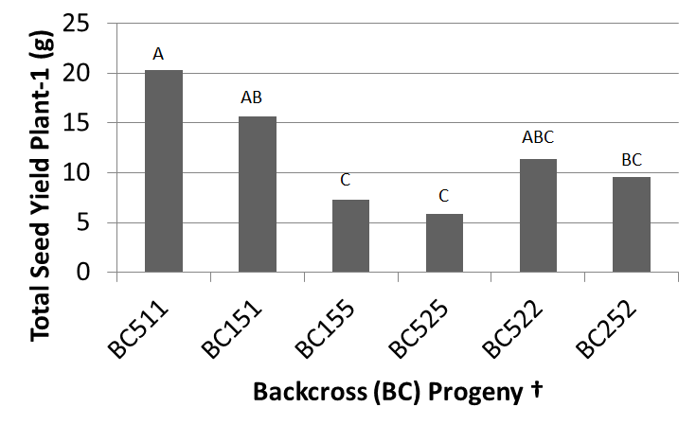
Fig. 2. Average total seed yield plant⁻¹ (g) variation of eight backcrosses (BC) 2014 at the East Tennessee (ETREC) and the Plateau (PREC) Research and Education Centers. BC511, BC151, BC155, BC525, BC522, and BC252 had 6, 20, 19, 11 21, 25 observations, respectively.
† BC’s with a letter in common are not significantly different based on Fisher’s LSD (P< 0.05).
‡ P1, P2, P3, P4, and P5 are parent accessions (PI 422242, PI 511305, PI 508075, PI 508076, and W6 18860, respectively). F₁(15) indicates that P1 was the maternal and P5 was the paternal parent. BC511 for example, indicates that F₁(51) was crossed with P1.
§ BC515 and BC255 were missing due to poor germination and disease.

A

B
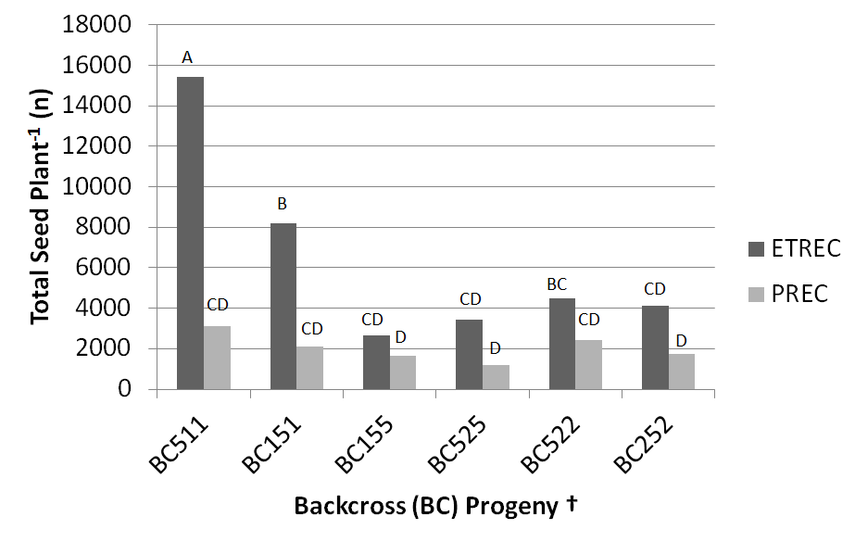
Fig. 3. Average total seed plant⁻¹ (n) for eight backcrosses (BC) at the East Tennessee (ETREC) and Highland Rim (HRREC) Research and Education Centers in 2013 (A), and in 2014 at ETREC and the Plateau (PREC) Research and Education Center (B). There were significant cross*location interactions in both years; therefore crosses were shown for each location. BC511, BC151, BC155, BC525, BC522, and BC252 had 2, 11, 1, 17, 18, 14, 12, and 8 observations, respectively, at ETREC, and 0, 1, 0, 9, 14, 0, 5, and 6 at HRREC in 2013 (A). BC511, BC151, BC155, BC525, BC522, and BC252 had 2, 4, 6, 5, 7, 7 observations, respectively, at ETREC, and 4, 16, 13, 7, 14, 18 at PREC in 2014.
† BC’s with a letter in common are not significantly different based on Fisher’s LSD (P< 0.05).
‡ P1, P2, P3, P4, and P5 are parent accessions (PI 422242, PI 511305, PI 508075, PI 508076, and W6 18860, respectively). F₁(15) indicates that P1 was the maternal and P5 was the paternal parent. BC511 for example, indicates that F₁(51) was crossed with P1.
§ BC515 and BC255 from ETREC and PREC were missing from (B) due to poor germination and disease.
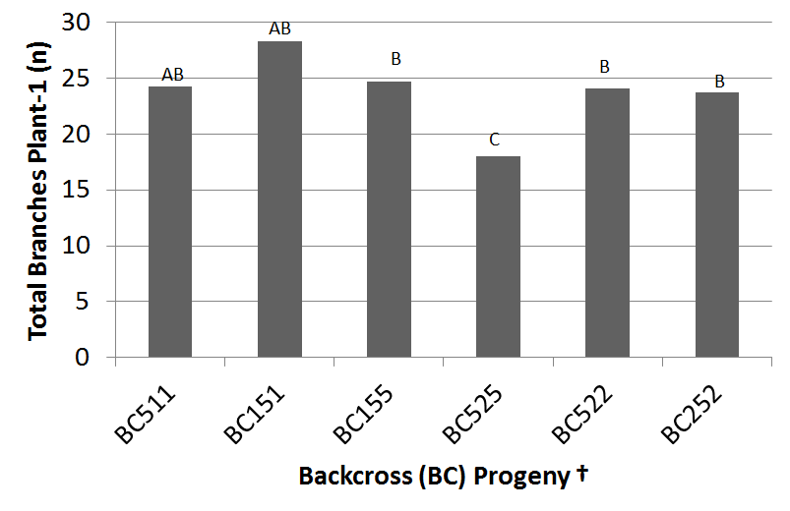
Fig. 4. Average total branches plant⁻¹ (n) for eight backcrosses (BC) in 2014 at East Tennessee (ETREC), Highland Rim (HRREC), and Plateau Research and Education Center (PREC). BC511, BC151, BC155, BC525, BC522, and BC252 had 2, 9, 39, 40, 21, 41, 41, and 1 observations, respectively.
† BC’s with a letter in common were not significantly different based on Fisher’s LSD (P< 0.05).
‡ P1, P2, P3, P4, and P5 are parent accessions (PI 422242, PI 511305, PI 508075, PI 508076, and W6 18860, respectively). F₁(15) indicates that P1 was the maternal and P5 was the paternal parent. BC511 for example, indicates that F₁(51) was crossed with P1.
§ BC515 and BC255 from ETREC and PREC were missing from (B) due to poor germination and disease.

CHAPTER V
CORRELATIONS BETWEEN SEED YIELD AND YIELD COMPONENT TRAITS AS WELL AS SEED YIELD, SEED OIL, AND FATTY ACID TRAITS

Abstract
In the United States, niger (Guizotia abyssinica (L.f) Cass.) is primarily marketed as a seed of choice for American goldfinch (Spinus tristis) as well as other song and ground feeding birds because of its high oil content. In countries such as Ethiopia and India, niger is grown as an edible oilseed crop. The objectives of this study were to determine correlations between: (i) yield traits (seed yield plant⁻¹and seed plant⁻¹) and agronomic traits (branches plant⁻¹, capitula plant⁻¹, seed capitulum₋₁, days to full bloom, height, and maturity) and (ii) between yield traits and fatty acids (linoleic acid, oleic acid, and palmitic) of selected parents, F₁, and F₂ crosses. Fourteen niger plant introductions (PIs) of Indian, Ethiopian, and American origin were obtained from USDA/ARS germplasm collection at Pullman, WA. Ten replications of the fourteen PIs were planted under field and greenhouse conditions at the East Tennessee Research & Education Center in Knoxville in August, 2012 using a completely randomized design. After initial assessments were made, five of the PIs were then selected for further evaluation, and crosses were made to produce six F₁ and six F₂ populations. Seed were planted at the East Tennessee (2013 and 2014), Highland Rim (2013 and 2014), and Plateau (2014) Research and Education Centers. Correlations between yield traits and capitula resulted in stronger correlations (.64-.83) than other agronomic traits. Moderate correlations reported for yield traits and palmitic acid (0.38-0.50) whereas correlations of linoleic acid (-0.15 and 0.34) and oleic acid (-0.27 and 0.01) with yield traits were weak.

Introduction
Plant breeders often use parameters other than yield to identify and select parents and segregating individuals with greater yield potential. Determining correlations between primary and secondary characters is therefore important for making indirect selections. Calculating genetic correlation requires an evaluation of the genetic material across multiple environments. A definitive evaluation of genetic correlation between characters requires the use of random genotypes from segregating populations to as to estimate variance and covariance (Fehr, 1987). Indirect selection is prudent when the secondary character has a higher heritability than the primary character.
Panda and Sial studies correlations of yield and yield components in 2012. They found that branches and seed yield had a correlation coefficient of 0.69. Captiula plant⁻¹ and yield were weakly correlated at 0.06, but seed capitulum⁻¹ was strongly correlated to seed yield (-0.77). Plant height and days to 50% flowering had were moderately correlated to seed yield (-0.56 and 0.58, respectively).
A previous study by Alemaw and Wold found negative correlations have been found between oleic and linoleic acid (1995). This can be expected since oleic synthesizes linoleic acid. Likewise, a negative correlation is expected for oleic and stearic acid since oleic acid is synthesized from stearic acid. A study by Geleta, Stymne, and Bryngelsson found that seed weight and linoleic acid had a negative correlation of -0.17 (2011). Seed weight and oleic acid were correlated at 0.13, while seed weight and palmitic acid had a negative correlation of -0.15.
Making selections in the field based on phenotypic may expedite future niger breeding programs. Since little research has been conducted on this matter, more research is needed to compare findings. Correlations between seed yield and yield component traits as well as seed yield, seed oil and fatty acid traits were studied.

Materials and Methods

Site locations. A randomized complete block design was used. Data were collected from two locations in 2013 (ETREC and HRREC) and three locations in 2014 (ETREC, HRREC, and PREC). The first field location was at the East Tennessee Research & Education Center (ETREC) in Knoxville, TN (35.53°N 83.57°W) (2013 and 2014) (Fig. 3A-B). The soil type at the Knoxville location was classified as an Etowah loam (Fine-loamy, siliceous, semiactive, thermic Typic Paleudults). The second field location was at the Highland Rim Research & Education Center (HRREC) in Springfield, TN (36.28°N 86.51°W) (2013 and 2014) (Fig. 3C-D). The soil type at the 2013 location was classified as a Dickson silt loam (Fine-silty, siliceous, semiactive, thermic Glossic Fragiudults). The soil type at the 2014 site was classified as a Sango silt loam (Coarse-silty, siliceous, semiactive, thermic Glossic Fragiudults).The third site was at the Plateau Research & Education Center (PREC) in Crossville, TN (36.01°N 86.13°W) (2014 only) (Fig. 3E). The soil type at this location was classified as Ramsey-Rock outcrop complex (loamy, siliceous, active, mesic Lithic Dystrudepts).
Correlation analyses for the were run on five parents (PI 422242, PI 511305, PI 508075, PI 508076, and W6 18860,) six F₁ progeny [(F₁(15), F₁(51), F₁(25), F₁(52), F₁(35), and F₁(45)], and six F₂’s [F₂(15), F₂(51), F₂(25), F₂(52), F₂(35), and F₂(45)] in 2013 and 2014. Correlations within this study included seed yield plant⁻¹ (g) and seed plant⁻¹ (n) with: capitula plant⁻¹ (n), plant maturity (%), plant height (cm), average seed capitulum ⁻¹ (n), branches plant⁻¹ (n), full bloom (days after planting), linoleic fatty acid (%), oleic fatty acid (%), and palmitic fatty acid (%). Due to late planting in 2013, the seeds at both locations did not have enough time to fully mature. Fatty acid profiles were only analyzed on seeds harvested from the 2014 planting season. Correlations between traits were analyzed using SAS 9.3 (Cary, NC) software.
RESULTS
Roughly 85% of the plants at the HRREC location were affected by Southern Blight (Sceroltium rolfsii) in 2014. This soil-borne disease first infected the lower stems, then caused dieback and death. The blight was most active in the middle of the season (July and August), causing the capitula to senesce before they had tome to pollinate and produce seed. The total number of capitula and yield for these diseased were thereby affected. The following information can be reviewed in Table 1.
2013 P’s, F₁’s, and F₂’s.
Seed yield with lodging resulted in insignificant correlations (P<0.05). Correlations between total seed and number of branches plant⁻¹(0.26), total seed with date at full bloom (-0.16), and total seed with height (0.24) were weak. Moderately positive correlations were found between total seed and percent maturity (0.34) and total seed with average number of seeds capitulum ⁻¹(0.61). Seed yield with average seed capitulum ⁻¹ (0.57) and seed yield with maturity (0.33) also showed moderate correlations. 2013 data showed strong positive correlation between total seed and total number of capitula plant⁻¹ (0.79) as well as seed yield with total seed (0.90). Seed yield with capitula (0.72) also showed a strong positive correlation.
2013 P’s.
Total seed with branches, seed yield with branches, total seed with height, seed yield with height, and seed yield with lodging all showed insignificant correlations (P<0.05). Total seed with full bloom (-0.53) and seed yield with full bloom (-0.54) resulted in a moderately negative correlation. Total seed with capitula (0.65), seed yield with capitula (0.64), total seed with maturity (0.40), seed yield with maturity (0.39), and total seed with average number of seed capitulum ⁻¹(0.69) showed moderately positive correlations, whereas seed yield with average number of seed capitulum ⁻¹ (0.70) resulted in a strong positive correlation. Total seed with seed yield resulted in a correlation coefficient of 1.00.
2013 F₁’s.
Total seed with full bloom and seed yield with full bloom were insignificant (P<0.05). Total seed with branches resulted in a weak correlation (0.26). Total seed with maturity (0.32), seed yield with maturity (0.33), total seed with height (0.34), seed yield with height (0.32), total seed with average seed capitulum ⁻¹ (n) (0.65), and seed yield with average seed capitulum ⁻¹ (n) (0.63) resulted in moderately positive correlations. Total seed with capitula (0.73), seed yield with capitula (0.74) and total seed with seed yield (0.96) showed a strong positive correlation.
2013 F₂’s.
Total seed with maturity (0.37), seed yield with maturity (0.38), total seed with average seed capitulum ⁻¹ (n) (0.61), and seed yield with average seed capitulum ⁻¹ (n) (0.61) resulted in a moderately positive correlation (P<0.05). Total seed with capitula (0.83), seed yield with capitula (0.80), and total seed with seed yield (0.98) showed strong positive correlations.
2014 P’s, F₁’s, F₂’s.
Capitula and average, maturity, and seed capitulum ⁻¹ were not recorded in 2014. Moderately positive correlations were found between seed yield and branches (0.32), total seed and branches (0.32), as well as total seed and palmitic fatty acid (P<0.05). Weak correlations were found between yield traits and full bloom, yield traits and branches, as well as yield traits and fatty acid traits.
2014 P’s.
Moderately positive correlations were found between yield traits and branches, as well as yield traits and height (P<0.05). There was also a moderately positive correlation between total seed and linoleic fatty acid.
2014 F₁’s.
Moderately positive correlations were found between yield and branches (0.32) as well as total seed and branches (0.30). Yield traits with branches and yield traits with height were all significant (0.05).
2014 F₂’s.
Moderately positive correlations were found between yield traits and branches, yield traits and full bloom, yield traits and height, and yield traits and palmitic fatty acid (P<0.05). Moderately negative correlations were found between yield traits and oleic fatty acid.
2013- 2014 P’s, F₁’s, F₂’s.
A moderately positive correlation was between total seed and height (0.41) (P<0.05). A moderately negative correlation was found between total seed and full bloom (-0.33). Yield traits with branches resulted in weak correlations.
2013-2014 P’s.
Yield traits with height resulted in moderately positive correlations (P<0.05). Yield traits with full bloom resulted in moderately negative correlations. Yield traits with branches were insignificant.
2013-2014 F₁’s.
Moderately positive correlations were found between yield traits and branches as well as yield traits and height (P<0.05). Moderately negative correlations were found between total seed and full bloom (-0.35). Yield and full bloom resulted in a weakly negative correlation (-0.29).
2013-2014 F₂’s.
Moderately positive correlations were found between total seed and branches (0.31) as well as total seed and height (0.41) (P<0.05).A moderately negative correlation was found between total seed and full bloom. Correlations between yield and all three agronomic traits were weak.
Conclusion
Overall, seed yield and seed plant⁻¹ were comparable in their correlations to agronomic traits, though correlations between agronomic traits components and total seed were slightly greater that of seed plant⁻¹. Of all agronomic traits analyzed, capitula plant⁻¹ consistently had the strongest correlations. Selections based on this trait could be decided earlier in the season than yield components like seed capitulum⁻¹, full bloom, and maturity.
Findings from this study differed from that of Panda and Sia (2012). Their results showed stronger correlations for branches (0.69), days to flowering (0.58), seed capitulum⁻¹ (-0.77), and height (-0.56) than the findings of this study. Correlations between yield traits and branches in this study ranged roughly between 0.25 and 0.50. Correlations for yield traits with days to flowering ranged roughly between 0.30 and 0.50, while correlations involving seed capitulum-1 ranged 0.57 and 70. Correlations involving height ranged between 0.20 and 0.50. Correlations of yield traits with capitula (0.65-0.80) were greater than the aforementioned study (0.06). Other differences between these two studies involve the direction of the correlations. Panda and Sia found that positive correlations for days to flowering while this study resulted in negative correlations. Seed capitulum-1 and height both showed negative correlations in Panda and Sia’s research, but were positive in this study.
The consistency of the negative correlation between full bloom (DAP) and both yield traits makes is justifiable. The longer it took for a plant to reach full bloom, the more likely it is that the plant will not reach maturity by the end of the growing season. This will ultimately reduce the number of mature, and therefore reduce seed yield.
Alemaw and Wold (1995) found weak correlations of seed weight and linoleic (-0.17), oleic (0.13), and palmitic acid (-0.15). These findings were similar to those of this study, with the exception of moderate correlations found for yield traits and palmitic acid (0.38-0.50). Correlations involving linoleic acid ranged between -0.15 and 0.34 while correlations involving oleic acid ranged between -0.27 and 0.01.

Literature Cited
Fehr, E.L. and H.J. Jessen. 1987. Principles of cultivar development. Vol. 1. Macmillan Pub. Co., NY.

Geleta, M., S. Stymne, and T. Bryngelsson. 2011. Variation and inheritance of oil content and fatty acid composition in niger (Guizotia abyssinica). J Food Comp. Anal 24(7): 95- 1003.
Panda, S. and P. Sial. 2012. Assessment of existing genetic variability and yield component analysis in niger (Guizotia Abyssinica Cass). Indian J. Innovations Dev., Vol. 1(7):511- 514.

Appendix
Table 1. Correlation coefficients between yield traits and agronomic traits for parents, F1’s, and F2’s at the East Tennessee (ETREC) and Highland Rim (HRREC) Research and Education Centers in 2013, and ETREC, HRREC, and Plateau Research and Education Center (PREC) in 2014.
Year | Population | Yield Traits |  | Agronomic traits |  |  |  |  |  |  |  |  | Fatty Acid Traits
 |  |  | Branches |  | Capitula |  | Seed Capitulum⁻¹ |  |  | Full bloom  (DAP) | Height | Maturity | Linoleic |  | Oleic |  | Palmitic
 |  |  | Number |  |  |  |  |  |  |  | cm | % | %
2013 | Parents, F₁'s, and F₂'s | Yield | 0.21** |  |  | 0.72** |  | 0.57** | -0.16** |  | 0.18** | 0.32** | n/a | n/a |  | n/a
 |  | Total seed | 0.26** |  |  | 0.79** |  | n/a | -0.14** |  | 0.24** | 0.34* | n/a | n/a |  | n/a
 | Parents | Yield | 0.11 |  |  | 0.64** |  | 0.70** | -0.54** |  | 0.2 | 0.39** | n/a | n/a |  | n/a
 |  | Total seed | 0.13 |  |  | 0.65** |  | n/a | -0.53** |  | 0.22 | 0.40** | n/a | n/a |  | n/a
 | F₁'s | Yield | 0.26** |  |  | 0.74** |  | 0.63** | 0.4 |  | 0.32** | 0.33** | n/a | n/a |  | n/a
 |  | Total seed | 0.26** |  |  | 0.73** |  | n/a | 0.06 |  | 0.34** | 0.32** | n/a | n/a |  | n/a
 | F₂'s | Yield | 0.20** |  |  | 0.80** |  | 0.61** | -0.22** |  | 0.17** | 0.38** | n/a | n/a |  | n/a
 |  | Total seed | 0.23** |  |  | 0.83** |  | n/a | -0.18** |  | 0.18** | 0.37** | n/a | n/a |  | n/a
2014 | Parents, F₁'s, and F₂'s | Yield | 0.32** |  |  | n/a |  | n/a | .29** |  | 0.28** | n/a | 0.06 | -0.17** |  | 0.27**
 |  | Total seed | 0.32** |  |  | n/a |  | n/a | .22** |  | 0.30** | n/a | 0.07 | -0.21** |  | 0.38**
 | Parents | Yield | 0.49** |  |  | n/a |  | n/a | 0.05 |  | 0.56** | n/a | 0.26 | -0.17 |  | 0.04
 |  | Total seed | 0.43** |  |  | n/a |  | n/a | -0.06 |  | 0.55** | n/a | 0.34* | -0.27 |  | 0.11
 | F₁'s | Yield | 0.32** |  |  | n/a |  | n/a | 0.04 |  | 0.29** | n/a | -0.15 | 0.01 |  | 0.02
 |  | Total seed | 0.30** |  |  | n/a |  | n/a | -0.09 |  | 0.28** | n/a | -0.03 | -0.1 |  | 0.12
 | F₂'s | Yield | 0.36** |  |  | n/a |  | n/a | 0.42** |  | 0.30** | n/a | 0.12* | -0.24** |  | 0.38**
 |  | Total seed | 0.37** |  |  | n/a |  | n/a | 0.37** |  | 0.33** | n/a | 0.09 | -0.25** |  | 0.50**
2013 - 2014 | Parents, F₁'s, and F₂'s | Yield | 0.25** |  |  | n/a |  | n/a | -0.13** |  | 0.25** | n/a | n/a | n/a |  | n/a
 |  | Total seed | 0.29** |  |  | n/a |  | n/a | -0.33** |  | 0.41** | n/a | n/a | n/a |  | n/a
 | Parents | Yield | 0.14 |  |  | n/a |  | n/a | -0.33** |  | 0.30** | n/a | n/a | n/a |  | n/a
 |  | Total seed | 0.08 |  |  | n/a |  | n/a | -0.44** |  | 0.37** | n/a | n/a | n/a |  | n/a
 | F₁'s | Yield | 0.30** |  |  | n/a |  | n/a | -0.29** |  | 0.39** | n/a | n/a | n/a |  | n/a
 |  | Total seed | 0.30** |  |  | n/a |  | n/a | -0.35** |  | 0.45** | n/a | n/a | n/a |  | n/a
 | F₂'s | Yield | 0.27** |  |  | n/a |  | n/a | -0.03 |  | 0.20** | n/a | n/a | n/a |  | n/a
 |  | Total seed | 0.31** |  |  | n/a |  | n/a | -0.31** |  | 0.41** | n/a | n/a | n/a |  | n/a
† Significant at P<0.01 and P<0.05 is indicated by ** and *, respectively.
‡ n/a indicates that the data was not collected for that trait.

CHAPTER VI
Conclusions and Recommendations

APPENDIX A

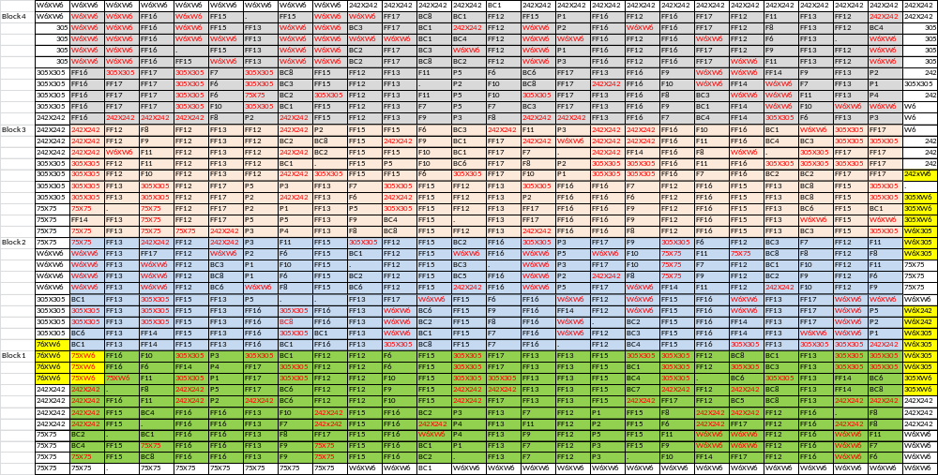
Table. 1A. Field map of niger plots at the East Tennessee Research and Education Center (ETREC) in 2013.
†Red font indicates that the plant was used as a fill.
‡ Yellow highlighted boxes indicate plants that were used to produce 2014 seed.

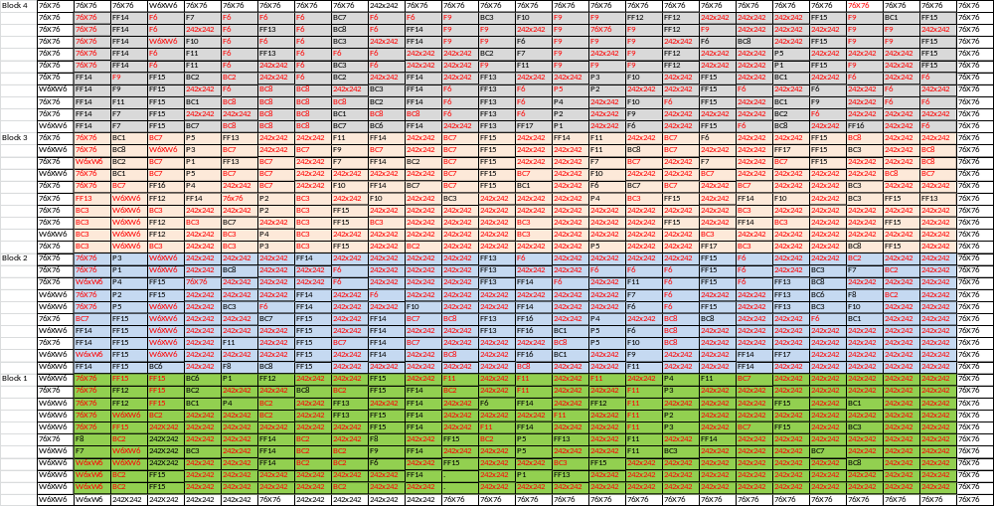
Table. 1B. Field map of niger plots at the East Tennessee Research and Education Center (ETREC) in 2014.
†Red font indicates that the plant was used as a fill.

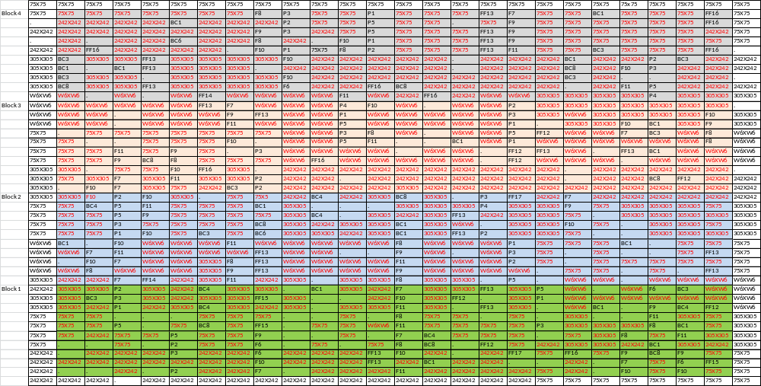
Table. 1C. Field map of niger plots at the Highland Rim Research and Education Center (HRREC) in 2013.
†Red font indicates that the plant was used as a fill.

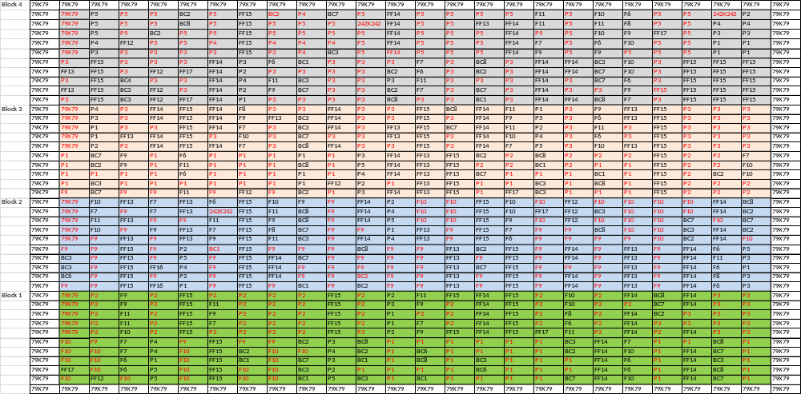
Table. 1D. Field map of niger plots at the Highland Rim Research and Education Center (HRREC) in 2014.
†Red font indicates that the plant was used as a fill.

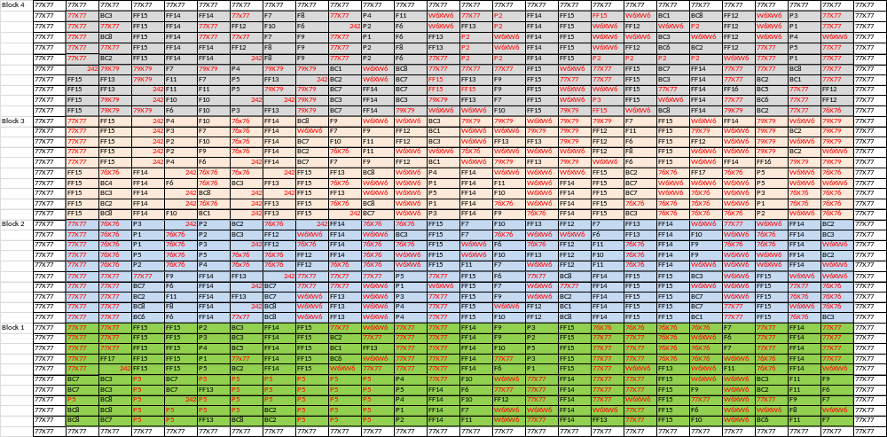
Table. 1E. Field map of niger plots at the Plateau Research and Education Center (PREC) in 2014.
†Red font indicates that the plant was used as a fill.

Vita

Victoria Benelli was born on 09 September 1988 in Johnson City, NY to David and Cynthia Knapp. She enrolled at Broome Community College after graduating from Harpursville Central High School in 2006. It was here that she completed an A.S. in Business Management, Marketing, and Sales in 2008. Victoria transferred to the University of Tennessee, Knoxville in 2010 to pursue a B.S. in Horticulture Science and Production. After graduation, she began work as a Graduate Research Assistant while earning a M.S. degree in Plant Breeding under Dr. Fred Allen. Soon after her enrollment in graduate school, she met her husband Jesse Benelli; also another graduate student. Victoria plans to work as an assistant plant breeder.

