To the Graduate Council:
I am submitting herewith a thesis written by Peter J. Doyle entitled “Modeling of Dislocation Channel Formation and Evolution in Irradiated Metals.” I have examined the electronic copy of this thesis for form and content and recomkevmend that it be accepted in partial fulfillment of the requirements for the degree of Master of Science, with a major in Nuclear Engineering.

Steven J. Zinkle
Major Professor
We have read this thesis
and recommend its acceptance:

Brian D. Wirth

Ronald E. Pevey

Accepted for the Council:
Carolyn R. Hodges
Vice Provost and Dean
of the Graduate School

(Original signatures are on file with official student records.)

Modeling of Dislocation Channel Formation and Evolution in Irradiated Metals

A Thesis Presented for
The Master of Science
Degree
The University of Tennessee, Knoxville

Peter J. Doyle
August 2017

Copyright © 2017 by Peter J Doyle
All Rights Reserved

Acknowledgements
I would like to thank Dr. Steven Zinkle for recommending this project to me and being my advisor over the last two years. Through his tutelage this project was able to reach its conclusion and I have gained valuable experience working at ORNL over the course of the Master’s program. Thanks also to Kelsa Benensky for collaborating on this project throughout its duration, to James Brechtl for providing valuable discussion, and to Dr. Yuri Osetsky for his comments on this work. Additionally, I would like to thank the Corrosion Science and Technology Group at ORNL for giving me the opportunity to work alongside some of their researchers on a variety of projects. I would be remiss to not also acknowledge the continued loving support of my wife, Bonnie, throughout all my studies, including this work.
Finally, this material is based on work supported under an Integrated University Program Graduate Fellowship, which provided funding for the last year and is much appreciated.

Abstract
Defect-free dislocation channel formation has been reported to promote plastic instability during tensile testing via localized plastic flow, leading to a distinct loss of ductility and strain hardening in many low-temperature irradiated materials. In order to study the underlying mechanisms governing dislocation channel width and formation, the channel formation process is modeled via a simple stochastic dislocation-jog process dependent upon grain size, defect cluster density, and defect size. Dislocations traverse a field of defect clusters and jog stochastically upon defect interaction, forming channels of low defect-density. Based upon prior molecular dynamics (MD) simulations and in-situ experimental transmission electron microscopy (TEM) observations, each dislocation encounter with a dislocation loop or stacking fault tetrahedron (SFT) is assumed to cause complete absorption of the defect cluster, prompting the dislocation to jog up or down by a distance equal to half the defect cluster diameter. Channels are predicted to form rapidly and are comparable to reported TEM measurements for many materials. Predicted channel widths are found to be most strongly dependent on mean defect size and correlated well with a power law dependence on defect diameter and density, and distance from the dislocation source. Due to the dependence of modeled channel width on defect diameter and density, maximum channel width is predicted to slowly increase as accumulated dose increases. The relatively weak predicted dependence of channel formation width with distance, in accordance with a diffusion analogy, implies that after only a few microns from the source, most channels observed via TEM analyses may not appear to vary with distance because of limitations in the field-of-view to a few microns. Further, examinations of the effect of the so-called “source-broadening” mechanism of channel formation showed that its effect is simply to add a minimum thickness to the channel without affecting channel dependence on the given parameters.

Table of Contents
Chapter 1: Introduction 1
1.1 Summary of Radiation Effects in Materials 1
1.2 Mechanisms of Radiation Hardening and Embrittlement 2
1.3 Objectives of this Work 2
Chapter 2: Literature Review 4
Chapter 3: Modeling Methodology 7
3.1 Description of the General Approach and Assumptions 7
3.2 The Average Spacing Model – Model 1 11
3.2.1 Maximum Channel Width Approximation 11
3.2.2 Core Channel Width Approximation 11
3.2.3 Design Limitations and Potential Systematic Errors in Model 1 12
3.3 The Discrete Barrier Model – Model 2 13
3.3.1 Maximum Channel Width Approximation 13
3.3.2 Core Channel Width Approximation 13
3.3.3 Design Limitations Remaining in Model 2 14
3.4 Analytic Approach to the Problem 15
3.4.1 General Mathematical Approach 15
3.4.2 Remaining Limitations Between all Three Methods 17
Chapter 4: Presentation of Results 18
4.1 Model 1 18
4.1.1 Effect of the Number of Dislocations on Channel Width 18
4.1.2 Effect of the Microstructural Properties on Channel Width 20
4.1.3 Summary Correlations 25
4.1.4 Error in Correlations 26
4.2 Model 2 29
4.2.1 Effect of the Number of Dislocations on Channel Width 29
4.2.2 Effect of the Microstructural Properties on Channel Width 29
4.2.3 Effect of the Microstructural Properties on Channel Width 31
4.2.4 Effect of Diameter Distributions 34
4.2.5 Effect of Source Broadening 34
4.2.6 Summary Correlations 36
4.2.7 Error in Correlations 36
4.3 Analytic Model 38
4.3.1 PDFs of Dislocation Passage/Defect Elimination 38
4.3.2 Microstructure Effects 40
Chapter 5: Discussion of Results Along with Predictions and Implications of the Models 44
5.1 Comparison of the three Approaches 44
5.1.1 Cross-model Validation 44
5.1.2 Interpretation of the model results 45
5.2 Comparison of Model Predictions with Reported Experimental Observations 46
5.3 Comparisons to Other Proposed Channel Formation Mechanisms 55
Chapter 6: Conclusions and Recommendations 57
List of References 59
Appendix A 66
A.1 Analytic Program 67
Appendix B 80
B.1 Main 81
B.2 Catch_up Subroutine 112
B.3 Choose_Diameter Function 114
B.4 CoreHeight Subroutine 117
B.5 DefectMesh Subroutine 121
B.6 Final Stats Subroutine 130
B.7 fparsef module 131
B.8 GetData Subroutine 133
B.9 Least_squares Subroutine 155
B.10 MeshDimension Subroutine 157
B.11 NextDefect Subroutine 158
B.12 Validation Subroutine 161
B.13 Writeout Subroutine 162

List of Tables
Table 1: Table of simulation parameters used for correlations in all models 22
Table 2: Comparison of predictions to TEM observations 48

List of Figures
Figure 1: Example of a first path through the Model 1 matrix 10
Figure 2: Simple logic flow chart of the program 10
Figure 3: Model 1 channel plot with overlaid core width approximation. 12
Figure 4: Model 2 example of channel core. 14
Figure 5: Example grid of analytic solution. 16
Figure 6: Model 1 channel plot 19
Figure 7: Model 1 maximum channel width dependence on the number of dislocation passes per history.. 19
Figure 8: Model 1 core channel width dependence on number of dislocation passes 20
Figure 9: Model 1 microstructural parameters effects on maximum channel width 23
Figure 10: Model 1 core channel width dependence on microstructural parameters 24
Figure 11: Model 1 comparison of correlative equations to select simulation sets 28
Figure 12: Model 2 channel plot 29
Figure 13: Model 2 maximum channel width dependence on number of dislocation passes per history. 30
Figure 14: Model 2 core channel width dependence on number of dislocation passes per history. 30
Figure 15: Effect of microstructure on the maximum channel width predictions from model 2. 32
Figure 16: Effect of microstructure on the core channel width prediction from model 2 33
Figure 17: Effect of Gaussian distributions about a mean diameter on the maximum channel width. 35
Figure 18: Effect of using distributed sources on the maximum channel width. 35
Figure 19: Model 2 comparison of correlative equations to select simulation sets 37
Figure 20: Maximum channel width PDFs at x = 2, 4, 6, 8, and 10 microns along the channel 39
Figure 21: Maximum channel width PDFs at x = 2, 4, 6, 8, and 10 microns along the channel 39
Figure 22 Maximum channel width PDFs at x = 2, 4, 6, 8, and 10 microns along he channel 39
Figure 23: Analytical model microstructural parameters effects on mean maximum channel width 41
Figure 24: Effects of defect diameter on the statistical quantities of the channel plots 42
Figure 25: Effects of defect number density on the statistical quantities of the channel plots 43
Figure 26: Predicted channel widths for different diameter distributions in (a) Cu, (b) Ni 49
Figure 27: Comparison experimental to predicted results for distributed and averaged defect sizes 50
Figure 28: Comparison of low temperature irradiated defect microstructure from literature. 52
Figure 29: Comparison of model and experimental prediction for dose dependence. 52
Figure 30: Comparison of predicted and observed dislocation channel width vs. dose in Mo 53
Figure 31: Maximum width dose and distance dependence of channels in Mo 54

List of Abbreviations
BCC | Body Center Cubic
CRSS | Critical Resoled Shear Stress
DD | Dislocation Dynamics
DL | Dislocation Loop
dpa | Displacements per atom
FCC | Face Centered Cubic
HCP | Hexagonal Closed Packed
LS | Least Squares
MC | Monte Carlo
MD | Molecular Dynamics
RSS | Resolved Shear Stress
SFE | Stacking-Fault Energy
SFT | Stacking-Fault Tetrahedra
TEM | Transmission Electron Microscopy

List of Symbols
$$μ$$ | Mean of a sample set
$$σ$$ | Standard deviation of a sample set
$$ΔL$$ | Average distance between dislocation-defect interactions
$$A$$ | Scaling parameter multiplying x in width equation
$$B$$ | Exponent on x in the width equation
$$C$$ | Scaling constant, member of A
$$D$$ | Diameter of grain, assuming spherical grains
$$d$$ | Diameter of defect loops
$$E$$ | Exponent on d as member of A
$$F$$ | Exponent on N as member of A
$$J$$ | Exponent on J as a member of B
$$N$$ | Number density of defects in matrix
$$T_{irr}$$ | Irradiation temperature
$$T_{M}$$ | Melting temperature
$$w$$ | Width of a channel at any given distance, x
$$V$$ | Exponent on d as member of B. When not used in equations, this refers to the element Vanadium
$$x$$ | Distance along a channel from the source

Introduction

Summary of Radiation Effects in Materials
Materials in the presence of irradiation are damaged by the transfer of energy between the iparticles and the matrix. In this process, excess energy of the recoil atoms is dispersed by additional cascades of collisions which lead to “balloons” of damage lasting roughly 1 ps before thermally healing with most of the defects recombining. All of the unresolved damage consists of interstitials and vacancies which are too far from one another to recombine spontaneously. These exist both as individual defects and also as clusters, with the number and size of clusters primarily dependent on crystal structure. In FCC materials, SFTs and larger interstitial clusters are formed as a result of the close-packed structure, whereas in BCC materials, a large number of small clusters exist because the structure is relatively open. These differences result in slightly different behavior between structures.
Following defect creation, temperature drives the macroscopic changes in the material. At low temperatures vacancy mobility is virtually negligible, while interstitials and their small clusters are mobile (except at extremely low temperatures). As temperature increases the mobility of large interstitial clusters increases and vacancies become mobile. Their movement leads to increasing cluster sizes, dissolution of clusters, and removal of defects to sinks, depending on the materials and temperature. In addition to interstitials and vacancies, radiation damage provides the high concentrations of energy required to initiate precipitation of particles (such as carbides) within the matrix.
These microstructural changes and interactions result in five primary radiation effects which are temperature and dose dependent. For certain materials additional effects are possible (such as crystallization with some amorphous alloys). These primary radiation effects are:
- Radiation Hardening and Embrittlement
- Radiation-Induced Precipitation
- Volumetric Swelling
- Radiation Creep
- High Temperature Helium (He) Embrittlement
Radiation hardening and embrittlement is discussed below in 1.2 and is the broad category under which defect-free channel formation occurs. Radiation-induced precipitation is caused by the temperature-induced growth of precipitates or phases which nucleate in a cascade, after sufficient damage has accumulated. Volumetric swelling is the coalescence of vacancies into large clusters which lead to material expansion. As such, this requires sufficient radiation damage for vacancies to find clusters and voids, and sufficient temperature for vacancy mobility, yet low enough temperature that the clusters are thermally stable. Radiation creep is caused by the abundance of vacancies providing ample opportunity for dislocation climb, the fundamental reason for creep. This occurs at lower temperatures primarily since the threshold vacancy concentration for creep is provided by thermal concentrations alone at high temperatures. He embrittlement is caused by He atoms in the material (through transmutation or alpha particle deposition) diffusing to voids and stabilizing them, essentially creating precipitate-like structures. These structures act as stress concentrators, strengthening, but embrittling the material.

Mechanisms of Radiation Hardening and Embrittlement
Radiation hardening and embrittlement is both a low temperature and low damage phenomenon, nominally occurring below 0.4 of the melting temperature ($T_{m}$) and onsetting at about 0.1 displacements per atom (dpa) [1–7]. Fundamentally, this phenomenon is just caused by the buildup of defects in the material. Since temperature is low, there is little recombination healing of the material and the defect clusters primarily just accumulate. This leads to locking of the dislocations and/or their sources in place, preventing plasticity at typical stresses. As damage increases this effect is exacerbated. Ultimately, this significantly increases the yield stress.
However, once the new yield stress is achieved, a dislocation becomes unpinned and able to move quickly through the material until it encounters the next defect where it can either be pinned there until the stress increases, or cut through the defect. As discussed in Chapter 2, these defects can be removed in part or entirely by this process, allowing subsequent dislocations to pass through at lower threshold stress. Over several cycles, channels with low densities of defects are formed through which dislocations pass very rapidly leading to enhanced plasticity and rapid failure. It is therefore of interest to know the details of how these channels form in order to develop mitigation strategies against embrittlement of low temperature irradiated materials.

Objectives of this Work
As discussed in Chapter 2, the current state of understanding with respect to defect-free channels consists in a plethora of observations of channels in various materials along with approximate estimates of channel width. This is accompanied by some dislocation dynamics (DD) simulations based on MD dislocation-defect interactions. There does not as yet exist a closed form model to estimate channel sizes nor quantitative estimates of the importance of parameters such as stacking-fault energy (SFE), defect size, defect density, distance along channel from its source, etc. This work is a first attempt at filling this hole in the research.
Rather than develop a detailed model (such as DD) which considers a significant fraction of the physics, this work focuses on the stochastic nature of dislocation-defect interactions and demonstrates its contribution to total dislocation width. The effects of defect diameter (d), defect density (N), and location along the channel relative to the source (x) are quantified using three different approaches, discussed in Chapter 3. The resulting model is then compared to previous experiments and used to propose suggestions for future experiments as well as provide some insight on the significance of parameters not considered in this model (Chapter 5 and Chapter 6). Because source broadening is a likely contributor to source width (Chapter 2), this work also considers source broadening as a method of channel development and quantifies source width with channel width.

Literature Review
Since the early days of nuclear power, the existence of defect-free channels has been known and studied [2,8–14] as a primary contributor to radiation hardening. At low damage and temperature, irradiated materials undergo necking immediately following the yield stress. Investigation of these materials identify defect-free channels within the material’s grains [6,8,10,12–17]. Development of these channels allows the strain to be localized within them, since dislocations have no impediment to motion within the channels vs. in the matrix, leading to a relatively unstrained matrix, but highly strained channels [8,11,12,15]. This development is identifiable as a special subset of deformation by dislocation glide [4].
Dislocations are emitted from sources after which they glide along a preferential plane. Grain boundaries and inclusions are natural sources for these dislocations [18–20], as well as other high stress surfaces, such as channels themselves [21]. As they glide, these dislocations interact with defects by direct interaction and through defect decoration of the dislocation as a result of attractive forces between them. These interactions cause immediate pinning of the dislocation and a variety of experimental studies [20,22–25] and MD simulations [20,23–30] have found that as the dislocation unpins, every interaction type from no change in the defect to partial or full destruction of the defect, or transport of the defect to a different location can occur. These interactions depend strongly on the type of dislocation (screw or edge), the type of defect (SFT, dislocation loop), strain rate, temperature, and general materials parameters, such as stacking fault energy.
Typcial interactions result in some amount of removal of the defect into the dislocation, during which process the dislocation forms a superjog to accommodate the defect contents. If partial absorption occurs, the defect may collapse to a planar loop (such as a Frank loop, in the case of SFT partial removal [2,22,24,25,31–35]). If no absorption occurs, defect shearing can take place with a portion of the defect being shifted one burger’s vector of the dislocation from its initial location with the dislocation passing on unaltered with no formation of a superjog. As one may infer, these processes are more probable, the weaker a defect is. Precipitates and voids are unlikely to be altered significantly, whereas loops and SFTs are more easily altered or removed entirely [36]. Unfortunately, it is difficult or impossible at the current time to generate PDFs of the current interactions due to the state of understanding.
While much work has been done (see the references above) to look at different mechanisms, the MD studies investigating them must use unrealistically high strain rates in order to gain an interaction over the simulation time [26]. The short time frames also obscure whether defect healing may occur in cases such as defect shearing. As computational power increases, these strain rates may approach a level where the results are more realistic. While using real strain rates, TEM studies have the normal experimental errors associated with them, not the least of which is the surface effect, which has been shown to possibly induce artifacts in terms of SFT absorption [37]. Models for defect removal must take this uncertainty into account when determining how to treat such interactions. Intuitively, as stress increases, the probability of full elimination increases. In the following work, this uncertainty is dealt with by assuming all interactions lead to full removal as a limiting case and is discussed further in Chapter 3.
Per the above MD studies, after the superjog forms, it runs along the entire length of the dislocation until the length of the dislocation shifting it in the direction of the jog. While this is true for a simulation with a small dislocation line fragment and no other pinnings, it must be stated that for a full dislocation line, there will be significant “weaving” of the dislocation as the jog will not able to pull pinned parts of the dislocation up to the current level, and will instead end in a link between lower and higher regions of the dislocation, relative to the initial glide plane. This superjog ripple is especially relevant for defect-free channel formation since this is method by which dislocations reach new glide planes on which they are able to continue interacting with defects. The step height of each of these glides can be inferred per the MD studies above to be proportional to the number of point defects in the larger loops, SFTs, etc. and is equal to the amount of the defect eliminated. On average then, since the dislocation has equal probability of interacting at any point along the defect, the jog height will be about half of the size of the defect, or, d/2 for a loop with diameter, d.The shifted dislocation will then glide parallel to its initial glide plane until it encounters another defect. As this process continues, hundreds of defects can be eliminated or altered significantly, concurrent with outward progression of the dislocation. Other mechanisms which do not eliminate defects (such as helical turn formation and cross slip) [30,38] are not likely to cause similar channel development directly. Rather it will transfer dislocations to other glide planes, effectively broadening the source, and thereby indirectly contributing to channel formation.
Specific mechanisms for channel formation and evolution has been the focus a number of modeling and experimental studies [16,39–41]. Empirical deformation mode maps have shown that there is a minimum dose required for channeling to be seen [6,42,43]. Intuitively, this is reasonable given the fundamental process that must occur for channeling. If the number of irradiation-induced defects, specifically soft defects, is small, then the probability of interaction drops significantly, leading to large glide distances between interactions, and a distinct difference between the “channel” and the matrix simply would not exist, as it does at higher doses. A pioneering DD study demonstrated what has been shown above, that dislocation double cross-slip to different planes is a fundamental mechanism in channel development. However, actual defect elimination was caused by absorption of defects in the gliding dislocation.This study was able to accurately represent actual channels [41]. Other DD and continuum studies have been conducted by several groups [39,40,43–46] that show similar results.
Ghoniem et. al. [39,40] performed DD simulations that showed significant defect decoration of dislocations. This decoration is presumed to cause significant increase in the stress required to allow dislocation glide. Defect absorption leading to dislocation jogs proportional to the size of the absorbed defects was shown to cause flow localization with large increases in yield stress, comparable to experiments. Arsenlis et. al. [43] performed a DD study demonstrating channel formation with pre-defining dislocation-defect interaction types. They found that channel formation could be simulated by loop displacement leading to coarsening that grew loops into large structures which began to act as larger dislocation networks. By performing simulations over a broad range of defect densities, they further determined a threshold defect density for flow localization to be around 8x10²¹m⁻³.
Continuum studies have been performed iin which the finite element method was used to create coarser scale, but more macroscopic models. As opposed to DD, which is limited to a few microns and is computationally intensive, continuum models are able to be much larger (many microns in size) and able to run for longer time periods. By assigning all physics parameters from MD and DD studies, these models also demonstrated channel formation. Po and Ghoniem [46] showed single band channel formation with edge dislocations interaction with SFTs. Patra and McDowell performed similar studies over larger domains, especially looking at the effect of Schmid factor on channel development [44,45]. These two studies showed broadening of the channels over large distances (>10 microns) and adequately reproduced flow localization in the channels.
Other authors have suggested that channels may be governed by dislocation sources being “volume elements” rather than point sources (such as a Frank-Read source) [47,48]. Despite this work, there is not currently a quantitative predictive model for channel width, and the relative importance of various microstructure and material parameters (including defect density and diameter, length of the channel, size of the source, cross-slip energy, etc.) is undetermined. Dose has been determined to impactful regarding initiation of channeling above a threshold damage level and some studies have shown small increases in channel width with both dose and resolved shear stress [15,49]. Ghoniem and colleagues published work on DD simulations indicating that dislocations become decorated with defects as they move, and defect size and distance from source are important factors in channel development [39,40].
In-situ TEM examination of irradiated 304SS was unable to correlate defect microstructure and channel width, including variation in channel width over distances up to 100 microns [8,15,47,49]. However, this is not a consistent result. In their detailed studies, Farrell et. al. found significant variation in channel width across a wide range of materials including stainless steels, zircaloy, etc. [6], in agreement with other studies [18,50]. A primary goal of this study, therefore, has been to computationally model the broadening caused by dislocation interaction and jog. Specifically, this study considered defect size, defect density, distance from the source of a channel, and, secondarily, the size of the source (point vs. volume).

Modeling Methodology

Description of the General Approach and Assumptions
Three models to simulate channel width have been created. For each model, the system is reduced to a 2D problem (vertical distance from the midplane and horizontal distance from the source) by averaging out the line length of the dislocations. Each dislocation, as it passes through the material, encounters defects stochastically according to defect placement, and is pinned on average every $ΔL$ nm, according to the dispersed barrier relationship [1]:
$$ΔL={\left(Nd\right)}^{-0.5}$$ | Eqn. 3.1
The dislocation thus will, on average, only interact with one defect within a block that is $ΔL$ deep, allowing a 3D block of this depth to be simplified to a 2D system. Figure 1 shows a representative dislocation trajectory through an array of defect clusters using Model 1 (discussed in 3.2 below). In Model 1, simulations use a 2D mesh, with an overall size corresponding to the grain diameter of interest, which is filled with obstacles of the desired defect density and size.
Dislocations are simulated to be emitted on a preferential glide plane from a point source (here assumed to originate at a grain boundary, although the model results do not depend on the type of dislocation source) and they eliminate defect clusters upon interaction with the defect microstructure. Upon interaction with a defect cluster, the defect cluster is completely eliminated and the dislocation segment is assumed to randomly jog up or down (representing absorption interactions with randomly-oriented dislocation loops or SFTs). The dislocation will continue to glide on a slip plane parallel to the original slip plane until subsequent interaction with another obstacle. Once a dislocation has spanned the mesh, it is terminated and another dislocation is emitted from the source. When examining source broadening, the source position is moved up or down incrementally through a given source size to construct the source volume of interest. Subsequent dislocations emitted from the same source progressively travel a longer distance before their first encounter with an obstacle due to prior defect cluster annihilation events. This process repeats until a user-specified number of dislocations have been sent through the material, ultimately leaving behind a simulated “defect-free” channel. This guiding methodology allowed for the contribution of the underlying impact of the defect microstructure and dislocation-defect interaction on channel formation to be determined. For each model, the following limiting assumptions are utilized:
- Effects from varying cross-slip energies, crystal structure, stacking fault energy, stress state, etc. are ignored in defect-dislocation interactions and dislocation motion. These variables are assumed to only affect the formation of the defect microstructure, direction of dislocation glide, and the speed of channel formation, but do not directly affect channel size.
- The defect microstructure is a required model input in order to simulate a discrete number of dislocation-defect interactions and model the effect of irradiated microstructure on channel formation. Defect size, density, and the distance from source to channel termination (grain diameter for grain boundary sources) are varied in the simulation and act as fundamental parameters when developing a predictive equation.
- Defects consist entirely of dislocation loops lying on randomly oriented habit planes. For uniformly distributed loops oriented across all possible habit planes in a given structure, interactions with defects will result in jogs also uniformly distributed between up and down directions, based on the Burgers vector orientation of the loop relative to the dislocation. Although the jog direction for a glide dislocation encounter with a dislocation encounter with a dislocation loop will be opposite for vacancy vs. interstitial loops, for random loop habit planes there will be equal probabilities for up vs. down jog directions [23,24,33,35,37]..
This is based upon numerous studies of SFT absorption observing dislocation jogs whose size and direction is directly proportional to the size and orientation (apex up/down) of the defect, leading to an average jog distance of about d/2 across all possible reaction positions from the tip to the base of the SFT [23,24,27,33,35,37,51–53]. Jogs will thus also occur with a 50% probability in either direction, since defects will be randomly oriented, This same sizing can be extrapolated to defect loops based on the following. Although studies have shown edge dislocations forming jogs on the order of d with defect loops [54], these jogs, when propagating along the dislocation line are likely to reduce in size. Moreover, while it is acknowledged that screw dislocations (which are the predominant mode for plastic deformation in BCC structures) have not been observed to form jogs, reported dislocation channel mechanisms in BCC metals such as double cross slip would functionally produce the same predicted behavior as the dislocation jog model if the difference between the glide planes before and after cross slip was on the order of d/2. Further, it is unlikely that all, or even most of the dislocations, even in a BCC system, are of pure screw character, but will be some degree of mixed dislocation, making some degree of jogging, cross-slipping, helical turning, etc. [26]
- When a dislocation jogs, an entire section, the length of the average spacing between defects, jogs uniformly. In reality, it is expected only part of the dislocation will jog and at some point along the dislocation line the dislocation will be interacting with other defects (and jogging in different directions). This assumption averages out these interactions over a fixed distance and enables tracking of the dislocation line to be accomplished. Further, it allows for only one section of the dislocation to be tracked while giving an estimation for the behavior of the entire dislocation line, with reasonable validity. This assumption creates the limitation that channel width predictions at the very beginning of the channel when it is quite close to the source are unreliable since the dislocation has not yet reached a size where this averaging across the whole line is physically realistic. However, this limitation is not expected to affect the bulk of the channel and probably only applies for the first tens of nm from the dislocation source. In the case of very large $Δl$ values (very low density or defect size), the reduced line tension in the dislocation may make the jog mechanism less likely, leading to smaller and/or fewer jogs.
- Loop orientation is ignored. Upon interaction, each loop is assumed to be entirely destroyed and no debris remain.
In order to predict channel sizing in real alloys, initial input of the expected/observed defect microstructure (based on reported microstructural data) is required. Details of each model follow; a flowchart presenting the general algorithm for both models is presented in Figure 2. Both models follow a similar computational algorithm to simulate defect-free channel formation. Model 1 assumes a uniform defect distribution with an average distance between dislocation-defect interactions, while model 2 is capable of simulating a non-uniform distribution of defects to account for inhomogeneity in actual material microstructures.

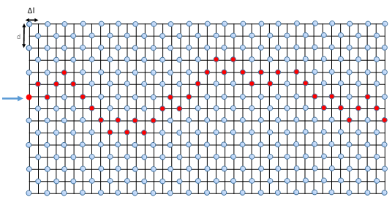
Figure 1: Example of a first path through the Model 1 matrix. Red (darker) dots indicate defect elimination sites and blue (lighter) dots show intact defects. The arrow shows the incidence location for the dislocation line and spacing is shown in the upper left corner. Future dislocations will not see the defects marked red and will thus continue to glide until coming to an existing defect. As defined in this paper, d is the defect diameter and Δl is the average distance between interactions/defects. Note that the defects are not drawn to scale for ease of viewing.

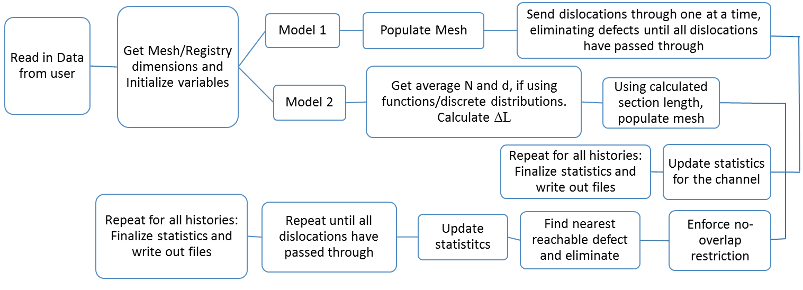
Figure 2: Simple logic flow chart of the program. Each history is a single channel creation and evaluation. At each new history, all preceding information is saved and a new channel is created with the same parameters as the previous channel. The randomness of the system is thereby averaged out over a large number of channels sampled. A much more detailed analysis is available at the beginning of the main routine and each subroutine in Appendix B.

The Average Spacing Model – Model 1
The first model uses a simple, uniform 2D mesh to model dislocation-defect interaction within a grain. Based on the defect diameter (d) and density (N), the model assumes the dislocation travels an average distance between interactions (ΔL), until its termination upon spanning the entire grain of diameter (D). The average interaction distance of a dislocation moving along a fixed glide plane in an array of homogeneously-spaced obstacles with fixed defect diameter and density is given by the well-known dispersed barrier relationship.
Model 1 allows the defect microstructure to be modeled via a two-dimensional array, where the distance between points on the axis of the dislocation jog is d/2 (average dislocation jog width) and the distance between points on the axis of dislocation glide is ΔL. Defects are filled into the array by assigning an initial “existence integer” to all defects, signifying each cell initially contains a defect. All non-defect elements are initialized to 0. An example grid with one dislocation passage is shown in Figure 1. A user-defined number of dislocations, originating from a central grain-boundary source, are passed through the simulated grain in the direction of dislocation glide. Upon dislocation-defect interaction, the existence integer is replaced by a non-existence integer, signifying a defect has been eliminated and the dislocation stochastically moves up or down in the direction of dislocation jog.
The final outcome of dislocation-defect interactions is surveyed to determine the resulting defect-free structure. Surveying is accomplished in one of two ways: maximum, or core width approximations. These are described in subsections 3.2.1, and 3.2.2 below.

Maximum Channel Width Approximation
This approximation tracks the movement of dislocations in their paths in each direction furthest from the midplane of the channel. Essentially, this is just finding the maximum and minimum possible paths that dislocations can traverse. The difference between these paths gives the maximum observable width of the given channel. As shown in section 4.1, this estimate includes large areas which have little defect removal, providing the basis for the development of the core channel width approximation, which is helpful to estimate a corresponding lower bound for comparing to TEM data.

Core Channel Width Approximation
Per 3.2.1, a lower limit on the channel width can be found by applying a defect density threshold, below which the channel is defined to exist. This allows for regions where the vast majority of defects have been eliminated to be estimated. The threshold used in the code was 10% of the matrix, or 10²¹ m⁻³, whichever is higher. The code in the appendix describes this method in detail (see Appendix B.4).

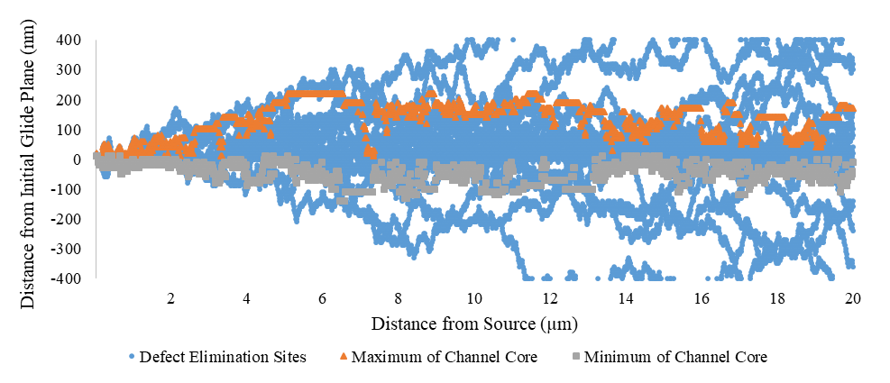
Figure 3: Model 1 channel plot with overlaid core width approximation. Parameters were 100 dislocation passes with defect cluster parameters d=10 nm, N=5x10²³ m⁻³. The round (blue) points are locations of defect elimination, while the triangles (orange) and squares (grey) are minimum and maximum locations of core channel assignment at each x location, respectively to show validity of this core analysis method for model 1 and these parameters. Threshold of channel identification was set at a defect concentration being 10% of the matrix density.

The above figure shows clearly that while a good approximation can be obtained, the core model at many points on the channel significantly under-predicts the core channel width.

Design Limitations and Potential Systematic Errors in Model 1
Model 1 is inherently simple, one of its strongest aspects. However, in order to achieve this simplicity the grid of defects that is created can only be populated with defects that are of the same size. Different sized defects require different vertical (d/2), and both horizontal and depth distances ($ΔL)$, which are inaccessibly by model 1 because a single grid is used. More fundamentally, there is a potential systematic error associated with using a grid, if such use cannot be verified as a reasonable approximation of the average dispersed barrier relationship. Moreover, the code in general must be externally verified to ensure that coding errors have not introduced systematic errors into the model.
Regarding the core approximation, it is important to validate the approximations it gives. To this end, a simple plot of a model 1 grid with the core maxima and minima estimations are presented below in Figure 3. It is important to note that while the code appears to accurately track the region expected to be viewed under a TEM, there are a number of data points which lie well within the expected region. Therefore, the core predictions will likely under predict the minimum. This was not resolvable with the current method and the detailed results are discussed in section 4.1.4.

The Discrete Barrier Model – Model 2
This second model was developed, in part, to address the limitations and possible errors discussed in section 3.2.3. The differences between model 1 and model 2 lie in removing the average spacing assumption, and using a second algorithm for all analysis routines. Removing the average spacing approximation confers two benefits. First, it confirms this technique to model defect-dislocation interactions as valid (see section 5.1). Second, more complex scenarios with defect distributions, rather than a simple average defect size, including Gaussian and custom distributions about given mean defect sizes can be analyzed. Writing the code as an entirely independent algorithm further enabled elimination of significant coding errors. As a result, the combination of models 1 and 2 allows evaluation of the five assumptions in section 3.1, with good confidence.
Algorithmically, the difference is in how the 2D mesh is generated. Instead of using a grid, an array of 4 columns, and rows equal to the number of defects is created. This is then filled with defects whose, x, y, and z positions, along with diameter, and existence integers. The positions are chosen uniformly along each axis (the z-axis being depth, y-axis being distance from midplane, and x-axis being horizontal distance traveled from the source). The z-axis is maximized at $ΔL$, per the expectation that the dislocation will only interact with one defect with a distance of $ΔL$. x- and y-axes are maximized by user entry. As the defects are being created, a spherical overlap restriction is used to ensure that defects don’t exist in the same location, or near enough that they are likely to combine.
As dislocations pass through the matrix, the program searches for the nearest defect that can interact with the dislocation. When the program finds such a defect, it eliminates it and jogs. All sampling locations (spaced out a distance of $ΔL$ for comparison to model 1) between the original dislocation location, and the location of jogging are updated with the dislocation’s position.

Maximum Channel Width Approximation
Maximum channel width is calculated in a similar manner to that in model 1. As dislocations are moving through the material, each recorded width at the sampling point is compared to the current maximum and minimum, which is updated accordingly. The maximum width, as with model 1, is simply the difference between these values.

Core Channel Width Approximation
The core width analysis is performed rather similarly to model 1. The primary difference is that within each sampling section, eliminated defects are gathered into a single array and all possible combinations of core width are examined to determine the width corresponding to the threshold density (section 3.2.2). This gives a reasonably similar result to the model 1 core width approximation. Figure 4 gives an example of the plot.
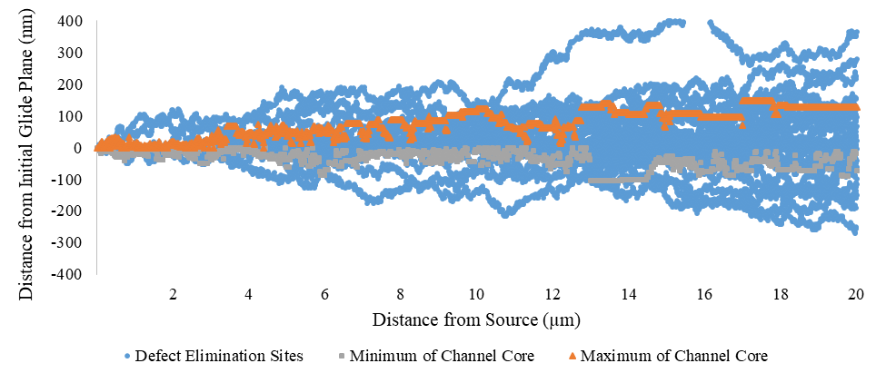
Figure 4: Model 2 example of channel core. Parameters were 100 dislocation passes with defect cluster parameters d=10 nm, N=5x10²³ m⁻³. The round (blue) points are locations of defect elimination, while the triangles (orange) and squares (grey) are minimum and maximum locations of core channel assignment at each x location, respectively to show validity of this core analysis method for model 1 and these parameters. Threshold of channel identification was set at a defect concentration being 10% of the matrix density.

As with the model 1 core approximation, this approximation is clearly an underestimate of the core, possible a little more of an underestimate than model 1. However, it still gives a reasonable approximation to the core channel width that is useful in Chapter 5:

Design Limitations Remaining in Model 2
Following the model 2 adjustments, design limitations are relegated primarily to the assumptions used in both models (section 3.1). This is demonstrated well in Chapter 4 where the comparisons between models show excellent agreement. However, the results presented for these two models only consider the mean value of the maximum and core channel widths. However, since this is a stochastic process, the distribution of the channel width is good to know for detailed comparisons with TEM data, both for model validation, and also for experimental validation, since TEM results are often extremely variable (Chapter 2 and section 5.2). The Analytic method in section 3.4 attempts to address this issue.

Analytic Approach to the Problem
The analytic result uses the model 1 approach to estimating the average of defect distribution within the matrix. Fundamentally, this method attempts to simultaneously explore all possible ways that a dislocation can move. This entails considering each and every path that a dislocation can take in order to reach a specified location. This can be done by allowing a portion of the dislocation to go in either direction every time the dislocation interacts with a defect.

General Mathematical Approach
This means that the dislocation encountering the first defect has weight of 1, meaning that it can eliminate 100 percent of the defect. The defect weight is dropped to 0, indicating full removal. The dislocation then jogs in both directions and its weight in each direction drops to 0.5, indicating that only 50% of the time the dislocation will encounter each new defect. Both defects are reduced by 0.5, in accordance with the weight of the dislocation. Both parts of the dislocation are halved and each jogs in both directions, leading a 0.25 reduction in defect weight on the edges, but a 0.5 reduction in the middle, since both dislocation fragments jog and eliminate 0.25 of that central defect. This process can continue resulting in probabilities of elimination as shown below.
The weight of the defects on each point, following the first pass, is thus 1 minus the above values. On the next pass, the dislocation fully passes the first defect, which is eliminated, and encounters the midline defect on column 3, fully eliminating it. However, since only 0.5 of a defect exists, only 0.5 of the dislocation jogs and separates, with the other 0.5 of the dislocation continuing on to the midplane column 5 defect with the process continuing from there. This process can be used to determine the probabilities of any defect being eliminated for any number of dislocations passing through the material. After this analysis, probabilities of different channel widths can be calculated via conditional probability analysis.
This is done via the following, only using the definition of maximum channel width, for simplicity. For this definition, two probabilities are important, the probability that an extremum point is eliminated,$P_{ex}$, and the probability that all other points beyond (further from the center) are still existing, $P_{out}$. These probabilities are valid for both the maximum and the minimum
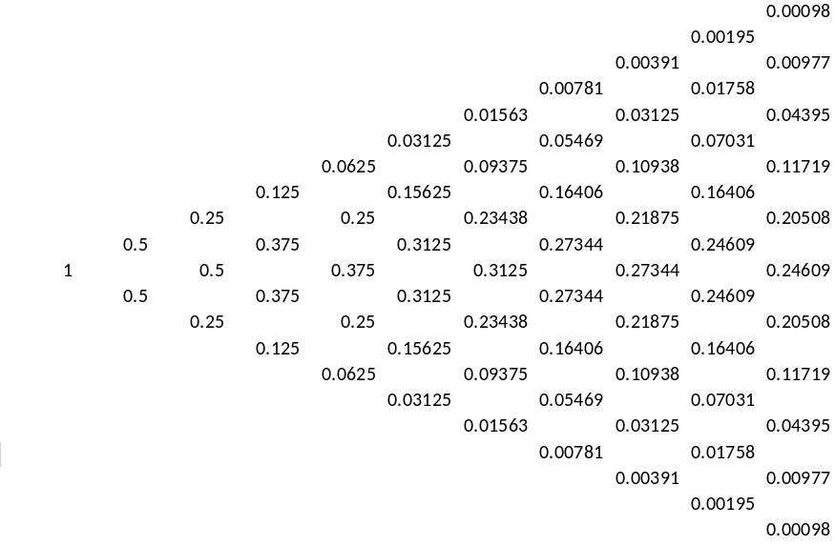
Figure 5: Example grid of analytic solution. Grid consists of probabilities that any given defect is eliminated after 1 dislocation passage. The staggered pattern of defects is due to the setup of model 1, see Figure 1. Defects outside of this cone have an elimination probability of 0 since the dislocations cannot jog out to them.

values of the channel. Or, for any given $y_{1}=max, y_{2}=min$, the probability of that channel width being found is,
$$P_{w_{i}}=P_{ex,y_{1,i}}P_{out,y_{1,i}}P_{ex,y_{2,i}}P_{out,y_{2,i} }$$ | Eqn. 3.2
These are each found by,
$P_{ex,y_{j,i}}$ is found by the analysis process just performed and can simply be pulled from the array.
$$P_{out,y_{j,i}}=\prod_{k=l+1}^{m}{\left(1-P_{elim,k}\right)}$$ | Eqn. 3.3
Where,
k is the counter variable
m is the total number of defects above or below the midplane
l is the current defect being evaluated
Leading to an average channel width,
$$W_{ave}=\sum_{i=1}^{n}{P_{w_{i}}w_{i}}$$ | Eqn. 3.4
For n = total possible widths. The specific code used to implement this is shown in Appendix A. This process leads not only to a listing of the average width, but to a distribution of all possible widths. The method of implementation was also made to be consistent with models 1 and 2 as well, allowing comparison between models. The specific results of this method are discussed in section 4.3.

Remaining Limitations Between all Three Methods
Because model 1 is a valid approximation per model 2 (section 5.1), and this analytic method is an extension of model 1, this method removes the limitation within the first two models of not knowing the distribution of channels. However, this particular method is a poor choice for general analysis for two reasons. First, it has no ability to probe multi-defect systems, just like model 1. As shown in section 4.2.3, these systems cannot typically be represented with a simple average of the defect sizes and a good model incorporating multiple sizes has not been developed, per the discussion of model 1 limitations.
Moreover, for the developed code, this method is limited to very short distances (<10$μ$m typically) due to high memory requirement, limiting its application. There are some ways in which this can be circumvented, but they have not been explored. As a result, there are no known limitations or systematic errors beyond those presented by the formulating assumptions. As a result, the following chapters will present results that are consistent with the assumptions given and evaluation of those assumptions via comparison to TEM results can be done with high confidence.

Presentation of Results

Model 1
For model 1, the defect elimination sites are interest for understanding of what the predictions are showing. In Figure 3, a plot for high diameter (d=10 nm) at moderate density (N=5x10²³ m⁻³) shows the sites of defect elimination with a plot of the core channel extrema estimation by the program. At a more moderated defect size (d=2 nm) with the same defect density, Figure 5 presents a plot of the defect elimination sites.

Effect of the Number of Dislocations on Channel Width
There has been some in situ work showing that defect-free channels form very quickly [47,48,55,56]. This implies either that the dislocations sources, once activated, produced dislocations quite rapidly, allowing the generation of channels by near-instantaneous passage of many dislocations, or that only a few dislocations are required in order to form these channels. In order to investigate this, typical conditions (N=10²³ m⁻³, d=2 nm) were applied for a variety of dislocation passes running from 2 to 1000 per channel with 10³⁻⁴ histories per simulation. The results are presented in Figure 6, showing a very small transient, such that the channel is nearly developed by just 10-15 dislocation passes, and fully developed by 20 with only insignificant increase in channel width moving up to 100 and no additional change up to 1000 dislocations.
The same plot for the core channel approximation yields Figure 7. This figure shows the same general trend as the maximum width correlations, indicating that the channel develops uniformly. However, as the channel becomes long (near 50 µm), only at 25 dislocation passes does the channel converge to the infinity passes result. The reason for this is due to the random walk nature of dislocations leading to more scatter in the channel width, leading to a decrease in the observed width from a core channel perspective at very low dislocation pass numbers.
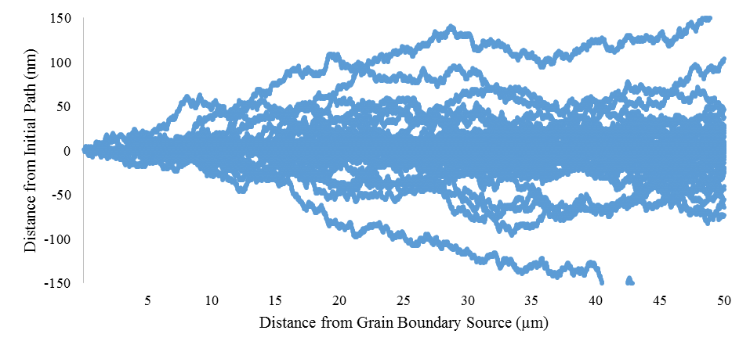
Figure 6: Model 1 channel plot. Parameters are d=2 nm, N = 5x10²³m⁻³ in a 50 $μ$m channel with 100 dislocation passes per section 4.1.1. Each point is a location of defect elimination. Maximum channel width predictions will follow the outer lines very closely, while the core channel width predictions will follow the low defect region more closely, ignoring the outer lines.

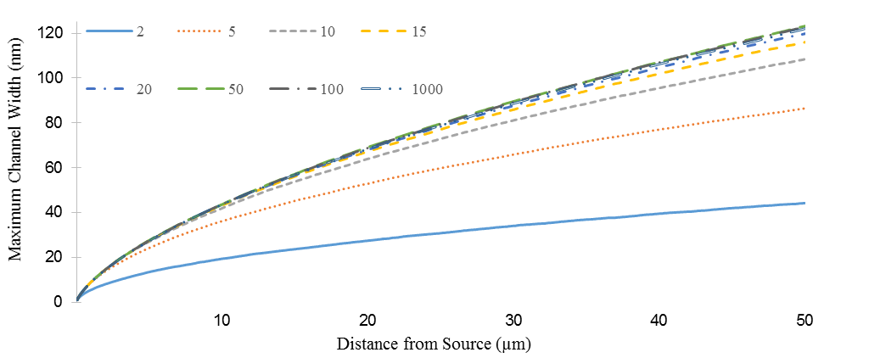
Figure 7: Model 1 maximum channel width dependence on the number of dislocation passes per history. The numbers in the legend reflect the number of dislocations per history. Model parameters for each run were d=2 nm, N=5x10²³ m⁻³.

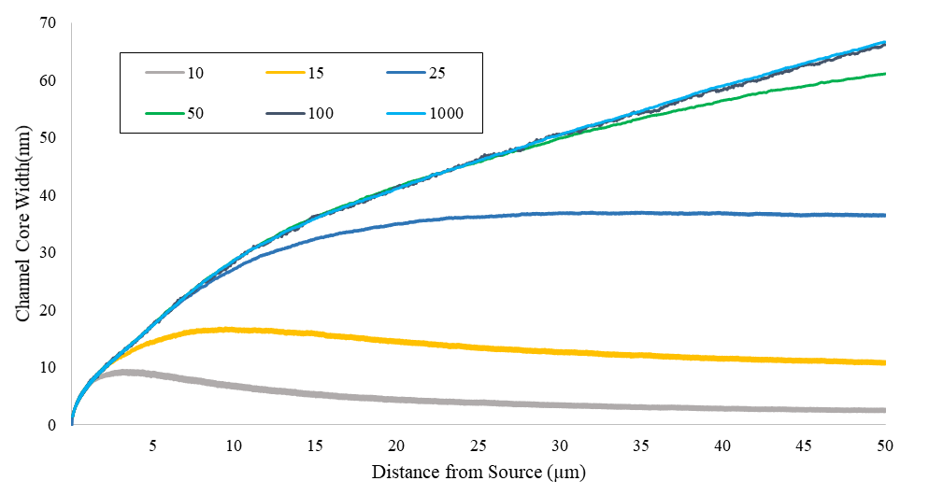
Figure 8: Model 1 core channel width dependence on number of dislocation passes per history. Simulation parameters were d = 3nm, N = 5x10²³ m⁻³ for each run. The numbers in the legend reflect the number of dislocations per history.

Generally, for both the core and maximum approximations in model 1, after several dislocation passes, the channel becomes fully developed. While it takes a few more passes for the core region to develop than the maximum region, the difference is quite minimal and only exists for longer channels such as simulated above. At 100 dislocation passes (the number used in all correlation studies), both are fully saturated, and in a real system, one or two networks of dislocations could easily contain the required number to fully clear a channel, in accordance with previously referenced works. Intuitively, the number of dislocations required for full channel formation should be somewhat higher due to the existence of other dislocation-defect interactions, including partial eliminations leading to defect debris. Additional work is needed to fully characterize this information.

Effect of the Microstructural Properties on Channel Width
The most important part of this study is the effect of microstructural properties, diameter and number density of defects, and the distance of sampling from the source. From the literature, diameters tend to vary between 1 and 6 nm, with densities between 10²²-10²⁴ m⁻³ [16,18,49,57,58]. In order to find the effect of each parameter, one parameter must be held constant while the varies. Choice of the value of the parameter to hold constant is vital to an accurate prediction, since the value obtained will be more accurate around those parameters, than much further from them. Based on the given typical parameters, when effect of density was being evaluated, d = 2 nm; when effect of diameter was being evaluated, N = 5x10²³ m⁻³, the same as in the dislocation number effect plots. The simulation data sets used are presented in Table 1.
These particular values were used so as to nearly equally span the range of normal data, while giving some bias towards low diameters and the higher, more commonly observed densities. For model 1, when all of these are performed the following, Figure 8, is obtained, only plotting some of the data points, for clarity. It should be noted that the above analyses do not permit the investigation of the resolved shear stress (RSS), despite it potential importance (see section 5.2). Based on the assumption that all defect interactions lead to defect elimination, it is implicitly assumed that the RSS is high, leading to more probable defect elimination and thus larger channel widths [16,44,49,55,59].

Table 1: Table of simulation parameters used for correlations in all models
Simulation Number | Diameter (nm) | Density (m⁻³) | Simulation Number | Diameter (nm) | Density (m⁻³)
1 | 2.0 | 7.5x10²¹ | 14 | 1 | 5.00x10²³
2 | 2.0 | 1.0x10²² | 15 | 2 | 5.00x10²³
3 | 2.0 | 2.5x10²² | 16 | 3 | 5.00x10²³
4 | 2.0 | 5.0x10²² | 17 | 4 | 5.00x10²³
5 | 2.0 | 7.5x10²² | 18 | 5 | 5.00x10²³
6 | 2.0 | 1.0x10²³ | 19 | 6 | 5.00x10²³
7 | 2.0 | 1.25x10²³ | 20 | 8 | 5.00x10²³
8 | 2.0 | 1.50x10²³ | 21 | 9 | 5.00x10²³
9 | 2.0 | 2.25x10²³ | 22 | 10 | 5.00x10²³
10 | 2.0 | 2.75x10²³ | 23 | 11 | 5.00x10²³
11 | 2.0 | 3.25x10²³
12 | 2.0 | 5.00x10²³
13 | 2.0 | 1.0x10²⁴

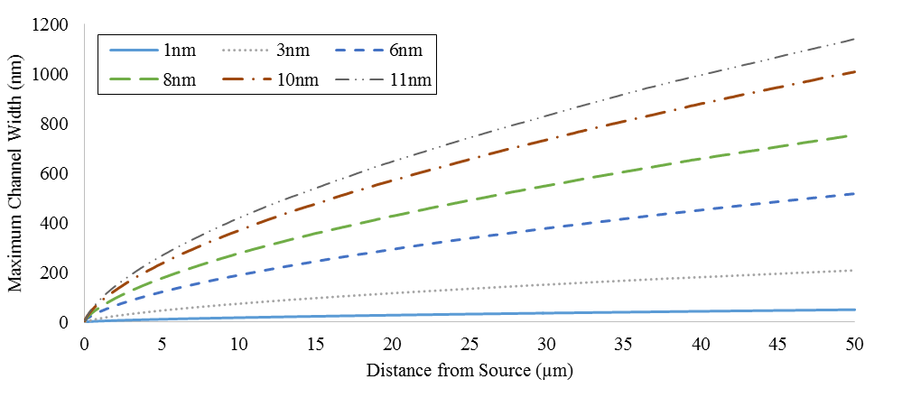
(a)
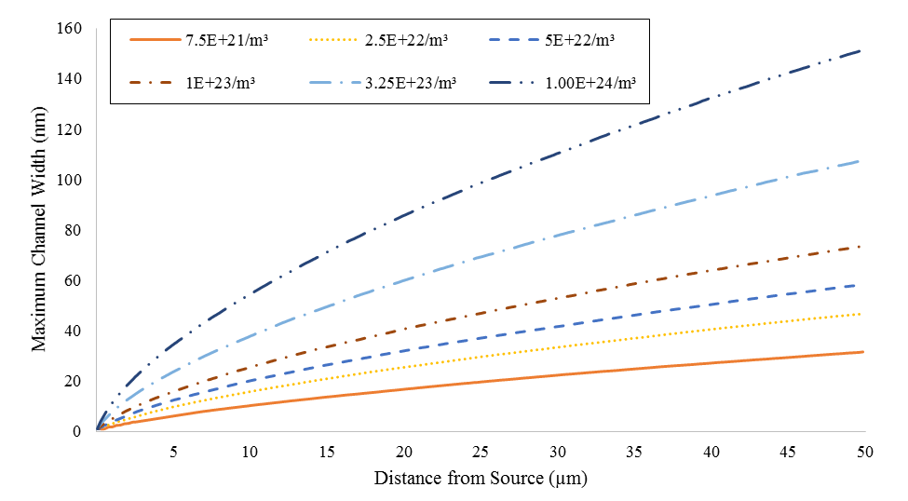
(b)
Figure 9: Model 1 microstructural parameters effects on maximum channel width. (a) Plot of the effect of changing defect diameter with N = 5x10²³ m⁻³ and a diameter variation of 1-11 nm. (b) Plot of the effect of changing defect density with d = 2.0 nm and defect density varying from 7.5x10²¹ m⁻³ to 1.0x10²⁴ m⁻³.

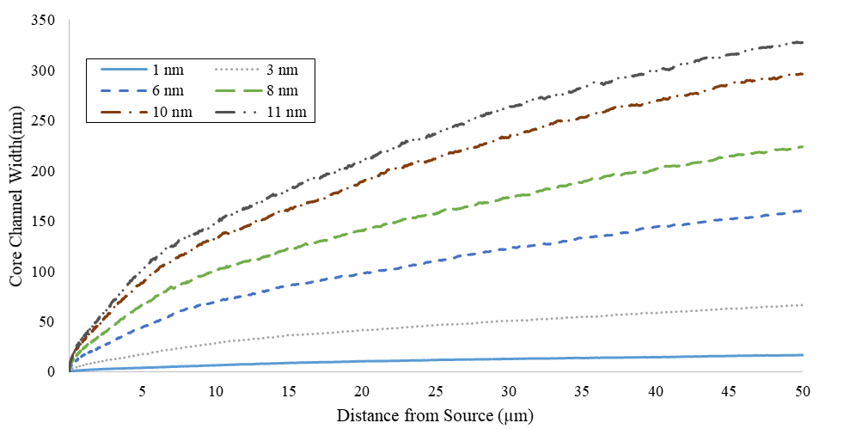
(a)
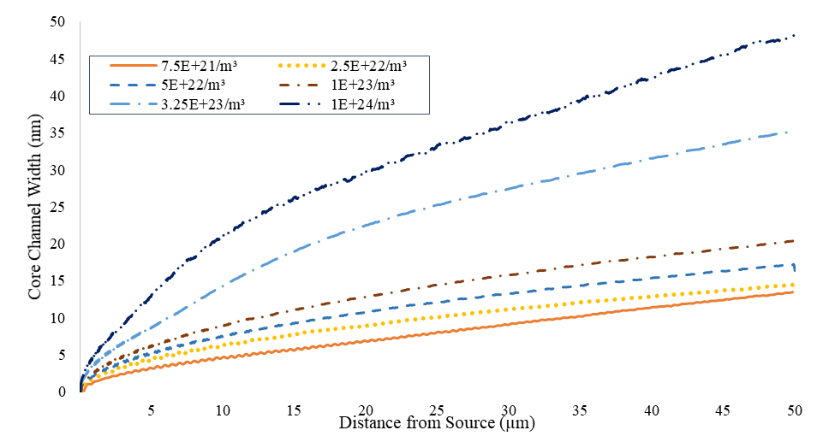
(b)
Figure 10: Model 1 core channel width dependence on microstructural parameters. (a) Plot of the effect of changing defect diameter with N = 5x10²³ m⁻³ and a diameter variation of 1-11 nm. (b) Plot of the effect of changing defect density with d = 2.0 nm and defect density varying from 7.5x10²¹ m⁻³ to 1.0x10²⁴ m⁻³.

Despite the number densities spanning two orders of magnitude, and the diameter spanning one order of magnitude, Figure 8 shows a significantly larger increase in channel size over the given range for diameter than density. It is also apparent from both graphs that the effect of distance from the source is to increase the channel width in a parabolic manner. These effects are quantified in section 4.1.3. For the core channel width approximation, the figures are predominately similar with the notable exception that the channel appears to develop more slowly. Moreover, the width of the channels is significantly reduced compared to the maximum channel width. The model 1 core approximations for all data sets are presented in Figure 9.

Summary Correlations
The above results were correlated by matrix comparison of the least squares (LS) fit to a power law for every case. A power law was chosen for the following reasons. 1) It is the best of the LS techniques, as determined visually and by the R² value. 2) It fits extremely well to the curve. 3) This is a random walk problem, meaning that it is similar to diffusion and should take the form of a power law as a result. Given this, the following form was assumed for the overall width equation.
$$W=Ax^{B}$$ | Eqn. 4.1
Where,
$$A=Cd^{E}N^{F}$$  $$B=Wd^{V}N^{J}$$ | Eqn. 4.2
C, E, F, W, V, J and empirically-determined constants. Because of the diffusion analogy, $B≈0.5$, while A is related to probability of defect interaction times the height of the interaction. Solving for E, F, V, and J is done by comparing only data sets where one of the parameters is constant, since the LS estimation gives values of A and B for each case, dividing the equations from two cases leads to
$$E=\frac{\log\left({A_{1}}/{A_{2}}\right)}{\log\left(d_{1}/d_{2}\right)}, V=\frac{\log\left({B_{1}}/{B_{2}}\right)}{\log\left({d_{1}}/{d_{2}}\right)}$$ | Eqn. 4.3
For constant N, and
$$F=\frac{\log\left({A_{1}}/{A_{2}}\right)}{\log\left(N_{1}/N_{2}\right)}, J=\frac{\log\left({B_{1}}/{B_{2}}\right)}{\log\left({N_{1}}/{N_{2}}\right)}$$ | Eqn. 4.4
The subscripts refer to two any two arbitrary parameters. Looping over all subscripts for subscript 1 $≠$ subscript 2 and incrementing subscript 1 through the whold data set, a full analysis of possible comparisons can be made. For constant d, taking the average values for all 23 data sets,
$$C=\frac{A}{d^{E}N^{F}}, W=\frac{B}{d^{V}N^{J}}$$ | Eqn. 4.5
Because all values of A and B are LS estimates, there will be variation in the estimates for the 6 empirical constants beyond the error in the simulation. Therefore, a Grubb’s test is used to exclude estimates that are outside of the tolerances inherent in that test [60]. This test simply compares an adjusted-extrema value to the Grubbs test table. The value is thrown out if the following is true.
$$G_{table}≤\frac{\left|extrema-μ\right|}{σ}$$ | Eqn. 4.6
Where,
$μ$ is the mean of the empirical constant estimations
$σ$ is the standard deviation of the estimations
Performing these operations on the model 1 results gives the following equation with significant figures limited by the standard deviation. W, d, and x have units of nm, and N has units of nm⁻³.
For the maximum width estimation:
$$W\left(x\right)=0.85d^{1.44}N^{0.43}x^{{0.611d}^{-0.020}N^{-0.014}}$$ | Eqn. 4.7
For the core width estimation,
$$W\left(x\right)=0.37d^{1.42}N^{0.32}x^{0.48d^{-0.031}N^{-0.025}}$$ | Eqn. 4.8

Error in Correlations
Error in the proposed correlations arise from two sources. The first is error due to the Monte Carlo (MC) process creating a degree of uncertainty around the channel widths. For 10³ to 10⁴ histories, these errors are at most 1% of the mean, except for the first few data points (less than about 200 nm from the source), where the standard deviations can be as high as 5-10% of the means. As x increases, this error falls off quickly to about 0.01% of the mean value. Therefore, the correlations will not be significantly affected by this source of error.
The second source of error is from the LS estimation of the power law equation leading to an imperfect fit to the data. The correlation error is most strongly affected by this factor. The correlative equations from the above section 4.1.3 can be compared to the data coming out of the simulations without separating out these two factors. This is important for eventual use of these equations to compare with TEM data. Figure 10 compares these results for both maximum and core approximations.
While the maximum approximation fits very well, the core approximation is poor. Primarily, this arises from the highly variable core region approximation leading to a less-repeatable process, with significantly more error. This also caused a significant number of trend reversals when analyzing the LS equation differences.

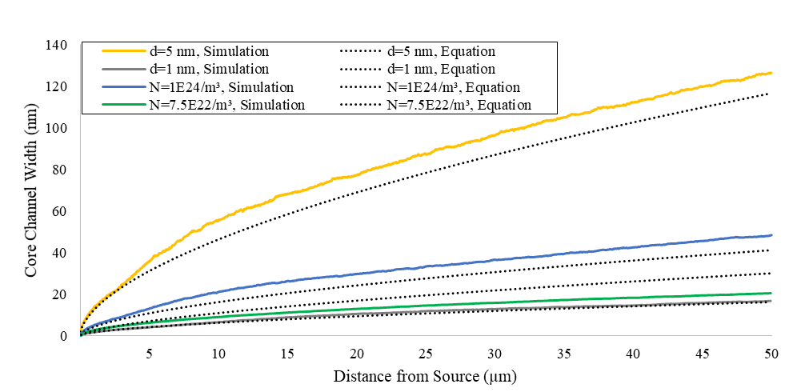
(a)
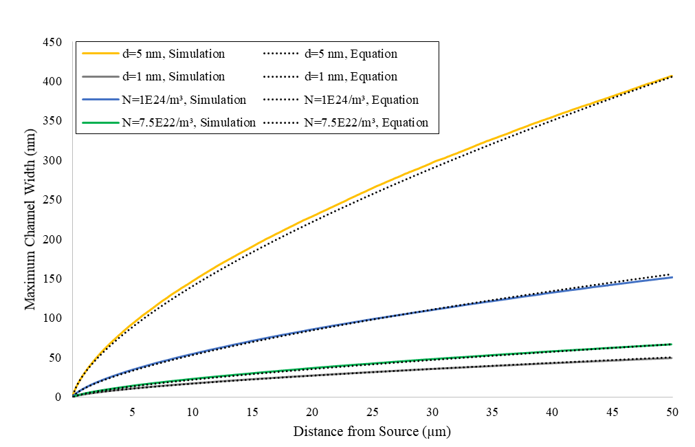
(b)
Figure 11: Model 1 comparison of correlative equations to select simulation sets. As noted earlier, for the cases where d is specified, N=5x10²³ m⁻³, and where N is specified, d=2 nm. (a) Core channel width comparisons. (b) Maximum channel width comparisons.

Model 2
Similar to section 4.1, the plot of the channel is useful for channel comparisons and understanding what the differences in the sampling methods (maximum vs core width estimation) mean. For the same parameters of the channel plot for model 1 (d=2 nm, N=5x10²³ m⁻³), Figure 11 shows the channel plot from model 2.

Effect of the Number of Dislocations on Channel Width
The number of dislocations in model 2 have the same effect as in model 1. For d=2 nm, and N=5x10²³ m⁻³, as with model 1, varying the number of dislocation passes per history from 2 to 1000 dislocation passes for the maximum channel width approximation results in Figure 12. Variation from 10 to 1000 dislocation passes per history for the core channel width approximation results in Figure 13.

Effect of the Microstructural Properties on Channel Width
See section 4.1.2 for explanation of density and diameter values. All models use the same set of values, listed in Table 1. As with model 1, selected data sets are plotted below in Figure 14, showing the effect of each parameter. The diameter affects the channel width significantly more than the defect number density. Moreover, the distance from the source does cause substantial variation in channel width, but it is parabolic, as section 4.2.7 shows clearly.

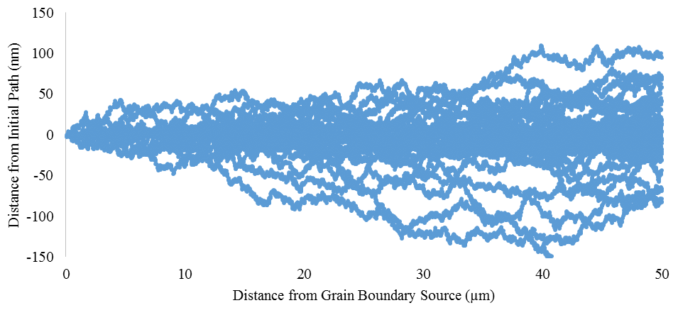
Figure 12: Model 2 channel plot. Simulation parameters are for typical (d=2 nm, N=5x10²³ m⁻³) microstructure properties in a 50 $μ$m channel, corresponding to the same plot in section 4.1, with 100 dislocation passes, per section 4.2.1. Each point is a location of defect elimination. The core model will follow the highly removed region, whereas the maximum model will follow the outside lines very closely, including some regions of matrix-level defect density.

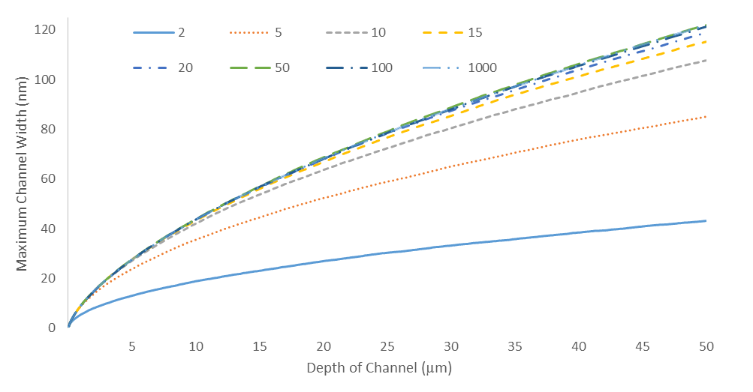
Figure 13: Model 2 maximum channel width dependency on number of dislocation passes per history. As with model 1, d=2 nm, N=5x10²³ m⁻³.
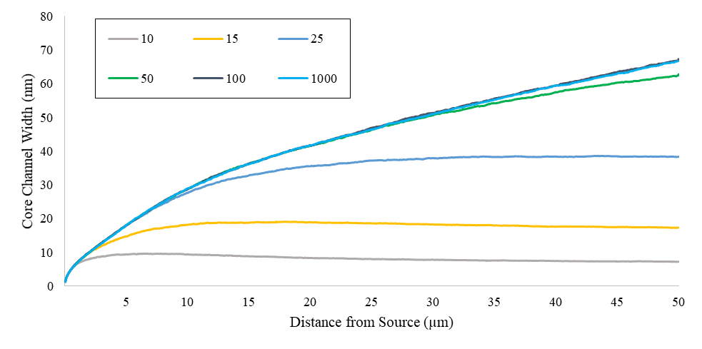
Figure 14: Model 2 core channel width dependency on number of dislocation passes per history. d=3 nm, N =10²³m⁻³.

Effect of the Microstructural Properties on Channel Width
See section 4.1.2 for explanation of density and diameter values. All models use the same set of values, listed in Table 1. As with model 1, selected data sets are plotted below in Figure 14, showing the effect of each parameter. The diameter affects the channel width significantly more than the defect number density. Moreover, the distance from the source does cause substantial variation in channel width, but it is parabolic, as section 4.2.7 shows clearly. This development is clearly altered somewhat when using a core model, with large reductions in predicted widths. The corresponding plots are in Figure 15.

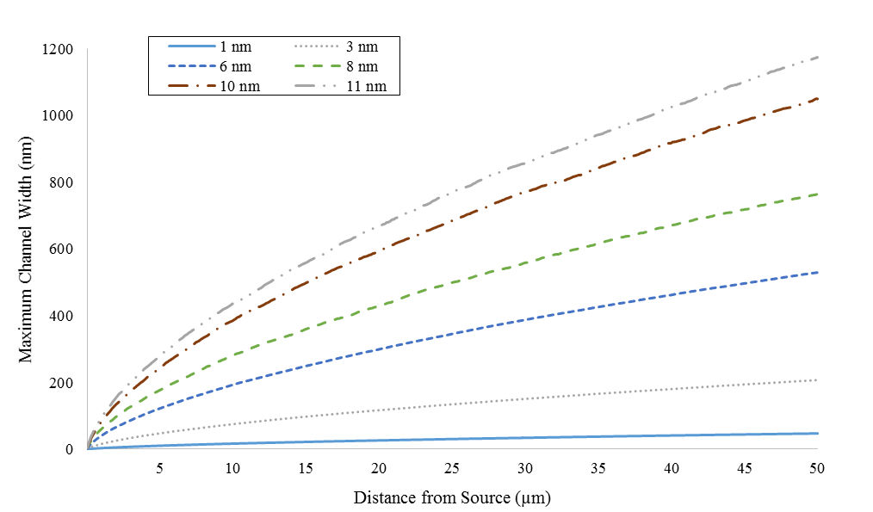
(a)
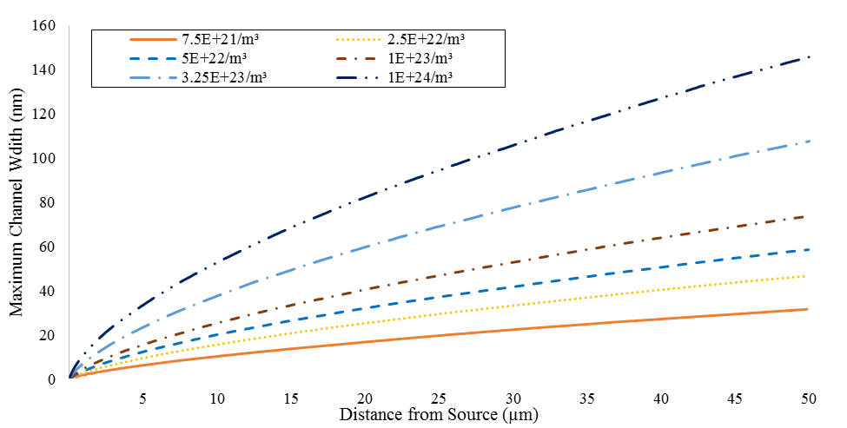
(b)
Figure 15: Effect of microstructure on the maximum channel width predictions from model 2. (a) Plot of the effect of changing defect diameter with N = 5x10²³ m⁻³ and a diameter variation of 1-11 nm. (b) Plot of the effect of changing defect density with d = 2.0 nm and defect density varying from 7.5x10²¹ m⁻³ to 1.0x10²⁴ m⁻³.

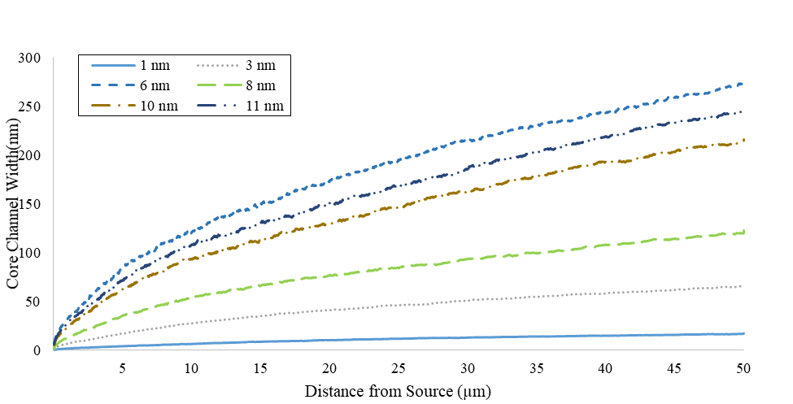
(a)
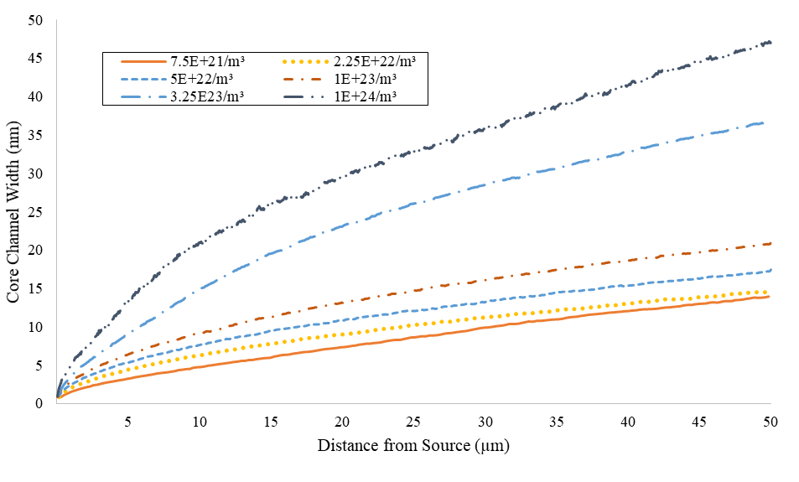
(b)
Figure 16: Effect of microstructure on the core channel width prediction from model 2. (a) Plot of the effect of changing defect diameter with N = 5x10²³ m⁻³ and a diameter variation of 1-11 nm. (b) Plot of the effect of changing defect density with d = 2.0 nm and defect density varying from 7.5x10²¹ m⁻³ to 1.0x10²⁴ m⁻³.

Effect of Diameter Distributions
As shown in sections 4.2.7 and 4.1.3, channel width varies to a power of about 1.5. Therefore, simple weighted averages of the defect diameter may significantly under-predict the width of actual channels formed. Capturing the effect of using these distributions was done using Gaussian distributions about a mean diameter with various standard deviations, and taking a few discrete distributions from literature. Using the same standard parameters as in the rest of these results (N=5.0x10²³m⁻³ and d=2nm) without a distribution, and normal distribution with standard deviations of 0.1, 0.5. 1.5, and 3.0 nm the following plot, Figure 17, is obtained. For similar comparison using literature data, see section 5.2.

Effect of Source Broadening
Source broadening is investigated by including a grouping of different discrete sources within a single, small volume. Dislocations are emitted from a different discrete source each time a dislocation is emitted such that each source is sampled equally. The effect of this is shown below in Figure 18 and is the same for every set of source sizes and number of sources. The full set of data is not present below for simplicity reasons. The effect is just a baseline addition to the same dislocation jog, leading to the following relation for the effect of dislocation jogs.
$$W\left(x\right)=W_{0}+SV$$ | Eqn. 4.9
Where the SV term refers to the source volume and W₀ is the width generated by a point source for the same parameters. The appropriate equations describing W₀ are found in sections 4.1.3 and 4.2.6.
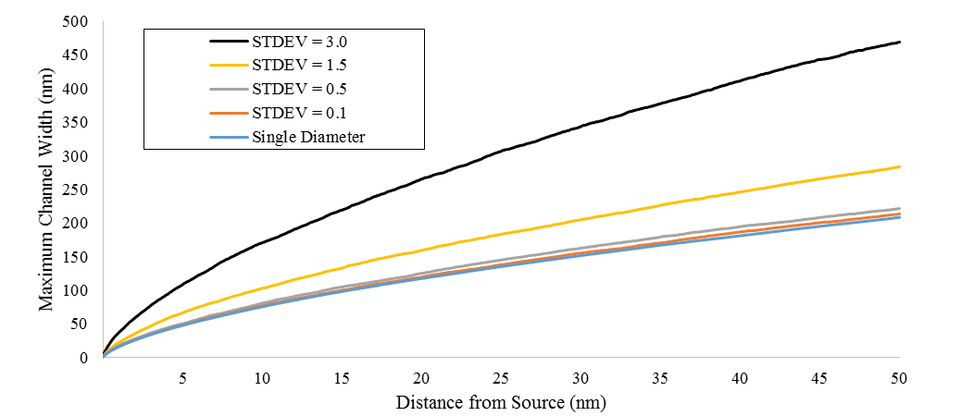
Figure 17: Effect of Gaussian distributions about a mean diameter on the maximum channel width. Parameters for each of the above lines are N = 5x10²³m⁻³ and d=3 nm. Standard deviations are 0, 0.1, 0.5, 1.5, and 3.0 with a total of 1000 histories per curve.

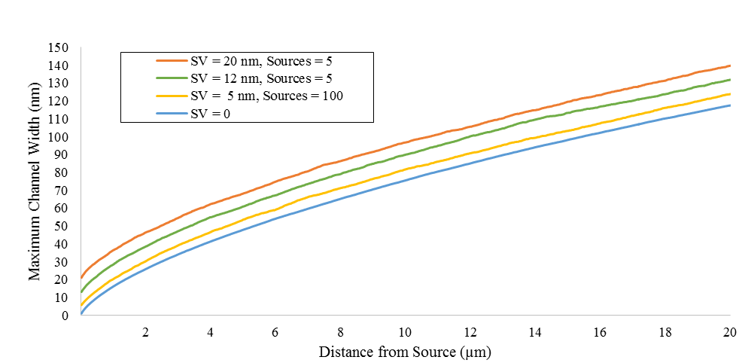
Figure 18: Effect of using distributed sources on the maximum channel width. Parameters for each run are N = 5x10²³m⁻³ and d=3 nm. Source widths are varied between 0 and 20 nm.

Summary Correlations
The method behind these correlations is discussed under section 4.1.3. There is no difference in the method of correlation between models 1 and 2. This allows exact comparison of the results of each of these models. The correlative equation for the maximum width approximation is
For the maximum width estimation:
$$W\left(x\right)=1.04d^{1.45}N^{0.44}x^{{0.595d}^{-0.016}N^{-0.015}}$$ | Eqn. 4.10
For the core width estimation,
$$W\left(x\right)=0.58d^{1.44}N^{0.36}x^{0.42d^{-0.04}N^{-0.05}}$$ | Eqn. 4.11

Error in Correlations
See section 4.1.4 for a discussion of general errors in the model. In addition to those comments, there is a larger error due to simulation stochastics as a direct result of using randomly-placed defects. This leads to a larger deviation from between the equation predictions and the simulation predictions. This is shown for both models in Figure 15. It should be noted that the core approximation for model 2 also does not correlate well to a single descriptive equation, for the same reasons as in model 1.

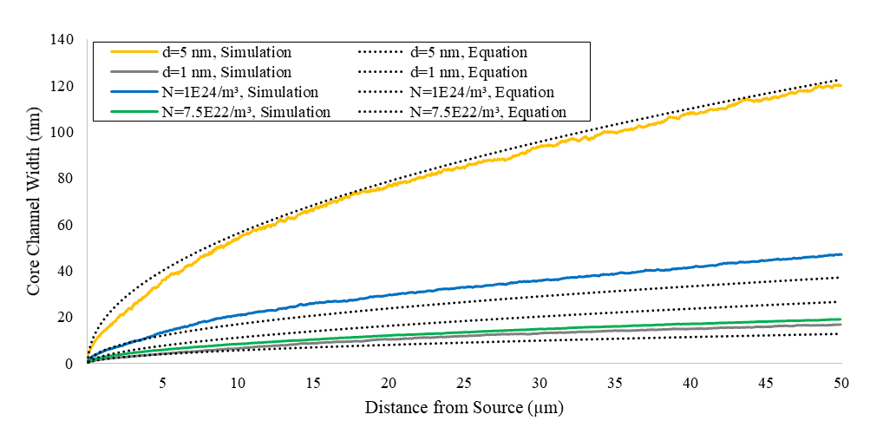
(a)
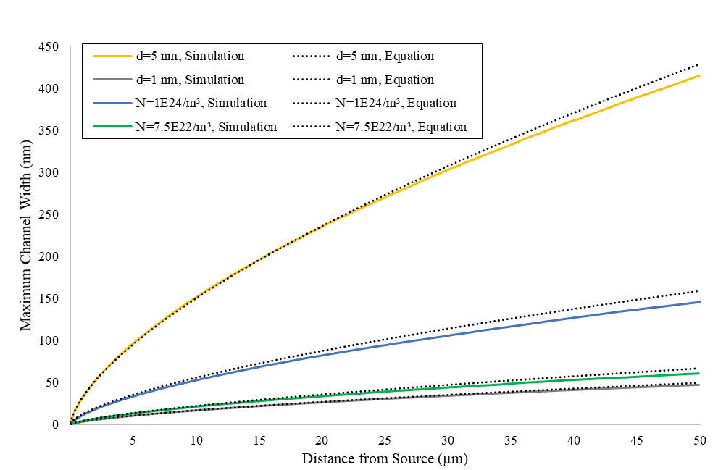
(b)
Figure 19: Model 2 comparison of correlative equations to select simulation sets. As noted earlier, for the cases where d is specified, N=5x10²³ m⁻³, and where N is specified, d=2 nm. (a) Core channel width comparisons. (b) Maximum channel width comparisons.

Analytic Model
For validation purposes, the same analysis done for models 1 and 2 in sections 4.1 and 4.2, respectively, was performed on this model with the following correlations, using the same parameter sets for up to 10 microns. The size of the matrices needed to go to 50 microns required more memory than readily available, limiting use to 10 microns. Since this is based on model 1, a fully set of graphs is not presented below. Rather, graphs for density and diameter variations are presented in section 4.3.2 along with the appropriate correlation, which will be compared to the other models in section 5.1.
As the strength of this approach lies in PDFs of possible maximum channel widths, that is the focus of this section and is discussed in 4.3.1, below. As mentioned in section 3.4, the core channel width was not evaluated for this model. However, an absolute minimum to the channel width can be established based on Figures 19, 20, and 21. This is the closest thing to a core width approximation that is presented here.

PDFs of Dislocation Passage/Defect Elimination
For each parameter set run, the program outputs probabilities that any given channel width is chosen. These are normalized and graphed below in Figures 19, 20, and 21. Various parameters, mean, standard deviation, skewness, and kurtosis, are then correlated with distance in a similar manner to models 1 and 2. The extended details of this are presented in section 4.3.2.

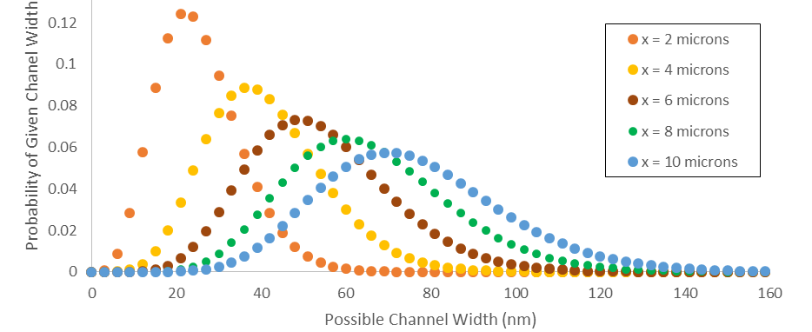
Figure 20: Maximum channel width PDFs at x = 2, 4, 6, 8, and 10 microns along the channel N = 5x10²³m⁻³, d=3nm.
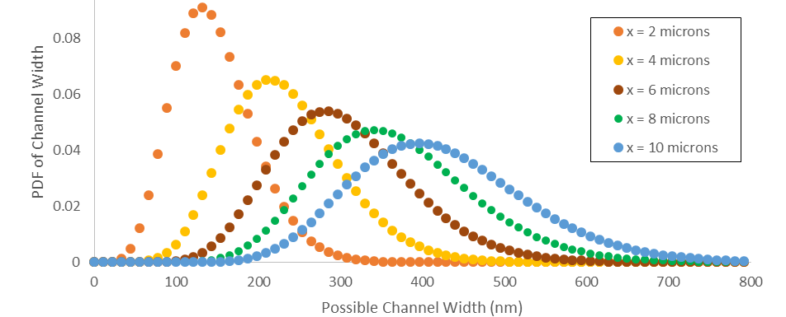
Figure 21: Maximum channel width PDFs at x = 2, 4, 6, 8, and 10 microns along the channel. N = 5x10²³m⁻³, d=11nm.
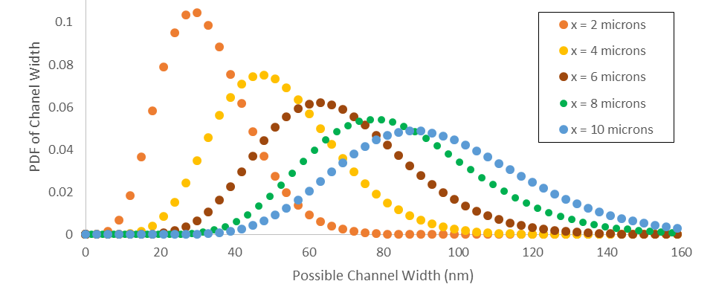
Figure 22 Maximum channel width PDFs at x = 2, 4, 6, 8, and 10 microns along he channel. N = 1x10²⁴m⁻³, d=3nm.

Microstructure Effects
Microstructural effects on the mean, maximum channel width approximation were found in the exact same way as with models 1 and 2. The only variation was in using d=3nm for variable density measurements. Graphs of microstructural effects from diameter and density variations are presented in Figure 22. The results of these variations are the following equation.
$$W\left(x\right)=0.955d^{1.480}N^{0.51}x^{{0.6166d}^{-0.023}N^{-0.023}}$$ | Eqn. 4.12
Microstructural effects on these four parameters are shown in Figures 23, 24, and 25. The former of these is quite similar to the model 1 and 2 equivalents (Figures 9 and 15) as is the above equation. The latter figure gives the probability of the mean, standard deviation, skewness, and kurtosis of the distribution. Each of these quickly converges to a steady value, and the details of this are discussed below in section 5.1.

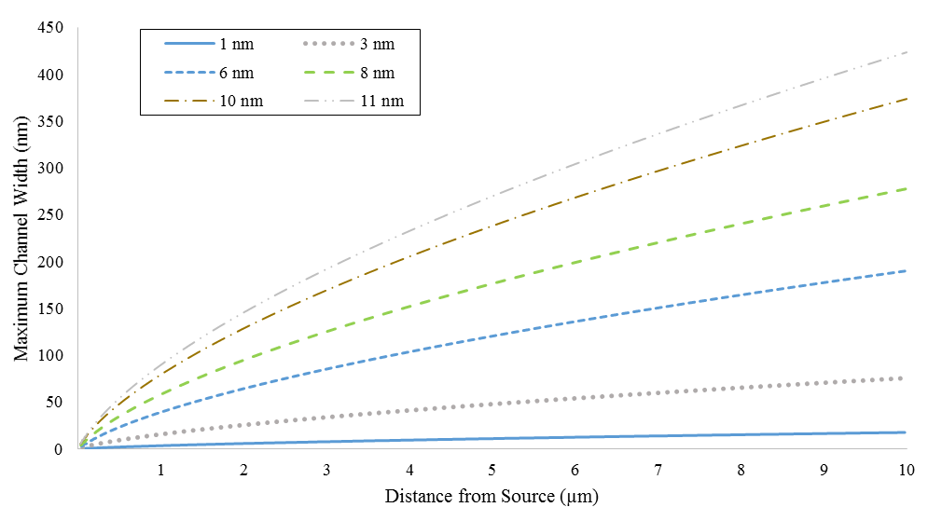
(a)
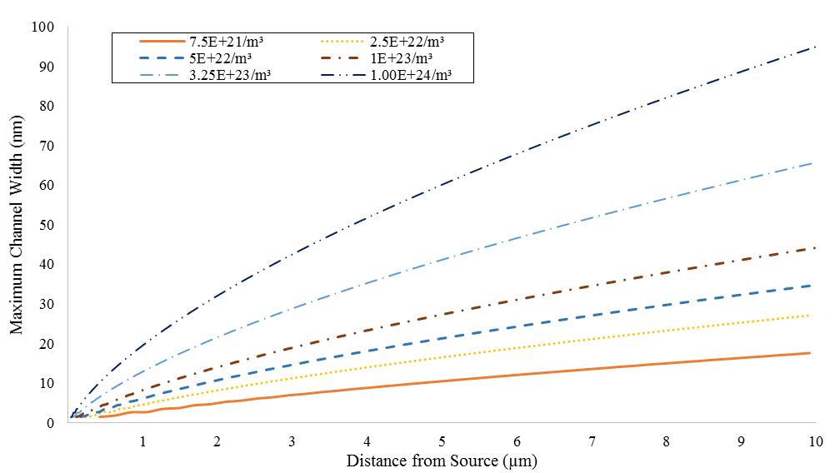
(b)
Figure 23: Analytical model microstructural parameters effects on mean maximum channel width. (a) Plot of the effect of changing defect diameter with N = 5x10²³ m⁻³ and a diameter variation of 1-11 nm. (b) Plot of the effect of changing defect density with d = 3.0 nm and defect density varying from 7.5x10²¹ m⁻³ to 1.0x10²⁴ m⁻³.
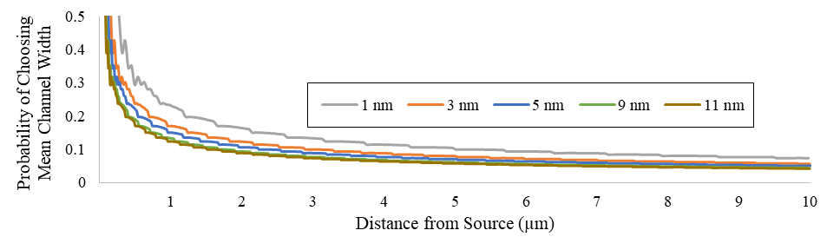
(a)
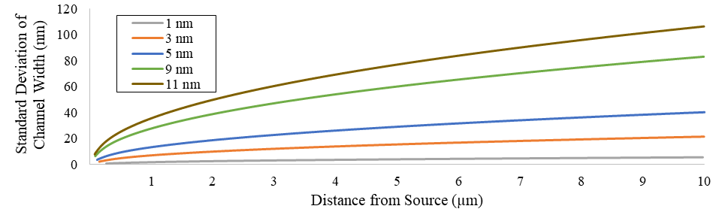
(b)
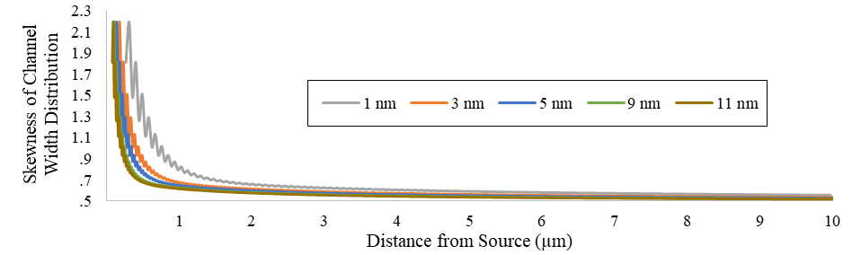
(c)
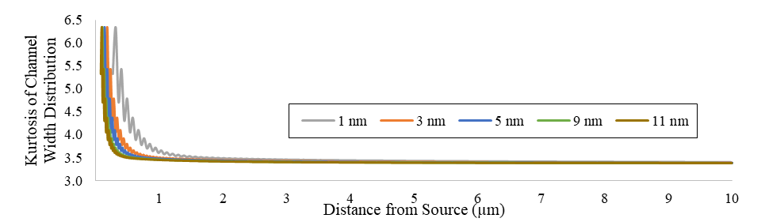
(d)
Figure 24: Effects of defect diameter on the statistical quantities of the channel plots. Number density is held constant at 5.0x10²³ m⁻³. (a) Variation of the probability of the mean channel width to be chosen with distance from the source (b) Variation of the standard deviation of the channel width PDF. (c) Variation of the skewness of the channel width distribution. (d) Variation of the kurtosis of the channel width distribution.
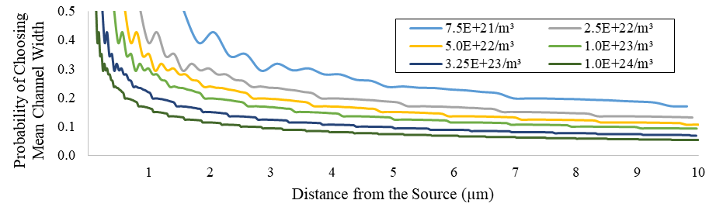
(a)
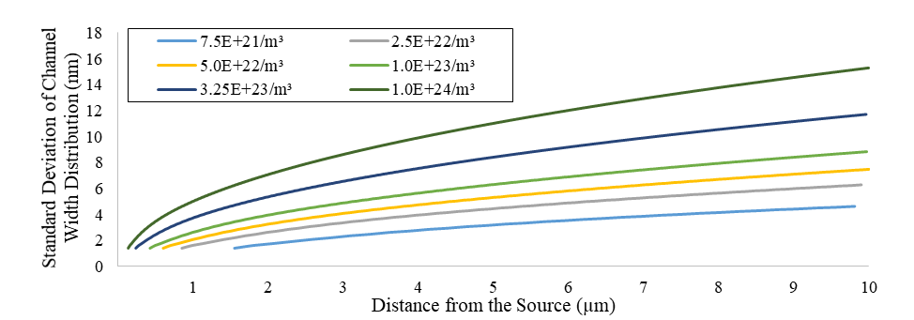
(b)
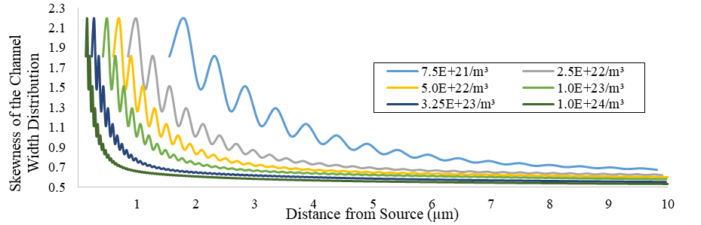
(c)
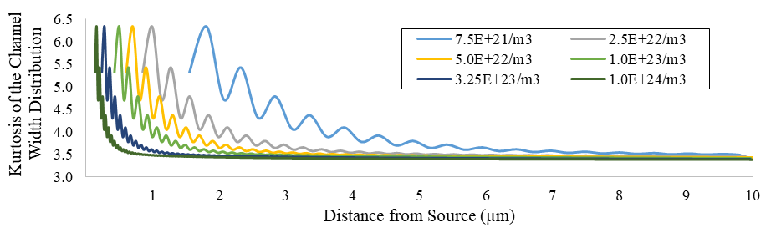
(d)
Figure 25: Effects of defect number density on the statistical quantities of the channel plots. Defect diameter is held constant at 2.0nm. (a) Probability of choosing the mean of the distribution. (b) Variation of the standard deviation of the channel width PDF. (c) Variation of the skewness of the channel width distribution. (d) Variation of the kurtosis of the channel width distribution.

Discussion of Results Along with Predictions and Implications of the Models

Comparison of the three Approaches
The most important validation comparison between these approaches involves comparing the microstructural results of the various models and the resulting correlations.

Cross-model Validation
Eqn. 4.7, 4.10, and 4.12 are in close agreement at each parameter. The pre-x factor, A, is related to the probability of interacting with a defect, multiplied by the increase of channel size upon interacting with a defect. The exponent on x, B, is just above the value of 0.5, which is expected since diffusion is dependent upon the square root of time. For this diffusion analogy, time is equivalent todistance along the axis, leading the equations agreeing with expectations. The equations describing the core channel width, Eqn. 4.8 and 4.11, are not in good agreement. While both show sharp differences in the constants C and W, the degree of change is quite different for each, despite both model simulations yielding similar results. It should also be noted, that the higher variability in model 2 leads to a discrepancy between the model 1 and model 2 core approximations at high defect diameters. This is also likely why the constants C and W in the equations are quite different. However, at the lower diameters, which are of greater interest for most real situations, the models primarily agree. Despite these problems, the correlations both agree that the effect of diameter and density of the defects is primarily unchanged from the maximum width approximation, with the primary difference being a slightly dampened diffusional broadening and a lower constant, C, with a small reduction in the effect of defect density. There is also an increase in the contribution of $Δl$ to the exponent, B. These are reasonable, being indicative of the core model removing the “tails” in the random walk process, leading to slower outgrowth of the channel width distance than in a diffusion analogy.
A few additional conclusions can be drawn from Figures 3 and 4. First, both core models have a high degree of variability from one sampling point to the next, as mentioned above, which was not able to be removed with a simple smoothing algorithm. This variability is mostly directed inward and use of 1% density threshold for analysis did not improve either the smoothness or the expected extrema locations. Such variations likely lead to an average under-prediction of the core channel width, especially in longer channels where the stochastics will cause this misidentification to increase. Secondly, while similar the models are not identical in their estimation. Model 1 appears visually to fit the expected channel core more faithfully than model 2, leading to both less variability in the result, and consequently greater precision and accuracy in the averaged result. This may account for the difference in model predictions at high defect size.
Comparison of Figures 9, 15, and 23, presenting the effect of microstructural parameters on mean channel width, visually presents the magnitude of the dependencies predicted by the equations. The primary quality difference between models 1 and 2 is the increased noise in model 2. This, however, is expected due to the inherent randomness of model 2 relative to model 1.
Therefore, these three approaches to modeling defect-free channels can be considered accurate instances of the 5 assumptions set forth in Chapter 3. The presented correlations are also reasonable with respect to the simulations as shown by Figures 11 and 19. The core channel widths were reasonably accurate only for certain parameter sets, as a result of the higher variability between models leading to less validity in the least squares regression. As a result of this, in section 5.2, the core comparisons to literature data are done with direct simulations rather than correlations. Since the correlations for the maximum approximations show better fidelity to the simulations, these correlations are used in the model comparisons to the literature data.

Interpretation of the model results
The large degree of agreement between models 1 and 2 confirms that the present “checker –board” configuration with model 1 is valid for dislocation-defect interactions governed by the assumptions given in Chapter 3. When considering additional parameters, such as force between dislocations and defects leading to defect decoration of the dislocation [39–41], significant simplification, without loss of information, can be achieved by implementing a model 1 framework, for a simplistic, 1 defect system.
Further, the model 2 results show the significance of distributed defect sizes. While the 1.5 exponent on the diameter implies that diameter distributions will not have the same effect as their mean, Figure 17 quantitatively shows that even for small distributions around typical defect sizes there is a significant deviation from the non-distributed solution. It is well known that defect sizes in metals are often significantly distributed according to non-Gaussian distributions [18,57,58]. Since a simple mathematical approximation of an equivalent diameter does not exist, the use of an actual simulation is needed to approximate channel widths in real materials.
One of the most interesting results from this study comes from the analytic model. The comparisons found in Figures 24 and 25 show the trends in the probability of choosing the mean channel width, and the standard deviation, skewness, and kurtosis of the channel width profile. Importantly, each curve in those figures represents the same number of interaction distances, $Δl$, from the source. However, since the number of those interaction distances varies equally with diameter and density of the defects, changes in these parameters lead to different convergence rates to the asymptotic limit over a given absolute distance. While the variation in the probability of the mean is equally dependent on the diameter and density variations, the skewness, kurtosis, and standard deviation of the PDF are not.
Because the probability of the mean is entirely dependent on the number of jumps outward from centerline of the dislocation, it is only dependent on $Δl$, with no stronger dependence on the diameter. The actual mean corresponding to this probability, however, is more strongly dependent on the defect size, since the magnitude of those jumps varies as d/2. This relationship explains the prefactor to x in the given width equations. Recalling Eqn. 4.2, and all three estimations of this factor, A varies as $d^{1.5}$ and $N^{0.5}$, consistent with the above explanation. Noting the definitions of standard deviation, skewness, and kurtosis, as the second, third, and fourth moments of a distribution, these parameters also vary as d/2, in addition to $Δl$, given this variation between the mean width and given possible width.
Regarding the actual quantities, it is significant that the probability of the mean channel width drops off quickly to below 0.1, asymptotically approaching ~0.04. Around this mean, the distribution is rather flat relative to a Gaussian, having a kurtosis of 3.5, while a Gaussian with unit variance has a kurtosis of 3.0. They are also highly right-skewed initially, but become more normally distributed, with an asymptotic skewness limit of about 0.5. The most important of these is the standard deviation, particularly given the low probability of choosing the mean. For typical conditions (d=3nm, N = 5x10²³m⁻³), the standard deviation reaches 20 nm by 10 µm from the source. Given the power law dependence, for a 50 µm channel, the standard deviation of all sampled channels would reach around 50 nm by the end of the channel. Comparing Figures 23 and 24, this distribution about the mean is large enough to make obtaining a good average channel width expected from TEM difficult and highlights the importance of obtaining a large sample of well-taken data. When making comparisons to TEM results (next section), the term “model” is used generically to describe any of the above approaches, except where indicated specifically.

Comparison of Model Predictions with Reported Experimental Observations
The most important test of accuracy for the present model is how it compares to TEM results. As detailed in Chapter 2, there have been many attempts to quantify the width of channels under a variety of conditions and materials. Some of these are compiled below in Table 2 with corresponding references and the predictions from the above maximum and core width models for point sources and non-distributed diameters. While many other studies have been conducted on defect-free channels, only the ones below had enough microstructural information (grain size, defect density, defect size) in order to evaluate their predicted sizes in the present model.
Evaluating Table 2, while the model appears to generally agree rather well with the data, the degree of agreement is inconsistent, with most of the predictions falling in the lower part of the experimental range. For most cases, the maximum width approximation agrees the best with TEM observations, while only alloys with concentrations similar to type 316 SS (KS and ES alloys from Stephenson and Was, [61,62], and 316 SS from Farrell et. al., [57]) are best predicted with the core width approximation. It is possible that the low SFE of austenitic stainless steels causes suppression of the cross-slip, biasing the channels only to the core region [57,51] with the typical straggle in the dislocation paths being minimized below observation levels in the TEM. DD studies may be necessary to work out the detailed effects of these types of systems along with quantification of the bias from energetics, and stress and strain distributions within the channels.

Table 2: Comparison of predictions to TEM observations. Both maximum and core channel widths are determined based upon reported defect microstructure (DL – dislocation loop, SFT – stacking fault tetrahedra). Core cannel widths are determined using model 1 simulations. Maximum channel widths can be predicted using any of the equations from Chapter 4, which yield similar values. The maximum widths below are calculated specifically from Eqn. 4.10, the model 2 relation. Calculated maximum and core channel widths are calculated at half the distance from the dislocation source (half the reported average grain size).
Material | Reported Channel Width (nm) | Calculated Maximum Width (nm) | Simulated Core Width (nm) | Reported Defect Microstructure |  |  |  | Grain Size  (μm) | Ref.
 |  |  |  | Dose  (dpa) | Type | Mean Size (nm) | Density  (10²³ m⁻³) | Grain Size  (μm) | Ref.
V | 15 - 85 | 18 | 5.7 | 0.012 | DL | 1.8 | 1.1 | 5 – 10 | [15,50]
V | 25 - 105 | 27 | 8.0 | 0.12 | DL | 2.1 | 1.9 | 5 – 10 | [15,50]
V | 80 - 105 | 29 | 8.3 | 0.69 | DL | 2.1 | 2.3 | 5 – 10 | [15,50]
V-4Cr-4Ti | ~50 | 49 | 17 | 0.5 | DL | 3.7 | 1.0 | 16 | [63]
Cu | 100 – 250 | 70 | 26 | 0.1 | SFT | 2.4 | 4.5 | 30 | [18,19]
Cu-Cr-Zr | 50 - 200 | 77 | 28 | 0.1 | SFT | 2.5 | 5.0 | 30 | [18]
Mo | 60 - 160 | 61 | 22 | 0.28 | DL | 3.36 | 0.2 | 70 | [58]
Fe | 100 – 200 | 101 | 32 | 0.79 | DL | 5 | 0.6 | 33 | [64]
A533B | 40 | 25 | 8.3 | 0.81 | DL | 1.3 | 0.65 | 60 | [57]
316 SS | 5 - 15 | 41 | 13 | 0.17 | DL | 1.6 | 1.0 | 67 | [57][1][1][1][1][1]
316 SS | 10-30 | 77 | 26 | 0.78 | DL | 1.8 | 4.0 | 67 | [57]
Zr-4 | 40 – 75 | 28 | 10 | 0.1 | DL | 1.8 | 4.0 | 13 | [57]
KS | 73-105 | 210 | 65 | 9.6 | DL | 9.2 | 0.8 | 25 | [61,62]
ES | 58-83 | 232 | 79 | 10.3 | DL | 6.1 | 4 | 29 | [61,62]
An additional anomaly is the effect of resolved shear stress (RSS) on channel width. For low temperature irradiation of vanadium between 0.01 and 0.6 dpa [49], Hashimoto et. al. showed an increase in the channel width range from 15-80 nm to 90-105 nm with an increase in the calculated RSS from 50-250 MPa. As shown in Table 2, the present model predicts widths between 18-28 nm for the increasing dose as reported. Per the previous discussions, the model does not take into account the effects of stress since stress is assumed only to unlock dislocations from the state of being pinned to gliding through and elimination of defects. As a result, at the maximum RSS, the observed and predicted channel widths should match, whereas decreases in RSS should lead to an over-prediction by the present model. This may be explained by the strong dependence on defect size distributions (section 4.2.4).
As explained there, diameter distributions, even of a Gaussian nature with reasonable or small standard deviations lead to marked increases in the channel width predictions over the mean. Unfortunately, most of the sources in Table 2 only report average defect sizes with total defect density, with no discussion, much less a breakdown, of the size distribution. This is demonstrated below for a number of different cases. In Figure 26, the model is used to predict channel widths found in Ni and Cu based on the different defect types with their corresponding sizes and densities in the measured materials.

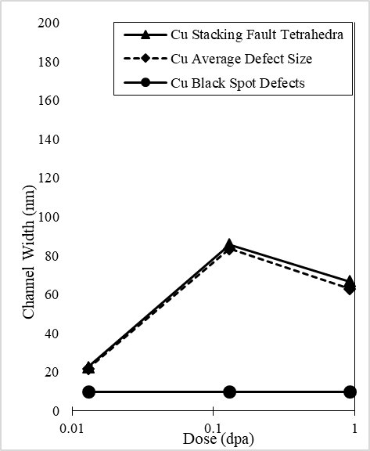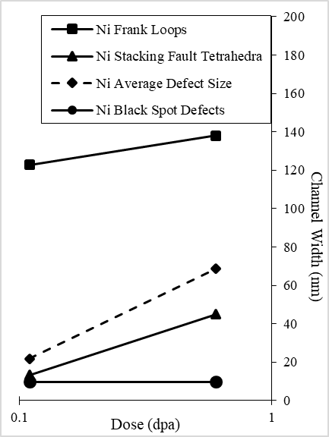
(a) (b)
Figure 26: Predicted channel widths for different diameter distributions in (a) Cu, (b) Ni. Widths are predicted at 10µm from the source for size distributions based on reported microstructure in Hashimoto et. al. [16] with black spot defects having a density of 10²³m⁻³ with a diameter of 1.0nm.
Especially for the Ni case, it is apparent that the average size under predicts the superposition of each defect type, due to the super linear dependence on defect size. In that study, Frank loops and SFTs were quantified down to ~1nm sizes with all remaining defects being classified as black spot defects. If only the mean sizes of each defect type are taken, simple averaging of different defect sizes is sufficient for Cu, where the small black dot defects have little effect on the total channel width, whereas for Ni, this is not sufficient since significant amounts of both loops and SFTs exist, with much more of a contribution from the loops leading to the averaging actually decreasing the predicted channel width, a clearly incorrect response. This illustrates from real data the significance of size distributions on channel response. This effect is clearly most important when distributions are bi-modal (i.e., different types of defects exist, or high irradiation doses [3,21]).
Unfortunately, in the study on vanadium, the microstructure was only reported as total defect density and mean size for the entire defect population [49,50]. Further experimental studies are needed to better quantify the defect types and their size distributions at various doses and temperatures in order to better compare with model 2’s defect distribution results and also to determine if the RSS has a larger effect than increasing the probability of defect elimination. Some of the available studies did provide such diameter distributions [18,19,57,58] with their data. For these studies, the results were compiled and plotted as found below in Figure 27.

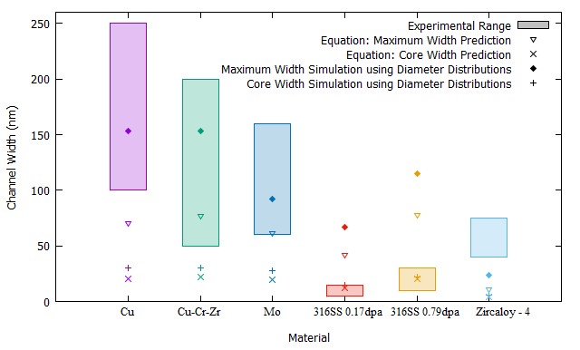
Figure 27: Comparison experimental to predicted results for distributed and averaged defect sizes. All sources for this figure provided distributions of the defect sizes which were used to compare to the present model. Results when using both the mean and distributed diameters are provided with each material plot using the same symbols which appear in the legend. As before, since no source information is given, the model uses half of the grain size as the approximate distance along the channel.
The dramatic improvement in the prediction when using the distributed sizes is apparent in Figure 27. For Cu, Cu-Cr-Zr, and Mo, the model fits quite well, despite needing to use the arbitrary distance of half-way along the channel. Were the results in these sources also specified relative to distance from the dislocation source, it is expected that these results would fit much better. As previously noted, for the 316 SS cases, the maximum width is likely suppressed while the core width fits the experiment excellently. Moreover, while there is dramatic increase in the widths from the maximum approximation, it is apparent that the correction across every listed case is rather small for the core approximation. For the Zircaloy-4 case, the model does not fit well, even for the maximum condition, and the channels observed are much greater than predicted. For this case, a small concentration (2.5x10²¹m⁻³) of large (6.5 nm) defects was added to distribution given in the paper 1) to see its effect and 2) to account for small amounts of such defects which were reported for lower doses [57]. Since this information (provided in above graph) still is well below reported values, it is expected that this material (or possibly the more general case of HCP metals) requires higher fidelity to the physics involved and the reason for this discrepency is an excellent topic for future study.
In general there a few discrepancies between the given model and experiment, but these are able to be accounted for either by the use of distributions in the defect sizes, recognizing the likely suppression of dislocation jogging leading to better agreement with the core approximation in austentitic steels, and noting the possible effects of HCP crystal structure, likely due to limited slip systems leading to biases in the type of interactions obtained and other presently ignored physics on channel width. Thus, except where the last of these explanations is needed, the model can be generally characterized as accurate, despite its low complexity. Defect-free channels can therefore be characterized by simple, stochastic dislocation-defect interactions, dependent primarily on defect diameter, with lower dependence on distance from the source and defect density. This implies that there should be marked dependence of the channels on dose; dose-dependent microstructure were evaluated to determine this dependence.
For several studies in Table 2, dose dependence has been reported by the authors [15,49,57,58]. However, only Hashimoto et. al. [49] and Farrell et. al. [57] also report the channel width variation with dose. For FCC stainless steel [57], and BCC vanadium [49] to doses below 0.8 dpa. Both the average size and density increased with dose, in both materials, Figure 27. In the model, these parameters show an increase in channel size with dose, supporting experimental evidence with the comparisons given in Figure 29. The reports on vanadium do not contain detailed microstructure information and the core model is irrelevant; only the maximum width, average diameter condition is reported. Given Figure 27, there is good reason to expect that reporting of the defect distributions would yield accurate results within the experimental range. In vanadium, the model accurately followed channel width development for low applied RSS. This my be due to evolution of defect microstructure of vanadium under irradiation. It is well understood that defect density and sizes increase with neutron damage, until approaching an asymptote as uncorrelated recombination becomes dominant, as in low SFE BCC metals [5–7].
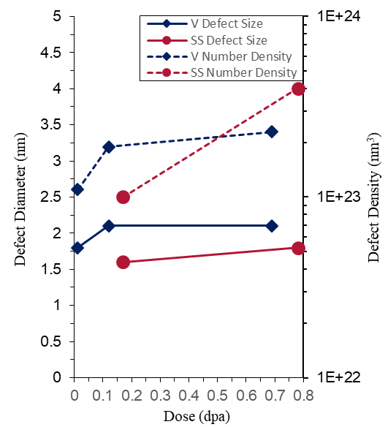
Figure 28: Comparison of low temperature irradiated defect microstructure from literature.
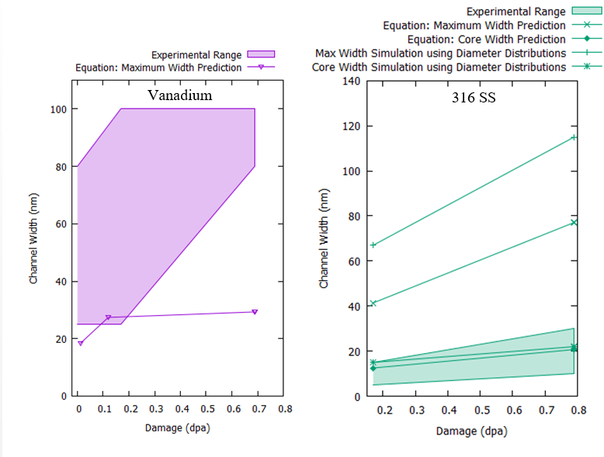
Figure 29: Comparison of model and experimental prediction for dose dependence. Microstructure information is presented in Figure 28 for (a) 316 SS and (b) vanadium under increasing dose.
At these lower doses, the distributions are small and the mean diameter and density are reasonable for channel predictions. As shown above, increases in dose require the use of distributions to predict. Similar trends are found for low temperature (80 ºC) in BCC molybdenum. Li et. al. also showed a broad range of widths from 60 - 160 nm once the threshold of 0.01 dpa is passed. While no dependence with dose is given, the development of microstructure with dose is given allowing comparison with the present model [58] in Figure 30. At these low doses, the model predictions using mean diameters appears to be sufficient. More specific information on channel widths would be useful in providing a more detailed comparison to this model.
Generally, in FCC materials with up to moderate SFE, SFTs are the most probable defects to form under irradiation. Mean sizes of SFTS are typically invariant with dose, with their density increasing instead up to a saturation point near 0.1 dpa [4,21], further, MD studies show that these immobile SFTs are produced during displacement cascades [7,26,65]. Due to the low dependence of dose on defect size, dose should be, at most, weak factor in the channel width of these materials. Sharp investigated some of these effects on channel width in copper [8] in some of the first work on this topic. Some of this work surprisingly showed a decrease in channel width with dose from 250 – 130 nm with increasing fluence (0.33 – 2.3 x 10¹⁸ cm⁻³). These results are rather incomplete and difficult to interpret, however, because detailed microstructure information was not given, and channel widths varied widely (110 - 230 nm at 1.0 x 10¹⁸ cm⁻³).

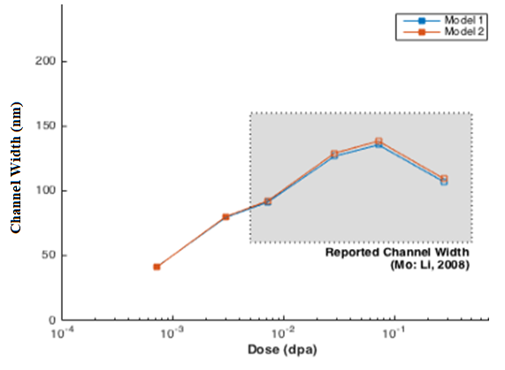
Figure 30: Comparison of predicted and observed dislocation channel width vs. dose in Mo. Irradiation was performed at ~80⁰C.Model predictions for both model variations was done using the equations given in Chapter 4 using mean diameter and density of defects.
Because defects in Cu are primarily SFTs [7], little variation of the channel with dose is expected for Sharp’s study and it is also possible that some of the channels were confused for twins, especially at low doses. Also, no other studies have been found which claim a decrease in width with dose. For example, Edwards et. al. found that defect size and density remained nearly constant with channel widths between 100 and 250 nm between 0.1 and 0.3 dpa [18]. While the present model shows a roughly square root dependence on distance from the source, many studies do not provide measurements of channel width at various grain locations. Byun et. al. in 2006 reported that BCC vanadium experiences widening across the grains, the most drastic of which was widths increasing from 50 to 200 nm [50], as opposed to materials with small defects (such as SFTs) for which Sharp did not see variation across 100 micron glide distances [8]. Few studies have made observations of channel width sampling relative to dislocation source. It is likely that lack of noticeable change in channel width is caused by the scale difference between channel width (~100 nm) and channel length (~10 µm) in many studies. The effect of this is illustrated below in Figure 31 where different channel lengths are sampled and directly compared. This data is taken from [58].
Per the above chapters, larger defects will accentuate this difference by increasing the factor multiplying distance, making higher damage systems more sensitive to the location of channel sampling, and increasing the standard deviation if arbitrary locations are sampled. In order to more clearly vet this model, detailed TEM studies on a variety of materials is needed with information on sampling distance, number of channels sampled, defect size distributions, and defect density.

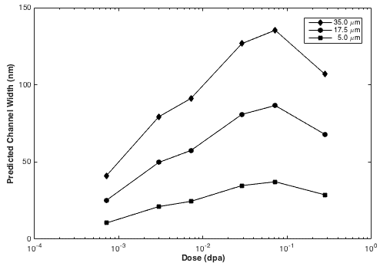
Figure 31: Maximum width dose and distance dependence of channels in Mo. Channel width is sampled at three different locations from the dislocation source, with microstructure parameters taken from Li et. al., 2008 [58].

Comparisons to Other Proposed Channel Formation Mechanisms
In addition to the point-source mechanism presented in this model, other mechanisms have been proposed for channel formation. Source broadening, proposed by Birceño et. al. and Kacher et. al. [47,48], is a mechanism where dislocations remain close to their initial glide plane, while the glide plane itself is determined by a “volume element” as the source. Dislocations are emitted from this entire volume region, leading to an essentially single-width channel. Within the channel, dislocations can become tangled, creating Frank-Read sources which widen the channel at its edges. If incorporated into this model, the effects of such a volume source are shown in Figure 18. As shown, the development of the channel remains unchanged, while the size of the source governs minimum, initial channel width. This indicates that unless sources are quite wide, and the channels very short (such as is present in cross-channels which connect near-parallel channels), source broadening has a corrective, rather than determining, contribution to channel width.
The other studies which attempted more advanced tools to simulate channel formation are De la Rubia et. al. and Ghoniem et. al. which both used variations of DD simulations to demonstrate channeling and replicate experimental results well [39–41]. The studies by Ghoniem were especially interesting in that they showed, within a certain field around the dislocations, defects would “decorate” the dislocations before being eliminated. This may contribute to an apparent source volume producing a minimum channel size based on the material and the force field around the dislocation. Moreover, since the present model also appears to agree with experiments, it is likely that higher fidelity to the physics provides minor correction to the present model, rather than being needed for a reasonable prediction.
Arsenlis, et. al. also used DD to develop some quantitative channel results for low density (10²⁰-10²² m⁻³) very large (d=25 nm) defect systems, and generated uniform channels over a 1.3 micron simulation cell [43]. Their results are similar to those of Patra and McDowell, which observed channel formation at low strain conditions, with channels broadening of 15-50 micron glide distances [44,45]. Po and Ghoniem [46] reported a continuum model of localized deformation, in which they found for uniform dislocation densities, normally distributing the defect density around a mean value was sufficient to produce channeling. In each of these, channels developed rapidly, and only in the Patra and McDowell 2013 study [45] did widening across the channel occur. The other studies did not explicitly observe channel development with distance for a variety of reasons including too coarse an FEM mesh size [44] use of a method that is in development and requiring additional sophistication [46], or use of a small simulation size in the other simulations. Moreover, double-cross slip is a mechanism that the above studies found to be important in populating glide planes parallel to the initial glide plane with dislocations. It appears that this is the same effect as source broadening, adding a minimum value to the channel width.
In addition to these, Byun et. al. provided qualitative correlations between the SFE and channel formation, noting that as SFE increases, channels become less likely to form [50]. At high SFEs, they noted dislocation “cells” formed, locking dislocations in places and preventing further propagation, and thereby channel creation. Hashimoto and coworkers further proposed that RSS weakly affects channel size [49,59]. If valid, the present model can explain such dependence as altering the probability of full elimination, leading to greater elimination at high stress, with more partial eliminations or non-elimination reactions at lower stress. Further is needed to fuller quantify the effects of SFE, cross-slip energy, and stress state. Based on the general agreement of the present model with experimental data, it is expected that these parameters will be of secondary importance for most materials.

Conclusions and Recommendations
In this work, defect-free channel formation and propagation has been modeled as a stochastic, unbiased dislocation random walk. Dislocations are generated from a point or volume element source and passed thorough a matrix of defects, eliminating every defect they encountered and jogging up or down with a magnitude of half of the diameter of the eliminated defect, with each defect being approximated as a dislocation loop. The channel width was estimated in two different ways. The maximum width approximation estimated the width as the difference between the extrema, while the core width approximation estimated the extrema of the channels at the point where the defect concentration dropped below 10% of the matrix concentration.
Further, three different versions of this model were developed. Model 1 used the dispersed barrier relationship to space out the defects of a given size and density onto a grid. Model 2 removed that averaging and employed randomly-spaced defects, while the third model used the same spacing relation in model 1 to provide an analytic estimate of the channels formed. Of these, the first two included bother width estimations, while the last only used the maximum width estimation. Each model was analyzed over a density range of 7.5x10²¹ m⁻³ to 1.0x10²⁴ m⁻³ and a diameter range of 1 nm to 11 nm.
From the simulation sets run, empirical correlations between channel width, distance from the disocation source, defect size, and defect density were obtained. Correlations were found to best fit a power law with respect to each parameter. Defect size is the most important parameter, with an exponent of 1.5 in the width correlation. Density and distance from the source were much less important, but still significant, each having an exponent of about 0.5 (density a little less, distance a little more). Moreover, expansion of point sources to volume sources did not lead to a change in channel development, but simply added a minimum width to the channel. By varying the number of dislocation passes, saturation of the channel is achieved quickly and exponentially, with minimal increase in size following 20 passes. In real materials, it can be expected that the additional possible mechanisms in dislocation-defect reactions would require more dislocation passes to eliminate defect debris and fully establish the channel. The same general trends were observed for the core width approximation, while the magnitude of the channel is significantly smaller with slower channel growth over increasing distance. Errors between the maximum width correlations and guiding simulation sets were small, while the core width correlations had larger errors due at least in part to large variance in the program identification of extrema from point-to-point leading to loss of fidelity in the correlation.
In comparing to TEM data, the most important issues are the sampling along the channel and the use of distributions of defect sizes. Since most of the useful data sets did not include any indication of where along the channel the sizes were sampled, or how many channels were sampled, all comparisons given in section 5.2 are arbitrarily placed at the center of the average grain.` Additional error stems from reporting of microstructure parameters as averages rather than distributions, which significantly affects the fidelity of the prediction, especially for higher dose systems, with bi-modal distributions of defect sizes. Wherever comparisons were able to be made, taking account of the defect distributions led to good agreement between the model and TEM data, with the exception of HCP Zircaloy-4. This suggests that the present, rather simple model can accurately describe most systems, implying that the stochastic dislocation-defect interactions control channel width, with other materials parameters, such as stress state and cross-slip energy having a more minor contributing effect. Future efforts should focus on obtaining distributions of defect sizes, along with samplings of the defect free channels at specific locations along the source. Such studies will enable good comparison of this model with data, providing principle components in the study of channel formation. Modeling efforts should also focus on singling out the effects of SFE, crystal structure, material stress state, and cross slip energy.

List of References

[1] A.K. Seeger, On the theory of radiation damage and radiation hardening, in: 2nd UN Conf. Peac. Uses At. Energy, United Nations, New York, 1958: pp. 250–273.
[2] M.J. Makin, J. V. Sharp, A Model of “Lattice” Hardening in Irradiated Copper Crystals with the External Characteristics of “Source” Hardening, Phys. Status Solidi. 9 (1965) 109–118. doi:10.1002/pssb.19650090114.
[3] M. Victoria, N. Baluc, C. Bailat, Y. Dai, M.. Luppo, R. Scha̋ublin, B.. Singh, The microstructure and associated tensile properties of irradiated fcc and bcc metals, J. Nucl. Mater. 276 (2000) 114–122. doi:10.1016/S0022-3115(99)00203-2.
[4] S.J. Zinkle, Y. Matsukawa, Observation and analysis of defect cluster production and interactions with dislocations, J. Nucl. Mater. 329–333, P (2004) 88–96.
[5] T.S. Byun, K. Farrell, Irradiation hardening behavior of polycrystalline metals after low temperature irradiation, J. Nucl. Mater. 326 (2004) 86–96.
[6] K. Farrell, T.S. Byun, N. Hashimoto, Deformation mode maps for tensile deformation of neutron-irradiated structural alloys, J. Nucl. Mater. 335 (2004) 471–486.
[7] S.J. Zinkle, Radiation-Induced Effects on Microstructure, in: R.J.M. Konings (Ed.), Compr. Nucl. Mater., Elsevier, Amsterdam, 2012: pp. 65–98.
[8] J. V. Sharp, Deformation of neutron-irradiated copper single crystals, Philos. Mag. 16 (1967) 77–96. doi:10.1080/14786436708229258.
[9] M.J. Makin, Radiation damage in face centered cubic metals and alloys, in: W.F. Sheely (Ed.), Radiat. Eff. (Metallurgical Soc. Conf. Vol. 37), Gordon and Breach, New York, 1967: pp. 627–669.
[10] M.S. Wechsler, Dislocation Channeling in Irradiated and Quenched Metals. The Inhomogeneity of Plastic Deformation, in: R.E. Reed-Hill (Ed.), ASM, Met. Park. Ohio, Am. Society for Metals, Metals Park, OH, 1973: p. 19.
[11] R.P. Tucker, M.S. Wechsler, S.M. Ohr, Dislocation channeling in neutron-irradiated niobium, J. Appl. Phys. 40 (1969) 400–408. doi:10.1063/1.1657068.
[12] J. V. Sharp, Correlation between cleared channels and surface slip steps in neutron irradiated copper crystals, Radiat. Eff. 14 (1972) 71–75.
[13] B. Mastel, H.E. Kissinger, J.J. Laidler, T.K. Bierlein, Dislocation Channeling in Neutron‐Irradiated Molybdenum, J. Appl. Phys. 34 (1963) 3637–3638. doi:10.1063/1.1729281.
[14] I.G. Greenfield, H.G.F. Wilsdorf, Effect of neutron irradiation on the plastic defoarmation of copper single crystals, J. Appl. Phys. 32 (1961) 827–839.
[15] N. Hashimoto, T.S. Byun, K. Farrell, S.J. Zinkle, Deformation microstructure of neutron-irradiated pure polycrystalline metals, J. Nucl. Mater. 329–333 (2004) 947–952. doi:10.1016/j.jnucmat.2004.04.063.
[16] N. Hashimoto, T.S. Byun, K. Farrell, Microstructural analysis of deformation in neutron-irradiated fcc materials, J. Nucl. Mater. 351 (2006) 295–302. doi:10.1016/j.jnucmat.2006.02.032.
[17] A. Luft, Microstructural processes of plastic instabilities in strengthened metals, Prog. Mater. Sci. 35 (1991) 97–204.
[18] D.J. Edwards, B.N. Singh, J.B. Bilde-Sorensen, Initiation and Propagation of Cleared Channels in Neutron- Irradiated Pure Copper and aPrecipitation Hardened CuCrZr Alloy, J. Nucl. Mater. 1485 (2005) 164–178. doi:http://dx.doi.org/10.1016/j.jnucmat.2005.04.001.
[19] B.N. Singh, D.J. Edwards, P. Toft, Effect of neutron irradiation and post-irradiation annealing on microstructure and mechanical properties of OFHC-copper, J. Nucl. Mater. 299 (2001) 205–218. doi:10.1016/S0022-3115(01)00698-5.
[20] J.S. Robach, I.M. Robertson, B.D. Wirth, A. Arsenlis, In-situ transmission electron microscopy observations and molecular dynamics simulations of dislocation-defect interactions in ion-irradiated copper, Philos. Mag. 83 (2003) 955–967.
[21] D.J. Edwards, B.N. Singh, Evolution of cleared channels in neutron-irradiated pure copper as a function of tensile strain, J. Nucl. Mater. 329–333, P (2004) 1072–1077.
[22] Y. Matsukawa, S.J. Zinkle, Dynamic Observation of the collapse of a stacking fault tetrahedron by moving dislocations, J. Nucl. Mater. 329–333 (2004) 919–923.
[23] Y. Matsukawa, Y.N. Osetsky, R.E. Stoller, S.J. Zinkle, Destruction processes of large stacking fault tetrahedra induced by direct interaction with gliding dislocations, J. Nucl. Mater. 351 (2006) 285–294.
[24] Y. Matsukawa, Y.N. Osetsky, R.E. Stoller, S.J. Zinkle, Mechanisms of stacking fault tetrahedra destruction by gliding dislocations in quenched gold, Philos. Mag. 88 (2008) 581–597.
[25] J.S. Robach, I.M. Robertson, H.J. Lee, B.D. Wirth, Dynamic observations and atomistic simulations of dislocation-defect interactions in rapidly quenched copper and gold, Acta Mater. 54 (2006) 1679–1690.
[26] Y.N. Osetsky, D.J. Bacon, Atomic-Level Dislocation Dynamics in Irradiated Metals, in: R.J.M. Konings (Ed.), Compr. Nucl. Mater., Elsevier, Amsterdam, 2012: pp. 333–356.
[27] Y.N. Osetsky, R.E. Stoller, D. Rodney, D.J. Bacon, Atomic-scale details of dilsocation - stacking fault tetrahedra interaction, Mater. Sci. Eng. A. 400 (2005) 370–373.
[28] B.D. Wirth, V.V. Bulatov, de la Rubia TD, Dislocation Stacking Fault Tetrahedron Interactions in Cu, J. Eng. Mater. Technol. 124 (2002) 329–334.
[29] D. Rodney, Atomic scale modeling of clear band formation in FCC metals, Nucl. Instruments Methods Phys. Res. Sect. B Beam Interact. with Mater. Atoms. 228 (2005) 100–110.
[30] D. Terentyev, D.J. Bacon, Y.N. Osetsky, Reactions between a 1/2<111> screw dislocation and <100> insterstitial dislocation loops in alpha iron modelled at atomic scale, Philos. Mag. 90 (2010) 1019–1033.
[31] M. Briceño, J. Kacher, I.M. Robertson, Dynamics of dislocation interactions with stacking-fault tetrahedra at high temperature, 433 (2013) 390–396. doi:10.1016/j.jnucmat.2012.10.004.
[32] J.-B. Baudouin, A. Nomoto, M. Perez, G. Monnet, C. Domain, Molecular dynamics investigation of the interaction of an edge dislocation with Frank loops in Fe–Ni10–Cr20 alloy, J. Nucl. Mater. 465 (2015) 301–310. doi:10.1016/j.jnucmat.2015.05.030.
[33] H. Fan, Q. Wang, C. Ouyang, Comprehensive molecular dynamics simulations of the stacking fault tetrahedron interacting with a mixed dislocation at elevated temperature, J. Nucl. Mater. 465 (2015) 245–253. doi:10.1016/j.jnucmat.2015.05.047.
[34] J. Marian, B.D. Wirth, R. Schaublin, G.R. Odette, J.M. Perlado, MD modeling of defects in Fe and their interactions, J. Nucl. Mater. 323 (2003) 181–191. doi:10.1016/j.jnucmat.2003.08.037.
[35] Y. Matsukawa, Y.N. Osetsky, R.E. Stoller, S.J. Zinkle, The collapse of stacking-fault tetrahedra by interaction with gliding dislocations, Mater. Sci. Eng. A. 400–401 (2005) 366–369. doi:10.1016/j.msea.2005.01.063.
[36] C.R.F. Azevedo, A review on neutron-irradiation-induced hardening of metallic components, Eng. Fail. Anal. 18 (2011) 1921–1942. doi:10.1016/j.engfailanal.2011.06.008.
[37] H. Fan, J.A. El-awady, Q. Wang, Towards further understanding of stacking fault tetrahedron absorption and defect-free channels – A molecular dynamics study, J. Nucl. Mater. 458 (2015) 176–186. doi:10.1016/j.jnucmat.2014.12.082.
[38] T. Nogaret, D. Rodney, M. Fivel, C. Robertson, Clear band formation simulated by dislocation dynamics: Role of helical turns and pile-ups, J. Nucl. Mater. 380 (2008) 22–29.
[39] N.M. Ghoniem, S.H. Tong, J. Huang, B.N. Singh, M. Wen, Mechanisms of dislocation-defect interactions in irradiated metals investigated by computer simulations, J. Nucl. Mater. 307–311 (2002) 843–851. doi:10.1016/S0022-3115(02)01092-9.
[40] M. Ghoniem, S.H. Tong, B.N. Singh, L.Z. Sun, On dislocation interaction with radiation-induced defect clusters and plastic flow localization in fcc metals, Philos. Mag. A. 81 (2001) 2743–2764. doi:10.1080/01418610110049725.
[41] de la Rubia TD, H.M. Zbib, T. Khraishi, B. Wirth, M. Victoria, M. Caturla, Multiscale modelling of plastic flow localization in irradiated materials, Nature. 406 (2000) 871–4. doi:10.1038/35022544.
[42] N. Hashimoto, S.. Zinkle, A.. Rowcliffe, J.. Robertson, S. Jitsukawa, Deformation mechanisms in 316 stainless steel irradiated at 60°C and 330°C, J. Nucl. Mater. 283 (2000) 528–534. doi:10.1016/S0022-3115(00)00087-8.
[43] A. Arsenlis, M. Rhee, G. Hommes, R. Cook, J. Marian, A dislocation dynamics study of the transition from homogeneous to heterogeneous deformation in irradiated body-centered cubic iron, Acta Mater. 60 (2012) 3748–3757. doi:10.1016/j.actamat.2012.03.041.
[44] A. Patra, D.L. McDowell, Crystal plasticity investigation of the microstructural factors influencing dislocation channeling in a model irradiated bcc material, Acta Mater. 110 (2016) 364–376. doi:10.1016/j.actamat.2016.03.041.
[45] A. Patra, D.L. McDowell, Continuum modeling of localized deformation in irradiated bcc materials, J. Nucl. Mater. 432 (2013) 414–427. doi:10.1016/j.jnucmat.2012.08.021.
[46] G. Po, N. Ghoniem, Continuum modeling of plastic flow localization in irradiated fcc metals, J. Nucl. Mater. 442 (2013) S607–S611. doi:10.1016/j.jnucmat.2012.10.039.
[47] M. Briceño, J. Fenske, M. Dadfarnia, P. Sofronis, I.M. Robertson, Effect of ion irradiation-produced defects on the mobility of dislocations in 304 stainless steel, J. Nucl. Mater. 409 (2011) 18–26. doi:10.1016/j.jnucmat.2010.12.026.
[48] J. Kacher, G.S. Liu, I.M. Robertson, In situ and tomographic observations of defect free channel formation in ion irradiated stainless steels, Micron. 43 (2012) 1099–1107. doi:10.1016/j.micron.2012.01.017.
[49] N. Hashimoto, T.S. Byun, K. Farrell, S.J. Zinkle, Deformation Microstructure of Neutron-Irradiated Pure Polycrystalline Vanadium, J. Nucl. Mater. 336 (2005) 225–232.
[50] T.S. Byun, N. Hashimoto, K. Farrell, E.H. Lee, Characteristics of microscopic strain localization in irradiated 316 stainless steels and pure vanadium, J. Nucl. Mater. 349 (2006) 251–264. doi:10.1016/j.jnucmat.2005.10.011.
[51] E.H. Lee, T.S. Byun, J.D. Hunn, M.H. Yoo, K. Farrell, L.K. Mansur, On the origin of deformation microstructures in austenitic stainless steel: part I -microstructures, Acta Mater. 49 (2001) 3269–3276. doi:10.1016/S1359-6454(01)00193-8.
[52] M. Hiratani, H.M. Zbib, B.D. Wirth, Interaction of glissile dislocations with perfect and truncated stacking-fault tetrahedra in irradiated metals, Philos. Mag. A. 82 (2002) 2709–2735. doi:10.1080/01418610210155744.
[53] Y.N. Osetsky, D. Rodney, D.J. Bacon, Atomic-scale study of dislocation - stacking fault tetrahedron interactions. Part I-Mechanisms, Philos. Mag. 86 (2006) 2295–2313.
[54] X.J. Shi, L. Dupuy, B. Devincre, D. Terentyev, L. Vincent, Interaction of <100> dislocation loops with dislocations studied by dislocation dynamics in alpha-iron, J. Nucl. Mater. 460 (2015) 37–43. doi:10.1016/j.jnucmat.2015.01.061.
[55] M.N. Gussev, K.G. Field, J.T. Busby, Deformation localization and dislocation channel dynamics in neutron- irradiated austenitic stainless steels, J. Nucl. Mater. 460 (2015) 139–152. doi:10.1016/j.jnucmat.2015.02.008.
[56] I.M. Robertson, A. Beaudoin, K. Al-fadhalah, L. Chun-ming, J. Robach, B.D. Wirth, A. Arsenlis, D. Ahn, P. Sofronis, Dislocation – obstacle interactions: Dynamic experiments to continuum modeling, Mater. Sci. Eng. A. 400–401 (2005) 245–250. doi:10.1016/j.msea.2005.04.002.
[57] K. Farrell, T.S. Byun, N. Hashimoto, Mapping Flow Localization Processes in Deformation of Irradiated Reactor Structural Alloys - Final Report, Oak Ridge, TN, 2003.
[58] M. Li, M. Eldrup, T.S. Byun, N. Hashimoto, L.L. Snead, S.J. Zinkle, Low temperature neutron irradiation effects on microstructure and tensile properties of molybdenum, J. Nucl. Mater. 376 (2008) 11–28. doi:10.1016/j.jnucmat.2007.12.001.
[59] N. Hashimoto, T.S. Byun, Deformation-induced martensite formation and dislocation channeling in neutron-irradiated 316 stainless steel, J. Nucl. Mater. 367–370 B (2007) 960–965. doi:10.1016/j.jnucmat.2007.03.204.
[60] F.E. Grubbs, Procedures for Detecting Outlying Observations in Samples, Technometrics. 11 (1969) 1. doi:10.2307/1266761.
[61] K.J. Stephenson, G.S. Was, The role of dislocation channeling in IASCC initiation of neutron irradiated stainless steel, J. Nucl. Mater. 481 (2016) 214–225. doi:10.1016/j.jnucmat.2016.09.001.
[62] K.J. Stephenson, G.S. Was, Crack initiation behavior of neutron irradiated model and commercial stainless steels in high temperature water, J. Nucl. Mater. 444 (2014) 331–341. doi:10.1016/j.jnucmat.2013.10.008.
[63] P.M. Rice, S.J. Zinkle, Temperature dependence of the radiation damage microstructure in V–4Cr–4Ti neutron irradiated to low dose, J. Nucl. Mater. 258 (1998) 1414–1419. doi:10.1016/S0022-3115(98)00208-6.
[64] S.J. Zinkle, B.N. Singh, Microstructure of neutron-irradiated iron before and after tensile deformation, J. Nucl. Mater. 351 (2006) 269–284. doi:10.1016/j.jnucmat.2006.02.031.
[65] S.J. Zinkle, N. Hashimoto, Y. Matsukawa, R.E. Stoller, Y.N. Osetsky, Microstructures of Irradiated and Mechanically Deformed Metals and Alloys: Fundamental Aspects, in: L.M. Wang, R. Fromknecht, L.L. Snead, D.F. Downey, H. Takahashi (Eds.), Radiat. Eff. Ion Beam Process. Mater., Materials Research Society, Warrendale, PA, 2004: pp. 1–10.
[66] R. Schmehl, Fortran 90 function parser, (2000). http://fparser.sourceforge.net.
[67] P. Young, Least squares fitting, 1 (2007) 1–10. http://mathworld.wolfram.com/LeastSquaresFitting.html.

Appendices

Appendix A

A.1 Analytic Program
The following program contains no subroutines and is able to move through a small channel of up to a few microns in length (due to memory limitations). Throughout the program, files are printed that give probabilities of the channel having certain widths at each point along the channel (“wfile___i=__.txt”), give the probability of a dislocation passing through any particular array element (“Dislocationgrid___.txt”), the probability of any defect being eliminated (“Probabilitygrid___.txt”), and finally the average expected channel width across the channel (“width_profile___.txt”). The underscores represent numbers based on the number of outputs already given.
At the beginning of the program, a pre-formatted input file is required of the user. The format can be found below in the source code. No file/screen print is provided to the user for formatting the file. This file also allows specific files to be printed/ignored. Related variables (dl, mesh dimensions, and midplane of the array) are calculed following this. The first calculation section then sends dislocations through the channel one at a time until all the the dislocation passes are complete. As opposed to the program in Appendix B where dislocations are given the option to jog up or down, this program sends the dislocations in both directions as follows. At first the dislocation has a weight of 1 (i.e., there is 100% probability that the dislocation passes through the first point in the midplane). When the dislocation hits that point, the defect also has a weight of 1 (i.e., it is has 100% probability of existing when the dislocation arrives). The probability that the defect is eliminated is used to calculated the fraction of the dislocation that escapes by simple pinning and release. The rest of the dislocation is assumed to jog, but it jogs in both directions by having the jogging dislocation fraction divided in half and sent through the points above and below the first point in the next column. A portion of the defect is eliminated based on the probability of elimination. The remaining defect fraction is equivalent to a probability that the defect has not been eliminated. Additional defects passing through this point will be broken into fractions that escape with only pinning, escape without interaction, and eliminate the defect. This process propagates through the channel with every defect point being analyzed. In this way, the dislocation is “spread” over all possible defects in every column. Future dislocations then pass through the channel in the same way, but with different weights on the defects. Following this, if the input file requested them, the “Probabilitygrid____.txt” file, containing information on defect existence probabilities is printed, along with the “Dislocationgrid___.txt” file containing the probability of dislocation passage through all points.
If width information is desired, then widths are calculated as follows. Each column is examined one at a time and a every combination of channel types is examined. This is done by beginning with the largest possible channel. The probability that both points furthest from the midplane see a dislocation passing through is multiplied by the distance between those points. Then, a loop moves one of those boundaries closer to the midplane and that width contribution is calculated, considering also that a dislocation cannot have moved through any of the points beyond the points being considered. When that loop reaches the midplane, the other side of the channel is moved one element closer to the midplane and the previous loop resets to the same point on the other side. This proceeds until all possible widths have been fully examined. Throughout this process, if the “wfile….” files are to be printed, the corresponding arrays are updated to include each possible width and its probability of occurring. At the end of a column’s evaluation, a file is printed containing that file’s information. The governing loop increments and moves to the next column after recording an average width as well. If the width profile information is requested, the program also prints this information annd calculates, via a least squares method, a power law correlation and prints it to the file. No core evaluation is provided by this routinse. Full source code is provided below.
Program Analytic
use ifport
use iso_fortran_env
implicit none

real(real64), dimension(:,:,:), allocatable :: mesh
real(real64), dimension(:,:), allocatable :: registry, reg2
integer(int64) :: n, i, j, k, h, filenum, passes, b, mid, count, g, count2
real(real64) :: x, Num, d, dl, w, tempw, d_esc, d_jog, sums, tempsum, progress, inc=5,w0, Entropy,pelim
real(real64) :: skew, kurt, meanstat, varstat
real(real64) :: ParA, ParB, sumlnxy, sumlnxsq, sumlnx, sumlny, a ! parameters for power law trendline
logical :: existence, grid, width, d_weight, wfile
logical(4) :: res
character(len=26) :: filename
character(len=15) :: dirname
character(len=1) :: choice

! get input filename information and read in data
Print *, 'Enter the name of the file you wish to use an input'
!Read *, filename
!Inquire(file=(trim(filename)), exist=existence)
!Do while(not(existence))
! Print *, 'File not found. Please retry'
! Read*, filename
! Inquire(file=(trim(filename)), exist=existence)
!End Do
filename = 'Input.txt'
Open(1,status='old', file=(trim(filename)))
Read (1,*), Num
Read(1,*), d
Read(1,*), x
Read(1,*), pelim
Read(1,*), passes
Read(1,*), choice
If (choice =='T') Then
Wfile = .true.
End If
Read(1,*), choice
If (choice =='T') Then
grid = .true.
End If
Read(1,*), choice
If (choice =='T') Then
width= .true.
End If
Read(1,*), choice
If (choice =='T') Then
d_weight= .true.
End If
Close(1)

dl = 1/sqrt(Num*d) ! distance between defects and columns in each mesh
n = x/dl ! number of columns in the arrays
b = x*2/d ! number of rows
mid = b/2 ! location of midpoint and source of channel
Allocate(mesh(1:b+4, 1:n+4, 1:3))
Allocate(registry(1:b+4,2), reg2(1:b,2))

! generate Mesh
1 print *, 'Creating mesh'
k = -1 ! starting row
Mesh = 0. ! initialize mesh to 0
Do i = 1, n, 1
k = k + 1
Do j = mid-k, mid+k, 2
Mesh(j,i,1) = 1
End Do
End Do

! Perform analysis
print *, 'Analyzing Mesh'
Do i = 1, passes, 1 ! for each pass
Mesh(:,:,2) = 0
Mesh(mid,1,2) = 1. ! start the dislocation weight at 1. this element in each row/col combination of the mesh array
! indicates the weight of the dislocation moving INTO the current element
k = -1
Do j = 1, n, 1 ! along each column
k = k + 1
Do h = mid-k, mid+k, 2 ! search through relevant rows
If (Mesh(h,j,2) == 0) cycle
d_esc = Mesh(h,j,2)*(1-Mesh(h,j,1)*pelim) ! weight of the dislocation escaping
tempw = Mesh(h,j,2)*(1-Mesh(h,j,1))
d_jog = (Mesh(h,j,2)-d_esc)/2. ! weight of the dislocation jogging, not escaping. Division by two is due to the dislocation jogging both directions.
! add the various weights to the next defect spots
Mesh(h,j+2,2) = Mesh(h,j+2,2) + d_esc
Mesh(h,j+1:j+2,3) = Mesh(h,j+1:j+2,3) + d_esc
Mesh(h,j,3) = Mesh(h,j,3) - tempw !this portion of the dislocation contributes nothing to the jth row width
Mesh(h-1,j+1,2:3) = Mesh(h-1,j+1,2:3) + d_jog
Mesh(h+1,j+1,2:3) = Mesh(h+1,j+1,2:3) + d_jog
! reduce the weight of the current defect by the incoming dislocation weight
Mesh(h,j,1)=Mesh(h,j,1)-Mesh(h,j,2)+d_esc
End Do
End Do
End Do
Mesh(mid,1,3) = 1
Forall(j=1:b+2,i=1:n+2, Mesh(j,i,3)>1)
Mesh(j,i,3)=1 ! set upper probability of dislocation passage to "1"
end forall
! Determine file name
inquire(file="outcount.txt", exist=existence)
If (existence) Then
open(1,status='old', file='outcount.txt')
read(1,"(i6)"), count
rewind(1)
write(1,"(i6)"), count+1
close(1)
Else
open(1,status='new', file='outcount.txt')
Write(1,"(i6)"), 1
count = 0
close(1)
End If

! Write out solution
If (grid) Then
print *, 'Writing Grid solution'
Write(filename,"(A16, i6,A4)"), "Probabilitygrid_",count,".txt"
open(1, status='replace', file=(filename))
Write(1,"(A22, i6)"), 'Data from file number ',count
Write(1,"(A2, f7.0, A2)"), 'x=', x,'nm'
Write(1,"(A2, E9.2, A5)"), 'N=', Num, 'nm^-3'
Write(1,"(A2, f5.2, A2)"), 'd=', d, 'nm'
Write(1,"(A3, f6.2, A2)"), 'dl=', dl, 'nm'
Write(1,"(A29,i6)"), 'Number of dislocation passes=', passes
Write(1,"(A26,f5.3)"), ' Defect elmination chance=', pelim
Write(1,*),''
Write(1,"(A53)"), ' #dl x(nm) y(nm) Fraction Remaining'
k = -1
Do i = 1, n, 1
k = k + 1
Do j = mid-k, mid+k, 2
Write(1,"(2x, i4, f10.2, 3x, f10.2, 5x, f12.8)"), i, i*dl, (j-mid)*d/2., Mesh(j,i,1)
End Do
End Do
close(1)
Else
print *, 'grid printing skipped'
End If

! print out dislocation weights file
If (d_weight) Then
print *, 'Writing dislocation weights file'
Write(filename,"(A16, i6,A4)"), "dislocationgrid_",count,".txt"
open(1, status='replace', file=(filename))
Write(1,*), 'dislocation weights file number', count
Write(1,"(A2, f7.0, A2)"), 'x=', x,'nm'
Write(1,"(A2, E9.2, A5)"), 'N=', Num, 'nm^-3'
Write(1,"(A2, f5.2, A2)"), 'd=', d, 'nm'
Write(1,"(A3, f6.2, A2)"), 'dl=', dl, 'nm'
Write(1,"(A29,i6)"), 'Number of dislocation passes=', passes
Write(1,"(A26,f5.3)"), ' Defect elmination chance=', pelim
Write(1,*),''
Write(1,"(A46)"), ' x(nm) y(nm) dislocation weight'
k = -1
Do i = 1, n, 1
k = k + 1
Do j = mid-k, mid+k, 1
Write(1,"(f10.2, 3x, f10.2, 3x, E15.8)"), i*dl, (j-mid)*d/2., Mesh(j,i,3)
End Do
End Do
close(1)
Else
print *, 'dislocation weights printout skipped'
End If

! Determine width information and then printout
! open file of interest
If (width) Then
print *, 'Determining Channel Width and Writing Solution'
Write(filename,"(A16,i6,A4)"),"width_profile___",count,".txt"
open(1,status='replace', file=(filename))
Write(1,*), 'channel width file number', count
Write(1,"(A2, f7.0, A2)"), 'x=', x,'nm'
Write(1,"(A2, E9.2, A5)"), 'N=', Num, 'nm^-3'
Write(1,"(A2, f5.2, A2)"), 'd=', d, 'nm'
Write(1,"(A3, f6.2, A2)"), 'dl=', dl, 'nm'
Write(1,"(A29,i6)"), 'Number of dislocation passes=', passes
Write(1,"(A26,f5.3)"), ' Defect elmination chance=', pelim
Write(1,*),''
Write(1,*),''
Write(1,*), ' #dl x(nm) width(nm) Prob of mean width sdev skewness kurtosis'

sums = 0
w = 0
Write(1,fmt=12),1, dl, w*d/2, sums
k = 0
progress = 0
count2 = 1
If (wfile) Then
Write(dirname,"(A6,i9)"),'wfile_',count
res = Makedirqq(dirname)
End If

sumlnxy = 0; sumlnxsq = 0; sumlnx = 0; sumlny = 0 ! Zero out parameters for power law analysis
a = n-1
Do i = 2, n, 1
! get file information for width breakdown file
If (wfile) Then
count2 = count2 + 1
Write(filename,"(A6,i4,A3,i9,A4)"),'wfile_',count,'_i=',count2,'.txt'
open(2,status="replace",file=(dirname//"\"//filename))
End If

If (progress < real(i)/n*100.) Then
print *, progress, '% complete'
Do while (progress <= real(i)/n*100.)
progress = progress + inc
End Do
End If
k = k + 1
registry=0
! Evaluate width contribution from symmetric channel events
w = 0 ! intialize width to "0"
sums = 1 ! probability that all defects outside of those being considered (below, these are
! given by row indexes "j" and "h") exist. Initially, outside defects are considered
Do j = mid-k, mid-1, 1 ! asymmetric channel events
If (Mesh(j,i,3) < 1e-10) cycle ! ignore very improbable events
tempsum = sums ! assign total probability of defect further from the midplane
! than defect "j" existing to tempsum.
Do h = j, mid, 1
If (Mesh(h,i,3) < 1e-10) cycle ! ignore very improbable events
If (h > j) then !asymmetric case
tempsum = tempsum*(1-Mesh(h-1,i,3)) ! update tempsum based on asymmetry
tempw = Mesh(j,i,3)*Mesh(h,i,3)*tempsum*2 ! find probability contribution of j and h being furthest defects
w = w + tempw*(2*mid-j-h) ! add the width contribution of this case to total width
If (wfile) then
w0 = 2*mid-j-h
Do g = 1,b,1
If (registry(g,1) == 0.) then
registry(g,1) = w0 ! width considered
registry(g,2) = tempw ! probability of this width ocurring
exit ! consideration of future points is useless
Else If(registry(g,1) == w0) Then
registry(g,2) = registry(g,2) + tempw
exit ! width has been found
End If
End Do
End If
Else ! symmetric case
tempw = Mesh(j,i,3)*(Mesh(j,i,3))*tempsum
w = w + tempw*2*(mid-j)
If (wfile) then
w0 = 2*(mid-j)
Do g = 1,b,1
If (registry(g,1) == 0.) then
registry(g,1) = w0 ! width considered
registry(g,2) = tempw ! probability of this width ocurring
exit ! consideration of future points is useless
Else If(registry(g,1) == w0) Then
registry(g,2) = registry(g,2) + tempw
exit ! width has been found
End If
End Do
End If
End If
End Do
sums = sums*(1-Mesh(j,i,3))*(1-Mesh(j,i,3)) ! update sums for next defects in
End Do
If (wfile) Then ! print width and close file
! update parameters used for power law determination
If (w <= 0.) then
a = a - 1
goto 10
End If
sumlnxy = sumlnxy + log(dl*i)*log(w*d/2.)
sumlnxsq = sumlnxsq + (log(dl*i))*(log(dl*i))
sumlnx = sumlnx + log(dl*i)
sumlny = sumlny + log(w*d/2.)
10 Write(2,*), 'Average width=', sum(registry(1:b,1)*registry(1:b,2))*d/2
! populate reg2 array
reg2 = 0
h = 1
Do g=1,b,1
If (registry(h,1) == 0) exit ! If end of list is reached
If (mod(int(registry(h+1,1)),2) == 1) Then ! If the next entry is odd
reg2(g,1) = registry(h,1)
reg2(g,2) = registry(h,2)+registry(h+1,2)
h = h + 2
Else ! if next entry is even
reg2(g,2) = registry(h,2)
reg2(g,1) = registry(h,1)
h = h + 1
End If
End Do
! populate wfile statistics
skew = 0; kurt = 0; meanstat = 0; varstat = 0;
h = 1
Do g = 1, b, 1
If (reg2(g,1) == 0) exit
meanstat = meanstat + reg2(g,2)*reg2(g,1)*d/2
h = h + 1
End Do
Do g = 1, b, 1
If (reg2(g,1) == 0) exit
kurt = kurt + reg2(g,2)*((reg2(g,1)*d/2-meanstat))**4.0
skew = skew + reg2(g,2)*((reg2(g,1)*d/2-meanstat))**3.0
varstat = varstat + reg2(g,2)*((reg2(g,1)*d/2-meanstat))**2.0
End Do
varstat = sqrt(varstat)
skew = skew/(varstat**3.0)
kurt = kurt/(varstat**4.0)
! find rough probability that the mean is chosen
g = 1
Do while (meanstat < reg2(g,1)*d/2)
g = g + 1
End Do
meanstat = reg2(g,2)
! write out results
Write(2,*), ' prob of mean sdev sample skewness kurtosis'
Write(2,fmt='(5x,4(E12.5, 3x))'), meanstat, varstat, skew, kurt
Do g=1,b,1
Write(2,"(f10.2,1x,E15.7)"), registry(g,1),registry(g,2)
If (registry(g,1) == 0) exit
End Do
close(2)
End If

! Writeout result
Write(1,fmt=12), i, i*dl, w*d/2, meanstat, varstat, skew, kurt
End Do
! Get final power law relation and print to end of file
ParB = (a*sumlnxy-sumlnx*sumlny)/(a*sumlnxsq-sumlnx*sumlnx)
ParA = exp((sumlny-ParB*sumlnx)/a)
Write(1,*),'' ! skip a space for easier postprocessing
Write(1,fmt="(E15.8,A2,E15.8)"),ParA,'x^',ParB
close(1)
Else
print *, 'Width determination skipped'
End If
12 format (2x, i4, f10.2, 5x, f10.2, 8x, 4(E12.5, 3x))

End Program Analytic

Appendix B

B.1 Main
The following code contains the majority of the functionality of the code used to generate all of the non-analytic results in this paper. Each section includes the code for the function/subroutine in question, with the exception of section B.7 fparsef module, which is not original to this work. Only the copyright, source, and general functionality information are provided in that section. The full source code is available as indicated there. The following description and the descriptions within each of the sections (B.2-B.11) are more detailed algorithm descriptions than given in the text. Each section, including this one, also includes the full source code for each routine.
This program begins with a series of interfaces which are used to alloy implicit array argument transfers. Following this and variable type assignements the subroutine GetData is called to pull in all the necessary information from the input file(s) to run the program. The program then enters a loop encompassing the entire program. The purpose of such a loop is simply to allow repetition of the program. Following, the information from GetData is then manipulated in the following ways. Specific variables (such as dl, number of histories, the average defect diameter, spacing between sources, etc.) are calculated. The MeshDimension subroutine is used to find array dimensions of the Mesh array and the main arrays in the program are allocated. The program then enters the analysis loop.
This loop begins with calling the DefectMesh subroutine which populates the Mesh array with defects. See section B.5 for details. Next, the program either enters a nested loop which propagates the dislocation through the channel. On entering this loop, the defect location is set to the middle of the box, and started at x=0, as the source is defined. Note that if different sources or a broadenend source are being used, the first dislocation starts at the source with the lowest y-value and subsequent dislocations are born the source above the previous source. When the highest source location has been used, the next dislocation is born in the lowest source again. When different sources are used, each source emits the number of dislocations requested by the input file. When a broadened source is used, each “sub-source” dislocation emission is counted as contributing to the number of dislocations per history.
In model 1, once the dislocation is born, a do-loop searches through subsequent columns along the given glide plane until an existing defect is found. As it glides along, the height of the dislocation is recorded every dl nm. Once it interacts, a random deviate chosen uniformly from 0 to 1 is chosen and its value (above or below 0.5) is used to determine which direction it jogs. The Validation subroutine is then calle to ensure the new height of the dislocation is not beyond the boundaries of the simulation box. This procedure repeats until the end of the channel is reached.
In model 2, the process is similar but requires more effort due to the nature of the model. To start, the NextDefect subroutine is called to find the location of the nearest defect. Then Catch_up is called record the height of the dislocation at the sampling points as it glides to the next defect. The defect is eliminated and the dislocation jogs as in model 1 with Validation being called. As in model 1, the process repeats until the channel end is reached. If the core model is being used, that data is gathered using the locations of defect elimination and defect densities. That information is saved and the history ends. The main evaluation loop is incremented to the next history and a new mesh is created. More histories are run until this loop terminates. At that point, Least_squares and Final Stats are called to finalize data. The Writeout subroutine is called and writes the files of interest.
At this point, the program enters its termination sequence where it checks if all the requested simulations have been run. If they have been, the program simply terminates. If not, the program updates any variables that are scheduled to be updated, deallocates all arrays for the next run, and returns to the beginning of the program, right after the GetData subroutine.
Program Defect_free_channel_height
use iso_fortran_env
use fparser
implicit none

!======================================================================================================================================================================
! Definitions::
!--------------------------------------------
! rand = random number for stochastic analysis
! num_density = number density of defect loops per cubic meter
! statistics = array containing statistics of channel height for each source across the whole chanel
! dis_track = array tracking height of each dislocation at sampled locations along channel
! Mesh = array containing defect locations
! mean, sdev = the mean and sdev of channel height across the channel. Recorded for each source
! mean_time, sdev_time = mean and sdev of mean of time for dislocation to reach the end of a channel
! dl = average spacing between defects
! a, b, D1 = dimensions of cube: line length of dislocation, max height of dislocation, channel length
! d = defect loop diameter array (nm)
! d_a = number of different-sized defect loops
! d_ds = diameter used to determine defect section size
! d_ave = average diameter of defects
! dx = x increment between sections
! dmin, dmax = min and max diameters which are used when the diameter is chosen from a distribution
! d_Type, N_Type = character strings indicating if diameters are discrete or distributed and if number density is constant or distributed
! Gauss = logical variable. if True, diameters are distributed according to Gaussian distribution about mean. Otherwise, diameters are exact values
! x = length along the channel
! height = location in cube along the b axis
! height0 = initial height of dislocation
! comptime = computer time used so far for the calculation
! comptime0 = computer time used up until this run (only useful when multiple runs are attempted)
! time = used to track time in kinetic MC
! t_inc = time increment in going between distances, dl
! time_pin = time, in seconds, pinned at a defect
! free_speed = rate of dislocation movement through defect-free lattice (m/s)
! spacing = spacing between sources
! N = number of histories for MC
! i,j,k, etc. = counting variables
! l, l0 = indices for location of source(s)
! deltaL = index difference between sources
! m = index location representing x location along channel in simple math-average model
! O = number of dislocation passes per history
! ip = interaction point counter for a particular dislocation
! progress = integer determining progress as a percentage, for printout
! increment = difference between percentage printouts
! num_sources = number of simultaneous dislocation sources
! Detail = integer determining choice between simple math-averaged spacing and random spacing models
! b1, c1, c2 = indices of the various arrays
! c_max, c_min = number of boundary (max/min) violations
! num_sections = number of sections to use when the random spacing model is used. Increases efficiency by psuedo-ordering of the Mesh array
! defect_section = number of defects in each section when a random spacing model is used
! auto_repeat = integer to indicate how many runs to perform. 0 is 1, 1 is 2, etc.
! rep_num = number of times the program has repeated so far
! repeat_var = single-character variable, d or N (diameter of density of defects) that is incremented automatically, when auto-repeat == 1
! repeat_inc = amount to increment the repeated variable, when auto-repeat == 1
! variable = long string used to display input.txt file used to generate data
! choose_files = logical array used to determine which files are written out at the end of the program
! funstr = allocatable array used to store read-in functions from respective files
! num_max, PDFmax = maximums of distribution functions as determined by the findmax() function
! min = calulcated minimum of a function evaluated by findmax()
! varN = boolean variable set to .true. when number density changes as a function
! mult = multiplier for increase in sampling when number density distribution is used
! p_elim = probability that a defect is eliminated on interaction
!
!======================================================================================================================================================================
interface
Subroutine GetData(a, b, c, N, O, increment, d, d_a, num_sources, num_density, Detail, time_pin, free_speed,&
auto_repeat, repeat_var, repeat_inc, choose_files, Gauss, dmin, dmax, d_Type, funstr, varN, sdev_d, var, &
mult, fast, Mesh1, det_prog, s_broad, spacing)

use iso_fortran_env
use fparser
implicit none

real(real64) :: num_density
real, allocatable :: d(:,:)
real :: a, b, c, time_pin, free_speed, increment, repeat_inc, sum_prob, dmin, dmax, sdev_d, spacing
integer :: i, j, N, O, num_sources, choice, Detail, auto_repeat, d_a, mult
character(len=75) :: variable ! used to display variable entries pulled from data file
character(len=3) :: d_type ! Chooses whether to read in diameters as PDF or discrete set
character(len=4) :: d_dist, N_Type ! Chooses whether to use normal or gaussian distribution around the chosen diameters
! and whether number density is constant or varies with x
character(len=1) :: repeat_var
character(len=10) :: openfilename
character(len=100), Dimension(:), allocatable :: funstr
character(len=1), Dimension(:), allocatable :: var
logical :: invalid = .false., invalid1 = .false., choose_files(2:6), Gauss, existence, varN, fast, Mesh1, det_prog, s_broad
End Subroutine GetData

Subroutine Catch_up(height, height0, x, j, i, c2, k, time, dl, D1, free_speed, dis_track, statistics, &
source, mean_time, sdev_time, t_inc)
use iso_fortran_env
implicit none

real(real64) :: statistics(:,2:,:), mean_time(:,:,:), sdev_time(:,:,:)
real :: time, x, height, height0, dl, free_speed, dis_track(:,:,:), D1, increment, t_inc, max
integer :: j, i, c2, source, k, j0
End Subroutine

Subroutine Writeout(c_min, c_max, N, O, c1, c2, b1, mean, mean_c, sdev, sdev_c, statistics, Mesh, D1, d, d_a, d_ave, b, dl, num_sources, l0, DeltaL, &
dis_track, Detail, a, mean_time, sdev_time, time_pin, free_speed, interaction_points, num_density, comptime, choose_files, Gauss, &
d_Type, varN, funstr, spacing, s_broad, output_res, output_cor,p_elim,sdev_d)
use iso_fortran_env
implicit none

integer :: c_min, c_max, N, O, i, j, k, c1, c2, b1, num_sources, source, l0, DeltaL, number, Detail, d_a
real :: mean(1:num_sources), sdev(1:num_sources), D1, d(1:d_a,1:2), b, dl, dis_track(1:c2, 1:O, 1:num_sources)
real :: Mesh(1:b1, 1:c1), spacing, p_elim,sdev_d
real :: interaction_points(1:(c2*4),1:(2*O)), a, time_pin, free_speed, d_ave, comptime, sdev_c(1:num_sources), mean_c(1:num_sources)
real(real64) :: statistics(1:c2, 2:9, 1:num_sources), mean_time(1:c2, 1:O, 1:num_sources), sdev_time(1:c2, 1:O, 1:num_sources)
real(real64) :: num_density
character(len=3) :: d_Type
character(len=*), dimension(:), allocatable :: funstr
character(len=15) :: Results
character(len=25) :: Plot, Track, ip
character(len=28) :: Kinetics
character(len=100) :: output_res, output_cor
logical :: existence, choose_files(2:6), Gauss, varN, s_broad
End Subroutine

Subroutine CoreHeight(b1, Nint, stepsize, yes, no, max, min, mid, m_den, dl,registry,detail,r2)
use iso_fortran_env
implicit none

Integer :: Nint, j, g, k, h, l, b1, count,detail
Real :: stepsize, yes, no, dl, mid
Real :: registry(:)
real,optional::r2(:)
Real(real64) :: max, min, m_den, jp, kp, maxw, tw
End Subroutine

end interface

! variable declaration
real(real64) :: rand, num_density, num_max, PDFmax, min, m_den
real(real64), dimension(:,:,:), allocatable :: statistics, mean_time, sdev_time
real, allocatable :: Mesh(:,:), mean(:), sdev(:), sdev_c(:), dis_track(:,:,:), interact_points(:,:), d(:,:)
real, allocatable :: aa(:,:), mean_c(:), registry(:),reg_2(:)
real :: num_defects, NSecScan, minsection, maxsection
real :: dl, a, b, D1, x, height, height0, time, time_pin, free_speed, d_ave, dmin, dmax, sdev_d, maxi, mini, temp1
real :: spacing, progress, increment, comptime, comptime0, t_inc, repeat_inc, rand_n(1:2), temp,dx, d_ds, p_elim
integer :: N, i, j, k, l, h, ip, l0, deltaL, m, O, num_sources, source, Detail, auto_repeat, rep_num, imin, Ave_DS
integer :: b1, c1, c2, c_max, c_min, num_sections, defect_section, d_a, closest_i, mult, hist_prog, lasti
character(len=1) :: repeat_var
character(len=1), dimension(:), allocatable :: var
character(len=3) :: d_Type
character(len=4) :: N_Type
character(len=100), dimension(:), allocatable :: funstr
character(len=100) :: output_res, output_cor
logical :: choose_files(2:6), Gauss, varN, fast, Mesh1, det_prog, s_broad

! SET P-ELIM TEMP VARIABLE
p_elim = 1.0
comptime0 = 0
j = 1
Do While (j == 1)
! Get variable information from user or file

Call GetData(a, b, D1, N, O, increment, d, d_a, num_sources, num_density, Detail, time_pin, free_speed, &
auto_repeat, repeat_var, repeat_inc, choose_files, Gauss, dmin, dmax, d_Type, funstr, varN, sdev_d, var,&
mult, fast, Mesh1, det_prog, s_broad, spacing)
print *, ' Setting up experiment...'

! Get source spacing information
If (num_sources == 1) spacing = 0

! Initialize/calculate remaining variables
N = 10.**(real(N))
rep_num = 0
10 progress = 0 ! location of return for auto-repeat
c_max = 0
c_min = 0
d_ave = 0
Call RANDOM_SEED() ! Seed the rndm number generator

! Find average and section diameter
If (d_Type == "Dis") Then
Do i = 1, d_a, 1
d_ave = d_ave + d(i,1)*d(i,2)
End Do
If (not(Gauss)) Then
If (d_a == 1) Then
d_ds = d(1,1)
Else ! find maximum diameter in this case
d_ds = 0
Do i = 1, d_a, 1
If (d(i,1) > d_ds) d_ds = d(i,1)
End Do
End If
Else
If (d_a == 1) Then
d_ds = d(1,1)+3.*sdev_d
Else ! find maximum diameter in this case
d_ds = 0
Do i = 1, d_a, 1
If (d(i,1) > d_ds) d_ds = d(i,1)
End Do
d_ds=d_ds+sdev_d*3.
End If
End If
Else
d_ds = dmax
Call findmax(1,dmax, dmin, min, PDFmax)
Do i = 1, 1000000, 1
Call RANDOM_NUMBER(rand_n(1:1))
rand_n(1:1) = rand_n(1:1)*(dmax-dmin)+dmin
temp = evalf(1,rand_n(1:1))
Call RANDOM_NUMBER(rand)
rand = rand*PDFmax
Do While (rand > temp)
Call RANDOM_NUMBER(rand_n(1:1))
rand_n(1:1) = rand_n(1:1)*(dmax-dmin)+dmin
temp = evalf(1,rand_n(1:1))
Call RANDOM_NUMBER(rand)
rand = rand*PDFmax
End Do
d_ave = d_ave + rand_n(1)
End Do
d_ave = d_ave/(i-1.)
End If

! For numerous sources, make sure spacing is correct scaling off of model 1
If (detail == 1 .AND. num_sources > 1) Then
100 temp = int(spacing*2/d_ave)
If (temp /= spacing*2./d_ave) Then
print *, 'spacing is not properly scaled. Please re-enter.'
print *, 'make sure the spacing is an integer factor of average diameter/2'
read *, spacing
goto 100
End If
End If

! Find average density if needed
If (detail == 2) Then
If (not(varN)) Then
dl = (10.**(9.))/sqrt(num_density*d_ave*(10.**(-9.0))) ! Given in "nm". Average spacing between defects
a = dl
mult = 1 ! Correction for later
Else ! For number density distribution case
Call findmax(2,(D1*1000.),0., min, num_max)

! Validate function entry here
If (min < 10**21.) Then
print *, ' The minimum value of the density function is less than the lower limit of the density'
print *, ' (10^21 m^-3). Choose a new function that is above this value.'
print *, ' THE PROGRAM WILL NOW EXIT'
stop
Else If (num_max > 10**26.) Then
print *, ' The maximum value of the density function is above the maximum limit of the denisty'
print *, ' (10^26 m^-3). Choose a new function that is above this value.'
print *, ' THE PROGRAM WILL NOW EXIT'
stop
End If
num_density = 0.
Do i = 0, 1000000, 1
rand_n(1:1) = i*D1/1000.
temp = evalf(2,rand_n(1:1))
num_density = num_density + temp/(10**21.0)
End Do
temp = 1
num_density = num_density/i*10**21. ! average number density
a = (10.**(9.))/sqrt(min*d_ave*(10.**(-9.0))) ! average line length -- used for reporting, not calculations
dl = (10.**(9.))/(sqrt(num_density*d_ave*(10.**(-9.0)))*mult)
End If
Else
dl = (10.**(9.))/sqrt(num_density*d_ave*(10.**(-9.0)))
End If
If (num_density/100. <= 1.e21) Then ! find minimum density to use the cuttoff point for core analysis
m_den=1.e-6
Else
m_den = num_density*1e-28
End If
t_inc = dl*0.000000001/free_speed

! Find dimensions of Mesh to be constructed later
Call MeshDimensions(b1, c1, a, b, D1, d_ave, dl, Detail, num_density)

! Divide channel into sections of:
If (Detail == 2) Then
dx = d_ds/2.
num_sections = D1*1000./dx
Do While (b1 < 5*num_sections) ! make sure more than 1 defect populates each section
dx = dx + 1
num_sections = D1*1000./dx
End Do
defect_section = b1/num_sections ! Initial setting. Only used for not(varN) condition
End If

! Assign values to aa array
If (varN) Then
! Adjust parameters based on aa array
Allocate(aa(1:num_sections,1:3))
aa = 0
b1 = 0
! rand_n(1:2) is the left (1) and right (2) x values at any point
rand = 0 ! Density tester
rand_n(1) = 0; rand_n(2) = dx
Do i = 1, num_sections, 1
aa(i,1) = 1./(sqrt((evalf(2,rand_n(1:1)) + evalf(2,rand_n(2:2)))*d_ave/(2.0*(10.**27.))))
aa(i,2) = aa(i,2) + aa(i,1)*b*dx*(evalf(2, rand_n(1:1)) + evalf(2,rand_n(2:2)))/(2.0*10.**27.)
If (i == 1) Then ! third column keeps track of total number of defects
aa(i,3) = aa(i,2)
Else
aa(i,3) = aa(i-1,3) + aa(i,2)
End If
If (i < num_sections) aa(i+1,2) = aa(i,2)-int(aa(i,2)) ! Transfer fractions of a defect into the next section to preserve total number
rand_n = rand_n + dx
rand = rand + int(aa(i,2))/(aa(i,1)*b*dx)
End Do
rand=rand*(10**27.)/num_sections ! Get average density as expressed by this routine
b1 = sum(int(aa(:,2))) ! Update b1: Choice by MeshDimension is over-ruled due to changing num_density condition
! Test to make sure that the average density calculated here and earlier agree
If (abs(rand-num_density)/num_density > 0.01) Then
print *, ' Warning: the program"s routine for assigning defects to sections of the channel'
print *, ' has detected a computational difference between the funtional average density,'
print *, num_density, ' and the actual density to be distributed in the channel'
print *, rand, ' of greater than 1%. If you wish to continue, press "1"'
print *, ' Otherwise, a different key will exit and you can change the function to a more'
print *, ' agreeable function for this program'
read *, rand
If (rand /= 1) Stop
End If
Ave_DS = sum(aa(:,3))/num_sections
End If

If (choose_files(4)) Then
NSecScan = dl/dx ! number of sections to scan through in each analysis loop
If (varn) Then ! allocate registry
allocate(registry(1:int(aa(1,3)*(1+NSecScan))*3)) ! registry length used is based on first section length. element values are y values.
allocate(reg_2(1:int(aa(1,3)*(1+NSecScan))*3))
Else If (Detail == 2) Then
allocate(registry(1:int((defect_section)*(1+NSecScan)*3)))
allocate(reg_2(1:int((defect_section)*(NSecScan+1)*3)))
End If
End If

! Assign max integer for statistical samples
If (Detail == 1) Then
c2 = c1
Else
c2 = D1*1000/dl ! rather arbitrary sampling distance, dl
End If

! Allocate and intialize arrays
Allocate(Mesh(1:b1, 1:c1))
Allocate(statistics(1:c2, 2:9, 1:num_sources))
Allocate(dis_track(1:c2, 1:O, 1:num_sources)) ! rows are height at location, columns are dislocation number
Allocate(mean(1:num_sources), mean_c(1:num_sources))
Allocate(sdev(1:num_sources), sdev_c(1:num_sources))
Allocate(mean_time(1:c2, 1:O, 1:num_sources))
Allocate(sdev_time(1:c2, 1:O, 1:num_sources))
If (Choose_files(6) .AND. (Detail == 2)) Then
Allocate(interact_points(1:(c2*4),1:(2*O)))
interact_points = 0.
End If
mean_time = 0.
sdev_time = 0.
dis_track = 0.
statistics = 0.
mean = 0.
mean_c = 0.
sdev = 0.
sdev_c = 0.

! MEAN SPACING MODEL ONLY:
! Set up first height location of the "highest" dislocation
If (Detail == 1) Then
l0 = b1/2 - (num_sources-1.)*spacing/d_ave ! Same for both even and odd source numbers
DeltaL = spacing*2/d_ave
If (mod(l0,2)==1) l0=l0+1 ! start the source at a defect
Mesh1 = .false.
End If

! Perform Analysis
print *, ' Beginning Analysis...'
Call CPU_TIME(comptime0) ! zero out computation initial time
Do i = 1, N, 1
If (det_prog) print *, ' Data for history ', i
If (not(Mesh1)) Then ! Populate mesh for next pass
Call DefectMesh(num_density, Mesh, b1, c1, Detail, a, aa, b, D1, d, d_a, d_ave, dx, defect_section, dmin, &
dmax, d_Type, Gauss, PDFmax, sdev_d, varN, num_sections, fast, imin, det_prog)
Else
If (i == 1) Then
Call DefectMesh(num_density, Mesh, b1, c1, Detail, a, aa, b, D1, d, d_a, d_ave, dx, defect_section, dmin, &
dmax, d_Type, Gauss, PDFmax, sdev_d, varN, num_sections, fast, imin, det_prog)
End If
Mesh(1:imin,4) = 2 ! reset all defects to existing
End If
! Initialize the upper limit of the channel to 0 and the lower limit to maximum height.
! This will be set to its actual value on the location of the first height determination
statistics(1:c2,2, 1:num_sources) = 0
statistics(1:c2,3, 1:num_sources) = b
If (Detail == 1) Then
If (Mesh(l0,1) ==0.) l0=l0+1
End If
! Perform the history's calculations
Do k = 1, O, 1 ! Send additional dislocations through the material until the required number have gone through
Do source = 1, num_sources, 1 ! Send one dislocation through the material at a time from each source
ip = 1
time = 0.
! Start dislocation moving in its chosen location in the mesh
If (Detail == 1) Then
l = l0+(source-1)*DeltaL ! starting row in Mesh
height0 = l*d_ave/2. ! Initial dislocation height
height = height0
x = 0.
m = 1 ! starting column in Mesh
Else
closest_i = 1
lasti = 3 ! initialize this variable used if varN = .true. to find the initial defect section location
height0 = b/2.+(source-1)*spacing ! Initial height of dislocation
height = height0
x = 0.
j = 1 ! Location in sampling arrays
End If
! Continue interacting until the dislocation has reached the channel boundary
Do While (x < D1*1000.)
!
! For the average spacing model
!
If (Detail == 1) Then
! Find the position of next interaction and update tracking arrays
Do While ((Mesh(l,m) /= 2.) .AND. (m < c1))
dis_track(m,k,source) = height-height0
mean_time(m,k,source) = mean_time(m,k,source) + time + dl/free_speed*0.000000001
sdev_time(m,k,source) = sdev_time(m,k,source) + (time + dl/free_speed*0.000000001)**2.0
time = time + dl/free_speed*0.000000001

! update max and min values of channel
If (height > statistics(m,2,source)) statistics(m,2,source) = height
If (height < statistics(m,3,source)) statistics(m,3,source) = height
m = m + 1 ! move over one mean free path
End Do
Mesh(l,m) = 1. ! Since a reaction has occured, change the value of the dislocation entry

! update max and min values of channel
If (height > statistics(m,2,source)) statistics(m,2,source) = height
If (height < statistics(m,3,source)) statistics(m,3,source) = height

! update tracking arrays and x
mean_time(m,k,source) = mean_time(m,k,source) + time + time_pin + dl/free_speed*0.000000001
sdev_time(m,k,source) = sdev_time(m,k,source) + (time + time_pin + dl/free_speed*0.000000001)**2.0
time = time + time_pin + dl/free_speed*0.000000001

! Get rand number and use to find up or down
Call RANDOM_NUMBER(rand)
If (rand <= p_elim) Then ! jog the dislocation only for defect removal conditions
Call RANDOM_NUMBER(rand)
If (rand < 0.5) Then
height = height + d_ave/2.
l = l - 1 ! row number 1 is defined as the top left of the array
Call Validation(l, b1, c_max, c_min) ! Prevent exit from boundary
Else
height = height - d_ave/2.
l = l + 1
Call Validation(l, b1, c_max, c_min) ! Prevent exit from boundary
End If
Else ! If no elimination occurs, preserve defect.
Mesh(l,m) = 2.
End If

! Record dislocation height
If (i == 1) dis_track(m,k,source) = height-height0

! Go to next index and update x
m = m + 1
x = m*dl
!
! For the random spacing model
!
Else
Call NextDefect(x, height, Mesh, b1, D1*1000., num_sections, defect_section, aa, closest_i, varN, lasti, Ave_DS) ! Find and eliminate the next defect
! For a non-interacting dislocation, sample the channel height every dx = dl and record statistics
! Sample locations up until interaction point (needed for statistical consistency)
If (x > j*dl) Then
Call Catch_up(height, height0, x, j, i, c2, k, time, dl, D1, free_speed, dis_track, statistics, &
source, mean_time, sdev_time, t_inc)
End If

! Store location of interaction in interaction points array
If (choose_files(6)) Then
If (i == 1) Then
If ((x < D1*1000) .AND. (ip <= 4*c2)) Then ! Only last interaction history is worth taking time on this
interact_points(ip,2*k-1) = x
interact_points(ip,2*k) = height-height0
ip = ip + 1
End If
! Warning statment evalutation
If (ip > 4*c2) then
print *, 'WARNING: number of interactions has reached maximum accounted for'
print *, 'Interaction point file will be incomplete'
End If
End If
End If

!if the dislocation interacted
If (x <= D1*1000.) Then
Call RANDOM_NUMBER(rand)
If (rand <= p_elim) Then ! jog the dislocation only for defect removal conditions
! Increase time for how long it took the dislocation to consume the loop
time = time + time_pin
! Interact with the defect and change height depending on if the defect is mostly higher or lower than the dislocation.
Call RANDOM_NUMBER(rand)
If (rand < 0.5) Then
height = height + Mesh(closest_i, 5)/2.
If (height > b) Then
print *, 'Warning: Boundary violation'
height = b
c_max = c_max + 1
End If
Else
height = height - Mesh(closest_i, 5)/2.
If (height < 0) Then
print *, 'Warning: Boundary violation'
height = 0
c_min = c_min + 1
End If
End If
Else ! If no elimination occurs, preserve defect.
Mesh(closest_i,4) = 2.
End If
End If
End If
End Do
End Do
End Do

! Get core channel height for all sources
If (Choose_files(4)) Then
If (Detail == 2) Then ! Model 2
If (varN) Then ! variable density
Do source = 1, num_sources, 1
minsection = 1
maxsection = NSecScan*3
l = 1 ! registry element count
Do j=1,int(D1/dl),1
num_defects = aa(maxsection,3)-aa(minsection,3)-aa(minsection,2) ! get number of defects to sort through to find the registry
registry = 0
Do k = aa(minsection,3)-aa(minsection,2),aa(maxsection,3),1 ! fill up registry
If (Mesh(k,4) == 2) Then ! defect must exist
If (Mesh(k,2) < statistics(j,2,source) .AND. Mesh(k,2) > statistics(j,3,source)) Then
If (Mesh(k,1)>((j-1.5)*dl) .AND. Mesh(k,1)<((j-0.5)*dl)) Then ! defect must be within +- half a section width
registry(l) = Mesh(k,2)
l = l + 1
End If
End If
End If
End Do
! Sort registry into a top-down order
mini = 1 ! index for location in reg_2 of lowest current value
maxi = 1 ! index for current maximum value
temp1 = 0 ! storage value to compare with each new value to determine if the max has been found
Do
Do k = 1, mini,1 ! find spot for current defect location
If (registry(maxi) > reg_2(k)) Then
If (reg_2(k) == 0) then ! no need to move defects. End of list has been reached.
exit
Else
Do ip = mini, k, -1
reg_2(k+1) = reg_2(k) ! move each defect forward one row
End Do
exit
End If
End If
End Do
reg_2(mini) = registry(maxi) ! proper location has been found, set value
maxi = maxi + 1
If (registry(maxi) == 0) exit ! end of registry entries has been reached.
End Do
! Get core height data
Call CoreHeight(b1, c1, d_ave/2., 1., 2., statistics(j,6,source), statistics(j,7,source), real(l), m_den, dl,reg_2,detail)
minsection = maxsection-1
maxsection = maxsection + NSecScan
If (maxsection > num_sections) maxsection = num_sections
End Do
! Clean up core results
Do k = 2, c2, 1 ! greater than comparison is required since for the minimum condition the indices are increasing as they approach the midpoint
If (statistics(k,6,source)< statistics(k-1,6,source)-2.*d_ave) statistics(k,6,source) = statistics(k-1,6,source)
If (statistics(k,7,source)> statistics(k-1,7,source)+2.*d_ave) statistics(k,7,source) = statistics(k-1,7,source)
End Do
End Do
Else ! Constant density
Do source = 1, num_sources, 1
minsection = 1
maxsection = NSecScan*2
Do j=1,c2,1 ! evaluate each sample point
num_defects = defect_section ! get number of defects to sort through to find the registry
registry = 0
reg_2 = 0
h = 1 ! registry element count (existing defects)
l = 1 ! reg_2 element count number (eliminated defects)
Do k = (minsection-1)*defect_section+1,(maxsection)*defect_section,1 ! fill up registry
If (Mesh(k,2) <= statistics(j,2,source)+10 .AND. Mesh(k,2) >= statistics(j,3,source)-10) Then ! accept only defects within max channel bounds
If (Mesh(k,1)>=((real(j)-1)*dl) .AND. Mesh(k,1)<=((real(j)+1)*dl)) Then ! defect must be within +- two and a half of a section width
If (Mesh(k,4) == 2.) Then
registry(h) = Mesh(k,2)
h=h+ 1
Else
reg_2(l) = Mesh(k,2)
l = l + 1
End If
End If
End If
End Do

! Sort registries into a top-down order
mini = 1
Do While (registry(mini) > 0)
If (registry(mini)<registry(mini+1)) Then! existing defect registry
temp1 = registry(mini)
registry(mini) = registry(mini+1)
registry(mini+1) = temp1
ip = mini-1 ! check counter variable
! Check previous entries
Do while (ip > 0)
If (registry(ip) < registry(ip+1)) Then
temp1 = registry(ip)
registry(ip) = registry(ip+1)
registry(ip+1) = temp1
ip = ip-1
Else
exit
End If
End do
End If
mini = mini + 1
End Do
mini = 1
Do While (reg_2(mini) >0)
If (reg_2(mini)<reg_2(mini+1)) Then ! eliminated defect registry
temp1 = reg_2(mini)
reg_2(mini) = reg_2(mini+1)
reg_2(mini+1) = temp1
ip = mini-1 ! check counter variable
! Check previous entries
Do while (ip > 0)
If (reg_2(ip) < reg_2(ip+1)) Then
temp1 = reg_2(ip)
reg_2(ip) = reg_2(ip+1)
reg_2(ip+1) = temp1
ip = ip-1
Else
exit
End If
End Do
End If
mini=mini + 1
End Do

! Get core height data
If (reg_2(1) == 0.) Then ! no core data available. Core width is max width
statistics(j,6,source) = statistics(j,2,source); statistics(j,7,source)=statistics(j,3,source)
Else
statistics(j,6:7,source) = height0
Call CoreHeight(b1, c1, d_ave/2., 1., 2., statistics(j,6,source), statistics(j,7,source), &
height0, m_den, dl,reg_2(1:l+1),detail,registry(1:h+1))
End If
minsection = maxsection-NSecScan*6
If (minsection < 1) minsection = 1
maxsection = maxsection + NSecScan
If (maxsection > num_sections) maxsection = num_sections
End Do
! Clean up core results
Do k = 2, c2, 1 ! greater than comparison is required since for the minimum condition the indices are increasing as they approach the midpoint
If (statistics(k,6,source)< statistics(k-1,6,source)-2.8*d_ave) statistics(k,6,source) = statistics(k-1,6,source)
If (statistics(k,7,source)> statistics(k-1,7,source)+2.8*d_ave) statistics(k,7,source) = statistics(k-1,7,source)
End Do
End Do
End If
Else ! Model 1
Do source = 1, num_sources, 1
l = l0+(source-1)*DeltaL ! starting row in Mesh
Do k = 1, c2, 1
Call CoreHeight(b1, c1, d_ave/2., 1., 2., statistics(k,6,source), statistics(k,7,source), real(l), m_den, dl, Mesh(:,k),detail)
End Do
! Clean up core results
Do k = 2, c2, 1 ! greater than comparison is required since for the minimum condition the indices are increasing as they approach the midpoint
If (statistics(k,6,source)< statistics(k-1,6,source)-2*d_ave) statistics(k,6,source) = statistics(k-1,6,source)
If (statistics(k,7,source)> statistics(k-1,7,source)+2*d_ave) statistics(k,7,source) = statistics(k-1,7,source)
End Do
End Do
End If
If (i == 1) Then ! temp diagnostic
open (1,status="replace", file="coretest.txt")
If (Detail == 1) Then
Do k = 1, c2, 1
Write(1,*), k,statistics(k,6,1)*2/d(1,1), statistics(k,7,1)*2/d(1,1)
End Do
Else
Do k = 1, c2, 1
Write(1,*), k,statistics(k,6,1), statistics(k,7,1)
End Do
End If
close(1)
open(1,status = "replace", file="instchannel.txt")
If (detail == 1) Then
Do k = 1, c2, 1 ! temp inst channel
Do j = 1, b1, 1
If (Mesh(j,k) == 1.) Write(1,*), k,j
End Do
End do
Else
! temp inst channel
Do j = 1, b1, 1
If (Mesh(j,4) == 1.) Write(1,*), Mesh(j,1), Mesh(j,2)
End Do
End If
close(1)
End If

Do source = 1, num_sources, 1
Forall (k = 1:c2)
! Store values for each incident point for height, and sdev of height
statistics(k,8, source) = statistics(k,8, source) + (statistics(k,6, source)-statistics(k,7, source))
statistics(k,9, source) = statistics(k,9, source) + &
(statistics(k,6, source)-statistics(k,7, source))*(statistics(k,6, source)-statistics(k,7, source))
End Forall

! Update sdev summation of squares information
sdev_c(source) = sdev_c(source) + (sum(statistics(1:c2,6, source)-statistics(1:c2,7, source))/c2)**2.0
End Do
End If

! Update extrema statistics
If (not(s_broad)) Then
Do source = 1, num_sources, 1
Forall (k = 1:c2)
! Store values for each incident point for height, and sdev of height
statistics(k,4, source) = statistics(k,4, source) + (statistics(k,2, source)-statistics(k,3, source))
statistics(k,5, source) = statistics(k,5, source) + &
(statistics(k,2, source)-statistics(k,3, source))*(statistics(k,2, source)-statistics(k,3, source))
End Forall

! Update sdev summation of squares information
sdev(source) = sdev(source) + (sum(statistics(1:c2,2, source)-statistics(1:c2,3, source))/c2)**2.0
End Do
Else
Do k = 1, c2, 1
maxi = 0
mini = 100000
Do source = 1, num_sources, 1
! Store values for each incident point for height, and sdev of height
If (statistics(k,2,source) > maxi) maxi = statistics(k,2,source)
If (statistics(k,3,source) < mini) mini = statistics(k,3,source)
End Do
statistics(k,2,1) = maxi
statistics(k,3,1) = mini
statistics(k,4,1) = statistics(k,4,1) + maxi-mini
statistics(k,5,1) = statistics(k,5,1) + (maxi-mini)*(maxi-mini)
End Do
! Update sdev summation of squares information
sdev(1) = sdev(1) + (sum(statistics(1:c2,2,1)-statistics(1:c2,3,1))/c2)**2.0
End If

! Print out computation progress and estimated remaining time
Call CPU_TIME(comptime)
If (progress <= (real(i)*100./N)) Then
Do While (progress <= real(i)*100./N)
progress = progress + increment
End Do
Write (*,fmt="(A19, f6.2, A2)"), 'Analysis Progress = ', progress-increment,' %'
Write (*,*), ' About ', (comptime-comptime0)/i*(N-i)/60., ' minutes remaining'
Write (*,*), ''
End If
End Do

! Perform final statistical calculations for reporting in the file
Call FinalStats(num_sources, c1, c2, b1, O, N, statistics, mean, mean_c, sdev, sdev_c, mean_time, sdev_time)

! Get best fit parameters for functional correlations
Call LeastSquares(c2, dl, statistics(1:c2,4,1), "power", output_res) ! for "Results.txt"
If (Choose_files(4)) Call LeastSquares(c2, dl, statistics(1:c2,8,1), "power", output_cor) ! for "Core_Results.txt"

! Write results to the output files
Call Writeout(c_min, c_max, N, O, c1, c2, b1, mean, mean_c, sdev, sdev_c, statistics, Mesh, D1, d, d_a, d_ave, b, dl, num_sources, l0, DeltaL, &
dis_track, Detail, a, mean_time, sdev_time, time_pin, free_speed, interact_points, num_density, comptime, choose_files, Gauss, &
d_Type, varN, funstr, spacing, s_broad, output_res, output_cor, p_elim, sdev_d)

! Repeat procedures
rep_num = rep_num + 1
If (rep_num <= auto_repeat) Then
! Update relevant parameters and notify user of new values

print *, repeat_var, ' was increased by ', repeat_inc, ' to: '
If (repeat_var == "N") Then
If (varN) Then
write(funstr(2),*), funstr(2)//'+',repeat_inc
Call parsef(2,funstr(2),var)
Write (*,"(A54)"), ' the function:', funstr(2)
print *, ' which was recompiled'
Else
num_density = num_density + repeat_inc
print *, num_density
End If
Else
If (d_Type == "Dis") Then
d(1:d_a,1) = d(1:d_a,1) + repeat_inc
print *, d
Else ! diameter boundaries incremented
dmin = dmin + repeat_inc
dmax = dmax + repeat_inc
print *, ' minimum diameter = ', dmin, 'nm'
print *, ' maximum diameter = ', dmax, 'nm'
print *, ' The function was unaltered. To alter the function'
print *, ' use a different input file. Autorepeat cannot'
print *, ' alter the diameter function'
End If
End If

! Deallocate arrays and return to beginning of program for re-initialization of variables
Deallocate(Mesh, statistics, mean, sdev, mean_c, sdev_c, dis_track, mean_time, sdev_time)
If(varN) Deallocate(aa)
If (Detail == 2 .AND. choose_files(4)) deallocate(registry,reg_2)
If (choose_files(6) .AND. (Detail == 2)) Deallocate(interact_points)
Call CPU_TIME(comptime)
comptime0 = comptime
goto 10
Else
! Allow user to repeat the program
print *, 'enter 1 to repeat, another value to exit'
read *, j
If (j == 1) Then
Deallocate(Mesh, statistics, mean, mean_c, sdev, sdev_c, dis_track, mean_time, sdev_time, d)
If (Detail == 2 .AND. choose_files(4)) Deallocate(registry,reg_2)
If(varN) Deallocate(aa)
If (d_Type == "PDF" .OR. varN) Deallocate(funstr,var)
If (choose_files(6) .AND. (Detail == 2)) Deallocate(interact_points)
Call CPU_TIME(comptime)
comptime0 = comptime ! reset initial computer time variable to allow for accurate time predictions
End If
End If
End Do

Contains
subroutine findmax(n, xmax, xmin, min, max)
use fparser
implicit none

integer :: n, i, upper
real, intent(in) :: xmax, xmin
real :: rand(1:1), temp
real(real64), intent(out) :: min, max
min = 10**26.
max = 0
upper = 1000000
Do i = 1, upper, 1
rand(1:1) = i*(xmax-xmin)/upper+xmin
temp = evalf(n,rand(1:1))
If (max < temp) max = temp
If (min > temp) min = temp
End Do

end subroutine
End Program

B.2 Catch_up Subroutine
This subroutine is only invoked for the Dispersed Barrier Model (model 2). Its purpose is simply to maintain statistical validity of the results. Once a defect has been found to interact with, the dislocation’s height is recorded for all sampling locaions (every dl) along the glide path. The routine then returns to the main program.
Subroutine Catch_up(height, height0, x, j, i, c2, k, time, dl, D1, free_speed, dis_track, statistics, source, mean_time,& sdev_time, t_inc)
use iso_fortran_env
implicit none

real(real64) :: statistics(:,2:,:), mean_time(:,:,:), sdev_time(:,:,:)
real :: time, x, height, height0, dl, free_speed, dis_track(:,:,:), D1, increment, t_inc, max
integer :: j, i, c2, source, k, j0

j0 = j ! Set initial location of j
! set criteria for Do-While loops
If (x < D1*1000) Then
max = x
Else
max = D1*1000.
End If

! Upate various arrays
Do While (max >= j*dl)
! update max and min values of channel
If (height > statistics(j,2,source)) statistics(j, 2, source) = height
If (height < statistics(j,3,source)) statistics(j, 3, source) = height

! Update time
time = time + t_inc
mean_time(j, k, source) = mean_time(j, k, source) + time+(j-i)*t_inc
sdev_time(j, k, source) = sdev_time(j, k, source) + (time+(j-i)*t_inc)*(time+(j-i)*t_inc)
j = j + 1
End Do

! Record dislocation height and update/check sampling location for the first history
If (i == 1) Then
j = j0
Do While (max > j*dl)
dis_track(j,k, source) = height-height0
j = j + 1
End Do
End If

End Subroutine

B.3 Choose_Diameter Function
This function is used to allow for multiple defect sizes to be used in model 2 and is not invoked for model 1. Three options exist for this routine. For a simple, non-Gaussian, single diameter case, the chosen diameter is the only diameter entry. For a non-Gaussian but multiple diameter case, a uniform random deviate between 0 and 1 is chosen, the CDF, as stored by GetData, is then sequentially sorted through until a diameter is found whose probability is greater than the number chosen. This diameter is then chosen and returned. For the third case where a Gaussian distribution is used, a diameter is chosen as just stated and then the standard deviation collected by GetData is used an input to the Gaussian distribution. A diameter is then chosen in that Gaussian using a standard rejection technique. The chosen value is then returned.
Real Function Choose_Diameter(d, d_a, Gauss, d_Type, PDFmax, dmax, dmin, sdev_d)
use fparser
use iso_fortran_env
implicit none

integer, intent(in) :: d_a
integer :: l
real, intent(in) :: d(1:d_a,1:2), sdev_d
real :: temp_d, g_val, CDF, rand, rand_d(1:1), dmin, dmax
real(real64), intent(in) :: PDFmax
character(len=3), intent(in) :: d_Type
logical, intent(in) :: Gauss

CDF = 0
l = 0
If (Not(Gauss) .AND. (d_Type == "Dis")) Then ! Standard exact defect size conditions
If (d_a == 1) Then
temp_d = d(1,1)
Else
Call RANDOM_NUMBER(rand)
Do While ((rand > CDF) .AND. (l < d_a)) ! Gets the index of d array to use
l = l + 1
CDF = CDF + d(l,2)
End Do
temp_d = d(l,1) ! defect size is chosen when the random deviate is not greater than the sum of probabilities of
! defect occurrence
End If
Else If (d_Type == "Dis") Then ! The following is chosen when a gaussian distribution is used to choose from the given
! defect sizes
Call RANDOM_NUMBER(rand)
Do While ((rand > CDF) .AND. (l < d_a)) ! Gets the index of d array to use
l = l + 1
CDF = CDF + d(l,2)
End Do
temp_d = d(l,1) ! assign initial, temporary diameter

! Use rejection method to determine value of diameter distributed about mean diameter chosen
! Rejection will be used assuming that 6 standard deviations away from the mean the value of the
! distribution is approximately zero
! Gaussian function is not normalized since the maximum condition is where G(x) = 1.0
dmin = temp_d - 6.0*sdev_d
If (dmin < 0) dmin = 0 ! set lower limit for dmin
dmax = temp_d + 6.0*sdev_d

! Get random diameter and gaussian comparison value
Call RANDOM_NUMBER(rand_d)
rand_d = rand_d*(dmax-dmin)+dmin
g_val = exp(-(rand_d(1)-temp_d)*(rand_d(1)-temp_d)/(2.0*sdev_d*sdev_d))
Call RANDOM_NUMBER(rand)

Do While (rand > g_val) ! Reject point if chosen y value is greater than gaussian result
Call RANDOM_NUMBER(rand_d)
rand_d = rand_d*(dmax-dmin)+dmin
g_val = exp(-(rand_d(1)-temp_d)*(rand_d(1)-temp_d)/(2.0*sdev_d*sdev_d))
Call RANDOM_NUMBER(rand)
End Do

! Assign final value to diameter
temp_d = rand_d(1)
Else ! Use a user-supplied PDF to find diameters
Call RANDOM_NUMBER(rand_d)
rand_d = rand_d*(dmax-dmin)+dmin
g_val = evalf(1, rand_d(1:1))
Call RANDOM_NUMBER(rand)
rand = rand*PDFmax

Do While (rand > g_val) ! Reject point and choose another if current point is outside of range
Call RANDOM_NUMBER(rand_d)
rand_d = rand_d*(dmax-dmin)+dmin
g_val = evalf(1, rand_d(1:1))
Call RANDOM_NUMBER(rand)
End Do

! Assign final value to diameter
temp_d = rand_d(1)
End If
Choose_Diameter = temp_d
End Function

B.4 CoreHeight Subroutine
This subroutine is invoked for both models if this information was requested. The overall algorithm is similar for both models but the individual algorithms are separate because of the data structure differences between the models. In model 1, a single column of the Mesh is passed to the subroutine as the region to be tested. The maximum and minimum locations of dislocation passage (defect elimination) are found. Core width criteria determined in the main program is then used to evaluate all possible core extrema. Each extrema location (locations of defect elimination) is tested sequentially on both sides of the midplane using a nested do-loop. For each examination, the number of existing defects is counted within the extrema possibility and if the density is less than the threshold, and the examined width is greater than the previously found core width, the potential extrema are set to be the temporary core width. Once all combinations have been sorted through, the stored extrema are used to report maximum and minium locations of the core of the channel.
For model 2, the algorithm is similar but evaluates two separate arrays. The first is a sorted list of defects that have been eliminated and the second is a sorted list of defects that have not been eliminated. The first is used to perform the same sorting information as above. As the program sorts through the combinations of eliminated defects, it counts the number of defects within the given range in the second array and determines density against the given threshold following the same extrema recording procedure as in model 1.
subroutine CoreHeight(b1, Nint, stepsize, yes, no, max, min, mid, m_den, dl,registry,detail,r2)
use iso_fortran_env
implicit none

! Variable definitions
! CoreHeight - nm
! registry - select portion of the mesh to be analyzed
! Nint - number of interactions possible across a grain
! step size - distance between mesh nodes - nm
! yes - condition that a mesh differentiates it does NOT have a defect (YES, defect wasremoved)
! no - condition that a mesh differentiates it does still have a defect (NO, defect was NOT removed)
! max - highest part of the core channel
! min - lowest part of the core channel1
! k - max index under consideration
! j - min index under consideration
! b1 - length of "registry"
! g - counter
! tw - width variable assigned during search for correct width
! r2 - second registry used in Model 2

! assign variable names
Integer :: Nint, j, g, k, h, l, b1, count,detail
Real :: stepsize, yes, no, dl, mid
Real :: registry(:)
real,optional::r2(:)
Real(real64) :: max,minmax, min, maxmin, m_den, jp, kp, maxw, tw,t_den

If (Detail==1) Then
! find max starting point
Do k = b1, mid, -1
If (registry(k) == 1.) exit
End Do
If (k < mid) k = mid

! find min starting point
Do j = 1, mid, 1
If (registry(j) == 1.) exit
End Do
If (j > mid) j = mid

maxw = 0
tw = 0
jp = mid
kp = mid
! Test density for critically small density
! loop through j
! loop through k
! test each j,k point for correct density
! once density if found less than critical density test if width (tw) is larger than the maxw
! if so, set maxw equal to tw, jp = j, kp = k
Do g = j, mid, 1
Do h = k, mid, -1
! get number of defects in chosen region
count = 0
Do l = g, h, 1
If (registry(l) == 2.) count = count + 1
End Do
! get density
tw = count/(dl*dl*stepsize*(h-g))
! compare densities
If (tw < m_den) Then
If (real(h-g) > maxw) Then
maxw = real(h-g)
jp = g
kp = h
End If
exit ! move to next value of g
End If
End Do
End Do
max = stepsize*kp
min = stepsize*jp
Else ! model 2
h=1 ! lowest point of the registry
Do
If(registry(h+1) == 0.) Then
exit
End If
h = h + 1
End Do

! Find largest core density
maxw = 0
maxmin = 0 ! highest acceptable value of min points
minmax = 10000000 ! lowest acceptable value of max points
Do j = 1, h-1,1 ! loop through all possible max points
If (registry(j) < mid) exit
Do g = h, j+1, -1 ! loop through all possible min points
If (registry(g) > mid) exit
tw = registry(j)-registry(g)
count = 0
l = 1 ! get number of remaining defects
Do While (r2(l) > 0)
If (r2(l) <= registry(j) .AND. r2(l) >= registry(g)) Then
count = count + 1
End If
l = l + 1
End Do
t_den = count/(tw*dl*dl) ! factor of 5 is for section width of 5 being used.
If (t_den < m_den) Then
If (tw > maxw) Then
maxw = tw
max = registry(j)
min = registry(g)
minmax = registry(j)
maxmin = registry(g)
End If
End If
End Do
End Do
End If

End subroutine

B.5 DefectMesh Subroutine
This subroutine is used to assemble the mesh for both models. In model 1 the mesh is set to 0 and then a nested do-loop is used to loop through columns and rows of the mesh, setting every other element to the value of 2. One moving from one column to the next the row where a defect is first placed is shifted to get the pattern presented in the paper.
For model 2, the mesh is also initialized to 0. Filling of the mesh is accomplished in a semi-ordered fashion along the x-axis (distance from the source) by using a series of sections. Each section covers a specific distance grouping. Based on the density given, a constant number of defects is calculated to fill each section. If a distance-dependent density distribution is given, the local density is used to calculated the local number of defects within a section. Sections are filled by choosing random deviates uniformly between the minimum and maximum distances from the source bounding the section. The height and depth (y and z) locations of the defect are chosen uniformly between the given bounds as well. The defect diameter is then chosen by calling the Choose_Diameter Function in section B.3.
Once all sections are filled each section is scanned for overlaps, accounting for defects sitting on the edge of a section by scanning over multiple sections at a time. When an overlap with a defect is found, the defect is re-positioned but keeps its formerly assigned diameter. The new position of the defect is then tested agains all previously positioned defects and re-assigned ad infinitum until it does not violate the conditions anymore.
Subroutine DefectMesh(num_density, Mesh, b1, c1, Detail, a, aa, b, c, d, d_a, d_ave, dx, defect_section, dmin, &
dmax, d_Type, Gauss, PDFmax, sdev_d, varN, num_sections, fast, imin, det_prog)
use iso_fortran_env
use fparser
implicit none

integer :: b1, c1, num_sections, DS0, adjust_DS_counter, imin
integer :: i, j, k, l, h, min, max, Detail, defect_section, d_a ! counting variables and Mesh-Type determining variable
real(real64) :: rand, PDFmax, num_density
real :: d(1:d_a,1:2), aa(1:num_sections, 1:3), dx, dx0, d_ave, val(1:1), adjust_DS_req, t0,t ! rad_dist is the distance
! mapped out by the sum of the radii of two dislocation loops' exclusion volumes
real :: a, b, c, CDF, dmin, dmax, Choose_Diameter, sdev_d, rad_dist, prog_Test ! dimensions of volume element and CDF,
! which represents a rolling CDF used to determine which defect size to use (Model 2)
real, Dimension(1:b1,1:c1), intent(out) :: Mesh ! Mesh containing defects
character(len = 3) :: d_Type
logical :: last ! if .true. this variable causes the analyzer loop to run fewer times
logical :: Gauss, varN, reset, fast, prog_log, det_prog

If (Detail == 1) Then ! For simple case
Mesh = 0 ! start the arrays with no dislocations
k = 1 ! Determines where the first defect is placed
Do i = 1, b1, 1
Do j = k, c1, 2 ! Add a loop to the array element
Mesh(i,j) = 2.
End Do

If (k == 1) Then ! Give k the appropriate value for the next run
k = 2
Else
k = 1
End If
End Do

Else ! For randomly-generated positions case
! X is first column (length along channel), Y is second column (height), Z is third column(depth)
! Build X locations in sections
If (det_prog) Then ! Potentially give user status updates if this is expected to be a long process
print *, ' Populating and validating Mesh'
prog_Test = 0.0
End If

last =.false.
i = 1 ! Mesh index
dx0 = dx ! set original (dx0) dx increment
DS0 = defect_section ! assign value to orignal defect section parameter
! Populate Mesh()
Do k = 0, num_sections-1, 1 ! Loop through all sections
! Get "a" for this section and number of defects in the section, if needed
If (varN) Then
a = aa(k+1,1)
defect_section = aa(k+1,2)
End If

Do j = 1,defect_section,1 ! Loop through all defects in section k, populating them
! Assign location
Call RANDOM_NUMBER(rand)
Mesh(i,1) = dx*rand+dx0*k
Call RANDOM_NUMBER(rand)
Mesh(i,2) = rand*b
Call RANDOM_NUMBER(rand)
Mesh(i,3) = rand*a

! Assign defect size
Mesh(i,5) = Choose_Diameter(d, d_a, Gauss, d_Type, PDFmax, dmax, dmin, sdev_d)

! Increment counter
i = i+1

If (i > b1) Then ! Ensure The value never goes beyond upper bound of Mesh
exit
End If
End Do

If (last) Then
exit
Else If (i+defect_section > b1) Then
last = .true.
dx = c*1000.-dx0*(1+k)
If (not(varN)) Then
defect_section = num_density*a*b*dx/(10.**27.)
Else
val = dx0*k
defect_section = (evalf(2,val)+evalf(2,val+dx))/2.*a*b*dx/(10.**27.)
End If
End If
End Do

If (det_prog) print *, ' Initial defect population complete'
imin = i - 1
defect_section = DS0 ! reset defect_section
dx = dx0 ! reset dx for overlap checking loops
Do i = imin, b1, 1! Set status of defects never assigned to not-existing ("0")
If (sum(Mesh(i,1:3)) == 0.) Then
Mesh(i:imin,4)= 0
exit
End If
End Do

! Verify the defects don't overlap assuming spherical exclusion volume
If (det_prog) Then ! possibly inform user of condition of analysis
If (prog_Test == 0.) Then
print *, ' Beginning the data overlap correction procedures'
prog_Test = 0.25
End If
End If

If (fast) Then
l = 1
h = 0
Else
l = 2
h = defect_section
End If
i = 1
last = .false.
k = 0
max = defect_section*l ! maximum value to compare in this defect section
min = 0
Do While (i <= imin) ! imin is the maximum value because b1 exceeds the actual value of defects put into Mesh
! Update user on status of overlap correction, if applicable
If (det_prog) Then
If (real(k)/num_sections >= prog_Test) Then
Write(*,"(A6,i3,A35)") ' ', int(prog_Test*100), '% done with data overlap correction'
prog_Test = 0.25+prog_Test
End If
End If

! Special calculations for variable density
If (varN) Then
a = aa(k+1,1)
defect_section = aa(k+1,2)
If (fast) Then ! for quick analysis
max = aa(k+1,2)
min = 0
Else If (k < num_sections-2) Then ! on all sections for more thorough analysis
max = aa(k+1,2)+aa(k+2,2)
min = aa(k+1,2)-1
Else ! on last two sections
max = imin-i
min = 0
End If
Else If (i > 1) Then
min = h
If (i + h + defect_section > imin) Then
max = imin-i
End If
End If

! Actual testing loop
If (varN) Then
Do j = min, max-1, 1
Call Comparison(i,i+j, Mesh, a, b, dx, k, defect_section, dx0, imin, int(aa(k+1,3)))
End Do
Else
Do j = min, max-1, 1
Call Comparison(i,i+j, Mesh, a, b, dx, k, defect_section, dx0, imin, i+defect_section)
End Do
End If

i = i + defect_section ! increment section
k = k + 1 ! increment section counter
If (last) Then ! final procedures case
exit
Else If (i+defect_section > imin) Then
last = .true.
dx = c*1000.-dx0*(1+k)
If (not(varN)) Then
defect_section = num_density*a*b*dx/(10.**27.)
Else
val = dx0*k
defect_section = (evalf(2,val)+evalf(2,val+dx))/2.*a*b*dx/(10.**27.)
End If
End If
End Do

defect_section = DS0 ! reset defect_section
dx = dx0 ! reset dx
Mesh(1:imin, 4) = 2. ! All defects exist!
If (det_prog) print *, ' Performing channel formation analysis'
End If

contains
Recursive Subroutine Comparison(mini, current, Mesh, a, b, dx, k, defect_section, dx0, imin, section_boundary)
use iso_fortran_env
implicit none

integer :: mini, current, k, defect_section, i, imin
integer, intent(in) :: section_boundary
real :: Mesh(:,:), a, dx, b, dx0
logical :: bound_viol

bound_viol = .false. ! At the start, the section boundary has not been violated
Do i = mini, current-1, 1 ! Loop through each defect in section, comparing locations to reference, Mesh(j,:)
rad_dist = (Mesh(i,5)+Mesh(current,5))/2
If (i > section_boundary) bound_viol = .true.
If (sqrt((Mesh(i,1)-Mesh(current,1))**2.+(Mesh(i,2)-Mesh(current,2))**2.+&
(Mesh(i,3)-Mesh(current,3))**2.) <= rad_dist) Then
! Assign new location to i+h defect
Call RANDOM_NUMBER(rand)
Mesh(current,2) = rand*b
Call RANDOM_NUMBER(rand)
If (bound_viol) Then
Mesh(current,1) = dx*rand+dx0*(k+1)
Else
Mesh(current,1) = dx*rand+dx0*k
End If
Call RANDOM_NUMBER(rand)
Mesh(current,3) = rand*a
Call Comparison(mini, current, Mesh, a, b, dx, k, defect_section, dx0, imin, section_boundary)
End If
End Do

End Subroutine

End Subroutine

B.6 Final Stats Subroutine
This subroutine simply gathers and manipulates all the raw data from the program, turning sums into averages, and then using those to create standard deviations for each point and the overall channel width average. Core and maximum results are evaluated simulatenously here.
Subroutine FinalStats(num_sources, c1, c2, b1, O, N, statistics, mean, mean_c, sdev, sdev_c, mean_time, sdev_time)
use iso_fortran_env
implicit none

integer :: source, num_sources, k, O, N, c1, c2, b1, j, i
real :: mean(1:num_sources), mean_c(1:num_sources), sdev(1:num_sources), sdev_c(1:num_sources)
real(real64) :: statistics(1:c2, 2:9, 1:num_sources)
real(real64) :: mean_time(1:c2, 1:O, 1:num_sources), sdev_time(1:c2, 1:O, 1:num_sources)

! Get max channel height statistics
Do source = 1, num_sources, 1
Forall (k = 1: c2)
statistics(k,5, source) = sqrt((statistics(k,5, source)/N-(statistics(k,4, source)/N)**2.0)/(N-1.0)) ! sdev of height
statistics(k,4, source) = statistics(k,4, source)/N ! mean of height
statistics(k,9, source) = sqrt((statistics(k,9, source)/N-(statistics(k,8, source)/N)**2.0)/(N-1.0)) ! sdev of core height
statistics(k,8, source) = statistics(k,8, source)/N ! mean of core height
! Time statistics
Forall (i = 1:O)
mean_time(k, i, source) = mean_time(k, i, source)/N
sdev_time(k, i, source) = sqrt(abs((sdev_time(k, i, source)/N-(mean_time(k, i, source))**2.0))/(N-1.))
End Forall
End Forall

mean(source) = sum(statistics(1:c2, 4, source))/c2
sdev(source) = sqrt((sdev(source)/N-(mean(source))**2.0)/(N-1.))
mean_c(source) = sum(statistics(1:c2, 8, source))/c2
sdev_c(source) = sqrt((sdev_c(source)/N-(mean_c(source))**2.0)/(N-1.))
End Do

End Subroutine

B.7 fparsef module
This code was not developed by the author but was used with generic copyright permission as indicated below [66]. It is used only for conditions in which a user enters the function that is to be used for diameter of number density distribution. It essentially parses the function into its individual parts and assignes mathematical significance to each term. Later, function calls will evaluate the chosen function using the input parameters to the function.
!
! Copyright notice from Copyright holders:
!
!----------
! Copyright (c) 2000-2008, Roland Schmehl.
! All rights reserved.
!
! * Redistribution and use in source and binary forms, with or without
! modification, are permitted provided that the following conditions are
! met:
!
! * Redistributions of source code must retain the above copyright notice,
! this list of conditions and the following disclaimer.
!
! * Redistributions in binary form must reproduce the above copyright
! notice, this list of conditions and the following disclaimer in the
! documentation and/or other materials provided with the distribution.
!
! * Neither the name of the copyright holder nor the names of its
! contributors may be used to endorse or promote products derived from
! this software without specific prior written permission.
!
!
! THIS SOFTWARE IS PROVIDED BY THE COPYRIGHT HOLDERS AND CONTRIBUTORS
! "AS IS" AND ANY EXPRESS OR IMPLIED WARRANTIES, INCLUDING, BUT NOT
! LIMITED TO, THE IMPLIED WARRANTIES OF MERCHANTABILITY AND FITNESS FOR
! A PARTICULAR PURPOSE ARE DISCLAIMED. IN NO EVENT SHALL THE COPYRIGHT
! OWNER OR CONTRIBUTORS BE LIABLE FOR ANY DIRECT, INDIRECT, INCIDENTAL,
! SPECIAL, EXEMPLARY, OR CONSEQUENTIAL DAMAGES (INCLUDING, BUT NOT
! LIMITED TO, PROCUREMENT OF SUBSTITUTE GOODS OR SERVICES; LOSS OF USE,
! DATA, OR PROFITS; OR BUSINESS INTERRUPTION) HOWEVER CAUSED AND ON ANY
! THEORY OF LIABILITY, WHETHER IN CONTRACT, STRICT LIABILITY, OR TORT
! (INCLUDING NEGLIGENCE OR OTHERWISE) ARISING IN ANY WAY OUT OF THE USE
! OF THIS SOFTWARE, EVEN IF ADVISED OF THE POSSIBILITY OF SUCH DAMAGE.
! ---------
!------- -------- --------- --------- --------- --------- --------- --------- -------
! Fortran 90 function parser v1.1
!------- -------- --------- --------- --------- --------- --------- --------- -------
!
! This function parser module is intended for applications where a set of mathematical
! fortran-style expressions is specified at runtime and is then evaluated for a large
! number of variable values. This is done by compiling the set of function strings
! into byte code, which is interpreted efficiently for the various variable values.
!
! The source code is available from http://fparser.sourceforge.net
!
! Please send comments, corrections or questions to the author:
! Roland Schmehl <roland.schmehl@alumni.uni-karlsruhe.de>
!
!------- -------- --------- --------- --------- --------- --------- --------- -------
! The function parser concept is based on a C++ class library written by Juha
! Nieminen <warp@iki.fi> available from http://warp.povusers.org/FunctionParser/
!------- -------- --------- --------- --------- --------- --------- --------- -------

B.8 GetData Subroutine
GetaData is a subroutine used to gather data from a user. It includes three separate options chosen from a menu. The first allows the user to provide a custom filename for input. The second chooses the default input file, “Input.txt”, as data source. The third prints to the screen the format required for the input file and provides the option for sample input files to be created. The third option contains only choice entry validation and writeout files. The first and second options have identical read-in data, but start from a different filename. Initially, the program looks in the given directory for the requested file and prompts the user for a filename again if it cannot find the file. On opening the file data is read sequentially, most of the data is required in the format specied in the instructions (under choice 3) where the outline of the file, and potentially associated files is given. All logical variables defining choices for file types to print, multiple simulation sets, time reduction (lower fidelity) options are assigned in this subroutine and returned to the main program. During the read-in of information, most of the data is screened for errors and erroneous data is reported and the user is required to manually enter the value of interest.
Subroutine GetData(a, b, c, N, O, increment, d, d_a, num_sources, num_density, Detail, time_pin, free_speed,&
auto_repeat, repeat_var, repeat_inc, choose_files, Gauss, dmin, dmax, d_Type, funstr, varN, sdev_d, var, &
mult, fast, Mesh1, det_prog, s_broad, spacing)

use iso_fortran_env
use fparser
implicit none

real(real64) :: num_density
real, allocatable :: d(:,:)
real :: a, b, c, time_pin, free_speed, increment, repeat_inc, sum_prob, dmin, dmax, sdev_d, spacing
integer :: i, j, N, O, num_sources, choice, Detail, auto_repeat, d_a, mult
character(len=75) :: variable ! used to display variable entries pulled from data file
character(len=3) :: d_type ! Chooses whether to read in diameters as PDF or discrete set
character(len=4) :: d_dist, N_Type ! Chooses whether to use normal or gaussian distribution around the chosen diameters
! and whether number density is constant or varies with x
character(len=1) :: repeat_var, choice1
character(len=10) :: openfilename
character(len=100), Dimension(:), allocatable :: funstr
character(len=1), Dimension(:), allocatable :: var
logical :: invalid = .false., invalid1 = .false., choose_files(2:6), Gauss, existence, varN, fast, Mesh1, det_prog, s_broad

print *, ' Press "1" to read in from a file of arbitrary name'
print *, ' Press "2" to read in from "Input.txt"'
print *, ' Press "3" to recieve instructions on formatting of the file'
read *, choice
Do While ((choice < 1) .OR. (choice > 3))
print *, 'Invalid entry, please re-enter your choice'
read *, choice
End Do

If (choice == 3) Then
print *, ' For your own file, you will be prompted to enter the file name. Otherwise, (choice "3") "Input.txt" will be used'
print *, ' If yours, enter the full filename you wish to use for this analysis, making sure it is in the file directory'
print *, ' Otherwise, make sure "Input.txt" is in the same directory as the application file'
print *, ' You will also have to create a "Diameter.txt" file if you use anything besides a single-defect type situation'
print *, ' For functional distribution of defect densities across the channel you will also need a "Number_Density.txt" file'
print *, ' NOTE: these two additional files MUST have the given names. Additional names are not allowed in the program to-date'
print *, ''
print *, ' GUIDELINES FOR: "Input.txt":'
print *, ' The file format must follow the following guidelines'
print *, ' The program reads the file as follows:'
print *, ' 1) Integer (1 or 2), 2 being default. '
print *, ' If 1, simple average spacing of defects occurs'
print *, ' If 2, defects are randomly dispersed on the grid.'
print *, ' 2) number density of defects (per cubic meter). For density distribution this serves as a placeholder'
print *, ' Enter as -.-E+--- or --.-E+-- between 10^21 and 10^25'
print *, ' 3) length of the channel in microns'
print *, ' 4) maxmimum allowed height of the channel (nm)'
print *, ' This specifies twice the climb in either direction allowed for the dislocation'
print *, ' Large entries will increase runtime. Small entries may cause boundary violations'
print *, ' Any violations which occur are reported in the final "Results_---.txt" file'
print *, ' as well as in the program during operation'
print *, ' 5) the speed of the dislocation through a defect-free lattice (m/s)'
print *, ' 6) time spent pinned at each dislocation (s)'
print *, ' 7) number of dislocation passes per history'
print *, ' 8) number of simultaneous sources to consider (normally set this to 1)'
print *, ' 9) number of histories as a power of 10 (e.g., for 100 histories, enter a 2)'
print *, ' 10) interval (%) between notification of progress (e.g, for output every 5.01%, the entry is simply 5.01)'
print *, ' 11) number of times you wish to repeat the program (0 runs once, 1 runs twice, etc.)'
print *, ' 12) Name of variable to increment on repeat.'
print *, ' "d" or "N". "d" changes diameter while "N" changes number density each time by a set value'
print *, ' Note that for functional entries, "d" increments upper and lower limits'
print *, ' While "N" increments the function itself by a constant value'
print *, ' 13) value to increment variable listed in 12).'
print *, ' Format for this value is identical to that in line 2)'
print *, ' 14) number of different loop sizes (if discrete size distribution), or "1" (if continuous distribution)'
print *, ' 15) either "PDF" or "Dis" '
print *, ' "PDF" - reads diameter as a PDF'
print *, ' "Dis" - reads discrete entries of diameter values and probabilities'
print *, ' 16) "Norm" or "Gaus". Choose "Norm" form "PDF" in last line. "Gaus" chooses a Gaussian distribution '
print *, ' around discrete points when line 15) is "Dis". "Norm" for a discrete distribution of diameters'
print *, ' chooses the exact diameter whenever the random deviate picks it.'
print *, ' 17) "Cnst" or "Dist". "Cnst" chooses defect density in line 2), "Dist" chooses distribution from file'
print *, ' 18) For a discrete set of diameters, enter the diameter on this line. Placeholder for PDF of d'
print *, ' This diameter MUST be entered as --.--'
print *, ' 19) Normalized probability of finding this defect. Placeholder for PDF of d'
print *, ' This probability MUST be entered as -.---'
print *, ' NOTE: relative probabilities will be corrected by scaling of sum of probabilities'
print *, ' ??-??) Continue repeating lines 18 and 19 until all defects and their probabilities have been entered'
print *, ' ??) Enter the value of the standard deviation of the Gaussian distribution, if being used'
print *, ' This line is a placeholder if no Gaussian distribution is being used'
print *, ' ??) Enter Y or N. Y looks less rigorously for defect overlaps and as much as 0.1% of the defects may be in error'
print *, ' if this set to Y (more likely only 0.05%). N takes 30% more time to look for defect overlaps more rigorously'
print *, ' and almost none will overlap'
print *, ' ??) Enter Y or N. Y gives detailed progress information each history'
print *, ' ??) Enter Y or N. Y reports all sources as being part of the same source.'
print *, ' Use this if you are evaluating source broadening effects'
print *, ' ??) value (nm) of spacing between sources. Placeholder if only one source exists'
print *, ' ??) "1" or less= write only "Results.txt". "5" or more = write all files. Otherwise, see below.'
print *, ' ??+6) exlude these lines if all data files are being printed. Otherwise, each "1" causes printing '
print *, ' of the files. Results.txt is always printed.'
print *, ' NOTE: File printing for other files is determined this way:'
print *, ' Channel_Plot, Dislocation_Track, Core_Results, Dislocation_Kinetics, Interaction_Point'
print *, ' Note that each is evaluated on a separate line'
print *, ''
print *, ''
print *, ' GUIDELINES FOR "Diameter.txt":'
print *, ' 1) Minimum diameter to include. Format: --.--'
print *, ' 2) Maximum diameter to include. Format: --.--'
print *, ' 3) Single character variable (e.g "x"). Do NOTE use d,D,e,E as'
print *, ' The parsing routine interprets these as exponents. "x" will work fine'
print *, ' 4) 100 character maximum function representing the diameter distribution.'
print *, ' Note that NO EXTRA SPACES OR TABS can be included after the end of the function'
print *, ' or the parsing routine will be unable to evaluate the function'
print *, ''
print *, ''
print *, ' GUIDELINES FOR "Number_Density.txt":'
print *, ' 1) Integer (value 1 to 50) that is multiplied by the average spacing'
print *, ' in order to increase sampling amount'
print *, ' NOTE that for certain input values of this function in particular, extremely large arrays'
print *, ' can be required and the program may fail to allocate memory. Thus, this number'
print *, ' should be kept low'
print *, ' 2) Single character variable (e.g "x"). Do NOTE use d,D,e,E as'
print *, ' The parsing routine interprets these as exponents. "x" will work fine'
print *, ' 3) 100 character maximum function representing the diameter distribution.'
print *, ' Note that NO EXTRA SPACES OR TABS can be included after the end of the function'
print *, ' or the parsing routine will be unable to evaluate the function'
print *, ''
print *, ''
print *, ' Press "1" or "2" to read in from the file, Press "3" to exit the program,'
print *, ' Press "4" to generate a set of sample files with annotations'
read *, choice
Do While ((choice < 1) .OR. (choice > 4))
print *, ' Invalid entry, please re-enter'
read *, choice
End Do
If (choice == 3) Then
Stop
End If

If (choice == 4) Then
! write sample input.txt
open(1,status="replace", file="Input_sample.txt")
Write(1,*),'2 Model Type - 1 or 2'
Write(1,*),'5.0E+023 Defect Density (m^-3). Use format shown. Placeholder for density distribution'
Write(1,*),'10. Channel length (microns)'
Write(1,*),'3000. Max height of channel (nm)'
Write(1,*),'15. Speed of dislocation through defect-free material (m/s)'
Write(1,*),'90. Time spent pinned at each defect loop (s)'
Write(1,*),'20 Number of dislocations passes per history (1000 is maximum)'
Write(1,*),'1 Number of simultaneous sources to consider (100 is maximum)'
Write(1,*),'1 Number of histories to record (as a power of 10)'
Write(1,*),'5.0 Interval (%) between notification of progress'
Write(1,*),'0 Number of repetitions to run'
Write(1,*),'d Name of variable (d - diameter, N - number density) to increment'
Write(1,*),'0.0E+000 Amount to increment'
Write(1,*),'1 Number of loop types (# of different defect sizes)'
Write(1,*),'Dis Dis or PDF. Selects how to determine diameters...see instructions'
Write(1,*),'Norm For Discrete distribution= "Norm"; or = "Gaus" for Gauss distribution'
Write(1,*),'Cnst Dist or Cnst. Number density as distribution or constant, respectively'
Write(1,*),'03.00 Diameter of 1st defect, (used for "Dis" case and placeholder otherwise)'
Write(1,*),'1.000 Prob of finding first defect, " "'
Write(1,*),'0.100 Standard deviation iff Gaussian is used, otherwise, line is placeholder'
Write(1,*),'N Y or N. Y causes the program to run faster by doing less rigorous analysis'
Write(1,*),'N Y or N. Y causes the program to only create the Mesh once...see instructions'
Write(1,*),'N Y or N. Y gives detailed progress information each history'
Write(1,*),'N Source broadening logical choice (Y or N). N = no broadening'
Write(1,*),'5.0 Spacing (nm) between sources. Placeholder if num_sources == 1'
Write(1,*),'5 Which files to write (see program instructions for details)'
Write(1,*),'1 Channel_Plot.txt'
Write(1,*),'1 Dislocation_Track.txt'
Write(1,*),'1 Core_Results.txt'
Write(1,*),'1 Dislocation_Kinetics.txt'
Write(1,*),'1 Interaction_Point.txt(Model 2 only)'
close(1)
! write sample diameter.txt
open(1,status="replace", file="Diameter_sample.txt")
write(1,*),'02.00 Minimum value of diameter (nm)'
write(1,*),'05.00 Maximum value of diameter (nm)'
write(1,*),'x Variable to use in the function (will be read in a single character)'
write(1,*),'1/(x*x)'
write(1,*),' Above line is used to read in a max 20 characters'
write(1,*),' string to be parsed and compiled at runtime as the'
write(1,*),' PDF (unormalized is fine) for diameter distribution.'
write(1,*),' Note, always use "d" as the variable and limit functions'
write(1,*),' to 20 character strings. Do not use variables symbolized'
write(1,*),' as d, D, e, or E as the parser interprets these as exponents.'
write(1,*),' x is the default variable.'
close(1)
! write sample number_density.txt
open(1,status="replace",file="Number_Density_sample.txt")
write(1,*),'10 Integer multiplier (up to 10) of average sampling distance'
write(1,*),'x Variable to use in the function (will be read in a single character)'
write(1,*),'10.^23.*exp(x)'
write(1,*),' Above line is used to read in a max 100 characters'
write(1,*),' string to be parsed and compiled at runtime as the'
write(1,*),' distribution. Do not use variables symbolized as d,'
write(1,*),' D, e, or E as the parser interprets these as exponents.'
write(1,*),' x is the default variable.'
close(1)
! allow read in of files
print *, 'Press "1" to read in your own file, "2" to read in "Input.txt"'
print *, ' Other entries will exit'
read *, choice
If (choice > 2 .OR. choice < 1) stop
End If
End If

If ((choice == 1) .OR. (choice == 2)) Then
! Read in and validate filename to use, then open the file
If (choice == 1) Then
print *, ' Enter the name of the file you wish to use (must be in the directory)'
read *, openfilename
Else
openfilename = "Input.txt"
End If

! Verification of file existence/proper location
Inquire(file=(openfilename),exist=existence)
Do While (Not(existence))
print *, ' The filename you provided/requested could not be found in this directory.'
print *, ' Please create the file or move it to the application directory'
print *, ' Enter the valid filename below'
read *, openfilename
Inquire(file=(openfilename),exist=existence)
End Do
print *, 'Gathering Data...'
open(1, file =(openfilename))

! read in most of the input data
read (1, "(i1)"), Detail
read (1, "(E8.1)"), num_density
read (1, "(f10.0)"), c
read (1, "(E12.2)"), b
read (1, "(f7.1)"), free_speed
read (1, "(f8.2)"), time_pin
read (1, "(i4)"), O
read (1, "(i3)"), num_sources
read (1, "(i1)"), N
read (1, "(f5.2)"), increment
read (1, "(i1)"), auto_repeat
read (1, "(A1)"), repeat_var
read (1, "(E8.1)"), repeat_inc
read (1, *), d_a
read (1, "(A3)"), d_Type
read (1, "(A4)"), d_dist
read (1, "(A4)"), N_Type

! Validate model type
Do While ((Detail < 1) .OR. (Detail > 2))
print *, ' The file contains an invalid entry. Re-enter the model type:'
print *, ' "1" is for average spacing, "2" for random defect placement'
read *, Detail
End Do

! Validate d_Type and d_dist and determine T/F value of Gauss
Do While ((d_Type /= "PDF") .AND. (d_Type /= "Dis"))
print *, ' The file contains an invalid entry. Enter "PDF" to type in normalized distribution '
print *, ' to use for diameter choice. Enter "Dis" for discrete function entry'
read *, d_Type
End Do

If (d_Type == "Dis") Then ! Only needed for the discrete entry condition for diameter
Do While ((d_dist /= "Norm") .AND. (d_dist /= "Gaus"))
print *, ' The file contains an invalid entry. Type "Norm" or "Gaus" for Gaussian vs exact'
print *, ' diameter distribution about the mean diameter given'
read *, d_dist
End Do
! Set value of "Gauss" Given value of distribution
If (d_dist == "Norm") Then
Gauss = .false.
Else
Gauss = .true.
If (Detail == 1) Then
print *, ' Note: gaussian distributions are not able to be accomodated in the '
print *, ' average spacing model and will thus not be implemented in this run. '
print *, ' To use a Gaussian distribution, select model #2'
Gauss = .false.
End If
End If
Else
Gauss = .false. ! If a PDF is being used, Gaussian distribution about the mean is meaningless
If (d_a /= 1) Then
d_a = 1
print *, ' Note: because of the choice of PDF for sizes, you entry for the number of defects'
print *, ' has been set to "1" for file reading purposes. If you have more than 1 entry'
print *, ' of discrete defects in your file, correct the file before continuing.'
print *, ' This program automatically skips two lines when it comes to the diameter input'
print *, ' section if "PDF" has been selected'
print *, ' Press "1" now to exit. Press any other key to continue'
read *, choice
If (choice == 1) Stop
End If

! Check for model compatibility with input
If (Detail == 1) Then
print *, ' Note: You have selected the average spacing model which is inherently unable to'
print *, ' model diameter distributions of any kind (PDF or Gaussian inputs). Choose a different'
print *, ' model type or change your inputs for this model.'
print *, ' THE PROGRAM WILL NOW EXIT'
stop
End If
End If

! Check N_Type to determine if distribution is being used- Validate Entry
Do While (N_Type /= "Dist" .AND. N_Type /= "Cnst")
print *, ' The file contains an invalid entry. To set the number density type enter "Dist"'
print *, ' for distribution along "x" or "Cnst" for constant value throughout simulation cell.'
print *, ' No variation along the height direction is currently available'
read *, N_Type
End Do

If (N_Type == "Cnst") Then
varN = .false.
Else
varN = .true.
End If

! Check for model compatibility with N_Type result
If (varN .AND. Detail == 1) Then
print *, ' Note: the average spacing model is unable to use number density distributions'
print *, ' as an inherent limitation. For this feature, please use model #2.'
print *, ' THE PROGRAM WILL NOW EXIT'
stop
End If

! Read in and parse needed functions
If (d_Type == "PDF" .OR. varN) Then
! Allocate arrays as requested by user
If (d_Type == "PDF" .AND. varN) Then
Allocate(var(1:2), funstr(1:2))
Call initf(2)
Else If (d_Type == "PDF") Then
Allocate(var(1:1), funstr(1:1))
Call initf(1)
Else
Allocate(var(2:2), funstr(2:2))
Call initf(2)
End If

! Use Diameter.txt file for reading in PDF and associated parameters
If (d_Type == "PDF") Then
Inquire(file="Diameter.txt",exist=existence)
Do While (Not(existence))
print *, 'Diameter.txt not found. For a PDF, you must create it according'
print *, 'to the instructions and place it in the application directory'
print *, 'Press any key to continue, or "1" to exit the program'
read *, choice
If (choice == "1") stop
Inquire(file="Diameter.txt",exist=existence)
End Do
open(2,status = "old", file = "Diameter.txt")
read(2,"(f5.2)"), dmin
read(2,"(f5.2)"), dmax
read(2,"(A1)"), var(1)
read(2,"(A100)"), funstr(1)

! Parse and compile the function
Call parsef(1,funstr(1),var)
close(2)
End If

! Use Number_Density.txt file to get requisit information on number density distribution
If (varN) Then
Inquire(file="Number_Density.txt",exist=existence)
Do While (Not(existence))
print *, 'Number_Density.txt not found. For a distribution, you must create it '
print *, 'according to the instructions and place in the application directory'
print *, 'Press any key to continue, or "1" to exit the program'
read *, choice
If (choice == "1") stop
Inquire(file="Number_Density.txt",exist=existence)
End Do
open(2,status = "old", file = "Number_Density.txt")
read(2,"(i2)"), mult
read(2,"(A1)"), var(2)
read(2,"(A100)"), funstr(2)

Do While (mult < 1 .OR. mult > 50) ! Validate multiplier entry
print *, ' "Number_Density.txt" contains an invalid multiplier constant entry.'
print *, ' Enter a sampling multiplier as an integer (max 50) greater than 0'
read *, mult
End Do
! Parse and compile the function
Call parsef(2, funstr(2), var)
close(2)
End If
End If

! validate number of defect types
Do While (d_a < 1)
print *, ' The file contains an invalid entry. How many defect sizes do you wish to use?'
read *, d_a
print *, ' NOTE: The program will skip twich the number of lines in the file as the value you'
print *, ' entered above. If your file structure causes this to be a problem press "1" below'
print *, ' Any other key simply continues'
read *, choice
If (choice == 1) stop
invalid = .True.
End Do

If ((Detail == 1) .AND. (d_a > 1)) Then
print *, ' Note: the first model does not have the capability to analyze multiple defects'
print *, ' sizes. A weighted average diameter will be used for this analysis'
End If

! allocate diameter array and read diameter values
Allocate(d(1:d_a,1:2))
If (Not(invalid)) Then
If (d_Type == "Dis") Then ! For discrete diameters
Do j = 1, d_a, 1
read (1, *), d(j,1)
read (1, *), d(j,2)
End Do
read (1, *), sdev_d ! Read in standard deviation used for Gaussian distribution
Else ! For PDF of diameters skip 2 diameter entry lines
read (1, "(//)")
End If
Else
If (d_Type == "Dis") Then
Do j = 1, d_a, 1
If (d_Type == "Dis") Then ! For discrete diameters
print *, ' What is diameter number'
read *, d(j,1)
print *, ' What is the corresponding probability?'
read *, d(j,2)
End If
read (1,"(//)") ! Skip two lines in the input file for each defect size since they are all considered invalid
End Do
read (1, "(f5.3)"), sdev_d ! read in standard deviation used for gaussian distribution
Else
read (1, "(///)") ! skip three lines in the program since these are irrelevant
End If
End If

! Get overlap accuracy parameter determination
read(1,"(A1)"), choice1
Do While (choice1 /= "Y" .AND. choice1 /= "N")
print *, ' The file contains an error. Please enter "Y" or "N" for'
print *, ' overlap accuracy determination'
read *, choice1
End Do
! set "fast" value based on entry
If (choice1 == "Y") Then
fast = .true.
Else
fast = .false.
End If

! Determine if more than 1 mesh should be made
read(1,"(A1)"), choice1
Do While (choice1 /= "Y" .AND. choice1 /= "N")
print *, ' The file contains an error. Please enter "Y" or "N" for'
print *, ' overlap accuracy determination'
read *, choice1
End Do
! set "fast" value based on entry
If (choice == "Y") Then
Mesh1 = .true.
Else
Mesh1 = .false.
End If

! Determine what progress type to display
read(1,"(A1)"), choice1
Do While (choice1 /= "Y" .AND. choice1 /= "N")
print *, ' The file contains an error. Please enter "Y" or "N" for'
print *, ' display detail'
read *, choice
End Do
! set "fast" value based on entry
If (choice1 == "Y") Then
det_prog = .true.
Else
det_prog = .false.
End If

! Determine source broadening
read(1,"(A1)"), choice1
Do While (choice1 /= "Y" .AND. choice1 /= "N")
print *, ' The file contains an error. Please enter "Y" or "N" for'
print *, ' source broadening'
read *, choice1
End Do
! set "fast" value based on entry
If (choice1 == "Y") Then
s_broad = .true.
Else
s_broad = .false.
End If
! if source broadening is evaluated, distribute passes over each source
If (s_broad) O = O/num_sources ! note: O is number of passes per history

! Read in value of source spacing
read(1,*), spacing
Do While (spacing < 0)
print * ,'Spacing must be greater than 0. Please re-enter.'
read *, spacing
End Do

! Determine how many files to write
read(1,"(i1)"), i
If ((i < 6) .AND. (i > 1)) Then
Do j=2,6,1
read (1,"(i1)"), i
If (i == 1) then
choose_files(j) = .true.
invalid1 = .true.
Else
choose_files(j) = .false.
invalid = .true.
End If
End Do
If ((invalid) .AND. (invalid1)) Then
print *, ' The following files will be printed following the program termination:'
print *, ' "Results.txt"'
If (choose_files(2)) print *, ' "Channel_Plot.txt"'
If (choose_files(3)) print *, ' "Dislocation_Track.txt"'
If (choose_files(4)) print *, ' "Core_Results.txt"'
If (choose_files(5)) print *, ' "Dislocation_Kinetics.txt"'
If (choose_files(6)) print *, ' "Interaction_Point.txt"'
Else If (invalid) Then
print *, ' Only "Results.txt" will be printed of the possible files'
Else If (invalid1) Then
print *, ' All output files will be written at the end of this analysis'
End If
invalid = .false.
Else If (i <= 1) Then
print *, ' Only "Results.txt" will be printed of the possible files'
choose_files(2:6) = .false.
Else
print *, ' All output files will be written at the end of this analysis'
choose_files = .true.
End If
! Validate rest of data

Do While (c <= 0)
print *, ' The file contains an invalid entry. Re-enter the grain size'
read *, c
invalid = .True.
End Do

Do While (b < 250)
print *, ' The file contains an invalid entry. Re-enter the height of the simulation box'
print *, ' the smallest allowed height is 250 nm'
read *, b
invalid = .True.
End Do

Do While ((num_density < 10**21.0) .OR. (num_density > 10**26.0))
print *, ' The file contains an invalid entry. Re-enter the defect number density(m^-3)'
print *, ' NOTE: densities below 10^21 and above 10^26 are not allowed as the program cannot accurately simulate this information'
read *, num_density
invalid = .True.
End Do

Do While (O <= 0)
print *, ' The file contains an invalid entry. Re-enter the number of dislocation passes'
read *, O
invalid = .True.
End Do

Do While (N < 0)
print *, ' The file contains an invalid entry. Re-enter the number of histories as a power of 10'
read *, N
invalid = .True.
End Do

If ((increment <= 0) .OR. (increment >= 50)) Then
print *, ' Increment value out of bounds. Increment set to 1%'
print *, ' Increment may not exceed 50 or be less than 0'
increment = 1.0
End If

Do While (auto_repeat < 0)
print *, ' The file contains an invalid entry. Re-enter the number of runs this program will perform'
read *, auto_repeat
invalid = .True.
End Do

Do While ((repeat_var /= "d") .AND. (repeat_var /= "N"))
print *, ' The file contains an invalid entry. Which variable should be repeated (d or N)'
read *, repeat_var
invalid = .True.
End Do
! Display input file for reference during run
rewind(1)

If (Not(invalid)) Then
print *, ' Parameters for this run are as follows:'
Do i = 1, 29+2*d_a, 1
read (1,fmt="(A75)"), variable
print *, variable
End Do
Else
print *, ' Data file not printed. Entries in the file were found to be erroneous'
print *, ' consult the Results_---.txt file at the end of the run if unsure of the data read-in'
print *, ' or correct the data file and re-run. '
End If
close(1)
End If

! Validate probability entries
If (d_Type == "Dis") Then
sum_prob = sum(d(1:d_a,2))
If (sum_prob /= 1.0) Then
print *, 'Note: the fractional abundances of each defect were normalized to 1.'
print *, ' Check input file to make sure probabilities sum to 1.'
print *, ' The new probabilities were determined to be:'
If (d_a == 1) then
d(1,2) = 1.0
print *, d(1,1), 'nm diameter with ', d(1,2), 'abundance'
Else
Do j = 1, d_a, 1
d(j,2) = d(j,2)/sum_prob
print *, d(j,1), 'nm diameter with ', d(j,2), 'abundance'
End Do
End If
End If
End If
End Subroutine

B.9 Least_squares Subroutine
This subroutine was developed using the summary equations found from WoframMathWorld [67]. It is made general to allow for portability to other programs and simply analyzes a data set for power, logarithmic, linear, or exponential dependencies, as requested by the program. This routine was used to generate power law dependencies only for this thesis. It simply loops through an array, excluding “0” values from the relation when applicable and outputting the final equation.
subroutine LeastSquares(number, x_inc, y_val, fit_type, output)
use iso_fortran_env
implicit none

integer :: a, i, number
real(real64) :: y_val(1:number), ParA, ParB ! Y=Ax^B, Y=Ax+B
real(real64) :: sumlnxy, sumlnxsq, sumlnx, sumlny, avex, avey, sumxy, sumx, sumxsq, sumy
real :: x_inc
character(len=*) :: fit_type
character(len=100) :: output

a = number
If (trim(fit_type) == "power") Then
sumlnxy = 0; sumlnxsq = 0; sumlnx = 0; sumlny = 0
Do i = 1, number, 1
If (y_val(i) <= 0.) then
a = a-1
cycle
End If
sumlnxy = sumlnxy + log(x_inc*i)*log(y_val(i))
sumlnxsq = sumlnxsq + (log(x_inc*i))*(log(x_inc*i))
sumlnx = sumlnx + log(x_inc*i)
sumlny = sumlny + log(y_val(i))
End Do
ParB = (a*sumlnxy-sumlnx*sumlny)/(a*sumlnxsq-sumlnx*sumlnx)
ParA = exp((sumlny-ParB*sumlnx)/a)
Write(output,"(E15.8,A2,E15.8)"),ParA,'x^',ParB
Else If (trim(fit_type) == "linear") Then
sumxy=0; sumx=0; sumxsq=0; sumy=0;
Do i = 1, number, 1
sumx = sumx + x_inc*i
sumy = sumy + y_val(i)
sumxsq = sumxsq + x_inc*i*i*x_inc
sumxy = sumxy + x_inc*i*y_val(i)
End Do
avex = sumx/a
avey = sumy/a
ParB = (avey*sumxsq-avex*sumxy)/(sumxsq-a*avex*avex)
ParA = (sumxy-a*avex*avey)/(sumxsq -a*avex*avex)
Write(output,"(E15.8,A2,E15.8)"),ParA,'x+',ParB
Else If (trim(fit_type) == "exponential") Then
Do i = 1, number, 1
If (y_val(i) <= 0.) then
a = a-1
cycle
End If
sumlnxy = sumlnxy + x_inc*i*log(y_val(i)) ! actually is x*ln(y) for this case
sumx = sumx + x_inc*i
sumxsq = sumxsq + x_inc*i*i*x_inc
sumlny = sumlny + log(y_val(i))
End Do
ParB = (a*sumlnxy-sumx*sumlny)/(a*sumxsq-sumx*sumx)
ParA = exp((sumlny*sumxsq-sumx*sumlnxy)/(a*sumxsq-sumx*sumx))
Write(output,"(E15.8,A2,E15.8)"),ParA,'x^',ParB
Else If (trim(fit_type) == "logarithmic") Then
Do i = 1, number, 1
If (y_val(i) <= 0.) then
a = a-1
cycle
End If
sumlnxy = sumlnxy + x_inc*i*log(y_val(i)) ! actually is x*ln(y) for this case
sumx = sumx + x_inc*i
sumxsq = sumxsq + x_inc*i*i*x_inc
sumlny = sumlny + log(y_val(i))
End Do
ParB = (a*sumlnxy-sumx*sumlny)/(a*sumxsq-sumx*sumx)
ParA = exp((sumlny*sumxsq-sumx*sumlnxy)/(a*sumxsq-sumx*sumx))
Write(output,"(E15.8,A2,E15.8)"),ParA,'x^',ParB
Else
print *, 'Error in output request. output = "error"'
output = "Error"
End If

end subroutine

B.10 MeshDimension Subroutine
This is a simpy subroutine that uses straightforward relations to calculate the dimensions for the Mesh array used to store defect locations and existence information in this thesis.
Subroutine MeshDimensions(b1, c1, a, b, c, d_ave, dl, Detail, num_density)
use iso_fortran_env
implicit none

real(real64) :: num_density
real :: a, b, c, d_ave, dl ! b is the maximum expected height of the channel (nm)
! c is the length of the channel (microns)
! d is the diameter of the loops
! dl is the average length to interaction.
Integer, intent(out) :: b1,c1 ! number of elements in each dimension of array corresponding to b, c of cell
Integer, intent(in) :: Detail

If (Detail == 1) Then ! Perform the following if a simple approach is used
b1 = 2.*b/d_ave ! To allow for dislocation climb
c1 = c*1000/dl
Else
b1 = num_density*a*b*c*(10.**(-24.0)) ! The number of rows is equal to the number of defects created
c1 = 5
End If

End Subroutine

B.11 NextDefect Subroutine
NextDefect only operates for model 2 and is used to find the next defect that can interact with the dislocation. This subroutine is superfluous for model 1 because that model’s defects are ordered perfectly and the next defect is found by simple index incrementing. In model 2, as shown in DefectMesh, section B.5, the random placing of the defects results in an inability to easily find the next defect as in model 1. This subroutine thus begins in a relevant defect section (see B.5 DefectMesh Subroutine for definition and implementation) and loops through the defects within that that section (and further sections), comparing the location of each defect with the location of the dislocation (x, y). No consideration is given to the defect decoration of dislocations although these have been shown to occur [39,40]. For defects that are in the path of the dislocation as defined by being ahead of the defect and within d/2 in the y direction, the location of that defect is recorded as long as it is closer (in the x direction) than the previously “interactable” defect, if any. This process is repeated for 3 defect sections from the initial location once an eligible defect has been found to ensure that it is the closest defect. This last step is somewhat useless because sections are small enough that if a defect is found within one section, it is likely the closest available defect. The reason the entire mesh is not sorted through is because of speed constraints. Note that this subroutine will go far beyond 3 sections if it cannot find a defect. Once it finds an eligble defect, if that defect is beyond 3 sections from the initial source, the program assumes this is the closest defect.
Subroutine NextDefect(x, height, Mesh, b1, c, num_sections, defect_section, aa, closest_i, varN, lasti, Ave_DS)
implicit none

integer :: b1, i, j, num_sections, closest_i, defect_section, lasti, Ave_DS
real :: x, closest, height, Mesh(1:b1, 1:5), c, aa(1:num_sections, 1:3)
logical, intent(in) :: varN

! Find starting location to analyze
If (varN) Then
i = lasti
Do While (aa(i,3) < closest_i)
i = i + 1
End Do
j = aa(i-2,3)-aa(1,3)
If (i > lasti) lasti = i-1
Else
j = (x*num_sections/c-2)*defect_section ! start at location several defects before the fraction the dislocation has
!currently travelled
End If

If (j<1) Then
j = 1
End If

! Set initial values for the result variables
closest_i = b1
closest = 1000000000
! loop through remainder of the Mesh to find closest defect to interact with
Do i = j, b1, 1
If (abs(height-Mesh(i,2)) <= Mesh(i,5)/2.) Then ! The next defect must be ahead of the dislocation and be able to
!interact
If (Mesh(i,4) == 2.)Then
If ((Mesh(i,1) > x).AND.(Mesh(i,1) < closest)) Then
closest = Mesh(i,1)
closest_i = i
End If
End If
End If ! Optimal configuration for if statment is nested as above. No significant advantage is gained
!from separating terms inlast nested if statment

! Test for subroutine termination by nearest-defect-found criterion
If ((closest < 1000000000)) Then
If (not(varN)) Then
If (i > j + 3*defect_section) Then
x = closest ! A suitable defect has been found. Move the dislocation to it
Mesh(closest_i, 4) = 1. ! eliminate the defect
return ! Return to the main program after updating x and eliminating the defect
Else If (i == b1) Then
x = closest
Mesh(closest_i, 4) = 1.
return
End If
Else
If (i > j + 3*Ave_DS) Then
x = closest ! A suitable defect has been found. Move the dislocation to it
Mesh(closest_i, 4) = 1. ! eliminate the defect
return ! Return to the main program after updating x and eliminating the defect
Else If (i == b1) Then
x = closest
Mesh(closest_i, 4) = 1.
return
End If
End If
End If
End Do
! No suitable defect has been found. Transport the dislocation to the edge of the grain
x = c
End Subroutine

B.12 Validation Subroutine
This subroutine was created initially to save some space early in this program’s development and simply tests the value of dislocation height after each interaction to ensure it does not violate the box boundaries. If a violation occurs, a counter is updated (which is eventually averaged to be a number of violations per history) and the height is adjusted back to the boundary border.
Subroutine Validation(a, b, c_max, c_min)
implicit none

integer :: a, b ! "a" is a particular value and "b" is its maximum. 1 is assumed to be the minimum
integer :: c_min, c_max ! Counts the number of times the max and min are reached.

If (a > b) Then
print *, 'Warning: The program has reached its minimum allowed channel height.'
a = b
c_min = c_min + 1
Else If (a < 1) Then
print *, 'Warning: The program has reached is maximum allowed channel height.'
a = 1
c_max = c_max + 1
End If

End Subroutine

B.13 Writeout Subroutine
This is a rather lengthy subroutine that is responsible for gathering all the data and input parameters from the simulation and outputting it to various files. “Results____.txt” is always printed but other files, “Channel_Plot_Data____.txt”, “Core_Results____.txt”, “Dislocation_Track____.txt”, “Dislocation_Kinetics____.txt”, “Interaction_Point____.txt” are only printed if requested by the input file. The block underscores above are substitutions for numbers that are recorded for each file. On entering this program, a test is run for “Output_counter.txt” which simply contains a number inidicating how many files have been witten. If it is found, the number is taken and incremented and that new number is used as the number for all files. “Output_counter.txt” is then saved with the new number. Otherwise, the file is created as given a value of 1. Details of printouts for each file are found below but generally, “Results” and “Core_Results” contain nearly the same information: Input parameters such as number of histories, defect size and density (along with distributions, if present), the name of the file within the text, the model type used, boundary violation information, length of the channel, number of sources, mean channel width and channel widths at each dl location along with standard deviations for each of these. The only difference in these files is the specific width of the “Core_Results” is the core width from subroutine CoreHeight, section B.4 and “Results” uses the maximum width results. “Channel_Plot_Data” includes x and y coordinates for each eliminated defect. “Dislocation_Track” includes the x and y positions of each dislocation every dl increment as it travels through the matrix. “Interaction_point” is similar to “Dislocation_Track” but instead uses the exact positions of defect elimination by each dislocation, rather than positions at each dl increment. “Dislocation_Kinetics” was not used for data in this thesis but includes any information from how long it takes for each dislocation to move through the matrix.
Subroutine Writeout(c_min, c_max, N, O, c1, c2, b1, mean, mean_c, sdev, sdev_c, statistics, Mesh, D1, d, d_a, d_ave, b, dl,&
num_sources, l0, DeltaL, dis_track, Detail, a, mean_time, sdev_time, time_pin, free_speed, interaction_points, num_density, &
comptime, choose_files, Gauss, d_Type, varN, funstr, spacing, s_broad, output_res, output_cor, p_elim)
use iso_fortran_env
implicit none

integer :: c_min, c_max, N, O, i, j, k, c1, c2, b1, num_sources, source, l0, DeltaL, number, Detail, d_a
real :: mean(1:num_sources), sdev(1:num_sources), D1, d(1:d_a,1:2), b, dl, dis_track(1:c2, 1:O, 1:num_sources)
real :: Mesh(1:b1, 1:c1), spacing, p_elim
real :: interaction_points(1:(c2*4),1:(2*O)), a, time_pin, free_speed, d_ave, comptime, sdev_c(1:num_sources),
real :: mean_c(1:num_sources)
real(real64) :: statistics(1:c2, 2:9, 1:num_sources), mean_time(1:c2, 1:O, 1:num_sources), sdev_time(1:c2, 1:O, 1:num_sources)
real(real64) :: num_density
character(len=3) :: d_Type
character(len=*), dimension(:), allocatable :: funstr
character(len=15) :: Results
character(len=20):: CResults
character(len=25) :: Plot, Track, ip
character(len=28) :: Kinetics
character(len=100) :: output_res, output_cor
logical :: existence, choose_files(2:6), Gauss, varN, s_broad

! Print status statment
print *, 'Writing files...'
! Get filename information
Inquire(file="Output_counter.txt", exist=existence)
If(existence) Then ! If the file exists, use it normally
open(1, status = "old", file = "Output_counter.txt")
read (1, "(i3)"), number
Backspace(1)
Else ! if the file does not exist, create it and populate it with a "0" value
number = 0
open(1, status = "new", file = "Output_counter.txt")
End If

! Create file names
Write(Results, "(A8,i3,A4)"), 'Results_' , number+1 , '.txt'
Write(CResults, "(A13, i3, A4)"), 'Core_Results_', number+1, '.txt'
Write(Plot, "(A18, i3, A4)"), 'Channel_Plot_Data_' , number+1 , '.txt'
Write(Track, "(A18, i3, A4)"), 'Dislocation_Track_', number+1 , '.txt'
Write(Kinetics, "(A21, i3, A4)"), 'Dislocation_Kinetics_', number+1, '.txt'
Write(ip, "(A18, i3, A4)"), 'Interaction_Point_', number+1, '.txt'
! Update counter and close file
Write(1,"(i3)"), number + 1
close(1)

! Create and populate results file
open(1, status = "replace", file=(Results))
Write(1,*),' Data from ', Results
If (Detail == 1) Then
Write(1,*), 'The following data was generated using an average spacing defect model'
Else
Write(1, *), 'The following data was generated using a random defect distribution model'
End If
Write(1,"(A148)"), 'The function describing this data set is height=', trim(output_res)
Write(1,"(A25, i1)"), 'number of histories = 10^', int(log10(real(N)))
Write(1,"(A43, i5)"), 'number of dislocation passes per history = ', O*num_sources
Write(1,"(A27, f6.1)"), 'Channel length (microns) = ', D1
If (d_a == 1) Then
If (Not(Gauss) .AND. d_Type == "Dis") Then
Write(1,"(A27, f6.2)"), ' Loop Diameter (nm) = ', d_ave
Else
Write(1,"(A27, f6.2)"), 'Average Loop Diameter(nm)= ', d_ave
End If

If (d_Type == "PDF") Then
Write(1,*), ' A PDF of defect diameters was used to generate this data'
Write(1,*), ' The equation for it is below'
Write(1,"(5x, A100)"), funstr(1)
End If
Else
Write(1,"(A29, f6.1)"), ' Average Loop Diameter(nm) = ', d_ave
Write(1,*), 'Loop Diameter (nm): % Abundance:'
Do i = 1, d_a, 1
Write(1,"(8x, f5.2, 17x, f4.1)"), d(i,1), d(i,2)*100.
End Do
End If
If (p_elim /= 1.) Write(1,"(A36,f5.3)"), ' Defect elimination probability was ', p_elim
If (Gauss) Write(1,*), ' Gaussian distribution about the mean diameter(s) was used for this simulation'
If (varN) Then
Write(1,*), ' A gradient of defect densities was used in this study'
Write(1,*), ' The equation for it is below'
Write(1,"(5x, A100)"), funstr(2)
Write(1,"(A30, E10.3)"), ' Average Loop Density (m^-3) =', num_density
Else
Write(1,"(A27, E10.3)"),' Loop Density (m^-3) = ', num_density
End If
Write(1,"(A32, f5.1)"), ' Dislocation line length (nm) = ', (10.**(9.))/sqrt(num_density*d_ave*(10.**(-9.0)))
Write(1,"(A51, f5.0, A2)"), ' The maximum climb allowed in either direction was ', b/2., 'nm'
If (num_sources > 1) Then
Write(1,"(A43, i2)"), ' The number of dislocation soures used was ', num_sources
If (s_broad) Then
Write(1,"(A60)"), ' All sources were evaluated as a single broadened source'
else
Write(1,"(A80)"), ' Each source was considered to be a unique source, independent of the others'
End If
Write(1,"(A24, f5.2, A2)"), ' Source spacing was ', spacing,'nm'
End If

If ((c_min > 0) .AND. (c_max > 0)) then
Write(1,"(A12, f5.2, A33)"), ' There were ', real(c_min)/N, ' min bound violations per history'
Write(1,"(A12, f5.2, A33)"), ' There were ', real(c_max)/N, ' max bound violations per history'
Else
Write(1,*), ' No boundary violations occurred in the simulation set'
End If
Write(1,*), ''
Write(1,*), ''

Write(1,*), ' mean standard deviation'
Write(1,*), ' channel height of mean'
If ((num_sources > 1) .AND. not(s_broad)) Then
Do source = 1, num_sources, 1
Write(1,"(i1, 3x, f7.1, 14x, E10.3)"), source, mean(source), sdev(source)
End Do
Else
Write(1,"(4x, f7.1, 14x, E10.3)"), mean(1), sdev(1)
End If

Do source = 1, num_sources, 1
Write(1,*), ''
If (num_sources > 1 .AND. not(s_broad)) Then
Write(1,*), ' For dislocation source number ', source
End If
Write(1,*), ' x height height_sdev'
Do i = 1, c2, 1
Write(1,"(f10.1, f10.2, 4x, E9.2)"), dl*i, statistics(i,4, source), statistics(i,5, source)
End Do
If (s_broad) exit
End Do
close(1)

! Write Channel plot results to an output file
If (choose_files(2)) Then
open (1, status = "Replace", file=(Plot))
Write(1,*),' Data from ', Plot
Write(1,*), ' x height '
If (Detail == 1) Then
Do i = 1, c2, 1
Do j = 1, b1, 1
If (Mesh(j,i) == 1.) Then
Write(1,"(1x, f8.1, f6.1)"), i*dl, (l0-j)*d_ave/2
End If
End Do
End Do
Else
Do i = 1, b1, 1
If (Mesh(i,4) == 1.) Then
Write(1,"(1x, f8.1, 2x, f6.1)"), Mesh(i,1), Mesh(i,2)-b/2.
End If
End Do
End If
close(1)
End If

! Write Dislocation track array to a file for plotting
If (choose_files(3) .AND. not(s_broad)) Then
open (1, status = "Replace", file = (Track))
Write(1,*),' Data from ', Track
Write(1, fmt="(A12, 1000(2x, i4, 7x))"), ' x(nm) ', (i,i=1,O)
If (num_sources == 1) Then
Do i = 1, c2, 1
Write(1, "(1x, f8.1, 1000(2x, f9.2, 2x))"), i*dl, (dis_track(i,j,1), j=1,O,1)
End Do
Else
Do source = 1, num_sources, 1
Write(1,fmt="(A20, i2)"), ' For source number ', source
Do i = 1, c2, 1
Write(1, "(1x, f8.1, 1000(2x, f9.2, 2x))"), i*dl, (dis_track(i,j,source), j=1,O,1)
End Do
Write(1,*), ''
Write(1,*), ''
End Do
End If
close(1)
End If

! Write Dislocation kinetics information array to a file
If (choose_files(5) .AND. not(s_broad)) Then
open (1, status = "Replace", file = (Kinetics))
Write(1,*),' Data from ', Kinetics
If (num_sources > 1) Then
Write(1,*), ' Only the first dislocation source is printed below'
End If
Write(1,*), ' Values under each dislocation number is time in seconds it takes to'
Write(1,*), ' REACH the location indicated'
Write(1,"(A40, f6.1, A8)"), ' Time to move through a defect was set at ', time_pin, ' seconds'
Write(1,"(A57, f6.0, A4)"), ' Time to move through the defect-free material was set at ', free_speed, ' m/s'
Write(1,*), ''
Write(1,*), ' | Dislocation number :'
Write(1, fmt="(A12, 1000(3x, i4, 4x))"), ' x(nm) |', (i,i=1,O)
Write(1, fmt="(A12, 1000(f10.2, 1x))"), 'mean time |', (mean_time(c2, i,1), i=1,O,1) ! mean time to end of channel
Write(1, fmt="(A12, 1000(E10.3, 1x))"), 'sdev time |', (sdev_time(c2, i,1), i=1,O,1) ! sdev of mean time
Do i = 1, c2, 1
Write(1, "(f10.0, 1x, 1000(f10.2, 1x))"), i*dl, (mean_time(i, j, 1), j=1,O,1)
End Do
close(1)
End If

! For random spacing model create file of interaction points
If ((Detail == 2) .AND. (choose_files(6)) .AND. not(s_broad)) Then
open(1, status="Replace", file= (ip) )
Write(1,*), ' Data from ', ip
Write(1,fmt="(1000(12x, i3, 4x))"), (i,i=1,O)
! Find maximum number of write-outs
j = 0
i = 1

If (O > 1 ) Then ! Determine the termination point for write-out
Do While ((j == 0) .AND. (i <= c2*4))
If ((interaction_points(i, 1) == 0) .AND. (interaction_points(i, 3) == 0)) j = i
i = i + 1
End Do
Else
Do While ((j == 0) .AND. (i <= c2*4))
If (interaction_points(i, 1) == 0) j = i
i = i + 1
End Do
End If

Do i = 1, j, 1 ! Write out data to termination point
Write(1,fmt="(1000(1x, f12.1, 1x, f5.1))"), (interaction_points(i,k),k=1,(O*2),1)
End Do
close(1)
End If

! Write out core results file
If (choose_files(4)) Then
open(1, status = "replace", file=(CResults))
Write(1,*), ' Data from ', CResults
If (Detail == 1) Then
Write(1,*), 'The following data was generated using an average spacing defect model'
Else
Write(1, *), 'The following data was generated using a random defect distribution model'
End If
Write(1,"(A148)"), 'The function describing this data set is height=', trim(output_cor)
Write(1,"(A25, i1)"), 'number of histories = 10^', int(log10(real(N)))
Write(1,"(A43, i5)"), 'number of dislocation passes per history = ', O*num_sources
Write(1,"(A27, f6.1)"), 'Channel length (microns) = ', D1
If (d_a == 1) Then
If (Not(Gauss) .AND. d_Type == "Dis") Then
Write(1,"(A27, f6.2)"), ' Loop Diameter (nm) = ', d_ave
Else
Write(1,"(A27, f6.2)"), 'Average Loop Diameter(nm)= ', d_ave
End If

If (d_Type == "PDF") Then
Write(1,*), ' A PDF of defect diameters was used to generate this data'
Write(1,*), ' The equation for it is below'
Write(1,"(5x, A100)"), funstr(1)
End If
Else
Write(1,"(A29, f6.1)"), ' Average Loop Diameter(nm) = ', d_ave
Write(1,*), 'Loop Diameter (nm): % Abundance:'
Do i = 1, d_a, 1
Write(1,"(8x, f5.2, 17x, f4.1)"), d(i,1), d(i,2)*100.
End Do
End If

If (Gauss) Write(1,*), ' Gaussian distribution about the mean diameter(s) was used for this simulation'
If (varN) Then
Write(1,*), ' A gradient of defect densities was used in this study'
Write(1,*), ' The equation for it is below'
Write(1,"(5x, A100)"), funstr(2)
Write(1,"(A30, E10.3)"), ' Average Loop Density (m^-3) =', num_density
Else
Write(1,"(A27, E10.3)"),' Loop Density (m^-3) = ', num_density
End If
Write(1,"(A32, f5.1)"), ' Dislocation line length (nm) = ', (10.**(9.))/sqrt(num_density*d_ave*(10.**(-9.0)))
Write(1,"(A51, f5.0, A2)"), ' The maximum climb allowed in either direction was ', b/2., 'nm'
If (num_sources > 1) Then
Write(1,"(A43, i2)"), ' The number of dislocation soures used was ', num_sources
If (s_broad) Then
Write(1,"(A60)"), ' All sources were evaluated as a single broadened source'
else
Write(1,"(A80)"), ' Each source was considered to be a unique source, independent of the others'
End If
Write(1,"(A24, f5.2, A2)"), ' Source spacing was ', spacing,'nm'
End If

If ((c_min > 0) .AND. (c_max > 0)) then
Write(1,"(A12, f5.2, A33)"), ' There were ', real(c_min)/N, ' min bound violations per history'
Write(1,"(A12, f5.2, A33)"), ' There were ', real(c_max)/N, ' max bound violations per history'
Else
Write(1,*), ' No boundary violations occurred in the simulation set'
End If
Write(1,*), ''
Write(1,*), ''
Write(1,*), ' mean standard deviation'
Write(1,*), ' channel height of mean'
If ((num_sources > 1) .AND. not(s_broad)) Then
Do source = 1, num_sources, 1
Write(1,"(i1, 3x, f7.1, 14x, E10.3)"), source, mean_c(source), sdev_c(source)
End Do
Else
Write(1,"(4x, f7.1, 14x, E10.3)"), mean_c(1), sdev_c(1)
End If

Do source = 1, num_sources, 1
Write(1,*), ''
If (num_sources > 1 .AND. not(s_broad)) Then
Write(1,*), ' For dislocation source number ', source
End If
Write(1,*), ' x height height_sdev'
Do i = 1, c2, 1
Write(1,"(f10.1, f10.2, 4x, E9.2)"), dl*i, statistics(i,8, source), statistics(i,9, source)
End Do
if (s_broad) exit
End Do
close(1)
End If

End Subroutine

[1] K. Farrell, T.S. Byun, N. Hashimoto, Mapping Flow Localization Processes in Deformation of Irradiated Reactor Structural Alloys—Final Report, 2003.

