Evaluating the Ecological Relationships among Beauveria bassiana,
Kudzu Bug and Kudzu

A Thesis Presented for the
Master of Science
Degree
The University of Tennessee, Knoxville

Kassie L. Hollabaugh
May 2022

Copyright © 2022 by Kassie L. Hollabaugh
All rights reserved.

Dedication

To
Curtis James Hollabaugh
and
Julie Lynne Hollabaugh
my parents
Thank you for loving, supporting, and guiding me through life. Your constant encouragement has driven me to achieve my goals and turn me into the strong-willed person I am today. I would have never made it this far without you both behind me. I could not be more thankful for everything you have done and continue to do for me.

To
Wayne Brown Schoonover
and
Nancy ValJean Schoonover
my grandparents
Thank you for all of the love and support you have given me over the years. You have always believed in me and encouraged me to follow my dreams, even if that meant chasing all those butterflies you despise so much, grandma.

To
my extended family and friends
Thank you for visiting me and always sending me pictures of bugs. I could not imagine having any other caring and supportive group behind me. Your enthusiasm is an inspiration and appreciated more than you will ever know.

Acknowledgements
So many people have helped me tremendously along the way. First, I would like to thank my advisor, Dr. Jerome Grant, for providing me with the knowledge and support to make my way through this project. His constant encouragement has not only inspired me but has provided me with opportunities to better myself academically and as a person. I would also like to thank Dr. Bonnie Ownley for her endless encouragement and for allowing me to work in her lab. I would not have been able to complete my project without the resources and input she has provided me. Additionally, I would like to thank Dr. Scott Stewart and Dr. Seong-Hoon Cho for their guidance and input throughout my entire project. The support and guidance from all of my committee members has encouraged and inspired me to continue to learn more about entomology and plant pathology and never be afraid to ask questions.
I also want to thank Mary Dee and Jennifer Chandler for their boundless attempts to brainstorm and problem-solve with me throughout my entire project. Their experience and knowledge were some of the driving forces of my project and I could not be more grateful for their willingness to help. I also owe a big thank you to all of my lab colleagues (Julian Cosner, David Bechtel, and David Paulsen) for their willingness to assist me with sampling when needed and to provide input on my project.
I owe a special thank you to Matthew Longmire for helping me sample, process samples, and encouraging me to push through. Without his support and willingness to help me, I would not have been able to accomplish as much throughout this project as I intended. Additionally, I owe a very special thank you to an undergraduate student worker, Katherine Seidel. Her enthusiasm for bugs, willingness to hike through kudzu on hot summer days, despite the spiders, and passion for learning and improving her laboratory skills were a tremendous help to me throughout my project. I am grateful and appreciative for the countless hours she spent making and pouring media, processing samples, and washing test tubes. I would not have been able to collect or process the number of samples I did within the timeframe that I did without her help.
Lasty, I owe a huge thank you to my parents, family, and friends who have showed me an endless amount of support. I would not have been able to get through this portion of my program without them encouraging me the entire way.

Abstract
When kudzu bug, Megacopta cribraria, was identified in the United States in 2009 as an invasive species, populations began to establish, increase, and spread throughout the southeastern region at intense rates. Kudzu bug invades urban structures, causing unpleasant scenes for homeowners, and reduces crop yield, such as soybean. Kudzu bug caused about $2.8 million in soybean yield loss and treatment in Tennessee in 2020. Although initial spread was rapid throughout the southeastern U.S., spatial modeling has shown populations of kudzu bug are declining and reducing risk of crop damage to growers. These local and regional declines in populations appear to be influenced by at least two natural enemies, a naturally-occurring entomopathogenic fungus, Beauveria bassiana, and an accidentally introduced egg parasitoid, Ooencyrtus nezarae. In Tennessee, O. nezarae causes 52% mortality in kudzu bug eggs and B. bassiana causes about 90% and 33% mortality in second-generation immature kudzu bugs and adult kudzu bugs, respectively.
A two-year study designed to evaluate the presence of B. bassiana was initiated in east Tennessee. The primary research goals of this project were to: 1) identify the temporal and seasonal presence of B. bassiana in kudzu bugs on kudzu in east Tennessee, and 2) identify the temporal and seasonal presence of B. bassiana in kudzu in east Tennessee. The results of this study have indicated that over time, B. bassiana increases in entomopathogenic presence in kudzu bugs and endophytic presence in kudzu in late summer to fall. Significant differences (p < 0.05) among sites were identified among entomopathogenic presence in kudzu bugs, but not in endophytic presence in kudzu (p ≥ 0.05). No differences among sampling locations within a site were identified between kudzu bug or kudzu vines (p ≥ 0.05). Differences were found among kudzu bug sex and developmental stage, with males being more likely to become infected with B. bassiana than immatures, and among immatures stages, with late instars being more likely to be infected than early instars (p < 0.05). Further research on mechanisms of dissemination and the interactions among these organisms, as well as in soybean, are essential to improve the use of B. bassiana to manage kudzu bug populations.

Table of Contents

CHAPTER I
Literature Review 1

Introduction 1

Kudzu 2

Kudzu Bug 6

Soybean 13

Beauveria bassiana 16

Research Objectives 19

CHAPTER II
Temporal and Seasonal Presence of Beauveria bassiana in Kudzu Bug on Kudzu in East Tennessee 21

Introduction 21

Materials and Methods 22

Assessment of Immature and Adult Kudzu Bugs 22

Data Analysis 27

Results and Discussion 27

2020 27

2021 30

Summary 41

CHAPTER III
Temporal and Seasonal Presence of Beauveria bassiana in Kudzu in East Tennessee 43

Introduction 43

Materials and Methods 45

Assessment of Kudzu (Leaves and Stems) 45

Data Analysis 48

Results and Discussion 51

Assessment of Kudzu Leaf Colonization 51

Assessment of Kudzu Stem Colonization 64

Assessment of Kudzu Vine Colonization 72

Summary 84

CHAPTER IV
Conclusions 86

REFERENCES 90

VITA 100

List of Tables

Table 1. Sites regularly visited to determine presence of Beauveria bassiana in kudzu bugs in kudzu 23

Table 2. Sampling dates to assess Beauveria bassiana presence and absence in kudzu bugs in kudzu in east Tennessee 26

Table 3. Model of proportion of kudzu bugs infected with Beauveria bassiana, 2020, GLM (p ≤ 0.05) 28

Table 4. Comparison of proportion of kudzu bugs infected with Beauveria bassiana by month, 2020, Tukey HSD (p ≤ 0.05) 31

Table 5. Model of proportion of kudzu bugs infected with Beauveria bassiana, 2021, GLM (p ≤ 0.05) 33

Table 6. Comparison of proportion of kudzu bugs infected with Beauveria bassiana by month, 2021, Tukey HSD (p ≤ 0.05) 35

Table 7. Model of proportion of kudzu leaves colonized by Beauveria bassiana, 2020, GLM (p ≤ 0.05) 52

Table 8. Comparison of proportion of kudzu leaves colonized by Beauveria bassiana by month, 2020, Tukey HSD (p ≤ 0.05) 53

Table 9. Model of proportion of kudzu leaves colonized by Beauveria bassiana, 2021, GLM (p ≤ 0.05) 61

Table 10. Comparison of proportion of kudzu leaves colonized by Beauveria bassiana by month, 2021, Tukey HSD (p ≤ 0.05) 62

Table 11. Model of proportion of kudzu stems colonized by Beauveria bassiana, 2020, GLM (p ≤ 0.05) 65

Table 12. Comparison of proportion of kudzu stems colonized by Beauveria bassiana by month, 2020, Tukey HSD (p ≤ 0.05) 66

Table 13. Model of proportion of kudzu stems colonized by Beauveria bassiana, 2021, GLM (p ≤ 0.05) 69

Table 14. Comparison of proportion of kudzu stems colonized by Beauveria bassiana by month, 2021, Tukey HSD (p ≤ 0.05) 70

Table 15. Model of proportion of kudzu vines colonized by Beauveria bassiana, 2020, GLM (p ≤ 0.05) 73
Table 16. Comparison of proportion of kudzu vines colonized by Beauveria bassiana by month, site, and location within site, 2020, Tukey HSD (p ≤ 0.05) 74

Table 17. Model of proportion of kudzu vine colonized by Beauveria bassiana, 2021, GLM (p ≤ 0.05) 81

Table 18. Comparison of proportion of kudzu vine colonized by Beauveria bassiana by month, 2021, Tukey HSD (p ≤ 0.05) 82

List of Figures

Figure 1. Current distribution of kudzu in the United States (www.eddmaps.org), 2021 4

Figure 2. Distribution of kudzu bug in the United States from 2009 to 2020 (Megacopta Working Group, 2020) 7

Figure 3. Average production of soybean in the United States from 2015 to 2019 (U.S. Department of Agriculture, National Agricultural Statistics Service, 2020) 15

Figure 4. Kudzu bugs, Megacopta cribraria, infected and non-infected with Beauveria bassiana in kudzu located in Knox County, Tennessee 18

Figure 5. Map of sites visited to assess Beauveria bassiana presence on kudzu bug, 2021 24
Figure 6. Average proportion of kudzu bugs infected by Beauveria bassiana by month, 2020 32

Figure 7. Average proportion of kudzu bugs infected by Beauveria bassiana by month and site, 2021. 36

Figure 8. Average proportion of kudzu bugs infected by Beauveria bassiana by month and location within a site, 2021 38

Figure 9. Average proportion of kudzu bugs infected by Beauveria bassiana by month, site, and sex/stage, 2021 40

Figure 10. Locations of kudzu vine leaf and stem samples. Kudzu leaf images in this figure are from http://clifflamere.com/Misc/Kudzu-Albany.htm 47

Figure 11. Process for cutting kudzu vine stem samples around nodes of plant 49
Figure 12. Layout of plating stem samples in Petri dishes 50
Figure 13. Average proportion of kudzu leaves endophytically colonized by Beauveria bassiana by month and site, 2020 55

Figure 14. Average proportion of kudzu leaves endophytically colonized by Beauveria bassiana by month and location within site, 2020 56

Figure 15. Average proportion of kudzu leaves endophytically colonized by Beauveria bassiana by site and location within site, 2020 58

Figure 16. Average proportion of kudzu leaves endophytically colonized by Beauveria bassiana by month, site, and location within site, 2020 59

Figure 17. Average proportion of kudzu leaves endophytically colonized by Beauveria bassiana by month, 2021 63

Figure 18. Average proportion of kudzu stems endophytically colonized by Beauveria bassiana by month, 2020 67

Figure 19. Average proportion of kudzu stems endophytically colonized by Beauveria bassiana by month, 2021 71

Figure 20. Average proportion of kudzu vines endophytically colonized by Beauveria bassiana by month and site, 2020 76

Figure 21. Average proportion of kudzu vines endophytically colonized by Beauveria bassiana by month and location within site, 2020 77

Figure 22. Average proportion of kudzu vines endophytically colonized by Beauveria bassiana by month, site, and location within site, 2020 79

Figure 23. Average proportion of kudzu vine endophytically colonized by Beauveria bassiana by month, 2021 83

CHAPTER I
Literature Review
Introduction
Invasive species are constantly being introduced in new geographical locations throughout the world at alarming and devastating rates. An invasive species is defined as a non-native species to an ecosystem that is likely to negatively impact the economy, environment, or human health (USDI/ISAC 2006). Global economic growth in recent centuries has increased worldwide commodity trading, resulting in increased biological invasion of invasive species throughout the globe (Hulme 2009). The intentional and unintentional distribution of invasive species by humans throughout the world has been an ongoing ecological and economic matter for millennia (Hulme 2009). This ongoing concern has devastatingly impacted the agricultural industry and can cause billions of dollars in economic losses annually (Pimentel et al. 2001, 2005). Effectively monitoring and managing invasive pests is extremely difficult in new geographical locations due to climatic differences and native species presence in the invasive ranges of these introduced pests.
Intentional and unintentional introductions of invasive species pose many difficulties when it comes to effective management to mitigate economic loss, expansion of distribution, and public perception of invasive species. The intentional introduction of exotic species, like oranges to Florida or potatoes to Ireland, are necessary and successful in boosting local economy and culture (Mann 2011, Michael 2018). However, invasive species can be introduced to new areas of the world unintentionally by clinging to cargo on ships, planes, and trains (Hulme 2009). These species are then introduced to new areas and are able to thrive, in most cases, due to a lack of natural enemies that contribute to biological control in native ranges. Native biological controls can appear to be effective in the invasive ranges of these species, but understanding the interactions among native species, invasive species, and host plants or habitats along with new environmental conditions for the invasive species are key to developing effective management strategies.
In the United States, two invasive species, one intentionally introduced species, kudzu (Pueraria montana (Lour.) Merr. var. lobata (Willd.) Maesen & Almeida (Fabales: Fabaceae)) (Ward 1998), and one unintentionally introduced species, kudzu bug (Megacopta cribraria (F.) (Hemiptera: Plataspidae)), have successfully established and transformed into major pests throughout the southeastern region of the country. Additionally, three native biological control organisms, two parasitoid wasps, Paratelenomus saccharalis (Dodd) (Hymenoptera: Platygastridae) and Ooencyrtus nezarae (Ishii) (Hymenoptera: Encyrtidae), and an endophytic fungal entomopathogen Beauveria bassiana (Balsamo) Vuillemin (Ascomycota: Hypocreales: Cordycipitaceae), have proven to be effective in managing kudzu bug in its invasive range (Borah and Dutta 2002, Gardner et al. 2013a, Britt 2016, Ademokoya et al. 2018, and Michael 2018).
Kudzu
Kudzu, native to Asia, is a well-known invasive weed that reduces the diversity of native plant species by competing for light, growing at intense rates, and completely overtaking trees, right of ways, powerlines, buildings, and other structures (Miller and Edwards 1983, Harrington et al. 2003, Frye et al. 2007). This destructive plant species was intentionally introduced to the U.S. twice. The first introduction of kudzu in the U.S. occurred in 1876 at the Centennial Exposition in Philadelphia (Miller and Edwards 1983, Forseth and Innis 2004). Kudzu was introduced a second time at the New Orleans Exposition in 1883 (Frye et al. 2007, Miller and Edwards 1983, Forseth and Innis 2004).
Since its introduction, kudzu has become one of the most invasive weeds in the U.S. (Harrington et al. 2003). The rapidly expanding semi-woody vines can grow up to 30 cm per day and 18 m per year, allowing the species to easily overtake native plant species and structures along the way (Harrington et al. 2003, Miller and Edwards 1983, Mitich 2000). Kudzu expands at a rapid rate due to its ability to root at nodes that come in contact with soil; fix atmospheric nitrogen in poor, eroded soils; high photosynthetic rate; large leaf area; and root and rhizome hydraulic capacitance (Harrington et al 2003, Forseth and Innis 2004, Miller and Edwards 1983). Kudzu can thrive in a variety of habitats, but grows best in deep, well-drained, loamy soils (Mitich 2000). Kudzu does not thrive in extremely wet conditions or in soils with a high pH (Mitich 2000). Due to the rapidly growing vines of kudzu, the U.S. Congress listed the species as a Federal Noxious Weed in July 1997 (Harrington et al. 2003). The current distribution of kudzu within its invasive range in the U.S. spans from as far south as Florida and Texas, north into Michigan and New York, west into Kansas and Nebraska, and within a few counties in Oregon (Fig. 1).
Between 1920 and 1950, nearly one million hectares of kudzu were planted for erosion control and as a forage crop for livestock (Harrington et al. 2003, Mitich 2000). Previously, kudzu was used to concoct root tea to treat diseases, create cloth and paper from fibers in the vines, make cooking starch from the roots, and food dishes all around the world from the leaves, roots, shoots, and flowers (Miller and Edwards 1983, Mitich 2000).
Kudzu vines are densely hairy and have two- to three-lobed, ovate, trifoliate leaves with hairy undersides (Mitich 2000, Forseth and Innis 2004). Kudzu roots are tuberous and able to
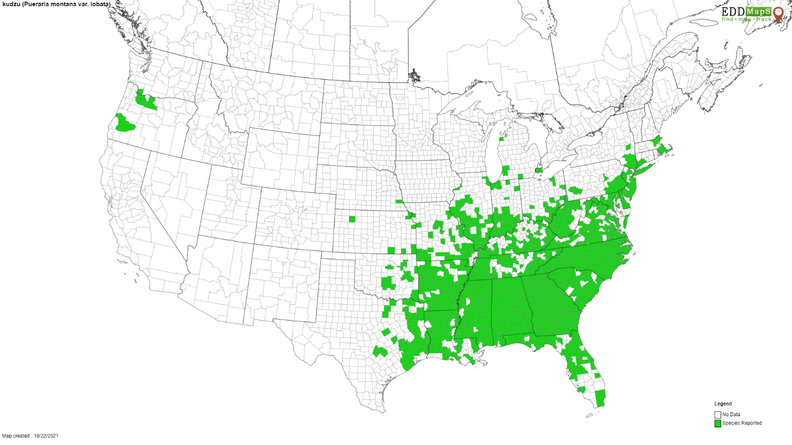Figure 1. Current distribution of kudzu in the United States (www.eddmaps.org), 2021.

hold enough water to survive throughout dry climatic conditions (Mitich 2000). In midsummer, usually between July and September, kudzu vines that are directly exposed to sunlight will begin producing red to purple flowers (Miller and Edwards 1983, Mitich 2000). Flowers produce densely hairy seed pods (4 to 5 cm long) and mature in the fall with few viable kidney-shaped seeds (Miller and Edwards 1983, Mitich 2000). The few viable seeds that kudzu produces remain in kudzu patches for years before they germinate (Everest et al. 1999). Reproduction of kudzu can either be by production of seeds (sexual reproduction) or vegetative propagation (asexual reproduction) (Mitich 2000). Within its invasive range in the U.S., kudzu reproduces mainly asexually by vegetative propagation, which results in low genetic diversity in kudzu patches (Bentley and Mauricio 2016). With the presence of multiple genotypes and the extreme success of kudzu in its invasive range, Bentley and Mauricio (2016) indicated that this could be due to either kudzu being preadapted to its environment or that is possesses high phenotypic plasticity within its environment. In the fall, kudzu vines die back (Mitich 2000) and leave the tuberous roots in the soil to produce new shoots the following year.
The eradication of kudzu from its invasive range in the U.S. is extremely difficult, time consuming, and expensive. Complete eradication of kudzu tends to occur only on a small, localized scale because complete defoliation or removal of the tuberous root system either mechanically or chemically must occur over the course of multiple years (Frye et al. 2007). However, kudzu is not the only invasive species in the U.S. that negatively impacts the environment and economy. Kudzu bugs within their invasive range throughout the U.S. also pose problems for the agricultural industry, specifically soybean production in the southeastern U.S.

Kudzu Bug
The kudzu bug is native to Asia and Australia in the Eastern Hemisphere (Eger et al. 2010, Dhammi et al. 2016). In addition to kudzu bug, alternative common names include lablab bug, globular stink bug, and bean plataspid (Gardner et al. 2013b). In October 2009, M. cribraria was discovered in the continental U.S. throughout nine counties in Georgia on homes near patches of kudzu (Jenkins et al. 2010) and is the only known species in the family Plataspidae in the continental U.S. How this invasive insect species arrived in the U.S. is not fully known (Zhang et al. 2012). However, it is thought that the invasive population of M. cribraria initially started from a single female haplotype that originated from Kyusha, Japan (Jenkins et al. 2010, Hosokawa et al. 2014).
Since its initial introduction in 2009, kudzu bug has spread throughout the southeastern U.S. (Jenkins et al. 2010); but little expansion in range has occurred since 2016 (Liang et al. 2019). The current distribution of kudzu bugs in the U.S. includes all of Alabama and North Carolina and portions of Georgia, Virginia, Maryland, South Carolina, Delaware, Kentucky, Tennessee, Mississippi, Arkansas, Texas, Missouri, and the District of Columbia (Fig. 2). Actual distribution within a state may differ because not all areas are comprehensively surveyed or re-surveyed on a regular basis, and low populations may go unreported. Kudzu bug possesses incredible dispersal capabilities, including an extremely strong ability to fly and reach heights 32 stories above ground level (Gardner et al. 2013b). Lovejoy and Lozier (2021) studied the association between kudzu bug dispersal from its origin in Georgia to its current distribution in the U.S. and found that the distance from initial site of invasion is closely associated with increased wing and body size of kudzu bugs and their morphology is most impacted by
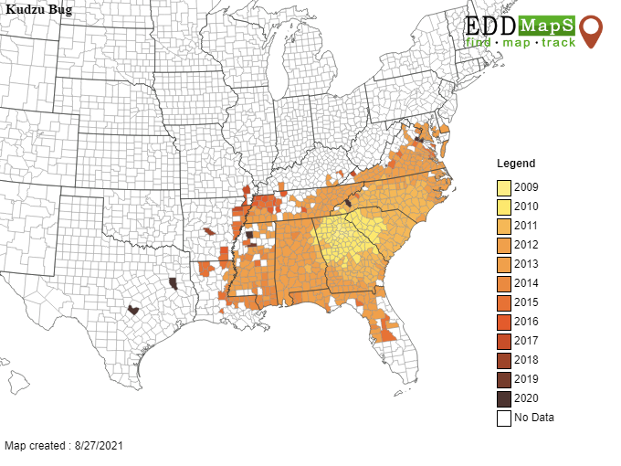
Figure 2. Distribution of kudzu bug in the United States from 2009 to 2020 (Megacopta Working Group, 2020).

environmental factors throughout their invasive range. The immense dispersal capabilities of kudzu bugs throughout their invasive range could be due, in part, to an increase in wing size in the U.S. because they are able to fly farther and increase their range expansion (Lovejoy and Lozier 2021).
Kudzu bugs are in the Order Hemiptera, which means that like other hemipterans, they possess a piercing-sucking mouthpart composed of four stylets (Stubbins et al. 2017). A
piercing-sucking mouthpart allows the insect to feed on leaves, stems, and petioles by sucking sap from leguminous plant species (Zhang et al. 2012), such as kudzu in its native and invasive range and soybean [Glycine max (L.) Merr. (Fabales: Fabaceae)] in its invasive and occasionally its native range (Suiter et al. 2010). Insects with piercing-sucking mouthparts feed via a process called probing, where they insert their mouthpart into the plant and produce a gelling saliva around their stylets that hardens and allows the insect to consume sap from the plant (Stubbins et al. 2017).
Kudzu bugs have a distinct square or hemispherical shape as adults and are colored dark green to brown with dark puncture markings (Halbert and Eger 2010). Megacopta cribraria adults are 4- to 6-mm long (Suiter et al. 2010) and have a scutellum that covers their abdomen completely (Halbert and Eger 2010). Female kudzu bugs have a rounded posterior end and larger pronotum and body size compared to the males, which possess a squared posterior end (Stubbins et al. 2017, Lovejoy and Lozier 2021). Adult kudzu bugs remain dormant throughout the winter, but with periods of the acceptable environmental conditions (moderately high temperatures and a lengthened photoperiod), they are able to overcome their state of dormancy and emerge in the spring (Golec and Hu 2015).
Kudzu bugs overwinter as adults in leaf litter, tree bark, or urban structures (Lahiri and Reisig 2016). Overwintering adults emerge from overwintering sites in mid-April, depending on environmental conditions, and move to kudzu where they begin laying eggs (Greenstone et al. 2014, Grant and Lamp 2018). Overwintering females are able to store sperm in their spermatheca throughout the winter and use the sperm to fertilize their eggs in the spring (Golec and Hu 2015). Golec and Hu (2015) compared stored sperm from the spermatheca of females that overwintered to the sperm in male testes that had overwintered and found them to be as active and viable as one another.
Kudzu bug egg masses are typically laid on the apex of kudzu or on stipules located at the base of the petiole of a trifoliate leaf. Kudzu bugs may lay their eggs on the apex of the vine or near the nodes of the plant because these areas have the most nutrient flow and resources throughout the plant. Occasionally kudzu bugs have been observed laying their eggs on the undersides of leaves within the kudzu canopy. Higher temperatures near the apex of the plant may also contribute to the choice in oviposition location of the females. In Zhejiang province, China, the preoviposition period of kudzu bug was observed over a period of 14 to 54 days (Shi et al. 2014). The fecundity of kudzu bug females varies within different geographical regions and is observed to be between 49 to 160 eggs per female in Zhejiang province, China (Shi et al. 2014), 49 to 73 eggs per female in Tamil Nadu state, India (Srinivasaperumal et al. 1992), and 102 to 157 eggs per female in Karnataka state, India (Thippeswamy and Rajagopal 2005). When female kudzu bugs lay their eggs, they also deposit bacteria-filled capsules containing the bacterial endosymbiont, Candidatus Ishikawaella capsulata, between the plant and the egg mass (Jenkins et al. 2010). Within one week, kudzu bug eggs will hatch (Grant and Lamp 2018) and immediately after eclosion, immature kudzu bugs feed on the bacterial endosymbiont (Jenkins et al. 2010). The consumption of Candidatus Ishikawallea capsulata aids in increased fecundity, normal growth, and development of plataspid insects and is associated with an increase pest status by improving the insect’s ability to feed on leguminous plants, like kudzu and soybean (Jenkins et al. 2010, Brown et al. 2014, Dhammi et al. 2016).
Some discrepancy, however, about the presence of Candidatus Ishikawallea capsulata and its role in the feeding habits of M. cribraria in its native and invasive ranges exists. In 2009 when M. cribraria was first discovered in the U.S., Jenkins et al. (2010) collected three specimens from Georgia and amplified their DNA to compare it with the species from its’ native range. The DNA sequences from the specimens collected in Georgia were a 98.6% match with M. cribraria from their native range; which suggested that the initial invader into the U.S. was a single female (Jenkins et al. 2010). To further investigate this, Jenkins and Eaton (2010) sequenced the DNA of 83 specimens collected from Georgia and South Carolina and found that all 83 specimens were identical, again suggesting that the initial invasion was a single female haplotype. Additional genes were amplified and the bacterial 16s rRNA gene found in the initial three specimens collected from Georgia were 100% homologous with Candidatus Ishikawallea capsulata, meaning that the specimens in the native and invasive range contained the same symbionts (Jenkins et al. 2010, Dhammi 2016). In the native range of M. cribraria, there is also a morphologically similar species, Megacopta punctatissima (Montandon), which was originally described as a variety of M. cribraria, but they are now identified as two distinct species (Eger et al. 2010). Jenkins et al. (2010) sequenced the entire bacterial genome of Candidatus Ishikawallea capsulata from the three specimens collected in Georgia and compared it to the genome of Candidatus Ishikawallea capsulata from M. cribraria and M. punctatissima specimens from Japan (Dhammi et al. 2016). Two Candidatus Ishikawallea capsulata genes from the invasive species’ genome in the U.S. were compared to the genome of the native species in Japan. The results of this comparison indicated that the groEL chaperone gene was a 99% match for both M. cribraria and M. punctatissima specimens from Japan and the 16s rRNA gene was identical to the M. punctatissima specimen from Japan (Jenkins et al. 2010, Dhammi et al. 2016). Additionally, Jenkins et al. (2010) compared the surface protein gene, wsp, from Wolbachia and found it to also be a 100% match to a M. punctatissima specimen from Japan. The Wolbachia gene from the three Georgia specimens and the M. punctatissima specimen from Japan were then compared to a specimen in a museum from 1952 and were found to all be of the same origin, but the museum specimen had recently been re-identified as M. cribraria (Jenkins et al. 2010, Dhammi et al. 2016). Hosokawa et al. (2014) then compared mitochondrial DNA from the specimens from Georgia to the M. punctatissima and M. cribraria specimens from Japan (Dhammi et al. 2016) and found that the specimens from Georgia were more similarly grouped with M. punctatissima from Kyusha, Japan. These results indicated that the insect M. cribraria in the U.S. is most similar to M. punctatissima in Asia (Hosokawa et al. 2014, Dhammi et al. 2016).
In Japan, M. punctatissima primarily feeds on P. lobata and is a known soybean pest, while M. cribraria primarily feeds on P. montana and is only occasionally found feeding on soybean (Dhammi et al. 2016). The feeding habits of these two species in their native range is thought to be influenced by the bacterial symbiont capsules placed by the females when laying eggs (Dhammi et al. 2016). Hosokawa et al. (2007) experimentally switched the bacterial symbionts of these two species before eclosion and found that the hatch rate of M. punctatissima decreased, while the hatch rate of M. cribraria increased, indicating an association between bacterial symbionts, and feeding behavior of these two species. The ability of M. cribraria within the U.S. to feed on soybean indicated that either the symbiont of the species has evolved to feed on soybean, or the species was misidentified (Dhammi et al. 2016). The role of the bacterial symbiont in the U.S. is crucial to understanding the life cycle and feeding habits of M. cribraria in its invasive range.
After consuming the symbiont, kudzu bug development from egg to adult requires 4 to 8 weeks, depending on environmental conditions and location throughout the invasive range (Ruberson et al. 2013, Greenstone et al. 2014, Grant and Lamp 2018). In the native range of kudzu bugs, it required 849 degree days for development of kudzu bugs from egg to adult using a minimum developmental temperature threshold of 14.25°C (Shi et al. 2014). Megacopta cribraria undergoes hemimetabolous development by developing through five green, hairy instar nymphal stages before molting into adults (Gardner et al. 2013b).
Megacopta cribraria is bivoltine in its invasive range within the U.S., meaning that the insect has two generations per year, which can develop successfully on kudzu and soybean (Greenstone et al. 2014); however, in their native range, kudzu bugs can produce up to three generations per year (Zhang et al. 2012). Medal et al. (2016) identified alternative suitable hosts of kudzu bug to be forage crops, such as alfalfa, red clover, and white clover, but identified corn, sorghum, tomato, and bell peppers as non-suitable hosts for the invasive pest. In field studies, kudzu bugs prefer to oviposit in kudzu rather than soybean (Zhang et al. 2012); however, in greenhouse studies, kudzu bugs do not have a preference between kudzu and soybean for oviposition (Medal et al. 2016). First-generation immature kudzu bugs become adults around mid-June to mid-July. Some adults then move to soybean in mid-June to mid-July to feed and produce a second generation until harvest (Greenstone et al. 2014), and some return to kudzu to feed before moving to overwintering sites in late October to early November. Other first-generation kudzu bugs remain in kudzu to feed and produce a second generation before moving to overwintering sites in the fall. Once they become adults, their longevity depends on their geographical area. In their invasive range within the U.S., kudzu bugs live from 6 to 25 days (Zhang et al. 2012). Around the world, kudzu bug longevity varies widely, from 44 to 81 days (Zhejiang province, China) (Shi et al. 2014), 2 to 5 days (Tamil Nadu state, India) (Srinivasaperumal et al. 1992), and 23 to 64 days (Karnataka state, India) (Thippeswamy and Rajagopal 2005). Throughout their lifetime, both adult and immature kudzu bugs can be observed gathering on the underside of leaves and on stems down within the canopy of kudzu and soybean plants; this behavior protects and shields kudzu bugs from high temperatures during the peak of the growing seasons of kudzu and soybean (Grant and Lamp 2018).
Kudzu bugs have become a major invasive pest in the U.S. for many reasons. They invade homes, vehicles, and clothing, where they emit a strong defensive odor when disturbed, similar to stink bugs (Hemiptera: Pentatomidae), and cause unpleasant, unsightly scenes for homeowners (Halbert and Eger 2010, Seiter et al. 2013, Medal et al. 2016). This chemical defense can be an irritant to humans (Ruberson et al. 2013), but the chemical composition of their defensive mechanism has not been studied (Dhammi et al. 2016). Megacopta cribraria is also invasive to the U.S. and North America, due to large populations that significantly reduce soybean production (Seiter et al. 2013).
Soybean
Soybean is a leguminous plant that was first grown in China (Qiu and Chang 2010). Since its introduction to the U.S. in 1765 in Georgia (North Carolina Soybean Producers Association 2014), soybean has become the second most cultivated crop (USDA ERS 2017). In the U.S., most soybean production occurs in the Midwest, but it is also grown in southern states, such as Tennessee (Fig. 3), where soybean is often the number one agricultural row crop in both number of hectares planted and economic value (Fig. 3) (USDA/NASS 2019).
Soybean in the southern U.S. already encounters an extensive list of arthropod pests that are potentially detrimental to yield and crop production; however, the list only increased once kudzu bug colonized the region (Seiter et al. 2013). Based on field-cage studies, soybean yield was significantly reduced by as much as 59.6% when an average of 25 kudzu bugs were placed per plant within a cage in the southeastern U.S. (Seiter et al. 2013). One of the biggest concerns for soybean growers is the expanding range of kudzu into areas dominated by soybean production, which provides additional habitat for kudzu bugs to expand their invasive range. Kudzu bugs were first discovered in Tennessee in 2012. At that time, they had minimal impact on soybean production with an estimated cost of $19,733 in the state of Tennessee and $988,034 in the southern U.S. in yield loss and treatment (Musser et al. 2013). By 2016, losses in yield and treatment costs were estimated at $4,005,419 in the southern U.S. and $1,551,469 in the state of Tennessee (Musser et al. 2017). In 2020, the control costs plus yield losses were estimated at $12,733,150 in the U.S. and $2,805,568 in Tennessee (Musser et al. 2021).
Many different methods of control have been investigated to reduce kudzu bug populations. Chemical insecticide applications are effective in reducing kudzu bug populations on soybean. Additionally, M. cribraria has multiple natural enemies within its invasive range, P. saccharalis and O. nezarae, and B. bassiana (Borah and Dutta 2002, Gardner et al. 2013a, Britt 2016, Ademokoya et al. 2018, Michael 2018). Because soybean is an important economic crop in Tennessee and the U.S., it is vital to understand how native natural enemies impact invasive kudzu bug populations.
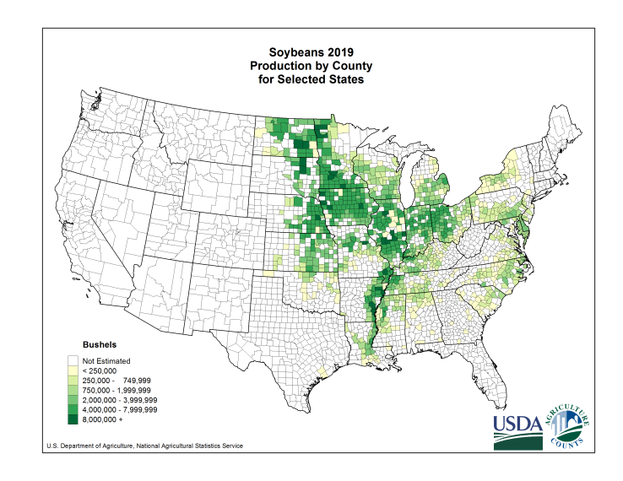
Figure 3. Average production of soybean in the United States from 2015 to 2019 (U.S. Department of Agriculture, National Agricultural Statistics Service, 2020).

Beauveria bassiana
Beauveria bassiana has been studied for decades in a multitude of ecosystems as an
entomopathogenic (Kumar et al. 1999) and endophytic fungus (Vega 2008) that is distributed worldwide (Garrido-Jurado et al. 2015). Beauveria bassiana was originally discovered infecting and causing white muscardine disease in silkworm, Bombyx mori L., by Agostino Bassi in 1834 (Porter 1973). The original identification of B. bassiana is credited to Balsamo-Crivelis, who named the species Botrytis bassiana (Porter 1973). Later, the genus name of the fungus was renamed to Beauveria by Veillmuin (Porter 1973). Beauveria bassiana is in the Phylum Ascomycota and is the asexually reproducing anamorph of the teleomorph Cordyceps bassiana, family Cordycipitaceae (Kumar et al. 1999, Yokoyama et al. 2004, Index Fungorum 2021). The asexual stage of B. bassiana produces septate hyphae, which give rise to conidiophores and conidia (Griffin 2007).
Beauveria bassiana is an entomopathogen that infects insects (Kumar et al. 1999), colonizes plants as an endophyte (Vega 2008), and occurs within the soil as a saprophyte (Kumar et al. 1999, Niland et al. 2019). Once a B. bassiana spore has penetrated the insect cuticle, the fungus begins producing hyphae, then hyphae give rise to blastospores within the insect body cavity (Griffin 2007). When the fungus emerges from the insect body cavity to the outer surface of the insect, B. bassiana produces aerial conidia that are released and able to infect other insects (Griffin 2007). Spores can either be disseminated by wind or by other insects (Griffin 2007). Because B. bassiana spores are hydrophobic, they are able to stick to a host and germinate within only a few hours, if a carbon source is present, and then, continued growth of the fungus requires a nitrogen source (Boucias and Pendland 1988, Griffin 2007, Filippou 2021).
Beauveria bassiana as an entomopathogen is documented to infect many insect and arthropod species (Kumar et al. 1999, McKinnon et al. 2017). In cotton, B. bassiana and Purpureocillium lilacinum (Thom.) were shown to have a negative effect on survival of cotton bollworm, Helicoverpa zea (Boddie) (Lopez and Sword 2015). The asexual stage of the fungus was first discovered infecting kudzu bugs in South Carolina in 2012 in soybean fields (Seiter et al. 2014). Later, B. bassiana was identified infecting kudzu bugs (Fig. 4) in east Tennessee in kudzu patches in August of 2015, and reappeared yearly around that time point (Britt 2016 and Michael 2018). The presence of B. bassiana is prominent when humidity levels are high (Michael 2018). Around the same time each year, B. bassiana is found in kudzu and soybean naturally controlling populations of kudzu bug (Britt and Taylor 2019). In addition to B. bassiana, an egg parasitoid, Ooencyrtus nezarae (Ishii) (Hymenoptera: Encyrtidae), was discovered causing 52% mortality in kudzu bug eggs (Britt 2016, Michael 2018). Beauveria bassiana was determined to cause 90% mortality in immature stages and 33% mortality of adult kudzu bugs (Britt 2016, Michael 2018). Only 3.2% of second-generation kudzu bugs survive both natural enemies and are able to overwinter (Britt 2016, Michael 2018). Immatures are extremely susceptible to B. bassiana within kudzu because they cannot fly and remain in the patch until they become adults (Michael 2018). While the effectiveness of B. bassiana as a natural biological control of kudzu bug in kudzu in Tennessee is high, the source of B. bassiana inoculum in this ecological system is unknown.
In addition to an entomopathogen, B. bassiana has been well documented as an endophyte. As an endophyte, B. bassiana can colonize many plant species, such as kudzu (Vega 2008, Michael 2018), common bean, Phaseolus vulgaris L. (Afandhi et al. 2019), and cotton, Gossypium hirsutum (Lopez and Sword 2015), and protect colonized plants against insects and
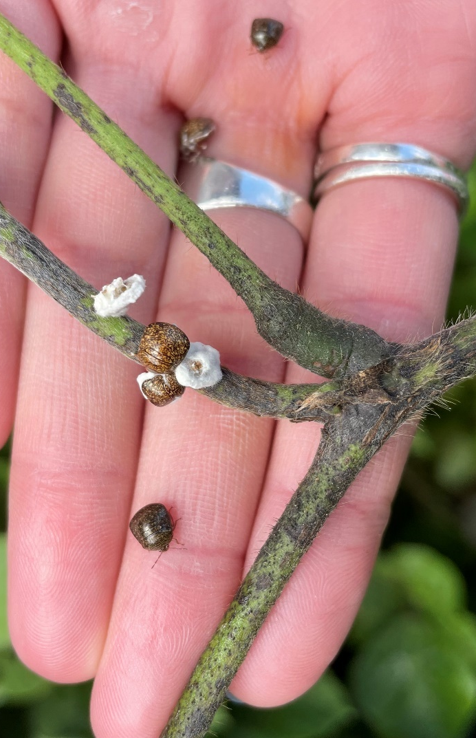
Figure 4. Kudzu bugs, Megacopta cribraria, infected and non-infected with Beauveria bassiana in kudzu located in Knox County, Tennessee.

plant pathogens (Ownley et al. 2008). Additionally, B. bassiana is a saprophyte in soil, as it relies on dead and decaying matter as its food source (Kumar et al. 1999). Furthermore, B. bassiana has been collected from soils of kudzu patches in North Carolina (Niland et al. 2019).
Kudzu bugs can overwinter in leaf litter (Lahiri and Reisig 2016); thus, they have the potential to come in contact with the soil, feed on kudzu, and come in contact with other insects that are infected with B. bassiana. The mechanism of how kudzu bugs initially come in contact with B. bassiana spores is unknown. In order to enhance management of kudzu bugs using B. bassiana as a natural biological control, interactions among these organisms need to be further investigated. Understanding how these organisms interact with one another throughout the growing season of kudzu and the life cycle of kudzu bugs will enhance the development and use of B. bassiana as a natural biological control of kudzu bug in integrated pest management programs for soybean growers throughout the U.S..
Research Objectives
Minimal information is known about the ecological interactions of B. bassiana, kudzu, soybean, and kudzu bug in the southeastern U.S.. Findings from previous research have led to more questions about ecological interactions within the invasive range of kudzu bug (Britt 2016, Michael 2018). Thus, a two-year research project was developed to further investigate the ecology of B. bassiana and kudzu bug.
The primary focus of this study is to determine the presence of a natural strain of B. bassiana in kudzu bugs as an entomopathogen and in kudzu as an endophyte. The findings of this research should provide insight on the ecological interactions among these organisms by laying the foundation for identifying and understanding potential pathways of infection of kudzu bugs. The specific research objectives of this project are to:
- Determine temporal and seasonal presence of B. bassiana in kudzu bugs on kudzu in east Tennessee; and
- Determine temporal and seasonal presence of B. bassiana in kudzu in east Tennessee.

CHAPTER II
Temporal and Seasonal Presence of Beauveria bassiana
in Kudzu Bug on Kudzu in East Tennessee

Introduction
Kudzu bug, Megacopta cribraria (F.) (Hemiptera: Plataspidae), is native to Asia (Eger et al. 2010, Dhammi et al. 2016), and was first discovered as an invasive species within the United States in 2009 in 9 counties in Georgia (Jenkins et al. 2010). However, the pathway of introduction of this insect to its invasive range in the U.S. remains unknown (Zhang et al. 2012). Initial kudzu bug range expansion in the U.S. was rapid, but since 2016, little expansion in kudzu bug range has occurred (Liang et al. 2019). Kudzu bugs were first discovered in Tennessee in 2012 (Gardner et al. 2013b) and later found to be naturally infected with Beauveria bassiana ((Balsamo) Vuillemin (Ascomycota: Hypocreales: Cordycipitaceae)) in fall of 2015 (Britt 2016).
Beauveria bassiana is a well-known entomopathogen that causes white muscardine disease in insects and other arthropods throughout the globe (Kumar et al. 1999, Porter 1973). In addition to B. bassiana, an egg parasitoid, Ooencyrtus nezarae (Ishii) (Hymenoptera: Encyrtidae), was discovered causing 52% mortality in kudzu bug eggs (Britt 2016, Michael 2018). Then, B. bassiana was determined to cause 90% mortality in immature and 33% mortality of adult kudzu bugs (Britt 2016, Michael 2018). Only 3.2% of second-generation kudzu bugs survive both natural enemies and are able to overwinter (Britt 2016, Michael 2018). The effectiveness of B. bassiana as a natural biological control of kudzu bug in kudzu within the U.S. is high. However, little is known about the mechanism of dissemination of B. bassiana on kudzu bug and how it is initially infected by this entomopathogenic fungus. Analyzing the rate at which kudzu bugs become infected with B. bassiana throughout the year and how the rate of infection changes over time will provide additional insight to understanding potential pathways of dissemination of the fungus. This investigation will enhance the potential for B. bassiana to be used as a natural biological control on kudzu bugs.
Therefore, a study was designed to address the objective to identify the temporal and seasonal presence of B. bassiana in kudzu bugs throughout east Tennessee. It is hypothesized that as second-generation kudzu bugs develop from nymph to adult, B. bassiana presence and infection will increase in the field. This hypothesis will be addressed by answering these questions in this study: What is the phenology and seasonality of B. bassiana in Tennessee – when is B. bassiana first detected infecting kudzu bugs, when does rate of infection change over time, and when does infection differ between kudzu bug life stages?
Materials and Methods
Assessment of Immature and Adult Kudzu Bugs
To determine temporal and seasonal presence of B. bassiana in kudzu bug found on kudzu, three field sites were established in east Tennessee (Knox County, Blount County, and McMinn County) in 2020 and 2021 (Table 1 and Fig. 5). Sites were visited biweekly to collect nymphal and adult kudzu bugs. Classification of nymphal stages (1-5) and the sex of adults (male or female) was determined using images found at www.kudzubug.org.
Biweekly sampling began on 2 June 2020 in Knox County, Blount County, and McMinn County and on 5 April 2021 in Knox County, 20 April 2021 in McMinn County, and 7 May 2021 in Blount County. Sampling began in 2020 after kudzu bugs were already established in kudzu. Sampling in 2021 began as adult kudzu bugs were emerging from overwintering sites. In

Table 1. Sites regularly visited to determine presence of Beauveria bassiana in kudzu bugs in kudzu.

Site | Latitude / Longitude | Years Sampled
Knox Co. (University Park Student Apartments) | N 35.949277  W 83.910441 | 2020, 2021
Blount Co. (WoodSpring Suites Knoxville Airport) | N 35.848282  W 83.965457 | 2020, 2021
McMinn Co. (US-411 Etowah, TN) | N 35.308047  W 84.533606 | 2020, 2021

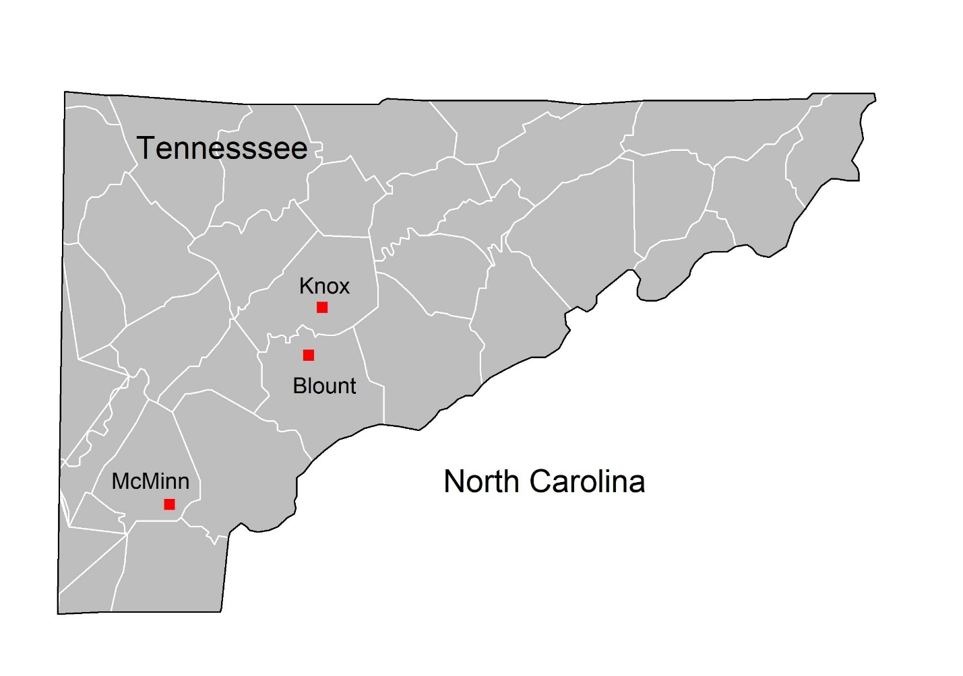
Figure 5. Map of sites visited to assess Beauveria bassiana presence on kudzu bug, 2021.

2021, adult kudzu bugs were discovered emerging from overwintering sites and moving to kudzu in the field on 5 April 2021 in Knox County, 20 April 2021 in McMinn, and 7 May 2021 in Blount County. Sampling continued in 2020 until kudzu bugs were no longer present in kudzu sites due to moving to overwintering sites (4 November). Sampling also continued in 2021 until kudzu bugs were no longer present in kudzu sites. All 2020 and 2021 sampling dates are listed in Table 2.
Upon visiting a kudzu site, 12 adult kudzu bugs and 6 immature kudzu bugs were collected from the perimeter (1-3 meters) of the kudzu patch and 12 adult kudzu bugs, and 6 immature kudzu bugs were collected from the interior (7-10 meters) of the kudzu patch. All adult and immature kudzu bugs collected were alive and were not showing physical presence of B. bassiana infection at the time of collection. Kudzu bug adults and immatures were collectively placed in Petri dishes (100 × 15 mm) according to stage (adult or immature) and the location they were collected (perimeter or interior), and they were transported to the laboratory.
In the laboratory, immature and adult kudzu bugs were stored for 24 to 48 hours in a freezer. Immature bugs were identified by life stage (nymphal stages 1-5) and were individually surface sterilized for 30 seconds in 10% commercial bleach (a.i. 7.5% sodium hypochlorite), rinsed in sterile distilled water, allowed to air dry, and plated in individual wells of a 12-well tissue culture plate containing a semi-selective media for B. bassiana (Doberski and Tribe 1980). Briefly, the medium contained dextrose (32 g), neopeptone (8 g), agar (12 g), chloramphenicol (0.5 g) (Thermo Fisher Scientific, Waltham, MA), crystal violet (0.008 g), (Sigma-Aldrich, St. Louis, MO), and cycloheximide (0.25 g) (VWR International, Radnor, PA). Cycloheximide and chloramphenicol were added to the medium once it was cooled after sterilization. Cycloheximide

Table 2. Sampling dates to assess Beauveria bassiana presence and absence in kudzu bugs in kudzu in east Tennessee.

Week No., 2020 | Sampling Date | Week No., 2021 | Sampling Date
 |  | 1 | 5 and 6 April
 |  | 2 | 20 April
 |  | 3 | 7 May
 |  | 4 | 17 and 18 May
1 | 2 and 3 June | 5 | 1 June
2 | 15 June | 6 | 15 June
3 | 30 June | 7 | 29 June
4 | 16 July | 8 | 13 July
5 | 29 July | 9 | 26 and 27 July
6 | 12 August | 10 | 10 August
7 | 24 August | 11 | 23 and 24 August
8 | 7 September | 12 | 7 and 8 September
9 | 21 September | 13 | 21 and 32 September
10 | 5 October | 14 | 11 October
11 | 23 October | 15 | 27 October
12 | 4 November | 16 | 9 November*

* Sample date not yet included in data analysis.

reduces fungal growth and chloramphenicol reduces bacterial growth in vitro. Adult kudzu bugs were identified by sex (male and female), individually surface sterilized for 1 minute in 10% commercial bleach, rinsed in sterile distilled water, air-dried, and plated in individual wells of a 12-well tissue culture plate containing the semi-selective medium for B. bassiana. All immature and adult kudzu bug samples were monitored weekly for 6 weeks before B. bassiana presence or absence was confirmed and recorded.
Data Analysis
Data recorded included proportion of kudzu bugs infected with B. bassiana by sampling date, site, location within site, and sex. An analysis of variance was performed using GLM in RStudio 1.4.1106. Significant differences among factors were determined using a means comparison test (Tukey HSD). A P-value of less than 0.05 was used to determine statistical significance. The fixed effects were month, site, location within site, sex, and instar stage, for each year separately. Analyses of proportion of kudzu bugs infected with B. bassiana was compared by year, month, site, location within site, sex/stage, and instar stage of immature kudzu bugs.
Results and Discussion
A significant difference was identified between years (p < 0.001); therefore, data collected in 2020 and 2021 were analyzed separately.
2020
In 2020, sampling began in June after adult kudzu bugs that overwintered had established in kudzu patches and begun laying eggs to initiate their first generation. Sampling in 2020 continued through November as second-generation adult kudzu bugs moved to overwintering sites, and thus, this analysis includes data from June through November.
Table 3. Model of proportion of kudzu bugs infected with Beauveria bassiana, 2020, GLM (p ≤ 0.05).

Factor | DF | Sums of Squares | F value | Pr(>F)*
Month | 4 | 1.433 | 4.376 | 0.003
Site | 2 | 0.276 | 1.688 | 0.191
Location | 1 | 0.174 | 2.124 | 0.149
Sex/Stage | 2 | 0.301 | 1.839 | 0.165
Month*Site | 6 | 0.866 | 1.764 | 0.116
Month*Location | 2 | 0.320 | 1.954 | 0.148
Month*Sex/Stage | 6 | 0.133 | 0.271 | 0.949
Site*Location | 2 | 0.100 | 0.613 | 0.544
Site*Sex/Stage | 4 | 0.161 | 0.492 | 0.742
Location*Sex/Stage | 2 | 0.311 | 1.899 | 0.156
Month*Site*Location | 4 | 0.028 | 0.087 | 0.986
Month*Site*Sex/Stage | 9 | 0.333 | 0.452 | 0.902
Month*Location*Sex/Stage | 3 | 0.064 | 0.260 | 0.854
Site*Location*Sex/Stage | 4 | 0.134 | 0.409 | 0.802
Month*Site*Location*Sex/Stage | 6 | 0.200 | 0.407 | 0.873
Residuals | 88 | 7.203

*Bold and underlined indicates significant p-values (p ≤ 0.05).

No significant differences in B. bassiana infection were found between sites in Knox County, Blount County, and McMinn County (Table 3). The percentages of infected kudzu bugs at each site were 16.8% (Knox County), 12.8% (Blount County), and 11.2% (McMinn County). Similarities in hot, humid environmental conditions among all three sites throughout
the lifecycle of second-generation kudzu bugs in kudzu resulted in similar pathogenicity of B. bassiana.
Kudzu bugs collected in June and July of 2020 were not separated by location (interior and perimeter) within a kudzu site, and no significant difference in percent infection was identified between interior and perimeter sampling locations (Table 3). Overall, 25.7% of kudzu bugs were infected with B. bassiana. Of all of the kudzu bugs collected from the perimeter of the kudzu sites, 21.3% were infected with B. bassiana. Similarities in pathogenicity of B. bassiana to infect kudzu bugs collected from the interior and perimeter of kudzu sites suggest that B. bassiana is equally likely to infect kudzu bugs located anywhere within a kudzu patch.
No significant differences among the percentage of infected kudzu bugs for sex/stage were documented when comparing females to males, males to immatures, and females to immatures (Table 3). The overall percent infections in 2020 were 15.4% (males), 10.2% (females), and 17.3% (immatures). A higher percentage infection rate for immature kudzu bugs could be influenced by their soft body that would allow B. bassiana spores to penetrate and infect immatures at a more successful rate than the adults, which have a hardened exoskeleton. Additionally, no significant differences among proportion of infected immature kudzu bugs were identified when comparing instar stages (p = 0.06).
Significant differences among months were detected for infected kudzu bugs when comparing June to August, June to September, June to October, June to November, July to August, July to September, July to October, July to November, August to November, and September to November (Tables 3, 4 and Fig. 6). The proportion of infected kudzu bugs was significantly less in June and July than in August, September, October, and November and significantly greater in November than in August and September (Table 4 and Fig. 6). These differences could be due to B. bassiana infecting kudzu bugs later in the year and non-infected kudzu bugs moving to overwintering sites in late October to early November. Few kudzu bugs were collected in November, as most had moved to overwintering sites or had already become infected with B. bassiana in the field.
2021
Sampling in 2021 began in April when kudzu bugs were emerging from overwintering sites and moving to kudzu vines as they began to establish in the field. Sampling continued through November when kudzu bugs moved from kudzu to overwintering sites. The analysis for 2021 includes data from April through October.
There were no significant differences in percent infection by B. bassiana in kudzu bugs between sites in Knox County, Blount County, and McMinn County (Table 5). Percent infection of kudzu bugs was similar among counties: 3.55% (Knox County), 4.62% (Blount County), and 2.48% (McMinn County). Similarities in hot, humid environmental conditions among all three sites throughout the lifecycle of second-generation kudzu bugs in kudzu promoted similar pathogenicity of B. bassiana.
No significant differences in the proportion of kudzu bugs infected by B. bassiana were identified among locations (interior or perimeter) within a site (Table 5). Of all the kudzu bugs collected from the interior of the kudzu sites, 3.57% were infected with B. bassiana and 3.58% were infected in the perimeter samples.
Table 4. Comparison of proportion of kudzu bugs infected with Beauveria bassiana by month, 2020, Tukey HSD (p ≤ 0.05).

2020 Month Comparison | Estimate | Standard Error | t value | Pr(>|t|)*
June – July | -0.019 | 0.085 | -0.226 | 1.000
June – August | -0.226 | 0.081 | -2.802 | 0.050
June – September | -0.233 | 0.077 | -3.020 | 0.030
June – October | -0.387 | 0.087 | -4.440 | <0.001
June – November | -0.823 | 0.208 | -3.955 | 0.001
July – August | -0.207 | 0.071 | -2.907 | 0.041
July – September | -0.214 | 0.067 | -3.185 | 0.018
July – October | -0.367 | 0.078 | -4.691 | <0.001
July – November | -0.804 | 0.205 | -3.929 | 0.002
August – September | -0.007 | 0.062 | -0.118 | 1.000
August – October | -0.161 | 0.074 | -2.185 | 0.229
August – November | -0.597 | 0.203 | -2.944 | 0.037
September – October | -0.154 | 0.070 | -2.199 | 0.223
September – November | -0.590 | 0.202 | -2.928 | 0.039
October – November | -0.437 | 0.206 | -2.124 | 0.257

*Bold and underlined indicates significant p-values (p ≤ 0.05).

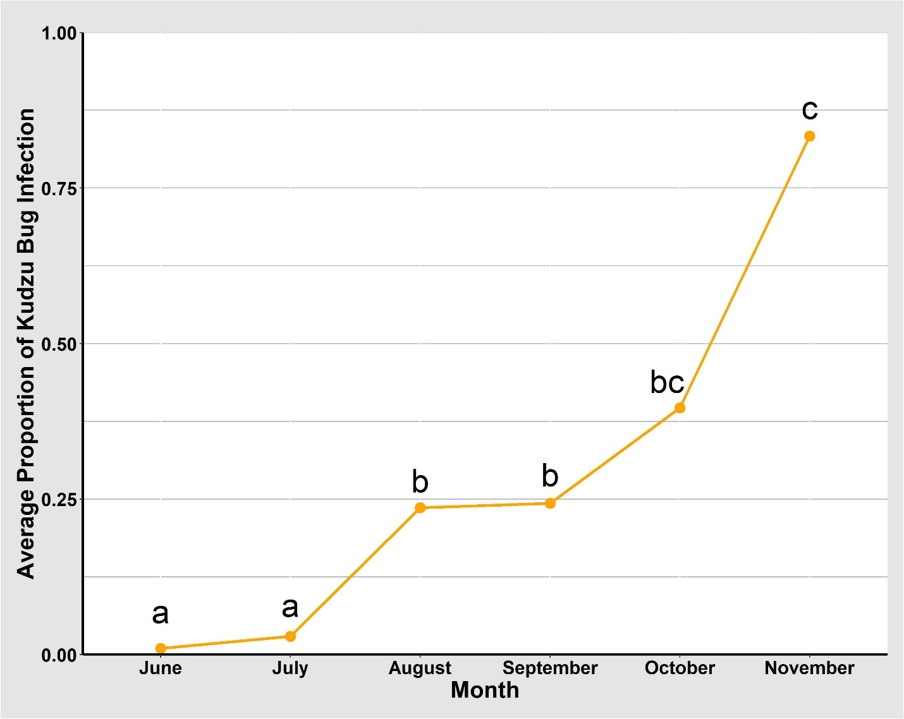
Figure 6. Average proportion of kudzu bugs infected by Beauveria bassiana by month, 2020.

Table 5. Model of proportion of kudzu bugs infected with Beauveria bassiana, 2021, GLM (p ≤ 0.05).

Factor | DF | Sums of Squares | F value | Pr(>F)
Month | 6 | 0.793 | 11.328 | <0.001*
Site | 2 | 0.029 | 1.260 | 0.286
Location | 1 | 0.005 | 0.415 | 0.520
Sex/Stage | 2 | 0.004 | 0.486 | 0.830
Month*Site | 11 | 0.569 | 4.431 | <0.001
Month*Location | 6 | 0.655 | 9.354 | <0.001
Month*Sex/Stage | 10 | 0.192 | 1.644 | 0.098
Site*Location | 2 | 0.008 | 0.338 | 0.713
Site*Sex/Stage | 4 | 0.162 | 3.481 | 0.009
Location*Sex/Stage | 2 | 0.063 | 2.693 | 0.071
Month*Site*Location | 10 | 0.201 | 1.726 | 0.078
Month*Site*Sex/Stage | 17 | 0.820 | 4.133 | <0.001
Month*Location*Sex/Stage | 8 | 0.154 | 1.647 | 0.115
Site*Location*Sex/Stage | 4 | 0.013 | 0.277 | 0.892
Month*Site*Location*Sex/Stage | 16 | 0.104 | 0.555 | 0.913
Residuals | 174 | 2.030

*Bold and underlined indicates significant p-values (p ≤ 0.05).

No significant differences in the proportion of kudzu bugs infected by B.
bassiana were identified between sexes and stages when comparing female to male, female to immature, and male to immature (Table 5). The percentage of infection varied slightly among sexes and immatures, as 2.78% of females, 4.74% of males, and 3.24% of immatures collected from April through October in 2021 across all sites were infected with B. bassiana. Additionally, no significant differences among proportion of infected immature kudzu bugs were identified when comparing instar stages (p = 0.242).
Significant differences among months were identified when comparing infected kudzu bugs (Table 5). Significant differences among months were detected for infected kudzu bugs when comparing April to May, April to June, April to July, May to October, June to October, July to October, and August to September (Table 6). The proportion of infected kudzu bugs was significantly higher in April than in May, June, and July and significantly higher in October than in May, June, July, and August (Table 6). These differences could be due to B. bassiana infecting kudzu bugs later in the year and non-infected kudzu bugs moving to overwintering sites in late October to early November. The percentage of infected kudzu bugs varied among months: 12.5% (April), 0.00% (May), 0.72% (June), 0.47% (July), 1.89% (August), 8.04% (September), and 14.1% (October). A higher proportion of infected kudzu bugs was observed in April because 1 of 8 kudzu bugs collected was infected with B. bassiana.
A significant interaction between month and site was identified when comparing the proportion of kudzu bugs infected by B. bassiana (Table 5 and Fig. 7). A significantly higher proportion of infected kudzu bugs was collected in Knox County in April (Fig. 7). This higher proportion could be due to a small number of kudzu bugs that were collected. Kudzu bugs

Table 6. Comparison of proportion of kudzu bugs infected with Beauveria bassiana by month, 2021, Tukey HSD (p ≤ 0.05).

2021 Month Comparison | Estimate | Standard Error | t value | Pr(>|t|)*
April – May | 0.200 | 0.067 | 2.977 | 0.044
April – June | 0.196 | 0.062 | 3.145 | 0.027
April – July | 0.195 | 0.063 | 3.085 | 0.032
April – August | 0.169 | 0.063 | 2.708 | 0.090
April – September | 0.128 | 0.063 | 2.029 | 0.375
April – October | 0.034 | 0.066 | 0.521 | 0.998
May – June | -0.004 | 0.034 | -0.123 | 1.000
May – July | -0.005 | 0.036 | -0.146 | 1.000
May – August | -0.031 | 0.035 | -0.888 | 0.971
May – September | -0.072 | 0.036 | -2.010 | 0.386
May – October | -0.166 | 0.040 | -4.149 | <0.001
June – July | -0.001 | 0.025 | -0.040 | 1.000
June – August | -0.027 | 0.024 | -1.120 | 0.914
June – September | -0.068 | 0.025 | -3.672 | 0.099
June – October | -0.162 | 0.031 | -5.216 | <0.001
July – August | -0.026 | 0.026 | -0.985 | 0.952
July – September | -0.067 | 0.027 | -2.431 | 0.174
July – October | -0.161 | 0.033 | -4.909 | <0.001
August – September | -0.041 | 0.026 | -1.587 | 0.669
August – October | -0.135 | 0.031 | -4.292 | <0.001
September – October | -0.094 | 0.033 | -2.871 | 0.059

*Bold and underlined indicates significant p-values (p ≤ 0.05).

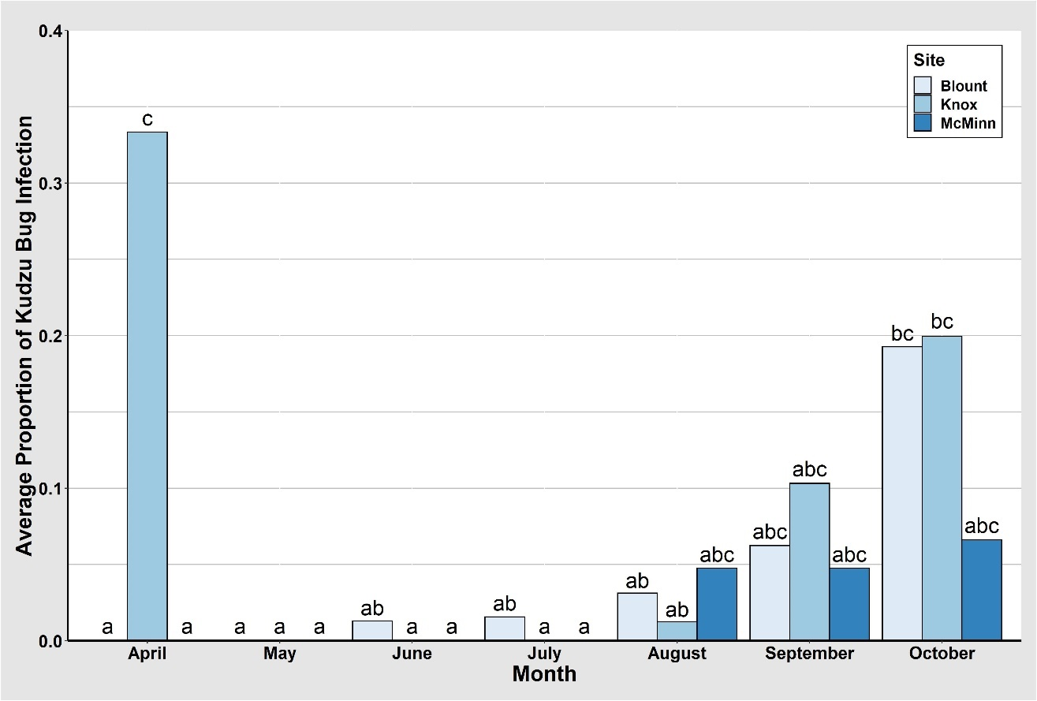

Figure 7. Average proportion of kudzu bugs infected by Beauveria bassiana by month and site, 2021.

collected in April were emerging from overwintering sites, and infection could have occurred prior to overwintering, during overwintering, or while moving from overwintering sites to kudzu. No infected kudzu bugs were collected in Blount County or McMinn County throughout the month of April (Fig. 7). Beauveria infection was detected in Blount County as early as June and steadily increased through October, where a significantly higher proportion of infected kudzu bugs were collected (Fig. 7). A similar trend was identified in Knox County; however, infection of second-generation kudzu bugs was not detected until August and steadily increased through October (Fig. 7). Generally, kudzu bugs move to overwintering sites in October. Significantly higher proportions of infected kudzu bugs collected in October could indicate that infected kudzu bugs are not able to move to overwintering sites and more infected kudzu bugs were collected in the field. The proportion of kudzu bugs infested with Beauveria similar from August through October and was not different from Knox County and Blount County (Fig. 7). The proportion of infected kudzu bugs collected in McMinn County was the same in August through October.
A significant interaction among month and location within a site was identified when comparing the proportion of infected kudzu bugs (Table 5 and Fig. 8). A significantly higher proportion of infected kudzu bugs was collected in April from the perimeter of the Blount County site (Fig. 8). However, infection in kudzu bugs collected from the perimeter from all sites was not identified until August and steadily increased through October (Fig. 8). Infection in kudzu bugs collected from the interior of the kudzu patch followed a similar pattern, but was first identified in June and steadily increased through October (Fig. 8). Infection in the interior began while first-generation immature and adult kudzu bugs were present in the field and continued to increase as adults laid eggs and their second-generation began to develop from immatures to adults. However, with the exception of April, infection in the perimeter did not become
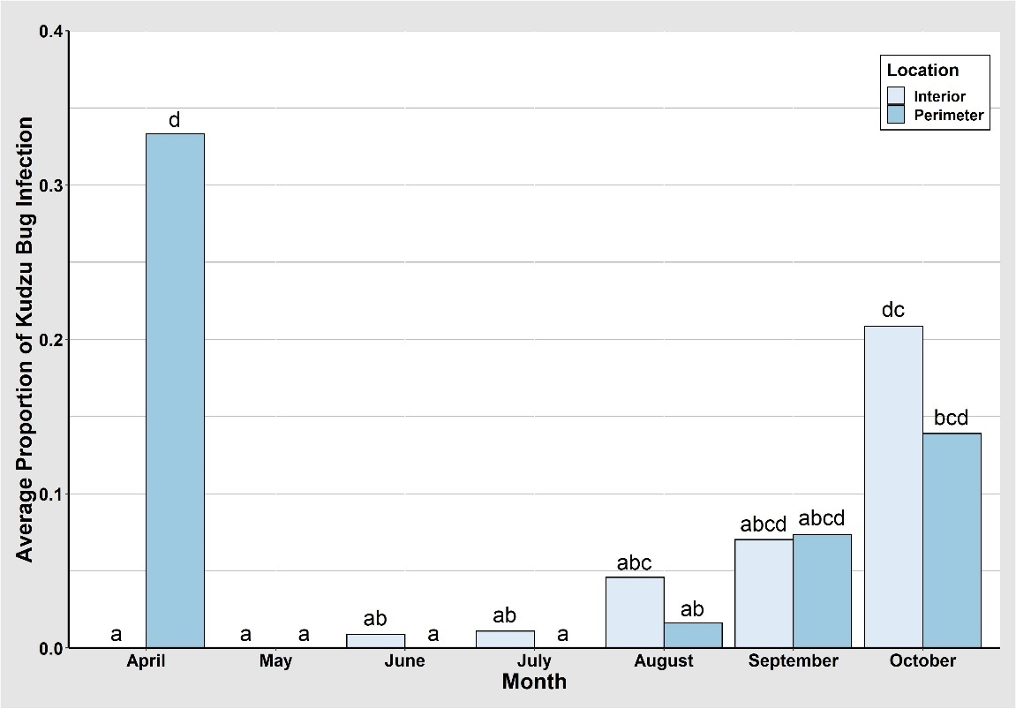

Figure 8. Average proportion of kudzu bugs infected by Beauveria bassiana by month and location within a site, 2021.

consistent until second-generation immature and adult kudzu bugs were present in the field in August.
A significant interaction among month, site, and sex/stage was identified when comparing proportion of infected kudzu bugs (Table 5 and Fig. 9). In Blount County, no female, male, or immature kudzu bugs were collected in April or May. Kudzu bugs were emerging from overwintering sites in late April and only adults were present in the field in May. Additionally, a significantly higher proportion of infected female kudzu bugs were collected in October in Blount County than any other month or other sex/stage (Fig. 9). Infected immature kudzu bugs were only found in July in Blount County (Fig. 9). However, infected males were found in June and August through October and females were found in August through October (Fig. 9). In Knox County, no immature kudzu bugs were collected in April and May, and no females were collected in April. A significant proportion of infected males were collected in April, and then not collected again until September and October (Fig. 9). Infected males had just emerged from overwintering sites and may have become infected prior to overwintering, during overwintering, or while moving from overwintering sites to kudzu. Infected females were not collected in Knox County until September and October, while infected immatures were collected in August through October (Fig. 9). In October, a significantly higher proportion of infected immature kudzu bugs was collected from Knox County than any other month, site, or sex/stage throughout the year (Fig. 9), which suggests that infected immatures are not able to develop into adults. In McMinn County, no immature kudzu bugs were collected in April, May, or October. Additionally, low proportions of infected males were only collected in October, females in September, and immatures in August and September (Fig. 9).
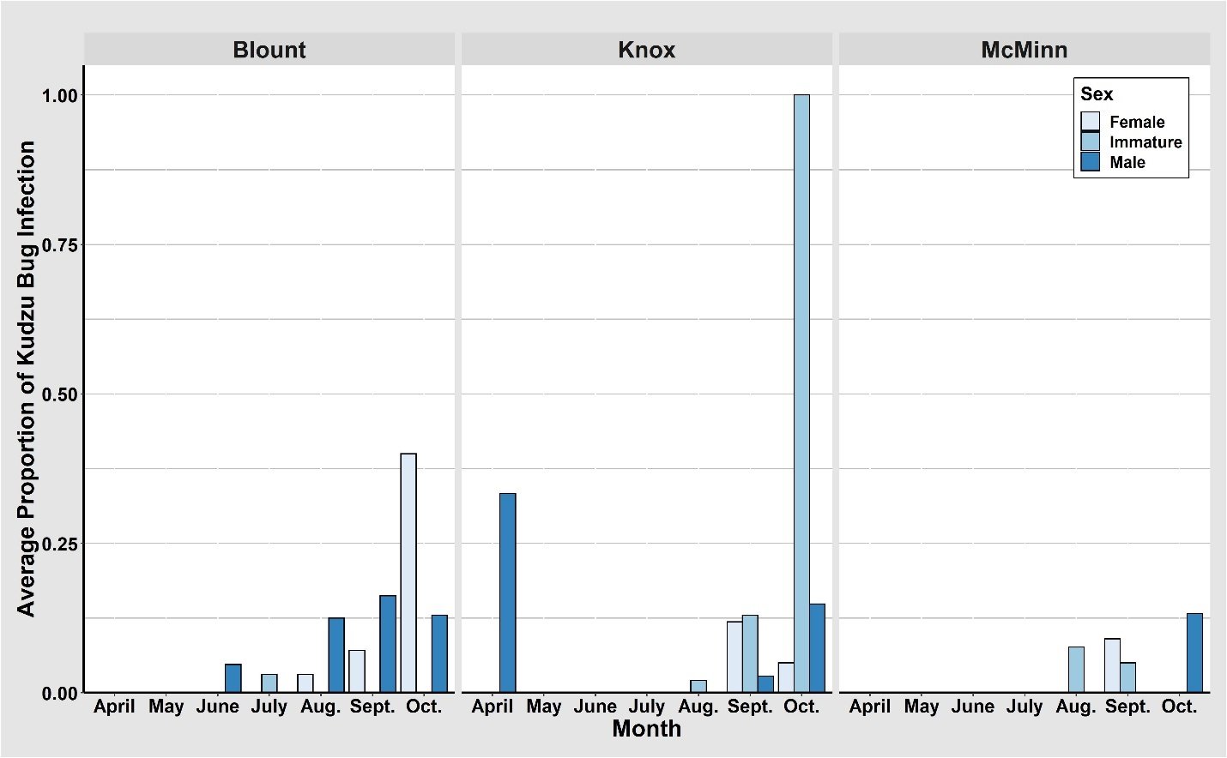
abc
a a
a
ab
abc
a
ab
a
a a a
a a a
a a a
a a a
abc
d
ab
ab
abc
abc
a
ab
a
a a a
a a a
a a a
c
bc
a a
abc
abc
ab
abc
a a a
ab
a
ab
ab
a a
a a a
a
a
a
a

Figure 9. Average proportion of kudzu bugs infected by Beauveria bassiana by month, site, and sex/stage, 2021.
Summary
Overall, a greater number of kudzu bugs, adults and immatures infected with B. bassiana, were collected in 2020 than in 2021. The physical presence of B. bassiana was observed on infected kudzu bugs in the field in late July of 2020 and early September of 2021. Presence of B. bassiana in the field in 2021 was similar seasonally to when B. bassiana was beginning to infect
kudzu bugs beginning in August of 2015 and for the subsequent years following 2015 (Britt 2016 and Michael 2018). The differences in time when B. bassiana began infecting kudzu bugs between 2020 and 2021 could be due to higher humidity levels and increased rainfall in 2020 compared to 2021 (Michael 2018).
A greater proportion of infected kudzu bugs were found at sites at higher latitudes (Knox County and Blount County); however, there were no significant differences among sites in 2020 and 2021. These results were similar to Britt (2016), where Blount County had higher kudzu bug mortality than Polk County, which has a lower latitude than Blount County. Adult kudzu bugs infected with B. bassiana that were collected in 2020 and 2021 were not significantly different among sexes. This finding is similar to previous studies (Britt 2016). However, differences in kudzu bug infection were previously found between adults collected from Knox County and McMinn County and immatures collected when comparing Blount County to Knox County and Knox County to McMinn County (Britt 2018). Additionally, the lowest levels of immature kudzu bug infection occurred in McMinn County for 2020 (11.15%), which were similar to data collected in 2016 and 2017 (Michael 2018). Location (perimeter or interior) within a kudzu site where kudzu bugs were collected did not have an effect on kudzu bug infection by B. bassiana.
Overall kudzu bug infection increased throughout the study. Beginning in April and continuing through November, percent infection of kudzu bugs increased, which results in similarities with the findings of Britt (2016). Additionally, infection of adults and immatures started at near zero and increased steadily throughout the remainder of the year. Findings from Britt (2016) and Michael (2018) showed comparable results where kudzu bug infection and mortality started low and increased steadily at all sites, resulting in ~100% mortality by the end of the sampling period.
This study gives critical insight to the periods of time and locations in which B. bassiana begins to infect kudzu bugs throughout east Tennessee. These data provide insight to potential sources of inoculum of B. bassiana by providing details of when kudzu bugs are infected with B. bassiana. The identification of kudzu bugs infected with B. bassiana as early as June in 2020 and April in 2021 in small numbers could indicate that kudzu bugs are becoming infected with B. bassiana while emerging from overwintering sites and moving to kudzu or as they begin feeding on kudzu. Significant increases in B. bassiana infection of kudzu bugs could indicate that the presence of B. bassiana as an endophyte has an influence on its entomopathogenic activity in kudzu over time. Additionally, it is possible that later in the season, the main source of inoculum comes from infected kudzu bugs that have died and are reservoirs for sporulating B. bassiana in kudzu. Additional research is needed to understand the potential pathways of dissemination of B. bassiana that could lead to kudzu bug infection, as well as understanding the impact that infected kudzu bugs have on kudzu bug infection rates as the season progresses. Understanding the pathways in which kudzu bugs are becoming infected with B. bassiana will provide critical results that can lead to enhanced use of B. bassiana as a biological control for kudzu bugs in soybean.

CHAPTER III
Temporal and Seasonal Presence of Beauveria bassiana
in Kudzu in East Tennessee

Introduction
Kudzu, Pueraria montana (Lour.) Merr var. lobata (Willd.) Maesen & Almeida (Fabales: Fabaceae), native to Asia, is an invasive species in the United States (Ward 1998). Kudzu is well-known for its ability to reduce native plant diversity, grow at intense rates, and overtake trees, right of ways, powerlines, buildings, and other structures (Miller and Edwards 1983, Harrington et al. 2003, Frye et al. 2007). This destructive, invasive plant species was intentionally introduced to the U.S. twice for its ability to reduce erosion as a forage crop and as an ornamental plant (Miller and Edwards 1983, Harrington et al. 2003, Frye et al. 2007). Kudzu was first introduced in the U.S. in 1876 at the Centennial Exposition in Philadelphia and introduced a second time in 1883 at the New Orleans Exposition (Miller and Edwards 1983, Forseth and Innis 2004, Frye et al. 2007).
In 2009, an invasive insect species, kudzu bug (Megacopta cribraria (F.) (Hemiptera: Plataspidae)), was discovered on homes in Georgia and later found to be feeding on kudzu nearby (Jenkins et al. 2010). How this invasive insect species arrived in the U.S. remains unknown (Zhang et al. 2012). In 2012, an entomopathogen, Beauveria bassiana [(Balsamo) Vuillemin (Ascomycota: Hypocreales: Cordycipitaceae)], was discovered infecting and causing white muscardine disease in kudzu bugs feeding on soybean in South Carolina (Seiter et al. 2014). Additionally, in August of 2015, B. bassiana was discovered infecting and causing white muscardine disease in kudzu bugs located in kudzu in east Tennessee (Britt 2016). In subsequent years, B. bassiana was identified infecting kudzu bugs around the same timepoint (Britt 2016, Michael 2018). Beauveria bassiana is known to be a successful biological control of kudzu bugs in the U.S. In addition to B. bassiana, an egg parasitoid, Ooencyrtus nezarae (Ishii) (Hymenoptera: Encyrtidae), was discovered causing 52% mortality in kudzu bug eggs (Britt 2016, Michael 2018). Michael (2018) accessed the impact of B. bassiana presence on kudzu bug populations in east Tennessee in 2016 and 2017 and found that 90% and 33% of second-generation immature and adult kudzu bugs, respectively, were infected with B. bassiana, leaving only 3.2% of second-generation kudzu bugs to survive and overwinter. While B. bassiana as a biological control is undoubtedly successful at controlling kudzu bug populations, the question of identifying how kudzu bugs become infected with the entomopathogen remains.
One potential source of B. bassiana infection of kudzu bugs could be linked to its endophytic presence in kudzu, as well as soybean (Vega 2008). Beauveria bassiana is a well-studied endophyte known for its ability to enhance growth of common bean, Phaseolus vulgaris L. (Afandhi et al. 2019), and cotton, Gossypium hirsutum L. (Lopez and Sword 2015), and protect against insect pests and plant pathogens (Ownley et al. 2008). Kudzu bugs have a piercing-sucking mouthpart that is used to suck sap from leguminous plant species. Their piercing-sucking mouthpart is wider in diameter than a B. bassiana spore (Michael 2018), which suggests that kudzu bugs may become infected with B. bassiana by ingesting spores while feeding on kudzu or soybean plants that have been endophytically colonized by the fungus. Analyzing B. bassiana presence as an endophyte in kudzu over time will give insight to when and in what proportion the fungus is colonizing kudzu vines. If kudzu bugs become infected with B. bassiana during or around the same time points that B. bassiana is colonizing kudzu vines, this infection could provide further evidence that kudzu bugs may become infected by feeding on endophytically colonized host plants.
Therefore, a study was designed to identify the temporal and seasonal presence of B. bassiana in kudzu throughout east Tennessee. It is hypothesized that as kudzu continues to grow throughout the year, endophytic B. bassiana colonization of vines will increase in the field. This hypothesis will be addressed by answering these questions in this study: What is the phenology and seasonality of B. bassiana in Tennessee – when is B. bassiana first detected colonizing kudzu vines, what proportion of the kudzu vine is colonized by B. bassiana over time, does percent colonization differ among sites, and does percent colonization differ among leaves, stems, and the entire kudzu vine?
Materials and Methods
Assessment of Kudzu (Leaves and Stems)
Data for this study consisted of field-collected kudzu vines that were processed to assess endophytic presence of B. bassiana in leaves, stems, and vines. Biweekly sampling in 2020 and 2021 was conducted at kudzu sites in Knox, Blount, and McMinn Counties in east Tennessee. To determine temporal and seasonal presence of B. bassiana in kudzu, three field sites were established in east Tennessee (Knox County, Blount County, and McMinn County) (Chapter 1: Table 1 and Fig. 4). Sites were visited biweekly to collect kudzu vines.
Biweekly sampling began on 2 June 2020 in Knox County, Blount County, and McMinn County and 20 April 2021 in Knox County, Blount County, and McMinn County (Chapter 1: Table 2). Sampling began in 2020 after kudzu vines were established in the field. Sampling in 2021 began as kudzu vines were emerging from their dormant state in spring. In 2021, kudzu vines were discovered emerging from their dormant state in the field in April 2021 in Knox County, Blount County, and McMinn County. Sampling continued in 2020 and 2021 until kudzu vines began to senesce and die back for winter. Sampling in 2020 was terminated on 4 November and in 2021 on 9 November (Chapter 1: Table 2).
Upon visiting a kudzu site, three kudzu vines were collected. One vine was collected from each of the following locations within the kudzu site: perimeter (1-3 meters), middle (3-7 meters), and interior (7-10 meters). The cut end of each kudzu vine was wrapped in a wet paper towel to prevent moisture loss. Each kudzu vine was placed in a separate 3.785-liter bag and transported to the laboratory.
In the laboratory, kudzu vine samples were stored in a refrigerated growth chamber for 18 to 48 hours before being processed. Each kudzu vine was divided into leaf and stem samples. Beginning at the apex and counting down the vine, leaf samples were labeled A through E (Fig. 10). Beginning at the apex and counting backwards down the vine, stem samples were labeled Apex and A through F (Fig. 10). More stem samples were taken because new leaf emergence was not present on the new kudzu vine growth on the apex nor on stem sample A. New leaf emergence on the kudzu vines did not begin until stem sample B. (Fig. 10).
Whole kudzu leaves (comprised of three leaflets) were chosen if the entire leaf would fit into a Petri dish (100 × 15 mm). If the entire kudzu leaf would not fit, one kudzu leaflet was randomly chosen from each leaf. Each leaf or leaflet sample was individually surface sterilized in 10% commercial bleach (a.i. 7.5% sodium hypochlorite) for 1 minute, rinsed in sterile distilled water, air-dried, and plated in individual Petri dishes (100 × 15 mm) containing a semi-selective medium for B. bassiana (Doberski and Tribe 1980). Briefly, the medium contained 32 g dextrose, 8 g neopeptone, 12 g agar, 0.5 g chloramphenicol (Thermo Fisher Scientific, Waltham,
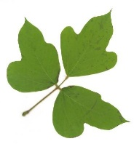
Leaf D/Stem E
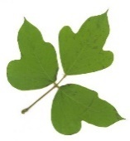

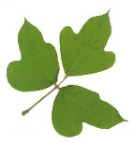
Leaf E/Stem F
Leaf A/Stem B
Leaf C/Stem D
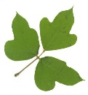

Leaf B/Stem C
Apex/Stem A
Figure 10. Locations of kudzu vine leaf and stem samples. Kudzu leaf images used in this figure are from http://clifflamere.com/Misc/Kudzu-Albany.htm.

MA), 0.008 g crystal violet (Sigma-Aldrich., St Louis, MO), and 0.25 g cycloheximide (VWR International, Radnor, PA). Cycloheximide and chloramphenicol were added to the medium after sterilization and cooling. Kudzu vine stem samples were divided into 7.62-cm sections around the nodes of the plant. (Fig. 11). Each stem sample was individually surface sterilized in 10% bleach for 1 minute, rinsed in sterile distilled water, cut into 2.54-cm section around the node, and air-dried. Three stem samples were plated in a triangular formation (Fig. 12) in a Petri dish (100 × 15 mm) containing a semi-selective medium for B. bassiana (Doberski and Tribe 1980). The medium used is the same as described above for leaf samples. The Apex and stem A samples were not detached from one another because the length between the two samples was not enough to obtain 7.62 cm for surface sterilization and 2.54 cm for plating. All kudzu vine leaf and stem samples were monitored weekly for 6 weeks before presence and absence of B. bassiana was confirmed and recorded.
Data Analysis
Data recorded included presence or absence of B. bassiana per kudzu sample. Data was analyzed using a binary logistic regression. An analysis of variance was performed using GLM in RStudio 1.4.1106. Significant differences among factors were determined using a Pearson chi-square post hoc binomial pairwise test and p-values were adjusted using Bonferroni. A P-value of less than 0.05 was used to determine statistical significance. Additionally, data were used to obtain percent colonization of B. bassiana of leaves, stems, and plant. An analysis of variance was performed using a mixed effects model, LMER, in R Studio 1.4.1106. Significant differences among factors were determined using a Tukey HSD. A P-value of less than 0.05 was used to determine statistical significance. The fixed effects were month, site, and location within
Outer 2.54-cm
sections discarded
Sample is surface sterilized

7.62 cm Stem Sample
Middle 2.54-cm
stem sample plated
Stem sample divided into
Three 2.54-cm sections

Figure 11. Process for cutting kudzu vine stem samples around nodes of plant.

Two separate Petri dishes containing a semi-selective medium for Beauveria bassiana.
Stem D
Apex/Stem A

Stem E
Stem C
Stem F
Stem B
Figure 12. Layout of plating stem samples in Petri dishes.

site for each year separately and combined. presence and absence by year, by month, by site, and by location within a site. Analyses of percent colonization of B. bassiana in kudzu for stem, leaf, and entire plant compared percent colonization by year, percent colonization by month, percent colonization by site, and percent colonization by location within site.
Results and Discussion
Assessment of Kudzu Leaf Colonization
2020
Significant differences among the proportion of kudzu leaves that were colonized endophytically by B. bassiana among months were identified when comparing June to August, June to September, July to August, and July to September (Tables 7, 8). During the months of August (25.0%), September (22.2%), October (9.88%), and November (11.4%), significantly more kudzu leaves were colonized endophytically by B. bassiana than in June (0.00%) and July (1.11%) (Table 8). These data also suggest that little endophytic colonization of kudzu stems occurs between June and when second-generation kudzu bugs are emerging from egg masses in July.
No significant differences among proportion of kudzu leaves colonized endophytically by B. bassiana were identified when comparing Knox County (10.11%) to Blount County (13.9%), and Knox County (10.1%) to McMinn County (5.56%). A significant difference was identified when comparing Blount County (13.9%) to McMinn County (5.56%) (Table 8). This indicates that latitudinal differences among sites could affect endophytic colonization of kudzu leaves, although this study encompasses a small geographic area. These results suggest that kudzu bugs at all sites throughout east Tennessee are equally likely to become infected by B. bassiana.

Table 7. Model of proportion of kudzu leaves colonized by Beauveria bassiana, 2020, GLM (p ≤ 0.05).

Source | Sum of Squares | Degrees of Freedom | F value | Pr(>F)*
Residuals | 0.571 | 47
Month | 0.960 | 5 | 15.794 | <0.001
Site | 0.094 | 2 | 3.873 | 0.028
Location | 0.011 | 2 | 4.417 | 0.018
Month*Site | 0.391 | 10 | 3.219 | 0.003
Month*Location | 0.307 | 10 | 2.525 | 0.016
Site*Location | 0.134 | 4 | 2.753 | 0.039
Month*Site*Location | 0.801 | 19 | 3.467 | <0.001

*Bold and underlined indicates significant p-values (p ≤ 0.05).

Table 8. Comparison of proportion of kudzu leaves colonized by Beauveria bassiana by month, 2020, Tukey HSD (p ≤ 0.05).

Comparison | Estimate | Standard Error | t Value | Pr(>|t|)*
June – July | -0.011 | 0.049 | -0.226 | 0.999
June – August | -2.500 | 0.056 | -4.456 | <0.001
June – September | -0.222 | 0.049 | 4.516 | <0.001
June – October | -0.085 | 0.050 | 1.704 | 0.527
June – November | -0.100 | 0.065 | 1.536 | 0.636
July – August | -0.239 | 0.060 | -3.964 | 0.002
July – September | -0.211 | 0.054 | 3.917 | 0.002
July – October | -0.074 | 0.055 | 1.357 | 0.748
July – November | -0.089 | 0.069 | 1.294 | 0.784
August – September | 0.028 | 0.060 | -0.461 | 0.997
August – October | 0.165 | 0.061 | -2.702 | 0.082
August – November | 0.150 | 0.074 | -2.032 | 0.327
September – October | 0.137 | 0.055 | 2.504 | 0.130
September – November | 0.122 | 0.069 | 1.779 | 0.478
October – November | -0.015 | 0.069 | -0.212 | 0.999

*Bold and underlined indicates significant p-values (p ≤ 0.05).

No significant differences were detected in rates of endophytic colonization by B. bassiana of leaves collected within a kudzu site and the locations when comparing interior
(8.92%) to perimeter (6.55%) and interior to middle (13.9%). However, a significant difference was identified when comparing middle (13.9%) to perimeter (6.55%) (Table 7). These results indicate that kudzu bugs located in any portion of a kudzu patch in east Tennessee are equally likely to become infected by B. bassiana.
A significant interaction was identified between month and site when comparing proportion of leaves endophytically colonized by B. bassiana (Table 7). In Blount County, endophytic colonization of kudzu leaves began in July, significantly increased through August and September, and deceased in October and November (Fig. 13). A decrease in colonization in October and November could be a result of kudzu not growing as rapidly and dying back in the fall. In Knox County and McMinn County, colonization was identified in August through November; however, no significant differences were identified (Fig. 13).
A significant interaction was identified between month and location within a site when comparing proportion of leaves endophytically colonized by B. bassiana (Table 7). Colonization of kudzu leaves collected from the interior was identified in August through October (Fig. 14). A higher proportion of endophytically colonized kudzu leaves were collected from the interior in September, but it was not significantly different from the proportions collected in August or October (Fig. 14). No significant differences were identified among the proportion of colonized kudzu leaves that were collected in August through November in the perimeter (Fig. 14). However, the colonization of kudzu leaves by B. bassiana collected from the middle of the kudzu sites began in July, significantly increased in August, then slowly decreased throughout the months of September, October, and November (Fig. 14).
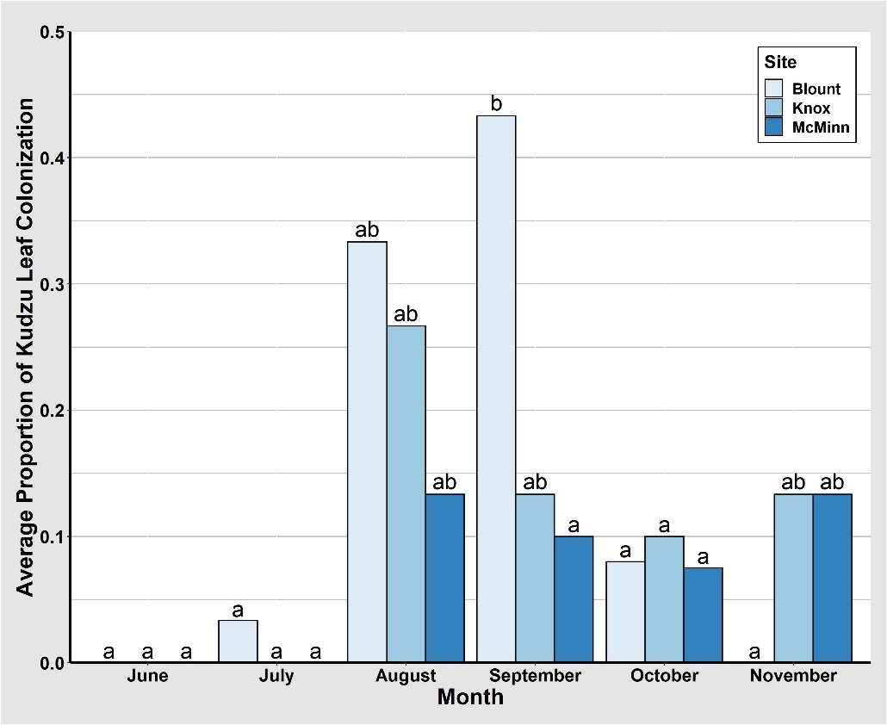

Figure 13. Average proportion of kudzu leaves endophytically colonized by Beauveria bassiana by month and site, 2020.

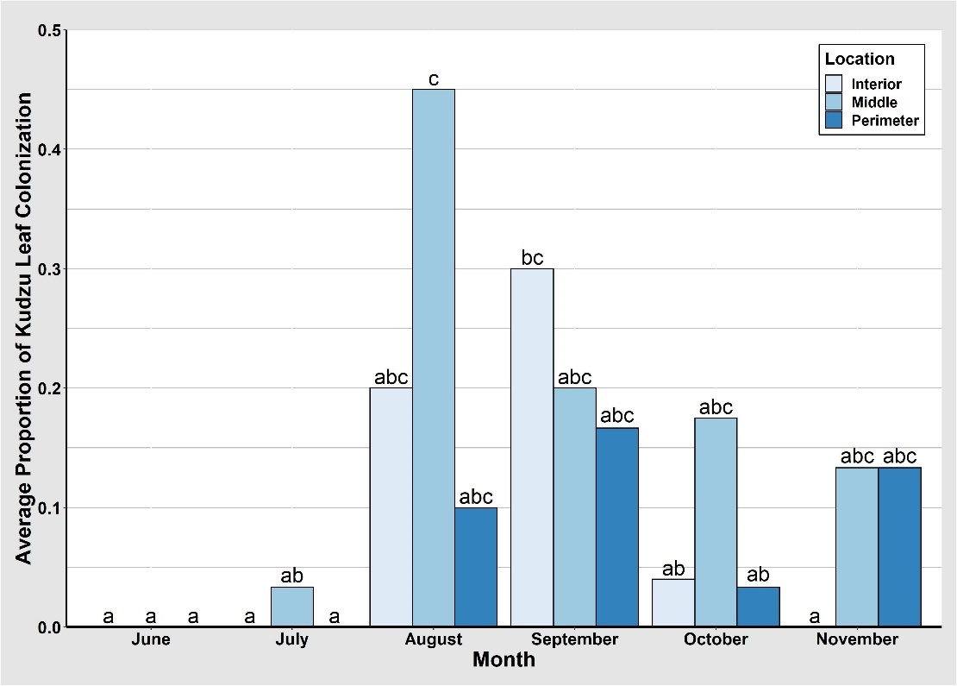

Figure 14. Average proportion of kudzu leaves endophytically colonized by Beauveria bassiana by month and location within site, 2020.

A significant interaction was identified when an F-test was performed between site and location within a site when comparing proportion of leaves endophytically colonized by B. bassiana (Table 7). However, no significant differences were identified using a Tukey HSD test. A low proportion of colonized kudzu leaves were collected from the perimeter in all three sites, but no significant differences were identified (Fig 15). The proportion of kudzu leaves collected from the middle of all three sites was relatively higher than all proportions collected from all locations throughout all sites, except those collected from the interior in Blount County (Fig. 15).
A significant interaction was identified between month, site, and location within a site when comparing proportion of leaves endophytically colonized by B. bassiana (Table 7). In Blount County, colonized leaves were collected from the interior and perimeter in August and September with a significantly higher proportion in the interior in September (Fig. 16). Additionally, in Blount County, colonized leaves were collected from the middle from July through October (Fig. 16). No kudzu vines were collected in Blount County from the interior in November because all the vines had either died back or were browsed by an animal, so no leaves were present along the vines. Similar to Blount County, colonized leaves from the interior in Knox County were only collected in August and September (Fig. 16). Colonized leaves in Knox County were highest in the middle in August and decreased in September and October (Fig. 16). However, those collected from the perimeter followed the opposite trend, where colonization began at a lower proportion in September and October and peaked in November in Knox County (Fig. 16). In McMinn County, colonized leaves were collected from the perimeter in August and September, interior only in October, and middle in August, October, and November (Fig. 16). However, no significant differences were identified among the proportion of leaves collected in McMinn County throughout the year from any location within the site (Fig. 16).
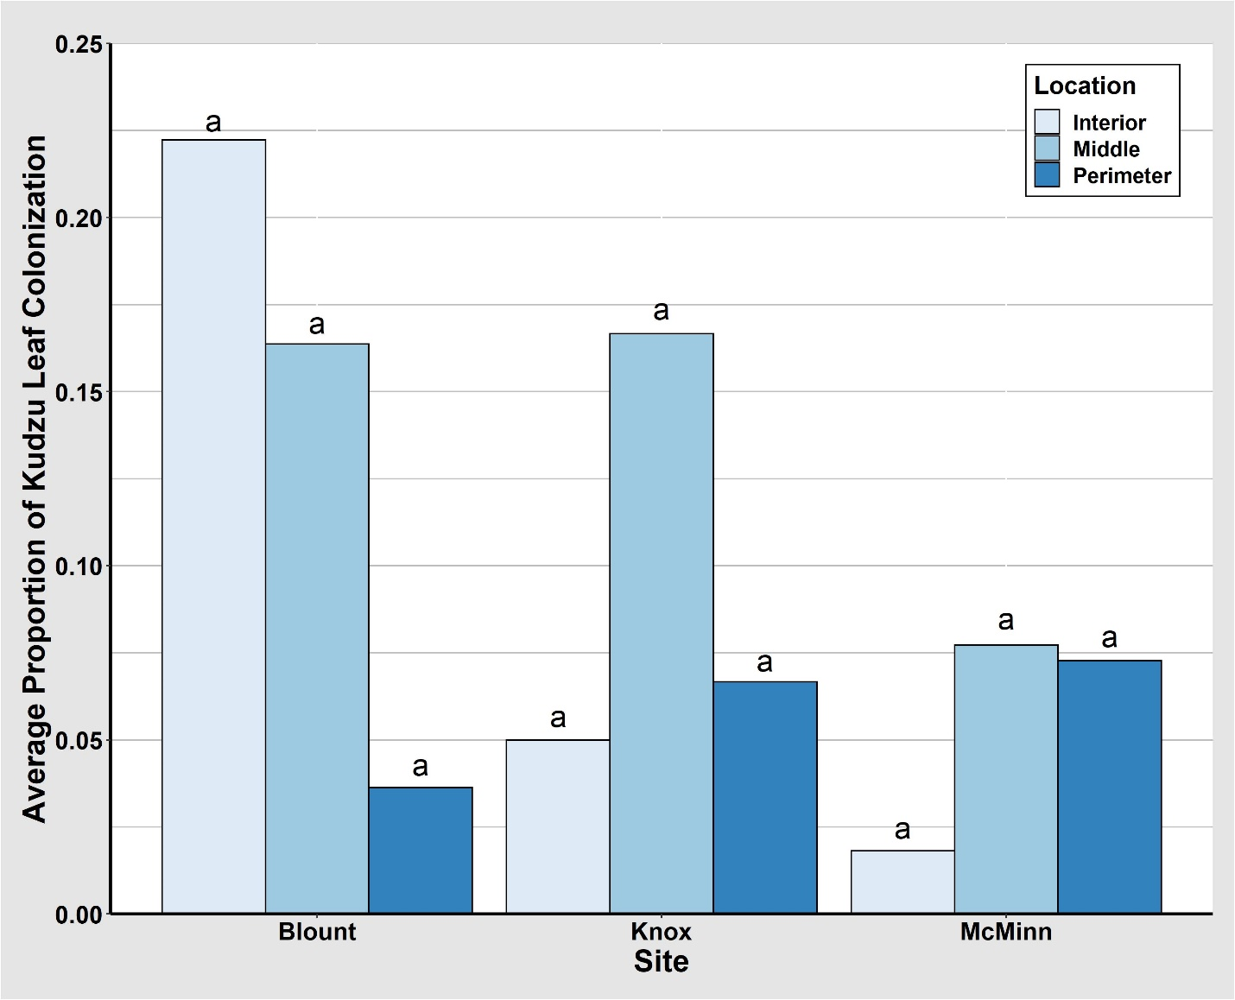

Figure 15. Average proportion of kudzu leaves endophytically colonized by Beauveria bassiana by site and location within site, 2020.

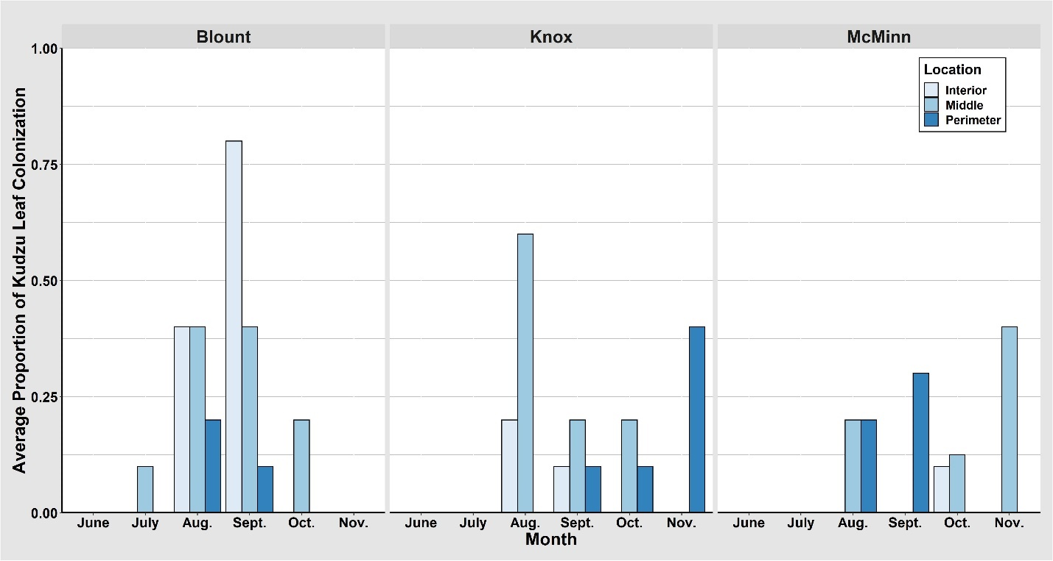
abc
a
a
a
a
a
ab
a a
ab ab
a
a a a
a a a
abc
a a
a
ab
a
ab
a a
a
bc
ab
a a a
a a a
a a a
a a a
ab
a a
a
a
abc
c
ab
abc abc
a a

Figure 16. Average proportion of kudzu leaves endophytically colonized by Beauveria bassiana by month, site, and location within site, 2020.

2021
Significant differences among the proportion of kudzu leaves that were colonized endophytically by B. bassiana among months were identified when comparing April, May, June, July and August to September and October (Tables 9, 10 and Fig. 17). During the months of April, May, June, July, and August, significantly more kudzu leaves were colonized endophytically by B. bassiana than in September and October (Table 10 and Fig. 17). These data also suggest that little endophytic colonization of kudzu stems occurs between June and when second-generation kudzu bugs are emerging from egg masses in July.
No significant differences among proportion of kudzu leaves colonized endophytically by B. bassiana were identified when comparing Knox County (4.39%) to Blount County (5.34%), Knox County (4.39%) to McMinn County (3.11%), and Blount County (5.34%) to McMinn County (3.11%) (Table 9). This indicates that latitudinal differences among sites did not affect endophytic colonization of kudzu leaves, although this study encompasses a small geographic area. These results indicate that kudzu bugs at all sites throughout east Tennessee are equally likely to become infected by B. bassiana.
No significant differences in rates of endophytic colonization of B. bassiana among locations where leaves were collected within a kudzu site were documented when comparing the perimeter (1.99%), middle (5.45%), and interior (5.47%) (Table 9). These results indicate that kudzu bugs located in any portion of a kudzu patch in east Tennessee are equally likely to become infected by B. bassiana.

Table 9. Model of proportion of kudzu leaves colonized by Beauveria bassiana, 2021, GLM (p ≤ 0.05).

Source | Sum of Squares | Degrees of Freedom | F value | Pr(>F)*
Residuals | 0.643 | 60
Month | 0.453 | 6 | 7.058 | <0.001
Site | 0.014 | 2 | 0.657 | 0.522
Location | 0.034 | 2 | 1.596 | 0.211
Month*Site | 0.075 | 12 | 0.584 | 0.846
Month*Location | 0.199 | 12 | 1.548 | 0.132
Site*Location | 0.014 | 4 | 0.322 | 0.862
Month*Site*Location | 0.229 | 24 | 0.890 | 0.613

* Bold and underlined indicates significant p-values (p ≤ 0.05).

Table 10. Comparison of proportion of kudzu leaves colonized by Beauveria bassiana by month, 2021, Tukey HSD (p ≤ 0.05).

Comparison | Estimate | Standard  Error | t Value | Pr(>|t|)*
April – May | 0.000 | 0.043 | 0.000 | 1.000
April – June | 0.000 | 0.039 | 0.000 | 1.000
April – July | 0.000 | 0.042 | 0.000 | 1.000
April – August | -0.022 | 0.042 | 0.534 | 0.998
April – September | -0.144 | 0.042 | -3.469 | 0.012
April – October | -0.128 | 0.042 | -3.069 | 0.040
May – June | 0.000 | 0.033 | 0.000 | 1.000
May – July | 0.000 | 0.036 | 0.000 | 1.000
May – August | -0.022 | 0.036 | -0.623 | 0.996
May – September | -0.144 | 0.036 | -4.051 | 0.002
May – October | -0.128 | 0.036 | -3.584 | 0.008
June – July | 0.000 | 0.031 | 0.000 | 1.000
June – August | -0.022 | 0.031 | -0.716 | 0.991
June – September | -0.144 | 0.031 | -4.654 | <0.001
June – October | -0.128 | 0.031 | -4.117 | 0.001
July – August | 0.022 | 0.034 | 0.654 | 0.994
July – September | -0.144 | 0.034 | -4.249 | <0.001
July – October | -0.128 | 0.034 | -3.758 | 0.005
August – September | -0.122 | 0.034 | -3.595 | 0.008
August – October | -0.106 | 0.034 | 3.105 | 0.037
September – October | 0.017 | 0.034 | 0.490 | 0.999

* Bold and underlined indicates significant p-values (p ≤ 0.05).

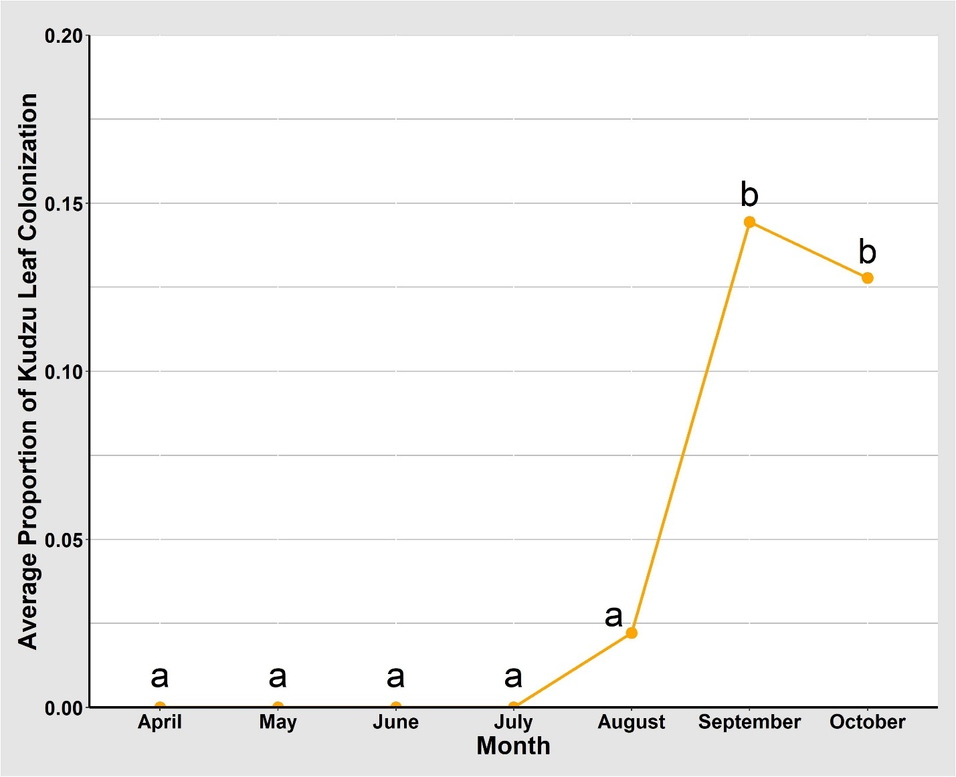

Figure 17. Average proportion of kudzu leaves endophytically colonized by Beauveria bassiana by month, 2021.

Assessment of Kudzu Stem Colonization
2020
Significant differences among the proportion of kudzu stems colonized endophytically by B. bassiana were identified between months when comparing June to August, June to
September, July to August, July to September, August to October, and August to November (Tables 11, 12 and Fig. 18). During the month of August, significantly more kudzu stems were colonized endophytically with B. bassiana than in June, July, October, and November (Table 12 and Fig. 18). Additionally, during the month of September, a significantly higher proportion of kudzu stems were colonized endophytically with B. bassiana than in June and July (Table 12 and Fig. 18). These data suggest that little endophytic colonization of kudzu stems occurs between June and when second-generation kudzu bugs are emerging from egg masses in July.
No significant differences among proportion of kudzu stems colonized endophytically by B. bassiana between sites were identified when comparing Knox County (12.6%) to Blount County (7.14%), Knox County (12.6%) to McMinn County (4.19%), and Blount County (7.14%) to McMinn County (4.19%) (Table 11). No significant differences among sites indicate that latitudinal differences among sites do not have an effect on endophytic colonization of kudzu stems. These results indicate that kudzu bugs at all sites throughout east Tennessee are equally likely to become infected by B. bassiana.
No significant differences among locations for endophytic colonization of kudzu stems by B. bassiana, with rates of 6.00% for perimeter, 8.08% in the middle, and 10.5% in the interior of the kudzu patch were detected (Table 11). These data suggest that kudzu bugs located in any part of a kudzu patch in east Tennessee are equally likely to become infected by B. bassiana.

Table 11. Model of proportion of kudzu stems colonized by Beauveria bassiana, 2020, GLM (p ≤ 0.05).

Source | Sum of Squares | Degrees of Freedom | F value | Pr(>F)*
Residuals | 0.596 | 47
Month | 0.747 | 5 | 11.793 | <0.001
Site | 0.080 | 2 | 3.168 | 0.051
Location | 0.029 | 2 | 1.138 | 0.329
Month*Site | 0.240 | 10 | 1.897 | 0.070
Month*Location | 0.215 | 10 | 1.697 | 0.110
Site*Location | 0.014 | 4 | 0.276 | 0.892
Month*Site*Location | 0.411 | 19 | 1.708 | 0.069

*Bold and underlined indicates significant p-values (p ≤ 0.05).

Table 12. Comparison of proportion of kudzu stems colonized by Beauveria bassiana by month, 2020, Tukey HSD (p ≤ 0.05).

Comparison | Estimate | Standard  Error | t Value | Pr(>|t|)*
June – July | -0.000 | 0.040 | 0.000 | 1.000
June – August | -0.250 | 0.045 | -5.535 | <0.001
June – September | -0.167 | 0.040 | 4.207 | <0.001
June – October | -0.102 | 0.042 | 2.530 | 0.123
June – November | -0.046 | 0.052 | 0.875 | 0.950
July – August | -0.250 | 0.049 | -5.153 | <0.001
July – September | -0.167 | 0.043 | 3.841 | 0.003
July – October | -0.102 | 0.044 | 2.316 | 0.194
July – November | -0.046 | 0.055 | 0.829 | 0.961
August – September | 0.083 | 0.049 | -1.718 | 0.518
August – October | 0.147 | 0.049 | -3.016 | 0.037
August – November | 0.204 | 0.059 | -3.436 | 0.011
September – October | 0.065 | 0.044 | 1.470 | 0.679
September – November | 0.121 | 0.055 | 2.184 | 0.250
October – November | 0.056 | 0.056 | 1.006 | 0.913

*Bold and underlined indicates significant p-values (p ≤ 0.05).
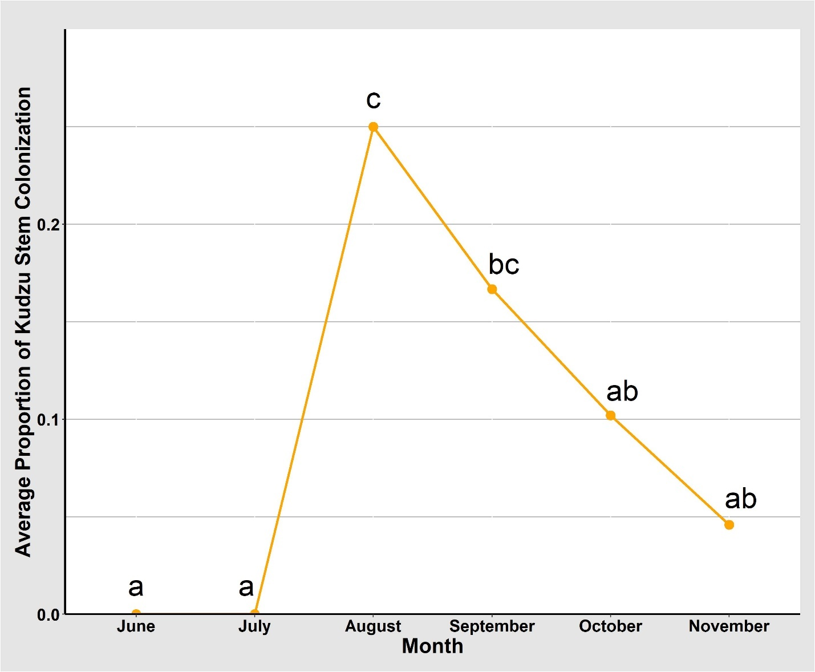

Figure 18. Average proportion of kudzu stems endophytically colonized by Beauveria bassiana by month, 2020.

2021
Significant differences among the proportion of kudzu stems colonized endophytically by B. bassiana were identified between months when comparing May, June, July, and September to October (Tables 13, 14 and Fig. 19). During the month of October, significantly more kudzu stems were colonized endophytically with B. bassiana than in May, June, July, and September (Table 14 and Fig. 19). These data suggest that little endophytic colonization of kudzu stems occurs between June and when second-generation kudzu bugs are emerging from egg masses in July.
No significant differences among proportion of kudzu stems colonized endophytically by B. bassiana between sites were identified when comparing Knox County (2.85%) to Blount County (2.81%), Knox County (2.85%) to McMinn County (0.43%), and Blount County (2.81%) to McMinn County (0.43%) (Table 13). No significant differences among sites indicate that latitudinal differences among sites do not have an effect on endophytic colonization of kudzu stems. These results indicate that kudzu bugs at all sites throughout east Tennessee are equally likely to become infected by B. bassiana.
There were no significant differences among locations where kudzu stems colonized endophytically by B. bassiana were indicated between proportion of B. bassiana colonization when comparing the perimeter (0.41%), middle (4.10%), and interior (1.68%) of the kudzu patch
(Table 13). These results indicate that kudzu bugs located in any portion of a kudzu patch in east Tennessee are equally likely to become infected by B. bassiana.

Table 13. Model of proportion of kudzu stems colonized by Beauveria bassiana, 2021, GLM (p ≤ 0.05).

Source | Sum of Squares | Degrees of Freedom | F value | Pr(>F)*
Residuals | 0.280 | 60
Month | 0.108 | 6 | 3.856 | 0.003
Site | 0.017 | 2 | 1.774 | 0.178
Location | 0.029 | 2 | 3.126 | 0.051
Month*Site | 0.101 | 12 | 1.804 | 0.068
Month*Location | 0.043 | 12 | 0.766 | 0.682
Site*Location | 0.034 | 4 | 1.828 | 0.135
Month*Site*Location | 0.143 | 24 | 1.279 | 0.218

*Bold and underlined indicates significant p-values (p ≤ 0.05).

Table 14. Comparison of proportion of kudzu stems colonized by Beauveria bassiana by month, 2021, Tukey HSD (p ≤ 0.05).

Comparison | Estimate | Standard  Error | t Value | Pr(>|t|)*
April – May | 0.037 | 0.031 | 1.179 | 0.899
April – June | 0.037 | 0.029 | 1.291 | 0.852
April – July | 0.028 | 0.030 | 0.913 | 0.969
April – August | 0.019 | 0.030 | 0.609 | 0.996
April – September | 0.028 | 0.030 | 0.913 | 0.969
April – October | -0.051 | 0.030 | -1.661 | 0.639
May – June | 0.000 | 0.024 | 0.000 | 1.000
May – July | -0.009 | 0.026 | -0.355 | 0.999
May – August | -0.019 | 0.026 | -0.711 | 0.992
May – September | -0.009 | 0.026 | -0.355 | 0.999
May – October | -0.088 | 0.026 | -3.361 | 0.017
June – July | -0.009 | 0.023 | -0.408 | 0.999
June – August | -0.019 | 0.023 | -0.817 | 0.982
June – September | -0.009 | 0.023 | -0.408 | 0.999
June – October | -0.088 | 0.023 | -3.862 | 0.004
July – August | -0.009 | 0.025 | -0.373 | 0.999
July – September | 0.000 | 0.025 | 0.000 | 1.000
July – October | -0.078 | 0.025 | -3.153 | 0.032
August – September | 0.009 | 0.025 | 0.373 | 0.999
August – October | 0.069 | 0.025 | 2.78 | 0.088
September – October | -0.078 | 0.025 | -3.153 | 0.032

*Bold and underlined indicates significant p-values (p ≤ 0.05).

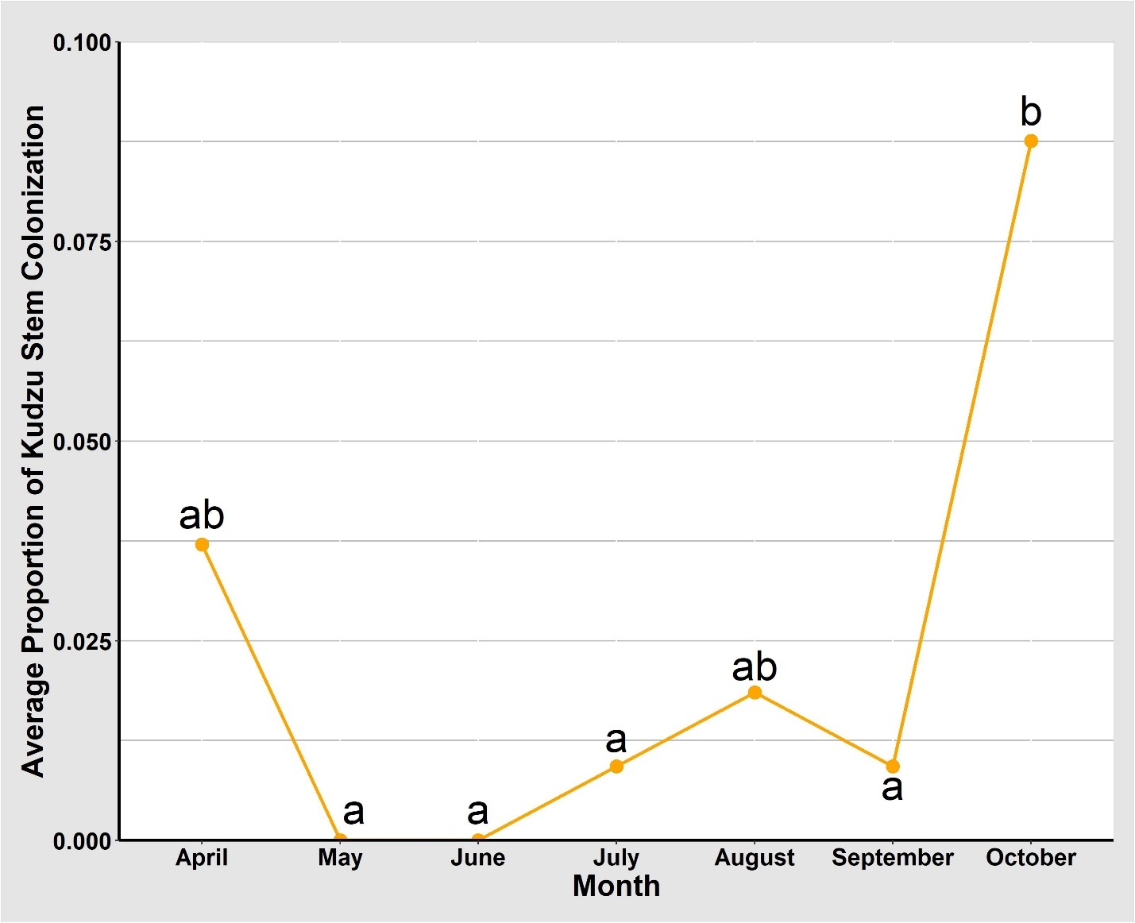

Figure 19. Average proportion of kudzu stems endophytically colonized by Beauveria bassiana by month, 2021.

Assessment of Kudzu Vine Colonization
2020
Significant differences between collection months among kudzu vines that were endophytically colonized by B. bassiana were identified when comparing June (0.00%) to August (25.0%), June (0.00%) to September (19.2%), July (0.51%) to August (25.0%), July (0.51%) to September (19.2%), August (25.0%) to October (10.1%), and August (25.0%) to November (7.79%) (Tables 15, 16). A significantly higher proportion of kudzu vines collected in August were endophytically colonized by B. bassiana than in June, July, October, and November (Table 16). Additionally, a significantly higher proportion of kudzu vines collected in September were endophytically colonized by B. bassiana than June and July (Table 16). These data suggest that little endophytic colonization of kudzu vines occurs between June and when second-generation kudzu bugs are emerging from egg masses in July.
No significant differences among proportion of kudzu vines colonized endophytically by B. bassiana between sites were identified when comparing Knox County (11.5%) to Blount County (10.2%)and Blount County (10.2%) to McMinn County (4.82%). However, a significant difference was identified when comparing Knox County (11.5%) to McMinn County (4.82%), (Table 15). No significant differences among sites suggest that latitudinal differences among sites have no effect on endophytic colonization of kudzu vines, and that kudzu bugs at all sites throughout east Tennessee are equally likely to become infected by B. bassiana.
The main effect of location within the kudzu patch was not significant for colonization of kudzu vine by B. bassiana when comparing perimeter (6.25%) to middle (10.7%), perimeter (6.25%) to interior (9.80%), and middle (10.7%) to interior (9.80%) of the kudzu patch (Table
15). These results indicate that kudzu bugs located in any portion of a kudzu patch in east
Table 15. Model of proportion of kudzu vines colonized by Beauveria bassiana, 2020, GLM (p ≤ 0.05).

Source | Sum of Squares | Degrees of Freedom | F value | Pr(>F)*
Residuals | 0.345 | 47
Month | 0.826 | 5 | 22.517 | <0.001
Site | 0.051 | 2 | 3.505 | 0.038
Location | 0.038 | 2 | 2.601 | 0.085
Month*Site | 0.248 | 10 | 3.375 | 0.002
Month*Location | 0.194 | 10 | 2.650 | 0.012
Site*Location | 0.044 | 4 | 1.495 | 0.219
Month*Site*Location | 0.381 | 19 | 2.731 | 0.003

*Bold and underlined indicates significant p-values (p ≤ 0.05).

Table 16. Comparison of proportion of kudzu vines colonized by Beauveria bassiana by month, site, and location within site, 2020, Tukey HSD (p ≤ 0.05).

Comparison | Estimate | Standard Error | t Value | Pr(>|t|)*
June – July | -0.005 | 0.036 | -0.140 | 0.999
June – August | -0.250 | 0.041 | -6.083 | <0.001
June – September | -0.192 | 0.036 | 5.324 | <0.001
June – October | -0.094 | 0.037 | 2.552 | 0.117
June – November | -0.073 | 0.048 | 1.530 | 0.640
July – August | -0.245 | 0.044 | -5.548 | <0.001
July – September | -0.187 | 0.039 | 4.732 | <0.001
July – October | -0.089 | 0.040 | 2.210 | 0.239
July – November | -0.068 | 0.050 | 1.350 | 0.752
August – September | 0.058 | 0.044 | -1.316 | 0.771
August – October | 0.156 | 0.045 | -3.502 | 0.009
August – November | 0.177 | 0.054 | -3.274 | 0.018
September – October | 0.098 | 0.040 | 2.455 | 0.146
September – November | 0.119 | 0.050 | 2.363 | 0.177
October – November | 0.021 | 0.051 | 0.406 | 0.999

*Bold and underlined indicates significant p-values (p ≤ 0.05).

Tennessee are equally likely to become infected by B. bassiana.
A significant interaction was identified between month and site when comparing proportion of vines endophytically colonized by B. bassiana (Table 15). Colonization of vines began in Blount County in July, but not until August in Knox County and McMinn County (Fig. 20). After initial colonization in July in Blount County, the proportion of colonization significantly increased in August and September, and decreased in October (Fig. 20). This difference could be due to kudzu vines dying back in October and November, so few vines are present in the field. Colonization in Knox County begins and is highest in August, but slowly decreases in proportion of vines colonized through November (Fig. 20). Similarly, colonization in McMinn County begins in August and decreases through November (Fig. 20).
A significant interaction was identified between month and location within a site when comparing proportion of vines endophytically colonized by B. bassiana (Table 15). Colonization of kudzu vines from the middle of a kudzu site begins in July, significantly increased in August, and steadily decreased in September through November (Fig. 21). The highest proportion of colonization in vines collected from the interior is also in August and slowly decreased throughout the remainder of the year (Fig. 21). However, when comparing vines collected from the perimeter of the sites, colonization began in August and continued through November, but there is not a significant increase or decrease in colonization throughout the year (Fig. 21). This difference could indicate that other plant species located near the perimeter of the sites have an impact on presence of B. bassiana colonization of kudzu vines in the field. Additionally, this interaction could suggest that second-generation kudzu bugs located within a kudzu site are more likely to become infected with B. bassiana by feeding on an infected vine.
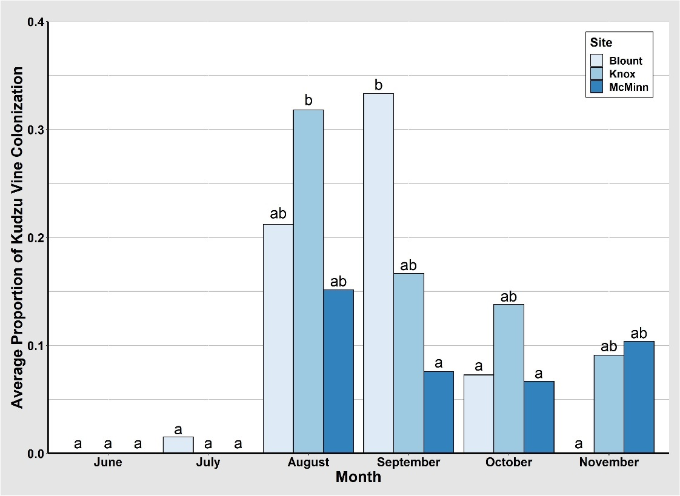

Figure 20. Average proportion of kudzu vines endophytically colonized by Beauveria bassiana by month and site, 2020.

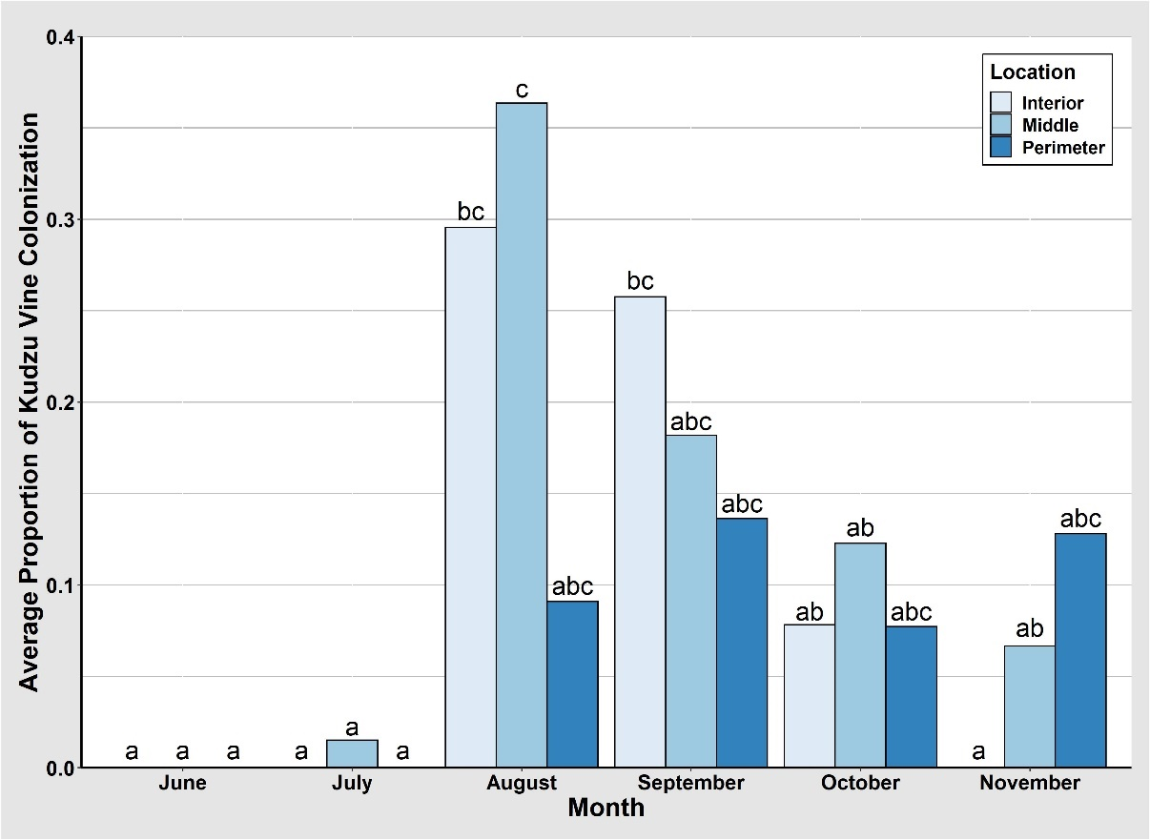

Figure 21. Average proportion of kudzu vines endophytically colonized by Beauveria bassiana by month and location within site, 2020.

A significant interaction was identified between month, site, and location within a site when comparing proportion of vines endophytically colonized by B. bassiana (Table 15). In Blount County, colonized vines were collected from the perimeter in August and September with no significant differences identified among proportion of infected vines (Fig. 22). Similarly, colonized vines were collected from the interior in August, September, and October in Blount County, with a significant increase in September colonization (Fig. 22). Additionally, in Blount County, colonized vines were collected from the middle from July through October, where an increase occurred in August and September, but no significant differences were identified among the proportion of colonization (Fig. 22). No kudzu vines were collected in Blount County from the interior in November because all the vines had either died back or were eaten by an animal, so no leaves were present along the vines. Similar to Blount County, colonized leaves from the interior in Knox County were collected in August, September, and October (Fig. 22). A significantly higher proportion of colonized vines were collected from both the middle and interior in August in Knox County (Fig. 22). Colonized vines collected from the perimeter in Knox County were identified in September through November, with the highest proportion colonized in November (Fig. 22). Few kudzu vines were collected in Knox County in November, since kudzu was dying back for the winter. In McMinn County, colonized vines were collected from the perimeter and middle in August through November (Fig. 22). However, vines collected from the interior were only colonized in August through October in McMinn County (Fig. 22). No significant differences were identified among the proportion of leaves collected in McMinn County throughout the year from any location within the site (Fig. 22).

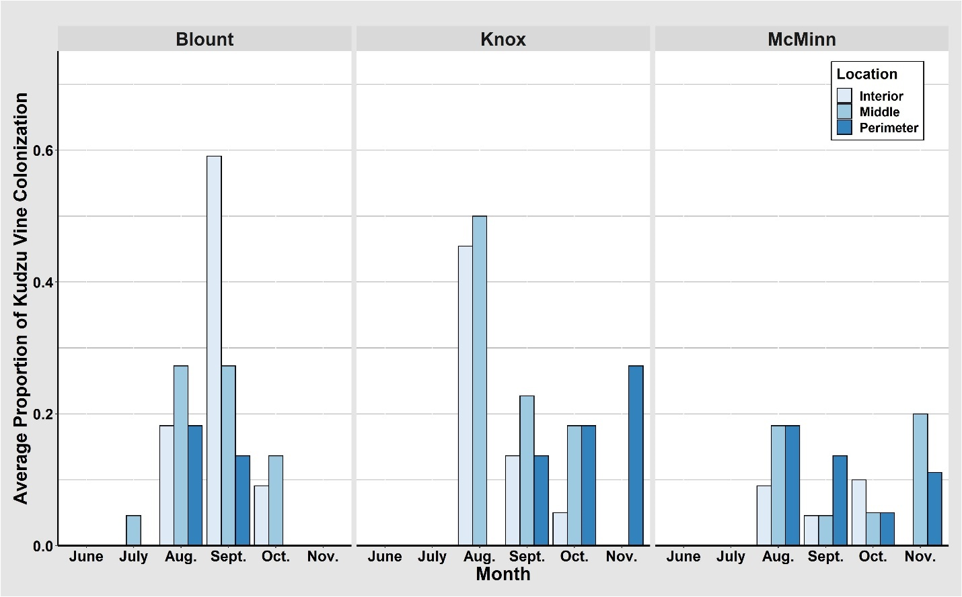
abcd
abc
abcd
a
ab
a a
abc
a a
abcd
abcd
ab
a a a
a a a
abcd
a a
abc
abc
a
abc
abc
abcd
a
cd
bcd
a a a
a a a
a a a
a
abc
ab
abc
abcd
d
abcd
abcd
a a
a
a a a

Figure 22. Average proportion of kudzu vines endophytically colonized by Beauveria bassiana by month, site, and location within site, 2020.
2021
Significant differences among kudzu vines endophytically colonized by B. bassiana between months were identified when comparing May, June, July, and August to October and June to September (Tables 17, 18 and Fig. 23). A significantly higher proportion of kudzu vines collected in October were endophytically colonized by B. bassiana than in May, June, July, August (Table 18, Fig. 23). Additionally, a significantly higher proportion of kudzu vines collected in September were endophytically colonized by B. bassiana than in June (Table 18 and Fig. 23). These data suggest that little endophytic colonization of kudzu vines occurs between June and when second-generation kudzu bugs are emerging from egg masses in July.
No significant differences among proportion of kudzu vines colonized endophytically by B. bassiana between sites were detected when comparing Knox County (3.55%) to Blount County (3.96%), Knox County (3.55%) to McMinn County (1.65%), and Blount County (3.96%) to McMinn County (1.65%) (Table 17). No significant differences among sites indicate that latitudinal differences among sites do not have an effect on endophytic colonization of kudzu vines. These results indicate that kudzu bugs at all sites throughout east Tennessee are equally likely to become infected by B. bassiana.
No significant differences among locations within the kudzu patch for endophytic colonization of kudzu vines by B. bassiana were found when comparing the perimeter (1.13%), middle (4.93%), and interior (3.42%) of the kudzu patch (Table 17). These results indicate that
kudzu bugs located in any portion of a kudzu patch in east Tennessee are equally likely to become infected by B. bassiana.

Table 17. Model of proportion of kudzu vine colonized by Beauveria bassiana, 2021, GLM (p ≤ 0.05).

Source | Sum of Squares | Degrees of Freedom | F value | Pr(>F)*
Residuals | 0.331 | 60
Month | 0.188 | 6 | 5.681 | <0.001
Site | 0.015 | 2 | 1.329 | 0.272
Location | 0.027 | 2 | 2.453 | 0.095
Month*Site | 0.063 | 12 | 0.946 | 0.509
Month*Location | 0.064 | 12 | 0.972 | 0.485
Site*Location | 0.015 | 4 | 0.675 | 0.612
Month*Site*Location | 0.123 | 24 | 0.926 | 0.568

*Bold and underlined indicates significant p-values (p ≤ 0.05).

Table 18. Comparison of proportion of kudzu vine colonized by Beauveria bassiana by month, 2021, Tukey HSD (p ≤ 0.05).

Comparison | Estimate | Standard  Error | t Value | Pr(>|t|)*
April – May | 0.020 | 0.031 | 0.647 | 0.995
April – June | 0.020 | 0.029 | 0.709 | 0.992
April – July | 0.015 | 0.030 | 0.501 | 0.999
April – August | 0.000 | 0.030 | 0.000 | 1.000
April – September | -0.051 | 0.030 | -1.670 | 0.633
April – October | -0.086 | 0.030 | -2.838 | 0.075
May – June | 0.000 | 0.024 | 0.000 | 1.000
May – July | -0.005 | 0.026 | -0.195 | 1.000
May – August | -0.020 | 0.026 | -0.780 | 0.986
May – September | -0.071 | 0.026 | -2.731 | 0.098
May – October | -0.106 | 0.026 | -4.095 | 0.001
June – July | -0.005 | 0.023 | -0.224 | 0.999
June – August | -0.020 | 0.023 | -0.896 | 0.972
June – September | -0.071 | 0.025 | -3.138 | 0.034
June – October | -0.106 | 0.023 | -4.075 | <0.001
July – August | 0.015 | 0.025 | 0.614 | 0.996
July – September | -0.066 | 0.025 | -2.660 | 0.116
July – October | -0.101 | 0.025 | -4.090 | 0.002
August – September | -0.051 | 0.025 | -2.046 | 0.387
August – October | -0.086 | 0.025 | -3.476 | 0.018
September – October | -0.035 | 0.025 | -1.430 | 0.781

*Bold and underlined indicates significant p-values (p ≤ 0.05).

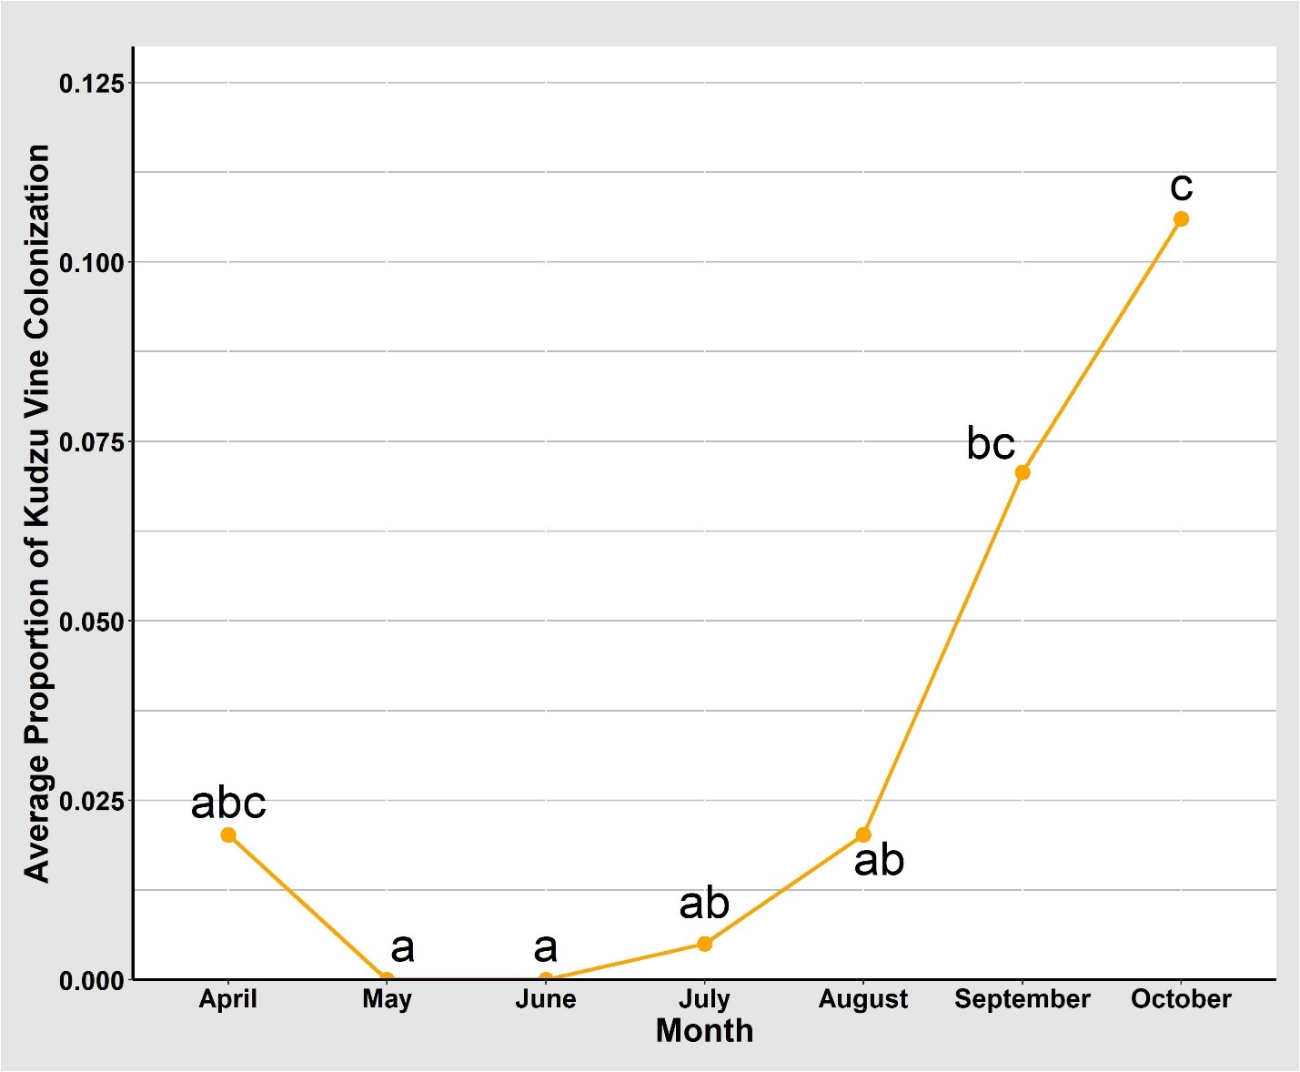

Figure 23. Average proportion of kudzu vine endophytically colonized by Beauveria bassiana by month, 2021.

Summary
Overall, a greater number of kudzu leaf, stem, and vines were colonized endophytically by B. bassiana in 2020 compared with 2021. Endophytic presence of B. bassiana in kudzu was isolated in July of 2020. However, endophytic presence of B. bassiana in kudzu was isolated first in April of 2021, but not again until July. Endophytic presence of B. bassiana in the field in 2021 was similar seasonally to when B. bassiana was beginning to infect kudzu bugs beginning in August of 2015 and for the subsequent years (Britt 2016 and Michael 2018).
Sites at higher latitudes had more kudzu leaf, stem, and vines colonized endophytically by B. bassiana in 2020 and 2021; however, no significant differences among sites were detected. These results align similarly with those discussed in Chapter 2 and to those of Britt (2016), who found higher kudzu bug mortality in Blount County than in Polk County (Polk County is located at a lower latitude than Blount County). Additionally, in 2020 and 2021, location within a kudzu site where kudzu vines were collected did not have an effect on endophytic colonization of kudzu by B. bassiana. These findings align with the findings in Chapter 2, where location within a site did not have an influence on kudzu bug infection by B. bassiana. Overall, in 2020 and 2021, kudzu colonization of B. bassiana increased throughout the study. Beginning in April and continuing through November, percent infection of kudzu leaves, stems, and vines increased.
This study gives critical insight to the periods of time and locations in which B. bassiana begins to colonize kudzu throughout east Tennessee. These data provide details to potential sources of inoculum of B. bassiana by providing specifics of when kudzu vines are infected with B. bassiana. The identification of kudzu vines colonized endophytically by B. bassiana as early as July in 2020 and April in 2021, in small numbers, aligns with and could indicate that kudzu bugs become infected with B. bassiana while emerging from overwintering sites, moving to kudzu, or as they begin to feed on kudzu. Significant increases in colonization of kudzu by B. bassiana could indicate that B. bassiana endophytically has an influence on its entomopathogenic presence in kudzu bugs over time. Additionally, it is possible that later in the season, the main source of inoculum infecting kudzu bugs comes from infected kudzu bugs that have died and are sporulating on kudzu vines within the canopy. However, the infected kudzu bugs that have died and are sporulating on the kudzu vines could also be positively influencing the endophytic presence in kudzu. Future research is needed to better understand the potential pathways of dissemination of B. bassiana that lead to kudzu bug infection, as well as understanding the impact that infected kudzu bugs have on kudzu bug and kudzu infection rates as the season progresses. Understanding the pathways in which kudzu bugs are becoming infected with B. bassiana will provide critical results that can lead to enhanced use of B. bassiana as a biological control for kudzu bugs in soybean.

CHAPTER IV
Conclusions
Kudzu, originally from Asia, was first introduced to the United States in 1876 at the Centennial Exposition in Philadelphia (Miller and Edwards 1983, Forseth and Innis 2004). Then, it was introduced again in 1883 at the New Orleans Exposition (Miller and Edwards 1983, Forseth and Innis 2004). Since its introduction kudzu has become one of the most invasive and destructive weed species in the U.S. (Harrington et al. 2003). While kudzu was intentionally introduced to the U.S., the invasive kudzu bug, which is also native to Asia and feeds on kudzu in both its native and invasive range, was accidentally introduced to the U.S. and discovered in Georgia in 2009 (Jenkins et al. 2010, Gardner et al. 2013b, Zhang et al. 2012). Kudzu bugs are bivoltine, meaning that they are able to complete two generations per year, and they are able to successfully develop on kudzu and soybean (Greenstone et al. 2014). In 2020, kudzu bugs caused an estimated $12,733,150 and $2,805,568 loss in yield and treatment costs to soybean production in the U.S. and Tennessee, respectively (Musser et al. 2021).
Kudzu bugs have multiple natural enemies within their invasive range in the U.S., which includes two parasitoid wasps, P. saccharalis and O. nezarae, and an endophytic fungal entomopathogen, B. bassiana (Borah and Dutta 2002, Gardner et al. 2013a, Britt 2016, Ademokoya et al. 2018, Michael 2018). Beauveria bassiana was first discovered infecting kudzu bugs in South Carolina in 2012 in soybean fields (Seiter et al. 2014). It was not until 2015 that B. bassiana was identified infecting kudzu bugs in kudzu in Tennessee (Britt 2016 and Michael 2018). Michael (2018) later found that B. bassiana is able to infect and cause mortality in 90% of immature and 33% of adult second-generation kudzu bugs in Tennessee. Additionally, B. bassiana was also identified endophytically colonizing kudzu in Tennessee (Michael 2018). While it is known that B. bassiana infects and causes mortality in kudzu bugs and endophytically colonized kudzu, it is not known how kudzu bugs become infected with the entomopathogen. One potential pathway of dissemination of B. bassiana could be from kudzu bugs feeding on kudzu that has been endophytically colonized by B. bassiana because the size of a spore is smaller than the size of the piercing-sucking mouthpart of a kudzu bug (Michael 2018). However, the temporal and seasonal distribution of B. bassiana in kudzu bugs and kudzu within their invasive ranges in the U.S. must be identified before dissemination pathways of the entomopathogenic, endophytic fungus can be isolated to understand their interactions in the field.
Results from this study indicated that B. bassiana infects more kudzu bugs as the second-generation develops in kudzu. However, few first-generation kudzu bugs that are present on kudzu between April and July are impacted by the presence of B. bassiana. These results may imply that environmental factors in the field, such as higher humidity and temperatures, have an impact on the entomopathogenic presence of B. bassiana in late summer to early fall. No significant differences among proportion of kudzu bug infection of B. bassiana presence between sites or location within a site could indicate that kudzu bugs present at all sites and anywhere within a kudzu patch are equally likely to become infected with B. bassiana. No significant differences among kudzu bug stages and sexes indicate that males, females, and immatures are equally likely to become infected with B. bassiana.
Further research on the pathogenicity of B. bassiana as an entomopathogen in kudzu bug adults and immatures needs to be addressed to understand the virulence of the pathogen in the field. Identifying the specific interactions among these organisms will provide essential details that will influence integrated pest management programs that include B. bassiana. Some factors could have influenced this study. For example, these results could be influenced by a smaller sample size of kudzu bug immatures, because they are not present in the field for as long as adult kudzu bugs. Additionally, kudzu bugs are excellent fliers and are able to escape quickly. Results may have been influenced by the kudzu bugs that were less mobile which may, in part, be due to infection with B. bassiana.
Additionally, results from this study indicate that kudzu is colonized endophytically with B. bassiana at a higher proportion throughout the growing season of kudzu between late summer to fall. These results could indicate that environmental factors play a role in the endophytic presence of B. bassiana. No significant differences among sites and locations within a site where kudzu vines were collected indicate that B. bassiana colonization is uniform throughout the kudzu sites. Further research is needed to understand the ability of B. bassiana to colonize a kudzu plant over time and the inoculum presence in the field. Some factors could have impacted the results of this part of the study. One influencing factor may be that surface sterilization of plant material may not have completely sterilized the sample and may have left spores behind on the surface. Additionally, some plant samples had a lot of bacterial growth present in the plates, once they were plated after surface sterilization. Bacteria present in culture can inhibit fungal growth.
Similarities between presence of B. bassiana infecting kudzu bugs and endophytically colonizing kudzu could indicate that kudzu bugs may become infected with B. bassiana by feeding on kudzu. These similarities do provide further evidence that second-generation kudzu bugs are impacted more by B. bassiana presence than first-generation kudzu bugs. Increased infection over time in kudzu bugs could be influenced by non-infected kudzu bugs coming into contact with infected kudzu bugs that are sporulating on the kudzu vines. However, increased presence of B. bassiana in kudzu over time may be influenced by infected kudzu bugs that are sporulating and could be endophytically inoculating the plant. Further research is needed to understand the potential mechanism of dissemination of the pathogen from kudzu to kudzu bugs or from kudzu bugs to kudzu. Additionally, a similar study to this one including the endophytic presence of B. bassiana in soybean and entomopathogenic presence of B. bassiana in kudzu bugs located in soybean would give a more complete depiction of how all of these organisms interact over time.

REFERENCES
Ademokoya, B., R. Balusu, C. Ray., J. Mottern, and H. Fadamiro. 2018. The first record of
Ooencyrtus nezarae (Hymenoptera: Encyrtidae) on kudzu bug (Hemiptera: Plataspidae) in North America. Journal of Insect Science 18: 1-7. https://doi.org/10.1093/jisesa/iex105.
Afandhi, A., T. Widjayanti, A. A. L. Emi, H. Tarno, M. Afiyanti, and R. N. S. Handoko. 2019.
Endophytic fungi Beauveria bassiana Balsamo accelerates growth of common bean (Phaeseolus [sic] vulgaris L.). Chemical and Biological Technologies in Agriculture 6: 6-11. http://dx.doi.org/10.1186/s40538-019-0148-1.
Bentley, K.E. and R. Mauricio. 2016. High degree of clonal reproduction and lack of large-scale
geographic patterning mark the introduced range of the invasive vine, kudzu (Pueraria montana var. lobata), in North America. American Journal of Botany 103: 1499-1507. https://doi-org.utk.idm.oclc.org/10.3732/ajb.1500434.
Borah, B.K. and S.K. Dutta. 2002. Entomogenous fungus, Beauveria bassiana (Balsamo)
Vuillemin: a natural biocontrol agent against Megacopta cribrarium [sic] (Fab.). Insect Environment 8: 7-8.
Boucias, D.G. and J.C. Pendland. 1998. Principles of Insect Pathology. Kluwer Academic
Publishers, Boston, MA.
Britt, K.E. 2016. An Ecological Study of the Kudzu Bug in East Tennessee: Life History,
Seasonality, and Phenology. M.S. Thesis, University of Tennessee, Knoxville.
Britt, K., and S. Taylor. 2019. Kudzu bug, Megacopta cribraria, a pest of soybeans. Virginia
Cooperative Extension, Department of Entomology, Virginia Tech. ENTO-303NP
Brown, A.M.V., L.Y. Huynh, C.M. Bolender, K.G. Nelson, and J.P. McCutcheon. 2014.
Population genomics of a symbiont in the early stages of a pest invasion. Molecular Ecology 23: 1516-1530. https://doi.org/10.1111/mec.12366.
Dhammi, A., J.B. van Krestchmar, L. Ponnusamy, J.S. Bacheler, D.D. Reisig, A. Herbert, A.I
Del Pozo-Valdivia, and R.M. Roe. 2016. Biology, pest status, microbiome and control of kudzu bug (Hemiptera: Heteroptera: Plataspidae): A new invasive pest in the U.S. International Journal of Molecular Sciences 17: 1570. https://doi.org/10.3390/ijms17091570.
Doberski, J.W. and H.T. Tribe. 1980. Isolation of entomogenous fungi from elm bark and soil
with reference to ecology of Beauveria bassiana and Metarhizium anisopliae. Transactions of the British Mycological Society 74: 95-100. https://doi.org/10.1016/S0007-1536(80)80013-1.
Eger Jr., J.E., L.M. Ames, D.R. Suiter, T.M. Jenkins, D.A Rider, S.E. Halbert. 2010. Occurrence
of the Old World bug Megacopta cribraria (Fabricius) (Heteroptera: Plataspidae) in
Georgia: A serious home invader and potential legume pest. Insecta Mundi 121: 1-11. https://journals.flvc.org/mundi/article/view/0121/24544.
Everest, J.W., J.H. Miller, D.M. Ball, and M. Patterson. 1999. Kudzu in Alabama: History,
uses, and control. Alabama Cooperative Extension System. ANR-65. https://www.srs.fs.usda.gov/pubs/ja/uncaptured/ja_everest001.pdf.
Filippou, C., R.M. Diss, J.O. Daudu, R.H.A. Coutts, and I. Kotta-Loizou. 2021. The
polymycovirus-mediated growth enhancement of the entomopathogenic fungus Beauveria bassiana is dependent on carbon and nitrogen metabolism. Frontiers in Microbiology 12: 606366. https://doi.org/10.3389/fmicb.2021.606366.
Forseth, I.N. and A.F. Innis. 2004. Kudzu (Pueraria montana): History, physiology, and ecology
combine to make a major ecosystem threat. Critical Reviews in Plant Sciences 23: 401-413. https://doi.org/10.1080/07352680490505150.
Frye, M. J., J. Hough-Goldstein, and J-H Sun. 2007. Biology and preliminary host range
assessment of two potential kudzu biological control agents. Environmental Entomology 36: 1430-1440. https://doi.org/10.1093/ee/36.6.1430.
Gardner, W.A., J.L. Blount, J.R. Golec, W.A. Jones, X.P. Hu, E.J. Talamas, R.M. Evans, X.
Dong, C.H. Ray, G.D. Buntin, N.M. Gerardo, and J. Couret. 2013a. Discovery of Paratelenomous saccharalis (Dodd) (Hymenoptera: Platygastridae), an egg parasitoid of Megacopta cribraria F. (Hemiptera: Plataspidae) in its expanded North American range. Journal of Entomological Science 48: 355-359. https://doi.org/10.18474/0749-8004-48.4.355.
Gardner, W.A., H.B. Peeler, J. LaForest, P.M. Roberts, A.N. Sparks, J.K. Greene, D. Reisig,
D.R. Suiter, J.S. Bacheler, K. Kidd, C.H. Ray, X.P. Hu, R.C. Kemerait, E.A. Scocco, J.E. Eger, J.R. Ruberson, E.J. Sikora, D. Ames Herbert, C. Campana, S. Halbert, S.D, Stewart, G.D. Buntin, M.D. Toews, and C.T. Bargeron. 2013b. Confirmed distribution and occurrence of Megacopta cribraria (F.) (Hemiptera: Heteroptera: Plataspidae) in the Southeastern United States. Journal of Entomological Science 48: 118-127. http://dx.doi.org/10.18474/0749-8004-48.2.118.
Garrido-Jurado, I., M. Fernández-Bravo, C. Campos, and E. Quesada-Moraga. 2015. Diversity of
entomopathogenic Hypocreales in soil and phylloplanes of five Mediterranean cropping systems. Journal of Invertebrate Pathology 130: 97-106. https://doi.org/10.1016/j.jip.2015.06.001.
Golec, J.R. and X.P. Hu. 2015. Preoverwintering copulation and female ratio bias: Life history
characteristics contributing to the invasiveness and rapid spread of Megacopta cribraria (Heteroptera: Plataspidae). Environmental Entomology 44: 411-417. https://doi.org/10.1093/ee/nvv014.
Grant, J.I. and W.O. Lamp. 2018. Degree day requirements for kudzu bug (Hemiptera:
Plataspidae), a pest of soybeans. Journal of Economic Entomology 111: 700-706. https://doi.org/10.1093/jee/toy027.
Greenstone, M.H., P.G. Tillman, and J.S. Hu. 2014. Predation of the newly invasive pest
Megacopta cribraria (Hemiptera: Plataspidae) in soybean habitats adjacent to cotton by a complex of predators. Journal of Economic Entomology 107: 947-954. https://doi.org/10.1603/ec13356.
Griffin, M.R. 2007. Beauveria bassiana, a cotton endophyte with biocontrol activity against
seedling disease. PhD Dissertation, University of Tennessee, Knoxville.
Halbert, S. and J.E. Eger. 2010. Pest Alert: Bean plataspid, Megacopta cribraria (Fabricius)
(Hemiptera: Plataspididae), an exotic legume pest established in Georgia. Florida Department of Agriculture and Consumer Services, Division of Plant Industry. FDACS-P-01725.
Harrington, T. B., L.T. Rader-Dixon, and J.W. Taylor, Jr. 2003. Kudzu (Pueraria montana)
community responses to herbicides, burning, and high-density loblolly pine. Weed Science 51: 965-974. https://www.jstor.org/stable/4046751.
Hulme, P.E. 2009. Trade, transport: managing species pathways in an era of globalization.
Journal of Applied Ecology 46: 10-18. https://doi.org/10.1111/j.1365-2664.2008.01600.x.
Hosokawa, T., Y. Kikuchi, M. Shimada, and T. Fukatsu. 2007. Obligate symbiont involved in
pest status of host insect. Proceedings of The Royal Society B 274: 1979-1984. https://doi.org/10.1098/rspb.2007.0620.
Hosokawa, T., N. Nikoh, and T. Fukatsu. 2014. Fine-scale geographical origin of an insect pest
invading North America. Plos One 9: e89107. https://doi.org/10.1371/journal.pone.0089107.
Index Fungorum. 2021. http://www.indexfungorum.org/Names/Names.asp. Web. 12 Aug. 2021.
Jenkins, T.M., T.D. Eaton, D.R. Suiter, J.E. Eger, L.M. Ames, and G.D. Buntin. 2010.
Preliminary genetic analysis of a recently-discovered invasive true bug (Hemiptera: Heteroptera: Plataspidae) and its bacterial endosymbiont in Georgia, USA. Journal of Entomological Science 45: 62-63. https://doi.org/10.18474/0749-8004-45.1.62.
Jenkins, T.M. and T.D. Eaton. 2010. Population genetic baseline of the first plataspid stink bug
symbiosis (Hemiptera: Heteroptera: Plataspidae) reported in North America. Insects 2: 264-272. https://doi.org/10.3390/insects2030264.
Kumar, V., G.P. Singh, A.M. Babu, N.M. Ahsan, and R.K. Datta. 1999. Germination,
penetration, and invasion of Beauveria bassiana on silkworm, Bombyx mori, causing white muscardine. Italian Journal of Zoology 66: 39-43. http://dx.doi.org/10.1080/11250009909356235.
Lahiri, S. and D.D. Reisig. 2016. Ecology and management of kudzu bug (Hemiptera:
Plataspidae) in southeastern soybeans. Journal of Integrated Pest Management 7: 1-6. https://doi.org/10.1093/jipm/pmw013.
Liang, W., L. Tran, G.J. Wiggins, J.F. Grant, S.D. Stewart, and R. Washington-Allen. 2019. Determining spread rate of kudzu bug (Hemiptera: Plataspidae) and its associations with environmental factors in a heterogeneous landscape. Environmental Entomology 48: 309-317. https://doi.org/10.1093/ee/nvz014.
Lopez, D.C., and G.A. Sword. 2015. The endophytic fungal entomopathogens Beauveria
bassiana and Purpureocillium lilacinum enhance the growth of cultivated cotton (Gossypium hirsutum) and negatively affect survival of the cotton bollworm (Helicoverpa zea). Biological Control 89: 53-60. https://doi.org/10.1016/j.biocontrol.2015.03.010.
Lovejoy, R.T and J.D. Lozier. 2021. Core-marginal dynamics interact with sex and temperature
to influence morphology of the rapidly expanding invasive kudzu bug (Megacopta cribraria). Ecological Entomology 46: 790-799. https://doi.org/10.1111/een.13007.
Mann, C.C. 2011. 1493: Uncovering the new world Columbus created, Alfred A. Knopf, New
York, NY.
McKinnon, A.C., S. Saari, M.E. Moran-Diez, N.V. Meyling, M. Raad, and T.R. Glare. 2017.
Beauveria bassiana as an endophyte: A critical review on associated methodology and biocontrol potential. BioControl 62: 1-17. http://dx.doi.org/10.1007/s10526-016-9769-5.
Medal, J., S. Halbert, A.S. Cruz, T. Smith, and B.J. Davis. 2016. Greenhouse study to determine
the host range of the kudzu bug, Megacopta cribraria (Heteroptera: Plataspidae). Florida Entomologist 99: 303-305. https://doi.org/10.1653/024.099.0224.
Megacopta Working Group. 2020. Distribution Map: Kudzu Bug, EDDMapS (Early
Detection & Distribution Mapping System). The University of Georgia – Bugwood Center for Invasives Species and Ecosystem Health, https://www.kudzubug.org/distribution-map/. Web. 27 Aug. 2021.
Michael, A.M. 2018. Influence of Abiotic and Biotic Factors on Kudzu Bug Populations in
Kudzu in Eastern Tennessee. M.S. Thesis, University of Tennessee, Knoxville.
Miller, J.H. and B. Edwards. 1983. Kudzu: Where did it come from? And how can we stop it?
Southern Journal of Applied Forestry 7: 165-169. https://www.srs.fs.usda.gov/pubs/6202.
Mitich, L.W. 2000. Kudzu [Pueraria lobata (Willd.) Ohwi] 1. Weed Technology 14: 231-235.
https://doi-org.utk.idm.oclc.org/10.1614/0890-037X(2000)014[0231:KPLWO]2.0.CO;2.
Musser, F.R., A.L. Catchot, Jr., J.A. Davis, D.A. Herbert, Jr., G.M. Lorenz, T. Reed, D.D. Reisig, and S.D. Stewart. 2013. 2012 Soybean insect losses in the Southern US. Midsouth Entomology 6: 12-24.
Musser, F.R., A.L. Catchot Jr., J.A. Davis, G.M. Lorenz, T. Reed, D.D. Reisig, S.D. Stewart, and
S. Taylor. 2017. 2016 Soybean insect losses in the Southern US. Midsouth Entomology 10: 1-13.
Musser, F.R., A.L. Catchot, Jr., S.P. Conley, J.A. Davis, C. DiFonzo, S.H. Graham, J.K. Greene,
R.L. Koch, D. Owens, D.D. Reisig, P. Roberts, T. Royer, N.J. Seiter, S.D. Stewart, S. Taylor, B. Thrash, K. Tilmon, R.T. Villanueva, and M.O. Way. 2021. 2020 Soybean insect losses in the United States. Midsouth Entomology 14: 1-25.
Niland, S.E., C. Lewallen, C. Carrillo, L. Perez, A. Thompson, and W.A. Gardner. 2019.
Qualification and molecular identification of Beauveria bassiana (Hypocreales: Clavicipitaceae) in soils associated with Megacopta cribraria (Hemiptera: Plataspidae). Journal of Entomological Science 54: 93-98. http://dx.doi.org/10.18474/JES18-100.
North Carolina Soybean Producers Association. 2014. History of Soybeans.
https://ncsoy.org/media-resources/history-of-soybeans/. Web. 7 Sept. 2021.
Ownley, B.H., M.R. Griffin, W.E. Klingeman, K.D. Gwinn, J.K. Moulton, and R.M. Pereira.
2008. Beauveria bassiana: Endophytic colonization and plant disease control. Journal of Invertebrate Pathology 98: 267-270. https://doi.org/10.1016/j.jip.2008.01.010.
Pimentel, D., S. McNair, J. Janecka, J. Wightman, C. Simmonds, C. O’Connell, E. Wong, L.
Russel, J. Zern, T. Aquino, and T. Tsomondo. 2001. Economic and environmental threats of alien plant, animal, and microbe invasions. Agriculture, Ecosystems and Environment 84: 1-20. https://doi.org/10.1016/S0167-8809(00)00178-X.
Pimentel, D., R. Zuniga, and D. Morrison. 2005. Update on the environmental and economic
costs associated with alien-invasive species in the United States. Ecological Economics 52: 273-288. https://doi.org/10.1016/j.ecolecon.2004.10.002.
Porter, J.R. 1973. Agostino Bassi bicentennial (1773-1973). Bacteriological Reviews 37: 284-288. https://doi.org/10.1128/br.37.3.284-288.1973.
Qiu, L., and R. Chang. 2010. The origin and history of soybean, pp. 125-172. In G. Singh (ed.), The Soybean: Botany, Production and Uses. CABI, Wallingford (United Kingdom). http://dx.doi.org/10.1079/9781845936440.0001.
Ruberson, J.R., K. Takasu, G.D. Buntin, J.E. Eger, Jr., W.A. Gardner, J.K. Greene, T.M. Jenkins,
W.A. Jones, D.M. Olson, P.M. Roberts, D.R. Suiter, and M.D. Toews. 2013. From Asian curiosity to eruptive American pest: Megacopta cribraria (Hemiptera: Plataspidae) and prospects for its biological control. Applied Entomology and Zoology 48: 3-13. https://doi.org/10.1007/s13355-012-0146-2.
Seiter, N.J., J.K. Greene, and F.P.F. Reay-Jones. 2013. Reduction of soybean yield components
by Megacopta cribraria (Hemiptera: Plataspidae). Journal of Economic Entomology 106: 1676-1683. https://doi.org/10.1603/ec13121.
Seiter, N.J., A. Grabke, J.K. Greene, J.L. Kerrigan, and F.P.F. Reay-Jones. 2014. Beauveria bassiana is a pathogen of Megacopta cribraria (Hemiptera: Plataspidae) in South Carolina. Journal of Entomological Science 49: 326-330. http://dx.doi.org/10.18474/0749-8004-49.3.326.
Shi, S.S., J. Cui, and L.-S. Lang. 2014. Development, survival, and reproduction of Megacopta
cribraria (Heteroptera: Plataspidae) at different constant temperatures. Journal of Economic Entomology 107: 2061-2066. https://doi.org/10.1603/EC14287.
Srinivasaperumal, S., P. Samuthiravelu, and J. Muthukrishnan. 1992. Host plant preference and
life table of Megacopta cribraria (Fab.) (Hemiptera: Plataspidae). Proceedings of the Indian National Science Academy Part B Biological Sciences 58: 333–340.
Stubbins, F.L., P.L. Mitchell, M.W. Turnbull, F.P.F. Reay-Jones, and J.K. Greene. 2017.
Mouthpart morphology and feeding behavior of the invasive kudzu bug, Megacopta cribraria (Hemiptera: Plataspidae). Invertebrate Biology 136: 309-320. https://doi.org/10.1111/ivb.12184.
Suiter, D.R., J.E. Eger, Jr., W.A. Gardner, R.C. Kemerait, J.N. All., P.M. Roberts, J.K. Greene, L.M. Ames, G.D. Buntin, T.M. Jenkins, and G.K. Douce. 2010. Discovery and distribution of Megacopta cribraria (Hemiptera: Heteroptera: Plataspidae) in northeast Georgia. Journal of Integrated Pest Management 1: F1-F4. https://doi.org/10.1603/IPM10009.
Thippeswamy, C., and B. Rajagopal. 2005. Life history of lablab bug, Coprosma cribraria
Fabricius (Heteroptera: Plataspidae) on field bean, Lablab purpureus var. lignosus Medikus. Karnataka Journal of Agricultural Sciences 18: 39–43.
USDA ERS (United States Department of Agriculture Economic Research Service). 2017.
Soybean and Oil Crops. https://www.ers.usda.gov/topics/crops/soybeans-oil-crops/background/. Web. 7 Sept. 2021.
USDA/NASS (United States Department of Agriculture, National Agricultural Statistics
Service). 2019. United States Soybean Production. https://ipad.fas.usda.gov/rssiws/al/crop_production_maps/US/USA_ Soybean.png. Web. 7 Sept. 2021.
USDA/NASS (United States Department of Agriculture, National Agricultural Statistics
Service). 2020. 2020 State Agriculture Overview for Tennessee. https://www.nass.usda.gov/Quick_Stats/Ag_Overview/stateOverview.php?%20state=TENNESSEE. Web. 7 Sept. 2021.
USDI/ISAC (United States Department of Interior, Invasive Species Advisory Committee).
2006. Invasive species definition clarification and guidance. https://www.doi.gov/sites/doi.gov/files/uploads/isac_definitions_white_paper_rev.pdf.
Vega, F.E. 2008. Insect pathology and fungal endophytes. Journal of Invertebrate Pathology 98:
277-279. https://doi.org/10.1016/j.jip.2008.01.008.
Ward, D.B. 1998. Pueraria montana: The correct scientific name of the kudzu. Southern
Appalachian Botanical Society 63: 76-77. https://www.jstor.org/stable/4034059.
Yokoyama, E., K. Yamagishi, and A. Hara. 2004. Development of a PCR-based mating type
assay for Clavicipitaceae. FEMS Microbiology Letters 237: 205-212. https://doi.org/10.1111/j.1574-6968.2004.tb09697.x
Zhang, Y., J.L. Hanula, and S. Horn. 2012. The biology and preliminary host range of
Megacopta cribraria (Heteroptera: Plataspidae) and its impact on kudzu growth.
Environmental Entomology 41: 40-50. https://doi.org/10.1603/EN11231.

VITA
Kassie Lynne Hollabaugh was born November 12, 1996, at Warren General Hospital in Warren, Pennsylvania, to her parents Curtis and Julie Hollabaugh. She grew up in Warren County, Pennsylvania on her parents’ property bordering the Allegheny National Forest and Allegheny River. She always had a passion for the outdoors and nature. When she was young, she would spend her days exploring nature by hiking with her father and dogs and maintains this interest to this day.
In June of 2015, she graduated eighth in her class from Youngsville Middle High School in Youngsville, Pennsylvania. After high school, she attended the University of Tennessee in Knoxville, Tennessee, where she obtained a Bachelor of Science degree in Biological Sciences with a concentration in Ecology and Evolutionary Biology and a minor in Wildlife and Fisheries Science in May of 2019. In August of 2019, Kassie began a concurrent Master of Science and Doctor of Philosophy program in the laboratory of Dr. Jerome Grant in the Department of Entomology and Plant Pathology at the University of Tennessee in Knoxville, Tennessee and concluded the Master of Science portion of her program in May of 2022. Kassie is a member of the Tennessee Entomological Society and the Entomological Society of America.

