Analysis of Primary Stripper Foils at the Spallation Neutron Source by an Electron Beam Foil Test Stand

A Dissertation Presented for the
Doctor of Philosophy
Degree
The University of Tennessee, Knoxville

Eric Paul Barrowclough
August 2015

Dedication
Asdfasdfasdf

Acknowledgements
Asdfasdfasdf

Abstract
asdfasdf
Table of Contents

Chapter 1. Introduction 1
1.1 History and Theory of Particle Accelerators 2
1.1.1 First Particle Accelerator 2
1.1.2 SLAC 10
1.1.3 CERN 11
1.1.4 JPARC 12
1.2 Spallation Neutron Source (SNS) 18
1.2.1 Purpose of SNS 18
1.2.2 Design of SNS 20
1.2.2.1 H⁻ Source 20
1.2.2.2 Linear Accelerator 21
1.2.2.3 Accumulator Ring and Primary Stripper Foil 30
1.2.2.5 Target 39
1.2.2.6 Neutron Instrumentation 42
1.2.3 Primary Stripper Foils 47
1.2.3.1 ACFC 47
1.2.3.2 TRIUMF 53
1.2.3.3 ORNL Methodology and Primary Stripper Foils Development 57
1.2.3.4 BlueWave Semiconductor 68
1.2.3.5 HBC 70
1.2.3.2 Fiber supported vs. no fiber supports 84
1.2.4 Comparison of stripper foils 85
1.2.5 Champion stripper foils 95
1.2.6 Post-analysis of stripper foils 104
1.3 SNS Current Conditions and Problems 110
1.4 Purpose of Foil Development Team 111
Chapter 2. Foil Test Stand - Experimental 116
Introduction and Purpose of FTS 117
Description of Foil Test Stand 119
Instrumentation 119
Electron Gun 119
Residual Gas Analyzer 133
Vacuum System 137
LabVIEW 141
FLIR 142
Cameras 143
Comparison to SNS 145
Calculation and theory 145
Stopping Power 146
Experimental 150
Chapter 3. Foil Test Stand – Temperature, Emissivity, and Material Transformation 159
History and Theory of Infrared Thermography and Emissivity 160
Infrared Thermography 160
Emissivity 162
Measurement Technique 165
Temperature versus Emission Current 169
Material Transformation 170
Raman Spectroscopy 170
History 170
Theory 170
Results 170
Visible 170
Ultraviolet 170
Comparison of carbon materials 170
Chapter 4. Foil Test Stand – SNS Operational Issues of Stripper Foils…………… 171
Stripper Foil Flutter 172
Why is this important 172
Factors that influence foil flutter 172
Charge buildup 172
Physical features of foil 172
How do we measure foil flutter 172
What influences foil flutter 172
Mechanical 172
Thermal 172
Electrical 172
Flutter comparison 172
SNS 172
FTS 172
Stripper Foil Design 173
Lithography 173
U-shaped 150-lines/inch 173
U-shaped 100-lines/inch 173
Checkerboard 173
Fingerprint 173
Random Ellipses 173
Deep U 173
Box-top edge 173
Corner cut pre-growth 173
Corner cut post-growth 173
Full box top 173
No box top 173
Stripper Foil Chemical Make-up 174
Nanocrystalline 174
Microcrystalline 174
Boron-Doped Diamond 174
BlueWave Semiconductor 174
HBC 174
SEM 175
Theory 175
Results 175
How spots change with respect to emission current 175
SNS vs FTS 175
Chapter 5. Conclusion and Future Work 176
Modifications of FTS 177
Ability to test foils with fibers 177
Modifications of SNS 177
Change location of Foil 177
Modification of electron collector 177
Laser Stripping 177
Modifications of Stripper Foils 177
Alternative foil BlueWave Semiconductor 177
Lithography pattern 177
Number of free standing sides: 3 versus 2 177
Size of foils: length and width 177
References…… 178
Vita…………… 180

List of Tables

List of Figures

Figure 1. 1 - Schematic of Cockcroft and Walton's Voltage Multiplier 3
Figure 1. 2 - Rolf Wideröe's diagrams describing a method for accelerating ions inspired Ernest Lawrence's invention of the cyclotron. 5
Figure 1. 3 - The linear accelerator of Sloan and Lawrence (1931). 6
Figure 1. 4 - Photograph of the construction of SLAC. 9
Figure 1. 5 - Aerial photograph of SLAC. 10
Figure 1. 6 - Depiction of the Japan Proton Accelerator Research Complex. 13
Figure 1. 7 - Diagram of a 3 GeV accelerator proton impacting a Target Nucleus and spallating off various particles, specifically a neutron. 14
Figure 1. 8 - Schematic layout of the accelerator complex of J-PARC. 16
Figure 1. 9 - Diagram of an accelerator proton (p) hitting a target nucleus and spallating off neutrons (n). 19
Figure 1. 10 - Schematic diagram of the SNS Ion Source. 21
Figure 1. 11 - Low Energy Beam Transport (LEBT) looking down the LINAC. 23
Figure 1. 12 - A section of the LEBT that helps accelerate the beam into the MEBT. 24
Figure 1. 13 - CCL 25
Figure 1. 14 - High Energy Beam Transfer of the LINAC 26
Figure 1. 15 - HEBT Linac and Beam Pipe Monitor 27
Figure 1. 16 - LINAC with horizontal magnets and beam pipe monitor. 28
Figure 1. 17 - LINAC with beam pipe monitor and vertical magnet. 29
Figure 1. 18 - LINAC to Primary Foil Changer (PFC) 31
Figure 1. 19 - Accumulator Ring coming around the bend into the LINAC. 32
Figure 1. 20 - View of Linear Accelerator and Accumulator Ring joining together. 33
Figure 1. 21 - Primary Stripper Foil Changer (PFC). The PFC houses the foils that used within the SNS during production. 34
Figure 1. 22 - Photograph looking into a viewport on the PFC at a foil and the chainsaw. 35
Figure 1. 23 - Photograph of a foil during a break from production inside the PFC to monitor the foil and bracket’s conditions. 36
Figure 1. 24 - Photograph of a foil postproduction. The SNS beam hit the bottom left corner as shown in the photograph. Notice the wrinkling and darkening of the foil caused by a material density change in the nanocrystalline diamond foil. 37
Figure 1. 25 - Schematic mechanism of the electron collector at the SNS. 39
Figure 1. 26 - Diagram of the mercury Target used at the SNS. 41
Figure 1. 27 - Photograph of the mercury Target being installed by remote manipulators within the SNS. 42
Figure 1. 28 - Schematic diagram of the SNS Instrument Hall. 44
Figure 1. 29 - Overview of the SNS with labels identifying the five major sections along with the main collaborators. 45
Figure 1. 30 - Turbostratic Crystal Structure of the Arizona Carbon Foil. 48
Figure 1. 31 - Evaporated Carbon Foil (approx. 100 µg/sq.cm) on glass substrate, showing compression-wrinkle pattern due to internal stresses (see section 2.5 below). This foil's substrate is glued permanently into its transparent plastic shipping box. Foil can be removed from its substrate by slowly immersing the substrate and box in water. 49
Figure 1. 32 - Summary of Carbon Foil Lifetime Tests 50
Figure 1. 33 - Carbon foil lifetime vs. Maximum foil temperature for Arizona 200 μg/cm² foil 50
Figure 1. 34 - Carbon foil holder (L-frame) showing nominal position and size of foil. The frame is about 76 mm wide and 51 mm high, and 3.18 mm thick. 51
Figure 1. 35 - ACFC Foil prior to be loaded into the SNS on aluminum bracket. 52
Figure 1. 36 - Schematic diagram of the vacuum chamber of the PLD system. 55
Figure 1. 37 - Aerial view of the TRIUMF Foils looking for pinholes prior to be loaded into the SNS. 56
Figure 1. 38 - Foil #1073 - Champion Foil #1 - A microcrystalline diamond stripper foil post-SNS production. 59
Figure 1. 39 - Foil #1108 - Champion Foil #2 - Nanocrystalline diamond stripper foil post-SNS production. 60
Figure 1. 40 - Photoresist being spin coated onto a silicon substrate. 61
Figure 1. 41 - The common U-shaped lithography that has been patterned on a four inch silicon substrate. 61
Figure 1. 42 - Schematic Diagram of a PECVD Chamber. 62
Figure 1. 43 - Photograph of the PECVD system located at ORNL. 63
Figure 1. 44 - Diamond film that has been grown on a silicon substrate. After the growth, a portion of the silicon substrate is etched away to leave a freestanding diamond portion. 65
Figure 1. 45 - A fully processed nanocrystalline diamond film grown at ORNL by PECVD and ready to be implemented for the SNS production mode. 65
Figure 1. 46 - Nanocrystalline Diamond foil grown at ORNL preproduction SNS mode. 66
Figure 1. 47 - Microcrystalline diamond foil grown at ORNL by PECVD post-production SNS mode. 66
Figure 1. 48 - Nanocrystalline diamond foil grown at ORNL that has additional fiber supports. 67
Figure 1. 49 BlueWave Semiconductor growth chamber (left) and a nanocrystalline diamond foil post-growth/etch (right). 68
Figure 1. 50 - Laser Reflectance of a polycrystalline and nanocrystalline diamond film. 69
Figure 1. 51 - SEM images of the Hot Filament CVD growth of diamond films. Left Side - various concentrations of methane gas in hydrogen (a) 7 sccm, (b) 5 sccm, and (c) 2 sccm. Right side - SEM images of diamond films grown at (a) 6 hrs, (b) 25 hrs, and (c) magnification of (b). 69
Figure 1. 52 - Photograph of the cathode and anode used in Sugai's CADAD method, along with the appropriate DC and AC arc-discharge diagrams. 70
Figure 1. 53 - Sugai's anode doped with 20% boron. 72
Figure 1. 54 - Sugai's cathode doped with 20% boron. 72
Figure 1. 55 - Sugai's HBC foils supported by carbon fibers prior to being placed into the SNS for production mode. 74
Figure 1. 56 - Schematic drawing of the carbon deposition using two arc-discharge carbon sources. 76
Figure 1. 57 - Photograph of carbon layers on microscope slide glass substrates. 78
Figure 1. 58 - A target holder for lifetime measurements of hybrid boron mixed ribbon carbon foils using a 3.2 MeV Ne⁺ beam. 79
Figure 1. 59 - Photograph of a HBC foil (340 μg/cm²) after ion irradiation. 80
Figure 1. 60 - Photograph of a diamond foil on its Si ring-frame at different stages of ion irradiation. 81
Figure 1. 61 - Sugai's HBC foil preproduction mode in SNS. 82
Figure 1. 62 - Sugai's HBC foil postproduction mode in SNS. The two HBC foils separated despite being held in together by carbon fibers. 83
Figure 1. 63 - Depiction of some of the various types of lithography patterns developed at ORNL. 90
Figure 1. 64 - Diagram of a diamond foil with a full box top edge. 91
Figure 1. 65 - Diagram of a diamond foil with the box top edge along the sides but removed from the bottom. 92
Figure 1. 66 - Diagram of diamond foil with corner cut pre-growth to allow a continuous box-top lid. 93
Figure 1. 67 - Diagram of diamond foil with corner cut post growth, leaving a partially incomplete box-top lid. 94
Figure 1. 68 - Diagram of where various SEM images were taken. 105
Figure 1. 69 - Overall view of SEM. 106
Figure 1. 70 - SEM Image - Location 1.A 106
Figure 1. 71 - SEM Image - Location 1.B 106
Figure 1. 72 - SEM Image - Location 2.A 107
Figure 1. 73 - SEM Image - Location 2.B 107
Figure 1. 74 - SEM Image - Location 3 108
Figure 1. 75 - SEM Image - Comparison (1, 2, 3, 4, and non-irradiated) 109
Figure 2. 1 – Top view of FTS chamber. 119
Figure 2. 2 - Cathode of Kimball Physics Electron Gun 121
Figure 2. 3 - Current (I) vs. Voltage (V) characteristics for a typical cathode. 123
Figure 2. 4 - Einzel Diagram 125
Figure 2. 5 - Photograph looking into the electron gun, picturing the two sets of x- and y-deflection plates. 129
Figure 2. 6 - Overall view of the electron gun. 129
Figure 2. 7 - Various angles of the faraday cup and limiting aperture. 131
Figure 2. 8 - Overall view of the faraday cup and limiting aperture. 132
Figure 2. 9 - Schematic view of the faraday cup and corresponding components. 132
Figure 2. 10 - Overall view of the SRS RGA. 133
Figure 2. 11 - Inner components of the SRS RGA. 135
Figure 2. 12 - Diagram of the SRS RGA quadrupole. 136
Figure 2. 13 - Schematic diagram of the SRS RGA. 137
Figure 2. 14 - Top view of the FTS chamber, including the faraday cup (bottom), turbo molecular pump (center), and electron gun (top). 138
Figure 2. 15 - Various aspects of the FTS: multisample foil holder without phosphorous screen, multisample holder with phosphorous screen, multisample holder alignment, wrapping multimotion feedthrough with heater tape for bake out, wrapping of chamber with aluminum foil to provide uniform heating of chamber, and controlling of bake out with Omega controller. 140
Figure 2. 16 - FTS electron gun graphical user interface in LabVIEW. 141
Figure 2. 17 - Photograph of the FLIR infrared camera used in experiments. 143
Figure 2. 18 - Photograph of JVC camera used to record and monitor foils during experiments. 144
Figure 2. 19 - Stopping power of a 1 GeV Proton (1.946 MeV cm² g⁻¹) in amorphous carbon (density = 2.0 g cm⁻³) 147
Figure 2. 20 - Stopping power of a 30 keV Electron (8.575 MeV cm² g⁻¹) in amorphous carbon (density = 2.0 g cm⁻³) 147
Figure 2. 21 - Determination of SNS spot size with Zeiss microscope measurement software. 149
Figure 3. 1 - Herschel's prism to measure temperature. 161
Figure 3. 2 - Bolometer 162

Chapter 1. Introduction

1.1 History and Theory of Particle Accelerators

1.1.1 First Particle Accelerator

Earnest Rutherford can be considered the grandfather of particle physics and particle accelerators. In 1910, Rutherford performed his famous gold foil experiment with alpha particles bombarding a gold foil. In his study, he found that some of the particles went through the foil and others bounced back. This led him to the conclusion that an atom’s mass is located at a small, dense center known as the nucleus. Later in the 1920’s, Rutherford used a radioactive isotope that gave off 5 million electron volts (MeV) alpha particle to disintegrate nitrogen nuclei. An alpha particle is a helium-4 atom with a charge of plus two (⁴₂He⁺² or α⁺² or α). After this discovery, he encouraged the scientific community to begin accelerating particles to break apart nuclei that had higher binding energies. John D. Cockcroft and Ernest Walton took up this call from Rutherford and became the original pioneers of particle accelerators while they were working at the Cavendish Laboratory in Cambridge, England. In 1930, Cockcroft and Walton began their research by estimating the amount of energy needed to penetrate a nucleus and decided that a better candidate to accelerate over alpha particles was protons. With this calculation in hand, they decided to build a 200-kilovolt (kV) transformer and tried to demonstrate the ability to accelerate protons (¹₁H⁺ or p⁺) in a straight discharge tube. Unfortunately the energies were not high enough, so they alter their set up by using a voltage multiplier to get a potential of 800 kV and were able to accelerate protons in a vacuum tube eight feet long.

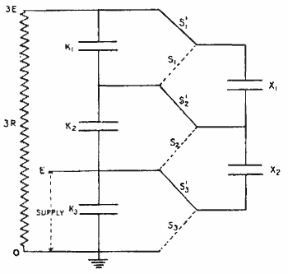
Figure 1. 1 - Schematic of Cockcroft and Walton's Voltage Multiplier
(Source: http://www.aip.org/history/lawrence/epa.htm)
(Source: steeremsc.pdf – Master’s Thesis from Michigan State)

By the end of 1932 they had successfully built an accelerator, when they were able to accelerate protons to a lithium target that disintegrated into two α-particles. A Soviet research team confirmed these results in Kharkov months later. A diagram of Cockcroft and Walton’s voltage multiplier is depicted in Figure 1.1.

At a similar time in history, Robert J. Van de Graaff was working on developing a device that would be able to produce and maintain high voltages using similar ideas and principles to that of Cockcroft-Walton accelerator. The first Van de Graaff generating device was demonstrated in 1931, and since this time several research groups and organization have expanded the capabilities and maximum voltage. The Van de Graaff generators used in particle accelerators today can produce and maintain voltages as high as 15 megavolts (MV).

Although Van de Graaff generators successfully accelerated particles, the physicists of the time found it very difficult to maintain a reliable high voltage source over an extended period of time. A proposed alternative to accelerating particles was to use a series of lower voltages. In an early paper by the Norwegian engineer, Rolf Wideröe, he described a system that would begin with a negative potential to attract positively charged particles. As the positively charged particles were pulled in, the potential would switch from a negative to a positive charge. This change in potential would force the positively charged particles out of the system, i.e. accelerate the particles. Wilderöe proposed that by adding several of these systems in a series would allow the acceleration of particles up to 25 kilovolts (kV). A diagram of Wideröe’s design is in Figure 1.2.
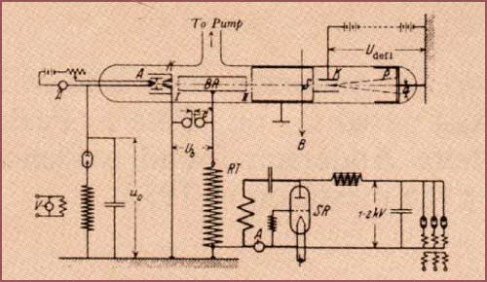
Figure 1. 2 - Rolf Wideröe's diagrams describing a method for accelerating ions inspired Ernest Lawrence's invention of the cyclotron.

In 1929, Ernest Lawrence translated Wideröe's paper entitled “On a new principle for the production of higher voltages” and took the above design plans to develop one of the first linear accelerator. In 1931, Lawrence with the help of David Sloan, a General Electric engineer with experience working with high voltages, built a series of thirty electrodes that could accelerate mercury ions up to 1.26 MeV. (Linear Accelerators – Lapostolle). A schematic diagram of the linear accelerator built by Sloan and Lawrence is in Figure 1.3. (Lawrence and
Sloan, NAS, Proc., 17 (1931), 68–69).

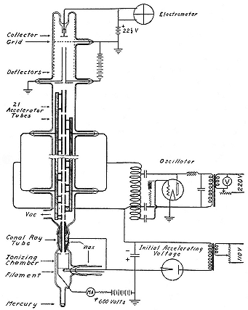
Figure 1. 3 - The linear accelerator of Sloan and Lawrence (1931).

Sloan continued to work on improving the design and capability of the linear accelerator, but this time with the help of W. M. Coates. In 1934, Sloan and Coates developed a linear accelerator with 36 drift tubes that could accelerator mercury ions up to 2.85 MeV. Unfortunately at the time, linear accelerators were more developed then the corresponding electronics required to make them successful for more than just accelerating particles. Despite this drawback, Sloan and Coates were able to accelerate mercury ions to bombard a variety of targets. Although no nuclear events occurred, they were able to report that some of the materials gave off X-rays of moderate intensity. Nevertheless until there was the capability to have sources of high power at high frequency (megawatt power range with frequencies in the megahertz or greater), the advancement of linear accelerator’s capabilities was sidelined.

As the Second World War began in Europe, Great Britain’s major line of defense was the use of radar systems to intercept enemy planes during the several months of night bombings. In order to increase the accuracy and reliability of their systems, along with having countermeasures against enemy radar systems, there was great need to develop a magnetron that was capable of multikilowatt power levels and frequencies as high as 30,000 megahertz (MHz). With this great advancement in capabilities, it allowed researchers following the war the ability to create the linear accelerators that had always desired. Two notable laboratories began to build these new linear accelerators, one at Stanford University under W. H. Hansen and the other at the University of California Berkley under L. W. Alvarez.

Hansen and colleagues began developing linear accelerators with these new available magnetrons, while another group composed of E. L. Ginzton, M. Chodorow, and S. Sonkin started researching higher power sources that had better stability than magnetrons. After beginning work in 1946, Hansen and his research group were able to design and construct one of the first accelerators by 1947 that became known as the “Stanford Mark I.” The Stanford Mark I had a 0.9 megawatt (MW) power source with a frequency of about 3000 MHz, and at a length of approximately 9 feet (ft) long was capable of accelerating electrons to 4.5 MeV. When the Stanford Mark I was extended from 9 ft to 14 ft, the electrons were capable of being accelerated to 6.0 MeV.

Hansen and his colleagues’ quick success led to the successful design of both the Stanford Mark II and the Stanford Mark III. The Stanford Mark II was built by Post and Shiren in 1955, and was a prototype to the future 1 GeV machine (Stanford Mark III). This design was similar to the Stanford Mark I, except it was only 12 ft long and had a radiofrequency (RF) power source that could provide 20 MW of power to accelerate electrons to 40 MeV. The Stanford Mark III was initially proposed and began construction prior to the Stanford Mark II. The Stanford Mark III was proposed to the Office of Naval Research in 1948 to build a 220 ft long linear accelerator that could accelerate electrons to 1 gigaelectron volt (GeV). After initial construction began in 1949, the first 30 ft of the Stanford Mark III was complete by 1951. This portion of the accelerator had three klystrons with a combined power of 24 MW to accelerate electrons to 75 MeV. After this portion was complete, experiments on the linear accelerator began immediately while further improvements and lengthening of the linear accelerator continued in 10 ft sections. Approximately two years later in 1953, 210 ft of the Stanford Mark III was complete and allowed electrons to be accelerated to a peak energy of 600 MeV. One of the most famous experiments that took place on the Stanford Mark III was by R. Hofstadter. Hofstadter used the powerful linear accelerator to make his momentous measurements on the form factors of the neutron and proton. This work led to Hofstadter receiving the Nobel Prize in 1961. In 1958, an extension of 90 ft was added to the Stanford Mark III to increase its peak energy to 900 MeV. After only five years at 900 MeV, in 1963 work was done once again to increase the operating energy. The now 300 ft linear accelerator was completely dismantled and reassembled with improvements in the design, that allowed the Stanford Mark III to reach its current operating energy of 1.2 GeV.


Figure 1. 4 - Photograph of the construction of SLAC.

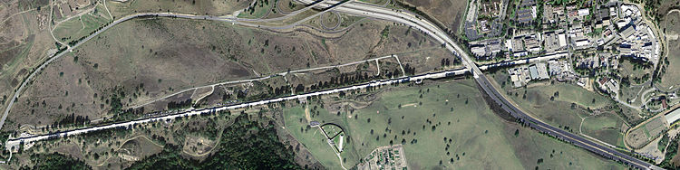
Figure 1. 5 - Aerial photograph of SLAC.

1.1.2 SLAC

Researchers at Stanford were still looking to push the boundary and limits of particle acceleration with the success of the Stanford Mark III. The researchers believed that if they were given the proper funding and resources, they could develop a linear accelerator that was ten to twenty times as powerful as the Stanford Mark III. In 1962 after several years of designing this new accelerator and appealing to the Atomic Energy Commission (AEC), the AEC approved researchers at Stanford to build this monumental linear accelerator. This new accelerator was the first of its kind, with a total length of approximately two miles and acceleration energy of 20 GeV. This accelerator became known as the Stanford Linear Accelerator Center (SLAC), and was completed in less than five years in 1967. After construction began in 1962, the two-mile linear accelerator accelerated its first electrons in May of 1966 to energy of 10 GeV. In less than a month, SLAC was able to accelerate up to 18 GeV and by January of 1967 to 20 GeV. Prior to and throughout construction, SLAC became a key focal point for high-energy physicists and included professors from Stanford and ten other universities throughout the United States. Since 1967, SLAC has been an area for several key discoveries in the physics community and has led to several Nobel Prize winners. These Nobel Prize winners include: Burton Richter of SLAC and Samuel Chao Chung Ting of Brookhaven National Laboratory (BNL) in 1976 for their independent discovery of the J/psi particle; Richard Taylor and Jerome I. Friedman of SLAC and Henry Kendall of Massachusetts Institute of Technology (MIT) in 1990 for the discovery of the building blocks of protons, known as quarks; and Martin Perl’s of SLAC in 1995 for his discovery of the tau lepton, a relative of the electron, in 1975.

1.1.3 CERN

Since SLAC’s became fully operational in 1967, its scientific mission has expanded from just particle physics to materials and environmental sciences, chemistry, alternative energy research, biology, and cosmology. In addition, SLAC has collaborated for several years with the world’s largest particle physics laboratories located in Switzerland, the European Organization for Nuclear Research (CERN). CERN was founded on September 29, 1954, and includes a variety of particle accelerators.
(https://www6.slac.stanford.edu/about/slac-history.aspx )

In addition to the research being completed at Stanford following World War II, Alvarez at the University of California began designing and building a proton linear accelerator. In 1945, construction began on the proton accelerator and several problems occurred that were not seen in electron accelerators. These problems were solved but they included: larger cavities for acceleration to overcome the radial variation when dealing with low phase velocities and high frequencies; instability in charge-free space that would cause the beam to dissipate from radial defocussing; and a different type of materials to be utilized in its construction. Despite these issues, in 1947 the first 32 MeV proton beam was produced and became one of the major prototypes for other proton and heavy ion accelerators in the following years. After over a decade of operation, the 32 MeV proton accelerator was dismantled and transferred to the University of Southern California.

1.1.4 JPARC

Since the construction of these key accelerator facilities, several other accelerators have been designed, built, and operated over the years with their own respective challenges and historical achievements. Two more accelerator facilities that are of particle interest are the Japan Proton Accelerator Research Center (J-PARC) and the Spallation Neutron Source (SNS). The SNS will be discussed in further detail in the proceeding sections. J-PARC is comprised of three accelerators and three experimental facilities. The accelerators include a 400 MeV linear accelerator (linac), a 3 GeV synchrotron (also known as a rapid-cycle synchrotron (RCS)), and a 50 GeV synchrotron known as the Main Ring (MR). The three experimental facilities include facilities for materials and life science, neutrinos, and hadrons. Construction of the accelerators and experimental facilities began in 2007 and reached completion in April of 2009. By having a facility that has multiple accelerators and different energies, J-PARC’s mission is to provide a diverse amount of high-power secondary beams for researchers from around the world.

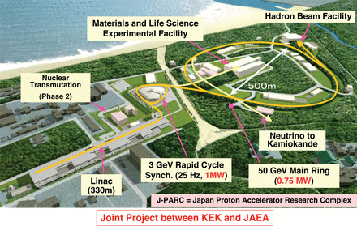
Figure 1. 6 - Depiction of the Japan Proton Accelerator Research Complex.

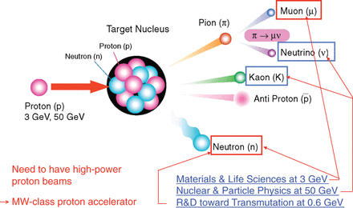
Figure 1. 7 - Diagram of a 3 GeV accelerator proton impacting a Target Nucleus and spallating off various particles, specifically a neutron.

J-PARC is of special interest to this particular research because of the similar use of thin carbon foils to strip electrons from a high energy H⁻ beam and the designed power output of 1 MW. The foils currently employed at J-PARC are known as Hybrid Boron mixed Carbon (HBC) foils that are approximately 1 μm thick with a corresponding aerial density of 200 μg/cm². This corresponding aerial density allows a 99.7% stripping efficiency of a 181 MeV H⁻ beam of its two electrons in the following reaction:

H⁻ (181 MeV) H⁺ + 2e⁻
J-PARC is very similar design to the SNS at Oak Ridge National Laboratory. J-PARC starts with an ion source to produce a negatively charged hydrogen ion (H⁻) by adding an electron to hydrogen atom (H). The H⁻ is extracted as a pulsed beam into a 250-meter (m) long linear accelerator, where it is accelerated to 50 kiloelectron volts (keV). The beam then goes through the radio frequency quadrupole (RFQ) where the beam is focused and accelerated up to 3 MeV (which is ~7% of the speed of light). The beam is then sent into a series of Drift Tube Linear accelerators (DTLs) where quadrupole magnets located within the cavities focus and accelerate the beam even further. As the beam exits this portion, it is up to 50 MeV (~30% of the speed of light), and enters the section of Separate-type Drift Tube Linear accelerator (SDTL). In this portion, the H⁻ beam is accelerated to 181 MeV (~53% of the speed of light) by quadrupole magnets that are located in between the SDTL cavities. The H⁻ beam is then accelerated into the last portion of the 330 m Linac, the Annular-ring Coupled Structure Linear Accelerator (ACS Linac). In the ACS Linac, several series of quadrupole magnets accelerates the beam to 400 MeV (~70% of the speed of light).

After the H⁻ beam is accelerated to 400 MeV in the Linac, it is injected into the Rapid Cycling Synchrotron (RCS). As the H⁻ beam is injected, it passes through a charge-exchange foil that strips the H⁻ beam of its electrons. Three potential cases are possible as the H⁻ beam passes through the foil, they are:

(1) H⁻ H⁺ + 2e⁻
(2) H⁻ H⁰ + 1e⁻
(3) H⁻ H⁻

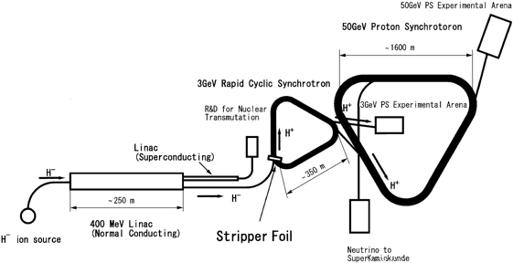
Figure 1. 8 - Schematic layout of the accelerator complex of J-PARC.
[Ref: I. Sugai et al., Nucl. Instr. and Meth. A 561(2006) 16]

In the first case, both electrons (e⁻) are stripped and the resulting proton (H⁺) is sent into the RCS where it is circulated. The electrons are captured in an electron collector and the H⁺ is circulated in the RCS. The second case, only one e⁻ is stripped and the resulting hydrogen atom (H⁰) and e⁻ are captured by a secondary foil and an electron collector, respectively. The third case is when no electrons are stripped from the H⁻ beam. If this occurs, the H⁻ beam is sent into a secondary foil where it is captured. While in the RCS, the H⁺ beam is accelerated, focused, and shaped by eleven RF accelerating cavities to 3 GeV. The H⁺ beam circulates in the RCS approximately X times to increase the intensity of the pulsed beam. The beam circulates in the RCS to allow additional pulses to be added to the beam from the Linac, to increase its overall intensity. As it circulates though, it passes through the stripper foil and causes a slight beam loss. Conditions are set to minimize this beam loss and optimize beam intensity. When the H⁺ beam reaches an intensity of 4.2 x 10¹¹ protons per pulse (ppp), it is extracted into the final major section of J-PARC, the Main Ring (MR).

As the H⁺ beam is extracted into the Material and Life Science Facility (MLF) or the MR, where it has two different options on where it can be used, the Hadron Facility and the Neutrino Facility. At the MLF, the 3 GeV H⁺ beam is extracted directly from the RCS and sent to a mercury target. When the H⁺ beam comes into contact with the mercury target, neutrons are knocked off and used for materials research. The remaining portion of the H⁺ beam that is not extracted into the MLF is sent into the MR. While in the MR, it is circulated and accelerated further to 50 GeV by 7 RF cavities. After being accelerated to 50 GeV, it can be extracted either to the Hadron Facility or the Neutrino Facility to be used for further scientific and materials research. (Reference: http://j-parc.jp/public/Acc/en/index.html)

1.2 Spallation Neutron Source (SNS)

1.2.1 Purpose of SNS

The word “spallation” was first used by W.H. Sullivan and Glenn T. Seaborg at the Lawrence Radiation Laboratory in Berkeley, California (B. G. Ha rvey, Ch. 3 “Spallation” in Progress in Nuclear Physics, Editor O. R. Frisch, Vol. 7, Pergamon Press pp 90-120 (1959)). The concept was already very well known and described the process of a high-energy particle colliding with a nucleus to emit a significant amount of neutrons and fragments. In Figure XX below is an illustration of the spallation process at ORNL’s SNS. SNS is an one-of-a-kind research facility that uses an accelerator-based system to deliver microsecond pulsed proton beams to a mercury target to produce the world’s most intense pulsed beam of neutrons. In combination with state-of-the-art instrumentation, the SNS allows researchers from a variety of backgrounds to characterize their samples, including but not limited – physics, chemistry, material science, pharmaceuticals, and biology. Although there are several other places in the world that provide intense neutron beams, the ability for the SNS to provide a more intense and brighter source of neutrons allows researchers to obtain a higher resolution, greater sensitivity, faster analysis time, and the use of more complex sample environments. (www.neutrons.ornl.gov).

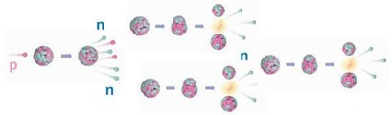
Figure 1. 9 - Diagram of an accelerator proton (p) hitting a target nucleus and spallating off neutrons (n).

In the early 1990’s, the Department of Energy (DOE) made the decision to design, develop, and operate a neutron scattering research facility that was an order of magnitude more powerful than the current neutron source. The DOE choose ORNL because of the extensive knowledge and experience of working within the neutron sciences. The Spallation Neutron Source (SNS) is a world-class particle accelerator research facility that delivers the world’s most intense pulsed neutron beam to researchers from around the world. The pulsed neutron beam is used for several areas of research and industrial development, including but not limited to material science, biology, chemistry, and physics. This research has allowed scientist to advance both research and commercial products, for example in characterizing medicines, developing powerful lightweight magnets, and lighter plastics to be used in automobiles and planes.

1.2.2 Design of SNS

The SNS can be divided into five main sections: Front-End Systems, Linear Accelerator, Accumulator Ring, Target, and Instrument Systems. (CRP #8) The Front-End Systems consists of the ion source, an electrostatic Low Energy Beam Transport (LEBT) that includes the first-stage beam chopper, a four-vane Radio-Frequency-Quadrupole (RFQ) to accelerate the beam up to 2.5 MeV, and a Medium Energy Beam Transport (MEBT) and second-stage chopper; which were all developed and tested at Lawrence Berkeley National Laboratory (LBNL) before being delivered to ORNL in June of 2002. Since the installation and commissioning, several modifications have taken place at ORNL that will now be discussed in this paper.

1.2.2.1 H⁻ Source

The ion source heats hydride plasma by radiofrequency and confines the plasma with a multicusp magnetic field and is referred to as the RFQ (http://ibt.lbl.gov/plasmatechnology.html) (http://trace.tennessee.edu/cgi/viewcontent.cgi?article=1684&context=utk_chanhonoproj). The ion source than delivers the 35 – 50 mA hydride source (H⁻) in a pulse, frequency of 60 Hz and width of 1 ms, to the linear accelerator. The ions are at an approximate energy of 2.5 MeV before entering the linear accelerator.

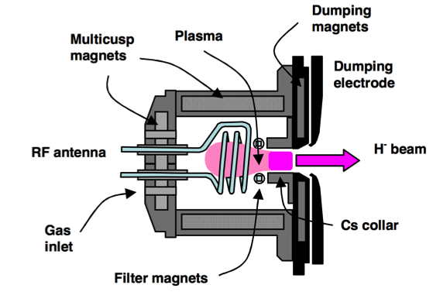
Figure 1. 10 - Schematic diagram of the SNS Ion Source.
http://www.osti.gov/home/osti-collections-neutron-sources-studying-matter

1.2.2.2 Linear Accelerator

The Linear Accelerator (Linac) uses a combination of conducting and superconducting cavities to accelerate and focus the beam to the Accumulator Ring while amplifying its voltage from 2.5 MeV to 1000 MeV (1 GeV) (http://arxiv.org/pdf/physics/0008070.pdf). The linac was designed by Los Alamos National Laboratory (LANL) and is made up of several klystrons and super conducting cavities and accelerates the H⁻ source to 968 MeV. The H⁻ source is kept at a pulse frequency of 60 Hz and pulse width of 1 ms, with an peak current of 52 mA. The beam is chopped to give an average pulsed beam current of 36 mA (68% chopping factor). The Linac can be separated into several sections in which each section has a set of specific parameters and purposes. Following the RFQ and MEBT, there is the Drift Tube Linac, Coupled-Cavity-Linac, a Superconducting Radio Frequency, several medium and high beta cryomodules, and a High-Energy Beam Transport. The Drift Tube Linac (DTL) is made up of six normal conducting cavity tanks that operate at 2.5 MW peak klystrons at 402.5 MHz to accelerate the beam from 2.5 MeV to 86.8 MeV. The beam goes next into the Coupled-Cavity-Linac (CCL), which is a 4-module conducting cavity that accelerates the beam from 86.8 MeV to 186 MeV using 5 MW peak klystrons at 805 MHz. From the CCL, the beam is sent into the Superconducting Radio-Frequency (SRF) that consists of medium and high beta cryomodules. There are eleven medium beta cryomodules used to accelerate the beam up to 379 MeV with a beta factor of 0.61, and twelve high beta cryomodules that accelerate the beam up to 968 MeV (max of 1000 MeV) with a beta factor of 0.81. The SRF uses superconducting cavities that are made up of 550 kW klystrons at 805 MHz. Once the hydride beam is accelerated up to 968 MeV from the SRF and superconducting cryomodules, it is sent into the High Energy Beam Transport (HEBT). The HEBT transports the accelerated beam into the Accumulator Ring.
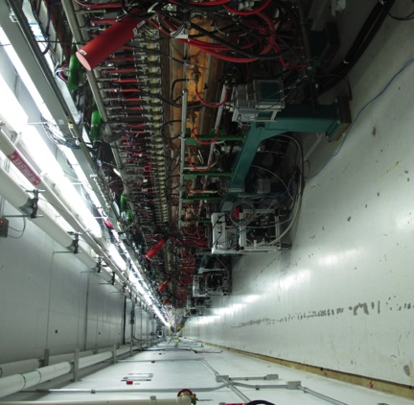
Figure 1. 11 - Low Energy Beam Transport (LEBT) looking down the LINAC.
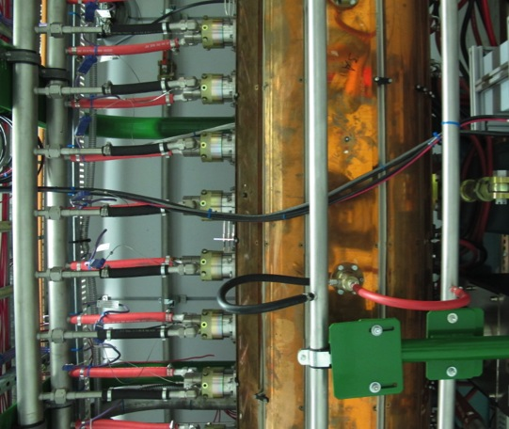

Figure 1. 12 - A section of the LEBT that helps accelerate the beam into the MEBT.

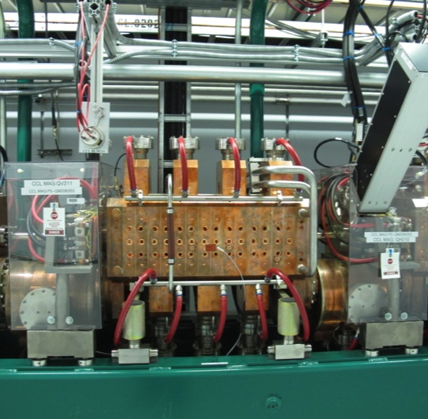
Figure 1. 13 - CCL
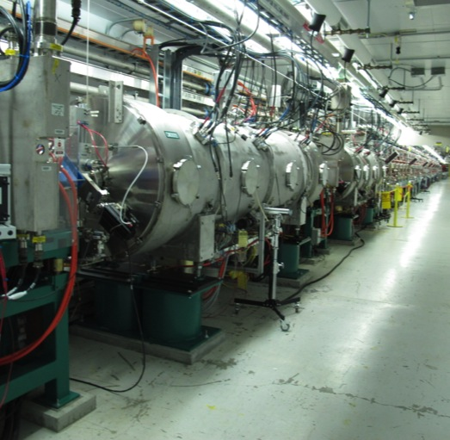
Figure 1. 14 - High Energy Beam Transfer of the LINAC
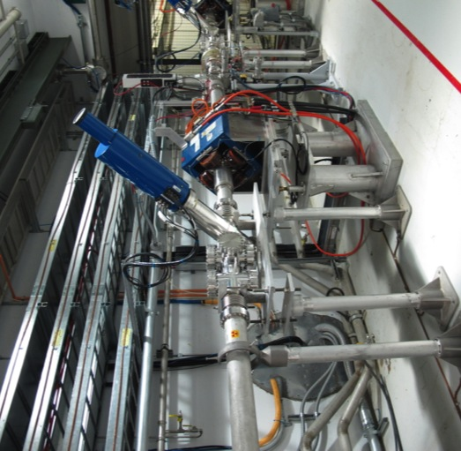
Figure 1. 15 - HEBT Linac and Beam Pipe Monitor
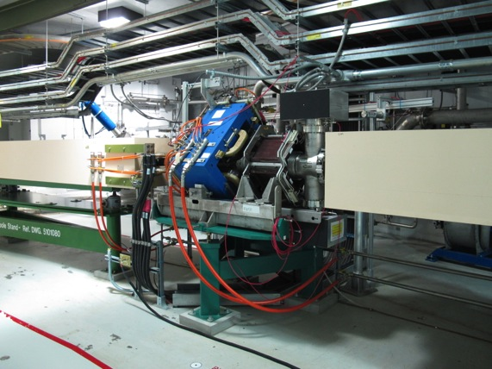
Figure 1. 16 - LINAC with horizontal magnets and beam pipe monitor.
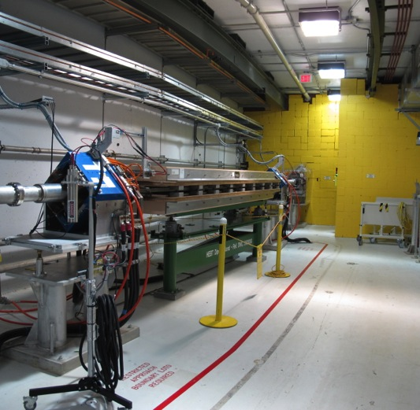
Figure 1. 17 - LINAC with beam pipe monitor and vertical magnet.

(https://accelconf.web.cern.ch/accelconf/l02/TOC/..%5CPAPERS%5CTU422.PDF, http://epaper.kek.jp/e02/PAPERS/TUZGB002.pdf, http://ics-web.sns.ornl.gov/TuningGuide/Front%20Only%20Mode/Startmap-Timing-Master.png, http://arxiv.org/pdf/physics/0008070.pdf, http://ibt.lbl.gov/plasmatechnology.html, http://trace.tennessee.edu/cgi/viewcontent.cgi?article=1684&context=utk_chanhonoproj, http://www.aps.org/units/dpb/resources/upload/holtkamp.pdf).

1.2.2.3 Accumulator Ring and Primary Stripper Foil

The Accumulator Ring (AR) is the third main section of SNS, following the Front End and Linac. The main function of the AR is to take the pulsed H⁻ beam (energy of 1 GeV, pulse frequency of 60 Hz, and pulse width of 1 ms), and convert it into a 0.5 microsecond beam through a charge exchange interaction with a stripping foil. The AR uses several magnets and vacuum tubing to circulate the beam approximately 1200 times, with the final beam having approximately 1.0 x 10¹⁴ protons per pulse. These protons are then delivered to the Target at 60 Hz repetition rate. This corresponds to an average beam of 1 MW. Facilities have been set aside that would allow twice as many protons to be stored within the accumulator ring per pulse (2.0 x 10¹⁴ protons per pulse), that would allow a 2 MW beam to be delivered to the target.

The Achilles heel of the AR is the charge exchange foil, more specifically the primary stripper foil (foil). The SNS has used several different designs and chemical compositions of foils. The most common used foil now is a nanocrystalline diamond foil grown on a silicon substrate (17 mm x 45 mm) by plasma enhanced chemical vapor deposition. A large section (17 mm x 30 mm) of the silicon substrate is etched away to leave a freestanding diamond portion with only one side of support. The remaining silicon is known as the silicon handle (17 mm x 15 mm), and is used to attach the foil to a foil bracket that is used to hold and maneuver the foil within the SNS. The foil bracket has also been modified several times, with the most current design being a L-shaped bracket made of titanium. The bracket is loaded into the Primary Foil Changer (PFC), which houses up to twelve different foils for one SNS cycle. The PFC is interconnected to the SNS under vacuum and transfers different foils in and out of the beam line. It is designed like a bicycle chain with points along the chain that allow for the attachment of the brackets. The bicycle chain is remotely manipulated to adjust the position of the foils. A more detailed analysis of the foils and the various foil components will be discussed in a further section.

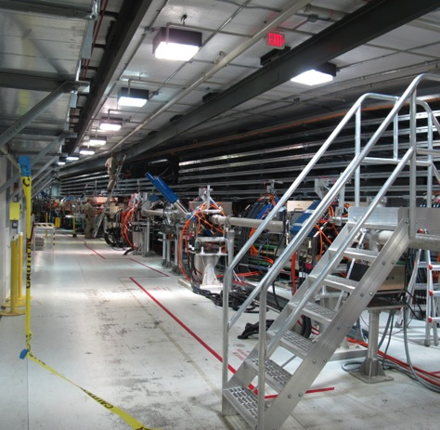
Figure 1. 18 - LINAC to Primary Foil Changer (PFC)
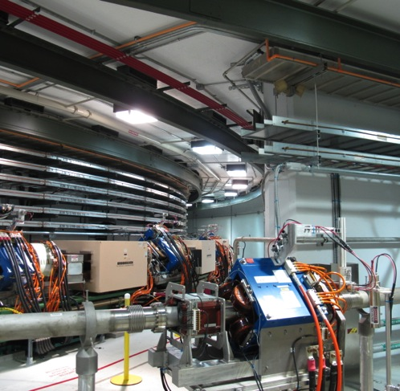
Figure 1. 19 - Accumulator Ring coming around the bend into the LINAC.
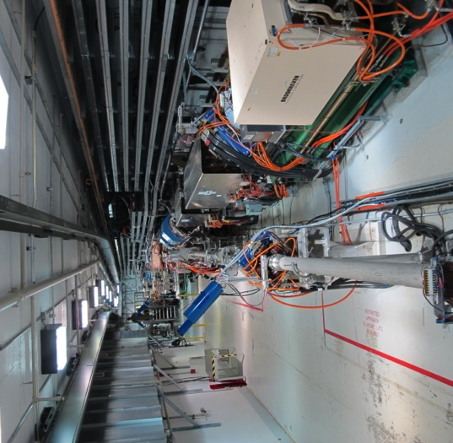
Figure 1. 20 - View of Linear Accelerator and Accumulator Ring joining together.
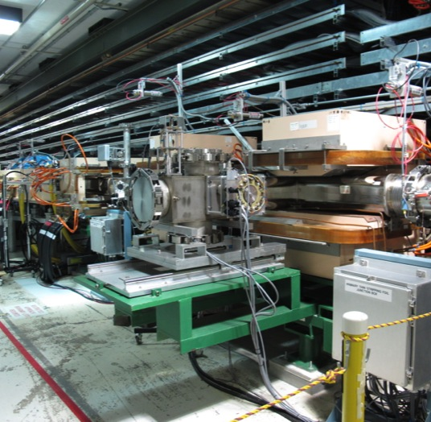
Figure 1. 21 - Primary Stripper Foil Changer (PFC). The PFC houses the foils that used within the SNS during production.
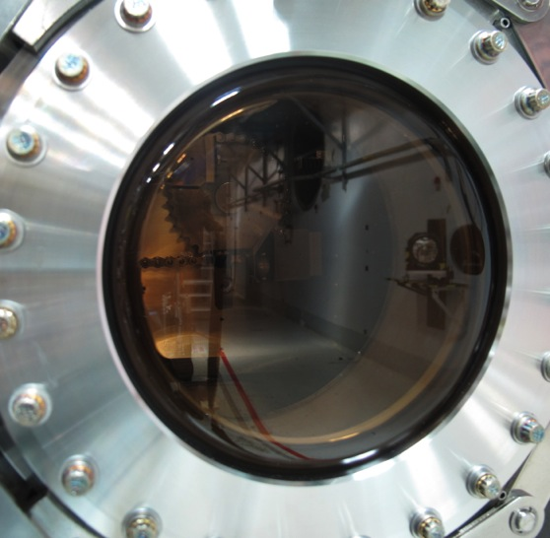
Figure 1. 22 - Photograph looking into a viewport on the PFC at a foil and the chainsaw.
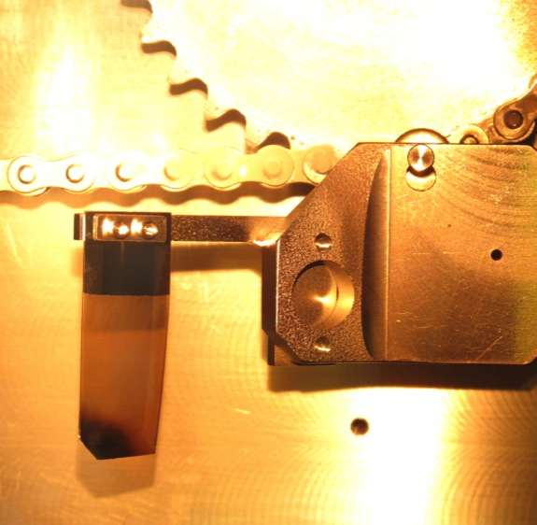
Figure 1. 23 - Photograph of a foil during a break from production inside the PFC to monitor the foil and bracket’s conditions.
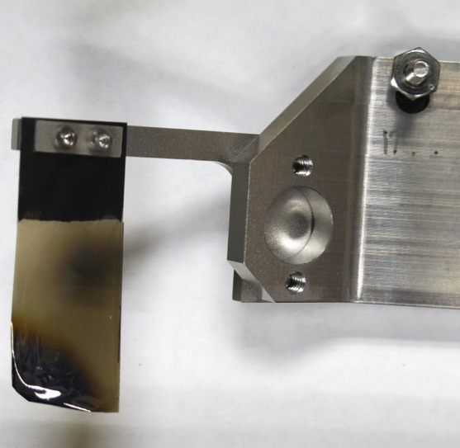
Figure 1. 24 - Photograph of a foil postproduction. The SNS beam hit the bottom left corner as shown in the photograph. Notice the wrinkling and darkening of the foil caused by a material density change in the nanocrystalline diamond foil.

Once the beam passes through the foil, there is potential for the H⁻ beam to undergo three different reactions. The first is the H⁻ beam is stripped of both of its electrons and sends the resulting proton into the AR and the two electrons into an electron collector located directly below the foil. The second is the H⁻ beam is stripped partially of its electrons and sends the Hº into the Secondary Stripper Foil (SSF) and electron into the electron collector. The third possibility is the H⁻ beam passes through the foil without being stripped and is directed into the SSF. Below is an overview of the possible reactions as the H⁻ beam passes through the foil:

H⁻ H⁺ + 2e⁻
H⁻ Hº + 1e⁻
H⁻ H⁻

It is very important that a large percentage of the H⁻ beam is stripped completely of its two electrons. In order to monitor how the beam is behaving from one SNS cycle to the next, two foils are constantly left within the PFC that are used to characterize the stripping efficiency. One foil has a higher aerial density (“thicker”), and the other has a lower aerial density (“thinner”) than the nominal 350 μg/cm². Additional discussion will take place on the current issues and problems that are affecting the lifetimes of foils in a further section.
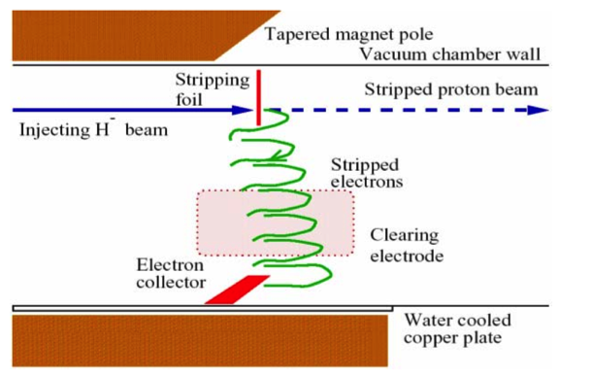
Figure 1. 25 - Schematic mechanism of the electron collector at the SNS.

Of the H⁻ beam that are completely stripped of their two electrons, the resulting protons are circulated approximately 1200 times to produce a pulsed beam bunch of 1.0 x 10¹⁴ protons per pulse.

1.2.2.5 Target

These protons are then delivered in a 1 x 10⁻⁶ pulse to a liquid mercury Target, where they knock off approximately 12 – 14 neutrons per mercury atom. Due to the intense energy being delivered to the Target, the Target must be able to quickly and efficiently dissipate this energy, and at the same time, provide a vast amount of neutrons to the source. With this in mind, a Target composed of liquid mercury (Hg) was chosen for its high neutron count per atom (80), its ability to dissipate the heat, and its capability of withstanding high doses of radiation. (CRP #8) If a typical solid target made of tantalum or tungsten was chosen, it would be susceptible to detrimental radiation damage and thermal shock. By having a liquid target that is circulated, it will be able to self-cool itself by constantly removing heat from the impact region. Additionally the circulation will prevent high radiation damage from occurring since the impact region is constantly being replenished and replaced. The Target will contain approximately 14 tons of liquid mercury that are circulated continuously through a series of channels within the enclosed system. By keeping the system enclosed, it allows the potential to use a single target for several years. Unfortunately current Target designs and manufacturing techniques require it to be replaced on average twice a year due to the mechanical and structural stress that the various components undergo.
The mercury target, Stage #4, as mentioned above was designed about ORNL. The mercury target was designed to take a 1.4 MW H⁺ beam from the accumulator ring, at a rate of 60 Hz and pulse width of 1 ms, and allow the H⁺ beam to spallate neutrons off from the mercury target, including the flow of mercury and the pitting that would occur on the inside of the target and limit the lifetime of the target. This was a very challenging problem due to the intense radiation that target area would undergo and the difficulties of working with liquid mercury. From here, the neutrons are focused into a secondary beam line that delivers the neutrons to the final stage.
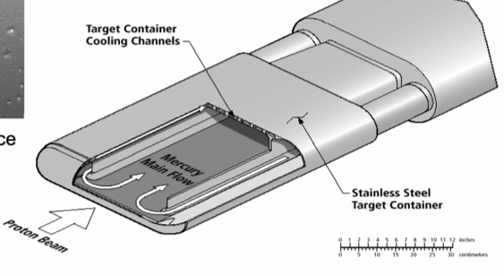
Figure 1. 26 - Diagram of the mercury Target used at the SNS.

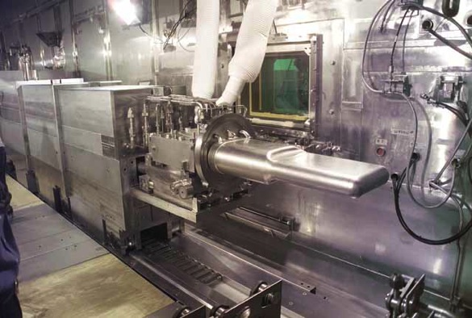
Figure 1. 27 - Photograph of the mercury Target being installed by remote manipulators within the SNS.
http://www.thelivingmoon.com/45jack_files/03files/Spallation_Neutron_Source_Target.html

1.2.2.6 Neutron Instrumentation

Once the neutrons are emitted from the Target, the neutrons are focused onto several different instruments that are used to analyze a variety of samples. Each instrument requires either a particular neutron energy or energy spread. Therefore the neutrons emitted from the Target are cooled by either water or liquid helium to adjust the neutron’s energy to the desired range. For the final stage, Stage #5, Argonne National Laboratory (ANL) was charged to design and develop the preliminary neutron scattering instrumentation along with working with ORNL to develop the experimental facilities. Since the initial instrumentation development, several other organizations and research groups have developed additional instruments. There are currently seventeen instruments that are currently under operation at the SNS, two in construction and commissioning phase, and three more in the design and proposal phase. The types of instruments currently in operation are a series of diffractometers, reflectometers, and spectrometers that have a wide range of analysis and characterization of samples. The diffractometers include the Nanoscale-Ordered Materials Diffractometer (NOMAD), the Spallation Neutrons and Pressure Diffractometer (SNAP), the Extended Q-Range Small-Angle Neutron Scattering Diffractometer (EQ-SANS), the Engineering Materials Diffractometer (VULCAN), the Powder Diffractometer (POWGEN), the Macromolecular Neutron Diffractometer (MaNDi), and the Single-Crystal Diffractometer (TOPAZ). The reflectometers include the Magnetism Reflectometer (MR) and the Liquids Reflectometer (LR). The spectrometers include the Backscattering Spectrometer (BASIS), the Cold Neutron Chopper Spectrometer (CNCS), the Neutron Spin Echo Spectrometer (NSE), the Vibrational Spectrometer (VISION), the Fine-Resolution Fermi Chopper Spectrometer (SEQUOIA), and the Wide Angular-Range Chopper Spectrometer (ARCS). (http://neutrons2.ornl.gov/instruments/SNS/) The samples that are tested in the SNS come from areas of research including but not limited to chemistry, polymers, life sciences, material chemistry, and applied engineering.
(http://www.iaea.org/inis/collection/NCLCollectionStore/_Public/32/002/32002992.pdf, #8 - CRP)
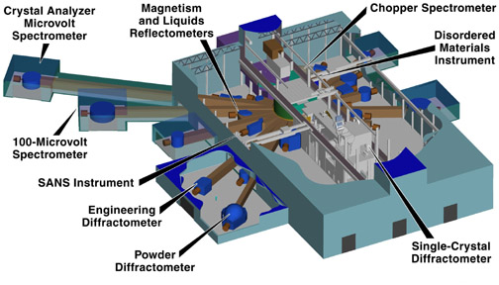
Figure 1. 28 - Schematic diagram of the SNS Instrument Hall.
(http://www.aps.org/publications/apsnews/200005/images/0500sns.jpg)
This project relied on several organization and national laboratories working together for a common goal, to build the world’s most intense source of neutrons, which allowed the successful design, building, and current operation of SNS. This was quite a feat and similar in magnitude to what was accomplished by the Manhattan Project during the Second World War. Below is an overall depiction of the SNS at ORNL along with the corresponding national laboratories that took this project from concept to reality. (http://science.energy.gov/~/media/opa/pdf/SNS_033110.pdf).
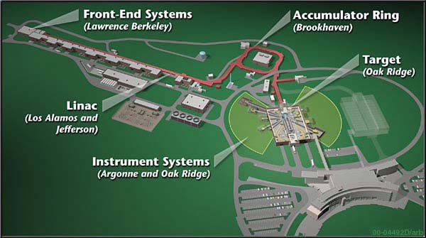
Figure 1. 29 - Overview of the SNS with labels identifying the five major sections along with the main collaborators.

After several years of development and research, construction began at ORNL for the building of SNS on December of 1999. Within six year after construction began at ORNL, the construction of SNS complete in May of 2006 both under budget and ahead of schedule. Following the end of construction, the first three SNS research instruments became available in August of 2007. Since 2007, a total of 17 instruments have been built with an average of 700 researchers per year as of 2011. (ORNL Neutron Sciences Neutron Review, UT-Battelle, LLC, ORNL/TM-2011/882011, 2011, p. 7.).

SNS is currently able to deliver a 1 MW of beam power with the existing system and foil conditions. It is the present goal of the SNS to reach a maximum beam power of 1.4 MW, and to develop practices to allow 3.0 and 5.0 MW upgrades.⁹ There are several challenges that must be faced with these future upgrades. One of the major challenges facing SNS ability to reach higher beam powers is the existing stripper foil used in operation. As stated previously diamond has been excellent in allowing high efficiency and reliability in stripping electrons, but is limited by inadequate thermal tolerance. Work described in this proposal intends to overcome this obstacle by using boron doped diamond films. The addition of boron into the films has the potential to allow the same high reliability and efficiency seen in pure diamond for stripping electrons, but also the ability to see this efficiency at higher beam powers. Previous work by Sugai et al. has shown these results and how effective boron doped diamond films are at stripping electrons and withstanding high heats.¹⁰

1.2.3 Primary Stripper Foils

The charge-exchange foils (“primary stripper foils” or “foils”) used within the SNS have gone through several different designs and modifications since the start of SNS in 2006. The foils that have been used within the SNS include carbon foils by Arizona Carbon Foil Company, Diamond-Like Carbon foils by TRIUMF; microcrystalline, nanocrystalline, and boron doped diamond foils developed by plasma enhanced chemical vapor deposition at ORNL; nanocrystalline diamond foil developed by hot filament chemical vapor deposition at BlueWave Semiconductors; and Hybrid Boron mixed Carbon foils by Sugai. All the foils used have had a range of thickness (i.e. aerial densities), sizes, and dimensions, with a select number of foils being fiber supported.

1.2.3.1 ACFC

The carbon foils from Arizona Carbon Foil Company (ACFC) were some of the first foils used within the SNS. The ACFC foils are developed by high temperature evaporation-condensation onto a glass slide have been used extensively throughout the world since 1964 because of their high quality and reliability (http://beamdocs.fnal.gov/AD/DocDB/0034/003496/001/sugai_seminar.pdf). The ACFC foils have a turbostratic crystal structure. A turbostratic crystal structure is the case when graphene sheets are randomly stacked together.
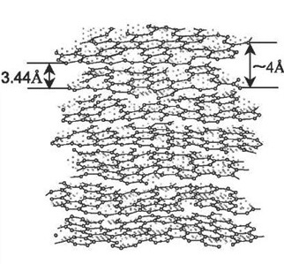
Figure 1. 30 - Turbostratic Crystal Structure of the Arizona Carbon Foil.
(http://what-when-how.com/nanoscience-and-nanotechnology/carbon-nanotubes-and-other-carbon-materials-part-1-nanotechnology/

The lifetimes of ACFC foils has been extensively measured at several particle accelerator facilities and were initially used at the SNS to characterize and calibrate the beam and its stripping efficiency. The ACFC foils were tested at Brookhaven National Laboratory (BNL) by C.J. Liaw et al. to determine their lifetime against other common stripper foils being developed in 2001 (https://accelconf.web.cern.ch/accelconf/p01/PAPERS/TPAH138.PDF). The ACFC foils ranged in thickness, with their aerial densities ranging from 200 – 400 μg/cm², and were supported by 5 μm diameter carbon wires. The lifetimes of these ranged from a few hours to a maximum lifetime of 75 hrs for a 200 μg/cm² thick foil, single layered, and carbon fiber supported foil. The lifetime decreased as the foil temperature increased and exceeded 2500 K, with a negligible lifetime at 4000 K.

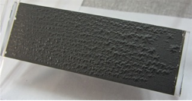
Figure 1. 31 - Evaporated Carbon Foil (approx. 100 µg/sq.cm) on glass substrate, showing compression-wrinkle pattern due to internal stresses (see section 2.5 below). This foil's substrate is glued permanently into its transparent plastic shipping box. Foil can be removed from its substrate by slowly immersing the substrate and box in water.
(mail.tunl.duke.edu/pipermail/sneap/attachments/.../attachment.doc)

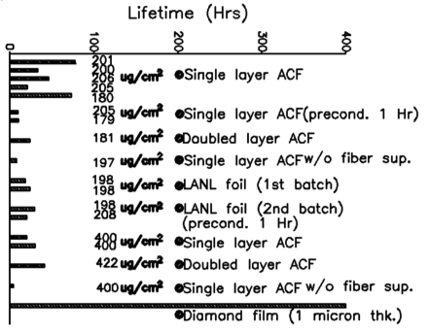
Figure 1. 32 - Summary of Carbon Foil Lifetime Tests
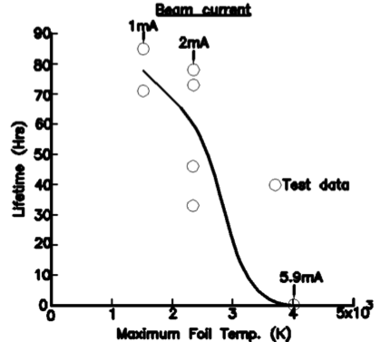
Figure 1. 33 - Carbon foil lifetime vs. Maximum foil temperature for Arizona 200 μg/cm² foil

The ACFC foils used within the SNS were cut to the appropriate dimension of 12 mm x 45 mm, with two holes tapped in the top of the foil to attach it to the foil bracket. The foil was placed on an aluminum bracket and held in place by 7 μm carbon fibers (ACFC reference). The figure below is a diagram of how the ACFC foil was installed on the foil bracket. After a brief period where a cumulative power of only 199.6 MW was placed on the foil, the ACFC failed and was replaced by the early-developed microcrystalline foils from ORNL. The ACFC foils were installed three more times into the primary stripper foil changer, but they were never used again to strip the SNS beam.

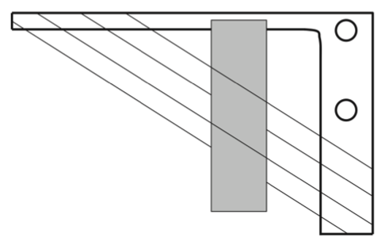
Figure 1. 34 - Carbon foil holder (L-frame) showing nominal position and size of foil. The frame is about 76 mm wide and 51 mm high, and 3.18 mm thick.

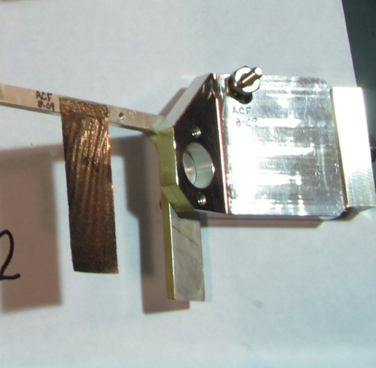
Figure 1. 35 - ACFC Foil prior to be loaded into the SNS on aluminum bracket.

1.2.3.2 TRIUMF

TRI University Meson Facility (TRIUMF), located in Vancouver, British Columbia, developed the second type of carbon foil utilized within the SNS. (http://www.researchgate.net/publication/229306736_Production_of_stripper_foils_by_laser_ablation_of_carbonboron_sputter_targets and wiki TRIUMF). TRIUMF’s staff has been developing carbon stripper foils for their 500 MeV Cyclotron for over 35 years. The Cyclotron works by taking accelerated negatively charged hydrogen ions from an ion source and accelerates these ions with an alternating high frequency electric field. The beam is confined and steered by several large magnets to a carbon foil, were the two electrons are removed from each hydride ion and the proton is allowed to pass through before being extracted to a proton beam line for further use. In 2008, TRIUMF Applied Technology Group decided to develop a multilayer foil that had alternating layers of amorphous and diamond like carbon, by carbon arc and pulsed laser deposition, respectively. Diamond-Like Carbon (DLC) foils were developed by the pulsed laser deposition (PLD) method (Multilayer Carbon Foils for Cyclotron Beam Extraction) in a customized PLD system form UHV Technologies, Inc. This custom PLD system consists of five main components: (1) a Spectron Nd:YAG infrared laser; (2) 48 cm diameter stainless steel bell jar with optical components, graphite sputter target, and a substrate holder; (3) cryogenic vacuum pump; (4) GE Fanuc 90-30 programmable logic controller operated by LabVIEW; and (5) a casing to hold various power supplies, display screens, valves, etc. The PLD method works by having the Nd:YAG infrared laser go through a glass vacuum window to the top of the bell jar. From here, the laser is defocused and adjusted by various optical mirrors and lenses prior to being focused onto a sputter target. When the laser beam hits the sputter target, it causes carbon particles to evaporate and become deposited on the nearby substrates. The length of time this process undergoes dictates the overall thickness of the film. Below is an image depicting the custom PLD system at TRIUMF, as reported by Zeisler and Jaggi in 2008 (REFERENCE). Similar to the ACFC foils, these foils were delivered to the SNS and cut to the appropriate dimensions and mounted on a bracket prior to being loaded into the SNS. A single TRIUMF foil was tested within the SNS in 2007, and due to the intensity and high repetition rate of the beam was unable to maintain the necessary structural integrity to be used for a long period of time and was substituted out with another foil.

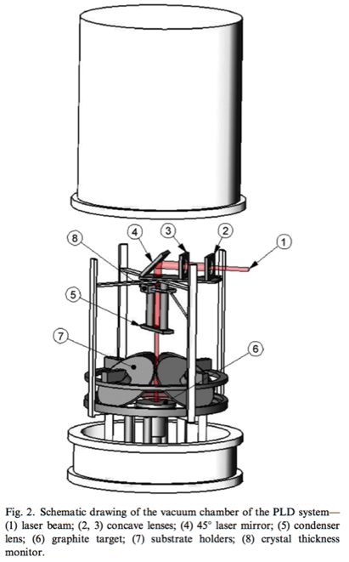
Figure 1. 36 - Schematic diagram of the vacuum chamber of the PLD system.

The durability of carbon stripper foils in a cyclotron depends on several parameters, such as type of foil material (amorphous, microcrystalline or nanocrystalline carbon structures), mounting method, handling of the foil before and during the mounting process, and eventually ion beam density and beam distribution. Obviously, much attention needs to be given to the careful handling and mounting of the stripper foils to ensure that they do not suffer mechanical damage before they are irradiated. Additionally, the foils should be mounted in a way that allows shrinkage or expansion when exposed to high temperatures by beam heating [1].
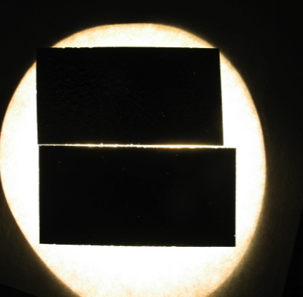
Figure 1. 37 - Aerial view of the TRIUMF Foils looking for pinholes prior to be loaded into the SNS.

1.2.3.3 ORNL Methodology and Primary Stripper Foils Development

Researchers at ORNL, Dr. Bob Shaw and Leslie Wilson, use the technique of microwave plasma chemical vapor deposition (MPCVD) to synthesize polycrystalline diamond films. These polycrystalline films include the nanocrystalline diamond, microcrystalline diamond, and boron doped diamond thin films that are all deposited onto a silicon substrate. [CRP #9] The chemical reactions that take place via chemical vapor deposition (CVD) are generally endothermic and restricted by their kinetic energy of activation. [CRP #11] Therefore, CVD reactions are generally controlled by the amount of heat given to the system. Typically, to achieve higher quality films with tolerable growth rates, there is a significant increase in applied temperature. [CRP #12] Unfortunately, temperature increases can be detrimental to any temperature sensitive starting materials (i.e. thin films) by creating holes and non-uniformity in growth. [CRP #11] Consequently, there has been research in the development of alternative methods of providing energy to the system. One proposed method to initiate the chemical reactions necessary to grow high quality thin films is using a plasma source. [CRP #13] MPCVD is a subset of plasma enhanced chemical vapor deposition (PECVD), is a technique that uses the gas state of an element to deposit a solid-state thin film of that element onto a chosen substrate. [CRP #11] The plasma created by MPCVD is typically produced above the substrate by creating a radio frequency (RF) glow discharge with the appropriate gas mixture, which allows for the plasma to deposit a thin and uniform film upon the substrate. The chemical reactions that take place to form the plasma have two fundamental purposes: to create the chemically active species necessary for the layer formation of molecules across the substrate and to deliver the necessary energy to provide uniform nucleation, particle migration, and heterogeneous kinetics across the substrate. [CRP #11]

After the ACFC failure, the early-developed polycrystalline (microcrystalline and nanocrystalline) foils from ORNL were placed into the SNS beam to determine how well they would respond. Preliminary tests of polycrystalline diamond foils at BNL showed they had a large advantage over other carbon foils. Polycrystalline foils showed greater promise because of the more rigid design, which decreased the amount of fluttering and beam loss, and their ability to withstand higher temperatures before failure. Therefore a foil development program was started at ORNL in 2001 in close collaboration with the University of Tennessee at Knoxville (UTK) and Dr. Charles Feigerle. Since 2001, these foils have been very successful and are now the primary foils used in the SNS for stripping the H⁻ beam. The foils created and developed at ORNL are unlike most other foils used in particle accelerators, in that they do not require fiber supports and have three of its four edge free of any support. Initial polycrystalline diamond foils grown on silicon had issues of curling after the silicon substrate was etched away. To overcome this, researchers introduced different lithography patterns onto the foil that would help keep the foil flat after the silicon substrate was etched away. Several different lithography patterns have been designed, with a standard U-shape pattern being the most commonly used. Further information on the different lithography patterns and their success will be discussed in a later section. There have been several types of foils developed at ORNL that have been very successful in the SNS. Two of these foils that survived beam powers of greater than 1.0 MW include a microcrystalline diamond foil (Foil #1073) and a nanocrystalline diamond foil (Foil #1108), both with a standard U-pattern. The total charge placed on the microcrystalline and nanocrystalline foils were 4820 and 7359 coulombs, respectively.

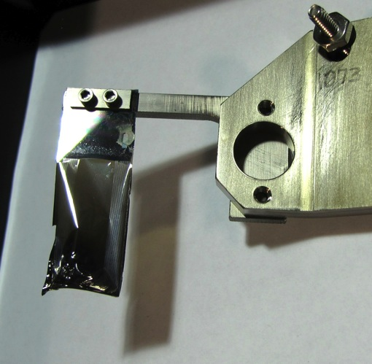
Figure 1. 38 - Foil #1073 - Champion Foil #1 - A microcrystalline diamond stripper foil post-SNS production.
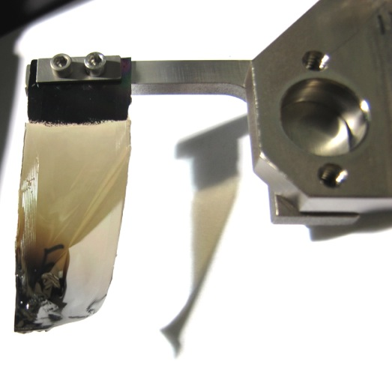
Figure 1. 39 - Foil #1108 - Champion Foil #2 - Nanocrystalline diamond stripper foil post-SNS production.

The next types of foils used within the SNS are the foils developed at ORNL by plasma enhanced chemical vapor deposition (PECVD). Another section is fully devoted to the development of these foils, from growth to use as a production foil within the SNS. Here is a brief overview of the process used to develop the microcrystalline, nanocrystalline, and boron-doped diamond foils. An (100) silicon substrate is first clean and then patterned with one of the several lithography designs, most commonly an U-shaped.
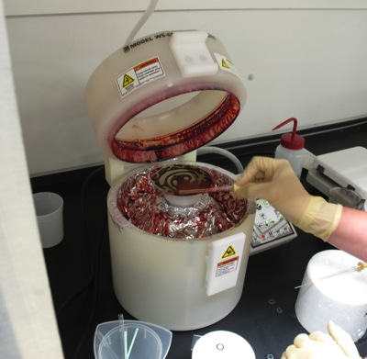
Figure 1. 40 - Photoresist being spin coated onto a silicon substrate.
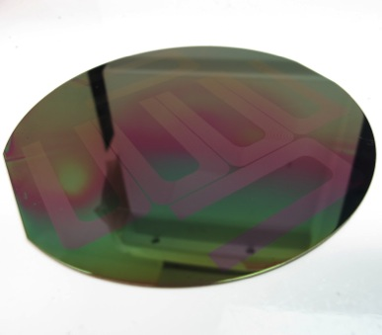
Figure 1. 41 - The common U-shaped lithography that has been patterned on a four inch silicon substrate.

Once a lithography pattern is chosen and implemented, the silicon wafer is cut to the appropriate dimension (17 mm x 45 mm) and seeded with diamonds seed. The seeded, cut wafer is then placed inside the PECVD chamber and growth of the films begins with the alteration of the various gases (argon, methane, hydrogen, and occasionally diborane) to develop the microcrystalline, nanocrystalline, and boron-doped diamond films.
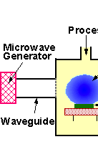
Figure 1. 42 - Schematic Diagram of a PECVD Chamber.
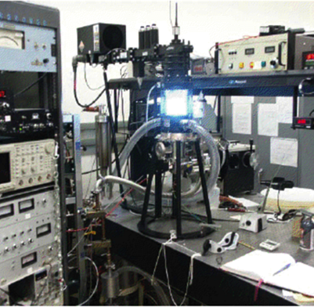
Figure 1. 43 - Photograph of the PECVD system located at ORNL.

After a set period of time (approximately 1 hour) of growth, the newly deposited films on the silicon substrate are brought back to room temperature and removed from the PECVD chamber. From here, the deposited films are analyzed by SEM to determine the crystallinity, a profilometer to determine the surface roughness, and then weighed and alpha-ranged to determine the thickness and uniformity of the films. Once the films meet a set of in-house standards, the films’ silicon substrate is etched away to leave a free-standing diamond portion that is typically 17 mm x 30 mm. The remaining 15 mm of the silicon that is left behind provides a handle for the films to be loaded into the SNS’s PFC. This is when the film is most fragile since the films typically grown have an aerial density of 350 μg/cm², which corresponds to a thickness of approximately 1 μm. Great care most be taken to restrict all quick movement and turbulent air flows that will cause the free-standing diamond portion of the film to break away from the silicon handle. The rigidity of the diamond films grown allow them to be inserted into the SNS beam without having any fiber supports. On a couple of occasions, the SNS personnel have supported the diamond films with carbon fibers to help eliminate some foil shaking (“foil flutter”) that was causing operational problems. Due to the high intensity of the SNS beam, the fibers were instantly burned off and had no significant effect of foil flutter. Fluttering and additional problems that have affected foils within the SNS will be discussed in another section. The nanocrystalline and microcrystalline diamond foils have shown to be quite successful within the SNS, lasting up to an entire run SNS cycle before the biannual shutdown. In addition, the foils have withstood the SNS design parameters of a 1 ms pulsed at 60 Hz, with a power level of 1.4 MW on the Target.
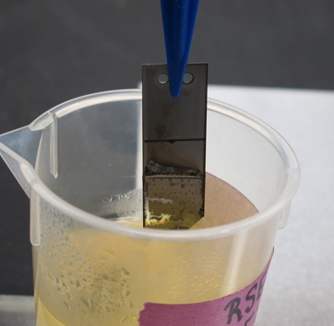

Figure 1. 44 - Diamond film that has been grown on a silicon substrate. After the growth, a portion of the silicon substrate is etched away to leave a freestanding diamond portion.
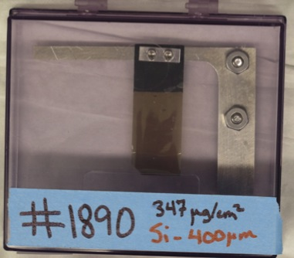
Figure 1. 45 - A fully processed nanocrystalline diamond film grown at ORNL by PECVD and ready to be implemented for the SNS production mode.

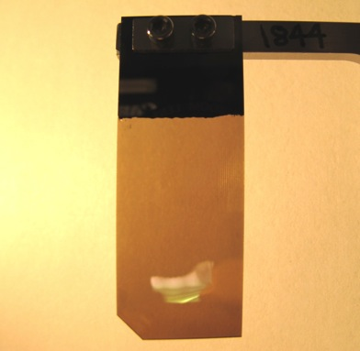
Figure 1. 46 - Nanocrystalline Diamond foil grown at ORNL preproduction SNS mode.
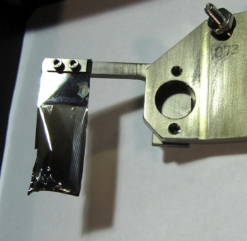
Figure 1. 47 - Microcrystalline diamond foil grown at ORNL by PECVD post-production SNS mode.
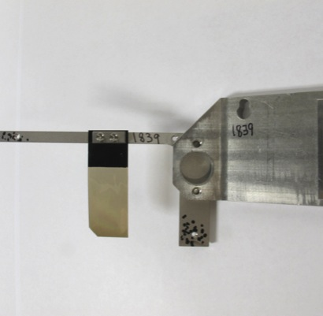
Figure 1. 48 - Nanocrystalline diamond foil grown at ORNL that has additional fiber supports.

1.2.3.4 BlueWave Semiconductor

The next type of foil used within the SNS is a nanocrystalline diamond foil grown by hot filament chemical vapor deposition at Blue Wave Semiconductor (BWS). These films are very similar to the foils grown by PECVD, with the lithography pattern and silicon substrate contributed by ORNL. These films showed great uniformity and were shipped from BWS to ORNL to have the silicon substrate etched away and loaded into the SNS for testing. The first BWS foil loaded within the SNS performed very well and showed the potential to be a viable alternative to PECVD. One concern of the BWS foils is there method of growth and that particles from the filament are contaminating the films. Although the films performed well and any impurities that may exist seems to have no impact on the foil lifetime, it is yet to be decided if there are any long term affects within the SNS from these impurities that may be detrimental to the machine.

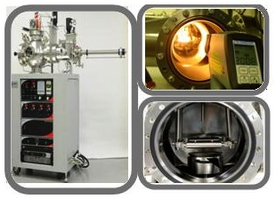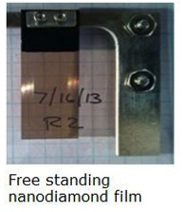
Figure 1. 49 BlueWave Semiconductor growth chamber (left) and a nanocrystalline diamond foil post-growth/etch (right).
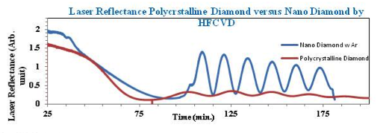
Figure 1. 50 - Laser Reflectance of a polycrystalline and nanocrystalline diamond film.

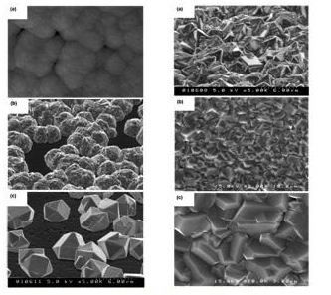
Figure 1. 51 - SEM images of the Hot Filament CVD growth of diamond films. Left Side - various concentrations of methane gas in hydrogen (a) 7 sccm, (b) 5 sccm, and (c) 2 sccm. Right side - SEM images of diamond films grown at (a) 6 hrs, (b) 25 hrs, and (c) magnification of (b).

1.2.3.5 HBC

The last type of foil that has been used within the SNS is the Hybrid Boron mixed Carbon (HBC) foil developed by Isao Sugai et al. of the High Energy Accelerator Research Organization (KEK) in Japan. The HBC foils were grown by a technique devised at KEK known as the Controlled AC/DC Arc Discharge Method (CADAD). The CADAD method works by alternating arc discharge between an anode and a cathode. Typically films grown from an anode produce carbon clusters that have an average size of 3 nm. The smaller size makes these films very strong against mechanical shock but the film becomes fragile when placed within the beam. On the other hand films grown from the cathode produce larger carbon clusters, typical size being 500 nm.

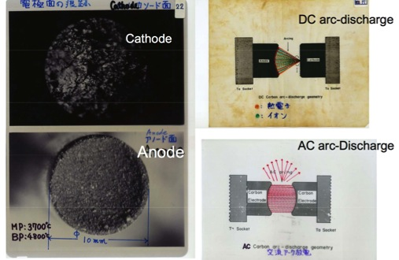
Figure 1. 52 - Photograph of the cathode and anode used in Sugai's CADAD method, along with the appropriate DC and AC arc-discharge diagrams.

These films are able to withstand high intensity beams but are very sensitive to mechanical shock. Therefore Sugai et al. decided to develop films that alternate between growth from an anode and growth from a cathode. It was found that the lifetimes of the foils became sensitive to the following ratio:

Lifetime Ratio = $\frac{Wc}{Wc+Wa}$

Where:
W_{c} = discharged amount of carbon from the cathode
W_{a} = discharged amount of carbon from the anode

After several growths, it was found that the best conditions of foil growth was when the lifetime ratio was greater than 50%. Unfortunately this limited that thickness of foils that could be grown before the foils began coming off of the substrate to 130 ± 40 μg/cm². Therefore to overcome this obstacle, the graphite rods were doped with various atoms including beryllium (Be), boron (B), aluminum (Al), and silicon (Si) to name a few. Of all the dopants tried, it was found that the foils that were grown by boron-doped graphite rods gave the best results. These foils are known as the Hybrid Boron mixed Carbon Stripper Foils (HBC-foil) and were grown by doping the graphite rods with up to 20% boron.

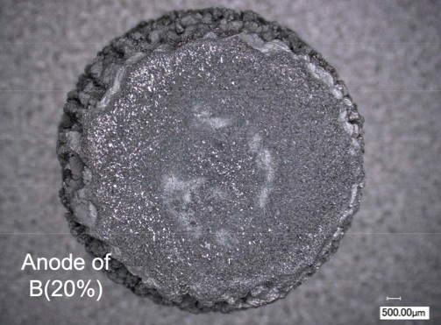
Figure 1. 53 - Sugai's anode doped with 20% boron.

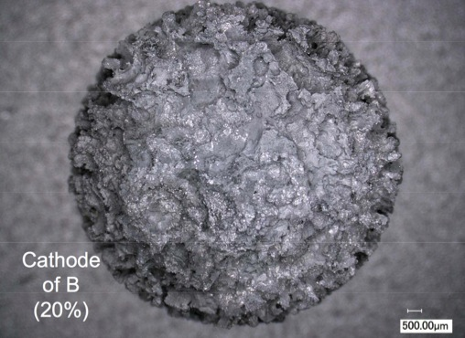
Figure 1. 54 - Sugai's cathode doped with 20% boron.

The HBC foils are limited to a maximum aerial density of approximately 170 – 200 μg/cm² before the films begin to peel away from the glass substrate. In order to accommodate the needs of the SNS, it requires that two HBC foils be used in conjunction with one another to meet the necessary aerial density requirement of 350 μg/cm². A set of HBC foils was used for a brief period within the SNS during the 2014 cycle. Since the foils did not have a way of being mounted directly to the foil bracket, a set of carbon fibers were used to hold the two foils together and in place on the bracket. Following the standard ramp up protocol within the SNS, the HBC foils began to show immediate issues with foil flutter. After a short period in production mode, the foils were deemed non-operational due to their severe foil flutter. When the foils were taken out of the SNS, it was found that the two foils that had been joined together by carbon fibers were no longer together and had essentially bowed out from one another. Since the foils were now no longer in parallel together, the SNS was essentially experiencing a single foil of ~170 μg/cm² which lead to high beam loss and a substantial decrease in stripping efficiency.
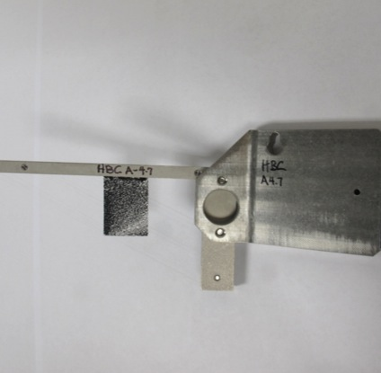
Figure 1. 55 - Sugai's HBC foils supported by carbon fibers prior to being placed into the SNS for production mode.

The foils currently used at J-PARC were grown by a method developed by Sugai et al. These foils are referred to as Hybrid type thick Boron-doped Carbon (HBC) foils that are approximately 1 μm thick with a corresponding aerial density of 200 μg/cm². Sugai has been growing stripper foils for accelerators for over thirty years by a variety of methods. His initial work relied on two arc-discharge methods to develop carbon foils. The first method is by DC arc-discharge. This method would grow foils by ablation of a carbon cathode onto a glass slide with particle sizes on average of 0.50 micrometers (μm). The foils developed are very delicate to mechanical stress but very tough against high-intensity ion beams. The second method is by AC arc-discharge. In this method, foils were grown by ablation from both the anode and cathode electrode and produce carbon particles with an average size of 0.03 μm. The foils developed are very durable to mechanical stress but become very frail when placed in a high-intensity ion beam. Sugai successfully proposed and developed a combination of the two methods, to get the benefits of mechanical stress durability by the AC arc-discharge method and the robustness against high-intensity ion beams by the DC arc-discharge method. This method is known as the controlled AC-DC arc discharge method (CDAA or CADAD). This method was developed in the 1980’s to produce carbon stripper foils that would have an extended lifetime in accelerators. The CADAD method is beneficial because it has a range of carbon particle sizes (0.03 to 0.50 μm) that provide good mechanical support and lifetime within high-intensity beams. The setup of the CADAD method has two major units that are placed inside a vacuum system. The first unit is the DC arc-discharge source that uses two different carbon rods, the first is a 15-millimeter (mm) anode rod and the other is a 0.5 μm cathode rod. The power source has energy of 20 volts (V) and a current of 105 amperes (A). The second system is the AC arc-discharge source that uses two carbon rods that have an approximate diameter of 3 to 5 mm. The AC power source has energy of 20 V and 75 A. The two systems are alternated back in forth to grow the appropriate film thickness and particle size. In order to determine how effective the CADAD method is compared to previous methods, a 3.2 MeV neon ion (Ne⁺) beam was used to provide lifetime measurements. Lifetime tests showed the CADAD method increased the average lifetime of carbon stripper foils when bombarded by a high intensity heavy ion beam.

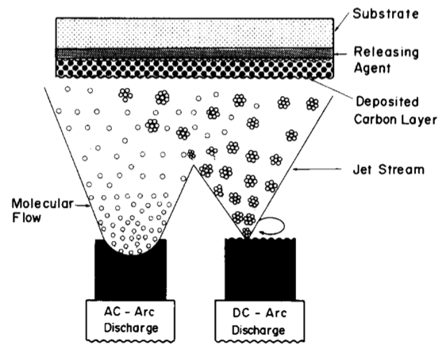
Figure 1. 56 - Schematic drawing of the carbon deposition using two arc-discharge carbon sources.

Since the early development of the CADAD method, Sugai and his team of researchers of continually modified the system to produce carbon stripper foils for accelerators. One accelerator of particular interest is J-PARC, which requires a thick carbon stripper foil (250 – 500 μg/cm²) to strip the H⁻ beam coming from the LINAC of its two electrons before being injected into the RCS. The foils created must be able to withstand a 25 Hz pulsed beam with energy of 400 MeV and current of 335 microamperes (μA). This corresponds to a temperature on the foil of 1800 Kelvin (K). One of the major issues with the CADAD method is the growth of foils that have an aerial density greater than 170 ± 30 μg/cm². As the foils begin to get thicker, they have a tendency to want to curl up from the substrate. Therefore to overcome this issue, Sugai and his colleagues suggested doping his graphite rods used in CADAD with other atoms; some of these atoms include: beryllium (Be), boron (B), aluminum (Al), and silicon (Si). Initial research demonstrated that foils doped with boron allowed better adhesion to the substrate and allowed thicker foils to be grown. This development has led to the growth of Hybrid type thick Boron-doped Carbon (HBC) foils. The HBC foils are more uniform in their growths compared to other foils grown by the CADAD method, as illustrated in Figure XX.

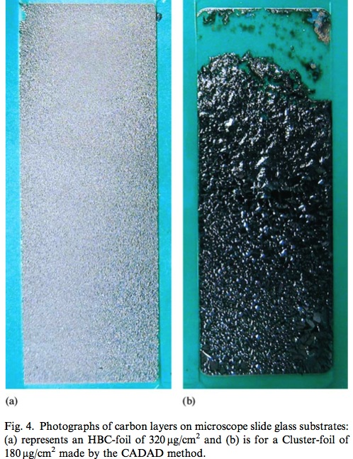
Figure 1. 57 - Photograph of carbon layers on microscope slide glass substrates.

Lifetime measurements were performed to determine how the HBC foils would compare to other commonly used stripper foils used in accelerators. As used previously, a 3.2 MeV N⁺ beam with a current of 2.5 ± 0.5 μA and a spot size diameter of 3.5 mm was utilized.

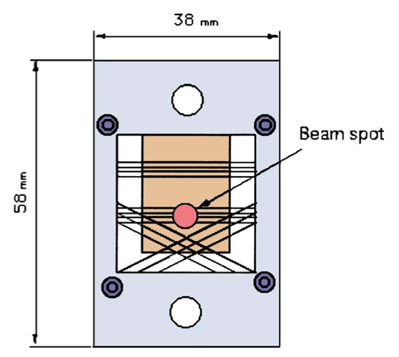
Figure 1. 58 - A target holder for lifetime measurements of hybrid boron mixed ribbon carbon foils using a 3.2 MeV Ne⁺ beam.

The foils tested included HBC foils of 200 – 380 μg/cm², diamond foils (DM foils) of 350 μg/cm², diamond foils of 680 – 780 μg/cm², and commercially available thick foils (CM-foils) of 200 – 400 μg/cm². Below is a table (Table xx) of results published by Sugai and his colleagues along with images of a HBC and diamond foil throughout the testing processes (Figure XX – HBC, Figure XX – DM).

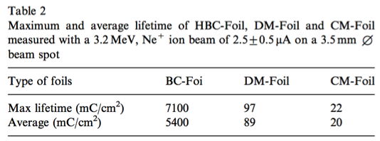
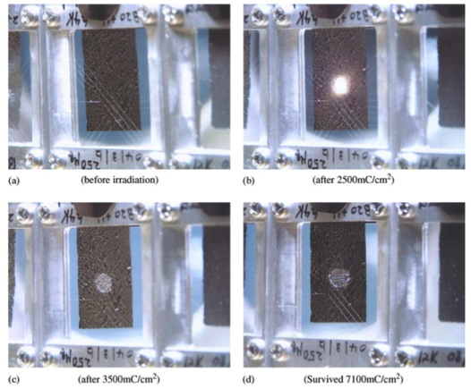
Figure 1. 59 - Photograph of a HBC foil (340 μg/cm²) after ion irradiation.
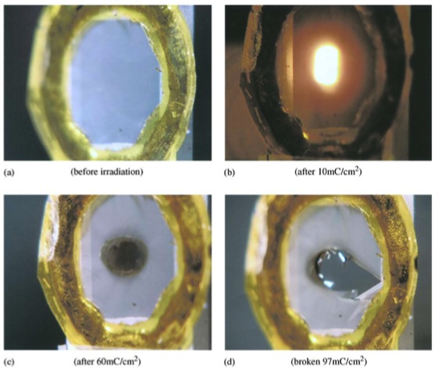
Figure 1. 60 - Photograph of a diamond foil on its Si ring-frame at different stages of ion irradiation.

Under these specific beam conditions, Sugai et al. was able to show that the HBC foils had an extended lifetime than CM, DM, and previous undoped carbon foils made by the CADAD method.
The HBC stripper foils have had great success at J-PARC, but had very little success when placed in the SNS at ORNL. When placed in the SNS, the HBC foils were given a modified bracket to accommodate for fiber supports needed to hold the foil. SNS tested the HBC foils twice at their operating beam conditions. In order to meet the required aerial density for stripping efficiency, two HBC foils of 175 μg/cm² formed a set of foils that were held together by either carbon or silicon fibers. The first set employed carbon fibers. After SNS operators applied a standard conditioning to the foils, the foils were placed into operation. Under the SNS beam conditions, the HBC foils failed within thirty minutes and were quickly replaced. The major issue the operators faced was drastic foil shaking and substantial beam loss. After the foils were taken out of the SNS, they were analyzed to determine why the HBC foils failed so readily. Below is a series of pictures taken by an SNS employee, Chris Luck, who was first to document how the set of two HBC foils separated from one another despite being held together by fiber supports.

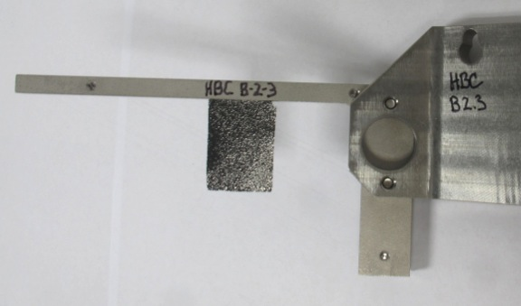
Figure 1. 61 - Sugai's HBC foil preproduction mode in SNS.
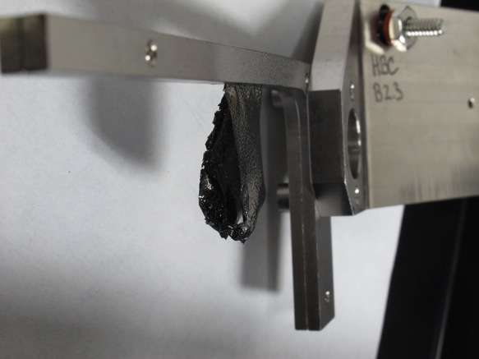
Figure 1. 62 - Sugai's HBC foil postproduction mode in SNS. The two HBC foils separated despite being held in together by carbon fibers.
(Reference #1: I. Sugai et al., Nucl. Instr. and Meth. A 561(2006) 16; Reference #2: Analysis of Hybrid Type Boron-Doped Carbon Stripper Foils in J-PARC RCS: http://iopscience.iop.org/1742-6596/417/1/012071/pdf/1742-6596_417_1_012071.pdf ; Reference #3 : Development of thick hybrid-type carbon stripper foils with high durability at 1800 K for RCS of J-PARC)

Despite J-PARC’s early success, progress has been slowed since the large earthquake and tsunami that hit Japan in March of 2011.

1.2.3.2 Fiber supported vs. no fiber supports

1.2.4 Comparison of stripper foils

Several types of foils that have a variety of chemical compositions and designs have been used within the SNS since it was first place into production mode in 2006 as mentioned in the preceding sections. A list of the types of foils used along with the number of each type used, the range of thicknesses, and the amount of charge the foils experienced while in the SNS before either being removed or failing are in Table XX. By far the most commonly used foil within the SNS is the Nanocrystalline Diamond foil developed at ORNL. This foil has become the “go-to-foil” when the SNS operators are in need of a reliable foil with predictable results. In addition to being reliable, this foil has been extensively studied and characterized to help predict how this type of foil will perform under SNS operation. The major limitation of this foil that was mentioned in the preceding section is the mechanical defects that are formed from post-growth handling and development. Despite these foils being made of one of the strongest material known to man, i.e. diamond, these foils are still very fragile. These foils’ free-standing diamond portion have been known to break off from the silicon handle with a turbulent air current, and additionally these foils’ edges tend to break if the etching process is too rapid. In addition to being the most commonly used, the nanocrystalline diamond foils made at ORNL have been able to withstand high current loads. Other foils that have performed very well, but with less frequency, include the microcrystalline diamond and boron-doped nanocrystalline diamond made at ORNL, and the nanocrystalline diamond foils made by BlueWave Semiconductor. Certain foil types have not performed as well under the SNS operational conditions. These foils include the carbon foils from TRIUMF, the diamond like carbon from ACFC, and the HBC foils by Sugai. These three foils perform well at other facilities in which the beam intensity is much lower. Additionally these three foils require being supported to the foil bracket by fibers. The use of fibers, mainly carbon fibers, helps keep these foils flat and rigid to provide a uniform surface for stripping. Unfortunately at high intensities, the fibers tend to break and lead to very intense foil fluttering. This intense foil fluttering makes the foils an operational headache for SNS operators and are typically replaced with a more rigid foil. The ACFC as mentioned previously, were initially used to characterize the SNS machine and help determine beam loss prior to developing a standard for a nanocrystalline diamond foil. After a standard was created for the nanocrystalline diamond foil on stripping efficiency, the uses of ACFC became obsolete and haven’t been used within the SNS since its early days. The TRIUMF foil were used once with very little success and quickly failed due to large foil flutter. The HBC foils developed by Sugai have been implemented twice within the SNS. The HBC foils have had great success at KEK and J-PARC, which has a similar design to SNS but is currently at a much lower intensity. Despite the HBC’s success at the facilities in Japan, the higher intensity beam at SNS is too detrimental to the HBC foils. The HBC foils experience high foil flutter and high beam loss, deeming these foils unusable for the SNS during production mode.
Primary Stripper Foils Used-to-Date Within the SNS
Foil Type | Number of Foil Used | Thickness Weight (µg/cm²) |  |  | Charge to Target (Coulombs)
Foil Type | Number of Foil Used | Minimum | Average | Maximum | Minimum | Average | Maximum
Diamond Like Carbon  ACFC | 4 | 260 | 260 | 260 | N/A | N/A | N/A
Boron-Doped Nanocrystalline Diamond - ORNL | 6 | 302 | 334 | 356 | 0.092 | 1666.529 | 6952.879
Microcrystalline Diamond ORNL | 15 | 265 | 329 | 463 | 0.000 | 912.849 | 2561.337
Nanocrystalline Diamond  ORNL | 33 | 265 | 317 | 391 | 0.000 | 1180.642 | 3177.000
TRIUMF | 1 | N/A | N/A | N/A | 16.000 | 16.000 | 16.000
HBC  KEK - Sugai | 1 | 350 | 350 | 350
Nanocrystalline Diamond  BlueWave Semiconductor | 1

In addition to the several types of chemical composition of foils used within the SNS, there have been additionally several types of lithography patterns used on the foils, specifically the diamond foils developed by ORNL researchers. The various lithography patterns have been researched to provide better stabilization for the foils to prevent and/or minimize foil flutter. These lithography patterns include U-shaped (50 and 100 lines per inch), checkerboard, Full U, U Sine, U with square corners, random ellipses, and concentric rings. A pictorial representation of the types of lithography patterns currently developed is in Figure XX. The success of the different types of lithography patterns will be discussed in a proceeding chapter. In addition to the different types of lithography patterns implemented, research on other physical features of the films and how they affect performance has also been completed. These other features include how the edges of the freestanding diamond portion effect foil flutter. When the diamond film is grown on the silicon substrate, the film is deposited on the top of the substrate as well as along the sides of the substrate. When the silicon substrate is etched away from the diamond, it typically leaves a uniform edge around the foil that has been labeled as the “box-top lid,” due to the remarkable similarity to a lid on a shoebox. This box-top lid is typically 1 μm thick, which is corresponds to the thickness of the silicon substrate. Researchers at the SNS were initially concerned that this increase in thickness along the edge would increase beam loss and scattering. Therefore portions of the films’ box-top lids were removed post growth. In addition to removing the areas of the box-top lids, one of the bottom corners of the films was cut off both pre- and post-growth to help eliminate some beam loss from where the circulating beam passed through the film. In order to compare how the removal of the box-top lid affected foil performance, additional foils were developed that had a continuous box-top lid all the way around the foil. In addition to how the lithography patterns affected performance, the affect the various types of box-top lids had on the performance of the foils will be discussed in a proceeding chapter. A pictorial representation of the foils and their various types of box-top lids are illustrated in Figure XX and Figure XX.

Figure 1. 63 - Depiction of some of the various types of lithography patterns developed at ORNL.

Figure 1. 64 - Diagram of a diamond foil with a full box top edge.

Figure 1. 65 - Diagram of a diamond foil with the box top edge along the sides but removed from the bottom.

Figure 1. 66 - Diagram of diamond foil with corner cut pre-growth to allow a continuous box-top lid.

Figure 1. 67 - Diagram of diamond foil with corner cut post growth, leaving a partially incomplete box-top lid.

1.2.5 Champion stripper foils

There have been a few foils in the SNS lifetime that have lasted almost an entire run cycle of SNS, and have been labeled as “champion foils.” In addition to the champion foils, there have been numerous foils that survived the SNS for a month without failing but were changed out in order to try different foils. These foils have a variety of properties that led to their success.

The first champion foil was Foil #1073, which was a nanocrystalline diamond foil made by PECVD at ORNL. Foil #1073 had an aerial density measured by alpha ranging of 344 μg/cm², U-shaped lithography pattern of 50 lines/inch, box-top lid on all sides, total size of 17 mm x 45 mm with the standard free diamond portion of 17 mm x 30 mm, and was a relatively continuous film as revealed by SEM. After the silicon substrate was etched away, the foil remained flat with no curling, showed no tears along the box-top lid, and was a rather perfect foil without any noticeable physical defects. The foil was attached to the current standard titanium foil bracket in which the bottom of the foil bracket was taken off. The foil was loaded into the PFC on August 5, 2009, and conditioning of the foil started about a month later on September 3, 2009. After the foil was conditioned for a few days, the foil was used for production on September 8, 2009 until the end of the SNS run cycle on December 22, 2009. The average beam energy was 928.00 MeV, a total charge placed on the Target of 4,820 Coulombs, a total power placed on the Target of 1,254.658 MW, and a peak power level on the Target of 1,038.400 kW or 1.038 MW. This foil never failed during operation but was rather removed from beam due to the end of the SNS run cycle. The foil was removed from the PFC on August 5, 2010 in which post-analysis pictures were taken of the foil.

Insert before/after picture of Foil #1073
SEM of Foil #1073

The second champion foil was Foil #1108, this was also a nanocrystalline diamond foil made by PECVD at ORNL. Foil #1108 had an aerial density measured by alpha ranging of 332 μg/cm², U-shaped lithography pattern of 50 lines/inch, box-top lid on all sides, total size of 17 mm x 45 mm with the a free diamond portion of 17 mm x 35 mm, and was a relatively continuous film with some cloudy regions near the top of the foil as revealed by SEM. After the silicon substrate was etched away, the foil remained relatively flat with a slight curling, showed a small vertical tear on box-top lid near the silicon edge, and was a rather good foil without any other physical defects. The foil was attached to the current standard titanium foil bracket in which the bottom of the foil bracket was taken off. The foil was loaded into the PFC on August 5, 2009, and conditioning of the foil started about several months later on February 18, 2010. After the foil was conditioned for a few days, the foil was used for production on February 23, 2010 until the end of the SNS run cycle on June 30, 2010. The average beam energy was 925.05 MeV, a total charge placed on the Target of 7,359 Coulombs, a total power placed on the Target of 1,890.792 MW, and a peak power level on the Target of 1,085.499 kW or 1.086 MW. Similar to Foil #1073, Foil #1108 never failed during operation but was rather removed from beam due to the end of the SNS run cycle. The foil was removed from the PFC on August 5, 2010 in which post-analysis pictures were taken of the foil.

Insert before/after picture of Foil #1108
SEM of Foil #1108

The third champion foil was Foil #B1616, this was also a boron-doped microcrystalline diamond foil made by PECVD at ORNL. Foil #B1616 was doped with 10 ppm diborane that gave the foil a blue appearance, an aerial density measured by alpha ranging of 308 μg/cm², U-shaped lithography pattern of 100 lines/inch, box-top lid on all sides except where the corner of the foil was cut off post-growth/pre-etch, total size of 17 mm x 45 mm with the a free diamond portion of 17 mm x 31 mm, and was a relatively continuous film as revealed by SEM. Unlike the first two champion foils, Foil #B1616 was etched without the use of tape to protect the silicon substrate. After the silicon substrate was etched away, the foil remained relatively flat and had a horizontal rip 4 mm below the silicon handle on the bracket size. Despite this defect, the foil appeared to be very good without any additional physical defects. The foil was attached to the current standard titanium foil bracket in which the bottom of the foil bracket was taken off. The foil was loaded into the PFC on January 31, 2012, and conditioning of the foil started a couple months later on March 13, 2012. After the foil was conditioned, the foil was used for production from March 13, 2012, to April 9, 2012. The foil performed very well in this initial month of production and was switched out to try a different foil. After having trouble with a different foil for a few days, Foil #B1616 was placed back into production mode on April 13, 2012, and used for the remaining of the SNS cycle that ended on June 20, 2012. The foil overall had very little foil flutter for the entire cycle, curling of the foil that worsened and than flattened out, and hot spots along the bottom edge for a short period of time. The average beam energy was 910.80 MeV, a total charge placed on the Target of 6,952.879 Coulombs, a total power placed on the Target of 1,757.860 MW, and a peak power level on the Target of 1,051.026 kW or 1.051 MW. Similar to the first two champion foils, Foil #B1616 never failed during operation but was rather removed from beam due to the end of the SNS run cycle. The foil was removed from the PFC on July 17, 2012 in which post-analysis pictures were taken of the foil.

Insert before/after picture of Foil #B1616
SEM of Foil #B1616

The fourth champion foil was Foil #1499, this was a nanocrystalline diamond foil made by PECVD at ORNL. Foil #1499 had an aerial density measured by alpha ranging of 344 μg/cm², U-shaped lithography pattern of 100 lines/inch, corner cut post-growth, box-top lid on all sides except for the 45° angle on the corner, total size of 17 mm x 45 mm with the a free diamond portion of 17 mm x 30 mm, and was a relatively continuous film as revealed by SEM. After the silicon substrate was etched away, the foil was floppy because of the 8 mm of box-top lid missing 4 mm below the silicon handle. The foil was attached to the current standard titanium foil bracket in which the bottom of the foil bracket was taken off. The foil was loaded into the PFC on August 7, 2012, and conditioning of the foil started several months later on January 5, 2013. After the foil was conditioned for a few days, the foil was used for production on February 5, 2013 until being switched out on April 2, 2013. The foil performed very well, with hot spots visible only on the first day and had a measured stripping efficiency of 98.2%. The average beam energy was 910.80 MeV, a total charge placed on the Target of 3,498 Coulombs, a total power placed on the Target of 1,890.792 MW, and a peak power level on the Target of 1,085.499 kW or 1.086 MW. Similar to the other foils, Foil #1499 never failed during normal operation but instead was used for a high hit density test on April 1, 2013, for 7 hours and 22 minutes. The foil was removed from the PFC on July 23, 2013, in which post-analysis pictures were taken of the foil.

Insert before/after picture of Foil #1499
SEM of Foil #1499

The fifth champion foil was Foil #1872, this was a nanocrystalline diamond foil made by PECVD at ORNL. Foil #1872 had an aerial density measured by alpha ranging of 339 μg/cm², U-shaped lithography pattern of 100 lines/inch, corner cut post-growth, box-top lid on all sides except for the 45° angle on the corner, total size of 17 mm x 45 mm with the a free diamond portion of 17 mm x 29.5 mm, and was a relatively continuous film as revealed by SEM. After the silicon substrate was etched away without the use of tape, the foil had a slight twist on the bracket side but had no visible tears or other physical defects. The foil was attached to the current standard titanium foil bracket in which the bottom of the foil bracket was taken off. The foil was loaded into the PFC on July 23, 2013 and conditioning of the foil started several months later on February 18, 2014. After the foil was conditioned, the foil was used for production on February 18, 2014 until being switched out on April 6, 2014. The foil performed very well, with a slight fluttering during its first few weeks of production but then stabilized for the last few weeks of operation. The foil was still in good shape when removed from production. The average beam energy was 910.80 MeV, a total charge placed on the Target of 4,633 Coulombs, a total power placed on the Target of 968.742 MW, and a peak power level on the Target of 25.320 kW or 0.025 MW. Similar to the other foils, Foil #1872 never failed during normal operation but was removed to test another foil for its performance capability. The foil was removed from the PFC on July 23, 2013, in which post-analysis pictures were taken of the foil.

Insert before/after picture of Foil #1872
SEM of Foil #1872

The sixth champion foil was Foil #1402, this was a nanocrystalline diamond foil made by PECVD at ORNL. Foil #1402 had an aerial density measured by alpha ranging of 320 μg/cm², U-shaped lithography pattern of 100 lines/inch, corner cut post-growth, box-top lid on all sides except for the 45° angle on the corner, total size of 17 mm x 45 mm with the a free diamond portion of 17 mm x 30 mm, and was a relatively continuous film as revealed by SEM. After the silicon substrate was etched away with the use of tape, the foil had a hole on the beam side that was approximately 16.5 mm from the bottom and 6 mm from the side. The foil was attached to the current standard titanium foil bracket in which the bottom of the foil bracket was taken off. The foil was loaded into the PFC on August 5, 2010, and conditioning of the foil started on November 2, 2010. After the foil was conditioned, the foil was used for production on February 9, 2010, until being switched out on December 22, 2010. The foil performed very well, with a slightly increase beam ramp of 400 kW to 900 kW over a 1.5 days. The foil was still in good shape when removed from production. The average beam energy was 925.00 MeV, a total charge placed on the Target of 3,177 Coulombs, a total power placed on the Target of 802.878 MW, and a peak power level on the Target of 1,085.688 kW or 1.086 MW. Similar to the other foils, Foil #1402 never failed during normal operation but was removed to test another foil for its performance capability. The foil was removed from the PFC on February 7, 2011, in which post-analysis pictures were taken of the foil.

Insert before/after picture of Foil #1402
SEM of Foil #1402

In addition to these six champion foils (add any foils from 2014/2015 run cycle), there were several other foils that performed very well and lasted on average for one month of the SNS production before being switch out for another foil. They are listed in the following table, Table XX. The most common foil used within the SNS, the nanocrystalline diamond foil made at ORNL by PECVD with an U-shaped lithography pattern, is by far the most common foil that performed well.

Additional Champion Foils
Foil Number | Foil Type | Lithography Pattern | Corner Cut |  | Overall Size | Free-Standing | Aerial Density by α-Ranging | Average Beam Energy | Charge on Target | Power on Target | Peak Power on Target
Foil Number | Foil Type | Lithography Pattern | Before Growth | After Growth | mm x mm | mm x mm | μg/cm² | MeV | Coulombs | MW | MW
1143 | ND | U-50 | - | - | 17 x 45 | 17 x 35 | 368.0 | 925.00 | 2010 | 536.477 | 1.018
1443 | ND | U-100 | - | ✓ | 17 x 45 | 17 x 30 | 326.0 | 925.00 | 1646 | 426.289 | 0.931
1437 | ND | U-100 | - | ✓ | 17 x 45 | 17 x 30 | 326.0 | 925.00 | 2120 | 553.787 | 0.881
1439 | ND | U-100 | - | ✓ | 17 x 45 | 17 x 30 | 326.0 | 925.00 | 2162 | 545.575 | 0.846
1467 | ND | U-100 | - | ✓ | 17 x 45 | 17 x 30 | 344.0 | 925.00 | 1405 | 360.886 | 0.839
1477 | ND | U-100 | - | ✓ | 17 x 45 | 17 x 30 | 320.0 | 925.00 | 1666 | 428.094 | 0.845
1497 | ND | U-100 | - | ✓ | 17 x 45 | 17 x 30 | 344.0 | 925.00 | 1614 | 414.645 | 0.835
1508 | ND | U-100 | - | ✓ | 17 x 45 | 17 x 28 | 344.0 | 925.00 | 1294 | 332.383 | 0.837
1524 | ND | U-100 | - | ✓ | 17 x 45 | 17 x 30 | 320.0 | 925.00 | 1457 | 374.273 | 1.017
1474 | ND | U-100 Checkerboard | - | ✓ | 17 x 45 | 17 x 30 | 368.0 | 925.00 | 2271 | 583.597 | 1.044
1495 | ND | U-100 | - | ✓ | 17 x 45 | 17 x 30 | 356.0 | 918.51 | 2245 | 568.086 | 1.036
B1674 | BD | U-100 | - | ✓ | 17 x 45 | 17 x 30 | 356.0 | 910.80 | 2480 | 616.980 | 1.034
B1752 | BD | U-100 | - | ✓ | 17 x 45 | 17 x 30 | 350.0 | 910.80 | 2449 | 97.881 | 1.039
1792 | ND | U-100 | - | ✓ | 17 x 45 | 17 x 30 | 320.0 | 910.80 | 1633
1501 | ND | U-100 | - | ✓ | 17 x 45 | 17 x 30 | 320.0 | 910.80 | 1925
1554 | ND | U-100 | - | - | 17 x 45 | 17 x 30 | 368.0 | 910.80 | 1884
1822 | ND | U-100 | ✓ | - | 17 x 45 | 17 x 30 | 352.0 | 910.80 | 1869 | 478.485 | 19.677
1839 | ND | U-100 | ✓ | - | 17 x 45 | 17 x 29.5 | 352.0 | 910.80 | 1842 | 483.819 | 23.487
HBC B-2.3 | HBC | - | - | - | 17 x 25 | 17 x 25 | 350.0 | 910.80 | 1382 | 358.293 | 18.766
1862 | ND | U-100 | ✓ | - | 17 x 45 | 17 x 30.5 | 364.0 | 910.80 | 2582 | 669.223 | 19.626
1505 | ND | U-100 | - | ✓ | 17 x 45 | 17 x 30 | 344.0 | 910.80 | 2120 | 240.215 | 24.031

1.2.6 Post-analysis of stripper foils

Analysis of the stripper foils that have been used within the SNS has been difficult to obtain on a routine basis due to the high radioactivity of the foils, especially since these foils are extremely fragile and difficult to handle. If the foils were to break to any degree, it has the potential to be swept up in an air current and contaminate the surrounding environment. Despite this issue, careful handling of the foils has allowed post-beam analysis of almost all the foils by photographs and a select number of foils by a scanning electron microscope. Post-beam analysis foils have shown a wide-range of damage, ranging from a slight wrinkling and darkening of the foil to a complete removal of the free-standing foil from the silicon handle. It has been noted on several occasions that the foils that experience severe foil flutter within the SNS typically have a mechanical defect that is causing the foil to shake. These mechanical defects include a horizontal rip across the freestanding portion of the foil, a vertical tear along the edge of the foil (i.e. the box-top lid), a break between the freestanding portion and the silicon handle, and severe curling or wrinkling of the foil. Some of these defects are shown in the following post-beam analysis photographs.

Image of foil that has a horizontal rip
Image of foil that has a vertical tear
Image of foil with break between diamond and silicon handle
Image of curling/wrinkling

Additional analysis of one of these foils, Foil #1792, by a scanning electron microscope (SEM) was completed to determine if and how the crystallinity of the foil changed after being placed in the SNS beam line.

Image of Foil #1792 before beam
Image of Foil #1792 after beam

SEM images taken from here

SEM stub
Removed for SEM

Figure 1. 68 - Diagram of where various SEM images were taken.

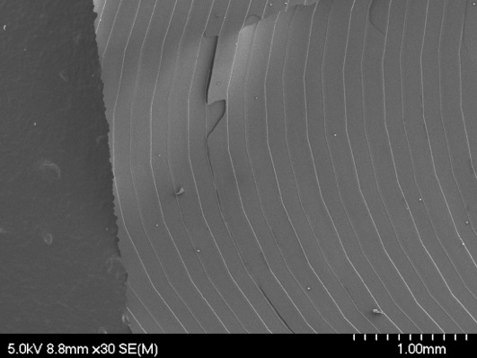

Location 1
Location 2
Location 3
Just outside
corrugations
Edge of notched
location on foil
Cracks from mounting sample
Location 4 near Si substrate on opposite end of foil from notch.

Figure 1. 69 - Overall view of SEM.
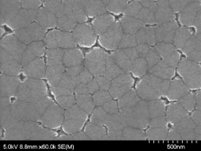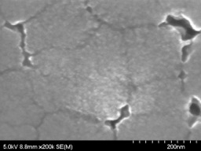
Figure 1. 70 - SEM Image - Location 1.A
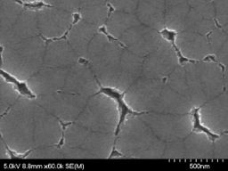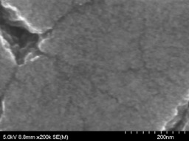
Figure 1. 71 - SEM Image - Location 1.B
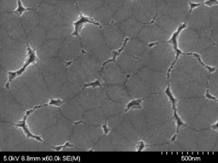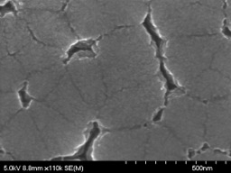
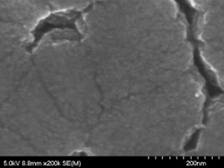
Figure 1. 72 - SEM Image - Location 2.A
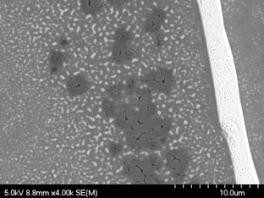
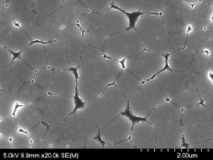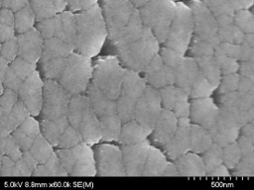
Figure 1. 73 - SEM Image - Location 2.B
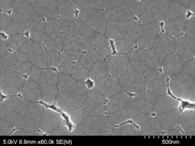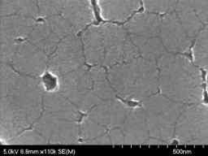
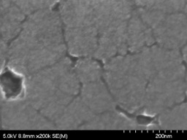
Figure 1. 74 - SEM Image - Location 3
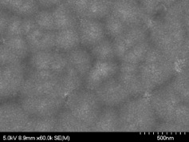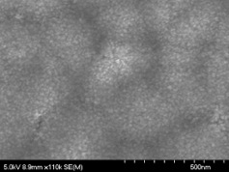
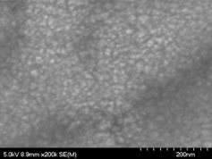
SEM Image – Location 4
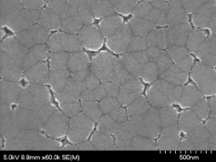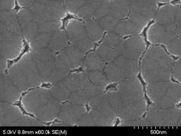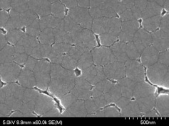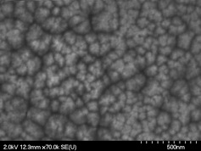
Figure 1. 75 - SEM Image - Comparison (1, 2, 3, 4, and non-irradiated)

1.3 SNS Current Conditions and Problems

The current status of SNS is providing to provide researchers with a 1.0 to 1.4 MW beam of protons to a mercury target. In the past year, several obstacles have delayed the progress of SNS to provide a constant design value of 1.4 MW. These obstacles are the result of both growing pains of a decade old machine and human error. Some examples that SNS employees have faced in recent months include multiple mercury target failures; water contamination in various portions of the linac; and multiple components that have either failed completely or have limited operation. Despite these issues, SNS employees have been able to successfully diagnosis and resolve these problems. By utilizing the lessons learned from recent obstacles and better understanding how to operate such a large machine with a decade of experience, the SNS will continue to deliver the scientific community the most intense pulsed neutron beams in the world.

1.4 Purpose of Foil Development Team

The Foil Development Team was developed in 2001 in consisted of members from ORNL, SNS, and UTK. This group consists of both highly skilled technicians in foil growth and development, experts in chemical vapor deposition, and experts in accelerator physics. The mission of this group is to design and develop foils for use in the SNS to maintain current operating conditions of 1.0 to 1.4 MW, along with developing foils for future SNS upgrades of 2.0 and 3.0 MW. One aspect of this team that is of particular interest to this work is developing and characterizing a variety of foils to determine how well the foils will perform under SNS operating conditions. This includes the use of an electron beam test stand to help determine how foils will perform under various thermal loads experienced in the SNS.

References
- Mike Plum – “Injection and Extraction – Stripper Foils”
  - http://web.ornl.gov/~mp2/Plum_5_foils.pdf
- Comparison of Carbon Stripper Foils Under Operational Conditions at the Los Alamos Proton Storage Ring
  - https://accelconf.web.cern.ch/accelconf/HB2008/papers/wgc02.pdf
- TRIUMF (wiki)
  - http://en.wikipedia.org/wiki/TRIUMF
- Lifetime of Carbon Stripping Foils for the Spallation Neutron Source (PAC 2001)
  - https://accelconf.web.cern.ch/accelconf/p01/PAPERS/TPAH138.PDF
- Maximum Temperature on the Carbon Stripping Foil in the Spallation Neutron Source
  - https://www.bnl.gov/isd/documents/86427.pdf
- The Spallation Neutron Source
  - http://www.aps.org/units/dpb/resources/upload/holtkamp.pdf
- Ion Source Development for the Spallation Neutron Source (Thesis)
  - http://trace.tennessee.edu/cgi/viewcontent.cgi?article=1684&context=utk_chanhonoproj
- Plasma & Ion Source Technology
  - http://ibt.lbl.gov/plasmatechnology.html
- The Spallation Neutron Source (SNS) LINAC RF System
  - http://arxiv.org/pdf/physics/0008070.pdf
- Commissioning Plans for the SNS DTL and CCL
  - https://accelconf.web.cern.ch/accelconf/l02/TOC/..%5CPAPERS%5CTU422.PDF
- The SNS LINAC and Storage Ring: Challenges and Progress Towards Meeting Them
  - http://epaper.kek.jp/e02/PAPERS/TUZGB002.pdf
- LabVIEW of SNS
  - http://ics-web.sns.ornl.gov/TuningGuide/Front%20Only%20Mode/Startmap-Timing-Master.png
- SNS Accumulator Ring Design and Space Charge Considerations
  - http://www.iaea.org/inis/collection/NCLCollectionStore/_Public/32/002/32002992.pdf
- SNS’s high energies call for a pioneering target source design
  - http://web.ornl.gov/info/ridgelines/mercury.htm
- A New Type of Stripping Carbon Foil for H⁻ Charge-Exchange Injection into a Synchrotron
  - http://ac.els-cdn.com/0168900287906681/1-s2.0-0168900287906681-main.pdf?_tid=b7cfeb48-ffe0-11e4-9e21-00000aacb360&acdnat=1432230315_34a1d597cd60bc8f2917827bb4423883
- Multilayer Carbon Foils for Cyclotron Beam Extraction
  - http://ac.els-cdn.com/S0168900208002647/1-s2.0-S0168900208002647-main.pdf?_tid=ecbac06e-ffd9-11e4-b18b-00000aab0f02&acdnat=1432227397_09b1f83a3f3b2aa16c6924b02691360f
- Production of Stripper Foils by Laser Ablation of Carbon-Boron Sputter Targets
- http://www.bluewavesemi.com/blog-sns-isdrs.html
- Present Status of HBC Stripper Foil Development (Sugai Seminar)
  - http://beamdocs.fnal.gov/AD/DocDB/0034/003496/001/sugai_seminar.pdf
- a

ADDITIONAL INFORMATION IF NEEDED

Dirk’s Dissertation

The Spallation Neutron Source is one of the world’s most powerful accelerator-based pulsed neutron sources. Located at the Oak Ridge National Laboratory in Oak Ridge, Tennessee, USA, the SNS is a third generation neutron source that provides pulses of neutrons for research in neutron scattering. SNS begins with the ion source (see figure 1.1 for a layout of the SNS facility), where 1 ms long macro-pulses of H- ions are produced in a magnetically- confined plasma at a rate of 60 Hz.
A Low Energy Beam Transport (LEBT) line transfers the ions into a 2.5 MeV Radio 2
Figure 1.1 Spallation Neutron Source conceptual layout. The SNS was built by a partnership of six U.S. Department of Energy laboratories. [3]

Frequency Quadrupole (RFQ) accelerator that defines the bunching structure for RF acceleration. After the RFQ, a Medium Energy Beam Transport (MEBT) section prepares the beam for the linear accelerator (linac) to accelerate the particles to approximately 88% the speed of light. An electrostatic chopper, in the LEBT, with a 50 ns rise time, along with a traveling wave chopper with a 20 ns rise time in the MEBT, cut 300 ns gaps to a level of 1x10-3 and 1x10-6 respectively, in the 1 ms macro-pulse to create a succession of mini-pulses.

The linac begins with two warm sections, a drift tube linac (DTL) and a coupled cavity linac (CCL), that accelerate the beam to 186 MeV. The latter portion of the linac is comprised of a liquid helium cooled, niobium superconducting linac (SCL) that finishes the acceleration. Upon exiting the linac, the 1 GeV H- ions pass through a high energy beam transport line (HEBT) to a foil where they are stripped of electrons. The time structure of the resulting proton beam in the ring can be seen in figure 1.2.

The ring accumulates 1060 individual 645 ns long mini-pulses with a peak beam current of 38 mA to a full intensity of 1.5x1014 protons per pulse, as illustrated in figure 1.3. This 1 μs high intensity pulse is transported to a liquid mercury target at a rate of 60 pulses per second with an average beam power of 1.4 MW. The spallation reaction produces a range of energetic neutrons which are then moderated and sent to a variety of experiments [3], [4].

http://arxiv.org/pdf/physics/0611157.pdf

3.4. Carbon foil lifetime
There are a number of factors that have impact on the lifetime of carbon foils: instant temperature rise, average temperature rise, mechanical stress and displacement, fatigue due to thermal buckling, sublimation (solid to gas transition at temperatures above 1600 °C), radiation damage of the structure [16], etc. Although we know how to estimate these effects either analytically or numerically, it is not clear which one is the determining factor. It is quite likely that the failure of a carbon foil is a combinational result of all these factors. Furthermore, foil manufacture technique and foil microstructure play a major role in lifetime. For the same ion bombardment, different types of foils can have vastly different lifetime. Hence, beam test in an accelerator is the ultimate way to determine the lifetime of a carbon foil.
4. Discussion
Liouville’s theorem precludes multi-turn injection of particles identical to those already present in a circulating beam. H− injection through a stripping foil provides a mean to circumvent this difficulty. As the energy increases, however, stripping efficiencies tend to decrease, which leads to the employment of thick foils. But the thickness is limited by thermal and mechanical considerations and cannot arbitrarily increase to compensate for the reduction in interaction cross-section. Furthermore, a thick
9
foil would result in more severe effects on the beam (e.g. emittance dilution due to multiple Coulomb scattering, acceptance limit due to large angle single Coulomb scattering, energy straggling, etc.) as well as on the machine (e.g. radiation activation of magnets nearby the foil). But these topics are beyond the scope of this paper.
In a high intensity proton machine, uncontrolled particle loss must be kept at a very low level in order to prevent activation of the accelerator components. A balance between the foil efficiency and foil lifetime must be studied carefully. It is necessary to design conservatively and ensure that adequate safety factors are introduced. Progress in foil technology demonstrates the possibility of new foils of much longer lifetime compared to the conventional ones [17]. This is encouraging news. Plans are under way to install these new foils in an operational accelerator for long term testing.

Chapter 2. Foil Test Stand - Experimental

Introduction and Purpose of FTS

The Spallation Neuron Source (SNS) at Oak Ridge National Laboratory (ORNL) has successfully operated since 2006 with only a few major problems. The SNS currently uses a standard nanocrystalline diamond foil that typically has an aerial density of 350 μg/cm² and a U-shaped lithography pattern (refer to previous section for description of lithography patterns). In recent years, the SNS employs a foil for one month of operation before replacing it. This accounts for approximately eight to ten foils per year. After the SNS started full operation in 2006, there was great need to have the instrument reliable for the various users coming from around the world. Therefore it was difficult to experiment with different foil composition and types that are currently being developed, and severely limited the foil development program. In 2009 the Foil Development Team (FDT), composed individuals from ORNL, SNS, and the University of Tennessee at Knoxville (UTK), deemed it necessary to develop a table top test stand that would allow a more adaptable approach to testing foil properties than what could be done during normal operation at SNS. This test stand would allow a variety of foils to be examined, along with determining the various properties that influence the success of a foil within the SNS. Since having an accelerated H⁻ beam was not feasible as a table top source, there was need to have a source that would both meet the size restriction and still apply the same thermal load that the foils experience during operation. Therefore it was calculated that a thirty thousand electron-volt (30 keV) beam could apply a spot on a foil with a high enough current density to simulate the thermal load of the SNS. This device became known as the Electron Beam SNS Foil Test Stand, or more commonly the Foil Test Stand (FTS).

Description of Foil Test Stand

The Foil Test Stand (FTS) was designed and built by members of the Foil Development Team (FDT) in 2009, to further the advancement of the foil development program. The FTS consists of several different components, including a 30 keV electron gun, a faraday cup and limiting aperture, a residual gas analyzer, various vacuum components, an actuator and bracket that allows up to four foils to be attached, an infrared camera, a high definition video recorder, and a stainless steel vacuum chamber that houses several of these components.

Instrumentation

Electron Gun
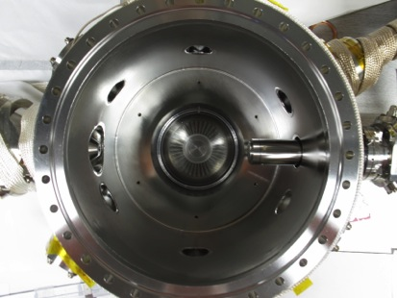
Figure 2. 1 – Top view of FTS chamber.

One of the most important units on the FTS is the electron gun and its corresponding power sources. The electron gun was a prototype developed by Kimball-Physics and is capable of producing a 30 keV electron beam with currents up to 5 milliamperes (mA). The electron gun consists of several different components to help focus and control the beam. These components are divided into four main sections, the triode, focus, beam collimation, and deflection.

The triode is made up of three different components that are in sequence with one another: the cathode, the grid or Wehnelt, and a grounded anode. The cathode is a thermionic emitter that is heated by an isolated voltage source from 0 to -30 kilovolts (kV). The cathode is made up of a 300 square micrometer (μm²) lanthanum hexaboride (LaB₆ or LAB6) crystal. The original LAB6 cathodes produced by Kimball-Physics were made into a conical shape with the tip of the cone flattened to produce a 15 micrometer (μm) surface with a <100> orientation. The flattened portion provides the best electron emission and therefore would produce a focused spot size diameter of 15 μm. In order to increase the focused spot size of the electron beam, the LAB6 crystal conical portion was flattened to give a spot size diameter of 19.5 μm. This in turn leads to a focused spot size of approximately 300 μm².

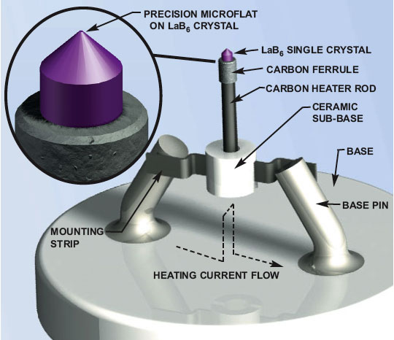
Figure 2. 2 - Cathode of Kimball Physics Electron Gun

The total amount of electron emission that is obtainable is a function dependent upon the cathode’s temperature and energy. If the temperature is low and the energy is high, it is operating in a temperature-limited mode. This is described by the Richardson-Dushman equation:

J = AT²e^{-ϕ/κT}

Where:
J = emission current density [amperes per square centimeter (A/cm²)]
A = Richardson’s constant for each cathode material [amperes per square centimeter per square Kelvin (A/cm²/K²)]
T = cathode temperature (K)
ϕ = work function of cathode [electron volt (eV)]
κ = Boltzmann’s constant = 8.6 x 10⁻⁵ eV/K

There is an exponential relationship between the temperature and the amount of electron emission. Therefore to increase the amount of emission, the temperature of the cathode must be increased. The amount of emission will continue to increase as the temperature increases until reaching a space charge limited region. In this region, the temperature no longer increases the amount of emission despite the increase in available electrons. On the other hand, if the temperature is high and the energy is low, it is operating in a space charge limited mode. This mode of operation is described by the Langmuir-Child space charge equation:

J = 2.335 x 10⁻⁶ V^{3/2}/d²

Where:
V = energy applied to cathode [volts (V)]
d = distance between cathode and anode [centimeters (cm)]

While in this mode, the amount of emission is dependent upon the amount of energy applied to the system, i.e. space charge limited. If the temperature of the cathode is held constant and the energy is increased, the amount of emission will increase until it reaches a temperature limited mode. This is similar to the space charge limited mode in that the amount of emission no longer increases with an increased applied energy, but will now only increase if the temperature of the cathode is increased. Operating the cathode in either a temperature or space charge limited mode has both desirable and undesirable effects. The temperature-limited mode allows for longer cathode lifetimes, but the beam current will tend to fluctuate. The space charge limited mode allows for less current fluctuations, but shorter cathode lifetimes due to the higher temperatures involved.

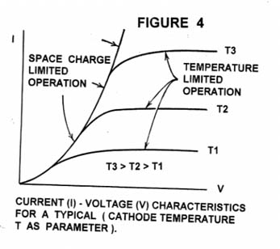
Figure 2. 3 - Current (I) vs. Voltage (V) characteristics for a typical cathode.
The second component of the triode is Wehnelt, more commonly called the control grid or Grid. The grid is a cylinder device that encases the cathode and has an applied voltage source, in reference to the negative energy supply. This voltage source, along with an aperture on one side of the Grid, restricts the emission of electrons. Applying a voltage source to the Grid, in reference to the negative energy supply, restricts the electron emission. If the voltage is increased on the Grid (increasing the grid bias), the electric field between the Grid and the cathode limits the amount of electron emission that occurs along the edge of the cathode. This makes the electrons get emitted in a columnar form from the center of the cathode. If the voltage is increased further, it will completely prevent any electrons from being emitted. The amount of voltage applied to the Grid is dependent upon the amount of electron beam energy. As the amount of electron beam energy is increased, the amount of voltage that must be applied to the Grid must increase as well to ensure that the beam becomes either collimated or completely suppressed. It is very important to have a well-collimated beam of electrons as it exits the Grid to prevent loss of current from other elements within the electron gun and to better represent the ratio between the beam current and the emission current. Where the beam current is the actual current leaving the gun and the emission current is the total current coming off of the cathode with respect to ground. The ability to easily adjust the amount of voltage applied to the Grid allows the operator to alternate between complete suppression of the beam and collimation of the beam, i.e. it allows the beam to be pulsed.

The third component of the triode is the anode that is an aperture plate held at ground potential. This creates an electric field between the anode and cathode/Grid because of its potential difference. By aligning the anode and cathode up with one another, such that the electron’s energy and direction can be fine-tuned.

The second section of the electron gun is the focus, which is a set of three tubes in series to form an Einzel lens. An Einzel lens is when the first and last tube are held at ground potential, while the middle tube has variable potential. This enables the electron gun to be focused at different energies and working distances. It also allows the ability to increase the spot size by defocusing the beam.

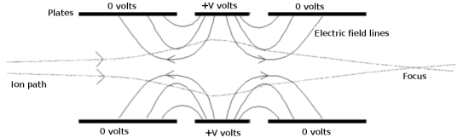
Figure 2. 4 - Einzel Diagram
(http://www.wikiwand.com/en/Einzel_lens)

Figure XX – Figure 3.5-1,2 (page 3-6)

The third section of the electron gun is the beam collimator. This is designed to do as its name suggests- to help collimate the electron beam. This works by setting the electron gun parameters to make the electrons travel in a parallel direction to one another. In addition, this allows the ability to keep the spot size and beam current density constant while the distance to the target is varied. In Figure XX below is an example of how to determine the collimating focus value by using several different working distances that have the same beam energy, source current, and source voltage. This is achieved by adjusting the focus voltage. Additionally, the amount the electron beam can be collimated is dependent upon the beam energy and current. If the beam energy is low, the electrons are able to travel at a lower velocity and will cause the beam to be less collimated because of the space charge effects within the beam. This is overcome by increasing the beam energy to help keep the electrons collimated. If beam current is high, there is a larger number of electrons present in the beam. This will cause the spot size of the beam to increase. To overcome this, a longer working distance is often employed to allow the beam additional time to become collimated.

Figure XX – Figure 3.6-1,2 (page 3-7)

The final section of the electron gun is the deflection assembly. The deflection assembly consists of two pairs of deflection plates that are in series with one another, a pair vertical plates (x-deflection) and a pair of horizontal plates (y-direction). By applying voltage to the deflection assembly, it allows the beam’s position to be controlled on the target. The voltage applied to the deflection plates may be altered back and forth to raster the beam on the target. Rastering of the beam increases the total spot size that the beam will cover on the target. Since the two pairs of deflection plates are in series with one another, first the y-deflection plates and second the x-deflection plates, the amount of voltage that must be supplied to each of these deflection plates to move the beam a similar amount is different. Additionally it is understandable that at higher beam energies, a higher voltage must be applied to the deflection plates to move the beam a similar amount to lower beam energies. Although it is sometimes necessary to largely deflect the beam, it should be noted that at larger deflections it is common to have distortion within the beam that leads to uneven distribution of the beam onto the target. Therefore it is with great need that the electron gun is optimized to limit the amount of deflection that is applied to prevent any beam distortion.

Figure XX – Figure 3.7-1,2 (page 3-8)

The electron gun is powered by a combination of a Kimball-Physics EGPS-4215 power supply and a Glassman High Voltage Supply. This combination supplies the electron gun the necessary high voltage needed to each of its components. The FTS is a very dynamic tool that is used to analyze and characterize a variety of foils that have the potential to be used within the SNS. The FTS has the capability to replicate the current and future thermal loads that the foils experience within the SNS. In order to meet the necessary spot size requirement, it is required that the beam from the electron gun be rastered in both the x- and y-direction. Rastering of the electron beam allows for a larger, but still uniform, sample size to be placed on the foil. Listed below are the capabilities of the electron gun as specified by the manufacture, and include the standard voltage and current ranges for the different components within the electron gun.

EMPS – 4215 Power Supply Ranges
 | Standard LaB₆ Cathode
Additional High Voltage Supply (Slave Energy) | 0 to -30 kV  (at 5 mA)
Energy | 0 V to -30 kV
Source (voltage) | 0 V to 3.0 V
Source (current) | 0 A to 6 A
Emission Current | 0 mA to 5 mA
Grid | 0 V to -500 V
Focus | 0 V to -20 kV
X-Deflection | -300 V to +300 V
Y-Deflection | -300 V to +300 V

Table XX – Table 4.1-1 EMG-4125 Power Supply Ranges (page 4-7)

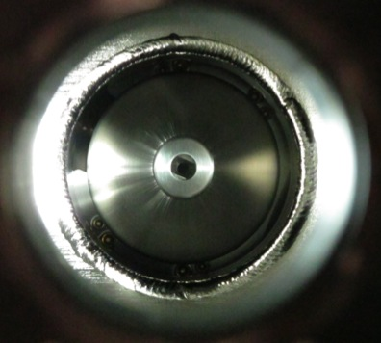
Figure 2. 5 - Photograph looking into the electron gun, picturing the two sets of x- and y-deflection plates.

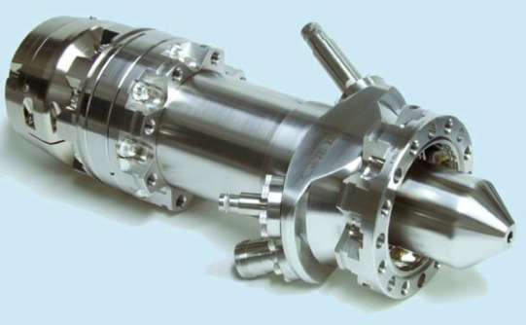
Figure 2. 6 - Overall view of the electron gun.

The second unit of the FTS that is of important is the Limiting Aperture and Faraday Cup. The Limiting Aperture (LA) and the Faraday Cup (FC) are in combination with one another and are directly opposite of the electron gun. The LA is a circular piece of stainless steel that has an aperture in the center that regulates the size of beam that may enter the FC. The FC is a long cylinder with the outer walls made of stainless steel and the inner diameter cylinder made of copper. The FC captures the electrons that go through the LA from the electron beam and indicate how well focused and tuned is the beam. Since the FC experiences a large amount of energy, it is necessary to regulate the temperature of the FC by cooling it with deionized water. Below are several images of the FC/LA. The first is the location of the FC/LA as it appears within the stainless steel vacuum chamber. Next is a view from the top of how the LA is attached to the FC. The last three images are focused on the FC; the first is top view of the FC without the LA, the second and third are looking into the FC at the copper lining. It shows how the copper has a spiral grove that helps direct the electrons coming in to the very back of the FC. A set of bias maybe applied to both the FC and LA to help direct the electrons. In addition to directing the beam with the deflection plates and bias being applied to the FC/LA components, it is sometimes necessary to physically direct the FC/LA assembly to prevent a large distortion in the electron beam. A device located on the outside of the vacuum system that allows the FC/LA assembly to be rotated to allow a better beam optimization does this. ASK CHRIS WHAT THIS IS CALLED

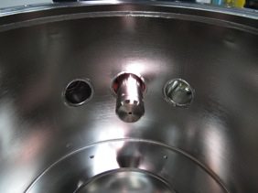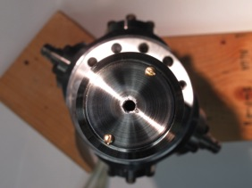
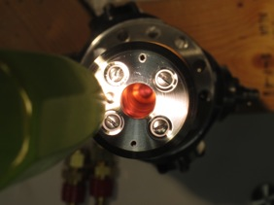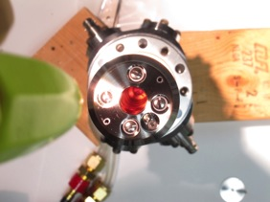
Figure 2. 7 - Various angles of the faraday cup and limiting aperture.

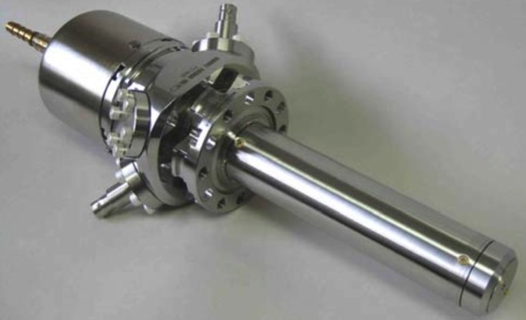
Figure 2. 8 - Overall view of the faraday cup and limiting aperture.
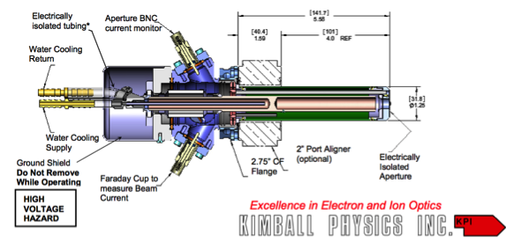
Figure 2. 9 - Schematic view of the faraday cup and corresponding components.

Residual Gas Analyzer
The next component that is of importance is the residual gas analyzer (RGA) from Stanford Research Systems (SRS). The RGA is a very small mass spectrometer that is connected directly to the vacuum system and is used to analyze the various gases within the vacuum chamber. As the different gases approach the RGA they become positively charged, then they travel through the RGA and are separated by a quadrupole magnet based upon their respective masses. The RGA is useful in readily analyzing the vacuum chamber environment for the different gaseous species that may be present. It is of particular interest when the vacuum system is leaked checked and when samples are introduced to a heat source, whether that heat source is the chamber being baked out or the electron gun.
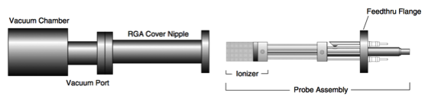
Figure 2. 10 - Overall view of the SRS RGA.

The SRS RGA consist of three major sections – the ionizer, the quadrupole, and the ion detector. The ionizer is made up of the repeller, the focus plate, the anode grid, and the filament. The filament produces electrons by being resistively heated to incandescence to ionizing the gas molecules within the vacuum chamber. By applying a negative bias to the filament relative to ground, the electrons that are produced become accelerated to the positively charged anode grid. The anode grid is a cage made of wire mesh that allows most of the electrons to pass through without being impeded. The electrons that make it through the anode grid will collide into the gas molecules and create positively charged ions. Some of the electrons will not undergo any collisions and end up in a region between the anode grid (positively biased) and the repeller (negatively biased). The repeller is another mesh cage that allows gas molecules to enter but repel electrons back from escaping. Therefore the electrons that don’t undergo any collisions will be accelerated back towards the positively biased anode grid. This process of will continue until either a gas molecule or the anode grid captures all electrons. While the electrons are undergoing this process, positively charged ions are being produced within the anode grid volume. To capture these ions, a negative bias is applied to the focus plate and a positive bias is applied to the anode grid. This allows the focus plate to lure out the ions into the filter section.
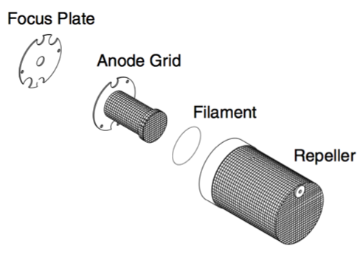
Figure 2. 11 - Inner components of the SRS RGA.

The second major section of the RGA consists of a quadrupole that helps filter the various ionized gas molecules for detection. The quadrupole consists of four stainless steel (type 304) cylindrical rods that are electrically conducting, and are held in place by a high-purity alumina insulator on each end to make them electrically isolated from ground. The four rods are divided into two pairs, with opposite side rods forming pairs designated by appropriate dimension (X consists of the top and bottom rod, while the Y consists of the left and right rod). A positive bias is applied to the X-dimension and a negative bias to the Y-dimension. As the ions travel into the quadrupole along the Z-dimension, alternating voltage is applied to rods at a frequency of f = 2.7648 megahertz (MHz) that begins to separate the ions based on their mass-to-charge ratio.
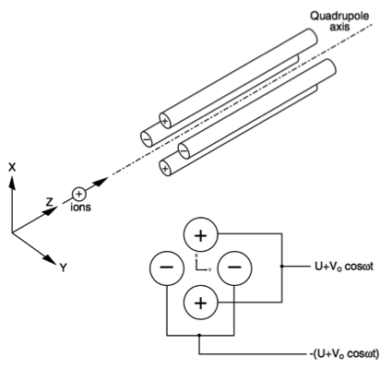
Figure 2. 12 - Diagram of the SRS RGA quadrupole.

The final section of the RGA is the ion detector, which measures the ion current directly by the use of a Faraday Cup. The Faraday Cup (FC) is essentially a receptacle made of stainless steel (type 304) that captures all the ions that make it through the quadrupole and is surrounded by the FC Shield. The FC Shield is a cylindrical tube that shields the FC from the quadrupole rods’ strong electrodynamic potentials and prevents the FC from capturing any ions that are not produced from the ionizer. Once the ions are captured and detected within the FC, the signal from the FC is sent to a detector to determine what gases are present within the vacuum chamber.

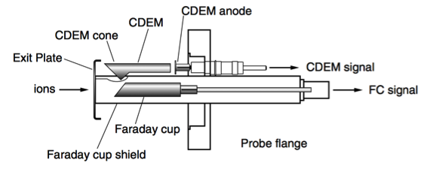
Figure 2. 13 - Schematic diagram of the SRS RGA.

Vacuum System

The next major component is the vacuum chamber. The vacuum chamber is made of a stainless steel tube that is eight inches long and has an outer diameter of twelve inches and an inner diameter of ten inches. On the topside of the stainless steel tube is a twelve-inch diameter conflate flange lid that provides the necessary seal to keep the system in an ultra-high vacuum state during operation. On the bottom side of the stainless steel tube is a reducing conflate flange that reduces the outer diameter from twelve inches to eight inches, which allows an eight-inch turbo molecular pump to be attached. The combination of the conflate flange lid on the topside and the turbo molecular pump on the bottom side allows the system to be pumped down and maintain an ultra-high to high vacuum state. Along the sides of the tube, there are additional vacuum ports that allow the attachment of the electron gun, the faraday cup, the RGA, vacuum gauges, and various view ports. The vacuum chamber was made by MDC Vacuum Products, LLC, and was machined precisely from a single piece of stainless steel. By using a single piece, it allowed for very accurate machining of the vacuum chamber to ensure all vacuum ports were at the correct location and angles to one another. This was essential in making sure the electron gun and the faraday cup ports were directly across from one another, to ensure that all the high-energy electrons were captured within the faraday cup.

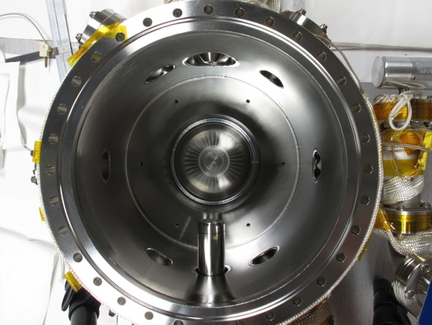
Figure 2. 14 - Top view of the FTS chamber, including the faraday cup (bottom), turbo molecular pump (center), and electron gun (top).

On the topside of the vacuum chamber is a twelve-inch diameter lid that has a one and half inch diameter port with a linear actuator and Z-stage attached. The linear actuator and the Z-stage have a travel distance of one inch and eight inches, respectively. This allowed the ability to design a sample holder that has the ability to hold three foils and a phosphorous disk, or simply just four foils. The phosphorous disk would be installed over a fourth foil when it is necessary to line and calibrate the electron gun, otherwise it is deemed unnecessary. The long travel distance of the linear actuator and Z-stage allows up to four foils with various characteristics and properties to be tested in a single vacuum pump down cycle. This allows for more consistent and accurate results between tests on different foils. Once it is decided on the number of foil samples to load into the vacuum chamber, the vacuum chamber is wrapped in heating tapes and aluminum foil for a twelve-hour bake out. The twelve-hour bake out removes most residual gases from the chamber, including water (H₂O), carbon dioxide (CO₂), and hydrogen gas (H₂). Occasionally other gases will appear to be offgasing from the chamber, including turbo molecular pump oil and hydrochloric acid (HCl). Following the bake out, the chamber is allowed to gradually cool to room temperature before any tests on the foils begin.

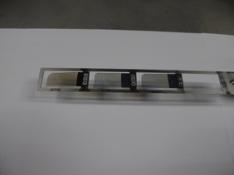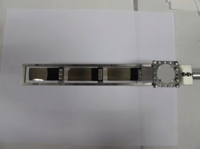
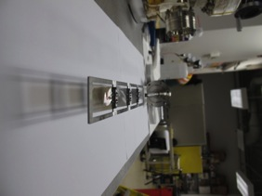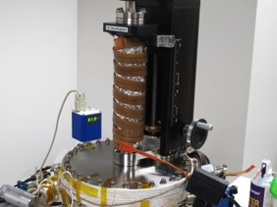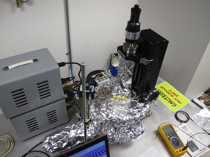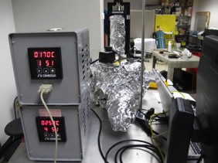
Figure 2. 15 - Various aspects of the FTS: multisample foil holder without phosphorous screen, multisample holder with phosphorous screen, multisample holder alignment, wrapping multimotion feedthrough with heater tape for bake out, wrapping of chamber with aluminum foil to provide uniform heating of chamber, and controlling of bake out with Omega controller.

LabVIEW

In order to efficiently and effectively control all the vacuum instrumentation, i.e. the electron gun, faraday cup, and limiting aperture, the system employs a custom designed graphical user interface (GUI) from LabVIEW. The GUI controls the electron gun’s beam energy and current, along with the necessary bias applied to the faraday cup and limiting aperture. This GUI was initially designed by Kimball Physics, but has since been further customized to better suit the needs of the FTS and its operators.

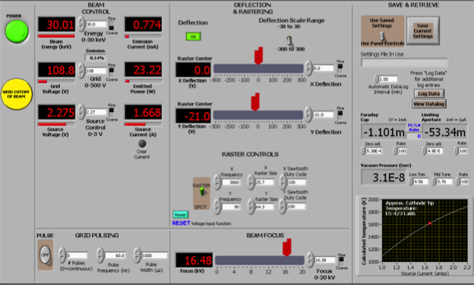
Figure 2. 16 - FTS electron gun graphical user interface in LabVIEW.

FLIR

The second most important component after the electron gun is the infrared camera. The infrared camera from FLIR uses an indium antimonide crystal as its sensor and has the ability to measure temperatures that range on a sample from 300 to 2500 °C. It has this ability to measure a wide temperature range because it uses a combination of three different filters, which each has their own range. The three different ranges are 300 to 500 °C, 500 to 1500 °C, and 1500 to 2500 °C. This majority of this work utilizes the second filter for a bulk of the measurements. In addition to being able to measure a sample’s temperature, it also has the ability to calculate the emissivity of a sample and measure a spot size. Since the emissivity of the foils being tested changes when exposed to the beam from the electron gun, it is crucial that the emissivity is known to accurately measure the temperature. Additionally it is important that the spot size that is being tested is known, since the calculation that relates the power density of the electron gun to that of the SNS is based on power density ratios. This infrared camera’s capability to measure the spot size is corroborated with measurements from a high magnification compact light microscope.

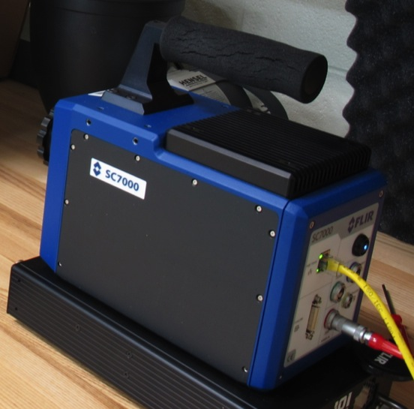
Figure 2. 17 - Photograph of the FLIR infrared camera used in experiments.

Cameras

In addition to the infrared camera, a high definition video recorder from JVC is also employed to monitor the foils. This video recorder has the capability to record both videos and pictures of foils throughout the whole process. This includes prior to the foils being loaded; after the foils are loaded; after the vacuum chamber is baked out; and before, during, and after all tests are performed on the foils. By being able to monitor and record the foils at the different stages, it allows a very complete and thorough analysis of how the foils change due to various beam conditions.


Figure 2. 18 - Photograph of JVC camera used to record and monitor foils during experiments.

Comparison to SNS

The FTS is a very dynamic tool that is used to analyze and characterize a variety of foils that have the potential to be used within the SNS. The FTS has the capability to replicate the current, and future, thermal loads that the foils experience within the SNS. In order to meet the necessary spot size requirement, it is required that the beam from the electron gun be rastered in both the x- and y-direction. Rastering of the electron beam allows for a larger, but still uniform, sample size to be placed on the foil. In order to compare the FTS to the SNS, it is necessary to determine what energy and current the electron gun from the FTS must apply to reach an equivalent thermal load as seen in the SNS.

Calculation and theory

As was stated in previous sections, the SNS was designed to produce a 1.0 GeV beam with a power of 1.4 MW and current of 70 A. This beam would be pulsed at 60 Hz, at a width of 1.00 ms. This corresponds to the beam to cycle between being on for 1 ms and off for 15 ms. This design parameter corresponds to a pulsed beam containing 1.5 x 10¹⁴ protons per pulse (ppp). In addition to foil being impacted by the 1.5 x 10¹⁴ ppp from the linear accelerator, the foil also experiences a foil load from the circulating beam within the accumulator ring. On average for each pulse coming from the linear accelerator, the foil will experience each proton seven to ten times. This accounts for the majority of the load that the foils experience. With this all in mind, a well-tuned SNS beam that is at the design-power of 1.4 MW, including the injected and circulating beams, will have a peak hit density on the foil of 4.5 x 10¹³ protons per square millimeter (p/mm²). Since the pulse width of the SNS beam is 1 ms (1 ms = 1x 10⁻³ s), then the peak proton beam density per unit time is approximately:

4.5 x 10¹³ p/mm² ÷ 1 x 10⁻³ s = 4.5 x 10¹⁶ p/mm²/s

To better understand this number of 4.5 x 10 ¹⁶ p/mm²/s, it can be converted to units of amperes. In units of amperes, this number corresponds to peak beam of 7.2 mA/mm².

Stopping Power

In order to compare the thermal load the foil will experience with the SNS H⁻/H⁺ to that of the FTS electron beam (e⁻), the stopping powers of the two different beams were compared. A 1.0 GeV beam of protons stopping power in amorphous carbon (density is ~2.0 g/cm³) is approximately 1.946 MeV*cm²/g. On the other hand, the stopping power of a 30 keV electron beam in amorphous carbon of the same density is 8.575 MeV*cm²/g. The stopping power of 30 keV electrons is ~4.43 times higher than that of a 1 GeV protons. Since the stopping power is much greater for electrons in amorphous carbon than protons are, it requires a lower power to achieve the same effect. Therefore to have a similar power density to that of a 7.2 mA/mm² proton beam, it is necessary to have an electron beam that can produce a power density of 1.6 mA/mm².

1.4 MW SNS Beam ≈ 1.6 mA/mm² Electron Beam
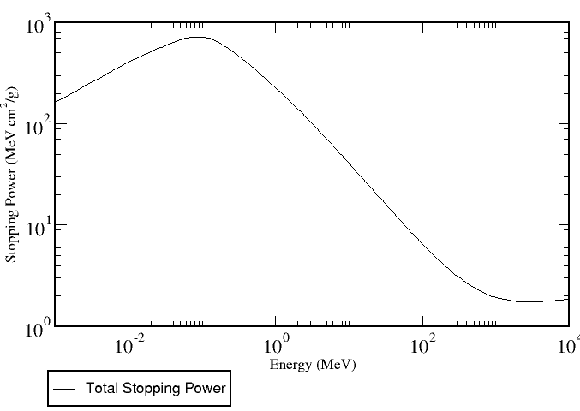
Figure 2. 19 - Stopping power of a 1 GeV Proton (1.946 MeV cm² g⁻¹) in amorphous carbon (density = 2.0 g cm⁻³)
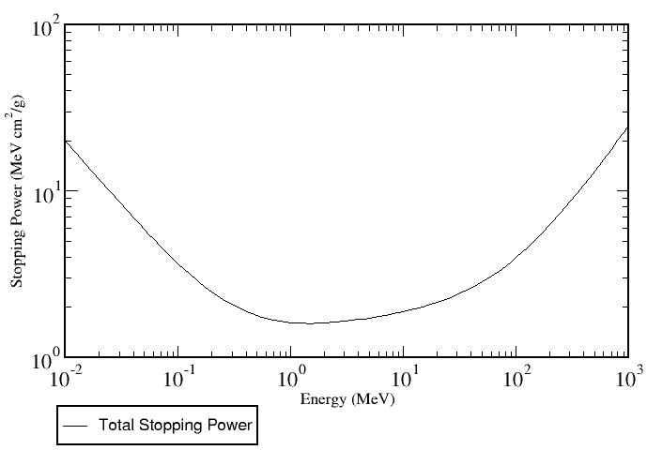
Figure 2. 20 - Stopping power of a 30 keV Electron (8.575 MeV cm² g⁻¹) in amorphous carbon (density = 2.0 g cm⁻³)

A concern with using electrons to simulate the thermal load the foils experience within the SNS is the range of the electrons within the foils. The typical foils used within the SNS are nanocrystalline diamond and an average aerial density of 350 μg/cm². A corresponding volume density of crystalline diamond is ~3.5 g/cm³. This gives a foil that is approximately 1 x 10⁻⁶ meters thick (or 1 μm). The range of 30 keV electrons is 1.996 x 10⁻³ g/cm² (1996 μg/cm²), which is over six times the average foil aerial density/thickness. Therefore it is believed that having a low power electron beam no additional effects from electrons being fully captured by the foil. In addition to being able to deliver a peak density of 1.6 mA/mm² to simulate a 1.4 MW SNS beam, it is also important that the electron gun is capable of delivering a similar spot size to that of the peak SNS beam size. The peak SNS beam size is approximately diameter of 3.00 mm, which corresponds to a beam area of 27 mm². Unfortunately to get the appropriate power density for a 27 mm² spot size, it would require either a single electron beam to produce a 43 mA beam simultaneously over this region or the rastering of a smaller electron beam of the same power density over the area. Since the first option is rather unrealistic for a tabletop electron source, it was decided that the spot size would be maximized for ~1 mm² and the beam would be rastered at a high enough frequency to prevent any unwanted cooling. This allowed the installation of a 30 keV electron gun, with a maximum emission current of 5 mA, to meet the design requirements.

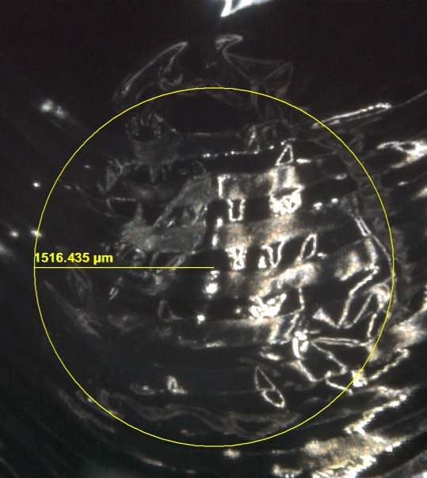
Figure 2. 21 - Determination of SNS spot size with Zeiss microscope measurement software.

Experimental

Several experiments were conducted on the FTS. Prior to conducting initial experiments on the primary stripper foils, it was first necessary to determine the capabilities of the electron gun and the other FTS components. Since the 30 keV electron gun was a prototype developed by Kimball Physics, it was essential to determine the limits and understand how well this electron gun prototype would be able to simulate the SNS beam. First off, it is necessary to recall the SNS beam conditions that need to be emulated to provide an accurate comparison. The SNS beam is pulsed at 60 Hz with a pulse width of 1.00 ms; it has a design beam energy of 1.0 GeV corresponding to a stopping power in amorphous carbon of 1.946 MeV cm² g⁻³, and a power density for a 1.4 MW proton beam of 7.2 mA/mm². The SNS beam size can range from a few millimeters to several millimeters in diameter. Therefore it was decided that the peak SNS beam size would be used, and it corresponds to a diameter of approximately 3.0 mm as measured post-production using a Zeiss microscope.
Since having a tabletop H⁻ source was not feasible as mentioned in previous sections, it was decided that an electron gun would be able to simulate the thermal load that the foil experiences within the SNS. Recall a thirty keV electron has a stopping power in amorphous carbon of 8.575 MeV cm² g⁻³. The stopping power of a 30 keV electron is 4.43 times larger; therefore to simulate a 1 GeV proton power density of 7.2 mA/mm², it is required to have a 30 keV electron power density of 1.6 mA/mm². The Kimball Physics electron gun is specified to have a maximum current output of 5 mA and a focused beam spot size of 0.300 mm². Therefore the maximum power density a focused beam my have is 16.7 mA/mm². Unfortunately this is only for a 1 mm² spot size, whereas the area of a 3.0 mm diameter SNS spot size is approximately 7.07 mm². If a pulsed beam was defocused to an approximate spot size of 7 mm², to get the appropriate 1.6 mA/mm² power density it would require an electron beam current of approximately 11.2 mA. This is over two times the specified maximum beam current on the electron gun. Additionally it was found that as the electron beam became defocused to increase the spot size, instead of having a uniform spot it created an annulus. This is expected since the majority of the electrons being discharged are coming from the circumference of a 0.300 mm² LaB₆ crystal. In order to overcome both the limited spot size and power density, it was decided that the electron beam could be rastered in both the x- and y-direction to increase the spot size but still have the appropriate power density being applied to the foil.
Rastering of the electron beam, or commonly called rasterization, is a technique that has been used for several years to increase the amount of area that an electron beam can cover. One of the most common devices that use the technique of rastering of a beam is an old television (i.e. tube television). The older televisions raster electron beams in both the x- and y-direction. Typically the rastering is much quicker in one direction over the other, painting the beam in a Z-like pattern. The Kimball Physics electronics allow the electron gun to be rastered in both the x- and y-direction at a very high frequency of 15,000 Hz. Initial work was determine what frequency ratio of x:y was required to optimize the electron beam. Several x:y ratios were tried that ranged from 150:1 to a 1:1, vice versa. In order to ensure that the spot had little to no cooling off between cycles, the maximum rastering frequency was employed. Below is a list of some of the rastering frequencies and the corresponding rastering ratios.

Table XX: Some of the raster frequencies and ratios tried with the electron gun.
Higher X Frequency |  |  | Higher Y Frequency
X Frequency  (Hz) | Y Frequency  (Hz) | Ratio  (X:Y) | X Frequency  (Hz) | Y Frequency  (Hz) | Ratio  (X:Y)
14,550 | 97 | 150:1 | 97 | 14,550 | 1:150
14,900 | 149 | 100:1 | 149 | 14,900 | 1:100
14,650 | 293 | 50:1 | 293 | 14,650 | 1:50
14,860 | 743 | 20:1 | 743 | 14,860 | 1:20
14,955 | 997 | 15:1 | 997 | 14,955 | 1:15
14,990 | 1,499 | 10:1 | 1,499 | 14,990 | 1:10
14,913 | 1,657 | 9:1 | 1,657 | 14,913 | 1:9
14,984 | 1,873 | 8:1 | 1,873 | 14,984 | 1:8
14,987 | 2,141 | 7:1 | 2,141 | 14,987 | 1:7
14,862 | 2,477 | 6:1 | 2,477 | 14,862 | 1:6
14,998 | 2,999 | 5:1 | 2,999 | 14,998 | 1:5

In addition to the table of some of the common raster frequency and ratios researched, it was also of interest to determine which ratio had the most uniform beam coverage on the foil. Therefore by looking at the coverage for one second of a beam being pulsed at 60 Hz with a width of 1 ms, the average area that the beam covered was calculated. Below are examples of the beam pattern that various ratios have on the foil; including a 1:9, a 1:8, and a 1:7 ratio. Initial experiments that used a raster ratio greater than 15:1 or 1:15, caused increase problems with foil flutter and caused non-uniformity in the beam area. Therefore to overcome these two issues, it was found that a ratio of 1:7 or 7:1 provided the best beam uniformity with the least amount of foil flutter. Since the SNS beam is not rastered, this is a major concern that additional foil flutter is not being caused in the FTS by the rastering of electron beam. In addition to having the best beam uniformity and least amount of foil flutter, the 1:7/7:1 ratio synchronized very well with the infrared camera from FLIR and the high definition video recorder from JVC.

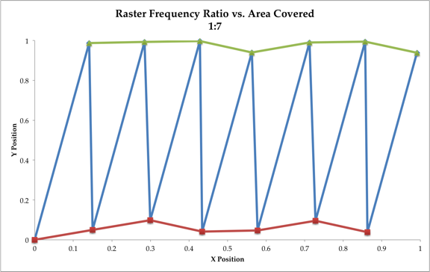
Figure 3. 1 - Raster Frequency Ratio vs. Area Covered (1:7)

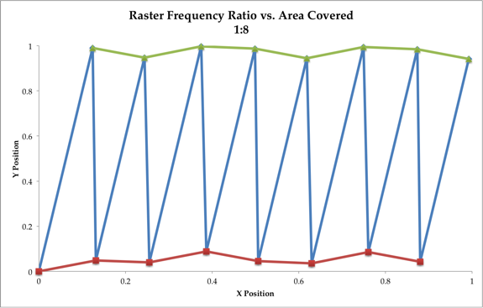
Figure 3. 2 - Raster Frequency Ratio vs. Area Covered (1:8)

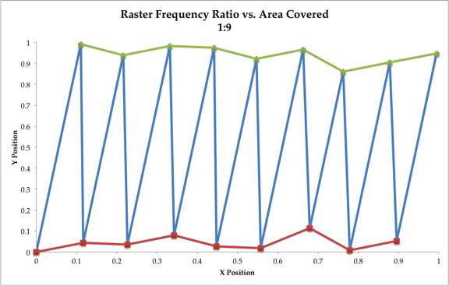
Figure 3. 3 - Raster Frequency Ratio vs. Area Covered (1:10)

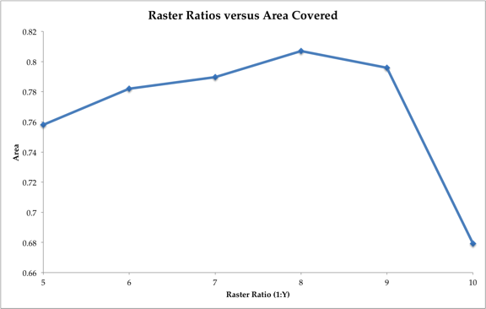
Figure 3. 4 - Raster Ratios versus Area Covered

While the appropriate rastering ratio was chosen, it was also necessary to determine the appropriate rastering sizes in the x- and y-direction. Since a focused spot size is 0.300 mm², it was necessary to find how much the voltage must be applied to each of the x and y deflection plates. Since the x deflection plates are closer to the filament, they required less voltage to be applied than to the y deflection plates to have the same impact on the size. It was found that a voltage of X V and Y V applied to the x and y deflection plates, respectively, gave the appropriate spot size radius of 1.5 mm². Although this set of voltage gave the appropriate spot size, it was often adjusted to provide a smaller spot size when testing the foils to allow for a greater number of tests to be completed on a single foil.
Once the appropriate raster frequency and size were determined, it was also important to determine the general protocol for testing several types of foils. Most of the foils tested within the FTS were diamond foils developed at ORNL, with similar sizes and parameters. This allowed for repeatable tests to be conducted on the foils, along with determining which parameters seemed to have the most influence on foil lifetime the most. Since one of the main purposes of the FTS is to help predict how foils will respond when placed into the SNS for production, it was necessary to provide a similar beam protocol. After the foils are loaded into the SNS and prior to the foils being used for production, the operators of the SNS condition the foil. Conditioning of the foil involves the gradual increase of beam power onto the foil to help accommodate the material transformation that is occurring within the foil. It was discovered in the SNS that a foil that experienced either a burst of power or a hasty conditioning would become severely damaged and decrease the overall lifetime. The results were confirmed several times within the FTS, both intentionally and unintentionally, would cause a hole in the foil. Therefore a gradual ramp up of the beam both within the SNS and FTS was necessary. A typical ramp up within the FTS would include the foil experience beam at the following currents for approximately five minutes before being brought up to the next current level. Table XX is a list of currents, listed as both a continuous beam and 60 Hz pulsed beam, that are commonly used when ramping up the electron beam within the FTS. Since the power density is dependent upon both the current applied and the appropriate spot size, the FTS is capable of providing a wide range of power density onto the foil without too much additional work. This will be important when predicting how the foils will behave at higher SNS power levels and upgrades.

Table XX: Gradual Ramp Up Beam Settings
Step | Continuous Wave Beam  (mA) | 60 Hz Pulsed Beam  (mA)
1 | 0.272 | 0.017
2 | 0.640 | 0.040
3 | 1.120 | 0.070
4 | 1.600 | 0.100
5 | 2.160 | 0.135
6 | 2.720 | 0.170
7 | 3.200 | 0.200
8 | 3.760 | 0.235
9 | 4.320 | 0.270
10 | 4.800 | 0.300

- Foil Test Stand – Temperature, Emissivity, and Material Transformation
  - Temperature Measurement
    - Infrared Thermography
      - History
      - Theory
      - Sugai’s Temperature Study
      - SNS Measurements
    - Measurement Techniques
      - How we monitor
      - How we determine
    - Temperature versus Emission Current
  - Emissivity Calculation
    - History
    - Theory
    - Measurement techniques
      - How we monitor
      - How we determine
    - Blackbody Source
      - Theory
      - Experimental
  - Material Transformation
    - Raman Spectroscopy
      - History
      - Theory
    - Results
      - Visible
      - Ultraviolet
      - Comparison of carbon materials

Chapter 3. Foil Test Stand – Temperature, Emissivity, and Material Transformation

History and Theory of Infrared Thermography and Emissivity

Infrared Thermography

The English astronomer, Sir William Herschel, first discovered infrared thermography in the early nineteenth century while he was researching optical materials. Herschel’s researched with telescopes and he was in need of reducing the sun’s intensity when making his solar observations. He first tried various pieces of colored glass to reduce the brightness of the sun, but still he suffered from high heat issues that would begin to cause eye damage at long exposures. Therefore he decided to systematically repeat Newton’s prism experiment and tried to determine how the heat intensity was distributed at the different wavelengths. In this experiment Herschel utilized a glass prism and discovered that as he went from the violet to the red end of the spectrum, the heat intensity increased. He further discovered that as he went past the red end of the spectrum into the dark region, the heat intensity continued to increase before reaching a peak temperature. This region he named the “thermometrical spectrum,” which is more commonly called today the infrared region. Herschel’s realized that his discovery would have limited impact until an optical material could be found that was more transparent to the infrared. Almost fifteen years after Herschel died, the Italian researcher, Macedonio Melloni, discovered large natural crystals of sodium chloride (NaCl) and found that when the NaCl was made into optical material, it was very transparent to the infrared. Therefore for the next one hundred years, the naturally occurring NaCl crystals were used for developing infrared optical materials until synthetic crystals could be routinely grown.

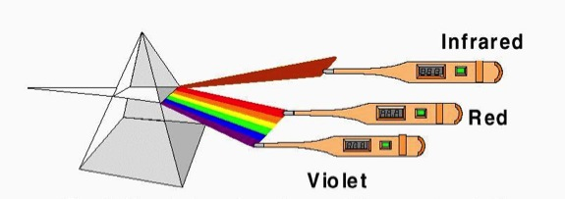
Figure 3. 5 - Herschel's prism to measure temperature.

Following in his father’s footsteps, Sir John Herschel developed and recorded the first thermal image. He accomplished this by using a focused heat pattern to evaporate a thin film of oil. As the film evaporated, it was collected and created a “thermal” image of the object that was visible to the eye. His method would work for heat sources up to three meters away.

In order to increase the distance at which a heat source could be detected, Samuel P. Langley invented the bolometer in 1880. The bolometer is Wheatstone bridge circuit that has a blackened strip of platinum connected to one arm with a galvanometer attached. As the infrared radiation is focused on to the platinum strip, it would cause a response within the galvanometer. This gave Langley the ability to measure a heat source at a distance of 400 meters, or a quarter of a mile.

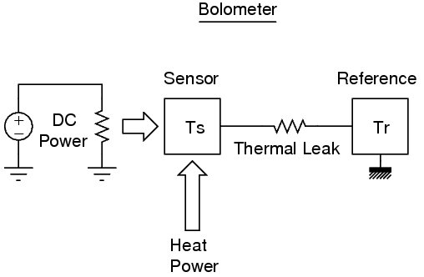
Figure 3. 6 - Bolometer

Since the Herschels’ and Langley’s discoveries of the nineteenth century, these ideas have been greatly expounded upon in both by civilian and military researchers. Their research has led to development of infrared cameras that are now able to detect and distinguish a thermal image of a sample from miles away and record the image.

Emissivity

In conjunction to developing infrared detectors, it was necessary to have a method to standardize radiation sources. Therefore in the 1860, a German scientist by the name of Gustav Kirchhoff presented the idea of a blackbody source (Infrared Thermography: Recent Advantages and Future Trends). Kirchhoff’s blackbody source was able to provide the necessary standardization to compare a variety of radiation sources. After the development of the blackbody source, several years later in 1879, Joseph Stefan was able to experimentally find that Kirchhoff’s blackbody emitted an energy that is proportional to the fourth power of the absolute temperature (Infrared Thermography: Recent Advantages and Future Trends {2}). These results were confirmed by theoretical calculations by Ludwig Boltzmann in 1884, and became known as the Stefan-Boltzmann Law. The Stefan-Boltzmann Law relates the amount of power radiated from a blackbody to the temperature of the radiation source. Additionally the Stefan-Boltzmann Law states that the radiant flux emitted by a surface per unit area (j*) is equal to the fourth power of the absolute temperature (T in units of Kelvin (K)) and a constant of proportionality (σ). This is shown in the below Equation XX:

j* = σT⁴
Equation XX

The constant of proportionality is equal to:

σ = 2π⁵k⁴
15c²h³

Where:

π = pi = 3.141519265359
k_{b} = Boltzmann Constant = 1.3806488 x 10⁻²³ m² kg s⁻² K⁻¹
h = Planck’s Constant = 6.62606957 x 10⁻³⁴ m² kg s⁻¹
c = Speed of Light = 2.99792458 x 10⁸ m s⁻¹

Making:
σ = 5.670373 x 10⁻⁸ W m⁻² K⁻⁴

After the acknowledgment of the Stefan-Boltzmann Law and all that it entails, it was necessary to develop and derive the initial laws of infrared radiation. The first law proposed that related the blackbody monochromatic radiation intensity (E_{λb}) to the radiation of a specific wavelength (λ), the Boltzmann’s constant (k_{b}), and the absolute temperature (T). This was theorized from classical physics by William Strutt, Lord Rayleigh, and James Hopwood Jeans and became known as the Rayleigh-Jeans Law. It is illustrated in Equation XX:

E_{λb} = 8πk_{b}T λ⁻⁴

The Rayleigh-Jeans Law only agreed with experimental results at long wavelengths and had no agreement with short wavelengths. This disagreement became known as the ultraviolet catastrophe, and indicated issues with classical physics. Therefore by using quantum mechanics, Max Planck was able to derive the Law of Radiation in 1900 that described the radiation from a blackbody and its spectral distribution. He indicated that electromagnetic energy could either oscillate between different energies or just be emitted in discrete packets of energy that were proportional to the frequency. Planck’s law of radiation is described in Equation XX:

E_{b} = 2πhc²
λ⁵(e^{hc/λkbT} – 1)

Where:

E_{b} = Blackbody Radiation Intensity
π = pi = 3.141519265359
k_{b} = Boltzmann Constant = 1.3806488 x 10⁻²³ m² kg s⁻² K⁻¹
h = Planck’s Constant = 6.62606957 x 10⁻³⁴ m² kg s⁻¹
c = Speed of Light = 2.99792458 x 10⁸ m s⁻¹
T = Absolute Temperature (T)

Measurement Technique

Determining the emissivity of the diamond foils is essential in determining the temperature that foils experience within the SNS and predicting how well the foils were survive at future SNS upgrades and power levels. The emissivity of the diamond foils has long eluded researchers at the SNS. Measuring the emissivity and monitoring how it changes at different beam energies is a very difficult task to perform at the SNS because of the high radiation environment that the foils are in during production mode. In addition to the high radiation environment, it is not cost effective to test foils within the SNS at different beam conditions to monitor the rate at which the emissivity changes with time and at various beam power density levels. Currently within the SNS, a set have telescopes, pyrometers, and radiation hard cameras are used to monitor the foil and calculate the foil temperature. Unfortunately, the reliability of the cameras has become an issue and is currently being addressed by SNS researchers. Additionally, the glass vacuum window that allows the cameras and pyrometers look at the foil through has the tendency to darken and make temperature measurements very difficult. On the other hand, monitoring the temperature of the foil within the FTS is relatively easy in comparison and can be done without worrying about radiation effects and disrupting the SNS production mode. The infrared camera from FLIR is capable of measuring both the temperature and calculating the emissivity of the sample. The infrared camera is capable of being able to do this by having a known standard, either a known temperature or emissivity. Unfortunately this is rather difficult and requires the use of a blackbody source. A blackbody source has a typical emissivity of 0.99 and has precise temperature control, so that both the temperature and emissivity are known. Therefore by using a blackbody source at a known temperature, the blackbody source and a sample at the same temperature can be viewed simultaneously by the infrared camera. Since the temperature is well known, the infrared camera software can be used to calculate the emissivity of the sample by adjusting the emissivity input in the software until both the temperature of the blackbody source and sample agree. Another approach, specifically when dealing with translucent materials, is to measure the transmission of a known temperature source through a sample. For example, the diamond foils developed at ORNL are very translucent prior to seeing any beam from either the SNS or FTS. As the foils experience beam, the foils tend to darken and the become less translucent and more opaque. Therefore by having a blackbody source with a known emissivity at a known temperature, a translucent material can be placed in front of the blackbody source and the transmission of the foil can be measured. Then by using Kirchhoff’s law and assuming that there is either negligible or no spectral reflectance from the foil, it can be assumed that Kirchhoff’s law becomes simplified (FLIR handbook):

α_{λ} + ρ_{λ} + τ_{λ} = 1

Where:
α_{λ} = spectral absorptance – the ratio of the spectral radiant power absorbed by an object to that incident upon it
ρ_{λ} = spectral reflectance – the ratio of the spectral radiant power reflected by an object to that incident upon it
τ_{λ} = spectral transmittance – the ratio of the spectral radiant power transmitted through an object that incident upon it

Assume:
ρ_{λ} = 0

Making:
α_{λ} + τ_{λ} = 1

In addition to have a spectral reflectance that is negligible, it is also shown by Kirchhoff’s law that the spectral emittance (ε_{λ}) and spectral absorptance of a body are equal at any specified temperature and wavelength. Therefore this becomes:

α_{λ} = ε_{λ}

Substitute into Equation XX:

ε_{λ} + τ_{λ} = 1
Or
τ_{λ} = 1 - ε_{λ}

Therefore one the spectral transmittance (or transmission) is known, the spectral emittance (or emissivity) can be calculated. In order to show that there isn’t a dependence upon wavelength (i.e. temperature) when measuring transmission, a range of temperatures can be used.

Temperature versus Emission Current

Material Transformation

Raman Spectroscopy

History

Theory

Results

Visible

Ultraviolet

Comparison of carbon materials

Chapter 4. Foil Test Stand – SNS Operational Issues of Stripper Foils

Stripper Foil Flutter

Why is this important

Factors that influence foil flutter

Charge buildup

Physical features of foil

How do we measure foil flutter

What influences foil flutter

Mechanical

Thermal

Electrical

Flutter comparison

SNS

FTS

Stripper Foil Design

Lithography

U-shaped 150-lines/inch

U-shaped 100-lines/inch

Checkerboard

Fingerprint

Random Ellipses

Deep U

Box-top edge

Corner cut pre-growth

Corner cut post-growth

Full box top

No box top

Stripper Foil Chemical Make-up

Nanocrystalline

Microcrystalline

Boron-Doped Diamond

BlueWave Semiconductor

HBC

SEM

Theory

Results

How spots change with respect to emission current

SNS vs FTS

Chapter 5. Conclusion and Future Work

Modifications of FTS

Ability to test foils with fibers

Modifications of SNS

Change location of Foil

Modification of electron collector

Laser Stripping

Modifications of Stripper Foils

Alternative foil BlueWave Semiconductor

Lithography pattern

Number of free standing sides: 3 versus 2

Size of foils: length and width

References

[1] asdfasd
[2] asdfasdf

Vita
asdfa

