The Mechanical Strength of Sedimentary Rocks
at Meridiani Planum, Mars

A Thesis Presented for the
Master of Science
Degree
The University of Tennessee, Knoxville

Tyler Seyglinski
August 2024

Copyright © 2024 by Tyler Seyglinski
All rights reserved.

ACKNOWLEDGEMENTS

This work was far from a sole effort and would not have been possible without the support and guidance of those around me. I owe many thanks to my advisor, Dr. Brad Thomson, for allowing me to take on this project and make it my own. Dr. Thomson has been an incredible mentor and instrumental in my success as a graduate student. Thank you to my committee members, Dr. Linda Kah and Dr. Jeff Moersch, who have been immensely helpful in offering feedback and ensuring my science is sound. Furthermore, thank you to the faculty and staff of the EEPS department who strive to serve our best interests as graduate students. I would also like to thank two undergraduates, Anna Nichols and Kenzie Dale, for their help processing data for this study.
I have made some incredible friends along this journey, without whom I could not have hoped to see as much personal growth as I have these last two years. To our MARVEL group, both past and present – Cole, Ivy, Cam, Andrew, Morgan, and Megan – thank you for your constant encouragement and willingness to serve as a sounding board for workshopping ideas. Catie, Jake, and Morgan, thank you for all the laughs we shared, from weekly trivia to weekend get-togethers. You all made the adjustment to Knoxville easier than I could have imagined. And to Brittan, Sara, Nick, Jesse, Cat, Dailey, Julian, and many other students, both graduate and undergraduate, thank you for making Strong Hall such an awesome place to be.
Finally, thank you to all of those who supported me outside of the EEPS department. To my partner, Nicola, these past ten years have been nothing short of an adventure and I look forward to many more to come. Thank you for your unwavering devotion as I navigate this crazy path called grad school. To my parents and siblings, thank you for your constant support and interest, even if you can’t always follow the science. To my friends back home – Gus, Joe, Ryan, Derek, Gabe, and Brett – thank you for keeping me grounded and reminding me to enjoy the small things life has to offer. And to my late brother, I will forever cherish the memories I have of our childhood. Thank you for being an inspiration.
ABSTRACT

The physical properties of rocks such as their strength, hardness, and density can help inform our understanding of the formation and modification history of rock units. For sedimentary rocks, strength is inherently linked to factors such as porosity and degree of induration, which are in turn controlled by factors such as burial depth and water-rock interaction. On Earth, rock strength is typically assessed as unconfined compressive strength (UCS) and can be measured directly or inferred via indirect strength tests (e.g., the Schmidt hammer test). On Mars, instruments such as the Rock Abrasion Tool (RAT) onboard the Opportunity rover can be used in a similar manner to indirectly infer UCS. Specific grind energy (SGE) is a ratio of energy consumed by the RAT normalized to the volume of material removed and has been shown to correlate with UCS. Here, we use engineering data returned by the Opportunity rover to evaluate the strength of sedimentary rocks abraded by the RAT at Meridiani Planum, Mars. Results exhibit a range of rock strengths from 1.4–79.9 MPa, but most rock targets appear to be very weak (less than 25 MPa), similar in strength to highly weathered or weakly cemented sedimentary rock. These results suggest limited burial depths, little compaction, and a low degree of induration in contrast to well-lithified sedimentary rocks on Earth, which have UCS values on the order of 50–100 MPa. Similar strength values are seen elsewhere on Mars, such as Peace class materials at Gusev crater as well as the Stimson formation at Gale crater. In general, these results help us better understand the emplacement of the bedrock units at Meridiani Planum by elucidating the extent of burial and water-rock interactions when considering geochemical and mineralogical observations.
Table of Contents

SECTION 1. INTRODUCTION 1
SECTION 2. BACKGROUND 8
2.1 Sedimentary Rock Strength 8
2.2 Geologic History of Mars 10
2.3 Geology of Meridiani Planum 11
2.3.1 Matijevic Formation 11
2.3.2 Shoemaker Formation 13
2.3.3 Grasberg Formation 13
2.3.4 Burns Formation 14
2.4 Mars Exploration Rover Opportunity 14
SECTION 3. METHODS 24
3.1 Porosity Measurements 24
3.2 Specific Grind Energy Calculations 26
3.3 Weathering Rinds and Veneers 31
SECTION 4. RESULTS 34
4.1 SGE and Inferred UCS 34
4.2 Weathering Rinds and Veneers 44
SECTION 5. DISCUSSION 47
5.1 Rock Strength and Burial Depths 47
5.2 Comparisons to Landed Spacecraft Elsewhere on Mars 50
5.3 Weathering Rinds and Veneers 53
5.4 Strength of Outcrop and Float Samples 54
5.5 Negative SGE Values 55
SECTION 6. CONCLUSIONS 56
REFERENCES 58
APPENDIX 64
VITA 82

LIST OF TABLES

Table 1. List of all Opportunity RAT grinds organized by sol. 17
Table 2. Summary of engineering data for Burns formation targets processed in this study. 36
Table 3. SGEs from prior literature for grind targets which could not be processed in this study. 38
Table 4. Rock strength classifications identified by Hoek and Brown (1997). Burns formation sandstones generally fall into the “weak” to “very weak” strength regimes, and only the float samples reach the “medium strong” to “strong” classifications. 49

LIST OF FIGURES

Figure 1. Unconfined compressive strength testing. (a) Diagram of typical setup for measuring UCS adapted from Figure 4.2 of Attewell and Farmer (1976), where P is the direction of principle stress and d is the sample diameter. (b) Example of UCS testing with a hydraulic press from Figure 3 of Komurlu and Çelik (2022). 3
Figure 2. Examples of the scratch test. (a) Profile view of the comminution of material that occurs as the apparatus’ cutting edge is scraped across a sample; Figure 1 of Schei et al. (2000). (b) Schematic diagram of the scratch test modified from Figure 2 of Kolawole and Ispas (2020). 4
Figure 3. Computer generated graphic showing the location of various instruments included in the Athena science payload on both MER rovers. Figure 1 from Squyres et al. (2004). 6
Figure 4. Relationship between porosity, burial depths, and factors which control compaction at various depths. At shallow depths, compaction is controlled by physical processes such as grain fracturing and pore collapse, which are in turn controlled by grain size, shape, sorting, and mineralogy. For example, coarse grains are more prone to compaction because of higher porosity and greater stress at grain contacts, while fine-grained material generally has less porosity results in stronger materials. As burial depth increases, conditions favor chemical processes such as pressure dissolution and the pervasive precipitation of cements. Modified from Figure 3 of Bjørlykke et al. (2014). 9
Figure 5. Stratigraphic column of units identified by the science team using measurements by the Opportunity rover at Meridiani Planum. Modified from Figure 17 of Crumpler et al. (2015). Burns formation subdivisions from Grotzinger et al. (2005). 12
Figure 6. Global context of Meridiani Planum created using ESRI’s ArcGIS Pro 2.8 software. The global inset was produced from Google Earth Pro. The Meridiani Planum basemap was produced using MOLA topography data superposed over a MOLA hillshade raster. The gold star indicates the landing site of the Opportunity rover. The small red box shows the extent of the mapped area in Figure 8. 15
Figure 7. The Rock Abrasion Tool (RAT) hosted on both the Spirit and Opportunity rovers. (a) A profile view of the RAT showing its size before being mounted on the IDD from Figure 2 of Gorevan et al. (2003). (b) An end-on view of the RAT cutting face which hosts the grinding bits and brushes, as well as magnets that were used as part of the magnetic properties experiment from Figure 2 of Gorevan et al. (2003). (c) A schematic diagram of the RAT cutting face showing how the grind and revolve motors worked in tandem to abrade rock surfaces over a 4.5 cm diameter region. Modified from Figure 2 of Myrick et al. (2004). 17
Figure 8. Overview of the Opportunity rover’s traverse across Meridiani Planum produced in ESRI’s ArcGIS Pro 2.8 software. The basemap is a CTX (5 m/pixel) and HiRISE (0.25 m/pixel) mosaic georeferenced to MOLA elevation data. The change in color of the traverse path denotes the change from closed-loop (given in yellow) to open-loop (given in red) control of the RAT onboard Opportunity (see text for details). Points along the traverse indicate the locations of RAT-abraded targets over the duration of Opportunity’s mission, symbolized by their position within stratigraphy. Numbers shown along the traverse indicate the sol on which some operations took place. 21
Figure 9. Example results of the methods for measuring porosity from Okubo (2007). (Top) MI mosaics of RAT abraded targets made available through the NASA PDS. Circles indicate the area of interest. The image on the left is the feature “Cobble Hill” on rock target “Kentucky” from sol 143 (1mm145ilf31per90p2957m222m2.img). Illumination is from the lower right. The image on the right is the feature “Grindstone” on rock target “Manitoba” from sol 152 (1mm152ilf32per00p2977m222m2.img). Illumination is from the top. (Middle) The same MI mosaics but with brightness and contrast adjusted to make the selection of pore space easier. (Bottom) Mapped distribution of porosity following the methods outlined in section 3.1. 27
Figure 10. Examples of targets for which porosity could not be directly measured due to accumulation of RAT cuttings. (A) Feature “Vols” on rock target “Tennessee” from sol 138 (1mm139ilf31per82p2956m222m2.img). Illumination is from the lower right. (B) Feature “Campbell2” on rock target “Mackenzie” from sol 182 (1mm184ilf33per70p2907m222m2.img). Illumination is from the upper left. (C) Feature “Tuktoyuktuk2” on rock target “Inuvik” from sol 184 (1mm188ilf34per12p2957m222m3.img). Illumination is from the upper left. (D) Feature “Azilda2” on rock target “Whitewater_Lake” from sol 3078 (1mmu87ilfbwper00p2906m222m3.img). Illumination is from the left. 29
Figure 11. Empirical correlation between SGE and UCS from Figure 6 of Thomson et al. (2013). The sample suite includes basalt (bas-01, bas-02, and bas-03), limestone (ls-01), kaolinite (kal-01), and sandstone (ss-01). The solid blue line represents the fit to the data, while the dashed blue lines are 95% confidence intervals around the fitted trend. (a) A linear fit to the calibration data. (b) A power law fit to the calibration data. The power law fit better captures the low end of the SGE-UCS relationship, which is more characteristic of Meridiani Planum. Thus, the power law fit is used in this study. 32
Figure 12. SGE and inferred UCS of Opportunity RAT grinds. Note that only SGEs for targets from the Burns formation were calculated in this study – SGEs for targets from the Grasberg, Shoemaker, and Matijevic formations were obtained elsewhere (Crumpler et al., 2015; Mittlefehldt et al., 2021). The “typical uncertainty” is the average uncertainty calculated for grinds processed in this study. While there is a wide range of SGE values, most targets (n = 26) were found to have SGEs of <5 J/mm³, suggesting very weak lithification at Meridiani Planum. 39
Figure 13. UCS values from this study compared to those previously reported in Okubo (2007). The red dashed line is a 1:1 line, and all values here are from Burns formation targets. The methods in Okubo (2007) appear to achieve higher UCS values than those reported here, resulting in the poor fit of the 1:1 line. This is likely due to the methods employed, where the strength values reported in Okubo (2007) are inversely proportional to the measured porosity of RAT targets. Since porosity values are lower limits due to factors such as debris accumulation, many targets may have higher porosities than those measured, which would decrease their inferred strength. 40
Figure 14. Examples of grind targets which show a highly irregular relationship between grind depth and SGE. (A) Feature “Middle” on target “McKittrick” from sol 30. (B) Feature “Vols” on target “Tennessee” from sol 138. (C) Feature “Tuktoyuktuk2” on target “Inuvik” from sol 184. (D) Feature “Aktineq” from target “Bylot” from sol 194. Nothing atypical was reported for these grinds and some heterogeneity is expected in natural rock samples, so these results may just be an effect of uncertainties in using that RAT on highly weathered and very weak materials. 41
Figure 15. Examples of grind targets which show an unexpected decrease in SGE with grind depth. (A) Feature “Drammensfjorden” on target “Millstone” from sol 162. (B) Feature “Campbell2” on target “Mackenzie” from sol 182. Decreasing SGE is not an expected relationship in the presence of weathering rinds, but this could be an external effect related to RAT instrumentation by which the increasing temperatures of the RAT motors could cause an artificial decrease in SGE. However, this does not explain why SGE continues decreasing throughout the duration of the grind, or why this is only seen in a few targets. 43
Figure 16. Examples of targets which may show evidence of case hardening. (A) Feature “Mojo2” on target “Flat Rock” from sol 42. (B) Feature “Virginia” on target “Layer_C” from sol 145. Evidence for case hardening may be related to the same motor temperature effect that results in apparent weakening. As the motors reach operational temperatures, SGE would appear to decrease alongside decreasing motor currents, which would explain the trend in early grind intervals. As depth increases, SGE would increase as more pristine material is encountered in rock interiors. However, this relationship was only observed in a few targets. 44
Figure 17. Examples of targets which show a clear relationship of increasing SGE with increasing grind depth, where the weathered exterior is much weaker than more pristine material at depth. (A) Feature “Case” on target “Bounce Rock” from sol 65. (B) Feature “Numa” on target “Lion Stone” from sol 103. (C) Feature “Kirchner” on target “Escher” from sol 219. (D) Feature “Penota” on target “Cercedilla” from sol 1176. 45
Figure 18. SGE and inferred UCS values of targets abraded by Opportunity plotted over the strength domains of rock classifications identified by the Spirit rover at Gusev crater, modified from Thomson et al. (2013). There is a strong correlation between the strength of Burns formation targets and the range of strength values encompassed by Peace class materials at Gusev crater. In addition to being mechanically similar, these materials share similarities in their chemistry, mineralogy, and possibly aspects of their formation. 52
Figure 19. Example plots of RAT motor activity under open-loop control for target “Sand_Cherry” on sol 3137, courtesy of Gale Paulsen at Honeybee Robotics. These plots show a typical full grind record exhibiting pseudoperiodic variation in grind current as the RAT advances into the target. However, these data do not match what is available for the same target in the PDS. 66

Section 1. Introduction

Macroscopic physical properties of rocks, including their texture, tone, color, density, grain size, presence or absence of layers, clasts, or phenocrysts, etc., are some of the first diagnostic features geologists use to characterize and categorize rocks into three types: igneous, sedimentary, or metamorphic. Some of these characteristics are typically non-unique – for example, on the basis of strength alone, it may be difficult to differentiate a weathered basalt from a well-indurated sandstone, but in concert, physical properties help to refine the identification of geologic materials. In addition to rock classification, physical properties can be used to make inferences as to the formation and alteration of rock units. For sedimentary rocks, strength can be used as a proxy for investigating the effects of burial depth (e.g., compaction and cementation) (Liu et al., 2020) and weathering (Thomson et al., 2014) on material competence. For example, compaction and lithification of sediments leads to the occlusion of pore space and a higher degree of induration, resulting in tighter packing of particles and overall greater competence of these materials (Bjørlykke, 2014). These processes generally scale with burial depth such that deeper burial produces well-lithified rocks with a greater surface area of grain-to-grain contacts, resulting in overall stronger materials.
When considered alongside geochemical data, rock physical properties offer a more complete history of the emplacement and evolution of rock units (e.g., Thomson et al., 2013). For example, the disparity in strength between a fresh and weathered surface can provide insight into how the weathering process affects material strength, which can be further described by the degree of chemical alteration that takes place as weathering proceeds (Thomson et al., 2014). Parameters such as texture, strength, porosity, and grain size distribution are linked to distinct facies which can aid in deciphering the geologic history of an area. Specifically, strength and porosity can inform our understanding of other rock physical properties (e.g., hardness, density, rock seismic velocity, etc.) and offer insight into the formation and modification of rocks (e.g., Chang et al., 2006; Thomson et al., 2013)
The most common index used for measuring rock strength is that of unconfined
compressive strength (UCS), which is a measure of the maximum amount of force withstood along one axis of a material before the failure threshold is reached. UCS is typically reported in units of megapascals (MPa) (ASTM, 2010). UCS can be directly measured by loading a cylindrical core of the material of interest into an apparatus that can apply a load at a controlled strain rate until brittle failure is reached (Figure 1). This failure generally occurs via axial splitting as tensional forces oriented normal to the compressional forces split the material along the axis that is parallel to the load (e.g., Hawkes and Mellor, 1970). The force at which failure occurs the cohesive strength of the material.
Although one of the most commonly used parameters for predicting rock mechanics, methods for directly measuring UCS are laborious and destructive, requiring considerable time for sample preparation and often lead to the catastrophic disaggregation of material. Thus, many indirect methods for inferring UCS have been developed that are less destructive, readily available, and generally show good correlation with independently measured physical properties (e.g., Schmidt hammer test, point load test, etc.). For example, the scratch test is an apparatus designed measure the force exerted by a blunt cutting edge to carve a shallow channel in a rock sample (Figure 2) (Schei et al., 2000). By measuring the force required to remove a volume of rock material (specific energy), correlations can be made to independently measured physical properties such as UCS (Schei et al., 2000).
In planetary investigations, the ability to analytically measure UCS is limited by mass and budget constraints of landed spacecraft. For example, much of what we know about the geologic history of Mars comes from the in-situ observations of rovers, such as the Mars Exploration Rovers (MER), sent to study the planet. These missions have provided a wealth of information about the Red Planet. Most published literature focuses on geochemical and geomorphological results (e.g., Zolotov and Shock, 2005; Squyres et al., 2006c; Squyres et al., 2012; Arvidson et al., 2014; Fraeman, 2018; Crumpler et al., 2020); less focus has been placed on interpreting physical properties results from these rovers. Here, we seek to interpret physical properties data returned by instruments onboard the Opportunity rover at Meridiani Planum.

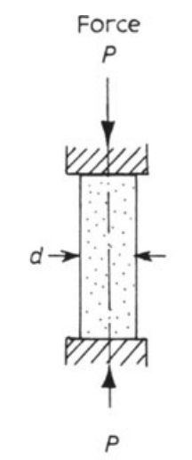
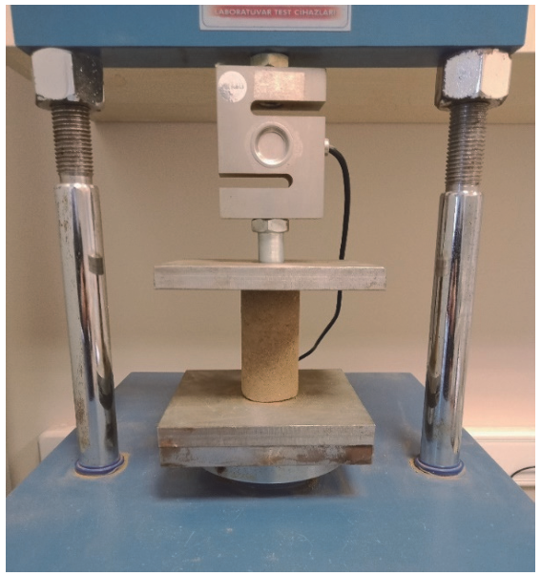
a
b
Figure 1. Unconfined compressive strength testing. (a) Diagram of typical setup for measuring UCS adapted from Figure 4.2 of Attewell and Farmer (1976), where P is the direction of principle stress and d is the sample diameter. (b) Example of UCS testing with a hydraulic press from Figure 3 of Komurlu and Çelik (2022).

Figure 2. Examples of the scratch test. (a) Profile view of the comminution of material that occurs as the apparatus’ cutting edge is scraped across a sample; Figure 1 of Schei et al. (2000). (b) Schematic diagram of the scratch test modified from Figure 2 of Kolawole and Ispas (2020).

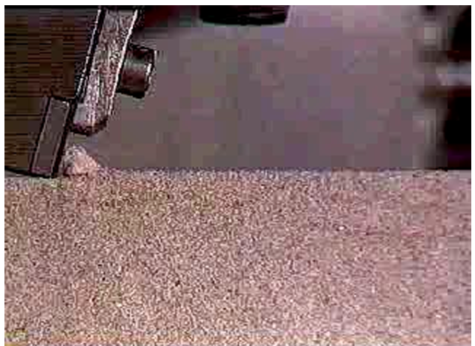
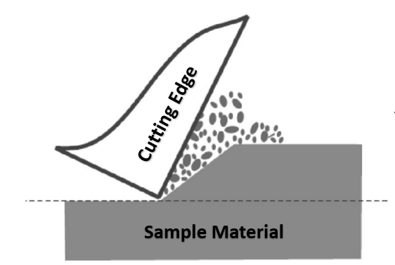
a
b

One instrument with abundant archived data is the Rock Abrasion Tool (RAT) that was hosted on both the Spirit and Opportunity rovers as part of the Athena science payload (Figure 3) (Squyres et al., 2003). The RAT acted akin to a geologist’s rock hammer by abrading a small patch of rock to expose less-altered material beneath weathering rinds for analysis by other instruments (Gorevan et al., 2003). In addition to aiding the scientific objectives of other instruments, engineering data recorded by the RAT during grind operations can offer insight into the strength of the material being abraded (Myrick et al., 2004). Parameters such as average motor currents, average voltage, and grind duration permit the calculation of specific grind energy (SGE), which is a ratio of the energy exerted by the RAT to the volume of material removed, reported in units of J/mm³. SGE can be directly related to the mechanical behavior of material, similar to how specific energy is correlated to UCS in the scratch test. However, since SGE is a RAT-specific parameter, it requires calibration to terrestrial analogs to offer comparisons on an absolute scale. This calibration exists and has been used to assess the physical properties of rocks investigated by the Spirit rover (Thomson et al., 2013). Here in this study, we use the same calibration to infer the strength of the sedimentary rocks abraded by the Opportunity rover through interpretations of energy consumption during RAT grinds to better inform our understanding of the formation and modification of these rocks.
To refine the calculation of SGE, we incorporated porosity measurements of RAT targets to better understand the volume of material removed since porosity is an absence of material. The effectiveness of RAT grinds is assessed through image analysis of RAT abraded targets to determine if the RAT achieved a full circle grind, the potential for grain plucking, etc. For example, evidence for grain plucking was observed in the RAT calibration data by which the sandstone sample fell below the curve defining the relationship between SGE and UCS from Thomson et al. (2013). Since the rocks at Meridiani Planum are sedimentary, grain plucking is likely a factor in many of these RAT grinds. Another important consideration when interpreting these data includes decoupling real trends in the data from potential effects of instrumentation (e.g., motor temperatures) whereby changes in motor temperatures during operation can affect SGE.
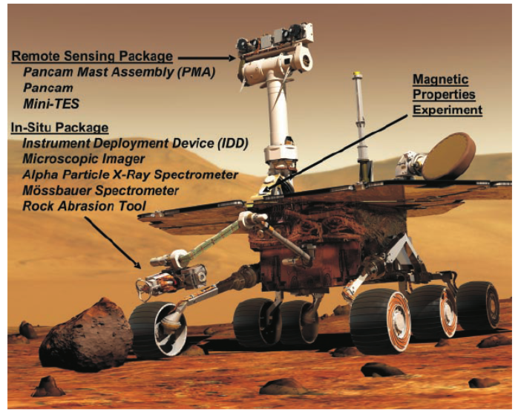
Figure 3. Computer generated graphic showing the location of various instruments included in the Athena science payload on both MER rovers. Figure 1 from Squyres et al. (2004).

For example, as motor temperatures increase, motor resistance also increases that would decrease the amount of current being drawn. In addition, analysis of how SGE changes with increasing grind depth may elucidate the extent of alteration rinds present on these martian rocks.

Section 2. Background

2.1 Sedimentary Rock Strength
The competency of sedimentary rocks is controlled by the surface area of grain-to-grain contacts, which is in turn controlled by factors such as porosity, grain size, and grain shape (Gorevan et al., 2003). Thus, many of the factors that affect sedimentary rock strength (e.g., burial depth) are also linked to factors which control other rock physical properties (e.g., porosity) (e.g., Chang et al., 2006). For example, smaller grain sizes and less porosity results in an increase in surface area of grain-to-grain contacts, leading to greater material strength (Gorevan et al., 2003). As such, the results of physical properties testing have been shown to vary with factors such as porosity (Wong et al., 2015).
The mechanical compaction of sediments increases density and rock seismic velocity as overburden increases the effective stress acting on sediments, resulting in the collapse of pore space and a tighter packing of particles (Bjørlykke, 2014). The degree to which sediments are compacted is directly related to the texture, mineralogy, and degree of lithification of sediments (Bjørlykke, 2014). For example, coarse-grained sediments exhibit a greater amount of compressibility because they typically experience greater degrees of grain fracturing as a result of overburden (Chuhan et al., 2002). Similarly, the sorting of sediments also plays a role in compaction, where poorly-sorted sediments have less initial porosity and show less reduction in porosity during compaction compared to well-sorted sediments (Fawad et al., 2011).
On Earth, mechanical compaction of siliceous sediments is the primary mode of compaction at burial depths up to 2 km because of the very slow reaction rates of silicate minerals at low temperatures (<100°C) (Bjørlykke, 1999). Below this depth, chemical compaction becomes prominent and pervasive cementation occurs (Figure 4). The
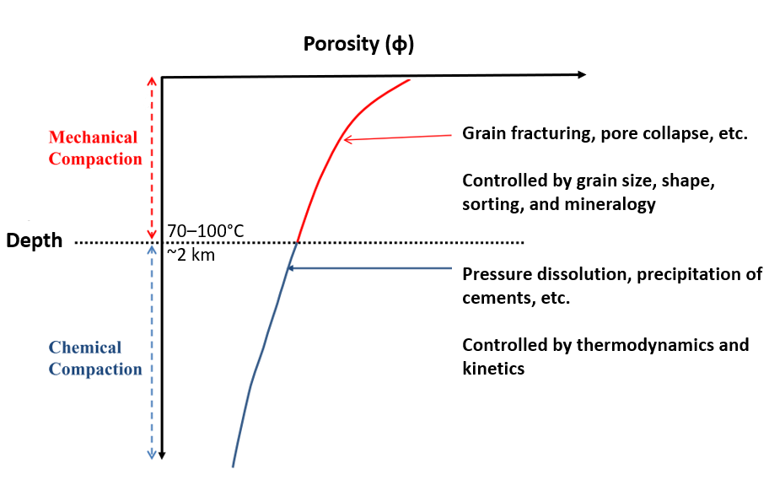
Figure 4. Relationship between porosity, burial depths, and factors which control compaction at various depths. At shallow depths, compaction is controlled by physical processes such as grain fracturing and pore collapse, which are in turn controlled by grain size, shape, sorting, and mineralogy. For example, coarse grains are more prone to compaction because of higher porosity and greater stress at grain contacts, while fine-grained material generally has less porosity, resulting in stronger materials. As burial depth increases, conditions favor chemical processes such as pressure dissolution and the pervasive precipitation of cements. Modified from Figure 3 of Bjørlykke et al. (2014).

precipitation of secondary cement phases can create a strong framework that reduces the effectiveness of mechanical compaction (Bjørlykke, 2014). The mineralogy of secondary cement phases exerts a strong control over the cohesiveness of sediments after lithification where, on Earth, syntaxial quartz overgrowths can produce very strong sedimentary rocks (Peters et al., 2018). Indeed, while burial depth is a primary driver of sedimentary rock strength, the microscale control on this relationship in terrestrial rocks is an increase in quartz content and decrease in porosity with increasing burial depths (Liu et al., 2020).

2.2 Geologic History of Mars
Water has a ubiquitous presence across Earth’s surface. It is a prerequisite for the development of life and is a primary target for investigations of life elsewhere in the solar system. Under the mantra of “follow the water,” we have sent many robotic craft out into our solar neighborhood to do just that: find places in the solar system where water once existed and may persist today. A prime target for this type of investigation is our planetary neighbor, Mars, to which we have sent a variety of orbiters, landers, and rovers in the search for past habitability.
Martian history is divided into three geologic time periods: the Noachian (~4.1–3.5 Ga), the Hesperian (~3.5–3.0 Ga), and the Amazonian (~3.0 Ga–present) (Tanaka, 1986; Wordsworth, 2016). Although it is cold and dry today, there is strong evidence that Noachian-Hesperian Mars once hosted a relatively warm and wet surface, at least episodically (Wordsworth, 2016). While the history of Mars’ hydrosphere remains uncertain (Carr and Head, 2015; Scheller, 2021), it is clear there was enough water to at least periodically flow across the surface as evidenced by widespread erosion, valley formation, and the formation of aqueous weathering products (e.g., phyllosilicates) (Carr and Head, 2010). This era of temperate conditions was likely short-lived and/or episodic, with erosion rates dropping precipitously in the Hesperian and Amazonian, the latter of which is characterized by a surface dominated by impact cratering (Carr and Head, 2010). The loss of an active hydrologic cycle on Mars was likely driven by the loss of its atmosphere following the depletion of its magnetic field (Wordsworth, 2016), exposing the surface to the damaging effects of the solar wind. While the channels and valleys of Mars were likely dry apart from ephemeral events (Christensen, 2003), evidence of the last vestiges of water (e.g., bedforms, secondary aqueous minerals, etc.) (Knoll and Grotzinger, 2006) are preserved in the rock record and provide a glimpse of past surface conditions similar to those of present-day Earth.

2.3 Geology of Meridiani Planum
The RAT onboard the Opportunity rover was used extensively over the mission to expose more pristine material from rock targets across Meridiani Planum. With a nominal mission to last only 90 days, the Opportunity rover far exceeded expectations, setting the distance record for any planetary traverse (45 km) and exploring the martian surface for almost 15 years (5,111 sols) (Callas et al., 2019). During that time, the rover documented many different morphological features, from rocky outcrops to impact debris and impactors themselves (Squyres et al., 2006b; Arvidson et al., 2011). One of the primary goals of the mission – apart from looking for evidence of liquid water – was to characterize the geologic history of Meridiani Planum (Golombek et al., 2005). In doing so, the science team documented the stratigraphy of at least four distinct, spatially extensive sedimentary bedrock units. These are, in stratigraphic order, the Matijevic formation, the Shoemaker formation, the Grasberg formation, and the Burns formation (Figure 5) (Crumpler et al., 2015).

2.3.1 Matijevic Formation

Limited outcrop exposures have resulted in the origin and thickness of the Matijevic formation remaining poorly constrained. It is thought, however, that these rocks were in place prior to the Endeavor impact (Crumpler et al., 2015). This unit was first encountered at the ~22 km diameter Endeavor crater and consists of fine-grained clastic rocks of basaltic composition (Hynek and Achille, 2017; Mittlefehldt et al., 2018). High abundances of matrix-supported spherules are found in some locations that suggests they formed after deposition as concretions in the presence of groundwater (Arvidson et al., 2014). A paucity of depositional features and a composition matching that of average martian soil provide little context for how this unit was emplaced (Arvidson et al., 2014; Crumpler et al., 2015). Previous studies suggest that unit emplacement may be associated
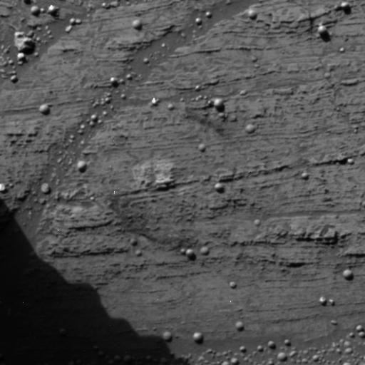
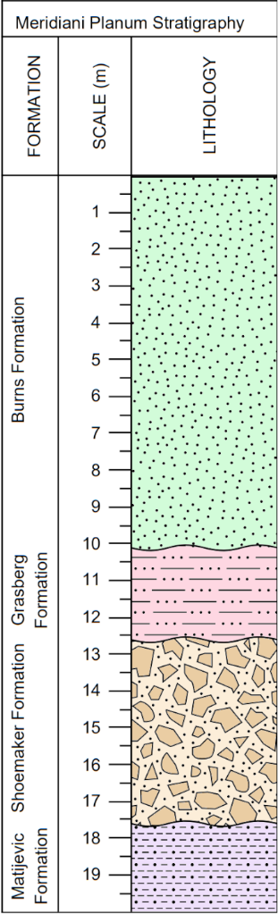
Lower
Middle
Upper
Burns Fm

Burns Fm
Matijevic Fm

Matijevic Fm
Shoemaker Fm

Shoemaker Fm
Grasberg Fm

Grasberg Fm

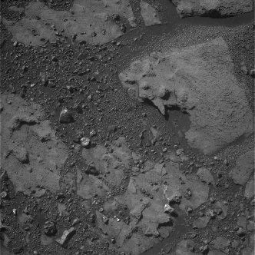

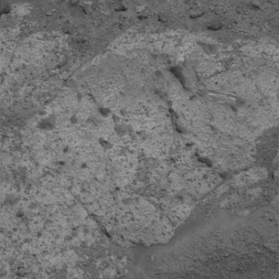

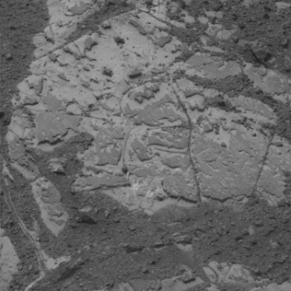

D
C
B
A
Figure 5. Stratigraphic column of units identified by the science team using measurements by the Opportunity rover at Meridiani Planum. Modified from Figure 17 of Crumpler et al. (2015). Burns formation subdivisions from Grotzinger et al. (2005). (A-D) Pancam images of targets from each stratigraphic unit. (A) “Flat Rock” from sol 42 (1p131922917rad05a6p2549r1c1.img). (B) “Cape Tribulation” from sol 4696 (1p545081525effcxstp2570l6c1.img). (C) “Chester Lake” from sol 2709 (1p368674596radbn00p2394r2c1.img) (D) “Matijevic Hill” from sol 3135 (1p406495253radbw__p2538r3c1.img).

with a regional event, such as an airfall deposit of volcaniclastic or impact origin (Crumpler et al., 2015; Mittlefehldt et al., 2021).

2.3.2 Shoemaker Formation

Unconformably overlying the Matijevic formation, a roughly 3 m thick sequence of polymictic breccia comprises the Shoemaker formation (Squyres et al., 2012; Crumpler et al., 2015). This breccia contains subrounded to angular clasts (≤10 cm in size) embedded in a fine-grained, light-toned matrix and form a continuous blanket around Endeavor crater (Crumpler et al., 2015; Mittlefehldt et al., 2018). Notably, the upper portion of the Shoemaker formation is clast rich with larger clast sizes while the lower portion is clast poor with smaller clasts (Crumpler et al., 2020). This distribution is indicative of impact ejecta in which the lower portion may consist of distal ejecta from at least two pre-Endeavor impacts while the upper portion may represent more proximal ejecta from the Endeavor impact (Mittlefehldt et al., 2021). The lower portion is believed to be related to – but compositionally distinct from – the underlying Matijevic formation (Crumpler et al., 2015; Mittlefehldt et al., 2018).

2.3.3 Grasberg Formation

The Grasberg formation has been interpreted as a very fine-grained airfall deposit that drapes over the existing paleotopography of Meridiani Planum (Crumpler et al., 2015). This thin (1–2 m) unit is divided into a lighter-toned upper unit and a darker lower unit, both of which lack prominent sedimentary structures with the exception of one lower unit target that showed fine, wavy laminations (Mittlefehldt et al., 2018). While originally described as being a distinct unit from the overlying Burns formation, recent work has shown that the chemistry of the Burns formation can be reproduced by the addition of MgO and SO₃ to a Grasberg-like precursor (McCollom and Hynek, 2021). In addition, depletions of these elements in the Grasberg formation are mirrored by the same depletions in some Burns formation rocks, including two Burns targets located near the Grasberg contact (McCollom and Hynek, 2021). This similarity implies that the two units may share a similar sediment source and aspects of their diagenetic history, which suggests that the observed differences in these two units can be explained by the Burns formation resulting from reworking of an airfall deposit similar to the Grasberg formation (McCollom and Hynek, 2023). Later diagenesis then enriched the reworked sediments in MgO and SO₃ to produce the sulfate-rich sands of the Burns formation (McCollom and Hynek, 2023).

2.3.4 Burns Formation

The first stratigraphic unit identified by the Opportunity rover was the Burns formation, named in honor of Dr. Roger Burns who first predicted the stable presence of ferric sulfates (e.g., jarosite) on the surface of Mars (Burns, 1987; Grotzinger et al., 2005). The Burns formation consists of cross-bedded eolian and fluvial sandstone with abundant sulfate and hematite concretions (“blueberries”) (Squyres et al., 2006b). The sediment comprising Burns formation sandstone were sourced from a primary basalt component (e.g., ashfall) and appear to have been exposed to fluctuating groundwater (Grotzinger et al., 2005; Squyres et al., 2006c). The Burns formation commonly exhibits millimeter-scale laminations and is loosely cemented by Ca- and Mg-sulfates (Crumpler et al., 2015). It is divided into 3 subunits based on chemical and morphological distinctions; a lower eolian dune facies, a middle eolian sand sheet facies, and an upper mixed sand sheet/interdune facies (Grotzinger et al., 2005)

2.4 Mars Exploration Rover Opportunity
Landing site selection for the MER rovers was guided toward locations with evidence of past aqueous activity on Mars, such as Meridiani Planum (Figure 6) (Arvidson et al., 2011). These low-lying plains of sedimentary strata exhibit orbital spectroscopic signatures of the iron-oxide mineral hematite (Fe₂O₃) (Christensen et al., 2000). These spectra were distinct from those of red nanophase hematite observed elsewhere on Mars and were consistent with coarse-grained specular hematite (Christensen et al., 2000). On Earth, specular hematite forms through processes such as precipitation from Fe-rich, oxygenated water (Christensen, 2004). Thus, orbital observations of specular hematite at Meridiani Planum were a key driver leading to its

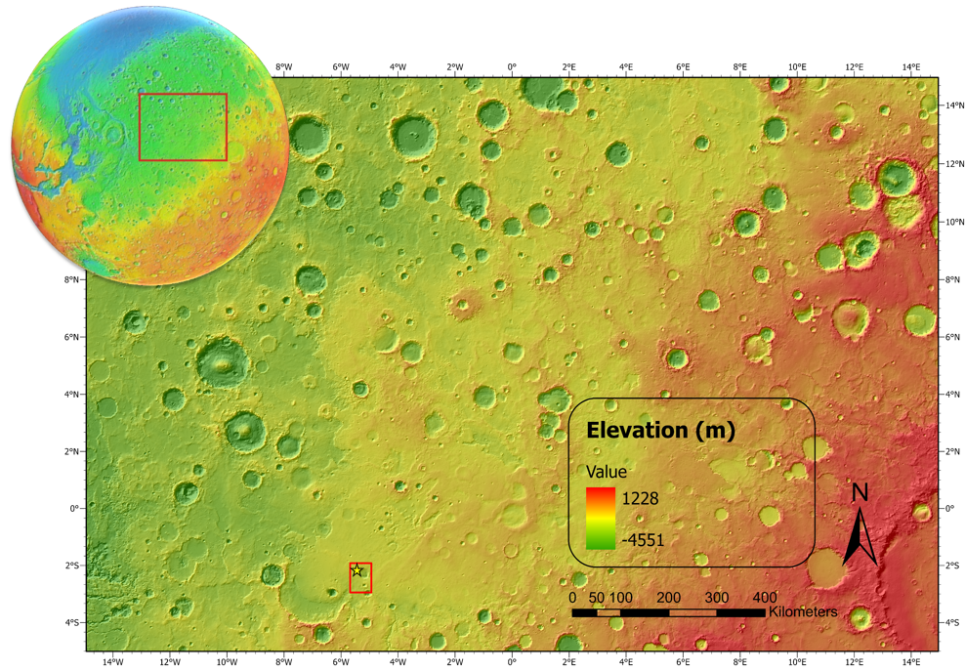
Figure 6. Global context of Meridiani Planum created using ESRI’s ArcGIS Pro 2.8 software. The global inset was produced from Google Earth Pro. The Meridiani Planum basemap was produced using MOLA topography data superposed over a MOLA hillshade raster. The gold star indicates the landing site of the Opportunity rover. The small red box shows the extent of the mapped area in Figure 8.

selection as the landing site for the Opportunity rover. In January 2004, the Opportunity rover touched down on the surface to begin its scientific campaign investigating the hydrologic history of Mars lasting 5,111 sols.
The Rock Abrasion Tool (RAT) (Figure 7) was mounted on the Instrument Deployment Device (IDD) as part of the Athena science payload (Gorevan et al., 2003; Squyres et al., 2003). The RAT was a rotary grinder that operated as a three-axis mechanism by which a high speed (~3000 RPM) grinding bit revolved around a central housing at lower speeds (up to 2 RPM), which was advanced into the target in 0.05 mm increments by a third z-axis motor (Myrick et al., 2004). The resultant abraded patch was 4.5 cm in diameter and of variable depth (generally less than 7 mm). Most grinding operations were followed by a sweep phase that cleared grinding debris using brushes also hosted on the RAT. The grinding bits consisted of two diamond-impregnated resin pads that were designed so that as the resin was worn away with grinding, new diamond particles were exposed to refresh the grinding surface (Myrick et al., 2004; Thomson et al., 2013). This ensured that the grinding ability of the RAT remained consistent through the duration of the mission, but also limited the lifetime of RAT grind operations to the lifetime of the bit. The action of the microdiamond particles in the RAT grinding bits was analogous to a blunt, chisel-like tool which removed material through compression-induced tension (Thomson et al., 2013), not unlike the scratch test (Schei et al., 2000).
The RAT was deployed 124 times over the duration of Opportunity’s mission with a total of 72 brushing events and 52 grinds (Callas et al., 2019). The brushes on the RAT remained functional throughout the mission, but RAT grinds became increasingly rare as the mission progressed since the grind bits were a consumable resource (Indyk et al., 2018). The remaining life of the RAT grind bits was reserved for rocks which offered the most science potential. As a result, brushing became one of the most common uses of the RAT throughout extended missions. An overview of Opportunity RAT grinds is given in Table 1.
Adjustments in the way the RAT was operated were also made as the instrument began to age. For example, the early grinds were set to execute over the course of a few hours, provided that a stall did not terminate the activity early. For later grinds, this
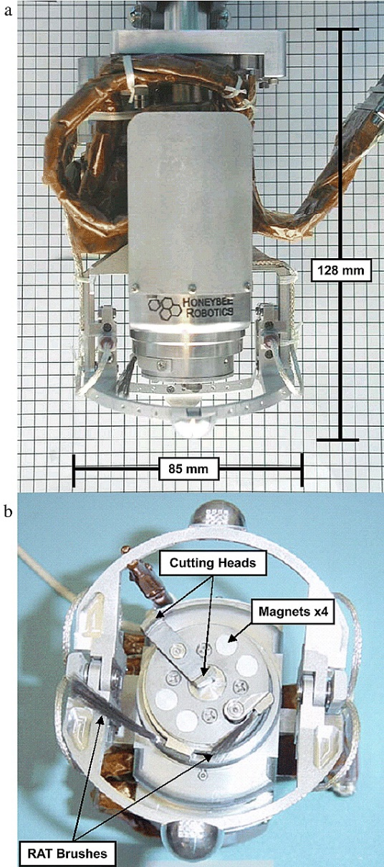
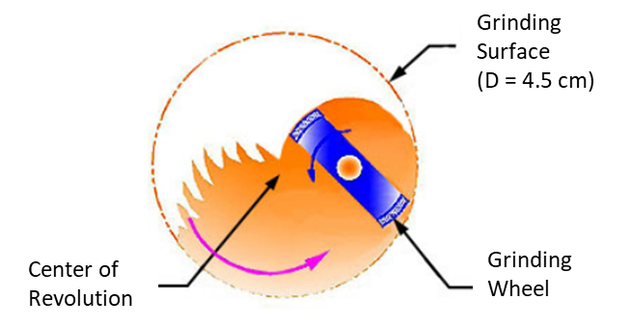
b
c
a
Table 1. List of all Opportunity RAT grinds organized by sol.
Figure 7. The Rock Abrasion Tool (RAT) hosted on both the Spirit and Opportunity rovers. (a) A profile view of the RAT showing its size before being mounted on the IDD from Figure 2 of Gorevan et al. (2003). (b) An end-on view of the RAT cutting face which hosts the grinding bits and brushes, as well as magnets that were used as part of the magnetic properties experiment; Figure 2 of Gorevan et al. (2003). (c) A schematic diagram of the RAT cutting face showing how the grind and revolve motors worked in tandem to abrade rock surfaces over a 4.5 cm diameter region. Modified from Figure 2 of Myrick et al. (2004).

Sol | Target Rock Name | Target Feature Name | Target Type | Grind Depth (mm) | Stratigraphic Unit | Rover Elevation (m)
Eagle crater
30 | McKittrick | Middle | Outcrop | 4.4 | Burns fm | -1386.7
34 | Guadalupe | King3 | Outcrop | 4.9 | Burns fm | -1386.7
42 | Flat Rock | Mojo2 | Outcrop | 3.1 | Burns fm | -1386.9
65 | Bounce Rock | Case | Float | 6.4 | Burns fm | -1386.3
Fram crater
85 | Pilbara | Golf | Outcrop | 7.2 | Burns fm | -1386.2
Endurance crater
103 | Lion Stone | Numa | Float | 6.3 | Burns fm | -1385.1
138 | Tennessee | Vols | Outcrop | 8.1 | Burns fm | -1384.7
143 | Kentucky | Cobble Hill | Outcrop | 3.8 | Burns fm | -1384.7
145 | Layer_C | Virginia | Outcrop | 4.3 | Burns fm | -1384.7
148 | Ontario | London | Outcrop | 4.5 | Burns fm | -1384.7
152 | Manitoba | Grindstone | Outcrop | 2.7 | Burns fm | -1384.7
154 | Manitoba | Kettlestone | Outcrop | 4.2 | Burns fm | -1384.7
162 | Millstone | Drammensfjorden | Outcrop | 6.3 | Burns fm | -1384.6
177 | Diamond Jenness | Holman3 | Outcrop | 2 | Burns fm | -1384.5
178 | Diamond Jenness | Holman3 | Outcrop | 5 | Burns fm | -1384.5
182 | Mackenzie | Campbell2 | Outcrop | 8.4 | Burns fm | -1384.5
184 | Inuvik | Tuktoyuktuk2 | Outcrop | 7.7 | Burns fm | -1384.4
194 | Bylot | Aktineq | Outcrop | 7.7 | Burns fm | -1383.1
219 | Escher | Kirchner | Float | 7.3 | Burns fm | -1384.4
306 | Black_Cow | Paikea | Outcrop | 6.3 | Burns fm | -1383.6
311 | Black_Cow | Wharenhui | Outcrop | 2.1 | Burns fm | -1383.6
Vostok crater
403 | Yuri | Gagarin | Outcrop | 6 | Burns fm | -1383.7
Erebus crater
546 | Ice_Cream | One Scoop | Outcrop | 6 | Burns fm | -1380.8
556 | Fruit_Basket | Lemon Rind | Outcrop | 1.5 | Burns fm | -1378.9
558 | Fruit_Basket | Strawberry | Outcrop | 3 | Burns fm | -1378.9
633 | Olympia | Kalavrita | Outcrop | 2.5 | Burns fm | -1375.4
691 | Rimrock | Ted | Outcrop | 6 | Burns fm | -1374
Beagle crater
894 | Beagle | Baltra | Outcrop | 3 | Burns fm | -1369.6
Victoria crater
961 | Fogo | Cha | Outcrop | 2 | Burns fm | -1367.5
1176 | Cercedilla | Penota | Float | 4 | Burns fm | -1371.6

Table 1. Continued

1311 | Steno | Steno | Outcrop | 2.5 | Burns fm | -1368.1
1359* | Smith | Smith2 | Outcrop | 1.07 | Burns fm | -1368.2
1384 | Lyell | Lyell1 | Outcrop | 3.5 | Burns fm | -1368.3
1422 | Lyell | Buckland | Outcrop | 2.7 | Burns fm | -1368.5
1475 | Gilbert | Gilbert_RAT | Outcrop | 2.8 | Burns fm | -1368.1
Intercrater Plains
1833 | Cook_Island | Penrhyn | Outcrop | 3 | Burns fm | -1373.2
2065 | Marquette_Island | Peck Bay | Float | 1.5 | Burns fm | -1370
Santa Maria crater
2481 | Santa Maria Crater | Luis de Torres | Outcrop | 2.8 | Burns fm | -1442
Endeavor crater
2713 | Chester_Lake | Salisbury1 | Outcrop | 2 | Shoemaker fm | -1485
2990 | Cape_York_Bench | Grasberg | Outcrop | 1.3 | Grasberg fm | -1491.5
3078 | Whitewater_Lake | Azilda2 | Outcrop | 6.8 | Matijevic fm | -1493.6
3137 | Matijevic_Hill | Sand_Cherry | Outcrop | 1 | Matijevic fm | -1494.1
3251 | Kirkwood | Sturgeon River3 | Outcrop | 2.5 | Matijevic fm | -1494.4
3301 | Matijevic_Hill | Espérance5 | Outcrop | 2 | Matijevic fm | -1493
3378 | Botany_Bay | Black_Shoulder | Float | - | Burns fm | -1545.6
4120 | Marathon_Valley_  Entrance | Pvt. Robert Frazer6 | Outcrop | 2.5 | Shoemaker fm | -1420.1
4230 | Marathon_Valley | Pvt. John Potts | Outcrop | 0.8 | Shoemaker fm | -1440.8
4354 | Knudsen_Ridge | Pierre Pinaut3 | Outcrop | 2.3 | Shoemaker fm | -1412.9
4700 | Cape_Tribulation | Ogallala | Outcrop | 0.5 | Grasberg fm | -1419.5
5024 | Ysleta_del_Sur | Aguas Calientes | Outcrop | 4 | Shoemaker fm | -1481.8
*Transition to open-loop control
duration was reduced to as little as 20–30 minutes since higher grind rates were attainable on the soft rocks at Meridiani Planum. However, the biggest change in RAT operation resulted from the loss of its revolve motor encoder on sol 1334 (Figure 8), which is a sensor that provides feedback on the motor’s speed, position, and direction. By this point, the RAT was already operating without its grind encoder which failed on sol 1045, but the loss of the revolve encoder made placing the RAT on rock more difficult. Because of this encoder failure, the closed-loop control algorithm had to be abandoned and replaced by open-loop control to allow continued functionality of the RAT.
A typical RAT grind would begin with a Seek/Scan routine. To find the surface of a rock, the RAT would be placed against the target and the grind and revolve actuators would slowly spin as the Z-stage stepped down in small increments. When contact was made, motor voltage would spike and the activity would terminate, ending the “Seek” phase. The “Scan” would then proceed with the revolve actuator completing one full revolution, which would be considered complete if the RAT made one full revolution without being interrupted by the rock surface, after which grinding could commence. With the loss of positional feedback from the revolve encoder, the “Scan” phase could no longer be completed (Indyk et al., 2018). Under open-loop control, revolutions of the revolve motor had to be estimated to permit the Z-stage to advance into the target. This
lack of encoder feedback necessitated a much more conservative approach to how abrasions were planned, including how motor current limits were set to prevent damage to the actuators.
The transition to open-loop controls allowed continued use of the RAT for the remainder of Opportunity’s mission. However, an unexpected consequence of this change is that these open-loop grinds could not be processed in a manner akin to the closed-loop data products. The data products in the PDS for these open-loop grinds do not contain parameters such as motor currents, z-axis position, etc., for calculating SGE so these parameters were estimated in prior studies through visual interpretation of plots showing RAT motor activity during these grinds (see Appendix 1). As such, results presented in this study only include targets for the Burns formation since sub- Burns stratigraphy was not encountered until much later in the mission, long after the transition to open-loop
Figure 8. Overview of the Opportunity rover’s traverse across Meridiani Planum produced in ESRI’s ArcGIS Pro 2.8 software. The basemap is a CTX (5 m/pixel) and HiRISE (0.25 m/pixel) mosaic georeferenced to MOLA elevation data. The change in color of the traverse path denotes the change from closed-loop (given in yellow) to open-loop (given in red) control of the RAT onboard Opportunity (see text for details). Points along the traverse indicate the locations of RAT-abraded targets over the duration of Opportunity’s mission, symbolized by their position within stratigraphy. Numbers shown along the traverse indicate the sol on which some operations took place.

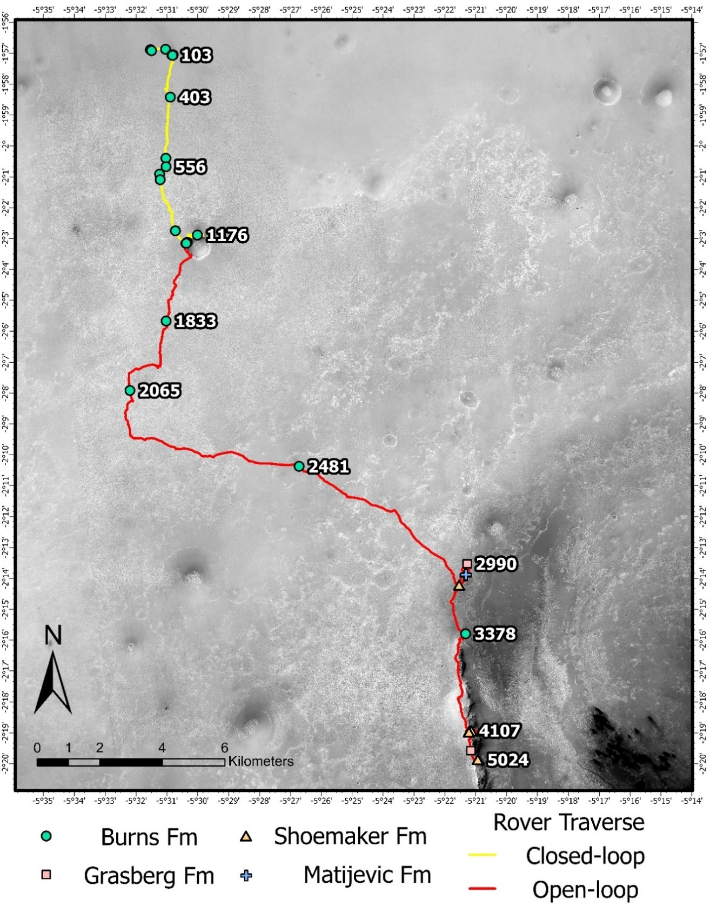
control. Some of the open-loop grinds have SGEs reported in the literature (Crumpler et al., 2015; Mittlefehldt et al., 2021) which presumably came directly from the mission team. These are also included in the results presented here with the caveat that they were not processed in the same manner as the closed-loop data products and will be denoted as such with reference to where they were obtained. At the time of this writing, efforts remain ongoing to recover these open-loop data products to provide an end-to-end treatment of these RAT engineering data over the duration of Opportunity’s mission. See Appendix 1 for further description of this issue and current recovery efforts.

Section 3. Methods

3.1 Porosity Measurements
Since SGE is calculated as energy per unit volume (i.e., J/mm³), it is important to understand the precise volume of rock material removed. For example, some RAT grinds did not achieve a full circular abraded region due to surface topography, difficult RAT placement, etc. Myrick et al. (2004) reported that, due to the way the RAT was programmed, time that the RAT spent off rock during these partial circle grinds does not introduce significant error into SGE calculations (only about 3–4%). This is because the algorithm controlling the RAT sets the revolve speed as inversely proportional to the load on the grind motor (Myrick et al., 2004). The effect of this control is that the RAT slows down when in contact with rock material and speeds up when it encounters little resistance. Thus, even when a grind is not a complete circle, the RAT still spends most of this time on rock rather than hovering over depressions (Myrick et al., 2004). However, what does change is the geometry of the grind interval being considered. Instead of a cylindrical volume with the diameter of the RAT grinding area, corrections must be made based on interpretations of post-grind Microscopic Imager (MI) mosaics of RAT activity.
In addition to assessing the completeness of RAT grinds, further considerations must be made to account for porosity. Since pore space is inherently an absence of material, porosity reduces the total area over which the grind bits contact the surface and, therefore, directly affects the volume of material removed, similar to volume changes in the case of an incomplete circle grind. Porosity, however, is typically distributed across the grind area, meaning there are no large intervals over which the RAT is not in contact with target material. However, since porosity should decrease resistance to grinding, the control algorithm should also speed up the revolve motor, keeping the time error small. Thus, volumetric corrections were carried out based on porosity measurements of rock targets to better estimate the true volume of material removed. It should be noted that while terms such as porosity and pore space are used here, for this study, any pre-existing negative relief on the RAT cutting surface is considered porosity (fractures, crystal molds, etc.).
Porosity measurements were carried out following the methods of Okubo (2007). This approach utilizes a visual thresholding technique developed for measuring porosity in photomicrographs of thin sections (Okubo and Schultz, 2005), but is adjusted to account for non-uniform solar illumination (Okubo, 2007). MI mosaics of RAT-abraded targets were obtained from the NASA PDS and imported into the GNU Image Manipulation Program (GIMP). This software offered more control in conducting these measurements than other programs (e.g., Photoshop, ImageJ, etc.) which is useful when images are not uniformly illuminated due to variable topography within the RAT hole. Once an image was loaded into GIMP, it was duplicated in a new layer to preserve an original copy of the image. In the new layer, brightness, contrast, and exposure settings were adjusted to allow better identification of pore space (C. Okubo, pers. comm. 2023). In addition, any areas that are unlikely to correspond to pore space are digitally masked during this step, such as areas shadowed by instrumentation or areas where grind debris has accumulated. In two of the MI mosaics, nodules were masked due to potential spallation (“Cobble Hill” on sol 143) and the nodule being dislodged during RAT activity, leaving a large, round void (“Grindstone” on sol 152) (Okubo, 2007). In the latter case, the void appears distinct from the surrounding pore space and the presence of a large (~0.5 mm) nodule in roughly the same place in the pre-RAT MI mosaic led to it being classified as a plucked nodule rather than original pore space. Once adjustments were made, the image was cropped to isolate only the pixels that fall within the grind area. The image was duplicated three more times so that average pore space could be calculated from three independent measurements. If these measurements differed by more than 10% porosity, results were reviewed and the measurements were performed again until consistency was achieved.
To determine the distribution of pore space, pixels were selected with brightness values corresponding to shadowed and sunlit surfaces of pores (Okubo, 2007). Once a selection was made, it was scrutinized with respect to both the original and adjusted images to ensure pore space is accurately captured and, if needed, adjusted to better encapsulate pore space. Once confirmed, the selection was filled with color and the threshold parameters were adjusted to select a different range of brightness values. After all pore space was captured, unfilled pixels corresponding to the rock surface were removed leaving only pixels corresponding to pore space. Measured porosity was then calculated as the ratio of pixels corresponding to pore space to pixels that encompass the entire grind area (Figure 9).
While relatively straightforward, this process is not without limitations. Porosity measurements here are considered minimum porosity for two reasons: 1) There is a resolution limit to the MI mosaics (~30 μm per pixel) (Herkenhoff et al., 2003) and any porosity below this resolution could not be confidently identified. 2) During grind operations, the RAT produces grind debris that fill the grind area and can obscure the abraded surface. In most cases, grinding was followed by a sweep phase to clear the hole of cuttings generated during RAT activity, but there are likely still some pore spaces filled with cuttings that could not be differentiated. In addition, this brushing was not always effective, and some targets were left with copious amounts of debris (Figure 10). In cases where the accumulation of cuttings precluded the direct measurement of porosity, a porosity value was estimated based on values measured for similar targets.

3.2 Specific Grind Energy Calculations
The strength of rock material is determined through interpretation of the SGE of individual grind events and compared to a terrestrial scale by converting to UCS based on a calibration between SGE and UCS determined from lab RAT analysis (Gorevan et al., 2003; Thomson et al., 2013). Engineering data such as motor currents are recorded during RAT operation and provide insight into the amount of energy consumed by the RAT
Figure 9. Example results of the methods for measuring porosity from Okubo (2007). (Top) MI mosaics of RAT abraded targets made available through the NASA PDS. Circles indicate the area of interest. The image on the left is the feature “Cobble Hill” on rock target “Kentucky” from sol 143 (1mm145ilf31per90p2957m222m2.img). Illumination is from the lower right. The image on the right is the feature “Grindstone” on rock target “Manitoba” from sol 152 (1mm152ilf32per00p2977m222m2.img). Illumination is from the top. (Middle) The same MI mosaics but with brightness and contrast adjusted to make the selection of pore space easier. (Bottom) Mapped distribution of porosity following the methods outlined in section 3.1.

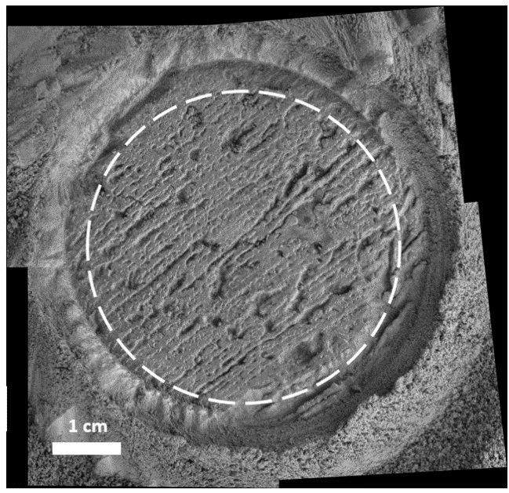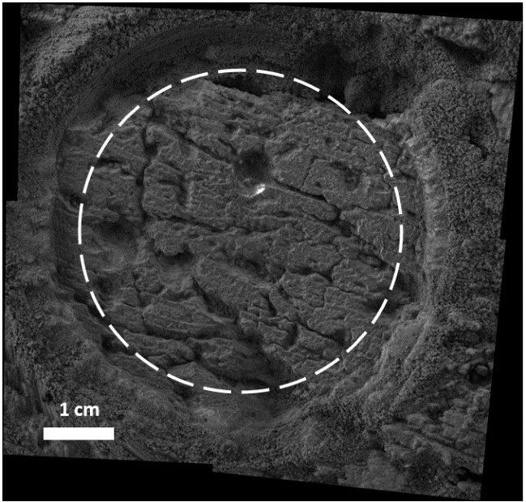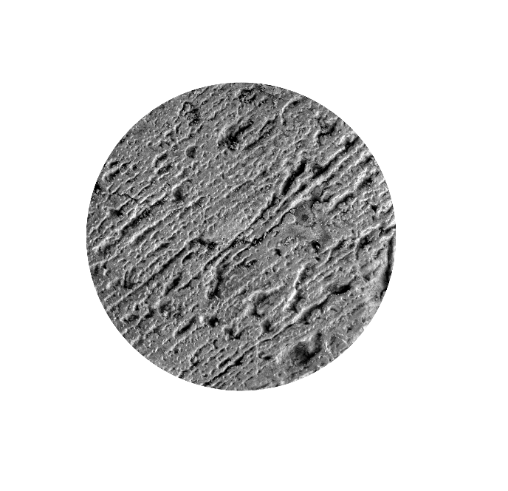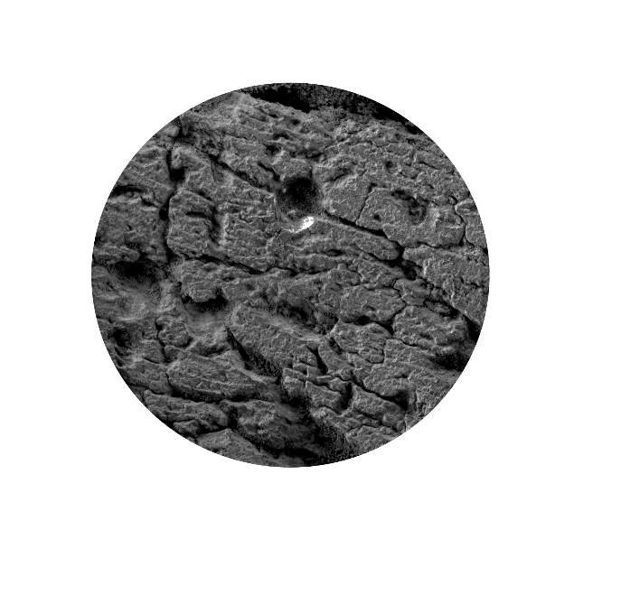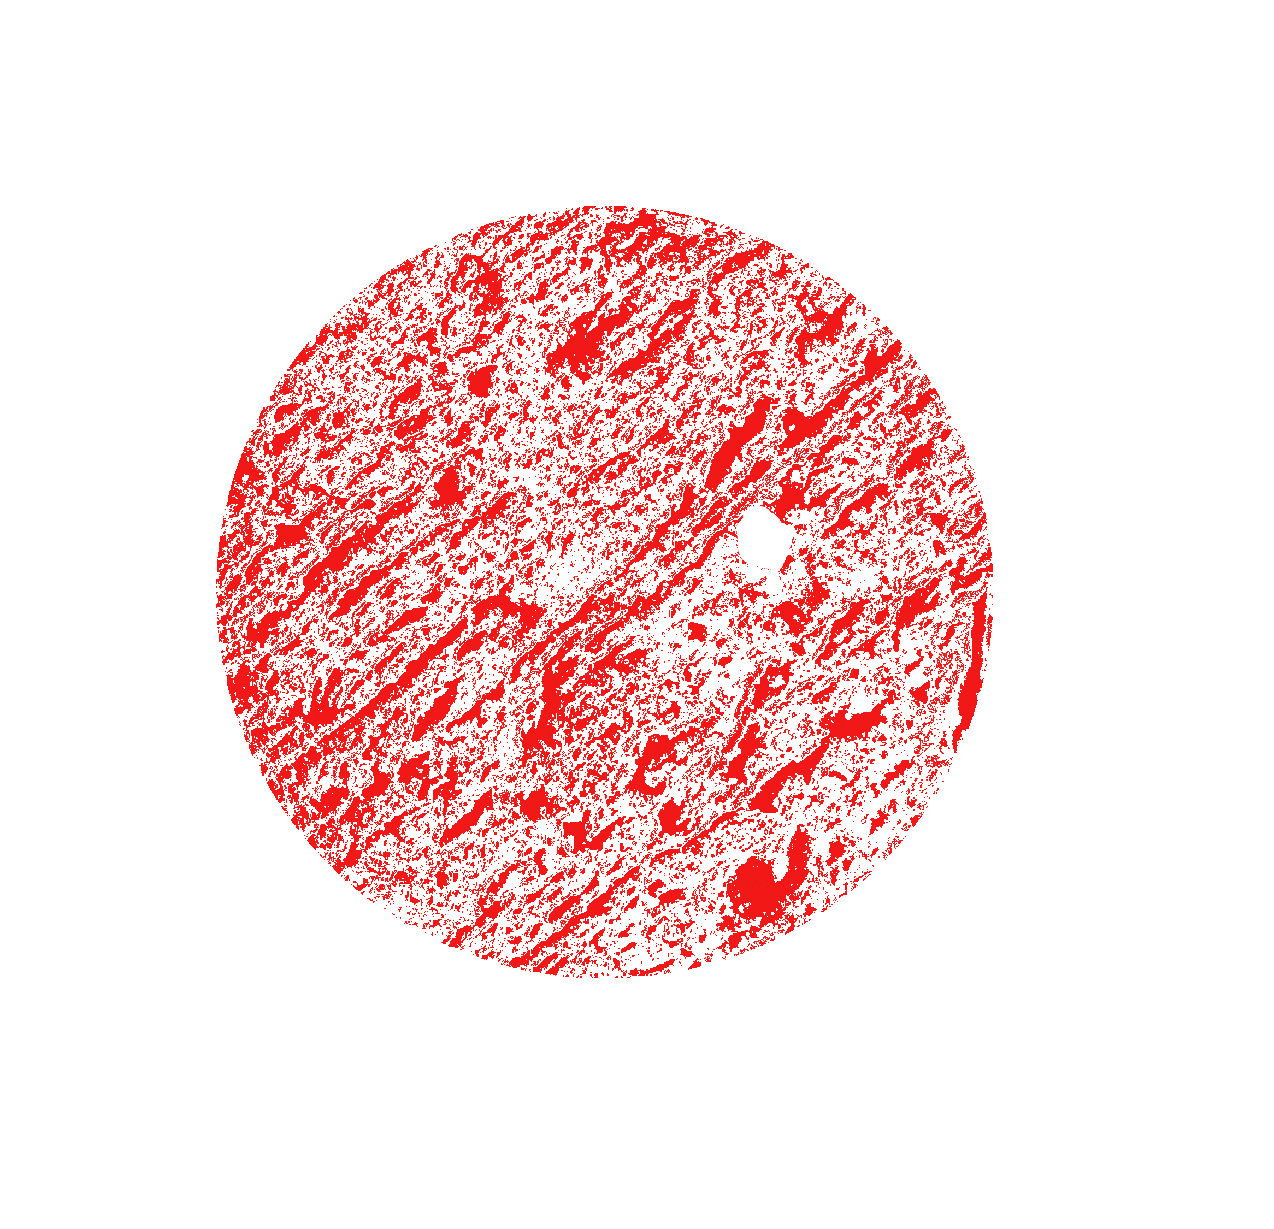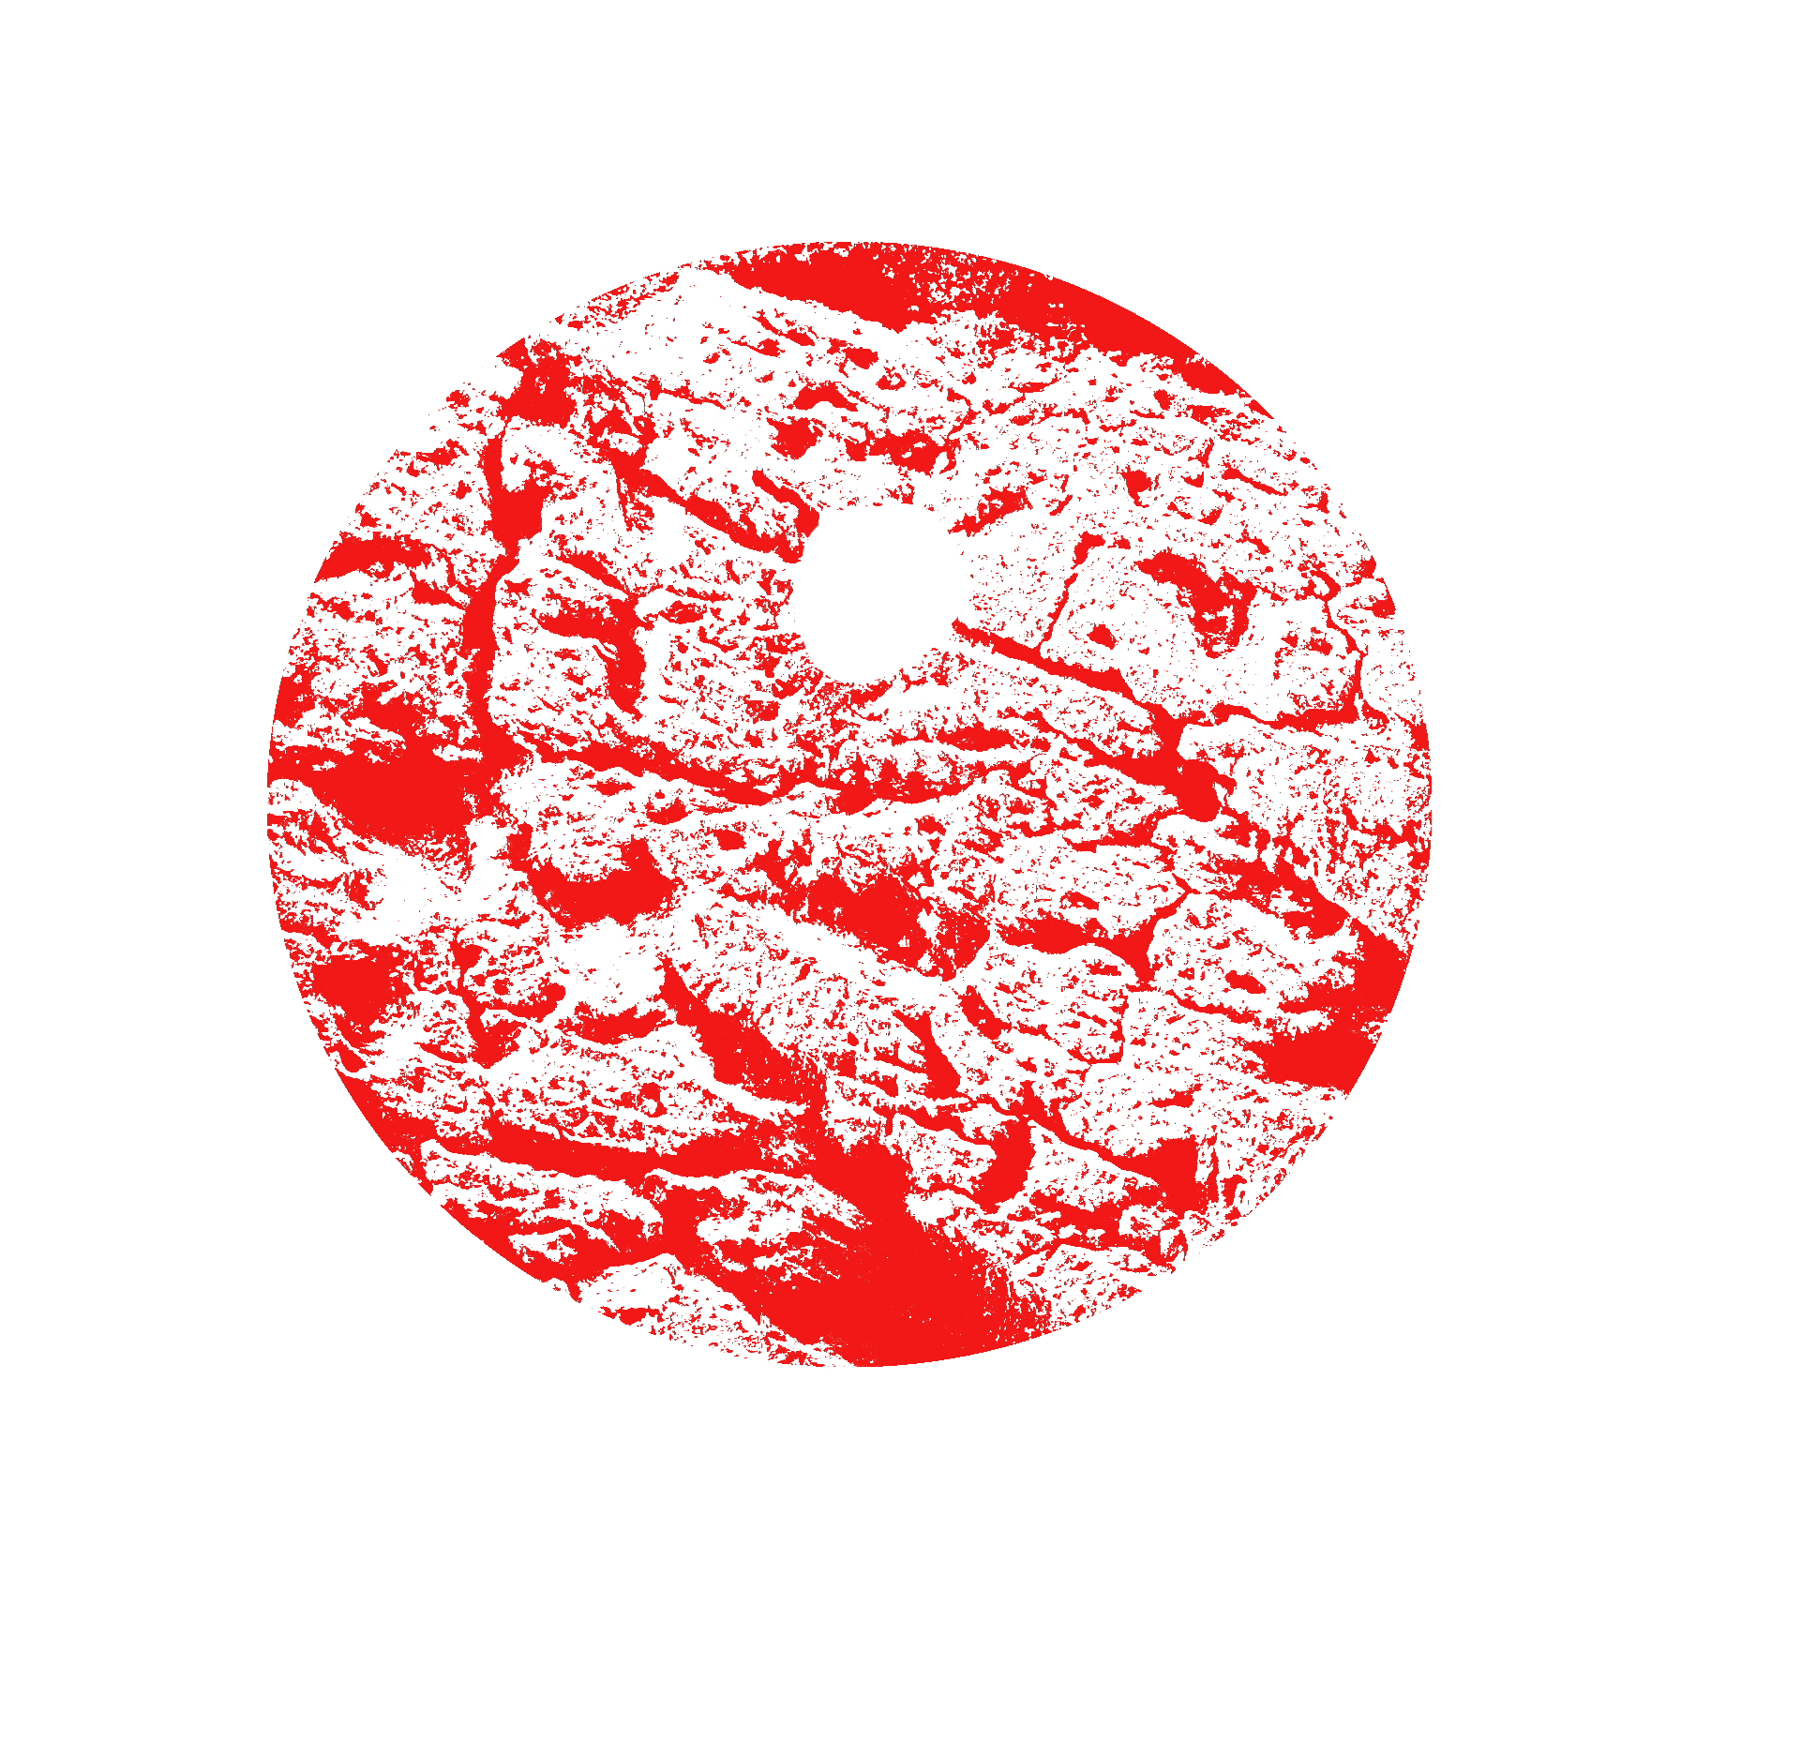
Brightness/Contrast Adjustments

Brightness/Contrast Adjustments
Thresholding
(Okubo, 2007)

Thresholding
(Okubo, 2007)
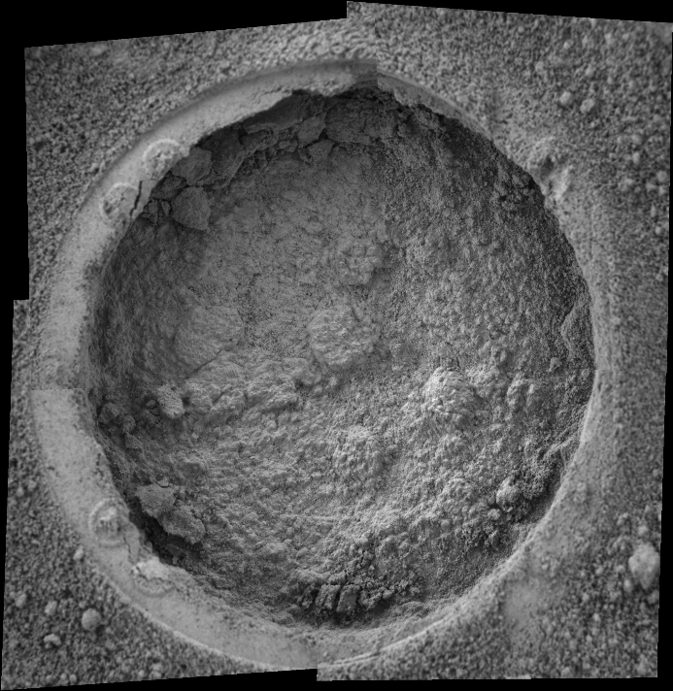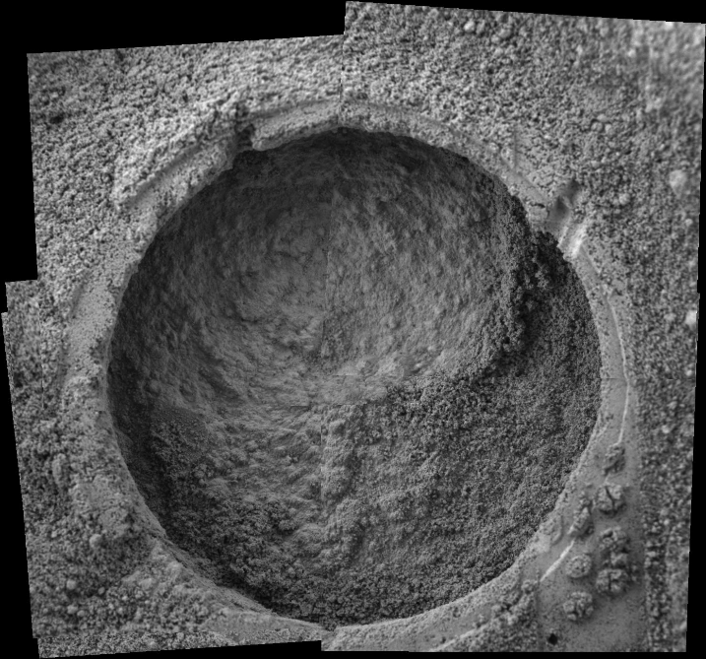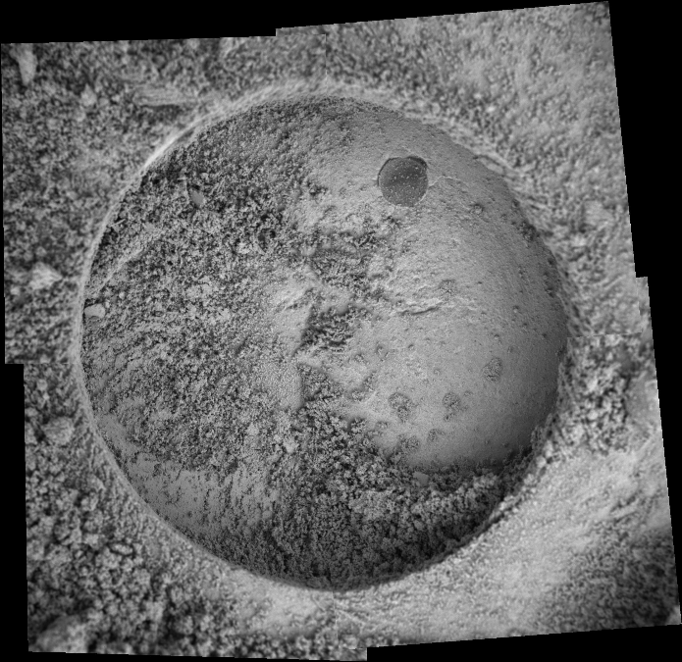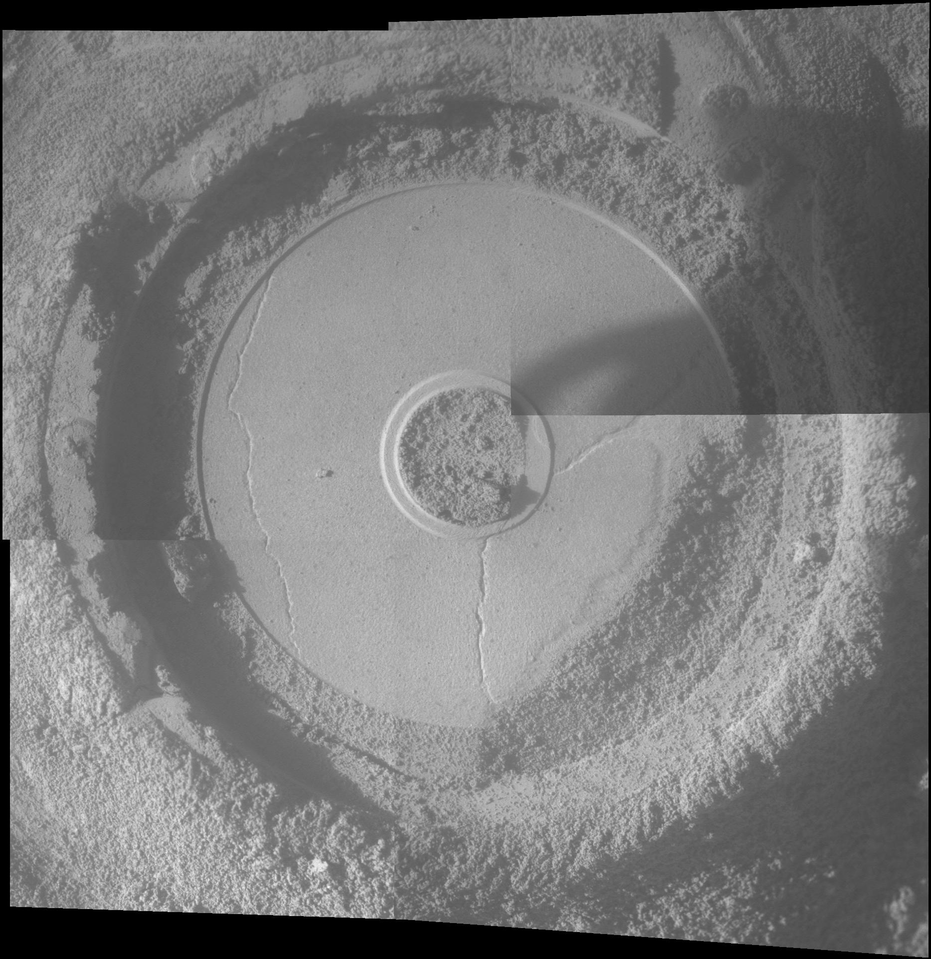
A

A
B

B
C

C
D

D
Figure 10. Examples of targets for which porosity could not be directly measured due to accumulation of RAT cuttings. (A) Feature “Vols” on rock target “Tennessee” from sol 138 (1mm139ilf31per82p2956m222m2.img). Illumination is from the lower right. (B) Feature “Campbell2” on rock target “Mackenzie” from sol 182 (1mm184ilf33per70p2907m222m2.img). Illumination is from the upper left. (C) Feature “Tuktoyuktuk2” on rock target “Inuvik” from sol 184 (1mm188ilf34per12p2957m222m3.img). Illumination is from the upper left. (D) Feature “Azilda2” on rock target “Whitewater_Lake” from sol 3078 (1mmu87ilfbwper00p2906m222m3.img). Illumination is from the left.

while abrading a target. Since the purpose of the RAT was to grind through surficial weathering rinds, here we use only data for the last 0.25 mm of the grind. There are two lines of reasoning for this: (1) this interval should correspond to the most intact material accessed with each grind, and (2) the deepest part of each grind should correspond to the interval over which the RAT has the most engagement with the target, especially in cases where the grind does not achieve a full circle.

$$SGE=V\left(\overline{A}-A_{NL}\right)s*{vol}^{-1}$$

Equation 1 (Thomson et al., 2013) provides a direct relation between RAT engineering data and SGE. Here, V is voltage (volts), $\overline{A}$ represents average grind current (A), A_{NL} is the no-load current (A), and s and vol represent the duration of the grind (seconds) and the volume of material removed (mm³) over the last 0.25 mm of grinding, respectively. Many of these values are obtained directly from RAT telemetry data returned by the Opportunity rover. A MATLAB script was used to process engineering data from the *.dat binary files archived in the NASA PDS. Once these engineering records were processed, the last 0.25 mm of each grind was isolated and the duration, average motor current, and average voltage were calculated for this interval.
(1)

(3)
It is necessary to subtract average no-load currents from the average motor currents so that only energy that is performing work on rock material is considered in the calculation of SGE; the RAT requires some energy to run, even if it is only spinning in free space. This no-load current is variable and unique for each grind depending on ambient temperature during operations, increased friction due to debris from previous RAT grinds, etc., so a single value cannot be used for all grinds. There are multiple methods to obtain no-load current values for each grind, such as during the Seek/Scan sequence at the beginning of RAT operations. However, since current values will drop as motor temperatures rise during use, it is best to calculate no-load when the motors are at or close to operational temperatures (Myrick et al., 2004). Grind operations are typically followed by a sweep phase to brush away cuttings generated by the RAT, which offers an ideal way to gather no-load currents since the drag due to brushing is negligible (Myrick et al., 2004).
The volume of material removed is also variable between each grind depending on factors such as porosity and the effectiveness of RAT activity. The latter is assessed through interpretations of MI mosaics of post-RAT activity to determine if the RAT achieved a full circle grind. In this case, we use a cylindrical volume with a diameter equivalent to the RAT cutting face (45.5 mm) and a height equal to the thickness of the grind interval considered (here, 0.25 mm) which is directly augmented by the porosity measured for each target. The volume of material removed is defined as
(2)

(3)

$$Vol=0.25π{\left(\frac{45.5}{2}\right)}^{2}\left(1-ϕ\right)$$

where ϕ is the measured porosity and vol is in mm³.
The equation for calculating SGE was used over the duration of the mission to provide information about the strength of rocks that were ground by the RAT on either rover. However, since SGE is a parameter that is specific to the RAT, it only allows comparison on a relative scale to other rocks abraded by a RAT. To allow comparison on an absolute scale to rocks on Earth and Mars, an empirical correlation is required to relate SGE to a more common index of rock strength (e.g., UCS). Using terrestrial analog rocks and the flight spare of the RAT, Thomson et al. (2013) derived an empirical correlation between SGE and UCS that was used to infer the strength of rocks investigated by the Spirit rover at Gusev crater (Figure 11) (Thomson et al., 2013). In the study presented here, the power law fit to the calibration data was used to infer the strength of rocks encountered by the Opportunity rover as this fit better captures the lower end of the SGE-UCS relationship, which is characteristic of Meridiani Planum. The calibration data show an intuitive positive correlation between SGE and UCS up to the cohesive threshold of fresh, intact basalt. Above this threshold (>150 MPa), the RAT shows a reduced ability to penetrate the target and instead only polishes the surface. However, given the weak lithification of bedrock units at Meridiani Planum, this threshold was not exceeded.
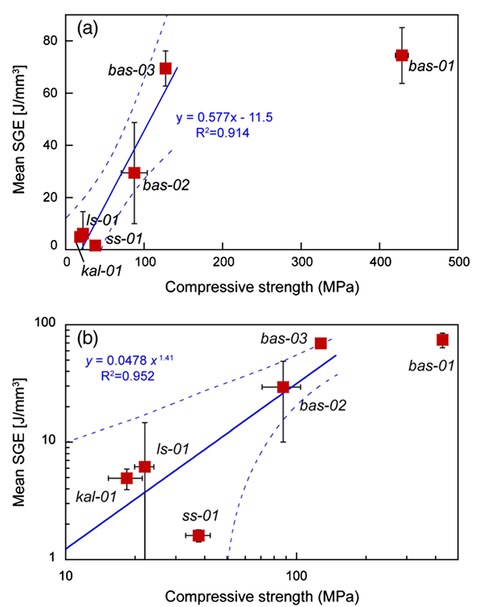
Figure 11. Empirical correlation between SGE and UCS from Figure 6 of Thomson et al. (2013). The sample suite includes basalt (bas-01, bas-02, and bas-03), limestone (ls-01), kaolinite (kal-01), and sandstone (ss-01). The solid blue line represents the fit to the data, while the dashed blue lines are 95% confidence intervals around the fitted trend. (a) A linear fit to the calibration data. (b) A power law fit to the calibration data. The power law fit better captures the low end of the SGE-UCS relationship, which is more characteristic of Meridiani Planum. Thus, the power law fit is used in this study.

3.3 Weathering Rinds and Veneers
In addition to estimating bulk rock strength, SGE as a function of grind depth can be used to investigate how rock strength changes within the surficial alteration rinds present on most rocks exposed on the surface of Mars. The formation of weathering products as a result of near-surface diagenesis has been shown to trend towards increases in porosity and decreases in both bulk density and rock hardness (Oguchi, 2013).
However, the inverse can also be true in that the production of Mn- and Fe-oxides and clays can infill surface pores in the process akin to case hardening (e.g., desert varnish) which creates a protective “skin” on the outer surfaces of rocks (Dorn et al., 2017). Although these protective veneers are often mediated by a biologic component on Earth, abiotic case hardening has also been observed (Dorn et al., 2012). Both very thin veneers (<1 mm) and thicker weathering rinds (a few millimeters) have been observed on outcrop samples at Meridiani Planum and may reflect interaction between rocks, soil, and atmosphere with potential evidence of diagenetic fluid flow (e.g, hydrated sulfates, cement-girded hematite spherules, etc.) (Knoll et al., 2008).
In order to assess the potential thickness and strength-depth relationship of alteration rinds, SGEs were calculated at regular depth intervals of RAT grinds. This process closely follows the methods outlined in section 3.2 with the exception that SGEs were calculated at every 0.25 mm interval instead of only the last 0.25 mm of each grind. To do so, a MATLAB script was used to parse the relevant engineering data for each 0.25 mm interval over the entire duration of each grind. Since porosity is measured from MI mosaics of RAT-abraded surfaces, a constant value for porosity is assumed for each interval based on the measured porosity of the abraded area. However, because the same porosity and volume is used for each interval, this assumption should not greatly affect the relationship between depth and SGE.

Section 4. Results

4.1 SGE and Inferred UCS
As previously mentioned, results here only include SGEs for grinds prior to the transition to open-loop controls, as well as open-loop grinds which had SGEs reported in the literature. A summary of engineering data calculated for this study is given in Table 2. SGEs for open-loop grinds that could not be processed here but have SGEs reported in prior publications are listed in Table 3 along with their source, and their inferred UCS values are reported using the same calibration from Thomson et al. (2013). Grind energies for rocks abraded at Meridiani Planum range <0.1 to 23.0 J/mm³, corresponding to UCS values of 1.4 MPa to 79.9 MPa, respectively. The average SGE was 3.2 J/mm³ (19.7 MPa) with a median value of 0.95 J/mm³ (8.4 MPa), and uncertainties ranged from 10.1% to 29.6%. These uncertainties were evaluated as the square root of the sum of the individual fractional errors of each term in the equation for calculating SGE (Eq. 3).
(3)

(3)
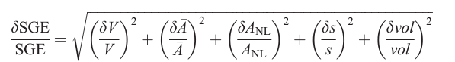
For reference, a typical well indurated sandstone has UCS values on the order of 50–100 MPa (Hoek and Brown, 1997). These SGE values are consistent with those previously reported (Myrick et al., 2004; Herkenhoff et al., 2008), and indicate very weak lithification at Meridiani Planum. In addition, two targets returned negative SGE values and highlight uncertainties in the telemetry data used in the calculation of SGE (Herkenhoff et al., 2008), which will be discussed later.
Of the closed-loop data products, there were two targets which could not be processed because of data missing from the PDS. The first – feature “King3” on the rock “Guadalupe” – was the second grind that the RAT onboard Opportunity performed at Meridiani Planum on Sol 34. While this grind was successful, the PDS only contains two data products for this grind. One of these data products contains no Z-axis position, and the other reached its maximum depth of ~5.8 mm after only ~30 seconds. In addition, both of these data products contain <5 minutes of RAT activity, which is much shorter than other grinds, especially early ones. “King3” does have SGEs reported in previous literature, which range from 7.3 J/mm³ to 46.2 J/mm³. However, Myrick et al. (2004) suggests that there were technical issues with this grind and that a value of 7.3J/mm³ is likely closer to the actual strength of this rock. Through interpretations of the engineering

Table 2. Summary of engineering data for Burns formation targets processed in this study.

Sol | Target Rock | Feature Name | Porosity | Grind Current (A) | No-load Current (A) | Motor Voltage (V) | Duration (sec) | Volume (mm³) | Target Type | SGE (J/mm³) | Previously Reported SGE | UCS (MPa) | Frac.  Error
30 | McKittrick | Middle | 0.211 | 0.161 | 0.119 | 31.4 | 441 | 313.6 | Outcrop | 1.72 | 1.67ª, 0.92^{b} | 12.69 | 0.191
34 | Guadalupe | King3 | 0.311 | - | - | - | - | - | Outcrop | - | 46.2ª, 7.3^{b} | - | -
42 | Flat_Rock | Mojo2 | 0.224 | 0.167 | 0.141 | 32.4 | 341 | 308.5 | Outcrop | 0.953 | 1.14ª | 8.35 | 0.202
65 | Bounce_Rock | Case | 0.139 | 0.28 | 0.135 | 32.5 | 423.5 | 342.3 | Float | 5.87 | 4.19ª, 3.7^{b} | 30.32 | 0.296
85 | Pilbara | Golf | 0.045 | 0.178 | 0.123 | 32.8 | 296 | 379.6 | Outcrop | 1.4 | 1.25ª, 1.0^{b} | 10.97 | 0.158
103 | Lion_Stone | Numa | 0.228 | 0.374 | 0.125 | 30.7 | 614.5 | 235.7 | Float | 20 | 18.1ª, 18.0^{b} | 72.33 | 0.183
138 | Tennessee | Vols | 0.224 | 0.156 | 0.139 | 32.8 | 255.5 | 308.5 | Outcrop | 0.468 | 0.332ª, 0.22^{b} | 5.04 | 0.21
143 | Kentucky | Cobble_Hill | 0.423 | 0.159 | 0.132 | 31.4 | 667 | 229.5 | Outcrop | 2.46 | 1.41ª, 1.4^{b} | 16.36 | 0.136
145 | Layer_C | Virginia | 0.473 | 0.14 | 0.13 | 31.2 | 529.4 | 209.5 | Outcrop | 0.81 | 0.775ª, 0.47^{b} | 7.44 | 0.136
148 | Ontario | London | 0.357 | 0.145 | 0.137 | 32.8 | 352.5 | 255.7 | Outcrop | 0.359 | 0.183ª, 0.10^{b} | 4.18 | 0.137
152 | Manitoba | Grindstone | 0.416 | 0.141 | 0.128 | 31.7 | 324 | 232.3 | Outcrop | 0.577 | 0.406ª, 0.36^{b} | 5.85 | 0.128
154 | Manitoba | Kettlestone | 0.274 | 0.148 | 0.1245 | 31.2 | 387.5 | 288.7 | Outcrop | 0.984 | 0.676ª, 0.67^{b} | 8.54 | 0.14
162 | Millstone | Drammensfjorden | 0.354 | 0.141 | 0.135 | 32.7 | 373.5 | 256.8 | Outcrop | 0.256 | 0.145ª, 0.06^{b} | 3.29 | 0.136
177 | Diamond_Jenness1 | Holman3-1 | 0.224 | 0.142 | 0.134 | 32.8 | 279 | 308.5 | Outcrop | 0.233 | 0.149ª | 3.08 | 0.206
178 | Diamond_Jenness2 | Holman3-2 | 0.224 | 0.124 | 0.132 | 31.4 | 253.5 | 308.5 | Outcrop | -0.226 | -0.403ª | n/a | 0.214
182 | Mackenzie | Campbell2 | 0.224 | 0.121 | 0.125 | 31.5 | 193.5 | 308.5 | Outcrop | -0.082 | -0.016ª | n/a | 0.217
184 | Inuvik | Tuktoyuktuk2 | 0.224 | 0.126 | 0.123 | 32.7 | 198 | 308.5 | Outcrop | 0.077 | 0.037ª | 1.4 | 0.218
194 | Bylot | Aktineq | 0.224 | 0.145 | 0.127 | 32.8 | 158.5 | 308.5 | Outcrop | 0.306 | 0.446ª | 3.73 | 0.211
219 | Escher | Kirchner | 0.05 | 0.334 | 0.1277 | 32.1 | 294 | 363.3 | Float | 5.15 | 4.69ª | 27.63 | 0.204
306 | Black_Cow | Paikea | 0.196 | - | - | - | - | - | Outcrop | - | - | - | -
311 | Black_Cow | Wharenhui | 0.344 | 0.144 | 0.11 | 32.8 | 289.8 | 260.7 | Outcrop | 1.24 | 0.567ª | 10.07 | 0.101
403 | Yuri | Gagarin | 0.151 | 0.208 | 0.128 | 32.8 | 192 | 337.5 | Outcrop | 1.49 | 1.22ª | 11.47 | 0.159
546 | Ice_Cream | One_Scoop | 0.115 | 0.17 | 0.143 | 32.8 | 173 | 352.1 | Outcrop | 0.44 | 0.683ª | 4.83 | 0.213
Table 2. Continued

556 | Fruit_Basket | Lemon_Rind | 0.392 | 0.137 | 0.119 | 32.8 | 162.5 | 241.7 | Outcrop | 0.39 | 0.507ª | 4.43 | 0.142
558 | Fruit_Basket | Strawberry | 0.15 | 0.161 | 0.124 | 32.8 | 0.652 | 337.9 | Outcrop | 0.652 | - | 6.38 | 0.162
633 | Olympia | Kalavrita | 0.074 | 0.183 | 0.13 | 31.2 | 178.5 | 368.4 | Outcrop | 0.797 | 0.782ª | 7.36 | 0.162
691 | Rimrock | Ted | 0.033 | 0.189 | 0.128 | 31.2 | 182 | 384.6 | Outcrop | 0.904 | 0.928ª | 8.04 | 0.166
894 | Beagle | Baltra | 0.164 | 0.19 | 0.137 | 32.8 | 181.2 | 332.3 | Outcrop | 0.947 | - | 8.31 | 0.228
961 | Fogo | Cha | 0.203 | 0.134 | 0.127 | 32 | 161 | 316.7 | Outcrop | 0.117 | - | 1.89 | 0.151
1176 | Cercedilla | Penota | 0.007 | 0.296 | 0.126 | 32.8 | 288 | 369.8 | Float | 4.35 | - | 24.51 | 0.228
1311 | Steno | Steno | 0.224 | 0.164 | 0.13 | 32.8 | 170.5 | 308.5 | Outcrop | 0.618 | - | 6.14 | 0.209
ªHerkenhoff et al. (2008); ^{b}Myrick et al. (2004)

Table 3. SGEs from prior literature for grind targets which could not be processed in this study.
Sol | Target Rock | Feature Name | SGE (J/mm³) | Target Type | Stratigraphic Unit | UCS (MPa) | SGE Source
2065 | Marquette_Island | Peck Bay | 11.5 | Float | Burns fm | 48.85 | Mittlefehldt et al. (2021)
2713 | Chester_Lake | Salisbury1 | 1.6 | Outcrop | Shoemaker fm | 12.06 | Crumpler et al. (2015)
2990 | Cape_York_Bench | Grasberg | 7.6 | Outcrop | Grasberg fm | 36.41 | Crumpler et al. (2015)
3078 | Whitewater_Lake | Azilda2 | 2.8 | Outcrop | Matijevic fm | 17.94 | Crumpler et al. (2015)
3251 | Kirkwood | Sturgeon River3 | 23 | Outcrop | Matijevic fm | 79.86 | Crumpler et al. (2015)
3301 | Matijevic_Hill | Espérance5 | 5.6 | Outcrop | Matijevic fm | 29.32 | Crumpler et al. (2015)

data, it was noted that there was a “plateau effect” in the latter part of the grind. This effect occurs when the current limits for the RAT actuators are exceeded, causing the Z-stage to step back before continuing with the grind and decreasing the penetration rate. This happened multiple times between the interval of 4000–9500 seconds, artificially increasing the SGE of this target. Thus, only the value of 7.3 J/mm³ is considered here.
The second closed-loop grind that could not be processed – feature “Paikea” on the rock “Black_Cow” – was abraded on Sol 306. The documentarian record generated for this target reports that this grind took about two hours. However, the data products archived in the PDS for this target only record a few minutes of RAT activity. Since there are no previous SGEs reported for this target, it is excluded from analysis here.
Grind targets that were processed in this study only include rocks that were classified as being part of the Burns formation because sub-Burns stratigraphy was not encountered and abraded until much later in the mission (target “Salisbury1” on sol 2713). Investigations of these units occurred long after the loss of the RAT motor encoders when open-loop controls were the only option for continued use of the RAT. However, SGEs reported in Crumpler et al. (2015) and Mittlefehldt et al. (2021) for a few of these later grinds allow for some comparisons to be drawn. The SGEs and inferred UCS values of these targets are given in Tables 2 and 3 and are plotted in Figure 12. Additionally, Okubo (2007) derived strength measurements for some RAT-abraded Burns formation rocks at Meridiani Planum using empirical relationships between porosity, Young’s modulus, and UCS. Comparisons between strength values from Okubo (2007) and those obtained in this study are given in Figure 13.

4.2 Weathering Rinds and Veneers
For brevity, only select results which encompass the range of relationships seen between grind depth and SGE are shown here. A few (n = 5) of the weakest targets (SGE <2 J/mm³) exhibit highly irregular values at various depths with no clear relationship between grind depth and SGE (Figure 14). Some targets (n = 5) show an unexpected decrease in SGE with increasing grind depth (Figure 15), while others (n = 3) may show evidence of case hardening, where there is an initial decrease in SGE followed by a

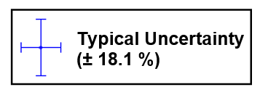
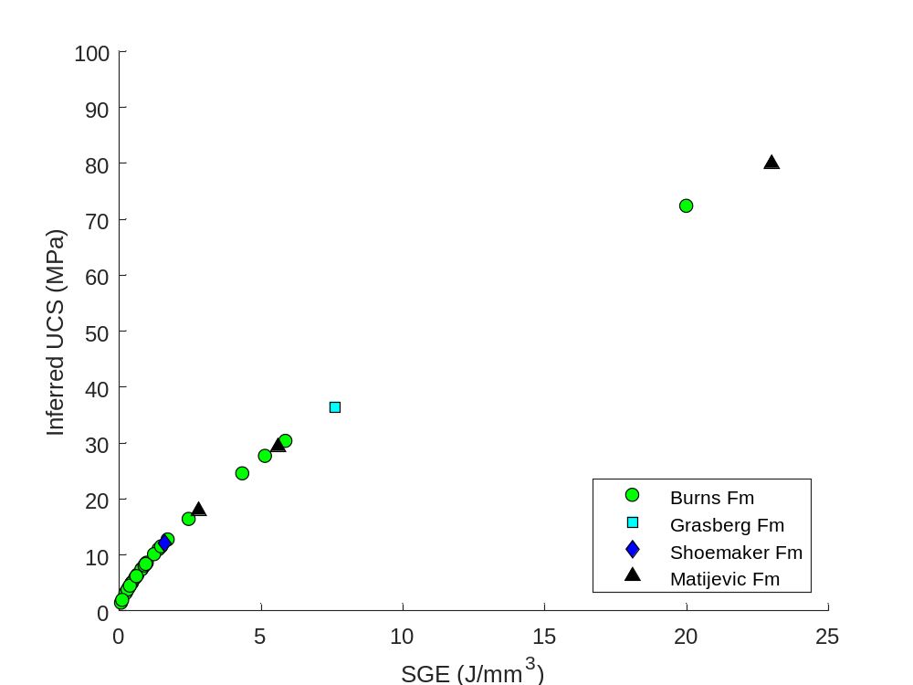
Figure 12. SGE and inferred UCS of Opportunity RAT grinds. Note that only SGEs for targets from the Burns formation were calculated in this study – SGEs for targets from the Grasberg, Shoemaker, and Matijevic formations were obtained elsewhere (Crumpler et al., 2015; Mittlefehldt et al., 2021). The “typical uncertainty” is the average uncertainty calculated for grinds processed in this study. While there is a wide range of SGE values, most targets (n = 26) were found to have SGEs of <5 J/mm³, suggesting very weak lithification at Meridiani Planum.

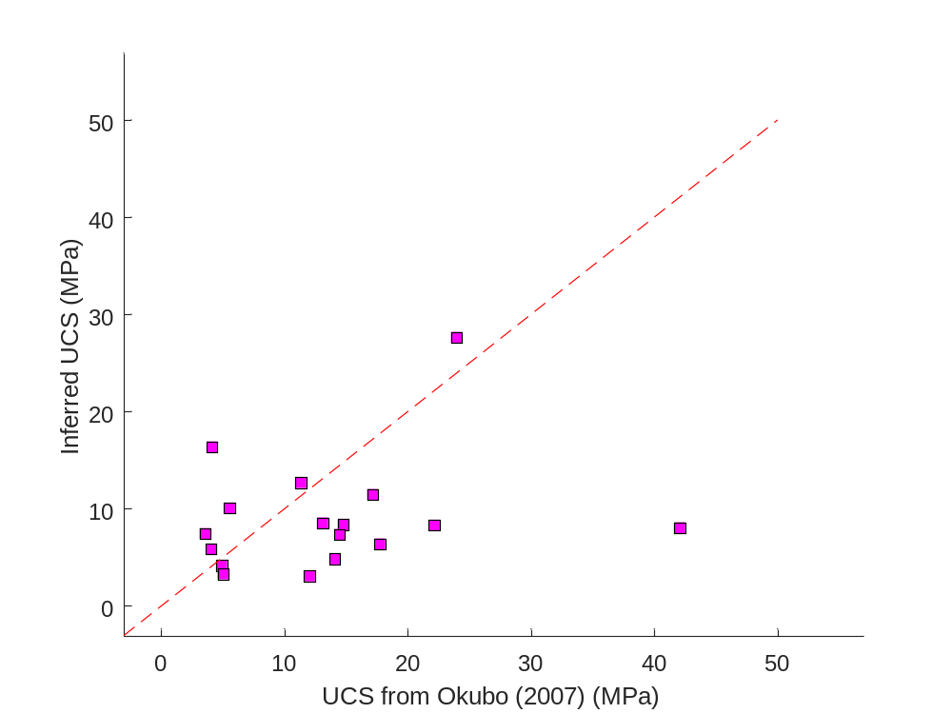
Figure 13. UCS values from this study compared to those previously reported in Okubo (2007). The red dashed line is a 1:1 line, and all values here are from Burns formation targets. The methods in Okubo (2007) appear to achieve higher UCS values than those reported here, resulting in the poor fit of the 1:1 line. This is likely due to the methods employed, where the strength values reported in Okubo (2007) are inversely proportional to the measured porosity of RAT targets. Since porosity values are lower limits due to factors such as debris accumulation, many targets may have higher porosities than those measured, which would decrease their inferred strength.

Figure 14. Examples of grind targets which show a highly irregular relationship between grind depth and SGE. (A) Feature “Middle” on target “McKittrick” from sol 30. (B) Feature “Vols” on target “Tennessee” from sol 138. (C) Feature “Tuktoyuktuk2” on target “Inuvik” from sol 184. (D) Feature “Aktineq” from target “Bylot” from sol 194. Nothing atypical was reported for these grinds and some heterogeneity is expected in natural rock samples, so these results may just be an effect of uncertainties in using that RAT on highly weathered and very weak materials.

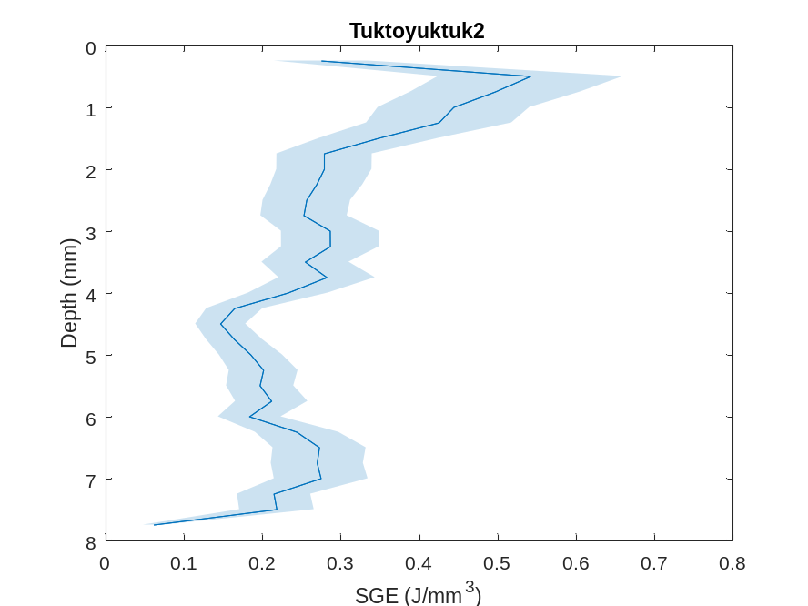
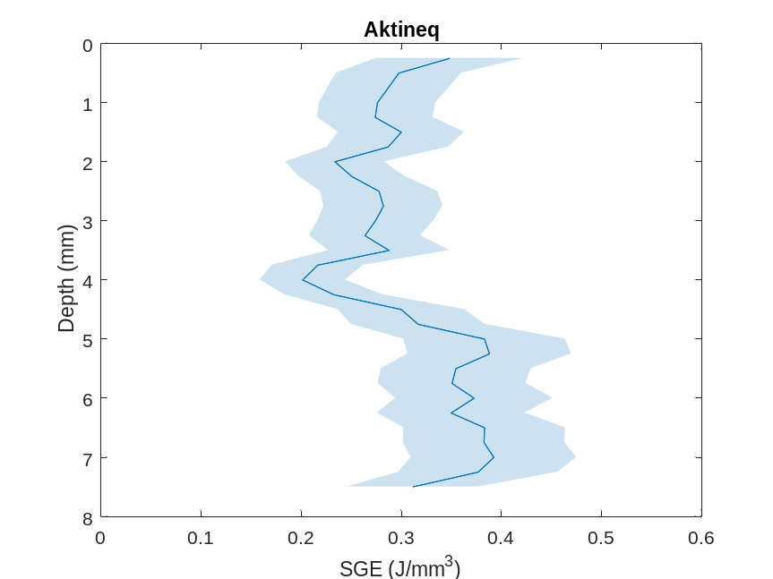
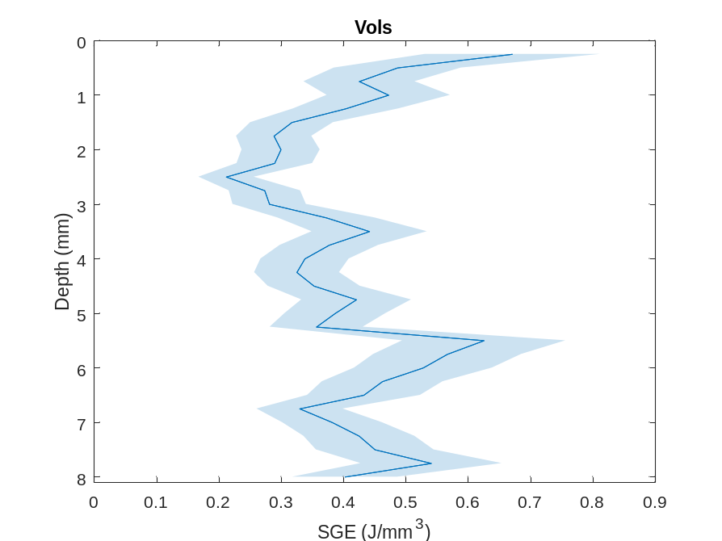
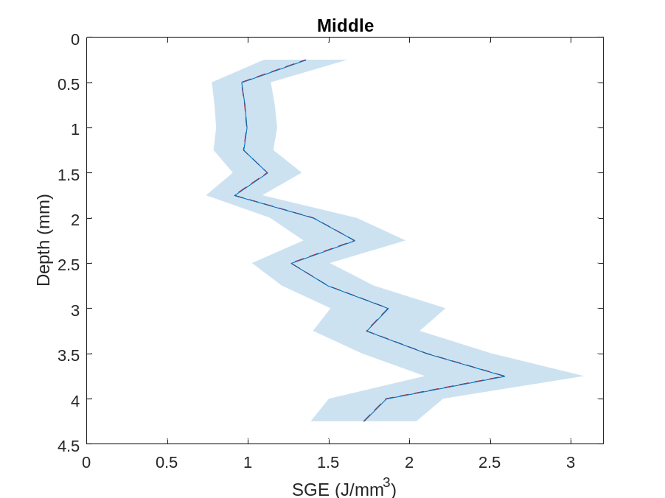
D

D
B

B
C

C
A

A
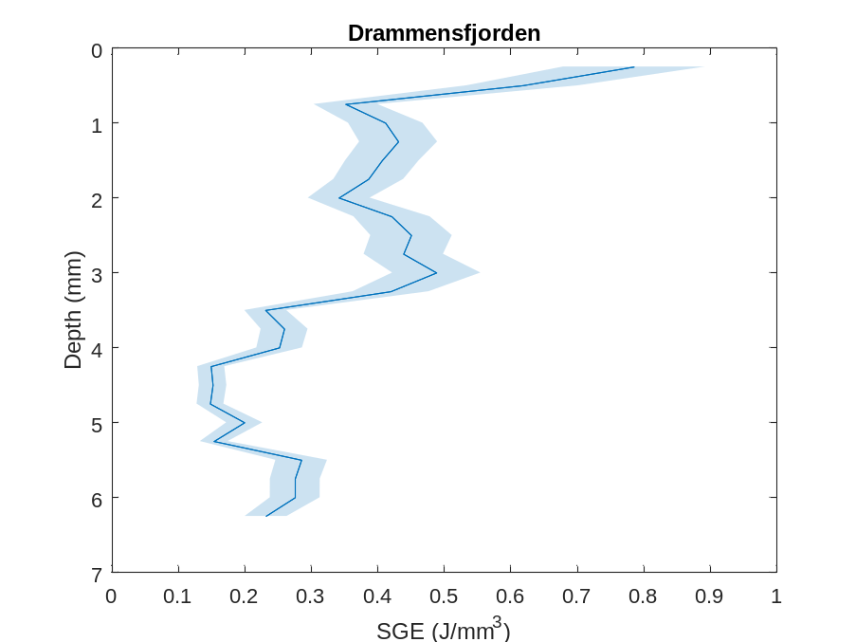
A

A
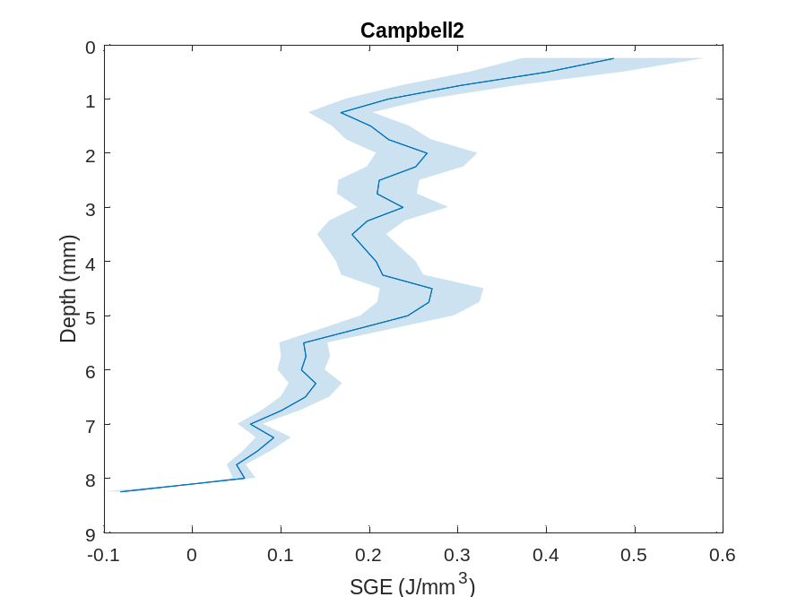
Figure 15. Examples of grind targets which show an unexpected decrease in SGE with grind depth. (A) Feature “Drammensfjorden” on target “Millstone” from sol 162. (B) Feature “Campbell2” on target “Mackenzie” from sol 182. Decreasing SGE is not an expected relationship in the presence of weathering rinds, but this could be an external effect related to RAT instrumentation by which the increasing temperatures of the RAT motors could cause an artificial decrease in SGE. However, this does not explain why SGE continues decreasing throughout the duration of the grind, or why this is only seen in a few targets.

B

B
gradual increase in SGE as more intact material is encountered with increasing grind
depth. (Figure 16). On the other hand, many targets (n = 16) show a clear positive correlation between SGE and grind depth (Figure 17).

Section 5. Discussion
A majority of samples investigated by the Opportunity rover are composed of materials from the Burns formation. These materials encompass a range of strengths, including the weakest and some of the most competent rocks abraded by the RAT. The latter, however, are less typical, and SGE values of <2 J/mm³ are far more common for Burns formation rocks. Additionally, an important consideration when interpreting these very low SGE values is the efficiency that the RAT can achieve when abrading granular targets (i.e., grain plucking). Evidence of grain plucking can be observed directly at larger scales due to the presence of a large, round void in the post-RAT MI mosaic of “Grindstone” that was once occupied by a concretion dislodged during RAT activity. Thomson et al. (2013) saw evidence attributed to grain plucking in the RAT calibration data by which the sandstone sample fell below the curve defining the relationship between SGE and UCS, likely due to the RAT plucking grains rather than grinding through them. If grain plucking is a prominent form of material removal in some grinds, then SGEs returned from those grinds would be a measure of the strength of the cement binding sediments rather than the strength of the material comprising the sediments. Given the weakly-cemented nature of the sedimentary bedrock at Meridiani Planum, some amount of grain plucking likely exists in all samples, so it should not greatly affect relative comparisons between rock targets. Since more analog work would be required to quantify the effect of grain plucking, it is considered but cannot be corrected for in these data.

5.1 Rock Strength and Burial Depths
The strength of rocks as sampled by the RAT onboard the Opportunity rover is indicative of weakly lithified sedimentary bedrock units at Meridiani Planum. Since burial depths exert a strong control over the strength of sedimentary rocks, these low
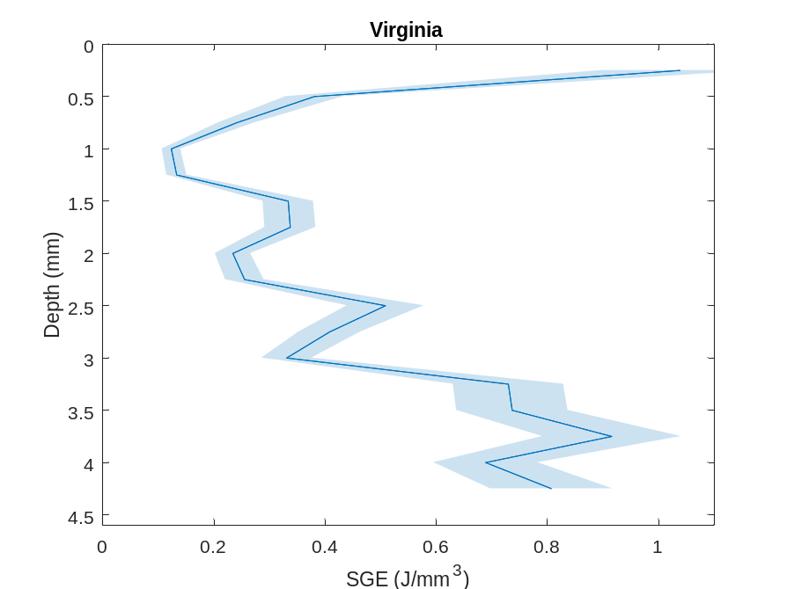
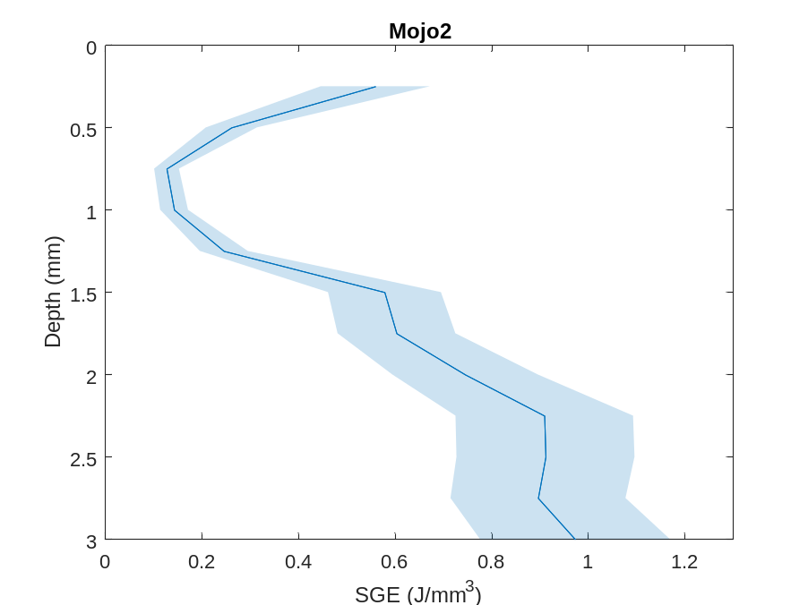
A

A
B

B

Figure 16. Examples of targets which may show evidence of case hardening. (A) Feature “Mojo2” on target “Flat Rock” from sol 42. (B) Feature “Virginia” on target “Layer_C” from sol 145. Evidence for case hardening may be related to the same motor temperature effect that results in apparent weakening. As the motors reach operational temperatures, SGE would appear to decrease alongside decreasing motor currents, which would explain the trend in early grind intervals. As depth increases, SGE would increase as more pristine material is encountered in rock interiors. However, this relationship was only observed in a few targets.

Figure 17. Examples of targets which show a clear relationship of increasing SGE with increasing grind depth, where the weathered exterior is much weaker than more pristine material at depth. (A) Feature “Case” on target “Bounce Rock” from sol 65. (B) Feature “Numa” on target “Lion Stone” from sol 103. (C) Feature “Kirchner” on target “Escher” from sol 219. (D) Feature “Penota” on target “Cercedilla” from sol 1176.

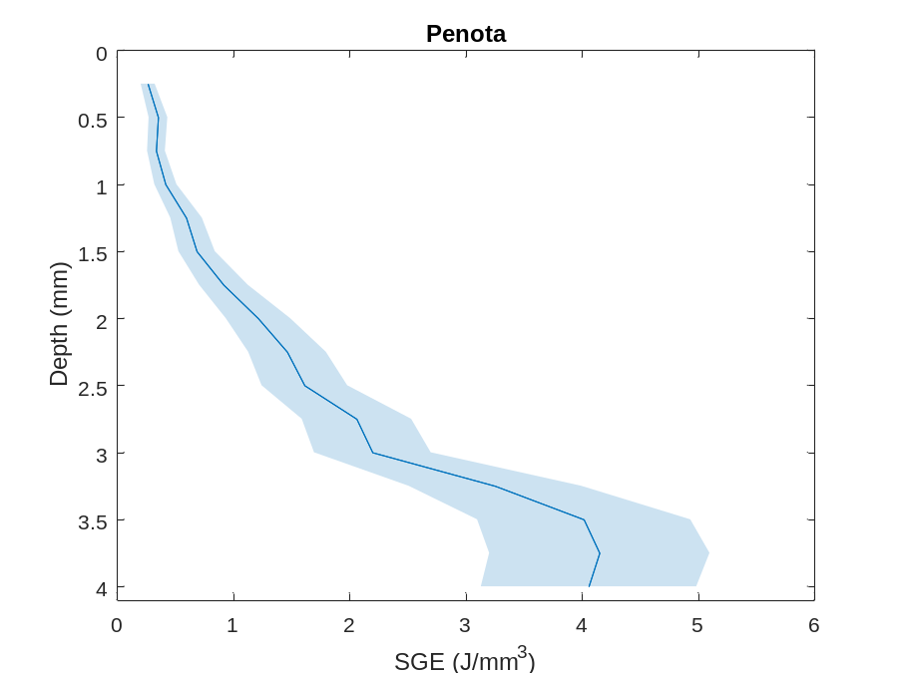
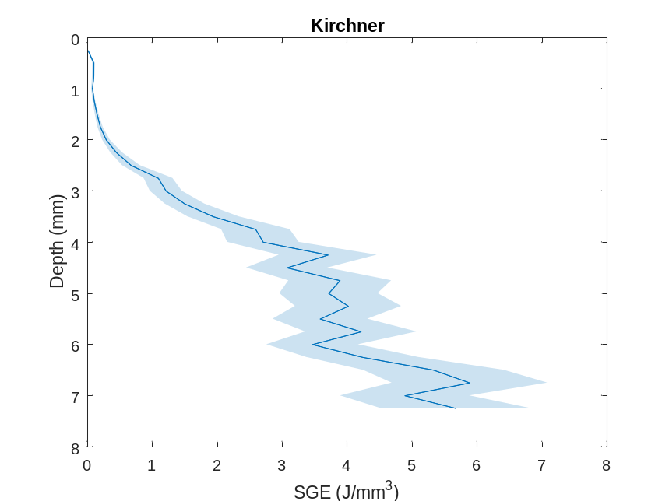
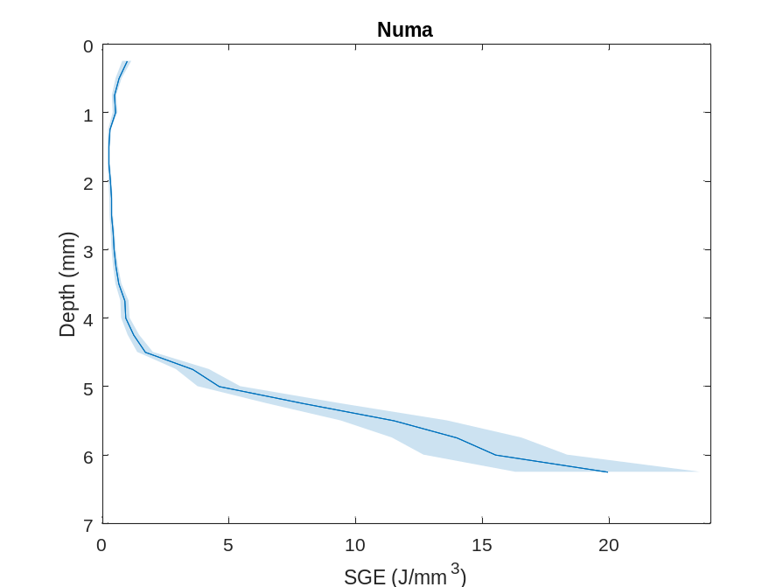
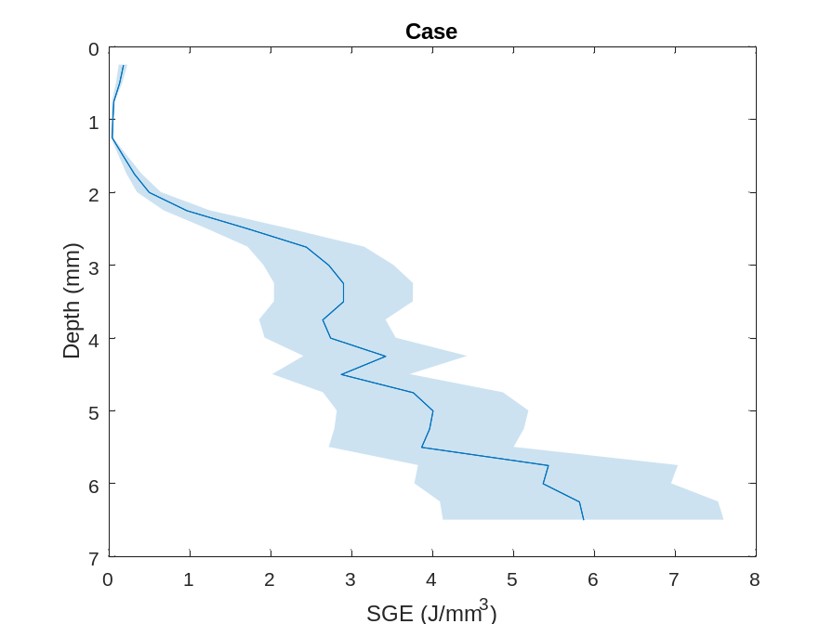
D

C
B

B
C

C
A

A

values suggest very limited burial and compaction of these units. Using a suite of sandstone samples acquired from various depths and subjecting them to compressive strength tests, Liu et al. (2020) derived an empirical relationship between burial depth and resulting UCS values under Earth conditions (Eq. 4)
(4)

(3)
$$σ_{c}=122.2-106.5e^{-0.00202h}$$

where σ_{c} is UCS and h is burial depth. Using compressive strength values obtained for in-place Burns formation outcrops, this relationship suggests that burial depths would be on the order of tens of meters under Earth conditions. Scaled to Mars’ gravity, these values would be approximately three times higher, but still relatively shallow compared to burial depths of hundreds of meters to kilometers as seen for well-lithified sandstones on Earth.
The presence of quartz overgrowths as a cementing agent on Earth is largely responsible for the high yield strength of well-lithified terrestrial sandstones (Liu et al., 2020), whereas the basaltic composition of the martian crust is less conducive to the production of quartz as a secondary phase. Indeed, the presence of crystalline SiO₂ in martian sedimentary rocks is more likely to be a clastic component than a diagenetic cement (Peters et al., 2018).
The strength values of rocks at Meridiani Planum are consistent with terrestrial aeolian sandstone, and their high porosity values suggest they were likely not fully indurated by secondary minerals, likely due to limited aqueous activity during and after their formation. Terrestrial aeolian rocks exhibit similar characteristics where porosity, cementation, and the surface area of grain-to-grain contacts directly influence rock strength and strongly correlate with compaction and diagenesis as a function of burial depth (Monsees et al., 2021). For example, the fluvio-aeolian rocks of the Sherwood Sandstone Group in the United Kingdom were measured to have UCS values of <22 MPa (Medici et al., 2019), likely as a result of poor induration and subsequent weathering (Sattler and Paraskevopoulou, 2019). Similarly, aeolian sandstone of the Nubian Formation is characterized by high porosity (~10–30%), low density rocks that were measured to have an average UCS of 18.97 MPa (Ismaiel et al., 2021). These high porosity and low strength values are attributed to weak cementation and little compaction under shallow burial conditions (Ismaiel et al., 2021).
When taken together, the above suggests that Burns formation rocks at Meridiani Planum are weak, likely due to only being subjected to shallow burial, similar to terrestrial aeolian sandstone. The inferred UCS values place them in the “weak” to “very weak” strength regime identified by Hoek and Brown (1997) (Table 4), being mechanically equivalent to weakly cemented and highly weathered rocks. Interestingly, only the float samples of Burns formation rocks reach the “medium strong” classification, and one float sample (“Numa”, 72.3 MPa) has an inferred UCS value in the range of “strong” rocks. Coupled with shallow burial, the extent of water-rock interactions was likely limited by a fluctuating water table where wet-dry cycles allowed the precipitation of sulfate material and hematite concretions without pervasive induration. These cycles are interpreted to have coincided with morphological transitions between dune and sand sheet facies as the groundwater table waxed and waned (Grotzinger et al., 2005).
SGEs for stratigraphic units below the Burns formation fall generally within the range of Burns formation targets, with only one Matijevic target (“Sturgeon_River3”) appearing stronger than any other rock target considered here (79.9 MPa). However, two other Matijevic formation targets, “Azilda2” and “Espérance5”, fall well below this value at 17.9 and 29.3 MPa, respectively. Despite the high strength value of “Sturgeon_River3”, post-RAT assessment of the grind bits noted little wear on the bits themselves. Without having access to the raw engineering data, it is difficult to determine if there was anything anomalous during this grind, but the Science Operations Working Group (SOWG) documentation notes that this grind executed nominally.
The inferred strength of the Shoemaker formation target fell within the range of the weakest Burns formation targets at 12.1 MPa (1.6 J/mm³). It is difficult to say whether this value from a single target is characteristic of the whole Shoemaker formation. This grind was relatively shallow (~2 mm), so it could be that the RAT did not fully grind through any weathering rind present and that the more pristine rock interior is in fact stronger. However, the lack of available telemetry data precludes assessment of how energy consumption changed with increasing grind depth for this target. The same is
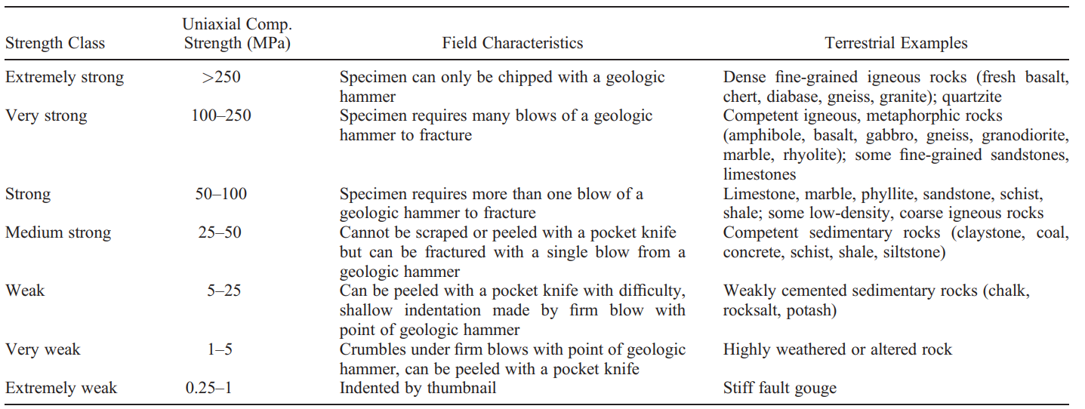
Table 4. Rock strength classifications identified by Hoek and Brown (1997). Burns formation sandstones generally fall into the “weak” to “very weak” strength regimes, and only the float samples reach the “medium strong” to “strong” classifications.
true with a single Grasberg formation sample, which returned an intermediate value in the “medium strong” strength regime at 36.4 MPa (7.6 J/mm³). This grind was also relatively shallow (~1.3 mm) but is markedly stronger than most other rock targets abraded by Opportunity. If this value is characteristic of Grasberg formation outcrops, then the fine-grained nature of the Grasberg formation may lend itself to higher compressive strength (Alomari et al., 2023).

5.2 Comparisons to Landed Spacecraft Elsewhere on Mars
The strength of rocks sampled by other spacecraft (e.g., MER Spirit and MSL Curiosity) have been reported in prior publications, allowing comparisons to be drawn with this study. Most notably, the Spirit rover hosted an identical payload to the Opportunity rover, including a RAT. The empirical relationship between SGE and UCS from Thomson et al. (2013) was used to infer the strength of rocks investigated by the Spirit rover at Gusev crater. In general, the Spirit rover analyzed a greater range of lithologies and rock strengths than those sampled by Opportunity. However, there is substantial overlap between the strength of rocks at Meridiani Planum and the strength of some rock classifications seen at Gusev crater (Figure 18), such as “Peace” class materials identified by the Spirit rover. Peace class materials were characterized as fine-grained sandstones with grains of basaltic origin weakly bound by Ca- and Mg-sulfate cement (Squyres et al., 2006a). These materials are very different from the other rock classifications at Gusev crater but share many similarities to the Burns formation identified on the other side of the planet.
In addition, a few Burns and Matijevic targets overlap with the strength values determined for Clovis class materials, and the sole Grasberg sample also plots within error of this strength domain. Clovis materials were classified as highly altered, poorly sorted clastic sedimentary rocks with a composition closely matching the basaltic nature of Gusev crater regolith (Squyres et al., 2006a). The poor sorting indicates a high energy depositional environment (e.g., explosive volcanism or impact ejecta), and their enrichment in Ni led to the hypothesis of an impact origin (Squyres et al., 2006a). The alteration pathways of Clovis class rocks strike a strong similarity with materials

Figure 18. SGE and inferred UCS values of targets abraded by Opportunity plotted over the strength domains of rock classifications identified by the Spirit rover at Gusev crater, modified from Thomson et al. (2013). There is a strong correlation between the strength of Burns formation targets and the range of strength values encompassed by Peace class materials at Gusev crater. In addition to being mechanically similar, these materials share similarities in their chemistry, mineralogy, and possibly aspects of their formation.

investigated at Meridiani Planum. The primary basaltic component of Clovis materials has been overprinted by later alteration, yet the presence of Fe-oxides (e.g., goethite) and enrichments in S, Cl, and Br suggest aqueous alteration under acidic conditions, notably producing abundant Ca-sulfates (Squyres et al., 2006a).
Much like the MER rovers, MSL Curiosity also hosts a payload which includes an instrument designed to mechanically interact with rock targets of interest. Similar to the RAT, the Powder Acquisition Drill System (PADS) is designed to drill into rock targets and extract comminuted rock material for analysis by other instruments (Grotzinger et al., 2012). While not designed as a physical properties tool, engineering data from drill operations can be used to calculate specific percussion energy, which is a measure of energy consumed by the drill normalized to the volume of material excavated and can be correlated to UCS via terrestrial calibration data (Peters et al., 2018).
This method was used in Peters et al. (2018) to estimate the strength of rocks belonging to the Murray and Stimson formations identified at Gale crater. The Murray formation consists predominantly of fine-grained mudstone interpreted to be lacustrine in origin, with some interfingering of fluvial-deltaic deposits (Grotzinger et al., 2015). Unconformably overlying the Murray formation is the Stimson formation, which is characterized by decimeter-scale, cross-bedded aeolian sandstone bound by Ca-sulfate and/or Fe-oxide cements (Banham et al., 2018). Strength results interpreted from drilling records indicate these rocks are very weak, with UCS values ranging from ~6–32 MPa (Peters et al., 2018), placing them within the strength regime of weakly cemented terrestrial aeolian sandstone, similar to rock targets encountered at Meridiani Planum.

5.3 Weathering Rinds and Veneers
Analysis of the relationship between grind depth and SGE showed various relationships regarding how strength changes with increasing grind depth. In general, because of how weak these rocks are, it is difficult to decouple what may be a real change in rock strength from perceived strength changes due to factors outside of rock mechanics. For example, some targets show a high degree of variability as the grind progressed, but this variation could come as a result of a combination of factors such as motor temperature changes, grain plucking, sample bedding anisotropy, etc. Other targets exhibit a decrease in SGE with increasing grind depth. While an initial decrease in SGE can be explained by the RAT motors reaching operational temperatures, it would be expected that SGE would begin increasing once peak temperatures were reached or remain relatively constant if the more pristine rock interior was encountered below any weathering rinds. On the other hand, the very weak nature of these targets means that even minor changes can have relatively large effects on SGE, so an explanation for the perceived weakening remains elusive. In addition, no targets appeared to show a plateau in SGE value at depth, indicating that weathering rinds extend further than RAT grind depths, indicative of long surface exposure times.
A few targets may show evidence of having a case-hardened surface but could otherwise be explained by external factors related to RAT operation. These targets showed an initial rapid decrease in SGE followed by a more gradual increase in SGE. This would be expected in cases where a thin (<1 mm) protective veneer has developed on the outer surface of a rock target, leading to an initially high SGE. Below this veneer, more weathered rock exists which, on Earth, aids in the exfoliation of rinds in the spheroidal weathering process (Dorn et al., 2017). This more weathered material immediately beneath the rind would have a much lower SGE, and SGE would then gradually increase with increasing grind depth as less altered material is encountered by the RAT. Conversely, due to the very low SGE for these rocks, this effect could simply be a result of increasing RAT motor temperatures in the beginning of these grinds. A similar effect is seen in stronger targets (e.g., “Case” and “Numa”) where the beginning of the grind shows a slight decrease in SGE. However, this effect is less pronounced due to the higher SGE values for these targets, suggesting that this is more likely to be an effect of motor temperatures rather than evidence of case hardening.
Many targets show a clear trend of increasing SGE with increasing grind depth. These were also some of the most competent rocks sampled which would minimize effects due to instrumentation. This is a more expected result of rocks which have weathering rinds present on their outer surfaces. The gradational nature of weathering rinds means that the outermost surface would be the most weathered, becoming progressively less weathered with increasing depth from the surface until a pristine core of rock material is reached (if present). The trend between grind depth and SGE displays this relationship by which the grind starts at a very low SGE and gradually increases as the RAT advances into the target. This change in SGE likely reflects changes in rock competency as the RAT progresses into the weathered surface, encountering more pristine material at depth.

5.4 Strength of Outcrop and Float Samples
Many of the strongest Burns formation rocks are characterized as float deposits associated with proximal and distal ejecta of the impact craters across Meridiani Planum. These float samples were between 1.7–8.1 times stronger than the strongest outcrop sample abraded by Opportunity (“Cobble Hill” from sol 143). This association raises questions about the effect of hypervelocity impacts on a weakly-lithified substrate. A plausible explanation for the high strength values of float samples could be the filtering of ejecta produced by impact cratering such that only competent materials survive the impact process (French, 1998). The fact that these rocks still exist suggests that they were strong enough to endure being excavated and ballistically emplaced elsewhere, whereas weaker materials would simply disaggregate under such forces. Since these rocks would have been excavated from depth, they likely experienced a different weathering regime and are less altered than rocks that have experienced longer surface exposure times.

5.5 Negative SGE Values
As noted previously, two Burns formation targets (“Holman3-2” and “Campbell2”) returned negative SGE values, which highlight uncertainties in interpretations of engineering data returned by the RAT. Based on the equation for calculating SGE (Eq. 1), negative values can only occur when the no-load current exceeds the average current drawn by the RAT grind motors during grind activity. Some potential explanations for this discrepancy of motor current values include motor temperature effects and/or contamination of the instrument by cuttings produced during RAT grinds. Since no-load currents are calculated from post-grind brushing events, the RAT grind motor may have cooled enough in the time between grinding and brushing to increase motor currents above the average current drawn during grinds (Herkenhoff et al., 2008). However, the motors should rapidly reach their operational temperatures during the brush phase, so averaging motor currents across the duration of the brush should minimize this effect since the brush current remains relatively constant (less than 20% variation over the brush duration). Contamination of the instrument by cuttings would also inflate motor current values by increasing the frictional resistance experienced by the RAT motors (Herkenhoff et al., 2008). While negative SGEs are not realistic, the fact that the average and no-load currents were close in value suggests that these two samples are very weak and easy to grind, consistent with other Burns formation targets.

Section 6. Conclusions
The physical properties of rocks such as their strength, hardness, and density can provide insight into the process of lithification. These factors tend to correlate with burial depth and compaction where the occlusion of pore space and precipitation of cement phases increases the surface area of grain-to-grain contacts, leading to stronger, denser rocks. Thus, understanding the strength of rocks allows some inference as to the conditions experienced during burial and lithification.
Here, engineering data from the RAT onboard the Opportunity rover were used to quantify the strength of rocks sampled across Meridiani Planum. Due to issues with data procurement, analysis featured a heavy emphasis on Burns formation targets that were abraded prior to the loss of the RAT’s motor encoders, which necessitated a transition to open-loop controls and made traditional SGE calculations nonviable. Results of energy consumption during RAT grinds show that these rocks are very friable and easy to grind, indicating that they are very weak in comparison to well-lithified terrestrial sedimentary rocks but are mechanically similar to terrestrial aeolian sandstone (e.g., the Sherwood Sandstone Group, Nubian Formation, etc.) (Medici et al., 2019; Ismaiel et al., 2021). This is likely due to limited burial depths and water-rock interaction, leaving poorly indurated rocks that are weakly bound by sulfate cement. Interestingly, ejecta blocks that are thought to be from the Burns formation appear stronger than any in-place Burns formation outcrop. Finally, negative SGEs that were returned highlight uncertainties in using the RAT as a physical properties tool, and further understanding of the mechanical interaction of the RAT grind bits and granular targets (e.g., grain plucking) would be useful for future interpretations of these data.
Comparing the results presented here to strength values reported elsewhere on Mars shows similarities in the sedimentary rock characteristics at other martian locales. At Gusev crater, Peace class materials appear to share not only a resemblance in mechanical response with the Burns formation, but also similarities in their sedimentology and possibly aspects of their formation including alteration by sulfate-bearing fluids. Additionally, the sedimentary rocks at Gale crater have similar strength values as those at Meridiani Planum. In particular, the Stimson formation appears to be analogous to the Burns formation at Meridiani Planum, much like Peace class materials at Gusev crater. In general, many of the sedimentary rocks at various locations on Mars seem to be weak, similar to terrestrial aeolian rocks that were only subjected to weak cementation and shallow burial.
Future work will, first and foremost, focus on the recovery and processing of the open-loop RAT data missing from the NASA PDS archive in order to provide a more complete assessment of the physical properties of rocks at Meridiani Planum. Additionally, further understanding of the microscale interactions of the RAT grinding bits on granular targets (e.g., grain plucking) would strengthen interpretations of SGE as a proxy for bulk rock strength. Finally, investigation of differences between Burns formation outcrop and float samples may reveal evidence as to the disparity in strength between these two sample types.

                - References
Alomari, E. M., Ng, K. W., Khatri, L., & Wulff, S. S. (2023). Effect of Physical Properties on Mechanical Behaviors of Sandstone under Uniaxial and Triaxial Compressions. Materials, 16(13), 4867.
Arvidson, R. E., Ashley, J. W., Bell, J. F., Chojnacki, M., Cohen, J., Economou, T. E., Farrand, W. H., Fergason, R., Fleischer, I., Geissler, P., Gellert, R., Golombek, M. P., Grotzinger, J. P., Guinness, E. A., Haberle, R. M., Herkenhoff, K. E., Herman, J. A., Iagnemma, K. D., Jolliff, B. L., . . . Wolff, M. J. (2011). Opportunity Mars Rover mission: Overview and selected results from Purgatory ripple to traverses to Endeavour crater. Journal of Geophysical Research, 116. https://doi.org/10.1029/2010je003746
Arvidson, R. E., Squyres, S. W., III, J. F. B., Catalano, J. G., Clark, B. C., Crumpler, L. S., Jr., P. A. d. S., Fairén, A. G., Farrand, W. H., Fox, V. K., Gellert, R., Ghosh, A., Golombek, M. P., Grotzinger, J. P., Guinness, E. A., Herkenhoff, K. E., Jolliff, B. L., Knoll, A. H., Li, R., . . . Wolff, M. J. (2014). Ancient Aqueous Environments at Endeavor Crater, Mars. Science, 343. https://doi.org/10.1126/science.1248097
ASTM. (2010). Standard Test Methods for Compressive Strength and Elastic Moduli of Intact Rock Core Specimens under Varying States of Stress and Temperatures. American Society for Testing and Materials International, West Conshohocken, PA.
Attewell, P. B., & Farmer, I. W. (1976). Principles of engineering geology. Springer Science & Business Media.
Banham, S. G., Gupta, S., Rubin, D. M., Watkins, J. A., Sumner, D. Y., Edgett, K. S., Grotzinger, J. P., Lewis, K. W., Edgar, L. A., & Stack‐Morgan, K. M. (2018). Ancient Martian aeolian processes and palaeomorphology reconstructed from the Stimson formation on the lower slope of Aeolis Mons, Gale crater, Mars. Sedimentology, 65(4), 993-1042.
Bjørlykke, K. (1999). An overview of factors controlling rates of compaction, fluid generation and flow in sedimentary basins. Growth, dissolution and pattern formation in geosystems, 381-404.
Bjørlykke, K. (2014). Relationships between depositional environments, burial history and rock properties. Some principal aspects of diagenetic process in sedimentary basins. Sedimentary Geology, 301, 1-14. https://doi.org/10.1016/j.sedgeo.2013.12.002
Burns, R. G. (1987). Ferric sulfates on Mars. Journal of Geophysical Research: Solid Earth, 92(B4), E570-E574. https://doi.org/10.1029/JB092iB04p0E570
Callas, J. L., Golombek, M., & Fraeman, A. (2019). Mars Exploration Rover Opportunity End of Mission Report. JPL Publication 19-10.
Carr, M. H., & Head, J. W. (2010). Geologic history of Mars. Earth and Planetary Science Letters, 294(3-4), 185-203. https://doi.org/10.1016/j.epsl.2009.06.042
Carr, M. H., & Head, J. W. (2015). Martian surface/near-surface water inventory: Sources, sinks, and changes with time. Geophysical Research Letters, 42(3), 726-732. https://doi.org/10.1002/2014gl062464
Chang, C., Zoback, M. D., & Khaksar, A. (2006). Empirical relations between rock strength and physical properties in sedimentary rocks. Journal of Petroleum Science and Engineering, 51(3-4), 223-237. https://doi.org/10.1016/j.petrol.2006.01.003
Christensen, P. R. (2003). Formation of recent martian gullies through melting of extensive water-rich snow deposits. Nature, 422, 45-48.
Christensen, P. R. (2004). Formation of the hematite-bearing unit in Meridiani Planum: Evidence for deposition in standing water. Journal of Geophysical Research, 109(E8). https://doi.org/10.1029/2003je002233
Christensen, P. R., Bandfield, J. L., Clark, R. N., Edgett, K. S., Hamilton, V. E., Hoefen, T., Kieffer, H. H., Kuzmin, R. O., Lane, M. D., Malin, M. C., Morris, R. V., Pearl, J. C., Pearson, R., Roush, T. L., Ruff, S. W., & Smith, M. D. (2000). Detection of crystalline hematite mineralization on Mars by the Thermal Emission Spectrometer: Evidence for near-surface water. Journal of Geophysical Research: Planets, 105(E4), 9623-9642. https://doi.org/10.1029/1999je001093
Chuhan, F. A., Kjeldstad, A., Bjørlykke, K., & Høeg, K. (2002). Porosity loss in sand by grain crushing—Experimental evidence and relevance to reservoir quality. Marine and Petroleum Geology, 19(1), 39-53.
Crumpler, L. S., Arvidson, R. E., Bell, J., Clark, B. C., Cohen, B. A., Farrand, W. H., Gellert, R., Golombek, M., Grant, J. A., Guinness, E., Herkenhoff, K. E., Johnson, J. R., Jolliff, B., Ming, D. W., Mittlefehldt, D. W., Parker, T., Rice, J. W., Squyres, S. W., Sullivan, R., & Yen, A. S. (2015). Context of ancient aqueous environments on Mars from in situ geologic mapping at Endeavour Crater. Journal of Geophysical Research: Planets, 120(3), 538-569. https://doi.org/10.1002/2014je004699
Crumpler, L. S., Arvidson, R. E., Mittlefehldt, D. W., Grant, J. A., & Farrand, W. H. (2020). Results from the first geologic traverse on the topographic rim of a complex impact crater, Endeavour Crater, Mars. Geology, 48(3), 252-257. https://doi.org/10.1130/g46903.1
Dorn, R. I., Dorn, J., Harrison, E., Gutbrod, E., Gibson, S., Larson, P., Cerveny, N., Lopat, N., Groom, K. M., & Allen, C. D. (2012). Case hardening vignettes from the western USA: convergence of form as a result of divergent hardening processes. Yearbook of the Association of Pacific Coast Geographers, 74(1), 53-75.
Dorn, R. I., Mahaney, W. C., & Krinsley, D. H. (2017). Case hardening: turning weathering rinds into protective shells. Elements: An International Magazine of Mineralogy, Geochemistry, and Petrology, 13(3), 165-169.
Fawad, M., Mondol, N. H., Jahren, J., & Bjørlykke, K. (2011). Mechanical compaction and ultrasonic velocity of sands with different texture and mineralogical composition. Geophysical Prospecting, 59(4), 697-720.
Fraeman, A. A. (2018). Unraveling the History of Meridiani Planum, Mars: New Chemical Clues From the Rim of Endeavour Crater. Journal of Geophysical Research: Planets, 123(3), 690-694. https://doi.org/10.1002/2018je005535
French, B. M. (1998). Traces of catastrophe: A handbook of shock-metamorphic effects in terrestrial meteorite impact structures.
Golombek, M. P., Arvidson, R. E., Bell, J. F., 3rd, Christensen, P. R., Crisp, J. A., Crumpler, L. S., Ehlmann, B. L., Fergason, R. L., Grant, J. A., Greeley, R., Haldemann, A. F., Kass, D. M., Parker, T. J., Schofield, J. T., Squyres, S. W., & Zurek, R. W. (2005). Assessment of Mars Exploration Rover landing site predictions. Nature, 436(7047), 44-48. https://doi.org/10.1038/nature03600
Gorevan, S. P., Myrick, T., Davis, K., Chau, J. J., Bartlett, P., Mukherjee, S., Anderson, R., Squyres, S. W., Arvidson, R. E., Madsen, M. B., Bertelsen, P., Goetz, W., Binau, C. S., & Richter, L. (2003). Rock Abrasion Tool: Mars Exploration Rover mission. Journal of Geophysical Research: Planets, 108(E12). https://doi.org/10.1029/2003je002061
Grotzinger, J. P., Arvidson, R. E., Bell, J. F., Calvin, W., Clark, B. C., Fike, D. A., Golombek, M., Greeley, R., Haldemann, A., Herkenhoff, K. E., Jolliff, B. L., Knoll, A. H., Malin, M., McLennan, S. M., Parker, T., Soderblom, L., Sohl-Dickstein, J. N., Squyres, S. W., Tosca, N. J., & Watters, W. A. (2005). Stratigraphy and sedimentology of a dry to wet eolian depositional system, Burns formation, Meridiani Planum, Mars. Earth and Planetary Science Letters, 240(1), 11-72. https://doi.org/10.1016/j.epsl.2005.09.039
Grotzinger, J. P., Crisp, J., Vasavada, A. R., Anderson, R. C., Baker, C. J., Barry, R., Blake, D. F., Conrad, P., Edgett, K. S., & Ferdowski, B. (2012). Mars Science Laboratory mission and science investigation. Space science reviews, 170, 5-56.
Grotzinger, J. P., Gupta, S., Malin, M. C., Rubin, D. M., Schieber, J., Siebach, K., Sumner, D. Y., Stack, K. M., Vasavada, A. R., & Arvidson, R. E. (2015). Deposition, exhumation, and paleoclimate of an ancient lake deposit, Gale crater, Mars. Science, 350(6257), aac7575.
Hawkes, I., & Mellor, M. (1970). Uniaxial testing in rock mechanics laboratories. Engineering Geology, 4(3), 179-285.
Herkenhoff, K. E., Golombek, M. P., Guinness, E. A., Johnson, J. B., Kusack, A., Richter, L., Sullivan, R. J., & Gorevan, S. (2008). In situ observations of the physical properties of the Martian surface. The Martian Surface: Composition, Mineralogy, and Physical Properties.
Herkenhoff, K. E., Squyres, S. W., Bell III, J. F., Maki, J. N., Arneson, H. M., Bertelsen, P., Brown, D. I., Collins, S. A., Dingizian, A., Elliott, S. T., Goetz, W., Hagerott, E. C., Hayes, A. G., Johnson, M. J., Kirk, R. L., McLennan, S., Morris, R. V., Scherr, L. M., Schwochert, M. A., . . . Wadsworth, M. V. (2003). Athena Microscopic Imager investigation. Journal of Geophysical Research: Planets, 108(E12). https://doi.org/https://doi.org/10.1029/2003JE002076
Hoek, E., & Brown, E. T. (1997). Practical Estimates of Rock Mass Strength. International Journal of Rock Mechanics and Mining Sciences, 34(8), 1165-1186. https://doi.org/10.1016/S1365-1609(97)80069-X
Hynek, B. M., & Achille, G. D. (2017). Geologic Map of Mars. USGS.
Indyk, S., Spring, J., Ford, S., Luczek, K., & Paulsen, G. (2018). Operating the Rock Abrasion Tool (RAT) Fourteen Years Beyond Mission Scope 2018 SpaceOps Conference,
Ismaiel, H. A. H., Askalany, M. M., & Ali, A. I. (2021). Statistical Analyses and Geotechnical Evaluation of Nubia Sandstone, Golden Triangle Area, Egypt. Journal of Geoscience and Environment Protection, 9(11), 46-60.
Knoll, A. H., & Grotzinger, J. (2006). Water on Mars and the Prospect of Martian Life. Elements, 2(3), 169-173. https://doi.org/10.2113/gselements.2.3.169
Knoll, A. H., Jolliff, B. L., Farrand, W. H., Bell III, J. F., Clark, B. C., Gellert, R., Golombek, M., Grotzinger, J. P., Herkenhoff, K. E., & Johnson, J. R. (2008). Veneers, rinds, and fracture fills: Relatively late alteration of sedimentary rocks at Meridiani Planum, Mars. Journal of Geophysical Research: Planets, 113(E6).
Kolawole, O., & Ispas, I. (2020). Evaluation of geomechanical properties via scratch tests: Where are we and where do we go from here? SN Applied Sciences, 2(10), 1633.
Komurlu, E., & Çelik, A. G. (2022). An Experimental Study on Stress Relaxation Behavior of Cement Stabilized Sands. Journal of GeoEngineering, 17(4).
Liu, X., Liu, Q., Kang, Y., & Liu, B. (2020). Investigation on relationship of the burial depth and mechanical properties for sedimentary rocks. Arabian Journal of Geosciences, 13. https://doi.org/10.1007/s12517-020-05757-1
McCollom, T. M., & Hynek, B. (2021). Geochemical data indicate highly similar sediment compositions for the Grasberg and Burns formations on Meridiani Planum, Mars. Earth and Planetary Science Letters, 557. https://doi.org/10.1016/j.epsl.2020.116729
McCollom, T. M., & Hynek, B. M. (2023). Proposed Origin of the Burns Formation (Meridiani Planum, Mars) by Erosion, Reworking, and Diagenetic Alteration of a Grasberg‐Like Precursor. Journal of Geophysical Research: Planets, 128(4). https://doi.org/10.1029/2022je007374
Medici, G., West, L., Mountney, N. P., & Welch, M. (2019). Permeability of rock discontinuities and faults in the Triassic Sherwood Sandstone Group (UK): insights for management of fluvio-aeolian aquifers worldwide. Hydrogeology Journal, 27(8), 2835-2855.
Mittlefehldt, D. W., Gellert, R., vanBommel, S., Arvidson, R. E., Ashley, J. W., Clark, B. C., Crumpler, L. S., Farrand, W. H., Golombek, M. P., Grant, J. A., Morris, R. V., & Schröder, C. (2021). Geology and Geochemistry of Noachian Bedrock and Alteration Events, Meridiani Planum, Mars: MER Opportunity Observations. Journal of Geophysical Research: Planets, 126(9). https://doi.org/10.1029/2021je006915
Mittlefehldt, D. W., Gellert, R., vanBommel, S., Ming, D. W., Yen, A. S., Clark, B. C., Morris, R. V., Schröder, C., Crumpler, L. S., Grant, J. A., Jolliff, B. L., Arvidson, R. E., Farrand, W. H., Herkenhoff, K. E., Bell, J. F., Cohen, B. A., Klingelhöfer, G., Schrader, C. M., & Rice, J. W. (2018). Diverse Lithologies and Alteration Events on the Rim of Noachian‐Aged Endeavour Crater, Meridiani Planum, Mars: In Situ Compositional Evidence. Journal of Geophysical Research: Planets, 123(5), 1255-1306. https://doi.org/10.1002/2017je005474
Monsees, A. C., Biebricher, S. F., Busch, B., Feinendegen, M., Ziegler, M., & Hilgers, C. (2021). Coupling of diagenetic alterations and mechanical properties of Lower Permian siliciclastic sandstones: a pilot study. Environmental Earth Sciences, 80, 1-18.
Myrick, T., Carlson, L., Chau, C., Powderly, J., Bartlett, P., Davis, K., & Gorevan, S. (2004). The RAT as a Mars Rock Physical Properties Tool Space 2004 Conference and Exhibit,
Oguchi, C. (2013). 4.6 weathering rinds: Formation processes and weathering rates.
Okubo, C. H. (2007). Strength and deformability of light-toned layered deposits observed by MER Opportunity: Eagle to Erebus craters, Mars. Geophysical Research Letters, 34(20). https://doi.org/10.1029/2007gl031327
Okubo, C. H., & Schultz, R. A. (2005). Evolution of damage zone geometry and intensity in porous sandstone: insight gained from strain energy density. Journal of the Geological Society, London, 162, 939-949. https://doi.org/https://doi.org/10.1144/0016-764904-148
Peters, G. H., Carey, E. M., Anderson, R. C., Abbey, W. J., Kinnett, R., Watkins, J. A., Schemel, M., Lashore, M. O., Chasek, M. D., Green, W., Beegle, L. W., & Vasavada, A. R. (2018). Uniaxial Compressive Strengths of Rocks Drilled at Gale Crater, Mars. Geophysical Research Letters, 45(1), 108-116. https://doi.org/10.1002/2017gl075965
Sattler, T., & Paraskevopoulou, C. (2019). Implications on characterizing the extremely weak sherwood sandstone: case of slope stability analysis using SRF at two oak quarry in the UK. Geotechnical and Geological Engineering, 37, 1897-1918.
Schei, G., Fjær, E., Detournay, E., Kenter, C. J., Fuh, G. F., & Zausa, F. (2000). The Scratch Test: An Attractive Technique for Determining Strength and Elastic Properties of Sedimentary Rocks. Society of Petroleum Engineers,
Scheller, E. L. (2021). Long-term drying of Mars by sequestration of ocean-scale volumes of water in the crust. Science, 372, 56-62. https://doi.org/10.1126/science.abc7717
Squyres, S. W., Arvidson, R. E., Baumgartner, E. T., Bell, J. F., Christensen, P. R., Gorevan, S., Herkenhoff, K. E., Klingelhöfer, G., Madsen, M. B., Morris, R. V., Rieder, R., & Romero, R. A. (2003). Athena Mars rover science investigation. Journal of Geophysical Research: Planets, 108(E12). https://doi.org/10.1029/2003je002121
Squyres, S. W., Arvidson, R. E., Bell III, J. F., Bruckner, J., Cabrol, N. A., Calvin, W., Carr, M. H., Christensen, P. R., Clark, B. C., & Crumpler, L. (2004). The Spirit rover's Athena science investigation at Gusev crater, Mars. Science, 305(5685), 794-799.
Squyres, S. W., Arvidson, R. E., Blaney, D. L., Clark, B. C., Crumpler, L., Farrand, W. H., Gorevan, S., Herkenhoff, K. E., Hurowitz, J., & Kusack, A. (2006a). Rocks of the Columbia hills. Journal of Geophysical Research: Planets, 111(E2).
Squyres, S. W., Arvidson, R. E., Bollen, D., Bell, J. F., Brückner, J., Cabrol, N. A., Calvin, W. M., Carr, M. H., Christensen, P. R., Clark, B. C., Crumpler, L., Des Marais, D. J., d'Uston, C., Economou, T., Farmer, J., Farrand, W. H., Folkner, W., Gellert, R., Glotch, T. D., . . . Yen, A. (2006b). Overview of the Opportunity Mars Exploration Rover Mission to Meridiani Planum: Eagle Crater to Purgatory Ripple. Journal of Geophysical Research: Planets, 111(E12). https://doi.org/10.1029/2006je002771
Squyres, S. W., Arvidson, R. E., III, J. F. B., III, F. C., Clark, B. C., Cohen, B. A., Crumpler, L. A., Jr., P. A. d. S., Farrand, W. H., Gellert, R., Grant, J., Herkenhoff, K. E., Hurowitz, J. A., Johnson, J. R., Jolliff, B. L., Knoll, A. H., Li, R., McLennan, S. M., Ming, D. W., . . . Zacny, K. (2012). Ancient Impact and Aqueous Processes at Endeavor Crater, Mars. Science, 336, 570-576.
Squyres, S. W., Knoll, A. H., Arvidson, R. E., Clark, B. C., Grotzinger, J. P., Jolliff, B. L., McLennan, S. M., Tosca, N., III, J. F. B., Calvin, W. M., Farrand, W. H., Glotch, T. D., Golombek, M. P., Herkenhoff, K. E., Johnson, J. R., Klingelhöfer, G., McSween, H. Y., & Yen, A. S. (2006c). Two Years at Meridiani Planum: Results from the Opportunity Rover. Science, 313. https://doi.org/10.1126/science.113089
Tanaka, K. L. (1986). The stratigraphy of Mars. Journal of Geophysical Research, 91(B13). https://doi.org/10.1029/JB091iB13p0E139
Thomson, B. J., Bridges, N. T., Cohen, J., Hurowitz, J. A., Lennon, A., Paulsen, G., & Zacny, K. (2013). Estimating rock compressive strength from Rock Abrasion Tool (RAT) grinds. Journal of Geophysical Research: Planets, 118(6), 1233-1244. https://doi.org/10.1002/jgre.20061
Thomson, B. J., Hurowitz, J. A., Baker, L. L., Bridges, N. T., Lennon, A. M., Paulsen, G., & Zacny, K. (2014). The effects of weathering on the strength and chemistry of Columbia River Basalts and their implications for Mars Exploration Rover Rock Abrasion Tool (RAT) results. Earth and Planetary Science Letters, 400, 130-144. https://doi.org/10.1016/j.epsl.2014.05.012
Wong, L. N. Y., Maruvanchery, V., & Liu, G. (2015). Water effects on rock strength and stiffness degradation. Acta Geotechnica, 11(4), 713-737. https://doi.org/10.1007/s11440-015-0407-7
Wordsworth, R. D. (2016). The Climate of Early Mars. Annual Review of Earth and Planetary Sciences, 44(1), 381-408. https://doi.org/10.1146/annurev-earth-060115-012355
Zolotov, M. Y., & Shock, E. L. (2005). Formation of jarosite-bearing deposits through aqueous oxidation of pyrite at Meridiani Planum, Mars. Geophysical Research Letters, 32(21). https://doi.org/10.1029/2005gl024253

                - Appendix
                - 1. Open-Loop RAT Data Products
The RAT’s transition to open loop controls was a necessary adjustment to allow continued use of an aging instrument on the Opportunity rover. However, this induced a change in the data products produced by the RAT which could not be processed in the same manner as the data products returned under closed-loop control. This issue was first noticed when attempting to process data products for the target “Smith2”. Looking to the SOWG reports for more details about this grind, it was noted that the RAT had faulted out during both the calibration and grind-scan routines for this target. While stalls during grind activity are not uncommon (e.g., dislodging concretions, release of preload due to rock shifting, etc.), there was no immediate explanation for why the RAT terminated its activity during this grind. Interpretations of RAT data produced before the stall indicated that the issue may have been internal, and further diagnostics revealed that the revolve encoder had failed. After a few weeks of troubleshooting in the rover testbed on Earth, the open-loop control was developed and was ready to be implemented on Mars. Commands for a grind were sent to Opportunity, and the RAT was placed on rock for about an hour before a contact switch failure terminated the activity. However, the open-loop control worked and the RAT ground a hole ~1 mm deep. Unfortunately, it was later discovered that during diagnostics the RAT brush was run in reverse which bent the bristles, leaving later targets with a mound of cuttings in the center that the brush could no longer clear.
While the RAT was back up and running, the data products returned under open-loop control no longer contained the information necessary in calculating SGE. Conversely, SGEs for some open-loop targets were reported in Crumpler et al. (2015) and Mittlefehldt et al. (2021), meaning there must be some way to continue calculating SGE. As a first step in tracking down how these calculations were being done, conversations were initiated with engineers at Honeybee Robotics – the firm that designed the RAT and maintained a crucial role in aiding RAT operations on both Spirit and Opportunity. Per these conversations, the engineers could no longer use RAT data products to evaluate average motor currents. Instead, they retrieved *.gif files of RAT activity from a server at JPL which were produced by a script that processed low-level motor functions from the RAT (Figure 19). Since these files only showed a plot of relevant engineering data (grind currents, motor voltage, etc.) over the duration of the grinds, values for these data had to be visually estimated from these plots. This information shed light on how the engineers were able to continue calculating SGE, albeit with some subjectivity, but does not explain how the data for these plots were generated.
Additional inquiries were sent to the PDS in hopes that these plots of grind activity were archived somewhere else. Unfortunately, these conversations provided no additional information as to where these data are. As things stand at the time of this writing, we are awaiting a response from engineers at JPL who may be able to point us in the right direction to recover these data.
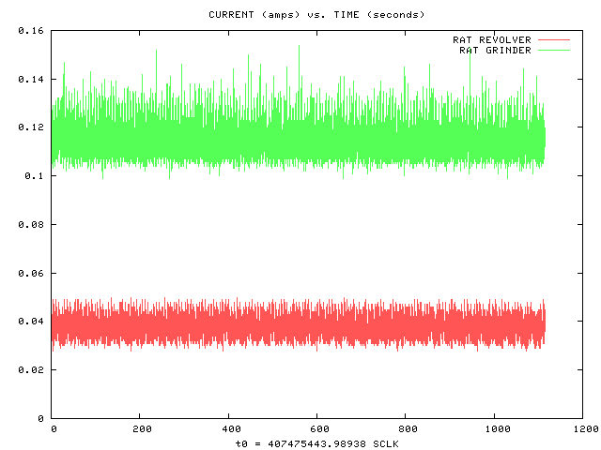

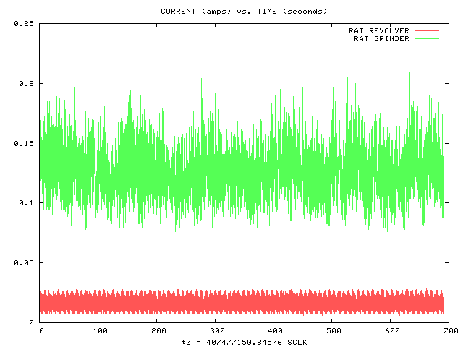
Figure 19. Example plots of RAT motor activity under open-loop control for target “Sand_Cherry” on sol 3137, courtesy of Gale Paulsen at Honeybee Robotics. These plots show a typical full grind record exhibiting pseudoperiodic variation in grind current as the RAT advances into the target. However, these data do not match what is available for the same target in the PDS.

                - 2. Grind Depth Vs. SGE Plots

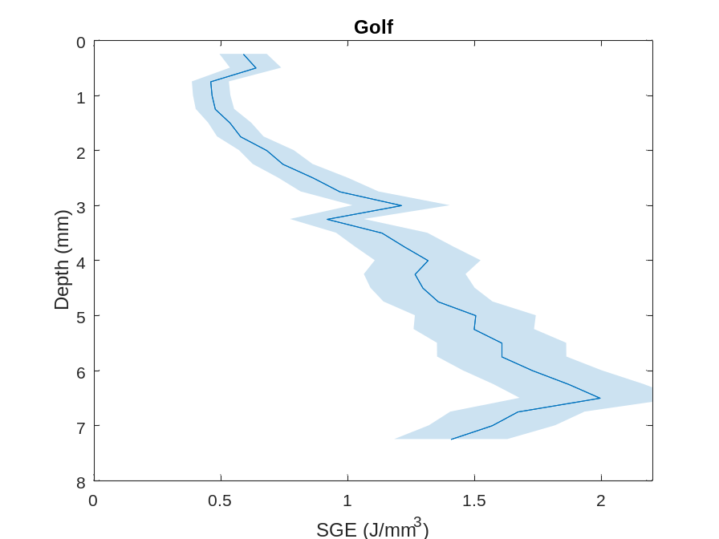
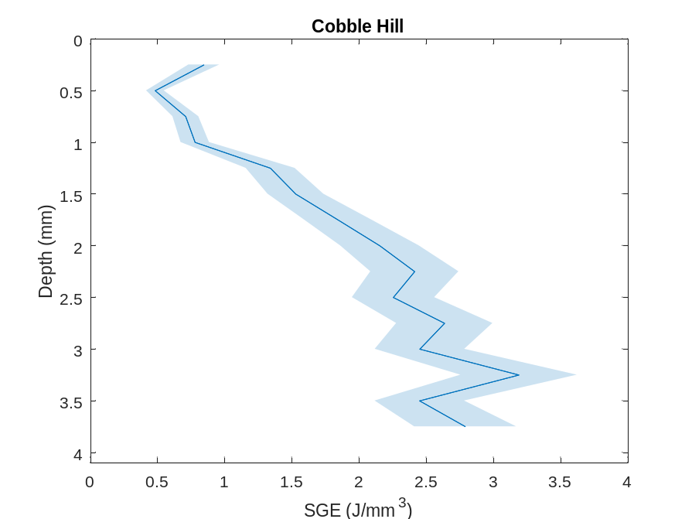
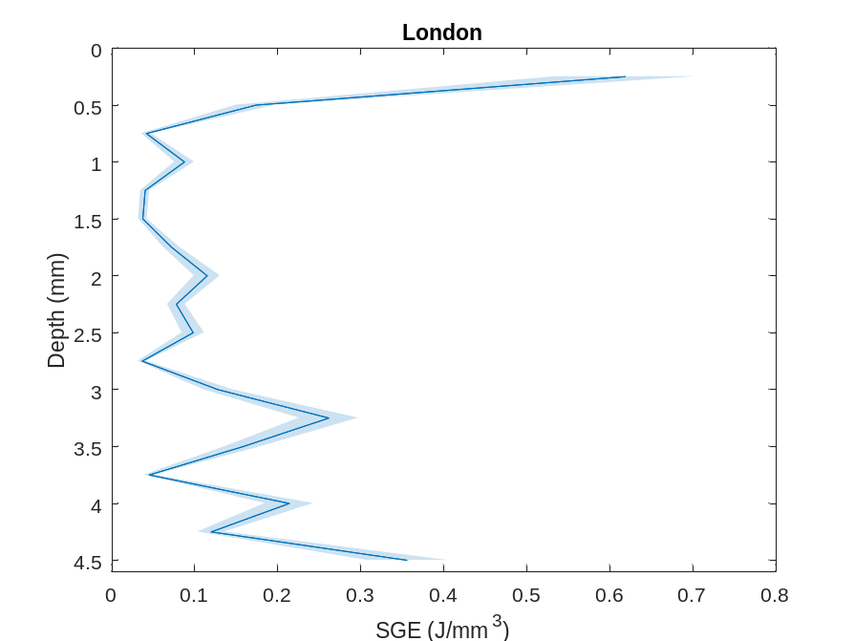
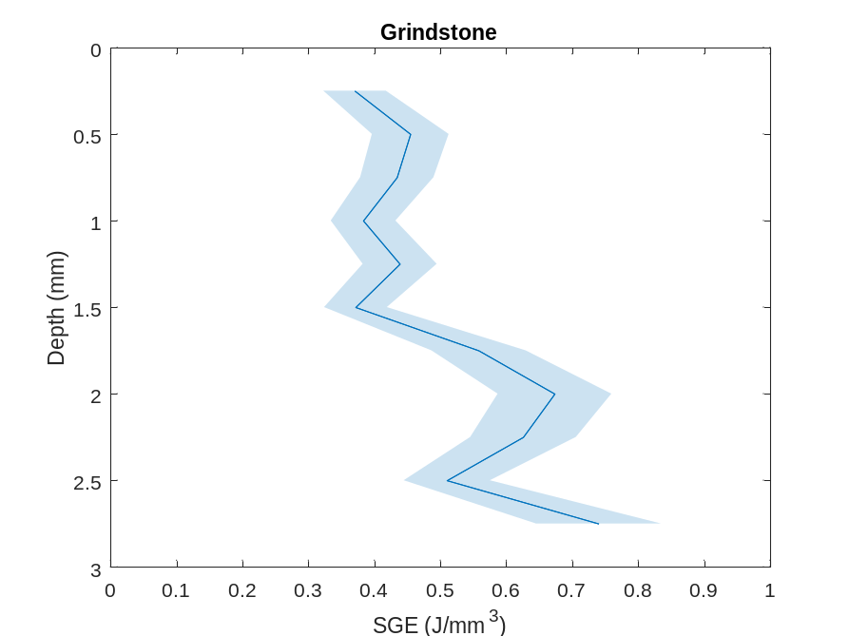
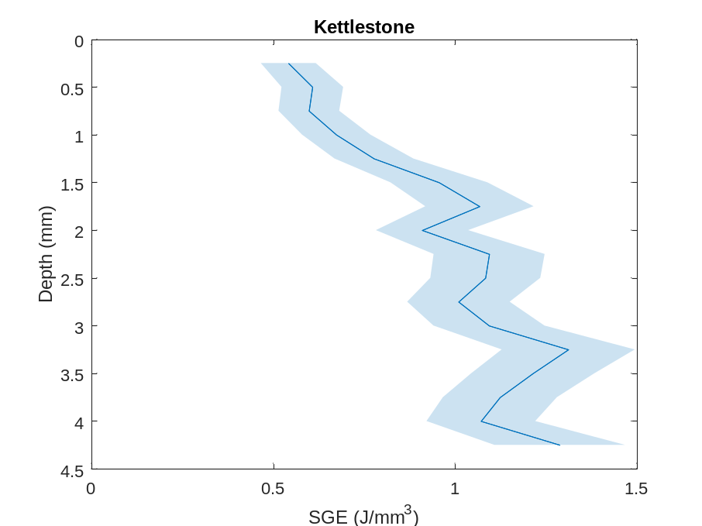
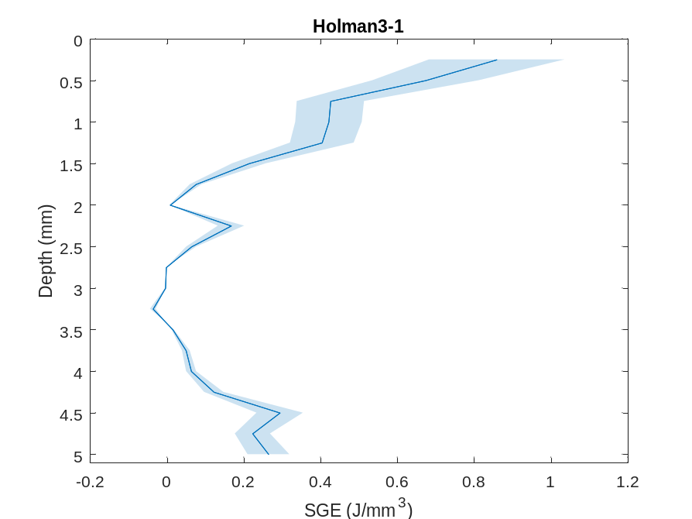
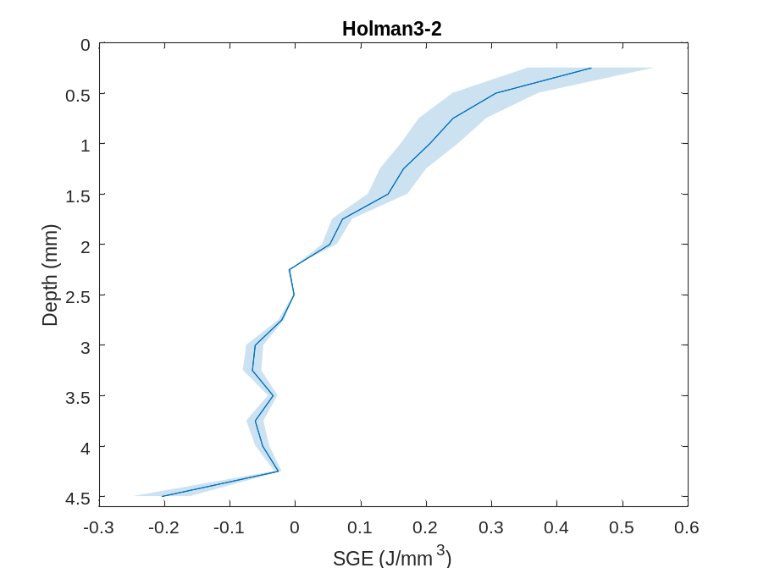
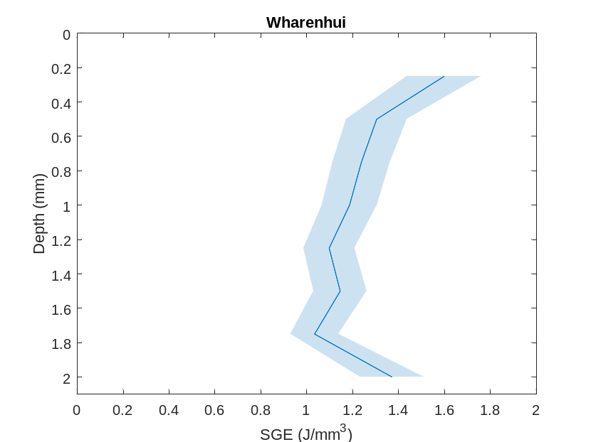
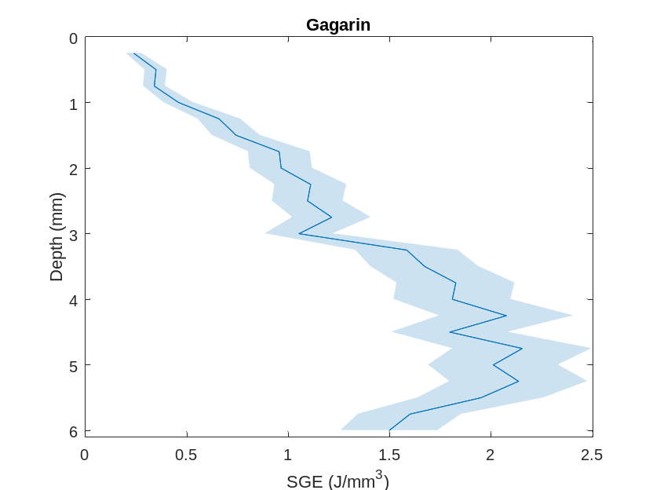
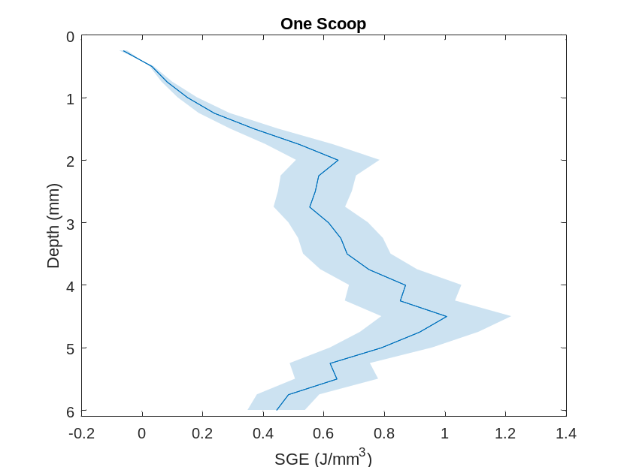
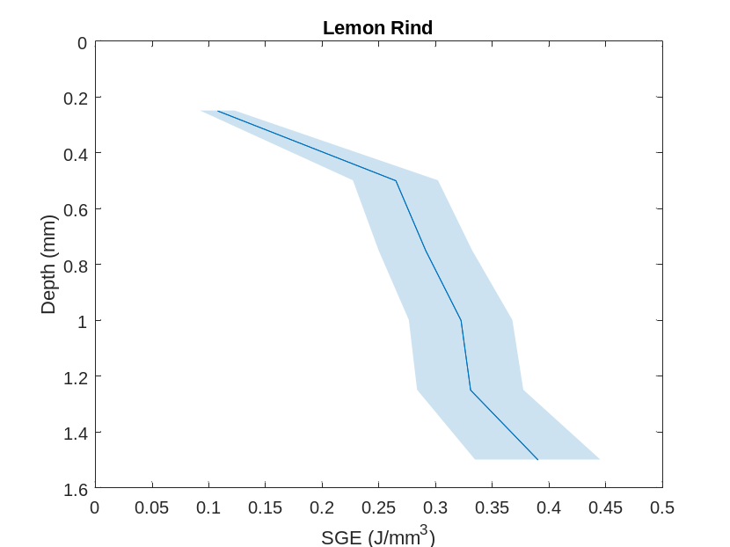
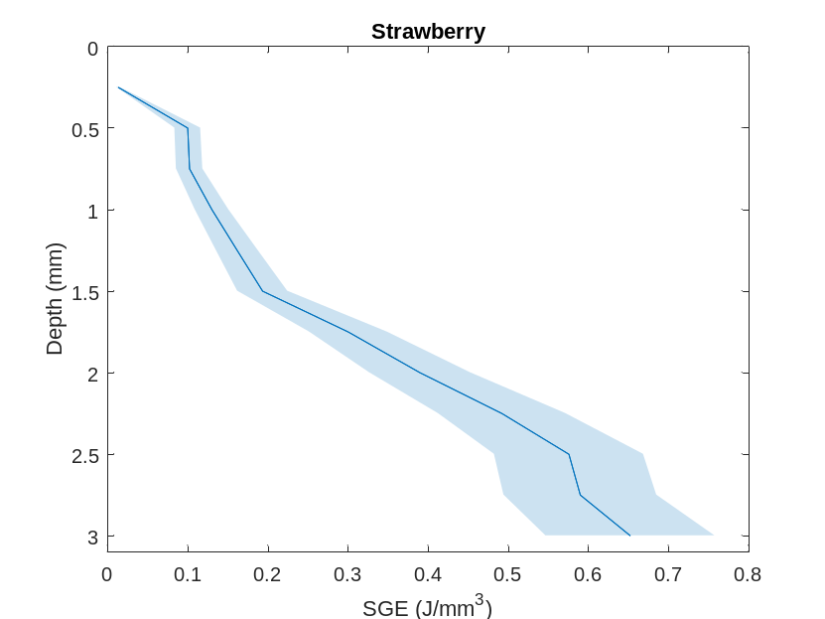
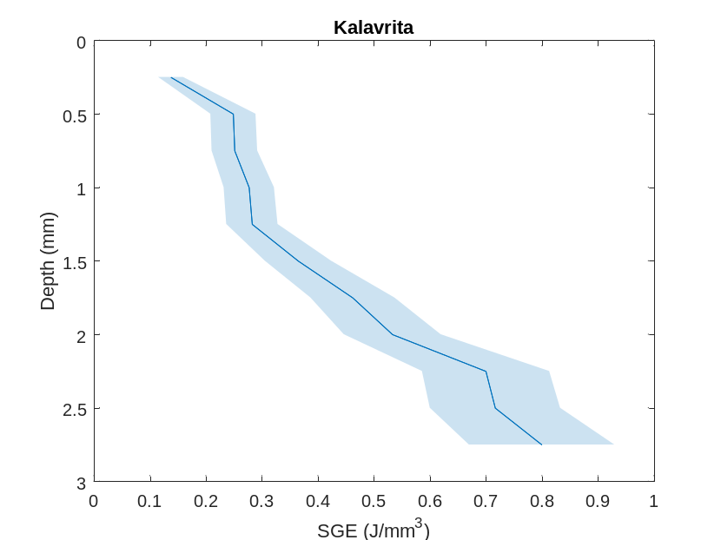
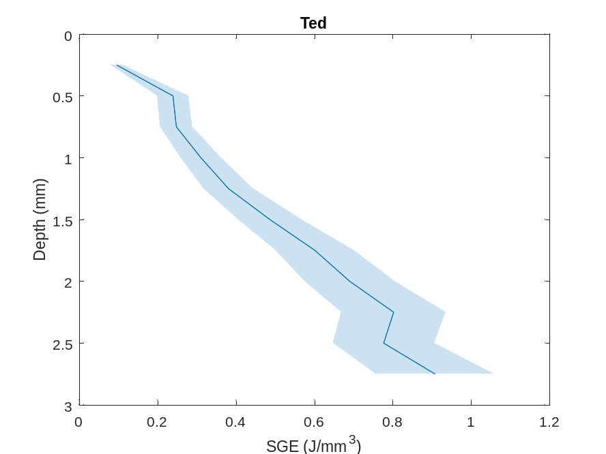
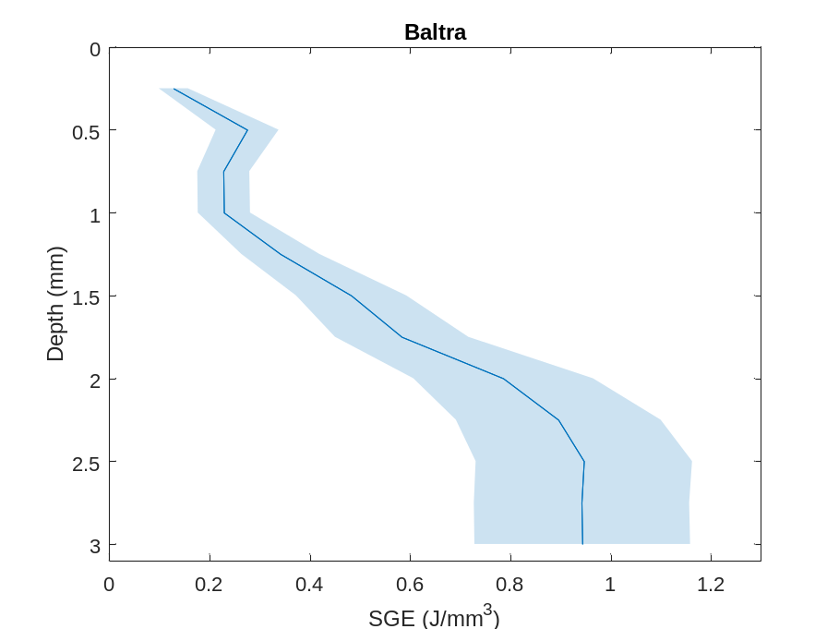
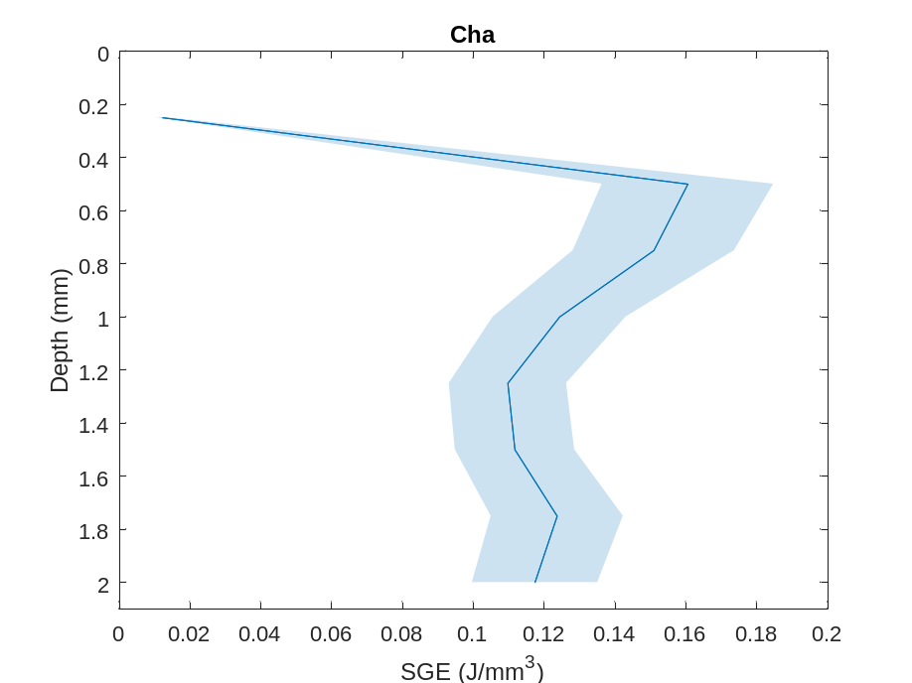
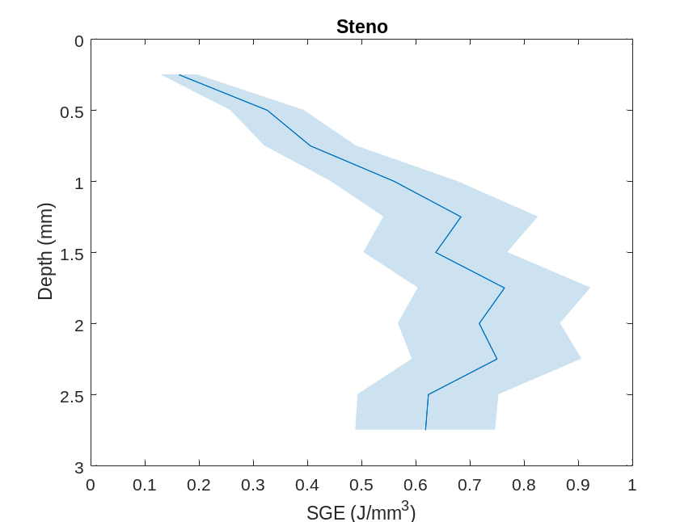

                - Vita
Tyler Seyglinski was born and raised in the small town of Jackson, New Jersey. After receiving his high school diploma in 2016, he began his undergraduate studies at Towson University in Baltimore, Maryland as a biomedical science major. During that time, he developed a vested interest in astronomy and felt enraptured by the idea of studying other planets. During his junior year, he switched into the geology major with aspirations of one day having some role in humanity’s exploration of worlds beyond our own. He got involved as a student researcher under the advisement of Dr. Wendy Nelson, to whom he is ever grateful for the opportunity to produce original research amidst the uncertainty of the COVID-19 pandemic. He went on to present this work on the petrogenesis of East African Rift flood basalts at AGU 2021 shortly after he graduated with a Bachelor of Science in geology and a minor in astronomy.
From there he began submitting applications to master’s programs where he was fortunate enough to find a spot in Dr. Brad Thomson’s lab group at the University of Tennessee, Knoxville. During this time, Dr. Thomson supervised Tyler’s research which focused on using the Rock Abrasion Tool onboard the Opportunity rover on Mars to infer the strength of martian sedimentary rocks. Tyler further had the chance to present research progress at the Lunar and Planetary Science Conference in both 2023 and 2024.

