Effects of land-use and disturbance on pollinators in wetlands

A Thesis Presented for the
Master of Science
Degree
The University of Tennessee, Knoxville

Nicholas V. Oldham
May 2022
Copyright © 2022 by Nicholas V. Oldham
All rights reserved.

DEDICATION
I would like to dedicate my thesis and research to Dr. Laura Russo, an incredible advisor and mentor who has taught me invaluable experience and wisdom. Without her, I would not be near the academic that I am today; my knowledge of pollination and the natural sciences would not be near as keen. Additionally, I would like to dedicate this thesis to my other advisors, Dr. Kevin Moulton, Jamie Herold, and Dr. Ernest Bernard. They have all been exceptionally wonderful to work with and given me insight and support that is deeply appreciated. From Dr. Moulton’s intense knowledge of Diptera and stoic demeanor to Jamie’s acute familiarity with flora and energetic disposition to Dr. Bernard’s ken of taxonomy and eagerness of support, all have impacted me professionally that will never be forgotten. Next, my life’s work and research will always be devoted to my parents. While not scientists themselves, my parents did an amazing job at guiding me into the scientist I am now; they cultivated my love of nature and taught me the importance of asking questions. Lastly, my research, my career, and my love I devote to my wife. Cari, you are my best friend, my most trusted confidante, and the love of my life. Your patience, humor, and devotion are what get me through each day.

ACKNOWLEDGEMENTS
I would like to acknowledge and thank everyone who got me to where I am today. In particular, let me say thank you to my committee for their guidance and insight for helping me develop my own research project and for lending me their expertise in insect and plant identification. Without their continued support, my journey would be more arduous, less fruitful, and not nearly as fulfilling.
I would also like to say thank you to all of the site managers that let me conduct research in my selected wetlands: Kevin Hoyt from the UT Arboretum, the UT Gardens’ incredible staff, Dr. Matt Grey with his constructed wetlands at the Cherokee Woodlot, Ben Nanny from the Ijams Nature Center, and of course the Oak Ridge National Laboratory’s (ORNL) Natural Resources Management Program. Their willingness to aid in my research is deeply appreciated.
I would also like to acknowledge and thank Dr. Adrian Gonzalez who helped us with our water quality analysis, and to Dr. Ellie Rotheray from The Buzz Club who created the original constructed hover fly lagoon. From analysis to design, both individuals’ expertise is exceptional.
A big thank you extends towards the Science Alliance for graciously awarding me the GATE Fellowship. Genuinely, their support helped me focus on my research and studies. Additionally, it helped cement our commitment to the relationship between ORNL and the University of Tennessee. Because of them, we were able to continue our research on ORNL’s site and overcome the obstacles resulted from the COVID-19 Pandemic.
Let me acknowledge and thank the University of Tennessee proper and to their Department of Entomology and Plant Pathology. Along with providing an excellent undergraduate program, I was offered a full-time position along with my research during my introductory years as a graduate student. It taught me the value of multidiscipline and science communication.
Let me say thank you to my family and friends. From my colleagues in the Russo Lab to my parents back home, their kinship and support has made this journey all the more rewarding. Every journey has its own obstacles, and it’s important to have a support system to lean on from time to time.
Lastly, I must thank my wife, Cari, for her loyalty and companionship. During the worst of times, I was still able to laugh and smile, pushing me further beyond than I thought I was capable of. She is an incredible person and deserves all the recognition in the world and more.

ABSTRACT
While pollinators and wetlands both provide important ecosystem services (e.g., the pollination of flowering plants and improving water quality), the relationship between the two is not well understood. Wetland quality can determine the local floral community, which likely mediates local pollinator populations. In this study, we investigated how land-use, including a gradient of urban development at the landscape scale, and anthropogenic disturbance affects pollinators in wetlands. We surveyed the abundance and diversity of plant communities in a range of different wetlands across two years. We also measured abiotic factors, such as water quality, light availability, and temperature for insights into the relationships between wetland and pollinator health. Among our surveyed sites, surrounding urban land-use had little effect on pollinator abundance or diversity within wetlands. In fact, urban land-use in a 1-km radius around wetlands was associated with a higher flowering plant abundance and diversity and had the largest abundance of pollinating insects, due to management within the wetlands. In that study, the biotic factors of plant species richness and abundance were the primary drivers of pollinator abundance and diversity, while abiotic factors, such as light availability, temperature, and humidity were not significantly associated with pollinators. We also found that the wetland with the highest proportion of surrounding natural land-use had the most unique pollinator community composition. In a second study, we found that anthropogenic disturbance played a significant role in water quality, where more disturbed sites had lower total organic content in the water. We also saw that disturbance affected the composition of the plant community. However, the response of the pollinator community was not directly related to the biotic and abiotic attributes we measured. Instead, the response of the pollinators was context dependent in different levels of disturbance. Our work has implications for the management of wetland habitats to promote pollinating insects, and also illustrates the impact of disturbance on these important systems.

Table of Contents
CHAPTER I EFFECTS OF URBAN LAND-USE ON POLLINATOR ABUNDANCE AND DIVERSITY IN WETLANDS 1
INTRODUCTION 1
MATERIALS AND METHODS 2
Site Selection 2
Flowering Plant Survey 2
Pollinator Survey 3
Water Sample 3
Data Analysis 4
RESULTS 4
DISCUSSION 6
Conclusion 7
CHAPTER II EFFECTS OF ANTHROPOGENIC DISTURBANCE ON WETLANDS AND LOCAL POLLINATORS 8
INTRODUCTION 8
MATERIALS AND METHODS 9
Site Selection 9
Flowering Plant Survey 9
Pollinator Survey 10
Hover Fly Lagoons 10
Water Sample 10
Data Analysis 11
RESULTS 11
Hover Fly Lagoons 13
DISCUSSION 13
Conclusion 14
WORKS CITED 15
APPENDICES 23
VITA 56

LIST OF TABLES
Table 1.1. Pearson’s Product-Moment Correlation between abundance and species richness among insect taxonomic groups. 24
Table 1.2. Top 10 most attractive flowers based on the number of specimens collected per relative floral display. 25
Table 2.1. Top 10 most attractive flowers based on the number of specimens collected per relative floral display. 38
Table 2.2. Plant communities for each disturbance category. 39
Table 2.3. Hover fly larvae collected from the artificial hover fly lagoons. 41

LIST OF FIGURES
Figure 1.1. Geographic map created in ArcGIS using the NLCD displaying wetland sites (blue triangles) and amount of urban development within 1-km radii (yellow circles).. 26
Figure 1.2. Correlation between total species richness and abundance of flower-visiting insects. 27
Figure 1.3. Relative preference of pollinators collected in relation to the relative flower abundance (floral display). 28
Figure 1.4. The predicted relationship between the proportion of natural habitat (1-km radius) and the log-transformed total insect abundance based on the GLMM analysis. 29
Figure 1.5. The predicted relationship between the plant species richness and the log-transformed hover fly abundance based on the GLMM analysis. 30
Figure 1.6. The predicted relationship between the proportion of natural habitat (1-km radius) and the log-transformed bee abundance based on the GLMM analysis. 31
Figure 1.7. Rarefaction analysis comparing species diversity among three different methods: species richness (0), Shannon diversity (1), and Simpson diversity (2). 32
Figure 1.8. Sample coverage among the surveyed wetland sites. 33
Figure 1.9. Non-Metric Multi-Dimensional Scaling (NMDS) analysis of insect species composition across the study sites. 34
Figure 1.10. NMDS analysis of insect species composition across the rotations (sampling round) throughout the season. 35
Figure 1.11. NMDS analysis of plant species composition across the study sites. 36
Figure 1.12. NMDS analysis of plant species composition across the rotations (sampling round) throughout the season.. 37
Figure 2.1. Constructed hover fly lagoon using a 2-liter plastic sweet tea jug. 42
Figure 2.2. Relative preference of pollinators collected in relation to the relative flower abundance (floral display). 43
Figure 2.3. Correlation plot evaluating correlations between abiotic and biotic measures on a scale from -1 to +1. 44
Figure 2.4. The predicted relationships for each disturbance category between total organic carbon (TOC) and the log-transformed total pollinator abundance based on the GLMM analysis. 45
Figure 2.5. The predicted relationships for each disturbance category between total organic carbon (TOC) and the log-transformed hover fly abundance based on the GLMM analysis. 46
Figure 2.6. The predicted relationships for each disturbance category between total organic carbon (TOC) and the log-transformed plant species richness based on the GLMM analysis. 47
Figure 2.7. The predicted relationship between plant species richness and the log-transformed pollinator species richness based on the GLMM analysis. 48
Figure 2.8. Boxplots of various abiotic (A-C) and biotic (D-F) variables in relation to the disturbance category, sorted by level of total organic carbon (TOC). 49
Figure 2.9. Boxplots of the amount of total organic carbon (mg/L) in the different levels of disturbed wetlands: low, medium, and high. 50
Figure 2.10. Rarefaction analysis comparing species diversity among three different methods: species richness (0), Shannon diversity (1), and Simpson diversity (2). 51
Figure 2.11. Sample coverage among the surveyed wetlands within the different disturbance categories. 52
Figure 2.12. Non-Metric Multi-Dimensional Scaling (NMDS) analysis of plant species composition across disturbance level categories: low, medium, and high. 53
Figure 2.13. Non-Metric Multi-Dimensional Scaling (NMDS) analysis of pollinator species composition across disturbance level categories: low, medium, and high. 54
Figure 2.14. Non-Metric Multi-Dimensional Scaling (NMDS) analysis of only bee species composition across disturbance level categories: low, medium, and high. 55

Chapter I
Effects of urban land-use on pollinator abundance and diversity in wetlands

INTRODUCTION
Wetlands provide important ecosystem services such as water filtration and nutrient retention (Yao et al. 2019). The economic value of the services provided by wetlands was estimated at $47.4 trillion per year globally (Davidson et al. 2019). Current legislation includes the imperative to preserve and improve wetland quality (Clean Water Act 1972). Because of the ecological and economic value of pollinating insects (Ollerton et al. 2011), another federal effort promotes the health and habitat of pollinators (Pollinator Partnership Action Plan 2016). Declines in pollinator populations have been an increasing concern, although our understanding of this trend is limited due to a lack of long-term data (Hallmann et al. 2021). The primary driver for the decline in pollinator populations is thought to be anthropogenic disturbance, including threats such as habitat fragmentation, land-use change, pesticides, and many more (Kearns et al. 1998).

Although bees are frequently considered to be the most important pollinators, flies are often-overlooked native pollinators (Rader et al. 2016). The primary Diptera taxon associated with pollination is the family Syrphidae, also known as hover flies or flower flies. Hover flies have shown to be effective pollinators in agroecosystems (Hodgkiss et al. 2018; Ssymank et al. 2011). Additionally, while almost all adult hover flies feed exclusively on pollen and nectar, many hover fly species have a predatory larval stage that can be useful as biocontrol agents for crop pests (Rotheray and Gilbert 2011; Bellefeuille et al. 2021). Additionally, many hover fly species—such as those that belong to the genus Eristalis-Latrielle—are effective at recycling waste during their aquatic larval stages (“rat-tailed maggots”) (Rotheray and Gilbert 2011; Stubbs and Falk 1983). Because of their importance not only as pollinators but also biological control agents and nutrient cyclers, hover flies have become an area of research interest in recent years (Lucas et al. 2018).

Wetlands not only have a critical role in providing beneficial habitat for many bee species (Vickruck et al. 2019), but may be even more important for hover flies with an aquatic larval stage. These species rely on microhabitats within wetland ecosystems to complete their life cycle (Moquet et al. 2018). In comparison to other pollinators, many hover fly species are more abundant in wetland ecosystems than upland habitats (Begosh et al. 2020). Unfortunately, wetlands are often degraded and threatened by land-use change such as urbanization (Holland et al. 1995; Zhang et al. 2016).

Urbanization is a form of land-use change that has been linked to decreases in wetland quality (Lee et al. 2006; Hogan and Walbridge 2007) and declines in pollinator populations (Wenzel et al. 2020). However, disturbance and land-use change—common side effects of urbanization—can positively affect more generalist pollinators like hover flies (Deans et al. 2007; Meng et al. 2012; Sugar 2000). To better understand the relationship between urbanization, wetlands, and pollinators, we surveyed flower-visiting insects in six landscapes across an urbanization gradient in eastern Tennessee. Our goal was to determine whether urban land-use affected wetland quality, and whether wetland quality related to pollinator abundance and diversity.

MATERIALS AND METHODS

Site Selection
In the spring of 2020, we selected wetlands for our surveys based on location, accessibility, and their placement on a land-use gradient from urban to natural. We used the National Land Cover Database (NLCD) 2016 raster in ArcGIS to generate 1-km buffer zones around each wetland. We used the clip raster tool to classify land-use in each buffer zone (Fig. 1.1; all tables and figures are located in the Appendices). We aggregated land-use categories into four types: agricultural (any land-use classified as crop or forage), natural (any land-use classified as forest or unmanaged fields), urban (all developed land-uses), and water. The six sites that met our criteria from most to least urbanized were: Turkey Creek Wetland Park (TC; 35.902444° N, 84.143240° W), University of Tennessee’s Gardens (UTG; 35.943693° N, 83.937715° W), Dean’s Woods (DW; 35.921284° N, 83.948330° W), the Lotus Pond and Subaru Floodplain at Ijams Nature Center (IJ; 35.956928° N, 83.866750°W), Cherokee Woodlot wetlands (CW; 35.935001° N, 83.940151° W), and the University of Tennessee Arboretum (UTA; 35.994329° N, 84.213473° W).

Flowering Plant Survey
During the summer of 2020, we surveyed plant-pollinator interactions in six wetlands in eastern Tennessee across an urban land-use gradient. For each wetland site, we set up two transects that were approximately 40 m in length. Both transects were strategically established in parts of the wetland with the highest abundance of flowering plants without overlapping each other. Once the transects were established, we recorded the time of day, temperature, and humidity from the nearest weather station.

For each transect, we first surveyed the flowering plant community to quantify plant diversity and abundance. We divided each transect into three even sections using colored flags. Per section, the flowering species were identified using expert knowledge and the iNaturalist application on Apple’s iOS. Plants that were not readily identified in the field were noted and later identified by experts within iNaturalist’s community.

After the flowers were identified and recorded, the floral cover of each flowering species per section of transect was ranked on a scale from one to ten. The higher the number, the more abundant the species was in that section, while a lower number signified the flowering species was less abundant. Using this ranking system, we were able to provide a comparable measure of relative flowering abundance within the wetland transects (Russo et al. 2013).

Light availability was recorded with the Plant Light Meter application by Studio Nano Ship Inc. on Apple’s iOS. The colored flags that served as guideposts for the transect sections also served as focal points for the application; photos were taken of every colored flag, which Plant Light Meter then used to detect the approximate light availability. The application provided a numeric value between 0 and 1500 in foot-candles (fc). Four measurements were taken in total for each transect (one for each section), which we averaged to gain an estimate of the overall light available across the entire transect. During the field season, the application underwent an update which allowed for more accurate light readings beyond 1500 fc. To maintain consistency and allow us to measure with previous data, light measurements were capped at 1500 fc throughout the season.

Pollinator Survey
To survey flower-visiting (putatively pollinating) insects, we collected samples along each the established transects at each wetland site four times during the summer of 2020. Each of the samples followed this protocol: the collector would walk the length of the transect in its entirety for 30 minutes and use a hand net to collect any adult, flying insect that made direct contact with the reproductive organs of any flower within one meter of the transect.

The timer was paused while net-collected insects were transferred to kill jars charged with ethyl acetate. The plant species the insect contacted was recorded along with the number of individuals caught during each catch. If the length of the transect was reached before the timer lapsed, we would repeat the transect, making sure sampling continued throughout the duration of time.

Collected pollinator specimens were frozen until they could be pinned, labelled, sorted, and identified in the lab. The bee specimens were identified using the Discover Life keys (discoverlife.org) and then verified by Sam Droege (United States Geological Survey). The hover fly specimens were sorted to genus using (Miranda et al. 2013). Other flies were sorted with the help of Dr. Kevin Moulton (University of Tennessee, Knoxville).

Water Sample
We evaluated the water quality within each wetland by collecting a water sample from a body of water in each site. We collected water samples in 250 ml Nalgene wide-mouth HDPE bottles. Because some wetlands contained multiple bodies of water, equal portions of each pool were collected and homogenized for a measure across the site. We preferentially sampled slow-moving water bodies in each site as that is the preferred habitat for many aquatic fly larvae. Because of the 2020 COVID-19 Pandemic, we were unable to collect and process these water samples until after all plant-pollinator surveys were complete.

Water samples were submitted to the University of Tennessee’s Water Quality Core Facility laboratory for analysis. Samples were analyzed for dissolved carbon (organic [TOC], inorganic [TIC], and total [TC]) on a Shimadzu TOC-L carbon analyzer and for total dissolved nitrogen (TN) on a Shimadzu TNM-L total nitrogen analyzer. Calibration standards, blanks, and reference standards were analyzed in conjunction with samples. For each element, results were given in milligrams per liter (e.g., mg/L as C; mg/L as N). Based on calibration criteria, clean blanks, and acceptable percent recoveries of reference standard samples, data quality was judged to be very good.

Data Analysis
We first analyzed the effect of environmental site attributes (temperature, humidity, average sunlight, and land-use at a 1-km radius) on total flower-visiting insect abundance and species richness, as well as hover fly and bee abundance and species richness. We evaluated these insect groups separately because we hypothesized that they may be affected in different ways by environmental variables. We used linear mixed effects models with log-transformed insect abundance as the response variable, and constructed a full model with all environmental attributes, using site as the random effect, and then performed a model selection process using the function “dredge” in the R package MuMIn (Bartoń 2022). We considered models with the lowest AICc value to have the best fit and considered models with delta <2 to be equivalent.
We also calculated the Pearson Correlation Coefficients among species richness and abundance in the different insect groups. Because insect abundance and insect species richness were strongly correlated (Fig. 1.2), we did not repeat the model selection process with species richness as a response variable. To compare species richness and diversity among the different sites, we conducted a rarefaction analysis, using the R package iNEXT (Hsieh et al. 2020). We also used rarefaction to calculate our sample coverage among the sites.

We also ranked plant preferences among the flower-visiting insects by quantifying abundance-standardized visitation rates for each of the plant species in each collection event.

Finally, we compared differences in community composition of the plants and flower-visiting insects at the different sites using non-metric multidimensional scaling (NMDS). This ordination analysis allowed us to visually compare overlap in the plant and pollinator communities.

RESULTS
We caught 896 insects (including 176 hover flies, 411 bees) representing 129 species or morphospecies (including 13 hover fly species, 45 bee species) in 24 hours of sampling (1.6 insects per minute). We surveyed 207 plant species in our research sites and sampled insects in 69‒94 °F temperature range (82.43 + 6.20), 30‒92 humidity range (56.40 + 12.86), and 11‒1500 Fc light range (765.20 + 436.19). All surveys were conducted between the hours of 0830 and 1715, beginning on 05/26/2020, ending on 08/26/2020.

Insect abundance increased as species richness increased (Table 1.1, Fig. 1.2). Among the different taxonomic groups in our study, we found that the Pearson Correlation Coefficients for abundance and species richness were all statistically significant (p-value <0.05, Table 1.1). As the abundance of each insect group increased, so did the number of species we found.

Based on the relative preference analysis, ten plant species were most attractive to pollinators in terms of the number of specimens collected relative to the size of the floral display (Table 1.2, Fig. 1.3). Hydrangea arborescens L., for example, seemed to be a very attractive flower for pollinators because while it was relatively uncommon in the surveys, 71 adult flying insects were collected while visiting them.

Because of overdispersion, the response variable of insect abundance in our models was log-transformed. The strongest model (lowest AICc) for the log-transformed total insect abundance had a fixed effect of the proportion of natural habitat within a 1-km radius. Contrary to our expectations, we found a negative association between the proportion of natural habitat at a 1-km radius and the total insect abundance (Fig. 1.4). The marginal R² suggested that 22% of the variation in total insect abundance was explained by the fixed effect of the proportion of natural habitat, whereas the conditional R² showed that 64% of the variation was explained by the whole model (fixed effects and random effects).

Hover fly abundance increased as plant species richness increased (Table 1.1, Fig. 1.5). Despite this correlation, the best model for the log-transformed hover fly abundance did not include any fixed effects. Moreover, when we evaluated plant species richness as a fixed effect, it only explained 14% of the variation in hover fly abundance. Likewise, only 23% of the variation in hover fly abundance was explained by the whole model. Lastly, our best model for the log-transformed bee abundance included the proportion of natural habitat at a 1-km radius as the fixed effect, similar to that for total insect abundance. We saw a negative relationship between bee abundance and natural land-use at a 1-km radius (Fig. 1.6). By this approach, only 17% of the variation in bee abundance was explained by the proportion of natural habitat, and only 29% of the variation was explained by the entire model.

In the rarefaction analyses, there are three measures for species diversity: species richness, Shannon diversity, and Simpson diversity. The Shannon and Simpson diversity indices showed that evenness in the pollinator community was comparable among the sites, as little change occurred between each comparison with regard to site order. For example, DW and UTG had the lowest species richness, and their ranking did not change when species evenness was incorporated into the equation for Shannon and Simpson diversity (Fig. 1.7). The other sites had comparable species diversity values. Additionally, the sample coverage rarefaction showed the proportion of the expected species richness found in our study. The only site that stands out in this regard is DW which was considerably less well sampled than the other sites (Fig. 1.8). The analysis suggests our sample coverage for DW was just over 60% of the true species richness, while the best sampled site (UTG) was at about 90%.

Lastly, in our NMDS analyses, we gained insight into how similar the insect and plant communities were between sites and sampling rotations. Our NMDS analysis illustrated significant overlap between the pollinator communities in the different sites (Fig. 1.9), and that DW was the site with the most distinct pollinator community composition. The composition of the pollinator community seemed to shift significantly between the 2nd and 3rd rounds of sampling but was similar between the first two rounds and last two rounds (Fig. 1.10). Similar to the pollinator community, the plant species community also showed significant overlap with the exception of DW (Fig. 1.11). The plant community changed significantly throughout the season, which is reflected by a lack of overlap between the rotations (Fig. 1.12).

DISCUSSION
We hypothesized that the total abundance for all pollinators would increase in sites with a higher proportion of natural habitat within a 1-km radius. However, we found the opposite; pollinators were more abundant in sites with less natural and more urban habitat in the landscape. Based on our observations, the relationship between pollinator abundance and diversity and land-use seemed to be based more on local biotic factors, such as plant abundance and diversity, than broader land-use or abiotic characteristics.

We found a strong correlation between pollinator abundance and species richness, which has also been documented in other studies (Bock et al. 2007; Cusser et al. 2016). Pollinators were most abundant in landscapes with a higher proportion of urban land-use, which was due primarily to site management. Many public parks and wetlands are managed and restored to some degree to promote the aesthetic beauty and the health of the habitat. High floral diversity in urban landscapes is often only achievable when there is dedicated management (Lindemann-Matthies and Marty 2013; Norfolk et al. 2013; Tew et al. 2022). Proper management of ecosystems like wetlands includes removing invasive species and promoting native species, establishing new beneficial native species, and frequent monitoring (DeMeester and Richter 2010; Lishawa et al. 2019; Rodrigo 2021). If this type of management is dedicated to promoting a native plant community, it can have a long-term positive effect on the local pollinator community (O’Connell et al. 2021; Plascencia and Philpott 2017). The more urbanized sites we surveyed were managed to promote high flowering plant density and diversity. This was especially true for sites IJ and UTG, where we found the highest pollinator abundance. Our findings contradict previous research showing that landscape was a driving factor for pollinator communities (Wenzel et al. 2020, but see Deans et al. 2007; Meng et al. 2012; Sugar 2000).

Another interesting finding was that the environmental attributes we measured, including temperature, humidity, and light levels, did not have a significant effect on pollinator abundance. For this study, biotic factors (i.e., plant abundance or habitat) were a much stronger driver of pollinator abundance. Moreover, there were substantial differences among the plant species in terms of both the background abundance of different flowering plants and relative pollinator preference. For example, Hydrangea arborescens seemed to be the most preferred plant species during our sampling period, while Diodia virginiana L. was the least preferred. Many plant species, particularly cultivars, were not observed to have any pollinator visitation at all.

When looking at hover flies in particular, we found that site-level plant species richness had the strongest correlation with their abundance. As with many pollinators, ecosystems with a more diverse plant community have a higher density of hover flies (Nicholls and Altieri 2013; Tschumi et al. 2016). While our data reflect this pattern, the explanatory power of our model was low at only 14%. This may be due to the difficulty for catching hover flies quantitatively with hand nets (Hussain et al. 2018; Sadeghi Namaghi et al. 2009). From our results, the landscape does not seem to influence hover fly abundance. There may also be other factors determining hover fly abundance that were not measured in this study.

Bees were the most abundant flower-visiting insects in our study. In this case, the bees seemed to be more sensitive to the surrounding landscape than the hover flies. Bee abundance had a significant positive association with urban land-use in a 1-km radius around the sites. Tangtorwongsakul et al. 2018 reported a similar finding, but their effect was weak and other studies have suggested the opposite trend (Tscheulin et al. 2011; Plascencia and Philpott 2017).

The rarefaction analyses showed the limitations in our sampling. For this experiment, we caught adult, flying insects that made direct contact with the reproductive organs of a flower with a hand-net. This method is more selective and has a lower catch-rate in comparison to other methods of insect trapping that collect putative pollinators rather than just visitors (Sadeghi et al. 2009). Although malaise trapping can be the most effective method in collecting for hover fly specimens, it does not discriminate in foraging behavior (Vezsenyi et al. 2021).

Throughout our study, we found that site DW consistently had the lowest insect abundance and plant density and diversity. This site is a shaded forest, and during our sampling period, had low plant diversity. This site may have greater hover fly abundance during the spring ephemeral bloom prevalent in these deciduous forests as hover fly activity is often at its peak during these times (Sajjad et al. 2010). However, it is important to note that this site also had the most unique plant and pollinator community composition relative to the rest of our sites.

Conclusion
We measured land-use by quantifying the proportion of urban land in a 1-km radius around each of the six habitats. We found a positive association between urban land-use and pollinator abundance. However, our observations suggest this was likely due to the land management approach. Proper management of floral communities can promote pollinator abundance (Plascencia and Philpott 2017). Although management is difficult to quantify as it varies based on objectives and funding, different levels of anthropogenic disturbance can be quantified in a given ecosystem. In this case, we showed that the strongest effect of the management was an increase in plant density and diversity, which had a positive association with pollinator abundance. However, it is imperative to realize that this study does not suggest that management for high floral diversity in urbanized land areas is a panacea for pollinators, even if the insect abundance was lower in our more natural site. Importantly, the plant and pollinator communities in that site were unique, while the other sites were very similar in composition. To avoid homogenization of plant and pollinator communities at landscape scales, it is important to also protect more natural areas. The better we define the driving factor for what is affecting pollinator abundance and health behind the scenes, the better we can protect, conserve, and promote their diversity and effectiveness in our ecosystems.

Chapter II
Effects of anthropogenic disturbance on wetlands and local pollinators

INTRODUCTION
Pollinators provide valuable services to the environment and human society. The value of the services they provide is estimated to be 1 trillion USD per year (Lippert et al. 2021). In recent years, concerns have been increasing about potential declines in overall insect biomass (including pollinators) (Hallmann et al. 2017 & 2021; Biesmeijer et al. 2006). Anthropogenic disturbance demonstrably plays a large role in insect declines (Kearns et al. 1998; Winfree et al. 2009).

Wetlands are an often-overlooked important habitat for pollinator populations (Vickruck et al. 2019). Many plant species found only in wetlands are obligate pollen and nectar sources for certain pollinator species, such as nude yellow loosestrife (Lycimachia ciliata L.) and the loosestrife bee (Macropis nuda Provancher) (Cane et al. 1983). Although wetlands are likely especially important for pollinating flies with an aquatic larval life stage, there appears to be a gap addressing this relationship and its potential economic significance. The economic value of wetlands, independent of their role in supporting pollinating insects, has been estimated at USD 47.4 trillion per year globally (Davidson et al. 2019). Wetlands provide essential ecosystem services, such as water filtration and nutrient retention (Yao et al. 2019) and comprise unique plant communities (Engelhardt and Ritchie 2001).

Globally, wetlands are impacted by a plethora of anthropogenic disturbances such as mowing, urbanization (see Chapter 1), invasive species, overfishing, and many others (Herbert et al. 2015; Holland et al. 1995; Kennish 2002; Uzarski et al. 2009; Zedler and Kercher 2004; Zhang et al. 2016). Additionally, anthropogenic disturbance can have a negative effect on wetland quality and the local plant community (Galatowitsch et al. 1998). The sphere of influence for anthropogenic disturbance is broad and complex, and some kinds of disturbance can even be beneficial to pollinators by maintaining early successional habitat or promoting flowering density (Chapter 1; Deans et al. 2007; Meng et al. 2012; Sugar 2000). Because anthropogenic disturbance can both negatively and positively affect pollinators in wetlands, there is a further need for research into the relationship amongst pollinators, wetlands, and anthropogenic disturbances, with a goal to promote management practices that lead to healthy wetland ecosystems. For example, harmful disturbances can be mitigated or lessened via restoration, which is an increasingly common tool for rebuilding wetlands (Kim et al. 2011; Purvais et al. 2020; Sievers et al. 2018).

In our study, we analyzed the effects of varying levels of anthropogenic disturbance on the composition of the local plant communities, as well as the abundance and species richness of pollinators in wetlands. Our study took place at the Oak Ridge National Laboratory (ORNL) and its greater Oak Ridge Reservation, which is managed by ORNL’s Natural Resources Management Program. We surveyed plant-pollinator interactions in three different categories of disturbance (low, medium, and high), to determine which biotic and abiotic wetland attributes provided the greatest insight into pollinator health.

MATERIALS AND METHODS

Site Selection
In the spring of 2021, we selected wetlands across the central portion of the Oak Ridge Reservation (ORR, 35.9311° N, 84.3100° W) Tennessee, USA, based on location, accessibility, and disturbance level. We used on-the-ground observations and the history of the sites to categorize each them within three levels of anthropogenic disturbance: low, medium, and high. We surveyed a total of nine sites with three sites at each level of disturbance. The most disturbed sites were wetlands adjacent to parking lots and buildings, while sites with a medium level of disturbance were on powerline rights-of-way (ROWs) that were minimally managed, and the low disturbance wetlands were impacted in the early 2000’s from development but currently only receive construction traffic. Major sources of human disturbance in these wetlands included frequency of mowing, exposure to run-off from impervious surfaces, and pollution (e.g. car exhaust, light and noise pollution). High disturbance sites were mown frequently and experienced high run-off and pollution, medium disturbance sites were mown infrequently and experienced intermediate levels of run-off and pollution, and low disturbance sites were not mown and experienced lower levels of pollution. All wetland sites included bodies of standing water and were deemed to be suitable for hover fly development based on the presence of microhabitats similar to those replicated by the artificial hover fly lagoons created by the Buzz Club (Rotheray 2018). All sites were within 4 km of one another.

Flowering Plant Survey
In the summer of 2021, we surveyed plant-pollinator interactions in selected wetlands across the ORR. We established two transects roughly 40 m in length at each site at the beginning of each sampling day. Transects were selected to maximize the local density of plants in flower at the time. After establishing the transects, we recorded relevant abiotic data (time, temperature, and humidity) using the Oak Ridge National Laboratory’s weather stations. While the readings for each weather station were similar, the closest tower in relation to the site was chosen to record the most accurate information.

Light availability across each transect was measured with the iOS application Plant Light Meter by Studio Nano Ship Inc. This application recorded available sunlight interpreted from a photograph. We measured light availability at four intervals across each transect and averaged these to estimate the overall sunlight per transect.

We also quantified the density and diversity of the flowering plant community for each transect. Each transect was divided in three sections. For each section, we quantified the relative flowering density for each plant species in bloom on a scale from one to ten. A higher number indicated a larger floral display, while a lower number indicated the opposite. This ranking system allowed us to quantify relative floral abundance. Next, we quantified plant species richness with the iOS application iNaturalist, recording and identifying every plant in bloom to genus or species using photographs.

Pollinator Survey
To properly observe and capture putative pollinators, we sampled adult, flying insects that made physical contact with the observed stamen or pistil of a flower across the two transects at each site. During a sampling event, the collector would walk the length of each 40 m transect for 30 minutes. The collector would catch flower-visiting insects via hand-net, translocate them to a kill jar charged with ethyl acetate, and record the flower with which it made contact. During data collection, the timer would be halted. Once everything was recorded, the timer and survey continued.

Collected pollinator specimens were frozen until they could be pinned, labelled, sorted, and identified in the lab. The bee specimens were sorted using voucher specimens identified by Sam Droege (United States Geological Survey) in 2021. The hover fly specimens were sorted to genus using a key to the Nearctic Syrphidae (Miranda et al. 2013).

Hover Fly Lagoons
To provide artificial habitat for hover flies with aquatic larval stages, we constructed “hover fly lagoons” out of plastic 2-liter jugs, following the instructions from the Buzz Club (Rotheray 2018). Three lagoons were placed at each of the nine sites and spread throughout the habitat. We filled two-thirds of each jugs with a mixed plant medium [a mixture Festuca sp. L., Ligustrum sp. L., Digitaria sp. Haller, Plantago lanceolata L., Smilax sp. L., Rumex crispus L., and Sorghum halepense (L.) Pers.] that was standardized across all hover fly lagoons to provide a comparable vegetative food source. The remaining third of each jug was filled with tap water from the same source. In addition, sticks and twigs of varying sizes were collected at the sites and placed in the lagoons to provide structural support for the hover fly larvae. Lastly, dried leaves from the wetlands were placed on top of the lagoons to mitigate unwanted insect development (e.g., mosquitoes) and to further simulate hover fly ovipositing habitat (Fig. 2.1).

Once the hover fly lagoons were constructed and placed, the contents were checked once a month to observe hover fly development. As identifying hover fly species based on larvae is difficult, photos were taken, and each was morpho-sorted based on approximate size, color, and appearance.

Water Sample
To quantify the relative water quality for each site and corresponding hover fly lagoons, we collected water samples in 250-ml Nalgene wide-mouth HDPE bottles. Samples were tested at the University of Tennessee’s Water Quality Core Facility (WQCF). Because there were multiple hover fly lagoons placed at each site, equal portions were collected from each container to gain a measure of water quality across all lagoons. We used the same method when there were multiple bodies of water present at the wetlands.

Samples were analyzed for dissolved carbon (organic [TOC], inorganic [TIC], and total [TC]) on a Shimadzu TOC-L carbon analyzer and for total dissolved nitrogen (TN) on a Shimadzu TNM-L total nitrogen analyzer. Calibration standards, blanks, and reference standards were analyzed along with samples. For each element, results were given in milligrams per liter (e.g., mg/L as C; mg/L as N). Based on calibration criteria, clean blanks, and acceptable percent recoveries of reference standard samples, data quality was judged to be very good.

Data Analysis
We evaluated all correlations between observed abiotic and biotic factors using a correlation grid. The correlations were scaled from 0 to + 1. Based on the strength of these correlations, we selected predictor variables for the generalized linear mixed models (GLMMs) and avoided using any correlated predictor variables in the same model.

A full GLMM was constructed with the response of pollinator abundance and site as the random effect. We were interested in the following fixed effects: available sunlight, TOC, TN, plant species richness, and the disturbance level at each site. To correct overdispersion, the pollinator abundance was log-transformed, and the predictor variables were rescaled. The “dredge” function in the R package MuMIn was then used to obtain the best model (lowest AICc) including a fixed effect (Bartoń 2022). To compare species richness and diversity among the different sites, we conducted a rarefaction analysis. We also used rarefaction to calculate our sample coverage among the sites.

The plant preferences among the flower-visiting insects were ranked by quantifying abundance-standardized visitation rates for each of the plant species in each collection event.

Finally, we compared differences in community composition of the plants and flower-visiting insects at the different disturbance categories using non-metric multidimensional scaling (NMDS). This ordination analysis allowed us to visually compare overlap in the plant and pollinator communities.

RESULTS
We collected 1170 flower-visiting insects (including 63 hover flies, 684 bees), representing 83 species or morphospecies (including 5 hover fly species, 40 bee species) during 27 hours of sampling (1.3 insects per minute) in our wetland transects. We surveyed 194 plant species in the wetland surveys and collected 61 hover fly larvae from the artificial hover fly lagoons (4 hover fly morphospecies) (Table 2.3). Our research survey was conducted between 68‒88 °F (77.51 + 5.40), 27‒86% humidity (53.09 + 12.90), and 1081.25‒7625 Fc light range (3831.97 + 1871.96). All surveys were conducted between the hours of 0930 and 1809, beginning on 05/24/2021 and ending on 09/09/2021.

Based on the relative preference analysis, there were ten plant species most attractive to pollinators in terms of the number of specimens collected relative to the size of the floral display (Table 2.1, Fig. 2.2). Rhus copallinum L., for example, seemed to be a very attractive flower for pollinators because while it was relatively uncommon during the surveys, a total of 43 adult flying insects were collected while visiting them (Table 2.1). Our medium disturbance wetlands had the highest plant species richness (Table 2.2). We also found a positive relationship between plant species richness and pollinator species richness (Fig. 2.7).

As expected, we found a negative correlation between the intrinsically-tied temperature and humidity and available sunlight and humidity. We also observed negative relationships between TOC and IC, as well as between TOC and TC. The predictors with the strongest correlations were TOC with IC (R = -0.74), TOC with TC (-0.7), background plant abundance with pollinator-visited plants (0.51), and background plant abundance with plant species richness (0.8) (Fig. 2.3). Moreover, TOC (mg/L) decreased as the level of disturbance increased (Fig. 2.9). Other abiotic (temperature, humidity, light availability) and biotic (total specimens collected, plant density, and plant diversity) factors that we measured did not vary consistently with disturbance (Fig. 2.8).

Because of overdispersion, we log-transformed insect and plant abundance and species richness in our models. In our study, we found that the effect of TOC on pollinators was context dependent based on the level of disturbance. For example, we saw a negative relationship between pollinator abundance and TOC in the low disturbance sites, but a positive relationship between pollinator abundance and TOC in both the medium and high disturbance sites (Fig. 2.4). We found a positive association between hover fly abundance in the low and medium disturbance wetlands, but a negative relationship in the high disturbance sites (Fig. 2.5). We saw the same pattern with plant species richness; TOC was positively associated with floral diversity in the low and medium disturbance wetlands but negatively associated in the high disturbance sites (Fig. 2.6).

In our rarefaction analyses, we used three measures for species diversity: species richness, Shannon diversity, and Simpson diversity. The Shannon and Simpson diversity indices showed that evenness in the pollinator community was comparable among the sites, as little change occurs between each comparison in regard to disturbance order. For example, the medium disturbance wetlands consistently had greater species diversity and that does not change when species evenness is incorporated into the equation (Fig. 2.10). On the other hand, while the low disturbance wetlands had a significantly higher species richness than the high disturbance wetlands, they did not have a significantly higher Shannon or Simpson diversity. Additionally, our sample coverage rarefaction showed the explanatory power of the species richness found in our study. We collected the most specimens in the lowest disturbed sites (Fig. 2.11).

The ordination analysis showed how similar the plant and pollinator communities were between the different disturbance levels. There was no overlap in plant species composition among the three disturbance levels (low, medium, and high) (Fig. 2.12). This lack of overlap suggests that the disturbance categories we assigned to the sites were also reflected in the composition of the plant community. However, we did not see this effect in the pollinator species community, which had considerable overlap (Fig. 2.13). This was also true when looking at just bees, which comprised the largest component of the pollinator community (Fig. 2.14).

Hover Fly Lagoons
We established 27 hover fly lagoons at the beginning of the season (3 per site), but 11 of them were either lost or disturbed due to weather or wildlife. We collected 61 hover fly larvae of 4 morphospecies from the lagoons (Table 2.3). Only the low and medium disturbance wetland lagoons contained larvae.

DISCUSSION
We assigned wetlands to three disturbance categories (low, medium, high) and surveyed both biotic and abiotic responses to anthropogenic disturbance. The categorization was determined before sampling began and was based on sites’ history and visible disturbance. Our low disturbance sites were wetlands that were disturbed initially due to development but were then subsequently left untouched thereafter. Sites considered to have medium disturbance included wetlands in green utility ROWs typically mowed twice a year. Lastly, high disturbance sites were mowed every week and located next to parking lots, garages, and buildings. We hypothesized that the total abundance and species richness of flower-visiting insects in wetlands would decrease as disturbance increased.

We found significant differences in the plant community composition associated with each of the disturbance categories. Our site categorization aligned with their respective plant communities as our NMDS ordination analysis showed no overlap in when comparing the sites based on their level of disturbance. However, the composition of the pollinator community overlapped between the disturbance categories. Pollinators are mobile creatures and are capable of moving between sites, which may explain why their communities were not distinctive, despite the difference in the floral communities. Additionally, most of the pollinators we sampled are considered generalists (e.g. hover flies) and thus were not limited to specific plant species.

Rarefaction analyses showed a high insect sampling coverage among our disturbance categories. Compared to our previous study (Chapter 1), we had considerably better sampling success. However, while we collected more pollinator specimens during this study’s sampling period, we had overall less species richness. There are several possible explanations for this outcome, including the fact that the wetlands were located within a 4-km radius and that the management strategies for each wetland were similar. The medium disturbance sites had the highest flowering plant species richness, which may explain why they also had the greatest pollinator species richness as well.

As expected, floral display had a strong, significant positive association with pollinator abundance, which agrees with other findings suggesting local flower abundance is a significant driver of pollinator abundance (Hennig and Ghazoul 2012; Stewart and Waitayachart 2020) and our previous work (Chapter 1). Our study confirmed the attractiveness of Rhus copallinum and Helenium autumnale L., which are both documented to be attractive to pollinators (Mach and Potter 2018, Rollings and Goulson 2019). However, it is worth noting that we included potential pollen predators, such as weevils (Curculionoidea) for species like Rhus copallinum; weevils are generally not considered effective pollinators as compared to insects that visit multiple individual plants in a row, such as bees and flies (Donaldson 1997; Terry et al. 2005).

The artificial hover fly lagoons were successful in that we collected a large number (61) of larvae of four different hover fly morphospecies. However, due to the materials used for their construction, many were disturbed, presumably by wildlife or weather. By the end of the season, we 11 out of the 27 lagoons were either missing or knocked over. For those that remained, only the low and medium disturbance wetland lagoons contained larvae. Although we had insufficient data to demonstrate a relationship between disturbance and hover fly oviposition, this pilot study suggests that disturbance may have an effect on the decision-making process for hover fly oviposition.

In this study, we measured dissolved carbon and nitrogen to determine if anthropogenic disturbance influenced these parameters. Most of the abiotic factors we measured did not respond consistently to disturbance, but we saw a significant negative effect of disturbance on total organic carbon. Total organic carbon is considered an important water quality parameter (Ouyang 2005; Chang et al. 2014). It can be introduced from natural sources such as organic matter and biological activity to anthropogenic disturbance like pesticides and fertilizer run-off (Chang et al. 2014). Since TOC was higher in our low disturbance sites, which are not treated with fertilizer or chemicals, we assume this is caused by higher biological activity. In addition, the low disturbance wetlands were visibly murkier and were known to have saturated soil throughout the year and therefore less likely to be switching between aerobic and anaerobic states. However, the relationship between TOC and plant/pollinator communities seems to be context dependent based on the level of disturbance.

Conclusion
We assigned nine sites to three disturbance categories based on a visual assessment and knowledge of the site history and then determined whether these categories matched the abiotic and biotic attributes of the sites. Wetland quality was quantified through this measure of both abiotic and biotic factors. To determine whether our disturbance categories related to water quality, we measured dissolved carbon and nitrogen. We also compared the disturbance categories to plant and pollinator community composition. From the results, the assigned disturbance category did relate to the quality of the wetland as TOC levels decreased in accordance with disturbance; this was also reflected in the plant community as they were distinct from one another within each level of disturbance. However, TOC was not a strong predictor of overall pollinator abundance. Based on our findings, the response of the pollinator community to abiotic factors such as TOC was context dependent, based on anthropogenic disturbance. Wetland quality does seem to affect the pollinator abundance and diversity but is dependent to the level of disturbance; in lower and intermediate levels of disturbance, wetland quality is beneficial but begins to have a negative effect in high disturbance. Our study highlights the importance and need of further research into the relationship between pollinators and wetland ecosystems to better determine what is driving pollinator communities.

Works Cited

Bartoń, K. (2022). MuMIn: Multi-Model Inference. R package. Version 1.46.0.

Begosh, A., Smith, L.M., Park, C.N., Mcmurry, S.T., Lagrange, T.G. (2020) Effects of Wetland Presence and Upland Land Use on Wild Hymenopteran and Dipteran Pollinators in the Rainwater Basin of Nebraska, USA. Wetlands. 40, 1017–1031. https://doi.org/10.1007/s13157-019-01244-w

Bellefeuille, Y., Fournier, M., Lucas, E. (2021). Biological control of the foxglove aphid using a banker plant with Eupeodes americanus (Diptera: Syrphidae) in experimental and commercial greenhouses. Biological Control. 155. 104541. ISSN 1049-9644. https://doi.org/10.1016/j.biocontrol.2021.104541

Biesmeijer, J.C., Roberts, S.P., Reemer, M., Ohlemüller, R., Edwards, M., Peeters, T., Schaffers, A.P., Potts, S.G., Kleukers, R., Thomas, C.D., Settele, J., & Kunin, W. E. (2006). Parallel declines in pollinators and insect-pollinated plants in Britain and the Netherlands. Science (New York, N.Y.), 313(5785), 351–354. https://doi.org/10.1126/science.1127863

Bock, C.E., Jones, Z.F. and Bock, J.H. (2007) Relationships between species richness, evenness, and abundance in a Southwestern savanna. Ecology, 88: 1322-1327. https://doi.org/10.1890/06-0654

Cane, J.H., Eickwort, G.C., Wesley, F.R., & Spielholz, J. (1983). Foraging, Grooming and Mate-seeking Behaviors of Macropis nuda (Hymenoptera, Melittidae) and Use of Lysimachia ciliata (Primulaceae) Oils in Larval Provisions and Cell Linings. The American Midland Naturalist, 110(2), 257–264. https://doi.org/10.2307/2425267

Chang, N.B., Vannah, B.W., Yang, Y.J., & Elovitz, M. (2014). Integrated data fusion and mining techniques for monitoring total organic carbon concentrations in a lake, International Journal of Remote Sensing, 35:3, 1064-1093, https://doi.org/10.1080/01431161.2013.875632

Cusser, S., Neff, J.L., & Jha, S. (2016). Natural land cover drives pollinator abundance and richness, leading to reductions in pollen limitation in cotton agroecosystems. Agriculture, Ecosystems & Environment, 226, 33-42. http://dx.doi.org/10.1016/j.agee.2016.04.020

Davidson, N.C., van Dam, A.A., Finlayson, C.M., McInnes, R.J. (2019) Worth of wetlands: revised global monetary values of coastal and inland wetland ecosystem services. Marine and Freshwater Research 70, 1189-1194. https://doi.org/10.1071/MF18391

Deans, A.M.; Smith, S.M.; Malcolm, J.R.; Crins, W.J.; Bellocq, M.I. (2007). Hoverfly (Syrphidae) Communities Respond to Varying Structural Retention After Harvesting in Canadian Peatland Black Spruce Forests. Environmental Entomology, 36(2), Pages 308–318, https://doi-org.utk.idm.oclc.org/10.1093/ee/36.2.308

DeMeester, J.E., deB. Richter, D. (2010). Restoring restoration: removal of the invasive plant Microstegium vimineum from a North Carolina wetland. Biological Invasions, 12, 781–793. https://doi.org/10.1007/s10530-009-9481-9

Discover Life. (n.d.). Discover life. Retrieved April 17, 2022, from https://www.discoverlife.org/

Donaldson, J.S. (1997), Is there a floral parasite mutualism in cycad pollination? The pollination biology of Encephalartos villosus (Zamiaceae). American Journal of Botany., 84: 1398-1406. https://doi-org.utk.idm.oclc.org/10.2307/2446138

Engelhardt, K., Ritchie, M. (2001). Effects of macrophyte species richness on wetland ecosystem functioning and services. Nature, 411, 687–689. https://doi-org.utk.idm.oclc.org/10.1038/35079573

Galatowitsch, S.M.W., Lehtinen, R., Husveth, J., Schik, K. (1998). Environmental Monitoring and Assessment, 60, 24. Clean Water Act 1972.

Hallmann C.A., Sorg M, Jongejans E, Siepel H, Hofland N, Schwan H, et al. (2017) More than 75 percent decline over 27 years in total flying insect biomass in protected areas. PLOS ONE 12(10): e0185809. https://doi.org/10.1371/journal.pone.0185809

Hallmann, C.A., Ssymank, A., Sorg, M., de Kroon, H. & Jongejans, E. (2021) Insect biomass decline scaled to species diversity: general patterns derived from a hoverfly community. Proceedings of the National Academy of Sciences, 118(2), e2002554117. https://doi.org/10.1073/pnas.2002554117

Hennig, E.I., Ghazoul, J. (2012). Pollinating animals in the urban environment. Urban Ecosystems, 15, 149–166. https://doi.org/10.1007/s11252-011-0202-7

Herbert, E.R., Boon, P., Burgin, A.J., Neubauer, S.C., Franklin, R.B., Ardón, M., Hopfensperger, K.N. Lamers, L.P.M., and Gell, P. (2015). A global perspective on wetland salinization: ecological consequences of a growing threat to freshwater wetlands. Ecosphere, 6(10):206. http://dx.doi.org.utk.idm.oclc.org/10.1890/ES14-00534.1

Hodgkiss, D., Brown, M., Fountain, M. (2018). Syrphine hoverflies are effective pollinators of commercial strawberry. Journal of Pollination Ecology. 22. https://doi.org/10.26786/1920-7603(2018)five

Hogan, D.M. and Walbridge, M.R. (2007), Urbanization and nutrient retention in freshwater riparian wetlands. Ecological Applications, 17: 1142-1155. https://doi-org.utk.idm.oclc.org/10.1890/06-0185

Holland, C.C., Honea, J.E., Gwin, S.E., and Kentula, M.E. (1995). Wetland degradation and loss in the rapidly urbanizing area of Portland, Oregon. Wetlands 15: 336– 345. https://doi.org/10.1007/BF03160888

Hsieh, T.C., Ma, K.H., and Chao, A. (2020). iNEXT: Interpolation and Extrapolation for Species Diversity. R package. Version 2.0.20.

Hussain, R.I., Walcher, R., Brandl, D., Arnberger, A., Zaller, J.G., Frank, T. (2018). Efficiency of two methods of sampling used to assess the abundance and species diversity of adult Syrphidae (Diptera) in mountainous meadows in the Austrian and Swiss Alps. European Journal of Entomology, 115, Article 150-156. https://doi.org/10.14411/eje.2018.014

Kearns, C.A., Inouye, D.W., Waser, N.M. (1998). Endangered Mutualisms: The Conservation of Plant-Pollinator Interactions. Annual Review of Ecology and Systematics. 29(1), 83-112. https://doi.org/10.1146/annurev.ecolsys.29.1.83

Kennish, M. (2002). Environmental threats and environmental future of estuaries. Environmental Conservation, 29(1), 78-107. https://doi.org/10.1017/S0376892902000061

Kim, K.G., Lee, H., Lee, D.H. (2011). Wetland restoration to enhance biodiversity in urban areas: a comparative analysis. Landscape and Ecological Engineering 7, 27–32. https://doi.org/10.1007/s11355-010-0144-x

Lee, S.Y., Dunn, R.J.K., Young, R.A., Connolly, R.M., Dale, P.E.R., Dehayr, R., Lemckert, C.J., McKinnon, S., Powell, B., Teasdale, P.R. and Welsh, D.T. (2006), Impact of urbanization on coastal wetland structure and function. Austral Ecology, 31: 149-163. https://doi-org.utk.idm.oclc.org/10.1111/j.1442-9993.2006.01581.x

Lindemann-Matthies, P., Marty, T., (2013). Does ecological gardening increase species richness and aesthetic quality of a garden? Biological Conservation, 159, Pages 37-44, ISSN 0006-3207, https://doi.org/10.1016/j.biocon.2012.12.011.

Lippert, C.; Feuerbacher, A.; Narjes, M. (2021). Revisiting the economic valuation of agricultural losses due to large-scale changes in pollinator populations, Ecological Economics, 180, 106860, ISSN 0921-8009, https://doi.org/10.1016/j.ecolecon.2020.106860.

Lishawa, S.C., Lawrence, B.A., Albert, D.A., Larkin, D.J., Tuchman, N.C. (2019). Invasive species removal increases species and phylogenetic diversity of wetland plant communities. Ecology and Evolution. 9: 6231– 6244. https://doi-org.utk.idm.oclc.org/10.1002/ece3.5188

Lucas, A., Bodger, O., Brosi, B.J., Ford, C.R., Forman, D.W., Greig, C. Hegarty, M., Jones, L., Neyland, P.N., de Vere, N. (2018). Floral resource partitioning by individuals within generalised hoverfly pollination networks revealed by DNA metabarcoding. Scientific Reports. 8, 5133. https://doi.org/10.1038/s41598-018-23103-0
Mach, B. M., & Potter, D. A. (2018). Quantifying bee assemblages and attractiveness of flowering woody landscape plants for urban pollinator conservation. PLOS ONE, 13(12), e0208428. https://doi.org/10.1371/journal.pone.0208428

Meng, L.-Z., Martin, K., Liu, J.-X., Burger, F. and Chen, J. (2012), Contrasting responses of hoverflies and wild bees to habitat structure and land use change in a tropical landscape (southern Yunnan, SW China). Insect Science, 19: 666-676. https://doi-org.utk.idm.oclc.org/10.1111/j.1744-7917.2011.01481.x

Miranda, G.F.G, Young, A.D., Locke, M.M., Marshall, S.A., Skevington, J.H., Thompson, F.C. (2013). Key to the Genera of Nearctic Syrphidae. Canadian Journal of Arthropod Identification, 23, https://doi.org/10.3752/cjai.2013.23

Moquet, L., Laurent, E., Bacchetta, R. and Jacquemart, A.-L. (2018), Conservation of hoverflies (Diptera, Syrphidae) requires complementary resources at the landscape and local scales. Insect Conservation and Diversity, 11: 72-87. https://doi.org/10.1111/icad.12245

Nicholls, C.I., Altieri, M.A. (2013) Plant biodiversity enhances bees and other insect pollinators in agroecosystems. A review. Agronomy for Sustainable Development. 33, 257–274. https://doi.org/10.1007/s13593-012-0092-y

Norfolk O., Eichhorn M. P., Gilbert F., (2013) Traditional agricultural gardens conserve wild plants and functional richness in arid South Sinai, Basic and Applied Ecology, 14( 8), Pages 659-669, ISSN 1439-1791, https://doi.org/10.1016/j.baae.2013.10.004.

O’Connell, M., Jordan, Z., McGilvray, E., Cohen, H., Liere, H., Lin, B.B., Philpott, S.M., Jha, S. (2021). Reap what you sow: local plant composition mediates bumblebee foraging patterns within urban garden landscapes. Urban Ecosystems. 24, 391–404. https://doi.org/10.1007/s11252-020-01043-w

Ollerton, J., Winfree, R., and Tarrant, S. (2011) How many flowering plants are pollinated by animals? Oikos. 120:321-326. https://doi.org/10.1111/j.1600-0706.2010.18644.x

Ouyang, Y. (2005). Evaluation of river water quality monitoring stations by principal component analysis. Water Research, 39(12), https://doi-org.utk.idm.oclc.org/10.1016/j.watres.2005.04.024

Plascencia, M., & Philpott, S. (2017). Floral abundance, richness, and spatial distribution drive urban garden bee communities. Bulletin of Entomological Research, 107(5), 658-667. https://doi.org/10.1017/S0007485317000153

Pollinator Health Task Force, Vilsack, T, McCarthy, G. (2016). Pollinator Partnership Action Plan. 1-30.

Purvis, E.E.N., Jess, L. Vickruck, J.L., Best, L.R., Devries, J.H., Galpern, P. (2020) Wild bee community recovery in restored grassland-wetland complexes of prairie North America, Biological Conservation, 252, 108829, ISSN 0006-3207, https://doi.org/10.1016/j.biocon.2020.108829.

Rader, R., Bartomeus, I., Garibaldi, L.A., Woyciechowski, M., et al. (2016). Non-bee insects are important contributors to global crop pollination. PNAS, 113(1), 146-151. https://doi.org/10.1073/pnas.1517092112

Rodrigo, M.A. (2021). Wetland Restoration with Hydrophytes: A Review. Plants, 10(6), 1035. https://doi.org/10.3390/plants10061035

Rollings, R., Goulson, D. (2019). Quantifying the attractiveness of garden flowers for pollinators. Journal of Insect Conservation. 23, 803–817. https://doi.org/10.1007/s10841-019-00177-3

Rotheray, E.L. (2018). Hoverfly Lagoons. Buzz Club—Hoverfly Lagoons. Retrieved March 16, 2022, https://www.thebuzzclub.uk/hoverfly-lagoons

Rotheray, G.E., Gilbert, F. (2011). The natural history of hoverflies. Forrest text.

Russo, L, DeBarros, N., Yang, S., Shea, K., Mortensen, D. (2013). Supporting crop pollinators with floral resources: network-based phenological matching. Ecology and Evolution, 3(9), 3125-3140. https://doi.org/10.1002/ece3.703

Sadeghi Namaghi H., Husseini M. (2009). The Effects of Collection Methods on Species Diversity of Family Syrphidae (Diptera) in Neyshabur, Iran. Journal of Agricultural Science and Technology, 11 (5) :521-526. http://jast.modares.ac.ir/article-23-8917-en.html

Sajjad, A., Saeed, S., Ashfaq, M. (2010). Seasonal variation in abundance and composition of hoverfly (Diptera: Syrphidae) communities in Multan, Pakistan. Pakistan Journal of Zoology, 42(2), 105-115.

Sievers, M., Hale, R., Parris, K. M., & Swearer, S. E. (2018). Impacts of human-induced environmental change in wetlands on aquatic animals. Biological reviews of the Cambridge Philosophical Society, 93(1), 529–554. https://doi.org/10.1111/brv.12358

Ssymank, A., Kearns, C.A., Pape, T., Thompson, F.C. (2008) Pollinating Flies (Diptera): A major contribution to plant diversity and agricultural production. Biodiversity. 9:1-2, 86-89, https://doi.org/10.1080/14888386.2008.9712892

Stewart, A.B., Waitayachart, P. (2020) Year-round temporal stability of a tropical, urban plant-pollinator network. PLOS ONE 15(4): e0230490. https://doi.org/10.1371/journal.pone.0230490

Stubbs, A. and Falk, S. (1983). British Hoverflies: An Illustrated Identification Guide (2nd ed.). London: British Entomological and Natural History Society. pp. 284–300. ISBN 1-899935-03-7.

Sugar, A. 2000. The long-term impacts of clear-cut logging on insect communities in the boreal mixedwood forests of northeastern Ontario. MSc thesis. University of Toronto, Toronto, Canada

Tangtorwongsakul, P., Warrit, N., Gale, G.A. (2018) Effects of landscape cover and local habitat characteristics on visiting bees in tropical orchards. Agricultural and Forest Entomology, 20: 28-40. https://doi-org.utk.idm.oclc.org/10.1111/afe.12226

Terry, L.I., Walter, G.H., Donaldson, J.S., Snow, E., Forster, P.I. and Machin, P.J. (2005), Pollination of Australian Macrozamia cycads (Zamiaceae): effectiveness and behavior of specialist vectors in a dependent mutualism. American Journal of Botany, 92: 931-940. https://doi-org.utk.idm.oclc.org/10.3732/ajb.92.6.931

Tew, N.E., Baldock, K.C.R., Vaughan, I.P., Bird, S., Memmott, J. (2022). Turnover in floral composition explains species diversity and temporal stability in the nectar supply of urban residential gardens. Journal of Applied Ecology, 59, 801– 811. https://doi-org.utk.idm.oclc.org/10.1111/1365-2664.14094

Tscheulin, T., Neokosmidis, L., Petanidou, T., & Settele, J. (2011). Influence of landscape context on the abundance and diversity of bees in Mediterranean olive groves. Bulletin of Entomological Research, 101(5), 557-564. https://doi.org/10.1017/S0007485311000149

Tschumi, M., Albrecht, M., Collatz, J., Dubsky, V., Entling, M.H., Najar-Rodriguez, A.J., Jacot, K. (2016) Tailored flower strips promote natural enemy biodiversity and pest control in potato crops. Journal of Applied Ecology, 53: 1169-1176. https://doi.org/10.1111/1365-2664.12653

Uzarski D.G., Burton T.M., Kolar R.E., Cooper M.J. (2009). The ecological impacts of fragmentation and vegetation removal in Lake Huron’s coastal wetlands. Aquatic Ecosystem Health & Management 9; 12 (1): 45–62. https://doi-org.utk.idm.oclc.org/10.1080/14634980802690881

Vezsenyi, K., Beresford, D., Moran, K., Young, A., Locke, M., Crins, W.J., Schaefer, J.A., Skevington, J. (2021). Distribution of Syrphidae (Diptera) across northern Ontario. The Canadian Entomologist, 153(2), 181-195. https://doi.org/10.4039/tce.2020.68

Vickruck, J.L., Best, L.R., Gavin, M.P., Devries, J.H., Galpern, P. (2019) Pothole wetlands provide reservoir habitat for native bees in prairie croplands, Biological Conservation, 232, Pages 43-50, ISSN 0006-3207, https://doi.org/10.1016/j.biocon.2019.01.015.

Wenzel, A., Grass, I., Belavadi, V., Tscharntke, T. (2020) How urbanization is driving pollinator diversity and pollination – A systematic review. Biological Conservation. 241. https://doi.org/10.1016/j.biocon.2019.108321.
Winfree, R., Aguilar, R., Vázquez, D.P., LeBuhn, G. and Aizen, M.A. (2009), A meta-analysis of bees' responses to anthropogenic disturbance. Ecology, 90: 2068-2076. https://doi-org.utk.idm.oclc.org/10.1890/08-1245.1

Yao, L., Rashti, M.R., Brough, D.M., Burford, M.A., Liu, W., Liu, G., Chen, C. (2019). Stoichiometric control on riparian wetland carbon and nutrient dynamics under different land uses. Science of the Total Environment, 697, 134127. https://doi.org/10.1016/j.scitotenv.2019.134127

Zedler, J.B., Kercher, S. (2004) Causes and Consequences of Invasive Plants in Wetlands: Opportunities, Opportunists, and Outcomes, Critical Reviews in Plant Sciences, 23:5, 431-452, https://doi.org/10.1080/07352680490514673

Zhang, W., Zhu, Y., Jiang, J. (2016). Effect of the Urbanization of Wetlands on Microclimate: A Case Study of Xixi Wetland, Hangzhou, China. Sustainability, 8(9), 885. https://doi.org/10.3390/su8090885

Appendices

Abundance vs Richness | Pearson Correlation Coefficient | p value
All Insects | 0.82 | <0.001
Hover flies only | 0.65 | <0.001
Bees only | 0.89 | <0.001
Table 1.1. Pearson’s Product-Moment Correlation between abundance and species richness among insect taxonomic groups.

Table 1.2. Top ten most attractive flowers based on the number of specimens collected per relative floral display. Floral display is ranked on a 1-10 scale per transect section, and then summed per transect.
Rank | Species | Common Name | Specimens per Floral Abundance
1 | Hydrangea arborescens L. | wild hydrangea | 15.53
2 | Pycnanthemum sp. Michx. | mountain mint | 11.40
3 | Eutrochium purpureum (L.) E.E. Lamont | Joe-Pye weed | 10.50
4 | Vernonia gigantea (Walter) Trel. | tall ironweed | 7.00
5 | Hydrangea sp. Gronov. ex. L. | N/A | 6.60
6 | Daucus carota L. | wild carrot | 6.32
7 | Pontederia cordata L. | pickerelweed | 5.29
8 | Caphalanthus occidentalis L. | buttonbush | 5.25
9 | Cichorium intybus L. | common chicory | 5.14
10 | Bidens frondosa L. | common beggar-ticks | 5.00

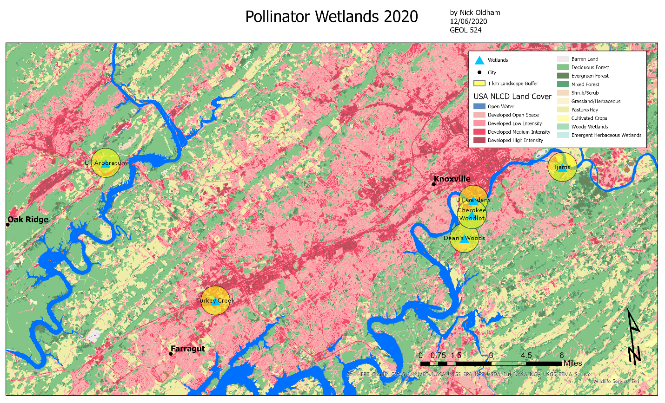
Figure 1.1. Geographic map created in ArcGIS using the NLCD displaying wetland sites (blue triangles) and amount of urban development within 1-km radii (yellow circles). The pink to red coloration represents varying intensities of developed land, whereas green coloration relates to natural and semi-natural landscapes, yellow relates to agricultural land use, and blue relates to open water.

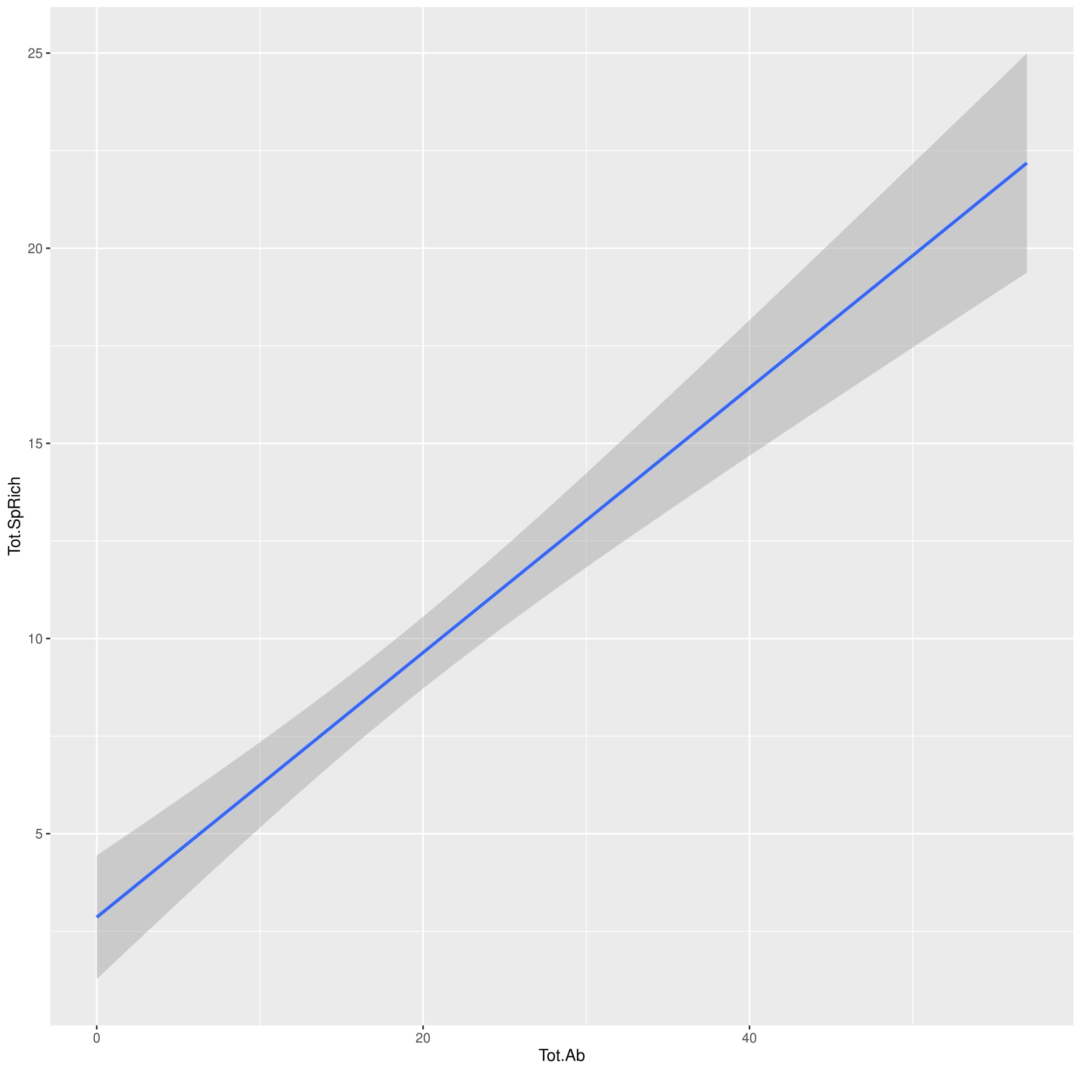
Figure 1.2. Correlation between total species richness and abundance of flower-visiting insects. The shaded area around the line indicates at 95% confidence interval around the linear relationship.

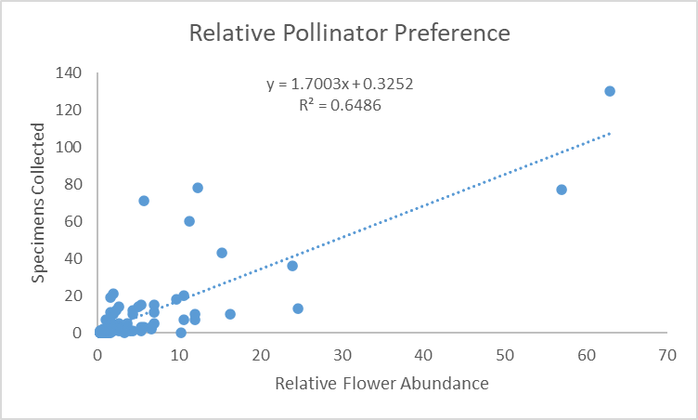
Figure 1.3. Relative preference of pollinators collected in relation to the relative flower abundance (floral display).

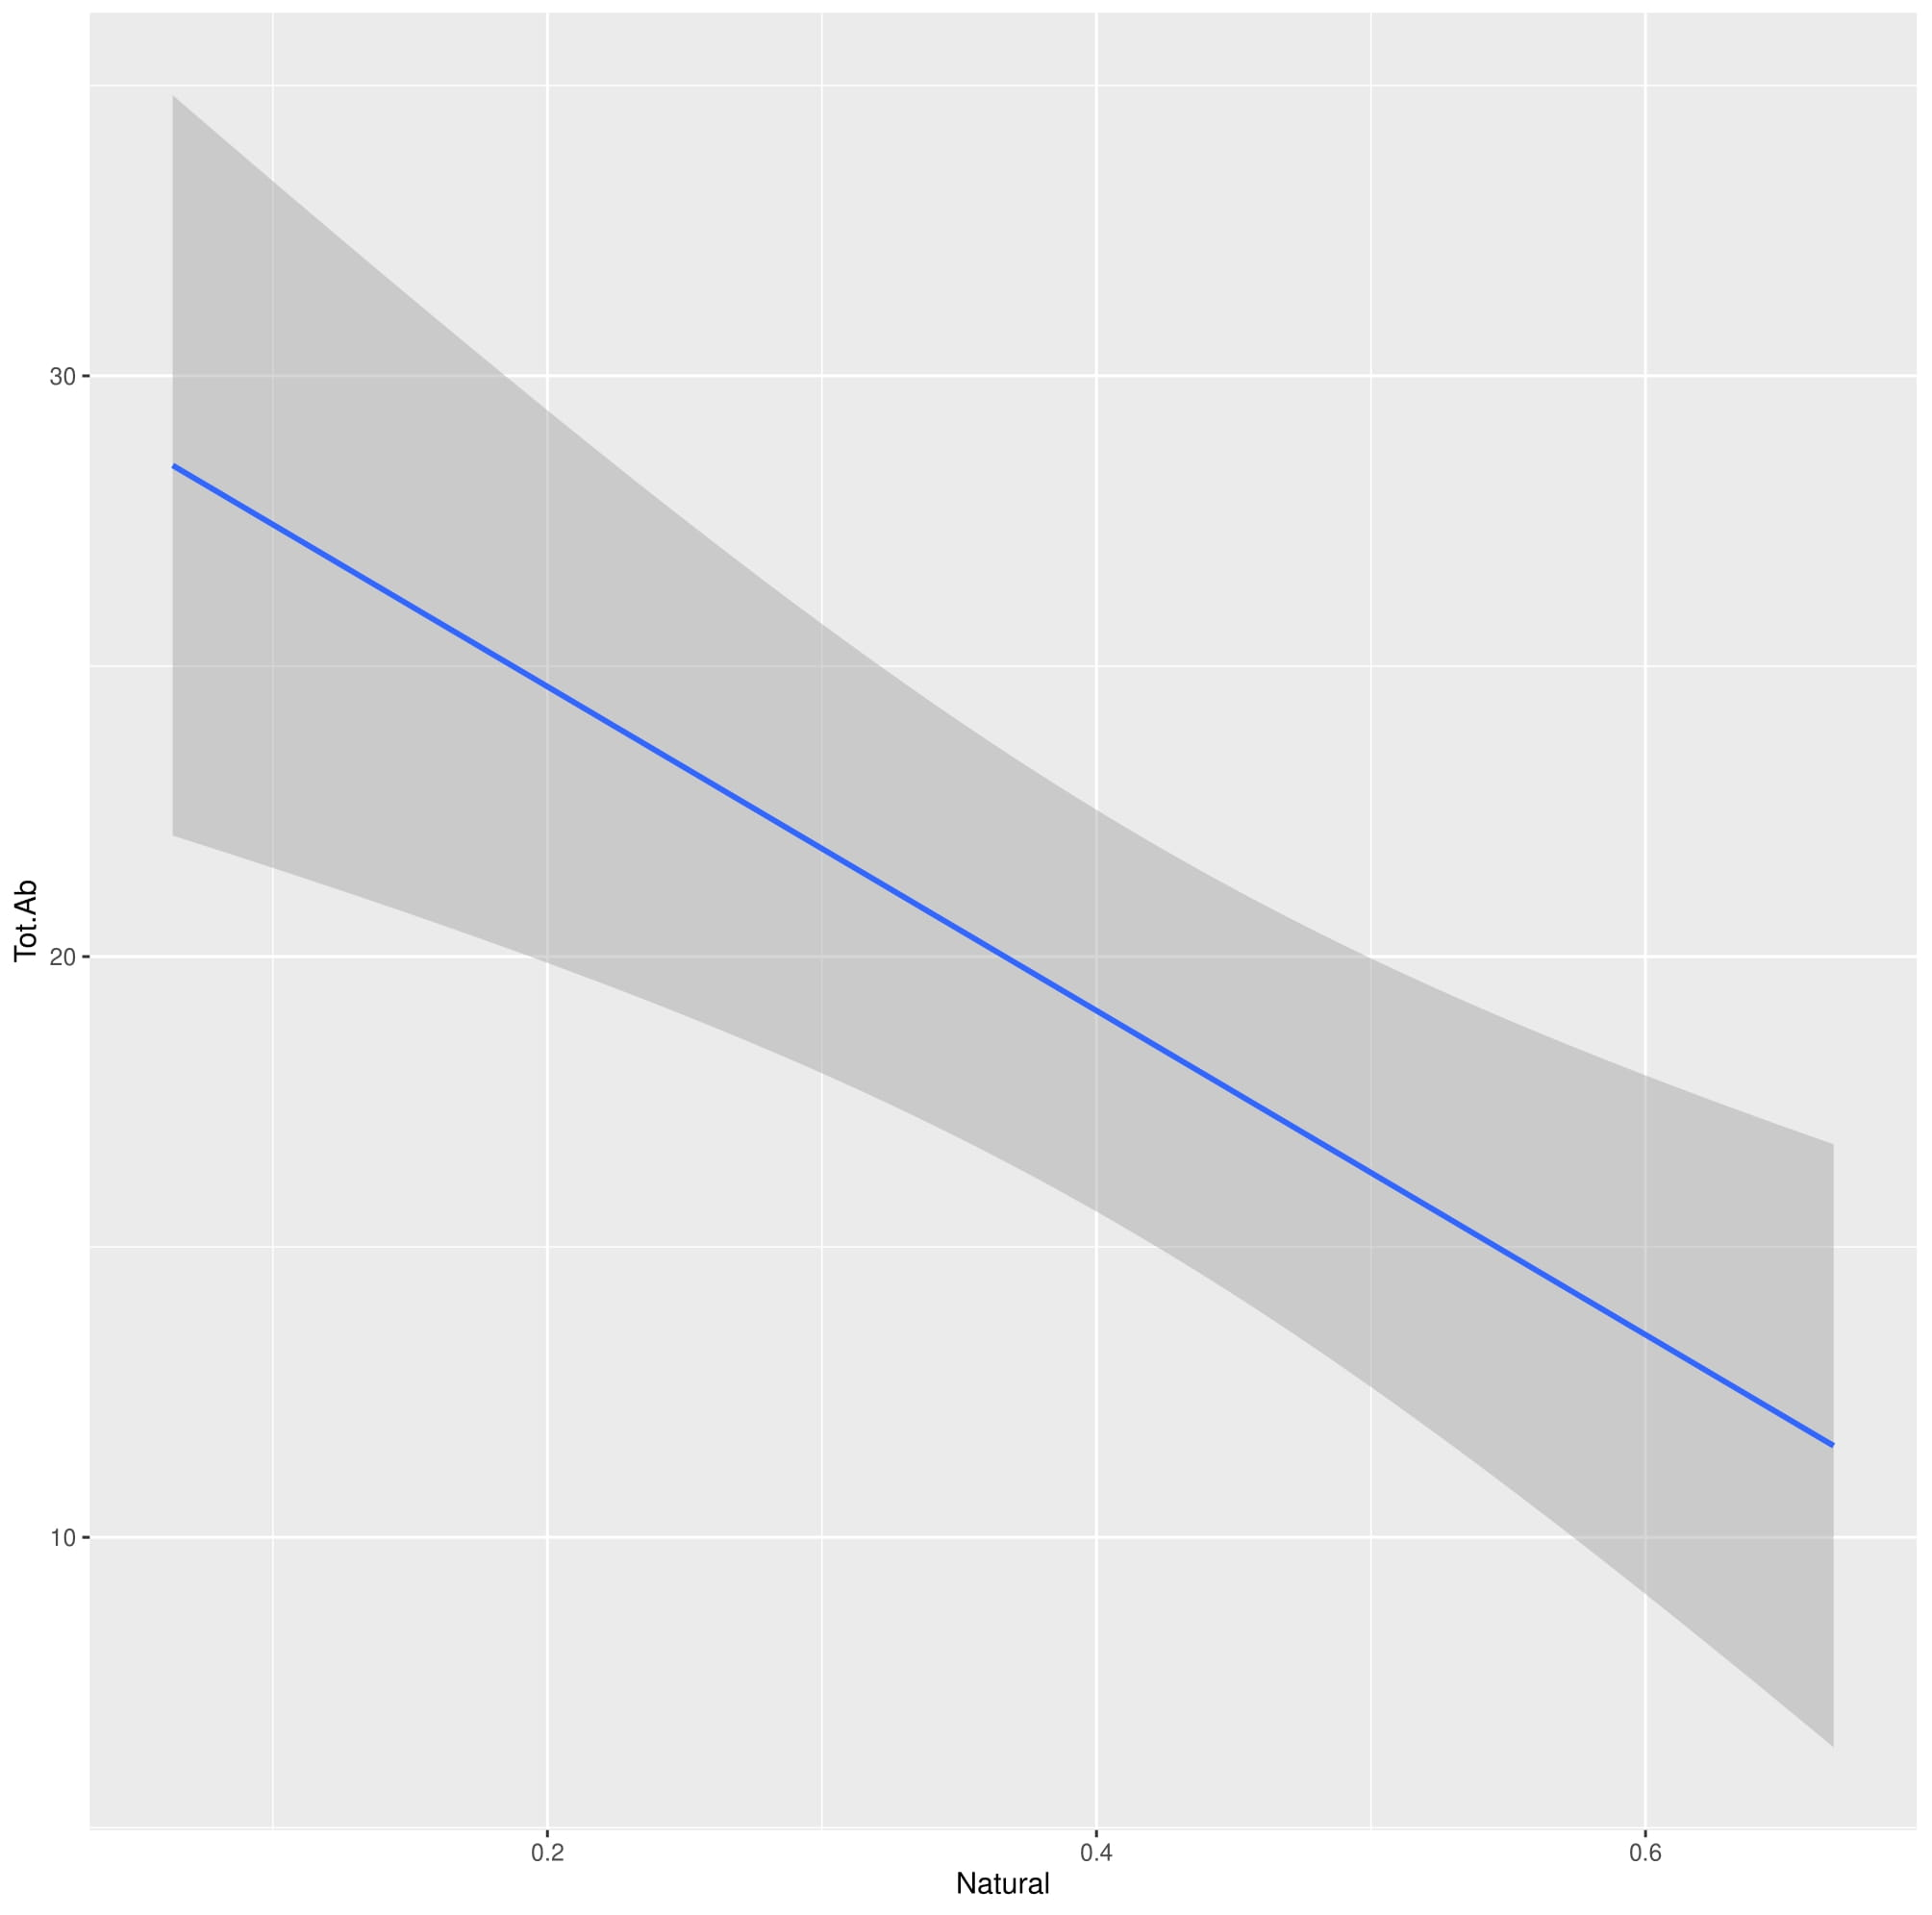
Figure 1.4. The predicted relationship between the proportion of natural habitat (1-km radius) and the log-transformed total insect abundance based on the GLMM analysis. The shaded area around the line indicates the 95% confidence interval around the predicted linear relationship.

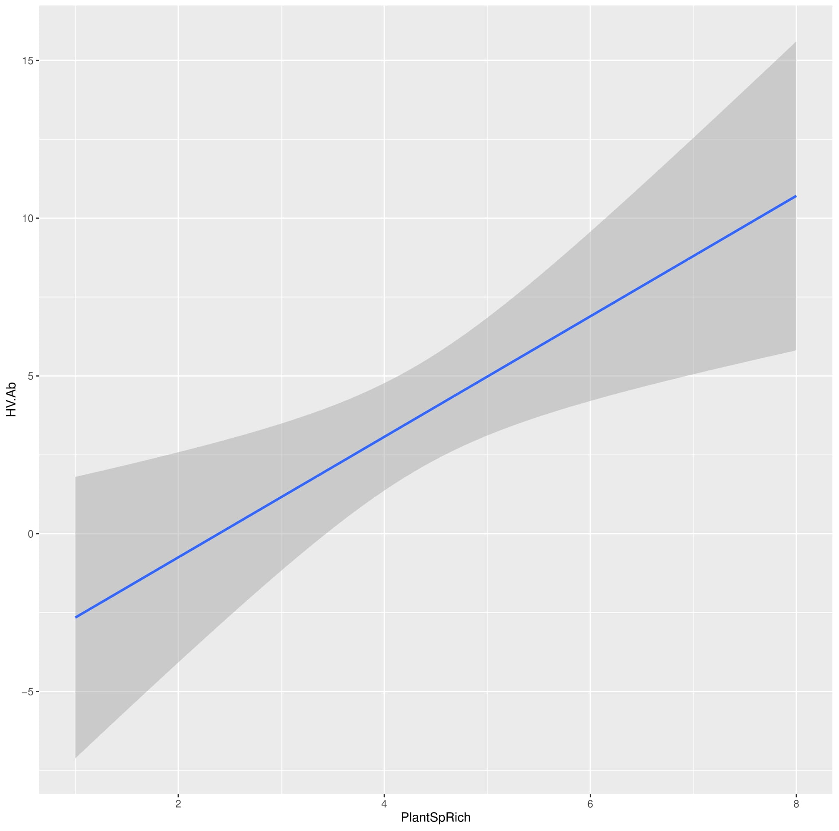
Figure 1.5. The predicted relationship between the plant species richness and the log-transformed hover fly abundance based on the GLMM analysis. The shaded area around the line indicates the 95% confidence interval around the predicted linear relationship.

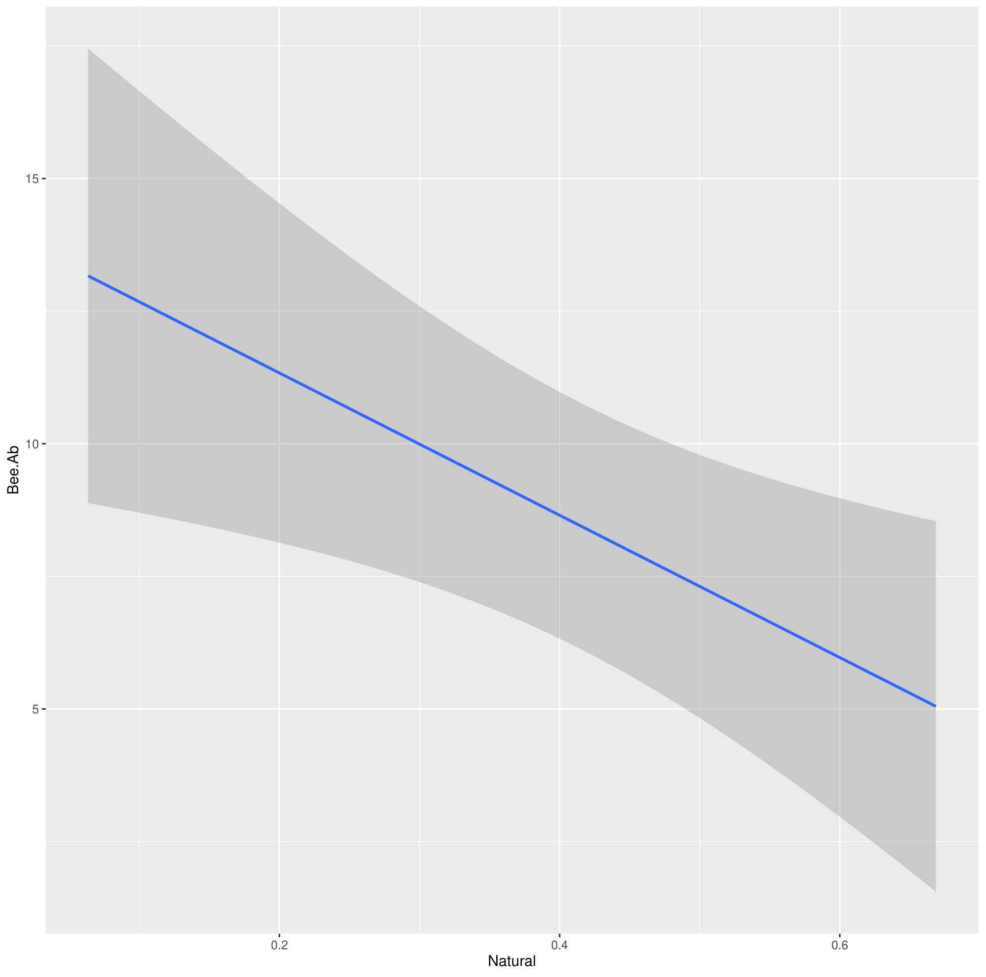
Figure 1.6. The predicted relationship between the proportion of natural habitat (1-km radius) and the log-transformed bee abundance based on the GLMM analysis. The shaded area around the line indicates the 95% confidence interval around the predicted linear relationship.

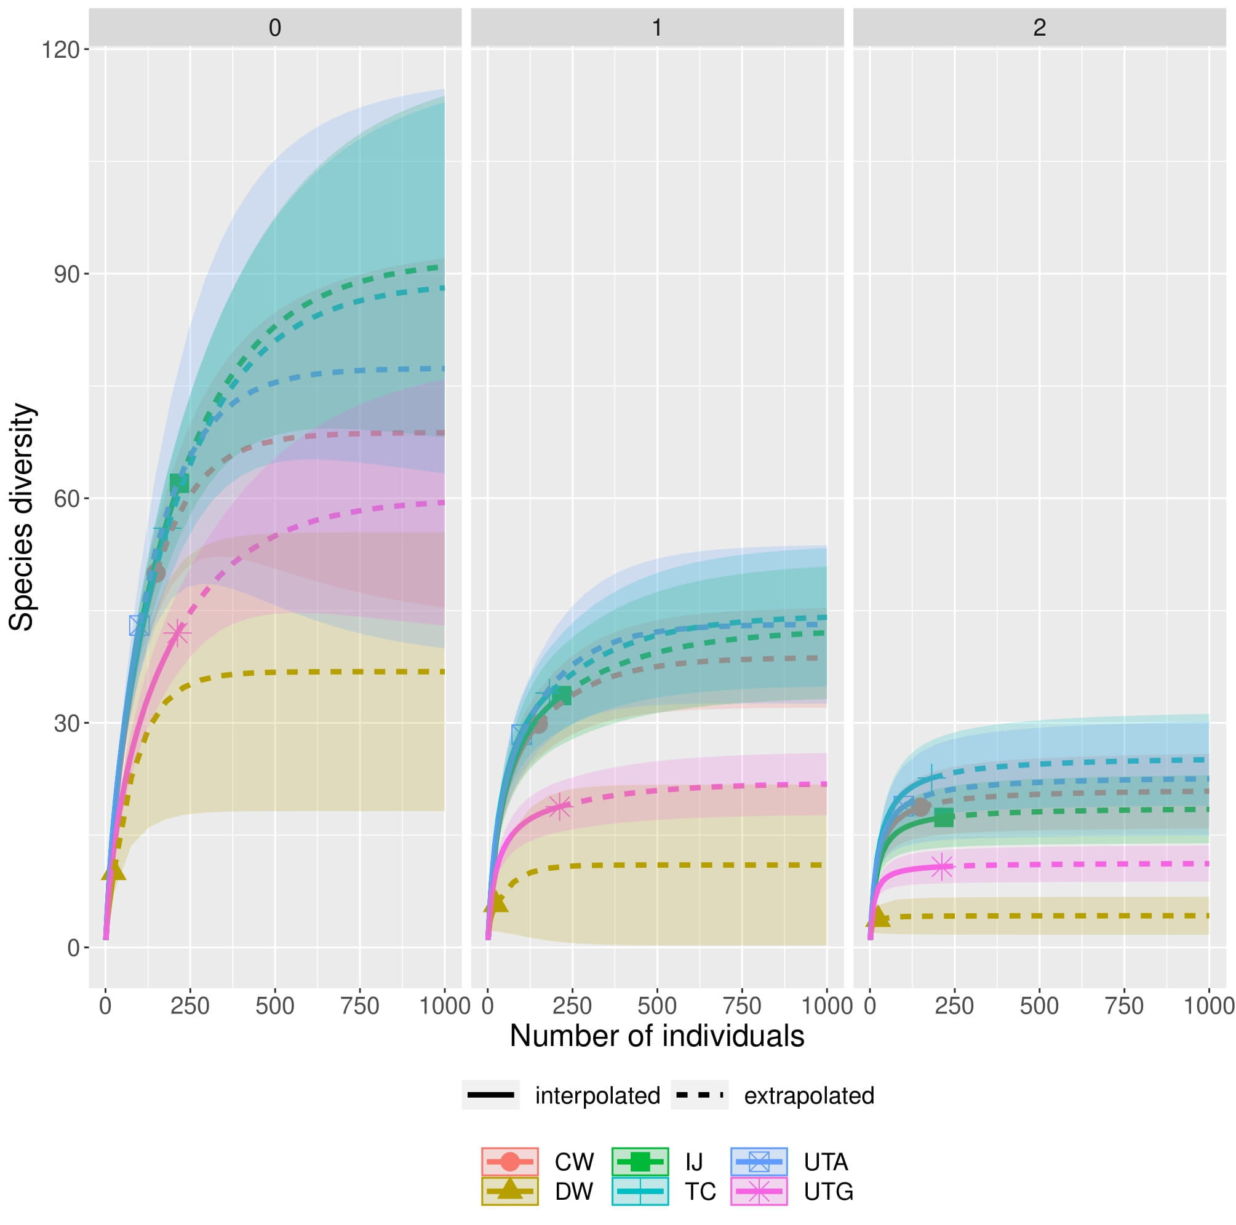
Figure 1.7. Rarefaction analysis comparing species diversity among three different methods: species richness (0), Shannon diversity (1), and Simpson diversity (2). The interpolated data are represented by a solid line, and the symbols indicate the total number of specimens collected at each site. The extrapolated data (dotted lines) were based on model projections of predicted species diversity. The sites are represented as follows: CW (pink circle), IJ (green square), UTA (blue open square), DW (brown triangle), TC (blue cross), UTG (purple star).

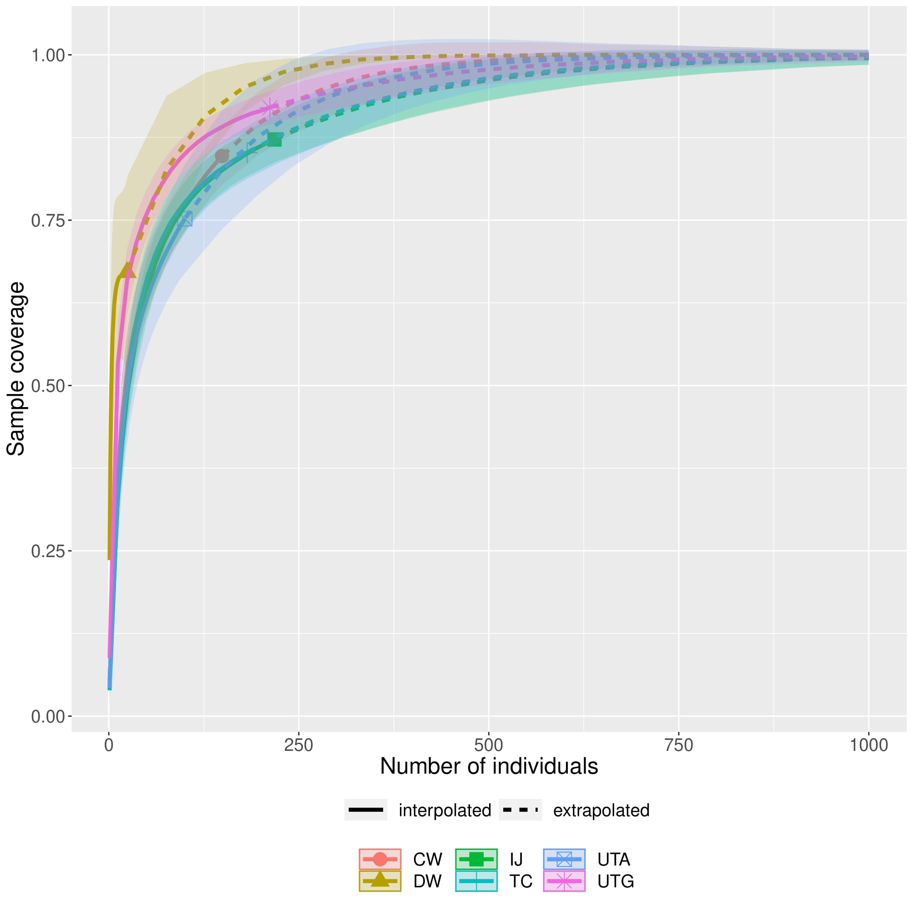
Figure 1.8. Sample coverage among the surveyed wetland sites. The interpolated data are represented by a solid line, and the symbols indicate the total number of specimens collected at each site. The extrapolated data (dotted lines) were based on model projections of predicted species richness. The sites are represented as follows: CW (pink circle), IJ (green square), UTA (blue open square), DW (brown triangle), TC (blue cross), UTG (purple star).

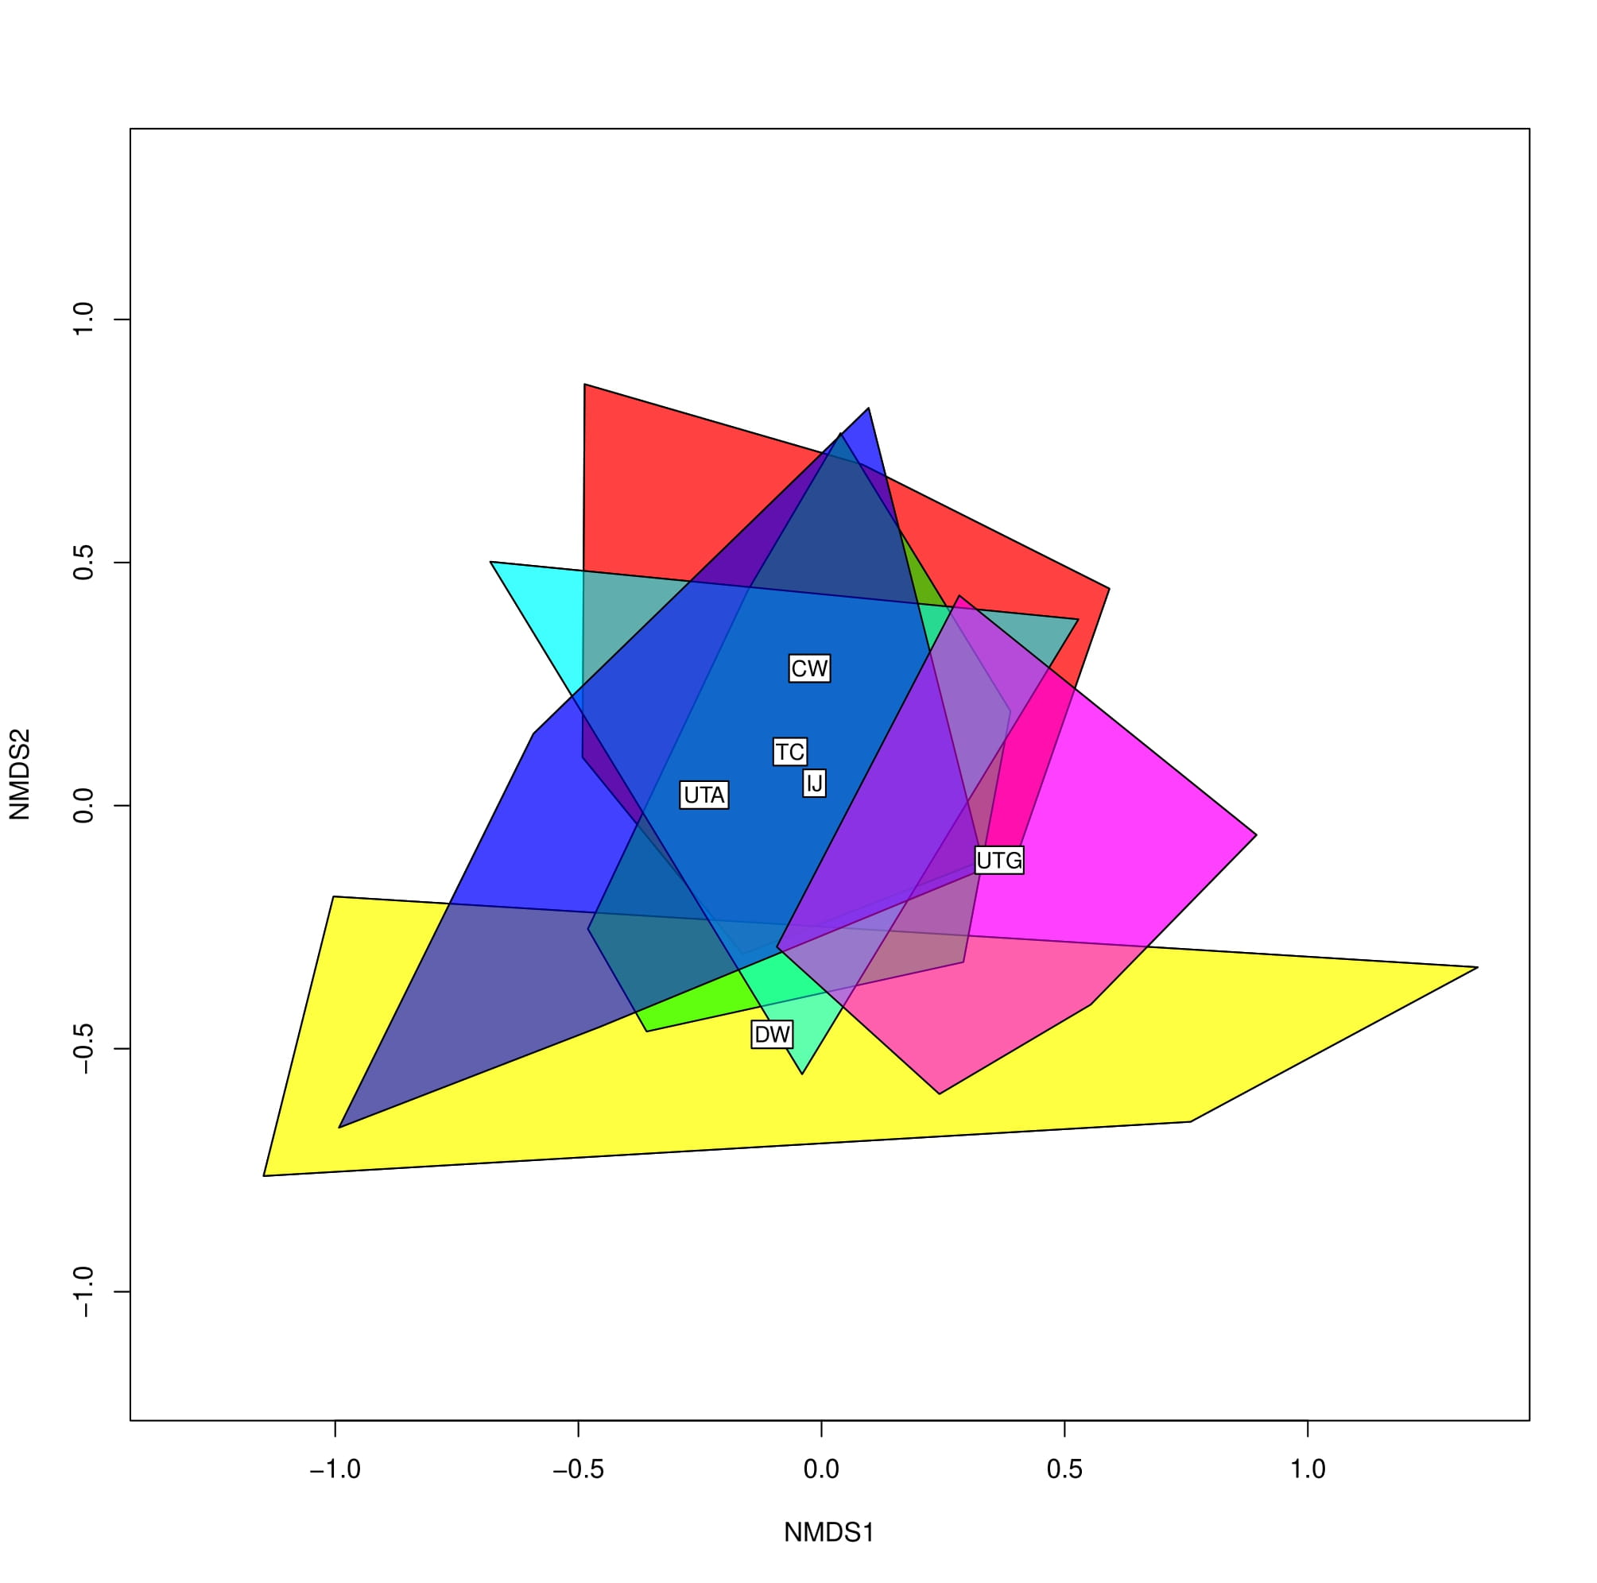
Figure 1.9. Non-Metric Multi-Dimensional Scaling (NMDS) analysis of insect species composition across the study sites. The sites are represented as follows: DW (yellow), UTG (pink), UTA (blue), TC (light blue), IJ (green), CW (red).

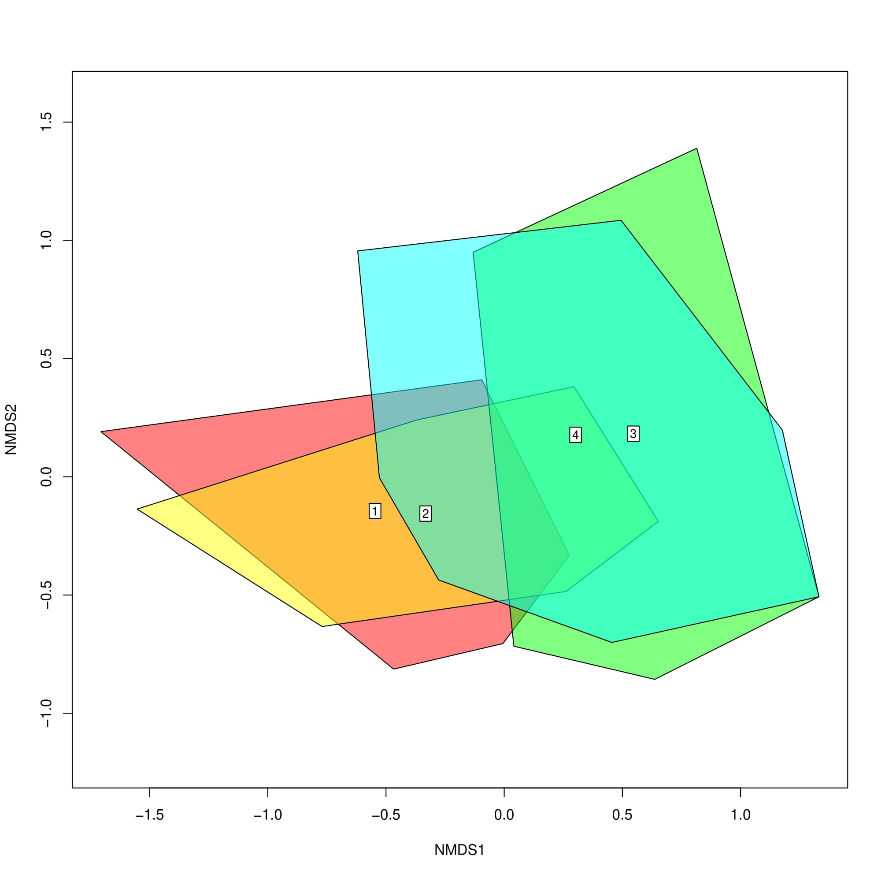
Figure 1.10. NMDS analysis of insect species composition across the rotations (sampling round) throughout the season. The sampling rounds are as follows: round 1 (red), round 2 (orange), round 3 (green), round 4 (blue).

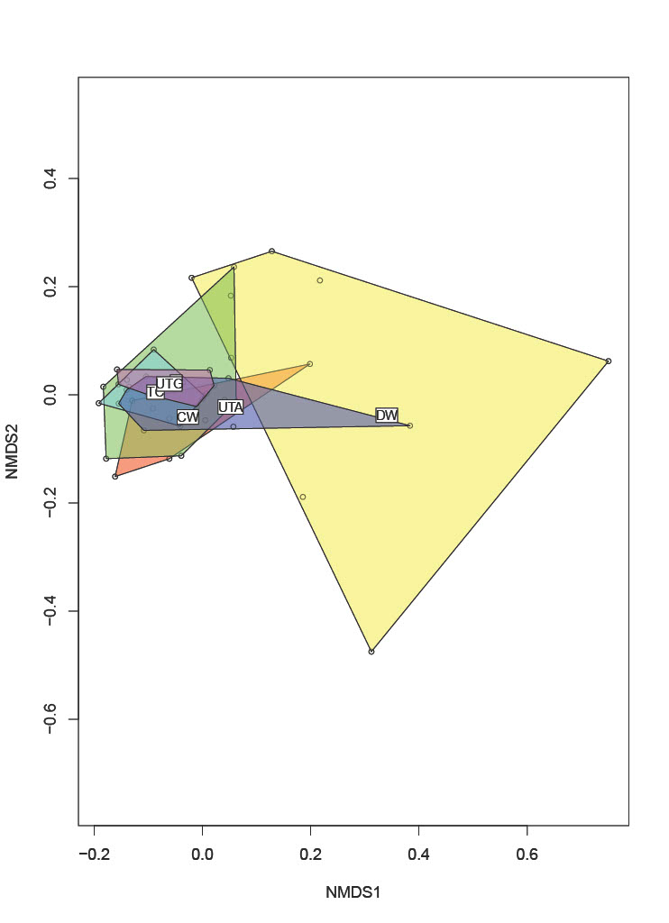
Figure 1.11. NMDS analysis of plant species composition across the study sites. The sites are represented as follows: DW (yellow), UTG (pink), UTA (blue), TC (light blue), IJ (green), CW (red).

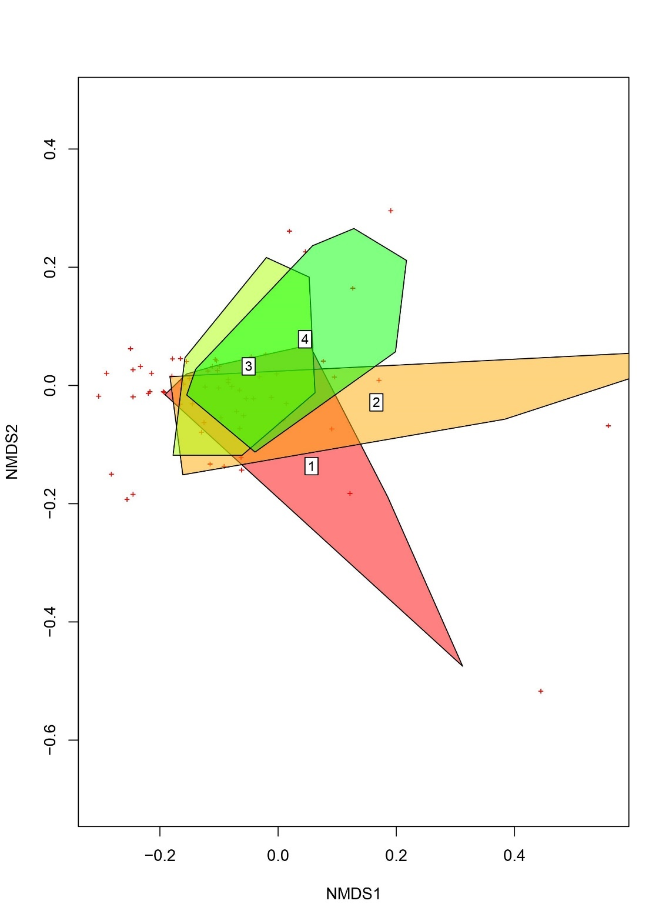
Figure 1.12. NMDS analysis of plant species composition across the rotations (sampling round) throughout the season. The sampling rounds are as follows: round 1 (red), round 2 (orange), round 3 (yellow), round 4 (green).

Table 2.1. Top 10 most attractive flowers based on the number of specimens collected per relative floral display. Floral display is ranked on a 1-10 scale for each transect section and then summed across the transect.
Rank | Species | Common Name | Specimens per Floral Abundance
1 | Rhus copallinum L. | shining sumac | 10.75
2 | Helenium autumnale L. | common sneezeweed | 3.86
3 | Clematis sp. L. | N/A | 3.00
4 | Coreopsis tripteris L. | tall coreopsis | 2.90
5 | Daucus carota L. | wild carrot | 2.81
6 | Pycnanthemum tenuifolium Schrad. | narrowleaf mountain mint | 2.74
7 | Solidago sp. L. | N/A | 2.39
8 | Melilotus albus Medik. | white sweetclover | 2.36
9 | Coreopsis tinctoria Nutt. | plains coreopsis | 1.56
10 | Eupatorium sp. L. | N/A | 1.50

Table 2.2. Plant community composition for each disturbance category.
LOW | MEDIUM | HIGH
Apios americana Medik. | Penstemon sp. Schmidel | Symphyotrichum sp. Nees
Medicago lupulina L. | Rudbeckia hirta | Phytolacca americana L.
Rudbeckia hirta L. | Houstonia sp. L. | Medicago lupulina L.
Asclepias tuberosa L. | Eupatorium sp. L. | Eupatorium sp. L.
Ruellia caroliniensis (J.F. Gmel.) Steud. | Asclepias tuberosa L. | Ruellia caroliniensis (J.F. Gmel.) Steud.
Chicorium sp. L. | Cephalanthus sp. L. | Lespedeza cuneata
Clematis sp. L. | Solanum carolinense L. | Helenium autumnale L.
Prunella vulgaris L. | Ruellia caroliniensis (J.F.Gmel.) Steud. | Conoclinium sp. DC. (Dum.Cours.) G.Don
Oenothera biennis L. | Lespedeza cuneata (Dum.Cours.) G.Don | Dactylis sp. L.
Heterotheca sessiliflora (Nutt.) Shinners | Prunella vulgaris L. | Taraxacum officinale (L.) Weber ex F.H.Wigg.
Erigeron sp. L. | Achillea millefolium L. | Pyrrhopappus sp. (Walter) DC.
Euphorbia corollata L. | Dianthus armeria L. | Agalinis sp. Raf.
Verbesina virginica L. | Lobelia puberula Michx. | Sherardia arvensis L.
Solidago sp. L. | Agalinis sp. Raf. | Erigeron sp. L.
Bechium sp. DC. | Erigeron sp. L. | Solidago sp. L.
Lonicera japonica Thunb. | Euphorbia corollata L. | Ilex sp. L.
Pycnanthemum tenuifolium Schrad. | Penstemon digitalis Nutt. ex Sims | Bechium sp. DC.
Leucanthemum vulgare Lam. | Verbesina virginica L. | Lonicera japonica Thunb.
Chamaecrista fasciculata (Michx.) Greene | Solidago sp. L.
Coreopsis tinctoria Nutt. | Scutellaria integrifolia L. | Potentilla indica (Andrews) Th.Wolf
Securigera varia (L.) Lassen | Trifolium campestre Schreb. | Hydrangea quercifolia Bartram
Trifolium pratense L. | Bechium sp. DC. | Leucanthemum vulgare Lam.
Plantago lanceolata L. | Eutrochium purpureum (L.) E.E. Lamont | Ligustrum vulgare L.
Rhus copallinum L. | Lobelia sp. L. | Securigera varia (L.) Lassen
Coreopsis tripteris L. | Lythrum sp. L. | Trifolium pratense L.
Coreopsis sp. L. | Pycnanthemum tenuifolium Schrad. | Plantago lanceolata L.
Campsis sp. Lour. | Hemerocallis fulva (L.) L. | Rubus sp. L.
Cicuta sp. L. | Leucanthemum vulgare Lam. | Salvia sp. L.
Trifolium repens L. | Packera sp. (L.) Á. Löve & D. Löve | Iris virginica L.
Table 2.2 Continued
LOW | MEDIUM | HIGH
Melilotus albus Medik. | Chamaecrista fasciculata (Michx.) Greene | Hypericum perforatum L.
Asclepias verticillata L. | Phlox sp. L. | Trifolium repens L.
Monarda fistulosa L. | Coreopsis tinctoria Nutt. | Asclepias verticillata L.
Daucus carota L. | Securigera varia (L.) Lassen | Monarda fistulosa L.
Hydrangea arborescens L. | Passiflora incarnata L. | Daucus carota L.
 | Trifolium pratense L. | Oxalis stricta L.
 | Sabatia angularis (L.) Pursh
 | Ludwigia alternifolia L.
 | Hymenocallis sp. Salisb.
 | Hypericum perforatum
 | Carduus nutans L.
 | Coreopsis sp. L.
 | Desmodium canadense (L.) DC.
 | Strophostyles helvola (L.) Elliott
 | Asclepias verticillata L.
 | Monarda fistulosa L.
 | Daucus carota L.
 | Ipomoea pandurata (L.) G.F.W.Mey.
 | Verbesina occidentalis (Walter) L.

Disturbance | Lagoon # | Missing | Knocked Over | Small | Medium | Large | Short-tailed
High | 1 | - | - | 0 | 0 | 0 | 0
High | 2 | - | - | 0 | 0 | 0 | 0
High | 3 | - | - | 0 | 0 | 0 | 0
High | 1 | X | - | 0 | 0 | 0 | 0
High | 2 | - | - | 0 | 0 | 0 | 0
High | 3 | - | - | 0 | 0 | 0 | 0
High | 1 | - | X | 0 | 0 | 0 | 0
High | 2 | - | X | 0 | 0 | 0 | 0
High | 3 | - | - | 0 | 0 | 0 | 0
Medium | 1 | - | X | 0 | 0 | 0 | 0
Medium | 2 | - | - | 0 | 0 | 0 | 0
Medium | 3 | - | - | 0 | 0 | 0 | 0
Medium | 1 | - | X | 3 | 14 | 0 | 0
Medium | 2 | - | X | 0 | 0 | 0 | 0
Medium | 3 | - | - | 0 | 0 | 5 | 0
Medium | 1 | - | X | 0 | 0 | 0 | 0
Medium | 2 | - | X | 0 | 0 | 0 | 0
Medium | 3 | - | - | 0 | 0 | 0 | 0
Low | 1 | - | - | 0 | 0 | 0 | 0
Low | 2 | X | - | 0 | 0 | 0 | 0
Low | 3 | - | X | 0 | 0 | 0 | 0
Low | 1 | - | - | 0 | 0 | 17 | 1
Low | 2 | - | X | 0 | 0 | 0 | 0
Low | 3 | - | - | 1 | 0 | 0 | 8
Low | 1 | - | - | 0 | 0 | 0 | 6
Low | 2 | - | - | 0 | 0 | 0 | 0
Low | 3 | - | - | 0 | 0 | 0 | 6
Table 2.3. Hover fly larvae collected from the artificial hover fly lagoons.

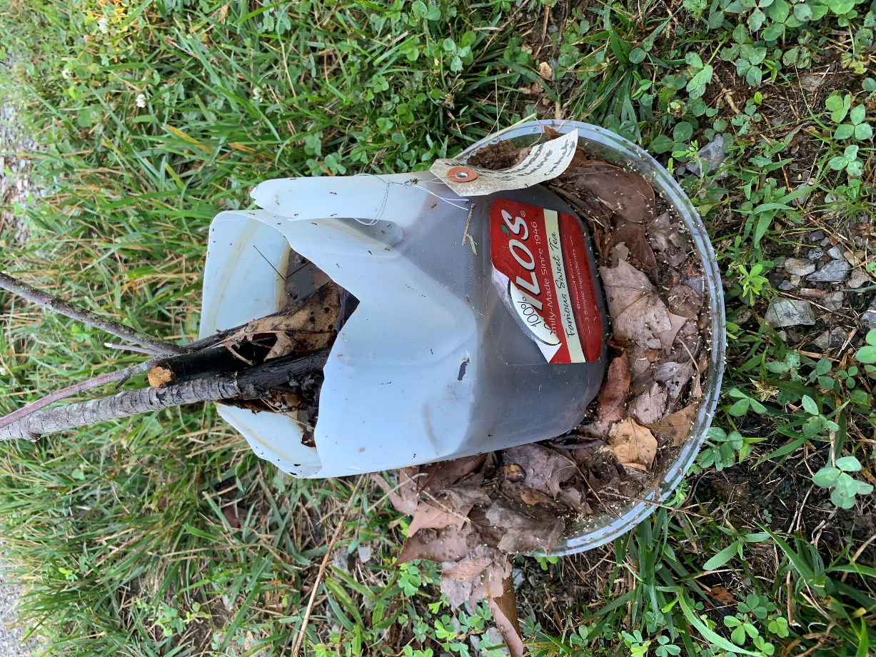
Figure 2.1. Constructed hover fly lagoon using a 2-liter plastic sweet tea jug. This particular lagoon was invaded by an ant colony.

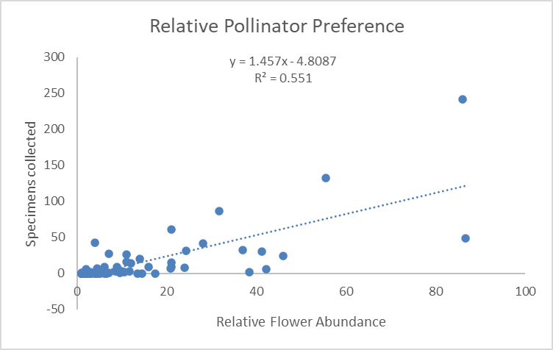
Figure 2.2. Relative preference of pollinators collected in relation to the relative flower abundance (floral display).

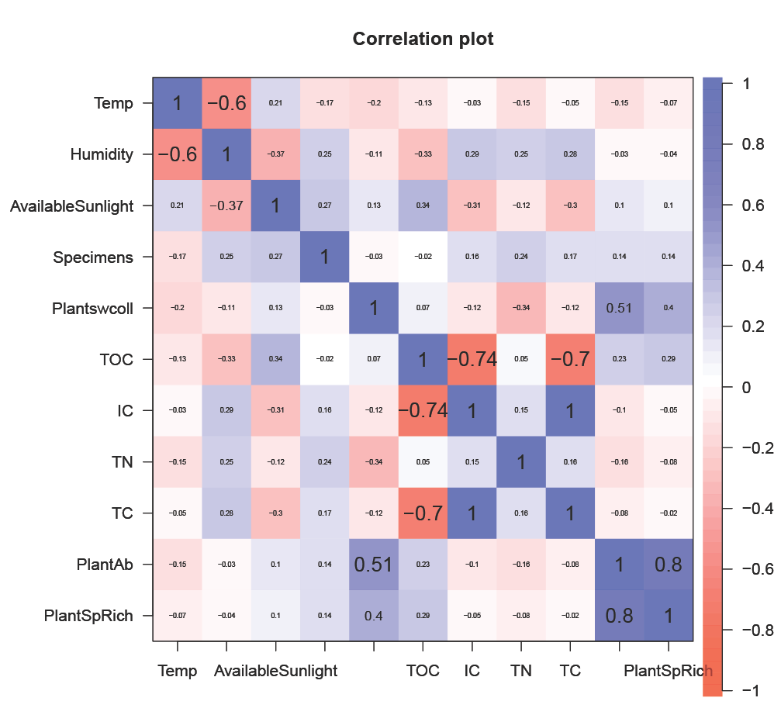
Figure 2.3. Correlation plot evaluating correlations between abiotic and biotic measures on a scale from -1 to +1. Values closer to 1 indicate a strong positive relationship and values closer to -1 indicate a strong negative relationship. The variables from top to top to bottom, left to right: Temperature, Humidity, Available Sunlight, Insect Specimens, Plants with Pollinators, Total dissolved Organic Carbon (TOC), Inorganic dissolved Carbon (IC), Total dissolved Nitrogen (TN), dissolved organic and inorganic Carbon difference (TC), plant abundance, plant species richness.

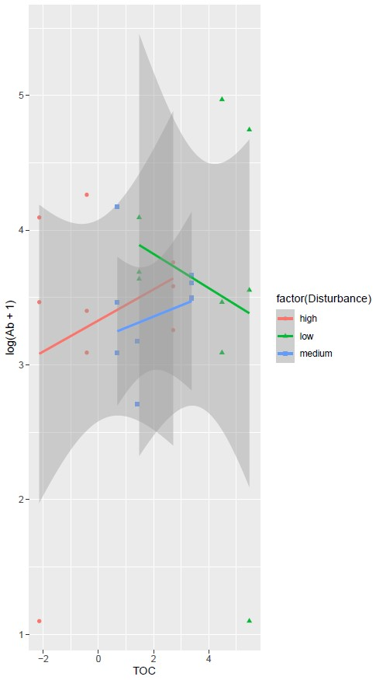
Figure 2.4. The predicted relationships for each disturbance category between total organic carbon (TOC) and the log-transformed total pollinator abundance based on the GLMM analysis. The shaded area around the line indicates the 95% confidence interval around the predicted linear relationship. The disturbance categories are represented as follows: high (pink), low (green), and medium (blue).

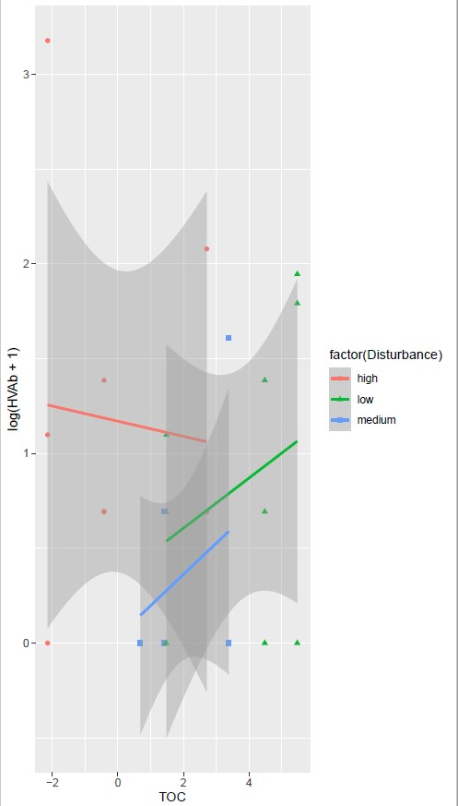
Figure 2.5. The predicted relationships for each disturbance category between total organic carbon (TOC) and the log-transformed hover fly abundance based on the GLMM analysis. The shaded area around the line indicates the 95% confidence interval around the predicted linear relationship. The disturbance categories are represented as follows: high (pink), low (green), and medium (blue).

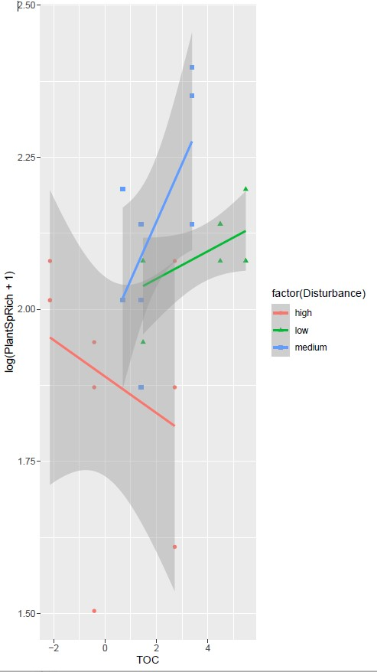
Figure 2.6. The predicted relationships for each disturbance category between total organic carbon (TOC) and the log-transformed plant species richness based on the GLMM analysis. The shaded area around the line indicates the 95% confidence interval around the predicted linear relationship. The disturbance categories are represented as follows: high (pink), low (green), and medium (blue).

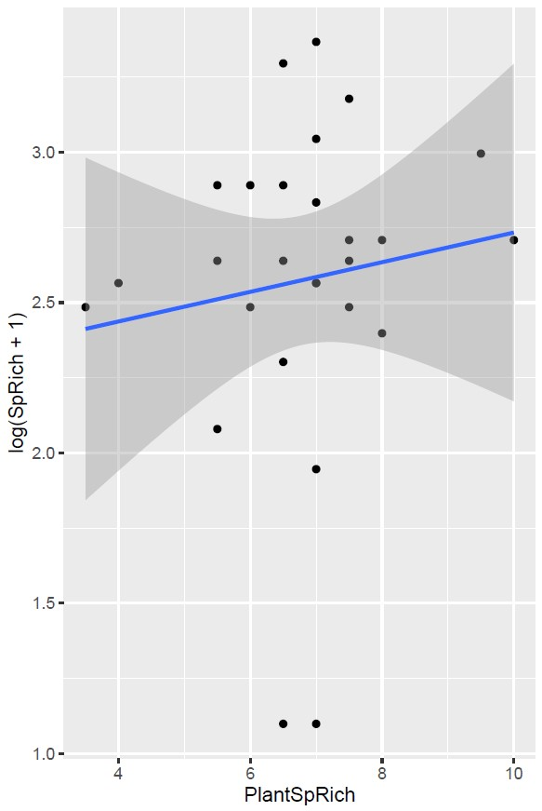
Figure 2.7. The predicted relationship between plant species richness and the log-transformed pollinator species richness based on the GLMM analysis. The shaded area around the line indicates the 95% confidence interval around the predicted linear relationship.

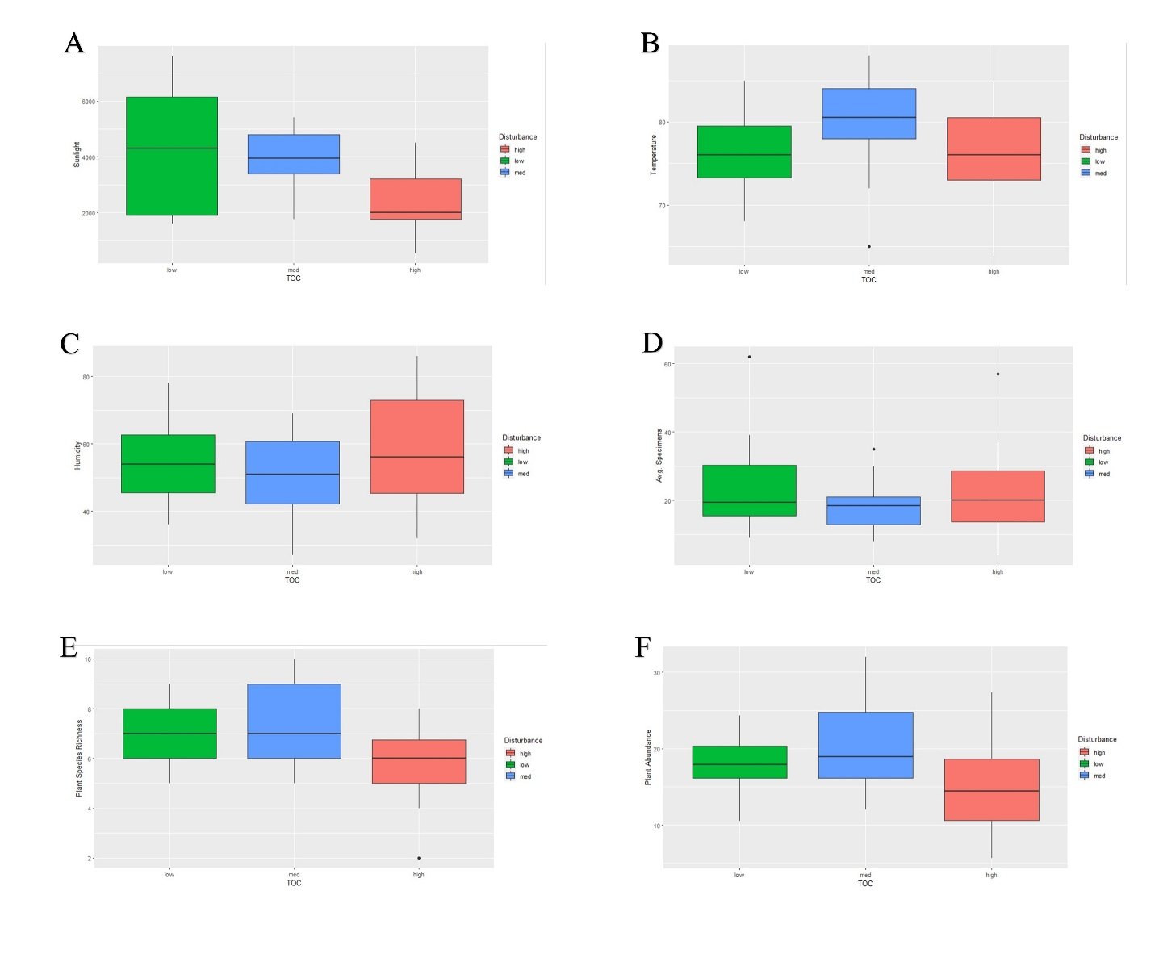
Figure 2.8. Boxplots of various abiotic (A-C) and biotic (D-F) variables in relation to the disturbance category, sorted by level of total organic carbon (TOC). Sunlight (A), temperature (B), humidity (C), averaged specimen abundance (D), plant species richness (E), and plant abundance (F) are the variables. The disturbance categories are represented as follows: low (green), medium (blue), and high (pink).

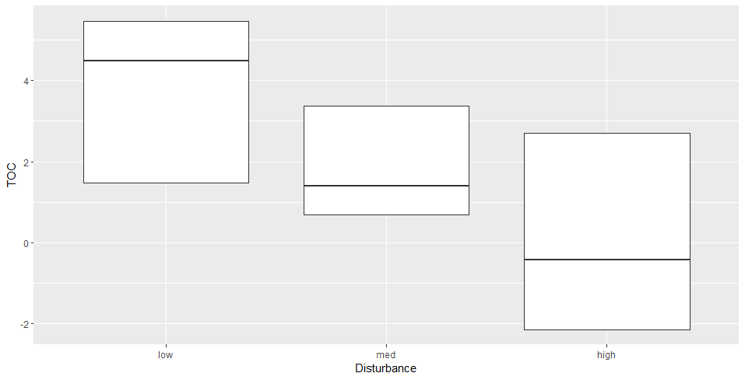
Figure 2.9. Boxplot of the amount of total organic carbon (mg/L) in the different levels of disturbed wetlands: low, medium, and high.

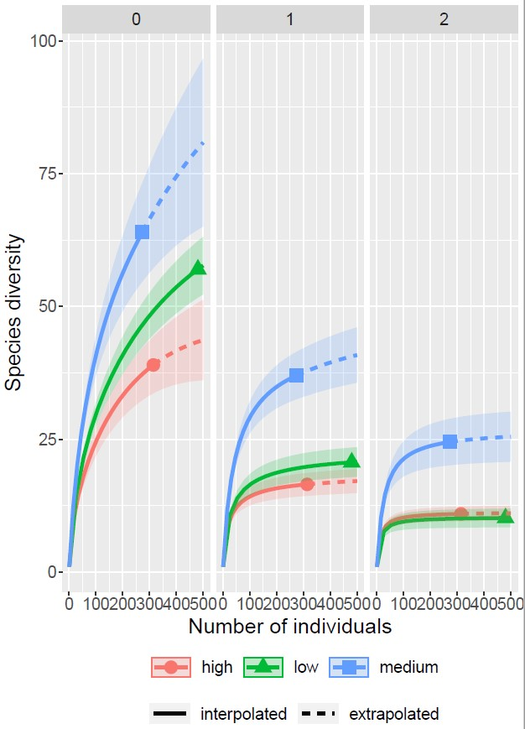
Figure 2.10. Rarefaction analysis comparing species diversity among three different methods: species richness (0), Shannon diversity (1), and Simpson diversity (2). The interpolated data are represented by a solid line, and the symbols indicate the total number of specimens collected in each disturbance category. The extrapolated data (dotted lines) were based on model projections of predicted species diversity. The disturbance categories are represented as follows: high (pink circle), low (green triangle), and medium (blue square).

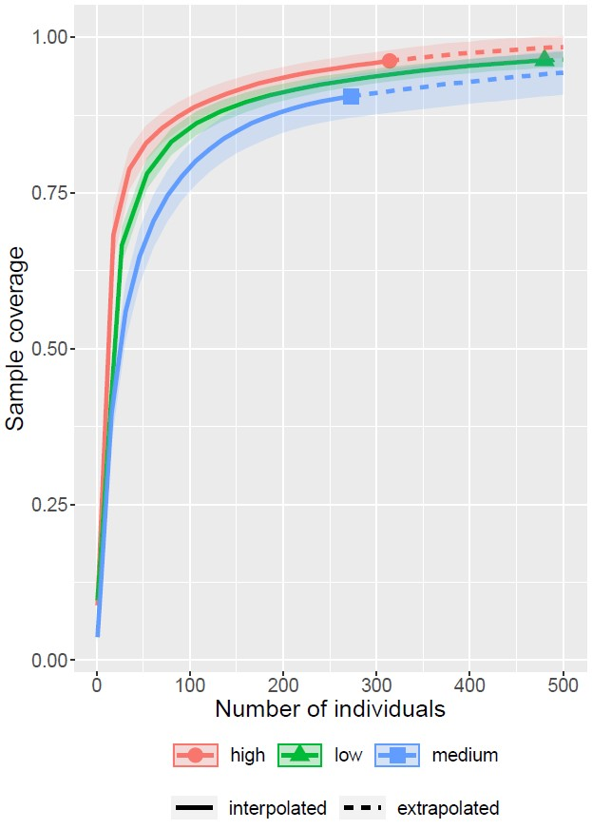
Figure 2.11. Sample coverage among the surveyed wetlands within the different disturbance categories. The interpolated data are represented by a solid line, and the symbols indicate the total number of specimens collected at each site. The extrapolated data (lines) were based on model projections of predicted species richness. The disturbance categories are represented as follows: high (pink circle), low (green triangle), and medium (blue square).

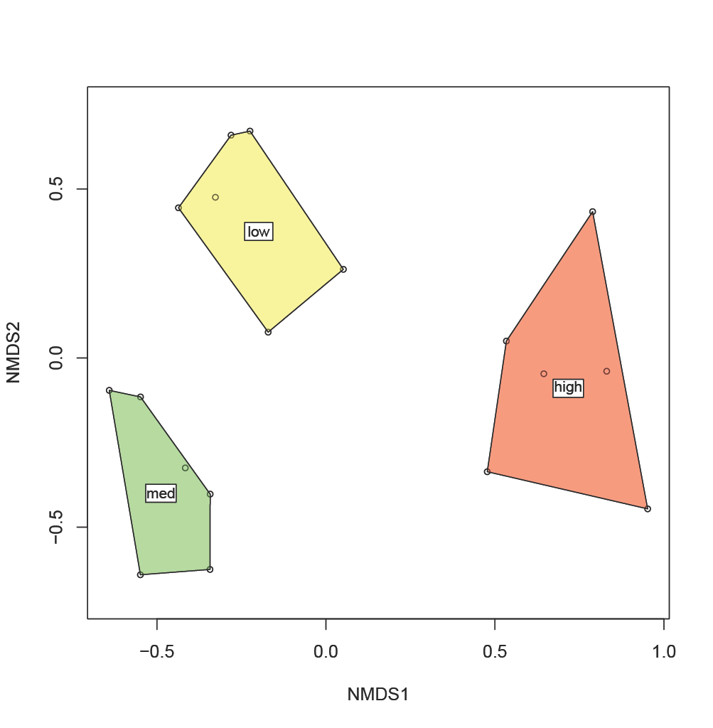
Figure 2.12. Non-Metric Multi-Dimensional Scaling (NMDS) analysis of plant species composition across disturbance level categories: low, medium, and high.

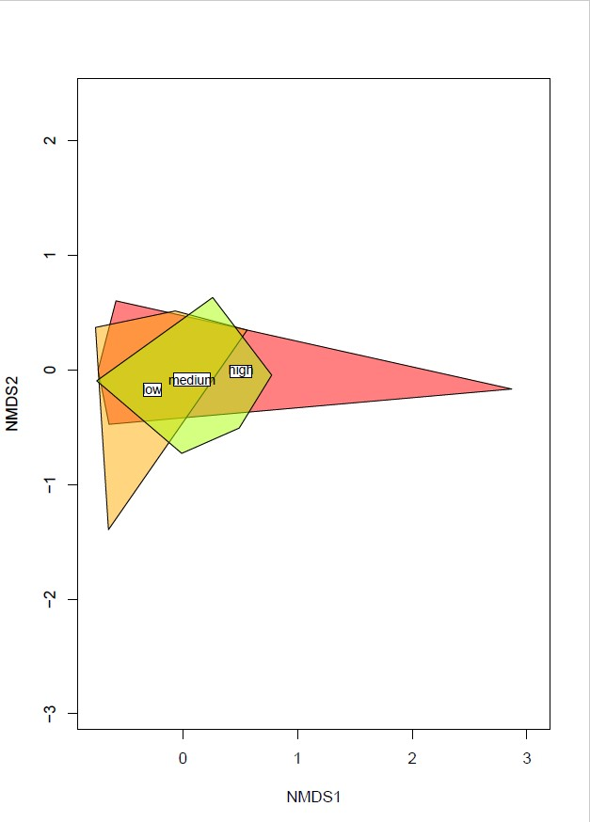
Figure 2.13. Non-Metric Multi-Dimensional Scaling (NMDS) analysis of pollinator species composition across disturbance level categories: low, medium, and high.

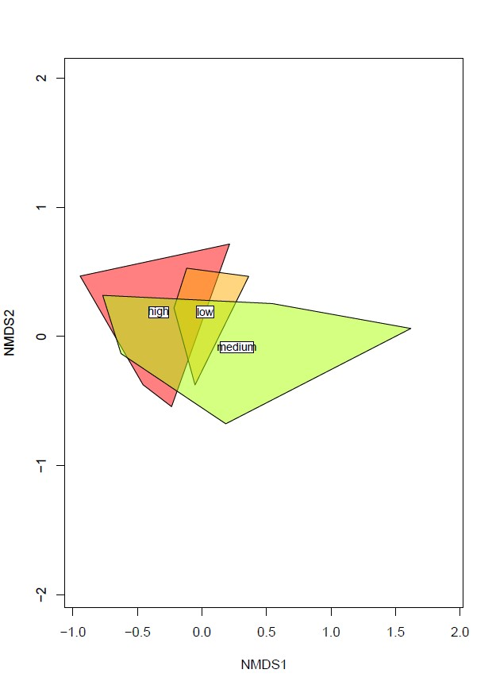
Figure 2.14. Non-Metric Multi-Dimensional Scaling (NMDS) analysis of bee species composition across disturbance level categories: low, medium, and high.

Vita
Nick Oldham attended Volunteer State Community College where he graduated with an Associate of Science in Pre-Medicine and Pre-Medical Studies in 2014. He then attended the University of Tennessee, graduating in 2018 with a Bachelor of Science in Forestry with a concentration in Forest Resources Management and a minor in Entomology & Plant Pathology.

While nursing and health care briefly interested Nick early on in his academic career, the natural sciences quickly invoked his passion for the outdoors. Beginning with his forestry program, Nick became familiar with management of the land and its effect on the inhabitants within. In particular, he focused on forest insects. What started out as a curiosity quickly became adoration as he learned more about the many arthropods that called the forest their home. He soon took upon the Entomology & Plant Pathology minor, attending any and all classes within the department that was offered. Soon after, he worked under Dr. Paris Lambdin in his walnut twig beetle research, assisting in monitoring and locating parasitoid wasps that would biologically control the pest. In 2018, Nick eventually had the pleasure of interning at the Oak Ridge National Laboratory under the Natural Resources Management Program. There, he worked on a myriad of projects such as aquatic plant establishment, gypsy moth monitoring, pollinator surveys, and establishing a certified arboretum on their campus. Additionally, it is here when Nick started to develop his passion in science communication. In addition to the hands-on tasks, he also created over a year’s worth of web articles for ORNL Today, titled “Native Plant of the Week”. These articles were intentionally targeted for the casual reader with the goal of informing the public of the importance of native flora and their benefits to wildlife and society. His internship gave him invaluable experience and was fortunately extended for over a year a half, until he began graduate school in the Russo and Moulton Labs in the Department of Entomology & Plant Pathology at the University of Tennessee in 2020.

At the beginning of his graduate school journey, Nick also worked in the department as their social media manager, where he continued his science communication campaign and helped create a fun and engaging platform online. He worked in that position while attending classes and beginning his research for a year and half up until he received the GATE Fellowship from the Science Alliance. With his fellowship and experience of science communication, Nick is currently completing his Master of Science in Entomology & Plant Pathology, concentrating in Entomology. His expertise is focused on pollination ecology with a particular interest in hover flies and wetlands. Throughout his two years, Nick has gotten covered head to toe with ticks and mosquitos and loved every moment of it. Despite the stings and bites, he has found admiration for the often-overlooked pollinators and an appreciation for those who research them. He hopes to continue this pollination journey in similar fields (pun-intended) in the near future.

