The Greek Youthening: Assessing the Iconographic Changes within Courtship during the Late Archaic Period

A Thesis Presented for the
Master of Science
Degree
The University of Tennessee, Knoxville

Jared Alan Johnson
August 2015
Acknowledgements
I am pleased to thank several individuals who helped me with this thesis. I want to thank David Anderson and Gregor Kalas for their many contributions, and their insight regarding my methodology and theory. Thank you to Merle Langdon, my advisor and committee chair, for your keen insight regarding my topic, and your patience during the entire process. Thank you to Aleydis Van de Moortel for allowing me to further my academic career at the University of Tennessee, and your guidance with my course work. Thank you to Stephen Collins-Elliott for providing some crucial manuscripts about the Etruscans. Thank you to the University of Tennessee’s Classics Department for helping me develop professionally and academically. Lastly, I want to thank my beloved companion, Hope Smith, who has always given me support and motivation throughout the entire process.

Abstract
During the late sixth century and early fifth century B.C., Athenian vase painters started experimenting with a new medium (i.e. red figure). Black figure was still the predominant medium by the early fifth century B.C., and its pederastic scenes on some of the vases belonged to a coherently consistent presentation or a conventional set of images. However, the conventional pederastic motifs of black figure, such as the differentiation in height between figures, the variation among lovers (e.g. bearded erastes and unbearded eromenos), and the appearance of courtship gifts all started to disappear in red figure throughout the fifth century B.C. Sir John Beazley, arguably one of the most preeminent Attic vase experts of the 20th century, noticed that the erastai (i.e. lovers) were depicted more often as youths throughout the fifth century B.C. He labeled this phenomenon as the “youthening” (Beazley 1950:321). Over the last few decades, several scholars (e.g. Shapiro 1981, 2000; Stewart 1997; Kilmer 1993; Lear and Cantarella 2008) have put forth many hypotheses regarding this “youthening”. However, their arguments have either given too much weight to social/political change (e.g. Shapiro 1981), or did not adequately take into consideration much of the extant literature (e.g. Lear and Cantarella 2008). (1) I will analyze this synchronic phenomenon by synthesizing evidence from both Attic vase materials and the extant literature; furthermore, (2) I will utilize elements of both Foucault’s (1985) “problematization” theory and Anthony Giddens’s (1986) theory of structuration as a theoretical framework for my analysis. (3) Lastly, I will demonstrate that the youthening happened as early as the late fifth century B.C., and that the addition of the cane or walking stick of the erastai was instrumental to this stylistic change because it replaced the beard as the signifier for the adult male; moreover, the “youthening” did in fact mirror certain aspects of social reality, and reflect the various forms of erotic alliances between age groups.
Table of Contents
Chapter 1 Introduction …………………………………………………………………………... 1
Outline of Thesis ……………………………………………………………………………... 11
Chapter 2 Literature Review …………………………………………………………………… 13
History of Greek Pederasty …………………………………………………………………... 13
A Symposium of Libertines, Philosophers, Historians, and Sir Kenneth Dover …………….. 13
Social Constructionists and the Isomorphic Model ………………………………………….. 18
Second-Wave Social Constructionism ……………………………………………………….. 21
The Essentialists ……………………………………………………………………………… 25
Beazley’s Youthening Period ………………………………………………………………... 39
Conclusion ………..………………………………………………………………………….. 48
Chapter 3 Theoretical Approaches ……………………………………………………………... 50
Qualitative Approaches …….……………………………………………………………….... 50
Methodology …………………………………………………………………………………. 51
Social Constructionist Perspective …………………………………………………………… 55
Problematization ……………………………………………………………………………... 59
Structuration …………………………………………………………………………………. 65
Chapter 4 Pederasty and the Ancient Literature ……………………………………………….. 71
Introduction ………………………………………………………………………………….. 71
Lyric Poetry ………………………………………………………………………………….. 71
Pindar and Aeschylus ………………………………………………………………………… 76
Philosophy …………………………………………………………………………………… 78
Plato’s Symposium …………………………………………………………………………... 84
Comedy ………………………………………………………………………………………. 91
Oratory ……………………………………………………………………………………….. 98
Conclusion ………………………………………………………………………………….. 106
Chapter 5 A History and Contextualization of Attic Vase Painting ………………………….. 109
Vase Painting as a Medium …………………………………………………………………. 109
History of Vase Painting ……………………………………………………………………. 110
Peisistratids of the Sixth Century …………………………………………………………… 114
Harmodios and Aristogeiton ………………………………………………………………... 115
Sir John Beazley’s Analysis of Courtship ………………………………………………….. 118
Iconographic Terminology ………………………………………………………………….. 120
Symbolism and Meaning …………………………………………………………………… 122
Questions of Context: Etruria ………………………………………………………………. 124
Chapter 6 Material Evidence for Black Figure ……………………………………………….. 134
A Representation of Pederasty ……………………………………………………………… 134
Analysis of Black Figured Scenes ………………………………………………………….. 136
Conclusion ………………………………………………………………………………….. 150
Chapter 7 Material Evidence for Red Figure …………………………………………………. 154
Youthening during the Fifth Century ……………………………………………………….. 154
Beazley’s Terse Analysis …………………………………………………………………… 156
Stylistic Changes and Their Implications in Red Figure …………………………………… 157
Analysis of Illustrations …………………………………………………………………….. 161
Chapter 8 Conclusion …………………………………………………………………………. 188
Raison D’Etre For Youthening ……………………………………………………………... 188
Decline in Pedagogical Elements …………………………………………………………… 188
Youthening as a Result of the Social and Political Environment …………………………... 190
The Beautification of Pederastic Scenes ……………………………………………………. 192
Youthening as Mutual Knowledge …………………………………………………………. 193
List of References …………………………………………………………………………….. 200
Appendix ……………………………………………………………………………………… 207
Vita ……………………………………………………………………………………………. 260

List of Figures
Figure 1: Vatican City, Museo Gregoriano Etrusco Vaticano, 352 (b-f amphora, Group E, BA 301064) ………………………………………………………………………………………. 209

Figure 2: London, British Museum, B 153 (b-f amphora, Affecter, BA 301333) …………... 210

Figure 3: Private Collection (b-f kalpis, BA 9029242) ……………………………………... 211

Figure 4: Malibu, The J. Paul Getty Museum, 82 AE 53 (r-f psykter, attributed to Smikros, BA 30685) ………………………………………………………………………………………… 212

Figure 5: Turin, Museo di Antichita, 3032 (r-f kylix, manner of Epeleios Painter, BA 201359) …………………………………………………………………………………………………. 213

Figure 6: San Antonio Museum of Art 86.134.80 (r-f kylix, attributed to the Eretria Painter, BA 30962) ………………………………………………………………………………………… 214

Figure 7: San Antonio Museum of Art 86.134.80 (r-f kylix, attributed to the Eretria Painter, BA 30962) ………………………………………………………………………………………… 215

Figure 8: San Antonio Museum of Art 86.134.80 (r-f kylix, attributed to the Eretria Painter, BA 30962) ………………………………………………………………………………………… 216

Figure 9: London, British Museum, 1865.11-18.39 (b-f amphora, Berlin Painter, BA 320395) ………………………………………………………………………………………………..... 217

Figure 10: London, British Museum, F65 (r-f bell krater, Dinos Painter, BA 215288) ……... 218

Figure 11: Boston 13.94 (r-f fragment, Douris Painter, BA 9017565) ………………………. 219

Figure 12: Malibu 83.AE.321 (r-f cup, Tarquinia Painter, BA 44984) ……………………… 220

Figure 13: Berlin, Antikensammlung, F2412 (r-f oinochoe, Shuválov Painter, BA 216500) .. 221

Figure 14: University of Mississippi 1977.3.72, (b-f kotyle, BA 7285) ……………………... 222

Figure 15a-b: Montpellier, Societe Archeologique, 149BIS (b-f Tyrrhenian amphora, BA 310101) ……………………………………………………………………………………….. 223

Figure 16: Paris, Musée de Louvre, F318 (r-f amphora, Dikaios Painter, BA 200167) ……... 224

Figure 17: New York 52.11.4, (r-f kylix, Douris, BA 205160) ……………………………… 225

Figure 18: New York 1979.11.8, (r-f cup, Makron, BA 6920) ……………………………… 226

Figure 19: Oxford, Ashmolean Museum, 1967.304 (r-f cup, Brygos Painter, BA 204034) … 227
Figure 20: Florence, Museo Archeologico Etrusco, ZB27 (r-f cup, Briseis Painter, BA 204415)……………………………………………………………………………………….. 228

Figure 21: New York 58.11.1, (r-f kylix, Lyandros Painter, BA 212153) ………………….. 229

Figure 22: Berlin, Antikensammlung, F2279 (r-f kylix, Peithinos, BA 200977) …………… 230

Figure 23: Orvieto, Museo Civico, Coll. Faina 2664 (b-f amphora, Guglielmi Painter, BA 310099) ……………………………………………………………………………………….. 231

Figure 24: Melbourne, G. Geddes, (r-f column krater, Harrow Painter, BA 10363) ………... 232

Figure 25: Berlin, Antikensammlung, F 1774 (b-f lip cup, Painter of the Nicosia Olpe, BA 330200) ……………………………………………………………………………………….. 233

Figure 26: Munich, Staatliche Antikensammlungen and Glyptothek, 1468 (b-f neck amphora, Painter of Cambridge 47, BA 301629) ……………………………………………………….. 234

Figure 27: London, British Museum, ABV 297.16 (b-f amphora, Painter of Berlin, BA 1686) …………………………………………………………………………………………………. 235

Figure 28: Berlin, lost, F1798 (b-f kylix, BA 11037) ………………………………………... 236

Figure 29: Meggen, Kappeli (b-f neck amphora, Timiades Painter, BA 310100) …………... 237

Figure 30: Paris, Musée du Louvre, A 479 (b-f cup skyphos, Amasis Painter, BA 310509) .. 238

Figure 31: Paris, Musée du Louvre, A 479 (b-f cup skyphos, Amasis Painter, BA 310509) .. 239

Figure 32: St. Petersburg 1440, (b-f lekythos, Pharos Painter, BA 302652) ………………... 240

Figure 33: St. Petersburg, State Hermitage Museum, 664 (r-f cup, BA 200982) ……………. 241

Figure 34: Mykonos, Archaeological Museum, 7 (r-f pelike, Triptolemos Painter, BA 203813) …………………………………………………………………………………………………. 242

Figure 35: Paris, Musée du Louvre, G141 (r-f cup, Makron, BA 204766) ………………….. 243

Figure 36: Wurzburg, Universitat, Martin Von Wagner Mus 482 (r-f cup, Douris, ARV² 444.239, Perseus Collection) …………………………………………………………………. 244

Figure 37: Paris, Musée du Louvre, G121 (r-f cup, Douris, BA 205123) …………………… 245

Figure 38: Paris, Musée du Louvre, G143 (r-f cup, Makron, BA 204830) ………………….. 246

Figure 39: London, Market, Sotheby’s (r-f pelike, Eucharides Painter, BA 13607) ………… 247
Figure 40: Naples, Museo Archeologico Nazionale, H2614 (r-f cup, manner of Epiktetos, BA 200641) ……………………………………………………………………………………….. 248

Figure 41: Berlin, Antikensammlung, F2325 (r-f stand, Antiphon Painter, BA 203436) …… 249

Figure 42: Paris, Musée du Louvre, G81 (r-f eye cup, Colmar Painter, BA 200414) ……….. 250

Figure 43a-b: Paris, Musée du Louvre, G81 (r-f eye cup, Colmar Painter, BA 200414) …… 251

Figure 44: Munich 2656, (r-f cup, Makron, BA 204869) ……………………………………. 252

Figure 45: Munich, Antikensammlungen, 2655 (r-f cup, Makron, BA 204879) ……………. 253

Figure 46: Copenhagen, Ny Carlsberg Glyptothek, 2699 (r-f cup, Makron, BA 204943) ….. 254

Figure 47: Malibu, The J. Paul Getty Museum, 85.AE.25 (r-f cup, Carpenter Painter, BA 31619) ………………………………………………………………………………………………… 255

Figure 48: Berlin, Antikensammlung, 31404 (r-f column krater, Myson, BA 202440) …….. 256

Figure 49: Rome, Mus. Naz. Etrusco di Villa Giulia, 50384 (r-f cup, Kleophrades Painter, BA 201725) ……………………………………………………………………………………….. 257

Figure 50: Wurzburg, Universitat, Martin Von Wagner Mus 487 (r-f cup, Wurzburg 487 Painter, BA 212162) ………………………………………………………………………………….... 258

Figure 51: London, British Museum, F65 (r-f bell krater, Dinos Painter, BA 215288) ……... 259

Figure 52: Paris, Musée du Louvre, G521 (r-f bell krater, Painter of the Louvre G 521, BA 218106) ……………………………………………………………………………………….. 260

Chapter 1
Introduction
In 480 B.C., the Persians along with Hippias, ransacked through Boeotia and Attica on their way to Athens (Herodotus 8.50-56). Once at Athens, they burnt the city and took the original statues of Harmodius and Aristogeiton back to Persia with them (Pausanias 1.8.5). Harmodius and Aristogeiton, the tyrannicides, were two individuals who epitomized, symbolized, and exemplified what pederasty (i.e. boy love) and democracy meant to the classical Athenians. The two were credited with taking down the Peisistratid dynasty, and establishing a democratic state at Athens. Taking away the statues was a symbolic move on the part of the Persians, and archaeologically we can tell that it had a significant impact on the Athenians.
The Athenians, who took thirty three years to rebuild the Parthenon, acted quickly after the capture of the Tyrannicides and rebuilt them in 477/476, only three years after the sack of 480 B.C. (Lear and Cantarella 2010:15). Unlike most city-states in Greece, Athens’ incorporated pederasty into its state mythology to the point where even Aeschines (Against Timarchos 136-140), who in the mid-fourth century B.C. accused Timarchos of prostituting himself to other men, had to backtrack and make sure not to associate Timarchos’ particular case with the whole of pederasty as an institution. Aeschines knew not to offend elite pederasts because the institution was embedded within the national ethos and state mythology.
Pederasty was quintessentially tied to the Athenians. It was a complex and idiosyncratic institution which had its own rules and regulations (i.e. ethics), and these ethics were not even consistent across city-states, or generations. Pausanias speaks in Plato’s Symposium (180-185C) about the different practices among the other Greeks in regards to pederasty. He (Sym. 182) speaks about how Athens’ practices are the most complex compared to others, such as Elis and Boeotia, who have straight forward and simple language in regards to whether or not the lover can be satisfied. Pausanias (Sym. 182) saves his harshest criticism for the Persians, who he describes as the antithesis to the Athenians. The Persians distrust philosophy and communal exercise. When analyzing this passage by Plato’s Pausanias, we see that philosophy and communal exercise are ingrained within pederasty; moreover, pederasty is what separates the Athenians from everyone else. Thus, pederasty is irrevocably linked with Athens’ obsession with pedagogy and athletics.
But what did Pausanias (Sym. 182) really mean when he said that the practices were complex at Athens and Sparta? Was he just trying to denigrate the Elians, Boeotians, and Persians, or did he actually believe that Athenian pederastic ethics were complex and even hard to follow among their own people? This short passage in Plato’s Symposium is extremely salient because, under the guise of arrogance, Pausanias, albeit obscurely, explains what makes the Athenian practice unique. Pausanias (Plato’s Sym. 182) says that Athenian practices are complex in their use of language, and even more importantly, tied in with other institutions at Athens, such as philosophy and athletics. If we take Pausanias for his word, then it appears that Classicists are finally on the right path to interpreting Greek sexuality after many years of reductionist thinking (Davidson 2009: 521). With the recent works of Hubbard (2014) and Davidson (2009), it seems that we are finally now understanding the complexity within pederasty, and not treating it as a monolith in a homogenous culture.
Yet the extant evidence is indeed complex and it keeps confounding us today. If we are to analyze and discuss Athenian pederasty, then we must have adequate evidence, both material and written. Fortunately, we have hundreds of pederastic scenes in vase paintings in both black and red-figure that we can compare with our written sources; however, most of our vases come during a period which there is a paucity of written sources (i.e. 520-470BC). Nevertheless, we press forward and with both forms of evidence we do see changes in attitudes regarding pederasty from the fifth and fourth-centuries B.C. Furthermore, it is vital that we respect the synchronic as well as the diachronic asymmetries within our evidence from generation to generation. It is also important that we treat pederasty as a continuum, in which practices, attitudes, iconographic representations, and language has both changed and restructured continuously.
If we are to move the scholarly discussion of pederasty in late Archaic Athens forward, then we must give a cogent, but terse overview of the modern literature. The once dominant and overarching camp of Kenneth Dover, Michel Foucault, and David Halperin has declined in influence the past twenty or so years. However, it is important to note how fundamental they have been to the studies of ancient sexualities; moreover, even though they have been labelled as reductionist by contemporary scholars (e.g. Skinner 2005; Davidson 1997, 2007; Hubbard 1998, 2000), they still gave us a good representation of the “normative” viewpoint of pederasty that some elite males (e.g. Plato, Xenophon) held concerning the love of boys. Dover’s (1989) Greek Homosexuality was the first seminal work to adequately incorporate much of the visual evidence. He also convinced many scholars that pederasty was the main mode of homosexuality in ancient Athens. Foucault (1985) incorporated Dover’s finds and brought to light the latent anxieties within pederasty for the classical Greeks, who were conscious actors operating within a system of honor and shame. Ultimately, Halperin (1990) adopted many of Foucault’s arguments and produced the social constructionist argument regarding ancient sexuality as a modern social construction.
Dover, Foucault, and Halperin’s works received much acceptance in the 1980s and 1990s, but after the harsh critiques of Hubbard (1998: 55-9) and Davidson (1997: 162-82), the discipline turned away from the early advances made by Dover and Foucault and have since labeled them as reductionist. The works of the constructionists (e.g. Foucault and Halperin) were criticized for focusing too much on the physical aspects (i.e. what the Greeks actually did in the bedroom) of Greek sexuality, and reducing Greek sexuality down to a hierarchical model focused on social power (Skinner 2005: 77). The isomorphic model of Greek sexuality that was propounded by Dover (1989: 100-9), Halperin (1990: 29-38) and Foucault (1985: 84-86), was a model that focused entirely too much on the political and sexual elements; moreover, it presented the entirety of Greek sexuality as an active/passive dichotomy (Davidson 1997: 167-82). This isomorphic model came to be known, pejoratively, as the penetration model (Skinner 2005: 77).
Apart from the much overlooked work of Halperin’s How to Do the History of Homosexuality in 2002, recent scholars have not adequately expanded upon the penetration model. In its place is the study of ancient “homosexualities” (Davidson 2007: 610-12). Both Hubbard (1998,2000) and Davidson (2007) have focused much of their analysis on the diversity of homosexuality among ancient Greek-speaking peoples in the Aegean. Hubbard (2003: 2-7) has argued for other modes of homosexuality in ancient Greece, such as that between individuals of the same age group or individuals who were close in age, and he has also argued against the “normative” model put forth by Dover (1989: 100-9) and Foucault (1985: 84-86), which says that pederasty tends to take place between an adult male and a mid-adolescent boy. Davidson (2007: passim) expanded on Hubbard’s argument, and sought to represent Greek sexuality as a changing entity with different practices taking place in the many cities that differed from what we see in Classical Athens.
I do not wholly agree with some of Davidson’s (2007) or Hubbard’s (1998; 2000; 2003) conclusions about Greek sexuality. However, I do accept that Greek sexuality, if we use that label inclusively and include all of the ancient city-states, is extremely complex and has the capacity to not only be culturally distinct for certain city states, but is likely to change from generation to generation in any city-state.
Unfortunately for the discipline, there have not been many works that have focused enough on the material evidence. Besides Lear and Cantarella’s Images of Ancient Greek Pederasty in 2010, there have not been enough studies to compliment the advances put for by Skinner, Hubbard, and Davidson. However, this is where my interests play a significant role. Lear and Cantarella’s (2010) work was seminal in that it comprehensively gathered most of the pederastic images together, and adequately analyzed the past literature done on Attic iconography. However, none of this iconography has been analyzed from an anthropological perspective.
Up until now, iconography has mainly been used to tell us about the action and the setting for the vase scenes. In relatively recent years, Martin Kilmer (1993;1997) has been one of the only scholars to exclusively look at vases from the 520s down to the 470s B.C. His main work was on Greek erotica and he did not put as much emphasis on the pederastic scenes as one would have hoped. However, his work was seminal because he did adequately compare both the erotic heterosexual and homosexual scenes. According to Kilmer (1993: 73), erotic heterosexual scenes vastly outnumber the few explicitly erotic homosexual scenes (excluding the latently erotic courtship scenes). Additionally, Kilmer (1993: 2) hypothesized that there was a general decrease in interest for erotic scenes, especially in red figure, after the late archaic (520-470BC). He also (1993: 2) argued that black figure was generally less restricted in its themes than its red figure counterpart, and this can be seen in the numerous orgy scenes in black figure compared to the relatively few in red figure. Black figure also had a scene which depicted heterosexual cunnilingus, as well as a couple scenes which depicted an aroused eromenos. Lastly, our only depictions of male, homosexual anal copulation comes from black figure. Therefore, Kilmer (1993) did make a convincing argument that a change in communal temperament followed the change in medium during the late sixth and early fifth centuries B.C., because our red figure scenes are a less explicitly erotic than their black figure counterparts.
Unfortunately, there has been a void in the modern literature after Kilmer (1993) and Lear (2010), and I address this gap. First of all, regarding the extant material evidence, there needs to be a change in focus and viewpoint. At this point in time, there have been numerous works (e.g. Koch-Harnack, Kilmer, and Shapiro) which have studied the symbolism of the pederastic vase scenes; however, we have yet to include complex theoretical frameworks (e.g. structuration and problematization) which may give us a bit more insight into the actual painters themselves. I plan to adopt the viewpoint of Gloria Ferrari (2002: 17-23), who analyzed vase paintings in the manner of a visual language. Additionally, I plan to analyze aspects of agency and structure within the pederastic repoitoire. It is crucial to acknowledge that our vase paintings were a form of discourse or exchange between addresser (artist or patron through an artist) and the addressee (a customer, citizen, or age class) (Ferrari 2002: 5).
There are some issues that any scholar or enthusiast encounters when analyzing vase paintings, and I want to make them self-evident to my reader before I continue. Even though the vase painters created the works and painted the vessels, it must be known that these individuals would likely have been working under the supervision of a wealthy patron. Any vase scene could have been influenced by the potter, painter, patron, artist, or a combination of everyone; moreover, this demonstrates that every scene may have taken into account many different attitudes and tastes among individuals from different socio-economic and cultural backgrounds. Additionally, we must remember that these vessels were mainly utilitarian wares (Robertson 1992: 2). Even the painted wares would have been produced in a large quantity, and the vase painters themselves would have repeated scenes and themes already used by other artists. The slight variance in these stock motifs demonstrates artistic agency, and the asymmetries among the vase paintings must be analyzed for their saliency. Lastly, as many past scholars have mentioned, most of our extant material evidence depicting courtship or pederasty comes from tombs in Etruria. I plan to adequately address questions regarding the Etruscans in this work.
Another issue, which must be tackled, is that of visual theory. Fortunately, Ferrari (2002) did tremendous work on visual theory in her Figures Of Speech. According to Ferrari (2002: 20-21) vase images are not photographs, which depict everyday life; rather, these images are representations for what is conceivable. Ferrari (2002: 22) said it best, “The imagery is a system that forms part of the broader network of representations, visual and otherwise, by means of which the ideas and values of the ancient community were conveyed and that relied upon sets of conventions that were standard for the community.” Basically, modern viewers must analyze vase paintings at the level of communication or discourse, and it is important to connect the images with its historical context. Without contextualizing the image and connecting it within an ancient discourse, scholars run the risk decontextualizing the images and assuming that they represent snapshots of daily life.
In this thesis, I analyze the pederastic vase scenes and interpret certain asymmetries within the courtship scenes throughout the transitioning period of 520-470 B.C. I use two theoretical frameworks (e.g. structuration and problematization) to analyze the potters, and see how they interpreted the normative practices of pederasty; moreover, how they incorporated the “normative” ethics from the elite and altered them and fit them into their new medium (i.e. red figure). Ultimately, I analyze the vase paintings, so that I may see how the vase painters perceived the elite institution of pederasty. Furthermore, (1) I want to understand how the vase painters experienced, recognized, and perceived pederasty, and more importantly; (2) how they identified with this elite institution.
Before I continue, I want to clarify the use of the word “normative,” which will occur throughout the rest of this work. In this work, “normative” will refer to the ethics of the elite. When a practice is “normative,” then it is the primary means of practice, which fits within the ethics established and constructed by elite men, such as Plato and Xenophon. Anything which is “non-normative,” may be a practice which is conceivable or even prevalent in de facto reality, but something that was either not put into discourse by elite men or something that lies outside of the established ethics. For example, pederasty was the “normative” same-sex practice in fifth-century Athens, because it was put into discourse by elite men. Pederasty was also practiced and accepted as the primary mode of same-sex relationships for men and boys at Athens.
The problematic area that this work will cover is the “youthening” period from 480-470 B.C. (Beazley 1950: 321). Beazely (1947: 27) used the term “youthening” because he saw a stylistic change from black figure to red figure throughout the fifth century B.C. Specifically, he noticed that there was a change in pederastic and courtship stock motifs during the classical period. Black figure tended to depict courtship and pederastic scenes with a bearded erastes (admirer) and a beardless eromenos (beloved). However, there was a stark change in this convention during the late archaic and classical period, and we start seeing more youthful looking erastai with either no facial hair or scant facial hair. Essentially both the erastai and eromenoi diversify throughout the fifth century B.C., and we have yet to adequately explain why this change in convention occurred.
Shapiro (1981) was the first after Beazley to take on the challenge and provide an answer for this “youthening” period. The basis of his (Shapiro 1981: 133) argument was that there was a reaction against certain elite practices and elite values associated with the Peisistratids. Shapiro thought that the generation after the fall of the Peisistratids was embarrassed by the relationship between Harmodius and Aristogeiton because pederasty was an elite practice associated with the tyrants (Shapiro 1981: 142). He (Shapiro 1981: 142) also noticed changes in the material evidence besides the decline in pederastic scenes, such as hunting scenes from horseback. Although his political and social arguments are still valid, Shapiro’s hypothesis was later proved untenable because he neglected the transition from black figure to red figure, and did not emphasize the impact of the new medium (i.e. red figure) on a new generation of vase painters. Lastly, we do not have numerous pederastic scenes in the mid-fourth century B.C., but Aeschines (132-133) makes it apparent that Harmodius and Aristogeiton were still highly regarded and looked upon fondly in the fourth century B.C. Overall, like Shapiro (1981), we must not assume a priori that a dearth of particular scenes must be interpreted necessarily as a popular change in opinion.
Ever since Shapiro’s (1981) first article, there have been other interpretations and hypotheses for the “youthening” period. Shapiro (2000) himself took another stab at it and developed a much more cogent argument. He picked up where he left off in 1981, but corrected several of his previous errors (e.g. archaeological context and change in medium) and suggested that there was a general trend towards “family values” because of a lack in both explicit homosexual and heterosexual scenes by the mid-fifth century B.C. (Shapiro 2000: 21). I find Shapiro’s hypothesis convincing and there does seem to be a more conservative trend throughout the fifth century B.C. in regards to vase painting; however, there have yet to be any conclusions regarding the original context of these vases or why the erastai and eromenoi appear younger.
Besides Shapiro’s works (1981; 2000), Lear and Cantarella (2010) interpreted the “youthening” period as the result of “a decreased emphasis on the pedagogical nature of pederastic relations” (Lear and Cantarella 2010:67). Lear (2010: 67) freely admitted that his hypothesis is anything but certain because it fits poorly with the themes in the extant literature in the fourth century B.C. (e.g. Plato’s Phaedrus; Symposium); furthermore, we actually see a stark increase in the importance of pedagogy within the literature during the same period. Nevertheless, Lear’s hypothesis (2010) appears to be robust because the material evidence (see figures 51-52) does back up his claim about vases in the fourth century B.C. We need to accept that there will be asymmetries between different media, and that these differences do not necessarily nullify an argument because Athens was not a homogenous society. Individuals from the elite and lower class had differing experiences with pederasty.
Expanding on all the previous interpretations of the “youthening” period, I argue that Shapiro is indeed correct in that there tends to be a more conservative ethos going on during the fifth century B.C.; however, there are subtle, but significant synchronic changes happening between certain groups of potters and painters, who both innovate and explore using the new medium. Along these lines, the newer generation of red figure painters favored new themes and altered older ones, not necessarily as a means to demonstrate changes in social practice. Rather, they expanded the themes themselves to create something novel to the viewer or purchaser. The “youthening” of the erastai also indicates that the painters could portray youths courting youths and, that these vases ended up in Etruria, tells us that these vases were approved by the potter and purchaser. Therefore, it was deemed conceivable for younger men or adolescent boys to practice the ethics of boy love with younger or same age partners. Essentially, non-elite Athenians (i.e. potters and members of the working class) did not entirely view pederasty as a penetrator/penetrated system fraught with anxiety as argued by Halperin (1990), but a system where younger men and boys could practice and emulate the love of boys because the ethics involved helped them establish an identity within the citizen body; moreover, it allowed them to play a very complicated game involving complex sexual ethics.
I will use this thesis to make all the aforementioned points clear, and I plan to address all of these issues greater detail in the pages to follow. Chapter two will be my literature review of all the modern works done on pederasty in ancient Athens. I will mainly focus on the most seminal works in the field during the last forty years or so. I want to give my reader a concise and cogent overview of the “penetration model” and the recent criticisms against it, so that it is obvious that the topic of pederasty in classical Athens is still up for debate, and that it is a very complex and contentious phenomenon. I also want to make it clear that there is still much room for another synthesis of both the fifth and fourth-century B.C. literature as well as the material evidence. Vase paintings have been underutilized and this work plans to put them at the forefront.
My third chapter will explore different methodologies and critical perspectives. I hope to demonstrate to my reader the futility of using statistical methods in this work, mainly because of the great paucity of the pederastic vase scenes found after the 470s BC, many of which are found in Etruria rather than in Attica. I also plan to illustrate why I will use structuration theory along with Foucault’s use of “problematization,” instead of other theoretical perspectives, such as practice theory and embodiment. The chapter will conclude with the strengths and weaknesses of my approach.
The fourth chapter will focus on the primary sources of the ancient literature (e.g. Plato, Xenophon, Aristophanes, and Aeschines). I will argue, similar to Hubbard (1998) that pederasty was on the decline by the late fifth century B.C. In my fifth chapter, I will provide my reader a short history of vase painting and introduce some iconographic concepts to better equip the reader to analyze the vase scenes in the proceeding chapters. My sixth chapter will be my analysis of the black figure scenes, and the seventh chapter will be my analysis of the red figure scenes. I hope by the eighth chapter that my conclusion is already clear, and my reader will understand the significance of one particular stylistic element that forever changed the way pederasty was depicted on vases. The introduction of the cane in the late sixth and early fifth centuries B.C. allowed vase painters to depict an adult citizen male without any additional attributes. The cane then allowed for erastai to be depicted with any type of facial hair, and this led to our perception of “youthening” on Greek vases.

Chapter 2

Literature Review
History of Greek Pederasty
Throughout the overview of the modern literature, I hope that my readers will understand the various asymmetries between vase paintings and the ancient literature; furthermore, I hope that they will understand how divided many scholars are regarding same-sex behaviors and sexuality in late archaic Athens. We will first look at some of the discourses on pederasty in 18th and 19th-century European thought. We will then move onto the prolific works of Dover (1989), Foucault (1985), and Halperin (1990;2002), who all adopted the social constructionist approach and established the isomorphic model of pederasty, or what is better known pejoratively as the “penetration model.” After exploring the isomorphic model, the chapter will conclude with the recent scholarship of Hubbard (1998;2003) and Davidson (2007) who have both adopted a more nuanced approach, and have both put forth a polemical critique of their predecessors’ penetration model. Lastly, I will discuss the literature on the material evidence, and examine the “youthening” period coined by Beazely along with the various theses that have been proposed by Shapiro (1981;2000), Kilmer (1993), and Lear (2010).
A Symposium of Libertines, Philosophers, Historians, and Sir Kenneth Dover
The discussion of pederasty has not just been limited in scope to scholars in recent years, rather prominent libertarians and philosophers over the centuries have brought up the topic as well, and relayed its benefits to civilization. Marquis de Sade speaks about pederasty in his Philosophy in the Bedroom (1795), and even (de Sade 1795: 113-114) quotes Hieronymus of Rhodes saying that pederasty instilled strength and courage, and goes on further to say that pederasty was “the vice of warrior races”. Even Nietzsche propounds a similar view to Marquis de Sade in that he argued, “… never since have young men been treated so attentively, so lovingly, so entirely with a view to their welfare as in the fifth and sixth centuries B.C.” (Nietzsche 1909-1913; VI, I, 259). Both Nietzsche and Marquis de Sade demonstrate that some intellectuals in Europe believed that pederasty was practiced for pedagogical purposes (Percy 1996: 1). They also both linked the institution of pederasty with the grooming of future men into civilized society. Thus, neither Marquis de Sade nor Nietzsche analyzed the actual practice of pederasty or the anxiety surrounding it in the ancient world; rather, they espoused pederasty for its latent benefits to “Western” civilization in a whitewashing manner. Ultimately, we see that there has been a long tradition of associating pederasty with pedagogy in “Western” thought.
Along with Nietzsche, many historians started analyzing ancient Greek pederasty. Thirteen years after von Ranke’s (1824) declaration of a scientifically (i.e. objective) minded history, Moritz Hermann Eduard Meier published his Päderastie in 1837 (Meier 1837). Meier’s work was only forty pages, but he did it under the impression that he was not attempting to incriminate the Greeks; rather, in von Ranke fashion, he wanted to represent the facts (Davidson 2007: 126). His argument was that Greek love was neither exclusively spiritual nor aesthetic; rather there was a powerfully sensual element (Meier 1837: 153). Meier focused much of his evidence on the Greek’s infatuation with male beauty, and his work was seminal at the time because he attempted to analyze the evidence in a morally neutral manner. Meier helped pioneer a movement toward objectivism without moral condemnation, and his legacy culminated in the works of later scholars such as Dover (Davison 2007: 126-127).
Following Meier and K.O. Müller’s The History and Antiquities of the Dorian Race (1824), came Eric Bethe’s Dorian Boy Love (1907). Eric Bethe’s thesis that pederasty was a militaristic comradeship, where anal intercourse gave the ephebe virtue, wisdom, and courage, was significant and helped establish the pedagogical model of pederasty (Beth 1907). Following Bethe’s work was Paul Brandt (a.k.a. Hans Licht) with his “objective” analysis of pederasty (1925), in which he recognized pederasty for its complexity (Hubbard 2000:5). Lastly, before Dover came J.Z. Eglinton (1964) with his Greek Love, in which he analyzed pederasty in Western culture (Hubbard 2000:5). By the early 1970s, there had been several works on Greek pederasty; however, it is not until Dover that we receive a comprehensive analysis of subject, which incorporates both the extant literature and the material evidence.
Sir Kenneth Dover’s seminal work, Greek Homosexuality, was released in 1978 and has arguably been the most influential work on Greek sexuality in the English speaking world. His work has influenced scholars, such as Halperin (1990;2002), Kilmer (1993), and Foucault (1985). Greek Homosexuality still carries the most popular theory on Greek pederasty in modern scholarship; albeit one that has received intense criticism in recent years (e.g. Hubbard 1998, Davidson 2007).
Dover’s (1989: 100-9) main theory was that the ancient Greeks incorporated social hierarchy into sexual politics. He argued that women, slaves, and boys were all subordinate to Athenian male citizens. For instance, “… homosexual relationships in Greek society are regarded as the product not of the reciprocated sentiment of equals but of the pursuit of those of lower status by those of higher status” (Dover 1989:84). The act of sex itself was a social act where a social superior penetrated a subordinate individual. Gender did not play as much of a factor as social rank because Athenian boys were seen as potential citizens; therefore, they were incorporated into the subordinate group until they became adult men. Dover argued that young Athenian men had many sexual outlets, such as slaves, prostitutes, and hetaerae, but girls of a citizen family were guarded by their father or nearest male relative; therefore, young men searching for emotional values in a relationship would have found it more readily available in free citizen boys than in fixed marriages with girls or women (Dover 1989:88).
To better explain his “penetration” model, Dover made an analogy where he compared pederastic courtship to 19th-century British society. Dover describes the 19th-century British woman as someone who did not even desire to marry until a man of good character came along and was approved by her father. Furthermore, the woman acted patiently and with modesty until she was married (Dover 1989:90). Besides the obvious errors (e.g. differences in gender, class, and environment) when anyone compares a more contemporary and historically situated normative schema with that of an ancient schema, Dover was onto something here. Like the British woman, the eromenos (i.e. beloved), in pederastic courtship, will be shamed if he discusses what goes on in the “bedroom”; moreover, if the eromenos does not play by the normative schema then he will be socially shamed by his peers. This honor and shame dichotomy was at the core of Athenian courtship practices, and Dover understood and highlighted this salient point in his work.
One of the reasons many scholars still refer to Dover’s Greek Homosexuality today is because he focused much of his analysis on the material evidence. When analyzing the various vases depicting erotica, Dover found that the homosexual and heterosexual courting sequences appeared “virtually identical” (Dover 1989:99). However, he did make the important distinction that male same-sex consummation is almost always depicted between the thighs (i.e. intercrural) (Dover 1989:99). Additionally, male same-sex anal consummation almost always occurs with satyrs, komasts, and individuals of the same age group, and therefore it was normally depicted in a grotesque manner (Dover 1989:99). Lastly, Dover concluded that heterosexual intercourse usually depicted men in the dominant position; whereas in male same-sex intercourse, the eromenos (i.e. beloved) is upright and the erastes (i.e. lover) is the one lowering his head and shoulders (Dover 1989: 101). Dover found the depictions of intercrural intercourse significant because it demonstrated latent anxiety amongst the Greeks, who virtually never portrayed same-sex anal copulation, or put the eromenos in a subordinate or lower position.
Now Dover (1989) argued that the intercrural position reflected the normative pederastic mode of copulation for the eromenos; moreover, the eromenos did not receive “bodily pleasure” by submitting to his erastes; rather, the eromenos granted favors because of his “admiration and gratitude” for the erastes (Dover 1989: 52-3; see DeVries 1997:14-24 for a counterargument). Much like the 19th-century British woman, an Athenian boy portrayed by Dover was an individual who constantly had to keep his honor in check. However, Athenian boys were quite different than women because boys were not allowed to accept or espouse the subordinate role and therefore be penetrated. Nevertheless, both Athenian boys and 19th-century British woman did have a similar end goal in mind, which was to establish a legitimate partnership.
Even though Dover provided several basics (e.g. the penetration model, intercrural intercourse, and pederasty as the primary mode of homosexual courtship) for Greek sexuality, many (e.g. Davidson 1997:167-82 and Hubbard 1998:55-9) have labeled Dover’s thesis on Greek sexuality as “reductionist,” and this label is more than warranted. But like Bethe and Meier before him, Dover wanted to find the “truth” about Greek sexuality. Unfortunately, when attempting to discover these truths in the subtexts of Greek literature, Dover over-emphasized and may have read too much into the base sexual acts which were glossed over for many years; nonetheless, his was a necessary step in the continuing scholarly conversation about ancient sexuality.
Social Constructionists and the Isomorphic Model
Following up on the discoveries made by Dover, Foucault wrote influential texts belonging to an unfinished series of works on the history of sexuality. Unlike Dover’s emphasis on the social reality of classical Greeks, Foucault’s History of Sexuality, volume 1, sought not to analyze what individuals actually did in the bedroom or what they thought about sex; but rather how the “polymorphous techniques of power” affected the Greek’s perceptions of themselves as sexual beings (Foucault 1978:11-12). Foucault, being a post-structural theorist, utilized a somewhat top down approach, in which he sought to analyze the discursive nature of sex, and the institutions which permeated its message to eventually affect an individual’s behavior (Foucault 1978: 11-12).
Foucault’s first volume on sexuality was pivotal because he posited the constructionist argument. Foucault argued that 19th-century society did not limit or construct rigid identifications for sexual acts, but that they disseminated the acts and elaborated on them to the point where sexual acts became tied to pathologies or instincts (Foucault 1978: 43). In 19th-century society, what started out in ancient Greece as just certain acts (e.g. same-sex intercourse) which were categorized as ‘forbidden acts’, eventually became sexual acts with a case history, an unnatural physiology and anatomy, and a psychology which affected an individual’s entire being (Foucault 1978:43). Foucault attributes the dawn of sexuality to the 19th century where psychiatry and medicine characterized homosexuality as a “hermaphrodism of the soul” (Foucault 1978:43). Freud’s achievement of placing sexuality at the forefront of psychological development was at the time seen as finally emphasizing the value of sexuality; however, the early psychological developments further ingrained a historical definition of sexual behavior within an individual’s bio-sexual makeup (Halperin 2002: 42-43). Homosexuality therefore became an insidious social construct which not only linked sexual acts with an individual’s psychology, but one that manifested itself in the very being of an individual. Thus, the homosexual became a biological other (Foucault 1978; Halperin 1990).
After arguing that sexuality was a 19th-century construct, Foucault published The History of Sexuality, volume 2, where he argued that the Greeks did not have our concept of “sexuality” (Foucault 1985:35). “Our idea of ‘sexuality’ does not just cover a wider area; it applies to a reality of another type, and it functions quite differently in our morals and knowledge” (Foucault 1985: 35). Foucault describes the Greeks’ conceptions of sex as ta aphrodisia, which roughly translates to sexual relations or pleasures of love (Foucault 1985: 35). Unlike modern civilizations, the classical Athenians did not have an institution which determined what types of sexual acts were permitted or forbidden, and this difference is crucial to understanding ta aphrodisia. Foucault argued that ta aphrodisia was the combination of the act, desire, and pleasure which could be distinguished individually, but was inevitably bound together (Foucault 1985:42). For Foucault, the Greeks did not care about which acts were practiced, but the degree of activity and the intensity of the practice (Foucault 1985:42). Therefore, the Greeks did not have a codified system of sexual acts that was agreed upon and experienced by every individual in the same manner like we do in modern society; moreover, it is not the sexual act itself that told the ancient Greeks anything about the individual, but the way and manner in which it was carried out. Thus, our classical Athenians experienced and defined sexual acts differently than individuals in modern “Western” societies.
Scholars (see Hubbard 2000: 2-3; Davidson 2007: 101-66) have recently criticized Foucault’s constructionist theory regarding homosexuality; particularly, because he adopted what scholars now pejoratively call the “penetration model.” Foucault adopted the model from Dover and emphasized the isomorphism between sexual and social relations, which culminated in the dichotomy between active and passive. Dover’s influence can be seen on Foucault throughout his second volume on sexuality. However, Foucault’s nuance was to distinguish the 19th-century gay/straight binary from the ancient active/passive binary.
According to Foucault (1985: 215-217), sex objects for citizen Athenian men included women, slaves, and boys. Slaves were objects of pleasure because they were seen as property; whereas, women were inferior and passive by nature; therefore, they were deemed as “natural” objects of pleasure (Foucault 1985: 216). Boys were in a special category and only deemed as objects of pleasure due to their incomplete development (Foucault 1985: 215-217). Foucault argued that boys occupied a special position because they were in a liminal stage where they would eventually become Athenian citizens (Foucault 1985: 217). As Foucault points out, both Aristophanes (see Clouds: 949-1113) and Aeschines (see Against Timarchos) highlighted the anxieties surrounding potential “passive” boys, who would eventually become active citizens. Essentially for Foucault, the anxiety surrounding the sexual conduct of boys led to the problematization of pederasty.
Unfortunately, Foucault (1985: 215-25) leaned too heavily on Dover’s penetration model and argued that sex in classical Athens was between “an individual who dominates and one who is dominated.” This analysis of Foucault (1985: 215-25), regarding the isomorphism of social standing and sexual positions, has led to many criticisms over the years:
This ‘penetration model’ has been challenged as overly reductionist because it imposes a uniform, one-sided dynamic upon the complex transactions of sex and does not take other factors into account- such as the power exercised by the beloved during courtship or the benefits, including pleasure, that she or he may derive from performing the receptive role in the sexual act. [Skinner 2005: 77]
This harsh critique of Foucault is now common in scholarly debate (e.g. Davidson 1997:167-82; Hubbard 1998:70), and unfortunately for some scholars, this critique has led to the devaluation of Foucault’s work in its entirety.
Even though the criticisms of the penetration model are spot on, I believe Foucault made a significant contribution to the study of ancient sexuality. For instance, David Halperin (1990) remarked, “..Foucault did for ‘sexuality’ what feminist critics had done for ‘gender’ (Halperin 1990: 7). I adopt many of the ideas laid out in Foucault’s works; including the argument that sexuality is a modern social and cultural construct which incorporates many distinguishable domains such as physiology and psychology. Additionally, I incorporate Foucault’s notion of “problematization,” so that I may analyze the disparities between the literature and material evidence.
Second-Wave Social Constructionism
After the controversial works of Dover and Foucault in the late 1970s and early 1980s came Halperin’s seminal work, One Hundred Years of Homosexuality. Halperin’s work inevitably followed the advances made by Dover and Foucault in regards to Greek sexuality. Where Foucault (1978:43) argued that the nascent beginnings of the homosexual construction began in the 19th century, Halperin argued for the precise date of 1892. This is the precise date when Charles Gilbert Chaddock is credited with introducing the term “homosexuality” into the English language (Halperin 1990:15).
Halperin’s aim in his One Hundred Years of Homosexuality was to elaborate on the discourse about the evolution of homosexuality in the 19th century. Where Foucault unconvincingly argued for sexuality as a modern social construct, Halperin (1990:26-7) succeeded because he presented a simplistic (some might say facetious) analogy (e.g. dietary choice) to compare to our modern construction of sexuality. Like Foucault, Halperin argued that both homosexuality and heterosexuality were social constructions, and that these constructs were Western bourgeois productions (Halperin 1990:8). “Unlike sex which is a natural fact, sexuality is a cultural production: it represents the appropriation of the human body and of its erogenous zones by an ideological discourse” (Halperin 1990:25). According to Halperin, the invention of homosexuality did not take place in a cultural or historical vacuum; rather, the homosexual construct is a culmination of many different and distinguishable historical mechanisms in “Western” thought (Halperin 1990: 26).
Halperin’s main argument for the cultural construction of homosexuality stemmed from his belief that before the physiological and psychological aspects were acquired into the term sexuality during the 19th century, sexual acts could individually be categorized into tastes (Halperin 1990: 26). According to Halperin (1990: 26), the relatively recent infatuation with sexual object choice was not always the most prominent characteristic in regards to one’s sexual preferences. Halperin compared the differences in the constructions of dietary object choice with sex object choice:
And yet, it would never occur to us to refer to a person’s dietary object-choice to some innate, characterological disposition or to see in his or her strongly expressed and even unvarying preference for the white meat of chicken the symptom of a profound psychophysical orientation, leading us to identify him or her in contexts quite removed from that of eating of food [Halperin 1990:26-27].
Halperin’s comparison demonstrated the severity and absurdity of our “Western” infatuation with sexuality, and how it is unreasonable to assume that pre-modern cultures, such as the ancient Athenians, would have individualized certain sexual preferences into distinct sexualities (Halperin 1990: passim). Just like modern individuals believe we all share the same fundamental set of alimentary appetites, pre-modern cultures likely would have shared the same fundamental set of sexual tastes (Halperin 1990:27).
Halperin incorporates not only Foucault’s argument regarding the historical construction of sexuality, but he also espouses and elaborates on the “penetration model” of Dover. “Not only is sex in classical Athens not intrinsically relational or collaborative in character; it is, further, a deeply polarizing experience: it effectively divides, classifies, and distributes its participants into distinct and radically opposed categories (Halperin 1990:30).” Much of Halperin’s evidence and acceptance of the penetration model stems from the active and passive forms of several verbs, such as ἀφροδισιάζειν (i.e. to indulge lust). Halperin argues that there is much significance in the fact that the verb only has an active and passive form (Halperin 1990:30). Like Dover, Halperin also agrees that the “active” and “passive” sexual relationship is synonymous with a relationship between a social superior and social inferior; however, Halperin elaborates on this isomorphic relationship by demonstrating, that even when the sexual act does not involve physical penetration, there is still a polarized relationship in regards to who receives the pleasure (Halperin 1990:30). Essentially, Athenian sexuality was incorporated into the social principles of everyday public life, and sex itself was a reflection of one’s social status and masculinity.
Halperin’s One Hundred Years of Homosexuality was groundbreaking in that it was a coherent synthesis of ideas first propounded by Foucault in his volumes on Greek sexuality. Halperin picked up where Foucault left off and finally detached Greek sexuality from our modern sexual constructions. He elaborated on the already stale penetration model at the time, and effectively situated gender’s place in the sexual system at classical Athens. My main critique of his work is that he did not incorporate material evidence from Attic vase paintings, which I believe could have made his argument more robust. Attic vases demonstrate their own constructions of normative pederasty through the eyes of non-elite craftsmen, and the incorporation of Attic vases into Halperin’s argument could have produced a more representative statement for Athenian male sexuality, because many of the potters were metics or non-elites who would have constructed different representations of Athenian pederasty.
Following up with the criticisms that followed his first seminal work, Halperin (2002) came out with his How to do the History of Homosexuality, which took a leap forward and established a modern day theory on how to study ancient sexual constructions. Halperin identified four different pre-homosexual categories: effeminacy, pederasty, friendship (male bond), and inversion (Halperin 2002:109). Most of these categories Halperin lists, are transhistorical across times and cultures; therefore, Halperin is aware that these names are not proper historical markers (Halperin 2002:110).Halperin’s cross analysis of all of these pre-modern constructions is salient because it demonstrates the radical difference between our modern construction of homosexuality and all of the others which came before it. Halperin analyses each construction through several specific questions like orientation, gender-deviance, genital-contact, sexual preference, character type, homoerotic desire, gender inclusive classification, and gender transition (Halperin 2002: 135). Overall, Halperin makes a very cogent argument for the construction of many sexual terms throughout history, and that their definitions, and how they were experienced, changed over time.
Overall, Halperin’s One Hundred Years of Homosexuality and How to do the History of Homosexuality are remarkable works that successfully elaborate on the advances set forth by Dover and Foucault. Unlike other scholars at the time, Halperin fastidiously and critically analyzed the transhistorical nature of social constructs, such as the sodomite, pathic, and homosexual. Now Halperin has received his share of fair criticism for his adoption of the penetration model over the years, but I still lean more towards the constructionist camp in regards to the study of homosexuality because Halperin said it best:
The essence of the constructionist approach to the history of homosexuality, after all, was to argue that homosexuality is a modern construction, not because no same-sex sexual acts or erotic labels existed before 1869, when the term ‘homosexuality’ first appeared in print, but because no single category of discourse or experience existed in the pre-modern and non-Western worlds that comprehended exactly the same range of same-sex sexual behaviors, desires, psychologies, and socialities, as well as the various forms of gender deviance, that now fall within the capacious definitional boundaries of homosexuality [Halperin 2002: 106].
The Essentialists
One of the most ardent critics of Dover, Foucault, and Halperin is Thomas Hubbard. Hubbard is one of the main proponents of the essentialist camp, which argues that our sexual instincts are biologically determined (Robson 2013: 59). His article (1998), “Popular Perceptions of Elite Homosexuality in Classical Athens,” tried to shift the focus within pederasty away from the obsession with sexual passivity. He argued against Dover’s (1978) assumptions that sexual object choice was not an identity, that homosexual relations seldom occurred among age equals, and that there was no prejudice against same-sex activity among adult citizen males for those who took the dominant role (Hubbard 1998:48). Hubbard also (1998: 49) argued that pederasty was an elite institution because only the wealthy were able to have the resources and time to court the youths of Athens, and the prevalence of elite environments (e.g. symposium, gymnasium, and athletics) depicted on numerous vase paintings makes this apparent.
The main aim of Hubbard’s (1998) article was to critique the past works of David Halperin (1990) and Dover (1978). Hubbard (1998) is very critical of Halperin’s interpretation of Greek sexuality and describes it as both “reductionist” and “phallocentric” (Hubbard 1998:71). Hubbard’s (1998) main argument against Halperin was that the opinions regarding pederasty were divided by class, and not even all elites supported the institution (e.g. Aristophanes; Wasps 1023-28). Hubbard goes on to accuse Halperin of distancing Athenian pederasts from modern day homosexuals, and reducing Greek sexuality down to a penetrator and penetrated model (Hubbard 1998:72). Lastly, Hubbard (1998) demonstrates some similarities between ancient pederasts and modern U.S. gays, and argues that poor Athenians would, like poor conservative Americans, have tended to be socially conservative (Hubbard 1998:72), and they would not have supported pederasty. Unlike Halperin, Hubbard (1998: 69) does not view pederasty as a monolithic institution at Athens, but as an elite practice that was practiced by a minority at Athens. For Hubbard (1998: 69), previous scholars focused too much on active and passive penetration, and not enough on the class dynamics.
Hubbard (2000) continued his critique of Dover and Halperin and their use of the penetration model in his Greek Love Reconsidered. Hubbard claims that Dover’s work is “insidious” because he argued that homosexual behavior was acceptable as long as the erastes assumed the dominant role (Hubbard 2000:5); moreover, Hubbard also alludes to the aforementioned comparisons of Dover’s beloved 19th-century British women and the Athenian eromenoi. Like his article of 1998, Hubbard’s more recent work views Dover’s influence as damaging to modern scholarship because he reduces Greek love down to a polarization of sexual roles and neglects the saliency of the courtship process (Hubbard 2000:5).
After the critique of Dover, Hubbard goes on to outline the works of Foucault. Even though Foucault adopted the penetration model, Hubbard (2000: 6) argues that even Foucault did not really see Greek sexuality as a zero-sum game. Hubbard summarizes and interprets Foucault’s main argument:
the pederastic relationship becomes a critical locus for testing equally the capacity of both adult lover and adolescent beloved to assume the responsibilities of wielding power within the family and the state, as demonstrated by their capacity to maintain mastery over their own passions and appetites [Hubbard 2000:6].
Hubbard’s interpretation of Foucault is important because he does not see a rigid dichotomy in the pederastic relationship; rather, Hubbard views the eromenos as having just as much authority to demonstrate his restraint and moderation as the erastes. In Hubbard’s opinion (2000:6), Foucault did not know any better than to adopt the penetration model from Dover; furthermore, Foucault’s main argument even contradicts the penetration model because it places the emphasis on individual ascetics and the ability to resist pleasures. Thus, the very fact that our eromenos has to practice modesty and moderation makes him an active agent within pederasty and not an exploited victim.
Following his interpretation of Foucault, Hubbard saves his most fervid critique for Halperin. He describes Halperin’s isomorphic dichotomization of sexual roles as “radical” (Hubbard 2000:6), and claims that Halperin’s dichotomy misunderstood Foucault: “ .. it misunderstood Foucault’s nuanced articulation of internalized power over the self as an external and unequal power relation between lover and beloved (Hubbard 2000:6).” Hubbard argues that Halperin, like many other classicists, utilized overarching social models and reduced ancient Greeks down to the interpretive level of other cultures, such as the “Australian Aborigines” or “Indian tribes” of the Brazilian rainforest (Hubbard 2000:7). Hubbard essentially claims that classicists were in an “ultra-egalitarian” mode, in which they were too critical of less progressive cultures for their treatment of women and minorities; therefore, it was inevitable, in this “ultra-egalitarian” context, that classicists would find pederasty as anything but exploitative, mainly because there was an age-difference (Hubbard 2000:7).
After Hubbard’s Greek Love Reconsidered, he decided to synthesize all the ancient literature to make a robust argument for the diversity of Greek thought in his (2003) Homosexuality in Greece and Rome. In this sourcebook, Hubbard laid out all of his evidence against Halperin and the social constructionists. Hubbard points to several passages (e.g. Soranus’ On Chronic Disorders 134-5 regarding Parmenides’ On Nature; Aristotle, Nicomachean Ethics 7.5.3-5; Hippocrates’ On Regimen 1.28-29; Archilochus 25, 1-5; Theognis 1357-60; and Pindar Fr. 123) which demonstrate that some Greeks believed in a biological or natural basis for sexual preference (Hubbard 2003: 2). Additionally, Hubbard (2003: 2) argues that these passages indicate that sexual preferences were considered as part of an individual’s character or identity, and therefore there was an early form of homosexuality in the ancient world.
Hubbard’s other argument laid out in his sourcebook (2003: 5) was that male, same-sex relationships did not always take the typical form of adult erastes and adolescent eromenos (see Theognis 1063-70, 1319-22; Pindar Tenth 55-68; and Plato Charm. 154, Phaed. 240; and Xenophon Sym. 4.23); rather, Hubbard argues that there were non-normative relationships (e.g. between adolescents) in Athens that were treated similarly to those among the normative guidelines (Hubbard 2003:4-5). Hubbard also refers to several red-figure vases (figures 4 and 6) to enhance his argument that courtship occurred between youths (Hubbard 2003:5). Overall, Hubbard makes a very convincing argument with both the textual and material evidence, and demonstrates the diversity of age classes that could participate in pederastic courtship.
Even though Hubbard’s vase painting evidence is anything but robust, he is definitely correct that there was something going on in the fifth century B.C. with youths coupling with other youths. In regards to vase painting, we have a “youthening” period after 470 B.C., in which there are far fewer erotic scenes, both homosexual and heterosexual (see Kilmer 1993: 2), as well as stock pederastic scenes which no longer exclusively portray a bearded erastes and a youthful eromenos. Hubbard points out several examples (e.g. Phaedrus 240; Xenophon’s Symposium 4.23) where youths admire or love other youths in the extant literature, and I would argue that this similarity between the material evidence and literature is salient.
Hubbard even discussed same-sex relationships between bearded adult men. He argues (2003: 5) that a youth’s attractiveness did not always go away after they grew a beard. For example, Hubbard points to the youths mentioned as meirakia (i.e. 18-21 year olds) in Greek oratory, as well as a passage from Xenophon’s Anabasis (2.6.28) describing Menon, a Thessalian general, having a bearded lover (Hubbard 2003:5). Hubbard also points to a reference in Plato’s Symposium (181) where Pausanias argues that men should fall in love with boys who can think for themselves, or boys who are nearly all grown up. Overall, Hubbard does demonstrate that there were “non-normative” same-sex relationships in Athens; therefore, the youthening that we see on vases in the early fifth century B.C. could reflect the social reality that many different age groups loved and courted each other in classical Athens.
Hubbard (2003: 86-88) also analyzes Greek comedy in his sourcebook, and his synthesis here is probably the most enlightening. Hubbard argued (2003: 86) that Aristophanes and other individuals like Archilochus championed the values of the working man. Additionally, he argues (2003: 8-9) that pederasty was an institution in decline during the late fifth century B.C., and it was clearly seen as an institution for the elite who had the time and resources to court boys. Furthermore, during the Peloponnesian Wars of the fifth century B.C., the masses started to resent the practices and culture among the elite because wider society viewed the aristocracy as detrimental to the state’s well-being. For this is the reason, Hubbard argues (2003: 9) that certain fourth-century B.C. philosophers (e.g. Xenophon’s Memorabilia, and Plato’ Symposium; Phaedrus; Laws) attempted to elaborate or change the institution of pederasty to meet the Athenian aristocracy’s needs as a result of its misuse in de facto practice during the latter half fifth century B.C.
Overall, Hubbard’s works and critiques of the penetration model are sound. He (2003: 8) demonstrates, in corroboration with the material evidence, that pederasty was an elite institution where the most sought after boys would have held power in the relationship. It is also apparent from both black and red figure vases that there were many pursuers compared to the pursued, and that a boy could not only take pride from having many suitors, but also easily reject an unwanted individual (Robson 2013: 39). Even though Hubbard’s (2003) critiques are warranted, this does not mean that we must scrap the penetration model altogether. Both Foucault (1985) and Halperin (2002) clearly identified the “normative” model of pederasty with the isomorphic model they established. Hubbard seems obsessed with arguing for the de facto reality in fifth-century B.C. Athens; but, as any anthropologist can tell you, actual practice and reality are vastly different than the norms. We should still consider the penetration model the “normative scheme” for the classical Greeks, even if the de facto reality did not reflect the idealistic scheme. Nevertheless, Hubbard’s works (1998, 2000, 2003, and 2014) have been vital for Classicists studying ancient sexuality because he has undoubtedly demonstrated that pederasty was a very complex and dynamic institution in Athens; moreover, pederasty was not solely based on power but also based on love and identity.
Hubbard was not alone in his crusade to critique the constructionists’ theoretical viewpoint. Davidson (1997) came to his aid and has been a strident critic against the constructionist point of view and the penetration model. Davidson’s first work, Courtesans and Fishcakes, argued (1997: 176) that the penetration model is a reductionist, zero-sum game focused solely on penetration, and that Dover and Foucault projected modern “gender nightmares” onto the ancients. For Davidson (1997: 162-82), it was not the act of penetration that made an individual’s role “passive,” but their addictiveness and immoderation that was inherent in their identity (e.g. kinaidos and katapugon).
Davidson elaborated on his initial findings and later came out with his magnum opus in 2007. It was appropriately titled The Greeks and Greek Love. It was a culmination of his previous works (1997) and included harsh criticisms aimed at both Dover (Davidson 2007: 127-45) and Foucault (Davidson 2007: 185-204), which really just elaborated on things previously said by either Hubbard (1998: 55-9) or Davidson himself (1997: 162-82). Now what was novel about his latest work was that he took much more time to analyze vase paintings, which was something that many in the essentialist camp had yet to do.
Davidson’s synthesis of the material evidence resulted in his interpretation of “archaeologicable sex” depicted on vases (Davidson 2007: 594). The three varieties of homosexuality depicted on vases are “sex-in-cloak,” “chair-sex,” and “intercrural” (Davidson 2007: 595). The “sex-in-cloak” variety of sex was based off of a passage from Cicero (Rep. 4.4), who speaks about Spartan customs several centuries after the heyday of Athenian pederasty. The archaeological evidence for this “sex-in-cloak” position is scarce. Davidson presents only one scene with Zephyr penetrating the cloak of Hyacinthus (figure 11). Now there are a few others, for instance, we have a scene showing Zephyr penetrating Hyacinthus without a cloak (BA 205366), and another scene showing the copulation between Zephyr and a youth (BA 205271). The belief that these few divine scenes actually represent a de facto sexual position for the Spartans is not in the least bit convincing. I would argue that Davidson’s “sex-in-cloak” is significant for another reason. Unlike their human counterparts, deities (see BA 205409) are able to break courtship norms and act aggressively towards their love object (Lear and Cantarella 2010: 146). The fact that Zephyr is depicted having mid-air intercrural intercourse with a boy is telling. These scenes demonstrate that, although deities can be overly aggressive in their pursuit, even they are supposed to have intercrural copulation with a boy; moreover, the fact that deities cannot be shown having homosexual anal copulation may demonstrate some anxiety with this particular sexual act.
Moving onto Davidson’s second homosexual variety, his “chair sex” position (e.g. figure 10 and 13), we have one that is much more convincing than the “sex-in-cloak,” for the very fact that these scenes show ephebes engaging in a certain sexual position. His evidence for the “chair sex” is contingent on one infamous vase in particular. The bell krater (figure 10) by the Dinos Painter, circa 430 B.C., is perhaps one of the most intriguing vases we have from the late fifth century B.C. The vase scene portrays two crowned ephebes who are about to engage in “chair sex,” meanwhile, a man with a headdress and a woman in a half door look in as voyeurs to the scene. The ephebe, who is about to mount the erection of the other ephebe, has a staff. The bearded man gives us a clue that he is in fact intrigued by this scene because he puts his hand on his hip as a gesture of observation (Kilmer 1993: 24).
Davidson’s interpretation of the scene is novel. He argues (2007: 603-7) that there is some sort of ritual aspect to the scene, but it is not with the Anthesteria; rather it is probably for some god of the gymnasium. Davidson argues that the crowns on the same-sex couple came from winning a competition at the gymnasium because we have a gymnasium scene depicted on the other side of the vase, which tells us that we might have a decorative scheme here (Davidson 2007:603-7). Something Davidson neglects to mention is that both Brendel (1970) and Von Blanckenhagen (1976) suggest strongly that the setting might be the Anthesteria, which I think is much more convincing than something related to athletics or the gymnasium.
The Anthesteria was a very ancient festival which was common to both the Athenians and Ionians, and it extended over three days with the Pithoigia, Choes, and Chytroi (Burkert 1985: 237; Phanodemos FGrHist 325 F 12).On the day of the Choes, each person has mixed wine, and the first to drain their jug is the winner (even slaves and children joined in). The Anthesteria was a festival connected with male maturation because children at the age of 3 could participate. Boys between three and four were deemed choikoi, and this laid the foundation for the development of a civic as opposed to merely intrafamilial persona (Garland 1990 122).
What is peculiar about the bell krater by the Dinos Painter (figure 10) is that both youths are naked, and we cannot be sure that these two youths are actually citizens. It is likely that both the individuals in this erotic scene might be slaves who participated in the drinking competition, then decided to come back and reenact a same-sex version of the union of Ariadne and Dionysus, portrayed by the archon basileus and his wife (Burkert 1985:239).This may be why the bearded gentleman has a more elaborate headdress and the woman is waiting in the distance behind a doorway.
There are three important elements which give us hints on how to interpret the scene. We have the Doric column and the platform on the floor, which indicates that this may be taking place near the temple of Dionysos, which is situated in the Marshes (Garland 1990:122). The sanctuary of Dionysus (en limnais) during the late fifth century B.C. would have probably been the older temple on the southern slope of the Acropolis, which had Doric columns (Moretti 2000: 380). Additionally, and most importantly, the shape of the vessel may be a physical manifestation of a synecdoche (i.e. part for the whole) because bell kraters were used for mixing water with wine; thus, this would be our clue that there was drinking involved. Lastly, the Anthesteria is associated with drunkenness, youths, slaves, and wine; therefore, it is likely that taboos could have been broken, such as the same-sex couple and the staff being held by a youth, when it would be more likely in the hands of the bearded man (cf. figure 17). In conclusion, my argument here suggests that it is probable that the two youths depicted in the scene may have been slaves, and that they were reenacting a same-sex version of the union of Dionysus and Ariadne with the actual archon basileus and his wife present.
Overall, Davidson’s “chair-sex” position is still not very convincing as a means of same-sex intercourse, because only this vase depicting chair sex (figure 10) has a gymnastic setting on the other side with three moderately dressed youths and an aryballos. Therefore, only this vase could be linked with pederasty, unlikely due to my argument regarding the Anthesteria. To consider the “sex-in-cloak” position further, there are several more scenes with the same position. The majority of these feature a heterosexual couple. For example, figure 12; a cup tondo by the Boot Painter (c. 475-460 B.C.), has a youth sitting on a chair with what appears to be a female prostitute wearing a sakkos. What is peculiar about this scene is that the female prostitute is holding a staff which is normally seen with erastai in courtship scenes, and this is similar to figure 10. There are similarities between the heterosexual sex scenes (figures 12 and 13) and the bell krater by the Dinos Painter (figure 10), such as the erotic gaze and the erection. But it is difficult to say that this position is purely a distinct homosexual type, because the “sex chair” position is normally depicted in copulation scenes with female prostitutes (cf. with a more affectionate scene from a cup by Makron, c. 490-470; Paris), who were probably slaves. Therefore, it is most likely that the “chair-sex” position is predominately just a heterosexual position, and that figure 10 is an aberration.
Davidson’s third and final version of homosexual intercourse is intercrural (Davidson 2007: 595). This is the most popular version of pederastic intercourse depicted on vases, compared to anal copulation which is extremely rare. Davidson argues that depictions of the intercrural act appears around 550 B.C. and that there are about twenty-five scenes which appear down to the early fifth century B.C. (Davidson 2007:595). Davidson continues: “This is not a huge number in relation to the thousands of vases that survive and the far more numerous scenes of gift giving and importuning (Davidson 2007:595).”
His statement here is accurate, but compared to the number of other homosexual copulation scenes, “intercrural” activity is not a statistical blip because it is the predominant mode of copulation in pederastic scenes. However, Davidson is correct when he asserts that the intercrural scenes decrease rapidly after 520 B.C., and that erotic scenes in general get more conservative throughout the fifth century B.C. Lastly, Davidson disagrees with Dover’s (1989: 98-103) assertion that “intercrural” was the position preferred by the eromenos, so that he would not be shamed. Instead, Davidson insists, based off of evidence from the third century B.C., that charizesthai means “graciously favoring” or “putting out” rather than “bending over” (Davidson 2007:596). Therefore, Davidson does not think that “intercrural” was exclusively done as a means to save the boy’s honor, but as a means to grant favors to a deserving erastes. This may seem a bit pedantic, but it is crucial to interpreting the courtship dynamics within pederastic relationships, and understanding that there was much more to courtship than power.
Davidson’s three modes of “homosex” are present in the material evidence, but there is a bit of overlap and redundancy within the types. Davidson really only has two “homosex” types because his “sex-in cloak” is really just one and the same as intercrural: just with deities. However, Davidson’s analysis is important because we need to consider activities pursued during intercourse on vase paintings. His sex-in chair position is one that we do see in pedagogical contexts (e.g. figure 17), for this reason we must not overlook it because it does not show explicit intercourse. Rather, we must critically analyze scenes that even hint at latent copulation because there was much anxiety, as will be explained later, surrounding the passivity of boys.
Besides Davidson’s three varieties of homosex, his most convincing argument regarding the material evidence comes from a three-footed pyxis (figure 14), in which Davidson believes the three scenes on the feet show different types of erotic alliances (Davidson 2007:597). There are three scenes here: (1) one scene shows a same-sex female pair sharing a pharos (i.e. cloak), (2) another shows a bride unveiling herself to a man, and (3) the last scene shows two pairs of males engaged in intercrural copulation. Davidson says that this vase demonstrates the male homosexual, female-homosexual, and the heterosexual erotic alliances because the pyxis shape is connected with weddings (Davidson 2007:597). This is by far Davidson’s most convincing argument with the extant material evidence, because the pyxis shape does have many scenes (e.g. BA 14007; 2563; 32319) with women; furthermore, the center of each scene emphasizes the erotic pairing. Thus, it is probable that “intercrural” scenes may not only be used euphemistically, but that they mark both an erotic and social alliance.
Davidson’s (2007: 599-603) other great contribution to the study of vase painting involves his analysis of the age classes. Davidson argues that age did play into the culture, but Athens did not encourage intergenerational sex as much as other scholars think (Davidson 2007:599). Davidson describes Athens accurately as an age-class system where boys reached different grades as they got older (e.g. ageneioi, meirakia, and neaniskoi). He (Davidson 2007: 78) also correctly points out that Athenian boys reached citizenship status at eighteen; however, Davidson neglects to mention that Athenians boys did not have a formal age-class until they reached eighteen, which is vastly different from Sparta, where boys entered into formal age classes starting at six (Garland 1990).
More importantly, Davidson discusses images of boys and men on vase paintings, and he describes two different diagnostics to differentiate age-groups. He distinguishes three distinct types: (1) a tall figure with a beard is most certainly a man, (2) a tall figure that is beardless is “ephebic,” and relatively short, (3) beardless individuals are boys (Davidson 2007:94). The fulcrum of Davidson’s argument here is that classical Greeks hit puberty about four years later than modern individuals due to differences in modern diet (Davidson 2007:93). Davidson describes the eighteen-year-old, classical Greek man as just starting to grow facial hair; moreover, the inspectors, during the dokimasia inspection, would have checked for facial hair as a mark of the eighteenth year (Davidson 2007:93). The ancient literature (e.g. Aristotle’s Historia Animalium: 7.581a11-581b7; Plato’s Laws: 8.833d) supports Davidson’s suggestion, because the authors agree that Greek boys hit puberty around thirteen, but they disagreed on the duration, which could last until the twenty-fourth year (e.g. Galen 17.ii.791-2 K).
Davidson’s argument about the three different age-groups on vase paintings is robust, and it may help us interpret the vases which portray more youths courting youths after 470 B.C. Davidson gives the example of Ctesippus, a meirakia or neaniskoi (i.e. eighteen or nineteen year old), as the erastes of Clinias in Plato’s Euthydemus (Davidson 2007:602). Now whether this was part of the norm is another matter, but it is clear that a neaniskoi could be an erastes even though he is only a few years older than his eromenos. This may help us interpret the numerous scenes which show taller youths courting smaller youths; however, it will not help us in scenes where height and status are not obvious. Nevertheless, Davidson’s contributions here are salient and will help us pin down the age classes of figures with scant or no facial hair.
So after this long look at two of the most prominent essentialists, what can we say that distinguishes them from Halperin, Dover, and Foucault? (1) Davidson (1997: 167-82) and Hubbard (1998: 55-9) strongly believe that the penetration model, or the isomorphic sexual system that Halperin argued for, is reductionist. (2) Davidson (2007: passim) adopted a diachronic Pan-Greek model of pederasty and analyzed how the different city-states expressed and experienced different homosexualities; whereas, Halperin, Dover, and Foucault mainly looked at classical Athenian practices. (3) Both Hubbard and Davidson (Hubbard 1998: 55-9; Davidson 2007:119-20) argued against the rigid characteristics of pederasty as an intergenerational, erotic alliance that tried to subordinate the young men of Athens; rather, they argued that the eromenoi had the power in the erotic relationship because there were many more pursuers than boys to be pursued, and that this point is backed up by the numerous vase paintings which depict more erastai than eromenoi.
Both Hubbard and Davidson have also greatly contributed to the analysis of vase painting. Hubbard (2003: 10) demonstrated that there is an emphasis on the penis of the eromenos, rather than on the anus; therefore, the eromenoi were depicted as active agents instead of as passive receptacles. Davidson (2007: 594-7) proposed his three different modes of “archaeologicable sex,” and made a very convincing argument that intercrural signifies the same-sex erotic alliance between men and boys. Lastly, Davidson (2007: 93-4) demonstrated that we really need to critically analyze the age groups depicted on the vase paintings; moreover, the height, attributes, and facial hair are significant and can signal the age class of the figure.
Beazley’s Youthening Period
During the sixth century B.C., pederastic scenes started showing up on vases. The portrayal of pederasty was initially depicted very rigidly on the vases, and it hardly varied. Most vases depicted bearded erastai courting beardless eromenoi; however, during the advent of the red-figure medium, vases started depicting youth/boy and youth/youth couples (Lear and Cantarella 2010:67). Beazley’s (1947) “Some Attic Vases in the Cypriot Museum” was the first work to interpret this stark transition in pederastic scenes that occurred throughout the fifth century B.C. This trend continued down into the late fifth century B.C., where we start seeing erastai depicted exclusively as youths. Beazley noticed this transition and interpreted this as a “youthening,” in which, the figures are portrayed as younger than they are in reality (Beazley 1947: 27; 1950:321).
There was no substantial work or analysis of this “youthening” phenomenon until the 1980s. Shapiro’s (1981) “Courtship Scenes in Attic Vase-Painting” was the first article to take this “youthening” period seriously. Shapiro’s (1981: 133-143) hypothesis was that there was a popular reaction against upper-class mores, in particular those associated with the Peisistratid dynasty. Shapiro (1981: 142) portrays the sixth century B.C. as a time when Ionian practices, from Anacreon, influenced the aristocracy under the tyrants. After the fall of the Peisistratids, Shapiro (1981: 142) argued that the generation, after the beginning of the Kleisthenic democracy, reacted against the elite genres of pederasty and even scenes of hunting scenes on horseback. Unfortunately, this thesis of Shapiro’s did not hold up because he neglected to analyze the transition in scenes from black figure to red figure.
Fortunately, Shapiro (2000) accepted the criticism thrown at him, and came back with a more robust hypothesis regarding the “youthening” period. Shapiro’s “Leagros and Euphronios: Painting Pederasty in Athens,” appeared in Hubbard’s (2000) Greek Love Reconsidered, and it is a very salient work for synthesizing iconographic elements along with the social, political, and historical elements in late archaic Athens.
Shapiro (2000: 21) no longer argues that the youthening occurred because of a generation’s distaste with the Peisistratids; rather, he now argues that it occurred because of conscious focus on family-values.
The explanation, I believe, must be sought in the socio-political sphere, i.e., that with the steady rise of the Athenian democracy (first instituted in 508BCE, but firmly rooted only after the Persian Wars of 490/79), and the increased focus on the integrity of the nuclear family that culminated in the Periclean Citizenship Law of 451/50, all forms of recreational sex, whether with prostitutes or with boys, were no longer fit subjects to celebrate in a popular art form [Shapiro 2000:21].
Shapiro further illustrates his case by referring to the lack of orgy and explicitly pornographic scenes during the late to mid-fifth century B.C., and the frequency of family related scenes after 470 B.C. Lastly, Shapiro touches on the increased emphasis in implicitness with the Berlin Painter and his followers. Many vases within the Berlin Painter’s circle, show single figures on each side of the vase (figure 24). According to Shapiro, this was a “socially driven desire” to change the explicitly erotic scenes to something more minimal and implicit (Shapiro 2000:21).
Shapiro’s argument here is much more convincing than his previous one in 1981; however, he still transforms a specific and synchronic transformation into a broad social generalization. He is correct in that the scenes are generally more implicit and conservative because we do see many more pederastic scenes after 470 B.C., where the youth is wrapped up to his chin with a cloak. But this still does not adequately explain why there was a need to “youthen” the erastes. For instance, why depict more youths courting youths if you wanted to make the vases more conservative? Yes, the artists around the Berlin Painter, for the most part, did portray courtship implicitly, but did the implicitness come from conscious conservatism, or was it more the result of exploring and elaborating on a new medium (i.e. red-figure)?
Besides Shapiro’s thesis regarding the “youthening” period, Martin Kilmer is another individual, who has analyzed vase painting in the early fifth century B.C. He (1993) was one of the first to critique Shapiro’s (1981) position on the “youthening” period. Kilmer (1993: 2) agrees with Shapiro on the premise that the homosexual scenes decreased at the end of the Archaic period; however, he astutely points out that the heterosexual scenes also decrease in number. In regards to the decline in heterosexual scenes, Kilmer says, “If there were political reasons for that decline, I cannot imagine that they were the same as those proposed for the decline of homosexual scenes (Kilmer 1993:2).” Kilmer argued (1993: 2) that the reduction in explicitly erotic scenes was something unique to the red figure medium; moreover, the sexual orientation of the subjects was not a significant factor in the change of taste that occurred during the reduction of erotic scenes (Kilmer 1993:2).
Out of all the scholars who have analyzed vase paintings, only Kilmer (1993: 177) has presented a convincing argument from the material evidence that affirms the constructionist’s viewpoint that Greek men saw slaves, boys, and women as interchangeable sex objects. Kilmer presents two peculiar vases that help solidify the constructionist’s argument: Figure 18, a cup by the Makron in New York, and a red figure cup by Douris at Vatican City (BA 205097).
The cup by the Makron (figure 18) in New York is a scene where the love object appears conspicuous. The scene depicts a bearded erastes making eye contact with a young woman. The garlands on the figures’ heads as well as the couch make it obvious that this is a symposium scene. However, there is something odd with the depiction of the young woman. Her body is very much like that of many eromenoi seen on similar symposium scenes (cf. figure 42); however, it is extremely common to have poorly drawn female figures (cf. BA 200078) in the late Archaic, and particularly, in the erotic scenes. For instance, most pornoi are depicted with male bodies and crudely drawn breasts (Kilmer 1993:181), so it is not unusual that the young woman in this scene is drawn like a youth; however, if one looks closely at the vase there is a line running down from the shoulder to make the breast. It appears that Makron first drew a male body and then added the breast later (Kilmer 1993: 181).
Finally there is much more convincing case which might indicate that artists could change the sex of the love objects at the last minute. A fascinating cup fragment by Douris at Vatican City (BA 205097) depicts a symposium scene with two young figures. The figure in question here is the one on the end of the couch, who is playing a game of kottabos (Kilmer 1993:181). The figure once again has poorly defined breasts, but the pubic hair tells us that the figure is female (Kilmer 1993:181). Here Kilmer argues that this figure was originally sketched as a male because the artist failed to fill in the space between his original line and the modified line, which led to the change of sex (Kilmer 1993:181). I agree with Kilmer’s argumentation here because the old contour line can readily been seen. Lastly, the right chest looks as if it could have originally been a pectoral instead of a breast.
Kilmer’s observations from these particular vases indicate that the Greek vase painters could readily and abruptly change the sex of the love objects in the scenes. This is of extreme importance because it demonstrates “practice” among the vase painters, in that they could alter scenes as they saw fit or potentially alter them for the tastes of their customers. Unfortunately, Kilmer’s evidence here only makes Greek sexual tastes more ambiguous. One could argue (i.e. taking an essentialist position) that Kilmer’s evidence demonstrates that customers did care about the sex of the love objects painted in the scenes and therefore changed them to meet the customer’s tastes; on the contrary, one could also argue (i.e. from a constructionist stance) that this last-minute change (e.g. Douris cup fragment in the Vatican) could mean that the sex of the love object was not significant, and the only thing that mattered was if the sex object was a social subordinate.
After Kilmer’s (1993) synthesis of Greek erotica in the archaic period, he (1997) came out with another important article regarding the “youthening period.” He argues that there does not seem to be political reasons for the lack of explicit pederastic scenes after 470B.C.; moreover, not only are there few explicit same-sex scenes from the late Archaic that survive, but there is a marked decline in explicit heterosexual scenes as well (Kilmer 1997: 37-38). Additionally, there are no explicit homoerotic scenes before 510B.C., and only three before 500B.C. (Kilmer 1997:38). The fact that we still have several explicit same-sex scenes (e.g. figure 19; a cup by the Brygos Painter in Oxford and figure 20; a cup by the Briseis Painter in Paris) after the fall of the Peisistratids demonstrates that the decline in explicit same-sex scenes was not wholly about a backlash against the elite institutions associated with the tyranny.
Not only does Kilmer (1997) cogently argue against Shapiro’s (1981) original hypothesis, but he argues that black figure conventions are not as rigid as they seem. For instance, he illustrates a black figure amphora by the Affecter in London (figure 2), which depicts two courting couples. The couple on the left has a youth with some facial hair touching the chin of an older, bearded man (Kilmer 1997:43). The pair is standing face to face and the semi-bearded man (i.e. the erastes) has a wreath, which would signify a courtship gift; however, the touching of the chin is the inverse of the usual up/down gesture. This pair does fit some of the known conventions of black figure, but it also deviates from the convention. Kilmer argues that this vase helps indicate that black figure has a much greater range of patterns of age and sexual roles than red figure (Kilmer 1997:47-48).
Kilmer’s (1997: 47-48) argument that black figure courtship scenes do not always conform to our constructed conventions for them is novel, but I do not agree that black figure depicted a greater range of patterns for age and sexual roles. First of all, Kilmer’s best evidence comes from the Affecter (figure 2), who not only has patterning which is much more similar to Eastern Greek black figure studios than Attic, but also has a few other scenes with many upper hand gestures that appear to signal communication (Shapiro 2000:20-21); therefore it is possible that the “chin touch” on the black figure amphora in London (figure 2) is actually just a conversation gesture (Boardman 1974:65). Secondly, Kilmer’s weakest evidence comes from a black figure Tyrrhenian amphora by the Buglielmi Painter (figure 23), which depicts a youth anally penetrating a bearded man. As will be further elaborated on in chapter 5, Tyrrhenian vases depict rare practices and may not even be from an Attic workshop; therefore, they should not be associated with the black figure conventions in the Attic tradition. Thirdly, I would argue, that there is much more variety in age and sexual roles in red-figure (e.g. figure 45), and my illustrations in chapter 7 will make this apparent.
The biggest issue with Kilmer’s (1997) article was that he placed too much emphasis on the Affecter. Lear and Cantarella (2010) argue that the Affecter is unique both “aesthetically and iconographically,” and that his vases are hard to interpret in general because his work as a whole is so odd (Lear and Cantarella 2010:70). Another thing which is rarely brought up when analyzing vases is the fact that pederasty occurred around many city-states in the Aegean; moreover, the Affecter’s usage of Eastern Greek patterns with his florals indicates that he may not have been depicting courtship scenes with Athenian pederastic practices. We cannot assume that every Attic courtship scene is reflecting social reality; furthermore, we cannot assume a priori that every scene is specifically depicting Athenian pederastic practices. Overall, I completely agree with Lear and Cantarella’s (2010) observations regarding the Affecter’s scenes being an oddity, and I think that Kilmer’s (1997) argument regarding the strong diversification of patterns in black figure is somewhat incorrect because it almost solely relies on a painter, who is very unique and incorporates Ionian vase traditions.
Following the works of Shapiro and Kilmer was Lear and Cantarella’s (2010) Images of Ancient Greek Pederasty. Their book has been the most recent seminal work in regards to the analysis and overview of Attic vase painting. Like his predecessors, Lear (2010) also interprets the youthening period. He (Lear and Cantarella 2010) describes the mid-fifth century B.C., as a period where “adult and youth erastai coexist,” however, thereafter there was a trend towards the elimination of age differences between erastai and eromenoi (Lear and Cantarella 2010:67). Lear is not keen on the theory that the “youthening” took place to make the figures more attractive to the customer as Stewart (1997: 157) suggested; rather, he argues: “.. the later preference for youth/youth couples shows a decreased emphasis on the pedagogical nature of pederastic relations (Lear and Cantarella 2010:67).”
Lear’s (2010: 67) hypothesis is tenuous at best, and he acknowledges that it does not fit well with the ancient literature in the fourth century B.C.; however, when looking at vase scenes which depict courtship at the latter end of the fifth century B.C., it appears that Lear is correct. Lear (2010) cogently argues that pederastic scenes are bereft of many elements which they had just a generation earlier in the early fifth century B.C. For instance, Lear illustrates a bell krater by the Dinos Painter (figure 51), which is lacking in many of the former pederastic conventions (e.g. variation between bearded and non-bearded erastai, naked versus clothed eromenoi, and even height difference between the lovers) (Lear and Cantarella 2010:177). The vase depicts three youths, of which two are erastai due to their centering on the eromenos between them. The vase is hard to distinguish as a courtship scene, but Lear rightly points out the two indicators. (1) The aryballos hanging on the wall is a synecdoche for the gymnasium: a usual hotspot for pederastic scenes. Additionally, the (2) central figure wears his cloak up to his chin, which is something we see in several pederastic scenes in the latter half of the fifth century B.C. (Lear and Cantarella 2010:176). This vase is good evidence for the poor quality of vases in the late fifth century B.C., and the fact that there was a reduction of pedagogical themes by the late fifth century B.C.
Now Lear’s hypothesis is not incorrect regarding the prevailing trends in the fifth century B.C., but his hypothesis still does not cogently explain the reasons behind the “youthening” period. He is correct that there are stark changes in iconographic conventions near the end of the fifth century B.C., but there are already changes in convention starting much earlier (e.g. figures 23, 35, and 40). Even Lear (2010), himself, mentions that there are already scenes in the early classical period which do not conform to the “normative” conventions of the sixth century B.C. For example, there is a kylix by the Lyandros Painter (figure 21) which depicts all the figures as youths. One youthful erastes offers the eromenos a lyre, while another erastes leans on his cane and gives a down gesture towards the eromenos (Lear and Cantarella 2010:98). This vase is hard to date and may be either late archaic or early classical which puts it at about 475-450 B.C. Nevertheless, this scene shows that there were artists in the early classical period, who did not concern themselves with previous conventions, such as the bearded erastai and clean shaven eromenos, or the height differentiation between the lovers.
In conclusion, it appears that red figure vase painters altered conventions throughout the fifth century B.C., and that many of the pederastic conventions were already being altered by the early fifth century B.C. Therefore, I would conclude that a synchronic change occurred during the late sixth and early fifth centuries B.C. Additionally during this period, there was a loosening of pederastic conventions which allowed vase painters to represent pederastic courtship in new ways and on a new medium.
Overall, Lear and Cantarella’s (2010) work was seminal because it illustrated numerous vases and demonstrated both the synchronic and diachronic changes in iconographic conventions throughout the fifth century B.C. It still stands as the best modern synthesis of Attic pederastic vases because it addressed homosexual copulation, divine pursuits, orgy scenes, and the youthening trend after the mid-fifth century B.C. Lear (2010) has been the most recent scholar to incorporate arguments from past scholars (e.g. Kilmer 1993, Shapiro 1981, and Koch-Harnack 1983), and elaborate on them in a nuanced and novel manner. His usage of the synecdoche is referenced heavily in my own interpretations of the vases, and I am greatly indebted to him for that.
Conclusion
In Hubbard’s most recent volume, A Companion to Greek and Roman Sexualities, Lear says, “Criticism has intensified in recent years (Lear 2014:123).” This terse, extremely understated statement cogently sums up recent scholarship in the last 30 years. It all started with Dover’s (1989) now polemical work, Greek Homosexuality, which won over many at the time (even Foucault), but now stands as a “reductionist work”(see Davidson 1997:167-82 and Hubbard 1998:55-9) that has been heavily criticized in recent decades.
Foucault (1985) soon followed up on Dover’s work and even adopted his isomorphic model (i.e. the penetration model). However, Foucault (1985: passim) placed much more emphasis on the sexual ethics of the classical Athenian, and discussed the areas of “problematization” within pederasty. Both Dover and Foucault’s influence could later be seen in Halperin’s (1990) One Hundred Years of Homosexuality; a work which furthered the isomorphic model, and helped to establish the constructionist argument that homosexuality and heterosexuality were both modern social constructions.
Several years after Halperin’s assertions came harsh criticism from a couple of scholars in particular. Both Davidson (1997) and Hubbard (1998) argued that classical pederasty was a complex phenomenon that could not adequately be explained by the isomorphic model. They have both refuted the claim that the eromenos was a passive victim, and have argued for a more loving and nuanced relationship between the erastai and the eromenoi. Furthermore, Davidson (2007) has recently argued for a focus on the political, pedagogical, and social aspects in regards to pederasty, because there has been too much focus on sexual practices and sexual acts in recent scholarship.
My thesis builds upon the recent advances in scholarship by adopting the normative narrative of pederasty propounded by both Foucault (1985) and Halperin (2002), as well as observing the other sociological functions, be they pedagogical or political, that were inherent within pederasty as Davidson (2007) proposed; however, unlike many of my predecessors, I focus much more on the material evidence at hand. I want to make it clear that I am a constructionist, but do not agree with the penetration model. I see how vase painters as interested in depicting pederasty, how they identified and perceived themselves within the practices of pederasty; moreover, how pederasty affected and altered their own perception of the institution. Only the vase painters (i.e. poor Athenians and metics) and their iconography can give us a glimpse into how the painters perceived the problems within pederasty, and how these issues were dealt with within a new medium (i.e. red-figure). Unfortunately, even after the work of Lear and Cantarella (2010), there is still a lack of emphasis put on the material evidence. Vase paintings are too often used as a secondary means to support a theoretical or philological argument, and not utilized enough as a piece of evidence from which archaeologists can answers questions about agency and identity.
In my following chapter on methodology, I discuss my means of analysis, and why my approach may shed more light on the vase paintings. I explain my theoretical approaches, and why their usage will be more beneficial than other approaches. Lastly, I explain why my approach predominantly provides a qualitative study, and why quantitative means will not be necessary.
Chapter 3
Theoretical Approaches
It is always vital to explain the methodologies that one uses in a study; moreover, it is pertinent to put forth the strengths and weaknesses of any methodology so that it is apparent how one methodology may counteract the weaknesses of another. I, and most anthropologists, would argue against the use of just one overarching mega theory; therefore, I plan to implement two different theoretical perspectives to make the analysis more robust. Before I discuss the theoretical viewpoints, I want to discuss the reasons why there will not be a quantitative method applied in this work.
Qualitative Approaches
Ideally it would be best to apply both qualitative and quantitative methods with the work at hand. Unfortunately, with the data currently available I will only use qualitative means, and primarily use anthropological theory in my work. One of the crucial differences between this work, and many others done on Attic vase painting, is that I will extensively use anthropological theory. However, I will not use a quantitative method within this work because the only quantitative method available, or even to present fitting approach, would be statistics. I want to add that I truly believe that statistics might be used in the future within this area of inquiry, but at this moment in time, I choose to proceed with qualitative methods.
Before I discuss my qualitative approaches, I would also like to mention an important note about the data that will be used in this study. Unfortunately, most of the evidence utilized in this work will be whole or mostly whole vases. There are thousands of pottery fragments depicting figured scenes which could be analyzed; however, they are difficult to analyze qualitatively because we do not have the whole scene. Anyone who has analyzed Attic vases understands that there are certain synecdochic (i.e. part for the whole; whole for the part) elements that are vital to interpret scenes. For example, many late fifth-century B.C. courtship scenes would have never been interpreted as they are now without the entire scene because most scenes at that time were implicit with their iconography. For example, numerous scenes in the late fifth century B.C. only depict two to three clothed youths standing around, and it is only the aryballos (i.e. synecdoche) hanging on the wall which indicates that the scene takes place in the gymnasium; thus if we only had a fragment of the vase showing the youths, then we would not have deemed the vase pederastic. This is another reason why it is hard to analyze certain subjects with statistical models because their might be many fragments which may be mislabeled. Another example would be a fragment showing a bearded man gesturing to a beardless youth. This fragment might never be interpreted as a courtship scene if the fragment is not large enough to show other iconographic elements (e.g. courtship gifs, pederastic gestures, etc.) which would give us more clues as to interpret the scene.
Methodology
I analyzed a sample size of fifty-two pederastic vase scenes ranging from the mid-sixth century B.C. all the way down to the early fourth century B.C. All of the illustrations are labelled and can be seen in the appendix at the end of the work. A significant majority of the data comes from the 520s B.C. down to the 460s B.C., which is the transitioning period (i.e. youthening) under discussion. Most of my data consists of whole vase scenes, while very few are fragments for the reasons mentioned previously. The iconography was analyzed on a case-by-case basis because there were many different painters and idiosyncratic scenes. Lastly, most of these vases were found in Etruscan tombs, and this must not be overlooked, because it could say more about the tastes of the Etruscans than the social norms of the Athenians. We will explore the Etruscan context in much more detail in chapter 5.
I recognize that analyzing fifty-two vases is quite a minor undertaking, and that many more scenes could be included within my sample; however, I fastidiously analyzed and grouped the most salient pederastic scenes, which are unambiguously pederastic. Most of the pederastic scenes left out are merely identical stock images that replicate most of the types shown in this work. All of the excluded scenes add little to the pederastic repertoire and do not deviate enough from the other stock scenes to be of great significance for this particular study. It is obvious from this selective sampling that there will unfortunately be some bias based on the selection of vase scenes; however, I would argue that the selected scenes demonstrate agency on the part of the vase painter; moreover, the scenes demonstrate that the painters were knowledgeable social participants who shared mutual knowledge about the institution of pederasty. Lastly, all of the scenes depicted in this work have already been illustrated by other authors and most have been recently published and analyzed.
Even though most of my data has already been published and analyzed, there has been a need for reanalysis because there was a lack of theoretical perspective in past undertakings (e.g. Kilmer 1993; Lear and Cantarella 2010). There have been numerous works that have reanalyzed the painter attributions (e.g. Robertson 1992) coined by Beazley, as well as articles written about social change (e.g. Shapiro 1980), erotica (e.g. Kilmer 1993), and iconography (e.g. Koch-Harnack 1983; Lear and Cantarella 2010); however, there has yet to be an analysis focusing on the experiences of the painter. Unfortunately, most of the previous works have not acknowledged the importance of the vase painters and the contribution of vase paintings to the structure of pederasty itself. With the right anthropological theory and perspectives, we can attempt to ask more nuanced questions about the structure of pederasty and how this structure was itself a reflexive practice among the elite participants and their lower class counterparts who depicted it on vases.
Regarding my approach to material culture, I will utilize past methods from scholars, such as Koch-Harnack (1983), Kilmer (1993), Lear (2010), and Shapiro (2000) to analyze the symbolism within the iconography. All of these previous scholars made substantial contributions to the discipline and have demonstrated how nuanced and complex a vase painting can be. My primary thematic scheme for analyzing iconography comes from both Beazley (1947; 1950) and Lear and Cantarella’s (2010) most recent work. Beazley (1947: 7) was the first to establish a thematic scheme regarding the study of pederastic scenes. He organized pederastic vase scenes into α, β, and γ schemes. The alpha scene-type includes the up and down gesture (e.g. figure 25); the beta scene-type includes the gift scenes (e.g. figure 30); lastly, the gamma scene-type includes intercrural scenes (figure 27) (Beazley 1947: 7). This three part scene typology is a bit reductionist, but it is a good overall framework to group pederastic scenes.
What I incorporate from Lear and Cantarella (2010) is there emphasis on the synecdoche. The synecdoche is the most useful tool when analyzing late archaic and classical iconography. A synecdoche is defined by Lear as “the representation of a whole by a part of that whole” (Lear and Cantarella 2010: 26). For example, Bérard and Durand demonstrated that something as small as a gym kit in most scenes can be an illusion to the gymnasium (1989: 31-34). Another example, Koch-Harnack (1983) argued that a hare alone could be an illusion to pederasty (Koch-Harnack 1983: 83-97). The Koch-Harnack example is one in which the synecdochic element is detached from its habitual scene type and then becomes a representative for that subject (e.g. pederasty) (Lear and Cantarella 2010:26). As we will later see in chapter 7, the hare is one of the most common courtship gifts in red figure (see figure 33-37); therefore, I would agree with Koch-Harnack that the ubiquitous hare must be a stand-alone element for pederasty.
Other common elements of vase scenes are inscriptions and decorative programs. A common type of inscription on pederastic scenes is the ho pais kalos inscription(i.e. the boy is beautiful). Certain scenes may just have one komast or one symposiast reclining, but the ho pais kalos may allude to a pederastic context (Lear and Cantarella 2010). These kalos inscriptions will be discussed in much more detail in chapter 7. In regards to decorative programs, they are at times overstated but they do illustrate complex planning and ornate story telling. We do have several vases in this work that have significant decorative programs, and these decorative programs remind us that it is always important to interpret all of the scenes on a vase along with the symbolism and shape of the vessel (e.g. amphora, kylix, pyxis, etc.).
I want to conclude by saying that I did not analyze the vase paintings in a vacuum, but included their archaeological context and compared their iconographic messages with those portrayed in the ancient literature. The ancient literature is the other half of the data and deserves equal, but distinct regard. In a way, this thesis is really a comparative study of the practices, perceptions, experiences, and anxieties within pederasty; moreover, both the written text and iconography are two media which communicated to classical Athenians. Therefore, both media need to be compared and their asymmetries analyzed to adequately answer questions about an institution that was extremely convoluted. It must not be lost on my reader that the ancient literature is from the perspective of the elite men in power at Athens; whereas, the vase paintings, even as aesthetically appealing as they may be to a modern viewer, were utilitarian wares that were created by working class Athenians, perhaps even metics and foreigners (Robertson 1992: 2-3). Thus, through the analysis of both media we will be able to compare the anxieties, opinions, and experiences of the elite and working class Athenians.
Social Constructionist Perspective
Since statistical models are not fitting for the analysis at hand, I want to describe the strengths and weaknesses of the qualitative models that will be used. The first theoretical perspective, generally speaking, is a post-structuralist approach and one that was adopted by Halperin (2002) in his How to do the History of Homosexuality. I do want my reader to know that there have been several critiques (e.g. Hubbard 1998; Davidson 1997) made against Halperin (1990) mainly for his usage of the isomorphic model (cf. chapter 2); nevertheless, I still see benefits in using his overarching theoretical outlook. Now, I do mostly agree with Hubbard (1998: 55-9) and Davidson’s (1997: 167-82) critique of Halperin’s isomorphic model; however, I would argue that the social constructionist approach is still the best theoretical perspective when interpreting past sexual practices and behaviors, because it argues that homosexuality and heterosexuality are social constructions.
I wholly endorse the social constructionist perspective but disagree with Halperin (1990) slightly, and this disagreement is crucial. I do not agree with the assertion that homosexuality was coined in 1869 by Maria Kertbeny and Krafft-Ebing; rather, I would argue, like Hubbard (2000) and Davidson (2007), that there are instances in the ancient literature (e.g. Theognis 1367-68; Soranus’ On Chronic Disorders 134-5 regarding Parmenides’ On Nature; Aristotle, Nicomachean Ethics 7.5.3-5; Hippocrates’ On Regimen 1.28-29) which do somewhat allude to the idea of a biological reason for an exclusive sexual preference. It seems to me that there have always been some individuals in antiquity that may have believed in a biological basis for sexual preference; moreover, the idea of a biological reason for same-sex preference was there in antiquity, but it just had yet to take on an additional psychological personality which has been more prevalent since the 19th century. Halperin and Foucault believed that the homosexual was constructed in the 19th century because it took on an additional anatomical and psychological character in that century; however, I would argue that it gradually happened over the centuries, and that Davidson (2007) correctly points to a crucial transition (e.g. focus on slaves as sex objects) in sexual ethics that happened during the Hellenistic period (Davidson 2007:612). This was a transition where the same-sex sexual practices were no longer practiced mainly on citizen boys, but on slaves. Thus, citizen men now had to problematize their preference for the male slave as a “sex object,” which was much different because they no longer had a pederastic reason behind the sexual practices with slaves as they did with citizen boys.
Even though there are some issues with the past users (e.g. Halperin and Foucault) of the social constructionist perspective, most of the evidence still agrees with the assertion that ancient same-sex practices were historically and culturally unique. Virtually all of the evidence alluding to the idea of a biological basis for sexual preference is not during the period (i.e. 520-470BC) under discussion, and I would add that most of these sources are much later. Therefore, I would be of the opinion that the biological basis for sexual preference would likely have been a minority opinion in the fifth century B.C. at best, because we have much more evidence (e.g. Xenophon’s Anabasis 1.14; Plato’s Laws 840a; Meleagros 18; Kallimakhos 11; Asklepiades 37; Meleagros 94; Theokritos 2.44f; Baccylides 43; Athenaeus 12.540c-e) which points to there being a lack of discrimination in regards to sex objects for elite men. Essentially, Greek men were allowed to have differing sexual tastes and still be masculine as long as they took the “active role” in sexual practices, and did not have relationships with adult men. Thus we do not have “homosexuals” yet in the fifth century B.C., because the modern construction of homosexuality sees same-sex desire as constituting an identity, not just something you happen to do. Greek men could have sex with boys and identify as maintaining a dominant, masculine role; therefore, there was no identity for one who exclusively favored boys over women in the fifth century B.C. (Halperin 1990: 23). Additionally, pederasty was exclusively the love of boys, and this sexual taste fits under the spectrum of homosexuality, but it is historically and culturally unique.
Based on the amount of literary evidence (e.g. Xenophon’s Anabasis 1.14 and Plato’s Laws 840a) closer to the period under discussion, I would conclude that fifth-century B.C. Athenians would have held many different opinions regarding sexual preferences; however, it does seem that most elite Athenian men did consider women, boys, and slaves as interchangeable sexual objects as Halperin (1990: 30) once suggested. If we are to take Halperin’s (1990: 30) isomorphic model at face value, then he is correct in his assertion that elite men seldom focused on the gender of the sex object; rather, they had, in certain contexts, sexual access to any social subordinate. However, I do not entirely espouse this isomorphic model because it is reductionist. It does not take into account the nuances within social/sexual contexts at Athens (Davidson 2007: xxviii, 182). For instance, the isomorphic model does not include the actual practices of pursuit or the elements of courtship that were very much ingrained into same-sex institutions such as pederasty (Davidson 2007: xxxviii). The ethics and anxieties surrounding the pursuit of boys was much less straight forward (see Plato’s Sym. 182) and infused with pedagogical meaning than the love of women. Additionally, there are many more anxieties (see Against Tim. 1.21) surrounding the courtship of boys than there are concerning hetaerae or citizen women. Greek men may have viewed slaves, women, and boys as sex objects, but the discourse and modes of practice in acquiring their desired sex object differed greatly by gender, and we must not forget this salient point.
Disagreements with Halperin and the isomorphic model aside, I analyze the “youthening” period with a social constructionist perspective (i.e. one similar to Halperin’s approach), and use a post-structuralist, theoretical framework to analyze the institution of pederasty and see how it affected the generations of potters and painters during the late sixth and early fifth centuries B.C. Before I discuss my first anthropological theory, I wish to summarize the fundamental points of the social constructionist perspective : (1) homosexuality and heterosexuality are modern social constructions that are culturally and historically situated; (2) sexuality itself is a modern social construction which incorporates elements of an individual’s psycho-social identity, sexual behavior, and elements of gender affiliation; (3) it is uncritical to impose our modern sexual constructions onto the ancient evidence; (4) sexual constructions are ever evolving and continually add on distinctive elements be they biological, cultural, or religious in different cultures throughout time; (5) same-sex constructions (e.g. homosexuality, same-sex lover, and kinaidos) have many features, such as gender-identity, sexual preference, psychological character, and orientation that differ between them; (6) the constructionist approach accepts the existence of “transhistorical continuities,” which allow for one to analyze both the synchronic and diachronic changes in sexual constructions (Halperin 2002:106). Overall, I believe the social constructionist approach will prove fruitful and allow me to respect the culturally and historically situated asymmetries between the material culture and ancient literature.

Problematization
Along with the social constructionist perspective, I incorporate elements of Foucault’s theory of sexuality and usage of “problematization”. Although an influential work, I contend that Foucault’s The Use of Pleasures has not been popular among academics since the 1990s. There was much backlash against his three works on ancient sexuality, mainly because he was not a competent historian or classicist. Many (e.g. Skinner 2005: 77, Hubbard 2000: 6; Davidson 2007: 185-91) who specifically criticized his work on pederasty, thought that he focused too much on philosophical sources and medical texts, and did not include many other genres of literature that would have made his work more robust. Regardless of what has been said about his usage of primary sources, it does not mean that his social theory was lacking. On the contrary, the social theory utilized in his work was tremendously nuanced and sought to answer many questions about sexual experience.
I do not plan to utilize all of the various strands of theory that Foucault (1985) established in his second work on the history of sexuality; rather, I plan to focus on just one. One aspect of Foucault’s theory was his usage of “problematization,” where one analyzes the varying conditions in which social actors problematize what they are, what they do, and the environment in which they live (Foucault 1985: 10). Foucault mainly focused on the ancient literature and the anxieties surrounding and within certain institutions like pederasty. For instance, when analyzing both marriage and pederasty, Foucault did not sense as many inherent anxieties or areas of problematization within marriage as he did with pederasty. However, this did not mean there were no anxieties or areas of problematization within marriage, just different dimensions and degrees of anxiety. For example, Foucault (1985: 152-165) analyzed Xenophon’s Oeconomicus regarding the institution of marriage. Unlike pederasty, marriage did not necessarily provoke anxieties pertaining to sexual practices or activities, but rather to the government of the household by the husband so that he could keep up his honor and masculine identity. Moreover, the only area of problematization regarding sexual practices within marriage came about when discussing the security of a man’s progeny (Foucault 1985: 163-5).
According to Foucault (1985: 183-184), the mutual sex life between husband and wife was not something that many Greek males regularly reflected upon. The arena of boy love however was a theme of anxiety and one in which there was intense reflection (Foucault 1985: 187). For Foucault who primarily utilized the philosophical treatises, pederasty was extremely problematic for five particular reasons: (1) there was an age difference; (2) there was a connection with the educational practices and the code of ethics; (3) it was an open game with free movement, unpredictable outcomes, and taste preferences; (4) there was ambiguity regarding time and passage (i.e. hard to tell when the boy was past the right age for courtship); and (5) it required a reflection on love (i.e. erotics) (Foucault 1985: 193-203). For Foucault (1985: passim), many ancient authors (e.g. Plato and Xenophon) focused all of their anxiety upon the conduct regarding courtship because it was a convoluted system that was moderated by the individual.
Foucault (1985) was so effective at finding areas of anxiety because he analyzed many of the ancient philosophical sources and looked for subjects that were focused on by the authors. Now, it does not mean that an author’s silence on a matter necessitates that it was not an area of anxiety; on the contrary, Foucault (1985) argued that there was much reticence regarding the de facto sexual practices that actually took place within pederasty (Foucault 1985: 223). For instance, Foucault argues that metaphorical language, such as θεραπεύειν, “to do a service,” when referring to sexual intercourse, demonstrates not only reticence but anxiety (Foucault 1985: 223). He utilized problematization effectively because he illuminated the prevalent subjects within many of these ancient works, and understood that even reticence was politically used as a means by the authors not to address certain, delicate issues.
In regards to the thesis at hand, I analyze both the anxieties surrounding pederasty in the ancient literature, and also within the medium of vase painting. Even though the overall representation we see in regards to pederasty is one which includes an intense reflection on love and an immensely convoluted courtship process, we must look at the areas of problematization to see not only how certain elite males wanted pederasty to be practiced, but also how this elite discourse affected how pederasty was depicted on Attic vases. At this point in time, only the literature has effectively been analyzed for areas of problematization, and this has been a grave mistake. Attic vase paintings are also a communicating medium, which may allow one to see areas of problematization in how certain themes are represented throughout time.
All of the areas of problematization within the literature need to be compared to and synthesized with the elements of anxiety found within the material evidence, mainly Attic vase paintings. As Kilmer (1993: 3) and Shapiro (2000: 14-15) noticed, certain anxieties in the literature can be supported with anxieties found within pederastic scenes on Attic vases. In particular, anal copulation between two males is virtually never depicted on vase paintings (Kilmer 1993: 2). During the late sixth and early fifth centuries B.C., we mainly still see intercrural intercourse taking place between males on Attic vase paintings rather than anal copulation or any other sexual acts such as fellatio (Kilmer 1993: 11). The hesitance to display anal copulation between two males in sixth and fifth centuries B.C. would demonstrate the severe anxiety surrounding this particular sexual act; moreover, the prevalence of intercrural intercourse between two males on these late sixth century and early fifth-century B.C. vases could be seen as the equivalent of a literary euphemism (Shapiro 2000: 19). Now this study is almost exclusively about male same sex-behavior, but problematization could be utilized to interpret anxieties surrounding heterosexual courtship and/or same-sex female sexual acts.
Like Foucault, I analyze and interpret the anxieties surrounding pederasty in the extant literature; furthermore, I also use this theoretical model to analyze the anxieties within the medium of vase painting. Through the analysis of the asymmetries among different forms of communication (i.e. media), we may finally be able to understand and discuss how the working class Athenians problematized pederasty. Unlike the ancient poetry and prose that we have to study, vase painting may offer us insight through the stylistic differences and interplay between vase painters (e.g. Euphronios group). The great asymmetries and differences between the two media allow us to account for individual agency, demonstrating how working class Athenians conceptualized, understood, and experienced pederasty in the fifth century B.C.
Before I discuss the strengths and weaknesses of the problematization approach, I want to establish some core principles within the framework and some minor differences from Foucault. First off, Foucault (1985) argued that, “In classical thought, … the demands of austerity were not organized into a unified, coherent, authoritarian moral system that was imposed on everyone in the same manner” (Foucault 1985:21). He later goes on to explain that men and women had different sexual experiences; moreover, these differences existed because there were different constraints and ethics for men, women, and boys (Foucault 1985: 21). Ancient Athens was a male dominated society, where men constructed the sexual ethics as regulations and self-regulating practices for other men to follow. There were not numerous laws which regulated men in their daily sexual practices; rather, these practices, or ethics, were self-regulated in Foucault’s (1985: 22) opinion.
Foucault is correct in asserting that men were supposed to self-regulate their practices, but he excludes the fundamental role women played in regulating sexual practices. For instance, Cohen (1991: 86) argues that women do play a substantial role in regulating the de facto sexual practices in Classical Athens through “the politics of reputation”. Sexual ethics were not completely under the control of men, rather, according to Cohen (1991: 86), women would have been in close proximity to their neighbors; therefore, they could spread slander about men who didn’t follow the ethical code. Unlike Foucault, Cohen (1991: 88) realized that archaeological space did play a substantial factor in the regulation of social practices; moreover, the cramped layout of housing in classical Athens would have led to neighbors being in very close proximity and therefore being able to closely monitor each other.
I would argue that Foucault’s premise that classical Athenian men self-regulated their code of ethics was partly correct. It is true that men did construct these codes and regulations; however, Foucault completely overemphasized the power that an individual man had in regulating the ethics. In reality, the regulating of these sexual ethics fell to the Athenian community and this included the working class men and women (Cohen 1991: 86). Therefore, and this is an extremely important point, pederasty was not just a self-regulated practice among men and boys; rather, it was also regulated by others in the community. In conclusion, it would have been probable for working class vase painters to hear the local gossip about certain elite boys (e.g. see analysis of figure 4 in chapter 5 regarding the Leagros group); moreover, this gossip would have allowed them to perceive and experience courtship practices vicariously.
Overall, there are several strengths to utilizing the theoretical approach of “problematization”: (1) it allows us to critically compare two different types of media while respecting the individual integrity of each medium; (2) we can look for anxieties within both media and analyze the various asymmetries that exist between the media; (3) it allows us to compare two different groups in Athens so that we can see how they experienced, conceptualized, and practiced the convoluted ethics which fall within pederasty; (4) problematization can be applied to both a diachronic or synchronic analysis of social change; and (5) it even allows us to interpret the reticence utilized within both media, in order to understand what could be talked about publicly, and what could not.
It must be mentioned that all theoretical perspectives are flawed and that one must utilize others in conjunction to counteract certain flaws. Unfortunately, problematization does place all of the emphasis on the anxiety and fear surrounding institutions. It often overemphasizes the importance of the anxiety and can be utilized in a reductionist fashion. One of the main reasons Foucault’s influence has not dominated intellectual thought in Classics mainly because he focused too much on the reticence in the literature and underemphasized the entire context regarding courtship (Skinner 2005: 77). Hubbard (1998: 55-9) and Davidson (1997: 167-182; 2007: passim) harshly criticized both Dover and Foucault for being phallic-centric, and focusing too much on the actual sexual acts that did or did not take place. Therefore, it is important to analyze and interpret the anxieties within a certain medium, but not to forget the entire context within which the anxieties are historically and culturally situated.
Another major weakness of problematization is that it has “structure” at its fundamental core. The main issue with either structuralism or post-structuralism is that they both include the idea of an external structure which affects human behavior and action. If we do not counter problematization with a theory that incorporates agency, then we take the risk of generalizing people as units and underemphasize the importance of individual agency in regards to experience and identity. My last criticism of problematization is that it does not include elements of space. Ancient Athenians were part of an honor and shame based society that did incorporate numerous dichotomies regarding time and space (see Cohen 1991: 70-97). Xenophon’s Oeconomicus is a great example which demonstrates that the classical Athenians did put value into social constructs such as private and public, and men’s space versus women’s space. Only a theoretical perspective which includes both time and space, along with agency could counteract the weaknesses of problematization.
Structuration
Giddens constructed his theory of “structuration” in 1986 with his The Constitution of Society. He provided social theorists with a theoretical framework that utilized both structure and agency, along with human geographical concepts, such as time and space (Giddens 1986: passim). His theory effectively addressed many of the weaknesses within structuralism and post-structuralism; moreover, he dealt with the hardline notion of structure as an external construct which determined human action and conduct (Cohen 1991: 27).
One of the fundamental concepts that I emphasize regarding structuration is the reproducing of social institutions by social actors. It is quite relevant for the thesis at hand to analyze the impact of social institutions (e.g. pederasty) on social actors (e.g. elite males or working class potters) and vice versa to see how the social actors reproduced the social institutions themselves. I want to explain this core theoretical concept by summarizing a tremendously effective example utilized by Giddens himself.
To demonstrate that social actors reproduce institutions and structure, Giddens (1986: 330) provides a modern example with a public defender and a district attorney discussing their concerns regarding a man who plead guilty to second degree burglary. In Giddens (1986: 330) example, the public defender asks the judge for a waiving of the probation report, and he also asks for immediate sentencing. The judge asks about the details of the defendant’s record , then the public defender describes a couple of minor past instances, but tells the judge that his recent charge was just a case of petty theft (Giddens 1986: 330). Giddens argues that such an exchange demonstrates the “tacit invocation of institutional features of the system of criminal justice” (Giddens 1986:330). He goes on to argue that each speaker assumes that the other social participants have similar mutual knowledge about normative procedures in court; moreover the knowledge of the social cues, and the participants’ ability to use the knowledge and make the conversation coherent is an exercise of reproduction (Giddens 1986:331).
For Giddens (1986), the emphasis is on the communication and shared knowledge between the actors. Like modern court cases, we can look at different ancient media (e.g. literature and vase painting) and analyze the knowledge expressed by the social actors (i.e. philosophers or potters) through their artifacts. Both the ancient literature and the vase paintings are archaeological knowledge that materialize the social actors’ mutual knowledge of certain social institutions. Furthermore, Giddens argues that, “it is essential to see that in reproducing it they also reproduce its ‘facticity’ as a source of structural constraint” (Giddens 1986: 331). Therefore, through a social actor’s agency and acceptance of a social institution, the individual can reproduce the social institution and its social constraints on oneself (Giddens 1986).
As it pertains to the thesis at hand, the mutual knowledge expressed through both the literature and the vase paintings would probably only indicate the normative knowledge. The very fact that potters consistently depicted pederastic scenes with specific conventions (e.g. courtship gifts, pedagogical settings, particular courtship gestures), tells us that these iconographic motifs were part of the normative scheme; moreover, it seems to indicate that through their mutual knowledge of the social ethics regarding pederasty, they themselves reproduced the institution. The potters and painters in sixth and fifth-century B.C. Athens, probably depicted pederasty on the vases as they saw the institution and the ethics involved within it. What we do not see in regards to pederasty on vase paintings might indicate what was not seen as part of pederasty’s meaning or function. It is probable that there was a system of mutual knowledge and a realm of possibilities to portray normative pederasty on utilitarian wares. Thus, what we do not see depicted very often, or virtually never (e.g. anal copulation between two males), might not demonstrate that those practices did not exist, but that they were not a part of the mutual, normative knowledge concerning pederasty.
Ultimately, I am describing the fundamental concept of structuration, which is what Giddens calls “reflexivity” (Giddens 1986:3). Giddens describes it best as, “the monitored character of the ongoing flow of social life” (Giddens 1986:3). Essentially, Giddens argues that social action occurs as a continuum, where there are not aggregate divisions for separate intentions or motives (Giddens 1986:3). Therefore, Athenian potters and painters are cognizant social actors who are aware, at least somewhat, of the rules and ethics regarding boy love and what they depict on the vases attempts to get at the expected reactions from the consumer (Cohen 1991:27).
One of the great strengths of structuration is its ability to accommodate both structure and agency. Unlike the post-structuralist background for problematization, structuration does not see the social actors as restrained by the external force of structure; rather, they are themselves producing the structure, and through their mutual knowledge they place social constraints on themselves (Giddens 1986). Giddens argues, “Structure has no existence independent of the knowledge that agents have about what they do in their day-to-day activities” (Giddens 1986:26). Through the analysis of vase paintings and other day-to-day activities, it is possible to analyze ancient structure and social ethics regarding pederasty.
A particular strength of structuration is that it clearly defines how we envision “norms”. Like structure, norms are not external entities, but “obligations expected of those participating in a range of interaction contexts” (Giddens 1986: 30). Normative obligations are not necessarily completely internalized within the social actors because the social actors are knowledgeable and can alter their behavior and actions to bend, twist, and manipulate their social conduct within the normative expectations (Bourdieu 1977: passim). Therefore, potters and painters did not just internalize the normative principles regarding pederasty; rather, they were knowledgeable about the norms and adjusted their own conduct to attain expected and wanted outcomes.
The last strength that will be discussed is about contradiction and conflict. Giddens describes contradiction as a structural concept, a “disjunction of structural principles of system organization” (Giddens 1986:198). On the contrary, conflict is an “actual struggle between actors or groups” (Giddens 1986:198). Many of the practices within classical Athenian pederasty have fundamental contradictions. Plato was one of the fourth-century B.C. Athenians to explain the contradictions within pederasty with his Symposium. The contradiction within pederasty comes from the speech of Pausanias (181-182), where he champions the love of Uranian Aphrodite over Aphrodite Pandemus. Pausanias describes a practice full of contradiction where any man is encouraged to pursue a boy, but there are numerous contingencies which could lead to the man gaining either honor or shame out of the exchange. For example Pausanias (183) says, “It is wrong if you satisfy the wrong person for the wrong reasons and right if you satisfy the right person for the right reasons” (Hubbard 2000: 186). Therefore, an erastes was encouraged to pursue and catch a boy; however, he could be judged negatively for achieving his goal because of his “perceived” motivations.
In addition to the contradictions within the ancient literature, Cohen (1991) argued that the structural contradictions can also be found within the Athenian laws. He argued that Athens had no explicit laws against pederasty between boys and men; however, there were particular laws which regulated certain kinds of problematic behavior. For instance, there was a statute against any Athenian citizen who engaged in same-sex intercourse for gain (Cohen 1991:176). Another statute, according to Aeschines (1.9-14), forbade the schools to open before sunrise (Cohen 1991:176). Lastly, there was the law of hubris, which could have been used against individuals who abused a boy in a pederastic relationship. Therefore, as Cohen argued, there was “no law prohibiting an Athenian male from consummating a sexual relationship with a free boy without using force or payment”; however, an individual could have been charged under the law of hubris for committing a sexual act against a citizen boy or youth (Cohen 1991: 176-177).
It is apparent that there were numerous structural contradictions within classical Athenian society. The statues regarding prostitution, school hours, and hubris demonstrate areas of severe anxiety which were seen as harmful to the community. It could also be argued that there was anxiety surrounding pederasty itself, but that it was allowed to be practiced and socially monitored by the community without de jure statutes. The main contradiction lies within the fact that the goal of the erastes was to establish an endearing relationship with a boy or youth; however, participating in the pederastic code of ethics could jeopardize the honor and masculinity of the boy, which would then warrant a charge of hubris (Cohen 1991: 176-177).
Overall, the theory of structuration will be useful in comparing my two different types of data. It will give me a solid theoretical base when analyzing the areas of problematization and contradiction within both the literature and the medium of vase painting. It will also aid me in attributing agency and practice to the painters and potters of the Kerameikos and those around Attica. It must be argued that the lower class, metic, or possibly foreign workers of the Kerameikos shared some mutual knowledge regarding pederasty and the code of ethics within it. Furthermore, by portraying this elite institution on the vases, these painters and potters helped establish and continually recreated the “structure” of pederasty; thereby, they should be seen as periphery but active participants within this elite institution that was espoused by only a minority of the Athenian population.
As we have seen, structuration has the ability to balance both agency and structure; however, it does not place as much emphasis on embodiment or identity. Nevertheless, I have selected this theory over those of practice (Bourdieu 1977) and embodiment (Meskell 2003) because I believe it is the best theory to interpret and finally give a cogent reason for the youthening period. I am not saying that identity did not play a role in the late archaic and early classical period; in fact, I believe that it did play a substantial role because we have the birth of red figure painting. Moreover, we have artists exploring the freedoms of red figure medium. However, I argue that synchronic change took place due to a stylistic change with the cane of the erastes, and this resulted in a “structural” change which we see as the “youthening”. Therefore, I see structuration as a more robust approach for this thesis.

Chapter 4
Pederasty and the Ancient Literature
Introduction
The debate concerning pederasty in fifth-century B.C. Athens has intensified in the last few decades. Many scholars have tried to piece together evidence concerning pederasty from forensics (Dover 1978), law (Cohen 1991), philosophy (Foucault 1985), and comedy (Hubbard 1998). It is necessary to compare the textual evidence with the pictorial and iconographic evidence, so that we can better understand the normative views of pederasty in early fifth century B.C. It is also vital to differentiate the de facto practice of pederasty in fifth-century B.C. Athens from that depicted on the medium of vase painting because this will demonstrate the importance of the “youthening” period, and how it demonstrates a generational shift in regards to how pederasty is depicted. The following chapter will focus primarily on the analysis of the ancient literature.
Lyric Poetry
The first genre of literature that we will analyze is lyric poetry. It is a medium that was accompanied with music from the lyre, barbitos, or cithara, and it was performed by both men and women during the archaic period (e.g. Sappho). The genre was very elitist and personal which makes it a useful genre to analyze, so that we get a glimpse of pederasty being established as an institution in the archaic period. Theognis of Megara was a prominent lyric poet (seventh- early sixth century B.C.) who is attributed with 1,388 verses in which there is a love story between the poet and a boy called Cyrnus. The environment in which Theognis wrote in was one of violence and turmoil (Osborne 2009: 178).If one reads Theognis closely, then they will often times see the symbolic meaning behind naturalistic references like the sea. For instance, the sea (Theognis 675-80) alludes to intoxication, private interests, and changes in political power (Osborne 2009: 75). Thus, our lyric poets were aware of the power amongst the elite, but also understood the constant changes in political regimes
In the aforementioned political climate, we can understand why pederasty would be established with pedagogical value, and why this value was important for the elite (Theognis 27-28 as translated by Lear and Cantarella 2010:12):
Wishing you well, I will teach you the things,
Cyrnus, that I myself learned as a child from a noble.

These “things” referred to are moderation and loyalty (Lear and Cantarella 2010: 12). This loyalty of the boy will be to the poet, his erastes, and to the eventual political faction of the eromenos. This loyalty is highly valued in the verses, since betrayal or disloyalty is the main theme throughout. However, it is difficult to distinguish erotic betrayal from political betrayal throughout the verses, and it would seem that they are one and the same to the poet (Lear and Cantarella 2010: 12). The political and social imagery is demonstrated at the end of the poem when the eromenos is referred to as a hetairos or courtesan (possibly in a political context), and the boy leaves the poet for a group of men (Theognis 1311-1312, trans. [Lear and Cantarella 2010: 13]).
You haven’t got away with cheating me, boy—for I am after you—
With those men whose close friend you now are.

Another important verse from Theognis is 1367-1368 where he compares the love of a boy to the love of a woman. It is clear that Theognis does not associate all the positive virtues to women, such as honesty and modesty. He clearly articulates his preference for boys because he believes a woman is disloyal and loves whoever is around:
A boy shows gratitude; a woman is a loyal companion
To no-one. She always loves the one who is at hand [trans. Lear and Cantarella 2010: 13].

It is also important to note that boys were not only sought after because of their loyalty and modesty, but also because of their bodies and sexual favors (Theognis 1299-1304):
Wait for me, instead, and grant me your favor(s): you will not long have
the gift of violent-crowned Aphrodite, the Cyprus-born [trans. Lear and Cantarella 2010: 13].

The favor here must be erotic, because the boy is not yet necessarily in position to give social or political favors. The youth most likely has yet to acquire his status as a citizen male in society; therefore, the “favor” that a youth could give most certainly must be a physical favor. Clearly the institution of pederasty was not only to serve pedagogical means but also the erotic desires of the erastes among the elite.
Other evidence for erotic desire for boys is mentioned in the poetry of Solon. Solon’s fragment 25:
While one loves boys among the lovely flowers of youth,
Desiring their thighs and sweet mouths [trans. Hubbard 2003: 36].

Now the authenticity of these short aphorisms attributed to Solon is still uncertain. Nevertheless, we have here an aphorism describing the eroticism inherent in the thighs of boys, which is something that we will later see emphasized in black figure scenes (see Chapter 6). It is also important to note that Solon was a prominent Athenian lawgiver who was active in the first quarter of the sixth century B.C. Even if this aphorism was not written by Solon, it still probable that the lyric tradition was established in Athens by the sixth century B.C. Moreover, in combination with the numerous depictions of pederastic courtship and intercrural scenes depicted on black figure pots, it seems likely that erotica and the ethics and practices for writing about boys in Athenian archaic poetry would have been commonplace among the elite. Lastly, there is evidence of pederasty during Solon’s generation because Aeschines (Aeschines, Against Timarchos 6-7) attributes laws regarding the decency of boys and youths to Solon; therefore, it seems likely that there was good evidence for pederasty taking place in Athens as early as the late sixth century B.C.
So far archaic lyric poetry has linked pedagogy, moderation, and erotic desire with pederasty. It is also important to discuss a piece of evidence which might give us insight to pederasty’s connection with the symposium. Anacreon’s fragment 357 could be an allusion to a symposium with a reference to Dionysus:
Our prayer with favor.
Become a good advisor to Cleobulus,
That he accept my love,
O Dionysus [trans. Hubbard 2003: 37].

The text where this fragment of Anacreon comes from is probably a cletic hymn to Dionysus (Hubbard 2003: 36). The connection with Dionysus here might be an indication for pederasty’s connection with intoxication at the symposium. It is important to also mention that Anacreon, who was originally at Polycrates court, went to Athens in 522 B.C. upon request of Hipparchus. Anacreon made acquaintances with Simonides and may have influenced Athenian elites with his poetry and his attire (Shapiro 1981: 139). One notices the similarity of fragment 22.9-13, attributed to Simonides, compared to the lyric tradition of Anacreon:
And seeing blond Echecratidas with my eyes,
I would take his hand,
While he drips the flower of youth from his comely skin
And alluring desire from his eyelids.
And I would luxuriate, reclining with the boy among flowers [trans. Hubbard 2003: 47].
We see that Athens in the late sixth century B.C. accepted immigrant poets from eastern cities, and these poets and their motifs could have been greatly influential to the Peisistratids and their inner circle who were already enamored with eastern motifs and customs (Shapiro 1981: 139-40).
We must not see the three vases depicting Anakreontic figures as just mere coincidence after the arrival of Anacreon in 522 B.C. One vase (BA 201684) by the Kleophrades Painter, depicting elderly komasts wearing chitons, mitra-turbans, and parasols, has an inscription on the lyre for Anacreon (Beazley 1975: 97). These transvestite-like komasts on these vases were all labelled as “Anacreontic” by Beazely because they incorporated Lydian attire. John Boardman (1975:219) argued that red figure symposium scenes incorporate the euphrosyne (i.e. good time) view of his poetry; therefore, it can be seen that Anacreon must have had some influence on Athenian elites during the late sixth century B.C. Overall, it seems as though many of the conventions (e.g. pedagogy, moderation, erotic desire, and the symposium) of pederasty were already laid out in many different city-states during the archaic period by Theognis, Sappho, Alcman, and Simonides. The inflow of poets to Peisistratid-controlled Athens, such as Anacreon, allowed for a cultural mixing of pederastic practices from city-states on the mainland and tyrant controlled cities in the East.
It seems that pederasty was commonplace in many city-states throughout the archaic period, but what is there to say about an ancient concept regarding the love of boys? Fragment 25. 1-5 attributed to Archilocus gives us a clue into the ancient mindset regarding sex:
. . . man’s nature is not the same,
But each man delights his heart in something different.
. . . cock pleases Melesander,
. . . pleases the shepherd Phalangius.
No prophet other than I tells this to you [trans. Hubbard 2003: 25].

A scholar interpreting this passage might make the argument that our Greeks viewed sexual tastes as tied to their “nature” (see Hubbard 2003: 2). I would argue that the aforementioned text gives good reason for this argumentation, but we must not view Greek society as homogenous. Archilochus clearly believes in a naturalistic reason behind sexual tastes in seventh century B.C., but as we have already seen with the other archaic poets, opinions are very diverse and poets such as Anacreon often times use similar erotic language when describing both boys and women. Basically, our archaic poets held numerous opinions about the love of both women and boys during the archaic period, and as scholars, we must respect the cultural and historical nuances in terms of sexuality between these several lyric poets from many different city-states.
It is clear that in several places in Archaic Greece, pederasty was an accepted activity among the elites. It not only served a pedagogical means for the youths in the city-state, but also as a way for the erastes to gain sexual favors from the youths in compensation for future political or social alliances. Now the institution of pederasty was not one structural entity which was shared by the city-states; rather, numerous city-states would have held different de jure and de facto norms and practices regarding pederasty (e.g. Pausanias explains this in the Symposium). In conclusion, lyric poetry is relevant to the discussion of pederasty in fifth-century B.C. Athens because the lyric poets would have been know and read by some elite Athenians. Furthermore, there is even lyric poetry attributed to Solon and Simonides, and this would have linked the lyric poetry to the pederastic tradition at Athens.

Pindar and Aeschylus
Unfortunately, there is a dearth of evidence regarding pederasty in the first half of the fifth century B.C, and we do not have a significant amount of textual evidence from Athens. However, there were many active authors around the Aegean at this time. For example, Pindar, following in the tradition of Ibycus, focused mainly on the praise and beauty of patrons and athletes during the games. Pindar is a bit more conscious of the tradition of pederastic poems, and he (Isthmian 2.1-11) even describes boy love as passé during his time (Hubbard 2003: 23). Nevertheless, Pindar still incorporates pederastic motifs and themes, and the best evidence for pederasty comes from his Tenth Pythian Ode 57-63:
I expect by my songs to make the crowned Hippocleas
Still more splendid to look upon to both his age-mates and older men,
And a heartthrob for young maids. For
Different loves tickle the fancies of different folks.
Whatever each man reaches for,
If he wins it, let him hold as his desire an ambition near at hand;
Things a year in the future are impossible to foreknow [trans. Hubbard 2003: 49]

This ode celebrates the footrace victory of the boy Hippocleas in the Pythian games of 498 BC. What is important here is that an ancient commentator identifies a Thessalian prince named Thorax as Hippocleas’ lover, and also as the individual who may have commissioned the ode. Lines 62-63 in the ode appear to exhort the boy not to be tempted by the other erotic opportunities that may be presented to him in his newly acquired glory (Hubbard 2003:69). Like the previous example, we have to critically analyze Pindar to see the subtle indications of pederasty, but what is apparent throughout his work is the attention and praise given to these young athletes and how important their athletic prowess and beauty were to the city-state.
Even though Pindar does give us some insight into pederasty in the early fifth century B.C., the best evidence in this period is purely archaeological and depicted in vase painting. Nevertheless, two lines from Aeschylus’ Myrmidons (fragment 64) demonstrate the link between erotic desire and pederasty: “You did not respect my pure reverence for youth thighs/ungrateful for our intense kisses” (Lear and Cantarella 2010: 11). These two lines in combination with the architecture and archaeological evidence from the early fifth century B.C. (see chapters 6-7) demonstrate that pederasty was still strongly represented among the elites in Athenian culture at this time.

Philosophy
There is a plethora of evidence in literature dating to the end of the fifth century B.C. and into the fourth century B.C. concerning pederasty. The first genre to be analyzed will be philosophy because it was written by elites for other elites. One of the most prominent philosophers of this time was Plato, and his works concerning Socrates are the closest to the period at hand, thus his works will be substantially analyzed first.
Plato’s depiction and characterization of Socrates is a bit more constructed for his own philosophical purposes compared to that of Xenophon, an apologist of Socrates, who tries to represent Socrates as a figure instilling the best values (e.g. marriage and moderation) in the youths for the betterment of the state. Therefore, we receive differing and sometimes contradictory constructions of Socrates in the works of Plato and Xenophon. I would argue that it is vital for us to analyze accounts of Socrates’ sexual exploits and tastes, so that we get an image of the “ideal” Athenian citizen, who represents the normative model.
But what can we say about Socrates’ sexual tastes? Out of all the ancient authors only Aristoxenos (55:153) describes Socrates as having a strong predilection for women; however, both Xenophon and Plato agree that Socrates was also keen on the beauty of boys (Dover 1989: 153-155). For instance, Plato’s Meno (76C) describes Socrates as incapable of resisting beauty. As well, Socrates is smitten by a boy with name of the title in Plato’s Charmides (155C-E), and this philosophical piece depicts Socrates going to the palaestra to admire and discuss the beauty of the boys. He also glances under Charmides’ tunic, and confesses that he loses mastery of himself, and even describes himself as being in the claws of a wild beast (Lear and Cantarella 2010: 17). The allusion to a wild beast is fitting here since losing oneself to desire lead to intemperance which Plato (Philebus 47b) believed man was always battling against. Like many others, even Socrates is presented as experiencing the desires of the flesh, but unlike most, Socrates was said to have always overcome the desire or passion.
Not only does Socrates appear in the text as if he experiences the sexual desires for boys, but he also approves of his close friends being romantically involved with prominent youths. In Plato’s earlier works like Euthydemos (Ktesippos and Kleinias), Lysis (Hippothales and Lysis), and the Meno (70b), Socrates approves of his companions pederastic relationships with boys (Dover 1989: 154). Furthermore, Plato’s Socrates rarely reproaches his companions for getting into pederastic relationships because he is only concerned with the moderation being exhibited by both the erastes and eromenos. Additionally even in Plato’s later years with the Laws, he (697b) stressed that one needs to experience the desire before he can overcome it. Therefore, it is not shocking to see Socrates approving pederastic relationships, because it is a way for his followers to test themselves and become temperate (Foucault 1985: 65-66).
Similarly to Plato, Xenophon portrays Socrates as the ideal citizen because he wanted to defend the Socrates who was put on trial in 399 B.C. For example, in Xenophon’s Memorabilia (1.2. 29-31), Socrates dissuades Critias from trying to take sexual advantage of Euthydemus. This passage is salient because Xenophon may be alluding to the conventional morality of most Athenians when he presents Socrates as a morally upright character who avoids seducing boys (Cohen 1991: 200). Socrates in Xenophon’s Memorabilia acts as the champion of noble Athenian values because he constantly advises his followers not to give into their desires (Hubbard 2003: 163). Socrates is not only focused narrowly on the followers’ well-being, but more importantly their well-being for the future of the state. In Xenophon’s Symposium (4.56-64), Socrates even takes pride in his ability to act as a pimp, someone who would teach youths how to make themselves more attractive to the city. Like Plato, Xenophon portrays Socrates as a good influence on the younger generation because he wants to inculcate the youths and have them control their desires, so that they may one day lead others.
Xenophon also portrays Socrates as one who admires beauty and young boys. Xenophon’s Symposium (8.2) has Socrates discussing that there was not a moment in his life where he was not in love. Therefore, both Plato and Xenophon allude to Socrates having desires for boys, but he never acts out on these desires. For instance, in Plato’s Symposium (219B-D), Socrates resists all of Alcibiades attempts to seduce him and have him act on his passions. Plato’s Socrates is able to control his passions, and this moderation is what leads Socrates to truth. Socrates believes and practices a form of sexual continence in regards to pederasty because he believes in the pedagogical value of pederasty and the male-male bond which can lead to sophrosyne. Socrates imposed self-control in every aspect of his life, because to give into bodily desires, was to enslave oneself to pleasure and the body.
Socrates ultimately propounded the pedagogical value of pederasty among the elite Athenians. In his eyes, passion and pederasty could not coexist. His stance in Xenophon’s Memorabilia (1.3.8) is made clear when he advises against sex with beautiful boys because he fears that nobody can behave moderately enough in relationships with them. Xenophon’s Socrates is obviously making a political statement that boy-love may not ever be controlled or made into a moderate practice. A quite different message is found in Plato’s Phaedrus (254-6) when Socrates is championing pederasty with philia for the future philosophers. However, Xenophon does align with Plato’s normative view of pederasty in certain instances. For example, Xenophon’s Symposium (8.8) alludes to good erastai who publicly demonstrate their love for the boy and tell the boy’s father about the relationship (Cohen 1991: 200). In conclusion, both Xenophon and Plato agree that boy love can bring about severe social anxiety, and this anxiety must be masked by ideal, non-sexual arrangements and public displays of affection.
It seems consistent throughout both Plato and Xenophon that acting out on desires for boys is detrimental to the body and the state. But why do we see a much more negative view of pederasty in Xenophon’s Memorabilia than Plato’s earlier works? Xenophon’s Symposium was most likely written after Plato’s Symposium, and Xenophon may have wanted to dissuade the Athenian elite against pederasty because he wanted persuade more Athenians to marry. Athens was decimated after the Peloponnesian Wars with Sparta and the rule of the thirty tyrants. After his years with the Spartans, Xenophon might have wanted Athens to get way from its harmful luxurious ways and produce a new generation of Athenians. Pederasty would have been seen as the primary obstacle to overcome, and Plato’s message would have been counterintuitive to Xenophon (Lear and Cantarella 2010: 18).
Later on in his life it seems that Plato himself was persuaded by Xenophon’s stance on pederasty. The elder Plato who wrote Laws no longer champions pederasty with sexual abstinence, because now it is seen as detrimental to the state. This transition in thought is obvious to the reader because Plato is no longer speaking through Socrates. Rather, Plato replaces Socrates with an anonymous Athenian who is actually just a stand in for Plato himself. In the Laws, Plato finally condemns same-sex relations as going beyond nature (Plato, Laws 636B-D, [trans. Hubbard 2003:252]):

Regardless of whether one approaches this subject in jest or in earnest, there is one thing that one must recognize and that is that the sexual pleasure experienced by the female and male natures when they join together for the purpose of procreation seems to have been handed down in accordance with nature, whereas the pleasure enjoyed by males with males and females with females seems to be beyond nature.

Plato who wrote the Laws is cynical regarding the institution of pederasty. He no longer puts trust in the individual not to act on his/her desire; rather, he wants to limit the individual down with coercive regimentation (Foucault 1985: 167). Plato stipulates in Laws (VI, 773c) that the proper age of marriage is 25-35 for men because it is the proper time to beget children (Foucault 1985: 167). Like Xenophon, the Plato of Laws is in complete agreement that marriage is good for the city. However, Plato clearly articulates his bold plan to rid Athens of pederasty by implementing laws regarding sexual conduct, and de facto social pressures that will make sure the correct practices are upheld.
Plato (Laws 835e-842a) strongly believes in four social elements which will help reinforce sexual norms in a city-state (Foucault 1985: 168-169). Public opinion is the first tool that can be used by society in cases of incest or any other sexual act that is deemed taboo (e.g. bestiality). Secondly, glory can be used as another social construction which motivates athletes to abstain from sex before the games. Thirdly, honor was also used as a means to regulate sexual conduct because humans would want to separate themselves from the beasts by acting superior in controlling their desires. Lastly, the most effective de facto means of regulating sexual conduct would be by shame (Foucault 1985: 169). Shame is an extremely effective means of regulating sexual acts in an honor based society, and Plato knew that linking certain sexual acts with shame would be the best means to regulate sexual practices in Athens (Foucault 1985: 169). These social elements demonstrate that Plato no longer believed that pederastic practices could be controlled by the individual. Thus, the elder Plato eventually agreed with Xenophon regarding the nature of pederasty.
It can be seen that opinions regarding pederasty among the elites in Athens could differ drastically between authors, and even between an author’s works over time (e.g. Plato). Early Plato does not seem at all opposed to the institution of pederasty in his earlier works as long as philia is established between the erastes and eromenos. It is not until Xenophon’s Memorabilia (1.3.8), that we see pederasty described as uncontrollable. Pederasty was one of the activities of the Athenian elites that Xenophon believed was detrimental to Athens after the Peloponnesian Wars.
Unlike Xenophon, Plato did not change his thought process regarding pederasty because of political reasons or cross cultural comparisons (e.g. Xenophon’s admiration of Spartan customs). Rather, Plato (Laws 636c) thought that nature attached the severest desire to sex and not food or drink because sex was necessary for procreation (Foucault 1985: 49). Sexual activity not only could lead to excess and immoderation, but it was inherently associated with a force that was itself liable to intemperance (Foucault 1985: 49). Therefore, Plato saw sex as the most imminent threat to the young generation of Athenians, because if future leaders of Athens could not control their sexual desires, then they could not control others (a prominent theme in fourth-century B.C. forensic cases). Overall, Plato’s change in tone was really based off of internal conflicts going on at Athens in the mid-fourth century B.C. While Xenophon wanted Athenians to produce more upright men, Plato sought to solidify a man’s relationship with his wife so that he would not give into adultery or excess; therefore, making a better elite class fit to rule.

Plato’s Symposium
Now we will shift focus to Plato’s Symposium which gives us insight into the differing opinions concerning pederasty in the early fourth century B.C. Although this source is several generations removed from our material evidence, it is still important to analyze these opinions and compare them to those found on vase painting in the early fifth century B.C. There are many speeches throughout the work, but we will start by analyzing the speech of Pausanias since his encomium of Eros discusses the current social practices and elegant opinions regarding pederasty at the time.
It is important to note that Plato places this social commentary in the mouth of Pausanias because he was a known pederast and lover of Agathon, who eventually left Athens and moved to the Macedonian court of Archelaus. His speech (Sym. 180-81) starts off by pointing out to the other interlocutors that no act is good or bad in and of itself. Already, apparently, Pausanias is setting up an argument concerning a problematic practice. Pausanias goes on to demonstrate to the other interlocutors what makes the act of pederasty a higher form of Eros than the love of women.
First, Pausanias presents a metaphor about base Eros with the “man in the street” and Common Aphrodite (Sym. 181), and goes on to demonstrate that a man is as likely to fall in love with women as he is with boys (Sym. 181). This one line in the speech is salient because it demonstrates a common opinion and lack of distinction between sex objects for men, and we will see another example of this later in Aristophanes’ Clouds 1071-4. These tastes were not exclusive and did not factor into one’s personality or character unless it led to excess. Furthermore, it was common for men not to distinguish much between women and boys, because they were both seen as interchangeable sex objects (Halperin 2002: 147). Now Halperin and Foucault’s isomorphic model fits within Pausanias’ speech, but this is not the only view the Greeks held regarding sex (see Hubbard 2003: 2-3). Furthermore, it is important to always remember that no society is homogenous, and therefore, we will always have different views than the norm.
Now back to Pausanias’ speech regarding the man in the street. Pausanias mentions that the man in the street is base and falls prey to others’ bodies. This love is the one of the younger Aphrodite, which is composed of male and female elements (Sym. 181). On the contrary, Heavenly Aphrodite produces the other Eros which is older and free from lust. Pausanias goes on to describe this Eros as stronger, because it is inclined to what is naturally stronger and intelligent: the male (Sym. 181). Besides the blatant misogyny in his passage, Pausanias does present some anxiety concerning the practice. He (Sym. 181) even believes that there should be a law against loving boys, because he fears that common lovers will abandon their current partners for others. Here Pausanias possibly hints that pederasty should remain an elite practice, and that only “good” men will voluntarily observe the rules. Therefore, the practice of pederasty is not ideal for the common man because it places restraints and rules on the erastai who must comply voluntarily.
Pausanias in Plato’s Symposium also describes how pederasty’s practices are convoluted in Athens and Sparta compared to other states (Sym. 182). He goes on to deride the less complex practices of Elis and Boeotia, which were commonly regarded by Athens as culturally inferior. Pausanias criticizes the Elians and Boeotians for being inept speakers. As for the Ionians under Persian rule, they did not trust their subjects with noble thoughts since pederasty promotes philosophy and communal exercise (Sym. 182). Pausanias obviously sees pederasty as a prerequisite for high culture. Nevertheless, for the same reasons he derided the Boeotians and Ionians, he understands that Athens’ practice of pederasty is “poikilos” (i.e. complex) because of the numerous social norms and parameters that have been placed on sexual acts with youths (Cohen 1991:174). Unlike the other Greek city-states, Athenian pederasty has very many nuanced conditions which apply to a variety of situations, and the censure is all contingent upon the individual’s acts and intentions.
Because of all these complex rules and practices, Pausanias (Sym. 181) makes the statement that the love of those under-eighteen should be illegal. According to Davidson (2009: 521), Pausanias believes that one should not fall for someone just because of their physical beauty alone. Mainly, the boy’s physical beauty fades over time and this inevitably leads to some falling out of love. Davidson also argues that Pausanias is saying that an erastes would not be able to judge the personality or character of the boy until they are eighteen, and this is why Pausanias remarks that love of those under-eighteen should be illegal (Davidson 2009:520-521).
But what is so important about the eighteenth year that finally gives a boy character or personality? The eighteenth year is the year where Athenian citizen males receive civic majority according to Aristotle (Constitution of Athens 42.1). The citizen male had to pass the dokimasia and prove that he was descended from Athenian citizens on both sides, and prove that he was fit to carry out his civic duties to the state (Garland 1990: 180-182). Once the citizen male was enrolled in the deme register then he required his legal rights (Garland 1990: 182).
It seems that Pausanias is really trying to say that those under-eighteen are not social equals. Pausanias’ anxiety about youths is well founded in the culture at large. The Greeks found children and young people to be innately deficient in commonsense and intelligence (Garland 1990: 127). For instance, Homer refers to children as nepios, but the word is also used to describe individuals without forethought (Garland 1990: 128). Thus, Greek men viewed and often conflated under-eighteen year old boys with women and slaves , because they all lacked intelligence. Greek boys were in a liminal stage and had yet to demonstrate their capacity to benefit the state, and until then they were viewed as social subordinates.
I happen to agree with Davidson’s argument that Pausanias warned against erastai falling prey to the beauty of young boys who inevitably change. But I would argue that Pausanias might have also been warning other erastai about falling in love with “potential” citizen males, who have yet to prove their legitimacy to the state. Any erastes who falls for a boy that does not pass the dokimasia, would most certainly bring shame upon himself. In conclusion, age was an area of problematization for pederasts. Pederasty in Athens was a very complex game which was high risk/high reward; moreover, falling in love with a boy was dangerous due to the very fact that boys themselves were not yet intelligent and wise social beings.
Another infamous speech in Plato’s Symposium is by Aristophanes which has been interpreted several ways, but normally interpreted (often times incorrectly) as an example of there being an ancient concept for a biological distinction between heterosexuals and homosexuals (e.g. Boswell: 1982-3: 99); Bullough: 1979: 3). The basis of Aristophanes (Sym. 189) myth is that there were once two-faced, eight-limbed creatures that were divided up into three sexes: male, female, and androgyne (Halperin 2002: 68). Zeus then bifurcated each of the three sexes and thereafter one half sought after the other half , because there was a desire to be whole. Based off the original sexes, the male sex half has a sexual preference for males, the female sex for other females, etc.
Aristophanes original androgynes have often been interpreted by scholars as the equivalent of modern heterosexuals; however, Aristophanes usage of the words moikhoi and moikheutriai are much more nuanced than to be termed heterosexual (Halperin 2002: 69). A moikhos, according to the Liddell and Scott is a male seducer of women who has consenting but unauthorized sex with a female under the guidance of an Athenian citizen, while a moikheutriai is the female object or the seducer of the moikhos (Halperin 2002: 69). There is obviously desire and attraction inherent in the definitions but it would be over-simplifying to characterize both as just heterosexuals. Both moikhoi and moikheutriai are culturally specific social constructions for the late fifth-century B.C. Athenians. It is dangerous to interpret these terms with our modern concepts of sexuality, because then we would detach these words from their particular historical and cultural context.
Now besides the androgynes, we also have Aristophanes mention the all-male sex. Aristophanes says that those who descended from the male sex pursue what is male (Sym. 191). He also makes it a point to say that these descendants, as boys, are fond of men and enjoy going to bed with men and embracing them (Sym. 191). These descendants are also the best young men because they by nature are the manliest (Sym. 192). Lastly, he (Sym. 192) goes on to be more favorable of this sex describing them as bold, courageous, and manly since they take pleasure in what is like themselves. Plato’s Aristophanes speaks favorably of the pederasts he describes in his myth, which is contrary to the actual Aristophanes who often had pejorative characterizations of pederasts in his Comedies (e.g. see Agathon in the Thesmophoriazusae).
Aristophanes further on in his description describes the descendants of the all-male sex as those who take part in public life, and who prove themselves as men (Sym.192). He also describes the all-male original sex as lovers of boys when they reach manhood. Thus if we read the passage cursorily, then we might conflate this all-male sex as the pederast. Nonetheless, it is important to note here that the all-male sex has different sexual tastes at certain points of his life. For instance, he is a philerast when he is a boy and a pederast when he becomes a man. Furthermore, the male sex has different sets of qualifications during his life. For instance, he should share a non-sexual pleasure with men while he is a boy, but when he is of age, he may attain sexual pleasure from boys (Halperin 1990: 20). Therefore, it is clear that the all-male sex in Aristophanes myth is not meant to be seen as an opposite to either the androgyne sex or the all-female sex; rather, the all-male sex is two “sexualities” (i.e. philerast and pederast) fused into one. However, Aristophanes’ intent was not to describe the all-male sex as a distinct taxonomic group with its own sexual orientation, but a group with conditional behaviors which change with age (Halperin 1990: 20). Aristophanes is not reducing his all-male sex to a “homosexual,” rather he is describing the nuanced institution of pederasty, which incorporates an alteration in sexual tastes with age.
Aristophanes’ description of the all-male sex is obviously alluding to the present institution of pederasty at Athens when he (Sym. 192) mentions that they show no interest in marriage and prefer to have boyfriends. He also mentions that the all-male sex’s relationship is not wholly sexual or base, and this is fitting for Plato’s philia philosophy regarding pederastic relationships. In fact, Aristophanes says that they spend their whole lives together not simply for sex, but for some other desire of the soul (Sym. 192). In conclusion, there is no evidence in Aristophanes speech to equate the all-male sex with our modern concept of the “homosexual”; rather, the all-male sex is clearly the historical and culturally situated phenomenon of pederasty, which incorporates two sexualities: philerasty and pederasty (Halperin 1990: 20). Plato’s Aristophanes is clearly not describing androphilia because he clearly qualifies the sexual orientation based on age, and the all-male sex changes his orientation from a philerast to a pederast during his lifetime (Halperin 1990: 19-21 ).
After demonstrating all the evidence within the Symposium, it is apparent that Aristophanes is not constructing the ancient basis for two distinct sexualities (e.g. heterosexuality and homosexuality); rather, he is describing different sexual tastes which all have the same “taste” because all three sexes are looking for the same thing in their partner, which is a symbolic substitute for something once loved and lost (Halperin 1990: 20). There is no good evidence for describing this passage as a locus classicus for the concept of heterosexuality and homosexuality (Halperin 1990:20). For instance, Plato’s Aristophanes does not lay out two distinct sexualities but four (i.e. adulteresses/adulterers, philerasts, pederasts, and tribades). What we have here is an author in Plato who lays out many different options for sexual tastes, and one who understand the socially constructed nuances of pederasty. Those who try to reduce Aristophanes myth down to our modern distinctions of sexuality are being reductionist and erroneously interpreting an ancient myth through modern social constructions (Halperin 2002: passim).
Overall, the philosophical texts demonstrate that pederasty was not only tolerated in the late fifth century B.C., but that it was approved by certain philosophers (i.e. Plato and Socrates) until later in the fourth century B.C. Plato’s Socrates not only takes part in pederastic discussions put even praises himself as a pimp of the young men of Athens (Xen. Sym. 4.56-64). Nevertheless, everything is not all and well concerning pederasty because there is much anxiety surrounding these treatises on love (Foucault 1985: 187). Questions are raised concerning the appropriate age of an erastes and eromenos (Plato’s Sym. 181-2), and how the relationship should be conducted (e.g. pedagogical, sexual, or philia). It is important to note that pederasty was both a precarious and ambiguous social practice which was always evolving and up for debate. Lastly, Aristophanes myth in Plato’s Symposium demonstrates how pederasty is not just one sexual taste, but an orientation which adapts based on age and qualification (i.e. citizen).
Comedy
Aristophanes represents the former (i.e. classical) generation at Athens which saw how the city grew from a burgeoning democracy rebuilding after the Persian Wars (e.g. Persian Wars) to an empire that dominated most of the Aegean. His comedies demonstrate the intergenerational and class frustrations going on at Athens during the late fifth century B.C. There is a sense of tragedy throughout many of his comedies as the older generation succumbs to the whims of young statesmen like Cleon. Aristophanes (Clouds 949-1113) satirized many of these young statesmen, orators, and poets as euruproktoi (wide-asses) during the argument between Stronger Logic and Weaker Logic in Clouds, and he (Clouds 949-1113) constantly equated the younger generations’ moral deterioration with sexual excess. Aristophanes believed that the younger generation was giving into excess and selling themselves for political powers, and this moral depravity signaled the end for Athens’ empire.
Scholars (e.g. Dover 1986) studying ancient pederasty have analyzed the Old Comedy of Aristophanes for years because it is full of seemingly contradictory opinions regarding pederasty, and as scholars, it is difficult to tell what opinions and passages we should take seriously. If one is to study pederasty in the fifth and fourth-centuries B.C. then it is crucial to analyze Aristophanes because he gives us some insight into what non elites thought about the social practice of pederasty. For instance, a passage from Wasps verifies that Aristophanes is communicating for the common man through his chorus when they say (Wasps 1023-28):
And when he was raised to greatness, and honored as nobody has ever been among you, he says he didn’t end up getting above himself; nor did he puff up with pride; nor did he gallivant around the wrestling-schools, making passes; and if a man who had had a lover’s quarrel pressed him to satirize the youth concerned, he says he never complied with any such request, having in this the reasonable purpose of not making the Muses he employs into procurers [trans. Hubbard 2003: 99].

With his chorus’ statement, Aristophanes does not align himself with the elite pederasts who spend time going to the gym and making passes at youths; rather, he tells the common Athenian citizens that he has integrity (Hubbard 1998: 51). For this reason, his opinion and that of many other comic playwrights is crucial to understanding if the social practices of pederasty were consistent through all levels of Athenian society, and if the common man held conflicting, positive, or even derogatory opinions about the practice of pederasty.
Pederasty is thought to have been predominantly an elite practice that was started in the Archaic period, because only the elites had the leisure time to sit and admire the youths at the gymnasium, as well as have the intellectual skills to entertain the boys (Hubbard 1998: 49). Nevertheless, by the time of Aristophanes comedies it seems that average citizens had a basic understanding pederasty and some of its practices due to the fact that we have kalos inscriptions on vases made by lower class potters and also street graffiti; moreover, we can tell that pederasty was not always favored by the working class. For instance, the champion of the working class, Aristophanes, often reduced the practice down to a base act. Aristophanes also makes it clear during the exchange between Better Argument and Worse Argument in Clouds (955-1113) that the institution of pederasty has been on a moral decline in the recent years compared to the disciplined older generation who did not leave marks of manhood in the gymnasium sand or sit cross legged (i.e. undisciplined).
At first glance, it appears that Aristophanes thinks that pederasty has denigrated throughout his lifetime. He often takes part in ridiculing men of the younger generation who have not upheld the bygone standards of his generation, and he does actively ridicule pederasts, such as Agathon (Thesmophoriazusae), Phaiax (Knights), and possibly Phainippos and Teisamenos (Acharnians) in his comedies. However, this does not mean that Aristophanes rebukes male same-sex object choice, because when one looks closer at the texts, it is clear that Aristophanes is somewhat tolerant of the love for boys; rather, it is the passive nature of citizen men submitting to other’s same-sex desires (e.g. Agathon in Thesmophoriazusae) that he rails against (Dover 1989: 137).
One of the most important discussions regarding pederasty in Aristophanes was propounded in Dover’s (1989: 135-153) History of Homosexuality in which he argues that Aristophanes only ridiculed individuals who took the passive role in pederasty. However, Hubbard (1998: 55) disagreed with Dover and argued that the active and passive roles were more fluid and interchangeable than what many scholars believed. Hubbard (1998: 55) makes the argument that all pederasts were once eromenoi who could have been penetrated when they were young; therefore, he believes that Aristophanes use of the word euruproktos (wide ass) hints at the fluidity of the positions of penetrator and penetrated (Hubbard 1998: 55).
Hubbard’s best evidence for this interchangeability of roles is in Knights ( Knights 364-365) where Paphlagon, a slave turned demagogue exploiting the common people, and the Sausage-seller, an even more shameless demagogue attempting to exploit the common people, threaten to anally penetrate one another as a sign of masculine aggression. On the contrary in Knights 417-28, the Sausage-seller boasts about hiding meat between his thighs when he was a boy. The Sausage-seller has both active and passive same-sex tastes, and he along with Worse Argument in Clouds might even be used by Aristophanes to expose the hypocrisy which underlies pederasty in the fifth century B.C. (Hubbard 1998: 56). Unlike the Better Argument in Aristophanes’ Clouds who champions the old generations’ sexual modesty, both the Sausage-seller and Worse Argument are open about their passive statuses as boys. They discuss how that got them to where they are now as demagogues. Essentially, Aristophanes ridicules the mercenary nature of same-sex submission for political gain (Dover 1989: 147; Hubbard 2003: 87).
Unfortunately, Hubbard’s interchangeability argument is not entirely convincing, because it appears that Aristophanes clearly ridicules the passive partner more than the active partner. Yes, Hubbard does point out the changing sexual roles of the Sausage-Seller, but Aristophanes is not placing the blame on active pederasts; rather, he places the blame on how pederasty as an institution has gone wrong and led to sexual excess. After all, it was the eromenoi who are supposed to resist the advances of their erastai and be the gatekeepers of the relationship. Furthermore, Dover points out evidence of hostility to eromenoi in Knights (736-40) where the old Demos (older generation) is compared to eromenoi and rival politicians of the current Demos are compared to erastai. The Sausage-seller scornfully says that the eromenoi (i.e. Old Demos) reject good men and give themselves to lamp-sellers, cobblers, shoemakers, and tanners (Dover 1989: 146). I would argue that Aristophanes placed most the blame on the younger generation of eromenoi for selecting men who had no moderation. To Aristophanes, it was the failure of the older generation to inculcate the younger generation about matters of ta aphrodisia. Moreover, the sense of empire and the bellicose desires of demagogues denigrated the elite at Athens, which inevitably lead to youths who gave into other’s base desires.
Additionally, I would also argue against Hubbard’s interchangeability argument, because the Better argument in Clouds (949-1113) illustrates that a male adulterer will have a radish forced up his anus by the offended husband; thereby, the adulterer becomes a euruproktos (Dover 1989: 140). It seems as if Aristophanes is somewhat ridiculing the active pederasts, who were once penetrated boys, by using the word euruproktos. However, the inclusion of adulterers under the term indicates that it is referring to anyone who acts out on sexual excess and not just passive same-sex acts. Thus, euruproktos is a broad term and we must not lose sight of this.
Another part of Hubbard’s argument, which is not all too convincing, is how he views the genre of Attic Comedy to be agrarian, populist, heterosexual, and fertility-oriented (Hubbard 1998:50). I concur that the genre is agrarian, populist, and fertility-oriented, but I disagree with the use of a modern social construction (i.e. heterosexual) to characterize a fifth to fourth-century B.C. genre. My reason stems from the lack of evidence in Aristophanes comedies which demonstrates that the Athenian lower-class had the same-sexual concepts, attitudes, and constructions as modern Americans. Now scholars have pointed to evidence from Lysistrata and Frogs (52-70) which does clearly demonstrate that most Athenians still preferred their women to the love of boys, but it is dangerous to assume a priori that this proves that Athenians were mostly “heterosexual”. Lysistrata demonstrated that most Athenians may have preferred their wives to the love of boys, but this does not mean that they did not occasionally like boys. Heterosexuality is exclusive in its opposite sex desire, and this concept is not consistent with ancient sexual constructions, which are much more fluid and based on sexual tastes, not gender (Halperin 1991: passim).
For instance, there is no clear indication that an individual is a “heterosexual or homosexual” in Aristophanes comedies; rather a man’s choice of sex-object is dictated by taste. The following passage from Clouds 1071-4 makes it clear that Athenian men had several options for sex-objects, and there is an absence of distinction among them (Dover 1989:136): “Just consider, my young friend, everything that’s involved in being ‘good’, and all the pleasures you’re going to miss: boys, women, kottabos-games, good food, drinks, laughs” (Clouds 1071-4). This (Knights 1071-4) passage demonstrates that there were several different types of pleasures that a man could enjoy, and a man’s sexual preference or taste did not manifest itself as a biologically inherent sexuality. Aristophanes did not see anything immoral about a man who preferred the beauty of boys over women or vice versa, because this did not have any connection to his personality. Rather, he saw those who preferred the passive aspect of the pederastic relationship (e.g. pathics and effeminates) as immoral and connected to personality traits (e.g. Agathon).
Case in point is the characterization of Agathon in Thesmophoriazusae (1-276) where he is portrayed as an effeminate in a derogatory manner. There is probably not a more enlightening caricature in all of Aristophanes’ comedies than Agathon, who is even alluded to as a prostitute in the opening scene of the Thesmophoriazusae (35); when Euripides tells his in-law that he has probably fucked Agathon, but that he was not aware of the fact (Dover 1989:140). Aristophanes also links Agathon to the Ionian tradition of archaic lyric by having him compare himself to Ibycus, Anacreon, and Alcaeus. This is important, because it demonstrates the “softness” of some elite men in Athens, and this would be used by Aristophanes to portray the destructive nature of the young elite at Athens. Overall, I would not label Old Comedy as “heterosexual,” because there is too much evidence to the contrary which depicts a broad range of sexual attitudes and tastes. Moreover, it is reductionist to interpose our binary sexual system onto the textual evidence. Even the lower-class Greeks were complex sexual agents who did not always view their personality traits as concomitant with their sexual tastes (e.g. the Sausage-Seller in Knights).
Now just because most of Aristophanes’ ridicule is placed on the passive partners in pederastic relationships, this does not mean that there was no inherent anxiety in regards to pederasty in Aristophanes comedies. Hubbard (1998: passim) made a salient point in that there was some prejudice against pederasty in ancient texts. Evidence demonstrating this prejudice can be found in a passage from Birds (137-42), when Euelpides wishes to find a place where a father would find him in the wrong if he did not kiss, greet, and finger the balls of his son after coming away from the gymnasium. This evidence points to there being prejudice against pederasts in Athens, because in the honor and shame culture of Athens, some of the elites would have wanted to keep their son away from the sexual advances of undeserving pederasts. As well, the presence of paidagogoi (i.e. slave guardians) would be not only to accompany the elite boy around town, but also to protect the boy from undeserving erastai (Davidson 2009: xxvi). I believe the presence of this anxiety backs up Hubbard’s argument (1998: 48) that we cannot assume a priori that there was no prejudice against pederasts in the late fifth century B.C. just because there were no laws against it.
In conclusion, what does Attic Comedy tell us about pederasty in the late fifth and early fourth centuries B.C.? Dover (1989) appears to have a more convincing argument than Hubbard (1998), because passive partners in pederastic relationships like Agathon receive the brunt of the ridicule, and even to the point where their excessive nature is manifested in their outside appearance and personality (e.g. Thes. 1-200). However, Hubbard does demonstrate that Aristophanes has fluidity in certain characters (i.e. Sausage-seller) who alternate between passive and active in same-sex roles, but these characters are moral instruments of Aristophanes who point out the latent hypocrisy prevalent in the institution of pederasty in the late fifth century B.C. (e.g. Better and Worse argument in Clouds). Aristophanes is not as much ridiculing active pederasts with his Sausage-Seller, but lampooning how the passive nature of the philerast (i.e. boy) has corrupted the younger generation at Athens.
Aristophanes demonstrates in Clouds (1071-4) that there is nothing wrong with the love of boys, and shows a lack of distinction in regard to different sex objects for citizen men. However, certain comedies, such as Lysistrata and Frogs (52-70), demonstrate how sexual tastes for women were more predominant than that for boys. Aristophanes Birds also illuminates the anxiety surrounding pederasty in the late fifth century B.C. The fact that Euelpides, an active pederast, wants to leave Athens and establish a new utopia, demonstrates how problematic relations with boys had become during the late fifth century B.C. Lastly, Aristophanes depicts both a generational and class divide between the elite pederasts and the common Athenians (Hubbard 1998: passim). Through his portrayal and ridicule of leaders like Cleon, Aristophanes demonstrates that the institutions of the previous generation have denigrated to the point that the young generation will sell themselves for political status. But what has denigrated about pederasty? Aristophanes makes it clear in Clouds that the eromenoi are now giving into the wishes of the erastai, and that these passive same-sex acts have led to the younger generation’s immoral and mercenary nature. Therefore, pederasty has become excessive and dangerous in regards to the future of the city-state.
Oratory
Like Attic Comedy, forensic cases give us many differing opinions concerning pederasty in the fourth century B.C. Unlike Attic Comedy which gives us some evidence in the fifth century B.C., our only evidence regarding pederasty in forensic cases comes from the mid-fourth century B.C. Unfortunately, the early fifth century B.C. to the mid-fourth century B.C. is a considerable amount of time, which incorporates several generations of social change. Nevertheless, I do find it important to analyze both Lysias’ speech Against Simon and Aeschines’ speech Against Timarchos, because they show diachronically how the opinions and attitudes regarding pederasty change after the classical period. By comparing the subtle changes within these attitudes among the general populace and the elite, we can acquire what aspects of pederasty continued to thrive and what aspects were no longer practiced. Moreover, we must also incorporate class into the analysis, because the practice was always prevalent among the elite (Hubbard 1998: 49).
Lysias’ Against Simon is great evidence for demonstrating how unpopular pederasty had become by the early fourth century B.C. (Hubbard 1998: 60). The speaker is a client of Lysias, who was charged with attempted murder after a brawl over a young Plataean man named Theodotus. This case, which is circa 394 B.C., is contemporaneous with the works of Xenophon, Plato, and Aristophanes, and it shows embarrassment on the part of speaker regarding his pederastic practices (Hubbard 1998: 60-61). The defendant clearly understands that he is among many common Athenian jurors who may not share his same-sexual preference for boys. Lines 4-5 of Lysias’ Against Simon demonstrate his caution:
If I have done anything wrong, members of the Council, I do not expect any mercy, but if I can show that I am not guilty of any of the charges that Simon has stated on oath, even though it is obvious that I have behaved rather foolishly towards the young man given my age, I shall ask you to think no worse of me. You know that desire affects everybody and that the most honorable and restrained man is the one who can bear his troubles most discreetly [trans. Hubbard 2003: 123-4].

Scholars such as Hubbard (1998: 60) are under the opinion that Lysias’ client is ashamed of being a pederast. It is apparent that the defendant feels a little ashamed about his actions, but I do not think it is because he is a pederast. I find that the defendant’s shame comes more from how he overreacted and gave into his desires; whether these are heterosexual or same-sex desires is irrelevant, and this is the reason why he mentions that desire affects everybody at the end of line 4. Plato’s works (e.g. Symposium and Phaedrus) demonstrate that an erastes is supposed to not give into base desires, and this normative or ideal attitude regarding the practice of pederasty would have been known by many among the elite (Cohen 1991: 183). Therefore, there was a high standard in regards to how an erastes should act in regards to his emotions and desires, and clearly Lysias’ client did not act according to ta aphrodisiac (practices of love). Even though it is likely that the jury would have been made up of common Athenians, who would have had a preference for women; nevertheless, they would have understood that Lysias’ client failed to restrain himself, and this in particular, not specifically the erotic attachment to Theodotus (i.e. a boy), is the reason for the defendant’s shame.
Another case dealing with pederasty was that of Aeschines’ speech Against Timarchos. Aeschines’ speech was made in a time of great turmoil at Athens, so much so that prominent orators were making accusations about each other’s character. The threat from Macedon loomed in the back of every Athenian’s mind after Demosthenes’ first Philippic, and as a result Timarchos and Demosthenes accused Aeschines of betraying Athens during the negotiation of the Peace of Philocrates in 346 B.C. The anti-Philip faction at Athens was suspicious of Aeschines who was a part of the delegation sent to Philip. Aeschines retaliated against both Demosthenes and Timarchos in his speech, Against Timarchos, which accuses Timarchos of prostituting himself during his youth. Any male citizen, who prostitutes himself, may then break the law of hetairesis (Lear and Cantarella 2010: 21). Aeschines (Against Tim.) 1.21 states that the individual who was a prostitute or had been one is no longer allowed to be an archon, magistrate, priest, or public advocate. Most importantly in regards to the case against Timarchos, the individual who broke the law of hetairesis could no longer express his opinion in the assembly. Therefore, Timarchos’ opinion regarding Aeschines committing treason was void. The punishment for anyone who broke the law and still acted in public would be death (Lear and Cantarella 2010: 21).
What is fascinating about the law of hetairesis is that it forbids an individual from doing almost all activities in the public sphere, which essentially makes the individual no longer a male citizen (Cohen 1991: 184). The male citizen who prostitutes himself allows his body to be penetrated which inevitably puts him in the category of sex objects for men. Body politics are here at work, and they are not only tied to elite community but to the entire city of Athens. Plato’s (e.g. Laws I, 626d-e) work discusses the importance of moderation and how the good citizen should control his desires for the betterment of the state. Foucault’s (1985: 65-77) analysis of the philosophical works of Xenophon, Plato, and Aristotle propounded the view that the Athenians developed an obsession with ascetics. Foucault argued that these ascetics incorporated the ideas of the civilized man restraining himself against desires of the flesh, because animals naturally tend towards excess (Foucault 1985: 77). According to these philosophical works, we can see that not only were citizens held accountable to themselves when in the public sphere, but also and more importantly accountable to the city.
The law of hetairesis incorporated the ideals of the “auto-regulated” man (Cohen 1991: 172). Athens required its citizen men to restrain from the desires of the flesh. To allow one’s body to be used as a sex object is to essentially effeminize the entire citizen body of Athens. Following this line of reason, Athenians believed that one corrupt individual in the citizen body leads to the entire body being corrupt (Cohen 1991: 181). The assumption behind the law stems from the thought that if a citizen man is not able to control his bodily desires, then he is likely not able to control others (Davidson 1997: passim). Therefore, if one cannot control himself then he should not be able to participate in public roles where he could impact the decisions made on behalf of the city. Overall, the law of hetairesis was established to prevent the corruption of Athens by the statesmen. For this same reason, Aristophanes (Knights) derides leaders like Cleon and points to their excessive acts as an indication of why they are corrupt. It is apparent that there was severe anxiety among the elite regarding pederasty and its effects on the citizen body.
Now that we understand what is expected out of a citizen male in a public office, we can start discussing the anxiety and opinions present in Against Timarchos. Aeschines discusses a few laws regarding same-sex behavior in the intro of his speech. He mentions (Against Tim. 10) that the wrestling schools must shut down before sunset, because the presence of darkness makes the lawgiver suspicious. Not only did the lawgivers dictate the hours of the wrestling schools, but they also made sure to have an official in charge of the boys along with the paidagogoi, who were already present to keep watch. There is clearly latent anxiety here just in the laws themselves, but Aeschines makes sure to elaborate on these laws and informs his audience as to why these laws were established. Additionally, I would argue that he poignantly illuminates this mundane school law, so that he can create an environment which would be full of predators. He does this to appeal to the common Athenian in the audience.
Aeschines’ second law (Against Tim. 13) is the law forbidding any father, brother, or uncle in the position of guardian to hire out his boy for prostitution. Unfortunately, this law (Against Tim. 14) is straight forward and only shows us how shameful it would have been to force one’s son to give up his citizen rights and the advantages of parenthood. Nevertheless, there is some latent ambiguity within this law in regards to pederasty. For instance, what necessarily connotes as prostitution compared to same-sex acts in a pederastic relationship? What if an eromenos takes money from his erastes in return for sexual favors? It is clear that social conventions within pederasty make it very precarious, and it only takes slander from one good orator to argue that it is prostitution (e.g. Against Timarchos).
Aeschines utilizes the implicit anxiety within some of the same-sex laws to create fear in the minds of the common Athenians, who could potentially have their sons be sought after by wealthy pederasts among the elite (Hubbard 1998: 63). The social conventions within the practices of pederastic courtship did encompass some ambiguity, which would have led to much latent anxiety among Athenian fathers. For instance, a poor Athenian citizen’s son could be given money or luxurious gifts for “favors”. Aeschines is playing into the anxiety and the sexual preferences (i.e. tastes) of the poorer citizens, because, according to Hubbard’s (2003: 86-88) evaluation of Aristophanes’ comedies, the common Athenians predominantly favored women over boys. According to the sentiments echoed in Aristophanes’ comedies, the common Athenian most likely held negative opinions regarding the conventions of an elite practice that he did not entirely understand, which would have led him to assume that base, furtive sexual acts commonly occurred in pederasty. Thus, when Aeschines’ tells the audience that the lawgivers were concerned with the darkness in the wrestling schools after the sun went down, most of the common Athenians likely would have made the same assumption as Aeschines, in that the lawgivers wanted to prevent furtive same-sex acts because anything in private is base.
In conclusion, can we then assume that pederasty’s popularity had declined by the time of case of Timarchos? We do not know much about Timarchos’ defense but we do know that it was unsuccessful (Dover 1989:39). It is also clear from Aeschines’ allusions to the inherent anxiety within certain same-sex laws that he was tapping into the prejudices among the common Athenians, who were most likely not as aware of the philosophical (i.e. Plato) benefits of pederasty and were more inclined to see the practices as a means for satisfying one’s desires. Aeschines (Against Tim. 75-76) also makes an argument that pederastic courtship gifts are the equivalent of money; therefore, this links pederasty to the base practice of prostitution (Hubbard 1998: 64). However, even after fomenting all the anxiety surrounding pederastic laws, Aeschines ( Against Tim. 136) plays the sycophant and appeals to the interests of the elite by calling himself an erastes.
Aeschines fears the possibility that he is favoring the opinions of the common Athenians too much because his insults regarding Timarchos could be taken as an affront against pederasty. Therefore, he recants and makes note that he is attacking Timarchos, not the institution of pederasty as a whole (Lear and Cantarella 2010: 22). Instead of letting the defense discuss the “obvious” benefits of pederasty, Aeschines preemptively knows what the defense will say in regards to the benefits of pederasty ( Against Tim. 132-33) and decides to list them:
He will cite first of all your benefactors, Harmodius and Aristogeiton and speak of their mutual loyalty and the good their relationship did for the city. He will not shrink, they tell me, even from using the poems of Homer or the names of heroes, but will sing the praises of the friendship of Patroclus and Achilles, based on love, they say, and will now eulogize beauty, as though it had not long since been considered a blessing—if it is combined with self-control [trans. Hubbard 2003: 147].

Moreover, in line 136 of Against Timarchos, Aeschines further states that he does not criticize legitimate desire because he has felt desire and still does: “Personally, I neither criticize legitimate desire, nor do I allege that boys of outstanding beauty have prostituted themselves; nor do I deny that I myself have felt desire and still do (Hubbard 2003: 148).” Here Aeschines makes it clear that he is only attacking Timarchos for his mercenary desires. It appears that Aeschines understands that pederasty was still popular among the elite, and we see in these passages that pederasty still had some aspects which were still accepted as culturally significant. Furthermore, pederasty was connected with the establishment of democracy, and this was something that distinguished Athens from other city-states (Lear and Cantarella 2010: 22).
Aeschines knows that the defense was going to point to the historical events in which pederasty was significant in helping establish the democracy. Pederasty’s historical ties with Harmodius and Aristogeiton point to the intense hatred Athenians held for tyrants, and this hatred was illustrated in Demosthenes First Philippic for their current tyrant, Philip. It is apparent that by the mid-fourth century B.C., all Athenians still associated pederasty with the downfall of the Peisistratid dynasty. Therefore, I do not agree with the argument held by Lear and Cantarella (2010: 22) that a majority of common Athenians understood pederasty’s benefits to Athens. Rather, I would argue that most common Athenians thought that pederasty was no longer of benefit to the state, because they saw time and time again it’s hypocrisy within the plays of Aristophanes (e.g. Clouds and Knights). However, they concomitantly acknowledged that the institution historically was beneficial to rid Athens of its tyrants. Overall, based off of Aeschines’ recognition of pederasty’s benefits, we could speculate that pederasty was still popular among some elites; however, the introduction of Aeschines’ speech and its focus on same-sex anxiety demonstrated that pederasty’s popularity had somewhat declined since the early fifth century B.C. A period where we still have explicit orgy scenes on vases and a plethora of pederastic courtship scenes (Lear and Cantarella 2010: 23). Essentially, most common Athenians rather tolerated the practice because it was still associated with the city’s foundational (e.g. Harmodius and Aristogeiton), historical (e.g. downfall of the Peisistratids), and cultural identity.
Overall, do any of the forensic cases give us salient insight regarding pederasty’s practices in the fourth century B.C.? Forensic cases demonstrate that the “private” aspect of courtship cannot be known by the community. Aeschines’ Against Timarchos (1.74-93) demonstrates that nobody can prove what took place between two individuals in private; therefore, the judges must make their inferences based off of the accused’s reputation (Cohen 1991:197). Thus, it seems that ideal pederastic practices must always be “public” to qualm the anxiety of Athenian fathers whose honor is partly based on the sexual protection of his daughters and sons (Cohen 1991:196). Xenophon’s (Sym. 8.11-20) statement, about how the lover informs the boy’s father of his inclination and sees the boy in public, may actually be representative of the “normative” or ideal pederastic relationship.
Conclusion
The analysis of the textual evidence in this work is by no means exhaustive. There is much more to be said regarding attitudes about pederasty in Greek philosophy, oratory, and comedy. However, all of the main evidence regarding pederasty in the literature has been represented, and it is beyond the scope of this work to delve any further into the literature. After the analysis of many works from Homer to Aeschines, we can make a diachronic outline of attitudes regarding pederasty. It is essential to analyze the subtle nuances and popularity of pederasty over time if we want to then make correlations with the stylistic shift in vase paintings, depicting pederasty during the 480-470’s B.C. Ultimately, an analysis of the vase paintings will help us to make comparisons, which will either confirm these attitudes found in the literature or run counter to them.
First, we have Aeschylus in Myrmidons who alludes to Achilles and Patroclus as a pederastic couple. This tells us in all likelihood that some elite Greeks held a high opinion regarding pederasty in the early fifth century B.C., since they attributed this institution onto the greatest hero pair of the Iliad. During the following centuries after the epics, the archaic lyric tradition was established at Athens by Anacreon, Simonides, and even Solon. Shapiro (1981: 139) makes a good argument for the incorporation of Ionian traditions into Athenian culture in the late sixth century B.C., and the substantial amount of pederastic courtship scenes in the sixth century B.C. as well as the Anakreontic scenes correlate well with this evidence. Since pederasty was incorporated into the archaic lyric tradition, then it is apparent that pederasty became almost a wholly elite practice. For instance, other elite’ activities were incorporated into pederasty, such as music, athletics, and banqueting. Numerous vase paintings confirm that it was an elite practice because almost all are situated in an elite environment (e.g. the gymnasium or the symposium). Lastly, the considerable time it took to court boys, and the amount of resources spent on courtship gifts leads us to speculate that mostly only the elite would have had enough time to practice pederasty (Hubbard 1998: 49).
Evidence from the philosophy of Plato and Xenophon allude to the innate anxiety within the institution of pederasty during the early fourth century B.C. Both Plato (Symposium and Phaedrus) and Xenophon (Memorabilia) allude to the intense nature of desire and how pederasty should only take place when both partners can attain a lasting friendship without submitting to carnal pleasures. However, eventually Plato agrees with Xenophon in his Laws when he no longer finds pederasty to benefit the city. The philosophical works chronicle pederasty’s decline as a popular and beneficial institution to the state. We can postulate that pederasty came under attack from certain elites (e.g. Xenophon and Aristophanes) and many common Athenians, and as a result Plato’s early works tried to formulate a raison d’etre for the institution which had come under intense scrutiny.
Attic comedy and forensic cases also paint a similar picture to that found in the philosophical works of Plato and Xenophon. Aristophanes’ portrayal of Euelpides in Birds, as a pederast fleeing Athens and seeking to find a place where he can be praised for fondling young boys, is a stark indication of the anxiety caused by pederasty in Athens. Along these lines, Lysias’ Against Simon has a defendant who is clearly ashamed of succumbing to his passions for a youth (Hubbard 1998: 60-61). Most of the evidence from comedy and forensic cases illuminate the severe anxiety inherent in pederastic practices. Unlike Plato’s depiction of pederasty as a vehicle for a higher love, Aristophanes represents the institution in all its baseness. The normative practices of pederasty were propounded by Plato and Xenophon, while its reality and hypocrisy was presented by Aristophanes. Overall, there was inherently too much risk involved within pederasty. In the honor/shame culture of the fifth and fourth-century B.C. Athens, having one’s son courted by several elites could be problematic. A father’s honor is partly based on the physical and sexual protection of his wife and children (Cohen 1991: 178-85). Therefore, if the erastes did not adhere to the normative practices of pederasty, then he (i.e. erastes) could be tried in the court for hubris.

Chapter 5
A History and Contextualization of Attic Vase Painting
Vase Painting as a Medium
While analyzing the literature is of some importance when examining stylistic changes in past media, it most pertinent to critically interpret the material evidence; because vase painting is a separate medium which communicates in different ways. Now Attic iconography will be analyzed throughout this work, and it is important to note that iconography is historically and culturally situated. What I mean by this is that Attic iconography was meant to communicate to ancient Greek speaking peoples and almost exclusively to Athenians. Any genre of vase painting has a vocabulary of elements which can vary, repeat, or combine; furthermore, these genres can be altered by the artist to create his/her distinctive mark on the vase paintings (Lear and Cantarella 2008:23). As western scholars, we must be aware of our own cultural biases and epistemologies; moreover, we must keep our interpretations grounded within the social and structural reality at Athens in the sixth and fifth centuries B.C.
For scholars it has always been tempting to rely on vase images to depict the reality of pederasty, since literary texts often idealize the normative ethics and only obfuscate actual practices. While the medium of vase painting is somewhat similar to that of the ancient texts because it portrays reality indirectly as well (Lear and Cantarella 2008: 24), analyzing the conventions and modes of vase paintings can aid us in understanding how the painters interpreted the normative practices of pederasty. How they depicted these practices through images and the medium. Lastly, how these images might differ from actual practice. For example, intercrural intercourse is commonly depicted in scenes of homoerotic consummation instead of anal penetration. So should we interpret intercrural as an actual practice among pederasts? Or is intercrural a convention which is the equivalent of a pictorial euphemism (see figure 3)? These questions will be discussed in a later chapter.
Another aspect which is often missed by scholars is the role of the vase painter. Greeks did not differentiate between ars and techne (Robertson 1992:2-3). Now, there were certainly vase painters who mastered techniques and their execution, but vase painters did not view their work as “art” in our modern sense (Robertson 1992: 3). There was no “art” market for these Greek vases in the Mediterranean, since they were primarily used for utilitarian means. Also, a majority of potters would have produced large quantities of vessels with mechanical decoration and relatively fewer vessels with elegant work. Lastly, the ancient Greek painters did not have our modern concept of copyright; therefore, the potters and painters did not highly value their scenes enough to prevent copies; something “artists” surely would do. There was absolutely no shame in attempting to copy a well-known vase painting for lesser artists, and the immense quantity of copies proves this point (Boardman 2001: 11). Overall, our vase painters made utilitarian wares and many of them, but that does not mean that vase paintings are not a significant medium for archaeologists to analyze; furthermore, these utilitarian wares, no matter how poor the quality, sometimes depicted figures representing institutions and social practices at Athens in the sixth and fifth centuries B.C., and this is we must not forget no matter how indirect or obfuscating the iconography is to the modern scholar.
History of Vase Painting
For the scope of this work, I find it important to give a terse summarization of Greek vase painting from the seventh century B.C. on down to our period of discussion. The exact period under examination is the late archaic or early classical period (i.e. 530-470 B.C.). I do acknowledge that most of the following history will only indirectly or tangentially contribute to the thesis at hand, but it is vital to demonstrate the stylistic and social changes that happened historically before the early fifth century B.C. I would be remiss if I did not incorporate a diachronic picture of Attic vase painting to help us situate and contextualize the synchronic, socio-cultural changes that took place in the medium during the period of interest. Therefore, this brief overview of vase painting will begin with the seventh century B.C.
To trace back the history of early black figure vases, we need to start with Athens’ earliest rival. Around the seventh century B.C., we see the development of black figure in Corinth. Before this period, Corinthian Geometric, the previous technique, had limited use of ornament and no tradition of figure work on large vases (Robertson 1992:2). The black figure technique allowed Corinth and Athens to explore their interests in myth and animal friezes on both small and large vases (Boardman 2001: 44). Unlike Athens at the time, Corinth had numerous colonies, and they shipped many vases around the Aegean and even to Athens itself. Therefore, Corinth dominated the pottery market in the Aegean until the early sixth century B.C. (Boardman 2001: 44-50). We suspect that the vast numbers of black figure Corinthian vases may have led to Athens’ emulation of Corinth’s animal frieze style around the latter half of the seventh century B.C. (Boardman 2001: 45). Overall, it is important to note how influential Corinth was until about 570 B.C., because almost all Athenian black-figure vases up until that point copied either the Corinthian shapes, the decoration, or even the narrative schemes (Boardman 2001: 50).
During the first half of the sixth century B.C., Corinth continued to make animal friezes for their bulk production. They really only relegated myth scenes to their larger vases as time went on because most of the smaller vases were often plainly decorated (Boardman 2001: 45-47). Near the mid-sixth-century B.C., Athens started to market more vases to Etruria. Before this they exclusively marketed to Attica and Aegina. Some vases, particularly Tyrrhenian amphorae, seem to adopt Corinthian schemes but use a popular Attic shape, the amphora (Boardman 2001: 48). The presence of Tyrrhenian amphorae in Etruria are also followed by the cessation of figure decoration on Corinthian vases at Corinth around the middle of the sixth century B.C. Some scholars, such as Robertson (1992: 2), believe that there was a trade war during the early sixth century B.C. because Corinth started to imitate Attic clay at this time, but Boardman (2001: 48) argues against a trade war on the basis that the quality of production was still at a high and exports continued for quite some time. I happen to agree with Boardman’s argument because we have the reforms of Solon at this time which promoted the immigration of craftsmen (Boardman 2001: 48). Therefore, it is possible that we have Corinthian painters immigrating to Athens in the middle of the sixth century B.C., and these very painters may have allowed Athens to adopt the color scheme necessary for the Tyrrhenian amphorae.
It appears that Athens became a cultural melting pot by the middle of the sixth century B.C. because we have many potters’ signatures with foreign names. These painters such as, Lydos, Amasis, and Sikelos were probably metics who immigrated to Athens at this time (Boardman 2001:48). Moreover, these foreign painters helped establish Athens’ dominance in the utilitarian medium of vase painting, because we still have plainly decorated wares coming out of Corinth after the middle of the sixth century B.C. Therefore, if anything occurred in the potters’ quarters at Corinth, it seems to have happened to the painters (Boardman 2001: 48). Another factor to take into consideration is the shift in principal focus of Attic wares. Before the sixth century B.C., Attic vases predominantly were for the graves, but there was a shift towards drinking vessels for the symposium (Robertson 1992: 2). This shift in focus at Athens, along with the immigration of vase painters from around the Aegean and the new foreign market in Etruria, could have led to Corinth switching focus from figure painted vases to panel painting and terracotta revetments for buildings (Boardman 2001: 50). However, this is just conjecture and we do not know for sure why Corinth stopped making their figured vases.
Before I end this segment on the history of Attic vase painting, I want to illustrate a salient vase which epitomizes the stylistic changes occurring by the middle of the sixth century B.C. The François Vase, which shares the name of its discoverer in 1845, is a 66cm volute krater with 270 figures and 121 inscriptions (Boardman 2001: 53). This vase is important because it no longer emphasizes animal friezes, but myth and figurative narration. The vase has several narratives going on with the friezes, and it is one of the first Attic black figures vases to effectively incorporate narration into the decorative scheme. Additionally, we even have signatures from both painters Kleitias and Ergotimos, which is unusual. Overall as evidenced by the François Vase, the Attic vase painters of the first half of the sixth century B.C. made substantial developments with their repertory of myths scenes and idioms (e.g. black for men; white for women). Additionally, we start seeing closer details in accoutrements, such as the peplos sleeves and himatia on the figures (Boardman 2001: 52-55). While vase painters predominantly made utilitarian wares, vases like the François Vase, tell us that potters and painters did have a sense of pride about their work, relative to that of other painters. In conclusion, with the influx of metic painters at Athens and their detailed creations, we have tremendous political, cultural, and stylistic shifts occurring in the third quarter of the sixth century B.C. The volume, quality, and details at this point are very high and we start seeing the dominance of the Attic pottery market that lasts for the next few centuries.

Peisistratids of the sixth century B.C.
It is clear that Athens was very active in the pottery trade throughout the sixth century B.C. But who oversaw this market expansion in Etruria? Historically, the Peisistratids dominated Athens in the latter half of sixth century B.C., and pottery boded well during the rule of these tyrants. The Peisistratids were fond of public works. For instance, they rebuilt the temple of Athena Polias in the 520s, built the altars to the Twelve Gods, started the construction of the temple of Olympian Zeus in the 510s, replaced the coinage with family symbols, and even built the public agora (Osborne 2009: 269). Even Aristotle’s account of Peisistratos (Constitution of the Athenians 13-17) paints him as a benevolent ruler for the average man (Osborne 2009: 268). For example, he relieved taxes for the poor and also extended their loans. Additionally, Peisistratos reorganized the Panathenaic festival in 566 B.C., in which the Panathenaic amphorae were prized vases (Robertson 1992: 65). Therefore, it appears that our vase painters might have looked fondly on the Peisistratids in the latter half of the sixth century B.C., because they were publicly valued with their Panathenaic amphorae, which served as a vital function in the ritual of the Panathenaia.
Now according to our most contemporaneous source, Herodotus (1.59-64) describes Peisistratos as a tyrant who ruled and had key alliances with other powerful individuals, such as Megakles. Herodotus also describes the sixth century B.C. as a time of tumult with feuds between the men of the coast, who were led by Megakles, and the men of the plains, who were led by Lykourgos (Osborne 2009: 268). Peisistratos is labeled as the ruler for the men of the hills, and he ruled by threats and promises according to Herodotus (1.59-64) (Osborne 2009: 269). Herodotus clearly is not an apologist for the Peisistratids because he goes on to describe Peisistratos as an exploiter of religious sensibilities (Herodotus 1.61), and as an individual who had non-customary intercourse with Megakles’ daughter (Herodotus 1.61) (Osborne 2009: 268). Now just because Herodotus portrayed Peisistratos negatively, does not mean that his account about the three factions is inaccurate, because we even have possible archaeological evidence for this feuding on temple fragments from the period, which show the uniting of the hills, coastlands, and plains (Bintliff 2012: 259). Therefore, it appears that the historical Peisistratos could have given Athenians peace for several years after settling this dispute, and this is another reason why our vase painters might not have looked negatively on the tyrants like their elite counterpart (i.e. Herodotus).
While some Athenian elites such as Herodotus might not have looked so fondly on Peisistratos, Athens’ potters profited tremendously during the peaceful and benevolent rule of the Peisistratids and could even receive acclaim during the Panathenaic festival. This generosity was not lost on the black figure painters. In particular, the prolific Priam Painter was fond of depicting fountain houses and chariots, which could be seen as sympathetic to the Peisistratids, since the tyrants were associated with both elements (Boardman 1974: 112). In conclusion, it seems that Peisistratos settling of the power dispute in the mid-sixth century B.C. would have led the way for many immigrant potters and painters to settle down in Athens and craft numerous utilitarian wares during a time of relative peace.
Harmodios and Aristogeiton
Besides the Peisistratids importance to our potters, their most important legacy actually pertains to their downfall and its association with the institution of pederasty at Athens. We have two contradictory and conflicting stories regarding the fall of the tyrants. The first story, and most relevant to the topic at hand, was the story of Harmodios and Aristogeiton (i.e. the tyrant slayers), who plotted and killed Hipparkhos in 514 B.C. (Osborne 2009: 277). Although Herodotus ( Histories 5.55, 6.123) and Thucydides ( History of the Pelop. 1.20, 6.52-60) make it known that the death of Hipparkhos did not actually end tyranny, later sources do in fact refer to them as the liberators (Plato’s Sym. 182C) (Lear 2014: 109). Additionally, this pair was later celebrated in song (Athenaios 695ab) and sculpture (i.e. tyrant-slayers) during the classical period. They were so celebrated at one point that even their descendants received free dining at the public’s expense (Osborne 2009: 277). It is easy to see that classical Athenians mythologized both Harmodios and Aristogeiton, and it just so happens that the erotic, pederastic bond was the concomitant circumstance behind the myth.
The second story pertains closer to the historical reality, where Sparta intervened to set Athens free by decree of the Delphic oracle (Osborne 2009: 277). Now the second story differs from our knowledge of the history in that the Spartans did not come by decree of an oracle, but forcefully intervened to rid Athens of its tyrants, so that they could establish an alliance with the newly wealthy city-state (Osborne 2009: 277-278). What is salient here is that our first story negates the Spartans all together, and focuses its heroism on two Athenians rather than any outside agent. So we are left with an obvious question. Why did the Athenians construct a national myth in association with Harmodios and Aristogeiton?
It appears that the Athenian elites of the fifth and fourth centuries B.C. did not desire to give any credence to the historical reality, that is, one in which the Spartans (i.e. their mortal enemies) liberated Athens from the Peisistratids. Instead the elite Athenians decided to expound the legacy of pederasty and its importance to the city. The myth of Harmodios and Aristogeiton essentially transferred all of pederasty’s association away from the tyrants, and transferred them onto the elites after the Kleisthenic reforms. This transference of pederasty onto the new elite stuck, because even Aeschines (Against Timarchos 132-133) in the mid-fourth century B.C. has to acknowledge the cultural impact of pederasty on the national myth at Athens, so that he does not alienate the elite minority during his case against Timarchos. To elite Athenians in the fourth century B.C., the foundational myth Harmodios and Aristogeiton linked pederasty with the downfall of tyranny. It is important to note that this association still meant something to the Athenians even in the fourth century B.C; over a century and a half after the historical event.
I would argue that the elite Athenians of the early fifth century B.C. espoused the national myth of Harmodios and Aristogeiton as a means to transfer pederasty’s association away from the tyrants and onto the new elite after the Kleisthenic reforms. This transference simultaneously allowed the elite Athenians to save face and not look spineless after letting the Spartans intervene (Osborne 2009: 277). Additionally, it allowed the new elite to keep an institution which they found vital to their civic identity.
We do not only have literary evidence for my claim regarding the association of pederasty with the new democracy, but we also see it in the material evidence. Through the analysis of vase materials from 530-470 B.C. in my thesis, I argue that we do see the continuance and importance of pederasty in the generation following the downfall of the Peisistratids. Even though we have several stylistic changes occurring from 530-470 B.C. in pederastic scenes, there is still a preponderance of pederastic scenes in early red figure (see figures 33-52) therefore, I would argue that our material evidence corresponds well with my claim that the Athenians elites, during the establishment of the democracy, wanted to keep the institution of pederasty and dissociate it from the tyrants. Furthermore, the stylistic changes occurring in the early fifth century B.C. may have partly occurred because the democratic elites wanted to keep the pederastic scenes; but distinguish the red figure scenes from their old black figure counterparts, which were aligned with the tyrants.
Sir John Beazley’s Analysis of Courtship
With my historical analysis at an end, I now want to transition from social history to the history of modern vase interpretation, and to do that we must make note of the most prominent vase scholar of the 20th century. Most of our vase painters have been attributed by Sir John Beazley, who assigned some 400 potters and groups (Beazley 1974: 10). Beazley primarily analyzed the vases using the Morellian technique, which was previously used by Furtwangler to analyze sculpture (Boardman 2001: 131). The Morellian technique is an art historical methodology that was efficacious because it focused on minutia, and Beazley was able to tell many painters apart from how they drew their ankles or ears (Boardman 2001: 133). Now painters were not always great draughtsman, but they usually differed in their selection of scenes, compositions, and their figures’ poses.
Beazley knew this better than anyone else, and he systematically analyzed hundreds of vases and accurately attributed vases to certain hands. John Boardman, a prominent scholar who took up the scholarly void after Beazley’s death in 1970, speaks so highly of him that he states, “I would guess that far less than one per cent of Beazley’s attributions are in any sense controversial, which are better odds than most in archaeology (Boardman 2001: 133). Overall, some scholars may criticize Beazley’s scholarship for his emphasis on art historical techniques and lack of quantitative methodology. However, his analysis is still relevant today, and that fact alone demonstrates his legacy on the field for the past century.
Beazley has had such a profound impact on the study of vase painting ever since his seminal works on Attic black figure (1956) and red figure (1963). Unlike current scholars who criticize Beazley’s methodology, I only take issue with his handling of the youthening phenomenon. For instance, when I read Some Inscriptions on Vases V, I thought there was something odd about Beazley’s cursorily statement regarding the “youthening” that he saw on Attic vases in red figure. Beazley says regarding an Attic red figure cup fragment, depicting a youth with a club standing nearby another seated youth, “One might expect Hoples, if shown with Theseus, to be represented as an old man: but there is a tendency to youthen everyone in the late fifth century and the fourth (Beazley 1950: 321).” Beazley was not incorrect with his assertion, but he forgot to mention that this youthening started taking place as early as the first quarter of fifth century B.C. Unfortunately, this is Beazley’s last statement regarding the phenomenon, and the cursory nature of his statement with no follow up work for why this youthening took place is peculiar.
Another major issue I found with Beazley’s analysis was his systematic synthesis of courtship and pederasty. Beazley grouped all pederastic vases into three different “scene-types”. His first scene-type was type α (alpha; see figure 25), where we have the “up and down” gesture by the erastes. The second scene-type was β (beta; see figure 30), where we see an erastes with a courting gift. The third and final scene-type was γ (gamma; see figure 27), which usually involved intercrural intercourse or scenes beyond the gift phase (Lear and Cantarella 2010: 25). As good intentioned and systematic as it may have been, Beazley’s (1947: passim) establishment of the three pederastic scene-types ended up employing reductionist logic. Unfortunately, the combination of this reductionist scene typology, and Beazley’s cursory statement regarding the “youthening,” has led to a void in recent scholarship regarding the youthening phenomenon. One in which many scholars are still trying to adequately interpret.
While Beazley might not have looked further into the “youthening” that occurred on vases in the fifth century B.C., his works were seminal and really helped gives scholars the tools to interpret courtship and pederastic scenes. Without Beazley’s critical analysis and systematic analysis, we would not have the esoteric understanding of vases that we do today. Lastly, even though I view Beazley’s pederastic scene types as reductionist, I, as any individual who analyzes vases, still refer to his scene-types as a means to compare and contrast common motifs. Therefore, I am still greatly indebted to the works of Sir John Beazley.
Iconographic Terminology
Given our focus on Sir John Beazley and the scene-types, it would also be good to give a terse explanation of iconographic terms. When describing each vase in chapters 7-8, I will label the scene type (e.g. α, β, or γ), and discuss the actions of the figure(s). Other elements which may be brought into analysis are the costumes, gestures, posture, musculature, inscriptions, symbols, decorative scheme, and most importantly the synecdoche. Some of the illustrated vases will have inscriptions, and as Davidson (2007: 531) keenly said, “They too need to be read, and I mean that literally.” Unfortunately, not all vases can be read and for most part, only the iconography can give us clues to their interpretation; therefore, we must be keen on all the other elements just mentioned.
When discussing the basic elements of pederastic iconography, I will commonly refer to Lear and Cantarella’s (2010) seminal work on the subject matter. As Lear (2010: 26) deduces, most of the scenes are standardized with a certain repertoire. The figures and composition are standard, but our figures can wear different costumes, gestures, and props, much like a doll or action figure (Lear 2010: 26). Therefore, we need to focus on the small details which one might gloss over, especially the synecdoche. The synecdoche is a representation of a whole by a part, or a whole for a part (Lear 2010:26). A good example would be the gym-kit found hanging on the wall in many vase scenes (Bérard and Durand 1989: 31-34; see figure 51). The gym kit is a common object, which a youth would have used after exercise to clean up; therefore, this object ends up representing the setting as a whole (i.e. the gymnasium).
Our last element is that of the decorative scheme or program. A good example of this is figure 26 with three connected scenes on the vase. I do not want to overvalue this element because not all vases have a decorative scheme, and some vases have multiple painters painting different scenes. But when we can connect several scenes on one vase, it provides valuable insight. For instance, figure 26 has one scene depicting intercrural intercourse between an erastes and an eromenos, while the other two scenes depict wrestling and a chariot. To the neophyte these scenes may not have an obvious connection. However, when we consider elite activities in association with pederasty, then we see the connection. For instance, all three of our scenes in figure 26 depict elite male activities, such as pederasty, warfare, and athletics.
In conclusion, our vases must be analyzed critically and closely. As standardized as these vases may be, it is of vital importance to notice the subtle asymmetries and differences among the pederastic scenes. One needs to incorporate all elements of decoration into their analysis, even uninterpretable elements such as nonsense inscriptions. Additionally, an element such as the synecdoche is salient because it not only helps us interpret our setting, but it also alludes to other institutions connected with pederasty. Furthermore we must always make note that pederasty was not just an isolated institution, but one that incorporated many different elements of several institutions on a continuous spectrum. Lastly, something that must never be forgotten in the analysis is the vessel itself. The function of the vessel, such as a kylix in a symposium, serves a vital role in the de facto practice of pederasty and we must always acknowledge that certain shapes do add an additional element to the vase scene.
Symbolism and Meaning
To fully understand the iconographic symbols that I will analyze and illustrate, it is important to briefly touch on the theoretical history of iconography in the social sciences. In 1968, Aniela Jaffé argued for the psychological meanings behind symbols. She argued that through symbols, one made conscious of unconscious content; moreover, one identified with the symbol (Jaffé 1968: 237ff). Jaffé and other prominent psychologists at the time, such as Jung (1968: passim) argued that symbols were a way for one to deal with his/her instinctual nature; moreover, symbols were not invented by historical cultures, but existed at the beginning of art. This idea of a “natural” or universal symbol was espoused by some psychologists for quite some time, and it was the dominant theory of symbols for most of the 20th century.
Mary Douglas (1986) was one of the first argue for a specific cultural and historical meaning behind ancient symbols. She argued against Levi-Strauss’ notion that there was a universal human system of symbols. Douglas (1970: 7) argued that symbols cannot be detached from their culture of origin. Basically, symbols are historically and culturally situated, and they cannot be analyzed without their original social context. Though now a bit dated, Douglas’ (1970; 1986) works on cultural symbols were both seminal and enlightening because she thought beyond the structuralist idea of dualism and universal symbols. She was also the first to effectively champion the idea of cultural and social relevance behind historical symbols. Because of Douglas, scholars interpreting Attic vases (e.g. Koch-Harnack) have focused on the political and social ethics involved in the elite institutions at Athens in the fifth century B.C., so that we are able to understand how the Athenians would have interpreted their narrative iconography.
Any individual who analyzes a vase filters its interpretation through their own socially constructed lens. Therefore, there is a need to adequately incorporate the ancient literature to better understand the elite institutions and practices among the Athenians. Only then will the iconographic elements start speaking to the viewer. We must not gloss over the subtleties on these vases, especially the rigid and repetitive iconographic conventions and postures. These postures are not meant to obfuscate the message but to illuminate it (Koch-Harnack 1983: 32). I agree with Koch-Harnack’s (1983: 32) argument that we must analyze these scenes functionally. We must view the erastes and eromenos as functional figures that are acting out ritualized acts; furthermore, these acts mostly, even though there are exceptions to the rules, represent the “normative practices” among the participants in the social institution.
Regarding the changes in pederastic scenes during the fifth century B.C., Koch-Harnack (1983: 32) makes the erudite point that symbols can be used to mask certain problematic practices because of pressure on the society to control the messages. Koch-Harnack further writes, “As long as a social system is stable, there is no reason, to change its symbol system; in times of social upheaval, also in transition situations, however one must accept, that there would be changes not only in forms and rituals, but also shifts in the entire structure of the social system (English translation of Koch-Harnack 1983: 32).” I strongly agree with Koch-Harnack here; however, I would argue that the “youthening” that went on during the fifth century B.C. was a minor stylistic change, and it did not have to come about from either social upheaval or a loosening of societal control regarding representations of pederasty. More than likely, minor changes in pederastic iconography could have come about from changes in stylistic taste, or somewhat arbitrary or conscious additions or negations by our vase painters.
In conclusion, modern scholars must critically analyze both the extant literature and the material evidence. We must understand that the Attic iconography is culturally and historically situated; moreover, these symbols must be analyzed in connection with Athenian institutions and social practices in the sixth and fifth centuries B.C. Athenian institutions were not isolates, these structures were all interrelated, and they affected the everyday lives of Athenians. If we analyze these vases accurately and critically, then the vases can yield valuable information to the modern scholar, and give us insight into the knowledge among the working class painters at Athens.
Questions of Context: Etruria
Before I get into the analysis of my data, it is vital that I entertain a prevalent and salient issue in regards to context. Every scholar that has studied Attic vases has dealt with the Etruscan quagmire. The quagmire being, why do so many of the surviving vases depicting pederasty come from Etruria? Unfortunately, this question has not been dealt with the level of pertinacity that it deserves. Many scholars have cursorily explained the phenomenon away and have not focused enough on the context for their vases. For instance, it has been a habit not to even label the provenance for vases in scholarly works (e.g. Hubbard 2000, Kilmer 1993, and Lear and Cantarella 2010). As classical archaeologists, we must not overlook the contexts of the vases. Moreover, we must not assume that Etruria was one homogeneous culture and that its cities, such as Vulci and Cerveteri, had the same ethnic and cultural makeup. Lastly with over 30,000 surviving Attic vases from Etruscan tombs, including most of the vases in this very work, we must address certain issues which pertain to the Etruscans (Osborne 2001: 277).
It seems surprising to the modern scholar now, but Attic vases found in Etruscan tombs were once believed to be Etruscan, not Attic (see Spivey 1991: 131). It was originally an a priori assumption in the 18th century that the wares were made locally and by Etruscan hands; since they came from Etruscan tombs. Eventually in the early 19th century, scholars, such as Eduard Gerhard, struggled with the great disparity of vases found in Vulci compared to other Etruscan sites, and therefore postulated that many of the vases came from Attic vase painters in Etruria (Spivey 1991: 132). After some more time, scholars deduced that these vases did in fact come from the Athenian Kerameikos, but after this discovery, we have gradually neglected what impact the context might have had on our Attic painters.
One of the most prominent questions asked, is how much were these vases worth to the Etruscans? Fortunately, this topic has recently garnered interest from several scholars (Boardman 2001; Spivey 1991: Robertson 1992). The first scholar to address the issue of value was Michael Vickers in 1985. He (1985: 153-168) said that Attic vases were sent to Etruria as ‘saleable ballast’, and that the wares were only saleable to the Etruscan poor because the wealthy Etruscans primarily bought metal wares. Many scholars (e.g. Boardman 1974) in the 1970s and 80s overemphasized that ceramic vases were utilitarian wares. Vickers espoused the zeitgeist in scholarly opinion at the time and held an a priori assumption that elite Etruscans must have only favored the best wares. Vickers’ argument has come under immense criticism in the past 30 years. One of Vickers most ardent critics was Nigel Spivey(1991: 138), who argued that ceramic vases are shown with metal vases in Etruscan tomb scenes (e.g. Tomba dei Vasi Dipinti). This is crucial because they are shown interchangeably with the metal wares, which would mean that there was not as great of difference in value as we once assumed. Additionally, owners actually repaired ceramic vases, thus demonstrating that ceramic wares had a moderate degree of value to their owners (see Spivey 1991: 138). Lastly, wells and midden areas of Etruscan settlements, where we find large amounts of impasto pottery at poor domestic sites, rarely yield fragments from Attic vases (Spivey 1991: 138); therefore, Spivey claimed that these Attic vases were not primarily in the hands of the Etruscan poor. In conclusion, if the Etruscan hoi polloi acquired Attic vases, then our archaeological evidence from domestic sites does not back up the argument; therefore, it seems that Attic vases had some sort of value and were not merely ‘saleable ballast’ as Vickers once presumed (Spivey 1991: passim).
In addition to Spivey’s argument, Boardman (2001: 153-167) also analyzed the pottery trade and the value of Attic wares. If Attic wares were merely ‘saleable ballast’ as Vickers (1985) argued, then why would Attic potters spend all their time and energy making them if they did not make any profit? To adequately answer this question, it is important to understand all the expenses that went into producing the Attic wares. According to Boardman (2001: 158-59), potters had relatively few expenses. There was no land tax, and clay was relatively abundant and free; nevertheless, the potters still had to sometimes pay the painters and also afford the firewood involved with using a kiln. Additionally, there is plenty of evidence to indicate that Attic vases had a range of values. Firstly, most vases had merchant marks from 570-450 B.C., which would mean that they were meant for sale, and not just used as padding for other materials on the ships. Secondly, graffito found on Attic red figure vases indicates a cost of up to three drachmae, which is not affordable to the most penurious because one drachma was around the average day’s wage in the Classical period. Lastly, plain black vases could go for only a fraction of an obol, which means that there were vases affordable to all social classes (Boardman 2001: 156-157). When we compare the Attic wares, we see a range of values, which means that our vases were a middle of the road commodity. For instance, these vases were not saleable ballast, but they definitely were not highly valued commodities like their metal counterparts (Boardman 2001: 157). We also must remember that these vases gained value after transportation, and may have held even higher prices in foreign markets because of their lack of accessibility (Boardman 2001: 157).
Now that we have established that these vases had some semblance of value to the Etruscans, it would be good to look at the Etruscans’ perspective. Luckily, there have been some good works that have already synthesized much of the data and their contexts in Etruria. Robin Osborne (2001), Spivey (1991), and Reusser (2002) all attempted to answer questions regarding: (1) the selection of imported Attic pottery; (2) the distribution of certain shapes and their scenes throughout Etruria; (3) the appeal of the Attic pots to the Etruscans; and (4) whether the Etruscan demand impacted the Attic painters and how they selected their scenes. First, we must address the contexts of the vases and discuss the cultural differences between the Greeks and the Etruscans.
One prevalent issue with the Etruscan context regards comparison. It is statistically difficult to compare the Etruscan tomb material with that of materials found in non-funeral contexts in Attica ( Osborne 2001: 280), because most of our Attic finds are fragmentary compared to the whole vessels unearthed from Etruscan tombs. Regarding the comparison of materials found in Attic and Etruscan tombs, we realize that the Athenians had different vessels deposited in their tombs (Osborne 2001: 280). Moreover, due to different burial customs and practices amongst the Athenians and Etruscans, it is hard to compare contexts. For instance, the Athenians did not have chamber tombs in the sixth and fifth centuries B.C. like their Etruscan counterparts (Osborne 2001: 280). While we cannot make direct comparisons contextually, we still have numerous Attic vases in Etruria, and therefore we must focus our analysis on vases and fragments from differing contexts in both Attica and Etruria to see what asymmetries we come up with.
One question that we have been able to answer, without much difficulty, is if any Attic vases were particularly marketed to Etruria. Indeed there are a few certain shapes, such as the Nikosthenic amphora, an adaptation of Etruscan bucchero, which seemed to have been marketed for the inhabitants of Cerveteri (Osborne 2001: 278). We also have the Perizoma Group in the late sixth century B.C., who depicted white loin cloths on their athletes, which is a non-Attic practice and thus could indicate foreign sensibilities (Spivey 2001: 144). Other shapes found primarily in Etruria, are the stamnoi (73% of all made) and the Tyrrhenian amphorae (87% of all made) (Osborne 2001: 278). Out of these prominent vase shapes, only the Tyrrhenian amphorae seem to have possessed a specific decorative niche for the Etruscans. For example, many of the vases are distinct for their scenes of explicit sex and violence (Spivey 1991: 141; Osborne 2001: 278). Furthermore, our illustrated Tyrrhenian vases (figure 15, figure 23, and figure 29) strongly support both Spivey (1991: 142) and Osborne’s (2001) claims about these vases showing explicit sex; moreover, they even depict sexual taboos (e.g. homosexual anal copulation in figure 23) and positions which would be shameful sexual practices in late Archaic Athens.
Given that we have some vases meant for foreign markets, did the Etruscans understand the iconography of Attica? This is a very complex question because some of our inscriptions tend to be “in-jokes,” such as the Leagros kalos inscription on figure 4. The in-joke on figure 4 is that a beardless Euphronios, clearly noted by the inscription near the figure, is pursuing Leagros, who was the hot young stud of the day. Beazley attributed the scene to Smikros, who was Euphronios’ colleague or slave. Smikros is clearly making social commentary about Euphronios, a vase painter, courting the most famous eromenos du jour (Davidson 2007: 547). Only other vase painters or poor Athenians would have found figure 4 humorous, because it makes light of specific cultural and historical power dynamics in fifth-century B.C. Athens.
It is not probable to assume that the Etruscans understood this culturally specific joke in figure 4; moreover, other evidence, such as figure 26 which ended up in Etruria, has nonsense inscriptions on it. I would argue that these nonsense inscriptions could have indicated that the vase was meant for a barbarian, or foreign viewer (Boardman 2001: 174-175). The Greek or metic painter could have made these inscriptions to mock the language of non-Greek speaking peoples (Spivey 1991: 142). Additionally, the painter could have been illiterate him or herself, or he/she could have wrote them out of listlessness; because they knew the foreigner would not be able to read the scene anyways (Spivey 1991: 142). We also must not forget that Athenian painters made hundreds of vases weekly; therefore, nonsense inscriptions could have been done out of haste, boredom, or weariness.
With an annual production of figured pots around 50,000 in the late archaic (Boardman 2001: 162), we can speculate that not every pot was drawn well, in fact most were copied. Boardman (2001: 175) argues that the inscriptions were an additional decorative device, and not normally used as a means of commentary; thus, just having an inscription on the vase itself might give it a higher decorative status: even if it is nonsense! Nonetheless, hundreds of vases ended up in Etruria and it could have been possible for Etruscans to have had some knowledge of Athenian practices through communication with traders, or at the very least, the iconography would have been intelligible to some Etruscans (Boardman 2001: 172). However, more than likely, the Etruscan buyers bought most of the vases for their utilitarian value and not for their imagery, but this does not mean that imagery was insignificant for the Etruscans (see Reusser 270).
Another question widely asked is if the Attic vases were just dumped on the Etruscans. Osborne (2001) adequately addressed this question, and he cogently interpreted the prevalence of scene types on Attic figured vases and compared them to the figured pottery found in Etruria. Osborne’s (2001: 290) finds indicated that Etruscan tastes were not determined by Greek traders; rather, their appetite was contingent upon their local needs. For instance, if the local Vulci potters did not have the mythological repertoire to depict certain scenes, then the appetite for particular Attic vases came about from necessity. Osborne (2001: 290) argues that the Etruscans took in Greek myths which the local tradition could not supply; moreover, they used these Greek myths to elaborate and enable new representations on their own works. Furthermore, Osborne (2001: 2009) argued that the Etruscans assimilated the exotic life of the Greeks, and the prevalence of pederastic and symposia imagery on vases in the tomb indicates that some Etruscans believed in an ebullient afterlife (e.g. Tomb of the Diver). Overall, I would argue in agreement with Osborne that Attic black figure and red figure vases were not just “dumped” on the Etruscans; rather, they had their local pottery cultures, and the local population acquired certain shapes from Attica for certain daily functions. Moreover, the imagery from Etruscan wares lacked the imagery and diversity of the Attic wares, thus this led to a demand for Attic vases in certain areas of Etruria (Osborne 2001: 291).
Regarding the agency and appeal of Attic vases to the Etruscans, Osborne (2001: 290) argues that (1) the Etruscan demand did not impact the imagery selected by the Attic painters, because most of the scenes types are found in both the Agora and in Etruria; (2) the imagery on the Attic pots was wanted by the Etruscans, but the demand was contingent upon what appealed in one Etruscan locale and medium (e.g. pots, walls, or mirrors). For example, there are a plethora of Etruscan gods depicted on Etruscan wall painting, but almost none, except Vanth, depicted on Etruscan mirrors. To fill the void of Etruscan gods on Etruscan mirrors, the Etruscans assimilated Greek myths depicted on pots, such as Apollo and Daphne, and created new stories with them and put these new adaptations on mirrors (Osborne 2001: 288). I would agree with Osborne that even though the imagery was not important to the Etruscans, they still related to it and even assimilated Greek scenes into their own mythological repertoire.
Osborne (2001: 291) also argues that most of the pots sent to Etruria were “appropriate” for the symposium, and these pots were not meant for the tomb, but were used for drinking parties. All the repairs done to several of these vases indicate that they were used before they were deposited in the tomb (Osborne 2001: 291; Spivey 1991). Therefore, the context of the tomb was not a determining factor in regards to the trade market. The Etruscans did not buy Attic vases with symposium scenes for the intention of entombing them; rather, they bought the vases primarily for their everyday utility, and the vases with courtship or symposiums scenes ended up being selected for the tomb only after its extensive use in drinking parties (Osborne 2001: 291).
Osborne’s work was not at all exhaustive and there still needed to be an in-depth analysis of pottery distribution in Italy. Reusser (2002) just so happened to fill that void, and he did it extremely well. Much like Osborne (2001), Reusser (2002: 269) also analyzed the distribution of Attic vases across cities, small communities, necropoleis, graves, living quarters, and sanctuaries. Reusser’s approach sought to analyze the entire ensemble of material evidence found in Etruscan tombs, mainly because he realized that Attic pottery was only one component in the entire assemblage (Reusser 2002: 269). According to Reusser (2002: 269), even though some vessels had signatures which could be read by literate Etruscans, the Attic potters and painters were of little to no interest to the Etruscan consumers. Overall, Reusser (2002) wanted archaeologists to stop focusing on the Attic painters and the artistic qualities of the scenes. Rather, Reusser wanted archaeologists to focus more on the archaeological context and assemblages, in which the Attic vases played a minor role.
After synthesizing the finds at hundreds of archaeological sites in Italy, Reusser (2002: 269-270) came to about a dozen conclusions. (1) There is a great distribution of Attic pottery in Etruria. (2) Attic vases were not initially meant for the grave, but bought for both use in the home and sanctuary. (3) Attic vases are actually found in small towns and villages. (4) The vases were used by both the elite and non-elite. (5) Attic vases were utilitarian, not works of art. (6) Attic vases were one component in a coherent, closed ensemble. (7) The shape and function were important for the Etruscan buyer. (8) The imagery was comprehensible by the Etruscans, and they could find symbolic significance in the imagery. (9) Draughtsman-ship played a minor role. (10) Attic vases had functions for rituals, but were not always connected with burial. Finally, (11) imported Attic pottery was mainly used for drinking banquets, which took place in sanctuaries, homes, and in public (Reusser 2002: 270). Overall, Reusser’s (2002) comprehensive archaeological synthesis brought up some ground breaking theses which both cemented Osborne’s previous claims or added to them.
After the seminal works of Spivey, Osborne, and Reusser, we can finally argue some salient points regarding the context of our Attic vases in Etruria. Both Osborne (2001) and Reusser (2002) agree that it was the function and shape of the vessel that was of greatest importance to the consumer (e.g. Tyrrhenian amphora). It also seems apparent that Spivey (1991) misspoke regarding the lack of Attic pottery not found in the hinterlands of Etruria, because Reusser (2002) found numerous archaeological sites in Etruria with Attic fragments. Therefore, it is apparent that Attic wares were sold to a wide array of social classes in Etruria. Lastly and most importantly, I would argue that the prevalence of pederastic vases was a byproduct of the Etruscan’s functional need for cups and vessels for the banquets. Furthermore, the preservation of whole vases depicting pederasty was a chance occurrence, coming about from the Etruscans relating the Greek symposia to their own ebullient ideas about the afterlife. Unfortunately for my own analysis, our Etruscan context tells us little about the Attic vases painters or potters; however, it is still important to understand the extremely complex and nuanced intercultural relations between Greeks and Etruscans.
Synthesizing information from several scholars, I will now layout several of my own conclusions explaining why the Etruscan tomb context has little bearing on my investigation of the “youthening period.” (1) The Etruscans bought the vases mainly for utilitarian purposes (Reusser 2002; Osborne 2001). (2) The intact Attic vases depicting scenes of pederasty from Etruscan tombs came about as a byproduct of the Etruscan’s taste for scenes relating to the Etruscan banquet (Reusser 2002: 270). (3) It just so happens that many of the Attic cups and drinking vessels had symposium scenes on them (Boardman 2001: passim). (4) The Etruscan elites would have sometimes bought sets of vessels needed for the banquet, and these sets may have included numerous symposium scenes, but also pederastic scenes (Boardman 2001: passim). (5) Finally, I would argue that the Etruscans did not have a taste for pederastic vases; rather, they had a taste for ebullient imagery depicting drinking and eroticism which related to their ideas of the afterlife. Ultimately, the Etruscan context does not help us investigate the changes in pederastic iconography throughout the fifth century B.C. It appears that Attic potters and painters marketed the shapes and functions of the vessels to the Etruscans, but not necessarily the imagery. Additionally, the Etruscans did not necessarily care about the subtle elements depicted in the pederastic scenes; rather, they only understood it at an artificial level.

Chapter 6
Material Evidence for Black Figure
A Representation of Pederasty
At this point, we have analyzed the ancient literature and discovered that there was no dominant opinion regarding pederasty among the Athenian populace. For instance, Aristophanes (Clouds: 949-1113) demonstrates the diverse, and at times, derogatory opinions about pederasty among the non-elite Athenians, who at times viewed pederasty as a practice for elites to fulfill their base desires. Even Plato, who wrote Laws, seemed capricious and pessimistic about pederasty near the middle of the fourth century B.C., compared to the same individual, who wrote an encomium (i.e. Symposium) about boy love earlier in his life. As David Cohen (2003: 166) has mentioned so profoundly, no society is homogenous, and this is salient because it is backed up by the differing attitudes in the ancient literature. Basically, scholars must view pederasty as a polysemous entity; an entity that was multifaceted and ever evolving in the minds of its citizens.
Much like the ancient literature, the medium of vase painting is also ambiguous in subject matter, and especially its portrayal of pederasty throughout the fifth century B.C (Lear and Cantarella 2010: passim). However, unlike the ancient literature, vase painting gives us the viewpoint and perspective from the painters. Moreover, it is crucial to point out that the painters had a different medium to communicate their thoughts and experiences of pederasty. Besides a few particular black figure painters, such as the Affecter (e.g. figure 2), many of the black figure artists followed rigid conventions when portraying and depicting pederasty and courtship. However, some scholars thought there was more variety in black figure than in red figure. For example, Kilmer (1997: 47-48) argued for that point, but he had a small sample size illustrating his evidence, and most of it was contingent on the Affecter, who, as we previously mentioned in chapter 2, was really an aberration compared to other black figure artists. In all actuality, we do have variety of black-figured erotic scenes as Kilmer claimed because there is a wide array of explicit sex and orgy scenes. But when it comes just to the pederastic scenes, I would argue that there is more stylistic variety within red figure pederastic scenes throughout the fifth century B.C. than their black figure counterparts.
The transition from black figure to early red figure during the latter part of the sixth century B.C. has been studied by numerous scholars over the years. Several scholars (e.g. Shapiro, Lear, Cantarella, and Kilmer) have analyzed pederasty during this transitional phase; however, none have espoused anthropological theory to adequately answer questions about the experience and perspectives of the vase painters. We must let the ancient text inform our material evidence, but we must not be myopic to the point in which we allow the text to assume preeminence over the material culture (Moreland 2001: passim). Both media must be respected for their value to both modern scholars and the historical culture in which they were made. These bilingual and early red figure painters, during the late sixth and early fifth centuries B.C., adapted, reduced, and altered aspects of black figure conventions, and explored new conventions for the red figure medium. Not only did they have agency, but their figured scenes were created as a means of communication to the consumer; therefore, these pictorial messages not only assumed that the consumers understood the meanings, but they established a means of mutual knowledge between social participants, which perpetuated and reproduced the institution of pederasty itself (Giddens 1986: passim). In conclusion, the medium of vase painting must be examined separately from the medium of text, so that we can understand how the working class potters experienced and communicated pederasty to their consumers.
In this chapter, I will illustrate numerous vases to demonstrate the shift in portrayals of pederastic scenes during the late sixth, and early fifth centuries B.C. First, I will look at the diachronic changes that occurred in the sixth century B.C., and in particular, through the analysis of the material evidence, demonstrate that the agency used by these painters helped define, establish, and reinforce the institution of pederasty among the non-elite. Secondly, in the following chapter I will examine the synchronic changes during “youthening period” which started in the late sixth and early fifth centuries B.C. I argue that the “youthening period” is a present phenomenon constructed by modern archaeologists to explain a stylistic shift during the early fifth century B.C.; however, the youthening that we see on these vases does indicate that both painters and their clients’ tastes shifted during the fifth century B.C. This subtle, stylistic change is crucial to the study of pederasty, because it demonstrates how pederasty was an ever evolving institution, which existed through the constant reproducing of mutual knowledge. Moreover, pederasty was not a “thing” per se, but an institution that existed within the minds and actions of the social participants, and was reproduced among the elite and the working classes through their written or visual media (Giddens 1986: passim). These stylistic changes may not have mirrored de facto reality at Athens, but they do show that the institution of pederasty was continually evolving, and the opinions and perceived functions for the institution, were subject to synchronic or generational change.
Analysis of Black figured scenes
Finally, for the analysis of the black figured scenes, I have illustrated eight scenes which demonstrate the stylistic norm within black figure. As previously mentioned, there is plenty of variety within erotic scenes as a whole, but there is more or less little variety concerning the pederastic scenes. I make a distinction here between erotic and pederastic, and this is crucial before I continue with explanation of the illustrated vases. Any figured scene can be constituted and deemed as erotic but to be labeled pederastic, the scene needs to include either elements of courtship, pedagogy, or intercrural sex between male participants. Therefore, orgy scenes are erotic but not pederastic unless they include two males engaged in some form pederastic courtship or sex. There are many scenes that are both erotic and pederastic (e.g. intercrural and kissing scenes); however, some pederastic scenes are not erotic in any sense. For instance, many pederastic scenes have an un-erect erastes either making gestures or giving courtship gifts to an unresponsive eromenos; therefore, these scenes are pederastic due to their elements, but not erotic. However, I would argue that courtship scenes can be latently erotic because they show the events that transpire before the erotic elements; however, they are not themselves erotic if there are no erotic elements, such as gazing, arm grabbing, or intercrural intercourse. As we will see with the following illustrations, most will be either erotic or pederastic, and some will be both.
Our first illustration, Figure 25, an Attic black-figure lip cup by the Painter of the Nicosia Olpe (550-500 B.C.), is a prime example of pederasty depicted in the black figure medium. The scene depicts the archetypical pederastic pairing of a bearded erastes and a beardless eromenos. Our scene here fits underneath Beazley’s α scene-type because it depicts the up/down gesture. However, what is peculiar about this scene is that we have two non-erect males which would indicate a lack of sexual arousal; nevertheless, we must always note that the gaze of the eyes may indicate something emotional or erotic (Frontisi-Ducroux 1996: 81-82). Thus, even with the lack of erections, we must not assume a priori that this scene is not erotic to the ancient viewer.
Regarding the frequency of erections on black figure vases, we have many courtship scenes in black figure where only the erastes is erect, and we also have many courtship scenes (e.g. figure 26) where both the erastes and eromenos are flaccid (DeVries 1997: 21). Indeed it is very unusual to see an erect eromenos as in figure 27. In recent years, Figure 25 has received attention in scholarship because of its saliency. For instance, DeVries illustrated the vase in his article about frigid eromenoi, because the zeitgeist in scholarly opinion at the time supported and espoused the penetration model of Halperin (1990) and Dover (1989). Halperin’s model (1990: passim) focused on the passive nature of the eromenos, where the boy was supposed to display modesty and not give into the desires of the suitor. Halperin (1990) and Dover (1989) saw the lack of erections on the eromenoi as evidence for our vase painters understanding that the boys are not supposed to be active agents within pederasty. Recently, many scholars (e.g. DeVries, Hubbard, and Davidson) have criticized the notion that the eromenoi are unresponsive in vase scenes.
DeVries argued that reciprocal love was in the social realm of possibilities for an eromenos, and he illustrated several vases (e.g. figure 4; figure 9; figure 19; and figure 47), which showed the eromenoi giving mutual affection or even taking the initiative to prove his point. DeVries argument regarding reciprocal affection is robust because there are obvious passages in the literature that support it (e.g. Xenophon’s Mem. 2.6.28; Plato’s Sym. 191E-192B). However, Halperin (1997: 49) later made a salient point and argued that the normative pederastic discourse still focused on the asymmetries between the two participants. Just because there was mutual affection in pederasty, does not take away the fact that we still have elements of power within the relationship (Halperin 1997: 49). In conclusion, as scholars we must take into consideration not only the social asymmetries, but also the erotic elements within pederastic scenes. But at the same time, we must understand that sex does not equate to love. Therefore, just because our figures lack erections on figure 25, does not mean that there are no other erotic or emotional elements between our figures. Our vase painters understood the ability for pederasty to create intense erotic relationships, and that is why we see it manifested on scenes like figure 25.
Before we move onto our next vase, I would like to discuss a few of the pederastic elements in figure 25. The first element is spear in the boy’s hand, and this can be construed as a synecdoche because it alludes to either the hunt or athletics. As mentioned previously in chapter 5, a synecdoche is an element in vase painting that alludes to either a setting or an institution connected with the iconographic theme. Much like the synecdoche with the spear, there are two komasts flanking the courting couple in the center, and these individuals can also be seen as a synecdoche signifying the symposium or some other festival or social event. I would argue that this black figure vase is salient because we have the usual bearded erastes and the beardless eromenos, but we also have an erotic gaze between the participants as well as allusions to pederastic institutions, such as the hunt and the symposium. Lastly, this vase epitomizes the standard pederastic conventions in black figure, such as the heroic nudity of the eromenos, the height differential between the figures, and the difference in facial hair.
Moving onto another fascinating vase, figure 26, a black figure amphora by the Painter of Cambridge 47 (550-530 B.C), we once again see obvious elements of pederasty. I am illustrating this vase in particular because it has an iconographic scheme. The shoulder of the entire vase depicts males wrestling, while the other face depicts a chariot with a bird. These scenes along with our illustrated scene, which depicts a pederastic couple, all fit nicely together. The chariot scene is a symbol for the power and role of the elite in battle, whilst, the wrestling scene alludes to the athletic events for citizen males. Lastly, along with the courtship scene, all the scenes correspond to the elite at Athens and their activities in war, athletics, and leisure.
Even though we have an iconographic scheme, the other scenes do not help us interpret the action going on amidst the pederastic couple. Our illustrated scene is clearly pederastic, with a bearded erastes making the up/down gesture to a non-bearded eromenos. Much like figure 25, we have two komasts, or possibly two other suitors flanking the central couple. The flanking figures are either dancing or gesticulating along with nonsense inscriptions, which we can only speculate was added by the painter(s) as a joke referring to barbarian language. I would also argue that the nonsense inscriptions may indicate that our vase painters made this vase particularly for another market. Additionally, our context for this vase was Vulci, and this only makes my argument more plausible.
Now back to the rest of the scene, one of our flanking figures has a deer on his shoulder, which is a common courtship gift and also alludes to the hunt. The presence of this courtship gift on the shoulder of the flanking figure indicates that we have other competing erastai in this scene. This is important because our vase painters indicate that we have several erastai competing for few eromenoi. All the other illustrations in this chapter depict either a 1:1 ratio or a 4:1 ration between erastai and eromenoi. So does this accurately reflect the ratio at Athens in the sixth century B.C.? According to Yates (2005: 33-47), Athenian boys would have only been in their prime for a very short period of time; therefore, this fact in combination with literary evidence about the fickle nature of eromenoi scorning their lovers (e.g. Demosthenes, Erotic Essay: 3-6) would tell us that there were many more erastai than eromenoi in Athens.
So now that we have made sense of our flanking figures, we must discuss the variation of the up/down gesture in our central couple. We have here a Beazley scene-type α, but it is a bit complicated with the eromenos grabbing the arm of the erastes. What do we make of this arm grab? According to Dover (1989: 95), we could interpret the grabbing of the upper arm by the eromenos as a means to repel the unwanted advance of the erastes. On the contrary, according to DeVries (1997: 19), we could interpret the arm grab as a gesture of intimacy and affection. I would argue that it is entirely up to context whether or not the gesture means dominance, resistance, or affection. In figure 26, our context indicates affection because the eromenos grabs the wrist instead of the hand reaching for his genitals. Another clue is that our eromenos already has received the fillet as a presumed gift from the erastes. Thus, it is probably more likely that the eromenos has already accepted the quid pro quo arrangement from his erastes. Nevertheless, we must not read too much into the scene because it was meant for a foreign market. The nonsense inscriptions may allude to ambiguity, and the painter may have kept the scene ambiguous for the consumer to judge for his or herself. Ultimately, all that we can say is that the vase demonstrates pederasty’s association with wrestling and other elite activities (e.g. hunting and chariots), and that there is an agonistic nature to the scene with four erastai competing for just one eromenos.
Whereas our previous two illustrations depicted early stages within courtship, the black figure amphora by the Painter of Berlin 1686 (540 B.C.), figure 27, depicts the last stage of courtship (i.e. consummation). This is a prominent vase that has been illustrated by others (e.g. Lear and Cantarella 2010: 66) because it depicts eromenoi with erections, albeit small ones at that. Figure 27 is actually the same vase but the opposite side of our previous figure 9. Both central eromenoi on figures 27 and figure 9 have erections. The erect phallus on figure 27 sticks straight out, while the one on figure 9 curves upward (Lear and Cantarella 2010:65). The fact that both sides show erections for the eromenoi is very unusual.
Besides the presence of arousal in our eromenoi, Figure 27 is also salient as a Beazley scene-type γ, which depicts intercrural intercourse. Furthermore, unlike many other black figure scenes depicting intercrural copulation, this vase is exceptional because it is an aberration compared to almost all the other extant black figure intercrural scenes. Why an aberration? Well it depicts erect eromenoi during intercourse. The only other black figure scene which depicts erect eromenoi is a Theban black figure phiale (BA 2179). However, as Dover mentions (1989: 79), this vase is very crudely drawn and it is hard to discern whether the eromenos is actually erect. Additionally, Kilmer (1993: 68) adds that it is unlikely to see an eromenoi with any type of erection, but Kilmer (1993) does allude to two exceptions in red figure: (1) a late sixth-century B.C. red figure pelike by Euphronios (BA 200073) and (2) a late sixth-century B.C. red figure cup by Epiktetos (BA 200641). The first of these scenes is sadistic with a bearded man who is about to beat an ithyphallic boy with a sandal, while the latter is an erotic, pederastic scene where the erastes fondles the penis of the eromenos. I would argue that it was possible to for our vase painters to portray aroused eromenoi, but the paucity of these scenes tells us that the normative mode was to depict an eromenos with modest genitalia. Overall, I would argue that figure 27 is an aberration among black figure courtship scenes because there is relatively no other evidence showing an erect eromenos. Therefore, I think it fair to say that eromenoi are conventionally depicted in black figure with modest penises throughout the sixth and fifth centuries B.C.
Even though figure 27 is an oddity, it does not mean that we should not acknowledge the asymmetry here. The scene on figure 27 follows all other black figure courtship conventions, such as the bearded/beardless couple, the courtship gifts, and the emphasis on the thighs and buttocks of the eromenos. The only variation is the length of the penis, and the painter obviously knew how to draw a modest penis if we look at the eromenos on the right hand couple. It is probable that the painter chose to alter the penis size through iconographic symbolism, so that he could demonstrate to the viewer that the eromenos was aroused by the intercrural intercourse. As scholars, we must not view iconographic conventions as an omnipotent and authoritarian entity, which enforced strict adherence to convention. Both painters and potters had agency. Although, they had to play within certain conventional parameters, they could alter them slightly from time to time for either their own liking or for the liking of the consumer. Lastly, sometimes being perverse and doing something different might have lessened the boredom of making numerous vessels daily.
Our next two vases are very similar. Figure 28 is a black figure kylix from the latter half of the sixth century B.C., while figure 29 is a black figure neck amphora from the second quarter of the sixth century B.C. The vases are both erotic and pederastic with same-sex couples and heterosexual couples in the midst of intercourse. The most important aspect of both vases is that they all depict bearded males engaged in intercourse with either a woman or a youth. The beard is salient feature because it further elucidates the rigidity of certain black figure conventions, particularly that of showing an adult male with a beard in courtship scenes. To my knowledge, almost all black figure courtship scenes depict a bearded erastes and a beardless eromenos (except figure 23; figure 15; figure 3; figure 2; and possibly figure 19), and almost all of these exceptions, except figure 3, can be explained because they are not traditionally Attic black figure.
Figure 23, a black figure amphora by the Guglielmi Painter is our lone depiction of a youth anally copulating with a bearded male. As exceptional as this scene may be, we cannot see this scene nor figure 15 as germane compared with our truly Attic vases, because they are Tyrrhenian amphorae, which were meant for the Etruscan market (cf. Scheffer 1988: 536-537). Most of our Tyrrhenian amphora are more overtly sexual and violent (Spivey 1991: 142); therefore, I would argue that Attic painters would have felt more at ease altering courtship scenes when they were marketed for foreigners. Depicting a male being penetrated at Athens would have been much more taboo, than if it was meant for a foreign audience. Kilmer (1997: 47-49) argues that the Tyrrhenian amphorae and those scenes by the Affecter (e.g. figure 2) show a greater range of age and sexual roles; however, we must not lump all black figure vases together without considering their separate context or make (e.g. Tyrrhenian versus Attic). When we incorporate the contexts of all these unusual black figure vases, we really only have figure 3 which could truly be considered an oddity among black figure courtship scenes because there is no doubt that it was Attic and meant for an Athenian audience. As previously mentioned in chapter 2, figure 2 cannot be included with figure 3 because of the particular idiosyncrasies with the Affecter. Thus, it is plausible that our Attic vase painters understood the iconographic conventions and parameters for courtship scenes; moreover, they only severely altered these conventions when the scenes were specifically meant for non-Athenians in Etruria or other markets.
Like Figure 15 and Figure 23, Figure 29 is a Tyrrhennian amphora meant for a different market. Understanding the context of this vase helps us put the same-sex couple in perspective. The scene depicts four heterosexual couples before copulation, and the last is a same-sex couple depicted in like manner. All the adult men are depicted with beards and they are standing erect behind their partners. The male youth, like the woman in the couple preceding him, looks back and gazes into his partner’s eyes: perhaps even comes close for a kiss (Lear and Cantarella 2010: 124). As Lear (2010: 124) argued, the figures are all preparing for copulation. Both the women and the youth are assimilated as sex objects for the bearded adult men. However, this scene is peculiar because it does not have a single pederastic synecdoche; in fact, the only reason we can interpret it as pederastic is because it follows the bearded/beardless convention (Lear and Cantarella 2010).
Similarly to Figure 29, Figure 28 has a mix of heterosexual and same-sex couples, but this time all five couples are copulating. Once again each couple has a bearded male penetrating either a woman or a youth. Two of the women are being penetrated from the rear, while the other two are being penetrated from the front. Our lone pederastic couple is engaged in intercrural intercourse. Unlike our ambiguous orgy scene in figure 29, we have a clue as to where the action is taking place. The large grape vines above the figures hint at our interior setting. I would argue that these grape vines allude to both wine and the brothel. It is extremely unlikely to be an allusion for the symposium because our women are naked; moreover, citizen women did not attend symposia with men (Keuls 1985: 188). Thus, it appears that these women are most likely either prostitutes or hetaerae.
What do we make of our same-sex couple? According to Lear (2010: 111), the implicit message is that intercrural is the only appropriate form of copulation for pederastic couples. I strongly agree with Lear’s assumption here because it is evident within the context of the brothel, and also with the stark contrast between the same-sex couple and their male-female counterparts. It is telling that we only have the one same-sex couple engaging in intercrural and not anal intercourse. Additionally, there is no same-sex female couple in this scene; therefore, we see sex positions according to the Athenian male. Figures 28 and 29 are extremely important vases if we are to understand the knowledge of our vase painters. It appears that our painters knew the normative means of copulation between the erastes and the eromenos as depicted in figure 28, but they also acknowledged the taboo and de facto mode of copulation in figure 29. In conclusion, I would argue that there was mutual knowledge shared between the vase painters who understood the normative modes of copulation, and who also were privy to the actual reality of pederastic copulation as hinted at in figure 29.
Even though the orgiastic themes of figure 28 and figure 29 are interpretable, what do we make of the minor details, specifically the nudeness of our figures? As usual, the women in both scenes are distinguished with white, but they are all nude. Most women in black figure are depicted wearing a chiton or peplos, and sometimes even a himation (Boardman 1974: 206). On the contrary, it is not unusual to have our men depicted as nude, but, like our nude women, it is difficult to discern their status in black figure. Eva Keuls (1985: 188) argued that some of the erotic scenes may have depicted hetaerae, particularly the ones portraying mutual affection. Keuls (1985: 262) also argues that we can distinguish slave women by their “short-cropped hair”. On the contrary, Kilmer (1993: 159-160) argues that our evidence for prostitutes and hetaera is problematic because we cannot assume a priori that short hair styles, garter amulets, or musical instruments necessarily make the women either slaves, prostitutes, or hetaerae.
I do agree that we need to be cautious, but I do think that figure 28 and figure 29 both depict either prostitutes or hetaerae, because (1) our background is the brothel. (2) All individuals are naked, and (3) we have tenuous but enough literary evidence to say that it was not normal for citizen women to attend banquets with men. For example, Theopompos 517d-518a (fourth century B.C.) is a late source, but he discusses the absurd dining habit of the Etruscans who allow their wives to join them at the banquet table. We also have Euphiletos mentioned in Lysias (Against Eratosthenes 1.39), who talks about bringing home a male friend for a meal, at which his wife is not present. Therefore, due to our literary evidence I would argue that our nude females are either prostitutes or hetaerae; moreover, the presence of nude women on black figure scenes tells us that our action might be taking place in a brothel.
Regarding nude men in black figure, what we do know is that male gods could be depicted nude on vases, while their female counterparts are never nude (Lear and Cantarella 2010: 151). Additionally, it is also common for pederastic couples to be depicted nude in black figure (Lear and Cantarella 2010: 27). Thus, nudity for our erastes is heroic, and we must acknowledge the saliency of the nudity in our black figure scenes, because it could signify that our erastai are good and noble suitors.
Judging by the emphasis of the thighs and buttocks of the eromenos, we could also say that it was conventional for youths to be portrayed naked on black figure vases as well. However, it is still difficult to decipher whether our youths are citizens or slaves in figures 28 and 29. I would argue that it is probable to view these youths as slaves or prostitutes because we have brothels scenes. The fact that all the sex objects are naked may signal that they are all prostitutes. I would argue that if our boy was in fact a citizen in figure 28, then there would be some sort of synecdoche alluding to pederasty, but there is not a single one. Additionally as we know, it was not uncommon to have both sexes available as sex objects in the brothel (Aristophanes’ Wealth 145-155). Furthermore, if we follow my argumentation, then it is plausible that figure 28 depicts a bearded man having intercrural intercourse with a prostitute boy.
So if our boy is a slave or prostitute, then why the need to show intercrural as the mode of intercourse? It appears that anal copulation was so problematic that our vase painters chose to avoid it and only depict intercrural as the iconographic convention for same-sex copulation. It did not matter to them whether the sex object was a slave or a citizen boy; they chose to represent same-sex copulation honorably for the male sex object. But then what do we make of the scene in figure 29 that alludes to same-sex anal copulation? Unlike figure 28, figure 29 is a Tyrrhenian amphora which is a medium that allows its vase painters to break Attic conventions; therefore, the scene may have been left ambiguous for a foreign consumer, or could have been intentionally perverse by the Attic artist as a means to elaborate and break convention. Overall, it must be noted that our Attic vase painters did not ever want to depict anal intercourse between same-sex couples on Attic wares meant for Athenians. Moreover, the fact that we have intercrural intercourse shown as the only mode for same-sex copulation on figure 28 tells us that anal copulation was heavily problematized already in the sixth century B.C.
After viewing a couple brothel scenes depicting different modes of copulation, we will move back to courtship with figures 30-31. Much like our other vases previously illustrated, the cup-skyphos by the Amasis Painter (c. 550 B.C.), seems to be a usual courtship scene. For instance, we have bearded erastai courting beardless eromenoi with large thighs and buttocks. Additionally, none of the male figures have erections, and we also have the scene set inside the gymnasium (Lear and Cantarella 2010: 129). How do we know of the interior setting? Well, the aryballos in the scene represents the oil used within the gymnasium, and it is also hanging on the wall. Therefore, it is likely that it is a synecdoche for the gymnasium (Lear and Cantarella 2010: passim). Other usual features on the vase are the nudity of our figures and the courtship gifts. But even within this extremely conventional courtship scene, we have some peculiarities. For instance, there are women demarcated once again with their white, and they are also participating within the gymnasium context. But what are these women doing within the gymnasium?
As far as scholars know, neither citizen women nor hetaerae frequented the gymnasium (Lear and Cantarella: 129). Nevertheless, Lear (2010: 129) makes a convincing argument for these women as hetaerae. He argues (2010: 129) that courtship of citizen women was not necessary in sixth-fifth century B.C. Athens, because they were usually arranged by the fathers of both partners. Therefore, these women in the scene were most likely hetaerae. It is possible that they were not, but the gymnasium setting, the courtship gifts, and their nudeness would all likely indicate that these women were not elite, marriageable women. Lastly, I would argue that these women are hetaerae and not prostitutes, because there is no copulation in this scene. Moreover, the men need to court the women rather than buy their sex outright, which means that these women have some sort of status.
Now it is safe to say that the youths depicted on figures 30-31 are citizen youths. Unlike figures 28-29, we have numerous synecdoches that allude to pederasty. For instance we have two aryballoi in this scene along with eromenoi holding spears and wreaths. These pederastic elements allude to elite activities or institutions associated with boy love, such as hunting with the spear and athletics with the aryballoi and wreaths. Figures 30-31 are not as salient as the other illustrations, but they show the usual conventions depicted in Attic black figure. Moreover, the vase shows the importance of associating elite activities along with pederasty during the sixth century B.C.
Our last black figure illustration is Figure 32, a black-figure lekythos by the Pharos Painter (560-525 B.C.). This vase is illustrated as a key representation of pederasty on black figure. We have an alpha scene type with the up/down gesture, along with the physical synecdoche of the cloak which represents courtship (cf. figure 14). As usual, our erastes is bearded and our eromenos beardless. We have a hare hanging on the wall as a synecdoche for the hunt, which is connected with pederasty. Moreover, the hare was likely the courtship gift before our current scene. According to Lear (2010: 53), the cloak, like the hare, could be a precursor to the eventual consummation of the courtship. The cloak also brings us back to the previous argument about whether the arm grasp is a sign of restraint or affection (e.g. DeVries 1997 and Dover 1989).
I believe figure 32, along with the evidence and linkage with courtship in figure 14, helps cement DeVries argument regarding the erotic potential behind the arm grab. However, it must be mentioned that the arm grab needs to be accompanied with the gaze as in figure 32. Without the erotic gaze, then the argument for restraint (Dover 1989: 95) does have some credibility as in figure 26; nevertheless, the combination of both the gaze and the arm grab surely means there is affection. Figure 14, according to Davidson (2007: 597) clearly demonstrates three forms of erotic alliances and all three depict the alliance with the same object, a cloak. I would go even further with this line of reason, and suggest that the cloak is a black figure convention that signifies the erotic alliance (Davidson 2009: 597), and therefore the arm grab in figure 32 does indicate affection because it is associated with the symbolism of the cloak. In conclusion, we should be keen on three gestures that signify eroticism in black figure: (1) the cloak; (2) the arm grab; and (3) the gaze between the participants. Any combination of two out of three of the elements would plausibly signal eroticism in a vase scene.
Conclusion
As we have seen up to this point, pederastic scenes on black figure are at once rigid and conventional, but also dynamic and full of idiosyncrasies. We have the establishment of several conventions during the sixth century B.C.: (1) the bearded erastes and the beardless eromenos (figures 25-32); (2) emphasis on the buttocks and thighs of the eromenos (Figures 25-27, 30-32)(Dover 1989); (3) three predominant scene types (e.g. intercrural: figures 27-28, up/down: figures 25-26, and 32, and courtship gifts: figures 26-27 and 30-31); (4) pederastic synecdoches, which allude to activities or environs associated with pederasty (e.g. the aryballos, wreath, spear, and courtship gift in figures 25-28, 30-32); and (5) the iconographic symbolism of the cloak to signify an erotic alliance ( see Davidson 2007: 597 and cf. figures 14 and 32). Most of our pederastic, black figure vases have at least three out of the five conventions just mentioned, including the vases illustrated here. Overall, pederastic scenes in the black figure medium were mostly conventional, and, for the most part, did not capture the complexity and nuance of pederasty in its day to day practice. Furthermore, these scenes were not reflections or mirror images of real life pederasty (Lear and Cantarella 2010); rather, they were social constructs created and experienced by individuals (i.e. painters) who most likely never took part in the elite institution, and if they did it was only vicariously (e.g. Euphronios and Smikros; see Shapiro 2000: 21-32).
Even though black figure was very conventional and rigid in its parameters, the vase painters and potters continually bended, altered, and even broke convention (e.g. figures 2-3, 15, 23, and 29-31). The potters and painters had agency, and as agents they understood the conventions and were willing to break the monotony anytime they worked on vases meant for the foreign market (e.g. Tyrrhenian vases; figure 29, figure 23, and figure 15). These black figure painters understood the conventions within black figure and continuously experienced them and recreated them; moreover, this shared mutual knowledge of the iconographic structure and medium allowed these painters to continually participate and even help reproduce the institution of pederasty itself. Furthermore, pederasty on the black figure vases is through the eyes and experiences of the working class potters, painters, and the tastes of their elite consumers, who may have actively participated in pederasty. Likely, most of the painters did not personally practice or take part in the elite institution; however, their illustration of the institution, and its practices on the vases, was viewed by elite citizens, non-elite, and even foreigners; therefore, their depictions of pederasty had real world impact, and helped establish the social codes of conduct regarding pederasty.
Our black figure painters shared enough knowledge about the basic rules of conduct. They knew that the anal penetration of any boy, be it citizen or slave was shameful, and that the erastes was supposed to please himself in the manner of intercrural intercourse. Figure 3 is one of our only vases depicting anal copulation between males. Unlike figures 15 and 23 which were meant for Etruria, figure 3 is not explained away by the nature of its foreign market. Figure 3 is not only truly Attic, but it was not meant for any other destination but Athens. The scene corresponds to most black figure conventions. For instance, (1) the left hand couple is a bearded erastes and a beardless eromenos; (2) we have the usual intercrural intercourse amidst the left hand couple; (3) there is an emphasis on the thighs and buttocks of the eromenos; and (4) we have a synecdoche with the central eromenos holding the hare. What does not correspond well with black figure conventions are a couple of peculiarities about the right hand couple. For instance, we have a huge muscular youth penetrating another youth anally. According to Shapiro (2000: 18-19), this is an example of letting the boys be boys because we do have some orgy scenes that depict youths engaged in unique sexual positions (e.g. figure 5 and figure 10). However, both of these scenes are in red figure and neither has a synecdoche related to pederasty. On the contrary, I happen to agree with Lear (210: 119) that this scene is depicting a sexual contrast.
Unlike all of the other scenes with youths having anal intercourse with other youths, only figure 3 has many of the pederastic conventions. As Hubbard (2000: 20) says, do we interpret this as an inexperienced or immoderate youth satisfying his lust? Or do we interpret this as the muscular youth competing and getting more out of his lover? I would argue that figure 3 is euphemistic, and this vase demonstrates that vase painters were allowed to show potentially shameful sexual acts as a means to explain the principles and rules of conduct in regards to pederasty. As anal penetration of a youth by an erastes was an area of problematization in the fourth-century B.C. literature, the absence of anal copulation between males in pederastic vases, tacitly indicates an area of anxiety at Athens. Nevertheless, we do not have a single vase in red figure that shows a youth penetrating another youth; therefore, I would argue that vase painters had more freedom to display potentially shameful sexual acts in late black figure, but that the scenes had less variation in regards to age classes and pederastic synecdoches.
As we can see, there are already certain anxieties established during the sixth century B.C. in vase painting. The painters shared mutual knowledge and established conventions (e.g. bearded erastes and beardless eromenos) for how to normatively portray pederasty. Several of our figures demonstrate that our painters had the freedom to alter and manipulate certain conventions (e.g. courtship gifts, size of eromenos, and even copulation mode). Moreover, these painters knew the institutions (e.g. hunting and athletics) and environs (e.g. symposium and gymnasium) connected with pederasty at this stage. We will now move onto the medium of red figure, so that we can see the youthening of both the erastai and eromenoi throughout the fifth century B.C., and analyze this phenomenon.

Chapter 7
Material Evidence for Red Figure
Youthening during the fifth century B.C.
During the third quarter of the sixth century B.C., Attic black figure painters started to experiment in a new medium. According to Robertson (1992: 7), many early red figure artists wanted to depict figures more naturally, so they employed less color than black figure, which allowed the painters to render faces and forms more accurately (Robertson 1992: 9). Additionally, many painters and potters started to specialize in either cups or other vessel shapes. Along with the new focus in particular vessels, there was a conscious effort to mirror reality with shading, twisting, and three-quarter views (Boardman 2001: 80-81). Although vase painting was not a “high art” form in Athens at the end of the sixth century B.C., the new medium allowed painters to explore artistic possibilities, and even to deviate from past conventions (Robertson 1992: passim).
As we previously saw in chapter six, black figure conventions are extremely rigid in regards to the pederastic repertoire. Most of our black figure vases depict standardized conventions that very rarely deviate from the stock motifs (see Kilmer 1997 for counterargument). Besides artists such as the Affecter (e.g. figure 2), we rarely see painters altering the pederastic conventions, especially the age classes of the erastai and eromenoi. Additionally, even though there are many more orgy scenes and a plethora of sexual acts (e.g. anal copulation) within black figure (Kilmer 1997), the courtship scenes almost always tend to keep in line with normative pederastic practices (e.g. intercrural). On the contrary, our red figure evidence for pederastic scenes is much more varied and unequivocally dynamic because of the changes in iconography for age classes.
The most salient change in iconography occurs mainly during the early fifth century B.C., something that Beazley (1950: 321) describes as “a tendency to youthen everyone”. In this chapter, I will analyze red figure vases from both the fifth and fourth-centuries B.C. It will be apparent that there are both synchronic and diachronic changes that occur in the pederastic conventions and iconography. I will also illustrate and analyze over twenty red figure vases, which will solidify my thesis regarding the “youthening.” Furthermore, I will incorporate structuration in my analysis, so that I may argue for the painters’ agency regarding these iconographic changes throughout the fifth and fourth-centuries B.C.
Previous scholars (e.g. Shapiro 1981 and 2000; Kilmer 1993; Stewart 1997; Lear and Cantarella 2010) have given many reasons for the youthening, such as (1) a trend toward family values, (2) a reaction against the elite during the Peisistratids, (3) a decline in popularity of explicitly erotic scenes, (4) something done so that it could be attractive to the viewer, and (5) a result due to the reduction in the pedagogical nature of pederasty. My argument is quite distinct from these previous hypotheses. I argue that the asymmetries between black figure and red figure are salient. Moreover, the drastic changes, which occurred within a half century after the dawn of red figure, demonstrate that the painters shifted away from the normative and propaganda-like conventions of black figure. Furthermore, red figure painters used the medium to naturalize their figures.
The freedom and urge to naturalize resulted in artists depicting de facto practices within pederasty, particularly the many different age classes involved in the pursuit of boys. Thus, much like our fourth-century B.C. literature, as both Hubbard (2003: 4) and Davidson (2007: 71-82) have recently pointed out, the medium of vase painting demonstrates that pederasty could be practiced by individuals of many age classes in Athens. Moreover, as evidenced by our literature, pederasty lost its primary sociological function (i.e. pedagogy) during the fifth century B.C. We even see a drastic decline in pederastic synecdoches by the late fifth century B.C. on Attic vases. The vase painters stripped down the former archaic motifs, and this gives archaeologists a glimpse at what pederasty had evolved into by the fourth century B.C.: a practice bereft of much of its former sociological functions, and one based almost entirely on passion and desire. Given this nature of pederasty by the beginning of the fourth century B.C., we see many more Athenian elites, such as Plato and Xenophon, problematizing pederasty and trying to find a raison d’être for its persistence.
Beazley’s terse analysis
In 1947, Beazley looked over numerous black figure and red figure vases which depicted courtship scenes. Beazley, an individual who understood the complexities and subtleties better than most scholars at the time, thought that these courtships scenes had little variety on the surface. Therefore, he created three scene types as a means to classify all of the courtship vases. As we already saw in chapter 6, Beazley’s three scene types work well with the analysis of black figure vases. However, there are enough variations within red figure, and as a result, it is difficult at times to classify them as one of Beazley’s scene types.
Fortunately, Beazley acknowledged several issues with red figure that stood out. He said: “In the red-figured the erastes is more often a youth, not a man (but so already in later black-figure); both parties are draped, whereas in black-figure they are usually naked; and the eromenos is usually younger than in black-figure (Beazley 1947: 27).” Beazley goes on to describe the kiss scene as a replacement for the chin tucking, as well as the constant addition of the walking stick for the erastes (Beazley 1947: 27). Unfortunately, this is all Beazley has left us because he was focused on issues of draughtsmanship and artist attribution. The interpretation of this “youthening” has been left up to modern scholars, and we have yet to adequately interpret the artistic and sociological implications surrounding this stylistic change. Through the analysis of the proceeding illustrated vases, I plan to demonstrate how these later stylistic changes. The loosening of the iconographic conventions for depicting pederasty may give us insight into the experiences and mutual knowledge among the painters.
Stylistic changes and their implications in red figure
We must recall that many of the first red figure painters were bilingual painters, which means that they painted figures in both black and red figure. These early red figure painters (e.g. Psiax, Andokides Painter, Epiktetos, and Oltos) of the late sixth century B.C. were well versed in the black figure conventions, and I would argue that they attempted to transfer the same conventions from black figure to red figure (c.f. Munich 2301; BA 200009). Additionally, the conservativeness of the bilingual painters may have stemmed from their lack of confidence in the new medium. For instance, many eye cups in this period had red figure on the outside and black figure in the tondo (Robertson 1994). This may indicate that the early artists were not very confident with the new medium, because it is generally more difficult for the average vase painter to render a tondo scene. However, after the initial experimental phase of red figure in the late sixth century B.C., the pioneers (e.g. Euphronios, Euthymides, and Phintias) were not afraid to break the mold.
The pioneers freely signed their vases, and even portrayed one another among the elite in their figured scenes (e.g. figure 4). It has always confounded scholars to see these red figure painters among the elite; for example, we have Euphronios depicted as an erastes, Smikros depicted at a symposium, and Euthymides depicted taking a music lesson (Robertson 1992: 26). What do we make of these scenes of social asymmetry? Initially some scholars did argue that these potters and painters could have bumped into these elites; however, it seems unlikely for an extremely hard working painter, who is a sedentary, indoor laborer, to be involved with these privileged elites, who had leisure time (Davidson 2007: 533). Additionally, there is implicit humor and irony with these vase scenes (e.g. figure 4), and it is likely that these painters were lampooning one another (Keuls 1997: 283-284). Therefore, I tend to concur with Robertson (1992: 26) and Keuls (1985: 147-150) that these vase painters are “indulging in fantasy.” Nevertheless, these fantasies were important because they indicate an affinity for the elite institutions at Athens. More importantly, these asymmetrical figure scenes first start appearing in the waning years of the sixth century B.C. for a reason, because is that it is now possible for these lowly vase painters to be among the elite in the new democracy (Davidson 2007: 534).
These fantastical scenes, albeit humorous, are very salient. Their saliency resides in the fact that these vase painters used the new red figure medium to break old conventions. Starting with the pioneers in the late sixth century B.C., these following generations of painters took their lead and further explored artistic and stylistic possibilities (Robertson 1992: passim). Even though red figure is technically the inverse of black figure, it established itself as an artistic and free medium compared to its predecessor, and a medium that allowed for courtship scenes to reflect both reality and fantasy. I am not arguing that red figure courtship scenes accurately mirrored de facto practices in fifth-century B.C. Athens; rather, I would argue that these vase painters shared mutual knowledge regarding how to portray pederasty. Moreover, the fact that we see “youthening” on these vases is a good indication that our painters thought it was not absurd or taboo to show ephebes (18 year olds) or neaniskoi (20 year olds) courting boys.
I would also argue that if the practice of ephebes courting boys was irregular, then it is likely that the painters would have portrayed youthful erastes in a grotesque manner like other irregular sexual acts (e.g. orgy scenes like figure 5) during the same period. However, they are not portrayed as grotesque, and therefore our painters are giving us insight into the complexities surrounding the courtship practices at the beginning of the fifth century B.C. These were same courtship practices, which were eventually lampooned by Aristophanes at the end of the fifth century B.C., and even refined philosophically by Plato (e.g. Symposium; Phaedrus) in the fourth century B.C. Overall, the fact that our pederastic scenes are not depicted as grotesque tells us that these scenes are not in the realm of fantasy like many of their orgy counterparts in the early fifth century B.C.
Before I continue with the analysis of the illustrations, I must make a few statements concerning the social status of these red figure pioneers of the early fifth century B.C. According to Keuls (1997: 286), our vase painters were not the artists or even workers of du jour. As mentioned many times before, these vase painters were not as highly regarded for their craft as their fellow sculptors, panel painters, or architects. Our literary evidence regarding vase painters is scant at best, with a mention of a white ground lekythoi painter in Aristophanes’ Ecclesiazusae, line 996 (Keuls 1997: 286). We do know that some potters were citizens who could afford to make dedications at the Acropolis (Keuls 1997: 287); however, we also have potters with foreign names (e.g. Amasis) and even slave names (e.g. Smikros) (Keuls 1997: 287). Given the varying degree of social standing amongst vase potters and painters, it is possible that some vase painters like Euphronios, who made a dedication on the Acropolis, might have participated in activities among the elite, but it is probable that most potters and painters were on the fringe of elite society (Keuls 1997: 291).
Eva Keuls (1997: 287-292) put forth the most convincing argument concerning the depictions of vase painters in pederastic scenes. She argues that these vase painters dealt with “chronic frustration,” because they made these drinking wares for the elite. However, they themselves did not get to partake in the leisurely activities. Furthermore, the painters lampooning one another and placing themselves amongst the elite, not only highlights the daily frustrations of the painters, but may demonstrate how badly these working class individuals wanted to be a part of the elite (Keuls 1997: 292). Moreover, our pioneers were able to make this statement under the new democracy; something potters were not able to do before. Keuls (1997: 291-292) argument leads me to my most promising point, which is that these potters and painters, most likely working class individuals on the fringe, shared enough mutual knowledge concerning pederasty to reinforce, problematize, and even alter their practices of pederasty on the vases.
Unlike their black figure predecessors, the Affecter being the only exception, red-figure painters had much more agency and artistic freedom after the fall of the tyrants in the late sixth century B.C. The establishment of the Kleisthenic democracy gave every potter and painter the dream of social advancement, because of his participation in the body politic. Moreover, this new identity manifested itself in fantasy scenes with potters and painters drinking and even courting with elites. All of this seems tangential concerning the reason behind the “youthening,” but it is actually at the fulcrum. The pioneers set new precedents during the late sixth and early fifth centuries B.C., in which the rigid courtship conventions of the old medium could be altered. Additionally, the new Kleisthenic democracy allowed for new participants to take part in the elite institutions. Whether these new, more youthful participants reflect reality or fantasy was really up to the painter, and only they and their consumers had the power to alter how pederastic practices were depicted on their vases.
Analysis of Illustrations
Our first illustration, Figure 33, is an Attic red figure cup (500 B.C.) As you may already notice, many of the iconographic conventions on this cup already seem normal to us; for instance, we have a bearded erastes, which is a hold-over from black figure conventions. Additionally, we also have the hare as a courtship gift, and the gym kit hanging on the wall as a synecdoche. We can read this vase much like any black figure scene type β because our synecdoche still alludes to the gymnasium; thus, on the surface there does not seem to be much difference in iconographic conventions. However, there are peculiar subtleties which we will see that distinguish red figure from black figure. For example: (1) our erastes is not heroically naked but draped; (2) our erastes has his trusty staff; and (3) our tondo scene does not explicitly depict pederasty, rather it does so tacitly. By tacitly, I mean that our viewer does not even need to see the eromenos to understand that this is a courtship scene, because the other pederastic elements already communicate the theme and setting.
Now it is possible that our figure in the tondo could be trying to court a woman, but it is not probable because our figure is accompanied with a kalos inscription for Epidromos. Therefore, already in the late sixth century B.C., it appears that our painters are already minimalizing the former black figure conventions, because there is no supporting scene on the vase showing any more figures or allusions to pederasty. We only have our one scene, which indicates that the hare, dog, and gym kit are all a synecdoche for pederasty. Lastly, the absence of a love object is extremely rare in black figure; therefore, our red figure painters are deviating from the old black figure motifs.
Figure 33 is a good segue for our next vase, which is Figure 34, an Attic red figure pelike by the Triptolemos Painter from around 475 B.C. We have a continuation of many black figure iconographic conventions here, such as the bearded erastes and beardless eromenos. This scene fits nicely within Beazley’s scene type γ because we have intercrural intercourse between our two figures. However, much like figure 33, we start seeing reoccurring red figure conventions. For instance, both of our figures are draped and the erastes has his staff, which we will see numerous times in red figure. Additionally, we have a few of the same iconographic synecdoches as in figure 33 with the hare and the dog. Nonetheless, what is much different about figure 34 is the explicitness of the pederastic scene and our locus: we are in a liminal setting that could be either inside the gymnasium or outside. According to Lear and Cantarella (2010: 45), we have a terma (i.e. a turning post for races) and flute cases which set the scene within the gymnasium. If there is indeed flute cases, then I would concur with Lear that this scene has a unique synecdoche alluding to music (cf. figure 6), which is part of a youths elite education; therefore, connecting our scene explicitly with pederasty.
Both figures 33 and 34 demonstrate that painters in the red figure medium could communicate courtship either explicitly with intercrural or implicitly with objects, such as dogs, hares, flute cases, and the gym kit. Figure 35, an Attic red figure cup by Makron (500-450 B.C.) does not add much to the red figure repertoire, but it does have a few peculiarities, such as the flower and the fully draped eromenos. Although there are differences from our old black figure conventions, such as the staff, the clothing, and the gestures, we have here a Beazley scene-type β with a courtship gift, a bearded erastes, and a beardless eromenos. The most salient feature on this vase is the fully draped youth, and it must be asked, why is this youth dressed so conservatively compared to the naked eromenoi found commonly on black figure? Our best argument for this trend with draped youths is Shapiro’s (2000: 7) family values hypothesis. Shapiro (2000: 7) argues that these draped youths are just part of a century long trend of courtship scenes becoming more conservative and implicit. I happen to strongly agree with Shapiro because explicit erotic scenes, particularly orgy scenes (see figure 5), tend to decline throughout the fifth century B.C. Thus, it appears that most of our vase painters followed suit with the conservative zeitgeist in the early fifth century B.C.
On a side note, it must be mentioned that the appearance of draped youths in red figure courtship scenes runs contrary to another hypothesis on “youthening”. Stewart (1997) argued that the “youthening” took place for aesthetic reasons: mainly as a means to be more attractive to both male and female customers. Granted, the youthening of the erastes would make the vase more appealing. If these youthful appearances were supposed to be more attractive to the viewer, then why would our painters dress most youths up to their chins? During the height of black figure, many of our courtship scenes depicted a robust and naked eromenoi with large hips and thighs, and just within a generation we see these eromenoi as younger, shorter, less robust, and draped. Unfortunately, I happen to find Stewart’s (1997) argument to be too reductionist because it oversimplifies the iconographic evidence. Furthermore, the draped youths seem to fit better with later literary evidence from the fourth century B.C., in which Plato (e.g. Phaedrus) philosophizes about youths being modest and displaying aidos. The fact that we start seeing fully draped youths up to their chins in early fifth-century B.C. vase painting is telling. I would argue that the problematization and anxiety surrounding the courtship of boys, which culminated in the later works of Aristophanes, Xenophon, and Plato, was also manifest within courtship scenes by the second quarter of the fifth century B.C.
As previously discussed in chapter 2, we start seeing derogatory perceptions of pederasty in Aristophanes’ works in the late fifth century B.C. (Hubbard 1998). We also have both Plato and Xenophon discussing and debating a raison d'être for pederasty in the fourth century B.C. Furthermore, we even have Athenian writers mentioning slave paidagogoi, who guarded citizen boys out in public (Davidson 2007: 77). All the discussing and reformation of pederasty in Plato, along with the mere appearance of slave chaperons, tells us that there was anxiety surrounding pederasty by the fourth century B.C. It is complete conjecture, but I would hypothesize that the trend in the early fifth century B.C., in which the eromenoi on red figured vases are draped, may demonstrate that some Athenians already in the late fifth century B.C. had anxiety concerning the ethics surrounding boy love. Moreover, our painters might have either noticed the anxiety among certain elites, or held their own biases and anxieties surrounding their own sons. Thus, portraying draped youths may have come about from anxieties among both elite and working class Athenians concerning the ethics and practices of boy love, and culminated in a later trend in the mid-fifth century B.C. towards “family values” as Shapiro (2000) argued.
Another scene depicting a draped youth is Figure 36, an Attic red figure cup by Douris (480-470 B.C.) from Vulci. According to Lear and Cantarella (2010: 40), the draped youth represents aidos or modesty in red figure scenes. I like to agree with Lear here, but I would add that the heavily draped youth could also be seen an indication of anxiety. It is telling that we see this stark transition within a generation from naked/heroic youth in black figure to heavily draped/modest youth in red figure. It is also probable that this iconographic change occurred after either changes in ethics or anxieties concerning boy love in the second quarter of the fifth century B.C. Now whether there were actual de facto changes in pederastic practices we can only relegate to conjecture, but it does not mean that our vase painters and their customers did not understand the anxieties surrounding the pursuit of citizen youths. It should not be coincidence that we start seeing draped youths during a period where we have more scenes focusing on the nuclear family. Therefore, I would argue that even our vase painters understood some of the core concerns regarding pederasty in the early fifth century B.C., and this is evidenced by the new heavily draped eromenos.
Another salient iconographic element on figure 36 is the staff of the erastes. It has been argued that the staff could either be a prop indicating leisure (Kaeser 1990: 154) or an indication of time, signifying that our erastes just arrived at the scene (Beazley 1947: 27). Besides the staff, we also have several pederastic elements, such as the hare, grape vine, and gym kit which allude to several institutions (e.g. the hunt, the symposium, and the gymnasium) that are connected with pederasty. However, the vine, according to Simon (1975: 134), may have been a synecdoche for Eros, not the symposium, which may help us explain why our erastes is making a conversational gesture.
Now regarding the conversational gesture, Lear and Cantarella (2007: 39) seem to think that it is like the modern gesture of one holding his/her hand over their heart. Unfortunately, without any inscription we do not know what exactly this gesture means. Given that we are very early on in the courtship process, I would agree with Lear that this gesture is conversational. Although, I would additionally say that if Simon is indeed correct in her Eros assertion, then the iconography could be hinting at an obvious erotic connection between the man and the boy. Furthermore, it appears that our erastes is gazing downward and looking smitten, and if this is correct then the Eros connection makes much more sense with this scene; thus making it plausible that we have an erotic connection.
Shifting now to our next vase, figure 37, another red figure cup by Douris (500-450 B.C.), we have another scene demonstrating the saliency of the draped youth. We have numerous courting couples on the outside of the vase where all of our erastai are bearded; while, all the eromenoi are beardless, seated, and draped youths. This vase is salient because it has a decorative scheme with the hare and gym kit. Three of our erastai in the outer scenes have courting hares with them, while our eromenos, who is all alone in the tondo, has a hare on his lap. All of these scenes are connected with the hare; moreover, the prevalence of the hare on this vase helps cement the importance of that particular gift in pederastic courtship. For the Athenians, the hare is important as an allusion to both the hunt and the agonistic nature of pederastic courtship (Koch-Harnack 1983: passim).
Besides the predominance of the hare, another important feature of figure 37 is that we have all β scene-types on the outside of the vase. Even more importantly, our eromenos in the tondo is not mantled up to his chin like his other counterparts; rather, he shows off his chest while holding a staff. Now it is possible to interpret this individual in the tondo as a youthful erastes, and it is likely that we have a decorative scheme here which shows an eromenos after receiving his courtship gift from the erastes (Lear and Cantarella 2010: 34). It is also salient that our youth is not draped up to his chin in the interior tondo, which I would argue confirms Lear’s argument that the mantle worn by the eromenos is in fact a visual representation of aidos (i.e. modesty). Furthermore, our eromenos only needs his cloak on when in public or in the presence of his erastes. It does not seem likely that this iconographic phenomenon mirrored actual practice, but might indicate an area of problematization in which the Athenian fathers and community at large were worried about pederasts, who did not strictly adhere to the code of ethics, particularly the ethics surrounding the honor of their sons.
Moving on to figure 38, an Attic red figure cup by Makron (500-450 B.C.), we have a vase showing many heterosexual couples in the midst of courtship. There are several heterosexual courting couples on both sides of the vase as well as in the tondo, and we can use this vase as a means of comparison for our pederastic scenes. Anytime one studies pederastic iconographic conventions; it is crucial to explore and compare the iconography with heterosexual courtship, and figure 38 is one of the best vases for comparison. All of the men or youths depicted on the vase have the staff; however, I must mention here that the staff that we normally see with the erastes is not narrowly connected to pederasty or even erotic pursuits in general, because we have numerous daily life scenes that have men with their staffs. I would argue that the staff just signals a citizen male, who has attained legal majority at 18, and is not exclusively a prop for erotic scenes. Thus, our two beardless youths with their staffs on our illustrated side would likely be at least 18, thereby making them ephebes. As mentioned in chapter 2, it was probable for different Athenian age groups to mingle in public and at the gymnasium until the fourth century B.C., where we have the reference from Aeschines (1.138-39; 1.10) in Against Timarchos for the laws forbidding certain groups from the gymnasium.
What is fascinating about figure 38 is that we have both bearded men and beardless youths courting and establishing erotic relationships with women; probably hetaerae due to the purse, suspended mirror, and suspended pipe case: all objects related to arenas of sexual entertainment. It is also likely that the mirror or distaff hanging on the wall, on our non-illustrated side, may hint at a brothel. There are several other vases which depict men with purses talking to hetaerae with this same distaff or mirror on the wall (see Toledo Art Museum 72.55; BA # 7766). You may be wondering, why distaff or a mirror should allude to a brothel. Well, archaeological remains, excavated by Ursula Knigge in the Kerameikos, yielded over one hundred loom-weights in the fifth and fourth-century B.C. levels of Building Z (Knigge 1991: 93; Davidson 1997: 87; Ferrari 2002: 13). Furthermore, according to Davidson (1997: 83-91), brothels also served as Athens’ textile industry, which was fitting because the word for brothel in Greek was ‘ergasterion’ (factory).
The brothel gives us context by which to compare this vase with scenes of pederastic courtship. Our women on this vase are much more receptive and open to the advances of the men, and this is probably due to their status as hetaerae. By comparing figure 38 with our other pederastic scenes, we can get a glimpse at the two different methods of courtship in fifth-century B.C. Athens, and see how the painters depict the willingness and receptivity of the hetaerae compared to the normatively rigid and modest eromenoi. Now I argue that these women are hetaerae because respectable women were not courted at Athens; rather, they were arranged in marriage to citizen men (Keuls 1985: passim). Now this does not mean that this normative view actually reflected de facto reality in Athens as Cohen (1991: passim) points out, because free women often did daily work at public fountain houses where they could have run into youths and men looking for clandestine erotic pursuits, albeit probably adulterous. Nonetheless, our vase painters did not always mirror de facto erotic practices in Athens most of the time but normative or ideal practices. Furthermore, what we see in figure 38 is the opposite end of the normative erotic spectrum for elite men as compared to pederastic pursuits.
Now moving on to another scene with figure 39, an Attic red figure pelike by the Eucharides Painter (500-450 B.C.), this is a scene type γ. We have a large bearded erastes having intercrural copulation with a small, beardless eromenos. What is peculiar here is that we see the enlargement of the thigh and buttocks, which is a common convention in black figure. Additionally, we once again have the gym kit and a column, which tells us that our scene is taking place in the gymnasium (Kilmer 1993: 16). But this scene does have some bizarre idiosyncrasies, such as the leaning ivy tree and the squatting boy to the side of the couple. The boy is naked and has the staff of the erastes in his hands. Oddly enough, he is also looking away from the central figures with his hand on his head. So what do we make of this gesture? Kilmer argues (1993: 16) that this boy is a slave who is waiting while his master is occupied. It seems odd to see a slave in the gymnasium since we have a passage from Aeschines (1.138) which forbids slaves from doing exactly that. Now our vase is from the first quarter of the fifth century B.C., and therefore it is probable that Aeschines’ law was not either enforced or regulated until the fourth century B.C. Thus, it is possible that Kilmer (1993: 16) is correct in asserting that this boy is a slave.
Another interpretation of this scene comes from Davidson (2007: 543-343), where he defines the boy as a stripling who could either be a slave or a citizen friend of the central eromenos. Unlike Kilmer, Davidson (2007: 542) argues that the column and oil flask are much more salient in the scene. He points (2007: 542) out that the oil flask is upside down and most likely empty, and the position of the flask and strigil looks very much like male genitals. Davidson also makes a convincing argument comparing the oil flasks in figures 22 and 39, because he (2007: 543) noticed that the oil flasks positions corresponded to the degree of sex. This is really just an extension of Kilmer’s (1993) own argument that the aryballos relates to the oil used for intercourse. Nevertheless, on figure 22, there is a upright oil flask paired with the erastes gently touching the head of the eromenos; while another couple, who is about to kiss on figure 39, has an aryballos which is starting to tilt to the side. Therefore, I would strongly agree with Davidson’s claim here that the position of the aryballos can be salient.
Other scholars (e.g. Frontisi-Ducroux 1996: 81-100) have mentioned that the slave boy in the scene could be looking away in disapproval of the intercrural intercourse. At first this argument appears to be completely conjectural, but through my own studies I have found a pertinent comparison. An Attic red figure hydria (BA 201724) by the Kleophrades Painter, showing a scene from the Iliupersis, has a twisted and top bent palm tree which is a symbol of ruin (Robertson 1992: 63). If the bending of a tree in a scene alludes to ruin or a bad event, then we could compare it to the bending ivy tree in figure 39, and therefore argue that the slave boy could be looking away disapprovingly. It is still conjectural, but I would argue that this argumentation is plausible because it corresponds well with the scene. In particular, we have a few combined elements that signify our youth is not acting appropriately or in the normative fashion. For instance, many other vases such as figure 34 depict a courtship gift or something received by the eromenos for his services; however, we have no courtship gifts given before the sexual services in figure 39. Therefore, I do think it is probable that the slave boy is looking away disapprovingly, because the eromenos gave in and acted according to his base desires, which is something that we see problematized in fourth-century B.C. forensic cases (e.g. Against Timarchos).
Moving away from intercrural and getting back to scenes depicting courtship, we have figure 40, an Attic red figure cup in the manner of Epiktetos from Etruria (525-475 B.C.). What we have here is a crudely drawn variant of a scene type α. However, unlike the usual up/down gesture, our erastes only reaches out with the down gesture. Interestingly enough, he also leans in to kiss the boy. What we have here is a mixture of an up/down gesture and a kiss, and this is uncommon but not rare (e.g. figure 4 and figure 19) in red figure courtship scenes. The most salient feature in this scene is the scant facial hair on the erastes. As previously mentioned, the scant facial hair may signal that our erastes is at least an ephebe, because the inspectors during the dokimasia examined the young men for facial hair in their eighteenth year (Davidson 2007: 93). Therefore, we could see the addition of the scant facial hair as means for our artist to depict a particular age class.
Other scholars (Schauenburg 1977: 97; Kilmer 1993: 21; Pinney 1984: 181-3)) have looked at the scant facial hair as an indication that our figure is a barbarian. Scholars made note of the exterior scene depicting Herakles and the Nemean lion, as well as warriors and archers battling. Kilmer (1993: 21) saw a possible connection with the victorious barbarian archers and the soon to be victorious erastes in the interior scene. Additionally, we do not have a single synecdoche relating to pederasty in the interior, and our erastes does not appear to have the usual staff denoting a leisurely citizen life. Thus, one can see that the barbarian argument does have some plausibility. Nevertheless, I do not wholly agree with this speculation because there are extremely subtle links to Athenian pederasty in the tondo scene, which I will point out.
First, Herakles does wrestle the Nemean lion, and we could construe this scene as a link to barbarians, but it is more likely an allusion to athletics. Second, both of our interior figures are wearing wreaths, thus possibly signaling a connection to athletics and fitting nicely with both of our exterior scenes’ agonistic elements. Lastly, the scant facial hair may allude to our erastes as an ephebe, which would connect well with the combat scene on the exterior because it may reference to the two year compulsory military training for epheboi after the dokimasia (Garland 1990).
Ultimately, I do not think we have enough evidence to say for certain whether the erastes is Athenian or barbarian, and it would be unwise to assume a priori that our erastes is barbarian due to the scant facial hair alone. What we can say about figure 40 is that we have an explicitly erotic scene with the gaze between the two figures, and the semi-erect phallus of the eromenos. More importantly, our eromenos is not represented as aidos with the cloak up to his chin; in fact we have the exact opposite, because our eromenos is not resisting the advances of the erastes. I would argue that this scene demonstrates the ability of our red figure painters to portray practices that run counter to the normative conventions in courtship scenes, and therefore depict flawed eromenoi and erastai that succumb to their passions and desires.
Up to this point, all of the analyzed vases have depicted either bearded or somewhat bearded erastai in red figure. Figure 41, an Attic red figure stand by the Antiphon Painter (500-450 B.C.) from Pomarico, depicts unbearded, naked youths in the gymnasium, presumably with their slaves. What is remarkable about this scene (cf. figures 7, 8, and 16) is that once again we possibly have slaves depicted in the gymnasium with citizen youths. As previously mentioned, Aeschines (1.138) refers to a law which forbids slaves from entering the gymnasium; therefore, what should we make of this scene? First, it must be known that Aeschines (fourth century B.C.) is almost a century removed from the context of this vase (fifth century B.C.); therefore, we must not assume a priori that these laws mentioned by Aeschines were either written down already in the fifth century B.C. or enforced by the city. Second, it is possible that the laws were written down and enforced after the fifth century B.C. Moreover, this would possibly indicate that the protection of youths was not as great of a concern in the early fifth century B.C., and therefore not problematized to the degree that it became in the fourth century B.C. Lastly, due to our evidence from figures 39 and 41, I would argue that it is probable that slaves were allowed in the palaestra in the early fifth century B.C.
Even if one posited that our scene is a fantasy about citizen youths, then I would still argue that our helpers in this scene are slaves and not citizen boys for a few reasons. Our possible slave figures are represented as much shorter in height than the citizen youths, and almost absurdly so. Secondly, the proximity and gentle gesture with our central figures indicates a close bond between the two figures. Thirdly, our possible slave figure is holding the staff and aryballos for the citizen youth, which would be demeaning for any other citizen youth to do in this scene. Fourthly, this scene does not fit within the normative or ideal iconographic motifs for courtship scenes because there is no intercrural sex, courtship gifts, or courtship gestures. Lastly, our slaves have a cropped hair cut similar to prostitutes in some explicitly erotic heterosexual scenes (cf. BA 204434 and 204435). In conclusion, the discrepancy between the hair of the erastai and the slaves is important, because we will see later scenes where the hair of both figures corresponds to their equal status (cf. figures 40 and 42).
Now that we have established the status of these boys in the scene, how do we rationalize the appearance of several common pederastic synecdoches? Our central slave holds a staff which is usually the iconographic symbol of the erastes. Additionally, our other citizen youth on the non-illustrated side is leaning on his staff. We also have a strigil, aryballos, sponge, and halteres in this scene which all represent the gymnasium. What do we make of all of this? Even though my interpretation is conjectural, it appears that we either have a fantasy scene showing two citizen youths in the gymnasium, or a scene depicting the everyday life of a citizen youth. Now you may be thinking, is this scene even pederastic? I think it is so because there is a kalos inscription to the right of our figure with the strigil, and this is our key to interpreting the scene. I would argue that both of our naked figures are beardless erastai, due to the staffs and the fact that they are practicing in the gymnasium. Both of our boys are slaves holding the equipment for their masters. This scene is salient because it demonstrates that our painters depicted beardless youths as erastai, and this exemplifies the trend to youthen erastai which catches on for the rest of the fifth century B.C.
Our next vase, figure 42, an Attic red figure eye cup by the Colmar Painter (500-450 B.C.) from Vulci, is meant as a comparison to figure 41. Figures 42, 43a, and 43b all form a decorative scheme. Our exterior scene, figures 43a-b, depicts a variant of scene type β because our eromenos, albeit unusually naked in red figure, has both a hoop and the hare. Our tondo scene, figure 42, depicts a courting couple at the symposium. Both the interior and exterior scenes are connected with pederastic synecdoches (i.e. the gymnasium and symposium). Now more on our exterior scene, it is a great example for how iconographic conventions use space and elements to create a narrative. We have the decorative eyes on the cup between the two central figures, but the amount of space between the figures does not matter, because our iconographic synecdoches communicate what already happened. Once again like figure 41, we have a beardless erastes with a staff. Furthermore, we understand that a pederastic gift was given because we see our naked eromenos with his hoop and hare, which was presumably given to him by his erastes. We also can argue that we have a gymnasium setting here due to the fact that the eromenos is naked with a hoop, thus associating our scene with athletics.
The most salient feature with figure 42 is the youthful look of the erastai. Both of our erastai are beardless, and are distinguished by either their staff (figure 43a) or their height and position on the couch (figure 42). Like most of our scenes, all of our figures are citizens because their hair styles are identical; unlike figure 41, which depicts a different hair style for the youths and the boy-slaves. Another interesting element with figure 42 is the prevalence of several kalos inscriptions. All of our scenes on figure 42 are thematically connected because we have three ho pai(s) inscriptions near every figure scene. As we already know, ho pai(s) is part of the usual kalos inscription; therefore, indicating that we possibly have eromenoi acting appropriately in every scene.
Something that needs to be discussed at this point is the insertion of these ho pai(s) kalos inscriptions by our vase painters. Many scholars have analyzed the kalos inscriptions for dating purposes in the past, and they particularly tried to link some of the inscriptions with historical figures. Overall, we have about a thousand kalos inscriptions and most of them are for unnamed individuals (Lissarrague 1999: 362-365). I happen to agree with Lear and Cantarella (2010: 171) that these numerous kalos inscriptions are generic, because they appear in a wide variety of scenes. Some of these inscriptions are not even linked with courtship. It is also possible as Davidson notes (2007: 533) that some prominent kalos inscriptions, for youths like Athenodotus, may have been numerous because large batches were made for certain festivals or athletic events. Unfortunately, all of this is conjectural, and the inscriptions themselves and their meanings are equivocal. However, I would argue, along with Lear and Cantarella (2010: 171) that these inscriptions tend to indicate that we have a modest and honorable eromenos. Additionally, I would argue that it is possible for any scene, which depicts a problematic practice, (e.g. figure 3) to implicitly apply a shameful act if it does not have a kalos inscription. However, there is just not enough consistent and unequivocal evidence to make this claim for certain, because with vases there are always exceptions to the rule. In conclusion, these kalos inscriptions have had a range of purposes and do not seem to follow a general pattern. Nevertheless, it is something to be conscious of when analyzing any pederastic scene on a vase because it could correspond to the action or figure on the vase.
Our next figure 44, an Attic red figure cup by Makron (500-450 B.C.) from Vulci, is another peculiar vase that brings up another discourse altogether. Once again we have a decorative scheme aligned with pederastic motifs. Our exterior scene is a scene type β with erastai courting youths. Additionally, we have our usual aryballos, strigil, hare, and sponge which are common pederastic synecdoches. The most intriguing scene is our tondo, which depicts a youthful erastes, indicated by his staff, with a purse and a suspended hare on the wall. Once again, we do not need to see the eromenos in the interior scene to figure out that this scene is pederastic. The hare hanging on the wall in the tondo connects with the hare on the exterior scene. But what do we make of the purse (Lear and Cantarella 2010: 36)? Here it is probable to assume that our erastes in the tondo is giving his purse to a hidden boy, because we have three same-sex courting courtin couples on the outside scene of the vase. One of the erastai on the outer scene has a live hare. Therefore, the purse in the tondo scene likely contains astragaloi and not money, because the decorative scheme is pederasty and not prostitution. According to Ferrari (2002:15), there are very few commercial scenes with these bags; therefore, it is unlikely that these purses ever contain money. As well in accordance to our logic regarding kalos inscriptions, of which there are two on the exterior scenes, it is probable that the hidden love object (i.e. eromenos) in the interior scene is kalos as well. Thus it would be unlikely for our erastes to give money to a boy that is described as kalos, because the money would be seen as shameful and associated with prostitution.
Unfortunately, unlike our exterior scenes, there is no inscription in our tondo scene; therefore, it is also just as probable that our interior scene is meant as a comparison to the exterior scenes. If the intended object of the tondo scene is actually a boy, then the lack of a kalos inscription could tell us that the purse contains money; thus telling us that our eromenos is not kalos but shameful. However, we do not have enough evidence either way to make a convincing argument because the purse is very equivocal. Nevertheless, what we can say about this vase is that our erastes is youthened, and we still have many of the common synecdoches, such as the gym kit and suspended hare on the walls of the exterior scene, which link the scenes with pederasty.
Finally around the first quarter of the fifth century B.C., we have a cup which shows both bearded and beardless erastai interchangeably. Figure 45 is an Attic red figure cup by Makron (500-450 B.C.) from Vulci. The side of the cup shows different phases of courtship (Lear and Cantarella 2010: 42). We have variants of α and β scene types with both communicative gestures and courtship gifts. Once again all three of our erastai are taller than the eromenoi, and they all have their staffs. Additionally, each one of our three courtship couples is in a slightly different phase of courtship. Lear and Cantarella (2010: 44) argued that we have a procession of courtship scenes in time, and I happen to agree with their analysis because we obviously have a linear narrative here with the three couples.
The earliest courtship scene is on the farthest right where a fully cloaked boy holds up his hands underneath his mantle; while, his erastes holds out the tendrils to his face. Our middle couple is further along in the courtship process, because our boy reveals his chest and holds out his hand, so that he may receive the hare as his courtship gift. Lastly, our left-hand couple is furthest along in the courting process, because our boy reveals his buttocks and genitals probably in anticipation of intercrural. As Lear and Cantarella (2010: 44) point out, the left-hand eromenos is not portrayed naturalistically with both his buttocks and genitals. If we were the erastes in this scene, we would only be able to see the boy’s genitals; therefore, the showing of the buttocks and genitals is purely an iconographic emphasis on the beautiful features of the boy. This emphasis is nothing new, and we could actually see this as our painter archaizing, because he is employing an old black figure convention (see figure 26).
The non-illustrated tondo scene on figure 45 depicts an erastes, with sideburn, making the hand on the heart gesture, similar to figure 36. As usual, our suitor has his staff, but this time there is no courting gift or synecdoche suspended on the wall. Additionally, our boy reveals his genitals and reaches his hand out for the erotic arm grab, which is evident by the kalos inscription behind the figures (cf. figure 26). As Lear and Cantarella argued (2010: 44-45), this vase by Makron is salient because it demonstrates the start of a trend that is much more prominent by the end of the fifth century B.C. The tondo of figure 45 does not even need to show any pederastic synecdoches; rather, it is more reductionist and allows the viewer to understand the context in connection with the outer scenes of the vase. With figure 45 we already see the phasing out of a few rigid iconographic conventions which were prominent in black figure, such as (1) the beard on the erastes, (2) the complete nakedness of the eromenos, and (3) the suspended pederastic synecdoche (e.g. aryballos, hare, etc.). On the contrary, it has not all been reductionist because we still have a few additions consistently in red figure, such as (1) the mantle on the eromenos; (2) the definite demarcation in stature between eromenos and erastes, and (3) the staff of the erastes. Overall, the vase by Makron demonstrates that our iconographic conventions have evolved significantly already in just a couple generations after the birth of red figure. Moreover, vase painters are already starting to use more decorative schemes, as well as reducing the number of archaic pederastic synecdoches.
Our next vase, figure 46, an Attic red figure cup by Makron (500-450 B.C.), has another decorative courting scheme. Our illustrated scene shows an eromenos holding a hare in his hand, while simultaneously running away and grabbing for the purse near the erastes with an erection to his right. Additionally, our eromenos runs to another erastes on his left. Like many other scenes our eromenos is displaying his buttocks and genitals, and our erastai are beardless. However, only one of our erastai has his usual staff. The other erastes has no staff and has his hands positioned as to capture either the youth or the purse, which our eromenos is reaching for. Once again we have synecdoches in this scene such as the hare, gym kit, and purse with astragaloi. Lear and Cantarella (2010: 48-49) see this scene as an “objective correlative for the choice between the erastai, just as the gifts themselves are an objective correlative for courtship.” I happen to agree with their interpretation because we have an agonistic struggle going on here in this scene between two competing erastai and their love gifts.
Oddly enough, the non-illustrated exterior scene is the exact inverse of our illustrated scene. The key difference is that our erastai now have full beards, and the eromenos has grabbed a lyre this time instead of a hare. Nevertheless, like in our illustrated scene, our other erastes is grabbing for the purse, so that the eromenos cannot take the gift and leave. What is apparent, albeit humorous, is that our purse full of either astragaloi is more unpopular than the other courtship gifts that the eromenoi possess. Given these inverse courting scenes, what do we make of them? I would argue that Makron is playing with two different iconographic conventions here. Even though this is conjectural, I would argue that the mirror imaging of the two scenes was not accidental; rather, we have an artist who was conscious of the old iconographic conventions as well as the new. We have here a prominent cup painter in Makron who is demonstrating his mastery and knowledge of courtship iconography with his portrayal of bearded and beardless erastai. Whether this was known to his customer does not matter; rather, it shows that our painters used their agency in interesting and peculiar ways to demonstrate their skill and mastery of the iconographic conventions.
There is one last thing to discuss regarding figure 46: the tondo scene. Once again Makron depicts a scantly bearded erastes holding a skyphos in the tondo. The skyphos is our last synecdoche which alludes to the symposium, and this is an important addition because it completes the pederastic scheme. Makron paints the gym kit, hare, lyre, astragaloi, and skyphos, which all allude to several institutions connected with pederasty. For instance, the gym kit, hare, and lyre allude to pedagogy in Athens; while, the astragaloi and skyphos are the games played by boys and adults. Every Athenian male starts out playing with astragaloi as boys, and then they play drinking games once they mature. The skyphos symbolizes the symposium, which is an institution that our youths will take part of more when they acquire civic majority; therefore, both the astragaloi and skyphos represent the continuum of social institutions at Athens.
What is unique about figures 45 and 46 is the varied use of pedagogical elements in pederastic scenes in the first quarter of the fifth century B.C. We ascribe both vases to Makron, and if Beazley’s attribution was right, then the differences between the two tondo scenes are telling. In figure 46, Makron, uses the arm grab, sideburn, and staff to indicate a pederastic scene. While with figure 46, he decides to depict an erastes with sideburn, staff, and skyphos. This variation in tondo scenes tells us that our vase painters had a whole repertoire of pederastic elements to use; moreover, our painters used their own agency to add, subtract, or alter new and old conventions in their scenes. Overall, Figures 45 and 46 demonstrate that even the same artist is not entirely consistent with the use or reduction of pederastic elements in his scenes. For instance, figure 45 does not have a courtship gift or suspended pederastic synecdoche, like its counterpart in figure 46. Thus, the first quarter of the fifth century B.C. was a time of exploration for our vase painters. The focus and reduction of pederastic elements was explored at this time, but it was a gradual process before we start seeing the complete reduction of pederastic elements on vases in the late fifth century B.C.
Our last vase of the late sixth/early fifth century B.C. focuses on Greek athletics. Figure 47, an Attic red figure cup by the Carpenter Painter (525-475 B.C.), is a well-published scene depicting an ardent eromenos kissing his erastes. Halperin (1990) even carefully positioned this scene as his front piece to his One Hundred Years of Homosexuality. His caption to the scene is telling because he titles it “more than he bargained for” (Halperin 1990: frontpiece). Halperin’s interpretation is important because he focuses on the earnestness of the eromenos, but indicates there is a lack of arousal in the eromenos due to the draped cloth over his waist (Halperin 1990: frontpiece). Halperin (1990) sees the Carpenter Painter trying to be perverse with this scene, because the painter is testing the conventional erotic practices and portraying the inverse of the ardent erastes. Along these same lines, von Bothmer (1986: 6-9) views the erastes’ facial expression as grim and unerotic; therefore, coinciding with Halperin’s argument that our erastes is reluctant and startled by the actions of the eromenos.
I tend to agree more with Lear and Cantarella’s interpretation (2010: 62) that the facial expression of the erastes is not interpretable. This scene is also not as one sided as Halperin makes it seem, because our erastes is cradling the head of the eromenos. Thus, I would argue that we do see mutual affection here in this scene between both participants because of their physical gestures and proximity. Moreover, we should not place too much value in the lack of erection or the facial expression of the erastes. As Kilmer (1997: 41) points out, the vase painter chose to drape a cloak over the youth in this scene, and thus forever leaves the scene ambiguous.
What is salient about this vase is that we still have a bearded and taller erastes in this scene. He also has his staff which is a common accouterment for the erastai in red figure. Nevertheless, we must make note that this vase is similar to figure 40 because we do not have any accompanying synecdoches that signify pederasty. We do not even have a kalos inscription here in the tondo. Therefore, as evidenced with the tondo scenes of figures 40 and figure 47, we already see a reduction in pederastic synecdoches by the early fifth century B.C. However, we must place the tondo scene within its context, because we have an elaborate exterior scene showing several naked athletes and acontists, and even one draped youth playing the pipes. There are also several synecdoches which allude to both athletics and pederasty, such as diskoboloi, halteres, javelins, and an altar with sponge and aryballos.
According to Fisher (2014: 251-252), we even have a representation of a prepuce on one of our athletes. Therefore, the setting for our interior must be the gymnasium. Although our tondo scene is bereft of pederastic synecdoches, our exterior scene makes up for it. In conclusion, I would argue that both figures 40 and 47 lack pederastic iconographic conventions in the tondo scenes, because they are surrounded by them on the exterior; be it by synecdoche or explicit scenes. This is important because this reductionism in tondo scenes will eventually be translated to all pederastic scenes as a whole by the fourth century B.C.
A generation removed from figure 47 is figure 48, an Attic red figure column krater by Myson (500-450 B.C.). Up to this point, most of our illustrations have come from cups, but the krater is another vessel which would be used at the symposium for mixing water and wine (Schreiber 1999: 128). Something to make note of is that most of our pederastic scenes appear on cups and vessels associated with the symposium, and we must take into consideration that the vessels, themselves, could be used as a stylistic synecdoche for pederasty (Barringer 2002: 73). This might be the reason why our vase painters (e.g. figures 45 and 47) employed fewer pederastic elements in their tondo scenes. Nonetheless, this is conjecture, and we cannot assume the vessel shape and function always corresponded with the decorative pattern.
Now the scene on figure 48 is another variant on the type β, but this time we have a feline as the courtship gift. Much like our other vases of the second quarter of the fifth century B.C. (e.g. figures 41-43), our erastai are youthened with scant facial hair. Additionally, they have their usual staffs, which help the viewer delineate them from the eromenos. What is salient about this vase is its lack of pederastic synecdoches like a few of the tondos (e.g. figures 40 and 47) already illustrated. However, we do not have a tondo here but an exterior scene. The only pederastic element, besides the usual accouterments of the erastai, is the feline. We could assume that this is the courtship gift, but, according to Barringer (2002: 73), felines and dead foxes are never actually handed over as gifts in vase painting. Therefore, it is ambiguous whether or not the feline was actually given to the eromenos in this scene.
Regardless of whether the feline was given as a gift or not, it does fit with the rest of the scene’s pederastic context; because we have the usual three figures and two erastai with their staffs. Therefore, we do in fact have a pederastic scene here because any animal alludes to the hunt, which was an aristocratic activity for both youths and men. I would argue in agreement with Barringer (2002: 72) that we should not view the hunt as a separate entity from the gym and symposium. Rather, we must view all the pedagogical and citizen institutions as a continuum where they are all interrelated and have intertwined symbolic meanings. I would argue that the feline alone can be described as a pederastic synecdoche itself, but the other side of the vase depicts a squire grooming his master’s horse. The master also appears as a draped erastes with his staff; thus, our vase is another decorative scheme associating pederasty with both the military and the hunt. In conclusion, Barringer’s argument (2002: 72) is convincing because we have the hunt associated here with the knight class and warfare; therefore, demonstrating the interrelatedness of certain pederastic institutions.
Our last vase of the second quarter of the fifth century B.C. is figure 49, an Attic red figure kalpis by the Kleophrades Painter (500-450 B.C.). We have a scene type β here with a youthened erastes, leaning on his staff near a fully cloaked eromenos. The hare here is a common courtship gift, and one that we have seen numerous times. I saved this vase till now because it epitomizes the iconographic conventions during the second quarter of the fifth century B.C. For instance, there are the usual elements: (1) a youthened erastes with sideburn, (2) a cloaked eromenos, (3) a hare as a courtship gift, and (4) only one pederastic synecdoche. Overall, the vase typifies and demonstrates a trend towards youthening and a decline in pederastic synecdoches, especially in cup tondos.
Finally, we have figures 50-52, which demonstrate how the youthening trend continues from the third quarter of the fifth century B.C. all the way down to the early fourth century B.C. Figure 50, an Attic red figure cup by the Wurzburg 487 Painter (475-425 B.C.), has a variant of the β scene type. We have a fully draped eromenos facing an Eros with his arms held out as if giving a gift. I cannot tell for certain what the gift is, but Lear and Cantarella (2010: 155) seem to think that it is a wreath; while Beazley (1963: 836.1) thought it might be a piece of fruit. Nevertheless, behind the youth is another semi-draped beardless youth with a staff and a purse. There are several peculiarities regarding this vase: (1) there is no obvious difference in size between erastes and eromenos; (2) our erastes does not have any facial hair; (3) there is no pederastic synecdoche (besides Eros) suspended on the wall to tell us the setting; (4) lastly, the mere presence of Eros as the second erastes substitutes for our usual second erastes. Compared to vases of the mid-fifth century B.C., there are some similarities, such as (1) the youthened erastes, (2) the draped eromenos, (3) the purse and staff of the erastes, and (4) the fact that we have a pederastic decorative scheme. Thus, this vase is both bizarre and somewhat familiar to us because it has some novelties, but at the same time, it fits within the usual iconographic mold with some usual conventions.
The other side of the vase has another inverse scene with Eros leaning on his staff and holding what I would say in agreement with Lear and Cantarella is a purse of astragaloi (Lear and Cantarella 2010: 155); while the erastes on the other side of the eromenos is trying to get his attention. Additionally, our tondo scene has draped youths where we have another erastes leaning on his cane with a purse suspended on the wall. We have an obvious pederastic scheme with all three scenes, but it is difficult to figure out the setting with just the suspended purse in the tondo scene. The fantasy element with Eros also makes figuring out our setting even more elusive. The wreath, if it actually is one, on our illustrated side could hint at a festival, but this pure conjecture.
What is salient about this vase is that we have youths courting youths with Eros present. It is also important to note that we have less pederastic synecdoches on this later vase than many of its predecessors in the early fifth century B.C. I would argue that our vase painter inserts Eros in both exterior scenes as a participant to make the scene explicitly pederastic to the viewer. I would also argue in agreement with Lear and Cantarella (2010: passim) that we start seeing less scenes with pederastic elements. For example, in past vases we saw decorative schemes which included hunting, athletics, and the symposium. With figure 50 we do not see any of the old references to the hunt or pedagogy; rather, we just have Eros stand in place for all of those other pedagogical institutions connected with pederasty. Therefore, as we will see with the next two vases, there is a lack of pederastic elements as the fifth century B.C. winds down.
Our next figure 51, an Attic red figure bell krater by the Dinos Painter (450-400 B.C.) from Capua, epitomizes the trend that we see by the end of the fifth century B.C. We have already discussed one side of this vase (see figure 10) in chapter two, but it is time to discuss the courtship scene on the other side of this bell krater. We have a variant of an α scene type, but at this point in the fifth century B.C., the Beazley scene types are not as useful to adequately explain pederastic scenes. We have three draped youths in this scene, but only our central eromenos is fully draped. Both of our erastes flank the eromenos as in many scenes throughout the fifth century B.C.; therefore, the convention of the three figures has not died out. However, our erastai are portrayed even younger than what we have seen up to this point. Additionally, our erastai do not have their staffs to lean on, and they are the same height as the eromenos. Lastly, they are making conversational gestures rather than presenting gifts or making advances at the eromenos.
According to Lear and Cantarella (2010: 177), we have conversational gestures in this scene. I would agree with their analysis because our eromenos and erastes are at eye level, and we have the erastes holding out his hand without a gift. What is most salient about this vase is how minimalist it is. Given the reductionist nature of the vase, how do we know that this scene is even pederastic? Without our usual markers, such as the height differential, staff, and facial hair, it is hard to argue that we actually have a pederastic scene. However, we have two vital markers: (1) the aryballos hinting that we are in a gymnasium setting, and (2) the eromenos is fully draped demonstrating his usual modesty in proximity to erastai.
The reductionist and minimalist approach continues down to the end of the fifth century B.C. with figure 52. An Attic red figure bell krater by the Painter of the Louvre G 521, figure 52 continues with the youthening trend. Once again we have two erastai flanking a draped eromenos, and it is interesting to see that our vase painters continue the three figure convention; however, they discard so many others by the end of the fifth century B.C. Unlike figure 51, our eromenos in this scene is not draped up to his chin, thus not demonstrating modesty in proximity to his erastai. Another difference in figure 52 is that our erastai hold strigils. The erastes on the left hand side holds a strigil and an aryballos, but the right-hand erastes only holds a strigil. It appears that our eromenos accepted an aryballos because he is gazing towards our right hand erastes while holding the gift. It appears as if we have a variant of a scene type β; however, the scene is minimalist because we do not have differences in height, facial hair, or other former pederastic elements. So once again how do we know that the scene is pederastic?
First, we still have the three figure convention with a central figure between two males. Second, we have the strigil and the aryballos which allude to the gymnasium. Thirdly, the other exterior scene on this bell krater is one of youths at the symposium; therefore, we have another institution connected with pederasty. Altogether we only really have three pederastic elements to help us make out this scene, and this trend continues throughout till the end of the fifth century B.C. Ultimately, as the medium of red figure declines by the beginning of the fourth century B.C., we see a reduction in pederastic iconography follow suit (Lear and Cantarella 2010: passim).

Chapter 8
Conclusion
Raison d’être for Youthening
After the analysis of the literature and material culture of the sixth and fifth centuries B.C., it is important that we adequately address the phenomenon of youthening in fifth-century B.C. vase painting. This phenomenon has been mentioned numerous times throughout the last forty years; however, no scholar has yet to fully publish anything more than a book chapter or article on this subject. I would say that my thesis is nowhere near exhaustive regarding this phenomenon, but it does respect the nuance and complexity within the social and political climate at Athens in the fifth century B.C. Moreover, my study does not favor one medium over another, and this is crucial if we are ever to respect the asymmetries between the literature and material culture. In this chapter, I want to address some alternative explanations regarding the youthening and evaluate their claims. After addressing these other explanations, I plan to postulate my own reason for the youthening in the fifth century B.C.
Decline in pedagogical elements
As chapters 6-7 illustrated, Attic iconographic conventions changed throughout the entirety of the fifth century B.C. The vases I illustrated at the end of the fifth century B.C. are much more minimalist in their iconography, because they lack many of the previous pedagogical elements, which were prominent earlier in the fifth century B.C. This phenomenon is something Lear and Cantarella (2010: 67) argued for in their last work, and it was also their tangential reason behind the youthening. My thesis is further evidence for their claim, and I wholly agree with their synthesis regarding the disassociation of pedagogical context in pederastic scenes of the late fifth century B.C. However, as Lear and Cantarella (2010: 67) even pointed out, this argument does not match up well with our fourth-century B.C. literature, because the literature (e.g. Plato and Xenophon) emphasizes the pedagogical nature of pederasty and eschews the base desires. Although there are reasons why the asymmetries in the literature are not as important as one may think, it is more important to note that this decline in pedagogical context on the vases comes much earlier than the literature in the early to mid-fourth century B.C. Additionally, the lack of pederastic elements occurs at the end of the fifth century B.C., and this is a few generations removed from the earlier painters who started youthening their erastes. Therefore, Lear and Cantarella described a phenomenon in the late fifth century B.C., which does not necessarily have any bearing on the social or stylistic implications behind the youthening in the early fifth century B.C. I would also add that pederastic elements are still going very strong in the early fifth century B.C. because we have numerous vases with elements that allude to elite institutions (e.g. gymnasium, music, symposium, etc.).
I argue that the lack of pederastic elements in the late fifth century B.C. may have come about from the decline in the red figure medium as a whole. It is widely known that Attic red figure vases were more conservative by the beginning of the fourth century B.C. For instance, Attic red figure painters abjured the new floral styles of the South Italian schools, and really only focused on linear drawing (Robertson 1992: 267). Coinciding with this conservative movement in the medium, many painters no longer used the white ground technique or employed free painting. Even more remarkable, the black figure Panathenaic vases are arguably the best painted vases in the fourth century B.C. (Robertson 1992: 267). Additionally, our fourth-century B.C. vases no longer come from Etruria; rather, many of the vases are now found in Attica, Boeotia, and Rhodes. Overall as a result of this lack of innovation, we see Attic red figure painters lose their artistic relevance in the fourth century B.C. as prominent vase painters. Moreover, I would argue that Lear and Cantarella’s (2010: 67) argument regarding the lack of pedagogical elements, may not have occurred because of a social dissociation of pedagogical elements with pederasty, but because of a general artistic decline in the medium. Essentially, I would argue that many scene types lose their conventional elements by the fourth century B.C. Our Attic red figure painters focus on linear drawing and the human figure, and lose their attachment with the archaic elements (e.g. pedagogical elements) that they struggled to maintain in the high classical period (e.g. figure 51) (Robertson 1992: 267).
Youthening as a result of the social and political environment
As discussed previously in chapter 2, we see a sharp decline in pederastic imagery around 500 B.C., as well as a decline in explicit sex scenes around 475 B.C. (Stewart 1997: 157; Robson 2013: 46). Coinciding with this trend, our youthening also starts appearing in the late sixth century B.C.; therefore, some scholars, such as Alan Shapiro (1981) analyzed the political climate and zeitgeist at Athens during this period. Even though Shapiro (2000) later refuted his earlier claim in 1981, I would like to revisit his original hypothesis, because I would argue that Shapiro was correct in asserting that the historical background in the late sixth century B.C. did have some impact on our potters and painters in Athens.
Shapiro (1981: 85) argued that our decline in same-sex courtship scenes coincided with a reaction against some scenes aligned with the Peisistratids. He based most of his argument on the lack of scenes showing elites on horseback after the sixth century B.C.; however, as he (2000: 21)) later discovered, heterosexual erotic scenes also declined around 480/470 B.C. Therefore, we have no concerted effort by the new aristocracy, after the institution of the democracy in 508 B.C., to rid themselves of the elite institutions associated with the Peisistratids: at least not pederasty. Given that we still have plenty of erotic and pederastic scenes in the early fifth century B.C., I tend to agree with Miller (1997: 256) who argues that there was no extermination of aristocratic ideals that predated the democracy, but a rearticulating of the aristocratic rhetoric at the private level. At the public level, our vase painters still depicted many institutions, such as the gymnasium, symposium, hunting, and pederasty which all predated the democracy at Athens.
Shapiro (2000) later came back and addressed the overall decline in erotic scenes after 480/470 B.C. He argued (2000: 21) that the cause for the youthening was still social and political because there was an emphasis on the nuclear family after the Persian Wars of 490/79 B.C. I have a hard time refuting Shapiro’s claim (2000: 21), and I tend to agree with his hypothesis. Not only does the Periclean Citizenship Law of 451/450 B.C. demonstrate Athens’ new obsession with autochthony and citizenship, but the prevalence of scenes, showing the citizen woman in her home after the Pioneer Group, demonstrates that even our painters instill some of the democratic propaganda and reinforce the ethos of the nuclear family. Overall, Shapiro (2000) has a very robust hypothesis in answering why we see a decline in erotic scenes, both same-sex and heterosexual. However, I only see this focus on family values as answering part of our quagmire regarding the youthening.
The political and social zeitgeist in the early fifth century B.C. had an impact on our painters in Athens, but we must not use structural and deterministic logic here. We must also not discount the profound impact that the new medium of red figure had on our painters, who were experimenting and constantly altering the old conventions of black figure. Ultimately, the reason for the youthening coincides more with the artists own agency and experiences.

The beautification of pederastic scenes
Probably the most simplistic answer to the phenomenon that is youthening came from Andrew Stewart in 1997. He argued (1997: 80) that the youthening occurred due to aesthetic reasons. Stewart (1997: 80) thought that by portraying two youthful figures, the vases would be more appealing to customers, particularly pederasts and women. I somewhat agree with Stewart’s synthesis, and I do think that vase painters did take aesthetic reasons into consideration for their scenes. For example, Kilmer (1993: 177) gives examples of a few vases (e.g. figures 17-18) where our artists could have altered the gender of the sex object at the last minute, and therefore could have taken the sexual tastes of the customer into consideration. Although there is some credence given to Stewart’s (1997: 80) claim, his analysis is a bit too reductionist to adequately explain such a complex and idiosyncratic phenomenon. Stewart’s argument also does not fit well with the vast majority of red figure scenes which still portray the erastes as bearded (Robson 2013: 40).
I would also like to add that there were numerous convention changes from black figure to red figure, such as the addition of the staff, the fully cloaked eromenos, and the lack of emphasis on the buttocks and hips of the eromenos. We actually see a drastic decline in explicitly sexual scenes throughout the fifth century B.C. in red figure (see Shapiro 2000). Therefore, I could make an argument that black figure, with its emphasis on heroic nudity, would have been more erotically appealing to the consumer. Nevertheless, Stewart’s argument is that the scenes are more aesthetically appealing, and I believe he is really saying “beautiful”. I do happen to agree with Stewart that our youthful erastai and their modestly draped eromenoi would be more appealing to the elite cognoscenti, who understand that an eromenos is one who is beautiful due to his modesty. Only in this manner can I see the youthfulness depicted in red figure as appealing more to the elite consumer. However, Stewart’s argument effectively reduces our painters’ agency, and does not take into consideration the mutual knowledge shared and propagated through these pederastic images by the painters. The youthening could have been done to make the scene more aesthetically appealing, but there were other social and stylistic implications involved.
Youthening as mutual knowledge
To really understand the reason, if any, behind the youthening that we see on vases throughout the fifth century B.C., we must look at the asymmetries between black figure and red figure. Chapters 6-7 did precisely that and focused solely on the changes in pederastic iconography from the late sixth century B.C. all the way down through the early fourth century B.C. So what changes do we find that are salient?
The staff or cane of the erastes, mentioned ad nauseam in chapter 7, is prominent in most red figure courtship scenes. The staff is virtually nonexistent in black figure courtship scenes, and I would argue that this is a novel red figure invention. Where facial hair and height were the attributes of erastai in black figure, the staff is the new indicator for the erastai in red figure (Lear and Cantarella 2010: 39). The added staff may or may not have delineated erastai from eromenoi in de facto reality for the Athenians, but the staff does attach the association of leisure with pederasty and does mark the erastes in the medium of red figure (Kaeser 1990: 154). The importance of this new prop must not be understated. The staff allowed the vase painters to enhance and focus more on the human anatomy. Erastai no longer have to be indicated by a beard; rather, painters may now show younger and more youthful erastai. Essentially, the staff or cane supplanted the beard as the main iconographic element which delineates the erastes.
We have a major iconographic alteration with the staff of the erastes. But do our youthful erastai mirror de facto reality? As previously mentioned throughout my thesis, I have argued that vase painting, for all intents and purposes, does not attempt to mirror reality. However, the prevalence of certain sexual acts and practices in courtship scenes can definitely tell us what was allowed, and what was problematic. For example, we have several intercrural scenes in both red figure (e.g. figure 39) and black figure (e.g. figure 27), but virtually no scenes (except figure 3) which depict anal copulation. Thus, our vase painters’ reticence regarding anal intercourse demonstrates areas of problematization. In regards to youthening, we have numerous scenes which portray a semi bearded or youthful erastes. Unlike our late fifth-century B.C. orgy scenes (e.g. figure 5), our youthened erastai in courtship scenes are not portrayed in a grotesque fashion like they are in some sado/masochism scenes (Kilmer 1993). The fact that our youthened erastai are not depicted humorously or grotesquely tells us that this did not go against the ta aphrodisia, or correct practices in regards to erotic pursuits. Basically, one could be an ephebe and court boys. Additionally, I would argue that the existence of youthful erastai in red figure courtship scenes actually does mirror a possible social reality; moreover, our knowledge of both age classes and even the literary evidence (see Hubbard 2003: 4-5) tells us that these youthened erastai could have been either ephebe or neaniskoi.
According to Lear and Cantarella (2010: 3), it was not appropriate to be an erastes before the age of twenty. However, their evidence for the minimum age comes from a second-century B.C. stele at the city of Berea, which forbids neaniskoi from frequenting the gymnasium. The stele aids us in understanding the anxiety surrounding pederasty in the ancient world, but it does not mean that erastai could be epheboi in the late sixth century B.C. at Athens. According to Garland (1990), Athenian boys attained civic majority at eighteen, but they had to go through the dokimasia (i.e. inspection). Garland (1990) believes that the dokimasia inspectors would have looked for signs of physical maturity, and I agree with him because we do have a passage from Aristophanes (Wasps 578) which corroborates this claim. The inspection was needed because the Greeks did not celebrate birthdays (Davidson 2007: 81). We even have a passage in Plato (Lysis 207b) where we have two boys arguing about their age. Lastly, I believe it was possible for epheboi to participate as erastai because eighteen seems to be the age of consent due to the fact that eighteens could be prosecuted for prostitution (Davidson 2007: 78). Regarding the second-century B.C. stele at Berea, I would argue that the issues regarding epheboi were problematized much more after the denigration of pederasty in the fifth century B.C., as evidenced by Aristophanes’ Clouds and Wasps. Moreover, the laws pertaining to epheboi and boys were not formulated until after the fifth century B.C., as seen on the stele at Berea.
I would argue that our vase painters reflect the reality of some pederastic practices at Athens. We do see some erastai depicted with scant facial hair (e.g. figures 40; tondo of figure 46), and I would argue that our painters were conscious of epheboi or neaniskoi participating as erastai. It is also probable that these scantly bearded erastai, depicted on vases, were always neaniskoi (at least 20 years of age), because puberty happened later in the ancient world (Davidson 2007: 72-78). However, all of this regarding puberty is a moot point because we cannot pinpoint the exact age, and I do not think the Greek viewer could either. The scant facial hair left the age ambiguous, but the presence of the scant facial hair tells the ancient viewer that the erastes is a young man, not a presbytes (30 year old). Therefore, the prevalence of youthful erastes in red figure indicates the ability of young men or even epheboi to participate as erastai. This does not mean that youthful erastai were the norm because the erastes still tends to be depicted as bearded even in red figure (Robson: 2013: 40), but it demonstrates the vast age range of individuals who could participate in pederasty as an erastes. Lastly, the fact that our red figure painters (e.g. figure 40) depicted scant facial hair coincides with the fervid emphasis on human anatomy that we see in red figure vases after the Pioneer Group (Robertson 1992). Therefore, in our painters’ attempts to depict more stylistic human anatomy, they may have looked at real life individuals who courted boys.
The youthening that occurred on the vases in the late sixth century and early fifth century B.C. was a result of an emphasis on realism. The new medium of red figure allowed the bilingual painters and the generation after them to explore new stylistic possibilities. During this exploratory process, the painters negated, adjusted, and altered previous black figure conventions. The addition of the staff was vital because it now allowed the painter to delineate the erastes not by his facial hair, but by the prop; moreover, this allowed the painters to render the erastes more realistically. Essentially, erastes no longer equaled bearded adult; rather, red figure painters could now depict a broad range of age classes for their erastai, and they did.
I would argue that youthened erastai mirrored de facto reality more in Athens than their previous, and ever so rigid, black figure counterparts. The youthening is also more in line with some of the fourth-century B.C. literature where we have youths courting and talking about eros (Hubbard 2003: 4-5). It is probable that epheboi and neaniskoi participated as erastai in the early fifth century B.C., and that our vase painters corroborated this by depicting them on the vases. The late fifth century B.C. could be seen as the height of pederasty at Athens because of the prevalence of scenes before 470 B.C., and the fact that we do not have any literature to counter this claim. Additionally, we do not see any anxieties surrounding pederasty in the literature until the late fifth century B.C., as evidenced by Aristophanes. Furthermore, the levels of anxiety reached their peak with the trial of Socrates and the following forensic cases in the fourth century B.C., such as Against Timarchos. We cannot assume a priori that just because we have no other evidence, especially literature in the late fifth century B.C. for anxiety surrounding pederasty, that there was no anxiety surrounding boys. However, the best evidence we have is vases, and they do not demonstrate much anxiety regarding neaniskoi with boys.
It must be said that our vase painters were manual laborers in Athens, who were on the fringe of the democracy (Keuls 1997: 291). However, even these individuals shared core concepts and mutual knowledge regarding pederasty (e.g. Leagros Group). We see this on the vases in all of the nuanced synecdoches and decorative schemes (e.g. figure 48). Our vase painters shared mutual knowledge regarding the pedagogical elements (e.g. the hunt, symposium, and gymnasium) and their associations with pederasty. They also started to shift away from the naked eromenos in black figure to the fully draped eromenos. The draping of the eromenos represented aidos or modesty, and we can argue that this may have reinforced certain conservative views of pederasty in the fifth century B.C. All of the elements just mentioned can be seen as reinforcing the normative view of pederasty that culminated in the works of Xenophon and Plato in the fourth century B.C. Where our eromenos displays modesty and constantly avoids bad actions, and therefore he exemplifies sophrosyne. However, we must not discount the many scenes which do not fit within the ideal scheme of courtship as establish by Plato (e.g. figures 10, 19, 20, and 47).
Our painters constantly altered the ideal scheme of pederasty, which espoused modesty on the part of the eromenos. For example on one end, we do have one scene which depicts anal copulation between a pederastic couple (figure 3). However, we have many more scenes with subtle changes to the pederastic repertoire (e.g. figure 19, figure 20, figure 47, and figure 50), where we have more receptive and aggressive youths (see DeVries 1997). We also have humorous and fantastical scenes depicting painters as erastai (e.g. figure 4) (Shapiro 2000: 27). Throughout the fifth century B.C., our painters shared extensive mutual knowledge regarding the core principles behind pederasty, such as its pedagogical value and its association with the leisure class. Our painters also demonstrated their ability to alter these normative practices, and depict scenes that depicted more everyday pederastic scenes. I am arguing that the visual asymmetries, scenes that either fit within the normative mold or do not, are salient and demonstrate that our vase painters did mirror certain aspects of pederasty. Particularly, our painters mirrored the intensely erotic nature of the institution by means of the several kissing scenes (e.g. figure 4) and even through the gaze between the participants (Frontisi-Ducroux 1996: 81-82).
In conclusion, our youthening was the result of many different factors. Firstly, the social and political zeitgeist during the beginnings of the democracy did have an impact on our scenes. Shapiro (2000) was correct in asserting that we have a trend towards family values, because we see more of an emphasis on the aidos of the eromenos in red figure. However, our vase painters still depicted scenes, which do not fit within the normative practices espoused in the fourth-century B.C. literature. Secondly, Lear and Cantarella (2010) were correct in asserting that later red figure scenes lose their pedagogical elements as the century wanes, but we must be aware that this may have come about through a broader trend, which was the decline of the medium. Thirdly, Stewart (1997) is correct in asserting that our painters did care about the aesthetic appeal of their vases because we have scenes where the gender of the sex object may have been altered at the last minute, but this aesthetic reason does not take into consideration all of the other conventional changes that occurred in the late fifth century B.C. Finally, I would argue that the youthening had more to do with our red figure painters exploring the new medium of red figure. Particularly, the stylistic addition of the cane allowed painters to depict more youthful men, because the cane replaced the beard as the primary attribute for the erastes. In their pursuit to portray more realism, our painters altered and changed many of the pederastic, iconographic conventions. In doing so, they depicted scenes, either consciously or unconsciously, which were much more closely aligned with the social reality in the late fifth century B.C. A social reality where pederasty was as much about pedagogy, modesty, and also social asymmetry, but also as much about eros and the mutual bond between two elite individuals.

List of References

Barringer, Judith
2002 The Hunt in Ancient Greece. Baltimore: Johns Hopkins University Press.
Beazley, John
1947 Some Attic Vases in the Cyprus Museum. London: Oxford University Press.
1950 Some Inscriptions on Vases V. AJA 54: 310-324.
Bérard, C. and Durand, Jean-Louis
1989 Entering the Imagery. In Bérard et al. eds. A City of Images: Iconography and Society in Ancient Greece. Princeton: NJ: 22-37.
Bethe, E.
1907 Die Dorische Knabenliebe. Rheinisches Museum für Philologie 62:438-75.
Blanckenhagen, Peter von
1976 Puerilla. In Larissa Bonfante and Helga Heintze, eds. In Memoriam Otto J. Brendel: Essays in Archaeology and the Humanities. Mainz.
Boardman, John
1974 Athenian Black Figure Vases. London: Thames and Hudson.
1975 Athenian Red Figure Vases: The Archaic Period. London: Thames and Hudson.
2001 The History of Greek Vases: Potters, Painters, and Pictures. London: Thames & Hudson.
Boswell, John
1982-3 Revolutions, Universals and Sexual Categories. In Robert Boyers and George Steiner eds. Homosexuality: Sacrilege, Vision, Politics: Essays, Memoirs, Letters and an Interview: Salmagundi: A Quarterly of the Humanities and Social Sciences, 58-59: 89-113, Fall 1982-Winter 1983.
Bothmer, Dietrich von
1986 An Archaic Red-figured Kylix. GMusJ 14: 6-20.
Bourdieu, Pierre
1977 Outline of a Theory of Practice. Richard Nice, trans. Cambridge University Press.
Brendel, O. J.
1970 The Scope and Temperament of Erotic Art in the Greco-Roman World. In T. Bowie et al., eds. Studies in Erotic Art. New York: Basic Books.
Bullough, Vern L.
1979 Homosexuality: A History. New York: Plume.
Burkert, Walter
1985 Greek Religion. John Raffan, trans. Malden: Blackwell Publishing.
Cohen, David
1991 Law, Sexuality, and Society: The Enforcement of Morals in Classical Athens. New York: Cambridge University Press.
2003 Law, Society, and Homosexuality in Classical Athens. In Mark Golden and Peter Toohey, eds. Sex and Difference in Ancient Greece and Rome. Edinburgh: Edinburgh University Press Ltd.
Davidson, James
1997 Courtesans and Fishcakes: The Consuming Passions of Classical Athens. New York: St. Martin’s Press.
2007 The Greeks and Greek Love. New York: Random House.
DeVries, Keith
1997 The “Frigid Eromenoi” and Their Wooers Revisited: A Closer Look at Greek Homosexuality in Vase Painting. In Martin Duberman, eds. Queer Representations: Reading Lives, Reading Cultures. New York: New York University Press.
Douglas, Mary
1970 Natural Symbols: Explorations in Cosmology. London: Barrie & Rockliff.
1986 Ritual, Tabu, and Körpersymbolik: Sozialanthropologische Studien in Industriegesellschaft und Stammeskultur. Frankfurt: Fischer.
Dover, K. J.
1989 Greek Homosexuality. New York: MJF Books.
Eglinton, J.Z.
1964 Greek Love. New York.
Ferrari, Gloria
2002 Figures of Speech: Men and Maidens in Ancient Greece. University of Chicago Press: Chicago.
Fisher, Nick
2014 Athletics and Sexuality. In Thomas Hubbard, eds. A Companion to Greek and Roman Sexualities. Malden: Blackwell Publishing.
Foucault, Michel
1978 The History of Sexuality: Volume I: An Introduction. Robert Hurley, trans. New York: Random House.
1985 The Use of Pleasure: Volume 2 of the History of Sexuality. Robert Hurley, trans. New York: Random House.
Frontisi-Ducroux, Françoise
1996 Eros, Desire, and the Gaze. In Natalie Boymel Kampen, eds. Sexuality in Ancient Art. Cambridge: Cambridge University Press.
Garland, Robert
1990 The Greek Way of Life. New York: Cornell University Press.
Giddens, Anthony
1986 The Constitution of Society. Berkley: University of California Press.
Halperin, David M.
1990 One Hundred Years of Homosexuality. New York: Routledge.
1997 Questions of Evidence: Commentary on Koehl, DeVries, and Williams. In Martin Duberman, eds. Queer Representations: Reading Lives, Reading Cultures. New York: New York University Press.
2002 How to Do the History of Homosexuality. Chicago: The University of Chicago Press.
Hubbard, Thomas K.
1998 Popular Perceptions of Elite Homosexuality in Classical Athens. Arion 6: 48-78.
Hubbard, Thomas K., ed.
2000 Greek Love Reconsidered. New York: Wallace Hamilton Press.
2003 Homosexuality in Greece and Rome: A Sourcebook for Basic Documents. Berkeley: University of California Press.
2014 A Companion to Greek and Roman Sexualities. Malden: Blackwell Publishing.
Jaffé, Aniela
1968 Symbolism in the Visual Arts. In Carl Jung, eds. Man and His Symbols. London: Random House.
Kaeser, Bert
1990 Zuschauerfiguren. In Bert Kaeser and Kurt Vierneisel, eds. Kunst der Schale/Kultur des Trinkens 151-156. Munich: Staatliche Antikensammlungen Glyptothek.
Keuls, Eva C.
1985 The Reign of the Phallus: Sexual Politics in Ancient Athens. Berkeley: University of California Press.
1997 Painter and Poet in Ancient Greece: Iconography and the Literary Arts. Stuttgart; Leipzig: Teubner.
Kilmer, Martin F.
1993 Greek Erotica on Attic Red-Figure Vases. London: Duckworth.
1997 Painters and Pederasts. In Mark Golden and Peter Toohey, eds. Inventing Ancient Culture: historicism, periodization, and the ancient world. New York: Routledge.
Knigge, Ursula
1991 The Athenian Kerameikos. J.Binder trans. Athens: Krene.
Koch-Harnack, Gundel
1983 Knabenliebe und Tiergeschenke: ihre Bedeutung im pederastischen Erziehungssystem Athens. Berlin.
Lear, Andrew
2014 Ancient Pederasty: An Introduction. In Thomas Hubbard, eds. A Companion to Greek and Roman Sexualities. Malden: Blackwell Publishing.
Lear, Andrew and Cantarella, Eva
2010 Images of Ancient Greek Pederasty: Boys were their Gods. New York: Routledge.
Licht, Hans
1932 Sexual Life in Ancient Greece. J. H. Freese trans. London.
Lissarrague, François
1999 Publicity and Performance: kalos-inscriptions in Attic vase painting. In Simon Goldhill and Robin Osborne, eds. Performance, Culture, and Athenian Democracy. Cambridge.
Meier, M. H. E.
1837 Päderastie. In J. S. Ersch and J.G. Gruber, eds. Allgemeine Encyclopädie der Wissenschaften und Künste 3(9):149-88. Leipzig.
Meskell, Lynn M. and Rosemary Joyce
2003 Embodied Lives: Figuring Ancient Maya and Egyptian Experience. New York: Routledge.
Miller, Margaret C.
1997 Athens and Persia in the Fifth Century B.C.: A Study in Cultural Receptivity. Cambrige University Press: Cambridge.
Moreland, John
2001 Archaeology and Text. London: Gerald Duckworth & Co. Ltd.
Moretti, Jean-Charles
2000 The Theater of the Sanctuary of Dionysus Eleuthereus in Late Fifth-Century Athens. Illinois Classical Studies 24-25:377-398. University of Illinois Press.
Müller, K.O.
1824 [1839] The History and Antiquities of the Dorian Race. Henry Tufnell trans. London: Oxford.
Nietzsche, Friedrich
1909-13 The Complete Work of Friedrich Nietzsche. New York.
Osborne, Robin
2001 Why Did Athenian Pots Appeal to the Etruscans? World Archaeology 33(2): 277-295. Routledge: Taylor & Francis Group.
2009 Greece in the Making, 1200479 BC: Second Edition. New York: Routledge.
Percy, William A. III
1996 Pederasty and Pedagogy in Archaic Greece. University of Illinois Press.
Pinney, G. G.
1984 For the Heroes are at Hand. JHS 104: 181-3.
Ranke, Leopold von
1824 Geshichten Der Romanischen und Germanischen Völker Von 1494 Bis 1514. Leipzig.
Reusser, Christoph
2002 Vasen Für Etrurien: Verbreitung Und Funktionen Attischer Keramik Im Etrurien Des 6. Und 5. Jahrhunderts Vor Christus. Zürich: AKANTHVS.
Robertson, Martin
1992 The Art of Vase-Painting in Classical Athens. New York: Cambridge University Press.
Robson, James
2013 Sex and Sexuality in Classical Athens. Edinburgh: Edinburgh University Press.
Sade, Marquis de
2006 [1795] La Philosophie dans le Boudoir. Joachim Neugroschel, trans. New York: Penguin Group.
Sapir, Edward
1912 Language and Environment. American Anthropologist (14)226-42.
1937 The Contribution of Psychiatry to an Understanding of Behavior in Society. The American Journal of Sociology 42:862-70.
Scanlon, Thomas F.
2002 Eros and Greek Athletics. New York: Oxford University Press.
Schauenburg, K.
1977 Siegreiche Barbaren. MDAI (Ath. A.) 92: 91-100.
Scheffer, Charlotte
1988 Workshop and Trade Patterns in Athenian Black Figure. In Christiansen and Melander, eds. Ancient Greek and Related Pottery: Proceedings of the Third Symposium, Copenhagen 1987. Nationalmuseet: Ny Carlsberg Glyptotek: Thorvaldsens Museum.
Schreiber, Toby
1999 Athenian Vase Construction: A Potter’s Analysis. Malibu: The J. Paul Getty Museum.
Shapiro, Alan H.
1981 Courtship Scenes in Attic Vase-Painting. AJA 85: 133-143.
2000 Leagros and Euphronios. In Thomas Hubbard, eds. Greek Love Reconsidered. New York: Wallace Hamilton Press.
Simon, E.
1975 Fuhrer Durch Die Antikenabteilung des Martin von Wagner Museums der Universitat Wurzburg. Philipp von Zabern.
Skinner, Marilyn B.
2005 Sexuality in Greek and Roman Culture. Malden: Blackwell Publishing.
Spivey, Nigel
1991 Greek Vases in Etruria. In Tom Rasmussen and Nigel Spivey eds. Looking at Greek Vases. New York: Cambridge University Press.
Stewart, Andrew
1997 Art, Desire and the Body in Ancient Greece. New York: Cambridge University Press.
Veyne, Paul
1978 La Famille et L’Amour Sous Le Haut-Empire Romain. “ Annales ESC” 33:35-63.
1979 Témoignage Hétérosexuelle d’un Historien Sur l’Homosexualité. In Arcadie. “Actes du Congrés International: Le Regard des autres”. 17-24.
Vickers, Michael
1985 Imaginary Etruscans: the changing perceptions of Etruria since the fifteenth century. Hephaistos 7/8: 153-68.
Whorf, Benjamin
1956 Language, Thought and Reality. Cambridge:MA.
Williams, Craig A.
2010 Roman Homosexuality. New York: Oxford University Press.
Yates, V.
2005 Anterastai: Competition in Eros and Politics in Classical Athens. Arethusa 38: 33-47.

Primary Sources
Aeschines
Against Timarchos 10, 13-14, 75-6, 77-93, 121, 131-133, 136
Aeschylus
Myrmidons fragment 64
Anacreon
Fragment 357
Archilochus
Fragment 25.1-5W
Aristophanes
Archarnians 659-64; Birds 137-42, Clouds 949-1113, Frogs 52-70, Knights 364-5, 417-28, 736-40, Plutus 149-59, Thesmophoria Women 1-276, Thesmophoriazusae 1-200, Wasps 1023-28,
Aristotle
Nicomachean Ethics 7.5.3-5, Historia Animalium: 7.581a11-581b7
Constitution of the Athenians 13-17
Ps. Aristotle
Problems 4.26
Aristoxenos
55: 153
Cicero
Republic 4.4
Demosthenes
Erotic Essay 3-6
Galen
17.ii.791-2 K
Herodotus
Histories 1.59-64, 5.55, 6.123, 8.50-56
Hippocrates
On Regimen 1.28-29
Lysias
Against Eratosthenes 1.39, Against Simon 4-5
Pausanias
Description of Greece 1.8.5
Phanodemos
Fragment History 325 F 12
Pindar
Fragment 123, Isthmian 2.1-11 Tenth Pythian 55-68
Plato
Charmides 154, 155C-E, Laws I, 626d-e, 636B-D, 697b, 835E-842A, VI 773c, 8.833d, Lysis 207b, Phaedrus 227A-257B, Philebus 47b, Symposium 178A-185C, 189C-193D, 199E-212C, 216A-219E, Meno 70b, 76c
Simonides
Fragment 22.9-13
Solon
Fragment 25
Soranus
On Chronic Disorders 134-5
Theognis
27-28, 675-680, 1063-70, 1097-1100, 1299-1304, 1311-1312, 1319-22, 1357-60, 1367-8, 1369-72
Theopompos
517d-518a
Thucydides
History of the Peloponnesian War 1.20, 6.52-60
Xenophon
Memorabilia 1.2. 29-31, 1.3.8, 2.6.28-33, Symposium 4.23, 4.56-64, 8.2, 8.8, Anabasis 7.4.7-8, 2.6.28, Constitution of Sparta 2.12-14

Appendix

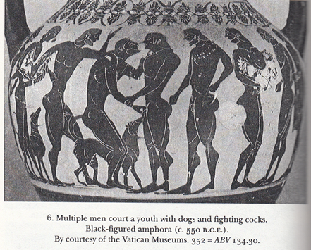

Figure 1: Black-figured amphora by Group E (c. 575-525 B.C.). Provenance: Etruria, Vulci. Beazley Archive # 301064.Vatican City, Museo Gregoriano Etrusco Vaticano: 352. Hubbard 2003: 267-268.
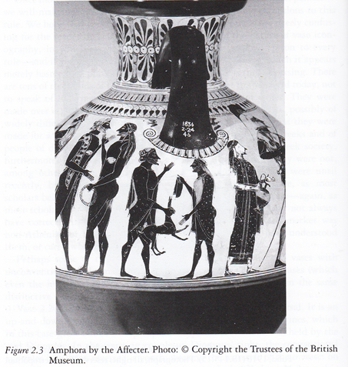
Figure 2: Black-figured amphora by the Affecter (c. 540-520). Provenance: Etruria, Vulci. Beazley Archive # 301333 London, British Museum: B153.Copyright the Trustees of the British Museum. Lear and Cantarella 2010: 70, figure 2.3.
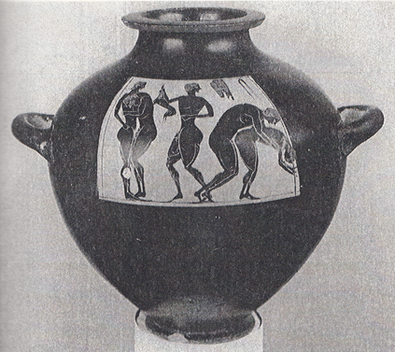
Figure 3: Black-figured kalpis (c. 550 B.C.). Provenance: Unknown. Beazley Archive # 9029242. Private Collection. Hubbard 2003: 267-268, illustration 8.
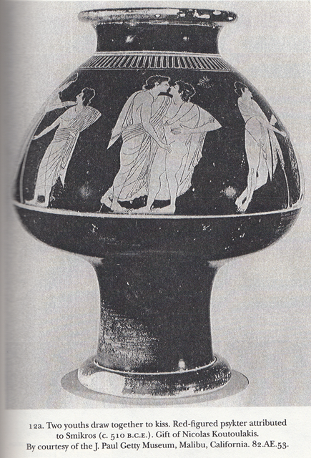
Figure 4: Red-figured psykter attributed to Smikros (c. 510 B.C.). Provenance: Unknown. Beazley Archive # 30685. J. Paul Getty Museum, Malibu, California. 82.AE.53. Hubbard 2003: 267-268, illustration 12a..
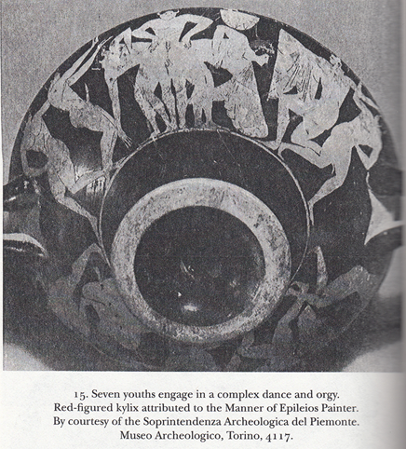
Figure 5: Red-figured kylix attributed to the Manner of Epeleios Painter (525-475 B.C.). Provenance: Unknown. Beazley Archive # 201359. Turin, Museo di Antichita: 3032. Ho pais kalos inscriptions by warrior. Hubbard 2003: 267-268, illustration 15.
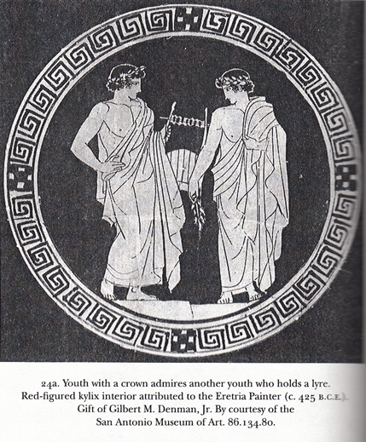
Figure 6: Red-figured kylix interior attributed to the Eretria Painter (450-400 B.C.). Provenance: Unknown. Beazley Archive # 30962. San Antonio Museum of Art. 86.134.80. Hubbard 2003: 267-268, illustration 24a.
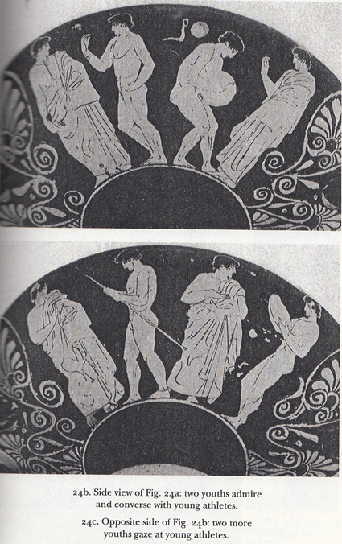
Figures 7-8: Red-figured kylix side views attributed to the Eretria Painter (450-400 B.C.). Provenance: Unknown. Beazley Archive # 30962. San Antonio Museum of Art. 86.134.80. Hubbard 2003: 267-268, illustration 24b and 24c.
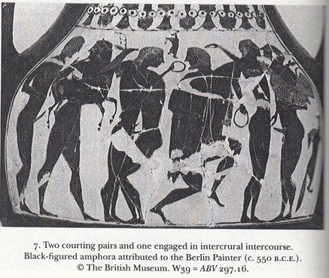
Figure 9: Black-figured amphora attributed to the Berlin Painter (c. 550-500 B.C.). Provenance: Etruria, Vulci. Beazley Archive # 320395. London, The British Museum, 1865.11-18.39. Hubbard 2003: 267-268, illustration 7.
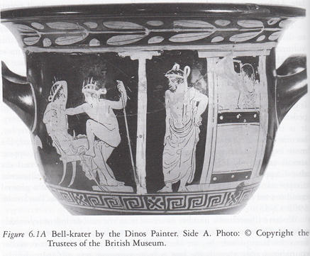
Figure 10: Red-figured bell-krater by the Dinos Painter (450-400 B.C.). Provenance: Italy, Capua. Beazley Archive # 215288. London, British Museum: F65. Copyright the Trustees of the British Museum. Lear and Cantarella 2010: 176, figure 6.1.
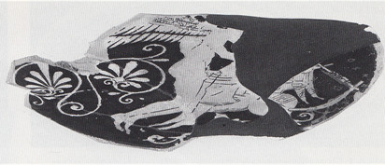
Figure 11: Red-figured cup fragment by the Douris Painter (c. 500-450 B.C.). Provenance: Etruria, Cerveteri. Beazley Archive # 9017565. Boston 13.94. Kilmer 1993: 255, R603.
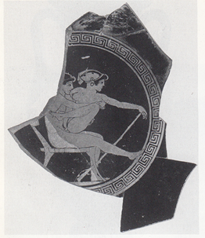
Figure 12: Red-figured cup by the Tarquinia Painter (500-450 B.C.). Provenance: Unknown. Beazley Archive # 44984. Malibu 83.AE.321. Kilmer 1993: 259, R814).
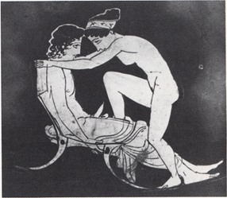
Figure 13: Red-figured oinochoe by the Shuválov Painter (c. 450-400 B.C.). Provenance: Italy, Locri. Beazley Archive # 216500. Berlin, Antikensammlung: F2412. Kilmer 1993:262, R970.
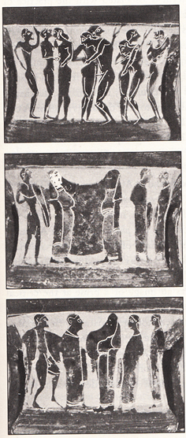
Figure 14: Black-figured kotyle (575-525 B.C.). Provenance: Unknown. Beazley Archive # 7285. University of Mississippi Cultural Center. 1977.3.72. Davidson 2007: 597, illustration 54.
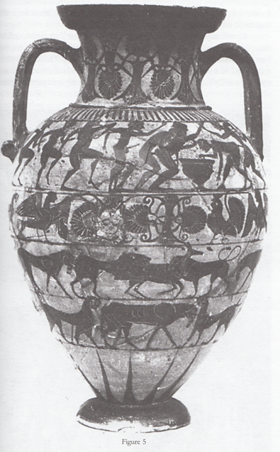
Figure 15: Black-figured Tyrrhenian amphora ( 575-525 B.C.). Provenance: Etruria, Vulci. Beazley Archive # 310101. Montpellier, Societe Archeologique: 149BIS. Hubbard 2000: 17.

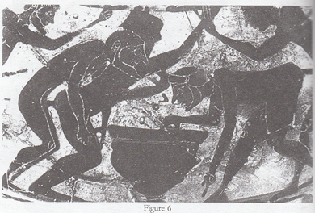
Figure 15b:Black-figured Tyrrhenian amphora (c. 560-530 B.C.). Provenance: Etruria, Vulci. Beazley Archive # 310101. Montpellier, Societe Archeologique: 149BIS. Hubbard 2000: 18.

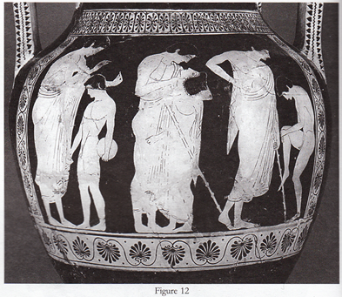
Figure 16: Red-figured amphora by the Dikaios Painter (c. 525-475 B.C.). Provenance: Unknown. Beazley Archive # 200167. Paris, Musee du Louvre: F318. Hubbard 2000: 24, illustration 12.
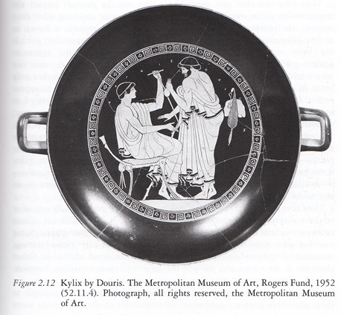
Figure 17: Red-figured Kylix by Douris (500-450 B.C.). Provenance: Unknown. Beazley Archive # 205160. New York (NY), Metropolitan Museum: 52.11.4. Photograph, all rights reserved, the Metropolitan Museum of Art. Lear and Cantarella 2010: 85, figure 2.12.
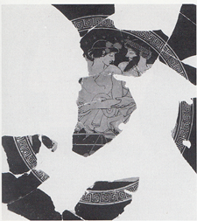
Figure 18: Red-figured cup by Makron (c. 490-470 B.C.). Provenance: Unknown. Beazley Archive # 6920. New York (NY), Metropolitan Museum: 1979.11.8. Kalos inscription: Euryptolemos Kilmer 1993: 255, R 618.1.
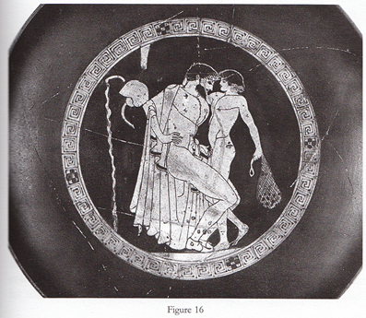
Figure 19: Red-figured cup by the Brygos Painter (500-540 B.C.). Provenance: Etruria, Vulci. Beazley Archive # 204034. Oxford, Ashmolean Museum: 1967.304, Photo: Museum. Hubbard 2000: 31, illustration 16.
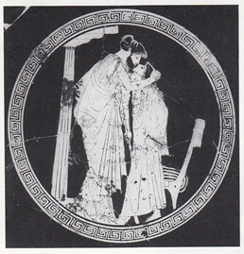
Figure 20: Red-figured cup by the Briseis Painter (500-450 B.C). Provenance: Etruria, Vulci. Beazley Archive # 204415. Florence, Museo Archeologico Etrusco: ZB27. Kilmer 1993: 253, R539.
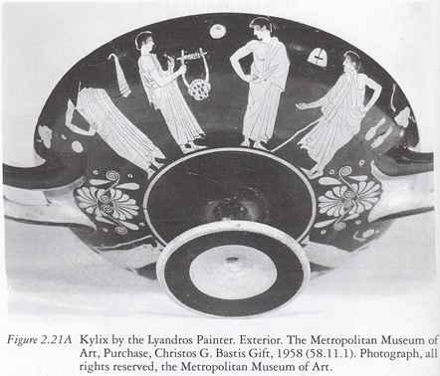
Figure 21: Red-figured kylix by the Lyandros Painter (475-425 B.C.).Provenance: Unknown. Beazley Archive # 212153. New York (NY), Metropolitan Museum: 58.11.1. Photograph, all rights reserved, the Metropolitan Museum of Art. Lear and Cantarella 2010: 100, figure 2.21.
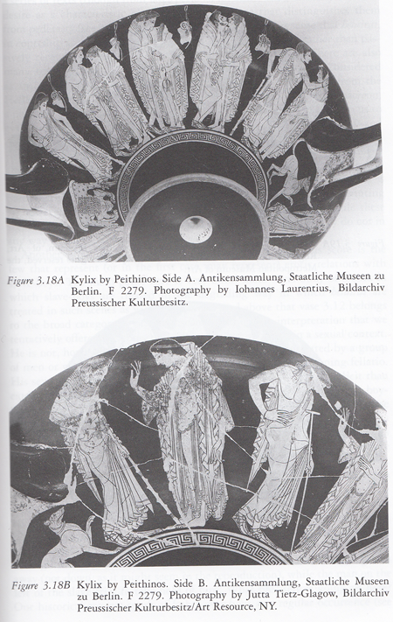
Figure 22: Red-figured kylix side A and B by Peithinos (525-475 B.C.). Provenance: Etruria, Vulci. Beazley Archive # 200977. Berlin, Antikensammlung: F2279. Photography by Iohannes Laurentius and Jutta Tietz-Glagow, Bildarchiv Preussischer Kulturbesitz/Art Resource, NY Lear and Cantarella 2010: 133, figure 3.18A-B.
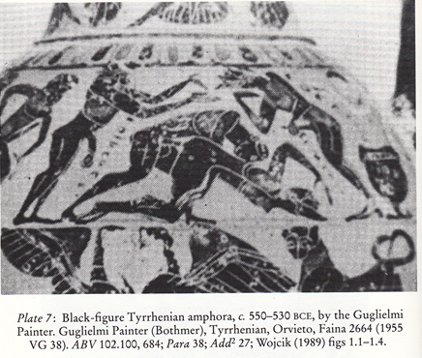
Figure 23: Black-figured amphora by the Guglielmi Painter (c. 575-525 B.C.). Provenance: Italy, Orvieto (?). Beazley Archive # 310099. Orvieto, Museo Civico, Coll. Faina: 2664. Golden and Toohey: 44, plate 7.

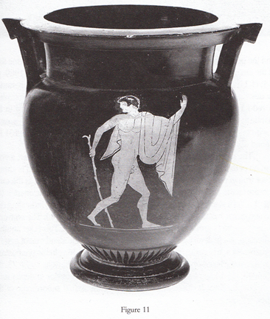
Figure 24: Red-figured column-krater attributed to the Harrow Painter (c. 500-450 B.C.). Provenance: Unknown. Beazley Archive # 10363. Melbourne, G. Geddes. Photos: Museum. Hubbard 2000: 23.

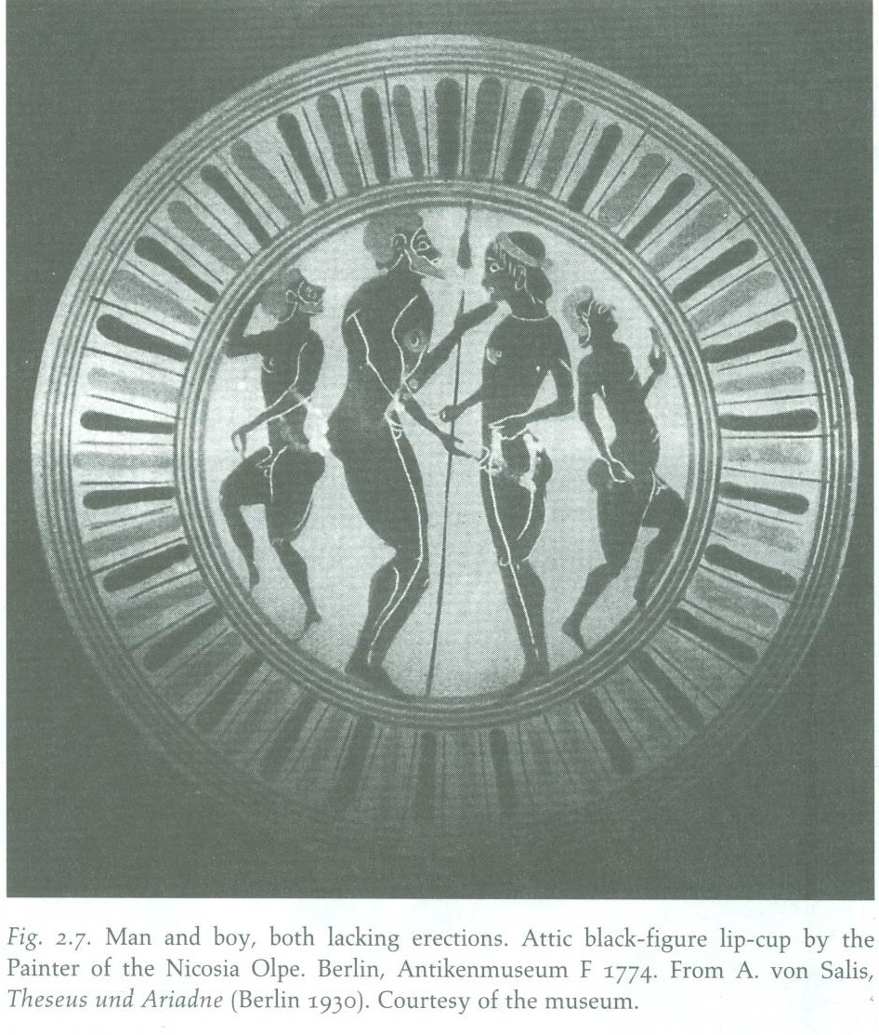
Figure 25: Attic black-figure lip cup by the Painter of the Nicosia Olpe (550-500 B.C.). Provenance: Rhodes, Camiros. Beazley Archive #330200. Berlin, Antikensammlung F 1774. DeVries 1997: 22.

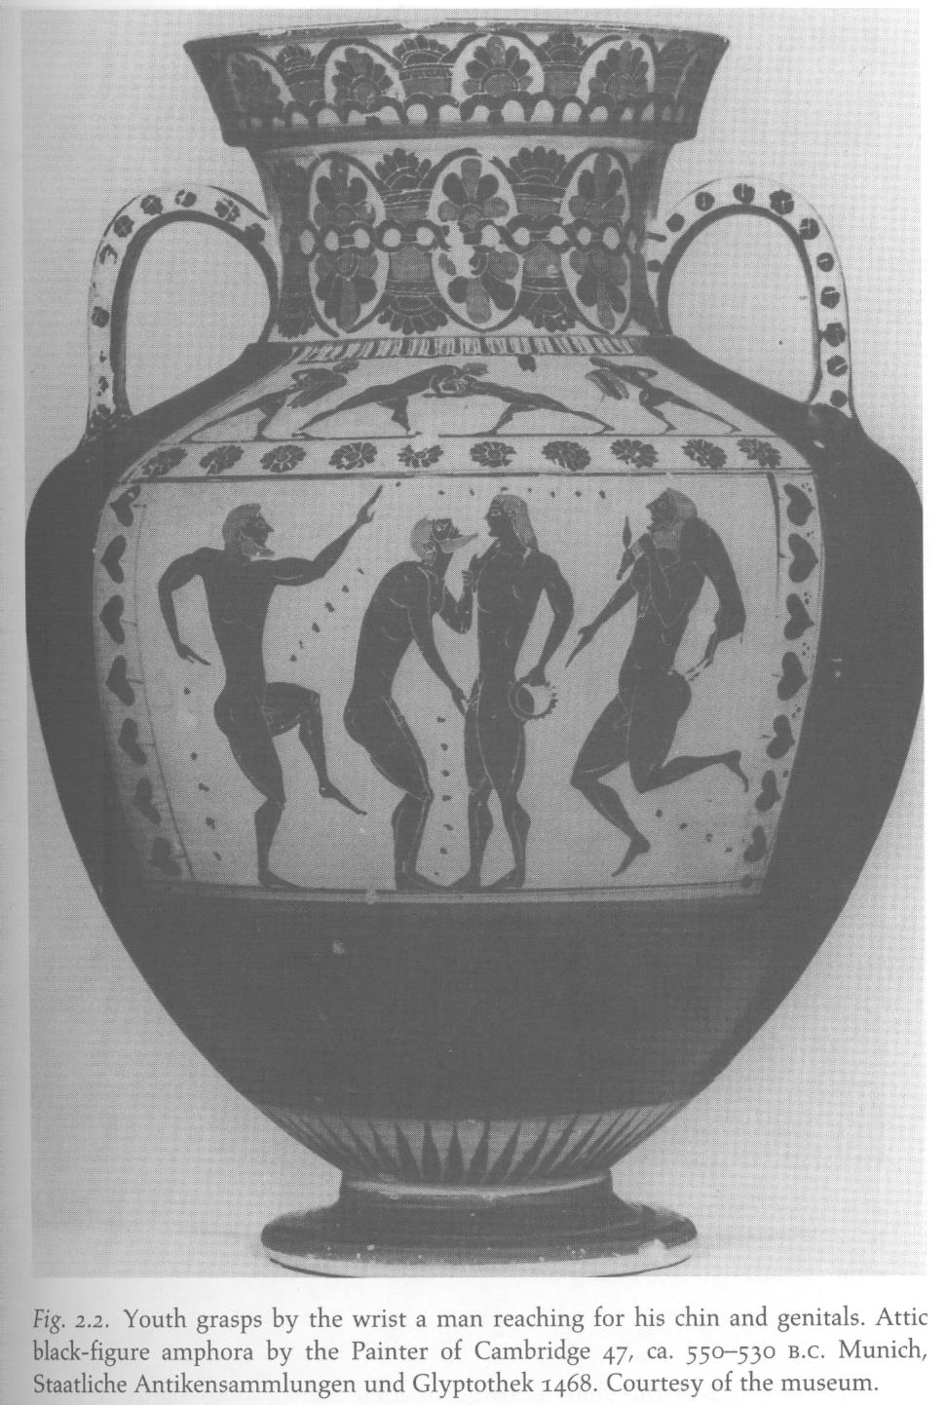
Figure 26: Attic black-figure neck amphora by the Painter of Cambridge 47 (550-530 B.C.). Provenance: Etruria, Vulci. Beazley Archive # 301629 Munich, Staatliche Antikensammlungen and Glyptothek 1468. DeVries 1997: 17.

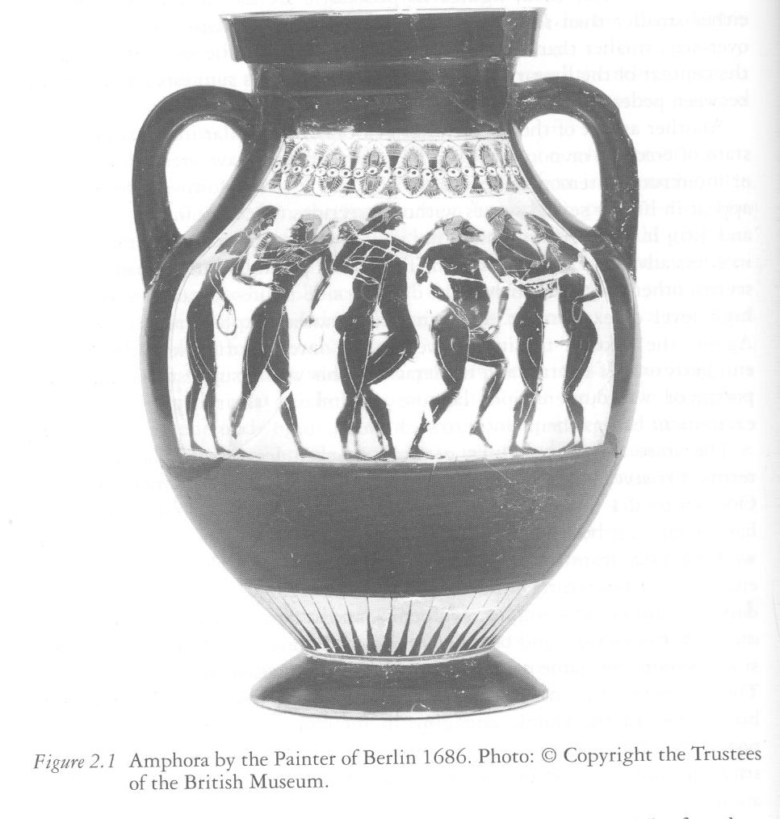
Figure 27: Attic black figure amphora by the Painter of Berlin 1686 (540 B.C.). Provenance: Etruria, Vulci. Beazley Archive # 320395. London, British Museum. ABV 297.16. Lear and Cantarella 2010: 66, figure 2.1.
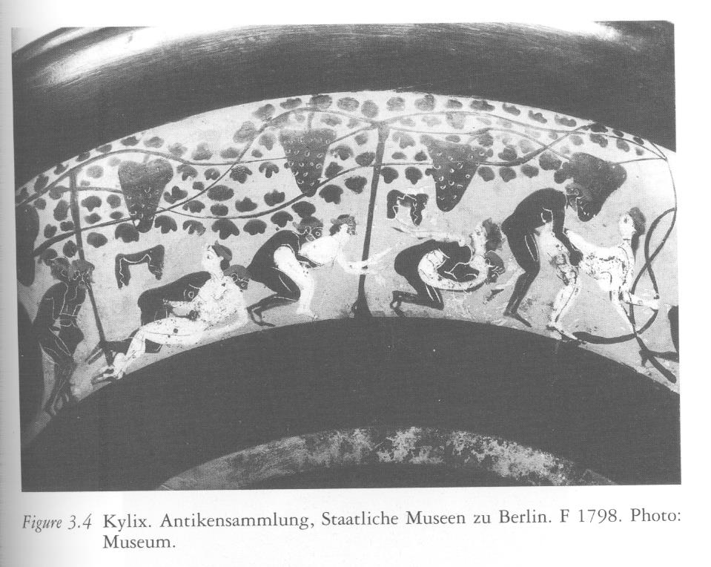
Figure 28: Black figure kylix (560-525 B.C.). Provenance: Unknown (vase is lost). Beazley Archive # 11037. Antikensammlung, Staatlich Museen zu Berlin, F 1798. Lear and Cantarella 2010: 111, figure 3.4.

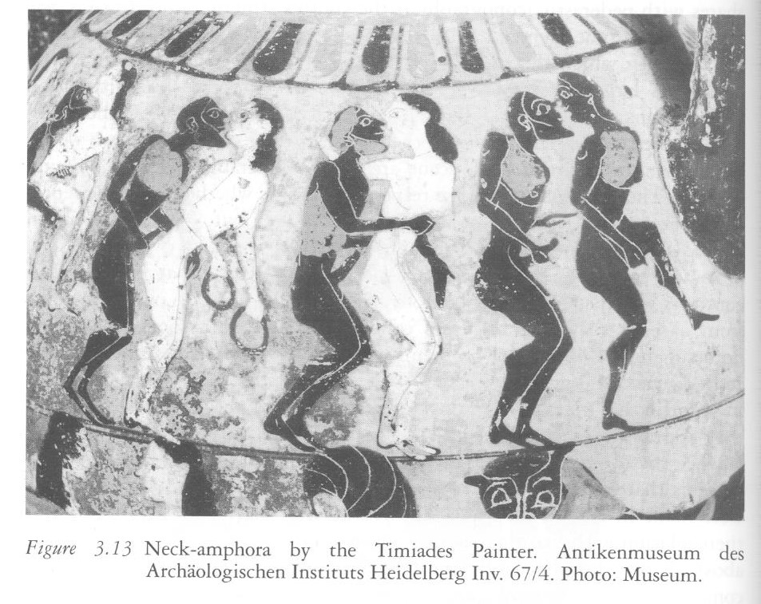
Figure 29: Black figure neck-amphora by the Timiades Painter (575-550 B.C.). Provenance: Etruria. Beazley Archive # 310100. Meggen, Kappeli; formerly: Antikenmuseum des Archäologischen Instituts Heidelberg Inv. 67/4. Lear and Cantarella 2010: 124, figure 3.13.

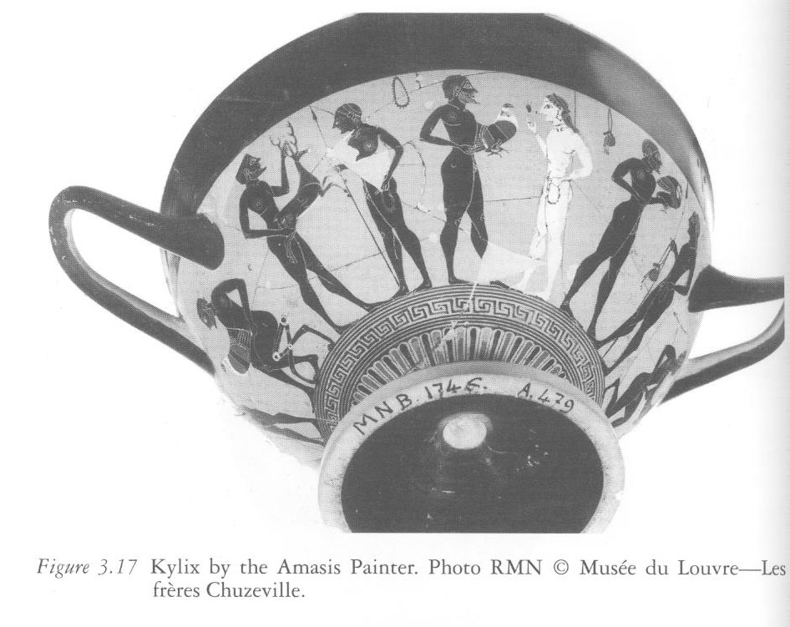
Figure 30: (Side A) Black figure cup skyphos by the Amasis Painter (575-525 B.C.). Provenance: Rhodes, Camiros. Beazley Archive # 310509. Paris, Musée du Louvre—Les frères Chuzeville, A 479. Lear and Cantarella 2010: 132, figure 3.17.

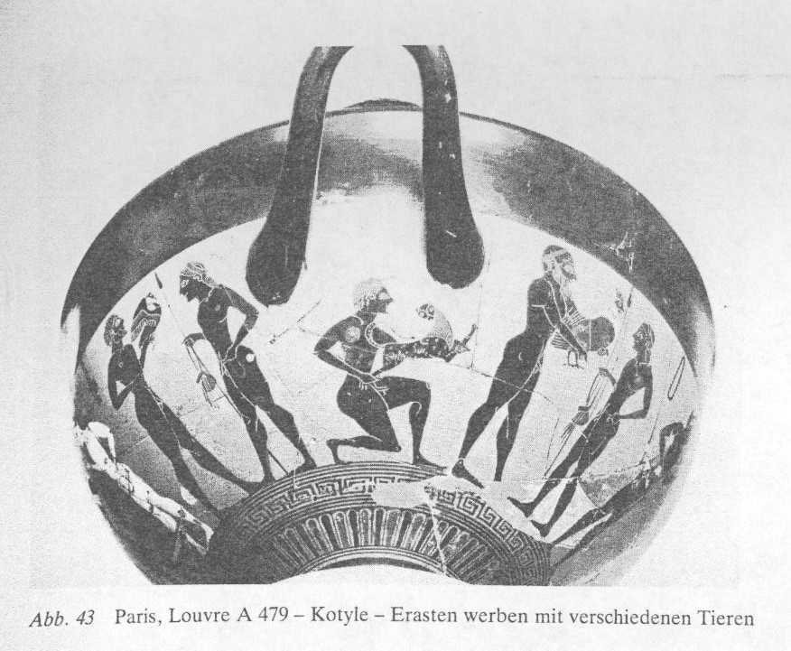
Figure 31: (Side B) Black figure cup-skyphos by the Amasis Painter (575-525 B.C.). Provenance: Rhodes, Camiros. Beazley Archive # 310509. Paris, Musée du Luvre, A 479. Koch-Harnack 1983: 109.

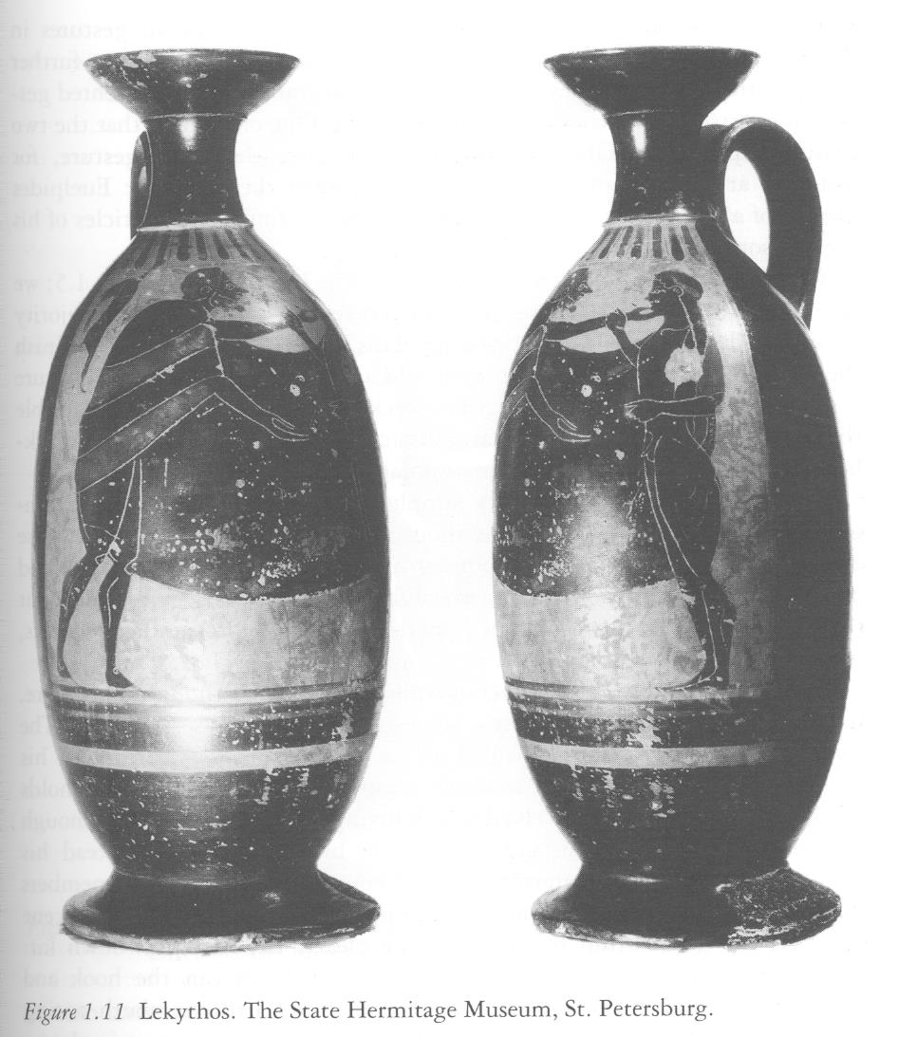
Figure 32: Black-figure lekythos by the Pharos Painter (560-525 B.C.). Provenance: Unknown. Beazley Archive # 302652. St. Petersburg 1440. Lear and Cantarella 2010: 53, figure 1.11.

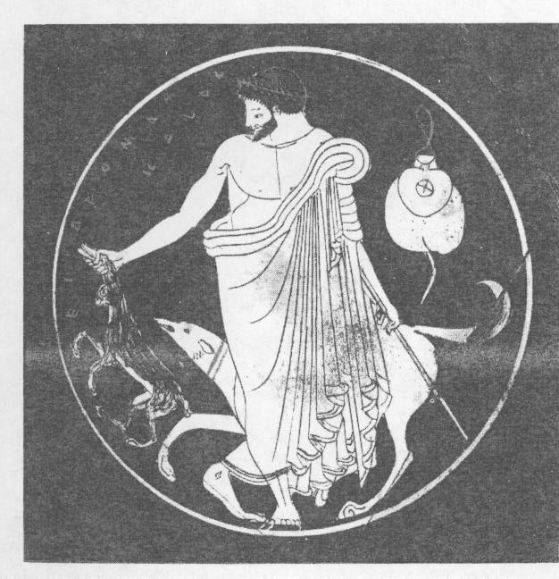
Figure 33: Attic red figure cup (525-475 B.C.). Painter: Unknown. Provenance: Etruria, Vulci. Kalos inscription: Epidromos. Beazley Archive #200982. St. Petersburg, State Hermitage Museum: 664. Koch-Harnack 1983: 88, figure 23.
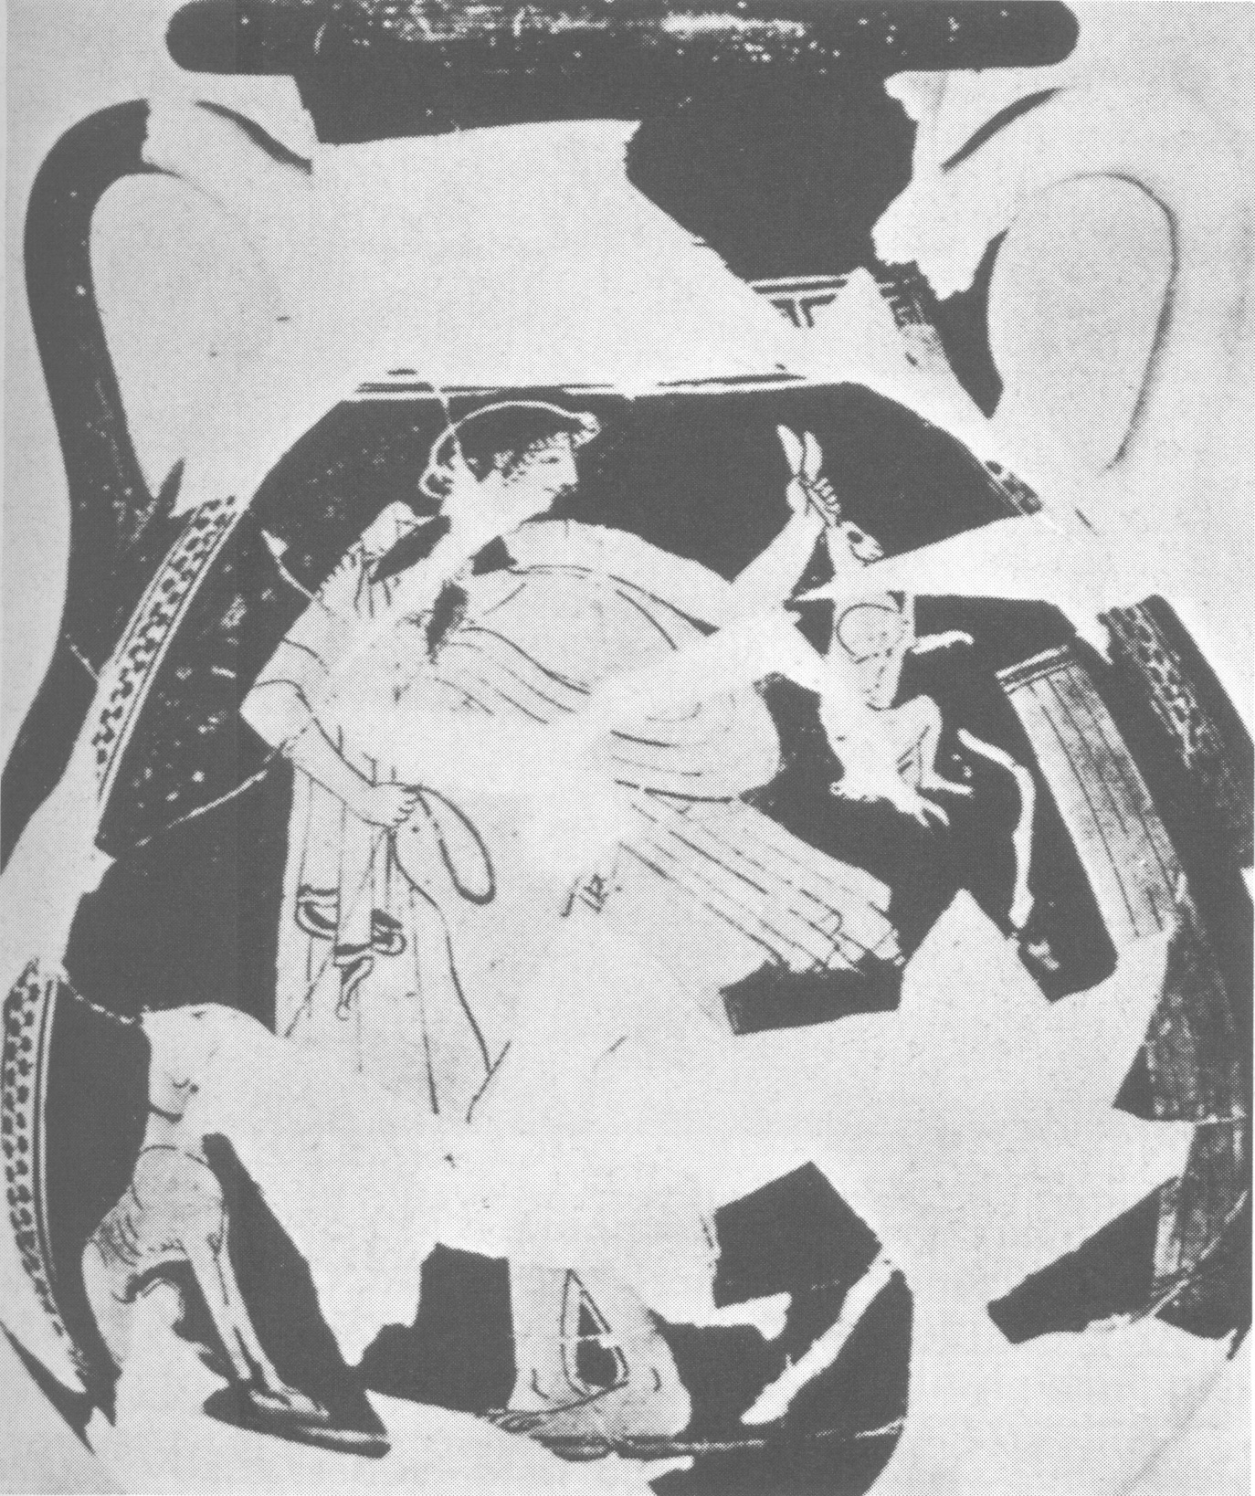
Figure 34: Attic red figure pelike by the Triptolemos Painter (500-450 B.C.). Provenance: Delos, Rheneia. Beazley Archive # 203813. Mykonos, Archaeological Museum: 7. Koch-Harnack 1983: 78, figure 15.
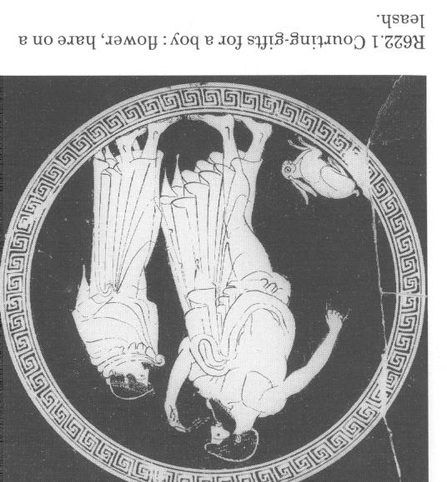
Figure 35: Attic red figure cup by Makron (500-450 B.C.). Provenance: Unknown. Beazley Archive # 204766. Paris, Musée du Louvre: G141. Signature inscription: Hieronepoiesen. Kilmer 1993: 146, R622.1.

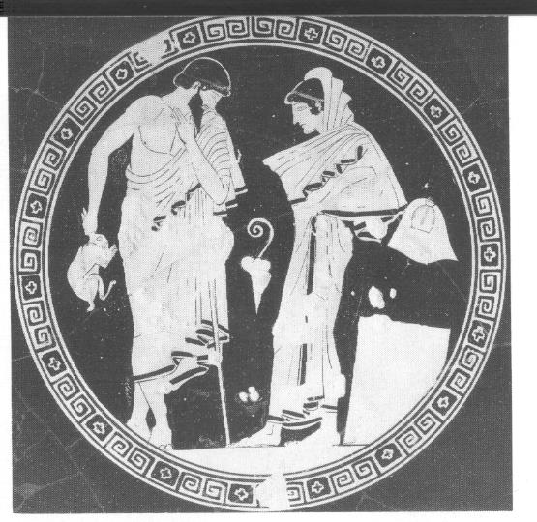
Figure 36: Attic red figure cup by Douris (480-470 B.C.). Provenance: Etruria, Vulci. Perseus collection. Wurzburg, Universitat, Martin von Wagner Mus.: 482. Lear and Cantarella 2010: 40, figure 1.1.

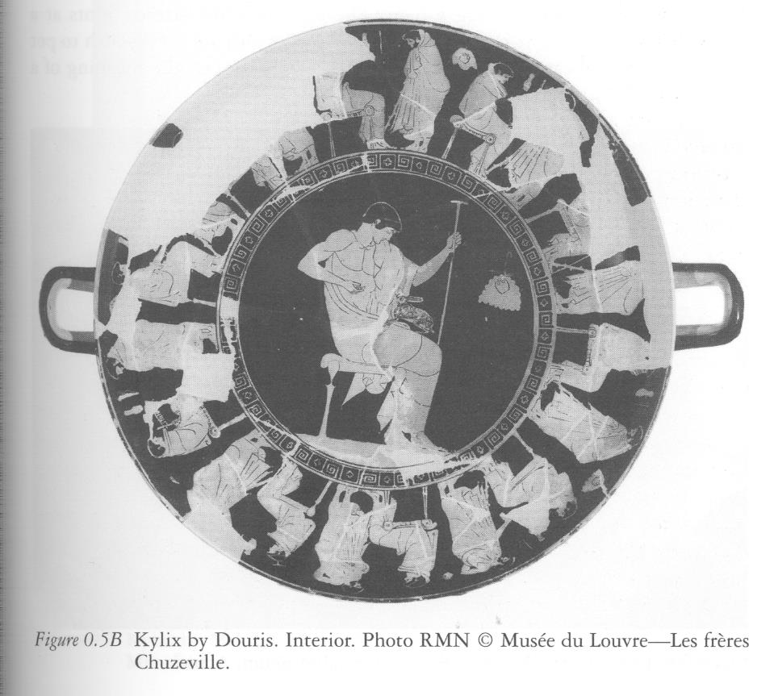
Figure 37: Attic red figure cup by Douris (500-450 B.C.). Provenance: Unknown. Beazley Archive # 205123. Paris, Musée du Louvre: G121. Kalos Inscription: Hippodama(s). Inscription: Dorisegraphsen. Lear and Cantarella 2010: 33, figure 0.5A-B. Decorative scheme: Courtship on the outside and a youth with hare on the interior.
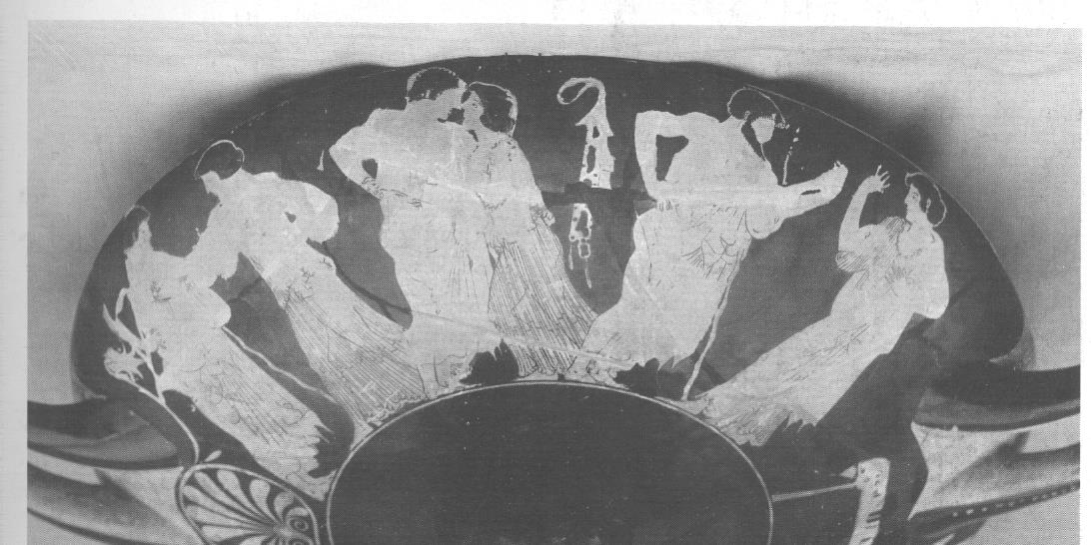
Figure 38: Attic red figure cup by Makron (500-450 B.C.). Provenance: Etruria, Vulci. Beazley Archive # 204830. Paris, Musée du Louvre: G143. Signature Inscription: Hieronepoiesen. Kilmer 1993: 146, R630.

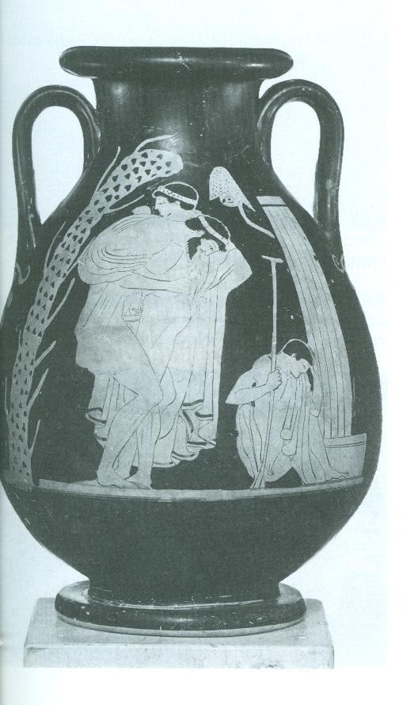
Figure 39: Attic red figure pelike by the Eucharides Painter (500-450 B.C.). Provenance: Unknown. Beazley Archive # 13607. London, Market, Sotheby's. Kilmer 1993: 146, R371.

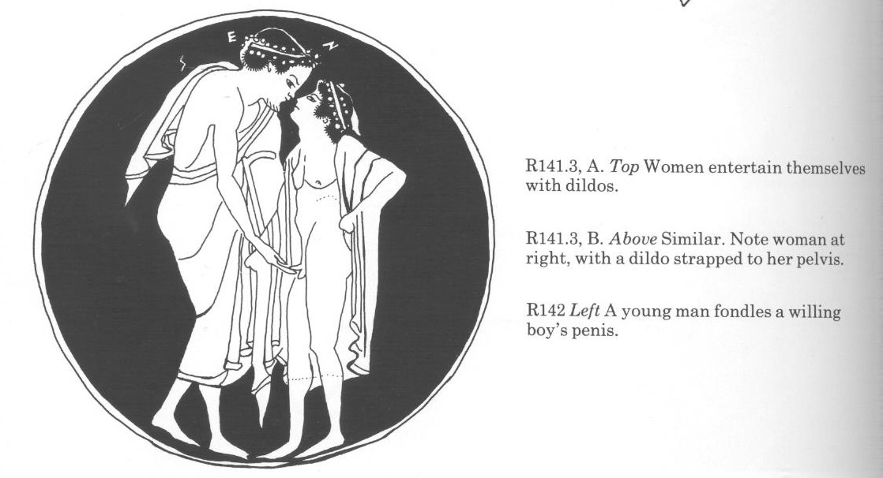
Figure 40: Attic red figure cup in the manner of Epiktetos (525-475 B.C.). Provenance: Italy, Etruria. Beazley Archive # 200641. Naples, Museo Archeologico Nazionale: H2614. Kilmer 1993: 146, R142.
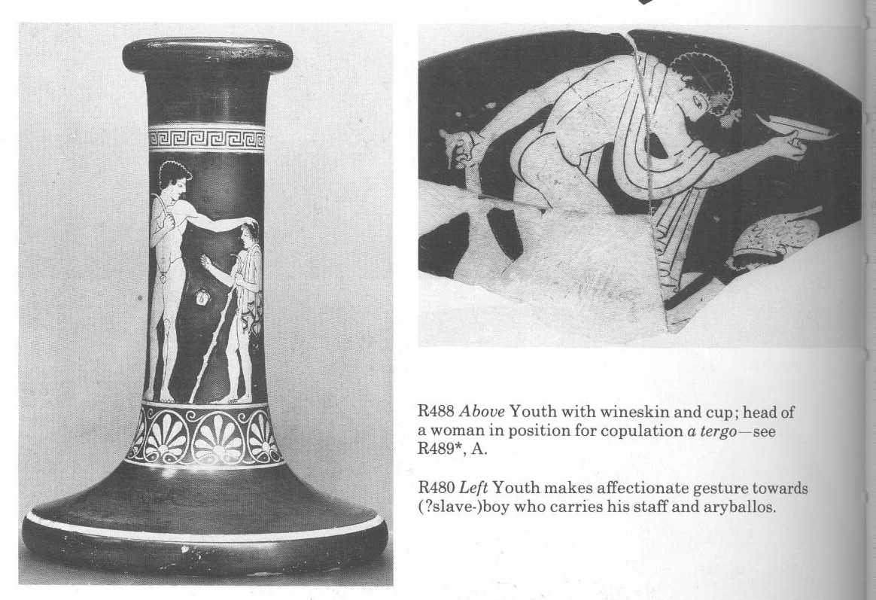
Figure 41: Attic red figure stand by the Antiphon Painter (500-450 B.C.). Provenance: Italy, Pomarico. Beazley Archive # 203436. Berlin, Antikensammlung: F2325. Kalos inscription: Antiphon. Kilmer 1993: 146, R480.
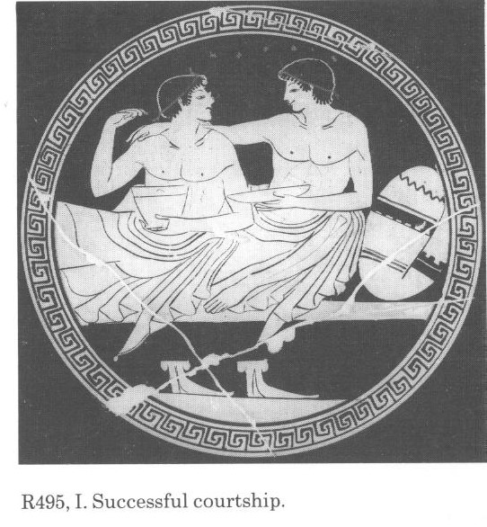
Figure 42: Attic red figure eye cup attributed to the Colmar Painter (500-450 B.C.). Provenance: Etruria, Vulci. Beazley Archive # 200414. Paris, Musée du Louvre: G81. Kilmer 1993: 146, R495. Decorative Scheme: Youth with hare and hoop (figure 43b); draped erastes with staff (figure 43a; symposium scene with youths.
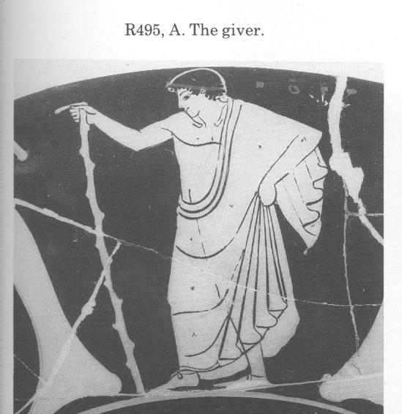
Figure 43a: Attic red figure eye cup attributed to the Colmar Painter (500-450 B.C.). Provenance: Etruria, Vulci. Beazley Archive # 200414. Paris, Musée du Louvre: G81. Kilmer 1993: 146, R495. Decorative Scheme: Youth with hare and hoop (figure 43b); draped erastes with staff (figure 42); symposium scene with youths.
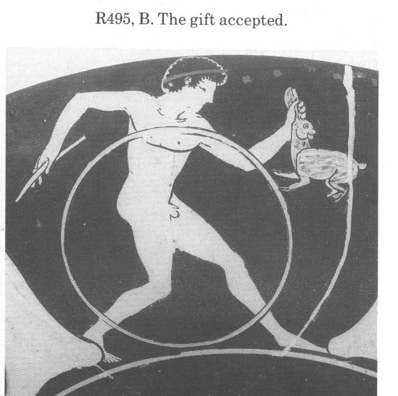
Figure 43b: Attic red figure eye cup attributed to the Colmar Painter (500-450 B.C.). Provenance: Etruria, Vulci. Beazley Archive # 200414. Paris, Musée du Louvre: G81. Kilmer 1993: 146, R495. Decorative Scheme: Youth with hare and hoop (figure 43b); draped erastes with staff (figure 44a; symposium scene with youths (figure 42).
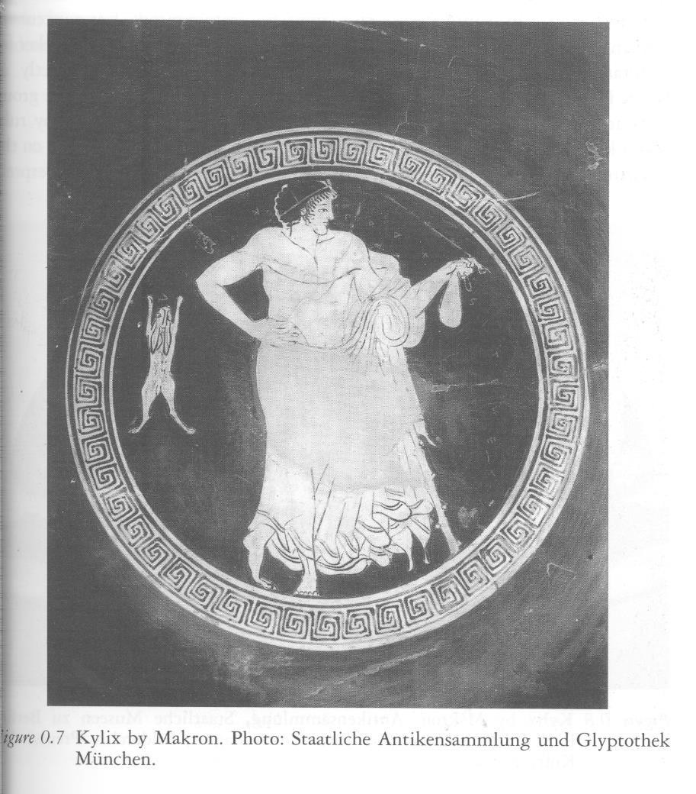
Figure 44: Red figure cup by Makron (500-450 B.C.). Provenance: Etruria, Vulci. Kalos inscription: Praxiteles. Beazley Archive # 204869. Munich 2656. Lear and Cantarella 2010: 35, figure 0.7.
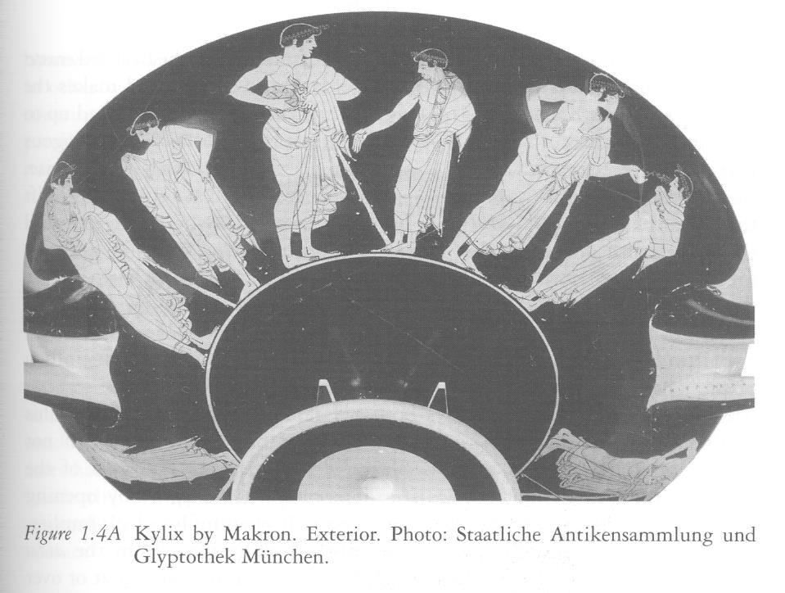
Figure 45: Attic red figure cup by Makron (500-450 B.C.). Provenance: Etruria, Vulci. Beazley Archive # 204879. Munich, Antikensammlungen: 2655. Kalos inscription: Hippodamas. Epoiesen inscription: Hieron. Lear and Cantarella 2010: 43, figure 1.4.

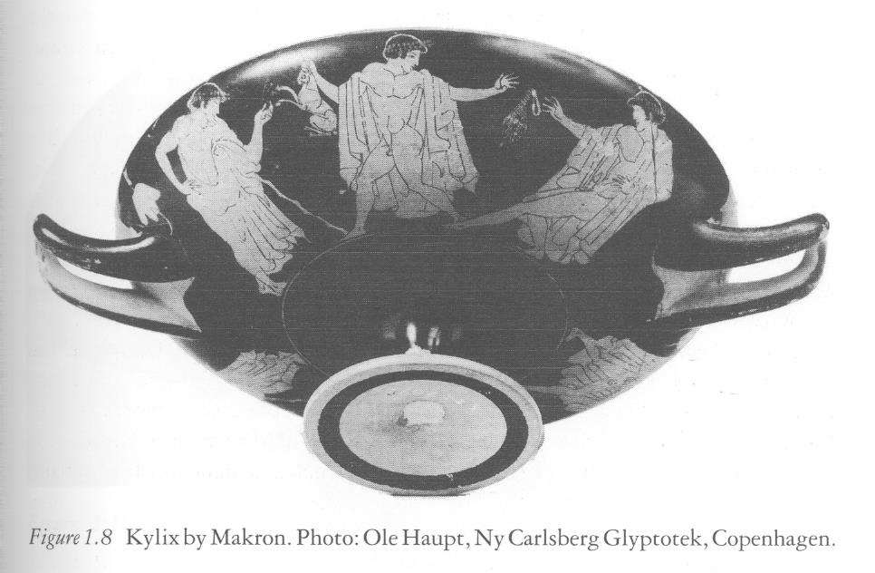
Figure 46: Attic red figure cup by Makron (500-450 B.C.). Provenance: Italy, Orvieto. Beazley Archive # 204943. Copenhagen, Ny Carlsberg Glyptothek: 2699. Lear and Cantarella 2010: 49, figure 1.8. Decorative scheme: interior has draped youth with staff holding a skyphos.
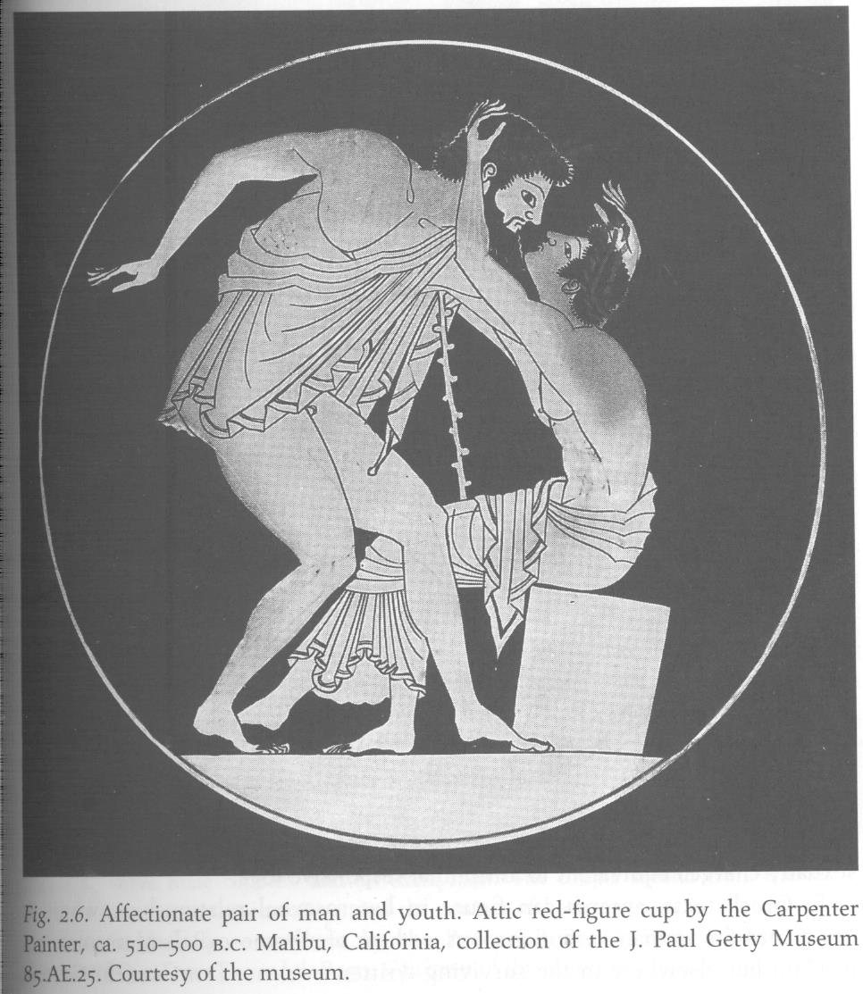
Figure 47: Attic red figure cup by the Carpenter Painter (525-475 B.C.). Provenance: Unknown. Beazley Archive # 31619. Malibu (CA), The J. Paul Getty Museum: 85.AE.25. Kilmer 1997: 41, plate 4, In Golden M. and Toohey, P., Inventing Ancient Culture, Historicism, periodization, and the ancient world. Decorative scheme: outside scene has athletes and youths with an altar, aryballos, and sponge.
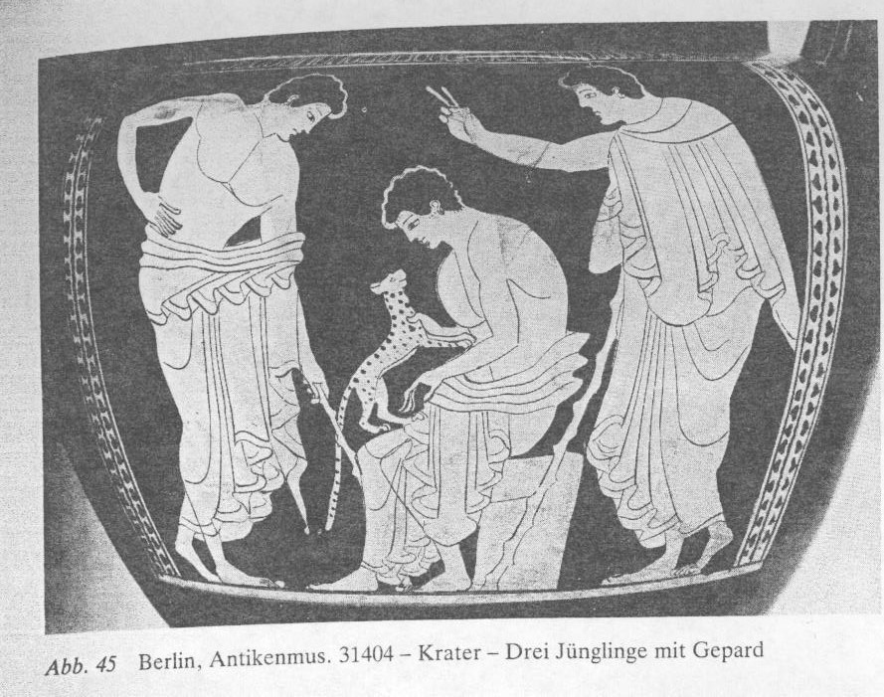
Figure 48: Attic red figure column krater by Myson (500-450 B.C.). Provenance: Italy, Taranto. Beazley Archive # 202440. Berlin, Antikensammlung: 31404. Koch-Harnack 1983: 111, figure 45.
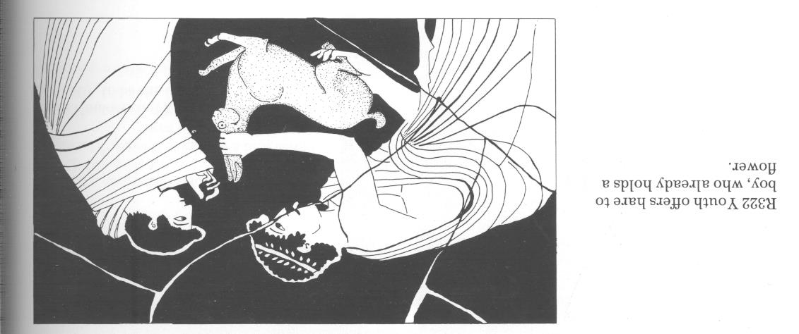
Figure 49: Attic red figure cup by Kleophrades Painter (500-450 B.C.). Provenance: Etruria, Cerveteri. Beazley Archive # 201725. Rome, Mus. Naz. Etrusco di Villa Giulia: 50384. Kilmer 1993: 146, drawing.
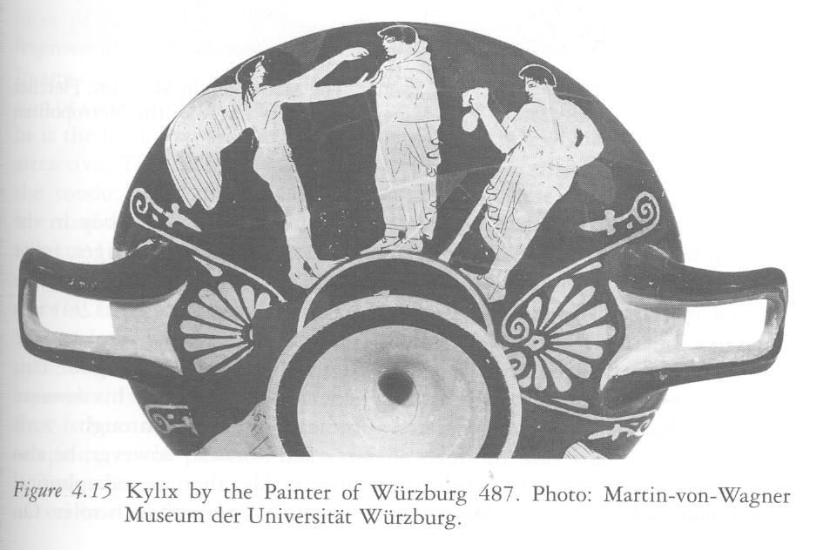
Figure 50: Attic red figure cup by Wurzburg 487 Painter (475-425 B.C.). Provenance: Etruria, Vulci. Beazley Archive # 212162. Wurzburg, Universitat, Martin von Wagner Mus.: 487. Lear and Cantarella 2010: 155, figure 4.15.

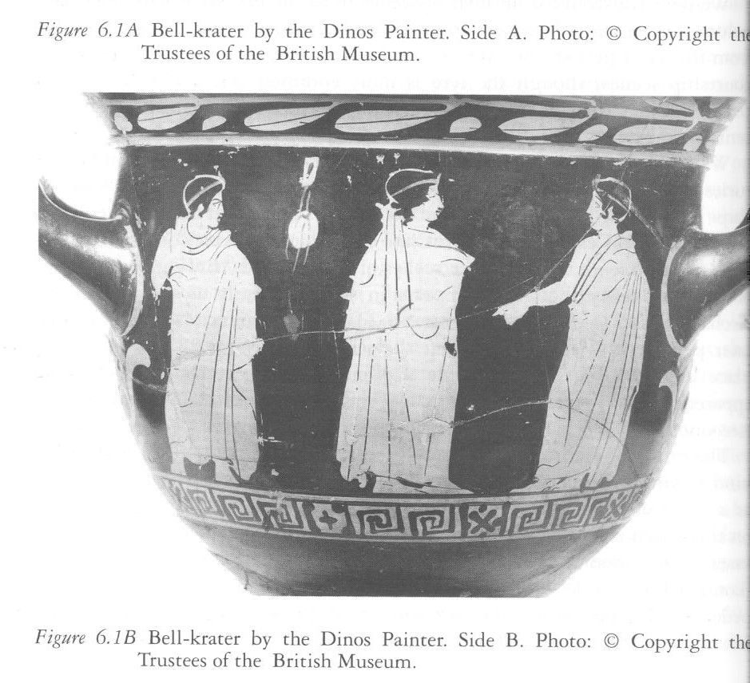
Figure 51: Attic red figure bell krater by the Dinos Painter (450-400 B.C.). Provenance: Italy, Capua. Beazley Archive # 215288. London, British Museum: F65. Lear and Cantarella 2010: 176, figure 6.1B.
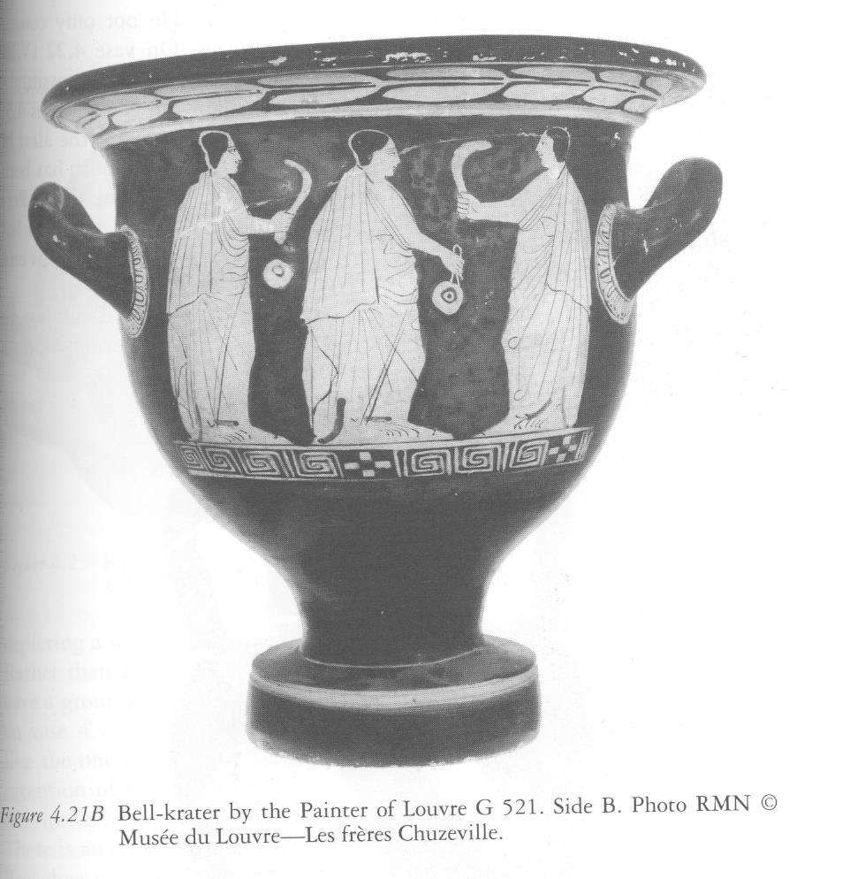
Figure 52: Attic red figure bell krater by the Painter of the Louvre G 521 (400-300 B.C.). Provenance: Unknown. Beazley Archive # 218106. Paris, Musée du Louvre: G521. Lear and Cantarella 2010: 160-161, figure 4.21B.

Vita
Jared Johnson was born in O’Neill, Nebraska. At the age of 6, he and his family moved to West Point, Nebraska, where Jared attended both primary and secondary school. He graduated from West Point Central Catholic high school in May 2005. Afterwards, Jared enrolled at the University of Nebraska at Lincoln, where he pursued majors in Anthropology, History, Classical Languages, and Classics and Religious Studies. He graduated from the University of Nebraska in the fall of 2009 with a BA in his four majors. During Jared’s time at the University of Nebraska, he participated in an archaeological field school with the university, and also as a staff archaeologist on the Antiochia ad Cragum project in Turkey. After these formative experiences in archaeology, Jared enrolled in the University of Tennessee in 2011 to pursue an MA degree in Anthropology with a concentration in Mediterranean Archaeology. He is expected to graduate with his MA program in the summer 2015. His research interests are in ancient sexuality, Greek vase painting, and feminist theory.

Halperin (1990:155) alludes to the actual coining of the term in 1869 by Maria Kertbeny and Krafft-Ebing. What is peculiar about 1869 is that die conträre Sexualempfindung (i.e. contrary sexual feeling) was also introduced by Carl Friedrich Otto Westphal (Halperin 1990:155).

