Evaluating the effects of temperature variability on a lepidopteran agricultural pest: from life history traits to host-pathogen interactions

A Dissertation Presented for the
Doctor of Philosophy
Degree
The University of Tennessee, Knoxville

Anchal Padukone
August 2025

Copyright © 2025 by Anchal Padukone
All rights reserved.

ACKNOWLEDGEMENTS

First, thank you to my advisor, Dr. Kimberly Sheldon, for providing steady guidance, mentorship and enthusiasm while supporting my independence and interests as a scientist. Thank you to my dissertation committee, Dr. James Fordyce, Dr. Xingli Giam and Dr. Juan Luis Jurat-Fuentes for sharing your expertise, feedback and ideas with me over the years.

To current and past members of the Sheldon Lab and our colleagues and collaborators – Morgan Fleming, Dr. Margaret Mamantov, Zan Killeffer, Nate Duerr, Dr. Amanda Wilson Cater, Dr. Nigel Andrew, Jerame Brown, Kayla Koory, Makenna Reilly, Dr. Robert McElderry – your support has been crucial for getting my projects off the ground and towards the finish line. I appreciate all your contributions: from workshopping my research plans and early grant/ dissertation proposals, to assisting me with tasks in the lab and keeping me company during our lab writing retreats.

I am grateful for all the financial support I received for this research and for my education more broadly: Sigma Xi Grants-in-Aid-of-Research, the University of Tennessee Chancellor’s Fellowship, UT Student Faculty Research Awards, the UTK EEB Research Fund, and Drs. Brian and Kitty Sales.

To my friends and family in Knoxville and beyond, thank you all for helping me weather a pandemic and cheering me on over the past several years. I am especially grateful to Anjali and Ashwin Padukone for strongly believing in me despite my many wrong turns and hiccups; to Don Meier, Judy Meier, Dr. Janet Meier and Dr. Tom Roberson for being amongst my biggest supporters; and to Dr. William Meier, who helped me find joy in the journey on the most challenging of days.

ABSTRACT

Temperature variability associated with climate change is expected to impact insect performance and alter the impacts of pest species and the efficacy of biocontrol strategies. However, our understanding of insect thermal biology is mostly based on measurements of insect performance under constant temperatures, which may not reflect the fluctuating temperatures insects experience over their lifespans in their natural environments. Moreover, thermal performance curves vary for different organismal traits and life stages; thus, understanding the impacts of temperature fluctuations requires measures of multiple traits across the life cycle. Here, I explored the impacts of temperature variability on the life history and demography of Spodoptera frugiperda, a widespread insect pest, and its susceptibility to pathogen commonly used in biocontrol. Using a full factorial experiment with a wide range of temperature treatments, I systematically investigated the effects of temperature mean and fluctuation magnitude on fitness-related traits in each life stage. I then used these data to parametrize stage-structured matrix population models to understand the overall effect of temperature means and fluctuations on expected population growth rates. I found interactive effects of mean temperature and the magnitude of daily fluctuations on survival to maturity, development rates, pupal mass, reproductive output, numbers of viable offspring and population growth rates. Larger fluctuations significantly reduced larval and pupal survival but not adult survival relative to constant temperatures. Effects of variability on individual traits and population growth rates were generally larger and more negative at the highest mean temperature. Changes in expected population growth with increasing variability are primarily driven by differences in reproductive parameters and egg hatch rates. Lastly, I investigated the effects of temperature fluctuations at intermediate and elevated mean temperatures on outcomes in S. frugiperda larvae exposed to sublethal doses of Bacillus thuringiensis subsp. kurtsaki. Mean temperature largely predicted survivorship following infection. However, temperature fluctuations modified delays in larval development in those surviving Bt infection, including at the intermediate mean temperature. Together, these results demonstrate the potential consequences of temperature fluctuations for multiple organismal traits and in the context of biotic stressors, which may become more salient under climate warming.
TABLE OF CONTENTS

Chapter 1 : Introduction 1
Chapter 2 : Temperature fluctuations interact with means to impact life history traits in Spodoptera frugiperda 5
Chapter 3 : Impacts of temperature variability on population growth rates in Spodoptera frugiperda 57
Chapter 4 : Warmer and more variable temperatures alter outcomes for Spodoptera frugiperda infected with Bacillus thuringiensis 94
Chapter 5 : Conclusions 124
References 127
Vita 141

LIST OF TABLES

Table 2-S1 34

LIST OF FIGURES

Figure 1-1 Hypothetical thermal performance curve showing the temperature-dependence of development rate 2
Figure 2-1 Survival across treatments 16

: Introduction
Insects in their natural environments are exposed to highly variable temperatures on a daily basis and their body temperatures often closely track these changes in ambient temperatures (Harrison et al., 2012). The potential consequences of short-term temperature variability for insect physiology and ecology have been increasingly recognized by biologists over the last few decades (Colinet et al., 2015; Stoks et al., 2017). However, insect thermal performance is still often studied using insects held in constant temperatures, with estimates from these studies informing models of insect distribution and spread (Rebaudo and Rabhi, 2018; Buckley et al., 2018). Even among laboratory experiments that do incorporate fluctuations in thermal treatments, the systematic effects of temperature variability on these responses are usually not the focus of investigation – studies often include a single fluctuation treatment or examine the effects of variability at a single intermediate temperature (e.g. Prasad et al., 2022).

Assuming that we can infer how insects will fare in an environment by measuring their performance in a constant environment with the same average temperature has several shortcomings. Most relationships between temperature and organismal performance (defined here as “any measure of an organism’s capacity to function”; Angiletta et al. 2009) are nonlinear and several are asymmetric due to metabolic and physiological constraints (for instance, enzyme denaturation thresholds). A typical thermal performance curve (TPC) is shown in Fig. 1-1. With increasing temperature, performance typically accelerates from a lower performance threshold until an inflection point, decelerates from the inflection point to a performance maximum, and declines steeply thereafter (Angilletta, 2006). Temperature fluctuations are therefore generally expected to increase performance over time in the initial “concave up” portion of the curve, decrease overall performance in the “concave down” portion of the curve (for instance, around the temperature at which performance is maximized) and have minimal impacts on performance in any linear regions of the curve. Ruel and Ayres (1999) and Denny (2019), among others, encouraged biologists studying temperature-performance relationships using constant temperatures to account for the effects of variability by integrating the thermal performance curve across the sequence of temperatures actually experienced by organisms. Incorporating fine-scale temperature variability in this manner can considerably improve predictions of how organisms respond to temperature change (Sheldon and Dillon, 2016).

a)
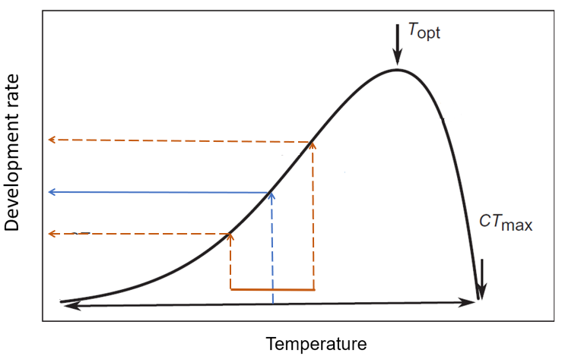
c)
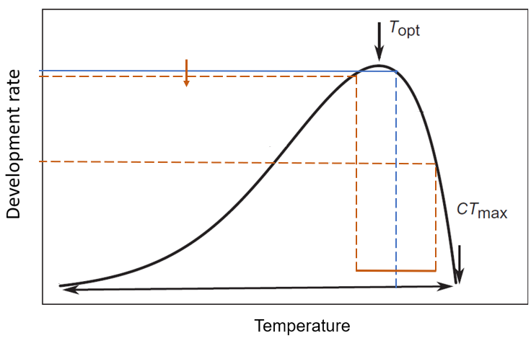
b)
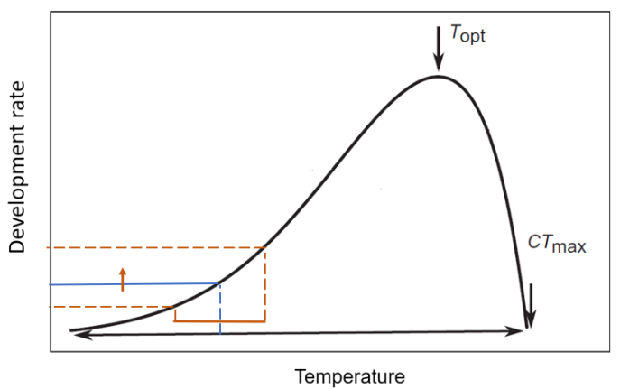

Figure 1-1 Hypothetical thermal performance curve showing the temperature-dependence of development rate
The blue line shows development rate at the mean temperature f($\overline{x}$), while the brown lines indicate the development rate at diurnal maxima and minima. Key features include the critical thermal minimum (CT_{min}) and critical thermal maximum (CT_{max}), which represent the upper and lower limits of thermal performance, and the thermal optimum (T_{opt}), at which performance is maximized. (a) In the linear portion of the curve, if variability is symmetric around the mean, the development rate at the mean temperature approximates the average development rate – any increases or decreases in development rates over the cycle are counterbalanced. (b) Variation in temperature over the concave-up portion of the curve generally increases the time-averaged development rate over f($\overline{x}$) – the increase in development rate when conditions are favorable exceeds any decrease in the rate when conditions are unfavorable. (c) Variation in temperature over the concave-down portion of the curve generally decreases the time-averaged development rate over f($\overline{x}$). Figures adapted from Sinclair et al., 2016.

However, predicting the effects of variability by averaging thermal performance curves overlooks the impacts of temperature variability on the physiology of organisms and the energetic costs they sustain over time. These time-dependent physiological responses to temperature variability can cause nonlinear averaging predictions to diverge from actual insect performance in variable environments (Kingsolver et al., 2015). Fluctuations that expose insects to stressful temperatures could trigger hardening and heat shock responses in the short-term, exert higher energetic demands on the organism and result in the accumulation of physiological damage over time (González‐Tokman et al., 2020). Conversely, depending on the range over which temperatures fluctuate, such environments may facilitate recovery during more benign phases of the fluctuation (Vajedsamiei et al., 2021) or metabolic acclimation to extreme temperatures (Williams et al., 2012; Bozinovic et al., 2013). Even more moderate fluctuations could alter organismal activity patterns and the timing of critical functions (for instance, diel narrowing; Kefford et al., 2022).

Therefore, resolving the biological effects of short-term temperature variability may require more empirical observations from a wider range of insect systems and contexts. This dissertation contributes to this effort by systematically studying the biology of a poikilothermic noctuid moth, Spodoptera frugiperda, under a range of temperature regimes that vary in both fluctuation magnitude and average temperature. Through controlled experiments, I assess how these components of the thermal environment interact to affect a suite of fitness-related traits and track these effects across the life cycle (Chapter 2). In particular, I compare the effects of variability at mean temperatures assumed to be optimal for growth and development of this species with effects at temperatures considered suboptimal and temperatures nearing upper performance thresholds, and evaluate hypotheses about differences in thermal impacts across traits and life stages.

Chapter 3 links individual-level outcomes to population-level fitness, and asks: what do thermal impacts on different life-history traits ultimately mean for rates of population increase in S. frugiperda? I use data from the above experiment to parametrize stage-structured matrix projection models, integrating temperature impacts over the life cycle. By further analyzing the demographic processes that drive differences among treatments, this project helps resolve the ambiguity over how temperature fluctuations may affect insect populations.

Insects in their natural environments face a multitude of biotic stressors, yet most investigations into the consequences of thermal variability isolate organisms from this context (Stoks et al., 2017). In Chapter 4, I address this gap by examining how increased warming and variability influence the outcome of an important interaction between S. frugiperda and a pathogen used to control its populations in agricultural settings.

Spodoptera frugiperda, commonly known as fall armyworm, is a tropical species native to the neotropics that does not undergo diapause (Sparks, 1979). A major crop pest in its larval stage, it has rapidly invaded parts of Africa, Asia and Oceania over the past decade (Kenis et al., 2023). Additionally, the dispersal ability of S. frugiperda adults allows them to seasonally migrate into subtropical and temperate regions where this species cannot overwinter (Tessnow et al., 2023). Tropical species are expected to be especially susceptible to the effects of projected climate warming, since they already occupy niches close to their physiological optimum (Deutsch et al., 2008; Diamond et al., 2012). Temperature variability, including the frequency of heat waves and diurnal variability, is projected to increase in many portions of the year-round and seasonal range for this species (Englehart and Douglas, 2005; Bathiany et al., 2018; Duffy et al., 2022). Understanding the consequences of warming and variability for S. frugiperda biology in the short-term, as I seek to do here, and over longer periods of time is increasingly relevant as these trends continue.

: Temperature fluctuations interact with means to impact life history traits in Spodoptera frugiperda

A version of this chapter is under review at the Journal of Thermal Biology and was coauthored by Anchal Padukone and Kimberly S. Sheldon:

Anchal Padukone and Kimberly S. Sheldon conceived and designed the study. Anchal Padukone collected and analyzed data. Anchal Padukone and Kimberly S. Sheldon interpreted the data. Anchal Padukone led the writing of the manuscript. All authors contributed critically to the drafts and gave final approval for publication.

ABSTRACT: Temperature variability associated with climate change is expected to impact insect performance and alter the ecological and economic impacts of both beneficial and pest species. However, our current understanding of how temperature impacts insect performance is not based on the fluctuating temperatures insects experience in their natural environments or the impact of these fluctuations over the lifespan. Yet, thermal performance curves vary for different organismal traits and life stages, and, thus, understanding the impacts of temperature fluctuations requires measures of multiple traits across the full life cycle. Using fall armyworm Spodoptera frugiperda, a global insect pest, we designed a full factorial experiment with a wide range of temperature treatments to study the effects of temperature mean and fluctuations on survival, development and/or reproduction in each life stage. Our results show interactive effects of mean temperature and the magnitude of daily fluctuations on survival to maturity, development time, and pupal mass as well as on the number of eggs laid by females and subsequent egg hatching. However, the impacts of temperature fluctuation varied across life stages: at the warmest mean temperature, larger fluctuations significantly reduced larval and pupal survival but not adult survival relative to constant temperatures. Our results demonstrate the importance of explicitly considering the biological effects of fluctuating temperatures across traits and life stages since these effects may become more salient under climate warming. Understanding how temperature fluctuations impact the entire life cycle of insects can support more accurate forecasts of insect populations under climate change.

KEYWORDS: climate change; fall armyworm; life stages; Noctuidae; thermal variability

1. INTRODUCTION
Temperature fluctuations associated with climate change are expected to have a major impact on insect performance. Insects are exposed to substantial short-term temperature fluctuations in their natural environments: the range of average daily air temperature exceeds 10°C in many parts of the world (Abatzoglou et al., 2018) and can be even greater between microhabitats (Kingsolver et al., 2011; Leith et al., 2024). Since the operating temperatures of many insects closely track ambient fluctuations, this variability impacts rates of critical biological processes (Colinet et al., 2015; Sheldon et al., 2020). In recent decades, research has increasingly recognized the impacts of fine-scale temperature variability on organismal traits, such as metabolism, growth, and development (Colinet et al., 2015; Sheldon et al., 2020). Understanding the consequences of temperature fluctuations may be especially important in a warming world in which insects are increasingly likely to experience temperatures above their thermal optimum (Buckley and Huey, 2016; Pigot et al., 2023). Indeed, compared to shifts in mean temperatures, many researchers expect temperature variability to have an equal or greater impact on insect populations (García-Carreras and Reuman, 2013; Vasseur et al., 2014).
Despite a recognized need to understand the impacts of temperature fluctuations on organisms (Clusella-Trullas et al., 2011; Paaijmans et al., 2013; Vasseur et al., 2014; Sheldon and Dillon, 2016), most studies of insect thermal performance still use constant temperature treatments that do not represent natural environments. By holding insects in the laboratory at the mean temperature of an environment, biologists assume that insects’ performance at that temperature represents their overall performance in that environment. This is not always a good approximation because temperature-performance relationships tend to be nonlinear and are often asymmetrical (Angilletta, 2006; Sinclair et al., 2016). With increasing temperature, performance typically accelerates from a lower performance threshold until an inflection point, decelerates from the inflection point to a performance maximum, and declines steeply thereafter (Angilletta, 2006). Therefore, when temperatures fluctuate around a mean temperature, an organism’s average performance over time may not equal its performance at the constant mean temperature (i.e., Jensen’s inequality; Ruel and Ayres, 1999; Denny, 2017; Massey and Hutchings, 2021). Even if the average environmental temperature is considered near optimal for a species, diurnal extremes can have a disproportionate influence on organismal responses (Lawson et al., 2015).
Exposure to thermal fluctuations alters organisms’ physiology and energetic costs over time. In thermally variable environments, metabolic rates increase and insects expend more energy to maintain homeostasis, negatively impacting fitness traits such as growth and survival (Estay et al., 2011; Folguera et al., 2011; Kingsolver and Woods, 2016; Fleming et al., 2021). However, through acclimation, insects can improve performance under fluctuating temperatures (Kingsolver et al., 2015; Kremer et al., 2018; Massey et al., 2022). For example, insects can reduce their thermal sensitivity of metabolism, reducing the energetic impacts of the warmer temperatures associated with thermal variability (Williams et al., 2012; Bozinovic et al., 2013). Temperature variability may also present opportunities for organisms to recover at regular intervals, such as recovering from mid-day heat during cooler periods at night (Vajedsamiei et al., 2021). These mechanisms may explain why realized performance of organisms under fluctuations often differs from predictions made from observations of constant temperatures, even after accounting for the nonlinear effects of thermal performance curves (Niehaus et al., 2012; Vangansbeke et al., 2015; Kingsolver et al., 2015; Marshall et al., 2021). Incorporating fluctuating temperatures into more empirical investigations is thus crucial for accurately predicting how taxa will fare under more variable climates.
The impact of temperature fluctuations is expected to vary across organismal traits and life stages (Schulte et al., 2011; Marshall et al., 2021). Thermal performance curves vary among traits and life stages, leading to differential impacts of temperature variation. For example, when examining organismal traits in woodlice (Porcellio laevis), Folguera et al., 2011 found that moderate fluctuations reduced survival but increased maximum size and growth rates, relative to static temperatures. Similarly, some life stages may be inherently more sensitive to thermal stress than others due to differences across ontogeny in morphology, physiology, behavior and microenvironment (Kingsolver et al., 2011; Woods, 2013). For instance, when exposed to heat stress, survival rates were lower for larvae of the leaf beetle Ophraella communa relative to eggs, pupae, or adults (Chen et al., 2018). Plastic responses to fluctuating temperatures also vary across life stages: in Onthophagus taurus beetles, metabolic sensitivity to fluctuations is higher in adults relative to pupae (Carter and Sheldon, 2020). Moreover, acclimation to fluctuating temperatures in earlier life stages can have lasting impacts on organismal traits (Carter and Sheldon, 2020; Shinner et al., 2020). Yet relatively few studies examine the consequences of temperature fluctuations for multiple traits or life stages, limiting our understanding of the impacts of temperature variability on insects.
Our goal was to fill these gaps by examining the impact of shifts in temperature mean and fluctuation on organismal performance across traits and life stages. We used the noctuid moth and major agricultural pest Spodoptera frugiperda since its short generation time enabled us to track the effects of temperature mean and fluctuations across the life cycle. In recent years, this highly destructive pest species has successfully established and spread beyond its native range. Previous studies examining the effects of temperature on Spodoptera frugiperda life-history did so by using a series of constant temperatures (Ali et al., 1990; Du Plessis et al., 2020; Chen et al., 2022; Lee et al., 2022; Díaz-Álvarez et al., 2023; Adan et al., 2024) or by incorporating a single fluctuating treatment (Barfield and Ashley, 1987; Prasad et al., 2022). Given the widespread distribution of this pest, understanding the consequences of temperature mean and variability for its development, fecundity, and survival is critical for improving predictions of its abundance and seasonal distribution under projected climate change (Bathiany et al., 2018; Duffy et al., 2022).
Thermal effects depend on how temperatures experienced by individuals map onto trait- and stage-specific thermal performance curves. Thus, we employed nine experimental treatments; our full factorial design consisted of three mean temperatures and three amplitudes of diurnal fluctuation. We monitored individuals in temperature treatments across their lifespans, measuring traits related to survival, development and/or reproduction in each life stage. We hypothesized that the effect of diurnal temperature variation on organismal traits would depend on mean temperature, with more pronounced impacts under warmer and more variable treatments relative to more intermediate conditions. We also hypothesized that increased temperature fluctuations would have more noticeable effects on development time and reproduction than on survival since we expect these traits to be more sensitive to temperature changes.

2. METHODS
2.1. Study system
Spodoptera frugiperda (J. E. Smith, 1797) is a holometabolous species with four major life stages. Female adults usually lay egg masses on the underside of host plant leaves (Pitre et al., 1983). Larvae go through 6 instars in favorable conditions (Kenis et al., 2023). After hatching, early instar larvae feed superficially on leaf tissue from one side, often in groups on the same plant and more actively at night, and commonly disperse between plants via ballooning (Sokame et al., 2020). By the third instar, larvae begin to perforate leaves and cause more extensive defoliation. Late-instar larvae often burrow into the growing points of host plants (leaf whorls, buds, corn ears), feeding on kernels and inhibiting plant growth. Mature larvae drop to the ground and pupate 2-8 cm in the soil within loose pupal burrows or on the surface under plant debris (Capinera, 2017). Upon eclosing, adult female moths may disperse over 500km before ovipositing; this enables seasonal migrations into regions where this neotropical species cannot overwinter, since it does not undergo diapause (Nagoshi and Meagher, 2008; Tessnow et al., 2023).

2.2 Temperature experiments
To investigate the effects of fluctuating temperatures across traits and life stages, we reared S. frugiperda from eggs in incubators and monitored them through larval, pupal, and adult stages. Our nine temperature treatments were combinations of three mean temperatures (22, 26, 30 °C) and three amplitudes of diurnal temperature variation (±0, ±3, ±6 °C, hereafter “constant”, “low fluctuation”, and “high fluctuation”, respectively). In the fluctuation treatments, temperatures fluctuated sinusoidally between specified maximum and minimum temperatures to simulate natural cycles. These temperature regimes are representative of daily fluctuations in regions where S. frugiperda can complete development year-round or during the growing season (Early et al., 2018). These include regimes estimated to be optimal for growth and development (26 ± 0 °C, 26 ± 3 °C, 30 ± 0 °C), regimes approaching the lower performance threshold (22 ± 3 °C, 22 ± 6 °C), and regimes near the upper performance threshold (30 ± 3 °C, 30 ± 6 °C) as determined by previous constant-temperature studies (Ali et al., 1990; Du Plessis et al., 2020; Ashok et al., 2021; Huang et al., 2021; Malekera et al., 2022; Chen et al., 2022). Photoperiod in the incubators was 14D:10N to simulate day length during the summer growing season.
Spodoptera frugiperda eggs were sourced from a mass-reared stock colony (Benzon Research Inc.) held at 26-29 ℃ that had been established using a strain collected from the USDA-ARS Station in Stoneville, Mississippi (USA). Over 1000 eggs were collected from the colony within 8 hours of oviposition and transferred to the University of Tennessee by the following day. Upon receipt, we separated eggs into groups of ~50, and each group was randomly assigned to a temperature treatment (Haahr, 2025). We placed eggs in incubators in sealed Ziploc bags and checked daily until larvae hatched. Given the large number of individuals we tracked, we were unable to run all nine temperature treatments at the same time. Thus, we completed the nine treatments using three different cohorts of eggs. To verify that the use of different egg cohorts did not impact our conclusions, we ran five of the nine treatments as part of a pilot study, all of which were repeated in the main study. We compared three variables (survival to pupation, time to pupation, and pupal mass) between the repeated sets of treatments and found the use of three cohorts did not alter our conclusions about the effects of fluctuating temperatures (Appendix B).

2.2.1. Larval and pupal survival and development
From each treatment, we randomly selected 90-120 neonate larvae that hatched on the same day to monitor. We assigned each larva a unique identification and reared them individually in 44 ml plastic containers on ad libitum artificial diet (Frontier Agricultural Sciences Inc.). For each larva, we recorded daily survival, and larval instar duration and time to pupation in days. We recorded mass and sex of each surviving pupa one day following pupation. We monitored pupae individually in 44 ml plastic cups, which we lined with paper towels to facilitate adult emergence and wing expansion, and recorded survival and days to adult eclosion.

2.2.2. Adult survival and fecundity
To monitor adult survival and fecundity, we paired male and female adults that emerged from the same temperature treatment on the same day since delays in mating can affect overall fecundity in this species (Wang et al., 2021). On the day of eclosion, we transferred breeding pairs to 266 ml plastic containers and returned them to their temperature treatments. We lined and covered breeding containers with paper towels, which served as a substrate for oviposition, and placed cotton wool saturated with 10% sucrose solution in the containers for adult sustenance. We formed the maximum number of breeding pairs possible every day until 15-20 pairs were achieved for each treatment. For two treatments (30±3 and ±6 °C), we had between 9 and 11 breeding pairs. We monitored adult survival daily. Every two days, we removed eggs laid by the female on the oviposition substrate and transferred breeding pairs to fresh containers. We placed the collected eggs in Ziploc bags labelled with the collection date and female ID. We returned the collected eggs to the same treatment incubators for a seven-day observation period before we removed the bag and immediately placed it into a freezer.
For a random subset of adult females in each treatment, we counted the number of unhatched eggs and hatched larvae in each Ziploc bag under a stereomicroscope. We kept a separate tally of any eggs left behind in the container that we were unable to collect (i.e., if eggs were laid directly on the plastic container). For each female, we summed the total number of unhatched eggs and hatched larvae from each 2-day collection period together with any uncollected eggs from that period to obtain total egg production for that period. We calculated hatch rates for each period as the percentage of eggs collected on substrate during that interval that hatched into larvae. We extrapolated the total number of hatched larvae for each period by multiplying the total egg production for that period by the hatch rate. To ensure that we allowed sufficient time for mating, we excluded from this subset any females that did not overlap with their paired males for at least two nights and that had also not oviposited by the first day following eclosion. Previous studies and our observations indicate that initial mating generally occurs between the first and second day after emergence in warmer temperatures (26-30 °C). Oviposition follows soon after in mated females, whereas unmated females frequently have prolonged pre-oviposition periods (Montezano et al., 2019). While initial mating and oviposition may occur 1-3 days later at cooler temperatures (Fig. 2-S1), all females in this subset that were held in mean 22°C temperatures overlapped with their paired males for at least 7 nights.

2.3. Data analysis
Our goal was to examine the effects of temperature variation across traits and life stages for Spodoptera frugiperda. Prior to analyses, we excluded individuals that did not meet certain criteria. Specifically, for analyses of larval development times and pupal masses, we removed individuals with major prepupal and pupal abnormalities that inhibited further development (Table 2-S1). For analyses of pupal stage duration and time to eclosion, we removed individuals that did not eclose successfully (Table 2-S1). For analysis of survival to pupation or adulthood, we counted only those that pupated normally (without major abnormalities) and those that eclosed successfully as having survived to pupation and eclosion, respectively. Final sample sizes for all analyses are in Table 2-S2.
To analyze the effects of mean temperature and temperature fluctuation on the various life-history traits (below), we constructed generalized linear models (GLMs) predicting each response variable as a function of mean temperature, temperature fluctuation, and their interaction. We specified mean temperature and temperature fluctuation as factor variables in our models because each combination of mean and variance corresponded to an experimental group and because we expect the relationship between temperature and performance to be nonlinear. When possible, we also included the effect of sex to account for potential differences between males and females, and interactions between sex and temperature if sex differences were observed to vary by temperature (Appendix A). We evaluated models using the residual diagnostics tools from the DHARMa R package (Hartig, 2022) and used likelihood ratio tests to compare models including the mean by fluctuation interaction to models that either excluded the interaction or the effect of temperature fluctuation altogether. We further investigated the independent and interactive effects of temperature mean and fluctuation by conducting post-hoc pairwise comparisons of mean responses. We estimated and compared these marginal means using the emmeans R package (Lenth, 2024), and applied the "mvt" adjustment (based on the multivariate t distribution) to correct p-values for each family of comparisons. We conducted all analyses in R version 4.4.1 (R Core Team, 2024).

2.3.1 Survival from hatch to pupation and adult eclosion
We analyzed survival from hatch to pupation and adult eclosion using logistic regression models with binomial error distributions and logit link functions. We could only identify sex at pupation, so we could not include sex as a predictor of survival since some individuals died in earlier stages.

2.3.2. Time to pupation and eclosion, and pupal stage duration
We analyzed total time in days from hatch to pupation, hatch to eclosion, and the duration of the pupal stage using Conway-Maxwell Poisson GLMs (glmmTMB package with family = compois(link = "log"); Brooks et al., 2017) since time was measured in discrete units and data were underdispersed. We found no discernible differences in time to pupation between female and male pupae within treatments (Fig. 2-S2), so we did not include sex as a predictor in that model. In our models of time to eclosion and pupal stage duration, we included sex and the interaction between mean temperature and sex as predictors since pupal sex ratios were not even across treatments and sex appears to influence development time following pupation.

2.3.3 Pupal mass
For pupal mass, we first removed individuals with pupal abnormalities and with missing sex identification. Using a Gaussian error distribution and an identity link function, we initially modelled pupal mass as a function of temperature mean, fluctuation, sex, and all two-way and three-way interactions. Although prior work on this species suggests that male pupae are generally larger than females (Malekera et al., 2022), we observed similar mass distributions for males and females in some treatments (Fig. 2-S3). However, we removed the interactions between sex and temperature variables from the model because they were not supported.

2.3.4 Adult lifespan
For post-maturity lifespans, we used the negative binomial distribution with variance quadratically related to the mean to account for overdispersion (glm.nb function from the MASS package in R; Venables and Ripley, 2002). Because females generally outlived males and differences between sexes widened with increasing mean temperature, we included sex and the interaction between mean temperature and sex in our model.

2.3.5 Egg production and hatching
Using data from the subset of adult females monitored for reproductive output, we analyzed lifetime egg production and larvae hatched. For lifetime egg production, we used a negative binomial distribution with variance linearly related to the mean (using the glmmTMB package and specifying family = nbinom1(link = “log”); Brooks et al., 2017) to account for overdispersion in the count data.
For lifetime larvae hatched, we removed data from three females because we did not monitor enough intervals to confidently determine hatch rates (Table 2-S2). We used glmmTMB to fit a hurdle model, specifying a truncated negative binomial error distribution (family = truncated_nbinom1) and log link for the hatch count component and a binomial error distribution and logit link for the zero component. In this way, we accounted for zero-inflation in the hatch counts resulting from several females not producing any eggs that hatched. We modelled the probability that a female produced zero larvae as a function of mean temperature, since this proportion appeared to primarily vary by mean and since our sample size limited model complexity. Then we modelled the non-zero outputs as a function of mean temperature, temperature fluctuation, and their interaction.

3. RESULTS

3.1. Survival to pupation
Overall larval survival ranged from 91% in the lowest mean, constant fluctuation treatment (22 ± 0°C) to only 55% in the warmest, most variable treatment (30 ± 6°C) (Fig. 2-1a). The best model of larval survival included the independent effects of mean temperature and temperature fluctuation, but not their interaction (Tables 2-S3, 2-S4). Increasing mean temperature significantly decreased larval survival, averaging across fluctuation conditions: for instance, the probability of surviving to pupation in treatments with a mean of 30 °C was about 16% and 24% lower than in treatments with a mean of 26 °C and 22 °C, respectively (adjusted P ≤ 0.008; Table 2-S5). Large fluctuations decreased larval survival relative to constant temperatures on average (Table 2-S4), although this effect was small relative to the effect of mean temperature and less visible at a mean of 26 °C (Fig. 2-1a).
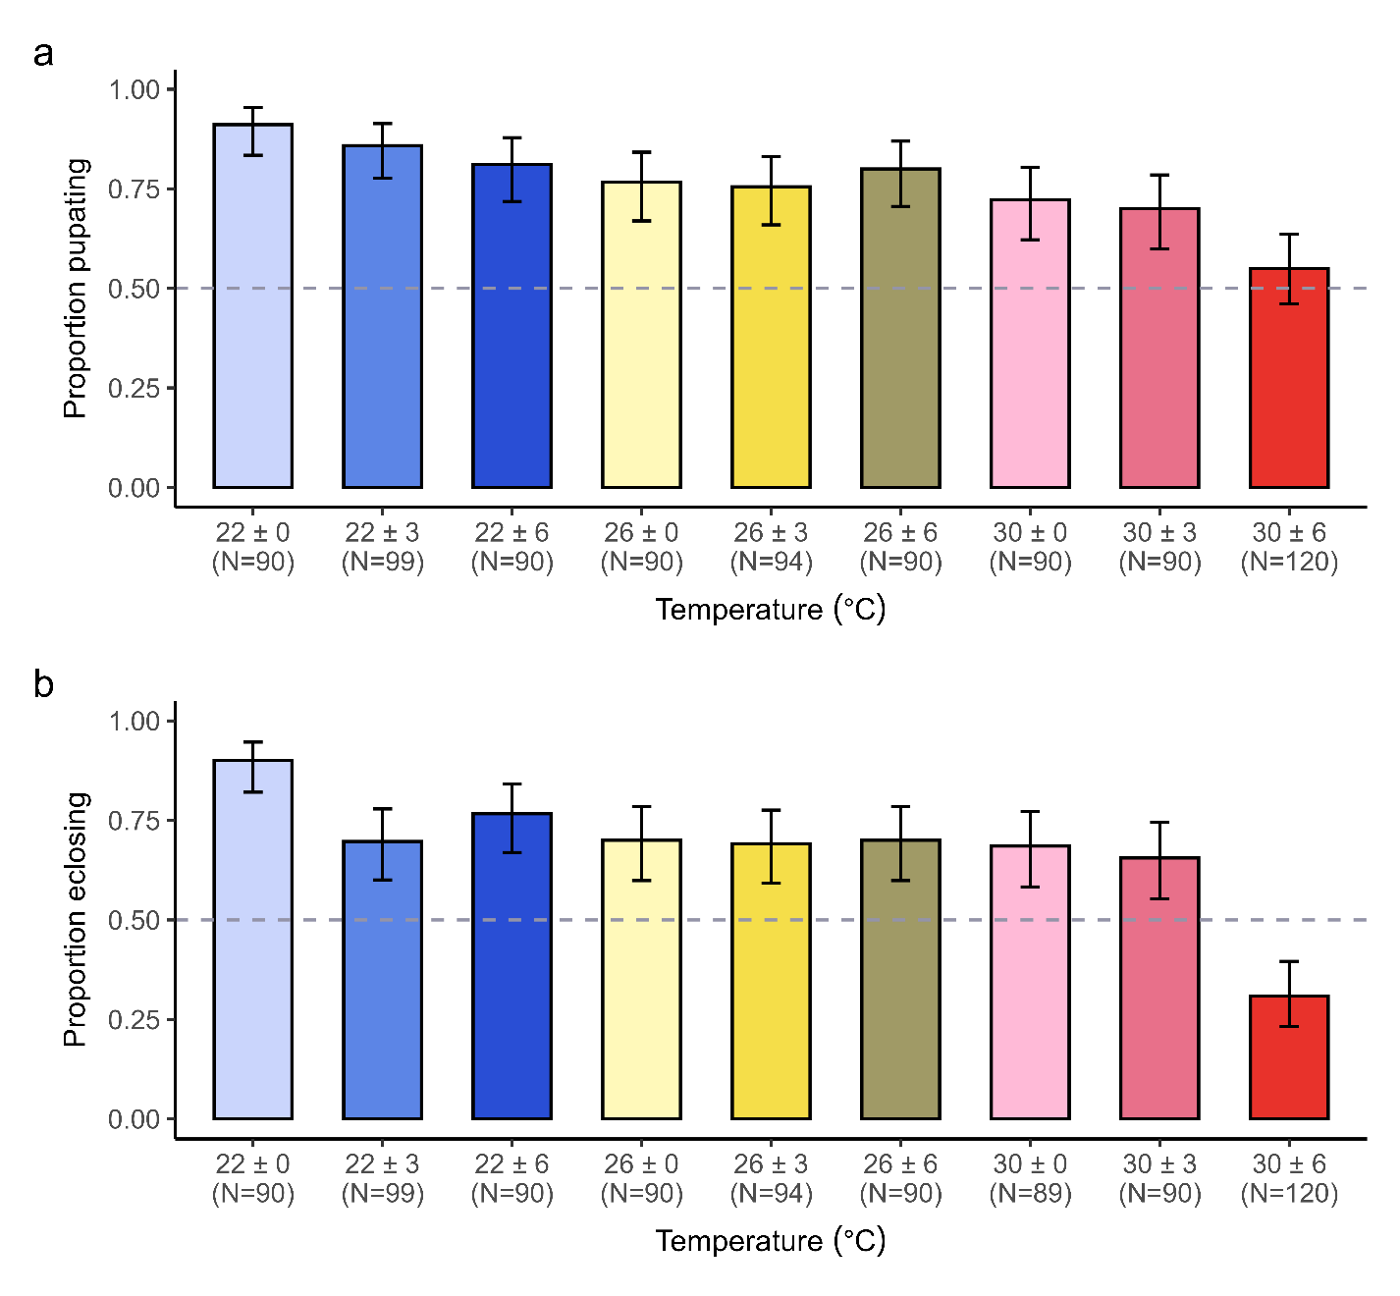
Figure 2-1 Survival across treatments.
a) Proportion of larvae in each temperature treatment that survived to pupation (excluding individuals with major prepupal or pupal abnormalities). b) Proportion of larvae in each treatment that survived to eclosion (excluding individuals that did not eclose completely).

3.2. Time to pupation
Among individuals that successfully pupated, the larval stage lasted between 9 and 34 days (Fig. 2-2a). The best model of time to pupation included mean temperature, temperature fluctuation, and their interaction (Table 2-S6). Increasing mean temperature decreased expected time to pupation regardless of the magnitude of temperature fluctuation (Fig. 2-2a; Table 2-S7). Overall, the effect of temperature fluctuation was noticeable at the coolest (22 °C) and warmest (30 °C) mean temperatures, but smaller than the effect of mean temperature. Large fluctuations around 30 °C significantly delayed expected time to pupation relative to low fluctuations by 11% (1.2 days, adjusted P = 0.0001) or no fluctuations by 15% (1.7 days, adjusted P < 0.0001) (Tables 2-S7, 2-S8). This delay began early in development: at a mean of 30 °C, 28% of larvae in high fluctuations took more than 3 days to reach the third instar compared to less than 11% of larvae in low fluctuations or constant treatments (Fig. 2-S4). For a mean of 22 °C, expected time to pupation was also delayed at low fluctuations relative to constant and high fluctuations by approximately 5% (1 day, adjusted P = 0.022 and 0.041 respectively) (Tables 2-S7, 2-S8). In contrast, temperature fluctuation did not significantly alter the time to pupation among treatments with a mean of 26 °C (adjusted P > 0.32).

3.3. Pupal mass
Pupal mass varied from 67.4 to 302.6 mg (Fig. 2-2b). The best model of pupal mass included mean temperature, temperature fluctuation, sex, and the interaction between temperature mean and fluctuation (Tables 2-S9, 2-S10). We did not find significant differences between males and females (t = 0.34, p = 0.74). Relative to constant temperatures, we observed lower pupal mass under both fluctuating temperature treatments at the coolest mean temperature (22 °C) (adjusted P ≤ 0.0001; Table 2-S11). At the warmest mean temperature (30 °C), the mean pupal mass in the high fluctuation treatment was significantly lower than in either the low fluctuation or constant treatments (adjusted P ≤ 0.020). Pupal mass was lowest in the warmest, most variable (30 ± 6 °C) treatment.

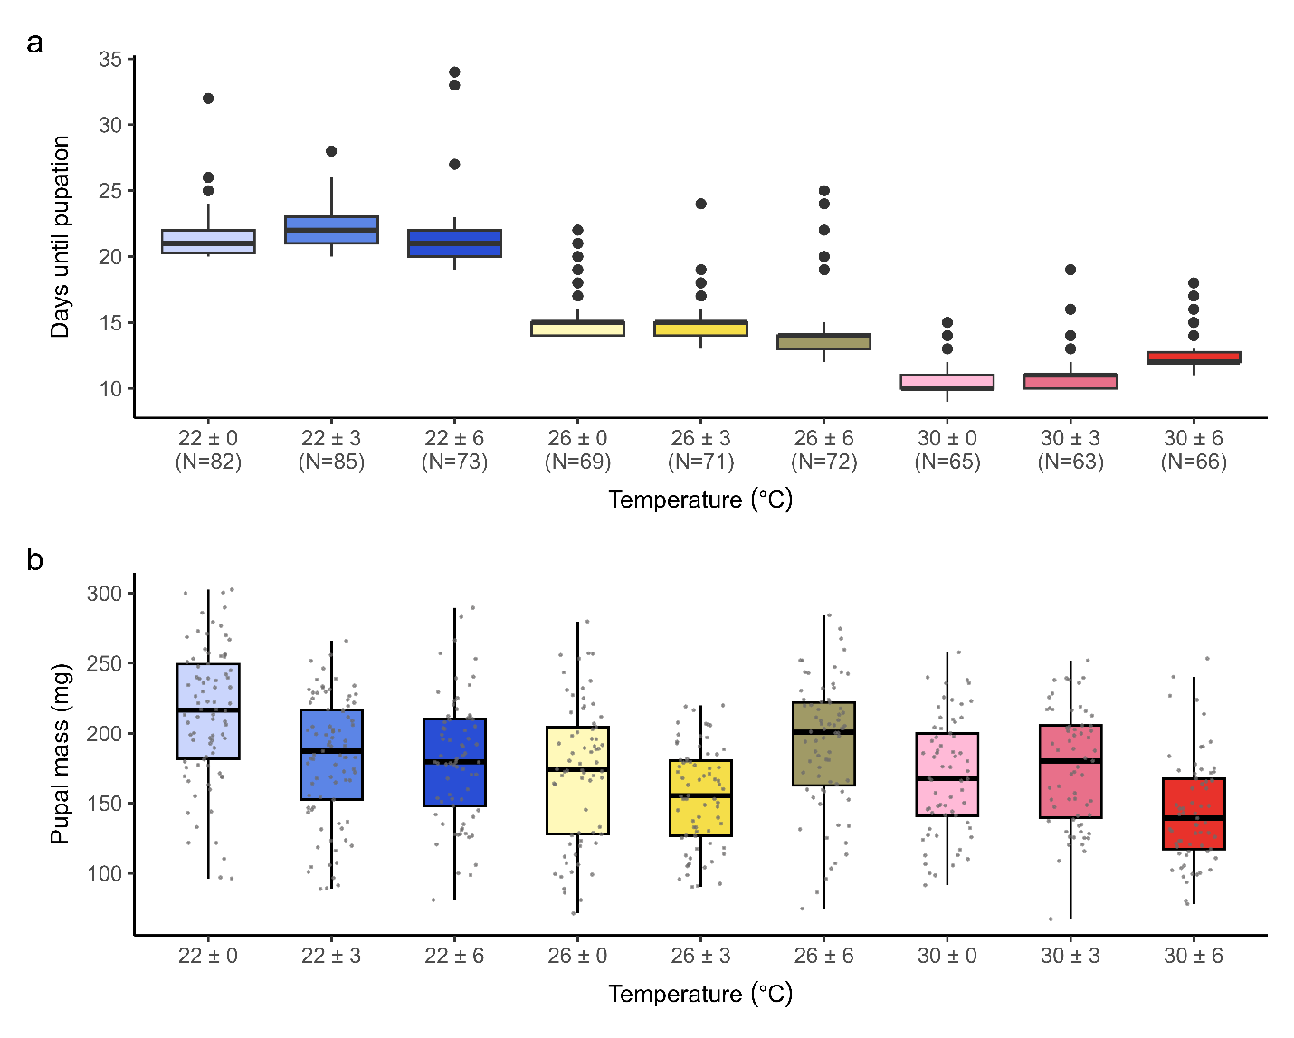
Fig. 2-2. Pupal timing and mass across treatments. a) Number of days between hatching and pupation for surviving pupae in each treatment. b) Distributions of pupal mass within each treatment (excluding those with pupal abnormalities). Jittered points indicate individual weights. Boxes and dark lines represent inter-quartile ranges and medians, respectively, for each treatment. Whiskers extend to the most extreme data value that is within 1.5 times the inter-quartile range.

3.4. Pupal stage duration
Among all individuals that successfully eclosed, time spent in pupation varied from 6 to 16 days (Fig. 2-3). Our final model of pupal stage duration included the effects of temperature mean, temperature fluctuation, and their interaction, and the effects of sex and its interaction with mean temperature (Tables 2-S12, 2-S13). Pupal stage duration decreased with increasing mean temperature (Fig. 2-3). Among treatments with the lowest mean temperature (22 °C), pupae in constant conditions spent nearly a full day longer in pupation on average than pupae in high and low fluctuations (adjusted P < 0.0001) (Table 2-S14). In contrast, pupal stage duration did not vary significantly across fluctuation treatments at the intermediate (26 °C) or warmest (30 °C) mean temperatures. Male pupae spent longer in pupation than females.

3.5. Survival to eclosion
Survivorship in the pupal stage was higher than in the larval stage, with more than 81% of pupae surviving to eclosion for most treatments (Fig. 2-S5). However, survivorship in the pupal stage was substantially lower – 56% – in the warmest and most variable treatment (30 ±6 °C). Consequently, the differences in survival among fluctuation conditions observed from hatch to pupation became more salient when examining differences in survival from hatch to adult eclosion (Fig. 2-1b). Our final model of survival to eclosion included mean temperature, temperature fluctuation, and their interaction (Tables 2-S15, 2-S16). Fluctuation magnitude affected survival to eclosion at the coolest (22 °C) and warmest (30 °C) mean temperatures, but not at the intermediate mean temperature (26 °C). At a mean of 22 °C, survival to eclosion was 29% higher under constant temperatures than under low fluctuations (adjusted P = 0.015; Table 2-S17). At a mean of 30 °C, high fluctuations reduced the probability of survival to eclosion by over 50% compared to constant and low fluctuation treatments (adjusted P < 0.0001).

3.6. Development time to eclosion
Time from hatch to eclosion varied from 16 to 47 days. The best model of development time to eclosion included mean temperature, temperature fluctuation, and their interaction as well as sex and the interaction between mean temperature and sex (Tables 2-S18, 2-S19). In the treatments with the coolest mean temperature (22 °C), females eclosed sooner than males, but these differences largely disappeared at mean temperatures of 26 and 30 °C (Fig. 2-4). Increasing mean temperature decreased expected time to eclosion in both sexes and fluctuation conditions (Table 2-S19). The effect of fluctuation magnitude on time to eclosion was noticeable at our warmest mean temperature but was smaller than the effect of mean temperature. Large fluctuations (± 6 °C) at the warmest mean temperature (30 °C) significantly increased time to eclosion compared to constant and low fluctuation treatments (adjusted P < 0.003; Table 2-S20).

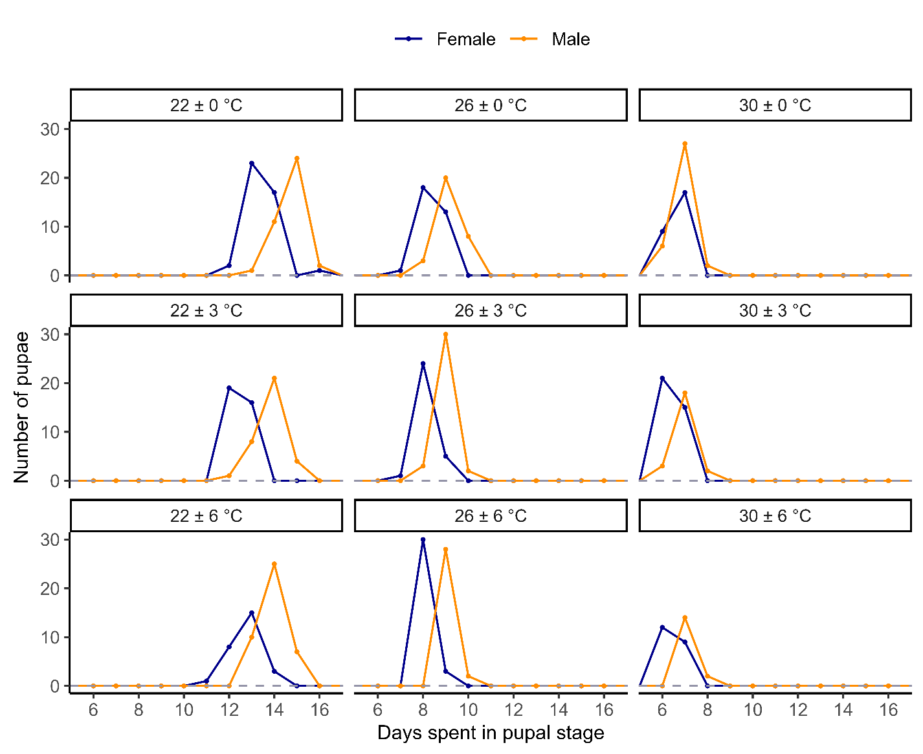
Fig. 2-3. Duration of the pupal stage for individuals within each treatment. Points along the lines indicate the number of pupae (blue = female; orange = male) in each treatment that spend the corresponding number of days in pupation.

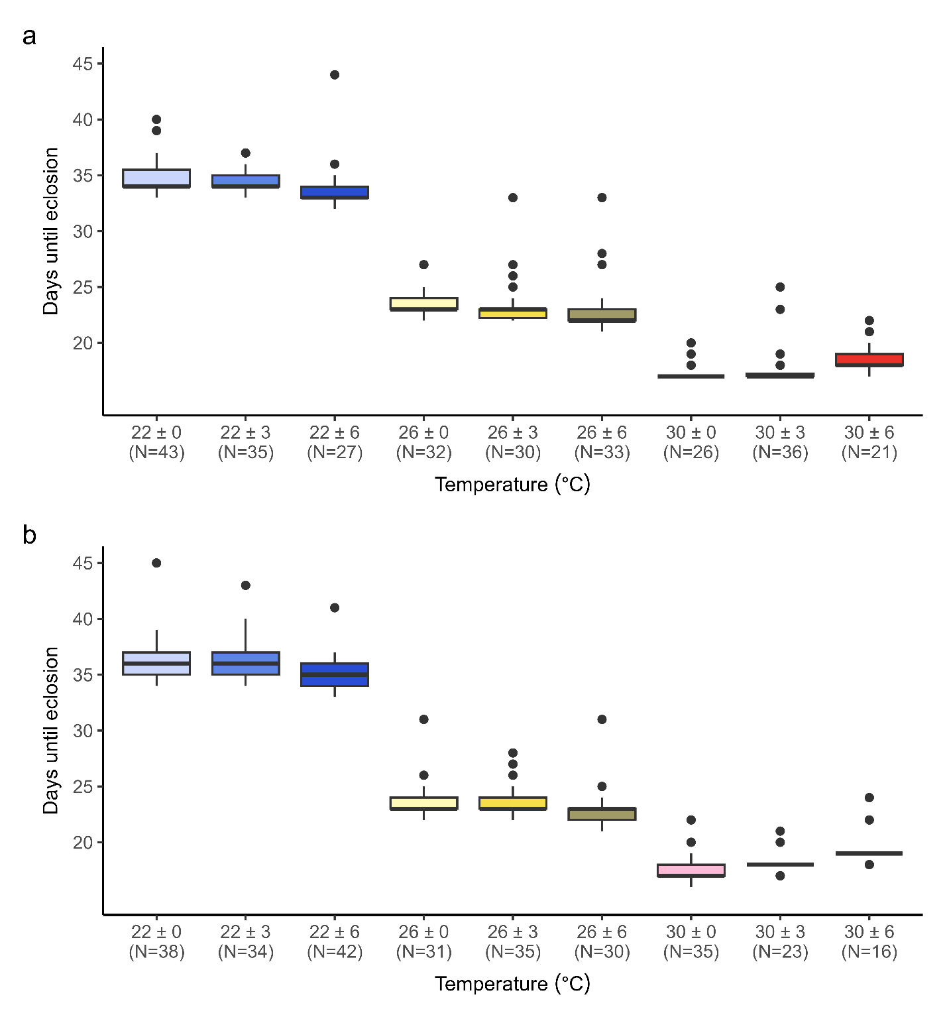
Fig. 2-4. Number of days between hatching and adult emergence for a) surviving female adults and b) surviving male adults within each treatment. Boxes and dark lines represent inter-quartile ranges and medians respectively for each treatment. Whiskers extend to the most extreme data value that is within 1.5 times the inter-quartile range.

3.7. Adult lifespan
Post-maturity lifespan varied from 4-33 days in females and 2-38 days in males (Fig. 2-5). The model that best explained adult lifespan included the effects of mean temperature, sex, and the interaction between mean temperature and sex (Tables 2-S21, 2-S22). For both males and females, average adult lifespan decreased significantly with each increase in mean temperature (from 22 °C to 26 °C, and from 26 °C to 30 °C; Table 2-S23). We found significant differences in expected lifespan between sexes only in the warmest mean temperature (30 °C) treatments, in which females lived 65% longer on average than males (adjusted P < 0.0001).

3.8. Egg production and hatching
Females laid eggs in all treatment conditions, with the greatest lifetime output of 2645 eggs produced by a female across 15 days in the 26 ± 0 °C treatment (Fig. 2-6a). Lifetime egg production was best predicted by mean temperature, temperature fluctuation, and their interaction (Tables 2-S24, 2-S25). On average, females in treatments with the warmest mean temperature (30 °C) laid fewer eggs over their lifetimes relative to other treatments, though most of these comparisons were not statistically significant given large inter-individual variability within each treatment (Table 2-S26). Females exposed to low fluctuations around this mean temperature (30 ± 6 °C) laid fewer eggs than females in other fluctuation conditions or in cooler mean temperatures (adjusted P ≤ 0.0004).
The number of successful hatches from eggs laid by females varied widely, from no larvae to a maximum lifetime output of 1941 larvae in the 22 ± 6 °C treatment (Fig. 2-6b). Among females that produced larvae, total eggs hatched was best predicted by mean temperature, temperature fluctuation, and their interaction (Tables 2-S27, 2-S28). Of females that were monitored for egg hatching, most (94%) held in the cooler (22 °C) and intermediate (26 °C) mean temperatures produced larvae, but only 39% of females held in the warmest mean temperature (30 °C) did so. At mean temperatures of 22 °C and 26 °C, females exposed to high fluctuations produced more larvae on average than females held in constant temperatures (Table 2-S29). We did not find significant differences in eggs hatched among females held in different fluctuation regimes at mean 30°C (adjusted P ≥ 0.85).

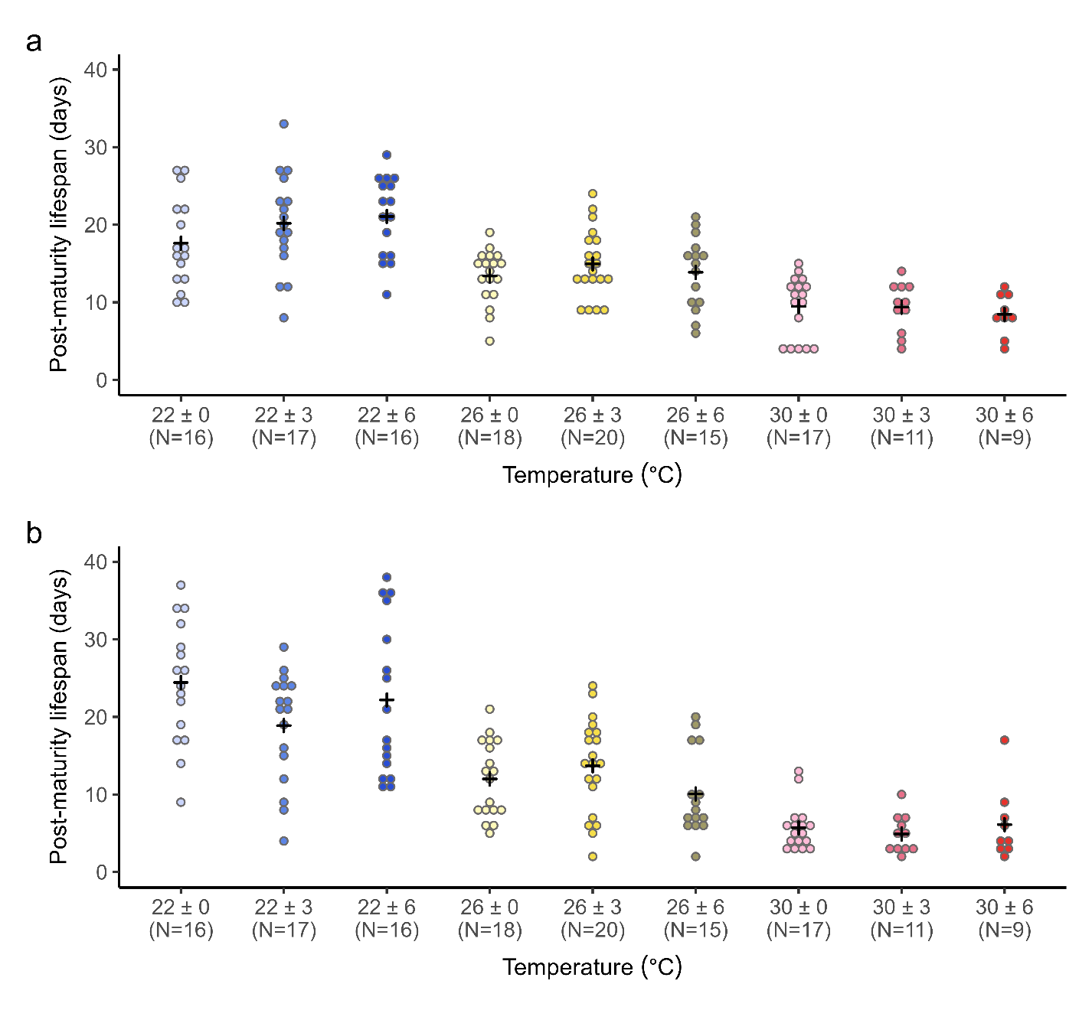
Fig. 2-5. Lifespan after eclosion. Dot-plots showing lifespans following eclosion of a) females and b) males in each treatment. Black crosses indicate mean lifespan for each treatment.

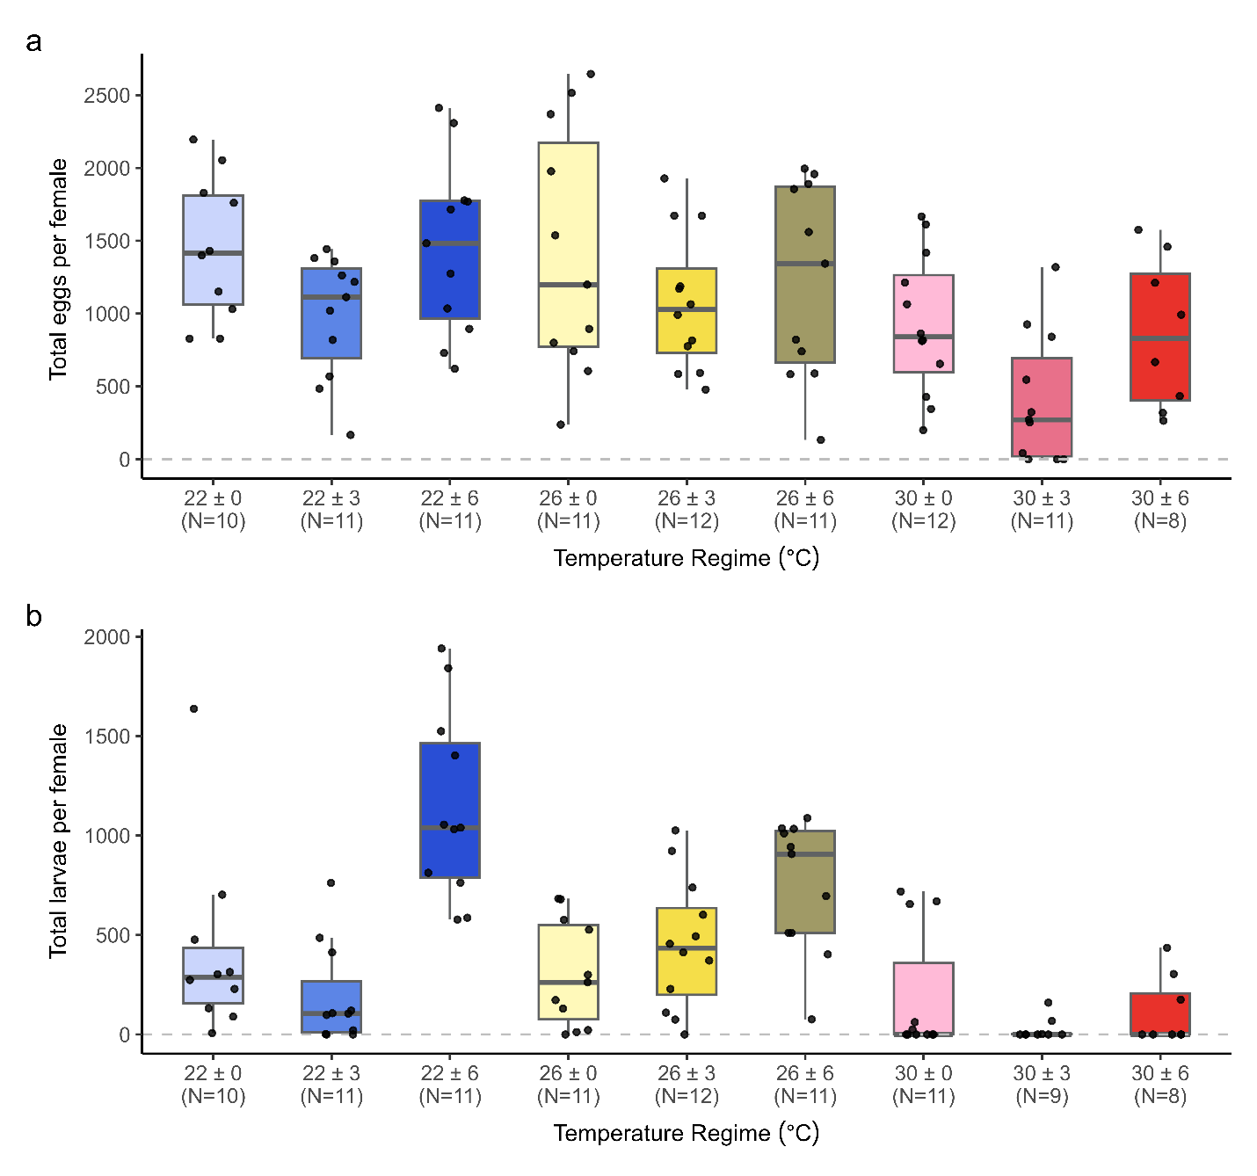
Fig. 2-6. Egg production and hatching. a) Lifetime total eggs laid by females in each treatment. b) Lifetime total larvae produced by females in each treatment. Boxes and dark lines represent inter-quartile ranges and medians respectively for each treatment. Whiskers extend to the most extreme data value that is within 1.5 times the inter-quartile range. Jittered points show data from each female.

4. DISCUSSION
Despite the importance of temperature variability for insect thermal performance, we lack an understanding of how different magnitudes of diurnal temperature fluctuation impact life history traits for many species. This knowledge is particularly important for understanding how populations of widespread agricultural pests like Spodoptera frugiperda will fare under climate change. Our study investigated the effects of shifts in temperature mean and variance on S. frugiperda life-history traits, and uniquely, we tracked these effects across the entire life cycle. We found that temperature fluctuations have considerable impacts on survival, development, and reproductive output that are not captured by constant temperature treatments, and the effects of these fluctuations vary substantially by trait and life stage.
The effects of temperature fluctuations depend on the mean temperature of the environment. For most traits, we observe more pronounced effects of fluctuations at our coolest (22°C) and warmest (30°C) mean temperatures than at our intermediate mean temperature (26°C). Recalling Jensen’s inequality, biological rates should be higher under variable temperatures than predicted by mean temperatures over the accelerating portions of performance curves and lower than predicted over the decelerating portion of the performance curve. In line with predictions, fluctuations had a large negative impact at the mean temperature known to maximize performance for some traits, such as development rate (Ali et al., 1990; Du Plessis et al., 2020; Lee et al., 2022; Malekera et al., 2022; Adan et al., 2024). However, contrary to predictions, temperature fluctuations have impacts beyond the expected nonlinear effects. Fluctuations around low to moderate temperatures can quicken development in S. frugiperda and other insects (Barfield and Ashley, 1987; Ragland and Kingsolver, 2008; Kingsolver et al., 2015), but in our study, low fluctuations around 22 °C actually delayed larval development. Similarly, in other insects, incorporating fluctuations around low mean temperatures can boost survival relative to constant temperatures (Carrington et al., 2013; Paaijmans et al., 2013), an effect we expected at our lowest mean temperature since survival of S. frugiperda larvae often declines at and below 22 °C (Du Plessis et al., 2020; Huang et al., 2021). Instead, survival to pupation and eclosion at 22 °C was lower in both fluctuation treatments relative to the constant treatment, as was pupal mass. These impacts suggest that withstanding repeated, transient exposures to stressful temperatures may divert energy from growth and other processes towards responding to thermal stress and recovering from thermal injuries, causing performance to deviate from nonlinear averaging predictions (Kingsolver and Woods, 2016).
The impacts of transient exposures to temperatures near the lower and upper performance thresholds are asymmetrical. Because thermal performance relationships are nonlinear and left-skewed for many traits, variability at warmer temperatures is more likely to hit or transcend performance thresholds than variability at cooler temperatures (Lawson et al., 2015). Past research on S. frugiperda shows that constant temperatures below 19 °C and above 33 °C reduce survival and fecundity (Ali et al., 1990; Du Plessis et al., 2020; Huang et al., 2021; Lee et al., 2022; Malekera et al., 2022). High fluctuations (± 6 °C) at our coolest (22 °C) and warmest (30 °C) mean temperatures exposed organisms to these extreme temperatures for comparable fractions of the diurnal cycle. Yet, we found large fluctuations to have more substantial negative impacts on S. frugiperda survival and larval development when temperatures varied around 30 °C than when they varied around 22 °C. Other insect studies show greater negative impacts of thermal fluctuations at higher mean temperatures (Slein et al., 2023) and on a wider range of traits for heat stress than for cold stress (Jeffs and Leather, 2014). Though acute responses to and recovery from both heat and cold stress and injury are energetically demanding, organisms in warmer treatments have high metabolic rates, which may raise their risk of mortality from energy depletion. Moreover, while heat acclimation with repeated exposures may improve performance, these mechanisms may involve a larger increase in metabolic costs than cold acclimation (González‐Tokman et al., 2020).
Performance curves vary such that temperature fluctuations have differential impacts on organismal traits. The noticeable effects—both positive and negative— of fluctuations on most traits reveal considerable variation in the underlying thermal performance curves, with some traits appearing particularly susceptible to heat stress. For instance, our data suggest that upper thresholds for reproduction may occur at lower temperatures than upper thresholds for survival of immature stages. Thus, an important takeaway from these results is that as climates warm, fertility in insects may decline before mortality. Conversely, in regions with cooler or more moderate temperatures, higher temperature variability and diurnal maxima may stimulate more oviposition – as seen in studies on other insects incorporating fluctuations (Mironidis and Savopoulou-Soultani, 2008; Nyamukondiwa et al., 2010) – and increase fertility. Since reproductive traits tend to have narrow thermal performance breadths (Walsh et al., 2019), more research into how temperature variability affects fertility limits and the mechanisms that contribute to fertility, from gamete development and viability to mating behavior, is crucial for understanding population viability and species distributions under global change (Parratt et al., 2021; van Heerwaarden and Sgrò, 2021).
Different life stages show differences in sensitivity to temperature fluctuations. We recorded a decline in larval survivorship under warmer and more variable temperatures, but pupal survivorship was similar across most temperature treatments, echoing previous findings in S. frugiperda (Simmons, 1993; Díaz-Álvarez et al., 2023). Unlike larval development times, pupation durations did not increase with fluctuations around our coolest and warmest mean temperatures. Similarly, Malekera et al., 2022 showed that an increase in temperature that led to faster pupal development in S. frugiperda resulted in slower larval development, indicating that the thermal performance curve for development is right-shifted in pupae compared to larvae. Several mechanisms could contribute to differences in sensitivity to thermal fluctuations among insect life stages. Spodoptera frugiperda pupae are exposed to large temperature fluctuations on the soil surface or in the upper regions of the soil whereas adults and larvae can move to more favorable microclimates (Pincebourde and Suppo, 2016). Sessile life stages, such as pupae, may thus be under greater selection than more mobile life stages to maintain physiological performance over a wider range of temperatures (Enriquez and Colinet, 2017). Expression levels of genes that encode heat-shock proteins involved in responses to temperature fluctuations and the capacity to acclimate to higher daily maxima can vary among life stages (Yang et al., 2021; Phungula et al., 2023). To fully understand impacts of temperature fluctuations, greater consideration of how responses vary across life stages is needed, particularly for organisms with complex life cycles.
The effects of temperature fluctuations during later life stages may be a consequence of acute impacts on the later life stages as well as exposure to fluctuations in earlier life stages (Rebolledo et al., 2021). In our study, individuals experienced regular fluctuations from the time of hatch until their death. Studies in which organisms only experience these conditions within a specific life stage or only as immatures may show different outcomes. For example, chronic exposures to fluctuations can result in selective mortality or acclimation during larval development that can increase thermal tolerance and performance in later life stages (Marshall and Sinclair, 2012). However, long exposure times can exacerbate any negative impacts of fluctuations (Slein et al., 2023). For example, in our warmest and most variable treatment, damage due to incomplete recovery from thermal injury may have accumulated over time and increased rates of developmental abnormalities. The especially low reproductive output in our warmest mean treatments may also reflect organisms’ altered allocation of resources between survival and fecundity due to heat stress earlier in development (Zheng et al., 2017; Awde et al., 2023). Going forward, experiments that monitor organisms over the long-term but vary the proportion of the life cycle when individuals are exposed to each treatment can help pinpoint specific acute and long-term impacts of fluctuations. This could even extend to monitoring transgenerational impacts, which have been observed for heat stress in S. frugiperda (Reshma et al., 2023).
The impacts of short-term variability may become more salient under global change as temperatures warm and insects are pushed closer to their upper threshold temperatures for more extended durations. Even where diurnal ranges in air temperatures are not projected to increase, habitat changes, such as desertification and forest canopy loss, may result in insects experiencing larger fluctuations in operative temperatures (Sheldon et al., 2018). Concurrent increases in temperature mean and variance may widen the deviation between observed organismal performance and constant-temperature predictions and increase the relevance of time-dependent effects of fluctuations. Understanding how temperature fluctuations in the upper range of insects’ thermal niches impact the entire life cycle would enable us to more accurately forecast insect populations.

Appendix A. Supplementary material

Supplemental Figures

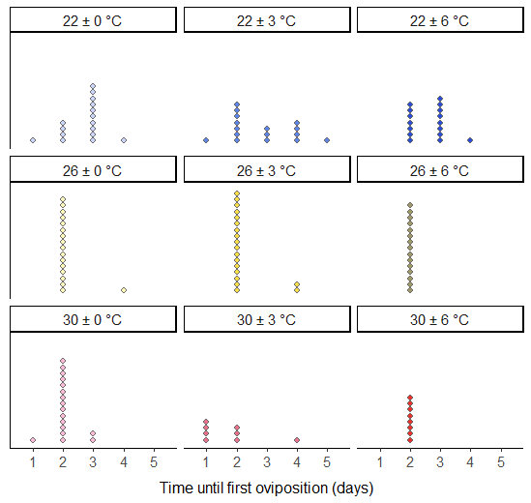
Figure 2-S1. Time (in days) between emergence and initial oviposition for each adult female observed during the breeding pair phase of the experiment as a function of temperature treatment. Each point represents the time to oviposition for an individual female.

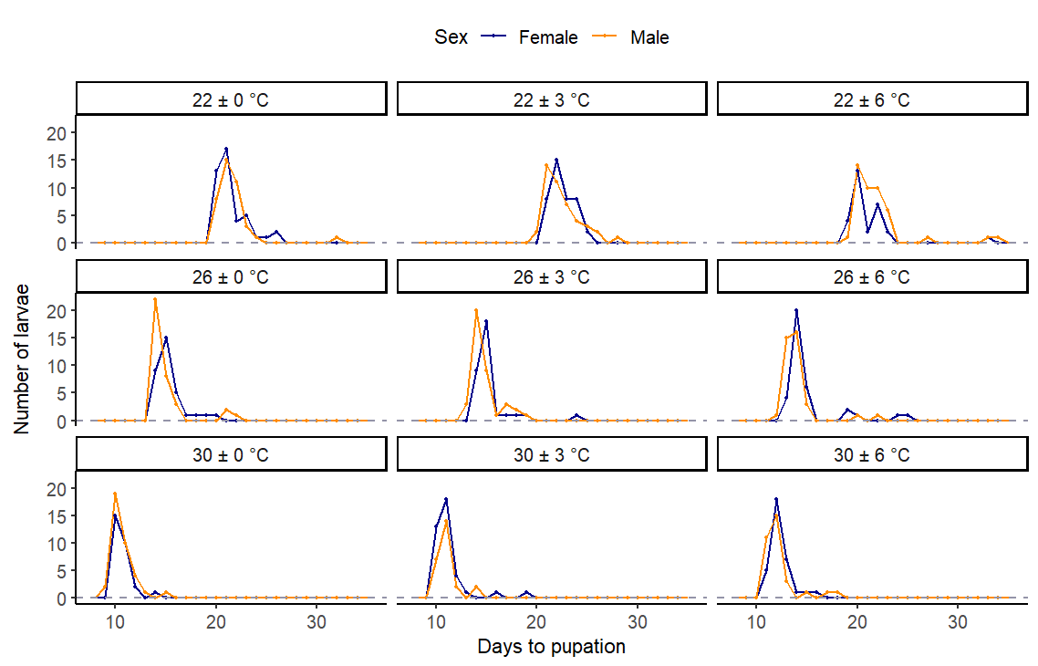
Figure 2-S2. Time (in days) between hatching and pupation for individuals within each temperature treatment. Points along the lines indicate the number of larvae (blue = female; orange = male) in each treatment that take the corresponding number of days to reach pupation.

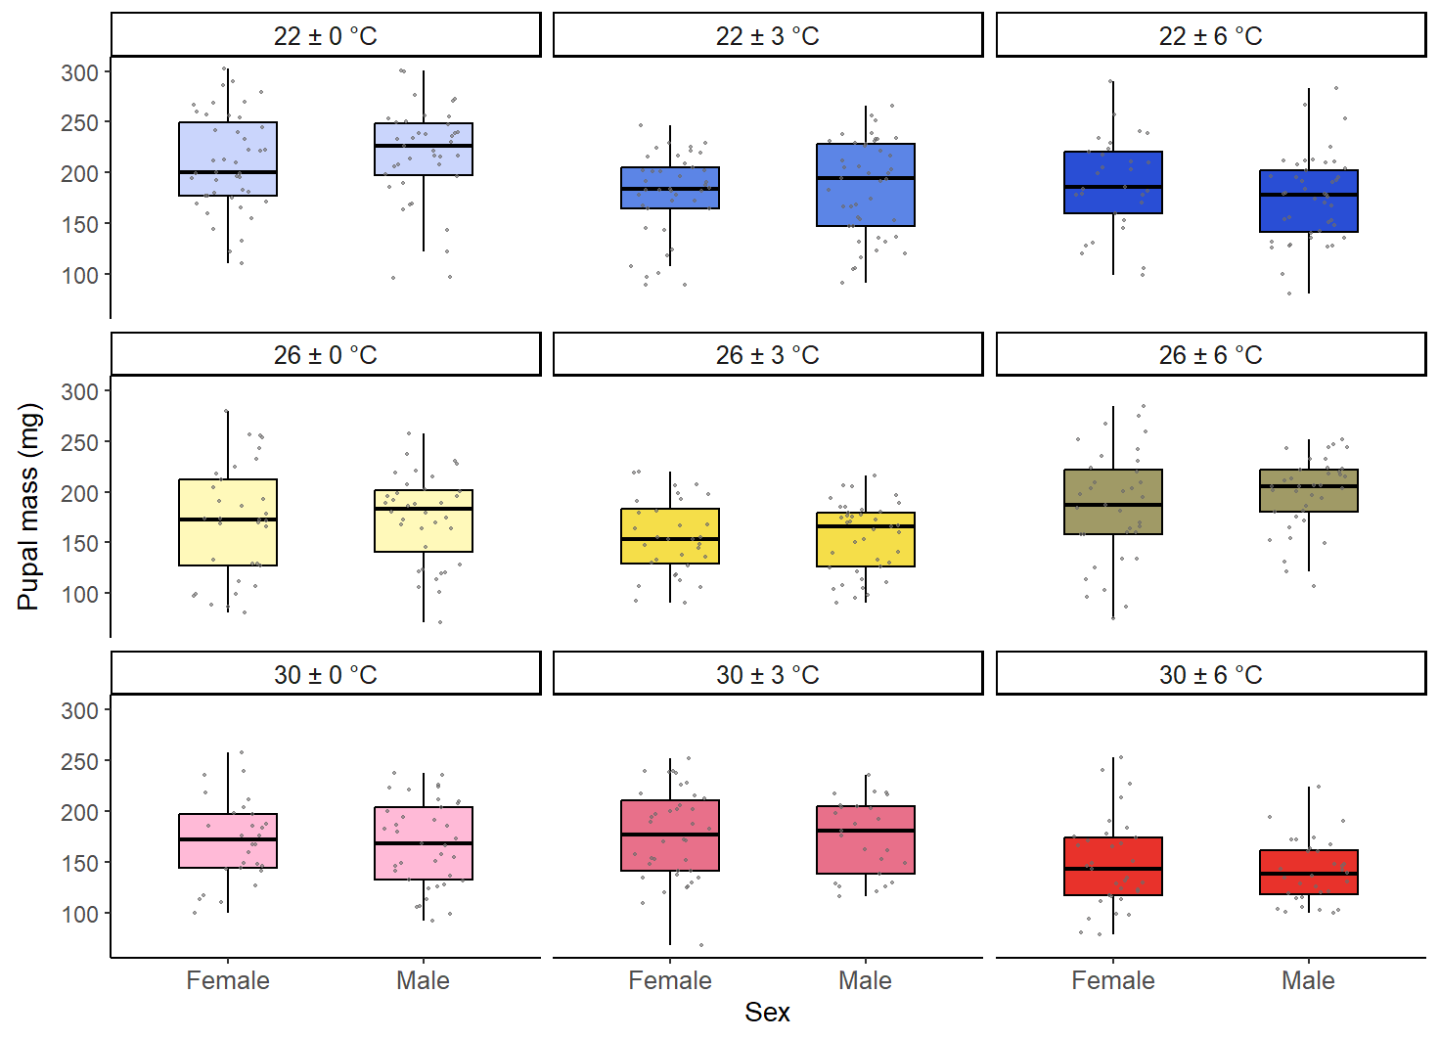
Figure 2-S3. Mass of female and male pupae within each temperature treatment, excluding pupae with major abnormalities. Boxes and dark lines represent inter-quartile ranges and medians, respectively, for each temperature treatment and sex. Whiskers extend to the most extreme data value that is within 1.5 times the inter-quartile range away from the box. Jittered points indicate masses of individual pupae.

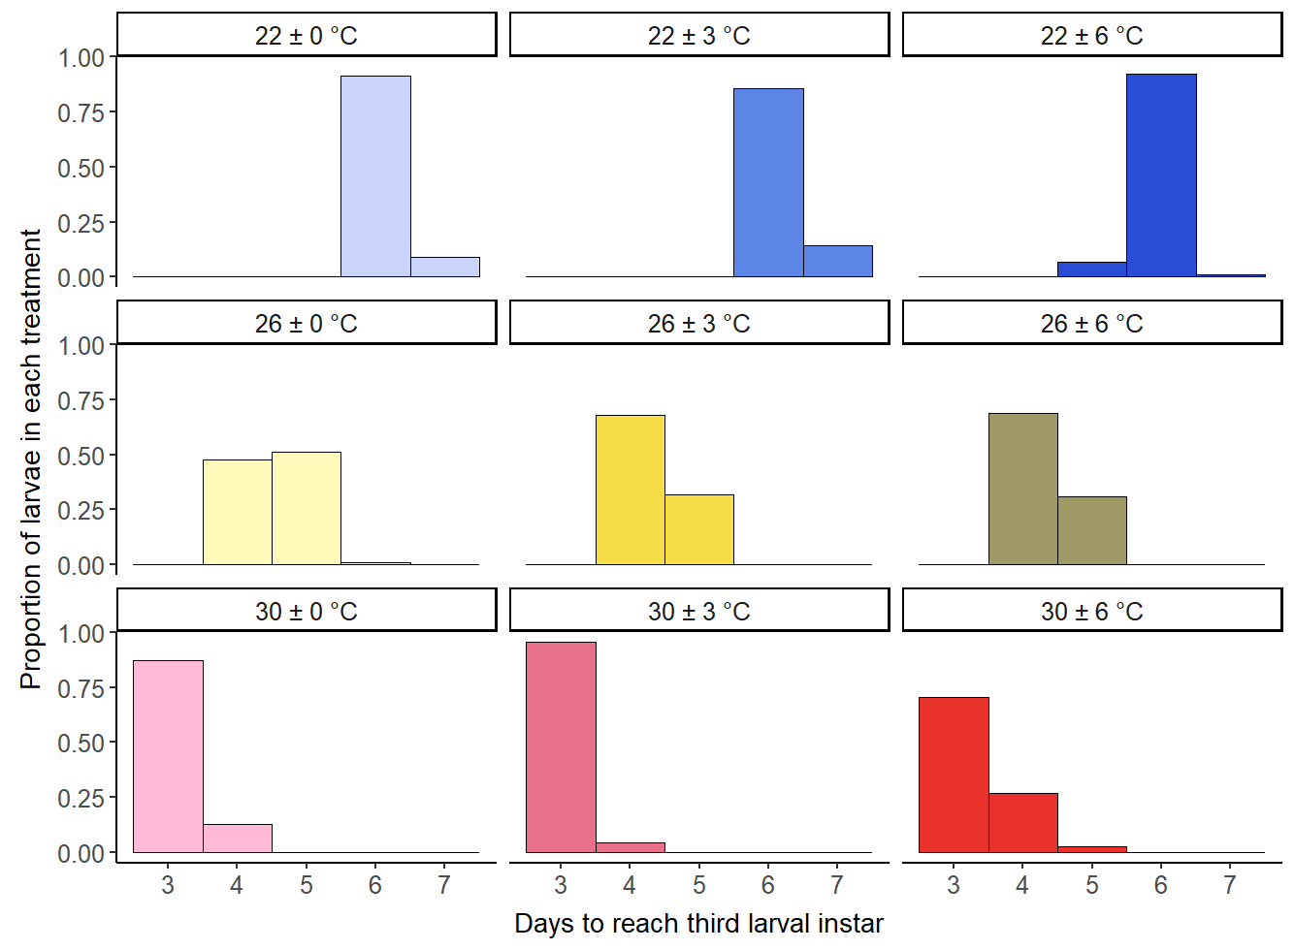
Figure 2-S4. Time (days) from hatching to reaching third larval instar in each temperature treatment. Histogram bars represent the proportion of surviving larvae in each treatment that take the corresponding number of days to reach the third larval instar.
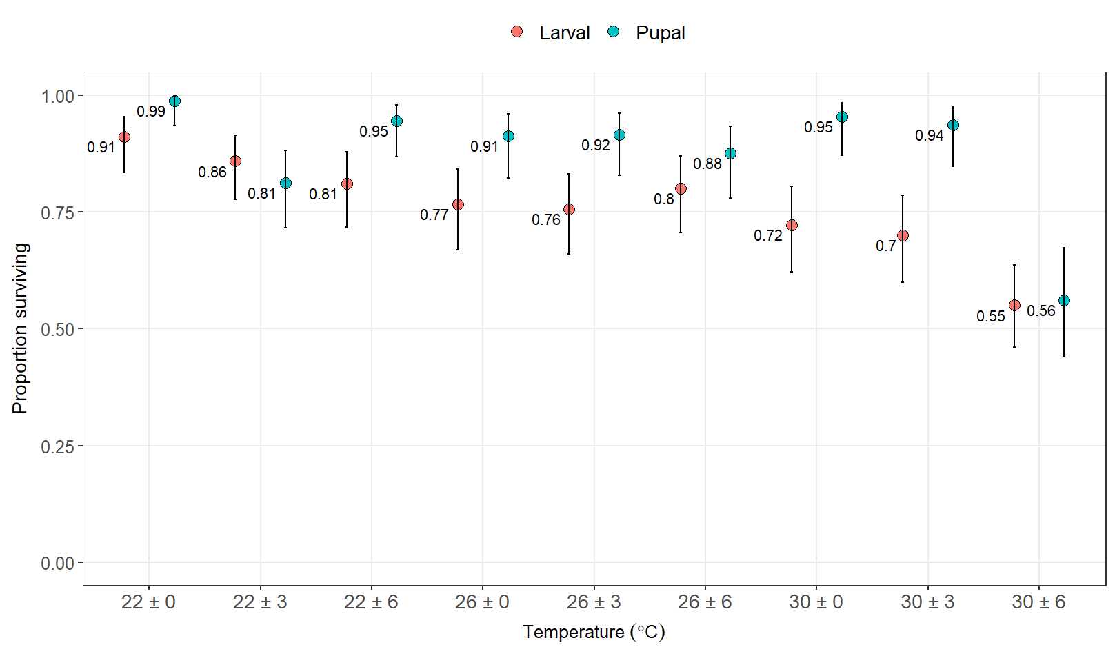
Figure 2-S5. Survivorship of immature stages in each temperature treatment. Red points represent the proportion of all neonates in a treatment that survive the larval stage and pupate without major abnormalities. Blue points represent the proportion of all normal pupae in a treatment (i.e., without major abnormalities) that successfully eclose. Error bars indicate Wilson 95% confidence intervals for the proportions.

Supplemental Tables
Table 2-S1. Prepupal and pupal abnormalities and failed eclosion
Table 2-1 Prepupal and pupal abnormalities and failed eclosion
Temperature  Regime (°C) | Number of individuals that develop major prepupal and pupal abnormalities | Percentage of individuals that develop major prepupal and pupal abnormalities (%) | Number of normal pupae that fail to eclose as adults | Percentage of normal pupae that fail to eclose as adults  (%)
22 ± 0 | 1 | 1.1 | 1 | 1.2
22 ± 3 | 6 | 6.1 | 5 | 6.8
22 ± 6 | 6 | 6.7 | 1 | 1.4
26 ± 0 | 11 | 12.2 | 2 | 3.1
26 ± 3 | 12 | 12.8 | 3 | 4.4
26 ± 6 | 4 | 4.4 | 1 | 1.6
30 ± 0 | 2 | 2.2 | 0 | 0.0
30 ± 3 | 7 | 7.8 | 1 | 1.7
30 ± 6 | 30 | 25.0 | 9 | 19.6

Table 2-S2. Final sample sizes at each stage
Temperature Regime (°C) | Individual monitoring  (survival, development) |  |  | Breeding pairs
Temperature Regime (°C) | Neonates * | Normal pupae (without major deformities) ⁺ | Eclosed adults | Number of adults followed in pairs  (post-maturity lifespan) | Females  (lifetime egg output) | Females  (lifetime larva output)
22 ± 0 | 90 | 82 | 81 | 32 | 10 | 10
22 ± 3 | 99 | 85 | 69 | 34 | 11 | 11
22 ± 6 | 90 | 73 | 69 | 32 | 11 | 11
26 ± 0 | 90 | 69 | 63 | 36 | 11 | 11
26 ± 3 | 94 | 71 | 65 | 40 | 12 | 12
26 ± 6 | 90 | 72 | 63 | 30 | 11 | 11
30 ± 0 | 90 | 65 | 61 | 34 | 12 | 11
30 ± 3 | 90 | 63 | 59 | 22 | 11 | 9
30 ± 6 | 120 | 66 | 37 | 18 | 8 | 8
Total | 853 | 646 | 567 | 278 | 97 | 94
* For analyses of survival to pupation, n = 853; for analyses of survival to eclosion, n = 852 as we removed an individual that was accidentally killed during the pupal stage from this dataset
⁺ One pupa with missing sex information was excluded from analyses of pupal weights (n = 645).

Table 2-S3. Likelihood ratio tests for survival to pupation
Full model | Nested model | Difference in degrees of freedom | χ² | p
Mean Temperature * Temperature Fluctuation | Mean Temperature + Temperature Fluctuation | 4 | 6.568 | 0.1605
Mean Temperature + Temperature Fluctuation | Mean Temperature | 2 | 6.072 | 0.0480

Table 2-S4. Final regression model and coefficients table for survival to pupation
Term | Estimate | Standard Error | z | p
(Intercept) | 2.051115 | 0.218233 | 9.398747 | 5.52E-21
Mean 26 °C | -0.59017 | 0.225728 | -2.61452 | 0.008935
Mean 30 °C | -1.19302 | 0.211556 | -5.63926 | 1.71E-08
Fluctuation (low) | -0.18117 | 0.212262 | -0.85353 | 0.393365
Fluctuation (high) | -0.48304 | 0.201973 | -2.39159 | 0.016776
Number of observations = 853; Residual deviance = 902.41; Residual degrees of freedom = 848; Null deviance = 945.37; Null degrees of freedom = 852

Table 2-S5. Pairwise comparisons of odds for survival to pupation
Contrast | Odds ratio | SE | Null | z ratio | p
Mean 26 °C / Mean 22 °C | 0.554233 | 0.125106 | 1 | -2.61452 | 0.047658
Mean 30 °C / Mean 22 °C | 0.303304 | 0.064166 | 1 | -5.63926 | 1.03E-07
Mean 30 °C / Mean 26 °C | 0.54725 | 0.103548 | 1 | -3.18604 | 0.008153
fluctuation (low) / constant | 0.834292 | 0.177089 | 1 | -0.85353 | 0.890229
fluctuation (high) / constant | 0.616908 | 0.124599 | 1 | -2.39159 | 0.08609
fluctuation (high) / fluctuation (low) | 0.739439 | 0.143921 | 1 | -1.55091 | 0.461663

Table 2-S6. Likelihood ratio tests for time to pupation
Full model | Nested model | Difference in degrees of freedom | χ² | p
Mean Temperature * Temperature Fluctuation | Mean Temperature + Temperature Fluctuation | 4 | 50.61 | < 0.0001
Mean Temperature * Temperature Fluctuation | Mean Temperature | 6 | 58.59 | < 0.0001

Table 2-S7. Final regression model and coefficients table for time to pupation
Term | Estimate | Standard Error | z | p
(Intercept) | 3.068053 | 0.010204 | 300.6755 | 0
Mean 26 °C | -0.35039 | 0.016769 | -20.8955 | 5.89E-97
Mean 30 °C | -0.70286 | 0.019354 | -36.3157 | 9.1E-289
Fluctuation (low) | 0.0452 | 0.014144 | 3.195801 | 0.001394
Fluctuation (high) | 0.001592 | 0.014862 | 0.107096 | 0.914713
Mean 26 °C: Fluctuation (low) | -0.05388 | 0.023468 | -2.29584 | 0.021685
Mean 30 °C: Fluctuation (low) | -0.00245 | 0.027156 | -0.09027 | 0.928077
Mean 26 °C: Fluctuation (high) | -0.04224 | 0.023977 | -1.76168 | 0.078123
Mean 30 °C: Fluctuation (high) | 0.140589 | 0.026856 | 5.23497 | 1.65E-07
Number of observations = 646; Deviance = 2525.8; Residual degrees of freedom = 636; Dispersion parameter = 0.180097

Table 2-S8. Pairwise comparisons of means for time to pupation
Temperature Fluctuation | Mean Temperature | Contrast | Ratio | SE | Null | z ratio | p
constant | . | Mean 26 °C / Mean 22 °C | 0.704415 | 0.011812 | 1 | -20.8955 | 0
constant | . | Mean 30 °C / Mean 22 °C | 0.495169 | 0.009584 | 1 | -36.3157 | 0
constant | . | Mean 30 °C / Mean 26 °C | 0.702951 | 0.014871 | 1 | -16.6614 | 0
low | . | Mean 26 °C / Mean 22 °C | 0.667467 | 0.010958 | 1 | -24.6236 | 0
low | . | Mean 30 °C / Mean 22 °C | 0.493957 | 0.009409 | 1 | -37.026 | 0
low | . | Mean 30 °C / Mean 26 °C | 0.740047 | 0.015533 | 1 | -14.3425 | 0
high | . | Mean 26 °C / Mean 22 °C | 0.675281 | 0.011573 | 1 | -22.9105 | 0
high | . | Mean 30 °C / Mean 22 °C | 0.569916 | 0.010611 | 1 | -30.1992 | 0
high | . | Mean 30 °C / Mean 26 °C | 0.843969 | 0.017022 | 1 | -8.41068 | 3.33E-16
. | 22 | low / constant | 1.046237 | 0.014798 | 1 | 3.195801 | 0.021635
. | 22 | high / constant | 1.001593 | 0.014886 | 1 | 0.107096 | 1
. | 22 | high / low | 0.957329 | 0.013962 | 1 | -2.99019 | 0.041246
. | 26 | low / constant | 0.99136 | 0.018565 | 1 | -0.46338 | 0.999877
. | 26 | high / constant | 0.960168 | 0.018065 | 1 | -2.16041 | 0.323401
. | 26 | high / low | 0.968536 | 0.018134 | 1 | -1.70754 | 0.641065
. | 30 | low / constant | 1.043676 | 0.024194 | 1 | 1.844077 | 0.540942
. | 30 | high / constant | 1.152785 | 0.025786 | 1 | 6.356315 | 1.68E-09
. | 30 | high / low | 1.104543 | 0.02462 | 1 | 4.4609 | 0.000123

Table 2-S9. Likelihood ratio tests for pupal mass
Full model | Nested model | Difference in degrees of freedom (numerator d.f.) | Residual degrees of freedom  (denominator d.f.) | F | p
Mean Temperature * Temperature Fluctuation * Sex | Mean Temperature * Temperature Fluctuation + Sex | 8 | 627 | 0.662 | 0.7251
Mean Temperature * Temperature Fluctuation + Sex | Mean Temperature + Temperature Fluctuation + Sex | 4 | 635 | 14.39 | < 0.0001
Mean Temperature * Temperature Fluctuation + Sex | Mean Temperature + Sex | 6 | 635 | 12.35 | < 0.0001

Table 2-S10. Final regression model and coefficients table for pupal mass
Term | Estimate | Standard Error | t-statistic | p
(Intercept) | 213.1148 | 5.08029 | 41.94933 | 3.4E-185
Mean 26 °C | -41.4064 | 7.114252 | -5.8202 | 9.33E-09
Mean 30 °C | -44.4129 | 7.237551 | -6.13645 | 1.49E-09
Fluctuation (low) | -31.6509 | 6.740715 | -4.69548 | 3.26E-06
Fluctuation (high) | -33.0993 | 7.019574 | -4.71528 | 2.97E-06
Sex (male) | 1.156133 | 3.450588 | 0.335054 | 0.737695
Mean 26 °C: Fluctuation (low) | 14.21729 | 9.979344 | 1.424672 | 0.154743
Mean 30 °C: Fluctuation (low) | 38.28544 | 10.25734 | 3.732492 | 0.000207
Mean 26 °C: Fluctuation (high) | 52.70649 | 10.15366 | 5.190888 | 2.82E-07
Mean 30 °C: Fluctuation (high) | 8.377449 | 10.38755 | 0.806489 | 0.420263
Residual standard error: 43.54 on 635 degrees of freedom; Multiple R-squared: 0.1651; F-statistic: 13.95 on 9 and 635 d.f., p-value: < 2.2e-16; Number of observations = 645

Table 2-S11: Pairwise comparisons of means for pupal mass
Temperature Fluctuation | Mean Temperature | Contrast | Estimate | SE | df | t ratio | p
constant | . | Mean 26 °C - Mean 22 °C | -41.4064 | 7.114252 | 635 | -5.8202 | 7.92E-08
constant | . | Mean 30 °C - Mean 22 °C | -44.4129 | 7.237551 | 635 | -6.13645 | 1.69E-08
constant | . | Mean 30 °C - Mean 26 °C | -3.0065 | 7.527273 | 635 | -0.39941 | 0.99996
low | . | Mean 26 °C - Mean 22 °C | -27.1891 | 7.000677 | 635 | -3.88378 | 0.001844
low | . | Mean 30 °C - Mean 22 °C | -6.12743 | 7.249932 | 635 | -0.84517 | 0.990973
low | . | Mean 30 °C - Mean 26 °C | 21.06165 | 7.55392 | 635 | 2.788175 | 0.076974
high | . | Mean 26 °C - Mean 22 °C | 11.30012 | 7.237854 | 635 | 1.561252 | 0.744151
high | . | Mean 30 °C - Mean 22 °C | -36.0354 | 7.434575 | 635 | -4.847 | 2.72E-05
high | . | Mean 30 °C - Mean 26 °C | -47.3355 | 7.449422 | 635 | -6.35426 | 2.44E-09
. | 22 | low - constant | -31.6509 | 6.740715 | 635 | -4.69548 | 4.78E-05
. | 22 | high - constant | -33.0993 | 7.019574 | 635 | -4.71528 | 4.55E-05
. | 22 | high - low | -1.4484 | 6.953584 | 635 | -0.2083 | 1
. | 26 | low - constant | -17.4336 | 7.360547 | 635 | -2.36852 | 0.214438
. | 26 | high - constant | 19.6072 | 7.334749 | 635 | 2.673194 | 0.103941
. | 26 | high - low | 37.0408 | 7.282781 | 635 | 5.086079 | 7.73E-06
. | 30 | low - constant | 6.634562 | 7.720311 | 635 | 0.859365 | 0.989882
. | 30 | high - constant | -24.7218 | 7.641595 | 635 | -3.23517 | 0.019754
. | 30 | high - low | -31.3564 | 7.704404 | 635 | -4.06993 | 0.000857

Table 2-S12. Likelihood ratio tests for pupal stage duration
Full model | Nested model | Difference in degrees of freedom | χ² | p
Mean Temperature + Temperature Fluctuation + Sex +  Mean Temperature: Temperature Fluctuation + Sex: Mean Temperature | Mean Temperature +Temperature Fluctuation + Sex + Sex: Mean Temperature | 4 | 29.71 | < 0.0001
Mean Temperature + Temperature Fluctuation + Sex +  Mean Temperature: Temperature Fluctuation + Sex: Mean Temperature | Mean Temperature + Sex + Sex: Mean Temperature | 6 | 97.51 | < 0.0001

Table 2-S13. Final regression model and coefficients table for pupal stage duration
Term | Estimate | Standard Error | z statistic | p
(Intercept) | 2.595194 | 0.005805 | 447.0345 | 0
Mean 26 °C | -0.47612 | 0.010167 | -46.8322 | 0
Mean 30 °C | -0.72564 | 0.012588 | -57.6468 | 0
Fluctuation (low) | -0.06805 | 0.007433 | -9.15503 | 5.43E-20
Fluctuation (high) | -0.05403 | 0.007389 | -7.31168 | 2.64E-13
Sex (male) | 0.094843 | 0.006183 | 15.33986 | 4.14E-53
Mean 26 °C: Fluctuation (low) | 0.04329 | 0.012257 | 3.531803 | 0.000413
Mean 30 °C: Fluctuation (low) | 0.063811 | 0.01412 | 4.519091 | 6.21E-06
Mean 26 °C: Fluctuation (high) | 0.032272 | 0.012395 | 2.60361 | 0.009225
Mean 30 °C: Fluctuation (high) | 0.065999 | 0.014819 | 4.453626 | 8.44E-06
Mean 26 °C: Sex (male) | 0.006174 | 0.010071 | 0.613031 | 0.539856
Mean 30 °C: Sex (male) | -0.02558 | 0.012415 | -2.06059 | 0.039342
Number of observations = 567; Deviance = 861.7; Residual degrees of freedom = 554; Dispersion parameter = 0.026476

Table 2-S14. Pairwise comparisons of means for pupal stage duration
Temperature Fluctuation | Mean Temperature | Contrast | Ratio | SE | Null | z ratio | p
constant | . | Mean 26 °C / Mean 22 °C | 0.623109 | 0.005444 | 1 | -54.1473 | 0
constant | . | Mean 30 °C / Mean 22 °C | 0.477864 | 0.004549 | 1 | -77.5782 | 0
constant | . | Mean 30 °C / Mean 26 °C | 0.766902 | 0.008338 | 1 | -24.4113 | 0
low | . | Mean 26 °C / Mean 22 °C | 0.650675 | 0.005603 | 1 | -49.9098 | 0
low | . | Mean 30 °C / Mean 22 °C | 0.50935 | 0.005359 | 1 | -64.119 | 0
low | . | Mean 30 °C / Mean 26 °C | 0.782803 | 0.008681 | 1 | -22.0812 | 0
high | . | Mean 26 °C / Mean 22 °C | 0.643545 | 0.00566 | 1 | -50.1122 | 0
high | . | Mean 30 °C / Mean 22 °C | 0.510466 | 0.005921 | 1 | -57.969 | 0
high | . | Mean 30 °C / Mean 26 °C | 0.793209 | 0.009756 | 1 | -18.8358 | 0
. | 22 | low / constant | 0.934214 | 0.006944 | 1 | -9.15503 | 0
. | 22 | high / constant | 0.947404 | 0.007001 | 1 | -7.31168 | 1.66E-12
. | 22 | high / low | 1.014119 | 0.007918 | 1 | 1.795747 | 0.575877
. | 26 | low / constant | 0.975545 | 0.009508 | 1 | -2.54037 | 0.141278
. | 26 | high / constant | 0.978477 | 0.009737 | 1 | -2.18642 | 0.307653
. | 26 | high / low | 1.003006 | 0.00952 | 1 | 0.31624 | 0.999993
. | 30 | low / constant | 0.995771 | 0.011957 | 1 | -0.35296 | 0.999985
. | 30 | high / constant | 1.012042 | 0.012999 | 1 | 0.931906 | 0.983006
. | 30 | high / low | 1.01634 | 0.013732 | 1 | 1.199597 | 0.925409

Table 2-S15. Likelihood ratio tests for survival to eclosion
Full model | Nested model | Difference in degrees of freedom | χ² | p
Mean Temperature * Temperature Fluctuation | Mean Temperature + Temperature Fluctuation | 4 | 28.421 | < 0.0001
Mean Temperature * Temperature Fluctuation | Mean Temperature | 6 | 51.474 | < 0.0001

Table 2-S16. Final regression model and coefficients table for survival to eclosion
Term | Estimate | Standard Error | z | p
(Intercept) | 2.197225 | 0.351335 | 6.253926 | 4E-10
Mean 26 °C | -1.34993 | 0.419936 | -3.2146 | 0.001306
Mean 30 °C | -1.41856 | 0.41898 | -3.38574 | 0.00071
Fluctuation (low) | -1.36432 | 0.413839 | -3.29673 | 0.000978
Fluctuation (high) | -1.00764 | 0.430753 | -2.33925 | 0.019322
Mean 26 °C: Fluctuation (low) | 1.324109 | 0.523488 | 2.529396 | 0.011426
Mean 30 °C: Fluctuation (low) | 1.229196 | 0.522089 | 2.354379 | 0.018554
Mean 26 °C: Fluctuation (high) | 1.00764 | 0.539785 | 1.866743 | 0.061937
Mean 30 °C: Fluctuation (high) | -0.57895 | 0.526052 | -1.10056 | 0.271089
Number of observations = 852; Residual deviance = 988.86; Residual degrees of freedom = 843; Null deviance = 1086.00; Null degrees of freedom = 851

Table 2-S17. Pairwise comparisons of odds for survival to eclosion
Temperature Fluctuation | Mean Temperature | Contrast | Odds ratio | SE | Null | z ratio | p
constant | . | Mean 26 °C / Mean 22 °C | 0.259259 | 0.108872 | 1 | -3.2146 | 0.020006
constant | . | Mean 30 °C / Mean 22 °C | 0.242063 | 0.10142 | 1 | -3.38574 | 0.011153
constant | . | Mean 30 °C / Mean 26 °C | 0.933673 | 0.30257 | 1 | -0.21177 | 1
low | . | Mean 26 °C / Mean 22 °C | 0.974513 | 0.304593 | 1 | -0.0826 | 1
low | . | Mean 30 °C / Mean 22 °C | 0.827489 | 0.257764 | 1 | -0.60789 | 0.99907
low | . | Mean 30 °C / Mean 26 °C | 0.849132 | 0.267274 | 1 | -0.51957 | 0.999705
high | . | Mean 26 °C / Mean 22 °C | 0.710145 | 0.240845 | 1 | -1.00925 | 0.972103
high | . | Mean 30 °C / Mean 22 °C | 0.135673 | 0.043157 | 1 | -6.27952 | 3.96E-09
high | . | Mean 30 °C / Mean 26 °C | 0.19105 | 0.057944 | 1 | -5.45754 | 7.07E-07
. | 22 | low / constant | 0.255556 | 0.105759 | 1 | -3.29673 | 0.015066
. | 22 | high / constant | 0.365079 | 0.157259 | 1 | -2.33925 | 0.225318
. | 22 | high / low | 1.428571 | 0.473669 | 1 | 1.07572 | 0.959264
. | 26 | low / constant | 0.960591 | 0.307955 | 1 | -0.12541 | 1
. | 26 | high / constant | 1 | 0.3253 | 1 | 6.28E-14 | 1
. | 26 | high / low | 1.041026 | 0.333741 | 1 | 0.125414 | 1
. | 30 | low / constant | 0.873612 | 0.278071 | 1 | -0.4245 | 0.999936
. | 30 | high / constant | 0.204622 | 0.061789 | 1 | -5.25422 | 4.57E-06
. | 30 | high / low | 0.234225 | 0.069594 | 1 | -4.88508 | 1.43E-05

Table 2-S18. Likelihood ratio tests for time to adult emergence
Full model | Nested model | Difference in degrees of freedom | χ² | p
Mean Temperature + Temperature Fluctuation + Sex + Mean Temperature: Temperature Fluctuation + Sex: Mean Temperature | Mean Temperature + Temperature Fluctuation + Sex + Sex: Mean Temperature | 4 | 35.14 | < 0.0001
Mean Temperature +Temperature Fluctuation +Sex + Mean Temperature: Temperature Fluctuation + Sex: Mean Temperature | Mean Temperature + Sex+ Sex: Mean Temperature | 6 | 35.86 | < 0.0001

Table 2-S19. Final regression model and coefficients table for time to eclosion
Term | Estimate | Standard Error | z statistic | p
(Intercept) | 3.548231 | 0.00727 | 488.0915 | 0
Mean 26 °C | -0.38571 | 0.01239 | -31.13 | 9.5E-213
Mean 30 °C | -0.70339 | 0.014709 | -47.821 | 0
Fluctuation (low) | -0.0019 | 0.009231 | -0.20571 | 0.837019
Fluctuation (high) | -0.01897 | 0.009321 | -2.0348 | 0.041871
Sex (male) | 0.044508 | 0.0077 | 5.780442 | 7.45E-09
Mean 26 °C: Fluctuation (low) | -0.00099 | 0.015343 | -0.06422 | 0.948795
Mean 30 °C: Fluctuation (low) | 0.025861 | 0.017524 | 1.475766 | 0.140007
Mean 26 °C: Fluctuation (high) | -0.00546 | 0.015522 | -0.35196 | 0.724865
Mean 30 °C: Fluctuation (high) | 0.105088 | 0.018981 | 5.536535 | 3.09E-08
Mean 26 °C: Sex (male) | -0.04273 | 0.012682 | -3.36925 | 0.000754
Mean 30 °C: Sex (male) | -0.02334 | 0.015051 | -1.55104 | 0.120891
Number of observations = 567; Deviance = 2209.5; Residual degrees of freedom = 554; Dispersion parameter = 0.111202

Table 2-S20. Pairwise comparisons of means for time to eclosion
Temperature Fluctuation | Mean Temperature | Contrast | Ratio | SE | Null | z ratio | p
constant | . | Mean 26 °C / Mean 22 °C | 0.665595 | 0.007145 | 1 | -37.9204 | 0
constant | . | Mean 30 °C / Mean 22 °C | 0.489159 | 0.005944 | 1 | -58.8484 | 0
constant | . | Mean 30 °C / Mean 26 °C | 0.734921 | 0.009983 | 1 | -22.6742 | 0
low | . | Mean 26 °C / Mean 22 °C | 0.664939 | 0.007287 | 1 | -37.2371 | 0
low | . | Mean 30 °C / Mean 22 °C | 0.501975 | 0.006283 | 1 | -55.0657 | 0
low | . | Mean 30 °C / Mean 26 °C | 0.754918 | 0.01026 | 1 | -20.6868 | 0
high | . | Mean 26 °C / Mean 22 °C | 0.661968 | 0.007414 | 1 | -36.8339 | 0
high | . | Mean 30 °C / Mean 22 °C | 0.543362 | 0.007887 | 1 | -42.023 | 0
high | . | Mean 30 °C / Mean 26 °C | 0.820828 | 0.01275 | 1 | -12.7105 | 0
. | 22 | low / constant | 0.998103 | 0.009214 | 1 | -0.20571 | 1
. | 22 | high / constant | 0.981212 | 0.009146 | 1 | -2.0348 | 0.403615
. | 22 | high / low | 0.983077 | 0.0095 | 1 | -1.76626 | 0.597084
. | 26 | low / constant | 0.99712 | 0.012219 | 1 | -0.23536 | 0.999999
. | 26 | high / constant | 0.975866 | 0.012112 | 1 | -1.9684 | 0.450018
. | 26 | high / low | 0.978685 | 0.012077 | 1 | -1.74602 | 0.612103
. | 30 | low / constant | 1.024252 | 0.015257 | 1 | 1.608705 | 0.709825
. | 30 | high / constant | 1.089938 | 0.018021 | 1 | 5.208608 | 2.32E-06
. | 30 | high / low | 1.064131 | 0.017541 | 1 | 3.770854 | 0.00274

Table 2-S21. Likelihood ratio tests for post-maturity lifespan
Full model | Nested model | Difference in degrees of freedom | χ² | p
Mean Temperature + Temperature Fluctuation + Sex + Mean Temperature: Temperature Fluctuation + Mean Temperature: Sex | Mean Temperature + Temperature Fluctuation + Sex + Mean Temperature: Sex | 4 | 5.71 | 0.2218
Mean Temperature + Temperature Fluctuation + Sex + Mean Temperature: Sex | Mean Temperature + Sex + Mean Temperature: Sex | 2 | 0.136 | 0.9342

Table 2-S22. Final regression model and coefficients table for post-maturity lifespan.
Term | Estimate | Standard Error | z | p
(Intercept) | 2.977194 | 0.050906 | 58.48396 | 0
Mean 26 °C | -0.33008 | 0.073234 | -4.50727 | 6.57E-06
Mean 30 °C | -0.75917 | 0.087108 | -8.71519 | 2.9E-18
Sex (male) | 0.103592 | 0.071278 | 1.453345 | 0.146128
Mean 26 °C: Sex (male) | -0.25797 | 0.10415 | -2.47687 | 0.013254
Mean 30 °C: Sex (male) | -0.60466 | 0.130333 | -4.63936 | 3.49E-06
Number of observations = 278; Residual deviance = 285.66; Residual degrees of freedom = 272; Null deviance = 589.13; Null degrees of freedom = 277; Theta = 13.15 (Std. Err.: 2.24)

Table 2-S23. Pairwise comparisons of means for post-maturity lifespan
Sex | Mean Temperature | Contrast | Ratio | SE | Null | z ratio | p
female | . | Mean 26 °C / Mean 22 °C | 0.718864 | 0.052645 | 1 | -4.50727 | 4.66E-05
female | . | Mean 30 °C / Mean 22 °C | 0.468056 | 0.040772 | 1 | -8.71519 | 0
female | . | Mean 30 °C / Mean 26 °C | 0.651106 | 0.057387 | 1 | -4.86836 | 2.21E-05
male | . | Mean 26 °C / Mean 22 °C | 0.55541 | 0.04113 | 1 | -7.94079 | 6.55E-15
male | . | Mean 30 °C / Mean 22 °C | 0.25568 | 0.024788 | 1 | -14.0677 | 0
male | . | Mean 30 °C / Mean 26 °C | 0.460345 | 0.045814 | 1 | -7.7951 | 3.09E-14
. | 22 | male / female | 1.109148 | 0.079058 | 1 | 1.453345 | 0.616351
. | 26 | male / female | 0.856952 | 0.065075 | 1 | -2.03289 | 0.25174
. | 30 | male / female | 0.605882 | 0.066111 | 1 | -4.59212 | 4.33E-05

Table 2-S24. Likelihood ratio tests for lifetime egg output
Full model | Nested model | Difference in degrees of freedom | χ² | p
Mean Temperature * Temperature Fluctuation | Mean Temperature + Temperature Fluctuation | 4 | 19.58 | 0.0006
Mean Temperature * Temperature Fluctuation | Mean Temperature | 6 | 34.93 | < 0.0001

Table 2-S25. Final regression model and coefficients table for lifetime egg output
Term | Estimate | Standard Error | z | p
(Intercept) | 7.350797 | 0.147911 | 49.69732 | 0
Mean 26 °C | -0.15832 | 0.20991 | -0.75421 | 0.450722
Mean 30 °C | -0.4764 | 0.220198 | -2.1635 | 0.030503
Fluctuation (low) | -0.40558 | 0.221975 | -1.82715 | 0.067677
Fluctuation (high) | -0.0247 | 0.203941 | -0.12111 | 0.9036
Mean 26 °C: Fluctuation (low) | 0.276455 | 0.307749 | 0.898312 | 0.369019
Mean 30 °C: Fluctuation (low) | -1.31922 | 0.426142 | -3.09573 | 0.001963
Mean 26 °C: Fluctuation (high) | -0.10776 | 0.298758 | -0.3607 | 0.718324
Mean 30 °C: Fluctuation (high) | -0.05237 | 0.333466 | -0.15704 | 0.875215
Number of observations = 97; Deviance = 103.6064; Residual degrees of freedom = 87; Dispersion parameter = 378.8533

Table 2-S26. Pairwise comparisons of means for lifetime egg output
Mean Temperature | Temperature Fluctuation | Contrast | Ratio | SE | Null | z ratio | p
22 | . | low / constant | 0.666589 | 0.147966 | 1 | -1.82715 | 0.548619
22 | . | high / constant | 0.975602 | 0.198966 | 1 | -0.12111 | 1
22 | . | high / low | 1.463573 | 0.31977 | 1 | 1.743274 | 0.610692
26 | . | low / constant | 0.878863 | 0.187428 | 1 | -0.60548 | 0.999073
26 | . | high / constant | 0.875936 | 0.19124 | 1 | -0.60672 | 0.999061
26 | . | high / low | 0.99667 | 0.218691 | 1 | -0.0152 | 1
30 | . | low / constant | 0.178208 | 0.065009 | 1 | -4.72821 | 2.74E-05
30 | . | high / constant | 0.925828 | 0.244266 | 1 | -0.2921 | 0.999996
30 | . | high / low | 5.195196 | 2.004284 | 1 | 4.271002 | 0.000374
. | constant | Mean 26 °C / Mean 22 °C | 0.853579 | 0.179175 | 1 | -0.75421 | 0.995653
. | constant | Mean 30 °C / Mean 22 °C | 0.621016 | 0.136747 | 1 | -2.1635 | 0.318353
. | constant | Mean 30 °C / Mean 26 °C | 0.727543 | 0.16166 | 1 | -1.43151 | 0.818842
. | low | Mean 26 °C / Mean 22 °C | 1.125399 | 0.253234 | 1 | 0.525018 | 0.999675
. | low | Mean 30 °C / Mean 22 °C | 0.166025 | 0.060787 | 1 | -4.90429 | 1.09E-05
. | low | Mean 30 °C / Mean 26 °C | 0.147525 | 0.053118 | 1 | -5.3151 | 1.75E-06
. | high | Mean 26 °C / Mean 22 °C | 0.766379 | 0.162974 | 1 | -1.25122 | 0.905355
. | high | Mean 30 °C / Mean 22 °C | 0.589332 | 0.147849 | 1 | -2.10769 | 0.353154
. | high | Mean 30 °C / Mean 26 °C | 0.768983 | 0.200502 | 1 | -1.00748 | 0.971847

Table 2-S27. Likelihood ratio tests for lifetime larval output
Full model | Nested model | Difference in degrees of freedom | χ² | p
Mean Temperature * Temperature Fluctuation | Mean Temperature + Temperature Fluctuation | 4 | 13.87 | 0.0077
Mean Temperature * Temperature Fluctuation | Mean Temperature | 6 | 40.20 | < 0.0001

Table 2-S28. Final regression model and coefficients table for lifetime larva output
Component | Term | Estimate | Standard Error | z | p
conditional | (Intercept) | 5.860653 | 0.24443 | 23.97686 | 4.8E-127
conditional | Mean 26 °C | -0.09777 | 0.341847 | -0.28599 | 0.774883
conditional | Mean 30 °C | -0.01148 | 0.411613 | -0.02789 | 0.977751
conditional | Fluctuation (low) | -0.52657 | 0.398143 | -1.32255 | 0.185984
conditional | Fluctuation (high) | 1.226453 | 0.277605 | 4.417973 | 9.96E-06
conditional | Mean 26 °C: Fluctuation (low) | 1.018066 | 0.507747 | 2.005063 | 0.044956
conditional | Mean 30 °C: Fluctuation (low) | -1.00783 | 1.309168 | -0.76982 | 0.441406
conditional | Mean 26 °C: Fluctuation (high) | -0.35167 | 0.405693 | -0.86683 | 0.386037
conditional | Mean 30 °C: Fluctuation (high) | -1.04254 | 0.594564 | -1.75346 | 0.079523
zero-inflated | (Intercept) | -2.70805 | 0.730297 | -3.70815 | 0.000209
zero-inflated | Mean 26 °C | -0.06455 | 1.031788 | -0.06256 | 0.950119
zero-inflated | Mean 30 °C | 3.143371 | 0.826478 | 3.803332 | 0.000143
Number of observations = 94; Deviance = 1086.4; Residual degrees of freedom = 81; Dispersion parameter = 286.4996

Table 2-S29. Pairwise comparisons of expected non-zero counts for lifetime larva output
Mean Temperature | Temperature Fluctuation | Contrast | Ratio | SE | Null | z ratio | p
22 | . | low / constant | 0.59063 | 0.235155 | 1 | -1.32255 | 0.865249
22 | . | high / constant | 3.409116 | 0.946389 | 1 | 4.417973 | 0.000121
22 | . | high / low | 5.772 | 2.0305 | 1 | 4.983218 | 1.11E-05
26 | . | low / constant | 1.634767 | 0.514173 | 1 | 1.562679 | 0.723023
26 | . | high / constant | 2.398366 | 0.718714 | 1 | 2.919187 | 0.046149
26 | . | high / low | 1.4671 | 0.378575 | 1 | 1.485365 | 0.773966
30 | . | low / constant | 0.215587 | 0.268824 | 1 | -1.23053 | 0.905956
30 | . | high / constant | 1.201907 | 0.632457 | 1 | 0.349498 | 0.999983
30 | . | high / low | 5.575043 | 7.063374 | 1 | 1.356235 | 0.8483
. | constant | Mean 26 °C / Mean 22 °C | 0.906861 | 0.310008 | 1 | -0.28599 | 0.999996
. | constant | Mean 30 °C / Mean 22 °C | 0.988587 | 0.406915 | 1 | -0.02789 | 1
. | constant | Mean 30 °C / Mean 26 °C | 1.090119 | 0.454287 | 1 | 0.207057 | 1
. | low | Mean 26 °C / Mean 22 °C | 2.510041 | 0.941752 | 1 | 2.452865 | 0.160237
. | low | Mean 30 °C / Mean 22 °C | 0.360846 | 0.448442 | 1 | -0.8202 | 0.991477
. | low | Mean 30 °C / Mean 26 °C | 0.143761 | 0.174849 | 1 | -1.59474 | 0.700624
. | high | Mean 26 °C / Mean 22 °C | 0.637991 | 0.139494 | 1 | -2.05552 | 0.3692
. | high | Mean 30 °C / Mean 22 °C | 0.348533 | 0.149562 | 1 | -2.45625 | 0.159573
. | high | Mean 30 °C / Mean 26 °C | 0.546298 | 0.239716 | 1 | -1.37782 | 0.836862

Appendix B. Comparing outcomes across cohorts

Methods for comparison of three main cohorts with pilot cohort
To verify that the use of three different egg cohorts during our main experiment did not change our conclusions, we ran five of the nine treatments as part of a pilot study. We compared three variables (survival to pupation, time to pupation and pupal mass as a fecundity proxy) between the set of treatments in each of the three main cohorts and the corresponding treatments in the pilot study. For analysis, we constructed generalized linear regression models of development time (Conway-Maxwell Poisson error distribution, log link), survivorship (binomial error distribution, logit link) and pupal mass (Gaussian error distribution, identity link) as functions of temperature regime, experimental phase (pilot versus main) and their interaction (since the main cohort used depended on the temperature regime, we expected differences between phases to vary by temperature regime). We then conducted pairwise comparisons between main and pilot cohorts for each temperature regime using the emmeans package in R (Lenth, 2024).

Results for comparison of three main cohorts with pilot cohort
Development time to pupation for each replicated temperature regime was very consistent between cohorts (Fig. 2-S6, below): pairwise comparisons of means revealed no significant difference in development time between the cohort used in the pilot study and the cohort used in the main study for each temperature treatment (Z tests, p > 0.05).
Pupal masses were largely comparable between the pilot study and main study for three of the temperature treatments (Fig. 2-S7). For two treatments (22 ± 3 °C and 22 ± 6 °C), pupal masses were lower for main cohorts 1 and 3 in the main experiment compared to the pilot cohort (t = 5.09 and 5.85, p < 0.0001). However, at a warmer mean temperature (26 ± 3 °C), we saw no difference in pupal mass between main cohort 3 and the cohort pilot, suggesting no major differences in pupae size across cohorts. Importantly, even if we assumed that main study cohorts 1 and 3 produced smaller than average pupae, or smaller pupae at cooler temperatures, and interpreted our results accordingly, we would still arrive at qualitatively similar conclusions about differences between temperature treatments. For instance, we can still conclude that pupal masses were higher at 22 ± 0 °C compared to 22 ± 6 °C (both run using main cohort 1).
Larval survival was comparable between the pilot study and main study for four of five temperature treatments (Fig. 2-S8; Z tests, p > 0.05). For one treatment, 22 ± 6 °C, survival was lower in the main study cohort (“main cohort 1”) relative to the pilot study cohort (Z = 2.47, p = 0.0149). However, when we compared within main cohort 1, responses were as expected, with larvae at 22 ± 6 °C significantly less likely to survive than larvae in 22 ± 0 °C. Even if we assume that main cohort 1 had lower survival on average, our qualitative results are the same. Thus, from these results, our overall conclusions for survivorship are robust to potential differences between cohorts.

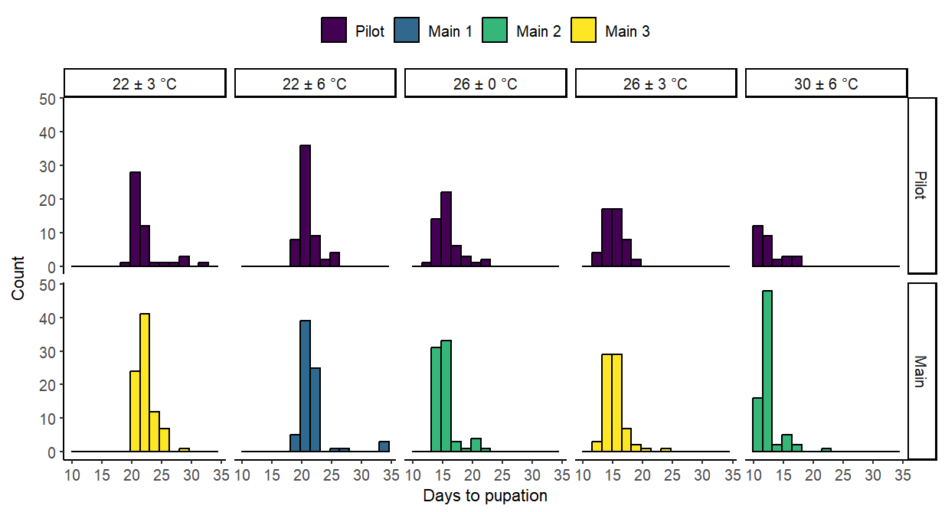
Figure 2-S6: Histograms of development times (days) between hatching and pupation of cohorts in the pilot study (top) and the main experiment (bottom) for the five temperature treatments. Different cohorts are indicated by different plot colors.

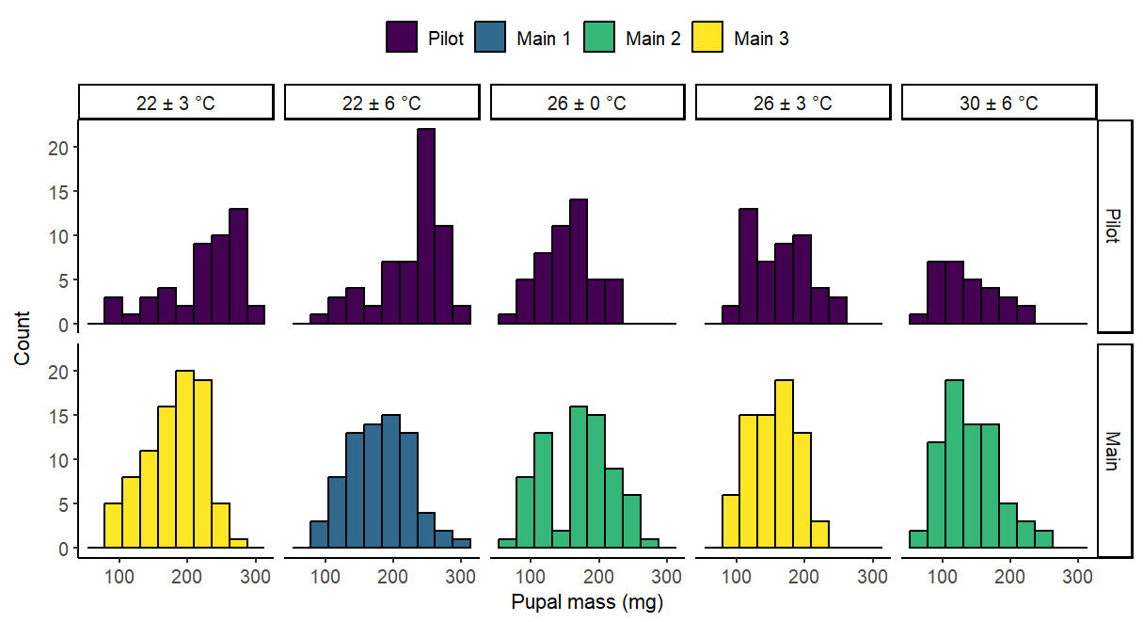
Figure 2-S7: Histograms of pupal masses of cohorts in the pilot study (top) and the main experiment (bottom) for the five temperature treatments. Different cohorts are indicated by different plot colors.

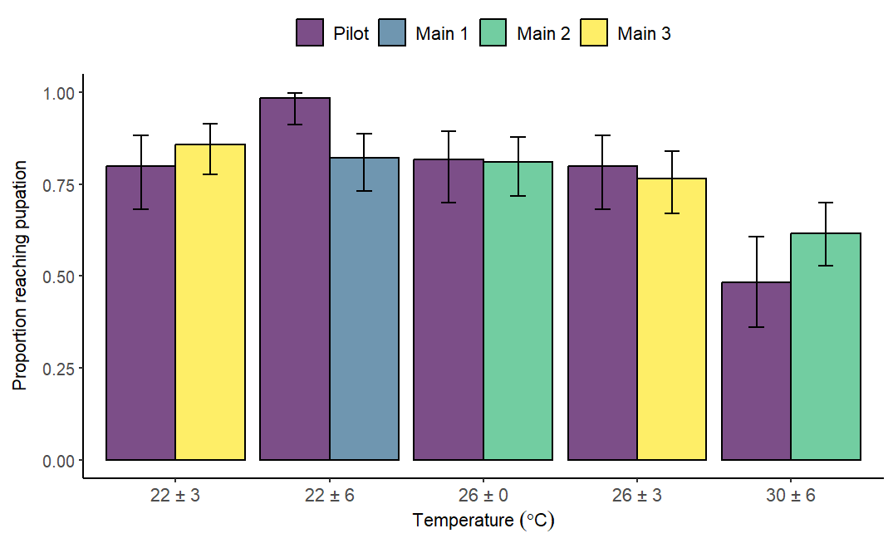
Figure 2-S8: Proportion of larvae surviving to pupation for cohorts in the pilot study and the main experiment for the five temperature treatments. The color of each bar corresponds to a particular cohort (see legend).

: Impacts of temperature variability on population growth rates in Spodoptera frugiperda

1. INTRODUCTION
Climate change is expected to impact insect populations through increases in average temperatures as well as changes in temperature variability. Under climate warming, insect populations in the tropics are generally expected to decline as even minor temperature increases may exceed upper performance thresholds and result in demographic attritions (Deutsch et al., 2008; Diamond et al., 2012; García-Robledo and Baer, 2021), while some temperate insect populations are expected to increase (Musolin, 2007; Ju et al., 2015; Deutsch et al., 2018; Pureswaran et al., 2019; Wagner et al., 2021). Changes in temperature variability have also been linked to altered growth rates and increased extinction risks of insect populations across latitudes, particularly for mid-latitude species during the warmer months (Kingsolver et al., 2013; Duffy et al., 2022). Moreover, climate warming may exacerbate the effects of daily temperature variation, even if the amplitude of variation does not change, since the effects of fluctuations may depend on the range over which temperatures fluctuate (Lawson et al., 2015). Therefore, research into the consequences of environmental change for insect populations should consider the consequences of concurrent changes in temperature means and variance (Vasseur et al., 2014).
Though temperature variability may alter the vital rates that underpin insect demography (Colinet et al., 2015), many predictive models of insect populations are based on measurements of life history traits under constant temperatures that do not reflect the fluctuations insects experience in their natural environments (Denny, 2017; Rebaudo and Rabhi, 2018; Buckley et al., 2018). The relationships between temperature and fitness-associated traits, such as survival, development and fecundity, are nonlinear and often asymmetric (Angilletta, 2006; Damos and Savopoulou-Soultani, 2012; Sinclair et al., 2016). Consequently, the values of these traits under variable temperatures may differ considerably from their expected values under a constant environmental temperature at the same mean. This property of nonlinear temperature performance functions is often referred to as Jensen’s inequality (Denny, 2017; Ruel and Ayres, 1999). In addition, exposure to temperature fluctuations may change the energetic costs organisms sustain relative to static temperatures, due to plastic mechanisms such as hardening (Folguera et al., 2011; Kingsolver and Woods, 2016) and acclimation (Williams et al., 2012; Bozinovic et al., 2013) as well as opportunities to accrue energetic costs or recover from thermal stress-related damage (Vajedsamiei et al., 2021; Kefford et al., 2022). These time-dependent physiological effects of fluctuations may explain why the observed performance of poikilothermic invertebrates in fluctuating environments often differs from predictions based on the nonlinear averaging of rates measured under constant temperatures (Kingsolver et al., 2015; Vangansbeke et al., 2015; Marshall et al., 2021). Indeed, previous studies report considerable variation in projected population growth rates between insects exposed to temperature fluctuations over their lifespans and insects held in static thermal environments at the same mean temperature, although the nature of these differences depends on the species and the range of temperatures used (Bozinovic et al., 2011; Carrington et al., 2013; Zhao et al., 2015; Cheng et al., 2018).
Clarifying the effects of long-term fluctuations on insect population dynamics for more species and under a wider range of environmental conditions could therefore benefit our overall understanding of how insects may fare under climate change. In particular, more populations may be exposed to heat stress and temperatures in the upper range of species’ thermal niches in the coming decades (Pigot et al., 2023). When organisms are regularly exposed to heat stress during diurnal fluctuations, we expect life history trait values and population dynamics to deviate even more from predictions based on constant temperature experiments (Ma et al., 2021; Slein et al., 2023). However, apart from critical thermal maxima, relatively few measurements of biological rates tend to be made in these upper ranges of thermal performance curves, beyond thermal optima (Kingsolver and Buckley, 2017). Investigating organismal performance in the tails of thermal distributions and quantifying the sublethal impacts of stressful high temperatures may help resolve the effects of thermal variability on insect biodemography.
Understanding how temperature variability affects insect pests is a particularly relevant problem, since the success of insect pests is often attributed to aspects of their life-histories (Wu et al., 2022), such as their fast and plastic generation times. An unresolved question for some widespread pest species is how diurnal temperature fluctuations across a range of average temperatures could affect the growth of their populations. García-Carreras and Reuman (2013) hypothesized that populations close to or in their optimal thermal environments are more likely to be affected by changes in variability than changes in mean temperatures, with pest populations likely benefitting from these changes. Others caution that the impacts of warming and variability on pests are complex and heterogeneous across species and geographies (Lehmann et al., 2020). We focus on the noctuid moth, Spodoptera frugiperda, which has in recent years spread beyond its native range in the Americas and successfully established in sub-Saharan Africa, Asia and Oceania (Kenis et al., 2023). The outsized economic impacts of this species and its presence across many ecoregions have made it a focus for several modelling efforts (Barfield et al., 1978; Ramirez-Cabral et al., 2017; Du Plessis et al., 2018; Garcia et al., 2019; Adan et al., 2024). However, many of these predictive models of S. frugiperda abundance and distribution have been parametrized using data from constant temperature experiments (Barfield and Ashley, 1987; Clavijo A et al., 1991; Garcia et al., 2018; Adan et al., 2024).
Our previous investigation of S. frugiperda life history showed that exposure to realistic temperature fluctuations across the lifespan can significantly alter survival to maturity, development rates and the number of viable offspring per female relative to constant environments with the same mean temperature (see Chapter 2). Importantly, the impacts of temperature variability differed across biological rates and life stages. In the current study, we employed tools from demography to synthesize these heterogenous effects and understand the overall consequences of variable temperatures for the population (in the absence of other limiting factors such as parasitism, predation and competition). We used measurements of S. frugiperda survival, stage durations and fecundity from our previous experiment to parametrize stage-structured matrix population models for nine temperature regimes, which were different combinations of three mean temperatures and three fluctuation amplitudes. From each matrix, we determined λ, the long-term growth rate for a stable population (i.e. a population with a relatively constant proportion of individuals in each stage). We then analyzed these models using a combination of prospective and retrospective approaches to address the following questions:
- How does daily temperature variability affect long-term population growth rates at different mean temperatures?
- What demographic processes drive the differences in expected population growth rates with increasing diurnal temperature range?
- Within each temperature regime, which life stage transitions represent the largest potential influences on population growth rates? In other words, to which stage transitions is the long-term population growth rate most sensitive or elastic, and does this depend on temperature?
Since the effects of temperature variability on several S. frugiperda life-history traits depend heavily on the mean temperature (Chapter 2), we hypothesized that diurnal fluctuations would influence population growth most at the warmest mean temperature of 30°C and least at an intermediate mean temperature of 26°C. We expected large fluctuations to increase population growth rates relative to constant temperatures at a mean of 22°C, primarily by increasing fecundity and the proportion of viable eggs. Conversely, we expected fluctuations to negatively affect population dynamics at a mean of 30°C by reducing survivorship of later larval and pupal stages, since S. frugiperda individuals that survive to maturity spend most of their lifespan in these stages.

2. METHODS
2.1. Data collection
We collected all life history information required to parametrize the models during the experiment detailed in Chapter 2 Section 2.2, except for the duration of the egg stage, which we approximated from the literature (Table 3-1). Briefly, we reared Spodoptera frugiperda (J. E. Smith, 1797) from eggs under nine temperature treatments, which were combinations of three mean temperatures (22, 26, 30 °C) and three amplitudes of diurnal temperature variation (±0, ±3, ±6 °C, hereafter “constant”, “low fluctuation”, and “high fluctuation”, respectively). We simulated these temperature regimes in incubators programmed to fluctuate sinusoidally between specified maximum and minimum temperatures. We chose fluctuation treatments that were representative of daily variation in ambient temperatures in regions and during seasons that support the presence of S. frugiperda (Early et al., 2018). Selected temperature regimes also represented different regions of the thermal performance curves for development time for this species, from temperatures considered to be optimal to regimes that approach lower and upper performance thresholds (Ali et al., 1990; Du Plessis et al., 2020; Ashok et al., 2021; Huang et al., 2021; Malekera et al., 2022; Chen et al., 2022).
Eggs used in this experiment were sourced from a mass-reared stock colony (Benzon Research Inc.) held at 26-29 ℃ that had been established using a strain collected from the USDA-ARS Station in Stoneville, Mississippi (USA). During the first phase of the experiment, we followed individuals in our temperature treatments from egg hatch to adult eclosion, tracking the duration of each developmental stage or instar in days and survival outcomes for each individual. During the second phase of the experiment, we formed breeding pairs of newly emerged adult males and females within each temperature treatment and monitored survival and time to oviposition for each female. Additionally, we monitored a subset of females within each treatment for egg laying and egg hatch rates. We collected eggs from these females every two days from eclosion, placed the eggs in sealed Ziploc bags and returned them to their treatment incubators for a seven-day period to monitor hatch success. We kept a separate tally of any eggs that we could not collect from the container (for instance, if moths laid eggs directly on the plastic surface such that we could not move them without risk of rupture). Total eggs and total hatches for each 2-day interval were calculated as described in Chapter 2, Section 2.2.2. To ensure that we allowed sufficient time for mating, we excluded from this subset and from our parameter estimates any females that did not overlap with their paired males for at least two nights and that had also not oviposited by the first day following eclosion.
2.2. Model setup and parameter estimation
Our previous results show that the effects of changing mean temperature or variability vary across performance traits and life stages of S. frugiperda (see Chapter 2). Stage-structured matrix population models (MPMs) allow us to translate these effects into consequences for population-level fitness and analyze the importance of specific demographic transitions (Caswell, 2001). These models are especially suited to studying the dynamics of holometabolous insects, since they enable us to divide the population into distinct life stages with separate stage-specific demographic rates. For each temperature regime, we constructed a 5 × 5 projection matrix, with each matrix dimension representing a life stage and each matrix element representing the probability of transitioning between life stages or the expected production of offspring over a single time step. The time step (projection interval) of each model was 1 day. Our simple MPMs make a few key assumptions: notably, they are deterministic (i.e. assume constant demographic rates) and density-independent.
Our models included five life stages: eggs, early-stage larvae (first and second larval instars), late-stage larvae (remaining larval instars), pupa, and reproductive adult. We separated early and late larval stages due to differences in observed mortality between these stages (Appendix 2) and due to potential differences between these stages in microhabitat preferences and behavior (for instance, early-stage larvae may feed in groups, whereas late-stage larvae are often solitary and cannibalistic) (Prasanna et al., 2018). In our experiment, pupae that eclosed as adults during a time step were only paired and given an opportunity to reproduce in the following time step. Our observations and data on time until initial oviposition (Fig. 3-S1) suggests that individuals were able to mate during the first time step after pairing, so we did not include a separate pre-reproductive stage in the model.
For each stage in the model, we calculated or estimated the proportion of individuals in each treatment that survived the stage as well as the average rate at which individuals matured from the stage (generally, as the mean of the inverse of individual stage durations) (details in Table 3-1). Our MPM focused on tracking the growth rates of the female population and assumed a 1:1 female: male ratio among offspring. Thus, we used pupal and adult stage survival and development rates from females only. Until pupation, development rates were either similar between sexes or we could not obtain female-specific rates as we could only identify sex in pupae onwards (Chapter 2).
The final stage in the model corresponds to the period when adult females are assumed to be reproductively active. In general, we observed declines in the daily number of eggs laid and steep declines in the number of larvae hatching from these eggs as females aged (Fig. 3-S2). Moreover, eggs collected towards the end of a female’s lifespan may have not been fertilized (for instance, after the death of the paired male). Therefore, we estimated the mean reproductive period in a treatment using data from females laying eggs that successfully hatched. For each such female, we estimated the reproductive period as the number of days between the date they were paired and the last collection date yielding a sample that contained hatched larvae. We then calculated daily fecundity for these females as the total number of eggs laid during the reproductive period divided by the length of the reproductive period. Further details about how we estimated mean daily fecundity and egg survivorship for other categories of females are in Table 3-2. We did not include a post-reproductive stage in our MPM since post-reproductive females do not contribute to population growth. Moreover, excluding this category makes the long-term behavior of the model and its insights into demographic processes independent of initial population structure, as long as that initial population includes individuals in other stages.

Table 3-1: Sources of life history information for the matrix population models.
Stage | Life history trait
Egg | Stage duration (T_{e}): we did not collect egg development times due to time constraints during the experiment. Instead, we approximated egg development times for each mean temperature using a model proposed by Ali et al. (1990), which was parametrized using data from S. frugiperda collected near the USDA-ARS station in Mississippi. The model adequately described the linear relationship between egg development time and temperatures in the range 18 – 32 °C and is given by: $Y = -0.318+0.025X$, where $X$ is the temperature (°C) and $Y$ is the development rate (days⁻¹). We assumed the same T_{e} for all fluctuation levels at a given mean temperature.  Daily fraction maturing from stage (γ_{e}) = 1/T_{e}. For all life stages, γ was approximated from stage durations as discussed in Section 6.4.1 of Caswell (2001).  Stage survivorship: Proportion of eggs that hatched out of the total number of eggs laid by reproductive females in each treatment.
Larva (instars 1 and 2) | Stage duration (T_{l}): Duration of the first and second instar for each individual in days.  Daily fraction maturing from stage (γ_{l}) = 1/T₁, averaged across all larvae surviving to instar 3.  Stage survivorship: Proportion of all neonates that survive to the third instar.
Larva (instars 3-6, prepupae) | Stage duration (T_{L}): Number of days between the transition to larval instar 3 and pupation for each individual.  Daily fraction maturing from stage (γ_{L}) = 1/T_{L}, averaged across all surviving pupae (excluding abnormal pupae, see Chapter 2).  Stage survivorship: Proportion of all third instar larvae that survive to normal pupation.
Pupa | Stage duration (T_{p}): Number of days between pupation and successful eclosion for each female.  Daily fraction maturing from stage (γ_{p}) = 1/T_{p}, averaged across females that successfully eclose as adults.  Stage survivorship: Proportion of normal female pupae that eclose completely.
Reproductive adult | Reproductive period duration (T_{r}): Number of days between the recorded eclosion date and the last collection date yielding a sample that contained hatched larvae, for each female laying eggs that successfully hatched.  Daily fraction maturing from stage (γ_{r}) = 1/T_{r}, averaged across all females laying eggs that hatched into larvae.  Fecundity: Mean daily fecundity during the reproductive period, averaged across females. Daily fecundity was calculated as the total number of eggs laid by a female during the reproductive period divided by the length of the reproductive period. If a reproductive period duration was not calculated for an individual female, we assumed this to be the mean reproductive period duration in that temperature regime (Table 3-2).

Table 3-2: Source of data for variables relevant to reproduction by adult females.
We obtained information on eggs laid and eggs hatched from most of the females that we followed for egg production and hatching. Some females did not produce any eggs that hatched, and a few laid no eggs altogether over their lifetime. Hatch records were incomplete for three females (although we obtained complete egg tallies for these females, we did not monitor enough eggs during the reproductive period to confidently assess hatch rates). The table below shows which data we included in calculating treatment means for each variable related to reproduction. Included = data from these females were included in calculating the treatment average. Value undefined/ not available = we could not include data from these females in the treatment average.
Subset of adult females | Variable
Subset of adult females | Potential adult reproductive period (days) | Daily egg production per female | Proportion of eggs that hatch into larvae
Complete egg count and record of successful hatches | Included | Included | Included  (total eggs, total hatches)
Complete egg count, incomplete record of hatches | Value undefined/ not available  For these females, mean reproductive period was assumed to be the treatment average. | Included | Value undefined/ not available
Complete non-zero egg count, no successful hatches | Value undefined/ not available  For these females, mean reproductive period was assumed to be the treatment average.* | Included | Included  (total eggs, total hatches = 0)
No eggs laid, no hatches | Value undefined/ not available  For these females, mean reproductive period was assumed to be the treatment average.* | Included  (daily eggs = 0) | Value undefined
* Our methods did not allow us to evaluate why these females did not lay eggs or produce any eggs that hatched; for instance, since we did not monitor mating behavior or dissect females to determine whether spermatophores were present in the bursa copulatrix, we could not confirm or rule out whether these females mated with their paired males or whether these eggs were fertilized.
Using the life history information in Table 3-1, we calculated the following vital rates for each life stage $j$:
- Gamma ($γ_{j}$) = the probability of graduating from stage $j$ to stage $j+1$ within a time step = daily fraction maturing from each stage (Caswell 2001, Section 6.4)
- Sigma ($σ_{j}$) = daily stage survival, calculated from stage survivorship as $({Stage survivorship)}^{\frac{1}{\overline{T_{j}}}}$, where $\overline{T_{j}}$ is the mean stage duration for a stage $j$
- $G_{j}$ represents the probability of transitioning from stage $j$ to stage $j+1$ during a time step. $P_{j}$ represents the probability of remaining in the same stage over the time step. For egg to pupal stages, $G_{i}$ = $σ_{i}$ $γ_{i}$ and $P_{i}$ = $σ_{i}$ $(1-γ_{i})$. For the reproductive adult stage, $γ_{r}$ represents the fraction of individuals leaving stage $r$ during a time step, either to enter the post-reproductive stage or due to mortality. Therefore, $P_{r}$ = $1-γ_{r}$
- Fecundity ($F_{r}$) = $P_{r} (0.5×Daily fecundity)$. Since our model tracks female population growth, we considered only the proportion of offspring that are female in the calculation. We assumed the ratio of female: male offspring to be 0.5 in all treatments, since sex-determination is not expected to be temperature-dependent in this species. Most mating happens in early evening with oviposition following soon after (Simmons and Marti, 1992; Montezano et al., 2019). Because we checked adults in the morning, we assumed that fecundity during a time step was conditional on the female’s persistence in the reproductive stage until the end of the time step (akin to a “birth-pulse” design; Equations 6.142 and 6.143 in Caswell, 2001).
The resulting projection matrices followed the general form below. Each matrix element $a_{ij}$ (i.e. each element in the i^{th} row and j^{th} column) corresponds to the average number of individuals in stage i contributed by an individual in stage j over one time step (i.e. 1 day). The matrix elements correspond to transitions or “arcs” between stage classes (“nodes”) in the life cycle model of Spodoptera frugiperda (Fig. 3-1).
$$A=\left(\begin{matrix}P_{e} & 0 & 0 & 0 & F_{r} \\ G_{e} & P_{l} & 0 & 0 & 0 \\ 0 & G_{l} & P_{L} & 0 & 0 \\ 0 & 0 & G_{L} & P_{p} & 0 \\ 0 & 0 & 0 & G_{p} & P_{r}\end{matrix}\right)$$
Note that we do not include a fecundity term in the column corresponding to the pupal stage, since we assume that maturing pupae cannot reproduce during the timestep that they eclose in, allowing time for wing expansion and drying post-emergence. In our experiment, pupae were held in individual containers and only paired shortly after eclosion, so they could not access mates during that time step.
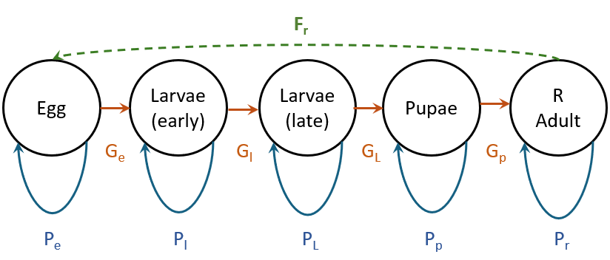Figure 3-1. Life cycle model of Spodoptera frugiperda. Solid arrows indicate survival transitions whereas dashed arrows indicate fecundity transitions.

2.3. Analyzing long-term (asymptotic) population dynamics under different temperatures
Per our MPMs, the population at time $t+1$ is given by:
$$n\left(t+1\right)=An(t)$$
where A is the 5 $×$ 5 stage-based projection matrix and $n(t)$ and $n\left(t+1\right)$ are vectors containing the numbers of individuals in each life stage, at the specified time point. The dominant eigenvalue (λ) of the projection matrix A is the asymptotic population growth rate. That is, λ is the long-term finite rate of population increase over one time step for a population that has reached an equilibrium such that the proportion of individuals in each life stage remains constant. This long-term relative abundance of different life stages is the stable stage distribution. We obtained dominant eigenvalues (λ), stable stage distributions and stagewise reproductive values for all nine projection matrices as all matrices were primitive, irreducible and ergodic.

2.3.1. Identifying the demographic processes that explain observed differences or similarities in population growth rates across temperatures (Life Table Response Experiment)
Having determined how temperature variability may impact population growth rates, we then turned our focus to the mechanisms by which those impacts are achieved. Population growth may be more sensitive to changes in some biological rates than others, suggesting that small differences in life-history traits between treatments may have large effects on λ. Changes to demographic rates may also have counteracting effects on λ, such increased temperatures and variability may alter survivorship, development rates or fecundity but result in similar λ – for instance, if poor survivorship during the larval stage is offset by faster times to maturity. Life table response experiment (LTRE) analyses allow us to decompose the effects of temperature regime on population growth rates into contributions from different demographic rates represented in the matrix (Caswell, 1989).
We performed one-way fixed LTREs to decompose the difference in λ between fluctuation levels at each mean temperature into contributions from each stage-specific vital rate. For each mean temperature, we measured the effects of low and high fluctuations against the projection matrix for the corresponding constant temperature regime, which served as the reference matrix in each comparison. Contributions from each matrix element were calculated by multiplying the difference in each matrix element (a_{ij}) between the reference matrix and the fluctuation treatment matrix by the sensitivity of that element in the midway matrix, ($A^{constant}+A^{fluctuation}$) /2 (Caswell, 2001). Therefore, contributions reflect both the difference in trait values between treatments and the sensitivity of λ to incremental changes in each trait.

2.3.2. Analyzing the elasticity of population growth rates to different life stages
We also conducted prospective analyses with the goal of understanding which life stages have the largest potential influences on population growth, and whether the most influential stages change with warming or increased temperature variability. That is, under each set of temperature conditions, which stage-specific vital rates, if altered, would result in the largest change in λ? Analyses of projection matrices for each temperature regime yielded sensitivities (the effect on the population growth rate, δλ, of a small absolute change in a matrix element, δ$a_{ij}$, holding other elements constant) and elasticities (the proportional change in λ following a proportional change in $a_{ij}$, i.e. the proportional sensitivities) (Caswell, 2019). For a given treatment, we summed elasticities for each stage to understand the relative importance of each stage for population growth within that environment. Comparing these elasticities could be insightful for a species that is regularly targeted for control in some stages.
All demographic analyses were conducted in R version 4.4.1 (R Core Team, 2024) using the popbio (Stubben and Milligan, 2007) and popdemo (Stott et al., 2025) packages.

3. RESULTS
Vital rates used in the models, together with associated standard errors and sample sizes, are given in Appendix 2 Tables 3-S1 through 3-S5. Final projection matrices for the nine treatments are listed in Appendix 3 Tables 3-S6 through 3-S14.

3.1. Long-term population dynamics under different temperatures
Long-term population growth-rate (λ) ranges from 1.094 to 1.362 across treatments (Fig. 3-2a), with the highest rate projected for 26 ± 6 °C and the lowest for 30 ± 3 °C. Populations that attain a stable demographic structure are expected to increase over time under all temperature conditions investigated in the study, given the assumptions of our model (Fig. 3-2b). The effect of fluctuation magnitude on λ varies by mean temperature. Large fluctuations around an intermediate mean temperature of 26 °C increase population growth rates by around 6%. Conversely, fluctuations around the warmest mean temperature of 30 °C decrease rates of population growth by close to 17% with low fluctuations and 7% with high fluctuations. Fluctuations around a mean temperature of 22 °C alter population growth rates by less than 4.3%.
Despite noticeable differences in expected rates of population increase, there is little difference between most temperatures in the stable stage distribution (i.e. the long-term relative abundance of life stages). Under stable population dynamics, populations under all conditions except 30 ± 3 °C should comprise of 51 – 58 % eggs, 22 – 28 % early-stage larvae, and 13 – 17% late-stage larvae, with pupae (2 – 4 %) and reproductive adults (1 % or less) being the least abundant life stages (Table 3-S15). Conversely, at 30 ± 3 °C, eggs and both larval stages should be similar in relative abundance (23 – 30%), with pupae and adults making up a higher proportion of stable populations under these conditions relative to other temperatures.

a)
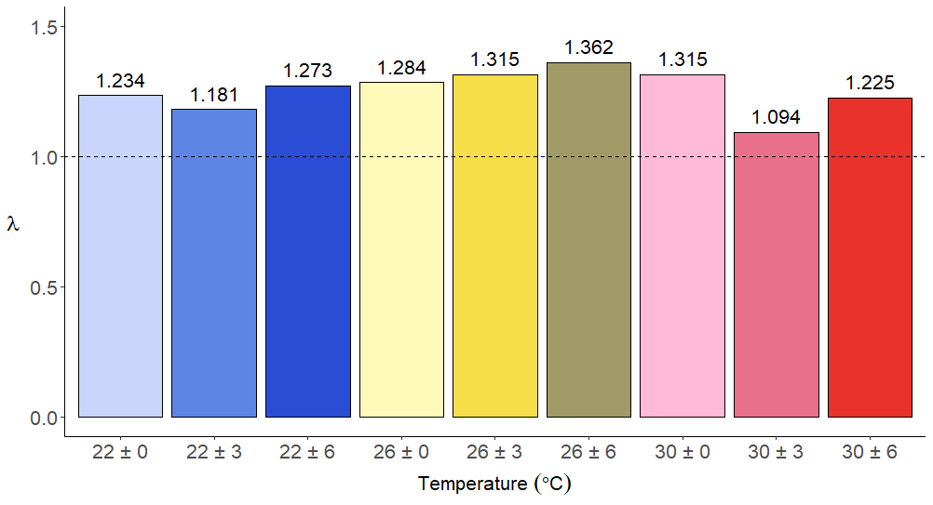
b)
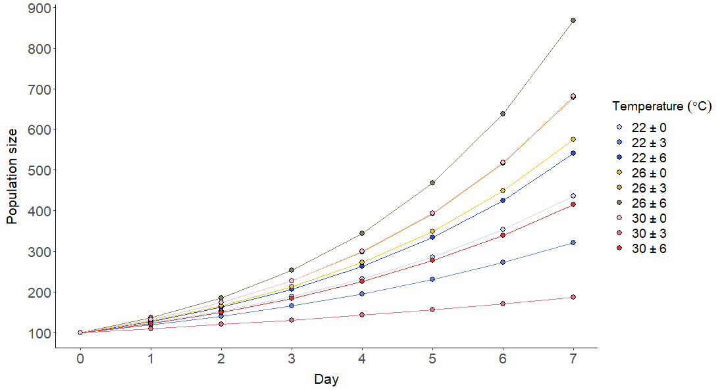
Figure 3-2: Projected long-term S. frugiperda population growth rates under different mean temperatures and fluctuations. a) Barplot showing changes in λ with increases in mean temperatures and diurnal fluctuation. b) Expected increases in the size of an equilibrium population (of 100 individuals on Day 0) under different temperature conditions, according to our models.
3.2. Retrospective and prospective analyses
Our LTRE analyses show that temperature fluctuations will alter population growth rates relative to constant mean temperatures primarily by changing fecundity, the length of the female reproductive period and egg survivorship (Fig. 3-3). The increase in λ with high fluctuations at a mean temperature of 26 °C is largely explained by increases in the proportion of eggs hatching (stasis and growth) and by a small increase in the persistence of adult females in the reproductively active period (stasis). Changes in projected population growth rates with fluctuations around mean 22 °C also appear to be due to decreased fertility (with low fluctuations) and increased egg survivorship (with high fluctuations). A steep decline in expected fecundity and a shorter reproductive adult stage underlies the reduction in projected population growth rates with a moderate increase in diurnal variability (30 ± 3°C) from constant 30 °C.
Other life stages play a bigger role in reducing population growth rates with a larger increase in diurnal temperature variation around the warmest mean temperature (30 °C). While the largest contribution to decreased λ in 30 ± 6°C is still from reduced fertility, lower growth of late-stage larvae and stasis of pupae contribute more to this decrease than these processes do to changes between other temperatures.

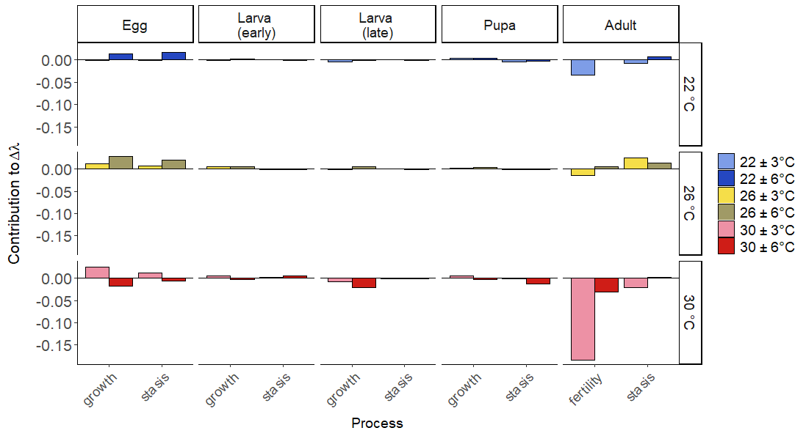Figure 3-3: Life table response experiment (LTRE) contributions of vital rates in each life stage to changes in projected S. frugiperda population growth rates (λ) between constant temperature environments and fluctuating temperature environments with the same mean temperature.

Contributions reflect from a fixed LTRE reflect both differences in vital rates between treatments and the sensitivity of λ to changes in those rates. The effects of temperature variability on λ in our study appear to arise from large differences in stasis and growth in the egg and adult stage and in fecundity (Fig. 3-4), despite low sensitivity to changes in egg stasis and growth and fecundity across all temperature regimes.
Within each temperature condition, elasticity analyses show that the long-term population growth rate is most elastic to demographic transitions within and from the late larval and pupal stages (Fig. 3-5). For most treatments, the next-highest elasticities are to transitions from the reproductive adult stage, and the lowest elasticities are associated with the earliest life stages. Reducing stasis within and growth from the late larval stage by 1% would change λ by 0.23 – 0.29%, whereas a similar 1% perturbation of transitions from the egg stage leads to only a 0.11 – 0.15 % change in λ. The similarity across most temperatures in which processes have the largest potential impact on λ may be explained by the similarities in expected population structures and in the value of late-stage larvae and pupae as seeds for population growth (Tables 3-S15 and 3-S16).
Elasticity patterns in some temperature regimes showed a few subtle deviations from the general trend. Under low fluctuations at the warmest mean temperature (30 ± 3 °C), the total elasticity associated with reproductive adult stasis and fecundity is especially low, such that the population growth rate is twice as responsive to late-stage larval or pupal vital rates versus adult vital rates. Also, population growth is more elastic to changes in stasis and growth from the egg stage when mean temperatures are moderate and diurnal temperature variation is high (22 ± 6 °C and 26 ± 6 °C) than when mean temperatures are high (30 °C) or when temperatures are less variable. Under variable but moderate temperatures, the proportion of eggs hatching into early-stage larvae is considerably higher than in other treatments (Table 3-S1), therefore individuals in the egg stage are more likely to survive to maturity and contribute to population growth.

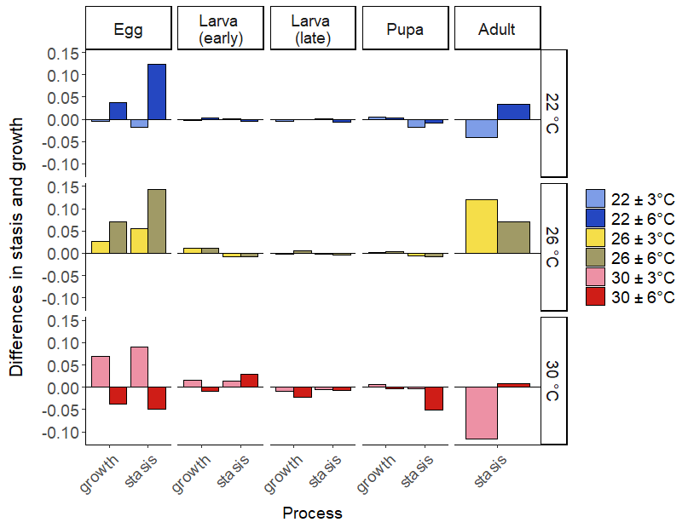
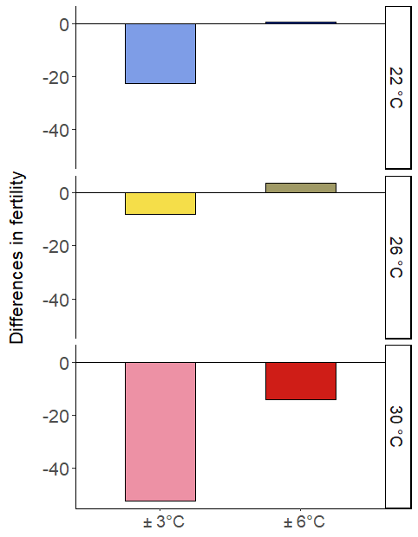
Figure 3-4: Changes in stage-specific vital rates (matrix elements) with increasing fluctuation magnitude, relative to constant mean temperatures.

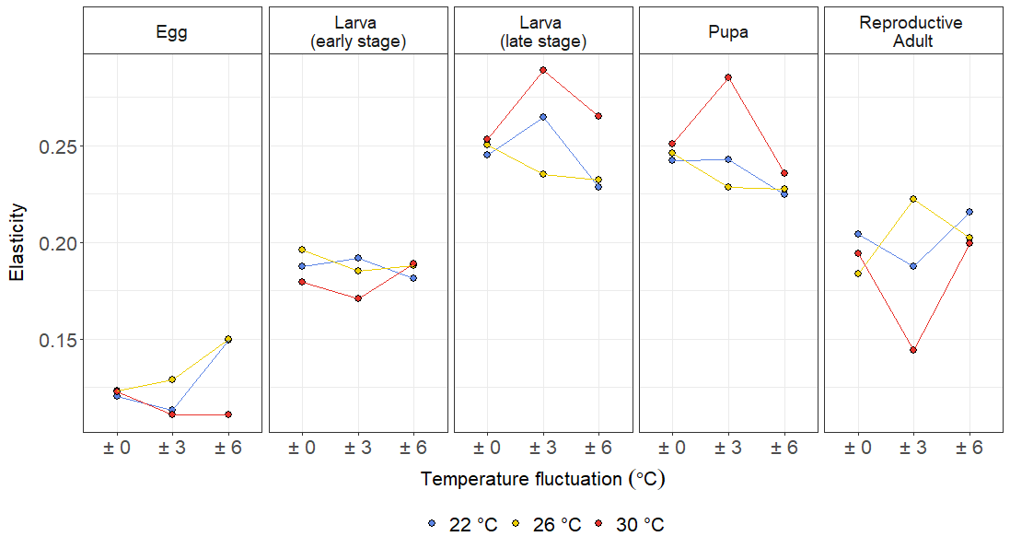
Figure 3-5: Total elasticities of λ to demographic processes in each S. frugiperda life stage for the nine temperature treatments. For readability, stage-summed elasticities for different fluctuation levels at the same mean temperature are connected by solid lines (blue = 22 °C, yellow = 26 °C, red = 30 °C).

4. DISCUSSION
Our goal was to understand how daily temperature variability can affect Spodoptera frugiperda population growth rates at different mean temperatures characteristic of its range. To do this, we used life history data from S. frugiperda individuals that had been exposed to fluctuating temperatures over their lifespans to parameterize stage-structured matrix population models. By doing so, we were able to incorporate time-dependent physiological effects of temperature fluctuations (for instance, accumulated physiological damage and recovery) into our estimates of survival, development and fecundity rates, and ultimately translate these into measures of population-level fitness. We found that whether diurnal temperature variability increases or decreases population growth rates relative to constant temperatures depends on the mean temperature of the environment, as we expected from our previous findings. Fluctuations around 30°C are projected to reduce λ, whereas fluctuations around 26 °C increase expected λ. These results align with theoretical predictions that increased temperature variability would decrease upper thermal performance thresholds, resulting in decreased population growth rates at warmer environmental mean temperatures (Estay et al., 2014).
Our results also partially agree with meta-analyses of organism-level responses to temperature fluctuations, which find more negative impacts on organisms at warmer mean temperatures and when the amplitude of fluctuation is larger (Slein et al., 2023; Stocker et al., 2024). Indeed, the effect of temperature fluctuations on population growth rates in our study is most pronounced at the warmest mean temperature of 30°C and least evident at 22 °C. However, the largest reduction in population growth rate relative to constant temperatures occurs with low fluctuations (30 ± 3 °C), and not large fluctuations (30 ± 6 °C). It is possible that larger fluctuations around 30°C are more conducive to reproduction and survival in S. frugiperda adults, as cooler nighttime temperatures and lower daily minima may facilitate physiological recovery from heat stress experienced during the day. Moreover, “diel narrowing” may result in individuals limiting their activity to periods with more optimal temperatures for reproduction, which are generally described to be lower than optima for survival and development rates (Kefford et al., 2022). More research into the physiological consequences of repeated, intermittent thermal stress and activity patterns under fluctuating temperatures may reveal whether these mechanisms are indeed at play in S. frugiperda exposed to variable summer temperatures.
Across mean temperatures, changes in fecundity, the duration of reproductive period for adult females and egg hatch rates drive the differences we observe in population growth rates with increasing diurnal temperature range. Identifying these underlying demographic processes allows us to draw more useful conclusions. If the primary mechanism through which temperature variation reduces population growth is through effects on the adult and egg stage, then S. frugiperda field populations may be able to avoid these effects and maintain higher rates of growth if adults can disperse to and oviposit in cooler and less variable environments. However, with larger fluctuations around 30°C, reduced survival and development rates in the larval and pupal stages become more important in explaining declines in population growth rates alongside impacts on the adult stage. Therefore, in warmer parts of S. frudiperda’s current range, increases in variability may indeed lead to reduced population growth in situ due to these broader impacts across life stages.
Our results support a broader argument that declines in fecundity and the proportion of viable offspring may be the most important constraints on population growth under projected climate change. Indeed, thermal fertility limits, which are generally lower than survival limits, may be even more closely related than the latter to population viability and species geographic range limits (Walsh et al., 2019; van Heerwaarden and Sgrò, 2021). Yet, among systematic investigations of how thermal variability affects biological rates, many focus on developmental rates, with fewer studies measuring impacts on reproduction (Slein et al., 2023). Therefore, focusing on how thermal variability could alter insect reproduction could improve forecasts of future population trends based primarily on lethal limits.
While temperature fluctuations did not impact vital rates for S. frugiperda larvae and pupae to the same extent as for eggs and adults, the highest stage-summed elasticities in all treatments were associated with the late larval stage and pupal stages. This suggests that further changes in the survival or development of these stages could have a larger impact on population growth rates than proportional changes to survival, development and fecundity in other stages, regardless of environmental temperatures. Therefore, according to these results, population control strategies that manage to reduce survival or slow development in larvae and pupae may still be effective in reducing long-term population growth rates under warming and increasingly variable temperatures. The question moving forward is whether reducing those vital rates in the first place will become more challenging under projected climate change.
Our simple MPMs do not account for factors that may further limit S. frugiperda populations in the field. For instance, due to our experimental design, we could not incorporate density-dependence in our model. However, high population densities in the field likely reduce population growth rates, through intraspecific resource competition, larval cannibalism and increased disease transmission. Moreover, our deterministic MPMs do not account for the random changes in vital rates that may occur across time (for instance, with heat waves). Allowing vital rates to depend on the population size at each time step and incorporating environmental stochasticity into the models could be useful extensions (Caswell, 2001). By projecting long-term growth rates, we also assume that populations reach an equilibrium in which the relative abundance of different life stages stays consistent across time. However, in many locations, S. frugiperda populations are only present seasonally and may not reach a stable stage distribution until well into the season, unless dispersal events and other disturbances that affect life stages non-uniformly prevent them from reaching this equilibrium at all. Therefore, analyzing transient dynamics may be necessary for understanding population trends in some contexts (Ezard et al., 2010). Finally, we used data from controlled laboratory environments to parametrize these models; survivorship in the field, particularly for early-stage larvae, may be substantially lower than the rates presented here.
Nevertheless, our models are still useful for isolating the effects of temperature variability on the potential for population growth rates, and for understanding the mechanisms underlying these effects. The qualitative comparisons they enable among different temperature conditions provide insights into the ability of different climates to sustain large populations of S. frugiperda.

APPENDIX 1: SUPPLEMENTARY FIGURES
Figure 3-S1. Time (in days) between emergence and initial oviposition for each adult female observed during the breeding pair phase of the experiment as a function of temperature treatment. Each point represents the time to oviposition for an individual female. Eggs were observed in breeding pair containers 1 day after pairing in 4 treatments and 2 days after pairing in all others.
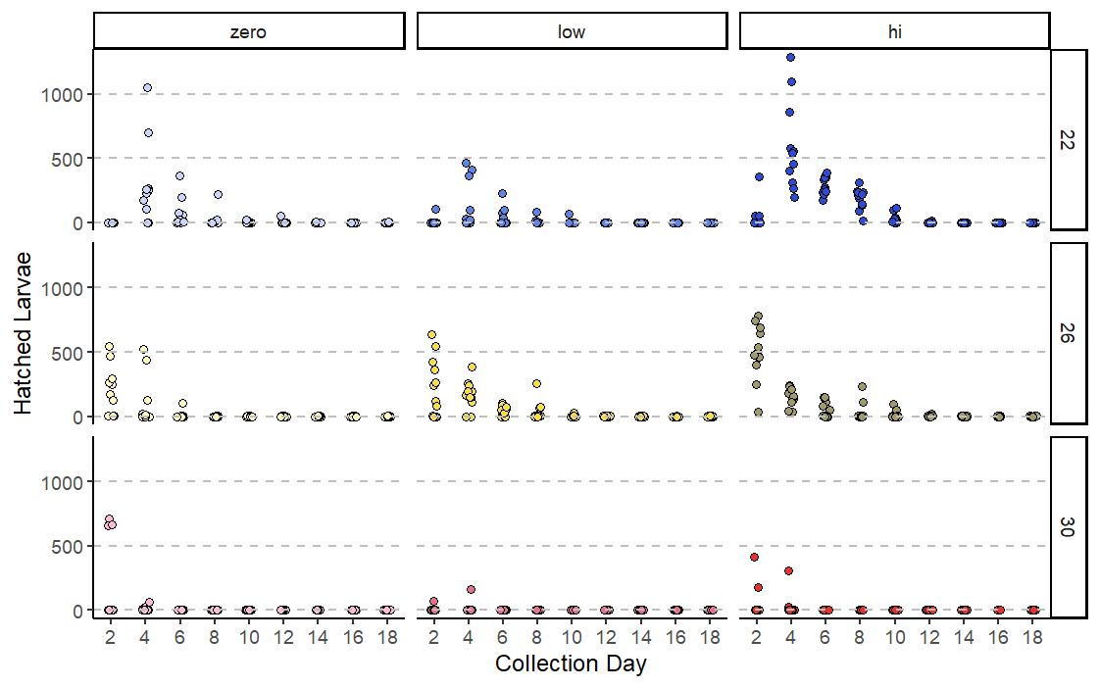Figure 3-S2. Number of eggs collected during each interval that eventually hatched into larvae. This number of successful hatches drops sharply after days 2-4 at 30°C, days 6-10 at 26°C and day 10 at 22°C.

APPENDIX 2: VITAL RATES

Table 3-S1: Vital rates for the egg stage
Temperature Regime | γ_{e} | Stage survivorship
22 ± 0 °C | 0.232 | 0.378853
22 ± 3 °C | 0.232 | 0.334653
22 ± 6 °C | 0.232 | 0.834694
26 ± 0 °C | 0.332 | 0.348885
26 ± 3 °C | 0.332 | 0.486929
26 ± 6 °C | 0.332 | 0.778346
30 ± 0 °C | 0.432 | 0.308271
30 ± 3 °C | 0.432 | 0.528736
30 ± 6 °C | 0.432 | 0.216466

Table 3-S2: Vital rates for the early larval stage (instars 1 and 2). SE = standard error of the mean (γ) or standard error of the proportion (stage survivorship). n = number of individuals.
Temperature Regime | Stage duration | γ_{l} | SE (γ_{l}) | n (γ_{l}) | Stage survivorship | SE (surv.) | n (surv.)
22 ± 0 °C | 6.088889 | 0.16455 | 0.000718 | 90 | 1 | 0 | 90
22 ± 3 °C | 6.142857 | 0.163265 | 0.000846 | 98 | 0.989899 | 0.01005 | 99
22 ± 6 °C | 5.944444 | 0.168624 | 0.000927 | 90 | 1 | 0 | 90
26 ± 0 °C | 4.534091 | 0.223485 | 0.002742 | 88 | 0.977778 | 0.015538 | 90
26 ± 3 °C | 4.319149 | 0.234043 | 0.002417 | 94 | 1 | 0 | 94
26 ± 6 °C | 4.311111 | 0.234444 | 0.002454 | 90 | 1 | 0 | 90
30 ± 0 °C | 3.126582 | 0.322785 | 0.003137 | 79 | 0.877778 | 0.034526 | 90
30 ± 3 °C | 3.045977 | 0.329502 | 0.001882 | 87 | 0.966667 | 0.018922 | 90
30 ± 6 °C | 3.321429 | 0.30744 | 0.003874 | 112 | 0.933333 | 0.022771 | 120

Table 3-S3: Vital rates for the late larval stage (instars 3 to prepupa). SE = standard error of the mean (γ) or standard error of the proportion (stage survivorship). n = number of individuals.
Temperature Regime | Stage duration | γ_{L} | SE (γ_{L}) | n (γ_{L}) | Stage survivorship | SE (surv.) | n (surv.)
22 ± 0 °C | 15.42683 | 0.065479 | 0.000659 | 82 | 0.911111 | 0.029998 | 90
22 ± 3 °C | 16.37647 | 0.06153 | 0.000571 | 85 | 0.867347 | 0.034264 | 98
22 ± 6 °C | 15.63514 | 0.065533 | 0.000951 | 73 | 0.811111 | 0.041259 | 90
26 ± 0 °C | 10.76712 | 0.095877 | 0.001488 | 69 | 0.784091 | 0.043861 | 88
26 ± 3 °C | 10.875 | 0.094316 | 0.001333 | 71 | 0.755319 | 0.044341 | 94
26 ± 6 °C | 10.22222 | 0.101315 | 0.001817 | 72 | 0.8 | 0.042164 | 90
30 ± 0 °C | 7.569231 | 0.133981 | 0.001822 | 65 | 0.822785 | 0.042962 | 79
30 ± 3 °C | 8.125 | 0.126616 | 0.002065 | 63 | 0.724138 | 0.047918 | 87
30 ± 6 °C | 9.189189 | 0.113672 | 0.001669 | 66 | 0.589286 | 0.046486 | 112

Table 3-S4: Vital rates for the pupal stage. SE = standard error of the mean (γ) or standard error of the proportion (stage survivorship). n = number of individuals.
Temperature Regime | Stage duration | γ_{p} | SE (γ_{p}) | n (γ_{p}) | Stage survivorship | SE (surv.) | n (surv.)
22 ± 0 °C | 13.4186 | 0.074714 | 0.000573 | 43 | 1 | 0 | 43
22 ± 3 °C | 12.40541 | 0.080403 | 0.000548 | 35 | 0.853659 | 0.055199 | 41
22 ± 6 °C | 12.75 | 0.07873 | 0.000866 | 27 | 0.931034 | 0.047054 | 29
26 ± 0 °C | 8.323529 | 0.119916 | 0.00142 | 32 | 0.969697 | 0.02984 | 33
26 ± 3 °C | 8.129032 | 0.12328 | 0.001172 | 30 | 0.9375 | 0.042791 | 32
26 ± 6 °C | 8.088235 | 0.123737 | 0.000706 | 33 | 0.942857 | 0.039235 | 35
30 ± 0 °C | 6.653846 | 0.151099 | 0.002265 | 26 | 0.928571 | 0.04867 | 28
30 ± 3 °C | 6.432432 | 0.156746 | 0.001984 | 36 | 0.947368 | 0.036224 | 38
30 ± 6 °C | 6.535714 | 0.156463 | 0.002635 | 21 | 0.636364 | 0.083739 | 33

Table 3-S5: Vital rates for the reproductive adult stage. SE = standard error of the mean. n = number of individuals.
Temperature Regime | γ_{r} | SE (γ_{r}) | n (γ_{r}) | Mean daily fecundity | SE (fecundity) | n (fecundity)
22 ± 0 °C | 0.132222 | 0.011484 | 10 | 131.7 | 15.70721 | 10
22 ± 3 °C | 0.173148 | 0.020449 | 9 | 83.75379 | 15.26383 | 11
22 ± 6 °C | 0.098485 | 0.004608 | 11 | 128.203 | 12.89298 | 11
26 ± 0 °C | 0.2625 | 0.04215 | 10 | 172.2386 | 35.32234 | 11
26 ± 3 °C | 0.141667 | 0.007538 | 11 | 128.9813 | 18.08127 | 12
26 ± 6 °C | 0.190909 | 0.018985 | 11 | 165.8909 | 21.33223 | 11
30 ± 0 °C | 0.3 | 0.05 | 5 | 162.75 | 29.78415 | 12
30 ± 3 °C | 0.416667 | 0.083333 | 3 | 16.09091 | 6.307217 | 11
30 ± 6 °C | 0.291667 | 0.11024 | 3 | 120.75 | 22.35504 | 8

APPENDIX 3: PROJECTION MATRICES
Table 3-S6: Projection matrix for 22 ± 6 °C
Stage at time t+1 | Stage at time t
Stage at time t+1 | Egg | Larva 1+2 | Larva 3+ | Pupa | R Adult
Egg | 0.736533141 | 0 | 0 | 0 | 57.696
Larva 1+2 | 0.222494386 | 0.831 | 0 | 0 | 0
Larva 3+ | 0 | 0.169 | 0.922034792 | 0 | 0
Pupa | 0 | 0 | 0.064626302 | 0.916168309 | 0
R Adult | 0 | 0 | 0 | 0.078261637 | 0.9015

Table 3-S7: Projection matrix for 22 ± 3 °C
Stage at time t+1 | Stage at time t
Stage at time t+1 | Egg | Larva 1+2 | Larva 3+ | Pupa | R Adult
Egg | 0.595895999 | 0 | 0 | 0 | 34.6513
Larva 1+2 | 0.18001025 | 0.835631067 | 0 | 0 | 0
Larva 3+ | 0 | 0.16273341 | 0.930368405 | 0 | 0
Pupa | 0 | 0 | 0.060967136 | 0.907969733 | 0
R Adult | 0 | 0 | 0 | 0.079383174 | 0.827

Table 3-S8: Projection matrix for 22 ± 0 °C
Stage at time t+1 | Stage at time t
Stage at time t+1 | Egg | Larva 1+2 | Larva 3+ | Pupa | R Adult
Egg | 0.613203324 | 0 | 0 | 0 | 57.288
Larva 1+2 | 0.185238504 | 0.835 | 0 | 0 | 0
Larva 3+ | 0 | 0.165 | 0.928860787 | 0 | 0
Pupa | 0 | 0 | 0.065104742 | 0.9253 | 0
R Adult | 0 | 0 | 0 | 0.0747 | 0.868

Table 3-S9: Projection matrix for 26 ± 6 °C
Stage at time t+1 | Stage at time t
Stage at time t+1 | Egg | Larva 1+2 | Larva 3+ | Pupa | R Adult
Egg | 0.614583802 | 0 | 0 | 0 | 67.147
Larva 1+2 | 0.30545183 | 0.766 | 0 | 0 | 0
Larva 3+ | 0 | 0.234 | 0.879546308 | 0 | 0
Pupa | 0 | 0 | 0.098814435 | 0.869668044 | 0
R Adult | 0 | 0 | 0 | 0.123103696 | 0.809

Table 3-S10: Projection matrix for 26 ± 3 °C
Stage at time t+1 | Stage at time t
Stage at time t+1 | Egg | Larva 1+2 | Larva 3+ | Pupa | R Adult
Egg | 0.526058955 | 0 | 0 | 0 | 55.341
Larva 1+2 | 0.261454451 | 0.766 | 0 | 0 | 0
Larva 3+ | 0 | 0.234 | 0.882646575 | 0 | 0
Pupa | 0 | 0 | 0.091899715 | 0.870122719 | 0
R Adult | 0 | 0 | 0 | 0.122035455 | 0.858

Table 3-S11: Projection matrix for 26 ± 0 °C
Stage at time t+1 | Stage at time t
Stage at time t+1 | Egg | Larva 1+2 | Larva 3+ | Pupa | R Adult
Egg | 0.470968733 | 0 | 0 | 0 | 63.468
Larva 1+2 | 0.23407428 | 0.773193716 | 0 | 0 | 0
Larva 3+ | 0 | 0.221907592 | 0.883956553 | 0 | 0
Pupa | 0 | 0 | 0.093763337 | 0.876784243 | 0
R Adult | 0 | 0 | 0 | 0.119561488 | 0.738

Table 3-S12: Projection matrix for 30 ± 6 °C
Stage at time t+1 | Stage at time t
Stage at time t+1 | Egg | Larva 1+2 | Larva 3+ | Pupa | R Adult
Egg | 0.292974968 | 0 | 0 | 0 | 42.834
Larva 1+2 | 0.222826032 | 0.678674358 | 0 | 0 | 0
Larva 3+ | 0 | 0.30065372 | 0.836409706 | 0 | 0
Pupa | 0 | 0 | 0.107619308 | 0.787571547 | 0
R Adult | 0 | 0 | 0 | 0.145570096 | 0.708

Table 3-S13: Projection matrix for 30 ± 3 °C
Stage at time t+1 | Stage at time t
Stage at time t+1 | Egg | Larva 1+2 | Larva 3+ | Pupa | R Adult
Egg | 0.431400279 | 0 | 0 | 0 | 4.69315
Larva 1+2 | 0.328107254 | 0.662668913 | 0 | 0 | 0
Larva 3+ | 0 | 0.326389166 | 0.838958866 | 0 | 0
Pupa | 0 | 0 | 0.122047853 | 0.835890712 | 0
R Adult | 0 | 0 | 0 | 0.155675969 | 0.583

Table 3-S14: Projection matrix for 30 ± 0 °C
Stage at time t+1 | Stage at time t
Stage at time t+1 | Egg | Larva 1+2 | Larva 3+ | Pupa | R Adult
Egg | 0.34150796 | 0 | 0 | 0 | 57.05
Larva 1+2 | 0.259738449 | 0.649435162 | 0 | 0 | 0
Larva 3+ | 0 | 0.309848681 | 0.843999475 | 0 | 0
Pupa | 0 | 0 | 0.130595762 | 0.83964948 | 0
R Adult | 0 | 0 | 0 | 0.149336951 | 0.7

Table 3-S15: Stable stage distributions for each temperature regime (right eigenvectors of each projection matrix)
Temperature Regime | Egg | Larva (instars 1 and 2) | Larva (instar ≥ 3) | Pupa | Adult (reproductive)
22 ± 6 °C | 0.555511 | 0.279907 | 0.13495 | 0.024471 | 0.005161
22 ± 3 °C | 0.512559 | 0.266969 | 0.173177 | 0.038637 | 0.008658
22 ± 0 °C | 0.561883 | 0.260996 | 0.141228 | 0.029805 | 0.006087
26 ± 6 °C | 0.548662 | 0.281309 | 0.136511 | 0.027413 | 0.006105
26 ± 3 °C | 0.554909 | 0.264398 | 0.143188 | 0.029597 | 0.007908
26 ± 0 °C | 0.560647 | 0.256888 | 0.14248 | 0.032803 | 0.007182
30 ± 6 °C | 0.548978 | 0.223712 | 0.172874 | 0.042485 | 0.011951
30 ± 3 °C | 0.299241 | 0.227891 | 0.292212 | 0.13844 | 0.042217
30 ± 0 °C | 0.576788 | 0.224944 | 0.147842 | 0.04058 | 0.009847

Table 3-S16: Stagewise reproductive values for each temperature regime (left eigenvectors of each projection matrix)
Temperature Regime | Egg | Larva (instars 1 and 2) | Larva (instar ≥ 3) | Pupa | Adult (reproductive)
22 ± 6 °C | 1 | 2.409205 | 6.294838 | 34.1432 | 155.4864
22 ± 3 °C | 1 | 3.251709 | 6.905834 | 28.41624 | 97.81955
22 ± 0 °C | 1 | 3.350197 | 8.097099 | 37.92401 | 156.6149
26 ± 6 °C | 1 | 2.4461 | 6.227622 | 30.3901 | 121.4781
26 ± 3 °C | 1 | 3.016477 | 7.07364 | 33.25803 | 121.1678
26 ± 0 °C | 1 | 3.473604 | 7.99663 | 34.12209 | 116.2311
30 ± 6 °C | 1 | 4.184896 | 7.611145 | 27.51607 | 82.77443
30 ± 3 °C | 1 | 2.017948 | 2.663699 | 5.55545 | 9.193175
30 ± 0 °C | 1 | 3.749668 | 8.059743 | 29.0951 | 92.69776

APPENDIX 4: ELASTICITY MATRICES
The two transitions with the highest elasticities are shown in bold for each matrix.
Table 3-S17: Elasticity matrix for 22 ± 6 °C
Stage at time t+1 | Stage at time t
Stage at time t+1 | Egg | Larva 1+2 | Larva 3+ | Pupa | R Adult
Egg | 0.086491342 | 0 | 0 | 0 | 0.06294674
Larva 1+2 | 0.06294674 | 0.118461394 | 0 | 0 | 0
Larva 3+ | 0 | 0.06294674 | 0.165573791 | 0 | 0
Pupa | 0 | 0 | 0.06294674 | 0.161812248 | 0
R Adult | 0 | 0 | 0 | 0.06294674 | 0.152927527

Table 3-S18: Elasticity matrix for 22 ± 3 °C
Stage at time t+1 | Stage at time t
Stage at time t+1 | Egg | Larva 1+2 | Larva 3+ | Pupa | R Adult
Egg | 0.057187255 | 0 | 0 | 0 | 0.056174305
Larva 1+2 | 0.056174305 | 0.135822317 | 0 | 0 | 0
Larva 3+ | 0 | 0.056174305 | 0.208327413 | 0 | 0
Pupa | 0 | 0 | 0.056174305 | 0.186647216 | 0
R Adult | 0 | 0 | 0 | 0.056174305 | 0.131144275

Table 3-S19: Elasticity matrix for 22 ± 0 °C
Stage at time t+1 | Stage at time t
Stage at time t+1 | Egg | Larva 1+2 | Larva 3+ | Pupa | R Adult
Egg | 0.059883225 | 0 | 0 | 0 | 0.060604146
Larva 1+2 | 0.060604146 | 0.126895373 | 0 | 0 | 0
Larva 3+ | 0 | 0.060604146 | 0.184610137 | 0 | 0
Pupa | 0 | 0 | 0.060604146 | 0.181779708 | 0
R Adult | 0 | 0 | 0 | 0.060604146 | 0.143810825

Table 3-S20: Elasticity matrix for 26 ± 6 °C
Stage at time t+1 | Stage at time t
Stage at time t+1 | Egg | Larva 1+2 | Larva 3+ | Pupa | R Adult
Egg | 0.067626059 | 0 | 0 | 0 | 0.082214798
Larva 1+2 | 0.082214798 | 0.105709728 | 0 | 0 | 0
Larva 3+ | 0 | 0.082214798 | 0.149961051 | 0 | 0
Pupa | 0 | 0 | 0.082214798 | 0.14530025 | 0
R Adult | 0 | 0 | 0 | 0.082214798 | 0.120328922

Table 3-S21: Elasticity matrix for 26 ± 3 °C
Stage at time t+1 | Stage at time t
Stage at time t+1 | Egg | Larva 1+2 | Larva 3+ | Pupa | R Adult
Egg | 0.051541645 | 0 | 0 | 0 | 0.077271591
Larva 1+2 | 0.077271591 | 0.107867293 | 0 | 0 | 0
Larva 3+ | 0 | 0.077271591 | 0.157847937 | 0 | 0
Pupa | 0 | 0 | 0.077271591 | 0.151225009 | 0
R Adult | 0 | 0 | 0 | 0.077271591 | 0.145160159

Table 3-S22: Elasticity matrix for 26 ± 0 °C
Stage at time t+1 | Stage at time t
Stage at time t+1 | Egg | Larva 1+2 | Larva 3+ | Pupa | R Adult
Egg | 0.045230044 | 0 | 0 | 0 | 0.078085243
Larva 1+2 | 0.078085243 | 0.118183929 | 0 | 0 | 0
Larva 3+ | 0 | 0.078085243 | 0.172519542 | 0 | 0
Pupa | 0 | 0 | 0.078085243 | 0.168106172 | 0
R Adult | 0 | 0 | 0 | 0.078085243 | 0.105534099

Table 3-S23: Elasticity matrix for 30 ± 6 °C
Stage at time t+1 | Stage at time t
Stage at time t+1 | Egg | Larva 1+2 | Larva 3+ | Pupa | R Adult
Egg | 0.026464524 | 0 | 0 | 0 | 0.084233361
Larva 1+2 | 0.084233361 | 0.1045475 | 0 | 0 | 0
Larva 3+ | 0 | 0.084233361 | 0.181082557 | 0 | 0
Pupa | 0 | 0 | 0.084233361 | 0.151492855 | 0
R Adult | 0 | 0 | 0 | 0.084233361 | 0.115245757

Table 3-S24: Elasticity matrix for 30 ± 3 °C
Stage at time t+1 | Stage at time t
Stage at time t+1 | Egg | Larva 1+2 | Larva 3+ | Pupa | R Adult
Egg | 0.043810189 | 0 | 0 | 0 | 0.067238894
Larva 1+2 | 0.067238894 | 0.103420435 | 0 | 0 | 0
Larva 3+ | 0 | 0.067238894 | 0.221613842 | 0 | 0
Pupa | 0 | 0 | 0.067238894 | 0.218173625 | 0
R Adult | 0 | 0 | 0 | 0.067238894 | 0.07678744

Table 3-S25: Elasticity matrix for 30 ± 0 °C
Stage at time t+1 | Stage at time t
Stage at time t+1 | Egg | Larva 1+2 | Larva 3+ | Pupa | R Adult
Egg | 0.031824582 | 0 | 0 | 0 | 0.090759263
Larva 1+2 | 0.090759263 | 0.088501118 | 0 | 0 | 0
Larva 3+ | 0 | 0.090759263 | 0.162482035 | 0 | 0
Pupa | 0 | 0 | 0.090759263 | 0.160166739 | 0
R Adult | 0 | 0 | 0 | 0.090759263 | 0.103229212

: Warmer and more variable temperatures alter outcomes for Spodoptera frugiperda infected with Bacillus thuringiensis

1. INTRODUCTION
Biologists increasingly recognize the importance of incorporating short-term temperature variability when studying the effects of temperature on insect performance (Vasseur et al., 2014; Colinet et al., 2015; Sheldon et al., 2020; Marshall et al., 2021; Vajedsamiei et al., 2021). However, most empirical studies and reviews that explicitly investigate the effects of temperature fluctuations focus on individual-level traits and survivorship, often using organisms maintained in controlled settings to isolate any temperature effects (Stoks et al., 2017; Slein et al., 2023). Yet, insects in their natural environments face a multitude of biotic stressors from their interactions with other species. For herbivorous insect pests in particular, parasites and pathogens can be major regulators of populations in the field and account for a large proportion of natural insect mortality, particularly in areas that are not sprayed with pesticides (Marenco and Saunders, 1993; Meagher et al., 2016). Despite projected warming and increases in diurnal fluctuations and extremes in many parts of the world (Bathiany et al., 2018; Duffy et al., 2022), we know relatively little about how withstanding large temperature fluctuations at higher mean temperatures may change the susceptibility of insects to parasites, pathogens and microbial biopesticides (Stoks et al., 2017; Verheyen et al., 2022).

The effects of simultaneous temperature variability and pathogen stress on insect hosts can be challenging to predict (Thomas and Blanford, 2003). The negative effects of warmer and more variable conditions on insect performance may be exacerbated in combination with other stressors: examples of these negative synergies abound in the literature and span various taxa (Dinh et al., 2016; González‐Tokman et al., 2020). Direct physiological damage by pathogens or pesticides may prevent insects from effectively thermoregulating and reduce their heat tolerance (Verheyen et al., 2022). Secondly, responding to either stressor may involve the same mechanism; for instance, both immune challenge and warming (via increased development rates) may increase the demands on the melanization pathway (Murdock et al., 2012) and proteins involved in immune surveillance or detoxification can also be involved in responding to heat stress, but may be unable to serve both functions simultaneously (Adamo, 2012). These situations could result in resource allocation tradeoffs where aspects of immune function may be constrained under warmer and more variable environments – such as in Bicyclus anynana butterflies, which had higher fat content and body size but reduced immune responses when reared in high temperatures (Lazzaro and Little, 2009; Karl et al., 2011). At the same time, research also associates short-term thermal stress with improved resistance to immune challenge (Wojda and Taszłow, 2013). Because both heat stress and pathogenic infection can share similar signaling pathways, mounting a response to one stressor – for instance, synthesizing heat-shock proteins in responses to large temperature fluctuations (Colinet et al., 2015) – may also stimulate the immune response (Wojda, 2017). Exposure to these stressors in sequence, especially, can pre-emptively activate common defense mechanisms and induce cross-tolerance to the subsequent stressor (Verheyen et al., 2022). Mechanisms that protect against physiological damage from temperature stress may also confer protection against pathogens: for instance, heat-shock proteins, which prevent protein denaturation and repair misfolded proteins during heat stress, may also protect host tissues from the toxic effects of reactive oxygen species produced during the immune response (Wojda, 2017). Aside from the consequences for insect hosts, hot and variable conditions also impact pathogen responses via changes in host body temperatures. Increased temperatures and daily temperature variation may directly reduce the abundance of parasites and pathogens within the organism and speed up degradation of biopesticides in the environment, or favor host performance over that of the pathogen, depending on the relative position and shape of their thermal performance curves (Thomas and Blanford, 2003; Ferguson and Sinclair, 2020).

Despite this complexity, understanding how warmer and more variable temperatures may alter insect-pathogen interactions may be especially critical for herbivorous insects that are the targets of biological control. In particular, studying the sublethal effects of pathogen infections in these contexts could be revealing, since insects are frequently exposed to low or moderate doses in the field (Guedes et al., 2017). For instance, when targeting lepidopteran larvae with microbial biopesticides, several areas that harbor larvae may receive partial or inadequate coverage (Roh et al., 2007). High rates of larval movement between plants (Pannuti et al., 2016; Fatoretto et al., 2017) further increase the likelihood of larvae receiving a sublethal dose as they move away from a sprayed area or into a sprayed area only after a delay. More broadly, studying responses to sublethal doses also allows us to probe the longer-term consequences of responding to concurrent thermal and pathogen stress. Immune activation and recovery from infection are associated with increases in energy expenditure (Ardia et al., 2012). Sustained exposure to high temperatures or repeated exposures to diurnal extremes could exert further energetic demands that could exacerbate the effects of sublethal infection on growth, development and survival in subsequent life stages.

In this study, we explored how temperature fluctuations around moderate and elevated mean temperatures affect the outcomes of a lepidopteran insect host-pathogen interaction. We studied the effects of a sublethal dose of Bacillus thuringiensis subsp. kurstaki (Btk), an entomopathogenic bacterium commonly used in biological control, on the survival of Spodoptera frugiperda larvae and on the longer-term consequences for performance in those that survive larval exposure to the bacterium. The toxic effects of Bt are primarily due to crystalline proteins produced during sporulation. When ingested by susceptible lepidopteran larvae, these protein endotoxins are proteolytically activated in the insect gut. The activated toxin can then cross the peritrophic membrane, bind to receptors on the brush border membrane of midgut epithelial cells, and eventually cause perforation of the midgut epithelial barrier. Bt and other gut bacteria may then be released into hemocoel, potentially killing the host via septicemia (Herrero et al., 2016; Li et al., 2020; Jurat-Fuentes et al., 2021). However, larvae may also mount responses to Bt that improve their chances of survival under low or moderate doses. These may include enhancing midgut epithelium repair, perhaps by upregulating specific proteins associated with cell proliferation or by forming melanized scabs to seal gaps, as well as increasing immune responses, both within the midgut (e.g. upregulating midgut antimicrobial proteins) and systemically, to limit the infection and prevent septicemia (Herrero et al., 2016; Jurat-Fuentes et al., 2021). For instance, sublethal exposure to Bt toxins has been shown to increase hemolymph phenoloxidase activity in several species (including S. frugiperda) and increase other immune functions (lysozyme-like activity and encapsulation rate) in Galleria mellonella (Dubovskiy et al., 2008; Cunha et al., 2013; Grizanova et al., 2014; Li et al., 2020).

The efficacy of Bt strains in suppressing S. frugiperda may depend on environmental conditions, due to environmental effects on pathogenicity (Raun et al., 1966) and/ or on host susceptibility (as suggested by Lysyk and Selinger, 2012). While studies in some insect systems have reported increases in overall mortality following exposure to Bt with increasing temperature (Li et al., 1995; Katbeh-Bader et al., 1999), others find that mortality declines when rearing temperatures are elevated (van Frankenhuyzen et al., 2008; Lysyk and Selinger, 2012), suggesting that this relationship could be specific to the particular host species and Bt strain.

To investigate how mean temperature and temperature fluctuations alter responses to Btk in S. frugiperda, we exposed fourth instar larvae reared under different temperature regimes (26 ± 0°C, 26 ± 6°C, 30 ± 6°C, 30 ± 0°C) to a dietary Btk dose observed to cause intermediate levels of mortality under standard rearing conditions. We then monitored stage survivorship, development rates and mass at pupation in these individuals. We hypothesized that elevated mean temperature (30 °C) and temperature fluctuations around 26°C (26 ± 6 °C) would increase survival relative to constant 26 °C following exposure to Bt, due to increased immune system activation and rates of repair at the higher temperature and the potential immunostimulatory effects of fluctuations (Greenspan et al., 2017; Ferguson and Sinclair, 2020). However, we expect large fluctuations around 30 °C to decrease survival relative to constant 30 °C, due to the inclusion of stressful high temperatures in this treatment, which may reduce immune activity and constrain energy availability. Based on previous examinations of the sublethal effects of Bt toxins, we expected exposure to Btk to delay development time and reduce pupal mass (Hardke et al., 2011; Sousa et al., 2016; Zhang et al., 2018; Botha et al., 2019). We hypothesized that the magnitude of these effects across temperatures would track patterns in mortality, with poorer outcomes for individuals at the intermediate mean temperature 26 °C and with the effect of fluctuations on performance depending on mean temperature.

2. METHODS

2.1. Study system
We sourced Spodoptera frugiperda eggs from a mass-reared stock colony (Benzon Research Inc.) that was established using a strain collected from the USDA-ARS Station in Stoneville, Mississippi (USA) and has been maintained at 26 – 29 °C for several years in the laboratory. For each preliminary and main assay, over one-thousand eggs were collected from Bt-susceptible females within 8 hours of oviposition and transferred to the University of Tennessee by the following day. Upon receipt, we separated all the eggs into groups of approximately 50, and each group was randomly assigned to a treatment using a random number generator (Haahr, 2025). Eggs were placed in the assigned incubator in sealed Ziploc bags and checked daily until larvae hatched. For each assay and within each treatment, we randomly selected neonate larvae that hatched on the same day for observation and reared them individually in 37 mL plastic containers on ad libitum agar-based artificial diet (Frontier Agricultural Sciences Inc.).

2.2. Preliminary bioassays
We first conducted preliminary assays to determine a suitable moderate (sublethal) dose of Bt. kurstaki (Btk) to use in the main experiment, since S. frugiperda populations vary in their susceptibility to different Bt strains and Cry toxins (Monnerat et al., 2006). We used a commercially available biopesticide formulation, Thuricide® (Certis USA, Columbia, MD), that is marketed for use on lepidopteran pests. This product contains solids, spores and toxic crystalline proteins from the SA-12 strain of Btk (98.35% by weight) as the active ingredient. Formulations containing spores and protein-endotoxins are known to have toxic activity against S. frugiperda (Souza et al., 2019). Our goal was to find the concentration that results in approximately 50% additional mortality in exposed fourth instar larvae relative to unexposed controls at 26 °C, a standard temperature for rearing S. frugiperda in the laboratory. Selecting such a concentration would best enable us to detect any variation in mortality across temperature and fluctuation treatments (van Frankenhuyzen et al., 2008), while having sufficient larvae survive to subsequent developmental stages to capture the effects of Bt exposure on longer-term outcomes. Fourth instar larvae are less sensitive to commercial Bt formulations than early instars and are expected to survive at higher rates in the field. Understanding the consequences for those that do survive is therefore important, especially since S. frugiperda larvae consume most of the total foliage they consume as larvae in the later instars and experience the largest mass gain between the fourth instar and pupation (Sparks, 1979; Capinera, 2017).

Larvae from a single cohort were reared at constant 26 °C on ad libitum diet as described in Section 2.1. until the fourth instar. The number of individuals in each instar was monitored daily to twice daily. Less than 24 hours before larvae were expected to molt into the fourth instar, we prepared a series of 5 concentrations of Btk spore-protein mixture suspensions using deionized water, spanning from 0.4 % volume/ volume (the recommended label concentration) to 0.01 % volume/ volume in dilution steps by a factor of 2.5. We then overlaid artificial diet that had been prepared in 12-well plates with Bt suspensions. Each well (with a surface area of 3.85 cm² and containing 2.0 mL of diet) was treated with 200 μL of a Bt suspension and a single concentration of Bt suspension was used for the whole plate, with multiple plates per concentration. We dispensed an equal volume of deionized water into each well of a corresponding set of control diet plates. After filling wells in each plate, we ensured that the liquid completely covered all of the diet surface. We then allowed plates to dry, monitoring them to prevent the gel from cracking or pulling away from the well sides and exposing untreated diet. We then transferred recently molted fourth instar larvae to the treated and control well plates, with 1 larva per well, and returned the larvae to the rearing incubator. We recorded daily survivorship and instar/ development stage for each larva in the assay at 24-hour intervals. Using data on larval survival to pupation, we calculated adjusted mortality (i.e. corrected for mortality in the control plates) for each Bt suspension concentration using Henderson-Tilton's formula (Henderson and Tilton, 1955). The concentration that resulted in adjusted larval stage mortality closest to 50% informed our choice of sublethal concentration in the main assay.

2.3. Temperature treatments for the main experiment
We reared and monitored S. frugiperda individuals from egg to adult in four temperature treatments. Treatments were combinations of one of two mean temperatures (26°C, 30°C) and one of two amplitudes of daily temperature variation (±0 or ±6°C). For fluctuating regimes, we programmed temperatures in incubators to fluctuate sinusoidally between specified daily maxima and minima and maintain a consistent photoperiod of 14D:10N to simulate natural cycles and expected summer day length. We selected fluctuating temperature regimes that are representative of diurnal variation in regions where S. frugiperda can complete development year-round or during the growing season (Early et al., 2018) and constant temperature treatments with the same mean temperature for comparison. The two mean temperatures chosen for this study also represent different locations on the thermal performance curve for development in this species, such that in the absence of infection or other stressors, increased temperature variability around a mean of 26 °C has negligible impacts on development, whereas increased temperature variability around 30 °C has significant negative effects (see Chapter 2).

2.4. Survival and development assays
Larvae from a single cohort were reared under the four temperature regimes described in Section 2.3. on ad libitum diet (as described in Section 2.1.) until the fourth instar. We monitored survival and molting to each subsequent instar regularly (daily to twice daily) until larvae reached fourth instar. Less than 24 hours before larvae were expected to molt into the fourth instar in each temperature treatment, we prepared Btk suspension of 0.06 % (volume/ volume) concentration using deionized water. We then dispensed 515 μL volume of Btk suspension onto the surface of artificial diet that had been freshly prepared in 37 mL rearing containers. Each rearing cup contained 4 mL of diet each (diet surface area was approximately 7.6 cm²). Corresponding control containers included 515 μL of deionized water applied over 4 mL of diet. We maintained a similar liquid overlay volume to surface area ratio as for the pilot study (67 μL/ cm²). We ensured that the liquid completely covered all of the diet surface and allowed the diet to dry, checking that untreated diet was not exposed as it dried. We then randomly assigned recently molted fourth instar larvae from the temperature treatment to either the “Bt exposure” condition or the “control” condition, transferred larvae accordingly to the relevant treated or control containers using paintbrushes and returned them to the same treatment incubator. In each combination of temperature regime and Bt exposure condition, we had 35 – 45 fourth instar larvae. We monitored survivorship and instar/ development stage for each larva in the assay daily at 24-hour intervals from the time of transfer. We monitored surviving larvae through the pupal stage until the date of adult eclosion, and weighed and sexed each surviving pupa one day following pupation to prevent damage to the newly formed pupal cuticle.

2.5. Data analysis
Final sample sizes from the main experiment are in Table 4-S1. While this experiment was replicated, we did not analyze data from the second experimental run due to elevated mortality and a high proportion of prepupal and pupal abnormalities among control larvae in that cohort (Fig. 4-S1).

Our first goal was to determine how temperature mean and fluctuation modified the impact of exposure to a moderate Bt concentration on S. frugiperda larval survival to the pupal and adult stages. We used logistic regression models with binomial error distributions and logit link functions to analyze survivorship to successive developmental stages. To understand the potential interactive effect of temperature and Bt exposure, we included mean temperature, temperature fluctuation, exposure condition and all two- and three-way interactions as predictors in the initial models. Because each combination of mean and variance corresponded to an experimental group and since we expect the general shape of temperature-performance functions to be nonlinear, mean temperature and temperature fluctuation were specified as factor variables in our models. We could only identify sex at pupation, so we could not include sex as a predictor of survival since many individuals died in the larval stage.

In three of four temperature regimes, all unexposed control larvae survived to pupation, which led to complete separation in the logistic regression model for survival to pupation. Since a similarly high proportion (98%) of controls pupated in the remaining temperature regime (30 ± 6°C), we removed exposure condition from this model and focused on predicting survival to pupation among Bt-exposed larvae as a function of mean temperature, temperature fluctuation and their interaction. Complete separation did not occur for our model of survival to eclosion, so we proceeded with the initial model.

Our second goal was to understand whether and how temperature variation altered development time between hatch and pupation, pupal mass and the duration of the pupal stage in those that survived initial infection with Bt. We first conducted likelihood ratio tests to investigate whether Bt exposure affected average pupal mass and development times to pupation within each temperature regime. There was little variation in the duration of the pupal stage among individuals in each temperature and exposure condition, therefore we did not conduct statistical comparisons of this response between exposure conditions. Because final sample sizes and the shapes of the outcome distributions differed considerably between control and Bt-exposed larvae (Table 4-S1), we then evaluated the independent and interactive effects of mean temperature and temperature fluctuation on outcomes separately for Bt-exposed larvae and controls (for comparison).

We analyzed the number of days between hatch and pupation and the duration of the pupal stage using Conway-Maxwell Poisson GLMs (glmmTMB package with family = compois(link = "log"); Brooks et al., 2017), since development time was measured in discrete units (days) and since these data were underdispersed. We modelled development time between hatch and pupation as a function of mean temperature, temperature fluctuation and their interaction. We did not include sex in our final models of time to pupation because the average difference between male and female individuals was negligible (for Bt-exposed larvae) or minor (0.3 days or about 7 hours for unexposed larvae) and was not modified by temperature. For pupae that had been exposed to Bt as larvae, we modelled the duration of the pupal stage in days as a function of mean temperature, temperature fluctuation, sex and the interaction between mean temperature and temperature fluctuation. On average, across all treatments, males surviving the pupal stage took 0.5 – 1 day longer than females to reach eclosion (Table 4-1).

Our models of pupal mass assumed a Gaussian error distribution and our analyses excluded individuals with missing sex identification or pupal abnormalities. We initially modeled mass at pupation as a function of mean temperature, temperature fluctuation, sex and all two-way and three-way interactions, to account for potential differences between males and females in responses to pathogen and/ or thermal stress. However, for individuals exposed to Bt, our sample size did not support a model of this complexity. Therefore, for this group, we removed the three-way interaction and the interaction between sex and mean temperature since these did not appear to be supported by the data and since doing so did not sacrifice explanatory power (the reduced model still explained about 18% of the variation in pupal mass among those exposed to Bt).

All statistical analyses were conducted in R version 4.4.1 (R Core Team, 2024). We evaluated models using the residual diagnostics tools from the DHARMa R package (Hartig, 2022) and tested hypotheses about model predictors using the Anova function from the car R package (Fox and Weisberg, 2019). We evaluated simple effects associated with the interactions between temperature variables, exposure condition and sex using the emmeans R package (Lenth, 2024).

3. RESULTS

3.1. Survival to pupation
The concentration of Btk spore-protein mixture used in the main experiment (0.06 % volume/ volume) elevated larval mortality under all temperature regimes, but a small to substantial percentage of larvae exposed as fourth instars survived and pupated in each temperature treatment: ranging from only 19% in constant 26 °C to 75% in constant 30 °C (Fig. 4-1).
Among control larvae followed in this study, mortality was close to zero in all temperature regimes. Among larvae reared on diet treated with Btk, most larval deaths occurred within 2 to 5 days from exposure (Fig. 4-S2).

Overall, our model of larval stage survivorship among those exposed to Btk explained 20.8% of the variation in survivorship (Table 4-S2). Analyses of deviance revealed that mean temperature significantly altered survival to pupation following exposure to Btk (p < 0.0001). However, we did not detect a statistically significant independent or interactive effect of temperature fluctuation on survival (Table 4-S3). Bt-exposed larvae held at constant 30 °C were 3.9 times as likely to survive to pupation as Bt-exposed larvae held at constant 26 °C. Under fluctuating temperatures, Bt-exposed larvae were 2.9 times as likely to survive to pupation in conditions with a mean temperature of 30 °C relative to conditions with a mean temperature of 26 °C.

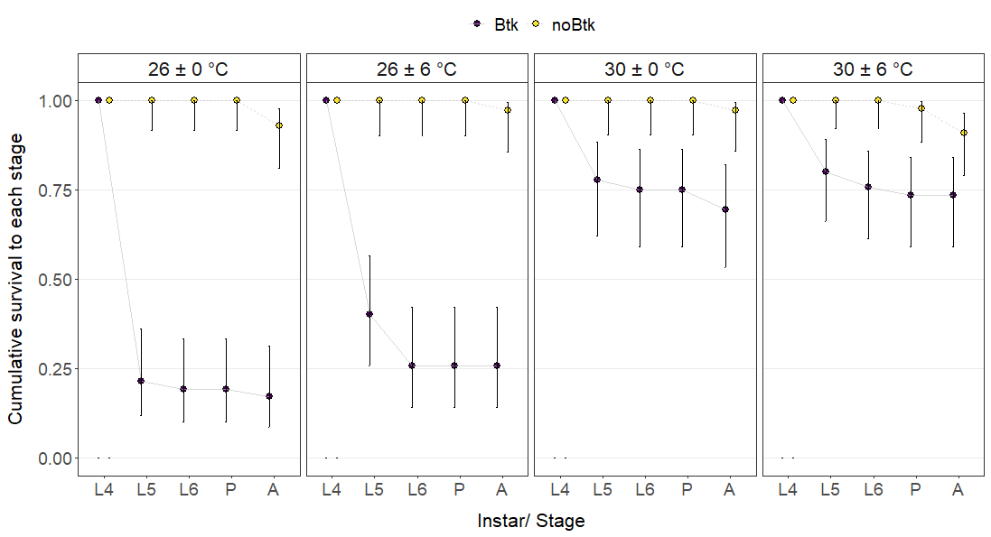
Figure 4-1: Cumulative survival of fourth instar larvae in each temperature and Btk exposure condition to successive life stages. Points represent the proportion of all starting fourth instars in a temperature and exposure condition that survive to a subsequent instar or life stage. Error bars indicate Wilson 95% confidence intervals for the proportions. L5 and L6 represent molts to the fifth and sixth larval instars, and P and A represent pupation and adult eclosion respectively.

3.2. Survival to adult eclosion
For individuals exposed to Btk, mortality in the pupal stage was low relative to larval mortality. Yet, the overall proportion of these individuals that survived from the fourth instar to adult eclosion was still lower than the same proportion among controls in every temperature regime, and ranged from 17% in constant 26 °C to 73% in the fluctuating treatment with mean 30 °C (Fig. 4-1). Our overall model of survival to adult eclosion explained 36.7% of the deviance in survivorship. Analyses of deviance revealed a significant interaction between mean temperature and exposure, suggesting that the extent to which Bt exposure reduced survival depended on mean temperature (p = 0.003334; Table 4-S4). However, interactions involving temperature fluctuation were not supported (p > 0.27), suggesting that temperature fluctuations did not significantly alter the effect of Bt on survival at either mean temperature (26 °C or 30 °C). When we removed interactive effects that were not supported from the model, the reduced model still explained 36% of the variation in survivorship.

Treatment with Bt significantly reduced the probability of surviving to adult eclosion relative to unexposed controls at both mean temperatures (p <= 0.0006; Table 4-S5). However, Bt-exposed larvae reared under constant or fluctuating temperatures with a mean of 30 °C were 3.4 times as likely to survive to eclosion as Bt-exposed larvae reared in conditions with a mean of 26 °C (p < 0.0001). We did not find a significant difference in survival probability between unexposed controls reared in mean 26 °C versus those reared in mean 30 °C (p = 0.7543). In all temperature regimes, between 91 – 97 % of control larvae reached maturity.

3.3. Development time from hatch to pupation
Exposure to Bt during the fourth instar significantly delayed development time from hatch to pupation in all temperature treatments (p < 0.0001; Table 4-S6). In both treatments with a mean temperature of 30 °C, larvae that survived exposure to Bt took 40 – 43% longer to reach pupation relative to unexposed controls. This delay was more pronounced in the constant 26 °C treatment, with those surviving Bt exposure taking 70% longer to reach pupation than unexposed larvae. However, under fluctuating temperatures with the same mean (26 ± 6 °C), time to pupation was only 48% longer in Bt-exposed larvae relative to controls. Larval development time was more variable for Bt-exposed individuals that survived the larval stage, ranging from 12 to 30 days across temperatures, whereas development times for unexposed controls ranged from 9 to 16 days across temperatures (Fig. 4-2).

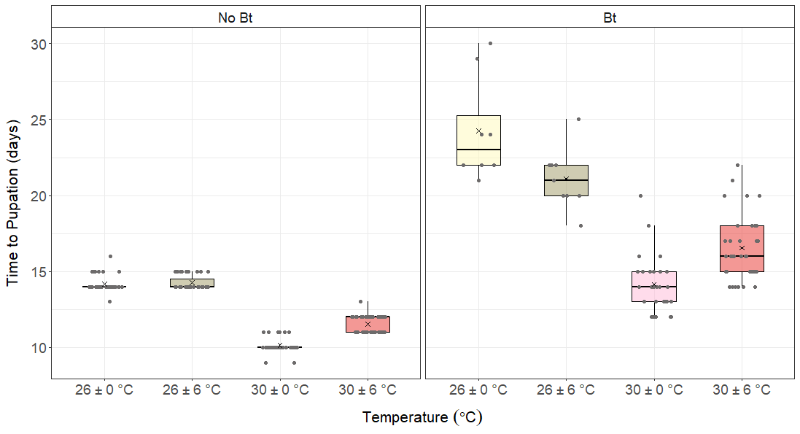
Figure 4-2: Number of days from hatching to pupation for surviving pupae in each temperature and Bt exposure treatment. Jittered points represent individual development times. Boxes and dark lines represent inter-quartile ranges and medians, respectively, for each group. Whiskers extend to the most extreme data value that is within 1.5 times the inter-quartile range. Crosses (×) represent group means.

Analyses of deviance revealed significant interactive effects of mean temperature and temperature fluctuation on development time to pupation in both Bt-exposed larvae and unexposed control larvae (p < 0.0001; Tables 4-S7 and 4-S8). On average, control larvae reared in conditions with a mean temperature of 30 °C reached pupation in fewer days than those reared in conditions with a mean temperature of 26 °C (10 – 12 days versus 14 days; p < 0.0001). For these larvae, temperature fluctuations around 26 °C did not alter larval development time compared to constant 26 °C (p = 0.4455), whereas fluctuations around 30 °C delayed larval development time by 1.5 days on average relative to constant 30 °C (p < 0.0001; Table 4-S9).

For individuals exposed to Bt during the fourth instar that successfully pupated, the effects of both increasing mean temperature and increasing fluctuation were generally more pronounced. For these larvae, increasing the mean temperature from 26 °C to 30 °C significantly reduced time to pupation by 42 % in constant temperatures (p < 0.0001) and by 22 % under fluctuations (p < 0.0001). Temperature fluctuations around both mean temperatures significantly altered time to pupation, but in opposite directions at 26 °C and at 30 °C. Around mean 26 °C, temperature fluctuation reduced the average number of days to pupation by about 13% (p = 0.007). Around mean 30 °C, temperature fluctuation increased the average number of days to pupation by about 17% (p < 0.0001; Table 4-S10).

Table 4-1 shows the median duration of each larval instar for all temperature treatments.

Table 4-1: Duration of larval instars within each temperature regime and exposure condition
Temperature regime | Exposure | Median duration, instar 4 (IQR) | Median duration, instar 5 (IQR) | Median duration, instar 6 (and instar 7) (IQR)
26 ± 0 °C | Btk | 4  (4 – 5) | 3  (3 – 4.25) | 9  (8.75 – 10.25)
26 ± 0 °C | Control | 2  (2 – 2) | 2  (2 – 2) | 4  (4 – 4)
26 ± 6 °C | Btk | 5  (4 – 5) | 3  (3 – 3) | 8  (7 – 8)
26 ± 6 °C | Control | 2  (2 – 2) | 2  (2 – 2) | 4  (4 – 4.5)
30 ± 0 °C | Btk | 3  (3 – 3) | 2  (2 – 3) | 5  (3 – 5)
30 ± 0 °C | Control | 2  (2 – 2) | 1  (1 – 2) | 3  (3 – 3)
30 ± 6 °C | Btk | 3  (3 – 4) | 2.5  (2 – 3) | 6  (4 – 6)
30 ± 6 °C | Control | 1  (1 – 2) | 2  (1.75 – 2) | 4  (3 – 4)

3.4. Mass at pupation
Likelihood ratio tests indicate that larval exposure to Bt does not affect the expected pupal mass of surviving individuals under most temperature conditions. However, pupae held at constant 26 °C that had been exposed to Bt were lighter by about 27 mg on average than control pupae at the same temperature (p = 0.02901; Table 4-S11).

Among unexposed controls in this experiment, expected pupal mass did not vary significantly across temperature regimes or between males and females. None of the predictors in this model had statistically significant independent or interactive effects on pupal mass (Table 4-S12).

For pupae surviving exposure to Bt, the effect of temperature fluctuation on pupal mass does not depend on mean temperature as we had predicted. However, analysis of variance revealed a statistically significant interaction between temperature fluctuation and sex (p = 0.046; Table 4-S13). Specifically, among those that survived to pupation, Bt-exposed males in fluctuating temperature treatments weighed more on average than Bt-exposed males in constant temperature treatments (p = 0.0019, Table 4-S14). On the other hand, for Bt-exposed females, expected pupal mass was consistent across fluctuation treatments (p = 0.63, Table 4-S14) and across mean temperatures (Fig. 4-3). However, given the low number of surviving pupae in the Bt condition, particularly for treatments with a mean of 26 °C, these results should be interpreted cautiously. Our reduced model of pupal mass for the Bt-exposed group explained about 18% of the variation in this response.
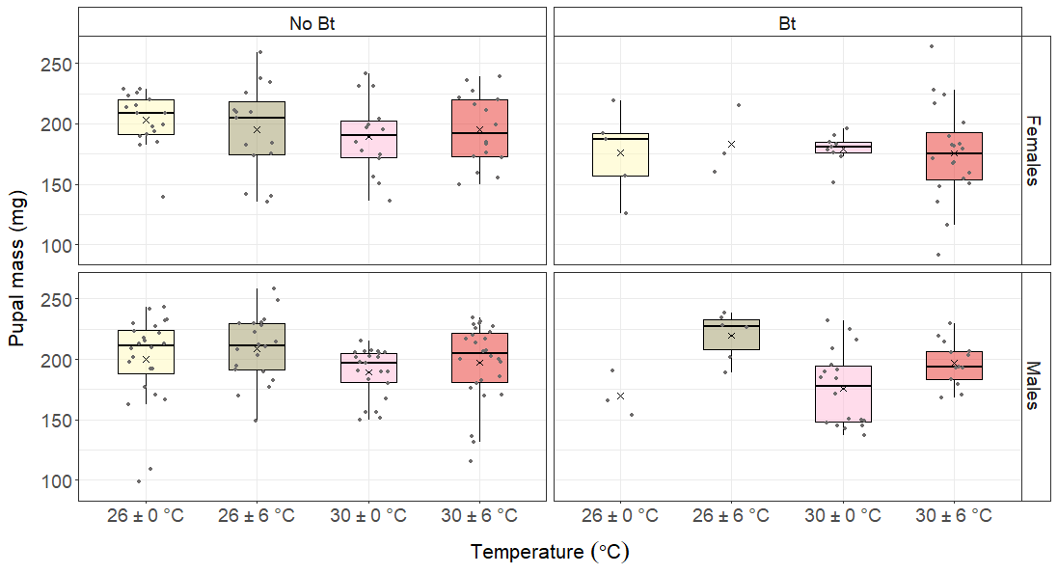
Figure 4-3: Distributions of pupal mass within each temperature regime and Bt exposure condition. Jittered points represent individual pupal masses. Boxes and dark lines represent inter-quartile ranges and medians, respectively, for each group. Whiskers extend to the most extreme data value that is within 1.5 times the inter-quartile range. Crosses (×) represent group means.

3.5. Duration of the pupal stage
For those that survived to adult eclosion, pupal stage durations did not differ between exposure conditions in most temperature regimes (Fig. 4-4). At constant 26 °C, pupae that were exposed to Bt as larvae took a day longer to eclose on average than unexposed controls, although there were few survivors in this exposure condition.

For those in the control condition, pupal stage duration decreased from 8 – 9 days in treatments with mean 26 °C to 6 – 7 days in treatments with mean 30 °C (Fig. 4-4). For this group, temperature fluctuations did not appear to impact pupal stage durations, although females in 30 ± 6 °C spent 1 fewer day in the pupal stage than females in constant 30 °C.

For surviving individuals that had been exposed to Bt as larvae, temperature fluctuation modified the effect of mean temperature on pupal stage duration (p = 0.02339; Table 4-S15). Pupae in this exposure condition took 1-3 fewer days to eclose in treatments with mean 30 °C relative to treatments with mean 26 °C (p < 0.0001; Table 4-S16). For this group, fluctuations around mean 26 °C reduced pupal stage durations by 1 day on average (p < 0.0001; Table 4-S16).

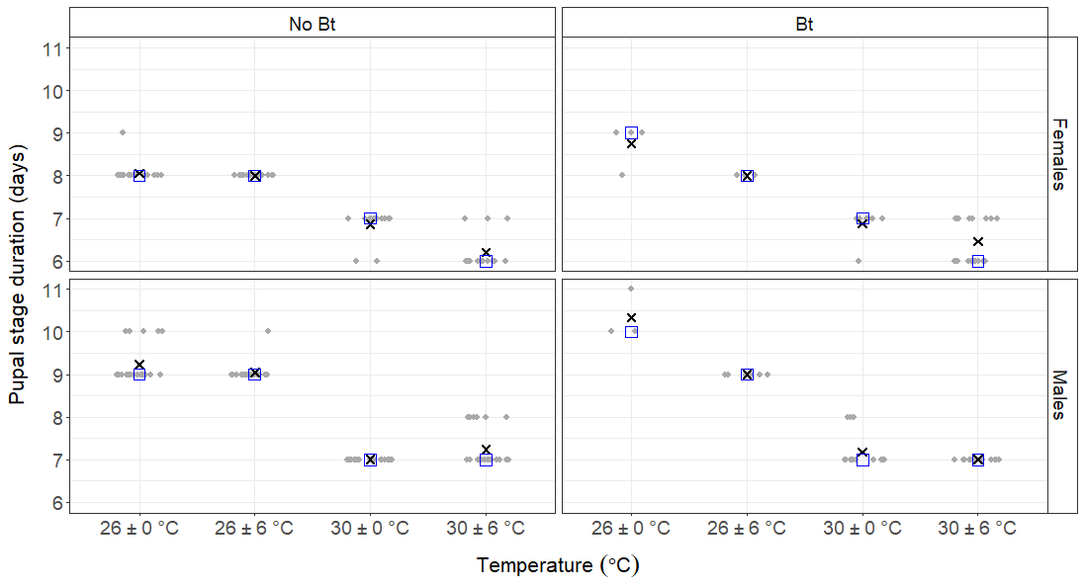
Figure 4-4: Durations of the pupal stage for males and females that survived to eclosion in each treatment. Jittered points represent individual stage durations. Black crosses (×) represent group means. Blue open squares show group medians.

4. DISCUSSION
Our results partially support our hypothesis that the level of mortality induced by an intermediate concentration of Bacillus thuringiensis subsp. kurstaki (0.06 % volume/ volume) in Spodoptera frugiperda would depend heavily on environmental temperature. As expected, increasing mean temperature of the rearing environment substantially increased larval survivorship following Bt exposure. These results align with some findings from other lepidopteran and dipteran species (van Frankenhuyzen et al., 2008; Lysyk and Selinger, 2012), but contradict other observations that insects fed Bt-contaminated diet experienced higher mortality at higher temperatures (Li et al., 1995; Katbeh-Bader et al., 1999). The latter relationship between temperature and Bt toxicity has been attributed to higher feeding rates at higher temperatures, which lead to larvae receiving higher pathogen doses – indeed, tightly controlling the dose ingested eliminated the effect of rearing temperature on overall larval mortality in at least one species (Choristoneura fumiferana; van Frankenhuyzen and Nystrom, 1987). Warmer temperatures could also increase rates of bacterial cell multiplication within the affected insect, which may quicken the progression of septicemia and death in an individual receiving an adequate dose (van Frankenhuyzen, 1994). However, despite not controlling the exact pathogen dose ingested by larvae, we found an inverse relationship between mortality and temperature in infected larvae. Secondly, median time to death in our study was comparable across most treatments (though 2 days shorter at constant 30°C). The pattern observed in this study may instead be mediated by changes in the effectiveness of host defenses, such as increased activation of immune responses involved in recovery from Bt in warm temperatures, and in larval development rates (Lysyk and Selinger, 2012). By developing more rapidly to later instars, larvae at mean 30°C may more quickly become less susceptible to the pathogen despite continuing to feed on contaminated diet; in general, later instar larvae require higher lethal doses (van Frankenhuyzen et al., 2008). Sustained exposure to higher temperatures may also cause the biopesticide overlay to lose efficacy over a shorter timescale.

Contrary to our predictions, however, ambient temperature fluctuations had little impact on overall survivorship to pupation or adult eclosion in individuals exposed to Btk as larvae. While Bt-exposed larvae reared in the cooler fluctuating temperature regime molted to the next larval instar at higher rates than those in the corresponding constant mean temperature (Fig. 4-1), the difference in survival had diminished by the sixth instar. Therefore, any effect of daily temperature variation on this outcome is minor relative to the effect of the overall average environmental temperature. In our previous study (see Chapter 2), we found large fluctuations around 30°C to reduce survival to eclosion in uninfected larvae, likely because these larvae were regularly exposed to stressful temperatures near their upper performance threshold. In the current study, we did not find lower survivorship to subsequent life stages among control larvae in this temperature regime. Here, however, we monitored a smaller subset of individuals that were all alive by the fourth instar, were similarly sized and at roughly the same point in development. The impacts of fluctuations in this temperature range may possibly be more salient in larvae infected with low doses of Bt in early instars, which may show more variation in growth and development trajectories and thermal tolerance.

In survivors of larval exposure to Bt, outcomes such as development times and pupal mass did not show the same pattern across temperatures as we had observed for survivorship. Of these, temperature had the largest impact on development time to pupation in infected individuals. While long delays in larval development times are an expected outcome of sublethal Bt exposure in S. frugiperda since larvae may pause feeding after initial exposure (Sousa et al., 2016; Botha et al., 2019), less attention has been paid to the temperature-dependence of this response in variable thermal environments. In line with our hypothesis, temperature fluctuations modified the effect of mean temperature on time to pupation in Bt survivors. Fluctuations around mean 30 °C delayed time to pupation relative to constant 30 °C – an expected outcome when ambient fluctuations include physiologically stressful temperatures (Colinet et al., 2015). We observed similar delays in larval development time with fluctuations in this temperature range in uninfected larvae, in this study and our previous experiment (see Chapter 2). Meanwhile, fluctuations around mean 26 °C shortened time to pupation relative to constant 26 °C in Bt survivors. In contrast, fluctuations around 26 °C did not alter larval development times in uninfected larvae in either study. Diel fluctuations could possibly ameliorate the stressful effects of Bt exposure at this temperature, though not to the extent of decreasing acute mortality. For instance, periodic exposure to unfavorable temperatures over time could decrease the toxic activity of Bt in the insect body or in the diet, and fluctuations may potentially stimulate a faster, if not larger, immune reaction – either of which could speed up recovery in surviving larvae.

Infection with Bt directly inhibits digestion and recovery imposes additional energetic costs, both of which could constrain mass gain during the larval stage. Previous studies find that S. frugiperda larvae reared on leaves from transgenic crops producing Bt Cry toxins have lower pupal mass (Hardke et al., 2011; Botha et al., 2019). However, in our study, we did not find differences between pupal mass in Bt-exposed and unexposed controls in most temperature regimes. Although characteristics of the dietary exposure may explain this difference (Bt corn leaves versus one-time application of a biopesticide that can degrade in the environment), we should be mindful of potential survivorship bias in these results. For instance, it is possible that only larvae with sufficient energetic reserves weighing above a certain mass threshold may have been able to pupate successfully in the Bt treatments and that this threshold may have been higher for males under thermal fluctuations. Measuring larval mass at multiple time points and on a finer time-scale, and perhaps in response to a range of less lethal doses, could allow us to compare growth trajectories in those that survive initial infection but fail to pupate and those that do not survive.

In the current study, as in our previous work (see Chapter 2), we found differences in how fluctuating temperatures affected larval and pupal development times, with both temperature and Bt exposure having relatively subtle effects on pupal stage duration. Unlike larval development, pupal development in those exposed to Btk as larvae was faster under fluctuations relative to constant mean temperatures at both mean 26 °C and at mean 30 °C. This suggests that the thermal performance curve for development in pupae may be right-shifted relative to that for larvae, such that large fluctuations around 30°C are less stressful for pupae. Our observation that Bt infection affected pupal maturation rates to a smaller extent than larval development rates follows expectations given the latter’s dependence on larval nutrition and agrees with other observations from S. frugiperda infected with other bacteria during the larval stage (Zhang et al., 2018).

In summary, warmer average temperatures appear to reduce the negative effects of Btk on S. frugiperda, with declines in Btk-induced mortality following exposure being the most obvious effect. Though the efficacy of Btk and its toxins as biocontrol agents will depend on the specific S. frugiperda population, given variable levels of resistance in natural populations (Monnerat et al., 2006; Ingber et al., 2018; Loto et al., 2019), our results suggest that the relative dose needed to control populations would be larger at higher temperatures. Additionally, the relative delays in development time with sublethal Bt exposure may be smaller under warmer mean temperatures. The amplitude of diurnal temperature variability may have minimal impacts on larval and pupal survival following Btk exposure. However, increasing temperature fluctuations could still impact population-level outcomes by altering development times, with the nature of these impacts depending on mean environmental temperature. In the field, delays in larval development due to sublethal Bt infection and environmental temperature may result in substantial additional larval mortality from prolonged exposure to threats such as intraspecific and interspecific competition, predation by natural enemies and additional pesticides.

APPENDIX 1: SUPPLEMENTARY FIGURES

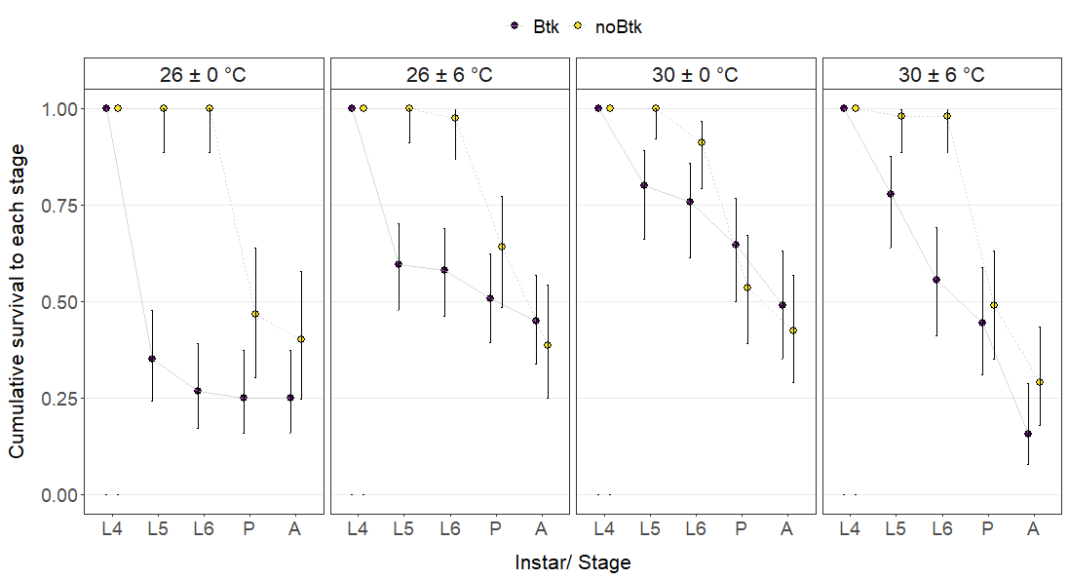
Figure 4-S1: Cumulative survivorship data from the second experimental run. We excluded data from this run from the analyses due to unusually poor survival among control larvae under benign temperatures and a high rate of pupal and prepupal abnormalities (50% among control larvae).

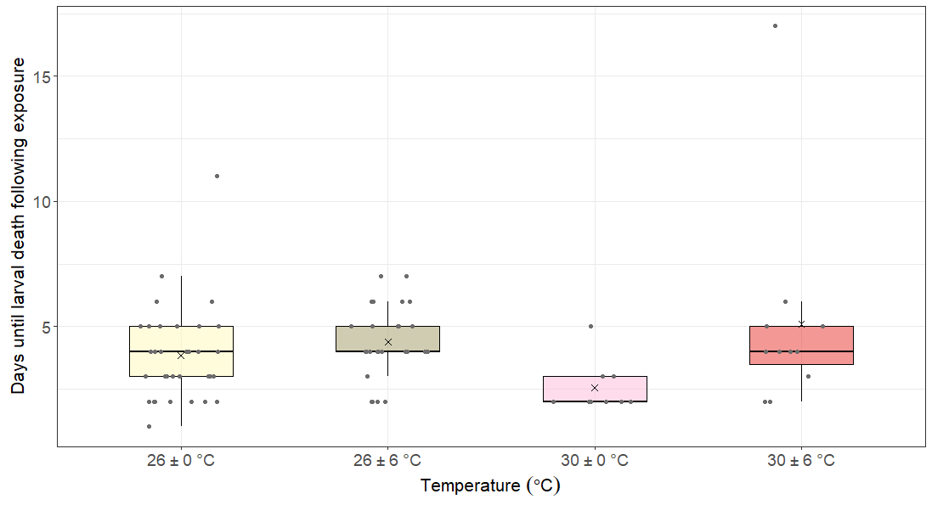
Figure 4-S2: Number of days between Btk exposure and larval death for all individuals in the Btk treatment condition that died in the larval stage. Jittered points indicate time until death for each individual.

APPENDIX 2: SUPPLEMENTARY TABLES

Table 4-S1: Sample sizes. Table shows the number of individuals assigned to each temperature and exposure condition at the beginning of the experiment (L4) and the number reaching each successive life stage (L5, L6 = number molting to instars 5 and 6; Pupa = number pupating; Adult = number eclosing)
Temperature  regime | Exposure | L4 (initial) | L5 | L6 | Pupa | Pupa (female) | Pupa (male) | Adult
26 ± 0 °C | No Btk | 42 | 42 | 42 | 42 | 17 | 24 | 39
26 ± 0 °C | Btk | 42 | 9 | 8 | 8 | 5 | 3 | 7
26 ± 6 °C | No Btk | 35 | 35 | 35 | 35 | 15 | 20 | 34
26 ± 6 °C | Btk | 35 | 14 | 9 | 9 | 3 | 6 | 9
30 ± 0 °C | No Btk | 36 | 36 | 36 | 36 | 14 | 22 | 35
30 ± 0 °C | Btk | 36 | 28 | 27 | 27 | 9 | 18 | 25
30 ± 6 °C | No Btk | 44 | 44 | 44 | 43 | 16 | 26 | 40
30 ± 6 °C | Btk | 45 | 36 | 34 | 33 | 20 | 13 | 33

Table 4-S2: Final regression model and coefficients table for survival to pupation following exposure to Btk-treated diet
Term | Estimate | Standard Error | z | p
(Intercept) | -1.44692 | 0.392953 | -3.68217 | 0.000231
Mean 30 °C | 2.545531 | 0.550054 | 4.627783 | 3.7E-06
Fluctuation (high) | 0.386047 | 0.551348 | 0.700188 | 0.48381
Mean 30 °C: Fluctuation (high) | -0.47306 | 0.752176 | -0.62892 | 0.529401
Number of observations = 158; Residual deviance = 173.48; Residual degrees of freedom = 154; Null deviance = 218.93; Null degrees of freedom = 157

Table 4-S3: Analyses of deviance results, survival to pupation following exposure to Btk-treated diet
 | χ² | df | p
Mean Temperature | 44.13117 | 1 | 3.07E-11
Temperature Fluctuation | 0.123608 | 1 | 0.725154
Mean Temperature: Temperature Fluctuation | 0.396834 | 1 | 0.528729

Table 4-S4: Analyses of deviance results, survival to adult eclosion following exposure to Btk-treated diet
 | χ² | df | p
Mean Temperature | 32.25417 | 1 | 1.35E-08
Temperature Fluctuation | 0.419526 | 1 | 0.517174
Exposure | 104.2765 | 1 | 1.76E-24
Mean Temperature: Temperature Fluctuation | 1.118827 | 1 | 0.290171
Mean Temperature: Exposure | 8.614983 | 1 | 0.003334
Temperature Fluctuation: Exposure | 0.488822 | 1 | 0.484453
Mean Temperature: Temperature Fluctuation: Exposure | 1.195432 | 1 | 0.274237

Table 4-S5: Simple effects of mean temperature and exposure on survival to adult eclosion following exposure to Btk-treated diet
Contrast | Mean Temperature | Exposure | Odds  Ratio | SE | Null | z | p
Btk / No Btk | 26 | - | 0.014474 | 0.008488 | 1 | -7.22259 | 5.1E-13
Btk / No Btk | 30 | - | 0.167499 | 0.087745 | 1 | -3.41085 | 0.000648
Mean 30 °C / Mean 26 °C | - | No  Btk | 0.805387 | 0.556987 | 1 | -0.31295 | 0.754315
Mean 30 °C / Mean 26 °C | - | Btk | 9.320134 | 3.491783 | 1 | 5.958042 | 2.55E-09

Table 4-S6: Likelihood ratio test results, effect of Bt exposure on development time between hatch and pupation
Temperature Regime | Full model | Nested model | Difference in degrees of freedom | χ² | p
26 ± 0 °C | Days to Pupation ~ Exposure | Days to Pupation ~ 1 | 1 | 118.7651 | 1.17894E-27
26 ± 6 °C | Days to Pupation ~ Exposure | Days to Pupation ~ 1 | 1 | 107.1455 | 4.1365E-25
30 ± 0 °C | Days to Pupation ~ Exposure | Days to Pupation ~ 1 | 1 | 86.62795 | 1.30983E-20
30 ± 6 °C | Days to Pupation ~ Exposure | Days to Pupation ~ 1 | 1 | 112.8610 | 2.31441E-26

Table 4-S7: Analyses of deviance results, development time between hatch and pupation for control individuals (not exposed to Btk during the fourth instar)
 | χ² | df | p
Mean Temperature | 1889.241 | 1 | 0
Temperature Fluctuation | 86.56206 | 1 | 1.35E-20
Mean Temperature: Temperature Fluctuation | 92.27099 | 1 | 7.56E-22

Table 4-S8: Analyses of deviance results, development time between hatch and pupation for individuals exposed to Btk-treated diet during the fourth instar
 | χ² | df | p
Mean Temperature | 156.5698 | 1 | 6.36E-36
Temperature Fluctuation | 5.751839 | 1 | 0.016471
Mean Temperature: Temperature Fluctuation | 23.01294 | 1 | 1.61E-06

Table 4-S9: Simple effects of mean temperature and temperature fluctuation on days to pupation among control larvae (not exposed to Btk during the fourth instar)
Contrast | Temperature Fluctuation | Mean Temperature | Ratio | SE | Null | z | p
Mean 30 °C / Mean 26 °C | Constant | - | 0.715686 | 0.006261 | 1 | -38.2391 | 0
Mean 30 °C / Mean 26 °C | Fluctuation (high) | - | 0.80906 | 0.007523 | 1 | -22.7877 | 6.1E-115
Fluctuation (high) / Constant | - | 26 | 1.006387 | 0.008398 | 1 | 0.762942 | 0.445498
Fluctuation (high) / Constant | - | 30 | 1.137687 | 0.010992 | 1 | 13.35107 | 1.17E-40

Table 4-S10: Simple effects of mean temperature and temperature fluctuation on days to pupation among larvae exposed to Btk-treated diet during the fourth instar
Contrast | Temperature Fluctuation | Mean Temperature | Ratio | SE | Null | z | p
Mean 30 °C / Mean 26 °C | Constant | - | 0.583429 | 0.025955 | 1 | -12.1122 | 9.1E-34
Mean 30 °C / Mean 26 °C | Fluctuation (high) | - | 0.783732 | 0.033308 | 1 | -5.73392 | 9.81E-09
Fluctuation (high) / Constant | - | 26 | 0.870561 | 0.04478 | 1 | -2.69485 | 0.007042
Fluctuation (high) / Constant | - | 30 | 1.169443 | 0.039475 | 1 | 4.637083 | 3.53E-06

Table 4-S11: Likelihood ratio test results, effect of Bt exposure on pupal mass (mg)
Temperature Regime | Full model | Nested model | Difference in degrees of freedom | Difference in Residual Sums of Squares | F | p
26 ± 0 °C | Pupal Mass ~ Exposure | Pupal Mass ~ 1 | 1 | -4977.3 | 5.0734 | 0.02901
26 ± 6 °C | Pupal Mass ~ Exposure | Pupal Mass ~ 1 | 1 | -149.19 | 0.1495 | 0.7009
30 ± 0 °C | Pupal Mass ~ Exposure | Pupal Mass ~ 1 | 1 | -2360.6 | 3.6468 | 0.06088
30 ± 6 °C | Pupal Mass ~ Exposure | Pupal Mass ~ 1 | 1 | -2866.5 | 2.7261 | 0.103
Table 4-S12: Analyses of variance results, mass (mg) at pupation of individuals in the control condition (not exposed to Btk as larvae)
 | Sum of Squares | df | F | p
Mean Temperature | 3325.885 | 1 | 3.603606 | 0.059628
Temperature Fluctuation | 806.2088 | 1 | 0.873529 | 0.351523
Sex | 343.5805 | 1 | 0.37227 | 0.542718
Mean Temperature: Temperature Fluctuation | 224.1809 | 1 | 0.242901 | 0.622859
Mean Temperature: Sex | 182.3309 | 1 | 0.197556 | 0.657359
Temperature Fluctuation: Sex | 837.0561 | 1 | 0.906953 | 0.342498
Mean Temperature: Temperature Fluctuation: Sex | 540.7028 | 1 | 0.585853 | 0.445263
Residuals | 134748.2 | 146

Table 4-S13: Analyses of variance results, mass (mg) at pupation of individuals that were exposed to Btk as larvae
 | Sum of Squares | df | F | p
Mean Temperature | 626.3504 | 1 | 0.721208 | 0.398602
Temperature Fluctuation | 4207.574 | 1 | 4.844793 | 0.030982
Sex | 2435.54 | 1 | 2.804392 | 0.098406
Mean Temperature: Temperature Fluctuation | 1398.298 | 1 | 1.610064 | 0.208627
Temperature Fluctuation: Sex | 3567.879 | 1 | 4.108219 | 0.046432
Residuals | 61661.61 | 71

Table 4-S14: Simple effects of temperature fluctuation and sex on the mass (mg) of pupae that were exposed to Btk-treated diet as larvae
Contrast | Sex | Temperature Fluctuation | Estimate | SE | df | t | p
Fluctuation (high) - Constant | f |  | 5.307903 | 10.97833 | 71 | 0.483489 | 0.630236
Fluctuation (high) - Constant | m |  | 33.84261 | 10.51668 | 71 | 3.217993 | 0.001946
Male - Female | - | Constant | -4.16508 | 10.50154 | 71 | -0.39662 | 0.69284
Male - Female | - | Fluctuation (high) | 24.36963 | 9.376191 | 71 | 2.599097 | 0.011361

Table 4-S15: Analyses of variance results, duration of the pupal stage in individuals that were exposed to Btk as larvae
 | χ² | df | p
Mean Temperature | 370.5454 | 1 | 1.42E-82
Temperature Fluctuation | 17.24449 | 1 | 3.29E-05
Sex | 33.73114 | 1 | 6.33E-09
Mean Temperature: Temperature Fluctuation | 5.139336 | 1 | 0.02339

Table 4-S16: Simple effects of mean temperature and temperature fluctuation on pupal stage duration in individuals exposed to Btk as larvae
Contrast | Temperature Fluctuation | Mean Temperature | Ratio | SE | Null | z | p
Mean 30 °C / Mean 26 °C | Constant | - | 0.732895 | 0.017698 | 1 | -12.8685 | 6.77E-38
Mean 30 °C / Mean 26 °C | Fluctuation (high) | - | 0.784855 | 0.013571 | 1 | -14.01 | 1.35E-44
Fluctuation (high) / Constant | - | 26 | 0.901768 | 0.022029 | 1 | -4.23268 | 2.31E-05
Fluctuation (high) / Constant | - | 30 | 0.965702 | 0.01667 | 1 | -2.02183 | 0.043194

: Conclusions

In this dissertation, I explored the impacts of temperature variability across a range of average temperatures on Spodoptera frugiperda life history, demography and susceptibility to the toxic effects of a pathogen and primary biocontrol agent. Here, I summarize my findings from each phase of this research and conclude with some final themes and takeaways.

First, I used controlled experiments to expose S. frugiperda individuals to combinations of different average environmental temperatures and different magnitudes of temperature fluctuation, with treatments representing ambient fluctuations within the species’ range. For these individuals, I monitored life-history traits across the life cycle, which enabled me to consider potential time-dependent physiological effects of fluctuations. I used these data to parametrize matrix population models and analyze long-term population growth rates and demographic drivers of temperature effects at the population level. From these studies, I concluded that temperature fluctuations can influence survival, development rates, reproductive output, and population growth rates, with these effects generally being more salient and more negative at higher temperatures that approach upper performance thresholds (close to where performance is maximized for some traits). Furthermore, the effects of fluctuations vary substantially by trait and life stage, with more pronounced consequences for reproductive parameters.

Integrating effects at the population level, I found similar interactive effects of temperature means and variability: fluctuations around 30°C are expected to reduce λ for this population while fluctuations around intermediate temperatures may increase λ. Across mean temperatures, changes in fecundity, the longevity of reproductively active females and egg hatch rates explained these differences. Therefore, improving our understanding of how populations respond to warming and thermal variability may require more studies that focus on insect reproduction, since current efforts focus heavily on lethal limits.

Finally, I investigated the effects of temperature fluctuations at intermediate (26 °C) and elevated temperatures (30 °C) on outcomes in S. frugiperda larvae exposed to sublethal doses of Bacillus thuringiensis subsp. kurtsaki spore-protein mixtures. Here, I found survival following exposure to Bt to be largely predicted by mean temperature, with fluctuations having little impact on survivorship to subsequent life stages. However, temperature fluctuations noticeably modified delays in larval development following Bt exposure in survivors, including at the intermediate mean temperature (26 °C). Since population growth in this species may be particularly elastic to changes in survival and development in the larval stage (see Chapter 3), reductions in Bt-induced mortality with warming and changes in any sublethal effects with increasing variability could have significant consequences at the population level.

Taken together, a few key themes emerge from this dissertation. The first is that insect thermal performance can be complex and highly variable, within individual lifespans and across different environmental contexts. Although there is much interest in finding optimal temperatures for insect development in particular, a more complex story emerges when we examine a larger suite of traits across the lifespan. This is especially true in thermally variable environments where organisms are exposed to multiple stressors and in the context of strongly interacting species, where temperature variability may alter which participant is favored in a given environment (Ferguson and Sinclair, 2020).

Second, temperature variability seems to have larger effects on thermal performance curves towards the tails of the curve, at least when we consider individual responses to temperature alone. Therefore, organismal responses to heat waves and other extreme events will be modified by characteristics of thermal variability during these events. These characteristics include fluctuation amplitude (the focus of this dissertation), but also fluctuation symmetry (for instance, disproportionate increases in nighttime temperatures) and predictability. Focusing our attention on measuring responses towards the extremes of thermal performance curve for traits other than critical thermal limits will help clarify these effects.

References
Abatzoglou, J.T., Dobrowski, S.Z., Parks, S.A., Hegewisch, K.C., 2018. TerraClimate, a high-resolution global dataset of monthly climate and climatic water balance from 1958–2015. Sci Data 5, 170191. https://doi.org/10.1038/sdata.2017.191
Adamo, S.A., 2012. The effects of the stress response on immune function in invertebrates: An evolutionary perspective on an ancient connection. Hormones and Behavior, Special Issue: The Neuroendocrine-Immune Axis in Health and Disease 62, 324–330. https://doi.org/10.1016/j.yhbeh.2012.02.012
Adan, M., Tonnang, H.E.Z., Kassa, C.E.F., Greve, K., Borgemeister, C., Goergen, G., 2024. Combining temperature-dependent life table data into Insect Life Cycle Model to forecast fall armyworm Spodoptera frugiperda (JE Smith) distribution in maize agro-ecological zones in Africa. PLOS ONE 19, e0299154. https://doi.org/10.1371/journal.pone.0299154
Ali, A., Luttrell, R.G., Schneider, J.C., 1990. Effects of Temperature and Larval Diet on Development of the Fall Armyworm (Lepidoptera: Noctuidae). Annals of the Entomological Society of America 83, 725–733. https://doi.org/10.1093/aesa/83.4.725
Angilletta, M.J., 2009. Thermal Adaptation: A Theoretical and Empirical Synthesis, Thermal Adaptation. Oxford University Press.
Angilletta, M.J., 2006. Estimating and comparing thermal performance curves. Journal of Thermal Biology 31, 541–545. https://doi.org/10.1016/j.jtherbio.2006.06.002
Ardia, D.R., Gantz, J.E., C, B., Schneider, Strebel, S., 2012. Costs of immunity in insects: an induced immune response increases metabolic rate and decreases antimicrobial activity. Functional Ecology 26, 732–739. https://doi.org/10.1111/j.1365-2435.2012.01989.x
Ashok, K., Balasubramani, V., Kennedy, J.S., Geethalakshmi, V., Jeyakumar, P., Sathiah, N., 2021. Effect of elevated temperature on the population dynamics of fall armyworm, Spodoptera frugiperda. J. Environ. Biol. 42, 1098–1105. https://doi.org/10.22438/jeb/42/4(SI)/MRN-1525a
Awde, D.N., Řeřicha, M., Knapp, M., 2023. Increased pupal temperature has reversible effects on thermal performance and irreversible effects on immune system and fecundity in adult ladybirds. Commun Biol 6, 1–7. https://doi.org/10.1038/s42003-023-05196-0
Barfield, C.S., Ashley, T.R., 1987. Effects of Corn Phenology and Temperature on the Life Cycle of the Fall Armyworm, Spodoptera frugiperda (Lepidoptera: Noctuidae). The Florida Entomologist 70, 110–116. https://doi.org/10.2307/3495097
Barfield, C.S., Mitchell, E.R., Poeb, S.L., 1978. A Temperature-Dependent Model for Fall Armyworm Development1,2. Annals of the Entomological Society of America 71, 70–74. https://doi.org/10.1093/aesa/71.1.70
Bathiany, S., Dakos, V., Scheffer, M., Lenton, T.M., 2018. Climate models predict increasing temperature variability in poor countries. Science Advances 4, eaar5809. https://doi.org/10.1126/sciadv.aar5809
Botha, A.S., Erasmus, A., du Plessis, H., Van den Berg, J., 2019. Efficacy of Bt Maize for Control of Spodoptera frugiperda (Lepidoptera: Noctuidae) in South Africa. J Econ Entomol 112, 1260–1266. https://doi.org/10.1093/jee/toz048
Bozinovic, F., Bastías, D.A., Boher, F., Clavijo-Baquet, S., Estay, S.A., Angilletta, M.J., 2011. The Mean and Variance of Environmental Temperature Interact to Determine Physiological Tolerance and Fitness. Physiological and Biochemical Zoology 84, 543–552. https://doi.org/10.1086/662551
Bozinovic, F., Catalan, T.P., Estay, S.A., Sabat, P., 2013. Acclimation to daily thermal variability drives the metabolic performance curve. Evolutionary Ecology Research 15, 579–587.
Brooks, M.E., Kristensen, K., Benthem, K.J. van, Magnusson, A., Berg, C.W., Nielsen, A., Skaug, H.J., Mächler, M., Bolker, B.M., 2017. glmmTMB Balances Speed and Flexibility Among Packages for Zero-inflated Generalized Linear Mixed Modeling. The R Journal 9, 378–400.
Buckley, L.B., Cannistra, A.F., John, A., 2018. Leveraging Organismal Biology to Forecast the Effects of Climate Change. Integr Comp Biol 58, 38–51. https://doi.org/10.1093/icb/icy018
Buckley, L.B., Huey, R.B., 2016. Temperature extremes: geographic patterns, recent changes, and implications for organismal vulnerabilities. Global Change Biology 22, 3829–3842. https://doi.org/10.1111/gcb.13313
Capinera, J.L., 2017. Fall Armyworm, Spodoptera frugiperda (J.E. Smith) (Insecta: Lepidoptera: Noctuidae). University of Florida/ Institute of Food and Agricultural Sciences.
Carrington, L.B., Armijos, M.V., Lambrechts, L., Barker, C.M., Scott, T.W., 2013. Effects of Fluctuating Daily Temperatures at Critical Thermal Extremes on Aedes aegypti Life-History Traits. PLOS ONE 8, e58824. https://doi.org/10.1371/journal.pone.0058824
Carter, A.W., Sheldon, K.S., 2020. Life stages differ in plasticity to temperature fluctuations and uniquely contribute to adult phenotype in Onthophagus taurus dung beetles. Journal of Experimental Biology 223. https://doi.org/10.1242/jeb.227884
Caswell, H., 2019. Sensitivity Analysis: Matrix Methods in Demography and Ecology, Demographic Research Monographs. Springer International Publishing, Cham, Switzerland. https://doi.org/10.1007/978-3-030-10534-1
Caswell, H., 2001. Matrix Population Models: Construction, Analysis, and Interpretation, 2nd ed. Sinauer Associates, Sunderland, Massachusetts.
Caswell, H., 1989. Analysis of life table response experiments I. Decomposition of effects on population growth rate. Ecological Modelling 46, 221–237. https://doi.org/10.1016/0304-3800(89)90019-7
Chen, H., Zheng, X., Luo, M., Guo, J., Solangi, G.S., Wan, F., Zhou, Z., 2018. Effect of short-term high-temperature exposure on the life history parameters of Ophraella communa. Sci Rep 8, 1–11. https://doi.org/10.1038/s41598-018-32262-z
Chen, Y.-C., Chen, D.-F., Yang, M.-F., Liu, J.-F., 2022. The Effect of Temperatures and Hosts on the Life Cycle of Spodoptera frugiperda (Lepidoptera: Noctuidae). Insects 13, 211. https://doi.org/10.3390/insects13020211
Cheng, L.-Y., Chang, Y., Chen, Z.-Z., Xu, Y.-Y., 2018. Effects of constant and fluctuating temperatures on development and reproduction of Megoura crassicauda and Aphis craccivora (Hemiptera: Aphididae). Entomologica Fennica 29, 1–12. https://doi.org/10.33338/ef.70036
Clavijo A, S., Fernandez Badillo, A., Ramirez A, A., Delgado, A., Lathullerie, J.M. (Venezuela U.C., 1991. Influence of temperature on the development of Spodoptera frutiperda Smith (Lepidoptera: Noctuidae). Agronomia Tropical (Venezuela).
Clusella-Trullas, S., Blackburn, T.M., Chown, S.L., 2011. Climatic predictors of temperature performance curve parameters in ectotherms imply complex responses to climate change. Am Nat 177, 738–751. https://doi.org/10.1086/660021
Colinet, H., Sinclair, B.J., Vernon, P., Renault, D., 2015. Insects in Fluctuating Thermal Environments. Annual Review of Entomology 60, 123–140. https://doi.org/10.1146/annurev-ento-010814-021017
Cunha, F.M., Wanderley-Teixeira, V., Torres, J.B., Teixeira, Á.A.C., Alves, T.J.S., Brayner, F.A., 2013. Impact of Bt cotton on the immune system and histology of the midgut of the fall armyworm Spodoptera frugiperda (J.E. Smith) (Lepidoptera: Noctuidae). Animal Biol 63, 185–197. https://doi.org/10.1163/15707563-00002405
Damos, P., Savopoulou-Soultani, M., 2012. Temperature-Driven Models for Insect Development and Vital Thermal Requirements. Psyche: A Journal of Entomology 2012, 123405. https://doi.org/10.1155/2012/123405
Denny, M., 2019. Performance in a variable world: using Jensen’s inequality to scale up from individuals to populations. Conserv Physiol 7. https://doi.org/10.1093/conphys/coz053
Denny, M., 2017. The fallacy of the average: on the ubiquity, utility and continuing novelty of Jensen’s inequality. Journal of Experimental Biology 220, 139–146. https://doi.org/10.1242/jeb.140368
Deutsch, C.A., Tewksbury, J.J., Huey, R.B., Sheldon, K.S., Ghalambor, C.K., Haak, D.C., Martin, P.R., 2008. Impacts of climate warming on terrestrial ectotherms across latitude. PNAS 105, 6668–6672. https://doi.org/10.1073/pnas.0709472105
Deutsch, C.A., Tewksbury, J.J., Tigchelaar, M., Battisti, D.S., Merrill, S.C., Huey, R.B., Naylor, R.L., 2018. Increase in crop losses to insect pests in a warming climate. Science 361, 916–919. https://doi.org/10.1126/science.aat3466
Diamond, S.E., Sorger, D.M., Hulcr, J., Pelini, S.L., Toro, I.D., Hirsch, C., Oberg, E., Dunn, R.R., 2012. Who likes it hot? A global analysis of the climatic, ecological, and evolutionary determinants of warming tolerance in ants. Global Change Biology 18, 448–456. https://doi.org/10.1111/j.1365-2486.2011.02542.x
Díaz-Álvarez, E.A., Martínez-Zavaleta, J.P., López-Santiz, E.E., de la Barrera, E., Larsen, J., del-Val, E., 2023. Climate change can trigger fall armyworm outbreaks: a developmental response experiment with two Mexican maize landraces. International Journal of Pest Management 69, 184–192. https://doi.org/10.1080/09670874.2020.1869347
Dinh, K.V., Janssens, L., Stoks, R., 2016. Exposure to a heat wave under food limitation makes an agricultural insecticide lethal: a mechanistic laboratory experiment. Glob Chang Biol 22, 3361–3372. https://doi.org/10.1111/gcb.13415
Du Plessis, H., Schlemmer, M.-L., Van den Berg, J., 2020. The Effect of Temperature on the Development of Spodoptera frugiperda (Lepidoptera: Noctuidae). Insects 11. https://doi.org/10.3390/insects11040228
Du Plessis, H., van den Berg, J., Ota, N., Kriticos, D.J., 2018. Spodoptera frugiperda. CSIRO-InSTePP Pest Geography.
Dubovskiy, I.M., Krukova, N.A., Glupov, V.V., 2008. Phagocytic activity and encapsulation rate of Galleria mellonella larval haemocytes during bacterial infection by Bacillus thuringiensis. Journal of Invertebrate Pathology, Special Issue for SIP 2008 98, 360–362. https://doi.org/10.1016/j.jip.2008.03.011
Duffy, K., Gouhier, T.C., Ganguly, A.R., 2022. Climate-mediated shifts in temperature fluctuations promote extinction risk. Nat. Clim. Chang. 12, 1037–1044. https://doi.org/10.1038/s41558-022-01490-7
Early, R., González-Moreno, P., Murphy, S.T., Day, R., 2018. Forecasting the global extent of invasion of the cereal pest Spodoptera frugiperda, the fall armyworm. NeoBiota 40, 25–50. https://doi.org/10.3897/neobiota.40.28165
Englehart, P.J., Douglas, A.V., 2005. Changing behavior in the diurnal range of surface air temperatures over Mexico. Geophysical Research Letters 32. https://doi.org/10.1029/2004GL021139
Enriquez, T., Colinet, H., 2017. Basal tolerance to heat and cold exposure of the spotted wing drosophila, Drosophila suzukii. PeerJ 5, e3112. https://doi.org/10.7717/peerj.3112
Estay, S.A., Clavijo-Baquet, S., Lima, M., Bozinovic, F., 2011. Beyond average: an experimental test of temperature variability on the population dynamics of Tribolium confusum. Population Ecology 53, 53–58. https://doi.org/10.1007/s10144-010-0216-7
Estay, S.A., Lima, M., Bozinovic, F., 2014. The role of temperature variability on insect performance and population dynamics in a warming world. Oikos 123, 131–140. https://doi.org/10.1111/j.1600-0706.2013.00607.x
Ezard, T.H.G., Bullock, J.M., Dalgleish, H.J., Millon, A., Pelletier, F., Ozgul, A., Koons, D.N., 2010. Matrix models for a changeable world: the importance of transient dynamics in population management. Journal of Applied Ecology 47, 515–523. https://doi.org/10.1111/j.1365-2664.2010.01801.x
Fatoretto, J.C., Michel, A.P., Silva Filho, M.C., Silva, N., 2017. Adaptive Potential of Fall Armyworm (Lepidoptera: Noctuidae) Limits Bt Trait Durability in Brazil. J Integr Pest Manag 8. https://doi.org/10.1093/jipm/pmx011
Ferguson, L.V., Sinclair, B.J., 2020. Thermal Variability and Plasticity Drive the Outcome of a Host-Pathogen Interaction. The American Naturalist 195, 603–615. https://doi.org/10.1086/707545
Fleming, J.M., Carter, A.W., Sheldon, K.S., 2021. Dung beetles show metabolic plasticity as pupae and smaller adult body size in response to increased temperature mean and variance. Journal of Insect Physiology 131, 104215. https://doi.org/10.1016/j.jinsphys.2021.104215
Folguera, G., Bastías, D.A., Caers, J., Rojas, J.M., Piulachs, M.-D., Bellés, X., Bozinovic, F., 2011. An experimental test of the role of environmental temperature variability on ectotherm molecular, physiological and life-history traits: Implications for global warming. Comparative Biochemistry and Physiology Part A: Molecular & Integrative Physiology 159, 242–246. https://doi.org/10.1016/j.cbpa.2011.03.002
Fox, J., Weisberg, S., 2019. An R Companion to Applied Regression, Third. ed. Sage, Thousand Oaks, CA.
Garcia, A.G., Ferreira, C.P., Godoy, W.A.C., Meagher, R.L., 2019. A computational model to predict the population dynamics of Spodoptera frugiperda. J Pest Sci 92, 429–441. https://doi.org/10.1007/s10340-018-1051-4
Garcia, A.G., Godoy, W.A.C., Thomas, J.M.G., Nagoshi, R.N., Meagher, R.L., 2018. Delimiting Strategic Zones for the Development of Fall Armyworm (Lepidoptera: Noctuidae) on Corn in the State of Florida. Journal of Economic Entomology 111, 120–126. https://doi.org/10.1093/jee/tox329
García-Carreras, B., Reuman, D.C., 2013. Are Changes in the Mean or Variability of Climate Signals More Important for Long-Term Stochastic Growth Rate? PLOS ONE 8, e63974. https://doi.org/10.1371/journal.pone.0063974
García-Robledo, C., Baer, C.S., 2021. Demographic Attritions, Elevational Refugia, and the Resilience of Insect Populations to Projected Global Warming. The American Naturalist 198, 113–127. https://doi.org/10.1086/714525
González‐Tokman, D., Córdoba‐Aguilar, A., Dáttilo, W., Lira‐Noriega, A., Sánchez‐Guillén, R.A., Villalobos, F., 2020. Insect responses to heat: physiological mechanisms, evolution and ecological implications in a warming world. Biological Reviews. https://doi.org/10.1111/brv.12588
Greenspan, S.E., Bower, D.S., Roznik, E.A., Pike, D.A., Marantelli, G., Alford, R.A., Schwarzkopf, L., Scheffers, B.R., 2017. Infection increases vulnerability to climate change via effects on host thermal tolerance. Scientific Reports 7, 9349. https://doi.org/10.1038/s41598-017-09950-3
Grizanova, E.V., Dubovskiy, I.M., Whitten, M.M.A., Glupov, V.V., 2014. Contributions of cellular and humoral immunity of Galleria mellonella larvae in defence against oral infection by Bacillus thuringiensis. Journal of Invertebrate Pathology 119, 40–46. https://doi.org/10.1016/j.jip.2014.04.003
Guedes, R.N.C., Walse, S.S., Throne, J.E., 2017. Sublethal exposure, insecticide resistance, and community stress. Current Opinion in Insect Science, Pests and resistance * Behavioural ecology 21, 47–53. https://doi.org/10.1016/j.cois.2017.04.010
Haahr, M., 2025. RANDOM.ORG: True Random Number Service [WWW Document]. True Random Integer Generator. URL https://www.random.org/integers/ (accessed 3.8.25).
Hardke, J.T., Leonard, B.R., Huang, F., Jackson, R.E., 2011. Damage and survivorship of fall armyworm (Lepidoptera: Noctuidae) on transgenic field corn expressing Bacillus thuringiensis Cry proteins. Crop Protection 30, 168–172. https://doi.org/10.1016/j.cropro.2010.10.005
Harrison, J., Woods, H.A., Roberts, S., 2012. Ecological and Environmental Physiology of Insects, Ecological and Environmental Physiology Series. Oxford University Press, Oxford, New York.
Hartig, F., 2022. DHARMa: Residual Diagnostics for Hierarchical (Multi-Level / Mixed) Regression Models.
Henderson, Chas.F., Tilton, Elvin.W., 1955. Tests with Acaricides against the Brown Wheat Mite. Journal of Economic Entomology 48, 157–161. https://doi.org/10.1093/jee/48.2.157
Herrero, S., Bel, Y., Hernández-Martínez, P., Ferré, J., 2016. Susceptibility, mechanisms of response and resistance to Bacillus thuringiensis toxins in Spodoptera spp. Current Opinion in Insect Science 15, 89–96. https://doi.org/10.1016/j.cois.2016.04.006
Huang, L.-L., Xue, F.-S., Chen, C., Guo, X., Tang, J.-J., Zhong, L., He, H.-M., 2021. Effects of temperature on life-history traits of the newly invasive fall armyworm, Spodoptera frugiperda in Southeast China. Ecology and Evolution 11, 5255–5264. https://doi.org/10.1002/ece3.7413
Ingber, D.A., Mason, C.E., Flexner, L., 2018. Cry1 Bt Susceptibilities of Fall Armyworm (Lepidoptera: Noctuidae) Host Strains. Journal of Economic Entomology 111, 361–368. https://doi.org/10.1093/jee/tox311
Jeffs, C.T., Leather, S.R., 2014. Effects of extreme, fluctuating temperature events on life history traits of the grain aphid, Sitobion avenae. Entomologia Experimentalis et Applicata 150, 240–249. https://doi.org/10.1111/eea.12160
Ju, R.-T., Zhu, H.-Y., Gao, L., Zhou, X.-H., Li, B., 2015. Increases in both temperature means and extremes likely facilitate invasive herbivore outbreaks. Scientific Reports 5, 15715. https://doi.org/10.1038/srep15715
Jurat-Fuentes, J.L., Heckel, D.G., Ferré, J., 2021. Mechanisms of Resistance to Insecticidal Proteins from Bacillus thuringiensis. Annual Review of Entomology 66, 121–140. https://doi.org/10.1146/annurev-ento-052620-073348
Karl, I., Stoks, R., De Block, M., Janowitz, S.A., Fischer, K., 2011. Temperature extremes and butterfly fitness: conflicting evidence from life history and immune function. Global Change Biology 17, 676–687. https://doi.org/10.1111/j.1365-2486.2010.02277.x
Katbeh-Bader, A., Khyami-Horani, H., Mohsen, Z.H., 1999. Effect of temperature on the susceptibility of Culiseta longiareolata (Macquart) (Dipt., Culicidae) to two standard strains of biocontrol bacteria. Journal of Applied Entomology 123, 629–631. https://doi.org/10.1046/j.1439-0418.1999.00414.x
Kefford, B.J., Ghalambor, C.K., Dewenter, B., Poff, N.L., Hughes, J., Reich, J., Thompson, R., 2022. Acute, diel, and annual temperature variability and the thermal biology of ectotherms. Global Change Biology 28, 6872–6888. https://doi.org/10.1111/gcb.16453
Kenis, M., Benelli, G., Biondi, A., Calatayud, P.-A., Day, R., Desneux, N., Harrison, R.D., Kriticos, D., Rwomushana, I., van den Berg, J., Verheggen, F., Zhang, Y.-J., Agboyi, L.K., Ahissou, R.B., Ba, M.N., Wu, K., 2023. Invasiveness, biology, ecology, and management of the fall armyworm, Spodoptera frugiperda. Entomologia Generalis 187–241. https://doi.org/10.1127/entomologia/2022/1659
Kingsolver, J.G., Arthur Woods, H., Buckley, L.B., Potter, K.A., MacLean, H.J., Higgins, J.K., 2011. Complex Life Cycles and the Responses of Insects to Climate Change. Integrative and Comparative Biology 51, 719–732. https://doi.org/10.1093/icb/icr015
Kingsolver, J.G., Buckley, L.B., 2017. Quantifying thermal extremes and biological variation to predict evolutionary responses to changing climate. Philosophical Transactions of the Royal Society B: Biological Sciences 372, 20160147. https://doi.org/10.1098/rstb.2016.0147
Kingsolver, J.G., Diamond, S.E., Buckley, L.B., 2013. Heat stress and the fitness consequences of climate change for terrestrial ectotherms. Functional Ecology 27, 1415–1423. https://doi.org/10.1111/1365-2435.12145
Kingsolver, J.G., Higgins, J.K., Augustine, K.E., 2015. Fluctuating temperatures and ectotherm growth: distinguishing non-linear and time-dependent effects. Journal of Experimental Biology 218, 2218–2225. https://doi.org/10.1242/jeb.120733
Kingsolver, J.G., Woods, H.A., 2016. Beyond Thermal Performance Curves: Modeling Time-Dependent Effects of Thermal Stress on Ectotherm Growth Rates. The American Naturalist 187, 283–294. https://doi.org/10.1086/684786
Kremer, C.T., Fey, S.B., Arellano, A.A., Vasseur, D.A., 2018. Gradual plasticity alters population dynamics in variable environments: thermal acclimation in the green alga Chlamydomonas reinhartdii. Proceedings of the Royal Society B: Biological Sciences 285, 20171942. https://doi.org/10.1098/rspb.2017.1942
Lawson, C.R., Vindenes, Y., Bailey, L., Pol, M. van de, 2015. Environmental variation and population responses to global change. Ecology Letters 18, 724–736. https://doi.org/10.1111/ele.12437
Lazzaro, B.P., Little, T.J., 2009. Immunity in a variable world. Philosophical Transactions of the Royal Society B: Biological Sciences 364, 15–26. https://doi.org/10.1098/rstb.2008.0141
Lee, Seongkyun, Park, Y., Hwang, C., Park, A., Lee, Seokho, Kim, J., 2022. Prediction of Growth Characteristics and Migration Period of Spodoptera frugiperda (Lepidoptera: Noctuidae) According to Temperature. Insects 13, 897. https://doi.org/10.3390/insects13100897
Lehmann, P., Ammunét, T., Barton, M., Battisti, A., Eigenbrode, S.D., Jepsen, J.U., Kalinkat, G., Neuvonen, S., Niemelä, P., Terblanche, J.S., Økland, B., Björkman, C., 2020. Complex responses of global insect pests to climate warming. Frontiers in Ecology and the Environment 18, 141–150. https://doi.org/10.1002/fee.2160
Leith, N.T., Miller, E.A., Fowler-Finn, K.D., 2024. Thermoregulation enhances survival but not reproduction in a plant-feeding insect. Functional Ecology 38, 1344–1356. https://doi.org/10.1111/1365-2435.14546
Lenth, R., 2024. emmeans: Estimated Marginal Means, aka Least-Squares Means.
Li, S., De Mandal, S., Xu, X., Jin, F., 2020. The Tripartite Interaction of Host Immunity–Bacillus thuringiensis Infection–Gut Microbiota. Toxins 12, 514. https://doi.org/10.3390/toxins12080514
Li, S.Y., Fitzpatrick, S.M., Isman, M.B., 1995. Effect of temperature on toxicity of Bacillus thuringiensis to the obliquebanded leafroller (lepidoptera: tortricidae). The Canadian Entomologist 127, 271–273. https://doi.org/10.4039/Ent127271-2
Loto, F. del V., Carrizo, A.E., Romero, C.M., Baigorí, M.D., Pera, L.M., 2019. Spodoptera frugiperda (Lepidoptera: Noctuidae) Strains from Northern Argentina: Esterases, Profiles, and Susceptibility to Bacillus thuringiensis (Bacillales: Bacillaceae). flen 102, 347–352. https://doi.org/10.1653/024.102.0209
Lysyk, T.J., Selinger, L.B., 2012. Effects of Temperature on Mortality of Larval Stable Fly (Diptera: Muscidae) Caused by Five Isolates of Bacillus thuringiensis. Journal of Economic Entomology 105, 732–737. https://doi.org/10.1603/EC11359
Ma, C.-S., Ma, G., Pincebourde, S., 2021. Survive a Warming Climate: Insect Responses to Extreme High Temperatures. Annual Review of Entomology 66, 163–184. https://doi.org/10.1146/annurev-ento-041520-074454
Malekera, M.J., Acharya, R., Mostafiz, M.M., Hwang, H.-S., Bhusal, N., Lee, K.-Y., 2022. Temperature-Dependent Development Models Describing the Effects of Temperature on the Development of the Fall Armyworm Spodoptera frugiperda (J. E. Smith) (Lepidoptera: Noctuidae). Insects 13, 1084. https://doi.org/10.3390/insects13121084
Marenco, R.A., Saunders, J.L., 1993. Parasitoides del gusano cogollero, Spodoptera frugiperda (Lepidoptera:Noctuidae) en maíz, en Turrialba Costa Rica. Manejo Integrado Plagas 27, 18–23.
Marshall, K.E., Anderson, K.M., Brown, N.E.M., Dytnerski, J.K., Flynn, K.L., Bernhardt, J.R., Konecny, C.A., Gurney-Smith, H., Harley, C.D.G., 2021. Whole-organism responses to constant temperatures do not predict responses to variable temperatures in the ecosystem engineer Mytilus trossulus. Proceedings of the Royal Society B: Biological Sciences 288, 20202968. https://doi.org/10.1098/rspb.2020.2968
Marshall, K.E., Sinclair, B.J., 2012. The impacts of repeated cold exposure on insects. Journal of Experimental Biology 215, 1607–1613. https://doi.org/10.1242/jeb.059956
Massey, M.D., Fredericks, M.K., Malloy, D., Arif, S., Hutchings, J.A., 2022. Differential reproductive plasticity under thermal variability in a freshwater fish ( Danio rerio ). Proc. R. Soc. B. 289, 20220751. https://doi.org/10.1098/rspb.2022.0751
Massey, M.D., Hutchings, J.A., 2021. Thermal variability during ectotherm egg incubation: A synthesis and framework. Journal of Experimental Zoology Part A: Ecological and Integrative Physiology 335, 59–71. https://doi.org/10.1002/jez.2400
Meagher, R.L., Nuessly, G.S., Nagoshi, R.N., Hay-Roe, M.M., 2016. Parasitoids attacking fall armyworm (Lepidoptera: Noctuidae) in sweet corn habitats. Biological Control 95, 66–72. https://doi.org/10.1016/j.biocontrol.2016.01.006
Mironidis, G.K., Savopoulou-Soultani, M., 2008. Development, Survivorship, and Reproduction of Helicoverpa armigera (Lepidoptera: Noctuidae) Under Constant and Alternating Temperatures. enve 37, 16–29. https://doi.org/10.1603/0046-225X(2008)37[16:DSAROH]2.0.CO;2
Monnerat, R., Martins, E., Queiroz, P., Ordúz, S., Jaramillo, G., Benintende, G., Cozzi, J., Real, M.D., Martinez-Ramirez, A., Rausell, C., Cerón, J., Ibarra, J.E., Rincon-Castro, M.C.D., Espinoza, A.M., Meza-Basso, L., Cabrera, L., Sánchez, J., Soberon, M., Bravo, A., 2006. Genetic Variability of Spodoptera frugiperda Smith (Lepidoptera: Noctuidae) Populations from Latin America Is Associated with Variations in Susceptibility to Bacillus thuringiensis Cry Toxins. Appl. Environ. Microbiol. 72, 7029–7035. https://doi.org/10.1128/AEM.01454-06
Montezano, D.G., Specht, A., Sosa-Gómez, D.R., Roque-Specht, V.F., Malaquias, J.V., Paula-Moraes, S.V., Peterson, J.A., Hunt, T.E., 2019. Biotic Potential and Reproductive Parameters of Spodoptera frugiperda (J. E. Smith, 1797) (Lepidoptera: Noctuidae). Journal of Agricultural Science 11, 13.
Murdock, C.C., Paaijmans, K.P., Bell, A.S., King, J.G., Hillyer, J.F., Read, A.F., Thomas, M.B., 2012. Complex effects of temperature on mosquito immune function. Proc Biol Sci 279, 3357–3366. https://doi.org/10.1098/rspb.2012.0638
Musolin, D.L., 2007. Insects in a warmer world: ecological, physiological and life-history responses of true bugs (Heteroptera) to climate change. Global Change Biology 13, 1565–1585. https://doi.org/10.1111/j.1365-2486.2007.01395.x
Nagoshi, R.N., Meagher, R.L., 2008. Review of Fall Armyworm (Lepidoptera: Noctuidae) Genetic Complexity and Migration. The Florida Entomologist 91, 546–554.
Niehaus, A.C., Angilletta, M.J., Sears, M.W., Franklin, C.E., Wilson, R.S., 2012. Predicting the physiological performance of ectotherms in fluctuating thermal environments. Journal of Experimental Biology 215, 694–701. https://doi.org/10.1242/jeb.058032
Nyamukondiwa, C., Kleynhans, E., Terblanche, J.S., 2010. Phenotypic plasticity of thermal tolerance contributes to the invasion potential of Mediterranean fruit flies (Ceratitis capitata). Ecological Entomology 35, 565–575. https://doi.org/10.1111/j.1365-2311.2010.01215.x
Paaijmans, K.P., Heinig, R.L., Seliga, R.A., Blanford, J.I., Blanford, S., Murdock, C.C., Thomas, M.B., 2013. Temperature variation makes ectotherms more sensitive to climate change. Global Change Biology 19, 2373–2380. https://doi.org/10.1111/gcb.12240
Pannuti, L.E.R., Baldin, E.L.L., Hunt, T.E., Paula-Moraes, S.V., 2016. On-Plant Larval Movement and Feeding Behavior of Fall Armyworm (Lepidoptera: Noctuidae) on Reproductive Corn Stages. Environ Entomol 45, 192–200. https://doi.org/10.1093/ee/nvv159
Parratt, S.R., Walsh, B.S., Metelmann, S., White, N., Manser, A., Bretman, A.J., Hoffmann, A.A., Snook, R.R., Price, T.A.R., 2021. Temperatures that sterilize males better match global species distributions than lethal temperatures. Nat. Clim. Chang. 11, 481–484. https://doi.org/10.1038/s41558-021-01047-0
Phungula, S.M., Krüger, K., Nofemela, R.S., Weldon, C.W., 2023. Developmental diet, life stage and thermal acclimation affect thermal tolerance of the fall armyworm,. Physiological Entomology 48, 122–131. https://doi.org/10.1111/phen.12414
Pigot, A.L., Merow, C., Wilson, A., Trisos, C.H., 2023. Abrupt expansion of climate change risks for species globally. Nat Ecol Evol 7, 1060–1071. https://doi.org/10.1038/s41559-023-02070-4
Pincebourde, S., Suppo, C., 2016. The Vulnerability of Tropical Ectotherms to Warming Is Modulated by the Microclimatic Heterogeneity. Integrative and Comparative Biology 56, 85–97. https://doi.org/10.1093/icb/icw014
Pitre, H.N., Mulrooney, J.E., Hogg, D.B., 1983. Fall Armyworm (Lepidoptera: Noctuidae) Oviposition: Crop Preferences and Egg Distribution on Plants. J Econ Entomol 76, 463–466. https://doi.org/10.1093/jee/76.3.463
Prasad, T.V., Rao, M.S., Rao, K.V., Bal, S.K., Muttapa, Y., Choudhary, J.S., Singh, V.K., 2022. Temperature-based phenology model for predicting the present and future establishment and distribution of recently invasive Spodoptera frugiperda (J. E. Smith) in India. Bulletin of Entomological Research 112, 271–285. https://doi.org/10.1017/S0007485321000882
Prasanna, B.M., Huesing, J.E., Eddy, R., Peschke, V.M., 2018. Fall Armyworm in Africa: A Guide for Integrated Pest Management. CIMMYT, Mexico.
Pureswaran, D.S., Neau, M., Marchand, M., De Grandpré, L., Kneeshaw, D., 2019. Phenological synchrony between eastern spruce budworm and its host trees increases with warmer temperatures in the boreal forest. Ecology and Evolution 9, 576–586. https://doi.org/10.1002/ece3.4779
R Core Team, 2024. R: A Language and Environment for Statistical Computing.
Ragland, G.J., Kingsolver, J.G., 2008. The effect of fluctuating temperatures on ectotherm life-history traits: comparisons among geographic populations of Wyeomyia smithii. Evol Ecol Res 10, 29–44.
Ramirez-Cabral, N.Y.Z., Kumar, L., Shabani, F., 2017. Future climate scenarios project a decrease in the risk of fall armyworm outbreaks. The Journal of Agricultural Science 155, 1219–1238. https://doi.org/10.1017/S0021859617000314
Raun, E.S., Sutter, G.R., Revelo, M.A., 1966. Ecological factors affecting the pathogenicity of Bacillus thuringiensis var. thuringiensis to the European corn borer and fall armyworm. Journal of Invertebrate Pathology 8, 365–375. https://doi.org/10.1016/0022-2011(66)90052-8
Rebaudo, F., Rabhi, V.-B., 2018. Modeling temperature-dependent development rate and phenology in insects: review of major developments, challenges, and future directions. Entomologia Experimentalis et Applicata 166, 607–617. https://doi.org/10.1111/eea.12693
Rebolledo, A.P., Sgrò, C.M., Monro, K., 2021. Thermal Performance Curves Are Shaped by Prior Thermal Environment in Early Life. Front. Physiol. 12. https://doi.org/10.3389/fphys.2021.738338
Reshma, R., Sagar, D., Subramanian, S., Kalia, V.K., Kumar, H., Muthusamy, V., 2023. Transgenerational effects of thermal stress on reproductive physiology of fall armyworm, Spodoptera frugiperda. J Pest Sci 96, 1465–1481. https://doi.org/10.1007/s10340-023-01660-2
Roh, J.Y., Choi, J.Y., Li, M.S., Jin, B.R., Je, Y.H., 2007. Bacillus thuringiensis as a specific, safe, and effective tool for insect pest control. J Microbiol Biotechnol 17, 547–559.
Ruel, J.J., Ayres, M.P., 1999. Jensen’s inequality predicts effects of environmental variation. Trends Ecol Evol 14, 361–366. https://doi.org/10.1016/s0169-5347(99)01664-x
Schulte, P.M., Healy, T.M., Fangue, N.A., 2011. Thermal Performance Curves, Phenotypic Plasticity, and the Time Scales of Temperature Exposure. Integrative and Comparative Biology 51, 691–702. https://doi.org/10.1093/icb/icr097
Sheldon, K.S., Dillon, M.E., 2016. Beyond the Mean: Biological Impacts of Cryptic Temperature Change. Integr Comp Biol 56, 110–119. https://doi.org/10.1093/icb/icw005
Sheldon, K.S., Huey, R.B., Kaspari, M., Sanders, N.J., 2018. Fifty Years of Mountain Passes: A Perspective on Dan Janzen’s Classic Article. The American Naturalist 191, 553–565. https://doi.org/10.1086/697046
Sheldon, K.S., Padash, M., Carter, A.W., Marshall, K.E., 2020. Different amplitudes of temperature fluctuation induce distinct transcriptomic and metabolomic responses in the dung beetle Phanaeus vindex. Journal of Experimental Biology 223. https://doi.org/10.1242/jeb.233239
Shinner, R., Terblanche, J.S., Clusella-Trullas, S., 2020. Across-stage consequences of thermal stress have trait-specific effects and limited fitness costs in the harlequin ladybird, Harmonia axyridis. Evol Ecol 34, 555–572. https://doi.org/10.1007/s10682-020-10045-1
Simmons, A.M., 1993. Fall Armyworm Symposium: Effects of Constant and Fluctuating Temperatures and Humidities on the Survival of Spodoptera Frugiperda Pupae (Lepidoptera: Noctuidae). Florida Entomologist 333–340.
Simmons, A.M., Marti, O.G., Jr, 1992. Mating by the Fall Armyworm (Lepidoptera: Noctuidae): Frequency, Duration, and Effect of Temperature. Environmental Entomology 21, 371–375. https://doi.org/10.1093/ee/21.2.371
Sinclair, B.J., Marshall, K.E., Sewell, M.A., Levesque, D.L., Willett, C.S., Slotsbo, S., Dong, Y., Harley, C.D.G., Marshall, D.J., Helmuth, B.S., Huey, R.B., 2016. Can we predict ectotherm responses to climate change using thermal performance curves and body temperatures? Ecology Letters 19, 1372–1385. https://doi.org/10.1111/ele.12686
Slein, M.A., Bernhardt, J.R., O’Connor, M.I., Fey, S.B., 2023. Effects of thermal fluctuations on biological processes: a meta-analysis of experiments manipulating thermal variability. Proceedings of the Royal Society B: Biological Sciences 290, 20222225. https://doi.org/10.1098/rspb.2022.2225
Sokame, B.M., Subramanian, S., Kilalo, D.C., Juma, G., Calatayud, P.-A., 2020. Larval dispersal of the invasive fall armyworm, Spodoptera frugiperda, the exotic stemborer Chilo partellus, and indigenous maize stemborers in Africa. Entomologia Experimentalis et Applicata 168, 322–331. https://doi.org/10.1111/eea.12899
Sousa, F.F., Mendes, S.M., Santos-Amaya, O.F., Araújo, O.G., Oliveira, E.E., Pereira, E.J.G., 2016. Life-History Traits of Spodoptera frugiperda Populations Exposed to Low-Dose Bt Maize. PLOS ONE 11, e0156608. https://doi.org/10.1371/journal.pone.0156608
Souza, C.S.F., Silveira, L.C.P., Pitta, R.M., Waquil, J.M., Pereira, E.J.G., Mendes, S.M., 2019. Response of field populations and Cry-resistant strains of fall armyworm to Bt maize hybrids and Bt-based bioinsecticides. Crop Protection 120, 1–6. https://doi.org/10.1016/j.cropro.2019.01.001
Sparks, A.N., 1979. A Review of the Biology of the Fall Armyworm. The Florida Entomologist 62, 82. https://doi.org/10.2307/3494083
Stocker, C.W., Bamford, S.M., Jahn, M., Mazué, G.P.F., Pettersen, A.K., Ritchie, D., Rubin, A.M., Noble, D.W.A., Seebacher, F., 2024. The Effect of Temperature Variability on Biological Responses of Ectothermic Animals—A Meta-Analysis. Ecology Letters 27, e14511. https://doi.org/10.1111/ele.14511
Stoks, R., Verheyen, J., Van Dievel, M., Tüzün, N., 2017. Daily temperature variation and extreme high temperatures drive performance and biotic interactions in a warming world. Current Opinion in Insect Science 23, 35–42. https://doi.org/10.1016/j.cois.2017.06.008
Stott, I., Hodgson, D., Townley, S., 2025. popdemo: Demographic Modelling Using Projection Matrices.
Stubben, C., Milligan, B., 2007. Estimating and Analyzing Demographic Models Using the popbio Package in R. Journal of Statistical Software 22, 1–23. https://doi.org/10.18637/jss.v022.i11
Tessnow, A.E., Nagoshi, R.N., Meagher, R.L., Fleischer, S.J., 2023. Revisiting fall armyworm population movement in the United States and Canada. Front. Insect Sci. 3. https://doi.org/10.3389/finsc.2023.1104793
Thomas, M.B., Blanford, S., 2003. Thermal biology in insect-parasite interactions. Trends in Ecology & Evolution 18, 344–350. https://doi.org/10.1016/S0169-5347(03)00069-7
Vajedsamiei, J., Melzner, F., Raatz, M., Morón Lugo, S.C., Pansch, C., 2021. Cyclic thermal fluctuations can be burden or relief for an ectotherm depending on fluctuations’ average and amplitude. Functional Ecology 35, 2483–2496. https://doi.org/10.1111/1365-2435.13889
van Frankenhuyzen, K., 1994. Effect of temperature on the pathogenesis of Bacillus thuringiensis Berliner in larvae of the spruce budworm, Choristoneura fumiferana clem. (Lepidoptera: Tortricidae). The Canadian Entomologist 126, 1061–1065. https://doi.org/10.4039/Ent1261061-4
van Frankenhuyzen, K., Nystrom, C.W., 1987. Effect of temperature on mortality and recovery of spruce budworm (Lepidoptera: Tortricidae) exposed to Bacillus thuringiensis Berliner. The Canadian Entomologist 119, 941–954. https://doi.org/10.4039/Ent119941-10
van Frankenhuyzen, K., Régnière, J., Bernier-Cardou, M., 2008. Response of Lymantria dispar L. (Lepidoptera: Lymantriidae) to Bacillus thuringiensis subsp. kurstaki at different ingested doses and temperatures. Journal of Invertebrate Pathology 99, 263–274. https://doi.org/10.1016/j.jip.2008.06.011
van Heerwaarden, B., Sgrò, C.M., 2021. Male fertility thermal limits predict vulnerability to climate warming. Nat Commun 12, 2214. https://doi.org/10.1038/s41467-021-22546-w
Vangansbeke, D., Audenaert, J., Nguyen, D.T., Verhoeven, R., Gobin, B., Tirry, L., Clercq, P.D., 2015. Diurnal Temperature Variations Affect Development of a Herbivorous Arthropod Pest and its Predators. PLOS ONE 10, e0124898. https://doi.org/10.1371/journal.pone.0124898
Vasseur, D., DeLong John P., Gilbert Benjamin, Greig Hamish S., Harley Christopher D. G., McCann Kevin S., Savage Van, Tunney Tyler D., O’Connor Mary I., 2014. Increased temperature variation poses a greater risk to species than climate warming. Proceedings of the Royal Society B: Biological Sciences 281, 20132612. https://doi.org/10.1098/rspb.2013.2612
Venables, W.N., Ripley, B.D., 2002. Modern Applied Statistics with S, Fourth Edition. ed, Statistics and Computing. Springer, New York, NY. https://doi.org/10.1007/978-0-387-21706-2
Verheyen, J., Delnat, V., Theys, C., 2022. Daily temperature fluctuations can magnify the toxicity of pesticides. Current Opinion in Insect Science 51, 100919. https://doi.org/10.1016/j.cois.2022.100919
Wagner, D.L., Fox, R., Salcido, D.M., Dyer, L.A., 2021. A window to the world of global insect declines: Moth biodiversity trends are complex and heterogeneous. Proc Natl Acad Sci U S A 118, e2002549117. https://doi.org/10.1073/pnas.2002549117
Walsh, B.S., Parratt, S.R., Hoffmann, A.A., Atkinson, D., Snook, R.R., Bretman, A., Price, T.A.R., 2019. The Impact of Climate Change on Fertility. Trends in Ecology & Evolution 34, 249–259. https://doi.org/10.1016/j.tree.2018.12.002
Wang, Y., Zhang, H., Wang, X., 2021. Effects of Delayed Mating on the Reproductive Performance and Longevity of the Fall Armyworm, Spodoptera frugiperda (Lepidoptera: Noctuidae). Neotrop Entomol 50, 622–629. https://doi.org/10.1007/s13744-021-00877-z
Williams, C.M., Marshall, K.E., MacMillan, H.A., Dzurisin, J.D.K., Hellmann, J.J., Sinclair, B.J., 2012. Thermal Variability Increases the Impact of Autumnal Warming and Drives Metabolic Depression in an Overwintering Butterfly. PLOS ONE 7, e34470. https://doi.org/10.1371/journal.pone.0034470
Wojda, I., 2017. Temperature stress and insect immunity. Journal of Thermal Biology, SI:Ectotherms: Performance 68, 96–103. https://doi.org/10.1016/j.jtherbio.2016.12.002
Wojda, I., Taszłow, P., 2013. Heat shock affects host-pathogen interaction in Galleria mellonella infected with Bacillus thuringiensis. J Insect Physiol 59, 894–905. https://doi.org/10.1016/j.jinsphys.2013.06.011
Woods, H.A., 2013. Ontogenetic changes in the body temperature of an insect herbivore. Functional Ecology 27, 1322–1331. https://doi.org/10.1111/1365-2435.12124
Wu, P., Head, M.L., Liu, C., Haseeb, M., Zhang, R., 2022. The high invasion success of fall armyworm is related to life-history strategies across a range of stressful temperatures. Pest Management Science 78, 2398–2404. https://doi.org/10.1002/ps.6867
Yang, C.-L., Meng, J.-Y., Zhou, L., Yao, M.-S., Zhang, C.-Y., 2021. Identification of five small heat shock protein genes in Spodoptera frugiperda and expression analysis in response to different environmental stressors. Cell Stress and Chaperones 26, 527–539. https://doi.org/10.1007/s12192-021-01198-1
Zhang, L., Ringbauer, J.A., Goodman, C. l, Reall, T., Jiang, X.-F., Stanley, D., 2018. Prostaglandin‐mediated recovery from bacteremia delays larval development in fall armyworm, Spodoptera frugiperda. Archives of Insect Biochemistry and Physiology 97. https://doi.org/10.1002/arch.21444
Zhao, J., Li, S., GAO, X.-W., Zhang, F., Wang, S., 2015. Comparison of Life Tables of Cheilomenes sexmaculata (Coleoptera: Coccinellidae) Under Laboratory and Greenhouse Conditions. Journal of Economic Entomology 108, 1700–1707. https://doi.org/10.1093/jee/tov178
Zheng, J., Cheng, X., Hoffmann, A.A., Zhang, B., Ma, C.-S., 2017. Are adult life history traits in oriental fruit moth affected by a mild pupal heat stress? Journal of Insect Physiology 102, 36–41. https://doi.org/10.1016/j.jinsphys.2017.09.004

Vita

Anchal Padukone ---

