Analysis of Japanese International Agricultural Trade Practices
by
Kelsey Vourazeris

An Honor’s Thesis Project for the Chancellor’s Honors Program

UNIVERSITY OF TENNEESSEE: KNOXVILLE
August 2017

Dedicated to My Family

Table of Contents
Introduction……………………………………………………………………………….........5 Time-Space Compression……………………………………………………………………...6
Economic Background…………………………………………………………………………9
Agriculture Domestic Policies………………………………………………………………..14
Culture Dimensions…………………………………………………………………………...22
Conclusion……………………………………………………………………………………27

List of Figures
Figure 1. Imports into a Foreign County……………………………………………………….10
Figure 2. Demand Increase in a Foreign Market……………………………………………….11
Figure 3. Subsidy Under Autarky………………………………………………………………14
Figure 4. Large Country Tariff…………………………………………………………………17
Figure 5. Cultural Dimension Scores in Japan and the United States………………………….23

Introduction
As technology advances, globalization becomes more entwined with the daily lives of local communities. Today globalization and technological innovation have become a vital part in evolving economies. One economy in specific that globalization affects is Japan. Japan faces limitations on the autonomy of the government due to globalization (Lechner, 2015). To contend with globalization, Japan is trying to push farmers to change their mindsets about policies surrounding rice and other goods to be able to compete with global firms (The Economist, 2013). An example of how farmers need to adapt is seen with the Trans-Pacific Partnership (TPP). The Japanese government claims that farmers could prove to be the biggest obstacle to the TPP because of the farmer’s close involvement with the rice industry (The Economist, 2013). Currently, the Japanese government is encouraging local farmers to grow a more diverse set of crops rather than just rice (Oryza, 2013). Local farmers have a hard time adjusting to these newer polices because rice shaped Japanese identity and culture with the communal effort required to grow it (The Economist, 2013).
As globalization expands and Japan’s involvement with other countries increase, the need to adjust barriers of trade and change strict agricultural polices occur. Despite the need to adjust policies due to globalization, the government must meet the cultural demands and expectations of Japanese society (OECD, 2009). This can be a challenge because cultural expectations are intertwined in Japan’s original agricultural policies (The Economist, 2013). This is especially seen in the rice sector of Japan because the rice community built modern Japan (The Economist, 2013). Historically the government used vertical integration to control all stages of the rice market. Now Japan reformed their rice policy so the price responds to the domestic market demand and supply. This has led to an increase in efficiency because the prices are not inflated and is a direct result of the Japanese economy becoming more global under new regulations (OECD, 2009). The ensuing analysis examines Japan’s international agricultural trade practices through the theories of cultural dimensions and international economics as Japan’s agriculture polices continue to change based on World Trade Organizations, technology, diversification of the population in Japan, and other foreign influences.

Time-Space Compression
Globalization influences countries’ economies like Japan (Kuttner, 1997). Globalization often happens because of a key term that countries must take into consideration, time-space compression. Time-space Compression means that in many ways, perceived distances are diminishing (Harvey, 1989). An example of this is how long it took to get from point A to point B and how long it now takes. Due to new technologies and innovations such as airplanes and freeways, it takes shorter time getting from point A to point B without changing the distance between points. New technologies and innovations such as infrastructure and transportation facilitate this progress (Harvey, 1989). This has allowed people to travel and conduct business more efficiently. The invention of the internet relating to global economies has made products available to the world without having to travel there. Consumers can use the internet to access goods and services that normally would not be available to them. In addition to this, the development of better cargo ships allows more goods to be exported and imported more efficiently. Time-space compression is from new technologies and innovations that allow for more efficient trading of products and information, which allows for rapid globalization (Harvey, 1989). This influences policies because countries should stay competitive with one another or they will fall behind. Time-space compression allows for faster, easier access to information, healthcare, and other products that expand worldwide. Worldwide distribution of supply chains is being more complex as globalization of chains increase (Harvey, 1989). The countries that are the most competitive and advanced have the best technology, infrastructure, and transportation to shrink distances. This is a challenge for Japanese agricultural polices because the country remains very traditional and struggles to adjust outdated economic policies to meet new demands (The Economist, 2013). The Japanese government wants to become more outward thinking in their policy decisions, but the collective Japanese society wants to remain inward thinking (Hofstede, 2017). Again, this ideology is demonstrated in the rice industry. The government must import rice under the World Trade Organization regulations, but the Japanese community is against it. Despite this divide in Japanese citizens and the government, Japan remains a core area for international trade which facilitates time-space compression and a healthier economy (Lechner, 2015). Their advanced technology in ships, cars, trains, and planes allow for efficient trade. It also forces Japan to remain consistently at the top of certain technology innovations like travel mechanisms to remain competitive. Core areas like Japan are centers of policy, communication, finance, transportation, and other functions, which means that globalization has the potential to affect Japan the most (Lechner, 2015). Core areas like Japan are often rich in human capital like skills and education, but Japan only utilizes men due to their masculine viewpoint and leaves the rest of their human capital untapped (Lechner, 2015). Peripheries are the opposite of core areas and are located outside of core regions. They are dependent upon decisions made in the core regions (Lechner, 2015). An example of a periphery area is rural Japan because they lack the needed technology and infrastructure to become core regions and compete on a global scale (Lechner, 2015). In the case of Japan, the government is the core area that makes policies for the entire country, while the agricultural community is a periphery area that is subjected to decisions made by the Japanese government (The Economist, 2013 and Lechner, 2015). Due to globalization, Japan is starting to shift their agricultural practices in a more modern direction.
Japan is also trying to direct their agricultural practices to accommodate global supply chains (Lechner, 2015). Supply chains are the systems involved with manufacturing and distributing a good. Japan has an increasing reliance on global supply chains because it imports a lot of agricultural products. If foreign countries were to stop exporting agriculture goods to Japan, Japan would severely suffer. Consequently, time-space compression is what enables supply chains to be viewed on a global scale (Harvey, 1989). It allows the consumer to compare different products, pick the best one, and then produce or consume the best agricultural product on the world market. It also allows the producer less time to make the product because there is less time spent in between shipments or communication with foreign officials (Harvey, 1989). Due to time space compression and the shrinking perceived distances between countries, Japan focused their revised polices to encompass approachable international trade policies and encourage diversification of agricultural products and gender roles (OECD, 2009). Overall, globalization and time space compression leads to more jobs, better circulation of cash flow, and normally a healthier economy (Lechner, 2015). Therefore, Japan has begun to adjust their international trade policies to fit with this idea of globalization.

Economic Background
It is important to understand how Japan as a country functions economically because that is what determines the types of policies Japan has in place. A large portion of Japan’s economy is based on the natural citizens. Japan’s citizens can be described by multiple words such as polite, kind, and collectively hard-working (Sansom, 1931). These qualities are still reflected in many of Japan’s domestic policies and cultural practices today. This is especially seen in their agricultural sector due to an older, traditional generation who typically make the decisions. The average age of a Japanese farmer is 66 years old. Consequently, Japanese agriculture is still dominated by an older society that focuses on the community. Therefore, agricultural practices are going to remain focused on the collective group (Wang,2016). Japan is also the tenth most populous country with approximately 126 million people (World-o-meters, 2017). It has a large consumer market, which makes it a valuable export market for foreign countries. In 2013, Japan had a Gross Domestic Product (GDP) of 4.92 trillion U.S. dollars (Central Intelligence Agency, 2015). Japan’s GDP has continued to increase over the years. In 2015 Japan’s GDP by consumption sector was the following: agriculture at 1.2%, industry at 26.6%, and services at 72.2% (Central Intelligence Agency, 2015). Although Japan imports over 60% of their food due to a lack of natural resources, agriculture makes up a small portion of their GDP (Central Intelligence Agency, 2015). However, the need for imports influences agricultural prices and barriers of trade.
An importing country like Japan experiences a greater domestic quantity demanded than is supplied domestically. This creates excess demand and the desire for the importing country to import goods to fill this void (Figure 1). In Figure 1, P* is the imported price of a good and the domestic price consumers’ face. Since the domestic quantity demanded (Q_{D}) exceeds the domestic quantity supplied (Q_{S}), imports equal the difference between the quantity consumed by domestic consumers and the quantity supplied by domestic producers

Figure 1. Imports into a Foreign County
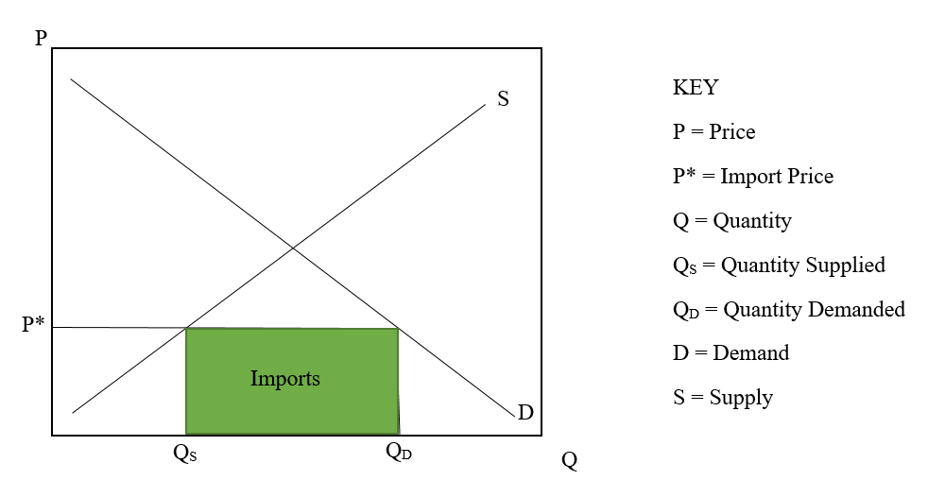
Now assume that the demand curve shifts outward as demand for agricultural products increase (Figure 2). In Figure 2, P* is the imported price of a good and the domestic price consumers’ face. As the demand curve shifts out, imports increase from Q_{S}Q_{D} to Q_{S}Q_{D2}.

Figure 2. Demand Increase in a Foreign Market
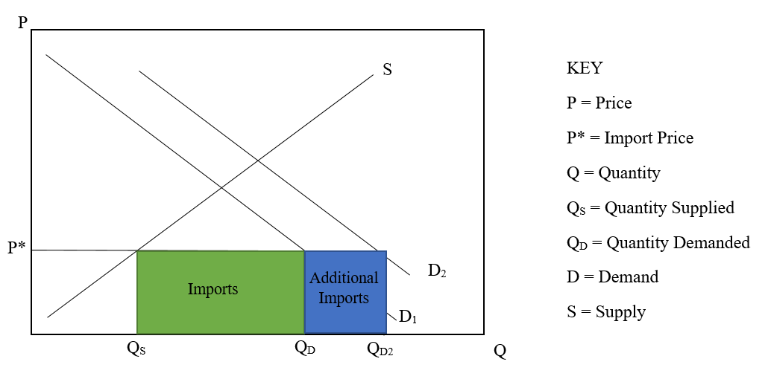
Therefore, imports will increase as demand increases assuming supply remains constant. This relationship between demand and domestic supply influences polices like tariffs and subsidies that will be discussed later. The need for imports is derived from Japan’s limited involvement in the production of domestic agriculture. Only 2.9% of the labor force is involved with agriculture since only 12.5% of land is used for cultivation (Central Intelligence Agency, 2015). Japan only cultivates a small portion of land because the majority of Japan is very mountainous. The lack of land availability forces Japan to be an import based country with a trade deficit rather than a surplus. In 2014, they imported $798.6 billion of imports and only exported $699.5 billion (Central Intelligence Agency, 2015). Japan mainly imported petroleum, liquid natural gas, and clothing from China, the United States, and Australia. Although Japan’s top imports are petroleum and natural gas, they still import a significant amount of food from Australia and the United States. Japan’s top ten agricultural imports are the following: cigarettes, maize, pork, rubber net dry, wheat, meat-cattle boneless (beef & veal), meat of chicken canned, coffee, soybeans, and food prep nets. Japan mainly exports motor vehicles, iron and steel products, and other high quality manufactured goods to the United States, China, and South Korea; however, Japan still exports some agricultural products. Japan’s top ten agricultural exports are the following: food prep nets, cigarettes, pastry, beverage non-alcoholic rice fermented beverages, apples, flour of wheat, alcoholic beverages including ethyl alcohol, food wastes, and tea (Food and Agriculture Organization, 2013). Although Japan’s agriculture sector makes up a small portion of their GDP, it still remains an important part of their economy and culture.
Japan’s currency exchange rate of their Japanese Yen is almost equal to one US cent. For every Japanese Yen, a person can receive 0.0089 US dollars or 0.89 cents. To put this in layman’s terms, one US dollar is almost equivalent to 100 yen, or 1,000 yen is 10 US dollars. The inflation rate is very low at 3.11% from 1958 until 2016; however, government debt is extremely high amounting up to more than 230% of their GDP (Central Intelligence Agency, 2015). The unemployment rate is also extremely low at 3.3 % in 2015 (Central Intelligence Agency, 2015). This would at first appear to seem to be beneficial; however, this statistic can be explained by Japan’s cultural influence on the market. Japanese business and government jobs operate in such a way that no one is ever fired. It is called taking the window seat approach (Tabuchi, 2013). Due to Japan’s hierarchical ideology, the highest ranked employee sits at the front of the room. The closer an employee is to the main supervisor, the more significant they are (Tabuchi, 2013). When employees get older or are deemed inefficient, they are placed near the back to face the window (Tabuchi, 2013). Here they are given the title madogiwa zoku or the window seat tribe (Tabuchi, 2013). There, the older individual is still a part of the company but no longer does any significant work. It is the company’s way of trying to get these older employees to quit. Due to strict Japanese labor laws, they cannot fire them (Tabuchi, 2013). This creates problems within the agriculture sector because the older generation can no longer do the intense labor that is involved with farming yet remain an input cost. An input cost is a cost for a firm to make a good.
Keeping older workers also creates a problem because even though a younger population sees the benefits of new innovative agricultural policies, most of Japan’s population will not recognize this due to being more traditional. Having a more flexible labor market in Japan would help companies thin out their work force to compete more efficiently with the global economy. Companies could distance themselves from traditional businesses and concentrate on more innovative businesses (Tabuchi, 2013). This labor policy also explains why the unemployment rate is so low, as well as the fact that Japan is struggling with a shrinking population, because they cannot fire anyone or replace them with a younger population.
In addition to a shrinking population, Japan’s has an upside-down population pyramid. This means that there are more elderly people then there are younger people. Out of the 126,999,808 people that reside in Japan the median age in Japan is 46.2 years (Worldometers, 2014). Japan’s older society and policies can be explained through Hofstede’s cultural dimensions. Hofstede’s cultural dimensions reveal that Japan is a very masculine, collective, long-term orientated, high uncertainty avoidance rate society. It also has a very high belief in power distance, meaning that they believe in a strong hierarchy government. This makes Japan’s parliamentary government with a constitutional monarchy very strong. Since 2012, Shinzō Abe has been the prime minister and remains extremely conservative. Most of the population is older and very rooted in their traditions. Japan’s domestic policies, including its agriculture policies, are the result of its older, more traditional population.
Agricultural Domestic Policies
Japan’s agricultural domestic policies have focused around a traditional rice community; however, Prime Minister Abe has begun to reform some of Japan’s old-fashioned strict agriculture domestic policies. Currently, Japan has very high import tariffs. The tariff rate on rice is 777.7%, on butter is 360%, and on sugar is 328% (The Economist, 2013). This is from the Gentan system that was first implemented in the 1970s to stray away from producing only rice and help diversify the types of crops from rice to other crops such as soybeans, wheat, or rice for animal feed (Oryza, 2013). Under this system, the government pays rice farms subsidies for the reduction in rice acreage. Originally, Japan operated under autarky or a closed economy. Figure 3 shows how the subsidy policy would cause the supply curve to shift to the left from S to S*, and a new equilibrium price and quantity would be reached. This would cause price of rice to increase and the quantity of rice consumed would decrease from Q₀ to to Q*.

Figure 3. Subsidy Under Autarky
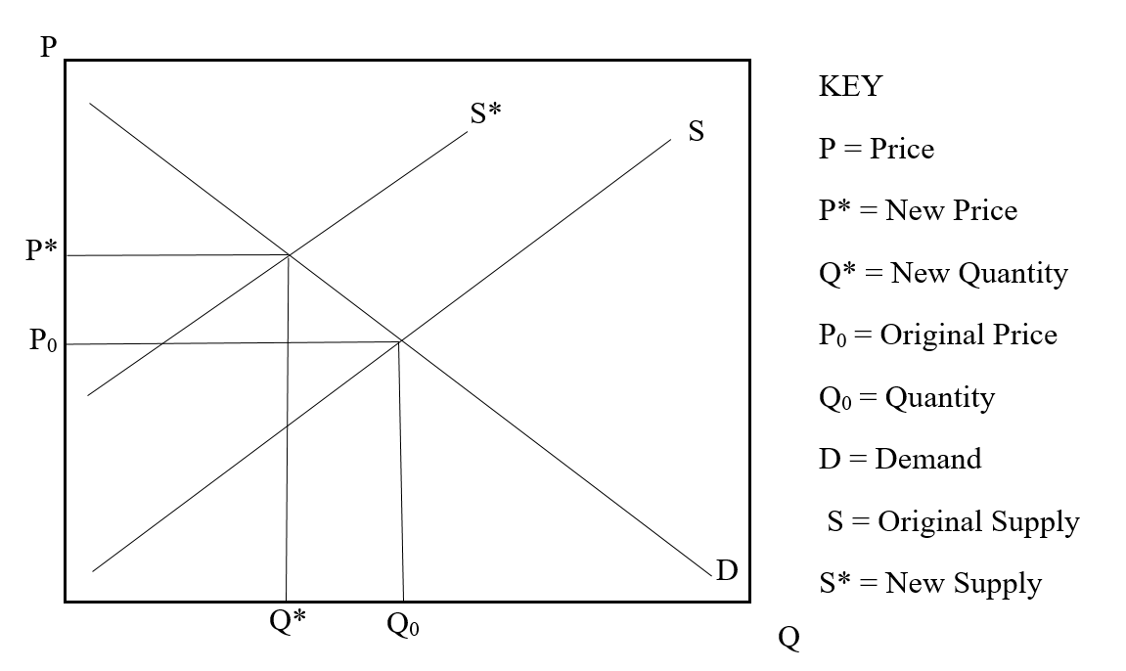
Japan now imports and exports rice due to their growing involvement with other countries and globalization. It is important for Japan to accomplish a reduction in their production of rice because they have a large rice supply and only consume small amounts (Hall, 2008). An average Japanese citizen consumes 119 grams of rice per day, which is equivalent to 1 standard size bowl of rice per day (Mike, 2015). There are 1,000,000 grams in 1 ton. In October of 2008, Japan had 2.6 million tons of domestic rice stored in warehouses and 1.5 million tons of imported rice, including 900,000 tons of imported American medium-grain rice stored in warehouses (Hall, 2008). For 2016-2017, Japan is expected to produce 7.9 million tons of rice (Lyddon, 2016). The previous year, Japan produced 7.6 million tons of rice and exported 100,000 tons of rice (Lyddon, 2016). In addition to the mass amounts Japan is currently storing, in 1995 the World Trade Organization rules stated that Japan must import rice (Hall, 2008). This was aimed at opening the country’s premium rice market to the global market; however, Japanese consumers do not consume much of the rice Japan imports because culturally it is inferior to Japanese rice (Hall, 2008). It also goes against the ideology that the Japanese community came together to produce rice for the entire country, therefore supporting foreign rice is extremely controversial (The Economist, 2013). Instead it is sent as food aid to low-income countries, made into rice wine, or used as livestock feed (Hall, 2008). These changes in policies are due to globalization and how the community reacts to these changes show how strongly culture identity is to Japan’s citizens.
The government is trying to meet both the expectations of Japanese society as well as remain competitive globally. Under Prime Minister Abe, the government announced the Gentan System that facilitates rice production controls will begin to decrease until it is eliminated in 2020 (Oryza, 2013). Then subsidies for other crops like tomatoes and peaches will increase to 30% (Oryza, 2013). In addition to produce industry, the livestock industry is changing in Japan. Prime Minister Abe also plans to change how the domestic livestock agricultural policies in Japan operate. There has been an increased consumption of meat in Japan because of globalization and Western influence. The increased consumption of meat in Japan has caused an increase in livestock production in agriculture in Japan from 18% to 30% between 1960 and 2005 (OECD, 2009). However, due to a lack of land, Japan has had to change their import quotas on beef as well. A high tariff originally replaced the import quota. Then from 1994 to 2008 the tariff level was gradually reduced from 50% to 38.5% (OECD, 2009).
Under a tariff, the producers in an importing country gain (Figure 4). In this case, Japan is a large country imposing a tariff on foreign goods. P_{F}, Q_{DF}, and Q_{SF} indicates the price, quantity demanded, and quantity supplied at free trade. P_{T}, Q_{DT}, and Q_{ST} indicates the price, quantity demanded, and quantity supplied under a tariff. Under free trade, the domestic consumer surplus consists of the areas ABCDEF. The domestic product surplus is GI and the domestic total welfare is ABCDEFGI. Under the tariff, the domestic consumer surplus is areas AB. The domestic surplus is CGI, the government revenue is EH, and the total welfare is ABCGIEH. As a result, the domestic producer and government gain but the domestic consumers lose. Operating under free trade, the exporter standpoint of consumer surplus is area J. The producer surplus is areas KLMNDRM, and the total welfare is JKLMNDRM. Under the tariff, the exporter consumer surplus is JKL, the producer surplus is NORU, and the total welfare changes to JKLNORU. Because of the tariff the consumer gains area KL, but the producers lose KLM. The total welfare difference for the exporter is also minus area M.
Figure 4. Large Country Tariff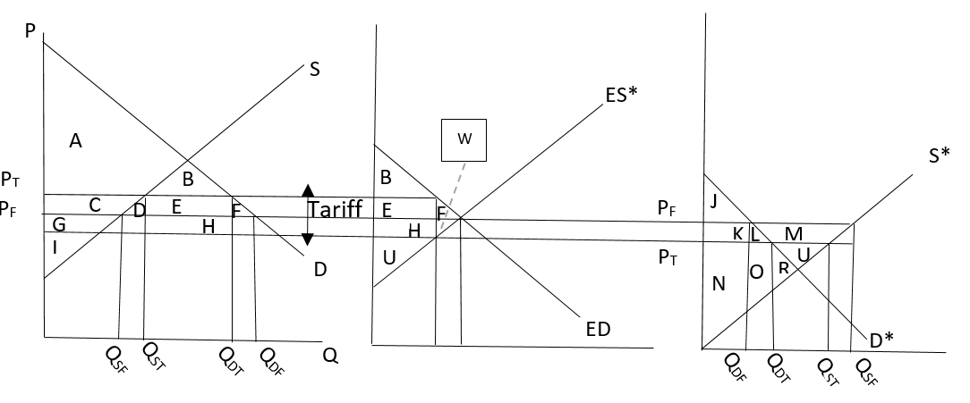
Under the Gentan System, Japan’s tariffs, and Japan’s tariff rate quotas are barriers of trade with other countries in the agricultural sector as well as the industry and services sectors of their economy. It creates unfair advantages for domestic producers, so foreign agriculture products cannot be as successful in the Japanese market. Japan also has some non-tariff barriers that impact foreign business. Some non-tariff trade barriers that foreign countries face when trading with Japan in agriculture are entry into market, regulations that discriminate against foreign products, cartels, language, cultural differences, strict food labeling, and tariff rate quotas (International Trade Administration, 2016). Tariff rate quotas are a combination of a tariff and a quota. Under a tariff rate quota, the supply is restricted compared to free trade. Under the tariff rate quota, the supply will decrease and shift inward. This type of policy benefits the government and producer, but hurts the consumer.

The most significant non-tariff barriers to trade are language, licensing, and cultural differences. Entry into the Japanese market can be difficult because foreign business must go through the Director-General of Customs and obtain a permit after their goods are inspected. Due to globalization, after items are declared and inspected, the foreign entity must pay duties and tax. Agricultural products have additional regulations they must go through. Products like animals, plants, perishable, and high value items the business must obtain a Japanese import license (International Trade Administration, 2016). Most of the time, documentation needed include an Import Declaration Form and a certificate of origin that are subjected to duty treatment determined by the WTO rates. Under the agreements of the WTO, all products must also be properly labeled and packaged according to Japanese standards (International Trade Administration, 2016).
Japanese standards can be explained through Hofstede’s cultural dimensions (Hofstede, 2017). Japan is a very collective, traditional group. They believe in long term orientation, meaning time wise Japanese people think long term rather than the United States who think very short term. Therefore, rice is so engrained in their culture and society, because it has historically been the staple crop for the Japanese population. It has been a reliable source of food for hundreds of years. Long-term orientation also influences Japan’s trade policies and why trade agreements are so hard to get into with Japan, but once that barrier is broken it is an everlasting trade agreement. Japan’s implementation of high tariffs on agriculture products makes it hard for other countries to trade with Japan. It costs more money to do business in Japan then it does in say China. What normally happens is that the consumers end up paying the high price, rather than the exporter, meaning that products like imported beef and imported dairy are extremely expensive to buy in Japan. Japan also has very strict food labeling laws. This requires any foreign companies to label all the properties that make up a food product in the Japanese market.
To combat these tariff barriers and non-tariff barriers to trade but still protect its domestic market, Japan has entered into free trade agreements with specific countries. As recently as January 2015, Japan entered into its first major agriculture free trade agreement with Australia, the Japan-Australia Economic Partnership Agreement (JAEPA). Under this agreement, Japan will phase out nearly 40% of the tariffs on Australian exports on beef (Japan Today, 2015). This is significant because Japan mainly imports its high-grade Kobe beef from Australia. Japan is Australia’s second biggest trading partner and imports over two-thirds of the beef Australia exports (Japan Today, 2015). In previous years, Japan used to import large volumes of beef products from the United States, but due to an outbreak of mad cow disease from US beef they have decreased import volumes (Strom, 2013). This significantly damaged the beef trade between the US and Japan. The outbreak is one of the reasons why the free trade agreement was formed between Australia and Japan (Strom, 2013). In return of Japan’s cooperation, Australia has agreed to end its tariffs on Japanese vehicles with a few exceptions (Japan Today, 2015). Due to globalization and time space compression, Japan and Australia are able to have close relations in the form of trade agreements. The Japan-Australia Economic Partnership Agreement trade agreement has taken seven years to be made and put into effect. It demonstrates that Japan is a slow processing country. The details of the agreement consist of the current 38.5% tariff on beef from Australia decrease to 23.5% for chilled beef within the next 15 years. Within the next 18 years, imported frozen beef should fall to 19.5% under the free trade agreement (Japan Today, 2015). However, parts of the trade agreement can be misleading. Although the import tariff rate decreased by 15% in chilled beef, the trade agreement between Australia and Japan also limited the amount of beef that can be imported into Japan’s market. Additionally, through this trade agreement, Japan has agreed to increase duty-free imports of cheese and eventually end their tariffs on wine, fruits, sea products, honey, vegetables, and nuts that meet Japanese regulations (Japan Today, 2015).
As mentioned previously, in addition to the Japan-Australia Economic Partnership Agreement, Japan is also involved with Trans-Pacific Partnership (TPP) negotiations. This agreement seeks to eliminate tariffs but also set a global standard for labor and environmental standards so countries can no longer obtain unfair advantages in competition with other countries. Originally, the General Agreement on Tariffs and Trade(GATT) that turned into the World Trade Organization (WTO) in 1995 covered polices that dealt with tariffs, services, government, and a few other things. Due to globalization in 2013 Japan joined the TPP negotiations, wishing to maintain high tariffs on wheat, beef, rice, forestry and fisheries products, pork, dairy products, and sugar (Yamashita page 18). The Trans-Pacific Partnership will cover trade and labor, trade and environment, trade facilitation, competition that deals with state owned enterprises, and investment. Again, Japan had to adjust those policies to remain competitive in the world economy and globalization
Additionally, Japan’s strict policies on tariffs have led to many retaliations from other countries. In turn, this has caused Japan to file many complaints with the World Trade Organization. Japan helped shape the transition from GATT to the WTO, World Trade Organization, in the Uruguay Round. During this round, Japan strongly opposed comprehensive tariffication. At the time, the most important issue to Japan during the Uruguay Round was to make sure that even the smallest amount of rice should not be permitted to enter the Japanese market because Japan had a large population of rice producers that had strong political power (Yamashita 10). However, due to a poor harvest that was the result of extremely cold weather in 1993, the Prime Minister of Japan accepted a tariff quota that opened the domestic market to foreign rice under the special treatment of rice with respect to new tariff quota (Yamashita 10). Subsequently, Japan raised the tariff quota from 5% to 8% of domestic consumption During the Doha round, Japan was forced to change their agricultural polices because of the EU-US agreement on direct payments to foreign countries. The Japanese government thought that to protect their agriculture sector they had no other choice but to switch to direct payments, following in suit of the EU transition in 1993 to survive the Uruguay Round negotiations. Because of the Doha Round, Japan decided to implement two changes. First, they decided to no apply tariff caps to a small number of products for non-trade. Under these products, rice was listed because of its special treatment of tariffication in the Uruguay Round. Japan decided that direct payments were not necessary for rice because there was no need to reduce the privet level. Secondly, Japan introduced this idea of sensitive products that are later used to dictate the negotiations of how other trade agreements go such as the Trans-Pacific Partnership. These sensitive products included agricultural products like rice, wheat, barley, sugar, diary, beef, and pork. Because of the Uruguay Round, the Doha Round, and Japan joining the WTO, Japan has had the power to dispute polices of other countries that they think are in violation of the agreements reached in these rounds.
Since Japan has joined the WTO it has been involved in 197 cases. It has been the complainant in 22 cases, the respondent in 15 cases, and the third-party member to 160 cases (World Trade Organization, 2016). In 2015, Japan filed a dispute to the WTO against Korea over import restrictions. In this dispute Japan stated that Korea had implemented additional certification and testing requirements under an import ban that affected the importation of food products from Japan, which violated the WTO (World Trade Organization, 2016). Japan has not filed any other disputes that dealt with agriculture products; however, they have filed many against the United States and China regarding anti-dumping laws and the automotive industry. Yet, over half of the 15 cases mentioned before have been over agriculture polices. Three have been on the taxes of alcohol, and three have been on the measures affecting imports of pork, agricultural products, and apples. These complaints to Japan came from the European Union, Canada, and the United States. In response to some of these complaints, Japan remains reluctant to loosen up their trade policies. An example of this can be seen with American beef and the Mad Cow Disease outbreak that occurred in Japan in 2003. Japan temporality banned beef imports and stopped issuing import certificates the U.S. beef exporters (Strom, 2013). It was not until 10 years later in 2013 that Japan finally started allowing more U.S. beef into Japan and reducing some of the restrictions they had on beef imports from the U.S. (Strom, 2013). This demonstrates Japan’s economic and cultural response to global situations like the Mad Cow Disease outbreak.

Culture Dimensions
To understand Japan’s policy decisions, one must understand Japan’s culture. According to Culture & Organizations, Software of the Mind by Professor Geert Hofstede, like many countries, Japan operates from several categories that include power distance, individualism, masculinity, uncertainty avoidance, long-term orientation, and indulgence (Hofstede, 2010). His theory is a framework for how the different values of countries affect their behavior using a factor analysis method and belief that culture is simply mental programming. These values that define cultures are based on beliefs like good versus evil or unnatural virus natural. Hofstede uses social anthropology to concur that all societies face the same basic problems as conception of one’s self, relation to authority, and methods to dealing with conflict; however, societies have different responses to these problems (Hofstede, 2010). Hofstede comprised his data of a survey about values in over 50 countries, Japan included. The sample was taken from employees who worked in the local branches of IBM, a multinational corporation. From there, he used a statistical analysis of the combined responses of different societies to uncover common problems that each society dealt with differently. These responses were put into the six cultural dimensions with a numerical score that can now be used to determine how countries will react to certain situations. Figure 5 displays the results of how Japan scored in the six cultural dimensions in comparison with the United States.
Figure 5. Cultural Dimension Scores in Japan and the United States
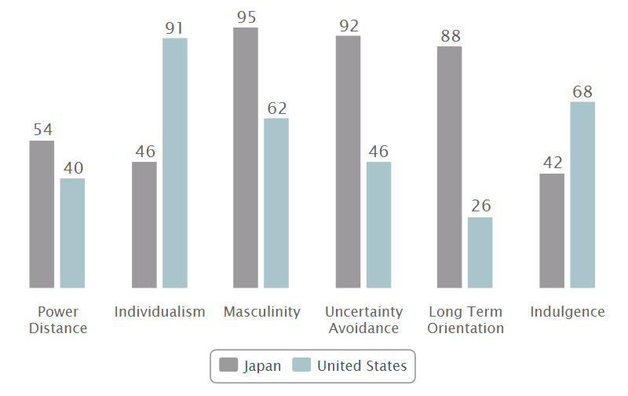
(Hofstede, 2017)
The first cultural dimension and the one that has the highest level of impact is that of Power Distance, which is defined as how less powerful members of society within a country assume and accept that power is spread unequally (Hofstede, 2017). Each dimension is given a score out of 100 points. The higher the score a country has, the more likely they are to have qualities associated with said dimension. Japan scores a 54 out of 100 in power distance, meaning that it is considered to have a hierarchical society. This affects policy making because all decisions must go through each hierarchical channel before the top position finally confirms it such as the Prime Minister of Japan. This makes the decision process in Japan very slow (Hofstede, 2017). An example of this can be seen in rural Japan. Communities pool their resources and work rice fields together. The village elders collectively make the decisions. The decision-making process is the following: choices are deliberated, data is gathered, then analyzed, and finally the elders reach a consensus (Kopp, 2012). This type of group behavior pattern that has always been seen in Japanese history is still seen in modern Japanese society today. They believe that it results in the best decision possible even though it takes much longer (Kopp, 2012).
The second cultural dimension is individualism, how members maintain a degree of interdependence within a society (Hofstede, 2017). In laymen’s terms, it is how a society acts on an individual basis, thinking of one’s own interest or thinking of interest of the whole country. Japan scores a 46 out of 100 in individualism, which indicts that they are a collective society. This indicates that Japan’s agricultural polices are always going to be made with the success of the entire country in mind, not just an individual farmer or corporation. This also influences how Japan implements barriers of trade like tariffs on rice or tariff rate quotas on beef. A comparison can be seen with the United States and how the United States interacts in international trade. They have a very high score of 92 out of 100 in individualism. Individuals in the United States will always look out for oneself, without taking into consideration how one’s action will affect others. For example, around 5% of the world’s population lives in the United States, yet they consume over 25% of the world’s resources (The End of Poverty, 2008). In contrast, Japan is shifting towards a more sustainable society because they have different values on individualism and time orientation. The United States is currently the world’s largest deficit and debtor country, whereas Japan is the world’s largest surplus and creditor country (Bergsten, 1998). The changes in fiscal and financial policies could enable the Japanese yen to reach a more sustainable level that can compete with the US dollar (Bergsten, 1998). Japan tries to maintain a smaller debt deficit because they fear long-term costs partly due to their older population.
The third dimension is masculinity. Japan scores a 95 out of 100 in the masculinity dimension, which indicates that Japan is focused on competition (Hofstede, 2017). Masculine dominated societies base their values off being a world of winners and losers. Masculinity also describes how men and women are viewed in society. Since Japan has a high score, women are not respected like men. This influences policy decisions because women still struggle to have a voice in Japanese parliament. The Inter-Parliamentary Union ranks Japan 164 out of 193 countries based on the number of women serving in the lower and upper houses of parliament. Only 9.3% is women in the lower house and there is 15.4% of women in the upper house. distracts how foreign affairs are handled because Japan will not negotiate seriously with foreign female representatives (National Parliaments, 2017). Therefore, Japan remains a very male dominated society where men make laws and trade policies (The Economist, 2014).
The fourth cultural dimension is uncertainty avoidance. This is one of the most important dimensions to describe Japan’s behavior patterns. Uncertainty avoidance involves a society’s outlook on the unknown future. Japan scores a 92 on the uncertainty avoidance dimension, so they try to prepare for any possible situation. From an economic standpoint, Japan puts effort into feasibility and knowing all the risk factors. This is one of the primary reasons why changes in policies and ideology is difficult. As mentioned previously, Japan has a fear of long-term budget costs due to the aging of the population (Bergsten, 1998). This influences how future polices and budgets will be made in Japan’s government. The fifth cultural dimension is long term orientation and Japan scores an 88 on this dimension. This indicates that Japan focuses on the future rather than living in the present (Hofstede, 2017). In corporate Japan, the goal is not to make money every quarter for investors, but to serve the stakeholders for many generations to come. Japan is constantly investing in research and development even in economically difficult times because they prioritize a steady growth of market share over a quarterly profit (Hofstede, 2017). This is also demonstrated in how Japan interacts with foreign entities. Japanese organizations want to establish a strong relation before discussing any sort of business (Katz, 2009). When forming new relationships, it takes several meetings to establish strong ties because the Japanese wants to see that foreigners are committed and dependable. In general, serious business negotiations cannot take place until a foreign entity establishes good will and trust. This will take time because of their time-orientation and their suspicion of foreigners (Katz, 2009). However, once a relationship is established it will be sustained for many generations to come.
The final cultural dimension is indulgence, the degree to how people within a society try to control their desires and impulse (Hofstede, 2017). Japan has a score of 42 on the indulgence dimension which means they favor restraint over indulgence. However, this cultural dimension does not strongly affect policy decision making. It just relates back to the other five dimensions that state Japan’s citizens will act as a unit for the greater good of the country. These six culture dimensions are important to understanding how a country makes decisions based off their values. They affect everyday life for people but also influence final laws that affect the future of Japan.
Conclusion
Japan’s international agricultural trade practices have been strongly influenced by culture, globalization, and international economics. Japan is adapting their agricultural policies to remain competitive as well as encouraging their citizens to have a more global outlook. Globalization and technological innovation remains a vital part and will continue to be in growing foreign markets. Japan’s citizens will have to change their traditional views to views reflecting a more global outlook if Japan wants to remain competitive (The Economist, 2013). Japan’s barriers of trade and strict agricultural policies are already beginning to change to accommodate a global market (OECD, 2009).

Works Cited
Australian Trade Commissions. "Export Markets - Japan." Doing Business. Australian Trade
Commissions, 2016. Web. 24 Apr. 2017.
Bergsten, Fred. "Japan and the United States in the World Economy." PIIE. Peterson Institute
for International Economics, 19 June 1998. Web. 21 June 2017.
Central Intelligence Agency. "The World Factbook." Central Intelligence Agency. Central
Intelligence Agency, 20 Aug. 2015. Web. 04 Nov. 2017.
FAO. “FAOSTAT.” FAOSTAT. Food and Agriculture Organization, 2013. Web. 27 Apr. 2016.
Hall, Kenji. “How Japan Helped Ease the Rice Crisis.” Bloomberg Business, Bloomberg, 22
May 2008.
Harding, Robin. "Japan Seeks to Bring Paciﬁc Trade Deal Back from the Dead." The
Financial Times. The Financial Times Limited, 23 Apr. 2017. Web.
Harvey, David. The Condition of Postmodernity . Blackwell Publishers, 1989.
Hofstede Centre. "What about Japan?" The Hofstede Centre. Hofstede Centre, 2017. Web. 05 Mar. 2017.
Hofstede, Geert, Gert Jan Hofstede, and Michael Minkov. Cultures and Organizations:
Software of the Mind. 3rd ed. USA: McGraw-Hill, 2010. Print.
International Trade Administration. "Japan - Trade Barriers." Japan - Trade Barriers. U.S.
Department of Commerce, 28 June 2016. Web. 09 July 2017.
Japan Today. "JapanToday." Japan Today RSS. GPlusMedia Co, 16 Jan. 2015. Web. 26 Apr.
2017.
Katz, Lothar. Negotiating International Business: the Negotiator's Reference Guide to 50
Countries around the World. Booksurge, 2009.
Kopp, Rochelle. "The Decision Making Progress in Japan." Japan Intercultural Consulting.
Japan Intercultural Consulting, 2 Apr. 2012. Web. 21 June 2017.
Kuttner, Robert. Everything for Sale: The Virtues and Limits of Markets. N.p.: U of Chicago,
1997. Print.
Lechner, Frank J., ed. The Globalization Reader. 5th ed. Oxford: Wiley-Blackwell, 2015.
Print.
Lyddon, Chris. "Focus on Japan." WORLD GRAIN. Sosland Publishing Company, 8 Nov.
2016. Web.
Mike. “Japan Ranks No. 50 in World Rice Consumption.” Japan Today, Japan Today, 15
Apr. 2015.
National Parliaments. "Women in National Parliaments." Women in Parliaments: World
Classification. Inter-Parliamentary Union, 1 July 2017. Web.
OECD. “Evaluation of Agricultural Policy Reforms in Japan” (2009): n. pag. OECD.
Organization for Economic Co-Operation and Development, 2009. Web. 27 Apr. 2017.
Oryza. "Japan Announces Major Shift in Rice Policy; Gentan System Ends in FY2018-
19." Oryza. Oryza, 26 Nov. 2013. Web. 24 Apr. 2017.
Sansom, George Bailey. Japan: A Short Cultural History. Stanford: Stanford UP, 1931. Print.
Strom, Stephanie. "Japan Eases Import Restrictions on U.S. Beef." The New York Times. The
New York Times, 28 Jan. 2013. Web.
Tabuchi, Hiroko. "Layoffs Taboo, Japan Workers Are Sent to the Boredom Room." The New
York Times. The New York Times, 16 Aug. 2013. Web. 07 July 2017.
Taylor, Adam. "It’s Official: Japan’s Population Is Dramatically Shrinking." The Washington
Post. WP Company, 26 Feb. 2016. Web.
The Economist. "Field Work." The Economist. The Economist Newspaper, 13 Apr. 2013.
Web. 24 Apr. 2017.
The Economist. "Holding Back Half the Nation." The Economist. The Economist Newspaper,
28 Mar. 2014. Web. 10 August 2017.
The End of Poverty. Dir. Philippe Diaz. Cinema Libre Studio, 2008. Web. 21 June 2017.
Wang, Brian. "Average Age of Japanese Farmers Is 66 so Japan Starting to Shift to Robotic
Farms." NextBigFuture.com. NextBigFuture.Inc, 2 Feb. 2016. Web. 21 June 2017.
Weatherby, Joseph. The Other World: Issues and Politics of the Developing World. 9th
ed, New York: Longman, 2007. Print.
Worldometer. "Japan Population (LIVE)." Population of Japan (2015). Worldometer, 1 July
2017. Web. 09 Mar. 2017.
World Trade Organization. "Japan News Archive." World Trade Organization. World Trade
Organization, 2016. Web. 24 Apr. 2017.
Yamashita, Kazuhito; (2015); Japanese Agriculture Trade Policy and Sustainable
Development; Issue Paper No. 56; International Centre for Trade and Sustainable
Development, Geneva, Switzerland, www.ictsd.org. Web. 24 Apr. 2017.

