Better Maternal Interaction

Zaynee Roy

Abstract
For my senior thesis, I have complied together all the different things that I have done to help with Dr. Patten’s study. Her study focuses on intervention with teenage mothers and their babies. Dr. Patten and her team used video self-modeling as their form of intervention. They videoed the teenage mothers interacting with their babies. When they played back the video for the mothers, they only told the mothers the positive aspects of their interaction with their babies. Then, they used text messaging to remind the mothers to keep up the positive aspects of their interaction with their baby. Dr. Patten and her team wanted to see if the teenage mothers increased their amount of positive interaction with their babies as a result of the intervention. I helped write the background for the study. I explained why intervention with teenage mothers is important, and I described how video self-modeling and using text messaging are proven to be effective intervention techniques. Furthermore, for the piolet participant video, I helped code for three of the 11 behaviors that Dr. Patten and her team looked at. The behaviors were maternal initiation, infant vocalization, and speech register. I developed a coding reliability manual for those three behaviors that future coders can use a resource as they code future participants. Lastly, I also developed a website that can be used as an educational resource for the participants and other teenage mothers.

Happy Moms Study’s Background
According to the Center for Disease Control (2015), nearly 300,000 babies were born to teenage mothers aged 15-19 in 2013. These young mothers are at an increased risk of having more troubling pregnancy outcomes than mothers between the ages of 20-24 because of their young age (Fraser, 1995). There is a strong correlation between lower maternal age and high prevalence of low birth weight (Friede, 1987). In addition, a study by Friede (1987) found that maternal age and neonatal mortality were inversely related. As maternal age increased, neonatal mortality decreased (Friede, 1987). A study by Tiffany Fields (1980) looked at the development of preterm infants compared to the fullterm infants born to teenage mothers, and compared them to preterm and fullterm infants born to adult mothers. The study found that even when parental care was equal, preterm infants of teenage mothers were at greater risk because of their small-to-date size and the mothers’ unrealistic attitudes about developmental milestones and child-rearing (Fields, 1980).
Children of teenage mothers have more difficulties in development compared to children of older mothers. A study examined teenage parenting and the children’s school readiness outcomes at age 4 for a large sample of low-income Latinos (Briceno, De Feyter, & Winsler, 2013). It was found that having a mother younger than 20 was associated with lower cognitive and language skills at age 3 and 4 even when other demographic factors were controlled (Briceno et al. , 2013). In addition, it was found that children of teenage mothers perform significantly worse than children of older mothers on measures of expressive language and language comprehension, such as the Child Development Inventory and the HOME Inventory (Keown, Woodward, & Field, 2001).
To continue, babies born to teenage mothers also generally have worse outcomes as young adults than babies born to adult mothers (Francescon, 2007). For example, children of teen mothers have a lower chance of high educational attainment, have a greater risk of inactivity, have higher teenage childbearing rates, and have a higher probability of being in the bottom decile of the earnings distribution when compared to children of non-teen mothers (Francescon, 2007). Furthermore, a study that looked at the correlation between maternal age at the first antenatal visit and psychological, behavioral, and health characteristics when the children were 14 years of age (Shaw, 2006). Researchers found that the children of the mothers under 18 were more likely to have disturbed psychological behavior, more likely to have poorer school performance, and more likely to have poorer reading ability than children of mothers who were older than 18. In addition, they were also more likely to be in contact with the criminal justice system and more likely to consume alcohol more regularly than children of mothers who were older than 18 (Shaw, 2006).
Teenage mothers have a number of characteristics that may have a negative effect in their children’s development. For example, babies of teenage mothers are at a greater risk for developmental problems because the teenage mothers haven’t matured fully themselves (Erikson, 1968). According to Erickson’s developmental stages, teenagers are at the stage of identity formation (Erikson, 1963). However, forming an identity can be very difficult for teenagers who are also trying to balance parenthood, which can in turn affect the quality of care that their child receives (Sadler & Cowlin, 2003). Teenage parents may also not be cognitively capable of handling all the problems that occur during parenthood (Sadler & Cowlin, 2003). Researchers also found that teen mothers significantly made more errors than adult mothers on the measures of attention/cognitive flexibility (Chico, Gonzalz, Ali, Steiner, & Fleming, 2014). Researchers also found that attention measures were correlated with maternal behaviors for teen mothers (Chico et al. , 2014) . For instance, the poorer the mother did on attention measures, the less sensitive she was and fewer she vocalized to her infant (Chico et al. , 2014). The study found that the mothers’ cognitive flexibility did not affect parenting for adult mothers (Chico et al. , 2014). However, for teenage mothers, cognitive flexibility did affect their parenting, with poor cognitive flexibility being related to less maternal sensitivity and less vocalizations to infants (Chico, et al. , 2014).
Teenage parents may also not be as sensitive to their child’s needs, which can negatively affect attachment (Bowlby, 1988; Meadows-Oliver et al. , 2007; Sadler & Cowlin, 2003). To continue, a study found that although teen mothers reported more sympathy and alertness in response to recorded infant cries compared to teens who were not mothers, teen mothers did not display differences between non-mothers in their heart rate and cortisol responses to infant cries (Giardino, Gonzalez, Steiner, & Fleming, 2008). On the other hand, adult mothers reported the same level of sympathy and alertness in response to the recorded infant cries as the teen mothers; however the adult mothers displayed an “alerted” pattern of heart rate and cortisol response to the infant cries not seen in the teen mothers group (Giardino et al. , 2008). Poor parent-child attachment is also connected to the child receiving lower language stimulation which can negatively affect the child’s language development, the child’s age-appropriate use of objects during infancy, the child’s cognitive development, the child’s motor development, and the child’s socioemotional development (De Wolff & van IJzendoorn, 1997; Flom & Pick, 2003; Keown, Woodward, & Field, 2001). To continue, increased stress and multiple other factors such as unemployment can hinder the quality of care teenage parents give their child (Meadows-Oliver, Salder, Swartz, &, Ryan-Krause, 2007).
Studies have also found that teenage mothers are not as aware of parent-child interaction techniques that help their babies’ general development, including language. Keown et al. (2001) found that teenage mothers used less verbal stimulation, were less sensitive, were more intrusive, and had less positive affect. In addition, it was found that teenage mothers were less likely to be emotionally and verbally responsive than adult mothers (Keown et al. , 2001). Teenage mothers were more likely than adult mothers to spend less time vocalizing to their infant and spend more time orienting away from their children (Chico et al. , 2014). Furthermore, Whitmarsh (2011) found that many teen mothers were not aware of the importance of child-directed speech. In addition, few teen mothers offered a rational for book sharing, and the teen mothers that were interviewed did not share books with their babies (Whitmarsh, 2011). Even though most teen mothers agree that repeating sounds supported language development, they were less sure about whether babies could copy speech at 2 months (Whitmarsh, 2011).
There are many behaviors that are associated with better communicative development, and these could be the areas that could be addressed in intervention with teenage mothers. One behavior that is very beneficial to the child’s communicative development is responsive utterances. Mol and Neuman (2014) looked at parent-child interaction patterns when they were sharing an informational book. They found that lexical richness and contingent responsiveness by parents or caregivers positively predicted the child’s receptive and expressive vocabulary (Mol & Neuman, 2014). Furthermore, researchers found that contingent responsiveness seemed to mediate the influence of the socioeconomic status on children’s receptive and expressive vocabulary (Mol & Neuman, 2014). This suggests that positive environmental contexts and supportive parent-child interactions can have a powerful influence on children’s development (Mol & Neuman, 2014).
Taylor, Anthony, and Aghara (2008) looked at the effect of maternal responsiveness on the children’s cognitive skills, reading decoding skills, and reading comprehension skills. They analyzed parenting behaviors through observation during a home visit that included a 60-minute period of daily activity and a 10-minute toy play session, and they conducted observations of maternal responsiveness when the children were 6, 12, and 24 months of age and again when the children were 3 and 4 years of age (Taylor et al. , 2008). In addition, the children’s cognitive skills were assessed when the children were four, and their reading decoding and comprehension skills were assessed when the children were eight (Taylor et al. , 2008). Researchers found that the interaction between children’s 4-year cognitive ability and maternal responsiveness cluster predicted children’s reading comprehension skills at 8 years of age, regardless of the children’s biological risks (Taylor et al. , 2008).
Furthermore, in a study by Merz et al. (2015), trained examiners gave children assessments over two academic years. The first assessment was given during the middle of the first year, and then they gave another assessment one year later (Merz et al. , 2015). Researchers found that parental responsiveness strongly predicted all concurrent cognitive skills, literacy knowledge, math knowledge, and emotional knowledge one year later (Merz et al. , 2015). In addition, researchers found that for children who had stronger initial language skills, higher levels of parental inferential language input helped greater vocabulary development (Merz et al. , 2015).
A study by Tamis-LeMonda, Bornstien, and Baumwell (2001) that looked at maternal responsiveness with 9 and 13 month olds found that it also predicted the timing of the development of five milestones in language in the children’s expressive language: first imitations, first words, 50 words in expressive language, combinatory speech, and the use of language to talk about the past. Maternal responsiveness at both ages predicted the timing of the children achieving language milestones over and above children’s observed behaviors (Tamis-LeMonda et al. , 2001). Yoder, McCathren, Warren, and Watson (2001) found in a study with children with disabilities or developmental delays that the number of nonlinguistic responses given by the mother was positively related to the rate of intentional communication in children 6 months after entry into the study. The number of nonlinguistic responses were also positively related to the expressive and receptive language scores 12 months after the entry into the study (Yoder et al. , 2001). In addition, the number of maternal linguistic mapping responses to intentional communication was also positively related to expressive and receptive language scores 12 months after entry (Yoder et al. , 2001).
The directiveness of mothers also affected their children’s development (Landry, Smith, Swank, & Miller-Loncar, 2000). For example, mothers who maintained their child’s interest while their child was 2-3 ½ year olds indirectly influenced their now 4 ½ year olds cognitive and social independence (Landry et al. , 2000). Directiveness positively support children’s early cognitive and responsive skills; however, high levels of directiveness by the time the child was 3 ½ had a direct negative influence on the children’s cognitive and social independence at 4 ½ (Landry et al. , 2000).
To continue, the use of infant-directed speech is also very important. In a study done by Estes and Hurley, infants who were 17 months old were given two label-object pairs in a habituation-based word learning task (Estes & Hurley, 2012). In Experiment 1, the labels were produced in adult-directed (AD) speech (Estes & Hurley, 2012). In Experiment 2, the labels were produced in infant-directed speech (Estes & Hurley, 2012). The infants did not learn the labels in adult-directed speech, but they did learn the labels in infant-directed speech (Estes & Hurley, 2012). In Experiment 3, researchers investigated the role of variability in learning from infant-directed speech (Estes & Hurley, 2012). They found that when infant-directed prosody was used with no variation across tokens, the infants did not learn them (Estes & Hurley, 2012). This indicates that infant-directed prosody can affect how readily infants may match sounds to meanings, and the variability in prosody that is characteristic of infant-directed speech may by very important in its effects on learning new words (Estes & Hurley, 2012). To continue, a study by Thiessen, Hill, and Saffran (2005) found that infant-directed speech helps with word segmentation. In their study, the infants were divided into two groups (Thiessan, Hill, & Saffran, 2005). The researchers present one group of infants a set of nonsense sentences that were spoken with adult-directed speech (Thiessen, Hill, & Saffran, 2005). The researchers presented the second group of infants with the same non-sense sentences, but the sentences were spoken with infant-directed speech (Thiessen, Hill, & Saffran, 2005). The only hint to word boundaries that both groups had was the way that the sentences were said (Thiessen, Hill, & Saffran, 2005). Researchers found that only the infants who heard the sentences in infant-direct speech were able to differentiate between words from syllable sequences spanning word boundaries (Thiessen, Hill, & Saffran, 2005).
Studies have shown that book sharing and book discussions are also very important. A particular study done by Kleeck, Gillam, Hamilton, and McGrath (1997) looked at book discussions and developmental gains made by the children. They videotaped 35 parents in their homes as they read a familiar and unfamiliar book to their preschoolers (Kleeck et al. , 1997). Then, they coded the parental discussions about the text based on four levels of abstraction, and they compared it with the gains the children made one year later on formal tests that tested those same four levels of language abstraction (Kleeck et al. , 1997). The Level I abstraction was considered to be the least abstract because it included adult language about the book which was very concrete (Kleeck et al. , 1997). Level II abstraction was more abstract than Level I, and it included questions or commands about recalling information presented earlier in the book, describing characteristics and scenes, and urging the child to finish a sentence of the book’s text using appropriate intonation patterns (Kleeck et al. , 1997). In Level III abstraction, they go a step further. Comments and questions are made about things that are or have been perceptually present (Kleeck et al. , 1997). Level IV is the most abstract, and the children are exposed to a variety of ways of reasoning and dealing with the information presented in the book (Kleeck et al. , 1997). For example, children are exposed to making hypothetical predictions, problem solving, and explaining concepts, and providing general information (Kleeck et al. , 1997). They found that the parental input at levels three and four of abstraction were positively and significantly correlated with their children’s gains at the highest level of abstraction (Kleeck et al. , 1997). At the beginning, these levels were the ones where the children scored the lowest initially; however, these levels are where the children showed the greatest gains after parental book discussion (Kleeck et al. , 1997). The results suggest that parental discussions during book reading with preschooler are a positive influence (Kleeck et al. , 1997). Furthermore, in a longitudinal study by Sénéchal and LeFevre (2003), they found that children’s exposure to books was correlated with the development of their vocabulary and listening comprehension skills, which were directly related to the children’s reading skills in 3rd grade. Furthermore, they found that early literacy skills, a direct predictor of word reading at the end of 1st grade, were promoted by parental involvement in teaching their children about reading and writing (Sénéchal & LeFevre, 2003). To continue, reading comprehension in 3rd grade was predicted by word reading at the end of 1st grade (Sénéchal & LeFevre).
This particular study uses cellphones as a means of enhancing intervention for teenage mothers. At first, the teenage mothers are videotaped as they interact with their baby. Later, the teenage mothers watch the video of themselves interacting with their baby. This is known as video self-modeling. They are given praise for the positive things they are doing while interacting with their baby. In this study, no attention is being brought to the negative things that the teenage mothers are doing while interacting with their baby. After, they receive daily text messages reminding them to keep doing the positive things while interacting with their baby. A study by Carta, Lefever, Bigelow, Borkowski, and Warren (2013) found mothers who received a cellular-phone enhanced version of a particular intervention used more of the strategies presented in the intervention than mothers who received the noncellular-phone enhanced version and the control group. In addition, the mothers who received the cellular-phone enhanced version also reported having greater reductions in stress and depression (Carta et al. , 2013). Another study found that using text messaging for reminder-recalls improved immunization coverage in a low-income urban population (Stockwell et al. , 2012).
To continue, there have also been studies looking at the efficiency of video modeling and video self-modeling interventions. A meta-analysis study by done Bellini and Akullian (2007) found analyzed the effectiveness of video modeling and video self-modeling interventions for children with autism spectrum disorder. They found that video modeling and video self-modeling are effective intervention strategies for addressing social communication skills, functional skills, and behavioral functional skills in children and adolescents with autism spectrum disorder (Bellini & Akullian, 2007). They also found that the skills acquired by using video modeling and video self-modeling are maintained over time and generalized across persons and settings (Bellini & Akullian, 2007). This suggests that video modeling and video self-modeling are evidence-based practices (Bellini & Akullian, 2007). Furthermore, a study by Wert and Neisworth (2003) tested the effectiveness of video self-modeling intervention on increasing spontaneous requesting in four participants with autism spectrum disorder. They found that all four participants increased their spontaneous requesting behavior as a result of the video self-modeling intervention (Wert & Neisworth, 2003).
Studies have also shown that behavior-specific praise, which is used in this study, is an effective method of intervention. Sutherland, Wehby, and Copeland (2000) looked at effects of behavior-specific praise by teachers and the on-task behavior of students with emotional and behavioral disorders. They found that there was a positive correlation between students’ on-task behavior and teacher’s behavior-specific praise (Sutherland, Webhy, & Copeland, 2000). For example, when teachers increased their behavior-specific praise, the students’ on-task behavior also increased (Sutherland, Webhy, & Copeland, 2000).
There have also been studies that examined the efficacy of interventions with teenagers. A particular study done by Neuman and Gallagher (1994) examined what effects coaching the teenage mothers to use selected cues in playful literacy exploration would have on their children’s literacy play intellectual development. The mothers were taught how to draw attention to and label the objects of interest to the children, taught how to use scaffolding techniques, and taught how to challenge their children’s interpretations through responses that are contingent to the child’s pervious utterance (Neuman & Gallagher, 1994). They found that the teenage mothers increased their use of interactional cues after the intervention (Neuman & Gallagher, 1994). In addition, the children’s active participation in literacy also increased, and their score on the Peabody Picture Vocabulary Test increased after the intervention (Neuman & Gallagher, 1994).

References
Bellini, S. , & Akullian, J. (2007). A meta-analysis of video modeling and video self
modeling intervention for children and adolescents with autism spectrum disorders. Exceptional Children, 73(3), 264-287.
Briceno, A. L. , De Feyter, J. J. , & Winsler, A. (2013). The school readiness of children
born to low-income, adolescent Latinas in Miami. The American Journal of Orthopsychiatry, 83(2-3), 430-442.
Carta, J. , Lefever, J, Bigelow, K. , Borkowski, J. , & Warren, S. (2013). Randomized
trial of a cellular phone-enhanced home visitation parenting intervention. Pediatrics, 132(2), s167-s173.
Center for Disease Control and Prevention. (2015). Reproductive Health: Teen
Pregnancy. Retrieved from http://www.cdc.gov/teenpregnancy/
Chico, E. , Gonzalz, A. , Ali, N. , Steiner, M. , Fleming, A. (2014). Executive function
and mothering: Challenges faced by teenage mothers. Developmental Psychobiology, 56(5), 1027-1035.
De Wolff, M. , & van Ijzendoorn, M. (1997). Sensitivity and attachment: A meta-analysis
on parental antecedents of infant-attachment. Child Development, 68(4), 571-591.
Erikson, E. H. (1963). Childhood and society. New York, NY: Norton.
Erikson, E. H. (1968). Identity: Youth and crisis. New York, NY: Norton.
Estes, K. , & Hurley, K. (2013). Infant-directed prosody helps infants map sounds to
meanings. Infancy, 18(5), 797-824.
Field, T. , Widmayer, S. , Stringer, S. , & Ignatoff, E. (1980). Teenage, lower-class,
black-mothers and their preterm infants: An intervention and developmental follow-up. Child Development, 10(3), 129-145.
Flom, R. , & Pick, A. (2003). Verbal encouragement and joint attention in 18-month-old
Infants. Infant Behavior Development, 26(2), 127-134.
Franescon, M. (2008). Adult outcomes for children of teenage mothers. The
Scandinavian Journal of Economics, 110(1), 129-145.
Fraser, A. , Brockert, J. , & Ward, R.H. (1995). Association of young maternal age with
adverse reproduction outcomes. The New England Journal of Medicine, 332, 1113-1118.
Friede, A. , Baldwin, W. , Rhodes, P. , Buehler, J. , Strauss, L. , Smith, J. , & Hogue, C.
(1987). Young maternal age and infant mortality: the role of low birth weight, Public Health Report, 102(2), 192, 199.
Giardino, J. , Gonzalez, A. , Steiner, M. , & Fleming, A. (2008). Effects of motherhood
on physiological and subjective responses to infant cries in teenage mothers: A comparison with non-mothers and adult mothers. Hormones and Behavior, 53(1), 149-158.
Keown, L, , Woodward, L. , & Field, J. (2011). Language development of pre-school
children born to teenage mothers. Infant and Child Development, 10(3), 129-145.
Kleck, A. , Gillam, R. , Hamilton, L. , & McGrath, C. (1997). The relationship between
middle-class parents’ book-sharing discussion and their preschooler’s abstract language development. Journal of Speech, Language, and Hearing Research, 40, 1261-1271.
Landry, S. , Smith, K. , Swank, P. , Miller-Lancar, C. , (2000). Early maternal and child
influences on children’s later independent cognitive and social functioning. Child
Development, 71(2), 358-375.
Meadows-Oliver, M. , Sadler, L. , Swartz, M. , & Ryan-Krause, P. (2007). Sources of
stress and support and maternal resources of homeless teenage mothers. Journal of Child and Adolescent Psychiatric Nursing, 20(2), 116-125.
Merz, E. , Zucker, T. , Landry, S. , Williams, J. , Assel, M. , Taylor, H, … Villiers, J.
(2015). Parenting predictors of cognitive skills and emotion knowledge in socioeconomically disadvantaged preschooler. Journal of Experimental Child Psychology, 132, 14-31.
Mol, S. , & Neuman, S. (2014). Sharing information books with kindergartners: The role
of parents’ extra-textual talk and socioeconomic status. Early Childhood Research Quarterly, 29(4), 399-410.
Neuman, S. , & Gallagher, P. (1994). Joining together in literacy learning: Teenage
mothers and children. Reading Research Quarterly, 29(4), 382-401.
Sadler, L. , & Cowlin, A. (2003). Moving into parenthood: A program for new adolescent
mothers combining parent education with creative physical activety, Journal for Specialists in Pediatric Nursing, 8(2), 62-70.
Sénéchal, M. , & LeFevre, J. (2002). Parental involvement in the development of
children’s reading skill: A five-year longitudinal study. Child Development, 73(2), 445-460.
Shaw, M. , Lawlor, D. , & Najman, J. (2006). Teenage children of teenage mothers:
Psychological, behavioral and health outcomes from an Australian prospective longitudinal study. Social Science & Medicine, 62(10), 2526-2539.
Stockwell, M. , Kharbanda, E. , Martinez, R. , Lara, M. , Vawdrey, D. , Natarajan, K. , &
Rickert, V. (2012). Text4Health: Impact of test message reminder-recalls for pediatric and adolescent immunizations. American Journal of Public Health, 102(2), e15-e21.
Sutherland, K. , Wehby, J. , & Copeland, S. (2000). Effect of varying rates of behavior-
specific praise on the on-task behavior of students with EBD. Journal of Emotional and Behavioral Disorders, 8(1), 2-8.
Tamis-LeMonda, C. , Bornstein, M. , & Baumwell, L. (2001). Maternal responsiveness
and children’s achievement of language milestones. Child Development, 72(3),
748-767.
Taylor, H. , Anthony, J. , & Aghara, R. (2008). The interaction of early maternal
responsiveness and children’s cognitive abilities on later decoding and reading comprehension skills. Early Education and Development, 19(1), 188-207.
Thiessen, E. , Hill, E. , & Saffran, J. (2005). Infant-directed speech facilitates word
segmentation. Infancy, 7(1), 53-71.
Wert, B. , & Neisworth, J. (2003). Spontaneous requesting in children with autism.
Journal of Positive Behavior Interventions, 5(1), 30-34.
Whitmarsh, J. (2011). Out of the mouth of babes: first-time disadvantaged mothers and
their perceptions of infant communication. International Journal of Early Years Education, 19(3-4), 283-396.
Yoder, P. , McCathern, R. , Warren, S. , Watson, A. (2001). Important distinctions in
measuring maternal responses to communication in prelinguistic children with disabilities. Communication Disorders Quarterly, 22(3), 135-147.

Screenshots of my Website

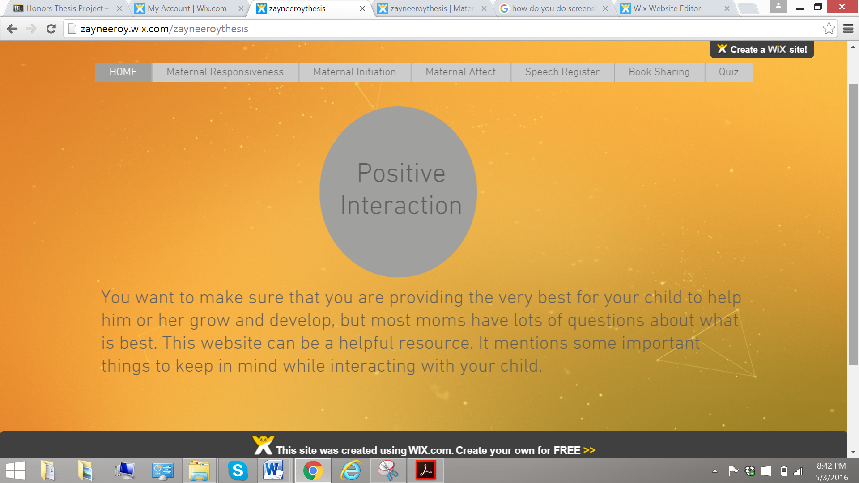

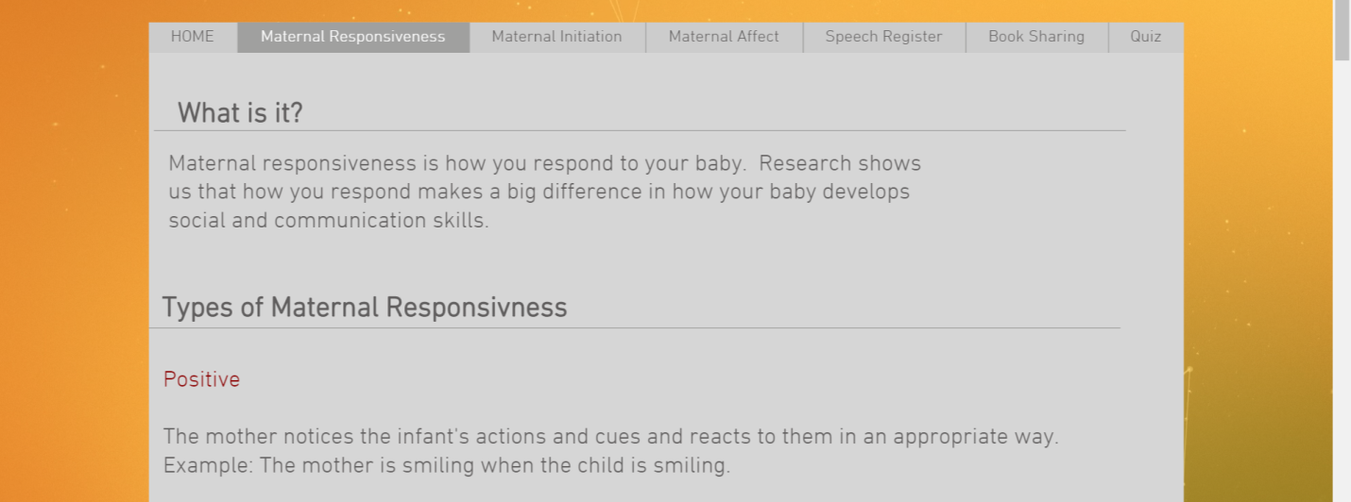

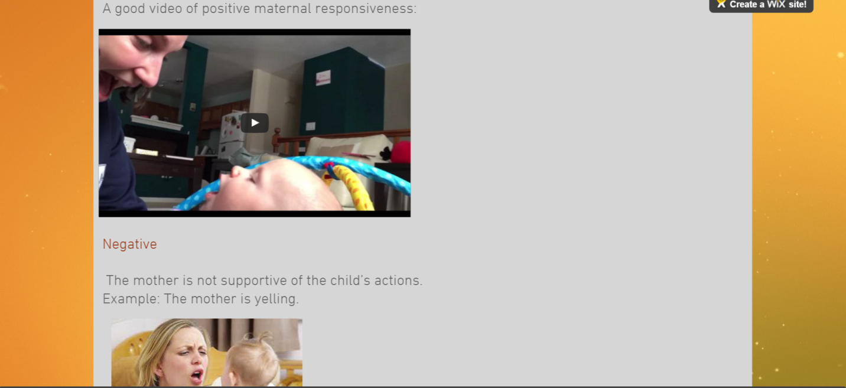

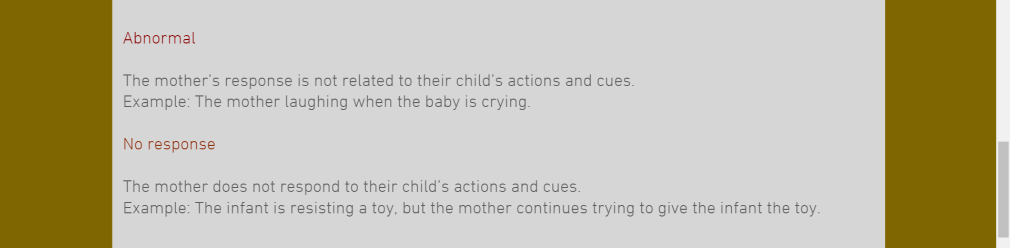

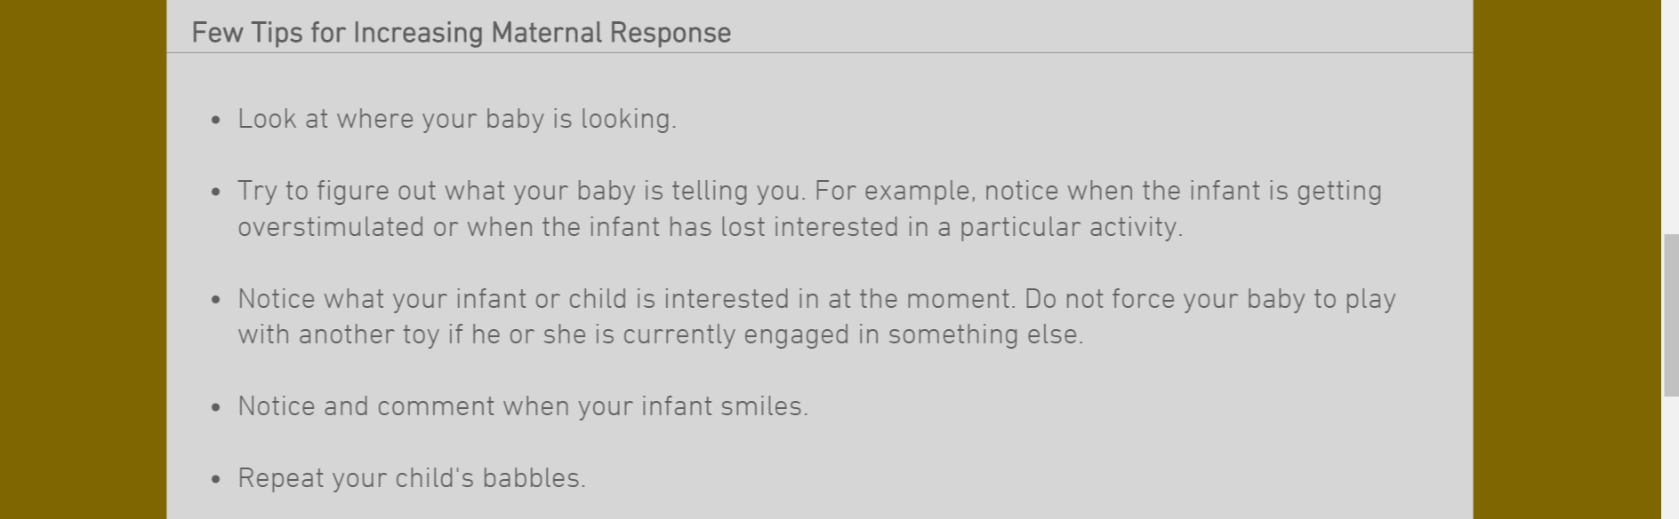

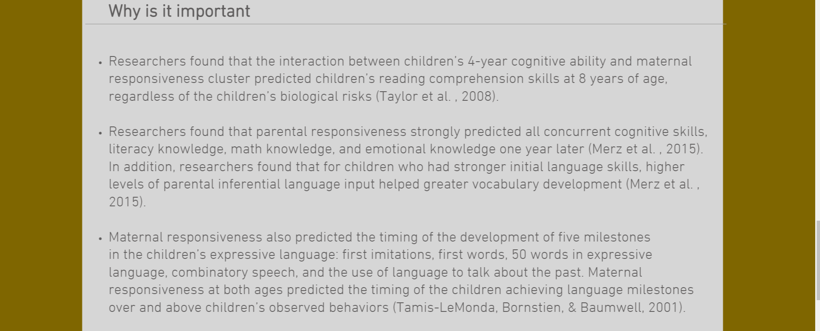

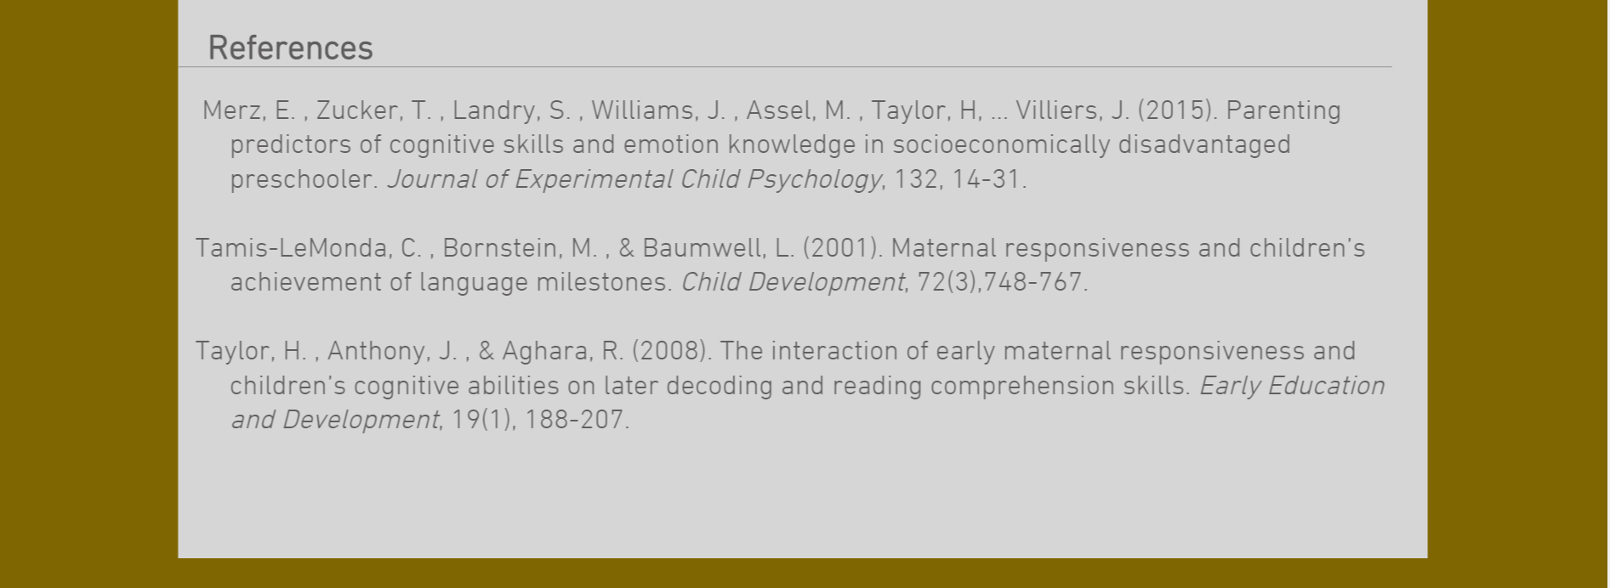
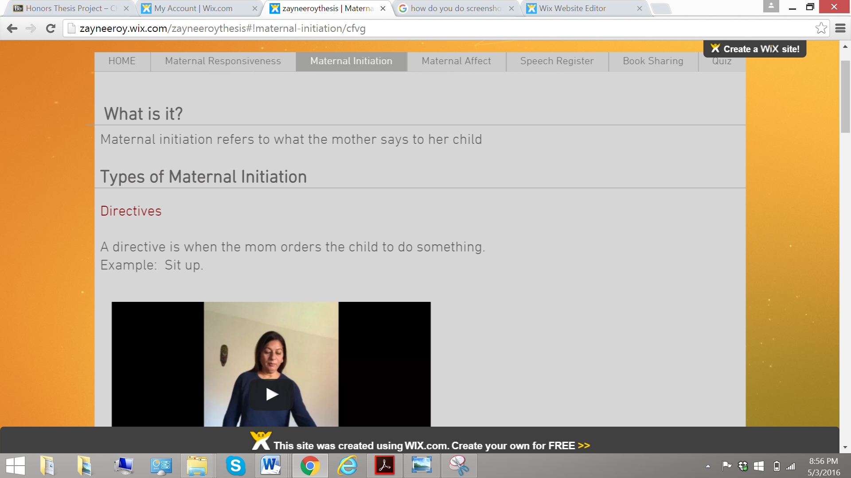



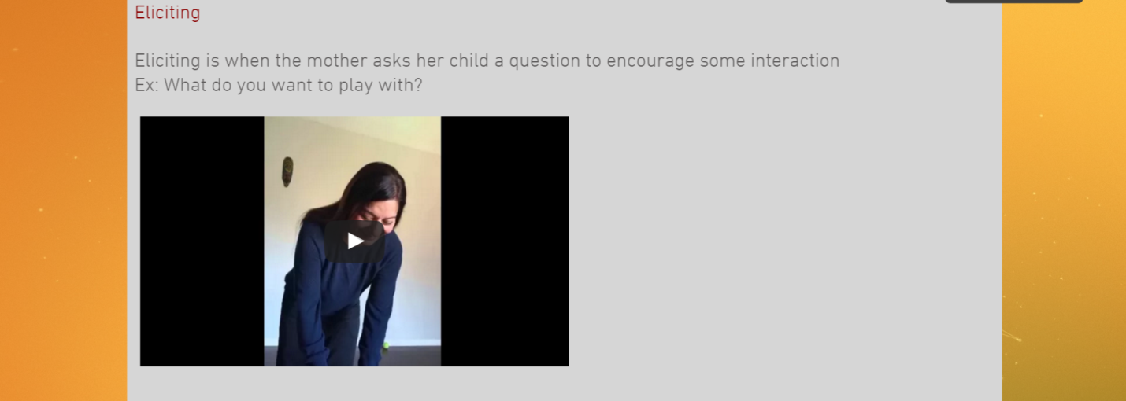

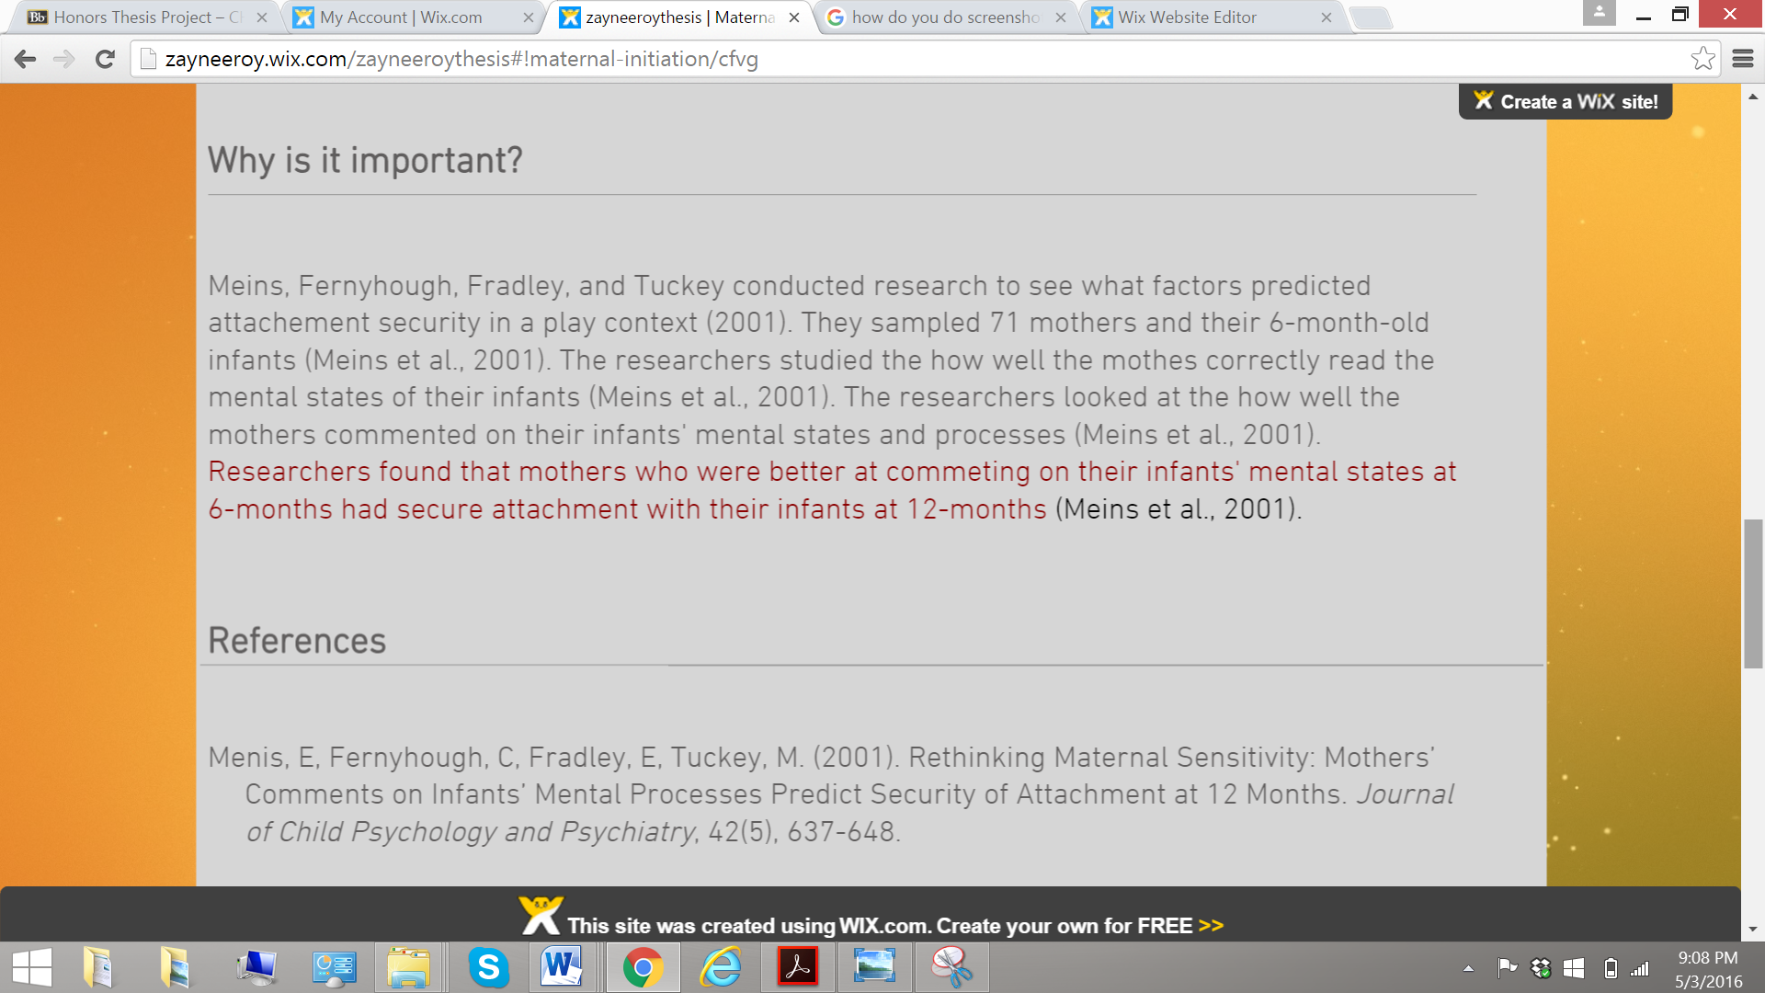

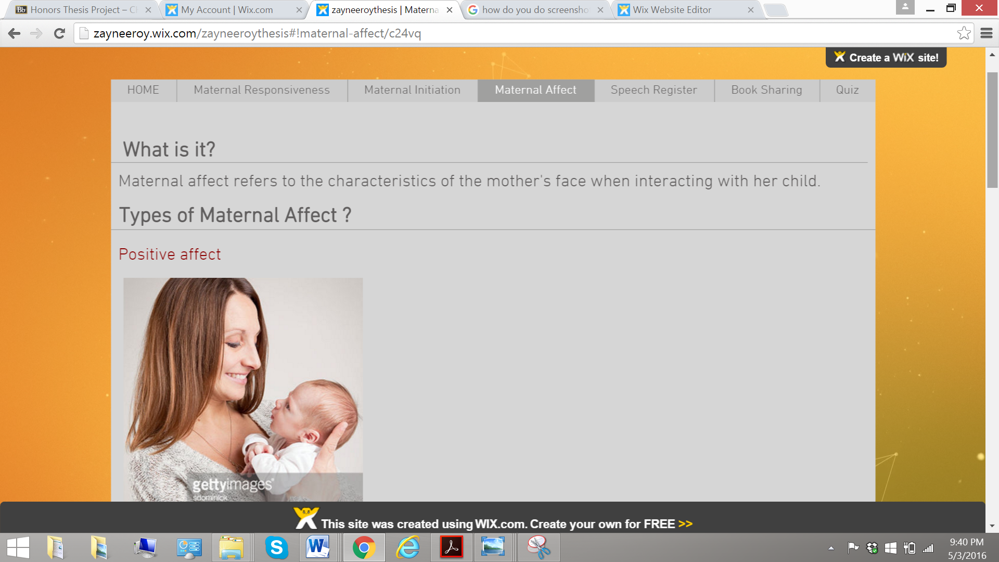

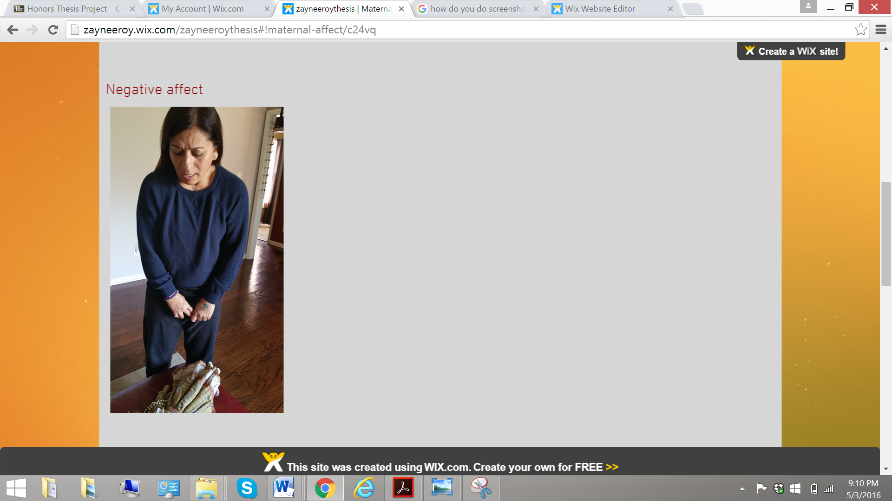



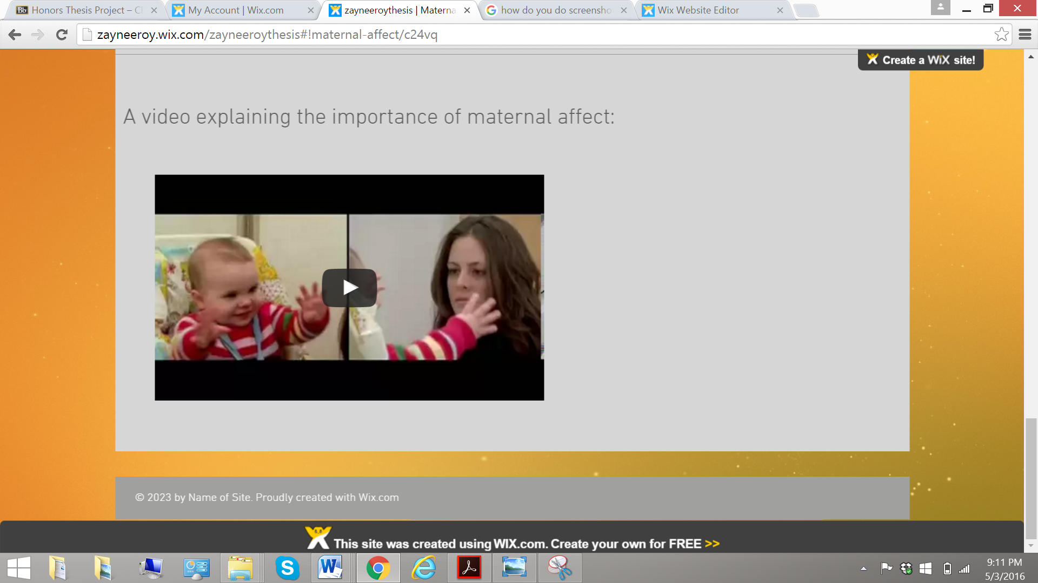

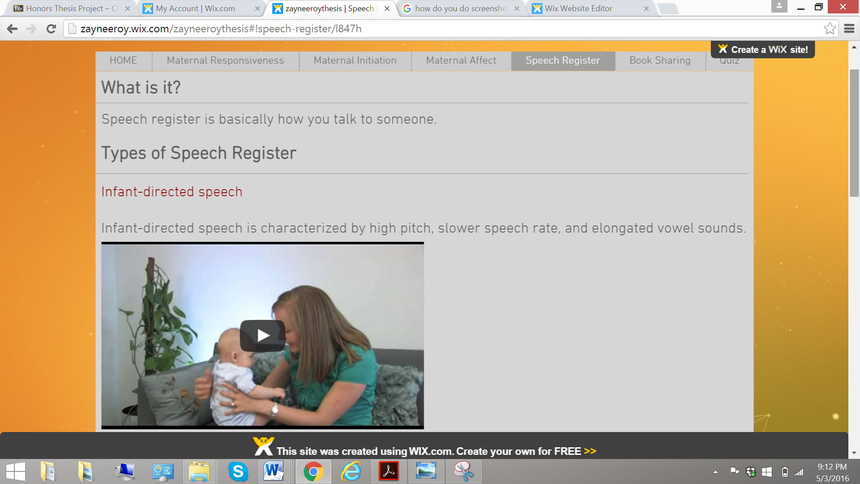

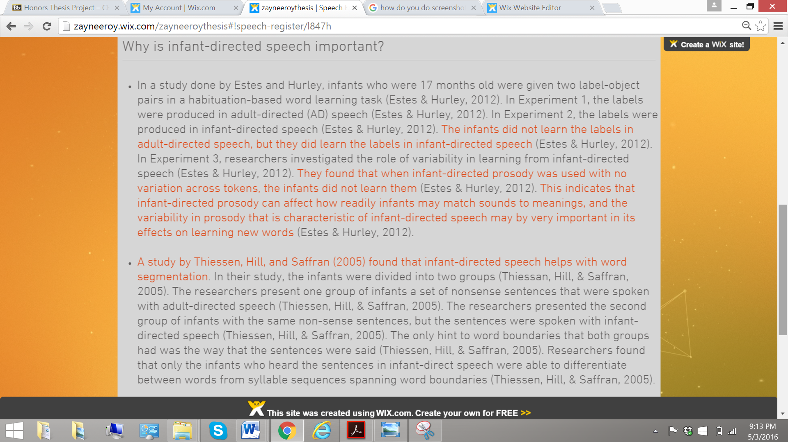


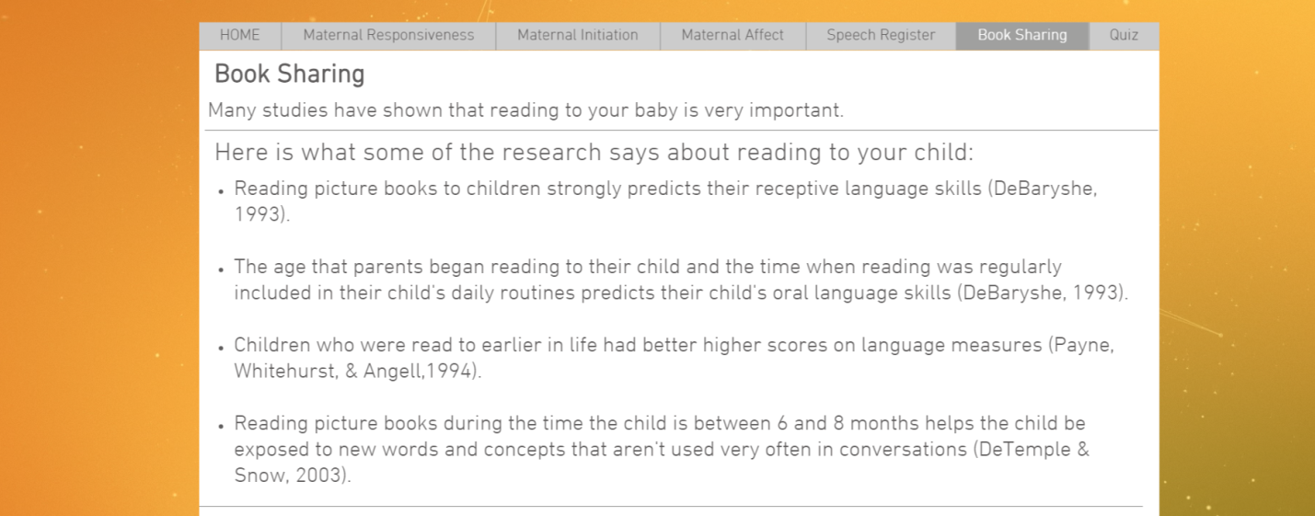

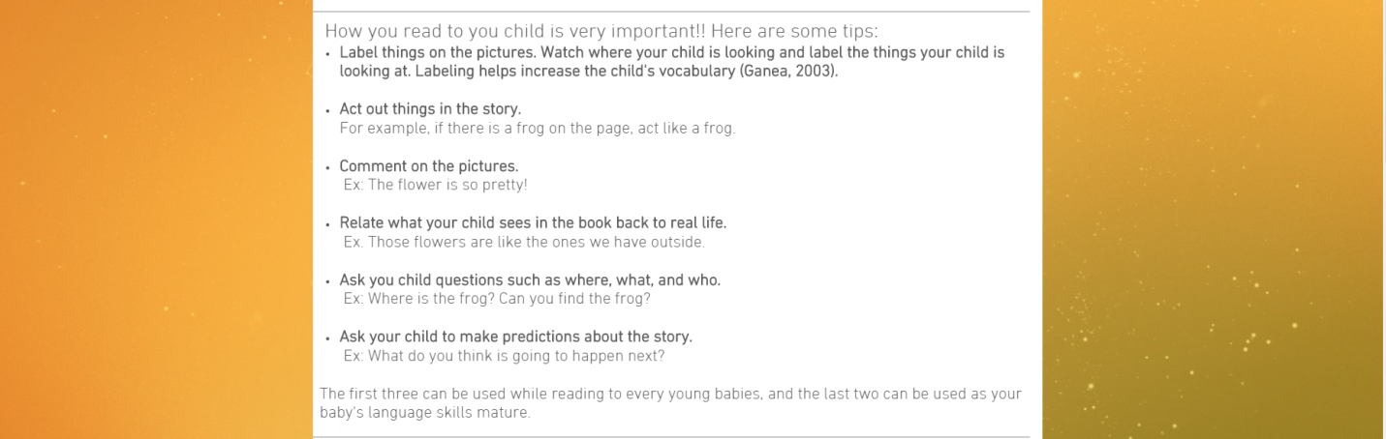



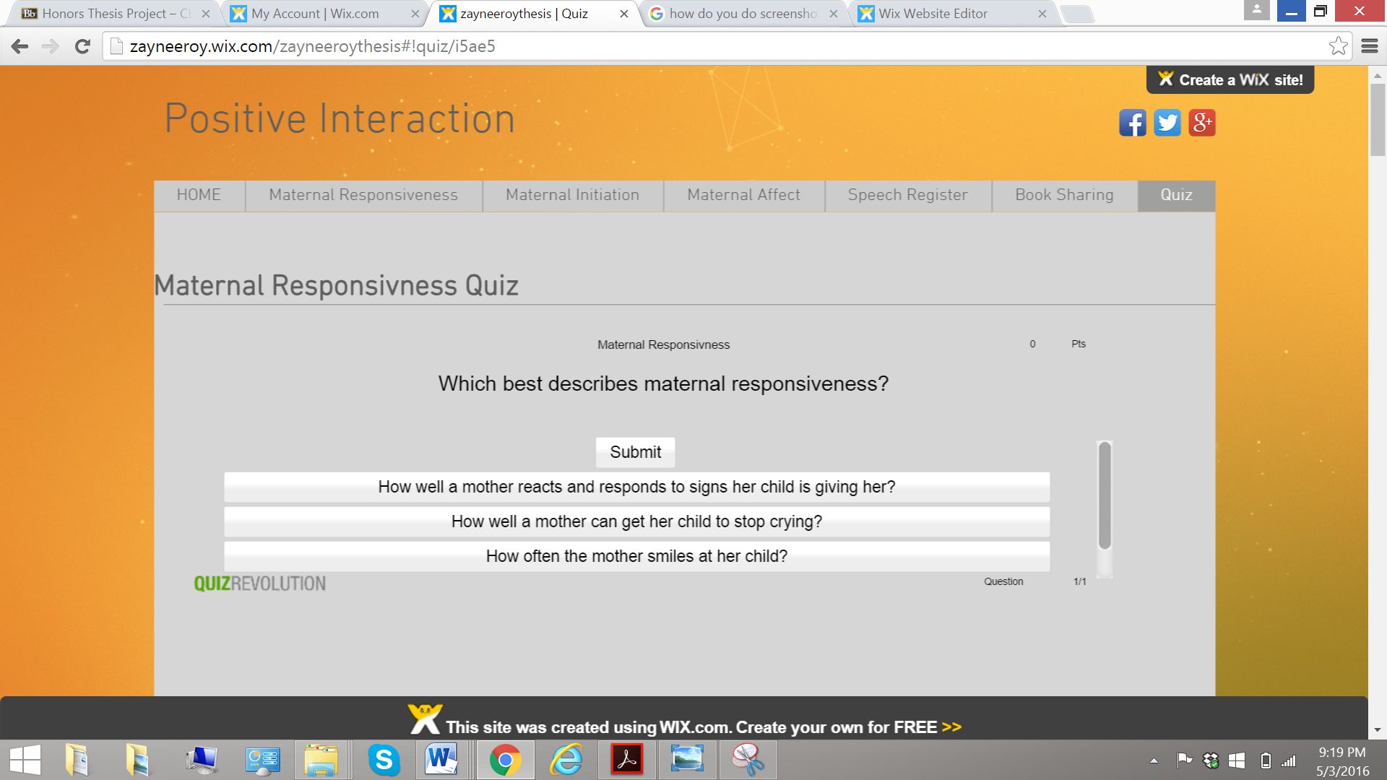

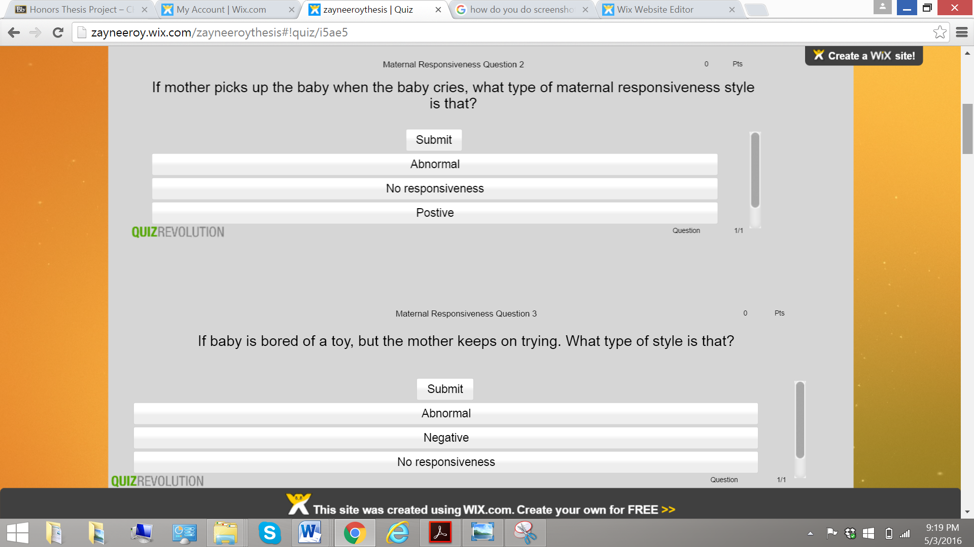

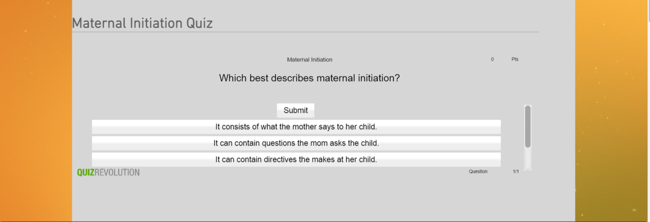

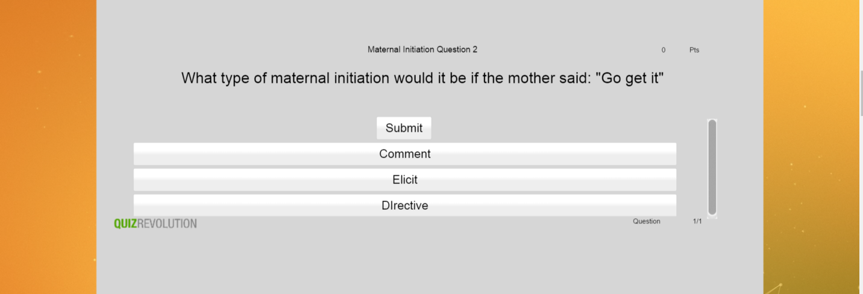

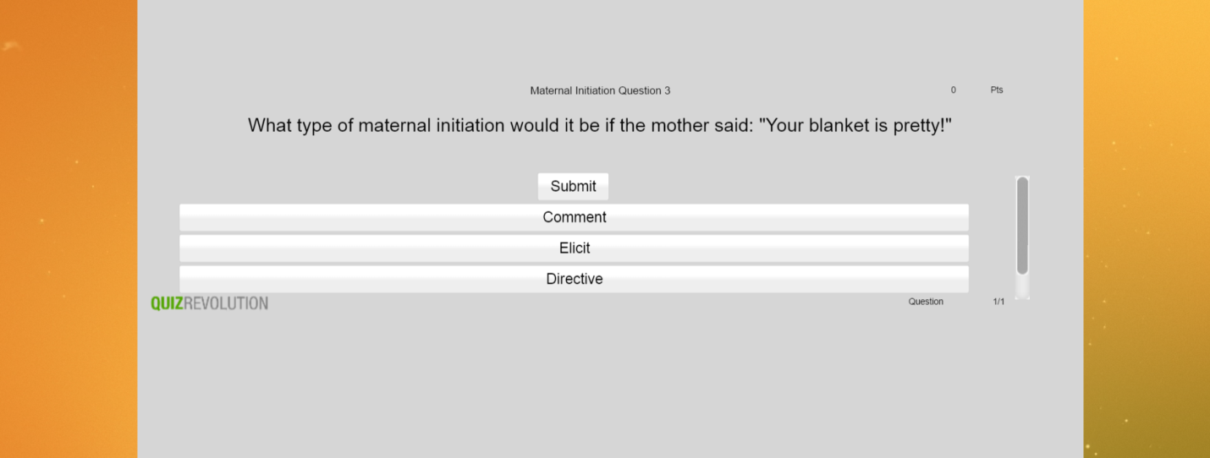

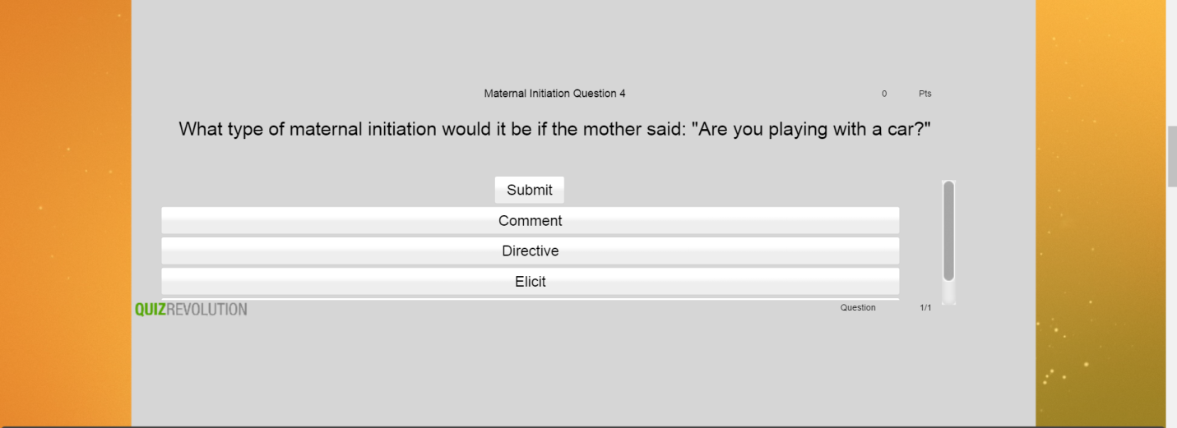

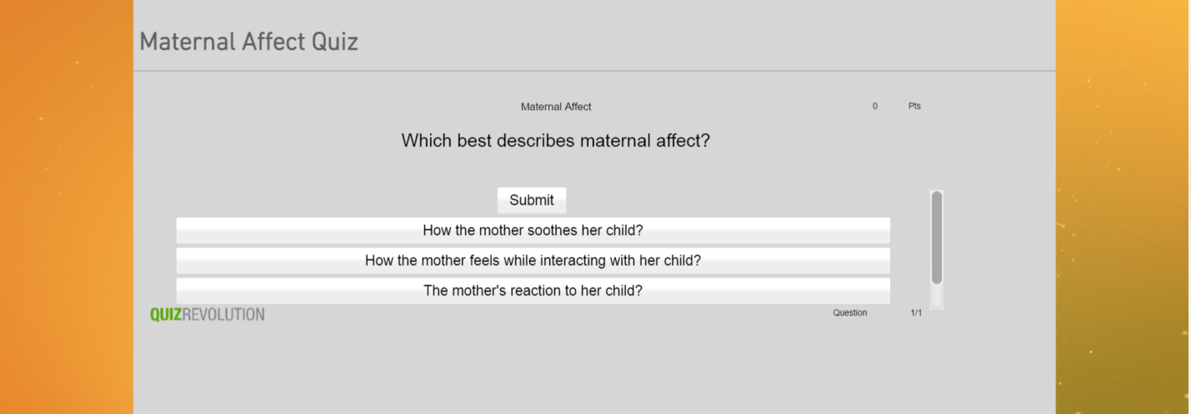

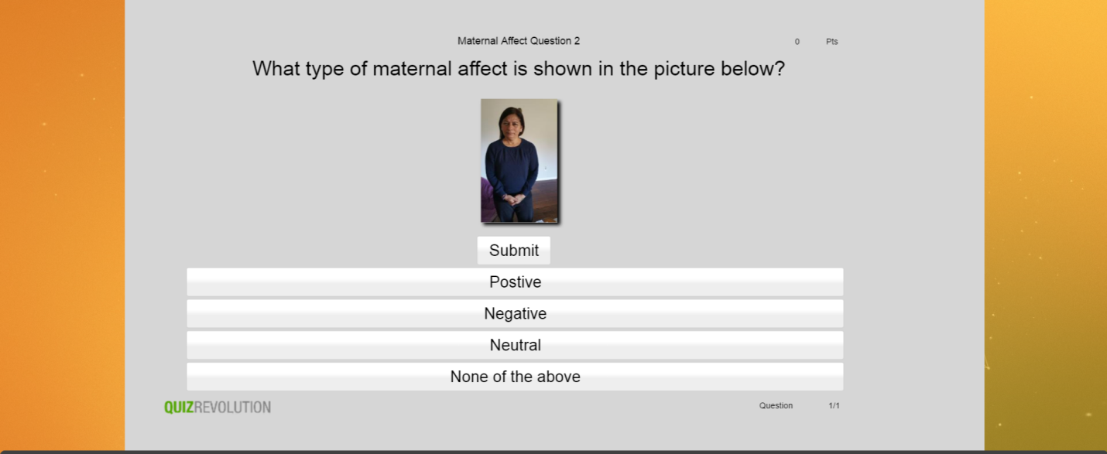

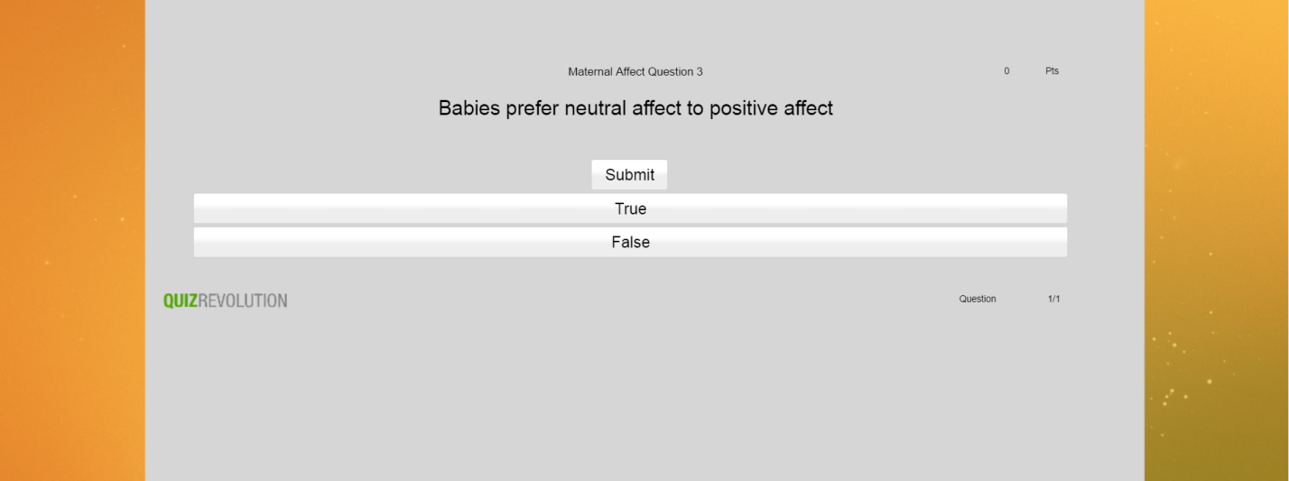

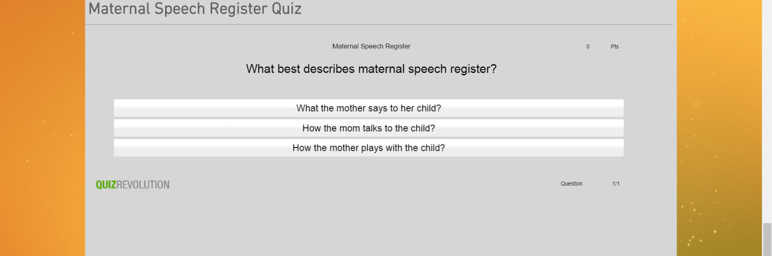

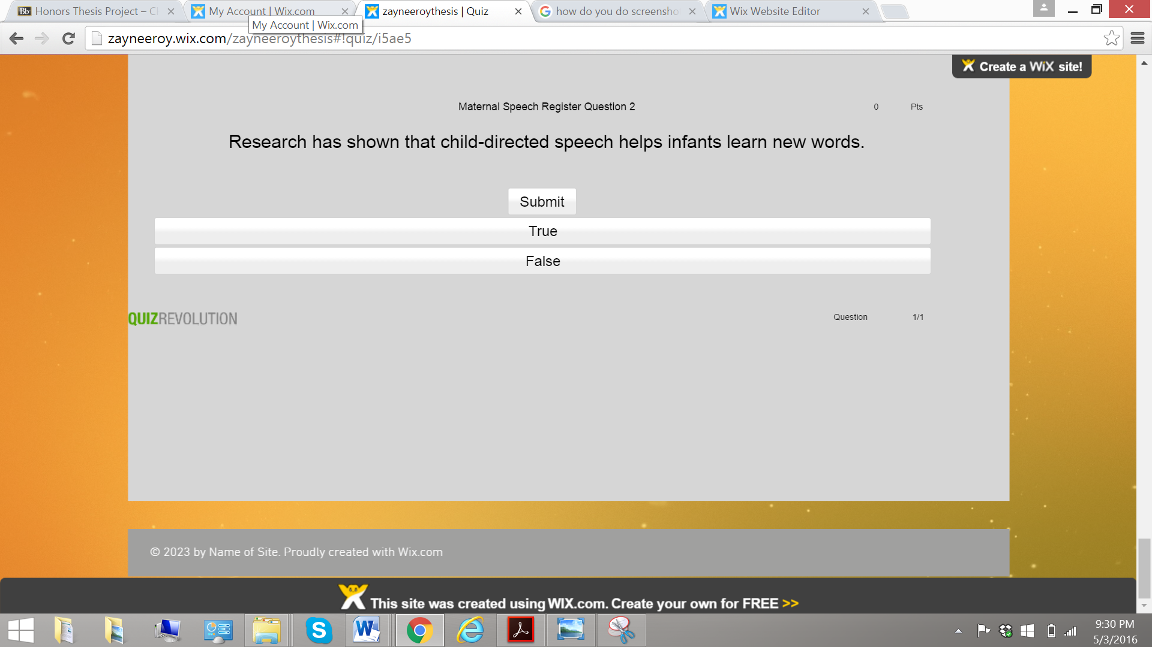

Parts of my Coding Manual that I helped develop

Speech Register
You will code either Infant Directed Speech or Adult Directed Speech. There is an “unspecified” code; however, this code should rarely, if ever, be used.
Infant directed speech (IDS) is characterized by higher frequency, increased pitch excursions, and exaggerated phrasing
Adult directed speech (ADS) is normal speech, the way you would talk to an adult
Helpful hints:
IDS:
- Sing-songy
- The rate of speech is slower
- The mom is more likely to lower her head and get on the baby’s level
- Speech is usually more enunciated, and the phrases are often exaggerated, especially the end of the phrases .
- The vowels are often elongated.
ADS:
- Speech that is of normal frequency, and the frequency does not vary very much.
- The rate of speech is usually a little faster.
- There is not as much emphasis on enunciation.
- Slang is used more often. (Ex. You just chillin’)
Examples: Go to coding assignment in AACT under zaynee. Open Speech Register (3rd assignment)
See the following segments for examples of difficult speech register coding.
- 00:00:56.209-00:00:57.465 19. 00:09:37.941-00:09:38.434
- 00:06:23.026-00:06:24.507 20. 00:11:29.636-00:11:30.769
- 00:06:29.543-00:06:30.464 21. 00:11:30.792-00:11:32.497
- 00:07:26.763-00:07:28.120 22. 00:11:32.553-00:11:33.663
- 00:07:28.180-00:07:29.224 23. 00:11:34.824-00:11:35.879
- 00:07:49.134-00:07:51.243 24. 00:11:37.197-00:11:38.632
- 00:07:51.949-00:07:53.598 25. 00:11:51.908-00:11:52.974
- 00:07:56.930-00:07:57.883 26. 00:11:54.723-00:11:56.148
- 00:07:58.108-00:07:58.837 27. 00:12:02.396-00:12:03.170
- 00:08:00.340-00:08:01.899 28. 00:09:33.828-00:09:35.051
- 00:08:15.641-00:08:17.884
- 00:08:25.798-00:08:26.830
- 00:08:37.503-00:08:38.995
- 00:09:02.080-00:09:03.684
- 00:09:24.463-00:09:25.259
- 00:09:25.463-00:09:27.113
- 00:09:27.649-00:09:28.468
- 00:09:32.605-00:09:33.873
Maternal Initiation
Your will code either Elicit, Comment, or Directive. There is an “unspecified” code; however, this code should rarely be used, only in situations where you cannot understand the mother.
Directive: e.g., stop crying, play with this
Comment: e.g., you’re a good baby, I don’t like green eggs
Elicitation: e.g., any question
Helpful hints:
Elicit:
- These are any questions that the mom asks her child.
- These can be wh-questions, or they can be questions such as “You want the ball?”
- “Huh?” is also included.
- Often times these questions have a rising intonation towards the end.
Comment:
- These are statements that the mother makes, usually regarding a present activity that they are engaged in. For example, the baby is playing with a doll, and the mom says “the doll has pink hair”.
- It also includes stories that the mom tells the infant.
- We have decided to include comments that the mom makes to herself.
- Include statements like “you can close it” because she is commenting on something that can be done with the object. She is not telling her child to close it.
- Include statements such as “let’s see what you do on your tummy”.
Directive:
- These are commands that the mom makes asking her child to do something. For example, the mom tells her child to “sit up”.
Examples: Go to coding assignment in AACT under zaynee. Open Maternal Initiation (2nd assignment)
See the following segments for examples of difficult speech register coding.
- 00:00:56.209-00:00:57.465 12. 00:06:05.931-00:06:06.503 23. 00:09:02.080-00:09:03.684
- 00:03:33.001-00:03:34.133 13. 00:06:11.764-00:06:14.20 24. 00:09:27.647-00:09:28.471
- 00:03:39.013-00:03:39.708 14. 00:06:29.532-00:06:30.553 25. 00:09:32.605-00:09:33.873
- 00:03:48.155-00:03:49.310 15. 00:06:38.012-00:06:39.818 26. 00:09:33.828-00:09:35.051
- 00:03:53:371-00:03:56.769 16. 00:06:40.525-00:06:42.342 27. 00:11:26.200-00:11:27.356
- 00:04:04.442-00:04:05.743 17. 00:07:09.218-00:07:09.812 28. 00:06:16.868-00:06:18.539
- 00:04:24.453-00:04.25.676 18. 00:07:32.403-00:07:33.043 29. 00:06:44.927-00:06:46.352
- 00:04:41.144-00:04:43.578 19. 00:07:44.293-00:07:46.458 30. 00:07:03.851-00:07:04.703
- 00:05:44.282-00:05:00.267 20. 00:07:46.582-00:07:47.883 31. 00:07:49.150-00:07:51.226
- 00:05:46.862-00:05:48.713 21. 00:07:56.913-00:07:57.911 32. 00:08:05.056-00:08:05.539
- 00:05.48.735-00:05:50.653 22. 00:08:15.679-00:08:17.844
Infant Vocalizations
You will either code Biological or Speech-like. There is an “unspecified” code; however, this code should rarely, if ever, be used.
Biological: e.g., cough, burp, hiccup, etc.
Speech-like: It is vowel-like and consonant-like. Whine is still speech-like but crying is characterized by open vocal tract
Helpful hints:
Biological:
- Biological productions can be more abrupt.
- They do not have intonation or prosody.
Speech-like:
- Productions that have recognizable intonation and prosody such as cooing and whining.
- Any type of babbling should be included.
- These productions are made with an approximated vocal tract.
- Vocalizations where vowels and consonants sounds are noticed should be included.
- Squeals and growls are also included.
Examples: Go to coding assignment in AACT under zaynee. Open Infant Vocalization (4th assignment)
See the following segments for examples of difficult speech register coding.
- 00:03:38.020-00:03:38.850
- 00:05:22.047-00:55:23.537
- 00:05:32.518-00:05:33.079
- 00:06:08.861-00:06:09.579
- 00:06:16.236-00:06:16.943
- 00:08:18.116-00:08:18.845
- 00:10:47.252-00:10:48.542
- 00:10:48.509-00:10:49.350
- 00:10:49.399-00:10:50.943
- 00:10:53.500-00:10:54.936
- 00:10:55.800-00:11:00.533
- 00:11:08.397-00:11:09.579
- 00:11:38.549-00:11:39.412

Tips for coding utterances:
- Use SALT transcription and C-Units
- What counts as a C-Unit is a complete sentences. For example, for the utterance “this is four, and this is five”, “this is four” would be one utterance, and “and this is five” would be another utterance.
Helpful Tips about AACT:
To code:
- Open AACT from the icon at the bottom of the desktop
- Once AACT opens click coder and log in
- Your username and password should be your first name.
- After you log in, your assignments should pop up.
- If you use the scroll bar towards the bottom and scroll over to the right to the heading Field, you will be able to see what you are coding.
- To open it, use the scroll bar and scroll back to the left to the heading Session File, and click on which ever one you want to code.
- After opening it, move video 1 to the computer screen on the right.
- Then, also move the AACT-TF32 window to the computer screen on the right.
- After that, on the AACT Event Coding window, click on video, and then click on Launch Second Video.
- Once you click that, an aactwin_20141217 window pops up. Just click OK, and Video 2 should pop up. Also move Video 2 to the computer screen on the right.
- To play straight through, on the ACCT Event Coding screen, click Make Active. Then, click Play. Click STOP when you find what you’re looking for.
- To play just the event of interest, on the AACT Event Coding window, click on Active Loop Range to TF32 Cursors, and then click on Video 1.
- On the AACT-TF32 window, ] is the beginning point, and [ is the ending point
- To code, on the AACT-TF32 window, drag ] to where [ is and then click on <<Cursor on the right side of the TF32 window (this will swap Right and Left cursors). After that, drag ] cursor to the beginning of the event you want to code. Then, on the AACT Event Coding window, under the heading Field, you will different options for coding that behavior. Click on one of those options, and you should be able to see it on the Field Codes Display window after you code it.
Helpful Hints:
- To look at a behavior that you have previously coded, on the Field Codes Display, click on the event that you want look at, and you cursors should line up on the AACT-TF32 window.
- To look at two different behaviors that you have coded, such as speech register and maternal initiation, on the AACT Event Coding window, click on fields. Then, click on select fields to code. After that, click on the field that you want to display. You will not be able to change anything on that field. You will only be able to view it.

