Improved Fungicidal Control of Large Patch through Optimal Use of Surfactants and Spray Rate Volume

A Dissertation Presented for the
Doctor of Philosophy
Degree
The University of Tennessee, Knoxville

Jesse J. Benelli
December 2016

Copyright © 2016 by Jesse J. Benelli
All rights reserved.

DEDICATION
I dedicate this dissertation to my loving wife Victoria Benelli and expected son Hudson.

ACKNOWLEDGEMENTS
I express my sincere appreciation to my graduate committee: Drs. Alan Windham, Bonnie Ownley, Alvin Womac, and John Sorochan. Their encouragement and project guidance has been invaluable for the past few years. I would also like to express a tremendous gratitude to my major professor Dr. Brandon Horvath for allowing me to pursue my academic endeavors throughout my graduate career and for providing ample opportunities to grow as a professional. I also like to thank many of the golf course superintendents and turfgrass managers for allowing me to conduct numerous research projects at their locations. My research would not have been possible if not for your assistance.
I would like to thank my fellow graduate students David Shell, Kyley Dickson, and Dr. Adam Thoms for providing assistance and friendship throughout graduate school. It would be a tremendous oversight if I didn’t mention my fellow inhabitants of the Turf House: Dr. Matt Elmore, Matt Hollan, Pat Jones, and Eric Reasor. Together, we flourished in an environment built on responsibility and hard work while serving as model citizens in the community which we lived.

ABSTRACT

Large patch (Rhizoctonia solani AG 2-2LP) epidemics cause significant damage to Japanese lawngrass (JLG; Zoysia japonica) in the transition zone. Large patch primarily affects the stems and sheaths of JLG and is difficult to control using traditional fungicide sprays. Field and growth chamber experiments were conducted during 2015-2016 in TN and GA to evaluate methods to enhance fungicidal control of large patch in JLG landscapes. The 1st experiment evaluated the most critical application target site that resulted in the greatest amount large patch control. In this experiment, four fungicides (azoxystrobin, flutolanil, tebuconazole, and chlorothalonil) were dispensed as single droplets on either the stem, sheath, or leaf plant part of JLG. Plants were evaluated for large patch control and photochemical efficiency (F_{v}/F_{m}). The 2nd experiment evaluated the effects of spray rate volume ((93, 374, 748, and 1496 L ha⁻¹) and adjuvants on large patch control and spray deposition quality on JLG. Results of the 1st experiment suggested that JLG treated with fungicides dispensed on the stem or sheath exhibited significantly lower large patch severity and higher F_{v}/F_{m} values compared to JLG receiving leaf applications on most rating dates. Results of the 2nd experiment suggested that increasing the spray rate volume from 93 to 1496 L ha⁻¹ improved large patch control by more than 20% depending on the fungicide. On most rating dates, each increase in spray rate volume resulted in significant decreases in large patch severity. The addition of adjuvants in the spray solution had less pronounced impacts compared to spray rate volume. Increases in spray rate volume were also critical in depositing more spray solution on the stems and sheaths of JLG plants. Higher spray rate volumes increased the percentage of stems and sheaths that contained spray deposits by as much as 35% compared to the lowest spray rate volume. This research demonstrated that higher spray rate volumes were able to penetrate the spray solution lower in the canopy near the site of pathogen infection. Increased spray rate volume applications were identified to enable increased fungicide deposition lower in the canopy and results in enhanced fungicidal control of large patch.

TABLE OF CONTENTS

CHAPTER I LITERATURE REVIEW 1
Japanese lawngrass 2
Rhizoctonia solani 3
Hyphal anastomosis reactions 3
Brown patch 5
Large patch 6
Fungicidal control of large patch 7
Literature Cited 10
CHAPTER II large patch (Rhizoctonia solani) development on japanese lawngrass (zoysia japonica) affected by fungicide mode of action and target site of application 13
ABSTRACT 14
Introduction 16
Materials and Methods 19
Results 23
Discussion 25
Acknowledgements 28
LITERATURE CITED 29
APPENDIX TABLES AND FIGURES 34
CHAPTER III Influence of spray rate volume and adjuvants on fungicidal control of large patch (rhizoctonia solani) and spray deposition characterstics 41
ABSTRACT 42
Introduction 43
Materials and Methods 47
Results 54
Discussion 58
Acknowledgements 61
LITERATURE CITED 62
APPENDIX TABLES AND FIGURES 66
CHAPTER IV CONCLUSIONS 81
CONCLUSIONS 82
VITA 85

LIST OF TABLES

Table 2.1. Fungicide treatments evaluated for large patch (Rhizoctonia solani) control. 35

Table 2.2. Analysis of variance for large patch (Rhizoctonia solani) severity and photochemical efficiency (F_{v}/F_{m}) of Japanese lawngrass (Zoysia japonica) in response to fungicide treatments. 36

Table 3.1. Analysis of variance for large patch (Rhizoctonia solani) severity of Japanese lawngrass (Zoysia japonica) in response to azoxystrobin applied at four spray rate volumes including 93, 374, 748, and 1496 L ha⁻¹. The AUDPC was pooled across locations. Research was conducted at Farm Golf Club and Gettysvue Golf and Polo Club in Dalton, GA, and Knoxville, TN, respectively during 2015-2016. 67

Table 3.2. Analysis of variance (pooled across experimental runs) for large patch (Rhizoctonia solani) severity of Japanese lawngrass (Zoysia japonica) in response to azoxystrobin, flutolanil, and tebuconazole applied at four spray rate volumes including 93, 374, 748, and 1496 L ha⁻¹. Research was conducted under greenhouse and growth chamber conditions in Knoxville, TN during 2016. 68

Table 3.3. Analysis of variance for large patch (Rhizoctonia solani) severity of Japanese lawngrass (Zoysia japonica) in response to azoxystrobin, flutolanil, and tebuconazole applied with and without surfactant additives. The AUDPC was pooled across locations. Research was conducted at Farm Golf Club and Gettysvue Golf and Polo Club in Dalton, GA, and Knoxville, TN, respectively during 2015-2016. 69

Table 3.4. Analysis of variance (pooled across experimental runs) for large patch (Rhizoctonia solani) severity of Japanese lawngrass (Zoysia japonica) in response to azoxystrobin, flutolanil, and tebuconazole applied with and without surfactant additives. Research was conducted under greenhouse and growth chamber conditions in Knoxville, TN during 2016. 70

Table 3.5. Analysis of variance (pooled across experimental runs) of spray deposition characteristics of surface coverage, and percent incidence of stem and sheath coverage severity on Japanese lawngrass (Zoysia japonica) in response to various spray rate volumes and surfactant additives. Treatments were applied under greenhouse and spray chamber conditions in Knoxville, TN during 2016. 71

LIST OF FIGURES

Figure 2.1. Large patch (Rhizoctonia solani) severity (a) and F_{v}/F_{m} measurements (b) on Japanese lawngrass (Zosyia japonica) pooled across target site among fungicide applications during the 1st experimental run. The experiment was conduction in a greenhouse located in Knoxville, TN, in 2015. Bars represent the standard error of the mean. Asterisks indicate significance levels at the p ≤ 0.05, 0.01, and 0.001 level, respectively. 37

Figure 2.2. Final large patch (Rhizoctonia solani) severity and F_{v}/F_{m} measurements in response fungicide and target site of fungicide application for the 1st (a-b) and 2nd (c-d) experimental run. Treatment means followed by same letter do not significantly differ according to Fisher’s LSD (p=0.05). Bars represent the standard error of the mean. 38

Figure 3.1. Climate data for Dalton, GA, (a-b) and Knoxville, TN, (c-d) during the experimental period from fall 2015 (a-c) through spring 2016 (b-d). Data was collected from Weather Underground weather stations in Chatsworth, GA, and Alcoa, TN. 72

Figure 3.2. Large patch (Rhizoctonia solani) severity in response to applications of azoxystrobin (0.61 kg ai ha⁻¹) at various spray rate volumes in Dalton, GA (a), and Knoxville, TN (b). Treatments were initiated on 18 SEP and reapplied on 14 OCT and 11 APR in Knoxville, TN. At Dalton, GA, treatments were initiated on 1 OCT and reapplied on 29 OCT and 29 MAR. Asterisks indicate significance levels at the p ≤ 0.05, 0.01, and 0.001 level, respectively. Bars represent the standard error of the mean. 73

Figure 3.3. Measurements of the Area Under the Disease Progress Curve (AUDPC) for large patch (Rhizoctonia solani) severity (pooled across locations) in response to applications of azoxystrobin (0.61 kg ai ha⁻¹) applied at various spray rate volumes. Treatment means followed by same letter do not significantly differ according to Fisher’s LSD (p=0.05). Bars represent the standard error of the mean. 74

Figure 3.4. Large patch (Rhizoctonia solani) severity (pooled across fungicides and experimental runs) in response to various spray rate volumes under growth chamber conditions. The fungicides azoxystrobin, flutolanil, and tebuconazole were applied once at 0.46, 3.51, and 0.62 kg ai ha⁻¹, respectively. Asterisks indicate significance levels at the p ≤ 0.05, 0.01, and 0.001 level, respectively. Bars represent the standard error of the mean. 75

Figure 3.5. Large patch (Rhizoctonia solani) severity at 28 days after treatment (pooled across experimental runs) in response to fungicides applied at four spray rate volumes. Treatment means followed by same letter do not significantly differ according to Fisher’s LSD (p=0.05). Bars represent the standard error of the mean. 76

Figure 3.6. Measurements of the Area Under the Disease Progress Curve (AUDPC) for large patch (Rhizoctonia solani) severity (pooled across locations) in response to fungicides applied with or without an organosilicone surfactant (0.25% v/v). Treatment means followed by same letter do not significantly differ according to Fisher’s LSD (p=0.05). Bars represent the standard error of the mean. 77

Figure 3.7. Influence of adjuvants (pooled across fungicides and experimental runs) on large patch (Rhizoctonia solani) severity under growth chamber conditions. Each adjuvant was applied at 0.25% v/v and mixed with fungicides azoxystrobin, flutolanil, and tebuconazole at a spray rate volume of 748 L ha⁻¹. Treatment means followed by same letter do not significantly differ according to Fisher’s LSD (p=0.05). Bars represent the standard error of the mean. 78

Figure 3.8. Spray deposition measurements on Japanese lawngrass (Zoysia japonica) stems (a), sheaths (b), and leaf surfaces (c) in response to various spray rate volumes (pooled across surfactant additives and experimental runs). Treatment means followed by same letter do not significantly differ according to Fisher’s LSD (p=0.05). Bars represent the standard error of the mean. 79

Figure 3.9. Leaf surface deposition (pooled across experimental runs) in response to various spray rate volumes applied with or without an organosilicone surfactant (0.25% v/v). Treatment means followed by same letter do not significantly differ according to Fisher’s LSD (p=0.05). Bars represent the standard error of the mean. 80

CHAPTER I
LITERATURE REVIEW

Japanese lawngrass
Japanese lawngrass (JLG; Zoysia japonica Steud.) is a C₄ turfgrass belonging to the Family Poaceae, Subfamily Chloridoideae, and Tribe Zoysieae (Beard, 2002). This species is commonly established vegetatively as a perennial amenity or recreational surface (Turgeon, 2008). Native to the Pacific Rim countries, JLG is best adapted to regions of the world that endure warm summers and mild winters. Japanese lawngrass is becoming increasingly popular in areas of the United States that experience hot summer temperatures and freezing winter temperatures, such as the transition zone, due to its greater cold hardiness compared to the bermudagrasses (Cynodon spp.) and greater heat and drought tolerance compared to the bentgrasses (Agrostis spp.) and fescues (Schedonorus spp.) (Tisserat et al., 1994; Bucher and Wilkinson, 2007; Lyman et al., 2007; Patton and Reicher, 2007).
Golf course fairway surfaces in the transition zone are commonly established with JLG due to its dense canopy, low nitrogen fertility requirements, and reduced growth potential compared to bermudagrass (Beard, 1973). Most cultivars of JLG produce medium-to-coarse leaf blades and are adapted to a wide range of mowing heights greater than 3 mm. Other Zoysiagrasses, such as Manila grass (Zoysia matrella L.) can tolerate a lower height of cut less than 3mm and are suitable for putting green surfaces in addition to roughs and fairways (Beard, 2002).
Japanese lawngrass suffers from few pests and diseases during summer months as long as temperatures and sunlight remain favorable for turfgrass growth. However, as temperatures and day length diminish during spring and fall, JLG becomes increasingly vulnerable to a number of plant pathogens. Among those, JLG is particularly susceptible to infection by Rhizoctonia solani Kühn anastomosis group (AG) 2-2LP (Green et al., 1993).

Rhizoctonia solani
Rhizoctonia solani is a soilborne plant pathogen belonging to a group of anamorphic fungi that do not produce asexual spores, but form hyphae and sclerotia to spread and overwinter. Rhizoctonia solani is perhaps the most widely recognized plant-pathogenic species across the world, and incites disease on a diverse host range including agricultural crops, forest trees, ornamental plants, and turfgrasses (Baker, 1970). R. solani infects the plant roots, stems, and foliage depending on the host and environmental conditions.
R. solani can be differentiated from other fungi by several morphological characteristics including 90° branching of hyphae near the septa, constriction of hyphal branching at the septa, and the observation of monilioid cells (Ogoshi, 1975). Isolates of R. solani differ in morphological characteristics and host specificity. Laboratory techniques have been developed to better characterize the diversity among these heterogeneous isolates. One of the most common techniques to identify and differentiate R. solani isolates is through hyphal anastomosis reactions.

Hyphal anastomosis reactions
Hyphal anastomosis reactions are performed to identify R. solani relatedness. Hyphal anastomosis reactions are performed by the placement of two isolates onto a single growing medium and observing their affinity to anastomose with each another. The site where the two isolates converge is referred to as the zone of confrontation.
Terminologies used to characterize hyphal anastomosis reactions have evolved in the literature over the past 80 years. Parmeter et al. (1969) reported the following hyphal anastomosis reactions: 0 = no anastomosis, 1 = hyphal contact with neither fusion nor cell death, 2 (Imperfect) = Cell well fusion but no hyphal fusion followed by cell death, and 2 (Perfect) = cell wall and hyphal fusion followed by cell death. Based on these reactions, R. solani isolates were initially categorized in one of four anastomosis groups (AG-1, AG-2, AG-3, or AG-4). Carling et al., (1998) modified the hyphal anastomosis reactions proposed by Parmeter et al. (1969) into a system of four categorical reactions (C-3, C-2, C-1, and C-0). C-3 reactions are closely related, in the same vegetatively compatible population (VCP), and placed in the same AG. C-2 reactions are related, are not in the same VCP, and placed in the same AG. C-1 reactions are distantly related, are not in the same VCP, and may or may not be placed in the same AG. C-0 reactions are not related, are not in the same VCP, and are not placed in the same AG. Presently, 12 AGs have been characterized, and the number of AGs is expected to increase with continued investigations. Further research has identified subgroups within the same AG (Ogoshi, 1987). Subgroups are based on colony morphology, pathogenicity, DNA-DNA complementarity, and zymogram patterns. Anastomosis group AG-2 is the most heterogeneous group with seven subgroups characterized to date (AG-2-1, AG-2-2 IIIB, AG-2-2 IV, AG-2-2 LP, AG-2-3, AG-2-4, and AG 2 BI).
Anastomosis group AG-2 has been identified to be the most damaging AG on turfgrass. This anastomosis group incites brown patch and large patch on cool and warm season turfgrasses, respectively. AG-1, AG-4, and AG-5 have also been reported to incite brown patch but are generally less severe (Burpee and Martin 1992, Aoyagi et al., 1998). However, occurrences of brown patch and large patch, incited R. solani AG-2-2IIIB and AG 2-2 LP, respectively, are among the most challenging diseases to manage in turfgrass landscapes.

Brown patch
Brown patch (R. solani AG-2-2 IIIB) is a severe disease of cool-season turfgrasses that was first reported in the early 1900’s (Piper and Oakley, 1917). Brown patch affects the foliage of turfgrass and does not affect roots or crowns. R. solani AG-2-2 IIIB infects the leaves through direct hyphal penetration with the aid of an infection cushion. Symptoms of brown patch are variable and often dependent on the turfgrass species and mowing height. Lesions on higher cut turfgrass (> 5 cm) are irregularly shaped, silver-gray-to-brown in appearance, and exhibit a thin brown-to-purple border. On closely mown turfgrass, lesions may not be easily distinguishable. In many landscapes, a dark gray-to-purple ring of mycelium may be observed on the outer edge of the patch during early morning hours when the canopy is still wet (Smiley et al., 2005). As the disease progresses, foliar necrosis is observed resulting in circular patches of blighted turf. The patches can range in size from a few cm to > 1 m in diameter (Burpee and Martin, 1992).
Brown patch development is favored by warm nighttime temperatures (> 24ºC) and more than nine hours of continuous high humidity (>90%) or leaf wetness (Fidanza et al., 1996; Gross et al., 1998). Numerous cultural practices can also trigger brown patch development. Dickinson (1930) observed increased brown patch severity when turfgrass was irrigated during evening and late morning hours, which extended leaf wetness duration. Excessive nitrogen fertilization can also promote brown patch development by increasing the succulence and density of the turfgrass canopy, thereby promoting faster leaf-to-leaf infection (Fidanza and Dernoeden, 1996; Giesler et al., 1996).

Large patch
Large patch (R. solani AG-2-2 LP) is a severe disease of several warm-season turfgrasses including the Zoysiagrasses and St. Augustine grass (Stenotaphrum secundatum Walt.) among others (Smiley et al., 2005). However, all warm-season turfgrasses are presumed susceptible. The pathogen infects the crown and leaf sheath during periods of cool-to-mild temperatures (20-25°C) with high relative humidity (Green et al., 1993). These environmental conditions are most often observed in the spring and fall months in the transition zone as the turfgrass is entering and breaking winter dormancy. However, disease development may occur any time of year during periods of persistent rainfall (Spurlock, 2009). After infection and during disease development, plants exhibit an orange discoloration and can be detached easily at the crown (Aoyagi et al., 1998). If left untreated, patches can expand more than 6 m in diameter. Patches often coalesce creating large irregularly shaped areas of blighted turf. The blighted areas often reoccur in the same areas and become progressively more severe (Spurlock, 2009). Recovery from infection is dependent on new plant growth during warmer weather (Green et al., 1994).
Large patch management is challenging because of the lack of identifiable cultural control options available. Increasing the mowing height from 1.2 to 4.5 cm can significantly reduce large patch severity. However, this increase in mowing height is not feasible under golf course fairway management. Adjusting nitrogen fertilization programs may also not influence large patch development. Green et al. (1994) reported no benefit in reducing large patch severity by administering various nitrogen inputs during summer. Furthermore, Miller et al. (2016) reported that spring and fall nitrogen fertilization has minor effects on large patch severity. The lack of cultural control options is compounded by the current lack of resistant JLG germplasm available for commercial use (Obasa et al., 2012). Therefore, turfgrass practitioners who manage JLG generally rely on preventive fungicide sprays to prevent large patch development.

Fungicidal control of large patch
Numerous fungicides are labelled to control large patch preventively. However, adherence to proper application procedures must be practiced to for effective disease control, i.e., fungicides must be applied in a manner than connects the active ingredient to the site of pathogen infection. This could be accomplished by deposition of fungicides at the site of infection or translocation of fungicide active ingredients being translocated to the site of infection. The goal is to maintain sufficient amounts of fungicide active ingredient in or on the plant tissue that prevents the growth of the pathogen during times of large patch development.
Three fungicides that have shown promising results for large patch control in university led fungicide efficacy trials are azoxystrobin, flutolanil, and tebuconazole. Azoxystrobin is a member of the strobilurin [Fungicide Resistance Action Committee (FRAC) Code 11] class of fungicides, flutolanil belongs to the Succinate Dehydrogenase Inhibitors (SDHI; FRAC Code 7] class, and tebuconazole belongs to the demethylation inhibitor (DMI; FRAC Code 3) class of fungicides. All three fungicides are considered acropetal penetrants as they have mobility through the xylem. Current fungicide label recommendations suggest that treatments should be applied preventively in the fall as soil temperatures fall below 23°C, and should be reapplied 28 days later. A third application may also be warranted during early spring as the turf resumes growth. However, despite label recommendations, efforts to control large patch with fungicide sprays have often yielded inconsistent results (B.J. Horvath, personal communication, 2016).
There are several possible reasons for control failure. Fungicide deposition factors (application rates, intervals, and surface coverage), disease pressure, and the residual efficacy of fungicides are among the most documented reasons (Latin, 2011). Of these, surface coverage may be the most influential to successful disease control depending on the pathosystem. Diseases such as dollar spot (Sclerotinia homoeocarpa F.T. Bennett) of turfgrass are controlled more easily when application techniques are designed to steer fungicide deposition towards the site of lesion development on the leaf foliage (Kennelly and Wolf, 2009; Kaminski and Fidanza, 2009). Unlike other problematic turfgrass diseases, research on improving large patch control is limited. Most current large patch control recommendations are based on successful management strategies for a different R. solani incited disease, brown patch. This related pathogen causes a disease of foliage on cool-season turfgrass, and unlike large patch, rarely affects the stem or lower leaf sheath. This is a possible explanation for poor large patch control. Foliar fungicide applications that do not adequately penetrate into the lower leaf canopy in sufficient amounts, where infection occurs, may not provide acceptable control of large patch.
Large patch control of JLG landscapes using fungicide sprays could be enhanced if improved application strategies are designed such that the fungicide is present where the pathogen occurs in the plant. Identifying the most critical target site of fungicide application in JLG landscapes is warranted. Additionally, developing field-based application methods that deliver the fungicide to this target site could lead to improved large patch control.

Literature Cited

Aoyagi, T., K. Kageyama, and M. Hyakumachi. 1998. Characterization and survival of Rhizoctonia solani AG 2-2LP associated with large patch disease of Zoysia grass. Plant Dis. 82:857-863.
Baker, K.F. 1970. Types of Rhizoctonia diseases and their occurrence. Pages 125-148 in: Rhizoctonia solani, biology and pathology. University of California Press, Berkeley, CA.
Beard, J.B. 1973. Turfgrass: Science and culture. Prentice Hall, Englewood Cliffs, NJ.
Beard, J.B. 2002. Turfgrass management for golf courses. Ann Arbor Press, Chelsea, MI.
Bucher, E.S., and H.T. Wilkinson. 2007. The pathogenicity of Gaeumannomyces incrustans on turfgrass Zoysia japonica. Can. J. Plant Pathol. 29:56-62. Doi:10.1b080/07060660709507437.
Burpee, L., and B. Martin. 1992. Biology of Rhizoctonia species associated with turfgrasses. Plant Dis. 76:112-117.
Dickinson, L.S. 1930. The effect of air temperatures on the pathogenicity of Rhizoctonia solani parasitizing grasses on putting-green turf. Phytopathology. 20:597-608.
Fidanza, M.A., and P.H. Dernoeden. 1996. Interaction of nitrogen source, application timing, and fungicide on Rhizoctonia blight in ryegrass. HortSci. 31:389-392.
Fidanza, M.A., P.H. Dernoeden, and A.P. Grybauskas. 1996. Development and field validation of a brown patch warning model for perennial ryegrass turf. Phytopathology. 86:385-390.
Green, D.E., J.D. Fry, J.C. Pair, and N.A. Tisserat. 1993. Pathogenicity of Rhizoctonia solani AG-2-2 and Ophiosphaerella herpotricha on zoysiagrass. Plant Dis. 77:1040-1044.
Green, D.E., J.D. Fry, and J.C. Pair. 1994. Influence of management practices on Rhizoctonia large patch disease in zoysiagrass. HortSci. 29: 186-188.
Giesler, L. J., G.Y. Yuen, and G.L. Horst. 1996. The microclimate in tall fescue turf as affected by canopy density and its influence on brown patch disease. Plant Dis. 80:389-394.
Gross, M.K., J.B. Santini, I. Tikhonova, and Latin. R. 1998. The influence of temperature and leaf wetness duration on infection of perennial ryegrass by Rhizoctonia solani. Plant Dis. 82:1012-1016.
Kaminski, J.E., and M.A. Fidanza. 2009. Dollar spot severity as influenced by fungicide mode of activity and spray nozzle. HortSci. 44:1762-1766.
Kennelly, M.M., and R.E. Wolf. 2009. Effect of nozzle type and water volume on dollar spot control in greens-height creeping bentgrass. Appl. Turf. Sci. Online. doi:10.1094/ATS-2009-0921-01-RS.
Lyman, G. T., C.S., Throssell, M.E. Johnson, G.A. Stacey, and C. D. Brown. 2007. Golf course profile describes turfgrass, landscape and environmental stewardship features. Online. Appl. Turf. Sci. doi:10.1094/ATS-2007-1107-01-RS.
Miller, G.L., D.T. Earlywine, R. Braun, J.D. Fry, and M.M. Kennelly. 2016. Influence of nitrogen source and application timing on large patch of zoysiagrass. Crop, For. Turf. Manage. Doi:10.2134/cftm2015.0189
Obasa, K., J. Fry, and M. Kennelly. 2012. Susceptibility of zoysiagrass germplasm to large patch caused by Rhizoctonia solani. HortSci. 47:1252-1256.
Ogoshi, A. 1975. Grouping of Rhizoctonia solani Kühn and their perfect stages. Rev. Plant. Protect. Res. 8, 93-103.
Ogoshi, A. 1987. Ecology and pathogenicity of anastomosis and intraspecific groups of Rhizoctonia solani Kühn. Ann. Rev. Phytopathology. 25:125-143.
Parmeter, J. R. J., R.T. Sherwood, and W.D. Platt. 1969. Anastomosis grouping among isolates of Thanatephorus cucumeris. Phytopathology. 59: 1270-1278.
Patton, A.J., and Z.J. Reicher. 2007. Zoysiagrass species and genotypes differ in their winter injury and freeze tolerance. Crop Sci. 47:1619-1627.
Piper, C.V. and R.A. Oakley. 1917. Golf Illustrated. P. 1-3.
Smiley, R.W., P.H. Dernoeden, and B.B. Clarke. 2005. Compendium of turfgrass diseases. 3rd ed. American Phytopathological Society, St. Paul, MN.
Spurlock, T.N. 2009. Epidemiology and etiology of zoysiagrass diseases in Northwest Arkansas. M.S. thesis. Univ. of Arkansas, Fayetteville.
Tisserat, N.A., J. Fry, and D. Green. 1994. Managing Rhizoctonia large patch. Golf Course Manage. 62:58-61.
Turgeon, A.J. 2008. Turfgrass management. 8th ed. Prentice Hall, Upper Saddle River, NJ.

CHAPTER II
large patch (Rhizoctonia solani) development on japanese lawngrass (zoysia japonica) affected by fungicide mode of action and target site of application

The intent of this manuscript is to publish articles in the peer-reviewed literature. This work is based on contributions by Jesse Benelli, Brandon Horvath, Bonnie Ownley, Alan Windham, and Alvin Womac.

My primary contributions to this paper include (i) designing and conducting the experiments, (ii) analyzing and interpreting data, (iii) reading literature, and (iv) writing the manuscript.

ABSTRACT
Large patch (Rhizoctonia solani AG 2-2LP) affects the sheaths and stems of Japanese lawngrass (JLG; Zoysia japonica) in the transition zone. Large patch is difficult to control using traditional fungicide sprays because much of the applied fungicide solution remains on the leaf and away from the site of pathogen infection. Our objective was to determine the amount of protection provided by fungicides deposited on the leaf, sheath, or stem of JLG. Repeated growth chamber experiments were conducted in 2015 in Knoxville, TN, to evaluate large patch control using fungicides deposited on three target sites of JLG (leaf, sheath, and stem). Azoxystrobin, flutolanil, tebuconazole, and chlorothalonil were applied using a pipette as 2.5 µl droplets that were dispensed singly on the leaf, sheath, or stem. Plants were inoculated with R. solani and kept in a growth chamber under high humidity. Measurements of visual disease severity and photochemical efficiency (F_{v}/F_{m}) were collected every seven days. In both experimental runs, JLG treated with fungicides applied on the sheath or stem exhibited significantly lower large patch severity and higher F_{v}/F_{m} values compared to JLG receiving leaf applications on most rating dates. Azoxystrobin, flutolanil, and tebuconazole applied on the leaf resulted in a range of 35-75% large patch severity between the two experimental runs. When these fungicides were applied on the stem and sheath, large patch severity ranged from 2-30%. Chlorothalonil, a contact fungicide, was least affected by the target site of application on most rating dates. This experiment demonstrated that the target site of fungicide application was critical in managing large patch. Developing novel spray strategies that result in greater penetration of the fungicide solution being deposited closer to the site of infection is warranted.

Introduction
Japanese lawngrass (JLG; Zoysia japonica Steud.) is typically established vegetatively as a perennial warm-season turf grown in temperate regions of the world such as the transition zone in the United States (Turgeon, 2008). In the transition zone, where both hot and freezing temperatures are endured in the summer and winter, respectively, JLG is primarily maintained as residential landscapes and recreational playing surfaces such as golf course fairways and roughs. Native to the Pacific Rim countries, JLG is best adapted to regions with warm summers and mild winters. The advantages of establishing JLG in the transition zone is its adaptation to variable soil conditions and pHs, tolerance to a wide range of mowing heights, and low fertilization requirements (Beard, 1973; Duncan and Shuman, 1993). Japanese lawngrass also exhibits greater cold hardiness compared to hybrid bermudagrass and is less susceptible to disease in the summer months compared to cool-season turfgrasses (Bucher and Wilkinson, 2007; Tisserat et al., 1994). However, during cool-wet weather, JLG can be significantly damaged by several diseases that affect the persistence and quality of the turf.
Large patch, Rhizoctonia solani Kühn AG-2-2LP, is the most severe disease of JLG in the transition zone of the United States and other humid-temperate regions of the world (Green et al., 1993; Hyakumachi et al., 1998). Large patch development is favored by cool-to-mild air temperatures (20-25°C) and high relative humidity (>90%; Green et al., 1993). Typically, large patch epidemics occur when the growth of JLG is slow during the fall and spring months as the turf enters and exits winter dormancy. Symptoms of large patch include the presence of a black, water-soaked lesions located on the stem or sheath. The foliage exhibits an orange discoloration that is evident at the margin of expanding patches. Damage from large patch often persists until the onset of warmer temperatures that are more favorable for JLG growth. Control of this disease is warranted because, once established, large patch often returns in the same location each year and becomes progressively more severe (Spurlock, 1999).
Few cultural management strategies have been identified as a reliable means to control large patch. Green et al. (1994) observed that large patch severity was reduced by raising the mowing height from 1.2 to 4.5 cm. However, raising the mowing height by this margin may not be feasible on a golf course fairway due to golfer expectations. In the same study, the authors found that various nitrogen fertilizer sources or rates applied during summer had no influence on large patch severity. This study was corroborated by researchers in Missouri and Kansas, who observed that while various spring, summer, or fall nitrogen fertilization programs may not enhance large patch epidemics, these fertilization programs had limited success in reducing large patch severity (Miller et al., 2016). Cultivation practices, such as core aeration, verticutting, and sand topdressing, have shown limited ability to control large patch (Obasa et al., 2013). Furthermore, core aeration may help spread the pathogen during times of large patch development (Spurlock, 2009). The absence of identifiable cultural control options is compounded by the lack of genetic resistance to large patch among screened JLG genotypes (Obasa et al., 2012). Therefore, most turfgrass managers implement chemical control to suppress this disease.
Large patch is primarily managed with fungicide applications on golf courses, sod farms, and other public landscapes. Sites with a prior history of large patch may require two-to-three fungicide sprays during the spring and fall to limit the spread of this disease. However, turfgrass managers have observed variable and often poor large patch control using fungicides that have demonstrated effectiveness in field trials by university researchers (B.J. Horvath, personal communication, 2016). Difficulties in managing large patch with fungicides have also been documented in industry press (Benelli, 2015; Carson, 2010). The failure of fungicide applications to control large patch not only results in overall poor quality turf, but also a substantial monetary cost to the turfgrass facility or manager.
There are several possible reasons for failure of fungicide control. Spray application factors (application rates, deposition, surface coverage, and nozzle pressure), disease pressure, environmental factors, and the residual efficacy of fungicides are among the most documented (Couch, 1984; Kennelly and Wolf, 2009; Latin, 2005; McDonald et al., 2006; Vincelli and Dixon, 2007). In cropping systems, adequate fungicide deposition near pathogen infection sites is also critical in managing plant disease. Csinos (1989) reported that targeting fungicide applications to the main stems of peanut (Arachis hypogaea L) using a narrow band width application resulted in significantly lower southern stem rot (Sclerotium rolfsii Sacc.) compared to a wide band spray application. Similarly, Butzler et al. (1998) observed increased disease control of Sclerotinia blight (Sclerotinia minor Jagger) in peanut when mechanical pruning was administered prior to a fungicide application. The authors suggested that pruning had allowed more fungicide deposition to the site of initial infection. Additional researchers have also shown that the penetration of the fungicide solution in the lower plant canopy, where infection occurs, have resulted in greater stem rot (Sclerotium rolfsii Sacc.) control and yield in peanut (Augusto et al., 2010).
Rhizoctonia solani AG 2-2LP colonizes and infects the sheaths and stems of JLP plants (Aoyagi et al., 1998). Quality fungicide deposition should target the lower canopy depending on the physical and chemical properties of the fungicide. Most fungicides are either xylem mobile, localized penetrant or contact. For most fungicides to be effective, the active ingredient must be deposited in close proximity to the infection site or be able to translocate towards the infection site. Fungicide solution that is deposited on the upper leaf canopy may not provide sufficient protection against large patch. The objective of this research was to evaluate large patch development in response to fungicides applied on either the upper or lower plant canopy of JLG.

Materials and Methods
Plant culture. Cup cutter sized plugs, 10 cm in diameter, of JLG (c.v. ‘Meyer’) were collected in July of 2014 from a fairway surface at the East Tennessee Education and Research Center in Knoxville, TN. The plugs were washed using a pressurized washer to remove soil and other contaminants. Individual stolons were separated by hand and rinsed three times with tap water. Stolons were then singly propagated in potting medium (Fafard Professional Potting Mix, Sun Gro Horticulture, Agawam, MA) contained in 3.8-cm diameter ‘conetainers’ (Steuwe and Sons, Tangent, OR). The racks of conetainers were maintained in a greenhouse at 28°C.
Plants were allowed to grow for 10 weeks. During establishment, plants were trimmed to a height of 3 cm using scissors, and irrigated twice daily with an overhead irrigation system. Fertilizer was applied every 14 days at a rate of 49 kg N ha⁻¹ with a complete 24-8-16 fertilizer (All Purpose Plant Food, The Scotts Company, Marysville, OH). After the 10 week establishment period, the JLG plants were trimmed to two individual tillers per conetainer. Both of the remaining tillers in each conetainer were of similar size and maturity.

Treatments. Treatments were arranged as a 4 x 3 factorial in a randomized complete block design with five replications. The fungicides evaluated were three systemic fungicides (azoxystrobin, tebuconazole, and flutolanil) and one contact fungicide (chlorothalonil; Table 2.1). These fungicides were chosen because they are frequently used in the turfgrass industry to control large patch. Two nontreated control treatments were added but were not included in the statistical analysis. One of the nontreated controls was inoculated and the other was not. The nontreated control treatments were added to reference large patch development when no fungicide was applied and to monitor the experimental environment on turfgrass health.
The fungicides were applied onto three application target sites of JLG. Azoxystrobin, tebuconazole, flutolanil and chlorothalonil were applied at a concentration of 0.76, 1.03, 5.81, and 9.98 g ai L⁻¹, respectively, using a pipette that delivered a 2.5-µl droplet (1684 microns in diameter) of fungicide solution that was dispensed singly on the leaf, sheath, or stem. This application mimics an ultra-coarse spray droplet landing on leaf, sheath, or stem from a spray mixture containing the high-labeled fungicide rate applied from a spray rate volume of 815 L ha⁻¹. Conetainers were discarded and replaced if fungicide run-off was observed. Both tillers in each conetainer received similar applications. The fungicide droplets were allowed to dry on the plant for 24 hr before inoculation.

Pathogen inoculation. Recovery and isolation of R. solani were similar to the methods of Obasa et al., 2012. In brief, an isolate of Rhizoctonia solani AG 2-2LP was recovered from a JLG fairway at Gettysvue Golf and Polo Club in Knoxville, TN, in April 2014. Affected samples, which exhibited characteristic black water-soaked lesions at the plant stem, were collected from the margin of large patch. Plant material was rinsed with tap water and cut into <1.0-cm sections. Portions of the leaf sheath were surface sterilized with 0.5% NaOCl for 1 min, and placed onto ¼-strength potato dextrose agar (PDA) amended with tetracycline (5 mg L^{–1}) and streptomycin (10 mg L^{–1}). After 24 hr, the tips of mycelial fragments growing from the plug were transferred to new amended ¼ strength PDA culture plates. After 3 days of colony growth, 5 plugs of R. solani were placed in a 1000 ml glass flask containing 300 g of autoclaved oat (Avena sativa L.) kernels. Flasks were stored at room temperature and periodically shaken to ensure even distribution of inoculum. After 20 and 14 days of incubation, in the 1st and 2nd experimental run, respectively, approximately six infested kernels were placed in each conetainer. The inoculated conetainers were placed inside a large plastic tub with a transparent lid. Moistened paper was placed throughout the plastic tub to ensure approximately 100% relative humidity. The plastic tub was placed in a growth chamber (Conviron Adaptis, Controlled Environment Ltd., Winnipeg, Canada) maintained at 24°C (day) and 20°C (night) with a 12-hr photoperiod.

Measurements of disease severity. Large patch severity was assessed visually using a modified nearest percent estimate (NPE) method. The following were the indices of the NPE used: 0, 2, 5, 10, 20, 30, 40, 50, 60, 70, 80, 90, and 100%. This rating method was chosen to provide equal interval assessments between 10 and 100%. Other, more categorical estimates (similar to the Horsfall-Barratt scale) have recently been shown to be a less reliable measure of disease severity compared to NPE measurements and may result in a higher probability of a type II error. (Bardsley and Ngugi, 2012; Bock et al., 2009a, 2009b, 2013). In the first experimental run, measurements of large patch severity were collected at 7, 14, 21, and 28 days after initial treatment (DAIT). In the second experimental run, large patch severity measurements were collected at 7 and 14 DAIT. The 2nd experimental run was terminated after 14 DAIT due to a substantial decline among the nontreated, non-inoculated JLG conetainers at 21 DAIT.

Measurements of photochemical efficiency (Fv/Fm). Measurements of the maximum photosynthetic yield (F_{v}/F_{m}) of photosystem II were assessed to supplement visual disease severity ratings. F_{v}/F_{m} is calculated using the following equation:$\frac{F\left(maximum fluorescence\right)-Fo(minimum fluorescence)}{F (maximum fluroescence)}$ . Recent research has shown that repeated measurements of F_{v}/F_{m} over time can be a useful indicator of changes in plant disease severity (Chang et al., 2015; Dallagnol et al., 2015; Ren et al., 2015). F_{v}/F_{m} was collected using a pulse-modulated chlorophyll fluorometer (Chlorophyll Fluorometer Model Os30p, Opti-Sciences, Inc. Hudson, NH). Two measurements of each JLG tiller were collected after 8 to 10 hours of dark adaptation. Measurements of F_{v}/F_{m} were collected on the same DAIT as disease severity.

Statistical analysis. Data were subjected to ANOVA using PROC MIXED with code generated by the DANDA macro in SAS (Statistical Analysis Software, Inc., Cary, NC) (Saxton, 2010). Due to the large difference in the number of rating assessments between runs, each run was analyzed and presented separately. Large patch severity and F_{v}/F_{m} measurements collected from both JLG tillers in each conetainer were averaged to determine a mean value for each experimental unit before statistical analysis. The nontreated control was not included in the statistical analysis but results are shown for comparative purposes. Response variable means were separated using Fisher’s protected least significant difference (LSD) test at α = 0.05.

Results
Disease severity. Symptoms of large patch were apparent seven days after inoculation in each experimental run. In the first experimental run, significant differences in the target site of application (pooled across fungicides) and the interaction of target site by fungicide were detected 14 days after treatment and continued until trial termination (Table 2.2). At 14, 21, and 28 DAIT, applications made to the sheath or stem exhibited significantly lower large patch severity compared to applications made on the leaf (Figure 2.1). On the final disease severity rating date, treatments applied on the sheath and stem plant parts exhibited 14 and 13% disease severity, respectively, and were significantly different from treatments applied on the leaf (Figure 2.1). Applications of azoxystrobin and flutolanil were most affected by target site of application in the first experimental run. On 28 DAIT, applications of azoxystrobin made to the sheath or stem exhibited only trace (< 3%) disease severity, whereas applications made to the leaf exceeded 70% disease severity (Figure 2.2). Applications of flutolanil made onto the sheath or stem plant parts resulted in 4% and 10% disease severity, respectively, and were also significantly different from applications to the leaf (43% disease severity; Figure 2.2).
Similar responses in the target site of application and the interaction of target site by fungicide were observed in the 2nd experimental run. Pooled across fungicides, applications made to the sheath and stem exhibited significantly lower large patch severity on 7 and 14 DAIT compared to applications to the leaf (Figure 2.3). All three xylem mobile fungicides tested in this experiment, applied on the sheath or stem, resulted in significantly lower large patch severity compared to leaf applications (Figure 2.2). No significant differences between sheath and stem applications were detected among these fungicides. Chlorothalonil, a contact fungicide, applied to the stem exhibited significantly higher large patch severity (58%) compared to applications on the sheath (26%) and was statistically similar to applications on the leaf (64%; Figure 2.2).

Fv/Fm measurements. F_{v}/F_{m} measurements gradually declined on each successive rating date throughout the trial duration (Figure 2.1). In the 1st experimental run, significant differences were detected 14, 21, and 28 DAIT for target site of application and the interaction among target site by fungicide treatment (Table 2.2). Pooled across fungicides, applications applied to the sheath and stem exhibited significantly higher F_{v}/F_{m} values compared to leaf applications on 14, 21, and 28 DAIT after treatment. On the final rating date, fungicides applied on the sheath and stem exhibited F_{v}/F_{m} values of 649.1 and 660.3, respectively, and were significantly higher than leaf applications (391.8; Figure 2.1). Applications of azoxystrobin were most affected by target site of application on the final rating date. Sheath and stem applications of azoxystrobin resulted in F_{v}/F_{m} values of 721.4 and 740.8, respectively, whereas applications on the leaf were significantly lower (210.2; Figure 2.2). Applications of flutolanil on the sheath and stem also resulted in significantly higher F_{v}/F_{m} values compared to leaf applications. However, this effect was not observed with applications of tebuconazole or chlorothalonil (Figure 2.2).
In the 2nd experimental run, significant differences in F_{v}/F_{m} measurements for application target site and fungicide were observed on the final rating date (14 DAIT; Table 2.1). Similar to the 1st experimental run, F_{v}/F_{m} values were significantly higher for sheath and stem applications compared to leaf applications when pooled across fungicides (Figure 2.3). Applications of azoxystrobin, tebuconazole, and flutolanil made onto the stem all exhibited significantly higher F_{v}/F_{m} values compared to leaf applications (Figure 2.2). However, applications of azoxystrobin onto the sheath (458.4) were not significantly different compared to azoxystrobin applied to the leaf (321.4; Figure 2.2).

Discussion
Results of this experiment suggest that improved large patch control could be achieved when fungicide treatments are deposited in the lower plant canopy of JLG. In this experiment, all xylem mobile fungicides resulted in a significant reduction of large patch severity and increased photochemical efficacy when applied on the sheath or stem compared to applications on the leaf. In some instances, fungicides applied on the leaf were comparable to the nontreated control. Expectedly, improving large patch control also resulted in the ability of JLG plants to maintain higher photochemical efficiency as measured by F_{v}/F_{m}. In this experiment, a strong correlation was observed between large patch severity and resultant F_{v}/F_{m} values (correlation coefficient of 0.86 and 0.91 in the 1st and 2nd experimental run, respectively). An increased photochemical efficiency may result in hastened recovery post infection.
Rhizoctonia solani 2-2LP is almost exclusively found and isolated in the lower plant parts of JLG (Aoyagi et al., 1998). Thus, it is presumed the sheath and stem area is where infection and lesion development primarily occurs. This contrasts with brown patch development observed on cool-season turfgrass. Brown patch primarily blights the foliage of turf where lesion development occurs. This suggests that fungicide applications strategies that result in quality brown patch control may not provide quality large patch control.
Fungicide mobility and deposition have significant consequences on large patch control. Our findings support reports in agronomic crops where xylem mobile fungicides must be deposited at or below the initial site of infection to be most effective (Augusto et al., 2010; Butzler et al., 1998; Csinos, 1989). Most fungicides, with few exceptions, are either contact (no uptake or translocation), local penetrant (uptake with limited xylem mobility), or systemic (uptake with xylem mobility). However, the mechanisms of xenobiotic uptake and translocation are not fully understood. Fungicides that do become translocated through the xylem could have either positive or negative effects on large patch control. In this study, fungicides applied on the leaf resulted in poor large patch control. The xylem mobile fungicides tested in this experiment, particularly azoxystrobin, may have translocated even further away from the site of pathogen infection when deposited on the leaf. Conversely, xylem mobile fungicides applied lower in the plant canopy may have provided protection across the entire matrix of the plant.
Some researchers have reported varying levels of disease control that occurred basipetally from initial fungicide deposition when using xylem mobile fungicides such as the pre-mixture of prothioconazole and tebuconazole (Augusto and Brenneman, 2012). However, the protection provided to the leaves basipetal from the fungicide deposition only occurred in the field and not in the greenhouse. The authors suggested that rain or irrigation could have washed surface residues to the lower canopy. The authors also suggested that prothioconazole may have the physicochemical properties necessary (pK_{a} value of 6.9 and a log K_{ow} of 3.82) to have phloem mobility (Brudenell, et al., 1995). In our study, all xylem mobile fungicides applied on the leaf exhibited the greatest large patch severity. Still, large patch severity was lower at times with leaf-applied fungicides when compared to the nontreated control. The reason for this apparent reduction in large patch severity is unclear. It may be possible that aerial mycelia fragments during colonization may have come in contact with the fungicide treated leaves causing fungal retardation. Another possibility is dew formation within the incubation chamber, which could have redistributed a small portion of the fungicide to the base of the plant.
Spray application strategies need to be developed that improve the penetration of fungicides into the lower canopy of JLG for enhanced large patch control. Spray rate volume, nozzle selection, operating pressure, environmental conditions, canopy morphology, and adjuvants are just several influences that affect the penetration, deposition, and fungicidal control of xenobiotics. (Augusto et al., 2010). Numerous studies have been conducted on the effect of increasing the spray rate volume or nozzle droplet size of fungicide mixtures in turfgrass landscapes (Latin, 2011). However, most of this research was conducted on the control of dollar spot (Sclerotinia homoeocarpa F.T. Bennett) (Kaminski and Fidanza, 2009; Kennelly and Wolf, 2009; McDonald et al., 2006; Vincelli and Dixon, 2007). In cropping systems, increasing the spray rate volume or nozzle droplet size has resulted in greater canopy penetration of spray mixtures in ambient wind conditions (Armstrong-Cho et al., 2008; Wolf and Daggupati, 2009). Large patch control in JLG landscapes may be improved by using higher spray rate volumes that allow for greater canopy penetration.
Redistribution of fungicide mixtures into the lower plant canopy without the use of increasing spray rate volume should also be considered for managing large patch. Post-application rainfall or irrigation may displace fungicide residues off the leaves and down towards the base of the plant (Elliott et al., 1993; Fife and Nokes, 2002). Another possibility to increase the redistribution of the fungicide solution lower in the plant canopy is the incorporation of super-spreading surfactants in the spray mixture. Surfactants are frequently used in agronomic crops for disease, weed, and insect control. In turfgrass, surfactants are most often used for weed control and soil-targeted applications. However, little research has been done on the effects of surfactant technology on turfgrass disease control. Future research is warranted to determine the benefits of post-application irrigation or the inclusion of surfactant technology in spray mixtures on large patch control in JLG landscapes.

Acknowledgements
The authors would like to thank the United States Golf Association [grant no. 2015-05-520] for partial funding of this experiment.

LITERATURE CITED

Aoyagi, T., K. Kageyama, and M. Hyakumachi. 1998. Characterization and survival of Rhizoctonia solani AG 2-2LP associated with large patch disease of Zoysia grass. Plant Dis. 82:857-863.
Armstrong-Cho, C., T. Wolf, G. Chongo, Y. Gan, T. Hogg, G. Lafond, E. Johnson, and S. Banniza. 2008. The effect of carrier volume on Ascochyta blight (Ascochyta rabiei) control in chickpea. Crop Prot. 27:1020-1030.
Augusto, J., T.B. Brenneman, A.K. Culbreath, and P. Sumner. 2010. Night spraying peanut fungicide II. Application timings and spray deposition in the lower canopy. Plant Dis. 94:683-689.
Augusto, J., and T.B. Brenneman. 2012. Assessing systemicity of peanut fungicides through bioassay of plant tissues with Sclerotium rolfsii. Plant Dis. 96:330-337.
Bardsley, S.J., and H.K. Ngugi. 2012. Reliability and accuracy of visual methods used to quantify severity of foliar bacterial spot symptoms on peach and nectarine. Plant Pathol. Online publication. Doi:10.111/j.1365-3059.2012.02651.x.
Beard, J.B. 1973. Turfgrass: Science and culture. Prentice Hall, Englewood Cliffs, NJ.
Benelli, J.J. 2015. Why large patch is so difficult to control. Tennessee Turfgrass. August/September 2015:18-21.
Brudenell, A.J.P., D.A. Baker, and B.T. Grayson. 1995. Phloem mobility of xenobiotics: tabular review of physiochemical properties governing the output of the Kleier model. Plant Growth Regul. 16:215-231.
Bucher, E.S., and H.T. Wilkinson. 2007. The pathogenicity of Gaeumannomyces incrustans on turfgrass Zoysia japonica. Can. J. Plant Pathol. 29:56-62. Doi:10.1080/07060660709507437.
Butzler, T.M., J. Bailey, and M.K. Beute. 1998. Integrated management of Sclerotinia blight in peanut: utilizing canopy morphology, mechanical pruning, and fungicide timing. Plant Dis. 82:1312-1318.
Bock, C.H., T.R. Gottwald, P.E. Parker, A.Z. Cook, F. Ferrandino, S. Parnell, and F. van den Bosch. 2009a. The Horsfall-Barratt scale and severity estimates of citrus canker. Euro. J. Plant Path. 125:23-38.
Bock, C.H., T.R. Gottwald, P.E. Parker, F. Ferrandino, S. Welham, F. van den Bosch, and S. Parnell. 2009b. Some consequences of using the Horsfall-Barratt scale for estimating disease severity compared to near percent estimation. In: Proc. Of the 10th Int. Workshop Plant Dis. Epid., University of Cornell, Geneva, NY. Pp 20-22.
Bock, C.H., B.W. Wood, F. VD. Bosch, S. Parnell, and T.R. Gottwald. 2013. The effect of Horsfall-Barratt catergory size on the accuracy and reliability of estimates of pecan scab severity. Plant Dis. 797-806.
Carson, T. 2010. Large patch in zoysiagrass. Golf Course Manage. 9:38.
Chang, R.K., Y.H. Wang, X.T. Zhang, G.C. Tang, and Y. Wei. 2015. The research on disease detection method of greenhouse cucumber leaf based on chlorophyll fluorescence analysis. Univ. Journ. of Agric. Res. 3:76-80.
Csinos, A.S. 1989. Targeting fungicides for control of southern stem rot on peanut. Plant Dis. 73:723-726.
Couch, H.B. 1984. Turfgrass fungicides. Part II. Dilution rates, nozzle size, nozzle pressure and disease control. Golf Course Manage. 52:73-80.
Dallagnol, L.J., S.C.V. Martins, F.M. DaMatta, and F.A. Rodrigues. 2015. Brown spot negatively affects gas exchange and chlorophyll a fluorescence in rice leaves. Trop. Plant Path. 4: 275-278.
Daniels, J.P, and R. Latin. 2013. Residual efficacy of fungicides for controlling brown patch of creeping bentgrass fairways. Plant Dis. 97:1620-1625.
Duncan, R.R., and L.M. Shuman. 1993. Acid soil stress response of zoysiagrass. Int. Turfgrass Soc. Res. J. 7:805-811.
Elliott, V.J., and H.W. Spurr. 1993. Temporal dynamics of chlorothalonil residues on peanut foliage and the influence of weather factors and plant growth. Plant Dis. 77:455-460.
Fife, J.P., and S. Nokes. 2002. Evaluation of the effect of rainfall intensity and duration on the persistence of chlorothalonil on processing tomato foliage. Crop Prot. 21:733-740.
Green, D.E., J.D. Fry, J.C. Pair, and N.A. Tisserat. 1993. Pathogenicity of Rhizoctonia solani AG-2-2 and Ophiosphaerella herpotricha on zoysiagrass. Plant Dis. 77:1040-1044.
Green, D.E., J.D. Fry, J.C. Pair, and N.A. Tisserat. 1994. Influence of management practices on Rhizoctonia large patch disease in zoysiagrass. HortSci. 29:186-188.
Hyakumachi, M., T. Mushika, Y. Ogiso, T. Toda, K. Kageyama, and T. Tsuge. 1998. Characterization of a new cultural type LP of Rhizoctonia solani AG 2-2 isolated from warm-season turfgrasses, and its genetic differentiation from other cultural types. Plant Path. 47:1-9.
Kaminski, J.E., and M.A. Fidanza. 2009. Dollar spot severity as influenced by fungicide mode of activity and spray nozzle. HortSci. 44:1762-1766.
Kennelly, M.M., and R.E. Wolf. 2009. Effect of nozzle type and water volume on dollar spot control in greens-height creeping bentgrass. Appl. Turfgrass Sci. doi:10.1094/ATS-2009-0921-01-RS.
Latin, R. 2005. Residual efficacy of fungicides for control of dollar spot on creeping bentgrass. Plant Dis. 90:571-575.
Latin, R. 2011. A practical guide to turfgrass fungicides. American Phytopathological Society, St. Paul, MN.
McDonald, S.J., P.H. Dernoeden, and C.A. Bigelow. 2006. Dollar spot control in creeping bentgrass as influenced by spray volume and application timing. Appl. Turfgrass Sci. doi:10.1094/ATS-2006-0531-01-RS.
Miller, G.L., D.T. Earlywine, R. Braun, J.D. Fry, and M.M. Kennelly. 2016. Influence of nitrogen source and application timing on large patch of zoysiagrass. Crop For. Turf. Manage. Doi:10.2134/cftm2015.0189
Obasa, K., J.Fry, and M. Kennelly. 2012. Susceptibility of zoysiagrass germplasm to large patch caused by Rhizoctonia solani. HortSci. 47:1252-1256.
Obasa, K., J.Fry, D. Bremer, R.S. John, and M. Kennelly. 2013. Effect of cultivation and timing of nitrogen fertilization on large patch disease of zoysiagrass. Plant Dis. 97:1075-1081
Ren, R., X. Yang, and R.V. Ray. 2015. Comparative aggressiveness of Microdochium nivale and M. majus and evaluation of screening methods for Fusarium seeding blight resistance in wheat cultivars. Euro. Journ. Plant Path. 141: 281-294.
Saxton, A.M. 2010. Design and Analysis Web Guide. DAWG Web site. Available online: http://dawg.utk.edu/ (accessed on 16 July 2016).
Spurlock, T.N. 2009. Epidemiology and etiology of zoysiagrass diseases in Northwest Arkansas. M.S. thesis. Univ. of Arkansas, Fayetteville.
Tisserat, N.A., J. Fry, and D. Green. 1994. Managing Rhizoctonia large patch. Golf Course Manage. 62:58-61.
Turgeon, A.J. 2008. Turfgrass management. 8th ed. Prentice Hall, Upper Saddle River, NJ.
Vincelli, P. and E. Dixon. 2007. Does spray coverage influence fungicide efficacy against dollar spot? Appl. Turfgrass Sci. doi:10.1094/ATS-2007-1218-01-RS.
Wolf, R.E, and N.P. Daggupati. 2009. Nozzle type on soybean canopy penetration. Appl. Engin. Agric. 25:23-30.

APPENDIX
TABLES AND FIGURES

Table 2.1. Fungicide treatments evaluated for large patch (Rhizoctonia solani) control.
Active ingredient | Trade name | Manufacturer | Fungicide class | Phytomobilityª | Concentration (g a.i. L⁻¹)^{b}
Azoxystrobin | Heritage | Syngenta Crop Protection LLC., Greensboro, NC | Quinone outside inhibitor | Xylem systemicity | 0.76
Tebuconazole | Torque | Nufarm Americas Inc., Burr Ridge, IL | Demethylation inhibitor | Xylem systemicity | 1.03
Flutolanil | Prostar 70 WG | Bayer Environmental Science, Research Triangle Park, NC | Succinate dehydrogenase inhibitor | Xylem systemicity | 5.81
Chlorothalonil | Daconil Ultrex | Syngenta Crop Protection LLC., Greensboro, NC | Benzonitrile | No systemicity | 9.98
ª Phytomobility information was referenced from Latin, 2011.
^{b} Fungicides were applied using a pipette to dispense a single 2.5 µl droplet of the fungicide solution onto the stem, sheath, or leaf plant parts of Japanese lawngrass (Zoysia japonica). This application mimics an ultra-coarse spray droplet landing on leaf, sheath, or stem from a spray mixture containing the high-labeled fungicide rate applied from a spray rate volume of 815 L ha⁻¹.

Table 2.2. Analysis of variance for large patch (Rhizoctonia solani) severity and photochemical efficiency (F_{v}/F_{m}) of Japanese lawngrass (Zoysia japonica) in response to fungicide treatments.
 |  | 1st experimental run |  |  |  |  |  |  |  |  |  | 2nd experimental run
 |  | Large patch severity |  |  |  | Fv/Fm |  |  |  |  |  | Large patch severity |  | Fv/Fm
 |  | - Days after trial initiation - |  |  |  |  | - Days after trial initiation - |  |  |  |  | - Days after trial initiation -
Source | df | 7 | 14 | 21 | 28 | 7 |  | 14 | 21 | 28 |  | 7 | 14 | 7 | 14
Replication | 4 | NSª | NS | NS | NS | NS |  | NS | NS | NS |  | NS | NS | NS | NS
Fungicide (F) | 3 | NS | * | * | NS | NS |  | NS | * | NS |  | NS | * | * | *
Target site (TS) | 2 | NS | *** | *** | *** | NS |  | ** | *** | *** |  | *** | *** | *** | ***
F x TS | 6 | NS | *** | * | * | * |  | ** | * | * |  | * | * | NS | *
ªNS = not significant.
*,**,***, Significant at the p ≤0.05, 0.01, 0.001 level, respectively.

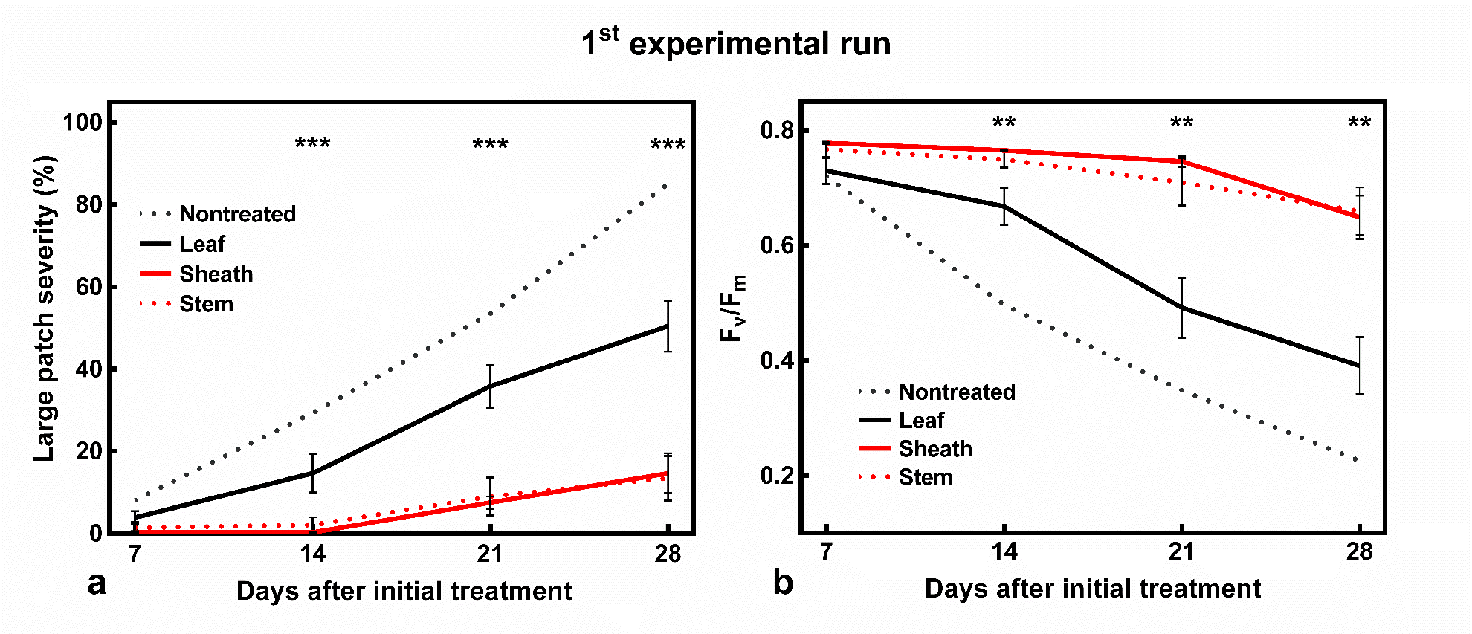

Figure 2.1. Large patch (Rhizoctonia solani) severity (a) and F_{v}/F_{m} measurements (b) on Japanese lawngrass (Zosyia japonica) pooled across target site among fungicide applications during the 1st experimental run. The experiment was conduction in a greenhouse located in Knoxville, TN, in 2015. Bars represent the standard error of the mean. Asterisks indicate significance levels at the p ≤ 0.05, 0.01, and 0.001 level, respectively.

Figure 2.2. Final large patch (Rhizoctonia solani) severity and F_{v}/F_{m} measurements in response fungicide and target site of fungicide application for the 1st (a-b) and 2nd (c-d) experimental run. Treatment means followed by same letter do not significantly differ according to Fisher’s LSD (p=0.05). Bars represent the standard error of the mean.

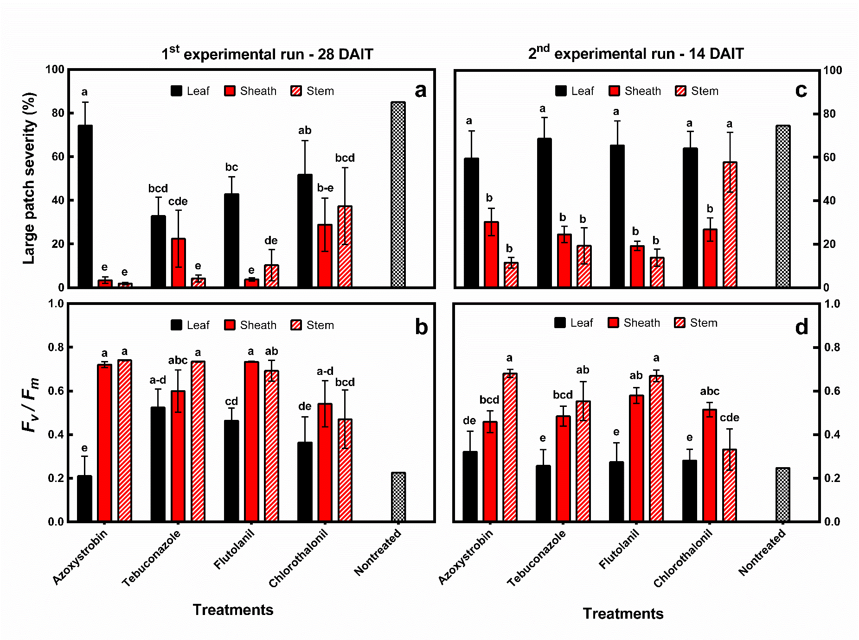

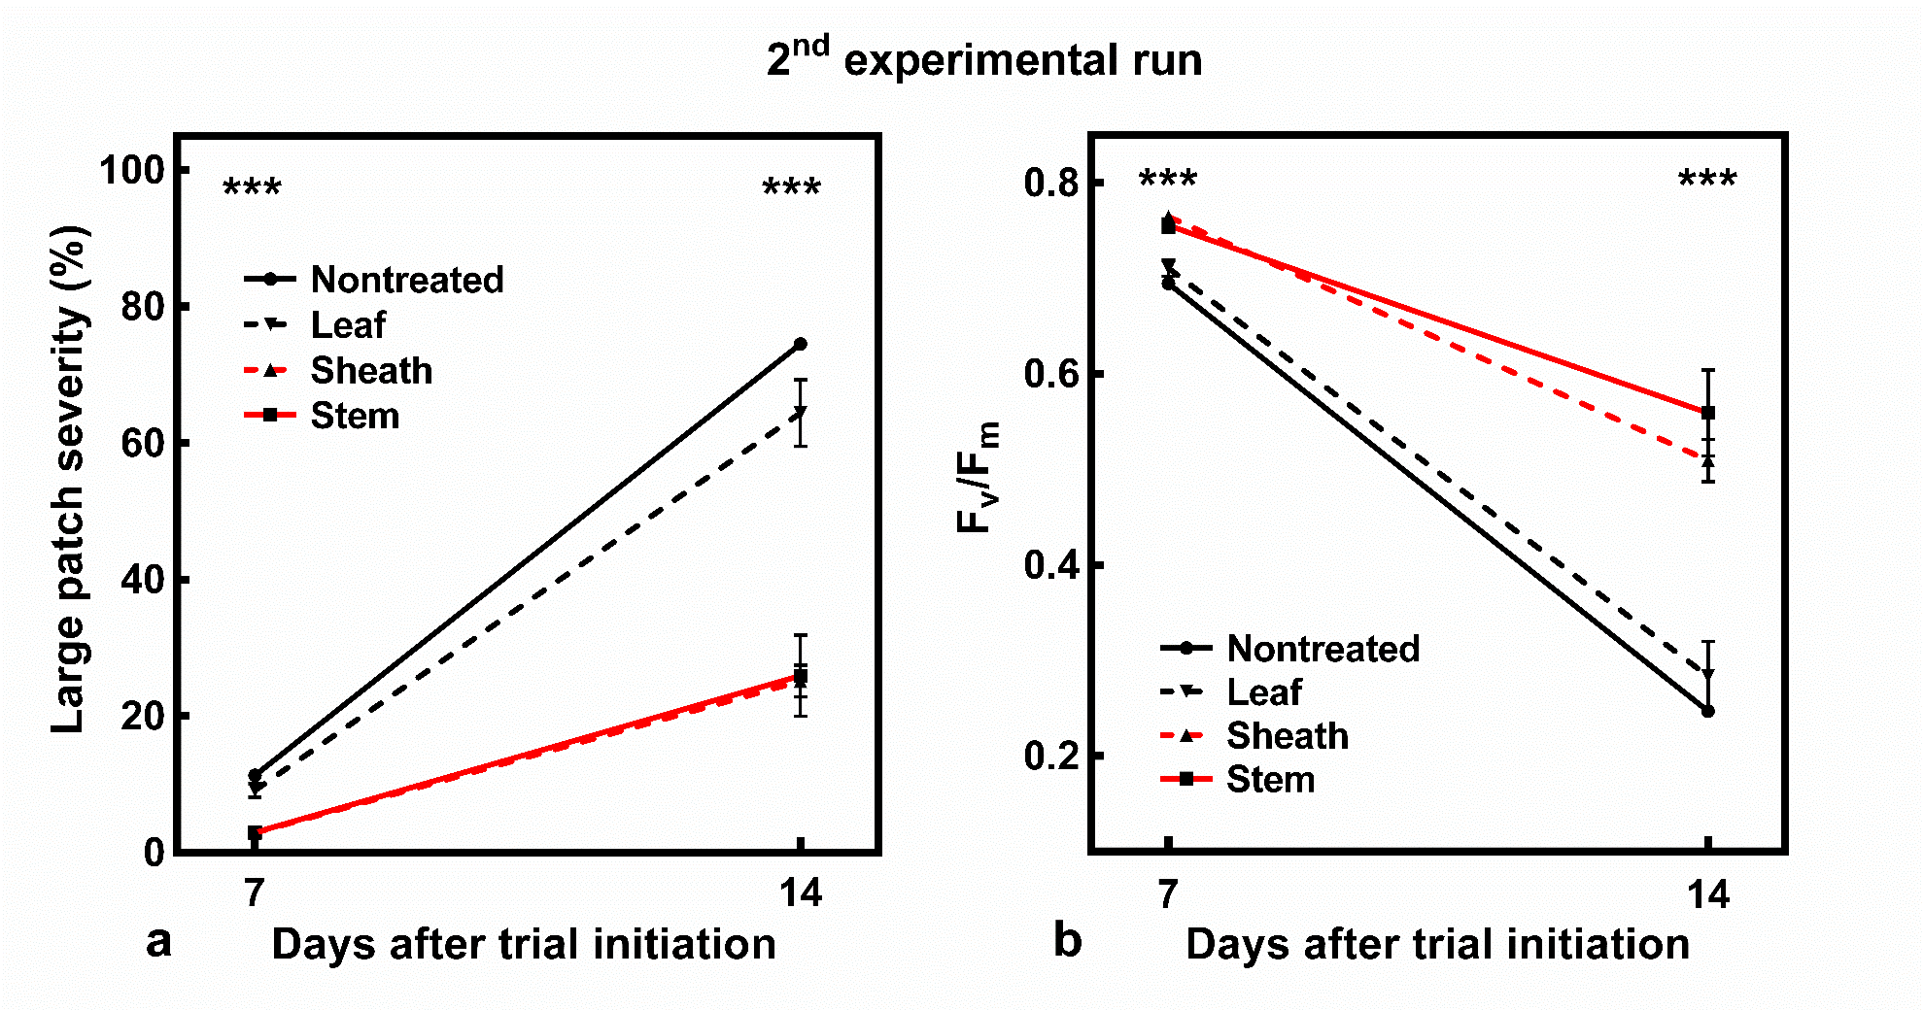

Figure 2.3. Large patch (Rhizoctonia solani) severity (a) and F_{v}/F_{m} measurements (b) on Japanese lawngrass (Zosyia japonica) pooled across target site among fungicide applications during the 2nd experimental run. Bars represent the standard error of the mean. Asterisks indicate significance levels at the p ≤ 0.05, 0.01, and 0.001 level, respectively.

CHAPTER III
Influence of spray rate volume and adjuvants on fungicidal control of large patch (rhizoctonia solani) and spray deposition characterstics

The intent of this manuscript is to publish articles in the peer-reviewed literature. This work is based on contributions by Jesse Benelli, Brandon Horvath, Bonnie Ownley, Alan Windham, and Alvin Womac.

My primary contributions to this paper include (i) designing and conducting the experiments, (ii) analyzing and interpreting data, (iii) reading literature, and (iv) writing the manuscript.

ABSTRACT
Previous growth chamber research indicates that fungicidal control of large patch (Rhizoctonia solani AG 2-2 LP) is enhanced when the spray solution is deposited on the stems and sheaths of Japanese lawngrass (JLG; Zoysia japonica). However, field-based spray strategies have not been developed that improve lower canopy fungicide deposition and improve large patch control on stands of JLG. Three experiments were designed to evaluate the effects of various spray rate volumes and surfactant additives on large patch control and spray deposition in JLG. In the 1st experiment, four spray rate volumes (93, 374, 748, and 1496 L ha⁻¹) were evaluated in combination with fungicides azoxystrobin, flutolanil, and tebuconazole for large patch control in field and growth chamber trials. The 2nd experiment evaluated two adjuvants (organosilicone and modified vegetable oil) in combination with fungicides for large patch control under field and growth chamber conditions. The 3rd experiment evaluated spray deposition characteristics on JLG affected by spray rate volume and adjuvant combinations. Results suggested that increasing spray rate volume from 93 to 1496 L ha⁻¹ improved large patch control by more than 20% when pooled across fungicides. On most rating dates, increases in spray rate volume resulted in significant increases in large patch control. The inclusion of adjuvants had lessor effects at reducing large patch severity compared to spray rate volume. However, pooled across fungicides, an organosilicone surfactant improved fungicide efficacy by 4% compared to the modified vegetable oil adjuvant and the no adjuvant treatment. Increases in spray rate volume also provided a greater penetration of spray solution to the lower plant canopy as indicated by use of a fluorescent tracer. Higher spray rate volumes increased the percentage of stems and sheaths that contained spray deposits by as much as 35% compared to the lowest spray rate volume. This research demonstrates that higher spray rate volumes provides greater spray deposition lower in the plant canopy and enhanced fungicidal control of large patch in JLG.

Introduction

Japanese lawngrass (Zoysia japonica Steud.) is a perennial C₄ turfgrass that is predominately established vegetatively in the areas of the United States that experience hot summer conditions and freezing winter conditions such as the transition zone (Beard, 2002). This warm-season grass is able to tolerant a wide range of mowing heights greater than 3 mm, making it suitable for golf course fairways and roughs. Other Zoysiagrasses, such as Manila grass (Zoysia matrella L.), can tolerate lower mowing heights making it suitable for putting-green surfaces in addition to fairways and roughs (Beard, 2002). Japanese lawngrass also requires low fertilization inputs and tolerates freezing conditions better than other warm-season turfgrasses grown in the transition zone such as bermudagrass [Cynodon dactylon (L.) Pers.] (Patton and Reicher, 2007). Additionally, JLG suffers from few diseases in the transition zone when the plant is actively growing in the summer months. However, one disease is particularly damaging to JLG when air temperature cools during the spring and fall months.
Large patch, caused by Rhizoctonia solani Kühn AG 2-2 LP, is a destructive disease of JLG in the transition zone United States (Green et al., 1993; Hyakumachi et al., 1998). The pathogen infects and colonizes JLG stems and sheaths as evident by the presence of a dark water-soaked lesion near the crown of the plant (Aoyagi et al., 1998). As the disease advances, stand symptoms include sunken off-color patches that can extend to more than 6 m in diameter. An orange ‘firing’ can occur at the margin of expanding patches. Large patch development is favored by cool-to-mild air and soil temperatures (20-25°C) with high relative humidity (>90%; Green et al., 1993). Patches tend to reoccur in the same areas each spring and fall and become progressively more severe (Spurlock, 2009). Affected areas may not recover until the onset of warmer weather that encourages the growth of the plant.
Preventative fungicide applications are critical in managing this disease. This is due, in part, to the lack of identifiable cultural control strategies that significantly reduce large patch development under field conditions (Green et al., 1994; Obasa et al., 2012; Obasa et al., 2013; Miller et al., 2016). However, severe large patch epidemics have been observed despite the use of fungicides that have been historically effective at controlling other R. solani diseases such as brown patch (B.J. Horvath, personal communication, 2016). One such reason for the disparity in fungicidal control between large patch and brown patch is the site of pathogen infection. Brown patch primarily affects the foliage of cool-season turfgrasses, whereas large patch affects warm-season turfgrass lower in the plant canopy near the stems and sheaths (Burpee and Martin, 1992). Fungicide applications that are deposited on the leaves and away from the site of pathogen infection may not provide adequate control of large patch considering the physical and chemical properties of most fungicides.
Benelli et al. (unpublished data, 2016) reported that azoxystrobin, flutolanil, tebuconazole, and chlorothalonil deposited on the leaf blades resulted in greater large patch severity compared to these fungicides deposited near the stem or sheath of JLG. However, these targeted applications were made using a pipette to singly dispense 2.5 µl droplets on specific areas of JLG. Improving spray application methods in the field that target specific plant diseases has been investigated by numerous researchers in turfgrass and agricultural crops.
Spray application strategies that target turfgrass disease control have been predominantly researched on dollar spot (Sclerotinia homoeocarpa F.T. Bennett) control (Latin, 2011). Dollar spot affects the foliage of most turfgrasses and fungicide spray applications that provide greater surface coverage through optimization of nozzle type and spray rate volume tended to result in greater dollar spot control (McDonald et al., 2006; Vincelli and Dixon, 2007; Kaminksi and Fidanza, 2009; Kennelly and Wolf; 2009). However, research is limited on optimizing field spray applications that target diseases of turfgrass that occur lower in the plant canopy.
In cropping systems, field based spray application strategies have been identified that help control plant pathogens that incite disease lower in the plant canopy. Armstrong-Cho et al. (2008) reported that increases in spray rate volume of fungicide mixtures provided greater control of Ascochyta blight (Ascochyta rabiei Pass.) in chickpea (Cicer arietinum L.). Enhanced fungicidal control of Sclerotinia blight (Sclerotinia minor Jagger) in peanut (Arachis hypogaea L.) was observed when the plant canopy was opened immediately before application through mechanical pruning (Butzler et al., 1998). Augusto et al. (2010) also observed greater fungicidal control of stem rot (Sclerotinia rolfsii Sacc.) in peanut when fungicide sprays were targeted lower in the plant canopy. Additionally, Csinos (1989) reported that narrow band spray fungicide applications that direct fungicide droplets to the main stems of peanut resulted in significantly lower stem rot compared to conventional band width spray applications.
Other spray application techniques that may enhance disease control are the use of adjuvants. Adjuvants are commonly used in conjunction with pesticides in agricultural crops to help reduce the surface tension of droplets and to enhance spray retention on hydrophobic plant surfaces (Gaskin et al., 2005). Adjuvants are also increasingly used with herbicide combinations to enable the active ingredient to penetrate plant barriers such as waxy cuticles. Additionally, adjuvants, such as an organosilicone surfactant, may help the pesticide solution spread along the surface of the plant to reach the intended application target site. A spray solution containing the herbicide dithiopyr mixed with an organosilicone surfactant was able to spread down along the plant sheath and into the crown enabling enhanced post-emergent control of large crabgrass (Digitaria sanguinalis L.) control (Keeley et al., 1997). Surfactant technology that allows spray solution to spread down the leaf sheath may significantly enhance fungicidal control of large patch.
Previous research has demonstrated that enhanced large patch control can be achieved when fungicides are deposited on the stems and sheaths of JLG. However, field applicable spray strategies that improve lower canopy deposition have not been established for managing large patch. The use of higher spray rate volumes and the incorporation of organosilicone surfactants may provide greater large patch control while depositing more spray solution lower in the plant canopy. The objective of this research was to evaluate various spray rate volumes and surfactant combinations on fungicidal control of large patch.

Materials and Methods
Field research site. Two field experiments were conducted from September 2015 to June 2016 at Farm Golf Club (FGC; 34°46’28.03” N, 85°01’34.07” W) located in Dalton, GA, and Gettysvue Golf and Polo Club (GGPG; 35°53’25.99 N, 84°04’53.45” W) in Knoxville, TN. The experiments were conducted in full sunlight and maintained as JLG ‘c.v. Meyer’ fairways mown three times weekly at 1.3 cm. At FGC, the fairways were fertilized each May to provide nitrogen at 97 kg ha⁻¹. At GGPG, nitrogen fertilizer was applied each May and June at a rate of 49 kg ha⁻¹. At each location, supplemental irrigation was administered to relieve symptoms of drought. However, irrigation at the FGC location was increased in April and May to provide 0.6 cm of water daily to the experimental area to help encourage large patch development. Mean air temperatures and precipitation amounts for each location were compiled from nearby airport weather stations at Chatsworth, GA and Alcoa, TN, respectively. Observed weather data that occurred throughout the experimental period are presented (Figure 3.1).

Field spray rate volume. Treatments were arranged in a randomized complete block design with four replications with plots measuring 0.9 x 2.1 m. Treatments included four spray rate volumes (93, 374, 748, and 1496 L ha⁻¹) using the fungicide azoxystrobin (Heritage WDG; Syngenta Crop Protection, Greensboro, NC) applied at 0.61 kg ai ha⁻¹. This represents the high-labeled rate for large patch control. A nontreated control was also included for comparative purposes. Foliar applications of azoxystrobin were made using a CO₂ pressurized spray boom equipped with two extended range nozzle tips (Spraying Systems Co., Roswell, GA) of various sizes spaced 45 cm apart. The spray rate volumes of 93, 374, 748, and 1496 L ha⁻¹ were calibrated using nozzle tips sizes consisting of XR8001VS, XR8003VS, XR8006VS, and XR8015VS, respectively. To maintain a constant spray operating pressure among treatments (241 kPa), walking speed was adjusted (with aid of a metronome) for each spray volume treatment similar to the methods of Kaminski and Fidanza (2009). At GGPG, treatments were initiated on 18 September and reapplied on 14 October and 11 April. At FGC, treatments were initiated on 1 October and reapplied on 29 October and 29 March.

Field adjuvant additives. Treatments with individual plots measuring 0.9 x 2.1 m were arranged as a 3 x 2 factorial in a randomized complete block design with four replications. The fungicides azoxystrobin, flutolanil (Prostar WDG; Bayer Environmental Science, Research Triangle Park, NC), and tebuconazole (Torque; Nufarm Americas Inc., Burr Ridge, IL) were applied at rates of 0.61, 4.69, and 0.83 kg ha⁻¹, respectively. These represents the high-labeled rate for large patch control. The fungicides were applied with or without a nonionic organosilicone based surfactant (Aircover; Winfield Solutions LLC, St. Paul, MN). The surfactant was added to the spray solution as a 0.25% v/v mixture. A nontreated control and a water + organosilicone surfactant (0.25% v/v) control was also included to monitor large patch severity in nontreated plots and to evaluate the organosilicone surfactant for control. All treatments were applied as a foliar spray using a CO₂ powered spray boom equipped with two XR8004 nozzle tips spaced 45 cm apart and calibrated to deliver a spray rate volume of 815 L ha⁻¹ at an operating pressure of 241 kPa. The treatment application schedule and interval were similar to those described previously.

Field inoculation. An isolate of Rhizoctonia solani AG 2-2LP was recovered from a JLG fairway at GGPG during spring 2014. Stem and sheath tissue that exhibited characteristic black, water-soaked lesions were collected from the margin of active large patch. Affected samples were rinsed with tap water and surface sterilized with 0.5% NaOCl for 1 min and placed on ¼-strength potato dextrose agar (PDA) amended with tetracycline (5 mg L^{–1}) and streptomycin (10 mg L^{–1}). Mycelial fragments growing from the plug were transferred to new amended ¼-strength PDA culture plates. The isolate was temporarily stored in water culture according to the methods by McGinnis et al. (1974) until the start of the experiment. To prepare inoculum, fresh plugs of R. solani were cut from the margin of 3-day old PDA culture plates and placed inside a 1000-ml glass flask containing 300 g of thrice autoclaved oat (Avena sativa L.) kernels. Additional plugs of 3-day old culture plates were placed in a thrice autoclaved sand-cornmeal mixture (2:1 ratio). Inoculated flasks and the mixture of sand-cornmeal were stored at room temperature and periodically shaken or mixed to ensure even distribution of inoculum.
To inoculate field plots, approximately 15 grams of infested oat kernels were placed below the thatch at two opposite locations in each plot. Additionally, 40 grams of the sand-cornmeal mixture was top-dressed on top of the turf canopy using a hand-held shaker jar. Plots were inoculated on 13 and 18 SEP 2015 at GGPG and FGC, respectively.

Field large patch severity. Large patch severity was evaluated with digital image analysis (Richardson et al., 2001). Digital images were captured using a camera (Canon G12; Canon Inc., Japan) mounted inside a 0.28 m² box equipped with eight light-emitting diodes. Four digital images were collected for each plot per rating date and were captured at the beginning of the experiment and approximately every 28 days thereafter. Images were analyzed using SigmaScan Pro (Version 5.0; SPSS Inc., Chicago, IL). The four images collected from each plot were averaged prior to analysis.

Greenhouse plant culture. A cup-cutter sized plug, 10-cm in diameter, of Japanese lawngrass (c.v. ‘Meyer) was harvested from the East Tennessee Research and Education Center in Knoxville, TN. The intact plug was placed upside down and aggressively rinsed using a pressurized washer to separate soil and other debris from the plug. The remaining stolon and leaf tissue were separated and rinsed with tap water before being propagated into potting medium (Fafard Professional Potting Mix; Sun Gro Horticulture, Agawam, MA) contained in an 18 by 30-cm stock pot. After 3 months, five tillers of JLG was harvested from the pot and placed into 3.8 cm diameter ‘conetainers’ (Steuwe and Sons, Tangent, OR) containing similar media. The racks of conetainers were maintained in a greenhouse at 28°C. The JLG was maintained at a height of 2.0 cm using scissors and irrigated once daily with an overhead irrigation system. Fertilizer was applied every 14 days at a rate of 49 kg N ha-1 with a complete 24-8-16 fertilizer (All Purpose Plant Food, The Scotts Company, Marysville, OH). Plants were allowed to establish for six months before trial initiation.

Greenhouse spray rate volume. Treatments were arranged as a 3 x 4 factorial in a randomized complete block design with five replications. The fungicides azoxystrobin, flutolanil, and tebuconazole (0.46, 3.51, and 0.62 kg ai ha⁻¹, respectively) were applied at four spray rate volumes consisting of 93, 374, 748, and 1496 L ha⁻¹. The spray rate volumes were individually calibrated using various even fan extended range nozzle tips. Nozzle tips including the XR8001EVS and XR8003EVS were selected for the lower spray rate volumes of 93 and 374 L ha⁻¹, while the XR8008EVS nozzle tip was used for both of the two higher spray rate volumes of 748 and 1496 L ha⁻¹. All treatments were sprayed at 241 kPa at a nozzle height of 30 cm using a spray chamber (Generation III Research Track Sprayer; DeVries Manufacturing, Hollandale, MN). Treatments were applied once for each of the two experimental runs.

Greenhouse adjuvant additives. Treatments were arranged in a 3 x 3 factorial arrangement in a randomized complete block design with five replications. The three fungicides were azoxystrobin, flutolanil, and tebuconazole applied at rates of 0.46, 3.51, and 0.62 kg ai ha⁻¹, respectively. Three surfactant combinations were evaluated including a nonionic organosilicone surfactant (0.25% v/v), a modified vegetable oil adjuvant (0.25% v/v) (Droplex; Winfield Solutions LLC, St. Paul, MN), and a no surfactant treatment. The following three treatments were included for comparative purposes: nontreated control, water + the organosilicone surfactant (0.25% v/v), and water + the modified vegetable oil adjuvant (0.25% v/v). These control treatments were included to monitor large patch severity within nontreated conetainers and to evaluate whether the two adjuvants controlled large patch. All treatments were applied using a track spray with a XR8003EVS nozzle tip (spaced 30 cm above the canopy) with at a spray volume of 748 L ha⁻¹. Treatments were applied once for each of the two experimental runs.

Greenhouse inoculation. Pathogen isolation and storage was similar to that outlined earlier. However, only the 2:1 sand-cornmeal mixture was used to inoculate conetainers. Conetainers were inoculated 24 hr after fungicide treatment by placing 3 g of inoculum near the plant-soil interface. The racks of conetainers were placed in a large plastic tub with a transparent lid. Water was added to the tub to provide high relative humidity. The tub was placed in a growth chamber (Conviron Adaptis; Controlled Environment Ltd., Winnipeg, Canada) maintained at 24°C (day) and 20°C (night) with a 12 hr photoperiod for the first 14 days. After 14 days, the temperature settings were lowered to 20°C (day) and 12°C (night) while maintaining the 12 hr photoperiod.

Greenhouse large patch severity. Similar to field experiments, large patch severity was assessed by digital image analysis. Digital images were collected 0, 7, 14, 21, and 28 days after treatment (DAT). Digital images were collected using the same camera outlined earlier in a modified light box containing two fluorescent light bulbs. Images were analyzed using SigmaScan Pro. A small demarcation was made on each conetainers to allow a constant camera angle for all images throughout the experimental duration. All conetainers were clipped to a height of 2.0 cm prior to image collection.

Greenhouse spray deposition treatments. Treatments were arranged as a 4 x 2 factorial in a randomized complete block design. Conetainers of JLG were evaluated for spray deposition characteristics in response to four combinations of spray rate volumes (93, 374, 748, and 1496 L ha⁻¹) applied with or without an organosilicone surfactant (0.25% v/v). Nozzle tip selection, operating pressure, and spray height were similar to that described in the greenhouse spray rate volume experiment.
To assess spray deposition characteristics, a yellow fluorescent tracer (LeafCheck 189 Fluorescent Pigment; Topline Paint LTD, Lonsdale, SA) applied at 18.6 L of product ha⁻¹ was included in all treatment combinations. Treatment applications were made using the same aforementioned spray configuration in regards to nozzle tip size and spray chamber for each respective spray rate volume. In consideration of spray droplets bouncing off the JLG conetainers, additional JLG conetainers were placed on the immediate perimeter of the actual experimental units prior to being sprayed.

Greenhouse leaf surface coverage. Approximately 3 hr after application, all conetainers were photographed using a modified light box that contained two light sources. Two fluorescent light bulbs were used to capture percent green cover in each conetainer. Immediately afterwards, a 2nd image was collected using two black-light fluorescent bulbs. The black light allows the tracer to fluoresce enabling detection of surface spray deposition on each JLG conetainer. Both images were analyzed using SigmaScan for percent cover. The percent cover of tracer fluorescence using black-lighting was divided by the percent green cover using fluorescent-lighting for an estimate of percent spray coverage for each JLG conetainer.

Greenhouse sheath and stem coverage. After image collection, all conetainers were destructively sampled for spray deposits on stems and sheaths on each JLG tiller. All sheaths and stems were individually placed under black-lighting to detect if the spray solution was deposited on the plant parts. The number of sheaths and stems with visible spray deposits were divided by the total number of sheaths and stems to determine the percentage of sheaths and stems with spray deposits.
Statistical analysis. Data were subjected to ANOVA using PROC MIXED with code generated by the DANDA macro in SAS (version 9.4; Statistical Analysis Software, Inc., Cary, NC) (Saxton, 2010). Due to differences in the number of rating assessments in the field experiments among locations, individual rating dates were analyzed separately. However, measurements of the Area Under the Disease Progress Curve were pooled across locations because there was no location by treatment interaction. The AUDPC measurements were initially calculated with ARM statistical software (ARM 8; Gylling Data Management, Brookings, SD) but were analyzed using SAS. No experimental run by treatment interaction was observed for the growth chamber experiments and data was pooled across runs. In each experiment, the nontreated control was not included in the statistical analysis but results are shown for comparative purposes. Response variable means were separated using Fisher’s protected least significant difference (LSD) test at α = 0.05.

Results
Spray rate volume. Large patch was slow to develop under field conditions due to unfavorably dry weather at both experimental locations and peak large patch severity did not exceed 15% at either location. Significant differences in spray rate volume were not observed at GGPG (Table 3.1). However, the influence of spray rate volume on the efficacy of azoxystrobin was significant on MAR 29 and MAY 6 at FGC (Table 3.1). On both rating dates, azoxystrobin applied at a spray rate volume of 748 or 1496 L ha⁻¹ exhibited significantly lower large patch severity compared with azoxystrobin applied at 93 and 374 L ha⁻¹ (Figure 3.2). Azoxystrobin applied at higher spray rate volumes also exhibited lower large patch severity when measurements of the AUDPC were pooled across locations. All spray rate volumes were comparatively lower than the nontreated control. However, lower spray rate volumes of azoxystrobin applications resulted in significantly higher AUDPC measurements compared to higher spray rate volumes (Figure 3.3).
Under growth chamber conditions, large patch severity exceeded 70% in the nontreated control at 28 DAT when pooled across experimental runs. Pooled across experimental runs, the effect of fungicide, spray rate volume, and the interaction of fungicide x spray rate volume were significant on most rating dates (Table 3.2). All fungicides (pooled across spray rate volumes) reduced large patch severity compared to the nontreated control on all rating dates. Among fungicides, azoxystrobin and flutolanil tended to exhibit lower large patch severity compared to applications of tebuconazole when pooled across spray rate volume (data not shown).
Spray rate volume (pooled across) fungicides was significant 14, 21, and 28 DAT (Table 3.2). On 28 DAT, large patch severity was significantly lower with each increase in spray rate volume (Figure 3.4). More than 50% large patch severity was observed on the final rating date under the lowest spray rate volume (93 L ha⁻¹), whereas, less than 40% large patch severity was observed under the highest spray rate volume (1496 L ha⁻¹; Figure 3.4). The interaction of fungicide x spray rate volume was significant on every rating date (Table 3.2). Applications of azoxystrobin and flutolanil were most impacted by spray rate volume. Azoxystrobin and flutolanil applied at a spray rate volume of 1496 L ha⁻¹ each exhibited approximately 35% large patch severity and was significantly lower compared to lower spray rate volumes (Figure 3.5). Azoxystrobin applied at 374 L ha⁻¹ was not significantly different from azoxystrobin applied at 93 L ha⁻¹. However, flutolanil applied at 374 L ha⁻¹ exhibited significantly lower large patch severity when compared to the lowest spray rate volume (Figure 3.5). The impact of spray rate volume on the efficacy of tebuconazole was less substantial than the other two aforementioned fungicides. However, tebuconazole applied at a spray rate volume of 1496 L ha⁻¹ still exhibited significantly lower large patch severity (45%) compared to tebuconazole applied at the lowest spray rate volume (50%; Figure 3.5).

Adjuvant additives. Similar to the spray rate volume field experiment, large patch was slow to develop under field conditions at each trial location. Peak large patch severity was 17% in the nontreated control at GGPG on MAY 23 and 10% at FGC on MAR 29. The impact of fungicide, surfactant, and the interaction of fungicide x surfactant were significantly different among treatments on select rating dates and when measurements of AUDPC were pooled across locations (Table 3.3). Treatment differences on individual rating dates were more pronounced on the final rating assessment at each location. On MAY 6 at FGC, all fungicides (pooled across surfactant) exhibited lower large patch severity compared to the nontreated control (data not shown). Pooled across fungicides, the effect of surfactant was significantly different at both locations on the final rating date. In general, the addition of an organosilicone surfactant resulted in lower large patch severity compared with fungicides applied without an organosilicone surfactant (data not shown). However, this effect was less pronounced with applications of tebuconazole. Similar trends in the interaction of fungicide x surfactant observed when measurements of the AUDPC was calculated. Pooled across locations, the fungicides azoxystrobin and flutolanil resulted in lower measurements of AUDPC when applied with an organosilicone surfactant (Figure 3.6). Tebuconazole was not significantly impacted by the inclusion of a surfactant additive.
Large patch development was more severe under growth chamber conditions reaching 87% severity on the final rating date pooled across experimental runs. However, few differences in fungicide, surfactant, and the interaction of fungicide x surfactant were observed (Table 3.4). The effect of surfactant was significant on the final rating date (28 DAT) when pooled across fungicides. At 28 DAT, fungicides applied with an organosilicone surfactant resulted in significantly lower large patch severity (34%) compared to fungicides applied with a modified vegetable oil adjuvant (38%) or no surfactant (38%; Figure 3.6). However, a significant fungicide x surfactant interaction was not detected.

Spray deposition characteristics. No treatment x experimental run differences were detected for leaf surface, sheath, and stem coverage. Therefore, data was pooled across runs. Pooled across surfactant additives, spray rate volume was significantly different among treatments (Table 3.5). The spray rate volume of 374 L ha⁻¹ resulted in the most leaf surface coverage (70%) followed by 748 L ha⁻¹ (64%; Figure 3.8). The lowest (93 L ha⁻¹) and highest (1496 L ha⁻¹) spray rate volumes resulted in the least amount of surface coverage (Figure 3.8). However, these spray rate volumes resulted in the biggest change in response to the inclusion of an organosilicone surfactant. The spray rate volume of 93 L ha⁻¹ exhibited a leaf surface coverage of 34% without an organosilicone surfactant and increased to 59% with an organosilicone surfactant (Figure 3.9). Conversely, the highest spray rate volume (1496 L ha⁻¹) resulted in 47% leaf surface coverage without an organosilicone surfactant and decreased to 39% with an organosilicone surfactant (Figure 3.9). The spray rate volumes of 374 and 748 L ha⁻¹ were least affected by the inclusion of an organosilicone surfactant in regards to leaf surface coverage (Figure 3.9). However, pooled across spray rate volumes, the inclusion of an organosilicone surfactant resulted in a significantly greater amount of leaf surface coverage (data not shown). Spray rate volumes (pooled across surfactant) were significantly different in regards to stem and sheath coverage (Table 3.5). Increases in spray rate volume resulted in significant increases in the percentage of stems with spray deposits coverage. The spray rate volume of 1496 L ha⁻¹ resulted in 65% of all stems containing spray deposits (Figure 3.8). Only 30% of stems contained spray deposits with the lowest spray rate volume. The effects of surfactant or the interaction of surfactant x spray volume were not significantly different among treatments.
Similar to stem coverage, the lowest spray rate volume also resulted in the lowest percentage of sheaths (72%) that contained spray deposits (Figure 3.8). The highest percentage of sheaths that contained spray deposits was observed with the spray rate volumes of 748 and 1496 L ha⁻¹ with 96 and 97% of sheaths containing spray deposits, respectively (Figure 3.8). Pooled across spray rate volume, the effect of surfactant was significant across treatments with 91% of sheaths with spray deposits with a surfactant, compared to 87% of sheaths with spray deposits without a surfactant (Figure 3.9). The interaction of spray rate volume x surfactant was not significantly different among treatments.

Discussion
These experiments evaluated the effect of spray rate volume and surfactant additives for fungicidal control of large patch and spray deposition. Increasing the spray rate volume to 1496 L ha⁻¹ improved large patch control by as much as 20% compared to the lowest spray rate volume of 93 L ha⁻¹ when pooled across fungicides. These results were observed with azoxystrobin under field environments and azoxystrobin, flutolanil, and tebuconazole under growth chamber conditions. These findings are corroborated with other researchers report of increases in disease control with higher spray rate volumes in turfgrass or agricultural cropping systems (Armstrong-Cho et al., 2008; McDonald et al., 2006; Vincelli and Dixon, 2007; Kaminksi and Fidanza, 2009; Kennelly and Wolf; 2009).
The effect of adjuvants on fungicidal control of large patch control was less clear. Under field conditions, an organosilicone surfactant added to azoxystrobin and flutolanil mixtures enhanced disease control when measurements of the AUDPC were calculated. However, greater disease control with tebuconazole was not observed when an organosilicone surfactant was added under field conditions. Under growth chamber conditions, an organosilicone surfactant and a modified vegetable oil adjuvant were evaluated in combination with azoxystrobin, flutolanil, and tebuconazole. Significant differences in the interaction of fungicide x surfactant were not observed on any rating date pooled across experimental runs. However, when pooled across fungicides, the organosilicone surfactant exhibited significantly less large patch severity when compared against the modified vegetable oil adjuvant and the no surfactant treatment.
The mechanism for the increase in large patch control with increased spray rate volumes may have been due to greater surface coverage near the site of pathogen infection. In the spray deposition experiment, a fluorescent tracer was added to various combinations of water with and without an organosilicone surfactant applied at four spray rate volumes (93, 374, 748, and 1496 L ha⁻¹). In this experiment, each increase in spray rate volume resulted in a significant increase in the percentage of stems that exhibited spray solution deposits on the stem. The greatest difference in the percentage of stems that exhibited spray solution deposits was between the spray rate volumes of 93 L ha⁻¹ (30%) and 1496 L ha⁻¹ (70%). The percentage of sheaths that exhibited spray solution deposits was also significantly impact by spray rate volume. Each increase in spray rate volume up to 748 L ha⁻¹ resulted in a significant increase of sheaths that contained spray solutions deposits compared to lower spray rate volumes. It has been reported that greater spray deposition occurs lower in the plant canopy with higher spray rate volumes (Wicks and Nitschke, 1986; Armstrong-cho et al., 2008; Foque et al., 2014).
Additional spray methods should be developed to further enhance quality spray deposition on JLG plants. In this study, spray rate volume had a greater impact at improving spray deposition on the stems and sheaths of JLG plants compared to the inclusion of an organosilicone surfactant. Spray rate volume also had a greater impact in reducing large patch severity in our experiments compared to surfactant additives. However, in this research, only two adjuvants were evaluated for their effects at improving fungicidal control of large patch. Other adjuvants should be evaluated in future research for their effect at improving fungicide efficacy. Furthermore, additional means to enhance lower canopy deposition is warranted. Another possible solution is the use of in-situ precipitation. In-situ precipitation introduces polyelectrolytes on the plant surface (Damak et al., 2016). This helps enable a hydrophilic environment that increases spray retention and reduces droplet bounce on intended targets. Another application strategy could be to administer post spray application irrigation to water in xylem mobile fungicides into the rootzone. Root absorbed fungicides may be able to provide protection across the entire matrix of the plant.
Turfgrass managers should consider the use of increasing the spray rate volume of fungicide applications to better control large patch epidemics. Increasing the spray rate volume may allow for more of the fungicide solution to reach the site of pathogen infection in JLG, while enhancing fungicidal control. Additionally, perhaps less fungicide active ingredient would be needed to maintain quality large patch control. Less active ingredient could results in financial savings for the turfgrass manager or facility. Turfgrass managers should also assess the risk of adding surfactants to the spray solution in fungicide sprays. Many fungicide labels do not recommend the use of adding a surfactant to the spray mixture. Turfgrass managers should spray a test area to ensure the usefulness and safeness of adding surfactants to the spray solution. Future research is needed to determine other spray technologies that can further enhance the value of fungicidal control of large patch and other turfgrass diseases.

Acknowledgements

The authors would like to thank the United States Golf Association [grant no. 2015-05-520] and WinField Solution for partial funding of this experiment.

LITERATURE CITED
Aoyagi, T., K. Kageyama, and M. Hyakumachi. 1998. Characterization and survival of Rhizoctonia solani AG 2-2LP associated with large patch disease of Zoysia grass. Plant Dis. 82:857-863.
Armstrong-Cho, C., T. Wolf, G. Chongo, Y. Gan, T. Hogg, G. Lafond, E. Johnson, and S. Banniza. 2008. The effect of carrier volume on Ascochyta blight (Ascochyta rabiei) control in chickpea. Crop Prot. 27:1020-1030.
Augusto, J., T.B. Brenneman, A.K. Culbreath, and P. Sumner. 2010. Night spraying peanut fungicide II. Application timings and spray deposition in the lower canopy. Plant Dis. 94:683-689.
Beard, J.B. 2002. Turfgrass management for golf courses. Ann Arbor Press, Chelsea, MI.
Brudenell, A.J.P., D.A. Baker, and B.T. Grayson. 1995. Phloem mobility of xenobiotics: tabular review of physiochemical properties governing the output of the Kleier model. Plant Growth Regul. 16:215-231.
Burpee, L., and B. Martin. 1992. Biology of Rhizoctonia species associated with turfgrasses. Plant Dis. 76:112-117.
Butzler, T.M., J. Bailey, and M.K. Beute. 1998. Integrated management of Sclerotinia blight in peanut: utilizing canopy morphology, mechanical pruning, and fungicide timing. Plant Dis. 82:1312-1318.
Csinos, A.S. 1989. Targeting fungicides for control of southern stem rot on peanut. Plant Dis. 73:723-726.
Damak, M., S.R. Mahmoudi, M.N. Hyder, and K.K. Varanasi. 2016. Enhancing droplet deposition through in-situ precipitation. Nature. DOI: 10.1038/ncomms12560.
Foque, D., J.G. Pieters, and D. Nuyttens. 2014. Effect of spray angle and spray volume on deposition of a medium droplet spray with air support in ivy pot plants. Pest. Manage. Sci. 70: 427-439.
Gaskin, R.E., K.D. Steele, and W.A. Forster. 2005. Characterizing plant surfaces for spray adhesion and retention. New Zealand Plant Prot. 58:179.
Green, D.E., J.D. Fry, J.C. Pair, and N.A. Tisserat. 1993. Pathogenicity of Rhizoctonia solani AG-2-2 and Ophiosphaerella herpotricha on zoysiagrass. Plant Dis. 77:1040-1044.
Green, D.E., J.D. Fry, J.C. Pair, and N.A. Tisserat. 1994. Influence of management practices on Rhizoctonia large patch disease in zoysiagrass. HortScience 29:186-188.
Kaminski, J.E., and M.A. Fidanza. 2009. Dollar spot severity as influenced by fungicide mode of activity and spray nozzle. HortSci. 44:1762-1766.
Keeley, SJ, Branham BE, Penner D. (1997) Adjuvant enhancement of large crabgrass (Digitaria sanguinalis) control with dithiopyr. Weed Sci. 45: 205-211.
Kennelly, M.M., and R.E. Wolf. 2009. Effect of nozzle type and water volume on dollar spot control in greens-height creeping bentgrass. Appl. Turfgrass Sci. doi:10.1094/ATS-2009-0921-01-RS.
Latin, R. 2011. A practical guide to turfgrass fungicides. American Phytopathological Society, St. Paul, MN.
McDonald, S.J., P.H. Dernoeden, and C.A. Bigelow. 2006. Dollar spot control in creeping bentgrass as influenced by spray volume and application timing. Appl. Turfgrass Sci. doi:10.1094/ATS-2006-0531-01-RS.
McGinnis, M.R., A. Padhye, and L. Ajello. 1974. Storage of stock cultures of filamentous fungi, yeast, and some aerobic actinomycetes in sterile distilled water. Appl. Mircobiol. 28: 218-222.
Miller, G.L., D.T. Earlywine, R. Braun, J.D. Fry, and M.M. Kennelly. 2016. Influence of nitrogen source and application timing on large patch of zoysiagrass. Crop For. Turf. Manage. Doi:10.2134/cftm2015.0189
Obasa, K., J. Fry, and M. Kennelly. 2012. Susceptibility of zoysiagrass germplasm to large patch caused by Rhizoctonia solani. HortScience 47:1252-1256.
Obasa, K., J.Fry, D. Bremer, R.S. John, and M. Kennelly. 2013. Effect of cultivation and timing of nitrogen fertilization on large patch disease of zoysiagrass. Plant Dis. 97:1075-1081
Richardson, M.D., D.E. Karcher, and L.C. Purcell. 2001. Quantifying turfgrass cover using digital image analysis. Crop Sci. 41:1884-1888.
Saxton, A.M. 2010. Design and Analysis Web Guide. DAWG Web site. Available online: http://dawg.utk.edu/ (accessed on 16 July 2016).
Spurlock, T.N. 2009. Epidemiology and etiology of zoysiagrass diseases in Northwest Arkansas. M.S. thesis. Univ. of Arkansas, Fayetteville.
Tisserat, N.A., J. Fry, and D. Green. 1994. Managing Rhizoctonia large patch. Golf Course Manage. 62:58-61.
Turgeon, A.J. 2008. Turfgrass management. 8th ed. Prentice Hall, Upper Saddle River, NJ.
Vincelli, P. and E. Dixon. 2007. Does spray coverage influence fungicide efficacy against dollar spot? Appl. Turfgrass Sci. doi:10.1094/ATS-2007-1218-01-RS.
Wicks, T.J., and L.F. Nitschke. 1986. Control of apple diseases and pests with low spray volumes and reduced chemical rates. Crop Prot. 5: 283-287.

APPENDIX
TABLES AND FIGURES
 |  | Farm Golf Club |  |  | Gettysvue Golf and Polo Club
Source | df | OCT 30  2015 | MAR 29  2016 | MAY 6  2016 | OCT 14  2015 | NOV 13  2015 | APR 11  2016 | MAY 3  2016 | MAY 23  2016 | AUDPC
Replication | 3 | NSª | NS | NS | NS | NS | NS | NS | NS | NS
Spray rate volume | 2 | NS | *** | ** | NS | NS | NS | NS | NS | *
ªNS = not significant.
*,**,***, Significant at the p ≤0.05, 0.01, 0.001 level, respectively.

Table 3.1. Analysis of variance for large patch (Rhizoctonia solani) severity of Japanese lawngrass (Zoysia japonica) in response to azoxystrobin applied at four spray rate volumes including 93, 374, 748, and 1496 L ha⁻¹. The AUDPC was pooled across locations. Research was conducted at Farm Golf Club and Gettysvue Golf and Polo Club in Dalton, GA, and Knoxville, TN, respectively during 2015-2016.

Table 3.2. Analysis of variance (pooled across experimental runs) for large patch (Rhizoctonia solani) severity of Japanese lawngrass (Zoysia japonica) in response to azoxystrobin, flutolanil, and tebuconazole applied at four spray rate volumes including 93, 374, 748, and 1496 L ha⁻¹. Research was conducted under greenhouse and growth chamber conditions in Knoxville, TN during 2016.
 |  | Large patch severity
 |  | - Days after trial initiation -
Source | df | 7 | 14 | 21 | 28
Replication | 4 | NSª | NS | NS | NS
Fungicide (F) | 2 | *** | NS | *** | ***
Spray Rate Volume (V) | 3 | NS | *** | *** | ***
F x V | 6 | * | * | *** | ***
ªNS = not significant.
*,**,***, Significant at the p ≤0.05, 0.01, 0.001 level, respectively.

 |  | Farm Golf Club |  |  | Gettysvue Golf and Polo Club
Source | df | OCT 30  2015 | MAR 29  2016 | MAY 6  2016 | OCT 14  2015 | NOV 13  2015 | APR 11  2016 | MAY 3  2016 | MAY 23  2016 | AUDPC
Replication | 3 | NSª | NS | NS | NS | NS | NS | NS | NS | NS
Fungicide (F) | 2 | * | * | ** | NS | * | NS | NS | NS | *
Surfactant (S) | 1 | * | NS | *** | NS | NS | NS | NS | *** | ***
F x S | 2 | NS | NS | NS | * | NS | NS | NS | ** | *
ªNS = not significant.
*,**,***, Significant at the p ≤0.05, 0.01, 0.001 level, respectively.

Table 3.3. Analysis of variance for large patch (Rhizoctonia solani) severity of Japanese lawngrass (Zoysia japonica) in response to azoxystrobin, flutolanil, and tebuconazole applied with and without surfactant additives. The AUDPC was pooled across locations. Research was conducted at Farm Golf Club and Gettysvue Golf and Polo Club in Dalton, GA, and Knoxville, TN, respectively during 2015-2016.

Table 3.4. Analysis of variance (pooled across experimental runs) for large patch (Rhizoctonia solani) severity of Japanese lawngrass (Zoysia japonica) in response to azoxystrobin, flutolanil, and tebuconazole applied with and without surfactant additives. Research was conducted under greenhouse and growth chamber conditions in Knoxville, TN during 2016.
 |  | Large patch severity
 |  | - Days after trial initiation -
Source | df | 7 | 14 | 21 | 28
Replication | 4 | NSª | NS | NS | NS
Fungicide (F) | 2 | NS | NS | ** | ***
Surfactant (S) | 3 | NS | NS | NS | *
F x S | 6 | NS | NS | NS | NS
ªNS = not significant.
*,**,***, Significant at the p ≤0.05, 0.01, 0.001 level, respectively.

Table 3.5. Analysis of variance (pooled across experimental runs) of spray deposition characteristics of surface coverage, and percent incidence of stem and sheath coverage severity on Japanese lawngrass (Zoysia japonica) in response to various spray rate volumes and surfactant additives. Treatments were applied under greenhouse and spray chamber conditions in Knoxville, TN during 2016.
Source | df | Surface coverage | Sheath coverage | Stem Coverage
Replication | 4 | NSª | NS | NS
Spray rate volume (V) | 2 | *** | *** | ***
Surfactant (S) | 3 | ** | ** | NS
F x S | 6 | *** | NS | NS
ªNS = not significant.
*,**,***, Significant at the p ≤0.05, 0.01, 0.001 level, respectively.

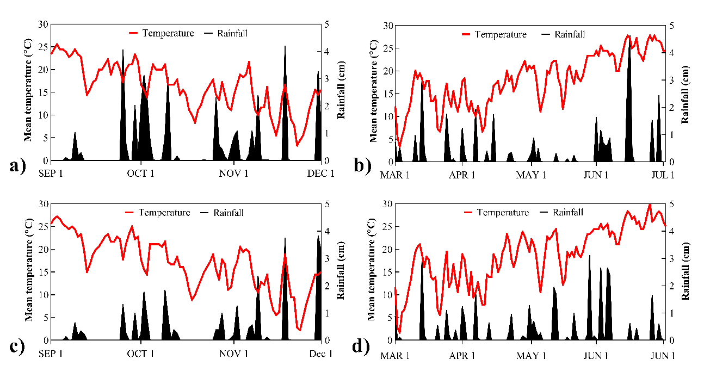

Figure 3.1. Climate data for Dalton, GA, (a-b) and Knoxville, TN, (c-d) during the experimental period from fall 2015 (a-c) through spring 2016 (b-d). Data was collected from Weather Underground weather stations in Chatsworth, GA, and Alcoa, TN.

Figure 3.2. Large patch (Rhizoctonia solani) severity in response to applications of azoxystrobin (0.61 kg ai ha⁻¹) at various spray rate volumes in Dalton, GA (a), and Knoxville, TN (b). Treatments were initiated on 18 SEP and reapplied on 14 OCT and 11 APR in Knoxville, TN. At Dalton, GA, treatments were initiated on 1 OCT and reapplied on 29 OCT and 29 MAR. Asterisks indicate significance levels at the p ≤ 0.05, 0.01, and 0.001 level, respectively. Bars represent the standard error of the mean.

Figure 3.3. Measurements of the Area Under the Disease Progress Curve (AUDPC) for large patch (Rhizoctonia solani) severity (pooled across locations) in response to applications of azoxystrobin (0.61 kg ai ha⁻¹) applied at various spray rate volumes. Treatment means followed by same letter do not significantly differ according to Fisher’s LSD (p=0.05). Bars represent the standard error of the mean.

Figure 3.4. Large patch (Rhizoctonia solani) severity (pooled across fungicides and experimental runs) in response to various spray rate volumes under growth chamber conditions. The fungicides azoxystrobin, flutolanil, and tebuconazole were applied once at 0.46, 3.51, and 0.62 kg ai ha⁻¹, respectively. Asterisks indicate significance levels at the p ≤ 0.05, 0.01, and 0.001 level, respectively. Bars represent the standard error of the mean.

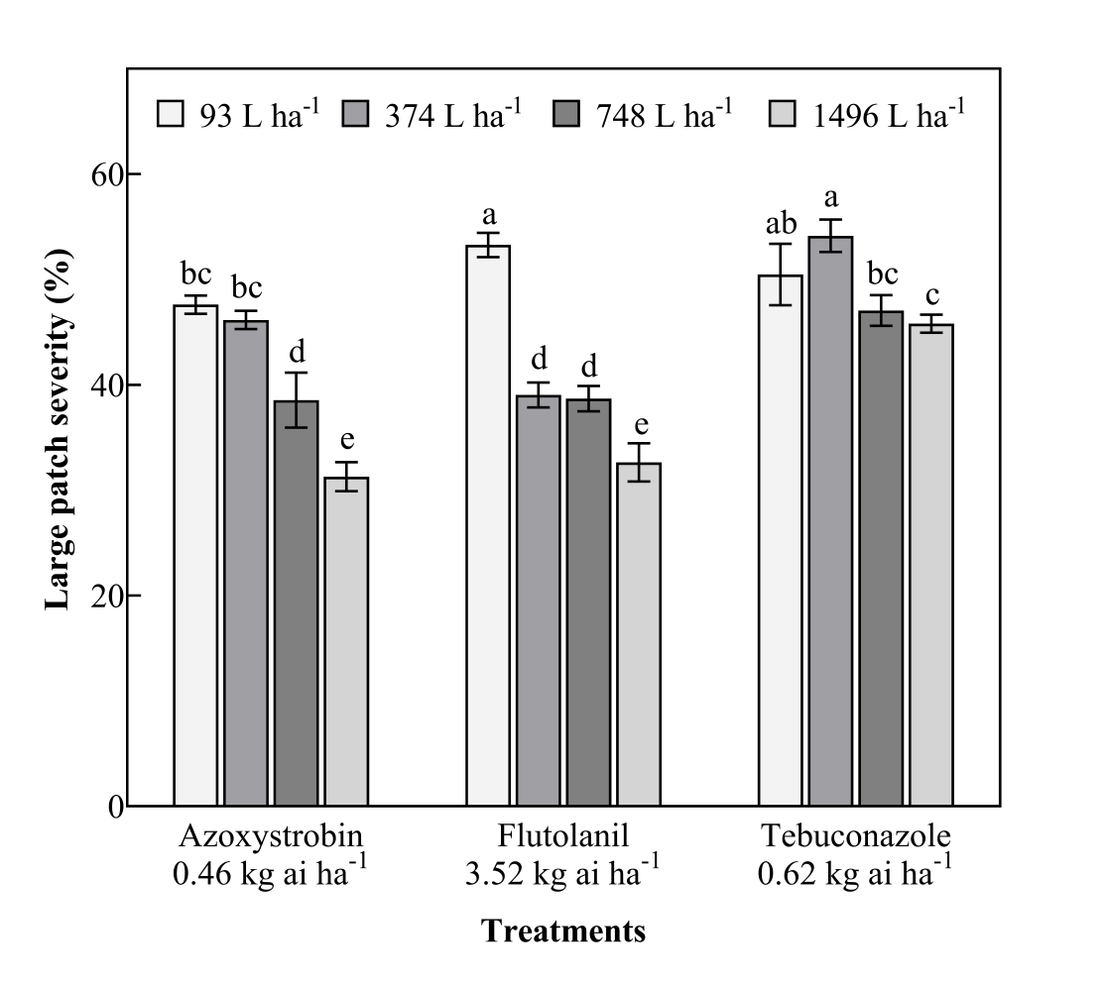

Figure 3.5. Large patch (Rhizoctonia solani) severity at 28 days after treatment (pooled across experimental runs) in response to fungicides applied at four spray rate volumes. Treatment means followed by same letter do not significantly differ according to Fisher’s LSD (p=0.05). Bars represent the standard error of the mean.

Figure 3.6. Measurements of the Area Under the Disease Progress Curve (AUDPC) for large patch (Rhizoctonia solani) severity (pooled across locations) in response to fungicides applied with or without an organosilicone surfactant (0.25% v/v). Treatment means followed by same letter do not significantly differ according to Fisher’s LSD (p=0.05). Bars represent the standard error of the mean.

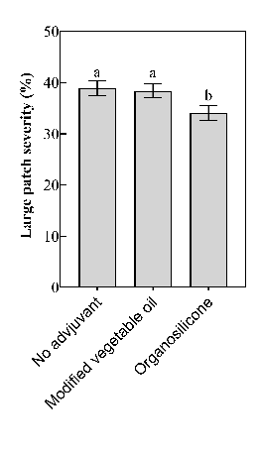

Figure 3.7. Influence of adjuvants (pooled across fungicides and experimental runs) on large patch (Rhizoctonia solani) severity under growth chamber conditions. Each adjuvant was applied at 0.25% v/v and mixed with fungicides azoxystrobin, flutolanil, and tebuconazole at a spray rate volume of 748 L ha⁻¹. Treatment means followed by same letter do not significantly differ according to Fisher’s LSD (p=0.05). Bars represent the standard error of the mean

Figure 3.8. Spray deposition measurements on Japanese lawngrass (Zoysia japonica) stems (a), sheaths (b), and leaf surfaces (c) in response to various spray rate volumes (pooled across surfactant additives and experimental runs). Treatment means followed by same letter do not significantly differ according to Fisher’s LSD (p=0.05). Bars represent the standard error of the mean.

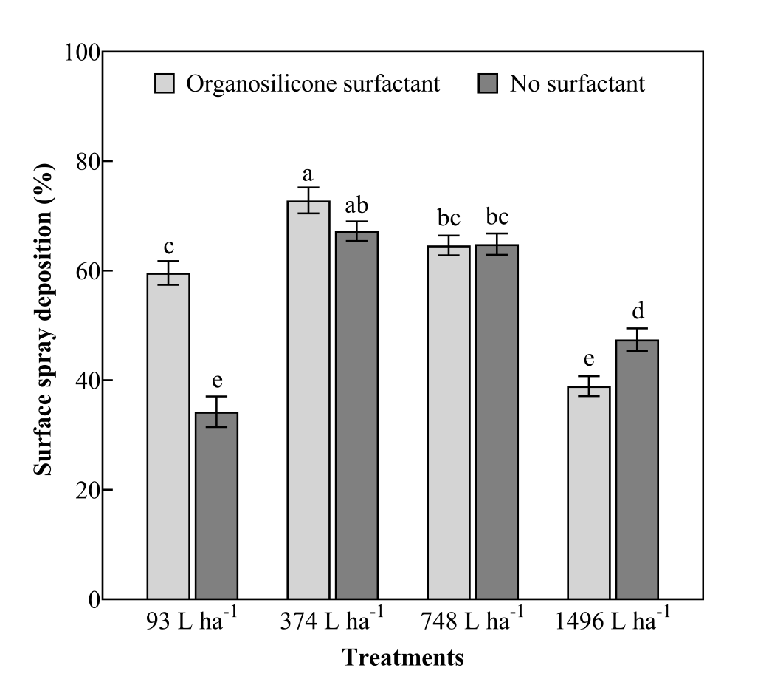

Figure 3.9. Leaf surface deposition (pooled across experimental runs) in response to various spray rate volumes applied with or without an organosilicone surfactant (0.25% v/v). Treatment means followed by same letter do not significantly differ according to Fisher’s LSD (p=0.05). Bars represent the standard error of the mean.

CHAPTER IV
CONCLUSIONS

CONCLUSIONS

Large patch epidemics are common on Japanese lawngrass (JLG; Zoysia japonica) landscapes in the transition zone of the United States. Despite the use of fungicide sprays, difficulties in controlling these epidemics have been observed. Research is warranted that improves spray application strategies that result in greater fungicidal control of large patch epidemics. Experiments were conducted to (I) identify the most critical application deposition site for fungicidal control of large patch; (II) determine spray application techniques that result in the greatest deposition on plant parts identified in the first objective; and (III) determine if the improved spray application techniques result in greater large patch control under field and growth chamber conditions.
In the first experiment, JLG treated with fungicides deposited in the lower plant canopy (sheath or stem) exhibited significantly reduced large patch severity compared to JLG receiving upper canopy (leaf) applications on most rating dates. The fungicides azoxystrobin, flutolanil, and tebuconazole applied on the leaf resulted in a range between 35-75% large patch severity when pooled across experimental runs. When these fungicides were applied on the stem and sheath, large patch severity ranged from 2-30%. Chlorothalonil, a contact fungicide, was least affected by the target site of application on most rating dates. This experiment demonstrated that lower canopy fungicide deposition was more critical than upper canopy deposition for greater large patch control.
The next phase of research involved identifying spray application techniques that resulted in more fungicide solution being deposited lower in the plant canopy. In this experiment, four spray rate volumes (93, 374, 748, and 1496 L ha⁻¹) were applied with and without an organosilicone surfactant. These applications were made on JLG plants in the greenhouse using a spray chamber. After treatment, JLG plants were measured for leaf surface coverage and the percentage of stems and sheaths that contained spray deposits. The use of a fluorescent tracer and black light illumination aided in identification of spray deposits. The effect of spray rate volume exhibited a greater impact than surfactant additives at increasing the spray deposition on stems and sheaths. Higher spray rate volumes increased the percentage of stems and sheaths that contained spray deposits by as much as 35% compared to the lowest spray rate volume. This research identified that higher spray rate volumes applied with or without an organosilicone surfactant aid in greater spray deposition in the lower canopy of JLG.
Various spray rate volumes and surfactant additives were evaluated for large patch control under field and growth chamber conditions. The four spray rate volumes (93, 374, 748, and 1496 L ha⁻¹) and two adjuvants (organosilicone surfactant and a modified vegetable oil adjuvant) were applied with three fungicides (azoxystrobin, flutolanil, and tebuconazole) to determine the effect on large patch severity. In general, increased spray rate volume resulted in significant decreases in large patch severity under field and growth chamber conditions. The highest spray rate volume (1496 L ha⁻¹) resulted in a 20% reduction on large patch severity compared to the lowest spray rate volume (93 L ha⁻¹). Large patch control was less affected by the use of adjuvants compared to spray rate volume. However, pooled across fungicides, an organosilicone surfactant improved fungicide efficacy by 4% compared to the modified vegetable oil adjuvant and the no adjuvant treatment.
This research demonstrated that lower canopy fungicide deposition was more important in reducing large patch severity compared to upper canopy deposition. Increases in spray rate volume may help enable more spray solution being penetrated into the lower plant canopy compared to lower spray rate volumes. In field and growth chamber experiments, increased spray rate volume was critical in reducing large patch severity with azoxystrobin, flutolanil, and tebuconazole. The effects of adjuvants on spray solution deposition and large patch control were less clear. However, more research is needed on the combination of higher spray rate volumes and adjuvants on turfgrass safety and large patch control under variable environmental combinations.

VITA

Jesse J Benelli was born on February 11th, 1984 in Bath, NY, to Donald and Carol Benelli. Raised in Wellsboro, PA, he attended Wellsboro Area High School and graduated in 2002. In 2007, Jesse graduated from Penn State University majoring in Turfgrass Science. During college, Jesse was employed with Tyoga Country Club, Meadowlands Country Club, State College Elks Country Club, and Gettysvue Golf and Polo Club. After graduation, Jesse was a research technician for the Penn State Turfgrass Pathology program until 2010. Jesse joined Dr. Brandon Horvath’s Turfgrass Pathology program in the summer of 2010 to earn his M.S. and Ph.D. degrees. After graduating with his Ph.D. degree, Jesse will be the Director of Turfgrass Programs for the Chicago District Golf Association.

