Integrating Engineering and Social Aspects in Selecting Stormwater Control Measures (SCMs)

A Thesis Presented for the
Master of Science
Degree
The University of Tennessee, Knoxville

Maudy Indriani Budipradigdo
May 2015

Copyright © 2015 by Maudy Indriani Budipradigdo
All rights reserved.

ACKNOWLEDGEMENTS
Most of all, I would like to thank Dr. Daniel Yoder, my mentor and adviser, for guiding me through the process of finishing this thesis project. Thank you for introducing me to the “new world” called engineering, for pushing me to go outside my comfort zone, and for trusting me to do what I never thought I could do. Thank you to Dr. John Tyner, Dr. Andrea Ludwig, and Brad Collet for the thoughts and input to this thesis.

My deepest gratitude goes to my parents. I am who I am today because of their love to me and what they taught me in life. Thank you for always bringing me in your prayer, letting me pursue my dreams, and supporting me in whatever I do. Thanks to my older sisters and best friends, Meike Budipradigdo and Milka Budipradigdo, who always laugh and cry with me.

I would also like to thank my husband, Reuben, for his endless love and support. Thank you for always giving me perspective and pushing me to be a better person. I could not have finished this thesis without you. Finally, thanks to my baby Owen for supporting me in his own way. You have made this past 7 months so wonderful!

ABSTRACT
The Low Impact Development (LID) approach to stormwater management is rapidly becoming the required replacement for the traditional approach of development design, solely for peak runoff attenuation. Stormwater Control Measures (SCMs) used in LID designs are some combination of physical structures and /or agronomic practices designed to capture runoff, remove pollutants, promote groundwater recharge, and protect receiving streams from channel degradation. The LID approach has been studied and documented in many journals and design manuals, but we know of no comprehensive study that combines the engineering (hydrologic performance requirements) and social aspects (complementary requirements) of the approach. SCMs have historically been designed by engineers solely to meet performance requirements for runoff volume, peak runoff rate, and water quality impact, but engineering designs seldom take into account the equally critical complementary design requirements such as aesthetics, social impacts, and safety concerns. On the other hand, plans developed by landscape architects and other designers too often focus on complementary requirements—emphasizing aesthetic features, spaces for social activities, and creating sanctuary for wildlife–without adequately taking into account engineering hydrologic performance requirements. The lack of understanding in the relationship between the engineering and social aspects can result in inappropriate selection of the SCM, resulting in the ultimate failure of the design to achieve its goals. This study produced a flexible logical framework to reflect a wide range of possible complementary goals. The framework includes a detailed description of all necessary inputs for a complementary score, a definition of the flow of logic, logic rules used in the decision process, some description of inputs needed for the hydrologic calculations, and a rough cost estimate. The logical framework will allow the selection of the “best” SCM(s), defined as meeting the hydrologic performance requirements while yielding the highest possible score for site-specific complementary requirements. The tool is intended to be used at the early stage of design process to help designers —stormwater engineers and landscape architects—obtain initial estimates of dimensions of the possible SCMs suitable for the design.

TABLE OF CONTENTS
1. BACKGROUND AND INTRODUCTION 1
2. OBJECTIVE 3
3. METHODS 4
3.1 Literature Review 4
3.2. Conceptual Model 5
3.3. Complementary Requirements 6
3.3.1. Objectives, Design Goals, Characteristics, and SCMs Scoring 8
3.3.1.1. Objective – Design Goals (O-DG score) 8
3.3.1.2. Design Goals – Characteristics (DG-C score) 10
3.3.1.3 Characteristics – SCMs 25
3.3.1.4 Cost Estimation 28
3.4. Hydrologic Performance Requirements 28
3.4.1. RRAT Fundamental Approach 29
4. COMBINING COMPLEMENTARY AND HYDROLOGIC PERFORMANCE 31
5. CASE STUDIES 33
5.1 Low density residential 33
5.2 High density residential 37
5.2.1. High Density Residential with Negative Score 38
5.2.2. High Density Residential with Multiple Objectives 39
5.3 Downtown parking garage 43
5.4 Apartment complex with multiple soil types 48
5.5 Strip Mall 53
6. DISCUSSIONS AND CONCLUSIONS 56
REFERENCES 59
APPENDIX 66
VITA 72

LIST OF TABLES
Table 1: Information collected from literature review (e.g., permeable pavement SCM) 4
Table 2: Example of O-DG and DG-C scores for residential Objective 7
Table 3: Example of O-SCM scores 8
Table 4 : List of Objective and Design Goals 9
Table 5: Example of assigned value for Objective – Design Goal (score O-DG) for two Objectives 10
Table 6: List of listed Design Goals and Characteristics 11
Table 7: Example of DG-C with a negative score 12
Table 8: Example of O-SCM scores 12
Table 9: Summary of the justification of how Characteristics can meet Design Goals 13
Table 10: Example of SCMs and their Characteristics 26
Table 11: Default SCMs 27
Table 12: Default design goals for residential Objective 33
Table 13: New set of design goals is made for high density residential projects 37
Table 14: Green roof characteristics and their matching design goals 38
Table 15: Set of design goals for high density residential Objective (table 14) with low maintenance Design Goal addition 39
Table 16: Creating a new Objective for different part of high density residential project 40
Table 17: Design goals for a downtown parking garage 43
Table 18: Impervious surface characteristics and their matching design goals. 44
Table 19: Design goals for the apartment complex 48
Table 20: New set of design goals is made for high density residential projects 53
Table 21: Possible alternative overall complementary score for figure 15 57
Table 22: Possible alternative overall complementary score for figure 13 57
Table 23: Scores to show how important the Design Goals for a specific Objective 67
Table 24: Scores to show how important the Characteristics in meeting the Design Goals 68
Table 25: Scores to show how well the SCMs can provide the Characteristics 69

LIST OF FIGURES
Figure 1: Conceptual model 5
Figure 2: RRAT interface 31
Figure 3: Example of overall complementary score calculation 32
Figure 4: List of recommended SCMs based for default residential Objective 34
Figure 5: Design scenario 1 for low residential project 35
Figure 6: RRAT interface for design scenario 1 35
Figure 7: Design scenario 2 for low residential project 36
Figure 8: RRAT interface for design scenario 2 36
Figure 9: List of recommended SCMs based on high density residential Objective 37
Figure 10: List of recommended SCMs based on design goals described in table 15 39
Figure 11: List of recommended SCMs based on design goals described in table 16 40
Figure 12: Runoff flow path inside the site 41
Figure 13: High density residential - scenario 1 42
Figure 14: High density residential - scenario 2 42
Figure 15: High density residential - scenario 3 42
Figure 16: List of recommended SCMs based on design goals described in table 17 44
Figure 17: Recommended SCMs based on design goals described in Table 17 with additional aesthetic appeal design goal 45
Figure 18: Runoff from rooftop is directed to an underground cistern 46
Figure 19: Runoff from rooftop is directed to a bioretention with low vegetation 46
Figure 20: Parking garage – Scenario 1 47
Figure 21: Parking garage – Scenario 2 47
Figure 22: Soil type map and simple site analysis 49
Figure 23: List of recommended SCMs for apartment complex project 50
Figure 24: RRAT interface for apartment complex project 51
Figure 25: Placement of selected SCMs for the apartment complex project 52
Figure 26: List of recommended SCMs for strip mall project 53
Figure 27: Strip mall - The site is dominated by impervious surface 54
Figure 28: Existing strip mall project does not meet the new stormwater requirements 54
Figure 29: Runoff flow path in the strip mall site 55
Figure 30: RRAT interface for strip mall project. This design meets the hydrologic requirement 55

1. BACKGROUND AND INTRODUCTION
A low impact development (LID) approach for stormwater management is strongly recommended to replace the traditional approach of designing solely for peak runoff attenuation (Dietz, 2007; Dietz, 2008; Coffman, 2002; Roy et al., 2008). A Stormwater Control Measures (SCM) is the basic building block for implementation of LID, comprised of a physical structure or practice designed to capture runoff, remove pollutants, and promote groundwater recharge and protect receiving streams. The main goal of LID is to mimic the pre-development hydrology by mainly infiltrating, filtering, storing / reusing, and evapotranspiring runoff near its source, focusing on treating runoff onsite through the use of small- and medium-scale practices distributed throughout the site. SCMs therefore play a significant role in minimizing the hydrologic and water quality environmental impacts caused by stormwater runoff, especially on urbanized or urbanizing land areas.
Urbanization alters the watershed hydrology, primarily through increases in impervious surfaces. This results in less area for water to infiltrate into the soil, which generates more runoff. The increase in impervious area also increases peak runoff rate and runoff velocity, which cause stream flooding, stream erosion, and water quality degradation (Leopold, 1968). Urban runoff can change stream chemistry by increasing levels of contaminants and nutrients such as nitrogen and phosphorous, and can change the morphology of the streams by increasing incoming sediment (Gregory et al., 1992; Walsh et al., 2005). The changes in stream morphology can harm stream ecosystems, which can indirectly affect human health and quality of life (Pavlowsky, 2004; Paul and Meyer, 2001; Gaffield et al., 2003). This adverse effect of urbanization is exacerbated by the traditional approach in managing the urban runoff.
The damaging effects of the traditional stormwater management approach have been well documented (Holman-Dodds et al., 2003; Roy et al., 2008). Contrary to the LID approach, this ‘old’ approach conveys runoff off of the site as quickly as possible, detaining it to the minimum degree required by ordinance, then discharging it directly to the receiving waters. The goal of this old approach is to design an inexpensive drainage system to avoid flooding. Designs following this approach rely heavily on centralized structural practices such as stormwater drains, big pipes, and large detention basins at the site boundary. Since the large volume and high flow rate of runoff is transported to the stream untreated, it is not surprising that urban runoff is alleged to be the leading cause of impairment in streams (Klein, 1979).
LID is a relatively new concept in stormwater management, so is constantly evolving and is the subject of ongoing research, which may be a primary reason for hesitation in adopting the SCMs (USEPA, 2000). Research shows promising results on the effectiveness of SCMs, but some unexpected results have raised concerns with respect to effectiveness of the practices, winter performance, cost, maintenance, safety, and community acceptance (Dietz, 2007). As this list of concerns demonstrates, success of an LID design depends on the SCMs meeting not only the required hydrologic performance requirements, but also non-engineering requirements related to aesthetic, social, and community impacts. We are calling these “complementary requirements”, and they are just as critical to the ultimate success of a design as are the engineering requirements.
The LID approach has been studied and documented in scientific journals and design manuals, but we know of no comprehensive study that combines the engineering (hydrologic performance requirements) and social aspects (complementary requirements) of the approach. Some studies focus heavily on the complementary social aspect, emphasizing such goals as providing aesthetic features, forming spaces for social activities, and creating sanctuary for wildlife. These studies generally discuss SCMs that are associated with vegetation and pervious surfaces such as wetlands, vegetated swales, permeable pavements, rain gardens, and bioretention SCMs, or SCMs that are very visible but may have limited hydrologic impact (e.g., rain barrels, green roofs). Unfortunately, these studies often focus too heavily on the aesthetics and public perception while lacking detail on the technical aspects associated with engineering sizing and design, which may lead to flooding, scouring, and structural failure. On the other hand, other studies focus heavily on the engineering design, emphasizing hydrologic analysis, soil analysis, and sizing calculations. Although these studies offer design guidance to ensure achieving the required runoff reduction, they often underemphasize the social aspects of the LID approach. LID approach has brought stormwater infrastructures to be a part of the public domain, thus requiring that they perform hydrologically, socially, and aesthetically as an integral part of the visible built environment. Therefore, the lack of understanding in the relationship between the engineering and social aspects can result in selecting an inappropriate SCM, resulting in the ultimate failure of the SCM and perhaps the full LID design to achieve its total set of goals.
Each project has its unique combination of technical and social conditions that will dictate the best-fit specific SCMs. For example, a development that houses primarily young families may want to avoid SCMs that incorporate open water, such as constructed wetlands and detention basins. In that case, the main criteria for choosing SCMs for that area may include child safety, traffic calming, and aesthetic appeal. On the other extreme, the best SCM for an industrial area may be an extended detention pond, treatment wetland, or subsurface infiltration bed. For ultra urban areas where space is very limited, the best SCMs may be porous pavement, cistern, green roofs, and planter boxes. In every case these SCMs would need to first be compared on the basis of how well they meet the site complementary requirements, ranking them based on their physical characteristics and ability to provide services important to the design. Once the rank is established based on complementary aspects, the overall design layout of SCMs must be further checked using Runoff Reduction Assessment Tool (RRAT) to ensure that it meets the hydrologic performance requirements.

2. OBJECTIVE
The objective of this study is to more fully integrate the hydrologic performance and complementary requirements of the LID approach. Using a decision matrix tool, this study aims to help designers (such as engineers and landscape architects) and end users select the best SCMs for their project, where the best SCM is defined as meeting the site hydrologic performance requirements while providing the highest possible complementary requirement score. While initial scores are provided for many of the ranking processes, the objective is not to provide a full set of scores. The objective is rather to provide the required framework for analysis, allowing each designer to define their own ranking scores to fit their needs.

3. METHODS

3.1 Literature Review
The first step in developing the framework was to perform a literature review of design manuals and scientific journals to gather detailed information on the SCMs of interest in the study. The information includes SCM performance, site suitability for each SCM, limits to SCM application, and benefits/constraints offered by the SCMs as shown in Table 1 for the single example of permeable pavement. This complete literature review yielded an SCM “database” that not only describes the SCM, but that also defines the inputs required to estimate its hydrologic performance as well as its complementary requirement score.
Completion of this review included detailed examination of 20 manuals and 55 additional publications. This resulted in a large cloud of relevant information, but left a strong need for a structure to bring all of the data together. Some of the design manuals made a preliminary effort at the sort of integration desired by this project (WVDEP, 2012; SEMCOG, 2008), but only on a cursory level listing preferred measures for a very limited set of land uses. In contrast, the goal of this tool is to provide a very flexible mechanism to reflect a wide range of possible complementary goals.
Table 1: Information collected from literature review (e.g., permeable pavement SCM)

Permeable Pavement
Performance |  |  |  |  |  | Maximum Setback Distance
Runoff vol. | Runoff peak  rate | TSS | TP | TN | G.W Recharge | Property line | Building foundation | Private well | Public water supply well | Septic system drainfield
High | High/  Mod | High | High/  Mod | Mod | High | N/A | N/A | N/A | N/A | N/A

Requirements
CDA | Slope | HSG | Infil. rate | Water table dist. | Distance to bedrock | Planting soil d. | Maintenance | Sunlight
N/A | 0% or low slope | - | >0.2 iph | 2' is ok  >4 feet is recommended | 2' is ok  >4 feet is recommended | 1-3’ | Vacuum, clean deposited soil on pavement, clean drainage inlets to subsurface bed twice a year. | N/A

Application |  |  |  |  |  |  | Cost
Residential | Commercial | Ultra urban | Industrial | Retrofit | Hwy/road | Hotspot | Construction | Maintenance
High | High | High | Low | High | Low | With liner | Mod | High

Benefits/ constraints
Winter performance | Aesthetic | Wildlife | Recreational Opportunity | Edu. Opp. | Cooling effect | Traffic calming | Open water | Safety | Rainwater reuse
Mod | Mod | Low | High | Med | No | High | No | High | No

3.2. Conceptual Model
The general approach of the framework is as shown in Figure 1. The critical mechanism for this approach hinges on the definition of a series of physical Characteristics, such as “perennial vegetation”, “open water”, or “paved high traffic surfaces”. These Characteristics are sorted by which most adequately meet the Design Goals associated with the desired Objective. That list of sorted Characteristics is then compared to the ability of each SCM to provide one or more of those Characteristics, allowing for a sorting of all SCMs.
In creating a site design, the designer defines the desired Objective or Objectives and associated Design Goals for each, and the tool sorts all available SCMs based on their applicability in meeting the Design Goals. The designer uses this list in selecting SCMs for the design, then the Runoff Reduction Assessment Tool (RRAT) tests that design to determine if it meets the Hydrology requirements. If not, the planner may redo the design, perhaps selecting somewhat less desirable SCMs that might better meet the Hydrologic requirements. Once a design meets the Hydrologic requirement, the planner might try additional designs to see if some alternative hydrologically-adequate design can yield a higher overall design complementary score.
It should be noted that the hydrologic performance requirement is about the design’s success or failure to meet local stormwater regulations. A design’s inability to meet hydrologic requirements may violate legal requirements and prove to be very costly. On the other hand, the complementary performance requirement is not based on any stormwater regulation. Therefore, this requirement is not rated on its passing of any specific benchmark, but more on a relative ranking and how to achieve the highest possible score for the project.

C-SCM
DG-C
O-DG
*Goal
Objective
Design goals
Characteristics
SCMs
Rank of SCMs
Location
Site Conditions
Runoff volume
SCM dimension
Selected SCM (s)
*Complementary performance requirement
*Hydrologic performance requirement
Figure 1: Conceptual model

3.3. Complementary Requirements
The ranking of each SCM is determined by the weighted complementary score, with a higher weighted score suggesting higher suitability of the SCM for the project. The scoring process starts by defining an Objective for the whole design or some part of the design, assigning to that Objective one or more important Design Goals, and giving a score ranging from 0-4 for the relative importance of each Design Goal in meeting that Objective. For example, if the Objective is to have “commercial office space”, “vehicle parking” would likely to be one of the main Design Goals, so the designer might well assign that Goal a score of 4 to indicate that parking is very important. The Design Goal scores assigned to the more aesthetic goals vary depending on the type of commercial use envisioned, so the method provides the flexibility to define any number of Objectives and Design Goals necessary for a specific design. This score is designated as the Objective – Design Goal (O-DG) score (Appendix A).
The next score in the process defines for the Design Goal how important each Characteristic is in meeting the Goal, and is designated as the Design Goal – Characteristic (DG-C) score (see Appendix B). Unlike the O-DG score above that ranged from 0-4, this ranges from negative four (-4) to four (4) and negative ninety nine (-99). The negative values allow us to indicate that a specific physical Characteristic may actually have a negative impact on achieving our Goal. A value of DG-C = 0 means that the Characteristic has no positive nor negative impact on achieving the goal, while DG-C = -4 indicates a strong negative impact and DG-C = 4 indicates a strong positive impact. The unique values of DG-C = -99 is an indicator that this particular physical Characteristic will make it almost impossible to achieve our goal. In our example of the office space above, the “open water” Characteristic does nothing to help meet the “vehicle parking” Design Goal so is given a score of 0, while the “paved high traffic surfaces” Characteristic does an excellent job of this, so is given a 4. An example of the use of negative DG-C might be for a Goal such as “nursery play area”. In that case, for safety reasons we might use DG-C = -99 for the “open water” Characteristic, meaning that we will simply not be able to use any SCM with the “open water” Characteristic. A score of DG-C = -4 would allow the SCMs with “open water” to be listed, but would seriously degrade their ranking. The use of these negative DG-C scores is described in more detail below when examining these scores more closely.
The O-DG score is then multiplied by the DG-C score, these are added for all DG-C combinations, and then normalized by dividing the sum by the number of Design Goals. This yields a list of Characteristics sorted by how important they are to the Design Goals defining the Objective, so can be thought of as calculated temporary Objective –Characteristic (O-C) scores.
The Final score is a 0-4 indication of how well each SCM provides the desired list of Characteristics, or a Characteristic – SCM (C-SCM) score (see Appendix C). In our example, a “bioretention cell” SCM does not provide a “paved high traffic surface” so would be given a score of C-SCM = 0, while a “permeable medium-traffic pavement” might be given a C-SCM = 2 or C-SCM = 3, and a “paved high-traffic surface” would be given a C-SCM = 4, but would obviously need to be used in conjunction with some other SCM (perhaps “subterranean infiltration”) to meet runoff reduction requirements. The earlier O-C score is then multiplied by the C-SCM score and these are summed for all Characteristics to yield the final Objective – SCM score (O-SCM), which is what we really need in order to determine the value of any SCM in meeting our Objective Design Goals.
Mathematically, this can be expressed as the following:
$$O-SCM= \sum_{C}{\left[C-SCM* \left(\frac{\sum_{C}{\left\{O-DG*DG-C\right\}}}{N_{DG}}\right)\right]}$$
Equation 1
where:
- N_{DG}: the number of scored (value different from 0) Design Goals in the Objective. Dividing O-C by this number is important for project with multiple Objectives. Without this division, the more Design Goals an Objective has, the bigger the complementary score, resulting in an exagerated overall complementary score, as described later.
- O-SCM: the resulting Objective – SCM score
- The C subscript on the summation sign indicates we are summing over all Characteristics, and all other terms are as defined in the text above. The steps through this process are described more completely below.
What follows is a simplified example displaying how the framework works for a simple example of a Residential area with a single design Objective and three related Design Goals. Table 2 displays the Objective and the three Design Goals, along with selected O-DG scores. It then applies the process for just three of the many possible Characteristics, displaying the DG-C scores as well. Table 3 then shows how two of the many possible SCMs would be sorted based on the C-SCM scores assigned to them.
Table 2: Example of O-DG and DG-C scores for residential Objective
Objective | O-DG | Design goals | DG-C | Characteristics
Residential | 4 | Corridor-human | 4 | Turf
Residential | 4 | Corridor-human | 0 | Perennials
Residential | 4 | Corridor-human | 0 | Tall grasses
Residential | 3 | Corridor- wildlife | 2 | Turf
Residential | 3 | Corridor- wildlife | 3 | Perennials
Residential | 3 | Corridor- wildlife | 3 | Tall grasses
Residential | 4 | Traffic calming | 0 | Turf
Residential | 4 | Traffic calming | 2 | Perennials
Residential | 4 | Traffic calming | 2 | Tall grasses
Using part of equation 1, the total O.C scores can be calculated as follows:
$$O-SCM= \sum_{C}{\left[C-SCM* \left(\frac{\sum_{C}{\left\{O-DG*DG-C\right\}}}{N_{DG}}\right)\right]}$$
- Turf : [(4*4) + (3*2) + (4*0)]/3 = 7.3
- Perennials : [(4*0) + (3*3) + (4*2)] /3 = 5.6
- Tall grasses : [(4*0) + (3*3) + (4*2)] /3 = 5.6
Table 3: Example of O-SCM scores
O-C Score | Characteristics | C-SCM score | SCMs | O-SCM score | TOTAL O-SCM score
7.3 | Turf | 4 | Bioretention- turf | 7.3*4 = 29.2 | 29.2
5.6 | Perennials | 0 | Bioretention- turf | 5.6*0 = 0 | 29.2
5.6 | Tall grasses | 0 | Bioretention- turf | 5.6*0 = 0 | 29.2
`
7.3 | Turf | 0 | Rain garden-low vegetation | 7.3*0 = 0 | 33.6
5.6 | Perennials | 4 | Rain garden-low vegetation | 5.6*4 = 22.4 | 33.6
5.6 | Tall grasses | 2 | Rain garden-low vegetation | 4.6*2 = 11.2 | 33.6
7.3 | Turf | 0 | Filter strip - good | 7.3*0 = 0 | 22.4
5.6 | Perennials | 0 | Filter strip - good | 5.6*0 = 0 | 22.4
5.6 | Tall grasses | 4 | Filter strip - good | 5.6*4 = 22.4 | 22.4
Based on the assigned scores in tables 2 & 3, the SCM “Rain garden with low vegetation” has the highest complementary score and therefore is the most recommended SCM for this particular example, followed by “Bioretention with low vegetation” and “Vegetated filter strip”.
As described mathematically above, the rank of SCMs for a particular Objective is based on the SCM’s ability to satisfy the complementary performance requirements, quantified in the form of scores. Ideally, the scores would be assigned by committees of designers, but the scores are currently assigned based on the author’s subjective judgment for the following reasons: first, the objective of this project is to develop a framework, not to specify the “correct” scores; second, users can modify the scores to match their preferences; third, users can add Objectives, Design Goals, and SCMs, which also require assigning new scores. What follows is a description of the admittedly subjective analyses used in defining those scores. The purpose of this is not to defend the current score selection, but rather to describe the thought processes used in determining those scores.

3.3.1. Objectives, Design Goals, Characteristics, and SCMs Scoring

3.3.1.1. Objective – Design Goals (O-DG score)
The complementary score is first determined by a set of Design Goals for our specific Objective. The term Design Goal in this study refers to the complementary goals that are associated with the SCMs in the LID system, which can be different from the goal of the entire plan. For example, “building” is certainly an ultimate goal of the design, but may not be part of the LID Design Goals for a residential project because the user does not want to tie their building in with any SCM. As another example, “parking” may be intentionally excluded from the LID Design Goals for a parking garage because the user does not want to use the parking surface as a part of the SCM design. Otherwise, the parking area can be used to infiltrate runoff, perhaps with interlocking permeable pavement.
A default Design Goals score list for each Objective is provided in the database (see Appendix A), but users are allowed to define new Objectives and to override the Design Goal scoring for the new Objective based on their preferences. Scores from 0-4 are assigned to each Design Goal selected for the Objective, based on the importance of each. There is no restriction on the number of Design Goals for an Objective or on the scores given to each. For example, a single Objective could have six Design Goals, and four of those could be given a score of 4 (see example in table 5), two Goals could be given a score of 2, and the remaining one could be given a score of 1. The list of current Objectives and Design Goals are listed in Table 4 below. New Objective and Design Goals can also be added to the list as desired.
Table 4 : List of Objective and Design Goals
Objective |  |  | Design goals
Residential |  |  | Water Supply
Institutional | Government building (police/fire station) |  | Cooling effect
Institutional | Government building (police/fire station) |  | Corridor
Institutional | Primary/secondary school |  | Human
Institutional | Higher education |  | Vehicle
Institutional | Offices |  | Wildlife
Recreational | Parks |  | Aesthetic appeal
Commercial | Shops, banks |  | Attract wildlife
Industrial | Factories |  | Birds
Agriculture | Farmland |  | Squirrels and chipmunk
 |  |  | Butterflies
 |  |  | Traffic calming
 |  |  | Recreational opportunities
 |  |  | Social gathering
 |  |  | Privacy/Boundary
 |  |  | Parking
 |  |  | Building
 |  |  | Child-friendly
 |  |  | Regulatory requirement
 |  |  | Green appeal

3.3.1.2. Design Goals – Characteristics (DG-C score)
As described earlier, the purpose of any design is to fulfill particular client goals, but the relative importance of those goals can vary greatly between designs. For example, a design for high-density housing will likely give much greater importance to the presence of green public space than will the design for an industrial park.
Table 5: Example of assigned value for Objective – Design Goal (score O-DG) for two Objectives
Objective: Factory |  |  | Objective: Single Family Housing
Score | Design goals |  | Score | Design goals
4 | Water Supply |  | 3 | Water Supply
4 | Cooling effect |  | 4 | Cooling effect
 | Corridor |  |  | Corridor
1 | - Human |  | 4 | - Human
4 | - Vehicle |  | 3 | - Wildlife
2 | Aesthetic appeal |  | 4 | Aesthetic appeal
4 | Parking |  |  | Attract wildlife
4 | Building |  | 4 | - Birds
 |  |  | 2 | - Squirrels and chipmunk
 |  |  | 4 | - Butterflies
 |  |  | 3 | Traffic calming
 |  |  | 4 | Privacy/Boundary
 |  |  | 4 | Child-friendly
 |  |  | 4 | Regulatory requirement
Which of these design goals can be met by using a specific SCM? Since an SCM may have many components, it can help meet multiple goals. An example of this is the bioretention SCM, where perennials offer aesthetic appeal, trees offer shade and cooling, and shrubs provide privacy. It is too difficult to map all SCM possibilities to the multitude of possible desired Design Goals, so this is done by adding an additional layer of abstraction we are calling Characteristics. The concept here is that it is not the SCM itself providing the desired benefit, but rather the individual or combined physical Characteristics of that SCM. For example, if “aesthetic appeal” is a highly-desired Design Goal, it is not the bioretention SCM per se that provides it, but rather the perennial plantings within that SCM. Other SCMs may provide the same benefit to a greater or lesser degree depending on how well they provide the “perennial planting” Characteristic. In this approach, it is the Characteristic (e.g., the perennials, trees, and shrubs in the bioretention example) that we can pinpoint as meeting the desired Design Goals (e.g., aesthetics, cooling effect, and privacy). The current lists of Design Goals and Characteristics are shown in table 6 below.
Table 6: List of listed Design Goals and Characteristics
Design goals |  | Characteristics
Water Supply |  | Vegetation | Turf
Cooling effect |  |  | Perennials
Corridor |  |  | Tall grasses
- Human |  |  | Low shrubs/bushes
- Vehicle |  |  | Small decorative tree
- Wildlife |  |  | Evergreen tree
Aesthetic appeal |  |  | Canopy tree
Attract wildlife |  |  | Wetland plants
- Birds |  | Public space | Not vegetated
- Squirrels and chipmunk |  |  | Vegetated
- Butterflies |  | Traffic surface | High - concrete/asphalt
Traffic calming |  |  | Medium - pavers
Recreational opportunities |  |  | Medium - gravel
Social gathering |  |  | Light traffic surface
Privacy/Boundary |  |  | Grass-based
Parking |  | Water | Open constant depth
Building |  |  | Open fluctuating
Child-friendly |  |  | Enclosed
Regulatory requirement |  | No additional surface
Minimize area of practice |  | Shelter
Green appeal |  | Green innovation
The link between Design Goals and Characteristics of SCMs is currently focused on urban settings. We are limiting ourselves to this because current stormwater regulation only affect Municipal Separate Stormwater Systems (MS4s), which generally coincide with urban areas, but the approach could be expanded to other SCMs. Table 9 shows some examples of commonly desired Design Goals and describes why and how certain Characteristics can help meet those goals.
As described above, the DG-C scores can range from -4 => 4. Scores of -1 to -4 are assigned to indicate that the Characteristic negatively affects achievement of the specific Design Goal. For example, tall grasses are not preferred for the “Wildlife Corridor” Design Goal, so a score of -3 is assigned to that characteristic. Negative scores diminish the value of specific Characteristics, so SCMs with those Characteristics get reduced complementary scores. Scores of -1 to -4 do not rule out SCM containing those Characteristics from the recommended list, because the same Characteristics may be important for achieving other Design Goals. For example, the score DG-C = -2 is assigned to the “perennials” Characteristic for the “traffic calming” Design Goal as shown in Table 7. Table 8 shows that because of the negative score, “Rain garden with low vegetation” no longer gets the highest complementary score as it was before in table 3.
Table 7: Example of DG-C with a negative score
Objective | O-DG score | Design goals | D-CG score | Characteristics
Residential | 4 | Corridor-human | 4 | Turf
Residential | 4 | Corridor-human | 0 | Perennials
Residential | 4 | Corridor-human | 0 | Tall grasses
Residential | 3 | Corridor- wildlife | 2 | Turf
Residential | 3 | Corridor- wildlife | 3 | Perennials
Residential | 3 | Corridor- wildlife | 3 | Tall grasses
Residential | 4 | Traffic calming | 0 | Turf
Residential | 4 | Traffic calming | -2 | Perennials
Residential | 4 | Traffic calming | 2 | Tall grasses
Using part of equation 1, the total O-C scores can be calculated as follows:
- Turf : [(4*4) + (3*2) + (4*0)]/3 = 7.3
- Perennials : [(4*0) + (3*3) + (4*-2)] /3 = 0.33
- Tall grasses : [(4*0) + (3*3) + (4*2)] /3 = 5.6
Table 8: Example of O-SCM scores
O-C Score | Characteristics | C-SCM score | SCMs | O-SCM score | TOTAL O-SCM score
7.3 | Turf | 4 | Bioretention- turf | 7.3*4 = 29.2 | 29.2
0.33 | Perennials | 0 | Bioretention- turf | 0.33*0 = 0 | 29.2
5.6 | Tall grasses | 0 | Bioretention- turf | 5.6*0 = 0 | 29.2
7.3 | Turf | 0 | Rain garden-low vegetation | 7.3*0 = 0 | 12.5
0.33 | Perennials | 4 | Rain garden-low vegetation | 0.33*4 = 1.32 | 12.5
5.6 | Tall grasses | 2 | Rain garden-low vegetation | 4.6*2 = 11.2 | 12.5
7.3 | Turf | 0 | Filter strip - good | 7.3*0 = 0 | 22.4
0.33 | Perennials | 0 | Filter strip - good | 0.33*0 = 0 | 22.4
5.6 | Tall grasses | 4 | Filter strip - good | 5.6*4 = 22.4 | 22.4
As also mentioned briefly above, a score of DG-C = -99 is assigned to “unallowable” Characteristics that will make it almost impossible to achieve a specific Design Goal, which then eliminates all SCMs expressing those Characteristics. This score therefore disregards the importance of those Characteristics for other Design Goals. For instance, to meet the “child friendly” Design Goal that would be critically important for a “child-care facility” Objective, the “open water” Characteristic is given DG-C = -99. The negative score completely eliminates the “dry detention basin”, “wet pond”, and “constructed wetland” from the list of recommended SCMs, though the “open water” Characteristic might have also been high-scoring in meeting the “aesthetic” Design Goal of the facility.
The following table and section describe the justification of the scoring in detail, including why selected Design Goals are included. However, the list is not meant to be exhaustive. Instead, it is meant to provide structure and to describe the underlying reasoning so that users can add more Design Goals as needed for their projects. The assigned scores are based on the author’s interpretation of studies in the literature (see references) available at the time of this writing. Therefore, the scores are subject to change as additional evidence arises. It should be noted that users should treat this section as guidance only, as many factors such as maintenance, placement, orientation, and selection of the each characteristic can affect its successfulness in meeting the Design Goals. Therefore, local design standards should be consulted in addition to this tool.
Table 9: Summary of the justification of how Characteristics can meet Design Goals
Design goal | Characteristics of importance | Justification / Reasoning
Water supply | Open water | Inexpensive storage option but may not be as efficient due to losses from infiltration and evaporation.
Water supply | Enclosed water storage | Can be built under or above the ground, which limits losses and provides easy accessibility for pumping.
Cooling Effect | Vegetation - canopy tree | Can absorb up to 90% of solar radiation, leading to evaporation and transpiration of water from the leaves (Heisler, 1986).
Cooling Effect | Vegetative-cover roof | Acts as an insulator for the building, which decreases energy demand for cooling and heating.
Human Corridor | Open-paved surfaces | Provide space and surface for human to walk and bike on
Human Corridor | Turf | Provide space and surface for human to walk and bike on
Human Corridor | Canopy trees | Form space underneath for people to walk and bike.
Vehicle corridor | High traffic surface | Forms outdoor linear passage for motorized vehicle that links at least two destinations.
Vehicle corridor | Medium traffic surface
Wildlife corridor | Native trees | Can host many wildlife species and are less likely to be obstructed by landscape barriers that disrupt the function of the corridor, such as solid fences, trenches, and steep slopes (Williams, 1998).
Wildlife corridor | Non-native trees | Can serve as corridor for small animal such as rabbit and birds, but can be disconnected by landscape barriers (Hilty et al, 2006).
Wildlife corridor | Tall grasses
Wildlife corridor | Perennials
Wildlife corridor | Turf | Provide a little benefit as a corridor.

Table 9. Continued.
Design goal | Characteristics of importance | Justification / Reasoning
Aesthetic appeal | All vegetation except turf | Dynamic change in leaves texture, organic shape of the trunk, and delicate gradient of green, blue, and yellow colors offered by trees dampens the flat color, rigid shape, and static objects of built environment (Appleyard and Craik, 1978).
Aesthetic appeal | Turf | Provide little benefit in offering aesthetic
Aesthetic appeal | Pervious pavement | Its color, texture, and pattern enhance aesthetic in urban area (Tennis et al., 2004).
Aesthetic appeal | Open water | Provide texture, sparkles, and ripples that enrich the aesthetic of a landscape (Kaplan, 1977).
Traffic calming | Trees | Provide vertical elements that can be used to create the sense of closeness which helps indicate the driver’s speed in relation to surrounding objects, leading to lower overall traffic speed (Godley et al. 2004, de Waard et al, 2004, Lewis-Evans and Charlton 2006).
Traffic calming | Shelter
Traffic calming | Medium and light traffic surface | Optical measures such as paving colors and textures that differ from the common surface can influence the drivers’ sense of speed (Vanderbilt, 2008)
Privacy/ boundary | Evergreen trees | Have screening capability, mainly by blocking view and noise (Reethof and Heisler, 1976).
Privacy/ boundary | Shrubs
Privacy/ boundary | Shelter
Privacy/ boundary | Perennials & grasses | View is not completely blocked, but can define space.
Recreational  Opp. &Social  Gathering | Public space | Physical form of public space is defined more broadly than simply a green nature space; it also includes plazas, pedestrian promenades, town squares, and other public spaces that can hold social, cultural, and political interactions (Thompson, 2002).
Green appeal | Green innovation | Can open opportunity to receive Innovation in Design credit for the LEED certification.
Regulatory requirements | Vegetation | Some areas regulate the amount of open space (Irwin and Bockstael, 2004; City of Carlsbad, CA. 2006). Open space in this case is defined as any land or water that is not developed for urbanized uses.
Regulatory requirements | Public space - vegetated
Regulatory requirements | Open water

Water Supply
Rainwater harvesting has been gathering interest in the United States. In regions with medium to high annual average precipitation such as in the Southeast, in addition to reducing runoff the driving factors include concerns about the possibility of longer drought periods, increased water demand, and increased awareness of protecting water supply (Jones and Hunt, 2010). Conserving water may not currently present a clear economic benefit in these generally humid regions, where the cost of tap water can be less than half a cent per gallon (KUB, 2013; Hathaway, 2014). In contrast, in arid regions where water scarcity and resulting high cost is a major problem, water supply may be the most important Design Goal for almost any landuse Objective. Harvesting rainwater may also be the only solution for stormwater volume reduction in ultra urban areas where space is limited and infiltration SCMs are not feasible.
Capturing stormwater has been a long tradition since the ancient world, where water supply infrastructure was uncommon (AbdelKhaleq and Ahmed, 2007). Collected water was reused for human consumption, livestock, agriculture, and other purposes. In urban areas, capturing rainwater may actually be simpler than in ancient times, since impermeable surfaces such as roads, driveways and rooftops are more dominant and generate more runoff. In the U.S. and other developed areas, captured rainwater can generally be reused for flushing toilets, irrigating plants, and other purposes that do not require potable water.
Water from impermeable surfaces is collected and can be stored in open or enclosed storage. Open water catchments involved contours, slope, and berms to concentrate runoff. Open water is an inexpensive storage option but may not be as efficient due to losses from infiltration and evaporation. Moreover, the location of open water is usually at the lowest point in the area, often far from facilities that can utilize the water. Enclosed water storage can be built under or above the ground, which limits losses and provides easy accessibility for pumping. Therefore, for its ability to provide water supply, DG-C = 4 is assigned to the Characteristic of “enclosed water storage”, DG-C = 2 for “open water with constant depth”, and DG-C = 1 is for “water with fluctuating depth”.

Cooling Effect
The so-called “heat island” effect is a common phenomenon in urban environments. As impermeable surfaces replace vegetated surfaces the area becomes warmer, generating 1.8-5.4°F higher temperatures compared to the surrounding rural area (Akbari, 2005). On a hot sunny summer day, the surface temperature of roofs and pavements can be 50-90°F higher than the air (Berdahl and Bretz, 1997). This urban phenomenon can directly affect urban dwellers by increasing demand for air conditioning and the resulting higher electrical use in summertime, leading to higher costs. From a more global perspective, an increase in energy demand leads to increased fossil fuel consumption, resulting in higher greenhouse gas emissions and air pollutants such as sulfur dioxide (SO2), nitrogen dioxides (NOx), carbon monoxide (CO), mercury (Hg), and particulate matter (PM). Air pollution and excessive heat may also affect human health and increase mortality (Katsouyanni et al, 1993). High surface temperature can also heat urban runoff and increase the temperature of the receiving river, which may damage many aquatic species in this ecosystem (EPA, 2013).
Some Characteristics of SCMs offer a cooling effect. Trees lower surface and air temperature by shading surface, minimizing solar radiation that reaches the surface. Trees can also absorb up to 90% of solar radiation, leading to evaporation and transpiration of water from the leaves, thus cooling the air (Heisler, 1986). Other vegetative covers can also provide cooling through similar effects. In addition, if the vegetation covers a roof it acts as an insulator for the building, decreasing energy demand for cooling and heating. Based on the above reasoning, the Characteristics of “evergreen trees”, “canopy trees”, and “shelter” are given DG-C = 4 for their ability to provide a cooling effect. A medium score of DG-C = 3 is assigned to the “small decorative tree”. Score of DG-C = 2 is assigned to “lawn”, “perennials”, “tall grasses”, and “open water with constant depth”. A low score of DG-C = 1 is given to all “open water” Characteristics.

Human Corridor
A human corridor for this project is defined as an outdoor linear passage for pedestrians and cyclists that connects neighborhoods and community facilities. The main purpose of the corridor is to facilitate movement, to create fluidity, to enhance cultural cohesion, and to support recreation in a community, consequently encouraging outdoor physical activities (Miller et al, 1998). The corridor can be wide to act as a promenade, or narrow like a greenway to provide a path between multiple gathering areas. The human corridor Characteristic is more likely to be a top priority for areas where large numbers of people move from area to area, as in an educational institution, camp, or other recreational land use. This Characteristic is less likely to be a priority for industrial and commercial land uses, except perhaps for high-end commercial land uses where movement across a “campus” is a desired Design Goal.
The scoring for how well an SCM Characteristic can meet the “human corridor” Design Goal depends on its potential for providing space and surface for human to walk and bike on. Therefore, DG-C = 4 is assigned to the Characteristics containing open-paved surfaces. A score of DG-C = 2 is assigned to the Characteristics that provide tree canopy, since space can be formed underneath that canopy. It should be noted that surface and space only may create a human corridor, but will not necessarily provide an enjoyable corridor experience. That would be provided by other Characteristics such as trees and other vegetation that might help meet a separate “aesthetic” Design Goal.

Vehicle Corridor
Vehicle corridor for this project is defined as an outdoor linear motorized vehicle passage linking at least two destinations. Although a vehicle corridor is required in almost every project, it is more likely to be a top priority for areas that have high vehicle traffic, such as commercial, institutional, and industrial land uses. Characteristics of various SCMs can enhance vehicle corridors, depending on the type of vehicle and traffic load passing through it. An SCM with the Characteristic “High traffic surface” such as conventional asphalt is likely the only choice for heavy trucks traffic for industrial land use. The Characteristic “Medium traffic surface” such as pervious interlocking paver is given score DG-C = 2 for its limited ability to serve as car and passenger light truck traffic commonly found in institutional and commercial land uses. As described above, note again that this only needs to be included as a Design Goal if there is a desire to tie this area into the LID system.

Wildlife Corridor
Land conversion for human use generally results in extensive conversion of natural areas into the built environment such as housing and roads, resulting in wildlife habitat loss and fragmentation. While preserved nature area can help alleviate the problem of declining habitat, these area are generally too small and too isolated for long term survival of many species (Williams, 1998). A wildlife corridor--defined as a biological linkage between habitat patches--is one way to prevent the isolation and fragmentation of wildlife habitat. The main purpose of the wildlife corridor is to facilitate movement of flora and fauna between two or more patches and to improve accessibility to habitat areas. Such connectivity can maintain diversity and gene flow, therefore minimizing the chance of local extinction and increasing species richness.
Such corridors can be several kilometers wide in large natural areas to facilitate big mammal migration, or only several meters wide such as vegetated linear strips on an individual lot for small mammals and migratory birds. Corridors can also be flexible in length and shape, but the location must be suitable for habitat movement (Mwalyosi, 1991). Some landscape elements can serve as corridors, such as fencerows, windbreaks, ditches, and vegetated right-of-ways (Hilty et al, 2006). Some SCMs have Characteristics that enhance the connectivity if they are vegetated and connected to other corridors or natural areas such as urban parks and forests. For master planning projects, the planners need to do ecological analysis and protect sensitive areas as much as possible. For individual lots, each lot acts as a piece of a puzzle, so ecological analysis needs to include the entire neighborhood.
The score for how well the SCM Characteristic provides wildlife corridor is exclusively assigned for “vegetation”, since it is the key physical element for a corridor. Native trees are the best as a corridor because wildlife evolved with them and have been using native plants communities as their habitat. Therefore, DG-C = 4 is given to Characteristics containing trees because they can host many wildlife species and are less likely to be obstructed by landscape barriers that disrupt the function of the corridor, such as solid fences, trenches, and steep slopes (Williams, 1998). The Characteristics ”turf”, “tall grasses”, and “perennials” are given DG-C = 1 because they provide little benefit as a corridor and can be disconnected by landscape barriers. Based on those Characteristics, “bioretention”, “managed vegetated area”, and “constructed wetland” SCMs—which are commonly rich in plant diversity--have high potential for a wildlife corridor.

Aesthetic Appeal
Aesthetic appeal refers to the feeling of pleasure obtained from looking at something (Matravers, 2003). Visual pleasure gratifies human senses and becomes a basic judgment of labeling an object as beautiful or artistic. Although not a basic survival need, aesthetic is one of the growth needs based on Maslow’s hierarchy of needs (Martin and Loomis, 2007). Aesthetic appeal is subjective, but there appear to be some almost universal common threads, and many researchers have tried to extract those common elements to form some principles (Matravers, 2003; Tsugawa, 1969). Spirn (1988) includes contrast, unity, rhythm, and form in the aesthetic elements of city and nature.
Aesthetic appeal can be found anywhere; in nature, inside buildings, and in art pieces. However, for this project the focus is on the outdoor aesthetic. Aesthetics is most likely to be a high priority for residential and recreational land uses with frequent outdoor activities. It usually is at most a medium priority for institutional and commercial land uses, because users occupy the area for short periods and most activities occur indoors. However, it can be a priority for high end commercial areas where the outdoor aesthetic is used to attract certain target audience. For industrial land uses, aesthetic appeal is likely to be low priority because the focus is on indoor activities and on functionality to maximize profits.
Some Characteristics of SCMs can offer outdoor aesthetic. Vegetation provides aesthetic value through its line, shape, pattern, structure, color, leaf and bark texture and pattern, changing color of leaves and flowers, and additional characteristics such as movement and silhouette (Appleyard, 1978; Nelson, 1976). Appleyard (1978) through his study describes that dynamic change in leaves texture, organic shape of the trunk, and delicate gradient of green, blue, and yellow colors offered by trees dampens the flat color, rigid shape, and static objects of the built environment. In addition to the continuous motion of vegetation by wind, vegetation also offers seasonal aesthetic “movement”. Small trees such as cherry and redbud provide flowers in the spring, perennials show their colorful flowers from late spring to early fall, grasses and canopy trees show their foliage color in fall, and some trees show their bark and fruit as winter interests. Therefore, a score of DG-C = 4 is assigned to all vegetation Characteristics except “turf”. A score of DG-C = 1 is given to turf for its limited benefit in offering aesthetic.
Other than vegetation, the characteristics of pervious surfaces and open water can also offer aesthetic value. Many pervious pavements provide color, texture, and pattern properties that can enhance the aesthetic appeal of urban areas. Pervious concrete and asphalt, despite the color similarity to the traditional ones, have a coarser character that many find aesthetically more pleasing than the smoother texture of non-porous surface (Tennis et al., 2004). Therefore, a score of DG-C = 2 is assigned to all types of pervious pavement. Water in the form of ponds and fountains provides aesthetic value through color, movement, and reflection, which can attract and grab people’s attention (Hubbard and Hubbard, 1917). Some researchers confirm the attractiveness of reflective water and observe the changing image it can offer, reflecting sky, trees, people, and buildings (Booth, 1990; Nasar and Li, 2004; and Miller, 1998). Furthermore, the water itself has texture, sparkles, and ripples that enrich the aesthetic of a landscape (Kaplan, 1977). For those reasons, the Characteristic “pond with constant water level” is given score of DG-C = 4, while Characteristics with fluctuating water levels are given a score of DG-C = 2. Note that open water is unfortunately also ideal mosquito breeding environment. Therefore, efforts need to be taken to maintain the benefits of this Characteristic without its negatives include using mosquito-specific bacteria, larvivorous fish (such as Gambusia affinis), selected vegetation, steep basin sides, fluctuation of water levels, and sparsely spacing vegetation (Knight et al, 2003).

Attract Wildlife
Wildlife offers ecological and psychological benefits. Many birds feed on unwanted pests and caterpillars, bats and wildlife control mosquitoes, and ladybugs can control aphids (Hunter, 2002). This biological control eliminates the need for chemical substances to control unwanted species. Birds, butterflies, bees, and bats are also pollinators, which provide substantial benefits in productivity of natural ecosystems (Pimentel et al, 1997). Attracting wildlife is also a way to provide a critical oasis for wildlife conservation, hence preventing habitat fragmentation. Wildlife offers entertainment, movement, beauty, and science lessons, therefore its presence can also affect human’s mental health. A study by Pretty and Barlett (2005) reports that in medical environments, wildlife can provide a pleasant distraction and reduce the need for painkilling drugs for patients.
The key to attracting wildlife is plant variety and use of native plants. The greater the diversity of native plants the greater the variety of attracted wildlife, which can form a small food chain system. In contrast, many non-native and monoculture are more likely to attract pests, so thus often rely on pesticides, fertilizers, and herbicides (Hunter, 2002). Native plants have shared an evolutionary history with the wildlife, so can generally give better support to wildlife’s well-being than can non-native plants.
The ability of each Characteristic of SCMs to attract wildlife is determined based upon whether it can provide food and/or shelter for wildlife, which in turn depends on which species is of most interest. Woody plants produce fleshy fruits available in summer, fall, and some in winter. These are valuable for birds, deer, raccoon, squirrel, and other small mammals. Evergreen and tall canopy trees such as oaks and hickory produce nuts that are important food for squirrel and chipmunks. Some weeds and grasses produce seeds that are staples for birds and small mammals. Vegetation itself is a major diet element for grazing mammals and some birds. Nectar-rich plants are important for hummingbirds and butterflies (Livingston, 2004). Shelter refers to all forms of protection that help animal stay alive. Consequently, it means place for sleeping, living, and hiding from predator and inclement weather, which often involved plants. Tall woody plants provide shelter for many birds and squirrels. Some evergreen trees and shrubs provide enduring shelter both in summer and winter for rabbits and ruffed grouse. Tall grasses and perennials offer seasonal shelter for small birds, rodents, and rabbits. Wetland environment is favorable for ducks, geese, marshbirds, muskrats, reptiles, and amphibians (Martin et al, 1961).
The default Wildlife Design Goal only includes birds, butterfly, and squirrel as wildlife to be attracted, because they are commonly desired on one’s property. However, users may certainly create Design Goals that include attracting other types of wildlife. All types of vegetation Characteristics are assigned score of DG-C = 4 for their high attractiveness to birds. Characteristics with trees are given score of DG-C = 4 due to attractiveness to squirrels and chipmunks. Characteristics including perennials are given score of DG-C = 4 for attracting butterflies.

Traffic Calming
Vehicular traffic can impact the quality of life in almost any residential neighborhood. Traffic speed is a strong negative when associated with biking, walking, and other outdoor physical activities (Timperio et al, 2004; Gielen et al, 2004). Thus, in areas where traffic and pedestrian use interact, high-speed traffic generally decreases pedestrian use, reducing physical activity.
Traffic calming has been a subject of research study in many areas, as road traffic injuries increased worldwide. Some common tools to reduce traffic speed include stop signs, speed bumps, speed limit signs, and speed cameras. In the United States, wide roads and low-mowed wide open grassy roadsides for driver visibility was once thought as highway safety features. Instead, a study by Forman and McDonald (2007) found that the perceived road width is a main causal factor for high traffic speed. A wide road and excellent forward visibility encourage the driver to go fast. On the other hand, having a “sense of boundary” helps indicate the driver’s speed in relation to surrounding objects, leading to lower overall traffic speed (Godley et al. 2004, de Waard et al, 2004, Lewis-Evans and Charlton 2006). Lower traffic speed is important not only in reducing the likelihood and severity of accidents, but also in encouraging thru traffic to find other faster routes, thus reducing the volume of vehicle traffic in residential areas.
Some Characteristics of SCMs can be used as tools to address traffic speed. Vertical elements such as tall woody vegetation, walls, or buildings close to both sides of the road can be used to create the sense of enclosure. Forman and Mc.Donald (2007) highlights the importance of oak trees on both sides of the road along with lower dense woody cover on roadside ditches in Europe in reducing traffic speed. Optical measures such as paving colors and textures that differ from the common surface can also be exploited to influence the drivers’ sense of speed (Vanderbilt, 2008). In addition, increased roughness from textured surface produces an acoustic mechanism alerting drivers to their high speed (Kennedy et al, 2005). Therefore, to quantify the ability of the Characteristics to provide traffic calming, the highest score of DG-C = 4 is assigned to Characteristics including trees, shelter, and pervious surfaces, and a score of DG-C = 2 is assigned to Characteristics including low vegetation.

Recreational Opportunities
Recreation--defined as activities engaged during leisure time--is a basic human need, especially in urban areas where space for this is limited (Randall, 1951). People living in urban areas face more psychologically-demanding lifestyles, hence they usually have worse average mental health than those living in rural areas, which can also lead to physical problems (Moughtin, 2009). SCMs have the opportunity to “piggy-back” stormwater management with this Design Goal by utilizing nature as a tool. The ability of nature to provide recreational opportunity therefore has therapeutic effect for mental health and have been studied extensively (Moughtin, 2009; Ulrich, 1986; Kaplan, 1977). Kaplan (1977) theorizes that fascination with nature gives people a feeling of escape from routine life, which make them feel more whole and content.
Many Characteristics of SCMs can contribute to providing recreational opportunity. To what degree this is true depends on how well the Characteristic provides opportunity for leisure activities. Outdoor open space allows young children to move freely while facilitating play-based learning activities (Maynard and Waters, 2007). Canopy trees create shaded space for picnicking, sleeping, reading, and social play. The tree itself is often utilized by children for playing, climbing, and hiding (Appleyard, 1978). Grass lawn has positive correlation with sleeping, playing, reading, and eating (Smardon, 1988). Shrubs are used for providing shelter, and perennials provide colors and shapes. Vegetation also demonstrates regularity through life cycle and seasonal changes that provide a sense of wonder and that opens up recreational and educational opportunity for children and adults. (Moughtin, 2009). Furthermore, even activities such as planting, watering, weeding, and cultivating the vegetation itself is a form of recreation (Appleyard, 1978). Fjørtoft and Sageie (2001) reports that children who play in the natural landscape tend to have better health, motor skills, balance, coordination, and creativity. Having experience with nature from an early age is vital for effective environmental education, since it develops sense of stewardship of the environment.
Vegetation also has perceptual attributes that contribute to recreational opportunities. It undoubtedly offers visual pleasure as previously discussed. In addition, fragrance from trees such as pine and eucalyptus, from shrubs such as lilac and viburnum, from perennials such as roses and lavender, and from most herbs are found to be attractive and stimulating (Appleyard, 1978). The sounds from vegetation (such as creaking branches and whisking leaves) are found to be pleasing urban sounds (Southworth, 1969).
Although not as effective as vegetation, other Characteristics of SCMs may also offer some recreational opportunities. Open-paved surface can provide space for leisure activities, especially for activities like biking and skateboarding that require a hard surface. Many also found that the properties of water in ponds, falls, and fountains are appealing (Booth, 1990; Miller, 1998; Kaplan, 1977). Therefore, a score of DG-C = 4 is assigned to the Characteristics that include vegetation and constant-level open water.

Social Gathering
Social interaction is a form of recreation that may affect the overall wellness of urban dwellers. In the book Health and Therapeutic Environment, Moughtin (2009) describes that emotional behavior, which affects feeling and many parts of bodily function, is shaped by social interaction. Public space is the main Characteristic of SCMs that can facilitate social interaction. The need for natural public space in a neighborhood has been documented by several researchers (Howard, 2003; Perry, 1929; Wu and Plantinga, 2003). In fact, people are willing to pay premium prices for property in neighborhoods that maintain such space (Bowman and Thompson, 2009). Furthermore, the role of public space goes beyond providing individual pleasure. Its vital role in the urban setting is to facilitate the expression of diversity (Thompson, 2002). Amin (2008) describes the role of public space in “shaping public behavior or indeed even a sense of the commons.” Therefore, the physical form of public space is defined more broadly than simply a green natural space; it also includes plazas, pedestrian promenades, town squares, and other public spaces that can hold social, cultural, and political interactions. Accordingly, the space should be seen as flexible outdoor space that allows broad range of different activities, including sports, street performance, and even religious functions. It should also serve as a multifunctional venue, perhaps as an outdoor classroom, outdoor movie theater, farmers market, concert hall, or festival platform.
Urban public space is more likely to be seen as essential for residential neighborhoods, recreational, and educational land uses. It should also become primarily important component in master planning for civic formation. The best Characteristics of SCMs that can provide space for urban activities include turf and open-paved surfaces, hence Characteristics including those have an assigned score of DG-C = 4. On the contrary, shrubs take up the space needed for activity, so are negatively correlated to most leisure activities.

Privacy/Boundary
In an urban area, where use density is much higher than that of rural area, it is often a necessity to separate or buffer relatively incompatible land uses such as industrial areas and residential developments. This is important both in terms of visual aspects and noise (Reethof and Heisler, 1976). In addition, it is also sometimes desirable to visually screen one residential property from another. Dense shrubs and evergreen trees with thick understory can provide such screening (Reethof and Heisler, 1976; Appleyard, 1978; Brush et al, 1979). In some cases, privacy control is a matter of psychological boundary. In this case, the view does not need to be completely blocked, but the space boundary needs to be clearly defined. Perennials, tall grasses, and large canopy trees can serve such purpose.
The assigned score for how well the Characteristics can serve as privacy/boundary depends on how well it can screen visibility. The screening capability is influenced mostly by the height of the undergrowth, the density of foliage, and the presence of foliage in winter. Therefore, Characteristics including evergreen trees and shrubs are assigned the score of DG-C = 4. Characteristics with perennials or tall grasses are assigned score of DG-C = 3 for their potential to screen some of the view. On the other hand, Characteristics with tall canopy trees are given a score of DG-C = 2 because they provide relatively little screening effect.

Parking
Having extensive parking space is one of the most important Design Goals for almost all land uses that have high traffic volume, including government buildings, educational institutions, commercial office parks, and industrial sites. Traditional development often simply allocated as much space as possible for paved parking lots without consideration for runoff reduction. If there is no desire to include parking areas as part of the LID design, that can still be the case. On the other hand, if it is desired to include parking in the LID design, that can fall under this project approach. Some SCMs implemented and tested to address both parking and runoff issues include designing paved surfaces in conjunction with vegetated SCMs such as bioretention and vegetated swale (Rushton, 2001; Dietz, 2007), while other solutions include subterranean infiltration through either porous pavements or infiltration vaults. This becomes especially critical in ultra-urban areas, where density and intensity are critical and space is so limited that one of the primary design concerns is that SCM does not encroach on parking space.
There are several Characteristics of SCMs that can provide parking space area. All pervious pavements can both provide parking surface and allow water to infiltrate into soil layers below it, so a score of DG-C = 4 is assigned to those Characteristics.

Building
Construction of a building is often the most important design goal for land uses that host mainly indoor activities. Those land uses include educational institutions, commercial facilities, and industrial sites. As a Design Goal, building may not be listed as the top priority when space is not a limiting issue. In that case, sufficient space for the building is assumed, so it is not includes in the LID design and the focus is on the other LID Design Goals. However, building will be the top LID priority for a project that has limited space or has premium-price land. Some examples are downtown office buildings, parking garages, and hotels. There are limited solutions to reducing runoff volume when the building footprint consumes most of the property area. Using the building component itself in the form of green roof is option that may require high installation and maintenance cost. Other options include rainwater harvesting and reuse or underground detention, which provides storage for runoff while still allowing the space above it for building. In order to reflect this, those Characteristics are given relatively high DG-C scores.

Child-Friendly
Any land use commonly associated with children must put child safety at or near the top of their Design Goal list. This would include especially land uses that are associated with primary school, daycare, and other facilities dealing specifically with small children, but should also include residential areas that are likely to house young families, and light commercial areas that include restaurants and other stores likely to host many children. Fortunately, most Characteristics of most SCMs are child-friendly, and can in fact often host educational and recreational activities for children. The few SCM Characteristics that can pose potential harm for children are ones that have substantial elevation changes or open water. Therefore, any kind of basin, pond, wetland, berm, and steep vegetated swales are not recommended for this concern. This is reflected in negative DG-C scores for those Characteristics, as described in earlier examples.

Regulatory Requirements
Care of natural resources and concern for the environment has led to the emergence of regulatory requirements including mandates governing impervious surface, tree preservation, and open space. Impervious surface regulation is directly connected to reducing runoff volume and improving water quality. Some cities such as Olympia, Washington and Austin, Texas implement this regulation in their zoning ordinance (Arnold and Gibbons, 1996). In other cities such as Franklin TN, the amount of impervious surface determines the amount of stormwater fee that property owners pay, where larger impervious surface corresponds to higher monthly fees. Almost all SCMs can, by definition, reduce the amount of impervious surface. Those that do not affect the amount of impervious surface include capture/reuse and underground SCMs. However, each SCM gives different water quality and quantity credits associated with reduction of stormwater fees.
Tree preservation regulations have several objectives: to enhance historical and aesthetic of an area, to increase health by cooling and cleansing the air, to reduce energy cost, and to protect and enhance water quality and ecosystem (City of San Antonio, TX, 2010). The policy includes preservation of existing trees, planting new trees, and increasing final tree canopy coverage. In San Antonio, the requirement for percentage of canopy cover depends on the land use. When the requirement is not satisfied, new planting, additional preservation effort, or payment to mitigation fund is required. SCMs that have trees in their Characteristics can contribute to the fulfillment of the tree preservation requirement. All kinds of trees can provide some kind of canopy, hence the score of DG-C = 4.
The amount of open space is also regulated in some areas (City of Carlsbad, CA. 2006). Open space in this case is defined as any land or water that is not developed for urbanized use. The purpose of the regulation is to preserve natural resources, to manage production of resources, to provide outdoor recreation, provide aesthetic, and for public health and safety. The protection of open space is assisted by some federal environmental regulations such as National Environmental Policy Act (NEPA) and Endangered Species Act (City of Carlsbad, CA. 2006). Characteristics of SCMs that can satisfy the open space requirements include those with vegetation, vegetated public space, and open water, to which the score of DG-C = 4 is given. Open space is best achieved in the master plan level.

Minimize area of practice
Minimum area of practice can be a significant design requirement for ultra urban areas. FHWA (2000) characterizes ultra urban as areas with impervious surface greater than 50%, high density of people, high ratio of building to the total area, and where the right-of-way is often the only available space for placing SCMs. Those areas commonly pose significant concerns in stormwater management. High population density is often associated with high amounts of waste products, which tend to pollute receiving streams and clog stormwater infrastructures. High density of impervious surface produces high runoff volume and runoff peak flow rate, which disrupts aquatic life and change the morphology of receiving streams. High density of traffic from people visiting businesses and offices --that also define ultra urban area-- are associated with high automobile usage. Consequently, pollutants associated with roadway such as lead from auto exhaust, zinc from auto body rust, copper from brake lining wear, cadmium from tire wear, manganese from moving engine parts, and petroleum from hydraulic fluids, lead to high pollutant loadings in stormwater runoff. Higher people density in ultra-urban areas also means higher amount of pets and pathogenic animal waste that is ready to be flushed off during storm events (FHWA, 2000). On top of that, the opportunity to direct runoff to pervious space to infiltrate and filter polluted stormwater runoff is very limited.
Limited space leads to premium cost per area, which leads to minimum area of SCM as a design goal. Therefore, “no additional surface area” is given score of DG-C = 4. Locating SCM underground or on rooftop may be an option, but will require more complex excavation technique and structural calculation. In addition, underground SCMs may need to yield to existing underground utilities. Those pipes and conduits are often buried in the ultra urban right-of-way, which often is the only space available for SCMs. Underground SCMs can also pose maintenance issues that need to be addressed by substantial planning. A Green roof is also suitable for ultra-urban area, especially since there are often many big buildings with flat roofs. Rooftop SCMs minimize runoff volume while still allow existing activities underneath. Similarly, porous pavement can provide surface for activities while also controlling stormwater.

Green Appeal
Green certification has become a desirable achievement for some property owners. The most common green certification rating system in the U.S. is Leadership in Energy and Environmental Design (LEED), administered by the United States Green Building Council (USGBC). The main goal for the LEED certification is to maximize efficiency of resources, including construction material, energy, water, and infrastructure (Retzlaff, 2009). LEED projects are thoughtfully designed to utilize nature for passive heating and cooling and to use local recycled non-toxic material, hence creating a better environment. Despite their commonly higher initial cost, LEED certified projects are energy efficient and low maintenance. Moreover, projects that are LEED certified are seen as “appealing and positive”, which is likely to increase their property value (Fuerst, 2011). SCMs can contribute to the achievement of the certification. All of the SCMs can be used to obtain credit for the Stormwater Management criteria in LEED certification (USGBC, 2014). Vegetation-based SCMs can also be used to receive credit for Heat Island Reduction and native habitat restoration criteria. Water storage can be used to gain Outdoor and Indoor Water Use Reduction credit.
Green appeal is chosen to be one of the Design Goals in this project because it may be important for some project owners to make a “green” statement. It has been found that environmental issues are a primary public agenda (Moulden and Carson, 1991). This growing environmental concern can be linked to how people see green products as attractive (Martin and Simintiras, 1995). To some extent, all SCMs are “green products” that are designed to protect the environment. However, some SCMs are more “green appealing” than the others. Those are SCMs that are considered rare, and that usually require innovation and high technology, which unfortunately come with high upfront investment because of their association with high-efficiency equipment, premium materials, and construction experts. In spite of that, those SCMs can provide opportunities to receive Innovation in Design credit for the LEED certification. Admittedly, seeing vegetation on ground level may seem ordinary, but seeing a vegetated roof, permeable pavement, or cistern is seen as appealingly “green”. For that reason, innovation, an SCM Characteristic providing such benefit is assigned a score of DG-C = 4.

3.3.1.3 Characteristics – SCMs
Scores are also assigned to show how well an SCM can provide the desired Characteristics (C-SCM score). Just like the Design Goal - Characteristic score (DG-C), each SCM is also mapped to all possible Characteristics. One SCM may provide several Characteristics. Examples in table 5 show that perennials, tall grasses, and shrubs are the main Characteristics associated with a “low vegetation bioretention cell”. The main Characteristics for a “green roof” SCM are “vegetation” and “shelter”, because a green roof provides three dimensional space that can be used as a shelter.
There is also a specific combination of Characteristics that defines a specific SCM option within a broader SCM description. For instance, a “bioretention cell” SCM may be designed with turf, low vegetation, or larger trees. The options will likely provide very similar hydrologic response, but the resulting complementary scores would be different. For example, the “bioretention with turf” SCM option has different Characteristics from the “bioretention with trees and some understory” SCM option. In this case, those bioretention alternatives are considered as different SCMs because they have different complementary scores, but hydrologically behave the same (see Table 10).
There are also SCMs that have the same combination of Characteristics but with different quantity of cover. For instance, the SCMs “managed vegetated area” and “infiltration area” may be designed for fair or good forest, or with fair coverage or good coverage of turf. In this case, each Characteristic is assigned different complementary scores. As an example, canopy tree is assigned a score of C-SCM = 4 for good forest and C-SCM = 2 for fair forest as shown in Table 10. This is different than the SCM options described above, as in these cases the SCM is not only different in terms of complementary score, but also in hydrologic performance.
Table 10 shows that the maximum total C-SCM score for vegetation is C-SCM = 8. As an example, the “bioretention” SCM with low vegetation has perennials, tall grasses, bushes, and wetland plants as Characteristics; each one of them has score of C-SCM = 2. Another example is the “managed vegetated area” SCM with good forest. This has evergreen and canopy tree as Characteristics, and each has a score of C-SCM = 4. This maximum limit of a combined C-SCM = 8 is used to avoid double counting and total score distortion. Some SCMs have total scores less than 8, in this case giving less credit to SCMs with monoculture like for “bioretention” with turf and to an SCM that has less-than-ideal condition, such as “managed vegetated area” with poor forest.
Table 10: Example of SCMs and their Characteristics
Characteristics |  | Bioretention |  |  | Managed vegetated area |  | Green roof
 |  | Turf | Low veg. | Trees & some understory | Forest, good | Forest, poor | Green roof
Vegetation | Turf | 4 | 0 | 0 | 0 | 0 | 2
Vegetation | Perennials | 0 | 2 | 0 | 0 | 0 | 2
Vegetation | Tall grasses | 0 | 2 | 2 | 0 | 0 | 2
Vegetation | Low shrubs/bushes | 0 | 2 | 0 | 0 | 0 | 0
Vegetation | Small/decorative tree | 0 | 0 | 2 | 0 | 0 | 0
Vegetation | Evergreen tree | 0 | 0 | 0 | 4 | 2 | 0
Vegetation | Canopy tree | 0 | 0 | 2 | 4 | 2 | 0
Vegetation | Wetland plants | 0 | 2 | 2 | 0 | 0 | 0
Public space | Not vegetated | 0 | 0 | 0 | 0 | 0 | 0
Public space | Vegetated | 4 | 0 | 0 | 0 | 0 | 0
Open-paved surface | High traffic surface (concrete/asphalt) | 0 | 0 | 0 | 0 | 0 | 0
Open-paved surface | Med. traffic surface  Pavers | 0 | 0 | 0 | 0 | 0 | 0
Open-paved surface | Gravel | 0 | 0 | 0 | 0 | 0 | 0
Open-paved surface | Light traffic surface  Grass-based | 0 | 0 | 0 | 0 | 0 | 0
Water | Open constant depth | 0 | 0 | 0 | 0 | 0 | 0
Water | Open fluctuating | 0 | 0 | 0 | 0 | 0 | 0
Water | Enclosed | 0 | 0 | 0 | 0 | 0 | 0
No additional surface |  | 0 | 0 | 0 | 0 | 0 | 0
Shelter |  | 0 | 0 | 0 | 0 | 0 | 4
Green innovation |  | 0 | 0 | 0 | 0 | 0 | 4
Table 11 lists all the default SCMs used for this project, which match with the SCMs selected for the first edition of Tennessee Permanent Stormwater Management and Design Guidance Manual. As previously mentioned, users are allowed to add more SCMs as desired.
Table 11: Default SCMs
SCMs
Filtration and settling | Dry detention | Dry pond
Filtration and settling | Dry detention | Extended detention basin
Filtration and settling | Wet pond
Filtration and settling | Constructed wetland
Infiltration | Vegetated swale | Vegetated swales
Infiltration | Vegetated swale | Water quality swale
Infiltration | Managed vegetated area | Forest, fair
Infiltration | Managed vegetated area | Forest, good
Infiltration | Managed vegetated area | Grassland
Infiltration | Managed vegetated area | Turf, good
Infiltration | Managed vegetated area | Turf, fair
Infiltration | Vegetated filter strip (grass strip) | Good
Infiltration | Vegetated filter strip (grass strip) | Fair
Infiltration | Vegetated filter strip (grass strip) | Poor
Infiltration | Bioretention (general, w/underdrain, and w/ underdrain and liner) | Turf
Infiltration |  | Low vegetation
Infiltration |  | Trees & some understory
Infiltration |  | Low vegetation
Infiltration |  | Trees & some understory
Infiltration | Rain gardens (general & w/underdrain )
Infiltration | Urban bioretention (general, w/underdrain, and w/ underdrain and liner) | Curb extension
Infiltration |  | Planter box
Infiltration | Infiltration areas | Forest, fair
Infiltration | Infiltration areas | Forest, poor
Infiltration | Infiltration areas | Grassland
Infiltration | Infiltration areas | Turf, fair
Infiltration | Infiltration areas | Turf, good
Infiltration | Permeable pavement
Infiltration | Green roofs
Infiltration | Underground infiltration system
Capture reuse | Rain barrels and cisterns | Rain barrels
Capture reuse | Rain barrels and cisterns | Cistern
Others | Manufactured treatment devices
Others | Impervious (all kind)

3.3.1.4 Cost Estimation
Cost estimation is an important factor in selecting SCM, but is not strongly emphasized in this study because it can lessen the importance of meeting the highest possible complementary score. However, the cost may become important decision factor if there are several SCMs with fairly similar complementary scores. Thus, a cost estimation is included in this study.
Summarizing and estimating the cost of SCMs has become a research subject for many researchers (MPCA, 2011; Hathaway and Hunt, 2007; MDE, 2011). However, there is no single study that covers the cost of every SCM listed in this study. Since costs vary among sites and time, it may not be fair to compare the costs of SCMs that come from multiple studies. Nonetheless, default costs are assigned to SCMs, but users are encouraged to update them to match the most recent cost data available. To anticipate various types of available cost and cost unit information, the tool provides several possible inputs as follow:
- Fixed construction cost
Cost of site discovery, surveying, design, permitting, and others that are not associated with area of SCM.
- Construction cost/ area
This cost includes labor, material, and overhead cost per area of SCM.
- Construction cost/ volume
This cost includes labor, material, and overhead cost per volume of runoff treated.
- Fixed annual maintenance cost
- Annual maintenance cost/area
- Annual maintenance cost/volume
- Annual maintenance cost/installation cost
This ratio is used in some studies to estimate annual maintenance cost.
- SCM life
Information about the SCM life is needed to get the annual cost. The annual cost assumes no time value of money. Generally, a lifespan of 20 years is listed as the default.

3.4. Hydrologic Performance Requirements
Water quality degradation has led to the emergence of federal and state government regulations. Although the Clean Water Act (CWA) has been successful in improving the nation’s water quality, about 40% of water bodies nationwide are still degrading or degraded and fall below the water quality standard (U.S. EPA, 2000). The main cause of this impairment is polluted runoff from stormwater in urban/suburban areas. EPA supports CWA’s goal through its Phase II Stormwater Program by requiring all municipal separate storm sewer systems (MS4s) to comply with National Pollutant Discharge Elimination System (NPDES) permits in preserving, improving and protecting the nation’s water resources.
The Tennessee Department of Environmental and Conservation (TDEC) implements EPA’s interpretation of the CWA through the Tennessee Water Quality Control Act. Under that act, the Tennessee Stormwater General Permit requirements enforce a 1-inch runoff reduction on-site for every rainfall event and a minimum 80% of contaminants removal from the portion of the first inch that cannot be infiltrated (TDEC, 2014). The first inch concept is critical for water quality because the majority of runoff contaminants are carried in the first flush of rainfall events. Among those pollutants are drip losses from leaking automobiles, nutrients from lawns, and heavy metals from roofing materials (Gobel et al, 2007). Since contaminants tend to bind to particulates, Total Suspended Solids (TSS) can be used as a manifestation surrogate, which means that the removal of TSS results in removal of most contaminant. In situations where the designer can prove that due to special circumstances the site is unable to meet those requirements, off-site mitigation or payment into a stormwater fund will be the last resort (TDEC, 2010). Those requirements are called the “hydrologic performance requirement” in this project.

The SCMs that are ranked highly based on their complementary performance requirements need to be tested to ensure that they meet the hydrologic requirements. The test will be done using the calculations from the SMART Runoff Reduction Assessment Tool (RRAT), which can be downloaded at tnpermanentsormwater.org. The tool is developed to help meet the Tennessee Stormwater General Permit Requirement (TSGPS), with the goal of minimum 1-inch runoff reduction on-site for every rainfall event and 80% of the TSS removal. The runoff reduction can be done using infiltration or rainwater harvesting/reuse techniques. TSS removal can be done using additional techniques such as filtering using plant and soil as media, or by settling or filtering using an engineer-specified proprietary device. The tool also makes sure that any storage needs to be emptied by 72 hours to prepare the SCM for the next rain event. For normal vegetation-based SCMs, the total ponding time should be less than 24 hours to ensure the vegetation’s survival.

3.4.1. RRAT Fundamental Approach
The RRAT offers unlimited flexibility for designers to route runoff from impervious areas to SCMs or offsite. This flexibility allows multiple SCMs to be used in one project while the tool tracks the first inch of rainfall and 80% TSS removal. Basically, the entire site is divided into design elements that are designed and arranged to drain or direct runoff to meet the target requirements. Below are basic inputs required in the RRAT:
Project location
The location is used to determine representative rainfall depth which varies from 1.3” for Johnson City to 1.9” for Memphis. The representative rain depth is defined using the 95th percentile of event precipitation, while the hyetograph is determined using the median duration for that event and a Type II storm distribution. The 95th and below percentile consists primarily of small to medium rain events. Therefore, the RRAT is not intended to be used to design channel and flood protection.
Target requirements
Runoff reduction credit can be given by some local jurisdictions as an incentive to adopt the following projects: redevelopment, brownfield, high density, vertical density, and mixed use. If that is the case, it is so indicated using this input.

Design elements
The combination of design elements affects the runoff flow in the site. Each design element consists of the following factors:
- Base SCM/Management
An SCM is an element’s defined set of materials and layout designed according to engineering specifications. An SCM can consist of several layers of materials such as in bioretention and permeable pavement. The materials may include soil, gravel, vegetation, liners, and underdrain, all of which control the degree of infiltration and treatment. Management refers to the cover type of the element that does not have engineering specification. Examples include forest, turf, and impervious surface. Various possible SCM/management are stored in the RRAT database, but users with high access level are allowed to add to the default list. The rank of recommended SCM based on complementary score is used to decide which SCM to be selected.
- Discharges to design element number
This number shows where surface runoff from each design element is routed, with the number ”0” used if the discharge goes offsite. The RRAT also allows subsurface runoff through an underdrain to be routed to different design element.
- Area
Area for each design element plays an important role in the SCM configuration. Surface area determines how much runoff can infiltrate, therefore can directly affect the hydrologic design. Area is also used to calculate the overall complementary score and rough cost estimation.
- Special conditions
Some conditions dictate whether some stormwater management techniques are suitable for certain areas on the site. Hotspots are areas that produce highly contaminated runoff far beyond pollutant concentration commonly found in stormwater system (USEPA, 2012). Any runoff passing this area must have 80% TSS removal before it leaves the site, therefore filtering SCMs or utilization of filtering devices can be options to treat the contaminated water. Karst feature is a special landscape that is formed as result of dissolving action of carbonic acid solution on soluble bedrock such as limestone, dolomite, marble, and gypsum (Zhou and Beck, 2011). Special attention given to karst geology is not merely for avoiding its subsidence, but also for its risk of groundwater contamination and its benefits to many habitats. In the RRAT, runoff from other elements may not be directed onto karst areas. Contaminated soil, which often called brownfield, is contaminated area due to activities on pre-existing land use. Infiltration SCMs are to be avoided for those areas to avoid groundwater contamination.
- Soil texture
Soil texture is a main factor in controlling infiltration rate. The RRAT offers fine classification that reflects various possible soil types.
- Depth to restrictive layer
A subsurface restrictive layer near the surface may control the infiltration rate by significantly blocking the downward movement of runoff such as bedrock, frozen layer, and cemented layers (USDA, 2010).

4. COMBINING COMPLEMENTARY AND HYDROLOGIC PERFORMANCE
To meet the objective of integrating the hydrologic performance and complementary requirements of the LID approach, the framework of this study has been implemented in the RRAT and becomes an extension of the program (Figure 2). The extension gives the following factors for each design element:
  - Objective
The Objective may be specified as the general land use for the site (i.e., light commercial), but because it refers to one or more specific design elements is more likely to be more specific, as in “parking area”. Some Objectives and their associated Design Goals are stored in the RRAT database, but users are allowed to add to or modify those. Each design element is assigned an Objective; therefore there can be multiple Objectives in a design. This option is especially useful for designing a master plan for a mixed use development.
  - Select SCM
This part consists of a list of recommended SCMs based on the Objective. Each listed SCM is followed by its complementary score and estimated annual cost, with the list ranked by decreasing complementary score. Given the rank of recommended SCMs, the user may then select the SCM that best meets their requirements and cost limitations. Other selection factors may include the available space for the SCM, maintenance effort, and construction cost. The tool will provide users with a ranked list of SCMs, but only the user can make the subjective weighting judgment to select the best SCM for their situation. As an example, a green roof may offer the highest complementary score but may not be the best for a retrofit housing project that has a steep hipped roof.

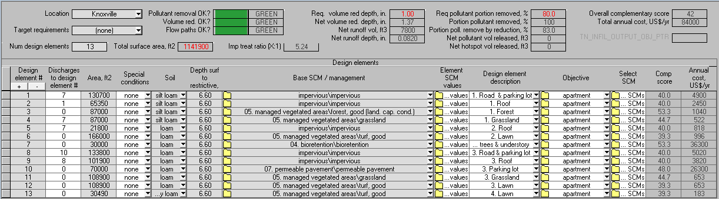
Extension
Original version
Figure 2: RRAT interface
Up to this point, users need to have a preliminary design that shows the path of runoff from impervious area to the selected SCMs until it goes offsite. If the first SCM on the complementary list does not meet the hydrologic requirement because of limited space and other reasons, the next SCM or combination of some SCMs should be considered. This iterative design process should be continued until the highest possible overall complementary score is achieved. A single overall complementary score for the entire design is also calculated once the area for each design element is known. The score is also calculated in the RRAT so the designer can compare which combinations best meet the complementary requirement. The overall design score calculation is done using the following formula:
$$Overall Complementary Score=\sum_{i=1}^{n}{({fa}_{i}*{O-SCM}_{i}})$$
Equation 2
Where:
- O-SCM: Objective– SCM score
- n: Number of SCMs
- fa: Fraction of total area
Figure 3 shows an example of comparison between two combinations of SCMs. If the complementary score for bioretention is 30, asphalt is 10, and permeable pavement is 25, the overall complementary score for scenario 1 is 14. The score goes up to 20 by converting half of the asphalt surface to permeable pavement. The higher score is caused by permeable pavement’s higher complementary score compare to asphalt’s. The same equation is used to calculate overall cost.
Scenario 1 | Scenario 2
Asphalt  fa: 0.8  Bioretention  fa: 0.2 | Asphalt  fa: 0.4  Permeable pavement  fa: 0.4  Bioretention  fa: 0.2
Figure 3: Example of overall complementary score calculation

5. CASE STUDIES
This section illustrates the thinking process for selecting SCM. Several projects with various scales, locations, and land uses are selected and used as examples of how existing projects can meet the 1-inch runoff reduction and 80-percent pollutant removal requirements. The purpose of this section is to show how the tool can be used not only for a simple housing with a single Objective, but also for more complex project with multiple soil types and Objectives. Some scenarios are explored to show various SCM combinations in meeting the complementary and hydrologic performance requirements.

5.1 Low density residential
A house in a low density neighborhood in Knoxville, Tennessee is going to be expanded along with the addition of impervious area to accommodate more cars. Since the project must meet the new Tennessee stormwater requirements, the designer needs to decide which SCMs are going to be used for the project. The default set of Design Goals for the residential Objective are as follows:
Table 12: Default design goals for residential Objective
Design goals | O-DG Score
Water Supply | 3
Cooling effect | 4
Corridor
- Human | 2
- Wildlife | 3
Aesthetic appeal | 4
Attract wildlife
- Birds | 4
- Squirrels and chipmunk | 2
- Butterflies | 4
Traffic calming | 4
Privacy/Boundary | 4
Child-friendly | 4
Regulatory requirement | 4
Based on these Design Goals, the ranked SCM list is shown in Figure 4. In order to get the highest possible complementary score, the first two SCMs on the list are selected for scenario 1 and become inputs to the RRAT as shown in Figure 6. Although providing a very high complementary score, this design (figure 5) fails to meet the hydrologic requirement, as indicated by the red light. Using this design, only 66% of pollutant from the runoff reduction volume is removed. The user therefore needs to choose the next SCM on the list or use combination of several SCMs.
Figures 7 and 8 show different runoff routing on the site. In this scenario, part of the managed vegetated area is converted to an infiltration area to accept runoff from the shed, the back portion of the roof, and part of the driveway. The green indicator lights show that this design succesfully meets the hydologic performance requirement while still providing the highest possible complementary score. Note that the overall complementary score for those two designs are the same, but the estimated overall annual cost are different ($870 vs $1200). The cost estimation may be used to decide which combination of SCMs is to be used.
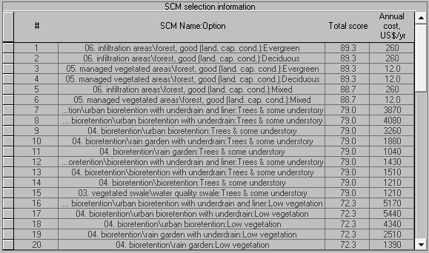
Figure 4: List of recommended SCMs based for default residential Objective

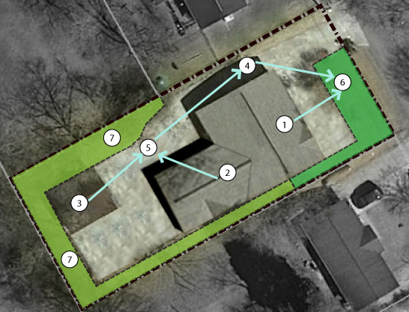
Figure 5: Design scenario 1 for low residential project

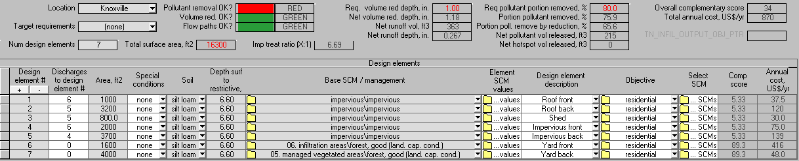
Figure 6: RRAT interface for design scenario 1
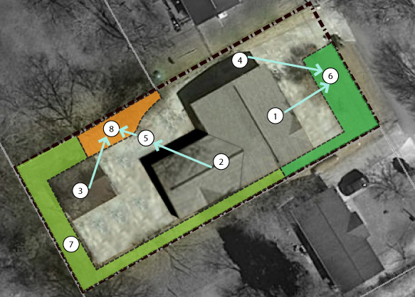
Figure 7: Design scenario 2 for low residential project
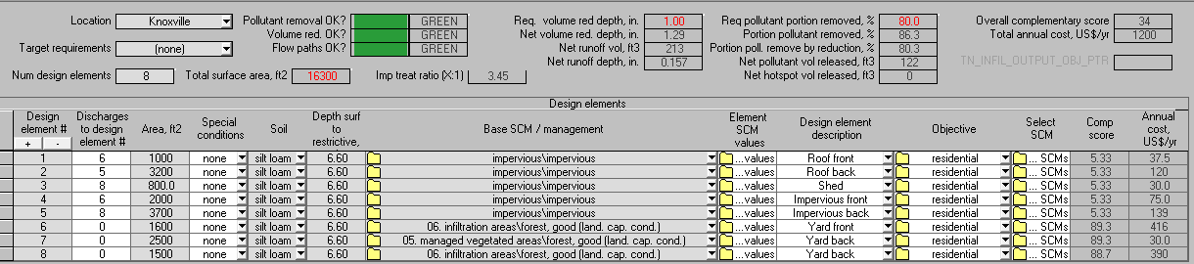
Figure 8: RRAT interface for design scenario 2

5.2 High density residential
A house is located in a high density neighborhood near the University of Tennessee, Knoxville. The site is dominated by impervious surface from the roof and hardscape. Because of premium land value in this area, utilizing the space as much as possible for the building and parking is the main goal of the design. Because of the space limitation, an SCM that does not take up active space is preferred. Since the user has specific Design Goals different from the default in the database for the High Density Residential Objective, a new set of Design Goals is defined as shown in Table 13.
Table 13: New set of design goals is made for high density residential projects
Design goals | O-DG Score
Cooling effect | 4
Attract wildlife - Birds | 2
Traffic calming | 4
Parking | 4
Building | 4
Minimize area of practices | 4
Based on those design goals, the recommended SCM for this project is shown in Figure 9.
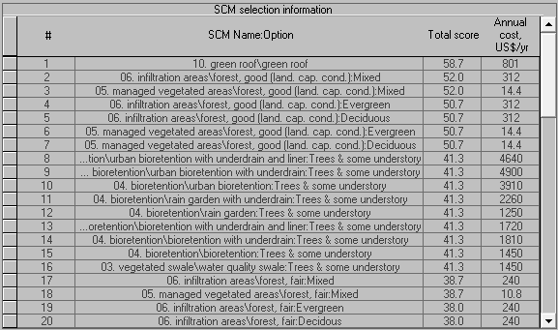
Figure 9: List of recommended SCMs based on high density residential Objective
The green roof is expected to be on the top list of the recommended SCM because its fulfillment of the following design goals: cooling effect, building, and minimize area of practices. It is also reasonable to have forest as infiltration areas on the top list because it offers cooling effect, traffic calming, and wildlife attraction. Table 14 shows the Characteristics of the green roof SCM that meet the desired Design Goals.
Table 14: Green roof characteristics and their matching design goals
Green roof |  |  |  | Characteristics
Characteristics |  | C-SCM Score |  | Design Goal: Cooling effect |  | DG-C Score
Vegetation | Turf | 1 |  | Vegetation | Turf | 2
 | Perennials | 2 |  | Vegetation | Perennials | 2
 | Grasses | 2 |  | Vegetation | Grasses | 2
No add. surface area |  | 4 |  | Shelter |  | 4
Shelter |  | 4
Innovation |  | 4 |  | Design Goal: Attract wildlife - birds
 |  |  |  | Vegetation | Turf | 1
 |  |  |  | Vegetation | Perennials | 4
 |  |  |  | Vegetation | Grasses | 4
 |  |  |  | Design Goal: Cooling effect
 |  |  |  | Vegetation | Perennials | 2
 |  |  |  | Vegetation | Grasses | 2
 |  |  |  | Shelter |  | 4
 |  |  |  | Design Goal: Privacy/ Boundary
 |  |  |  | Vegetation | Perennials | 3
 |  |  |  |  | Grasses | 3
 |  |  |  | Design Goal: Building
 |  |  |  | Shelter |  | 4
 |  |  |  | Design Goal: Minimize area of practice
 |  |  |  | No additional surface area |  | 4

5.2.1. High Density Residential with Negative Score
As described above, in some situations certain Characteristics are avoided for safety reasons or to avoid high maintenance costs. In that case, a score of DG-C = -9 can be assigned for those Characteristics. This step will eliminate all SCMs that contain those Characteristics from the recommended SCM list. As an example, let’s say that the “perennials” Characteristic is unwanted for this high density residential project because the owner considers it as high maintenance. The first step to eliminate all of SCMs that contains perennial is by creating a new Design Goal called “low maintenance” that has a score of DG-C = -99 assigned to the “perennial” Characteristic (Table 15). The new Design Goal is added to the current list of Design Goals for this Objective as found in Table 13, and that new set can be saved as a new Objective. Based on the new set of Goals, the ranked SCM list for this project is shown in Figure 10.
Table 15: Set of design goals for high density residential Objective (table 14) with low maintenance Design Goal addition
Design goal “Low maintenance” |  |  | Objective: Residential low maintenance
Characteristics | DG-C score |  | Design goals |  | O-DG Score
Vegetation - Perennials | -99 |  | Cooling effect |  | 4
 |  |  | Attract wildlife |  | 2
 |  |  | Traffic calming |  | 4
 |  |  | Parking |  | 4
 |  |  | Building |  | 4
 |  |  | Minimize area of practices |  | 4
 |  |  | Low maintenance |  | 4
Figure 10 shows that green roof, because of perennial as one of its characteristic, is no longer found in the list. Furthermore, all SCMs with understory that are on the top 15 in Figure 9 are now replaced by SCMs that have no perennials.
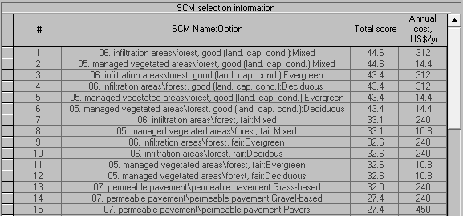
Figure 10: List of recommended SCMs based on design goals described in table 15

5.2.2. High Density Residential with Multiple Objectives
In some situations, different SCM Characteristics may be preferred for various elements in a project. In that case, multiple Objectives can be created to get different ranked lists of recommended SCMs. As an example, high visibility is desired for the front side of this high density residential. To achieve this goal, all tall vegetation needs to be excluded from the option by assigning a DG-C = -99 score for those Characteristics, as shown in Table 16. That new Design Goal can be saved and perhaps called something like “visibility”, and this Design Goal is then added to the set in table 13 and is saved as a new Objective called “residential front”. Using the new Objective, the ranked list of recommended SCMs is shown in Figure 11, which includes only SCMs that do not block the view to the front part of the house. High visibility is not a requirement for the back side of the house, so the Design Goals in Table 13 are more appropriate for that area.
Using the runoff flow paths shown in Figure 12 and the two lists of recommended SCMs shown in Figure 9 for the back and Figure 11 for the front part of the house, the RRAT input interfaces are shown in Figures 13 to 15.
Table 16: Creating a new Objective for different part of high density residential project
Design goal “Visibility” |  |  | Objective: Residential front
Characteristics | DG-C score |  | Design goals |  | O-DG Score
Vegetation – Low shrubs | -99 |  | Cooling effect |  | 4
Vegetation – Small decorative trees | -99 |  | Attract wildlife - Birds |  | 2
Vegetation – Evergreen trees | -99 |  | Traffic calming |  | 4
Vegetation – Canopy trees | -99 |  | Parking |  | 4
 |  |  | Building |  | 4
 |  |  | Minimize area of practices |  | 4
 |  |  | Visibility |  | 4

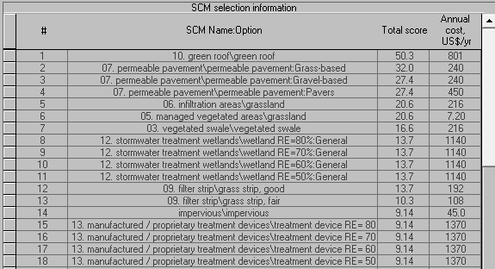
Figure 11: List of recommended SCMs based on design goals described in table 16
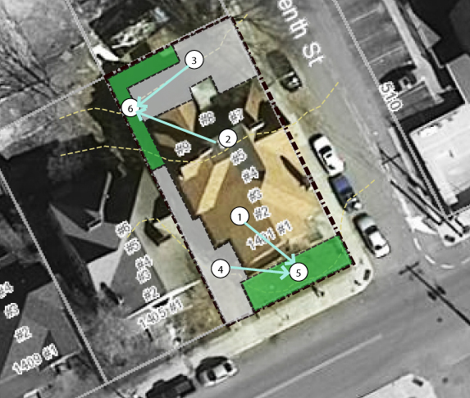
Figure 12: Runoff flow path inside the site
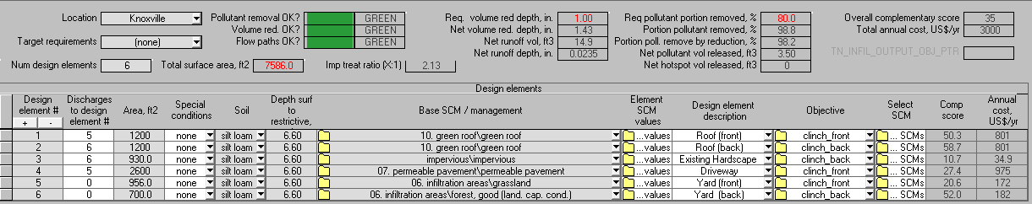
Figure 13: High density residential - scenario 1
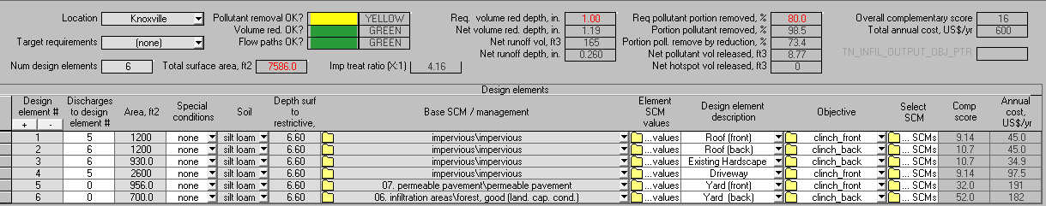
Figure 14: High density residential - scenario 2
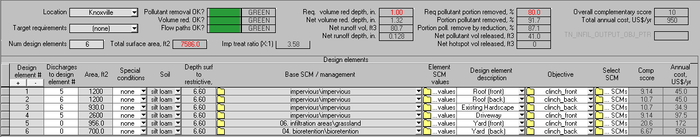
Figure 15: High density residential - scenario 3
In scenario 1 (Figure 13), the first two SCMs from the list in Figures 9 and 11 are selected. Selecting those SCMs results in the highest overall complementary score, higher than those for scenarios 2 and 3. This design also works well hydrologically as indicated by the three green lights. In fact, the runoff reduction and pollutant removal is much greater than the requirement. However, the total annual cost is much higher than for the other two scenarios. Moreover, converting the existing hipped roof to a green roof may not be practical for a residential project.
Scenario 2 is a design using the second-best SCMs from the recommended SCM lists. This design yields a higher complementary score than scenario 3 with lower annual cost, but is unable to meet the pollutant removal requirement, so fails hydrologically. In scenario 3, the “grassland infiltration area” SCM is selected for the front yard and “bioretention with tree and understory” is selected for the back yard. Bioretention is selected instead of forest infiltration area because the limited green space is inadequate to meet the requirement of a good forest, where the density should be less than or equal to 200 ft²/tree (TDEC,2014).
These three design scenarios show that the list of recommended SCM should only be used as selection guidance. The first SCM on the list is not always the best SCM for a project. Users need to use their subjective judgment to select SCMs that meet cost and site condition requirements.

5.3 Downtown parking garage
A parking garage project in a downtown area consists of 88,700 ft² roof and 13,300 ft² of pervious area. The soil is designated as “Urban soil”, so an in-situ soil texture test is required. The main Design Goal for this project is to provide parking inside a building in an ultra-urban area where minimal area of practice is required. The vehicle traffic to/from the parking spots in the garage makes vehicle corridor another main Design Goal for this project. Since people are also accessing the parking spots by foot, human corridor is also one of the goals, but a relatively low score will be given to this to indicate that it is not a top priority. It should be noted that the sidewalk outside the building, where an SCM can be located, is outside the property line, so it is excluded from the runoff reduction and pollutant removal calculations. Since the garage is designated for high traffic, traffic surfaces for medium and light traffic are avoided by assigning -99 to those characteristics. The set of Design goals for this project is summarized in Table 17.
Table 17: Design goals for a downtown parking garage
Design goal: “High traffic” |  |  | Objective: Parking garage
Characteristics | DG-C score |  | Design goals |  | O-DG Score
Vegetation - Turf | -99 |  | Parking |  | 4
Traffic surface - Pavers | -99 |  | Building |  | 4
Traffic surface - Gravels | -99 |  | Corridor - Vehicle |  | 4
Traffic surface - Grass-based | -99 |  | Corridor - Human |  | 2
 |  |  | Minimize area of practice |  | 4
 |  |  | High traffic |  | 4
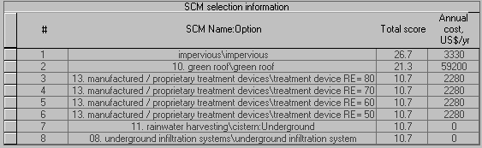
Figure 16: List of recommended SCMs based on design goals described in table 17
Based on the Design goals in Table 17, the ranked list of recommended SCMs is shown in Figure 16. Among the fairly limited SCM choices, it may be unexpected to see impervious surface on the top list of recommended SCMs, since impervious is commonly labeled as runoff generator. However, impervious surface earns the highest score because “high traffic surface”, as one of its Characteristics, provides parking, human corridor, and vehicle corridor for high traffic (see Table 18). If impervious surface is selected to meet the complementary requirements, other SCMs need to be used to compensate for the absence of runoff reduction and pollutant removal by the surface.
Table 18: Impervious surface characteristics and their matching design goals.
Impervious surface |  |  |  | Design goals
Characteristics |  | Score |  | Parking |  | Score
Public space | General | 4 |  | Vegetation | Concrete/asphalt | 4
Traffic surface | Concrete/asphalt | 4 |  | Public space | Non vegetated | 2
 |  |  |  | Traffic surface | H- concrete/asphalt | 4
 |  |  |  |  | M- pavers | 4
 |  |  |  |  | M- gravels | 4
 |  |  |  |  | L- grass-based | 4
 |  |  |  | Vehicle corridor |  | Score
 |  |  |  | Traffic surface | H- concrete/asphalt | 4
 |  |  |  | Traffic surface | M- pavers | 2
 |  |  |  | Traffic surface | M- gravels | 2
 |  |  |  |  | L- grass-based | 1
 |  |  |  | Human corridor |  | Score
 |  |  |  | Vegetation | Turf | 3
 |  |  |  |  | Canopy tree | 2
*Grey colors are Characteristics that are not associated with Impervious surface and Characteristics that are eliminated because of “High Traffic” design goal. |  |  |  | Traffic surface | H- concrete/asphalt | 4
 |  |  |  |  | M- pavers | 4
 |  |  |  |  | M- gravels | 4
 |  |  |  |  | L- grass-based | 4
Green roof is also on the top of the list because its characteristics meet building and minimum area of practice design goals. Nonetheless, green roof may not be a good SCM choice for this project because the roof is also utilized as parking spaces. The “proprietary treatment device” and “underground” SCMs are the next on the list because they require minimum area of practice.
The runoff flow path over the site is shown in Figure 18. If an underground cistern is used to capture all runoff from the impervious area, a 5,100 ft³ volume with water use withdrawal rate of 100 ft³ per day is required to meet the Tennessee stormwater requirements (see Figures 18 and 20).
If aesthetic appeal is added to the set of Design Goals in Table 17 and given a score of O-DG = 2, the ranked list of recommended SCMs is shown in Figure 17. Despite the low score given to the new Design Goal, the list of SCMs changes substantially compared to that in Figure 16. Noticeably, the previous list has only 8 recommended SCMs, while the new one many more SCMs. The expansion is caused by multiple Characteristics that meet the aesthetic appeal Design Goal, including most types of vegetation and open water. Since vegetation is a Characteristic for a majority of SCMs, the list of recommended SCMs is longer. Evidently, additional SCMs listed in Figure 17 have tree and/or bush as one of their characteristics. For this scenario, the SCM “bioretention with low vegetation” is selected to receive runoff from the roof of the parking garage (see Figures 19 and 21).

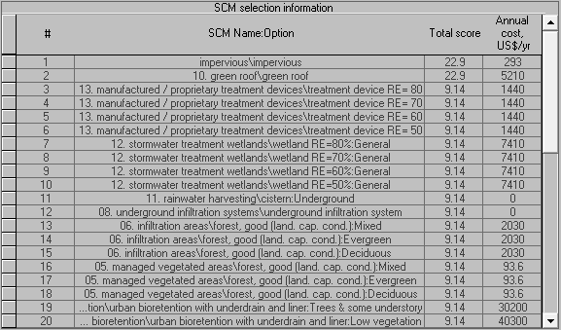
Figure 17: Recommended SCMs based on design goals described in Table 17 with additional aesthetic appeal design goal
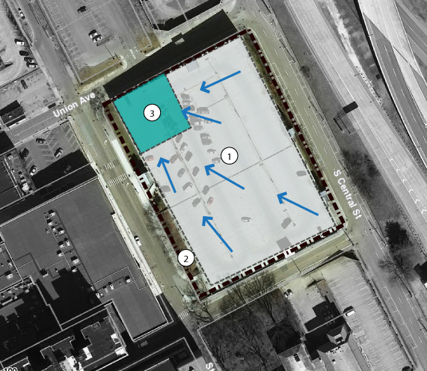
Figure 18: Runoff from rooftop is directed to an underground cistern

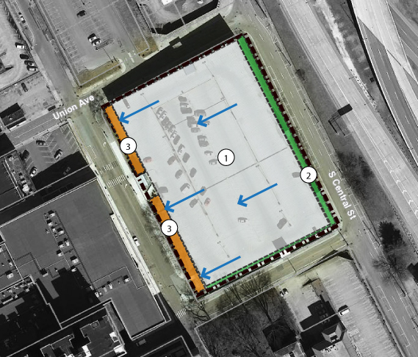
Figure 19: Runoff from rooftop is directed to a bioretention with low vegetation
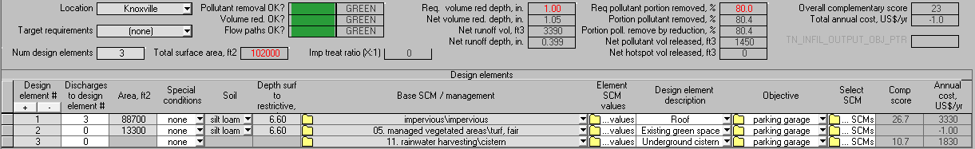
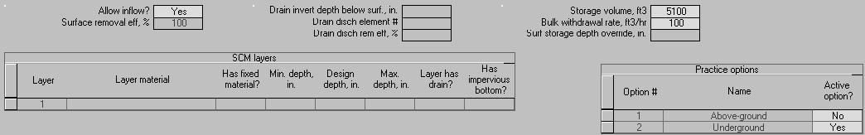
Figure 20: Parking garage – Scenario 1

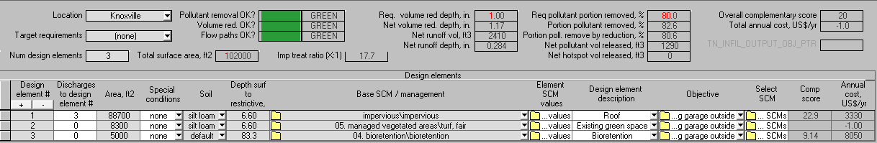
Figure 21: Parking garage – Scenario 2

5.4 Apartment complex with multiple soil types
A proposed 26-acre apartment complex has the desired image of providing a healthy lifestyle for its residents. The area lies on 3 different soil types. To be congruent with its slogan, the main Design Goals for this design are to have corridor for pedestrian and provide space for social gathering and some outdoor activities while still providing access for vehicles. To encourage people to have outdoor activities, traffic calming and child friendly are also important. Aesthetic, which is a need for emotional health, is also valuable as selling point. The summary of the design goals is shown in Table 19. Based on the set of Design Goals, the ranked list of recommended SCMs is shown in Figure 23.
Table 19: Design goals for the apartment complex
Objective: Apartment complex
Design goals |  | O-DG Score
Corridor - Vehicle |  | 3
Corridor - Human |  | 4
Aesthetic appeal |  | 3
Traffic calming |  | 3
Social gathering |  | 4
Child friendly |  | 4
It is worth noting that selecting SCMs with the highest complementary score only is not enough to reach the desired Design Goals, as the placement of the SCMs on the site is also critical, so a site analysis is required. For complex projects like this, multiple Objectives can be created for different parts of the site (see section 5.2.2). Another way to select and place SCMs is by matching recommended SCMs with the site analysis. Using this method, some of the suitable SCMs may not be at the top on the list. For example, figure 22 shows site analysis based on fully utilizing site potential. The site is hilly, with a few level areas suitable for outdoor activities and public space. The best view is on the northeast side, so tall trees should not be placed in that area. On the other hand, a rather unpleasant view over the southwest property line can be blocked by evergreen forest
Figure 25 shows the selected and placement of the selected SCMs on the site. Since there are multiple soil types and slopes in the site, the project is divided into four sections. Runoff from the first and second sections drains to a “bioretention with trees and understory” SCM. Tall vegetation for the bioretention and evergreens for the managed vegetated area on the southwest border are selected to block the view from and of adjacent lots. Turf for another managed vegetated area (number 6 in Figure 25) is selected to encourage outdoor activities. This common area also overlooks the best long-range view. Runoff from section 3 drains to permeable pavement. Two permeable pavement parking lots infiltrate the runoff from roads and roofs. Permeable pavement is also placed on portions of the access road close to a turf managed vegetated area to drain runoff from the surrounding and also to calm traffic. Traffic calming is important for this area because the managed vegetated area with turf is designated for a gathering place. Grassland as managed vegetated area is selected for the steep slope on the north side of section 3. Those grasses provide aesthetic and also control erosion.

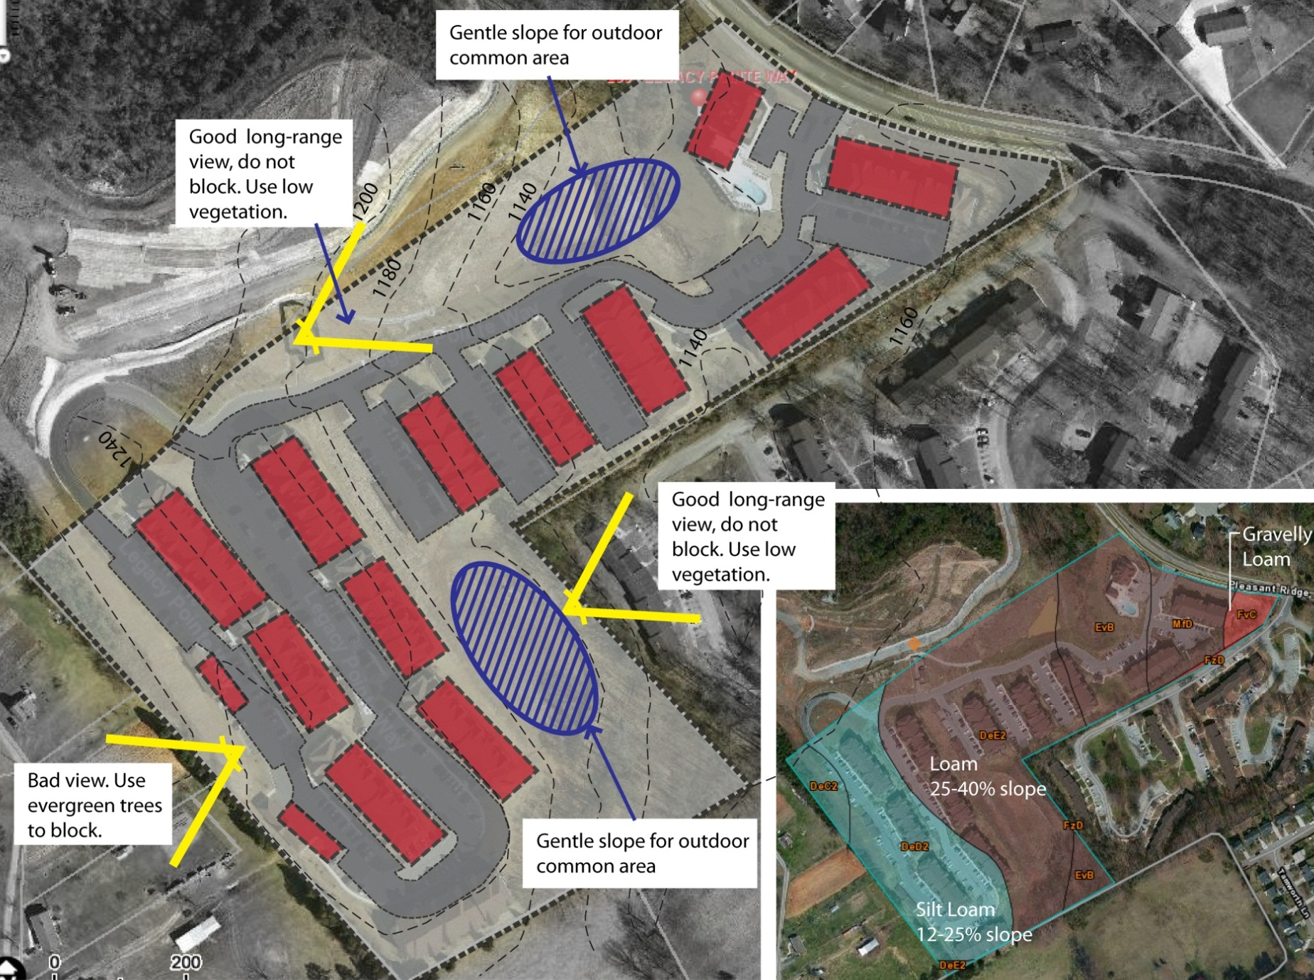
Figure 22: Soil type map and simple site analysis
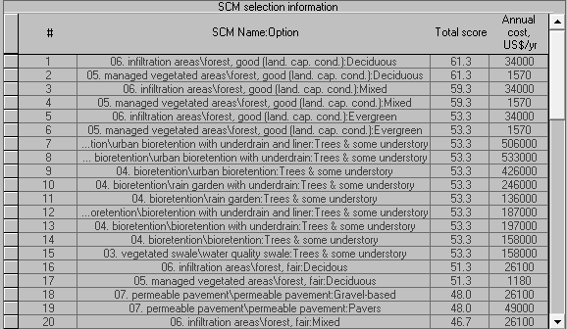
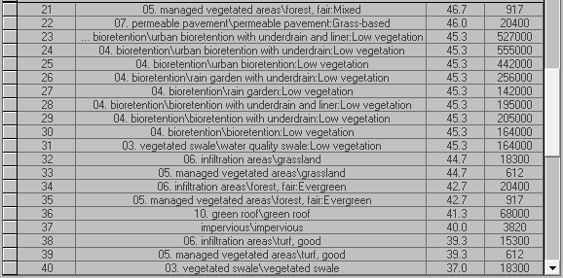
Figure 23: List of recommended SCMs for apartment complex project
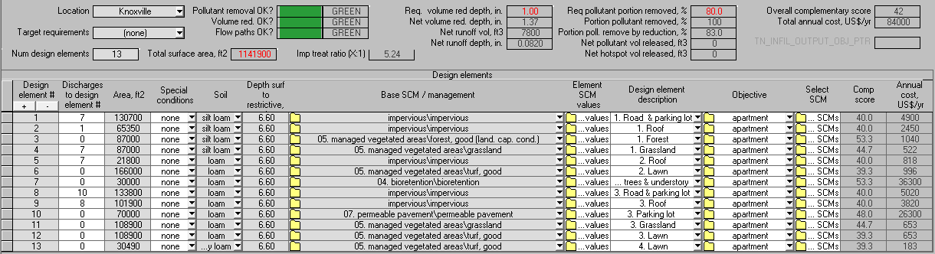
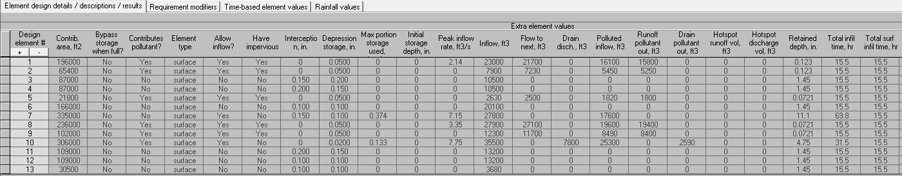
Figure 24: RRAT interface for apartment complex project
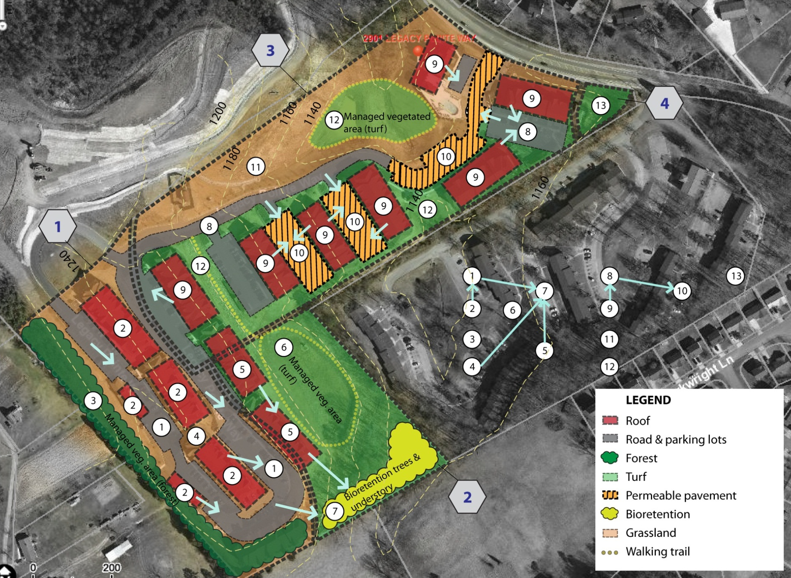
Figure 25: Placement of selected SCMs for the apartment complex project

5.5 Strip Mall
A strip mall along a major road near the University of Tennessee consists of businesses and joining parking lots. The site is dominated by impervious surfaces from the roof, parking lot, and hardscape, and generates runoff that goes directly to storm drains (Figures 27 and 28). If this site is redesigned to meet the new stormwater requirements, some impervious surfaces need to be converted to design elements that can receive or store runoff.
The main design goal for this site is to have minimum area of practice since the space is limited. In order to maximally utilize the limited space, the user is willing to include parking and building as part of the LID system. The rest of the design goals are listed in Table 20. Based on those design goals, the recommended SCMs are shown in Figure 26. Permeable pavement and green roof get the highest scores, caused primarily by the parking, building, and minimize area of practice design goals. It might be surprising to see stormwater treatment wetland in the recommended SCMs list for a strip mall project that has space limitation. However, a wetland can fulfill aesthetic appeal design goal. Wetland can be excluded from the recommended list of SCM by assigning DG-C score of -99 for open water for minimize area of practice design goal. As shown in Figures 29 and 30, the site can meet the new stormwater regulations by mainly changing the impervious surface of parking spaces to permeable pavement and routing runoff from the roof to these areas.
Table 20: New set of design goals is made for high density residential projects
Design goals | O-DG Score
Aesthetic appeal | 4
Human corridor | 4
Parking | 4
Building | 2
Minimize area of practices | 4

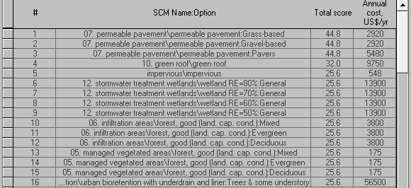
Figure 26: List of recommended SCMs for strip mall project
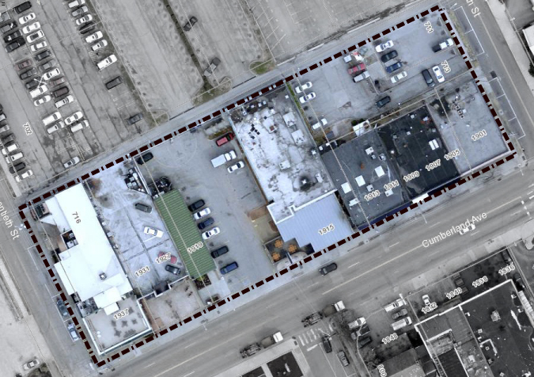
Figure 27: Strip mall - The site is dominated by impervious surface

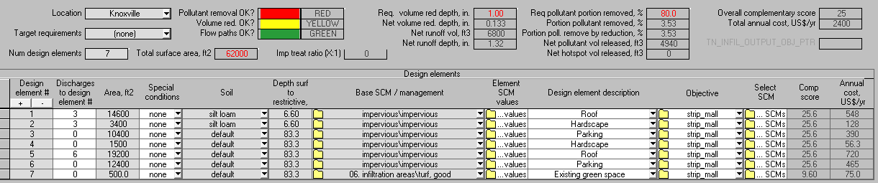
Figure 28: Existing strip mall project does not meet the new stormwater requirements
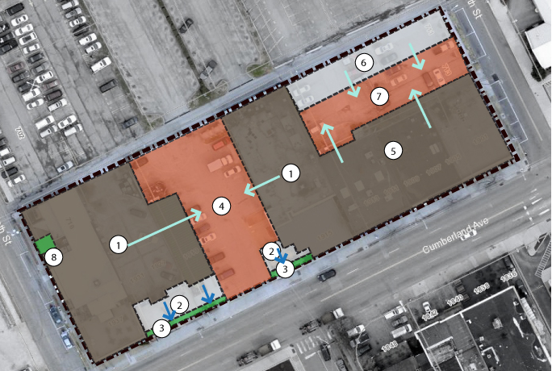
Figure 29: Runoff flow path in the strip mall site

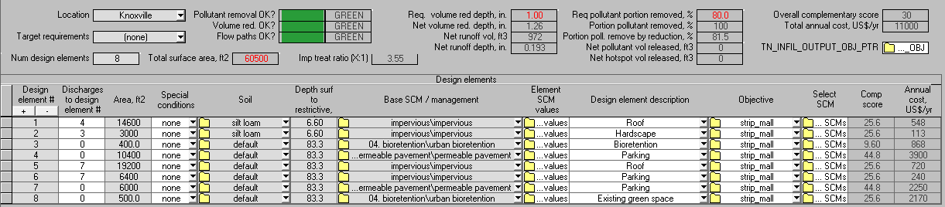
Figure 30: RRAT interface for strip mall project. This design meets the hydrologic requirement

6. DISCUSSIONS AND CONCLUSIONS
The objective of this study is to integrate hydrologic performance and complementary requirements of the LID approach to help designers select the best SCM for their project. A logical framework was developed to meet the objective, which included a detailed description of all necessary inputs for the complementary score, a definition of the flow of logic and logic rules used in the decision process, and some description of inputs needed for hydrologic calculation. The logical framework resulted in the selection of the “best” SCM, defined as meeting the hydrologic performance requirements while yielding the highest possible score for the site-specific complementary requirements. The complementary scoring was accomplished using a method involving design Objectives, Goals, and SCM Characteristics. This approach is flexible to reflect a wide range of possible complementary goals. The hydrologic design was handled using the Runoff Reduction Assessment Tool (RRAT), which also allowed some flexibility in the design specification while still following design standards in the first edition of Tennessee Permanent Stormwater Management and Design Guidance Manual. Those two elements were then integrated into a complete package to provide an idea of the best SCM design configuration, its dimension for each design element, and its rough cost estimation.
As more states are adopting the EPA’s interpretation of the Clean Water Act by enforcing the regulation that every new development needs to manage the first inch of rainfall and remove 80% of pollutant onsite, having SCM onsite is no longer voluntary but is required by the language in the permit. In Tennessee, there are 94 municipalities in the state that must meet this requirement. All developers within those MS4s must meet the requirements, and to do so need to select the best SCMs for their project. A tool such as this can therefore prove beneficial to those developers. This tool is not, however, meant to replace the roles of landscape architects and stormwater engineers. In fact, their role is critical to ensure the correctness of the SCM selection for the site condition, the design specification of the selected SCM in the site, and the placement of the SCM to meet the design goals.
This project and its resulting framework and approach have clear limitations. One example is in the way overall complementary score calculated. This score, one of whose inputs is the project’s Design Goals, is presently calculated using area-weighted average to allow users to compare combinations of SCMs in a project. However, Design Goals such as water supply, parking, building, child friendly, traffic calming, and minimize area of practice are not necessarily area dependent, while others such as cooling effect, attract wildlife, and aesthetic probably are positively correlated to surface area.
As an attempt to find an alternative to the area-weighted method, the ratio of SCMs’ complementary score to the highest possible complimentary score on the list was explored. Mathematically, this can be expressed as the following:
$$Overall Complementary Score=\frac{\sum_{i=1}^{n}{\left(\frac{{Complementary score}_{i}}{Highest SCM score}\right)}}{n}*100\%$$
Equation 3
Where:
- Highest SCM score : Highest complementary score on the list of recommended SCM
- n: Number of SCMs in the design
Example: The high density residential design in Figure 15 and 13 currently have overall complementary scores of 10 and 35. Using the alternative method, the designs get scores 21% and 67% respectively.
Table 21: Possible alternative overall complementary score for figure 15
High density residential – Scenario 3
Base SCM/Management | Complementary Score | Highest score |  | $$\frac{{Complementary score}_{i}}{Highest SCM score}$$
impervious\impervious | 9.14 |  | 50.3 |  | 0.18
impervious\impervious | 10.7 |  | 58.7 |  | 0.18
impervious\impervious | 10.7 |  | 58.7 |  | 0.18
impervious\impervious | 9.14 |  | 50.3 |  | 0.18
06. infiltration areas\grassland | 20.6 |  | 50.3 |  | 0.41
04. bioretention\bioretention | 6.67 |  | 58.7 |  | 0.11
 | Total |  |  |  | 1.25
 | Overall complementary score |  |  |  | 20.85

Table 22: Possible alternative overall complementary score for figure 13
High density residential – Scenario 1
Base SCM/Management | Complementary Score | Highest score |  | $$\frac{{Complementary score}_{i}}{Highest SCM score}$$
10. green roof\green roof | 50.3 |  | 50.3 |  | 1.00
10. green roof\green roof | 58.7 |  | 58.7 |  | 1.00
impervious\impervious | 10.7 |  | 58.7 |  | 0.18
07. permeable pavement | 27.4 |  | 50.3 |  | 0.54
06. infiltration areas\grassland | 20.6 |  | 50.3 |  | 0.41
06. infiltration areas\forest, good | 50.7 |  | 58.7 |  | 0.86
 | Total |  |  |  | 4.00
 | Overall complementary score |  |  |  | 66.67

This method allows comparison of successes among different projects because the overall complementary score is treated as a measure of completion. However, this method also has some problems. Since it completely ignores the area of the SCM, breaking up a large area into separate little SCMs can yield a higher overall complementary score than a reasonably-sized single SCM. This problem can be solved by using design specification or size threshold for each Design Goal so that SCM that is smaller than the “standard” is not getting a full complementary score. Unfortunately, finding information about what size is considered “good” for each Design Goal has proved to be difficult.
Another possible limitation is fact that the complementary scores should ideally be assigned by committees of designers, but currently are based solely on the author’s subjective judgment supported by the limited available literature. The author realizes that the assigned default scores may lead to questions regarding the validity of the recommended SCMs list. However, the focus of the study is to develop the framework itself rather than specifying the “correct” scores. Therefore, the assigned scores should be considered only as initial starting points rather than the final consensus. In fact, users can modify the scores to match their preferences. It is also the hope of the author that over time, this approach will get more validation by numerous stormwater engineers and landscape architects through usage of this tool. The lesson learned, corrections, and feedback can then be incorporated back into the framework to improve the scoring and ranking in this tool. Unfortunately, due to limited time, testing the tool is limited to author’s trials to various design case study scales and scenarios. Although the results are promising, inputs from stormwater management professionals can be useful for the next version of the logical framework.

REFERENCES

AbdelKhaleq, R.A., and I. Alhaj Ahmed. “Rainwater Harvesting in Ancient Civilizations in Jordan.” Water Science & Technology: Water Supply 7.1 (2007): 85. Web. 7 Jan. 2015.
Akbari, Hashem. “Energy Saving Potentials and Air Quality Benefits of Urban Heat Island Mitigation.” Lawrence Berkeley National Laboratory (2005): n. pag. Print.
Amin, Ash. “Collective Culture and Urban Public Space.” City 12.1 (2008): 5–24. Web. 21 Sept. 2014.
Appleyard, Donald, and Kenneth H. Craik. “Annuaire Des Organizations Directory of Organizations.” Applied Psychology 27.1 (1978): 53–55. Web. 7 Jan. 2015.
Arnold, Chester L., and C. James Gibbons. “Impervious Surface Coverage: The Emergence of a Key Environmental Indicator.” Journal of the American Planning Association 62.2 (1996): 243–258. Web. 21 Jan. 2015.
Berdahl, Paul, and Sarah E. Bretz. “Preliminary Survey of the Solar Reflectance of Cool Roofing Materials.” Energy and Buildings 25.2 (1997): 149–158. Web. 7 Jan. 2015.
Booth, Norman K. Basic Elements of Landscape Architectural Design. Waveland Press, 1989. Print.
Brush, Robert O., Dennis N. Williamson, and Julius Fabos G.Y. “Visual Screening Potential of Forest Vegetation.” Urban Ecology 4.3 (1979): 207–216. Web. 7 Jan. 2015.
Carson, Patrick, and Julia Moulden. Green Is Gold: Business Talking to Business about the Environmental Revolution. HarperCollins Publishers, 1991. Print.
City of Carlsbad. Open Space & Conservation Element. N.p., 2006. Print.
Coffman, Larry S, and R.L. France. “Low-Impact Development: An Alternative Stormwater Management Technology.” Handbook of Water Sensitive Planning and Design. N.p., 2002. 97–123. Print.
De Waard, Dick, Frank J.J.M Steyvers, and Karel A Brookhuis. “How Much Visual Road Information Is Needed to Drive Safely and Comfortably?” Safety Science 42.7 (2004): 639–655. Web. 25 Dec. 2014.
Dietz, Michael E, and John C Clausen. “Stormwater Runoff and Export Changes with Development in a Traditional and Low Impact Subdivision.” Journal of environmental management 87.4 (2008): 560–6. Web. 10 Dec. 2014.
Dietz, Michael E. “Low Impact Development Practices: A Review of Current Research and Recommendations for Future Directions.” Water, Air, and Soil Pollution 186.1-4 (2007): 351–363. Web. 24 Jan. 2015.
FHWA. “Stormwater Best Management Practices in an Ultra-Urban Setting: Selection and Monitoring.” N.p., 2000. Web.
Fjørtoft, Ingunn, and Jostein Sageie. “The Natural Environment as a Playground for Children.” Landscape and Urban Planning 48.1-2 (2000): 83–97. Web. 28 Jan. 2015.
Forman, Richard TT, and Robert I McDonald. “A Massive Increase in Roadside Woody Vegetation: Goals, Pros, and Cons.” Road Ecology Center (2007): n. pag. Print.
Fuerst, Franz, and Patrick McAllister. “Green Noise or Green Value? Measuring the Effects of Environmental Certification on Office Values.” Real Estate Economics 39.1 (2011): 45–69. Web. 2 Jan. 2015.
Gaffield, Stephen J. et al. “Public Health Effects of Inadequately Managed Stormwater Runoff.” American Journal of Public Health 93.9 (2003): 1527–1533. Web. 8 Jan. 2015.
Gielen, Andrea Carlson et al. “Child Pedestrians: The Role of Parental Beliefs and Practices in Promoting Safe Walking in Urban Neighborhoods.” Journal of urban health : bulletin of the New York Academy of Medicine 81.4 (2004): 545–55. Web. 8 Jan. 2015.
Göbel, P, C Dierkes, and W G Coldewey. “Storm Water Runoff Concentration Matrix for Urban Areas.” Journal of contaminant hydrology 91.1-2 (2007): 26–42. Web. 1 Jan. 2015.
Godley, Stuart T, Thomas J Triggs, and Brian N Fildes. “Perceptual Lane Width, Wide Perceptual Road Centre Markings and Driving Speeds.” Ergonomics 47.3 (2004): 237–56. Web. 18 Dec. 2014.
Gregory, K.J., R.J. Davis, and P.W. Downs. “Identification of River Channel Change to due to Urbanization.” Applied Geography 12.4 (1992): 299–318. Web. 8 Jan. 2015.
Hathaway, Jon, and William Hunt. Stormwater BMP Costs Division of Soil & Water Conservation Community Conservation Assistance Program. N.p., 2007. Print.
Hathaway, Jon. Lecture 8: ENVE 530 – Urban Hydrology and Stormwater Engineering. Knoxville, TN: N.p., 2014. Print.
Heisler, Gordon M. “Energy Savings with Trees.” Journal of Aboriculture 12(5) (1986): 113–125. Print.
Hilty, Jodi A., William Z. Lidicker, and Adina Merenlender. “Chapter 4: Approaches to Achieving Habitat Connectivity.” Corridor Ecology: The Science and Practice of Linking Landscapes for Biodiversity Conservation. Washington, DC: N.p., 2006. Print.
Holman-Dodds, Jennifer K., A. Allen Bradley, and Kenneth W. Potter. “Evaluation Of Hydrologic Benefits Of Infiltration Based Urban Storm Water Management.” Journal of the American Water Resources Association 39.1 (2003): 205–215. Web. 8 Jan. 2015.
Howard, Tim. Stormwater Best Management Practices, Mosquitoes, And West Nile Virus A Look at the Colorado Front Range. Broonfield, Colorado: N.p., 2003. Print.
Hunter, Margie. Gardening with the Native Plants of Tennessee: The Spirit of Place. University of Tennessee Press, 2002. Print.
Irwin, Elena G., and Nancy E. Bockstael. “Land Use Externalities, Open Space Preservation, and Urban Sprawl.” Regional Science and Urban Economics 34.6 (2004): 705–725. Web. 17 Mar. 2015.
Jones, Matthew P., and William F. Hunt. “Performance of Rainwater Harvesting Systems in the Southeastern United States.” Resources, Conservation and Recycling 54.10 (2010): 623–629. Web. 17 Mar. 2015.
Kaplan, Rachel. Down by the Riverside: Informational Factors in Waterscape Preference. N.p., 1977. Print.
Katsouyanni, K et al. “Evidence for Interaction between Air Pollution and High Temperature in the Causation of Excess Mortality.” Archives of environmental health 48.4 235–42. Web. 17 Mar. 2015.
Kennedy, J. et al. “Psychological”traffic Calming. TRL, 2005. Print.
Klein, Richard D. “Urbanization And Stream Quality Impairment.” Journal of the American Water Resources Association 15.4 (1979): 948–963. Web. 5 Mar. 2015.
Knight, Robert L et al. “Strategies for Effective Mosquito Control in Constructed Treatment Wetlands.” Ecological Engineering 21.4-5 (2003): 211–232. Web. 15 Dec. 2014.
KUB. “KUB Water Quality Report 2013.” (2013): n. pag. Print.
Leopold, Luna B. Hydrology for Urban Land Planning: A Guidebook on the Hydrologic Effects of Urban Land Use. Geological Survey Professional Circular 554. N.p., 1968. Print.
Lewis-Evans, Ben, and Samuel G Charlton. “Explicit and Implicit Processes in Behavioural Adaptation to Road Width.” Accident; analysis and prevention 38.3 (2006): 610–7. Web. 8 Jan. 2015.
Livingston, Margaret. Landscape Design for Attracting Wildlife in Southwestern Urban Environments." Proceedings 4th International Urban Wildlife Symposium. N.p., 2004. Print.
Martin, Alexander Campbell, H. S. Zim, and A. L. Nelson. A Guide to Wildlife Food Habits: The Use of Trees, Shrubs, Weeds, and Herbs by Birds and Mammals of the United States. Courier Dover Publications, 1961. Print.
Martin, Bridget, and Antonis C. Simintiras. “The Impact of Green Product Lines on the Environment.” Marketing Intelligence & Planning 13.4 (1995): 16–23. Web. 17 Mar. 2015.
Martin, David, and K Loomis. Building Teachers: A Constructivist Approach to Introducing Education. Belmont, CA: Thomson/Wadsworth: N.p., 2007. Print.
Matravers, D. “The Aesthetic Experience.” The British Journal of Aesthetics 43.2 (2003): 158–174. Web. 8 Jan. 2015.
Maynard, Trisha, Jane Waters, and Jennifer Clement. “Moving Outdoors: Further Explorations of ‘child-Initiated’ Learning in the Outdoor Environment.” Education 3-13 41.3 (2013): 282–299. Web. 16 Mar. 2015.
MDE (Maryland Department of the Environment). “Costs of Stormwater Management Practices In Maryland Counties.” (2011): 5. Print.
Miller, William et al. “An Approach for Greenway Suitability Analysis.” Landscape and Urban Planning 42.2-4 (1998): 91–105. Web. 8 Jan. 2015.
Moughtin, C., P. Signoretta, and K. M. Moughtin. Urban Design: Health and the Therapeutic Environment. Routledge: N.p., 2009. Print.
MPCA (Minnesota Pollution Control Agency). Best Management Practices Construction Costs, Maintenance Costs, and Land Requirements. N.p., 2011. Print.
Mwalyosi, R.B.B. “Ecological Evaluation for Wildlife Corridors and Buffer Zones for Lake Manyara National Park, Tanzania, and Its Immediate Environment.” Biological Conservation 57.2 (1991): 171–186. Web. 8 Jan. 2015.
Nasar, Jack L., and Minhui Li. “Landscape Mirror: The Attractiveness of Reflecting Water.” Landscape and Urban Planning 66.4 (2004): 233–238. Web. 8 Jan. 2015.
Nelson, W. R. Aesthetic Consideration in the Selection and Use of Trees in the Urban Environment. N.p., 1976. Print.
Paul, Michael J., and Judy L. Meyer. “Streams in the Urban Landscape.” Annual Review of Ecology and Systematics 32 (2001): 333–365. Print.
Pavlowsky, R. T. “Urban Impacts on Stream Morphology in the Ozark Plateaus Region.” Self-Sustaining Solutions for Streams, Wetlands, and Watersheds: proceedings of the 12-15 September 2004 conference, Radisson Riverfront Hotel, St. Paul, Minnesota USA Amer Society of Agricultural (2004): n. pag. Print.
Perry, C. “‘The Neighbourhood Unit’ in Neighbourhood and Community Planning.” Regional Plan of New York and the Environs VII. N.p., 1929. Print.
Pimentel, David et al. “Economic and Environmental Benefits of Biodiversity.” BioScience 47.11 (1997): 747. Print.
Pretty, Jules, and Peggy F. Barlett. “Concluding Remarks: Nature and Health in the Urban Environment.” Urban Place: Reconnecting with the Natural World. N.p., 2005. 299–319. Print.
Reethof, G. E. R. H. A. R. D., and G. M Heisler. “Trees and Forests for Noise Abatement and Visual Screening.” USDA Forest Service General Technical Report NE (1976): n. pag. Print.
Retzlaff, R. C. “The Use of Leed in Planning and Development Regulation: An Exploratory Analysis.” Journal of Planning Education and Research (2009): n. pag. Web. 17 Mar. 2015.
Roy, Allison H et al. “Impediments and Solutions to Sustainable, Watershed-Scale Urban Stormwater Management: Lessons from Australia and the United States.” Environmental management 42.2 (2008): 344–59. Web. 14 Oct. 2014.
Rushton, Betty T. “Low-Impact Parking Lot Design Reduces Runoff and Pollutant Loads.” Journal of Water Resources Planning and Management 127.3 (2001): 172–179. Web. 8 Jan. 2015.
SEMCOG. Low Impact Development Manual for Michigan. N.p., 2008. Print.
Southworth, Michael. “The Sonic Environment of Cities.” Environment and Behavior 1.1 (1969): 49–70. Web. 8 Jan. 2015.
Spirn, Anne Whiston. “The Poetics of City and Nature: Towards a New Aesthetic for Urban Design.” Landscape Journal 7.2 108–126. Web.
TDEC, and UT SMART Center. Introduction to the Tennessee Runoff Reduction Assessment Tool. N.p., 2014. Print.
TDEC. “NPDES General Permit For Discharges From Small Municipal Separate Storm Sewer Systems; Permit No. TNSOOOOOO.” N.p., 2010. Print.
Tennessee Department of Environment and Conservation, and Division of Water Resources (TDEC). Tennessee Permanent Stormwater Management and Design Guidance Manual. N.p., 2014. Print.
Tennis, Paul D., Michael L. Leming, and David J. Akers. Pervious Concrete Pavements (No. PCA Serial No. 2828). Skokie, IL: N.p., 2004. Print.
The City of San Antonio. Amending Chapter 35, Unified Development Code, Of The City Code Of San Antonio, Texas, Relating " To Tree Preservation And Adequate Canopy Coverage. N.p., 2010. Print.
Thompson, Catharine Ward. “Urban Open Space in the 21st Century.” Landscape and Urban Planning 60.2 (2002): 59–72. Web. 8 Jan. 2015.
Thompson, Catharine Ward. “Urban Open Space in the 21st Century.” Landscape and Urban Planning 60.2 (2002): 59–72. Web. 8 Jan. 2015.
Timperio, A. “Perceptions about the Local Neighborhood and Walking and Cycling among Children.” Preventive Medicine 38.1 (2004): 39–47. Web. 15 Dec. 2014.
Tsugawa, A. “The Nature of the Aesthetic and Human Values.” NASSP Bulletin 53.340 (1969): 51–67. Web. 8 Jan. 2015.
USDA. From the Surface Down An Introduction to Soil Surveys for Agronomic Use. N.p., 2010. Print.
USEPA. “Heat Island Impacts.” N.p., 2013. Web. 7 May 2014.
USEPA. “Water: Best Management Practices - Grassed Swales.” 2012. N.p., n.d. Print.
USEPA. National Water Quality Inventory. N.p., 2000. Print.
Vanderbilt, Tom. “How Our Eyes and Minds Betrays Us on the Road.” Traffic: Why We Drive the Way We Do (and What It Says about Us). New York: Alfred A. Knopf, 2008. 92–93. Print.
Walsh, Christopher J. et al. “The Urban Stream Syndrome: Current Knowledge and the Search for a Cure.” Journal of the North American Benthological Society 24.3 (2005): 706–723. Web. 7 Jan. 2015.
West Virginia Department of Environmental Protection (WVDEP). West Virginia Stormwater Management and Design Guidance Manual. N.p., 2012. Print.
Williams, Justin C. “Delineating Protected Wildlife Corridors with Multi‐objective Programming.” Environmental Modeling & Assessment 3.1-2 (1998): 77–86. Web.
Wu, JunJie, and Andrew J. Plantinga. “The Influence of Public Open Space on Urban Spatial Structure.” Journal of Environmental Economics and Management 46.2 (2003): 288–309. Web. 7 Dec. 2014.
Zhou, Wanfang, and Barry F. Beck. “Engineering Issues on Karst.” Karst Management. N.p., 2011. Print.

APPENDIX

Appendix A: O-DG scores
Table 23: Scores to show how important the Design Goals for a specific Objective
Objective |  | Design Goals
 |  | Water supply | Cooling effect | Corridor |  |  | Aesthetic Appeal | Attract wildlife |  |  | Traffic  calming | Recreational opportunity | Social gathering | Privacy  /Boundary | Parking | Building | Child-  Friendly | Regulatory requirement | Minimize area of practice | Green appeal
 |  | Water supply | Cooling effect | Human | Vehicle | Wildlife | Aesthetic Appeal | Birds | Squirrels & chipmunks | Butterflies
Residential |  | 3 | 4 | 4 | 0 | 3 | 4 | 4 | 2 | 4 | 4 | 0 | 0 | 4 | 0 | 0 | 4 | 4 | 0 | 0
Institutional | Government building  (police/fire station) | 2 | 3 | 0 | 2 | 0 | 2 | 0 | 0 | 0 | 0 | 1 | 1 | 0 | 4 | 4 | 0 | 0 | 0 | 3
Institutional | Primary/secondary | 2 | 3 | 4 | 2 | 2 | 2 | 2 | 0 | 2 | 4 | 0 | 4 | 4 | 0 | 4 | 4 | 0 | 0 | 4
Institutional | Higher education | 2 | 3 | 4 | 3 | 2 | 2 | 1 | 0 | 1 | 4 | 0 | 4 | 0 | 4 | 4 | 2 | 0 | 0 | 4
Institutional | Offices | 0 | 3 | 2 | 4 | 0 | 2 | 0 | 0 | 0 | 3 | 1 | 1 | 0 | 4 | 4 | 0 | 0 | 0 | 3
Recreational | Parks | 0 | 4 | 4 | 0 | 4 | 4 | 4 | 4 | 4 | 4 | 4 | 4 | 0 | 0 | 0 | 4 | 4 | 0 | 0
Commercial | Shops, banks | 0 | 0 | 2 | 4 | 0 | 3 | 0 | 0 | 0 | 3 | 0 | 0 | 0 | 4 | 4 | 2 | 0 | 0 | 0
Industrial | Factories | 4 | 0 | 1 | 4 | 0 | 2 | 0 | 0 | 0 | 0 | 0 | 0 | 0 | 4 | 4 | 0 | 0 | 0 | 0
Parking garage | Ultra urban | 0 | 0 | 2 | 4 | 0 | 0 | 0 | 0 | 0 | 0 | 0 | 0 | 0 | 0 | 4 | 0 | 0 | 4 | 0
Transportation |  | 0 | 0 | 2 | 4 | 0 | 0 | 0 | 0 | 0 | 0 | 0 | 0 | 0 | 4 | 0 | 0 | 0 | 0 | 0
Agriculture | Farmland | 4 | 0 | 1 | 1 | 0 | 0 | 0 | 0 | 0 | 0 | 0 | 0 | 2 | 0 | 0 | 0 | 0 | 0 | 0

Appendix B: DG-C scores
Table 24: Scores to show how important the Characteristics in meeting the Design Goals
Characteristics |  | Design Goals
 |  | Water supply | Cooling effect | Corridor |  |  | Aesthetic Appeal | Attract wildlife |  |  | Traffic  calming | Recreational opportunity | Social gathering | Privacy  /Boundary | Parking | Building | Child-  Friendly | Regulatory requirement | Minimize area of practice | Green appeal
 |  | Water supply | Cooling effect | Human | Vehicle | Wildlife | Aesthetic Appeal | Birds | Squirrels & chipmunks | Butterflies
Vegetation | Turf | 0 | 2 | 2 | 0 | 1 | 1 | 1 | 0 | 0 | 0 | 2 | 4 | 0 | 0 | 0 | 4 | 4 | 0 | 0
Vegetation | Perennials | 0 | 2 | 0 | 0 | 1 | 4 | 4 | 0 | 4 | 2 | 4 | 0 | 3 | 0 | 0 | 4 | 4 | 0 | 0
Vegetation | Tall grasses | 0 | 2 | 0 | 0 | 1 | 4 | 4 | 0 | 0 | 2 | 4 | 0 | 3 | 0 | 0 | 4 | 4 | 0 | 0
Vegetation | Low shrubs/bushes | 0 | 2 | 0 | 0 | 3 | 4 | 4 | 0 | 3 | 2 | 4 | 0 | 4 | 0 | 0 | 4 | 4 | 0 | 0
Vegetation | Small decorative tree | 0 | 3 | 0 | 0 | 4 | 4 | 4 | 4 | 3 | 4 | 4 | 0 | 3 | 0 | 0 | 4 | 4 | 0 | 0
Vegetation | Evergreen tree | 0 | 4 | 0 | 0 | 4 | 4 | 4 | 4 | 0 | 4 | 4 | 0 | 4 | 0 | 0 | 4 | 4 | 0 | 0
Vegetation | Canopy tree | 0 | 4 | 2 | 0 | 4 | 4 | 4 | 4 | 2 | 4 | 4 | 3 | 2 | 0 | 0 | 4 | 4 | 0 | 0
Vegetation | Wetland plants | 0 | 2 | 0 | 0 | 4 | 4 | 4 | 0 | 2 | 0 | 4 | 0 | 0 | 0 | 0 | 0 | 4 | 0 | 0
Public space | Not vegetated | 0 | 0 | 0 | 0 | 0 | 0 | 0 | 0 | 0 | 0 | 0 | 4 | 0 | 0 | 0 | 0 | 0 | 0 | 0
 | Vegetated | 0 | 0 | 0 | 0 | 0 | 0 | 0 | 0 | 0 | 0 | 0 | 4 | 0 | 0 | 0 | 0 | 4 | 0 | 0
Traffic surface | High traffic surface | 0 | 0 | 4 | 4 | 0 | 0 | 0 | 0 | 0 | 0 | 0 | 4 | 0 | 4 | 0 | 0 | 0 | 0 | 0
 | Medium traffic surface - pavers | 0 | 0 | 4 | 2 | 0 | 2 | 0 | 0 | 0 | 4 | 2 | 4 | 0 | 4 | 0 | 0 | 0 | 0 | 0
 | Medium traffic surface - gravel | 0 | 0 | 4 | 2 | 0 | 2 | 0 | 0 | 0 | 4 | 2 | 4 | 0 | 4 | 0 | 0 | 0 | 0 | 0
 | Light traffic surface | 0 | 2 | 4 | 1 | 0 | 2 | 0 | 0 | 0 | 4 | 2 | 4 | 0 | 4 | 0 | 0 | 0 | 0 | 0
Water | Open constant depth | 2 | 2 | 0 | 0 | 0 | 4 | 0 | 0 | 0 | 0 | 4 | 0 | 3 | 0 | 0 | 0 | 4 | 0 | 0
 | Open fluctuating depth | 1 | 1 | 0 | 0 | 0 | 2 | 0 | 0 | 0 | 0 | 0 | 0 | 2 | 0 | 0 | 0 | 4 | 0 | 0
 | Enclosed | 4 | 0 | 0 | 0 | 0 | 0 | 0 | 0 | 0 | 0 | 0 | 0 | 0 | 0 | 0 | 4 | 0 | 0 | 0
No additional surface area |  | 0 | 0 | 0 | 0 | 0 | 0 | 0 | 0 | 0 | 0 | 0 | 0 | 0 | 0 | 0 | 0 | 0 | 4 | 0
Shelter |  | 0 | 4 | 0 | 0 | 0 | 0 | 0 | 0 | 0 | 4 | 0 | 0 | 0 | 0 | 4 | 4 | 0 | 0 | 0
Green Innovation |  | 0 | 0 | 0 | 0 | 0 | 0 | 0 | 0 | 0 | 0 | 0 | 0 | 0 | 0 | 0 | 0 | 0 | 0 | 4

Appendix C: C-SCM scores
Table 25: Scores to show how well the SCMs can provide the Characteristics
 | SCMs |  |  | Characteristics
 |  |  |  | Vegetation |  |  |  |  |  |  |  | Public space |  | Traffic surface |  |  |  | Water |  |  | No additional surface area | Shelter | Green innovation
 |  |  |  | Turf | Perennials | Tall Grasses | Low shrubs/ bushes | Small/ decorative tree | Evergreen tree | Canopy tree | Wetland plants | General | Vegetated | High traffic | Medium traffic |  | Light traffic | Open constant depth | Open fluctuating | Enclosed | No additional surface area | Shelter | Green innovation
 |  |  |  |  |  |  |  |  |  |  |  |  |  | Concrete/asphalt | Pavers | Gravel | Grass-based
Filtration SCMs | Dry pond |  |  | 2 | 0 | 0 | 0 | 0 | 0 | 0 | 0 | 0 | 0 | 0 | 0 | 0 | 0 | 0 | 4 | 0 | 0 | 0 | 0
Filtration SCMs | Extended detention basin |  |  | 2 | 0 | 0 | 0 | 0 | 0 | 0 | 0 | 0 | 0 | 0 | 0 | 0 | 0 | 0 | 4 | 0 | 0 | 0 | 0
Filtration SCMs | Wet pond |  |  | 2 | 0 | 0 | 0 | 0 | 0 | 0 | 0 | 0 | 0 | 0 | 0 | 0 | 0 | 4 | 0 | 0 | 0 | 0 | 0
Filtration SCMs | Constructed wetland |  |  | 0 | 0 | 0 | 0 | 0 | 0 | 0 | 4 | 0 | 0 | 0 | 0 | 0 | 0 | 4 | 0 | 0 | 0 | 0 | 0
Infiltration SCMs | Vegetated swales |  |  | 2 | 0 | 4 | 0 | 0 | 0 | 0 | 0 | 0 | 0 | 0 | 0 | 0 | 0 | 0 | 0 | 0 | 0 | 0 | 0
Infiltration SCMs | Water quality swale | Turf |  | 4 | 0 | 0 | 0 | 0 | 0 | 0 | 0 | 0 | 0 | 0 | 0 | 0 | 0 | 0 | 0 | 0 | 0 | 0 | 0
Infiltration SCMs | Water quality swale | Low vegetation |  | 0 | 4 | 2 | 2 | 0 | 0 | 0 | 0 | 0 | 0 | 0 | 0 | 0 | 0 | 0 | 0 | 0 | 0 | 0 | 0
Infiltration SCMs | Water quality swale | Trees & some understory |  | 0 | 2 | 2 | 0 | 2 | 0 | 2 | 0 | 0 | 0 | 0 | 0 | 0 | 0 | 0 | 0 | 0 | 0 | 0 | 0
Infiltration SCMs | Managed vegetated area | Forest, good | Deciduous | 0 | 0 | 0 | 0 | 4 | 0 | 4 | 0 | 0 | 0 | 0 | 0 | 0 | 0 | 0 | 0 | 0 | 0 | 0 | 0
Infiltration SCMs | Managed vegetated area |  | Evergreen | 0 | 0 | 0 | 0 | 4 | 4 | 0 | 0 | 0 | 0 | 0 | 0 | 0 | 0 | 0 | 0 | 0 | 0 | 0 | 0
Infiltration SCMs | Managed vegetated area |  | Mix | 0 | 0 | 0 | 0 | 2 | 3 | 3 | 0 | 0 | 0 | 0 | 0 | 0 | 0 | 0 | 0 | 0 | 0 | 0 | 0
Infiltration SCMs | Managed vegetated area | Forest, fair | Deciduous | 0 | 0 | 0 | 0 | 3 | 0 | 3 | 0 | 0 | 2 | 0 | 0 | 0 | 0 | 0 | 0 | 0 | 0 | 0 | 0
Infiltration SCMs | Managed vegetated area |  | Evergreen | 0 | 0 | 0 | 0 | 3 | 3 | 0 | 0 | 0 | 1 | 0 | 0 | 0 | 0 | 0 | 0 | 0 | 0 | 0 | 0
Infiltration SCMs | Managed vegetated area |  | Mix | 0 | 0 | 0 | 0 | 2 | 2 | 2 | 0 | 0 | 1 | 0 | 0 | 0 | 0 | 0 | 0 | 0 | 0 | 0 | 0
Infiltration SCMs | Managed vegetated area | Grassland | Grassland | 0 | 2 | 4 | 0 | 0 | 0 | 0 | 0 | 0 | 4 | 0 | 0 | 0 | 0 | 0 | 0 | 0 | 0 | 0 | 0
Infiltration SCMs | Managed vegetated area | Turf, good | Turf, good | 4 | 0 | 0 | 0 | 0 | 0 | 0 | 0 | 0 | 4 | 0 | 0 | 0 | 0 | 0 | 0 | 0 | 0 | 0 | 0
Infiltration SCMs | Managed vegetated area | Turf, fair | Turf, fair | 3 | 0 | 0 | 0 | 0 | 0 | 0 | 0 | 0 | 4 | 0 | 0 | 0 | 0 | 0 | 0 | 0 | 0 | 0 | 0
Table 25. Continued.
 | SCMs |  |  | Characteristics
 |  |  |  | Vegetation |  |  |  |  |  |  |  | Public space |  | Traffic surface |  |  |  | Water |  |  | No additional surface area | Shelter | Green innovation
 |  |  |  | Turf | Perennials | Tall Grasses | Low shrubs/ bushes | Small/ decorative tree | Evergreen tree | Canopy tree | Wetland plants | General | Vegetated | High traffic | Medium traffic |  | Light traffic | Open constant depth | Open fluctuating | Enclosed | No additional surface area | Shelter | Green innovation
 |  |  |  |  |  |  |  |  |  |  |  |  |  | Concrete/asphalt | Pavers | Gravel | Grass-based
Infiltration SCMs | Vegetated filter strip (grass strip) | Good |  | 0 | 0 | 4 | 0 | 0 | 0 | 0 | 0 | 0 | 4 | 0 | 0 | 0 | 0 | 0 | 0 | 0 | 0 | 0 | 0
Infiltration SCMs | Vegetated filter strip (grass strip) | Fair |  | 0 | 0 | 3 | 0 | 0 | 0 | 0 | 0 | 0 | 3 | 0 | 0 | 0 | 0 | 0 | 0 | 0 | 0 | 0 | 0
Infiltration SCMs | Bioretention (general &  w/underdrain) | Turf |  | 4 | 0 | 0 | 0 | 0 | 0 | 0 | 0 | 0 | 0 | 0 | 0 | 0 | 0 | 0 | 0 | 0 | 0 | 0 | 0
Infiltration SCMs | Bioretention (general &  w/underdrain) | Low vegetation |  | 0 | 4 | 2 | 2 | 0 | 0 | 0 | 0 | 0 | 0 | 0 | 0 | 0 | 0 | 0 | 0 | 0 | 0 | 0 | 0
Infiltration SCMs | Bioretention (general &  w/underdrain) | Trees & some understory |  | 0 | 2 | 2 | 0 | 2 | 0 | 2 | 0 | 0 | 0 | 0 | 0 | 0 | 0 | 0 | 0 | 0 | 0 | 0 | 0
Infiltration SCMs | Rain gardens (general &  w/underdrain) | Turf |  | 4 | 0 | 0 | 0 | 0 | 0 | 0 | 0 | 0 | 0 | 0 | 0 | 0 | 0 | 0 | 0 | 0 | 0 | 0 | 0
Infiltration SCMs | Rain gardens (general &  w/underdrain) | Low vegetation |  | 0 | 4 | 2 | 2 | 0 | 0 | 0 | 0 | 0 | 0 | 0 | 0 | 0 | 0 | 0 | 0 | 0 | 0 | 0 | 0
Infiltration SCMs | Rain gardens (general &  w/underdrain) | Trees & some understory |  | 0 | 2 | 2 | 0 | 2 | 0 | 2 | 0 | 0 | 0 | 0 | 0 | 0 | 0 | 0 | 0 | 0 | 0 | 0 | 0
Infiltration SCMs | Urban bioretention | Turf |  | 4 | 0 | 0 | 0 | 0 | 0 | 0 | 0 | 0 | 0 | 0 | 0 | 0 | 0 | 0 | 0 | 0 | 0 | 0 | 0
Infiltration SCMs | Urban bioretention | Low vegetation |  | 0 | 4 | 2 | 2 | 0 | 0 | 0 | 0 | 0 | 0 | 0 | 0 | 0 | 0 | 0 | 0 | 0 | 0 | 0 | 0
Infiltration SCMs | Urban bioretention | Trees & some understory |  | 0 | 2 | 2 | 0 | 2 | 0 | 2 | 0 | 0 | 0 | 0 | 0 | 0 | 0 | 0 | 0 | 0 | 0 | 0 | 0
Infiltration SCMs | Infiltration areas | Forest, good | Deciduous | 0 | 0 | 0 | 0 | 4 | 0 | 4 | 0 | 0 | 0 | 0 | 0 | 0 | 0 | 0 | 0 | 0 | 0 | 0 | 0
Infiltration SCMs | Infiltration areas | Forest, good | Evergreen | 0 | 0 | 0 | 0 | 4 | 4 | 0 | 0 | 0 | 0 | 0 | 0 | 0 | 0 | 0 | 0 | 0 | 0 | 0 | 0
Infiltration SCMs | Infiltration areas | Forest, good | Mixed | 0 | 0 | 0 | 0 | 2 | 3 | 3 | 0 | 0 | 0 | 0 | 0 | 0 | 0 | 0 | 0 | 0 | 0 | 0 | 0
Infiltration SCMs | Infiltration areas | Forest, fair | Deciduous | 0 | 0 | 0 | 0 | 3 | 0 | 3 | 0 | 0 | 2 | 0 | 0 | 0 | 0 | 0 | 0 | 0 | 0 | 0 | 0
Infiltration SCMs | Infiltration areas | Forest, fair | Evergreen | 0 | 0 | 0 | 0 | 3 | 3 | 0 | 0 | 0 | 1 | 0 | 0 | 0 | 0 | 0 | 0 | 0 | 0 | 0 | 0
Infiltration SCMs | Infiltration areas | Forest, fair | Mixed | 0 | 0 | 0 | 0 | 2 | 2 | 2 | 0 | 0 | 1 | 0 | 0 | 0 | 0 | 0 | 0 | 0 | 0 | 0 | 0
Infiltration SCMs | Infiltration areas | Grassland |  | 0 | 2 | 4 | 0 | 0 | 0 | 0 | 0 | 0 | 4 | 0 | 0 | 0 | 0 | 0 | 0 | 0 | 0 | 0 | 0
Infiltration SCMs | Infiltration areas | Turf, good |  | 4 | 0 | 0 | 0 | 0 | 0 | 0 | 0 | 0 | 4 | 0 | 0 | 0 | 0 | 0 | 0 | 0 | 0 | 0 | 0
Infiltration SCMs | Infiltration areas | Turf, fair |  | 3 | 0 | 0 | 0 | 0 | 0 | 0 | 0 | 0 | 4 | 0 | 0 | 0 | 0 | 0 | 0 | 0 | 0 | 0 | 0

Table 25. Continued.
 | SCMs |  |  | Characteristics
 |  |  |  | Vegetation |  |  |  |  |  |  |  | Public space |  | Traffic surface |  |  |  | Water |  |  | No additional surface area | Shelter | Green innovation
 |  |  |  | Turf | Perennials | Tall Grasses | Low shrubs/ bushes | Small/ decorative tree | Evergreen tree | Canopy tree | Wetland plants | General | Vegetated | High traffic | Medium traffic |  | Light traffic | Open constant depth | Open fluctuating | Enclosed | No additional surface area | Shelter | Green innovation
 |  |  |  |  |  |  |  |  |  |  |  |  |  | Concrete/asphalt | Pavers | Gravel | Grass-based
Infiltration SCMs | Permeable pavement | Pavers | 0 | 0 | 0 | 0 | 0 | 0 | 0 | 0 | 4 | 0 | 0 | 4 | 0 | 0 | 0 | 0 | 0 | 4 | 0 | 3 | 0
Infiltration SCMs | Permeable pavement | Gravel-based | 0 | 0 | 0 | 0 | 0 | 0 | 0 | 0 | 4 | 0 | 0 | 0 | 4 | 0 | 0 | 0 | 0 | 4 | 0 | 3 | 0
Infiltration SCMs | Permeable pavement | Grass-based | 0 | 0 | 0 | 0 | 0 | 0 | 0 | 0 | 4 | 0 | 0 | 0 | 0 | 4 | 0 | 0 | 0 | 4 | 0 | 3 | 0
Infiltration SCMs | Green roofs |  |  | 0 | 2 | 2 | 0 | 0 | 0 | 0 | 0 | 0 | 0 | 0 | 0 | 0 | 0 | 0 | 0 | 0 | 4 | 4 | 4
Infiltration SCMs | Underground infiltration system |  |  | 0 | 0 | 0 | 0 | 0 | 0 | 0 | 0 | 0 | 0 | 0 | 0 | 0 | 0 | 0 | 0 | 0 | 4 | 0 | 0
Capture & reuse | Rainwater harvesting | Rain barrels |  | 0 | 0 | 0 | 0 | 0 | 0 | 0 | 0 | 0 | 0 | 0 | 0 | 0 | 0 | 0 | 0 | 4 | 0 | 0 | 3
Capture & reuse | Rainwater harvesting | Cistern | Above ground | 0 | 0 | 0 | 0 | 0 | 0 | 0 | 0 | 0 | 0 | 0 | 0 | 0 | 0 | 0 | 0 | 4 | 0 | 0 | 2
Capture & reuse | Rainwater harvesting |  | Underground | 0 | 0 | 0 | 0 | 0 | 0 | 0 | 0 | 0 | 0 | 0 | 0 | 0 | 0 | 0 | 0 | 4 | 4 | 0 | 0
Others | Manufactured treatment devices |  |  | 0 | 0 | 0 | 0 | 0 | 0 | 0 | 0 | 0 | 0 | 0 | 0 | 0 | 0 | 0 | 0 | 0 | 4 | 0 | 0
Others | Impervious (all kind) |  |  | 0 | 0 | 0 | 0 | 0 | 0 | 0 | 0 | 4 | 0 | 4 | 0 | 0 | 0 | 0 | 0 | 0 | 0 | 0 | 0

VITA
Maudy Indriani Budipradigdo was born in Semarang, Central Java, Indonesia. She moved to Surabaya, Indonesia to complete her Bachelor of Arts degree in Architecture from Universitas Kristen Petra. After graduating, she worked at an architecture firm that focused on high-end residential. Budipradigdo earned her master’s degree in Landscape Architecture from University of Tennessee in August 2011. The 3-year Landscape Architecture program exposed her to various environmental problems the world is facing, including stormwater management issues. Her interest in stormwater management led her to her job as a research coordinator for the Stormwater Management Assistance Research and Training (SMART Center) Center project, whose aim is to provide facilities for research and training related to stormwater management. Although she was initially hired to design the landscape and buildings and to produce graphic illustrations for obtaining funding for the Center, her responsibilities evolved to include surveying, designing wetlands, and co-designing research and demonstration practices. As most of her landscape architecture knowledge focused heavily on the aesthetic, she felt that her lack of engineering competency is a limitation in her design effectiveness in certain cases. She decided to pursue another master’s degree in Biosystems Engineering Technology at the University of Tennessee, Knoxville and expected to complete her study in May 2015.

