Effect of exposure to 3,4,4′-Trichlorocarbanilide (TCC) during critical developmental life stages

A Thesis Presented for the

Doctorate of Philosophy Degree,

The University of Tennessee, Knoxville

Rebekah C. Kennedy

July, 2016

DEDICATION
This work is dedicated to my husband, Russell Fling
We will fight this fight together

ACKNOWLEDGEMENTS
I would like to thank everyone who has provided support throughout this dissertation. First, I want to express my gratitude to Misty Bailey and Kim Rutherford for all their help. From reminder emails to homemade vegetable soup during orientation, your support and encouragement pushed me on the path to success.
I would like to extend my sincere gratitude to Dr. J Chen, my committee chair and major advisor for molding me into the researcher I am today. You pushed me beyond what I thought I was capable of and instilled in me an attention to detail that will prove valuable throughout my career. Additionally, I am very thankful to my committee members Dr. D. Bemis, Dr. R. Donnell and Dr. K. Fecteau for providing valuable insight and guidance into my dissertation project at the same time allowing independence to grow and flourish as a researcher. Further, I would like to thank everyone that contributed to this dissertation as collaborators. Specifically, I want to thank Dr. M. Robeson and Dr. A. Saxton for their hard work and commitment to this project.
Finally, thanks are deserving to my family and friends for all the support provided throughout my time at The University of Tennessee. To my parents and sister, every phone call or visit pushed me to continue. Your belief in my abilities was continuous and I thank you for that. Last, but not least, I want to thank my husband who allowed me to pursue my dreams in Knoxville.

ABSTRACT
The non-prescription antimicrobial compound, triclocarban (3,4,4'-trichlorocarbanilide; TCC) is an antimicrobial compound found in bar soaps. Once applied to the skin, TCC is absorbed and can be detected systemically. Evidence of endocrine disruption has been documented both in vitro and in vivo in adult and immature rats. To date, little research attention has been paid to early life TCC exposure. Here, we demonstrated reduced survival among neonates born to rats provided 0.2 percent w/w or 0.5 percent w/w TCC supplemented chow during lactation. TCC was detected in the breastmilk and suckling neonates developed distended abdomens with liquid mustard colored diarrhea indicating a disturbance of the gut microbiota. When the concentration of TCC provided to dams through the chow was lowered to 0.1 percent w/w TCC, all neonates survived. However, sequencing of the V4 region of 16S rRNA on the MISeq platform revealed that TCC exposure modified the composition of the gut microbiota of suckling neonates. In addition, exposure to post-weaned rats at TCC concentrations of 0.2 percent and 0.5 percent w/w TCC through the diet modified the gut microbial composition of post-weaned rats. Though, when exposure was removed from post-weaned rats, the compositional profile of microbial communities eventually rebounded and became more similar to samples collected for control animals at subsequent collection dates. To better understand the exposure pathway of TCC to the gut microbiota, a method was developed to analyze the concentration of TCC in the rat fecal matrix that could potentially be applied to human samples to understand the extent of human TCC exposure. This dissertation collectively adds to the growing body of concern related to TCC exposure and provides information to both the public and regulatory agencies on the safety of non-prescription antimicrobial exposure during early life.

TABLE OF CONTENTS

INTRODUCTION…... 1
CHAPTER I – TRICLOCARBAN: AN OVERVIEW 4
Background 5
Health Effects 15
Environmental Exposure 25
Conclusion 34
CHAPTER II – EARLY LIFE TRICLOCARBAN EXPOSURE DURING LACTATION AFFECTS NEONATE RAT SURVIVAL 54
Abstract 55
Introduction 56
Materials and Methods 59
Results 69
Discussion 75
References 84
Appendix 88
CHAPTER III – TEMPORAL DEVELOPMENT OF GUT MICROBIOTA IN TRICLOCARBAN EXPOSED PREGANANT AND NEONATAL RATS 101
Abstract 102
Introduction 103
Methods 105
Results 110
Discussion 114
References 120
Appendix 123
CHAPTER IV – TEMPORAL DYNAMICS OF GUT MICROBIOTA IN TRICLOCARBAN EXPOSED WEANED RATS 134
Abstract 135
Introduction 136
Methods 138
Results 143
Discussion 146
References 153
Appendix 155
CHAPTER V –TRICHLOROCARBANALIDE FROM RAT FECAL SAMPLES FOR DETERMINATION BY HIGH PRESSURE LIQUID CHROMATAGRAPHY TANDEM MASS SPECTROMETRY 161
Abstract 162
Introduction 163
Methods 164
Results and Conclusion 167
References 170
Appendix 172

CONCLUSION AND FUTURE DIRECTIONS…... 176
VITA…... 178

LIST OF TABLES

Table 1. General Properties of TCC 51

Table 2. Reported Aquatic TCC Concentrations 52

Table 3. Reported Terrestrial TCC Concentrations 53

Table 4. Endpoints of Dams Exposed to TCC during GDs 5-19 97

Table 5. Body Weight and Relative AGD of Neonates (PNDs 0-21) Stratified by Postnatal Exposure status (PND 0-PND 21) 98

Table 6. Body Weight of Offspring Raised by Control Dams Stratified by in utero Exposure Status 99

Table 7. Relative Organ Weight of Offspring Raised by Control Dam Stratified by in utero Exposure Status 100

Table 8. Assay Performance Parameters 174

Table 9. Detected Fecal TCC Concentration during Treatment and Washout Periods 175

LIST OF FIGURES

Figure 1a.Transfer Scheme to Understand Breast Tissue Involution 90

Figure 1b.Transfer Scheme of Cross-fostering Experiment 91

Figure 2.TCC Concentration of Biological Samples Collected during Lactation 92

Figure 3. Survival Status of Offspring 93

Figure 4. Mammary Tissue Histology of Pregnant Rats in Response to TCC Exposure............................................................................................................................94

Figure 5. TCC Concentration of Biological Samples Collected during Lactation 95

Figure 6. Survival Status of Offspring by Birth Group 96

Figure 7. Alpha Diversity of Dams during Gestation and Lactation 126

Figure 8. Beta Diversity of Dams during Gestation and Lactation 127

Figure 9. Relative Abundance of Bacteria among Dams 128

Figure 10. Alpha Diversity of Neonates during Lactation 129

Figure 11. Beta Diversity of Neonates during Lactation 130

Figure 12. Comparison of Beta Diversity between Dams at the Last Collection Date prior to Birth and Neonates across Lactation 131

Figure 13. Relative Abundance of Gut Bacteria among Neonates during what stage 132

Figure 14. Histology of Neonate Intestinal Tract 133

Figure 15. Alpha Diversity of Post-weaned Rats during Gestation and Lactation 157

Figure 16. Beta Diversity of Post-weaned Rats during Gestation and Lactation 158

Figure 17. Relative Abundance of Bacteria among Post-weaned Rats 159

Figure 18. Effect of TCC Exposure on Food Intake and Body Weight among Post-weaned Rats 160

Figure 19. Typical HPLC-MS/MS Ion Chromatograms of TCC in Fecal Matrix……...173

Introduction
Humans are ubiquitously exposed to a wide range of natural and anthropogenic environmental compounds.¹ Exposure to these compounds may occur as a result of daily activity, such as the use of personal care products.^{1,2} Non-prescription antimicrobials or antibacterial compounds are commonly added to a variety of personal care products such as hand soaps, toothpastes, bar soaps and deodorants.³ The addition of two antimicrobials, triclosan (TCS) and triclocarban (TCC) to personal care products have received increased scrutiny from the research and regulatory community alike due to concerns of human health risks without significant added benefit as well as ubiquitous environmental contamination. ^{4,5}
In the United States (U.S.), personal care products and cosmetics are regulated by the U.S. Food and Drug Administration (FDA).⁶ Regulation of Over-the-counter (OTC) drugs occurs under a Monograph system for each claimed indication.⁶ Under this system, active ingredients are evaluated and with the judgment that compounds are safe and efficacious, a specified concentration range is set for use in products.⁶ In 1974, FDA issued a proposal to establish conditions in which OTC topical antiseptic drug products were generally recognized as safe (GRAS) and effective (GRAE) and not misbranded.⁷ The monograph was tentatively finalized in 1978, but was later amended in a 1994 Tentative Final Monograph (TFM) where TCC was GRAS but additional data were needed on effectiveness in antiseptic hand wash used by consumers; available data were considered inadequate to classify TCS as safe and effective.⁸ In 2013, the FDA reopened the administrative record of the 1994 TFM and with this review TCC was no longer GRAS while TCS was maintained in the same category as the 1994 TFM.⁸ FDA issued a proposed ruling that would require manufactures of antimicrobial products containing TCC or TCS to conduct randomized trials to demonstrate safety and efficacy over plain soap and water.⁹ If safety and efficacy cannot be demonstrated, the products would need to be relabeled or reformulated. The main concerns to human health are related to endocrine disruption, potential for antibiotic resistance and little evidence that these compounds are any more effective than regular soap.¹⁰ Given the interest into non-prescription antimicrobials to academic, regulatory agencies and the public alike, it is imperative to understand the breadth of the concern of non-prescription antimicrobial exposure to human and environmental health. In the interest of brevity, this review and dissertation will be limited to TCC alone.
This dissertation will be divided into four major sections. First, a literature review (Chapter I) was conducted. For TCC, trichlorocarbanilide OR 3,4,4'-trichlorocarbanilide OR "trichlorcarban" OR "Septivon-Lavril" OR "Cutisan" OR "Solubacter" OR "Septivon" OR triclocarban were used as search terms in the Pubmed database. Septivon-Lavril, Cutisan, Solubacter and Septivon are trade names for triclocarban. The literature review will cover a background of TCC itself, human exposure, concerns of mammalian toxicity as well as general issues related to environmental exposure to humans and animals. Additional relevant information on TCC toxicological testing was identified from the Scientific Committee on Consumer Products and supplementary background information was identified through experts familiar with the literature.^{11,12} Next, the effect of early life exposure to TCC was delineated in a rat model (Chapter II). The subsequent two chapters investigate the effect of exposure to TCC through the breastmilk on suckling rat pups (Chapter III) and through the diet to post-weaned rats (Chapter IV). Finally, a method was developed to extract TCC from the fecal matrix (Chapter V). The dissertation work may be used to guide the consumer in antimicrobial purchases and aid regulatory agencies in determining the safety of TCC for use in everyday products.

Chapter I: Triclocarban an overview

Background

What is TCC?
Triclocarban (3,4,4'-trichlorocarbanilide; TCC) is an antimicrobial compound synthesized in 1957 with either bacteriostatic or bactericidal properties depending on the concentration.^{13,14} The structure and general properties of TCC are shown in Table 1.^{11,15-21} All tables and figures in this dissertation will appear in the appendix of each chapter. In FDA’s 1974 proposed monograph on OTC Topical Antimicrobial Products, the OTC Antimicrobial I Panel determined that the only permitted use of TCC should be confined to bar soaps at up to 1.5% w/w. In the most recent survey of antimicrobial compounds found in consumer soaps in the US, TCC was detected in 84% of national brands of antimicrobial bar soaps indicating potential for broad human exposure among consumers of these products.³

Antibacterial Activity
Originally, the addition of non-prescription antimicrobials to soap used commercially was initiated to reduce dermal microbial load responsible for body odor, namely Gram-positive bacteria.²² Indeed, TCC shows selective efficacy for Gram-positive bacteria over Gram-negative strains.²³ One investigation reported that after 12 days using 0.5% w/w TCC containing soap to wash hands, an 88.5% reduction in bacterial populations of the hands could be achieved while a 97.8% reduction was noted with the use of 2.0% w/w TCC containing soap.²⁴ It has been suggested that a 70% reduction in skin microbiota is reasonable to reduce odor and those soaps that achieve greater than a 90% reduction may create a niche allowing for the overgrowth of Gram-negative bacterial strains.²² Concerns of the alteration of the skin ecology were apparent even forty years ago, prior to the current age of antibacterial resistance.²⁵ Using a cross-over design, when subjects washed forearms for three weeks with either plain or an antimicrobial soap containing 1.5% w/w TCC, followed by a switch to the alternate soap type (i.e. antimicrobial soap switched to plain soap vs plain soap switched to antimicrobial soap) for four weeks, use of antimicrobial soap did not significantly reduce total bacterial colony counts compared to plain soap, but resulted in reduction or elimination of Diptheroids in 71% of subjects and significantly increased colony counts of Acinetobacter calcoacetics biotypes, a Gram-negative bacteria. However, J.G. Voss (1975) reported that when individuals used antimicrobial soap containing 1.0% w/w TCC and 0.5% w/w 3-trifluoromethyl-4,4’-dichlorocarbanalide in a mixture of equal parts tallow and coconut oil for two to seven months, total bacterial counts were reduced at sites across the body. However, this suppression of bacteria was not sufficient to allow for overgrowth of 10 species of Gram-negative bacteria tested. However, Voss (1975) did not make use of a control group and both investigations of the effect of TCC on the skin microbial composition are outdated and conducted through traditional culture techniques. Investigation into the dysbiotic potential of TCC to Gram-positive bacterial composition with next-generation sequencing technologies may provide insight into the true effect of TCC exposure.

Antimicrobial mechanism
As a membrane-active antibacterial compound, reduced sensitivity by Gram-negative strains may result through insufficient penetration of the cell wall and accumulation in the cell by protection from components of the outer membrane.^{26,27} Though it is clear that interaction with the membrane is important in the activity of TCC, the antimicrobial mode of action is still inadequately defined.²⁸ TCC is thought to alter the semi-permeability of the bacterial membrane to anions and protons.^{14,29} This action then results in uncoupling of oxidative phosphorylation in bacteria. No investigations have focused on how this potential mechanism might relate to mammalian cells, but may be relevant given the non-specific mechanism and known human use.

Efficacy to inhibit bacterial growth and prevent illness over regular soap
Though TCC was originally utilized as protection against odor, today antimicrobial soaps have been marketed to consumers as protection against infectious organisms residing on the skin.^{22,30} Some clinical investigations of the effect of TCC containing soap on skin microbiota have demonstrated increased efficacy to reduce the number of potential skin pathogens over plain soap in the general population when subjects were provide specific instructions on use or soap use was ad libitum.³¹⁻³³ However, whether the use of these TCC containing soaps by the general population actually translates into protection from disease is unknown.^{4,5,34,35} This efficacious dichotomy demonstrated between laboratory research and community use is thought to occur due to major differences between controlled laboratory studies compared to normal use in the community setting, such as extended exposure times in experimental investigations.⁴

Absorption and metabolism
With the normal use of TCC containing soap, a portion of the compound is left behind on the skin and 0.39-0.6% of the applied amount may be absorbed.³⁶⁻³⁹ Metabolism of TCC may occur at the skin, as well as internally.^{40,41} In vitro, Schebb et al (2012) demonstrated that minimal, but detectable metabolism of TCC occurred in human epidermal spontaneously immortalized keratinocytes (SIK) to produce 2′OH-TCC, 3′OH-TCC, 6-OH-TCC, DHC (3,4-dichloro-4’-hydroxy-carbanilide) and 2′-Gluc-O-TCC.⁴¹ Once absorbed through the skin, TCC can rapidly be detected in the circulation. It has been reported that total TCC (TCC and glucuronide conjugates) was detected two to three hours in the whole blood of male volunteers after a 15-minute whole body shower with 0.6% TCC containing soap.⁴² In the same group of volunteers, the highest concentration of total TCC was detected 10-24 hours after exposure to TCC through showering.³⁹
With intravenous, oral or dermal exposure TCC is primarily distributed to organs involved in metabolism with the highest concentration detected in the liver in both adult and young animals.^{43,44} Because of similar elimination and distribution pathways of TCC, the use of oral exposure in toxicity studies is considered an appropriate substitution for dermal exposure.⁴³ Time-course elimination has been investigated after oral exposure to TCC in humans.⁴⁰ Hiles and Birch (1978) reported that among humans exposed orally to TCC that elimination is biphasic and N- and N’-glucuronides of TCC are eliminated from the plasma after two hours and are then excreted with the urine steadily over time.⁴⁰ In the slow phase, O-hydroxy-sulfate conjugates are then eliminated from the plasma with a 20 hour half-life. These metabolites, however were not detected in the urine and instead were assumed to be eliminated through the bile.⁴⁰ TCC has been detected in rat and monkey bile mainly as the glucuronide conjugates of 2’-OH-TCC.^{45,46} Bile is released into the gastrointestinal tract and excretion through the feces occurs in both humans and rats exposed orally, intravenously or dermally.^{38,40,43,47} Scharpf et al (1975) demonstrated that among men exposed to radio-labeled TCC intravenously, approximately 54% of the dose was cleared through the feces while 21% was detected in the urine.³⁸ The recovered dose in the feces was composed of both parent TCC and conjugated metabolites. Though the metabolites of TCC are thought to have limited activity,³⁹ because a portion of TCC is detected free in the feces, exposure may have unintended consequences given the antimicrobial nature of TCC on the gut microbiota.
Release through the gastrointestinal tract may be final or reabsorption of TCC metabolites may occur as enterohepatic circulation has been documented in rat and monkey models of human exposure using radio labeled TCC, potentially allowing for increased exposure time.^{43,44} Further, while TCC is not expected to accumulate, a steady-state concentration may be reached with the daily use of TCC containing products providing constant internal exposure.^{39,42}As a result of the collective elimination, TCC and its hydroxylated metabolites, 2’-OH-TCC, 3’-OH-TCC, or 6’-OH-TCC are conjugated to glucuronic acid or sulphate and can be detected in the plasma.^{40,45,48} While TCC is mainly detected conjugated to glucuronic acid in the urine.^{40,45,48} Species differences have been demonstrated in the metabolism of TCC where a similar profile to humans is displayed in monkey plasma and urine though dihydroxy-TCC has been detected in rat matrices.^{40,49}
The risk of xenobiotic exposure may be enhanced in populations where certain biotransformation pathways are inadequate, including infants.⁵⁰ Compound elimination may be affected as in the neonate enzymatic glucuronidation is limited and expression of hepatic uridine diphosphate glucuronyl transferase (UDPGT) enzymes is low during fetal and early postnatal development reaching approximately 25% of adult levels by three months.⁵¹ However, sulfotransferases that catalyze sulfate conjugation are highly active potentially providing compensation. This pattern was noted in newborn rhesus monkeys where levels of O-glucuronide conjugates of TCC were low in the plasma compared to adult monkeys, but high levels of O-sulfate conjugates were instead detected.⁴⁴ Differences in metabolism between the adult stage and early life in regard to the safety of TCC exposure were noted in the proposed monograph drafted by the FDA of OTC topical antiseptic drug products in 1974, where it was suggested that adequate research be conducted in young animals with blocked formation or unavailable glucuronide systems to define toxicity potential for human infants bathed in soap containing TCC. ⁷ It should be noted that to date, adequate investigations regarding early life exposure are yet to be completed.

Human Exposure to TCC
Adult exposure

Detection of TCC in physiological matrices provide a picture of exposure that begins during gestation and continues into adulthood. Experimentally, the total TCC concentration in the whole blood of adult male volunteers can reach 530 nM (~167 ng/mL) after a 15 minute whole body shower with 0.6% w/w TCC containing soap, while in the urine peak levels of TCC were detected as the glucuronide conjugate at 1013 nM (~320 ng/mL).^{39,42} Typical biomonitoring investigations have not detected concentrations nearing those levels, though these investigations typically analyze the serum concentration while TCC is shown to concentrate in the blood cellular fraction potentially limiting our understanding of exposure.^{42,52-54} However, urine is commonly collected and because glucuronide conjugates of TCC are excreted in a relatively constant fashion analysis of total TCC in this matrix can be used to estimate systemic exposure.⁴⁰
At limited concentrations, TCC has been detected in samples collected from the general adult population around the world. In Danish male participants (n=33), when two spot, three first morning void and three 24 hour urine samples were collected over a three month period, total TCC was detected in 29% of spot urine samples, 15% of first morning urine voids and 2% of 24-hour urine samples at a maximum concentration 0.56 ng/mL by the spot urine collection.⁵⁵ Detection from Greece samples (n=100) is limited, with total TCC only found in 4% of urine samples collected from males and females ranging in age from 2.5 to 87 years, with a mean age of 49 years.⁵² Among samples collected from the Southeastern portion of the US among adults without known TCC exposure, total TCC was detected in 35% urine samples (n=158) and 44% of archived serum samples (n=16) with a mean concentration of 15.2 ng/mL and 0.46 ng/mL in urine and serum respectively.⁵³ The highest urine concentration of TCC was detected at up to 401 ng/mL. Human nail clippings have been used as a medium to better understand cumulative TCC exposure.⁵⁴ In samples collected from adult participants in China (n=209), total TCC has been detected in 100% of both fingernail and toenail clippings analyzed.⁵⁴ It is possible that detection of TCC was the result of outside contamination and not internal exposure. However, the samples were washed three times in ethanol prior to extraction and the concentration of TCC in the fingernails correlated to the concentration in toenails from matched participants that the authors suggested would have a lower probability of external contamination. The authors stated that this correlation suggested that external TCC may be removed through the washing procedure employed. Further, in the same investigation, total TCC was detected in the urine of 99% of samples at an average of 0.36 µg/L. The authors suggested that the high detection frequency indicated extensive TCC exposure among the Chinese population but noted that the concentration in the urine was actually 2-3 times lower than 158 urine samples collected from the South Eastern portion of the US and could be related to the sensitivity of the limit of detection (LOD) at 0.005 µg/L. Further, the high detection rate in clippings, but reduced concentration in the urine compared to US samples may suggest that the majority of the Chinese participants were exposed to TCC at limited time points, while US exposure may be more continuous as long-term exposure may be analyzed through nail clippings as the nail grows out, but the peak concentration in the urine is shown to occur between 10-24 hours.³⁹

Early life TCC exposure
Taking life stage into account is important when assessing susceptibility to chemical exposures.⁵⁶ It is now understood that infants and children are not just little adults and that risk of exposure to environmental compounds may be more profound during critical windows of development than adulthood.⁵⁷ The developing infant/child may have increased risk of exposure to environmental compounds due to differences in early life physiology and behaviors specific to the infant/child developmental stage, such as breast feeding or increased oral exploration. This increased susceptibility may influence later life disease/disfunction.⁵⁸ Known as the “developmental origins of health and disease” (DOHaD), this paradigm focuses on the interaction between developmental exposure to environmental factors and genotypic variation altering the individuals response to environmental insults later in life. Taking the DOHaD paradigm into consideration suggests that TCC exposure during early life may have a very different impact than if exposure occurs during the adult stage.
In the US, total TCC has been detected in 87.6% of maternal urine samples and 22.9% of cord blood samples collected from mother/infant pairs (n=181) at 27.11 µg/L and 1.17 µg/L respectively indicating gestational penetration of the placental barrier and potential fetal exposure.¹⁰ In addition, breastfeeding may be an important infant exposure route when the compound moves from the maternal circulation into the milk. ³⁶ Biomonitoring investigation suggests that compounds in the breast milk are often detected in the free form indicating potentially increased exposure during a susceptible period to active compounds.^{59,60} In a recent analysis of breast milk samples from China (n=25), total TCC was detected at concentrations up to 4.28 µg/kg.⁶¹ However in the only other two breast milk analyses studies, TCC was not detected among Canadian or US samples.^{60,62} Future analysis is warranted to better understand the full extent of infant exposure given the limited amount of available data in concert with the fact that poor recovery (~20%) was noted in the only investigation conducted in the US potentially underestimating exposure.⁶⁰⁻⁶²
The only available biomonitoring data to suggest TCC exposure during childhood is limited to Europe.⁶³⁻⁶⁵ Through a cross-sectional analysis of the first morning void, total TCC has been detected in 28% of urine samples of 6-11 year old Danish children at 1.3 ng/mL and 25% of urine samples collected from their mothers at 1.0 ng/mL in mother/child pairs (n=145).⁶³ Further total TCC was identified in 24 hour urine samples collected from approximately 52% of healthy Danish children and adolescents (n=129) at a maximum concentration of 1.76 ng/mL.⁶⁴ When additional collection points were added throughout the day, the detection percentage decreased to 13.2% at the first morning void and further decreased to 5.4% at the second morning void. In contrast, TCC was not detected in any of the first morning voids collected from German mother-child pairs (n=59) or spot samples randomly collected from adult males (n=39) potentially indicating reduced exposure among this population.⁶⁵ Though detection in the urine may depend on the timing of the use of TCC containing products as well as the timing of collection. It is possible that TCC is used at specific time-points such as the morning or evening shower. As previously stated, Schebb et al (2011) demonstrated that after a 15 minute whole body shower with 0.6% TCC containing soap, the highest concentration of TCC in the urine was reached 10-24 hours after use.³⁹ If exposure were to occur through a nightly shower, TCC may be detected in the first morning void. However, TCC may more likely be detected through a 24-hour urine collection if exposure occurred through the morning shower. Though, because no data are available to understand use patterns of non-prescription antimicrobial soaps, making predictions of systemic concentrations is difficult.

Health Effects

Toxicity
Based on data from early toxicological testing conducted in animals, toxicity is limited to high doses of TCC during the adult stage.¹¹ Acute toxicity is demonstrated at the mg/kg level with the LD₅₀ through oral, dermal or intraperitoneal exposure occurring at over 2,000 mg/kg for all mammal species tested. The lowest no observed effect level (NOEL) was documented in a chronic two year feeding study at 25 mg/kg/day in rats conducted by Monsanto.¹¹ Here, exposure to TCC led to statistically significant differences in some organ weights compared to controls including increased liver weights in both sexes at 75 and 250 mg/kg/day, increased spleen weights among males at 75 and both sexes at 250 mg/kg/day, and increased testes and heart weights in males at 250 mg/kg/day. Further, an increase in the incidence of small and flaccid testes was observed in males at 250 mg/kg/day that died spontaneously or were killed moribund between 12 and 23 months. The effect of TCC exposure on changes to secondary sex organ weights have been documented in additional reports potentially indicating an influence on the endocrine system.⁶⁶⁻⁶⁸
Beyond noted changes in male sex organs, early clues have suggested that TCC exposure may affect reproduction.⁶⁶ In 1979, Nolen and Dierckman reported that a 2:1 mixture of triclocarban and an additional antimicrobial compound that is no longer marketed to consumers, 3-trifluoromethyl-4-4’-dichlorocarbanalide (TFC) at 0.25% w/w in the chow diet during gestation and lactation significantly reduced the number of rats that conceived, pups born and those that survived until weaning along with a significant suppression of pup body weight at weaning.⁶⁶ Exposure during organogenesis (days 6-15 of gestation) alone had no effect on reproductive performance. These endpoints were not observed when exposure was reduced to 0.2% w/w (~ 135 mg/kg/day). In the same investigation, pregnant New Zealand rabbits were exposed to the same antimicrobial mixture either topically at 250, 500 or 1000 mg/kg/day or orally at 50, 100 or 250 mg/kg/day from days 7-18 of gestation. Only mild skin irritation was noted in animals exposed topically, while oral exposure lead to weight loss, abortion and maternal death that the authors noted reflected the lower bioavailability through dermal exposure. Though the results of the two investigations indicated that oral exposure to TCC/TFC affected fecundity and fertility but was not embryotoxic or teratogenic while evidence of reproductive toxicity through dermal exposure was not demonstrated. However, exposure occurred as a mixture of TCC and a compound that is no longer available. Future investigation should focus on TCC exposure alone given its current use.
Little is known regarding toxicity of TCC exposure in humans beyond potential local level effects related to the skin.^{69,70} In 1973, Alexander Fisher suggested in his book “Contact Dermatitis” that TCC was a potent photosensitizer.⁶⁹ Few subsequent investigations in animals or humans including a large clinical investigation by the International Contact Determitis Research Group (ICDRG) published in 1978 could substantiate these claims.^{11,70} Though in vitro, Schebb et al (2012) demonstrated that metabolism of TCC occurred in human epidermal spontaneously immortalized keratinocytes (SIK) to produce reactive intermediates (2′OH-TCC, 3′OH-TCC, 6-OH-TCC, DHC and 2′-Gluc-O-TCC) that could bind carrier proteins.⁴¹ Metabolism was augmented from approximately 5% to 15% when cells were pre-incubated with 10 nM TCDD. This adduct formation is concerning due to the production of larger potential antigens and resulting allergic sensitization among susceptible populations with TCDD exposure.
Documented human toxicity has been linked to TCC exposure resulting in occurrence of methemoglobinemia among infants and older child populations.^{71,72} Associations to methemoglobinemia have been noted that resulted from contact with diapers and other nursery clothing laundered with TCC, as well as documented exposure through the use of an enema with TCC containing soap chips.⁷¹⁻⁷³ Investigations suggested that when heat was applied to TCC, the break down product aniline was responsible for the outbreak given the established etiologic link to methemoglobinemia.⁷³ To date, investigations to confirm this mechanism experimentally or to understand at what exposure levels this association exists are limited. Fisch and colleagues (1963) were able to demonstrate the occurrence of methemoglobinemia in newborn kittens, but only when these animals were exposed to one gram of autoclaved TCC through intraperitoneal injection.⁷¹ Because human exposure would not reach these levels under normal use and a nontraditional animal model was utilized, additional research is need to understand risk to younger populations.

Endocrine disruption
Reports of endocrine disruption with exposure to TCC began in the mid-2000s, the delay of which is intriguing given the original suggestions of altered reproduction and testicle hyperplasia. Endocrine-disrupting chemicals (EDCs) interfere with hormone action.⁷⁴ These compounds can act through nuclear receptors, nonnuclear steroid hormone receptors, nonsteroid receptors, orphan receptors, enzymatic pathways involved in steroid biosynthesis and/or metabolism, and numerous other mechanisms of interaction with the endocrine and reproductive systems. Further, transgenerational inheritance of endocrine disruption may be important due to epigenetic alteration of the developing genome.⁷⁵
The first formal accusation that TCC had endocrine disrupting properties came from Chen and colleagues (2008) with the suggestion that TCC may act as a new type of EDC ⁶⁷ since interference did not occur with the synthesis, secretion, transport, binding or elimination of natural hormones as suggested by the United States Environmental Protection Agency (USEPA) definition,⁷⁶ but instead amplified steroid receptor transcriptional activity. Steroid receptors are comprised of the glucocorticoid receptor (GR), estrogen receptor (ER), progesterone receptor (PR) and the androgen receptor (AR) that act as transcription factors to modulate gene expression when bound by the hormone ligand controlling a variety of physiological processes outside of just reproduction.⁷⁷ Using human embryonic kidney cells stably transfected with a human AR and androgen response element reporter gene exposed simultaneously to 1 µM TCC and 0.125 nM testosterone for 16 hours resulted in a 45% luciferase signal increase compared to testosterone alone.⁶⁷ TCC itself had little activity and did not competitively bind to the AR. This effect was confirmed at the protein level and in vivo when exposure to 0.25% w/w TCC and 0.2mg/kg testosterone propionate for 10 days increased secondary sex organ weights in adult male castrated rats. Augmentation of androgen activity was further amplified in the intact immature rats producing hyperplasia of secondary sex organs with exposure 0.25% w/w TCC alone for the same time period demonstrating that TCC enhanced both exogenous and endogenous hormonal activity.^{67,68}
Following the initial publication from Chen’s group (2008), interaction with additional nuclear receptors has subsequently been tested and confirmed.⁷⁸⁻⁸¹ The estrogenicity of TCC has been documented, primarily through an interaction with ERɑ. In contrast to the interface of TCC with AR, activity is not necessarily dependent on hormone co-exposure.^{78,80} ER-α positive recombinant human ovarian cancer cells with a stably integrated ER-responsive reporter plasmid (pGudLuc7ERE) displayed weak estrogenicity in response to 1 or 10 μM TCC.⁷⁸ The signal was greatly intensified with exposure to 1 nM estradiol (E₂). This amplification does not appear to be cell specific as Huang and colleagues (2014) demonstrated that TCC induced estrogenic activity with exposure to 0.1 µM to 1 µM TCC in African Green Monkey Kidney (CV-1) cells transfected with ERɑ and the pERE-TATA-Luciferase reporter gene.⁸⁰ These results were confirmed in the whole cell using the E-screen assay where estrogen responsive MCF-7 breast cancer cells were induced to proliferate with TCC exposure and by use of the ER antagonist ICI 182,780 confirmed that TCC acted through ERɑ. The authors further noted that 1 µM TCC modulated gene expression of estrogen responsive biomarkers with the upregulation of ps2 and suppression of ERɑ at the mRNA and protein level. The upregulation of certain microRNAs suggested a possible interaction with ERα expression downregulation. It should be noted that the authors only tested a limited number of genes and microRNAs and further did not analyze the synergistic effect of TCC with E₂ limiting potential inferences. Nonetheless, these collective results suggest TCC modulation of ERα as well as genes under the control of this receptor.
Upregulation of ERα expression is linked to estrogen receptor-α (ERα)-positive breast cancers.⁸² The only investigation that focused on the relationship between TCC and breast cancer development demonstrated that TCC exposure could induce pre-malignancy in breast tissue cells, though independent of ER.⁸³ Sood et al (2013) demonstrated that normal breast epithelial cells (MCF10A) that lack ER could be induced to display characteristics of cancerous cells (i.e. reduced dependence on growth factors and attachment to the extracellular matrix) with chronic exposure (10-20 cycles) to as low as 200 nM TCC. Further, chronic exposure to TCC activated the ERK-Nox pathway that is involved with maintenance of these carcinogenic characteristics. Activation was not limited to chronic exposure but this pathway could be activated after only a single exposure to 200 nM TCC in either MCF10A cells or MCF7 cells containing the ER. Co-exposure to 1 µM curcumin rescued these endpoints after both chronic and transient TCC exposure in MCF10A cells. Though these results indicate potential susceptibility to breast cancer with exposure to TCC, constitutive endpoints in chronically exposed MCF10A cells did not compare to the tumorigenic cell lines tested as positive controls and xenograph tumor growth did not occur after inoculation into mammary fat pads of immunocompromised nu/nu mice for 90 days. The authors concluded that TCC exposure was not tumorigenic but could induce pre-malignancy as a co-carcinogen. Given the body burden that humans are known to contain,^{84,85} it would be interesting to test the interaction of TCC in mixtures of additional carcinogenic compounds in regards to cancer onset.
Beyond a potential role in cancer progression, TCC may have a functional influence on nuclear receptor target genes involved in metabolism of steroids and xenobiotics.⁸¹ Yeuh’s group (2012) demonstrated an ERɑ dependent induction of cytochrome P450 enzymes, CYP2B6 and CYP1B1 in CV-1 cells transiently transfected with luciferase reporter genes and the pcDNA2.1 expression vector for ERα with exposure to 10 µM TCC. This interaction was further confirmed by dose and time-dependent effects of TCC treatment on induction of CYP2B6 and CYP1B1 in ERɑ-positive MCF7 cells but not ERɑ-negative MDA-MB-231 cells. While, siRNA knockout of ERα interrupted expression of these transcripts further validating dependence on ERα. Mouse CYP1b1 expression was induced in the ovary of hUGT1*28 mice exposed to 16 mg/kg TCC intraperitoneally confirming in vitro augmentation at the tissue level. In the same investigation, 10 µM TCC was shown to activate the Constitutive Androstane Receptor (CAR), but binding was not demonstrated. Upregulation of several UGT1A gene products regulated by CAR occurred in the liver of hUGT1*28 mice exposed to 16 mg/kg TCC intraperitoneally. This phenomenon was shown to be CAR dependent with the upregulation of the CAR specific gene target, CYP2B10 in hUGT1*28 mice, but no induction of the UGT1A genes and only minimal expression of CYP2B10 in hUGT1*28/Car^{−/−} mice. It can only be speculated if TCC exposure might positively or negatively alter metabolism of steroid hormones or drugs given that genes analyzed were selectively targeted. However, the investigation provides confirmation of TCC’s role in the modulation of ERα target genes and provides additional information on the influence of TCC outside of the endocrine system.
Beyond the influence on sex steroid hormones, TCC is shown to interact with the aryl hydrocarbon receptor (AhR).^{78,86} The AhR is a ligand-activated transcription factor with a known role in dioxin and dioxin-like induced toxicity.⁸⁷ The interaction between TCC and the potent AhR ligand, 2,3,7,8-tetrachlorodibenzo-p-dioxin (TCDD) has received the most attention.⁸⁶ Zhao and colleagues (2006) reported that TCC could interact with AhR in the presence of TCDD but had little activity without the exogenous ligand.⁸⁶ Here, 1 µM TCC was sufficient to compete with TCDD to bind to guinea pig hepatic cytosolic AhR and through detection with the stable transfection of the pGudLuc1.1 reporter plasmid, inhibit TCDD-induced AhR-dependent gene expression. The authors concluded that the reported transformation of the AhR and DNA binding suggested that TCC further could act as an AhR agonist. To date, this relationship is not adequately elucidated.
Subsequent investigations have built on the original observation of activity with AhR.^{41,88} TCC may act through cross-talk of multiple receptors including AhR.⁸⁸ TCC alone stimulated expression of CYP1A1 in MCF-7 cells after 24 hours of exposure and the effect was further stimulated by co-exposure to 17β-estradiol or estrogenic environmental compounds. Further, addition of TCC stimulated transcription of CYP1B1 induced by estrogens.⁸⁸ siRNA knockdown of either AhR or ERɑ, suppressed CYP1 gene transcription induced by TCC or environmental estrogen exposure. The authors concluded that these collective results suggested co-regulation of CYP1 expression. TCDD-induced CYP1A1 activity was suppressed with co-exposure to TCC. These results confirmed data from Zhao and colleagues (2006) that TCC can act as an antagonist of TCDD.⁸⁶ The authors suggested the response to TCC was AhR-mediated because TCC exposure was sufficient to enhance expression of CYP1A1 that is exclusively regulated through AhR, while co-stimulation by estrogen(s) was necessary for increased transcription of CYP1B1 expression that is co-regulated by estrogens, indicating that TCC had little estrogenic activity. These results demonstrate the importance of broader picture investigations that take into account the interaction between multiple systems of the human body that may be influenced by TCC.
The fact that the majority of investigations have used luciferase based reporter assays to demonstrate the endocrine disrupting potential of TCC has been criticized.⁸⁸ Tarnow and colleagues (2013) reported that the amplification of estrogen and androgen signals were confirmed with co-exposure to 1 µM TCC using luciferase gene reporter assays. However, the estrogenic activity could not be demonstrated in subsequent tests either using the E-screen assay to measure cellular proliferation or analysis of expression of estrogen responsive genes in MCF-7 cells with TCC exposure alone or co-exposure to TCC and either 17β-estradiol, bisphenol A, butyl paraben or genistein. Further, androgenicity could not be established with the evaluation of certain gene transcripts known to be regulated by AR. The authors demonstrated through thermal shift assays that TCC was able to stabilize luciferase readouts potentially resulting in false positives. Though, the endocrine disrupting effect of TCC as demonstrated through luciferase based activity may be debated, the modulation of AR and ER has been demonstrated in vivo supporting a role in endocrine disruption.^{67,68,81,88}

Immune function
In addition to its part in endocrine disruption, TCC may have a role in immune modulation.⁸⁹ Original investigations of chronic toxicity demonstrated spleen hyperplasia and more recently, TCC has been shown to inhibit soluble epoxide hydrolase (sEH) both in vitro and in vivo.^{11,89} Epoxyeicosatrienoic acid (EETs) that have anti-inflammatory and cardiovascular protective effects are converted to less active dihydroxyeicosatrienoic acids (DHETs) by sEH.⁹⁰ TCC has similar potency to a pharmaceutical inhibitors of recombinant human sEH and among Swiss Webster mice, in a time dependent manner, exposure to 5 mg/kg TCC orally rescued the LPS induced inflammation as measured through systolic blood pressure and increased tail volume. Exposure significantly suppressed LPS-induced inflammatory cytokines (TNF-α and IL-6) and a chemokine production (MCP-1) and shifted the oxylipin profile to anti-inflammatory as measured through the ratio of EETs to DHETs. No effects were demonstrated without LPS challenge. The authors concluded that a significant systemic effect on the immune system was not probable, but anti-inflammatory effects might occur at the local level of the skin. Because TCC exposure can interact with a wide range of endogenous and exogenous compound, from LPS to TCDD, ^{88,89} it would appear that the effect may be non-specific.
In fact, TCC exposure can modulate zinc, sodium and calcium flow in primary rat thymocytes.⁹¹⁻⁹³ Calcium flow is altered from 0.1µM to 3µM in a bi-phasic manner where TCC first releases intracellular Ca²⁺ stores followed by a late-phase increase of intracellular Ca²⁺ that is dependent on extracellular Ca²⁺.⁹² These results were speculated to have potential relevance to immune function as changes in intracellular Ca²⁺ are important following lymphocyte activation. However changes in ion flow in relation to TCC exposure are not novel, though have been demonstrated in bacteria in the search for the mechanism of antimicrobial action.^{29,94} Future investigation might benefit from understanding if changes in ion flow are specific to immune functional influence and bacterial inhibition or could be a common non-specific mode of action in additional mammalian biologic systems.

Environmental Exposure

Environmental contamination pathway
Following human exposure, TCC is washed down the drain where it enters the wastewater treatment process.⁹⁵⁻⁹⁷ Up to 99% of TCC is removed from the aqueous phase through processing.^{95,96,98,99} However, this is not to say that the majority of TCC is degraded, but with a high octanol-water partition coefficient (logKow) and soil organic carbon-water partitioning coefficient (Koc), along with low water solubility (Table 1),^{15,16,95,96} TCC primarily sorbs to and concentrates in sludge/biosolids where it is commonly found at up to the ppm range (Table 3).^{11,16-18,20,95-127} In fact, TCC has been detected in 100% of 110 biosolids samples collected through the Environmental Protection Agency’s (EPA) 2001 National Sewage Sludge Survey, accounting for 48% of the total mass of pharmaceuticals and personal care products.¹⁰⁴ A small portion of TCC may be degraded or transformed through the wastewater treatment process by abiotic and biotic means.^{96,120,121,128,129} In a mass balance investigation, Heidler and colleagues (2006) reported that while 76% of TCC sorbed to sludge, approximately 21% of the TCC that entered the WWTP could not be unaccounted for.⁹⁶ Organisms have been identified that could transform TCC or utilize TCC or its carbon backbone (NCC) as nutrients.^{128,130} Further, microbial transformation products along with human metabolites and manufacturing by-products of TCC have been documented in sewage sludge.¹²⁰ Though TCC is ubiquitously detected in samples leaving the WWTP, a long-term study of the concentration of TCC in biosolids from a WWTP in the US demonstrated a significant concentration decrease (47%) that could not be explained by season of collection or waste water levels, potentially indicating reductions in compound usage overtime.⁹⁷
Terrestrial environmental contamination may occur with the use of biosolids as nutrient rich fertilizers in agriculture, where around 50% of WWTP derived biosolids are land applied.^{96,100,131} Strong adsorption is demonstrated in soils with and without biosolid amendment with distribution coefficients (K(d)) in the range of 763 to 1187 L kg.¹⁹ It has been suggested that biosolid amendment may additionally allow for antimicrobial contamination of ground or surface waters.¹³¹ Though, TCC is not readily transported in runoff potentially due to the tendency to sorb, as reduced transport potential has been associated with log K(ow) values of 3.18 or more (Table 1).¹⁰⁰ Further, leaching potential is shown to be low.²¹ Using groundwater ubiquity scores (GUS): GUS = log t_{1/2} × (4−log K_{oc}), where t_{1/2} is the half-life in the soil, Cha and Cupples (2010) predicted GUS scores of less than -0.5 for TCC in three soils. This model categorizes compounds with GUS scores of less than 1.8 as non-leachable chemicals, indicating TCC leaching may be insignificant. Following biosolid application, levels of TCC rapidly decline with increasing soil depth indicating leaching is restricted.^{21,114}
A significant source of contamination to aquatic environments occurs through the release of TCC from the WWTP effluent with increased levels of TCC detected downstream verses upstream of the WWTP.^{11,17} Additionally, TCC may be released environmentally through raw wastewater.^{132,133} This release pathway may be particularly concerning in developing countries where an estimated 90% of wastewater is directly discharged without treatment.¹³⁴ It should be noted that TCC has been detected in Baltimore urban streams in the US where all sampling was conducted upstream of wastewater treatment plants.¹³³ It was speculated that detection of TCC occurred through raw wastewater discharge from leaking sewer lines from a sewer system that was known to leak wastewater. Solubility in water is low (Table 1) and TCC has been shown to partition to solid particulate matter where as much as 100% has been detected in the particulate phase, and is commonly detected in sediment.^{15,95,101,111,125-127,135-148} Wang and colleagues (2014) demonstrated that the concentration of TCC in river water and aquatic sediment decreased with distance downstream from the WWTP indicating the WWTP as the source of TCC for both compartments and likely a result of sedimentation of solid particulate matter in the WWTP effluent.¹³⁵
Terrestrial and aquatic contamination of TCC has been documented around the world in both developed and developing countries, the extent of which is shown in Table 2 and 3.11,17,95,96,98,99,101-103,109,111,112,119,125-127,132,133,135-142,144,145,147-165 Environmentally, the concentration of TCC can range from non-detectable up to the ppm level with the highest concentration of TCC detected in the aquatic environment in Baltimore urban streams reaching up to 5,600 ng/L and sediment at peak concentrations of 24,000 ng/g (Table 2).^{11,137} In soil, the concentration of TCC is typically detected at the low ppb level (Table 3). Few investigations have reported the concentration of TCC in the soil without experimental application of biosolids, with or without TCC spike.^{112,127} Thus our current understanding of the TCC exposure levels in the natural terrestrial environment is limited.

Environmental Persistence
Persistence in the environment is characteristic of TCC with a predicted half-life of 60 days in water, 540 days in sediment and estimated degradation of greater than a 1000 days in soil (Table 1).^{11,18} Though limited data are available regarding persistence in sediment to predict the half-life in this matrix, TCC has been detected in sediment cores dated back to the mid-20th century suggesting decade’s long exposure.^{137,144,166} Radiometric dating (137Cs/7Be) of sediment cores from Jamaica Bay, New York, revealed the appearance of TCC as far back as the 1950s when it was first produced.¹³⁷ The concentration of TCC peaked in the 1960s at around 24,000 ng/g (Table 3) and declined following assumed changes in wastewater treatment, though the concentration in the sediment surface layer was detected above 1 ng/g, indicating recent exposure.
The ubiquitous detection and environmental persistence of TCC raises safety concerns of both aquatic and terrestrial organisms with continuous exposure.^{110,153,154,165,167,168} Bioaccumulation has been demonstrated in terrestrial earth worms as well as a variety of aquatic organisms. ^{110,144,153,154,165,167-171} Accumulation of TCC occurs to the extent that certain aquatic species have been considered for use in the removal of TCC from the environment.¹⁶⁹ The compound is not expected to concentrate without constant exposure and when exposure is removed, the level in the tissue declines.^{167,170} Though, like the human exposure scenario to personal care products, a steady body burden can be reached in theory still allowing for potential magnification up the food chain.^{168,169} This is concerning given that TCC is released from the WWTP effluent on a daily basis,¹⁰² ensuring constant exposure even with potential environmental degradation. Nelson’s group (2011) demonstrated through hourly samples of wastewater effluent that TCC was released constantly throughout the day with low variability in release patterns over a 24 hour period potentially indicating continued human use throughout the day.¹⁰²

Environmental toxicity
Chronic and acute toxicity are demonstrated with exposure to environmentally relevant levels of TCC. In the peer reviewed literature, toxicity threshold data are limited to aquatic organisms.¹⁷² Tamura et al (2013) reported that growth inhibition occurred among algae (Pseudokirchneriella subcapitata) where the NOEC of TCC exposure was reported at 5.7 µg/L, while the EC₅₀ occurred at 29 µg/L.¹⁷³ Among fish, (Danio rerio) the reported NOEC related to survival of larvae and hatching after 8 days of exposure to TCC was 24 µg/L, while among Oryzias latipes, 96 h exposure to 210 µg/L was lethal to 50% of the organism (LC₅₀). From this same report, Daphnia (Ceriodaphnia dubia) were shown to be sensitive to the effects of TCC and with exposure for 8 days, the NOEC related to reproduction was reported at 1.9 µg/L, while the 48-hour EC₅₀ of immobilization occurred at 10 µg/L. TCC is acutely toxic to Brine shrimp (Artemia salina) at 17.8 µg/L (LC₅₀).¹⁷⁴ The most sensitive organism to the effects of TCC exposure, however, appears to be the mud snail (Potamopyrgus antipodarum).¹⁷⁵ Giudice and Young (2010) demonstrated that TCC exposure for four weeks lead to significant increases in the number of total, shelled and unshelled mud snail embryos.¹⁷⁵ As low as 0.2 µg/L increased the number of total and shelled embryos while exposure to 1.6 µg/L resulted in significant increases in the number of unshelled embryos. From the data, the NOEC was set at 0.05 μg/L. Microorganisms appear to be relatively resistant to the effects of TCC.^{172,176} The IC₅₀ of inhibition of bacterial luminescence among Vibrio fischeri occurred at 700 µg/L.¹⁷² In protozoa (Tetrahymena thermophile), the 24- hour concentration that that was effective to inhibit growth of 10% of organisms tested (EC₁₀) or 50% of organisms tested (EC₅₀) occurred at 714 and 1,063 µg/L respectively.¹⁷⁶ From the values reported in Table 2, it is clear that certain aquatic organisms may have exposure at levels risking toxicity.
A number of additional investigations have reported adverse effects related to TCC exposure both alone and in mixtures primarily related to reproductive/endocrine or developmental effects.¹⁷⁷⁻¹⁸³ A focus on mixture scenarios is important given that a wide variety of environmental compounds are detected simultaneously in water resources.¹⁸⁴ This co-exposure may have a very different effect than when exposure to TCC occurs alone, potentially translating into health outcomes that are difficult to predict.^{177-179,181} For example, exposure of adult male fathead minnows (Pimephales promelas) to 1.6 μg/L TCC for 21 days decreased aggressive nest defense behavior.¹⁸¹ Co-exposure to 560 ng/L triclosan and a reduced concentration of 179 ng/L TCC for the same time period was also sufficient to decrease this endpoint. In contrast, among zebra fish embryos, exposure to 0.25µM TCC enhanced the 17β-estradiol induced aromatase (AroB) transcription 18-fold that of vehicle control.¹⁷⁹ However, exposure to TCC suppressed bisphenol A (BPA) mediated transcription of AroB. Many pharmaceuticals and compounds found in personal care products are additionally found as mixtures in biosolids.¹⁰⁴ Interestingly, no attention has been paid to the effect of mixtures on terrestrial organisms collected from biosolid amended soil. Humans too have continuous exposure to a wide range of environmental compounds documented through biomonitoring studies.¹⁸⁵ Though in general, research that utilizes mammalian cells or models to investigate endocrine disrupting activity of TCC have tested TCC as a single compound potentially limiting our understanding of the broad spectrum of toxicity.^{67,68,78,80,81}
Given the antimicrobial nature of TCC, research has been conducted on individual microorganisms alone as well as at the microbial community level to investigate if TCC exposure might alter microbial community composition potentially influencing the health microcosms where microbes have a functional role.^{172,176,186-189} For example, exposure of river water to 10 µg/L TCC or the equivalent nutrients for 8 weeks altered biofilm architecture, composition and function.¹⁸⁶ In certain ecosystems, exposure to TCC might selectively target microbes allowing for increased risk of antibiotic resistance.¹⁸⁸ Though this relationship has not been demonstrated in the clinical or community setting with TCC specifically, cross-resistance has been reported among certain biocides to prescription antibiotics.¹⁹⁰ Furthermore, the subinhibitory TCC concentrations found in wastewater or environmentally may contribute to resistance. In fact, exposure to environmentally relevant concentrations of TCC allows for the upregulation of known antibiotic resistant genes experimentally in simulated wastewater treatment microcosms fueling these concerns.^{188,191} To date, relatively little is known regarding the effect of TCC on microorganisms in the natural environmental setting. Though the use of next generation sequencing technologies will no doubt aid in our understanding of the effect of TCC exposure to environmental microbial ecosystems.
Phytoaccumulation and human exposure
Plants grown on biosolid amended soil and/or irrigated with wastewater may remove TCC from the environment and decrease potential leaching into water resources.^{122,192} However, this phytoaccumulation is concerning when the plants in question are food crops potentially used for human or animal consumption, where TCC has experimentally been detected in a variety of produce including soy beans, pumpkin, zucchini, switch grass, pepper, collard, lettuce, radish, tomato, spinach, cucumber, okra, cabbage, celery, broccoli, asparagus, beet, onion, potato and strawberry.^{122,124,193-198} Translocation may occur from the soil up to even the edible portion of the plant.^{124,194,195} Though in general, the highest bioaccumulation of TCC occurs in the roots raising concern regarding the increased potential exposure with consumption of tuber vegetables.^{122,196-198} While TCC has been detected at lower concentrations in the tuber vegetable than the roots, it has been predicted that consumption of root vegetables contributes to 72-86% of food crop antimicrobial exposure.¹⁹⁸ To date all investigations have been experimental and surveys have never been conducted to document the actual human exposure through fruits and vegetables commercially available for sale thus limiting conclusions regarding human exposure pathways. TCC exposure to humans through drinking water has been documented.^{103,152} TCC has been detected in tap water up to 20.2 ng/L in New York State in homes utilizing septic tanks for onsite wastewater treatment,¹⁵² as well as tap and bottled water at a maximum concentration of in 347 ng/L in Taiwan and 13 ng/L in the Valencian Community East of Spain.^{103,150}
Risk assessment investigations indicate that TCC exposure through food or drinking water is not expected to be overtly toxic.^{103,122,124,199} With the assumption that a 70-kg adult could consume two liters of water per day or a 10-kg child could consume one liter of water per day, a child could intake up to 212 ng per day of parent TCC while an adult could intake up to 425 ng per day of parent TCC based on the estimates of TCC in tap water in Taiwan.⁹⁵ Here, the analysis was conducted alongside TCS and was estimated at well below the tolerable daily intake of TCS of 50 ug/kg body weight thus posing minimal risk. It should be noted that no tolerable intake is available for TCC. Further it is unknown what the effect of the mixture of the two compounds may be. Aryl and Reinhold (2011) predicted exposure through the diet with consumption of pumpkin and zucchini grown in biosolid amended soil with the assumption that fruit concentrations were equal to the range of those TCC concentrations observed in the stems and leaves reported in the literature. This exposure was then compared to that of drinking water, consumption of soybeans grown in biosolid amended fields and through product use. The authors found that exposure through multiple routes was less than the NOEL of 25 mg/kg body weight per day and thus did not present acute risks to human health. Though, little concern is afforded through these oral exposure routes, it should be noted that no investigation has analyzed the effect on the human gut microbiota which may potentially be susceptible to the actions of an antimicrobial especially considering that TCC is detected without deconjugation and thus in the free and active form environmentally. ^{112,122,194}

Conclusion
Humans have been exposed to TCC for almost 70 years¹³ and since that time, our knowledge of the human and environmental effects of TCC have greatly expanded. Little is known regarding the impact of TCC exposure during early life and given the effect on the endocrine system, modulation of reproduction may be significant. Further, while it is not expected that TCC exposure through food and water will be toxic after potential oral exposure, ^{103,122,124,199} little is known about how this pathway may affect gut microbial composition. Currently, it is up to the individual to decide the appropriate use of antimicrobial soaps. Though each investigation of the potential health effects related to TCC exposure or the impending environmental contamination as a result of down the drain disposal provides insight to allow informed decision making and at the same time adds to the growing body of research and regulatory concern regarding the use of antimicrobials in personal care products.

References

1. Paustenbach D, Galbraith D. Biomonitoring: is body burden relevant to public health? Regul Toxicol Pharmacol. 2006;44(3):249-261.
2. Larsson K, Ljung Bjorklund K, Palm B, et al. Exposure determinants of phthalates, parabens, bisphenol A and triclosan in Swedish mothers and their children. Environ Int. 2014;73:323-333.
3. Perencevich EN, Wong MT, Harris AD. National and regional assessment of the antibacterial soap market: a step toward determining the impact of prevalent antibacterial soaps. Am J Infect Control. 2001;29(5):281-283.
4. Kim SA, Moon H, Lee K, Rhee MS. Bactericidal effects of triclosan in soap both in vitro and in vivo. J Antimicrob Chemother. 2015;70(12):3345-3352.
5. Halden RU. On the need and speed of regulating triclosan and triclocarban in the United States. Environ Sci Technol. 2014;48(7):3603-3611.
6. Nohynek GJ, Antignac E, Re T, Toutain H. Safety assessment of personal care products/cosmetics and their ingredients. Toxicol Appl Pharmacol. 2010;243(2):239-259.
7. Over-the-Counter Drugs. Proposal to establish a monograph for OTC topical antimicrobial products. Fed Reg. Vol 39: Food and Drug Administration
1974:33103-33141.
8. Safety and Effectiveness of Consumer Antiseptics; Topical Antimicrobial Drug Products for Over-the-Counter Human Use; Proposed Amendment of the Tentative Final Monograph; Reopening of Administrative Record. 2013; https://www.federalregister.gov/articles/2013/12/17/2013-29814/safety-and-effectiveness-of-consumer-antiseptics-topical-antimicrobial-drug-products-for#h-21. Accessed 06/01/2016, 2016.
9. Kuehn BM. FDA pushes makers of antimicrobial soap to prove safety and effectiveness. JAMA. 2014;311(3):234.
10. Pycke BF, Geer LA, Dalloul M, Abulafia O, Jenck AM, Halden RU. Human fetal exposure to triclosan and triclocarban in an urban population from Brooklyn, New York. Environ Sci Technol. 2014;48(15):8831-8838.
11. Halden RU, Paull DH. Co-occurrence of triclocarban and triclosan in U.S. water resources. Environ Sci Technol. 2005;39(6):1420-1426.
12. Aly R, Maibach HI. Skin microbiology: relevance to clinical infection. Springer-Verlag; 1981.
13. Beaver DJ, Roman DP, Stoffel PJ. The preparation and bacteriostatic activity of substituted ureas. Journal of the American Chemical Society. 1957;79(5):1236-1245.
14. Hamilton WA. Membrane-active antibacterial compounds. Biochem J. 1970;118(3):46P-47P.
15. Ying GG, Yu XY, Kookana RS. Biological degradation of triclocarban and triclosan in a soil under aerobic and anaerobic conditions and comparison with environmental fate modelling. Environ Pollut. 2007;150(3):300-305.
16. Snyder EH, O'Connor GA, McAvoy DC. Measured physicochemical characteristics and biosolids-borne concentrations of the antimicrobial Triclocarban (TCC). The Science of the total environment. 2010;408(13):2667-2673.
17. Sapkota A, Heidler J, Halden RU. Detection of triclocarban and two co-contaminating chlorocarbanilides in US aquatic environments using isotope dilution liquid chromatography tandem mass spectrometry. Environmental research. 2007;103(1):21-29.
18. Walters E, McClellan K, Halden RU. Occurrence and loss over three years of 72 pharmaceuticals and personal care products from biosolids-soil mixtures in outdoor mesocosms. Water Res. 2010;44(20):6011-6020.
19. Wu C, Spongberg AL, Witter JD. Adsorption and degradation of triclosan and triclocarban in soils and biosolids-amended soils. Journal of agricultural and food chemistry. 2009;57(11):4900-4905.
20. Chen F, Ying GG, Ma YB, Chen ZF, Lai HJ. Field dissipation of four personal care products in biosolids-amended soils in North China. Environmental toxicology and chemistry / SETAC. 2014;33(11):2413-2421.
21. Cha J, Cupples AM. Triclocarban and triclosan biodegradation at field concentrations and the resulting leaching potentials in three agricultural soils. Chemosphere. 2010;81(4):494-499.
22. Marzulli FN, Bruch M. Antimicrobial soaps: benefits versus risks. Skin Microbiology: Springer; 1981:125-134.
23. Walsh SE, Maillard JY, Russell AD, Catrenich CE, Charbonneau DL, Bartolo RG. Activity and mechanisms of action of selected biocidal agents on Gram-positive and -negative bacteria. J Appl Microbiol. 2003;94(2):240-247.
24. Roman D, Barnett E, Balske R. Cutaneous antiseptic activity of 3, 4, 4’-trichlocarbanilide. Proc Sci Section, Toilet Goods Assoc. 1957;28:12-13.
25. Bibel DJ. Ecological effects of a deodorant and a plain soap upon human skin bacteria. J Hyg (Lond). 1977;78(1):1-10.
26. Hamilton WA. The mechanism of the bacteriostatic action of tetrachlorosalicylanilide: a Membrane-active antibacterial compound. J Gen Microbiol. 1968;50(3):441-458.
27. Sheldon AT, Jr. Antiseptic "resistance": real or perceived threat? Clin Infect Dis. 2005;40(11):1650-1656.
28. McDonnell G, Russell AD. Antiseptics and disinfectants: activity, action, and resistance. Clin Microbiol Rev. 1999;12(1):147-179.
29. Hamilton WA, Jeacock RE. The ion-specific increases in membrane permeability with a group of membrane-active antibacterial agents. Biochem J. 1972;127(3):56P-57P.
30. Levy SB. Antibacterial household products: cause for concern. Emerging infectious diseases. 2001;7(3 Suppl):512-515.
31. Voss JG. Effects of an antibacterial soap on the ecology of aerobic bacterial flora of human skin. Appl Microbiol. 1975;30(4):551-556.
32. Billhimer WL, Berge CA, Englehart JS, Rains GY, Keswick BH. A modified cup scrub method for assessing the antibacterial substantivity of personal cleansing products. J Cosmet Sci. 2001;52(6):369-375.
33. Breneman DL, Hanifin JM, Berge CA, Keswick BH, Neumann PB. The effect of antibacterial soap with 1.5% triclocarban on Staphylococcus aureus in patients with atopic dermatitis. Cutis. 2000;66(4):296-300.
34. Luby S, Agboatwalla M, Schnell BM, Hoekstra RM, Rahbar MH, Keswick BH. The effect of antibacterial soap on impetigo incidence, Karachi, Pakistan. Am J Trop Med Hyg. 2002;67(4):430-435.
35. Luby SP, Agboatwalla M, Feikin DR, et al. Effect of handwashing on child health: a randomised controlled trial. Lancet. 2005;366(9481):225-233.
36. Demetrulias J, Corbin N, North-Root H. The hairless mouse as a model for quantitating skin deposition of 3,4,4'-trichlorocarbanilide in bar soap. Toxicol Lett. 1984;22(2):241-248.
37. North-Root H, Demetrulias J, Wester R, Maibach H, Corbin N. Deposition of 3,4,4'-trichlorocarbanilide on human skin. Toxicol Lett. 1984;22(2):235-239.
38. Scharpf LG, Jr., Hill ID, Maibach HI. Percutaneous penetration and disposition of triclocarban in man: body showering. Arch Environ Health. 1975;30(1):7-14.
39. Schebb NH, Inceoglu B, Ahn KC, Morisseau C, Gee SJ, Hammock BD. Investigation of human exposure to triclocarban after showering and preliminary evaluation of its biological effects. Environmental science & technology. 2011;45(7):3109-3115.
40. Hiles RA, Birch CG. The absorption, excretion, and biotransformation of 3,4,4'-trichlorocarbanilide in humans. Drug metabolism and disposition: the biological fate of chemicals. 1978;6(2):177-183.
41. Schebb NH, Buchholz BA, Hammock BD, Rice RH. Metabolism of the antibacterial triclocarban by human epidermal keratinocytes to yield protein adducts. Journal of biochemical and molecular toxicology. 2012;26(6):230-234.
42. Schebb NH, Ahn KC, Dong H, Gee SJ, Hammock BD. Whole blood is the sample matrix of choice for monitoring systemic triclocarban levels. Chemosphere. 2012;87(7):825-827.
43. Hiles RA. Metabolism and toxicity of halogenated carbanilides: absorption, distribution and excretion of radioactivity from 3,4,4'-trichloro[14C]carbanilide (TCC) and 3-trifluoromethyl-4,4'-dichloro[14C]carbanilide (TFC) in rats. Food and cosmetics toxicology. 1977;15(3):205-211.
44. Hiles RA, Caudill D, Birch CG, Eichhold T. The metabolism and disposition of 3,4,4'-trichlorocarbanilide in the intact and bile duct-cannulated adult and in the newborn rhesus monkey (M. mulatta). Toxicology and applied pharmacology. 1978;46(3):593-608.
45. Birch CG, Hiles RA, Eichhold TH, et al. Biotransformation products of 3,4,4'-trichlorocarbanilide in rat, monkey, and man. Drug metabolism and disposition: the biological fate of chemicals. 1978;6(2):169-176.
46. Jeffcoat AR, Handy RW, Francis MT, et al. The metabolism and toxicity of halogenated carbanilides. Biliary metabolites of 3,4,4'-trichlorocarbanilide and 3-trifluoromethyl-4,4'-dichlorocarbanilide in the rat. Drug metabolism and disposition: the biological fate of chemicals. 1977;5(2):157-166.
47. Howes D, Black JG. Percutaneous absorption of triclocarban in rat and man. Toxicology. 1976;6(1):67-76.
48. Gruenke LD, Craig JC, Wester RC, Maibach HI, North-Root H, Corbin NC. A selected ion monitoring GC/MS assay for 3,4,4'-trichlorocarbanilide and its metabolites in biological fluids. Journal of analytical toxicology. 1987;11(2):75-80.
49. Warren JT, Allen R, Carter DE. Identification of the metabolites of trichlorocarbanilide in the rat. Drug metabolism and disposition: the biological fate of chemicals. 1978;6(1):38-44.
50. Alcorn J, McNamara PJ. Ontogeny of hepatic and renal systemic clearance pathways in infants: part I. Clin Pharmacokinet. 2002;41(12):959-998.
51. Grijalva J, Vakili K. Neonatal liver physiology. Seminars in pediatric surgery. 2013;22(4):185-189.
52. Asimakopoulos AG, Thomaidis NS, Kannan K. Widespread occurrence of bisphenol A diglycidyl ethers, p-hydroxybenzoic acid esters (parabens), benzophenone type-UV filters, triclosan, and triclocarban in human urine from Athens, Greece. Sci Total Environ. 2014;470-471:1243-1249.
53. Zhou X, Ye X, Calafat AM. Automated on-line column-switching HPLC-MS/MS method for the quantification of triclocarban and its oxidative metabolites in human urine and serum. Journal of chromatography. B, Analytical technologies in the biomedical and life sciences. 2012;881-882:27-33.
54. Yin J, Wei L, Shi Y, Zhang J, Wu Q, Shao B. Chinese population exposure to triclosan and triclocarban as measured via human urine and nails. Environ Geochem Health. 2015.
55. Lassen TH, Frederiksen H, Jensen TK, et al. Temporal variability in urinary excretion of bisphenol A and seven other phenols in spot, morning, and 24-h urine samples. Environmental research. 2013;126:164-170.
56. Cohen Hubal EA, Moya J, Selevan SG. A lifestage approach to assessing children's exposure. Birth Defects Res B Dev Reprod Toxicol. 2008;83(6):522-529.
57. Chance GW, Harmsen E. Children are different: environmental contaminants and children's health. Can J Public Health. 1998;89 Suppl 1:S9-13, s10-15.
58. Heindel JJ, Balbus J, Birnbaum L, et al. Developmental Origins of Health and Disease: Integrating Environmental Influences. Endocrinology. 2015;156(10):3416-3421.
59. Mitrano JA, Spooner LM, Belliveau P. Excretion of antimicrobials used to treat methicillin-resistant Staphylococcus aureus infections during lactation: safety in breastfeeding infants. Pharmacotherapy. 2009;29(9):1103-1109.
60. Ye X, Kuklenyik Z, Needham LL, Calafat AM. Measuring environmental phenols and chlorinated organic chemicals in breast milk using automated on-line column-switching-high performance liquid chromatography-isotope dilution tandem mass spectrometry. Journal of chromatography. B, Analytical technologies in the biomedical and life sciences. 2006;831(1-2):110-115.
61. Zhang P, Zhang J, Shi Y, Shao B. [Determination of triclosan and triclocarban in human breast milk by solid-phase extraction and ultra performance liquid chromatography-tandem mass spectrometry]. Wei sheng yan jiu = Journal of hygiene research. 2015;44(2):294-298.
62. Arbuckle TE, Weiss L, Fisher M, et al. Maternal and infant exposure to environmental phenols as measured in multiple biological matrices. The Science of the total environment. 2015;508:575-584.
63. Frederiksen H, Nielsen JK, Morck TA, et al. Urinary excretion of phthalate metabolites, phenols and parabens in rural and urban Danish mother-child pairs. International journal of hygiene and environmental health. 2013;216(6):772-783.
64. Frederiksen H, Aksglaede L, Sorensen K, et al. Bisphenol A and other phenols in urine from Danish children and adolescents analyzed by isotope diluted TurboFlow-LC-MS/MS. International journal of hygiene and environmental health. 2013;216(6):710-720.
65. Moos RK, Angerer J, Wittsiepe J, Wilhelm M, Bruning T, Koch HM. Rapid determination of nine parabens and seven other environmental phenols in urine samples of German children and adults. International journal of hygiene and environmental health. 2014;217(8):845-853.
66. Nolen GA, Dierckman TA. Reproduction and teratogenic studies of a 2:1 mixture of 3,4,4'-trichlorocarbanilide and 3-trifluoromethyl-4,4'-dichlorocarbanilide in rats and rabbits. Toxicol Appl Pharmacol. 1979;51(3):417-425.
67. Chen J, Ahn KC, Gee NA, et al. Triclocarban enhances testosterone action: a new type of endocrine disruptor? Endocrinology. 2008;149(3):1173-1179.
68. Duleba AJ, Ahmed MI, Sun M, et al. Effects of triclocarban on intact immature male rat: augmentation of androgen action. Reprod Sci. 2011;18(2):119-127.
69. Fisher A. Contact photodermatitis. Con 一 tact D び niatitisx^ nd Ed., Lea & Febiger, Philadelphia. 1973:197-192.
70. Maibach H, Bandmann HJ, Calnan CD, et al. Triclocarban: evaluation of contact dermatitis potential in man. Contact dermatitis. 1978;4(5):283-288.
71. Fisch RO, Berglund EB, Bridge AG, Finley PR, Quie PG, Raile R. METHEMOGLOBINEMIA IN A HOSPITAL NURSERY: A SEARCH FOR CAUSATIVE FACTORS. JAMA. 1963;185:760-763.
72. Johnson RR, Navone R, Larson EL. An unusual epidemic of methemoglobinemia. Pediatrics. 1963;31:222-225.
73. Hazards of laundry products used in the newborn nursery. Pediatrics. 1971;48(6):988-989.
74. Zoeller RT, Brown TR, Doan LL, et al. Endocrine-disrupting chemicals and public health protection: a statement of principles from The Endocrine Society. Endocrinology. 2012;153(9):4097-4110.
75. Schug TT, Janesick A, Blumberg B, Heindel JJ. Endocrine disrupting chemicals and disease susceptibility. The Journal of steroid biochemistry and molecular biology. 2011;127(3-5):204-215.
76. Kabir ER, Rahman MS, Rahman I. A review on endocrine disruptors and their possible impacts on human health. Environmental toxicology and pharmacology. 2015;40(1):241-258.
77. Wierman ME. Sex steroid effects at target tissues: mechanisms of action. Advances in physiology education. 2007;31(1):26-33.
78. Ahn KC, Zhao B, Chen J, et al. In vitro biologic activities of the antimicrobials triclocarban, its analogs, and triclosan in bioassay screens: receptor-based bioassay screens. Environ Health Perspect. 2008;116(9):1203-1210.
79. Kolsek K, Gobec M, Mlinaric Rascan I, Sollner Dolenc M. Screening of bisphenol A, triclosan and paraben analogues as modulators of the glucocorticoid and androgen receptor activities. Toxicol In Vitro. 2015;29(1):8-15.
80. Huang H, Du G, Zhang W, et al. The in vitro estrogenic activities of triclosan and triclocarban. J Appl Toxicol. 2014;34(9):1060-1067.
81. Yueh MF, Li T, Evans RM, Hammock B, Tukey RH. Triclocarban mediates induction of xenobiotic metabolism through activation of the constitutive androstane receptor and the estrogen receptor alpha. PLoS One. 2012;7(6):e37705.
82. Miyoshi Y, Murase K, Saito M, Imamura M, Oh K. Mechanisms of estrogen receptor-alpha upregulation in breast cancers. Med Mol Morphol. 2010;43(4):193-196.
83. Sood S, Choudhary S, Wang HC. Induction of human breast cell carcinogenesis by triclocarban and intervention by curcumin. Biochemical and biophysical research communications. 2013;438(4):600-606.
84. Hines EP, Mendola P, von Ehrenstein OS, Ye X, Calafat AM, Fenton SE. Concentrations of environmental phenols and parabens in milk, urine and serum of lactating North Carolina women. Reprod Toxicol. 2015;54:120-128.
85. Romero-Franco M, Hernandez-Ramirez RU, Calafat AM, et al. Personal care product use and urinary levels of phthalate metabolites in Mexican women. Environ Int. 2011;37(5):867-871.
86. Zhao B, Baston DS, Hammock B, Denison MS. Interaction of diuron and related substituted phenylureas with the Ah receptor pathway. Journal of biochemical and molecular toxicology. 2006;20(3):103-113.
87. Tian J, Feng Y, Fu H, Xie HQ, Jiang JX, Zhao B. The Aryl Hydrocarbon Receptor: A Key Bridging Molecule of External and Internal Chemical Signals. Environmental science & technology. 2015;49(16):9518-9531.
88. Tarnow P, Tralau T, Hunecke D, Luch A. Effects of triclocarban on the transcription of estrogen, androgen and aryl hydrocarbon receptor responsive genes in human breast cancer cells. Toxicology in vitro : an international journal published in association with BIBRA. 2013;27(5):1467-1475.
89. Liu JY, Qiu H, Morisseau C, et al. Inhibition of soluble epoxide hydrolase contributes to the anti-inflammatory effect of antimicrobial triclocarban in a murine model. Toxicology and applied pharmacology. 2011;255(2):200-206.
90. Christmas P. Role of Cytochrome P450s in Inflammation. Advances in pharmacology (San Diego, Calif.). 2015;74:163-192.
91. Tanaka J, Yonemoto J, Zaha H, Kiyama R, Sone H. Estrogen-responsive genes newly found to be modified by TCDD exposure in human cell lines and mouse systems. Mol Cell Endocrinol. 2007;272(1-2):38-49.
92. Miura Y, Chen X, Yamada S, et al. Triclocarban-induced change in intracellular Ca(2)(+) level in rat thymocytes: cytometric analysis with Fluo-3 under Zn(2)(+)-free conditions. Environmental toxicology and pharmacology. 2014;37(2):563-570.
93. Sun Y, Enkhjargal M, Sugihara A, et al. Effect of triclocarban on membrane potential of rat thymocytes: Assessment with bis-(1, 3-dibutylbarbituric acid) trimethine oxonol. 徳島大学総合科学部自然科学研究= Natural Science Research, The University of Tokushima. 2013;27(4):53-59.
94. Ahmed S, Booth IR. The use of valinomycin, nigericin and trichlorocarbanilide in control of the protonmotive force in Escherichia coli cells. The Biochemical journal. 1983;212(1):105-112.
95. Kumar KS, Priya SM, Peck AM, Sajwan KS. Mass loadings of triclosan and triclocarbon from four wastewater treatment plants to three rivers and landfill in Savannah, Georgia, USA. Archives of environmental contamination and toxicology. 2010;58(2):275-285.
96. Heidler J, Sapkota A, Halden RU. Partitioning, persistence, and accumulation in digested sludge of the topical antiseptic triclocarban during wastewater treatment. Environmental science & technology. 2006;40(11):3634-3639.
97. Andrade NA, Lozano N, McConnell LL, Torrents A, Rice CP, Ramirez M. Long-term trends of PBDEs, triclosan, and triclocarban in biosolids from a wastewater treatment plant in the Mid-Atlantic region of the US. J Hazard Mater. 2015;282:68-74.
98. Heidler J, Halden RU. Fate of organohalogens in US wastewater treatment plants and estimated chemical releases to soils nationwide from biosolids recycling. Journal of environmental monitoring : JEM. 2009;11(12):2207-2215.
99. Lozano N, Rice CP, Ramirez M, Torrents A. Fate of Triclocarban, Triclosan and Methyltriclosan during wastewater and biosolids treatment processes. Water research. 2013;47(13):4519-4527.
100. Sabourin L, Beck A, Duenk PW, et al. Runoff of pharmaceuticals and personal care products following application of dewatered municipal biosolids to an agricultural field. Sci Total Environ. 2009;407(16):4596-4604.
101. Zhao JL, Ying GG, Liu YS, Chen F, Yang JF, Wang L. Occurrence and risks of triclosan and triclocarban in the Pearl River system, South China: from source to the receiving environment. Journal of hazardous materials. 2010;179(1-3):215-222.
102. Nelson ED, Do H, Lewis RS, Carr SA. Diurnal variability of pharmaceutical, personal care product, estrogen and alkylphenol concentrations in effluent from a tertiary wastewater treatment facility. Environ Sci Technol. 2011;45(4):1228-1234.
103. Shen JY, Chang MS, Yang SH, Wu GJ. Simultaneous determination of triclosan, triclocarban, and transformation products of triclocarban in aqueous samples using solid-phase micro-extraction-HPLC-MS/MS. J Sep Sci. 2012;35(19):2544-2552.
104. McClellan K, Halden RU. Pharmaceuticals and personal care products in archived U.S. biosolids from the 2001 EPA National Sewage Sludge Survey. Water research. 2010;44(2):658-668.
105. Wick A, Marincas O, Moldovan Z, Ternes TA. Sorption of biocides, triazine and phenylurea herbicides, and UV-filters onto secondary sludge. Water Res. 2011;45(12):3638-3652.
106. Olszewski JM, Lozano N, Haines C, Rice CP, Ramirez M, Torrents A. The effect of liming on antibacterial and hormone levels in wastewater biosolids. Journal of environmental science and health. Part A, Toxic/hazardous substances & environmental engineering. 2013;48(8):862-870.
107. Lozano N, Andrade NA, Deng D, et al. Fate of microconstituents in biosolids composted in an aerated silage bag. Journal of environmental science and health. Part A, Toxic/hazardous substances & environmental engineering. 2014;49(6):720-730.
108. Giudice BD, Young TM. Mobilization of endocrine-disrupting chemicals and estrogenic activity in simulated rainfall runoff from land-applied biosolids. Environmental toxicology and chemistry / SETAC. 2011;30(10):2220-2228.
109. Yu Y, Huang Q, Wang Z, et al. Occurrence and behavior of pharmaceuticals, steroid hormones, and endocrine-disrupting personal care products in wastewater and the recipient river water of the Pearl River Delta, South China. Journal of environmental monitoring : JEM. 2011;13(4):871-878.
110. Higgins CP, Paesani ZJ, Chalew TE, Halden RU, Hundal LS. Persistence of triclocarban and triclosan in soils after land application of biosolids and bioaccumulation in Eisenia foetida. Environ Toxicol Chem. 2011;30(3):556-563.
111. Souchier M, Casellas C, Ingrand V, Chiron S. Insights into reductive dechlorination of triclocarban in river sediments: Field measurements and in vitro mechanism investigations. Chemosphere. 2016;144:425-432.
112. Cha J, Cupples AM. Detection of the antimicrobials triclocarban and triclosan in agricultural soils following land application of municipal biosolids. Water Res. 2009;43(9):2522-2530.
113. Edwards M, Topp E, Metcalfe CD, et al. Pharmaceutical and personal care products in tile drainage following surface spreading and injection of dewatered municipal biosolids to an agricultural field. The Science of the total environment. 2009;407(14):4220-4230.
114. Xia K, Hundal LS, Kumar K, Armbrust K, Cox AE, Granato TC. Triclocarban, triclosan, polybrominated diphenyl ethers, and 4-nonylphenol in biosolids and in soil receiving 33-year biosolids application. Environ Toxicol Chem. 2010;29(3):597-605.
115. Kwon JW, Xia K. Fate of triclosan and triclocarban in soil columns with and without biosolids surface application. Environmental toxicology and chemistry / SETAC. 2012;31(2):262-269.
116. Al-Rajab AJ, Sabourin L, Lapen DR, Topp E. Dissipation of triclosan, triclocarban, carbamazepine and naproxen in agricultural soil following surface or sub-surface application of dewatered municipal biosolids. The Science of the total environment. 2015;512-513:480-488.
117. Narumiya M, Nakada N, Yamashita N, Tanaka H. Phase distribution and removal of pharmaceuticals and personal care products during anaerobic sludge digestion. Journal of hazardous materials. 2013;260:305-312.
118. Ogunyoku TA, Young TM. Removal of triclocarban and triclosan during municipal biosolid production. Water environment research : a research publication of the Water Environment Federation. 2014;86(3):197-203.
119. Kim M, Guerra P, Shah A, Parsa M, Alaee M, Smyth SA. Removal of pharmaceuticals and personal care products in a membrane bioreactor wastewater treatment plant. Water science and technology : a journal of the International Association on Water Pollution Research. 2014;69(11):2221-2229.
120. Pycke BF, Roll IB, Brownawell BJ, et al. Transformation products and human metabolites of triclocarban and triclosan in sewage sludge across the United States. Environmental science & technology. 2014;48(14):7881-7890.
121. Guerra P, Kleywegt S, Payne M, et al. Occurrence and Fate of Trace Contaminants during Aerobic and Anaerobic Sludge Digestion and Dewatering. J Environ Qual. 2015;44(4):1193-1200.
122. Aryal N, Reinhold DM. Phytoaccumulation of antimicrobials from biosolids: impacts on environmental fate and relevance to human exposure. Water Res. 2011;45(17):5545-5552.
123. Gottschall N, Topp E, Metcalfe C, et al. Pharmaceutical and personal care products in groundwater, subsurface drainage, soil, and wheat grain, following a high single application of municipal biosolids to a field. Chemosphere. 2012;87(2):194-203.
124. Prosser RS, Lissemore L, Topp E, Sibley PK. Bioaccumulation of triclosan and triclocarban in plants grown in soils amended with municipal dewatered biosolids. Environmental toxicology and chemistry / SETAC. 2014;33(5):975-984.
125. Langford KH, Reid M, Thomas KV. Multi-residue screening of prioritised human pharmaceuticals, illicit drugs and bactericides in sediments and sludge. Journal of environmental monitoring : JEM. 2011;13(8):2284-2291.
126. Yu Y, Huang Q, Cui J, Zhang K, Tang C, Peng X. Determination of pharmaceuticals, steroid hormones, and endocrine-disrupting personal care products in sewage sludge by ultra-high-performance liquid chromatography-tandem mass spectrometry. Analytical and bioanalytical chemistry. 2011;399(2):891-902.
127. Chen ZF, Ying GG, Lai HJ, et al. Determination of biocides in different environmental matrices by use of ultra-high-performance liquid chromatography-tandem mass spectrometry. Anal Bioanal Chem. 2012;404(10):3175-3188.
128. Mulla SI, Hu A, Wang Y, et al. Degradation of triclocarban by a triclosan-degrading Sphingomonas sp. strain YL-JM2C. Chemosphere. 2016;144:292-296.
129. Gledhill W. Biodegradation of 3, 4, 4′-trichlorocarbanilide, TCC®, in sewage and activated sludge. Water Research. 1975;9(7):649-654.
130. Miller TR, Colquhoun DR, Halden RU. Identification of wastewater bacteria involved in the degradation of triclocarban and its non-chlorinated congener. Journal of hazardous materials. 2010;183(1-3):766-772.
131. Fu Q, Sanganyado E, Ye Q, Gan J. Meta-analysis of biosolid effects on persistence of triclosan and triclocarban in soil. Environ Pollut. 2016;210:137-144.
132. Lv M, Sun Q, Xu H, Lin L, Chen M, Yu CP. Occurrence and fate of triclosan and triclocarban in a subtropical river and its estuary. Marine pollution bulletin. 2014;88(1-2):383-388.
133. Halden RU, Paull DH. Analysis of triclocarban in aquatic samples by liquid chromatography electrospray ionization mass spectrometry. Environ Sci Technol. 2004;38(18):4849-4855.
134. Corcoran E. Sick water?: the central role of wastewater management in sustainable development: a rapid response assessment. UNEP/Earthprint; 2010.
135. Wang XK, Jiang XJ, Wang YN, Sun J, Wang C, Shen TT. Occurrence, distribution, and multi-phase partitioning of triclocarban and triclosan in an urban river receiving wastewater treatment plants effluent in China. Environ Sci Pollut Res Int. 2014;21(11):7065-7074.
136. Gasperi J, Geara D, Lorgeoux C, et al. First assessment of triclosan, triclocarban and paraben mass loads at a very large regional scale: case of Paris conurbation (France). The Science of the total environment. 2014;493:854-861.
137. Miller TR, Heidler J, Chillrud SN, et al. Fate of triclosan and evidence for reductive dechlorination of triclocarban in estuarine sediments. Environmental science & technology. 2008;42(12):4570-4576.
138. Zhao JL, Zhang QQ, Chen F, et al. Evaluation of triclosan and triclocarban at river basin scale using monitoring and modeling tools: implications for controlling of urban domestic sewage discharge. Water research. 2013;47(1):395-405.
139. Klosterhaus SL, Grace R, Hamilton MC, Yee D. Method validation and reconnaissance of pharmaceuticals, personal care products, and alkylphenols in surface waters, sediments, and mussels in an urban estuary. Environment international. 2013;54:92-99.
140. Zhu S, Chen H, Li J. Sources, distribution and potential risks of pharmaceuticals and personal care products in Qingshan Lake basin, Eastern China. Ecotoxicology and environmental safety. 2013;96:154-159.
141. Gautam P, Carsella JS, Kinney CA. Presence and transport of the antimicrobials triclocarban and triclosan in a wastewater-dominated stream and freshwater environment. Water research. 2014;48:247-256.
142. Liu WR, Zhao JL, Liu YS, et al. Biocides in the Yangtze River of China: spatiotemporal distribution, mass load and risk assessment. Environmental pollution (Barking, Essex : 1987). 2015;200:53-63.
143. Zhang NS, Liu YS, Van den Brink PJ, Price OR, Ying GG. Ecological risks of home and personal care products in the riverine environment of a rural region in South China without domestic wastewater treatment facilities. Ecotoxicology and environmental safety. 2015;122:417-425.
144. Chiaia-Hernandez AC, Ashauer R, Moest M, et al. Bioconcentration of organic contaminants in Daphnia resting eggs. Environmental science & technology. 2013;47(18):10667-10675.
145. Venkatesan AK, Pycke BF, Barber LB, Lee KE, Halden RU. Occurrence of triclosan, triclocarban, and its lesser chlorinated congeners in Minnesota freshwater sediments collected near wastewater treatment plants. Journal of hazardous materials. 2012;229-230:29-35.
146. Long ER, Dutch M, Weakland S, Chandramouli B, Benskin JP. Quantification of pharmaceuticals, personal care products, and perfluoroalkyl substances in the marine sediments of Puget Sound, Washington, USA. Environmental toxicology and chemistry / SETAC. 2013;32(8):1701-1710.
147. Chen ZF, Ying GG, Liu YS, et al. Triclosan as a surrogate for household biocides: an investigation into biocides in aquatic environments of a highly urbanized region. Water research. 2014;58:269-279.
148. Zeng K, Zou Y, Liu J, et al. Enzyme-linked immunosorbent assay for triclocarban in aquatic environments. Water science and technology : a journal of the International Association on Water Pollution Research. 2015;72(10):1682-1691.
149. Ferguson PJ, Bernot MJ, Doll JC, Lauer TE. Detection of pharmaceuticals and personal care products (PPCPs) in near-shore habitats of southern Lake Michigan. The Science of the total environment. 2013;458-460:187-196.
150. Carmona E, Andreu V, Pico Y. Occurrence of acidic pharmaceuticals and personal care products in Turia River Basin: from waste to drinking water. Sci Total Environ. 2014;484:53-63.
151. Lv M, Sun Q, Hu A, et al. Pharmaceuticals and personal care products in a mesoscale subtropical watershed and their application as sewage markers. J Hazard Mater. 2014;280:696-705.
152. Subedi B, Codru N, Dziewulski DM, et al. A pilot study on the assessment of trace organic contaminants including pharmaceuticals and personal care products from on-site wastewater treatment systems along Skaneateles Lake in New York State, USA. Water Res. 2015;72:28-39.
153. Coogan MA, Edziyie RE, La Point TW, Venables BJ. Algal bioaccumulation of triclocarban, triclosan, and methyl-triclosan in a North Texas wastewater treatment plant receiving stream. Chemosphere. 2007;67(10):1911-1918.
154. Coogan MA, La Point TW. Snail bioaccumulation of triclocarban, triclosan, and methyltriclosan in a North Texas, USA, stream affected by wastewater treatment plant runoff. Environmental toxicology and chemistry / SETAC. 2008;27(8):1788-1793.
155. Young TA, Heidler J, Matos-Perez CR, et al. Ab initio and in situ comparison of caffeine, triclosan, and triclocarban as indicators of sewage-derived microbes in surface waters. Environmental science & technology. 2008;42(9):3335-3340.
156. Chen F, Ying GG, Yang JF, Zhao JL, Wang L. Rapid resolution liquid chromatography-tandem mass spectrometry method for the determination of endocrine disrupting chemicals (EDCs), pharmaceuticals and personal care products (PPCPs) in wastewater irrigated soils. Journal of environmental science and health. Part. B, Pesticides, food contaminants, and agricultural wastes. 2010;45(7):682-693.
157. Chen F, Ying GG, Kong LX, et al. Distribution and accumulation of endocrine-disrupting chemicals and pharmaceuticals in wastewater irrigated soils in Hebei, China. Environmental pollution (Barking, Essex : 1987). 2011;159(6):1490-1498.
158. Nam SW, Jo BI, Yoon Y, Zoh KD. Occurrence and removal of selected micropollutants in a water treatment plant. Chemosphere. 2014;95:156-165.
159. Souchier M, Benali-Raclot D, Benanou D, et al. Screening triclocarban and its transformation products in river sediment using liquid chromatography and high resolution mass spectrometry. The Science of the total environment. 2015;502:199-205.
160. Klein DR, Flannelly DF, Schultz MM. Quantitative determination of triclocarban in wastewater effluent by stir bar sorptive extraction and liquid desorption-liquid chromatography-tandem mass spectrometry. Journal of chromatography. A. 2010;1217(11):1742-1747.
161. Garcia-Ac A, Segura PA, Viglino L, et al. On-line solid-phase extraction of large-volume injections coupled to liquid chromatography-tandem mass spectrometry for the quantitation and confirmation of 14 selected trace organic contaminants in drinking and surface water. Journal of chromatography. A. 2009;1216(48):8518-8527.
162. Gonzalez-Marino I, Quintana JB, Rodriguez I, Cela R. Simultaneous determination of parabens, triclosan and triclocarban in water by liquid chromatography/electrospray ionisation tandem mass spectrometry. Rapid communications in mass spectrometry : RCM. 2009;23(12):1756-1766.
163. Pedrouzo M, Borrull F, Marce RM, Pocurull E. Stir-bar-sorptive extraction and ultra-high-performance liquid chromatography-tandem mass spectrometry for simultaneous analysis of UV filters and antimicrobial agents in water samples. Analytical and bioanalytical chemistry. 2010;397(7):2833-2839.
164. Schenck K, Rosenblum L, Ramakrishnan B, Carson J, Jr., Macke D, Nietch C. Correlation of trace contaminants to wastewater management practices in small watersheds. Environmental science. Processes & impacts. 2015;17(5):956-964.
165. Macherius A, Lapen DR, Reemtsma T, Rombke J, Topp E, Coors A. Triclocarban, triclosan and its transformation product methyl triclosan in native earthworm species four years after a commercial-scale biosolids application. The Science of the total environment. 2014;472:235-238.
166. Maruya KA, Dodder NG, Tang CL, Lao W, Tsukada D. Which coastal and marine environmental contaminants are truly emerging? Environ Sci Pollut Res Int. 2015;22(3):1644-1652.
167. Higgins CP, Paesani ZJ, Chalew TE, Halden RU. Bioaccumulation of triclocarban in Lumbriculus variegatus. Environ Toxicol Chem. 2009;28(12):2580-2586.
168. Chalew TE, Halden RU. Environmental Exposure of Aquatic and Terrestrial Biota to Triclosan and Triclocarban. Journal - American Water Works Association. 2009;45(1):4-13.
169. Ismail NS, Muller CE, Morgan RR, Luthy RG. Uptake of contaminants of emerging concern by the bivalves Anodonta californiensis and Corbicula fluminea. Environmental science & technology. 2014;48(16):9211-9219.
170. Schebb NH, Flores I, Kurobe T, et al. Bioconcentration, metabolism and excretion of triclocarban in larval Qurt medaka (Oryzias latipes). Aquatic toxicology (Amsterdam, Netherlands). 2011;105(3-4):448-454.
171. Ramaswamy BR, Kim JW, Isobe T, et al. Determination of preservative and antimicrobial compounds in fish from Manila Bay, Philippines using ultra high performance liquid chromatography tandem mass spectrometry, and assessment of human dietary exposure. J Hazard Mater. 2011;192(3):1739-1745.
172. Villa S, Vighi M, Finizio A. Experimental and predicted acute toxicity of antibacterial compounds and their mixtures using the luminescent bacterium Vibrio fischeri. Chemosphere. 2014;108:239-244.
173. Tamura I, Kagota K, Yasuda Y, et al. Ecotoxicity and screening level ecotoxicological risk assessment of five antimicrobial agents: triclosan, triclocarban, resorcinol, phenoxyethanol and p-thymol. J Appl Toxicol. 2013;33(11):1222-1229.
174. Xu X, Lu Y, Zhang D, et al. Toxic Assessment of Triclosan and Triclocarban on Artemia salina. Bull Environ Contam Toxicol. 2015;95(6):728-733.
175. Giudice BD, Young TM. The antimicrobial triclocarban stimulates embryo production in the freshwater mudsnail Potamopyrgus antipodarum. Environmental toxicology and chemistry / SETAC. 2010;29(4):966-970.
176. Gao L, Yuan T, Cheng P, et al. Effects of triclosan and triclocarban on the growth inhibition, cell viability, genotoxicity and multixenobiotic resistance responses of Tetrahymena thermophila. Chemosphere. 2015;139:434-440.
177. Ankley GT, Jensen KM, Kahl MD, et al. Use of chemical mixtures to differentiate mechanisms of endocrine action in a small fish model. Aquat Toxicol. 2010;99(3):389-396.
178. Simon A, Preuss TG, Schaffer A, Hollert H, Maes HM. Population level effects of multiwalled carbon nanotubes in Daphnia magna exposed to pulses of triclocarban. Ecotoxicology (London, England). 2015;24(6):1199-1212.
179. Chung E, Genco MC, Megrelis L, Ruderman JV. Effects of bisphenol A and triclocarban on brain-specific expression of aromatase in early zebrafish embryos. Proc Natl Acad Sci U S A. 2011;108(43):17732-17737.
180. Yang LH, Ying GG, Su HC, Stauber JL, Adams MS, Binet MT. Growth-inhibiting effects of 12 antibacterial agents and their mixtures on the freshwater microalga Pseudokirchneriella subcapitata. Environ Toxicol Chem. 2008;27(5):1201-1208.
181. Schultz MM, Bartell SE, Schoenfuss HL. Effects of triclosan and triclocarban, two ubiquitous environmental contaminants, on anatomy, physiology, and behavior of the fathead minnow (Pimephales promelas). Arch Environ Contam Toxicol. 2012;63(1):114-124.
182. Zenobio JE, Sanchez BC, Archuleta LC, Sepulveda MS. Effects of triclocarban, N,N-diethyl-meta-toluamide, and a mixture of pharmaceuticals and personal care products on fathead minnows (Pimephales promelas). Environ Toxicol Chem. 2014;33(4):910-919.
183. Osachoff HL, Mohammadali M, Skirrow RC, et al. Evaluating the treatment of a synthetic wastewater containing a pharmaceutical and personal care product chemical cocktail: compound removal efficiency and effects on juvenile rainbow trout. Water Res. 2014;62:271-280.
184. Pedrouzo M, Borrull F, Marce RM, Pocurull E. Ultra-high-performance liquid chromatography-tandem mass spectrometry for determining the presence of eleven personal care products in surface and wastewaters. J Chromatogr A. 2009;1216(42):6994-7000.
185. Aylward LL, Seiber JN, Hays SM. California biomonitoring data: Comparison to NHANES and interpretation in a risk assessment context. Regulatory toxicology and pharmacology : RTP. 2015;73(3):875-884.
186. Lawrence JR, Zhu B, Swerhone GD, et al. Comparative microscale analysis of the effects of triclosan and triclocarban on the structure and function of river biofilm communities. The Science of the total environment. 2009;407(10):3307-3316.
187. Holzem RM, Stapleton HM, Gunsch CK. Determining the ecological impacts of organic contaminants in biosolids using a high-throughput colorimetric denitrification assay: a case study with antimicrobial agents. Environ Sci Technol. 2014;48(3):1646-1655.
188. Carey DE, Zitomer DH, Hristova KR, Kappell AD, McNamara PJ. Triclocarban Influences Antibiotic Resistance and Alters Anaerobic Digester Microbial Community Structure. Environmental science & technology. 2016;50(1):126-134.
189. Prosser RS, Lissemore L, Shahmohamadloo RS, Sibley PK. Effect of biosolids-derived triclosan and triclocarban on the colonization of plant roots by arbuscular mycorrhizal fungi. Sci Total Environ. 2015;508:427-434.
190. Walsh SE, Maillard JY, Russell AD, Catrenich CE, Charbonneau DL, Bartolo RG. Development of bacterial resistance to several biocides and effects on antibiotic susceptibility. The Journal of hospital infection. 2003;55(2):98-107.
191. Son A, Kennedy IM, Scow KM, Hristova KR. Quantitative gene monitoring of microbial tetracycline resistance using magnetic luminescent nanoparticles. Journal of environmental monitoring : JEM. 2010;12(6):1362-1367.
192. Prosser RS, Lissemore L, Solomon KR, Sibley PK. Toxicity of biosolids-derived triclosan and triclocarban to six crop species. Environ Toxicol Chem. 2014;33(8):1840-1848.
193. Hyland KC, Blaine AC, Higgins CP. Accumulation of contaminants of emerging concern in food crops-part 2: Plant distribution. Environ Toxicol Chem. 2015;34(10):2222-2230.
194. Wu C, Spongberg AL, Witter JD, Fang M, Czajkowski KP. Uptake of pharmaceutical and personal care products by soybean plants from soils applied with biosolids and irrigated with contaminated water. Environ Sci Technol. 2010;44(16):6157-6161.
195. Wu C, Spongberg AL, Witter JD, Sridhar BB. Transfer of wastewater associated pharmaceuticals and personal care products to crop plants from biosolids treated soil. Ecotoxicol Environ Saf. 2012;85:104-109.
196. Wu X, Ernst F, Conkle JL, Gan J. Comparative uptake and translocation of pharmaceutical and personal care products (PPCPs) by common vegetables. Environ Int. 2013;60:15-22.
197. Aryal N, Reinhold D. Phytoaccumulation of antimicrobials by hydroponic Cucurbita pepo. International journal of phytoremediation. 2013;15(4):330-342.
198. Mathews S, Henderson S, Reinhold D. Uptake and accumulation of antimicrobials, triclocarban and triclosan, by food crops in a hydroponic system. Environmental science and pollution research international. 2014;21(9):6025-6033.
199. Snyder EH, O'Connor GA. Risk assessment of land-applied biosolids-borne triclocarban (TCC). The Science of the total environment. 2013;442:437-444.

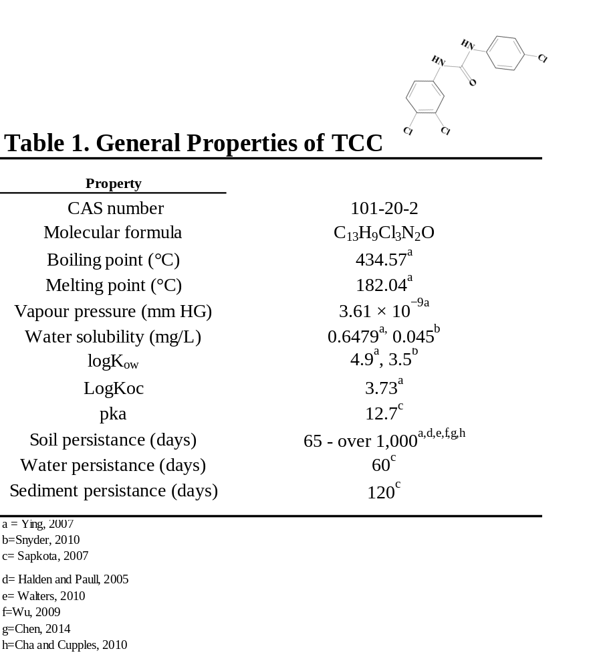
Appendix

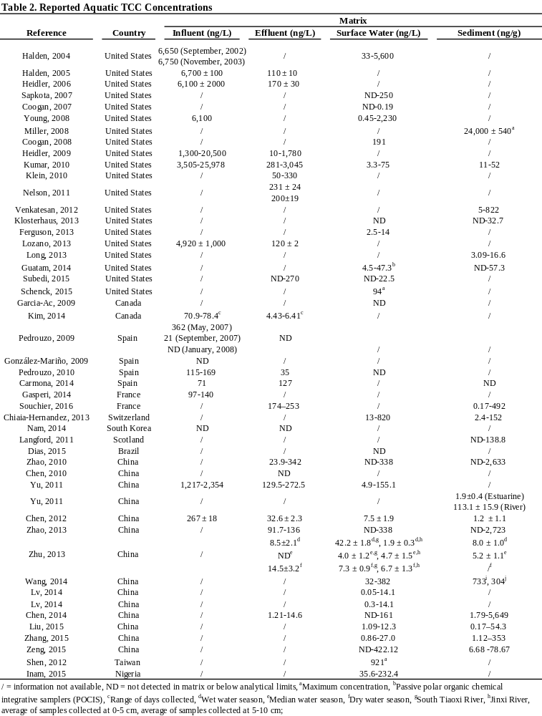

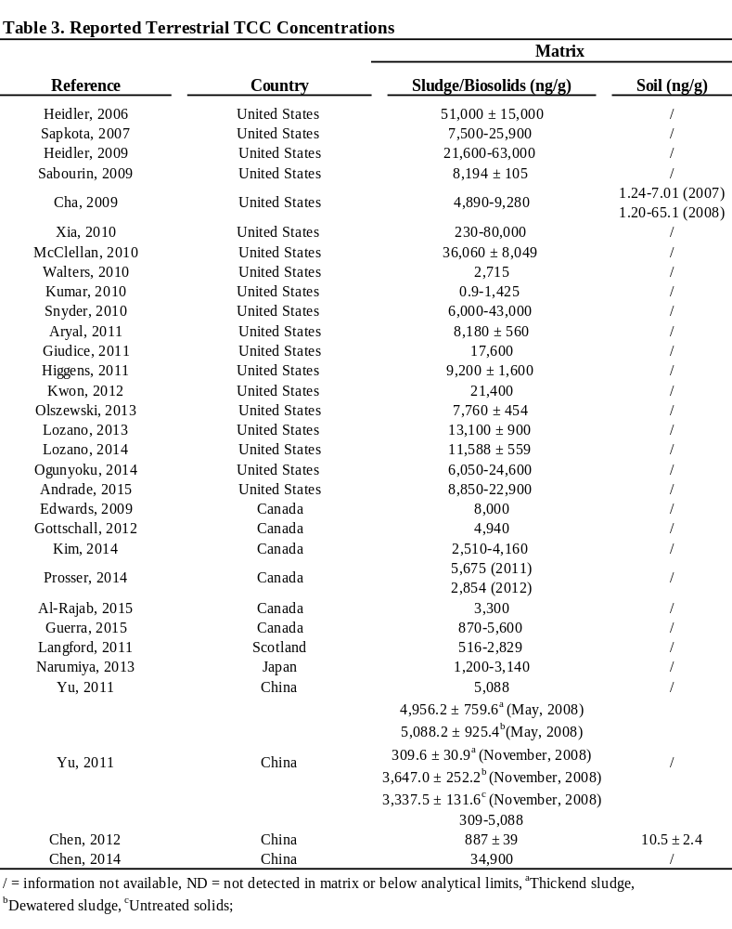

CHAPTER ii
Early Life Triclocarban Exposure during Lactation Affects Neonate Rat Survival

A version of this chapter was originally published by Rebekah C. Kennedy, Fu-min Menn, Laura Healy, Kellie Fecteau, Pan Hu, Jiyoung Bae, Nancy Gee, Bill Lasley, Ling Zhao and Jiangang Chen:
Kennedy RC, Menn FM, Healy L, Fecteau KA, Hu P, Bae J, Gee NA, Lasley BL, Zhao L, Chen J. Early Life Triclocarban Exposure during Lactation affects Neonate Rat Survival. Reprod Sci. 2015;22(1):75-89.

No revisions were made to the original published manuscript beyond general formatting to allow consistency through the dissertation. RCK and JC performed the research, analyzed the data, wrote the manuscript and contributed to study design. TCC concentration in blood and milk samples of lactating rats and neonates were analyzed by FM. TCC concentration in samples prior to parturition were analyzed by NG and BLL. Tissue histology was analyzed by LH. KF conducted hormone analysis. PH and JB assisted with animal necropsy. All authors contributed to the writing of the manuscript.

Abstract
Triclocarban (3,4,4’-trichlorocarbanilide; TCC), an antimicrobial used in bar soaps, affects endocrine function in vitro and in vivo. This study investigates whether TCC exposure during early life affects the trajectory of fetal and/or neonatal development. Sprague Dawley rats were provided control, 0.2% weight/weight (w/w), or 0.5% w/w TCC-supplemented chow through a series of 3 experiments that limited exposure to critical growth periods: gestation, gestation and lactation, or lactation only (cross-fostering) to determine the susceptible windows of exposure for developmental consequences. Reduced offspring survival occurred when offspring were exposed to TCC at concentrations of 0.2% w/w and 0.5% w/w during lactation, in which only 13% of offspring raised by 0.2% w/w TCC dams survived beyond weaning and no offspring raised by 0.5% w/w TCC dams survived to this period. In utero exposure status had no effect on survival, as all pups nursed by control dams survived regardless of their in utero exposure status. Microscopic evaluation of dam mammary tissue revealed involution to be a secondary outcome of TCC exposure rather than a primary effect of compound administration. The average concentration of TCC in the milk was almost 4 times that of the corresponding maternal serum levels. The results demonstrate that gestational TCC exposure does not affect the ability of dams to carry offspring to term but TCC exposure during lactation has adverse consequences on the survival of offspring although the mechanism of reduced survival is currently unknown. This information highlights the importance of evaluating the safety of TCC application in personal care products and the impacts during early life exposure.

Introduction

Numerous empirical and epidemiological studies have linked exposure to various compounds found in consumer and personal care products with altered endogenous signaling and/or function of endocrine/reproductive systems.¹ Emerging evidence of daily contact with these compounds has raised public concern regarding the potential ecological and human health impacts.² Widely used as an antimicrobial in personal care products, triclocarban (3,4,4′-trichlorocarbanilide; TCC) is a high production volume antimicrobial, at a mass of up to 1.5% in certain brands of bar soaps.^{3,4} Once applied, the compound is washed down the drain and enters the wastewater treatment process.⁵ The removal of TCC through wastewater treatment is insufficient however, accounting for the pervasive existence of TCC in both US and international waterways and contributing to its bioaccumulation in aquatic species.⁶⁻¹⁰ Following wastewater treatment, TCC has a robust propensity to partition to sludge due to its hydrophobic nature (log K_{ow} = 4.9) allowing for potential transfer to the terrestrial environment when a significant proportion of this nutrient-rich sludge is applied as fertilizer in agriculture use.^{5,11,12} As a consequence, TCC has been detected at the ppm level in biosolid-amended soil and is environmentally persistent with a reported half-life of 87 to greater than 1000 days.¹³ These observations raise safety concerns regarding the potential transfer to the food chain. In fact, TCC uptake from biosolid amended soil has been shown in a variety of plants meant for human consumption, including pumpkin, zucchini and soybean plants.^{12,14}
TCC can be absorbed through the skin during the regular use of TCC-containing personal care products.^{15,16} TCC has been detected in 35% of human adult urine and 44% of serum samples in the US.¹⁷ Experimentally, a study conducted in a small group of human volunteers demonstrated that peak circulating TCC levels could reach up to 530 nM, 3 hours after a single 15 minute whole body shower with soap containing 0.6% TCC.¹⁵ It is worth noting that a background TCC level of 285nM was detected in a volunteer who was a routine user of TCC-containing personal care products, indicating that frequent application of personal care products containing TCC may lead to a significant body burden. ¹⁵ The widespread existence, high environmental persistence and the direct human exposure to TCC, therefore warrants further investigation into its effective biological impact on human health.
Several lines of evidence demonstrate that TCC is a potential endocrine disrupting chemical (EDC) with the capacity to modulate androgen and estrogen activity as well as other hormone-mediated biological processes in vitro and in vivo in the adult rat and other animal models. ¹⁸⁻²⁴ Although the underlying mechanism(s) of TCC’s action is unclear and could be diverse, collectively, evidence implicates that TCC exposure may adversely impact endogenous hormone action resulting in the deviation from normal homeostatic, physiological control and therefore adversely affect pregnancy as well as reproductive outcomes. ^{18,19,21,25,26}
Timing of exposure is the key to human disease, specifically if the exposure occurs during early life. ^{27,28} Early life development in utero is complex, tightly under endogenous signal control and susceptive to subtle endogenous/exogenous environmental insult. ^{29,30} The general consensus by the research community suggests that a significant proportion of disease burden among children is due to modifiable environmental factors.²⁷ The so-called “embryo-fetal origins of adult disease” indicates exposure of environmental factors to a developing fetus or infant may have very different consequences from the same exposure to an adult. The interaction between the maternal and external environment also plays a major role in determining the propensity of an individual to develop a disease or dysfunction later in life.²⁷ The growing public anxiety regarding the identification of an increasing number of synthetic compounds in biological samples of children further justifies the urgent need to document the adverse effects of early life exposure to these compounds.³¹
Data with respect to the potential impacts of TCC during early life exposure however, are scarce. The only published data are available from Nolen and colleagues, who reported that chow supplementation of 21-23 day old rats with 0.25% weight/weight (w/w) of a 2:1 mixture of TCC and 3-trifluoromethyl-4,4’-dichlorocarbanalide (TFC) for 8 weeks prior to breeding and continuously throughout gestation reduced the survival rate of neonates.³² As an antimicrobial, TFC is no longer used. While these data reflect the impact of the mixture on reproductive outcomes, the relatively extended exposure period prior to gestation as well as the fact that TFC is considered slightly more toxic than TCC, leaves several fundamental questions regarding TCC’s toxicity largely unanswered and prevents the research community, public and regulatory agencies from obtaining a better understanding of the safety of the compound. This study aims to address two primary questions: 1) whether early life TCC exposure alone will alter the trajectory of fetal and/or neonatal development and 2) if it does, what is/are the susceptible window(s) of exposure for the observed developmental outcomes. In addition, the reproductive endpoints in surviving F1 offspring were also evaluated. In this report, three experiments directed to address these questions were carried out in Sprague Dawley (SD) rats.

Materials and Methods

Animals
Pregnant SD rats (Harlan Laboratory, Dublin, VA) were housed individually with Harlan Teklad laboratory grade 7087 soft cob bedding (Harlan Laboratories, Madison, WI) in clear plastic cages in a room with a 12:12 h photoperiod, temperature of 20–22 °C and a relative humidity of 40–50%. A separate group of animals was used for each experiment. The day after mating was designated as gestational day 1 (GD 1). On GD 5, dams were weight ranked and randomized to control or treatment groups to produce similar average body weights per group. All randomizations in the report were achieved by using a computer random number generator (random.org). While the treatments were not blinded, the blood/ milk chemical analysis as well as tissue pathological evaluation were all blinded to evaluators. Animals were provided ad libitum access to water and commercial Harlan ground 2020X chow or 2020X supplemented with TCC (purity=99%, Sigma Aldrich, St.Louis, MO) at a concentration of 0.2% or 0.5% w/w. This diet is a soy protein-free rodent chow that contains an isoflavone concentration (daidzein+genistein agylcone equivalents) which is less than 20 mg/kg and is ideal for studying the impacts of xenobiotics on neonatal development and reproductive function since background phytoestrogen levels are minimized. The TCC supplemented chow was prepared weekly by first weighing the correct amount of TCC and mixing the compound with small amounts of powdered chow using a mortar and pestle. This mixture was then added and mixed into a pre-weighed amount of powdered chow to obtain the required concentration. Fresh supplemented chow was added to feeding containers as needed. Food intake was measured every other day starting on GD 15. Doses were chosen based on previous studies in castrated adult and immature rats as well as a multi-generation TCC exposure study conducted in the rat. ^{1818,19,32} Administration of TCC in chow was chosen as the exposure route, which was used in our previous studies. Exposures by dermal and oral routes lead to similar metabolic profiles in rat and human, although there is no direct evidence to compare the internal concentrations achieved between rats and human beings.³² All protocols used in the study were approved by the Animal Use and Care Committee at the University of Tennessee Knoxville and the studies were conducted in an animal facility fully accredited by the Association for Assessment and Accreditation of Laboratory Animal Care.

Experiment I —Concentration of TCC in maternal serum and amniotic fluid
Starting on GD 5, dams were either fed with control (n=4) or TCC supplemented chow (0.2% w/w, n=5 or 0.5% w/w, n=5). On GD 19, maternal blood was collected between 0800 AM and 1200 PM prior to sacrifice. At necropsy, amniotic fluid was collected and total number of fetuses as well as number of implantation sites were counted. Systemic organs (liver, kidney, adrenal), and sex organs (ovary) were dissected and weighed. Tissue sections were examined with routine hematoxylin-eosin staining and histological changes were evaluated by a board-certified histopathologist blinded to treatment group. Serum and amniotic fluid samples were frozen at −80 °C until analysis.

Experiment II: in utero/lactational TCC exposure and neonate survival
  - IIa. TCC exposure on neonate survival
To determine the consequence of early life TCC exposure, on GD 5 pregnant animals (n=5 per group) were weight ranked and randomly assigned to groups. Dams were fed either rat chow or chow supplemented with 0.5% w/w TCC from GD 5 until weaning at postnatal day (PND) 21. On the day of delivery (PND 0), total neonate number was recorded and the survival of pups was monitored daily during the study period. Dams were terminated either on PND 21 or on the day when remaining pups died and mammary tissue was removed for histological analysis.
  - IIb. TCC exposure during lactation on mammary tissue
The size of the milk bands indicates an estimate of amount of milk consumed. ³³ This measure is shown to correlate with stages of deprivation in the rat. Through this assessment it is possible to determine if milk has been transferred to the pups as the bands are visible through the skin. ³³ To assess if TCC exposure could directly reduce the lactational capacity of the mammary glands (i.e. induce involution) thereby affecting the pup survival, all pups were examined daily for the presence and size of milk bands. Milk bands were rated as described by Ruppert and colleagues.³³ Briefly, 0-no band visible; 1-small band visible on the side of pup; 2- small band visible across pup’s abdomen, and 3-large band visible across pup’s abdomen. Pregnant (GD 5) dams were weight ranked and randomized by body weight into groups fed either rat chow (n=6) or chow supplemented with 0.5% w/w TCC (n=3) from GD 5 until PND 6. After delivery at PND 0, litter size was culled to 6 from all 3 of 0.5% w/w treated dams and only 2 control dams. No culling was conducted for the rest of the control dams (n=4) which served as reserve controls to provide healthy pups to the treated dams as described below.
Starting on PND 1, healthy age-matched pups (n=3) born to the 4 reserve control litters were added to replace half (n=3) the pups raised by TCC treated dams to maintain normal suckling activity (Figure 1a). Therefore by PND 1, all 0.5% w/w treated dams carried 6 pups (3 born to 0.5% w/w TCC treated dams and 3 born to reserve control dams). On PND 3, the same procedure was conducted as PND 1, except 3 healthy control pups born to the 4 reserve control dams were added to treated dams to replace the pups previously transferred on PND 1 from reserve control dams. Therefore, on PND 3, all 0.5% w/w TCC treated dams carried 3 of her own pups and 3 new pups transferred from reserve control dams. At PND 6, the procedure was again conducted except that 3 healthy age-matched pups born to the reserve control dams were added to each treated dam to replace the remaining 3 pups originally born to 0.5% w/w treated dams. After the above manipulation on PND 6, pups nursed by the treated dams were all born to reserve control dams. The same substitution procedure was conducted once more on PND 9 and this time the 3 pups transferred from reserve control dams to treated dams on PND 3 were replaced. Milk band quantification comparison was only conducted between control born/raised animals and 0.5% w/w born/raised animals on PND 1, PND 3, and PND 6, the last day before all the pups born to TCC treated dams were replaced with pups born to reserve control dams. All dams were terminated on PND 14 and mammary tissue was removed for histological analysis.
  - IIc. TCC concentration in biological fluids
To measure the concentration of TCC in biological fluid during lactation, starting on GD 5, dams were either fed with control (n=3) or TCC supplemented chow 0.2% w/w (n=4) or 0.5% w/w (n=3) until PND 6. Dams were weight ranked and randomly assigned to groups. In addition, a separate population of 3 control dams were used as reserves to provide healthy pups to maintain suckling activity. After delivery, the litter size was culled to six. No culling was conducted for the 3 reserve control dams. On PND 3, healthy age-matched pups (n=3) born to reserve control dams were added to each litter of treated dams to replace 3 treated born/raised pups to maintain suckling activity. On PND 5, all dams were individually housed without neonates for 22 hours to increase milk production/accumulation in mammary glands.³⁴ The remaining 3 treated born pups from each TCC treated dam group were sacrificed on PND 5 and pup blood samples were pooled within each litter and frozen at -80 °C for future TCC analysis. On PND 6, all dams were sacrificed and blood samples were collected. At necropsy, mammary tissue/fat pads of dams were carefully separated from the underlying muscles by a cut along the ventral midline. Mammary glands were then open from inside without penetrating the skin and pooled milk was collected.

Experiment III-- in utero and/or lactational TCC exposure on the survival of F1 female rats (cross-fostering study)
  - Cross-fostering and survival assessment
To identify the susceptive windows of gestational and postnatal TCC exposure to offspring survival, on GD 5 pregnant animals (n=5 per group) were weight ranked and randomly assigned to groups. Dams were then fed with rat chow or chow supplemented with either 0.2% or 0.5% w/w TCC. Supported by our observation that none of the pups could survive when they were nursed by the 0.5% w/w supplemented dams regardless of their gender (experiment II) and the observation that all the pups nursed by control dams survived, however whether pups were raised by 0.2% w/w supplemented dams could survive was unknown and was one of the primary objectives. To create a manageable workload for the cross-over study, only females were used in this experiment. On PND 0, female pups were weighed and sexed based on anogenital distance (AGD). AGD is defined as the distance between the base of the genital papilla and the rostral end of the anal opening.³⁵ Litter size was culled to 6 females by random removal of pups on PND 0 right after sexing. Specifically, individual pups in each litter were randomly marked with a number using a permanent marker. The numbers were entered into a computer random number generator (random.org) and the order of the numbers was randomized. Pups labeled with the first six randomized numbers were kept for the subsequent experiments. After culling, on PND 0, a cross-fostering design was implemented within each litter. Briefly, each dam carried and nursed 2 female pups from her own original litter and fostered 2 female pups from each of the two other treatment groups (Figure 1b). In this manner, each control dam raised 2 of her own pups, 2 pups born to 0.2% w/w treated dams and 2 pups born to 0.5% w/w treated dams. Each 0.2 % w/w treated dam raised 2 of her own pups, 2 pups born to 0.5% w/w treated dams and 2 pups born to control dams. Finally, each 0.5% w/w treated dam raised 2 of her own pups, 2 pups born to control dams, and 2 pups born to 0.2% w/w treated dams. The treatment regimen continued from GD 5 throughout lactation until sacrifice either on weaning/PND 21 or on the same date when all pups died. At PND 3, all pups were reweighed and AGD was measured. Pup mortality was monitored daily throughout the experiment. At PND 4 and 5, three pups raised by 0.5% w/w treated dams with greater than a 20% body weight loss over two consecutive days were used for pathological assessment.
  - Vaginal opening (VO) and estrous cyclicity assessment
On PND 21, all surviving female offspring from Experiment III were weighed, weaned, and AGD was measured. All offspring raised by the same dam were thereafter housed separately with 3 offspring in each cage. The onset of puberty was assessed in female offspring daily from PND 30 to 54 for vaginal opening (VO), which is considered as a marker of the onset of puberty in rats.³⁶ All animals were weighed every other day until VO was achieved and the weight of animals on the day of VO was recorded.
All females that displayed VO were assessed for estrous cyclicity by daily vaginal lavage (smears). Vaginal smears were taken between 0830 AM and 1030 AM each morning and examined without stain under light microscopy (×20). The relative abundance of leukocytes, nucleated epithelial cells, and cornified epithelial cells was assessed and cycle stage (day) for each animal was determined.³⁷ The time from VO until the first date of estrous was documented and the cycle stage was recorded until termination on the day of the estrous just prior to or shortly after PND 54. At termination, systemic and sex organs were removed and weighed.

Hormone and TCC measurements in biological samples
Maternal (Experiment I on GD 19: n=4, control; n=5, 0.2% w/w; n=5, 0.5% w/w and Experiment IIc on PND 6: n=3, control; n=4, 0.2% w/w; n=3, 0.5% w/w) and neonatal serum (Experiment IIc on PND 5: n=3 control; n=4, 0.2% w/w; n=3, 0.5% w/w), and amniotic fluid samples (Experiment I on GD 19: n=4, control; n=5, 0.2% w/w; n=5, 0.5% w/w) were analyzed for TCC. First, 50 µl of serum was added into 800 µl of ethyl acetate. Following agitation for 1 hour, 400 µl of liquid was removed from the solution, dried under gentle nitrogen stream and the residue was re-dissolved in 100 µl of acetone prior to analyze by LC-MS-MS. For analysis of TCC from milk, 100 µl of pooled milk sample was mixed with 600 µl of 2-propanol. The mixture was vortexed for 5 minutes at the highest speed followed by centrifugation at 4º C at x5000g for 50 minutes. Three hundred microliters of supernatant was then removed and mixed with 600 µl of water plus 600 µl of ethyl acetate. The mixture was vortexed for another 5 minutes at highest speed followed by centrifugation for 20 minutes at 4º C at x5000g. After centrifugation, 300 µl of supernatant was collected, dried under nitrogen and the residue was re-dissolved in 100 µl of acetone prior to measurement by LC-MS-MS. TCC sample extracts were analyzed on a Dionex UltiMate 3000 UHPLC system coupled to a triple stage quadrupole mass spectrometer (TSQ Quantum Access Max MS/MS, Thermo Scientific, Waltham, Massachusetts). A Hypersil GOLD PFP column (2.1X100 mm 1.9 µm, Thermo Scientific, Waltham, Massachusetts) was used for HPLC analysis and temperature was held at 38˚C for column compartment. The autosampler tray temperature was set at 5˚C. The solvent system consists of H₂O with 0.02% acetic acid (mobile phase A) and methanol (mobile phase B). The analyte was separated using a gradient program starting with T (minute)=0, A=40%, B=60% at 0.3 mL/min; T=3, A=2%, B=98% at 0.3 mL/min; T=5.5, A=2%, B=98% at 0.3 mL/min; T=5.6, A=2%, B=98% at 0.35 mL/min; T=12, A=2%, B=98% at 0.35 mL/min; T=12.1, A=40%, B=60% at 0.35 mL/min; T=18.5, A=40%, B=60% at 0.35 mL/min and T=18.6, A=40%, B=60% at 0.3 mL/min. Detection and quantification of TCC was analyzed under negative ion electrospary ionization (ESI-) using selective reaction monitoring (SRM) and parameters for MS condition were: Spray Voltage (V): -3350; Tube Lens (V): 215; Vaporizer Temp: 425 ˚C; Capillary Temp: 200 ˚C; Sheath gas pressure: 20.0 arb units; Aux gas pressure: 2.0 arb units; Collision gas pressure (mTorr): 1.5 and Cycle time (s): 0.45. The m/z 312.718 and 160.000 were used as precursor and product ion, respectively.
For hormone analysis, circulating progesterone, testosterone, total T3, and total T4 were measured using commercial radioimmunoassay (RIA) kits (Coat-A-Count, Siemens, Los Angeles, CA). 17ß-Estradiol levels were measured using ImmunChem Double Antibody RIA kit (MP Biomedicals, Solon, OH). Thyroid-stimulating hormone concentrations were analyzed with an RIA kit specific for rat TSH (MP Biomedicals, Germany).

Energy expenditure assessment
The impact of TCC treatment on energy expenditure of pregnant animals and offspringwas monitored using Oxymax Comprehensive Lab Animal Monitoring System (CLAMS, Columbus Instruments, Columbus, Ohio).³⁸ On GD 13, pregnant dams (Experiment III) and on PND 41 randomly selected neonates (Experiment III) from each respective group were housed individually in a chamber with a 12-h light/12-h dark cycle and an ambient temperature of 22–24°C. Animals were acclimated to the system for 12 hours before data was collected. Carbon dioxide production (Vco₂) and oxygen consumption (Vo₂) were collected every 35 minutes over a 24 h period. The respiratory exchange ratio (RER) was calculated as Vco₂/Vo₂ ratio.

Statistical analysis
Data were presented as group mean±SEM. Data were analyzed using SPSS (version 20, IBM, Armonk, NY) by ANOVA (i.e. organ weights, body weight, AGD, TCC and hormone concentration), or ANOVA with repeat measurements (i.e. changes of AGD and body weight over time). In addition, data were analyzed with a covariate of PND 21 body weight (offspring) or pre-treatment body weight (dams) when appropriate. Milk band rating was analyzed with a non-parametric Mann-Whitney U test. Mortality measurements were analyzed by Kaplan-Meier survival analysis with JMP Pro 10, followed by pairwise Student-Newman-Keuls post hoc test when appropriate. Statistical significance was considered p < 0.05. Data were transformed if either normality or the equal variance assumption was invalid. If transformation did not correct normality or equal variance assumption, Kruskal-Wallis One-Way Analysis of Variance on Ranks was used.

Results

Experiment I: TCC exposure during pregnancy
  - Maternal and fetal compartment TCC concentrations
TCC concentration in maternal serum and amniotic fluid was measured from samples collected at necropsy on GD 19. The mean concentrations of TCC in the serum collected from TCC supplemented dams (0.5% w/w: 116.25±22.2; 0.2% w/w: 82.48±17.6 ng/mL) were significantly higher than controls (0.67±0.3 ng/mL, p<0.05, Figure 2a). Similarly, significantly higher levels of TCC were detected in amniotic fluid from the TCC treated dams with a mean concentration of 11.10±1.9 ng/mL detected in 0.2% w/w TCC treated group and 14.64±2.0 ng/mL in 0.5% w/w TCC treated group compared to 0.42±0.01 ng/mL detected in control dams (p<0.05, Figure 2b).
  - Maternal and pregnancy data
The average terminal body weight of 0.5% w/w treated dams was 6.7% less than that of control dams on GD 19. Maternal body weight gain from GD 5-19 in 0.5% w/w treated group was significantly less compared to both control dams and 0.2% w/w TCC supplemented dams but there was no statistical difference in body weight gain between the control and 0.2% w/w TCC supplemented group (Table 4). TCC treatment at any dose had no effect on implantation number. Neither systemic nor sex organ weights at necropsy were significantly different between any group (Table 4). At necropsy on GD 19, circulating levels of estradiol, progesterone, testosterone, T4 and TSH were measured with no significant difference revealed among any group. T3 levels were significantly decreased among dams provided 0.5% w/w TCC supplemented chow relative to control and 0.2% w/w treated dams (Table 4). Gross physiological examination and histological evaluation of organs collected at necropsy showed no significant anomaly among treated dams compared to controls (data not shown).

Experiment IIa. TCC exposure in utero/lactational
  - Neonate Survival
At birth, no statistical difference in number of live births or average birth weight per litter between groups was noted (data not shown). While 0.5% w/w TCC treatment did not affect the ability of dams to carry neonates to term, survival analysis revealed that supplementation of 0.5% w/w TCC during gestation and lactation affected neonate survival throughout the experiment (Figure 3). Neonates born to and nursed by 0.5% w/w TCC treated dams could not survive beyond PND 8; however, all neonates born to and nursed by control dams survived until weaning.
  - Maternal data
No statistical food intake difference was noted (control, 18.52 ±1.1g; 0.5% w/w 19.06 ±1.4g) on GD 19. All TCC exposed dams were sacrificed right after all pups were deceased (between PND 5 and 8). Control dams were sacrificed on PND 21. Milk bands were observed in pups raised by dams treated with 0.5%w/w TCC and histology of mammary tissue collected from both control and 0.5% w/w TCC supplemented dams revealed evidence of retained secretory material in the tissues. However, the mammary glands collected from 0.5% w/w dams had evidence of involution showing increased lobule separation by interstitial mature fat, thinning epithelial height, and increased epithelial vacuolation with fat (Figure 4, panel a and b and c).
  - IIb. Effect of TCC exposure on mammary tissue during lactation
In the experiment (Figure 1a) designed to differentiate if the decreased neonate survival was secondary to TCC’s effect on the reduction of the lactational capacity of the mammary glands (i.e. TCC induces involution), milk band scores were similar between PND 1 and PND 3 (median: 3 in 0.5% w/w born/raised pups and control pups). However, the milk band size decreased over time after PND 3. On PND 6, the median milk band score was 0 in 0.5% w/w born/raised pups and 2 among pups born/raised by control dams (Mann-Whitney test, p<0.05). Compared to results from control dams (Figure 4 panel d), histology evaluation revealed that mammary tissue collected from treated dams on PND 14 was not involuted when additional healthy pups were continuously provided on PND 3, PND 6 and PND 9 to maintain normal suckling activity (Figure 4, panel e).
  - IIc. TCC concentration in biological fluids
TCC concentration on PND 6 was measured from maternal blood and milk. TCC level in pooled blood samples collected from neonates on PND 5 were also analyzed (Figure 5). Maternal serum TCC concentration significantly increased with either concentration of TCC in the chow compared to controls at 0.19±0.11 ng/mL in control dams (n=3), to 134.6±15.4 ng/mL in 0.2% w/w TCC treated dams (n=4) and 230.3±77.3 ng/mL in 0.5% w/w TCC treated dams (n=4) (p<0.05, Figure 5). Following the same pattern, a dose-dependent increase of TCC in maternal milk samples was observed among groups [control (n=3): 0.23±0.14 ng/mL; 0.2% w/w (n=4): 510.99±122.8 ng/mL and 0.5% w/w (n=4): 917.8±88.9 ng/mL] with significance shown between 0.5% w/w, 0.2% w/w and control collected milk (p<0.01, Figure 5). High levels of TCC were also detected in pooled neonate serum samples raised by TCC treated dams in both groups compared to controls on PND 5 (0.5% w/w: 136.20±55.86 ng/mL; 0.2% w/w: 13.87 ± 8.5 ng/mL vs. 0.56±0.23 ng/mL in controls, p<0.05, Figure 5); pups raised by 0.5% w/w treated dams showed significantly higher serum levels of TCC than 0.2% w/w raised pups (Figure 5).

Experiment III. TCC exposure in utero/lactational (cross-fostering study)
  - Maternal data
At birth, no statistical difference in number of live births or average birth weight per litter between groups was noted (data not shown). There was no significant difference in respiratory exchange ratio (RER) (0.5% w/w: 0.97±0.01; 0.2% w/w: 0.96±0.01 and control: 0.98±0.01). After birth, dams were continuously exposed to either treated chow or control chow in the manner provided prior to delivery.
  - F1 female generation data
There was no initial statistical body weight difference in female pups born to control dams or pups born to either group of treated dams prior to the culling on PND 0 (control: 5.84±0.17 g; 0.2% w/w: 5.81±0.13 g; 0.5% w/w: 5.45± 0.24 g ). After the cross-fostering manipulation, each dam nursed 2 of its own pups and 2 pups from each of the other two treatment groups (Figure 1b). All dam groups (n=5 in each group) raised 30 pups (10 pups born to 0.5% w/w TCC treated dams, 10 pups born to 0.2% w/w TCC treated dams and 10 pups born to control dams). A total of 90 pups were manipulated in Experiment III. Average pup body weight in each group after the crossover manipulation at PND 0 was similar among the control, 0.2% w/w TCC and 0.5% w/w TCC fed group (Table 3). Starting on PND 3, body weight and AGD were measured every two days. Postnatal maternal treatment status significantly affected pup body weight as measured between PND 3-PND 9. Average body weight was significantly less in pups nursed by TCC supplemented dams at PND 3 with a 16% decrease found in pups raised by 0.2% w/w TCC treated dams and a 25% decrease observed among pups raised by 0.5% w/w TCC treated dams compared to the counterparts raised by control dams (p<0.05, Table 2). Within each dam group however, no statistical body weight difference was observed among the pups with different in utero exposure status ( i.e. born to a 0.5% w/w TCC treated, 0.2% w/w TCC treated or a control dam) at PND 3, PND 6, and PND 9 respectively (Table 6).
Pup mortality was followed throughout the study. A significant reduction in pup number over time was observed between pups raised by 0.5% w/w , or 0.2% w/w TCC treated dams compared to those raised by controls (p<0.05, Figure 6A and B). No pups raised by 0.5% w/w TCC treated dams survived beyond PND 5 regardless of in utero exposure status (n=30) (Figure 6A). The majority of pups (27 out of 30) raised by 0.2% w/w TCC treated dams survived to PND 6 but only 4 animals in this group survived beyond weaning day (all raised in the same litter with 2 offspring born to control dams and 2 offspring born to 0.5% w/w TCC treated dams) (Figure 6B). In contrast, all pups raised by control dams survived throughout the study period regardless of in utero exposure status (n=30). The abdomens of all the pups raised by dams exposed to either TCC concentrations were distended and all had diarrhea. Gross pathological examination of randomly selected pups (n=3) raised by the 0.5% w/w dams on PD 4 and 5 showed small acute gastric ulcers and fatty vacuolation of hepatocytes (data not shown). The effect was found in all 3 animals examined, however the small sample size may not provide a definitive conclusion.
Because surviving animals in the 0.2% w/w TCC supplemented group (n=4) were all raised by the same dam, statistical analysis based on litter could not be conducted. Therefore, only group means were provided for all relevant parameters derived from these 4 surviving offspring. At weaning, the average body weight of the 4 surviving offspring raised by the 0.2% w/w TCC treated dam was approximately half that of offspring raised by control dams (Table 5). The average RER measured on PND 41 from the 4 surviving offspring raised by 0.2% w/w dams was similar compared to the RER measured from offspring (n=12) raised by control dams (0.99 and 0.97±0.01 respectively). Among control raised offspring, average RER was similar when analyzed by their respective in utero status (data not shown).
No statistical difference of AGD indexed by cube root of body weight (at the time AGD was acquired) was detected on PND 3 among offspring raised by different dam groups. Similarly, no statistical difference of AGD indexed by cube root of body weight was detected on PND 6 between offspring raised by 0.2% w/w TCC treated dams compared to those raised by control dams (Table 5). At weaning, the mean relative AGD of the 4 remaining pups was 2.51(mm/³√g) compared to 2.46 (mm/³√g) from offspring born and raised by control dams (Table 3). In utero status had no effect on AGD, VO date, or first date of estrus after VO (data not shown).
The average age of VO in the 4 surviving offspring raised by the 0.2% w/w TCC treated dam was 38.5 days while the average age of VO from offspring raised by the control dams was 37.17 days. Organ weight indexed by body weight of offspring raised by control dams on the day of sacrifice, categorized by in utero exposure status is shown in Table 4 with no significant difference noted between any groups for any organ analyzed.

Discussion
Knowledge regarding human and environmental risks to TCC exposure is currently limited, with available data only measuring TCC prevalence and persistence in the environment. Although no long term TCC exposure studies in humans have been reported, Schebb et al. demonstrated that after a 15 minute whole body shower with 0.6% TCC-containing bar soap, up to 1030 nM of TCC metabolites was detected in the urine of 6human volunteers.³⁹ The significant excretion suggests that absorbed TCC must be systemically available and thus present in blood.^{15,39} In fact, after a single 15 minute shower, peak circulating level of TCC was detected within 3 hours with a range between 10 to 530 nM.¹⁵ Interestingly, a high TCC background level of 285±5 nM was reported in the circulation of a subject who used TCC-containing personal care products regularly compared to other volunteers.¹⁵ These data indicate that routine users of TCC-containing products may have a high body burden.
Human exposure through the diet has not been explored. The pharmacokinetic profile of long term TCC exposure in the chow goes beyond the scope of the current study, nonetheless, after 14 days of oral exposure between GD 5 and GD 19, we detected an average circulating level of 82.48±17.6 ng/mL (261.36 nM) and 116.25±22.2 ng/mL (368.37 nM) TCC in 0.2% and 0.5% w/w treated SD rats respectively (Experiment I), a level within the range of reported human exposure data.¹⁵ A similar dose dependent detection of TCC was identified in the fetal compartments. We detected 11.10±1.9 ng/mL and 14.64±2.0 ng/mL TCC in the amniotic fluid of 0.2% and 0.5% w/w TCC groups respectively, showing the transplacental transfer of TCC during gestation. The wide range of the TCC concentration in circulation of pregnant rats after exposure (0.2% w/w: 39.85-145.37 ng/mL; 0.5% w/w 71.33-171.85 ng/mL) (Experiment I), may reflect the inter-individual difference in TCC absorption, distribution and excretion, a similar scenario that has been reported in humans.¹⁵
Nolen et al. reported that a 2:1 mixture of TCC and a another antimicrobial compound 3-trifluoromethyl-4,4’-dichlorocarbanilide (TFC), compromises reproductive outcomes when rats were fed continuously with 0.25% TCC/TFC mixture in the chow for more than 11 weeks starting 8 weeks prior to pregnancy.³² A significant decrease in the average number of pups born/litter, average number of live pups/litter at PND 4 as well as the number weaned/litter was observed compared to the control group. When exposure was extended to cover the second pregnancy period, only an average of one offspring per litter was able to survive beyond weaning. In contrast, when the mixture was administrated only during the organogenesis period (PNDs 6-15), or for an extended period of time but only with 0.2% TCC/TFC mixture, no significant differences were detected by any of the criteria described above when compared to the controls. Therefore, Nolen et al. conclude that the maximum dietary concentration of the TCC/TFC mixture having no effect on reproduction should be between 0.20 and 0.25%. The authors further concluded that 0.25 % concentration of mixture had no effect when fed only during GDs 6-15.³² Only the extended exposure with 0.25% w/w TCC/TFC mixture (8 weeks prior to pregnancy plus entire pregnancy period) would affect the survival of the neonates.
While the results of Nolen’s are informative, it raises several critical issues. A 2:1 TCC/TFC mixture rather than an individual compound was tested.³² Subchronic studies indicate TFC is slightly more toxic than TCC, therefore the possibility that compromised reproductive outcomes observed by Nolen et al. may reflect an additive/synergistic effect of the two compounds cannot be ruled out. Since the use of TFC as an antimicrobial agent in personal care products has been phased out,³² it is essential to investigate if the administration of TCC alone would interfere with reproduction.
In our study, dose and length of TCC exposure does not appear to affect parturition; no statistical difference in number of implantation sites or the number of live births at delivery were observed in either TCC treatment group compared to controls even when 0.5% w/w TCC was administered (Experiment I and IIa). Further, we found no statistical difference in reproductive outcomes (AGD, vaginal opening, or estrous cycling) of the F1 generation of control raised animals born to different treatment groups (0.5% w/w, 0.2% w/w, or control). However, TCC exposure at 0.5% w/w affected neonate survival, with no survival beyond PND 8 among either male or female pups when the treatment regimen covered both pregnancy and lactation (Figure 3, Experiment IIa). Due to the mortality effects of TCC treatment on F1 offspring raised by treated dams, the small number of surviving offspring in the current study prevents a definitive conclusion regarding the examined reproductive outcomes.
To help further examine the potential susceptive windows of TCC exposure (in utero only, in utero plus lactation, or lactation only) that lead to the decline in neonate survival, a cross-fostering design was implemented (Figure 1b, Experiment III). Regardless of in utero exposure status, maternal exposure status during lactation significantly affected pup body weight (Tables 5 and 6). Compared to controls on PND 3, an average of a 16% and 25% body weight reduction was observed in pups raised by 0.2% and 0.5% w/w TCC treated dams respectively (Table 5). When control fed groups were stratified by gestational exposure status, no statistical body weight difference was observed among pups with different in utero exposure status ( i.e. pups raised by control dams but were born to either 0.5% w/w, 0.2% w/w TCC treated dams or control dams, Table 6).
All pups raised by control dams survived beyond weaning, regardless of in utero exposure status. In contrast, no pups raised by 0.5% w/w TCC treated dams survived beyond PND 5 regardless of the group they were born to (Figure 6B, Experiment III) and only 4 pups raised by 0.2% w/w TCC treated dams survived beyond weaning (Figure 6A, Experiment III). Collectively, these data implicate the critical TCC exposure window for neonate survival occurs during lactation, because even pups with no in utero exposure could not survive when raised by TCC treated dams and all pups raised by control dams survived even with gestational TCC exposure.
No statistical difference in energy expenditure was observed between any dam groups (Experiment III). We observed a 6.7% body weight decrease among 0.5% w/w TCC treated dams although it was not statistically significant. TCC treatment does not appear to affect milk production and transfer. Pathological evaluation of mammary tissue demonstrated involution of the mammary glands in TCC treated dams when necropsy was conducted between PND 5 and PND 8 after complete litter loss (Experiment IIa). To differentiate if the involution of the mammary gland was due to the TCC treatment (primary) or reduced stimulation on the mammary gland as an outcome of reduced neonate suckling when pups expired (secondary), healthy age-matched pups born to control dams were added to the TCC treated dams at various time points during lactation to maintain normal suckling activity and dams were sacrificed on PND 14 (Experiment IIb). Pups born to/raised by 0.5% w/w TCC treated dams had similar milk band size when compared to control pups on PND 1 and PND 3. The size of milk band was significantly smaller at PND 6 between pups born to/raised by 0.5% w/w dams compared to age-matched controls. Microscopic assessment revealed no sign of involution in mammary glands of treated dams that were provided continuously with healthy pup suckling stimulation. Together, our data suggest that the reduced survival in pups raised by TCC treated dams was unlikely due to the primary impact of TCC on the development and function of mammary glands.
We further compared the concentration of TCC collected from dam and neonate circulation and the milk from dams (Experiment IIc). As shown in Figure 5, a similar dose dependent pattern of TCC concentration was observed in the circulation of dams as well as in the pups that were raised by the treated dams. Interestingly, 510.9±122.8 ng/mL and 917.8±88.9 ng/mL of TCC was detected in the milk of the 0.2% and 0.5% w/w TCC treated dams respectively. This level of TCC in the milk was almost 4 times the amount detected in blood circulation from either group. These data imply that TCC concentrates in the milk. Although extrapolation to human exposure still requires further investigation, our data, nevertheless, highlight the potential of high levels of TCC exposure to neonates via lactation.
Several lines of evidence in the current study further support the hypothesis that TCC exposure during lactation influences the survival of the neonates. In treated pups, we observed small, acute gastric ulcers (indicating potential stress) and fatty vacuolation of hepatocytes in pups exposed to TCC during lactation (Experiment III). Post-mortem evaluation of neonates that expired prior to weaning had swollen abdomens, diarrhea and grossly enlarged, liquid filled ceca, which is consistent with observations in rodents with impaired gut microflora i.e. germ free mice or rodents orally treated with an excess of antimicrobials.⁴⁰ In germ free mice, an enlarged cecum starts during suckling. The appearance of an enlarged cecum is postulated to be due to the accumulation of macromolecular, sulfate-containing glycoproteins from the milk that normally are degraded by the microflora of the lower gut.⁴¹ These negatively charged macromolecules not only attract water into the cecal lumen, but also limit Na⁺-dependent water transport out of the cecum. The enlarged cecum thus could become a reservoir of pharmacologically active materials that may become bloodborne and affect the physiology of the animal.⁴¹
The existence of certain intestinal microbes could promote normal mammalian physiology including proper digestion, metabolism, epithelial cell function, angiogenesis, enteric nerve function, and immune system development.⁴² On the other hand, altered intestinal flora has been reported in patients with inflammatory bowel disease, allergies, or patients with metabolic syndrome, indicating that microbial populations might influence disease pathogenesis although the causality is still unclear.⁴³⁻⁴⁵ Imbalances in the composition of intestinal flora diversity could lead to dysfunction and chronic disease state. Antibiotics have been shown to drastically disrupt indigenous microbiota in animals as well as in humans, which could result in a long-term decrease of its overall diversity.^{42,46-48} Limited information from human and animals has shown antibiotic treatment can eliminate native intestinal microflora populations that normally compete with or otherwise antagonize invading pathogens, or induce the overgrowth of “pathogenic” components of gut microbiota.^{49,50} The disturbance of microflora therefore could result in diminishing the natural defense mechanisms provided by the colonic microbial ecosystem, making the host vulnerable to infection. Whether high levels of TCC exposure through lactation changes the intestinal microflora of the neonates affecting the establishment /colonization of different microflora in the gut or affects the survival of offspring requires further investigation.
Alternatively, TCC may alter the various processes by which milk components are synthesized and/or secreted or interfere with the delivery of substrate for milk formation and resulting composition^{51,52} Results from experiment IIb demonstrated that milk was transferred from dam to pups, however the effect of TCC exposure to the nutritional composition of the milk or its direct toxic effect is unknown. Artificial feeding methods could be used to control the nutritional composition of the milk and delivery of TCC,⁵³ to investigate the mechanisms of reduced survival.
In summary, our study demonstrates that early life 0.2% w/w and 0.5% w/w TCC exposure affects the survival of neonates. Although the current study by design could not reveal the underlying mechanism(s) of the reduced survival of F1 offspring during lactation, several lines of suggestive evidence support the hypothesis that TCC exposure during lactation influences the development of the neonates. The susceptive window of exposure is during lactation. While TCC exposure does not affect the ability of dams to carry neonates to term, few pups can survive beyond weaning if the pups are raised by 0.2% w/w TCC treated dams and no pups could survive when raised by 0.5% w/w treated dams, regardless of their in utero exposure status. Collectively, the results of our study demonstrate the need for future research to determine the mechanism of reduced survival during lactation and evaluate the impact of TCC-containing products on reproductive and developmental health in humans.
There are limitations to prevent full extrapolation of the results derived from animal studies to human exposure scenario. Human exposure to TCC through the use of TCC- containing personal care products are likely sporadic while the animals in the current study had ad libitum access to the TCC supplemented chow, therefore animals had constant TCC exposure. If problems occur during breastfeeding and infants failed to thrive, humans can make a decision to use formula, an option that animals do not have. Regardless of these limitations, the animal study data warn the potential risk of TCC exposure during lactation and underscore the importance to assess the levels of TCC exposure in lactating women who are also routine users of TCC-containing products and evaluate the impact of TCC-containing products to human health.

References

1. Witorsch RJ, Thomas JA. Personal care products and endocrine disruption: A critical review of the literature. Crit Rev Toxicol. 2010;40 Suppl 3:1-30.
2. Bergman Å, Heindel JJ, Susan Jobling, Kidd KA, Zoeller RT, eds. State of the Science of Endocrine Disrupting Chemicals - 2012. United Nations Environment Programme and the World Health Organization; 2013.
3. Perencevich EN, Wong MT, Harris AD. National and regional assessment of the antibacterial soap market: a step toward determining the impact of prevalent antibacterial soaps. Am J Infect Control. 2001;29(5):281-283.
4. Baumann A, Lohmann W, Rose T, et al. Electrochemistry-mass spectrometry unveils the formation of reactive triclocarban metabolites. Drug Metab Dispos. 2010;38(12):2130-2138.
5. Kwon JW, Armbrust KL, Xia K. Transformation of triclosan and triclocarban in soils and biosolids-applied soils. Journal of environmental quality. 2010;39(4):1139-1144.
6. Heidler J, Halden RU. Fate of organohalogens in US wastewater treatment plants and estimated chemical releases to soils nationwide from biosolids recycling. J Environ Monit. 2009;11(12):2207-2215.
7. Sapkota A, Heidler J, Halden RU. Detection of triclocarban and two co-contaminating chlorocarbanilides in US aquatic environments using isotope dilution liquid chromatography tandem mass spectrometry. Environ Res. 2007;103(1):21-29.
8. Zhao JL, Ying GG, Liu YS, Chen F, Yang JF, Wang L. Occurrence and risks of triclosan and triclocarban in the Pearl River system, South China: from source to the receiving environment. J Hazard Mater. 2010;179(1-3):215-222.
9. Coogan MA, Edziyie RE, La Point TW, Venables BJ. Algal bioaccumulation of triclocarban, triclosan, and methyl-triclosan in a North Texas wastewater treatment plant receiving stream. Chemosphere. 2007;67(10):1911-1918.
10. Coogan MA, La Point TW. Snail bioaccumulation of triclocarban, triclosan, and methyltriclosan in a North Texas, USA, stream affected by wastewater treatment plant runoff. Environ Toxicol Chem. 2008;27(8):1788-1793.
11. Snyder EH, O'Connor GA, McAvoy DC. Measured physicochemical characteristics and biosolids-borne concentrations of the antimicrobial Triclocarban (TCC). Sci Total Environ. 2010;408(13):2667-2673.
12. Wu C, Spongberg AL, Witter JD, Fang M, Czajkowski KP. Uptake of pharmaceutical and personal care products by soybean plants from soils applied with biosolids and irrigated with contaminated water. Environ Sci Technol. 2010;44(16):6157-6161.
13. Walters E, McClellan K, Halden RU. Occurrence and loss over three years of 72 pharmaceuticals and personal care products from biosolids-soil mixtures in outdoor mesocosms. Water Res. 2010;44(20):6011-6020.
14. Aryal N, Reinhold D. Phytoaccumulation of antimicrobials by hydroponic Cucurbita pepo. International journal of phytoremediation. 2013;15(4):330-342.
15. Schebb NH, Ahn KC, Dong H, Gee SJ, Hammock BD. Whole blood is the sample matrix of choice for monitoring systemic triclocarban levels. Chemosphere. 2012;87(7):825-827.
16. North-Root H, Demetrulias J, Wester R, Maibach H, Corbin N. Deposition of 3,4,4'-trichlorocarbanilide on human skin. Toxicol Lett. 1984;22(2):235-239.
17. Zhou X, Ye X, Calafat AM. Automated on-line column-switching HPLC-MS/MS method for the quantification of triclocarban and its oxidative metabolites in human urine and serum. J Chromatogr B Analyt Technol Biomed Life Sci. 2012;881-882:27-33.
18. Chen J, Ahn KC, Gee NA, et al. Triclocarban enhances testosterone action: a new type of endocrine disruptor? Endocrinology. 2008;149(3):1173-1179.
19. Duleba AJ, Ahmed MI, Sun M, et al. Effects of triclocarban on intact immature male rat: augmentation of androgen action. Reprod Sci. 2011;18(2):119-127.
20. Ahn KC, Zhao B, Chen J, et al. In vitro biologic activities of the antimicrobials triclocarban, its analogs, and triclosan in bioassay screens: receptor-based bioassay screens. Environ Health Perspect. 2008;116(9):1203-1210.
21. Chung E, Genco MC, Megrelis L, Ruderman JV. Effects of bisphenol A and triclocarban on brain-specific expression of aromatase in early zebrafish embryos. Proc Natl Acad Sci U S A. 2011;108(43):17732-17737.
22. Hinther A, Bromba CM, Wulff JE, Helbing CC. Effects of triclocarban, triclosan, and methyl triclosan on thyroid hormone action and stress in frog and mammalian culture systems. Environmental science & technology. 2011;45(12):5395-5402.
23. Zhao B, Baston DS, Hammock B, Denison MS. Interaction of diuron and related substituted phenylureas with the Ah receptor pathway. Journal of biochemical and molecular toxicology. 2006;20(3):103-113.
24. Schebb NH, Buchholz BA, Hammock BD, Rice RH. Metabolism of the antibacterial triclocarban by human epidermal keratinocytes to yield protein adducts. Journal of biochemical and molecular toxicology. 2012;26(6):230-234.
25. Giudice BD, Young TM. The antimicrobial triclocarban stimulates embryo production in the freshwater mudsnail Potamopyrgus antipodarum. Environ Toxicol Chem. 2010;29(4):966-970.
26. Ankley GT, Jensen KM, Kahl MD, et al. Use of chemical mixtures to differentiate mechanisms of endocrine action in a small fish model. Aquatic toxicology (Amsterdam, Netherlands). 2010;99(3):389-396.
27. Barker DJ. Fetal origins of coronary heart disease. BMJ. 1995;311(6998):171-174.
28. Skinner MK. Endocrine disruptors and epigenetic transgenerational disease etiology. Pediatr Res. 2007;61(5 Pt 2):48R-50R.
29. Crinnion WJ. Maternal levels of xenobiotics that affect fetal development and childhood health. Altern Med Rev. 2009;14(3):212-222.
30. Fligny C, Hatia S, Amireault P, Mallet J, Cote F. Mammalian prenatal development: the influence of maternally derived molecules. Bioessays. 2009;31(9):935-943.
31. Ye X, Zhou X, Wong LY, Calafat AM. Concentrations of bisphenol A and seven other phenols in pooled sera from 3-11 year old children: 2001-2002 National Health and Nutrition Examination Survey. Environ Sci Technol. 2012;46(22):12664-12671.
32. Nolen GA, Dierckman TA. Reproduction and teratogenic studies of a 2:1 mixture of 3,4,4'-trichlorocarbanilide and 3-trifluoromethyl-4,4'-dichlorocarbanilide in rats and rabbits. Toxicol Appl Pharmacol. 1979;51(3):417-425.
33. Ruppert PH, Dean KF, Reiter LW. Developmental and behavioral toxicity following acute postnatal exposure of rat pups to trimethyltin. Neurobehav Toxicol Teratol. 1983;5(4):421-429.
34. Brake SC. Procedures for the collection of milk from the rat dam. Physiol Behav. 1979;22(4):795-797.
35. Hotchkiss AK, Lambright CS, Ostby JS, Parks-Saldutti L, Vandenbergh JG, Gray LE, Jr. Prenatal testosterone exposure permanently masculinizes anogenital distance, nipple development, and reproductive tract morphology in female Sprague-Dawley rats. Toxicol Sci. 2007;96(2):335-345.
36. Ojeda SR, Wheaton JE, Jameson HE, McCann SM. The onset of puberty in the female rat: changes in plasma prolactin, gonadotropins, luteinizing hormone-releasing hormone (LHRH), and hypothalamic LHRH content. Endocrinology. 1976;98(3):630-638.
37. Marcondes FK, Bianchi FJ, Tanno AP. Determination of the estrous cycle phases of rats: some helpful considerations. Braz J Biol. 2002;62(4A):609-614.
38. Lou PH, Yang G, Huang L, et al. Reduced body weight and increased energy expenditure in transgenic mice over-expressing soluble leptin receptor. PLoS One. 2010;5(7):e11669.
39. Schebb NH, Inceoglu B, Ahn KC, Morisseau C, Gee SJ, Hammock BD. Investigation of human exposure to triclocarban after showering and preliminary evaluation of its biological effects. Environmental science & technology. 2011;45(7):3109-3115.
40. Reikvam DH, Erofeev A, Sandvik A, et al. Depletion of murine intestinal microbiota: effects on gut mucosa and epithelial gene expression. PLoS One. 2011;6(3):e17996.
41. Wostmann BS. The germfree animal in nutritional studies. Annual review of nutrition. 1981;1:257-279.
42. Hill DA, Hoffmann C, Abt MC, et al. Metagenomic analyses reveal antibiotic-induced temporal and spatial changes in intestinal microbiota with associated alterations in immune cell homeostasis. Mucosal immunology. 2010;3(2):148-158.
43. Milani C, Hevia A, Foroni E, et al. Assessing the fecal microbiota: an optimized ion torrent 16S rRNA gene-based analysis protocol. PLoS One. 2013;8(7):e68739.
44. Sokol H, Seksik P, Rigottier-Gois L, et al. Specificities of the fecal microbiota in inflammatory bowel disease. Inflammatory bowel diseases. 2006;12(2):106-111.
45. Tilg H, Kaser A. Gut microbiome, obesity, and metabolic dysfunction. The Journal of clinical investigation. 2011;121(6):2126-2132.
46. Manichanh C, Reeder J, Gibert P, et al. Reshaping the gut microbiome with bacterial transplantation and antibiotic intake. Genome research. 2010;20(10):1411-1419.
47. Jakobsson HE, Jernberg C, Andersson AF, Sjolund-Karlsson M, Jansson JK, Engstrand L. Short-term antibiotic treatment has differing long-term impacts on the human throat and gut microbiome. PLoS One. 2010;5(3):e9836.
48. Lamousé-Smith ES, Tzeng A, Starnbach MN. The intestinal flora is required to support antibody responses to systemic immunization in infant and germ free mice. PloS one. 2011;6(11):e27662.
49. Stiefel U, Donskey CJ. The role of the intestinal tract as a source for transmission of nosocomial pathogens. Current infectious disease reports. 2004;6(6):420-425.
50. Donskey CJ. The role of the intestinal tract as a reservoir and source for transmission of nosocomial pathogens. Clinical infectious diseases. 2004;39(2):219-226.
51. Dostal LA, Weaver RP, Schwetz BA. Transfer of di (2-ethylhexyl) phthalate through rat milk and effects on milk composition and the mammary gland. Toxicology and applied pharmacology. 1987;91(3):315-325.
52. Neville MC, Walsh CT. Effects of xenobiotics on milk secretion and composition. The American journal of clinical nutrition. 1995;61(3):687S-694S.
53. West JR. Use of pup in a cup model to study brain development. The Journal of nutrition. 1993;123(2 Suppl):382.

Appendix

Figure Legends:

Figure 1a. Experiment IIb. Dams were exposed to either 0.5% w/w TCC supplemented or control chow from GD 5-PND 14. On PND 1, healthy age-matched pups (•, n=3) born to the reserve control litters were added to replace half (, n=3) the pups raised by TCC treated dams to maintain normal suckling activity. On PND 3 the same procedure was conducted, 3 healthy pups (♦) born to the 4 reserve control dams were added to treated dams to replace the pups (•) previously transferred on PND 1 from reserve control dams. At PND 6, the procedure was again conducted and 3 healthy age-matched pups (Ο) born to the reserve control dams were added to treated cages to replace the remaining 3 pups () originally born to 0.5% w/w treated dams. The same substitution procedure was conducted once more on PND 9 with 3 pups (♥) transferred from reserve control dams to treated dams replacing the reserve pups (♦) transferred on PND 3. All damns were sacrificed on PND 14.

Figure 1b. Experiment III. Cross-fostering design within each dam group (control, 0.2% w/w and 0.5%w/w; n=5 dams per group). Pregnant SD rats continued on respective treatment with TCC from GD 5-PND 21. Cross over was conducted on PND 0. Each dam nursed two of her own pups, and two pups from each of the other two treatment groups (∇: pups born to control dams; Ο: pups born to 0.2% w/w TCC treated dams; : pups born to 0.5% w/w TCC treated dams). Dams were euthanized on PND 21 or on the date that all pups deceased. Surviving offspring were continued on respective treatment until PND 54.

Figure 2. Experiment I. TCC concentration (ng/mL) on GD 19 from maternal serum (A) and fetal amniotic fluid (B). Pregnant SD rats were treated between GD5 and GD19 with rat chow supplemented with 0.2% w/w TCC (n=5, hatched bar), 0.5% w/w TCC (n=5, dark solid bar) or control food (n=4, gray solid bar). Data represent mean±SEM of each group. Data were analyzed with one-way ANOVA followed by Student-Newman-Keuls post hoc test. Statistical significance set at p<0.05. * indicate statistical significance between groups.

Figure 3. Experiment IIa. Survival of neonates raised by dams (n=5 litters per treatment group) exposed to 0.5% w/w TCC treatment from GD 5 through lactation (: born to and raised by 0.5% w/w treated dams). All offspring born to and nursed by control dams survived until weaning. Data were analyzed with Kaplan-Meier survival analysis. Statistical significance was set at p<0.05.

Figure 4. Experiment IIb. Representative histology of mammary tissue collected from dams at selected time points. Panel a: Normal mammary tissue collected from control dam on PND 21 (H&E 5X); panel b: Mammary tissue collected from 0.5% w/w exposed dam on PND 8 with moderate involution. Glandular elements are widely separated by adipose tissue (A) (H&E 5X); Panel c: Mammary tissue collected from 0.5% w/w exposed dam on PND 8, showing glands with decreased epithelial height (attenuation) indicated by green arrows and vacuolation of epithelial cells with fat (black arrows) (H&E 40X); Panel d: Mammary tissue collected from control dam on PND 14 (H&E 5X); panel e: Mammary tissue collected from 0.5% w/w TCC exposed dam on PND 14 with continuously provided healthy control pups to maintain suckle stimulation (H&E 5X).

Figure 5. Experiment IIc. TCC concentration (ng/mL) of maternal serum (open bar), maternal milk (solid bar), and neonate serum (hatched bar) collected from control or TCC exposed dams on PND 6 and neonates raised by control or TCC exposed dams on PND 5. Dams were exposed to TCC from GD 5 to PND 6 (n=3 control; n=4, 0.2% w/w TCC; n=3 0.5 w/w TCC). Neonate sera were collected from pooled neonates raised by each dam group (3 pooled sera from control; 4 pooled sera from 0.2% group; and 3 pooled sera from 0.5% w/w group). Data represent mean±SEM of each group. Data were analyzed with one-way ANOVA followed by Student-Newman-Keuls post hoc test. Statistical significance set at p<0.05. * indicate statistical significance between groups.

Figure 6. Experiment III. Survival of neonates nursed by A: 0.2% w/w exposed dams (Ο: born to 0.2% w/w TCC treated dams; : pups born to 0.5% w/w TCC dams and ∇: pups born to control dams) after crossover at PND 0 up to PND 21; B: 0.5% w/w TCC supplemented dams (Ο: born to 0.2% w/w TCC treated dams; : pups born to 0.5% w/w TCC dams and ∇: pups born to control dams). All neonates raised by control dams survived beyond weaning regardless of their in utero exposure status. Only four offspring survived beyond weaning raised by 0.2% w/w TCC supplemented dams. Data were analyzed with Kaplan-Meier survival analysis followed by a log-rank test for trend to determine individual significance. Statistical significance was set at p<0.05.

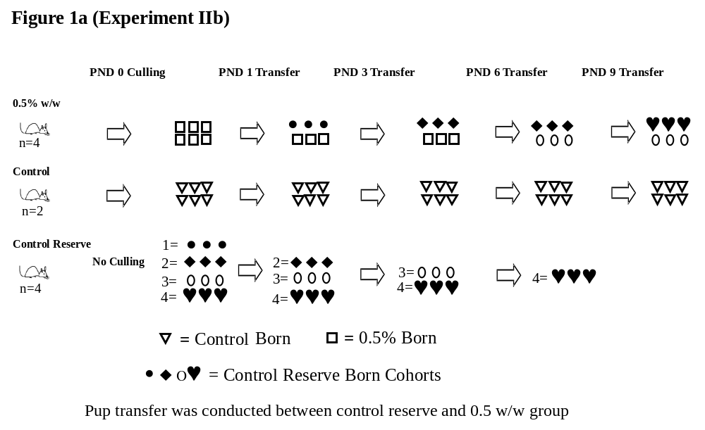

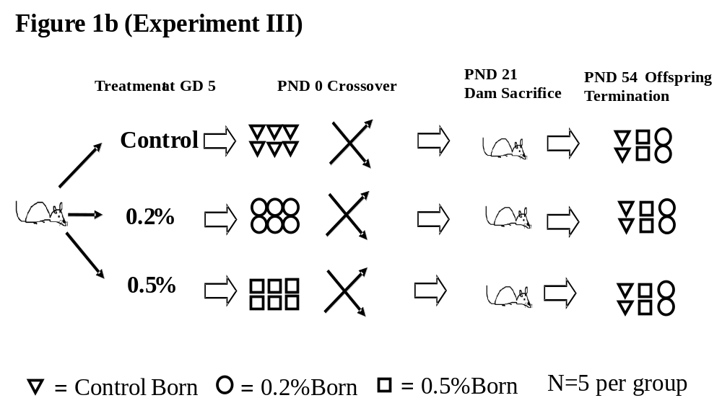

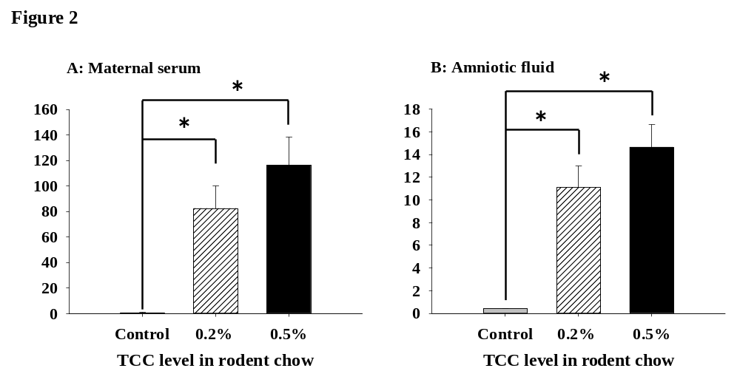
..

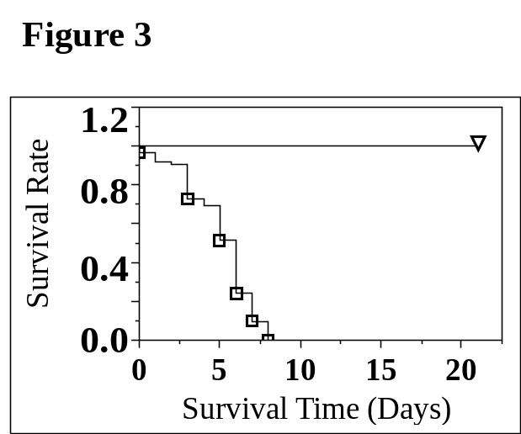

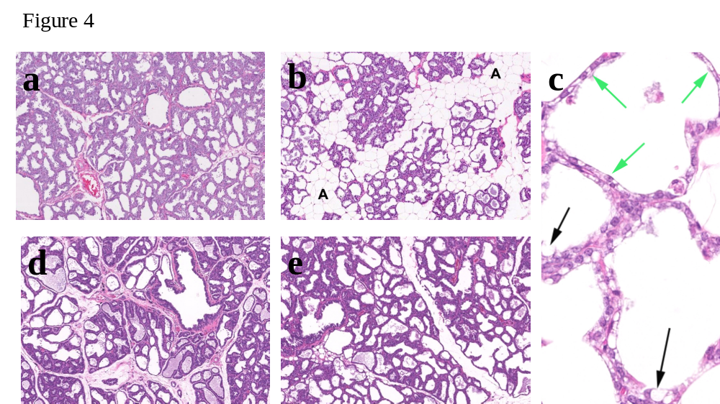

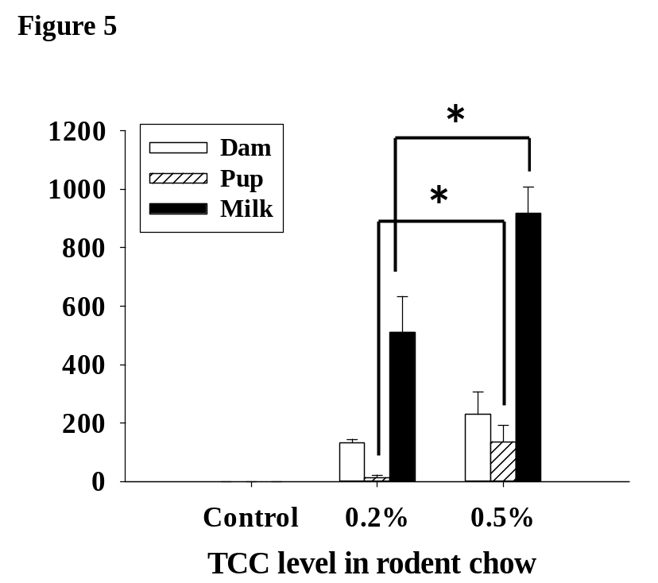

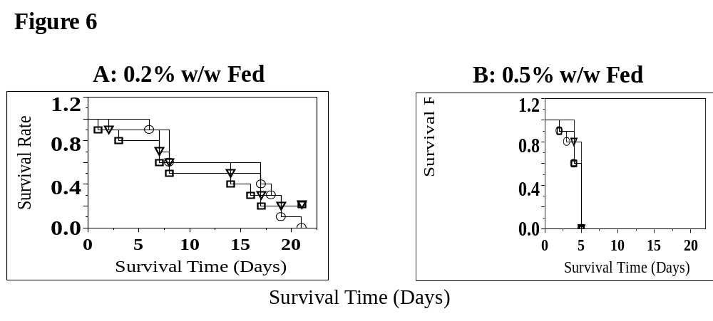

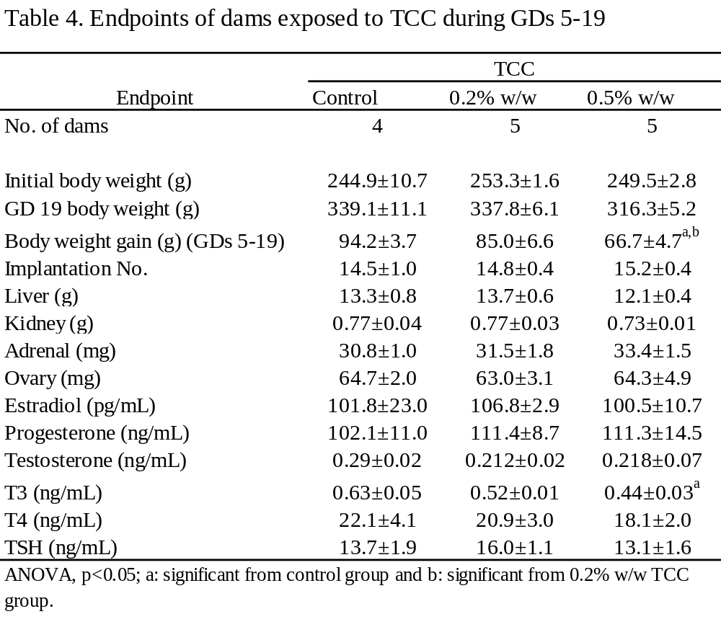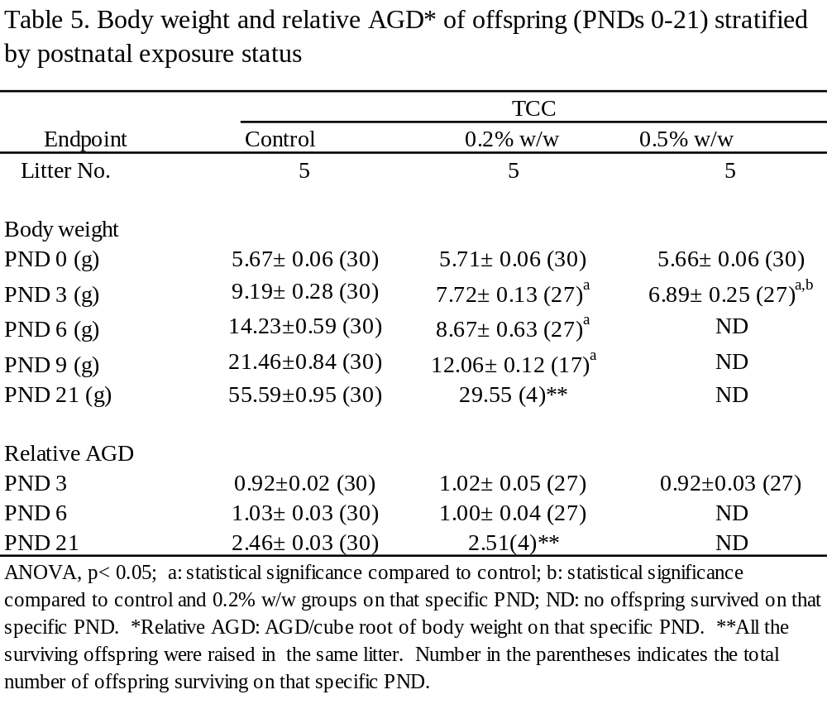

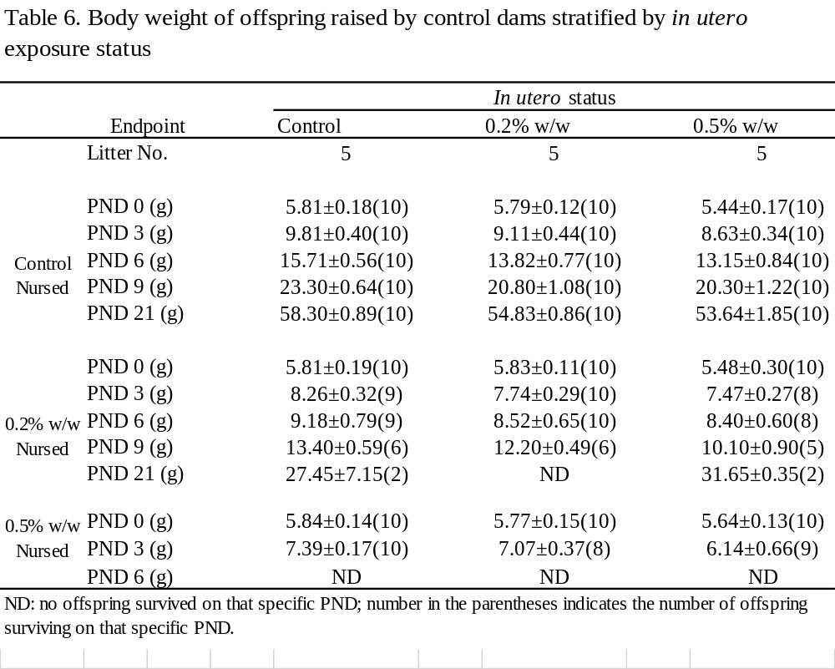

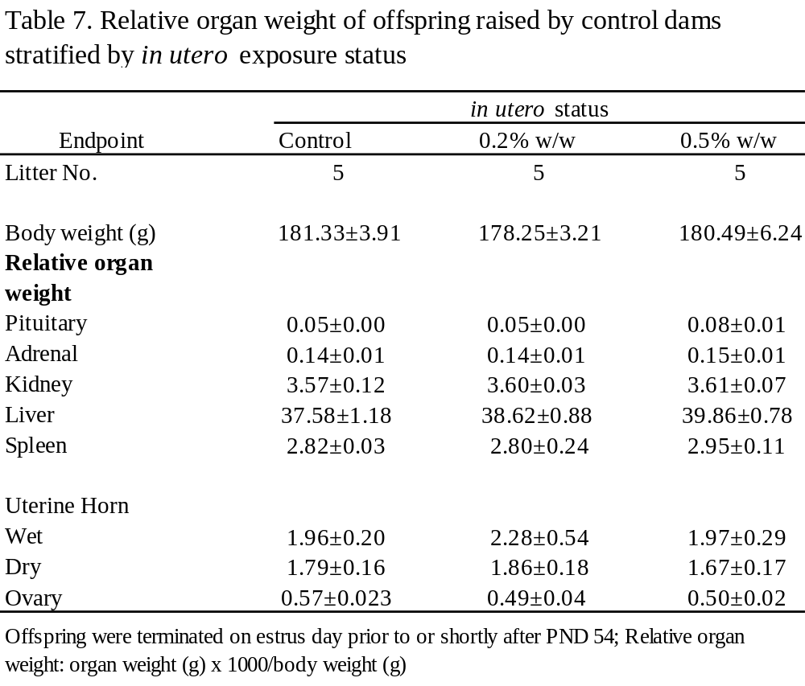

CHAPTER III
Temporal Dynamics of Gut Microbiota in Triclocarban Exposed Pregnant and Neonatal Rats
A version of this chapter is under review at Scientific Reports by Rebekah C. Kennedy, Russell R. Fling, Michael S. Robeson, Arnold M. Saxton, Robert L. Donnell, David A. Bemis, Jiang Liu, Ling Zhao and Jiangang Chen. General formatting was conducted for consistency. RCK performed the research, analyzed the data and wrote the manuscript and contributed to study design; RRF performed the research, analyzed the data and contributed to writing of the manuscript. MSR assisted with bioinformatic analysis and contributed to writing of the manuscript; AMS contributed R code for statistical analysis; RLD conducted histological assessment; DAB contributed to writing of the manuscript; JL contributed bioinformatics analysis; LZ contributed to writing of the manuscript; JC designed the research and contributed to the writing of the manuscript.

Abstract
Alteration of gut microbial colonization process may influence susceptibility of the newborn/infant to infectious and chronic disease. Infectious disease risk during pregnancy and lactation leads to widespread use of non-prescription antimicrobials in household products such as Triclocarban (TCC), an antimicrobial compound in personal care products. TCC concentrates in and is transferred through the milk to suckling offspring. TCC exposure during gestation and lactation significantly reduced phylogenetic diversity (PD) among exposed dams and neonates. Among dams using weighted Unifrac distances, TCC induced significant dysbiosis of gut microbiota by gestational day (GD) 18, a trend that continued after delivery. Similarly, an overall restructuring of gut microbiota occurred in neonates. By postnatal day (PND) 12, communities separated based on exposure status and became significantly different at PND 16. The ability of TCC to drive microbial dysbiosis warrants future investigation to evaluate the safety of non-prescription antimicrobial use, including TCC, during critical exposure windows.

Introduction
The human intestinal tract harbors trillions of microorganisms comprised of at least 1,000–5,000 species.¹ The collective gut microbiota can act as an “ancillary organ” with a critical function in human health including regulation of host metabolism and energy balance, immune function stimulation, maintenance of host nutritional physiological homeostasis, and defense against pathogens.^{2,3} Indigenous gut microorganisms occupy available intestinal niches, therefore any transient species derived from the environment will not colonize and will instead pass through the gastrointestinal system. In contrast, alternation or imbalance of the composition of commensal bacterial population could induce transient or permanent damage to the host with profound health consequences.⁴
At birth, microbial colonization is largely a product of the host environment and is tied to a variety of factors including delivery (vaginal/caeseran) and infant feeding mode (breast/formula feeding).^{5,6} Around the first year of life, the evolvement of infant gut microbial composition is dynamic with large community shifts that occur at transitional stages, i.e. when solid foods are introduced or during early exposure to prescription antibiotics.^{7,8} Close to the conclusion of the first year, the infant acquires a less dynamic gut microbial community that gradually converges to a more adult-like profile.⁷
The composition of the gut microflora can have a broad impact on the health of the host; it is well established that prescription antibiotic exposure can disrupt the balance of the intestinal microbiota potentially leading to unintentional side-effects; alteration of the colonization process may influence susceptibility of newborn/infant to infectious disease in the short-term and lead to immune mediated and metabolic disorders later in life.^{3,4} More than 40% of pregnant women are prophylactically prescribed antibiotics during pregnancy/birth for prevention of preterm labor, vertical pathogen transmission to the infant, and maternal morbidity after caesarean section.⁹ While the average pregnant or lactating female does not control the use of prescription antibiotics, precaution and fear of infectious disease outbreak in human populations leads to widespread use of non-prescription antimicrobials in household products.^{10,11} It is estimated that more than 10 million women are either pregnant or lactating in the United States at any given time and the use of antimicrobial personal care products is increased among this population without confidence in the safety of antimicrobial exposure during early-life periods.^{10,11,12} Specifically, the impact of early-life non-prescription antimicrobial compound exposure on both intestinal microbiota community integrity and the resultant health outcomes are understudied.
Triclocarban (3,4,4′-trichlorocarbanilide; TCC) is a high production volume antimicrobial, used in personal care products, at a mass of up to 1.5% in certain brands of bar soaps.^{13,10} TCC can be absorbed through the skin and has been detected in adult human urine, serum and in cord blood indicating exposure throughout the lifespan.¹⁴⁻¹⁶ Volunteers with frequent exposure through the application of TCC containing products tend to have a higher TCC body burden in the circulation.¹⁷ Recent evidence demonstrates that human exposure to TCC may not be limited to the purposeful use of antimicrobial products, but could occur through the diet.¹⁸ Following incomplete removal by wastewater treatment process, TCC is detected in nutrient-rich sludge that may be applied as agricultural fertilizer leading to safety concerns regarding the potential intake through the food chain.¹⁹
Previously our group reported that TCC concentrates in the breast milk after dietary exposure in a rodent model indicating potential neonatal TCC exposure via lactation.²⁰ Furthermore, neonates with TCC exposure during lactation had distended gastrointestinal tracts with liquid, mustard-colored diarrhea implying the disturbance of intestinal microbiota and hence a dysbiotic status. In this report, we utilized a rodent model to investigate and characterize the temporal dynamics of intestinal microbiota in pregnant dams and neonatal rats in response to TCC exposure during gestation and lactation.

Materials and Methods

Animals and Husbandry
Timed-pregnant Sprague Dawley (SD) rats were purchased from Harlan Laboratory (Dublin, VA). The day after mating was designated as gestational day (GD) 1. Upon arrival, animals were weight ranked and randomly assigned to control or treatment groups (n=4/group). Animals were housed individually under specified conditions (12:12-hour light cycle, temperature of 20°C to 22°C, and relative humidity of 40% to 50%) with ad libitum access to water and commercial Harlan ground 2020X chow or 2020X supplemented with 0.1% w/w TCC (purity 99%, Sigma Aldrich, St Louis, Missouri) daily from GD 4 until 16 days after delivery. This period was chosen as we demonstrated that TCC could cross the placental barrier and accumulate in the milk of lactating rats.²⁰ The Animal Use and Care Committee at the University of Tennessee, Knoxville, approved all study protocols. All methods were conducted in accordance with the Institutional Animal Care and Use Committee (IACUC) guidelines. This investigation was conducted in an animal facility fully accredited by the Association for Assessment and Accreditation of Laboratory Animal Care.
  - Fecal/cecum Sample Collection
Fecal samples from dams (n = 4/group) and cecum content (n = 3/group) from neonates were collected at designated dates throughout gestation and lactation. Briefly, for fecal collection, an individual dam was removed from the home cage and placed in a clean cage free of bedding. The tail of the rat was lifted to facilitate the discharge of feces. Stainless steel forceps were used to collect fecal pellets immediately after the samples were produced. All tools were autoclaved prior to use and changed between cages. Fecal samples were collected at baseline (GD 4), 7 days post-treatment (GD 11), 14 days post-treatment (GD 18), and 16 days after delivery (AD) corresponding to 34 days after the initiation of exposure regimen. No fecal samples were collected from dams between GD 18 and any days prior to the final day of the study to reduce disturbance prior to the delivery and during lactation.
Collection of cecum content from neonates was a terminal procedure. Samples were collected between 8:00 AM and 12:00 PM on the day of sacrifice. At postnatal day (PNDs) 3, 6, 12 and 16, within each group, two female neonates were randomly selected from each dam. Cecum content from each neonate was removed and combined into three pools so that no individual pool contained two neonates born to the same dam. The maternal origin of the composition of each pool was made consistent at each subsequent collection date. In other words, if cecum content from a neonate born to a specific dam was added to a designated pool on PND 3, cecum content from an additional neonate born to the same dam was used to create the same pool on PND 6. Fecal/cecum samples were snap frozen immediately following collection and stored at -80° C until analysis.

Neonatal Histology
At PND 12, neonatal gastrointestinal tracts (jejunum and cecum) were collected from male neonates with or without TCC exposure during lactation and fixed in 10% formalin. Tissue sections were examined with hematoxylin-eosin (H&E) staining. A board-certified pathologist, blinded to treatment status, evaluated histological changes.

DNA Isolation, Amplification, and 16S rRNA Sequencing
  - DNA Extraction, Amplification and Clean-up
DNA was extracted from frozen fecal/cecum samples with the Power fecal DNA isolation kit (Mo Bio Laboratories, Inc. Carlsbad, CA) following manufacturer’s instructions. Extracted DNA samples were quantified with Nanodrop 1000™ and stored at -80 °C until PCR amplification. DNA was amplified by targeting the V4 region of the bacterial 16S rRNA gene as described by Caporaso et al.²¹
The initial PCR product was purified with DNA gel electrophoresis to remove DNA impurities and primer dimers. The concentration of purified amplicon product was measured with Qubit dsDNA HS Assay Kit (Life Technologies, Carlsbad, CA) and normalized to an equal concentration to create a single amplicon pool.

Bacterial Barcoded Amplicon Library Preparation, Sequencing and Sequence Analysis
  - Beads Clean-up
Pooled amplicons were purified with SPRIselect (Beckman Coulter, Inc., Indianapolis, IN) following the manufacturer’s protocol (Next-flex™ 16S V4 Amplicon Seq-kit manual). The products were analyzed with Agilent High Sensitivity DNA Analysis (CHIP) Kit for quality assurance on a 2100 Bioanalyzer (Agilent, Santa Clara, CA).
  - Library Quantification and Illumina Sequencing
The pooled amplicon library concentration was quantified with the Illumina Library Quantification kit (KAPA Biosystems, Boston, MA) prior to sequencing. Quantitative PCR was performed with the KAPA SYBR® FAST qPCR Master Mix (2X). The amplicon library was diluted to a starting concentration of 10 nM and sequenced on the Illumina MiSeq sequencer (Illumina, Inc., San Diego, CA).
  - Sequence Data Analysis
The resulting raw sequencing data was analyzed using the QIIME (v1.8.0) pipeline.²² Unless otherwise stated all python scripts reside within QIIME. The script, join_paired_ends.py, was used to generate the assembled paired-end reads. Next, paired-end sequences were demultiplexed and quality filtered with Phred score no less than 20. The UCHIME program was used to detect chimeras on assembled reads via identify_chimeric_seqs.py. Operational taxonomic units (OTU) were generated using the script, pick_open_reference_otus.py, with 97% similarity via UCLUST.²³ The OTU taxonomy was assigned using the Ribosomal Database Project (RDP) classifier with the May 2013 Greengenes release in QIIME, and then aligned via PyNAST.²⁴ Any OTU present at less than 0.005% of the total read count was filtered to remove the potential influence of spurious OTUs.^{25,26} The resulting filtered output was used to make a phylogeny (make_phylogeny.py). The phylogeny was then rooted to Bacteroidetes. All samples were rarefied at a minimum sequencing depth of 55,000 OTUs. The script alpha_rarefaction.py was used to confirm the appropriate minimum sequencing depth across samples. 16S datasets were deposited in the Sequence Read Archive under accession number: SRP067613.

Statistics
Statistical analysis was conducted in R (version 3.1.2) using Phyloseq unless otherwise noted.²⁷ Microbial community composition by treatment group at each fecal/cecum collection date was visualized using Principal Coordinate Analysis (PcoA) plots constructed with weighted UniFrac distances.²⁸ Community level statistical significance was tested with the nonparametric ADONIS function in the Vegan package at each individual time-point.^{29,30} ADONIS permutations were stratified by collection date among neonates in the Vegan package to account for sampling across time. A repeated measures permanova was conducted on dam samples stratified by rat ID using the BiodiversityR package, with separate whole and sub-plot analyses. Post-hoc analysis of repeated measures ADONIS results were analyzed with the Vegan package to dissect significant time-treatment interactions. Within sample richness and evenness were estimated using Shannon’s index. Faith’s phylodiversity (PD) metric was calculated via QIIME.³¹ Dam alpha diversity estimates were analyzed using two-way ANOVA with repeated measures and neonate alpha diversity was analyze by ANCOVA using dam GD 18 alpha diversity as a covariate in SigmaPlot (version 13) with Bonferroni post-hoc test. Data were presented as group mean±SEM. Relative abundance of OTUs at the phyla and family level were visualized with Phyloseq.²⁷ Statistical significance was set at alpha = 0.05.

Results

Influence of Gestational and Lactational TCC Exposure on Dam Fecal Microbiota
  - Alpha and Beta Diversity
After quality filtering and removal of any OTU present at less than 0.005% of the total read count, 54 samples comprised of 4,931,803 sequences remained with an average of 91,330 sequences per sample. Neither Shannon’s index nor phylogenetic diversity differed between control and exposed dams prior to TCC exposure at baseline (GD 4). TCC exposure significantly reduced the diversity of microbiota in feces of treated animals compared to controls at 7 days after treatment (GD 11: Shannon 4.93 ± 0.88 vs 3.73 ± 0.180, Figure 7A; PD 26.5 ± 0.338 vs 21.7 ± 0.277, Figure 7B). This trend continued throughout gestation after 14 days of treatment at GD 18 (Shannon 4.97 ± 0.077 vs 3.50 ± 0.123, Figure 7A; PD 25.9 ± 0.204 vs 19.1± 0.522, Figure 7B) and into lactation 16 days after delivery (AD 16), corresponding to 34 days of TCC exposure when both measures were significantly suppressed in the exposed dams compared to controls (Shannon 4.59 ± 0.109 vs 4.14 ± 0.051, Figure 7A; PD 25.9 ± 0.143 vs 19.4 ± 0.272, Figure 7B; two-way ANOVA, p<0.05). The phylogenetic diversity of control samples was relatively stable across time, but decreased among exposed dams from GD 4 until 16 days after delivery (AD 16) at the end of the study.
A principal coordinate’s analysis (PCoA) plot of weighted Unifrac distances is shown in Figure 8 to visualize beta diversity dissimilarity over time among dams. The PCoA demonstrated an initial shift from baseline in both control and TCC treatment dams at GD 11. Microbiota structure became statistically dissimilar by 14 days of treatment (GD 18; R² = 0.69, ADONIS p<0.05) and remained different until AD 16 (34 days of TCC exposure; R² = 0.69, ADONIS p<0.05). Repeated measures analysis revealed a significant interaction between time and treatment (R² =0.27, ADONIS p<0.05). Post-hoc analysis demonstrated that a significant time-treatment interaction occurred beginning at GD 11 after which microbial communities in control and treatment dams behaved differently.
  - Fecal Microbiota Community Composition
Figure 9 shows the relative abundance of the gut microbial community composition of dams over time, during pregnancy and lactation. At the phylum level, no consistent differences in pattern developed between control and exposed dams (Figure 9A). The effect of TCC was more pronounced at the family level (Figure 9B). Across the study period in control dams, S24-7 dominated fecal microbiota with relative OTU fluctuating from 11% at GD 11 to 14% at GD 18 and reached 26% by 34 days of exposure (AD 16). After dams were exposed to 0.1% w/w TCC for 7 days (GD 11), 30% of the gut community structure was occupied by microbes belonging to the Bacteroideaceae family. Across time in TCC exposed dams, this compositional trend continued, but oscillated from 50% at 14 days (GD 18) of exposure to 16% at 34 days exposure (AD 16) (Figure 9B).

Influence of Gestational and Lactational TCC Exposure on Neonatal Microbiota
  - Alpha and Beta Diversity
Among neonates, Shannon’s index did not differ between the two groups across the study period. Phylogenetic diversity became significantly different on PND 16 (PD 19.51 ± 0.60 vs 9.18 ± 1.35 Figure 10B; ANCOVA, p < 0.05).
The effect of TCC exposure on beta diversity is shown in Figure 11 using weighted Unifrac distances. Regardless of treatment status, an initial stochastic pattern emerged at PND 3 followed by convergence at PND 6. After PND 6, the weighted Unifrac distances behaved similarly between control and exposed groups. By PND 12, separation based on treatment status occurred which became significantly different at PND 16 (R² = 0.87, ADONIS p<0.05). Repeated measures analysis revealed an effect of collection date (R² = 0.25).
To determine microbial similarity between neonates and dams, we further compared weighted Unifrac distances of neonatal samples during lactation in relation to dam samples at GD 18. Figure 12A demonstrates initial clustering between control dams at GD 18 and control neonates at PND 3; neonatal diversity then reorganized, moving away from dams at PND 6 and again clustered more closely with dams at PND 12 and PND 16. The visualization between TCC exposed dams and exposed neonates is shown in Figure 12B. Note that samples of exposed neonates were isolated away from dams at all time points.
  - Cecum Microbiota Community Composition
While relative abundance of microbiota present in neonate samples revealed a dominance by three phyla: Proteobacteria, Firmicutes, and Bacteroidetes regardless of collection date or treatment status (Figure 13A), among control samples, the relative contribution of Bacteroidetes increased overtime to 65% and became the dominant phylum at PND 16. In contrast, Proteobacteria consistently monopolized and increased to 78% in exposed neonates at the same collection date. The community composition of cecum contents from neonates at the family level is shown in Figure 13B. Visually, control samples became more diverse over time reflecting the increased phylogenetic diversity and consistency with data shown in Figure 13B. Enterobacteriaceae dominated TCC exposed samples as lactation progressed, reaching 77% by PND 16.

TCC Exposure on Pathology of Neonatal Gastrointestinal Tract
Grossly, TCC exposure during gestation and lactation led to enlarged abdomens with mustard colored diarrhea in neonates. The formalin fixed gut of a control and an exposed neonate at PND 12 are shown in Figure 14 A and B respectively. Compared to controls, the gastrointestinal tracts of TCC exposed neonates were filled with gas and liquid. H&E staining of the large (cecum) and small intestine (jejunum) is shown between control (Figure 14C) and TCC exposed neonates at PND 12 (Figure 14D). No apparent histological differences were noted between the two groups.

Discussion

It is common for women during pregnancy and lactation to choose non-prescription antimicrobial containing products for prophylactic reasons.^{10,11} TCC has been detected in human serum and cord blood suggesting a systemic distribution of this hydrophobic compound through maternal circulation.^{15,16} Hydrophobic drugs are likely to concentrate in breast milk because of the high lipid load.³² Detection of TCC is reported in human milk, implying that as the natural and optimal food for infants, breast milk may serve as the primary exposure route to TCC among breastfed infants.³³ We recently demonstrated that TCC was transferred through the milk to suckling neonates.²⁰ Pups exposed to TCC through lactation had distended gastrointestinal tracts with liquid, mustard-colored diarrhea. Further, the concentration of TCC identified in the milk of exposed dams was four times higher than the corresponding levels found in maternal circulation.²⁰ The potential TCC exposure among nursing infants dictates the need to investigate the effect of TCC on the gut microbiota composition during early life.

In this study, to determine the dynamics of gut microbial community structure in neonatal and pregnant/lactating rats in response to TCC exposure, fecal/cecum material were collected at specific time-points during gestation and lactation. Provision of TCC during gestation and lactation altered the community structure of dam fecal microbiota over time. In dams, alpha diversity was significantly reduced in exposed animals at all collection dates after baseline (Figure 7 A and B). Beta diversity was significantly dissimilar on both GD 18 during gestation and on 16 days postdelivery (AD 16) in exposed compared to control dams (Figure 8). Weighted Unifrac ADONIS stratified to each sample over time revealed a significant interaction between time and treatment that occurred at GD 11. Here, distances remain relatively stable among exposed dams across the study while microbial distance among control animals becomes more dynamic after GD 11. Thus, it appears that TCC as an antimicrobial confines distance of exposed dams relative to controls.

In the dam, the effect of TCC exposure on beta and alpha diversity was mirrored in the microbial relative abundance at the family level (Figure 12B). Provision of TCC during gestation and lactation induced the overgrowth of Bacteroidaceae across the study period. Increased occupancy by Bacteroidaceae, is demonstrated in murine models of experimentally induced colitis.^{34,35} Because we did not observe adverse gastrointestinal reactions (i.e. diarrhea) in the adult animals during the study period, histological assessment was not conducted.
Among suckling neonates, TCC exposure led to microbial diversity loss. Within cecum samples collected from exposed neonates, visually the overall alpha diversity declined overtime with significant suppression of phylogenetic diversity at PND 16 (Figure 8B) compared to controls.
During infancy, one view of antibiotic-induced dysbiosis purports that the gut microbiome responds to prescription antibiotics with the loss of keystone taxa and metabolic shifts in the short-term.⁴ Even after antibiotic treatment ends, keystone taxa may not have recovered and the loss of diversity could allow for the bloom of pathogens and pathobionts. In this study, unexposed neonatal communities became more diverse over time while TCC exposure, like prescription antibiotics,⁴ restricted diversity of colonizing species during the same period (Figure 12 A and 1B). The health outcomes of this taxa loss remain to be determined.
A similar pattern developed when neonatal beta diversity was evaluated, whereby in control and TCC exposed neonates, an initial stochastic pattern emerged at PND 3. At PND 6, an overall restructuring occurred where control and TCC exposed communities converged. Starting from PND 12, communities separated based on exposure status and became significantly different at PND 16 (Figure 11). The overall restructuring that occurred among samples collected from control neonates at PND 6 was interesting though may provide an indication of the normal colonization process. Using Friend leukemia virus B mice, Pantoja-Feliciano et al. (2013) demonstrated suppressed diversity at PND 3 and 9, compared to day 1, that increased again to levels similar to dams at PND 21.³⁶ Additionally, Palmer et al. (2007) reported that the mean Pearson’s correlation between human infant and adult fecal microbiota increased from day 0 until around day 5 post-birth, when an apparent population rearrangement occurred resulting in the divergence from adult samples.⁷ Thereafter, infant microbial profiles again correlated more closely to adults throughout the first 18 months of life.
We demonstrated that distances of samples from control neonates at PND 3 clustered around microbiota of control dams at GD 18 (Figure 12A). By PND 6, a population shift occurred, with movement of neonates away from that of dams. At PNDs 12 and 16, the neonatal distance from dams decreased at each respective time-point. Microbiota may initially be acquired and only those microbes that can occupy the niche specific of the infant gut will colonize.⁴ We postulate that among control neonates, the initial dam-neonate similarity reflects the microbiota transferred either from the dam or environment over the first few days of life. At PND 6, only those microbes that can occupy the neonatal cecum biome propagate. This in turn produces a more hospitable microbial environment, driving increased diversity and similarity to adult dam samples at PNDs 12 and PND 16.
The distance similarity noted between control dams at GD 18 and neonates at PND 3 was not demonstrated among TCC exposed dams and their neonates (Figure 12B). Here, among exposed neonates, early life TCC exposure constrained the progression to a more diverse state. One limitation of this study design was that samples were not collected prior to PND 3. Thus we cannot comment on the potential similarity of TCC exposed neonatal microbiota to dams at the time of delivery. Additional limitations such as the small sample size and the fact that the neonatal samples were pooled is noted. Further, because exposure during gestation and lactation was not separated we could not dissect the effect of early microbial restriction at gestation or lactation individually. A cross-fostering design with increased sample size including early time point data collection should provide further insight into the normal colonization process at early life stages.
The infant gut is first colonized by facultative anaerobes such as Enterobacteriaceae that lower the redox potential allowing for growth of strictly anaerobic bacteria.³⁷ Among neonates at PND 3, Enterobacteriaceae dominated in both control and treated groups (Figure 13B). After PND 6, Bacteroidaceae gained a stronghold in control samples. In contrast, Enterobacteriaceae maintained dominance in TCC exposed samples from PND 6 until the end of the study period. It appears that the overgrowth of Enterobacteriaceae primarily contributed to the significant differences in diversity after PND 6 observed between the two neonatal groups. The relative contribution of Enterobacteriaceae may also explain the convergence at PND 6. TCC shows selective efficacy for Gram positive bacterial strains.³⁸ If mostly Gram negative bacteria dominated at PND 6 in both groups, the effect of TCC may be minimal. However, with consistent exposure few Gram positive bacteria, for example, may colonize overtime contributing to the diversity difference between the two groups. Enterobacteriaceae bloom in the gut microbiota is documented among human infants in response to prescription antibiotics and is associated with potentially life threatening diseases such as necrotizing enterocolitis.³⁹⁻⁴¹ Furthermore, a reduction in the ratio of Bacteriodeace to Enterobacteriaceae of the human infant gut is indicated in later-life health outcomes, such as food sensitivities.⁴² Collectively, our results should drive future research regarding both short and long-term health consequences related to TCC exposure in humans, specifically during early life.
Because diarrhea was not documented in TCC exposed dams, histological evaluation was limited to neonates only (Figure 14). It was interesting to note that exposed neonates showed distended abdomens with mustard-colored diarrhea, though no apparent histopathological differences were identified (Figure 14 C and D). Currently, the mechanism of TCC-induced diarrhea among the neonates is unknown. However, given its antimicrobial nature, TCC may act similarly to prescription antibiotics. The use of many prescription drugs, including antibiotics, can lead to diarrhea onset, commonly without organic lesions.⁴³ Antibiotic-associated diarrhea (AAD) is unexplained diarrhea that is associated with antibiotic administration.⁴⁴ The mechanisms of AAD are diverse and may be related to the pharmacokinetic properties of the drug itself or to suppression of the gut microbiota.
Following the stable establishment of the gut microbiota, oscillations in the community structure can occur with exposure to prescription antibiotics leading to dysbiosis of the gut ecosystem.⁴⁵ These compositional changes can induce opportunistic pathogen overgrowth resulting in infectious disease (i.e. C. difficile infection) in the short-term and chronic disease (i.e. asthma and diabetes) throughout life. Like prescription antibiotics, we demonstrated the ability of a non-prescription antimicrobial TCC, to induced gut microbial dysbiosis during sensitive exposure windows in a rat model. Collectively, our results add to the growing public concern related to the potential human health impact of non-prescription antimicrobial exposure and should guide regulatory agencies in policy decisions regarding the use of non-prescription antimicrobials in personal care products during critical physiological stages.

References

1. Brestoff JR, Artis D. Commensal bacteria at the interface of host metabolism and the immune system. Nat. Immunol. 2013;14(7):676-684.
2. Guinane CM, Cotter PD. Role of the gut microbiota in health and chronic gastrointestinal disease: understanding a hidden metabolic organ. Therap. Adv. Gastroenterol. 2013;6(4):295-308.
3. Walker WA, Iyengar RS. Breast milk, microbiota, and intestinal immune homeostasis. Pediatr. Res. 2015;77(1-2):220-228.
4. Vangay P, Ward T, Gerber JS, Knights D. Antibiotics, Pediatric Dysbiosis, and Disease. Cell Host Microbe. 2015;17(5):553-564.
5. Makino H, Kushiro A, Ishikawa E, et al. Mother-to-infant transmission of intestinal bifidobacterial strains has an impact on the early development of vaginally delivered infant's microbiota. PLoS One. 2013;8(11):e78331.
6. Albenberg LG, Wu GD. Diet and the intestinal microbiome: associations, functions, and implications for health and disease. Gastroenterology. 2014;146(6):1564-1572.
7. Palmer C, Bik EM, DiGiulio DB, Relman DA, Brown PO. Development of the human infant intestinal microbiota. PLoS Biol. 2007;5(7):e177.
8. Koenig JE, Spor A, Scalfone N, et al. Succession of microbial consortia in the developing infant gut microbiome. Proc. Natl. Acad. Sci. U. S. A. 2011;108 Suppl 1:4578-4585.
9. Martinez de Tejada B. Antibiotic use and misuse during pregnancy and delivery: benefits and risks. Int. J. Environ. Res. Public Health. 2014;11(8):7993-8009.
10. Perencevich EN, Wong MT, Harris AD. National and regional assessment of the antibacterial soap market: a step toward determining the impact of prevalent antibacterial soaps. Am. J. Infect. Control. 2001;29(5):281-283.
11. Morgan DJ, Okeke IN, Laxminarayan R, Perencevich EN, Weisenberg S. Non-prescription antimicrobial use worldwide: a systematic review. Lancet Infect. Dis. 2011;11(9):692-701.
12. Nahum GG, Uhl K, Kennedy DL. Antibiotic use in pregnancy and lactation: what is and is not known about teratogenic and toxic risks. Obstet. Gynecol. 2006;107(5):1120-1138.
13. Baumann A, Lohmann W, Rose T, et al. Electrochemistry-mass spectrometry unveils the formation of reactive triclocarban metabolites. Drug Metab. Dispos. 2010;38(12):2130-2138.
14. Scharpf LG, Jr., Hill ID, Maibach HI. Percutaneous penetration and disposition of triclocarban in man: body showering. Arch Environ Health. 1975;30(1):7-14.
15. Ye X, Zhou X, Furr J, et al. Biomarkers of exposure to triclocarban in urine and serum. Toxicology. 2011;286(1-3):69-74.
16. Pycke BF, Geer LA, Dalloul M, Abulafia O, Jenck AM, Halden RU. Human fetal exposure to triclosan and triclocarban in an urban population from Brooklyn, New York. Environ Sci Technol. 2014;48(15):8831-8838.
17. Schebb NH, Inceoglu B, Ahn KC, Morisseau C, Gee SJ, Hammock BD. Investigation of human exposure to triclocarban after showering and preliminary evaluation of its biological effects. Environmental science & technology. 2011;45(7):3109-3115.
18. Mathews S, Henderson S, Reinhold D. Uptake and accumulation of antimicrobials, triclocarban and triclosan, by food crops in a hydroponic system. Environmental science and pollution research international. 2014;21(9):6025-6033.
19. Kwon JW, Armbrust KL, Xia K. Transformation of triclosan and triclocarban in soils and biosolids-applied soils. Journal of environmental quality. 2010;39(4):1139-1144.
20. Kennedy RC, Menn FM, Healy L, et al. Early life triclocarban exposure during lactation affects neonate rat survival. Reprod. Sci. 2015;22(1):75-89.
21. Caporaso JG, Lauber CL, Walters WA, et al. Ultra-high-throughput microbial community analysis on the Illumina HiSeq and MiSeq platforms. Isme j. 2012;6(8):1621-1624.
22. Caporaso JG, Kuczynski J, Stombaugh J, et al. QIIME allows analysis of high-throughput community sequencing data. Nat Methods. 2010;7(5):335-336.
23. He Y, Caporaso JG, Jiang XT, et al. Stability of operational taxonomic units: an important but neglected property for analyzing microbial diversity. Microbiome. 2015;3:20.
24. Caporaso JG, Bittinger K, Bushman FD, DeSantis TZ, Andersen GL, Knight R. PyNAST: a flexible tool for aligning sequences to a template alignment. Bioinformatics. 2010;26(2):266-267.
25. Bokulich NA, Subramanian S, Faith JJ, et al. Quality-filtering vastly improves diversity estimates from Illumina amplicon sequencing. Nature methods. 2013;10(1):57-59.
26. Navas-Molina JA, Peralta-Sanchez JM, Gonzalez A, et al. Advancing our understanding of the human microbiome using QIIME. Methods in enzymology. 2013;531:371-444.
27. McMurdie PJ, Holmes S. phyloseq: an R package for reproducible interactive analysis and graphics of microbiome census data. PLoS One. 2013;8(4):e61217.
28. Lozupone CA, Hamady M, Kelley ST, Knight R. Quantitative and qualitative beta diversity measures lead to different insights into factors that structure microbial communities. Applied and environmental microbiology. 2007;73(5):1576-1585.
29. Dixon P, Palmer M. VEGAN, a package of R functions for community ecology. Journal of Vegetation Science. 2003;14(6):927-930.
30. Zapala MA, Schork NJ. Multivariate regression analysis of distance matrices for testing associations between gene expression patterns and related variables. Proc. Natl. Acad. Sci. U. S. A. 2006;103(51):19430-19435.
31. Faith DP. Conservation evaluation and phylogenetic diversity. Biol. Conserv. 1992;61(1):1-10.
32. Mitrano JA, Spooner LM, Belliveau P. Excretion of antimicrobials used to treat methicillin-resistant Staphylococcus aureus infections during lactation: safety in breastfeeding infants. Pharmacotherapy. 2009;29(9):1103-1109.
33. Zhang P, Zhang J, Shi Y, Shao B. [Determination of triclosan and triclocarban in human breast milk by solid-phase extraction and ultra performance liquid chromatography-tandem mass spectrometry]. Wei sheng yan jiu = Journal of hygiene research. 2015;44(2):294-298.
34. Berry D, Schwab C, Milinovich G, et al. Phylotype-level 16S rRNA analysis reveals new bacterial indicators of health state in acute murine colitis. Isme j. 2012;6(11):2091-2106.
35. Huang YL, Chassard C, Hausmann M, von Itzstein M, Hennet T. Sialic acid catabolism drives intestinal inflammation and microbial dysbiosis in mice. Nat Commun. 2015;6:8141.
36. Pantoja-Feliciano IG, Clemente JC, Costello EK, et al. Biphasic assembly of the murine intestinal microbiota during early development. Isme j. 2013;7(6):1112-1115.
37. Bezirtzoglou E. The intestinal microflora during the first weeks of life. Anaerobe. 1997;3(2-3):173-177.
38. Walsh SE, Maillard JY, Russell AD, Catrenich CE, Charbonneau DL, Bartolo RG. Activity and mechanisms of action of selected biocidal agents on Gram-positive and -negative bacteria. J Appl Microbiol. 2003;94(2):240-247.
39. Arboleya S, Sanchez B, Milani C, et al. Intestinal microbiota development in preterm neonates and effect of perinatal antibiotics. J. Pediatr. 2015;166(3):538-544.
40. Tanaka S, Kobayashi T, Songjinda P, et al. Influence of antibiotic exposure in the early postnatal period on the development of intestinal microbiota. FEMS Immunol. Med. Microbiol. 2009;56(1):80-87.
41. Brower-Sinning R, Zhong D, Good M, et al. Mucosa-associated bacterial diversity in necrotizing enterocolitis. PLoS One. 2014;9(9):e105046.
42. Azad MB, Konya T, Guttman DS, et al. Infant gut microbiota and food sensitization: associations in the first year of life. Clin. Exp. Allergy. 2015;45(3):632-643.
43. Chassany O, Michaux A, Bergmann JF. Drug-induced diarrhoea. Drug Saf. 2000;22(1):53-72.
44. Varughese CA, Vakil NH, Phillips KM. Antibiotic-associated diarrhea: a refresher on causes and possible prevention with probiotics--continuing education article. J. Pharm. Pract. 2013;26(5):476-482.
45. Cotter PD, Stanton C, Ross RP, Hill C. The impact of antibiotics on the gut microbiota as revealed by high throughput DNA sequencing. Discov. Med. 2012;13(70):193-199.

Appendix

Figure Legends:
Figure 7. Alpha diversity of dams during gestation and lactation. Shannon’s diversity index (A) and phylogenetic diversity (B) is shown at GDs 4 (baseline), 11, 18 and 16 days after delivery (AD) (control: gray bar, 0.1% w/w: black bar; n=4/group). Data represent mean ± SEM of each group. Data were analyzed with two-way ANOVA with repeated measures followed by Bonferroni post-hoc test. Statistical significance was set at p=0.05; (*) indicates statistical significance at each time point relative to controls.

Figure 8. Beta diversity of dams during gestation and lactation. Principal coordinate analysis of weighted UniFrac distances is shown among dams at GDs 4 (baseline), 11, 18 and 16 days after delivery (AD) (control: gray circle, 0.1% w/w: black circle; n=4/group). Statistical significance of community level microbial distance was analyzed with ADONIS, in the Vegan package, at each collection date.^{251,252} Repeated measures analysis was conducted and significant time-treatment interactions were investigated with the Vegan package. (*) indicates statistical significance at each time point relative to controls.
Figure 9. Relative abundance of bacteria among dams at the phylum (A) and family (B) levels by collection date at GDs 4 (baseline), 11, 18 and 16 days after delivery (AD) (n=4/group). At the family level, only the top 100 OTUs are shown. Taxon labeled within square brackets indicate GreenGenes proposed taxonomy.

Figure 10. Alpha diversity of neonates during lactation period. Shannon’s diversity index (A) and phylogenetic diversity (B) is shown at PNDs 3, 6, 12 and 16 (control: gray bar, 0.1% w/w: black bar; n= 3/group). Data represent mean ± SEM of each group. ANCOVA at each individual time point was conducted using alpha diversity of dams at GD 18 as the covariate for phylogenetic diversity and Shannon’s index followed by Bonferroni post hoc test. Statistical significance was set at p=0.05; (*) indicates statistical significance at each time point relative to controls.

Figure 11. Beta diversity of neonates during lactation period. Principal coordinate analysis of weighted UniFrac distances is shown at PNDs 3, 6, 12 and 16 (control: gray circle, 0.1% w/w: black circle; n= 3/group). Community level statistical significance was analyzed using ADONIS, in the Vegan package.^{251,252} Repeated measures analysis was conducted and significant time-treatment interactions were investigated with the Vegan package. (*) indicates statistical significance at each time point relative to controls.

Figure 12. Comparison of the principal coordinate analysis of weighted UniFrac distances among samples collected from A: control dams (gray circles, n=4) at GD 18 and samples collected from their offspring (n=3) at PNDs 3 (triangle), 6 (square), 12 (cross) and 16 (star); (B): 0.1% w/w TCC exposed dams (black circles, n=4) at GD 18 and samples collected from their offspring (n=3) at PNDs 3 (triangle), 6 (square), 12 (cross) and 16 (star).

Figure 13. Relative abundance of bacteria among neonates at the phylum (A) and family (B) levels by collection date at PNDs 3, 6, 12 and 16 (n= 3/group). At the family level, only the top 50 OTUs are shown. Taxon labels within square brackets indicate GreenGenes proposed taxonomy.

Figure 14. Representative histology of formalin fixed gross gastrointestinal morphology in control (A) and 0.1% w/w TCC (B) exposed male neonates at PND 12. Large intestine (cecum) and small intestine (jejunum) is shown from control (C) and 0.1% w/w TCC (D) exposed neonates at PND 12 (H&E, 20X).

Figure 7
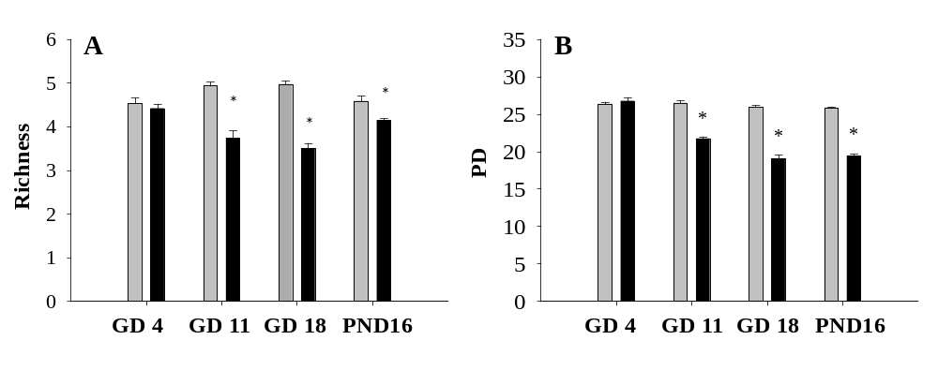
Figure 8

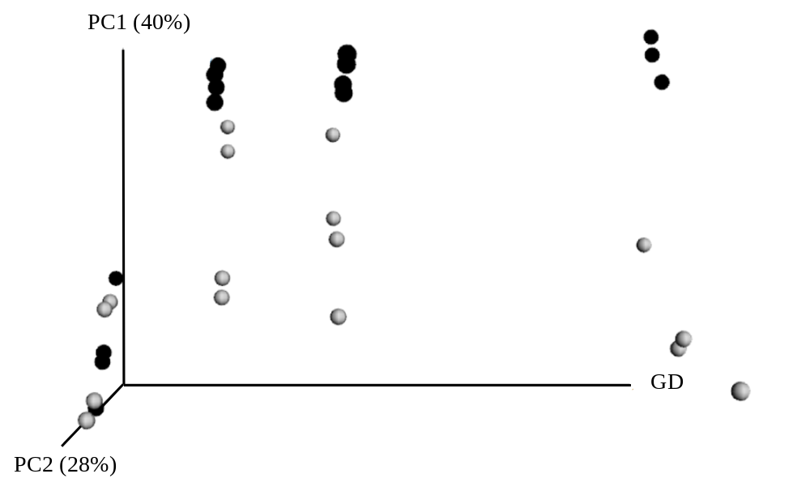

Figure 9
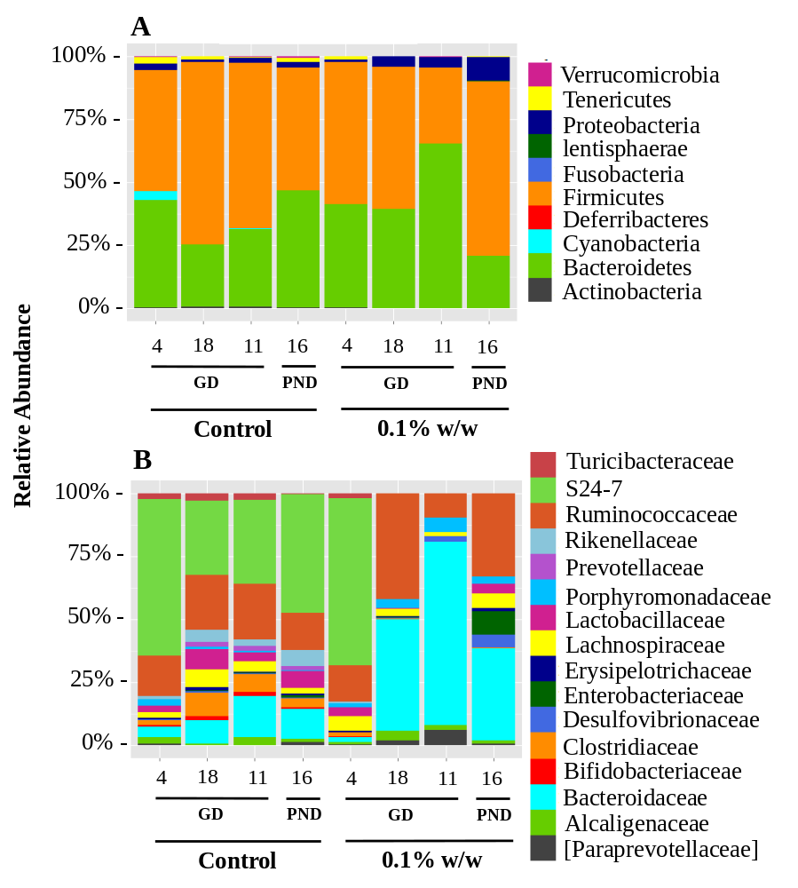

Figure 10
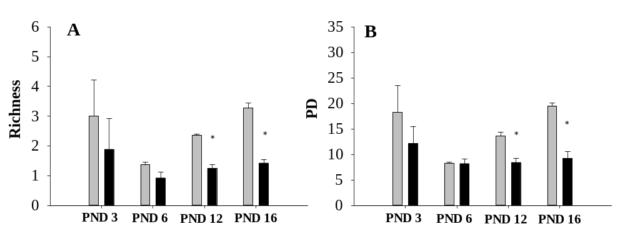

Figure 11
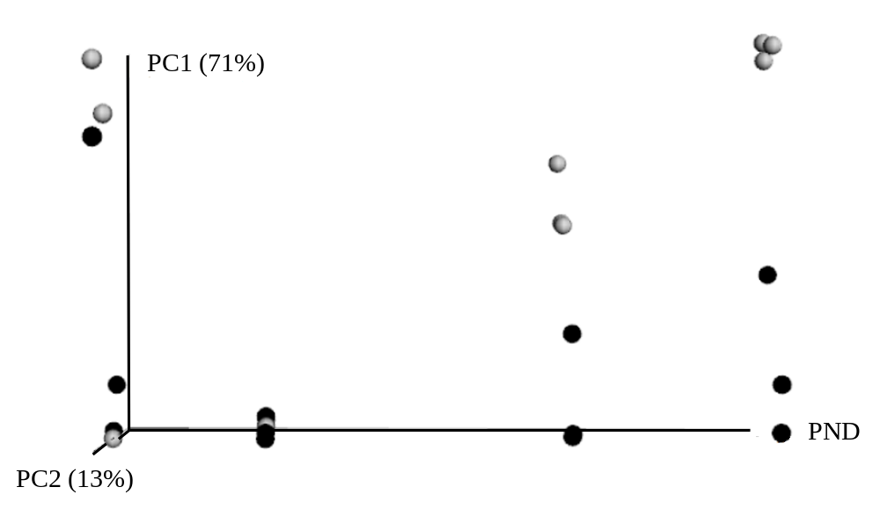

Figure 12
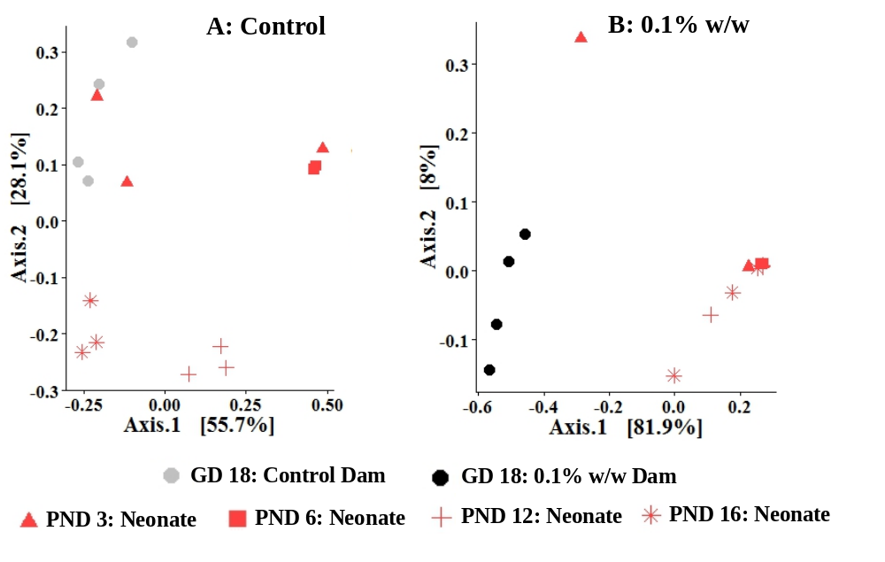

Figure 13

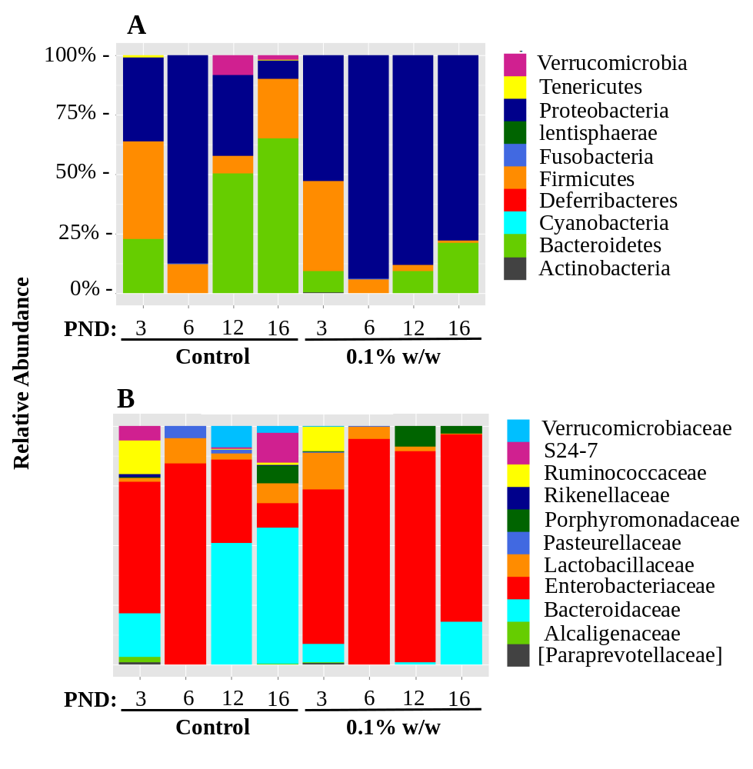

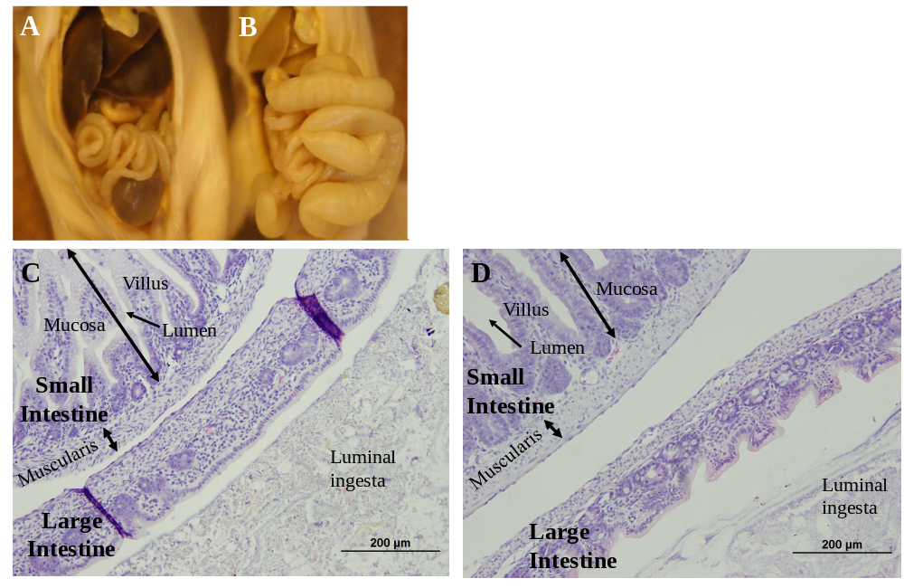
Figure 14

CHAPTER IV
Temporal Dynamics of the Gut Microbiota in Triclocarban Exposed Weaned Rats

Abstract
Alternations on the gut microbiota as a result of antibiotic exposure can lead to pathogenesis, when the homeostatic diversity of gut microbiota is disrupted such that opportunistic pathogens overgrow without competitive suppression from normal resident bacteria. Widely used as an antimicrobial in bar soaps, triclocarban (3,4,4′-trichlorocarbanilide; TCC) is effective against Gram positive bacteria, but shows little efficacy against Gram negative strains. To date, the consequence of antimicrobial exposure from compounds in personal care products is still elusive. Weaned (PND 22) SD rats were provided ad libitum access to TCC supplemented diet (0.2 % w/w or 0.5% w/w) for four-weeks (Phase I) followed by a four-week washout period (Phase II) to determine microflora rebound with TCC withdrawal. Fecal samples were collected at PND 22 and throughout the study period. DNA was extracted, followed by PCR amplification of the v4 region of 16S rDNA and sequencing with the MiSeq platform. Exposure to both 0.2% w/w and 0.5% w/w was sufficient to alter diversity of microbiota throughout phase I of treatment. Repeated measures analysis demonstrated a prolonged effect of TCC exposure during phase II of the washout period (ADONIS, p<0.05). Further, TCC exposure altered the community composition of gut microbiota translating into an increased ratio of Firmicutes to Bacteroidetes in both exposed groups compared to control microbiota during phase I. Collectively, these data highlight the present and long term impact of early life TCC exposure on gut microbial ecology and warrant further investigation into the clinical manifestations of this dysbiotic state.

Introduction
The human intestinal tract is home to a microcosm of trillions of microbes that act in symbiosis with the human host to protect against pathogens, regulate the immune system, and procure food nutrients.¹ The human fetal environment was initially considered sterile and acquisition of infant gut microbiota was thought to occur during the birthing process, with rapid colonization following delivery.² Evidence now demonstrates that microbial programming begins in utero when the fetus comes into contact with microbes of the maternal gut through the placenta and amniotic fluid. Postnatal gut microbial colonization is dynamic with two primary shifts from birth to weaning and weaning to adulthood when the introduction to food diversifies the infant gut microbiota to a more adult-like profile with relative stability around 3 years of age.³
Environmental insults during early life, such as prescription exposure, can disrupt microbiome stability. Children are prescribed antibiotics more than any other medication available.⁴ The sometimes inappropriate use of prescription antibiotics during early life can alter colonization patterns influencing susceptibility to infectious disease in the short-run and metabolic, immunologic and even behavioral outcomes later in life.^{3,5,6} Though the average parent does not decide whether their child is prescribed prescription antibiotics, they are in control of their consumer purchases. Marketing campaigns have successfully convinced the public to purchase antibacterial soaps though the efficacy over regular soap in the community setting to reduce infectious disease has not been established.^{7,8} Antimicrobials added to consumer products tend to have a broader activity spectrum than prescription antibiotics and while prescription antibiotics have specific intracellular targets, antimicrobials may have multiple targets or an undefined mode of action,⁹ suggesting an increased risk for microbial dysbiosis.
Triclocarban (3,4,4′-trichlorocarbanilide; TCC) is a high production volume antimicrobial added to personal care products at a weight of up to 1.5%. ^{10,11} As an antiseptic normally applied to the skin, TCC has an affinity for Gram positive bacteria with reduced efficacy for Gram negative strains,⁹ suggesting the potential structural disruption of mixed population microbial communities. Following external application, TCC can be absorbed through the skin and has been detected in biological matrices collected from pregnancy to adulthood suggesting lifelong exposure beginning during sensitive windows of physiological development.¹²⁻¹⁴ Alternatively, human exposure to TCC could occur through the diet as an outcome of the incomplete removal of antimicrobials by the wastewater treatment process.¹⁵ Treated wastewater is used to irrigate food crops while biosolids contaminated with TCC are used as fertilizer increasing the persistence of antimicrobial compounds in the soil and leading to the potential uptake by the edible parts of the plant.^{15,16} Though the level of exposure expected from the food is thought to be lower than no observed effect levels (NOAEL) of 25 mg/kg bw/d and is therefore not estimated to be chronically toxic to humans,¹⁷ the effect of the assumed exposure on more sensitive endpoints, such as the gut microbiota is unknown.
Historically, TCC toxicity has been tested through oral exposure with an emphasis on reproductive function.¹⁸ To date, the effect of TCC exposure through oral dosing on the gut microbiota has not been investigated. From the standpoint of utilizing oral toxicity models alone, this information is important. Growth data, including body weight is routinely evaluated in toxicological studies to understand compound related effects.¹⁹ A large body of research now indicates an important role of gut microbial signaling in energy balance and energy stores.²⁰ Therefore, it is possible that exogenous compound exposure could influence the gut microbiota composition resulting in weight changes independent to acute or chronic toxicity. Given the evidence of human exposure to antimicrobial compounds during infancy and childhood and the potential oral exposure through the food chain, in this report, we utilized a rodent model to investigate and characterize the temporal changes of the biodiversity and composition of intestinal microbiota of post-weaned rats in response to oral TCC exposure.

Materials and Methods

Animals and husbandry
Sprague Dawley (SD) rats were purchased from Harlan Laboratory (Dublin, VA) and arrived on postnatal day (PND) 21. Animals were weight ranked and randomly assigned to control or treatment groups (n=4/group). Two animals from the same treatment group were housed per cage with a12:12-hour light cycle, temperature of 20°C to 22°C, and relative humidity of 40% to 50%. Animals were provided ad libitum access to water and commercial Harlan ground 2020X chow or 2020X supplemented with 0.2% or 0.5% w/w TCC (purity 99%, Sigma Aldrich, St Louis, Missouri) from PND 22 until PND 50. At PND 50, the diet of TCC exposed animals was switched to control chow and animals were maintained on chow diet until PND 78 as a washout period to understand the potential rebound of gut microbial communities exposed to TCC. Animals in the control group were provided regular chow throughout the entire study period. The period when TCC exposure was initiated will be referred to as phase I. When TCC exposure was removed will be referred to as phase II. Potential poor palatability of TCC supplemented chow has been noted in the literature.¹⁸ To monitor the consistency of consumption across the exposure groups, food intake was recorded to ensure that gut microbial community changes were not the results of amount of chow consumed, but were limited to TCC exposure. Food intake was collected for a two week period from PND 31, just prior to the typical onset of sexual maturity.²¹ Feed conversion efficiency (g weight gain/g food intake)²² with exposure to TCC was analyzed and body weight changes were recorded. During this period, animals were housed individually. Following conclusion of the two week period when food intake was measured, animals were again housed two per cage. The Animal Use and Care Committee at the University of Tennessee, Knoxville, approved all study protocols. All methods were conducted in accordance with the Institutional Animal Care and Use Committee (IACUC) guidelines. This investigation was conducted in an animal facility fully accredited by the Association for Assessment and Accreditation of Laboratory Animal Care.
  - Fecal/cecum sample collection
Fecal samples were collected at designated dates for 28 days of exposure and 28 days of washout. Briefly, for fecal collection, an individual rat was removed from the home cage and placed in a clean cage free of bedding. The tail/hind legs of the rat were gently lifted to facilitate the discharge of feces. Stainless steel forceps were used to collect fecal pellets immediately after the samples were produced. Directly following collection, fecal pellets were snap frozen and stored at -80° C until analysis. All tools were autoclaved prior to use and changed between cages. Fecal samples were collected at baseline (PND 22, prior to exposure to TCC supplemented diet), 5 days post-treatment (PND 27), 12 days post-treatment (PND 34), and 28 days post-treatment (PND 50). After treatment was removed, fecal samples were collected at 2 days post- washout (PND 52), 8 days post-washout (PND 58), 11 days post-washout (PND 61) and 28 days post-washout (PND 78). Feces collection was most frequent closer to initiating treatment and removal of treatment to catch the early dynamics shortly after and following removal of TCC exposure.

DNA Isolation, Amplification, and 16S rRNA Sequencing
  - DNA Extraction, Amplification and Clean-up
DNA was extracted from frozen fecal/cecum samples with the QIAamp DNA Stool Mini Kit (QIAGEN, Inc. Valencia, CA) following manufacturer’s instructions. Extracted DNA samples were quantified with Nanodrop 1000™ and stored at -80 °C until PCR amplification.
DNA was amplified by targeting the V4 region of the bacterial 16S rRNA gene as described by Caporaso et al.²³ PCR reactions (50 μL) were performed on AB Applied Biosystems Veriti 96 well Thermo Cycler (Grand Island, NY) as the following: xx ul of 100 ng of template DNA, 0.5 μL of forward and reverse barcode primers (10 uM) respectively, 0.5 μL of DMSO (Sigma, St. Louis, MO), 20 μL of Illustra hot start master mix in a final volume of 50 μL reaction system (GE Health Care, Pittsburgh, PA). The PCR conditions consisted of an initial 94°C denaturation step for 3 minutes, a cycling program of 94°C for 45 seconds, 50°C for 1 minute, 72°C for 90 seconds, and a final elongation step of 72°C for 10 minutes.
The initial PCR product was purified with DNA gel electrophoresis to remove DNA impurities and primer dimers. The DNA gel containing the target amplicon band was removed, purified, and concentrated with the Zymoclean Gel DNA Recovery Kit (Zymo Research, Irvine, CA). The concentration of purified amplicon product was measured with Qubit dsDNA HS Assay Kit (Life Technologies, Carlsbad, CA) and normalized to an equal concentration to create a single amplicon pool.

Bacterial Barcoded Amplicon Library Preparation, Sequencing and Sequence Analysis
  - Beads Clean-up
Pooled amplicons were purified with SPRIselect (Beckman Coulter, Inc., Indianapolis, IN) following the manufacturer’s protocol (Next-flex™ 16S V4 Amplicon Seq-kit manual). The products were analyzed with Agilent High Sensitivity DNA Analysis (CHIP) Kit for quality assurance on a 2100 Bioanalyzer (Agilent, Santa Clara, CA).
  - Library Quantification and Illumina Sequencing
The pooled amplicon library concentration was quantified with the Illumina Library Quantification kit (KAPA Biosystems, Boston, MA) prior to sequencing. Quantitative PCR was performed with the KAPA SYBR® FAST qPCR Master Mix (2X) using 10 fold serial dilutions of DNA standards from 20 pM to 0.0002 pM. Sample concentration was determined based on amplicon adaptors. Serial dilutions of each sample amplicon (1:1000, 1:5000, and 1: 10000) were made using TRIS (Invitrogen, Carlsbad, CA) + TWEEN (Fisher Scientific, Hampton, NH) solution (10 mM TRIS with 0.05% TWEEN). Diluted sample amplicons, standards (4μL) and de-ionized water controls (4μL) were loaded with 0.2 µL of master mix in a 96-well PCR plate and ran in duplicate. The amplicon library was diluted to a starting concentration of 10 nM and sequenced on the Illumina MiSeq sequencer (Illumina, Inc., San Diego, CA).
  - Sequence Data Analysis
The resulting raw sequencing data was analyzed using the QIIME (v1.9.1) pipeline.²⁴ Unless otherwise stated all python scripts reside within QIIME. The script, join_paired_ends.py, was used to generate the assembled paired-end reads. Next, paired-end sequences were demultiplexed and quality filtered with Phred score no less than 20. The UCHIME program was used to detect chimeras on assembled reads via identify_chimeric_seqs.py. Operational taxonomic units (OTU) were generated using the script, pick_open_reference_otus.py, with 97% similarity via UCLUST.²⁵ The OTU taxonomy was assigned using the Ribosomal Database Project (RDP) classifier with the May 2013 Greengenes release in QIIME, and then aligned via PyNAST.²⁶ Any OTU present at less than 0.005% of the total read count was filtered to remove the potential influence of spurious OTUs.^{27,28} The resulting filtered output was used to make a phylogeny (make_phylogeny.py). The phylogeny was then rooted to Bacteroidetes. All samples were rarefied at a minimum sequencing depth of 4200 OTUs. The script alpha_rarefaction.py was used to confirm the appropriate minimum sequencing depth across samples.

Statistics
Statistical analysis was conducted in R (version 3.1.2) using Phyloseq unless otherwise noted.²⁹ Microbial community composition was visualized using Principal Coordinate Analysis (PcoA) plots constructed with Weighted UniFrac distances.³⁰ Community level statistical significance was tested with the nonparametric ADONIS function in the Vegan package across time.^{31,32} A repeated measures permanova was conducted on fecal samples stratified by rat ID using the BiodiversityR package, with separate whole and sub-plot analyses during both the treatment and washout period. Post-hoc analysis of repeated measures ADONIS results were analyzed with the Vegan package to dissect significant time-treatment interactions and to dissect differences between treatment groups. Faith’s phylodiversity (PD) metric was calculated via QIIME.³³ Alpha diversity estimates were analyzed for the treatment and washout period using two-way ANOVA with repeated measures in SigmaPlot (version 12) with Bonferroni post-hoc test. Relative abundance of OTUs at the phyla and family level were visualized with Phyloseq.²⁹ Body weight, food intake and feed conversion efficiency was analyzed in SigmaPlot (version 12) with one way ANOVA. Data were presented as group mean±SEM. Statistical significance was set at alpha = 0.05.

Results

Alpha and Beta Diversity
After quality filtering and removal of any OTU present at less than 0.005% of the total read count, 102 samples comprised of 1,067,997 sequences remained with an average of 10,471 sequences per sample. Two-way repeated measures ANOVA revealed a significant effect of time and treatment over the entire study, including during both phase I and phase II (Two-way RM ANOVA, p<0.05). No interaction was noted for either phase I or phase II. Phylogenetic diversity did not differ between control and exposed animals prior to TCC exposure at baseline (PND 22). During the phase I treatment period, TCC exposure significantly reduced the diversity of microbiota in feces of 0.5% w/w exposed animals compared to controls 12 days (PND 34: PD, 18.1 ± 1.99 vs 13.1 ±0.40; Figure 15A) and 28 days (PND 50: PD, 17.2 ± 3.94 vs 11.3 ± 0.26; Figure 1A) after treatment was initiated. Exposure to 0.2% w/w TCC did not significantly affect PD during the treatment period. However, when TCC exposure was removed for 2 days of phase II washout, prior exposure to either 0.2% w/w TCC or 0.5% w/w TCC was sufficient to suppress the average microbial taxa number relative to control samples (PND 52: PD, Control: 17.8 ± 2.55, 0.2% w/w: 13.4 ± 1.00, 0.5% w/w: 12.0 ± 0.33; Figure 15B). However, PD rebounded at all subsequent collection dates in both the previously exposed groups of phase II and no significant differences were noted between groups.
Weighted Unifrac distances represented by a principal coordinate’s analysis (PCoA) in Figure 16 are provided as a visualization of beta diversity dissimilarity over time. During phase I, an initial shift occurred after 2 days of exposure where both 0.2% w/w and 0.5% w/w exposed samples move away from control samples and remained separated throughout the treatment period. After exposure was removed for 2 days during phase II, 0.2% w/w and 0.5% w/w microbial communities clustered more similarly again with control microbiota until the end of the phase II washout. An effect of time was demonstrated using repeated measures ADONIS in both phases (ADONIS, p<0.05). Further, nested permanova analysis revealed an effect of exposure group during both phase I and phase II. To determine the relationship between the groups, post-hoc analysis was conducted that demonstrated significant differences between the distance of control microbiota communities and the microbiota of both exposure groups during phase I (p<0.05), though a significant difference was only noted between control communities and 0.5% w/w communities during the washout period (p<0.05). Additionally, a time-treatment interaction was identified during Phase I only (ADONIS, p<0.05). Posthoc analysis was conducted to determine the time frame of the time-treatment interaction and revealed that the interaction occurred after exposure was initiated at PND 22 (p<0.05).
Fecal Microbiota Community Composition
Figure 17 shows the relative abundance of the gut microbial community composition of animals over time at the phylum level. During the phase I, Firmicutes dominated in both 0.2% w/w and 0.5% w/w samples while Bacteroidetes was the prominent phylum in control samples (Figure 17A). Small fluctuations were noted in the average ratio of Firmicutes to Bacteroidetes among control samples over the treatment period fluctuating from 0.45 at baseline (PND 22) to 0.92 after 28 days of exposure (PND 50), the last date of phase I. In contrast, at baseline, the average ratio of Firmicutes to Bacteroidetes in 0.2% w/w samples began at 0.24 and increased to 4.55, 28 days later (PND 50). A similar pattern occurred in relation to 0.5% w/w exposure when the baseline (PND 22) the average ratio of Firmicutes to Bacteroidetes initiated at 0.35 but reached 2.75 after 28 days when the treatment period ended (PND 50). During phase II, the average ratio of Firmicutes to Bacteroidetes slightly fluctuated in control samples though remained similar to the average ratio at the last collection date of phase I (Figure 17B). Two days into phase II (PND 52), the average ratio decreased among control samples to 0.79 but increased again to 1.07 after 28 days of washout (PND 78) when the study was completed. The ratio declined in previously exposed 0.2% w/w TCC exposed samples ranging from 2.50 at two days washout (PND 52) to 1.01 at the end of phase II 28 days later (PND 78). Among the previously exposed 0.5% w/w samples, the ratio remained relatively stable where the average ratio of Firmicutes to Bacteroidetes was 1.44 after removing TCC exposure for two days (PND 52) and increased to 1.91 at the final collection date during phase II (PND 78).

Body weight and food intake
Figure 18 demonstrates that TCC exposure did not affect feed efficiency (Figure 18A), body weight (Figure 18B) or food intake (Figure 18C). No significant differences in feed efficiency, body weight or food intake were noted between any groups throughout the two week collection period. No diarrhea was noted in any animals over phase I or phase II of the study period.

Discussion
Prescription antibiotic use during sensitive exposure windows is frequent with the number of broad spectrum prescription antibiotics given to infants and children dramatically increasing over the previous decade.³⁴ Beyond the threat of antimicrobial resistance, this is concerning given that inappropriate antibiotic usage can lead to dysbiosis of the gut resident community and produce a predisposition towards certain infectious and chronic diseases. ³⁵ Like prescription antibiotics, exposure to non-prescription antimicrobials during development is widespread with these compounds potentially behaving more like broad spectrum prescription antibiotics given their reduced specificity.^{9,36,37} To the best of our knowledge, this study is the first to determine the dynamics of gut microbial community structure in rats exposed to TCC after weaning.
Weaned rats were exposed to TCC for 28 days and fecal material was collected at specific time-points. A washout period was then initiated for an additional 28 days to monitor the potential rebound of the gut microbial community structure. A two-way repeated measures ANOVA revealed a significant effect of both time and treatment demonstrating collective differences between the groups that occurred during phase I and remained even during the washout phase II after TCC exposure was removed suggesting that exposure to TCC may have prolonged effects on the gut microbiota even if the use of TCC containing products are discontinued. When broken down by collection date, provision of TCC during both phase I and phase II altered the community structure of rat fecal microbiota over time among the 0.5% w/w exposed animals. Exposure to 0.5% w/w TCC significantly reduced phylogenetic diversity beginning as early as 12 days post exposure until the end of the phase I treatment period (Figure 15A). Exposure to 0.2% w/w TCC exposure was not sufficient to significantly affect phylogenetic diversity during phase I. During phase II, prior TCC exposure in both the 0.2% w/w and 0.5% w/w reduced phylogenetic diversity across the study period confining the average number of taxa within each sample, although significant differences were only noted after 2 days of washout (Figure 15B) indicating that TCC exposure reduced the average number of bacterial taxa within each sample during exposure and after TCC exposure was removed. Though continuous exposure to TCC may translate into the most risk given the eventual rebound in both the TCC exposed groups.
Weighted Unifrac distances revealed a similar pattern to phylogenetic diversity across both the treatment and washout periods. Figure 16 visually demonstrates that both 0.2% w/w and 0.5% w/w TCC exposure restricted diversity of microbial samples beginning as early as two days of exposure. During phase II, previously exposed samples began to again cluster with control samples though the microbiota in both groups of TCC exposed samples remained relatively confined until the end of the study period. Repeated measures analysis revealed a significant effect of time and treatment during both phase I (ADONIS p<0.05) and phase II (ADONIS p<0.05). Additionally, a time-treatment interaction was observed during phase I and was not demonstrated when exposure was removed during phase II. Though the significant difference during phase II could be primarily be attributed to the influence of 0.5% w/w TCC exposure given that posthoc analysis revealed a difference only between control samples and this group during phase II. This information collectively indicates that TCC exposure affected the relationship of microbial communities between the groups during exposure to TCC in phase I, however even after TCC exposure was removed, the relationship was still altered among the highest exposed group indicating a prolonged effect of TCC exposure.
The effect of TCC exposure on beta and alpha diversity was mirrored in the microbial relative abundance at the phylum level (Figure 17 A and B). All samples collected from treated animals were dominated by the Bacteroidetes and Firmicutes phylum during both the treatment and washout periods. Changes in these phyla have been associated with increased weight gain and obesity among humans, though whether an inverse ratio of Bacteroidetes to Firmicutes or Firmicutes to Bacteroidetes is necessary for the phenotype is yet to be firmly established.^{38,39} During the treatment period, the average ratio of Firmicutes to Bacteroidetes was relatively stable among control samples. However, provision of TCC during phase I was sufficient to dramatically increase this ratio among both the 0.2% w/w and 0.5% w/w exposed groups across the treatment period (0.2% w/w: PND 22, 0.24 vs PND 50, 4.55; 0.5% w/w: PND 22, 0.35 vs PND 50, 2.75). At the final collection date of the washout period, the ratio of Firmicutes to Bacteroidetes was similar to control samples in the 0.2% w/w group. Though the ratio among samples collected from animals previously exposed to 0.5% w/w TCC was only slightly elevated compared to control samples (PND 78: Control, 1.07 vs 0.2% w/w, 1.01 vs 0.5% w/w, 1.91) indicating that continuous exposure may, like the effect on phylogenetic diversity, be important to maintain this phenotype. While variations in the average ratio of Firmicutes to Bacteroidetes were noted, these alterations did not translate into weight changes during phase I treatment (Figure 18).
Changes in phylogenetic diversity, weighted Unifrac distances and relative abundance of microbial communities demonstrates that TCC exposure during immaturity was sufficient to alter diversity of gut microbiota both during and after exposure was removed. This is not altogether surprising given that exposure to certain prescription antibiotics can result in compositional changes to the gut microbiota during treatment and incomplete recovery to a stasis that is altered from the initial community structure even when antibiotic exposure is removed.⁴⁰ These structural changes induced by TCC exposure, like prescription antibiotics, may have implications for susceptibility to infectious disease along with chronic disorders such as obesity, allergies, atopic disorders and autoimmune diseases resulting from gut microbial dysbiosis.^{6,41} Future investigations should focus on the functional changes and potential health outcomes resulting from TCC exposure during sensitive exposure periods.
It appears that continuous exposure may be important to TCC induced gut microbial dysbiosis. Given its use in antimicrobial bar soaps, exposure may occur on a daily basis. Though TCC is not expected to accumulate in the tissues, a steady-state concentration may be reached with the daily use of TCC containing products resulting in an increased body burden.⁴² Blood samples were not collected to measure the systemic TCC concentration in this investigation. However, we have previously demonstrated that the serum TCC concentration of 0.2% w/w orally exposed pregnant rats was similar to the concentration in the blood of a human volunteer that was a regular user of TCC containing soap.^{42,43} This information collectively indicates that the concentration used in this investigation may be translatable to human exposure in certain circumstances.

Conclusion
Like prescription antibiotic induced dysbiosis, given the dramatic effect of TCC exposure on the microbial composition during both phase I and phase II, our results suggest that TCC exposure in immature animals may alter the gut microbiota in both the long and short-term potentially leading to later life health consequences. Additionally, our data add to the growing body of literature and general public and regulatory concern related to the potential human health impact of non-prescription antimicrobial exposure during sensitive exposure windows. This information should be utilized to guide regulatory agencies in policy decisions regarding the use of non-prescription antimicrobials in personal care products during critical physiological stages and provide information to the general public to make educated decisions when purchasing non-prescription antimicrobial products.

References

1. Fujimura KE, Slusher NA, Cabana MD, Lynch SV. Role of the gut microbiota in defining human health. Expert review of anti-infective therapy. 2010;8(4):435-454.
2. Rautava S, Luoto R, Salminen S, Isolauri E. Microbial contact during pregnancy, intestinal colonization and human disease. Nat. Rev. Gastroenterol. Hepatol. 2012;9(10):565-576.
3. Wopereis H, Oozeer R, Knipping K, Belzer C, Knol J. The first thousand days - intestinal microbiology of early life: establishing a symbiosis. Pediatric allergy and immunology : official publication of the European Society of Pediatric Allergy and Immunology. 2014;25(5):428-438.
4. Chai G, Governale L, McMahon AW, Trinidad JP, Staffa J, Murphy D. Trends of outpatient prescription drug utilization in US children, 2002-2010. Pediatrics. 2012;130(1):23-31.
5. Nicholson MR, Thomsen IP, Slaughter JC, Creech CB, Edwards KM. Novel risk factors for recurrent Clostridium difficile infection in children. Journal of pediatric gastroenterology and nutrition. 2015;60(1):18-22.
6. Vangay P, Ward T, Gerber JS, Knights D. Antibiotics, pediatric dysbiosis, and disease. Cell host & microbe. 2015;17(5):553-564.
7. Giuliano CA, Rybak MJ. Efficacy of triclosan as an antimicrobial hand soap and its potential impact on antimicrobial resistance: a focused review. Pharmacotherapy. 2015;35(3):328-336.
8. Should parents buy antibacterial products? Child health alert. 2002;20:1.
9. McDonnell G, Russell AD. Antiseptics and disinfectants: activity, action, and resistance. Clin Microbiol Rev. 1999;12(1):147-179.
10. Baumann A, Lohmann W, Rose T, et al. Electrochemistry-mass spectrometry unveils the formation of reactive triclocarban metabolites. Drug Metab. Dispos. 2010;38(12):2130-2138.
11. Perencevich EN, Wong MT, Harris AD. National and regional assessment of the antibacterial soap market: a step toward determining the impact of prevalent antibacterial soaps. Am. J. Infect. Control. 2001;29(5):281-283.
12. Scharpf LG, Jr., Hill ID, Maibach HI. Percutaneous penetration and disposition of triclocarban in man: body showering. Arch Environ Health. 1975;30(1):7-14.
13. Ye X, Zhou X, Furr J, et al. Biomarkers of exposure to triclocarban in urine and serum. Toxicology. 2011;286(1-3):69-74.
14. Pycke BF, Geer LA, Dalloul M, Abulafia O, Jenck AM, Halden RU. Human fetal exposure to triclosan and triclocarban in an urban population from Brooklyn, New York. Environ Sci Technol. 2014;48(15):8831-8838.
15. Fu Q, Sanganyado E, Ye Q, Gan J. Meta-analysis of biosolid effects on persistence of triclosan and triclocarban in soil. Environmental pollution (Barking, Essex : 1987). 2015;210:137-144.
16. Hyland KC, Blaine AC, Higgins CP. Accumulation of contaminants of emerging concern in food crops-part 2: Plant distribution. Environ Toxicol Chem. 2015;34(10):2222-2230.
17. Aryal N, Reinhold DM. Phytoaccumulation of antimicrobials from biosolids: impacts on environmental fate and relevance to human exposure. Water research. 2011;45(17):5545-5552.
18. Nolen GA, Dierckman TA. Reproduction and teratogenic studies of a 2:1 mixture of 3,4,4'-trichlorocarbanilide and 3-trifluoromethyl-4,4'-dichlorocarbanilide in rats and rabbits. Toxicol Appl Pharmacol. 1979;51(3):417-425.
19. Hoffman WP, Ness DK, van Lier RB. Analysis of rodent growth data in toxicology studies. Toxicological sciences : an official journal of the Society of Toxicology. 2002;66(2):313-319.
20. Rosenbaum M, Knight R, Leibel RL. The gut microbiota in human energy homeostasis and obesity. Trends in endocrinology and metabolism: TEM. 2015;26(9):493-501.
21. Sengupta P. The Laboratory Rat: Relating Its Age With Human's. International journal of preventive medicine. 2013;4(6):624-630.
22. Mercer LP, Watson DF, Ramlet JS. Control of food intake in the rat by dietary protein concentration. The Journal of nutrition. 1981;111(6):1117-1123.
23. Caporaso JG, Lauber CL, Walters WA, et al. Ultra-high-throughput microbial community analysis on the Illumina HiSeq and MiSeq platforms. The ISME journal. 2012;6(8):1621-1624.
24. Caporaso JG, Kuczynski J, Stombaugh J, et al. QIIME allows analysis of high-throughput community sequencing data. Nature methods. 2010;7(5):335-336.
25. He Y, Caporaso JG, Jiang XT, et al. Stability of operational taxonomic units: an important but neglected property for analyzing microbial diversity. Microbiome. 2015;3:20.
26. Caporaso JG, Bittinger K, Bushman FD, DeSantis TZ, Andersen GL, Knight R. PyNAST: a flexible tool for aligning sequences to a template alignment. Bioinformatics (Oxford, England). 2010;26(2):266-267.
27. Bokulich NA, Subramanian S, Faith JJ, et al. Quality-filtering vastly improves diversity estimates from Illumina amplicon sequencing. Nature methods. 2013;10(1):57-59.
28. Navas-Molina JA, Peralta-Sanchez JM, Gonzalez A, et al. Advancing our understanding of the human microbiome using QIIME. Methods in enzymology. 2013;531:371-444.
29. McMurdie PJ, Holmes S. phyloseq: an R package for reproducible interactive analysis and graphics of microbiome census data. PloS one. 2013;8(4):e61217.
30. Lozupone CA, Hamady M, Kelley ST, Knight R. Quantitative and qualitative beta diversity measures lead to different insights into factors that structure microbial communities. Applied and environmental microbiology. 2007;73(5):1576-1585.
31. Dixon P, Palmer M. VEGAN, a package of R functions for community ecology. Journal of Vegetation Science. 2003;14(6):927-930.
32. Zapala MA, Schork NJ. Multivariate regression analysis of distance matrices for testing associations between gene expression patterns and related variables. Proceedings of the National Academy of Sciences of the United States of America. 2006;103(51):19430-19435.
33. Faith DP. Conservation evaluation and phylogenetic diversity. Biol. Conserv. 1992;61(1):1-10.
34. Lee GC, Reveles KR, Attridge RT, et al. Outpatient antibiotic prescribing in the United States: 2000 to 2010. BMC medicine. 2014;12:96.
35. Arrieta MC, Stiemsma LT, Amenyogbe N, Brown EM, Finlay B. The intestinal microbiome in early life: health and disease. Frontiers in immunology. 2014;5:427.
36. Weiss L, Arbuckle TE, Fisher M, et al. Temporal variability and sources of triclosan exposure in pregnancy. Int J Hyg Environ Health. 2015;218(6):507-513.
37. Frederiksen H, Aksglaede L, Sorensen K, et al. Bisphenol A and other phenols in urine from Danish children and adolescents analyzed by isotope diluted TurboFlow-LC-MS/MS. International journal of hygiene and environmental health. 2013;216(6):710-720.
38. Sweeney TE, Morton JM. The human gut microbiome: a review of the effect of obesity and surgically induced weight loss. JAMA surgery. 2013;148(6):563-569.
39. Duncan SH, Lobley GE, Holtrop G, et al. Human colonic microbiota associated with diet, obesity and weight loss. International journal of obesity (2005). 2008;32(11):1720-1724.
40. Dethlefsen L, Relman DA. Incomplete recovery and individualized responses of the human distal gut microbiota to repeated antibiotic perturbation. Proceedings of the National Academy of Sciences of the United States of America. 2011;108 Suppl 1:4554-4561.
41. Zeissig S, Blumberg RS. Life at the beginning: perturbation of the microbiota by antibiotics in early life and its role in health and disease. Nature immunology. 2014;15(4):307-310.
42. Schebb NH, Inceoglu B, Ahn KC, Morisseau C, Gee SJ, Hammock BD. Investigation of human exposure to triclocarban after showering and preliminary evaluation of its biological effects. Environmental science & technology. 2011;45(7):3109-3115.
43. Kennedy RC, Menn FM, Healy L, et al. Early life triclocarban exposure during lactation affects neonate rat survival. Reproductive sciences (Thousand Oaks, Calif.). 2015;22(1):75-89.

Appendix

Figure Legends:
Figure 15. Alpha diversity (phylogenetic diversity) shown during Phase I (A) at 0 (baseline; PND 22) 2, 3, 12, and 28 days of exposure and during Phase II (B) when TCC exposure was removed for 2, 8, 11 or 28 days (control: hatched bar, 0.2% w/w: gray bar, 0.5% w/w: black bar; n=4/group). Data represent mean ± SEM of each group. Data were analyzed with two-way ANOVA with repeated measures followed by Bonferroni post-hoc test. Statistical significance was set at p=0.05; (*) indicates statistical significance at each time point relative to controls.

Figure 16. Beta diversity shown during Phase I and Phase II of the study period. Principal coordinate analysis of weighted UniFrac distances is shown during Phase I (A) at 0 (baseline; PND 22) 2, 3, 12, and 28 days of exposure and during Phase II (B) when TCC exposure was removed for 2, 8, 11 or 28 days (control: blue circle, 0.2% w/w: pink circle, 0.5% w/w: black circle; n=4/group). Repeated measures analysis was conducted and significant time-treatment interactions were investigated with the Vegan package.

Figure 17. Relative abundance of bacteria at the phylum level during Phase I (A) at 0 (baseline; PND 22) 2, 3, 12, and 28 days of exposure and during Phase II (B) when TCC exposure was removed for 2, 8, 11 or 28 days.

Figure 18. Effect of TCC on body weight and food intake. Feed conversion efficiency (A), body weight (B) and Food intake (C) shown during Phase I at 0 (baseline; PND 22) 2, 3, 12, and 28 days of exposure (control: hatched bar, 0.2% w/w: gray bar, 0.5% w/w: black bar; n=4/group).

Figure 15
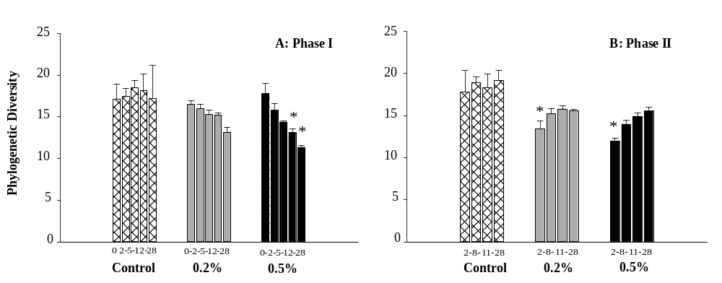

Figure 16
Figure 2
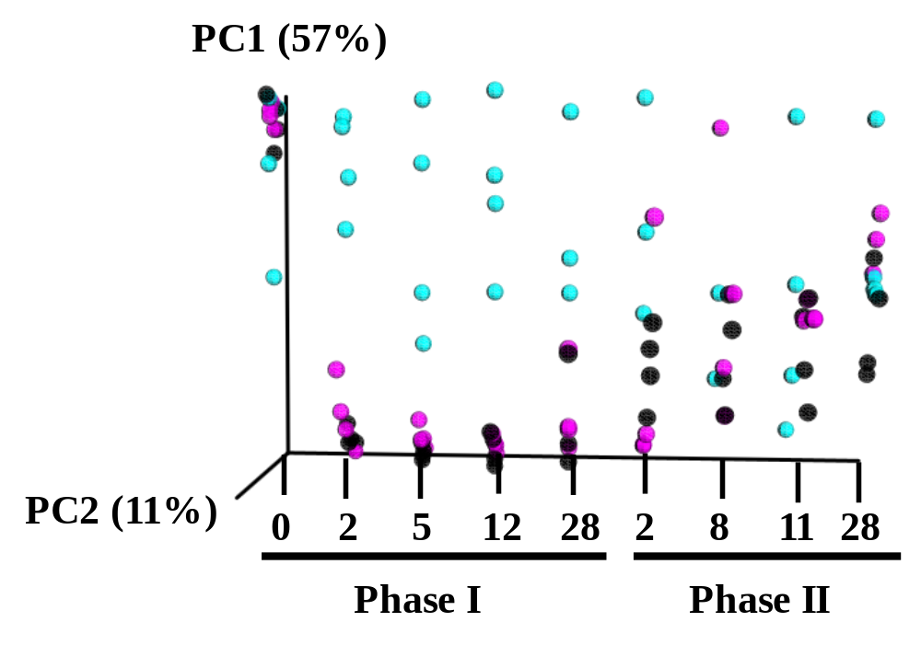

Figure 17

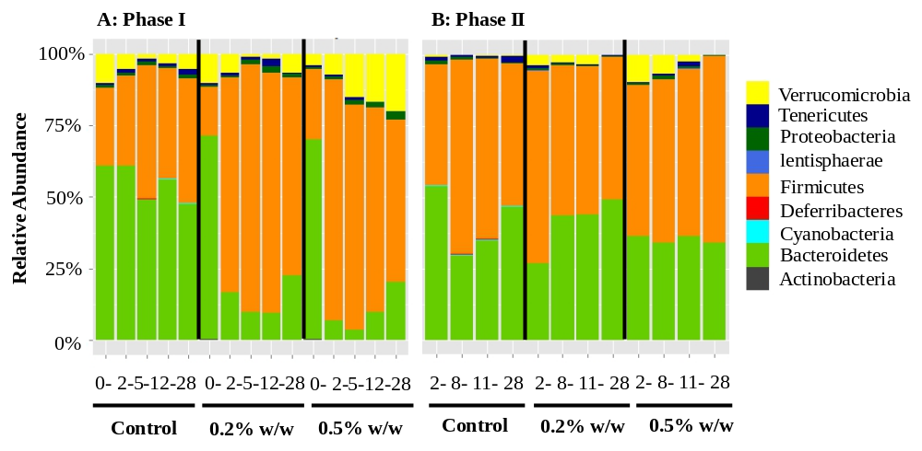

Figure 18

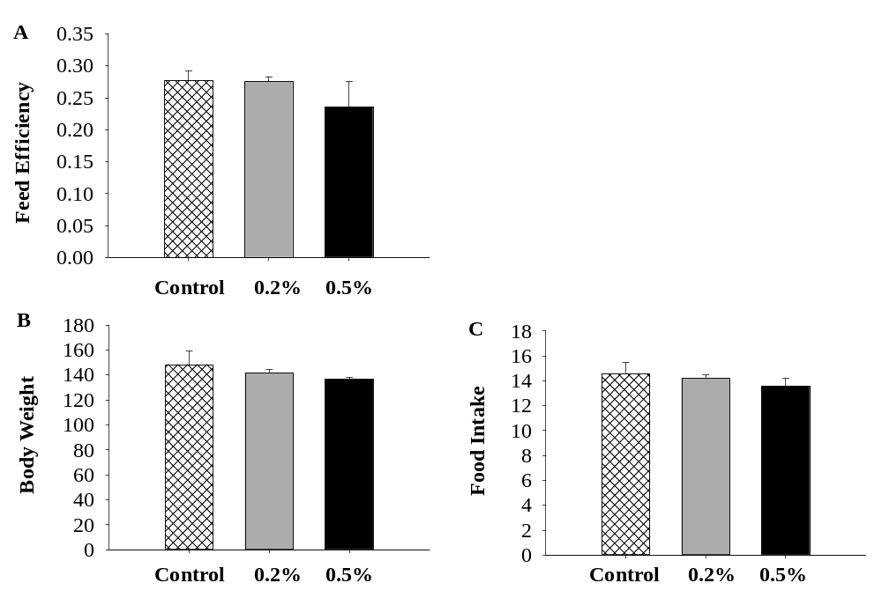

CHAPTER V
Trichlorocarbanilide from Rat Fecal Samples for Determination by High Pressure Liquid Chromatography-Tandem Mass Spectrometry

A version of this chapter was published by Rebekah C. Kennedy, Russell R. Fling, Paul D. Terry, Fu-Min Menn, Jiangang Chen and Christopher J. Borman:
Kennedy RC, Fling RR, Terry PD, Menn FM, Chen J, Borman CJ:
Extraction of 3,4,4'-Trichlorocarbanilide from Rat Fecal Samples for Determination by High Pressure Liquid Chromatography-Tandem Mass Spectrometry. Int.J.Environ.Res. Public Health. 2015;12(7):8125-8132.

This chapter does not differ from the published manuscript. RCK, JC, PDT and CJB conceived and designed the experiments; FM developed the initial method; RCK and RRF performed the experiments and analyzed the data. All authors contributed to the writing of the paper.

Abstract
Triclocarban (3,4,4′-Trichlorocarbanilide; TCC) in the environment has been well documented. Methods have been developed to monitor TCC levels from various matrices including water, sediment, biosolids, plants, blood and urine; however, no method has been developed to document the concentration of TCC in fecal content after oral exposure in animal studies. In the present study, we developed and validated a method that uses liquid extraction coupled with HPLC-MS/MS determination to measure TCC in feces. The limit of detection and limit of quantitation in control rats without TCC exposure was 69.0 ng/g and 92.9 ng/g of feces, respectively. The base levels of TCC in feces were lower than LOD. At 12 days of treatment, the fecal TCC concentration increased to 2220 µg/g among 0.2% w/w exposed animals. The concentration in fecal samples decreased over the washout period in 0.2% w/w treated animals to 0.399 µ/g feces after exposure was removed for 28 days. This method required a small amount of sample (0.1 g) with simple sample preparation. Given its sensitivity and efficiency, this method may be useful for monitoring TCC exposure in toxicological studies of animals.

Introduction

Triclocarban (3,4,4′-trichlorocarbanilide; TCC) is a chlorinated urea commonly used as a broad range antimicrobial in personal care products.¹ Human exposure to TCC primarily occurs through dermal absorption with the use of TCC-containing bar soaps,² where approximately 0.6% of the applied amount is absorbed through the skin.² Biomonitoring investigations have detected TCC in several environmental and biological matrices.²⁻⁵ Given its widespread use, interest in the health impact of TCC to the general public has increased in both academic and regulatory communities. The FDA recently presented a proposed ruling holding manufacturers of nonprescription antimicrobials, including TCC, responsible to prove the safety and efficacy of these compounds over regular soap.⁶ This proposed ruling comes amidst concerns of possible antimicrobial resistance and endocrine disruption activities during routine use in humans.⁶⁻⁸

After topical application, the bulk of TCC enters the wastewater treatment process where current treatment technologies can only transfer up to 79% of TCC to waste water sludge.¹ With high octanol-water and organic carbon partition coefficients, TCC has a high propensity to adsorb to the hydrophobic components of sludge and soil (log K_{ow} =4.9 and K_{oc} = 50,118 L/kg, respectively), and is environmentally persistent undergoing little degradation for months.⁹ When biosolids (i.e, treated wastewater sludge) are applied to agriculture fields as fertilizer, TCC is then transferred to the terrestrial environment raising safety concerns regarding the potential uptake of TCC into the food chain, allowing for a potential secondary human exposure route.^{10,11} Previously, we demonstrated that TCC exposure through the diet, during lactation, lead to TCC concentration in the milk of exposed dams and substantially reduced rat offspring survival.¹³ These results highlight the importance of monitoring TCC levels in various biological matrices to investigate and prevent potential health consequences.¹²

Methods of TCC detection have been reported in both solid and liquid biological matrices (urine, blood, and finger nails).¹³ Oral TCC exposure in animals has been used to investigate its potential endocrine-disrupting properties and reproductive toxicity.^{7, 9, 14-18} However, to our knowledge, no analytical method to monitor TCC concentration in a semi-solid fecal matrix has been published. In this study, a simple liquid extraction was applied followed by HPLC-MS/MS determination to estimate TCC concentration in fecal samples collected from an animal feeding study. The application of this method may facilitate the assessment of TCC exposure in biological matrices.

Materials and Methods

Chemicals and reagents

Acetone (99.5% purity), acetonitrile (99.9% purity), methanol (99.9% purity) and water (purity grade: Optima™) were purchased from Thermo Fisher Scientific (Waltham, MA). TCC (99% purity), carbon-13 labeled TCC (¹³C₆-TCC, quantitation reference) and ¹³C₆-2,4,5-trichlorophenoxyacetic acid (TCPAA, 99% purity, internal standard) were purchased from Cambridge Isotope (Tewksbury, MA) and prepared in methanol. Stock solutions of TCC (5 mg/mL) were prepared in acetone and TCC standards (0-500 ng/mL, or 0-500 ppb) were prepared from stock solution in methanol. TCC standards, ¹³C₆-TCC and TCPAA were stored at - 20°C until use.

Animal Fecal Samples Collection and Preparation
Feces were collected from female Sprague Dawley rats (Harlan Laboratory, Dublin, Virginia). Briefly, rats (n=4 per group) were weight ranked and randomized to control or TCC treatment groups and fed Harlan chow diet (2020X) or 2020X supplemented with 0.2% w/w TCC ad libitum for 4 weeks beginning at post-natal day (PND) 22 followed by 4 weeks washout with 2020X only. Feces were collected prior to treatment initiation at PND 22 and after 12 days of treatment. Fecal samples were also collected throughout the washout period at 2, 8, and 28 days after the withdrawal of TCC exposure. Samples were snap frozen and stored at -80°C until analysis. The Animal Use and Care Committee at University of Tennessee, Knoxville, approved all research protocols used in this report. The studies were conducted in a facility fully accredited by the Association for Assessment and Accreditation of Laboratory Animal Care.

Fecal Sample Extraction and Preparation
To extract TCC from fecal samples, 50 µL of 500 ng/mL ¹³C₆-TCC was added to 0.1g thawed feces and vortexed with a countertop vortex at maximum speed for 1 minute. Next, 5 mL of 80:20 acetonitrile/H₂O was added to each sample and vortexed at maximum speed for 30 seconds. After vortexing, samples were sonicated for 30 minutes and centrifuged at 1,500 rpm for 8 minutes at 21°C followed by 0.45 µm filtration prior to blow down under nitrogen flow to 1 mL. Samples were reconstituted to 2 mL with a 1:1 mixture of methanol/H₂O. A 300 µL aliquot of the mixture plus 6 µL of 2500 ng/mL ¹³C₆ TCPAA was added to auto-sampler vials prior to analysis.

HPLC-MS/MS Determination
Instrumental protocols followed were from EPA Method 1694²⁰ and as follows: Quantitation of TCC in the sample extracts were performed on a Dionex™ UltiMate™ 3000 HPLC/TSQ Quantum™ Access Max triple quadrupole mass spectrometer (Thermo Scientific). Chromatographic separation from interferences was performed by injection of 6 μL onto a Thermo Scientific™ Hypersil™ GOLD PFP, 2.1x100 mm, 1.9 µm column. The HPLC/MS/MS was run in the ESI negative, MRM (Multiple Reaction Monitoring) mode and quantitation was performed by recording the chromatographic peak area of the coincident precursor and product ions, m/z: 312.72 and 160.00, respectively.² Instrument conditions of both LC and MS are as follows: The HPLC column compartment was held at 38°C and the autosampler tray temperature was set at 5°C. The solvent system consisted of H₂O with 0.02% acetic acid (mobile phase A) and methanol (mobile phase B). Solvent A is 0.02% (v/v) acetic acid in LC/MC water; solvent B is 100% methanol. The analyte was separated using a gradient program starting with T (minute)=0, A=40%, B=60% at 0.3 mL/min; T=3, A=2%, B=98% at 0.3 mL/min; T=5.5, A=2%, B=98% at 0.3 mL/min; T=5.6, A=2%, B=98% at 0.35 mL/min; T=12, A=2%, B=98% at 0.35 mL/min; T=12.05, A=40%, B=60% at 0.35 mL/min; T=18.5, A=40%, B=60% at 0.35 mL/min and T=18.6, A=40%, B=60% at 0.3 mL/min. The MS conditions used in the method were set as follow: negative Electrospray Ionization (ESI); 200 °C for capillary temperature; 425 °C for vaporizer temperature; 20 (Arb) for sheath gas pressure; 2 (Arb) for Aux gas; and 1.5 mTorr for collision gas pressure. Collision energy was set 17 for TCCs, and 16 for 13C-TCPAA. Product ions were monitored at m/z 200.700 for 13C-TCPAA; m/z 160.000 for TCC; and m/z 159.700 for 13C-TCC. The signal:noise ratio was set at ˃ 3.
Thermo Xcalibur© (version 2.1) software was utilized to acquire and analyze data. Concentration of TCC in the sample was determined as the peak area ratio of TCC/¹³C₆-TCC as compared to the calibration curve derived from TCC concentrations: 2.5, 7.5, 37.5, 125, and 500 ng/mL). Quan Browser in Thermo Xcalibur 2.2® was used to set up the calibration cure (2.5, 7.5, 37.5, 125, and 500 ng/ml). Quadratic log-log calibration curve was used for quantitation. Calibrants were weighted by the inverse of the square of their quantity (1/X²).

Results and Conclusion

Method Validation and Quality Control
Typical chromatograms showing integration area of TCPAA, and that of a 10 ng/mL concentration of TCC standard in fecal matrix are shown in Figure 19. The analytical limit of detection (LOD) of the method was 1.46 ng/mL in solvent as defined by the average blank signal plus 3 standard deviations (n=20). The analytical limit of quantitation (LOQ) was 4.87 ng/mL which was defined as the average blank signal of the LOD plus 10 standard deviations. Fecal samples (0.1 gram) collected from control dams with no known TCC exposure were spiked with various TCC standards and ¹³C₆-TCC to characterize the performance of the assay in the presence of matrix. The LOD and the LOQ of the TCC in the fecal matrix was 69.0 and 92.9 ng/g feces respectively. To determine intra-assay variability, concentration of 10 or 350 ng/mL TCC standard was spiked into control feces (n=4 per concentration). Day-to-day inter-assay variability was calculated from 4 extractions over a period of 4 days with TCC spiked at both 10 and 350 ng/mL. Relative standard deviation (RSD%) of intra-assay variability was 22.4% at 10 ng/mL and 4.99% at 350 ng/mL respectively; the average recovery of TCC was 87.7% at 10 ng/mL and 120% at 350 ng/mL; the inter-assay variability (RSD%) was 30.6% (relative recovery of 73.5%) at 10 ng/mL and 14.1% (relative recovery of 130.6%) at 350 ng/mL over the period of 4 days. The accuracy and precision of the assay in a single extraction day were assessed by repeat analysis of 15 control replicates spiked with either 25 ng/mL or 100 ng/mL TCC (Table 8).

Quantification of TCC in Feces Samples
The assay was applied to determine the concentration of TCC in fecal samples collected from female SD rats during the treatment and a post-TCC exposure washout period. The concentration of TCC in the feces over the study period is shown in Table 9. At PND 22 (pre-exposure), the TCC concentration in fecal samples collected from both control and 0.2% w/w treated animals was below the LOD. At 12 days of treatment, the fecal TCC concentration in control animals was still below the LOD, but increased to 2,220 µg/g among 0.2% w/w exposed animals. The concentration of TCC in fecal samples decreased over the washout period in 0.2% w/w treated animals. At 8 days of washout, TCC in the feces of control animals (n=2) was below the LOD (<68.97 ng/g); in contrast, an average of 0.885 µg/g TCC was detected in fecal samples collected from 0.2% w/w TCC treated animals (n=2) at the same washout date. At 28 days of washout, the concentration of TCC extracted from control animals (n=2) remained below the LOD, whereas TCC concentration decreased to 0.399 µg/g in rats (n=2) exposed to TCC 28 days prior, which reflected discontinuation of exposure.

Conclusion
We developed a HPLC–MS/MS method for TCC detection from the fecal matrix that required a relative small amount of fecal sample (0.1 g) and utilized a liquid extraction method (Acetonitrile/H2O: 80/20). Our method was based on EPA Method 1694 which is optimized for Group 3 Compounds²⁰. TCC elutes at 5.5 minutes, thus it is possible that a shorter column (50 mm) could be used and/or column cleaning could start at 6 minutes, for 3 min followed by reequlibaration which potentially could further improve the analytical efficiency and save the solvent use for TCC measurement. Our data demonstrate the ability of this method to monitor TCC concentrations from the fecal matrix with reasonable repeatability and inter-/intra-assay variability. This method may prove useful in animal-based toxicological investigations and, ultimately, studies of TCC exposure and human health.

References

1. Lozano N, Rice CP, Ramirez M, Torrents A. Fate of Triclocarban, Triclosan and Methyltriclosan during wastewater and biosolids treatment processes. Water research. 2013;47(13):4519-4527.
2. Schebb NH, Inceoglu B, Ahn KC, Morisseau C, Gee SJ, Hammock BD. Investigation of human exposure to triclocarban after showering and preliminary evaluation of its biological effects. Environmental science & technology. 2011;45(7):3109-3115.
3. Pycke BF, Geer LA, Dalloul M, Abulafia O, Jenck AM, Halden RU. Human fetal exposure to triclosan and triclocarban in an urban population from Brooklyn, New York. Environ Sci Technol. 2014;48(15):8831-8838.
4. Asimakopoulos AG, Thomaidis NS, Kannan K. Widespread occurrence of bisphenol A diglycidyl ethers, p-hydroxybenzoic acid esters (parabens), benzophenone type-UV filters, triclosan, and triclocarban in human urine from Athens, Greece. Sci Total Environ. 2014;470-471:1243-1249.
5. Frederiksen H, Nielsen JK, Morck TA, et al. Urinary excretion of phthalate metabolites, phenols and parabens in rural and urban Danish mother-child pairs. International journal of hygiene and environmental health. 2013;216(6):772-783.
6. Kuehn BM. FDA pushes makers of antimicrobial soap to prove safety and effectiveness. Jama. 2014;311(3):234.
7. Chen J, Ahn KC, Gee NA, et al. Triclocarban enhances testosterone action: a new type of endocrine disruptor? Endocrinology. 2008;149(3):1173-1179.
8. Duleba AJ, Ahmed MI, Sun M, et al. Effects of triclocarban on intact immature male rat: augmentation of androgen action. Reprod Sci. 2011;18(2):119-127.
9. Chen F, Ying GG, Ma YB, Chen ZF, Lai HJ. Field dissipation of four personal care products in biosolids-amended soils in North China. Environmental toxicology and chemistry / SETAC. 2014;33(11):2413-2421.
10. Mathews S, Henderson S, Reinhold D. Uptake and accumulation of antimicrobials, triclocarban and triclosan, by food crops in a hydroponic system. Environmental science and pollution research international. 2014;21(9):6025-6033.
11. Prosser RS, Lissemore L, Topp E, Sibley PK. Bioaccumulation of triclosan and triclocarban in plants grown in soils amended with municipal dewatered biosolids. Environmental toxicology and chemistry / SETAC. 2014;33(5):975-984.
12. Kennedy RC, Menn FM, Healy L, et al. Early life triclocarban exposure during lactation affects neonate rat survival. Reproductive sciences (Thousand Oaks, Calif.). 2015;22(1):75-89.
13. Shi Y, Liu X, Zhang J, Shao B. Analysis of triclosan and triclocarban in human nails using isotopic dilution liquid chromatography-tandem mass spectrometry. Journal of chromatography. B, Analytical technologies in the biomedical and life sciences. 2013;934:97-101.
14. Schebb NH, Ahn KC, Dong H, Gee SJ, Hammock BD. Whole blood is the sample matrix of choice for monitoring systemic triclocarban levels. Chemosphere. 2012;87(7):825-827.
15. Birch CG, Hiles RA, Eichhold TH, et al. Biotransformation products of 3,4,4'-trichlorocarbanilide in rat, monkey, and man. Drug metabolism and disposition: the biological fate of chemicals. 1978;6(2):169-176.
16. Nolen GA, Dierckman TA. Reproduction and teratogenic studies of a 2:1 mixture of 3,4,4'-trichlorocarbanilide and 3-trifluoromethyl-4,4'-dichlorocarbanilide in rats and rabbits. Toxicol Appl Pharmacol. 1979;51(3):417-425.
17. Hiles RA. Metabolism and toxicity of halogenated carbanilides: absorption, distribution and excretion of radioactivity from 3,4,4'-trichloro[14C]carbanilide (TCC) and 3-trifluoromethyl-4,4'-dichloro[14C]carbanilide (TFC) in rats. Food and cosmetics toxicology. 1977;15(3):205-211.
18. Jeffcoat AR, Handy RW, Francis MT, et al. The metabolism and toxicity of halogenated carbanilides. Biliary metabolites of 3,4,4'-trichlorocarbanilide and 3-trifluoromethyl-4,4'-dichlorocarbanilide in the rat. Drug metabolism and disposition: the biological fate of chemicals. 1977;5(2):157-166.

Appendix

Figure Legends:

Figure 19. Typical HPLC-MS/MS ion chromatograms from fecal matrix; (A) Integration area of representative TCPAA spike in fecal matrix; (B) 10 ng/mL TCC spiked blank fecal matrix;

Figure 19

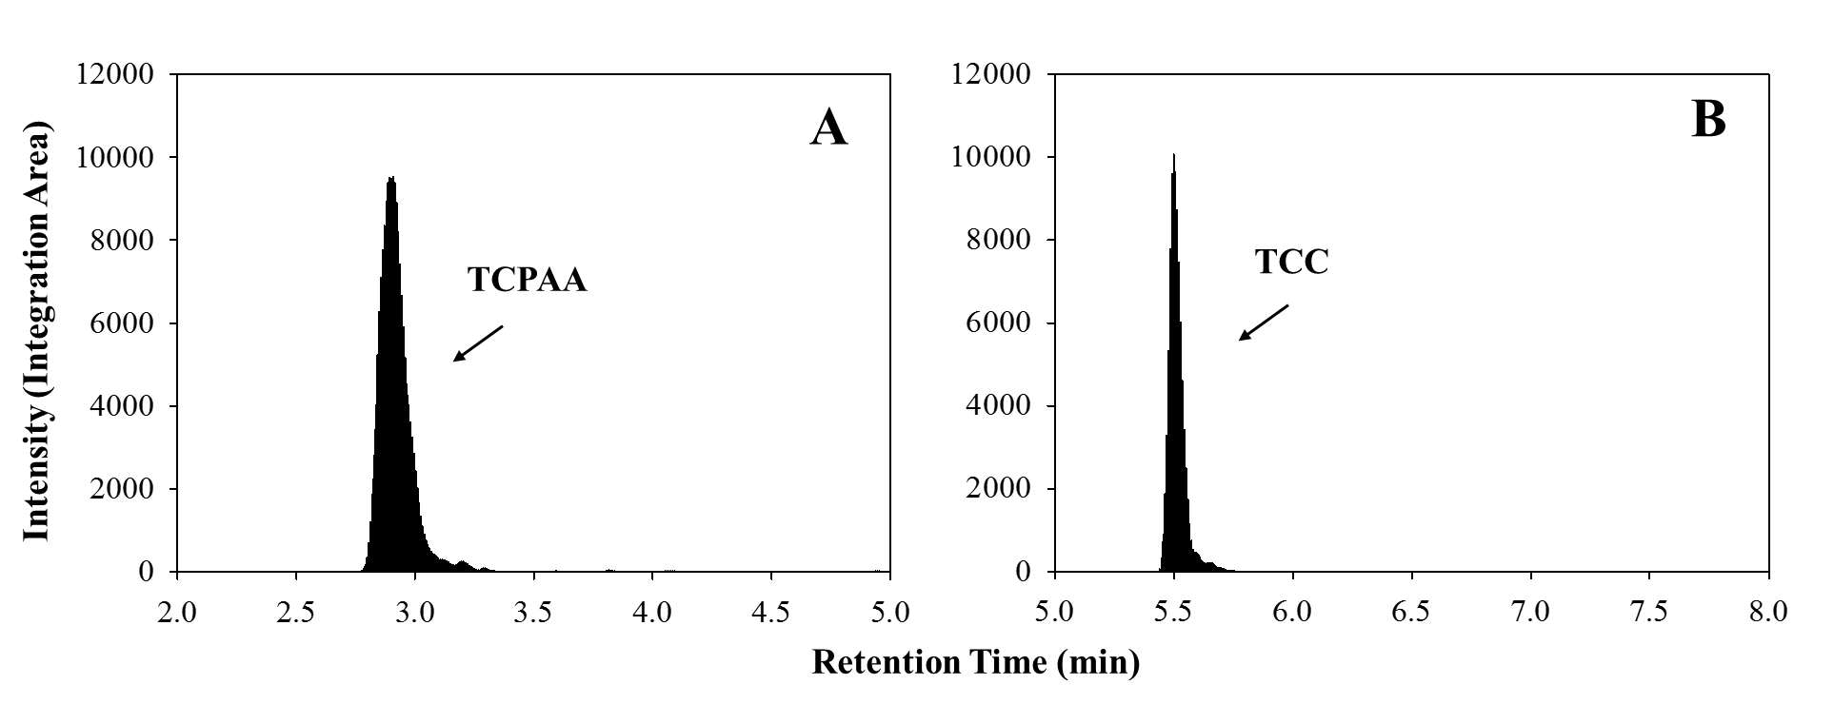

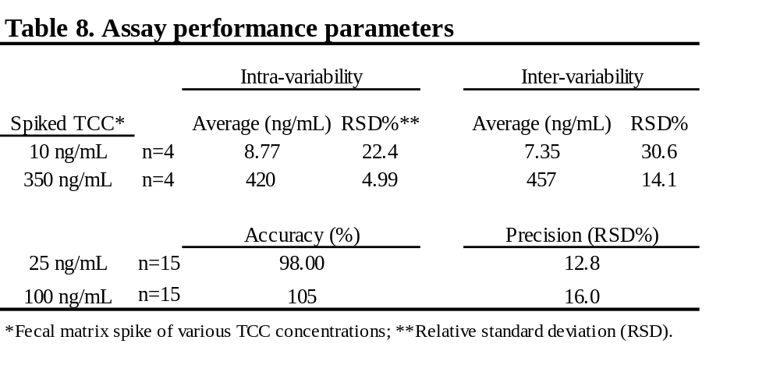

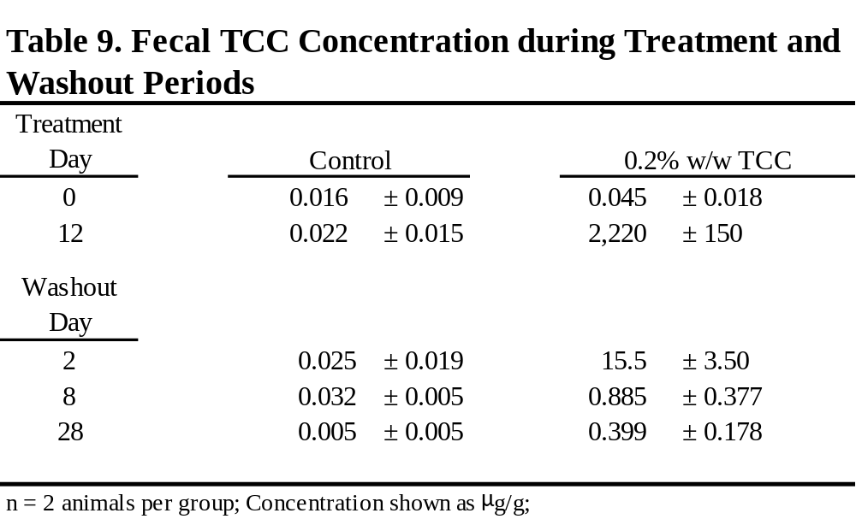

CONCLUSION and Futurue Directions
The results of this dissertation demonstrated that TCC exposure may interfere with early life development. TCC concentrated in the milk and reduced survival was noted from offspring suckling from dams exposed to 0.2% w/w or 0.5% w/w TCC orally. Exposure to TCC affected the health of suckling offspring leading to dam breast tissue involution. The use of 16S sequencing revealed the alteration of the gut microbial composition of suckling offspring raised by 0.1% exposed dams. Overt toxicity was not demonstrated in adult or post-weaned animals exposed to TCC through the diet. Though gut microbial dysbiosis was induced in post-weaned rats exposed to 0.2% w/w or 0.5% w/w TCC and pregnant and lactating dams exposed to 0.1% w/w TCC orally. Though the compositional rebound that occurred in post-weaned rats after exposure was removed demonstrated that continual TCC exposure may present the most risk.
Exposure to TCC has been documented in human populations around the world from gestation until adulthood. Given that TCC is detected in the breastmilk and our results demonstrated that TCC exposure through this humanly relevant pathway can induce gut microbial dysbiosis in suckling offspring, future investigations should consider the impact of TCC exposure on the gut microbiota among human infants. Though our results provided information regarding the effect of TCC exposure on gut microbial composition, the mechanism of diversity alterations and potential resultant health outcomes related to these changes are elusive and should be explored. This research may be used by regulatory agencies to determine the safety of TCC use during early life and provides the public additional information to make informed product purchases.

VITA

Rebekah Kennedy was born in Anchorage Alaska. She graduated from Purdue University with a BA in Psychology and Law and Society in 2007. She worked as a research assistant at Purdue and as a case manager working with children struggling with mental health difficulties following graduation. In 2010, she entered a dual master’s program in Nutrition and Public Health and graduated with an MS-MPH in 2013 from the University of Tennessee. The following semester, she entered a doctoral program in Comparative and Experimental Medicine and will graduate with a PhD in July of 2016. Throughout her time at UTK, she has focused on early life exposure to compounds found in everyday items. Following graduation, she looks forward to her next big adventure in research at Michigan State University as a postdoctoral researcher.

