Computer Simulations of Enzymes

A Dissertation Presented for the

Doctor of Philosophy

Degree

The University of Tennessee, Knoxville

Jianzhuang Yao

May 2014

Copyright © 2014 by Jianzhuang Yao.
All rights reserved.

DEDICATION

To my younger sister
Jianli Yao

To my parents
Shuzhen Wu and Guoqi Yao.

ACKNOWLEDGEMENTS
I would like to express my deepest gratitude to my advisor, Dr. Hong Guo who has the attitude of a genius, for his continually and convincingly encouragement, patient guidance, and professional advice.
I would like to thank my committee members, Dr. Cynthia Peterson, Dr. Tongye Shen, Dr. Tamah Fridman, Dr. Chunlei Su and Dr. Jerome Baudry for their valuable suggestions on research and career development.
I want to appreciate all the members of Dr. Hong Guo’s lab, our collaborator Dr. Feng Chen’s lab, Dr. Tongye Shen’s lab and Dr. Xiaohan Yang’s lab. Completion of this dissertation is impossible without their support.
Finally, I would like to thank my younger sister Jianli Yao, and my parents Shuzhen Wu and Guoqi Yao. They are always encouraging and supporting me with their best wishes.

ABSTRACT

Enzymes are fundamentally important catalyst which reactions involve in performing and controlling most life processes. Thus, understanding catalytic mechanism of enzymes are a fundamental task in modern biophysics. Based on structural data from NMR and X-Ray crystallography, computational simulations are emerging to investigate how enzymes work.

In this dissertation, classic MD simulation and QM/MM MD simulations were applied to study the catalytic mechanisms of Sedolisin, S-adenosyl-L-methionine (AdoMet)-dependent methyltransferases, Salicylic acid binding protein 2 and Terpenoid cyclases. The deacylation reaction catalyzed by sedolisin suggested that Asp170 acts as a general acid/base catalyst not only in the acylation step, but also in the deacylation step. The free energy simulations reported in SAMT work showed that the structure of the reactant complex containing salicylate is rather close to the corresponding TS structure compared to 4-hydroxybenzoate. Thus, additional energy seems to be required to generate the TS-like structure during the methyl transfer process for 4-hydroxybenzoate. For protein lysine methyltransferase SET7/9, the free energy the simulations showed that while the wild type SET7/9 may act like a mono-methylase, the Y245→A mutation could increase the ability of SET7/9 to add two more methyl groups on the target lysine and lead to a tri-methylase. Salicylic acid binding protein 2 (SABP2) that has promiscuous esterase activity toward a series of substrates, but shows specific highly activity toward its natural substrate methyl salicylate (MeSA). It is demonstrated that SABP2 represent a case in which the enzyme itself might have not been perfectly evolved and that SAC involving its natural substrate (MeSA) may be used to enhance the activity specifically on this substrate and therefore achieve substrate discrimination between its native and promiscuous substrates. We report a detailed mechanistic description of the biosynthesis of the (4S)-limonene synthase and identify the His579 is a key residue that favors formation of (4S)-limonene by deprotonation of (4S)-α-terpinyl cation, which is crucial in product fidelity of (4S)-LS. The rate-limiting formation of (4S)-α-terpinyl cation from 3S-LPP is a concerted-asynchronous reaction.
In addition, protein protein interaction prediction is also included in my dissertation. We established a robust pipeline for PPI prediction by integrating multiple classifiers using random forests algorithm. This pipeline could be very useful for predicting PPI in non-model species.

TABLE OF CONTENTS
INTRODUCTION 1
Catalytic Mechanism of Enzymes 2
Sedolisins 2
AdoMet-dependent methyltransferases 4
Salicylic acid binding protein 2 7
Terpenoid cyclases 8
Protein Protein Interaction Prediction 9
References 10
CHAPTER I QM/MM and free energy simulations of deacylation reaction catalyzed by sedolisin, a serine carboxyl peptidase 24
Abstract 25
Introduction 26
Method 28
Results and Discussion 32
Conclusion 36
Acknowledgement 37
References 44
CHAPTER 2 QM/MM Free Energy Simulations of Salicylic Acid Methyltransferase: the Effects of Stabilization of TS-Like Structures on Substrate Specificity 49
Abstract 50
Introduction 51
Methods 57
Results and Discussion 60
Conclusions 67
Acknowledgment 68
References 78
CHAPTER 3 Understanding Product Specificity of Protein Lysine Methyltransferases from QM/MM MD and Free Energy Simulations: the Effects of Mutation on SET7/9 beyond the Tyr/Phe Switch 85
Abstract 86
Introduction 87
Methods 92
Results and Discussion 96
Conclusions 102
Acknowledgement 103
Reference 112
CHAPTER 4 QM/MM and experimental study of substrate-assisted catalysis in substrate promiscuity, a novel substrate discrimination mechanism in promiscuous enzyme 119
Abstract 120
Introduction 121
Methods 126
Results and Discussion 131
Conclusion 140
Acknowledgement 142
References 153
CHAPTER 5 Quantum Mechanical/Molecular Mechanical Study of Catalytic Mechanism of (4S)-Limonene Synthase and Role of Key Residues (His579) in Product Fidelity 166
Abstract 167
Introduction 168
Methods 171
Results and Discussion 177
Conclusion 185
Acknowledgement 185
References 194
CHAPTER 6 PPCM: Combing multiple classifiers to improve protein-protein interaction prediction 204
Abstract 205
Introduction 206
Methods 210
Results and Discussion 212
Acknowledgement 215
References 234
CONCLUSIONs 240
VITA 243

LIST OF FIGURES, TABLES, and SCHEME
Figure 1.1 38
Figure 1.2 40
Figure 1.3 42
Figure 1.4 43
Figure 2.1 70
Figure 2.2 72
Figure 2.3 73
Figure 2.4 75
Figure 2.5 77
Figure 3.1 105
Figure 3.2 107
Figure 3.3 109
Figure 3.4 111
Figure 4.1 143
Figure 4.2 144
Figure 4.3 145
Figure 4.4 147
Figure 4.5 148
Figure 4.6 149
Figure 4.7 150
Table 4.1 151
Table 4.2 151
Figure 5.1 186
Figure 5.2 188
Figure 5.3 189
Figure 5.4 190
Table 5.1 191
Scheme 5.1 193
Figure 6.1 216
Figure 6.2 218
Figure 6.3 220
Figure 6.4 221
Table 6.1 222
Table S6.1 223
Table S6.2 229

INTRODUCTION
Enzymes are fundamentally important catalyst which reactions involve in performing and controlling most life processes.(Warshel 1991, Fersht 1999) Therefore, it has fundamental and practical importance to understand the catalytic power of enzymes. Although biomedical and structural studies (e.g. NMR and X-Ray Crystallography) shed some light on how enzymes work, the origin of enzymes enormous catalytic efficiency is not widely understood. For example, how enzymes achieve transition state stabilization and what are the catalytic groups in the active site remain elusive. In recent decade, computer simulations of enzymes have emerged along with the dramatically increased computing power and have become a popular and effective tool to study detailed catalytic mechanism of enzymes.(Villa, Štrajbl et al. 2000, Warshel 2003, Warshel, Sharma et al. 2006) Based on modeling of enzymatic reactions, Warshel and co-workers proposed that the pre-organized polar environment (electrostatic effect) in active site is the major factor accounting for transition state stabilization.(Warshel, Sharma et al. 2006) However, effort in applications of computer simulations for enzymes is still far from enough to elucidate the catalytic mechanism and catalytic power of all enzymes. Thus, understanding the detailed catalytic mechanism of enzymes (e.g. catalytic groups) and how enzymes achieve transition state stabilization using computer simulations is an important task of modern biophysics/biochemistry. In this dissertation, I seek to investigate enzyme catalytic mechanism of several important enzymes and enzymes families including Sedolisins, S-adenosyl-L-methionine(AdoMet)-dependent methyltransferases, Salicylic acid binding protein 2 and terpenoid cyclases using quantum mechanical/molecular mechanical (QM/MM) calculations, MD (both classical and QM/MM) and free energy (potential of mean force) simulations.
In addition to computer simulations of enzymes, I develop a novel protein protein interaction prediction pipeline named PPCM.

Catalytic Mechanism of Enzymes

Sedolisins
Sedolisins (serine-carboxyl peptidases) belong to the family S53 of clan SB of serine peptidases (MEROPS S53).(Oda, Sugitani et al. 1987, Wlodawer, Li et al. 2001, Wlodawer, Li et al. 2003) The enzymes in this family share some common properties, including maximum activity at low pH (e.g., pH 3~5) and the presence of conserved acidic residues (aspartate and glutamate) required for the activity.(Murao, Ohkuni et al. 1993, Shibata, Dunn et al. 1998, Tsuruoka, Isono et al. 2003, Tsuruoka, Nakayama et al. 2003, Wlodawer, Li et al. 2003, Reichard, Lechenne et al. 2006, Siezen, Renckens et al. 2007) The members of the family also include tripeptidyl-peptidase 1 (TPP1)(Sleat, Donnelly et al. 1997) for which the loss of the activity as a result of mutations in the TPP1 gene (previously named CLN2) is believed to be the cause of a fatal neurodegenerative disease, classical late-infantile neuronal ceroid lipofuscinosis.(Sleat, Donnelly et al. 1997, Rawlings and Barrett 1999, Lin, Sohar et al. 2001, Golabek and Kida 2006)
As the first isolated and described member of the sedolisins family, Pseudomonas sp. 101 sedolisin has been extensively studied by biochemical and mutagenesis approaches along with the determination of crystal structures for several enzyme-inhibitor complexes;(Oda, Takahashi et al. 1994, Ito, Narutaki et al. 1999, Oyama, Abe et al. 1999, Wlodawer, Li et al. 2001, Wlodawer, Li et al. 2001, Wlodawer, Li et al. 2004) a quantum mechanical/molecular mechanical (QM/MM) study based on energy minimization approach has also been performed on this enzyme.(Bravaya, Bochenkova et al. 2006) Sedolisin has a catalytic triad Ser-287−Glu-80−Asp-84 in place of the Ser-His-Asp triad of related (but usually smaller) classical serine peptidases. Another conserved acidic residue, Asp-170, is structurally equivalent to Asn-155 (part of the oxyanion hole) in subtilisin. The natural substrates for most of the serine carboxyl peptidases are still unknown. Some understanding of the substrate specificity for these enzymes has been achieved through inspection of the inhibitor interactions in the X-ray structures of these enzymes, and/or from the determination of their ability to process peptide libraries.(Wlodawer, Li et al. 2001, Wlodawer, Li et al. 2001, Comellas-Bigler, Fuentes-Prior et al. 2002, Wlodawer, Li et al. 2003, Comellas-Bigler, Maskos et al. 2004, Wlodawer, Li et al. 2004, Wlodawer, Li et al. 2004, Guhaniyogi, Sohar et al. 2009, Pal, Kraetzner et al. 2009) Nevertheless, the origin of differences in substrate preferences for different members of the sedolisin family is still not well understood. I’ve studied the detailed acylation mechanism and substrate specificities. (Xu, Yao et al. 2011) Deacylation process is studied in Chapter 1.

AdoMet-dependent methyltransferases
Plants produce a large number of low molecular weight metabolites which may play critical roles in diverse biological processes such as plant growth and development as well as plant interactions with the environment. One chemical modification that has profound impact on the biological processes mentioned above is enzymatic methylation of carboxyl moieties for some of these low molecular weight metabolites, such as salicylic acid (SA), benzoic acid (BA), indole-3-acetic acid (IAA), gibberellic acid (GA), farnesoic acid (FA), cinnamic/coumaric acid (CC) and jasmonic acid (JA), using S-adenosyl-L-methionine (AdoMet) as the methyl donor.(Taiz and Zeiger 2006) The methylated products can have biological and ecological functions that are quite different from their precursors. The enzymes that catalyze the methylation of SA, BA, IAA, GA, FA, CC and JA, for instance, are SA methyltransferase (SAMT),(Ross, Nam et al. 1999, Chen, D'Auria et al. 2003) BA methyltransferase (BAMT),(Murfitt, Kolosova et al. 2000) IAA methyltransferase (IAMT),(Qin, Gu et al. 2005, Zhao, Guan et al. 2007, Zhao, Ferrer et al. 2008) GA methyltransferase (GAMT),(Varbanova, Yamaguchi et al. 2007) FA methyltransferase (SAMT),(Yang, Yuan et al. 2006) CC methyltransferase (CCMT)(Kapteyn, Qualley et al. 2007) and JA methyltransferase (JAMT),(Seo, Song et al. 2001) respectively. These enzymes belong to the same SABATH enzyme family(D’Auria, Chen et al. 2003) and can be distinguished according to their substrate preferences. The SABATH family also contains some other proteins, including the nitrogen-directed methyltransferases involved in caﬀeine biosynthesis.(Ogawa, Herai et al. 2001, McCarthy and McCarthy 2007) Previous studies have shown that small changes in primary protein sequences may lead to the functional emergence of SABATH proteins with altered substrate preferences.(Zubieta, Ross et al. 2003, Pichersky, Noel et al. 2006) The SABATH enzymes have been a subject of extensive biochemical and structural investigations.(Ross, Nam et al. 1999, Zubieta, Ross et al. 2003, Pott, Hippauf et al. 2004, Effmert, Saschenbrecker et al. 2005, Hippauf, Michalsky et al. 2010, Tieman, Zeigler et al. 2010, Zhao, Guan et al. 2010) Nevertheless, the origin of their substrate specificity is still not well understood. In Chapter 2, catalytic mechanism of SAMT is studied.
The tails of histone proteins are subject to a variety of post-translational modifications, and these modifications are believed to be a part of the histone code for chromatin regulation (Strahl and Allis 2000). One of such modifications is the methylation of a range of lysine (K) residues on histones, including K4, K9, K27, K36, K79 on histone H3 and K20 on histone H4 (Marmorstein 2003). Catalyzed by protein lysine methyltransferases (PKMTs), histone lysine methylations have been found to affect a variety of important biological processes, including heterochromatin formation, X-chromosome inactivation, transcriptional silencing and activation (Martin and Zhang 2005, Jenuwein 2006). PKMTs may be classified based on their ability to transfer one, two or three methyl groups from S-adenosyl-L-methionine (AdoMet, the methyl donor) to the ε-amino group of target lysine, a special property of the enzymes that is termed as product specificity (Strahl and Allis 2000, Martin and Zhang 2005). Since different methylation states may lead to different downstream events (Turner 2005, Lall 2007, Taverna, Li et al. 2007), it is of fundamental importance to understand the determinant of the product specificity, including the energetic and structural factors that control the product specificity. A number of experimental (Zhang, Tamaru et al. 2002, Xiao, Jing et al. 2003, Zhang, Yang et al. 2003, Collins, Tachibana et al. 2005, Couture, Collazo et al. 2005, Xiao, Jing et al. 2005, Couture, Dirk et al. 2008, Del Rizzo, Couture et al. 2010, Wu, Min et al. 2010, Xu, Wu et al. 2011) and computational studies (Hu and Zhang 2006, Guo and Guo 2007, Wang, Hu et al. 2007, Chu, Xu et al. , Hu, Wang et al. 2008, Zhang and Bruice 2008, Zhang and Bruice 2008, Xu 2009, Bai, Shen et al. 2011) have been performed to understand the origin of the product specificity for PKMTs. Structural and mutational studies have identified a Phe/Tyr switch located at the active site of many SET domain PKMTs (Xiao, Jing et al. 2003, Zhang, Yang et al. 2003, Collins, Tachibana et al. 2005, Couture, Collazo et al. 2005). It has been shown previously that the product specificity of the enzyme may depend on whether this position is occupied by a Phe or Tyr residue. Indeed, it has been observed that this position tends to be occupied by a tyrosine residue for mono-methyltransferases (e.g. Y305 in SET7/9 (Del Rizzo, Couture et al. 2010) and Y334 in SET8 (Couture, Collazo et al. 2005, Couture, Dirk et al. 2008)) and by a phenylalanine for di- or tri-methyltransferases (e.g. F281 in DIM-5 (Zhang, Yang et al. 2003)). Moreover, the substitution at the Phe/Tyr switch position could lead to the change of the product specificity that is consistent with the observations on the wild-type enzymes. In Chapter 3, we report QM/MM free energy simulations on SET7/9 mutation (Y245A) effects on product specificity.

Salicylic acid binding protein 2
Substrate-assisted catalysis (SAC) is a process in which the functional groups from substrates, in addition to those from enzymes, contribute to the rate acceleration of the enzyme-catalyzed reactions.(Carter and Wells 1987, Carter, Nilsson et al. 1989, Xu, Guo et al. 2006) The removal of such functional groups from the substrates impairs the catalysis. It has been demonstrated that for engineered enzymes SAC may provide a way of drastically changing substrate specificity.(Carter and Wells 1987) Question remains, however, as to whether naturally occurring enzymes might have already used SAC as one of important strategies for the discrimination between their native substrates and promiscuous substrates that lack the groups capable of participating in SAC. Salicylic acid binding protein 2 (SABP2) studied in this work has specific esterase activity toward methyl salicylate (MeSA) and belongs to the hydrolase superfamily.(Kumar and Klessig 2003, Forouhar, Yang et al. 2005, Kumar, Park et al. 2005, Kumar, Gustafsson et al. 2006, Zhao, Guan et al. 2009) It has been shown(Kumar and Klessig 2003, Forouhar, Yang et al. 2005, Kumar, Park et al. 2005, Kumar, Gustafsson et al. 2006, Zhao, Guan et al. 2009) that Ser-81, His-238 and Asp-210 act as the catalytic triad and the main-chain amide group of Ala-13 participates in the oxyanion-hole interaction (Fig. 1A). The conversion of MeSA to SA catalyzed by SABP2 is believed to be a part of the signal transduction pathways that activate systemic acquired resistance and local defense responses to plant pathogens.(Kumar and Klessig 2003, Forouhar, Yang et al. 2005, Kumar, Park et al. 2005, Kumar, Gustafsson et al. 2006, Zhao, Guan et al. 2009) Previous studies have demonstrated that SABP2 possesses specific esterase activity toward MeSA, and this activity seems to be much stronger than the activities of this enzyme toward to some other promiscuous substrates.(Kumar and Klessig 2003, Forouhar, Yang et al. 2005, Kumar, Park et al. 2005, Kumar, Gustafsson et al. 2006, Zhao, Guan et al. 2009) The exact reasons for the differences in the activities are still not clear. In Chapter 4, we report the results of computational and experimental investigations which suggest that SAC may play an important role in substrate discrimination.

Terpenoid cyclases
Terpenoid cyclases involve in initial cyclization of more than 60,000 known natural product synthesis.(Gershenzon and Dudareva 2007) Some of them such as carotenes and sterols are part of fundamental metabolism and found substantially in all plants. This surprising product diversity of terpene cyclases demonstrates a significant catalytic challenge to these so-called promiscuous enzymes. Therefore, it is very important to determine the factors that account for product specificity of terpene cyclases. We use Mentha spicata (4S)-limonene synthase as the model.(Hyatt, Youn et al. 2007) In Chapter 5, we report a detailed catalytic mechanism of (4S)-Limonene using QM(SCC-DFBTPR)/MM MD and free energy (2d-PMF) simulations. By comparing the active sites and catalytic mechanisms of limonene synthase and bornyl diphosphate synthase, it is proposed based on the results of computer simulations that a histidine residue (His579) of limonene synthase, corresponding to Phe578 in bornyl diphosphate synthase, may act as a general base for the depronation process of α-terpinyl cation resulting in the final main product limonene.

Protein Protein Interaction Prediction
In recent decades, protein protein interaction (PPI) prediction has become a popular research area and many PPI prediction methods have been developed to enhance PPI prediction accuracy. Machine learning methods showed their powerful ability in protein interaction prediction by integration of different kinds of biological data. However, to our knowledge, there is not any method which focuses on enhancing PPI prediction by integration of individual classifiers. In Chapter 6, we report a novel robust PPI prediction pipeline named PPCM that merges all classifiers from GO2PPI and Phyloprof. As a result, our PPCM showed three advantages compared to individual classifiers. First, all tests of PPCM showed significant improvement in AUC compared with their corresponding individual classifiers. Second, more features (classifiers) led to better improvement in the PPI prediction accuracy (AUC). Finally, all cross species PPCM achieved competitive and even better prediction accuracy compared to the SC PPCM and classifiers with highest AUC in the same category.

References
Bai, Q. F., Y. L. Shen, X. J. Yao, F. Wang, Y. P. Du, Q. Wang, N. Z. Jin, J. Hai, T. J. Hu and J. B. Yang (2011). "Modeling a New Water Channel That Allows SET9 to Dimethylate p53." Plos One 6(5): e19856.
Bravaya, K., A. Bochenkova, B. Grigorenko, I. Topol, S. Burt and A. Nemukhin (2006). "Molecular modeling the reaction mechanism of serine-carboxyl peptidases." Journal of Chemical Theory and Computation 2(4): 1168-1175.
Carter, P., B. Nilsson, J. P. Burnier, D. Burdick and J. A. Wells (1989). "ENGINEERING SUBTILISIN BPN' FOR SITE-SPECIFIC PROTEOLYSIS." Proteins-Structure Function and Genetics 6(3): 240-248.
Carter, P. and J. A. Wells (1987). "ENGINEERING ENZYME SPECIFICITY BY SUBSTRATE-ASSISTED CATALYSIS." Science 237(4813): 394-399.
Chen, F., J. C. D'Auria, D. Tholl, J. R. Ross, J. Gershenzon, J. P. Noel and E. Pichersky (2003). "An Arabidopsis thaliana gene for methylsalicylate biosynthesis, identified by a biochemical genomics approach, has a role in defense." Plant Journal 36(5): 577-588.
Chu, Y. Z., Q. Xu and H. Guo (2008). "Understanding Energetic Origins of Product Specificity of SET8 from QM/MM Free Energy Simulations: What Causes the Stop of Methyl Addition during Histone Lysine Methylation?" J Chem Theory Comput 6(4): 1380-1389.
Collins, R. E., M. Tachibana, H. Tamaru, K. M. Smith, D. Jia, X. Zhang, E. U. Selker, Y. Shinkai and X. Cheng (2005). "In vitro and in vivo analyses of a Phe/Tyr switch controlling product specificity of histone lysine methyltransferases." J Biol Chem 280(7): 5563-5570.
Comellas-Bigler, M., P. Fuentes-Prior, K. Maskos, R. Huber, H. Oyama, K. Uchida, B. M. Dunn, K. Oda and W. Bode (2002). "The 1.4 angstrom crystal structure of kumamolysin: A thermostable serine-carboxyl-type proteinase." Structure 10(6): 865-876.
Comellas-Bigler, M., K. Maskos, R. Huber, H. Oyama, K. Oda and W. Bode (2004). "1.2 angstrom crystal structure of the serine carboxyl proteinase pro-kumamolisin: Structure of an intact pro-subtilase." Structure 12(7): 1313-1323.
Couture, J. F., E. Collazo, J. S. Brunzelle and R. C. Trievel (2005). "Structural and functional analysis of SET8, a histone H4 Lys-20 methyltransferase." Genes & Development 19(12): 1455-1465.
Couture, J. F., L. M. A. Dirk, J. S. Brunzelle, R. L. Houtz and R. C. Trievel (2008). "Structural origins for the product specificity of SET domain protein methyltransferases." Proc Natl Acad Sci U S A 105(52): 20659-20664.
D’Auria, J. C., F. Chen and E. Pichersky (2003). The SABATH family of MTs in
Arabidopsis thaliana and other plant species. Recent Adv Phytochem. 37: 95–125.
Del Rizzo, P. A., J. F. Couture, L. M. A. Dirk, B. S. Strunk, M. S. Roiko, J. S. Brunzelle, R. L. Houtz and R. C. Trievel (2010). "SET7/9 Catalytic Mutants Reveal the Role of Active Site Water Molecules in Lysine Multiple Methylation." J Bio Chem 285(41): 31849-31858.
Effmert, U., S. Saschenbrecker, J. Ross, F. Negre, C. M. Fraser, J. P. Noel, N. Dudareva and B. Piechulla (2005). "Floral benzenoid carboxyl methyltransferases: From in vitro to in planta function." Phytochemistry 66(11): 1211-1230.
Fersht, A. (1999). Structure and mechanism in protein science: a guide to enzyme catalysis and protein folding, Macmillan.
Forouhar, F., Y. Yang, D. Kumar, Y. Chen, E. Fridman, S. W. Park, Y. Chiang, T. B. Acton, G. T. Montelione, E. Pichersky, D. F. Klessig and L. Tong (2005). "Structural and biochemical studies identify tobacco SABP2 as a methyl salicylate esterase and implicate it in plant innate immunity." Proceedings of the National Academy of Sciences of the United States of America 102(5): 1773-1778.
Gershenzon, J. and N. Dudareva (2007). "The function of terpene natural products in the natural world." Nat Chem Biol 3(7): 408-414.
Golabek, A. A. and E. Kida (2006). "Tripeptidyl-peptidase I in health and disease." Biological Chemistry 387(8): 1091-1099.
Guhaniyogi, J., I. Sohar, K. Das, A. M. Stock and P. Lobel (2009). "Crystal Structure and Autoactivation Pathway of the Precursor Form of Human Tripeptidyl-peptidase 1, the Enzyme Deficient in Late Infantile Ceroid Lipofuscinosis." Journal of Biological Chemistry 284(6): 3985-3997.
Guo, H. B. and H. Guo (2007). "Mechanism of histone methylation catalyzed by protein lysine methyltransferase SET7/9 and origin of product specificity." Proc Natl Acad Sci U S A 104(21): 8797-8802.
Hippauf, F., E. Michalsky, R. Q. Huang, R. Preissner, T. J. Barkman and B. Piechulla (2010). "Enzymatic, expression and structural divergences among carboxyl O-methyltransferases after gene duplication and speciation in Nicotiana." Plant Molecular Biology 72(3): 311-330.
Hu, P., S. Wang and Y. Zhang (2008). "How do SET-domain protein lysine methyltransferases achieve the methylation state specificity? Revisited by ab initio QM/MM molecular dynamics simulations." Journal of the American Chemical Society 130(12): 3806-3813.
Hu, P. and Y. K. Zhang (2006). "Catalytic mechanism and product specificity of the histone lysine methyltransferase SET7/9: An ab initio QM/MM-FE study with multiple initial structures." J Am Chem Soc 128(4): 1272-1278.
Hyatt, D. C., B. Youn, Y. Zhao, B. Santhamma, R. M. Coates, R. B. Croteau and C. Kang (2007). "Structure of limonene synthase, a simple model for terpenoid cyclase catalysis." Proceedings of the National Academy of Sciences 104(13): 5360-5365.
Ito, M., S. Narutaki, K. Uchida and K. Oda (1999). "Identification of carboxyl residues in pepstatin-insensitive carboxyl proteinase from Pseudomonas sp. 101 that participate in catalysis and substrate binding." Journal of Biochemistry 125(1): 210-216.
Jenuwein, T. (2006). "The epigenetic magic of histone lysine methylation." FEBS J 273(14): 3121-3135.
Kapteyn, J., A. V. Qualley, Z. Z. Xie, E. Fridman, N. Dudareva and D. R. Gang (2007). "Evolution of cinnamate/p-coumarate carboxyl Methyltransferases and their role in the biosynthesis of methylcinnamate." Plant Cell 19(10): 3212-3229.
Kumar, D., C. Gustafsson and D. F. Klessig (2006). "Validation of RNAi silencing specificity using synthetic genes: salicylic acid-binding protein 2 is required for innate immunity in plants." Plant Journal 45(5): 863-868.
Kumar, D. and D. F. Klessig (2003). "High-affinity salicylic acid-binding protein 2 is required for plant innate immunity and has salicylic acid-stimulated lipase activity." Proceedings of the National Academy of Sciences of the United States of America 100(26): 16101-16106.
Kumar, D., S. Park, F. Forouhar, Y. Yang, A. Vlot, E. Fridman, Y. Chiang, T. Acton, V. Shulaev, G. Montelione, E. Pichersky, L. Tong and D. Klessig (2005). "Identification of SA-binding protein 2 (SABP2) as a critical component of plant innate immunity." Phytopathology 95(6): S55-S55.
Lall, S. (2007). "Primers on chromatin." Nat Struc Mol Biol 14(11): 1110-1115.
Lin, L., I. Sohar, H. Lackland and P. Lobel (2001). "The human CLN2 protein/tripeptidyl-peptidase I is a serine protease that autoactivates at acidic pH." Journal of Biological Chemistry 276(3): 2249-2255.
Marmorstein, R. (2003). "Structure of SET domain proteins: a new twist on histone methylation." Trends Biochem Sci 28(2): 59-62.
Martin, C. and Y. Zhang (2005). "The diverse functions of histone lysine methylation." Nat Rev Mol Cell Biol 6(11): 838-849.
McCarthy, A. A. and J. G. McCarthy (2007). "The structure of two N-methyltransferases from the caffeine biosynthetic pathway." Plant Physiology 144(2): 879-889.
Murao, S., K. Ohkuni, M. Nagao, K. Hirayama, K. Fukuhara, K. Oda, H. Oyama and T. Shin (1993). "PURIFICATION AND CHARACTERIZATION OF KUMAMOLYSIN, A NOVEL THERMOSTABLE PEPSTATIN-INSENSITIVE CARBOXYL PROTEINASE FROM BACILLUS NOVOSP MN-32." Journal of Biological Chemistry 268(1): 349-355.
Murfitt, L. M., N. Kolosova, C. J. Mann and N. Dudareva (2000). "Purification and characterization of S-adenosyl-L-methionine: Benzoic acid carboxyl methyltransferase, the enzyme responsible for biosynthesis of the volatile ester methyl benzoate in flowers of Antirrhinum majus." Archives of Biochemistry and Biophysics 382(1): 145-151.
Oda, K., M. Sugitani, K. Fukuhara and S. Murao (1987). "PURIFICATION AND PROPERTIES OF A PEPSTATIN-INSENSITIVE CARBOXYL PROTEINASE FROM A GRAM-NEGATIVE BACTERIUM." Biochimica Et Biophysica Acta 923(3): 463-469.
Oda, K., T. Takahashi, Y. Tokuda, Y. Shibano and S. Takahashi (1994). "CLONING, NUCLEOTIDE-SEQUENCE, AND EXPRESSION OF AN ISOVALERYL PEPSTATIN-INSENSITIVE CARBOXYL PROTEINASE GENE FROM PSEUDOMONAS SP-101." Journal of Biological Chemistry 269(42): 26518-26524.
Ogawa, M., Y. Herai, N. Koizumi, T. Kusano and H. Sano (2001). "7-Methylxanthine methyltransferase of coffee plants - Gene isolation and enzymatic properties." Journal of Biological Chemistry 276(11): 8213-8218.
Oyama, H., S. Abe, S. Ushiyama, S. Takahashi and K. Oda (1999). "Identification of catalytic residues of pepstatin-insensitive carboxyl proteinases from prokaryotes by site-directed mutagenesis." Journal of Biological Chemistry 274(39): 27815-27822.
Pal, A., R. Kraetzner, T. Gruene, M. Grapp, K. Schreiber, M. Gronborg, H. Urlaub, S. Becker, A. R. Asif, J. Gartner, G. M. Sheldrick and R. Steinfeld (2009). "Structure of Tripeptidyl-peptidase I Provides Insight into the Molecular Basis of Late Infantile Neuronal Ceroid Lipofuscinosis." Journal of Biological Chemistry 284(6): 3976-3984.
Pichersky, E., J. P. Noel and N. Dudareva (2006). "Biosynthesis of plant volatiles: Nature's diversity and ingenuity." Science 311(5762): 808-811.
Pott, M. B., F. Hippauf, S. Saschenbrecker, F. Chen, J. Ross, I. Kiefer, A. Slusarenko, J. P. Noel, E. Pichersky, U. Effmert and B. Piechulla (2004). "Biochemical and structural characterization of benzenoid carboxyl methyltransferases involved in floral scent production in Stephanotis floribunda and Nicotiana suaveolens." Plant Physiology 135(4): 1946-1955.
Qin, G. J., H. Y. Gu, Y. D. Zhao, Z. Q. Ma, G. L. Shi, Y. Yang, E. Pichersky, H. D. Chen, M. H. Liu, Z. L. Chen and L. J. Qu (2005). "An indole-3-acetic acid carboxyl methyltransferase regulates Arabidopsis leaf development." Plant Cell 17(10): 2693-2704.
Rawlings, N. D. and A. J. Barrett (1999). "Tripeptidyl-peptidase I is apparently the CLN2 protein absent in classical late-infantile neuronal ceroid lipofuscinosis." Biochimica Et Biophysica Acta-Protein Structure and Molecular Enzymology 1429(2): 496-500.
Reichard, U., B. Lechenne, A. R. Asif, F. Streit, E. Grouzmann, O. Jousson and M. Monod (2006). "Sedolisins, a new class of secreted proteases from aspergillus fumigatus with endoprotease or tripeptidyl-peptidase activity at acidic pHs." Applied and Environmental Microbiology 72(3): 1739-1748.
Ross, J. R., K. H. Nam, J. C. D'Auria and E. Pichersky (1999). "S-adenosyl-L-methionine : salicylic acid carboxyl methyltransferase, an enzyme involved in floral scent production and plant defense, represents a new class of plant methyltransferases." Archives of Biochemistry and Biophysics 367(1): 9-16.
Seo, H. S., J. T. Song, J. J. Cheong, Y. H. Lee, Y. W. Lee, I. Hwang, J. S. Lee and Y. D. Choi (2001). "Jasmonic acid carboxyl methyltransferase: A key enzyme for jasmonate-regulated plant responses." Proceedings of the National Academy of Sciences of the United States of America 98(8): 4788-4793.
Shibata, M., B. M. Dunn and K. Oda (1998). "Substrate specificity of pepstatin-insensitive carboxyl proteinase from Bacillus coagulans J-4." Journal of Biochemistry 124(3): 642-647.
Siezen, R. J., B. Renckens and J. Boekhorst (2007). "Evolution of prokaryotic subtilases: Genome-wide analysis reveals novel subfamilies with different catalytic residues." Proteins-Structure Function and Bioinformatics 67(3): 681-694.
Sleat, D. E., R. J. Donnelly, H. Lackland, C. G. Liu, I. Sohar, R. K. Pullarkat and P. Lobel (1997). "Association of mutations in a lysosomal protein with classical late-infantile neuronal ceroid lipofuscinosis." Science 277(5333): 1802-1805.
Strahl, B. D. and C. D. Allis (2000). "The language of covalent histone modifications." Nature 403(6765): 41-45.
Taiz, L. and E. Zeiger (2006). Plantphysiology. Sunderland, MA, Sinauer Associates.
Taverna, S. D., H. Li, A. J. Ruthenburg, C. D. Allis and D. J. Patel (2007). "How chromatin-binding modules interpret histone modifications: lessons from professional pocket pickers." Nat Struc Mol Biol 14(11): 1025-1040.
Tieman, D., M. Zeigler, E. Schmelz, M. G. Taylor, S. Rushing, J. B. Jones and H. J. Klee (2010). "Functional analysis of a tomato salicylic acid methyl transferase and its role in synthesis of the flavor volatile methyl salicylate." Plant Journal 62(1): 113-123.
Tsuruoka, N., Y. Isono, O. Shida, H. Hemmi, T. Nakayama and T. Nishino (2003). "Alicyclobacillus sendaiensis sp nov., a novel acidophilic, slightly thermophilic species isolated from soil in Sendai, Japan." International Journal of Systematic and Evolutionary Microbiology 53: 1081-1084.
Tsuruoka, N., T. Nakayama, M. Ashida, H. Hemmi, M. Nakao, H. Minakata, H. Oyama, K. Oda and T. Nishino (2003). "Collagenolytic serine-carboxyl proteinase from Alicyclobacillus sendaiensis strain NTAP-1: Purification, characterization, gene cloning, and heterologous expression." Applied and Environmental Microbiology 69(1): 162-169.
Turner, B. M. (2005). "Reading signals on the nucleosome with a new nomenclature for modified histones." Nat Struc Mol Biol 12(2): 110-112.
Varbanova, M., S. Yamaguchi, Y. Yang, K. McKelvey, A. Hanada, R. Borochov, F. Yu, Y. Jikumaru, J. Ross, D. Cortes, C. J. Ma, J. P. Noel, L. Mander, V. Shulaev, Y. Kamiya, S. Rodermel, D. Weiss and E. Pichersky (2007). "Methylation of gibberellins by Arabidopsis GAMT1 and GAMT2." Plant Cell 19(1): 32-45.
Villa, J., M. Štrajbl, T. Glennon, Y. Sham, Z. Chu and A. Warshel (2000). "How important are entropic contributions to enzyme catalysis?" Proceedings of the National Academy of Sciences 97(22): 11899-11904.
Wang, S. L., P. Hu and Y. K. Zhang (2007). "Ab initio quantum mechanical/molecular mechanical molecular dynamics simulation of enzyme catalysis: The case of histone lysine methyltransferase SET7/9." J Phys Chem B 111(14): 3758-3764.
Warshel, A. (1991). Computer modeling of chemical reactions in enzymes and solutions, Wiley New York.
Warshel, A. (2003). "Computer simulations of enzyme catalysis: methods, progress, and insights." Annual review of biophysics and biomolecular structure 32(1): 425-443.
Warshel, A., P. K. Sharma, M. Kato and W. W. Parson (2006). "Modeling electrostatic effects in proteins." Biochimica et Biophysica Acta (BBA)-Proteins and Proteomics 1764(11): 1647-1676.
Warshel, A., P. K. Sharma, M. Kato, Y. Xiang, H. Liu and M. H. Olsson (2006). "Electrostatic basis for enzyme catalysis." Chemical reviews 106(8): 3210-3235.
Wlodawer, A., M. Li, Z. Dauter, A. Gustchina, K. Uchida, H. Oyama, B. M. Dunn and K. Oda (2001). "Carboxyl proteinase from Pseudomonas defines a novel family of subtilisin-like enzymes." Nature Structural Biology 8(5): 442-446.
Wlodawer, A., M. Li, A. Gustchina, Z. Dauter, K. Uchida, H. Oyama, N. E. Goldfarb, B. M. Dunn and K. Oda (2001). "Inhibitor complexes of the Pseudomonas serine-carboxyl proteinase." Biochemistry 40(51): 15602-15611.
Wlodawer, A., M. Li, A. Gustchina, H. Oyama, B. M. Dunn and K. Oda (2003). "Structural and enzymatic properties of the sedolisin family of serine-carboxyl peptidases." Acta biochimica Polonica 50(1): 81-102.
Wlodawer, A., M. Li, A. Gustchina, H. Oyama, K. Oda, B. B. Beyer, J. Clemente and B. M. Dunn (2004). "Two inhibitor molecules bound in the active site of Pseudomonas sedolisin: a model for the bi-product complex following cleavage of a peptide substrate." Biochemical and Biophysical Research Communications 314(2): 638-645.
Wlodawer, A., M. Li, A. Gustchina, N. Tsuruoka, M. Ashida, H. Minakata, H. Oyama, K. Oda, T. Nishino and T. Nakayama (2004). "Crystallographic and biochemical investigations of kumamolisin-As, a serine-carboxyl peptidase with collagenase activity." Journal of Biological Chemistry 279(20): 21500-21510.
Wu, H., J. R. Min, V. V. Lunin, T. Antoshenko, L. Dombrovski, H. Zeng, A. Allali-Hassani, V. Campagna-Slater, M. Vedadi, C. H. Arrowsmith, A. N. Plotnikov and M. Schapira (2010). "Structural Biology of Human H3K9 Methyltransferases." Plos One 5(1): e8570.
Xiao, B., C. Jing, G. Kelly, P. A. Walker, F. W. Muskett, T. A. Frenkiel, S. R. Martin, K. Sarma, D. Reinberg, S. J. Gamblin and J. R. Wilson (2005). "Specificity and mechanism of the histone methyltransferase Pr-Set7." Genes & Development 19(12): 1444-1454.
Xiao, B., C. Jing, J. R. Wilson, P. A. Walker, N. Vasisht, G. Kelly, S. Howell, I. A. Taylor, G. M. Blackburn and S. J. Gamblin (2003). "Structure and catalytic mechanism of the human histone methyltransferase SET7/9." Nature 421(6923): 652-656.
Xu, Q., Chu, Y-Z, Guo, H-B, Smith, J.C., Guo, H. (2009). "Energy Triplets for Writing Epigenetic Marks: Insights from QM/MM Free-Energy Simulations of Protein Lysine Methyltransferases." Chemistry - A European Journal 15: 12596 – 12599.
Xu, Q., H. Guo and A. Wlodawer (2006). "The importance of dynamics in substrate-assisted catalysis and specificity." Journal of the American Chemical Society 128(18): 5994-5995.
Xu, S. T., J. Wu, B. F. Sun, C. Zhong and J. P. Ding (2011). "Structural and biochemical studies of human lysine methyltransferase Smyd3 reveal the important functional roles of its post-SET and TPR domains and the regulation of its activity by DNA binding." Nucleic Acids Res 39(10): 4438-4449.
Yang, Y., J. S. Yuan, J. Ross, J. P. Noel, E. Pichersky and F. Chen (2006). "An Arabidopsis thaliana methyltransferase capable of methylating farnesoic acid." Archives of Biochemistry and Biophysics 448(1-2): 123-132.
Zhang, X. and T. C. Bruice (2008). "Enzymatic mechanism and product specificity of SET-domain protein lysine methyltransferases." Proc Natl Acad Sci U S A 105(15): 5728-5732.
Zhang, X., H. Tamaru, S. I. Khan, J. R. Horton, L. J. Keefe, E. U. Selker and X. Cheng (2002). "Structure of the Neurospora SET domain protein DIM-5, a histone H3 lysine methyltransferase." Cell 111(1): 117-127.
Zhang, X., Z. Yang, S. I. Khan, J. R. Horton, H. Tamaru, E. U. Selker and X. Cheng (2003). "Structural basis for the product specificity of histone lysine methyltransferases." Mol Cell 12(1): 177-185.
Zhang, X. D. and T. C. Bruice (2008). "Product specificity and mechanism of protein lysine methyltransferases: Insights from the histone lysine methyltransferase SET8." Biochemistry 47(25): 6671-6677.
Zhao, N., J. L. Ferrer, J. Ross, J. Guan, Y. Yang, E. Pichersky, J. P. Noel and F. Chen (2008). "Structural, biochemical, and phylogenetic analyses suggest that indole-3-acetic acid methyltransferase is an evolutionarily ancient member of the SABATH family." Plant Physiology 146(2): 455-467.
Zhao, N., J. Guan, J. L. Ferrer, N. Engle, M. Chern, P. Ronald, T. J. Tschaplinski and F. Chen (2010). "Biosynthesis and emission of insect-induced methyl salicylate and methyl benzoate from rice." Plant Physiology and Biochemistry 48(4): 279-287.
Zhao, N., J. Guan, F. Forouhar, T. J. Tschaplinski, Z. M. Cheng, L. Tong and F. Chen (2009). "Two poplar methyl salicylate esterases display comparable biochemical properties but divergent expression patterns." Phytochemistry 70(1): 32-39.
Zhao, N., J. Guan, H. Lin and F. Chen (2007). "Molecular cloning and biochemical characterization of indole-3-acetic acid methyltransferase from poplar." Phytochemistry 68(11): 1537-1544.
Zubieta, C., J. R. Ross, P. Koscheski, Y. Yang, E. Pichersky and J. P. Noel (2003). "Structural basis for substrate recognition in the salicylic acid carboxyl methyltransferase family." Plant Cell 15(8): 1704-1716.

CHAPTER I
QM/MM and free energy simulations of deacylation reaction catalyzed by sedolisin, a serine carboxyl peptidase

A version of this chapter was originally published by Jianzhuang Yao, Qin Xu and Hong Guo:
Jianzhuang Yao, Qin Xu and Hong Guo “QM/MM and free-energy simulations of deacylation reaction catalysed by sedolisin, a serine-carboxyl peptidase.” Molecular Simulation 39 (2013): 206-213.
My contributions to this study include: 1) discussions with the design of the experiments; 2) performing the experiments; 3) analysis of the result and preparing the manuscript. This study was designed by the principle investigator, Dr. Hong Guo, he also wrote the manuscript. Dr. Qin Xu is involved with the discussions of the design of the experiment.

Abstract
Quantum mechanical/molecular mechanical (QM/MM) free energy simulations were performed to understand the deacylation reaction catalyzed by sedolisin (a serine-carboxyl peptidase) and to elucidate the catalytic mechanism and role of the active-site residues during the process. The results given here demonstrate that Asp170 may act as a general acid/base catalyst for the deacylation reaction. It is also shown that the electrostatic oxyanion hole interactions involving Asp170 may be less effective in transition state stabilization for the deacylation step in the sedolisin-catalyzed reaction compared to the general acid/base mechanism. The proton transfer processes during the enzyme-catalyzed process were examined and their role in the catalysis was discussed.

Introduction
Sedolisin is the first isolated and described member of the sedolisin family of enzymes (MEROPS S53) that has been extensively studied by biochemical and mutagenesis approaches; for a recent review of the enzymes in this family, see Ref. 1.(Oda 2012) Sedolisin and other enzymes in the sedolisin family normally exhibit maximum activity at low pH and often high temperature with a fold resembling that of subtilisin (even though they are significantly larger).(Wlodawer, Li et al. 2003) Thus, it is of considerable interest to understand the similarities and differences between sedolisins and classical serine peptidase (e.g., subtilisin) in their catalytic mechanisms and substrate specificities. The importance of the enzymes in the sedolisin family has been demonstrated by the fact that a fatal neurodegenerative disease, classical late-infantile neuronal ceroid lipofuscinosis, is caused by the loss of the activity of the enzyme tripeptidyl-peptidase 1 (TPP1) belonging to this family as a result of mutations in the TPP1 gene (previously named CLN2).(Sleat, Donnelly et al. 1997) The crystal structures have shown that the defining features for the enzymes in the sedolisin family are a unique catalytic triad, Ser-Glu-Asp (e.g., Ser-287−Glu-80−Asp-84 for sedolisin) in place of the Ser-His-Asp triad of related classical serine peptidases.(Wlodawer, Li et al. 2001, Wlodawer, Li et al. 2001, Wlodawer, Li et al. 2003, Wlodawer, Li et al. 2004) In addition, there is an aspartic acid residue (e.g., Asp170 for sedolisin) that occupies the position of Asn155 in subtilisin (a residue that is involved in creating the oxyanion hole in the serine peptidase) that is also of importance for the enzyme’s activity.
Computational studies have been performed previously for determining the similarities and differences between the catalytic mechanisms of “classical” serine peptidases and sedolisins as well as inhibitor binding process.(Guo, Beahm et al. 2004, Guo, Wlodawer et al. 2005, Guo, Wlodawer et al. 2006, Xu, Guo et al. 2006, Sun, Li et al. 2007, Xu, Li et al. 2010) The simulations were also performed for the acylation step of the enzyme-catalyzed reaction involving sedolisin. (Bravaya, Bochenkova et al. 2006, Xu, Yao et al. 2011) Nevertheless, to the best of our knowledge the deacylation reaction for sedolisin has not been examined. One conclusion from the earlier quantum mechanical/molecular mechanical (QM/MM) molecular dynamics (MD) and free energy simulations on the acylation reaction of sedolisin(Xu, Yao et al. 2011) is that an aspartic acid residue (i.e., Asp170 that replaces Asn155 in subtilisin) might act as a general acid catalyst to protonate the substrate and stabilize the tetrahedral intermediate (TI) during the nucleophilic attack. Moreover, Asp170 was found to act as a general base during the formation of the acyl-enzyme from the tetrahedral intermediate based on the computer simulations and may therefore play multiple roles during the catalysis.(Xu, Yao et al. 2011) It was proposed that the general acid/base mechanism observed for the acylation reactions involving sedolisin and kumamolisin-As may be applied to other members of the sedolisin family as well. However, question remains as to whether the general acid/base mechanism involving Asp170 may also be used for the deacylation process during the catalysis of sedolisin. Therefore, it would be of considerable interest to examine the nature of the general acid/base catalysis as well as the detailed mechanism for the deacylation reaction catalyzed by sedolisin.
Here we examine this deacylation step based on the structure of the acyl-enzyme from the previous investigations using QM/MM MD and free energy (potential of mean force) simulations. It is shown that Asp170 indeed acts as a general acid/base catalyst in the deacylation step. Moreover, the detailed mechanism of deacylation is provided through the free energy simulations.

Method
A fast semi-empirical density-functional method (SCC-DFTB)(Cui, Elstner et al. 2001, Elstner, Cui et al. 2003) implemented in the CHARMM program(Brooks, Bruccoleri et al. 1983) was used in the QM/MM molecular dynamics (MD) and free energy (potential of mean force or PMF) simulations of the deacylation process. The efficiency of the semi-empirical QM methods (such as SCC-DFTB) makes possible to sample millions of structures and conformations for enzyme systems and to determine the free energy profiles of the enzyme-catalyzed reactions. These important tasks for understanding enzymes are often not feasible with the high-level first-principle ab initio methods without use of considerable computational resources. However, comparisons of the performance of the SCC-DFTB method with the results from high-level ab intio calculations on certain models as well as on simplified enzyme systems are of importance. Such tests have been done for kumamolsin-As in our previous investigations; for more detailed discussions concerning the use of the SCC-DFTB method and comparison with high level ab initio methods for kumamolisin-As.
The initial coordinates for studying the deacylation process were prepared from the structures at the end of the free energy simulation of the acylation process with the LLE*FL substrate that were published earlier.(Xu, Yao et al. 2011) To generate the reactant structure for acylation, the X-ray structure of sedolisin complexed with the inhibitor pseudoiodotyrostatin (PDB ID: 1NLU) and the X-ray structure of the S287A mutant of prokumamolisin (PDB ID: 1T1E) were superposed to produce the initial structure. In the structures used for studying deacylation, the acyl-enzyme was formed through the carbonyl group of the scissile peptide bond and Ser287. For this complex (designated as AE in Figure 1.1), the first product from the peptide bond cleavage was still retained in the active site. In order to remove this peptide fragment, a constraint with the force constant of 100 kcal∙Mol⁻¹∙Å⁻² was applied to a reaction coordinate that is the average value of the two distances from the carbonyl carbon of the P₁ residue to the nitrogen of the P_{1’} amino group and to the P_{1’} C_{β} atom, respectively. This reaction coordinate was gradually increased from 4.00 Å to 11.50 Å in 16 windows with 40ps for each window. The first product was removed from the site of the bond breaking making. The resulting structure (AE2) was then treated with two cycles of minimization (see below), heating (from 50 K to 300 K in 20 ps) and equilibration (at 300 K for 80 ps). A water molecule (W1) that is close to the P₁ carbonyl carbon was changed from the MM region into QM region (see below), and this water molecule was used later for the nucleophilic attack in the deacylation process. The system was solvated by a modified TIP3P water model(Jorgensen, Chandrasekhar et al. 1983, Neria, Fischer et al. 1996) using the standard procedure in the CHARMM program. The stochastic boundary MD method(Brooks, Brunger et al. 1985) was applied to the solvated system. To be consistent with the previous study of the acylation reaction, the reaction region was the part of the system with radius R < 16 Å, and the buffer region had R equal to 16 Å ≤ R ≤ 18 Å. The reference center for this partitioning was chosen to be the carbonyl carbon atom (C) of the residue at the P₁ site of the substrate. The Langevin Dynamics (LD) in the buffer region had frictional constants as 250 ps⁻¹ for the protein atoms and 62 ps⁻¹ for the water molecules. In the reaction region, the side chains of Glu80, Asp84, Asp170, and Ser287 as well as a part of the substrate involved in the reaction [the carbonyl of P₂ (C=O), the whole P₁ residue, and a part of P_{1’} (C_{α}-NH)] were treated by the quantum mechanical approach, and the rest of the system by molecular mechanical (MM) method. The atoms in the QM region were treated with SCC-DFTB method as described above. The all-hydrogen potential function (PARAM22)(MacKerell, Bashford et al. 1998) was used for the MM method. The link-atom approach(Field, Bash et al. 1990) available in the CHARMM program was used to separate the QM and MM regions. The resulting system contains 3430 atoms (2544 enzyme atoms, 85 substrate atoms, and 801 atoms for 267 water molecules, including 79 crystal water molecules). The same procedure was used for the study of the deacylation processes in the D170N mutant for which the acyl-enzyme structure was generated simply by replacing Asp170 by Asn. This allows a better comparison of the deacylation process in wild-type and mutated enzyme with the similar initial condition. The simulations were also performed for the cases in which the proton on Asp170 was removed (i.e., with deprontonated Asp170) or fixed by the Shake algorithm(Ryckaert, Ciccotti et al. 1977) (to prevent Asp164 acting as the general acid/base catalyst for the nucleophilic attacks).
The entire stochastic boundary system was first optimized by adopted basis Newton-Rhaphson (ABNR) method. Then the system was gradually heated from 50 to 300 K in 20 ps, equilibrated at 300 K for 80 ps and then simulated at 300K for at least 1 ns. A 1-fs time step was used for integration of the equations of motion, and the coordinates were saved every 50 fs for analyses. As discussed previously,(Xu, Yao et al. 2011) for the acylation process the reaction coordinate is defined as R(C-N) – R(C…O_{γ}), the difference between the bond length of the scissile peptide bond R(C-N) and the distance involving O_{γ}(Ser287) during the nucleophilic attack. For the deacylation process, the reaction coordinate ξ is defined as ξ = R(C-O_{γ}) – R(C…O_{w1}), where R[C…O_{W1}] is the distance involving W1 (which makes nucleophilic attack on P₁ carbonyl carbon). The umbrella sampling method(Torrie and Valleau 1974) implemented in the CHARMM program with Weighted Histogram Analysis method (WHAM)(Kumar, Bouzida et al. 1992) was applied to determine the change of the free energy (Potential of mean force, or PMF) for the deacylation reaction in wild-type sedolisin under different conditions (see above) and its mutant. Sixteen to nineteen windows were used to generate the free energy profiles for changing AE2 to the product complex (EP), and for each window 100 ps simulations were formed (50 equilibration and 50ps production run). The force constants used in these free energy simulations were 100 ~ 800 kcal∙Mol⁻¹∙Å⁻².

Results and Discussion
Structural and dynamic properties of the acyl-enzyme (AE2) after the first product removed. The average active-site structure for the acyl-enzyme obtained from the QM/MM MD simulations is given in Figure 1.2A. As is evident from Figure 1.2A, the nucleophile W1 is well positioned to attack the carbonyl carbon of the substrate during the MD simulations. Glu80 and Asp170 are located at the right positions to act as the general base and acid catalysts, respectively, during the nucleophilic attack, consistent with the previous investigations.(Xu, Yao et al. 2011) Figure 1.2A also shows that Asp84 forms a strong hydrogen bond with Glu80 in the acyl-enzyme. The similar observation was made for kumamolisin-As.(Sun, Li et al. 2007) The top panel on the right in Figure 1.2A shows that Asp170 interacts with the carbonyl group of the P₁ residue with H_{a} mainly located on Asp170. This is consistent with the expectation that the role of this residue is to stabilize the tetrahedral intermediate either through the general acid/base mechanism (i.e., similar to its role in the acylation step of the sedolisin catalyzed reaction) or by the strengthening of the interaction during the charge formation (i.e., as in the case of classical serine peptidases); the role of Asp170 for deacylation obtained from the simulations will be discussed later. The hydrogen bonding interactions from the backbone amide group of Thr286 as well as its side chain seem to be crucial in stabilizing the position of Asp170. Given the important function of Asp170, the stabilization of Asp170 to the correct position should be of importance. In addition to Asp170, the amide group of the serine residue (Ser287) interacts with the carbonyl oxygen as in the case of classical serine peptidases.
Comparison of different free energy profiles of the deacylation reaction. The free energy (potential of mean force) profiles as a function of the reaction coordinate (ξ) for the deacylation reaction in wild-type (red solid line) and D170N (green dashed line) are compared in Figure 1.2B; the free energy profile for the case in which the proton on Asp170 was removed (i.e., with deprontonated Asp170. Orange dotted-dash line) or fixed by the Shake algorithm(Ryckaert, Ciccotti et al. 1977) (to prevent Asp164 acting as the general acid/base catalyst for the nucleophilic attacks. Blue dotted line) are also given. It should be pointed out that the free energy profiles in Figure 1.2B were based on the one-dimensional free-energy simulations (as it would be very time consuming to determine multi-dimensional free energy profiles). For the step-wise bond breaking and making events, the use of one-dimensional free energy simulations may not pose a serious problem. However, for the concerted processes some information that would be contained in the multi-dimensional free-energy profiles might be absent in the one-dimensional profiles. Indeed, there are certain proton transfers during the deacylation reaction which may be coupled to the rearrangement of the system (i.e., the nucleophilic attacks and the formation of the product). For instance, our earlier two-dimensional free energy simulations(Guo, Wlodawer et al. 2005, Guo, Wlodawer et al. 2006) on the nucleophilic attack of Ser-278 on the AcIPF inhibitor in kumamolisin-As showed that there are important free-energy relationships between the nucleophilic attack and the proton transfers. Such free energy relationships between the nucleophilic attack and proton transfers are absent in the one-dimensional free energy profiles such as those in Figure 1.2B. However, the previous study(Guo, Wlodawer et al. 2006) also indicated that one-dimensional free energy simulations with the selection of the suitable reaction coordinate (as we did here) should be sufficient to determine the key energetic properties for the reactions.
Figure 1.2B shows that TI2 is considerably more stable in wild-type than in D170N, leading to the relatively low free energy barrier for the formation of TI2. The free energy profile of D170N is rather similar to the one for which the proton on Asp170 was fixed by the Shake algorithm, confirming the suggestion that the barrier lowering is due, at least in part, to the proton transfer. These results suggest that for the deacylation process in sedolisin the general acid/base mechanism is probably more effective in lowering the energy barrier than the stabilization of the charge formation on the carbonyl oxygen through the hydrogen bonding interaction (e.g., by Asn170 in the D170N mutant), consistent with the results of the previous investigations of the acylation process.(Xu, Yao et al. 2011) Although the barrier for the formation of TI2 is higher for D170N compared to those for wild-type, it is still considerably lower than the barrier for the reaction involving the deprotonated Asp170 in wild-type. This indicates that the enzyme cannot use the deprotonated Asp170 during the reaction, and this is consistent with the fact that sedolisin is active at low pH.(Wlodawer, Li et al. 2003, Oda 2012) The results of the simulations reported here extend the earlier proposal(Xu, Yao et al. 2011) concerning the importance of the general acid/base mechanism involving Asp170 to the case of the stabilization of TI2 in the deacylation process; the results are consistent with the available mutagenesis studies on the enzymes in this family. For instance, for the D164N mutant of kumamolisin-As, a low but appreciable level of catalytic activity (1.3%) was found,(Okubo, Li et al. 2006) corresponding to an increase of the activation barrier of about 2.5 kcal/mol.
Structures of TS_{d1}, TI2, TS_{d2} and EP and Proton Transfer processes. The average active-site structures of TS_{d1} (near the transition state for the nucleophilic attack by W1), TI2 (the tetrahedral intermediate of deacylation), TS_{d2} (near the transition state for the formation of the product complex) and EP (product complex) are given in Figure 1.3 along with the fluctuations of some distances involved in the proton transfers which are coupled with the deacylation reaction. The average structure in Figure 1.3A shows that a strong hydrogen bond is formed between Asp170 and the carbonyl group of the P₁ residue, and this is supported by the fluctuations of the distances of H_{a} to O (D170) and O from the carbonyl group, respectively, in the top panel on the right in Figure 1.3A. Moreover, the proton on W1 (H_{c}) has already moved to Glu80 at TS_{d1}, whereas H_{b} is now mainly located on Asp84 as expected (i.e., due to the protonation of Glu80). Sedolisin was found to have relatively higher specificity for the substrates with Glu at the P₁ site.(Wlodawer, Li et al. 2004) It was found in our earlier simulations(Xu, Yao et al. 2011) that a proton transfer/shift occurred during the formation of the acyl-enzyme involving Asp-170 and the sidechain of P₁-Glu. Such proton transfer or partial proton transfer was, however, not observed in the deacylation process (see Figure 1.3).
The locations of the three protons (H_{a}, H_{b} and H_{c}) at different stages of the reaction in wild-type are plotted in Figure 1.4. Figure 1.4A shows that H_{a} is located on Asp170 in both AE2 (green) and EP (magenta) states with the H_{a}-O (Asp170) distance as about 1 Å. However, this proton moves to the carbonyl oxygen of the His residue at P₁ of the substrate when the tetrahedral intermediate (TI2) is formed (blue). Figure 1.4B shows that while H_{b} is mainly located on Asp84 in TI2 (blue), it is involved in a low-barrier hydrogen bond in AE2 and EP and spends a lot of time on both Asp84 and Glu80. In Figure 1.4C, H_{c} moves to Glu80 as a result of the formation of TI2 (from green to blue) and then moves to S287 (magenta) during the formation of the product.

Conclusion
The deacylation reaction catalyzed by sedolisin has been studied by the QM/MM MD and free energy simulations. The results given here suggested that Asp170 acts as a general acid/base catalyst not only in the acylation step, but also in the deacylation step. It is also shown that the electrostatic oxyanion hole interactions involving Asp170 may be less effective in transition state stabilization for the deacylation step in the sedolisin-catalyzed reaction compared to the general acid/base mechanism. The proton transfer processes during the enzyme-catalyzed process are examined and their role in the catalysis is discussed.

Acknowledgement
We thank Drs. Wlodawer, Nakayama and Haobo Guo for useful discussions and Professor Martin Karplus for a gift of the CHARMM program. This work was supported by National Science Foundation (Grant number: 0817940 to HG) and NSF TeraGrid resources provided by University of Texas at Austin.

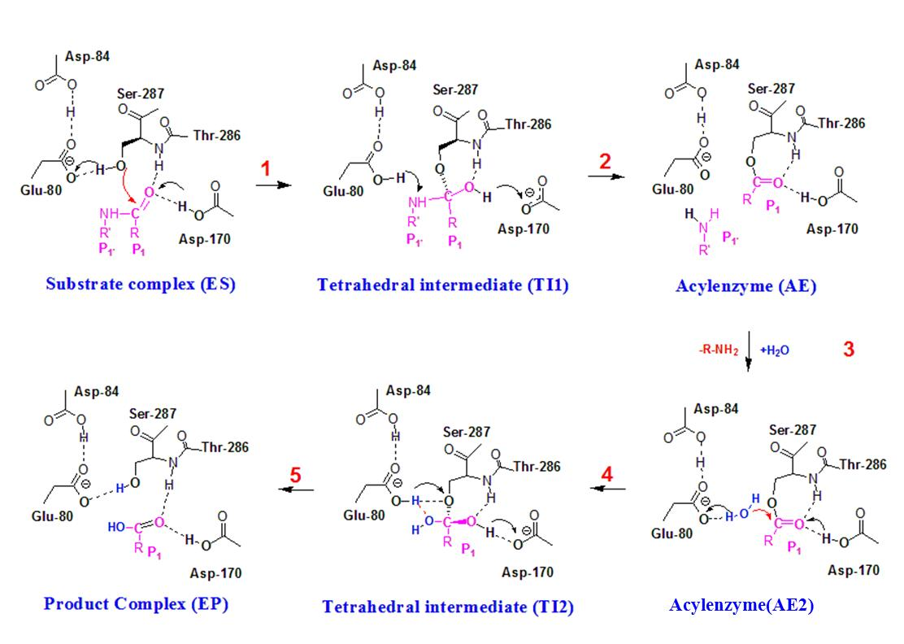
Figure 1.1
The catalytic mechanism and the role of the key active-site residues for the both acylation and deacylation reactions based on this study as well as the previous investigation. The acyl-enzyme is termed as AE2 to distinguish it with the one (AE) for which the N-terminal region of the substrate still remains at the active site after the cleavage.

A
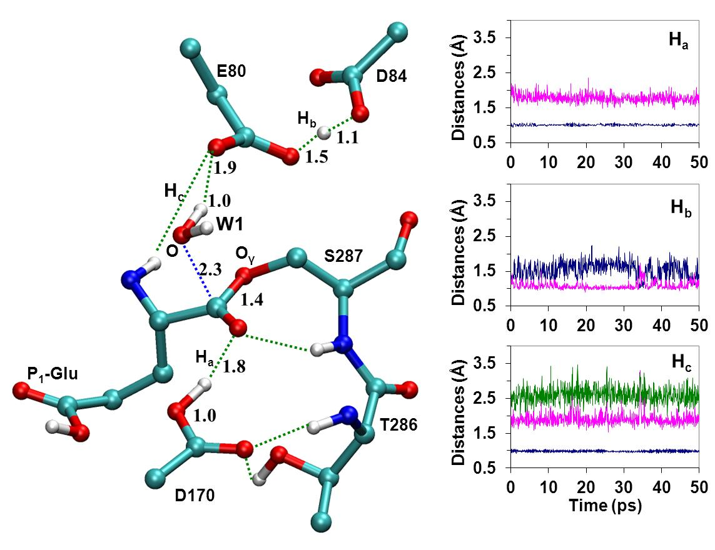
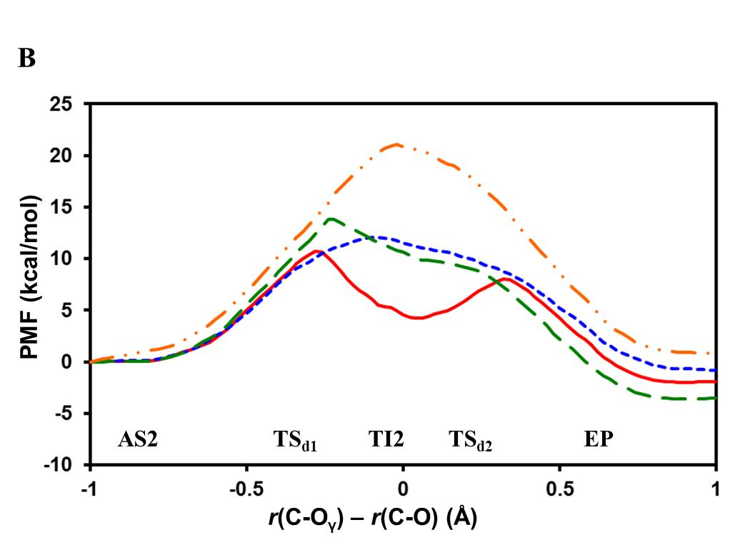
Figure 1.2
(A) Left: The average structure of the active site of the acyl-enzyme that was formed after the acylation step of the reaction involving the LLE*FL substrate as well as release of the cleaved first product of the substrate from the active site (see text). Most of the hydrogen atoms are not shown here for clarity. Right: The distances (Å) from certain oxygen atoms to three hydrogen atoms, H_{a}, H_{b} and H_{c}, as functions of time (ps). These atoms may be involved in proton transfer processes during the deacylation step (see below). Top panel: the distances from O (Asp170) and O (carbonyl group of the P1 residue) to H_{a} (colored in blue and magenta, respectively); Middle panel: the distances from O (E80) and O (Asp84) to H_{b} (colored in blue and magenta, respectively); Bottom panel: the distances from O (W1), O (Glu80) and O (Ser287) to H_{c} (colored in blue, magenta and green, respectively). The locations of the hydrogen atoms, H_{a}, H_{b} and H_{c}, are shown in the structure on the left. (B) The free energy profiles for the deacylation reaction of this work. The reaction coordinate for deacylation is ξ=R(C-Oγ)-R(C-O); see Figure 1.2A for the definition of the atoms. TI2 is the tetrahedral intermediate for deacylation. TSd1 and TSd2 are the first and second transition states, respectively. Wild-type sedolisin: red and solid line; D170N: green dashed line. In addition, the free energy profile for the wild type enzyme with the proton fixed on Asp170 with the SHAKE algorithm (blue dotted line) or with deprotonated Asp170 is also given (orange dotted dash line).

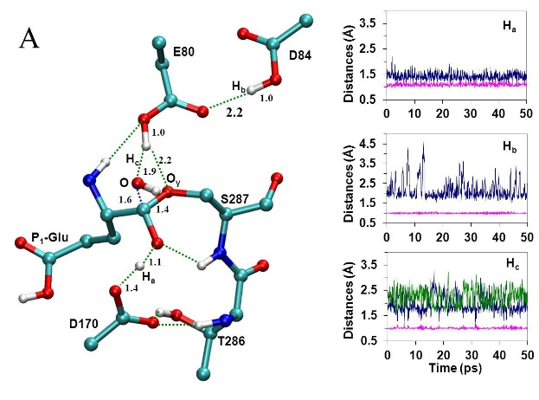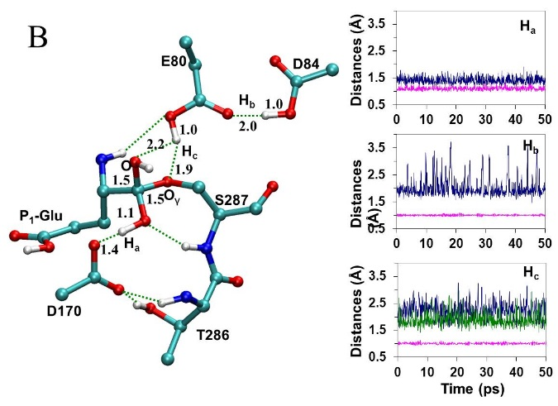

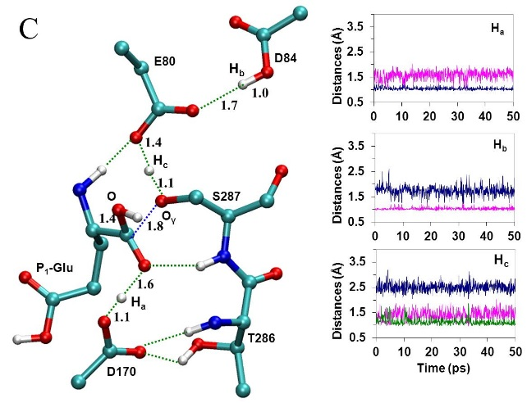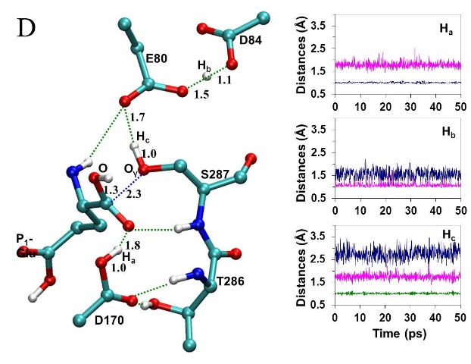

Figure 1.3
The active-site structures and the distances (Å) to the hydrogen atoms (protons) as functions of time at different stages of the deacylation reaction (see the caption of Figure 1.2A). (A) The first transition state of the deacylation reaction (TS_{d1}). Top panel: the distances from O (Asp170) and O (carbonyl group of the P₁ residue) to H_{a} colored in blue and magenta, respectively. Middle panel: the distances from O (Glu80) and O (Asp84) to H_{b} colored in blue and magenta, respectively. Bottom panel: the distances from O (W1), O (Glu80) and O (Ser287) to H_{c} colored in blue, magenta and green, respectively. (B) The tetrahedral intermediate (TI2). The color schemes for the distances are the same as in (A). (C) The second transition state (TS_{d2}). The color schemes for the distances are the same as in (A). (D) Product. The color schemes for the distances are the same as in (A).

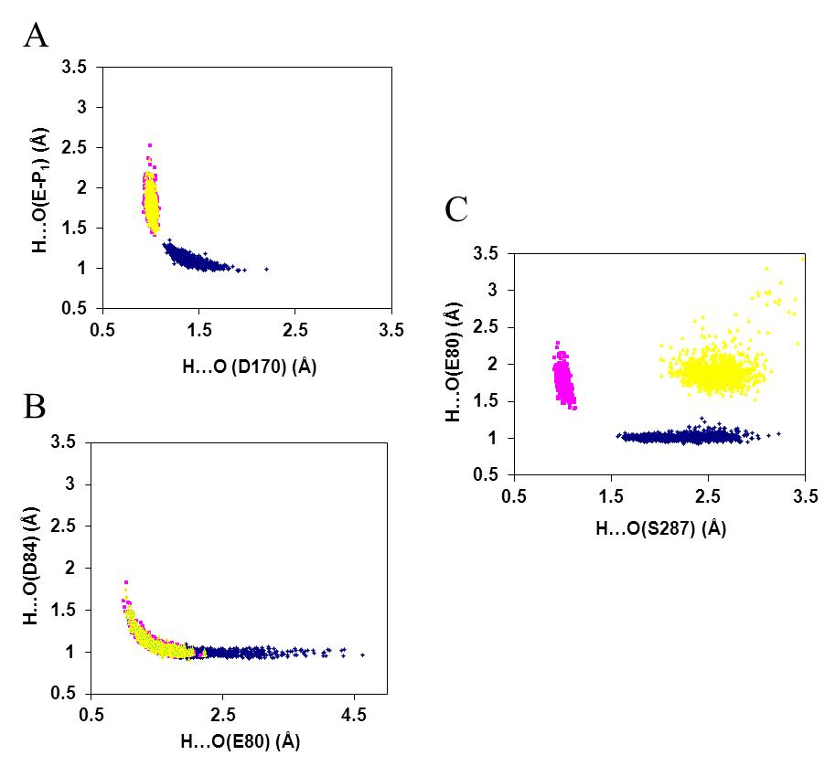
Figure 1.4
Locations and transfers of the protons among AE2 (yellow), TI2 (blue) and EP (magenta) in wild-type. (A) H_{a.} H_{a} is located on Asp170 in both AE2 (yellow) and EP (magenta) states with the H…O (Asp170) distance as about 1 Å. However, this proton moves to the carbonyl oxygen of the residue at P₁ of the substrate when the tetrahedral intermediate (TI2) is formed (blue). (B) H_{b.} While H_{b} spends most of the time on Asp84 in TI2 (blue), it is involved in a strong hydrogen bond in AE2 (yellow) and EP (magenta). (C) H_{c.} H_{c} on W1 moves to Glu80 as a result of the formation of TI2 (from yellow to blue) and then moves to Ser287 (magenta) during the formation of the product.

References
Bravaya, K., A. Bochenkova, B. Grigorenko, I. Topol, S. Burt and A. Nemukhin (2006). "Molecular modeling the reaction mechanism of serine-carboxyl peptidases." Journal of Chemical Theory and Computation 2(4): 1168-1175.
Brooks, B. R., R. E. Bruccoleri, B. D. Olafson, D. J. States, S. Swaminathan and M. Karplus (1983). "CHARMM - A PROGRAM FOR MACROMOLECULAR ENERGY, MINIMIZATION, AND DYNAMICS CALCULATIONS." Journal of Computational Chemistry 4(2): 187-217.
Brooks, C. L., A. Brunger and M. Karplus (1985). "ACTIVE-SITE DYNAMICS IN PROTEIN MOLECULES - A STOCHASTIC BOUNDARY MOLECULAR-DYNAMICS APPROACH." Biopolymers 24(5): 843-865.
Cui, Q., M. Elstner, E. Kaxiras, T. Frauenheim and M. Karplus (2001). "A QM/MM implementation of the self-consistent charge density functional tight binding (SCC-DFTB) method." Journal of Physical Chemistry B 105(2): 569-585.
Elstner, M., Q. Cui, P. Munih, E. Kaxiras, T. Frauenheim and M. Karplus (2003). "Modeling zinc in biomolecules with the self consistent charge-density functional tight binding (SCC-DFTB) method: Applications to structural and energetic analysis." Journal of Computational Chemistry 24(5): 565-581.
Field, M. J., P. A. Bash and M. Karplus (1990). "A COMBINED QUANTUM-MECHANICAL AND MOLECULAR MECHANICAL POTENTIAL FOR MOLECULAR-DYNAMICS SIMULATIONS." Journal of Computational Chemistry 11(6): 700-733.
Guo, H. B., R. F. Beahm and H. Guo (2004). "Stabilization and destabilization of the C-delta-h center dot center dot center dot O=C hydrogen bonds involving proline residues in helices." Journal of Physical Chemistry B 108(46): 18065-18072.
Guo, H. B., A. Wlodawer and H. Guo (2005). "A general acid-base mechanism for the stabilization of a tetrahedral adduct in a serine-carboxyl peptidase: A computational study." Journal of the American Chemical Society 127(45): 15662-15663.
Guo, H. B., A. Wlodawer, T. Nakayama, Q. Xu and H. Guo (2006). "Catalytic role of proton transfers in the formation of a tetrahedral adduct in a serine carboxyl peptidase." Biochemistry 45(30): 9129-9137.
Jorgensen, W. L., J. Chandrasekhar, J. D. Madura, R. W. Impey and M. L. Klein (1983). "COMPARISON OF SIMPLE POTENTIAL FUNCTIONS FOR SIMULATING LIQUID WATER." Journal of Chemical Physics 79(2): 926-935.
Kumar, S., D. Bouzida, R. H. Swendsen, P. A. Kollman and J. M. Rosenberg (1992). "THE WEIGHTED HISTOGRAM ANALYSIS METHOD FOR FREE-ENERGY CALCULATIONS ON BIOMOLECULES .1. THE METHOD." Journal of Computational Chemistry 13(8): 1011-1021.
MacKerell, A. D., D. Bashford, M. Bellott, R. L. Dunbrack, J. D. Evanseck, M. J. Field, S. Fischer, J. Gao, H. Guo, S. Ha, D. Joseph-McCarthy, L. Kuchnir, K. Kuczera, F. T. K. Lau, C. Mattos, S. Michnick, T. Ngo, D. T. Nguyen, B. Prodhom, W. E. Reiher, B. Roux, M. Schlenkrich, J. C. Smith, R. Stote, J. Straub, M. Watanabe, J. Wiorkiewicz-Kuczera, D. Yin and M. Karplus (1998). "All-atom empirical potential for molecular modeling and dynamics studies of proteins." Journal of Physical Chemistry B 102(18): 3586-3616.
Neria, E., S. Fischer and M. Karplus (1996). "Simulation of activation free energies in molecular systems." Journal of Chemical Physics 105(5): 1902-1921.
Oda, K. (2012). "New families of carboxyl peptidases: serine-carboxyl peptidases and glutamic peptidases." J. Biochem. 151 (1): 13-25.
Okubo, A., M. Li, M. Ashida, H. Oyama, A. Gustchina, K. Oda, B. M. Dunn, A. Wlodawer and T. Nakayama (2006). "Processing, catalytic activity and crystal structures of kumamolisin-As with an engineered active site." Febs Journal 273(11): 2563-2576.
Ryckaert, J. P., G. Ciccotti and H. J. C. Berendsen (1977). "NUMERICAL-INTEGRATION OF CARTESIAN EQUATIONS OF MOTION OF A SYSTEM WITH CONSTRAINTS - MOLECULAR-DYNAMICS OF N-ALKANES." Journal of Computational Physics 23(3): 327-341.
Sleat, D. E., R. J. Donnelly, H. Lackland, C. G. Liu, I. Sohar, R. K. Pullarkat and P. Lobel (1997). "Association of mutations in a lysosomal protein with classical late-infantile neuronal ceroid lipofuscinosis." Science 277(5333): 1802-1805.
Sun, J., Y. Li and Z. Zhao (2007). "Phylogenetic profiles for the prediction of protein–protein interactions: How to select reference organisms?" Biochemical and Biophysical Research Communications 353(4): 985-991.
Torrie, G. M. and J. P. Valleau (1974). "MONTE-CARLO FREE-ENERGY ESTIMATES USING NON-BOLTZMANN SAMPLING - APPLICATION TO SUBCRITICAL LENNARD-JONES FLUID." Chemical Physics Letters 28(4): 578-581.
Wlodawer, A., M. Li, Z. Dauter, A. Gustchina, K. Uchida, H. Oyama, B. M. Dunn and K. Oda (2001). "Carboxyl proteinase from Pseudomonas defines a novel family of subtilisin-like enzymes." Nature Structural Biology 8(5): 442-446.
Wlodawer, A., M. Li, A. Gustchina, Z. Dauter, K. Uchida, H. Oyama, N. E. Goldfarb, B. M. Dunn and K. Oda (2001). "Inhibitor complexes of the Pseudomonas serine-carboxyl proteinase." Biochemistry 40(51): 15602-15611.
Wlodawer, A., M. Li, A. Gustchina, H. Oyama, B. M. Dunn and K. Oda (2003). "Structural and enzymatic properties of the sedolisin family of serine-carboxyl peptidases." Acta biochimica Polonica 50(1): 81-102.
Wlodawer, A., M. Li, A. Gustchina, H. Oyama, K. Oda, B. B. Beyer, J. Clemente and B. M. Dunn (2004). "Two inhibitor molecules bound in the active site of Pseudomonas sedolisin: a model for the bi-product complex following cleavage of a peptide substrate." Biochemical and Biophysical Research Communications 314(2): 638-645.
Xu, Q., H. Guo and A. Wlodawer (2006). "The importance of dynamics in substrate-assisted catalysis and specificity." Journal of the American Chemical Society 128(18): 5994-5995.
Xu, Q., L. Y. Li and H. Guo (2010). "Understanding the Mechanism of Deacylation Reaction Catalyzed by the Serine Carboxyl Peptidase Kumamolisin-As: Insights from QM/MM Free Energy Simulations." Journal of Physical Chemistry B 114(32): 10594-10600.
Xu, Q., J. Z. Yao, A. Wlodawer and H. Guo (2011). "Clarification of the Mechanism of Acylation Reaction and Origin of Substrate Specificity of the Serine-Carboxyl Peptidase Sedolisin through QM/MM Free Energy Simulations." Journal of Physical Chemistry B 115(10): 2470-2476.

CHAPTER 2
QM/MM Free Energy Simulations of Salicylic Acid Methyltransferase: the Effects of Stabilization of TS-Like Structures on Substrate Specificity

A version of this chapter was originally published by Jianzhuang Yao, Qin Xu, Feng Chen and Hong Guo:
Jianzhuang Yao, Qin Xu, Feng Chen, and Hong Guo “QM/MM Free Energy Simulations of Salicylic Acid Methyltransferase: the Effects of Stabilization of TS-Like Structures on Substrate Specificity” The Journal of Physical Chemistry B 115 (2010): 389-396.
My contributions to this study include: 1) discussions with the design of the experiments; 2) performing the experiments; 3) analysis of the result and preparing the manuscript. This study was designed by the principle investigator, Dr. Hong Guo, he also wrote the manuscript. Dr. Qin Xu and Dr. Feng Chen are involved with the discussions of the design of the experiment.

Abstract
Salicylic acid methyltransferases (SAMTs) synthesize methyl salicylate (MeSA) using salicylate as the substrate. MeSA synthesized in plants may function as an airborne signal to activate the expression of defense-related genes and could also be a critical mobile signaling molecule that travels from the site of plant infection to establish systemic immunity in the induction of disease resistance. Here the results of QM/MM free energy simulations for the methyl transfer process in Clarkia breweri SAMT (CbSAMT) are reported to determine the origin of the substrate specificity of SAMTs. The free energy barrier for the methyl transfer from S-adenosyl-L-methionine (AdoMet) to 4-hydroxybenzoate in CbSAMT is found to be about 5 kcal/mol higher than that from AdoMet to salicylate, consistent with the experimental observations. It is suggested that the relatively high efficiency for the methylation of salicylate compared to 4-hydroxybenzoate is due, at least in part, to the reason that a part of the stabilization of the transition state (TS) configuration is already reflected in the reactant complex, presumably, through the binding. The results seem to indicate that the creation of the substrate complex (e.g., through mutagenesis and substrate modifications) with its structure closely resembles TS might be fruitful for improving the catalytic efficiency for some enzymes. The results show that the computer simulations may provide important insights into the origin of the substrate specificity for the SABATH family and could be used to help experimental efforts in generating engineered enzymes with altered substrate specificity.

Introduction
Plants produce a large number of low molecular weight metabolites, and some of these metabolites play critical roles in diverse biological processes including plant growth and development as well as plant interactions with the environment. Chemical modifications of such metabolites by different enzymes may have a profound impact on these activities. One of such modifications is enzymatic methylation of carboxyl moieties of certain small molecules, such as salicylic acid (SA), benzoic acid (BA), indole-3-acetic acid (IAA), gibberellic acid (GA), farnesoic acid (FA), cinnamic/coumaric acid (CC) and jasmonic acid (JA), using S-adenosyl-L-methionine (AdoMet) as the methyl donor.(Taiz and Zeiger 2006) The methylation of carboxyl group of these compounds may affect the concentrations of the free acids in plant tissues, and the corresponding methylated products can have biological and ecological functions that are quite different from their precursors. The enzymes that catalyze the methylation of SA, BA, IAA, GA, FA, CC and JA, for instance, are SA methyltransferase (SAMT),(Ross, Nam et al. 1999, Chen, D'Auria et al. 2003) BA methyltransferase (BAMT),(Murfitt, Kolosova et al. 2000) IAA methyltransferase (IAMT),(Qin, Gu et al. 2005, Zhao, Guan et al. 2007, Zhao, Ferrer et al. 2008) GA methyltransferase (GAMT),(Varbanova, Yamaguchi et al. 2007) FA methyltransferase (SAMT),(Yang, Yuan et al. 2006) CC methyltransferase (CCMT)(Kapteyn, Qualley et al. 2007) and JA methyltransferase (JAMT),(Seo, Song et al. 2001) respectively. These enzymes belong to the same SABATH enzyme family(D’Auria, Chen et al. 2003) (which was named based on the first three identified members of the family, SAMT, BAMT and theobromine synthase). They can be distinguished according to their substrate preferences and are homologous at the protein sequence level. The SABATH family also contains some other proteins, including the nitrogen-directed methyltransferases involved in caﬀeine biosynthesis.(Ogawa, Herai et al. 2001, McCarthy and McCarthy 2007) It has been demonstrated that the emergence of novel SABATH MT activity can occur rapidly and small changes in primary protein sequences can lead to the functional emergence of SABATH proteins with altered substrate preferences.(Zubieta, Ross et al. 2003, Pichersky, Noel et al. 2006) Although the SABATH enzymes have been a subject of extensive biochemical and structural investigations,(Ross, Nam et al. 1999, Zubieta, Ross et al. 2003, Pott, Hippauf et al. 2004, Effmert, Saschenbrecker et al. 2005, Hippauf, Michalsky et al. 2010, Tieman, Zeigler et al. 2010, Zhao, Guan et al. 2010) the factors that determine the substrate specificity and the origin for the differences in the breadth of substrate preference of individual enzymes are still not well understood.
SA methyltransferases (SAMTs) are among the best studied members of the SABATH family that synthesize methyl salicylate (MeSA) using SA as the substrate. The closed related enzymes of the family include BA methyltransferases (BAMTs) which have a higher catalytic efficiency and preference for benzoic acid (BA) lacking the 2-hydroxyl group of SA. It is generally believed that the reactive carboxyl groups of the substrates are fully or predominantly deprotonated at cellular pH values,(Zubieta, Ross et al. 2003) and the methyl transfers should occur without enzyme-mediated general acid/base catalysis (Figure 2.1A). SA is an important plant signal/hormone and can influence a number of processes, including seed germination, seedling establishment, cell growth, respiration, senescence-associated gene expression, responses to abiotic stresses, and fruit yield.(Loake and Grant 2007, Santner and Estelle 2009, Vlot, Dempsey et al. 2009) Moreover, it has been demonstrated that SA may signal the activation of disease resistance following pathogen infection.(Loake and Grant 2007, Santner and Estelle 2009, Vlot, Dempsey et al. 2009) MeSA synthesized by SAMT is a volatile ester and is normally absent in plants. However, MeSA can be dramatically induced upon pathogen infection.(Seskar, Shulaev et al. 1998, Huang, Cardoza et al. 2003) It has been suggested that MeSA may function as an airborne signal to activate the expression of defense-related genes for disease resistance in non-damaged organs of the same or neighboring plants.(Shulaev, Silverman et al. 1997) Recent studies have also shown that MeSA may be a critical mobile signaling molecule that travels from the site of infection to establish systemic immunity in the induction of a long-lasting and broad-spectrum disease resistance,(Park, Kaimoyo et al. 2007) the so-called systemic acquired resistance (SAR).(Sticher, MauchMani et al. 1997) Furthermore, MeSA is a flavor ingredient for taste and scent of many fruits and flowers and is often produced synthetically and used for making candy, food and medicine. Given the importance of SA and MeSA in plant biology and food industry, understanding the mechanism of the SA methylation catalyzed by SAMT as well as the origin of its substrate specificity is of considerable interest. Such understanding may also provide important insights into the substrate specificity of other members of the SAMT family whose activities may influence diverse biological processes in plants.
Previous experimental studies(Zubieta, Ross et al. 2003, Effmert, Saschenbrecker et al. 2005) have shown that the substrate recognition and catalytic efficiency of SAMTs and other members of the family appear to have subtle biochemical characteristics and their dependences on the active-site and other residues may be complicated. Therefore, applications of different experimental and computational approaches may be required for quantitatively assessing the structural features for substrate recognition and for identifying the amino-acid residues important for the enzyme’s function. Computer simulations can provide important insights into the energetic origins of substrate specificity and help to predict the effects of mutations quantitatively, as demonstrated from numerous previous investigations. We have applied molecular dynamics (MD) and free energy (potential of mean force) simulations with hybrid quantum mechanical/molecular mechanical (QM/MM) potentials to study several enzyme-catalyzed reactions earlier, including protein lysine methyltransferases (PKMTs)(Guo and Guo 2007, Xu, Chu et al. 2009, Chu, Xu et al. 2010) which belong to another family of AdoMet-dependent methyltransferases and may catalyze the methyl transfer processes from AdoMet to the lysine residues on the tails of histone proteins. It was found that there is a good correlation between the activities of the enzymes observed experimentally and the results of the computer simulations,(Guo and Guo 2007, Xu, Chu et al. 2009, Chu, Xu et al. 2010) suggesting the computational approaches are well suited for the investigations of enzyme-catalyzed methyl transfer processes.
Here, we report the results of QM/MM MD and free energy simulations for the methyl transfers in Clarkia breweri SAMT (CbSAMT). One of the interesting experimental results is the observation that the catalytic efficiency of SAMTs is considerable lower for 4-hydroxybenzoic acid (4HA) than for SA.(Ross, Nam et al. 1999, Zubieta, Ross et al. 2003, Effmert, Saschenbrecker et al. 2005, Hippauf, Michalsky et al. 2010, Zhao, Guan et al. 2010) This experimental result may also be used as an important testing ground in the determination of usefulness of the computational approaches for understanding substrate specificity for the SAMT family. It is still not clear as to why the change of the hydroxyl group from the 2-position (as in SA) to 4-position (as in 4HA) can lead to such large decrease in the activity. For instance, for CbSAMT the activity on 4HA is only 0-0.8% of that on SA.(Ross, Nam et al. 1999, Zubieta, Ross et al. 2003) The free energy simulations reported in this work show that the free energy barrier for the methyl transfer from AdoMet to 4-hydroxybenzoate in CbSAMT is about 5 kcal/mol higher than that from AdoMet to salicylate, consistent with the experimental observations.(Ross, Nam et al. 1999, Zubieta, Ross et al. 2003) The results show that the structure of the reactant complex containing salicylate resembles the transition state (TS) of the reaction with the carboxylate of salicylate well aligned with the methyl group of AdoMet. Thus, a part of the stabilization of the TS configuration is already reflected in the reactant complex, presumably, through the binding. This is, however, not the case for 4-hydroxybenzoate. The existence of the 4-hydroxyl group and the increase of the length of the molecule appear to weaken some of the key hydrogen bonds and produce new repulsions between 4-hydroxybenzoate and some of the neighboring residues (e.g., Phe347). This leads to a poor alignment of the reactive groups in the 4-hydroxybenzoate reactant complex that is considerably different from those of the transition state of the 4-hydroxybenzoate methylation reaction and the reactant complex containing salicylate mentioned above. Thus, additional energy is needed for generating the TS configuration during the methyl transfer, leading to a higher free energy barrier (lower efficiency). To the best of our knowledge, this is the first time that the QM/MM MD and free energy simulations are used for studying the SASBTH family.

Methods
QM/MM free energy (potential of mean force) simulations were applied to determine free energy profiles for the methyl transfer from AdoMet to the carboxyl group of salicylate and 4-hydroxybenzoate, respectively, and to characterize the active-site dynamics of the reactant complexes using the CHARMM program.(Brooks, Bruccoleri et al. 1983) AdoMet/S-adenosyl-L-homocysteine (AdoHcy) and the substrates were treated by QM and the rest of the system by MM. The link-atom approach(Field, Bash et al. 1990) as implemented in CHARMM was applied to separate the QM and MM regions. A modified TIP3P water model(Jorgensen, Chandrasekhar et al. 1983) was employed for the solvent. The stochastic boundary molecular dynamics method(Brooks, Brunger et al. 1985) was used for the QM/MM MD and free energy simulations. The system was separated into a reaction zone and a reservoir region, and the reaction zone was further divided into a reaction region and a buffer region. The reaction region was a sphere with radius r of 20 Å, and the buffer region extended over 20 Å ≤ r ≤ 22 Å. The reference center for partitioning the system was chosen to be the carboxyl oxygen atom (O) of the substrate where the methyl group is transferred to (see Figure 2. 1A and 1B). The resulting systems contained around 5600 atoms, including about 400-500 water molecules.
The SCC-DFTB method(Elstner, Porezag et al. 1998, Cui, Elstner et al. 2001) implemented in CHARMM was used for the QM atoms and the all-hydrogen CHARMM potential function (PARAM27)(MacKerell, Bashford et al. 1998) was used for the MM atoms. High level ab initio methods (e.g., B3LYP and MP2) are too time-consuming to be used for MD and free energy simulations. To correct the errors due to the deficiency of SCC-DFTB method, an empirical correction approach introduced in the earlier study of PKMT SET7/9(Guo and Guo 2007) was applied to the free energy curves obtained from the potential of mean force simulations in the present work. This approach has been applied to the studies of PKMT DIM-5(Xu, Chu et al. 2009) and SET8(Chu, Xu et al. 2010) previously. In this approach, the results of the SCC-DFTB and B3LYP/6-31G** methods for the description of the methyl transfer in a small model system involving AdoMet and salicylate were compared using an energy minimization-based approach. This comparison allowed us to understand the performance of the semi-empirical method in the description of the bond breaking and making for the system under investigation. Some systematic deviations of the SCC-DFTB method in the description of the energetics of the methyl transfer were found from such comparison in the small model system containing AdoMet and salicylate. A simple linear function ∆E_{corr} = k_{c} × R + E_{c} was derived based on these results and applied to correct the possible errors in the free energy profiles, as was done in the earlier studies of PKMTs.(Guo and Guo 2007, Xu, Chu et al. 2009, Chu, Xu et al. 2010) Here, k_{c} = 4.4 kcal·mol-1·Å-1 and E_{c} = -5.7 kcal/mol and R is the reaction coordinate for the methyl transfer from AdoMet to salicylate (see below). The comparison of the corrected SCC-DFTB and B3LYP/6-31G** potential energy profiles for the methyl transfer in the small model system containing AdoMet and salicylate is given in the Supporting Information. For a more detailed explanation of the correction method and why it may works.
The initial coordinates for the reactant complexes were based on the crystallographic structure (PDB code: 1M6E) of CbSAMT complexed with salicylate and AdoHcy.(Zubieta, Ross et al. 2003) A methyl group was manually added to AdoHcy to form AdoMet. In addition, for the reactant complex containing 4-hydroxybenzoate, the hydroxyl group at the 2-position of salicylate was removed and a hydroxyl group was manually added to the 4-position of the ring to generate the substrate. The initial structures for the entire stochastic boundary systems were optimized using the steepest descent (SD) and adopted-basis Newton-Raphson (ABNR) methods. The systems were gradually heated from 50.0 to 310.15 K in 50 ps. A 1-fs time step was used for integration of the equation of motion, and the coordinates were saved every 50 fs for analyses. 1.5 ns QM/MM MD simulations were carried out for each of the reactant complexes. The umbrella sampling method(Torrie and Valleau 1974) implemented in the CHARMM program along with the Weighted Histogram Analysis Method (WHAM)(Kumar, Bouzida et al. 1992) was then applied to determine the changes of the free energy (potential of mean force) as a function of the reaction coordinate for the methyl transfers from AdoMet to the carboxylate groups of salicylate and 4-hydroxybenzoate, respectively. The reaction coordinate was defined as a linear combination of r(C_{M}-O) and r(C_{M}-S_{δ}) [R = r(C_{M}-S_{δ}) – r(C_{M}-O)] (see Figure 2. 1B for the definitions of the atoms). The determination of multidimensional free energy maps would be too time-consuming. Our previous study(Guo, Wlodawer et al. 2006) indicated that the one dimensional free energy simulations with the selection of a suitable reaction coordinate reflecting the key bond-breaking making events may be able to capture the key energetic properties for the reaction (e.g., the free energy barrier). For each methyl transfer process, twenty windows were used, and for each window 100 ps simulations were performed with 50 ps equilibration. The force constants of the harmonic biasing potentials used in the PMF simulations were 50 to 500 kcal mol^{–1} Å^{–2}. The statistical errors for the free energy profiles were also estimated and were found to be quite small (see the Supporting Information).

Results and Discussion
The active-site structures of the reactant complexes for the methyl transfers from AdoMet to salicylate (Figure 2.2B) and from AdoMet to 4-hydroxybenzoate (Figure 2.2C) in CbSAMT obtained from the simulations are compared with that of the X-ray structure (Figure 2.2A). Figure 2.2B shows that the active-site structure for the salicylate complex generally agrees with the experimental structure shown in Figure 2.2A. For instance, the position of the reactive carboxylate group of salicylate is fixed by the hydrogen bonds from Trp-151 and Gln-25, and these interactions are expected to be important for an efficient methyl transfer. Comparison of Figure 2.2A and 2B shows that there are some deviations in the positions of the residues and ligand in the two structures. These differences seem to be reasonable due in part to the fact that the experimental structure is not the reactant complex and contains AdoHcy rather than AdoMet. The existence of the methyl group as well as the positive charge on AdoMet is expected to produce some changes in the interactions which could lead to certain modifications in the active site structure. It is interesting to note from Figure 2.2B that the conserved Lys-10 residue interacts with the carboxylate of salicylate instead of the carbonyl group Met-9 as observed in the X-ray structure.(Zubieta, Ross et al. 2003) This seems to suggest that Lys-10 might play a role in the substrate binding, although a detailed investigation is still necessary. The free energy simulations (see below) suggest that Lys-10 is likely to change to the position observed in the X-ray structure and form a hydrogen bond with the carbonyl group of Met-9 during the methyl transfer from AdoMet to salicylate. The result from the simulations is therefore not inconsistent with the X-ray structure. Figure 2.2B also shows that the methyl group of AdoMet is well aligned with the lone pair of electrons of the carboxylate of salicylate (see also the top of Figure 2.2D), in agreement with the suggestion(Takusagawa, Fujioka et al. 1998, Zubieta, Ross et al. 2003) that SAMT relies on the proper positioning of the SA substrate’s ionized and desolvated carboxyl group near the reactive methyl group of SAM to facilitate methyl transfer. Moreover, it has been shown from the previous computational studies(Guo and Guo 2007, Xu, Chu et al. 2009, Chu, Xu et al. 2010) on PKMTs that a good alignment between the transferable methyl group and the lone pair of electrons (where the methyl group is transferred to) is an important factor for an efficient methyl transfer for the PKMT enzymes as well. The results of the simulations thus suggest that the requirement for a good alignment of the reactive groups seems to be satisfied for the reactant SAMT complex containing salicylate, consistent with the substrate specificity of this enzyme. As will be discussed below, this reactant structure with the well aligned reactive groups resembles the transition state configuration for the methyl transfer so that less free energy would be required for the system to generate such configuration and to reach the transition state.
It should be pointed out that a proper balance of different interactions (e.g., the hydrogen bonds involving Trp-151 and Gln-25 and hydrophobic interactions involving Phe-347, Tyr-255, Trp226 and Met-308) is likely to be crucial for producing the good alignment between the reactive groups from the methyl donor and acceptor in the salicylate complex. The change in the substrate structure or replacement of some key residues may destroy such balance and lead to a poor alignment. The structures in Figure 2.2A and 2B show that the active site of the enzyme seems to be rather crowded and does not have enough space to accommodate a hydroxyl group at 4-position of the benzoate ring without significant structural modifications. Consistent with this observation, the move of the hydroxyl group from 2- to 4-position in the substrate in going from salicylate to 4-hydroxybenzoate perturbs the active site interactions and changes the active site structure significantly (Figure 2.2C). For instance, 4-hydroxybenzoate in the reactant complex seems to be pushed towards AdoMet, presumably, by the newly formed interactions of the 4-hydroxyl group with the active site residues (e.g., Phe-347 and Met-308). This movement of the substrate is likely to affect the alignment of the reactive groups. Figure 2.2D compares the relative orientations of AdoMet and the carboxylate for some typical structures of the reactant complexes containing salicylate (Top) and 4-hydroxybenzoate (Bottom) obtained from the MD simulations. As is evident from Figure 2.2D, while a good alignment can be made in the salicylate complex, this is not the case for the 4-hydroxybenzoate complex. The methyl group of AdoMet is pushed away considerably by 4-hydroxybenzoate. The distance between the carboxylate oxygen of 4-hydroxybenzoate and the S_{δ} atom of AdoMet can reach as small as 2.6Å. As a result, it is less likely that the methyl group would be able to be located between these two atoms for achieving a good alignment with the lone pair of electrons of the carboxylate and generating the TS-like structure (see below for a more detailed discussion). The lack of the proper balance of the interactions as a result of the change of the position of the hydroxyl group is presumably the key reason for the deviation of the reactant structure of the 4-hydroxybenzoate complex from the TS-like structure observed for the salicylate complex.
The free-energy profiles for the methyl transfers from AdeMot to salicylate and 4-hydroxybenzoate in CbSAMT are plotted in Figure 2.3 as a function of the reaction coordinate (R). The free energy barriers were calculated to be about 16 and 21 kcal/mol for the salicylate and 4-hydroxybenzoate complexes, respectively. The increase of the free energy barrier from 16 kcal to 21 kcal/mol in going from salicylate to 4-hydroxybenzoate is in a good agreement with the experimental finding that the activity of the enzyme on 4HA is only 0-0.8% of that on SA.(Ross, Nam et al. 1999, Zubieta, Ross et al. 2003) The k_{cat} value for the methylation of SA in CbSAMT was estimated to be 0.092 s⁻¹ corresponding to an activation barrier of 18.9 kcal/mol based on the transition state theory. The calculated free energy barrier (16 kcal/mol) is therefore about 3 kcal/mol lower than this estimated experimental activation barrier. The difference is probably related to the use of density functional approaches in this study that could underestimate the reaction barriers. It should be pointed, however, that the relative free energy barriers from the simulations, as opposed to the absolute barriers, are expected to be more important for the comparison of substrate specificities for different molecules. The relative free energy barriers are less sensitive to the choice of the QM method due to the cancellation of the errors and are presumably more reliable. Figure 2.3 also shows that the increase of the free energy along the free energy profile for the 4-hydroxybenzoate complex occurs well before the system reaches the transition state. Indeed, the free energy difference is already 5 kcal/mol at R = -0.3Å and remains almost the same until the system passes the transition state (R = 0.3Å). The detail explanation for this result will be given below.
The r(O… S_{δ}) distance as a function of time for Windows 1, 3, and 5 of the free energy simulations of the methyl transfer involving salicylate and 4-hydroxybenzoate are monitored in Figure 2.4A and 4B, respectively. This distance should be at least 4.0-4.5 Å in order to have the transferable methyl group located between O (from the methyl acceptor) and S_{δ} (from the methyl donor) as required during the methyl transfer (note that because the lone pairs of electrons are on the same plane as the carboxylate group, the methyl group should be preferably located on this plane as well). Figure 2.4A shows that this condition on r(O… S_{δ}) is satisfied for the salicylate complex for the three windows. It can also be shown that this is generally true for almost all the windows (including those near the transition state) during the methyl transfer involving salicylate; the only exceptions are the last few windows near the product state. By contrast, the r(O… S_{δ}) distance in the 4-hydroxybenzoate complex remains rather small in general (between 2.5 and 4 Å) in the first two plots (Windows 1 and 3), consistent with the structure in Figure 2.2C. The distance is able to reach relatively large values (e.g., 3.5 to 4 Å) in some instances in the second plot, suggesting 4-hydroxybenzoate and AdoMet move apart in order to accommodate the methyl group between them as the reaction proceeds. It is of interest to note that the two molecules are able to be 4.0-4.5 Å apart (see the third plot in Figure 2.4B, corresponding to Window 5 in the free energy simulations with R = -0.3Å) well before the system reaches the transition state of the methyl transfer (~R = 0.3Å). It should be pointed out that additional energy is expected to be required for achieving this separation of 4-hydroxybenzoate and AdoMet within the enzyme complex during much of the methyl transfer process. Such energy costs could contribute to the increase of the free energy observed in the free energy profiles in going from salicylate to 4-hydroxybenzoate that covers much of the free energy profile (not just at the transition state), leading to the higher free energy barrier for the methyl transfer involving 4-hydroxybenzoate (see above).
Figure 2.5 plots the structures at R = -0.3Å and near the transition state (R ~ 0.3Å) for the methyl transfer processes involving salicylate (Figure 2.5A and 5B) and 4-hydroxybenzoate (Figure 2.5C and 5D), respectively. Comparison of Figure 2.2C and Figure 2.5C shows that the local active-site structure seems to have been perturbed during the formation of the TS-like structure, as 4-hydroxybenzoate and AdoMet have to move apart in order to accommodate the methyl group between them (see above). This movement seems to lead to the formation of the hydrogen bond between the carboxylate and Gln25 (Trp151) at R = -0.3Å (see Figure 2.5C). These hydrogen bonds are broken again near TS (Figure 2.5D), presumably, due to the neutralization of the negative charge of the carboxylate by the methylene group. It is of interest to note that the relative orientations of the reactive groups (the transferable methyl group and carboxylate) are rather similar for the structures in Figure 2.5 containing salicylate and 4-hydroxybenzoate; e.g., r(C_{M}…O) and r(S_{δ}… C_{M}) are 2.0 and 2.4 Å near the transition state, respectively, in the both Figure 2.5B and 5D. As discussed earlier, the structural features for the corresponding reactant complexes, on the other hand, are significantly different. Indeed, the relative orientations of the reactive groups in the reactant complex of the salicylate complex (see Figure 2.2B and the top of Figure 2.2D) are rather close to the corresponding TS-like and TS structures in Figure 2.5A and 5B with an average r(O… S_{δ}) distance of about 4.3 Å. Thus, a part of the TS stabilization is probably already reflected on the reactant state by generation of such TS-like configuration through the binding. By contrast, the relative orientations of the reactive groups in the reactant complex of the 4-hydroxybenzoate complex (Figure 2.2C and the bottom of Figure 2.2D) are significantly distorted from those of the corresponding TS-like and TS structures (Figure 2.5C and 5D), and the average r(O… S_{δ}) distance is only around 2.8 Å. As discussed earlier, the additional energy for generating the TS-like structure for the 4-hydroxybenzoate complex could contribute to the increase of the free energy along the free energy profile (e.g., ~5 kcal/mol at R = -0.3 to 0.3Å) in going from the salicylate to 4-hydroxybenzoate complex, and this leads to the increase of the free energy barrier for the methyl transfer. It would be of interest to replace certain residues and remove some of the interactions that lead to the distorted reactant structure for the 4-hydroxybenzoate complex. The potential residues to be replaced by smaller residues may include Phe-347, Trp284 and Trp226 that are located near the hydroxyl group of 4-hydroxybenzoate (see Figure 2.5C and 5D). Additional combined experimental and computational investigations are under way to study the activity of wild-type and mutated enzyme on 4-hydroxybenzoate.

Conclusions
One of the interesting observations from the previous experimental investigations(Ross, Nam et al. 1999, Zubieta, Ross et al. 2003, Effmert, Saschenbrecker et al. 2005, Hippauf, Michalsky et al. 2010, Zhao, Guan et al. 2010) is that the catalytic efficiency of SAMTs is considerable lower for 4-hydroxybenzoic acid (4HA) than for salicylic acid (SA). It was not clear as to why the change of the hydroxyl group from the 2-position (as in SA) to 4-position (as in 4HA) could lead to such large decrease in the activity. The free energy simulations reported in this work showed that the free energy barrier for the methyl transfer from AdoMet to 4-hydroxybenzoate in CbSAMT is about 5 kcal/mol higher than that from AdoMet to salicylate, consistent with the experimental observations.(Ross, Nam et al. 1999, Zubieta, Ross et al. 2003) It was found that the structure of the reactant complex containing salicylate is rather close to the corresponding TS structure. Thus, a part of the TS stabilization is probably already reflected in the reactant state by generation of such TS-like configuration through the binding. By contrast, the structure of the reactant complex containing 4-hydroxybenzoate is significantly distorted from the corresponding TS structure. Thus, additional energy seems to be required to generate the TS-like structure during the methyl transfer process. This leads to an up-shift of the free energy profile and a higher free energy barrier (lower efficiency) for the methyl transfer. The results seem to indicate that for a given substrate the efficiency of the catalysis might depend on the energy cost for generating the TS-like structure at the active site during the reaction, although other factors may be involved as well. Thus, the creation of the reactant structure (e.g., through mutagenesis and substrate modifications) that requires less energy to generate the TS-like structure in the active site might be fruitful for improving the catalytic efficiency for some enzymes, although stabilization of the charge formation may be important as well (e.g., as observed in the case of cytidine deaminase(Guo, Rao et al. 2005, Xu, Guo et al. 2007)). The results presented here suggest that the computer simulations may provide important insights into the origin of the substrate specificity for the SABATH family and could be used to help experimental efforts in generating engineered enzymes with altered substrate specificity.

Acknowledgment
We thank Professor Martin Karplus for a gift of the CHARMM program. This work was supported by the National Science Foundation (Grant number: 0817940 to HG), the DOE Office of Biological and Environmental Research - Genome to Life Program through the BioEnergy Science Center (BESC) (to FC) and the Sun Grant Initiative (to FC). We are also grateful for the computer resources (Newton) from University of Tennessee Knoxville.

(A)
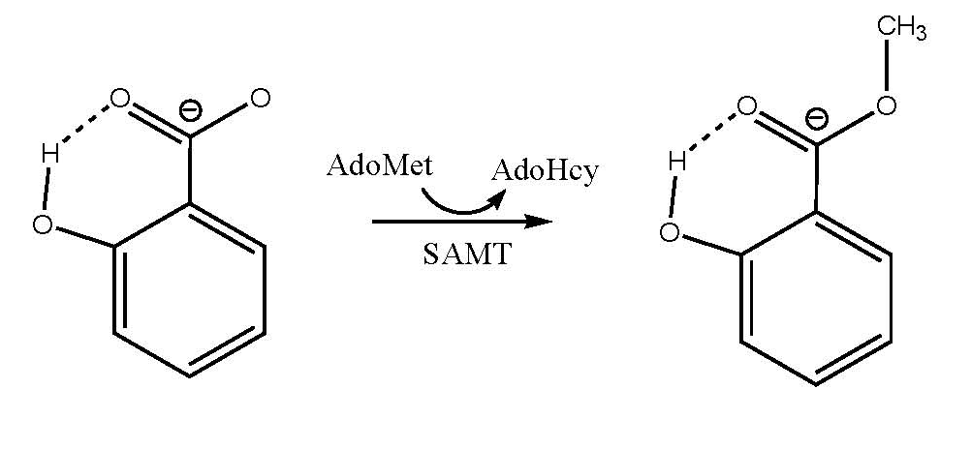
(B)
Figure 2.1
(A) The reaction catalyzed by SAMT. (B) The atoms used for the definition of the reaction coordinate in calculating the free energy profiles of the methyl transfers. The reaction coordinate is: R = r(C_{M}…S_{δ}) – r(C_{M}…O).

Figure 2.2
(A) The X-ray structure of the active site of CbSAMT complexed with AdoHcy and salicylate. SAMT is shown in sticks, and AdoHcy and salicylate are in balls and sticks. Only the three atoms from AdoHcy and the residues that are close to salicylate are shown for clarity. Some distances are given. (B) The structure of the active site of the reactant complex containing AdoMet and salicylate. Some average distances from the simulations are given. (C) The structure of the active site of the reactant complex containing AdoMet and 4-hydroxybenzoate along with some average distances obtained from the simulations. (D) The relative positions of AdoMet and the substrates in typical structures of the reactant complexes containing salicylate (SAL) (based on Figure 2B) and 4-hydroxybenzoate (4BA) (based on Figure 2C), respectively. Top: salicylate complex; Bottom: 4-hydroxybenzoate complex.

Figure 2.3
Free energy (potential of mean force) changes for the methyl transfers from AdoMet to salicylate and 4-hydroxybenzoate, respectively, as a function of the reaction coordinate [R = r(C_{M}…S_{δ}) – r(C_{M}…O)] in CbSAMT. The methyl transfer involving salicylate: red; The methyl transfer involving 4-hydroxybenzoate: blue. The relative free energies at R = -0.3Å and 0.3Å (near the transition state) are also given.

Figure 2.4
(A) The r(O… S_{δ}) distance as a function of time for some of the windows during the free energy simulations of the methyl transfer involving salicylate. (1) Window 1; (2) Window 3; (3) Window 5. (B) The r(O… S_{δ}) distance as a function of time during the free energy simulations of the methyl transfer involving 4-hydroxybenzoate. (1) Window 1; (2) Window 3; (3) Window 5.

Figure 2.5
(A) The average structure obtained from Window 5 of the free energy simulations for the methyl transfer involving salicylate (see Figure 2.4A). (B) The average structure near transition state for the methyl transfer involving salicylate. (C) The average structure obtained from Window 5 of the free energy simulations for the methyl transfer involving 4-hydroxybenzoate (see Figure 2.4B). (D) The average structure near transition state for the methyl transfer involving 4-hydroxybenzoate.

References
Brooks, B. R., R. E. Bruccoleri, B. D. Olafson, D. J. States, S. Swaminathan and M. Karplus (1983). "CHARMM - A PROGRAM FOR MACROMOLECULAR ENERGY, MINIMIZATION, AND DYNAMICS CALCULATIONS." Journal of Computational Chemistry 4(2): 187-217.
Brooks, C. L., A. Brunger and M. Karplus (1985). "ACTIVE-SITE DYNAMICS IN PROTEIN MOLECULES - A STOCHASTIC BOUNDARY MOLECULAR-DYNAMICS APPROACH." Biopolymers 24(5): 843-865.
Chen, F., J. C. D'Auria, D. Tholl, J. R. Ross, J. Gershenzon, J. P. Noel and E. Pichersky (2003). "An Arabidopsis thaliana gene for methylsalicylate biosynthesis, identified by a biochemical genomics approach, has a role in defense." Plant Journal 36(5): 577-588.
Chu, Y. Z., Q. Xu and H. Guo (2010). "Understanding Energetic Origins of Product Specificity of SET8 from QM/MM Free Energy Simulations: What Causes the Stop of Methyl Addition during Histone Lysine Methylation?" Journal of Chemical Theory and Computation 6(4): 1380-1389.
Cui, Q., M. Elstner, E. Kaxiras, T. Frauenheim and M. Karplus (2001). "A QM/MM implementation of the self-consistent charge density functional tight binding (SCC-DFTB) method." Journal of Physical Chemistry B 105(2): 569-585.
D’Auria, J. C., F. Chen and E. Pichersky (2003). The SABATH family of MTs in
Arabidopsis thaliana and other plant species. Recent Adv Phytochem. 37: 95–125.
Effmert, U., S. Saschenbrecker, J. Ross, F. Negre, C. M. Fraser, J. P. Noel, N. Dudareva and B. Piechulla (2005). "Floral benzenoid carboxyl methyltransferases: From in vitro to in planta function." Phytochemistry 66(11): 1211-1230.
Elstner, M., D. Porezag, G. Jungnickel, J. Elsner, M. Haugk, T. Frauenheim, S. Suhai and G. Seifert (1998). "Self-consistent-charge density-functional tight-binding method for simulations of complex materials properties." Physical Review B 58(11): 7260-7268.
Field, M. J., P. A. Bash and M. Karplus (1990). "A COMBINED QUANTUM-MECHANICAL AND MOLECULAR MECHANICAL POTENTIAL FOR MOLECULAR-DYNAMICS SIMULATIONS." Journal of Computational Chemistry 11(6): 700-733.
Guo, H. B. and H. Guo (2007). "Mechanism of histone methylation catalyzed by protein lysine methyltransferase SET7/9 and origin of product specificity." Proceedings of the National Academy of Sciences of the United States of America 104(21): 8797-8802.
Guo, H. B., N. Rao, Q. Xu and H. Guo (2005). "Origin of tight binding of a near-perfect transition-state analogue by cytidine deaminase: Implications for enzyme catalysis." Journal of the American Chemical Society 127(9): 3191-3197.
Guo, H. B., A. Wlodawer, T. Nakayama, Q. Xu and H. Guo (2006). "Catalytic role of proton transfers in the formation of a tetrahedral adduct in a serine carboxyl peptidase." Biochemistry 45(30): 9129-9137.
Hippauf, F., E. Michalsky, R. Q. Huang, R. Preissner, T. J. Barkman and B. Piechulla (2010). "Enzymatic, expression and structural divergences among carboxyl O-methyltransferases after gene duplication and speciation in Nicotiana." Plant Molecular Biology 72(3): 311-330.
Huang, J., Y. J. Cardoza, E. A. Schmelz, R. Raina, J. Engelberth and J. H. Tumlinson (2003). "Differential volatile emissions and salicylic acid levels from tobacco plants in response to different strains of Pseudomonas syringae." Planta 217(5): 767-775.
Jorgensen, W. L., J. Chandrasekhar, J. D. Madura, R. W. Impey and M. L. Klein (1983). "COMPARISON OF SIMPLE POTENTIAL FUNCTIONS FOR SIMULATING LIQUID WATER." Journal of Chemical Physics 79(2): 926-935.
Kapteyn, J., A. V. Qualley, Z. Z. Xie, E. Fridman, N. Dudareva and D. R. Gang (2007). "Evolution of cinnamate/p-coumarate carboxyl Methyltransferases and their role in the biosynthesis of methylcinnamate." Plant Cell 19(10): 3212-3229.
Kumar, S., D. Bouzida, R. H. Swendsen, P. A. Kollman and J. M. Rosenberg (1992). "THE WEIGHTED HISTOGRAM ANALYSIS METHOD FOR FREE-ENERGY CALCULATIONS ON BIOMOLECULES .1. THE METHOD." Journal of Computational Chemistry 13(8): 1011-1021.
Loake, G. and M. Grant (2007). "Salicylic acid in plant defence-the players and protagonists." Current Opinion in Plant Biology 10(5): 466-472.
MacKerell, A. D., D. Bashford, M. Bellott, R. L. Dunbrack, J. D. Evanseck, M. J. Field, S. Fischer, J. Gao, H. Guo, S. Ha, D. Joseph-McCarthy, L. Kuchnir, K. Kuczera, F. T. K. Lau, C. Mattos, S. Michnick, T. Ngo, D. T. Nguyen, B. Prodhom, W. E. Reiher, B. Roux, M. Schlenkrich, J. C. Smith, R. Stote, J. Straub, M. Watanabe, J. Wiorkiewicz-Kuczera, D. Yin and M. Karplus (1998). "All-atom empirical potential for molecular modeling and dynamics studies of proteins." Journal of Physical Chemistry B 102(18): 3586-3616.
McCarthy, A. A. and J. G. McCarthy (2007). "The structure of two N-methyltransferases from the caffeine biosynthetic pathway." Plant Physiology 144(2): 879-889.
Murfitt, L. M., N. Kolosova, C. J. Mann and N. Dudareva (2000). "Purification and characterization of S-adenosyl-L-methionine: Benzoic acid carboxyl methyltransferase, the enzyme responsible for biosynthesis of the volatile ester methyl benzoate in flowers of Antirrhinum majus." Archives of Biochemistry and Biophysics 382(1): 145-151.
Ogawa, M., Y. Herai, N. Koizumi, T. Kusano and H. Sano (2001). "7-Methylxanthine methyltransferase of coffee plants - Gene isolation and enzymatic properties." Journal of Biological Chemistry 276(11): 8213-8218.
Park, S. W., E. Kaimoyo, D. Kumar, S. Mosher and D. F. Klessig (2007). "Methyl salicylate is a critical mobile signal for plant systemic acquired resistance." Science 318(5847): 113-116.
Pichersky, E., J. P. Noel and N. Dudareva (2006). "Biosynthesis of plant volatiles: Nature's diversity and ingenuity." Science 311(5762): 808-811.
Pott, M. B., F. Hippauf, S. Saschenbrecker, F. Chen, J. Ross, I. Kiefer, A. Slusarenko, J. P. Noel, E. Pichersky, U. Effmert and B. Piechulla (2004). "Biochemical and structural characterization of benzenoid carboxyl methyltransferases involved in floral scent production in Stephanotis floribunda and Nicotiana suaveolens." Plant Physiology 135(4): 1946-1955.
Qin, G. J., H. Y. Gu, Y. D. Zhao, Z. Q. Ma, G. L. Shi, Y. Yang, E. Pichersky, H. D. Chen, M. H. Liu, Z. L. Chen and L. J. Qu (2005). "An indole-3-acetic acid carboxyl methyltransferase regulates Arabidopsis leaf development." Plant Cell 17(10): 2693-2704.
Ross, J. R., K. H. Nam, J. C. D'Auria and E. Pichersky (1999). "S-adenosyl-L-methionine : salicylic acid carboxyl methyltransferase, an enzyme involved in floral scent production and plant defense, represents a new class of plant methyltransferases." Archives of Biochemistry and Biophysics 367(1): 9-16.
Santner, A. and M. Estelle (2009). "Recent advances and emerging trends in plant hormone signalling." Nature 459(7250): 1071-1078.
Seo, H. S., J. T. Song, J. J. Cheong, Y. H. Lee, Y. W. Lee, I. Hwang, J. S. Lee and Y. D. Choi (2001). "Jasmonic acid carboxyl methyltransferase: A key enzyme for jasmonate-regulated plant responses." Proceedings of the National Academy of Sciences of the United States of America 98(8): 4788-4793.
Seskar, M., V. Shulaev and I. Raskin (1998). "Endogenous methyl salicylate in pathogen-inoculated tobacco plants." Plant Physiology 116(1): 387-392.
Shulaev, V., P. Silverman and I. Raskin (1997). "Airborne signalling by methyl salicylate in plant pathogen resistance." Nature 385(6618): 718-721.
Sticher, L., B. MauchMani and J. P. Metraux (1997). "Systemic acquired resistance." Annual Review of Phytopathology 35: 235-270.
Taiz, L. and E. Zeiger (2006). Plantphysiology. Sunderland, MA, Sinauer Associates.
Takusagawa, F., M. Fujioka, A. Spies and R. L. Schowen (1998). S-Adenosylmethionine (AdoMet)-Dependent Methyltransferases. Comprehensive Biological Catalysis: A Mechanistic Reference. M. Sinnott, London: Academic Press. 1: 1-30.
Tieman, D., M. Zeigler, E. Schmelz, M. G. Taylor, S. Rushing, J. B. Jones and H. J. Klee (2010). "Functional analysis of a tomato salicylic acid methyl transferase and its role in synthesis of the flavor volatile methyl salicylate." Plant Journal 62(1): 113-123.
Torrie, G. M. and J. P. Valleau (1974). "MONTE-CARLO FREE-ENERGY ESTIMATES USING NON-BOLTZMANN SAMPLING - APPLICATION TO SUBCRITICAL LENNARD-JONES FLUID." Chemical Physics Letters 28(4): 578-581.
Varbanova, M., S. Yamaguchi, Y. Yang, K. McKelvey, A. Hanada, R. Borochov, F. Yu, Y. Jikumaru, J. Ross, D. Cortes, C. J. Ma, J. P. Noel, L. Mander, V. Shulaev, Y. Kamiya, S. Rodermel, D. Weiss and E. Pichersky (2007). "Methylation of gibberellins by Arabidopsis GAMT1 and GAMT2." Plant Cell 19(1): 32-45.
Vlot, A. C., D. A. Dempsey and D. F. Klessig (2009). "Salicylic Acid, a Multifaceted Hormone to Combat Disease." Annual Review of Phytopathology 47: 177-206.
Xu, Q., Y. Z. Chu, H. B. Guo, J. C. Smith and H. Guo (2009). "Energy Triplets for Writing Epigenetic Marks: Insights from QM/MM Free-Energy Simulations of Protein Lysine Methyltransferases." Chemistry-a European Journal 15(46): 12596-12599.
Xu, Q., H. B. Guo, A. Gorin and H. Guo (2007). "Stabilization of a transition-state analogue at the active site of yeast cytosine deaminase: Importance of proton transfers." Journal of Physical Chemistry B 111(23): 6501-6506.
Yang, Y., J. S. Yuan, J. Ross, J. P. Noel, E. Pichersky and F. Chen (2006). "An Arabidopsis thaliana methyltransferase capable of methylating farnesoic acid." Archives of Biochemistry and Biophysics 448(1-2): 123-132.
Zhao, N., J. L. Ferrer, J. Ross, J. Guan, Y. Yang, E. Pichersky, J. P. Noel and F. Chen (2008). "Structural, biochemical, and phylogenetic analyses suggest that indole-3-acetic acid methyltransferase is an evolutionarily ancient member of the SABATH family." Plant Physiology 146(2): 455-467.
Zhao, N., J. Guan, J. L. Ferrer, N. Engle, M. Chern, P. Ronald, T. J. Tschaplinski and F. Chen (2010). "Biosynthesis and emission of insect-induced methyl salicylate and methyl benzoate from rice." Plant Physiology and Biochemistry 48(4): 279-287.
Zhao, N., J. Guan, H. Lin and F. Chen (2007). "Molecular cloning and biochemical characterization of indole-3-acetic acid methyltransferase from poplar." Phytochemistry 68(11): 1537-1544.
Zubieta, C., J. R. Ross, P. Koscheski, Y. Yang, E. Pichersky and J. P. Noel (2003). "Structural basis for substrate recognition in the salicylic acid carboxyl methyltransferase family." Plant Cell 15(8): 1704-1716.

CHAPTER 3
Understanding Product Specificity of Protein Lysine Methyltransferases from QM/MM MD and Free Energy Simulations: the Effects of Mutation on SET7/9 beyond the Tyr/Phe Switch

A version of this chapter was originally published by Jianzhuang Yao, Yuzhuo Chu, Ran An, and Hong Guo:
Jianzhuang Yao, Yuzhuo Chu, Ran An, and Hong Guo “Understanding Product Specificity of Protein Lysine Methyltransferases from QM/MM MD and Free Energy Simulations: the Effects of Mutation on SET7/9 beyond the Tyr/Phe Switch” Journal of chemical information and modeling 52 (2012): 449-456.
My contributions to this study include: 1) discussions with the design of the experiments; 2) performing the experiments; 3) analysis of the result and preparing the manuscript. This study was designed by the principle investigator, Dr. Hong Guo, he also wrote the manuscript. Dr. Yuzhuo Chu and Ran An are involved with the discussions of the design of the experiment.

Abstract
The results of hybrid quantum mechanical/molecular mechanical (QM/MM) free energy (potential of mean force) simulations for methyl transfer processes in SET7/9 and its Y245A mutant are compared to address the question concerning the change of the product specificity as well as catalytic efficiency due to the mutation. One of the key questions is whether or not the free energy profiles of methyl transfers may be used to predict the change of the product specificity as a result of the mutations for the residues that are not located at the Tyr/Phe switch position. The simulations show that while the wild type SET7/9 is a mono-methylase, the Y245→A mutation increases the ability of the enzyme to add more methyl groups on the target lysine (i.e., acting as a tri-methylase). However, the first methyl transfer process seems to become less efficient in the mutant compared to that in wild-type. All these results are consistent with experimental observations concerning the effects of the mutation on the product specificity and catalytic efficiency. Thus, the previous suggestion that the energetics of the methyl transfer reactions may determine the product specificity, at least in some cases, is confirmed by the present work. Moreover, the dynamic information of the reactant complexes obtained from the QM/MM MD simulations shows that the ability of the reactant complexes to form the reactive TS-like configurations may be used as an important indicator for the prediction of the product specificity of PKMTs, consistent with previous computational studies.

Introduction
Lysine residues on the tails of histone proteins may be methylated by protein lysine methyltransferases (PKMTs) using S-adenosyl-l-methionine (AdoMet) as the methyl donor.(Martin and Zhang 2005, Jenuwein 2006) This and some other post-translational modifications generate important epigenetic marks of the histone code for regulation of chromatin.(Strahl and Allis 2000) One of the key properties of PKMTs is their product specificities that determine how many methyl groups that the enzyme may “write” on the target lysine.(Xiao, Wilson et al. 2003, Cheng, Collins et al. 2005, Martin and Zhang 2005) Different methylation states produced by different PKMTs can lead to specific patterns of histone modifications and networks of interacting proteins for the regulation of chromatin structure and gene expression.(Turner 2005, Lall 2007, Taverna, Li et al. 2007) Determining the factors that control the product specificity of the enzymes and understanding the reasons that stop the continuation of methylation process (up to a maximum of three methyl groups) are therefore of considerable importance.
The product specificity of PKMTs has been a subject of extensive experimental(Wu, Min et al. , Tachibana, Sugimoto et al. 2001, Zhang, Tamaru et al. 2002, Xiao, Jing et al. 2003, Zhang, Yang et al. 2003, Collins, Tachibana et al. 2005, Couture, Collazo et al. 2005, Xiao, Jing et al. 2005, Couture, Collazo et al. 2006, Couture, Dirk et al. 2008, Del Rizzo, Couture et al. 2010, Xu, Wu et al. 2011) and computational investigations(Hu and Zhang 2006, Guo and Guo 2007, Wang, Hu et al. 2007, Hu, Wang et al. 2008, Zhang and Bruice 2008, Zhang and Bruice 2008, Xu 2009, Chu, Xu et al. 2010, Georgieva and Himo 2010, Bai, Shen et al. 2011) in the last several years. Previous structural and biochemical studies⁵ have identified some active-site structural features that seem to be of importance in controlling the product specificity of the enzymes.(Zhang, Yang et al. 2003, Collins, Tachibana et al. 2005, Couture, Dirk et al. 2008) One important feature is the general occurrence of Tyr/Phe residues at certain positions of the active site.(Xiao, Jing et al. 2003, Zhang, Yang et al. 2003, Collins, Tachibana et al. 2005, Couture, Collazo et al. 2005) It has been found that replacement of some of the Try/Phe residues could lead to changes of product specificity and/or enzyme’s catalytic efficiency. For instance, a single Tyr or Phe residue occupies a structurally similar position in the active sites of several PKMTs with this residue normally being Phe for di- and tri-methylases (e.g., Phe-281 in DIM-5(Zhang, Yang et al. 2003)) and Tyr for mono-methylases (e.g., Y305 in SET7/9(Del Rizzo, Couture et al. 2010) and Y334 in SET8(Couture, Collazo et al. 2005, Couture, Dirk et al. 2008)). Interestingly, the tri-methylase DIM-5 can be converted into a mono-/di-methylase by the F281→Y mutation, whereas the mono-methylases SET7/9 and SET8 may be changed to di-methylases through the corresponding Tyr→Phe mutation (e.g., Y305→F and Y334→F mutations for SET7/9 and SET8, respectively).(Zhang, Yang et al. 2003, Couture, Collazo et al. 2005, Couture, Dirk et al. 2008) In other words, the Tyr→Phe mutation at this position (termed as Tyr/Phe switch position) of the active site tends to increase the ability of the enzyme to add more methyl group(s) to the target lysine (if the residue is Tyr in wild-type), while the Phe→Tyr mutation tends to decrease this ability (if the residue is Phe in wild-type). The similar observations have been made for some other PKMTs.(Wu, Min et al. , Collins, Tachibana et al. 2005) Different suggestions have been proposed to explain how this Tyr/Phe switch residue could affect the product specificity of PKMTs,(Wu, Min et al. , Couture, Dirk et al. 2008, Del Rizzo, Couture et al. 2010) including the proposal that the Tyr/Phe switch may regulate the product specificity through changing the size of the active site or altering the affinity of water molecule(s) at the active site.
Previous investigations have demonstrated that mutations of residues at some other positions of the active sites of PKMTs may also lead to changes of product specificity and/or catalytic efficiency.(Wu, Min et al. , Zhang, Yang et al. 2003, Del Rizzo, Couture et al. 2010) However, unlike the Tyr/Phe switch mentioned above, only limited studies have been performed for determining the role of these residues on the product specificity and for understanding the origin for the effects of these mutations. The enzymes for which such changes of product specificity have been observed include, but not limited to, SET7/9,(Xiao, Jing et al. 2003, Del Rizzo, Couture et al. 2010) G9a methyltransferase and its close relative G9a-like-protein (GLP).(Wu, Min et al. , Collins, Tachibana et al. 2005) For instance, there is a Tyr residue (Y245) hydrogen-bonding to the methyl accepting nitrogen of the target lysine in the X-ray structures of SET7/9 complexed with substrates.(Xiao, Jing et al. 2003, Del Rizzo, Couture et al. 2010) It has been found that the Y245→A mutation is able to increase the enzyme’s ability to add two additional methyl groups to the target lysine (even though Y245 is not really located at the Tyr/Phe switch position), and the Y245A mutant is therefore a tri-methylase.(Xiao, Jing et al. 2003, Del Rizzo, Couture et al. 2010) Nevertheless, the mono-methylation process seems to become significantly less efficient for the Y245A mutant compared to that in wild-type, probably due in part to the reduction of the transition state stabilization for the methyl transfer as a result of this mutation(Guo and Guo 2007) and/or less optimum orientations between the methyl donor and acceptor.(Hu and Zhang 2006)
We and some other groups(Hu and Zhang 2006, Guo and Guo 2007, Wang, Hu et al. 2007, Hu, Wang et al. 2008, Zhang and Bruice 2008, Zhang and Bruice 2008, Xu 2009, Chu, Xu et al. 2010, Georgieva and Himo 2010, Bai, Shen et al. 2011) have studied PKMTs by computer simulations and tried to understand their product specificities as well as changes of the product specificities as a result of certain mutations. The energetic origin for the existence of specific product specificity was examined for some PKMTs and their mutants. It was proposed based on systematic investigations of the energetics for the first, second and third methyl transfers in the enzymes that the reason for the stop of methylation process at certain stage (i.e., before the completion of all the three methyl additions) was probably due to a significant increase of the activation barrier for one of the methyl transfer reactions.(Guo and Guo 2007, Hu, Wang et al. 2008, Xu 2009, Chu, Xu et al. 2010) Therefore, the relative efficiencies of the chemical steps involving the three methyl transfers from S-adenosyl-l-methionine (AdoMet) to the ε-amino group of the target lysine/methyl lysine in PKMTs may control, at least in some cases, how the epigenetic marks of lysine methylation are written.(Guo and Guo 2007, Xu 2009, Chu, Xu et al. 2010) For instance, for SET8 the simulations showed that the Y334→F mutation changed the first occurrence of an inefficient methyl transfer (i.e., with a relatively high free-energy barrier) from the second methyl transfer to the third methyl transfer.(Chu, Xu et al. 2010) Thus, in contrast to the wild-type enzyme that may not be able to catalyze the second methyl transfer (i.e., a mono-methylase), the Y334F mutant becomes a di-methylase. Interestingly, it has been shown that this principle for understanding product specificity might even be applied to some of the inactive mutants (e.g., the F281W mutant of DIM-5) that have a relatively high activation-barrier for the first methyl transfer.(Xu 2009) However, question remains as to whether the previous conclusions(Xu 2009, Chu, Xu et al. 2010) could be generalized to the cases involving residues other than that occupying the Tyr/Phe switch position. As a first step of answering this question, the QM/MM free energy simulations are applied to SET7/9 and its Y245A mutant with the TAF10 substrate in this work. The free energy barriers for the methyl transfers obtained from the simulations are found to be well correlated with the experimental observations on the product specificities for these cases, supporting our earlier suggestions(Guo and Guo 2007, Xu 2009, Chu, Xu et al. 2010). Specifically, unlike wild-type the Y245A mutant is found to act like a tri-methylase based on the results of the simulations. However, the first methyl transfer process is less efficient in Y245A than in wild-type, consistent with the results of previous experimental studies(Xiao, Jing et al. 2003),(Del Rizzo, Couture et al. 2010) and MD simulations.(Hu and Zhang 2006) Furthermore, the QM/MM MD simulations are performed on the reactant complexes of the first, second, and third methyl transfers for each of the systems systematically, and a good correlation is obtained between the ability of the reactant complexes to form the reactive TS-like configurations for the methyl transfers and product specificity.

Methods
QM/MM free energy (potential of mean force) simulations were applied in the determination of the free energy profiles for the first, second, and third methyl transfers in SET7/9 and its Y245A mutant using the models generated from the newly determined X-ray structures containing AdoHcy and unmodified or methylated TAF10 peptide (see below);(Couture, Collazo et al. 2006, Del Rizzo, Couture et al. 2010) the MD simulations were also performed on the reactant complexes of the methyl transfers for each system to study their dynamic properties. AdoMet/AdoHcy and the sidechains of the target lysine/methyl lysine were treated by QM and the rest of the systems were treated by MM. The link-atom approach(Field, Bash et al. 1990) implemented with CHARMM(Brooks, Bruccoleri et al. 1983) was used to separate the QM and MM regions. The reason for this QM and MM partition is to be consistent with our previous studies(Xu 2009, Chu, Xu et al. 2010) which seem to be able to reproduce experimental results. This may also make it easier for comparison. The stochastic boundary molecular dynamics method(Brooks, Brunger et al. 1985) was used for the QM/MM MD and free energy simulations. The system was separated into a reaction zone and a reservoir zone, and the reaction zone was further divided into a reaction region and a buffer region. The reaction region was a sphere with radius r of 22 Å, and the buffer region had r equal to 20 Å ≤ r ≤ 22 Å. The reference center for partitioning the system was chosen to be the C_{δ} atom of the target lysine/methyl lysine. The resulting systems contained around 5500 atoms, including about 900 water molecules.
The SCC-DFTB method(Cui, Elstner et al. 2001) implemented in CHARMM(Brooks, Bruccoleri et al. 1983) was used for the QM atoms and the all-hydrogen CHARMM potential function (PARAM27)(MacKerell, Bashford et al. 1998) was used for the MM atoms. A modified TIP3P water model(Jorgensen, Chandrasekhar et al. 1983, Neria, Fischer et al. 1996) was employed for the solvent. In our earlier studies,(Guo and Guo 2007, Xu 2009, Chu, Xu et al. 2010) the results of the SCC-DFTB and B3LYP/6-31G** methods for the description of the methyl transfer in a small model system were compared using an energy minimization-based approach. This comparison allowed us to understand the performance of the semi-empirical method in the description of the bond breaking and making for the methyl transfer and to derive an empirical formula for the correction of the errors in the free energy curves from potential of mean force simulations. It was shown that that the energy curves from the corrected SCC-DFTB and B3LYP/6-31G** were very close,(Guo and Guo 2007, Xu 2009, Chu, Xu et al. 2010) supporting the use of this approach to make the first-order correction to the bond breaking and making events involving the simple and similar S_{N}2 methyl transfer processes. The similar approach of this first-order correction to the free energy curves was also adopted in this work.
The initial coordinates of the reactant complexes for the first, second and third methyl transfers were based on the crystallographic complexes of SET7/9 and its Y245A mutant containing AdoHcy and unmodified or methylated TAF10 peptide (PDB codes: 3M53, 3M57, 3M58, 3M59 and 2F69)(Couture, Collazo et al. 2006, Del Rizzo, Couture et al. 2010). In each case, a methyl group was added to AdoHcy to form AdoMet, the methyl donor. For the reactant complexes of the first, second and third methyl transfers in Y245A, the X-ray structures containing K189 (3M57), K189me (3M58) and K189Me2 (3M59) were used, respectively, to generate the corresponding reactant complexes. For the second and third methyl transfers in wild-type, the reactant complexes were generated by replacing one and two hydrogen atoms on the target lysine in the X-ray structure (3M53) by one and two methyl groups, respectively, to generate the corresponding reactant complexes. The initial structures for the entire stochastic boundary system were optimized using the steepest descent (SD) and adopted-basis Newton-Raphson (ABNR) methods. The systems were gradually heated from 50.0 to 298.15 K in 50 ps and equilibrated at 298.15 K for 500 ps. A 1-fs time step was used for integration of the equation of motion, and the coordinates were saved every 50 fs for analyses. After 500-ps of equilibration were performed, 1-ns QM/MM MD simulations were carried out for each of the reactant complexes of the first, second and third methyl transfers. As discussed in the previous studies,(Guo and Guo 2007, Xu 2009, Chu, Xu et al. 2010) the S_{N}2 methyl transfer from AdoMet to lysine/methyl lysine is presumably more efficient if the S-CH₃ group of AdoMet is well aligned with the lone pair of electrons on N_{ξ} in the reactant complex; i.e., with a small θ angle and relatively short C_{M}-N_{ξ} distance (about 3Å). Therefore, we determined the distributions of r(C_{M}-N_{ξ}) and θ from the MD trajectories; θ was defined as the angle between the direction of the C_{M}-S_{δ} bond (r₂) and the direction of the electron lone pair (r₁) (see Figure 3.1). Moreover, the histogram method was used in the calculation of the probability density distributions for r(C_{M}-N_{ξ}) and θ as well as the relative free energies as a function of r(C_{M}-N_{ξ}).
The umbrella sampling method(Torrie and Valleau 1974) implemented in the CHARMM program along with the Weighted Histogram Analysis Method (WHAM)(Kumar, Bouzida et al. 1992) was applied to determine the change of the free energy (potential of mean force) as a function of the reaction coordinate for the methyl transfer from AdoMet to lysine/methyl lysine in SET7/9 and Y245A. The reaction coordinate was defined as a linear combination of r(C_{M}-N_{ξ}) and r(C_{M}-S_{δ}) [R = r(C_{M}-S_{δ}) – r(C_{M}-N_{ξ})] (see Figure 3.1). For each methyl transfer process, twenty windows were used, and for each window 50-ps production runs were performed after 50-ps equilibration. The force constants of the harmonic biasing potentials used in the PMF simulations were from 50 to 400 kcal mol^{–1} Å^{–2}.

Results and Discussion
The average active-site structure of the reactant complex and the structure near the transition state for the first methyl transfer in SET7/9 are shown in Figure 3.2A and 2C, respectively. Figure 3.2A shows that the average active-site structure of the reactant complex has the lone pair of electrons on N_{ξ} of the target lysine well aligned with the methyl group of AdoMet, in agreement with previous MD studies.(Hu and Zhang 2006, Guo and Guo 2007, Wang, Hu et al. 2007, Hu, Wang et al. 2008, Xu 2009, Chu, Xu et al. 2010) These previous simulations already showed that there seemed to be a good correlation between the alignment of the methyl group with the lone pair of electrons and the efficiency of the methyl transfer. Y245 and an active-site water molecule (W1) accept stable hydrogen bonds from the ε-amino group of target lysine, and these interactions may help to orientate the electron lone pair towards the methyl group of AdoMet in the reactant complex. It has been observed in our earlier study(Guo and Guo 2007) that these hydrogen bonds became generally stronger as the system changed from the reactant complex to transition state. The similar observation was also made in the present simulations. Indeed, the average distances for the two hydrogen bonds decrease by 0.2-6Å in going from the reactant complex to the transition state. Such strengthening of the hydrogen bonding interactions may play a role in the transition state stabilization and increase the efficiency of the methyl transfer, as proposed previously.(Guo and Guo 2007)
Consistent with the average structure in Figure 3.2A and previous investigations,(Hu and Zhang 2006, Guo and Guo 2007, Wang, Hu et al. 2007, Hu, Wang et al. 2008, Xu 2009, Chu, Xu et al. 2010) the distribution plot (Figure 3.2B, Left) shows that there is a large population of the structures with relative short r(C_{M}-N_{ξ}) distances and small values of the θ angle; the average r(C_{M}-N_{ξ}) distance in the reactant complex is around 2.9 Å and the average θ angle is less than 30°. Figure 3.2C shows that the r(C_{M}-N_{ξ}) and r(C_{M}-S_{δ}) distances change to around 2.1 Å and 2.3 Å, respectively, as the system reaches the structure near the transition state for the methyl transfer. The similar structural parameters have also been obtained for the transition states of other methyl transfers, including those for the second and third methyl transfers in SET7/9 and all the three methyl transfers in the Y245A mutant of SET7/9 (see below).
It has been proposed that the CH…O hydrogen bonding between the AdoMet methyl group and oxygen atoms within the SET domain active site may play an important role in AdoMet binding and catalysis.(Couture, Hauk et al. 2006, Horowitz, Yesselman et al. 2011) The interactions involving the C-H group has attracted considerable attention recently in the structural biology and computational chemistry communities due in part to the frequent occurrence of short C-H…O contacts in the structures of proteins, peptides, and DNA (For a review of the C-H…O interactions and the results of high-level ab initio quantum mechanical calculations based on protein structures as well as possible polarization effects,(Guo and Karplus 1994) see Ref. 17).(Guo, Beahm et al. 2004, Guo, Gorin et al. 2009) For SET7/9, one of the possible interactions involves Y335 (see Figure 3.2), a conserved residue.(Couture, Hauk et al. 2006, Horowitz, Yesselman et al. 2011) The results of the simulations show that Y335 is indeed within the accepted carbon-oxygen hydrogen bond distances;(Guo, Beahm et al. 2004) for the first methyl transfer the average distance from oxygen atom of Y335 to carbon atom of the transferable methyl group is about 3.3 Å in the both structures of the reactant complex and transition state.
The average active-site structure of the reactant complex for the second methyl transfer in SET7/9 is shown in Figure 3.2D; the structure near the transition state is plotted in Figure 3.2F. In contrast to the case of the first methyl transfer, the lone pair of electrons on N_{ξ} of the methylated lysine cannot be well aligned with the methyl group of AdoMet in the reactant complex; the average r(C_{M}-N_{ξ}) distance is 4.7 Å. This fact is further demonstrated by the distribution plot in Figure 3.2E (Left) which shows the r(C_{M}-N_{ξ}) distance is generally long during the MD simulations with a broad distribution of θ; the free energy cost for generating the structures with shorter r(C_{M}-N_{ξ}) distance (e.g., 3 Å) more suitable for the reaction is expected to be quite high based on the free energy plot (Figure 3.2E, Right). These results are consistent with previous investigations.(Hu and Zhang 2006, Guo and Guo 2007, Wang, Hu et al. 2007, Hu, Wang et al. 2008, Xu 2009) Figure 3.2D and 2E show that W1 is present at the active site in the both reactant complex and transition state, and previous structural studies seem to suggest that the failure for W1 to dissociate may inhibitor the further methylation of the mono-methyl lysine by wild-type SET7/9 and SET8 (an enzyme that has the similar product specificity as SET7/9).(Couture, Dirk et al. 2008, Del Rizzo, Couture et al. 2010) Consistent with this suggestion, our earlier QM/MM MD and free energy simulations on SET8(Chu, Xu et al. 2010) showed that while W1 was present at the active site of wild-type SET8 during the second methyl transfer, it moved away from its original position in the Y334F mutant (the Tyr/Phe switch mutation) of SET8 during the second methyl transfer. This seems to make the second methyl transfer more efficient in Y334F and prevent the stop of the methylation process after the first methyl transfer. Comparison of the structures in Figure 3.2A and 2C shows that the structure of the reactant complex for the first methyl transfer in wild-type is rather similar to the corresponding structure near TS. This is in contrast to the case for the second methyl transfer where the reactant structure (Figure 3.2D) is significantly distorted from the corresponding TS structure (Figure 3.2F).The results support the earlier suggestion that one of the reasons for the existence of the relatively low free-energy barrier for the first methyl transfer compared to those for the second and third methyl transfers (see below) is likely owed to the fact that a part of TS stabilization is already reflected on the reactant state of the first methyl transfer through the generation of the TS-like conformation.(Xu 2009, Chu, Xu et al. 2010) For the second methyl transfer in wild-type, the average distance from oxygen atom of Y335 to carbon atom of the transferable methyl group is significantly longer than that for the first methyl transfer (about 4.3 and 3.8 Å for the reactant complex and transition state of the second methyl transfer, respectively).
Figure 3.3A, 3C and 3E show the average structures of the reactant complexes for the first, second and third methyl transfers, respectively, in the Y245A mutant of SET7/9 along with the distribution plots and free energy analyses; the corresponding structures near the transition states are given in Figure 3.3B, 3D and 3F, respectively. The lone pair of electrons on N_{ξ} of the target lysine/mono-methyl lysine/di-methyl lysine seems to be able to aligned with the methyl group of AdoMet reasonably well for the first, second and third methyl transfers; the average r(C_{M}-N_{ξ}) distance are around 3.1 Å. The distribution is broad for the first methyl transfer. Nevertheless, the population for the structures with the well aligned lysine and methyl group of AdoMet is still quite high from our simulations, as indicated by the free energy plot in Figure 3.3C (Right). Indeed, the free energy cost for generating structures with r(C_{M}-N_{ξ}) ~ 3 Å is negligible. It appears that additional space at the active site generated by the substitution of Y245 by Ala would make it easier for the addition of more methyl groups (see below).
The free energy profiles for the first, second and third methyl transfers in SET7/9 and Y245A are shown in Figure 3.4A and 4B, respectively. As is evident from Figure 3.4A, for wild-type the free energy barriers for the second and third methyl transfers are significant higher than that for the first methyl transfer (about 3 and 6 kcal/mol higher, respectively). Therefore, addition of the second methyl would probably become more difficult and the methylation process would stop after the first methyl transfer, consistent with the observation that the enzyme is a mono-methylase. It is of interest to note that the difference (about 3 kcal/mol) for the free energy barriers of the first and second methyl transfers is quite similar to an earlier result (about 3.7 kcal/mol) from a quite different QM/MM approach;(Hu, Wang et al. 2008) some of the difference might be due to the use of different X-rays structures with different substrates. For Y245A, the free energy barriers for all the three methyl transfer steps are not very significantly different. Figure 3.4 shows that the free energy barrier for the first methyl transfer is about 2 kcal/mol higher in Y245A than that in wild-type, and as a result, the methyl transfer process probably becomes slower in the mutant. This is consistent with previous experimental results(Xiao, Jing et al. 2003, Del Rizzo, Couture et al. 2010) which showed that the kcat value for the mono-methylation in Y245A was about 30-folds lower than that in wild-type. The increase of the free energy barrier for the first methyl transfer in going from wild-type to Y245A could be related to the loss of the transition state stabilization involving Y245 (see above), although other factors may be involved as well.(Hu and Zhang 2006, Del Rizzo, Couture et al. 2010) Interestingly, the experimental study also suggested that for Y245A the kcat values for di-methylation and tri-methylation are higher than that for mono-methylation. Our simulations results given in Figure 3.4B show that the barriers for the second and third methyl transfers are indeed 0.7 and 1.3 kcal/mol lower than that for the first methyl transfer. In our earlier studies,(Xu 2009, Chu, Xu et al. 2010) we proposed the use of two free energy triplets, (0, Δ2-1W, Δ3-1W) and (ΔM-W, Δ2-1M, Δ3-1M), to describe the energetics of methyl transfers in PKMTs and their mutants (see Figure 3.4 for explanation). The energy triplets for wild-type and the Y245A mutant can be written as (0, 3, 5.9) and (2.1, -0.7, -1.3), respectively. It should be pointed out that the relative free energy barriers, as opposed to the absolute barriers, are expected to be more reliable and important in the determination of the product specificity. The relative free energy barriers are expected to be less sensitive to the choice of the QM method and experimental structural differences due to the cancellation of the errors. This is one of the reasons that we proposed the use of two free energy triplets to describe the energetics of methyl transfers in PKMTs and their mutants that are based on the relative free energy barriers.

Conclusions
In this study, the QM/MM MD and free energy simulations have been performed on different methyl transfer steps from AdoMet to target lysine/methyl-lysine in SET7/9 and its Y245A mutant. As far as the product specificity is concerned, one of the key questions is what causes the stop of further methyl addition during histone lysine methylation (which is different from the question concerning the rate-limiting step of the enzyme-catalyzed methyl-transfer process). In the earlier publications,(Guo and Guo 2007, Xu 2009, Chu, Xu et al. 2010) DIM-5, SET7/9 and SET8 as well as their mutants at the Tyr/Phe switch position were studied, and it was shown that the stop of methylation (product specificity) of PKMTs could be identified based on the relative free energy barriers for the three methyl transfers (the energy triplets) as well as the dynamic properties of the reactant complexes. The next question that needs to be addressed is whether or not the free energy profiles and the energetic triplets may be used to understand and predict the changes of the product specificity as a result of the mutations at other positions. This question was addressed in the present study. The free energy barriers for the methyl transfers obtained here were found to be well correlated with the experimental observations on the change of product specificity due to the Y245→A mutation. Indeed, the simulations showed that while the wild type SET7/9 may act like a mono-methylase, the Y245→A mutation could increase the ability of SET7/9 to add two more methyl groups on the target lysine and lead to a tri-methylase. The simulations also suggested that the first methyl transfer process in Y245A might become less efficient compared to the first methyl transfer in wild-type, consistent with experimental observations and previous MD simulations (see above). The QM/MM MD simulations were also performed on the reactant complexes of the first, second, and third methyl transfers for each of the systems, and a good correlation was obtained between the ability of the reactant complexes to form the reactive configurations for the methyl transfers and product specificity.

Acknowledgement
This work is supported in part by the National Science Foundation Award (Grant number: 0817940 to H. Guo) and the NSF TeraGrid resources provided by University of Texas at Austin. YZC is supported by a NSF NIMBioS fellowship at University of Tennessee Knoxville. We thank Prof. Martin Karplus for a gift of CHARMM program and Prof. Xiaodong Cheng and Drs. Qin Xu and Haobo Guo for useful discussions.

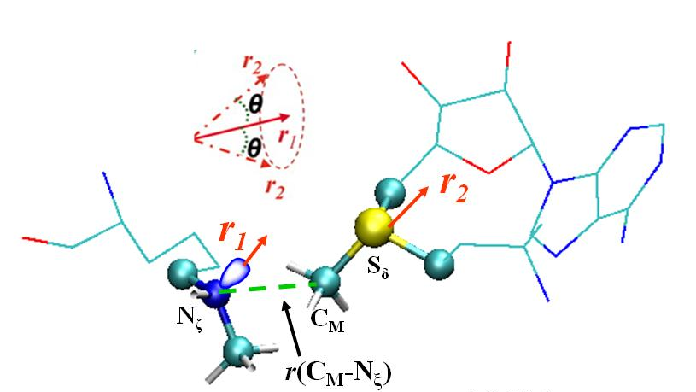

Figure 3.1
The definition of the structural parameters for monitoring the relative orientation of AdoMet and K189me1 [K189 and K189(me)2] in the reactant complex. The efficiency of the methyl transfer may be related to the distributions of r(C_{M}…N_{ζ}) and θ in the reactant complexes. θ is defined as the angle between the two vectors r1 and r2. Here r1 is the direction of the lone pair of electrons on N_{ζ} and r2 is the vector pointing from C_{M} to S_{δ}. The reaction coordinate for calculating the free energy profiles for the methyl transfers is R = r(C_{M}…S_{δ}) – r(C_{M}…N_{ζ}).

Figure 3.2
MD results for the wild-type enzyme (SET7/9) with TAF10-K189 peptide as the substrate. (A) The average active-site structure of the reactant complex for the first methyl transfer. SET7/9 is shown in balls and sticks, and AdoMet and TAF10-K189 are in sticks. Hydrogen atoms are not shown for clarity except for those on N_{ζ} and transferable methyl group. Hydrogen bonds are indicated by red dotted lines, and the distances related to the reactant coordinate are also shown. (B) Two-dimensional plot of r(C_{M}…N_{ζ}) and θ distributions based on the 1-ns simulations of the reactant complex for the first methyl transfer along with the corresponding free energy change as a function of r(C_{M}...N_{ξ}) obtained from the distributions. (C) The average structure near the transition state for the first methyl transfer obtained from the free energy (potential of mean force) simulations. (D) The average active-site structure of the reactant complex for the second methyl transfer. (E) The two-dimensional plot of r(C_{M}…N_{ζ}) and θ distributions based on the 1 ns simulations of the reactant complex for the second methyl transfer along with the corresponding free energy change as a function of r(C_{M}...N_{ξ}). (F) The average structure near the transition state for the second methyl transfer obtained from the free energy simulations.

Figure 3.3
MD results for Y245A. (A) Left: The average active-site structure of the reactant complex for the first methyl transfer in the mutant. Right: the two-dimensional plot of r(C_{M}…N_{ζ}) and θ distributions based on the 1 ns simulations of the reactant complex for the first methyl transfer along with the corresponding free energy change as a function of r(C_{M}...N_{ξ}) obtained from the distributions. (B) The average structure near the transition state for the first methyl transfer obtained from the free energy simulations. (C) Left: The average active-site structure of the reactant complex for the second methyl transfer. Right: the two-dimensional plot of r(C_{M}…N_{ζ}) and θ distributions based on the 1.5-ns simulations of the reactant complex for the second methyl transfer along with the corresponding free energy change as a function of r(C_{M}...N_{ξ}). (D) The average structure near the transition state for the second methyl transfer obtained from the free energy simulations. . (E) Left: The average active-site structure of the reactant complex for the third methyl transfer. Right: the two-dimensional plot of r(C_{M}…N_{ζ}) and θ distributions of the reactant complex for the third methyl transfer along with the corresponding free energy change as a function of r(C_{M}...N_{ξ}). (F) The average structure near the transition state for the third methyl transfer obtained from the free energy simulations.

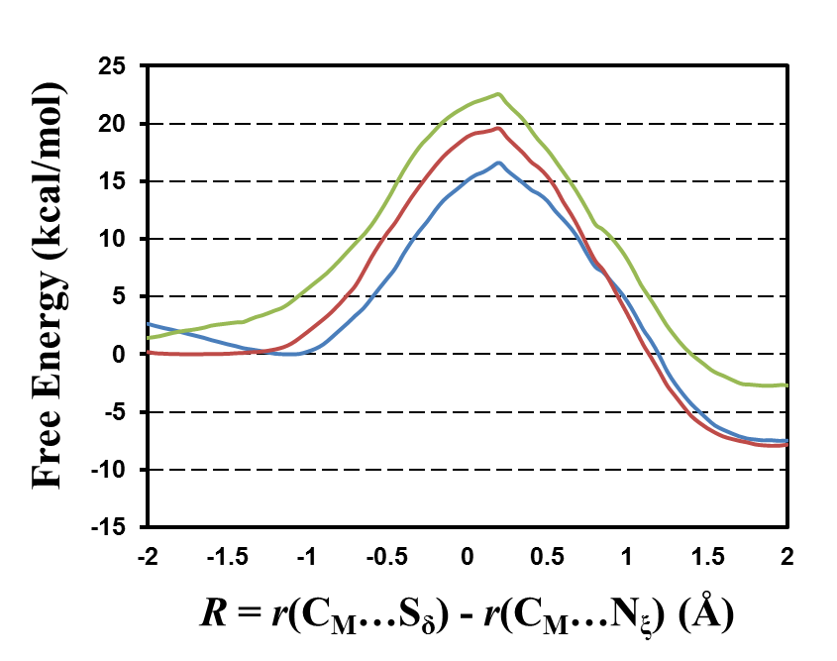
(B)

Figure 3.4
(A) Free energy (potential of mean force) changes for the first, second and third methyl transfers, respectively, as a function of the reaction coordinate [R = r(C_{M}…S_{δ}) – r(C_{M}…N_{ζ})] in the wild-type SET7/9 with TAF10-K189 peptide as the substrate. The first methyl transfer: blue line with a free energy barrier of 16.6 kcal/mol; the second methyl transfer: red line with a free energy barrier of 19.6 kcal/mol; the third methyl transfer: green line with a free energy barrier of 22.5 kcal/mol. Two free energy triplets, (0, Δ2-1W, Δ3-1W) and (ΔM-W, Δ2-1M, Δ3-1M) for wild-type and mutated enzyme, respectively, have been proposed to describe the product specificity of PKMTs and their mutants. For wild-type enzyme the second (Δ2-1W) and third (Δ3-1W) parameters are the differences in the free-energy barriers between the second and first and between the third and first methyl transfers, respectively. For the mutated enzyme, the first parameter (ΔM-W) is the difference in the free-energy barriers for the first methyl transfer in the wild-type and mutant. The second (Δ2-1M) and third (Δ3-1M) parameters are the differences in the free-energy barriers between the second and first and between the third and first methyl transfers, respectively. The energy triplet for SET7/9 with TAF10-K189 substrate was therefore calculated to be (0, 3, 5.9). (B) The free energy changes for the first, second and third methyl transfers as a function of the reaction coordinate in the Y245A mutant. The first methyl transfer: blue line with a free energy barrier of 18.7 kcal/mol; the second methyl transfer: red line; the third methyl transfer: green line. The energy triplet for Y245A is (2.1, -0.7, -1.3).

Reference
Bai, Q. F., Y. L. Shen, X. J. Yao, F. Wang, Y. P. Du, Q. Wang, N. Z. Jin, J. Hai, T. J. Hu and J. B. Yang (2011). "Modeling a New Water Channel That Allows SET9 to Dimethylate p53." Plos One 6(5).
Brooks, B. R., R. E. Bruccoleri, B. D. Olafson, D. J. States, S. Swaminathan and M. Karplus (1983). "CHARMM - A PROGRAM FOR MACROMOLECULAR ENERGY, MINIMIZATION, AND DYNAMICS CALCULATIONS." Journal of Computational Chemistry 4(2): 187-217.
Brooks, C. L., A. Brunger and M. Karplus (1985). "ACTIVE-SITE DYNAMICS IN PROTEIN MOLECULES - A STOCHASTIC BOUNDARY MOLECULAR-DYNAMICS APPROACH." Biopolymers 24(5): 843-865.
Cheng, X., R. E. Collins and X. Zhang (2005). "Structural and sequence motifs of protein (histone) methylation enzymes." Annu Rev Biophys Biomol Struct 34: 267-294.
Chu, Y. Z., Q. Xu and H. Guo (2010). "Understanding Energetic Origins of Product Specificity of SET8 from QM/MM Free Energy Simulations: What Causes the Stop of Methyl Addition during Histone Lysine Methylation?" Journal of Chemical Theory and Computation 6(4): 1380-1389.
Collins, R. E., M. Tachibana, H. Tamaru, K. M. Smith, D. Jia, X. Zhang, E. U. Selker, Y. Shinkai and X. Cheng (2005). "In vitro and in vivo analyses of a Phe/Tyr switch controlling product specificity of histone lysine methyltransferases." J Biol Chem 280(7): 5563-5570.
Couture, J. F., E. Collazo, J. S. Brunzelle and R. C. Trievel (2005). "Structural and functional analysis of SET8, a histone H4 Lys-20 methyltransferase." Genes & Development 19(12): 1455-1465.
Couture, J. F., E. Collazo, G. Hauk and R. C. Trievel (2006). "Structural basis for the methylation site specificity of SET7/9." Nature Structural & Molecular Biology 13(2): 140-146.
Couture, J. F., L. M. A. Dirk, J. S. Brunzelle, R. L. Houtz and R. C. Trievel (2008). "Structural origins for the product specificity of SET domain protein methyltransferases." Proceedings of the National Academy of Sciences of the United States of America 105(52): 20659-20664.
Couture, J. F., G. Hauk, M. J. Thompson, G. M. Blackburn and R. C. Trievel (2006). "Catalytic roles for carbon-oxygen hydrogen bonding in SET domain lysine methyltransferases." Journal of Biological Chemistry 281(28): 19280-19287.
Cui, Q., M. Elstner, E. Kaxiras, T. Frauenheim and M. Karplus (2001). "A QM/MM implementation of the self-consistent charge density functional tight binding (SCC-DFTB) method." Journal of Physical Chemistry B 105(2): 569-585.
Del Rizzo, P. A., J. F. Couture, L. M. A. Dirk, B. S. Strunk, M. S. Roiko, J. S. Brunzelle, R. L. Houtz and R. C. Trievel (2010). "SET7/9 Catalytic Mutants Reveal the Role of Active Site Water Molecules in Lysine Multiple Methylation." Journal of Biological Chemistry 285(41): 31849-31858.
Field, M. J., P. A. Bash and M. Karplus (1990). "A COMBINED QUANTUM-MECHANICAL AND MOLECULAR MECHANICAL POTENTIAL FOR MOLECULAR-DYNAMICS SIMULATIONS." Journal of Computational Chemistry 11(6): 700-733.
Georgieva, P. and F. Himo (2010). "Quantum Chemical Modeling of Enzymatic Reactions: The Case of Histone Lysine Methyltransferase." Journal of Computational Chemistry 31(8): 1707-1714.
Guo, H. and M. Karplus (1994). "SOLVENT INFLUENCE ON THE STABILITY OF THE PEPTIDE HYDROGEN-BOND - A SUPRAMOLECULAR COOPERATIVE EFFECT." Journal of Physical Chemistry 98(29): 7104-7105.
Guo, H. B., R. F. Beahm and H. Guo (2004). "Stabilization and destabilization of the C-delta-h center dot center dot center dot O=C hydrogen bonds involving proline residues in helices." Journal of Physical Chemistry B 108(46): 18065-18072.
Guo, H. B., A. Gorin and H. Guo (2009). "A peptide-linkage deletion procedure for estimate of energetic contributions of individual peptide groups in a complex environment: Application to parallel β-Sheets " Interdisciplinary Sciences: Computational Life Sciences 1(1): 12-20.
Guo, H. B. and H. Guo (2007). "Mechanism of histone methylation catalyzed by protein lysine methyltransferase SET7/9 and origin of product specificity." Proc Natl Acad Sci U S A 104(21): 8797-8802.
Horowitz, S., J. D. Yesselman, H. M. Al-Hashimi and R. C. Trievel (2011). "Direct Evidence for Methyl Group Coordination by Carbon-Oxygen Hydrogen Bonds in the Lysine Methyltransferase SET7/9." Journal of Biological Chemistry 286(21): 18658-18663.
Hu, P., S. Wang and Y. Zhang (2008). "How do SET-domain protein lysine methyltransferases achieve the methylation state specificity? Revisited by ab initio QM/MM molecular dynamics simulations." Journal of the American Chemical Society 130(12): 3806-3813.
Hu, P. and Y. K. Zhang (2006). "Catalytic mechanism and product specificity of the histone lysine methyltransferase SET7/9: An ab initio QM/MM-FE study with multiple initial structures." Journal of the American Chemical Society 128(4): 1272-1278.
Jenuwein, T. (2006). "The epigenetic magic of histone lysine methylation." FEBS J 273(14): 3121-3135.
Jorgensen, W. L., J. Chandrasekhar, J. D. Madura, R. W. Impey and M. L. Klein (1983). "COMPARISON OF SIMPLE POTENTIAL FUNCTIONS FOR SIMULATING LIQUID WATER." Journal of Chemical Physics 79(2): 926-935.
Kumar, S., D. Bouzida, R. H. Swendsen, P. A. Kollman and J. M. Rosenberg (1992). "THE WEIGHTED HISTOGRAM ANALYSIS METHOD FOR FREE-ENERGY CALCULATIONS ON BIOMOLECULES .1. THE METHOD." Journal of Computational Chemistry 13(8): 1011-1021.
Lall, S. (2007). "Primers on chromatin." Nature Structural & Molecular Biology 14(11): 1110-1115.
MacKerell, A. D., D. Bashford, M. Bellott, R. L. Dunbrack, J. D. Evanseck, M. J. Field, S. Fischer, J. Gao, H. Guo, S. Ha, D. Joseph-McCarthy, L. Kuchnir, K. Kuczera, F. T. K. Lau, C. Mattos, S. Michnick, T. Ngo, D. T. Nguyen, B. Prodhom, W. E. Reiher, B. Roux, M. Schlenkrich, J. C. Smith, R. Stote, J. Straub, M. Watanabe, J. Wiorkiewicz-Kuczera, D. Yin and M. Karplus (1998). "All-atom empirical potential for molecular modeling and dynamics studies of proteins." Journal of Physical Chemistry B 102(18): 3586-3616.
Martin, C. and Y. Zhang (2005). "The diverse functions of histone lysine methylation." Nat Rev Mol Cell Biol 6(11): 838-849.
Neria, E., S. Fischer and M. Karplus (1996). "Simulation of activation free energies in molecular systems." Journal of Chemical Physics 105(5): 1902-1921.
Strahl, B. D. and C. D. Allis (2000). "The language of covalent histone modifications." Nature 403(6765): 41-45.
Tachibana, M., K. Sugimoto, T. Fukushima and Y. Shinkai (2001). "SET domain-containing protein, G9a, is a novel lysine-preferring mammalian histone methyltransferase with hyperactivity and specific selectivity to lysines 9 and 27 of histone H3." Journal of Biological Chemistry 276(27): 25309-25317.
Taverna, S. D., H. Li, A. J. Ruthenburg, C. D. Allis and D. J. Patel (2007). "How chromatin-binding modules interpret histone modifications: lessons from professional pocket pickers." Nature Structural & Molecular Biology 14(11): 1025-1040.
Torrie, G. M. and J. P. Valleau (1974). "MONTE-CARLO FREE-ENERGY ESTIMATES USING NON-BOLTZMANN SAMPLING - APPLICATION TO SUBCRITICAL LENNARD-JONES FLUID." Chemical Physics Letters 28(4): 578-581.
Turner, B. M. (2005). "Reading signals on the nucleosome with a new nomenclature for modified histones." Nat Struct Mol Biol 12(2): 110-112.
Wang, S. L., P. Hu and Y. K. Zhang (2007). "Ab initio quantum mechanical/molecular mechanical molecular dynamics simulation of enzyme catalysis: The case of histone lysine methyltransferase SET7/9." Journal of Physical Chemistry B 111(14): 3758-3764.
Wu, H., J. R. Min, V. V. Lunin, T. Antoshenko, L. Dombrovski, H. Zeng, A. Allali-Hassani, V. Campagna-Slater, M. Vedadi, C. H. Arrowsmith, A. N. Plotnikov and M. Schapira "Structural Biology of Human H3K9 Methyltransferases." Plos One 5(1).
Xiao, B., C. Jing, G. Kelly, P. A. Walker, F. W. Muskett, T. A. Frenkiel, S. R. Martin, K. Sarma, D. Reinberg, S. J. Gamblin and J. R. Wilson (2005). "Specificity and mechanism of the histone methyltransferase Pr-Set7." Genes & Development 19(12): 1444-1454.
Xiao, B., C. Jing, J. R. Wilson, P. A. Walker, N. Vasisht, G. Kelly, S. Howell, I. A. Taylor, G. M. Blackburn and S. J. Gamblin (2003). "Structure and catalytic mechanism of the human histone methyltransferase SET7/9." Nature 421(6923): 652-656.
Xiao, B., J. R. Wilson and S. J. Gamblin (2003). "SET domains and histone methylation." Current Opinion in Structural Biology 13(6): 699-705.
Xu, Q., Chu, Y-Z, Guo, H-B, Smith, J.C., Guo, H. (2009). "Energy Triplets for Writing Epigenetic Marks: Insights from QM/MM Free-Energy Simulations of Protein Lysine Methyltransferases." Chemistry - A European Journal 15: 12596 – 12599.
Xu, S. T., J. Wu, B. F. Sun, C. Zhong and J. P. Ding (2011). "Structural and biochemical studies of human lysine methyltransferase Smyd3 reveal the important functional roles of its post-SET and TPR domains and the regulation of its activity by DNA binding." Nucleic Acids Research 39(10): 4438-4449.
Zhang, X. and T. C. Bruice (2008). "Enzymatic mechanism and product specificity of SET-domain protein lysine methyltransferases." Proceedings of the National Academy of Sciences of the United States of America 105(15): 5728-5732.
Zhang, X., H. Tamaru, S. I. Khan, J. R. Horton, L. J. Keefe, E. U. Selker and X. Cheng (2002). "Structure of the Neurospora SET domain protein DIM-5, a histone H3 lysine methyltransferase." Cell 111(1): 117-127.
Zhang, X., Z. Yang, S. I. Khan, J. R. Horton, H. Tamaru, E. U. Selker and X. Cheng (2003). "Structural basis for the product specificity of histone lysine methyltransferases." Mol Cell 12(1): 177-185.
Zhang, X. D. and T. C. Bruice (2008). "Product specificity and mechanism of protein lysine methyltransferases: Insights from the histone lysine methyltransferase SET8." Biochemistry 47(25): 6671-6677.

CHAPTER 4
QM/MM and experimental study of substrate-assisted catalysis in substrate promiscuity, a novel substrate discrimination mechanism in promiscuous enzyme

Jianzhuang Yao, Haobo Guo, Minta Chaiprasongsuk, Nan Zhao, Feng Chen, and Hong Guo. “Understanding the coincidence of substrate promiscuity and substrate discrimination in methyl salicylate esterases: a QM/MM and experimental study” To be submitted.
My contributions to this study include: 1) discussions with the design of the experiments; 2) performing the experiments; 3) analysis of the result and preparing the manuscript. Dr. Hong Guo also wrote the manuscript. Minta Chaiprasongsuk and Dr. Nan Zhao perform the experiments for kinetic data. Dr. Haobo Guo and Dr. Feng Chen are involved with the discussions of the design of the experiment.

Abstract
Although one of enzymes hallmark is their highly catalytic specificity to natural substrates, substrate promiscuity has been increasingly reported recently. Promiscuous Enzymes generally show different catalytic efficiencies to different substrates. This substrate discrimination may be achieved by diversity of binding affinity to active site and/or different positioning relative to catalytic residues. It is believed from protein engineering perspective that substrate-assisted catalysis (SAC) may provide a strategy for drastically changing enzyme substrate specificity. Question remains as to whether naturally occurring enzymes might have used SAC to achieve substrate discrimination and how SAC enzymes catalyze reaction on promiscuous substrates without SAC. Here, we report the results of quantum mechanical/molecular mechanical (QM/MM) calculations and experimental study on salicylic acid binding protein 2 (SABP2) that has promiscuous esterase activity toward a series of substrates, but shows specific highly activity toward its natural substrate methyl salicylate (MeSA). It is demonstrated that SABP2 may represent a case in which the enzyme itself might have not been perfectly evolved and that SAC involving its natural substrate (MeSA) may be used to enhance the activity specifically on this substrate and therefore achieve substrate discrimination. In the meantime, SABP2 provides sub-optimal activity toward its promiscuous substrates without SAC ability by an intrinsic compensation mechanism. The theoretical prediction is subsequently confirmed experimentally by comparing the results of the calculations with the k_{cat} values for MeSA and methyl benzoate (MeBA) which lacks this ability of participating in SAC.

Introduction
Traditionally, enzymes are considered to specifically catalyze reaction on single substrate. However, enzyme substrate promiscuity, capable to metabolize multiple substrates by same reaction of an enzyme, is not a new concept(Hult and Berglund 2007, Nath and Atkins 2007) and has been reported frequently.(Theodossis, Walden et al. 2004, Faridmoayer, Fentabil et al. 2008, Huang, Horváth et al. 2009, Cohen-Rosenzweig, Guan et al. 2014) On one hand, rate accelerations (k_{cat}/k_{uncat}) and catalytic proficiency (k_{cat}/K_{M}/k_{uncat}) are substantially high for promiscuous enzymes.(Catrina, O'Brien et al. 2007, Olguin, Askew et al. 2008, van Loo, Jonas et al. 2010) The mechanism of promiscuity has been discussed in several reviews.(Aharoni, Gaidukov et al. 2005, Khersonsky, Roodveldt et al. 2006, Babtie, Tokuriki et al. 2010, Khersonsky and Tawfik 2010, Gatti-Lafranconi and Hollfelder 2013) Briefly, factors linked to substrate promiscuity include substrate-binding-related active site conformational change,(Jackson, Foo et al. 2008) diverse interactions (like hydrophobic binding(Villiers and Hollfelder 2009) and hydrogen bonding(Theodossis, Walden et al. 2004)) provided by very same active site, reactive potential (like protonation states(Wang, Johnson et al. 2003, Wang, Person et al. 2003) and subsites(Yeung, Lenz et al. 2005, Khersonsky and Tawfik 2006)) from one active site, assistants from water,(Kourist, Bartsch et al. 2008) cofactors,(Bakker, Rantwijk et al. 2002) and post-translational modification.(Babtie, Bandyopadhyay et al. 2009, van Loo, Jonas et al. 2010) On the other hand, enzymes with promiscuous substrates generally show different catalytic efficiencies (k_{cat}/K_{M}).(Kopycki, Rauh et al. 2008, Sabini, Hazra et al. 2008) Catalytic specificity of promiscuous substrates can be evaluated by both K_{M} and k_{cat}. For promiscuous substrates, weakly binding to active site results in high K_{M} values, while inappropriate positioning relative to catalytic residues of active site leads to low k_{cat}.(Babtie, Tokuriki et al. 2010, Khersonsky and Tawfik 2010) Other factors like substrate-assisted catalysis (SAC), which also can effect k_{cat} values besides sub-optimal positioning of promiscuous substrates, remain barely reported. SAC is a process in which the functional groups from substrates, in addition to those from enzymes, contribute to the rate acceleration of the enzyme-catalyzed reactions.(Carter and Wells 1987, Carter, Nilsson et al. 1989, Xu, Guo et al. 2006) The removal of such functional groups from the substrates impairs the catalysis. It has been demonstrated that for engineered enzymes SAC may provide a way of drastically changing substrate specificity. Question remains, however, as to whether naturally occurring enzymes might have already used SAC as one of important strategies for the discrimination between their natural substrates and promiscuous substrates that lack the groups capable of participating in SAC and how SAC enzymes catalyze reaction on promiscuous substrates without SAC functional group. Therefore, understanding the co-existing factors of substrate promiscuity and self-assisted substrate discrimination is a very important task in enzymology, especially helpful in protein engineering(Bornscheuer and Kazlauskas 2004, Lairson, Watts et al. 2006) and drug design.(Fernández, Tawfik et al. 2005, Lewinson, Adler et al. 2006)
Salicylic acid binding protein 2 (SABP2) studied in this work has specific esterase activity toward methyl salicylate (MeSA) and belongs to the α/β fold carboxylesterase hydrolase superfamily (EC 3.1.1).(Kumar and Klessig 2003, Forouhar, Yang et al. 2005, Kumar, Park et al. 2005, Kumar, Gustafsson et al. 2006, Zhao, Guan et al. 2009) Previous studies have demonstrated that SABP2 possesses specific esterase activity toward MeSA.(Kumar and Klessig 2003) MeSA is an general compound in plants and produced from salicylic acid (SA) by methylation activity of SA methyltransferase (SAMT).(Yao, Xu et al. 2010) The conversion of MeSA to salicylic acid (SA) catalyzed by SABP2 is believed to be a part of the signal transduction pathways that activate systemic acquired resistance and local defense responses to plant pathogens.(Kumar and Klessig 2003, Forouhar, Yang et al. 2005, Kumar, Park et al. 2005, Kumar, Gustafsson et al. 2006, Zhao, Guan et al. 2009) It has been shown(Forouhar, Yang et al. 2005) that Ser-81, His-238 and Asp-210 act as the catalytic triad (Figure 4.1a). Esterase activity was mostly or totally abrogated by Ser81Ala Mutant to substrates.(Forouhar, Yang et al. 2005) SABP2 esterase catalytic activity consists of acylation and deacylation processes. In Figure 4.1a, the proposed acylation reaction mechanism indicates that Ser-81 serves as nucleophile which attacking the carbon atom in ester bond, His-238 functions as both general acid and base which accepting the side chain proton of Ser-81 and transferring this proton to product, and Asp-210 stabilizes the transition state by electrostatic interactions. It has been shown that SABP2 can catalyze reactions on a series substrates in Figure 4.1b,(Kumar and Klessig 2003, Forouhar, Yang et al. 2005, Kumar, Park et al. 2005, Kumar, Gustafsson et al. 2006, Zhao, Guan et al. 2009, Padhi, Fujii et al. 2010, Tripathi, Jiang et al. 2010) so-called “substrate promiscuity”. However, the structure basis of SABP2 substrate promiscuity is still unclear. Interestingly, SABP2 natural activity seems to be much stronger than the activities of this enzyme toward its promiscuous substrates.(Forouhar, Yang et al. 2005, Zhao, Guan et al. 2009, Padhi, Fujii et al. 2010) One possible explanation is that the active site of SABP2 is too crowd to occupy some other substrates.(Forouhar, Yang et al. 2005) Nonetheless, the exact reasons for the catalytic differences in the activities are still not clear.
As important as the classic catalytic triad in active site, composition of oxyanion hole, an essential component in the active site of SABP2, still remains elusive. Components of oxyanion hole have been widely studied in classic serine protease.(Hedstrom 2002, Di Cera 2009) The role of the oxyanion hole is to stabilize the increasing negative charge on the O atom of substrate during the tetrahedral intermediate formation. For instance, backbone amide group of Gly-193 and Ser-195 form a two-pronged oxyanion hole in chymotrypsin,(Blow 1976) while subtilisin contains a three-pronged oxyanion hole forming by side chains of Asn-155, Thr-220 and backbone amide group of Ser-221.(Matthews, Alden et al. 1975) Moreover, carboxylesterase hydrolase superfamily also use oxyanion hole to stabilize the tetrahedral intermediate,(Hosokawa 2008) an example is that Acetobacter turbidans α-Amino Acid Ester Hydrolase owns a two-pronged oxyanion hole consisting of a side chain of Tyr-121 and a backbone amide group of Ser-205.(Barends, Polderman-Tijmes et al. 2006) Although two-pronged or three-pronged oxyanion hole seems like a general, the X-Ray crystal structure of tobacco SABP2 complexed with salicylic acid (SA)(Forouhar, Yang et al. 2005) reveals that only backbone amide group of Ala-13 in enzymes participates in the oxyanion hole interaction through hydrogen bonding with SA carbonyl oxygen atom, as shown in Figure 4.2. Another possible Hydrogen bond which may participate in tetrahedral intermediate (TI) oxyanion hole stabilization is from the backbone amide group of Leu-82. Although it is a weak hydrogen bond which distance between two heavy atoms is 3.35Å in product complex, the question is whether the distance will get closer from reactant state (RS) to TI in order to neutralize the developing negative charge of carbonyl O atom? The third hydrogen bonding candidate is the hydroxyl group from substrate which distance between two oxygen atoms is 2.66Å. The question is whether SABP2 will use SAC mechanism to build oxyanion hole and discriminate its natural substrate (MeSA) from other promiscuous ones?
To elucidate the role of catalytic triad and oxyanion in the coincidence of substrate promiscuity and discrimination, we have studied MeSA and MeBA acylation reaction SABP2 using SCC-DFTB/MM Hamiltonian(Cui, Elstner et al. 2000) and experimental study. We also present the result of benchmark calculations by ab initio QM/MM calculations. Here we report the results of computational and experimental investigations which suggest that 1) two-pronged oxyanion hole, whose stability is compensated by moveable amide group of Leu-82, is sub-optimal but critical for substrate promiscuity of SABP2, 2) substrate-assisted three-pronged oxyanion hole provides three hydrogen bonding to maximize SABP2 esterase activity which may results in substrate discrimination between natural and promiscuous substrates.

Methods
Enzyme complex model setup. The initial coordinates for the reactant complexes were based on the crystallographic structure (PDB code: 1Y7I, 2.1 Å resolution) of tobacco SABP2 in complex with SA.(Forouhar, Yang et al. 2005) A methyl group was manually added to SA to form MeSA. The side chain of Ser81 was manually placed between His238 and the carbonyl carbon of MeSA to complete the catalytic triad. Hydrogen atoms of protein were added by the HBUILD module(Brünger and Karplus 1988) implemented in CHARMM,(Brooks, Bruccoleri et al. 1983, Brooks, Brooks et al. 2009) but substrates hydrogen atoms were added manually. All acidic and basic amino acids protonation states were determined by surrounding environment under physiological pH condition. Reactant complex was solvated by a water droplet with 22 Å radius by the standard superimposing protocol at the center of Ser-81 oxygen atom (O_{γ} labeled in Figure 4.2), and solvent water molecules within 2.8 Å of any crystal atoms were removed. A modified TIP3P water model(Jorgensen 1981, Neria, Fischer et al. 1996) was employed for the solvent. The substrates and the side chains of Ser-81, His-238 and Asp-210 were treated by QM and the rest of the system by MM. The link-atom approach(Field, Bash et al. 1990) implemented in the CHARMM program(Brooks, Brooks et al. 2009) was applied to separate the QM and MM regions. The DIV scheme(König, Hoffmann et al. 2005) implemented in CHARMM was used to treat the QM/MM frontier. The SCC-DFTB method(Cui, Elstner et al. 2001) with empirical dispersion corrections(Elstner, Hobza et al. 2001) implemented in CHARMM was used for the QM atoms and the all-hydrogen CHARMM potential function (PARAM27)(MacKerell, Bashford et al. 1998) was used for the MM atoms. For the reactant complex containing MeBA, the hydroxyl group at the 2-position of MeSA was removed to generate the substrate. The resulting systems contained around 5400 atoms, including about 600 water molecules.
Stochastic boundary molecular dynamics (MD) and potential mean force (PMF) free energy simulations. Stochastic boundary molecular dynamics method(Brooks, Brunger et al. 1985) was used with the oxygen atom (O_{γ}) of the Ser-81 as the reference center. The reaction region was a sphere with radius r of 20 Å, and the buffer region extended over 20 Å ≤ r ≤ 22 Å. All bonds of hydrogens except the one involved in proton transfer in the system were constrained by the SHAKE algorithm.(Ryckaert, Ciccotti et al. 1977) The initial structures for the entire stochastic boundary systems were optimized using the steepest descent (SD) and adopted-basis Newton-Raphson (ABNR) methods. The systems were gradually heated from 50.0 to 298.15K in 100 ps. A 1-fs time step was used for integration of the equation of motion. 500 ps QM/MM MD simulations were carried out for each of the reactant complexes.
The umbrella sampling method(Torrie and Valleau 1974) implemented in the CHARMM program along with the Weighted Histogram Analysis Method (WHAM)(Kumar, Bouzida et al. 1992) was then applied to determine the change of the free energy (potential of mean force) as a function of the reaction coordinate. The reaction coordinate (RC) was defined as a linear combination of r(C…O) and r(C...O_{γ}) [RC = r(C…O)-r(C...O_{γ})], as shown in Figure 4.2. The determination of multidimensional free energy maps would be too time-consuming. Several previous ab initio studies(Zhang, Kua et al. 2002, Ishida and Kato 2003) on catalytic triad indicated that the one dimensional free energy simulations with the selection of a suitable reaction coordinate reflecting the key bond-breaking and bond-making events may be able to capture the key energetic properties for the acylation reaction (e.g., the free energy barrier). For each acylation process, more than forty windows were used, and for each window 100 ps simulations were performed with 50 ps equilibration. The force constants of the harmonic biasing potentials used in the PMF simulations were 50 to 500 kcal∙mol⁻¹∙Å⁻². The key average structure properties for important windows were provided in Table 4.1.
Benchmark calculations. Benchmark calculations method has been successfully used by several previous SCC-DFTBPR studies(Hou and Cui 2011, Hou and Cui 2013) to prove the applicability of SCC-DFTBPR/MM on different enzyme systems. To our knowledge, this is the first study applying SCC-DFTB to study the classic catalytic triad (Ser, His, and Asp). So, benchmark calculation was also carried out based on our enzyme complex model to explicitly demonstrate the reliability of SCC-DFTB method on simulating the bond breaking and making process of SABP2 acylation process. First, we compared the optimized structures of reactant complexes between B3LYP(Becke 1988, Lee, Yang et al. 1988, Becke 1993)/MM and SCC-DFTB/MM methods. The basis set (6-31G(d,p)) has been successfully used on ab initio QM/MM simulations of Acetylcholinesterase.(Zhou, Wang et al. 2010, Sirin, Zhou et al. 2012) The QM(B3LYP/6-31G(d,p))/MM calculations were performed for the acylation processes in SABP2 using GAMESS-US method(Schmidt, Baldridge et al. 1993) implemented in the CHARMM program.(Brooks, Bruccoleri et al. 1983, Brooks, Brooks et al. 2009)
In addition to reactant complex comparison, we applied the same comparisons on appropriate transition states and tetrahedral intermediates on potential energy surfaces. The adiabatic mapping calculations were carried out based on the following protocol. Reaction coordinate is the same as PMF calculations. A harmonic constraint with force constant of 2000 kcal∙mol⁻¹∙Å⁻² was added to the RC to guide the SABP2 acylation reaction. The RC value was increased stepwise from reactant complex to product complex, with the step size of 0.2 Å. An adopted basis Newton Raphson (ABNR) minimization was carried out under the constraint. The RC value was then decreased from the product complex to the reactant complex, and the forward and backward progresses were repeated so as to obtain a smooth and more reliable potential energy surface (PES) profile along the reaction path.
B3LYP/MM correction of the SCC-DFTB/MM PMF barrier. Table 4.2 shows energetic data from our benchmark calculations. The reaction barriers for SABP2 acylation reactions with MeSA and MeBA tend to be underestimated by SCC-DFTB/MM compared with B3LYP/MM. Therefore, a barrier correction at different QM/MM levels is necessary for SCC-DFTB result to be comparable with experimental data.(Hou and Cui 2011, Hou and Cui 2013) The correction, to be added to PMF free energy barrier, is the difference in potential energy barriers from adiabatic mapping calculations between SCC-DFTB/MM level and B3LYP/MM level.
Kinetic Data. Vmax for PtSABP2-1 and PtSABP2-2 using MeSA as substrate has been experimentally determined in our previous study.(Zhao, Guan et al. 2009) It was used to calculate the kcat of this enzyme with MeSA. Vmax of PtSABP2-1 and PtSABP2-2 using MeBA as substrate was experimentally determined using the same protocol as that for determining the Vmax of PtSABP2-1 and PtSABP2-1 with MeSA.(Zhao, Guan et al. 2009) PtSABP2-1 and PtSABP2-2 recombinant protein expressed in E. coli was purified, then used in a two-step radiochemical esterase assay to determine the Vmax using MeBA as substrate. The obtained Vmax values were used to calculate the kcat of PtSABP2-1 and PtSABP2-2 using MeBA as substrate, as shown in Table 4.2.

Results and Discussion
Before comparing our theoretical calculation to experimental results, it is worth pointing out that SABP2 esterase activity consists of two steps (acylation and deacylation). The potential energy functions, by B3LYP/MM for both acylation and deacylation, has been determined for both MeSA and MeBA, prove that acylation step is rate-limiting which energy barrier can be discussed in the context of experimental data.
The active site structure of SABP2 complexed with product SA was plotted based on the X-ray structure of the SABP2-SA complex,(Forouhar, Yang et al. 2005) as shown in Figure 4.2. The classic catalytic triad (Ser-81, His-238, and Asp-210) is clearly presented in the active site but without complete hydrogen-bonding network among the catalytic triad. Although there is a hydrogen bonding between His-248 and Asp-210, the hydroxyl group of Ser-81 side chain is not hydrogen-bonded with the His-238. In order to performing the nucleophilic attack by Ser-81 on the carbon atom (C) of substrates, the hydrogen-bonding network of catalytic triad was completed by changing the torsion angle of the side chain of Ser-81, consistently with a computer model from the previous investigation.(Forouhar, Yang et al. 2005) As a result, the residues of the catalytic triad are well aligned for the nucleophilic attack by Ser-81 on the carbon atom (C) of MeSA as required for acylation. In the active site of crystal structure, oxyanion hole is formed by two hydrogen bond from SA and Ala-13. It is of interest to note that the amide group of Leu-82 forms a rather week interaction with carbonyl group O of the substrate with a distance of 3.55 Å. This oxyanion hole construction indicates that those two hydrogen bonds (O…O 2.64 Å and N…O 2.79 Å) may be enough for oxyanion hole stabilization in reactant complex and the weak hydrogen bond from amide group of Leu-82 (N…O 3.55 Å) may be enhanced as a result of the developing of negative charge along the reaction coordinate of acylation process.
MeSA acylation in SABP2. MeSA is the natural substrate of SABP2. The active-site structures of SABP2 complexed with MeSA obtained from the QM(B3LYP and SCC-DFTB)/MM geometry optimizations are shown in Figure 4.3a; the initial structures for the optimization calculations were from different snapshots based on the X-ray structure of the SABP2-SA complex and QM(SCC-DFTB)/MM molecular dynamics simulations. The optimized structure of the reactant complex by SCC-DFTB/MM shows generally good agreement with that by B3LYP/MM. Hydrogen-bonding networks of the catalytic triad are aligned very well for both QM/MM levels. The specific three-pronged oxyanion hole, consisting of two hydrogen bonds and a weak one, also agrees well with the crystal structure. Although reactant state optimizations of two QM/MM levels were started from two different snapshots of QM(SCC-DFTB)/MM MD simulation, most atom distances between two QM/MM levels are similar with around 0.1 Å difference. The difference (more than 0.25 Å) between two QM/MM levels is rooted in two hydrogen-bonding distances in reactant state. One is from amide group of Leu-82 and carbonyl O of MeSA, which distances (H…O) are 2.49 and 2.86 Å for B3LYP/MM and SCC-DFTB/MM calculation, respectively. The other is from hydroxyl group of Ser-81 and His-236 with the distances of 1.54 and 1.89 Å for B3LYP/MM and SCC-DFTB/MM calculations, respectively. However, those hydrogen bond distance differences do not keep on along the reaction coordinate. Furthermore, the hydrogen bond from product methanol hydroxyl group and His236 side chain shows 0.29 Å difference between SCC-DFTB/MM and B3LYP/MM calculations, as shown in Figure 4.3d. The proton has been transferred from side chain of His238 to acylation product, which is different with PMF calculation (Figure 4.4f). At this point, SCC-DFTB/MM and B3LYP/MM calculations show the same result, which is the most important for this benchmark calculation. That means this inconsistence with PMF calculation is not due to SCC-DFTB/MM method, but maybe because of the limitation of adiabatic mapping calculations. Those differences indicate that non-covalent bonds such as hydrogen bond described by SCC-DFTB still need improvement.(Yang, Yu et al. 2007, Gaus, Cui et al. 2011) Overall, SCC-DFTB/MM Hamiltonian is a reliable method for describing the structure features of SABP2 complexed with MeSA.
For most structural features in Figure 4.3b-d, SCC-DFTB/MM and B3LYP/MM show the same reaction trends in TSs and TI from adiabatic mapping calculations. For example, hydrogen bond from Leu-82 and substrate is enhanced with developing of the negative charge through RS to TI. The shapes of potential energy surfaces for two QM/MM levels also agree well with each other with two energy ridges (TSs) and a basin (TI), as shown in Table 4.2. The activation barriers both locate at the second TS. The activation barrier by SCC-DFTB/MM level is lower than that calculated with B3LYP/MM (12.2 vs 17.7 kcal/mol). The ~5.5 kcal/mol underestimation by SCC-DFTB/MM in energy barrier compared to high level QM/MM calculation is consistent with a previous SCC-DFTBPR study.(Hou and Cui 2013) Although SCC-DFTB still has room for further improvement, it is an efficient and reliable method(Hou and Cui 2011, Hou, Zhu et al. 2012, Hou and Cui 2013) for computational simulation of acylation reaction of MeSA SABP2.
The PMF free energy profile along the reaction coordinate of the acylation reaction of MeSA obtained from the SCC-DFTB/MM calculations is shown in Figure 4.4a. As can be seen from Figure 4.4e, there exists a stable tetrahedral intermediate (TI) during the acylation step (the structure has been shown in Figure 4.1b). The PMF profile at the SCC-DFTB/MM level (Figure 4.4a) indicates a two steps exothermic with two TSs, as shown in Figure 4.4b and Figure 4.4f. The energy barrier locates at the second TS with a reaction coordinate near at 0.4 Å. The free energy barrier is 9.5 kcal/mol, which is 6 kcal/mol lower than the experimental kinetic estimate(Forouhar, Yang et al. 2005) based on k_{cat}, as shown in Table 4.2; this is not surprise since the adiabatic mapping benchmark (discussed above) finds that SCC-DFTB/MM underestimates the potential energy barrier compared to B3LYP/MM by ~5.5 kcal/mol (Table 4.2). With an energy correction, our corrected PMF free energy barrier (14.9 kcal/mol) shows a well agreement with experimental estimation (15.5 kcal/mol) based on transition state theory. The potential energy function for the deacylation step was obtained as well; the energy barrier was calculated to be 15.4 kcal/mol from the QM(B3LYP/6-31G(d,p))/MM method. This results demonstrate the acylation process is the rate-limiting step. In Figure 4.4b, the bond lengths of C-O and C-O_{γ} were plotted as functions of RC during PMF calculation. The bond lengths of r(C…O) and r(C-O_{γ}) change smoothly and intersect at RC around 0 Å. Several important bond lengths from RS, TSs, and TI has been summarized at Table 4.1.
Figure 4.4c-f show that the average structures along the reaction path share the similar situation found in the optimized structures (Figure 4.3a-d) in terms of patterns of hydrogen bonding network and oxyanion hole construction. Different from optimized structure of TS2, but consistent with an ab initio QM/MM MD simulation,(Zhou and Zhang 2011) average structure of TS2 has not been transferred from His236 side chain to deprotonated methanol group in TS2. The role of catalytic triad in acylation process is the same with classic serine protease.(Blow 1976, Zhang, Kua et al. 2002) For instance, carboxylate of Asp-208 works with the incipient imidazolium cation to stabilize the TS and the TI by the electrostatic interaction.(Blow 1976, Warshel, Naray-Szabo et al. 1989)
We also investigated changes of the hydrogen bonds formed in the three-pronged oxyanion hole (Ala-13, Leu-82, and MeSA hydroxyl group). The changes in heavy atom distances (N-O, O-O) along the reaction coordinate are shown in Figure 4.7. In RS (Figure 4.4a), two hydrogen bonds are formed between the MeSA carbonyl O₁ and the amide group of Ala-13 and hydroxyl group of MeSA, with N-O and O-O distances of 1.90 and 1.80 Å. It is of interest to note that the amide group of Leu-82 forms a rather week interaction with O₁ of the substrate with a distance of 2.96 Å in RS. Thus, the enzyme seems to have been evolved with a less effective oxyanion hole for the stabilization of the tetrahedral intermediates (TIs) during the catalysis. Interestingly, the 2-OH group of MeSA, in addition to the amide group of Ala-13, forms an intra-molecular hydrogen bond with O₁ of the substrate with a hydrogen-bond distance of 1.67 Å. Moreover, this hydrogen bond seems to strengthen significantly as the reaction proceeds from the reactant complex to the tetrahedral intermediate (see Figure 4.4c-f Figure 4.7) based on the PMF calculations. Thus, the 2-OH group from the MeSA substrate may help to generate a more effective oxyanion hole and lower the activation barrier through SAC. This may contribute to the relatively high specificity of SABP2 toward MeSA compared to that toward some other compounds (Figure 4.1b) which lack such or similar interactions.
MeBA acylation in SABP2. To understand the substrate promiscuity of SABP2 and test the hypothesis concerning the importance of SAC in substrate discrimination, the catalytic mechanism of acylation involving methyl benzoate (MeBA) (which is one of the promiscuous substrates of SABP2 and lacks the 2-OH hydroxyl group) was also studied. There is no available experimental data (like k_{cat}) for MeBA hydrolysis in tobacco SAPB2.
Similar with the MeSA benchmark comparisons (See above), SCC-DFTB/MM minimizations for MeBA in SABP2 give overall similar results to B3LYP/MM calculations (Figure 4.5a-b). In the optimized RS (Figure 4.5a), SABP2 complexed with MeBA shows identical patterns of hydrogen bonding network with MeSA complex. Furthermore, MeBA shows the similar oxyanion hole configuration with MeSA (Figure 4.3a). The hydrogen bonds distance difference (more than 2.5 Å, Figure 4.3a) among the catalytic triad of MeSA keeps in MeBA complex for both RS and TS. Without the OH group in the substrate, MeBA complex forms a two-pronged oxyanion hole instead of three-pronged one. As a result of missing one hydrogen bond in oxyanion hole, amide group of Leu-82 moves closer to O₁ of MeBA carbonyl group compared with optimized RS of MeSA complex in both SCC-DFTB/MM and B3LYP/MM calculation and this distance difference (more than 2.5 Å, Figure 4.3a) between two theoretical levels disappears. For the results of adiabatic mapping calculations, SCC-DFTB/MM underestimates the barrier compared to B3LYP/MM by a few kcal/mol (14.9 vs 19.5 kcal/mol), which is similar to the situation of MeSA. However, the TS geometries at the two QM/MM levels are very consistent with each other (Figure 4.5b). Different to PMF TS (Figure 4.6b), The proton has been transferred from side chain of His238 to acylation product. This phenomenon has been seen and discussed in MeSA benchmark calculation. Compared with MeSA acylation process (Figure 4.3), a stable TI was not obtained for the reaction involving MeBA from the adiabatic mapping calculation. Therefore, RS active site comparison between MeSA and MeBA complexes seems to deny the hypotheses that inappropriate positioning of MeBA compared with MeSA relative to catalytic residues of active site leads to low k_{cat}, but may support our alternative hypotheses that SAC may contribute to substrate discrimination.
The calculated PMF (Figure 4.6) at the SCC-DFTB/MM level indicates an exothermic reaction with the plateau TS with the highest point at RC ~ 0.1 Å. This PMF profile supports our hypothesis that SABP2 forms a sub-optimal oxyanion hole during evolution. In Figure 4.6b, the bond lengths of C-O and C-O_{γ} were plotted as functions of RC during PMF calculation. Similar with MeSA, the bond lengths of r(C…O) and r(C-O_{γ}) change smoothly and intersect at RC around 0 Å. The calculated free energy barrier is 11.4 kcal/mol, which is 1.9 kcal/mol higher than MeSA PMF free energy barrier. As shown in Table 4.2, this is likely underestimated by 4.9 kcal/mol, because of the systematic error of SCC-DFTB. After the barrier correction based on adiabatic mapping calculations at different QM/MM levels, the corrected estimate for the free energy barrier is about 16.1 kcal/mol (Table 4.2), which is 1.2 kcal/mol higher than corrected MeSA free energy barrier. To confirm the theoretical prediction concerning the involvement of the hydroxyl group of MeSA in SAC and substrate discrimination, Instead, we measured the esterase activities of PtSABP2-1 and PtSABP2-2 toward MeSA and MeBA, respectively (Table 4.2). PtSABP2-1 and PtSABP2-2(Zhao, Guan et al. 2009) are 98% identical to each other and has over 77% sequence identity with tobacco SABP2(Forouhar, Yang et al. 2005) and its activity profile for different substrates was found to be basically the same as that of tobacco SABP2.(Forouhar, Yang et al. 2005) Consistent with the results of the theoretical calculations, the free energy barriers based on k_{cat} values for MeSA (0.120 s^{–1}) and MeBA (0.007 s^{–1}) catalyzed by PtSABP2-1 were found to be 16.3 and 18.0 kcal/mol, respectively (0.45 s^{–1} for tobacco SABP2 with MeSA(Forouhar, Yang et al. 2005)). Correspondingly, the K_{M} values were found to be 68.2μM and 39.6μM for MeSA and MeBA, respectively. Similar with PtSABP2-1, the free energy barriers based on k_{cat} values for MeSA (0.187 s^{–1}) and MeBA (0.038 s^{–1}) catalyzed by PtSABP2-2 are 16.0 and 17.0 kcal/mol. Again, the K_{M} values were found to be 24.6μM and 42.1μM for MeSA and MeBA, respectively. Thus, k_{cat} is the major determinant for the specificity. The measured activation energy difference between MeSA and MeBA in both PtSABP2-1 and PtSABP2-2 based on transition state theory is about 1.0-1.7 kcal/mol, which agrees well with our PMF free energy calculation (1.2 kcal/mol).
The average structurefor the reactant complex and that at R = -0.1 (i.e., the structure that is close to the TI in the reaction involving MeSA) are given in Figures 4.6c and 6d, respectively. Figure 4.6a shows the free energy function along the reaction coordinate of the acylation reaction involving MeBA obtained from the SCC-DFTB/MM PMF calculations. As can be seen from Figure 4.6a, the energy barrier for acylation is not locates at a ridge as shown in MeSA TS2 (Figure 4.4a), but at a plateau. A stable TI was not obtained for the reaction involving MeBA from the calculation; this suggests that the enzyme SABP2 may not perfectly evolved for MeBA hydrolysis due to the insufficient oxyanion hole stabilization. This free energy barriers from experimental and theoretical studies are about 1.0-1.7 kcal/mol higher than the barrier involving MeSA (see above). This difference may be attributed to the absence and existence of the interaction involving the 2-OH group in MeBA and MeSA, respectively. The existence of this group can presumably increase the effectiveness of the oxyanion-hole interaction and provide additional stabilization of TI with the MeSA substrate. Nevertheless, several previous studies about oxyanion hole showed that the disturbing electrostatic interaction of a hydrogen bond or destroying the oxyanion hole, which contributes a stabilization to the RS and TSs, may cause a free energy barrier increasing by 1.5-3.0 kcal/mol in Thrombin and Trypsin(Bobofchak, Pineda et al. 2005), and even abrogation of the catalytic activites of subtilisin(Bryan, Pantoliano et al. 1986) and serine-carboxyl peptidase.(Xu, Yao et al. 2011, Yao, Xu et al. 2012) If this is also the case in SABP2 complexed with MeBA, there should be an energy compensation for deleting the OH group of MeSA. Interestingly, the hydrogen bond formed by Leu-82 in oxyanion hole demonstrates an enhanced hydrogen bond in MeBA complex compared to MeSA complex by around 2-4 Å along with the developing of the negative charge of carbonyl O₁ from RS to TI (Figure 4.4c-e, Figure 4.6c,d and Figure 4.7). This hydrogen bonding compensation mechanism provides at least a part of explanation to substrate promiscuity of SABP2 that has catalytic activities toward a series of substrates (Figure 4.1b). In Figure 4.7, the enhanced hydrogen bond of Leu-82 at TI does not go back to weak hydrogen bond as its original situation in RS for both MeSA and MeBA complex, this may because such an oxyanion hole configuration in acyl-enzyme is favored by SABP2 deacylation process.

Conclusion
To our knowledge, this is the first successful task to study catalytic triad and oxyanion hole by semi-empirical QM/MM method such as SCC-DFTBM/MM method. Although our benchmark calculation indicates that SCC-DFTB/MM model shows systematic errors for both structural (e.g., hydrogen bond distance) and energetic properties of SABP2 acylation transition state, we focus on the overall trends generated by two levels of comparison and the relative energy barrier difference by MeSA and MeBA acylation comparison, which is consistent with experimental data. Therefore, the findings based on SCC-DFTB/MM results are qualitatively meaningful, but quantitatively need requires more improvement, e.g., the absolute energy barrier. In this work, we studied the acylation steps of MeSA and MeBA in SABP2 using SCC-DFTB/MM simulations with the empirical dispersion corrections.(Elstner, Hobza et al. 2001) Together with our experimental study of MeSA and MeBA hydrolysis in SABP2, the current work provides a fairly complete acylation reaction model in the SABP2 at a semiquantitative level.
Many enzymes have been found to possess remarkable ability to discriminate between their substrate and closely related molecules.(Fersht 1998, Hedstrom 2002) However, our understanding of this ability of enzymes is still lacking. For SABP2, the enzyme seems to have been evolved with a less perfect oxyanion hole with the additional contribution coming from the natural substrate MeSA. For other compounds without such well-positioned functional group, the catalysis would be less efficient and the discrimination between MeSA and these compounds would then be achieved. Our results therefore support the suggestion that some naturally occurring enzymes might have already used SAC as one of important strategies for substrate discrimination. Therefore, the experimental data seem to support our theoretical prediction that the participation of the 2-OH group for the catalysis may contribute, at least in part, to the relatively strong esterase activity of SABP2 towards MeSA. It would be of considerable interest to examine whether other naturally occurring enzymes would use SAC for substrate discrimination as well.
Previous experimental studies have shown that SABP2 is highly specific to MeSA at physiologically relevant concentrations.(Forouhar, Yang et al. 2005, Zhao, Guan et al. 2009) Our study suggests the high specificity to MeSA may root in SAC. As discussed above, hydrogen bonding in oxyanion hole may contributes about 1.5-3.0 kcal/mol(Bobofchak, Pineda et al. 2005) or even more to favor the reaction. However, SABP2 shows substrate promiscuity toward a series of substrates (Table 4.1b). By losing a substrate-assisted hydrogen bond, the activation energy barrier of MeBA hydrolysis is only increased by 1.0-1.7 kcal/mol. The difference of catalytic activity between natural substrate and promiscuous ones seems too small to explain the missing OH group of promiscuous substrates compared to natural substrate MeSA. Interestingly, we found two-pronged oxyanion hole provide a hydrogen bonding enhancement mechanism by amide group of Leu-82 which may partly compensate the energy loss by missing of one hydrogen bonding. To sum up, this hydrogen bonding compensation mechanism provides a reasonable explanation to substrate promiscuity of SABP2 that has catalytic activities toward a series of substrates like MeBA. Nevertheless, the promiscuous substrates of SABP2 previously used in the study (such as pNP acetate, methyl jasmonate and methyl indole-acetic acid) have structures that are quite different from that of MeSA (Table 4.1b). Thus, the relatively weak activities for these compounds may have different or comprehensive origins (e.g., different binding modes) besides of the lack of the contribution from the 2-OH group for the oxyanion-hole interactions.

Acknowledgement
This work was supported by grants 0817940 from the National Science Foundation (H.G.) and by the Department of Energy Office of Biological and Environmental Research - Genome to Life Program through the BioEnergy Science Center (BESC) (to FC).

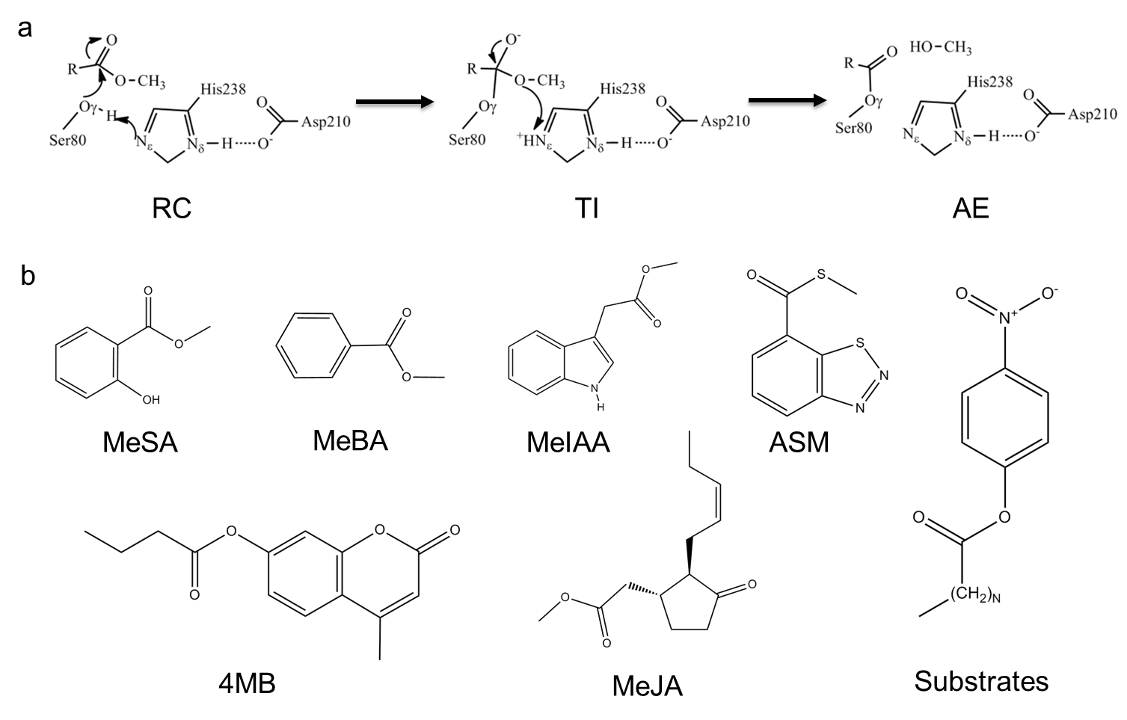
Figure 4.1
Acylation catalytic mechanism of promiscuous substrates by SABP2. (a) Acylation process: Reactant complex, Tetrahedral intermediate, and Acyl-enzyme complex (AE). (b) Promiscuous substrates catalyzed by SABP2. MeSA, methyl salicylate;(Forouhar, Yang et al. 2005, Zhao, Guan et al. 2009) MeBA, methyl benzoate; MeJA, methyl jasmonate;(Forouhar, Yang et al. 2005, Zhao, Guan et al. 2009) MeIAA, methyl indole acetic acid;(Forouhar, Yang et al. 2005, Zhao, Guan et al. 2009) ASM, acibenzolar-S-methyl;(Tripathi, Jiang et al. 2010) 4MB, 4-methylumbelliferone butyrate;(Kumar and Klessig 2003) Substrate* includes para-nitrophenyl (pNP) palmitate, pNP myristate, pNP butyrate,(Kumar and Klessig 2003) and pNP acetate.(Padhi, Fujii et al. 2010)

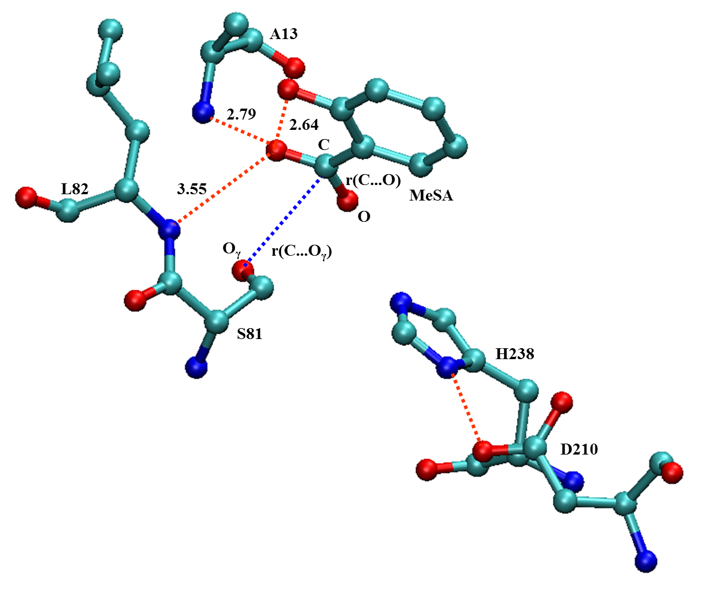
Figure 4.2.
Active site of SABP2 X-Ray crystal structure (PDB code 1Y7I). Reaction coordinate, RC = r(C…O)-r(C...O_{γ}), is labeled. All distances in Å.

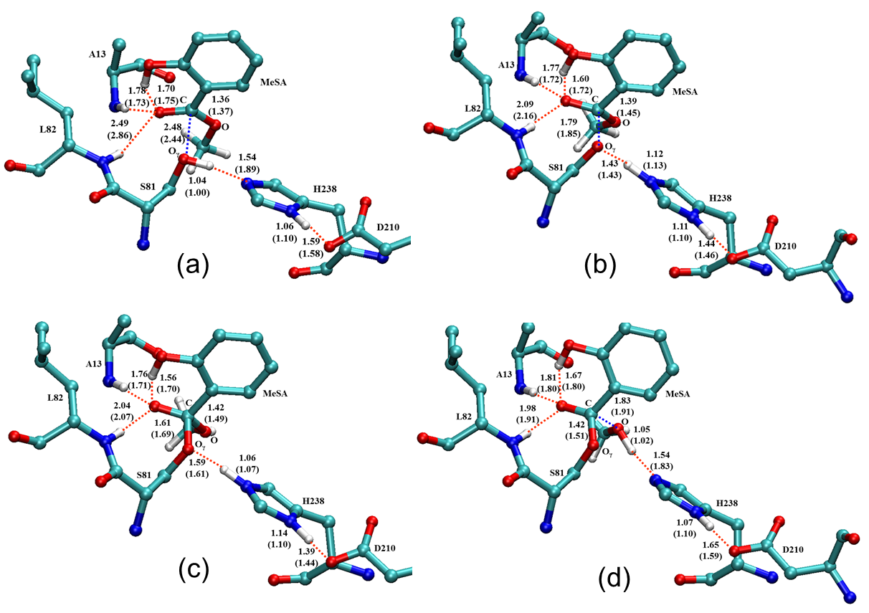
Figure 4.3
Benchmark calculations for SABP2 complexed with MeSA. All distances are labeled in Å. Numbers within parentheses are obtained by SCC-DFTB/MM optimization with dispersion correction; those without parentheses are obtained by B3LYP/6-31G(d,p)/MM optimization. Unimportant hydrogens are omitted for clarity. (a) Reactant state; (b) Transition state 1 by adiabatic mapping; (c) Tetrahedral intermediate by adiabatic mapping; (d) Transition state 2 by adiabatic mapping.

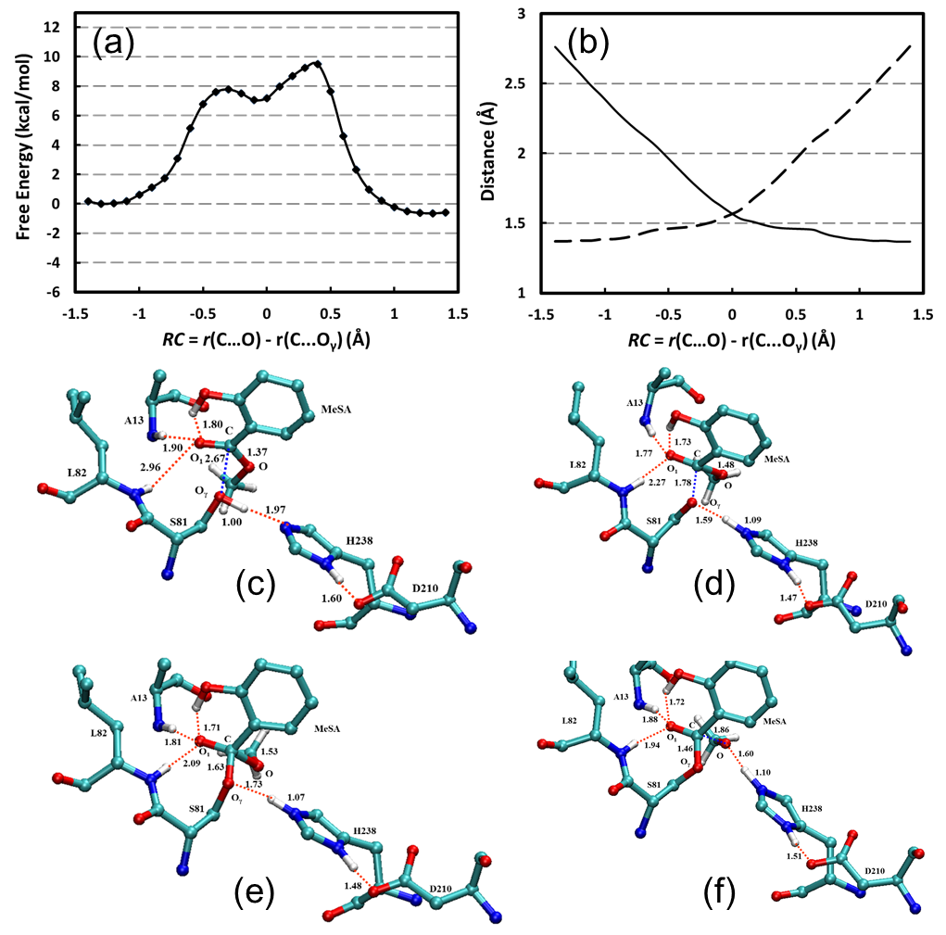

Figure 4.4
PMF calculation results for SABP2 complexed with MeSA with SCC-DFTB/MM. Distances are labeled in Å, and energies are in kcal/mol. (a) PMF along the reaction coordinate. (b) Changes of average distances along the reaction coordinate. Solid line stands for r(C…O_{γ}); dash line stands for r(C…O). (c) Reactant state. (d) Transition state 1; (e) Tetrahedral intermediate; (f) Transition state 2. Unimportant hydrogens are omitted for clarity.

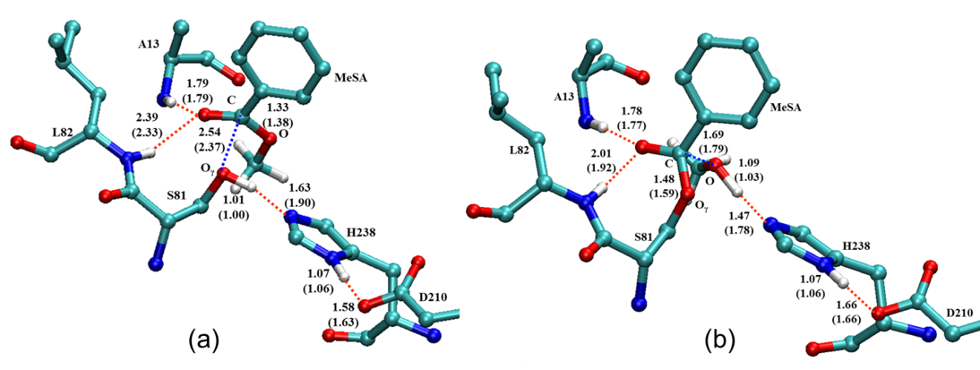
Figure 4.5
Benchmark calculations for SABP2 complexed with MeBA. All distances are labeled in Å. Numbers within parentheses are obtained by SCC-DFTB/MM optimization with dispersion correction; those without parentheses are obtained by B3LYP/6-31G(d,p)/MM optimization. Unimportant hydrogens are omitted for clarity. (a) Reactant state; (b) Transition state (TS) by adiabatic mapping.

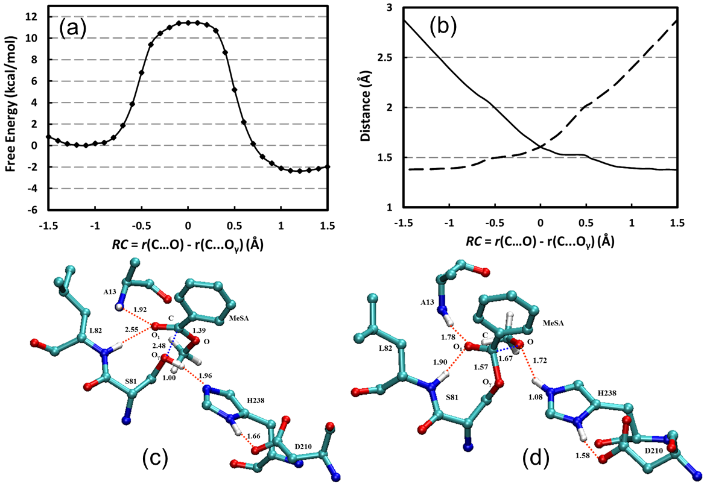
Figure 4.6
PMF calculation results for SABP2 complexed with MeBA with SCC-DFTB/MM. Distances are labeled in Å, and energies are in kcal/mol. (a) PMF along the reaction coordinate. (b) Changes of average distances along the reaction coordinate. Solid line stands for r(C…Oγ); dash line stands for r(C…O). (c) Reactant state. (d) Transition state. Unimportant hydrogens are omitted for clarity.

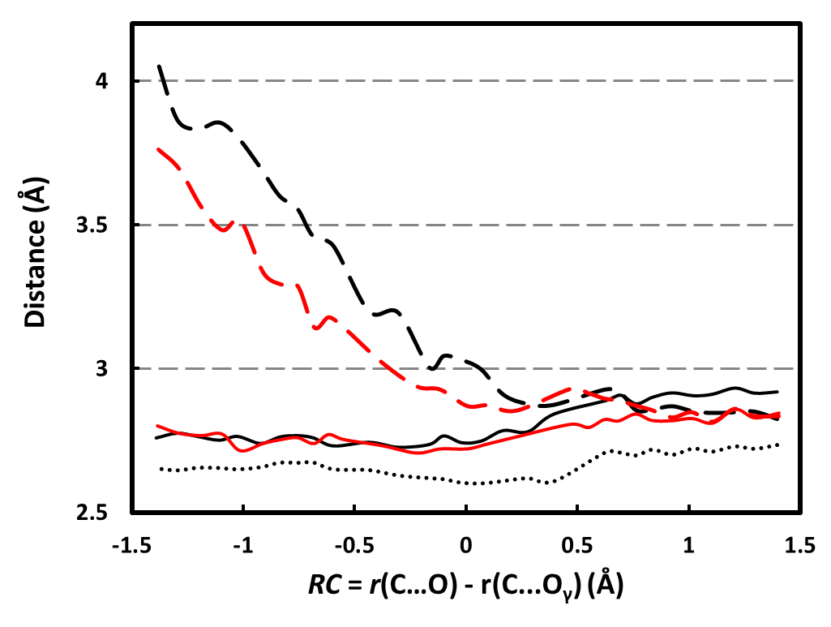
Figure 4.7
Calculated heavy atoms distances (N-O and O-O) between the carbonyl oxygen of substrates and the groups (NH and OH) of oxyanion hole (Ala-13, LEU-81, and MeSA) along the reaction coordinate for the acylation reaction. Black lines for MeSA complex and red lines for MeBA complex. Solid lines for NH of Ala13, dash lines for NH of Leu-82, and dot line for OH of MeSA.

Table 4.1. RC related average bond lengths for the RSs, TIs, and TIs of MeSA and MeBA acylation in tobacco SABP2 from QM(SCC-DFTB)/mm free energy simulations (All in Å)
Substrates | Acylation  Process | RCª | C-O | O_{γ}-C
MeSA | RS | -1.30 ± 0.05 | 1.37 ± 0.03 | 2.67 ± 0.06
MeSA | TS1 | -0.30 ± 0.06 | 1.78 ± 0.06 | 1.48 ± 0.03
MeSA | TI | -0.10 ± 0.06 | 1.63 ± 0.06 | 1.53 ± 0.04
MeSA | TS2 | 0.40 ± 0.04 | 1.46 ± 0.03 | 1.86 ± 0.05
MeBA | RS | -1.10 ± 0.05 | 1.39 ± 0.03 | 2.48 ± 0.06
MeBA | TS | 0.10 ± 0.05 | 1.67 ± 0.05 | 1.57 ± 0.04
ªRC is defined as the difference between C-O and O_{γ}-C.

Table 4.2
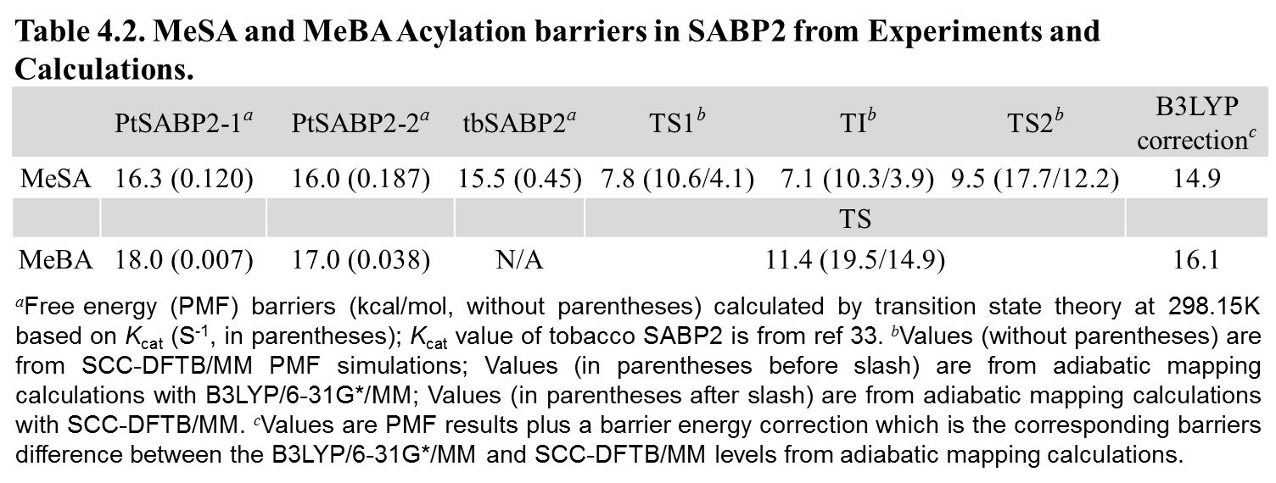

References
Aharoni, A., L. Gaidukov, O. Khersonsky, S. M. Gould, C. Roodveldt and D. S. Tawfik (2005). "The 'evolvability' of promiscuous protein functions." Nature Genetics 37(1): 73-76.
Babtie, A., N. Tokuriki and F. Hollfelder (2010). "What makes an enzyme promiscuous?" Current Opinion in Chemical Biology 14(2): 200-207.
Babtie, A. C., S. Bandyopadhyay, L. F. Olguin and F. Hollfelder (2009). "Efficient Catalytic Promiscuity for Chemically Distinct Reactions." Angewandte Chemie International Edition 48(20): 3692-3694.
Bakker, M., F. v. Rantwijk and R. A. Sheldon (2002). "Metal substitution in thermolysin: Catalytic properties of tungstate thermolysin in sulfoxidation with H2O2." Canadian Journal of Chemistry 80(6): 622-625.
Barends, T. R. M., J. J. Polderman-Tijmes, P. A. Jekel, C. Williams, G. Wybenga, D. B. Janssen and B. W. Dijkstra (2006). "Acetobacter turbidans α-Amino Acid Ester Hydrolase: HOW A SINGLE MUTATION IMPROVES AN ANTIBIOTIC-PRODUCING ENZYME." Journal of Biological Chemistry 281(9): 5804-5810.
Becke, A. D. (1988). "Density-functional exchange-energy approximation with correct asymptotic behavior." Physical Review A 38(6): 3098-3100.
Becke, A. D. (1993). "Density‐functional thermochemistry. III. The role of exact exchange." The Journal of Chemical Physics 98(7): 5648-5652.
Blow, D. M. (1976). "Structure and mechanism of chymotrypsin." Accounts of Chemical Research 9(4): 145-152.
Bobofchak, K. M., A. O. Pineda, F. S. Mathews and E. Di Cera (2005). "Energetic and Structural Consequences of Perturbing Gly-193 in the Oxyanion Hole of Serine Proteases." Journal of Biological Chemistry 280(27): 25644-25650.
Bornscheuer, U. T. and R. J. Kazlauskas (2004). "Catalytic Promiscuity in Biocatalysis: Using Old Enzymes to Form New Bonds and Follow New Pathways." Angewandte Chemie International Edition 43(45): 6032-6040.
Brooks, B. R., C. L. Brooks, A. D. Mackerell, L. Nilsson, R. J. Petrella, B. Roux, Y. Won, G. Archontis, C. Bartels, S. Boresch, A. Caflisch, L. Caves, Q. Cui, A. R. Dinner, M. Feig, S. Fischer, J. Gao, M. Hodoscek, W. Im, K. Kuczera, T. Lazaridis, J. Ma, V. Ovchinnikov, E. Paci, R. W. Pastor, C. B. Post, J. Z. Pu, M. Schaefer, B. Tidor, R. M. Venable, H. L. Woodcock, X. Wu, W. Yang, D. M. York and M. Karplus (2009). "CHARMM: The Biomolecular Simulation Program." Journal of Computational Chemistry 30(10): 1545-1614.
Brooks, B. R., R. E. Bruccoleri, B. D. Olafson, D. J. States, S. Swaminathan and M. Karplus (1983). "CHARMM - A PROGRAM FOR MACROMOLECULAR ENERGY, MINIMIZATION, AND DYNAMICS CALCULATIONS." Journal of Computational Chemistry 4(2): 187-217.
Brooks, C. L., A. Brunger and M. Karplus (1985). "ACTIVE-SITE DYNAMICS IN PROTEIN MOLECULES - A STOCHASTIC BOUNDARY MOLECULAR-DYNAMICS APPROACH." Biopolymers 24(5): 843-865.
Brünger, A. T. and M. Karplus (1988). "Polar hydrogen positions in proteins: Empirical energy placement and neutron diffraction comparison." Proteins: Structure, Function, and Bioinformatics 4(2): 148-156.
Bryan, P., M. W. Pantoliano, S. G. Quill, H. Y. Hsiao and T. Poulos (1986). "Site-directed mutagenesis and the role of the oxyanion hole in subtilisin." Proceedings of the National Academy of Sciences 83(11): 3743-3745.
Carter, P., B. Nilsson, J. P. Burnier, D. Burdick and J. A. Wells (1989). "ENGINEERING SUBTILISIN BPN' FOR SITE-SPECIFIC PROTEOLYSIS." Proteins-Structure Function and Genetics 6(3): 240-248.
Carter, P. and J. A. Wells (1987). "ENGINEERING ENZYME SPECIFICITY BY SUBSTRATE-ASSISTED CATALYSIS." Science 237(4813): 394-399.
Catrina, I., P. J. O'Brien, J. Purcell, I. Nikolic-Hughes, J. G. Zalatan, A. C. Hengge and D. Herschlag (2007). "Probing the Origin of the Compromised Catalysis of E. coli Alkaline Phosphatase in its Promiscuous Sulfatase Reaction." Journal of the American Chemical Society 129(17): 5760-5765.
Cohen-Rosenzweig, C., Z. Guan, B. Shaanan and J. Eichler (2014). "Substrate Promiscuity: AglB, the Archaeal Oligosaccharyltransferase, Can Process a Variety of Lipid-Linked Glycans." Applied and Environmental Microbiology 80(2): 486-496.
Cui, Q., M. Elstner, E. Kaxiras, T. Frauenheim and M. Karplus (2000). "A QM/MM Implementation of the Self-Consistent Charge Density Functional Tight Binding (SCC-DFTB) Method." The Journal of Physical Chemistry B 105(2): 569-585.
Cui, Q., M. Elstner, E. Kaxiras, T. Frauenheim and M. Karplus (2001). "A QM/MM implementation of the self-consistent charge density functional tight binding (SCC-DFTB) method." Journal of Physical Chemistry B 105(2): 569-585.
Di Cera, E. (2009). "Serine proteases." IUBMB Life 61(5): 510-515.
Elstner, M., P. Hobza, T. Frauenheim, S. Suhai and E. Kaxiras (2001). "Hydrogen bonding and stacking interactions of nucleic acid base pairs: A density-functional-theory based treatment." The Journal of Chemical Physics 114(12): 5149-5155.
Faridmoayer, A., M. A. Fentabil, M. F. Haurat, W. Yi, R. Woodward, P. G. Wang and M. F. Feldman (2008). "Extreme Substrate Promiscuity of the Neisseria Oligosaccharyl Transferase Involved in Protein O-Glycosylation." Journal of Biological Chemistry 283(50): 34596-34604.
Fernández, A., D. S. Tawfik, B. Berkhout, R. Sanders, A. Kloczkowski, T. Sen, B. Jernigan, D. S. Tawfik, B. Berkhout, R. W. Sanders, A. Kloczkowski, T. Z. Sen and R. L. Jernigan (2005). "Protein Promiscuity: Drug Resistance and Native Functions—HIV-1 Case." Journal of Biomolecular Structure and Dynamics 22(6): 615-624.
Fersht, A. (1998). Structure and Mechanism in Protein Science, W.H. Freeman and Company.
Field, M. J., P. A. Bash and M. Karplus (1990). "A COMBINED QUANTUM-MECHANICAL AND MOLECULAR MECHANICAL POTENTIAL FOR MOLECULAR-DYNAMICS SIMULATIONS." Journal of Computational Chemistry 11(6): 700-733.
Forouhar, F., Y. Yang, D. Kumar, Y. Chen, E. Fridman, S. W. Park, Y. Chiang, T. B. Acton, G. T. Montelione, E. Pichersky, D. F. Klessig and L. Tong (2005). "Structural and biochemical studies identify tobacco SABP2 as a methyl salicylate esterase and implicate it in plant innate immunity." Proceedings of the National Academy of Sciences of the United States of America 102(5): 1773-1778.
Gatti-Lafranconi, P. and F. Hollfelder (2013). "Flexibility and Reactivity in Promiscuous Enzymes." ChemBioChem 14(3): 285-292.
Gaus, M., Q. Cui and M. Elstner (2011). "DFTB3: Extension of the Self-Consistent-Charge Density-Functional Tight-Binding Method (SCC-DFTB)." Journal of Chemical Theory and Computation 7(4): 931-948.
Hedstrom, L. (2002). "Serine protease mechanism and specificity." Chemical Reviews 102(12): 4501-4523.
Hosokawa, M. (2008). "Structure and Catalytic Properties of Carboxylesterase Isozymes Involved in Metabolic Activation of Prodrugs." Molecules 13(2): 412-431.
Hou, G. and Q. Cui (2011). "QM/MM Analysis Suggests That Alkaline Phosphatase (AP) and Nucleotide Pyrophosphatase/Phosphodiesterase Slightly Tighten the Transition State for Phosphate Diester Hydrolysis Relative to Solution: Implication for Catalytic Promiscuity in the AP Superfamily." Journal of the American Chemical Society 134(1): 229-246.
Hou, G. and Q. Cui (2013). "Stabilization of Different Types of Transition States in a Single Enzyme Active Site: QM/MM Analysis of Enzymes in the Alkaline Phosphatase Superfamily." Journal of the American Chemical Society 135(28): 10457-10469.
Hou, G., X. Zhu, M. Elstner and Q. Cui (2012). "A Modified QM/MM Hamiltonian with the Self-Consistent-Charge Density-Functional-Tight-Binding Theory for Highly Charged QM Regions." Journal of Chemical Theory and Computation 8(11): 4293-4304.
Huang, F.-C., G. Horváth, P. Molnár, E. Turcsi, J. Deli, J. Schrader, G. Sandmann, H. Schmidt and W. Schwab (2009). "Substrate promiscuity of RdCCD1, a carotenoid cleavage oxygenase from Rosa damascena." Phytochemistry 70(4): 457-464.
Hult, K. and P. Berglund (2007). "Enzyme promiscuity: mechanism and applications." Trends in Biotechnology 25(5): 231-238.
Ishida, T. and S. Kato (2003). "Theoretical Perspectives on the Reaction Mechanism of Serine Proteases: The Reaction Free Energy Profiles of the Acylation Process." Journal of the American Chemical Society 125(39): 12035-12048.
Jackson, C. J., J.-L. Foo, H.-K. Kim, P. D. Carr, J.-W. Liu, G. Salem and D. L. Ollis (2008). "In Crystallo Capture of a Michaelis Complex and Product-binding Modes of a Bacterial Phosphotriesterase." Journal of Molecular Biology 375(5): 1189-1196.
Jorgensen, W. L. (1981). "QUANTUM AND STATISTICAL MECHANICAL STUDIES OF LIQUIDS .10. TRANSFERABLE INTERMOLECULAR POTENTIAL FUNCTIONS FOR WATER, ALCOHOLS, AND ETHERS - APPLICATION TO LIQUID WATER." Journal of the American Chemical Society 103(2): 335-340.
Khersonsky, O., C. Roodveldt and D. S. Tawfik (2006). "Enzyme promiscuity: evolutionary and mechanistic aspects." Current Opinion in Chemical Biology 10(5): 498-508.
Khersonsky, O. and D. S. Tawfik (2006). "The Histidine 115-Histidine 134 Dyad Mediates the Lactonase Activity of Mammalian Serum Paraoxonases." Journal of Biological Chemistry 281(11): 7649-7656.
Khersonsky, O. and D. S. Tawfik (2010). Enzyme Promiscuity: A Mechanistic and Evolutionary Perspective. Annual Review of Biochemistry, Vol 79. R. D. Kornberg, C. R. H. Raetz, J. E. Rothman and J. W. Thorner. 79: 471-505.
König, P. H., M. Hoffmann, T. Frauenheim and Q. Cui (2005). "A Critical Evaluation of Different QM/MM Frontier Treatments with SCC-DFTB as the QM Method." The Journal of Physical Chemistry B 109(18): 9082-9095.
Kopycki, J. G., D. Rauh, A. A. Chumanevich, P. Neumann, T. Vogt and M. T. Stubbs (2008). "Biochemical and Structural Analysis of Substrate Promiscuity in Plant Mg2+-Dependent O-Methyltransferases." Journal of Molecular Biology 378(1): 154-164.
Kourist, R., S. Bartsch, L. Fransson, K. Hult and U. T. Bornscheuer (2008). "Understanding Promiscuous Amidase Activity of an Esterase from Bacillus subtilis." ChemBioChem 9(1): 67-69.
Kumar, D., C. Gustafsson and D. F. Klessig (2006). "Validation of RNAi silencing specificity using synthetic genes: salicylic acid-binding protein 2 is required for innate immunity in plants." Plant Journal 45(5): 863-868.
Kumar, D. and D. F. Klessig (2003). "High-affinity salicylic acid-binding protein 2 is required for plant innate immunity and has salicylic acid-stimulated lipase activity." Proceedings of the National Academy of Sciences of the United States of America 100(26): 16101-16106.
Kumar, D., S. Park, F. Forouhar, Y. Yang, A. Vlot, E. Fridman, Y. Chiang, T. Acton, V. Shulaev, G. Montelione, E. Pichersky, L. Tong and D. Klessig (2005). "Identification of SA-binding protein 2 (SABP2) as a critical component of plant innate immunity." Phytopathology 95(6): S55-S55.
Kumar, S., D. Bouzida, R. H. Swendsen, P. A. Kollman and J. M. Rosenberg (1992). "THE WEIGHTED HISTOGRAM ANALYSIS METHOD FOR FREE-ENERGY CALCULATIONS ON BIOMOLECULES .1. THE METHOD." Journal of Computational Chemistry 13(8): 1011-1021.
Lairson, L. L., A. G. Watts, W. W. Wakarchuk and S. G. Withers (2006). "Using substrate engineering to harness enzymatic promiscuity and expand biological catalysis." Nat Chem Biol 2(12): 724-728.
Lee, C., W. Yang and R. G. Parr (1988). "Development of the Colle-Salvetti correlation-energy formula into a functional of the electron density." Physical Review B 37(2): 785-789.
Lewinson, O., J. Adler, N. Sigal and E. Bibi (2006). "Promiscuity in multidrug recognition and transport: the bacterial MFS Mdr transporters." Molecular Microbiology 61(2): 277-284.
MacKerell, A. D., D. Bashford, M. Bellott, R. L. Dunbrack, J. D. Evanseck, M. J. Field, S. Fischer, J. Gao, H. Guo, S. Ha, D. Joseph-McCarthy, L. Kuchnir, K. Kuczera, F. T. K. Lau, C. Mattos, S. Michnick, T. Ngo, D. T. Nguyen, B. Prodhom, W. E. Reiher, B. Roux, M. Schlenkrich, J. C. Smith, R. Stote, J. Straub, M. Watanabe, J. Wiorkiewicz-Kuczera, D. Yin and M. Karplus (1998). "All-atom empirical potential for molecular modeling and dynamics studies of proteins." Journal of Physical Chemistry B 102(18): 3586-3616.
Matthews, D. A., R. A. Alden, J. J. Birktoft, S. T. Freer and J. Kraut (1975). "X-ray crystallographic study of boronic acid adducts with subtilisin BPN' (Novo). A model for the catalytic transition state." Journal of Biological Chemistry 250(18): 7120-7126.
Nath, A. and W. M. Atkins (2007). "A Quantitative Index of Substrate Promiscuity†." Biochemistry 47(1): 157-166.
Neria, E., S. Fischer and M. Karplus (1996). "Simulation of activation free energies in molecular systems." Journal of Chemical Physics 105(5): 1902-1921.
Olguin, L. F., S. E. Askew, A. C. O’Donoghue and F. Hollfelder (2008). "Efficient Catalytic Promiscuity in an Enzyme Superfamily: An Arylsulfatase Shows a Rate Acceleration of 1013 for Phosphate Monoester Hydrolysis." Journal of the American Chemical Society 130(49): 16547-16555.
Padhi, S. K., R. Fujii, G. A. Legatt, S. L. Fossum, R. Berchtold and R. J. Kazlauskas (2010). "Switching from an Esterase to a Hydroxynitrile Lyase Mechanism Requires Only Two Amino Acid Substitutions." Chemistry & Biology 17(8): 863-871.
Ryckaert, J. P., G. Ciccotti and H. J. C. Berendsen (1977). "NUMERICAL-INTEGRATION OF CARTESIAN EQUATIONS OF MOTION OF A SYSTEM WITH CONSTRAINTS - MOLECULAR-DYNAMICS OF N-ALKANES." Journal of Computational Physics 23(3): 327-341.
Sabini, E., S. Hazra, S. Ort, M. Konrad and A. Lavie (2008). "Structural Basis for Substrate Promiscuity of dCK." Journal of Molecular Biology 378(3): 607-621.
Schmidt, M. W., K. K. Baldridge, J. A. Boatz, S. T. Elbert, M. S. Gordon, J. H. Jensen, S. Koseki, N. Matsunaga, K. A. Nguyen, S. J. Su, T. L. Windus, M. Dupuis and J. A. Montgomery (1993). "GENERAL ATOMIC AND MOLECULAR ELECTRONIC-STRUCTURE SYSTEM." Journal of Computational Chemistry 14(11): 1347-1363.
Sirin, G. S., Y. Zhou, L. Lior-Hoffmann, S. Wang and Y. Zhang (2012). "Aging Mechanism of Soman Inhibited Acetylcholinesterase." The Journal of Physical Chemistry B 116(40): 12199-12207.
Theodossis, A., H. Walden, E. J. Westwick, H. Connaris, H. J. Lamble, D. W. Hough, M. J. Danson and G. L. Taylor (2004). "The Structural Basis for Substrate Promiscuity in 2-Keto-3-deoxygluconate Aldolase from the Entner-Doudoroff Pathway in Sulfolobus solfataricus." Journal of Biological Chemistry 279(42): 43886-43892.
Torrie, G. M. and J. P. Valleau (1974). "MONTE-CARLO FREE-ENERGY ESTIMATES USING NON-BOLTZMANN SAMPLING - APPLICATION TO SUBCRITICAL LENNARD-JONES FLUID." Chemical Physics Letters 28(4): 578-581.
Tripathi, D., Y.-L. Jiang and D. Kumar (2010). "SABP2, a methyl salicylate esterase is required for the systemic acquired resistance induced by acibenzolar-S-methyl in plants." FEBS Letters 584(15): 3458-3463.
van Loo, B., S. Jonas, A. C. Babtie, A. Benjdia, O. Berteau, M. Hyvönen and F. Hollfelder (2010). "An efficient, multiply promiscuous hydrolase in the alkaline phosphatase superfamily." Proceedings of the National Academy of Sciences 107(7): 2740-2745.
Villiers, B. R. M. and F. Hollfelder (2009). "Mapping the Limits of Substrate Specificity of the Adenylation Domain of TycA." ChemBioChem 10(4): 671-682.
Wang, S. C., W. H. Johnson and C. P. Whitman (2003). "The 4-Oxalocrotonate Tautomerase- and YwhB-Catalyzed Hydration of 3E-Haloacrylates: Implications for the Evolution of New Enzymatic Activities." Journal of the American Chemical Society 125(47): 14282-14283.
Wang, S. C., M. D. Person, W. H. Johnson and C. P. Whitman (2003). "Reactions of trans-3-Chloroacrylic Acid Dehalogenase with Acetylene Substrates: Consequences of and Evidence for a Hydration Reaction†." Biochemistry 42(29): 8762-8773.
Warshel, A., G. Naray-Szabo, F. Sussman and J. K. Hwang (1989). "How do serine proteases really work?" Biochemistry 28(9): 3629-3637.
Xu, Q., H. Guo and A. Wlodawer (2006). "The importance of dynamics in substrate-assisted catalysis and specificity." Journal of the American Chemical Society 128(18): 5994-5995.
Xu, Q., J. Yao, A. Wlodawer and H. Guo (2011). "Clarification of the Mechanism of Acylation Reaction and Origin of Substrate Specificity of the Serine-Carboxyl Peptidase Sedolisin through QM/MM Free Energy Simulations." The Journal of Physical Chemistry B 115(10): 2470-2476.
Yang, H. Yu, D. York, Q. Cui and M. Elstner (2007). "Extension of the Self-Consistent-Charge Density-Functional Tight-Binding Method: Third-Order Expansion of the Density Functional Theory Total Energy and Introduction of a Modified Effective Coulomb Interaction." The Journal of Physical Chemistry A 111(42): 10861-10873.
Yao, J., Q. Xu, F. Chen and H. Guo (2010). "QM/MM Free Energy Simulations of Salicylic Acid Methyltransferase: Effects of Stabilization of TS-like Structures on Substrate Specificity." The Journal of Physical Chemistry B 115(2): 389-396.
Yao, J., Q. Xu and H. Guo (2012). "QM/MM and free-energy simulations of deacylation reaction catalysed by sedolisin, a serine-carboxyl peptidase." Molecular Simulation 39(3): 206-213.
Yeung, D. T., D. E. Lenz and D. M. Cerasoli (2005). "Analysis of active-site amino-acid residues of human serum paraoxonase using competitive substrates." FEBS Journal 272(9): 2225-2230.
Zhang, Y., J. Kua and J. A. McCammon (2002). "Role of the Catalytic Triad and Oxyanion Hole in Acetylcholinesterase Catalysis: An ab initio QM/MM Study." Journal of the American Chemical Society 124(35): 10572-10577.
Zhao, N., J. Guan, F. Forouhar, T. J. Tschaplinski, Z. M. Cheng, L. Tong and F. Chen (2009). "Two poplar methyl salicylate esterases display comparable biochemical properties but divergent expression patterns." Phytochemistry 70(1): 32-39.
Zhou, Y., S. Wang and Y. Zhang (2010). "Catalytic Reaction Mechanism of Acetylcholinesterase Determined by Born−Oppenheimer Ab Initio QM/MM Molecular Dynamics Simulations." The Journal of Physical Chemistry B 114(26): 8817-8825.
Zhou, Y. and Y. Zhang (2011). "Serine protease acylation proceeds with a subtle re-orientation of the histidine ring at the tetrahedral intermediate." Chemical Communications 47(5): 1577-1579.

CHAPTER 5
Quantum Mechanical/Molecular Mechanical Study of Catalytic Mechanism of (4S)-Limonene Synthase and Role of Key Residues (His579) in Product Fidelity

Jianzhuang Yao, Feng Chen, and Hong Guo. “QUANTUM MECHANICAL/MOLECULAR MECHANICAL STUDY OF CATALYTIC MECHANISM OF (4S)-LIMONENE SYNTHASE AND ROLE OF KEY RESIDUES (HIS579) IN PRODUCT FIDELITY” To be submitted.
My contributions to this study include: 1) discussions with the design of the experiments; 2) performing the experiments; 3) analysis of the result and preparing the manuscript. Dr. Hong Guo also wrote the manuscript. Dr. Feng Chen are involved with the discussions of the design of the experiment.

Abstract
More than 60, 000 individual compounds of natural terpenoids have been found to be biosynthesis by terpene synthases. Among those terpene synthase, monoterpene synthases are account for biosynthesis of several hundred natural monoterpenes based on a very limited pool of substrates. For instance, limonene synthase and bornyl diphosphate synthase share highly conserved active site and both use geranyl pyrophosphate as natural substrate, but their catalytic activities lead to different products. Particularly, they catalyze partly same reaction from geranyl pyrophosphate to α-terpinyl cation. After this, limonene synthase mainly produce limonene, but bornyl diphosphate synthase mainly conducts the α-terpinyl cation to bornyl diphosphate. The factor that account for their different product fidelity is still elusive. In the current study, we present a detailed catalytic mechanism of (4S)-Limonene using QM(SCC-DFBTPR)/MM MD and free energy (2d-PMF) simulations. By comparing the active sites and catalytic mechanisms of limonene synthase and bornyl diphosphate synthase, it is proposed based on the results of computer simulations that a histidine residue (His579) of limonene synthase, corresponding to Phe578 in bornyl diphosphate synthase, may act as a general base for the depronation process of α-terpinyl cation resulting in the final main product limonene.

Introduction
Terpene synthases (TPSs) are of important enzymes in terpenoid biosynthesis that catalyze the precursors of isoprenyl diphosphate to various terpene skeletons. Terpenoids play diverse roles in the nature.(Gershenzon and Dudareva 2007) For instance, plant-original terpenoids are communication medium between plants and their environment. Until now, more than 60, 000 individual compounds of natural terpenoids have been identified from all life forms(Koksal, Jin et al. 2011) and widely studied by experimental studies.(Cane 1990, Sacchettini and Poulter 1997, Christianson 2006, Gershenzon and Dudareva 2007) Based on product specificity, promiscuous TPSs can be divided into several classes with specific products, including monoterpenoid (C₁₀), sesquiterpenoid (C₁₅), and diterpenoid (C₂₀) and so on. The proposed synthesis process of cyclic terpenoid compounds often via complex carbocation cyclization reactions consisting of substrate ionization, internal addition, cyclization, secondary cyclization, rearrangement, and reaction termination by deprotonation or nucleophile capture.(Cane 1990) The catalytic mechanisms of terpene carbocation reactions have been studied theoretically both in gas phase(Tantillo 2011) and in enzymes environments.(Rajamani and Gao 2003, Allemann, Young et al. 2007, Weitman and Major 2010, Major and Weitman 2012)
Monoterpenes are the simplest member of terpene family. Several hundred natural monoterpenes are biosynthesized by monoterpenoid synthase using geranyl pyrophosphate (GPP) as substrate to produce plant resins and fundamental oils and characterize plants with flavor, fragrance, and medicinal properties.(Croteau 1987) The catalytic mechanism has been proposed for monoterpenoid synthase,(Alonso, Rajaonarivony et al. 1992, Whittington, Wise et al. 2002, Hyatt, Youn et al. 2007) as shown in Scheme 5.1. First, an ionization and isomerization of the GPP lead to linalyl diphosphate (LPP). It is a required step to eliminate the double bond of GPP to achieve a favorable geometry for cyclization. Second, cyclization is occurred to generate α-terpinyl cation, which is shared intermediate in monoterpene cyclizations. Third, the final step is depending on diverse product specificity. For instances, deprotonation of methyl group of α-terpinyl cation leads to main product (limonene) of limonene synthase (LS), while bornyl diphosphate synthase (BPPS) synthesizes bornyl diphosphate (BPP, main product) via internal addition, secondary cyclization and nucleophile capture. However, the factors controlling the product specificity is still elusive.
(4S)-LS from Mentha species was first studied by Kjonaas and Croteau in 1983(Kjonaas and Croteau 1983) and crystalized by Hyatt et. al. in the presence of merely reactive 2-fluoro analogs of geranyl (FGPP) and linalyl diphosphate (FLPP).(Hyatt, Youn et al. 2007) However, FGPP had been isomerized to FLPP during crystallization. LS is an angiosperm monoterpene synthase (cyclase) in plastids(Turner, Gershenzon et al. 1999), which catalytic activity requires a divalent metal ion (Mn²⁺ or Mg²⁺) and pH optimum is around neutrality. The rate-limiting step of (4S)-LS catalytic reaction is the ionization and syn-migration of the diphosphate moiety to form (3S)-LPP,(Rajaonarivony, Gershenzon et al. 1992) with a k_{cat} value 0.024 S⁻¹ and K_{m} value 6.7 µM.(Williams, McGarvey et al. 1998) When reaction starts from (3S)-LPP, the kinetic parameters for wild type enzyme are k_{cat} value 0.063 S⁻¹ and K_{m} value 22.2 µM. However, the corresponding rate limiting step is still unknown. Another question is no general base has been found to fulfill the termination role by deprotonation, although it is suggested that the diphosphate moiety may function as a general base to accept a proton from (4S)-α-terpinyl cation.(Gao, Honzatko et al. 2012)
BPPS is the first crystalized monoterpenoid synthase from Salvia officinalis.(Whittington, Wise et al. 2002) It partly shares the same catalytic path with LS through GPP to α-terpinyl cation, as shown in Scheme 5.1.(Whittington, Wise et al. 2002, Major and Weitman 2012) Instead of formation of the main product limonene via deprotonation starting from α-terpinyl cation, BPP as the main product is formed via 2-bornyl cation in BPPS by internal addition, secondary cyclization and nucleophile capture.(Wise, Savage et al. 1998, Major and Weitman 2012) It seems like (4S)-LS is apt to deprotonate the methyl group of α-terpinyl cation to fulfill the reaction rather than BPPS, although the sequence identity between LS (PDB ID 2ONH) and BPPS (PDB ID 1N23) is more than 50 %. Therefore, the question is whether (4S)-LS has a general base in its active site to guarantee the product fidelity. In Figure 5.1A, the active site structure of (4S)-LS complexed with its inhibitor FLPP was plotted based on the X-ray structure of (4S)-LS with FLPP and Mn²⁺.(Croteau, Shaskus et al. 1985) Inspection of the overlay active sites of (4S)-LS and BPPS, the residues in their active sites are highly conserved with each other, as shown in Figure 5.1b. One interesting difference is the His579 in (4S)-LS and Phe578 in BPPS. His579 in the active site is close to target methyl group and may function as a general base for the function of deprotonation.
In this study, we present the catalytic mechanism of (4S)-LS from (3S)-LPP to its main product (4S)-limonene using a new SCC-DFTBPR/MM Interaction Scheme based on the Klopman-Ohno (KO) approximation. We also present the result of benchmark calculations by ab initio QM/MM calculations. Here we report the results of computational investigations which suggest that 1) the formation of (4S)-α-terpinyl cation is a concerted-asynchronous reaction, which free energy barrier is in a good agreement with experimental estimation, 2) His579 in the active site of (4S)-LS may accept a proton from positively charged methyl group of (4S)-α-terpinyl cation to favor formation of (4S)-limonene.

Methods
Enzyme complex model setup. The initial coordinate for the reactant complex was based on the crystallographic structure (PDB code: 2ONH, 2.7 Å resolution) of Mentha spicata (4S)-limonene synthase (LS) in complex with 2-fluorolinalyl diphosphate (FLPP).(Hyatt, Youn et al. 2007) The fluorine was manually deleted to turn FLPP to (3S)-LPP. Mn²⁺ atoms were changed to Mg²⁺ manually, since Mg²⁺ was obtained in the same position as Mn²⁺ and both ions show similar kinetic data and produce identical products.(Rajaonarivony, Gershenzon et al. 1992, Hyatt, Youn et al. 2007) Hydrogen atoms of protein were added by the HBUILD module(Brünger and Karplus 1988) implemented in CHARMM,(Brooks, Bruccoleri et al. 1983, Brooks, Brooks et al. 2009) but substrates hydrogen atoms were added manually. All acidic and basic amino acids protonation states were determined by surrounding environment under physiological pH condition. Reactant complex was solvated by a water droplet with 27 Å radius by the standard superimposing protocol centered at PA atom of (3S)-LPP, and solvent water molecules within 2.8 Å of any crystal atoms were removed. A modified TIP3P water model(Jorgensen 1981, Neria, Fischer et al. 1996) was employed for the solvent. The substrate and three Mg²⁺ ions were treated by QM and the rest of the system by MM. All protein atoms in the MM region were treated by the all-hydrogen CHARMM potential function (PARAM27).(MacKerell, Bashford et al. 1998) The resulting systems contained around 11514 atoms, including 866 water molecules. The SCC-DFTBPR method(Yang, Yu et al. 2008) with empirical dispersion corrections(Elstner, Hobza et al. 2001) implemented in CHARMM was used for the QM atoms treatment in order to guarantee the correct geometry of di-phosphate group in substrate (3S)-LPP. Benchmark calculations(Yang, Yu et al. 2008, Hou, Zhu et al. 2010, Hou, Zhu et al. 2012) of SCC-DFTBPR and its applications(Hou and Cui 2011, Hou and Cui 2013) demonstrated that it is one of the top semiempirical methods so far reported in the literatures for phosphate chemistry. However, we performed the explicit benchmark calculations for (3S)-LPP in LS.
The long-range electrostatic interactions were treated by generalized solvent boundary potential (GSBP)(Im, Berneche et al. 2001, Schaefer, Riccardi et al. 2005, Riccardi, Schaefer et al. 2006) in MD simulations and geometry optimizations. The enzyme complex system was partitioned into a 27 Å spherical inner region centered at the PA atom with the rest was in the outer region. Within 23 Å MD region, Newtonian equations of motion were solved, while langevin equations of motion with a temperature bath of 300 K were applied for the buffer regions between 23 Å to 27 Å. The crystallographic B-factors were used to determine the force constants and the later were applied to harmonically restrain protein atoms in the buffer region.(Brooks and Karplus 1989) All hydrogen-involved bonds were constrained by the SHAKE algorithm,(Torrie and Valleau 1977) and the time step of MD simulations was 1 fs. All of the water molecules in the inner region (within 27 Å) were subject to a weak GEP type restraining potential in order to keep them inside the inner region by the MMFP module of CHARMM. The static field because of atoms in outer region, φ_{s}^{(o)}, was determined with the linear Poisson-Boltzmann (PB) equation(Im, Beglov et al. 1998) with a focusing scheme with a fine grid of 0.4 Å and a course cubic grid of 1.2 Å spacing. 400 spherical harmonics were applied to evaluate the reaction field matrix M. In the PB calculations, we applied the protein dielectric constant of ϵ_{p} = 1, the water dielectric constant of ϵ_{w} = 80, and 0.0 M salt concentration. The value of ϵ_{p} applied in this study was not expected to make a large difference due to the solvent-assessable active site and the outer and inner boundaries were far from the site interest.(Lu and Cui 2013) The solvent-solute dielectric boundary was defined by the optimized radii(Nina, Beglov et al. 1997, Nina, Im et al. 1999) based on the calculated interaction energy with explicit water molecules and experimental solvation free energies of small molecules. Based on the original GSBP protocol, the extended electrostatic model(Steinbach and Brooks 1994) was used to treat the electrostatic interactions among inner region atoms and the interactions beyond 12 Å were treated by multipolar expansions, consisting of the quadrupolar and dipolar terms.
SCC-DFTBPR/MM Interaction Scheme and potential mean force (PMF) free energy simulations. The new SCC-DFTBPR/MM Interaction Scheme based on the KO approximation(Klopman 1964, Ohno 1964, Thiel 1996, Elstner 2007) was used to treat the high charge of phosphate group. The initial structures for the entire stochastic boundary systems were optimized using the steepest descent (SD) and adopted-basis Newton-Raphson (ABNR) methods. The system were gradually heated from 50.0 to 298.15K and equilibrated for 100 ps. The umbrella sampling method(Torrie and Valleau 1974) implemented in the CHARMM program along with the Weighted Histogram Analysis Method (WHAM)(Kumar, Bouzida et al. 1992) was then applied to determine the change of the free energy (PMF) as a function of the reaction coordinates (RC). Two 2-dimensional PMFs were carried out for both (4S)-α-terpinyl cation formation and PPO migration. For 2d-PMF of (4S)-α-terpinyl cation formation, RC1 was defined as r(C3…O) and RC2 was defined as r(C1…C2). For 2d-PMF of PPO migration, RC1 was defined as r(C3…O) and RC2 was defined as r(C1…O). The range of each distance is 0.1 Å. In total, 484 and 374 windows were used for PPO migration and (4S)-α-terpinyl cation formation, respecitively. For each window, 100 ps simulations were performed with 50 ps equilibration. The force constant of the harmonic biasing potentials used in the PMF simulations were 500 kcal∙mol⁻¹∙Å⁻². One dimensional PMF simulations was applied for the deprotonating process of (4S)-α-terpinyl cation (4S-Limonene formation) with 22 windows. The RC was defined as a linear combination of r(C9…H) and r(N...H) [RC = r(C9…H)-r(N...H)]. The distance range, simulation time length, and force constant are the same with 2D PMF.
Benchmark calculations. Benchmark calculations method has been successfully used by several previous SCC-DFTBPR studies(Hou and Cui 2011, Hou and Cui 2013) to prove the applicability of SCC-DFTBPR/MM on different enzyme systems. However, benchmark calculation was also carried out based on our enzyme complex model to explicitly demonstrate the reliability of SCC-DFTBPR method on simulating the bond breaking and making process of (4S)-α-terpinyl cation process. First, we compared the optimized structures of reactant complexes between B3LYP(Becke 1988, Lee, Yang et al. 1988, Becke 1993)/MM and SCC-DFTB/MM methods. The basis set (6-31+G(d,p)) has been successfully used on ab initio simulations of Bornyl Diphosphate synthase.(Weitman and Major 2010) The QM(B3LYP/6-31G+(d,p))/MM calculations were performed for (4S)-α-terpinyl cation formation in LS using GAMESS-US method(Schmidt, Baldridge et al. 1993) implemented in the CHARMM program.(Brooks, Bruccoleri et al. 1983, Brooks, Brooks et al. 2009)
In addition to reactant complex comparison, we applied the same comparisons on appropriate transition states on one dimensional potential energy surfaces. The adiabatic mapping calculations were carried out based on the following protocol. Reaction coordinate is the same as 2d PMF calculations. The RC values was increased stepwise from reactant complex to product complex, with the step size of 0.2 Å. An adopted basis Newton Raphson (ABNR) minimization was carried out under the constraint. The RC value was then decreased from the product complex to the reactant complex, and the forward and backward progresses were repeated so as to obtain a smooth and more reliable potential energy surface (PES) profile along the reaction path.
B3LYP (MP2)/MM correction of the SCC-DFTB/MM PMF barrier. Table 4.1 shows energetic data from our benchmark calculations. The reaction barriers for (4S)-α-terpinyl cation formation in LS tends to be overestimated by SCC-DFTBPR/MM compared with B3LYP/MM. Therefore, a barrier correction at different QM/MM levels is necessary for SCC-DFTBPR result to be comparable with experimental data.(Hou and Cui 2011, Hou and Cui 2013) The correction, to be added to PMF free energy barrier, is the difference in potential energy barriers from adiabatic mapping calculations between SCC-DFTB/MM level and B3LYP/MM level. High level (B3LYP/6-311G++(d,p)) single point energy calculation only changes the final energy barrier slightly. In addition, a single point energy calculation by MP2/6-31G+(d,p) showed B3LYP/6-31G+(d,p) generated the valid geometry but underestimated the relative stability of cyclic structures in consistent with previous studies.(Matsuda, Wilson et al. 2006, Hong and Tantillo 2009)

Results and Discussion
Before comparing our theoretical calculation to experimental results, it is worth pointing out that the proposed reaction catalyzed by (4S)-LS involves multiple steps, from the initial substrate GPP to final product (4S)-limonene through intermediate (3S)-LPP,(Rajaonarivony, Gershenzon et al. 1992) as shown in Scheme 5.1. In this study, we focus on the catalytic mechanism of the main product reaction on producing (4S)-limonene starting from (3S)-LPP. We note that the rate-limiting step of this reaction is the (3S)-LPP formation through GPP ionization and PPO migration. However, kinetic data (e.g., k_{cat})(Williams, McGarvey et al. 1998) is also available for reaction starting from (3S)-LPP and this turnover number will be compared with our computational activation barrier in Table 5.1. Therefore, we present our computational results in two parts. One is formation of (4S)-α-terpinyl cation, and the other is formation of (4S)-limonene by deprotonation of (4S)-α-terpinyl cation in which His579 functions as a general base.
Benchmark Calculation of (4S)-α-terpinyl cation formation in (4S)-LS. The active-site structures of (4S)-LS complexed with (3S)-LPP obtained from the QM(B3LYP and SCC-DFTB)/MM geometry optimizations are shown in Figure 5.2a; the initial structures for the optimization calculations were from corresponding reactant state snapshots based on B3LYP/MM and SCC-DFTBPR/MM adiabatic mapping calculations. The optimized structure of the reactant complex by SCC-DFTBPR/MM shows generally good agreement with that by B3LYP/MM. Hydrogen-bond and salt bridge patterns among substrate, magnesium ion, and protein are aligned very well for both QM/MM levels. Three aspartic acids consisting of D352, D356, and D496 coordinate to Mg²⁺ in both QM/MM levels calculations and in X-Ray crystal structure in Figure 5.1a. R493 and R351 forms salt bridges with the diphosphate group of (3S)-LPP in both QM/MM levels calculations in consistent with that in X-Ray crystal structure. Two N_{R351}-O_{(3S)-LPP} distances in the optimized structures are 2.7 (2.8) and 3.4 (3.1) Å in B3LYP/MM (SCC-DFTBPR/MM), close to the values of 3.2 and 3.4 Å in the X-Ray crystal structure. The N_{R351}-O_{(3S)-LPP} distance with the O atom bonded to C3 appears shorter than the other one in both QM/MM levels calculations, which agrees well with the corresponding distance in X-ray crystal structure. SCC-DFTBPR/MM shows slightly shorter distance on the salt bridge of the first N_{R351}-O_{(3S)-LPP}, but slightly longer distance on the salt bridge of the second N_{R351}-O_{(3S)-LPP}. This is maybe due to the minimized RSs locating at different local minimums on potential energy surfaces. The distances (C1…C6) in both QM/MM levels are 3.2 Å, while the corresponding distance in X-Ray crystal structure is 2.7 Å. Considering the ligand in X-Ray crystal structure is FLPP ((3S)-LPP in computational studies), the 0.5 Å difference in (C1…C6) between computational results and X-ray crystal structure is reasonable. In addition, hydrophobic interactions between methyl groups of (3S)-LPP are shown to be very important interactions in stabilizing the substrate in the active sites. B3LYP/MM result shows W324 sidechain is close to C8 compared to C9, while SCC-DFTBPR/MM indicates an opposite interaction pattern. The distance differences between substrate and aromatic rings from H579 in two QM/MM levels may also due to different local minimums in the potential energy surface again. Curiously, C1…H1 forms a C-H…pi interaction with H579 sidechain in B3LYP/MM calculation, but such interaction does not appear in SCC-DFTBPR/MM level, suggesting that the SCC-DFTBPR/MM with KO scheme still has room for further improvement. (Yang, Yu et al. 2007, Gaus, Cui et al. 2011) Nevertheless and overall, SCC-DFTBPR/MM Hamiltonian with KO scheme is a reliable method for describing the RS structure features of (4S)-LS complexed with (3S)-LPP.
Compared to B3LYP/MM result, the most structural features of SCC-DFTBPR/MM and B3LYP/MM lead to the similar general trend in approximate transition state from adiabatic mapping calculations, as shown in Figure 5.2b. For example, H1 moves away from H579 as a result of C1…C6 bond forming. C10 forms a hydrogen bond with O1 of diphosphate group, which may due to the developing negative charge in O1 along with the reaction coordinate increasing. Different with RS, B3LYP/MM and SCC-DFTBPR/MM demonstrate the same relative distances between W324 sidechain and (3S)-LPP carbon atoms (C8 and C9). This further indicates this relative distance difference between two QM/MM levels might be due to different local energy minimums on potential energy surface. Importantly, SCC-DFTBPR/MM points the identical reaction coordinate in approximate transition state with B3LYP/MM. The activation barriers both locate at the same reaction coordinate with r(C1…C6) = 2.00 Å and r(C3…O) = 2.80 Å. The activation barrier by SCC-DFTBPR/MM level is higher than that calculated with B3LYP/MM (27.8 vs 19.8 kcal/mol). Nevertheless, the important point is SCC-DFTBPR/MM is a valid semi-empirical method to sample the transition state properties of (3S)-LPP isomerization and cyclization. Therefore, SCC-DFTBPR/MM is a semi quantitative method for description of (3S)-LPP isomerization and cyclization.
Free energy calculation of (4S)-α-terpinyl cation formation in (4S)-LS. The 2d-PMF free energy profile along the reaction coordinates of the (3S)-LPP isomerization and cyclization obtained from the SCC-DFTBPR/MM calculations is shown in Figure 5.2a. The energy barrier locates at the second TS with a reaction coordinate near at RC1 = 2.0 Å and RC2 = 2.8 Å. The free energy barrier is 25.8 kcal/mol, which is 9.0 kcal/mol higher than the experimental kinetic estimate based on k_{cat}, as shown in Table 5.1; this is not surprise since the adiabatic mapping benchmark (discussed above) finds that SCC-DFTBPR/MM overestimates the potential energy barrier compared to B3LYP/MM by 8.0 kcal/mol (Table 5.1). With B3LYP/MM and MP2 single point energy corrections, our corrected PMF free energy barrier (17.8 kcal/mol-16.2 kcal/mol) shows a good agreement with experimental estimation (16.8 kcal/mol) based on transition state theory.
The simulation in Figure 5.2a commence with (3S)-LPP bound in the active site of (4S)-LS. The structure features of this binding model are indeed similar to those observed in the crystal structure with FLPP bound as inhibitor (See Figure 5.1c for comparison). This observed similarity is consistent with experimental studies.(Poulter and Satterwhite 1977, Poulter, Argyle et al. 1978, Poulter, Wiggins et al. 1981, Croteau 1986) In this initial conformation, the C1-C2 bond is rotated to a position which favors the C1-C6 bond formation of the (4S)-α-terpinyl cation in the S-configuration (see step from (3) to (4) in Scheme 5.1). As shown in 2d-PMF (Figure 5.2a), the formation of (4S)-α-terpinyl cation is a concerted-asynchronous reaction,(Tantillo 2008) which agrees well with a previous multidimensional ab initio QM/MM PMF study,(Major and Weitman 2012) in which Major and Weitman simulate the same reaction in a different enzyme named bornyl diphosphate (BPP) synthase. Both concerted-synchronous and C1-C6 bond association before C3-O bond dissociation result in very high energy barriers. Therefore, the C3-O bond dissociation, resulting in a diphosphate-ally cation ion pair, is the starting step of the carbocation cyclization. Following forming this linalyl cation, the (4S)-α-terpinyl cation is generated by C1-C6 bond formation with a low barrier process. Overall, the free energy barrier with energy corrections is 16.2-17.8 kcal/mol, which is in an excellent agreement with experimental rate constant(Williams, McGarvey et al. 1998) based on transition state theory (Table 5.1). Figure 5.2c shows that the thermally equilibrated RS, corresponding to RS in Figure 5.2a, is similar to the structure properties in the minimized structure (Figure 5.1a). Specifically, W324 sidechain is closer to C9, but not C8, which is consistent with B3LYP/MM minimized result. The average C1-C6 distance in equilibrated RS is 3.01 Å, which is slightly tighter with that (3.20) in the optimized RS. As shown in Figure 5.2d, TS corresponding to RS in Figure 5.2a suggests the TS happens at reaction coordinate with RC1 = 2.00 Å and RC2 = 2.80 Å. In consistent with adiabatic mapping inspection, C1 moves away from His579 sidechain along with the carbocation cyclization process. An interesting observation consistent with adiabatic mapping is that C10 forms a hydrogen bond with O1 of diphosphate group, which may due to the developing negative charge in O1 along with the reaction coordinate increasing. In the TS, the average distance between Hm and O1 increases by 0.1 Å and the angle formed by C10-Hm-O1 increases significantly from 113 to 146 degree. In addition, we define the Hydrogen bond cutoff as distance (C10-O1) less than 3.5 Å and angle (C10-Hm-O1) is more than 120 degree. Based on 500 windows, the formation of this hydrogen bond is enhanced from RS (18.8%) to TS (64.6%). This hydrogen-bond enhancement might help to stabilize the developing negative charge of O1 along with the disassociation of O-C3 bond. Such hydrogen bond seems to provide a possibility to yield unwanted side reactions, e.g., formation of Myrcene, as shown in Scheme 5.1.
Question remains whether diphosphate moiety has a chance (energetically) to be transferred from C3 to C1 after the C1-C2 bond rotation. In other words, is there any other benefic for C1-C2 bond rotation on product specificity except favoring the C1-C6 bond cyclization? In Figure 5.2b, we present the 2-dimensional PMF free energy as a function of two bond distances (C3-O and C1-O). PS1 is the (4S)-α-terpinyl cation. Energy barrier at TS2 is 2.82 kcal/mol higher that at TS1 in this free energy surface and transformation from PS2 to RS gain -1.40 kcal/mol free energy. All of these free energy comparison suggest (3S)-LPP is a favorable intermediate in a reaction path from GPP to limonene. Concerted synchronous isomerization from RS to PS2 without forming (4S)-α-terpinyl cation results in a very high free energy barrier, which is ~ 8 kcal/mol higher than that at TS2. It is proposed that the syn-migration of diphosphate moiety is the rate-limiting step in formation of LPP from GPP.(Rajaonarivony, Gershenzon et al. 1992) Therefore, we conclude that rotation of C1-C2 bond is crucial for product specificity on formation of (4S)-α-terpinyl cation, not only because it favors the C1-C6 bond formation, but also prevents diphosphate moiety from being isomerized back to C1 atom.
Formation of (4S)-LS by deprotonation of (4S)-α-terpinyl cation. Free energy surface in Figure 5.2a indicates formation of (4S)-α-terpinyl cation is an endothermic reaction and reaction free energy is ~ 9 kcal/mol. Therefore, a deprotonation process is expected to transfer (4S)-α-terpinyl cation to (4S)-Limonene, the main product of (4S)-LS. No the general base in (4S)-LS for deprotonation has been identified and it is speculated that diphosphate moiety may fulfill this function.(Gao, Honzatko et al. 2012) However, this speculation is not able to explain the difference in product specificities between (4S)-LS and BPPS, considering their highly identical active site as shown in Figure 5.1b. Both wild-type and recombinant (4S)-LS recombinant from mint species are proved to own high fidelity on product specificity with the main product (4S)-limonene,(Hyatt, Youn et al. 2007) while the well-studied BPPS produce BPP as main product.(Wise, Savage et al. 1998) Based on active sites comparison of X-Ray crystal structures by MOE2012 (Figure 5.1b), one difference in their highly conserved active sites is His579(LS)/Phe578(BPPS). In Figure 5.3b, the product state of (4S)-α-terpinyl cation shows His579 is only 4.70 Å from C atom in the positively charged methyl group. Therefore, our hypothesis is that His579 in (4S)-LS active site might be the key residue in determination of (4S)-LS product specificity by functioning as the general base. The rational is His579 in the active site of (4S)-LS may accept a proton from positively charged methyl group of (4S)-α-terpinyl cation to favor formation of (4S)-limonene, but Phe578 in the active site of BPPS provide hydrophobic interaction and favors the formation of main product BPP through intermediate 2-bornyl cation.(Wise, Pyun et al. 2001)
The calculated PMF (Figure 5.3a) at the SCC-DFTBPR/MM level indicates an exothermic reaction and the reaction free energy is -35 kcal/mol. Together with the reaction free energy of (4S)-α-terpinyl cation formation (10 kcal/mol), we conclude that the reaction from (3S)-LPP to (4S)-limonene is overall an exothermic reaction with a free energy gain as -25 kcal/mol. Figure 5.3c shows the reactant state of (4S)-α-terpinyl cation deprotonation process. The overall active site structure is similar with product state of (4S)-α-terpinyl cation formation (Figure 5.3b), so only (4S)-α-terpinyl cation, diphosphate moiety and proposed general base His579 are shown for clarity. The PMF suggested reactant state shows that positive charged C9 of methyl group provides a hydrogen bonding to imidazole sidechain of His579. 100ps QM/MM MD simulation shows protonated N_{δ} of neutral His579 imidazole sidechain is necessary for generating the similar active site geometry with X-Ray crystal structure. The average C9-H bond distance in reactant state is 1.11 Å, which may due to the positive charge on C9 and the hydrogen bond between N and C9. The average distance between diphosphate moiety and N_{δ} of His579 is 5.04 Å. In the product state (Figure 5.3d), The H atom has been transferred from C9 to N atom of neutral His579 imidazole sidechain and the product is (4S)-Limonene. Interestingly, the negative charged diphosphate moiety moves close to N_{δ} of His579 in order to stabilize the imidazolium cation. It is also possible that imidazolium cation of His579 transfers the N_{δ} proton to diphosphate group to complete the whole reaction of (4S)-Limonene formation.

Conclusion
In this study, we present a detailed mechanistic description of the biosynthesis of the (4S)-limonene from 3S-LPP by (4S)-LS by QM/MM and MD free energy (PMF) simulation. We identify the His579 is a key residue that favors formation of (4S)-limonene main product of (4S)-LS by deprotonation of (4S)-α-terpinyl cation, which is crucial in product fidelity of (4S)-LS. The rate-limiting formation of (4S)-α-terpinyl cation from 3S-LPP is a concerted-asynchronous reaction. Our computational free energy barrier is in a good agreement with experimental kinetic data.

Acknowledgement
This work was supported by grants 0817940 from the National Science Foundation (H.G.) and by the Department of Energy Office of Biological and Environmental Research - Genome to Life Program through the BioEnergy Science Center (BESC) (to FC).

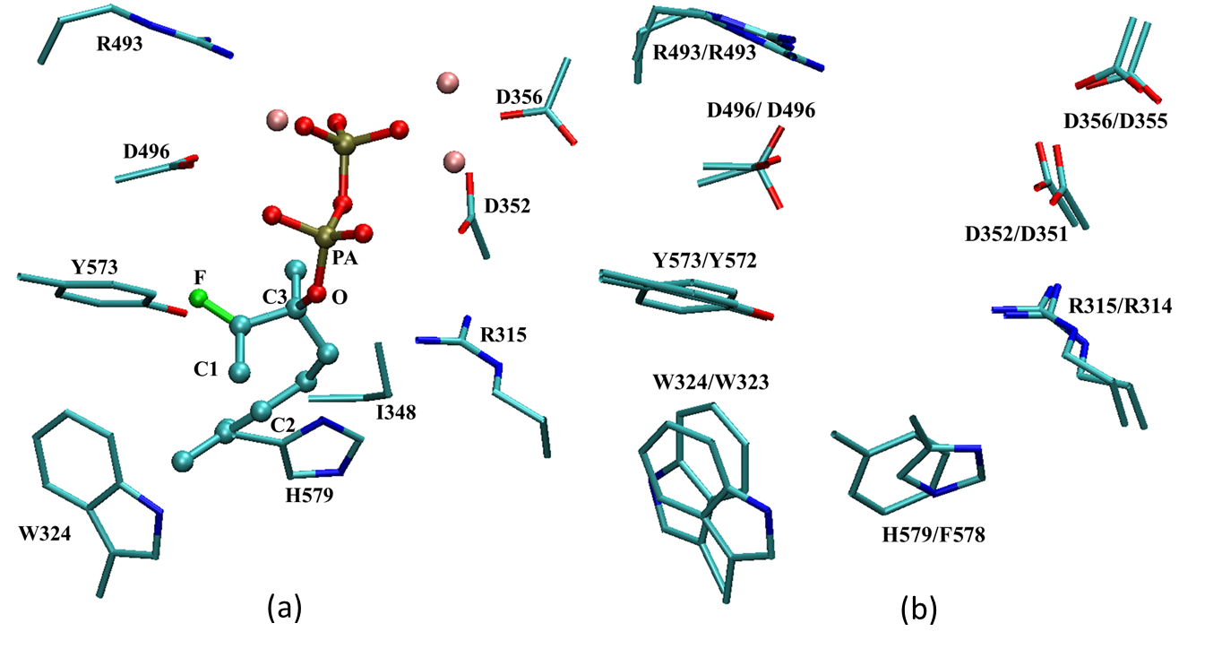
Figure 5.1
Structures of active site. (a) The active site of (4S)-LS X-ray crystal structure. (b) Active sites comparison between (4S)-LS (PDB ID 2ONH, before slash) and BPPS (PDB ID 1N23, after slash) by superposition. Substrate and manganese ion are shown as ball and stick; Residue sidechains are shown as stick.Hydrogen atoms are omitted.

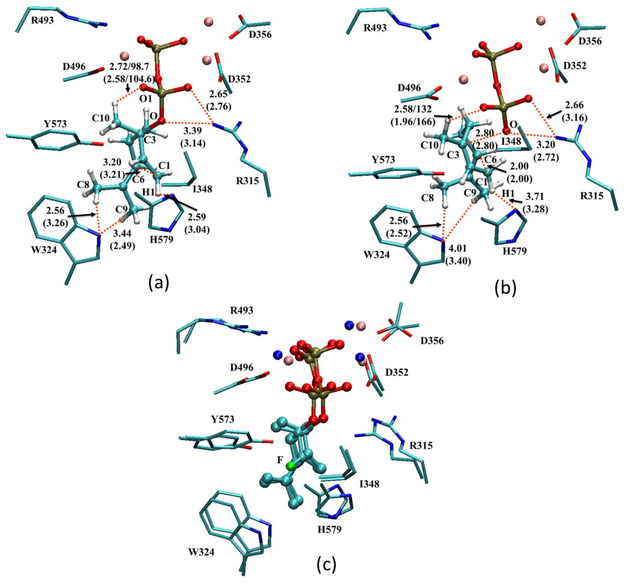

Figure 5.2
Benchmark calculations for (4S)-LS complexed with (3S)-LPP. All distances are labeled in Å. Numbers within parentheses are obtained by SCC-DFTBPR/MM optimization with dispersion correction; those without parentheses are obtained by B3LYP/6-31+G(d,p)/MM optimization. Unimportant hydrogens are omitted for clarity. (a) Reactant state; (b) Transition state by adiabatic mapping; (c) Overlay of crystal structure with FLPP and B3LYP/6-31+G(d,p)/MM optimized structures with LPP.
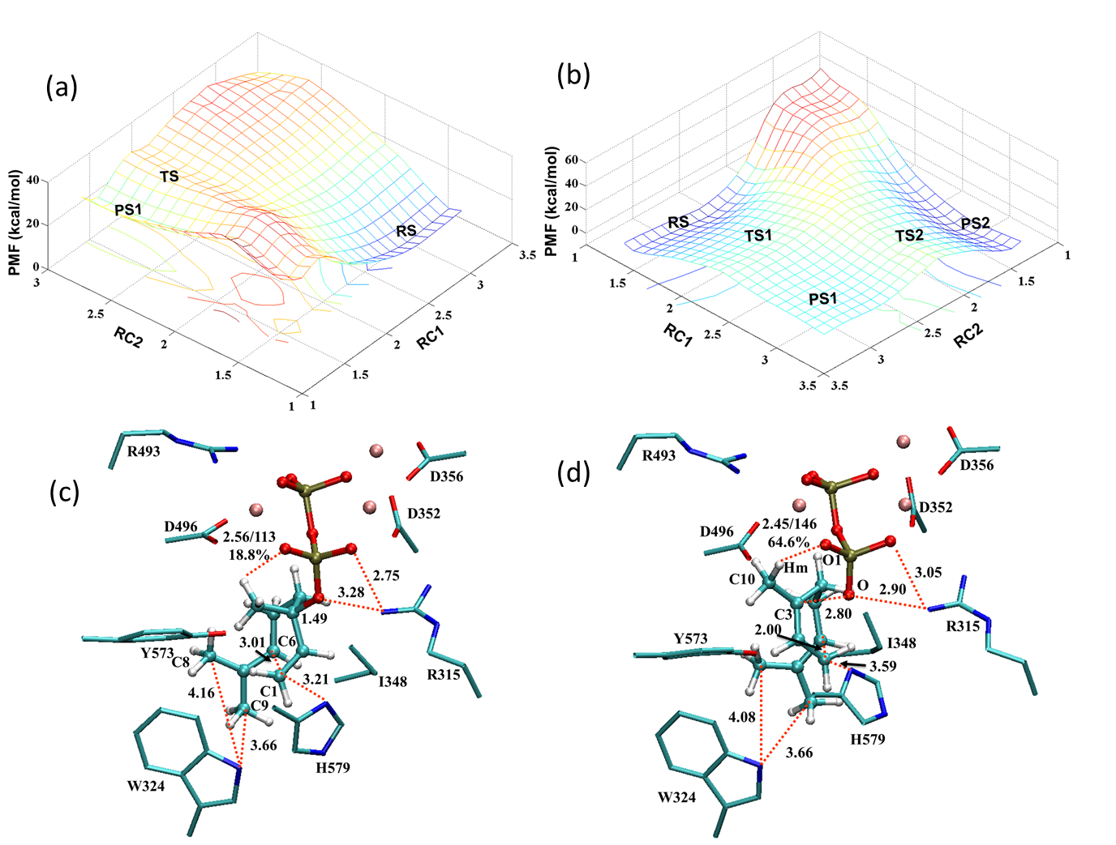
Figure 5.3
PMF calculation results for (4S)-LS complexed with (3S)-LPP with SCC-DFTBPR/MM. Distances are labeled in Å, and energies are in kcal/mol. (a) 2D free-energy (PMF) map for (4S)-α-terpinyl cation formation obtained from the QM(SCC-DFTBPR)/MM simulations. RC1 = r(C3…O); RC2 = r(C1…C2). (b) 2D free-energy (PMF) map for PPO migration obtained from the QM(SCC-DFTBPR)/MM simulations. RC1 = r(C3…O); RC2 = r(C1…O). (c) RS of (a). (d) TS of (a). Unimportant hydrogens are omitted for clarity. All distances are average distances from PMF calculation.

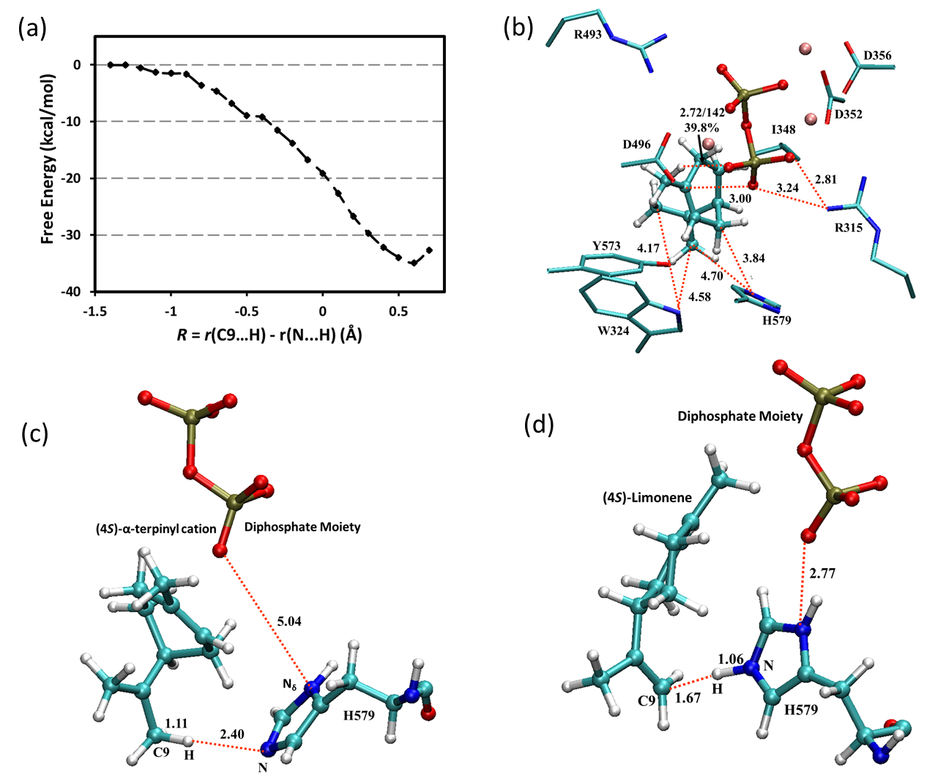
Figure 5.4
PMF calculation result for (4S)-Limonene formation from (4S)-α-terpinyl cation with SCC-DFTBPR/MM. Distances are labeled in Å, and energies are in kcal/mol. (a) 1D free-energy (PMF) map along the reaction coordinate RC = r(C9…H) - r(N…H). (b) PS of Figure 5.3a. (c) RS of (a). (d) PS of (a). All distances are average distances from PMF calculation.

Table 5.1. 3S-LPP Reaction Barriers in Limonene Synthase.
 | expª | SCC-DFTBPR/MM^{b} | + Corrections^{c}
3S-LPP  ªFree energy barriers (kcal/mol) calculated by transition state theory based on experimental rate constants (kcat) from Ref . ^{b}Values (without parentheses) are from SCC-DFTBPR/MM PMF simulations; Values (in parentheses before slash) are from adiabatic mapping calculations with B3LYP/6-31+G(d,p)/MM; Values (in parentheses after slash) are from adiabatic mapping calculations with SCC-DFTBPR/MM. ^{c}Value (before slash) is PMF results plus a barrier energy correction which is the PMF corresponding barriers difference between the B3LYP/6-31+G(d,p)/MM and SCC-DFTBPR/MM levels from adiabatic mapping calculations. Value (after slash) is the B3LYP/MM corrected PMF barrier plus the energy difference between B3LYP/6-31+G(d,p) and MP2/6-31+G(d,p) levels from single point energy calculations. | 16.8 | 25.8 (19.8/27.8) | 17.8/16.2
Table 0.1.
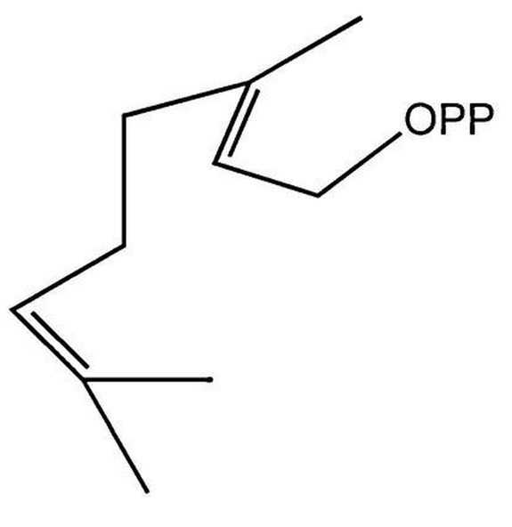
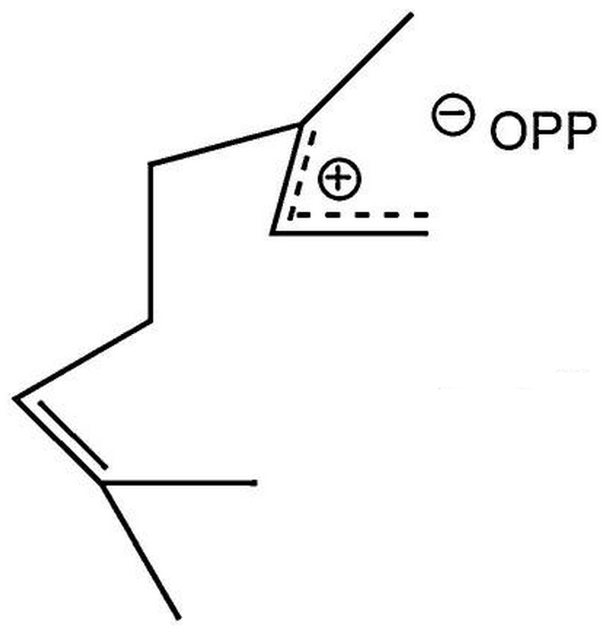
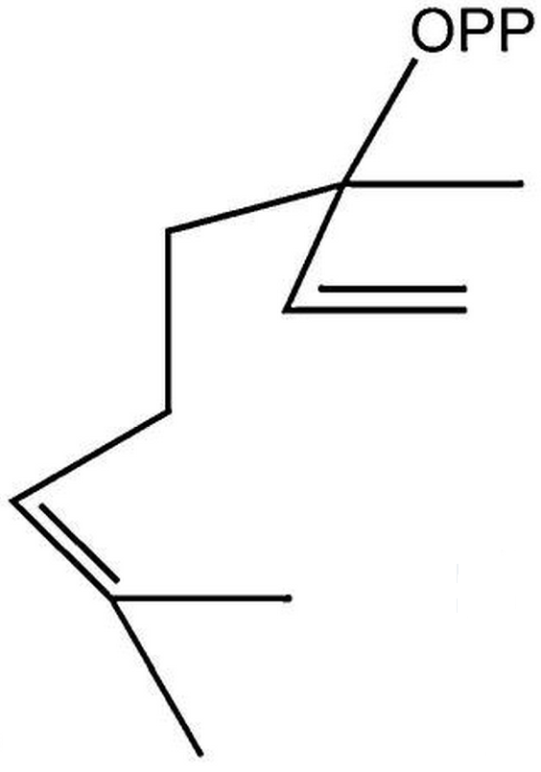
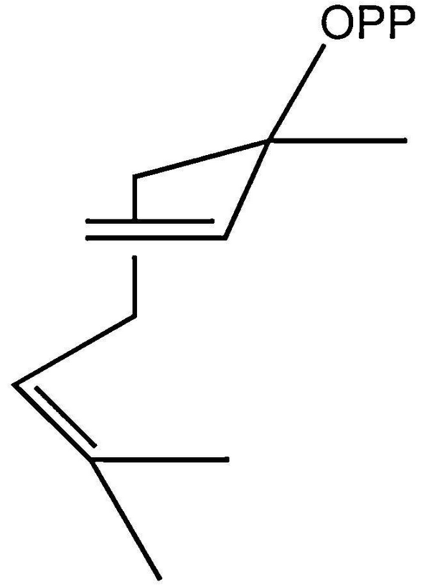
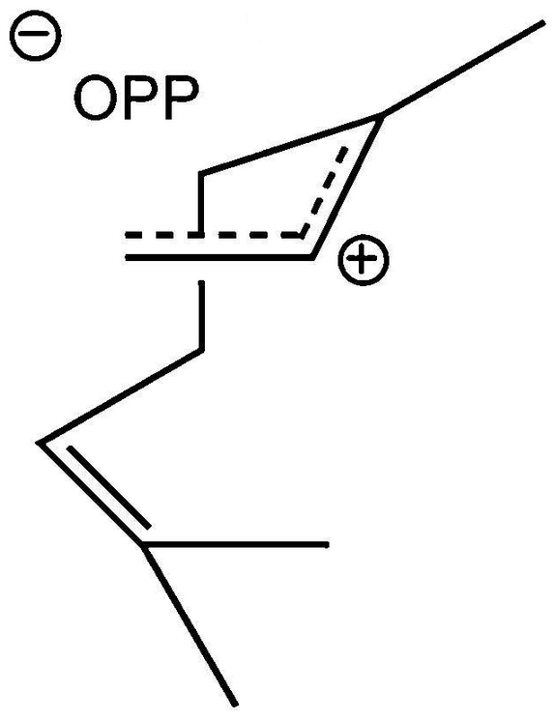
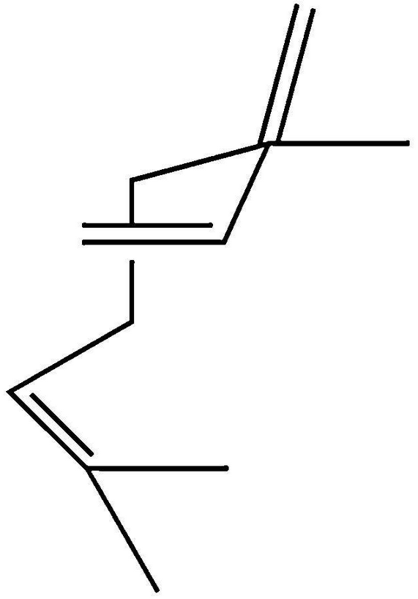
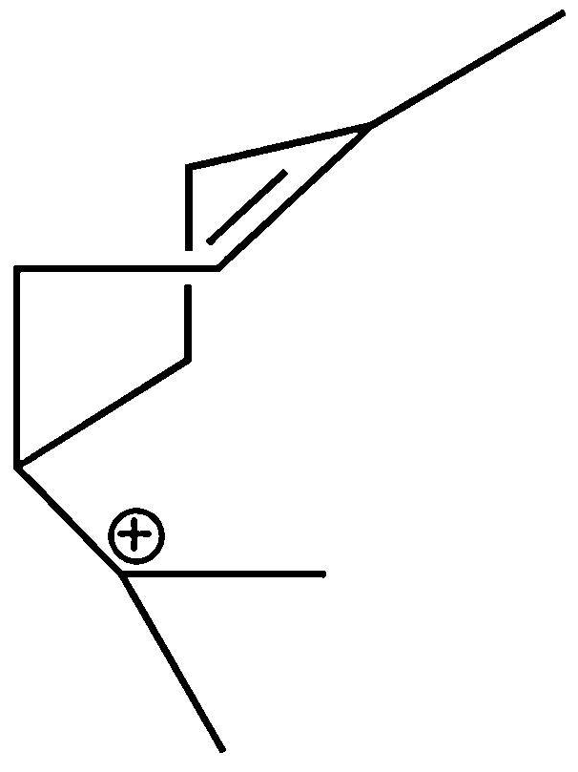
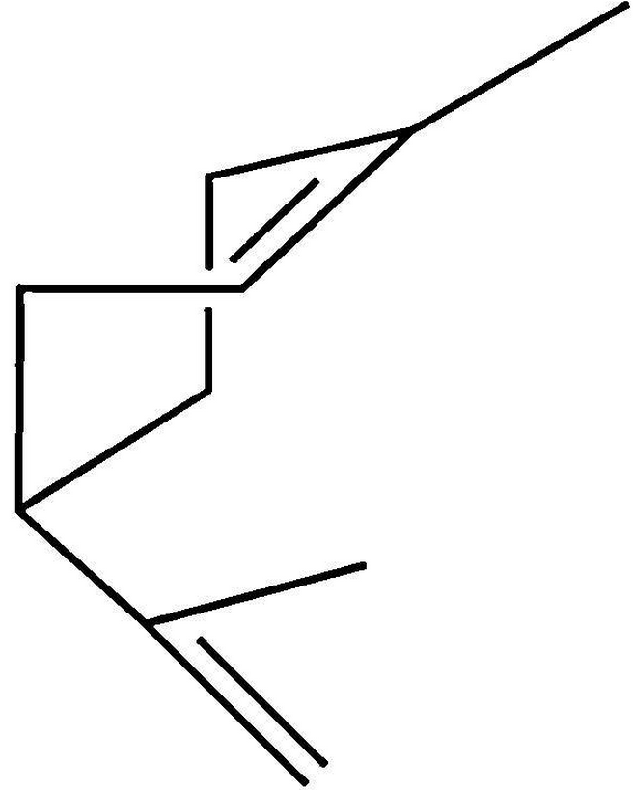
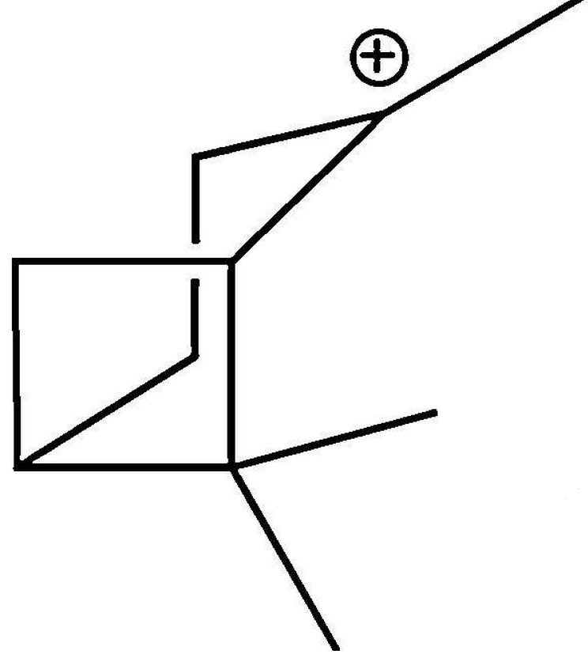
(1)
(2)
(3)
(4)
(5)
(6)
(7)
Scheme 5.1
Proposed limonene synthase catalytic mechanisms. (1) Geranyl diphosphate, (2) Linalyl diphosphate, (3) Linalyl diphosphate, (4) α-Terpinyl cation, (5) Limonene, (6) Pinyl cation, (7) Myrcene.

References
Allemann, R. K., N. J. Young, S. Ma, D. G. Truhlar and J. Gao (2007). "Synthetic Efficiency in Enzyme Mechanisms Involving Carbocations: Aristolochene Synthase." Journal of the American Chemical Society 129(43): 13008-13013.
Alonso, W. R., J. I. Rajaonarivony, J. Gershenzon and R. Croteau (1992). "Purification of 4S-limonene synthase, a monoterpene cyclase from the glandular trichomes of peppermint (Mentha x piperita) and spearmint (Mentha spicata)." Journal of Biological Chemistry 267(11): 7582-7587.
Becke, A. D. (1988). "Density-functional exchange-energy approximation with correct asymptotic behavior." Physical Review A 38(6): 3098-3100.
Becke, A. D. (1993). "Density‐functional thermochemistry. III. The role of exact exchange." The Journal of Chemical Physics 98(7): 5648-5652.
Brooks, B. R., C. L. Brooks, A. D. Mackerell, L. Nilsson, R. J. Petrella, B. Roux, Y. Won, G. Archontis, C. Bartels, S. Boresch, A. Caflisch, L. Caves, Q. Cui, A. R. Dinner, M. Feig, S. Fischer, J. Gao, M. Hodoscek, W. Im, K. Kuczera, T. Lazaridis, J. Ma, V. Ovchinnikov, E. Paci, R. W. Pastor, C. B. Post, J. Z. Pu, M. Schaefer, B. Tidor, R. M. Venable, H. L. Woodcock, X. Wu, W. Yang, D. M. York and M. Karplus (2009). "CHARMM: The Biomolecular Simulation Program." Journal of Computational Chemistry 30(10): 1545-1614.
Brooks, B. R., R. E. Bruccoleri, B. D. Olafson, D. J. States, S. Swaminathan and M. Karplus (1983). "CHARMM - A PROGRAM FOR MACROMOLECULAR ENERGY, MINIMIZATION, AND DYNAMICS CALCULATIONS." Journal of Computational Chemistry 4(2): 187-217.
Brooks, C. L. and M. Karplus (1989). "SOLVENT EFFECTS ON PROTEIN MOTION AND PROTEIN EFFECTS ON SOLVENT MOTION - DYNAMICS OF THE ACTIVE-SITE REGION OF LYSOZYME." Journal of Molecular Biology 208(1): 159-181.
Brünger, A. T. and M. Karplus (1988). "Polar hydrogen positions in proteins: Empirical energy placement and neutron diffraction comparison." Proteins: Structure, Function, and Bioinformatics 4(2): 148-156.
Cane, D. E. (1990). "Enzymic formation of sesquiterpenes." Chemical Reviews 90(7): 1089-1103.
Christianson, D. W. (2006). "Structural Biology and Chemistry of the Terpenoid Cyclases." Chemical Reviews 106(8): 3412-3442.
Croteau, R. (1986). "Evidence for the ionization steps in monoterpene cyclization reactions using 2-fluorogeranyl and 2-fluorolinalyl pyrophosphates as substrates." Archives of Biochemistry and Biophysics 251(2): 777-782.
Croteau, R. (1987). "Biosynthesis and catabolism of monoterpenoids." Chemical Reviews 87(5): 929-954.
Croteau, R. B., J. J. Shaskus, B. Renstrom, N. M. Felton, D. E. Cane, A. Saito and C. Chang (1985). "Mechanism of the pyrophosphate migration in the enzymic cyclization of geranyl and linalyl pyrophosphates to (+)- and (-)-bornyl pyrophosphates." Biochemistry 24(25): 7077-7085.
Elstner, M. (2007). "SCC-DFTB: What is the proper degree of Self-Consistency?" Journal of Physical Chemistry A 111(26): 5614-5621.
Elstner, M., P. Hobza, T. Frauenheim, S. Suhai and E. Kaxiras (2001). "Hydrogen bonding and stacking interactions of nucleic acid base pairs: A density-functional-theory based treatment." The Journal of Chemical Physics 114(12): 5149-5155.
Gao, Y., R. B. Honzatko and R. J. Peters (2012). "Terpenoid synthase structures: a so far incomplete view of complex catalysis." Natural Product Reports 29(10): 1153-1175.
Gaus, M., Q. Cui and M. Elstner (2011). "DFTB3: Extension of the Self-Consistent-Charge Density-Functional Tight-Binding Method (SCC-DFTB)." Journal of Chemical Theory and Computation 7(4): 931-948.
Gershenzon, J. and N. Dudareva (2007). "The function of terpene natural products in the natural world." Nat Chem Biol 3(7): 408-414.
Hong, Y. J. and D. J. Tantillo (2009). "A potential energy surface bifurcation in terpene biosynthesis." Nat Chem 1(5): 384-389.
Hou, G. and Q. Cui (2011). "QM/MM Analysis Suggests That Alkaline Phosphatase (AP) and Nucleotide Pyrophosphatase/Phosphodiesterase Slightly Tighten the Transition State for Phosphate Diester Hydrolysis Relative to Solution: Implication for Catalytic Promiscuity in the AP Superfamily." Journal of the American Chemical Society 134(1): 229-246.
Hou, G. and Q. Cui (2013). "Stabilization of Different Types of Transition States in a Single Enzyme Active Site: QM/MM Analysis of Enzymes in the Alkaline Phosphatase Superfamily." Journal of the American Chemical Society 135(28): 10457-10469.
Hou, G., X. Zhu and Q. Cui (2010). "An Implicit Solvent Model for SCC-DFTB with Charge-Dependent Radii." Journal of Chemical Theory and Computation 6(8): 2303-2314.
Hou, G., X. Zhu, M. Elstner and Q. Cui (2012). "A Modified QM/MM Hamiltonian with the Self-Consistent-Charge Density-Functional-Tight-Binding Theory for Highly Charged QM Regions." Journal of Chemical Theory and Computation 8(11): 4293-4304.
Hyatt, D. C., B. Youn, Y. Zhao, B. Santhamma, R. M. Coates, R. B. Croteau and C. Kang (2007). "Structure of limonene synthase, a simple model for terpenoid cyclase catalysis." Proceedings of the National Academy of Sciences 104(13): 5360-5365.
Im, W., D. Beglov and B. Roux (1998). "Continuum Solvation Model: computation of electrostatic forces from numerical solutions to the Poisson-Boltzmann equation." Computer Physics Communications 111(1-3): 59-75.
Im, W., S. Berneche and B. Roux (2001). "Generalized solvent boundary potential for computer simulations." Journal of Chemical Physics 114(7): 2924-2937.
Jorgensen, W. L. (1981). "QUANTUM AND STATISTICAL MECHANICAL STUDIES OF LIQUIDS .10. TRANSFERABLE INTERMOLECULAR POTENTIAL FUNCTIONS FOR WATER, ALCOHOLS, AND ETHERS - APPLICATION TO LIQUID WATER." Journal of the American Chemical Society 103(2): 335-340.
Kjonaas, R. and R. Croteau (1983). "Demonstration that limonene is the first cyclic intermediate in the biosynthesis of oxygenated p-menthane monoterpenes in Mentha piperita and other Mentha species." Archives of Biochemistry and Biophysics 220(1): 79-89.
Klopman, G. (1964). "SEMIEMPIRICAL TREATMENT OF MOLECULAR STRUCTURES .2. MOLECULAR TERMS + APPLICATION TO DIATOMIC MOLECULES." Journal of the American Chemical Society 86(21): 4550-&.
Koksal, M., Y. Jin, R. M. Coates, R. Croteau and D. W. Christianson (2011). "Taxadiene synthase structure and evolution of modular architecture in terpene biosynthesis." Nature 469(7328): 116-120.
Kumar, S., D. Bouzida, R. H. Swendsen, P. A. Kollman and J. M. Rosenberg (1992). "THE WEIGHTED HISTOGRAM ANALYSIS METHOD FOR FREE-ENERGY CALCULATIONS ON BIOMOLECULES .1. THE METHOD." Journal of Computational Chemistry 13(8): 1011-1021.
Lee, C., W. Yang and R. G. Parr (1988). "Development of the Colle-Salvetti correlation-energy formula into a functional of the electron density." Physical Review B 37(2): 785-789.
Lu, X. and Q. Cui (2013). "Charging Free Energy Calculations Using the Generalized Solvent Boundary Potential (GSBP) and Periodic Boundary Condition: A Comparative Analysis Using Ion Solvation and Oxidation Free Energy in Proteins." Journal of Physical Chemistry B 117(7): 2005-2018.
MacKerell, A. D., D. Bashford, M. Bellott, R. L. Dunbrack, J. D. Evanseck, M. J. Field, S. Fischer, J. Gao, H. Guo, S. Ha, D. Joseph-McCarthy, L. Kuchnir, K. Kuczera, F. T. K. Lau, C. Mattos, S. Michnick, T. Ngo, D. T. Nguyen, B. Prodhom, W. E. Reiher, B. Roux, M. Schlenkrich, J. C. Smith, R. Stote, J. Straub, M. Watanabe, J. Wiorkiewicz-Kuczera, D. Yin and M. Karplus (1998). "All-atom empirical potential for molecular modeling and dynamics studies of proteins." Journal of Physical Chemistry B 102(18): 3586-3616.
Major, D. T. and M. Weitman (2012). "Electrostatically Guided Dynamics—The Root of Fidelity in a Promiscuous Terpene Synthase?" Journal of the American Chemical Society 134(47): 19454-19462.
Matsuda, S. P. T., W. K. Wilson and Q. Xiong (2006). "Mechanistic insights into triterpene synthesis from quantum mechanical calculations. Detection of systematic errors in B3LYP cyclization energies." Organic & Biomolecular Chemistry 4(3): 530-543.
Neria, E., S. Fischer and M. Karplus (1996). "Simulation of activation free energies in molecular systems." Journal of Chemical Physics 105(5): 1902-1921.
Nina, M., D. Beglov and B. Roux (1997). "Atomic radii for continuum electrostatics calculations based on molecular dynamics free energy simulations." Journal of Physical Chemistry B 101(26): 5239-5248.
Nina, M., W. Im and B. Roux (1999). "Optimized atomic radii for protein continuum electrostatics solvation forces." Biophysical Chemistry 78(1-2): 89-96.
Ohno, K. (1964). "SOME REMARKS ON THE PARISER-PARR-POPLE METHOD." Theoretica Chimica Acta 2(2): 219-227.
Poulter, C. D., J. C. Argyle and E. A. Mash (1978). "Farnesyl pyrophosphate synthetase. Mechanistic studies of the 1'-4 coupling reaction with 2-fluorogeranyl pyrophosphate." Journal of Biological Chemistry 253(20): 7227-7233.
Poulter, C. D. and D. M. Satterwhite (1977). "Mechanism of the prenyl transfer reaction. Studies with (E)- and (Z)-3-trifluoromethyl-2-buten-1-yl pyrophosphate." Biochemistry 16(25): 5470-5478.
Poulter, C. D., P. L. Wiggins and A. T. Le (1981). "Farnesylpyrophosphate synthetase. A stepwise mechanism for the 1'-4 condensation reaction." Journal of the American Chemical Society 103(13): 3926-3927.
Rajamani, R. and J. Gao (2003). "Balancing Kinetic and Thermodynamic Control: the Mechanism of Carbocation Cyclization by Squalene Cyclase." Journal of the American Chemical Society 125(42): 12768-12781.
Rajaonarivony, J. I. M., J. Gershenzon and R. Croteau (1992). "Characterization and mechanism of (4S)-limonene synthase, A monoterpene cyclase from the glandular trichomes of peppermint (Mentha x piperita)." Archives of Biochemistry and Biophysics 296(1): 49-57.
Riccardi, D., P. Schaefer, Y. Yang, H. B. Yu, N. Ghosh, X. Prat-Resina, P. Konig, G. H. Li, D. G. Xu, H. Guo, M. Elstner and Q. Cui (2006). "Development of effective quantum mechanical/molecular mechanical (QM/MM) methods for complex biological processes." Journal of Physical Chemistry B 110(13): 6458-6469.
Sacchettini, J. C. and C. D. Poulter (1997). "Creating Isoprenoid Diversity." Science 277(5333): 1788-1789.
Schaefer, P., D. Riccardi and Q. Cui (2005). "Reliable treatment of electrostatics in combined QM/MM simulation of macromolecules." Journal of Chemical Physics 123(1).
Schmidt, M. W., K. K. Baldridge, J. A. Boatz, S. T. Elbert, M. S. Gordon, J. H. Jensen, S. Koseki, N. Matsunaga, K. A. Nguyen, S. J. Su, T. L. Windus, M. Dupuis and J. A. Montgomery (1993). "GENERAL ATOMIC AND MOLECULAR ELECTRONIC-STRUCTURE SYSTEM." Journal of Computational Chemistry 14(11): 1347-1363.
Steinbach, P. J. and B. R. Brooks (1994). "NEW SPHERICAL-CUTOFF METHODS FOR LONG-RANGE FORCES IN MACROMOLECULAR SIMULATION." Journal of Computational Chemistry 15(7): 667-683.
Tantillo, D. J. (2008). "Recent excursions to the borderlands between the realms of concerted and stepwise: carbocation cascades in natural products biosynthesis." Journal of Physical Organic Chemistry 21(7-8): 561-570.
Tantillo, D. J. (2011). "Biosynthesis via carbocations: Theoretical studies on terpene formation." Natural Product Reports 28(6): 1035-1053.
Thiel, W. (1996). Perspectives on semiempirical molecular orbital theory. Advances in Chemical Physics, Vol Xciii: New Methods in Computational Quantum Mechanics. I. Prigogine and S. A. Rice. 93: 703-757.
Torrie, G. M. and J. P. Valleau (1974). "MONTE-CARLO FREE-ENERGY ESTIMATES USING NON-BOLTZMANN SAMPLING - APPLICATION TO SUBCRITICAL LENNARD-JONES FLUID." Chemical Physics Letters 28(4): 578-581.
Torrie, G. M. and J. P. Valleau (1977). "NON-PHYSICAL SAMPLING DISTRIBUTIONS IN MONTE-CARLO FREE-ENERGY ESTIMATION - UMBRELLA SAMPLING." Journal of Computational Physics 23(2): 187-199.
Turner, G., J. Gershenzon, E. E. Nielson, J. E. Froehlich and R. Croteau (1999). "Limonene Synthase, the Enzyme Responsible for Monoterpene Biosynthesis in Peppermint, Is Localized to Leucoplasts of Oil Gland Secretory Cells." Plant Physiology 120(3): 879-886.
Weitman, M. and D. T. Major (2010). "Challenges Posed to Bornyl Diphosphate Synthase: Diverging Reaction Mechanisms in Monoterpenes." Journal of the American Chemical Society 132(18): 6349-6360.
Whittington, D. A., M. L. Wise, M. Urbansky, R. M. Coates, R. B. Croteau and D. W. Christianson (2002). "Bornyl diphosphate synthase: Structure and strategy for carbocation manipulation by a terpenoid cyclase." Proceedings of the National Academy of Sciences 99(24): 15375-15380.
Williams, D. C., D. J. McGarvey, E. J. Katahira and R. Croteau (1998). "Truncation of Limonene Synthase Preprotein Provides a Fully Active ‘Pseudomature' Form of This Monoterpene Cyclase and Reveals the Function of the Amino-Terminal Arginine Pair†." Biochemistry 37(35): 12213-12220.
Wise, M. L., H.-J. Pyun, G. Helms, B. Assink, R. M. Coates and R. B. Croteau (2001). "Stereochemical disposition of the geminal dimethyl groups in the enzymatic cyclization of geranyl diphosphate to (+)-bornyl diphosphate by recombinant (+)-bornyl diphosphate synthase from Salvia officinalis." Tetrahedron 57(25): 5327-5334.
Wise, M. L., T. J. Savage, E. Katahira and R. Croteau (1998). "Monoterpene Synthases from Common Sage (Salvia officinalis) : cDNA ISOLATION, CHARACTERIZATION, AND FUNCTIONAL EXPRESSION OF (+)-SABINENE SYNTHASE, 1,8-CINEOLE SYNTHASE, AND (+)-BORNYL DIPHOSPHATE SYNTHASE." Journal of Biological Chemistry 273(24): 14891-14899.
Yang, H. Yu, D. York, Q. Cui and M. Elstner (2007). "Extension of the Self-Consistent-Charge Density-Functional Tight-Binding Method: Third-Order Expansion of the Density Functional Theory Total Energy and Introduction of a Modified Effective Coulomb Interaction." The Journal of Physical Chemistry A 111(42): 10861-10873.
Yang, Y., H. Yu, D. York, M. Elstner and Q. Cui (2008). "Description of Phosphate Hydrolysis Reactions with the Self-Consistent-Charge Density-Functional-Tight-Binding (SCC-DFTB) Theory. 1. Parameterization." Journal of Chemical Theory and Computation 4(12): 2067-2084.

CHAPTER 6
PPCM: Combing multiple classifiers to improve protein-protein interaction prediction

Jianzhuang Yao, Hong Guo, and Xiaohan Yang. “PPCM: Combing multiple classifiers to improve protein-protein interaction prediction.”To be submitted.
My contributions to this study include: 1) discussions with the design of the experiments; 2) performing the experiments; 3) analysis of the result and preparing the manuscript. Dr. Xiaohan Yang and Dr. Hong Guo also participated in writing the manuscript.

Abstract
In recent decades, protein-protein interaction (PPI) prediction has become a popular research area and many classifiers have been developed for PPI prediction. However, no single classifier has been able to predict PPI with high-confidence. We postulate that combining individual classifiers could improve PPI prediction accuracy over individual classifiers alone. We developed protein-protein interaction classifiers merger (PPCM) that combines output from two PPI prediction tools -- GO2PPI and Phyloprof using random forests algorithm. The performance of PPCM was tested by area under the curve (AUC) using an assembled gold standard PPI database that contains positive PPI pairs as well as negative PPI pairs. Our AUC test showed that PPCM significantly improved PPI prediction accuracy over corresponding individual classifiers. We found that more classifiers incorporated into PPCM led to better improvement in the PPI prediction accuracy. Furthermore, cross species PPCM achieved competitive and even better prediction accuracy compared to the single species PPCM. This study established a robust pipeline for PPI prediction by integrating multiple classifiers using random forests algorithm. This pipeline will be useful for predicting PPI in non-model species.

Introduction
Protein-protein interaction (PPI) networks play important roles in many cellular activities, including complex formation and metabolic pathways (Gavin, Bosche et al. 2002){Gavin, 2002 #115}{Planas-Iglesias, 2013 #114}{Gavin, 2002 #115}, and identification of PPI pairs provides insight into the molecular basis of cellular processes (Alberts 1998). Several high-throughput experimental approaches have been developed for PPI identification, including two-hybrid assays (Devos and Russell 2007), tandem affinity purification followed by Mass Spectrometry (Gavin, Aloy et al. 2006), and protein microarrays (Kumar and Snyder 2002). These high-throughput methods have produced a large amount PPI data, which have been accumulated in the public PPI databases, such as DIP (Xenarios, Rice et al. 2000) and STRING (Franceschini, Szklarczyk et al. 2013). However, the results generated by these high-throughput methods lack reliability (von Mering, Krause et al. 2002), and have limited coverage of PPIs in any given organism (Planas-Iglesias, Bonet et al. 2013). Additional experimental information for PPI includes X-ray structures of protein complexes in the PDB databank (Sussman, Lin et al. 1998). Although significant experimental progress has led to a rapid accumulation of protein structural information, PDB data is only available for a small number of proteins. In particular, the information concerning protein complex structures is limited compared with the large volume of protein sequences available in the public databases (Hart, Ramani et al. 2006). Therefore, protein complex information in the PDB databank is not sufficient for large-scale PPI prediction.
To overcome the limitations in PPI identification using experimental methods, computational approaches have been developed to achieve large-scale PPI prediction in various organisms (Chen and Liu 2005, Qi, Klein-Seetharaman et al. 2005, Liu, Kim et al. 2008, Garcia-Garcia, Guney et al. 2010, Yu, Chou et al. 2010, Gallone, Simpson et al. 2011). Traditional input features for PPI prediction are mainly from biological data sources, which can be divided into four categories: Gene Ontology (GO)-based, structure-based, network topology-based, and sequenced-based features (Theofilatos, Dimitrakopoulos et al. 2011). Each individual computational PPI prediction method utilizes only one or a few input sources for PPI prediction. For example, BIPS only takes protein sequences as input for Interolog searching (Garcia-Garcia, Schleker et al. 2012). Bio::Homology::InterologWalk takes protein sequences and well-known PPI networks as input (Gallone, Simpson et al. 2011). Although these methods with single or several features as input can generate fairly accurate results, they are unable to take advantage of other input features that could be helpful for PPI prediction. Thus, machine learning methods (e.g., Bayesian classifiers (Jansen, Yu et al. 2003), Artificial Neural Networks (ANN) (Chen, Liu et al. 2008), Support Vector Machines (SVM) (Gomez, Noble et al. 2003), and Random Forests (Strobl, Boulesteix et al. 2007)) have been developed to integrate multiple features as inputs. Machine learning approaches achieve higher performance than other methods; among them, Random Forests shows the best performance (Qi, Bar-Joseph et al. 2006).
In addition to the progress in identification of informative features for PPI prediction, a variety of algorithms have been developed to improve the PPI prediction accuracy (Theofilatos, Dimitrakopoulos et al. 2011). For instance, Phylogenetic Profiling (PP) uses genome-scale and network-based features as inputs for PPI prediction founded on the assumption that the co-occurrence of two proteins across taxa indicates a good chance for them to function together (GAASTERLAND and RAGAN 1998, Pellegrini, Marcotte et al. 1999). Although PPI prediction by PP has shown good performance in prokaryotes, it is has poor performance in PPI prediction in eukaryotes, because of modularity of eukaryotic proteins, biased diversity of available genomes, and large evolutionary distances (Snitkin, Gustafson et al. 2006, Jothi, Przytycka et al. 2007). Several studies indicate that the accuracy of PPI prediction by PP can be improved by selecting the appropriate reference taxa and matching the reference taxa to the known PPI network (Jothi, Przytycka et al. 2007, Sun, Li et al. 2007, Herman, Ochoa et al. 2011). Recently, Simonsen et al. (2012) developed a PPI prediction software PhyloProf (Simonsen, Maetschke et al. 2012) that integrates four PPI prediction methods including the original PP method (Pellegrini, Marcotte et al. 1999), mutual information (MI) method (Date and Marcotte 2003), hypergeometric distribution based method (Wu, Kasif et al. 2003), and the extension of the hypergeometric distribution (RUN) method (Cokus, Mizutani et al. 2007). Also, PhyloProf provides six reference taxa optimization methods including Tree Level Filtering, Iterative Taxaon Selection, Genetic Algorithm, and Tree based search (Singh, Wall et al. 2008, Simonsen, Maetschke et al. 2012). Furthermore, there are four PPI networks available in PhyloProf, including the networks from Escherichia coli (EC), Saccharomyces cerevisiae (hereafter referred to as SC), Drosophila melanogaster (DM), and Arabidopsis thaliana (AT). In short, PhyloProf provides a series of PPI prediction classifiers as a result of various combinations of PPI prediction methods, reference taxa optimization methods, and networks from different species.
Another sophisticated PPI prediction software called GO2PPI has been developed to use Gene Ontology and PPI networks as input (Maetschke, Simonsen et al. 2012). By introducing a concept called inducer to combine machine learning and semantic similarity techniques, GO2PPI can provide a series of PPI prediction classifiers that are combinations of machine learning methods (i.e. Naïve Bayes (NB) and Random Forests), GO categories (i.e. biological process (BP), cellular component (CC), and molecular function (MF)), and networks from eight species (Homo sapiens (HS), Mus musculus (MM), S. pombe (SP), Chlamydia trachomatis (CT), SC, AT, EC, and DM).
To build off of this research, we developed a pipeline PPCM (i.e., PPI prediction classifiers merger) to enhance the PPI prediction accuracy by merging multiple PPI prediction classifiers using the random forests algorithm. To the best of our knowledge, this study is the first effort to merge multiple classifiers by machine learning for PPI prediction.

Methods
We created a training and a test dataset containing direct interacted protein pairs of yeast for protein-protein interaction (PPI) prediction using a method described Y. Qi et al. (Qi, Bar-Joseph et al. 2006). Briefly, 2865 positive PPI pairs were obtained from the DIP database (Xenarios, Rice et al. 2000). These direct interaction protein pairs were tested to be highly confident PPI pairs by small-scale experiments. Since there was insufficient high-confident negative data (Smialowski, Pagel et al. 2010), negative PPI pairs were generated by randomly pairing proteins followed by removing the positive PPI pairs (Zhang, Wong et al. 2004). Finally, the positive PPI pairs and the negative PPI pairs were combined by a ratio of 1 to 100 into a “gold standard” dataset.
The results of PPI prediction classifiers were used as features of PPCM. Specifically, PhyloProf has three kinds of input parameters, including four PPI prediction methods, eight Reference Taxa Optimization methods, and four PPI networks. Without the time-consuming PPI prediction method ‘run’, there were 96 different classifiers based on different combinations of parameters provided by PhyloProf (Table S6.1). As mentioned above, GO2PPI has three kinds of input parameters as well, including two machine learning methods, seven GO terms or terms combinations (BP, CC, MF, BPCC, BPMF, CCMF, and BPCCMF), and seven PPI networks. In the same way, there were 98 different combinations of classifiers provided by GO2PPI (Table S6.2). We used combined GO terms in this study, because the best accuracy was achieved by the integration of three GO terms in the GO2PPI paper (Maetschke, Simonsen et al. 2012).
The PPCM pipeline, as illustrated in Figure 6.1, was developed to combine multiple classifiers for enhancing PPI prediction accuracy. Specifically, a protein pair is first evaluated by classifiers provided by PPI prediction software, such as GO2PPI (add reference here) and Phyloprof (add reference here). Then, the classification scores from individual classifiers are used as input features to generate the final PPI prediction score using random forests algorithm, implemented in the Berkeley Random Forests package (Breiman 2001). GO2PPI has 98 PPI prediction classifiers, among which 14 are SC-related and 84 are not SC-related (cross species) classifiers (Table S6.1). Phyloprof has 98 PPI prediction classifiers, among which 24 are SC-related and 72 not SC-related (cross species) classifiers (Table S6.2).
The aforementioned gold standard PPI database that contains 30,000 PPI pairs with a positive-to-negative PPI ratio of 1:100 was used to evaluate the PPI prediction accuracy. The following measures were used to evaluate PPI prediction results: the true positive rate (TPR, also called sensitivity) -- defined as the ratio of correctly predicted positive PPI pairs among all positive PPI pairs, the true negative rate (TNR; also called specificity) -- defined as the ratio of correctly predicted negative PPI pairs among all negative PPI pairs and the false positive rate (FPR; also called Type I error) -- defined as the ratio of incorrectly predicted PPI pairs among all negative PPI pairs. FPR is one minus TNR. The receiver operating characteristic (ROC) curves were created by plotting TPR versus FPR. The Area Under the Curve (AUC) was used as a measure of the prediction accuracy. The AUC value was calculated using the following equation:
$$AUC=\frac{1}{2}\sum_{k=1}^{n}{\left(\left(X_{k}-X_{k-1}\right)\left(Y_{k}+Y_{k-1}\right)\right), (1)}$$
Where, $X_{k}$ is the FPR at k pair, $Y_{k}$ is the TPR at k pair in the ranked PPI pair list. The prediction process was repeated 25 times, and the average AUC value was reported.
We evaluated the PPI prediction accuracy of PPCMs as well as the classifiers in GO2PPI and Phyloprof using AUC. We introduced three categories of PPCM, including GO2PPI, Phyloprof, and GO2PPI+Phyloprof, with each further divided to three sub-categories: SC, cross-species and all species (i.e., SC plus cross species) (Table 6.1).

Results and Discussion
Using our Gold Standard dataset, the average AUC of the 14 SC-related classifiers in GO2PPI (Table 6.1) was 0.63 and rf|bpcc|SC was the most accurate classifier, with an AUC of 0.64, among these 14 classifiers (Fig. 6.2A). The average AUC of the 84 cross-species related classifiers in GO2PPI (Table S6.1) was 0.57 and rf|bpcc|HS was the most accurate classifier, with an AUC of 0.61, among these 84 classifiers (Fig. 6.2B). The average AUC of all the 96 (all-species) classifiers in GO2PPI (Table S6.1) was 0.58 and rf|bpcc|SC was the most accurate classifier, with an AUC of 0.64, among these 98 classifiers (Fig. 6.2C). The AUCs of PPCMs are 0.70, 0.68, and 0.70 for SC, cross-species and all-species PPCM, respectively (Fig. 6.2). These results indicate that PPCM significantly improved PPI prediction accuracy compared with their corresponding classifiers in GO2PPI category.
Compared with the most accurate classifier in GO2PPI category, the cross species PPCM improves AUC by 11%. The improvement of PPCM in SC PPCM was only 9% (Fig. 6.2), indicating that the cross species PPCM had better performance than the SC classifier. The better performance of cross-species PPCM (containing 84 features) than SC PPCM (containing 14 features) suggests that the larger number of features incorporated into PPCM enhanced PPI prediction accuracy in GO2PPI category.
Performance of PPCM in the Phyloprof category
Again, using our Gold Standard dataset, the average AUC of the 24 SC-related classifiers in Phyloprof (Table S6.2) was 0.64 and mi|et|SC was the most accurate classifier, with an AUC of 0.71, among these 24 classifiers (Fig. 6.3A). The average AUC of the 72 cross-species related classifiers in Phyloprof (Table S6.2) was 0.61 and mi|et|EC was the most accurate classifier, with an AUC of 0.72, among these 84 classifiers (Fig. 6.3B),. The average AUC of all the 96 (all-species) classifiers in Phyloprof (Table S6.2) was 0.62 and mi|et|EC was the most accurate classifier, with an AUC of 0.72, among these 96 classifiers (Fig. 6.3C). The AUCs of PPCMs are 0.72, 0.76, and 0.77 for SC, cross-species and all-species PPCM, respectively (Fig. 6.3). These results indicate that PPCM significantly improved PPI prediction accuracy compared with their corresponding classifiers in the Phyloprof category. Compared with the most accurate classifier in the Phyloprof category, the cross-species PPCM improves AUC by 6%, while the improvement by SC PPCM is only 1% (Fig. 6.2), indicating that the cross species PPCM had better performance in AUC improvement. The better performance of cross-species PPCM (containing 72 features) than SC PPCM (containing 24 features) suggests that more features incorporated into PPCM could enhance PPI prediction accuracy in the Phyloprof category.
After separate evaluation of PPCM in the GO2PPI and Phyloprof categories, we assessed the performance of PPCM in the GO2PPI+Phyloprof category that combined all the classifiers in both GO2PPI and Phyloprof. The AUCs of PPCMs in the GO2PPI+Phyloprof category were 0.83, 0.85, and 0.86 for SC, cross-species and all-species PPCM, respectively (Fig. 6.4), significantly higher than those of PPCMs in either GO2PPI or Phyloprof category separately (Figs. 6.2-6.3). Compared with the highest AUCs of individual classifiers in GO2PPI and Phyloprof category, the cross species PPCM improves AUC by 18% and the improvement by SC PPCM was 17% (Figs. 6.2-6.4). These results indicate that PPCM based on all the 194 classifiers from both GO2PPI and Phyloprof could generate more accurate PPI prediction than PPCM based on a fewer number of classifiers in GO2PPI or Phyloprof individually, further supporting the aforementioned premise that more features incorporated into PPCM would enhance PPI prediction accuracy. In summation, based on our combinatorial approach, our cross species PPCM results yield informative predictions that will help build high-quality PPI networks for non-model organisms. Such prediction will be valuable for non-model organisms that lack biological data and PPI prediction software for non-model organisms (Theofilatos, Dimitrakopoulos et al. 2011).

Acknowledgement
Authors wish to thank G. A. Tuskan and T.J. Tschaplinski for providing edits and constructive comments. This research was supported by the Department of Energy, Office of Science, Genomic Science Program (under award number DESC0008834). Oak Ridge National Laboratory is managed by UT-Battelle, LLC for the U.S. Department of Energy under Contract Number DE–AC05–00OR22725.

Figure 6.1
The PPCM pipeline for protein-protein interaction prediction. Given a pair of query proteins QA and QB, their interaction possibility was first predicted by each of the 194 classifiers from GO2PPI and Phyloprof. Then, the classification scores were merged using random forests algorithm to generate the final PPI prediction score. Nine PPI classification scores were provided by PPCM. “SC” represents PPI networks in Saccharomyces cerevisiae. “Cross” represents all PPI networks except SC. “All” represents all the PPI networks in both SC and cross-species.

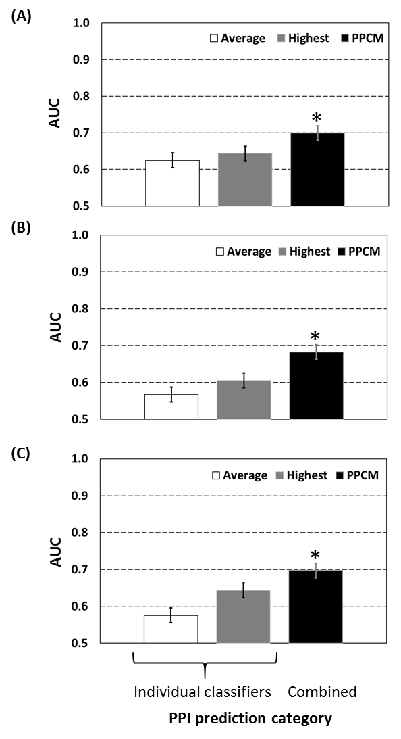

Figure 6.2
Comparison of PPI prediction accuracy in the GO2PPI category. (A) PPI prediction based on classifiers related to SC; (B) PPI prediction based on classifiers related to cross-species; and (C) PPI prediction based on classifiers related to all-species. “Average” represents the mean AUC of all the classifiers in each category. “Highest” represents the classifier with highest AUC among all the classifiers in each category. Error bars show standard deviation. “*” indicates that AUC of PPCM was significantly (P-value < 0.05; T-test) higher than that of the most accurate classifier in each category.
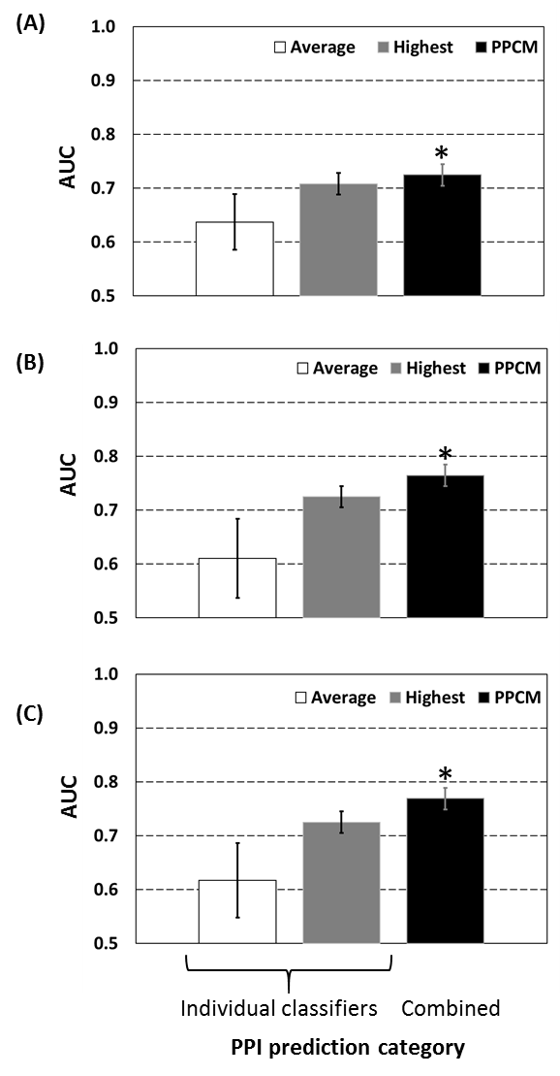

Figure 6.3
Comparison of PPI prediction accuracy in the Phyloprof category. (A) PPI prediction based on classifiers related to SC; (B) PPI prediction based on classifiers related to cross-species; and (C) PPI prediction based on classifiers related to all-species. “Average” represents the mean AUC of all the classifiers in each category. “Highest” represents the classifier with highest AUC among all the classifiers in each category. Error bars show standard deviation. “*” indicates that AUC of PPCM was significantly (P-value < 0.05; T-test) higher than that of the most accurate classifier in each category.
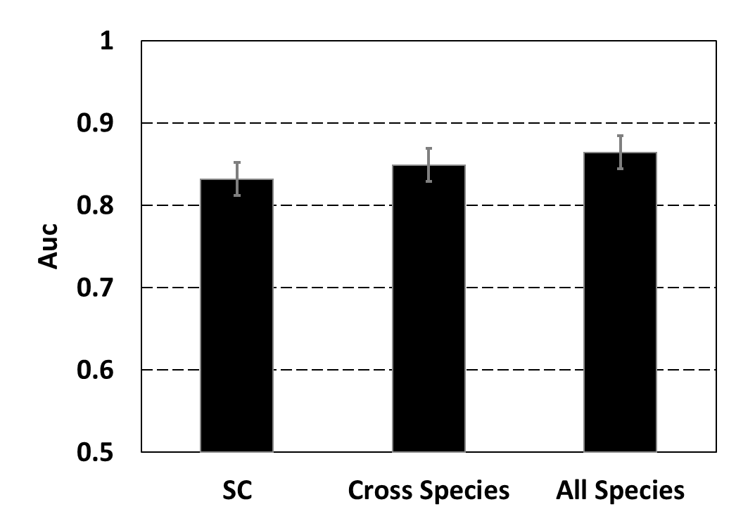
Figure 6.4
Comparison of PPI prediction accuracy in the GO2PPI+Phyloprof category. Error bars show standard deviation.
Table 6.1. Summary of PPCM classifiers.
Software categories | Species categories* | Number of classifiers
GO2PPI | SC  Cross-species  All-species | 14  84  98
Phyloprof | SC-species  Cross-species  All-species | 24  72  96
GO2PPI+Phyloprof | SC-species  Cross-species  All-species | 38  156  194
*SC represents PPI networks in Saccharomyces cerevisiae; cross-species represents all PPI networks except SC; and “all-species” represents all the PPI networks in both SC and cross-species.

Table S6.1. The individual classifiers of GO2PPI merged by PPCM
NO. | Machine learning algorithm|GO|NetWork
1 | nb|bp|AT
2 | nb|bp|DM
3 | nb|bp|EC
4 | nb|bp|HS
5 | nb|bp|MM
6 | nb|bp|SC
7 | nb|bp|SP
8 | nb|bpcc|AT
9 | nb|bpcc|DM
10 | nb|bpcc|EC
11 | nb|bpcc|HS
12 | nb|bpcc|MM
13 | nb|bpcc|SC
14 | nb|bpcc|SP
15 | nb|bpccmf|AT
16 | nb|bpccmf|DM
17 | nb|bpccmf|EC
18 | nb|bpccmf|HS
19 | nb|bpccmf|MM
20 | nb|bpccmf|SC
21 | nb|bpccmf|SP
22 | nb|bpmf|AT
23 | nb|bpmf|DM
24 | nb|bpmf|EC
25 | nb|bpmf|HS
26 | nb|bpmf|MM
27 | nb|bpmf|SC
28 | nb|bpmf|SP
29 | nb|cc|AT
30 | nb|cc|DM
31 | nb|cc|EC
32 | nb|cc|HS
33 | nb|cc|MM
34 | nb|cc|SC
35 | nb|cc|SP
36 | nb|ccmf|AT
37 | nb|ccmf|DM
38 | nb|ccmf|EC
39 | nb|ccmf|HS
40 | nb|ccmf|MM
41 | nb|ccmf|SC
42 | nb|ccmf|SP
43 | nb|mf|AT
44 | nb|mf|DM
45 | nb|mf|EC
46 | nb|mf|HS
47 | nb|mf|MM
48 | nb|mf|SC
49 | nb|mf|SP
50 | rf|bp|AT
51 | rf|bp|DM
52 | rf|bp|EC
53 | rf|bp|HS
54 | rf|bp|MM
55 | rf|bp|SC
56 | rf|bp|SP
57 | rf|bpcc|AT
58 | rf|bpcc|DM
59 | rf|bpcc|EC
60 | rf|bpcc|HS
61 | rf|bpcc|MM
62 | rf|bpcc|SC
63 | rf|bpcc|SP
64 | rf|bpccmf|AT
65 | rf|bpccmf|DM
66 | rf|bpccmf|EC
67 | rf|bpccmf|HS
68 | rf|bpccmf|MM
69 | rf|bpccmf|SC
70 | rf|bpccmf|SP
71 | rf|bpmf|AT
72 | rf|bpmf|DM
73 | rf|bpmf|EC
74 | rf|bpmf|HS
75 | rf|bpmf|MM
76 | rf|bpmf|SC
77 | rf|bpmf|SP
78 | rf|cc|AT
79 | rf|cc|DM
80 | rf|cc|EC
81 | rf|cc|HS
82 | rf|cc|MM
83 | rf|cc|SC
84 | rf|cc|SP
85 | rf|ccmf|AT
86 | rf|ccmf|DM
87 | rf|ccmf|EC
88 | rf|ccmf|HS
89 | rf|ccmf|MM
90 | rf|ccmf|SC
91 | rf|ccmf|SP
92 | rf|mf|AT
93 | rf|mf|DM
94 | rf|mf|EC
95 | rf|mf|HS
96 | rf|mf|MM
97 | rf|mf|SC
98 | rf|mf|SP

Table S6.2. The individual classifiers of Phyloprof merged by PPCM.
NO. | Network|taxa optimization|PPI prediction
1 | AT|hg|et
2 | AT|hg|ga
3 | AT|hg|gapd
4 | AT|hg|gatc
5 | AT|hg|ite
6 | AT|hg|ot
7 | AT|hg|rt
8 | AT|hg|to
9 | AT|mi|et
10 | AT|mi|ga
11 | AT|mi|gapd
12 | AT|mi|gatc
13 | AT|mi|ite
14 | AT|mi|ot
15 | AT|mi|rt
16 | AT|mi|to
17 | AT|sb|et
18 | AT|sb|ga
19 | AT|sb|gapd
20 | AT|sb|gatc
21 | AT|sb|ite
22 | AT|sb|ot
23 | AT|sb|rt
24 | AT|sb|to
25 | SC|hg|et
26 | SC|hg|ga
27 | SC|hg|gapd
28 | SC|hg|gatc
29 | SC|hg|ite
30 | SC|hg|ot
31 | SC|hg|rt
32 | SC|hg|to
33 | SC|mi|et
34 | SC|mi|ga
35 | SC|mi|gapd
36 | SC|mi|gatc
37 | SC|mi|ite
38 | SC|mi|ot
39 | SC|mi|rt
40 | SC|mi|to
41 | SC|sb|et
42 | SC|sb|ga
43 | SC|sb|gapd
44 | SC|sb|gatc
45 | SC|sb|ite
46 | SC|sb|ot
47 | SC|sb|rt
48 | SC|sb|to
49 | HS|hg|et
50 | HS|hg|ga
51 | HS|hg|gapd
52 | HS|hg|gatc
53 | HS|hg|ite
54 | HS|hg|ot
55 | HS|hg|rt
56 | HS|hg|to
57 | HS|mi|et
58 | HS|mi|ga
59 | HS|mi|gapd
60 | HS|mi|gatc
61 | HS|mi|ite
62 | HS|mi|ot
63 | HS|mi|rt
64 | HS|mi|to
65 | HS|sb|et
66 | HS|sb|ga
67 | HS|sb|gapd
68 | HS|sb|gatc
69 | HS|sb|ite
70 | HS|sb|ot
71 | HS|sb|rt
72 | HS|sb|to
73 | EC|hg|et
74 | EC|hg|ga
75 | EC|hg|gapd
76 | EC|hg|gatc
77 | EC|hg|ite
78 | EC|hg|ot
79 | EC|hg|rt
80 | EC|hg|to
81 | EC|mi|et
82 | EC|mi|ga
83 | EC|mi|gapd
84 | EC|mi|gatc
85 | EC|mi|ite
86 | EC|mi|ot
87 | EC|mi|rt
88 | EC|mi|to
89 | EC|sb|et
90 | EC|sb|ga
91 | EC|sb|gapd
92 | EC|sb|gatc
93 | EC|sb|ite
94 | EC|sb|ot
95 | EC|sb|rt
96 | EC|sb|to

References
Alberts, B. (1998). "The Cell as a Collection of Protein Machines: Preparing the Next Generation of Molecular Biologists." Cell 92(3): 291-294.
Breiman, L. (2001). "Random Forests." Mach. Learn. 45(1): 5-32.
Chen, X.-w., M. Liu and Y. Hu (2008). Integrative Neural Network Approach for Protein Interaction Prediction from Heterogeneous Data. Advanced Data Mining and Applications. C. Tang, C. Ling, X. Zhou, N. Cercone and X. Li, Springer Berlin Heidelberg. 5139: 532-539.
Chen, X. W. and M. Liu (2005). "Prediction of protein-protein interactions using random decision forest framework." Bioinformatics 21(24): 4394-4400.
Cokus, S., S. Mizutani and M. Pellegrini (2007). "An improved method for identifying functionally linked proteins using phylogenetic profiles." BMC Bioinformatics 8(Suppl 4): S7.
Date, S. V. and E. M. Marcotte (2003). "Discovery of uncharacterized cellular systems by genome-wide analysis of functional linkages." Nat Biotech 21(9): 1055-1062.
Devos, D. and R. B. Russell (2007). "A more complete, complexed and structured interactome." Current Opinion in Structural Biology 17(3): 370-377.
Franceschini, A., D. Szklarczyk, S. Frankild, M. Kuhn, M. Simonovic, A. Roth, J. Lin, P. Minguez, P. Bork, C. von Mering and L. J. Jensen (2013). "STRING v9.1: protein-protein interaction networks, with increased coverage and integration." Nucleic Acids Research 41(D1): D808-D815.
GAASTERLAND, T. and M. A. RAGAN (1998). "Constructing multigenome views of whole microbial genomes." Microbial & comparative genomics 3(3): 177-192.
Gallone, G., T. I. Simpson, J. D. Armstrong and A. P. Jarman (2011). "Bio::Homology::InterologWalk - A Perl module to build putative protein-protein interaction networks through interolog mapping." Bmc Bioinformatics 12.
Garcia-Garcia, J., E. Guney, R. Aragues, J. Planas-Iglesias and B. Oliva (2010). "Biana: a software framework for compiling biological interactions and analyzing networks." Bmc Bioinformatics 11(1): 56.
Garcia-Garcia, J., S. Schleker, J. Klein-Seetharaman and B. Oliva (2012). "BIPS: BIANA Interolog Prediction Server. A tool for protein–protein interaction inference." Nucleic Acids Research 40(W1): W147-W151.
Gavin, A.-C., P. Aloy, P. Grandi, R. Krause, M. Boesche, M. Marzioch, C. Rau, L. J. Jensen, S. Bastuck, B. Dumpelfeld, A. Edelmann, M.-A. Heurtier, V. Hoffman, C. Hoefert, K. Klein, M. Hudak, A.-M. Michon, M. Schelder, M. Schirle, M. Remor, T. Rudi, S. Hooper, A. Bauer, T. Bouwmeester, G. Casari, G. Drewes, G. Neubauer, J. M. Rick, B. Kuster, P. Bork, R. B. Russell and G. Superti-Furga (2006). "Proteome survey reveals modularity of the yeast cell machinery." Nature 440(7084): 631-636.
Gavin, A.-C., M. Bosche, R. Krause, P. Grandi, M. Marzioch, A. Bauer, J. Schultz, J. M. Rick, A.-M. Michon, C.-M. Cruciat, M. Remor, C. Hofert, M. Schelder, M. Brajenovic, H. Ruffner, A. Merino, K. Klein, M. Hudak, D. Dickson, T. Rudi, V. Gnau, A. Bauch, S. Bastuck, B. Huhse, C. Leutwein, M.-A. Heurtier, R. R. Copley, A. Edelmann, E. Querfurth, V. Rybin, G. Drewes, M. Raida, T. Bouwmeester, P. Bork, B. Seraphin, B. Kuster, G. Neubauer and G. Superti-Furga (2002). "Functional organization of the yeast proteome by systematic analysis of protein complexes." Nature 415(6868): 141-147.
Gomez, S. M., W. S. Noble and A. Rzhetsky (2003). "Learning to predict protein–protein interactions from protein sequences." Bioinformatics 19(15): 1875-1881.
Hart, G. T., A. Ramani and E. Marcotte (2006). "How complete are current yeast and human protein-interaction networks?" Genome Biology 7(11): 120.
Herman, D., D. Ochoa, D. Juan, D. Lopez, A. Valencia and F. Pazos (2011). "Selection of organisms for the co-evolution-based study of protein interactions." BMC Bioinformatics 12(1): 363.
Jansen, R., H. Yu, D. Greenbaum, Y. Kluger, N. J. Krogan, S. Chung, A. Emili, M. Snyder, J. F. Greenblatt and M. Gerstein (2003). "A Bayesian Networks Approach for Predicting Protein-Protein Interactions from Genomic Data." Science 302(5644): 449-453.
Jothi, R., T. Przytycka and L. Aravind (2007). "Discovering functional linkages and uncharacterized cellular pathways using phylogenetic profile comparisons: a comprehensive assessment." BMC Bioinformatics 8(1): 1-17.
Kumar, A. and M. Snyder (2002). "Proteomics: Protein complexes take the bait." Nature 415(6868): 123-124.
Liu, Y., I. Kim and H. Zhao (2008). "Protein interaction predictions from diverse sources." Drug Discovery Today 13(9-10): 409-416.
Maetschke, S. R., M. Simonsen, M. J. Davis and M. A. Ragan (2012). "Gene Ontology-driven inference of protein–protein interactions using inducers." Bioinformatics 28(1): 69-75.
Pellegrini, M., E. M. Marcotte, M. J. Thompson, D. Eisenberg and T. O. Yeates (1999). "Assigning protein functions by comparative genome analysis: Protein phylogenetic profiles." Proceedings of the National Academy of Sciences 96(8): 4285-4288.
Planas-Iglesias, J., J. Bonet, J. García-García, M. A. Marín-López, E. Feliu and B. Oliva (2013). "Understanding Protein–Protein Interactions Using Local Structural Features." Journal of Molecular Biology 425(7): 1210-1224.
Qi, Y., Z. Bar-Joseph and J. Klein-Seetharaman (2006). "Evaluation of different biological data and computational classification methods for use in protein interaction prediction." Proteins: Structure, Function, and Bioinformatics 63(3): 490-500.
Qi, Y., J. Klein-Seetharaman and Z. Bar-Joseph (2005). "Random forest similarity for protein-protein interaction prediction from multiple sources." Pacific Symposium on Biocomputing. Pacific Symposium on Biocomputing: 531-542.
Qi, Y. J., Z. Bar-Joseph and J. Klein-Seetharaman (2006). "Evaluation of different biological data and computational classification methods for use in protein interaction prediction." Proteins-Structure Function and Bioinformatics 63(3): 490-500.
Simonsen, M., S. Maetschke and M. A. Ragan (2012). "Automatic Selection of Reference Taxa for Protein-Protein Interaction Prediction with Phylogenetic Profiling." Bioinformatics.
Singh, S., D. P. Wall, S. Singh and D. P. Wall (2008). "Testing the Accuracy of Eukaryotic Phylogenetic Profiles for Prediction of Biological Function." Evolutionary Bioinformatics 4(EBO-4-Wall-et-al-Supplementary): 0-0.
Smialowski, P., P. Pagel, P. Wong, B. Brauner, I. Dunger, G. Fobo, G. Frishman, C. Montrone, T. Rattei, D. Frishman and A. Ruepp (2010). "The Negatome database: a reference set of non-interacting protein pairs." Nucleic Acids Research 38(suppl 1): D540-D544.
Snitkin, E., A. Gustafson, J. Mellor, J. Wu and C. DeLisi (2006). "Comparative assessment of performance and genome dependence among phylogenetic profiling methods." BMC Bioinformatics 7(1): 420.
Strobl, C., A.-L. Boulesteix, A. Zeileis and T. Hothorn (2007). "Bias in random forest variable importance measures: Illustrations, sources and a solution." BMC Bioinformatics 8(1): 25.
Sun, J., Y. Li and Z. Zhao (2007). "Phylogenetic profiles for the prediction of protein–protein interactions: How to select reference organisms?" Biochemical and Biophysical Research Communications 353(4): 985-991.
Sussman, J. L., D. Lin, J. Jiang, N. O. Manning, J. Prilusky, O. Ritter and E. E. Abola (1998). "Protein Data Bank (PDB): Database of Three-Dimensional Structural Information of Biological Macromolecules." Acta Crystallographica Section D 54(6 Part 1): 1078-1084.
Theofilatos, K. A., C. M. Dimitrakopoulos, A. K. Tsakalidis, S. D. Likothanassis, S. T. Papadimitriou and S. P. Mavroudi (2011). "Computational Approaches for the Prediction of Protein-Protein Interactions: A Survey." Current Bioinformatics 6(4): 398-414.
von Mering, C., R. Krause, B. Snel, M. Cornell, S. G. Oliver, S. Fields and P. Bork (2002). "Comparative assessment of large-scale data sets of protein-protein interactions." Nature 417(6887): 399-403.
Wu, J., S. Kasif and C. DeLisi (2003). "Identification of functional links between genes using phylogenetic profiles." Bioinformatics 19(12): 1524-1530.
Xenarios, I., D. W. Rice, L. Salwinski, M. K. Baron, E. M. Marcotte and D. Eisenberg (2000). "DIP: the Database of Interacting Proteins." Nucleic Acids Research 28(1): 289-291.
Yu, C. Y., L. C. Chou and D. T. H. Chang (2010). "Predicting protein-protein interactions in unbalanced data using the primary structure of proteins." Bmc Bioinformatics 11.
Zhang, L., S. Wong, O. King and F. Roth (2004). "Predicting co-complexed protein pairs using genomic and proteomic data integration." BMC Bioinformatics 5(1): 38.

CONCLUSIONs
Given the indispensable role of enzymatic reactions involve in life processes, understanding the catalytic mechanism of enzymes are fundamentally and practically importance. In addition to biomedical and structural studies (e.g. NMR and X-Ray Crystallography), computer modeling of enzymatic reactions has shown its ability in understanding the origin of enzymes catalytic power in recent decades. However, more computatianl effort are required to further elucidate the catalytic mechanism and catalytic power of enzymes.
In this dissertation, I studied enzyme catalytic mechanism of several important enzymes and enzymes families including Sedolisins, S-adenosyl-L-methionine(AdoMet)-dependent methyltransferases, Salicylic acid binding protein 2 and terpenoid cyclases using QM/MM calculations, MD (both classical and QM/MM) and free energy (potential of mean force) simulations.
In simulations of sedolisin, the deacylation reaction catalyzed by sedolisin has been studied by the QM/MM MD and free energy simulations. The proton transfer processes during the enzyme-catalyzed process are examined and their role in the catalysis is discussed. The simulation results show that the general acid/base mechanism is more effective than the electrostatic oxyanion hole stabilization in both acylation and deacylation reactions of sedolisin. Asp170 functions as a general acid/base in oxyanion hole stabilization.
In the simulations of SAMT with SA and 4HA, we reported that change of the hydroxyl group from the 2-position (as in SA) to 4-position (as in 4HA) could lead to large activity reduction. The free energy simulations reported in this work showed that the free energy barrier difference between SA and 4HA is about 5kcal/mol, which agrees well with experimental study. Simulations show reactant complex with salicylate is close to the corresponding TS structure rather than the reactant complex containing 4-hydroxybenzoate. The active site binding configuration of the reactant complex containing 4-hydroxybenzoate is significantly distorted from the corresponding TS structure. Thus, additional energy seems to be required to generate the TS-like structure during the methyl transfer process.
In the simulations of SET7/9, different methyl transfer steps from AdoMet to target lysine/methyl-lysine in SET7/9 and its Y245A mutant have been performed. Our results show that free energy profiles and the energetic triplets could be used to understand and predict the changes of the product specificity as a result of the mutations at other positions, since the free energy barriers for the methyl transfers obtained here were found to be well correlated with the experimental observations on the change of product specificity due to the Y245→A mutation.
In the simulations of SABP2, we proposed a novel substrate discrimination mechanism in substrate promiscuous enzyme. SABP2 seems to have been evolved with a less perfect oxyanion hole with the additional contribution coming from the natural substrate MeSA. Our results support the suggestion that some promiscuous enzymes might have used SAC as one of important strategies for substrate discrimination. Interestingly, we also found two-pronged oxyanion hole provides a hydrogen bonding enhancement mechanism by amide group of Leu-82 which may partly compensate the energy loss by missing of one hydrogen bonding.
In the simulation of (4S)-LS, the rate-limiting formation of (4S)-α-terpinyl cation from 3S-LPP is a concerted-asynchronous reaction. A detailed mechanistic description of the biosynthesis of the (4S)-limonene from 3S-LPP by (4S)-LS was studied using QM/MM and MD free energy (2d-PMF) simulation. In addition, the His579 in (4S)-LS active site is proposed to be a key residue involved in controlling the formation of (4S)-limonene of (4S)-LS by deprotonation of (4S)-α-terpinyl cation and playing an essential role in product fidelity of (4S)-LS.
In addition to catalytic mechanism of enzymes, we developed protein-protein interaction classifiers merger (PPCM) that merged classifiers from two PPI prediction tools called GO2PPI and Phyloprof using random forests algorithm. First, PPCM significantly improved PPI prediction accuracy over corresponding individual classifiers. Second, more classifiers incorporated into PPCM led to better improvement in the PPI prediction accuracy. Third, cross species PPCM achieved competitive and even better prediction accuracy compared to the single species PPCM.

VITA

Jianzhuang Yao was born in Cangzhou, Hebei, China at 1982. He attended Dalian University, China in 2002 and got his bachelor’s degree majoring in Bioengineering in 2006. He then entered Capital Normal University and got his Master’s degree majoring in Cell Biology in 2009. He then joined the department of Biochemistry, Cellular and Molecular Biology at the University of Tennessee, Knoxville for his Ph.D. study. He is defending his dessertation in May 2014.

