ECHOES OF CARE:
UNDERSTANDING WELL-BEING AND ADAPTABILITY AMONG RURAL APPALACHIAN EARLY CHILDHOOD EDUCATORS

A Dissertation Presented for the
Doctor of Philosophy
Degree
The University of Tennessee, Knoxville

Hannah Rae Thompson
May 2025

Copyright © 2025 by Hannah Rae Thompson
All rights reserved.

ACKNOWLEDGEMENTS

There are many people I would like to thank for their support throughout my doctoral studies and in completing this dissertation. I would first like to thank the educators and community I have had the opportunity to work alongside over the past three years. I am so grateful to be a part of the TIPS Partnership.
To my committee, thank you so much for taking the time to read through my dissertation. Thank you so much for your care and for supporting me with my dissertation and doctoral process.
I would also like to thank my mentors, Dr. Quinn, Dr. Harper, Dr. Grist, and especially Dr. Caudle for all of the time, energy, and care you have put into me over the last four years. I am so grateful for my time at UT and the opportunity I have had to learn from and work alongside each of you. I am so grateful for our work together, excited for our continued work, and our friendship. There are few words that could describe how thankful I am for my time and the opportunities I have had at the University of Tennessee. Finally, I would like to thank NJ and N, thank you for being my home, taking part in the long days and nights, and for navigating the everyday with me.

ABSTRACT

In rural Appalachian early childhood contexts, educators have complex, demanding jobs that are steeped in compounded, consistent forms of trauma (i.e., environmental, secondary) and minimal opportunities to care for their own well-being. In these spaces, educators are often expected to use their social capital in overwhelming ways to lessen social determinants of health for the young children and communities that they support. This study utilizes Critical Theory of Place and The Social Ecology of Resilience to understand the multiple forms of well-being that impact the early care and education workforce (i.e., physical, psychological, professional, and relational).
This study explores the stories of five rural Appalachian early childhood pre-kindergarten educators, specifically how they conceptualize their own well-being and the factors that impact it. Conducted across three years this study is situated within a trauma-informed research-practice partnership, the Trauma-Informed Intervention Preschool Studies (TIPS). Critical Narrative Inquiry and Reflexive Thematic Analysis were utilized to understand the factors that relate to how educators conceptualize their own well-being and act as reflexive means to amplify educator voice. This study found rural educators conceptualize their own well-being through connection to place, critical understanding of complex traumas that affect their everyday experiences, and the negotiation of resilience factors and forms of adaptation that are influenced by their assets and resources. This research contributes to the limited body of literature that provides a comprehensive understanding of the lived experiences of rural early childhood educators.

Table of Contents

Chapter One Introduction and General Information 1
The Early Care and Education Workforce 5
Structural and Systemic Challenges 5
Early Care and in Rural Appalachian Environments 6
Instances of Adaptability in the Early Care Workforce 8
Problem Statement 11
Purpose of the Study and Research Questions 12
Rationale and Significance to the Field 12
Overview of Research Design and Methods 14
Researcher Lens 16
Organization of the Dissertation 18
Chapter Two Literature Review 20
Theoretical Frameworks 21
Critical Theory of Place 21
The Social Ecological Framework of Resilience 24
Early Care and Education Workforce State and Educator Well-Being 27
Major Components of Early Childhood Educator Well-Being 29
Adaptability of Early Childhood Educators 31
Resilience as a Form of Adaptation 34
Adaptation as a Form of Hope 35
The Appalachian Colony 37
The Rural Appalachian Early Childhood Workforce 41
Indigenous Appalachian Communities 43
Chapter Three Research Design and Methodology 45
Rationale for Critical Qualitative Methodology 48
Critical Narrative Inquiry 49
Community-Based Methods 51
Deep Hanging Out 51
Kitchen Table Methodologies 52
Social Constructivism Onto-epistemological Paradigm 53
Researcher Identity: Early Childhood Educator 54
Ethics of Care 55
Participants 56
Winnie 57
Wiley 57
Cora 58
Pearl 58
Kit 59
Research Context 60
IRB 60
Study Timeline 61
Individual Check-In Meetings 61
Qualitative Questionnaire 63
Study Timeline - Reflexive Thematic Analysis (RTA) 66
Familiarization 67
Generation of Codes 68
Identified Theme Table #1, Winnie 70
Identified Theme Table #2, Wiley 70
Identified Theme Table #3, Cora 71
Identified Theme Table #4, Pearl 71
Identified Theme Table #5, Kit 72
Identified Theme Table #6, Collapsed Codes 72
Place Based Categories 73
Identified Theme Table #7 74
Theme Generation 76
Review of Themes 77
Defining and Naming Themes 79
Iterative RTA, Re-Familiarization 80
Chapter Four Results and Discussion 83
Shifting Ecological Perspectives 84
Individual Educator Conceptualization of Well-Being 85
Winnie 85
Wiley 87
Cora 89
Pearl 93
Kit 94
Connection to Community and the Home Lives of Children 97
Experiences of Children, Born into circumstances beyond his control -Cora 99
Working with families, They’re trying. They just don’t know any better -Wiley and Winnie 101
Blue Mountains 104
Role of the director, I am the person -Cora 105
Capacity, We just need consistency -Wiley 108
District wide policies and/or practices, So that they can see that our students are learning -Pearl 111
Feelings of uncertainty, I’ve had a hard time in finding the balance -Winnie 111
Individual Classroom Experiences 114
Relationships with children, Why they’re saying sorry -Kit 115
Capacity, Now its behaviors and social emotional it's just super hard -Pearl 118
Capacity, Definitely outside of anything I had known -Winnie 120
References to children physically hurting the educators, I would describe it as pure hell -Wiley 121
Capacity, It was not an easy call -Cora 125
Chapter Five Conclusions and Recommendations 128
Researcher Reflexivity 129
A Paradigmatic, Reflexive Checklist 130
Sociality, Temporality, and Place 130
Reflection on University-Partner, Educator Relationships 131
Limitations 132
Implications for Future Research and Practice 133
List of References 138
Appendix A 171
Appendix B 172
Appendix C 173
Appendix D 174
Appendix E 175
Appendix F 176
Appendix G 177
Appendix H 178
Vita 179

LIST OF FIGURES

Figure 1.1. NREA Research Goals (Hartman et al. 2022). 18
Figure 2.1. Adapted by Panzeri et al. (2021) from Windle & Bennett (2012) The Social Ecology of Resilience Framework. 25
Figure 2.2. The Social Ecology of Resilience to the Social Ecology of Adaptability 27
Figure 2.3. The Aftermath of Hurricane Helene (Rafferty, 2025). 40
Figure 2.4. Fires in Southeast Appalachia Six Months After Hurricane Helene (Runkle, 2025). 40
Figure 3.1. Where We Meet, Blue Mountains 52
Figure 3.2. Educator Demographics 59
Figure 3.3. Educator Well-Being Questionnaire Recruitment Documentation 66
Figure 3.4. Thematic Map 76
Figure 3.5. Main Code Occurrences 80
Figure 4.1. Educator Conceptualization of Place 97

Introduction and General Information
Since the 1990s, research has documented the declining well-being of the early childhood education (ECE) workforce, which faces greater risks associated with turnover, health complications, and social determinants of health (SODH) respective to K-12 and other care-focused workforces (Bryant et al., 2023; McLean et al., 2021; Ng et al., 2023; Wolfe et al., 2023). Researchers have found educator well-being is consistently being re-negotiated and is a key component of the state of the workforce (Caudle et al., 2023). The construct of educator well-being at both an individual and community level is understudied and often misunderstood as it relates to the contextual, structural, and individual factors found within the workforce (Lessard et al., 2020; Swigonski et al., 2021). Early childhood educators and the ECE profession are often seen and described from a deficit perspective, focused on what educators do not have, rather than the protective factors they contribute and the joys of the early childhood classroom.
Despite this known perspective within contemporary early childhood, education, and economic literature, it is important to note that the early childhood workforce performs critical work to support young children (CSCCE, 2022). Navigating structural barriers and systemic inequities found both within the workforce and in western environments, early childhood educators are adaptable and are themselves protective factors for young children, families, and other educators. Early childhood educators experience and foster the instances of hope, joy, and fulfillment that are often found informally within their daily experiences and the classroom environment - most often these are not documented in formal scholarship.
Additionally, it is important to share that early childhood educators have significantly different experiences that depend on the structural and contextual factors that contribute to their everyday lived experiences in the classroom, at home, and in their communities. In particular, this dissertation study is focused on the experiences of early childhood educators living and working within rural, Southeastern Appalachian communities.
Historical and current cultural vignettes often paint rural Appalachian communities in a deficit perspective, as individuals have consistently approached these communities with a negative attitude. Plein (2009) describes this as being long- embedded within American cultural consciousness. More recently, prominent political figures have used their cultural influence to further the misunderstanding of the values, community culture, and lives of individuals living in rural Appalachian communities. Vance’s 2016 autobiography, Hillbilly Elegy, reinforces the prescribed stereotypes of rural Appalachian communities (Carlson, 2022; Vance, 2016).
Both deficit perspectives and continued historical harm have impacted approaches to research and education systems in rural Appalachian communities. As individuals from these communities have more than often been researched on, as subjects, rather than being posited as co-collaborators and community partners that collectively build meaning. Though this dissertation study focuses on a small subset of individuals living in and contributing rural Appalachian communities, my hope is, through the use of a critical transformative, participatory paradigm, this dissertation reads as an affirmative reflection of the experiences of the rural early childhood educators, through the amplification of their voices and lived experiences.
From a critical, post-structural perspective, two applicable theoretical approaches are used throughout this study to understand how rural educators conceptualize their own well-being and factors that contribute to their well-being. First, the Critical Theory of Place, which honors the understanding of rural, critical pedagogies, and is understood as the center of an individual's experience, the space in which they inhabit, and where relationships are formed (Greenwood, 2013; Grunewald, 2003). Sherfinski (2022) suggests that Critical Theory of Place is a connection point, a space to discuss and build common understanding of experiences through the negotiation of lived experiences and understandings, it is rooted in belonging and contribution (Duhn, 2012; Sherfinski et al., 2016; 2021). Second, the Social Ecology of Resilience theory (Ungar, 2011) that is centered within an individual's ability to adapt to both every day and adverse experiences while also focusing on their growing social determinants of health that contribute to their individualized factors of resilience (Southwick et al., 2014). The Social Ecology of Resilience has evolved from Bronfenbrenner’s’ Bioecological Systems Theory (1979; 1994; 2000). Within the Social Ecology of Resilience, this study will consider the complex yet fluid process of adaptation. In recognition of the contemporary, shifting understanding of resilience, as a process occurring throughout the lifetime, adaptation is considered an on-going, complex interaction between an individual's cognitive reasoning, emotions, physiologic, behavioral responses and their environment (Jones, 1991).
Lastly, to deconstruct the perceived power hierarchies that exist and contribute to the perceived value of the individual in early childhood spaces, throughout this work, all early childhood educators, teachers, and administrators will be referred to as educators throughout this study. Generalizing the term does two important things; first, it takes away hierarchical power structures that exist within the field of early childhood education between licensed and non-licensed individuals; each of the teachers is a true early childhood educator in their own right; they are educators contributing to the classroom and lives of young children and their families. Secondly, overlaying a critical perspective allows for a more common language and understanding that all of the educator’s stories and voices that are amplified throughout this dissertation are active contributors to their school, community environments, and in their own experiences; their title does not define their role, but instead, limits the reader's and society’s understandings.
The National Association for the Education of Young Children (NAEYC), an accrediting body within the early childhood education sector, describes an early childhood educator as individuals who care for children, birth through age eight, who actively promote the learning, development, and well-being of children in all early childhood education learning environments. Early childhood educators meet qualification of the profession and have mastery of the fields specialized knowledge, skills, and competencies (NAEYC, 2019). This language is consistently missing from the early care and education literature and can be acknowledged as an important step toward recognizing the knowledge, expertise, and overall embedded skills of the workforce.

The Early Care and Education Workforce
The early childhood care and education sector includes a complex, multi-faceted workforce that often lacks the necessary means for educators to conceptualize and prioritize their own well-being (Cumming, 2017; Kwon et al., 2020a; 2021; McLean et al., 2021). Current literature suggests the early childhood workforce performs complex forms of labor and is charged with the caring of young children, birth through age eight. In all contexts, educators face structural and systemic challenges and barriers in both the classroom and their everyday lives (Lessard et al., 2020; McLean et al., 2021; Whitebook et al., 2018).
Structural and Systemic Challenges
More specifically, barriers to well-being are especially exasperated for rural Appalachian early childhood educators who continue to experience forms of historical, generational, cultural, and situational trauma along with compounded adverse experiences. Adverse experiences are considered experiences that affect an individuals’ allostatic load, the biological stability of physiological variables (Danese & McEwen, 2012) these experiences are defined differently than perceived trauma or stress (Compton et al., 2023; McLaughlin, 2018). All early childhood educators are disproportionately disadvantaged by interlocking forms of societal oppression (e.g., racism, sexism, classism), systemic challenges to early care (e.g., poor working conditions, lack of resources), and other social and situational determinants of health (Caudle et al., 2023; Hege et al., 2020; Collins, 2000; Kelley, 2020; Rosemberg et al., 2018). These disadvantages are further emphasized for rural Appalachian educators and the young children they care for, who are often geographically isolated (Miller, 2018), live within communities that have been historically depleted of natural and economic resources (Hendryx & Ahern, 2008), and surrounded by a growing environment of incarceration (Dewey et al., 2023). This population also continues to endure complex health epidemics (e.g., the opioid crisis; Sherfinski et al., 2021), the aftermath of COVID-19, and are more susceptible to forms of intergenerational and situational poverty, interpersonal violence, and continued forms of trauma (Hege et al., 2020; Riffe-Snyder et al., 2022; Pollard et al., 2023). Further, situational, social, and cultural barriers to health, combined with the underlying effects and viewpoints of historical trauma, and continued structural disadvantages contribute to the impact of the heightened social determinants to health, which in turn contribute to how rural early childhood educators conceptualize their own well-being.
Early Care and Education in Rural Appalachian Environments
The early care and education workforce and landscape are physically, geo-politically, and historically different in rural Appalachian early childhood environments. According to Pollard et al. (2023), in comparison to the rest of rural America and urban communities, the 107 rural counties in Appalachia are behind in measures of educational attainment, overall household income, and labor force participation. Rural Appalachian spaces have 22% of the overall population living in poverty and 30% of children living in poverty versus 16% of individuals in non-rural Appalachian areas in poverty and only 23% of children, these numbers have not yet been updated to account for 2023-2025 (Pollard et al., 2023; U.S. Census Bureau, 2021). Further, these numbers have most likely been exacerbated due to the COVID-19 pandemic, due to the hard economic, socio-political factors that the pandemic carried, and current political upheaval (Caudle et al., 2023; Pollard & Jacobson, 2022). Further, the rural Appalachian environment is multi-layered and complex, having compounded instances of significant historical traumas (i.e., environmental degradation, the opioid epidemic, forced removal of indigenous persons) and continued social inequities that affect the lives of young children, their families, and the early care and education workforce serving rural communities (Sturm, 2008). It is important to note, due to historical traumas and institutional distrust of higher education and education spaces, complexities exist and are manifested as mistrust of– and lack of– access to preschool and infant-toddler early childhood environments.
Further, though there are quite a few instances of compounded intergenerational and historical traumas in rural Appalachia and continuous forms of adversity that impact an individuals’ social determinants to health, there are also instances of adaptability, hope and interdependence of care within community spaces and among chosen family (Caudle et al., 2023; Eyre et al., 2017; Magill et al., 2021). Despite current literature that continually emphasizes the deficit perspectives of the early care and education workforce - when posited within structural barriers there is little room for positive perspectives. In recognition of the shifting state of the workforce there have also been significant gains that have impacted the workforce and shaped the current landscape of early childhood education.
It is also important to note that the current state of early care and education literature is presented through a deficit lens, so there is very little literature focusing on the positive aspects or continued areas of growth of the early care and education sector. Because of this pervasive deficit lens, it becomes critical to amplify educators’ voices in the literature by working alongside them rather than generalizing their experiences. Co-inquiry and co-collaboration with and alongside early childhood educators are transformative and participatory means of shifting the dynamic of current literature.
Instances of Adaptability in the Early Care Workforce
In recent years, the Felitti et al. (1998) Adverse Childhood Experiences (ACEs) Questionnaire has been utilized at length to understand the contextual factors that lead to compounded adverse experiences that may occur throughout childhood (Compton et al., 2023; Loomis et al., 2025). Widespread social campaigns (i.e., ACES Aware; https://www.acesaware.org/) meant to support the general population and care industries in gaining an understanding of the effects of adverse experiences have become more prevalent. This societal trend has also led to conversations about the importance of early childhood educators and responsive relationships between a child and a trusting caregiver. In 2000, Bruce Perry shared that in order for young children to survive they need the constant support of a caring adult. Over time, this has been reiterated, time and time again (Cole & Lanham, 2011; Perry & Szalavitz, 2017; Perry et al., 2021). Young children deeply rely on caregivers who are consistent and attuned and support young children in navigating their emotions, regulatory processes, and meet their daily basic needs (Center on the Developing Child, 2010; Loomis et al., 2025).
Additionally, there has been more attention paid to the mental health outcomes of young children and the providers that care for them through the implementation of Infant Early Childhood Mental Health (IECMH) practices. IECMH consultants provide real time professional learning opportunities by working alongside educators to support in building educator capacity in order to emphasize the importance of social-emotional learning, children's self-regulatory skills, and reduce challenging behaviors through direct implementation and access to resources (e.g., access to mental health professionals or community resources; Silver et al., 2023). Again, IECMH works in partnership with educators and families to build capacity, it is understood as a professional learning opportunity for educators and can be seen as a positive example of direct support offered to early childhood educators and their communities. Infant Early Childhood Mental Health Consultation, along with other hands-on, real time professional learning opportunities, such as quality coaching measures, have been implemented to ensure that the basic needs of the early childhood community are being met (Silver et al., 2023; Thornton & Cherrington, 2019; Yang et al., 2022).
Additionally, continued conversations have led to a deeper understanding of the field of early care and education and the significant role of early childhood educators and the long-term trajectory of young children. The amplification of the role of educators, especially as an “essential workforce” during the COVID-19 pandemic, though not always treated as such, has led to measures that are working toward improving structural features of quality (CSCCE, 2022; Kim et al., 2022). In 2020-2023 this improvement included COVID-19 dollars that flowed into, mostly, publicly funded early childhood programs and attention paid by the Biden Administration. Throughout their time in office the Biden Administration put forth multiple plans that invested within the care economy, which included increased funding for children, families, and early childhood providers through the Child Care Development Fund (CCDF), increased funds for the Child Care and Development Block Grant (CCDBG), Head Start grants, and to make child care more accessible in the United States (Small & Schmit, 2024).
Recently, McLean et al. (2021) and the Center for the Study of Child Care Employment (CSCCE) continue to push the needle on social justice, structural, and systemic issues that affect the early care and education workforce. Amplifying the voices and realities of educators in a public forum that is collectively working towards bettering the livelihood of early childhood educators through means of teacher power, advocacy, supporting the, “experiences, intellect, and leadership” of BIPOC women, justice and liberation of oppressive systems, and dignity (https://cscce.berkeley.edu/; CSCCE, 2025). Lastly, there are on-going efforts to improve quality of care for young children and their families, in addition to the efforts concerning the well-being of the early childhood workforce. This work is happening state by state and sometimes by county to ensure the viability and sustainability of the workforce. For example, Minnesota increased their funding for Early Learning Scholarships increasing the $252 dollar program by $58.9 million for the 2026-2027 fiscal year. California did not require the childcare subsidy copay for families earning less than 75% of the state median income, capping copayments at one percent who are earning more than 75% of the state median income. Massachusetts invested $475 million in new state funding for the Commonwealth Care for Children grants program and started a pilot program, Care Staff Pilot Program, which supports subsiding childcare for early childhood educators and supports recruiting new educators. New York invested $500 million for its Workforce Retention Grant Program. Lastly, Montana implemented a sliding scale for family copayments ensuring childcare costs did not exceed nine percent of a family’s annual income (Center for American Progress, https://www.americanprogress.org/; Espey et al., 2023).
Problem Statement
The current available early childhood education and teacher education literature does not provide a comprehensive or clear understanding of the lived experiences and everyday realities of rural early childhood educators and the young children and families in their care (Cumming et al., 2020; Cumming & Wong, 2019; Hall-Kenyon et al., 2014; Murphy et al., 2013). Further, the literature lacks a critical, equity-based perspective. The gap dismisses the voices and collective narratives of individuals who hold intersecting identities as White, women, living in rural communities in the heart of Southeast Appalachia. Rather, the literature is situated within contexts that are overly generalizable and based on the inequitable access to resources that exists among early care programs (i.e., HeadStart vs. public pre-K vs. privately funded care; McLean et al., 2020; Tirrell-Corbin et al., 2023). The current literature base is written largely from a deficit lens, focusing on what educators do not have, rather than the strengths of the profession. Such as, the protective factors educators provide, and the palpable joy that is felt in the early care and education classrooms and communities, and generally the adaptability and compassion it takes to care for very young children. As well, the current literature does not hold space for the lived experiences of subsets of educators, especially rural educators, nor does it uplift the voices and lived experiences of individuals, or how educators conceptualize their own well-being and the factors that impact it (Cumming et al., 2020).
Purpose of the Study and Research Questions
The purpose of this qualitative, critical narrative study is to explore the factors that impact the well-being of rural, Appalachian early childhood educators. In this work, well-being is conceptualized by the educators themselves as they share their experiences and insight into multiple facets of their lives.
Specifically, this study will explore the following research questions:
- How do rural early childhood educators conceptualize their own well-being?
- What factors impact rural early childhood educators’ well-being?
Rationale and Significance to the Field
Overall, this study will contribute to the field’s understanding of the factors that impact educator well-being in rural Appalachian early care and education contexts. This understanding comes from the educators' own experiences and perspectives. Additionally, this study aims to honor the educators’ ways of knowing by amplifying their voices and everyday lived experiences in early care and education settings. Though there is some literature focusing on educator well-being, it is in its infancy, and currently lacks direct contributions from the educators; this study includes their voice and individualized perspectives (i.e., Ford et al., 2024a; Kwon et al. 2021; McMullen et al., 2020). This study hopes to reflect the ways of knowing of the educators, reflecting the lived realities of their day-to-day lives, that both emulates the joys of early childhood, despite the known and perceived challenges. The research questions in this study will be answered through the amplification of educator voices and their lived experiences described through stories, in a critical narrative format. This study hopes to bring needed attention to the on-going lack of awareness of the realities of educators living and working in rural Appalachian communities and the continued failure and lack of structural and systemic safeguards. In addition, this study plans to amplify the instances of joy, adaptability, and relational well-being that exists in rural education contexts. Established through long-term relationships, I will rely on the voices of educators, using critical narrative methods.
The significance of this study is twofold. This study will amplify the voices, perspectives, and realities of rural, Appalachian early childhood educators, both contextualizing their experiences and illustrating how they conceptualize varying facets of their own well-being. Rural early childhood educator perspectives are not included with the early care and education literature so this study will contribute to a deeper understanding of our workforce and, in turn, how to better support educators, young children, and the communities they support. Additionally, the structure and study design of this critical narrative inquiry is considered an evolving approach that contributes to knowledge development and meaning making of narrative inquiry, in both critical and sustainable ways (Pino Gavidia & Adu, 2022). These emerging practices of individuals working alongside early childhood educators contribute to current gaps in the literature, inform future development of practice-partnerships, and inform future narrative practices that contribute to issues of social importance (Bruce et al., 2016; Pino Gavidia & Adu, 2022).
Further, this study demonstrates the importance of infrastructure within early care and education contexts and can influence future work that aims to mitigate structural and social barriers to educator success, particularly in rural areas. It also demonstrates the importance of listening to the stories of individuals because we, the early care and education field, and others, cannot generalize the experiences of this population of educators, or any educator. Finally, this study highlights the importance of viewing early care experiences through an intersectional lens that honors the lived experiences of others and multiple ways of knowing.
Overview of Research Design and Methods
Using a critical qualitative research approach, I explored the research questions across multiple time points. I utilized a subset of prior data that was collected over three years within an ongoing research-practice partnership. The partnership, the Trauma-Informed Intervention Preschool Studies (TIPS), works specifically with rural Southeastern educators from Appalachian communities.
Data were collected across three years through individual check-in meetings (ICM); these meetings were held over Zoom between a university-partner and an educator. The ICM data and subsequent analyses were used to inform a short online qualitative questionnaire that was sent to the educators in March of 2025. This step of data collection specifically asked how educators conceptualize their own well-being, what day-to-day factors affect their well-being, and about a specific resource (e.g., Second Step Social Emotional Curriculum) the educators were using in the classroom to support the well-being of the children they work alongside.
In this study, I took on a critical constructivist onto-epistemological lens that follows a post-structural, transformative, participatory paradigm (Mertens, 2010; 2017). Additionally, critical narrative inquiry (CNI) was used as the research design and to structure the methods in order to answer all questions of this study (Iannacci, 2007; Kim, 2016). Critical narrative inquiry is the most appropriate research design for this study as it adapts to the long held cultural and historical forms of storytelling that occur within the Appalachian region and gives agency to the lived experiences of individuals (Essin, 2009; Gibbons et al., 2023). Further, critical narrative inquiry allows for instances of critical reflection and provides space for activity reflexivity of both the researcher and the participants at every stage of research (Guillemin & Gillam, 2004; Josselson, 2011; Pino Gavidia & Adu, 2022). CNI provides a framework to explore assumptions, knowledge, and power, and allows for the deconstruction of individual stories and snapshots of experiences shared by the rural early educators (Hickson, 2016). Pino Gavidia & Adu (2022) shared that the role of the qualitative researcher is to co-construct social knowledge across time occurring throughout the research process; co-constructing occurs in the “collection, interpretation, and revelation of meaning behind the stories” (Lindsay & Schwind, 2016). Further, Josselson (2011) and Gibbons et al. (2023) share that critical narrative research captures the lived experiences of individuals and gives participants the autonomy and opportunity to share stories and experiences in their own words that they personally value and hold significant. Relevant to the current study, critical narrative inquiry is collaborative in nature within responsive, cultivated relationships that are highly valued within ethics of and communities of care (Connelly & Clandinin, 1990; Clandinin et al., 2007; Kim, 2016).
Researcher Lens
I view this research through a critical constructivist lens that is post-structural in nature and follows the structure of a transformative, participatory paradigm (Mertens, 2010). This paradigm acts as a framework that promotes advocacy for marginalized groups that is social justice-oriented and intended to honor community voices (Jackson et al., 2018). Combining a critical social constructivist onto-epistemological lens and transformative, participatory paradigm compliments the critical narrative structure of this study, allowing for reflexivity and co-construction of knowledge that honors the voice and lived experiences of the rural early childhood educators who participated in this study.
Lastly, the researcher lens is also comprised of my own experiences as an early childhood educator. Though I have never worked in a rural school setting, I spent the better part of eight years in and out of the early care classroom as an infant-toddler and preschool educator and working as an Infant Early Childhood Mental Health Consultant (IECMH-C). In my role as an IECMH Consultant, I worked directly with early childhood educators experiencing various forms of trauma and structural barriers to well-being that widely affect their daily experiences within and outside of the workplace. My personal experiences and onto-epistemological paradigms position me towards culturally responsive work that is responsive in nature and values ethics of community care. It is important to note that I do not belong to the rural Appalachian community or to the South. I am an outsider that actively and continuously works to gain access and trust through responsive relationships and significant investments of time spent within the rural educators and their communities. Despite not being from a rural community or an Appalachian community, trust and confidence has been slowly built due to the contextualized understanding of the structural and systemic challenges and everyday barriers that I have experienced, as I identify as an early childhood educator myself. More than often, when appropriate, I share about my personal experiences I have had working with young children, families, and the barriers to success and career advancement in early childhood education. Through this shared identity and universal early childhood language and experience, a mutual understanding has been built through responsive care to understand the realities of navigating the structural and systemic inequities that have to be scaled in order to perform the complex labor of caring for children and families.
Additionally, this study follows the research goals of the National Rural Education Association (NREA), which focuses on six core values that highlight the strengths and needs of rural schools, educators, and students. These values include policy and funding, health and wellness, partnership and community relationships, teacher and leader preparation, recruitment, and retention, college and career trajectory, and spatial and educational equity, see figure 1.1. NREA Research Goals (Hartman et al., 2022; NREA, 2022). NREA is an organization that situates the work of rural educators from birth through higher education and contextualizes the importance of rural educators and the impact that they have on the children, families, and communities that they actively care for and live in.
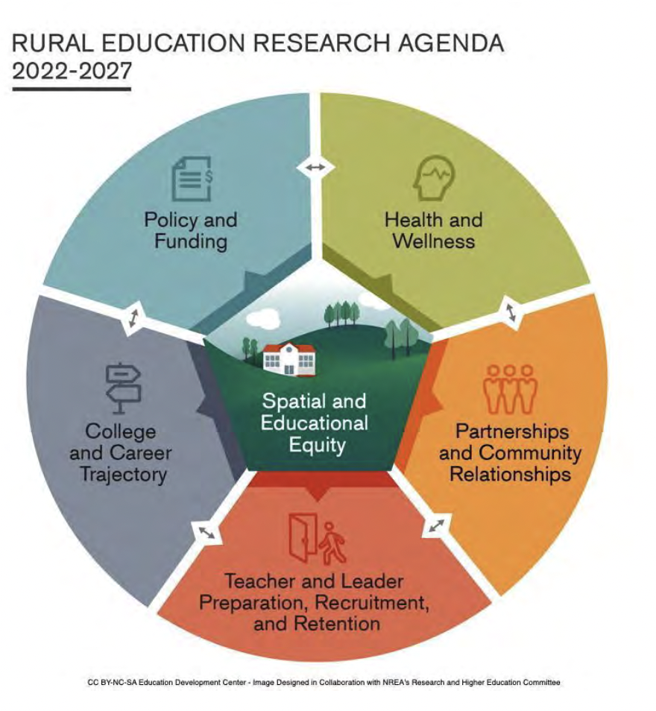

Figure 1.1. NREA Research Goals (Hartman et al., 2022).
Organization of the Dissertation
To conclude, the subsequent chapters are structured as follows. Chapter Two lays out the theoretical frameworks and literature that focuses on an understanding of the early care and education workforce, early childhood educator well-being, and the importance of adaptability for educators in navigating the different social systems that educators have to navigate each day. Additionally, Chapter Two is framed by two theoretical frameworks: the Critical Theory of Place (Greenwood, 2013; Sherfinski et al., 2021) and the Social Ecology of Resilience, which has been shifted to focus on the fluid construct of adaptability (Harney, 2007; Ungar, 2011; Windle & Bennet, 2012). Chapter Three expands on how critical narrative inquiry research methods and study design to answer the proposed research questions in this study. Additionally, Reflexive Thematic Analysis (Braun & Clarke, 2022) was utilized to reflexively analyze the data. Chapter Four describes the results and the factors that contribute to how educators conceptualize their well-being through place and factors of well-being. Chapter Five focuses on the discussion, future direction, and recommendations. The references and appendices follow.

Literature Review
The purpose of this literature review is to understand the structural barriers and larger systems of oppression that impact the well-being of the early care and education workforce. This literature review will also focus on the adaptability of the workforce. Further, this literature review will focus both more generally on the early care workforce and more specifically on rural early childhood educators living in Appalachian communities. This review of the literature intentionally seeks to understand the experiences of educators and to amplify their voices. Finally, this review gives more in-depth context, consideration, and insight into how rural educators conceptualize their own well-being and the factors that impact it.
This literature review, as with the rest of the study, is situated within a multi-paradigmatic approach to research that includes post structural, critical transformative, participatory paradigms (Carducci & Pasque, 2025; Hurtado, 2015; Mertens, 2010; 2017; 2019), acting as a catalyst that allows for the understanding that this research is grounded in the voices of marginalized populations that push towards means of justice through the amplification of rural educator voice (Carducci & Pasque, 2025). Noting that forms of social justice are not static and differ in varying spaces and among populations, this critical perspective will be a guide as co-constructed knowledge is built throughout this critical qualitative study (Carducci & Pasque, 2025; Hurtado, 2015; 2022; Pasque & Carducci, 2015). According to Carducci & Pasque (2025) scholars situated within this methodological framework work to explore and engage in inquiry practices that expand the contextualized understandings of both past events and the lived realities of systemic inequity and on-going challenges. Carducci & Pasque (2025), describe this work as being guided by multiple, “ontologies (being), epistemologies (knowing), methodologies (research design), and axiologies (ethics), and praxiologies (doing),” (Boylorn & Orbe, 2020; Hurtado, 2015; Pasque & Carducci, 2015, p. 267).
Further, this multi-paradigmatic perspective gives us base to understand the literature described in this chapter, building from theoretical frameworks, such as Critical Theory of Place and The Social Ecological Model of Resilience to literature that reflects the current state of the early care and education field and the iterative finings of this study to the importance of using decolonizing practices within the Appalachian Colony.
Theoretical Frameworks
Two theoretical frameworks guided this work, first being Critical Theory of Place, which emphasizes the importance of place and experience, both holding importance to rural Appalachian communities and individuals (Caudle et al., 2023; Greenwood 2013; Sherfinski et al., 2021; 2023). Additionally, the Social Ecological Model of Resilience (Ungar, 2011) will be considered from the lens of adaptability in order to understand how educators adapt to and within the factors that make up their daily experiences and impact their overall well-being.
Critical Theory of Place
Theory of place, also referred to as place-consciousness, or place pedagogies is the first theoretical framework that was used to guide this study in order to construct an understanding of rural educator well-being (Greenwood, 2013; Sherfinski et al., 2021; 2022). A critical paradigmatic view has been taken in order to grasp the differing realities for each educator and their conceptualized understanding of place. Place is understood as a fluid construct that is the center of experience where identities and relationships are formed, place is influenced and molded by the individuals that inhabit them (Greenwood, 2013). Through its fluidity, place is subjective to the individual and the space, shaped by the bounded biophysical, socio-political, and cultural environments. Geertz (1996) stated in Greenwood (2013), that “‘[N]o one lives in the world in general”’ (p. 259), signifying the importance of place by describing that individuals live embodied and emplaced. Due to the flexibility of place, place theory considers the knowledge of rural environments as a form of pedagogy that is conscious of the specific needs and demands that exist within an environment (Greenwood, 2013; Grunewald, 2003; Sherfinski et al., 2021). Again, place is sustained by the individual and the competing and compounding factors of their everyday lived experiences that contribute to how their world is shaped and reshaped. Considering this, we can understand that the individuals inhabiting rural, Appalachian places embody the cultural identities, past histories, contemporary happenings, and that the significance of their place within their environment contributes to their knowledge of self, their personal conceptualization of place and how they perceive their own well-being.
Third space is also a component of place-based pedagogies, third spaces are those that allow for movement and fluidity acting as an in-between where comfort is found and relationships are formed (Brown & Allen, 2021; Caudle et al., 2024). Third spaces are not always tangible, rather they are grey areas that exist in correspondence between groups of individuals that allows them to be further embedded within the construct of place; additionally, this allows for the critical intersection of lived and shared experiences to exist and varying forms of identity to be negotiated (English, 2004; Sherfinski et al., 2021; 2022).
Sense of place should also be considered a factor of adaptability as individuals living in Appalachian communities are documented feeling strong connections to the land, mountains, and natural environments (Bollinger, 2019; Caudle et al., 2023; Turman-Deal, 2010). Gragson & Bolstad (2006), describe the Southeast Appalachians as one of the many “Souths” denoting the location and cultural viability and specificity of the area that relates to an individual's sense of place. Additionally, critical theory of place aligns with the understanding of the intergenerational transmission of trauma, as it considers the passing down of lived realities which translate and manifest over time into the effects of exposure to on-going adverse experiences (e.g., situational poverty) passed through epigenetics and psycho-social patterns (Yehuda & Lehrner, 2018). This theory signifies the importance of understanding the differing environments that individuals navigate from day-to-day which includes all of the environments in which rural educators inhabit (i.e., community, home, school) as places hold on to and shape individuals' experiences (Greenwood, 2013; Sherfinski et al., 2021; 2022). Similar to trauma, place tangibly exists but is also liminal and temporal and individually defined by each person. It can vary day-to-day and throughout a lifetime. To each individual, place is fluid, adaptable, and a form of knowledge (Greenwood, 2013; Grunewald, 2003; Sherfinski et al., 2021; 2022).

The Social Ecological Framework of Resilience
The Social Ecology of Resilience is a resilience framework that is posited within the context of caring relationships and an individual's environment, which reflects the work of early childhood educators (Windle & Bennett, 2012). According to Windle and Bennet (2012), resilience is a process of negotiation and adaptation on behalf of the individual in response to situations of stress, trauma, and constantly occurring change. How an individual adapts is influenced by their overall assets and resources (e.g., housing, health, access to robust social and health services). Resilience is multilayered and includes factors relating to life circumstance, an individuals’ sociable environments, and their biology, including epigenetics (Panzeri et al., 2021; Southwick et al., 2014; Windle & Bennett, 2012). This study conceptualizes the Theory of Resilience from a perspective of adaptation, which is an on-going, fluid part of resilience. Adaptation is an ongoing process that occurs throughout an individual's lifespan in small ways involving complex interactions and intricacies between cognitive, emotional, physiological, and behavioral responses to shifting environments (Jones, 1978; 1991). Over time the ability to adapt turns into a resilience factor that is available to the individual and allows various means of coping and responding to change throughout their lifespan (Southwick et al., 2014; Windle, 2011). Additionally, adaptability within this context refers to the ways in which educators, children, and their communities adapt and navigate the small changes within their environment. Related to resilience, adaptability refers to an individual's ability to cope with and navigate changes and compounded factors of an individual's current environment, both large and small (Jones, 1991). Further, resilience is understood to be a multilayered adaptation and reaction to an individual's environment that is affected by their biology, psychological, and social and cultural factors (Southwick et al., 2014; Ungar, 2011). Resilience is built over a lifetime, while adaptability happens in the small moments, relying on the social capital of individuals to move forward through adversity and reframe their personal perception of the everyday.
The social ecology of resilience theoretical framework conceptualizes resilience across multiple indicators and describes how each indicator interacts with one another. According to work of Windle (2011), Harney (2007), and Ungar (2011), this framework reflects Bronfenbrenner’s (1979; 1994) human ecology framework, which posits a cyclically nested Bioecological Systems Model, see figure 2.1.

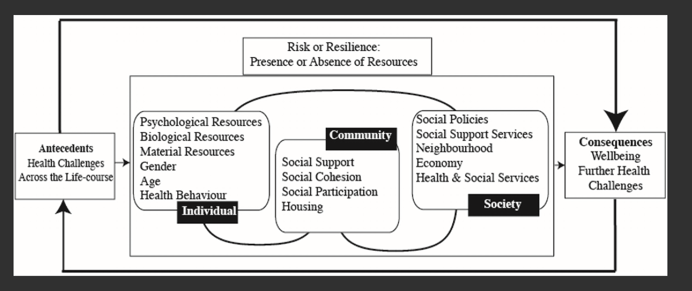
Figure 2.1. Adapted by Panzeri et al. (2021) from Windle & Bennett (2012) The
Social Ecology of Resilience Framework.

Similar to Bronfenbrenner’s model, the social ecology of resilience framework situates individuals within their context, in the environments in which they live interacting with both their community and society, see figure 2.2 (Windle & Bennett, 2012; Windle, 2011). Further noting that individuals do not live in isolation, but are influenced and interact with by their physical, social, and environmental contexts (Windle & Bennett, 2012). This model is a significant example of the importance of place and the iterative experiences of early childhood educators. The social ecology of resilience model is a clear example of how individuals do not exist in isolation and demonstrates how their place is fluid, shifting over time. In addition from an early childhood perspective this model provides fluidity in understanding how educators are adapting, shifting and responding in place to the differing realities that affect them, as individuals, at a community level (e.g., education requirements from the state, health and social services, structural and systemic barriers to the ECE workforce), programmatic level (e.g., school wide policies), with a research-practice partnership (e.g., time spent with university-researchers), and at the classroom level (e.g., working with children, challenging behaviors, working alongside families) all interact.
To conclude, from an adaptive perspective, the social ecology of resilience model adapted by Panzeri et al., (2021) from Windle & Bennett (2012) and Ungar (2011), along with the critical theory of place (Greenwood, 2013; Grunewald, 2003; Sherfinski et al., 2021; 2022), can be used to understand how early childhood educators conceptualize their own well-being. These theoretical frameworks work to support the educators’ everyday lived experiences and how they adjust and adapt within their environments.

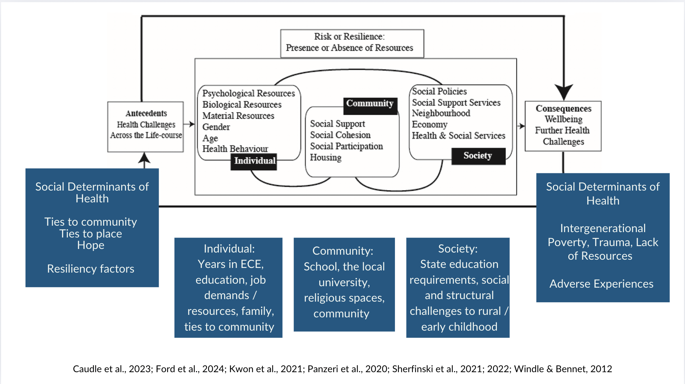
Figure 2.2. The Social Ecology of Resilience to the Social Ecology of Adaptability

Early Care and Education Workforce State and Educator Well-Being
Burgess et al. (2022) suggests the state of the workforce is inextricably linked to the well-being of early educators, which, in turn, is also linked to the well-being of children and long-term child outcomes (Roberts et al., 2019; Tirrell-Corbin et al., 2023). To improve the state of the workforce, holistic whole educator well-being concerning the physical, psychological, and professional well-being of educators must be considered (Cumming & Wong 2019; Kwon et al., 2021). There is a growing trend in the literature to define holistic educator well-being, that should be extended to also include relational well-being, as relational factors significantly intermingle and contextualize the factors that contribute to an educator's physical, psychological, and professional well-being (Cumming et al., 2017; 2020; Ford et al., 2024a; Kwon et al., 2021). Further, research should consider incorporating a strengths-based approach, that gives voice to educators who are implementing relational systems of care in order to lessen the effects of systemic challenges and improve the long-term state of the workforce (Haydon & van der Riet, 2017; Lessard et al., 2020; Ng et al., 2023; Roberts et al., 2019; Wolfe et al., 2023).
Historically, the Heckman Institute has suggested that early childhood education has a substantial return on societal investment and has shown to enhance long-term child and family outcomes, yet the early childhood workforce has not had substantial, long-term investment to improve working conditions or long-term social determinants to health of early care providers (Garcia et al., 2020; Heckman, 2011; 2012; McLean et al., 2021; Wolfe et al., 2023).
Subsequently, Whitebook et al. (2018) approximated that every day in the United States there are two million early educators, mostly women who are disproportionately Black Indigenous People of Color (BIPOC; Lessard et al., 2020; McLean et al., 2021), who are responsible and care of about 20 million young children across various child care contexts (i.e., center-based, public, private early care centers; Edwards et al., 2021; Kwon et al., 2020a; Lessard et al., 2020; McLean et al., 2021; Ng et al., 2023; Stein et al., 2022; Swigonski et al., 2021). Though the numbers have shifted since the onset of the COVID-19 pandemic with approximately 171,000 recorded early childhood jobs lost, the realities and status of the workforce has become further complicated (ACF, 2023; Elharake et al., 2022; Wallace et al., 2023; Wolfe et al., 2023).
Lastly, the early childhood education workforce lack means of financial stability (Phillips et al., 2016), health insurance, work benefits (i.e., long term retirement benefits, paid time off; Kwon et al., 2020a; 2021; Wolfe et al., 2023) or social capital. Often early educators rely heavily on public income support programs to secure their basic needs and face devastating long-term financial insecurity (McLean et al., 2021; Ng et al., 2023; Swigonski et al., 2021; U.S. Bureau of Labor Statistics, 2023). In 2015, the National Academics called for reform of systemic challenges and barriers to the success of educators and young children by transforming the workforce with the intention of sustainably improving the status of the workforce and relational systems of care (Karch, 2013; McLean et al., 2021; McCormick et al., 2022; National Research Council, 2015; Whitebook et al., 2018; Wolfe et al., 2023). Despite some remediation, early educators still experience barriers to well-being at all levels, impacting the overall state of the workforce and the long term, proximal outcomes of the young children they support (McLean et al., 2021; Ng et al., 2023; Roberts et al., 2019).
Major Components of Early Childhood Educator Well-Being
Though the needs of the workforce are vast and vary, current and past literature have suggested three overarching categories to conceptualize the construct of educator well-being to grasp the complexities of the individual educator and the workforce at large. These components include professional, psychological, and physical well-being (Cumming et al., 2017; Cumming & Wong, 2019; Edwards et al., 2021; Hall-Kenyon et al., 2014; Kwon et al., 2020a; 2021; McMullen et al., 2018). As stated earlier, educator well-being directly influences the state of the early childhood education workforce and the proximal trajectory and outcomes of children (Bellows et al., 2022; Cumming & Wong, 2019; Roberts et al., 2019). Furthermore, well-being, is a dynamic state that is often subjectively defined (Cumming et al., 2017), is understood as an individual’s ability to navigate demands across time, within differing circumstances, and settings (Ashford et al., 2006; Weiland, 2021), contextualized through the presence of feelings that are positive, suggest satisfaction with life, fulfillment, and self-efficacy (Center for Disease Control, 2018; Cumming, 2017; Hall-Kenyon et al., 2014; Kwon et al., 2020b; 2021; Veenhoven, 2008; Wolfe et al., 2023). Cumming et al. (2017) further states that educator well-being is the responsibility of the individual and relies on ongoing support and input across an individual's domains of well-being (i.e., psychological, physical, relational). Lastly, eudaimonic well-being is a deeper, more comprehensive form of wellness that involves finding opportunities for meaning making, personal development and growth, and purpose (Niemiec, 2024).
Educator well-being is contextual and relational. It should be considered through a holistic lens to account for the multi-dimensionality of educators themselves whose well-being is comprised of individual markers (i.e., physical, psychological, social, and emotional aspects; Cumming, 2017; Eadie et al., 2021; Liu et al., 2018), and external influences (i.e., psycho-social work and home environments; Cumming, 2017; Cumming et al., 2021; Ng et al., 2023; Wolfe et al., 2023). Further considerations to holistic whole educator well-being must include knowledge of the systemic barriers and challenges to success faced by the workforce (Edwards et al., 2021; McLean et al., 2021; McMullen et al., 2020).
Compounded with historical contextual factors, current structural inequities, and barriers to success (Karch, 2013), the workforce continues to lack means for upward mobility (McLean et al., 2021), relies heavily on social safety nets (Lessard et al., 2020), is burned out (McMullen et al., 2020; Ng et al., 2023), experiences high levels of turnover, between 26% and 47% each year (Blöchliger & Bauer, 2018; Eadie et al., 2021; Farewell et al., 2023; Grant et al., 2019; Ng et al., 2023; Phillips et al., 2016; Thorpe et al., 2020; Totenhagen et al., 2016), and experience feelings of invisibility (Ng et al., 2023; Quinones et al., 2021; Rogers, 2021). Furthermore, the workforce is emotionally exhausted and consistently experiences poor mental health outcomes (Farewell et al., 2021; Stein et al., 2022; Whitebook & Sakai, 2004; Wolfe et al., 2023). Educators are exposed to adverse experiences associated with work demands (Compton et al., 2023; Lawson et al., 2019; Sheehan et al., 2023) that lead to poor health and increased long-term social determinants to health (ACF, 2023; First Five Years Fund, 2021; Kwon et al., 2019; 2020a; 2021; McLean et al., 2021).
Adaptability of Early Childhood Educators
The history of early care and education is complex - built out of reaction rather than response to caring for children. The systemic function of caring for other people's children has roots in slavery, with Black individuals caring for the children of White landowners' children without proper means of care or compensation (Llyod et al., 2021). The trend of reactivity has continued as means of early childhood education have expanded in the United States, for example during both world wars women entered into the workforce and temporary care was created (e.g., Lanham Act, 1940; Karch, 2013). The early care and education sector responds to trends and societal needs representing one way in which the workforce is forced to demonstrate forms of adaptability.
There continues to be little structural and institutional infrastructure from a federal standpoint that protects and cares for the educators themselves, rather the policies in place protect the means of capital and the organization as a whole (Klien, 2013; Llyod et al., 2021). The structural and systemic fractures seep into every layer of early care and have contributed to the inability of educators to adapt within early care environments. Leaving them susceptible to secondary and compounded forms of trauma that are inherently a part of the early care and education environment (Caudle et al., 2023). Early childhood educators have always been adapting to their environment, structural challenges, the ways in which they care for young children, and their personal ways of knowing.
The early childhood classroom environment has been documented and described as a space of constant change that is both fluid and unpredictable (Granziera et al., 2016). Early childhood educators are constantly making small shifts throughout their day to meet the needs of the children, meet the demands of their job, respond to their peers, and care for the dimensions of their own well-being. Two of the major corresponding components of early childhood educator well-being is an educator's ability to make small changes quickly and adapt to their environment and their capacity to do so.
Jones, (1991) describes adaptation as an ongoing process, with complex interactions that relate to small changes made through an individual's day and overtime. Adaptation to change over time could be considered a resilience factor that is built throughout an individual's lifetime, as resilience is typically recognized as being socially constructed (Ellis et al., 2017; Ungar, 2014). While capacity is an educator's ability to hold attention to or self-traject toward means of adaptability (Jones, 1991). Capacity is dynamic and includes an individual's functional ability to adjust to change, often capacity has to do with a person’s physical and psychological capabilities (Ahmadi et al., 2025). Mainly studied in nursing and geriatric literature, capacity has to do with an individual's level of functioning and their ability to keep moving throughout their day, while simultaneously addressing challenges, making changes, and regulating themselves, often the term capacity is linked to capacity-building or intrinsic motivation (Mayangsari et al., 2025). Further, the capacity of an individual also has to do with the available resources and assets afforded to that individual and is impacted by the job demands and resources available (Farewell et al., 2022; Ford et al., 2024b).
Capacity and adaptability of early childhood educators are interconnected. Due to the demanding nature of the job, early childhood educators have to have some level of both personal and professional capacity as well as have the ability to adapt quickly in the classroom environment, when working through complex situations with children, peers, and supporting families day-to-day without burning themselves out. These daily complexities and challenges associated with the profession can lead to attrition and turnover in early care facilities (Bryant et al., 2023). The capacity of children to adapt to varying situations within the classroom (i.e., change in schedule, trusted adults being out) is also related to the capacity of the educators. Attuned relationships are a key component of capacity and the adaptability of each individual and the classroom environment as a whole (Perry, 2000; Plum, 2024).

Resilience as a Form of Adaptation
Resilience is a component of adaptability, and it reflects a long-term process that is built over time (Ungar, 2014). Resilience factors are built up from moments of adapting within an individual's environment. According to Southwick et al. (2014) and colleagues, resilience is not something all individuals inherently have. Instead, it is understood to be a multilayered adaptation and reaction to an individual's environment that is affected by their biology, psychological, and social and cultural factors. In rural Appalachian communities, resilience factors are a component needed to navigate the intergenerational, historical, environmental, and government funded adversities that continually affect the physical and psycho-social environments. Southwick et al. (2014) and the social ecological model of resilience (Ungar, 2011) note that resilience and an individual's availability to cope changes throughout the lifespan, adapting to the compounded factors of an individual's current environment. Masten (2014a & 2014b) define resilience as a dynamic system that allows individuals to adapt successfully to adverse experiences that threaten their ability to function. Panter-Brick and Leckman (2013) suggest that it is an individual's ability to harness the resources needed to sustain their own well-being. Maintaining well-being and successful adaptation are both subjective terms that depend on the individual's personal perspectives that often depend on the compounded factors that impact their life circumstances.
Due to the compounded systems of oppression that interact and impact an individual's ecological system at all levels, resilience has to be considered within context. For example, Caudle et al. (2023) and Eyre et al. (2017) share that communities in rural Appalachia are often subject to issues of economic insecurity, family and community well-being, food and health insecurity, and higher levels of social determinants to health, yet, despite the impact of these compounded factors, these communities are known for building exceptional resilience.
Additionally, resilience should be understood as a proximal process of adaptation that interacts with all systems within an individual environment (e.g., family, community, society, place), noting that within the social ecology of resilience framework, individuals are not in isolation and that there are means of resilience factors (i.e., assets) that support in mitigating the effects of adverse experiences. Further, due to the interconnected systems that impact an individual's ability to adapt and build resilience over time, it is important to consider the social capital of individuals and the assets they possess (Southwick et al., 2014). For example, early childhood educators in rural Appalachian communities' social capital may come from the responsive relationships they are able to build with young children and their families, within their connection to other educators, the environment, having access to financial resources, or their personal communities and the impact of having or sustaining hope (Eggerman & Panter-Brick, 2010; Farrell et al., 2003; Southwick et al., 2014).
Adaptation as a Form of Hope
In addition to factors of resilience, it is important to consider the impact of hope, or the sense of hope, that connects the past circumstances to the present and is considered a part of meaning-making (Eggerman & Panter-Brick, 2010; Southwick et al., 2014). Hope and resilience are mitigating factors that may be able to decrease the long-term impact of adverse experiences that occur or are sustained within an individual's environment. Snyder (2002) and Ong et al. (2006) suggest that hope serves as a form of adaptation both are directly related to an individual's well-being and also holds an important role in mitigating or moderating adverse life experiences. Hope is considered to be connected to agency or successful determination in meeting goals or moving forward (Snyder et al., 1991). Additionally, Snyder et al. (1991) defines hope to be an individual's ability to build successful pathways to meet goals and is understood as cognitive agency, a form of social capital that allows individuals to move forward in adversity and reframe their perception.
In rural Appalachian communities hope should be considered a form of adaptation that leads to longform resilience. However, hope also represents a form of resistance to the cultural, economic, and environmental depletion (Caudle et al., 2023; Trozzo et al., 2019; Zipper & Shousen, 2021). Hope is understood as part of a sense of continuity and stability that is connected to an individual's sense of belonging and place (Bollinger, 2019; Caudle et al., 2023; Sherfinski et al., 2021; 2022). Additionally, hope can be found within community social capital and values. In rural Appalachian communities this can be seen as forms of spirituality or religion, connection to the land and the mountains in which they live, and through informal means of community, such as found family (Caudle et al., 2023; Helton & Keller, 2010). Further, hope in rural Appalachian communities can be understood as a way for women to consciously represent forms of agency (Harel-Shalev & Daphna-Tekoah, 2018) and acts as a mitigating factor against intergenerational and environmental social determinants to health and contextual factors that may be out of an individual's control. The following section will look further into the history and experiences of individuals living within rural Appalachian communities.
The Appalachian Colony
Referenced throughout the various forms of literature that have been compiled to provide an understanding of the factors that impact educator well-being within the contextualized factors of rural Appalachian communities, is the understanding that neo-liberal, anti-White hegemonic, decolonizing practices have to be implemented in order to listen to adequately and responsively and support individuals living in rural Appalachia. Post structural, critical paradigmatic views take this into consideration when considering the temporality of place, history, and counterarguments that socially build a constructed narrative of individuals (Carducci & Pasque, 2025).
The Appalachian Colony (Lewis, 1978) is understood through the practice of colonialism that has and continues to occur within and throughout the Appalachian region. This region of the United States should be seen as a colony due to the process of colonization that continues to occur within the mountains and these perspectives can be used as a framework to understand the structural, community level experiences of living within Appalachia. This perspective is opposed to current narratives about the region which do not take into consideration the cultural wealth, generational knowledge, connection to the land or experiences of place, or structural resilience of individuals living in rural Appalachian communities (Lewis, 1978; Sherfinski et al., 2021; Southwick et al., 2014; Turman-Deal, 2010).
The Colonialism Model (Lesser, 1970; Lewis, 1978) is relevant when means of classical colonialism (Blauner, 1969) occurs, as large companies (i.e., agents of change) move into the Appalachian region under the guise of addressing social determinants to health or resolving problems of place typically attributed to the individuals living in the region. Agents of change do this rather than assessing the community's sense of place and connection as a form of adaptation, culture, or a protective factor.
Blauner’s (1969) model of classical colonialism suggest four complex, components of colonization that have taken place within the Appalachian region, including forced, involuntary entry, acculturation of the dominant population, entry of the colonizer understood through the rapid structural changes occurring to the physical and socio-political environments, technological advancement, forced relationships and practices, and conditions of racism.
Historically, the peoples of the Appalachian region have been referred to as having a lack of social capital, as poor, White, lacking culture or as, “a backwards and primitive people [who] cannot cope in the modern world” (Lewis, 1978, pg. 2). This deficit perspective is derivative, disheartening, and upholds White structures and practices of oppression and power. It has been used as an excuse for the United States government and others to attempt to save the Appalachian inhabitants from perpetuating problems of poverty and underdevelopment (Lewis, 1978). This has led to colonial domination and exploitation by those who are outsiders to the Appalachian environments. The Appalachian Mountains are some of the oldest lands in the world and have seen forms of physical and socio-political destruction and colonization reiterated in a multitude of ways overtime.
Some historical examples include the Indian Removal Act of 1830 and the intentional displacement of indigenous people and destruction of ancestral lands (Sturm, 2008), the labor movements of the 1890’s, the inflicted health disparities and environmental depletion brought to the region by way of mountain toppling, coal mining, and the creation of the Tennessee Valley Authority (TVA; Caudle et al., 2023; Hendryx & Ahern, 2008; Klein, 2011). Most recently, the ongoing opioid epidemic continues to destroy communities and health systems within the region. Lastly, the continued depletion of environmental resources and pollution act as modern forms of colonialism in Appalachia (Schalkoff et al., 2020; 2021). The effect of Hurricane Helene occurring in September of 2024 is an example of the structural forms of oppression that can affect the physical land, see figure 2.3. Due to the storms capacity, lack of human-made infrastructure and failing emergency systems, the land had no way of protecting itself from landslides or lack of soil absorption (i.e., soil degradation) due to long term anthropogenic factors (Lin et al., 2024; Miller & Foubert, 2025). These conditions have been further exacerbated by fires that are now raging across the mountain landscape in the same areas that Hurricane Helene decimated, see figure 2.4 (Runkle, 2025).
Through the use of decolonizing practices and a transformative, participatory paradigm Lewis (1978) reports that deconstruction and dismantling of current practices and perspectives for the Appalachian region needs to occur in order to radically structure and redistribute resources to the seemingly, “poor and powerless,” individuals of Appalachia.
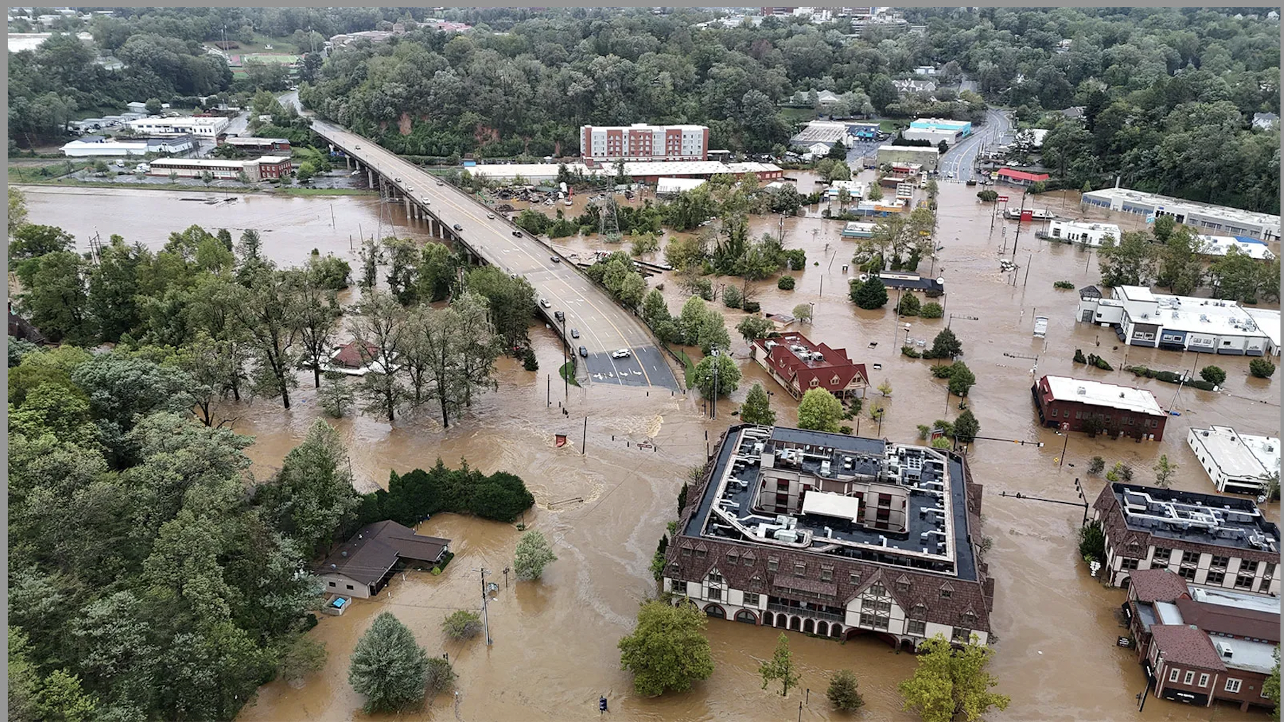
Figure 2.3. The Aftermath of Hurricane Helene (Rafferty, 2025).
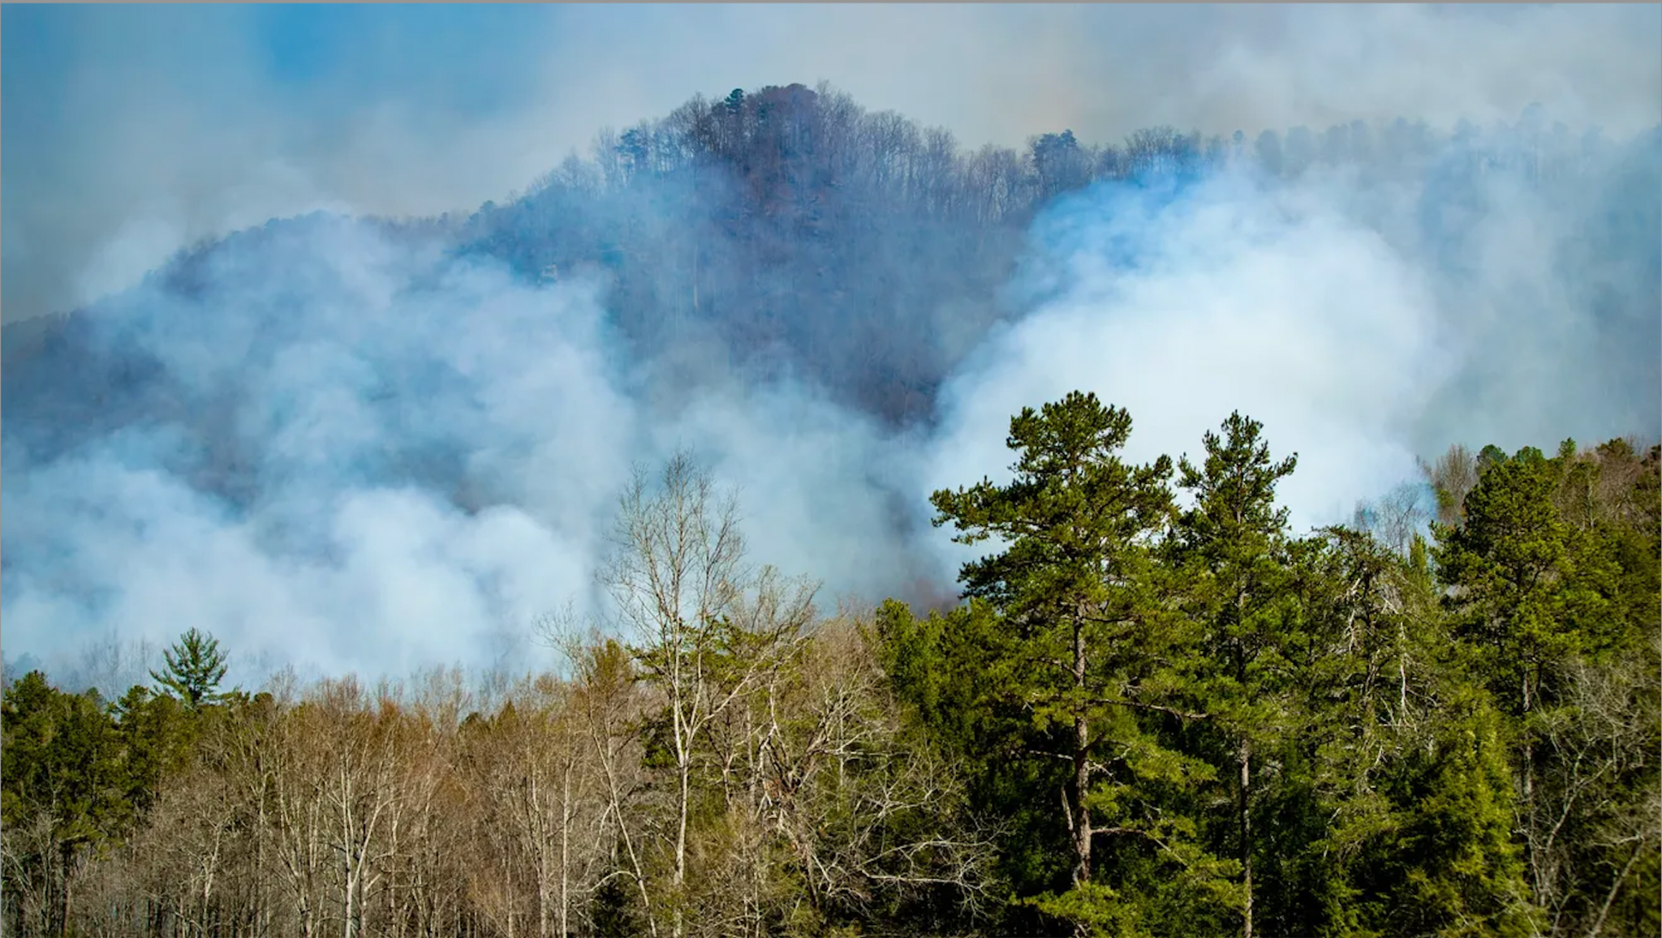
Figure 2.4. Fires in Southeast Appalachia Six Months After Hurricane Helene (Runkle, 2025).
The Rural Appalachian Early Childhood Workforce
In rural communities, schools are often situated as community spaces that provide local communities with the opportunity to access basic needs. Schools act as protective factors for young children and provide opportunities for families to access preventative health care, mental health literacy, and other community, social, and state organized services (Brown et al., 2022; Caudle et al., 2023; Crumb et al., 2021; Lewis et al., 2023; Murphy et al., 2013). The shift towards schools as a community asset is often met with an attitude of resistance towards education that has been slowly evolving since the 1980s, when Reck and Reck (1980) reported that rural Appalachians do not correlate educational environments with meeting the needs of the rural community, pointing out that the colonial model of education continues to be the source of the deconstruction of cultural pride. This distrust in education, compounded with under-resourced environments and layers of intergenerational and secondary trauma, are part of what rural early childhood educators navigate on a daily basis in order to support young children living in rural Appalachia.
Rural early childhood educators are often part of the greater community where they live, work, and teach in spaces in which their own children also participate (Leech et al., 2022). The educators are especially important in rural communities as they often act as the first line of defense in supporting children and families in obtaining social and educational support services (Brown et al., 2022; Lewis et al., 2023; McClain, 2021; Sano & Mammen, 2022). Additionally, they provide care within community spaces that are considered childcare deserts, addressing the 35% gap that exists between the need for available care (Rodriguez, 2024).
In addition to being considered childcare deserts, these rural areas should also be considered educator deserts as they often lack available certified educators or community resources needed to sustain care. This shortage of educators and accessibility of care exacerbates the disproportionality of responsibility that falls on women to stay home with children when community care is unavailable (Rodriguez, 2024). Furthermore, there is little current research on the demographics and the overall status of the rural early care and education workforce besides comprehensive white pages, such as McLean et al. (2021). The work of McLean et al. (2021) focuses on the broad availability and accessibility of care and workforce factors more broadly across the United States, specifically focusing on factors of well-being across states without considering rural contexts specifically. Obviously, structural barriers and social determinants of health that most early educators encounter (e.g., insufficient pay, reliance on government assistance, lack of workplace benefits, chronic stress, and burnout; Kwon et al., 2020a; 2020b; McLean et al., 2021; Ng et al., 2023) likely also impact the lives of rural educators, but little else is known.
Grist and Caudle (2021) found that early childhood educators have higher, more disproportionate levels of adverse childhood experiences in comparison to the general population, which likely shifted since the onset and effects of the pandemic. Compounded by feelings of isolation (Hubel et al., 2020; Ford et al., 2024a; Mahfouz, 2018; 2020) that may occur in the classroom environment, lack of resources, or support, educators in rural spaces are often left to navigate complex situations in order to provide quality care that young children need (Henning-Smith & Kozhimannil, 2016; Murphy et al., 2013). Further, there continues to be little known research on the effects of adverse experiences of rural early educators, outside of generalized adverse experiences and known social determinants to health that are often associated within individuals living in rural Appalachian communities (Crouch et al., 2020; Yuan et al., 2022).
Indigenous Appalachian Communities
Though there has been an increase in literature exploring the experiences of rural communities in the United States, studies explicitly focused on the rural indigenous communities of Appalachia and rural communities living within the Appalachian region remain limited (Gottron, 2020; Schafft, 2016). Gottron (2020) suggests that the Appalachian region itself, though containing a large population and a sizable geographical region, has been left out and is on the periphery of scholarly research. More recent work by Fiorentino et al. (2024) suggests that rural Appalachian communities and especially those where indigenous individuals inhabit, have been purposefully left behind, contributing to the compounded adverse experiences and the continued perpetuation of White hegemonic practices of capitalism.
The layers of Appalachian culture are not just bound physically through place, but also through means of spirituality, the environment, but through topography and connection to the land. This is especially true in the Southeastern state where this study is geographically located. The educators in this study and the pre-kindergarten center where the study took place support young children and families who identify as indigenous, as part of the Eastern Band of Cherokee Indians. Additionally, some of the educators or their families identify as part of the boundary. This boundary encompasses much of the land, the social-political landscape, and protective factors (i.e., assets or resources) are available for young children. Informally, it has been shared with the partnership that at least half of the children and educators have some affiliation with the indigenous community. Importantly, very few instances of professional learning or cultural responsiveness to working alongside indigenous families have been mentioned by the educators in this study or in the literature. Most formal education or P-21 education literature focuses on the experiences and outcomes of older children and families.
Rogers and McLendon (2015) suggest that decolonizing practices have to be incorporated into educational systems to support children and families from indigenous communities. They further suggest that Tribal Critical Theory (TribalCrit; Brayboy, 2005) may be the most appropriate lens in which to understand the experiences of indigenous individuals. Brayboy (2005) suggests colonialism and racism are so deeply ingrained within everyday experiences that it is often misunderstood or invisible and that decolonizing practices have to be integrated into school systems; this includes early childhood and caretaking practices. In the early childhood classroom environment in which White, female educators are dominant, this may be expressed as a need to change the behavior or patterns of young indigenous children (Rogers & McLendon, 2015).
To conclude, Chapter Three will focus on the research design, methodology, and analysis in order to showcase the practices put in place that have led to an understanding of how rural early childhood educators conceptualize their own well-being.

Research Design and Methodology
Contemporary literature does very little to conceptualize the lived experiences and everyday realities of the early care and education workforce (Lloyd et al., 2021; Zaslow et al., 2010). Currently, most available literature offers a broad, scoping view of the workforce that posits limited understanding of the systemic and structural barriers that educators and the early care sector have to navigate within differing early childhood contexts. As well, there is even less known literature of educators having the direct opportunity to share their experiences, through narrative methods (Kim, 2016). This is especially true in relation to how educators are positioned and how education systems value early childhood educators' ways of knowing and personal understanding of and aspects that contribute to their own well-being (Kwon et al., 2021).
This study investigated the phenomenon of how rural early childhood educators conceptualize their own well-being and factors that impact their well-being. This conceptualization can be best understood through the direct narrative and voices of five rural, Appalachian pre-kindergarten early childhood practitioners. This study is a starting point; it fills a very small gap of the ever-expanding lack of literature that directly shares the voices of early childhood educators and expands the literature currently available on rural, Appalachian early childhood education and the lived experiences of the educators working within the contextualized early childhood environments. Additionally, this study amplifies the voices of rural, Appalachian educators from Southeast Appalachia, which has been very few and far between, one of the last known references of the experiences of rural Appalachian educators being from a Head Start study Leigh O’Brien published in 1993. This study contributes to the field of early care and education current understandings of the factors that impact educator well-being in rural, Appalachian early care and education contexts. Across all three years of data collection the intention has and continues to be that this study will act as a space for the amplification of educator voices and their experiences through narrative forms of storytelling. Additionally, the voices of educators and amplification of their experiences is one of the ways in which the early care and education sector is able to mitigate structural and systemic barriers to the field and increase the longevity of early childhood educators.
This chapter is organized to represent the data collections across all three years of this study and the involved process of Reflexive Thematic Analysis (RTA). The study design and methods are described in detail. This includes information about ethical consideration, privacy of the educators, researcher positionality, and limitations and delimitation of the study.
Through reciprocal relationships, educator voices are shared through means of critical narrative inquiry, solidifying as vignettes in chapters four and five. The data collection process for this study posited educators to have the autonomy and space to share their experiences through individual check-in meetings (Datnow et al., 2023). Within these check-in meetings, space could be considered liminal and reflexive in nature; this allowed the educators to sit and reflect within a perceived third space that is not traditionally allocated to educators (Bhabha, 2004; Brown & Allen, 2021; Caudle et al., 2024). Further this study utilized relational and culturally responsive methodological strategies (e.g., deep hanging out; Geertz, 1998) and kitchen table methods (Edwards et al., 2021; Kohl & McCutcheon, 2015; Folkes, 2022; Phillips, 2006). Through these in-depth methodological strategies, this study examined the cultural, systemic, and structural barriers that are related to rural educator well-being. Within this study, I implemented a social constructivist, onto-epistemological stance through a post-structural transformative, participatory paradigm, through which a collective, critical narrative inquiry forms of qualitative research were utilized to answer the research questions. Further, the personal positionality and the naturally reflexive process of partnership-based research was considered. Through both the reflexive process, reflexive thematic analysis, educator ways of knowing, and the study of experiences as stories through critical narrative inquiry (Pino Gavidia & Adu, 2022), this study conceptualized the factors that contribute to rural educators’ well-being. The stories and experiences of the educators themselves gave insight into the multiple facets of their lives that contributed to their well-being.
This work is conceptualized through critical narrative inquiry (CNI) as a way to deconstruct narratives to examine individual assumptions, values, and build conceptualization of individual educator well-being through constructed understanding of meaning making (Pino Gavidia & Adu, 2022). Finally, this study contributes to the current early childhood literature, as it provides a deep, holistic understanding of rural early childhood educator well-being through individual and collective narratives of the experiences of rural early childhood educators. This study directly contributes counter narratives to the current, growing gap and trend in education that excludes the voices of early childhood educators from the literature. Additionally, this study extends the current literature and known understandings of rural, Appalachia early childhood educators from the Southeastern United States, recognizing the power of and importance of individualized experiences. Amplification of the importance of educator experience and voice is critical to the sustainability of the field and contributes to the deconstruction of systems of oppression and power, when educators are directly included.
Rationale for Critical Qualitative Methodology
Making use of critical narrative inquiry study design, this study provides a comprehensive perspective of the factors that impact the well-being of rural early childhood educators (Buestto et al., 2020; Butina, 2015). Posited within a post-structural paradigm, critical narrative inquiry methodologies bring together collective narratives that engage in critically analyzing the lived experiences and told stories of individuals to understand a specific phenomenon, while also critically analyzing structures of power (Clandinin & Murphy, 2009; Clandinin & Rosiek, 2007; 2019). This form of critical qualitative research is the most appropriate form of study design as critical narrative inquiry and place-based pedagogies alongside the tellability (Kurlinkus & Kurlinkus, 2018; Riffe-Snyder et al., 2022; Webb-Sunderhaus, 2016) and storytelling aspects of Appalachian cultures are a way to engage in sociality, temporality, and place (Pino Gavidia & Adu, 2022). Further, critical qualitative research methodologies utilize a cross-disciplinary approach that emphasizes the importance of the human experience, lived experiences, and approaches research with the belief that realities are socially constructed in order to generate new in-depth understandings and outcomes (Alele & Malau-Aduli, 2023; Bunniss & Kelley, 2010; Butina, 2015; Scotland, 2012). Further, qualitative methods allow researchers to capture in-depth details through open-ended data collection methods that are considered thick descriptions (Butina, 2015; Geertz, 1973; Merriam & Tisdell, 2015); this allows the researcher a window into the lived experiences and identities of the participants (Alele & Malau-Aduli, 2023; Butina, 2015; Clandinin & Rosiek, 2007; Patton, 2002). Qualitative research is collaborative, based in relationships, and allows for the shaping and re-shaping of design complexity as a moving, iterative process that is open and flexible, allowing for the emergent movement of data (Busetto et al., 2020).
Critical Narrative Inquiry
This study utilized a critical narrative inquiry approach informed by Kim (2016) and Pino Gavidia and Adu (2022), which has been historically informed by Connelly and Clandinin’s (1990) description of narrative inquiry to address both research questions. Using a critical lens to conduct the narrative inquiry allowed for critical reflection and fluid forms of reflexivity to take place, which provided a framework to explore assumptions around knowledge, power, and construction of meaning, through the deconstruction of individual narratives or stories (Hickson, 2016; Pino Gavidia & Adu, 2022). Critical narrative inquiry is an interpretive approach that is collaborative in nature and a reflexive method of exploring the lived experiences of others; this form of qualitative research often occurs within relationships (i.e., researcher - educator; educator - child) that are constructed within communities of care (Connelly & Clandinin, 1990; Clandinin et al., 2007; Kim, 2016).
Complimented by the gap in the early childhood literature concentrating on educator well-being, critical place-based pedagogies, and critical narrative methodologies - Pino Gavidia and Adu (2022) share that storytelling is rooted in individual and collective “expression of living, telling, and retelling experiences,” (Buce et al., 2016). Stories intersect through socially constructed means of meaning making and how an individual conceptualizes and shapes their daily lives in conjunction with the perceived structural and social barriers that affect the complex systems of an individuals’ every day (Pino Gavidia & Adu, 2022). Further, critical narrative inquiry and place-based pedagogy are rooted in belonging (Duhn, 2012; Sherfinski, 2023). This methodology provides space to construct both meaning and collective understandings through inscribed stories that act as knowledge paradigms situated with constructed systems of power (Pino Gavidia & Adu, 2022). Through the process of critical narrative inquiry, meaning making is situated through the deconstruction of stories - highlighting the reality of place-based paradigms to explore the multidimensional perspectives of human action, society, and culture (Braun & Clarke, 2019; Clandinin, 2006; Clandinin et al., 2007; Kim, 2016; Leavy, 2009; 2020).
Centering the voices of educators (individuals) forms of knowledge are developed through in-depth descriptions of sociality, which encompasses personal and social conditions (i.e., individual hopes, power structures; Clandinin et al., 2007; Dewart et al., 2020; Pino Gavidia & Adu, 2022), temporality, the place based understanding that an individual's stories exist within the context of time, connecting the past to the present and the present to the intentions of the future (Dewart et al., 2020; Pino Gavidia & Adu, 2022), and lastly, place, which references the physical environment(s) in which everyday life experiences are happening and unfolding overtime (Dewart et al., 2020; Pino Gavidia & Adu, 2022). Finally, a co-constructivist, participatory paradigm compliments a critical narrative inquiry study design as it allows for a fluid modality of storytelling that leans into the reflexivity of self as individuals explore their own conceptualizations. This reflexivity allows for the co-construction of knowledge and understanding by addressing both trustworthiness of the researcher-participant relationship and situated structures of power with the research (Danielsson & Berge, 2020).
Community-Based Methods. To further complement the inter- and intrapersonal qualities of critical narrative inquiry and qualitative research, community-based methods were utilized. Community-based research methods follow a participatory paradigm that builds on the strengths of the community and involves researchers and participants as co-collaborators (Burke et al., 2013; Filler et al., 2021). Community-based methods are similar to the work of Geertz’s (1998) and the concept of deep hanging out, which involves co-collaboration through capacity building in order to understand others’ ways of knowing (Israel et al., 2005; Vaughn et al., 2020). Study design, data collection, and analysis throughout all time points of data collections were considered within the context of deep hanging out, as the I, the researcher, was embedded and in partnership with educators.
Deep Hanging Out. Geertz (1998) shared that deep hanging out occurs when the researcher spends a significant amount of time in localized, vernacular field research to ensure long-form relationships and contextual understandings. This methodology includes the chance for navigation and negotiation of both insider and outsider positionalities, through personal lived experiences within context (Woodward, 2008).
Kitchen Table Methodologies. Kitchen table methods (Edwards et al., 2021; Kohl & McCutcheon, 2015; Phillips, 2006) were also used throughout the research process, based on proximity, time spent, and conversations that took place within the natural environment of the educators. Which includes spaces such as the classroom and a community table which is situated in the most centralized part of the pre-kindergarten building. This table is a mutual junction between each of the classrooms. Kohl & McCutcheon, 2015 coined the term, kitchen table reflexivity, that describes the importance of everyday talk, formally and informally, as a tool for exploring positionality, see figure 3.1. Finally, due to the distance and rural proximity of the educators, kitchen table methodologies were used to navigate and establish Zoom as a third space (Bhabha, 2004; Brown & Allen, 2021; Caudle et al., 2024).
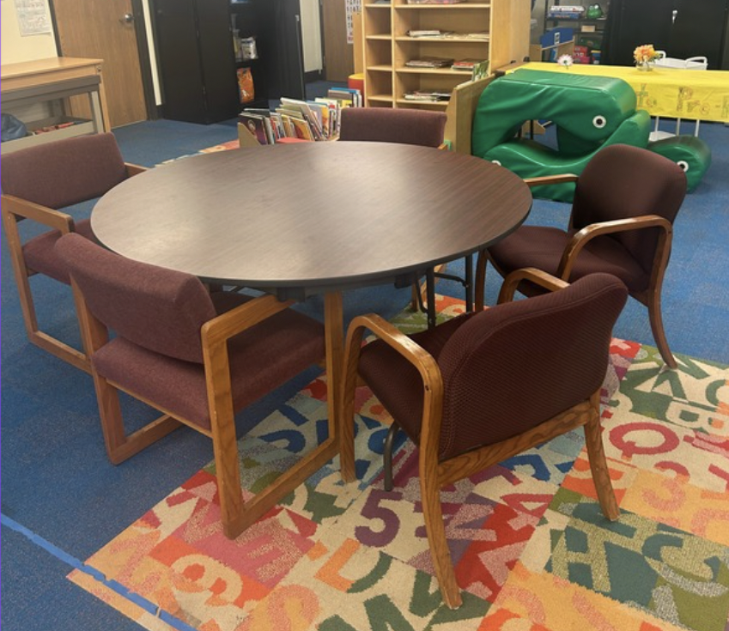
Figure 3.1. Where We Meet, Blue Mountains
Social Constructivism Onto-epistemological Paradigm
The epistemological stance of social constructivism negotiates how knowledge is constructed and embodied in critical qualitative work; this stance is shaped by structural and paradigmatic values (Pino Gavidia & Adu, 2022; Ponterotto, 2005). This epistemological and ontological stance describes the subjectivity of the intersecting human experience, through constructed meaning and understanding of their environment and own lived experiences. In this study, the well-being of educators is understood through social cultural factors and systems that affect their every day (Creswell et al., 2007; Scotland, 2012; Ültanir, 2012; von Glasersfeld, 2013). Accordingly, the conceptualized stories that impact educators' well-being are narratives that are social creations and do not spring from the minds of individuals (Pino Gavidia & Adu, 2022; Smith & Sparkles, 2005, p. 3). Ültanir (2012) shared that constructivism is critical in nature and guides the researcher to engage more deeply in reflection, social consciousness, imagination, and other social structures oriented towards social justice (Creswell et al., 2007; Scotland, 2012). Methodologically, a social constructivist epistemology and ontology allow the researcher to view research beyond a single axis orientation (Edwards et al., 2021) to ensure a collaborative experience in which meaning is built alongside participants, and participants are understood as partners. Just as children’s learning is developed and influenced by the complex, interdependent and interfacing systems of relationships (Bronfenbrenner, 1979), so are adults, relationally built through socially constructed meaning and the subjective interpretation of personal experiences (Wolfe et al., 2023).
Researcher Identity: Early Childhood Educator
Although I have been out of my own classroom for the past six years, I continue to consider myself as part of the early care and education workforce and as an early childhood educator. As stated in Chapter 1, the term early childhood educator expands to all community partners who contribute to and work alongside children, families, and communities. I would like to expand this definition by including those who work alongside early education professionals that collaboratively work to solve problems, find, and provide resources, and share the lived experiences and realities of the individuals who care for our youngest learners. This researcher identity is important to me, as I navigate the liminal space that exists between the two dichotomies of being highly educated, White and in a position of power, as compared to the typical demographic of early childhood educators, who are most often women of color, have a high school diploma or some college credit (McLean et al., 2021).
Early childhood educator, as an identity, provides the base for common language and experience navigating structural barriers and supporting young children and gets me in the door. Though it is a shared identity with the educators participating in this study, it does not bear knowledge that all experiences are shared, conceptualized, or reacted to in the same way. Instead, it leverages me to have a small pocket of an insider position which allows me to advocate for the dismantling of structural barriers and the affordance to amplify and center the voices of early educators in all spaces.

Ethics of Care

Considering relational ethics of care are essential in research-practice partnerships, and in critical narrative inquiry, considerations are in place to ensure the confidentiality of the educators and the school environment (Clandinin & Caine, 2008). Additionally, when supporting educators who have had experience with secondary trauma and adverse experiences, it is important that trauma-reducing care strategies are implemented throughout data collection (Lin et al., 2019; Risan et al., 2020).
Ethics of care have to be considered throughout all collaborations, Clandinin et al. (2007) stated that lives become connected through ethic(s) of and communities of care, reaching far beyond institutionalized ethics, and exists beyond study dissemination (Pino Gavidia & Adu, 2022; Smythe & Murray, 2000). This includes informal and formal opportunities to check-in with the educators, asking for verbal consent before recordings take place or the start of project activities, and reminders that they always have the option to opt out, pause, or end research activities (Lin et al., 2019; Risan et al., 2020). Ethics of care are an embodied practice understood through reciprocity and relationships constructed between the educators and the researcher that allow liminal space for mutuality and co-composition of inquiry (Blix et al., 2019; Caine et al., 2020; Haydon & van der Riet, 2017). Furthermore, ethics of care go beyond the required forms of institutional ethics; this form of ethical consideration is reflexive and requires give and take from the researcher themselves as participants in the co-construction of knowledge (Blix et al., 2019; Braun & Clarke, 2019; Caine et al., 2020; Haydon & van der Riet, 2017).
Participants
As described in Chapter One, the educators whose stories are shared during individual check-in meetings are early childhood educators from a rural Appalachian community in the Southeast United States nestled among the Appalachian Mountains; these educators had consented to be a part of research under the TIPS Partnership IRB. After all, ICM were complete all fourteen educators from Blue Mountains were asked to participate in a qualitative questionnaire, the contextualized voices from the educators were included in this study. An important note is that each of the educators holds a different role at Blue Mountains (BM) Pre-Kindergarten program and all of them have been a part of the TIPS Partnership, which again is a larger, long-term research-practice partnership. Additionally, I have worked to establish responsive relationships and rapport with each of the educators over the past three years and have worked alongside university faculty, Dr. Lori Caudle and Dr. Cathy Grist, within the larger context of the TIPS Partnership, who have established long-term relationships with the Blue Mountains educators and across the community.
The five educators chosen for this study represent the five roles that early childhood educators can potentially hold within a traditional, public pre-kindergarten facility. Each of these educators holds a critical role in both their classrooms, the program as a whole, and within the community. The inclusion criteria for this study are grounded in geographic characterization and relational aspects of partnership participation (Connelly, 2020; Palinkas et al., 2015; Patton, 2002; Pilot & Beck, 2018). The Blue Mountains educators are the most appropriate individuals to share their experiences as highly qualified rural educators who are the most deeply engaged with the chosen phenomena of interest, factors that impact rural educator well-being (Palinkas et al., 2015). Additionally, if the educators are from the same classroom (i.e., lead educator, assistant educator; Developmental Day lead educator; Developmental Day assistant educator), in order to account for anticipated classroom dynamics and relationships. This includes the role of director, Cora, lead educator, Pearl, and assistant educator, Kit, in a typically developing classroom that serves young children who do not identify as having developmental disabilities or delays. Wiley served as the lead educator of a developmental day pre-kindergarten classroom and Winnie continues to work as an assistant educator in a developmental day classroom context.
Winnie. Winnie is a 40-year-old, White woman who grew up in a rural community similar to Willow Oak, the county in which Blue Mountains resides. Winnie is in her second year at Blue Mountains and has been in the field of early childhood education for two years. During the academic year 2023-2024, Winnie had a four-year-old child attending Blue Mountains who was in Pearl and Kit’s classroom. Winnie is an assistant educator in a Developmental Day classroom serving three- to five-year-old children that are considered to have high needs or developmental delays. She was Wiley’s assistant during the 2023-2024 academic year and is now working alongside Stella and Skyla for the 2024-2025 academic year.
Wiley. Wiley is also a 40-year-old, White woman that grew up and continues to live in the Willow Oak community. She has worked at and or been associated with Blue Mountains for over 17 years. Wiley started as an assistant educator and moved into the role of Developmental Day lead educator in 2021. Further, Wiley’s family has a generational stronghold of working in early childhood education spaces, as her aunt was the director of Blue Mountains in the early 2000s, and she has other family members who hold roles within the public school system in Willow Oak. Wiley has three school aged children and is heavily involved in the local community (i.e., at church, in a volunteer capacity, and with the local indigenous community). Wiley has been in the field of early childhood education for 18 years and is currently pursuing her master’s degree in Early Childhood Intervention and Family Studies. Wiley moved on from Blue Mountains Pre-K after the 2023-2024 academic year, transitioning to a coaching position at a federally funded early childhood education facility. Wiley is still involved at Blue Mountains and the TIPS Partnership through continued collaboration and outside involvement.
Cora. Cora is the director and sole administrator of Blue Mountains Pre-K. She has held both the role of lead educator and director during her tenure at Blue Mountains. Cora is a 42-year-old, White woman with a Master of Education degree in Birth to Kindergarten (2008). She has two school-aged children who attended Blue Mountains in the past and grew up in the local community. Cora has been in the field of early childhood education for 20 years and has been at Blue Mountains Pre-K for 17 years. Cora moved into the role of director in 2015.
Pearl. Pearl is a 39-year-old, White woman that grew up in a community similar to Willow Oak. Pearl has a master’s degree in Christian Education and has been in the field of early childhood education for 14 years. Before coming to Willow Oak, she worked at a daycare facility. Over the past 10 years, she has been both an assistant educator and a lead education at Blue Mountains. Currently, she is a lead educator in a typically developing classroom at Blue Mountains and her assistant educator is Kit. Pearl had a child at Blue Mountains from 2022-2024 in Somers and Lilia’s classroom.
Kit. Kit is a 33-year-old, White woman from a northern state. She relocated to Willow Oak to be near her partner's family. Kit has been in the field of early childhood and at Blue Mountains for three years working alongside Pearl as the assistant educator in a typically developing pre-kindergarten classroom. Kit is currently in school at the regional college, finishing her Bachelor of Arts in Early Childhood Education. During the 2024-2025 academic school year, she will begin her teaching practicum. Kit has one child that is school-aged and did not attend Blue Mountains pre-kindergarten. To conclude, figure 3.2. further shares educator demographics.
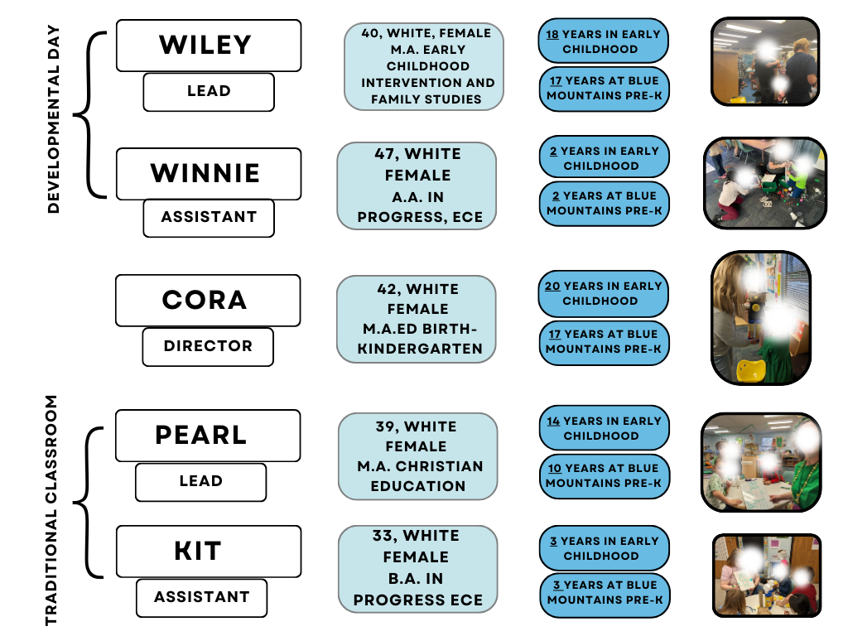
Figure 3.2. Educator Demographics
Research Context
Blue Mountains pre-kindergarten is a rural early care and education center, serving young children ages 3 to 6 and their families, nestled in the Appalachian Mountains. This pre-kindergarten program is the only preschool setting within a larger public school district serving several very rural communities, including children and families from the neighboring indigenous boundary. Blue Mountains serves over 100 children and families spread across six classrooms, two of which are Developmental Day classrooms serving children who have been identified as needing additional support or special education services. Blue Mountains is composed of sixteen early childhood educators, special education instructional assistants, and Cora, the sole on-site administrator (director). Due to the rural context of the community and low socioeconomic status, children and families at Blue Mountains are able to receive assistance through Title 1 Part A: Improving Basic Programs, Title II Part A: Supporting Effective Instruction, Title IV Part A: Student Support and Academic Enrichment, Title IV Part B: 21st Century Community Learning Centers, Title V Part B: Rural Education Initiative, Title VI Part A: Indian Education, IDEA Part B: Individuals with Disabilities Education Act, McKinney-Vento Homeless Assistance Act, Education for Homeless Children and Youth, and the Carl D. Perkins Career and Technical Education Act.
IRB. The data being collected are part of a larger research-practice partnership. Each of the educators has consented to be a part of this study and on-going data collection. Consent is collected in October of each academic school year. The Institutional Review Board number is IRB-19-05475-XP and is currently held at the University of Tennessee, Knoxville. This study falls under partnership work and the agreed to IRB specifications. Additionally, all data are stored securely according to IRB guidelines, are password protected, de-identified, and only accessible to individuals on the partnership research team. Drs. Lori Caudle and Cathy Grist are the current PIs on this study.
Study Timeline. The study timeline was iterative and fluid, adapting to many occurrences (i.e., shifting school schedules; road closures; Hurricane Helene) that impacted the participating educators at personal, local, and environmental levels. This study could be considered the data collection process of longitudinal study as three active years of data collection have occurred and within the context of the TIPS Partnership, so far (Auduly et al., 2022). Additional data collection in the form of individual check-in meetings are on-going; the study timeline occurred as follows.
Individual Check-in Meetings. Across academic years 2022 through 2023, 2023 through 2024, and in the fall of the 2024-2025 school year individual check- in meetings were conducted with all five of the educators. Individual check-in meetings are dedicated time within the TIPS partnership in which educators and university-partners come together through Zoom to spend time. These meetings were scheduled for approximately 20 minutes, but more than often ended up lasting anywhere from 14 minutes (Kit) to over 1 hour and 17 (Cora) minutes depending on the time and space allocated by the educator and the university-partner. These meetings are considered loosely to semi-structured interviews, following a dedicated format that was established. This format was established by Dr. Lori Caudle, Dr. Cathy Grist, Hannah Thompson, and Cora, Blue Mountains Pre-K Director, reflecting the Infant Early Childhood Mental Health practice-based coaching models from Georgetown University (e.g., https://www.iecmhc.org/; COE, 2025) and the NCPMI, National Center for Pyramid Model Innovations (e.g., https://challengingbehavior.org/; NCPMI, 2024), and from past experiences of the university-partners working alongside the educators and being early childhood educators themselves (Snyder et al., 2015). Zoom helped us bridge both physical and liminal spaces, as practice-based coaching meeting models often describe in-person, face-to-face meetings, bridging the gap, mountains, and the almost 200 miles between the University of Tennessee, Knoxville and Blue Mountains Pre-K. Additionally, Zoom allowed for flexibility, quick rescheduling based on the happenings of the day, and created a liminal third space for educators that is now a key component of our partnership. Reflexive memos were written after each ICM. Finally, these meetings were recorded through and saved in relation to the TIPS Partnership database and University of Tennessee, Knoxville Institutional Review Board (IRB) requirements.
It is important to note that these meetings were held with all sixteen educators at Blue Mountains Pre-Kindergarten and occurred in both the fall and spring of each academic year. The educators chosen for this study were not known when data collection occurred, other than in the spring and fall of 2024. ICM are voluntary on the discretion of the educator, have flexibility in modality (e.g., Zoom, a phone call, in-person if on site), and are part of on-going partnership activities (Caudle et al., 2023). Lastly, the researchers conducting these meetings had a shared document for memoing and reflexivity notes that were used to take notes and reflect the current needs of the individual educators.
Further, deep hanging out (Geertz, 1998) occurred throughout the individual check-in meetings. Again, deep hanging out occurred when the educators and I spent a significant amount of time together which allowed us, both the educators and I, to understand the nuances of each other’s everyday experiences. Over the three years, this time allowed for reciprocal relationships to be built that are fluid and allow for understanding of other experiences and perspectives. Again, as time was spent together, through Zoom and in -person in relation to partnership work, a form of third space was established, existing as both a liminal and physical space.
Qualitative Questionnaire. After the individual check-in meetings were processed, a qualitative survey was then shared with the educators. This questionnaire supported the contextualization of the data and acted as a form of triangulation, to ensure that voices of educators were centered. A qualitative, open-ended questionnaire consisting of three content- related questions related to the research questions, specifically focusing on research question two, what factors influence rural early childhood educator well-being? The survey was sent in early March of 2025, available for ten days, and sent through Google Survey, which is an established form of communication with the educators (see figure 3.3). A reminder email was sent out the day before the survey closed. Again, the follow up questionnaire allowed space to be able to directly ask the educators, what factors impact your well-being? and do you have anything else you would like to share about well-being, how you conceptualize your own well-being, and/or how you are generally doing? Throughout the three years of data collection these were not questions that were asked during ICM. This was intentional in order to allow space for the educators to feel comfortable to express themselves, their experiences, and their needs at their own pace and time depending on their level of engagement, comfort, and relationship with the university-partner. Relationships were always meant to be responsive and follow the ethical guidelines of care, rather than be rushed to figure out a solution to current problems of practice. The questionnaire was formatted to be in first person - what factors impact your well-being? and included the statement, “*this could be related to your psychological, physical, professional, or relational well-being with your community, at Blue Mountains, with the children in your classroom or in your personal life.” Additionally, the educators were provided with a definition of educator well-being:
“Educator well-being is multidimensional and includes factors that impact the daily lives and experiences of early childhood educators. Some of the domains of educator well-being include psychological well-being, professional well-being, physical well-being, and relational well-being. It can be defined as, [this is from chapter 1].” Well-being, often subjectively defined, is understood as an individual’s ability to navigate demands across time, within differing circumstances, and settings (Ashford et al., 2006; Weiland, 2021), contextualized through the presence of feelings that are positive, suggest satisfaction with life, fulfillment, and self-efficacy (Center for Disease Control, 2018; Cumming, 2017; Hall-Kenyon et al., 2014; Kwon et al., 2020a; 2021; Veenhoven, 2008; Wolfe et al., 2023).”
All fourteen educators at Blue Mountains were asked to fill out this survey to ensure forms of equity and access to participation for all educators. All fourteen educators responded to the survey, including the five educators included in this study. The educator's responses were considered as part of identified theme table seven (see Appendix H). Their responses added contextualized depth to my understanding of how the educators are conceptualizing their own well-being, while also acting as a form of member checking. All educators were additionally compensated, $70.00 dollars, for their time and energy. The funding for this part of this study came from the Office of Access and Engagement at the University of Tennessee, Knoxville. Both forms of data collection and analysis were comprehensive and allowed me space and the needed resources to investigate rural educator well-being and “capture exceedingly complex situations,” (Thyer, 2015).
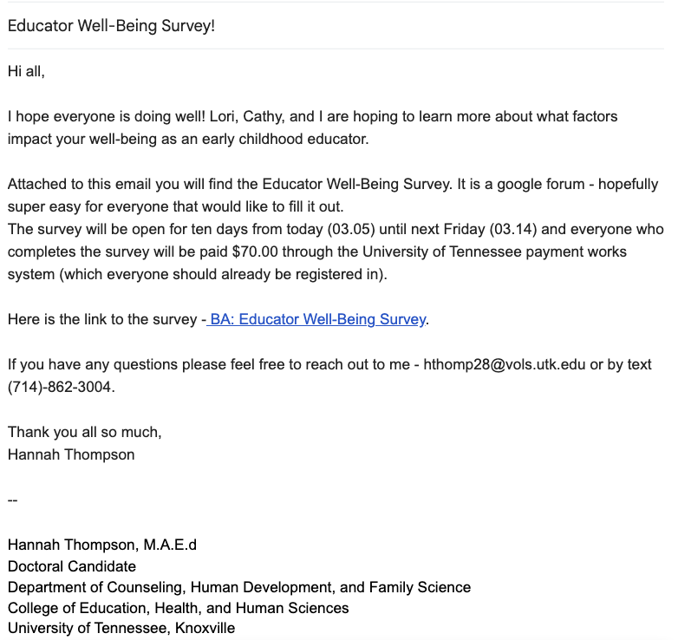
Figure 3.3. Educator Well-Being Questionnaire Recruitment Documentation
Study Timeline - Reflexive Thematic Analysis (RTA)
Recall the overarching research questions of this study,
1: How do rural early childhood educators conceptualize their own well-being?
2: What factors impact rural early childhood educators’ well-being?
As an active co-contributor to the partnership work and having an insider perspective of well-being as an early childhood educator, reflexive thematic analysis is the most appropriate tool to analyze the results of this study. Though other forms of thematic analysis (TA) exist, such as the works of Boyatzis (1998) and Joffe (2012), Braun and Clarke’s (2022) iterative model of RTA are the most appropriate analysis of narrative inquiry for this study design (Byrne, 2022; Harper & Thompson, 2012). Again, reflexivity is the researcher’s ability to self-assess and look inward to understand their own emotions, reactions, and limited constructs (Holland, 1999) and is noted throughout each component of the study. This approach situated my active role in knowledge production (Braun & Clarke, 2019; Byrne, 2022). Braun and Clarke have identified six iterative steps to the RTA analysis process, which facilitate the doing and learning of thematic analysis (Byrne, 2022). Like other qualitative methodologies, this approach is not linear, but recursive and iterative, allowing movement within phases of the analysis (Braun & Clarke, 2021; Byrne, 2022). Lastly, reflective memoing was utilized to document the changes over time and the progression of the study that are associated with my role and subjectivity, and the collective knowledge production and meaning-making process (Braun & Clarke, 2019; 2022; Byrne, 2022).
Familiarization. After my dissertation proposal in April of 2024, I began to spend increased time with and in the data. Please note that within Chapter Three, I, Hannah, will be referring to myself in first person; this is a characteristic of Reflexive Thematic Analysis to reflect the reflexive nature of the work and the relationship between the researcher, participations - educators, and the data (Braun & Clarke, 2022). Additionally, I will be directly naming my data analysis partner, Dr. Lori Caudle, my faculty mentor; this is both a means of reflexivity and part of my onto-epistemological paradigm. In accordance with the reflexive process of RTA, I spent time with and in my data, building a data repository. This included, first, listening to and re-watching all of the individual check-in meetings and making reflexive notes (Byrne, 2022). This step was important as it allowed for relevant information relating to the research questions to be identified, along with observations and initial trends (Byrne, 2022). Next, I transcribed all of the videos, and used a video processor (i.e., Adobe Premiere Pro) to support the transcription process. Adobe is a closed-ended processor that is responsive in transcribing accents, punctuation, and pauses in conversation. Then, I went back through and individually listened to each ICM and worked through the transcriptions. In total, this included three rounds of rewatching each ICM, cleaning the transcriptions, and adding in both a layer of body language brackets (i.e., [laughing]) and contextualization brackets (i.e., [A child had passed away in the fall]; Cora_ICM_02.22.2023). Both acted as a form of researcher reflexivity codes (Braun & Clarke, 2019; Byrne, 2022). In total, there were 227 total pages of transcripts from all five educators from n=13 ICMs. Cleaning each of the transcripts and adding in the layering took several weeks and totaled close, if not over, sixty hours of work.
Generation of Codes. After all data were cleaned, transcribed, and formatted the transcripts were uploaded to Dedoose Version 9 and 10 (Dedoose, 2021), a qualitative analysis software. Dr. Caudle was included on the Dedoose project to ensure validity and reliability, but not generalizability, as this work should not be generalized to ensure that the individual voices and narratives of each educator are amplified (Busetto et al., 2020; Butina, 2015; Connelly & Clandinin, 1990; 2007; Haydon & van der Riet, 2017; Jentoft & Olsen, 2019). Pino Gavidia and Adu (2022) recommend that researchers engage in reflexive conversations throughout the coding and data analysis process, to ensure that the CNI process does not become ‘fact telling’ through direct interpretation, rather than a systematic, transparent process of interpretation. The coding process occurred in multiple iterations, following the fluid process of critical qualitative work, critical narrative inquiry study design and RTA (Butina, 2015; Braun & Clarke, 2021; 2022; Pino Gavidia & Adu, 2022). Reflexive memoing occurred throughout the coding process, often by hand, through Google Chat or text and voice messages with my research mentor, Dr. Lori Caudle, and through notes left in each of the educators’ identified theme tables that were created in Google documents, see Appendix A for an example. Identified theme tables, versions one through seven, are iterative tables of the codes that were identified from the data for each educator individually and collectively. The codes created were both descriptive and brief, offering details that were informative in the process of developing themes - there was no expected number of codes, rather codes were collated with adequate depth (Braun & Clarke, 2019; Braun et al., 2016; Byrne, 2022). Inductive, open coding methods were used to build out each theme table that was created for and added to with corresponding data for each educator (Braun & Clarke, 2019). Each educator had their own dedicated color that allowed Dr. Caudle and me to easily identify the contributions of each educator to the growing list of codes and the changes that occurred within each iteration. Data were coded in five individual, iterative rounds starting with Winnie, who only had one recorded individual check-in meeting, in May of 2024. Winnie’s meeting was not traditionally recorded on Zoom, rather Winnie and I were on a phone call that was then recorded through Zoom due to technical issues. Further, this ICM was set up and organized by Wiley, to ensure Winnie had the chance to meet with a university-partner. At that time, there had been large shifts in staffing due to the second assistant educator in Wiley’s classroom leaving Blue Mountains.
The iterative building of the identified theme tables is recognized as a form of triangulation, acting as a reflexive member checking mechanism built on the experiences of each educator. A new theme table was created for each educator that incorporated the experiences of each educator, starting with Winnie and ending with Kit. Reflexive memos were also included, in the form of comments added along the sides of each table and on the Google document. These comments also provided spaces for collaborative, reflexive memos between Dr. Caudle and me, which supported the negotiation of themes.
Identified Theme Table #1, Winnie. 37 codes were identified in the first theme table; this included three larger sections (i.e., educator, well-being, university-partner). Twenty-eight of the identified codes were focused either on the experiences of the educators or their well-being. Nine codes were university-partner codes, which are considered research reflexivity codes. Open inductive coding occurred first by hand and then transferred into Dedoose. Winnie only had one ICM, that was 24 minutes and 50 seconds long. An example of the changes made to the iterative theme table, version 1, Winnie, can be found in Appendix B.
Identified Theme Table #2, Wiley. Forty-three codes were identified in the second theme table; this included four larger sections (i.e., educator, well-being, body language, and university-partner). Thirty-one of the identified codes were focused either on the experiences of educators or their well-being. Codes about the individualized experiences of children, working alongside caregivers and family experiences, and adaptability codes were added to the theme table during this round of coding. Eighteen codes were identified throughout Wiley’s transcriptions. All codes were transferred into Dedoose after Winnie’s ICM. I moved coding efforts to Dedoose, rather than by hand, so Dr. Caudle and I could communicate easier, for code counts, and for clarity versus hand coding, which was overly involved and lengthy in Google documents. Wiley had three individual check-in meeting transcripts that totaled 108 minutes and 62 seconds. An example of the changes made to the iterative theme table, version 2, Wiley, can be found on Appendix C.
Identified Theme Table #3, Cora. Seventy-three total codes were identified in the third theme table; this included five larger sections (i.e., educator, well-being, body language, structural and systemic barriers, and university-partner). Sixty-two of the identified codes were focused on either the experiences of educators or their well-being while the other 11 codes were reflexivity codes (i.e., university-partner). Director codes were created for Cora, as there is an added layer of programmatic understanding correlated with the role of the director, a co-occurring duality. Cora is often having to separate herself from the role of a caring friend and co-educator to an individual in a position of authority. The experiences of children codes were expanded during this iterative step (i.e., supporting children, severe health impairments of children), along with director codes (i.e., role of the director). Cora had four individual check-in meeting transcripts, totaling over four hours. Cora’s longest ICM was an hour and 17 minutes and the shortest was 51 minutes. An example of the changes made to the iterative theme table, version 3, Cora, can be found in Appendix D.
Identified Theme Table #4, Pearl. Again, there are 73 total codes identified in the fourth theme table; this included the five larger sections (i.e., educator, well-being, body language, structural and systemic barriers, and university-partner). Sixty-two codes are related to the educator experiences and educator well-being, while 11 codes are considered university-partner reflexivity codes. No new codes were identified in Pearl’s ICM. Rather, quotes were added throughout the theme table relating to Pearl’s experiences. Pearl had a total of four transcripts, that totaled over an hour and a half. An example of the changes made to the iterative theme table, version 4, Pearl, can be found in Appendix E.
Identified Theme Table #5, Kit. Lastly, there are 73 total codes identified in the fifth theme table. Sixty-two codes are related to educator experiences and well-being, while 11 codes are university-partner reflexivity codes. Again, no new codes were identified in Kit’s ICM. Throughout the identified theme table, there are reflexive memos of codes that I felt could be collapsed. For example, trying to find the good in each day could be collapsed into positive classroom experiences. Kit had a total of two transcripts, which totaled 45 minutes. An example of the changes made to the iterative theme table, version 5, Kit, can be found in Appendix F.
Identified Theme Table #6, Collapsed Codes. After completing almost all of the coding, which is appropriate for this study design due to the iterative nature and process of CNI and RTA, five more ICMs (e.g., Cora (1), Pearl (2), and Kit (2)), needed to be coded during the first round of code negotiations with Dr. Caudle. During the first round of code negotiations, ten codes were collapsed and/or shifted under the three major categories, including severe health impairments of children, traumas (compounded, secondary, and intergenerational), references to domestic violence, child exposure to opioids; these codes were moved under the subcategory of educator experiences with children. Structural and systemic barriers were collapsed and moved under the Connection to Community and the Home Lives of Children. Adaptability was moved under Educator Well-Being, with an understanding that adaptability is all forms of well-being (i.e., physical, psychological, professional, and relational). References about experiences of children were moved under Educator Well-Being. Educator reflections about working at Blue Mountains were collapsed and moved under the category of Blue Mountains. While achieving goals was collapsed into the professional growth code. Lastly, body language was moved under University-Partner codes, as this is a reflexivity code and my perception of the educator’s well-being.
Place Based Categories. Additionally, the codes were separated into three major categories - experiences of educators, educator well-being, and researcher reflexivity codes. Experiences of Educators were further broken down into three subcategories that were situated in place, reflecting the place-based theoretical stance of this study’s ecological systems models, 1: Connection to Community and the Home Lives of Children; 2: Blue Mountains; 3: Individual Classroom Experiences. Four subcategories were also created for Educator Well-Being that included, 1: Psychological Well-Being, 2: Physical Well-Being, 3: Professional Well-Being, and 4: Relational Well-Being. Finally, two categories of researcher reflexivity codes were combined, University-Partner and Body Language - these codes both helped me acknowledge my own role, separate both voices, mine, and the educators, and added contextualized details about the educator and the systems of place and understanding in how they were constructing differing forms of well-being. An example of the changes made to the iterative theme table, version 6, Lori and Hannah, can be found in Appendix G.
Identified Theme Table #7. Between theme table six and seven a thematic map was completed, this iterative process allowed for further understanding of the connection between place and the forms of well-being. All data had been coded when this table was generated. As seen in figure 3.3, the thematic table represents the identified codes as two separate sections, Place-Based and Well-Being, combining the two allowed for both comparison and connection across codes. The contextualized data collected from the qualitative questionnaire were also included in this iteration of the theme table. My reflexive memo is below, these thoughts were compiled while making connections between place and forms of well-being.
- Community structural and systemic barriers are connected to all forms of adaptability
- Community experiences are connected to the adaptability of children AND the adaptability of educators
- Systemic barriers - are structural connections to the program level
- BM systems are connected to adaptability
- Role of the director is connected to the adaptability of the educator
- Educator larger reflections of working with children is connected to adaptability
- Role of the director is connected to educator professional well-being and intentions to stay in the field - these are also connected to teacher relationships, forms of advocacy, and support
- Collapse systemic barrier - multiple jobs into systemic barriers - district, school board wide policies and/or procedures
- Professional well-being is connected to higher education and professional learning
- Classroom routines are connected to professional well-being - positive, inconsistent, and school wide
- Intersecting of being a pre-k educator should be collapsed into capacity
- Educator larger reflections about their experiences working with other early childhood educators, comparison to peers | other classrooms MOVE under relational well-being
- Classroom supports are connected to capacity and frustration
- Navigating challenging behaviors, children self-regulation, developmental disabilities, and working with families are connected to experiences with children
- Working with families, CPS, supporting children, child exposure to opioids, DM, traumas, severe health, and experiences of children are connected to relational well-being these are also related to relationships with peers, children, and families.
- CPS is related to experiences with families, children, AND peers
- Role of the director is related to relationships with peers
- The impact of higher education could probably also go under psychological well-being → a lot of the codes are correlated - between things people have to do at work and how it impacts them and their psychological well-being → AGAIN DOES THIS HAVE TO DO WITH JDR? [Jobs Demand Resources].

The major finding from this thematic table in making connections between place-based and forms of educator well-being are that many of the codes are correlated and correspond to one another, see figure 3.4. For example, number seventeen, the impact of higher education is situated under place-based program level but could also mesh well under psychological well-being because the impact of higher education and having to continually take early childhood related course work, often without increased pay, due to state mandates impacts the psychological well-being of the educators. Connecting the themes through hand gave me a deep understanding and insight into how each of the themes is connected to both place and educator well-being and how they were connected within their own sections as well, which reflect the stories of and lived realities of the educators.
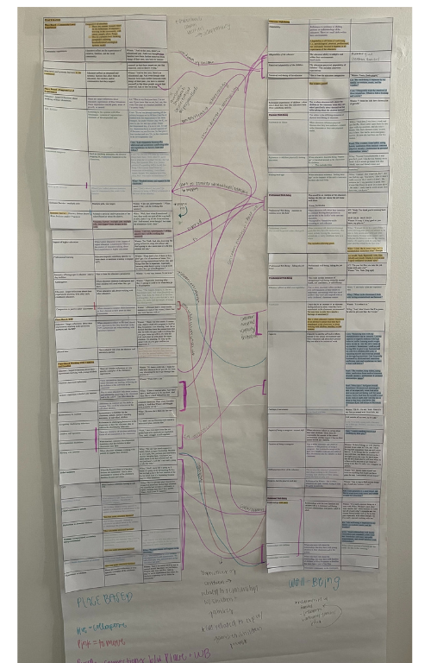
Figure 3.4. Thematic Map
Theme Generation. Throughout the theme generation, multiple themes have been considered and negotiated. The developing themes were considered fully developed as a conceptual pattern based on three aspects, how the theme captured patterns (Braun & Clarke, 2006), the shareability of each theme, and the overall shared meaning of the theme (Braun & Clarke, 2012; Braun & Clarke, 2022; Byrne, 2022). A thematic map was developed to understand the connections across the developed themes, connecting the sub themes, which allowed me to consider the connection between and reflect on the represented data. In order to fully contextualize the data and ensure that the voices of educators were centered in the data. Again, the negotiation of themes and patterns of the data informed the research questions and the structure and flow of the qualitative questionnaire in order to ensure conceptualization and clarity of the data.
Review of Themes. During the fourth step of RTA, I conducted two levels of review; first I looked at the relationships between codes that inform each theme, for example, Educator Well-Being → Psychological Well-Being → Capacity. Candidate themes were then reviewed in relation to the connection, depth, and scope across all data (Byrne, 2022). This step was recursive and on-going, to ensure that all candidate themes were appropriate for answering the research questions and ensuring depth of the data (Braun & Clarke 2012; 2021). At this step of theme construction and negotiation, all data were considered to understand the contextualized depth of the data for each of the established categories and themes. Additionally, renegotiating and reviewing the themes allowed me to reflexively ensure that the educators voices were centered, in order to be amplified rather than my (researcher) voice as an active participant. At this stage, 54 total codes were identified, which were constructed into two major theme categories, and nine total themes.
A series of key questions were posed by Braun and Clarke (2012, pg. 65) to support reviewing potential themes, focusing on quality, boundaries, meaningfulness of the data, and coherence (Byrne, 2022). I used the following questions in order to thoroughly conduct the fourth step of RTA.
- Is this a theme? Could it just be a code? Is this a theme, is there a recurring pattern among each of the educators, could it just be a code? Among other codes and considerations, what weight does this code hold? Where does it intersect with other codes?
- If it is a theme, what is the quality of this theme? Does it tell me something useful about the data set and my research questions? This was established during reflexive memoing and conversations with Dr. Caudle. I thought about pedagogies of place and how place is understood and negotiated for each educator and the consistent recurrence of ecological systems and how the educators conceptualized their experiences within contextualized time, relational context, and space (i.e., the community).
- What are the boundaries of this theme? What does it include and exclude?
The boundaries of each theme are related to the ecological system level in which they occur and the relational context (i.e., educator - child, educator - educator, educator - caregivers). In addition to what each place-based level includes and excludes, such as Blue Mountains→ Systemic barrier - District, School Board Wide Policies and/or Practices → Classroom supports.
- Are the data too diverse and wide ranging? Does the theme lack coherence? No, the data are not too diverse and wide ranging, throughout theme generation codes were collapsed and shifted to fit under the established theme categories. Additionally, the codes identified were, yes, identified within the data, but also conceptualized through the reciprocal relationships between myself and the educators in addition to time spent in early childhood literature and my contextualized understandings and personal positionality and experiences as an early childhood educator.
Defining and Naming Themes. The fifth step of the Reflexive Thematic Analysis process charges the researcher with detailing the analysis of the thematic framework with a cogent narrative that is consistent with the duality of the dataset and research questions (Byrne, 2022). The constructed themes were developed following the RTA process and reflect the conceptualized experiences and understandings of the five educators. At the conclusion of this process, there were two established thematic categories related to how rural educators conceptualize their own well-being, (i.e., Educator Well-Being and Place Based Experiences of Educators), each having multiple subthemes, see figure 3.5.
- Educator Well-Being → Psychological → Physical → Professional → Relational Well-Being, these are in-depth codes of the experiences of educators.
  - Psychological → Capacity and adaptability
  - Physical → References to children physically hurting educators, Feeling their age
  - Professional → Professional Growth
“When educators talk about professional goals that they have for themselves - this could include leaving the classroom, school site, or early childhood field as a whole” [Iterative Theme Table, Version 7].
  - Relational → Relationship with Peers
- Place Based Experiences of Educators → Connection to Community and the Home Lives of Children →Blue Mountains → Individual Classroom Experiences
  - Connection to Community and the Home Lives of Children → Working with Families → Experiences of Children
  - Blue Mountains → Role of the Director → District Wide Policies and/or Practices → Impact of Higher Education
  - Individual Classroom Experiences → Navigating Challenging Behaviors
Lastly, a narrative write-up with detailed illustrated descriptions and data extract was combined at this phase to ensure that data are accurately represented and contextualized when reported (Braun & Clarke, 2013; Byrne, 2022; Terry et al., 2017).
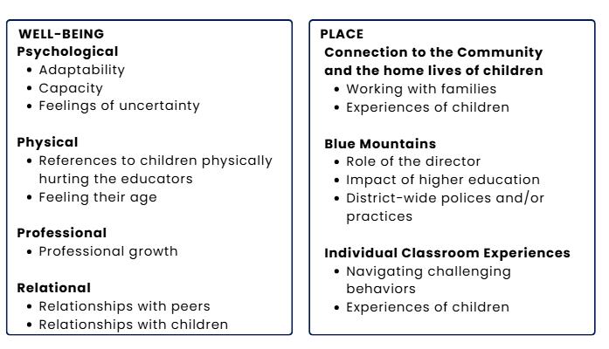
Figure 3.5. Main Code Occurrences
Iterative RTA, Re-Familiarization
After defining and naming the themes, I went back through the iterative process of spending time and familiarizing myself with the data (Braun & Clarke, 2022). This iterative, reflexive process allowed me to ensure that I fully understood the data and shored up any lingering questions I had after the data analysis process.
It is important to note that during the analysis phase, I started data cleaning, coding, and analysis with Winnie, then Wiley, and Cora, rather than Pearl and Kit. This was intentionally done, after spending time in the educators' classrooms, in large group meetings, while conducting the individual check-in meetings, through informal means of communication (i.e., text messages and phone calls), and in spending time with the data during the first round of the familiarization process. This process was twofold. During the first round of familiarization, I was able to spend an extended amount of time with the data, which allowed me to gather my thoughts and gather a preliminary understanding of what themes may occur. After the data analysis process occurred, spending more time with the data allowed me to spend time in a reflexive space memoing, asking questions, ensuring that I understood what had been identified in the data. This time allowed me to think more deeply about the relationships I had with each of the educators and come to know what I already knew, for some in great depth, about their lives. This time may have contributed to the ecological perspective that was taken when considering how the educators defined and constructed the varying levels of place and the thematic identification of the varying components that contribute to each of the educators’ conceptualization of well-being.
To conclude, methodologically Chapters Four and Five of this study are understood as the final report of the reflexive thematic analysis process. This final step of RTA is the finalization of the body of the report, which should be thoughtful, reflective, and ordered by synthesized and contextualized themes reported to communicate the narrative of the data (Braun & Clarke, 2012; Byrne, 2017; 2022; Terry et al., 2017).

Chapter 4

Results and Discussion
The five narratives featured in this study were selected to reflect the stories of the rural, Appalachian early childhood educators in hopes of understanding how they conceptualize their own well-being and factors that influence it. The structure of the following narratives is situated in places identified by the educators as being significant in their day-to-day experiences. Each place, including (1) connection to community and the home lives of children, (2) Blue Mountains, and (3) and individual classroom experiences, are reflected in how the educators are navigating their own experiences in places that are related to the varying dimensions of their conceptualized well-being. Though there are similarities across the educators' experiences, there are also vast differences depending on their role, personal and familial factors outside of the school environment, and the complication of relationships that are intertwined by living in a small, rural environment. Additionally, these experiences reflect how each of the educators’ approach and care for their own well-being. While there were four places identified in the data, only three significantly stood out in the data (i.e., connection to community and the home lives of children, Blue Mountains, and individual classroom experiences). The fourth place that stood out was a third space that exists within the TIPS research-practice partnership; more information about this place can be found in the future directions section of Chapter Five.

Shifting Ecological Perspectives
From an ecological perspective, the individual is static in the middle of the concentric circles, yet, in this study it is clear that the educators are anything but static and instead move within and between the places that make up their everyday lives. In this section, each place is labeled in association with the context of the place (i.e., connection to community and the home lives of children, Blue Mountains, and individual classroom experiences) to support in the visualization of the identified place. Though there was consistency in the places and characteristics of place identified by each of the educators, it is important to remember that place is a fluid construct that comes together through constructed realities; it is the experiences of both the individual and the collective; it is where relationships are formed and solidified, and a space in which individuals are molded by and to (Greenwood, 2013; Sherfinski et al., 2021; 2022). Within the ecological system that has been constructed by the educators, there are not distinct delineations, rather it is all interconnected, and so this means the community is connected to the classroom and the individual and vice versa molding together. These places are overlapping and entangled. In the following descriptions of the educator’s narrative, I had to make reflexive decisions that were associated with the specific place and the experiences of educators that contributed to the conceptualization of their well-being. The entanglement of the ecological systems are understood through the educators' experiences and what stories they chose to share, noting that in the early childhood classroom, the community is part of the classroom, and the classroom is the community.
Aligning with ethical considerations of care for the educators and for you, before moving forward to the individual and collective stories of the educators please know that forms of violence and trauma including the death of a child will be mentioned. You will also notice that there are two tenses used throughout this chapter, past and present, this was intentional to represent the on-going nature of many of the challenges that the educators continue to face. Please proceed with care.
Individual Educator Conceptualization of Well-Being
The following section focuses on how each early childhood educator individually conceptualizes her own well-being. This section answers research question one, how do rural early childhood educators conceptualize their own well-being and reflects the purpose of this study to understand the lived experience of rural, Appalachian early childhood educators and how their experiences converge and contribute to their conceptualization of their well-being. In the following narratives, you will notice there are specific ways and experiences that contribute to how each educator is conceptualizing their own well-being. Again, these conceptualizations are fluid and will continue to change as the educators shift and change within their environments and personal understandings of self.
Winnie. Winnie is both the newest educator to Blue Mountains and the newest to the field of early care and education. She has long been part of the Willow Oak community. When asked about what factors impact her well-being, she shared that there are multiple factors that affect her well-being. For Winnie, these factors are related to her physical well-being (e.g., sleep patterns, taking medication, working out), being a mom and caregiver, and caring for her psychological well-being by trying to find joy in small moments every day. It is interesting that Winnie herself noted that she tries to mask her worries and be present for the children in her classroom and her co-workers. This was a common conversation among educators that begs the question: is it healthy for the psychological, physical, professional, or relational health of the educator if they are not able to express themselves within the comforts of the classroom environment or safety of their peers? Winnie shared:
Many thigs [things] affect my well-being, if I slept enough the night before, that my kids are ok and have what they need, if I remembered to take my medication, I feel much better if I have been able to workout. Finding the things in everyday moments that bring you joy. Regardless of what may be running through my mind, I try to mask all of that and be present for my class kids and co-workers.
When asked if she would like to share anything else about her own well-being or how she conceptualizes well-being, Winnie shared her views on happiness and seeking joy (i.e., psychology well-being),
I think a lot of people view happiness and well-being as the same thing. Personally I feel that happiness is fleeting and that the key is joy. Society likes to say "do what makes you happy, be with whoever makes you happy." I do not feel that we should rely on others for your happiness.
Winnie goes on further to share how she navigates her everyday experiences, sharing that some days are better than others, that a whole day should not be wasted because one thing did not go right, and that there are opportunities to find joy in the everyday, However I do think that we should strive to find joy. For myself, some days are better than others, but I wont sink a whole day just because something unintended happened. Looking for the joy helps my well-being through helping my mental and emotional health. I am doing ok.
Opportunities to find joy or the good in each day are also reflected in how Winnie approaches the classroom environment and supporting young children with complex needs while also balancing her home life, her own schooling, and other commitments she has in the community,
truthfully, just trying to find joyous things out of each day because it can. It [the classroom] was very intense. It can wear. So I had to make myself not focus on anything that might not have gone the way I anticipated or had hoped. Yeah. And just focus on the wins. So that it didn’t just crush.
Winnie’s thoughtful approach to finding small moments of joy, despite the constantly changing and challenging classroom landscape that comes with supporting children with complex histories and developmental delays seem to be one of the ways in which she anchors herself in place as she navigates her shifting roles and responsibilities of each day.
Wiley. Wiley worked at Blue Mountains for 16 years. She has a complicated relationship with the pre-kindergarten program as she virtually grew up in the school environment, starting as a teacher’s assistant right out of high school and moving her ways up to developmental day, certified educator. She worked hand-in-hand with Cora and Norah, who is an assistant educator in another classroom, for all sixteen years. Before Cora, her aunt was the director, while other extended family members held significant roles within the Willow Oak school system. Wiley is deeply integrated within the Willow Oak and local indigenous communities. These compiled experiences, in addition to her own complicated experiences with the local school board, impact the factors that contribute to her conceptualization of her own well-being. Yet, when asked, the biggest factor was student trauma and support in the classroom. Wiley has a huge heart and compassion for supporting young children who have developmental delays, disabilities, and endured trauma at the hands of their caregivers, due to community factors, and local and larger systems of power. Wiley is an advocate for young children who have experienced trauma. In her work, she would like educators to have the means to care for young children who have endured adverse experiences while also having support in the classroom. During her last ICM in May of 2024, Wiley shared that she would most likely be transitioning away from Blue Mountains and would no longer be a full-time classroom educator to become a case manager at the local Head Start. In this role, she would have the opportunity to support other educators as they navigate supporting young children who have endured trauma, have complex histories, and/or disabilities and developmental delays. Wiley shared that she would like to be able to make a difference and be part of a system that is working towards change,
I would like to be part of that. I mean my long-term goal was always to be able to help people deal with kids who have trauma, because some people can’t look past the behavior and see the trauma. And so if I want to work towards that goal, moving would be the best way. Yeah. Because I would have an opportunity to be hands on with [a] significant amount more teachers.
Wiley shared that, when in the classroom I dealt with feeling overwhelmed and burnt out, due to the lack of support in the classroom, and a lot of times here [Blue Mountains] I don’t feel like I get heard. You know, or [I’m] just a thought that kind of gets dismissed a lot and it’s getting old. Wiley’s well-being is inextricably linked to the well-being of the children and families that she was caring for within her classroom environment. She worked to develop individual relationships with each child and their families and carried their burdens like her own. Wiley worked to break down structural barriers, navigate oppressive systems of power, and move through very close and complicated interpersonal relationships with other educators to ensure that the children in her classroom had their basic needs met daily and that they and their families had the means to do better when they left the care of Blue Mountains.
Cora. Cora’s well-being is an interconnected web, intertwined within her roles and the relationships that she navigates each day from mom and partner, to friend, co-worker, early childhood educator, to director acting as an authority figure. Often, Cora’s roles mesh together; she shifts from director of Blue Mountains asserting authority over a situation to in the same instance to a friend and coworker talking about the soccer game their children played together over the weekend. The intersection of Cora’s many roles can make it hard for Cora to disentangle each one and the power structures that are part of her position and the predetermined hierarchy that may exist or be expected of the role. The role that she is taking on connects her and grounds her in place and allows space for thoughtful deconstruction of her lived experiences. It allows her to understand the intersection of her roles and how she responds differently in each of them, which, in turn, can lead to a lack of transparency or understanding or reliance on others to support her in understanding her own reflexivity and position, even when asked for,
I’ve told them I told them when I took this job because I was one of the six teachers here for ten years before I took this, and I went to each of the other five teachers and said, I’m considering this and I want to be honest with me and tell me where you think my strengths will lie and where my weaknesses lie in it and I want you to promise me that if I ever become disconnected and forget where I came from, that you will tell me to leave…because I hear them from time to time say, oh, she’s been out of the room too long. You know, when they talk about other administrators. And I remind them then when they say those words, when that happens to me, I want you to tell me it’s time that I just can’t be an effective leader, one to, you hear that.
When asked about what factors impact her well-being, Cora shared that there are multiple factors that affect her physical, psychological, professional, and relational well-being,
Good relationships with family (immediate and extended), a few close knit friendships and many enjoyable acquaintances, and overall positive work relationships. I still enjoy learning about child development, how we can support it, and what changes how children are impacted by other factors in their development. I enjoy coaching soccer and watching my kids play. Balancing time with my responsibilities can be stressful.
Cora goes on to share that she often lacks capacity to support children that demand more attention and time due to higher needs, while also supporting the educators as they navigate supporting the child. Cora is at the top of the hierarchy of attunement, working to balance out the educators who, in turn, support the children, with little support from district wide supervisors, lacking capacity to support students with high behavior and/or learning needs weighs heavy on me as I see the toll it takes on my teachers. This lack of capacity spills into her home life and the energy, time, and capacity she has to care for her husband and children at the end of the day (i.e., her second shift), sometimes I catch myself having little left to give my husband and my own two children after a day of regulating myself and everyone around me through big emotions. Cora’s role and responsibility for everyone further contributes to how she conceptualizes her well-being. As she has to continually put out fires, from staffing shortages to supporting children with complex needs, regulating alongside educators, and making sure the basic needs of families are met. In addition to the structural barriers that occur due to conflicting policies and system of powers in Willow Oak and nationally in public school systems, all of which are topped with the systemic barriers to success that exist for early care and education. Over time, Cora has repeatedly shared that taking care of her own well-being, it’s hard to do when you’re putting out fires sometimes and I am frequently frustrated by additional and sometimes conflicting rules and regulations that we have to learn and follow. Though Cora jokes about the fires she is putting out, there is a consistent layer of stress and form of adaptation that comes from constantly extending care.
Again, Cora’s well-being is interconnected, shifting to the role and relationship. When asked if she would like to share anything else about her own well-being or how she conceptualizes well-being, she shared, I frequently wear the emotions of those around me. Which is both a blessing and a curse.” [It] makes me a very empathetic person. So I can I can feel pain and help work through it. This thought has been reiterated throughout our time together through ICMs and during informal conversations passing in the hallways or sitting on the couch in her office. In this role, Cora is extending herself to others, making sure that their needs are met, though there is hardly ever mention of her own, though, at times, she recognizes that self-preservation and understanding are two factors that contribute greatly to her psychological well-being.
I wear other people’s emotions, and I have become increasingly aware of it since taking this job especially through COVID and then try to be a little safer about it. For my own boundaries and mental health and all those type things. But I think being aware of it helps me know when I’m wearing things around me more than I should.
Cora is constantly navigating and adapting to her environment, shifting every time a parent walks in or she is called into a classroom to support with a child having big emotions. Over the years, there have been multiple big instances of loss in the Willow Oak and surrounding areas (i.e., Hurricane Helene; loss of community members). Overtime, I have asked Cora what keeps her hanging on and keeps her at Blue Mountains as most early childhood educators leave the field in three to five years (Bryant et al., 2023) especially when compiled with adverse experiences (i.e., environmental traumas), I love my people [the educators]. Cora’s well-being is related to her relationships with others, which is demonstrated in how she cares for those around her by working to provide new professional learning and novel opportunities, my people are going to love it. That makes it worthwhile. Despite the known and recognized reality that she is aging and that being an early childhood educator is hard work impacting an individual's physical, psychological, relational, professional well-being, and so much more, there are body aches and pains where I think I don't know how long I can do this.
Pearl. For Pearl, the conceptualization of her well-being has roots in how well she is caring for herself and meeting her every day, basic needs. Though the heightened number of challenging behaviors and children experiencing complex home lives seems to be lessened in Pearl’s classroom, she, along with Kit, is still the caregiver to many, including her own son who attended Blue Mountains for Pre-K. When asked about what factors impact her well-being, Pearl shared that there are multiple physical and environmental attributes that contribute to her day-to-day well-being. Pearl recognizes that her well-being is not static and depends on multiple factors and shifts from day to day, the weather, sleep habits, eating habits, medication from medical concerns (thyroid, anxiety), professional & personal relationships, stress. Throughout our time together, it has been noticeable that when Pearl is directly confronted with a child displaying consistent challenging behaviors that it affects her psychological well-being and her physical well-being, as she reports feeling stressed and/or more tired. One notable experience occurred in the winter of 2023 the Early Childhood Professional Well-Being Questionnaire (ECWP-Q; McCormick et al., 2022; McMullen et al., 2020) was administered through a qualitative focus group, I (Hannah), was the only university-partner at that meeting with the six lead educators. As we went through the survey Pearl participated but also was quietly crying throughout the meeting, even when asked if she would like to step out to take a break, she felt more comfortable staying with the group. After that meeting, Pearl and I had a moment to talk informally through text. She shared that a child in her classroom had had a particularly bad day, throwing shoes and other materials at Pearl. Pearl shared that she had used all of the known strategies she had in her metaphorical toolbox of supporting children navigate challenging behaviors and big emotions.
When asked if she would like to share anything else about her own well-being or how she conceptualizes well-being, Pearl shared that, most days I feel great overall. Sometimes I let stress and anxiety get a hold of me especially when I am extra tired or am not feeling well for some reason but she works to pause, and engage in an activity that brings her joy (e.g., reading), I try to find time for myself to read or just relax at night after I put my son to sleep so that I can wind down. Pearl does point out that sometimes she just needs to meet her physical well-being needs to sleep after a long day of caring for others, but sometimes I just fall asleep on the couch! For Pearl, taking care of her physical and psychological well-being keeps her grounded in place and, in turn, allows her to have the capacity needed to navigate the changing classroom environment and care for those around her.
Kit. When responding to the questionnaire, Kit responded very broadly about the factors that impact her well-being. She shared multiple factors that contributed to her well-being (i.e., relational, psychological, and physical), my well-being is impacted by my family, co-workers, music, and the weather. Weather is interesting because it could affect both psychological and physical which impacts relational and professional well-being. Kit is in her third year at Blue Mountains and is not originally from the Willow Oak area so the upheaval in weather and school closures affects the sustainability of her routine and personal patterns. Over the years, Kit has shared that her relationships with others really impact her well-being and that she highly values time with her family. In reference to asking Kit if she was going to work over the summer as most assistant educators at Blue Mountains have two or three jobs over the summer to make ends meet, she shared that,
I wasn’t going to be full time, I’d be part time to like [clean] because that’s what I wanted. And I was just like alright. That’s good. That’s good with me. I just don’t especially over the summer when I get a break from, like work, work. I don’t want to have to stress about work and not being able to see my family.
Kit has a young son and partner that she joyfully shares about each time that we meet. Her connection with her family embeds her in place within the Willow Oak community while her relationship with her co-workers (i.e., Pearl and Clementine) embedded her in place at Blue Mountains. Kit was one of the few educators who responded with activities she enjoys doing to take care of her well-being, [I] like to wind down with music and ASMR at night for relaxation. She was also one of the few educators to share about factors that contributed to their perceived self-regulation and frame of mind, I am generally in a good mood, compared to her peers, and other assistant educators who shared about their experiences with children in the classroom significantly impacting their holistic well-being, Clementine, another assistant educator across the hall from Kit, shared, one thing that highly effects my well-being at work is staying in response mode, watching and waiting for challenging behaviors to arise in our classroom. I feel that this takes a mental, emotional and even physical toll on my well-being.
For each of the educators, there are varying factors that contribute to their well-being. These factors are associated with how they keep themselves grounded in place. The following section moves into a collection of shared, small narratives that allows for understanding of how place and well-being intersect for each of the educators. Through this writing process, I used reflexivity (i.e., memoing, conversations with Dr. Caudle) to engage in the act of finding narrative meaning and further exploring the phenomena of how rural educators conceptualize their well-being (Kim, 2016; Polkinghorne, 1988). Again, the places mentioned in the following section were collectively constructed by the educators as they are the spaces in which they live their daily lives, construct their lived experiences, and where their well-being is situated, see figure 4.1. Kim (2016) further points out that narrative, the process of sharing stories and amplification of voices, is an act of meaning-finding in which we can better understand the human experiences. In the case of this study, it is in hopes of better understanding the experiences of rural early childhood educators, how they conceptualize their well-being, and the realities of their everyday lives.

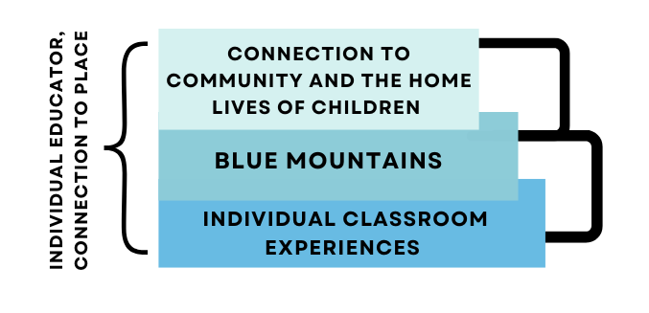
Figure 4.1. Educator Conceptualization of Place
Connection to Community and the Home Lives of Children
The first place that will be explored is the community and the home lives of children, which are considered community-level experiences that affect and shape the lives of rural early childhood educators. Community as a place is complex because it combines the individual pockets of community that each educator has built for themselves and their families outside of Blue Mountains, yet it is intertwined as Blue Mountains Pre-K is central to the community and many of the educators have intersecting roles and relationships. For example, Pearl and Winnie both had children attending Blue Mountains for their pre-kindergarten year. Pearl and Cora have been friends for many years, which included their children playing soccer and socializing together. Wiley and Winnie attend the same church, and Kit and Pearl spend time together during the summers with their children and at community events. All of these relationships are entangled in two places within the Willow Oak community and at Blue Mountains, which are then further embedded within the mountain community and the specific aspects of rurality that relate to the socio-political and geographic location of this place. Rural communities have specific community culture that is often unknowingly embedded in the daily lives of individuals living in that community; this may include the collective values and histories of the community. For Southeast Appalachian communities, these complex understandings of place and community are further embedded with structural and systemic barriers that operate as community-level traumas (i.e., situational and intergenerational poverty, lack of resources, environmental degradation, natural disasters, the opioid epidemic). This also includes a long-embedded mindset that is slowly evolving, of a lack of trust in educational institutions and social services (Reck & Reck, 1980).
For many of the educators, they are embedded in place through their personal connections to the community from their experiences growing up in or near Willow Oak or are connected through the experiences of their own children and the larger experiences of the children that attend Blue Mountains. Throughout our time together, the educators have reflected on their experiences working alongside young children as they navigate living in a rural environment that has naturally occurring compounded and intergenerational traumas that affect their development and long-term outcomes. In conversation, Cora, Winnie, and Wiley often pointed out how social determinants of health are working against the well-being and long-term trajectory of the children and, in turn, affecting the psychological well-being of the educators, maxing out their capacity while sometimes causing distress, and burnout.

Experiences of children, Born into circumstances beyond his control - Cora
In the fall of 2022 during her ICM, Cora shared with me that a child who had recently attended Blue Mountains, and still had siblings there, had passed away after ingesting narcotics that they had access to within their home,
so a heads up to you, the county lost a student over the weekend the first grader who did come through Blue Mountains. So myself and my staff are feeling that in different ways. And the ones that were close to him, of course, feel it differently.
Norah, an assistant educator who had the child in her class shared with Cora, he didn’t have a chance from the get go. Cora continued sharing, he was born into circumstances beyond his control, eventually came around to get him and I mean he was six. The reality of his age really hit the educators hard as,
he’s the same age as my kid, the same age as Kit’s kid and Kit is feeling it, too, because he went to school with her little boy. One of the greatest tragedies to lose a little kid to something that could have been controlled and that should [not] have happened. It wasn’t a freak accident, it was a–he should have not had access to the things he had access to.
Cora goes on further sharing about how the educators are handling this occurrence and the resources that the district has put in place to support the educators (i.e., the option to meet with a counselor), though the resources are more reserved for the elementary school educators and students. This incident hit very close to home for many of the educators and impacted their psychological well-being and capacity to care for the children in their community. As Cora expressed, this was not the first incident and won’t be the last due to structural challenges that are readily occurring due to intergenerational forms of trauma. Cora goes onto share,
I’m both coping with it because my kid is that age. But also, you know, I loved him too. When he was here and he was in after school was with but then the other side of this is I look at some of these other kids this year. There’s one in Mabel and Norah’s class this year who both favors him in looks but also his family life is very, very similar. And to me, I’m thinking what else can we put in place to prevent that from ever happening again? You know, and I know it’s not fully in my circle of control, but are there pieces of it that I can help implement for my teachers? Because they’re worrying about it, too. You know, there are now other kids crossing their minds and they’re like, I could happen to this kid, you know.
Due to the structural implications of community, the educators had to adapt to their new reality of supporting each other, their own children, the children in their classrooms, and the community as a whole through this loss. Early childhood educators are not traditionally trained in trauma-informed or reducing care practices or tragedy relief mitigation practices and yet they are consistently putting the needs of the children in their classrooms and therefore their communities above the needs of themselves though this affects their well-being and often shortens their professional lifespan in the early care field. Cora shared that the educators would continue to work to build stronger relationships with families and offer them resources but as she further shares, it goes beyond that,
I mean, heck, Norah has done everything to going and getting things they need and taking them to their home…Norah will literally crawl out of her shirt to give it to them and I just don’t know what else we can do.
Cora’s story about Norah is just one example of how the early childhood educators in this community are willing to put the well-being of the children they care for above their own just to ensure that the children in their care have access to basic resources.
Working with families, They’re trying. They just don’t know any better - Wiley and Winnie
Wiley and Winnie also have direct experiences with larger structural and systemic barriers affecting the livelihood of the children and families in their classroom. During the 2023-2024 academic year, they identified multiple children in their classrooms whose families lacked everyday access to basic needs such as consistent money for food, running water or power in their homes, transportation, or other adults in the community to care for their children outside of school hours when they had to work. Wiley reflected on a conversation between her and Winnie,
we were saying the other day, like if we talked about solid home environments where food wasn’t an issue. Water or power, custody wasn’t an issue. We probably have two kids who out of thirteen who are not red flag kids. Winnie goes on to share, and in this area, there’s an educational gap. And even though other families have been further removed from things of their past, you have to remind yourself that these people are not that removed. And so they’re trying. They just don’t know any better.
The educators physical, psychological, relational, and professional well-being were compromised due to the intensity of this academic school year. Wiley and Cora’s relationship grew more complicated, which was one of the factors pushing Wiley to leave Blue Mountains, while Winnie was left exhausted, this being her first year in the Pre-K classroom. Even with calls put into social services, constantly adapting the classroom and themselves to fit the needs of the children, and support from Cora and other educators, it was not a fair reality to expect Winnie and Wiley to adequately ensure these children were ‘prepared’ for kindergarten, when they were constantly operating out of chaos and compounded trauma due to structural and systemic community-level factors.
For Winnie and Wiley, there are two children in particular that affected their psychological well-being, capacity, and forms of adaptability day in and day out. The first child, M, lived in a camper with her mom, her mom’s partner and at least four other children, Wiley shared,
well the camper has no power, no water. We had…a few accidents where we had to bathe her because something got spilled, you know? Yeah and then finally, I just reached out to mom and the line was like, hey, is it okay if we give her a bath? You know, like, yeah because [M] told us one of the times in the back that they didn’t have water and that they, you know, eat over a fire.
Multiple times Winnie and Wiley rallied behind this family, working together and with the community to raise enough money to get the power and water turned back on in the camper, Winnie and I went throughout the community to get private donors to get the water turned on. Both Winnie and Wiley used their resources and maxed out their capacity to care for this child and her family, supporting mom when she miscarried, and getting the two-year-old brother an application to the local Head Start. This also included dropping off a Thanksgiving meal to ensure that M and her sibling had food in the home during the school closures. Throughout the school year, there were multiple hardships and calls to CPS surrounding the health and safety of M, yet Winnie and Wiley continued to hold space for the family and extend compassion and the limited resources that they had, recognizing the capacity and limitations of the adult caregivers, Wiley shared,
I mean, because while this mother doesn’t have water and is out of power, she’d done the homework and read a book every night and signed the log. So, like, she wants better. I just don’t think she knows how to get there… and I think especially with that case, like I had known family members of that family, and it’s just generational poverty.
Through the amplification of Cora, Winnie, and Wiley’s voices and experiences, it can be understood that within the community they are both embedded in place through conceptualizing factors of their own well-being through their connection to the experiences of children in their care and their home lives. Throughout these experiences, it can be understood that their psychological well-being was the most impacted factor of well-being identified in the data corresponding to place-based community and structural and systemic challenges. Factors of psychological well-being that were impacted for the educators were capacity, adaptability, and the shifting perspective of the educator. Further, for both place-based community and structural and systemic challenges, there were over twenty code occurrences that also overlapped with working with families and the experiences of children. Identified in the data are the multitude of factors and experiences that affect how the educators conceptualize their psychosocial well-being, which are most directly connected to the experiences of young children and working with families, which are then shadowed by community experiences and the structural and systemic challenges that impact them. In her last ICM, Wiley stated, that’s the part of this job people don’t see, the invisible labor of caring for other people’s children in great depth that is extended to the families, and, in turn, the community. These factors consistently impact how rural educators conceptualize their own well-being in relation to the community.
Blue Mountains
At the programmatic level, the educators are embedded in place at Blue Mountains through multiple compounding factors that impact their day-to-day lives and how they conceptualize their own well-being. For each of the educators, this may include having access to classroom supports, district and school board wide policies and practices, the role of the director, access to professional learning, the impact of higher education, and the overall intensity of being a pre-k educator.
For Kit and Pearl, the connection to Blue Mountains and place-based program experiences were linked to their overall place-based connection to the community; this was identified in the data as they did not directly talk about their connection to community, or home lives of children. Pearl mentioned only once when asked if she had met all of her goals for the year that she hoped to get more parents involved in,
more of the leadership groups and trying to get parents involved with leader and me [school-wide leadership program]. And that piece kind of got pushed to the side and that was kind of hard because I love building relationships with parents.
Pearl had hoped that interactions with parents would take place at the Pre-K through family events or in the classroom, not directly commenting on the school-to-home connection. Further, this lack of connection to the community and children’s home lives could be due to the composition of children in their classroom over the last three years. They have had a more traditional pre-kindergarten classroom, that is inclusive and holds space for young children with challenging behaviors, developmental delays, and complex home lives. However, the number of children with high needs is less concentrated as compared to Wiley’s developmental day classroom.
Role of the director, I am the person - Cora
Cora’s psychological, relational, and professional well-being is impacted by the structural systems of Blue Mountains and the ongoing challenges with district policies, especially when it comes to retaining and hiring educators,
staffing is always always just hard to find coverage. I’ve got two that are trying to get certified right now. So I have a couple of extras that the systems that our school uses [X] services, and they’re nationwide, but not all school systems use them…the process was get[ting] through that initial hire and qualifications and [the] paperwork pieces is absurd. And like I one of these girls that’s trying to get certified with them to come work for me has literally been working on it for three weeks and I could have used her today like I’m short today.
This process stretches Cora's capacity, which leads to feelings of overwhelm and uncertainty as she has to juggle multiple roles, I am being a person today. So it’s just the process of getting through that is absolutely ridiculous. Cora goes onto share that she is, I am frequently frustrated by additional and sometimes conflicting rules and regulations that we have to learn and follow.
Due to the hierarchical role of Cora’s position, she often has to implement change and navigate the responses of the educators. One example of stretching Cora’s psychological well-being and her capacity during the 2022-2023 school year occurred while supporting Stella, a lead educator, with a child in the classroom that had been displaying significant and consistent challenging behaviors due to significant trauma, parental neglect, and being born with drugs in his system that led the classroom to be an unsafe environment for all children and educators. There were multiple instances of Cora expressing her frustration about the lack of support from the family, the overall lack of support for the child due to district policies and staffing, and the fact that Cora had to suspend the child, the first time in her history as the director. Cora also expressed deep concern for Stella’s mental health,
it’s been very stressful for her. I do feel like she is dealing with some post-trauma and secondary trauma off of him. And then the kids in that room, she’s seeing how they’re interacting and behaving and as an educator I’m built the same way Stella is.
Cora and Stella are very close. They worked as co-educators and are good friends outside of Blue Mountains, I go home and second guess everything I’ve done all day long… I know she is drilling herself and as all of us involved are. Cora goes on further to share that Stella has taken a beating like a physical, literal beating. Even though they are tiny they’re quite powerful. These experiences have stretched Cora’s psychological and professional well-being. This situation, in particular, increased her sense of being overwhelmed and forced her and other educators into being more adaptable to shift into the daily changes and challenges. Supporting this child, family, and the educators has also pushed Cora’s capacity to the limits, which has impacted her physical well-being as she comments that it’s exhausting and that she is feeling her age. Cora’s conceptualization of her well-being is tied to her relationships with others and due to systems, that affect Blue Mountains, she goes beyond her role to ensure that her peers have the resources they need to be successful,
and not just for me, but for [EC specialist] because it’s a lot of this falls on her. She’s done beautifully with it and we’re having to rearrange her caseload. And part of what she loves about her job is getting to come in and do push in services with our kids with IEPS. Well, that’s not happening for her now…she’s having to go do push in services for HeadStart and the local daycare because they don’t have any BK license teachers. So my teachers can provide that EC service but their teachers can’t. So she’s having to do that. And that’s a little sad for her. And so she and I are negotiating for her caseload here, taking off what I can to give her some time to counteract that. And still it’s one of those things that I know she loves but I have to take it from her or she’s going to drown. You know, you can’t add 2 hours onto your day plus the planning for all her sessions and not take anything off. She already has a full caseload.
Capacity, We just need consistency - Wiley
Wiley and Winnie’s psychological and physical well-being are both impacted by the inconsistencies in the staffing in the classroom. During the 2023-2024 academic year, four assistant educators floated in and out of Wiley and Winnie’s classroom, which is hard for continuity of care for children and consistency of care and work-load balance for other educators,
and it would be like we would get three weeks into something like [educator] was with us for a month, and she left. Yeah. So then we had [educator] for three weeks, [she] was a substitute. And it became too much for [educator]. So we pulled one of the other assistants over. We had her for three weeks. Well, then something happened and they had to switch back. So we had [educator] for two weeks. It was just constant.
Multiple times throughout the school year, Wiley expressed feelings of uncertainty and frustration. She was upset with the inconsistency in routines and the burden that Winnie and Wiley have had to navigate as they hold down the classroom, caring for the complex needs of the children while trying to provide them with consistency. The inconsistency of not having a third educator in the classroom stretched their capacity and means of professional well-being, which, in Wiley’s case, was one of the reasons she left the classroom. Further Wiley shared, and I do want to say out loud that we have assistant turnover because they don’t make enough money. Wiley reflected further on the district policies and how the lack of state funding affects their well-being,
there’s also like, like here there’s no room for salary increase. Really, I mean, you get your state increase, but that’s kind of a joke at this point. And then like, even Cora only gets teacher pay, she doesn’t get director’s pay. So like there’s no room to continue to grow here unless you want to go, like, admin at the elementary school and that sounds like torture.
In another meeting, Wiley reflected, we just need consistency. Consistency but it’s going well right now. I think we’ve hit stride that we’re going to stay here at one point. These changes, and the long process of hiring a new educator, pushed Wiley and Winnie’s capacity and impacted their psychological well-being, requiring them to be further adaptable to the consistent changes and frustration about the lack of support,
we had one position that changed between subs and people rotating down here six different times and so there was no consistency in that position. And then my other assistant Winnie, that would be the longest she and I were working together but in that one position that was like, you know, constant rotating and that got difficult.
The constant rotation of educators impacts Wiley’s psychological well-being. She shared, yeah I feel tired all the time and that she had been pushed to the point of burnout. Winnie shared, I think they should have texted my cortisol before I came into this job and then tested it today. After they lost the third educator, Wiley shared,
I was supposed to go to this Autism training tomorrow…I just cannot be out of the classroom with this, because the kids are done. The biggest thing is, like, we functioned really well when [teacher] was here. Like, the three of us function well together and so now that she’s gone you really feel the weight of losing that third person. Today someone was like, 18 more days and I don’t know that we’re going to survive 18 more days but we’re going to we’re going to try.
Wiley ended the school year frustrated about the general lack of support at Blue Mountains in addition to the district-wide and state-wide policies that affect Blue Mountains. Throughout the school year, Wiley’s professional well-being was also pushed to its limits because at the end of this school year she left Blue Mountains due to the lack of opportunities for professional growth and just stuff last year with the school board and stuff that kind of affected me. During our last meeting together, Wiley shared that she is looking to improve her psychological well-being and be in a space that supports educators in a positive way and supports children in receiving the resources they deserve, I was thinking like, I don’t know. I just don’t know. The possibility of something different being nice. It is nice because it's May. I think that they actually have more options and more money to help kids. Now, do they always do it? No. They have more resources than we have and we’re not going to get any more resources because we're state funded verse, they’re not. She goes on to share that, I get sick of fighting with [the district] people who don’t want to place a kid when placing the kid is what they need. But all they say is, well, you know the money. It's expensive to have an IEP.
District-wide policies and/or practices, So that they can see that our students are learning - Pearl
Pearl’s sense of place in Blue Mountains is related to her psychological well-being as she is frustrated with the push down of kindergarten expectations and having to do multiple forms of assessments to meet district wide expectations that, for four- and five-year-olds, may not be the most appropriate ways to capture the knowledge of children,
We use Teaching Strategies Gold as our main assessment. We also have to turn in an assessment to the county, and so they like to see. You know we’ve tried to kind of come up with our version, because, you know, in elementary and middle school and higher school, they put in their schools, and it’s like numbers. And so they want to see the numbers grow well for us it's a little harder…and so we have to send in that for the county, so that they can see that our students are learning.
Pearl’s concern about the push down of kindergarten expectations and learning standards, is well known in early childhood. Her concerns similar to Wiley's are related to district wide policies and practices that may not be the best for the children at Blue Mountains.
Feelings of uncertainty, I’ve had a hard time in finding the balance - Winnie
For assistant educators, their psychological well-being was impacted by factors such as their capacity to handle changing district policies, feelings of uncertainty about the changing expectations, and frustration around not meeting their professional learning goals. Additionally, their professional well-being is impacted by having to take their job responsibilities home in order to balance all of their demands, which influences their desire to stay in the field of early childhood. Additionally, the impact of higher education widely affects the psychological well-being of assistant educators. Cora shared that assistant educators have to be enrolled in classes due to changing requirements and state level policy, it’s actually part of Willow Oak Pre-K requirements now and that my people will be working towards associates in early education…That how it is but it’s challenging for some of them.
Winnie and Kit are embedded in place at Blue Mountains, connected by their shared experiences trying to balance competing demands and changing expectations that are further impacted by their intersecting identities as a mother to young children. When asked if she feels like she took the job home, Winnie shared, Yes, yeah [sighed], and goes on to share how she thinks about the experiences of children outside of the classroom, which makes it harder to balance her classes, honestly, my classes. It’s going to be a little bit of a Tetris puzzle putting pieces before pieces. Because it’s been quite some time since I was in school. And when I was in school last my priorities were different and because she is having to check into her ‘second shift’ as soon as she gets home to care for her own children, I feel like I’ve had a hard time in finding the balance between school and then coming home straight into being my with own littles. Winnie goes onto share that at the end of the day she has hit her limit and capacity to meet the needs her own children,
you know, I tried really hard to like I’ve had a trying day, I would ask my kids, I need I need just a few minutes for myself because it’s been a rough day and I want to be there for you. So I had to and I realized that I needed to separate. I can’t carry that to them and get them to realize they needed to give me a moment so I could be the best me…and I am also knowing I’m going to have to jump into school and that’s going to take more time or [I’ll] be less present.
Kit’s sense of place is similarly affected by the systems and competing expectations of Blue Mountains. In person, she would often share feelings of being overwhelmed with taking classes, taking care of her son, and balancing the specific demands of assistant educators at Blue Mountains, such as working the extended care after school and riding the bus in the morning,
it's just today is a busy day. I ride the bus, and I have this meeting, and then I have another meeting for insurance. And then, um, I am taking an after school for somebody, and I have homework that I was planning on doing instead of doing after school.
Kit goes on to share that the impact of higher education is also entangled with her capacity to care for and spend time with her son,
and then this semester well, this year has been hard just because, um, I lost my job in the pandemic, and so I just went to school in, like, school I feel like was easier then because it was like I didn't have a job, so I just did school while my kid was in school. Yeah. And then I still had time to see him and whatever. But yeah, I know now it's like, he'll ask me, Can you play with me? And like, for, like, five minutes and then I got stuff to do.
For each of the educators, connection to place at Blue Mountains is intertwined often with factors that contribute to the conceptualization of their psychological, professional, and physical well-being. As each of the educators has multiple corresponding demands, before, during, and after school, they have to balance to meet the needs of the children in the classroom, the expectations of Blue Mountains, and their own families.
Individual Classroom Experiences
For each of the educators, the classroom at Blue Mountains was the only place directly and vividly constructed by all five educators. The classroom is where they spend eight to ten hours of their day, it is the space they spend their summers and weekends thinking about and is their direct connection to the children they support. Again, within the ecological system, individual classroom experiences are interconnected to educators' other experiences and the factors that impact their well-being at Blue Mountains, and further interconnected to the structural and systemic challenges that impact their connection to the community and the home lives of children. Classroom experiences directly impact varying factors of well-being for each of the educators and the experiences in the classroom directly impact how they conceptualize their psychological, professional, physical, and relational well-being. Supporting children while navigating challenging behaviors was the major theme identified in the data, with each educator having shared a story, or many stories about supporting the young children in their classrooms navigate big emotions and challenging behaviors.
Though not directly included in this study, Clementine, an assistant educator in a developmental day classroom, said it best in the qualitative questionnaire,
one thing that highly effects [affects] my well-being at work is staying in response mode, watching and waiting for challenging behaviors to arise in our classroom. I feel that this takes a mental, emotional and even physical toll on my well-being.
Clementine put into words the thoughts of many of the educators at Blue Mountains, commenting on the need to constantly walk on eggshells, being in a constant state of response keeps the educators in a state of flight, fight, freeze, or fawn. Waiting for the next upheaval in the day or challenge to occur, which for many has made them question why they are in the classroom, continually asking, what is the point of going home exhausted at the end of each day, not having enough energy to care for their own children, and continually depleting their own well-being to care for other people's children?
Relationships with children, Why they’re saying sorry - Kit
The experiences that impact Kit’s psychological, professional, physical, and relational well-being often have to do with children with challenging behaviors and not knowing how to navigate through them. Though Kit has now been in the classroom for three years it is still a shifting skill to be able to care for young children as they navigate big emotions and challenging behaviors,
sometimes I get frustrated, but most of the time I feel like I can handle whatever they’re going and whatever is going on. But I think most of the time I’m just frustrated whenever it’s like an ongoing problem that I'm not finding a solution for…because like I guess because I had never worked [in child care]. This is my first year within a classroom. I didn’t know how to handle those situations to be like, well, don’t do that anymore. Like that doesn’t really feel like [I] solved it. They feel like they need to know why they’re saying sorry or why.
Kit goes on to share about a specific instance of girls in her class wanting to be best friends and navigating forms of friendship,
sort of sometimes we have a lot of girls that want to be best friends and we try to enforce that everyone’s friends and then they get very angry when they are playing outside and their best friend is playing with somebody else.
Navigating challenging situations impacts Kits well-being and her perspectives about the classroom environment. Often Kit is shouldering the day-to-day problems of the children by addressing challenging behaviors with disdain and wanting to solve the problems of young children for them and quickly, rather than allowing children to navigate the challenges and solve the problems on their own. Having to manage the challenging behaviors of children also contributes to Kit’s overwhelm in the classroom and how well she is taking care of her physical well-being,
no, I didn’t drink water for three days in a row [laughs]. Yeah no other than the drinking water part, I feel like I’ve, I don’t know. I’m pretty behind on scrapbooks, so…ask me that again when I’m done with assessments because then I’ll feel better about it.
For Kit, her psychological and relational well-being is entangled in place with the children in her classroom from both navigating challenging behaviors and the complex feelings that come along with getting to know and build responsive relationships with young children,
well, I’ve always loved kids, so I just feel like I’ve gotten attached to some of them, and I just love to see how smart some of them are. Like I’m like wow you’re going to be real smart when you get older. I can already tell I told Hattie, like I had a dream the other night that we had to say goodbye because all of our kids were leaving for kindergarten. I was so sad and she was just like don’t, it's not [over] yet. Don’t get upset but it's coming. She’s like prepare yourself.
So far Kit’s experiences supporting young children navigate challenging behaviors has been complex, gnawing at both her capacity and ability to adapt in small ways to respond to the classroom has been tested while she also grapples with building relationships with each of the children. Further, Kit’s physical health has been pushed in the classroom, as described in this and other sections, she has to go home and care for her son, she isn’t drinking enough water and is feeling overwhelmed with the amount of work assistant educators are asked to do. One stand out component of Kit’s experiences navigating the classroom and supporting children with challenging behaviors has been the increase to her relational well-being, as the challenges have brought her and Pearl closer together as they work to find ways to respond, rather than react and work together to support their classroom,
she told you probably about some of our behavior problems that we’ve had pop up. But I mean, we try to work on it together and then we talk to other teachers to see what they're going through and some of them are going through something similar.
These are the factors that impact how Kit conceptualizes her psychological, physical, professional, and relational well-being.
Capacity, Now its behaviors and social emotional it's just super hard - Pearl
Pearl’s psychological, physical, and professional health is wrapped up in her experiences with individual children in the classroom. Pearl has been in the field of early care and education and has noticed overtime that there is an uptrend in challenging behaviors and the social emotional needs of children which has affected both her psychological and professional well-being, I think what’s different has been the past few years now is behaviors and social emotional it’s just super hard. Additionally, due to compounding factors understood through action throughout the years of partnership, it seems that Pearl has less capacity and forms of adaptability when it comes to supporting children navigate challenging behaviors, as time and again she shared that she is out of tools in her toolbox to support children with behaviors. Pearl shared,
we had some behaviors pop up after Christmas that weren’t there before. So from our kiddos and so I think that was kind of hard kind of threw a wrench in thing because it was like, okay, we’re just going to come back and review, you know what the rules are…and when you have to stop and put out fires…it makes it more difficult…I was supposed to be doing this at circle time, but this kid went crazy and threw us off. And now all these kids are crazy and now I just want to end circle because I am going to go crazy.
Additionally, Pearl goes on to talk about her relationship with K, a child who as previously mentioned was throwing shoes and other materials at her various times throughout the school year. Pearl shared that they had made progress,
she has changed. Gotten a little better at it [being in the classroom] but now we’re coming back around, I’m afraid, not throwing shoes, but just, it was just kind of like, not going to sit here for circle, and I [Pearl] just ignores it and move[s] on. And so then eventually she would [be] at circle, you know, like, she would just decide to sit up and stop because I just didn’t pay attention to it but today and last week, a little bit, we’ve come back to like throwing cushions…throwing cushions at people and kicking people close to her.
Pearl goes on to express her frustration with the child’s behaviors and describes that they will be working to put supports in place for K when she moves on to kindergarten.
I’m like, no, no, no, I’m not coming back to this. This is not good but I think we’re going to be trying to put some services in place for her so that she'll get services, and she goes to kindergarten because there’s just some things there that are not connecting. So I think a piece of it is that she just is going to need some extra something. So we’re working with Miss CG and I think she’ll end up having an IEP.
Navigating challenging behaviors and children in the classroom are some of the factors that contribute to Pearl’s psychological, physical, professional, and relational well-being as her limits and capacity are pushed. She is a deeply empathetic individual that looks to do her best with the children in her classroom but has a hard time compartmentalizing the differences between the behavior and the child.
Capacity, Definitely outside of anything I had known - Winnie
Throughout the data Winnie and Wiley’s experiences working with young children navigating challenging behaviors was interconnected with overlapping stories. For Winnie when asked how she was feeling about the school year Winnie shared, it’s been a wild ride. I think the kids have shown a lot of growth it’s been educating for me to go through this process. Additionally, Winnie commented on her psychological well-being in terms of her capacity to navigate the classroom and the forms of adaptability that she has had to put in place to make it through the school year,
I think so. It was definitely challenging, and something this was my first year of it ever. So was definitely outside of anything I had known other than just to love on kids. So yeah, I had to dig deep and be flexible and just do the things. During Winnie’s ICM she described her psychological well-being hanging on by a thread, that she was ready for summer, but still intended to come back next school year, it is my it is my goal to, you know, my plan to.
Wiley followed this up by sharing that Winnie had been parenting by herself for over two weeks while her partner was out of town, while continuing to juggle school, and caring for her children. Throughout the school year Winnie and Wiley had to navigate multiple forms of challenging behaviors in the classroom (i.e., hitting, biting, head butting, screaming, refusal to engage, tearing apart the classroom), often these challenges were further compounded with the complex home lives of children and years of compounded and/or intergenerational trauma coming to head demonstrated through the high needs of the children. Winnie and Wiley’s classroom make up also included a significant number of children with Individualized Education Plans (IEP) and developmental delays, some of which were very profound. Often children had a mix of all three, a developmental delay and a complex home life that led to a higher rate of challenging behaviors or challenges to meet the basic needs of the children in the classroom. The compounding factors within the classroom environment were further added on to by the inconsistencies in educators and lack of staffing.
This compounded environment tore away at Winnies physical (i.e, consistently tried, being physically inquired by children), psychological (i.e., lacking capacity, constantly having to adapt, burnout), relational (i.e., with the children and her co-educators), and professional (i.e., impact of higher education, wanting to stay in the field) well-being, which in turn affected her efficacy and the level of care she was able to provide each in the classroom.
References to children physically hurting the educators, I would describe it as pure hell - Wiley
During her time at Blue Mountains Wiley has consistently shared she has lacked support in the classroom supporting children with high developmental needs and working with the parents. She felt that not enough attention was placed on her classroom or that her opinions were not considered, and a lot of time here I don’t feel like I get heard. You know, or [my] thought [just] kind of get[s] dismissed a lot and it’s getting old, which has further impacted Wiley’s relational well-being with her peers.
Over the years, when asked directly about the classroom, Wiley would often comment on how tired she was and how there were many structural barriers to success for her within the classroom relating to district policies, funding, and lack of staff that were eating away at her psychological and physical well-being.
When asked about her highs and lows of the school year, Wiley responded by sharing,
I think the highs and lows are, like, the same. I mean, today [P] has been. Well, he’s been asleep since 10:00 [am] on the floor, and we called his mom to come get him. And she said if he doesn’t have a fever, I’m not coming. It’s my right for him to be at school. She’s like but wake him up so he doesn’t sleep all night or stay up all night.
Wiley and Winnie left the child sleeping because, like, he has been headbutting and kicking and punching. No, I’m not, I’m not waking him up like he does not. He does not want to be awake. Wiley and Winnie made this decision in order to meet his needs and follow rules and regulations enforced by Willow Oak Child Care licensing.
Wily goes on to share, so I think the lows have been just dealing with the parents and the situations outside of here that we have no control over. Earlier in the school year Wiley had shared about P’s current classroom experiences and his homelife,
We have one little guy [P] who. He just turned five, nonverbal Autism. Had never worn shoes until he came to us. I’m not sure he had really ever been out of the house until he came to us. So the first six weeks were, I mean I would describe it as pure hell. Like he was beating me to death. Like I would go home with like [black] eyes and bloody noses and scratches.
P was one of the children that weighed heavily on Wiley’s mind, as everyday was a new challenge, constantly pushing her to adapt and shift her expectations for the classroom. Throughout the school year, Wiley shared multiple times that they had to call Child Protective Services (CPS), as P came to school with handprints on his body and they were not sure who was caring for him overnight while his caregivers worked, we’re not sure that this babysitter isn’t the 12-year-old sister. Who is significantly delayed as well. We think he’s probably getting medication, put to bed, and they go to work. Exasperated Wiley went on to share,
honestly, we just need a caseworker in our classroom. There’s, like, four kids who are literally like, one step away from us having to make a call. And we just really haven’t been able to get enough information about this one.
Even though Wiley had been physically hurt by this child, ignored by his caregivers, and pushed to the limits of her capacity, Wiley still showed deep levels of compassion and care for this family. She recognized that multiple structural systems and safeguards had let this them down, well, I fully think that how [P’s] family ended up where they are. They just couldn’t find anywhere within their income. And probably low-income housing was full [or] they were scared to ask for help. Wiley goes on to share that caring for children and families in complex situations that are out of their control due to the failure of safeguards weighed on her, I don’t know and that’s where the guilt of making a decision [calling CPS] comes in. But at the end of the day, ethically, yeah, that’s the part of this job people don’t see. Wiley has reiterated time and again that she cares deeply about the safety, care, and long-term trajectory of each of the children in her classroom. When asked if she will think about them over the summer, she responded,
yeah maybe a little less [about] [P], because I talked to this caseworker and she’s going to be involved this summer, so that helps that there’s somebody you know, to check up on him anyway. And [M] she can survive because she’s a fighter. So she’ll be okay. But will I worry about them? Probably, yeah.
It is clear that Wiley’s care extends beyond the classroom. This care is also related to her relational well-being and her capacity to care for her co-educators. When asked if she felt like a different person than she was at the beginning of the school year, Wiley responded,
yeah, I think in a lot of ways, the one like giving a care about what’s going on outside of my room, like I do care, but I just can’t. I can’t get too involved. Just because we’re like, a different little planet…and I feel like Winnie has grown a lot too.
Wiley’s psychological, relational, physical, and professional well-being are directly related to her experiences in the classroom and supporting children as they navigate challenging behaviors and complex home lives. This study reveals her consistent need to adapt, her overwhelming level of burnout, and her overall lack of capacity due to challenges in the field of early care and education, specifically within her classroom being, a job on fire.

Capacity, It was not an easy call - Cora
Cora’s experiences supporting children with challenging behaviors is often twofold as she is both supporting the child(ren) and their educators. Factors of Cora’s psychological, relational, professional, and physical well-being are interconnected to her relationships with the children, families, and educators. As mentioned earlier, she often wears her emotions and her heart on her sleeve, which can make the dynamics of the roles she has to take on more difficult. Over the years, Cora has shared multiple stories about supporting children and her educators navigate challenging behaviors and complex situations,
but sometimes it’s like children with significant health impairments. We had a little guy who aspirated just on his own saliva last year, like [multiple] staff had to pull him out of his feeding chair and do rescue maneuvers, you know, so.
Cora went on to share, we just need extra hands to keep our kids safe and learning and healthy and give them the support they need. It is true that early childhood educators are trained in CPR and life-saving techniques, yet having to implement them and the worry that comes after weighs heavily on the psychological well-being of educators. In a similar thought process to Pearl, Cora shared, we’ve already served every level of need here [but] there’s a pattern that more and more children are having higher level needs, which impact the classroom and school environment, making day-to-day operations more complex. She went on to share that her professional and psychological capacity and well-being are often stretched thin as she has to support the educators and the children, and that makes sense but it was every classroom yesterday was just in shambles. And we’re like checking the moon phases and you know, like what is happening.
Cora reflected on one specific child, mentioned earlier, who had been a particularly hard case to navigate with Stella, you know Stella and I were talking this morning. You know, he was on edge like because we know him. We could tell, okay, he goes either way today. This was assessed as soon as the child walked into the classroom, had he been in the classroom on edge like that he would have flipped 20 minutes in like we would have been spiraling because any interruption in his plan for the day would have thrown him. Cora and Stella met every day for a year in order to create a plan to navigate the challenging behaviors of this specific child, on top of navigating the demands of the family, and expectations of the school district. This child is also the only child Cora has ever had to ask to leave Blue Mountains and come back for alternative forms of care,
I’ve [never] had to remove [a child] from the classroom. This is the first one I know of my time here and we’ve had to completely remove from the classroom, very first Pre-K suspension. And honestly, I probably wouldn’t have done it that way, but it took that to get the reaction from the family that we needed to take steps, it was not an easy call.
Expulsion in Pre-K is becoming more and more common, but not at Blue Mountains. Cora and the educators pride themselves in being able to meet the needs of each child and family, especially because they serve as a critical resource to the community as the only public pre-kindergarten in the school district. To conclude, the everyday decisions Cora has to make to keep Blue Mountains operational and a safe environment for children and educators is astounding. Often, she goes home with little reserve left for her own partner and children, maxing out her capacity and adaptability each day.
In this chapter, I described the significant findings related to the factors that impact each of the educators' conceptualization of their own well-being. Chapter Four showed us that educator well-being is not static, and it is directly related to their experiences in the classroom environment. Further, their psychological, physical, professional, and relational well-being is related to their direct experiences with young children and the complex realities, relationships, and challenging behaviors that they have to navigate on a daily basis. For the educators, their daily experiences with children, good or bad, embed them in place in the classroom.

Chapter 5

Conclusions and Recommendations
Reflecting back, the purpose of this qualitative, critical narrative study was to explore the factors that impact the well-being of rural, Appalachian early childhood educators and how they conceptualize their well-being. Well-being was situated with place(s), the community and children's home lives, Blue Mountains, and individual classrooms. Well-being was conceptualized through the narratives of the educators to answer both research questions,
1: How do rural early childhood educators conceptualize their own well-being? and
2: What factors impact rural early childhood educators’ well-being?
Impacting factors have been described through in-depth examples that share the daily experiences and lived realities of the Blue Mountains educators. This study reflects many of the everyday realities of educators navigating early care and education spaces across the United States, struggling with a lack of structural and systemic safeguards. It also directly adds to the current gap in the literature that works to understand and amplify the experiences of rural, Appalachian early childhood educators. Through the direct amplification of educator voice, we are able to understand, in great depth, the realities of what it means to be a pre-kindergarten educator in a rural community in the Southeastern United States.
When early childhood educators are known and approached with care, their experiences of joy and adaptability in the classroom can be amplified to counteract the deficit perceptions and perspectives currently defining the literature. This study demonstrates how critical narrative methodologies are an essential tool that should be used to reveal the known realities of early childhood educators and should be used more readily in the literature to amplify the voices of all early childhood educators.
Researcher Reflexivity
Mentioned throughout this study, reflexivity was highly valued and sought after within each iterative phase of study design, implementation, and analysis. Many hours were spent driving over the mountain, in conversation with Dr. Caudle and Dr. Grist, as we reflected on what we were learning from the educators at Blue Mountains, about the lives of the children, and the community. Our conversations acted as a reflexive space to explore the phenomena of well-being, what is it? Who has access to being well? We consistently noted that well-being does not exist in a static form. It has to do with the educator's allostatic load (Danese & McEwen, 2012), their capacity, and their ability to adapt as they navigate the day-to-day experiences within their constructed environments (Farewell et al., 2022; Ford et al., 2024b; Mayangsari et al., 2025).
It is in this context that the conversation of adaptability as a form of hope blossomed and an understanding that educators themselves are protective factors within early care and education spaces. As Jones (1991) stated, hope is a form of social capital that allows an individual to move forward, to reframe their perspective, and adapt (Snyder, 2002; Ong et al., 2006). Additionally, reflexivity is one of the standing core values within the TIPS Partnership. It is also an extended iteration of the ethics of care (Lin et al., 2019; Risan et al., 2020) and is an especially important tool in research-practice partnerships and when working with others through collaborative communities of care. Reflexivity is a core value of my epistemologies and ontologies as a researcher and early childhood educator. My hope is that the importance of reflexivity is reflected in the care taken in this study to amplify the voices of educators and the care that is taken every day through responsive means of partnership.
A Paradigmatic, Reflexive Checklist
Cain et al. (2023) refers to the paradigmatic, reflexive checklist as the salad bar approach to consider quality in qualitative research. Multiple considerations have to be understood by the researcher in order to understand the implications and importance of quality in qualitative research and the embedded nature of personal epistemologies, ontologies, and praxeologies. It is important to remember that individual narratives are socially constructed and inscribed (Pino Gavidia & Adu, 2022), and that outcomes reflect on the paradigmatic, structural means of study designed by the researcher, in this case, to understand the lived experiences of the educators as a form of knowledge.
Sociality, Temporality, and Place
For the educators of Blue Mountains, and the places mentioned have been socially constructed by and for the educators, and children they support, as they are the spaces in which they spend their lives. Though their relationships with these places are convoluted, both full of joy, frustration, and sometimes sorrow, these places could still be considered protective factors for the educators (Ungar, 2014), acting as safety nets that connect them to the children, families, and community that they care for and are a part of. Recognition of these places and the impact they have on the educators’ physical, psychological, professional, and relational well-being allows space for them to construct and deconstruct the realities of their everyday lives and retroactively understand the impact of their actions and the depth of their care (Greenwood, 2013; Sherfinski et al., 2021; 2022).
Sociality, temporality, and place are key factors to centering the voices of the individual stories of the educators, reflecting as forms of knowledge (Clandinin et al., 2007; Dewart et al., 2020; Pino Gavidia & Adu, 2022). Additionally, the different methodologies utilized throughout this study (i.e., deep hanging out, kitchen table methods, community methods) came together to support the meta-structure of the study and the emerging approaches of narrative methodologies, specifically within early care and education spaces that aim to amplify and center the voices of educators.
Similar to the structure of the Appalachian Mountain range, especially in Southeast Appalachia, the co-constructed forms of knowledge and individual stories of each of the educators are layered, ever evolving, and complex, socially constructed and shaped by time, place, social, geopolitical, and economic values (Pino Gavidia & Adu, 2022; Ponterro, 2005). The complexities of the individual narratives are similar to that of a mountain, consistently being built upon, deconstructed, and opened up, allowing for continued growth and adaptability.
Reflection on University-Partner, Educator Relationships
The order of the results had to do with the depth of the individual relationships that I have with each of the educators. Over the years of partnership, I have built responsive relationships with each of them. Over time, I spent a significant amount of time in Winnie and Wiley’s classroom and working alongside Cora to support all of the educators across Willow Oak. I, along with Drs. Caudle and Grist, probably spent the majority of our time in Winnie and Wiley’s classroom during the 2023-2024 academic year, as there were a significant number of children who had been enduring adverse experiences and/or had high needs due to developmental delays and expounded forms of trauma such as parental neglect, lack of access to basics needs (i.e., running water, power) in the home, or extreme challenging behaviors. CPS was called no less than eight times throughout the academic year regarding children in this classroom. Cora worked alongside Winnie and Wiley and we, in turn, worked alongside Cora and directly with the educators responsively providing the support that each individual educator needed.
I did not spend as much time in Pearl and Kit’s classrooms or in informal conversations with them. Rather, time was spent in large groups and during the ICMs. Further, I coded Cora’s ICM in between both classroom types, developmental day and a traditional classroom, which allowed me to understand the perspective of the director. It also all allowed me to understand that Wiley and Cora have a really complicated relationship and had worked closely for over sixteen years. Pearl and Cora also have a close relationship, but it is intertwined with the relationships of their own children and community-based experiences; they are very good friends outside of the school building.
Finally, each of the educators had complicated relationships with one another, navigating work, family, and living in a small community that has its own cultural values and complexities.
Limitations
This research was conducted with a small group of rural, Appalachian early childhood educators in the Southeast United States in a public pre-kindergarten setting. This sample of educators is not necessarily representative of all rural early childhood educators, of all rural early childhood educators in Appalachia or all early childhood educators across the United States. Nor is it representative of all types or centers of early care and education or the lived experiences of all early educators. This work is not meant to be generalizable. The way in which data was collected for this study may also be considered a limitation. I have the privilege and opportunity to work alongside these professionals and have over the past three years, collecting ICM data, most scholars do not have the time, funds, or opportunity to engage in means of community engaged research. Further, this study was limited by time constraints, continued work and time may be needed to further understand how educators conceptualize their own well-being. It should be noted that access to high quality early childhood education, health equity, and economic access are confounding factors that may have limited access to educators and limited the results of this study.
Implications for Future Research and Practice
The findings of this study have implications for the field of early care and education as a whole. This study highlights the needed shifts in the literature and demonstrates why more critical, qualitative methodologies, that include early childhood educators, are important to understand the experiences of educators at a more minute level. Additionally, the concepts of capacity and joy as a form of hope in early childhood environments should also be further investigated to understand educator experiences.
Future directions of this study may also include scholars actively working to shift the literature and general understanding that it is realistic for educators to meet the needs of all young children in their classrooms. Additionally, early childhood educators are greatly impacted by structural and systemic barriers which actively contribute to roadblocks that make their jobs more difficult. Without the proper resources, early childhood educators do not have the capacity to support the complex needs of children that come from trauma. The children in this narrative are at most six years old and yet many of them have had a whole lifetime's worth of trauma and hurt to navigate. Their stories act as a form of advocacy for educators, demonstrating the critical nature of the field and the need for more available resources to support educators in both the classroom and in caring for their well-being.
Representing and amplifying educator voice in early childhood literature is a form of advocacy. The individual and collective narratives of the rural early educators and their communities highlighted in this study should be used to drive future policies that relate to bettering the livelihood of early educators and their communities. Again, the community is the classroom, and the classroom is the community. This thought implies that the policies aimed at supporting families (e.g., the child tax credit) also relate to the well-being of early childhood educators and the health of the classroom environment. This is also true for educators as district-wide and state-level policies affect their longevity in the classroom. For example, there are policies that hinder educators from pursuing further higher education (i.e., graduate degrees) because they will not be compensated with comparable or comprehensive pay or opportunities for job advancement. These policies affect educator capacity in the classroom and emphasize the need for educators to hold multiple jobs and rely on government assistance which, in turn, affect the children, educator attrition, and overall continuity and quality of care.
As demonstrated throughout this study, the home, school, and community environments are deeply interconnected and entwined in place. The stories of the educators are direct examples of how state and federal policy and structural systems of care need to be built in ways that directly support the well-being and livelihood of children, their families, rural communities, and educators. Future areas of policy that this study and educator voice could contribute to are related to child safety, educator incentives and reimbursement, basic needs and access in rural spaces, school safety, and access to wrap-around, early intervention services.
Further, future research should also explore educators' experiences with secondary trauma and allostatic load and what systemic infrastructure and access to resources is needed in order to mitigate their own social determinants of health. This allows them to protect their long-term physical, psychological, relational, and professional outcomes.
In relation to Blue Mountains, I would like to further explore why this specific subset of educators have made the decision time and time again to stay at Blue Mountains, despite the increase in challenging behaviors, social emotional, and complex needs of the children and families. As compared to the rest of the early care and education sector Blue Mountains, has a low turnover and attrition rate. I would like to further investigate why the educators stay, the attributes the school environment, and the community factors involved keeping them in the Pre-K classroom.
Additionally, another future direction I would like to further investigate is the duality of my role within this type of reflexive work. This includes the process that I as a researcher underwent and how I continue to grow within the environment of a research practice partnership through reflexive means of participation. I would also like to gain a better understanding of the third space that has been created in relation to the TIPs Partnership and the depth of the relational aspects of research-practice partnerships. I would like to further explore how relational partnerships impact educator sustainability and well-being. Additionally, I would like to explore how relationships and/or relational factors could be a factor of support for pre-service educators’ well-being, sustainability, and longevity in the classroom environment. This could also include more education around the dimension of well-being and trauma-informed strategies that support the psychological health and allostatic load of both the educators and the children as they navigate compounded and past trauma. Lastly, an on-going implication for future research and practice would be the continuation of this work, further investigating the phenomena of early childhood educator well-being to understand the varying factors that impact the dimensions of well-being in relation to an educator’s environment, job demands, and access to resources.
In conclusion, Mahani (2024) wrote about how, “our experiences write themselves on us in a way that they become embodied.” The lived experiences of Winnie, Wiley, Cora, Pearl, and Kit are reflected on the ways in which they navigate and construct their sense of place and about the varying factors impacting how they conceptualize their own well-being and the varying dimensions of well-being that affect their day-to-day experiences. The stories shared in this dissertation study amplify the continued need for early educator voices in our literature and reflect that educators’ ways of knowing and meaning making experiences are embodied forms of care that are critical to the sustainability of the field of early care and education.

REFERENCES
Administration for Children and Families (ACF). (2023, February 2). HHS launches the first national early care and education workforce center. HHS.gov. https://www.hhs.gov/about/news/2023/02/02/hhs-launches-first-national-early-care-and-education-workforce-center.html
Alele, F., & Malau-Aduli, B. (2023). An introduction to research methods for undergraduate health profession students. Townsville, Qld: James Cook University. Ashford, J.
Audulv, Å., Hall, E. O., Kneck, Å., Westergren, T., Fegran, L., Pedersen, M. K., ... & Ludvigsen, M. S. (2022). Qualitative longitudinal research in health research: A method study. BMC Medical Research Methodology, 22(1), 255.
Ahmadi, S., Afshar, P. F., Malakouti, K., & Azadbakht, M. (2025). The relationship between intrinsic capacity and functional ability in older adults. BMC geriatrics, 25(1), 57.
Bellows, L., Bassok, D., & Markowitz, A. J. (2022). Teacher turnover in early childhood education: Longitudinal evidence from the universe of publicly funded programs in Louisiana. Educational Researcher, 51(9), 565–574. https://doi.org/10.3102/0013189X221131505
Bhabha, H. K. (2004). The location of culture (2nd ed.). Routledge. https://doi.org/10.4324/9780203820551
Blauner, R. (1969). Internal colonialism and ghetto revolt. Social Problems, 16(4), 393-408.
Blix, B. H., Berendonk, C., & Caine, V. (2019). Theoretical foundations of narrative care: Turning towards relational ethics. Nursing Ethics, 26(7-8), 1917-1927.
Blöchliger, O. R., & Bauer, G. F. (2018). Correlates of burnout symptoms among child care teachers. A multilevel modeling approach. European Early Childhood Education Research Journal, 26(1), 7-25.
Bollinger, J. (2019). Sense of place and resilience in Appalachia. Journal of Appalachian Studies, 25(2), 155–170.
Boyatzis, R. E. (1998). Transforming qualitative information: Thematic analysis and code development. Sage.
Boylorn, R. M., & Orbe, M. P. (Eds.). (2020). Critical autoethnography: Intersecting cultural identities in everyday life. Routledge.
Braun, V., & Clarke, V. (2006). Using thematic analysis in psychology. Qualitative Research in Psychology, 3(2), 77-101.
Braun, V., & Clarke, V. (2012). Thematic analysis. American Psychological Association.
Braun, V., & Clarke, V. (2019). Reflecting on reflexive thematic analysis. Qualitative Research in Sport, Exercise and Health, 11(4), 589-597.
Braun, V., & Clarke, V. (2021). One size fits all? What counts as quality practice in (reflexive) thematic analysis?. Qualitative Research in Psychology, 18(3), 328-352.
Braun, V., & Clarke, V. (2022). Conceptual and design thinking for thematic analysis. Qualitative Psychology, 9(1), 3–26. https://doi.org/10.1037/qup0000196
Braun, V., Clarke, V., & Weate, P. (2016). Using thematic analysis in sport and exercise research. Routledge Handbook of Qualitative Research in Sport and Exercise, 1, 191-205.
Brayboy, B. M. J. (2005). Toward a tribal critical race theory in education. The Urban Review, 37, 425-446.
Bronfenbrenner, U. (1979). The ecology of human development: Experiments by nature and design. Harvard University Press.
Bronfenbrenner, U. (1994). Ecological models of human development. In T. Husen & T. N. Postlethwaite (Eds.), International encyclopedia of education (2nd ed., Vol. 3). Elsevier: New York.
Bronfenbrenner, U. (2000). Ecological systems theory. American Psychological Association.
Brown, S., & Allen, A. (2021). The interpersonal side of research-practice partnerships. Phi Delta Kappan, 102(7), 20–25. https://doi.org/10.1177/00317217211007333
Brown, M., Howard, J., & Walsh, K. (2022). Building trauma informed teachers: A constructivist grounded theory study of remote primary school teachers’ experiences with children living with the effects of complex childhood trauma. Frontiers in Education (Vol. 7, p. 870537). Frontiers.
Bruce, A., Beuthin, R., Sheilds, L., Molzahn, A., & Schick-Makaroff, K. (2016). Narrative research evolving: Evolving through narrative research. International Journal of Qualitative Methods, 15(1), 1609406916659292.
Bryant, D., Yazejian, N., Jang, W., Kuhn, L., Hirschstein, M., Hong, S. L. S., ... & Wilcox, J. (2023). Retention and turnover of teaching staff in a high-quality early childhood network. Early Childhood Research Quarterly, 65, 159-169.
Bunniss, S., & Kelly, D. R. (2010). Research paradigms in medical education research. Medical Education, 44(4), 358-366.
Bureau of Labor Statistics. (2023). Occupational outlook handbook, preschool teachers. Bureau of Labor Statistics, U.S. Department of Labor. https://www.bls.gov/ooh/education-training-and-library/preschool-teachers.htm
Burgess, S., Rogers, M., & Jeffries, D. (2022). Empathy and narrative: A discussion of contemporary stories from childcare and healthcare. International Electronic Journal of Elementary Education, 14(5), 631-646.
Burke, J. G., Hess, S., Hoffmann, K., Guizzetti, L., Loy, E., Gielen, A., ... & Yonas, M. (2013). Translating community-based participatory research (CBPR) principles into practice: Building a research agenda to reduce intimate partner violence. Progress in community health partnerships: research, education, and action, 7(2), 115.
Butina, M. (2015). A narrative approach to qualitative inquiry. Clinical Laboratory Science, 28(3), 190-196.
Busetto, L., Wick, W., & Gumbinger, C. (2020). How to use and assess qualitative research methods. Neurological Research and Practice, 2, 1-10.
Byrne, D. (2022). A worked example of Braun and Clarke’s approach to reflexive thematic analysis. Quality & Quantity, 56(3), 1391–1412. https://doi.org/10.1007/s11135-021-01182-y
Byrne, G. (2017). Narrative inquiry and the problem of representation: ‘Giving voice’, making meaning. International Journal of Research & Method in Education, 40(1), 36-52.
Cain, L. K., Williams, R. E., & Bradshaw, V. (2023). Establishing quality in qualitative research: Trustworthiness, validity, and a lack of consensus.
Caine, V., Chung, S., Steeves, P., & Clandinin, D. J. (2020). The necessity of a relational ethics alongside Noddings’ ethics of care in narrative inquiry. Qualitative Research, 20(3), 265-276.
Carducci, R., & Pasque, P. A. (2025). Critical Advocacy Inquiry: The blending of critical, participatory, and transformative paradigms. In Advancing Qualitative Inquiry Toward Methodological Inclusion (pp. 26-48). Routledge.
Carlson, E. B. (2022, December 12). Against hillbilly hot takes: Humanizing rural Appalachia through nuanced rhetorical frames. Present Tense. https://www.presenttensejournal.org/past-issues/volume-9/against-hillbilly-hot-takes-humanizing-rural-appalachia-through-nuanced-rhetorical-frames/
Caudle, L., Grist, C., & Thompson, H. (2023). Trauma-informed research-practice partnership building to support early childhood educators in an Appalachian community. Theory & Practice in Rural Education, 13(2), 51-75.
Caudle, L. A., Quinn, M. F., Harper, F. K., Thompson, H. R., Rainwater, T. R., & Flowers Jr, C. E. (2024). “Any Other Thoughts?”: Establishing Third Space in a Family-School-University STEM Partnership to Center Voices of Parents and Teachers. Peabody Journal of Education, 99(3), 274-294.
Center for Disease Control and Prevention. (2018). Well-being concepts. Retrieved from https://www.cdc.gov/hrqol/wellbeing.htm.
Center on the Developing Child. (2010). The foundations of lifelong health are built in early childhood. www.developingchild.harvard.edu
Center of Excellence. (2025). The Center of Excellence (COE) for infant and early childhood mental health consultation (IECMHC). https://www.iecmhc.org/
Clandinin, D. J. (2006). Narrative inquiry: A methodology for studying lived experience. Research Studies in Music Education, 27(1), 44-54.
Clandinin, D.J., & Caine, V. (2008). Narrative inquiry. In Lisa M. Given (Ed.), The Sage Encyclopedia of Qualitative Research Methods. (pp. 542-545). Thousand Oaks, CA: SAGE Publications, Inc. doi: http://dx.doi.org/10.4135/9781412963909.n275
Clandinin, D. J., & Connelly, F. M. (1990). Narrative, experience and the study of curriculum. Cambridge Journal of Education, 20(3), 241-253.
Clandinin, D. J., & Murphy, M. S. (2009). Comments on Coulter and Smith: Relational ontological commitments in narrative research. Educational Researcher, 38(8), 598-602.
Clandinin, D. J., Pushor, D., & Orr, A. M. (2007). Navigating sites for narrative inquiry. Journal of Teacher Education, 58(1), 21-35.
Clandinin, D. J., & Rosiek, J. (2007). Mapping a landscape of narrative inquiry (pp. 35-75). Handbook of narrative inquiry: Mapping a methodology. Sage.
Clandinin, D. J., & Rosiek, J. (2019). Mapping a landscape of narrative inquiry: Borderland spaces and tensions. Journeys in narrative inquiry (pp. 228-264). Routledge.
Cole, S. Z., & Lanham, J. S. (2011). Failure to thrive: An update. American Family Physician, 83(7), 829-834.
Collins, P. H. (2000). Gender, black feminism, and black political economy. The Annals of the American Academy of Political and Social Science, 568(1), 41-53.
Compton, A. B., Panlilio, C. C., & Humphreys, K. L. (2023). What's the matter with ACEs? Recommendations for considering early adversity in educational contexts. Child Abuse & Neglect, 106073.
Connelly, L. M. (2020). Inclusion and exclusion criteria. Medsurg Nursing, 29(2).
Connelly, F. M., & Clandinin, D. J. (1990). Stories of experience and narrative inquiry.
Educational Researcher, 19(5), 2-14.
Creswell, J. W., Hanson, W. E., Clark Plano, V. L., & Morales, A. (2007). Qualitative research designs: Selection and implementation. The Counseling Psychologist, 35(2), 236-264.
Crumb, L., Crowe, A., Averett, P., Harris, J. A., & Dart, C. (2021). “Look like you have it together”: Examining mental illness stigma and help seeking among diverse emerging adults. Emerging Adulthood, 9(6), 702-711.
Crouch, E., Radcliff, E., Probst, J. C., Bennett, K. J., & McKinney, S. H. (2020). Rural‐urban differences in adverse childhood experiences across a national sample of children. The Journal of Rural Health, 36(1), 55-64.
CSCCE. (2022, June 24). Child care teachers are essential workers-let’s treat them that way. Center for the Study of Child Care Employment. https://cscce.berkeley.edu/publications/infographic/child-care-teachers-are-essential-workers-lets-treat-them-that-way/
CSCCE. (2025, March 13). Center for the study of childcare employment. Center for the Study of Child Care Employment. https://cscce.berkeley.edu/
Cumming, T. (2017). Early childhood educators’ well-being: An updated review of the literature. Early Childhood Education Journal, 45, 583-593.
Cumming, T., & Wong, S. (2019). Towards a holistic conceptualisation of early childhood educators’ work-related well-being. Contemporary Issues in Early Childhood, 20(3), 265-281.
Cumming, T., Logan, H., & Wong, S. (2020). A critique of the discursive landscape: Challenging the invisibility of early childhood educators’ well-being. Contemporary Issues in Early Childhood, 21(2), 96-110.
Cumming, T., Wong, S., & Logan, H. (2021). Early childhood educators’ well-being, work environments and ‘quality’: Possibilities for changing policy and practice. Australasian Journal of Early Childhood, 46(1), 50-65.
Danese, A., & McEwen, B. S. (2012). Adverse childhood experiences, allostasis, allostatic load, and age-related disease. Physiology & Behavior, 106(1), 29-39.
Danielsson, A. T., & Berge, M. (2020). Using video-diaries in educational research exploring identity: Affordances and constraints. International journal of qualitative methods, 19, 1609406920973541.
Datnow, Guerra, A. W., Cohen, S. R., Kennedy, B. C., & Lee, J. (2023). Teacher sensemaking in an early education research–practice partnership. Teachers College Record (1970), 125(2), 66–98. https://doi.org/10.1177/01614681231161391
Dedoose. (2021). Version 9.0.17, cloud application for managing, analyzing, and presenting qualitative and mixed method research data. Los Angeles, CA: SocioCultural Research Consultants, LLC www.dedoose.com
Dewart, G., Kubota, H., Berendonk, C., Clandinin, J., & Caine, V. (2020). Lugones’s metaphor of “world travelling” in narrative inquiry. Qualitative Inquiry, 26(3-4), 369-378.
Dewey, S., VandeBerg, B., Prohaska, A., & Yearout, L. (2023). Women incarcerated in rural southern prisons in the United States: A review of existing multidisciplinary literature and suggestions for future directions. International Journal of Rural Criminology, 7(3), 386-414.
Duhn, I. (2012). Places for pedagogies, pedagogies for places. Contemporary Issues in Early Childhood, 13(2), 99-107.
Eadie, P., Levickis, P., Murray, L., Page, J., Elek, C., & Church, A. (2021). Early childhood educators’ wellbeing during the COVID-19 pandemic. Early Childhood Education Journal, 49(5), 903-913.
Edwards, E. B., Terry, N. P., Bingham, G., & Singer, J. L. (2021). Perceptions of classroom quality and well-being among Black women teachers of young children. Education Policy Analysis Archives, 29(56). https://doi.org/10.14507/epaa.29.5964
Eggerman, M., & Panter-Brick, C. (2010). Suffering, hope, and entrapment: Resilience and cultural values in Afghanistan. Social Science & Medicine, 71, 7183. 10.1016/j.socscimed.2010.03.023
Elharake, J. A., Shafiq, M., Cobanoglu, A., Malik, A. A., Klotz, M., Humphries, J. E., Murray, T., Patel, K. M., Wilkinson, D., Yildirim, I., Diaz, R., Rojas, R., Cohen, A. K., Lee, A., Omer, S. B., & Gilliam, W. S. (2022). Prevalence of chronic diseases, depression, and stress among US childcare professionals during the COVID-19 pandemic. Preventing Chronic Disease, 19, E61–E61. https://doi.org/10.5888/pcd19.220132
Ellis, B. J., Bianchi, J., Griskevicius, V., & Frankenhuis, W. E. (2017). Beyond risk and protective factors: An adaptation-based approach to resilience. Perspectives on Psychological Science, 12(4), 561-587.
English, L. M. (2004). Feminist identities: Negotiations in the third space. Feminist theology, 13(1), 97-125. Essin, C. (2009). Storytelling live! (review). Theatre Journal, (2), 326–328. https://doi.org/10.1353/tj.0.0194
Espey, M., Shepherd, M., Schneider, A., Lovejoy, A., McManus, A., Weiss, M., Bedekovics, G., Kogan, B., & Fellowes-Granda, L. (2023, December 14). States are taking action to address the childcare crisis. Center for American Progress. https://www.americanprogress.org/article/states-are-taking-action-to-address-the-child-care-crisis/
Eyre, S. L., O'Neill, M., & Corbett, M. (2017). Community resilience in Appalachia: An exploratory study of rural communities. Journal of Community Practice, 25 (2),159–178.
Farewell, C. V., Quinlan, J., Melnick, E., Powers, J., & Puma, J. (2022). Job demands and resources experienced by the early childhood education workforce serving high-need populations. Early Childhood Education Journal, 1–10. https://doi-org.utk.idm.oclc.org/10.1007/s10643-020-01143-4
Farewell, C. V., Quinlan, J., Gonzales, L., & Puma, J. (2023). Changes in demands and resources faced by the early childhood education workforce due to COVID-19. Journal of Early Childhood Research, 21(1), 63-75.
Farrell, M., Tayler, C., & Tennent, L. (2003). Social capital and early childhood education. Perspectives on Educational Leadership, 13(7), 1-2.
Filler, T., Benipal, P. K., Torabi, N., & Minhas, R. S. (2021). A chair at the table: A scoping review of the participation of refugees in community-based participatory research in healthcare. Globalization and Health, 17, 1-10.
Felitti, V. J., Anda, R. F., Nordenberg, D., Williamson, D. F., Spitz, A. M., Edwards, V., Koss, M. P., & Marks, J. S. (1998). Adverse Childhood Experiences study questionnaire [Database record]. APA PsycTests.https://doi.org/10.1037/t26957-000
First Five Years Fund. (2021, March 19). Covid-19 relief: Urge congress to #savechildcare. https://www.ffyf.org/covid19/
Folkes, L. (2022). Moving beyond ‘shopping list’ positionality: Using kitchen table reflexivity and in/visible tools to develop reflexive qualitative research. Qualitative Research, 14687941221098922.
Ford, T. G., Kwon, K. A., Lavigne, A. L., & McHugh, T. (2024a). Testing a holistic framework of early care and education and K–12 leaders’ working conditions and well-being. AERA Open, 10, 23328584241235923.
Ford, T. G., Kwon, K. A., Lavigne, A. L., & McHugh, T. (2024b). The working conditions and well-being of early childhood leaders in the United States. Early Childhood Education Journal, 1-16.
Fiorentino, S., Glasmeier, A. K., Lobao, L., Martin, R., & Tyler, P. (2024). ‘Left behind places’: What are they and why do they matter?. Cambridge Journal of Regions, Economy and Society, 17(1), 1-16.
García, J., Heckman, J. J., Leaf, D. E., & Prados, M. J. (2020). Quantifying the life-cycle benefits of an influential early-childhood program. The Journal of Political Economy, 128(7), 2502–2541. https://doi.org/10.1086/705718
Geertz, C. (1973). The interpretation of cultures (Vol. 5019). Basic books.
Geertz, C. (1996). Afterward. In S. Feld & K. Basso (Eds.), Senses of place (pp. 259–262). Santa Fe, NM: School of American Research Press.
Geertz, C. (1998, October 22). Deep hanging out. The New York Review. https://www.nybooks.com/articles/1998/10/22/deep-hanging-out/
Gibbons, M. M., Cain, L. K., Gantt, H., Riley, K., Hanley, C., Hardin, E. E., & McCollum, T. (2023). “It felt like a little community”: Supporting rural Appalachian college students. Journal of Career Development, 50(5), 997-1018.
Gottron Jr, D. J. (2020). The interaction of adversity, hope, social support, and academic
resilience in emerging Appalachian adults.
Gragson, T. L., & Bolstad, P. V. (2006). Land use legacies and the future of southern Appalachia. Society and Natural Resources, 19(2), 175-190.
Grant, A. A., Jeon, L., & Buettner, C. K. (2019). Relating early childhood teachers’ working conditions and well-being to their turnover intentions. Educational Psychology, 39(3), 294-312.
Granziera, H., Collie, R. J., & Martin, A. J. (2016). Adaptability: An important capacity to cultivate among pre-service teachers in teacher education programmes. Psychology Teaching Review, 25(1), 60-66.
Greenwood, D. A. (2013). A critical theory of place-conscious education. International Handbook of Research on Environmental Education (pp. 93–100). Routledge.
Grist, C. L., & Caudle, L. A. (2021). An examination of the relationships between adverse childhood experiences, personality traits, and job-related burnout in early childhood educators. Teaching and Teacher Education, 105, 103426.
Gruenewald, D. A. (2003). Foundations of place: A multidisciplinary framework for place-conscious education. American Educational Research Journal, 40(3), 619-654.
Guillemin, M., & Gillam, L. (2004). Ethics, reflexivity and ‘ethically important moments’ in research. Qualitative Inquiry, 10(2), 261–280. https://doi.org/10.1177/1077800403262360
Hall-Kenyon, K. M., Bullough, R. V., MacKay, K. L., & Marshall, E. E. (2014). Preschool teacher well-being: A review of the literature. Early Childhood Education Journal, 42(3), 153-162.
Harel-Shalev, A., & Daphna-Tekoah, S. (2018). Listening to silences and voices: A methodological framework. In J. Parpart & S. Parashar (Eds.), Rethinking silence, voice and agency in contested gender terrains (pp. 78–92). Routledge. https://doi.org/10.4324/9781315180458-6
Harney, P. A. (2007). Resilience processes in context: Contributions and implications of Bronfenbrenner's person-process-context model. Journal of Aggression, Maltreatment & Trauma, 14(3), 73-87.
Hartman, S. L., Roberts, J. K., Schmitt-Wilson, S., McHenry-Sorber, E., Buffington, P. J., & Biddle, C. (2022). National Rural Education Association Research agenda--2022-2027: A closer look at the research priorities. Rural Educator, 43(3), 59-66.
Haydon, G., & van der Riet, P. (2017). Narrative inquiry: A relational research methodology suitable to explore narratives of health and illness. Nordic Journal of Nursing Research, 37(2), 85-89.
Heckman, J. J. (2011). The economics of inequality: The value of early childhood education. American Educator, 35(1), 31–35.
Heckman, J. J. (2012). Invest in early childhood development: Reduce deficits, strengthen the economy. The Heckman Equation, 7(1-2).
Hege, A., Bouldin, E., Roy, M., Bennett, M., Attaway, P., & Reed-Ashcraft, K. (2020). Adverse childhood experiences among adults in North Carolina, USA: Influences on risk factors for poor health across the lifespan and intergenerational implications. International Journal of Environmental Research and Public Health, 17(22), 8548.
Helton, L. R., & Keller, S. M. (2010). Appalachian women: A study of resiliency assets and cultural values. Journal of Social Service Research, 36, 151–161.https://doi.org/10.1080/01488370903578124
Hendryx, M., & Ahern, M. M. (2008). Relations between health indicators and residential proximity to coal mining in West Virginia. American Journal of Public Health, 98(4), 669–671. https://doi.org/10.2105/AJPH.2007.113472
Henning-Smith, C., & Kozhimannil, K. B. (2016). Availability of child care in rural communities: Implications for workforce recruitment and retention. Journal of Community Health, 41(3), 488-493.
Hickson, H. (2016). Becoming a critical narrativist: Using critical reflection and narrative inquiry as research methodology. Qualitative social work, 15(3), 380-391.
Holland, R. (1999). Reflexivity. Human Relations, 52(4), 463-484.
Hubel, G. S., Davies, F., Goodrum, N. M., Schmarder, K. M., Schnake, K., & Moreland, A. D. (2020). Adverse childhood experiences among early care and education teachers: Prevalence and associations with observed quality of classroom social and emotional climate. Children and Youth Services Review, 111, 104877.
Hurtado, S. (2015). The transformative paradigm: Principles and challenges. In A. M.
Martínez-Alemán, B. Pusser, & E. M. Bensimon (Eds), Critical approaches to the study of higher education: A practical introduction (pp. 285–307). Johns Hopkins University Press.
Hurtado, S. (2022). The transformative paradigm: An evolving journey in methods and
social justice. In P. A. Pasque & e alexander (Eds), Advancing culturally responsive research and researchers: Qualitative, quantitative, and mixed methods (pp. 276–291).Routledge.
Iannacci, L. (2007). Critical narrative research (CNR): Conceptualizing and furthering the validity of an emerging methodology. Vitae Scholasticae, 24, 55-77.
Israel, B. A., Eng, E., Schulz, A. J., & Parker, E. A. (2005). Introduction to methods in community-based participatory research for health. Methods in Community-Based Participatory Research for Health, 3, 26.
Jackson, K. M., Pukys, S., Castro, A., Hermosura, L., Mendez, J., Vohra-Gupta, S., ... & Morales, G. (2018). Using the transformative paradigm to conduct a mixed methods needs assessment of a marginalized community: Methodological lessons and implications. Evaluation and Program Planning, 66, 111-119.
Jentoft, N., & Olsen, T. S. (2019). Against the flow in data collection: How data triangulation combined with a ‘slow’ interview technique enriches data. Qualitative Social Work, 18(2), 179-193.
Joffe, H.: Thematic analysis. In: Harper, D., & Thompson, A. R. (Eds.). (2012). Qualitative research methods in mental health and psychotherapy: A guide for students and practitioners. John Wiley & Sons.
Jones, P. S. (1978). An adaptation model for nursing practice. The American Journal of Nursing, 1900-1906.
Jones, P. S. (1991). Adaptability: A personal resource for health. Scholarly Inquiry for Nursing Practice, 5(2), 95-108.
Josselson, R. (2011). "Bet you think this song is about you": Whose narrative is it in narrative research? Narrative Matters, 1(1), 33-51.
Karch, A. (2013). Early start: Preschool politics in the United States. University of Michigan Press.
Kelley, A. (2020). Public health evaluation and the social determinants of health. Routledge.
Kim, J. H. (2016). Understanding narrative inquiry: The crafting and analysis of stories as research. Sage publications.
Kim, Y., Montoya, E., Doocy, S., Austin, L. J., & Whitebook, M. (2022). Impacts of COVID-19 on the early care and education sector in California: Variations across program types. Early Childhood Research Quarterly, 60, 348-362.
Klein, A. (2011). The coal mining industry of Appalachia: A history of environmental devastation. Environmental Justice, 4(4), 225-231.
Kohl, E., & McCutcheon, P. (2015). Kitchen table reflexivity: Negotiating positionality through everyday talk. Gender, Place & Culture, 22(6), 747-763.
Kwon, K. A., Jeon, S., Jeon, L., & Castle, S. (2019). The role of teachers' depressive symptoms in classroom quality and child developmental outcomes in Early Head Start programs. Learning and Individual Differences, 74, 101748.
Kwon, K. A., Ford, T. G., Jeon, L., Malek-Lasater, A., Ellis, N., Randall, K., Kile, M., & Salvatore, A. L. (2021). Testing a holistic conceptual framework for early childhood teacher well-being. Journal of School Psychology, 86, 178-197.
Kwon, K. A., Ford, T. G., Salvatore, A. L., Randall, K., Jeon, L., Malek-Lasater, A., Ellis, N., Kile, M. S., Horm, D. M., Kim, S. G., & Han, M. (2020a). Neglected elements of a high-quality early childhood workforce: Whole teacher well-being and working conditions. Early Childhood Education Journal, 50(1), 157–168. https://doi.org/10.1007/s10643-020-01124-7
Kwon, K. A., Malek, A., Horm, D., & Castle, S. (2020b). Turnover and retention of infant-toddler teachers: Reasons, consequences, and implications for practice and policy. Children and Youth Services Review, 115, 105061.
Kurlinkus, W., & Kurlinkus, K. (2018). “Coal keeps the lights on”: Rhetorics of nostalgia for and in Appalachia. College English, 81(2), 87-109.
Lawson, H., Caringi, J. C., Gottfried, R., Bride, B. E., & Hydon, S. P. (2019). Educators’ secondary traumatic stress, children’s trauma, and the need for trauma literacy. Harvard Educational Review, 89(3), 421–447. https://doi.org/10.17763/1943-5045-89.3.421
Leavy, P. (2009). Method meets art: Arts-based research practice. Guilford publications.
Leavy, P. (2020). Method meets art: Arts-based research practice. Guilford publications.
Leech, N. L., Haug, C. A., Rodriguez, E., & Gold, M. (2022). Why teachers remain teaching in rural districts: Listening to the voices from the field. The Rural Educator, 43(3), 1-9.
Lessard, L.M., Wilkins, K., Rose-Malm, J., & Mazzocchi, M. C. (2020). The health status of the early care and education workforce in the USA: A scoping review of the evidence and current practice. Public Health Reviews, 41(1), 2–2. https://doi.org/10.1186/s40985-019-0117-z
Lesser, R. (1970). Culture: Toward tomorrow's people. People’s Appalachia, 1.
Lewis, H. M. (1978). Colonialism in modern America: The Appalachian case.
Lewis, T., Hodgkins, L., & Wynne, K. (2023). Trauma and rural schooling: Exploring educators’ perceptions of the impact of various forms of childhood trauma on students’ academic success. Theory & Practice in Rural Education, 13(2), 125-159.
Lin, S., Chen, S., Rasanen, R. A., Zhao, Q., Chavan, V., Tang, W., Shanmugan, N., Allan, C., Braxtan, N., & Diemer, J. (2024). Landslide prediction validation in Western North Carolina after Hurricane Helene. Geotechnics, 4(4), 1259-1281.
Lin, Y. K., Liu, K. T., Chen, C. W., Lee, W. C., Lin, C. J., Shi, L., & Tien, Y. C. (2019). How to effectively obtain informed consent in trauma patients: A systematic review. BMC Medical Ethics, 20, 1-15.
Lindsay, G. M., & Schwind, J. K. (2016). Narrative inquiry: Experience matters. Canadian Journal of Nursing Research, 48(1), 14-20.
Liu, L. B., Song, H., & Miao, P. (2018). Navigating individual and collective notions of teacher wellbeing as a complex phenomenon shaped by national context. Compare: A Journal of Comparative and International Education, 48(1), 128-146.
Lloyd, C.M., Carlson, J., Barnett, H., Shaw, S., & Logan, D. (2021). Mary Pauper: A historical exploration of early care and education compensation, policy, and solutions. Child Trends.
Loomis, A. M., Zinsser, K. M., Iruka, I. U., & Curby, T. W. (2025). Improving evaluations of trauma-informed professional development in early care and education settings through observational measures. Topics in Early Childhood Special Education, 02711214251325781.
Magill, C., Moseley, C., & Chaffin, C. (2021). Rural community resilience in the Appalachian region: Exploring the influence of community capital. Rural Sociology, 86(1), 83 –111.
Mahani, S. (2024). Accessing embodied knowledges: Poetry as culturally relevant pedagogy. Qualitative Inquiry, 30(2), 184-190.
Mahfouz J. (2018). Mindfulness training for school administrators: Effects on well-being and leadership. Journal of Educational Administration, 56(6), 602–619.
Mahfouz J. (2020). Principals and stress: Few coping strategies for abundant stressors. Educational Management Administration & Leadership, 48(3), 440–458.
Masten, A. S. (2014a). Global perspectives on resilience in children and youth. Child Development, 85(1), 620. 10.1111/cdev.12205
Masten, A. S. (2014b). Ordinary magic: Resilience in development. New York: Guilford Press.
Mayangsari, D., Nawangsari, N. A. F., Yoenanto, N. H., & Suminar, D. R. (2025). Unraveling intrinsic motivation: The key to empowering teacher professional growth. Journal Evaluation in Education (JEE, 6(1), 268-277.
McClain, M. P. (2021). Teacher candidates’ perceptions of preparedness of teaching students who experience trauma. Journal of Teacher Education and Educators, 10(1), 5–23.
McCormick, I., McMullen, M. B., & Lee, M. S. C. (2022). Early childhood professional well-being as a predictor of the risk of turnover in early Head Start & Head Start settings. Early Education and Development, 33(4), 567–588. https://doi.org/10.1080/10409289.2021.1909915
McLaughlin, K. A. (2018). Future directions in childhood adversity and youth psychopathology. In Future Work in Clinical Child and Adolescent Psychology (pp. 345-366). Routledge
McLean, C., Austin, L.J.E., Whitebook, M., & Olson, K.L. (2021). Early childhood workforce index – 2020. Berkeley, CA: Center for the Study of Child Care Employment, University of California, Berkeley. https://cscce.berkeley.edu/workforce-index-2020/report-pdf/
McMullen, M.B., Lee, M. S. C., McCormick, K. I., & Choi, J. (2020). Early childhood professional well-being as a predictor of the risk of turnover in child care: A matter of quality. Journal of Research in Childhood Education, 34(3), 331–345. https://doi.org/10.1080/02568543.2019.1705446
McMullen, M. B., McCormick, K. I., & Lee, M. (2018). Caring for the well-being of early childhood care and education professionals. Child Care Exchange, 42(1), 16–19.
Merriam, S. B., & Tisdell, E. J. (2015). Qualitative research: A guide to design and implementation. John Wiley & Sons.
Mertens, D. M. (2010). Transformative mixed methods research. Qualitative Inquiry, 16(6), 469-474.
Mertens, D. M. (2017). Transformative research: Personal and societal. International Journal for Transformative Research, 4(1), 18-24.
Mertens, D. M. (2019). Research and evaluation in education and psychology: Integrating diversity with quantitative, qualitative, and mixed methods. Sage publications.
Miller, S. E. (2018). Early childhood trauma in Appalachia: Understanding the scope, recognizing the impact and developing effective interventions. Child and Adolescent Social Work Journal, 35(5), 477–490.
Miller, G., & Foubert, A. (2025). Why Helene hit so hard: Lessons for a future of bareknuckle storms. Journal of Critical Infrastructure Policy, 6(1), e12037.
Murphy, M. A., Mccormick, K. M., & Rous, B. S. (2013). Rural influence on the use of transition practices by preschool teachers. Rural Special Education Quarterly, 32(1), 29-37.
NAEYC. (2019). Developmentally appropriate practice (DAP) position statement. https://www.naeyc.org/resources/position-statements/dap/contents
National Research Council. (2015). Transforming the workforce for children birth through age 8: A unifying foundation.
NCPMI. (2024, November 19). National Center for Pyramid Model Innovations. https://challengingbehavior.org/
Ng, J., Rogers, M., & McNamara, C. (2023). Early childhood educator’s burnout: A systematic review of the determinants and effectiveness of interventions. Issues in Educational Research, 33(1), 173–206.
Niemiec, C. P. (2024). Eudaimonic well-being. In Encyclopedia of quality of life and well-being research (pp. 2212-2214). Cham: Springer International Publishing.
NREA. (2022). 2022-2027 National Rural Research Agenda. National Rural Education Association. https://www.nrea.net/
O'Brien, L. M. (1993). Teacher values and classroom culture: Teaching and learning in a rural, Appalachian Head Start program. Early Education and Development, 4(1), 5-19.
Ong, A. D., Edwards, L. M., & Bergeman, C. S. (2006). Hope as a source of resilience in later adulthood. Personality and individual differences, 41(7), 1263-1273.
Palinkas, L. A., Horwitz, S. M., Green, C. A., Wisdom, J. P., Duan, N., & Hoagwood, K. (2015). Purposeful sampling for qualitative data collection and analysis in mixed method implementation research. Administration and Policy in Mental Health and Mental Health Services Research, 42, 533-544.
Panzeri, A., Bertamini, M., Butter, S., Levita, L., Gibson-Miller, J., Vidotto, G., ... & Bennett, K. M. (2021). Factors impacting resilience as a result of exposure to COVID-19: The ecological resilience model. Plos one, 16(8), e0256041.
Panter-Brick, C., & Leckman, J. F. (2013). Editorial commentary: Resilience in child development interconnected pathways to wellbeing. The Journal of Child Psychology and Psychiatry, 54, 333336.
Pasque, P. A. & Carducci, R. (2015). Critical advocacy perspectives on organization in higher education. In M. B. Paulsen (Ed.). Higher Education: Handbook of Theory and Research, 29(30), 275–333. Springer.
Patton, M. Q. (2002). Qualitative research and evaluation methods. Thousand Oaks. Cal.: Sage Publications, 4.
Perry, B. D. (2000). Attunement: Reading the rhythms of the child. Scholastic Early Childhood Today, 15(2), 20-21.
Perry, B. D., & Szalavitz, M. (2017). The boy who was raised as a dog: And other stories from a child psychiatrist's notebook--What traumatized children can teach us about loss, love, and healing. Hachette UK.
Perry, B. D., Winfrey, O., & O’Connor, N. (2017). What happened to you? Conversations on trauma, resilience, and healing.
Phillips, L. (Ed.). (2006). The womanist reader. Taylor & Francis.
Phillips, D., Austin, L. J. E., & Whitebook, M. (2016). The early care and education workforce. The Future of Children, 26(2), 139–158. https://doi.org/10.1353/foc.2016.0016
Pilot, D.F., & Beck, C.T. (2018). Essentials of nursing research: Appraising evidence for nursing practice (9th ed.). Wolters Kluwer.
Pino Gavidia, L. A., & Adu, J. (2022). Critical narrative inquiry: An examination of a methodological approach. International Journal of Qualitative Methods, 21, 16094069221081594.
Polkinghorne, D. (1988). Narrative knowing and the human sciences. Suny Press.
Ponterotto, J. G. (2005). Qualitative research in counseling psychology: A primer on research paradigms and philosophy of science. Journal of Counseling Psychology, 52(2), 126.
Plein, S. (2009). Portraits of Appalachia: The identification of stereotype in publishers' bookbindings, 1850-1915. Journal of Appalachian Studies, 99-115.
Plum, M. (2024). Multi-sensitive attunement: Exploring the relationship between the toddler and the nursery teacher in the institutional arrangement of early childhood education and care. Pedagogy, Culture & Society, 1-14.
Pollard, K., & Jacobson, L. A. (2022, September 27). Appalachia data report identifies economic gains, key gaps heading into covid pandemic. Population Reference Bureau. https://www.prb.org/resources/appalachia-data-report-identifies-economic-gains-key-gaps-headng-into-covid-pandemic/
Pollard, K., Srygley, S., & Jacobsen, L.A. (2023). The Appalachian region: A data overview from the 2017–2021 American community survey chartbook. Appalachian Regional Commission.
Quinones, G., Barnes, M., & Berger, E. (2021). Early childhood educators’ solidarity and struggles for recognition. Australasian Journal of Early Childhood, 46(4), 296-308.
Rafferty, J. P. (2025, March 21). Hurricane Helene. Encyclopædia Britannica. https://www.britannica.com/event/Hurricane-Helene
Reck, U. M. L., & Reck, G. G. (1980). Living is more important than schooling: Schools and self-concept in Appalachia. Appalachian Journal, 8(1), 19-25.
Riffe-Snyder, K. A., Crist, J. D., & Reel, S. J. (2022). Intimate partner violence stories of Appalachian women. Clinical Nursing Research, 31(2), 261-273.
Risan, P., Milne, R., & Binder, P. E. (2020). Trauma narratives: Recommendations for investigative interviewing. Psychiatry, Psychology and Law, 27(4), 678-694.
Roberts, A. M., Gallagher, K. C., Daro, A. M., Iruka, I. U., & Sarver, S. L. (2019). Workforce well-being: Personal and workplace contributions to early educators' depression across settings. Journal of Applied Developmental Psychology, 61, 4-12.
Rodriguez, J. O. (2024, January 8). Child care gaps in rural American threaten the future of small communities. Chalkbeat. https://www.chalkbeat.org/2024/01/08/rural-child-care-gaps-threaten-to-undercut-small-communities/
Rogers, C., & McLendon, A. (2015). Shayla: A portrait of the schooling experiences of an Eastern Band of Cherokee Indian youth. Multicultural Perspectives, 17(4), 190-197.
Rogers, M. (2021). Contextualised, not neoliberalised professionalism in early childhood education and care: Effects of prescribed notions of quality on educator confidence in Australia. International Electronic Journal of Elementary Education, 13(4).
Rosemberg, M. A., Gultekin, L., & Pardee, M. (2018). High-ACE low wage workers: Occupational health nursing research and praxis through a trauma-informed lens. Workplace Health & Safety, 66(5), 233-240.
Runkle, T. (2025, March 27). Western NC wildfires updates: See details on multiple fires in the region. The Asheville Citizen Times. https://www.citizen-times.com/story/news/local/2025/03/26/western-north-carolina-wildfires-live-updates-march-26/82673668007/
Sano, Y., Mammen, S. (2022). Mitigating the impact of the coronavirus pandemic on rural low-income families. Journal of Family and Economic Issues, 43, 227–238.
Schalkoff, C. A., Richard, E. L., Piscalko, H. M., Sibley, A. L., Brook, D. L., Lancaster, K. E., Miller, C.M. & Go, V. F. (2021). “Now we are seeing the tides wash in”: Trauma and the opioid epidemic in rural Appalachian Ohio. Substance Use & Misuse, 56(5), 650-659.
Schalkoff, C. A., Lancaster, K. E., Gaynes, B. N., Wang, V., Pence, B. W., Miller, W. C., & Go, V. F. (2020). The opioid and related drug epidemics in rural Appalachia: A systematic review of populations affected, risk factors, and infectious diseases. Substance Abuse, 41(1), 35-69.
Schafft, K. A. (2016). Rural education as rural development: Understanding the rural school–community well-being linkage in a 21st-century policy context. Peabody Journal of Education, 91(2), 137–154. https://doi.org/10.1080/0161956X.2016.1151734
Scotland, J. (2012). Exploring the philosophical underpinnings of research: Relating ontology and epistemology to the methodology and methods of the scientific, interpretive, and critical research paradigms. English Language Teaching, 5(9), 9-16.
Sheehan, C., Butler, J., & O’ Neill, C. (2023). The provision of trauma awareness training in the early childhood education & care profession: A systematic review. Early Childhood Education Journal. https://doi.org/10.1007/s10643-023-01565-w
Sherfinski, M. (2023). Rooted in belonging: Critical place-based learning in early childhood and elementary teacher education. Teachers College Press.
Sherfinski, M., Slocum, A., & Lough, J. (2022). How might place be pedagogical in
Appalachia? New possibilities for early childhood classrooms in the Anthropocene. Pedagogy, Culture & Society, 30(5), 617-637.
Sherfinski, M., Hayes, S., Zhang, J., & Jalalifard, M. (2021). Grappling with funds of
knowledge in rural Appalachia and beyond: Shifting contexts of pre-service teachers. Action in Teacher Education, 43(2), 106-127.
Sherfinski, M., Weekley, B. S., & Slocum, A. (2016). After Arthurdale: Place-based education and early childhood in West Virginia. Journal of Curriculum and Pedagogy, 13(2), 164 183.
Silver, H. C., Davis Schoch, A. E., Loomis, A. M., Park, C. E., & Zinsser, K. M. (2023). Updating the evidence: A systematic review of a decade of Infant and Early Childhood Mental Health Consultation (IECMHC) research. Infant Mental Health Journal, 44(1), 5-26.
Small, S., & Schmit, S. (2024, April 11). Understanding child care and early education investments in president Biden’s FY2025 budget. CLASP. https://www.clasp.org/blog/understanding-child-care-and-early-education-investments-in-president-bidens-fy2025-budget/
Smith, B., & Sparkes, A. C. (2005). Men, sport, spinal cord injury, and narratives of hope. Social Science & Medicine, 61(5), 1095-1105.
Smythe, W. E., & Murray, M. J. (2000). Owning the story: Ethical considerations in narrative research. Ethics & Behavior, 10(4), 311-336.
Snyder, C. R. (2002). Hope theory: Rainbows in the mind. Psychological Inquiry, 13(4), 249-275.
Snyder, C. R., Harris, C., Anderson, J. R., Holleran, S. A., Irving, L. M., Sigmon, S. T., Yoshinobu, L., Gibb, J., Langelle, C. & Harney, P. (1991). The will and the ways: Development and validation of an individual differences measure of hope. Journal of Personality and Social Psychology, 60(4), 570.
Snyder, P. A., Hemmeter, M. L., & Fox, L. (2015). Supporting implementation of evidence-based practices through practice-based coaching. Topics in Early Childhood Special Education, 35(3), 133-143.
Southwick, S. M., Bonanno, G. A., Masten, A. S., Panter-Brick, C., & Yehuda, R. (2014). Resilience definitions, theory, and challenges: Interdisciplinary perspectives. European Journal of Psychotraumatology, 5(1), 25338.
Stein, R., Garay, M., & Nguyen, A. (2022). It matters: Early childhood mental health, educator stress, and burnout. Early Childhood Education Journal, 1–12. https://doi.org/10.1007/s10643-022-01438-8
Sturm, C. (2008). Displacement, removal, and erasure: The cultural politics of the Trail of Tears. Annals of the Association of American Geographers, 98(4), 857–876.
Swigonski, N. L., James, B., Wynns, W., & Casavan, K. (2021). Physical, mental, and financial stress impacts of COVID-19 on early childhood educators. Early Childhood Education Journal, 49(5), 799-806.
Terry, G., Hayfield, N., Clarke, V., Braun, V., Willig, C., & Rogers, W. S. (2017). The SAGE handbook of qualitative research in psychology. The SAGE Handbook of Qualitative Research in Psychology, 2, 17-36.
Thornton, K., & Cherrington, S. (2019). Professional learning communities in early childhood education: A vehicle for professional growth. Professional Development in Education, 45(3), 418-432.
Thyer, B. A. (2015). Celebrating our 25th anniversary: Research on Social Work practice is becoming bigger and better. Research on Social Work Practice, 25(1), 5-9.
Tirrell-Corbin, C., Klika, J. B., & Schelbe, L. (2023). Using research-practice-policy
partnerships to mitigate the effects of childhood trauma on educator burnout. Child Abuse & Neglect, 142, 105941.
Totenhagen, C. J., Hawkins, S. A., Casper, D. M., Bosch, L. A., Hawkey, K. R., & Borden, L. M. (2016). Retaining early childhood education workers: A review of the empirical literature. Journal of Research in Childhood Education, 30(4), 585-599.
Trozzo, K., Munsell, J., Niewolney, K., & Chamberlain, J.L. (2019). Forest food and medicine in contemporary Appalachia. Southeastern Geographer, 59(1), 52–76.https://doi.org/10.1353/sgo.2019.0005
Turman-Deal, J. A. (2010). "We Were an Oddity": A look at the Back-to-the-Land Movement in Appalachia. West Virginia History: A Journal of Regional Studies, 4(1), 1-32.
Ültanir, E. (2012). An epistemological glance at the constructivist approach: Constructivist learning in Dewey, Piaget, and Montessori. International Journal of Instruction, 5(2).
Ungar, M. (2011). The social ecology of resilience: Addressing contextual and cultural
ambiguity of a nascent construct. American Journal of Orthopsychiatry, 81, 1–17.
Ungar, M. (2014). Resilience and culture: The diversity of protective processes and positive adaptation. In Youth resilience and culture: Commonalities and complexities (pp. 37-48). Dordrecht: Springer Netherlands.
U.S. Census Bureau. (2021, October 8). American Community survey 2014-2018 5-Year
Estimates now available. Census.gov. https://www.census.gov/newsroom/press-releases/2019/acs-5-year.html
Vance, J. D., & Vance, J. D. (2016). Hillbilly elegy (p. 238). New York: HarperCollins.
Veenhoven, R. (2008). Healthy happiness: Effects of happiness on physical health and the consequences for preventive health care. Journal of Happiness Studies, 9, 449-469.
von Glasersfeld, E. (2013). Radical constructivism (Vol. 6). Routledge.
Wallace, L. E., Lippard, C., Molthen, F. M., Choi, J. Y., & Rouse, H. (2023, March). A
disruption, not an interruption: The impact of COVID-19 on child care in Iowa. In Child & Youth Care Forum (pp. 1-21). New York: Springer US.
Webb-Sunderhaus, S. (2016). “Keep the Appalachian, drop the redneck”: Tellable student narratives of Appalachian identity. College English, 79(1), 11-33.
Weiland, A. (2021). Teacher well-being: Voices in the field. Teaching and Teacher Education, 99, 103250.
Whitebook, M., & Sakai, L. (2004). By a thread: How child care centers hold on to
teachers, how teachers build lasting careers. WE Upjohn Institute.
Whitebook, M., McLean, C., Austin, L.J.E., & Edwards, B. (2018). Early childhood workforce index – 2018. Berkeley, CA: Center for the Study of Child Care Employment, University of California, Berkeley. Retrieved from http://cscce.berkeley.edu/topic/early-childhood-workforce-index/2018/.
Windle, G. (2011). What is resilience? A review and concept analysis. Reviews in clinical gerontology, 21(2), 152-169.
Windle, G., & Bennett, K. M. (2012). Caring relationships: How to promote resilience in challenging times. In M. Ungar (Ed.), The social ecology of resilience: A handbook of theory and practice (pp. 219–231). Springer Science Business Media. https://doi.org/10.1007/978-1-4614-0586-3_18
Wolfe, A., Rowland, T., & Blackburn, J. C. (2023). “Half the teacher I once was”: Ohio early childhood educators describe their mental well-being during the first year of the COVID-19 pandemic. Early Childhood Education Journal, 1-11.
Woodward, K. (2008). Hanging out and hanging about: Insider/outsider research in the sport of boxing. Ethnography, 9(4), 419-560.
Yang, W., Huang, R., Su, Y., Zhu, J., Hsieh, W. Y., & Li, H. (2022). Coaching early childhood teachers: A systematic review of its effects on teacher instruction and child development. Review of Education, 10(1), e3343.
Yehuda, R., & Lehrner, A. (2018). Intergenerational transmission of trauma effects: Putative role of epigenetic mechanisms. World Psychiatry, 17(3), 243-257.
Yuan, N. P., Kram-Brooks, N. A. Z., Ellsworth-Kopkowski, A., & Hamby, S. (2022). Adverse experiences and positive and negative responses among Appalachian young people. Journal of rural mental health, 46(4), 237.
Zaslow, M., Tout, K., Halle, T., Whittaker, J. V., & Lavelle, B. (2010). Toward the identification of features of effective professional development for early childhood educators. Literature Review. Office of Planning, Evaluation and Policy Development, US Department of Education.
Zipper, C.E., & Skousen, J. (2021). Coals legacy in Appalachia: Lands, waters, and people. The Extractive Industries and Society, 8(4). https://doi.org/10.1016/j.exis.2021.100990
Appendices
Appendix A.
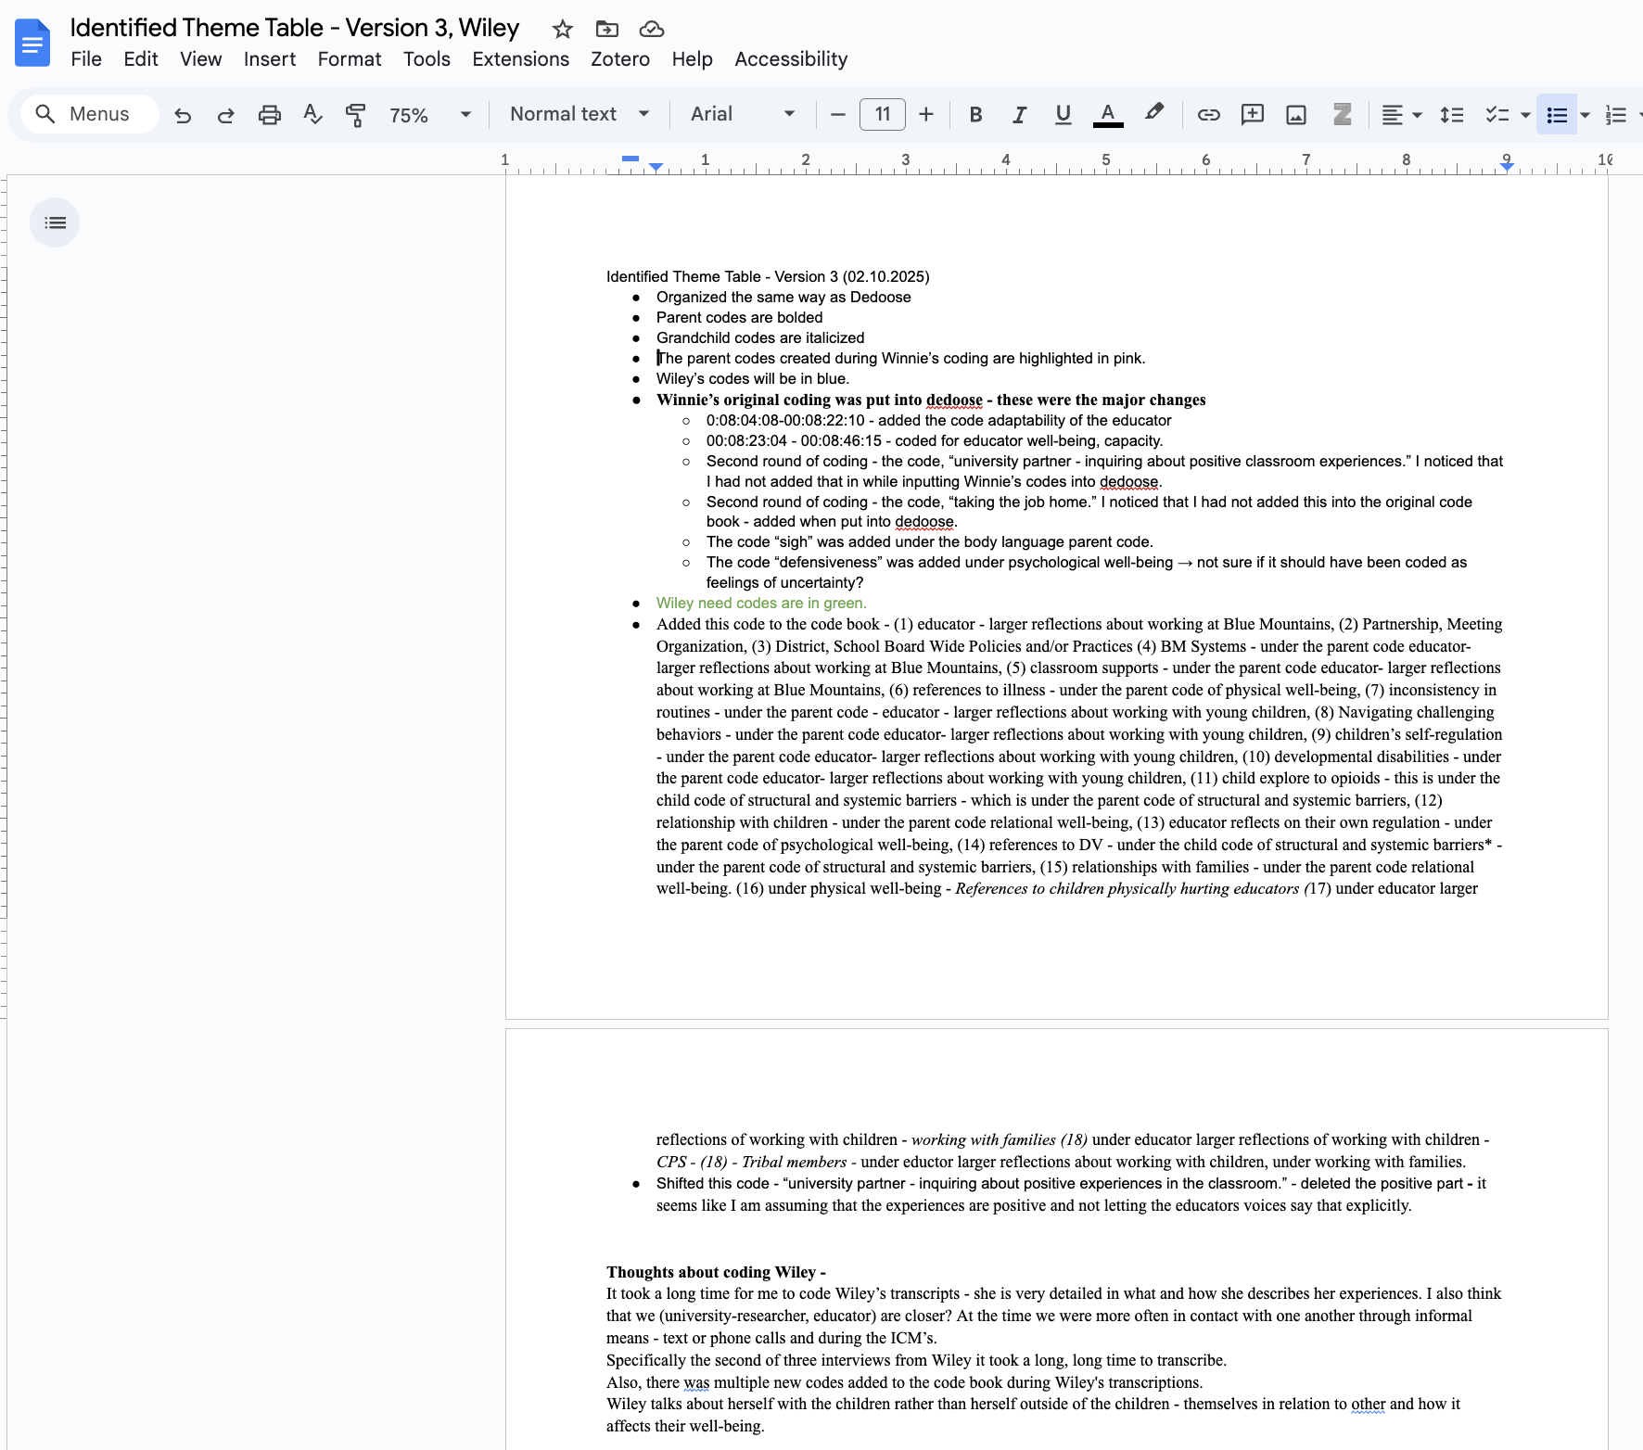

Figure 1. Reflexive Memoing

Appendix B.

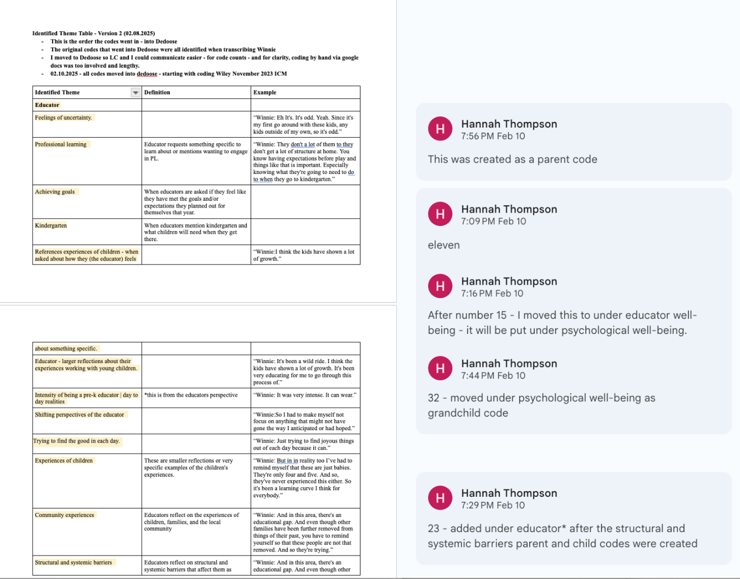

Figure 2. Example of Changes to Identified Theme Table Version 1, Winnie

Appendix C.
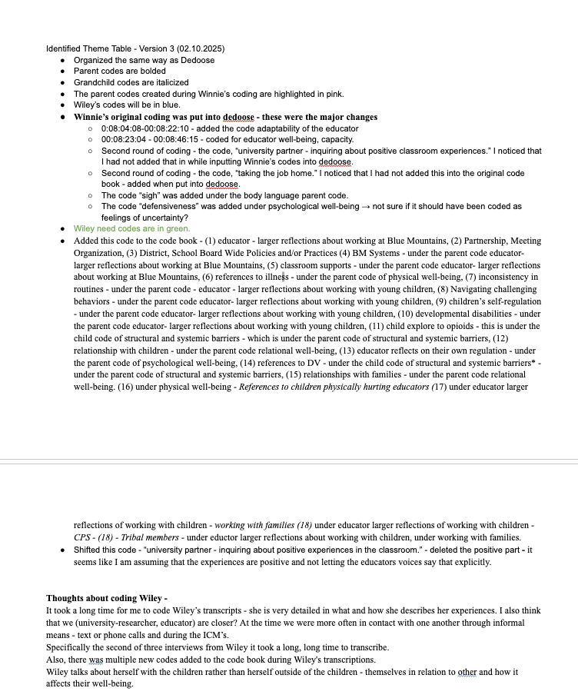

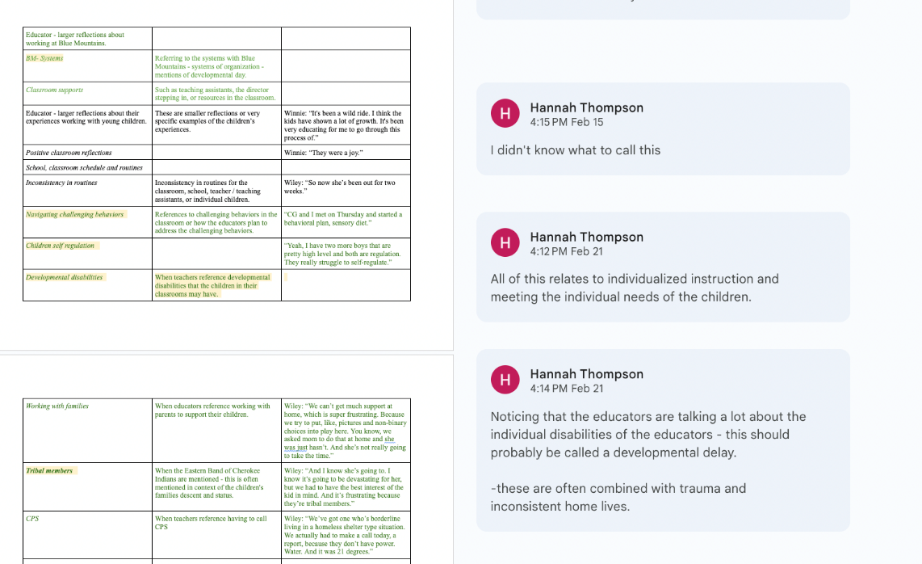

Figure 3. Example of Changes to Identified Theme Table Version 2, Wiley

Appendix D.

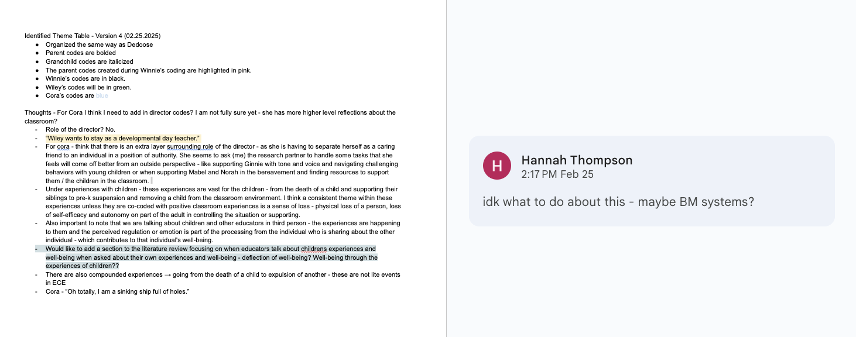

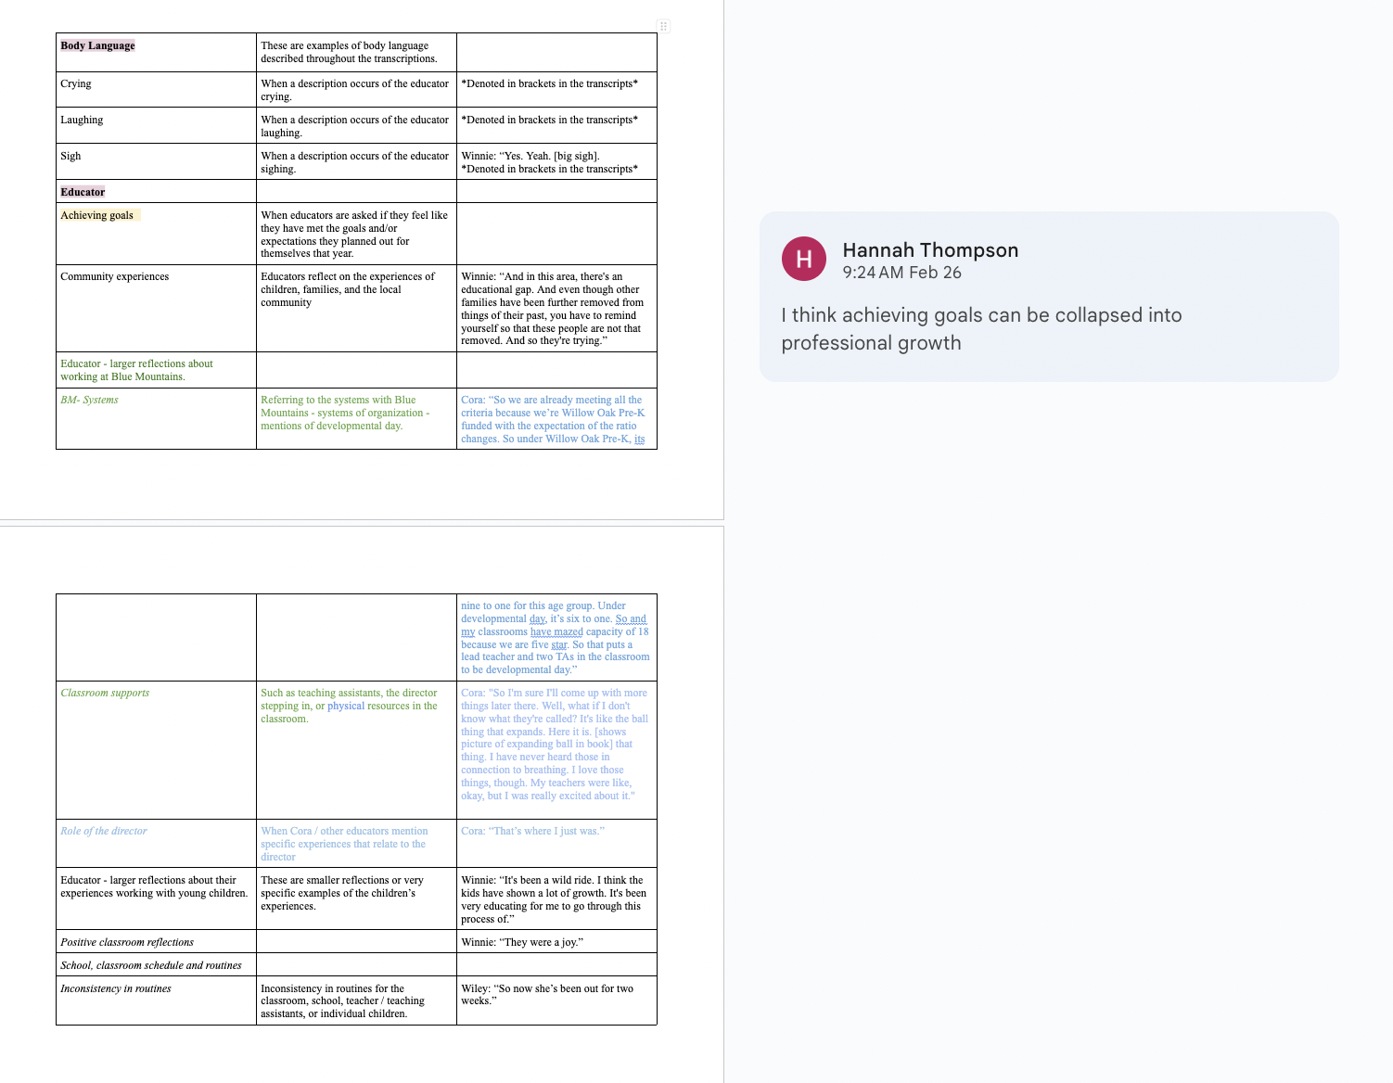
Figure 4. Example of Changes to Identified Theme Table Version 3, Cora

Appendix E.

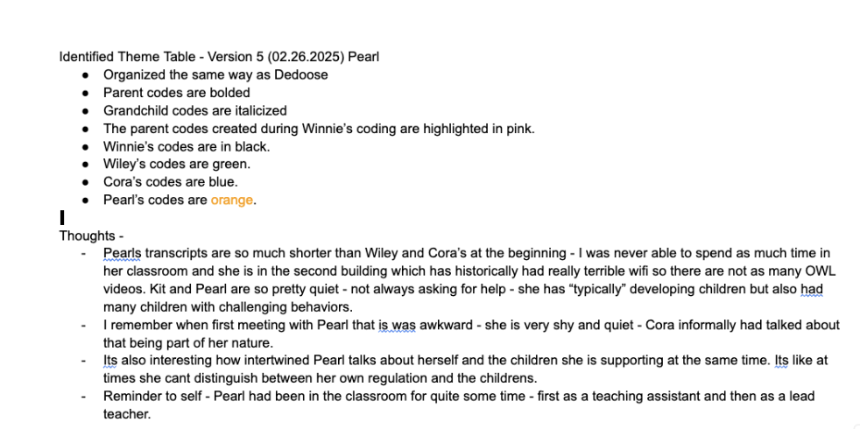

Figure 5. Example of Changes to Identified Theme Table Version 4, Pearl

Appendix F.
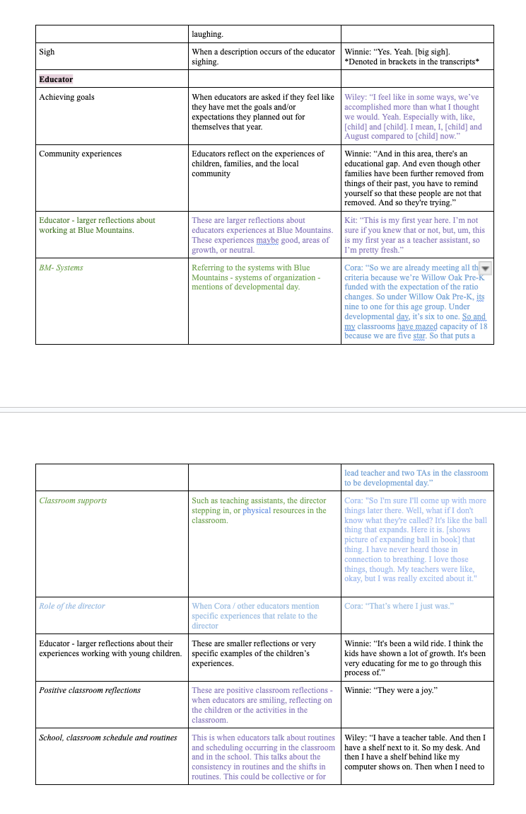
Figure 6. Example of Changes to Identified Theme Table, Version 5, Kit

Appendix G.

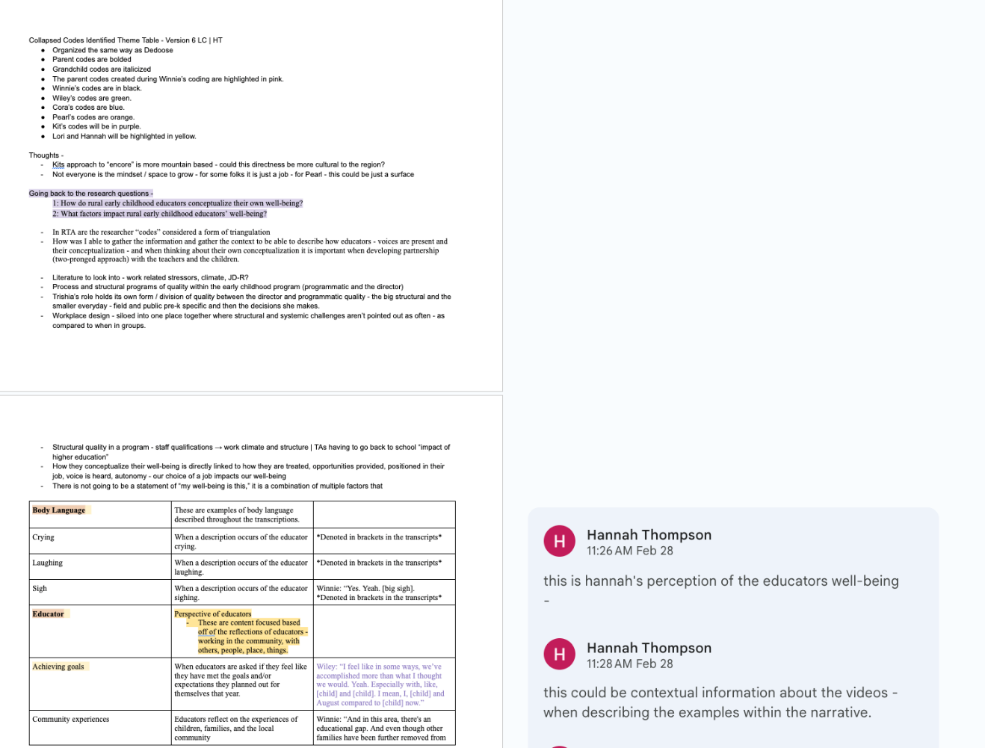

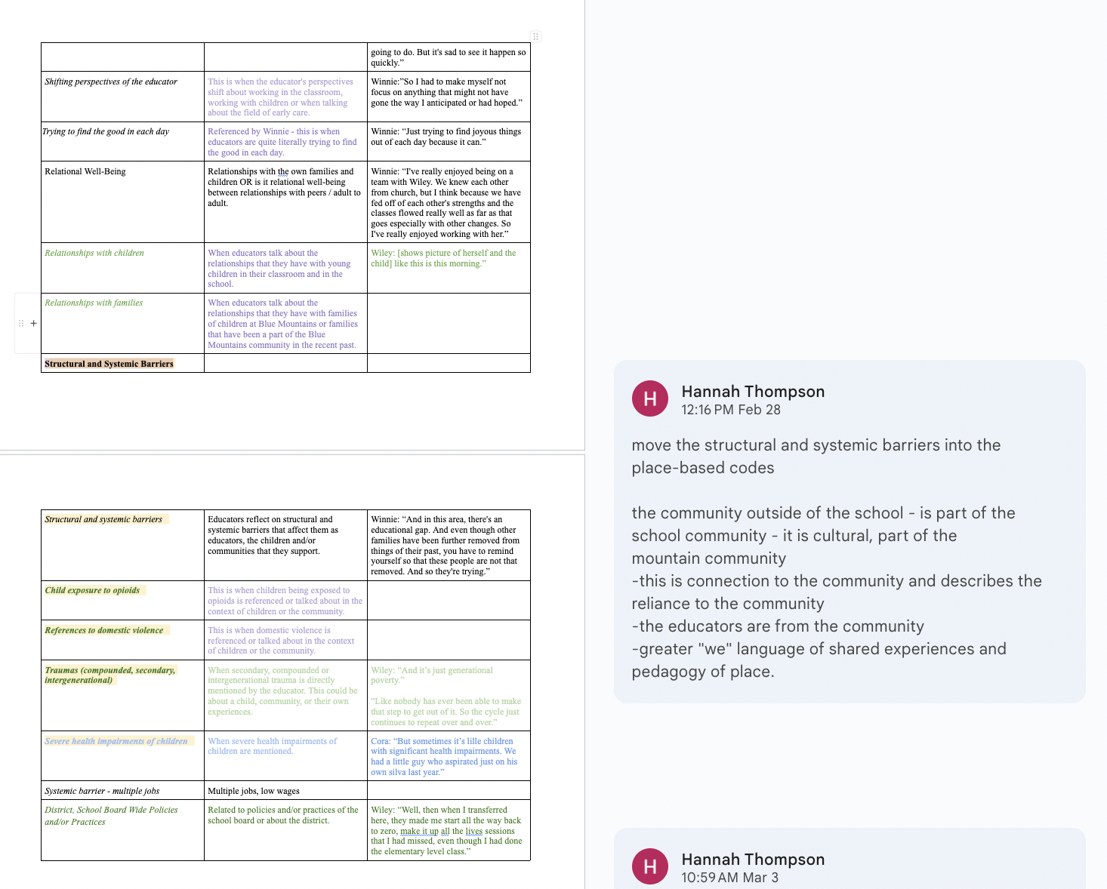

Figure 7. Example of Changes to Identified Theme Table, Version 6, Lori and Hannah

Appendix H.

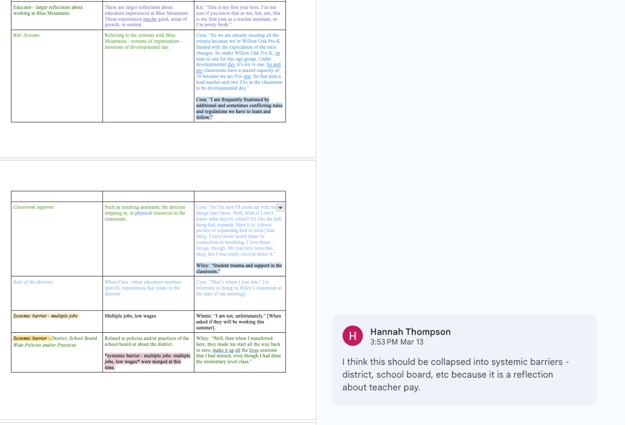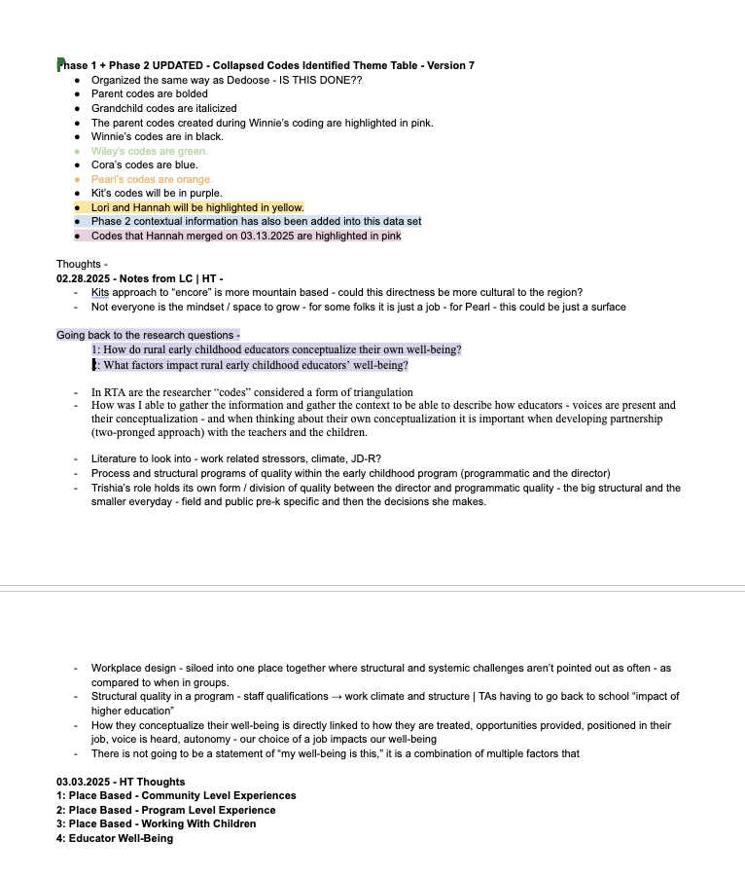
Figure 8. Example of Changes to Identified Theme Table, Version 7

Vita
Hannah Rae Thompson has a bachelor’s degree in Communication Disorders and Sciences from the University of Oregon and her Master of Education with an emphasis in Early Childhood Education from California State University, Long Beach. Hannah taught infant and toddlers and preschool aged children in Oregon and California before pursuing her Ph.D. at the University of Tennessee, Knoxville.

