Development of Microfluidic Platforms for Studies of Cellular Organization in Escherichia Coli

A Thesis Presented for the
Master of Science
Degree
The University of Tennessee, Knoxville

Anna Dawn Jennings
December 2016

Copyright © 2016 by Anna Dawn Jennings
All rights reserved.
ACKNOWLEDGEMENTS
I would like to thank Dr. Jaan Mannik for making this research possible, without whom our lab would not be up and running. His guidance and support throughout this journey is much appreciated. I would also like to thank Dr. Jaana Mannik, who has helped the understanding of the biological side of the lab aspects. I also greatly appreciate my committee members, Dr. Rachel McCord and Dr. Christine Nattrass, for their support and guidance in this research.
This journey has come with its ups and downs and there have been many people along the way I would like to thank. Bryant Walker, Matt Bailey, and Da Yang have been a major contribution to this work and in helping with many discussions, whether about research or otherwise. I would like a to extend a huge thank you to my mom, who has inspired and supported me throughout my entire life to do the best work I can. Lastly, I could not have done this without the consistent support of Duncan Bennett, who has been there through the thick and thin of this part of my life. I appreciate each of you and would not have made it this far without all of you.

ABSTRACT

Traditionally, bacteria cells have been imaged on agarose pads allowing them to grow in steady conditions for only a few doubling times. To understand the cellular organization in bacteria, tools are needed that allow cells to grow in steady-state conditions for many generations. In recent years, several microfluidic platforms have been designed that allow bacteria to grow in log-phase in micron-size channels and pockets for over one hundred generations. One of the most promising approaches has been the so-called mother machine design where bacteria grow in small dead-end channels all connected to a large main channel. The fluid flow in the main channel flushes away extra cells and metabolic waste products from pocket entrances. It also constantly resupplies nutrients providing steady cell growth. The mother machine chips are made of PDMS and are easy to assemble and usable over long periods of time. However, the cell loading process is time consuming, the chips do not enable high resolution phase contrast imaging, and as has turned out, there is a nutrient gradient in the pockets meaning that cells further from the main channel experience nutrient deprivation. Here, we investigate two extensions to mother machine platform to overcome these shortcomings. The first platform, which we refer to as the flow through chip, allows the liquid to flow over all the cells in the pockets through a small connector and thereby decreasing the nutrient gradient. This platform also significantly decreases the loading time of cells. The second platform follows the original mother machine design but is made of agarose. This chip produces good quality phase contrast images of cells since the index of refraction of agarose is like that of water. Also, the diffusion of nutrients is more consistent throughout agarose which helps decrease the nutrient gradient.

Table of Contents

Chapter One Introduction 1
Chapter Two Literature Review 4
Bacterial Growth 4
Cell-size control and homeostasis 7
Studies of bacterial cellular organization and physiology using Microfluidic Chips 10
Different material considerations in making microfluidic chips for cellular studies 15
Chapter Three Materials And Methods 1
Strain and Growth Conditions 1
Fluorescence Microscopy 3
Image Analysis 6
Chapter Four Mother machine 8
Design 8
Fabrication of PDMS Devices 9
Measurements and Results for Mother Machine 10
Bacterial loading procedure 10
Growth of the Mother Cell 11
Nutrient Gradient 16
Chapter Five Agarose Based Design 18
Fabrication 18
Experiment Set-up 21
Results 22
Chapter Six Flow through platform 27
Design 27
Preliminary Results for Nutrient Gradient 28
Chapter Seven Conclusions 31
List of References 33
Vita 37

LIST OF FIGURES
Figure 1.1: Agar pad measurement showing exponential growth of E. coli after 12 hours of imaging. 2
Figure 2.1: Schematic of slow and fast growth in E. coli. The left column shows the chromosome in slow growth conditions with a clear distinction in the three phases of the cell growth cycle. The right column shows the chromosome in fast growth conditions with the multifork replication shown clearly in the termination stage. Image from [21]. 6
Figure 2.2: Correlations of growth parameters against the rescaled newborn length on the single-cell level using SDs from the entire set of E. coli showing the rescaled (A) generation time, (B) elongation rate, and (C) dividing length. Graph from [18]. 8
Figure 2.3: Individual cells newborn data (blue) versus growth rate showing the average in each growth condition follows the population growth law (red). The blue line shows the adder model theory. Graph from [18]. 9
Figure 2.4: Taheri-Araghi et al. showing that cells add a constant length at birth, regardless of size to maintain homeostasis. After a number of divisions, the cell size at birth will converge to a consistent length for the population. 10
Figure 2.5: Mother machine design by Wang et al. showing in and out flow through main center channel with dead-end channels for linear cell growth. 12
Figure 2.6: Agarose chip design used by Moffitt et al. showing the gutters to flow nutrients and wash away waste with the horizontal tracks to grow cells linearly. 13
Figure 2.7: Cell growth on patterned agarose (a) Phase contrast image following lineage of a cell (solid line) and its daughters; (b) Same lineage 6hrs later showing cells being pushed into gutters. Image from [4]. 14
Figure 3.1: Fluorescent image of two E. coli cells. (Left) WD2 strain on agar pad with an mCherry label on MatP and a GFP label on ZipA. (Right) AJ5 strain in mother machine with tagRFP cytosolic label. The scale bars are 2µm. 4
Figure 0.2: Fluorescent image as seen in Matlab image analysis (left) showing original image, before binary mask is created. (Right) shows the contour (green) and midline (red) from Cload of the selected cell after the binary mask is created and the background subtracted. 7
Figure 4.1: (A) Schematic for mother machine showing the flow in and out of cells while the cells can enter the pockets initially and then leave after the mother cell has doubled enough times. (B) 100x image of mother machine, PDMS, showing the two lengths of pockets, 20µm and 15µm. 9
Figure 4.2: Silicon wafer with 9 chip patterns. 10
Figure 4.3: (A) Fluorescent and phase image of mother machine showing bacteria growing in pockets. (B) Growth curve of two E. coli cells shown in (A). 12
Figure 4.4: Growth curve (left) of AJ5 cells in 28ºC tube measurement. The logarithmic plot (right) of the growth curve shows best fit line used to find the doubling time in the tube measurement during log-phase growth. 13
Figure 4.5: (A) Averaged doubling time of mother cell across the different widths of pockets showing both lengths, 15µm (red) and 20µm (black). Each measurement is the average of three independent measurements. The solid line shows the doubling time measured for cells grown in a test tube. (B) Averaged cell width at birth across the pocket widths. (C) Averaged cell length at birth, (D) average cell volume at birth. The error bars are standard error of mean. 14
Figure 4.6: Raw data for the gradient analysis from three measurements in the 0.8µm wide channel. The cell length (left), width (middle), and volume (right) at birth confirm a nutrient gradient as seen by the best fit lines. Their slopes are significantly different than zero. N=1766 newborn cells. 17
Figure 4.7: Gradient results for cell length (left), width (middle), and volume (right) versus channel width. The channel length is 20µm. In all cases the gradient is significantly different from zero. The slopes were found from the best fit line of the raw data as seen in Figure 4.6 for each respective channel width. Error bars represent the standard error. P shows the probability that the gradient is zero. 18
Figure 5.1: Schematic of agarose platform 19
Figure 5.2: Agarose assembly process; The Al mold to make the PDMS sidewalls shown as a top view (A) and side view (B) with the center part to create the hole for the agarose. (C) The PDMS sidewalls bonded to the glass cover slip. (D) Teflon mold to pattern the agarose. (E) and (F) show the completed platform held together by screw holders pressing evenly on the top glass slide. 20
Figure 5.3: Phase contrast image of PDMS (A) and agarose (B) and (C) taken 2.5 hours apart showing how the cells push themselves up slowly. The width of the pockets is 0.6µm and are 20µm in length. 23
Figure 5.4: (A) Phase contrast image overlaid with fluorescent image of agarose platform of width 0.7µm and length 20µm. (B) The growth curve of the selected channel with an average doubling time of 68mins. 24
Figure 5.5: (A) Average doubling time versus channel width for agarose based platform with a line at 71mins to show the doubling time from the tube measurement. (B) The average cell width at birth versus the channel width with best fit lines for each length of channel. (C) Average cell length at birth, (D) Average cell volume at birth versus channel width. The asterisk represents the channel width shows a significant difference in the two averages shown. Error bars show the standard error of the mean. 25
Figure 5.6: Comparison between PDMS and agarose for the different growth characterizations versus channel length. Data was averaged between all channel widths. (A) Average doubling time, (B) Average cell width and birth, (C) Average cell length at birth, and (D) Average cell volume at birth. Error bars are the standard error of the mean. 26
Figure 6.1: (A) Schematic of flow design chip showing cells flowing in on the top left. The connector is shown which allows medium to pass through to the right channel. The bottom left exit hole is where the valve is placed to control the pressure and flow of cells. (B) Phase image of flow design showing a 0.4µm connector (top) and a 0.3µm connector (bottom). The scale bar is 5µm. 28
Figure 6.2: Time sequence of flow design platform over 7.5 hours showing the cells pushing through the 0.4µm constriction. 30
Figure 6.3: Top row shows raw data for flow through platform with channel width 0.6µm and connector width 0.3µm. The line represents the best fit of the data. The bottom row shows the length (left), width (middle), and volume (right) gradients with the asterisk representing a gradient significantly different than zero. 30

Introduction

There are estimated 5x10³⁰ bacteria on the Earth [25]. Bacteria are vital in everything from recycling nutrients such as the fixation of nitrogen from the atmosphere to the treatment of sewage and production of cheese. There are also many species that cause infectious diseases such as M. tuberculosis, a causative agent of tuberculosis, killing about 2 million people a year. Increasing antibiotic resistance is a growing global problem. To be able to design new antibiotics, essential cellular pathways need to be identified and then screened for their vulnerabilities. To identify new antibiotic targets, bacterial physiology, including organization of chromosomes and the formation of the divisome, needs to be better understood. Studies addressing cellular organization in bacteria have been focused on a few model organisms. Among these, Escherichia coli is the best studied model system. In E. coli, like other bacteria, chromosomal DNA is packed into a compact structure, termed the nucleoid. The organization of DNA within the nucleoid is still poorly understood. The chromosome within the nucleoid replicates during the cell cycle and then is partitioned into two new daughter cells with some help from its cell division apparatus, the divisome. The physical organization of the divisome is also actively studied. To better understand the structure of these essential macromolecular assemblies, new tools for cell growth and imaging are needed.
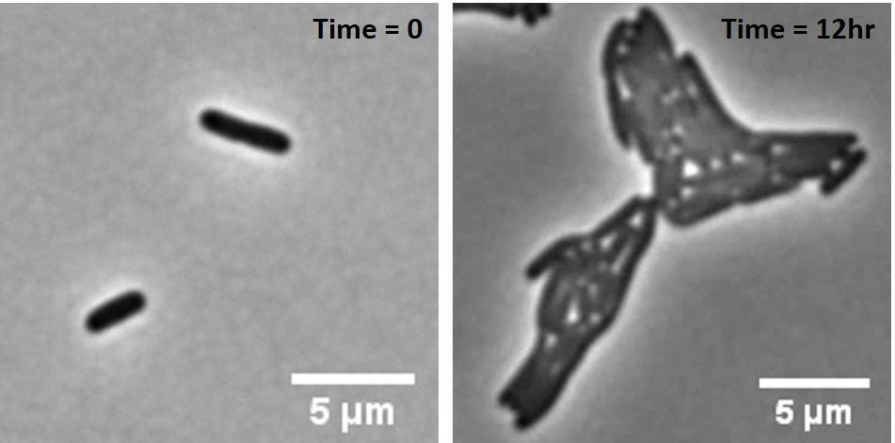
Most bacterial studies use population average measurements. In single cell studies agar pads are typically used to image cells. Due to the limited nutrients and space the bacteria can only divide about 8 times before they start to deplete the nutrients and start to overlap with each other (Figure 1.1).
Figure 1.1: Agar pad measurement showing exponential growth of E. coli after 12 hours of imaging.
The goal of this study is to evaluate three microfluidic platforms to study the cellular organization and formation of the Z-ring on a single-cell level. The first platform studied is the mother machine design [10]. In this design, bacteria populate small dead-end channels connected to a larger channel with flow. The purpose of the latter is to deliver nutrients, dispose of waste, and to flush away excess cells. While investigating cell growth in the mother machine, we observed a small but significant cell size gradient in the small channels. We hypothesized this size gradient was caused by a nutrient gradient in the channel. To overcome the nutrient gradient, we designed, what we refer to as the flow through platform, which sets up a flow in the small channels where bacteria reside. As a third approach, we also built the mother machine chips using agarose as the channel material, instead of PDMS, which can possibly cause cytotoxicity from free oligomers leaking into the cell membrane. This platform was to provide a more useable phase contrast image for analysis. Agarose can also help deliver nutrients to cells more evenly. In this thesis, I will compare bacterial growth in these platforms to determine the most suitable platform to study bacteria. This thesis is organized in the following way.
Chapter two reviews the literature on bacterial growth in microfluidic devices and the application of these devices in biological studies. It will also give a comparison between the different materials, PDMS and agarose, that will be used in this study. Chapter three describes the materials and methods used to carry out these experiments. There will be a discussion on the theory behind fluorescent microscopy used to image the bacteria and the image analysis used. Chapters four, five, and six present the design, fabrication, and measurements of bacterial growth rate and cell sizes in the mother machine, agarose based design, and the flow through platform, respectively. Chapter seven concludes this work by characterizing the bacterial growth parameters in each of the three platforms tested. Preliminary results show the flow through platform improves the nutrient gradient, while phase contrast imaging is improved by the agarose based platform.

Literature Review

Bacterial Growth

In this study, we will compare different microfluidic platforms using bacterial growth as a characterization of how well the platform allows for natural growth. Bacteria go through three main growth phases: lag phase, log phase, and stationary phase. During lag phase, the cell division rate is null, although metabolic activities continue. Log phase is made up of three stages, acceleration, exponential, and retardation. It is when the cells experience their fastest doubling times. Lastly, stationary phase is when cell division stops [12]. When characterizing the growth of cells over an extended period the cells should be kept in exponential growth phase. The cell number is shown in Equation 1, where $1/{t_{d}}=μ$ is the doubling rate, or the number of generations per unit time.
$N=N_{0}∙2^{t/{t_{d}}}$ (1)
This can be rewritten in form of growth rate, where µ is the growth rate.
$N=N_{0}e^{μt}$ (2)
A common method to experimentally determining the number of cells in a culture is by measuring the optical density, OD₆₀₀, of a sample. The OD₆₀₀ measures the turbidity of the cell culture by measuring the amount of light that is scattered by the sample at wavelength 600nm and is proportional to the number of cells. By graphing an optical density curve, the doubling time may be calculated during the exponential phase of growth.
The growth rate of cells will depend on the growth conditions. For E. coli, there are several growth mediums that result in either fast or slow growth. The speed cells grow will affect how the chromosome replication occurs. In fast growing conditions the cell size must accommodate extra DNA generated by the multifork replication and therefore, will be larger on average [20]. The multifork replication allows for the bacteria to sustain its mass during shorter doubling times as the time to double is shorter than the time to replicate [20]. LB media is a nutrient-rich medium that provides the necessary amino acids which allow for faster growth rates in bacteria. During slow growth rates, there is a finite B period. Slow growth also results in cells being smaller in size. M9 growth media result in slowing growing cells when it does not contain all the amino acids. M9 salts consists of MgSO₄, CaCl₂, water, Na₂HPO₄, KH₂PO₄, NH₄Cl, NaCl. Glycerol or glucose is added to M9 to supply a carbon source for the cells for metabolism. Figure 2.1 shows a schematic of slow and fast growing cells. The multifork replication can be seen in the fast-growing chromosome in both oriC sites as opposed to the single replication fork in the slow growing chromosome.
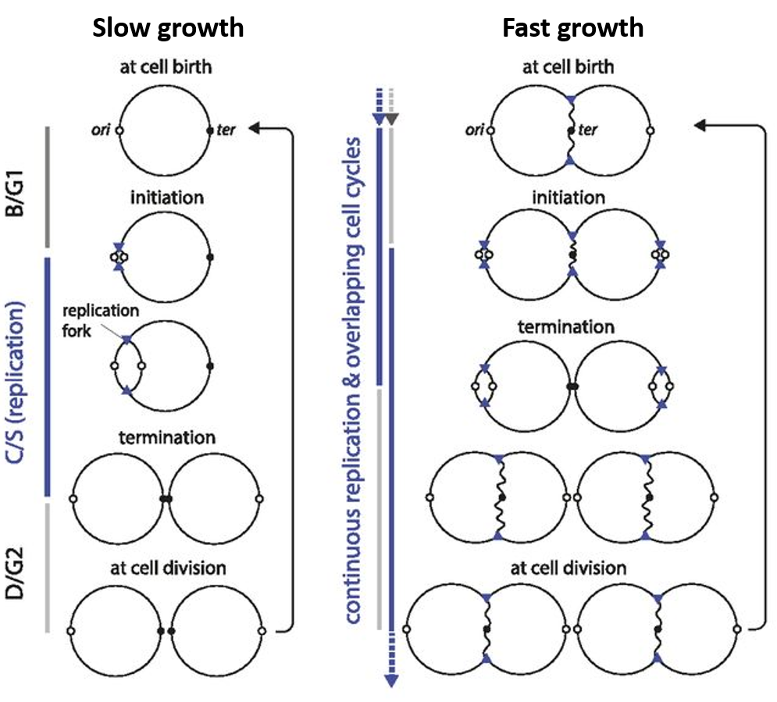
Figure 2.1: Schematic of slow and fast growth in E. coli. The left column shows the chromosome in slow growth conditions with a clear distinction in the three phases of the cell growth cycle. The right column shows the chromosome in fast growth conditions with the multifork replication shown clearly in the termination stage. Image from [21].

Cell-size control and homeostasis
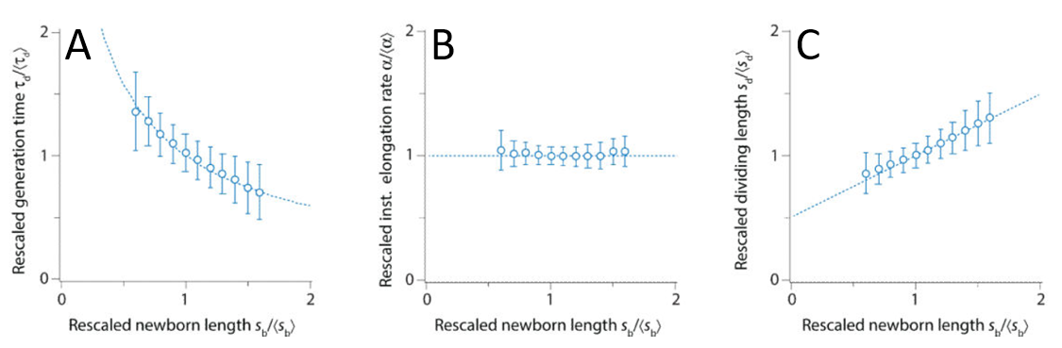
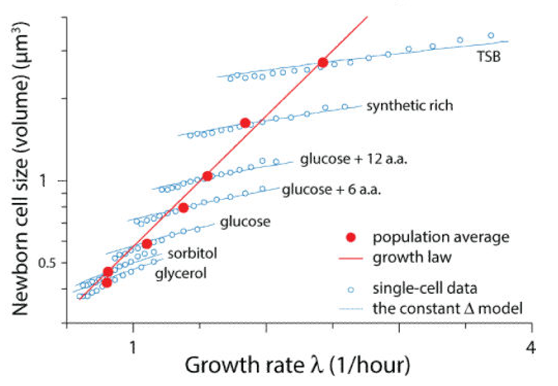
Bacteria are known to be able to control their size and maintain homeostasis; how they do this is an open question. Historically, there have been two main theories: the sizer model and the timer model. The sizer model states that a cell will trigger division when the cell has reached a critical size. The timer states the cell will grow for a finite period before division. Using population-averaged data and the growth law, there have been different interpretations reaching inconclusive results. Amir et al. proposed the idea that cells add a constant size after each division to maintain cell size control [22]. Taheri-Araghi et al. used an extension to the mother machine, originally designed by Wang et al., to monitor hundreds of thousands of E. coli generations under several growth conditions to support that cells add a constant volume after each division, regardless of their newborn size [18]. They termed this the adder model. To disprove the timer model, they plotted the rescaled generation time, τ_{d}, versus the rescaled newborn length, s_{b} (Figure 2.2(A)). If the theory were true the generation time should be constant regardless of newborn length. The sizer model was disproven in Figure 2.2(C) since the dividing length showed a positive, linear dependence on the newborn length. Per the theory, the dividing length should be constant. Their data show that at the population level, cells will follow the standard growth law as stated in Equation 2. When individual cells were observed, they had an intrinsic, non-random, variability from the growth law under constant growth conditions. The average of each growth condition did follow the population growth law (Figure 2.3). They tested seven different growth conditions labeled on Figure 2.3 with glycerol being the slowest and TSB (tryptic soy broth) having the fastest growth rate. The adder model showed there was a constant added size to a cell between birth and division ($Δ=s_{d}-s_{b}$) that was only dependent on growth condition. This adder length will ensure homeostasis by approaching the population average through each cell division. By stochastically adding an uncorrelated size Δ, each cell born of length $s_{b}=〈s_{b}〉+δs_{b}$ will divide in half with some precision and have daughter cells of length $〈s_{b}〉+δs_{b}/2$, on average. The original cell size deviation of the newborn length will be decreased as $δs_{b}/2^{n}$ after n consecutive divisions. This was confirmed for both E. coli (Figure 2.4) and B. subtillis.
Figure 2.2: Correlations of growth parameters against the rescaled newborn length on the single-cell level using SDs from the entire set of E. coli showing the rescaled (A) generation time, (B) elongation rate, and (C) dividing length. Graph from [18].
Figure 2.3: Individual cells newborn data (blue) versus growth rate showing the average in each growth condition follows the population growth law (red). The blue line shows the adder model theory. Graph from [18].
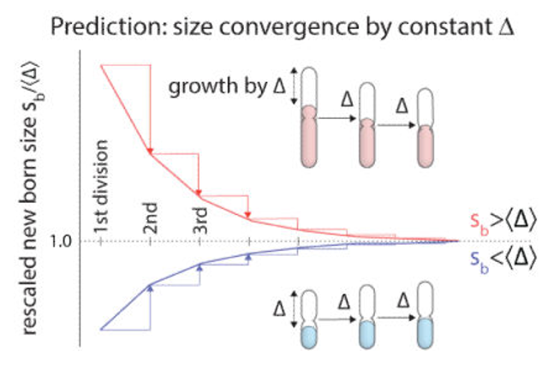
This study was just one use of the mother machine design, showing the ability to study bacterial growth for long periods in log phase. There have been more designs to study bacteria using microfluidics that will be mentioned next.
Figure 2.4: Taheri-Araghi et al. showing that cells add a constant length at birth, regardless of size to maintain homeostasis. After a number of divisions, the cell size at birth will converge to a consistent length for the population.

Studies of bacterial cellular organization and physiology using Microfluidic Chips
Microfluidic devices have shown to be useful in many areas of bacterial research. These include, but are not limited to, subcellular organization, cellular mechanics, growth and motility of cells, antibiotic resistance, and cell-fate switching. Microfluidic chips are effective high-throughput platforms with the ability to compose as many as 10⁵ microchambers spanning only a few millimeters. This helps in separating bacteria for manipulation and detection [14]. Takeuchi et al. [15], observed the growth of filamentous cells by trapping bacteria in an array of agarose microchambers using a film of PDMS containing a droplet of liquid. This allowed the cells to grow continuously in a nutrient-rich environment. The capillary force distributed the cells into the chambers once the surplus of liquid was absorbed by agarose [14]. The iChip, “isolation chip’, developed by Nichols et al. [16], showed up to 50% recovery of a species compared to the 1% standard Petri dishes could cultivate. The iChip is designed by dipping a plate with multiple through-holes into a suspension of environmental cells with the aim to capture a single cell. A semi-permeable polycarbonate membrane allowed chemical exchange between the cells and the environment, while isolating the cells [16]. This method is a high-throughput platform for cultivating many new species of bacteria [14]. Taniguchi et al. [17], developed a high-throughput platform that allowed them to image 1018 strains by stacking up to 96 microfluidic devices in parallel channels. While the process of loading cells into each of the chambers with individual tubing was slow, the platform made for much faster analysis and microscopy [14]. This is a goal of microfluidics and it has the promise to make imaging and analysis more efficient in the future.
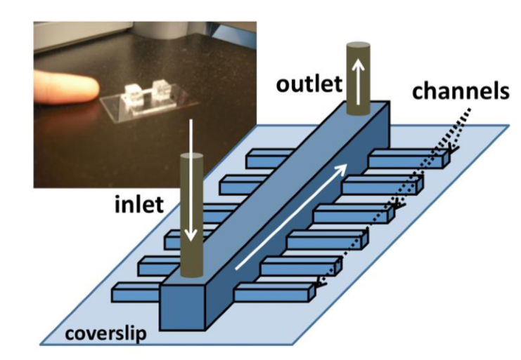
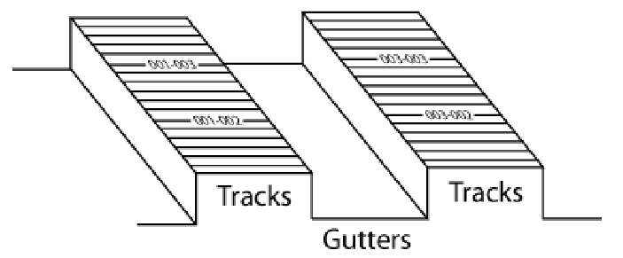
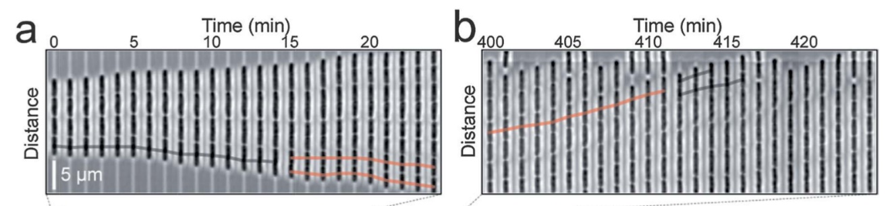
Another advantage of microfluidic devices is they can track the lineage of cells. Bacteria cells, like many others, have a tendancy to reach homeostasis and will develop mechanisms to decrease undesirable conditions [18]. Lineage tracking allows biologists to study the origins of phenotypic variations in cells by spatially separating populations of cells. A device termed the ‘mother machine’ was developed and comprised of hundreds of line channels forcing bacteria to grow in single file instead of the standard colony as they would on an agarose pad (Figure 2.5) [10]. The small channels are connected to a large flow trench that provided nutrients while flushing away waste. Wang et al. [10] could grow E. coli cells for over 100 generations in steady-state growth using the mother machine. Historically, the mother cell was thought to have significant growth rate changes due to inheriting the old pole after each generation, however they could show this is not the case using the mother machine. The number of generations tracked is limited by the distance nutrients can diffuse through the material. When studying B. subtillis, gram-positive bacteria, Norman et al. [19], provided nutrients at longer distances by adding a shallow side channel. Gram-negative bacteria, such as E. coli, can squeeze into the side channel when crowded, resulting in multiple lines of cells growing next to each other instead of a single line of cells. To solve this, agarose has been used instead of PDMS. Agarose allows for more diffusion of nutrients over a longer distance. This can also allow for signaling molecules to transfer between cells, which is both advantageous and disadvantageous depending on the applications. Moffitt et al. [4], could pattern agarose using the design in Figure 2.6, but found that the spacing between channels can easily be taken over by cells since it is a much softer material than PDMS. They solved this problem by making the channels that were narrower (0.3-0.8µm) but deeper (1-1.5µm) than the width of bacteria. The channels were connected between two gutters that aided in flowing old cells out after being pushed out of the channel (Figure 2.4). They could track single cells over time, seen by the black and red line in Figure 2.7 as a function of the position. They found the rate at which cells were pushed towards the gutter increased proportionally as a function of the position near the center of the colony. This let them relate the rate at which the cells moved to the average elongation rate of cells, which was also constant in time over 30 generations. They were also able to find the average elongation rate, the length at division, and the division time of individual cells were constant over time. They tested different track sizes and found that, when compared to a PDMS device, the bacteria did not change morphology while in the channels and determined the agarose channels are a ‘one-size-fits-all,’ allowing the agarose to conform to different bacteria sizes.
Figure 2.5: Mother machine design by Wang et al. showing in and out flow through main center channel with dead-end channels for linear cell growth.
Figure 2.6: Agarose chip design used by Moffitt et al. showing the gutters to flow nutrients and wash away waste with the horizontal tracks to grow cells linearly.
Figure 2.7: Cell growth on patterned agarose (a) Phase contrast image following lineage of a cell (solid line) and its daughters; (b) Same lineage 6hrs later showing cells being pushed into gutters. Image from [4].

Different material considerations in making microfluidic chips for cellular studies
A standard material used to make the microfluidic chips is polydimethylsiloxane, PDMS, which is a crosslinked polymer composed of hydrophobic dimethylsiloxane oligomers. There are both advantages and disadvantages to using PDMS for a biological system. Some advantages include its ability to be molded easily with features on the sub-micron scale; it is considered non-toxic and cures at low temperature; it is also able to seal to itself and to other materials reversibly through van de Waals bonds with the surface; it can also be irreversibly sealed using an oxygen plasma bonding treatment which creates a covalent bond on the surface [6]. With soft lithography, a microfluidic chip can be attained in any number of patterns on the sub-micron scale [7]. There are several disadvantages with PDMS as well. PDMS is rather stiff [7], and can produce a force on cells causing a high mechanical stress on the cell wall [8], which may cause deformations in growth. Next, phase contrast imaging is difficult due to the index of refraction of PDMS being higher than that of water [9,10]. To do analysis, it is necessary to use fluorescent markers in the cytosol of the cells, since in phase contrast images the cell and channel contours overlap. Finally, PDMS is not permeable than agarose to aqueous solutions, meaning cells may not receive the given nutrients if they are further away from the source [7]. There are also two possible biological implications when PDMS is used for bacterial studies. The first is the potential for uncrosslinked oligomers to leak into the medium and possibly into the membrane of cells. The second is that small hydrophobic molecules from the medium may be sequestered in the porous, hydrophobic network of oligomers [19] resulting in potential cytotoxicity in signaling molecules between cells. Toth et al. showed that as much 5% (w/w) of the bulk PDMS remains uncrosslinked through curing, which is a time- and temperature dependent process. Organic solvents can extract the free oligomers, referred to as low molecular weight (LMW) species. The diffusion of these oligomers aid in the bonding process by masking the hydrophilic surface groups. This study used energy-dispersive X-ray spectroscopy (EDS) in attempt to characterize the number of free oligomers found in the medium and in the cell membranes. PDMS is nearly 40% silicon, so EDS could detect the amount of Si in the cell membranes. Since it is not a standard component of the membrane, it was assumed the presence was from uncrosslinked oligomers. After 24 hours of a culture being in PDMS microchannels, EDS confirmed a presence of silicon in the plasma membrane of cells. To date, there is no result to show that the oligomers affect the growth and stress of cells though, but their presence is still concerning.
A second material that has been explored more recently is agarose [4]. There are many known benefits for cell growth on the nutrient rich material, including better phase contrast imaging, a more permeable and nutrient rich environment for cells to grow, and less mechanical stress on the cell walls [4]. The assembly of the agarose based chip is slightly more cumbersome than the PDMS chip, however. This is partly due to the nature of agarose. It is a polysaccharide made up mostly of water and will dehydrate over time if let to sit in open air, unlike PDMS, which will retain its structure once formed.

Materials And Methods

To study bacteria, we need sufficient methods to image and analyze the cells once grown. A standard method is to fluorescently label a protein, or proteins, of interest thought to contribute to cell growth and division or chromosomal organization. This will involve fusion of a fluorescent protein with a protein of interest. In this thesis, we have fluorescently labelled the cytosol to follow the cell size in time. The main imaging techniques used for this thesis were fluorescent and phase contrast microscopy. To quantify the size and growth of cells, digital image analysis was employed. The image analysis relies on both the fluorescent and phase contrast microscopy to determine the size of the cell. This chapter will describe the techniques used to grow, image, and analyze the bacteria in this thesis.

Strain and Growth Conditions

The strain used in these experiments was E. coli strain, AJ5. This strain was made by a P1 phage transduction of the parent strain, BW25113 [27], with a lysate from FW1401 [28] to insert a tagRFP-T sequence in leuB locus of the cell. The strain is Kan^{R} at 25µg/mL. Through P1 transduction, the lysate packed with the bacterial chromosome from the host strain, FW1401, will recombine in the recipient strain, BW25113. The procedure takes a total of 5 days to create a new strain. Both the host and recipient strain are grown overnight from a single colony in liquid LB, Lysogeny Broth [29], culture at 28ºC. The FW1401 strain is grown with 25µg/mL kanamycin to decrease mutations. The next morning, the lysate is prepared by combining 3mL fresh LB with 30µL of the FW1401 culture grown overnight with no antibiotics in 37ºC for 1-2 hours until the OD₆₀₀ ~0.2. Once done, 30µL 1M CaCl₂ and 30µL P1 lysate is added to the tube and incubated at 37ºC for 1-2 hours until strands or clumps start to form. This is to ensure the lysis has happened. Next, 50µL of chloroform are added and the cells are vortexed at 8000RPM for 3 minutes. The supernatant is collected into two screw cap tubes and 15µL chloroform is added to each. Once the lysate is prepared, 5 tubes are prepared. The first three contain 200µL of the recipient strain, BW25113, from the overnight culture, 2µL CaCl₂, and varying amounts of lysate (1µL, 10µL, and 50µL) to determine the amount needed. The last two test tubes are controls. A positive control containing just the lysate, and a negative control containing just LB media. Incubate the tubes for 30 minutes without shaking at 37ºC and then add 100µL sodium citrate and 500µL LB, then incubate again for 45 minutes without shaking at 37ºC. Once done, spin the tubes in a centrifuge for 2 minutes at 8000RPM and discard the supernatant. Resuspend the pellets in 100µL LB plus 5mM citrate. Plate each tube on LB media with 25µg/mL kanamycin using a glass spreader to ensure an even spread of bacteria. Incubate the plates overnight at 28ºC and chose which colonies to replate in the morning. This final step is repeated 3x to ensure there are no other mutations in the bacteria strain. The cells were checked on an agar pad to determine if the tagRFP was on the cytosol. A frozen stock was made to use for the experiments. For the experiments in this thesis, the cells were grown overnight on a LB plate at 28ºC. A single colony was then taken and grown in M9 minimal medium liquid culture with 25µg/mL kanamycin and 0.2% casamino acids overnight at 28ºC. The flow medium consisted of M9 minimal medium, 0.2% casamino acids, and 1mg/mL BSA to prevent the cells from clumping to one another and sticking to the glass slide.

Fluorescence Microscopy

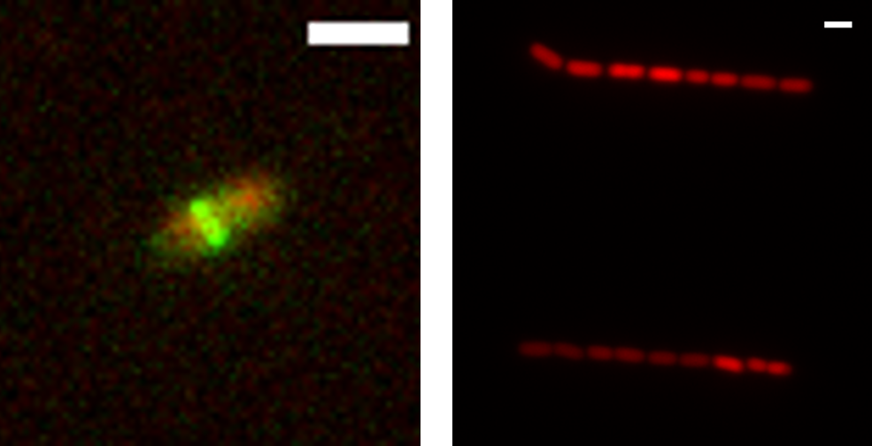
Fluorescence microscopy is a widely-used tool to study bacteria. The physical phenomena of fluorescence occurs when light by organic and inorganic specimens is absorbed and subsequently re-radiated. This process is nearly simultaneous with the absorption of the excitation light since the delay between photon absorption and emission is relatively short, ranging usually less than a microsecond. Traditional optical microscopy does not allow for the high degree of specificity in sub-cellular components as fluorescence microscopy does, and as such, it has become pertinent in the studies of biology and biomedical sciences [26]. To study the cellular organization, specifically the Z-ring, different fluorophores can be used to tag specific proteins used to assemble the ring. Fluorescence microscopy can detect these molecules and with time lapse imaging, the proteins can be observed as the cell grows and divides. The advantage of this technique with the platforms to study single cells, we can study how the Z-ring is formed over hundreds over generations versus the short time lapses taken on an agar pad. Fundamentally, the microscope irradiates the specimen with a desired wavelength and then separates the excitation light from the much weaker emitted fluorescence using a filter. Figure 3.1 shows this contrast with two different strains of E. coli. The left image shows two fluorescent labels on specific proteins of the divisome, while the right image shows a tag RFP labeling the cytosol. The intensity of the fluorophores are used to analyze where specific proteins are in the cell. In this study, we use the cytosolic label to determine specific growth characteristics of the cells using a program that determines the outer edges of the cells on the fluorescent image. A specific wavelength of light, often ultraviolet, blue or green, is produced by passing multispectral light from an arc-discharge lamp through a wavelength selective excitation filter. The dichromatic mirror then reflects the passed wavelengths and acts as a beamsplitter to bath the specimen with intense light. If the specimen fluoresces, the light is passed back through the dichromatic mirror and is subsequently filtered by the barrier filter. The barrier filter blocks unwanted excitation wavelengths from the fluoresced specimen. A wide spectrum of conditions effects the re-radiation of fluorescence emission.
Figure 3.1: Fluorescent image of two E. coli cells. (Left) WD2 strain on agar pad with an mCherry label on MatP and a GFP label on ZipA. (Right) AJ5 strain in mother machine with tagRFP cytosolic label. The scale bars are 2µm.
Photobleaching happens when the fluoresced molecules are subject to irreversible decomposition while in their excited state from the interaction with molecular oxygen before emission. Essentially, this leads to the fading of fluoresced molecules making analysis on their intensity almost impossible. FRAP, fluorescence recovery after photobleaching is a widely-used technique to study the diffusion and motion of biological macromolecules that uses photobleaching on a sharply defined region of the cell by an intense burst of laser light. The rate of recovery is then observed in the area [26].
A possibility of fluorescence emission is the ability to detect single molecules. For this to happen, the background detector noise needs to be sufficiently low. To decrease this, fluorescence microscopy techniques started using total internal reflection to provide high excitation light flux with a low background [26]. This takes advantage of the evanescent wave developed when light is totally internally reflected. Light only transmits as far as 200nm into the cell, which allows for an extremely low-level background. Fluorescence microscopy is a vital tool in understanding cellular organization, which requires the ability to label and observe single proteins in the cell over an extended period.
For this experiment, a Nikon Eclipse Ti-E inverted fluorescence microscope was used to take time lapse images. A 100x NA 1.40 oil immersion phase contrast objective was used to image the bacteria. A 200W Hg lamp was used to excite the fluorescence through a ND4 neutral density filter. An Andor iXon DU897 camera was used to capture the images and were recorded using NIS-Elements software.

Image Analysis

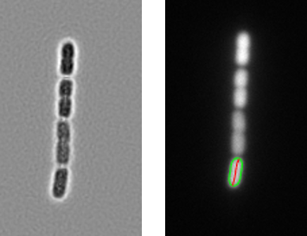
The goal of image analysis is to segment the cells from the background. The optical image produced from the microscope is a 2D continuous image based on light intensity in real space, $I(x, y)$. The digital representation of this image is a rectangular grid of pixels in discrete positions $(m, n)$. The intensity values are discretized as well, creating a 2D image in the discrete space $I(m, n)$. Image segmentation aims to label each pixel in an image to group similar pixels together. A common image technique is phase contrast imaging, where the cells show up as dark regions on a light background, if the cells as imaged on an agar pad. PDMS is used frequently in this thesis and the difference in the index of refraction between that and agarose is described above. Here, we label the cytosol of the cell, allowing us to analyze just the fluorescent image, which is not affected by the presence of PDMS. The analysis utilizes Cload, which is a function in the PSICIC software from Guberman et al. [30]. The PSICIC, Projected System of Internal Coordinates from Interpolated Contours, uses interpolated-contour analysis to accurately define cell borders while automatically generating an internal coordinate system. Cload uses a thresholding algorithm based on a user-defined level determined by the contour level. The program first creates a binary mask image to segment the cell from the background using the addition of the Laplacian and the second derivative of the gradient. Erosion and dilation filters are used to smooth the cell edges. Using this binary image, the contour level is found by the average intensity value of all the inflection points surrounding the cell. Once the level is set, Cload can draw a contour line surrounding the edge of the cell with a defined midline connecting the two poles, which are the two points furthest from each other for E. coli (Figure 3.2). Homemade Matlab scripts based off the DipImage Toolbox (http://www.diplib.org/) and Matlab Image Analysis toolbox were used to analyze the time lapse images.
Figure 0.2: Fluorescent image as seen in Matlab image analysis (left) showing original image, before binary mask is created. (Right) shows the contour (green) and midline (red) from Cload of the selected cell after the binary mask is created and the background subtracted.

Mother machine

The first platform we investigated was the mother machine design. The goal was to learn which channel size is most suitable for bacterial growth. For this purpose, we created a variety of different dead-end channel widths with two lengths.

Design

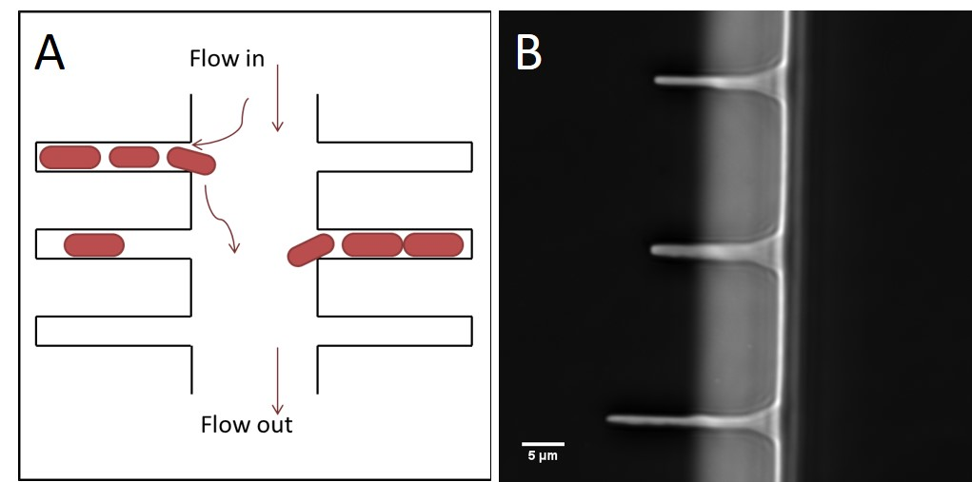
The dead-end channels nominal widths were 0.5, 0.6, 0.7, 0.8, and 1.0µm and lengths, 15µm and 20µm. A schematic shows the cells flowing in a unilateral direction down the main channel of the chip (Figure 4.1).
Figure 4.1: (A) Schematic for mother machine showing the flow in and out of cells while the cells can enter the pockets initially and then leave after the mother cell has doubled enough times. (B) 100x image of mother machine, PDMS, showing the two lengths of pockets, 20µm and 15µm.

Fabrication of PDMS Devices

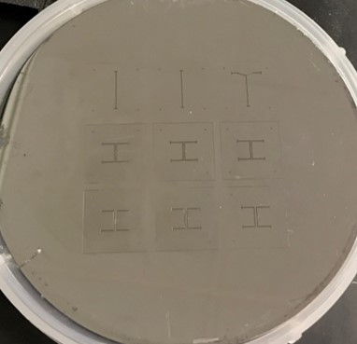
Here, the lab-on-a-chip devices were made using PDMS. The PDMS is patterned by replica molding. We mold it on Silicon wafers (Figure 4.2). The Si wafer is created at ORNL in the clean room using a combination of e-beam lithography and photolithography. A 5:1 mixture of PDMS to curing agent is used to increase cross-linking of polymers and thereby reduce any cytotoxicity effects. Once mixed, half of the mixed PDMS is poured onto the wafer, which is held in place by a home-made mold. This is placed in a vacuum desiccator for ~1 hour until the air bubbles are gone. The rest of the PDMS is then poured on the wafer and degassed again for ~45mins. The chip is then placed in the oven at 194º F for 15mins to cure the PDMS. Once taken out and cooled, the PDMS is cut carefully out of the holder. Individual chips are then cut out and have entrance and exit holes punched. The chip may be cleaned in IPA, isopropyl alcohol, in a sonicator for ~5mins at low to medium power. A glass cover slip is cleaned in IPA in a sonicator for ~5mins at high power. The cover slip is then placed in an O₂ plasma machine and is treated for 70sec followed by the PDMS chip for 5sec and the two are bonded immediately.
Figure 4.2: Silicon wafer with 9 chip patterns.

Measurements and Results for Mother Machine

Bacterial loading procedure
Initially, the chip is flushed with medium to wet the channels before the cells are loaded. The cells are grown overnight to stationary phase so they are small enough to enter the pockets easily. They are then spun down at 6000RPM for 1:30mins to concentrate them. The supernatant is discarded and the cells are resuspended in 20µL of flow medium. A pipette tip is used to slowly mix the pellet. Approximately 10µL of cells is taken up into a pipette tip and the end is placed in the entrance hole of the chip. The cells are loaded by slowly pushing the pipette tip down. The main channel needs to be concentrated fully with cells so that they push each other into the pockets. It takes approximately 1-2 hours for cells to fill the side channels after loading. Once enough cells have entered the pockets, a syringe pump is attached and a steady flow of medium is pumped into the main channel at a rate of 3-5µL/min. Left overnight, the cells will reach log phase in their growth so time lapse imaging can proceed the following day. The flow will pump fresh nutrients into the channels while flushing out old cells and any waste. This allows cells stay in log phase for an extended period.

Growth of the Mother Cell
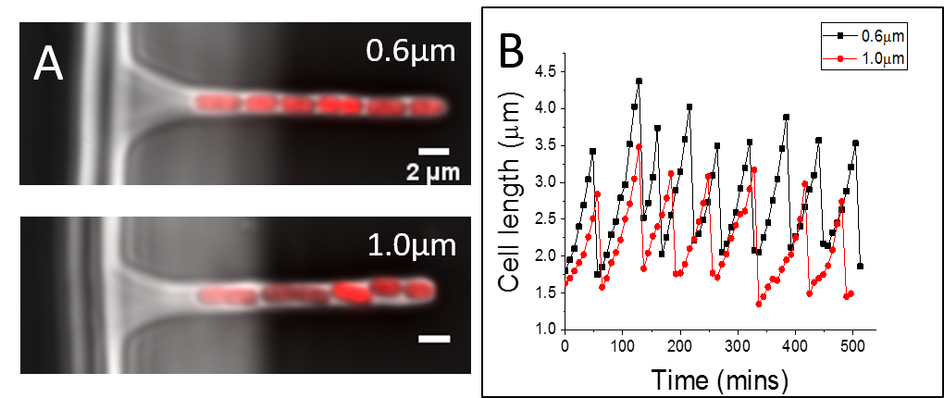
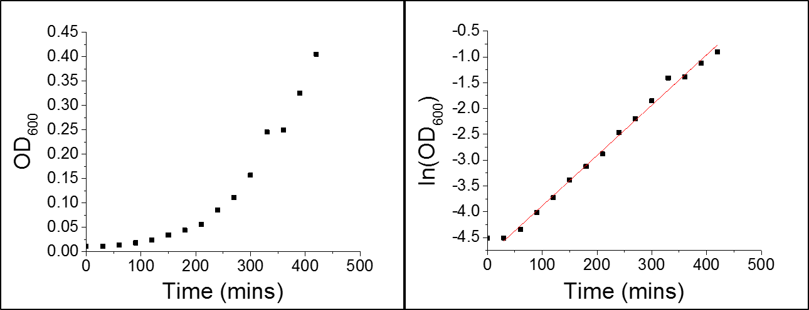
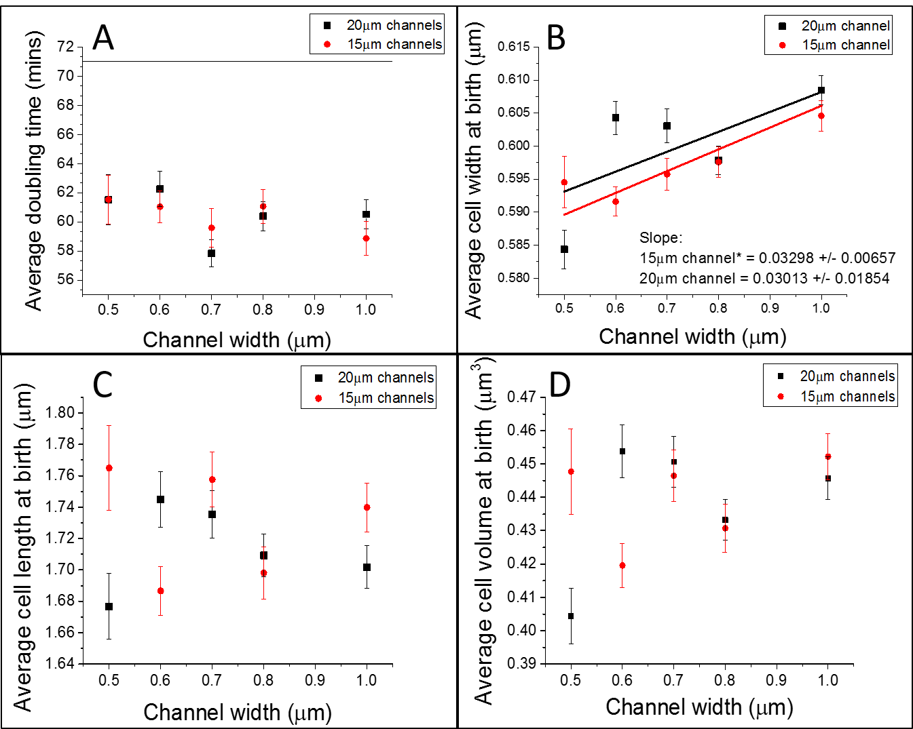
The cells were imaged over a time of 8 hours for each time lapse. Analysis was run on all cells in the pockets. The innermost cell, termed the mother cell, produces generations of daughter cells throughout the length of the pocket. To characterize the growth of cells, the quantities studied were the doubling time of the mother cell and the length, width, and volume at birth for all cells in the channel. These were then compared across the different platforms to judge which platform allowed for the fastest cell growth in nominally the same conditions. Figure 4.3 compares two channel widths, 0.6µm and 1.0µm, showing the respective growth curve for 8 hours. There is no noticeable difference in growth of the mother cell. The first quantity analyzed was the doubling time of the mother cell. As stated earlier, the doubling time is a known characteristic of bacteria and will be consistent amongst a specific strain with given growth conditions. The doubling time in the mother machine was compared with the measured doubling time for cells grown in a test tube. E. coli was grown overnight in a test tube consisting of M9 minimal media with 0.2% casamino acids, 25µl/mL kanamycin, and 25µg/mL glucose at 28ºC in a shaker incubator then diluted to an OD₆₀₀ of 0.01 in the morning. The OD₆₀₀, optical density, of the cells was measured every half hour until they reached an OD₆₀₀ of 0.4 using a spectrophotometer. The natural log was applied to the curve shown in Figure 4.4(left), which was then fit to calculate the doubling time (Figure 4.4(right)). This was found to be 71mins. The mother machine was designed to compare five different widths of channels ranging from 0.5µm to 1.0µm. There were two lengths used as well, 15µm and 20µm. The goal was to see if the bacteria would grow differently given different sized channels. Figure 4.5(A) shows the average doubling time of the mother cell across all channel widths.
Figure 4.3: (A) Fluorescent and phase image of mother machine showing bacteria growing in pockets. (B) Growth curve of two E. coli cells shown in (A).
Figure 4.4: Growth curve (left) of AJ5 cells in 28ºC tube measurement. The logarithmic plot (right) of the growth curve shows best fit line used to find the doubling time in the tube measurement during log-phase growth.
Figure 4.5: (A) Averaged doubling time of mother cell across the different widths of pockets showing both lengths, 15µm (red) and 20µm (black). Each measurement is the average of three independent measurements. The solid line shows the doubling time measured for cells grown in a test tube. (B) Averaged cell width at birth across the pocket widths. (C) Averaged cell length at birth, (D) average cell volume at birth. The error bars are standard error of mean.
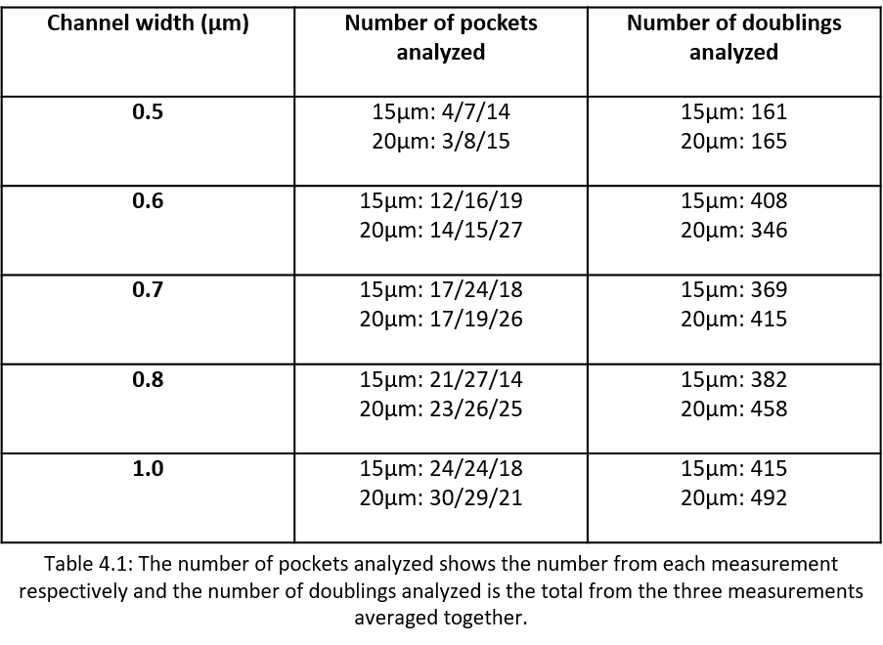
Figure 4.5 is a result of three separate measurements averaged together. All three measurements were performed in the same manner. Table 4.1 shows far fewer cells entered the 0.5µm wide channels when compared to the rest, resulting in few cells being analyzed for this channel width. A Mann-Whitney test, which uses a null hypothesis saying the means of two distributions are different from each other, was performed to compare the average doubling time of the three measurements per each pocket width to see if there was a significant difference; there was not. When comparing the channel widths, the doubling time in the 20µm pockets are not significantly different from one another per the Mann-Whitney test. The same was true for the 15µm channels. The average doubling time in the 20µm and 15µm channels were 60.5mins and 60.42mins respectively, resulting in no significant difference in the doubling time of the mother cell between the two channel lengths as well.
The cell size was also studied since the size is a more sensitive characteristic of all growth conditions than doubling time. I will first discuss cell width, followed by cell length and volume. The average width for this strain is approximately 0.6-0.8µm. As seen in Table 4.1, the smallest pocket has far fewer filled pockets than the larger widths even though the cells were loaded in stationary phase for each measurement, meaning they would be at their smallest size during growth. When analyzing the different pockets, Figure 4.5(B) shows a positive linear trend that is significantly different than zero for the 15µm length pockets. This shows that the mother cell was wider at birth in the 1.0µm wide pocket than the mother cell in the 0.5µm pocket. There is a positive linear trend for the 20µm long pockets as well, however, the slope is not significantly different than zero. There may be slight variations in the sizes of the pockets that arise when patterning the PDMS from the Si wafer and then bonding the PDMS to the glass cover slip, resulting in a systematic error between the design widths and the actual widths. Also, when the glass cover slip is bonded, it may change the widths of the pockets slightly if pressed too hard. To decrease the error, the glass cover slide was held by a tweezers and only tapped on one corner of the PDMS. When comparing the two lengths of pockets, only the 0.6µm wide pocket showed a significant difference in the two means even though the 20µm long pockets show a slightly higher average width at birth across the pockets. However, when considering the dependence on cell length and volume at birth for the mother cell, Figure 4.5(C) and Figure 4.5(D), show no dependence on either as a function of channel width or length.

Nutrient Gradient
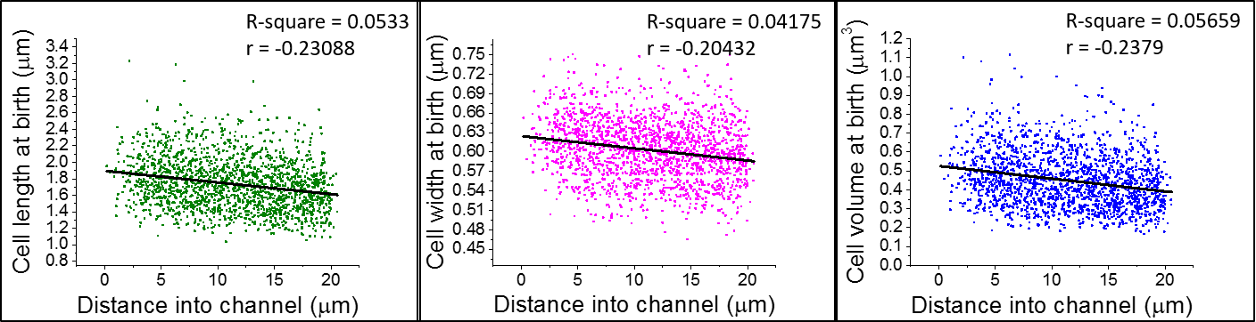
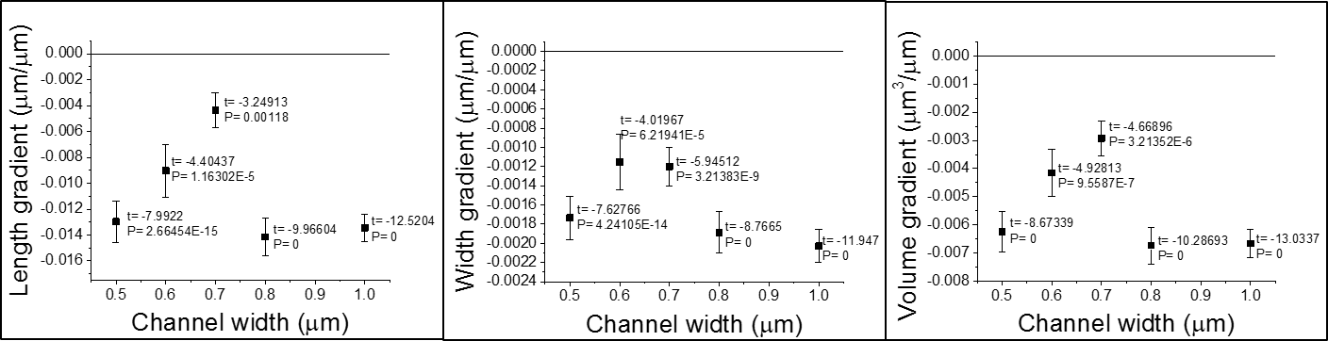
We also analyzed the dependence of the cell length, width, and volume for newborn cells on the position of the cell in the channel. Figure 4.6 shows a representative sample of the raw data from the 0.8µm channel. The line represents the best fit and each shows a negative slope that is significantly different than zero for cell length, width, and volume. This trend was observed in all 5 channel widths at the 20µm length. The slope of the best fit line was used to compare the nutrient gradient in the channel and can be seen in Figure 4.7, which compares the magnitudes of the gradient for each channel width. This can be attributed to the lack of diffusion of nutrients through the PDMS as there is no flow to the end of the pockets from the dead-end design. It may also be from the possible cytotoxicity from free oligomers in the PDMS leaking into the medium and cell membrane.
Figure 4.6: Raw data for the gradient analysis from three measurements in the 0.8µm wide channel. The cell length (left), width (middle), and volume (right) at birth confirm a nutrient gradient as seen by the best fit lines. Their slopes are significantly different than zero. N=1766 newborn cells.
Figure 4.7: Gradient results for cell length (left), width (middle), and volume (right) versus channel width. The channel length is 20µm. In all cases the gradient is significantly different from zero. The slopes were found from the best fit line of the raw data as seen in Figure 4.6 for each respective channel width. Error bars represent the standard error. P shows the probability that the gradient is zero.

Agarose Based Design

Our second platform follows the same design as the mother machine, but utilizes agarose as the patterned material instead of PDMS. The goal for this platform was decrease the nutrient gradient problem as well as improve the phase contrast imaging.

Fabrication

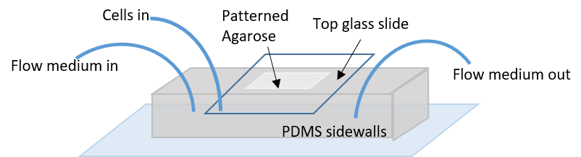
The second platform is based agarose, a polysaccharide polymer typically used to grow cells on. Agarose is a much softer material than PDMS, but can still be patterned to yield sub-micron sized pockets. The assembly of this chip requires two steps; the first is to make the PDMS sidewalls and the second is to pattern the agarose; a schematic of the completed chip is shown in Figure 5.1. A 10:1 ratio of PDMS to curing agent will be used to make the sidewalls and is prepared like the aforementioned chip, however this time the PDMS will be 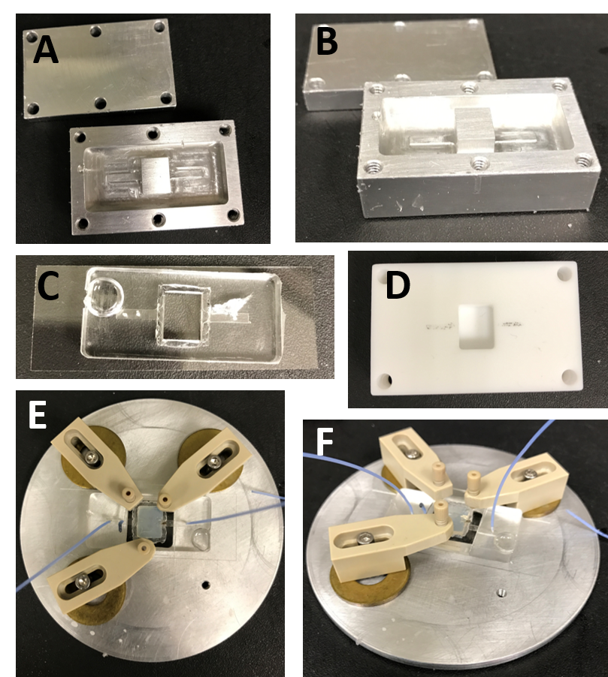degassed for about 40mins and then poured into an Al holder (Figure 5.2(A)). The lid of the holder is screwed into place so the top of the PMDS is flat. This is then placed in the oven at 194º F for 15 mins. Once cooled the PDMS is carefully taken out of the holder and about 0.5mm of the top, inner corners of the center hole are cut off to make a well for fluid build-up from the agarose to help reduce leaks between the top glass slide and PDMS. Finally, entrance and exit holes are punched, the chip is cleaned as before and bonded in a similar fashion to the PDMS chip. While the PDMS is in the desiccator, 5% agarose is microwaved until melted and then poured onto the Si wafer held in place by a Teflon mold (Figure 5.2(D)), which has a hole 5% larger than the center PDMS mold. This is to ensure a close fit when the agarose is placed in the center of the PDMS. The agarose will take 1 hour to solidify. It can then be taken out of the mold and placed carefully in the center of the PDMS sidewalls. As it is 5% larger and softer than the PDMS, there is a chance the corners or sides of the agarose may be shaved off at this point. The goal is to reduce this problem since cells can flow into those holes and grow exponentially causing further problems during imaging. A small divot is cut on the top of the agarose where the entrance and exit of the main channel resides to decrease the buildup of cells in the main channel caused from the ceiling being collapsed in due to pressure. The agarose must be about 5% higher than the PDMS so that, when pushed down using the top glass slide, the bottom of the agarose is tight enough to not allow for wandering cells outside the main channel. However, it cannot be too tight such that the main channel and pockets, which are only 20µm and 1.3µm in height, respectively, can collapse. This can be accomplished by placing the entire chip in an Al holder and using 3 screws to hold the top glass slide down evenly (Figure 5.2(E)).
Figure 5.1: Schematic of agarose platform
Figure 5.2: Agarose assembly process; The Al mold to make the PDMS sidewalls shown as a top view (A) and side view (B) with the center part to create the hole for the agarose. (C) The PDMS sidewalls bonded to the glass cover slip. (D) Teflon mold to pattern the agarose. (E) and (F) show the completed platform held together by screw holders pressing evenly on the top glass slide.

Experiment Set-up
The agarose based chip follows the same pattern as the mother machine. The advantage of using agarose versus PDMS is the availability of nutrients to the cells, better phase contrast imaging, and that it provides less stress on the cell walls. The cells are grown overnight in liquid culture to stationary phase and then diluted to OD₆₀₀ ~0.02. They are let to grow to log phase (OD₆₀₀ ~0.07) for about 3 hours and then concentrated at 6000RPM for 1:30mins. This design requires a constant flow of medium during the loading process otherwise the cells get stuck to the agarose in the main channel. A syringe pump is hooked up and flows in medium at a rate of about 6-8µL/mint before the cells are loaded. This takes about 20mins to even get a steady flow out the exit tube. The height of the top glass slide is checked to make sure fluid can flow while also checking for leaks. Once all air bubbles are flowed out and there is a steady flow, the cells can be loaded. A second entrance hole, further in than the flow hole, labeled “cells in” (Figure 5.2), is unplugged and cells are brought up in a small tube using a syringe. The end of the tube is then placed in the hole and a small push of the syringe is enough to flow cells in. The flow rate may need to be lowered during this part so that it does not flush out all the cells immediately. It should be about 1-3µL/min. Once cells have entered the pockets, the flow can be increased back to about 6µL/min. The cell loading tube is replaced again with a plug to avoid leaks. The height of the top glass slide can be adjusted again depending on where the cells are flowing. If the cells cannot enter the side channels, the screws may be loosened slightly to allow more room for the cells. The cells will be in log phase and therefore time lapse imaging may start shortly after the cells are in the pockets.

Results

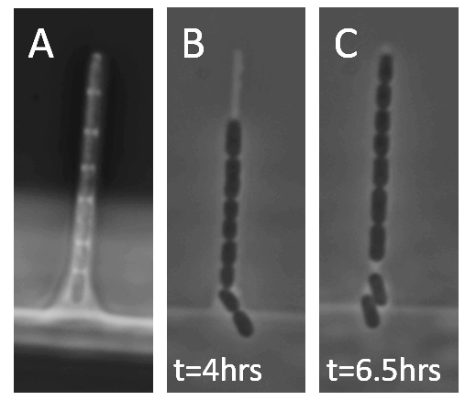
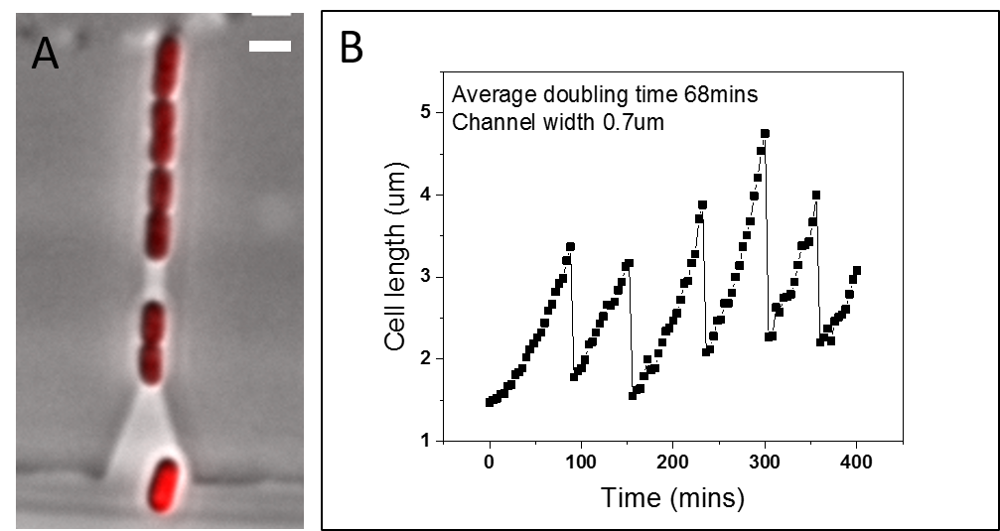
The agarose platform hopes to improve the image quality of phase contrast imaging for analysis. Although PDMS has been a highly-used material for microfluidic devices, the phase contrast image due to the index of refraction difference between PDMS (~1.4) and water (1.33) leads to poor analysis when using the second derivative to find the contour of the cell. The second platform is based on agarose and employs the same mother machine pattern. As seen in Figure 5.3(A), the phase contrast image shows the PDMS and cells appear black leaving the program with little room to be able to successfully find the outline of the cell. Whereas Figure 5.3(B) shows the phase image of the agarose platform where the outline of the cell is easily found due to the good contrast between the agarose and the cell, since the index of refraction is ~1.34.
Figure 5.3: Phase contrast image of PDMS (A) and agarose (B) and (C) taken 2.5 hours apart showing how the cells push themselves up slowly. The width of the pockets is 0.6µm and are 20µm in length.
Figure 5.4: (A) Phase contrast image overlaid with fluorescent image of agarose platform of width 0.7µm and length 20µm. (B) The growth curve of the selected channel with an average doubling time of 68mins.
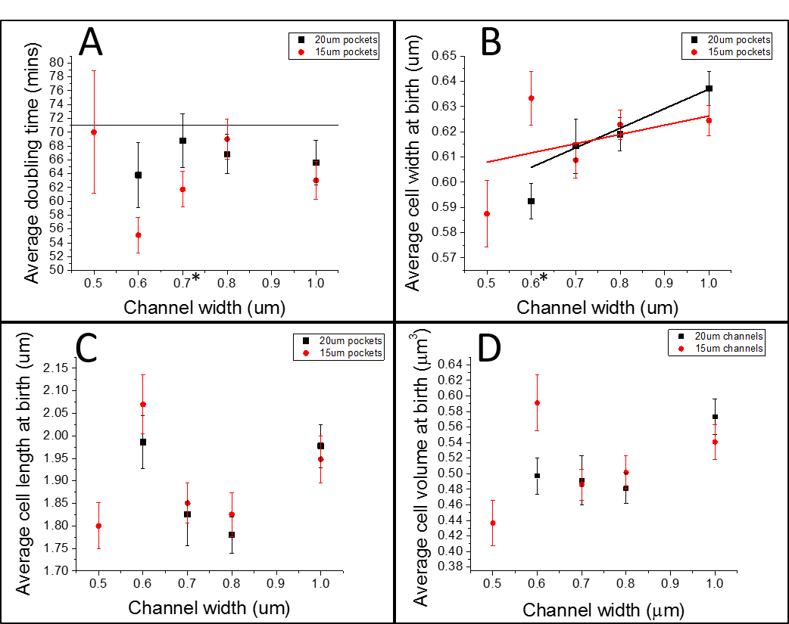
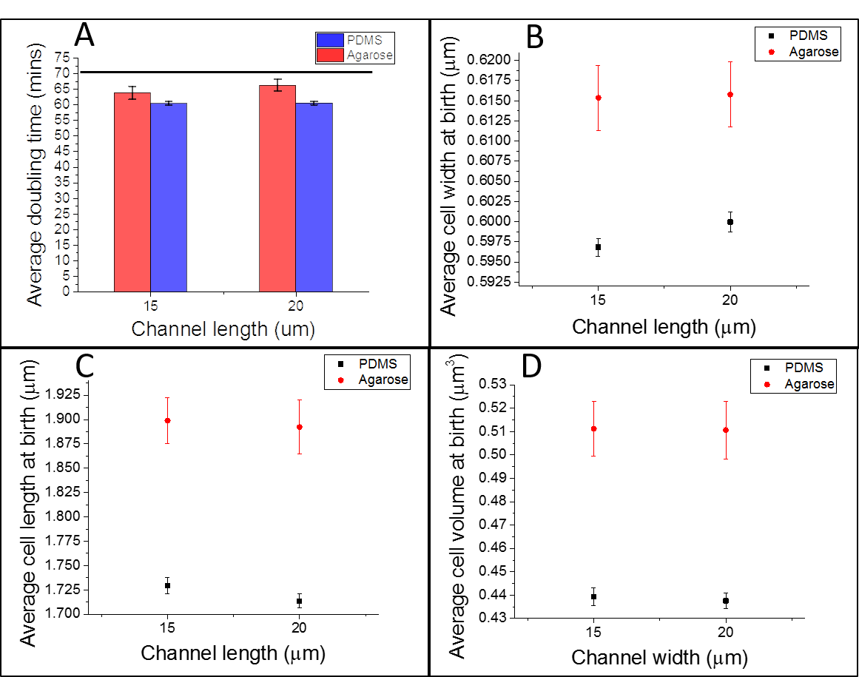
The agarose results were averaged between two measurements, but in neither measurement, did the cells fill the 20µm long, 0.5µm wide channels. Figure 5.4(B) shows the corresponding growth curve to the channel pictured with width 0.7µm. The average doubling time for this channel was 68mins. When analyzing the average doubling time across the channels they show more variation than in the PDMS mother machine. In the 0.7µm wide pocket, there is a significant difference in the mean between the two lengths of channels. The error bars show the standard error. However, the agarose pockets are more form-fitting than PDMS so the cells can grow closer to their true width since they are not being as constrained by the stiffness of the material. Figure 5.5(B) shows the variation of width to be 0.59-0.64µm, whereas in the mother machine it was 0.585-0.605µm. Figure 5.6 shows the comparison between the PDMS and agarose mother machine for the given growth characteristics. The data were averaged together for all the channel widths to get an average for both channel lengths. The mother cell in cell length, width, and volume at birth for the agarose chip shows the cells are consistently larger than in the PDMS chip. Again, it is noted that the sample size for the agarose chip is much smaller than in the PDMS chip. However, since nutrients can diffuse better through agarose, it would make sense that the cells would be larger. This should correspond to a faster doubling time, which is not the case here. Although, the agarose chip shows a doubling time more like the doubling time found in the tube measurement, so with that, the agarose platform may allow for a more normal growth of cells when compared to liquid culture cells. This can be attributed to better diffusion of nutrients or less mechanical stress on the cells.
Figure 5.5: (A) Average doubling time versus channel width for agarose based platform with a line at 71mins to show the doubling time from the tube measurement. (B) The average cell width at birth versus the channel width with best fit lines for each length of channel. (C) Average cell length at birth, (D) Average cell volume at birth versus channel width. The asterisk represents the channel width shows a significant difference in the two averages shown. Error bars show the standard error of the mean.
Figure 5.6: Comparison between PDMS and agarose for the different growth characterizations versus channel length. Data was averaged between all channel widths. (A) Average doubling time, (B) Average cell width and birth, (C) Average cell length at birth, and (D) Average cell volume at birth. Error bars are the standard error of the mean.

Flow through platform

The final platform was designed to eliminate the nutrient gradient by setting up a flow through concept using a small constriction at the tip of the channels. Two constrictor sizes were tested with two channel widths.

Design

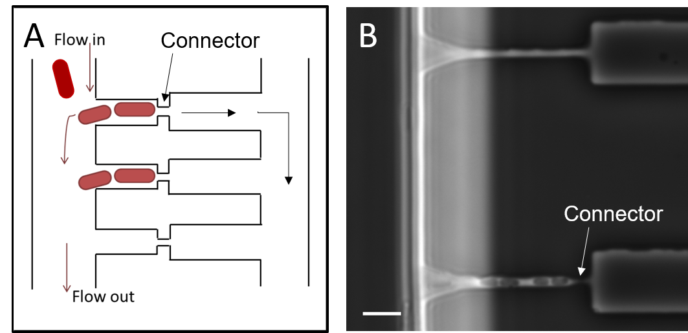
The final platform tested was the flow through design, also patterned with PDMS. A schematic (Figure 6.1(A)) shows a small constriction at the end of the channel ranging in size from 0.2µm to 0.4µm. The length of the channel is 20µm, but the 3µm connector is included. There are two widths of channels, 0.6µm and 0.8µm. This design was intended to decrease the cell loadingtime and to maintain a constant flow of nutrients over all the cells, instead of just the cells near the base of the pockets. The large channel on the opposing side of the constriction in Figure 6.1(B) is meant solely for the flow of medium to a second side channel. The cells do not have to be in stationary phase to load into the chip, as in the mother machine. Once the medium is flushed into the chip, the cells are loaded. A pressure difference is created by placing a valve on the loading side exit hole to ensure the cells flow into the channels. Once cells are in the channels, which only takes about 20mins, the valve is opened so that waste and old cells are flushed away without cells being pushed through the constriction.
Figure 6.1: (A) Schematic of flow design chip showing cells flowing in on the top left. The connector is shown which allows medium to pass through to the right channel. The bottom left exit hole is where the valve is placed to control the pressure and flow of cells. (B) Phase image of flow design showing a 0.4µm connector (top) and a 0.3µm connector (bottom). The scale bar is 5µm.

Preliminary Results for Nutrient Gradient

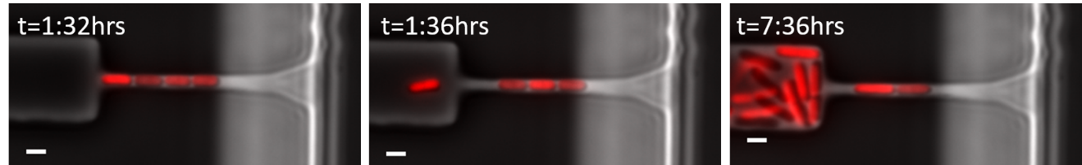
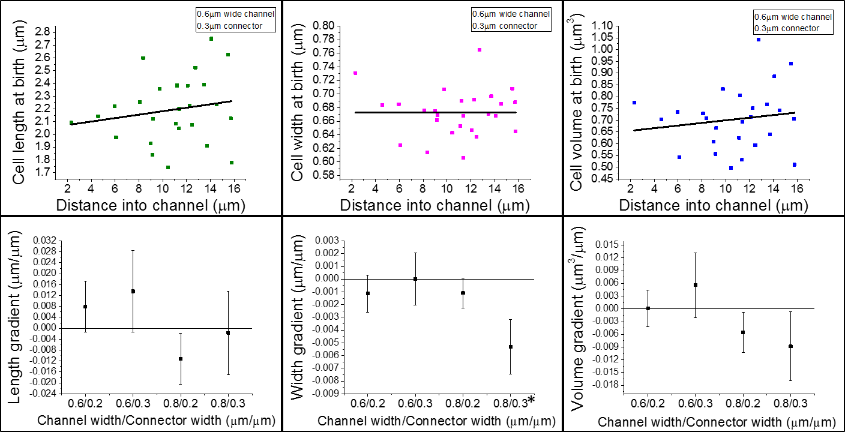
With the motivation for this platform being the nutrient gradient, our main analysis was on testing to see if the flow design improved this. Similarly, we tested the length, width, and volume of cells at birth as in the mother machine. However, we found the cells can push through the 0.4µm connector if there is too much pressure, resulting in cells growing exponentially in the opposite channel (Figure 6.2). Once the population was large enough the cells started to push back through the connectors. This did not allow for the constant flow of nutrients as the design was meant for. The 0.2µm connectors have the problem of collapsing due to the width being too small. This negates the flow design as well by reverting the pockets back to the dead-end design. The 0.3µm connectors showed the most promise, but a second Si wafer with only 0.3µm connectors will need to be created to fully test this design. Preliminary results (Figure 6.3) show the flow through platform does improve the nutrient gradient. Only one channel width (0.8µm) with connector size 0.3µm showed a significant gradient in the cell width at birth, however this could be due to the low sampling size in the measurements. Further testing will be necessary to determine if this platform will be able to fully eliminate the nutrient gradient.
Figure 6.2: Time sequence of flow design platform over 7.5 hours showing the cells pushing through the 0.4µm constriction.
Figure 6.3: Top row shows raw data for flow through platform with channel width 0.6µm and connector width 0.3µm. The line represents the best fit of the data. The bottom row shows the length (left), width (middle), and volume (right) gradients with the asterisk representing a gradient significantly different than zero.

Conclusions

The goal of this study was to design a suitable microfluidic platform to study the cellular organization of E. coli. The lack of ability to study single cell bacteria over time on an agar pad due to the exponential growth rate in colonies and the lack of nutrients present to continue growth past about 8 generations motivated this study on microfluidic platforms. Here we proposed three microfluidic platforms to help eliminate these issues. The first platform investigated was the mother machine. This platform was based on PDMS and was designed with a main center channel for constant flow of nutrients and dead-end side channels of varying lengths and widths for single cell studies. This advantage to this platform is the simplicity of its assembly and the large number of side channels. The disadvantage is the poor phase contrast imaging and the nutrient gradient in the dead-end channels. When the growth parameters were compared across channels widths, there was no significant difference in doubling time, cell length, width, or volume at birth for the mother cell. Only one channel width, 0.6µm showed a significant difference in mean when the two channel lengths were compared in cell width, length, and volume at birth. To improve the nutrient gradient, a platform with flow through channels was designed. The flow through pockets shortened the loading time to approximately 20mins and preliminary results show the nutrient gradient problem is eliminated since medium can flow across all cells equally. However, the size of the connector is a factor. We tried three connector sizes and found the cells can push through the connector if it is 0.4µm while the 0.2µm connectors could easily collapse. The second reason for the gradient is due to the PDMS, which has a poor diffusion rate for the medium. To improve this and the phase contrast imaging, the agarose based platform was designed. Agarose is a material E. coli are typically grown on as it is a nutrient source and allows for more equal diffusion of medium. The index of refraction of agarose is much more like that of water than is PDMS, resulting in a more analysis friendly phase contrast image. The disadvantage of this platform is the assembly of the chip. Agarose is much softer than PDMS and cannot be bonded to glass therefore when the patterned agarose piece is put into place, the user must push it into place with a top glass slide. If pressed too hard the ceiling of the channels does not allow for normal flow of nutrients and cells. If not pressed enough, the cells are free to roam without being constrained in the side channels. They can also lift the agarose up and start to grow exponentially if there is enough of a pressure build-up.
With improvements in the connector width in the flow through platform and a more stable assembly of the agarose platform so cells can’t overtake the channels, these platforms can eliminate the nutrient gradient and improve the phase contrast imaging. These platforms will help to study single cells for the goal of studying the cellular organization in E. coli.

List of References

- J. C.W. Locke and M. B. Elowitz, Nat. Rev. Microbiol., 2009, 7, 383–392.
- J.-W. Veening, W. K. Smits and O. P. Kuipers, Annu. Rev. Microbiol., 2008, 62, 193–210.
- O. Gefen and N. Q. Balaban, FEMS Microbiol. Rev., 2009, 33, 704–717.
- J. R. Moffitt, J. B. Lee., P. Cluzel., Lab Chip, 2012, 12, 1487.
- M. R. Bennett and J. Hasty, Nat. Rev. Genet., 2009, 10, 628–638.
- J.C. McDonald, Review, Electrophoresis 2000, 21, 27-40.
- D. Qin, Y. Xia and G. M. Whitesides, Nat. Protoc., 2010, 5, 491–502.
- J. Mannik, R. Driessen, P. Galajda, J. E. Keymer and C. Dekker, Proc. Natl. Acad. Sci. U. S. A., 2009, 106, 14861–14866.
- N. Q. Balaban, J. Merrin, R. Chait, L. Kowalik and S. Leibler, Science, 2004, 305, 1622–1625.
- P. Wang, L. Robert, J. Pelletier, W. L. Dang, F. Taddei, A. Wright and S. Jun, Curr. Biol., 2010, 20, 1099–1103.
- G. M. Whitesides, Nature, 2006, 442, 368-373.
- J. Monod, Annu. Rev. Microbiol. 1949.3:371-394.
- F. Widdel, "Theory and measurement of bacterial growth." Di dalam Grundpraktikum Mikrobiologie 4.11 (2007).
- F. Wu, C. Dekker, Chem. Soc. Rev., 2015, 10.1039/c5cs00514k.
- S. Takeuchi, W. R. DiLuzio, D. B. Weibel and G. M. Whitesides, Nano Lett., 2005, 5, 1819-1823.
- D. Nichols, N. Cahoon, E. M. Trakhtenberg, L. Pham, A. Mehta, A. Belanger, T. Kanigan, K. Lewis and S. S. Epstein, Appl. Environ. Microbiol., 2010, 76, 2445-2450.
- Y. Taniguchi, P. J. Choi, G.-W. Li, H. Chen, M. Babu, J. Hearn, A. Emili and X. S. Xie, Science, 2010, 329, 533-538.
- S. Taheri-Araghi, S. Bradde, J. T. Sauls, N. S. Hill, P. A. Levin, J. Paulsson, M. Vergassola and S. Jun, Curr. Biol., 2015, 25, 385-391.
- K. J. Regehr, M. Domenech, J. T. Koepsel, K. C. Carver, S. J. Ellison-Zelski, W. L. Murphy, L. A. Schuler, E. T. Alarid and D. J. Beebe, Royal Soc. Of Chem., 2009, 10.1039/b903043c.
- A. Chien, N. S. Hill, P. A. Levin, Curr. Biol., 2012, 10.1016/j.cub.2012.02.032.
- B. Youngren, H. J. Nielsen, S. Jun and S. Austin, Genes & Dev., 2014, 10.1101/gad.231050.113.
- A. Amir, Phys. Rev. Lett. 112, 208102.
- G. Velve-Casquillas, M. L. Berre, M. Piel and P. T. Tran, 2010, 10.1016/j.nantod.2009.12.001.
- L. Kang, B. G. Chung, R. Langer and A. Khademhosseini, 2008, 10.1016/j.drudis.2007.10.003.
- W. B. Whitman, D. C. Coleman and W. J. Wiebe, PNAS, 1998, 95(12), 6578-6583.
- K. R. Spring and M. W. Davidson, Nikon Microscopy.
- K. A. Datsenko and B. L. Wanner, One-step inactivation of chromosomal genes in Escherichia coli K-12 using PCR productsPNAS 2000 97 (12) 6640-6645; published ahead of print May 30, 2000, doi:10.1073/pnas.120163297.
- Wu, F., Van Rijn, E., Van Schie, B. G. C., Keymer, J. E., & Dekker, C. (2015). Multi-color imaging of the bacterial nucleoid and division proteins with blue, orange, and near-infrared fluorescent proteins. Frontiers in Microbiology, 6, 607. http://doi.org/10.3389/fmicb.2015.00607.
- Bertani, G. (2004). "Lysogeny at mid-twentieth century: P1, P2, and other experimental systems". Journal of Bacteriology. 186 (3): 595–600. doi:10.1128/JB.186.3.595-600.2004. PMC 321500. PMID 14729683.
- Guberman

Vita

