The Larsen Motive:
Three Analytical Studies of Evolving Motivic Connectivity in
Libby Larsen’s Corker, Slang,
and String Symphony, III

A Thesis Presented for the
Master of Music
Degree
The University of Tennessee, Knoxville

Shelise Nicole Washington
August 2014
Copyright © 2014 by Shelise Nicole Washington.
All rights reserved.

DEDICATION
I would like to dedicate my work to my mother, Dr. Sheila M.T. Washington. Thank you for your constant support throughout these two years while I have been obtaining my Master’s degree. You have always encouraged me to be myself and follow my dreams, no matter the obstacles or sacrifices. You have done so much for me that I am eternally grateful for. Thank you for your understanding, your sympathetic heart, and for always being my rock when I was crumbling under pressure. All of my fight and strength comes from you. You have always had more confidence in me than I do myself, and your faith in me keeps me going. I am so proud that I am your daughter, and I am thankful to call you mom. I love you.

ACKNOWLEDGEMENTS
I would like to thank my committee members Dr. Brendan McConville, Dr. Barbara Murphy, Dr. Leslie Gay, and Dr. David Brunell for their patience and understanding throughout this endeavor. I am beyond grateful for your flexibility while I have been completing my thesis.
I would especially like to thank my thesis advisor, Dr. Brendan McConville for guiding me every step of the way throughout this process. Thank you for pushing me and for helping me see my potential as a music theorist and scholar. I will never forget everything that you have done for me during my time here at the University of Tennessee-Knoxville.
I would like to thank my friends, Lindsey Cope, Tyler C. Mitchell, and Ryan Taussig for their support and feedback. It is wonderful to have colleagues who can relate to your circumstances and are willing to listen to your ideas. I am definitely appreciative of your time and empathy throughout these two years. I wish you all the best of success and happiness in the future.

ABSTRACT

Libby Larsen presents the motive in Corker (1977), Slang (1994) and “Ferocious Rhythm” from String Symphony (1999) as more than a memorable melody or tune. Her rhythmic motive has multiple connections within each piece and overall between the three works. It has value and purpose that can be explained through multiple musical parameters. Larsen develops the motive over many years, while containing its individuality within each work, yet it is still a part of a larger evolutionary process for the motive.
This thesis will show the motive’s pitch and contour relationships contribute to its musical growth. Pc analysis and contour theory will quantify the motivic evolution as it stabilizes and changes through the procession of each work. The polarity of the Larsen Motive’s consistent rhythm versus the varying transformations in pitch content and contour not only provide in-depth discussion of the motive’s growth, but it also provides perspective of Libby Larsen’s compositional voice. The prevalence of the Larsen Motive in Corker, Slang, and “Ferocious Rhythm,” demonstrates the role of the motive has drastically changed.

TABLE OF CONTENTS
Introduction………………………………………………………………....................................1
Chapter I: Libby Larsen’s Compositional Influences……………………………………………3
Chapter II: The Larsen Motive………………………………………………………...................9
The Larsen Motive: Function and Atomic Model……………………....................................9
The Role of PC Analysis in Corker, Slang, and “Ferocious Rhythm”……………………...11
Shape and Formation: The Larsen Motive and Musical Contour Theory…………………..14
Chapter III: Motivic Origins: Corker (1977)……………………………………………………19
Harmonic Variability: Pitch Content and Set Classes…………………………………..19
Structural Shape: Contour Relations in Corker…………………………………………24
Chapter IV: Motivic Continuance: Slang (1994)………………………………..........................28
Harmonic Sustainability: Pitch Content in Slang…………………………………….....29
Contour Invariance: Contour Relations in Slang………………………………………..35
Chapter V: Motivic Expansion: “Ferocious Rhythm from String Symphony………...................39
Harmonic Intricacy: Pitch Content in “Ferocious Rhythm”…………………………….40
Diversity in Structure: Contour Relations in “Ferocious Rhythm”……..………………50
Chapter VI: Conclusion…………………………………………………………………………61
Bibliography………………………………………………………………………......................63
Vita……………………………………………………………………………………………....66
LIST OF FIGURES
Figure 1. Rhythmic Skeleton of the Larsen Motive…………………………………………….10
Figure 2. Atomic Model of the Larsen Motive………………………………………................11
Figure 3. Examples of C-SEGS, Steve A. Harper, “Contour and Melodic Structure in Two Homophonic Instrumental Works by Anton Webern…………………………......17
Figure 4. Corker, m. 51…………………………………………………………………………20
Figure 5. Corker, mm. 52-53………………………………………………................................21
Figure 6. Corker, m. 72…………………………………………………………………….........21
Figure 7. Corker, mm. 104-105……………………………………………………………........22
Figure 8. Corker, mm. 179-181, 183……………………………………………………………22
Figure 9. Corker, m. 51……………………………………………………………………….....25
Figure 10. Corker, m. 72………………………………………………………………………...25
Figure 11. Corker, mm. 104-105……………………………………………………..................25
Figure 12. Corker, mm. 179-181, 183…………………………………………………………..26
Figure 13. Slang, mm. 44-48………………………………………………………………........29
Figure 14. Slang, mm. 50, 66-67………………………………………………………………..31
Figure 15. Slang, mm. 77-79……………………………………………………………………32
Figure 16. Slang, mm. 81-82, 85…………………………………………………………….32-33
Figure 17. Slang, mm. 135-136………………………………………………………………....34
Figure 18. Slang, mm. 142-143, 146-148……………………………………………………34-35
Figure 19. Slang, mm. 45-48……………………………………………………………………36
Figure 20. Slang, mm. 66-67……………………………………………………………………37
Figure 21. Slang, mm. 77-79……………………………………………………………………37
Figure 22. Slang, mm. 81-82……………………………………………………………………37
Figure 23. Slang, mm. 135-136…………………………………………………………………38
Figure 24. Slang, mm. 142-143…………………………………………………………………38
Figure 25. Slang, mm. 146-148…………………………………………………………………38
Figure 26. “Ferocious Rhythm,” mm. 6-8………………………………………………………40
Figure 27. “Ferocious Rhythm,” mm. 14, 22…………………………………………………...41
Figure 28. “Ferocious Rhythm,” m. 29…………………………………………………………42
Figure 29. “Ferocious Rhythm,” mm. 38-40…………………………………………………....42
Figure 30. “Ferocious Rhythm,” m. 44…………………………………………………………43
Figure 31. “Ferocious Rhythm,” mm. 51-52…………………………………………………....44
Figure 32. “Ferocious Rhythm,” m. 56…………………………………………………………44
Figure 33. “Ferocious Rhythm,” mm. 59-60……………………………………………………45
Figure 34. “Ferocious Rhythm,” mm. 74-76……………………………………………………45
Figure 35. “Ferocious Rhythm,” mm. 117-123…………………………………………………47
Figure 36. “Ferocious Rhythm,” mm. 212-215…………………………………………………48
Figure 37. “Ferocious Rhythm,” mm. 233-236…………………………………………………49
Figure 38. “Ferocious Rhythm,” mm. 6, 14…………………………………………………….51
Figure 39. “Ferocious Rhythm,” m. 22…………………………………………………………52
Figure 40. “Ferocious Rhythm,” m. 29…………………………………………………………52
Figure 41. “Ferocious Rhythm,” mm. 38-40…………………………………………………....53
Figure 42. “Ferocious Rhythm,” m. 44………………………………………………………….54
Figure 43. “Ferocious Rhythm,” mm. 51-52…………………………………………………....54
Figure 44. “Ferocious Rhythm,” m. 56………………………………………………………….55
Figure 45. “Ferocious Rhythm,” mm. 59-60……………………………………………………56
Figure 46. “Ferocious Rhythm,” mm. 74-76……………………………………………………56
Figure 47. “Ferocious Rhythm,” mm. 117-123…………………………………………………57
Figure 48. “Ferocious Rhythm,” mm. 212-215…………………………………………………59
Figure 49. “Ferocious Rhythm,” mm. 233-236…………………………………………………60

LIST OF TABLES
Table Page
Table 1. Pitch Content Chart of the Larsen Motive in Corker……………………………….....23
Table 2. Contour Relationships of the Larsen Motive in Corker…………………………….....27
Table 3. Formal Diagram of Slang based on the Larsen Motive………………………………..33
Table 4. Transpositional Relationships, “Ferocious Rhythm,” mm. 117-123…………………..48
Table 5. Transpositional Relationships, “Ferocious Rhythm,” mm. 212-215, 233-236………..50

Introduction
Libby Larsen’s compositional voice has generated much recognition because of her unique musical attributes to harmonic semantics, energy, emotion, and rhythmic patterns. Her well-defined rhythmic motive, present in Corker (1977), Slang (1994), and “Ferocious Rhythm” of String Symphony (1999) asserts itself as more than a memorable and prominent melodic figure. Its consistent rhythmic pattern connects occurrences of the motive, while its migratory pitch content and musical contour provide a launching point for comprehensive analysis. This particular motive, or the “Larsen Motive” not only serves as a listening strategy for Larsen’s music, but provides for deeper understanding of the evolutionary nature of her melodic gestures in these compositions. Within the extensive span of years these works were composed, Larsen displays her affinity for the motive by developing it organically with various techniques, therefore evolving it with different compositional and musical perspectives.
This thesis aims to quantify motivic evolution in Libby Larsen’s Corker, Slang, and “Ferocious Rhythm” by analyzing the Larsen Motive’s pitch and contour relationships within the works individually and overall, projecting its musical connectivity. The Larsen Motive will be analyzed with pitch-class analysis and musical contour theory. Using these two analytical techniques simultaneously presents a distinctive methodology to justifying the motive’s growth throughout these compositions. Chapter One begins with a literature review of relevant scholarship on Libby Larsen, as well as validating the resources used in this research. Chapter One also discusses Larsen’s compositional influences and how they contributed to forming The Larsen Motive. Chapter Two will elaborate on the unique approaches of pitch-class analysis and contour theory used in this thesis, as guided by relevant scholarship. Chapters Three, Four, and Five will delve deep into the analysis of The Larsen Motive in Corker, Slang, and “Ferocious Rhythm” and its connective evolution. Chapter Six concludes this thesis by reiterating The Larsen Motive’s analytical importance, followed by how this research can be expanded upon to explore further relationships.

Chapter I
Libby Larsen’s Compositional Influences

Libby Larsen’s love for music and composing began at a very early age. While growing up in Minnesota, she was immersed in an eclectic musical background that ranged from boogie piano, choral, Dixieland, chant, ballet, and symphonic music. Her mother often played the boogie-woogie on the record player, her father was an amateur clarinetist in a Dixieland band, and young Libby received classical instruction in school. She earned her Bachelor of Music, Master of Music, and Doctor of Philosophy from the University of Minnesota. There she studied composition with Dominick Argento, Paul Fetler, and Erick Stokes. At the University of Minnesota, Larsen and fellow composition student Stephen Paulus co-founded the Minnesota Composers Forum, which is currently the American Composers’ Forum. This organization “serves to champion the work of American composers and provide a connection between composers, musicians and communities.” She recognized during her studies in the 1970s there were not adequate outlets for young composers to discuss ideas and techniques, perform new works, and find ensembles who were willing to perform contemporary music. Larsen has been the resident composer with the Minnesota Orchestra, and her music has been commissioned by the St. Louis Symphony, the Ohio Ballet, the Cleveland Lyric Opera, the Los Angeles Chamber Orchestra, the Cleveland Quartet, as well as many soloists and other ensembles. Along with her passion for composition, Libby Larsen is highly active in music education advocacy. She combined multiple cultural perspectives, personal experiences, and observations while serving on the National Endowment for Arts, Director of The College Music Society, and the Vice President of the American Music Center.
Libby Larsen’s compositional interests started to blossom at an early age, but her path to a career in composition began during her sophomore year at the University of Minnesota. According to Linda Moorhouse, Larsen explicitly remembers loving sounds and trying to organize them into “pieces of music” as a young child. Larsen attributes her early compositional beginnings to her Catholic grade school teachers, who encouraged her natural talent when she began to compose works in the sixth grade. Her interest in sound and rhythm prompted the urge to compose. She has explained that composing enabled her to musically interpret and physically notate words and rhythm from the American English language. Larsen’s rhythmic curiosity has been her catalyst for composing, but her niche became clearer during college. While taking voice lessons, Larsen’s professor asked her if she wanted to write songs for her vocal jury. Taking on the task, Larsen composed and prepared Five Shakespeare Songs. After that epiphany, Larsen knew that she wanted to dedicate herself to composing.
I started composing out of need, and that need was to communicate things that I was not able to express through any other venue. I had no idea of how deep the need was. I started composing in grade school, putting sound in order, attempting to communicate a sense of being. I didn’t recognize it as a valuable or even successful activity until college.

Larsen’s unique compositional voice has been influenced in part by popular and film music. For instance, Larsen found composer Carl Stalling to be highly influential. Carl Stalling was the well-known composer for the “Looney Tunes” cartoons at Warner Bros. Larsen places Stalling as one of her great American music inspirations because of “the way in which he constructed compact ‘sound bite’ scores defined so much about the influence and development of the media, timing and culture over the past sixty years.” Stalling relied heavily on popular songs while composing cartoon music. He learned from being a previous silent film accompanist to integrate the songs into his music to enhance the on-screen story, a quality that Larsen greatly admired about Stalling’s music. His humorous and practical personality as a composer made the synthesis of music, animation, and narrative seamless with his use of popular music, therefore establishing the Warner Bros. style.
Larsen’s deep-rooted exuberance for American culture and music shapes her compositions in a holistic way. Tina Milhorn Stallard explains that “Larsen’s focus on incorporating American vernacular into her compositions naturally applies to rhythm and melody; yet many of her instrumental works are idea based, incorporating her knack for storytelling and communicating broader concepts, such as the way different audiences embrace the synthesis of traditional performance and contemporary media.” Stallard gives the example of Larsen’s opera Frankenstein: The Modern Prometheus (1990). Larsen elaborates on the cultural significance of Mary Shelley’s story by combining traditional music with film, television and technology. American culture being infused into Larsen’s works is a distinct quality that she proudly proclaims.
Larsen’s other influences results from her eclectic musical background and upbringing. Her years of being in choir and learning Gregorian chant have impacted the way she approaches certain musical components in her compositions. Furthermore, according to Tina Milhorn Stallard, Larsen’s early training in Gregorian chant is evident in her rhythmic vocabulary. For the first eight years of school at Christ the King in Minneapolis, she learned Gregorian chant as well as sight reading with solfege syllables. Her diverse exposure to music that later influenced her style was being a member of a rock band. While in high school, Larsen joined a rock band, playing the synthesizer, electric bass, harmonica, and tambourine. She relates her experience in the rock band to her chanting in grade school because of the freedom of the rhythm and the ensemble. “The rock band was much more akin to my eight years of chanting, ‘conductorless’ music discovered through performance by the ensemble itself and made it real, spontaneous time.” During her piano studies, Larsen’s teacher gave her various types of repertoire. She played Mozart, Bartok, Stravinsky, Japanese music, and “boogie.” Larsen states that “the variety was very important in introducing so many different musical sounds and colors to me.”
Although her music has been praised for its lyricism, refreshing tonalities, color, orchestration, intense energy, and optimism, one of the most memorable features of Libby Larsen’s compositional output is rhythm. Larsen believes that her music can be “recognized by its rhythm more than anything else.” Her fascination with rhythms comes from the “rhythms and pitches of spoken American English or vernacular.”According to Linda Moorhouse, Larsen continually studies and examines “rhythmic patterns, pitch, tempo, and phrase contour in American spoken English.” She carefully observes everyday conversations, and her reflections on these conversations prove to be influential on her compositions. She speaks of the fluidity of our language and how it continues to evolve every day in new ways. Larsen elaborates that our language has “now gotten more inflected lately. It’s more slighted, curved, and hooked.” The variety and character that Larsen analyzes in American vernacular is the approach she employs with the rhythm in her music. Larsen correlates the evolutionary changes of American English to her rhythm. Larsen states that a great deal of rhythmic detail was involved in creating this motive, specifically the rhythm of American English. She believes that her rhythmic procedures have evolved, which will be the focus of this research in Corker, Slang, and “Ferocious Rhythm” of String Symphony. Evolutionary changes can be analyzed at two levels: the motive itself within each work, and the how it grows with the progression of each piece. Larsen elaborates on the motive’s strong presence, stating “This is a powerful rhythmic gesture that originates in the authentic evolution of the language we speak. Since communication through verbal language is a combination of both rhythm and inflected pitch, it’s natural to use developmental devices to present the motive in both parameters.” Libby Larsen’s motive is notable for its distinctive rhythm, which attracts further in-depth analysis as to its relationships.
Chapter II
The Larsen Motive
“The Larsen Motive” is a governing rhythmic motive that occurs frequently in three of Libby Larsen works. This chapter proposes the consistent presence of the Larsen Motive (LM) in these works, and suggests that pitch class (pc) analysis and contour theory can assists in revealing aspects of the LM’s musical growth. In order to utilize these two analytical techniques uniquely for this analysis, it is necessary to provide basic explanations of the methods themselves and to contextualize their appropriateness of application to the LM. First, this chapter will outline the LM’s general structure and consider it analogous to an atom. Second, the discussion will identify how pc analysis, supported by selected scholarship, assists in examining the LM for this thesis. Finally, an explanation of contour theory, again with appropriate scholarship, will likewise help the reader prepare for the forthcoming analyses of the LM. Expounding on these analytical methods will clarify the significance of Larsen’s progressing rhythmic motive in Corker, Slang, and “Ferocious Rhythm.” Therefore, this chapter will set the foundation for the analyses in the remainder of this thesis.

The Larsen Motive: Function and Atomic Model
The LM appears in Corker, Slang, and “Ferocious Rhythm” of String Symphony as an energetic and staccato motivic cell. Its jagged and choppy disposition helps define its individuality and lends itself well to repetition. The rhythm of the LM is steady throughout all three works. No matter the musical transformations the motive encounters, the rhythmic structure remains invariant. The unchanging nature of the LM’s rhythm provides a controlled variable within the analytical framework. Figure 1 shows a rhythmic representation of the LM: its pitch and contour content will be discussed later in this thesis. Deborah Rifkin simply defines a motive as “an ordered progression of pitches that is repeated within and across musical levels.” This definition is flexible and applicable to the LM, which assumes an important musical role within the music.
Figure 1. Rhythmic Skeleton of the Larsen Motive.
For some, it may be helpful to also envision the LM as an atomic structure. In this model (Figure 2), the LM’s rhythm is the nucleus, or the protons and neutrons of the structure; this is the core of each LM occurrence. The rhythm gives the distinction of the nucleus because it is the most notable feature of the motive. The pitch and contour are the electrons of the LM: although they circulate around the nucleus at different and independent levels, the electrons are still connected to it because of the consistency of the rhythm versus the variability of the pitch content and contour.
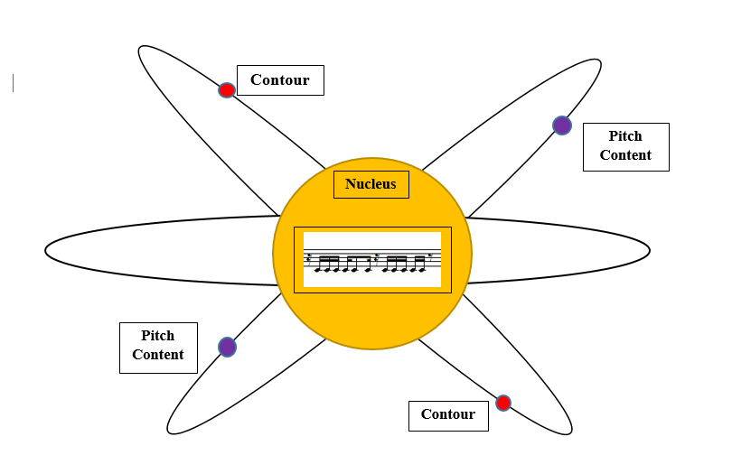
Figure 2. Atomic Model of the Larsen Motive.
The changing contour and pitch elements of the LM are separate but equal influences that function independently, but co-exist within the motive to affect its overall function and growth. This analogy is a perspective for departure when exploring the pitch and contour relationships of the motive in Corker, Slang, and “Ferocious Rhythm.” Her selection of pitch content and shape solidifies the intention of this analysis.

The Role of PC Analysis in Corker, Slang, and “Ferocious Rhythm”
The use of pc analysis in this examination of Libby Larsen’s Corker, Slang, and “Ferocious Rhythm” is to assist in revealing the evolutionary trajectories of the LM. This analytical technique facilitates the comprehension of the growth of the motive and Larsen’s harmonic palette. With the emphasis on rhythm and motivic independence, set theory remains an essential analytical tool when considering post-tonal music. According to Joseph N. Straus, “set theory emerged in response to the motivic and contextual nature of post-tonal music.” Straus stresses the importance of the motivic individuality involved in set theory. Since Larsen’s compositional voice is highly motivic, pc analysis is an ideal analytical tool to study her music. Straus also states that motives became independent and function as primary structural determinants, which is the case in Corker, Slang, and “Ferocious Rhythm.” Pc analysis is a flexible technique that enables diverse ways to interpret harmonic relationships without tonal connotations. It presents freedom and creativity, which are qualities Larsen incorporates with the motive. Straus describes set theory as follows:
Set theory is not a single language, but a community of local dialects and subcultures. It is best understood not as a rigidly prescribed practice, but as an array of flexible tools for discovering and interpreting musical relationships. It should be emphasized that these relationships can and should be enjoyably audible.

This statement by Straus presents meaning to the analysis of the LM because it illustrates the unique approach of pc analysis employed in Corker, Slang, and “Ferocious Rhythm” to demonstrate the pitch relationships that support its growth on the small and large levels. It participates in the luxury of developing its own analytical technique for the purpose of individuality.
Allen Forte led the way in developing pc analysis and the appropriate applications of the technique. He stated that pc analysis was developed with specific musical repertoire in mind, the atonal music at the beginning of the twentieth century. Today, pc analysis is not restricted to atonal music, which will be qualified in this thesis. In fact, Forte not only discusses its original applications but how it has expanded through diverse theory scholarship. For example, in 1993 David Lewin employed pc analysis in his analyses of Karl Stockhausen’s Klavierstück III to organize and navigate transformational pitch class networks. He also applied it to Webern’s Opus 10, No. 4, which focused more acutely on hexachordal segmentation. Milton Babbitt’s analyses of Arnold Schoenberg’s Op. 29 used pc analysis to concentrate on the nature of all-combinatorial chords and discussed how trichords and tetrachords employed in the work are derived from the all-combinatorial hexachords, along with chromatic aggregates. In his analysis, Babbitt shows the influence of pc analysis in complex investigations of serial compositions. Paul Wilson likewise utilized pc analysis as a tool to theorize Bartók’s complex pitch networks in his “large structure, form and tonal orientation” through analyses of the composer’s large instrumental works. David Schiff also used a pc perspective when he discussed all-interval hexachords, tetrachords, and twelve-tone chords that Elliott Carter employed in his music. These scholars took the creative initiative to utilize pc analysis for better understanding of specific perspectives. This thesis will aspire to accomplish the same goals while analyzing the LM and its evolution.
In the present analyses of Larsen’s Corker, Slang, and “Ferocious Rhythm,” pc analysis is applied to the motive’s harmonic implications, which contains tonal “spheres.” This means that they also do not contain concrete tonal centers. According to Tina Milhorn Stallard, “Larsen’s intention is to create areas of tonality in which color and suggestion are paramount.” Larsen composes freely inside the implied tonal areas, supported by intervallic saturation and usage of pedal points. Larsen creates vertical harmonies that are conceived linearly, but the linear harmonic palette of the motive will occupy the focus of this research. The LM’s jagged rhythm places great importance on horizontal pitch elements that Stallard mentions as a characteristic of Larsen’s music. Pc analysis will assist in explaining and contextualizing the harmonic relationships that support the evolution of the motive.

Shape and Formation: The Larsen Motive and Musical Contour Theory
Musical contour is an important aspect of the LM. Therefore, this examination of Larsen’s music will use the theory of musical contour to help trace the motive’s various shapes and how each supports the motive’s evolution in Corker, Slang, and “Ferocious Rhythm.” According to Ian Quinn, contour theory has an immediate appeal and a general applicability because of its combination of formal rigor and flexibility. One of the main contributors to the introduction and growth of contour theory is Robert D. Morris. He states that musical contour is one of the most general and recognizable aspects of pitch perception. Contour is based on “the listener’s grounded ability to hear pitches as relatively higher, equal, or lower without discerning the exact pitches among them” according to theorist Elizabeth West Marvin. According to West Marvin and Paul A. Laprade, the importance of the contour assists in the retention and recognition of well-known melodies that even if the interval sizes between successive pitches were altered, the listener will most likely to be able to recognize the melody if the contour remains unaltered. With intervallic changes between melodies, the contour can remain invariant. Morris and his colleagues validated the significance of melodic contour and its role in isolating musical relationships, solidifying contour as not only a method of analysis, but also to explain how it plays “an important structural role in a specific composition or repertoire.”
Since musical contour theory is a relatively new analytical technique compared to pc analysis, and will be used consistently in this study, it is warranted here to provide a brief explanation of the technique. Morris’s work with contour theory specifically involves “contour spaces with its various entities and relations.” Morris defines contour space (c-space) as a category of musical space “consisting of elements arranged from low to high disregarding the exact intervals between the elements.” These elements are defined as “c-pitches” (cps), which are ordered from low to high. The cps numbering begins with 0 up to n-1, where n equals the cardinality of the segment, and the “intervallic distance between cps is ignored and left undefined.” When the order of presentation of cps is defined, they are called contour segments (C-SEGS), which reveals other aspects of the c-spaces. Figure 3 is an example of contour segments, provided by Steven A. Harper, who demonstrates the clarity of C-SEGS in his analysis of Anton Webern’s Op. 9, No. 5’s melodic structure.

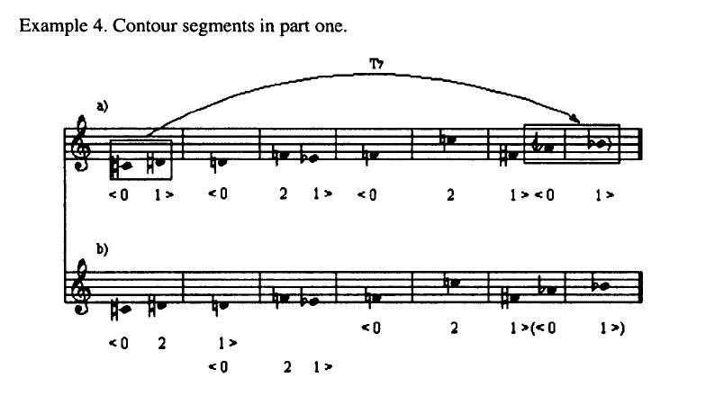
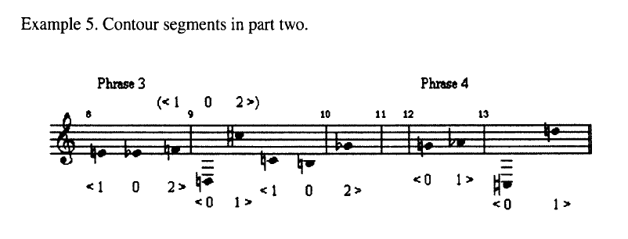Figure 3. Examples of C-SEGS, Musical Figure reproduced with kind permission from Steve A. Harper, “Contour and Melodic Structure in Two Homophonic Instrumental Works by Anton Webern,” College Music Symposium, Vol. 46 (2006): 109-110.
In this analysis, various C-SEGS within the c-space are used to compare the contour similarities, differences, and variations in Corker, Slang, and “Ferocious Rhythm” in effort to confirm the LM’s growth and connectivity throughout each piece.
The LM’s shape is based on the consistency of the rhythm, so the analysis of contour variations will further assist in identifying aspects of evolution. Ian Quinn states that “contour theory adjusts to contextual situations by smoothing out detail in the very sequential dimensions that it operates.” Quinn’s statement relates very well to the analytical approach employed in this analysis because of the L.M.’s contextual identity in each work, which is based on Libby Larsen’s compositional workings.

Chapter III
Motivic Origins: Corker (1977)

The LM’s conception is in Corker. Corker is a work for B flat clarinet and percussion. It was commissioned by Robert Spring, the Professor of Clarinet at Arizona State University. Libby Larsen describes the work as follows: “My inspiration for the work is drawn from 1940s popular music language, which I love, because the performers are spectacular musicians and because it speaks the rhythms and harmonic language of contemporary American English.” Larsen’s description clearly conveys she places great importance on rhythm in this piece, which is thoroughly combined with the harmonic content and varying melodic contour of the LM. The motive also is an organizational component that helps define the sections of the piece. It occurs in the outer sections, with each presentation containing a different tonal center. This chapter analyze instances of the LM in Corker by examining their changing pitch content and melodic contour relationships.

Harmonic Variability: Pitch Content and Set Classes
One of the main objectives of this thesis is to show the LM’s pitch content as a vital contributor to its evolution. In Corker, the motive’s harmonic material initiates its journey as an influential part of the LM’s growth.
Anatomically, the LM is a simple combination of two set classes: a hexachord 6-z11 and pentachord 5-z18, separated by a sixteenth rest. In this piece, the clarinet is the only instrument that plays the motive. The two set classes are the carriers of the pitch content of the LM throughout Corker. These set classes are adjoined to unique rhythmic idea throughout this composition [see Fig. 5, labeled Rhythm A (R-A) and Rhythm B (R-B)]. The set classes remain intact – in this order throughout Corker. Larsen’s applications of pitch content explores a myriad of harmonic relationships by utilizing fragmentation, subsets, supersets, and sequencing. As seen in Figure 4, the motive first appears in m. 51 and is an established a point of departure for growth.
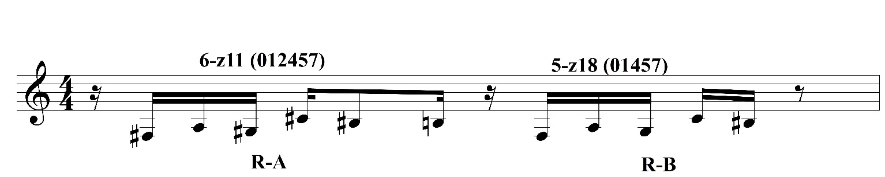
Figure 4. Libby Larsen, Corker, m. 51.
After the presentation of the motive in m. 51, Larsen repeats R-B verbatim in mm. 52-53 as seen in Figure 5, creating a rhythmic sequence with one set class. Within the rhythmic sequence, there is a superset-subset relationship because 5-z18 (01457) is a literal subset of 6-z11 (012457). The repetition gives the allusion of a tonal “sphere” of f# minor, making this set class the foundation of the pitch content of Corker.
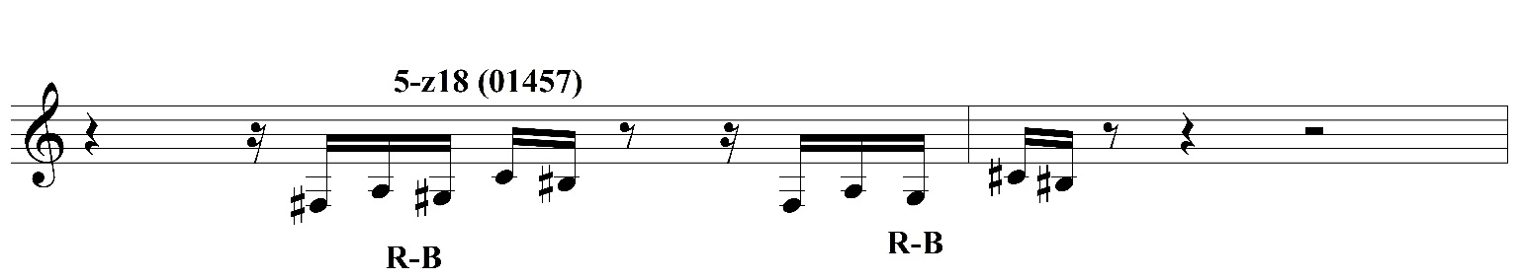
Figure 5. Libby Larsen, Corker, mm. 52-53.
The LM returns in m. 72, but as it uses an invariant R-A in its first portion, it changes the pitch content to 5-9 (see Figure 6). This shift in pitch cardinality from mm. 51-53 to m. 72 demonstrates an initial metamorphosis of the LM.
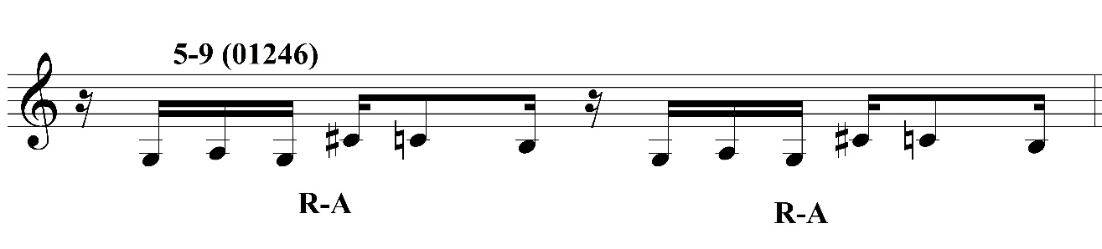
Figure 6. Libby Larsen, Corker, m. 72.
Pitch invariance also connects the first two presentations of the LM in Corker. Pitch classes G#, A, and C bind the LM instances in Figures 5, 6, and 7. Though Larsen’s harmonic material changes, the motive is linked by those common pitches.
The next instance of the motive is at mm. 104-105. Figure 7 illustrates that it resembles m. 51 though it uses G as the third note instead of G#. When Larsen lowered the G# a semitone to G, it changed to the set-class combination to 6-z12 and 5-19. Within this set-class combination is a non-literal subset relationship between them, sharing the tetrachord 4-9 (0167). This slight alteration still shows the close relations of the LM’s pitch content, here with the same five-pitch invariance between R-A and R-B as m. 51, demonstrating Larsen’s control of it in this piece.
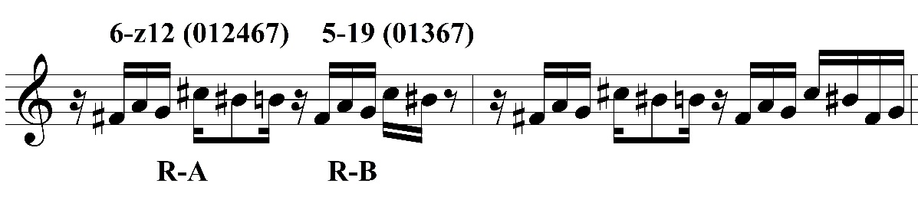
Figure 7. Libby Larsen, Corker, mm. 104-105.
The final presentation of the LM in Corker occurs in mm. 179-183 with the set class combination of 6-z43 and 5-20. Similar to m. 51, 5-20 (01568) is a literal subset of 6-z43 (012568). This occurrence includes an invariant rhythmic scheme with m. 51 and 104-105, but the motive expands further through repetition and elongation. The LM in these measures is significantly longer, and cultivates prior presentations of the LM into a new version. This also demonstrates its growth and development as it reaches its high point in mm. 179-181 and m. 183
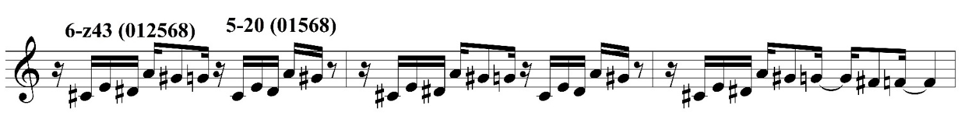
Figure 8. Libby Larsen, Corker, mm. 179-181.
Tracing the LM reveals that Larsen uses tonal pitch centers Corker. The progression of tonal spheres reveals a possible reading of the chain of centers as i-bii-i-v. Table 1 displays the LM’s harmonic movement with its corresponding set classes. The LM’s harmonic content in Corker is a testament to Larsen’s harmonic color when expressing the motive. Its variations in set classes strongly states its gradual growth throughout the piece.
Corker: Pitch Content Relationships of the Larsen Motive
Measure | m. 51 | m. 72 | mm. 104-105 | mm. 179-181
Rhythmic Sequence | R-A, R-B | R-A, R-A | R-A, R-B | R-A, R-B
PC Set | f#: 6-z11, 5-z18 | g: 5-9 | f#: 6-z12, 5-19 | c#: 6-z43, 5-20
Superset-Subset (if applicable)  with prime Forms | R-A:  6-z11 (012457) Literal  R-B:  5-z18 (01457) | R-A: (01246) | R-A:  6-z12 (012467)  Non-literal  4-9 (0167)  R-B:  5-19 (01367) | R-A:  6-z43 (012568)  Literal  R-B:  5-19 (01568)
Invariant pitch classes | 6, 8, 9, 11, 0, 1 | 9, 11, 0, 1 | 6, 9, 11, 0, 1 | 8, 9, 1

Table 1. Pitch Content Chart of the Larsen Motive in Corker.

Structure through Shape: Contour Relations in Corker
The contour relations in Corker contribute to the formation of the LM. The shape of the motive in this piece is one of its identifiable characteristics: each occurrence is aurally and visually unique. As with the pitch content, the contour relations of the LM in Corker explains its importance as an anchor and link to all of the LM presentations.
The first presentation of the motive in Corker, m. 51, which employs the same LM partitions identified earlier (i.e. R-A, R-B), has C-SEGS <021543> and <02143>, respectfully. These particular C-SEGS quantify the motive’s overall structure and c-space. Larsen’s decision of the shape of R-A and R-B and their respective C-SEGS equate to the formation of the melodic contour of the LM. The immediate fragmentation from one C-SEG to the next recalls the superset-subset relationship of 6-z11 and 5-z18 in Figure 9.
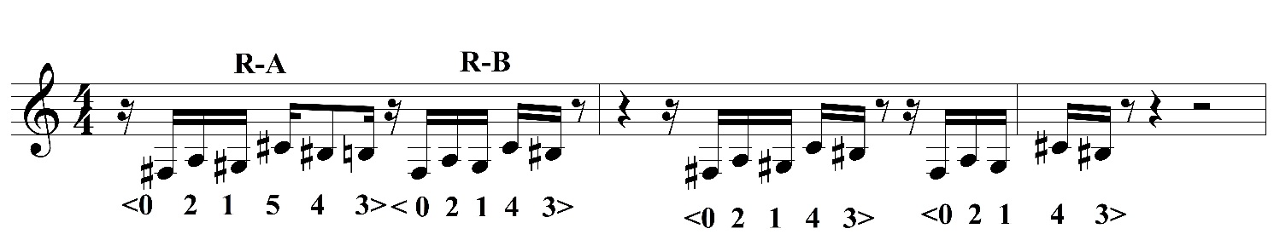
Figure 9. Libby Larsen, Corker, m. 52, mm. 51-52.
Measure 72 (Figure 10) is unlike m. 51: varies in contour due to the isolated repetition of R-A of the LM with the C-SEG <01432>. R-A changes the development of it in regards to the shape. The rhythm of R-A remains unchanged, which makes the contour variation all the more poignant.
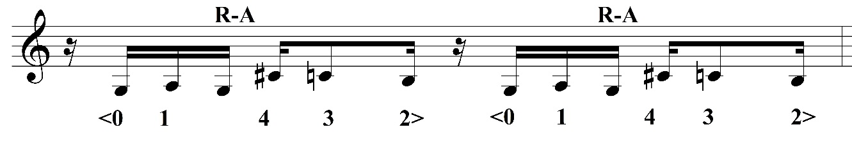
Figure 10. Libby Larsen, Corker, m. 72.
As the piece progresses, mm. 104-105 presents the LM with the same contour relations as mm. 51-52. <021543> and <02143> return in these two measures, despite the slight intervallic alterations. The G natural instead of G# (9 instead of 8) does not change the C-SEG because of the order of the notes. Its invariant shape and rhythm, regardless of the intervallic variations, is why the LM in mm. 104-105 maintains the C-SEG <021543> and <02143>.
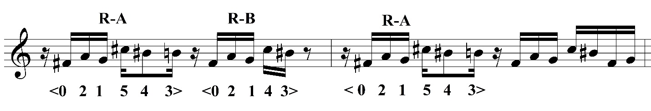
Figure 11. Libby Larsen, Corker, mm. 104-105.
The culmination of the LM in Corker, mm. 179-181 and m. 183, contain the same C-SEGS as mm. 51-52 and mm. 104-105, <021543> and <02143>, respectively. Even with the expansion of the motive, this C-SEG combination further binds these LM occurrences Corker together. The invariance of <021543> and <02143> throughout this work shows Larsen’s affinity for the motive’s melodic structure. Table 2 presents a formal overview of the C-SEGS of the LM in Corker. It shows the invariance of the motive, clarifying its connection to one another throughout this piece.

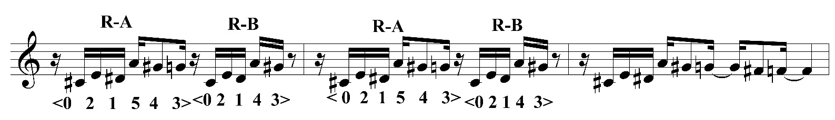
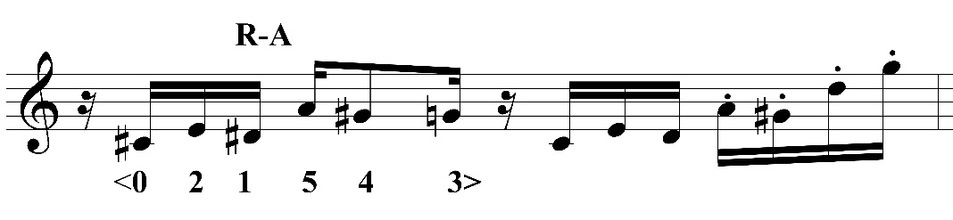
Figure 12. Libby Larsen, Corker, mm. 179-181, 183.

Corker: Contour Relationships of the Larsen Motive
Measures | m. 51 | m. 72 | m. 104-105 | m. 179-181
Rhythmic Sequence | R-A, R-B | R-A, R-A | R-A, R-B | R-A, R-B
C-SEGS | R-A:<021543>  R-B: <02143> | R-A: <01432> | R-A: <021543>  R-B: <02143> | R-A: <021543>  R-B: <02143>
C-SEG Invariance | R-A: <021543>  R-B: <02143> |  | R-A: <021543>  R-B: <02143> | R-A: <021543>  R-B: <02143>

Table 2. Contour Relationships of the Larsen Motive in Corker.
Corker is the first stop in the journey of the LM, stating its pitch and contour relationships as a corridor to explore the motive’s evolution. The set classes and C-SEGS interweave to enlighten the LM’s importance in this piece, as well as necessitating its purpose of growth and connectivity in the analysis to come. Corker defines the LM as a functional and cultivating tool, containing musical depth that connects it to Slang and “Ferocious Rhythm.”

Chapter IV
Motivic Continuance: Slang (1994)
Slang is a single movement chamber work divided into three sections for B flat clarinet, violin, and piano. It was commissioned by the Verdeher Trio and funded by Michigan State University. The piece was premiered on November 6, 1994 at the University of Saskatchewan, Canada. Larsen states the title makes reference to the use of “both jazz and boogie slang and twentieth-century ‘new music’ slang throughout the composition.” Her innate fascination with American vernacular and slang has generated her interest in what she describes as a developed “lexicon of musical slang.” The changing musical genres throughout the work give the performers freedom to adapt to each musical language. This chapter will discuss the growth of the LM in Slang, as well as present its connection to Corker, with the intention of verifying the motive’s evolutionary track through the present three works by displaying its pitch and contour relationships.
Corker and Slang are two works that vary in instrumentation and style, yet share a similar LM with featured set classes. In the two works, the LM shares the same foundational set classes, rhythmic structure, and contour equivalencies. However, Larsen uses the motive in an entirely different manner. She uses the ensemble to create textural and timbral development. In Corker, the clarinet is the only voice that plays the LM, while the percussion instruments in the piece provide rhythmic support, energy, and pulse. Larsen approaches the LM in Slang with parallel textures. At the first occurrence, the clarinet, violin, and piano perform the LM in unison, covering the span of four octaves. The clarinet and violin perform the motive multiple times together while the piano supports with a Stravinsky-like ostinato. Therefore, Larsen’s orchestration techniques help guide this analysis of the LM.

Harmonic Sustainability: Pitch Content in Slang
The pitch content of the motive is invariant for the entire work: the two partitions of the LM in this work are always set classes 6-z11 and 5-z18. The LM’s set classes and pitch content in Slang and Corker contain different transformations. In Corker, the motive changes set classes with each presentation: it begins with 6-z11 and 5-z18 in m. 51, uses 5-9 in m. 72, changes to 6-z12 and 5-19 in mm. 104-105, and concludes with 6-z43 and 5-20 in m. 179 (see Chapter 3 Figures 5, 7, 8, 9). Recall that within these set classes transformations, Corker contains abundant pitch invariance. In contrast, Slang maximizes 6-z11 and 5-z18.
After an introduction, the first entrance of the LM is in m. 45, making an impactful statement with the clarinet, violin, and piano playing in a texture spread across four octaves. In Figure 16, the unison proclamation presents the LM as focal point in this piece. As mentioned, rhythms R-A and R-B return in this work (from Corker) and are again connected to 6-z11 and 5-z18, as shown in Figure 13. Larsen immediately partitions R-A and R-B of the LM into various fragments throughout mm. 45-48, which she did not do in Corker. The rhythmic unisons are characteristics of the motive in Slang, along with isolated voices and conversational techniques.
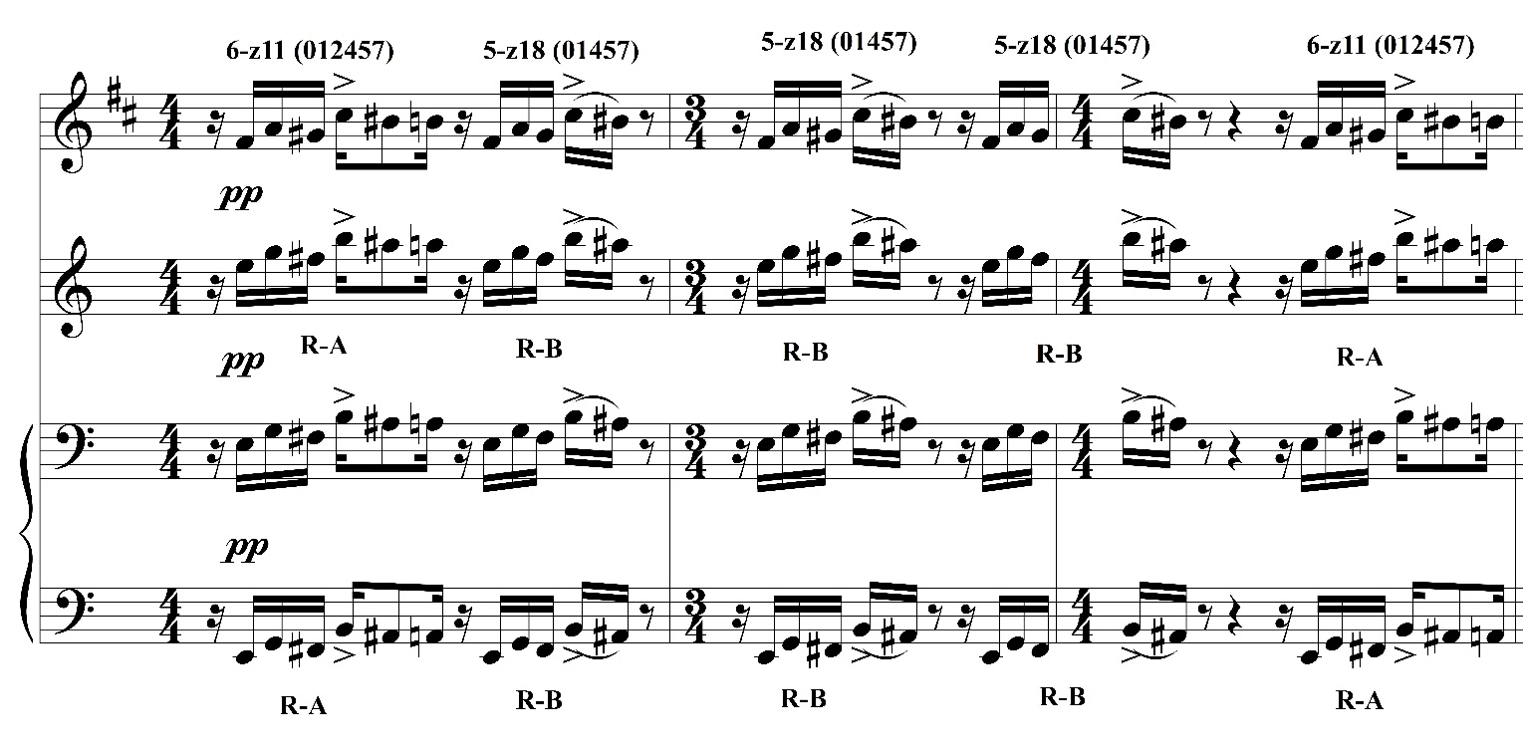
Figure 13. Libby Larsen, Slang, clarinet, violin, piano mm. 45-48.
Larsen creates tonal spheres with the LM centered around the pitch E. Set classes 6-z11 and 5-z18 appear consistently as the work progresses after the initial LM occurrence, so Larsen varies the instrumental-registeral placements and fragments the motive. An example of this is in mm. 50 and 66 in Figure 14. The clarinet and violin have the R-A division of the LM in parallel octaves in m. 50 with set class 6-z11. The LM returns to its full length with both R-A and R-B in mm. 66-67, complete with the same voicing.

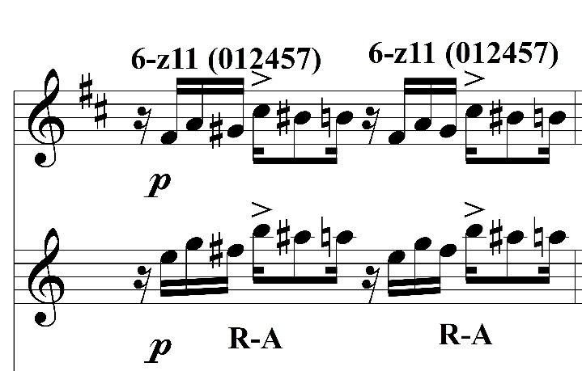

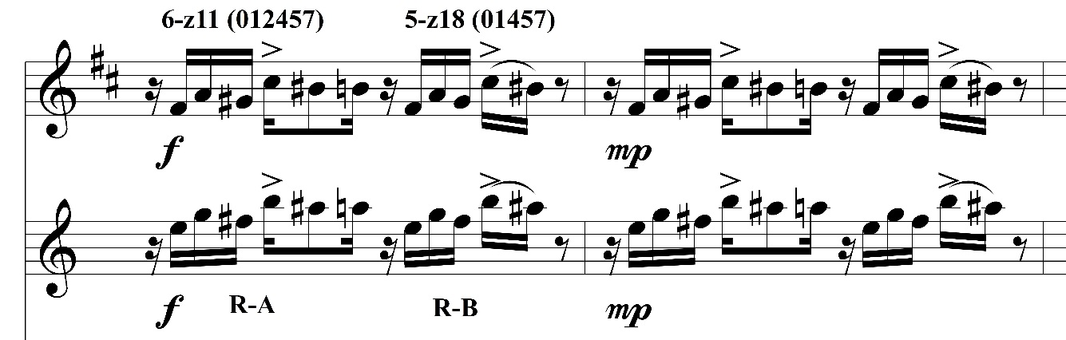
Figure 14. Libby Larsen, Slang, clarinet, violin, mm. 50, 66-67.
There is finally pitch content growth and variety with the LM at mm. 77-79. At m. 77, 6-z11 and 5-z18 remain intact, but the LM is transposed up a perfect fifth (i.e. T_{7).} This is a significant harmonic change because the past presentations of the motive have been centered around E. The set classes stay consistent, but the transposition level seven semi-tones to a B pitch center suggest a tonic-dominant, quasi-functional “tonal” relationship between instances of the LM. This recalls the tonic-dominant relationship in Slang, also found in Corker (Fig. Table 1), which can be seen in Figure 15.
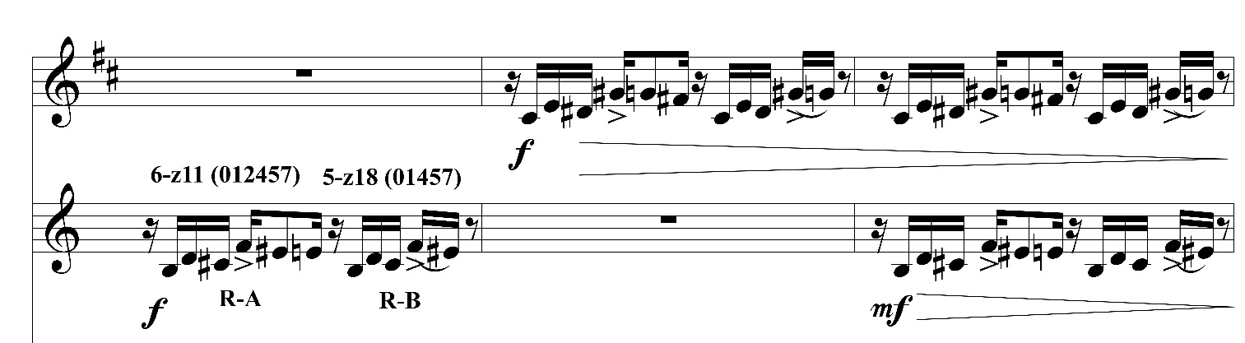
Figure 15. Libby Larsen, Slang, clarinet, violin, mm. 77-79.
The original form of the LM quickly resurfaces in mm. 81-82 and 85, recalling the pitch content and E pitch center of previous presentations. The piano presents it in two octave splits in mm. 81-82, and one octave in m. 85, as shown below in Figure 16.

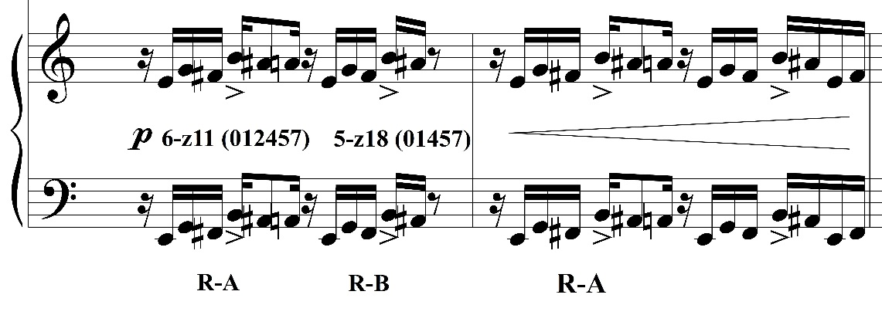
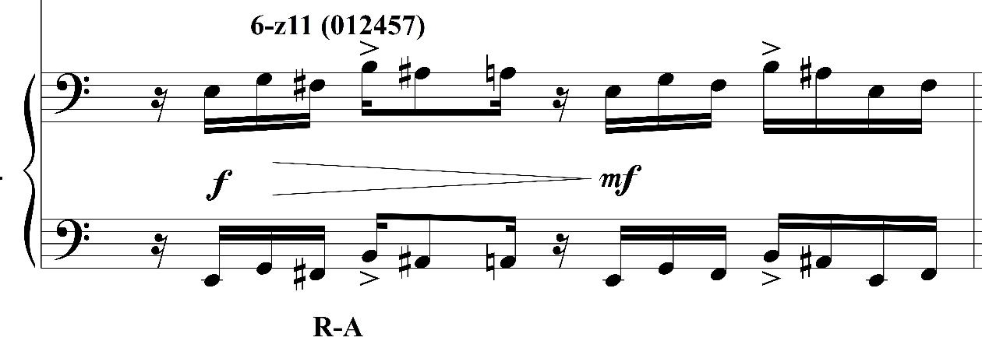
Figure 16. Libby Larsen, Slang, piano, mm. 81-82, 85.
Larsen presents the LM in the first section of Slang with force, employing various methods of repetition and fragmentation and confirming its importance to the piece. Table 3 shows a basic formal design of Slang based on the occurrences of the LM. The sections labeled “A” contain the LM presentations.
A | A | B
mm. 1-89 | mm. 104-105 | 155-302

Table 3. Formal Diagram of Slang based on the Larsen Motive.
The second section does not have as many LM occurrences, but it still functions as a significant musical connector. In mm. 135-136, the LM returns in the clarinet with 6-z11 and 5-z18 at the original center of E. Larsen uses the LM in either its full context or in R-A and R-B fragments, and in mm. 135-136 (Figure 17) she combines the entire motive followed by R-A fragments.
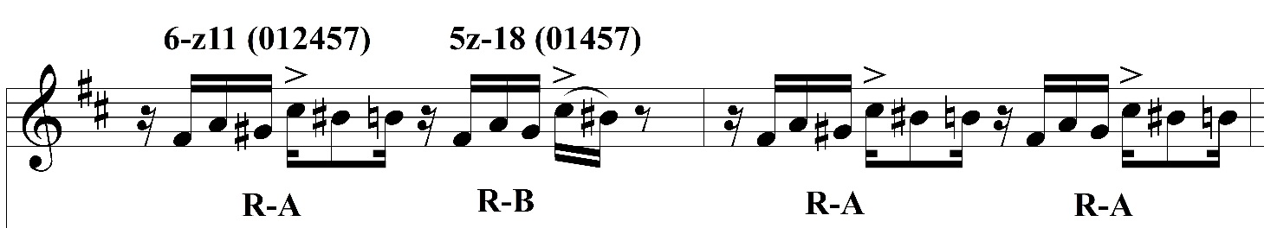
Figure 17. Libby Larsen, Slang, clarinet, mm. 135-136.
Larsen presents the LM in m. 142 by merging both R-A and R-B together, which is shown in Figure 18. Both combined divisions of the LM contain the set class of 6-z11. The violin plays a fusion of both rhythmic partitions by using the entire R-A, then ends with the descending sixteenth notes of R-B. This expresses a different version of the motive while continuing to maintain the pitch content of 6-z11. Four measures later in m. 146, the clarinet and violin emerge for the final presentation of the LM in Slang. Larsen merges the pitch centricity of E and B, which maintains 6-z11 and 5-z18 with a T₅ relationship between violin and clarinet above it. The clarinet is centered around E, while the LM is centered around B in the violin part in mm. 146-148. The joining of E and B in mm. 146-148 is a testament to the LM’s development throughout this work. The pitch content of the motive moves from isolation to unification, which is a reflection of the motive’s growth.
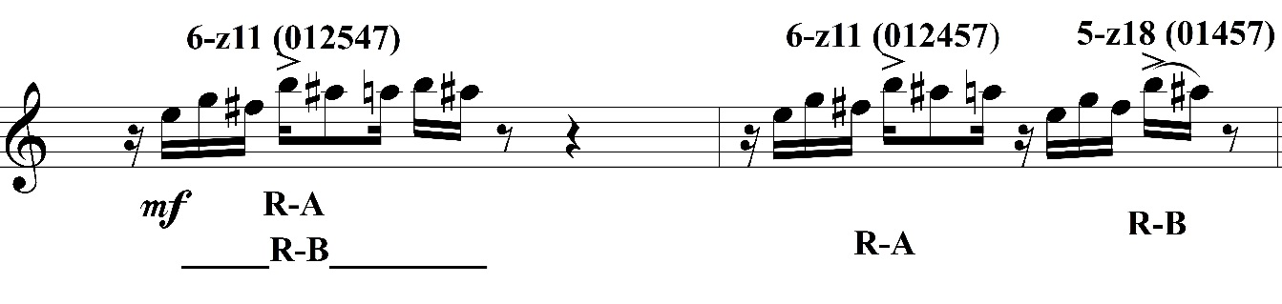
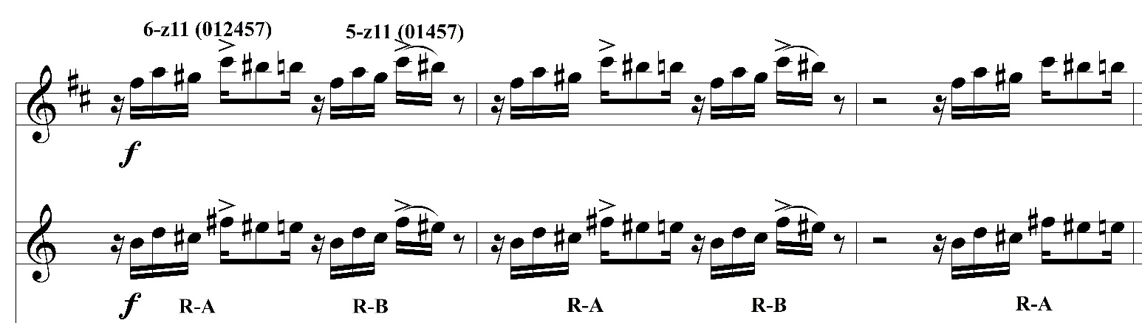
Figure 18. Libby Larsen, Slang, mm. 142-143 violin, 146-148, clarinet, violin.

Contour Invariance: Contour Relations in Slang
The contour relations of the LM in Slang reflect those of pitch content because it maintains the same shape throughout the entire work. Every presentation of the LM contains the C-SEGS <021543>, which corresponds to R-A, and <02143> corresponding to R-B. These particular C-SEGS represents a majority of the LM occurrences in Corker. Although Slang entails a different instrumental palette than Corker, it obtains consistency in its contour and C-SEGS. The LM’s invariant contour relations assists in revealing that the work’s overall development.
The strong introductory statement of the LM that occurs in mm. 45-48 establishes the contour and the C-SEGS <021543> and <02143>. The monophonic layers of the LM’s initial presentations eliminate any uncertainty of its shape. Figure 19 shows the extent of the contour of LM in mm. 45-48. Larsen begins the measure with the full motive, followed by repeating R-B twice, then ending with R-A in m. 48.
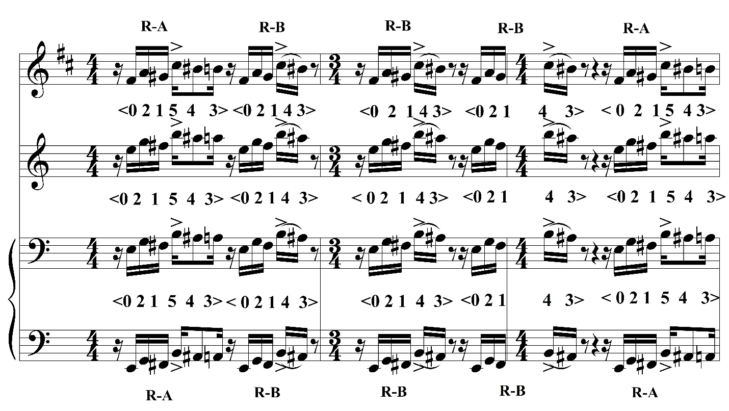
Figure 19. Libby Larsen, Slang, mm. 45-48.
As stated earlier in this chapter, Larsen’s method for developing the motive in Slang, differs from Corker. However, her methods of expressing the LM, e.g. fragmentation, voice isolation, and timbral combinations with the clarinet, violin, and piano, do not affect its contour. Figures 20-25 survey the LM’s contour invariance throughout each motivic appearance in Slang. The individual presentations show the LM in its full context, along with repeated rhythmic portions (e.g. repeated R-A fragments in Figure 20). No matter the rhythmic sequence, the contour invariance is evident in the LM’s musical growth.
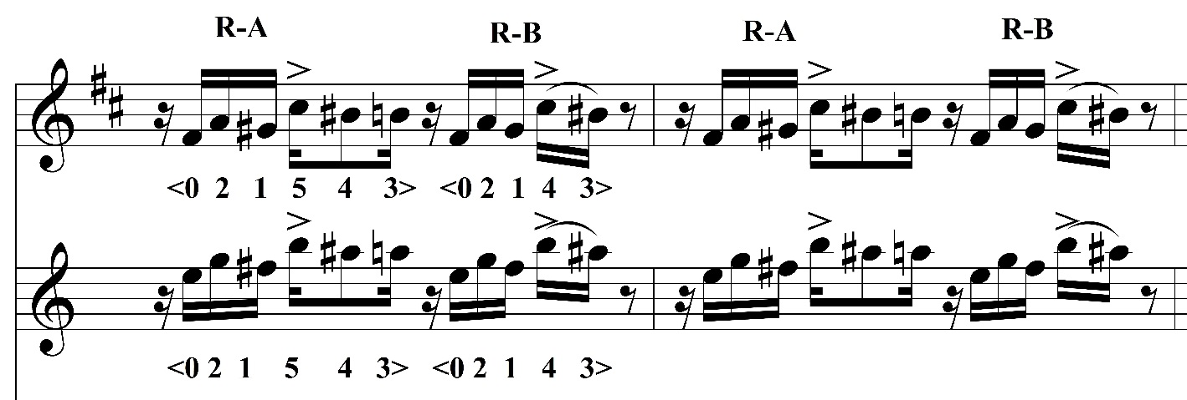
Figure 20. Libby Larsen, Slang, clarinet, violin, mm. 66-67.
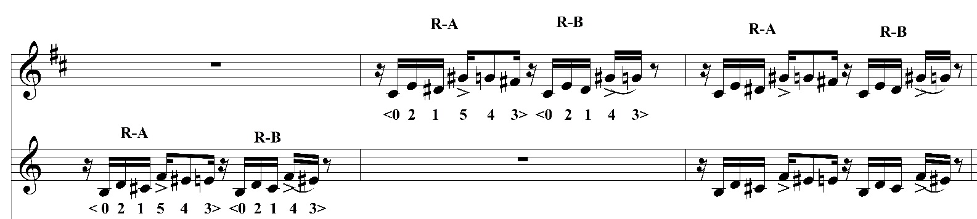
Figure 21. Libby Larsen, Slang, clarinet, violin, mm. 77-79.
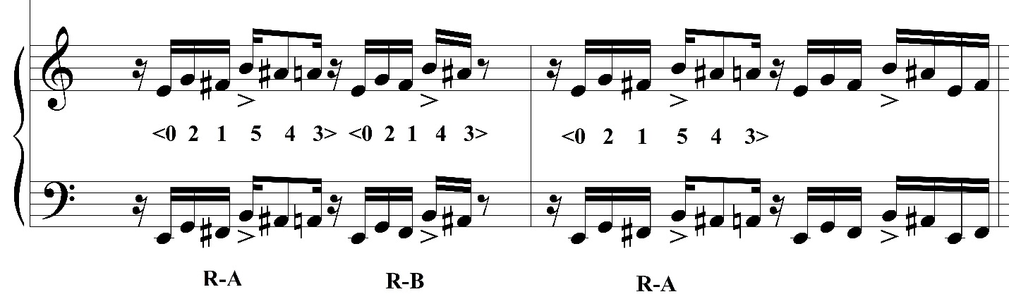
Figure 22. Libby Larsen, Slang, piano, mm. 81-82.
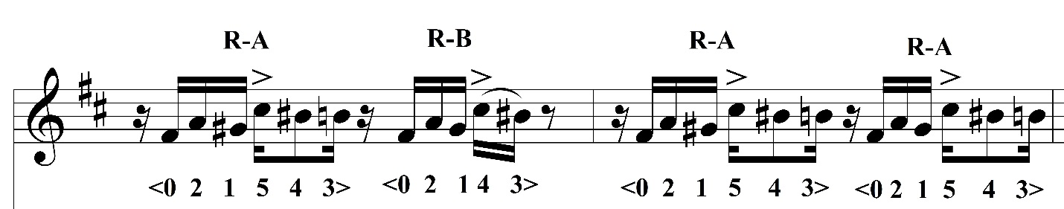
Figure 23. Libby Larsen, Slang, clarinet mm. 135-136.

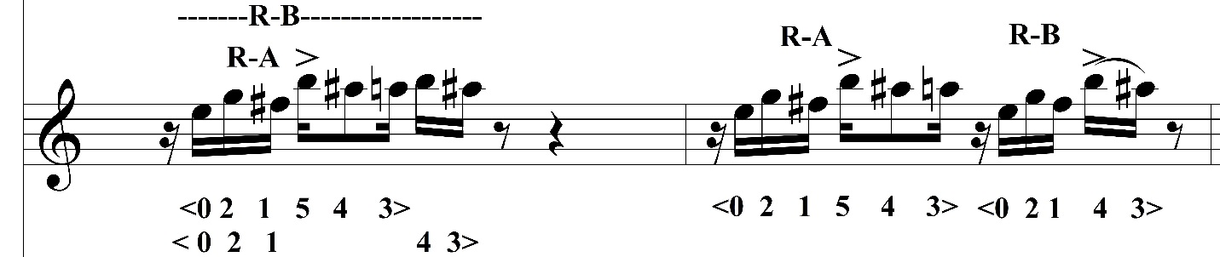
Figure 24. Libby Larsen, Slang, violin mm. 142-143.

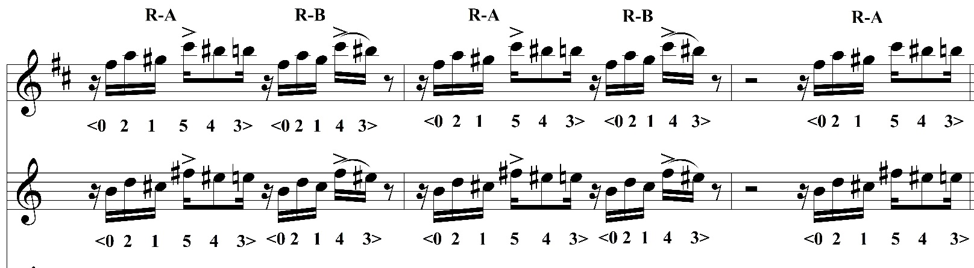
Figure 25. Libby Larsen, Slang, clarinet, violin, mm. 146-148.
Chapter V
Motivic Expansion: String Symphony, III: Ferocious Rhythm (1999)
A compositional trait of Libby Larsen is her intuition to use rhythmically and its energetic pulses, which reveals itself in the third movement of String Symphony, “Ferocious Rhythm.” The piece was commissioned by the Minnesota Orchestra as part of a new series of works, “Centennial Commission.” String Symphony premiered in Minneapolis as part of the orchestra’s centennial celebration in 2003. Larsen’s focus was to create both a homage and essay about strings. She strives to express the lyrical and percussive qualities that can be produced by them. The first two movements, “Elegance” and Beauty Alone” accumulate the lyrical and sonorous characteristics that are synonymous with strings, but “Ferocious Rhythm,” brings a different personality to String Symphony because of Larsen’s rhythmic intensity paired with recurring the motivic material. Stallard describes the movement as “Organically grown from the seeds a few fragmented statements in the opening measure, the instruments expound upon these fragments, heightening the rhythmic tension.” Rhythmic tension is a significant part of the motive’s development in this movement of String Symphony.
Larsen composed String Symphony in 1999, many years after Corker (1977) and five years after Slang (1994). Of these three works, “Ferocious Rhythm” of String Symphony resents the LM at its highest level of intricacy and diversity of pitch content and musical contour. This chapter aims to show that “Ferocious Rhythm” is the final evolutionary point of the LM, and how its musical zenith illustrates its growth and connectivity with through pitch content and contour relations.

Harmonic Intricacy: Pitch Content in “Ferocious Rhythm”
In contrast to the two previous works in this study, here Larsen begins her pervasive motive from a seed of a motivic cell within the broader LM. This explains the liberty of the LM’s pitch content. Throughout this movement it moves from various set classes at a very rapid pace. The first presentation of the LM in “Ferocious Rhythm” is in m. 6. It is an explosive entrance from the violins with the set class 5-2, which can be seen in Figure 26. It continues to develop in m. 14 (Figure 27), integrating forthcoming of the eventual Lm, which is ultimately a rhythmic fusion of the R-A and R-B (from the previous two analyses) with the set class 5-2. The fragment in m. 22, also with set class 5-2 replicates the R-B division of the motive.
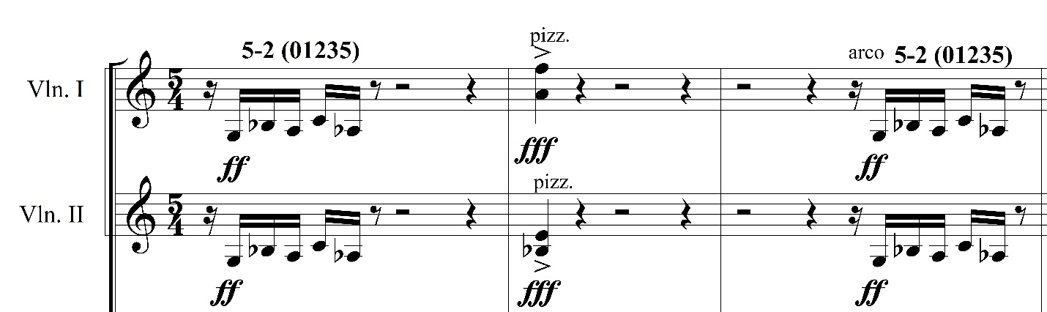
Figure 26. Libby Larsen, “Ferocious Rhythm,” mm. 6-8.
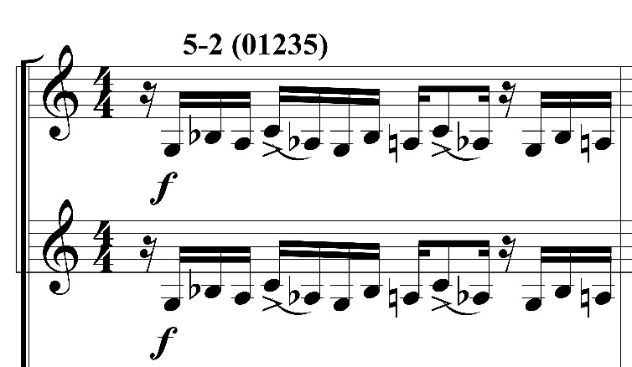
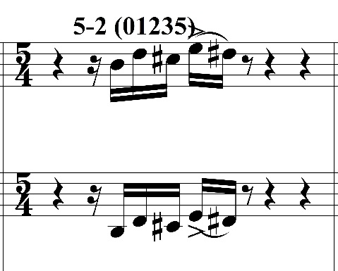
Figure 27. Libby Larsen, “Ferocious Rhythm,” mm. 14, 22.
Larsen combines the fragments in m. 29 in a canonic manner with the 5-2 set class. The contrapuntal motion in m. 29 is a precursor to what is to occur with the LM in this movement of String Symphony. Figure 28 displays a forthcoming display of Larsen’s contrapuntal movement between the first and second violins.
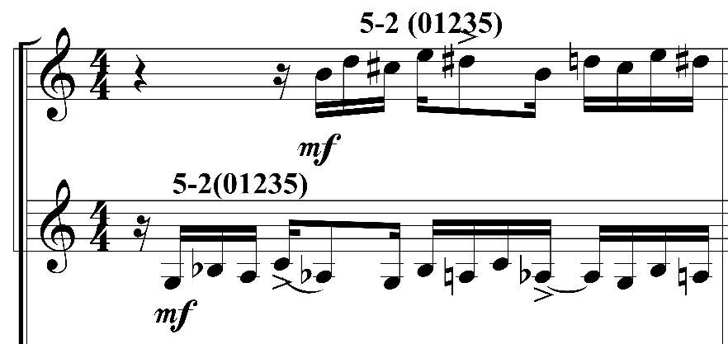
Figure 28. Libby Larsen, “Ferocious Rhythm,” m. 29.
Larsen finally presents the LM in its full form at mm. 38-40. The set class combination, 6-z11 and 5-z18, which were prominent in Corker and Slang, makes its first appearance with its corresponding R-A and R-B divisions. It is harmonized at the strong attacks of beats two and four by a tritone. Larsen continues to develop the LM through variation.
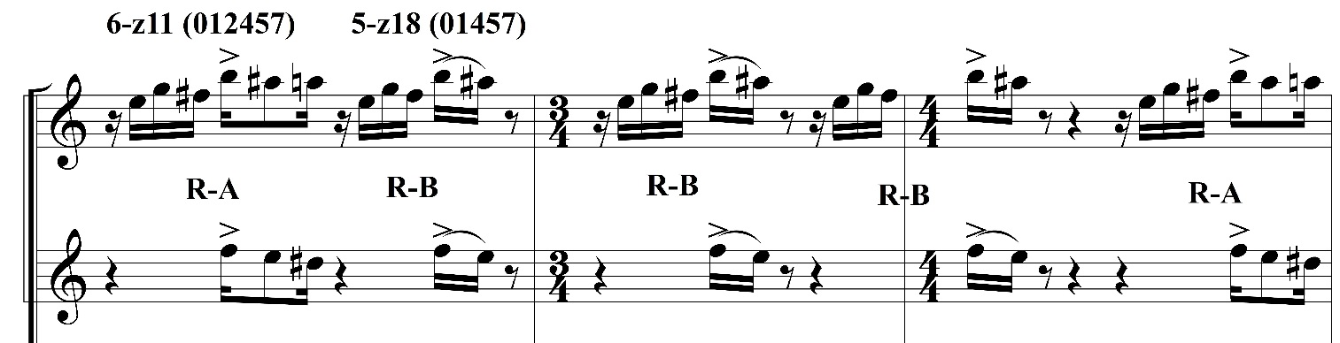
Figure 29. Libby Larsen, “Ferocious Rhythm,” mm. 38-40.
The LM occurs again in m. 44 with the 6-z11 and the R-A being repeated in succession by the first violins and cellos. Similar to Corker and Slang, 6-z11 propels the pitch content of the LM in this section of “Ferocious Rhythm.”
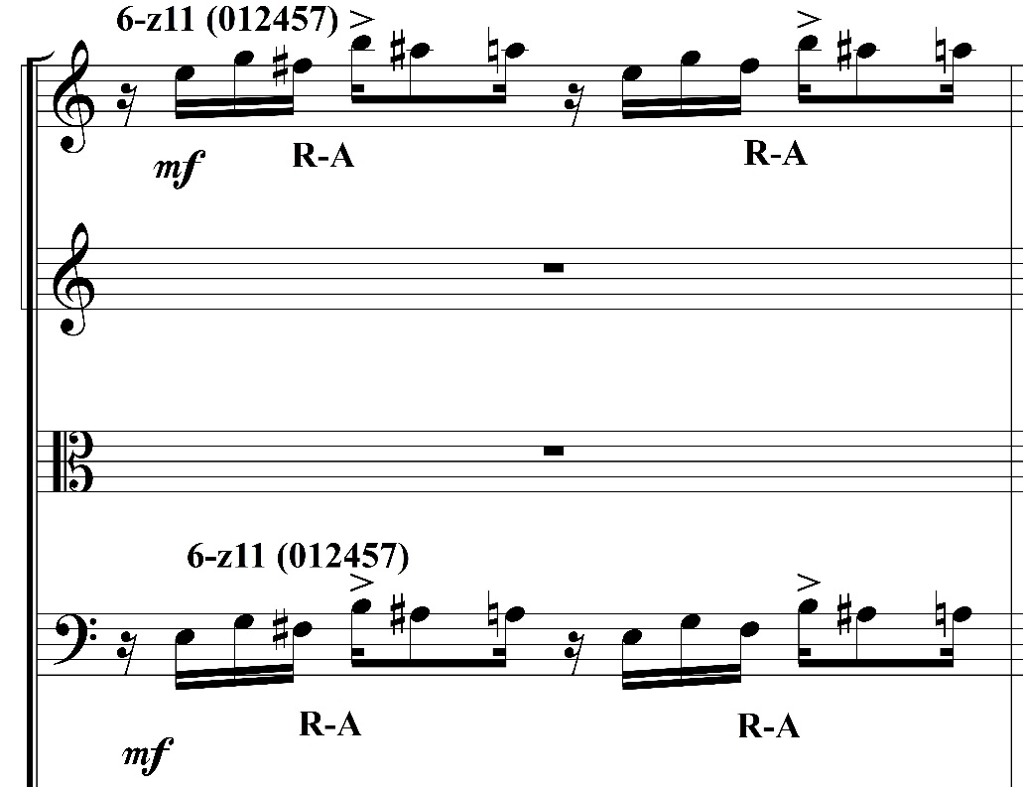
Figure 30. Libby Larsen, “Ferocious Rhythm,” m. 44.
6-z11 and 5-z18 continue to permeate the LM in mm. 51 and 56 with considerable pitch content alterations. There are stark differences between mm. 51 and 56, but the continuous thread is the familiar set class combination. As shown in Figure 31, the LM is played in unison by the violins in m. 51, while in m. 56, the second occurrence of the R-A is harmonized T₆ in the second violins and yielding a resultant set class 5-1. Here the motive displays growth by using different set classes simultaneously. This harmonic adjustment also occurs in mm. 59-60, where the LM contains both R-A and R-B, with T₆ applied to in the second half of each of the rhythmic portions. Measures 59-60 reflect on upon the subset relationships that occurred in Corker. Just as 6-z11 and 5-z18 are literal subsets, so are 5-1 and 4-1. This translates to the LM’s growth and connectivity.

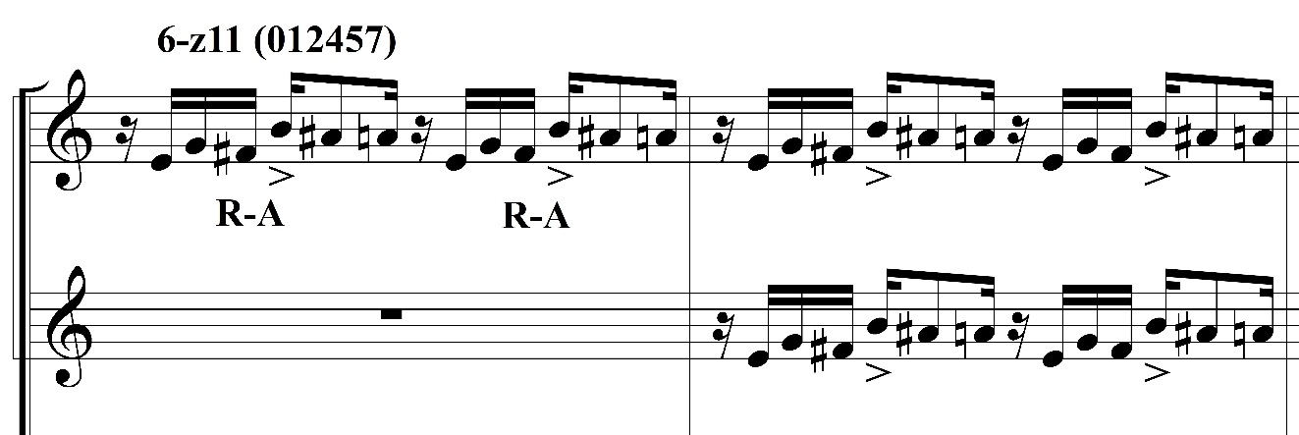
Figure 31. Libby Larsen, “Ferocious Rhythm,” mm. 51-52.
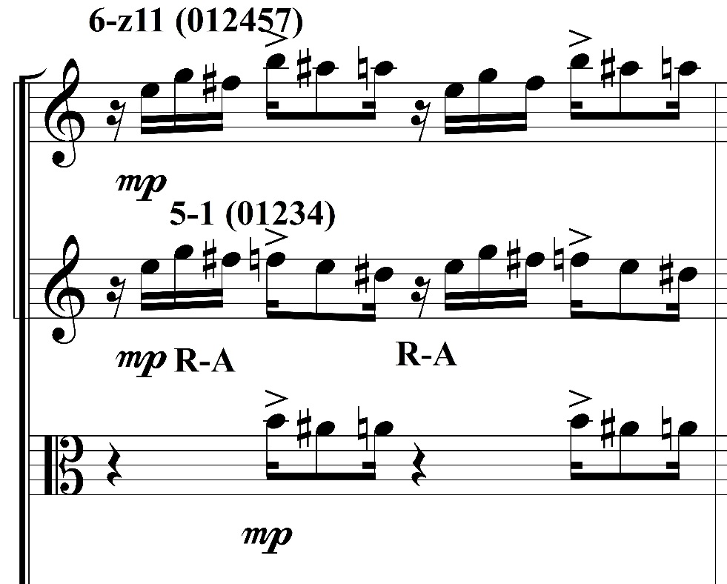
Figure 32. Libby Larsen, “Ferocious Rhythm,” m. 56.
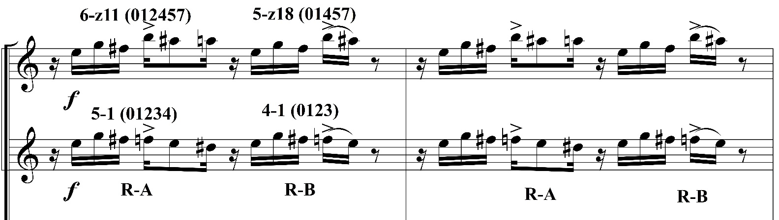
Figure 33. Libby Larsen, “Ferocious Rhythm,” mm. 59-60.
As the piece proceeds, the LM develops through layering and contrapuntal motion. This begins in m. 74 with the cello carrying the motive. Larsen creates a partnering relationship when she dovetails instrument with the aural and visual ascent of the LM in mm. 74-76, shown in Figure 37. The LM’s pitch content returns to the beginning set class of 5-2. The second violin’s set class of 4-2 generates the tritone harmonization with the violas, evidence that Larsen is keen to that particular intervallic harmonization.
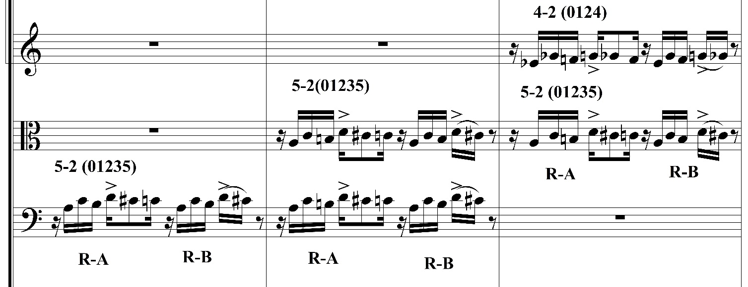
Figure 34. Libby Larsen, “Ferocious Rhythm,” mm. 74-76.
Larsen takes the LM to a more intricate level in mm. 117-123, as shown in Figure 35. She has tightly-woven it by layering it in close proximity with different voices, creating an intensely contrapuntal section of the movement. The table below is a concise guide to the transpositional relationships in mm. 117-123. The identical concept of tight, contrapuntal movement with the LM occurs again in mm. 212-215 (Figure 39). Larsen begins the with the same pitch content as mm. 117, with the difference being that the cellos begin this series instead of the first violins.

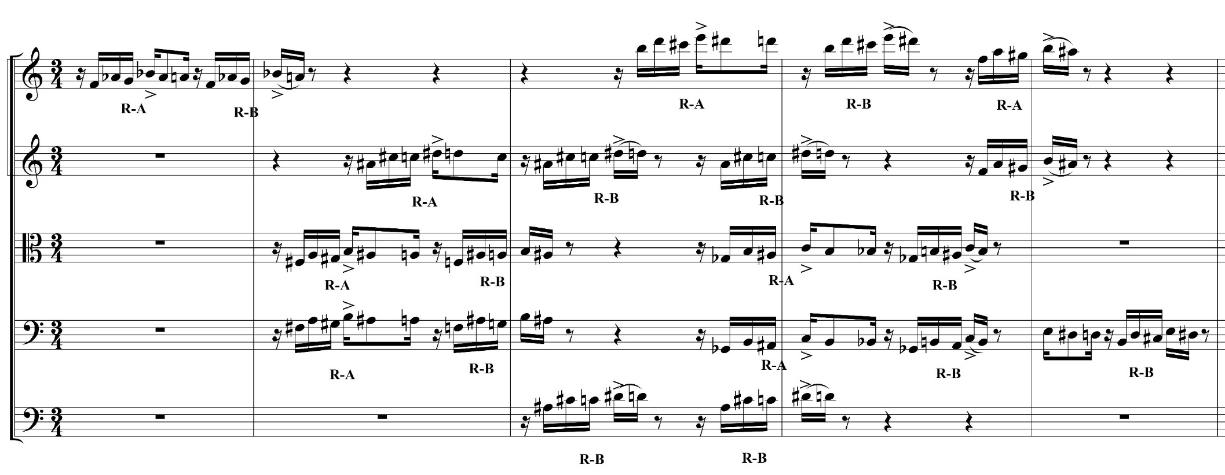
Figure 35. Libby Larsen, “Ferocious Rhythm,” mm. 117-123.
Instruments | Set Class | Transpositions
Violin 1 | 5-2: m. 117-118  5-4: m. 120-121 | 5:2 T₆: m. 119  5-2 T₅: m. 119-120
Violin 2 | 5-2: m. 118  5-4: m. 120-121 | 5-2 T₄: Violas and Cellos, mm. 119-120  5-2 T₅: Violin 1, mm. 119-120
Violas and Cellos | 5-2: m. 118  4-5: m. 120 | 5-2 T₁: Violin 1, m. 119  5-2 T_{4:} Violin 2, mm. 119-120
String Bass | 5-2: mm. 119-120 | Doubles Violin 2

Table 4. Transpositional Relationships, “Ferocious Rhythm,” mm. 117-123.

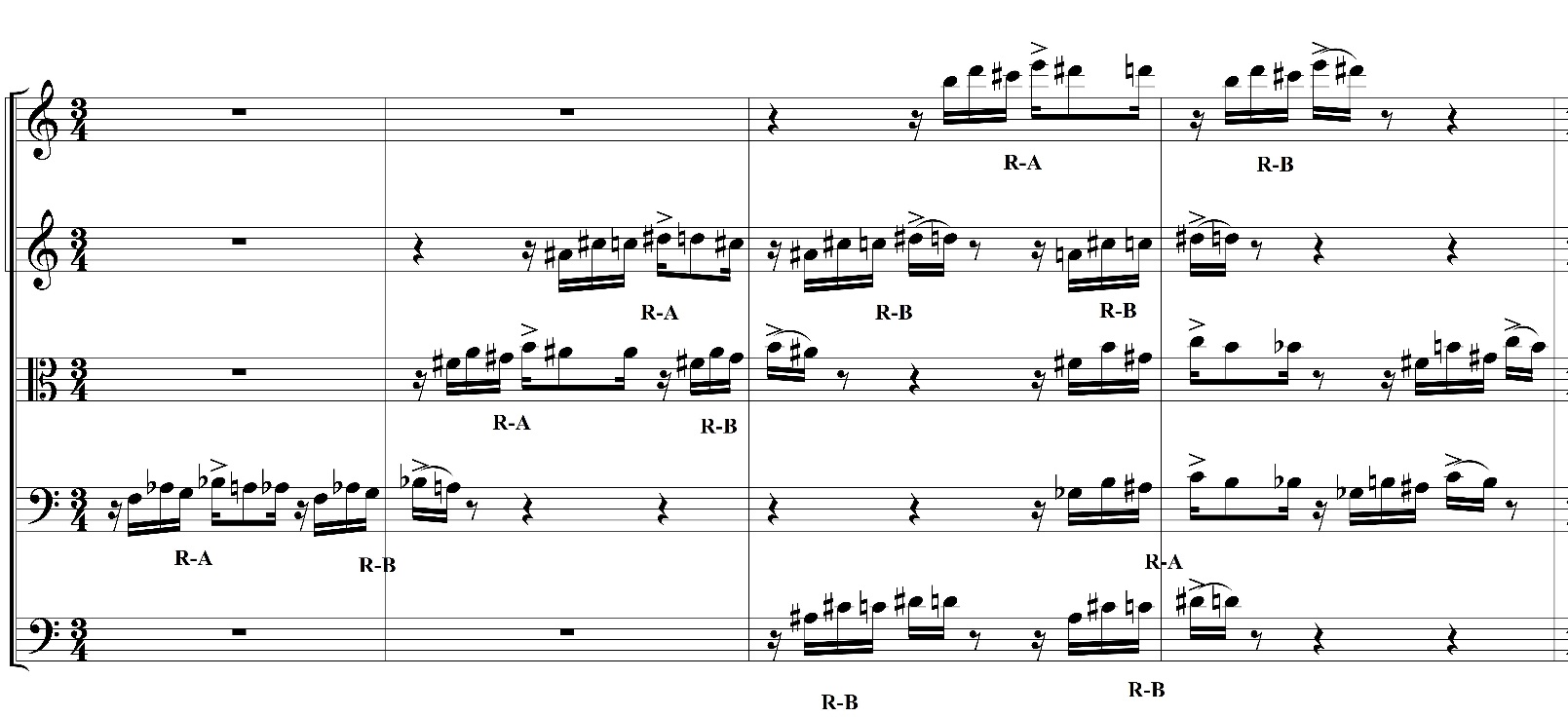

Figure 36. Libby Larsen, “Ferocious Rhythm,” mm. 212-215.
Measures 212-215 still contains the same pitch relationships and transpositions as mm. 117-123. Set class 5-2 stays consistent until m. 215, where it descends to set class 4-5 in the violas and cellos. With the instrumental order and succession, Larsen completes her contrapuntal series of the LM usage in mm. 233-236 as shown in Figure 37. The network of pitch content and transpositions that were outlined in Table 4 are again present between mm. 212-215 and 233-236 (Table 5).
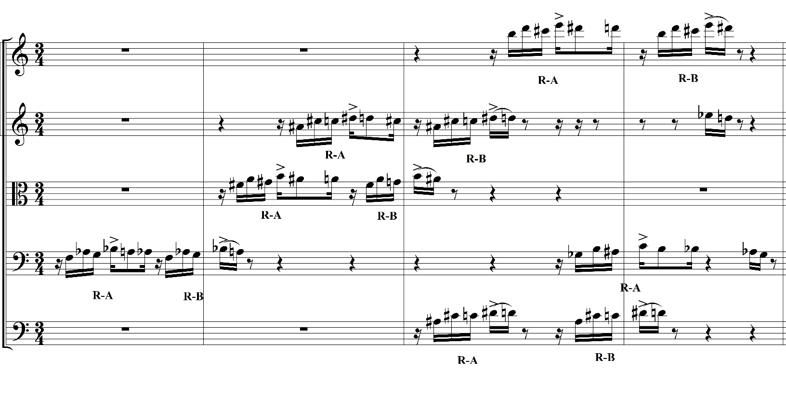
Figure 37. Libby Larsen, “Ferocious Rhythm,” mm. 233-236.

Instruments | Set Class | Transpositions (both sections)
Violin 1 | 5-2: mm. 235-236 | None
Violin 2 | 5-2: mm. 234-236 | 5-2 T₁: Violin 1
Violas | 5-2: mm. 234-235  4-5: mm. 214-215 | 5-2 T_{4:} Violin 2  T₅: Violin 1
Cellos | 5-2: mm. 212-213  mm. 233-234  4-5: mm. 214-215  mm. 235-236 | 5-2 T₁: Violas  T₆: Violin 1
String Bass | 5-2: mm. 235-236 | 5-2 T₁: Violin 1

Table 5. Transpositional Relationships, “Ferocious Rhythm,” mm. 212-215, 233-236.

Diversity in Structure: Contour Relations in “Ferocious Rhythm”
The contour relations of the LM in “Ferocious Rhythm” reflect the pitch content relations because of their diverse nature. The C-SEGS analyzed here support the LM’s varying shape are flexible because they mirror the motive’s pitch and rhythmic development. Motivic fragmentation is perhaps made even more prevalent through a contour connecting corresponding C-SEGS. This analysis of the LM’s contour in “Ferocious Rhythm” expounds on its shape and how it contributes to the overall culmination of the LM from Corker and Slang.
The first two presentation of the LM motive in mm. 6 and 14 share the same C-SEG <03241>. The C-SEGs shown in Figure 38 announces fragmented statements of the motive that were discussed previously in this chapter. Measure 22 contains the C-SEG <03241> as well. Figure 39 illustrates the initial motive’s intention of the building up to its entirety as the LM with <02143>, a familiar C-SEG that identified R-B in Corker and Slang.
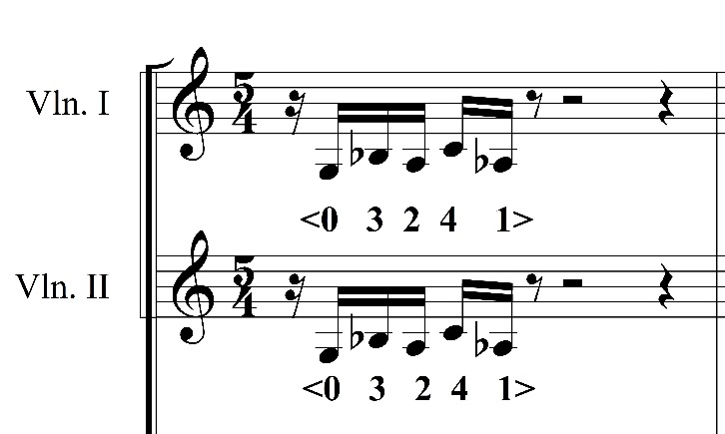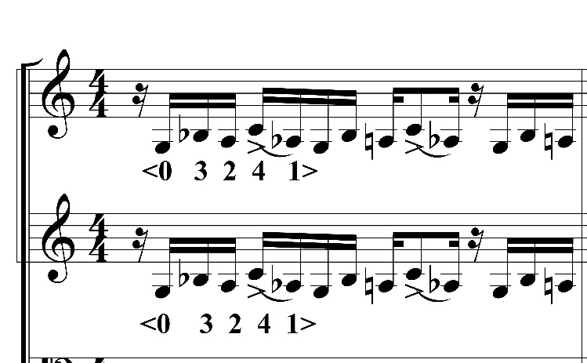
Figure 38. Libby Larsen, “Ferocious Rhythm,” first and second violins, mm. 6, 14.

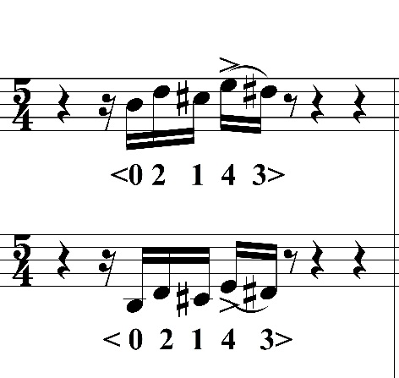
Figure 39. Libby Larsen, “Ferocious Rhythm,” first and second violins, m. 22.
The contour relations of the LM in “Ferocious” makes an unprecedented move: two different C-SEGs occurring simultaneously. In m. 29, shown in Figure 40, the first and second violins layer with individual C-SEGs. The second violins (starting on G3) have the C-SEG <03241>, and the first violins (starting on B5) respond with the C-SEG <02143>. C-SEG <02143> is recognizable as it is part of the R-B partition of the LM that was analyzed in Corker and Slang. Thus, a familiar LM C-SEG returns here, now in conjunction with a different C-SEG.
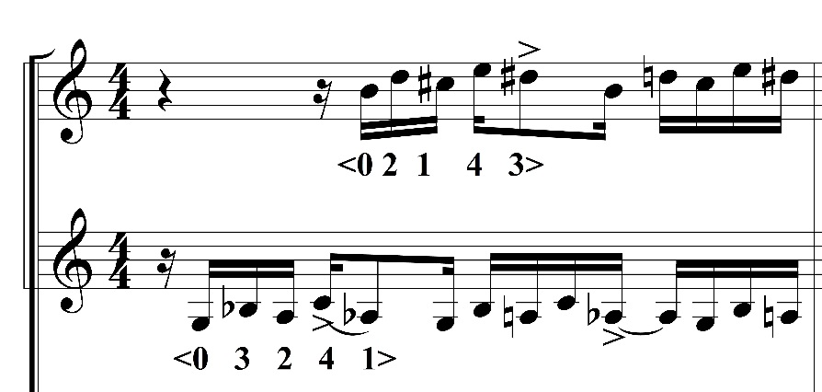
Figure 40. Libby Larsen, “Ferocious Rhythm,” first violins, m. 29.
The LM is presented in its full entirety in 38-40. The R-A and R-B fragments are in its original rhythmic succession, which upon the familiar C-SEGs of the motive from Corker and Slang. As seen in Figure 41, R-A is represented by the C-SEG <021543> and R-B with <02143>.
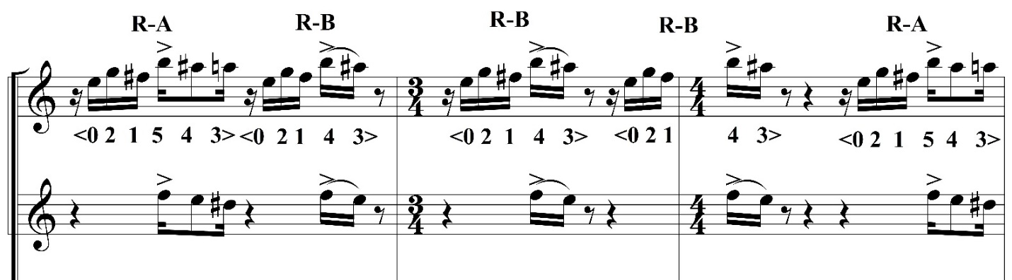
Figure 41. Libby Larsen, “Ferocious Rhythm,” first and second violins, mm. 38-40.
The LM continues to occur using he R-A divisions only in the next series of motivic presentations. The C-SEG <021543> is prominent in mm. 44, 51-52, and 56. This shows its connectivity to Corker and Slang, which also shares <021543>. Larsen uses orchestration methods that were incorporated in Slang to expand on the LM. For instance, in m. 44, R-A is played by a first violin-cello combination. In m. 56, simultaneously occurring different C-SEGs within rhythm R-A are present. C-SEG <021543> is the contour for the first staff, and <04321> represents LM of the second first violins (i.e. the middle staff in Fig. 44). Figures 42-44 clearly illustrates that the R-A C-SEG <021543> remains intact in the movement. This similar facet occurs in Slang and Corker, which indicates the LM’s employment as a musical chain.
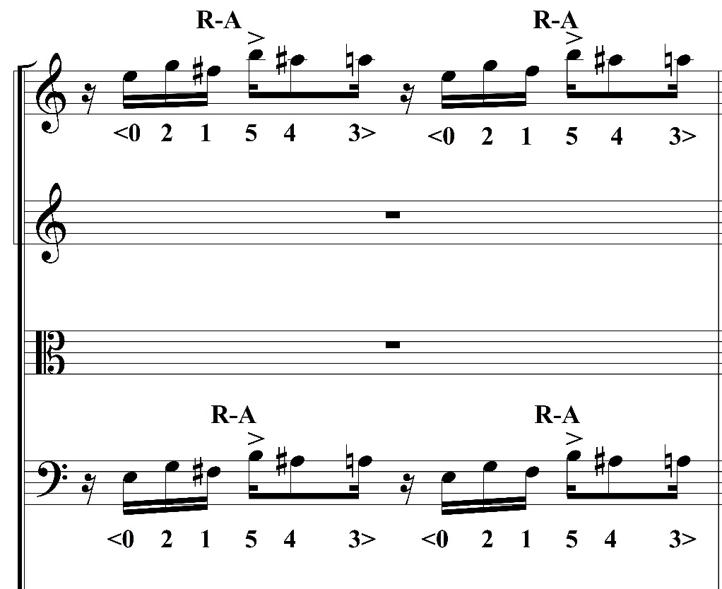
Figure 42. Libby Larsen, “Ferocious Rhythm,” first violins and cellos, m. 44.
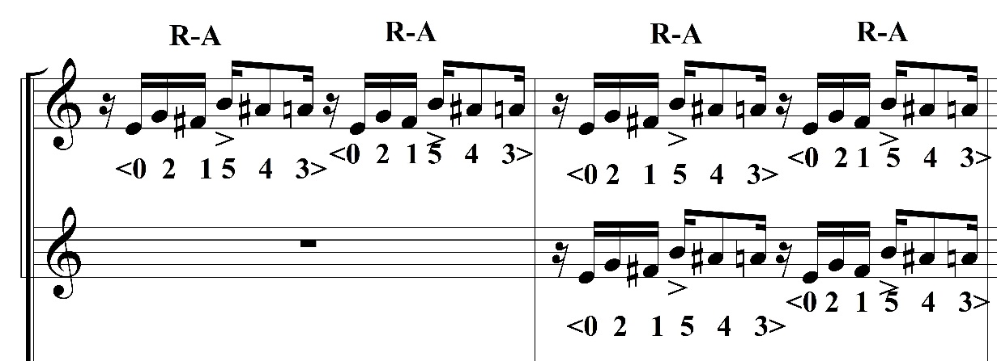
Figure 43. Libby Larsen, “Ferocious Rhythm,” first violins, mm. 51-52.

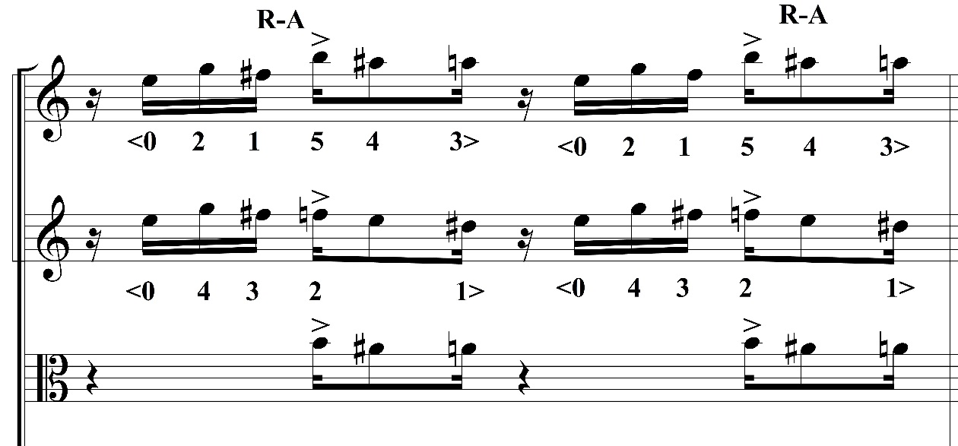
Figure 44. Libby Larsen, “Ferocious Rhythm,” first violins and violas, m. 56.

Measures 59-60 in “Ferocious Rhythm” demonstrates the LM’s contrasting contours accomplished through different C-SEGs and cardinalities. The full motive returns in the split first violins. As shown in Figure 48, the LM’s corresponding C-SEGS are as follows:
Top first violins, mm. 59-60 Bottom first violins, mm. 59-60
R-A: <021543> R-A: <04321>
R-B: <02143> R-B: <0321>
The dissimilar cardinalities of the C-SEGs displays the LM’s contour intricacies and variety, which mirrors its pitch content. The same cardinalities also occur in mm. 74-76, or Figure 46.

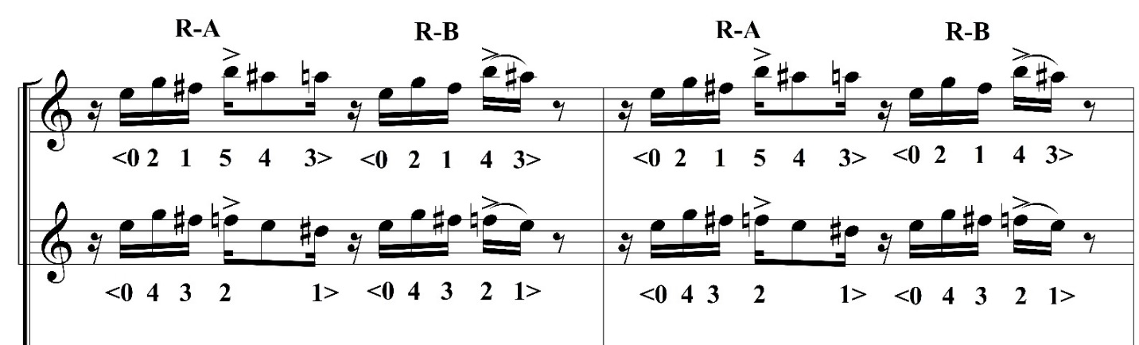
Figure 45. Libby Larsen, “Ferocious Rhythm,” first violins, mm. 59-60.
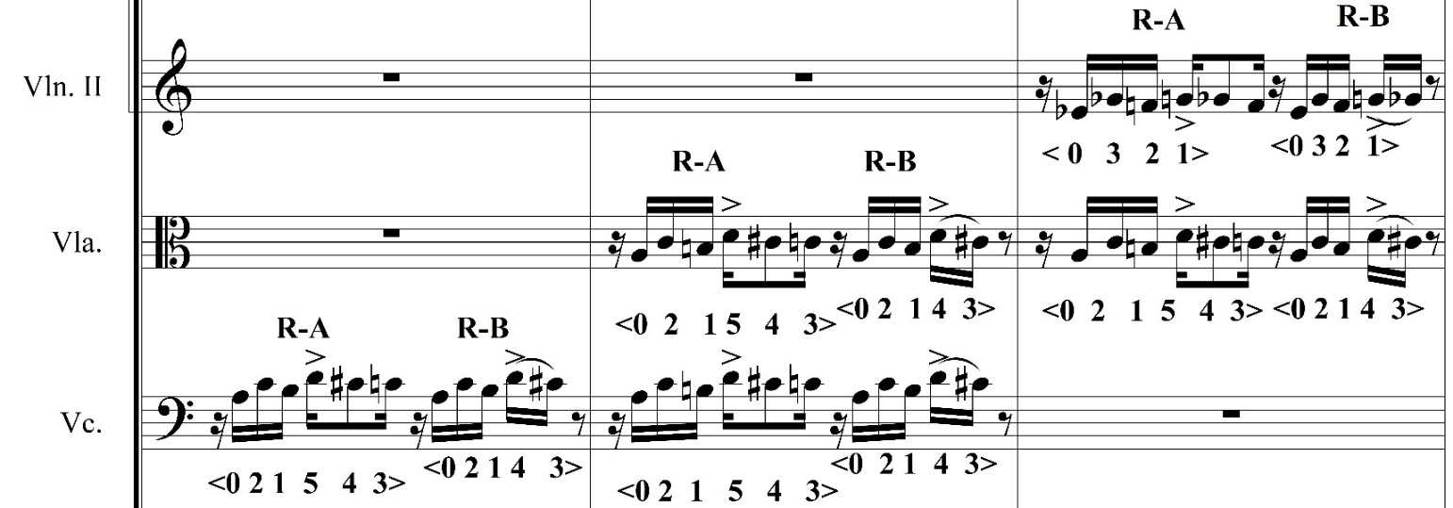
Figure 46. Libby Larsen, “Ferocious Rhythm,” second violins, violas, cellos, mm. 74-76.
Larsen’s contrapuntal movement of the LM in mm. 117-123 brings a paradoxical notion to its contour: while the motive is intricately layered, it contour remains invariant. Each motivic occurrence in each instrument contains the C-SEG <02143>. Figure 47 shows mm. 117-123 the first of the LM’s contrapuntal motions that that plays a vital part in its development.
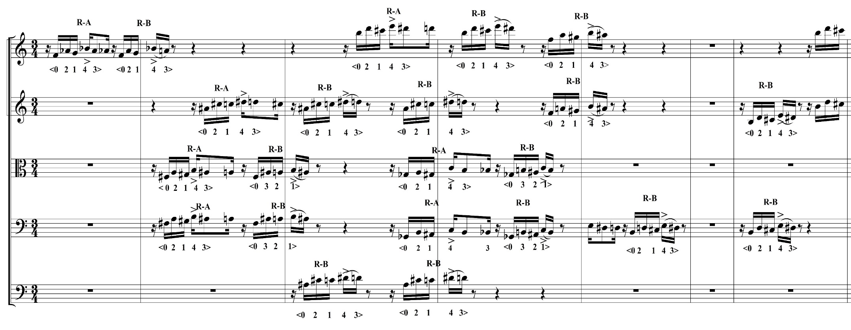
Figure 47. Libby Larsen, “Ferocious Rhythm,” mm. 117-123.
<02143> governs the final presentations of the motive in “Ferocious.” Measures 212-215 (Figure 48) shows Larsen’s layering of the LM does not alter its contour. Every motivic presentation in these four measures has the C-SEG <02143> except in the m. 215. The LMs in the violas and cellos are represented by <0213>. The LM’s C-SEG’s cardinality change in mm. 214-215 seems infectious; the same superset-subset contour relationships occur in mm. 233-236, the last LM occurrence in the “Ferocious Rhythm.” Similar to the pitch content, mm. 212-215 and 233-236 have almost identical contour relationships. The motivic presentations, shown in Figure 49, all contain <02143> except for the cellos in mm. 235-236, which has <0213>.
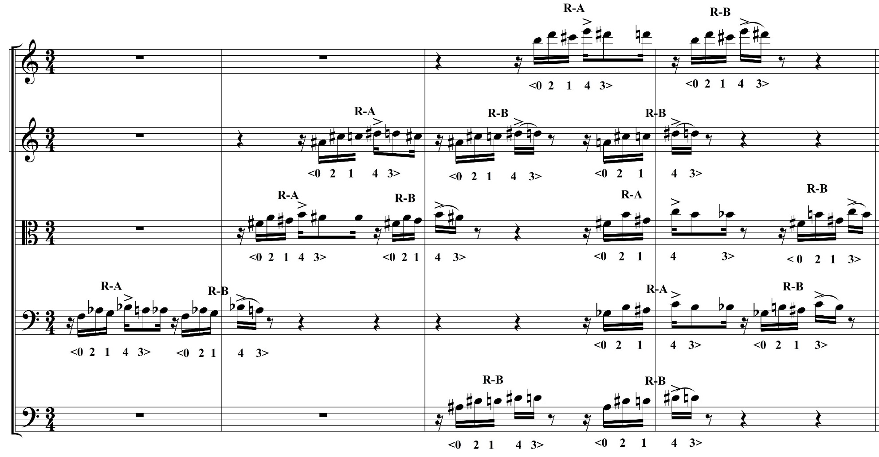Figure 48. Libby Larsen, “Ferocious Rhythm,” mm. 212-215.
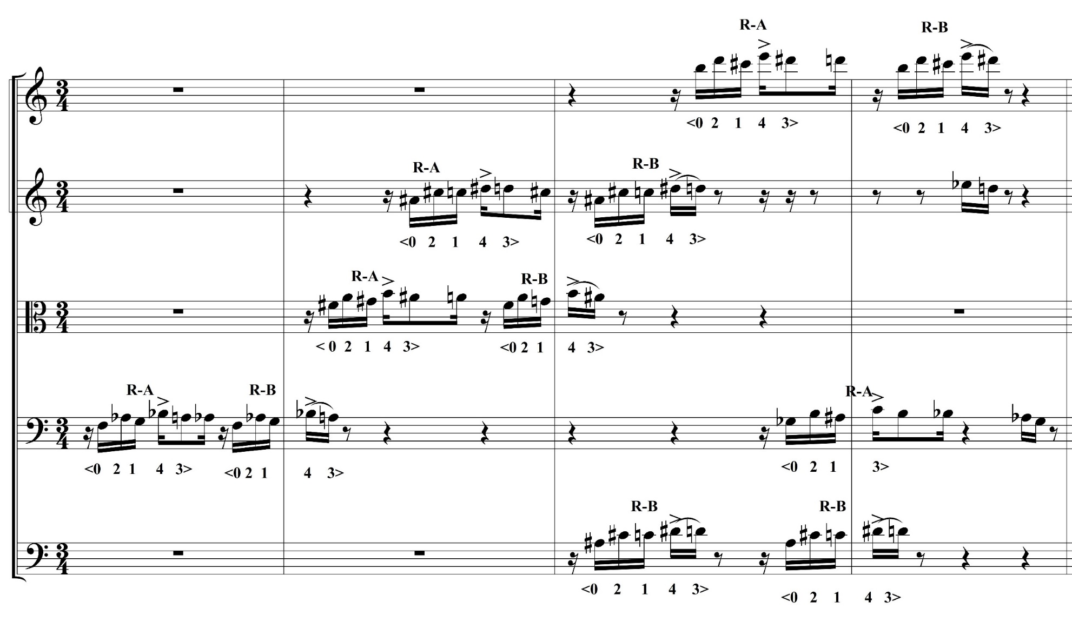
Figure 49. Libby Larsen, “Ferocious Rhythm,” mm. 233-236.
Chapter VI: Conclusion
The Larsen Motive in Corker, Slang, and “Ferocious Rhythm” from String Symphony proves itself as a tool of musical growth and connectivity. This thesis shows the LM’s evolutionary track throughout these three works, and how Larsen’s compositional approaches contributes to its development. These approaches shape Larsen’s voice, including consistent rhythmic cells, groups of pitches, and melodic contours. As the music develops internally (within each work) these “constant” approaches are subjected to “variables” that slightly alter her motives. The LM is a vehicle for a musical exploration and individuality of her voice. The motive has a prominent musical purpose that serves as a catalyst for innovative analysis.
This research has the potential to expand based on the foundations set by this thesis. Pitch and contour relationships in coordination with rhythmic cells is a helpful start in contextualizing instances of the LM, but further analysis can be done. Future research on the LM’s pitch content and contour relationships can display more intricacies about its growth. This could be done by utilizing: (1) pc set similarity relations (SIM), (2) the pc mutually embedding function (MEMB), (3) the contour similarity function (CSIM), and (4) the contour embedding function (CEMB). In contour theory for example, West Marvin and Laprade state that similarity relations can be measured by the contour similarity function (CSIM), which involves measuring two C-SEGs of the same cardinality. The other option is the contour embedding function (CEMB), in which the two C-SEGs being measured are divided by the total number of csubsegs of the same cardinality to show great similarity. This is only an example of the future analysis of the LM can expand to with contour theory and pc analysis.
Ultimately, the LM’s evolution and musical vigor is qualified in Corker, Slang, and “Ferocious Rhythm.” The LM is a contemporary example of using a principal motive for musical development. The LM in these works not only demonstrates how a seed of motivic material can grow musically, but it is an outlet to comprehend Libby Larsen’s compositional language.

BIBLIOGRAPHY
Babbitt, Milton. Words about Music. Edited by Stephen Dembski and Joseph N. Straus. Madison, WI: The University of Wisconsin Press, 1987.

Forte, Allen. “Pitch-Class Set Analysis Today.” Music Analysis, Vol. 4, no. 1/2 (1984): 29-58.

Goldmark, Daniel. “Carl Stalling and Popular in the Warner Bros. Cartoons” in Tunes for ‘toons” Music and the Hollywood Cartoon. Berkeley: University of California Press, 2005.

Harper, Steve, A. “Contour and Melodic Structure in Two Homophonic Instrumental Works by Anton Webern.” College Music Symposium, Vol. 46, (2006): 105-122.

Kelly, Jennifer. “Libby Larsen” in In Her Own Words: Conversations with Composers in the United States. Chicago: University of Illinois Press, 2013.

Larsen, Libby. “Corker: Composer Notes.” http://libbylarsen.com/index.php?contentID=242&profileID=1302&startRange=.

Larsen, Libby. Corker: for B flat clarinet and Percussion. Boston: E.C. Schirmer Music Company, 2001.

Larsen, Libby. Slang: for Violin, Clarinet, and Piano. Oxford: Oxford University Press, 2008.

Larsen, Libby. String Symphony. Oxford: Oxford University Press, 2001.

Lewin, David. Musical Form and Transformation. New Haven: Yale University Press: 1993.

McCutchan, Ann. “Libby Larsen” in The Muse that Sings: Composers Speak about the Creative Process. New York: Oxford University Press, 1999.

Moorhouse, Linda, R. “Libby Larsen” in A Composer’s Insight: Thoughts, Analysis and Commentary on Contemporary Masterpieces for Wind Band, Vol. 2. Edited by Timothy Salzman. Galesville, MD: Meredith Music Publications, 2003.

Morris, Robert, D. Compositions with Pitch-Classes: A Theory of Compositional Design. New Haven: Yale University Press, 1987.

Morris, Robert. D. “New Directions in the Theory and Analysis of Musical Contour.” Music Theory Spectrum, Vol. 15, no. 2 (1993): 205-228.

Quinn, Ian. “Fuzzy Extensions to the Theory of Contour.” Music Theory Spectrum, Vol. 19, no. 2 (1997): 232-263.

Rifkin, Deborah. “A Theory of Motives for Prokofiev’s Music.” Music Theory Spectrum, Vol. 26, no. 2 (2004): 265-290.

Schiff, David. The Music of Elliott Carter. Ithaca, NY: Cornell University Press, 1998.

Stallard, Tina, Milhorn. “Libby Larsen,” in Women of Influence in Contemporary Music: Nine American Composers. Edited by Michael K. Clayton. Lanham, MD: Scarecrow Press, 2011.

Strand, Katherine. “A Socratic Dialogue with Libby Larsen on Music, Musical Experience in American Culture, and Music Education.” Philosophy of Music Education Review, vol. 19 (2011): 52-66.

Straus, Joseph, N. “A Primer to Atonal Set Theory.” College Music Symposium, vol. 31 (1991): 1-26.

West Marvin, Elizabeth. “A Generalization of Contour Theory to Diverse Musical Spaces: Analytical Applications to the Music of Dallapiccola and Stockhausen” in Concert Music, Rock, and Jazz since 1945: Essays and Analytical Studies. Edited by Elizabeth West Marvin and Richard Hermann. Rochester: University of Rochester Press, 1995.

West Marvin, Elizabeth and Paul A. Laprade. “Relating Musical Contours: Extensions of a Theory for Contour.” Journal of Music Theory. Vol. 31, no. 2 (1987): 225-267.

Wilson, Paul. The Music of Béla Bartók. New Haven: Yale University Press, 1992.

Vita
Shelise Nicole Washington is a Master of Music candidate with a concentration in music theory at the University of Tennessee-Knoxville. She completed her Bachelor of Science in Music degree from Murray State University in 2012. At Murray State University, Ms. Washington was highly involved in large and chamber ensembles as a clarinetist, studying with Dr. Scott Locke. Her passion for music theory grew while at MSU, with the tutelage and encouragement of Dr. Mike D’Ambrosio. While working with Dr. D’Ambrosio, Shelise completed her Final Research Project, “Reduce, Reuse, Recycle: Aaron Copland’s Concerto for Clarinet, Piano, Harp, and Strings.”
At the University of Tennessee-Knoxville, Shelise has worked with Dr. Brendan McConville and Dr. Barbara Murphy, who she credits as being a major part of her success and scholastic achievement. Under Dr. McConville’s advisement, her thesis, “The Larsen Motive: Three Analytical Studies of Evolving Motivic Connectivity in Libby Larsen’s Corker, Slang, and String Symphony, III” has proven to be fruitful. Washington’s research on Libby Larsen has led her to present at the 2014 Joint Regional Conference of the College Music Society Southern Chapter and Mid-Atlantic Chapter at the University of Tennessee-Knoxville and the First Annual THEMUS Graduate Student Conference at Temple University. Shelise Washington is also a music theory graduate teaching assistant at the University of Tennessee-Knoxville, teaching undergraduate ear training courses as well as the fundamental music theory course.

Linda R. Moorhouse, “Libby Larsen,” from A Composer’s Insight: Thoughts, Analysis, and Commentary on Contemporary Masterpieces for Wind Band, Vol. 2, ed. Timothy Salzman, (Galesville, MD: Meredith Music Publications, 2003), 53.
Tina Milhorn Stallard, “Libby Larsen,” in Women of Influence in Contemporary Music: Nine American Composers, ed. Michael K. Slayton, (Lanham, MD: Scarecrow Press, Inc., 2011), 192. 3 Moorhouse, “Libby Larsen,”55.
4 Ann McCutchan, “Libby Larsen,” in The Muse that Sings: Composers Speak about the Creative Process, (Oxford: Oxford University Press, 1999), 143.
5 Stallard, “Libby Larsen,”192.
6 Ibid., 192.
7 Ibid., 192.
Ann McCutchan, “Libby Larsen,” in The Muse that Sings: Composers Speak about the Creative Process, (Oxford: Oxford University Press, 1999), 143.
Katherine Strand, “A Socratic Dialogue with Libby Larsen on Music, Musical Experience in American Culture, and Music Education, Philosophy of Music Education Review, vol. 19 (2011): 52.
Ibid., 54.
Linda R. Moorhouse, “Libby Larsen,” from A Composer’s Insight: Thoughts, Analysis, Commentary on Contemporary Masterpieces for Wind Band, Vol. 2, ed. Timothy Salzman, (Galesville, MD: Meredith Music Publications, 2003), 54.
Ibid., 54.
Ibid., 55.
Ibid., 55.
Linda R. Moorhouse, “Libby Larsen,” from A Composer’s Insight: Thoughts, Analysis, and Commentary on Contemporary Masterpieces for Wind Band, Vol. 2, ed. Timothy Salzman, (Galesville, MD: Meredith Music Publications, 2003), 54.
Ibid., 54.
Ibid., 54.
Ann McCutchan, “Libby Larsen,” in The Muse that Sings: Composers Speak about the Creative Process, (Oxford: Oxford University Press, 1999), 143.
Moorhouse, “Libby Larsen,” 57.
Ibid., 57.
Ibid., 57.
Daniel Goldmark, “Carl Stalling and Popular Music in Warner Bros. Cartoons” in Tunes for ‘toons: Music and the Hollywood Cartoon, (Berkeley: University of California Press, 2005), 10.
Ibid., 10.
Daniel Goldmark, “Carl Stalling and Popular Music in Warner Bros. Cartoons” in Tunes for ‘toons: Music and the Hollywood Cartoon, (Berkeley: University of California Press, 2005), 11.
Tina Milhorn Stallard, “Libby Larsen,” in Women of Influence in Contemporary Music: Nine American Composers, ed. Michael K. Slayton, (Lanham, MD: Scarecrow Press, Inc., 2011), 193. 26 Ibid., 193.
27 Ibid., 193.
28 Ibid., 194.
Linda R. Moorhouse, “Libby Larsen,” from A Composer’s Insight: Thoughts, Analysis, Commentary on Contemporary Masterpieces for Wind Band, Vol. 2, ed. Timothy Salzman, (Galesville, MD: Meredith Music Publications, 2003), 54
Ibid., 54.
Ibid., 54.
Ibid., 54.
Ibid., 54.
Ibid., 54.
Ibid., 54.
36 Ibid., 58.
37 Ibid., 58.
38Ibid., 58.
39Ibid., 59.
40 Jennifer Kelly, “Libby Larsen,” in In Her Own Words: Conversations with Composers in the United States, (Chicago: University of Illinois Press, 2013), 311.
Ibid., 311.
Shelise Washington, email message to author, September 13, 2013.
Ibid., 2013.
For the remainder of this thesis, the Larsen Motive will be referred to as LM.
Deborah Rifkin, “A Theory of Motives for Prokofiev’s Music,” Music Theory Spectrum, Vol. 26, no. 2 (2004): 266.
Joseph N. Straus, “A Primer for Atonal Set Theory,” College Music Symposium, Vol. 31 (1991): 1.
Ibid., 1.
Ibid., 2.
Allen Forte, “Pitch-Class Set Analysis Today,” Musical Analysis, Vol. 4, no. 1 (1984): 33.
See David Lewin’s Musical Form and Transformation (New Haven: Yale University Press, 1993).
See Milton Babbitt’s Words about Music (Madison, WI: The University of Wisconsin Press: 1987).
Paul Wilson, “First Steps toward a Theory” in The Music of Béla Bartók, (New Haven: Yale University Press, 1992), 15.
See David Schiff’s The Music of Elliott Carter (Ithaca, NY: Cornell University Press, 1998).
This thesis uses the term “harmonic” when referring to any pitch content. This term may describe vertical harmonic relations or linear harmonic relations.
Tina Milhorn Stallard, “Libby Larsen,” in Women of Influence in Contemporary Music: Nine American Composers, ed. Michael K. Slayton, (Lanham, MD: Scarecrow Press, Inc., 2011), 196. 56 Ibid., 196.
57 Ibid., 196.
58 Ian Quinn, “Fuzzy Extensions to the Theory of Contour,” Music Theory Spectrum, Vol. 19, no. 2 (1997): 232.
59 Ibid., 205.
60 Elizabeth West Marvin and Paul A. Laprade, “Relating Musical Contours: Extensions of a Theory for Contour,” Journal of Music Theory, Vol. 31, no. 2 (1987): 225. 61 Ibid., 225
62 Morris, 205.
63 Ibid., 205.
64 Elizabeth West Marvin and Paul A. Laprade, “Relating Musical Contours: Extensions of a Theory for Contour,” Journal of Music Theory, Vol. 31, no. 2 (1987): 226.
65 Ibid., 226.
66 Robert D. Morris, “Chapter Two: Pitches Spaces” in Composition with Pitch-Classes: A Theory of Compositional Design, (New Haven: Yale University Press, 1987).
West Marvin and Paul A. Laprade, 226, 228.
68 Elizabeth West Marvin and Paul A. Laprade, “Relating Musical Contours: Extensions of a Theory for Contour,” Journal of Music Theory, Vol. 31, no. 2, (1987): 229.
See Steven A. Harper’s “Contour and Melodic Structure in Two Homophonic Instrumental Works by Anton Webern,” College Music Symposium, Vol. 46 (2006): 109-110.
Steve A. Harper, “Contour and Melodic Structure in Two Homophonic Instrumental Works by Anton Webern,” College Music Symposium, Vol. 46 (2006): 109-110.
74 Ian Quinn, “Fuzzy Extensions to the Theory of Contour,” Music Theory Spectrum, Vol. 19, no. 2 (1997): 232.
Libby Larsen, “Corker: Composer’s Notes,” http://libbylarsen.com/index.php?contentID=242&profileID=1302&startRange=
Ibid.
Libby Larsen, Corker, (E.C. Schrimer Music Company, 2001), 5.
Libby Larsen, Corker, (E.C. Schrimer Music Company, 2001), 5.
Ibid., 7.
Libby Larsen, Corker, (E.C. Schrimer Music Company, 2001), 9. 78 Ibid., 14.
Libby Larsen, Corker, (E.C. Schrimer Music Company, 2001), 5.
Libby Larsen, Corker, (E.C. Schrimer Music Company, 2001), 7.
Ibid., 9.
Libby Larsen, Corker, (E.C. Schrimer Music Company, 2001), 14.
Libby Larsen, Slang, (Oxford: Oxford University Press, 2008), 2.
Ibid., 2.
Ibid., 2.
Ibid., 2.
Ibid., 2.
Parallel textures refers to when multiple instruments have the same melodic material in unison.
In this chapter, isolated voices is used to describe when one of the instruments (B flat clarinet, violin, piano) play the LM individually.
Libby Larsen, Slang, (Oxford University Press, 2008), 11.
Libby Larsen, Slang, (Oxford University Press, 2008), 12, 15-16.
Libby Larsen, Slang, (Oxford University Press, 2008), 18.
Libby Larsen, Slang, (Oxford University Press, 2008), 19.
Libby Larsen, Slang, (Oxford University Press, 2008), 28-29.
Libby Larsen, Slang, (Oxford University Press, 2008), 30-31.
Libby Larsen, Slang, (Oxford University Press, 2008), 11.
Libby Larsen, Slang, (Oxford University Press, 2008), 15-16.
Ibid., 18.
Ibid., 19.
Libby Larsen, Slang, (Oxford University Press, 2008), 28-29.
Ibid., 30-31.
Ibid., 30-31.
Libby Larsen, String Symphony, (Oxford University Press, 2001), 2.
Ibid., 2.
Ibid., 2.
Ibid., 2.
Tina Milhorn Stallard, “Libby Larsen” in Women of Influence in Contemporary Music: Nine American Composers, ed. Michael K. Clayton (Lanham, MD: Scarecrow Press, 2011), 196.
Libby Larsen, “Ferocious Rhythm” from String Symphony, (Oxford University Press, 2001, 31.
Libby Larsen, “Ferocious Rhythm” from String Symphony, (Oxford University Press, 2001, 32.
Libby Larsen, “Ferocious Rhythm” from String Symphony, (Oxford University Press, 2001, 33.
Ibid., 34.
Libby Larsen, “Ferocious Rhythm” from String Symphony, (Oxford University Press, 2001, 35.
Libby Larsen, “Ferocious Rhythm” from String Symphony, (Oxford University Press, 2001, 35-36.
Ibid., 36. 116 Ibid., 37.
Libby Larsen, “Ferocious Rhythm” from String Symphony, (Oxford University Press, 2001, 39.
Libby Larsen, “Ferocious Rhythm” from String Symphony, (Oxford University Press, 2001, 42-43.
Libby Larsen, “Ferocious Rhythm” from String Symphony, (Oxford University Press, 2001, 49.
Ibid., 49.
Libby Larsen, “Ferocious Rhythm” from String Symphony, (Oxford University Press, 2001), 31.
Ibid., 32.
Libby Larsen, “Ferocious Rhythm,” from String Symphony, (Oxford University Press, 2001), 33.
Libby Larsen, “Ferocious Rhythm,” from String Symphony, (Oxford University Press, 2001), 34.
Libby Larsen, “Ferocious Rhythm,” from String Symphony, (Oxford University Press, 2001), 35.
Ibid., 35-36.
Libby Larsen, “Ferocious Rhythm,” from String Symphony, (Oxford University Press, 2001), 36.
Libby Larsen, “Ferocious Rhythm,” from String Symphony, (Oxford University Press, 2001), 37.
Ibid., 39.
Libby Larsen, “Ferocious Rhythm,” from String Symphony, (Oxford University Press, 2001), 42-43.
Libby Larsen, “Ferocious Rhythm” from String Symphony, (Oxford University Press, 2001), 49.
Libby Larsen, “Ferocious Rhythm” from String Symphony, (Oxford University Press, 2001), 51.
For more information on these functions see the following: Robert Morris’ Composition with Pitch Classes and Elizabeth West Marvin and Paul A. Laprade’s “Relating Musical Contours: Extensions of a Theory for Contour.”
Elizabeth West Marvin and Paul A. Laprade, “Relating Musical Contours: Extensions of a Theory for Contour,” Journal of Music Theory, Vol. 31, no. 2 (1987): 234.
Ibid., 237.

