Using Fiber-Optic Reflectance Spectroscopy (FORS)
to Identify Human Decomposition Characteristics in Plants and Soil

A Thesis Presented for the
Master of Arts
Degree
The University of Tennessee, Knoxville

Anielle Duncan
August 2023

Copyright © 2023 by Anielle Duncan
All rights reserved.

ACKNOWLEDGEMENTS

This thesis would not be possible without the help and support of my committee. Thank you, Drs. Dawnie Steadman, Sierra Bow and Amy Mundorff.

Add more here

ABSTRACT

This is a sample Word document that can be used as a template in formatting your thesis/dissertation. It cannot exceed 350 words.

Table of Contents

Chapter 1: Introduction…………………………………………………………………1
Chapter 2: Literature Review………………………………………………………
Background………………………………………………………
Remote Sensing………………………………………………………
Fiber-optic Reflectance Spectroscopy……………………………………
Spectral Classifications………………………………………………………
Reflectance Spectroscopy of Plants……………………………………
Reflectance Spectroscopy of Soil……………………………………
Human Decomposition………………………………….……………………
Cadaveric Decomposition Island (CDI) Formation……………………
Spectral Classifications of Cadaveric Materials……………………………
Chapter 3: Materials and Methods……………………………………
Materials……………………………………
Sample Sets……………………………………
Longitudinal Sample Set……………………………………
Cross-sectional Sample Set……………………………………
Initial Data Processing……………………………………
Chapter 4: Results and Discussion……………………………………
Chapter 5: Conclusions and Recommendations……………………………………
References……………………………………………………………………
Appendix……………………………………………………………………
Vita……………………………………………………………………

LIST OF TABLES

Table: 3.1 Donor Demographics……………………………………………………….
Table 3.2: Sampling dates for each trial for longitudinal sample set ……………….…
Table 3.3: List of honeysuckle species and number of spectral samples per plant…….
Table 3.4: Sampling dates of soil for donors 31 and 37………………………………..
Table 3.5: Donor placement data, Plant I.D, Plant Species, Location to Donor, and Distance from Donor Groin………………………………………………………….…

LIST OF FIGURES

Figure 2.1: Electromagnetic Spectrum…………………………………………………...
Figure 2.2 Different reflectance and absorption features for different spectral materials..
Figure 2.3: Reflectance output of green vegetation in the VIS-NIR-SWIR regions (Gupta 2017)……………………………………………………………………………………..
Figure 2.4: Image indicating the differences in reflectance values for wet versus dry soil. (Aggarwal 2004:33)…………………………………………...………………………....
Figure 3.1: Map of donor placements throughout the ARF…..….……………………....
Figure 3.2: FieldSpec 4 instrument…………………………………………...………….
Figure 3.3: Contact Probe making contact with the Spectralon panel to collect a white reference……………………………………………………………………...…………..
Figure 3.4: Plant Spectra collected using the ASD FieldSpec 4 at ARF………………...
Figure 3.5: Soil grid for Donor 31……………………………………………………….
Figure 3.6: Soil grid for Donor 37……………………………………………………….
Figure 4.# Spectral Residuals for Calibration Model for Decomposition Fluid and Trial 4 Plant Samples……………………………………………………………………...………
Figure 4.# Spectral Residuals for Calibration Model for Trial 4 Controls and June Control Sample taken outside of ARF…………………………………………………………….
Figure 4.# Spectral Residuals for Calibration Model for June Control Sample………….
Figure 4.# Spectral Residuals for Calibration Model for September Control Sample……..
Figure 4.# Spectral Residuals for Calibration Model for June and September Control Sample Combined……………………………………………………………………..
Figure 4.# Spectral Residuals for Calibration Model for June Control Sample and Donor 1 Plant Samples. A: No outliers removed. B: Sample 359 and 533 removed…………….

Chapter 1
Introduction

According to the National Missing and Unidentified Persons (NamUs) database there are more than 600,000 people that go missing annually and approximately 4,400 unidentified remains are recovered each year (World Population Review). Locating missing deceased individuals can be difficult given the harsh terrain where people go missing. Methods for locating missing individuals can be difficult and limited based on technology, terrain, and the available equipment and labor force. Both intrinsic and extrinsic factors associated with human decomposition can create additional difficulties for the search. Research has found that the environment can directly affect the rate and characteristics of human decomposition and human decomposition can affect the environment. The interaction between human decomposition and the environment has the potential to assist in the location of missing deceased individuals.
The purpose of this study is to evaluate if remote sensing hyperspectral technology, specifically fiber optic reflectance spectroscopy (FORS), can be used to identify human decomposition from plants and soil. FORS has been used to examine the health and presence of extraneous elements in both plants and soil. Spectral data is used to classify materials at various wavelength regions on the electromagnetic spectrum (EMS) depending on their physical and compositional make-up (Gupta 2018). My research questions address the efficacy of using FORS to identify human decomposition in plants and soil:
- Does human decomposition have a unique spectral signature that can be detected?
- Can the spectral signature of human decomposition be detected in plants and soil during active decomposition?
- Does the spectral signature of human decomposition persist over time after the cessation of active decomposition?

To address these research questions, I have developed two different samples sets, longitudinal and cross-sectional. The longitudinal sample set examines the spectral signature throughout the decomposition process from fresh decomposition through advanced decay. The purpose of the longitudinal set is to answer the first and second research questions in order to classify if a human decomposition signature is detectable during active decomposition via FORS. The cross-sectional dataset examines the spectral signature during advanced decay after the cessation of the release of fluids. The purpose of the cross-sectional data set is to answer the third research question to determine how long a unique spectral signature persists after the cessation of active decomposition and can be detected using FORS.
My working hypothesis is that human decomposition will have a unique spectral signature that will be identifiable in plants and soil and the signature will persist overtime. The unique signature will be present and persist overtime due to the influx of fats and proteins, as well as other compounds that are introduced to the environment during active decomposition. Results from this study will inform the applicability of using hyperspectral instruments to located missing deceased individuals.
This thesis is organized in the following way. Chapter two details the uses, applicability, and identifications made using FORS. The process of human decomposition is also detailed in chapter two. Chapter three discusses the methods and materials used for the research. Chapter four provides the results and chapter five details the interpretations of the results. Finally, chapter six provides conclusions and future directions for this work.
CHAPTER 2

BACKGROUND

Law enforcement often search for missing deceased persons, but technology to assist in such searches can be limited, especially in difficult terrain. Remote sensing technology may have the potential to allow for the detection of decomposing human remains in areas with difficult terrain. Brabazon et al (2020) has proposed that by using remote sensing technology such as a hyperspectral unmanned arial vehicles (UVA) or drones to determine a spectral response can be found at the forest canopy that can be used to locate a decomposing individual but have not determined a specific spectral signature for human decomposition. While research has largely looked at how plants and soil can change spectrally based on different environmental impacts, there has been no research that looks at how human decomposition can be viewed spectrally. Plants and soil are affected differently as plants uptake and metabolize the decomposition fluid, while the fluid saturates the soil altering the soil chemistry. The soil underneath and the plants around a decomposing body hold tremendous information about the surrounding environment, including the cadaver. The following subsections will detail the uses of remote sensing and reflectance spectroscopy, the progression and chemical composition of human decomposition, and how stress in plants and changes in soil potentially visible spectrally.

Remote Sensing
Remote sensing broadly refers to the ability to measure or obtain information from an object at the Earth’s surface (Aggarwal 2004, Gupta 2018). Information obtained by a ‘remote’ recording device, meaning it which does not come into direct contact with the object being analyzed. Some remote sensing devices collect data in the form of spectra (Aggarwal 2004, Gupta 2018). Spectral data is defined as plotted information on the electromagnetic spectrum (EMS) that is the function of either a wavelength or the frequency of light (Gupta 2018). Spectral signatures are identified by their function of a wavelength as either absorption or reflectance (Brown et al 2006). The basic principle in remote sensing through spectral analysis is that various wavelength regions of the electromagnetic wavelength spectrum reflect at various intensities depending on the physical and compositional makeup of the object (Gupta 2018).
Types of remote sensing technology includes light detection and ranging (LiDAR), thermal imaging, and spectroradiometers. LiDAR is a type of radar imaging remote sensing technology that uses lasers to provide a detailed representation of terrain topography (Campbell and Wynne 2011). LiDAR has been used in forensic contexts to track changes in surface elevation of burials (Corcoran et al 2018). Thermal imaging measures an objects infrared energy and converts that to temperature, which can be viewed on the far infrared regions of the EMS (Campbell and Wynne 2011). Thermal imaging can be used to detect the thermal properties and surface temperatures of materials such as soil, rocks, vegetation, and other objects on the Earth’s surface (Campbell and Wynne 2011). In a forensic context thermal imaging has been used to determine the thermal signature changes of human decomposition (Butters et al 2021).
Spectroscopy instruments, such as spectroradiometers and hyperspectral drones can be used remotely to separate and measure spectral data (Campbell and Wynne 2011, Merwe et al 2020). Spectroradiometers that record data in the ultraviolet, visible, and near-infrared (UV-VIS-NIR) spectroscopy have been used in soil science to interpret soil characteristics (Aitkenhead-Peterson et al 2020, Campbell and Wynne 2011). Spectroradiometers to produce a spectral response curve with a wave-length range of 400-2500nm. This is based on the EMS including the visible, near-infrared (NIR), and short-wave infrared regions (SWIR). Spectral response curves show the intensity of radiation emitted or reflected by objects. Aitkenhead-Peterson et al (2021) have used spectroscopy to investigate the use of ultraviolet, visible, and UV-Vis-NIR wavelength ranges to determine if soil spectra can be used to estimate the PMI of an individual. They found that the PMI of individuals placed on clay soil could be estimated within 117 days. This study did not examine plants but found that soil is a means for estimating PMI.
Remote sensing devices are classified as either active or passive. Active remote sensing refers to when energy is measured in the microwave region of the EMS and energy is provided by the particular technology. The senor in active devices have their own built-in in light source that is used to collect the data. Passive remote sensing refers to technology that uses an external energy source such as the sun or other external light source and these sensors use the energy to collect data. (Aggarwal 2004; Campbell and Wynne 2011). The instrument used in this research contains an active sensor.
Hyperspectral unmanned aerial vehicles (UVAs), also known as drones, have been used in agriculture and plant ecology sciences to monitor information such as plant health, crop damage, plant height and size, and soil conditions (Merwe et al 2020). Individual plant species can be classified spectrally using hyperspectral UAVs while determining the spatial relationship to other plants (Sun et al 2021). UVAs can classify the morphology and physiological status of plants. Sun et al (2021) discuss that UAVs can be used to conduct forest phenology studies that identify biochemical and physiognomic characteristics of plants. This can identify certain macronutrients in the spectra such as nitrogen, carbon, and magnesium.

Fiber-optic Reflectance Spectroscopy
While remote sensing technologies are known for not making contact with what is being analyzed, some sensing instruments are used for ground-truthing purposes and can come into contact with the object being analyzed. An example of this is a spectroradiometer, such as the ASD FieldSpec 4 Standard-Res Spectroradiometer, manufactured by Malvern Panalytical which I used for this research. Spectroradiometers are instruments that produce a spectral response curve on the EMS (Gupta 2018). Spectral information is measured based on electromagnetic energy by either reflecting or radiating the material at the surface of the object. Specifically, spectroradiometers use reflectance spectroscopy. Reflectance spectroscopy is a function of a wavelength that is based on differential reflection and the scattering of light (Bow 2020). Reflectance spectroscopy can also be defined as the ratio of irradiance, or light coming off an object, to the incident light, or that light that illuminates a surface (Bow 2020). While spectral reflectance can be described as the percentage of light reflected from a particular object (Gupta 2018).
Important definitions to the process of reflectance spectroscopy include reflectance, reflection, radiation, and radiance. Reflectance is the relative brightness of a surface based on the specific wavelength interval for the object being measured, while reflection occurs when a ray of light is redirected as it hits a non-transparent surface. Specular reflection occurs when incident radiation is redirected in one direction for materials of a smooth surface (Campbell and Wynne 2016). Radiance is defined by the amount of radiation that is intercepted by the particular instrument being used and spectral radiance is what is detected in wavelength intervals on the EMS. Many disciplines use spectroscopy such as geology, agriculture, forestry, hydrogeology, and others (Gupta 2018).
Spectral signatures produced by spectroscopy are created from the electronic transition of atoms and vibrational bending and stretching of structural atoms that form molecules (Brown et al 2006). FORS, a type of reflectance spectroscopy uses a fiber-optic cable that casts an incident beam into a sample. The incident beam is then reflected back to the senor and collected by the fiber optic cable (Bow 2020). When collecting data, spectral software depicts that data collected by the fiber optics of the sensor as a waveform on the EMS and displays reflectance values as peaks on the spectrum and absorption features as valleys which can be board or narrow depending on the sample being collected (Bow 2020).
Field spectrometers collect spectra at various parts of the EMS, but they all have two main components, an optical system, and a detector system (Gupta 2018). The optical system collects radiation between the light source and the object under analysis and converts that radiation into an electromagnetic signal on the wavelength spectrum (Gupta 2018). The detector system us what converts the radiation intensity into the electrical signal that provides the spectra (Gupta 2018). Spectral data can be viewed on the EMS in ranges of 400nm-1000nm, which includes visible light and near-infrared regions (VNIR), and 1000nm to 3000nm, which includes the short-wave infrared regions of the EMS (Gupta 2018; Bow2020) (Figure 2.1). Key spectral features for different compounds appear differently on the wavelength in association with its spectral bands based on the reflection and absorption values (Gupta 2018). The different spectral values in association with bands allows for differentiation between types of objects under analysis. For example, healthy versus dry plants will have different reflectance values based on molecular compositions (Figure 2.2).
Spectral response curves indicate the intensity of reflected light from on object (Gupta 2018). This is also referred to as a spectral signature (Gupta 2018). When viewing spectral data in related to the EMS an increase in visible light at the time a sample was taken results in a decrease in near infrared reflectance on the data output (Chaerle and Van Der Straeten 2000). Additionally spectral response curves are within the wavelengths that show the intensity of reflected light from on object (Gupta 2018).

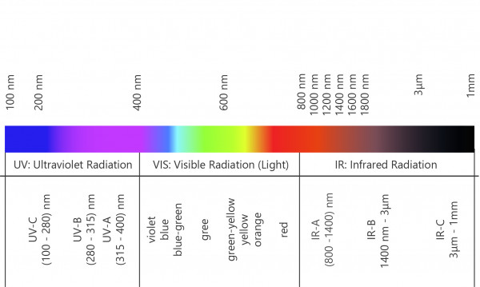

Figure 2.1: Electromagnetic Spectrum (https://www.gigahertz-optik.com/en-us/service-and-support/knowledge-base/basics-light-measurement/light-color/opt-rad-wavelength-range/)

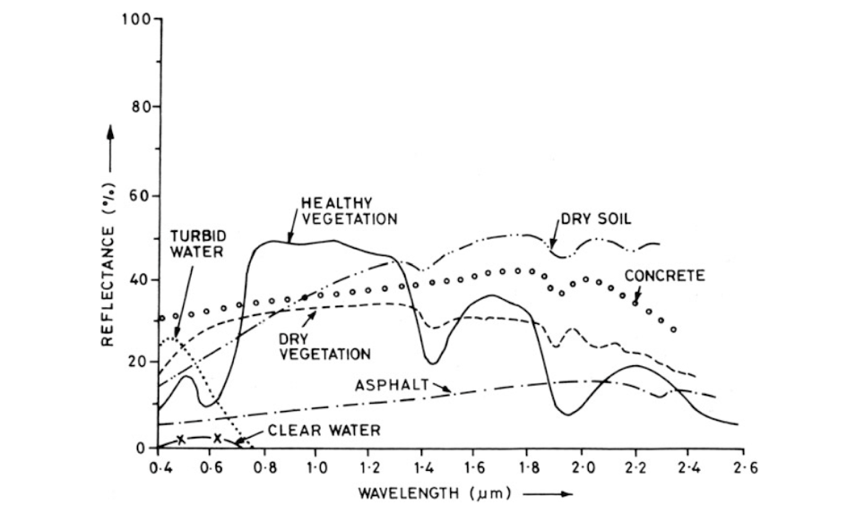
Figure 2.2: Different reflectance and absorption features for different spectral materials (Gupta 2018: 33)

Human Decomposition
The decomposition process is a natural disturbance that alters biological and chemical characteristics of the surrounding environment (Cater et al 2007:19). Because of this alteration to the environment, plants and soils are becoming an increasingly important area of interest within decomposition research. Studies have shown that certain soil components can be used as a mechanism to determine a postmortem interval (PMI) (Carter and Tibbett 2008; Forbes et al 2017). Decomposition occurs as a progression and can be divided into stages (Marks et al 2009). The stages can be classified as autolysis, putrefaction, and advanced decay (Marks et al 2009). While all stages are important to the process of decomposition, the focus for this thesis will be on putrefaction and advanced decay as this is what has the greatest impact on the environment given the release of body fluids into the soil. The rate of decomposition is influenced by both intrinsic and extrinsic factors, such as environment, season, and individual human composition.
Autolysis, or the fresh stage of decomposition is the breakdown of cells by intrinsic enzymes (Janaway et al 2009). During autolysis there are no macroscopic changes visible on the body. Putrefactive changes occur as a result of the increase growth of bacteria found in the gastro-intestinal (GI) tract. Therefore, with the growth of this bacteria there is first visible changes at the macroscopic level to the abdominal wall, which is visible as green discoloration from the formation of suph-haemoglobin. Sulph-haemoglobin later extends through to the chest, arms, and thighs and results in marbling which appears as a red/greenish red color. The body will continue to discolor as a result of more sulph-haemoglobin that settles in the blood (Janaway et al 2009). Gases are then generated through this process which are hydrogen sulphide, carbon dioxide, methane, ammonia, sulphur dioxide, and hydrogen (Janaway et al 2009). These gases result from the autolysis and bacterial lysis. There is the additional presence of volatile fatty acids from anaerobic fermentation. The bacteria from the GI tract continue to grow and are anaerobic in nature.
During putrefaction, by-products of the anaerobic respiration of bacteria creates gasses that cause bloating in the abdominal cavity (Dautartas 2018). As the body is going through these processes, there must be a release of the gasses, microbes, and by-products as liquefied tissues out of the body (Hyde et al 2017). Pressure for the gasses build up inflating the abdomen and aid the in the release of fluid from the body, also known as purge (Dautartas 2018). The release of this fluid occurs through natural orifices. After the purging of gasses and fluid from the body and the cessation of bloating, active decomposition beings (Vass 2001; Dautartas 2018).
During active decomposition, proteins form volatile fatty acids through bacteria (Vass 2001). Protein decay, or proteolysis is driven by enzymes and is determined by moisture, bacteria, and temperature. Proteolysis creates peptones, polypeptides, and amino acids and gasses such as carbon dioxide, ammonia, and methane. Fat is broken down by hydrolysis and results in the formation of fatty acids. Carbohydrates are broken down and oxidized to created carbon dioxide and water (Forbes 2008; Janaway et al 2009). The skin of the remains disintegrates, along with the other soft tissues, and as this occurs the remaining internal tissues are then exposed to the environment, increasing aerobic bacteria and accelerating decomposition (Dautartas 2018). As the body fluids continue the leak out of the body bones may be exposed and the remains will begin drying out and mummification may occur (Dautartas 2018).
Factors that affect decomposition include temperature, moisture, insect activity, animal scavengers, microorganisms found in the soil, overall soil chemistry, and fungi. The ambient temperature affects the rate of decomposition because both the internal and external microbial processes are affected by the temperature with 15°C and 35°C promoting peak bacterial activity (Janaway et al 2009; Dautartas 2018). Putrefaction occurs optimally between 21°C and 38°C and is slowed at temperatures below 10°C or above 40°C (Forbes 2008). Insect activity is also highly dependent on temperature. Insect activity can occur within hours of death, as gravid female flies are attracted to oviposit eggs onto the remains (Janaway et al 2009). The formation of maggot masses from the hatching of fly eggs with result in soft tissue loss from the fly that result in further putrefaction of the remains (Janaway et al 2009). (I need to add more here) Scavengers can also affect the rate of decomposition, as canids and rodents often dismember and disarticulate the body during the stages of decomposition (Dautartas 2018). Following liquefaction and active decay, the remains will become skeletonized or mummified in the absence of rapid decay. The rate that the remains become skeletonized depends on the various factors associated with decomposition (Dautartas 2018).
Cadaver Decomposition Island (CDI) Formation
During putrefaction and active decay, the release of purge fluid enters the soil and surrounding environment, and a CDI is formed. A CDI is the spatial area where decomposition fluid extends outside of the body during decomposition. The interaction of decomposition fluid and soil within CDI has become an important forensic resource in recent years because of its ability to provide an understanding of the changes to the environment that occur from the interaction of a decomposing body and the soil (Cobaugh 2013; Barton et al 2020). The CDI is formed from water, carbon, phosphous, and nitrogen. During putrefaction, purge fluids are released through the orifices onto the surrounding surfaces (e.g., soil). According to Carter and Tibbett (2008) a CDI may be formed only when large amounts of cadaveric materials are created when insects and microbes are a large driver of decomposition. There is an increase of carbon, nitrogen, ammonium, nitrate phosphorus, calcium, potassium, sulphate, magnesium, chloride, sodium, manganese, and others base cations in the soil from the release of fluids during the cadaveric breakdown process (Cater et al 2007; Carter and Tibbett 2008). Once these elements are released into soil the surrounding environment takes them up in their nutrient cycles (Forbes et al 2017).
The biophysicochemical makeup of a CDI changes overtime and is defined by succession of insects and plant and fungal communities. The concentration of chemical compounds such as ammonium and nitrate also change over time (Carter and Tibbett 2008). Decomposition fluid impacts the soil by lowering the pH levels, increasing the amount of nitrogen, ammonium, and calcium are present, lowering the amounts of sulfates (Aitkenhead-Peterson et al 2012). The lateral boundaries of a CDI have been found to extend about 2.2 meters away from the body. The vertical depth of the CDI is not great. Coboaugh etl al (2015) sampled soil zero to three centimeters below the surface and did not find significant changes to the soil pH below the surface. However, the boundary changes over time depending on the size of the body, the size and extent of maggot masses, and the type and texture of the soil (Cater et al 2007; Carter and Tibbett 2008). As decomposition progresses, the size of the CDI expands during active decay. The soil and plants located within the CDI will be altered due to the chemical process of decomposition (Forbes et al 2017).
The presence of increased nitrogen is found to stay in the soil for one to four years after decomposition, meaning that the CDI maintains a presence in the environment well after decomposition ceases (Cater et al 2007; Carter and Tibbett 2008). This could mean that plant communities surrounding a decomposing body may also affected for years after decomposition (Hyde et al 2017). The effects on plant communities are affected by the soil microbial communities as well. The interaction between plants and soil occurs in rhizosphere (plant roots) (Brabazon et al 2020; Hyde et al 2017). As the soil is impacted by the decomposition fluid in the CDI the soil maintains cadaveric materials and these materials are being taken up in the rhizosphere causing stress to plants (Brabazon et al 2020).
To detect plant stress, it is important to understand the plants interaction with the surrounding environment Decomposition fluid affects plant physiology and often initially kills the plants within the CDI. However, the plants will regrow, sometimes healthier than before, particularly for colonizing/opportunistic plants due to the increased available nutrients (Forbes et al 2017). Changes to plant health occur on both the macro and microscopic levels (Forbes et al 2017).
Spectral Classifications
Objects are spectrally classified based on where their absorption and reflectance values are located along the EMS. The classification depends on the structural, chemical, and physical properties of the sampled material. The changes to both plants and soil chemistry may not be visible to the human eye, but these changes are identifiable spectrally (Corcoran 2016). Spectral analysis on soils and plants is a mechanism for understanding how they are impacted by various stressors.

Reflectance Spectroscopy of Plants
Reflectance imaging has been used to detect stress in plants in multiple contexts, as well as estimated nitrogen levels (Muñoz-Huerta et al 2018). The spectra of a healthy green leaf show that the leaf absorbs most light in the visible light regions with a peak at 550nm. The carotenoid pigments associated with chlorophyll is found at 480nm. At 680nm there is also an absorption feature corresponding to the magnesium component of chlorophyll. A near-infrared (NIR) plateau can be found beginning at 800nm to 1300nm which corresponds to leaf tissue and its cellular structure. The rise in reflectance at 800nm is due to the red edge of chlorophyll absorption bands (Figure 2.3) (Gupta 2018). While these are characteristics of a healthy plant, stressed plants will have decreased reflectance in the NIR regions and the red band absorption feature will be short and shallow (Gupta 2018) (Figure 2.3).

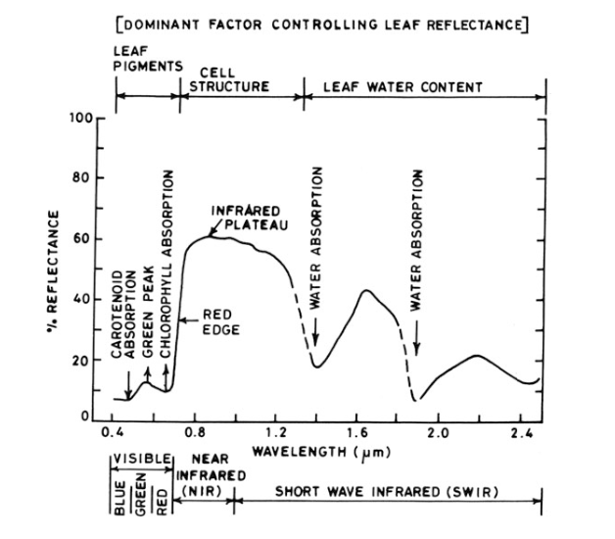

Figure 2.3: Reflectance output of green vegetation in the VIS-NIR-SWIR regions (Gupta 2018:34)

Plants become stressed when they are unable to adjust between a disruption in their physiological homoeostasis due to environmental factors (Jansen and Potters 2017). Plant stress is any disturbance that affects the growth and health of the plant and can be defined as either abiotic or biotic (Jackson 1986). Abiotic plant stress can be characterized by environmental conditions such as temperature, light, and chemicals that reduce growth while biotic stress is biological, like insects and infectious disease (Cramer et al 2011; Gull et al 2019). Both physiological and anatomical changes occur to the plant as a result of stress (Jackson 1986). Leaf color may change as a result of water deficiency, plant pathogens, or chemical changes within the plant (Jackson 1986). Plant stress can also be defined as a temporary, non-optimal state of being before that plant either dies or reaches an equilibrium (Jansen and Potters 2017). The health of plants can be seen by the human eye after the leaves exhibit conditions such as curling or drooping; however, spectroscopy allows for the ability to detect plant stress before there are visible changes to the plant (Jackson 1986).
To use FORS to analyze the stress of a plant, the VIS-NIR region of the EMS should be viewed (Jones and Schofield 2008). The overall reflectance value depends on the health and condition of the plant’s chlorophyll (Jones and Schofield 2008). Carbon, hydrogen, oxygen, and nitrogen are essential elements in plants that regulate chlorophyll production (Muñoz-Huerta et al 2013). Nitrogen as part of various enzymatic proteins of the plant is also responsible for regulating plant growth (Muñoz-Huerta et al 2013). Plants absorb nitrogen through the soil. The nitrogen plants uptake may be altered ammonium and nitrate (Muñoz-Huerta et al 2013).
The plant stress in often shown in the color of the plant due to the lack of chlorophyll and this can be seen spectrally within 400nm-750nm of the EMS (Jones and Schofield 2008). A nitrogen deficiency leads to a yellowing of plants with the lack of chlorophyll. Chaerle and van der Straeten (2000) discuss that hyperspectral imaging as a promising mechanism for determining signatures relating to a particular plant stress.

Reflectance Spectroscopy of Soil
Reflectance spectroscopy of soil is a rapid and inexpensive mechanism for soil analysis (Reeves 2010). Spectral features that indicate the presence of soil material are found in the 700-2500nm range with most information in the mid-infrared ranges (Brown et al 2006). Soil reflectance that is found in the VNIR region are comprised of organic material, minerals, salt, and poorly-crystalline andic (containing weathered volcanic glass or pumice) materials (Brown et al 2006). Moisture, organic carbon, and total nitrogen present in the soil can be determined by viewing the VNIR regions of the EMS (Nduwamungu et al 2009). The reflectance values change when there is more moisture present in the sample (Figure 2.4).

Spectral classification of cadaveric materials
Lipids, fats, and proteins also have spectral signatures that are visible on the EMS. Lipids are present within the near infrared regions at 1725, 1762, 2309-2310, and 2347-2352nm and proteins are present at 2042-2063 and 2173-2177nm (Horn 2018). Carbohydrates in the form of polysaccharides are present within wavelengths of 1692,

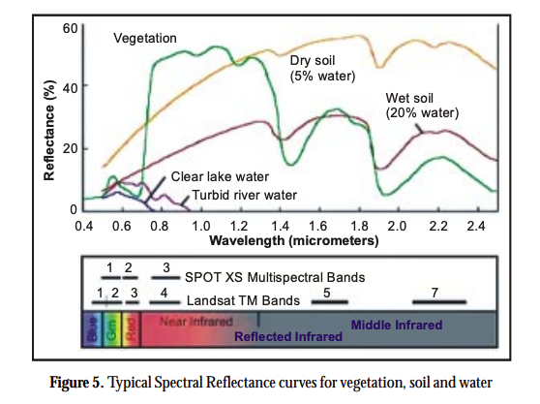

Figure 2.4. Image indicating the differences in reflectance values for wet versus dry soil. (Aggarwal 2004:33)

1771, 1827, 1923, 2319, and 2352nm (Horn 2018). As proteins, fats, and carbohydrates are broken down through decomposition these are the areas on the EMS where decomposition could appear it is expected that because decomposition fluid also consisting of fats, proteins, and lipids it is expected that the spectra of decomposition fluid should contain features at these wavelengths.
The CDI has the potential to provide information on how human decomposition fluid interacts with the environment. The effects of human decomposition on the environment allows for the use of FORS to analyze the spectra of plants and soil near where an individual has decomposed. Analyzing specific spectral bands associated with lipids, proteins, and carbohydrates that are directly associated with decomposition fluid in the spectra of plants and soil will determine if there are any components of decomposition present.

CHAPTER THREE
MATERIALS AND METHODS

Materials
In this study, 38 humans who donated their bodies to the Forensic Anthropology Center (FAC) were placed at the Anthropology Research Facility (ARF), the original outdoor decomposition facility. About 100 are received each year and over 5,000 individuals are pre-registered for body donation. Upon their death, a donor will be transported to the FAC and go through an intake process before placement at ARF. The ARF is an approximately 3-acre wooded area with sloped terrain that is a preserved temperate deciduous forest (Cobaugh et al 2015). The soil profile at the ARF is characterized as very deep, well-drained, clayey soil (Damann et al 2012). The soil formed in residuum from interbedded, leached sandstone and shale (Damann et al 2012). The surface sediments located zero to five centimeters below the surface is comprised of partially decomposed hardwood leaf litter. Five to fifteen centimeters below the surface is a friable, acidic dark reddish-brown loam with roots present (Damann et al 2012).
Of the 38 donors used in this study 18 were females and 20 were males. The age range of the donors include 26 to 91 years, with 70 being the average age. Demographic information is provided in Table 3.1 in the appendix. The ARF is divided into sectors donors were placed throughout these sectors across varying terrain rather than in a localized area. Figure # is a map of the donor placements throughout the ARF.

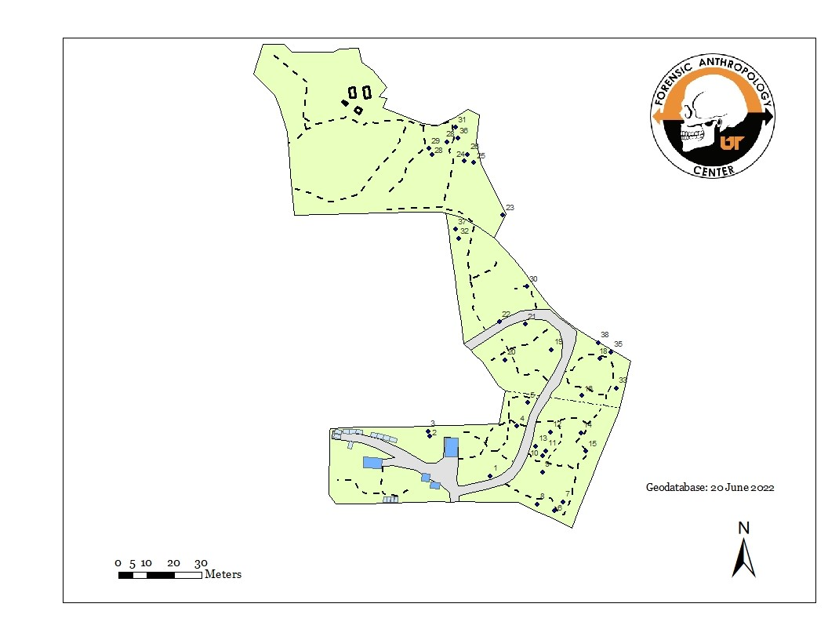
Figure 3.1: Map of donor placements throughout the ARF

Each donor was selected based on proximity to targeted plants. Spectral data was collected on a total of n=59 plants and the soil surrounding of the 32 human body donors enrolled. The plants studied include Amur (Lonicera maackii) because of its prevalence at the ARF. Amur honeysuckle is a hardy, multi-stemmed deciduous woody scrub that can grow up to 15 to 20 feet high. The amur honeysuckle has simple, smooth elongated ovate leaves are covered in tiny hairs. This species is considered invasive in East Tennessee and thus have expansive root systems and respond quickly to a changing environment. Their response includes changing their chemical make-up based on what they are exposed to in the soil (Brabazon et al 2020).
A Malvern Panalytic ASD FieldSpec 4 Standard-Res Spectroradiometer was used to collect all spectral data (Figure 3.2). The instrument’s wavelength range is from 350 to 2500nm. The device records spectra based on 2151 bands (Danner et al 2015). The resolution varies from 3nm in the short wavelengths and 10nm in the longer/farther wavelengths (Danner et al 2015). This instrument has three different detectors to record the spectra which includes a silicon-pho- todiode-array composed of 512 elements for the VNIR (350-1000nm) and thermoelectrically cooled InGaAs-photodiodes (Indium, Gallium, Arsenid) for each the SWIR1 (1000-1800nm) and the SWIR2 (1800-2500nm) (Danner et al 2015). The spectra were collected through the instrument’s software RS³ which is processed on an accompanying laptop. The spectral data was calibrated on a Spectralon White Reference panel with a reflectance value of 1.0 using the internal light source within the contact probe (Figures 3.2, 3.3).
Given the influence sunlight can have on an object’s radiance and reflectance values, ARF’s large canopy and filtered sunlight requires a contract probe to be used (Gupta 2018; Muñoz-Huerta et al 2018). The contact probe houses its own light source and the fiberoptic cable allowing for control of external light interference. The contact probe also ensures that adequate light is available and consistent throughout collections. This allows for standardization at each collection interval, so each leaf receives the same light intensity. Figure 3.4 depicts plant spectra collection at ARF.

Sample Sets
There are two sample sets for this study a longitudinal sample set which include n=8 donors (Donors 31-38) and a cross-sectional sample set which includes n=30 donors (Donors 1-30). Control data for each sample set was taken for the selected plants and soil. For the longitudinal sample, the control samples were taken prior to placement of the donor. For the cross-sectional sample set, control data was taken just outside of the ARF in an area that had not previously been impacted by decomposition and includes n=2 areas of soil and n=3 Lonicera fragrantissima. Controls for cross-sectional data were taken during the June 2022 and September 2022 collection periods.

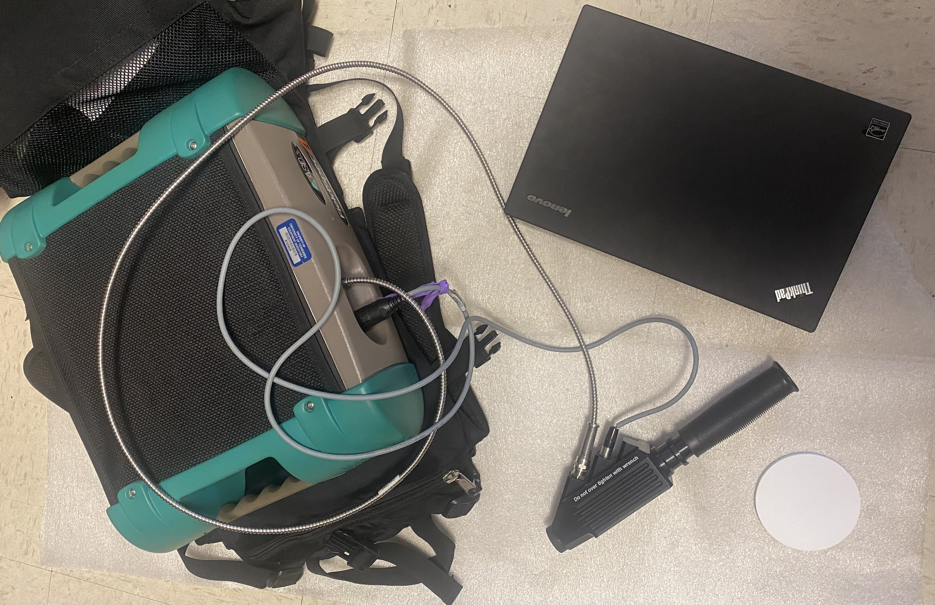
A
B
D
C

Figure 3.2: FieldSpec 4 instrument. A: The main component to the instrument that houses the fiberoptic cable. B: The contact probe. C: The Spectralon White Reference. D: Laptop the connects to the instrument that controls the RS³ software.

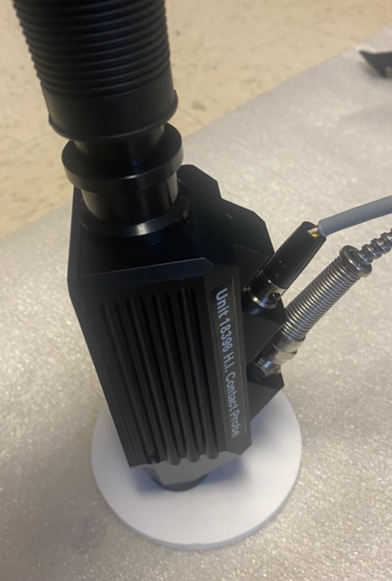

Figure 3.3: Contact Probe making contact with the Spectralon panel to collect a white reference.

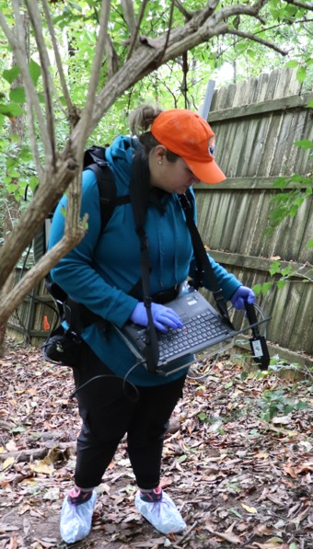
Figure 3.4: Plant Spectra collected using the ASD FieldSpec 4 at ARF

Longitudinal Sample Set
The five donors, (31,33,34,36,37), were followed longitudinally and placed across two separate trials throughout 2021. The goal of this sample set was: 1) to
determine the spectral signature of decomposition fluid, and 2) to determine if decomposition fluid in soil and taken-up by plants are visible within the spectra of each. One frozen donor was placed on the ground surface in April 2021 for soil analysis (31), two frozen donors were placed in June for plant analysis, and two were placed in September of 2021 both were for plant analysis and one donor (37) was used for soil as well. Spectra of five plants were collected at weekly intervals during active decomposition. Following the cessation of active decomposition, data collection occurred bi-monthly. There were 18 collections for trial four, and nine collections for trial five. Control data was taken prior to placements. The spectral signature of decomposition fluid was recorded by placing the contact probe directly on the purge fluid to determine its composition as each donor began to release decomposition fluid. Table 3.2 found in the appendix displays the sampling period for each donor. The plants were followed until November 30, 2021. The spectra were collected again in June and September of 2022 to capture how the plants may be affected by the persistence of decomposition fluid in soil and if a similar spectral signature is present after another growing season. Table 3.3 found in the appendix displays the plant species and number of spectral samples collected per sampling period for each donor in each trial. At each collection interval samples were taken in the morning with times ranging from 0730 to 1330 to allow for consistency of the sun’s location.
Two donors of longitudinal were used to systematically track decomposition characteristics in the soil (31 and 37). These two donors are used to address if a spectra of decomposition fluid is visible in soil. Initial soil data was collected on donors 31(Trial 3) and 37 (Trial 5). For each of these donors, a three by three-meter grids was set-up and divided into 50-centimeter increments. A spectral sample was collected at each 50-centemeter mark for a total for 49 samples per grid. Figure 3.5 displays a grid for donor 31 and Figure 3.6 for donor 37 the lines on each grid denote a 50 cm interval. The CDI for each donor was tracked at each sampling from initial expansion through the last collection of 2021. The sampling dates for each grid are included in Table 3.4 in the appendix.

Cross-sectional data set
The cross-sectional set includes 27 donors that decomposed at different times on the ground surface. This sample set examines if decomposition characteristics are visible in the plant spectra after growing seasons and the initial influx of decomposition. In addition to plants, this sample set also examines how long a spectral signature of decomposition




28
35
96
14

Figure 3.5: Soil grid for Donor 31: Colors indicate the CDI expansion on days 14, 28, 35, 96

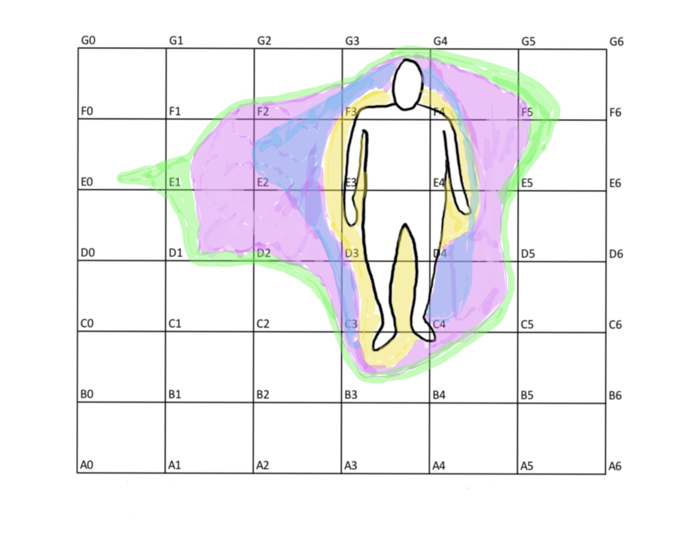
9
23
16
55
Figure 3.6: Soil grid for Donor 37: Colors indicate the CDI expansion on days 9, 16, 23, 55

persists in the soil particularly, in the groin area. Placements for the donor ranged from years 2017 to 2022. Table 3.5 in the appendix includes a list of the donors and their
placement date. At the time of collection all donors were no longer releasing fluid into the soil and were either mummified or skeletal. Data on these 30 donors were collected in the morning at two different collection periods, one in June 2022 and one in September 2022. The sampling dates for June included the 15, 16, 17, and 22nd, and the sampling dates for September included the 14, 16, 17, and 19th. Sampling occurred on different days with dry and sunny weather conditions because all sampling could not take place over a one-day period given the amount of data being collected and battery life of the instrument.
The number of plants per donor vary depending on the number and species of available honey-suckle plants near a donor placement site. The donors will have either, one, two, or three plants sampled. Table 3.5 in the appendix displays the plant and plant species for each donor. The distance from the plant to the donor was taken from the groin and its location in relation to the donor is listed in Table 3.5. For each plant 100 spectra were taken, and 30 spectra of the soil with the groin region were taken at each sampling period. Each spectral sample was taken on different leaves unless 100 leaves were not present. In this case the same spectra on multiple leaves had to be taken. The samples were taken across the whole plant where leaves were reachable with the contact probe. This range was from the leaves at the lowest level of the plant to about two meters above ground. Control data was collected on soil and Amur honeysuckle where there had not been previous instances of decomposition present in a new area of ARF. Due to available plants two amur honeysuckles were selected. For each control plant 100 spectra were collected. Two separate areas of soil were analyzed with 30 spectra taken at each site. The control data was collected at both sampling periods in June and September. Having the comparison between both longitudinal and cross-sectional donors determines that spectral signatures for decomposition and what compounds from decomposition are present in plants and soil and how they persist over multiple growing seasons.

Initial Data Processing
Spectral data was processed using Fisher ThermoScientific GRAMS software. This software views spectral data to create a calibration file containing the mean averages for each spectral band (300-2500). For the longitudinal data set the control data was compared to the data at each sampling period. For the cross-sectional data the control data was compared to the test plants for each donor. Prior to answering the research questions the control data was analyzed for any outliers as a result of a poor-quality spectral sample. This ensured that all control data was normal and was within the limits of normal variation of healthy plant spectra.
To analyze the spectra for each sample calibration files or models with provided the mean spectra for each band of sample. These calibration files were created in GRAMS using a discriminate, cross-validation model and Multiplicative Scatter Correction (MSC) pathlength correction. A discriminate calibration model is used for developing qualitative calibration models. A cross-validation model provides an estimate of the prediction error when unknown samples of a similar type are predicted with the model. A MSC normalizes each spectrum to an ‘ideal spectrum’ which is assumed to be the average of all the spectra. MSC is calculated by regression of each spectrum against an ideal spectrum. The correction is then preformed individually over each region of the spectrum according to selected regions (3-Grams Manual V.9). Once the calibration set has been created the results of the model are interpreted by a Spectral Residual plot. A Spectral Residuals plot identifies samples that are spectrally different within the model.
Calibration models, for the samples in the longitudinal samples were created, based on each plant. Calibration model for the samples in the cross-sectional samples were created for each donor. One model was created for the plant samples, and one was created for the soil samples.
Once the calibration models were created statistical analysis was preformed to answer the research questions:
- Does human decomposition have a unique spectral signature that can be detected?
- Can the spectral signature of human decomposition be detected in plants and soil during active decomposition?
- Does the spectral signature of human decomposition persist over time after the cessation of active decomposition?

To answer the first research question….
To answer the second research question…
To answer to third research question…..
For the statistical analysis, certain bands were selected. For lipids bands at 1725, 1762, 2309-2310, and 2347-2352nm were selected. For proteins 2042-2063 and 2173-2177nm and for carbohydrates in the form of polysaccharides 1692, 1771, 1827, 1923, 2319, and 2352nm were selected. For soil 700-2300nm and for plants 600-1350 bands were selected.

More the come here

May run more test and talk about placement dates and times etc.

Chapter 4
Results and Discussion

The main goal of this study was to determine if human decomposition fluid has a unique spectral signature that can be identified in plants and soil. To confirm if FORS…

Decomposition

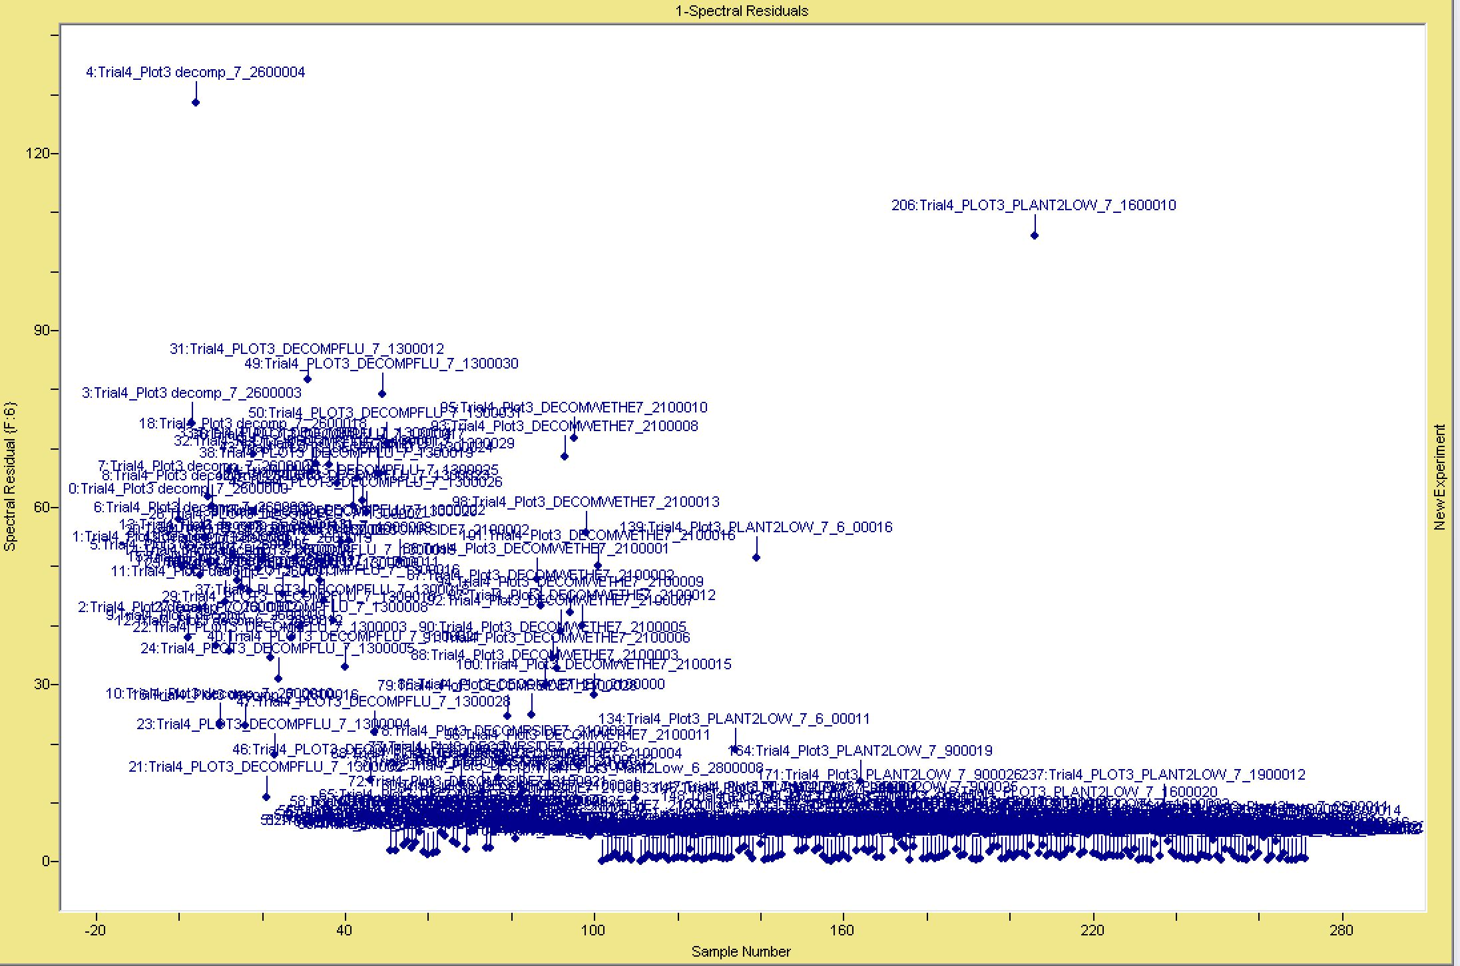
Figure 4.# Spectral Residuals for Calibration Model for Decomposition Fluid and Trial 4 Plant Samples

This is to show distinct difference in the decomposition from the plant sample.

Longitudinal

Plants

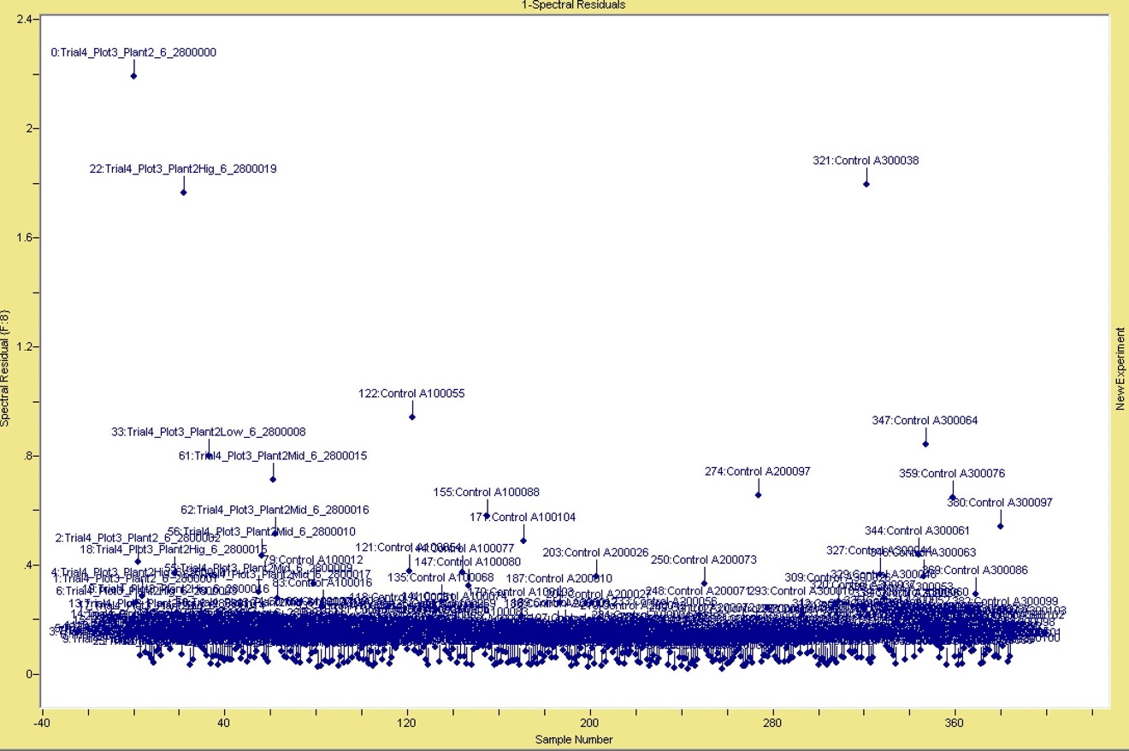
Figure 4.# Spectral Residuals for Calibration Model for Trial 4 Controls and June Control Sample taken outside of ARF.

This is to show little variability between control sample within and outside ARF.

Soil
Soil for analysis was targeted in blocks of the 3x3m grid that the CDI expanded. These blocks include A2,3,4,5 B2,3,4,5 C2,3,4,5,6 D2,3,5,6 E3,4,5 for donor 31 (Figure 3.5). For donor 37 the blocks included B3,4, C2,3,4,5 D1,2,3,4,5 E0,1,2,3,4,5, F1,2,3,4,5 (Figure 3.6)

Cross-Sectional

Plants

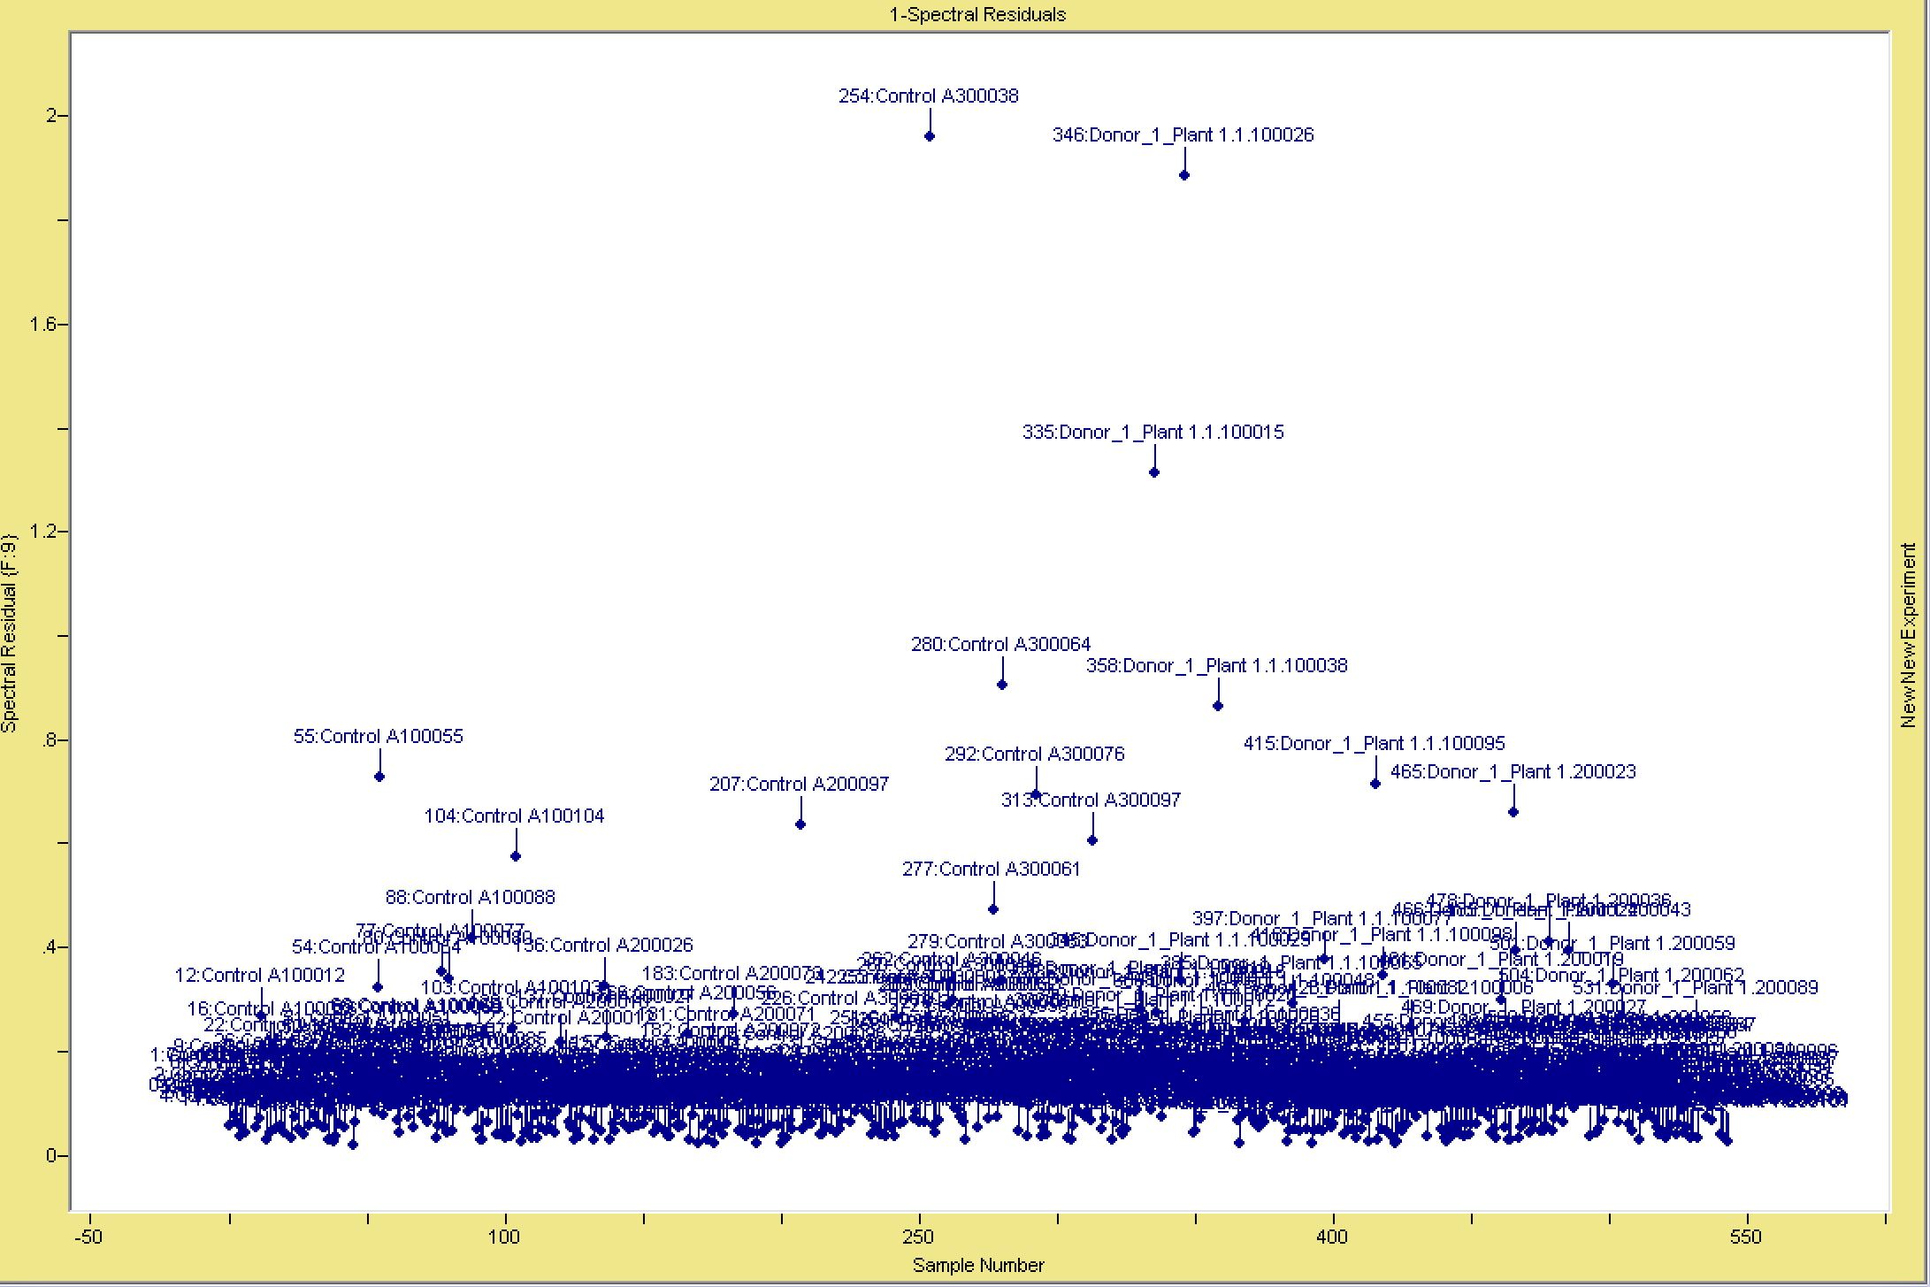
Figure 4.# Spectral Residuals for Calibration Model for June Control Sample

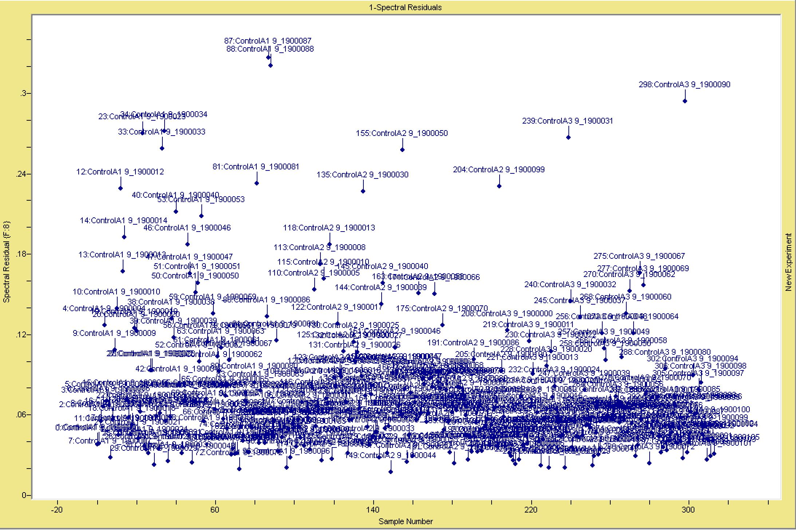
Figure 4.# Spectral Residuals for Calibration Model for September Control Sample

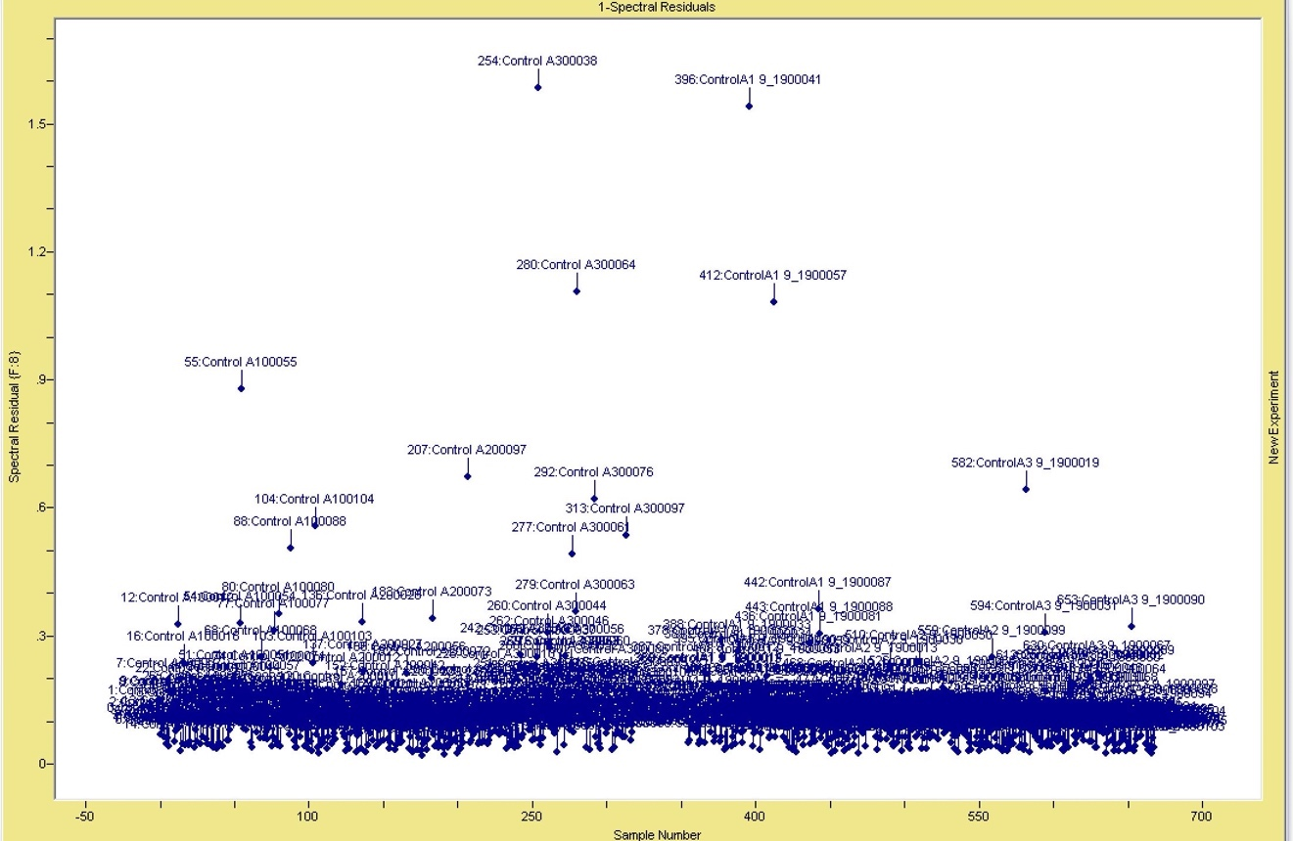
Figure 4.# Spectral Residuals for Calibration Model for June and September Control Sample Combined

This is to show little variability between two control sets at different times.

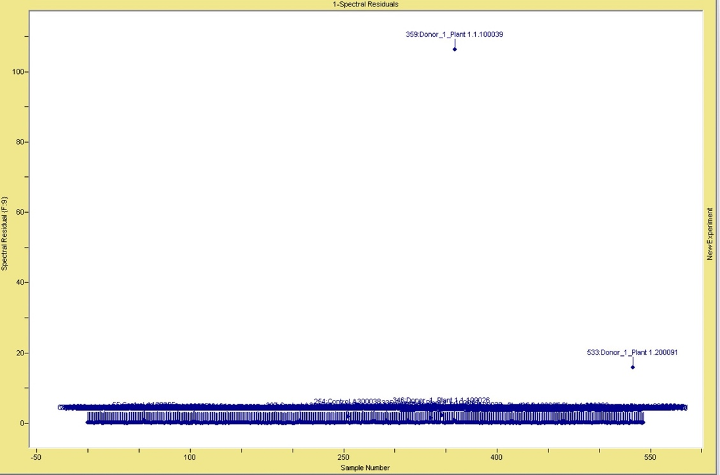
A
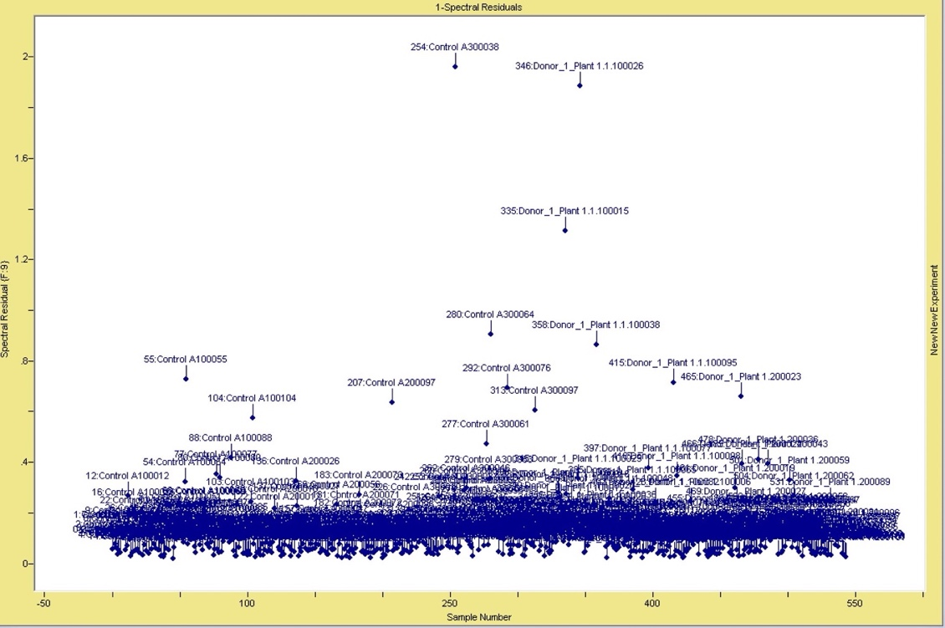
B
Figure 4.# Spectral Residuals for Calibration Model for June Control Sample and Donor 1 Plant Samples. A: No outliers removed. B: Sample 359 and 533 removed.

Soil

Chapter 5
Conclusions and Recommendations

                - References
Aggarwal, Shefali (2004) “Principles of Remote Sensing.” Satellite Remote Sensing and GIS Applications in Agricultural Meteorology. World Meteorological Organisation.

Aitkenhead-Peterson, J. A., C. G. Owings, M. B. Alexander, N. Larison, and J. A. Bytheway. (2012) "Mapping the lateral extent of human cadaver decomposition with soil chemistry." Forensic science international 216, no. 1-3: 127-134.

Aitkenhead‐Peterson, Jacqueline A., James P. Fancher, Michael B. Alexander, Michelle D. Hamilton, Joan A. Bytheway, and Daniel J. Wescott. (2021) "Estimating postmortem interval for human cadavers in a sub‐tropical climate using UV‐Vis‐near‐infrared Spectroscopy." Journal of Forensic Sciences 66, no. 1:190-201.

Barton, P. S., Reboldi, A., Dawson, B. M., Ueland, M., Strong, C., & Wallman, J. F. (2020). Soil chemical markers distinguishing human and pig decomposition islands: a preliminary study. Forensic Science, Medicine and Pathology, 16(4), 605-612.

Bow, Sierra (2020). Characterizing Late Pre-Contact Mississippian Paint Recipes in the Southeastern United States. University of Tennessee Dissertation
Brabazon, Holly et al. (2020) “Plants to Remotely Detect Human Decomposition?” Trends in plant science 25.10: 947–949
Brown, Shepherd, K. D., Walsh, M. G., Dewayne Mays, M., & Reinsch, T. G. (2006). Global soil characterization with VNIR diffuse reflectance spectroscopy. Geoderma, 132(3), 273–290.

Butters, Owyn, Matt N. Krosch, Michell Roberts, and Donna MacGregor. (2021) "Application of forward‐looking infrared (FLIR) imaging from an unmanned aerial platform in the search for decomposing remains." Journal of Forensic Sciences 66, no. 1: 347-355.
Carter, David, David Yellowlees, and Mark Tibbett. (2007). “Cadaver Decomposition in Terrestrial Ecosystems.” Naturwissenschaften 94 (1): 12-24.
Van Der Straeten, Chaerle, Laury, and Dominique (2000) “Imaging Techniques and the Early Detection of Plant Stress.” Trends in plant science 5.11: 495–501.
Cobaugh, and DeBruyn, J. M. (2013). Soil microbial community succession during cadaver decomposition. The University of Tennessee, Knoxville.

Corcoran, K. A. (2016). A characterization of human burial signatures using spectroscopy and LIDAR.

Corcoran, Katie A., Amy Z. Mundorff, Devin A. White, and Whitney L. Emch. (2018) "A novel application of terrestrial LIDAR to characterize elevation change at human grave surfaces in support of narrowing down possible unmarked grave locations." Forensic science international 289:320-328.

Danner, M., M. Locherer, T. Hank, and K. Richter (2015). “Spectral Sampling with the ASD FieldSpec 4 – Theory, Measurement, Problems, Interpretation.” EnMAP Field Guides Technical report: GFZ Data Services.
Forbes, S. L., Perrault, K. A. and Comstock, J. L. (2017). Microscopic Post-Mortem Changes: the Chemistry of Decomposition. In Taphonomy of Human Remains: Forensic Analysis of the Dead and the Depositional Environment (eds E. M. Schotsmans, N. Márquez-Grant and S. L. Forbes
Galloway, A., Birkby, W. H., Jones, A. M., Henry, T. E., & Parks, B. O. (1989). Decay Rates of Human Remains in an Arid Environment. Journal of Forensic Sciences, 34(3), 607-616.
Gupta, Ravi P. (2018) Remote Sensing Geology. 3rd ed. Berlin, Heidelberg: Springer Berlin Heidelberg.
Horn, Karen R. (2018) “Time Takes Its Toll: Detection of Organic Binder Media in Ochre Paints with Visible Near-Infrared and Short-Wave Infrared Reflectance Spectroscopy.” Journal of archaeological science reports 21: 10–20(Danner et al 2015).
Hyde, Embriette R., Jessica L. Metcalf, Sibyl R. Bucheli, Aaron M. Lynne, and Rob Knight. (2017) "Microbial communities associated with decomposing corpses." Forensic microbiology 245.

Jackson, Ray D. (1986) "Remote sensing of biotic and abiotic plant stress." Annual review of Phytopathology 24, no. 1: 265-287.
Janaway, R.C., Percival, S.L., Wilson, A.S. (2009). Decomposition of Human Remains. In: Percival, S.L. (eds) Microbiology and Aging. Humana Press.
Jansen, Marcel AK, and Geert Potters. (2017) "Stress: The way of life." Plant stress physiology (2017): ix-xiv.
Jones H. G. and P. Schofield (2008) “Thermal and Other Remote Sensing of Plant Stress.” Gen. Appl. Plant Physiology, Special Issue 34 (1-2), 19-3
Liu, J. et al. (2018) “Prediction of soil organic carbon with different parent materials development using visible-near infrared spectroscopy.” Spectrochimica Acta Part A: Molecular and Biochemical Spectroscopy 204 : 33-39.
Marks MK LJ, and Dadour IR. (2009). Taphonomy and Time: Estimating the Postmortem Interval. In: Steadman DW, editor. Hard Evidence: Case Studies in Forensic Anthropology. New York: Taylor and Francis.
Megyesi, M. S., et al. (2005). "Using accumulated degree-days to estimate the postmortem interval from decomposed human remains." Journal of Forensic Sciences 50(3): 618-626.
Muñoz-Huerta, Rafael F et al. (2013) “A Review of Methods for Sensing the Nitrogen Status in Plants: Advantages, Disadvantages and Recent Advances.” Sensors (Basel, Switzerland) 13.8: 10823–10843
Nduwamungu, Ziadi, N., Parent, L.-E., Tremblay, G. F., & Thuries, L. (2009). Opportunities for, and limitations of, near infrared reflectance spectroscopy applications in soil analysis: A review. Canadian Journal of Soil Science, 89(5), 531–541.

Reeves, James (2010). Near- versus mid-infrared diffuse reflectance spectroscopy for soil analysis emphasizing carbon and laboratory versus on-site analysis: Where are we and what needs to be done? Geoderma, 158(1), 3–14.

Sun, Wang, X., Wang, Z., Yang, L., Xie, Y., & Huang, Y. (2021). UAVs as remote sensing platforms in plant ecology: review of applications and challenges. Journal of Plant Ecology, 14(6), 1003–1023.
Tibbett, Mark and David O. Carter (2008) Soil Analysis in Forensic Taphonomy: Chemical and Biological Effects of Buried Human Remains. Boca Raton: CRC Press, 2008. Print.
van der Merwe, Burchfield, D. R., Witt, T. D., Price, K. P., & Sharda, A. (2020). Drones in agriculture. In Advances in Agronomy (Vol. 162, pp. 1–30).

Campbell and Wynne, R. H. (2011). Introduction to remote sensing (5th ed.). Guilford Press.

                - Appendix
Table 3.1 Donor Demographics
Donor Numbering | Placement Date | Sex: Female (F) Male (M) | Age | Sample Set: Cross-sectional (C) Longitudinal (L)
1 | 11-Jan-20 | F | 85 | C
2 | 6-May-19 | F | 60 | C
3 | 16-Apr-21 | M | 68 | C
4 | 15-Apr-19 | M | 54 | C
5 | 18-Sep-20 | M | 89 | C
6 | 26-Apr-19 | F | 71 | C
7 | 15-Jul-21 | F | 48 | C
8 | 13-Jul-21 | F | 59 | C
9 | 18-Mar-22 | M | 91 | C
10 | 8-Jan-20 | M | 82 | C
11 | 6-Jan-20 | M | 64 | C
12 | 17-Nov-21 | M | 49 | C
13 | 15-Apr-21 | M | 72 | C
14 | 12-Jul-18 | M | 87 | C
16 | 18-Sep-20 | M | 66 | C
17 | 7-May-18 | M | 60 | C
18 | 18-Sep-19 | F | 56 | C
19 | 1-Feb-22 | M | 74 | C
20 | 11-Oct-21 | F | 73 | C
21 | 12-Nov-21 | F | 69 | C
22 | 1-Jul-21 | F | 26 | C
23 | 17-Sep-20 | M | 74 | C
24 | 6-Aug-21 | M | 65 | C
27 | 29-Apr-17 | M | 79 | C
28 | 5-Nov-21 | F | 74 | C
29 | 5-Nov-21 | F | 78 | C
30 | 15-Jun-21 | F | 71 | C
31 | 9-Apr-21 | M | 62 | L
33 | 28-Jun-21 | F | 65 | L
34 | 28-Jun-21 | M | 67 | L
36 | 7-Sep-21 | M | 88 | L
37 | 7-Sep-21 | F | 86 | L

Table 3.2: Sampling dates of Plants for each trial for longitudinal sample set (n=8)

Trial 4 Sampling Dates | Trial 5 Sampling Dates
28-Jun-21 | 7-Sept-21
6-Jul-21 | 14-Sep-21
9-Jul-21 | 23-Sep-21
13-Jul-21 | 30-Sep-21
16-Jul-21 | 12-Oct-21
19-Jul-21 | 20-Oct-21
26-Jul-21 | 26-Oct-21
2-Aug-21 | 1-Nov-21
9-Aug-21 | 8-Nov-21
20-Aug-21 | 29-Nov-21
27-Aug-21 | 16-Jun-22
2-Sep-21 | 17-Jun-22
16-Sep-21 | 16-Sept-22
28-Sep-21 | 17-Sept-22
12-Oct-21
26-Oct-21
11-Nov-21
29-Nov-21
16-Jun-22
17-Jun-22
16-Sept-22
17-Sept-22

Table 3.3 List of spectral samples per plant

Trial 4 Plot 2 | Spectral Samples/Plant
Plant 1 | 60
Trial 4 Plot 3 | Spectral Samples/Plant
Plant 2 | 60
Trial 5 Plot 2 | Spectral Samples/Plant
Plant 3 | 60
Trial 5 Plot 3 | Spectral Samples/Plant
Plant 1 | 60
Plant 2 | 60

Donor 31 | Donor 37
9-Apr-21 | 14-Sep-21
12-Apr-21 | 16-Sep-21
16-Apr-21 | 28-Sep-21
19-Apr-21 | 12-Oct-21
23-Apr-21 | 19-Oct-21
26-Apr-21 | 1-Nov-21
7-May-21 | 16-Nov-21
14-May-21
21-May-21
30-Jun-21
9-Aug-21
30-Nov-21
Table 3.4: Sampling dates of soil for donors 31 and 37

Table 3.5. Donor placement data, Plant I.D, Location to Donor, and Distance from Donor Groin
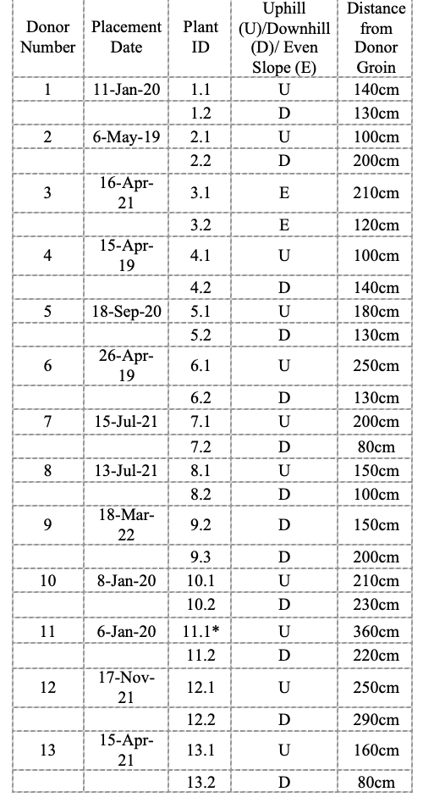

Table 3.5 Continued:
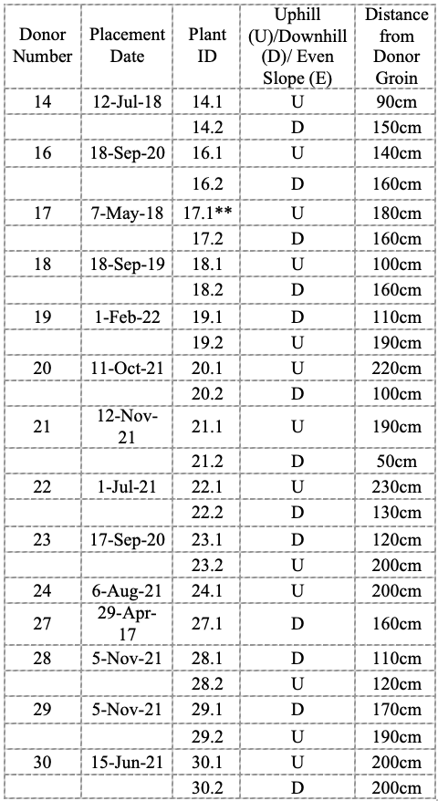

* Plant 10.1 and 11.1 are the same, both are to close Donor 10 and 11
** Plant 16.1 and 17.1 are the same, both are to close Donor 16 and 17

Appendix material continued. This section is optional. You can place tables and figures in the appendix if you like. If you choose this option, you should indicate that tables and figures are in the appendix after the first mention in the text. You can place some tables/figures in the text and others in the appendix, or all tables/figures in the appendix.
                - Vita
Anielle Constance Duncan was born in Knoxville, Tennessee. Anielle began her undergraduate degree at Pellissippi State Community College in August 2012. She graduated with an Associates of Arts Degree in July 2015 and then transferred to the University of Tennessee, Knoxville (UTK) to complete her Bachelor of Arts degree in Anthropology. She graduated from UTK in May 2017 Summa Cum Laude. Anielle began her Master of Arts degree in August 2019 at UTK under Dr. Dawnie Steadman.

ADD MORE

