SOYBEAN IRRIGATION MANAGEMENT AND YIELD ESTIMATION BASED ON UAV IN THE MID-SOUTH

A Dissertation Presented for the
Doctor of Philosophy
Degree
The University of Tennessee, Knoxville

Shuhua Xie
August 2025

ACKNOWLEDGEMENTS
I would like to express my deepest gratitude to my advisor, Dr. Brian Leib, for providing me with the invaluable opportunity to pursue my PhD studies and for his unwavering support throughout this journey. His encouragement, patience, and guidance have been instrumental in my growth as a researcher.
I am also profoundly grateful to my committee members for their time, expertise, and insightful feedback, which have significantly strengthened my work. Their constructive critiques and mentorship have shaped both my research and my academic perspective.
Finally, thanks to my parents for their unconditional support.

ABSTRACT
Optimizing irrigation management is critical for maximizing soybean yield, particularly in regions with variable rainfall and diverse soil types. This study aimed to (1) quantify the effects of irrigation timing (R1, R3, and R5 growth stages), rates (0.5, 1, and 1.5 in/wk), and tools (water balance method and soil moisture sensors) on soybean yield in silt loam soil; (2) evaluate how these effects vary across different soil types; (3) assess the utility of one-year rainfed yield data for field zoning; and (4) develop a predictive model using drone-derived vegetative index by comparing in-season and post-season models. Field experiments were conducted in Jackson, TN, with various irrigation treatments. Drone-based multispectral data, soil electrical conductivity (EC), ground-penetrating radar (GPR), and weather data were collected to capture dynamic crop responses. Results showed that (1) initiating irrigation at the R3 stage with a rate of 1.5 in/wk maximized yield whith less water in silt loam soil in 4 out of 5 experimental years; (2) soil type significantly influenced irrigation effectiveness, with sandy soil requiring earlier irrigation initiation at R1 with 1.5 in/wk to achieve maximum yield; (3) one-year rainfed yield data proved effective for field zoning, comparable to EC and GPR, in identifying areas with high yield variability; (4) the incorporation of soil features consistently enhanced yield prediction model performance across all experimental configurations. In conclusion, this study highlights the importance of tailoring irrigation strategies to soil type and growth stage, demonstrates the effectiveness of one-year rainfed yield data for zoning, and underscores the potential of drone-based tools for optimizing soybean production under varying environmental conditions.
Table of Contents
Chapter One Introduction 1
Supplemental irrigation in West Tennessee 2
Soybean supplemental irrigation strategies 3
Irrigation management zone delineation 7
UAV based yield prediction 9
Reference 12
Chapter Two Soybean Yield Response to Managed Depletion Irrigation Regimes in a Mid-South Silt Loam Soil 22
Abstract 24
Introduction 25
Materials and Methods 30
Study area 30
Experimental setup 31
Analytical method 33
Results and Discussion 33
Weather conditions during the crop seasons 33
Grain yield 34
IWP 36
Relationship between the yield and irrigation rate 37
MOIST and soil moisture sensors 38
Rainfed treatments 39
R1-3.81 treatments 40
R5-2.54 treatments 41
Insufficient rainfall year 2017 42
Overall 43
Conclusion 43
References 46
Appendix II 52
Chapter Three Irrigation timing and rate for improving soybean yield across different soil zones in subtropical humid climate 62
Abstract 63
Introduction 64
Method 67
Experiment location 67
Soil texture 68
Irrigation experiment design 68
Soybean growth stages 70
Soil water sensor 70
Water balance-based irrigation method 70
Statistical analysis 71
Results 72
Precipitation and irrigation 72
Yield response 73
Irrigation water productivity 77
MOIST 77
Soil water sensor 80
Discussion 83
Soil effects on yield 83
Irrigation effects on yield in silt loam soil 84
IWP in silt loam soil 85
MOIST 86
Soil water sensor 87
Limitation and future research 88
Conclusion 89
References 91
Appendix III 104
Chapter Four Using limited rainfed yield data for irrigation management zone delineation for soybeans in Tennessee 121
Abstract 122
Introduction 123
Method 128
Study site 128
Irrigation experimental setup 128
EC data measurement 129
GPR data measurement 129
Yield data measurement 130
Covariate analysis 130
Management zone delineation 131
Result 132
Descriptive statistics 132
ANCOVA 134
The optimal clustering number 134
Evaluation of management zones for irrigation 135
Discussion 137
Considerations for selecting representative single-year rainfed yield data 138
Selection of the optimal zone number 139
Conclusion 141
References 142
Appendix IV 149
Chapter Five Soybean yield prediction from UAV multispectral imagery under various irrigation regimes 161
Abstract 162
Introduction 163
Method 167
Study site 167
Ground field experiment setup 167
UAV surveys 169
Image processing 169
Yield prediction model 170
Statistical analysis 171
Results 172
Results on Irrigation Effects and Yield Relationships 172
Pearson correlation between VIs and yield 173
Post-season prediction model 174
In-season prediction model 175
Discussion 176
Comparison between in- and post-season prediction model 176
Selection of VIs 177
Conclusion 178
References 179
Appendix IV 186
Chapter Six Conclusion 195
Vita 198

LIST OF TABLES
Table 2.1. Observed phenological growth stages of soybeans. 52
Table 2.2. Soybeans yield each treatment and each year. 53
Table 2.3. ANOVA for soybean yield. 54
Table 2.4. Applied irrigation amount and IWP for each treatment and each year. 55
Table 2.5. ANOVA for soybean IWP. 56
Table 2.6. Regression models for yield and rate. 57
Table 3.1. Treatment design (irrigation timing × rate) and water applied amount for 2018 and 2019. 104
Table 3.2. Soybean growth stage details in 2018 and 2019. 105
Table 3.3. Plot properties for each soil moisture sensor. 106
Table 3.4. ANOVA results for irrigation treatment and soil zone on yield. 107
Table 3.5. ANOVA results for irrigation treatment on yield within each soil type 108
Table 3.6. ANOVA for the impact of irrigation treatment and soil zone on IWP. 109
Table 3.7. IWP (kg m⁻³) mean separation for each year. 110
Table 4.1. Irrigation treatment design by timing and rate 149
Table 4.2. Summary of MZD attributes and clustering algorithms 150
Table 4.3. Descriptive statistics of ECd, GPR, and 2020 rainfed yield 151
Table 4.4. Pearson correlation coefficients (r) among ECd, GPR, 2020 rainfed yield 152
Table 4.5. ANCOVA result of ECa, GPR, and 2020 rainfed yield effects on irrigated soybean yield in 2018 and 2019 153
Table 4.6. Two-way ANOVA for irrigation treatment and management zone effects on soybean yield 154
Table 4.7. ANOVA of irrigation treatment effects on soybean yield in 2018 and 2019 within each zone with seven clustering methods 155
Table 5.1. Irrigation treatment design 186
Table 5.2. The flight date of UAV 187
Table 5.3. Definitions of vegetation indices extracted from different sources 188
Table 5.4. ANCOVA analysis of irrigation impacts on soybean yield across growing seasons (2023, 2024) with 2020 rainfed yield as covariate 189
Table 5.5. Validation statistics of different models for grain yield prediction 190

LIST OF FIGURES
Figure 2.1. Jackson precipitation in 16 years and during the growing season from 2013 to 2017. 58
Figure 2.2. Yield and Irrigation Rate from 2013 to 2017. 59
Figure 2.3. Seasonal water balance using MOIST irrigation scheduling tool. 60
Figure 2.4. Soil moisture sensor data. 61
Figure 3.1. The experiment field. a Filed location in Jackson, TN; b Spatial block treatment distribution. Sensors: two depth (15 cm, 61 cm) soil matric potential sensors. 111
Figure 3.2. Electrical conductivity at 0.91 m depth (ECd) and ground penetrating radar (GPR) distribution for each soil zone. 112
Figure 3.3. Monthly precipitation during the growing season (May to September) from 1924 to 2023. 113
Figure 3.4. Rainfall and irrigation distribution during soybean growing season. 114
Figure 3.5. Soybean yield mean separation by soil type for 2018 and 2019 115
Figure 3.6. Soybean yield responses to irrigation treatment in three zones in 2018 and 2019. 116
Figure 3.7. Daily soil water depletion from MOIST in 2018 and 2019. 117
Figure 3.8. Soil moisture sensors in sandy soil zone. 118
Figure 3.9. Soil moisture sensors in silt loam zone. 119
Figure 3.10. Rainfall distribution during soybean growth stages and total rainfall (from sowing to R6) from 2013 to 2019. 120
Figure 4.1 Spatial distribution of ECd, GPR, and 2020 rainfed yield 156
Figure 4.2 Within-cluster sum of squares for seven cluster methods 157
Figure 4.3 Average silhouette width for seven cluster methods 158
Figure 4.4 Management zone results for seven clustering methods 159
Figure 4.5 Soybean yield response to irrigation amount in zone 1 (2018) across seven clustering methods 160
Figure 5.1. A flowchart of data processing 191
Figure 5.2. UAV systems 192
Figure 5.3. Correlation analysis heat map in R1, R3, and R5 stage, respectively 193
Figure 5.4. Results of training set of four inputs combinations (RGB VIs, RGB VIs + soil, MS VIs, and MS VIs + soil) with three machine learning methos (MLR, SVM, and RF). 194

Introduction

Supplemental irrigation in West Tennessee
Global climate change impacts agricultural productivity due to the rising temperature and uncertain rainfall patterns (Waldhoff et al., 2020; IPCC, 2023). Irrigation plays a crucial role in sustaining crop production under environmental stress, despite being the largest consumer of freshwater resources; notably, 22% of agricultural areas contribute over 40% of global crop yield (FAO, 2023).
In Tennessee, climate is characterized by relatively high annual precipitation, and the precipitation is the main resource of crops. However, due to the temporal unpredictability of precipitation combined with seasonal drought and flood risk, supplemental irrigation has emerged as a vital strategy to mitigate water stress and stabilize yields (EPA, 2016). Unlike full irrigation providing water throughout the growing season, supplemental irrigation is applied only when the natural precipitation is not sufficient for crop water use. Supplemental irrigation can help farmers to address the water deficit and reduce yield loss.
Regional on-farm studies demonstrate that supplemental irrigation delivers significant economic gains with irrigated soybean fields in Tennessee yielding 1,200 kg/ha more than rainfed fields (Kebede et al., 2014; Ortiz et al., 2021). Additionally, advanced practices like variable-rate irrigation and soil moisture sensor-based scheduling among Tennessee Valley farmers in Alabama and Tennessee optimize water use by targeting high-need zones, reducing consumption by up to 28% while maintaining yields, and achieving 6.2% higher revenue compared to fully rainfed fields (Ortiz et al., 2021).
Given these benefits, irrigation has expanded significantly in West Tennessee over the past decade. For example, irrigated soybean land has increased from 17,459 hectares to 50,600 hectares from 2012 to 2024 (USDA, 2024). However, further research is still needed to optimize irrigation strategies for maximizing crop yield with reduced water use, including the development of irrigation management tools, zone delineation protocols, and accurate yield estimation methods.

Soybean supplemental irrigation strategies
Soybeans are the dominant row crop in Tennessee with over 736,000 hectares planted and an average yield of 2,825 kg/ha (NASS, 2025). Since soybean water requirements vary across growth stages and uneven rainfall distribution leads to insufficient water availability during some critical stages, effective irrigation management is essential to optimize soybean growth and yield. In particular, sufficient water supply during reproductive stages can significantly improve total dry matter, leaf area index, and yield.
Additionally, soybean responses to supplemental irrigation vary across soil textures due to their different soil water holding capacity. In sandy soil with rapid drainage and low water holding capacity, field experiments showed water stress during vegetative growth and flowering stage significantly reducing yield and total dry matter (Jha et al., 2018; S. Li et al., 2020; X. Li et al., 2024; L. Zhang et al., 2024). In addition, InfoCrop-Soybean model simulated the soybean response to supplemental irrigation in Delhi region, India, and the results showed that water stress during August and early September significantly reduced yield and supplemental irrigation during this period could minimize the yield losses (Jha et al., 2018). However, several studies in silt loam and clay soil have indicated that short periods of moderate water stress during vegetative stages do not significantly impact soybean yield and the sufficient irrigation from R3 to R6 was emphasized to achieve the highest level of yield with less water applied (Dogan et al., 2007; Shekoofa & Leib, 2022; Torrion et al., 2014).
Irrigation scheduling determines when and how much irrigation to apply. Effective irrigation scheduling can help to mitigate crop water stress and maximize yields, reduce the cost of water and labor through less irrigation, and increase net returns by increasing crop yields and quality (S. & M., 2013; Zahoor et al., 2019). Various methods and tools have been developed to determine when crops need irrigation and how much to apply. These methods can be classified into three categories: field observation, soil moisture-based approach, and evapotranspiration-based approach. While each method has advantages and disadvantages, it is often recommended to use more than one method for irrigation scheduling.
Field observation is usually based on personal experience and visual observation of crops and soil. When crops are under water stress, the crop characteristics and soil appearance change, such as fewer leaves, light green color, curling of leaves, etc. It is easy, quick, and does not require equipment investment or technical support. However, the accuracy of using this method relies on extensive experience, and it is hard to assess subsoil moisture. In addition, when the symptoms are obvious, crops usually have not gotten enough water for a long time and yield losses are unavoidable.
Various soil moisture measurement methods have been developed to estimate soil water status with technological advances. The traditional method is to measure gravimetric soil moisture content by sampling using augers, caps, and ovens. It has high accuracy but can be destructive, labor intensive, and time consuming. The neutron gauge is the most accurate indirect soil moisture sensor available (Kodikara et al., 2014; Long & French, 1967; Stone et al., 1955). The nuclear source emits high-speed neutrons at a desired depth. When it interacts with water, neutrons are slowed down. By counting the slow neutrons, the soil moisture can be calculated. However, it is not popular among farmers because the neutron gauge is expensive, and the radioactive source requires proper training, licensing, and safety measures. Electromagnetic sensors are another indirect approach that measures the dielectric properties of the soil medium. Electromagnetic sensors can be categorized as time-domain and frequency-domain sensors (Nelson et al., 2001). Time-domain sensors measure the soil moisture content from the travel time of the wave (Bennett & Ross, 1978). The frequency of time-domain sensors is a bandwidth signal ranging between 0 and 1 GHZ. Frequency-domain sensors measure the capacitance, impedance, or resonant frequency of soil around the electrodes at a fixed frequency (Pelletier et al., 2016; Zhu et al., 2019). The accuracy of electromagnetic sensors can be affected by soil salinity, temperature, texture, bound water, circuitry, probe geometry, and installation. Tensiometers measure soil matric potential using a water-filled tube with a hollow ceramic tip (Cassel & Klute, 2018; Van Der Ploeg et al., 2008). The measurement range is between 0 and 75 kPa. However, the suggested trigger points for silt and clay usually exceed the range and the soil water retention curve is required to convert between soil water content and soil tension. Electrical resistance sensors are another approach to estimate soil tension with two non-connecting electrodes. The current between the two electrodes is affected by soil water content, and the voltage output is proportional to the resistance between the electrodes.
The third category is the water balance method, tracking soil water deficit by accounting for all water additions and subtractions within the root zone (Davis et al., 2009; McCready et al., 2009; Ortiz et al., 2021). The water requirement can be met by stored soil water, precipitation, and irrigation. Irrigation is required when crop water demand exceeds the supply of stored soil water and precipitation. Therefore, it needs soil and crop data, including crop coefficients, field capacity, available water holding capacity, the threshold depletion, and starting soil moisture. By setting a management allowable depletion as a trigger, irrigation should be applied before reaching the threshold depletion for preventing yield loss.
Additionally, irrigation scheduling can be developed by measurements of plant stress and simulation models. Canopy temperature is one of the popular indicators to estimate plant water stress and a threshold time or crop water stress index is usually used to trigger irrigation (Alderfasi & Nielsen, 2001; Jackson et al., 1988). However, this method faces limitations due to the high variability in plant stress indicators, which are strongly influenced by changing weather conditions (Gu et al., 2017). Simulation modeling provides an alternative scheduling approach with enhanced insight into soil-plant-atmosphere system dynamics and plant-environment interactions, such as CROPWAT, SWAT, AquaCrop, and simple regression models (Cavero et al., 2000; J. G. Arnold et al., 2012; Steduto et al., 2009). However, these two methods require specialized knowledge and technical implementation, making them more suitable for irrigation research than practical farm applications.
Precision irrigation scheduling helps farmers make more accurate decisions about when and how much to irrigate. Each method has advantages and disadvantages, but relying on a sole approach is not recommended due to the complexity of field situation and crop response.

Irrigation management zone delineation
Conventional agriculture considers each field as uniform and applies uniform agricultural practices based on the average situation of the field (Gomiero et al., 2011). However, significant within-field variability exists due to climate, topography, and biological activity (Godwin & Miller, 2003). Precision agriculture addresses field heterogeneity by dividing it into management zones (MZs) with relatively homogeneous characteristics for site-specific applications (Haghverdi et al., 2015).
As a critical component of precision agriculture, MZ delineation involves selecting appropriate attributes and clustering methods. Potential attributes include soil nutrients, soil physical properties, yield, topography, and satellite imagery (Barker et al., 2017; Cohen et al., 2013). Although single-attribute zoning is possible, researchers generally recommend multiple-attribute approach for more comprehensive yield analysis. For example, a single-year yield map can delineate MZs, but temporal inconsistency among yield maps from year to year is the main problem (Mzuku et al., 2005; Schepers et al., 2004). Promising results are achieved by combining a single-year yield data with other attributes or average multi-year yield data to account for temporal variations (Khosla et al., 2010). However, in a field with high soil variation, the lowest or highest yield zones often remain spatially consistent across seasons, making single-year yield data a potential option when resources for additional attributes are limited.
Various clustering methods are employed to process these attributes, such as K-means, fuzzy K-means, Mixture of Gaussians, Hierarchical clustering (Córdoba et al., 2013; Gavioli et al., 2016; Lark & Stafford, 1997; Zhang et al., 2010). Each has unique advantages and limitations. The choice of method depends on input data characteristics. Determining the optimal number of zones presents another challenge. It is addressed by attribute-based criteria and external objectives.
The attribute-based criteria are calculated by the input data, such as the elbow method to identify the point where the decrease rate of the sum of squared distances slows sharply, silhouette scores to measure how similar each point is to its own cluster compared to others, and gap statistics to compare within-cluster dispersion with that expected under an appropriate null reference distribution. The second method is based on external objectives. For example, when the purpose of MZs delineation is to optimize the irrigation water use efficiency, the overall within-zone variance of available water capacity could be a good index to assess the zoning strategies and find the optimal number of zones. Validation requires demonstrating significant yield differences among zones. A more advanced approach involves developing zone-specific irrigation strategies or prescription maps (O’Shaughnessy et al., 2015a). Prescription maps are usually generated at the start of the growing season. The static nature of prescription maps often fails to account for in-season variability, such as weather shifts or disease pressure (Haghverdi et al., 2015; O’Shaughnessy et al., 2015a). However, dynamic adjustments remain challenging due to the complex interplay of crop water requirements and the need for real-time data.
MZs delineation should consider the spatial variation of soil hydraulic properties and the crop response to different irrigation regimes for each soil type. However, due to equipment, cost, or labor constraints, farmers might not have access to other data types and readily available single-year rainfed yield data may offer a practical starting point for MZ delineation.

UAV based yield prediction
Accurate and non-destructive estimation of crop yield at low-cost is imperative for food security (Maimaitijiang et al., 2020; Pantazi et al., 2016). Early yield estimation at farm level is critical in site-specific fertilization, irrigation and pesticide application (Y. Kang et al., 2009). One widespread way is to utilize the multi-senor platforms on unmanned aerial vehicles (UAV) with machine learning methods.
In-season prediction plays a critical role in early agriculture practices. Crop yield estimation based on UAV research in West Lafayette, Indianna, using both RGB camera and a multispectral sensor were conducted during the late soybean reproductive stage (R4 and early R5) across hundreds of soybean genotypes (Herrero-Huerta et al., 2020a). Multispectral imagery was used to analyze the soybean spectrum response in 2D, and RGB images were used to derive soybean physiological growth dynamics via height in 3D. Random Forest and XGBoost models explained over 90 percent of yield variation (R² > 0.90) with low error rates, showcasing robust performance under diverse genotype and environmental conditions. A systematic review further underscores that the timeliness of data collection significantly affects model accuracy (Shammi et al., 2024). Collection at early reproductive stages (e.g. R4–R5) yields stronger correlations with final yield than earlier phases, supporting targeted UAV missions at key developmental time points.
Post-season prediction with time-series model exhibits the crop dynamic growth. Complementary research in Argentina utilized RGB imagery across approximately 30,000 experimental plots (Bhadra et al., 2024). The result showed that time-series model achieved the highest accuracy (R² ≈ 0.69), demonstrating that multitemporal observations capture critical phenological dynamics sufficient for yield estimation.
In terms of model inputs, the combination of vegetative index (VI) and crop phenological traits such as plant height and canopy structure often outperform than a single resource. A broad review of over 76 recent studies highlights that UAV-based crop yield prediction consistently reveals high performance when combining spectral features with agronomic traits (Yuan et al., 2024). High-throughput breeding applications have further demonstrated the value of UAV-based phenotyping (Zhou et al., 2021). A mixed CNN model combining image features and categorical predictors (e.g. maturity group or drought tolerance) captured 78% of yield variability across breeding lines under drought conditions.
In conclusion, multispectral data at soybean reproductive stages, crop phenological traits, and machine learning models effectively supports UAV-based soybean yield prediction.
Irrigation plays a crucial role in soybean management, but the challenge lies in determining the optimal timing, quantity, and spatial application of irrigation. Therefore, this dissertation on soybean irrigation seeks to address four fundamental questions: (1) When should irrigation be applied? (2) How much water is needed? (3) Where should it be targeted within the field? And (4) how can management tools, such as soil moisture sensors and water balance methods, support these decisions?
Given that most agricultural fields in Tennessee consist predominantly of silt loam soils, the first chapter focuses on evaluating irrigation strategies under these conditions. Importantly, effective irrigation management cannot be decoupled from soil properties, as soil texture significantly influences water retention and movement. Then the second chapter extended the study to more heterogeneous fields characterized by a mix of sandy and silt loam soils. However, before site-specific irrigation can be implemented effectively in such variable fields, a crucial preliminary step is addressed in the third chapter: how to delineate practical and agronomically meaningful irrigation MZs. The fourth chapter focuses on data-driven decision support through UAV-based yield prediction modeling by comparing the accuracy of in-season and post-season models using both standard RGB and multispectral sensors.

Reference
Alderfasi, A. A., & Nielsen, D. C. (2001). Use of crop water stress index for monitoring water status and scheduling irrigation in wheat. Agricultural Water Management, 47(1), 69–75. https://doi.org/10.1016/S0378-3774(00)00096-2
Barker, J. B., Franz, T. E., Heeren, D. M., Neale, C. M. U., & Luck, J. D. (2017). Soil water content monitoring for irrigation management: A geostatistical analysis. Agricultural Water Management, 188, 36–49. https://doi.org/10.1016/j.agwat.2017.03.024
Bennett, C. L., & Ross, G. F. (1978). Time-domain electromagnetics and its applications. Proceedings of the IEEE, 66(3), 299–318. https://doi.org/10.1109/PROC.1978.10902
Bhadra, S., Sagan, V., Skobalski, J., Grignola, F., Sarkar, S., & Vilbig, J. (2024). End-to-end 3D CNN for plot-scale soybean yield prediction using multitemporal UAV-based RGB images. Precision Agriculture, 25(2), 834–864. https://doi.org/10.1007/s11119-023-10096-8
Cassel, D. K., & Klute, A. (2018). Water potential: Tensiometry (pp. 563–596). https://doi.org/10.2136/sssabookser5.1.2ed.c23
Cavero, J., Farre, I., Debaeke, P., & Faci, J. M. (2000). Simulation of maize yield under water stress with the EPICphase and CROPWAT models. Agronomy Journal, 92(4), 679–690. https://doi.org/10.2134/agronj2000.924679x
Cohen, S., Cohen, Y., Alchanatis, V., & Levi, O. (2013). Combining spectral and spatial information from aerial hyperspectral images for delineating homogenous management zones. Biosystems Engineering, 114(4), 435–443. https://doi.org/10.1016/j.biosystemseng.2012.09.003
Córdoba, M., Bruno, C., Costa, J., & Balzarini, M. (2013). Subfield management class delineation using cluster analysis from spatial principal components of soil variables. Computers and Electronics in Agriculture, 97, 6–14. https://doi.org/10.1016/j.compag.2013.05.009
Davis, S. L., Dukes, M. D., & Miller, G. L. (2009). Landscape irrigation by evapotranspiration-based irrigation controllers under dry conditions in Southwest Florida. Agricultural Water Management, 96(12), 1828–1836. https://doi.org/10.1016/j.agwat.2009.08.005
Dogan, E., Kirnak, H., & Copur, O. (2007). Deficit irrigations during soybean reproductive stages and CROPGRO-soybean simulations under semi-arid climatic conditions. Field Crops Research, 103(2), 154–159. https://doi.org/10.1016/j.fcr.2007.05.009
EPA. (2016). What climate change means for Tennessee. United Sates Environmental Protection Agency. https://19january2017snapshot.epa.gov/sites/production/files/2016-09/documents/climate-change-tn.pdf
FAO. (2023). Food and Agriculture Organization of the United Nations. FAO. https://www.fao.org/faostat/en/#home
Gavioli, A., de Souza, E. G., Bazzi, C. L., Guedes, L. P. C., & Schenatto, K. (2016). Optimization of management zone delineation by using spatial principal components. Computers and Electronics in Agriculture, 127, 302–310. https://doi.org/10.1016/j.compag.2016.06.029
Godwin, R. J., & Miller, P. C. H. (2003). A Review of the technologies for mapping within-field variability. Biosystems Engineering, 84(4), 393–407. https://doi.org/10.1016/S1537-5110(02)00283-0
Gomiero, T., Pimentel, D., & Paoletti, M. G. (2011). Environmental impact of different agricultural management practices: Conventional vs. Organic agriculture. Critical Reviews in Plant Sciences, 30(1–2), 95–124. https://doi.org/10.1080/07352689.2011.554355
Gu, Z., Qi, Z., Ma, L., Gui, D., Xu, J., Fang, Q., Yuan, S., & Feng, G. (2017). Development of an irrigation scheduling software based on model predicted crop water stress. Computers and Electronics in Agriculture, 143, 208–221. https://doi.org/10.1016/j.compag.2017.10.023
Haghverdi, A., Leib, B. G., Washington-Allen, R. A., Ayers, P. D., & Buschermohle, M. J. (2015). Perspectives on delineating management zones for variable rate irrigation. Computers and Electronics in Agriculture, 117, 154–167. https://doi.org/10.1016/j.compag.2015.06.019
Herrero-Huerta, M., Rodriguez-Gonzalvez, P., & Rainey, K. M. (2020). Yield prediction by machine learning from UAS-based multi-sensor data fusion in soybean. Plant Methods, 16(1), 78. https://doi.org/10.1186/s13007-020-00620-6
IPCC. (2023). Climate Change 2021 – The Physical Science Basis. Cambridge University Press. https://doi.org/10.1017/9781009157896
J. G. Arnold, D. N. Moriasi, P. W. Gassman, K. C. Abbaspour, M. J. White, R. Srinivasan, C. Santhi, R. D. Harmel, A. van Griensven, M. W. Van Liew, N. Kannan, & M. K. Jha. (2012). SWAT: Model use, calibration, and validation. Transactions of the ASABE, 55(4), 1491–1508. https://doi.org/10.13031/2013.42256
Jackson, R. D., Kustas, W. P., & Choudhury, B. J. (1988). A reexamination of the crop water stress index. Irrigation Science, 9(4), 309–317. https://doi.org/10.1007/BF00296705
Jha, P. K., Kumar, S. N., & Ines, A. V. M. (2018). Responses of soybean to water stress and supplemental irrigation in upper Indo-Gangetic plain: Field experiment and modeling approach. Field Crops Research, 219, 76–86. https://doi.org/10.1016/j.fcr.2018.01.029
Kang, Y., Khan, S., & Ma, X. (2009). Climate change impacts on crop yield, crop water productivity and food security – A review. Progress in Natural Science, 19(12), 1665–1674. https://doi.org/10.1016/j.pnsc.2009.08.001
Kebede, H., Fisher, D. K., Sui, R., & Reddy, K. N. (2014). Irrigation methods and scheduling in the Delta Region of Mississippi: Current status and strategies to improve irrigation efficiency. American Journal of Plant Sciences, 05(20), 2917–2928. https://doi.org/10.4236/ajps.2014.520307
Khosla, R., Westfall, D. G., Reich, R. M., Mahal, J. S., & Gangloff, W. J. (2010). Spatial variation and site-specific management zones. In Geostatistical Applications for Precision Agriculture (pp. 195–219). Springer Netherlands. https://doi.org/10.1007/978-90-481-9133-8_8
Kodikara, J., Rajeev, P., Chan, D., & Gallage, C. (2014). Soil moisture monitoring at the field scale using neutron probe. Canadian Geotechnical Journal, 51(3), 332–345. https://doi.org/10.1139/cgj-2012-0113
Lark, R. M., & Stafford, J. V. (1997). Classification as a first step in the interpretation of temporal and spatial variation of crop yield. Annals of Applied Biology, 130(1), 111–121. https://doi.org/10.1111/j.1744-7348.1997.tb05787.x
Li, S., Xie, Y., Liu, G., Wang, J., Lin, H., Xin, Y., & Zhai, J. (2020). Water use efficiency of soybean under water stress in different eroded soils. Water, 12(2), 373. https://doi.org/10.3390/w12020373
Li, X., Wang, J., Lin, X., & Chen, Z. (2024). Effect of irrigation and fertilization on soybean growth and yield in different soil types. Molecular Soil Biology. https://doi.org/10.5376/msb.2024.15.0022
Long, I. F., & French, B. K. (1967). Measurement of soil moisture in the field by neutron moderation. Journal of Soil Science, 18(1), 149–166. https://doi.org/10.1111/j.1365-2389.1967.tb01496.x
Maimaitijiang, M., Sagan, V., Sidike, P., Hartling, S., Esposito, F., & Fritschi, F. B. (2020). Soybean yield prediction from UAV using multimodal data fusion and deep learning. Remote Sensing of Environment, 237, 111599. https://doi.org/10.1016/j.rse.2019.111599
McCready, M. S., Dukes, M. D., & Miller, G. L. (2009). Water conservation potential of smart irrigation controllers on St. Augustinegrass. Agricultural Water Management, 96(11), 1623–1632. https://doi.org/10.1016/j.agwat.2009.06.007
Mzuku, M., Khosla, R., Reich, R., Inman, D., Smith, F., & MacDonald, L. (2005). Spatial variability of measured soil properties across Site‐Specific management zones. Soil Science Society of America Journal, 69(5), 1572–1579. https://doi.org/10.2136/sssaj2005.0062
NASS. (2025, January 10). 2024 State agriculture overview - Tennessee. https://www.nass.usda.gov/Quick_Stats/Ag_Overview/stateOverview.php?state=TENNESSEE&utm_source=chatgpt.com
Nelson, C. V., Cooperman, C. B., Schneider, W., Wenstrand, D. S., & Smith, D. G. (2001). Wide bandwidth time-domain electromagnetic sensor for metal target classification. IEEE Transactions on Geoscience and Remote Sensing, 39(6), 1129–1138. https://doi.org/10.1109/36.927425
Ortiz, B., Morata, G. T., Kumar, H., Lamba, J., Lena, B. P., Bondesan, L., Sangha, L., Srivastava, P., Duzy, L., Taper, T., & Davis, D. (2021, November 16). Increasing adoption of climate- & water-smart irrigation practices among Tennessee valley farmers in Alabama & Tennessee: findings and lessons learned (2017-2021). Alabama A&M University. https://www.aces.edu/wp-content/uploads/2021/11/ANR-2776-Increasing-Adoption-of-Climate-Smart-Water-Irrigation_111021L-G.pdf
O’Shaughnessy, S. A., Evett, S. R., & Colaizzi, P. D. (2015). Dynamic prescription maps for site-specific variable rate irrigation of cotton. Agricultural Water Management, 159, 123–138. https://doi.org/10.1016/j.agwat.2015.06.001
Pantazi, X. E., Moshou, D., Alexandridis, T., Whetton, R. L., & Mouazen, A. M. (2016). Wheat yield prediction using machine learning and advanced sensing techniques. Computers and Electronics in Agriculture, 121, 57–65. https://doi.org/10.1016/j.compag.2015.11.018
Pelletier, M., Schwartz, R., Holt, G., Wanjura, J., & Green, T. (2016). Frequency domain probe design for high frequency sensing of soil moisture. Agriculture, 6(4), 60. https://doi.org/10.3390/agriculture6040060
S., M., & M., A. (2013). Irrigation of sandy soils, basics and scheduling. In Crop Production. InTech. https://doi.org/10.5772/55117
Schepers, A. R., Shanahan, J. F., Liebig, M. A., Schepers, J. S., Johnson, S. H., & Luchiari, A. (2004). Appropriateness of management zones for characterizing spatial variability of soil properties and irrigated corn yields across years. Agronomy Journal, 96(1), 195–203. https://doi.org/10.2134/agronj2004.1950
Shammi, S. A., Huang, Y., Feng, G., Tewolde, H., Zhang, X., Jenkins, J., & Shankle, M. (2024). Application of UAV multispectral imaging to monitor soybean growth with yield prediction through machine learning. Agronomy, 14(4), 672. https://doi.org/10.3390/agronomy14040672
Shekoofa, A., & Leib, B. (2022). Irrigating soybean. In Tennessee soybean production handbook (PB 1912-F). https://utcrops.com/wp-content/uploads/2023/03/PB-1912-F-TN-Soy-Prod-Handbook-CH6-FINAL.pdf
Steduto, P., Hsiao, T. C., Raes, D., & Fereres, E. (2009). AquaCrop—The FAO crop model to simulate yield response to water: I. concepts and underlying principles. Agronomy Journal, 101(3), 426–437. https://doi.org/10.2134/agronj2008.0139s
Stone, J. F., Kirkham, D., & Read, A. A. (1955). Soil moisture determination by a portable neutron scattering moisture meter. Soil Science Society of America Journal, 19(4), 419–423. https://doi.org/10.2136/sssaj1955.03615995001900040007x
Torrion, J. A., Setiyono, T. D., Graef, G. L., Cassman, K. G., Irmak, S., & Specht, J. E. (2014). Soybean irrigation management: Agronomic impacts of deferred, deficit, and full-season strategies. Crop Science, 54(6), 2782–2795. https://doi.org/10.2135/cropsci2014.03.0261
USDA. (2024). Quick stats. https://quickstats.nass.usda.gov/
Van Der Ploeg, M. J., Gooren, H. P. A., Bakker, G., & de Rooij, G. H. (2008). Matric potential measurements by polymer tensiometers in cropped lysimeters under water‐stressed conditions. Vadose Zone Journal, 7(3), 1048–1054. https://doi.org/10.2136/vzj2007.0104
Waldhoff, S. T., Wing, I. S., Edmonds, J., Leng, G., & Zhang, X. (2020). Future climate impacts on global agricultural yields over the 21st century. Environmental Research Letters, 15(11), 114010. https://doi.org/10.1088/1748-9326/abadcb
Yuan, J., Zhang, Y., Zheng, Z., Yao, W., Wang, W., & Guo, L. (2024). Grain crop yield prediction using machine learning based on UAV remote sensing: A systematic literature review. Drones, 8(10), 559. https://doi.org/10.3390/drones8100559
Zahoor, S. A., Ahmad, S., Ahmad, A., Wajid, A., Khaliq, T., Mubeen, M., Hussain, S., Din, M. S. U., Amin, A., Awais, M., & Nasim, W. (2019). Improving water use efficiency in agronomic Crop production. In Agronomic Crops (pp. 13–29). Springer Singapore. https://doi.org/10.1007/978-981-32-9783-8_2
Zhang, L., Cao, Z., Gao, Y., Huang, W., Si, Z., Guo, Y., Wang, H., & Wang, X. (2024). Soybean yield simulation and sustainability assessment based on the DSSAT-CROPGRO-soybean model. Plants, 13(17), 2525. https://doi.org/10.3390/plants13172525
Zhang, X., Shi, L., Jia, X., Seielstad, G., & Helgason, C. (2010). Zone mapping application for precision-farming: a decision support tool for variable rate application. Precision Agriculture, 11(2), 103–114. https://doi.org/10.1007/s11119-009-9130-4
Zhou, J., Zhou, J., Ye, H., Ali, M. L., Chen, P., & Nguyen, H. T. (2021). Yield estimation of soybean breeding lines under drought stress using unmanned aerial vehicle-based imagery and convolutional neural network. Biosystems Engineering, 204, 90–103. https://doi.org/10.1016/j.biosystemseng.2021.01.017
Zhu, Y., Irmak, S., Jhala, A. J., Vuran, M. C., & Diotto, A. (2019). Time-domain and frequency-domain reflectometry type soil moisture sensor performance and soil temperature effects in fine- and coarse-textured soils. Applied Engineering in Agriculture, 35(2), 117–134. https://doi.org/10.13031/aea.12908

Soybean Yield Response to Managed Depletion Irrigation Regimes in a Mid-South Silt Loam Soil

(Published in Agricultural Water Management, DOI: 10.1016/j.agwat.2023.108657)
Shuhua Xie^{a,*}, Brian G. Leibª, Mabood Farhadi-Machekposhtiª, Timothy James Grantª, Nutifafa Adoteª, David M. Butler^{b}
ª Department of Biosystems Engineering and Soil Science, University of Tennessee, Knoxville, TN 37996, United States
^{b} Department of Plant Sciences, University of Tennessee, Knoxville, TN 37996, United States
* Corresponding author, sxie6@vols.utk.edu

Abstract
Soybean irrigation experiments were conducted for five years (2013-2017) on silt loam soil in Jackson, TN, a sub-humid region with high and variable precipitation. The purpose of the experiment was to investigate managed depletion irrigation (MDI) regimes in soybean to obtain the highest yield with minimal water applied on high water-holding capacity soil. Another goal was to find the best use of soil matric potential sensors and water balances to achieve MDI goals. Irrigation supplemented rainfall at a rate of 1.27, 2.54, and 3.81 cm wk-1 starting from first bloom (R1), first pod (R3), and first seed (R5) stages and these treatments were compared against a rainfed control. The results lead to the recommendation that delaying irrigation to R5 in most years and R3 in dry years produced yields at the highest significance level. The connection between irrigation rate and yield fluctuates yearly, but generally, higher rates result in greater crop yields, necessitating a high irrigation rate and rainfall for managed depletion after initiation. The water balance method best emulated optimum MDI results when irrigation was delayed until the soil moisture depletion reached the management allowable depletion (MAD) and then was followed by irrigation that maintained soil water at the MAD level. The irrigation trigger points were initially lowered for matric potential sensors to avoid excess watering in early growth, transitioning to higher levels for optimal yield later in the R3 stage. These results may be applicable in other regions with high water holding capacity soil and high to moderate rainfall rates during the growing season.

Introduction
Soybean (Glycine max L.) is the eighth-most produced agricultural crop worldwide, and the most produced oilseed crop, accounting for 59% of the worldwide oilseed production(FAOSTAT, 2020). With 32% of US cropland in soybeans, the U.S. accounts for 29% of global production or acreage and is the second-largest soybean producer after Brazil in 2020(FAOSTAT, 2020). There are 16 million acres of soybeans in the Mid-South, producing 14% of the U.S. total soybeans(NASS, 2018). However, high variability in precipitation during the growing season in the Mid-South is one of the most serious risks to soybean production since conditions can be either too wet or dry for optimal yield. To reduce the risk, it is important to investigate the soybean yield potential from supplemental irrigation and to analyze the irrigation timing and rate to achieve high yield and low irrigation inputs.
Precipitation is the main source of water for crop production in the Mid-South(Haghverdi et al., 2019). However, the high variation in the temporal and spatial rain distribution in the Mid-South can lead to the majority of annual rainfall occurring outside the growing season and year-to-year variability in water use, nutrient uptake, and crop yield(Barnes et al., 2020; Grant, Leib, Duncan, et al., 2017; Grant, Leib, Savoy, et al., 2017; Scott et al., 1986). To ensure an optimal yield under such conditions, supplemental irrigation is often needed during the growing season. Not only does irrigation capability provide some assurance of viable crop production during drought years, but also it increases yields in near-normal precipitation years in temperate humid climatic conditions(Bryant et al., 2017; Heatherly et al., 1990; Montoya et al., 2017).
Given the variable precipitation during the growing season in the Mid-South, supplemental irrigation is an irrigation strategy for maintaining maximum yield by irrigating during inadequate rainfall to meet the crop water requirements(Haghverdi et al., 2019). Leib and Grant(2019) recommended manage depletion irrigation (MDI), a type of supplemental irrigation that creates a significant withdrawal of soil moisture by creating storage capacity before initiating irrigation for capturing rainfall. This procedure can not only alleviate crop stress from waterlogging but also inhibit excess vegetative growth while maintaining a buffer of easily available soil water to prevent drought stress(B. G. Leib & Grant, 2019). However, to effectively implement MDI for soybeans in the Mid-South, complex questions about timing and rate need to be addressed.
Several studies focusing on irrigation initiation time had investigated the soybean response to full-season irrigation verse irrigation during reproductive development in sub-humid areas(Candogan et al., 2013; Montoya et al., 2017; Sandhu & Irmak, 2022). The conclusion from these clay and silt loam soil studies was irrigation before the reproductive stage produced no appreciable yield advantage over irrigation applied only during the reproductive development stage. This seems particularly applicable in the humid Mid-South because of a reservoir of soil water from the usually wet winters and springs(B. G. Leib et al., 2019). During the vegetative stage, short periods of moderate soil water deficit generally do not harm soybean yield, but severe or long-term deficits can lead to yield reductions. Under a tropical savanna climate with sandy loam textured soil, Nunes et al. (2016) suggested that a moderate water deficit during vegetative growth, followed by full irrigation during reproductive growth, could lead to optimal agronomic growth characteristics and optimized yield. Conversely, under semi-arid or sub-humid conditions on silt loam soil, the importance of adequate crop-available water from R3 through R6 was emphasized by Dogan et al. (2007), Leib et al. (2021) and Torrion et al. (2014). In general, adequate water should be applied during the critical reproductive stage to achieve higher yield.
Another important consideration in soybean irrigation management is the irrigation rate. Leib et al. (2019) illustrated that average weekly soybean water use was less than 2.5 cm wk⁻¹ throughout the vegetative growth stages and peaked around 3.8 cm wk⁻¹ at R3. Weekly crop-water use, 3.8 cm wk⁻¹, should be maintained throughout seed fill. However, more data is needed to establish how to meet MDI and the corresponding high yield with the minimal amount of water.
Although research-based soybean irrigation can optimize grain yield and irrigation water use efficiency, current research about adapting irrigation management practices remains low in Tennessee(NASS, 2018). Only 13.6% of agricultural land was irrigated in Tennessee in 2017. However, the amount of irrigated land on farms has increased from 61,217 acres in 2002 to 184,899 acres in 2017. The irrigation decision method is another problem according to the 2018 Irrigation and Water Management Survey(NASS, 2018). In this survey, 88.8% of producers in Tennessee identified crop condition as the main method for deciding when to irrigate while 31.3% cited the feel of soil as their preferred method to manage irrigation. Only 13.6% of producers reported using soil moisture sensors to schedule irrigation, 4.5% using irrigation scheduling service or software, and 2.1% using daily crop water evapotranspiration(ET)(NASS, 2018). Hence, a better understanding of irrigation scheduling methods will help producers attain higher goals for soybean production in humid environments.
Irrigation scheduling methods can help producers avoid lower soybean yield caused by either inadequate rate or improper timing of irrigation(ASABE, 2015). Scheduling is generally based on the measurement of soil water content in soils or meteorological parameters for computing evapotranspiration. The differences among those approaches and the intricacies of each could lead to disagreement on irrigation management, particularly noting the influence of soil texture and the effectiveness of precipitation events(Sui & Vories, 2020). Irrigation scheduling tools using the water budget or ET replacement method are often accomplished by spreadsheets or mobile application-based tools that require users to input crop, soil, climate, and irrigation data(Liakos et al., 2019; Perry et al., 2012).
Management of Irrigation Systems in Tennessee (MOIST) spreadsheet is a water budget method for keeping track of the water added to the soil by rainfall and irrigation as well as the amount used and removed by the crop(B. G. Leib, 2011). The information about rainfall, irrigation, crop-water use, actual depleted moisture, and allowable depleted moisture are recorded on MOIST. MOIST can make contributions to obtaining optimum yield with minimum irrigation by maintaining soil moisture in a reasonable depletion range.
While a water budget provides an indirect estimation of soil and crop-water status, soil moisture sensors can directly measure soil water status. Soil matric potential-based sensors are popular for representing the relative availability of soil moisture(Irmak, 2019). Unfortunately, the trigger points vary due to sensor site, growth stage, and crop types(B. Leib et al., 2015). Krutz and Roach (2016) recommended soybean irrigation trigger points of 80 - 90 kPa during R1 to R3 and 75 kPa during R3 to R6 for silt loam to heavy clay soils in the Mississippi Delta Region. Krutz and Roach(2016) proposed that the trigger point should be the average sensor readings in active rooting depths and information how to calculate average soil moisture was provided. Bryant et al. (2017) suggested using a weighted average of matric potential between 85 and 100 kPa to trigger soybean irrigation in Mississippi to conserve irrigation water while maintaining high yields. Irmak (2019) suggested irrigation trigger points for soil matric potential-based sensors on silt loam to be 90-100 kPa.
Consequently, adequate information concerning irrigation timing and rate along with sensor and water balance recommendations is required to improve irrigation management and maximize soybean water productivity in Mid-South on silt loam soil. A 5-year experiment was carried out to investigate the MDI approach with the goal of producing the highest soybean yield with the least amount of water, and to use a water balance or soil moisture sensor approach for better irrigation management. The objectives of this study were to:
1. Establish a multi-year field experiment with 9 MDI regimes compared against a rainfed control. MDI regimes would be created by delaying irrigation until R1, R3, and R5. Once irrigation was initiated, applying water at a rate of 1.27, 2.54, and 3.81 cm wk⁻¹ as a combination of rainfall and irrigation. MOIST water balance and Meter Group’s matric potential sensors were used to track soil water status in key MDI plots.
2. Evaluate the necessity for supplemental irrigation in a high rainfall region on high water-holding capacity soils by comparing the irrigated yields with rainfed yields.
3. Evaluate which MDI regime resulted in the highest yield for each year and overall years by timing and rate.
4. Evaluate which MDI regime resulted in the highest IWP for each year and overall years by timing and rate.
5. Identify patterns in the optimal MDI regimes to formulate general soybean irrigation recommendations.
6. Compare yield and IWP in MOIST and matric potential results to determine whether and how these irrigation scheduling approaches can be used to implement optimal MDI strategies.

Materials and Methods

Study area
Soybean production using MDI regimes was evaluated in a five-year field study at the West Tennessee Research and Education Center in Jackson, TN (35.624°N, 88.845°W). Soil in the trial area is classified as Memphis silt loam (fine-silty, mixed, active, thermic Typic Hapludalf), and it is very deep, moderately permeable, well-drained, and formed in loess deposits more than 120 cm in thickness (NRCS, Memphis Soil Series Description). These soils comprise some of the most productive soils in Tennessee with measured available soil water holding capacities up to 2.5 in ft⁻¹(B. G. Leib & Grant, 2019).

Experimental setup
Before this trial, the field was planted with cotton along with winter wheat for several years. Phosphorus and potassium fertilizers were applied in accordance with University of Tennessee (UT) soil test recommendations throughout the study. Soybeans were planted in a no-till cropping system on 16th May 2013, 6th May 2014, 4th May 2015, 25th May 2016, and 3rd May 2017. Management of soybeans included weed and pest management following UT Extension guidelines for soybean production.
Seventy soybean trial plots, each 3.0 meters wide and 9.1 meters long, were established with four rows per plot, and row spacing was 0.75 meter. A surface drip irrigation system was applied for each treatment because of the small plot size even though it is not a common irrigation method regionally. Some inherent differences between surface drip irrigation and more common irrigation methods, such as center pivots, should be noted. Drip irrigation provides water more slowly and evenly to each plant than a center pivot system. It also avoids applying water to crop vegetation, which increases irrigation effectiveness and can reduce the need for fungicide treatments. However, the drip system was operated with similar frequency and application amounts as center pivot irrigation which is commonly used on soybean.
The drip irrigation system was installed by placing one line of drip tape alongside each soybean row after emergence. A drip tape (T-Tape, Rivulis) system was applied with rates of either 0.20, 0.39, or 0.58 cm hr⁻¹ depending on the treatment designation. Irrigation treatments differed in the irrigation rate and timing. These differences included nominal irrigation plus rainfall rates of 1.27, 2.54, and 3.81 cm wk⁻¹ and a non-irrigated control, and three initiation timing options in R1, R3, and R5. All supplemental irrigation treatments were terminated at the full seed stage (R6).
The irrigation schedule was implemented weekly based on precipitation in the last seven days. Forty percent of weekly irrigation rate was provided on Monday, 30% on Wednesday, and 30% on Friday. There was no irrigation when major precipitation events (>2.54 cm) occurred in the previous week. Otherwise, rainfall adjustments of irrigation time were based on 2.54 cm wk⁻¹ since all treatments were operated for the same length of time. If the weekly rainfall was 1.27 cm, all treatment would be operated for half the normal time. Precipitation data were collected in-field using a tipping bucket rain gauge and were corroborated by a National Oceanic and Atmospheric Administration (NOAA) standard weather station less than 400 m from the study area.
Soil moisture was monitored from early vegetative growth through maturity in 4 key plots: non-irrigated control, 3.81 cm wk⁻¹ beginning at R1, 2.54 cm wk⁻¹ beginning at R3, and 2.54 cm wk⁻¹ beginning at R5. Matric potential sensors (MPS-2 or MPS-6, Meter Group) were installed within crop rows at depths of 15 and 45 cm below the ground surface after crop establishment and were removed before harvest each year.
Growth stage measurements were visual, based on Fehr and Caviness(1977) modified by Hodges and French . Table 2.1 in Appendix II shows the date after planting of reproductive stages for each year. Variations in planting dates across five years of study were primarily the result of rainfall which made the field too wet to plant at the beginning of May. Except in 2016, all years of the five-year study had similar lengths of time in the same growth stages. The exception is 2016 where the late sowing date is thought to have caused faster growth due to the higher temperatures thus shortening the length of time between growth stages. This accelerated maturity may have reduced the time needed to produce full yield potential .
The two center rows of each plot were harvested mechanically. The measured grain yield of each plot was extrapolated to an estimated crop yield in kg/ha. Applied irrigation amounts per treatment were calculated by using records of system run-time and flow rate per drip tape rating. Irrigation water productivity (IWP) was calculated as described by Sincik et al.(2008): crop yield added above rainfed divided by irrigation water applied.

Analytical method
Ten treatments (3 timings x 3 rates plus one-rainfed control) were replicated seven times in a randomized complete block design (RCBD). Each block is established in a field with generally uniform soil, topography, and drainage conditions. Treatment assignments to plots were re-randomized within blocks each year. The Analysis of Variance (ANOVA) was used to analyze the grain yield and IWP using the mixed procedure of SAS 9.4 (SAS Institute, Cary, NC). The five-year data were analyzed separately, as it was hypothesized that irrigation initiation timing and rate to optimize grain yield might differ year by year because of climactic dissimilarities. Mean separation was achieved using Fisher’s LSD p=0.05.

Results and Discussion

Weather conditions during the crop seasons
West Tennessee has a humid subtropical climate with mild winters and warm summers. The mean annual rainfall is about 130 cm, of which only about 30% usually occurs during the core soybean growing season from May to August(S. Anapalli et al., 2016). Figure 2.1 shows the variation in monthly precipitation and potential evapotranspiration from 2005 to 2020 (16 years) to identify how the experimental years corresponded to historical weather patterns. It should be noted that precipitation is extremely variable compared to potential evapotranspiration. That makes rainfall a key factor for when producers should make irrigation decisions. Both 2013 and 2015 were considered average as total rainfall during the growing season was 407 and 487 mm, respectively. However, rainfall in June of 2015 was high and well distributed such that irrigation was never triggered in R1 and essentially there is a double set of R3 treatments in that year. In the wet year 2014, soybeans received 617 mm of rainfall during the growing season, and the highest rainfall recorded was 120 mm in a week. The entire growing season in 2016 and 2017 was characterized as dry since precipitation was 330 and 344 mm, respectively. However, there was a noticeable difference between 2016 and 2017. A long dry period occurred from July 9 to July 23 in 2017, while in 2016, there was light rainfall every week during the growing season. Even though significant temporal variability in rainfall occurred during the five-year experiment, these weather conditions should be considered typical for soybean production in the Mid-South.

Grain yield
Soybean yields for each treatment from 2013 to 2017 are summarized in Table 2.2. The maximum soybean yields occurred at the 3.81 cm wk⁻¹ rate at all growth stages during the five seasons (Table 2.2). On the other hand, the minimum yields were produced by the rainfed treatments. Irrigation significantly improved soybean yields by up to 30% compared to the rainfed area across five years (P<0.05). Anapalli et al.(2022)reported a similar statistic result that soybean yield in rainfed was 24% lower than irrigation treatment in a two-year experiment in Mississippi. Notably, the 5-year duration of this study provides stronger evidence due to its consideration of variable weather conditions. A year effect was observed by the combined analysis of irrigation rate and initiation time for soybean yields (Table 2.3). In 2013, 2016, and 2017, ANOVA demonstrated the significant effect of the irrigation rate on yields. But initiation time did not have much influence on improving yields. In another words, delaying irrigation until R5 with a high rate could produce yield at a significant level with the least irrigation. The low-rate treatments in both 2014 and 2015 had the same higher statistical yields as high-rate treatments, perhaps because these two years had so much rainfall in June, July, and August that extra rainfall with less irrigation also provided high-rate treatments. In 2017, a dry year with an extended dry period in R3, the two main effects were important to soybean yields, and the highest yield was obtained at R3 with the highest irrigation rate. By adding year as a random effect, ANOVA for all five years' data shows the importance of irrigation rate rather than initiation time. All ANOVA results exhibited there was no interaction between irrigation rate and initiation time. Initiation time had no statistical effect on soybean yields in four years (P>0.05). Specifically, irrigation starting at the early reproductive stage applied additional water that was not required to improve soybean yield. Irrigation could be delayed until R5 in four years and R3 in one dry year, and still obtain the statistically highest yield while statically significant yields were observed for irrigation rate except 2014 and 2015. It is recommended that once irrigation starts, the high rate, 3.81 cm wk⁻¹, of rainfall plus supplemental irrigation should be maintained to obtain the statistically highest yield in most years.
Some reports (Specht et al., 1989; Sweeney et al., 2003) indicated that moisture stress has a more significant impact during the reproductive stage (R3 to R6) compared to other growth stages. Research by S. Irmak et al. (2014) demonstrated that delaying irrigation until the R3 stage resulted in higher yields compared to fully-irrigated control treatments in silt loam soils. However, it's important to note that these outcomes can vary depending on the soybean variety and soil type. In another study(Francis et al., 2018), delaying irrigation led to reduced yields and profitability for indeterminate soybean varieties on loamy soil, whereas it had no effect on determinate soybeans. Additionally, a 2-week delay in irrigation initiation could lead to yield reduction in soybeans grown on cracking clay soil.

IWP
Table 2.4 shows the applied irrigation amount and IWP for each treatment from 2013 to 2017. The amount of applied water varied depending on the year and the treatments, and these differences were due to changes in amount and pattern of precipitation within each year. IWP was the combined index of additional yield and applied water to evaluate the productivity of different water regimes. IWP generally increased when the amount of water applied was reduced either by reduced rate or delayed timing. The highest IWP was most likely not the most beneficial treatment as it must be evaluated with the highest yielding treatments when water is inexpensive and abundant, especially in Mid-South. Lower IWP in this experiment was not generally associated with lower yield but rather more water applied without additional yield benefit. Similar findings were reported by Anapalli et al. (2022) that water use efficiency increases with water stress. Various IWP ranges have been reported(Garcia y Garcia et al., 2010; S. Irmak et al., 2014; Sandhu & Irmak, 2022) and these variations can be attributed to differences in cultivar, maturity group, seeding rate, climate, irrigation method, management condition, and various other factors. ANOVA of irrigation rate and initiation time for IWP displayed a yearly difference (Table 2.5). In 2013 and 2014, both factors had significant effects on IWP while in 2015, only the irrigation rate; in 2016, only the initiation time; and in 2017, neither on yields. But when adding year as a random effect, ANOVA for all five years showed that both factors were statistically significant. According to the goal of higher significant yield levels with less applied irrigation water, the optimal MDI regimes for each year are R5-2.54, R5-1.27, R5-1.27, R5-3.81, and R3-3.81, respectively. Delayed irrigation is recommended until to R5 in most years and to R3 in dry years, and optimal rates were varied. Therefore, to obtain the highest yield with the least irrigation, the irrigation schedule should be adapted to the current rainfall pattern. But as a general suggestion, it is recommended that once irrigation starts, the rate of irrigation supplemented rainfall should be high to ensure the highest yield.

Relationship between the yield and irrigation rate
The ANOVA results for soybean yield (Table 2.3) indicated that the relationship between yield and irrigation rate may be due to the different seasonal precipitation and its distribution during the five growing seasons. In 2013 and 2016, the irrigation rate was the only significant factor for yield (Table 2.3), and the result of regression analysis showed a positive linear relationship with R² above 0.9 (Table 2.6). Because both factors were insignificant to soybean production in 2014 and 2015 (Table 2.3), the relationship between factors and yield could not be determined. Even though the irrigation rate couldn’t improve the soybean yield to a significant level in a statistical method in 2014 and 2015 (Table 2.3), it should be noted that the higher rate could produce a comparable higher yield. All the irrigated treatments yielded more soybeans at a significant level than rainfed (Table 2.2). In 2017, as both factors were significant for yield, each initial timing should have an individual linear regression model (Table 2.6). Although the variable weather during five experimental years resulted in different ANOVA results, the positive effect of irrigation can be clearly shown in Figure 2.2. Therefore, irrigation is needed to improve soybean yield to achieve a comparable yield no matter which weather situation over a 5-year period.
The highly positive correlation suggests that high irrigation water levels do not adversely affect soybean yield, consistent with findings reported by He et al., (2020). However, other studies, such as that by Gajić et al. (2018) and S. Irmak et al. (2014), have exhibited a weak quadratic relationship with lower R² values and yield decreases due to excess irrigation. This discrepancy could be contributed to our experiment design, which employed MDI tried to avoid surplus irrigation. Also the deep silt loams of this experiment are well drained.

MOIST and soil moisture sensors
Soil water content was evaluated in four key treatments using the MOIST water balance and matric potential sensors (Figure 2.3 & Figure 2.4). The MOIST water balance estimated soil water depletion from field capacity by keeping track of water into and out of the crop rootzone i.e. rain/irrigation and plant uptake/soil evaporation, respectively. The MOIST estimate of soil water depletion was compared with the Management Allowable Depletion (MAD) of 7 cm based on 50% of available water holding capacity (18.3% volumetric water content for a silt loam soil) and a 0.76 m root zone. Matric potential sensors from Meter Group, on the other hand, measured capacitance within a granular matrix sensor that is in equilibrium with the surrounding soil water. This capacitance reading has been calibrated to soil pressure (negative pressure or positive tension) to provide an indication of soil moisture level or the tension required for plants roots to remove water from the soil. The matric potential sensors of Figure 2.4 were compared with an irrigation trigger point of keeping both sensors above -100 kPa as suggested by Irmak, (2019).

Rainfed treatments
The rainfed treatments produced the statically lowest yields in all five years, indicating the need for irrigation to optimize yield. MOIST determines the need for irrigation based on a MAD of 7 cm for soybeans grown in deep silt loam soil. MOIST showed that soil water depletion in rainfed areas fell below the MAD in all five years. In 2013, the soil water decreased gradually with soybean growth and dropped below the MAD after the late R3. However, the heavy rainfall in 2014 stabilized the soil moisture depletion around MAD with small fluctuation during R5. In the absence of irrigation in 2015 and 2016, soil water depletion dropped below the MAD starting in R5. The long dry period in 2017 led to a significant drop in soil moisture below the MAD starting from R1. Additionally, the matric potential sensors were used to evaluate the need for irrigation, with an irrigation trigger point of keeping both sensor depths above -100 kPa. In all five years, either one or both sensors fell below this trigger point in the rainfed treatments. In 2013, matric potential of both sensors fell below -100 kPa during R1 and R5. Sharp fluctuations for both sensors occurred in 2014 and 2016, with both sensors dropping below -100 kPa during reproductive growth stages. Only the deeper sensor dropped below -100 kPa in 2015 and stabilized at -250 kPa from R5. In 2017, the deeper sensor showed a downtrend in 2017 and fell below -100 kPa after R1 while the upper sensor fluctuated above and below -100 kPa during the reproductive stages Therefore, both the MOIST and matric potential sensor methods correctly indicated the need for irrigation in all five years in the rainfed treatment.

R1-3.81 treatments
The irrigation treatments with the earliest initiation time and highest rate, R1-3.81, produced the highest statistical yields in all years. However, there were other treatments that produced statistically similar yields with less irrigation applied. The MOIST estimated soil water depletion did not fall below the allowable depletion in any year of the R1-3.81 treatment and correctly predicted optimum yield would be obtained. In fact, the soil water depletion did not come close to the allowable depletion in most years with exception of 2017, indicating that less water could have been used to obtain the optimum yield. Similarly, the sensor results from 2014 to 2016 suggest that keeping both matric potential values above -100 kPa would result in optimal yield and less water could have been applied since the sensor values were well above -100 kPa level. However, in 2013 and 2017, matric potential dropped below -100 kPa during R1 and R5, respectively, indicating that following this rule of keeping both matric potential sensors above -100 kPa would have resulted in the application of more unnecessary water. Therefore, results of R1-3.81 underscore the importance of utilizing MOIST and matric potential sensors to improve soybean yield and to prevent unnecessary water use. It also suggests the need for further analysis concerning the trigger point rule of keeping matric potential above -100 kPa at both depths in the root zone.

R5-2.54 treatments
The R5-2.54 treatment results are important to analyze since the highest yield with the least irrigation occurred at R5 in 4 out of 5 years (2013 to 2016) and because matric potential sensors were only placed in the 2.54 rate plot of the R5 treatments. In 2014 and 2015, the MOIST estimated soil water depletion stayed above the MAD in R1 through R5 while in 2013 and 2016 it fell below MAD in R3/R5 and in R5, respectively when irrigated at the 2.54 rate in R5. It should be noted that 2.5 cm and 1.8 cm more irrigation was applied in the R5-3.81 than the R5-2.54 treatment in 2013 and 2016, respectively and mean separation levels increased from “ab” to “a” and from “abc” to “a,” respectively. This extra irrigation in R5 would have brought the MOIST estimated soil water depletion much closer to the MAD value in 2013 and 2016. Therefore, the MOIST water balance would have been able to delay irrigation until R5 for 2014 to 2016 when irrigation was actually needed. It would have started irrigation a little before R5 in 2013.
Interestingly, the R5-2.54 treatments provided comparable results in the matric potential sensors. In 2014 and 2015, just the top sensor needed to stay above -100 kPa from R1 through R5 to obtain optimal yield while the bottom sensor dropped to around -200 kPa by R5. In 2013 and 2016, the matric potential values dropped well below -100 kPa at both sensor depths during R1 without any adverse effect on yield. In 2016, both sensors depths were also well below -100 kPa at the beginning of R3 while rainfall returned the upper sensor to -50 kPa before R5 prior to being irrigated. For these two years, it appeared that only the top sensor needed to be returned to a high matric potential of around -50 kPa from later in R3 through R5 to obtain optimal yield. Therefore, matric potential sensors could have delayed irrigation until R5 if very low values are allowed in R1 at both depths, rainfall maintains or returns the top sensor to a high value part way through R3, and rain/irrigation maintains a high value at the top sensor in R5. How high the top sensor needs to be maintained seems somewhat dependent on the year. In the wetter years of 2014 and 2015, -100 kPa was sufficient, but in the drier years, -50 kPa was needed. It should be noted that the top sensors were only at -100 kPa for short periods of time during 2014 and 2015.

Insufficient rainfall year 2017
The only year that required irrigation in R3 and R5 to obtain optimal yield was 2017. This was because of insufficient rainfall during R3 as shown by rainfall levels in Figure 2.1. MOIST estimated soil water deletion in Figure 2.3 and the matric potential sensors in Figure 2.4 also showed earlier and more sustained drying than in previous years. MOIST would have actually triggered irrigation in R1; therefore, the MAD value of R1 may have needed to be increased to delay irrigation until R3 for that year. The original criteria of keeping both sensors above -100 kPa, would have triggered irrigation in R1 according to the rainfed plot. However, the improved criteria discussed in the previous paragraph would have delayed irrigation until R3 in 2017.

Overall
In practice, the use of MOIST and matric potential sensors can help optimize soybean yield while reducing unnecessary water use. For the deep silt loam soil of this experiment, only irrigating to maintain the MAD level in MOIST would appear to be an effective method for implementing an MDI approach while significant adjustments need to be made for irrigation triggered by matric potential sensors. MOIST and soil moisture sensor results also demonstrate that R5 is a more critical stage for irrigation than R1. The point at which irrigation becomes more important during the R3 growth stage (includes R4) is less clear. The MOIST water balance approach seems to be less affected by the transition from less critical to highly critical growth stages while matric potential based triggers need to be very different for these periods. The fact that matric potential decreases exponentially as soil dries could be the reason for the significant decrease in trigger points for the less sensitive growth stage.

Conclusion
A five-year soybean irrigation study (2013-2017) in Tennessee, a high rainfall subtropical region, was conducted to determine the optimal timing and rate of irrigation on a uniform silt loam with high water holding capacity to maximize soybean yield with the least water applied.
In all 5years, irrigated yields were significantly higher than rain-fed yields. The average yield increase was 736 kg m-3 (18.5%) and ranged from 534 to 1,286 kg m-3 (10% to 29%) depending on each year’s rainfall pattern. Even in a high rainfall region with high AWHC soils, irrigation has the potential to increase yield. Therefore, Tennessee’s shallower silt loam soils and courser texture soils are expected to have a greater yield response to irrigation than the deep silt loam soils used in this study.
In 4 out of 5 years, irrigation could be delayed until R5 and still produce the highest irrigated yield. Only in 2017, irrigation was needed in R3 and R5 to produce the highest irrigated yield. Conversely, the highest irrigation rate of 3.81 cm/week was needed in 3 out of 5 years to obtain optimum yields. The years 2014 and 2015 did not require the highest irrigation rate and these were the wettest years of the study period. It should be noted that wetter years have rainfall events that exceed 3.81 cm/week and this extra water can carry over and supply plant needs in following weeks.
The lowest irrigation rates and the latest initiation periods produced the highest irrigation water productivity (IWP). However, these treatments most often did not correspond to the highest irrigated yield. The highest irrigation treatments averaged 14.4 cm of water applied compared to 7.2 cm in the optimal treatments, thus representing a significant water savings when irrigation is delayed from R1 to R5.
It is recommended that irrigation can be delayed until R5 in most years and until R3 in dry years to create an acceptable soil moisture depletion level. Once irrigation is initiated, water should be applied at high rate that meets or nearly meets crop water use as a combination of rainfall and irrigation.
The MOIST water balance indicated that irrigation could be delayed until R5 by waiting until soil moisture depletion equaled the allowable depletion in an MDI approach. However, in the year that irrigation was needed in R3, the allowable depletion would have needed to be increased during R1 and R2 to prevent unneeded early irrigation.
The use of soil matric potential (SMP) sensors would need to be altered significantly to implement an MDI approach. A single irrigation trigger point around -100 kpa is commonly used with SMP sensors. However, this approach would have applied significantly more irrigation than needed if followed in our study. Both sensors could go well below -100 kpa before R3/R4 and after R3/R4 only one sensor needed to be between 50 and 100 kpa.
These study results serve as guidelines on how to best irrigate deep silt loam soils in high rainfall regions. It is important to recognize that different soil types may require different recommendations and that significant soil variability can occur under a single irrigation system in larger producer fields. Better recommendations are still needed for responding to soil variability when only a single irrigation amount can be applied or when different levels of site-specific irrigation are available. Also, more soybean varieties and maturity groups should undergo MDI irrigation testing to broaden the scope of recommendation.

References
Anapalli, S., Pettigrew, W., Reddy, K., Ma, L., Fisher, D., Sui, R., 2016. Climate-Optimized Planting Windows for Cotton in the Lower Mississippi Delta Region. Agronomy 6, 46. https://doi.org/10.3390/agronomy6040046
Anapalli, S.S., Pinnamaneni, S.R., Reddy, K.N., Sui, R., Singh, G., 2022. Investigating soybean (Glycine max L.) responses to irrigation on a large-scale farm in the humid climate of the Mississippi Delta region. Agric Water Manag 262, 107432. https://doi.org/10.1016/j.agwat.2021.107432
ASABE, 2015. S526.4: Soil and water terminology.
Barnes, E.M., Campbell, B.T., Vellidis, G., Porter, W., Payero, J., Leib, B., Sui, R., Fisher, D.K., Anapalli, S., Colaizzi, P., Bordovsky, J., Porter, D., Ale, S., Mahan, J., Taghvaeian, S., Thorp, K., 2020. Forty years of increasing cotton’s water productivity and why the trend will continue. Appl Eng Agric 36, 457–478. https://doi.org/10.13031/aea.13911
Bryant, C.J., Krutz, L.J., Falconer, L., Irby, J.T., Henry, C.G., Pringle, H.C., Henry, M.E., Roach, D.P., Pickelmann, D.M., Atwill, R.L., Wood, C.W., 2017. Irrigation Water Management Practices that Reduce Water Requirements for Mid-South Furrow-Irrigated Soybean. Crop Forage & Turfgrass Management 3, 1–7. https://doi.org/10.2134/cftm2017.04.0025
Candogan, B.N., Sincik, M., Buyukcangaz, H., Demirtas, C., Goksoy, A.T., Yazgan, S., 2013. Yield, quality and crop water stress index relationships for deficit-irrigated soybean [Glycine max (L.) Men.] in sub-humid climatic conditions. Agric Water Manag 118, 113–121. https://doi.org/10.1016/j.agwat.2012.11.021
Dogan, E., Kirnak, H., Copur, O., 2007. Deficit irrigations during soybean reproductive stages and CROPGRO-soybean simulations under semi-arid climatic conditions. Field Crops Res 103, 154–159. https://doi.org/10.1016/j.fcr.2007.05.009
FAOSTAT, 2020. Food and Agriculture Organization of the United Nations. Stadistic Division [WWW Document]. URL https://www.fao.org/faostat/en/#homehttps://www.fao.org/
Fehr, W.R., Caviness, C.E., 1977. Stages of soybean development. Iowa State University of Science and Technology Ames.
Francis, P.B., Stark, C.R., Henry, C.G., Espinoza, L., Ismanov, M., Hayes, S., Earnest, L., 2018. Scheduling of Furrow Irrigation Initiation on Soybean Yield and Net Returns. Crop, Forage & Turfgrass Management 4, 1–7. https://doi.org/10.2134/cftm2018.05.0033
Gajić, B., Kresović, B., Tapanarova, A., Životić, L., Todorović, M., 2018. Effect of irrigation regime on yield, harvest index and water productivity of soybean grown under different precipitation conditions in a temperate environment. Agric Water Manag 210, 224–231. https://doi.org/10.1016/j.agwat.2018.08.002
Garcia y Garcia, A., Persson, T., Guerra, L.C., Hoogenboom, G., 2010. Response of soybean genotypes to different irrigation regimes in a humid region of the southeastern USA. Agric Water Manag 97, 981–987. https://doi.org/10.1016/j.agwat.2010.01.030
Grant, T.J., Leib, B.G., Duncan, H.A., Main, C.L., Verbree, D.A., 2017a. A Deficit Irrigation Trial in Differing Soils Used To Evaluate Cotton Irrigation Scheduling For The Mid-South. J Cotton Sci 21, 265–274.
Grant, T.J., Leib, B.G., Savoy, H.J., Verbree, D.A., Haghverdi, A., 2017b. Cotton Response to Irrigation and Nitrogen Source in Differing Mid-South Soils. Agron J 109, 2537–2544. https://doi.org/10.2134/agronj2017.03.0147
Haghverdi, A., Leib, B., Washington-Allen, R., Wright, W., Ghodsi, S., Grant, T., Zheng, M., Vanchiasong, P., 2019. Studying crop yield response to supplemental irrigation and the spatial heterogeneity of soil physical attributes in a humid region. Agriculture 9, 43. https://doi.org/10.3390/agriculture9020043
He, J., Jin, Y., Turner, N.C., Li, F.-M., 2020. Irrigation during Flowering Improves Subsoil Water Uptake and Grain Yield in Rainfed Soybean. Agronomy 10, 120. https://doi.org/10.3390/agronomy10010120
Heatherly, L.G., Wesley, R.A., Elmore, C.D., 1990. Corn, Sorghum, and Soybean Response to Irrigation in the Mississippi River Alluvial Plain. Crop Sci 30, 665–672. https://doi.org/DOI 10.2135/cropsci1990.0011183X003000030038x
Irmak, S., 2019. Soil water content-and soil matric potential-based irrigation trigger values for different soil types. Nebraska Extension NebGuide 3045.
Krutz, J., Roach, D., 2016. Corn and soybean irrigation guidelines. Mississippi State University Exten-AAES Research Series 670.
Leib, B., Payero, J., Pringle, L., Bordovsky, J., Porter, W., Barnes, E., 2015. Placement and interpretation of soil moisture sensors for irrigated cotton production in humid regions [WWW Document]. Cotton Inco. URL https://cottoncultivated.cottoninc.com/wp-content/uploads/2015/12/Soil-Moisture.final-web.pdf (accessed 12.10.23).
Leib, B.G., 2011. Management of irrigation systems in Tennessee (MOIST) spreadsheet [WWW Document]. URL http://bioengr. ag. utk. edu/weather/ (accessed 7.17.12).
Leib, B.G., Grant, T., 2019. How Soils Hold Water: A Home Experiment [WWW Document]. URL https://extension.tennessee.edu/publications/Documents/W809-D.pdf
Leib, B.G., Grant, T., McClure, A., Shekoofa, A., 2019. The basics of soybean irrigation in Tennessee [WWW Document]. URL https://extension.tennessee.edu/publications/Documents/W809-B.pdf
Leib, B.G., Knappenberger, T.J., Vellidis, G., Wendroth, O., 2021. A regional approach to improving soybean irrigation management in the Southeastern United States, in: 6th Decennial National Irrigation Symposium, 6-8, December 2021, San Diego, California. American Society of Agricultural and Biological Engineers, St. Joseph, MI, p. 1. https://doi.org/10.13031/irrig.2020-054
Liakos, V., Porter, W., Kichler, J., Sawyer, A., Pavlou, D., Orfanou, A., Vellidis, G., 2019. A model for precision irrigation scheduling of soybeans for the South-eastern US, in: Precision Agriculture’19. Wageningen Academic Publishers, pp. 713–720. https://doi.org/https://doi.org/10.3920/978-90-8686-888-9
Montoya, F., García, C., Pintos, F., Otero, A., 2017. Effects of irrigation regime on the growth and yield of irrigated soybean in temperate humid climatic conditions. Agric Water Manag 193, 30–45. https://doi.org/10.1016/J.AGWAT.2017.08.001
NASS, 2018. Irrigation and water management survey [WWW Document]. URL https://www.nass.usda.gov/Surveys/Guide_to_NASS_Surveys/Farm_and_Ranch_Irrigation/index.php
Nunes, A.C., Bezerra, F.M.L., Silva, R.A.E., da Silva, J.L.C., Goncalves, F.B., Santos, G.A., 2016. Agronomic aspects of soybean plants subjected to deficit irrigation. Revista Brasileira De Engenharia Agricola E Ambiental 20, 654–659. https://doi.org/10.1590/1807-1929/agriambi.v20n7p654-659
Perry, C., Barnes, E., Munk, D., Fisher, K., Bauer, P., 2012. Cotton irrigation management for humid regions. Cotton Incorporated: Cary, NC, USA.
S. Irmak, J. E. Specht, L. O. Odhiambo, J. M. Rees, K. G. Cassman, 2014. Soybean yield, evapotranspiration, water productivity, and soil water extraction response to subsurface drip irrigation and fertigation. Trans ASABE 729–748. https://doi.org/10.13031/trans.57.10085
Sandhu, R., Irmak, S., 2022. Effects of subsurface drip-irrigated soybean seeding rates on grain yield, evapotranspiration and water productivity under limited and full irrigation and rainfed conditions. Agric Water Manag 267. https://doi.org/ARTN 107614 10.1016/j.agwat.2022.107614
Scott, H.D., Ferguson, J.A., Sojka, R.E., Batchelor, J.T., 1986. Response of Lee-74 soybean to irrigation in Arkansas. Arkansas Agricultural Experiment Station Bulletin 1–44.
Sincik, M., Candogan, B.N., Demirtas, C., Büyükcangaz, H., Yazgan, S., Göksoy, A.T., 2008. Deficit irrigation of soya bean [Glycine max (L.) Merr.] in a sub‐humid climate. J Agron Crop Sci 194, 200–205.
Specht, J.E., Elmore, R.W., Eisenhauer, D.E., Klocke, N.W., 1989. Growth stage scheduling criteria for sprinkler-irrigated soybeans. Irrig Sci 10. https://doi.org/10.1007/BF00265687
Sui, R., Vories, E., 2020. Comparison of sensor-Based and Weather-Based Irrigation Scheduling. Appl Eng Agric 36, 375–386. https://doi.org/10.13031/aea.13678
Sweeney, D.W., Long, J.H., Kirkham, M.B., 2003. A Single Irrigation to Improve Early Maturing Soybean Yield and Quality. Soil Science Society of America Journal 67, 235–240. https://doi.org/10.2136/sssaj2003.2350
Torrion, J.A., Setiyono, T.D., Graef, G.L., Cassman, K.G., Irmak, S., Specht, J.E., 2014. Soybean irrigation management: Agronomic impacts of deferred, deficit, and full-season strategies. Crop Sci 54, 2782–2795. https://doi.org/10.2135/cropsci2014.03.0261

Appendix II
Table 2.1. Observed phenological growth stages of soybeans.
Phenological stages | 2013 | 2014 | 2015 | 2016 | 2017
Phenological stages | Days after planting
Planting | 0(May 16) | 0(May 6) | 0(May 4) | 0(May 25) | 0(May 3)
Beginning bloom(R1) | 48 | 48 | 45 | 36 | 42
Beginning pod(R3) | 66 | 66 | 63 | 52 | 63
Beginning seed(R5) | 87 | 83 | 80 | 68 | 84
Full seed(R6) | 107 | 111 | 117 | 92 | 107

Table 2.2. Soybeans yield each treatment and each year.
Initiation  timing | Rate  (cm wk⁻¹) | 2013 | 2014 | 2015 | 2016 | 2017
Initiation  timing | Rate  (cm wk⁻¹) | Yield (kg ha⁻¹) | Yield (kg ha⁻¹) | Yield (kg ha⁻¹) | Yield (kg ha⁻¹) | Yield (kg ha⁻¹)
R1 | 3.81 | 5784ª | 6914ª | - | 4330ª | 3351^{ab}
R1 | 2.54 | 5605^{ab} | 6663^{ab} | - | 4283^{ab} | 3027^{bcd}
R1 | 1.27 | 5214^{cd} | 6776^{ab} | - | 3950^{bc} | 2858^{cde}
R3 | 3.81 | 5802ª | 6730^{ab} | 4876ª | 4328ª | 3450ª
R3 | 2.54 | 5426^{bc} | 6695^{ab} | 4795ª | 4308ª | 3053^{bc}
R3 | 1.27 | 5264^{cd} | 6496^{b} | 4683^{ab} | 4088^{abc} | 2877^{cde}
R5 | 3.81 | 5738ª | 6760^{ab} | 4777ª | 4341ª | 2922^{cde}
R5 | 2.54 | 5637^{ab} | 6718^{ab} | 4931ª | 4113^{abc} | 2795^{cde}
R5 | 1.27 | 5108^{d} | 6674^{ab} | 4745ª | 4058^{abc} | 2575e
Rainfed | 0 | 4452e | 6126^{c} | 4397^{b} | 3807^{c} | 2669de
F test |  | ** | ** | * | * | **
Note: ª: The values marked with the same letter are statistically homogeneous in the LSD test.
*: Significant at the 5% probability level (P<0.05).
**: Significant at the 1% probability level (P<0.01).

Table 2.3. ANOVA for soybean yield.
Source of variation | 2013 | 2014 | 2015 | 2016 | 2017 | 5 years
Rate | ** | 0.31 | 0.32 | * | ** | **
Initiation time | 0.85 | 0.38 | 0.69 | 0.77 | ** | 0.13
Rate × Initiation time | 0.38 | 0.75 | 0.50 | 0.80 | 0.86 | 0.78
Note: Rate, initiation time, and rate × initiation time as the fixed effect. Year and block as the random effect.
*: Significant at the 5% probability level (P<0.05).
**: Significant at the 1% probability level (P<0.01).

Table 2.4. Applied irrigation amount and IWP for each treatment and each year.
Initiation  timing | Rate  (cm wk⁻¹) | 2013 |  | 2014 |  | 2015 |  | 2016 |  | 2017
Initiation  timing | Rate  (cm wk⁻¹) | Applied  (cm) | IWP  (kg m⁻³) | Applied  (cm) | IWP  (kg m⁻³) | Applied (cm) | IWP  (kg m⁻³) | Applied(cm) | IWP  (kg m⁻³) | Applied  (cm) | IWP  (kg m⁻³)
R1 | 3.81 | 12.45 | 0.11^{d} | 15.49 | 0.05^{c} | - | - | 17.53 | 0.03^{b} | 16.51 | 0.04ª
R1 | 2.54 | 8.38 | 0.14^{cd} | 10.41 | 0.05^{c} | - | - | 11.68 | 0.04^{b} | 11.18 | 0.03^{ab}
R1 | 1.27 | 4.06 | 0.19^{abc} | 5.08 | 0.13^{ab} | - | - | 5.84 | 0.02^{b} | 5.59 | 0.03^{ab}
R3 | 3.81 | 9.65 | 0.14^{cd} | 12.19 | 0.05^{c} | 9.91 | 0.05^{b} | 9.65 | 0.05^{b} | 11.94 | 0.07ª
R3 | 2.54 | 6.6 | 0.15^{cd} | 8.13 | 0.07^{bc} | 6.6 | 0.06^{ab} | 6.35 | 0.08^{ab} | 8.13 | 0.05ª
R3 | 1.27 | 3.3 | 0.25ª | 4.06 | 0.09^{bc} | 3.3 | 0.09^{ab} | 3.3 | 0.09^{ab} | 4.06 | 0.05ª
R5 | 3.81 | 7.87 | 0.16^{bcd} | 8.64 | 0.07^{bc} | 7.62 | 0.05^{ab} | 5.33 | 0.10^{ab} | 4.57 | 0.06ª
R5 | 2.54 | 5.33 | 0.22^{ab} | 5.59 | 0.11^{bc} | 5.08 | 0.11^{ab} | 3.56 | 0.09^{ab} | 3.05 | 0.04ª
R5 | 1.27 | 2.54 | 0.26ª | 2.79 | 0.20ª | 2.54 | 0.14ª | 1.78 | 0.14ª | 1.52 | -0.06^{b}
Rainfed | 0 | 0 |  | 0 |  | 0 |  | 0 |  | 0
F test |  |  | ** |  | ** |  | 0.33 |  | 0.13 |  | 0.32
Note: ª: The values marked with the same letter are statistically homogeneous in the LSD test.

Table 2.5. ANOVA for soybean IWP.
Source of variation | 2013 | 2014 | 2015 | 2016 | 2017 | 5 years
Rate | ** | ** | * | 0.70 | 0.21 | **
Initiation time | ** | * | 0.09 | * | 0.27 | **
Rate × Initiation time | 0.55 | 0.53 | 0.52 | 0.84 | 0.32 | 0.98
Note: Rate, initiation time, and rate × initiation time as the fixed effect. Year and block as the random effect.
*: Significant at the 5% probability level (P<0.05).
**: Significant at the 1% probability level (P<0.01).

Table 2.6. Regression models for yield and rate.
Year | Initial timing | Regression model | R²
2013 |  | Y = 340.8 × R + 4595.2 | 0.93
2014 |  | -
2015 |  | -
2016 |  | Y = 140.2 × R + 3834.6 | 0.97
2017 | R1 | Y = 174.4 × R + 2644 | 0.98
2017 | R3 | Y = 198.4 × R + 2634.4 | 0.96
2017 | R5 | Y = 77.1 × R + 2593.4 | 0.70

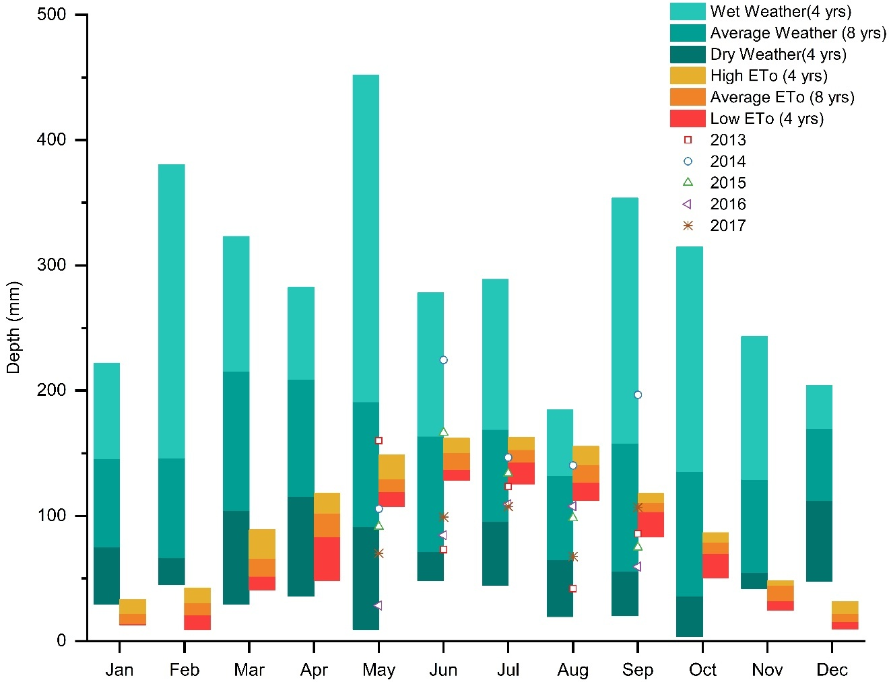
Figure 2.1. Jackson precipitation in 16 years and during the growing season from 2013 to 2017.

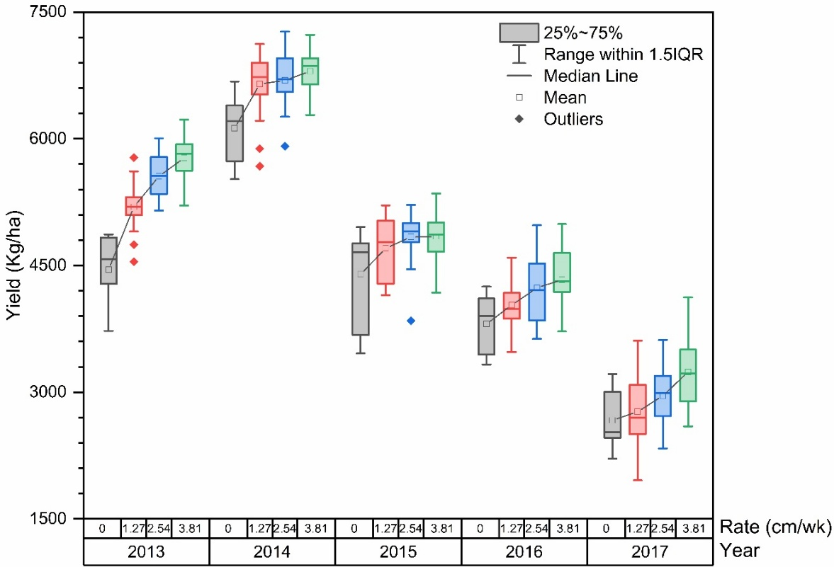
Figure 2.2. Yield and Irrigation Rate from 2013 to 2017.

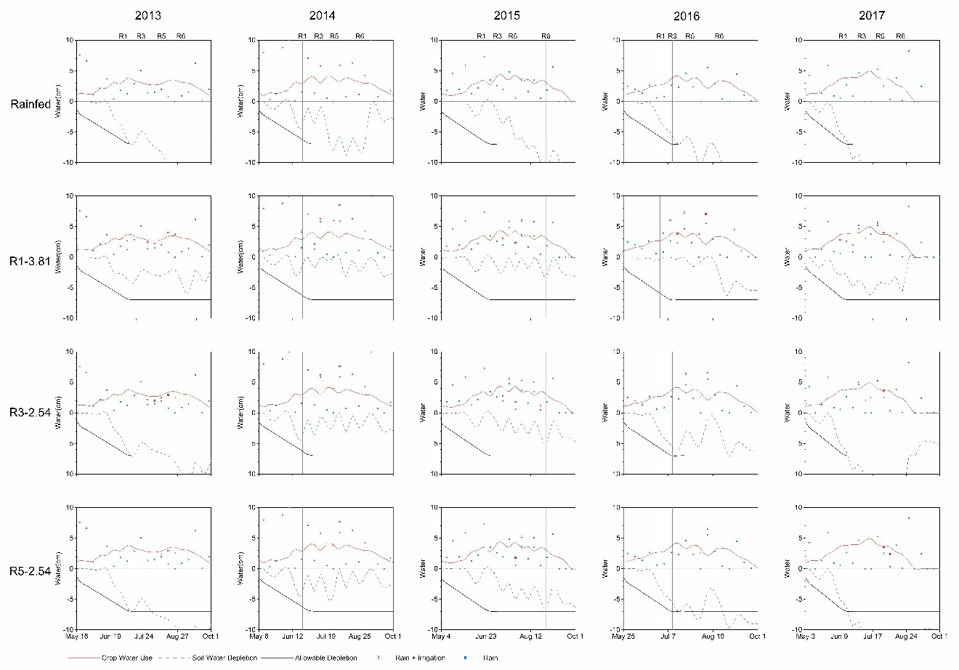
Figure 2.3. Seasonal water balance using MOIST irrigation scheduling tool.

Figure 2.4. Soil moisture sensor data.

Irrigation timing and rate for improving soybean yield across different soil zones in subtropical humid climate

Abstract
Water scarcity and increasing climate variability pose significant challenges to optimizing irrigation practices in subtropical soybean production systems, where ineffective use of irrigation can compromise both crop productivity and resource sustainability. A two-year experiment (2018-2019) in West Tennessee assessed soybean yield responses to various irrigation treatments across three soil zones (sandy soil, silt over sandy soil, and silt loam soil), and evaluated the performance of the water-balance model and soil matric potential sensors for irrigation guidance. Irrigation treatments varied by timing (beginning at flowering (R1), podding (R3), and seed filling (R5) stages) and application rate at each timing (2.8 cm/week and 4.1 cm/week). Irrigation amount reduced only by the amount of rainfall in a week. Also, a rainfed treatment served as the control. Results demonstrated that soil type was the primary determinant of yield and irrigation water productivity (IWP), with sandy soil exhibiting the lowest yields but highest IWP under strategic irrigation, silt over sandy soil achieving intermediate yields with intermediate IWP, and silt loam producing the highest yield yet lowest IWP due to natural water sufficiency. Rainfall patterns negated irrigation's impact on IWP (p > 0.05), but yield responses were soil-specific: sandy soils benefited most from R1-initiated irrigation (~2,300 kg/ha), silt over sandy soils showed marginal gains with R3-stage irrigation (0.05 < p < 0.1), and silt loam required no irrigation. The water balance model provided reliable guidance in silt loam soil zone and sandy soil zone but faced limitations in the spatially variable silt-over-sandy zone, particularly during R3–R5 stages. Matric potential sensors would have triggered more irrigation than needed to optimize yield, suggesting for careful placement, replicated measurements and possibly drier trigger thresholds. These findings highlight the necessity of soil-specific irrigation strategies and underscore opportunities to improve decision-support tools for sustainable water management in climate-variable agroecosystems.

Introduction
In 2023, the United States produced 124.94 million tons of soybeans (Glycine max L.) across 33.3 million hectares (USDA, 2024a). Of the total production, approximately 48.25 million tons were exported, representing 29% of global production and valued at $27.72 billion (USDA, 2024b). With nearly 90% of US soybeans grown under rainfed conditions, the crop is highly vulnerable to weather fluctuations, particularly the increasing frequency of heat waves, droughts, and unpredictable rainfall patterns (Hamed et al., 2021). USDA’s Economic Research Service projects that soybean yields will decline by 3% by 2036 due to climate-linked changes in temperature and precipitation (Hayhoe et al., 2018). In the humid subtropical regions of the Mid-South, soybean production is challenged by not only the reliance on unpredictable precipitation patterns but also farm-scale soil spatial variability. These factors make it difficult to design effective irrigation regimes for achieving the optimal yield with less water, as soybean yield responses to irrigation differ across soil textures and rainfall patterns.
As an essential part of the Mid-South, Tennessee grows 0.65 million hectares of soybean annually and is a prime example of an area facing these challenges (Haghverdi et al., 2015). Even though the humid subtropical climate brings a high annual average precipitation of over 1300 mm to Tennessee and about 23% of annual precipitation falls during the soybean critical water period of June to August (NOAA, 2024), the temporal distribution of growing season precipitation exhibits high variability, characterized by extended dry intervals between rainfall events. This variability is further compounded by the fact that heavy rainfall events often result in increased runoff with only a portion of the rainfall percolating into soil for soybean use (Doerr et al., 2003), and the fact that the occurrence of dry periods at soybean critical water need periods can lead to reduced yields (Xie et al., 2024). This unpredictable nature of both the amount and timing of precipitation poses a major risk to soybean production.
Additionally, soybean production is highly sensitive to soil variability, which can range from excessively drained loamy sands to poorly drained clays within a single field (M. S. Cox et al., 2006; J. A. Thomasson et al., 2001). On well-structured silt loams, yields sustain above 4,200 kg ha⁻¹ through improved moisture retention (Grassini et al., 2015), whereas on coarse-textured loamy sands, average yields plateau at 2,800 kg ha⁻¹ due to low water-holding capacity (Heatherly & Elmore, 2016). Notably, claypan soils exhibit yield depression to 2,100 kg ha⁻¹ under identical management, attributed to restricted root penetration and poor drainage (Myers et al., 2007). These disparities originate from soil-mediated modulation of water availability, bulk density, and cation exchange capacity, all of which are crucial for plant growth (Botta et al., 2004; Sinclair et al., 2010; Suriadi et al., 2021).
The variable precipitation distribution and the inherent variability in soil conditions within a field lead to different irrigation requirements on various soil textures at different soybean growth stages. On deep medium- and fine-textured soils, short or moderate water deficits during vegetative stages do not significantly reduce yield (Ashley & Ethridge, 1978; Elmore et al., 1988). Yet, soybeans become increasingly sensitive to water deficits during reproductive stages (Dogan et al., 2007; Jha et al., 2018; B. G. Leib et al., 2021; Torrion et al., 2014). Specifically, water deficits marginally impact soybean yield during flowering stage (R1) (Andrade, 1995; Foroud et al., 1993), while significantly affecting yield during the podding (R3) and seed filling stage (R5) by reducing the number of pods, seeds, and seed weight (W. J. Cox & Jolliff, 1986; Montoya et al., 2017). A five-year supplemental irrigation experiment on silt loam soil in TN recommended delaying irrigation until R5 in most years and until R3 in dry years and applying a high rate of 3.81 cm per week combined with rainfall to achieve higher soybean yield (Shekoofa & Leib, 2022; Xie et al., 2024). Conversely, on coarse-textured soils, water stress during vegetative and flowering stage significantly impacts soybean yield (Jha et al., 2018). However, the optimal irrigation timing and amount for soybean cultivation across diverse soil types in subtropical humid climate remains poorly characterized.
This research tested three irrigation initiation times (R1 to R6, R3 to R6, R5 to R6) at two irrigation rates (2.8 cm/wk and 4.1 cm/wk) in soil that varies from 3% to 19% available water holding capacity (AWHC) with the water balance approach and soil matric potential sensors applied to specific plots. The objectives of this two-year study were to:
1. Evaluate the soybean yield response to supplemental irrigation in a humid subtropical climate on different soil textures. It was hypothesized that the lower AWHC soils would require earlier irrigation at higher rates and that generalized recommendations on how to irrigate these soils would be better characterized. Since these highly variable AWHC soils are in the same field, both uniform rate and variable rate irrigation recommendations would be enhanced.
2. Investigate the relationship between irrigation water productivity (IWP) and soil AWHC. It was hypothesized that the lower AWHC soils would have greater potential for higher IWP and that this experiment would help produce recommendation on which soil types would be a better investment for supplemental irrigation.
3. Evaluate the effectiveness of the water balance approach and soil matric potential sensor at producing the highest soybean yields using the minimum amount of irrigation. It was hypothesized that these tools would be valuable in guiding irrigation decisions, but adjustments would be needed to arrive at the highest yield with minimal applied water.

Method

Experiment location
The two-year experiment was conducted at the West Tennessee Research and Education Center (WTREC) in Jackson, Tennessee (35.624°N, 88.845°W). The experiment area (Figure 3.1) is 0.7 hectares and includes two adjacent fields: the west field and the east field. Although the entire field was planted with soybeans, not all plots were used for analysis due to the randomized complete block experiment design replication requirements. The region is characterized by a humid subtropical climate. Historical data from the past 70 years indicates that the average monthly precipitation from May to November is approximately 97 mm, coupled with an average temperature of 21 °C (Haghverdi et al., 2019).

Soil texture
The soil composition in the field consists of silt layer overlying sand with the thickness of the silt layer varying gradually across the field. Based on soil sampling (only 21 of the 77 plots), electrical conductivity at 0.91 m depth (ECd) in all plots, and ground penetrating radar (GPR) in all plots, this field was divided into three distinct zones: sandy soil, silt over sandy soil, and silt loam soil (Duncan, 2012). Although significant correlations exist between ECd and GPR (r = 0.78), some overlap between these zones remains (Figure 3.2) and the vertical soil properties differ even within a single zone. Generally, the sandy soil percentage increases with depth. In the sandy soil zone with AWHC ranging from 3% to 9%, the top silt loam soil layer is less than 30 cm thick, and the soil is nearly 100% sand at depth greater than 60 cm. In the silt loam soil zone with AWHC ranging from 14% to 19%, the soil texture remains uniform from the top to the bottom. In the silt over sandy soil zone with AWHC ranging from 7% to 16%, it represents an intermediate condition between the other two zones.

Irrigation experiment design
A randomized complete block design was implemented in the experiment field. Treatment assignments for plots within blocks were re-randomized each year. Soybean management included weed and pest control following University of Tennessee Extension guidelines (Adotey, 2022; Steckel, 2022).
Eleven blocks were used for soybean supplemental irrigation experiments in the no-till field in 2018 and 2019 (Figure 3.1). Four blocks were dominated by the silt loam zone, three by the sandy over silt zone, and the remaining four by the sandy soil zone. Within each block, seven supplemental irrigation treatments (Table 3.1) were randomly applied to the plots. Each plot size was 3 m × 9.1 m with a 3 m alley. Consequently, a total of 77 plots were utilized. The study focused on investigating three crucial soybean growth stages for irrigation initiation timings (R1, R3, and R5) and two irrigation rates (2.8 cm/wk and 4.1 cm/wk), where the irrigation rate was determined by the combined total of irrigation and rainfall. A rainfed plot within each block served as the control. The irrigation schedule was based on rainfall in the past 7 days. The irrigation amount was determined by the rainfall and the treatment rates. For example, if the rainfall over the past 7 days exceeded the designed irrigation rate of 2.8 cm, irrigation would not be necessary. Conversely, if the rainfall in the last 7 days was less than 2.8 cm, irrigation would be used to supplement the rainfall to meet the designed rate. Irrigation was terminated after the full seed stage (R6).
A drip irrigation system equipped with T-tape (Rivulis Irrigation Inc., San Diego, CA, USA) was designed and implemented across the field. Within each plot, four rows of soybeans were planted. Each soybean row was serviced by a single drip tape and controlled by an individual valve. These valves were opened according to their corresponding treatment timing. The irrigation amounts were controlled by the run-time and flow rate of drip tape (Table 3.1). Two rain gauges were installed during the vegetative stage and removed before harvesting. Additionally, precipitation data were corroborated by a National Oceanic and Atmospheric Administration (NOAA, 2024) standard weather station located less than 400 meters from the field.

Soybean growth stages
Irrigation initiation was timed according to the soybean growth stages with the determination of these stages following the classification system developed by Fehr and Caviness (1977). Soybean growth was observed weekly to accurately assess the developmental stage and document the duration of each growth stage (Table 3.2).

Soil water sensor
Soil matric potential sensors (TEROS 21, METER Group Inc., Pullman, WA, USA) were installed at depths of 15 cm and 61 cm across seven plots (Figure 3.1): three plots in the sandy soil zone and four plots in the silt loam zone. The intermediate zone of silt over sandy soil was not covered because this zone displays greater variability in soil properties, making it more challenging to characterize consistently, while both the sandy soil zone and the silt loam zone exhibit relatively uniform soil properties (Figure 3.2). In the first year, treatments applied to the soil moisture sensor plots focused on the early growth stage in the sandy soil zone and the late growth stage in the silt loam zone. Based on the yield outcomes from that year, the assigned treatments were subsequently adjusted to encompass all growth stages with high rate (Table 3.3). To evaluate the effectiveness of soil matric potential sensors in guiding irrigation decisions, the trigger point of 50 kPa for sandy soil zone and 100 kPa and silt loam zone were compared, respectively, with the optimal treatment within each zone (Irmak, 2019).

Water balance-based irrigation method
Management of Irrigation Systems in Tennessee (MOIST) spreadsheet is an irrigation management tool based on the water balance method (Leib, 2011). MOIST utilizes crop water use (water out of the soil) along with irrigation and rainfall (water into the soil) to determine the soil water depletion for comparison against the management allowable depletion (MAD) of each soil. It should be noted that MAD was set based on 50% of the soil AWHC with a soybean root zone depth of 0.76 m. Soil AWHC was calculated as the average of each zone. Given various soil textures in the study area, three different MAD levels were established corresponding to each zone. This method has demonstrated effectiveness in optimizing irrigation practices for better water management on silt loam soil in Tennessee (Xie et al., 2024). However, the effectiveness of this approach on other soil textures remains uncertain and is a subject of investigation in this study.

Statistical analysis
Soybean yield data were cleaned by identifying values greater than ±3 standard deviations from the mean as outliers. Irrigation water productivity (IWP) was calculated by dividing the improvement in crop yield attributable to irrigation by the total volume of water used for irrigation (Sincik et al., 2008).
The data was subjected to Analysis of Variance (ANOVA) with the mixed procedure of SAS 9.4 (SAS Institute, Cary, NC). Data from each year were analyzed separately because the optimal treatment might differ yearly due to the weather condition. All means were separated using Fisher’s least significant difference and differences were considered significant at p < 0.05.
Initially, ANOVA assessed yield differences across soil types and irrigation treatments, and eta squared analysis measures the proportion of variance associated with each main effect and interaction effect in ANOVA model. The response variable was yield, with soil types, irrigation treatments, and their interaction as the main effects. Subsequently, within each soil type, ANOVA was used to evaluate differences among the seven irrigation treatments, with yield as the response variable and irrigation treatments as the main effect. Additionally, within each soil type, the effects of irrigation timing and rate on soybean yield were examined as two main effects through separate ANOVA analyses. Similar ANOVA assessed IWP response across soil and irrigation treatments.

Results

Precipitation and irrigation
Figure 3.3 presents monthly precipitation during the soybean growing season (May to September) from 1924 to 2023, offering insights into precipitation variability over the past century (NOAA, 2024). During the soybean reproductive stages of 2018, rainfall was well above average for June and July while being average in August. For 2019, rainfall was average in June, extremely above average in July, and above average in August. Notably, cumulative growing season rainfall (May to September) substantially exceeded the 100-year historic average (52.2 cm), measuring 93.5 cm in 2018 (79% above average) and 66.3 cm in 2019 (27% above average).
Figure 3.4 illustrates the distribution of daily precipitation and irrigation at two irrigation rates during the 2018 and 2019 growing seasons. Soybeans received 57 cm of precipitation from planting to the R6 stage in 2018, and 50 cm in 2019. Within the reproductive stage (R1 to R6), rainfall accounted for 40 cm in 2018 and 38 cm in 2019. The rainfall pattern in 2018 was characterized by high-intensity events with relatively longer intervals between them, whereas in 2019 rainfall was more evenly distributed with moderate intensity. Specifically, dry periods in R1 and R5 treatments can be noted in 2018 while only one R5 dry period can be noted in 2019.

Yield response

Soil zone effect
The analysis of soybean yield responses revealed a dominant influence of soil zone variability compared to irrigation management (Table 3.4). Across both growing seasons, the soil zone exhibited a significant effect on yield, accounting for 77% of observed yield variation in 2018 and 93% in 2019. In contrast, irrigation treatment showed temporally dependent effects, demonstrating significance only in 2018 accounting for 16% of observed yield variation but not in 2019. Notably, the soil zone × irrigation interaction failed to reach significance in either year, suggesting that soil-mediated yield responses operated independently of water application regimes under the tested conditions.
In both years, soybean yields in the silt loam zone significantly outperformed those in silt over sandy soils and sandy soils (p < 0.001, Figure 3.5). Specifically, in 2018, the average yield in silt loam soil reached 3,788 kg ha⁻¹, marking a 25% increase over silt over sandy soils and a striking 75% increase over sandy soils. A similar trend was noted in 2019, where silt loam soil produced an average yield of 3,588 kg ha⁻¹, 17% higher than silt over sandy soils and 84% higher than sandy soils.

Irrigation treatment effect
Results revealed distinct soil-dependent yield responses to irrigation strategies, with each soil type exhibiting consistent irrigation effects across both growing seasons (Table 3.5, Figure 3.6). Notably, sandy soil demonstrated significantly greater yield sensitivity to irrigation (p < 0.05) compared to silt loams (p > 0.1), reflecting their contrasting water holding capacities.

Sandy soil zone
In sandy soil, yields were significantly influenced by irrigation treatments in both years, with increases in irrigation amount generally boosting yields (p < 0.05, Table 3.5, Figure 3.6). Specifically, yields in irrigated plots were 2.5% to 128.7% higher compared to rainfed treatments.
In 2018, the irrigation rate significantly impacted soybean yields rather than the timing
(p < 0.05, Table 3.5). Higher rates increased yields by 16% to 39%. While examining the impact of timing at a consistent irrigation rate, yields were notably higher when irrigation commenced at the R1 stage compared to later stages (Figure 3.6). For instance, when comparing treatments with the same high irrigation rate but different timings (treatments 1, 3, and 5), yield from treatment 1 had a higher yield than treatments 3 and 5. Notably, when irrigation increased from 16.8 cm (treatment 3) to 23.9 cm (treatment 1), the yield increase per additional unit of water slowed down, suggesting the yield was approaching the point of diminishing returns.
Conversely, in 2019, timing played a more crucial role than rate (p < 0.05, Table 3.5), with earlier irrigation resulting in yield increases of 7% to 38% (Figure 3.6). When irrigation started from R1, treatment 2 with a lower rate produced a higher yield than treatment 1 with a higher rate. However, when comparing yields across treatments with timing post-R3, higher rates consistently resulted in increased yields. Specifically, treatments 3 and 5, both marked with the 'a' level, showed higher yields compared to treatments 4 and 6, respectively. When the irrigation amount increased from 8.1 cm (treatment 2) to 9.7 cm (treatment 3), or even 13 cm (treatment 1), soybean yields no longer increased and slightly decreased, showing diminishing returns with additional irrigation. This indicates treatment 2 provided the optimal yield for this year and there is the possibility of obtaining less than optimum yields in extremely wet years when irrigating early at a high rate (treatment 1).
Our two-year study demonstrated that irrigation starting from R1 consistently produced the highest soybean yields in sandy soil. However, these results must be interpreted within the context of above-average precipitation during both experimental years - with seasonal rainfall exceeding the 100-year mean by 79% in 2018 and 27% in 2019 (Figure 3.3). This wetter-than-normal baseline suggests that under typical or drought conditions, sandy soil may require earlier irrigation initiation (potentially beginning at vegetative stages), increased application volumes, or more frequent water applications.
Notably, the yield ceiling in sandy soils remained constrained by inherent soil properties - the maximum irrigated yield in sand (2719 kg ha⁻¹ in 2018, 2313 kg ha⁻¹ in 2019) still underperformed the rainfed yield in silt loam (3622 kg ha⁻¹ in 2018, 3691 kg ha⁻¹ in 2019). This persistent yield gap underscores how soil texture fundamentally determines productivity potential, with irrigation only partially mitigating sandy soil limitations.

Silt over sandy soil zone
In silt over sandy soil, irrigation exhibited a marginally significant impact on yield with p values ranging between 0.05 and 0.10 (Table 3.5). Over the two-year period, treatment 3 consistently produced the highest soybean yield denoted by a solitary 'a' in mean separation tests (Figure 3.6). Irrigated plots produced higher yield than rainfed plots. Irrigated plots generally outperformed rainfed plots, reinforcing that supplemental water benefits soybean yield in intermediate AWHC soils under typical growing conditions. Given that reproductive stage rainfall in both 2018 and 2019 was well above average, these results suggest that irrigation in such soils should generally begin by the R3 growth stage in most years to optimize yield. However, in drier years with below-average June rainfall, initiating irrigation at R1 with higher application rates may be necessary to mitigate water stress. Notably, excessive irrigation in wet years could prove counterproductive as demonstrated in 2019, where increasing irrigation from 9.7 cm (Treatment 3) to 13 cm (Treatment 1) reduced yield. Silt over sand soil produced less yield than the silt loam soil at all treatment levels but the degree of reduction was not as great as the sandy soil, highlighting their intermediate position in soil-dependent yield potential.

Silt loam zone
In the silt loam soil zone, irrigation had no significant effect on soybean yields in either growing season (p > 0.1, Table 3.5, Figure 3.6). This lack of response can be attributed to the exceptionally high rainfall during the reproductive stages (40 cm in 2018, 38 cm in 2019) combined with the high water-holding capacity and drainage properties, which allowed soil to effectively retain moisture without waterlogging.
Interestingly, while the overall effect was non-significant, subtle interannual trends emerged: in 2018, 5 out of 6 irrigated treatments showed marginally higher yields than the rainfed control, whereas in 2019, the opposite occurred, with 5 out of 6 irrigated treatments yielding slightly less. These contrasting patterns highlighted the conditional role of irrigation in high AWHC soils, demonstrating that supplemental water may offer negligible benefits or even slight yield reductions in exceptionally wet growing seasons.

Irrigation water productivity
Results demonstrated that soil variability was the dominant factor governing IWP in this study across both experimental years, rather than irrigation management (Table 3.6). This conclusion was further supported by the non-significant response of IWP to irrigation treatments within each soil zone (p > 0.05). The high AWHC of silt loam soil combined with above-average seasonal rainfall resulted in lower yield gains per unit irrigation compared to coarser-textured soils (Table 3.7). Notably, while sandy and silt-over-sandy soils exhibited statistically similar IWP levels, the latter achieved higher absolute yields (Figure 3.6, Table 3.7). It suggested that water availability was not the primary yield constraint in these lower-AWHC soils. Instead, ancillary factors such as reduced organic matter content or limited nutrient retention capacity likely suppressed yield potential (Lal, 2015). Mitigation of these constraints could render these soils more responsive to irrigation. Interannual comparisons revealed that IWP in 2018 exceeded 2019 despite nearly identical treatment-period rainfall, a divergence attributable to IWP in 2019 more temporally distributed precipitation. This even distribution enhanced rainfed yields, diminishing both the relative benefit of irrigation and overall IWP.

MOIST
Figure 3.7 illustrates the daily soil moisture depletion under various irrigation treatments across three soil zones for the growing season in 2018 and 2019. Heavy rainfall events that returned the rainfed treatment to field capacity (FC; 0 in soil water depletion in Figure 3.7) caused the soil moisture depletion profile to overlap at the transitions between growth stages across all treatments. Therefore, the three irrigation initiation timings for each year can be represented by one graph instead of three separate graphs. For example, in Figure 3.7, treatment 3 where irrigation starts at R3 with 4.1 cm/wk rate, should initially be presented by a black line prior to R3 indicating no irrigation then combining transition to a red line post R3 to denote the commencement of high-rate irrigation.

Sandy soil zone
Rainfed plots in sandy soil with low AWHC experienced soil water depletion (SWD) below MAD threshold during all reproductive stages for both years (Figure 3.7, black line). This matches the yield outcomes shown that irrigation was always needed in the sandy zone (Figure 3.6). When 2.8 cm/wk rate of irrigation was applied (Figure 3.7, blue line), the resulting SWD stays mostly above MAD until R5 indicating that a higher irrigation rate would have been needed from R5 to R6 to maximize yield. This mostly matched the yield results since the low rate of irrigation produced lower yield than the high rate at corresponding growth stages with the exception irrigation starting R1 in 2019. It should be noted that the rainfed SWD also exceeded MAD during the vegetative growth stage in both years. But it is uncertain whether yield potential was lost during the vegetative growth stage in this experiment. One explanation could be that the vegetative stage of grain crops is generally more drought tolerant than the reproductive stages and thus the actual MAD value could be greater than represent in MOIST.

Silt over sandy soil zone
For the silt over sand zone with medium AWHC, SWD of the rainfed plots approached MAD by mid-R5 in both years, while at other stages, it remained within the allowable range (Figure 3.7, black line). Also, only the low irrigation rate was needed to maintain SWD above MAD during R5 to R6 (Figure 3.7, blue line). Irrigation starting at R5 did provide notable yield increases with very little applied irrigation (Figure 3.6). However, the highest statistical yield occurred when irrigation was initiated at R3 with a high rate in both years. One possible explanation could be that the actual SWD was larger than represented in MOIST or the MAD value that represented the silt over sand plots should have been lower to trigger more irrigation. Therefore, using MOIST as represented in Figure 3.7 would have resulted in medium yield with less irrigation, but more irrigation would have been needed to reach the highest yield.

Silt loam zone
With high AWHC to retain rainfall, the silt loam zone effectively maintained soil water depletion above MAD across all treatments (except during R5 of rainfed plots in 2018, black line in Figure 3.7) for both growing seasons. Since irrigated yields were not significantly different from rainfed yield in either year, MOIST correctly predicted no irrigation was needed in 2019 but would have added some unneeded irrigation at R5 to R6 in 2018. It indicated that a larger MAD value in MOIST would reduce unnecessary irrigation in 2018.

Overall performance of MOIST
It should be noted that rainfall exceeded crop water use in the R1 to R3 and the R3 to R5 stages since SWD was returned to zero or field capacity at the end of each of those treatment periods in both years. Yet the lower AWHC soil zones still required irrigation in that time frame to obtain the highest yields. MOIST readily shows that even though rainfall was sufficient in amount, the time between rainfall events was too great for the lower AWHC soils to supply sufficient water for optimum soybean development. MOIST does account for deep percolation losses but does not estimate runoff, which could make the actual SWD lower than it was represented by MOIST. Overall, MOIST provided helpful irrigation guidance across a large range of AWHC in soil. MOIST could have been more accurate at guiding soybean irrigation to the highest yield with minimum applied water if there were better accounting for effective rainfall in terms of runoff losses and the larger MAD value for the highest AWHC soil.

Soil water sensor

Sandy soil
Figure 3.8 illustrates the soil water dynamics within the sandy soil zone. In 2018, treatment #2 (2.8 cm/wk irrigation starting R1) showed drier soil conditions and greater fluctuation of matric potential than the wetter treatments and indicates more irrigation was required. In fact, treatment #1 applied the highest irrigation amount produced the highest irrigated yield. However, the matric potential sensors in treatment #1 would have triggered more irrigation in both R1 to R3 and R5 to R6 since both sensor depths fell below the 50 kPa trigger point for sand. It is difficult to determine if more water was actually needed in 2018 since treatment #1 is the earliest irrigation timing at the highest rate.
In 2019, treatment #5 was not irrigated until R5 and it shows irrigation should have been triggered by R3 but not by R1 when in fact the highest yield was obtained by starting irrigation at R1 with the low rate (treatment #2). Treatment #2 was not monitored for matric potential in 2019 but treatment #1 was monitored which also started at R1 but with a high rate. The matric potential of treatment #1 maintained matric potential at one or more depths for most of the reproductive stages and there was only one short period at the beginning of R5 when both sensors were below the trigger point calling for more irrigation. It is presumed that treatment#2 would have triggered additional unnecessary irrigation since, this was a lower irrigation rate than treatment #1.
In general, the matric potential sensors seemed to trigger more irrigation events than necessary at the sand threshold of 50 kPa. It should be noted that water from drip irrigation does not spread laterally as far as in finer textured soils. Perhaps irrigation was adequate, but this water did not sufficiently reach the sensor locations. Care is needed to make sure the drip emission points stay close to both the plant and the sensor locations. (Irmak, 2019)

Silt loam soil
Figure 3.9 depicts soil moisture matric potential in the silt loam soil zone. In 2018, the rainfed treatment (Figure 3.9 a) revealed a drop in matric potential below the irrigation trigger point several times in R1 to R5 and for an extended period of time in R5 to R6. However, yield data indicates that there was no significant difference in yield between treatments signifying that no irrigation was necessary in 2018 and that the sensors would have triggered unnecessary irrigation. When looking at the sensor response in treatments #5 and #6 (the lowest irrigation amounts), irrigation was only able to bring the matric potential above the trigger points at the high rate of irrigation in R5 to R6. Again, this is more irrigation than is necessary. Perhaps these sensor results are signaling that a small amount of irrigation was helpful since irrigated yields were numerically higher than rainfed in 5 out of the 6 irrigated treatments in 2018. More likely, there is some available soil water either above or below the sensor locations that is still providing adequate water for the crop. Note that the deeper rainfed sensors do not return to field capacity at the end of the R1 to R3 or the R3 to R5 periods as suggested by the MOIST water balance. This could be due to run-off and/or rainwater being higher than field capacity behind the rainfall induce wetting front which never reached the deeper sensor location. More sensors at more depths may be needed to make good irrigation decisions in all years.
In 2019, the rainfed treatment revealed a slight drop below the 100 kPa irrigation trigger during R1 to R5 but it should be noted that this also occurred in the previous 5-year experiment where it was recommended that the trigger point could be lower than 100 kPa in R1 to R3 growth stage without losing yield potential. Still, matric potential fell below the 100 kPa trigger in R5 to R6 and irrigation would have been applied that was not necessary. All of the other monitored treatments in 2019 revealed matric potential well above the irrigation triggers and approaching saturation during the irrigation treatment periods. In this case, the sensor would have correctly served as a warning against over irrigation since 5 out of 6 irrigated treatments were numerically lower in yield than the rainfed treatment.

Overall performance of matric potential sensors
In this experiment, the matric potential sensors did not seem to perform as well as the MOIST water balance in assisting irrigation decisions that led to the highest yield with the least water, because the sensors location and numbers significantly impact the irrigation suggestion. The matric potential trigger points could be adjusted downward or drier to reduce the amount of unnecessary irrigation. However, these two years of evidence do not seem sufficient to recommend such a change at this time.

Discussion

Soil effects on yield
This study investigated the effects of different irrigation schedules on soybean yield across three soil types under a subtropical humid climate. The two-year experimental results demonstrated that silt loam soil consistently produced higher yields compared to sandy and silt over sandy soils, aligning with previous findings that highlight the superior productivity of medium-textured soils under similar climatic conditions (Arora et al., 2011; Butcher et al., 2018; Suriadi et al., 2021). However, even with the highest irrigation input in sandy soil, yields remained significantly lower than those in non-irrigated silt loam plots. It suggested that water availability alone was not the primary limiting factor (Wesseling et al., 2009; Wankmüller et al., 2024). If water were the sole constraint, the intensively irrigated sandy soil should have achieved comparable yields to the silt loam control, yet this was not observed. Instead, the inherent limitations of sandy soils—including reduced organic matter content, poor nutrient retention, and elevated nematode pressure—likely contributed to the yield suppression (Lal, 2015). These ancillary factors impair root development and nutrient uptake efficiency, further exacerbating yield disparities. In contrast, silt loam soils provided a more favorable growth environment, not only due to their superior water-holding capacity but also because of their balanced physical and chemical properties, which enhance nutrient availability and microbial activity (Sainju et al., 2022; Singh et al., 2022). Thus, while optimized irrigation can mitigate water stress, soil texture and associated properties remain critical determinants of soybean productivity in subtropical regions.

Irrigation effects on yield in silt loam soil
The results demonstrate that irrigation had no significant impact on soybean yield in silt loam soil during the 2018-2019 growing seasons (p>0.05), which contrasts with previous recommendations from a five-year study (2013-2017) at the same location suggesting delayed irrigation until R5 could optimize yields in similar high AWHC soils (Xie et al., 2024). This discrepancy primarily stems from interannual rainfall variability (Figure 3.10), as documented in other studies examining irrigation responses under fluctuating precipitation patterns (Lobell et al., 2013).While 2014 received exceptional rainfall during vegetative stages when soybean water demand is naturally low (Ashley and Ethridge, 1978; Specht et al., 1989; Dong et al., 2019), the 2018-2019 seasons featured more favorable rainfall distribution, with greater precipitation occurring during critical reproductive phases (R1-R5) when soybean water requirements peak (S. Dong et al., 2019). The high AWHC characteristic of silt loam soils effectively captured and retained this moisture, rendering additional irrigation unnecessary in these two study years. These findings align with research showing that irrigation benefits in medium-textured soil become marginal when seasonal rainfall exceeds 50 cm and is well-distributed (Grassini et al., 2011).
Synthesizing seven years of data in silt loam, we propose context-dependent irrigation strategies: 1) delay until R5 in typical years (2013-2016), 2) advance to R3 in drought years (2017), and 3) forgo irrigation in exceptionally wet years (2018-2019) - an approach consistent with precision agriculture principles (Bronson et al., 2006). However, since growers cannot predict seasonal rainfall patterns at planting, the most risk-averse strategy would be to apply conservative irrigation during R5-R6, as this maintains yield potential across all weather scenarios without causing overwatering (Montoya et al., 2017). This recommendation echoes findings that modest reproductive-stage irrigation provides yield stability while conserving water resources (N. L. Klocke et al., 2006), particularly important given increasing climate variability (Rosenzweig et al., 2014). The study underscores the need for adaptive irrigation management that considers both soil properties and real-time weather data (Evans & Sadler, 2008), rather than relying on fixed schedules.

IWP in silt loam soil
Similar to other findings (Ali et al., 2017; Sohoulande Djebou et al., 2021), the wet conditions during the two study years rendered irrigation ineffective for yield improvement in silt loam soil, resulting in low IWP compared to other soil types. However, data from the preceding five-year study demonstrated that silt loam soil can achieve comparable IWP values, with peak annual IWPs ranging from 0.07 to 0.25 kg/m³ (Xie et al., 2024). This contrast highlights that when water stress occurs, silt loam soils exhibit superior yield responsiveness that translates to higher IWP, particularly valuable in water-scarce regions (S. Kang et al., 2017). Importantly, in regions without water scarcity, farmers may avoid substantial investments in labor and electricity by irrigating only during R5-R6 to maintain stable yields, rather than irrigating throughout the entire reproductive stage, as this critical period (R5-R6) typically lasts only 20-30 days and often coincides with natural rainfall events (Piao et al., 2010). This finding aligns with economic analyses showing diminishing returns on irrigation investments in humid regions with reliable rainfall (Boggess & Ritchie, 1988; Rey et al., 2016).

MOIST
The MOIST model provided valuable irrigation guidance across a wide range of AWHC values in different soil types (Evans et al., 2013). However, its accuracy showed limitations in certain scenarios, particularly for silt over sandy soil where it failed to recommend irrigation during the R3-R5 growth stages despite this timing producing the highest yields. This discrepancy may stem from the MAD threshold being set too high in the model's parameters (Pereira et al., 2015). Further analysis reveals that MAD is determined by three factors: root depth, AWHC, and the standard 50% maximum allowable depletion. While MOIST assumes a constant soybean root depth of 76 cm, field observations suggest roots may not reach maximum depth during the critical R3-R5 period (Kunert et al., 2016; Fried et al., 2019).Additionally, the silt over sandy soil zone exhibits greater AWHC variability (7-16%) compared to uniform sandy or silt loam soils, and using average AWHC values in MOIST may oversimplify the complex yield-AWHC relationship in these heterogeneous conditions (Lobell et al., 2013). These findings suggest that model improvements could be achieved by incorporating dynamic root growth patterns and better accounting for spatial AWHC variability (Kephe et al., 2021).

Soil water sensor
The strategic placement and number of soil moisture sensors are critical factors for effective irrigation decision-making in soybean production (Vellidis et al., 2008). For drip irrigation systems as used in this study, sensors should be positioned within the wetting zone but not directly beneath emitters to obtain representative soil water status measurements (Evett et al., 2012). This placement consideration becomes particularly important in sandy soils where limited lateral water movement creates distinct wetting patterns (Thompson et al., 2007), whereas sprinkler systems - the predominant irrigation method for soybeans - provide more uniform water distribution making sensor placement less critical (O’Shaughnessy et al., 2015b). Multi-depth sensor arrays better capture the vertical distribution of plant-available water (Pardossi et al., 2009), as water content often varies significantly above and below single sensor positions (B. Leib et al., 2015). This is especially relevant when considering wetting front dynamics, where water content temporarily exceeds field capacity as moisture moves downward through the profile, potentially bypassing shallow sensors during light irrigation or rainfall events on initially dry soil (Schwartz et al., 2020).
Center pivot systems, the most common sprinkler irrigation method for soybeans, typically apply water in frequent, light applications to minimize runoff, resulting in relatively shallow water penetration (Lamm and Rogers, 2017; Dong et al., 2023). This application pattern, combined with crops' tendency to extract water from upper soil layers first, can lead to situations where adequate moisture exists below the deepest sensors as the season progresses (Michael D Dukes, 2010). This phenomenon is particularly pronounced in silt loam soils due to their ability to retain substantial plant-available water within discrete soil layers, highlighting the need for comprehensive sensor arrays in precision irrigation management (Hedley & Yule, 2009).

Limitation and future research
This study employed soil EC, GPR, and partial soil sampling to cluster soil zones under the assumption that soils within the same zone exhibit similar properties (Corwin & Lesch, 2005a). A randomized complete block design was implemented to minimize intra-zone variability, which proved effective in reducing heterogeneity in sandy and silt loam zones due to their relatively low AWHC variability, as evidenced by the clear yield-irrigation relationships observed (Hedley et al., 2013). However, the high AWHC variability (7–16%) in the sandy-over-silt zone resulted in less definitive conclusions, suggesting that future studies should increase plot numbers and subdivide this zone into more homogeneous subzones to better elucidate water-yield relationships (Moral & Serrano, 2019).
Irrigation management zone delineation is a critical component of precision irrigation, yet robust delineation typically relies on extensive datasets such as EC, GPR, and comprehensive soil sampling (Farid et al., 2016; Gavioli et al., 2019). Unfortunately, such data are often unavailable to many producers, limiting practical implementation. Future research should prioritize developing delineation methods based on more accessible farmer-owned data—such as yield maps, topography, and simplified soil testing—to enhance the feasibility of precision irrigation management for broader agricultural adoption.

Conclusion
This study evaluated soybean yield responses to different irrigation schedules across three distinct soil types (silt loam, silt over sandy, and sandy soils) under subtropical humid climate conditions (2018-2019), while simultaneously assessing the efficacy of the MOIST model and soil matric potential sensors for irrigation guidance. The key findings demonstrate that soil type was the dominant factor influencing both yield and IWP, with silt loam producing the highest yields yet lowest IWP due to water sufficiency, silt over sandy soil achieving intermediate yields with intermediate IWP, and sandy soil showing the lowest yields but highest IWP.
Rainfall patterns significantly modulated irrigation effects: while supplemental watering did not statistically improve IWP in any soil type (p > 0.05), its yield impacts were soil dependent. In sandy soil, irrigation initiated at R1 with dynamic rainfall adjustments maximized yields (~2,300 kg/ha). For silt over sandy soil, irrigation started at R3 at 4.1 cm/week provided marginal yield benefits (0.05<p<0.1). Silt loam required no irrigation due to its high water-holding capacity and adequate rainfall matching crop demand.
The MOIST water-balance model performed robustly in silt loam zone and sandy soil zone but faced limitations in the spatially variable silt-over-sandy zone (AWHC range: 7–16%), particularly during R3-R5 stages where root depth assumptions may need calibration. Conversely, matric potential sensors would have triggered more irrigation than needed to optimize yield, suggesting for careful placement, replicated measurements and possibly drier trigger thresholds.
These results highlight the necessity of soil-specific irrigation strategies in subtropical soybean systems and underscore opportunities to refine decision-support tools for sustainable water management in climate-variable futures.

References
Adotey, N., 2022. Soil fertility and nutrient management in soybean [WWW Document]. Tennessee soybean production handbook. URL https://utcrops.com/wp-content/uploads/2022/11/Chapter-5-final-PB_1912-E_Soybean_Handbook.pdf (accessed 10.26.24).
Ali, S., Xu, Y., Ma, X., Ahmad, I., Kamran, M., Dong, Z., Cai, T., Jia, Q., Ren, X., Zhang, P., Jia, Z., 2017. Planting patterns and deficit irrigation strategies to improve wheat production and water use efficiency under simulated rainfall conditions. Front Plant Sci 8. https://doi.org/10.3389/fpls.2017.01408
Andrade, F.H., 1995. Analysis of growth and yield of maize, sunflower and soybean grown at Balcarce, Argentina. Field Crops Res 41, 1–12. https://doi.org/10.1016/0378-4290(94)00107-N
Arora, V.K., Singh, C.B., Sidhu, A.S., Thind, S.S., 2011. Irrigation, tillage and mulching effects on soybean yield and water productivity in relation to soil texture. Agric Water Manag 98, 563–568. https://doi.org/10.1016/j.agwat.2010.10.004
Ashley, D.A., Ethridge, W.J., 1978. Irrigation effects on vegetative and reproductive development of three soybean cultivars. Agron J 70, 467–471. https://doi.org/10.2134/agronj1978.00021962007000030026x
Boggess, W.G., Ritchie, J.T., 1988. Economic and risk analysis of irrigation decisions in humid regions. Journal of Production Agriculture 1, 116–122. https://doi.org/10.2134/jpa1988.0116
Botta, G.F., Jorajuria, D., Balbuena, R., Rosatto, H., 2004. Mechanical and cropping behavior of direct drilled soil under different traffic intensities: effect on soybean (Glycine max L.) yields. Soil Tillage Res 78, 53–58. https://doi.org/10.1016/j.still.2004.01.004
Bronson, K.F., Booker, J.D., Bordovsky, J.P., Keeling, J.W., Wheeler, T.A., Boman, R.K., Parajulee, M.N., Segarra, E., Nichols, R.L., 2006. Site‐specific irrigation and nitrogen management for cotton production in the Southern High Plains. Agron J 98, 212–219. https://doi.org/10.2134/agronj2005.0149
Butcher, K., Wick, A.F., DeSutter, T., Chatterjee, A., Harmon, J., 2018. Corn and soybean yield response to salinity influenced by soil texture. Agron J 110, 1243–1253. https://doi.org/10.2134/agronj2017.10.0619
Corwin, D.L., Lesch, S.M., 2005. Apparent soil electrical conductivity measurements in agriculture. Comput Electron Agric 46, 11–43. https://doi.org/10.1016/j.compag.2004.10.005
Cox, M.S., Gerard, P.D., Abshire, M.J., 2006. Selected soil properties’ variability and their relationships with yield in three Mississippi fields. Soil Sci 171, 541–551. https://doi.org/10.1097/01.SS.0000228031.49776.0F
Cox, W.J., Jolliff, G.D., 1986. Growth and yield of sunflower and soybean under soil water deficits. Agron J 78, 226–230. https://doi.org/10.2134/agronj1986.00021962007800020002x
Doerr, S.H., Ferreira, A.J.D., Walsh, R.P.D., Shakesby, R.A., Leighton‐Boyce, G., Coelho, C.O.A., 2003. Soil water repellency as a potential parameter in rainfall‐runoff modelling: experimental evidence at point to catchment scales from Portugal. Hydrol Process 17, 363–377. https://doi.org/10.1002/hyp.1129
Dogan, E., Kirnak, H., Copur, O., 2007. Deficit irrigations during soybean reproductive stages and CROPGRO-soybean simulations under semi-arid climatic conditions. Field Crops Res 103, 154–159. https://doi.org/10.1016/j.fcr.2007.05.009
Dong, S., Jiang, Y., Dong, Y., Wang, L., Wang, W., Ma, Z., Yan, C., Ma, C., Liu, L., 2019. A study on soybean responses to drought stress and rehydration. Saudi J Biol Sci 26, 2006–2017. https://doi.org/10.1016/j.sjbs.2019.08.005
Dong, Y., Kelley, L., Anderson, E., 2023. Demonstration of center pivot uniformity evaluation and retrofit to improve water use efficiency. J Water Resour Prot 15, 71–84. https://doi.org/10.4236/jwarp.2023.153005
Duncan, 2012. Locating the Variability of Soil Water Holding Capacity and Understanding Its Effects on Deficit Irrigation and Cotton Lint Yield (Master’s thesis). University of Tennessee, Knoxville.
Elmore, R.W., Eisenhauer, D.E., Specht, J.E., Williams, J.H., 1988. Soybean yield and yield component response to limited capacity sprinkler irrigation systems. Journal of Production Agriculture 1, 196–201. https://doi.org/10.2134/jpa1988.0196
Evans, R.G., LaRue, J., Stone, K.C., King, B.A., 2013. Adoption of site-specific variable rate sprinkler irrigation systems. Irrig Sci 31, 871–887. https://doi.org/10.1007/s00271-012-0365-x
Evans, R.G., Sadler, E.J., 2008. Methods and technologies to improve efficiency of water use. Water Resour Res 44. https://doi.org/10.1029/2007WR006200
Evett, S.R., Schwartz, R.C., Casanova, J.J., Heng, L.K., 2012. Soil water sensing for water balance, ET and WUE. Agric Water Manag 104, 1–9. https://doi.org/10.1016/j.agwat.2011.12.002
Farid, H.U., Bakhsh, A., Ahmad, N., Ahmad, A., Mahmood-Khan, Z., 2016. Delineating site-specific management zones for precision agriculture. J Agric Sci 154, 273–286. https://doi.org/10.1017/S0021859615000143
Fehr, W.R., Caviness, C.E., 1977. Stages of soybean development. Iowa State University of Science and Technology Ames.
Foroud, N., Mundel, H.-H., Saindon, G., Entz, T., 1993. Effect of level and timing of moisture stress on soybean plant development and yield components. Irrig Sci 13. https://doi.org/10.1007/BF00190029
Fried, H.G., Narayanan, S., Fallen, B., 2019. Evaluation of soybean [Glycine max (L.) Merr.] genotypes for yield, water use efficiency, and root traits. PLoS One 14, e0212700. https://doi.org/10.1371/journal.pone.0212700
Gavioli, A., de Souza, E.G., Bazzi, C.L., Schenatto, K., Betzek, N.M., 2019. Identification of management zones in precision agriculture: An evaluation of alternative cluster analysis methods. Biosyst Eng 181, 86–102. https://doi.org/10.1016/j.biosystemseng.2019.02.019
Grassini, P., Thorburn, J., Burr, C., Cassman, K.G., 2011. High-yield irrigated maize in the Western U.S. Corn Belt: I. On-farm yield, yield potential, and impact of agronomic practices. Field Crops Res 120, 142–150. https://doi.org/10.1016/j.fcr.2010.09.012
Grassini, P., Torrion, J.A., Yang, H.S., Rees, J., Andersen, D., Cassman, K.G., Specht, J.E., 2015. Soybean yield gaps and water productivity in the western U.S. Corn Belt. Field Crops Res 179, 150–163. https://doi.org/10.1016/j.fcr.2015.04.015
Haghverdi, A., Leib, B., Washington-Allen, R., Wright, W., Ghodsi, S., Grant, T., Zheng, M., Vanchiasong, P., 2019. Studying crop yield response to supplemental irrigation and the spatial heterogeneity of soil physical attributes in a humid region. Agriculture 9, 43. https://doi.org/10.3390/agriculture9020043
Haghverdi, A., Leib, B.G., Washington-Allen, R.A., Ayers, P.D., Buschermohle, M.J., 2015. Perspectives on delineating management zones for variable rate irrigation. Comput Electron Agric 117, 154–167. https://doi.org/10.1016/j.compag.2015.06.019
Hamed, R., Van Loon, A.F., Aerts, J., Coumou, D., 2021. Impacts of compound hot–dry extremes on US soybean yields. Earth System Dynamics 12, 1371–1391. https://doi.org/10.5194/esd-12-1371-2021
Hayhoe, K., Wuebbles, D.J., Easterling, D.R., Fahey, D.W., Doherty, S., Kossin, J.P., Sweet, W. V., Vose, R.S., Wehner, M.F., 2018. Chapter 2 : Our Changing Climate. Impacts, Risks, and Adaptation in the United States: The Fourth National Climate Assessment, Volume II. Washington, DC. https://doi.org/10.7930/NCA4.2018.CH2
Heatherly, L.G., Elmore, R.W., 2016. Managing inputs for peak production. pp. 451–536. https://doi.org/10.2134/agronmonogr16.3ed.c10
Hedley, C.B., Roudier, P., Yule, I.J., Ekanayake, J., Bradbury, S., 2013. Soil water status and water table depth modelling using electromagnetic surveys for precision irrigation scheduling. Geoderma 199, 22–29. https://doi.org/10.1016/j.geoderma.2012.07.018
Hedley, C.B., Yule, I.J., 2009. Soil water status mapping and two variable-rate irrigation scenarios. Precis Agric 10, 342–355. https://doi.org/10.1007/s11119-009-9119-z
Irmak, S., 2019. Soil water content-and soil matric potential-based irrigation trigger values for different soil types. Nebraska Extension NebGuide 3045.
J. A. Thomasson, R. Sui, M. S. Cox, A. Al-Rajehy, 2001. Soil reflectance sensing for determining soil properties in precision agriculture. Transactions of the ASAE 44. https://doi.org/10.13031/2013.7002
Jha, P.K., Kumar, S.N., Ines, A.V.M., 2018. Responses of soybean to water stress and supplemental irrigation in upper Indo-Gangetic plain: Field experiment and modeling approach. Field Crops Res 219, 76–86. https://doi.org/10.1016/j.fcr.2018.01.029
Kang, S., Hao, X., Du, T., Tong, L., Su, X., Lu, H., Li, X., Huo, Z., Li, S., Ding, R., 2017. Improving agricultural water productivity to ensure food security in China under changing environment: From research to practice. Agric Water Manag 179, 5–17. https://doi.org/10.1016/j.agwat.2016.05.007
Kephe, P.N., Ayisi, K.K., Petja, B.M., 2021. Challenges and opportunities in crop simulation modelling under seasonal and projected climate change scenarios for crop production in South Africa. Agric Food Secur 10, 10. https://doi.org/10.1186/s40066-020-00283-5
Kunert, K.J., Vorster, B.J., Fenta, B.A., Kibido, T., Dionisio, G., Foyer, C.H., 2016. Drought stress responses in soybean roots and nodules. Front Plant Sci 7. https://doi.org/10.3389/fpls.2016.01015
Lal, R., 2015. Restoring soil quality to mitigate soil degradation. Sustainability 7, 5875–5895. https://doi.org/10.3390/su7055875
Lamm, F.R., Rogers, D.H., 2017. Longevity and performance of a subsurface drip irrigation system. Trans ASABE 60, 931–939. https://doi.org/10.13031/trans.12237
Leib, B., Payero, J., Pringle, L., Bordovsky, J., Porter, W., Barnes, E., 2015. Placement and interpretation of soil moisture sensors for irrigated cotton production in humid regions [WWW Document]. Cotton Inco. URL https://cottoncultivated.cottoninc.com/wp-content/uploads/2015/12/Soil-Moisture.final-web.pdf (accessed 12.10.23).
Leib, B.G., 2011. Management of irrigation systems in Tennessee (MOIST) spreadsheet [WWW Document]. URL http://bioengr. ag. utk. edu/weather/ (accessed 7.17.12).
Leib, B.G., Knappenberger, T.J., Vellidis, G., Wendroth, O., 2021. A regional approach to improving soybean irrigation management in the Southeastern United States, in: 6th Decennial National Irrigation Symposium, 6-8, December 2021, San Diego, California. American Society of Agricultural and Biological Engineers, St. Joseph, MI, p. 1. https://doi.org/10.13031/irrig.2020-054
Lobell, D.B., Hammer, G.L., McLean, G., Messina, C., Roberts, M.J., Schlenker, W., 2013. The critical role of extreme heat for maize production in the United States. Nat Clim Chang 3, 497–501. https://doi.org/10.1038/nclimate1832
Michael D Dukes, 2010. Water conservation potential of smart irrigation controllers, in: 5th National Decennial Irrigation Conference Proceedings, 5-8 December 2010, Phoenix Convention Center, Phoenix, Arizona USA. American Society of Agricultural and Biological Engineers, St. Joseph, MI. https://doi.org/10.13031/2013.35888
Montoya, F., García, C., Pintos, F., Otero, A., 2017. Effects of irrigation regime on the growth and yield of irrigated soybean in temperate humid climatic conditions. Agric Water Manag 193, 30–45. https://doi.org/10.1016/J.AGWAT.2017.08.001
Moral, F.J., Serrano, J.M., 2019. Using low-cost geophysical survey to map soil properties and delineate management zones on grazed permanent pastures. Precis Agric 20, 1000–1014. https://doi.org/10.1007/s11119-018-09631-9
Myers, D.B., Kitchen, N.R., Sudduth, K.A., Sharp, R.E., Miles, R.J., 2007. Soybean root distribution related to claypan soil properties and apparent soil electrical conductivity. Crop Sci 47, 1498–1509. https://doi.org/10.2135/cropsci2006.07.0460
N. L. Klocke, L. R. Stone, G. A. Clark, T. J. Dumler, S. Briggeman, 2006. Water allocation model for limited irrigation. Appl Eng Agric 22, 381–389. https://doi.org/10.13031/2013.20458
NOAA, 2024. National weather service [WWW Document]. URL https://www.weather.gov/wrh/climate?wfo=meg (accessed 9.29.24).
O’Shaughnessy, S.A., Evett, S.R., Colaizzi, P.D., 2015. Dynamic prescription maps for site-specific variable rate irrigation of cotton. Agric Water Manag 159, 123–138. https://doi.org/10.1016/j.agwat.2015.06.001
Pardossi, A., Incrocci, L., Incrocci, G., Malorgio, F., Battista, P., Bacci, L., Rapi, B., Marzialetti, P., Hemming, J., Balendonck, J., 2009. Root zone sensors for irrigation management in intensive agriculture. Sensors 9, 2809–2835. https://doi.org/10.3390/s90402809
Pereira, L.S., Allen, R.G., Smith, M., Raes, D., 2015. Crop evapotranspiration estimation with FAO56: Past and future. Agric Water Manag 147, 4–20. https://doi.org/10.1016/j.agwat.2014.07.031
Piao, S., Ciais, P., Huang, Y., Shen, Z., Peng, S., Li, J., Zhou, L., Liu, H., Ma, Y., Ding, Y., Friedlingstein, P., Liu, C., Tan, K., Yu, Y., Zhang, T., Fang, J., 2010. The impacts of climate change on water resources and agriculture in China. Nature 467, 43–51. https://doi.org/10.1038/nature09364
Rey, D., Holman, I.P., Daccache, A., Morris, J., Weatherhead, E.K., Knox, J.W., 2016. Modelling and mapping the economic value of supplemental irrigation in a humid climate. Agric Water Manag 173, 13–22. https://doi.org/10.1016/j.agwat.2016.04.017
Rosenzweig, C., Elliott, J., Deryng, D., Ruane, A.C., Müller, C., Arneth, A., Boote, K.J., Folberth, C., Glotter, M., Khabarov, N., Neumann, K., Piontek, F., Pugh, T.A.M., Schmid, E., Stehfest, E., Yang, H., Jones, J.W., 2014. Assessing agricultural risks of climate change in the 21st century in a global gridded crop model intercomparison. Proceedings of the National Academy of Sciences 111, 3268–3273. https://doi.org/10.1073/pnas.1222463110
Sainju, U.M., Liptzin, D., Jabro, J.D., 2022. Relating soil physical properties to other soil properties and crop yields. Sci Rep 12, 22025. https://doi.org/10.1038/s41598-022-26619-8
Schwartz, R.C., Domínguez, A., Pardo, J.J., Colaizzi, P.D., Baumhardt, R.L., Bell, J.M., 2020. A crop coefficient –based water use model with non-uniform root distribution. Agric Water Manag 228, 105892. https://doi.org/10.1016/j.agwat.2019.105892
Shekoofa, A., Leib, B., 2022. Irrigating soybean. Tennessee soybean production handbook.
Sincik, M., Candogan, B.N., Demirtas, C., Büyükcangaz, H., Yazgan, S., Göksoy, A.T., 2008. Deficit irrigation of soya bean [Glycine max (L.) Merr.] in a sub‐humid climate. J Agron Crop Sci 194, 200–205. https://doi.org/https://doi.org/10.1111/j.1439-037X.2008.00307.x
Sinclair, T.R., Messina, C.D., Beatty, A., Samples, M., 2010. Assessment across the United States of the Benefits of Altered Soybean Drought Traits. Agron J 102, 475–482. https://doi.org/10.2134/agronj2009.0195
Singh, H., Northup, B.K., Rice, C.W., Prasad, P.V.V., 2022. Biochar applications influence soil physical and chemical properties, microbial diversity, and crop productivity: a meta-analysis. Biochar 4, 8. https://doi.org/10.1007/s42773-022-00138-1
Sohoulande Djebou, C.D., Conger, S., Szogi, A.A., Stone, K.C., Martin, J.H., 2021. Seasonal precipitation pattern analysis for decision support of agricultural irrigation management in Louisiana, USA. Agric Water Manag 254, 106970. https://doi.org/10.1016/j.agwat.2021.106970
Specht, J.E., Elmore, R.W., Eisenhauer, D.E., Klocke, N.W., 1989. Growth stage scheduling criteria for sprinkler-irrigated soybeans. Irrig Sci 10. https://doi.org/10.1007/BF00265687
Steckel, L., 2022. Soybean weed management [WWW Document]. Tennessee soybean production handbook. URL https://utcrops.com/wp-content/uploads/2023/01/PB_1912-I_Soybean_Handbook_Ch9_Final.pdf (accessed 10.26.24).
Suriadi, A., Zulhaedar, F., Nazam, M., Hipi, A., 2021. Optimal irrigation at various soil types for soybean production. IOP Conf Ser Earth Environ Sci 648, 012081. https://doi.org/10.1088/1755-1315/648/1/012081
Thompson, R.B., Martínez-Gaitan, C., Gallardo, M., Giménez, C., Fernández, M.D., 2007. Identification of irrigation and N management practices that contribute to nitrate leaching loss from an intensive vegetable production system by use of a comprehensive survey. Agric Water Manag 89, 261–274. https://doi.org/10.1016/j.agwat.2007.01.013
Torrion, J.A., Setiyono, T.D., Graef, G.L., Cassman, K.G., Irmak, S., Specht, J.E., 2014. Soybean irrigation management: Agronomic impacts of deferred, deficit, and full-season strategies. Crop Sci 54, 2782–2795. https://doi.org/10.2135/cropsci2014.03.0261
USDA, 2024a. Quick stats [WWW Document]. URL https://quickstats.nass.usda.gov/ (accessed 9.8.24).
USDA, 2024b. U.S. soybeans exports in 2023.
Vellidis, G., Tucker, M., Perry, C., Kvien, C., Bednarz, C., 2008. A real-time wireless smart sensor array for scheduling irrigation. Comput Electron Agric 61, 44–50. https://doi.org/10.1016/j.compag.2007.05.009
Wankmüller, F.J.P., Delval, L., Lehmann, P., Baur, M.J., Cecere, A., Wolf, S., Or, D., Javaux, M., Carminati, A., 2024. Global influence of soil texture on ecosystem water limitation. Nature 635, 631–638. https://doi.org/10.1038/s41586-024-08089-2
Wesseling, J.G., Stoof, C.R., Ritsema, C.J., Oostindie, K., Dekker, L.W., 2009. The effect of soil texture and organic amendment on the hydrological behaviour of coarse‐textured soils. Soil Use Manag 25, 274–283. https://doi.org/10.1111/j.1475-2743.2009.00224.x
Xie, S., Leib, B.G., Farhadi-Machekposhti, M., Grant, T.J., Adotey, N., Butler, D.M., 2024. Soybean yield response to managed depletion irrigation regimes in a Mid-South silt loam soil. Agric Water Manag 292, 108657. https://doi.org/10.1016/j.agwat.2023.108657

Appendix III
Table 3.1. Treatment design (irrigation timing × rate) and water applied amount for 2018 and 2019.
Treatment number | Irrigation timing | Irrigation rate (cm/wk) | Applied water (cm)
Treatment number | Irrigation timing | Irrigation rate (cm/wk) | 2018 | 2019
1 | R1 | 4.1 | 23.9 | 13.0
2 | R1 | 2.8 | 15.0 | 8.1
3 | R3 | 4.1 | 16.8 | 9.7
4 | R3 | 2.8 | 10.4 | 6.1
5 | R5 | 4.1 | 13.0 | 5.3
6 | R5 | 2.8 | 5.7 | 3.3
7 | Rainfed | Rainfed | 0.0 | 0.0
Total rainfall from R1 to R6 (cm) |  |  | 38.8 | 39.7

Table 3.2. Soybean growth stage details in 2018 and 2019.
Growth detail | 2018 |  | 2019
Growth detail | Date (M/d) | DAS | Date (M/d) | DAS
Sowing | 5/3 | 0 | 5/24 | 0
Beginning flowering (R1) | 6/6 | 34 | 6/29 | 36
Beginning pod (R3) | 6/30 | 58 | 7/22 | 59
Beginning seed (R5) | 7/19 | 77 | 8/10 | 78
Full seed (R6) | 8/18 | 107 | 8/28 | 96
Harvest date | 10/29 | 179 | 10/5 | 134
DAS: day after sowing

Table 3.3. Plot properties for each soil moisture sensor.
Sensor number | Soil class | ECd (mS/m) | GPR (m) | Treatment number
 |  |  |  | 2018 | 2019
1 | Sandy | 6.4 | 2.4 | 3 | 5
2 | Sandy | 4.5 | 2.1 | 1 | 3
3 | Sandy | 4.0 | 1.3 | 2 | 1
4 | Silt loam | 12.0 | 3.2 | 6 | 7
5 | Silt loam | 11.6 | 3.2 | 7 | 5
6 | Silt loam | 9.6 | 3.0 | 5 | 3
7 | Silt loam | 10.8 | 3.2 | 3 | 1

Table 3.4. ANOVA results for irrigation treatment and soil zone on yield.
Year | Soil zone | Irrigation treatment | zone × treatment
2018 | *** | ** | ns
2019 | *** | ns | ns
Note: ns: not significant; *: p<0.05; **: p<0.01; ***: p<0.0001.

Table 3.5. ANOVA results for irrigation treatment on yield within each soil type
Soil zone | 2018 |  |  |  | 2019
Soil zone | Treatment | Timing | Rate | Timing×Rate | Treatment | Timing | Rate | Timing×Rate
Sandy | ** | ns | * | ns | ** | * | ns | ns
Silt/sandy | 0.08 | ns | ns | ns | 0.09 | 0.06 | ns | ***
Silt loam | ns | ns | ns | ns | ns | ns | ns | ns
Note: ns: not significant; *: p<0.05; **: p<0.01; ***: p<0.0001.

Table 3.6. ANOVA for the impact of irrigation treatment and soil zone on IWP.
 | 2018 | 2019
Irrigation treatment | ns | ns
Soil zone | *** | ***
Irrigation treatment × soil type | ns | ns
Note: ns: not significant; *: p<0.05; **: p<0.01; ***: p<0.001.

Table 3.7. IWP (kg m⁻³) mean separation for each year.
Soil zone | 2018 | 2019
Sandy | 0.87ª | 0.46ª
Silt/sand | 0.84ª | 0.55ª
Silt loam | 0.16^{b} | 0^{b}
Note: ª The values marked with the same letter are statistically homogeneous in the LSD test.

Figure 3.1. The experiment field. a Filed location in Jackson, TN; b Spatial block treatment distribution. Sensors: two depth (15 cm, 61 cm) soil matric potential sensors.

Figure 3.2. Electrical conductivity at 0.91 m depth (ECd) and ground penetrating radar (GPR) distribution for each soil zone.

Figure 3.3. Monthly precipitation during the growing season (May to September) from 1924 to 2023.

Figure 3.4. Rainfall and irrigation distribution during soybean growing season.

Figure 3.5. Soybean yield mean separation by soil type for 2018 and 2019

Figure 3.6. Soybean yield responses to irrigation treatment in three zones in 2018 and 2019.
Note: In silt loam zone, since irrigation treatment did not significantly influence soybean yield (p > 0.1), there is no mean separation, and no polynomial fit for the relationship between applied water and yield.

Figure 3.7. Daily soil water depletion from MOIST in 2018 and 2019.
Note: MAD: management allowable depletion. The negative sign of soil water depletion denotes directionality and does not reflect the magnitude.

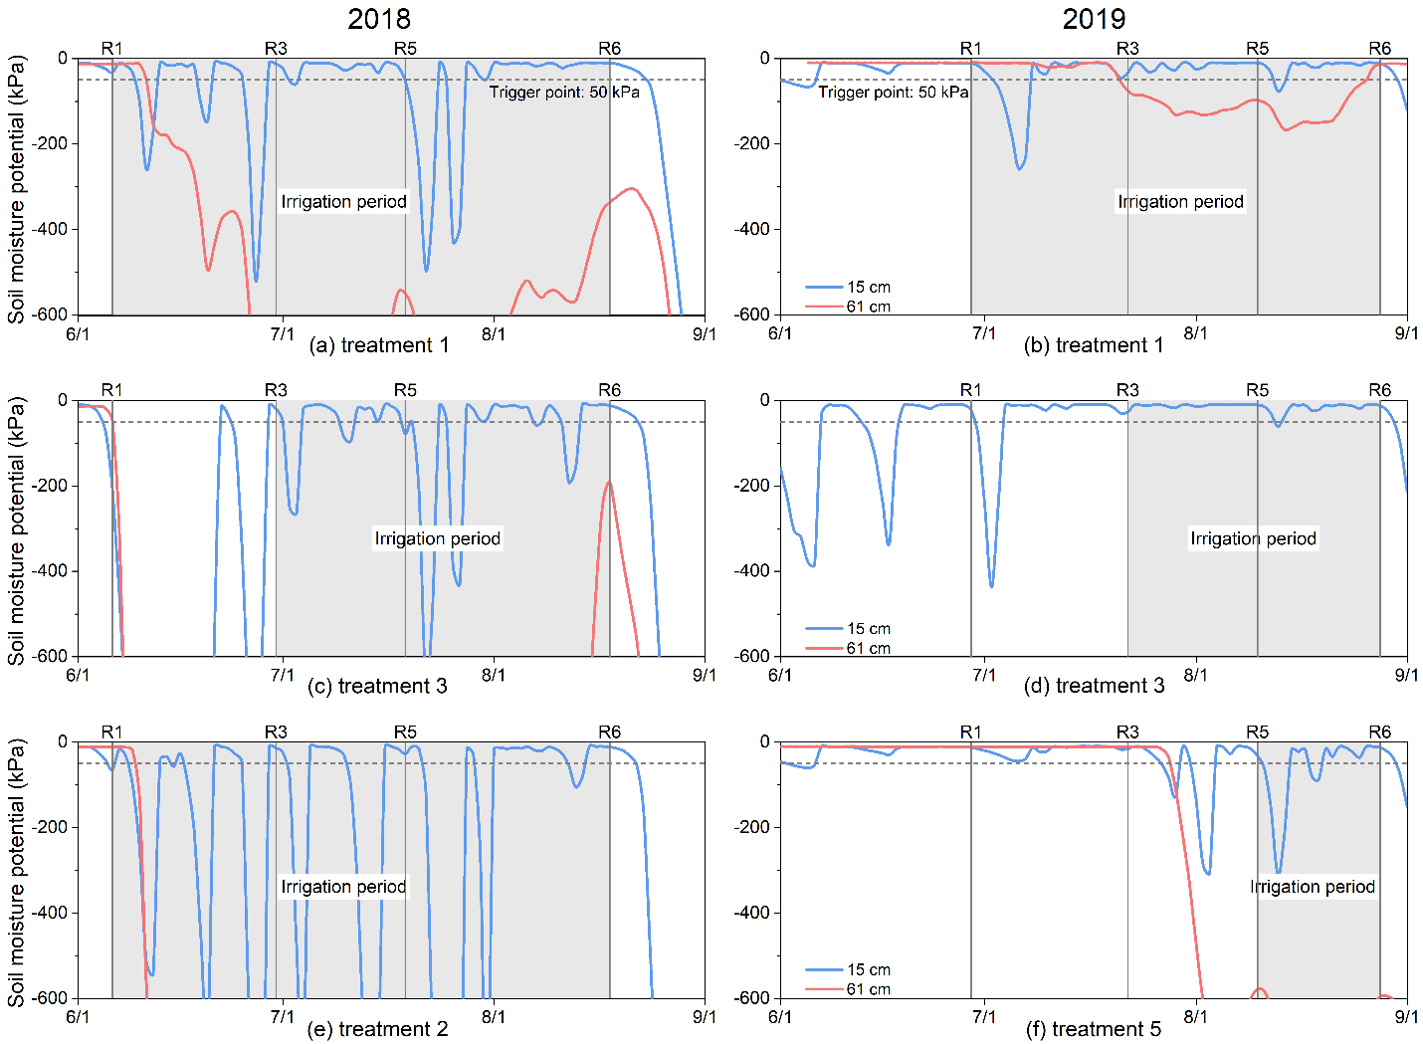
Figure 3.8. Soil moisture sensors in sandy soil zone.
Note: the sensor at 61 cm in treatment 3 in 2019 lost signal since few days after sowing. The negative sign of soil moisture potential denotes directionality and does not reflect the magnitude. Treatment 1: irrigation starts from R1 with 4.1 cm/wk. Treatment 2: irrigation starts from R1 with 2.8 cm/wk. Treatment 3: irrigation starts from R3 with 4.1 cm/wk. Treatment 5: irrigation starts from R5 with 4.1 cm/wk.

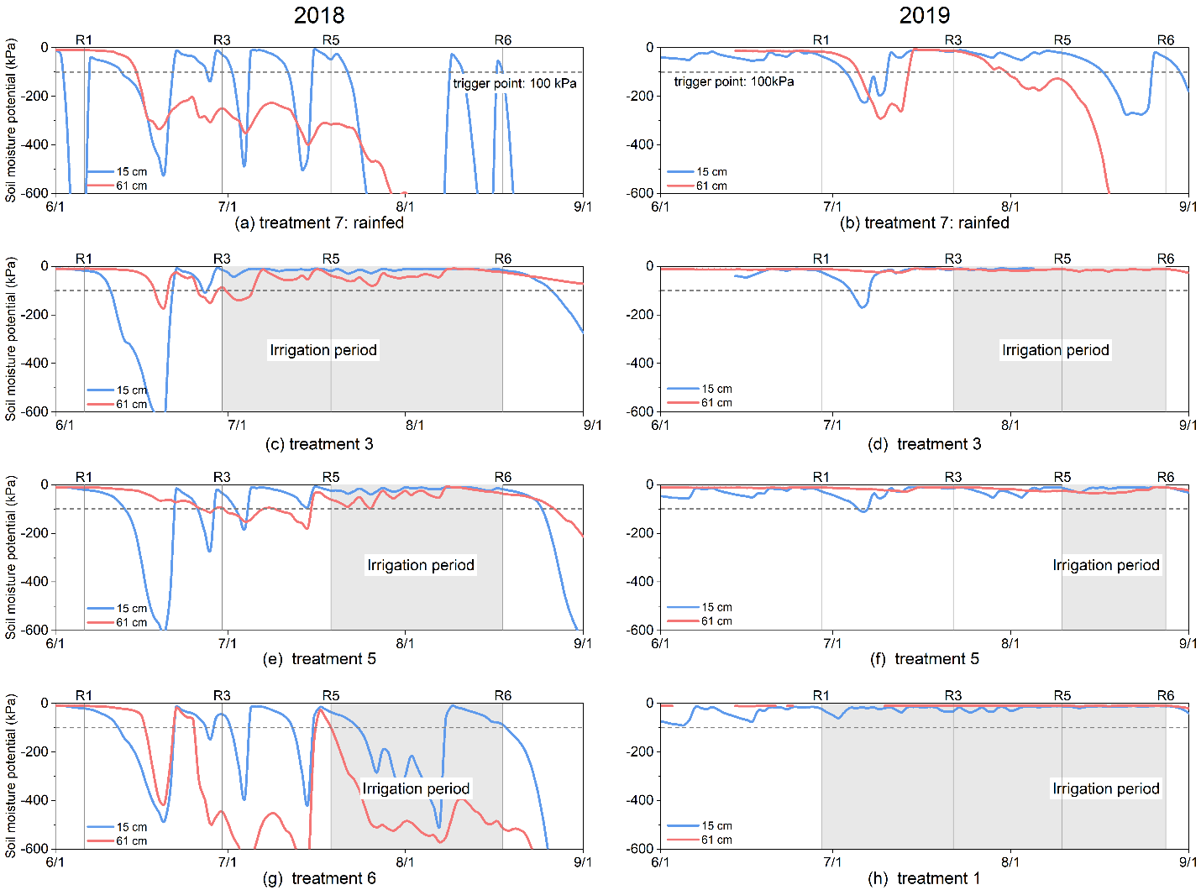
Figure 3.9. Soil moisture sensors in silt loam zone.
Note: The negative sign of soil moisture potential denotes directionality and does not reflect the magnitude. Treatment 1: irrigation starts from R1 with 4.1 cm/wk. Treatment 3: irrigation starts from R3 with 4.1 cm/wk. Treatment 5: irrigation starts from R5 with 4.1 cm/wk. Treatment 6: irrigation starts from R5 with 2.8 cm/wk

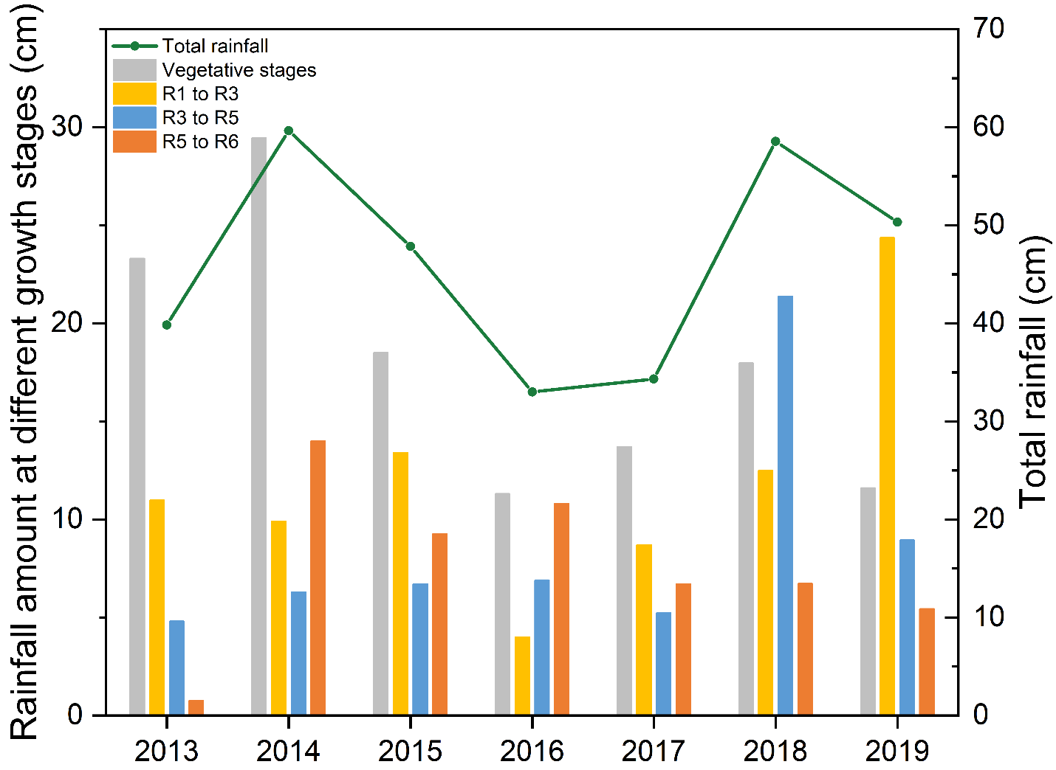
Figure 3.10. Rainfall distribution during soybean growth stages and total rainfall (from sowing to R6) from 2013 to 2019.

Using limited rainfed yield data for soybean irrigation management zone delineation in Tennessee

Abstract
Traditional uniform irrigation leads to inefficient water use through either over or under watering. While management zones (MZs) address this by dividing fields into homogeneous sub-areas for precision irrigation, the conventional delineation methods require extensive datasets that are costly and technically demanding for farmers, such as electrical conductivity (ECd) and ground-penetrating radar (GPR). This study evaluates whether single-year rainfed yield data can effectively replace the complex metrics (ECd and GPR) for MZ delineation in a Tennessee soybean production system. The methodology combines statistical (ANCOVA) and unsupervised clustering (k-means) methods, with validation conducted through a two-year (2018-2019) experiment testing irrigation initiation stages (R1, R3, R5) and application rates (2.8, 4.1 cm/wk). ANCOVA revealed that all three attributes (ECd, GPR, single-year rainfed yield) individually influenced irrigated yield (p < 0.05), but when analyzed together, only rainfed yield consistently predicted irrigated yield, unlike GPR (insignificant both years) or ECd (significant only in 2018). Among 7 k-means clustering methods derived from different combinations of these three attributes (ECd, GPR, single-year rainfed yield), yield-based clustering optimally identified two MZs (silhouette score = 0.73): Zone 1 (sandy soils) achieved 133% yield increases with R3-4.1 irrigation treatment (17 cm seasonal) in 2018, while Zone 2 (silt loam) showed no response. While 2019 rainfall minimized irrigation effects, the 2018 results highlight the utility of yield-based zones for water-use optimization by capturing field variability. This presents the possibility of single-year yield data as a practical, scientifically valid alternative to resource-intensive methods for precision irrigation in sub-humid regions, particularly where advanced soil sensing is unavailable.

Introduction
The increasing frequency of droughts necessitates the development of precision irrigation strategies to enhance agricultural productivity while optimizing water resource use (Hoegh-Guldberg et al., 2019; Xu et al., 2019; Falcon et al., 2022; Xing & Wang, 2024). Soybean (Glycine max L.) is a critical crop for global food security as a primary source of protein and oil, yet its production is highly sensitive to water availability (Anda et al., 2019; Di Mauro et al., 2019). Conventional irrigation management often applies water uniformly across the field based on average conditions, which often leads to either over- or under- watering due to the spatial variability in soil properties and topography (Evans et al., 2013). To address this more effectively, management zone delineation (MZD) has been employed to tailor irrigation strategies to sub-field variability, thereby improving water use efficiency and crop yield (Jiang et al., 2011; Chen et al., 2020; Agyeman et al., 2023).
By dividing a field into homogeneous sub-regions that respond similarly to inputs such as water, fertilizers, and pesticides, MZD improves crop productivity and reduces environmental impacts (Mzuku et al., 2005; Oldoni & Bassoi, 2016; Linker, 2021). However, a major challenge lies in acquiring sufficient data for MZD, which typically relies on soil sampling, sensors, yield maps, or remote sensing, resources often inaccessible to farmers due to cost and logistical limitations (Nawar et al., 2017). Among those data sources, yield data stands out because it directly correlates with producer income and inherently captures field variability driven by multiple interacting factors, such as, soil properties, weather, and management practices(Jaynes et al., 2005; Hornung et al., 2006). Yet, conventional MZD approaches require multi-year yield data to account for seasonal fluctuations, a requirement that may be impractical for many farmers. While some studies in Tennessee suggest yield data alone may offer less zoning potential than ECa, in regions lacking advanced sensing technologies, yield data often remains the only feasible option (Haghverdi et al., 2015).
To understand the feasibility of using yield data alone for MZD, it is necessary to examine the broader attributes used in zone delineation. These attributes can be broadly classified into three groups: (1) soil properties, which include inherent physical and chemical characteristics of the soil; (2) crop-related data, which encompass yield maps, vegetation indices, and other plant performance indicators; and (3) integrated approaches, which combine soil and crop data to improve the robustness of MZD. Each of these categories has distinct advantages and limitations, and their suitability depends on factors such as data availability, cost, and the specific objectives of precision management.
Soil properties have long been considered one of the most stable and influential factors in determining spatial variability in crop performance (Schepers et al., 2004; Mzuku et al., 2005). Among these, soil texture, organic matter content, water-holding capacity, and nutrient availability play critical roles in shaping yield patterns (Bashir et al., 2021; Ye et al., 2024). Measuring these properties traditionally requires destructive soil sampling and laboratory testing, which are time-, labor-, and cost-intensive due to the need for extensive sampling to represent entire fields accurately (Demougeot‐Renard et al., 2004; Yang et al., 2018). However, advancements in technology have introduced useful methods for indirectly measuring soil properties without disturbing the soil.
Geophysical tools such as soil apparent electrical conductivity (ECa) and ground-penetrating radar (GPR) have gained prominence in precision agriculture due to their ability to rapidly assess soil variability at high spatial resolution. ECa, for instance, measures how easily an electric current flow through the soil (Friedman, 2005). It is strongly influenced by clay content, moisture, and salinity, making it a useful proxy for soil texture and water retention characteristics (Clay et al., 2001; Corwin & Lesch, 2005b). ECa patterns remain consistent year after year and effectively illustrate how soil characteristics vary across a field (De Caires et al., 2014; Pedrera-Parrilla et al., 2017). Similarly, GPR, an electromagnetic technique that transmits and receives radio waves, provides insights into subsurface features such as soil layering and compaction by analyzing electromagnetic wave reflections (Knight, 2001; Neal, 2004). Changes in soil electrical properties cause partial reflection of these waves back to the receiver. By converting wave velocity and time into distance measurements, GPR can estimate the depth of claypans or fragipans and map lithologic discontinuities. While GPR is particularly effective in dry, coarse-textured soils with low amounts of expandable clay, its performance depends heavily on specific soil conditions (Lombardi et al., 2022; Adão et al., 2025). Both ECa and GPR have shown strong correlations with physical and chemical soil properties across spatial variability in crop productivity and have proven effective for MZD.
While ECa and GPR can effectively map soil variability, their relationship with actual crop yield is not always direct or consistent across different environments (Sun et al., 2011; Cavallo et al., 2016; Petito et al., 2025). Unlike soil-based measurements, crop-related data such as yield maps and vegetation indices provide a direct assessment of how spatial variability manifests in actual plant performance (Ozdogan, 2010; Li et al., 2020). Yield monitors mounted on harvesters generate high-resolution spatial data. However, the reliability of yield data has been questioned due to its sensitivity to interannual climatic fluctuations. Studies suggest that five or more consecutive years of yield records are ideal for creating temporally stable management zones because this volume of data averages out anomalies from individual seasons (Boydell & McBratney, 2002). A common yield-based MZD approach involves averaging relative yield data over multiple years, which assumes that yield patterns remain stable over time and reflect crop responses to environmental conditions rather than relying solely on soil-yield relationships (Jaynes et al., 2005). However, many producers lack access to such extensive historical data, particularly those who have recently adopted yield monitoring technology or whose field management practices, and crop rotations vary annually, raising concerns about the reliability of zones derived from limited years of data.
While a single year’s yield map may be heavily influenced by anomalous weather, leading to concerns that management zones derived from such data may not be stable over time, emerging evidence suggests that the spatial structure of yield variability, rather than absolute yield values, may remain consistent across seasons, even if the magnitude of yield changes (Batchelor et al., 2002; Jägermeyr & Frieler, 2018). Studies have shown that areas of persistently low or high yield tend to correlate with stable soil properties, meaning that a single year’s yield data may still capture key spatial patterns relevant for MZD (Maestrini & Basso, 2018). Nevertheless, the extent to which a single year’s rainfed yield data can substitute for multi-year datasets or soil-based measurements remains a critical research gap.
Recognizing the limitations of relying solely on soil or crop data, many researchers advocate for integrated approaches that combine multiple data layers to improve accuracy (Moral & Rebollo, 2017; Nawar et al., 2017; X. Wang et al., 2022). These hybrid methods leverage the strengths of both soil and crop datasets, compensating for their individual weaknesses. It captures inherent soil variability while addressing complex interactions among weather patterns, management practices, and plant genetics. For instance, combining high-resolution soil maps with vegetation index data can reveal how crops respond to stressors such as drought or waterlogging. Advanced sensor technologies and geostatistical methods further enhance precision by delineating stable management zones that optimize resource use efficiency while reducing production costs. While robust in theory, the added complexity and cost of acquiring and processing multiple data layers may not always be justified, particularly if simpler approaches (e.g., yield-only MZD) can achieve comparable results (Maestrini & Basso, 2018).
Given the trade-offs between data availability, cost, and accuracy, there is a pressing need to evaluate whether single-year rainfed yield data can serve as a standalone input for MZD without significant loss of precision compared to ECa, GPR, or integrated approaches. If proven effective, this would greatly simplify the adoption of precision irrigation strategies, particularly for small to mid-sized farms where advanced soil sensing technologies are not economically available.
The primary objective of this study is to assess the feasibility of using a single year of rainfed soybean yield data for MZD in Tennessee’s subtropical humid climate. This study aims to (1) evaluate the influence of electrical conductivity (ECa), ground-penetrating radar (GPR), and one-year rainfed yield data on irrigated soybean yield; (2) compare the efficacy of different combinations of these three attributes for zone delineation using k-means clustering; and (3) assess irrigation strategies based on these clustering methods for achieving the highest yield with less water use.

Method

Study site
This study was conducted at the West Tennessee Research and Education Center, Jackson, TN (35.624°N, 88.845°W), a sub-humid region characterized by variable rainfall patterns. The experimental field consisted of silt loam topsoil overlying sandy subsoil, with the thickness of silt loam topsoil varying across the site. Measurements of electrical conductivity at a depth of 90 cm (ECd) and GPR demonstrated strong correlations with sandy topsoil thickness, soil water-holding capacity, and sandy composition (Duncan, 2012).

Irrigation experimental setup
Irrigation treatments were implemented in 2018 and 2019 using a surface drip irrigation system with individual plot control. Each plot measured 3 m × 9.1 m and contained four rows of soybeans. Treatments varied by irrigation timing – early flowering (R1), early podding (R3), or early seeding (R5) - and irrigation rates of either 2.8 or 4.1 cm/week. Irrigation amount was adjusted based on rainfall amount. A rainfed control treatment was also included (Table 4.1). Each treatment was replicated 11 times in a randomized layout across the field. Fertilizer applications followed soil test recommendations from the University of Tennessee.

EC data measurement
A Veris Soil EC 3100 system (Veris Technologies, Inc., KS, USA) was used to measure ECa at depths of 0-30 cm and 0-90 cm using two sets of coulters mounted on a tractor. The widest coulters covered a swath width of 2.2 meters per pass. A John Deere StarFire 3000 GPS receiver with SF2 correction signal (Deere & Company, IL, USA) recorded the location of each reading. After collecting point data, ECa values were analyzed in ArcGIS Pro using Kriging to generate a field-wide shapefile. In this study, only EC at depth of 0-90 cm (ECd) was used and plot-level average ECd values were calculated based on plot size and location.

GPR data measurement
A GSSI SIR-20 data acquisition unit (Geophysical Survey Systems, Inc., NH, USA) equipped with real-time RTK-corrected GPS and a 200-MHz antenna (Model 5106) was used for GPR measurements. RADAN 6.6 software (Geophysical Survey Systems, Inc., NH, USA) integrated GPS data to generate radar images showing vertical changes in soil properties based on GPR reflections. By calculating the travel time of radar waves in nanoseconds and their velocity, the depth of uniform topsoil was determined at each sampling point. Kriging in ArcGIS Pro was used to interpolate these measurements across the field, and average GPR depths were calculated for each plot.

Yield data measurement
Soybean yields were measured for three consecutive years (2018-2020) using a harvester equipped with onboard sensors that recorded grain weight and moisture content from the middle two rows of each plot. The 2018 and 2019 data were collected under controlled irrigation treatments as part of an experimental design, while 2020 yields reflected rainfed conditions. Yield was calculated using the formula:
$$Y=67.25×w× \frac{100-m}{100-13}×\frac{43560}{60×ab}$$
where Y is yield in kg/ha, w is the weight, m is the moisture (%), a and b are the plot length and width, respectively, in feet.

Covariate analysis
Analysis of Covariance (ANCOVA) was conducted to evaluate how three field attributes - ECd, GPR, and 2020 rainfed soybean yield - influenced irrigated soybean yields under experimental conditions. These covariates represented potential benchmarks for yield under natural field conditions. Using irrigated yield as the response variable and irrigation treatments as the main effect, we developed separate ANCOVA models for each covariate (ECd, GPR, and 2020 yield) followed by a combined model incorporating all three covariates. To account for interannual variability, we analyzed the 2018 and 2019 irrigation experiments independently. All analyses were performed in SAS (v9.3, Cary, NC) using Fisher's protected Least Significant Difference test at α = 0.05.

Management zone delineation

Clustering method
To assess the effectiveness of single-year rainfed yield data for MZD, seven K-means were implemented clustering approaches using different combinations of three key attributes: ECd, GPR, and 2020 rainfed soybean yield (Table 4.2). Due to the difference range among attributes, all variables were standardized to normalize their measurement scales. The analysis was conducted in R Studio (Posit Connect, Boston, MA), where we developed and evaluated the K-means clustering models

The optimal cluster number determination
Two methods were employed to determine the optimal number of clusters. First, the elbow method was applied by plotting the within-cluster sum of squares (WSS) against the number of clusters, with the optimal cluster number identified at the inflection point where additional clusters provided diminishing returns in WSS reduction. Second, the average silhouette width (ASW) was calculated as the mean of all individual silhouette coefficients by comparing intra-cluster similarity with inter-cluster dissimilarity, ranging from -1 to 1 (Layton et al., 2013). Values approaching 1 indicate optimal cluster assignment, where observations are well-matched to their own cluster and distinctly separated from neighboring clusters. Intermediate values near 0 suggest ambiguous cluster membership, while negative values imply probable misclassification. The silhouette width (s(i)) for an individual observation i is calculated as:
$$s\left(i\right)= \frac{b\left(i\right)-a\left(i\right)}{max\left\{a\left(i\right), b\left(i\right)\right\}}$$
where $s(i)$ w is the silhouette coefficient, $a(i)$ is the mean distance between $i$ and all other data points in the same cluster. $b(i)$ is the smallest mean distance of $i$ to all points in any other cluster.

Evaluation of MZs for irrigation
To evaluate irrigation-responsive zones and identify optimal treatments, we conducted a two-tiered ANOVA approach following zone delineation using seven clustering methods. First, field-wide ANOVA assessed overall clustering effectiveness, with cluster, irrigation treatment, and their interaction as fixed effects and soybean yield as the response. Second, zone-specific ANOVAs examined irrigation effects within each management zone (MZ), treating irrigation treatment as the main effect and yield as the response. All pairwise comparisons used Fisher’s protected LSD test (α = 0.05). This hierarchical analysis enabled: (1) validation of zone delineation efficacy across the field, and (2) targeted evaluation of irrigation responses within zones to optimize spatial water management strategies.

Result

Descriptive statistics
Descriptive statistics of ECd, GPR, and 2020 rainfed yield revealed substantial field-scale variability among the three attributes with markedly different value ranges across the study area (Table 4.3). ECd values (4.0-15.7 mS/m) exhibited moderate variability characteristics of mixed soil textures with this range typically associated with sandy to silt loam soils. The comparatively narrower GPR range (1.3-3.5 m) suggested more homogeneous subsurface properties. In contrast, yield measurements showed substantial variation (285.7-4345.5 kg/ha), spanning an order of magnitude that reflects the complex interaction between soil properties, water availability, and agronomic factors. The skewness values (-0.4 to -0.6) indicate mild left-skewed distributions for all three datasets, while the kurtosis values reveal a near-normal distribution for ECd but platykurtic (flatter-than-normal) distributions for GPR and yield (Table 4.3). This near-normal distribution pattern, combined with the absence of significant outliers, confirms these parameters' suitability for geospatial analysis and supports their use in reliable management zone delineation.
Visual inspection of spatial patterns demonstrated a clear spatial correlation and coherent alignment of relative highs and lows across the three attribute maps (Figure 4.1). Notably, the spatial distribution of values exhibited a distinct geographical trend: the west field (located in the southwest) and the east field (located in the northeast) displayed contrasting patterns, with low values concentrated along their adjacent boundaries (the eastern part of the west field and the western part of the east field), while the remaining areas predominantly exhibited high values. This spatial structure suggests a potential underlying environmental or management-driven gradient influencing soil and crop performance. The consistency in low-value zones may indicate shared limiting factors, such as localized soil degradation, or hydrological constraints. Conversely, the high-value regions likely reflect more favorable conditions, possibly linked to soil fertility, or drainage efficiency. The strong spatial coherence among ECd, GPR, and rainfed yield further supports the interdependence of these variables in determining field-scale variability and reinforcing their combined utility for precision agriculture applications. Additionally, multivariate correlation analysis showed strong pairwise correlations (Table 4.4). These high Pearson correlation coefficients confirmed significant spatial correlation among ECd, GPR, and rainfed yield data. These observed field-scale variability and distribution characteristics highlight the potential for effective MZD using these datasets.

ANCOVA
When analyzed individually as covariates, all three attributes (ECd, GPR, and rainfed yield) exhibited significant effects on irrigated soybean yield. However, in the combined ANCOVA model incorporating all covariates simultaneously, only rainfed yield maintained consistent significance across both study years (Table 4.5). While ECd showed year-dependent effects (significant in 2018 but not 2019), GPR failed to demonstrate significant influence in either year.
These results imply that any of these attributes could potentially serve as viable proxies for spatial variability when access to comprehensive measurements is limited. Notably, rainfed yield emerged as the most robust indicator with two key advantages: consistent interannual reliability unaffected by unknown confounding factors and practical accessibility in resource-constrained scenarios where advanced sensing technologies (e.g., ECd or GPR) are unavailable. This underscores the particular utility of historical yield data as a foundational metric for MZD with limited infrastructure.

The optimal clustering number
The optimal number of clusters for this field was determined to be two, based on joint evaluation of WSS (Figure 4.2) and ASW (Figure 4.3). Among the seven clustering methods tested, the most effective spatial delineation - characterized by the highest ASW and lowest within-cluster sum of squares - was obtained when using exclusively rainfed yield data. These results demonstrate that interannual yield variability under rainfed conditions is the primary driver of spatial patterns in this agricultural system. The findings highlight the predominant influence of rainfall distribution on field-scale variability and confirm that single-year rainfed yield data can serve as a reliable standalone variable for management zone delineation in similar production environments.

Evaluation of management zones for irrigation
The clustering results from seven methods (Figure 4.4) aligned with spatial patterns observed in attribute maps (Figure 4.1), where zones with lower values predominantly occurred near field boundaries. The common zonal characterization of those seven results revealed significant differences in soil properties and yield performance between the two management zones. Zone 1 was distinguished by consistently lower values across all measured parameters, along with shallower sandy subsoil and a higher sand content. In contrast, zone 2 exhibited markedly higher ECd, GPR, and yield values, coupled with deeper sandy subsoil and dominant silt loam composition.
While WSS and ASW indicated that the two-cluster solution using only rainfed yield data (C3) outperformed other approaches in terms of cluster cohesion and separation, this superior clustering performance does not necessarily translate to improved irrigation management outcomes. To assess practical utility, ANOVA was conducted to examine the effects of management zones and irrigation treatments on irrigated soybean yield (Table 4.6) .The analysis revealed that management zones significantly influenced yield across all clustering methods in both years, and it confirms the importance of spatial variability and validating the clustering approaches for identifying zones with distinct yield potentials. However, the significance of irrigation treatments varied interannually. In the first year, irrigation showed no significant effect on yield when zones were derived solely from ECd or GPR data but became significant for the five methods incorporating yield data (either alone or combined with other attributes). This implies that yield-inclusive clustering better captured irrigation-responsive patterns in the first year. In contrast, irrigation had no significant effect in the second year regardless of clustering method, potentially due to more favorable rainfall distribution or other environmental factors that may have mitigated irrigation impacts or introduced compensating effects.
Additionally, no significant interaction was found between irrigation treatments and management zones in either year, indicating that irrigation and management zone affect yield independently.
To evaluate zone-specific irrigation effects, separate ANOVA models were conducted for each management zone in 2018 and 2019. The analysis revealed a significant irrigation effect (p < 0.05) on soybean yield in Zone 1 during both years, whereas no significant treatment response was detected in Zone 2 (Table 4.7). This consistent differential response pattern was observed across all seven clustering results, indicating robust spatial variation in irrigation efficacy. In 2019, irrigation treatments showed no significant yield impact in either zone, likely due to favorable in-season rainfall distribution that met crop water requirements, thereby diminishing the relative benefit of supplemental irrigation.
Analysis of the responsive system (zone 1 in 2018) revealed a consistent yield response pattern across all seven clustering methods (Figure 4.5). While minor variations existed between methods, they all showed a similar relationship between irrigation and yield. However, the method only using rainfed yield has smoother transitions and resembles a traditional water production function. Notably, soybean yield exhibited diminishing returns beyond 17 cm of irrigation water with no statistically significant yield increase (p > 0.05) observed at higher application rates. The 17 cm irrigation treatment produced a dramatic improvement of over 180% compared to rainfed conditions, elevating yields from 980 kg/ha to 2500 kg/ha. This response pattern suggests the existence of an irrigation threshold that optimizes water use efficiency in this management zone. And the consistency of this threshold across all clustering approaches strengthens its reliability for management decisions in similar soil-crop systems.

Discussion
Our results demonstrate that single-year yield data can effectively replace resource-intensive measurements for irrigation management zone delineation in sub-humid soybean production systems. While achieving comparable precision to multi-sensor approaches, this simplified method overcomes three key implementation barriers: (1) eliminating specialized equipment requirements, (2) reducing data processing complexity, and (3) demonstrating operational validity under real-world rainfall variability (Haghverdi et al., 2016; Yari et al., 2017; Reyes et al., 2019; Fontanet et al., 2020; Flint et al., 2023; Maleki et al., 2023). The two-year validation experiment confirmed consistent irrigation responses across zones delineated by yield data alone. This finding is particularly significant for resource-limited operations where current precision agriculture technologies remain impractical due to high costs and technical demands. Our approach bridges the gap between scientific precision and farm-level feasibility by transforming existing yield data into actionable zone management insights.

Considerations for selecting representative single-year rainfed yield data
The selection of an optimal rainfed year for MZD represents a critical decision point in precision agriculture implementation, as it must balance the need to capture persistent spatial variability while minimizing distortion from anomalous weather events (Ceglar et al., 2016; Leroux et al., 2018). Our study selected the 2020 growing season as the foundation for zoning based on its meteorological representativeness and yield response characteristics. This year received near-average precipitation (50.6 cm compared to the 20-year average of 57.9 cm) with appropriate temporal distribution that avoided both water stress periods and excessive rainfall events (NOAA, 2024). More importantly, spatial yield patterns in 2020 demonstrated strong concordance with multi-year trends (r = 0.7-0.8, p < 0.01), suggesting this single year effectively captured the field's inherent productivity gradients rather than transient weather impacts. These findings align with the growing recognition that well-selected individual growing seasons can serve as practical proxies for longer-term yield patterns in limited resources farms. However, the approach requires careful meteorological screening - as demonstrated by the contrasting conditions in adjacent years - along with the screening out of other production problems that were inconsistent across the field. For example, 2017's extended drought and 2018's record precipitation in Tennessee would have introduced substantial bias and misleading interpretation (Xie et al., 2024).
Future research directions should prioritize two complementary pathways: first, validating the temporal stability of single-year-derived zones across diverse weather scenarios, and second, developing hybrid approaches that strategically combine yield data with targeted soil measurements. Emerging technologies like AI-driven yield prediction models and seasonal climate forecasting tools could further enhance zoning robustness (Guo et al., 2022; L. Li et al., 2022; X. Li et al., 2022; J. Wang et al., 2024). This evolution toward integrated data systems promises to bridge the gap between scientific precision and practical farm implementation.

Selection of the optimal zone number
The determination of the optimal number of MZs is critical for implementing effective precision agriculture strategies. Our analysis employing statistical metrics (WSS and ASW) provided the most effective balance between cluster compactness and separation to identify the optimal zone number (Rousseeuw, 1987; Tibshirani et al., 2001). It offers the advantage of being data-driven and reproducible, as demonstrated by the clear elbow point in the WSS curve and the maximized ASW value (0.73) for k=2. Such methods have been widely adopted in precision agriculture studies due to their computational efficiency and ability to handle multivariate datasets(Pascucci et al., 2018; Ohana-Levi et al., 2021; R. Naveen Kumar et al., 2023; Thongnim et al., 2023; Rodrigues de Oliveira et al., 2024; Subham et al., 2024).
However, several researchers have advocated for incorporating soil water dynamics directly into the zone delineation process (Haghverdi et al., 2015, 2016; Jiang et al., 2011). This alternative approach typically considers factors such as soil water holding capacity, infiltration rates, and plant available water content to define zones that reflect fundamental hydrological differences. While theoretically appealing, this method presents practical challenges in data acquisition of soil water mapping particularly for smallholder farmers who may lack access to detailed soil hydraulic property measurements (Adamchuk et al., 2004).
The choice between these approaches ultimately depends on the intended application of the management zones. Statistically derived zones based on WSS/ASW may better capture integrated crop responses to multiple stress factors, while soil water-based delineation could provide more direct guidance for irrigation scheduling. Our results suggest that for systems where yield monitoring is already implemented, the statistical approach offers a practical compromise that maintains scientific rigor while remaining accessible to farmers. Additionally, our two-zone solution via statistical method demonstrated strong agreement with observed soil textural differences and irrigation response patterns in our study area. This convergence between statistical clustering and agronomic reality supports the validity of our approach while highlighting the importance of ground-truthing any zone delineation method against field observations. Future research could explore hybrid approaches that combine the objectivity of statistical clustering with key soil water parameters to further refine zone delineation for irrigation management.

Conclusion
This study demonstrates that single-year rainfed yield data (2020) effectively supports soybean irrigation management zone delineation under Tennessee's sub-humid climate, validated through both statistical (ANCOVA) and unsupervised clustering (k-means) methods. ANCOVA of individual attributes (rainfed yield, ECd, GPR) revealed all three significantly influenced irrigated yield when analyzed separately. However, combined ANCOVA showed only 2020 rainfed yield maintained consistent predictive power across both years (2018–2019), while ECd exhibited year-specific effects (significant in 2018 only) and GPR showed no significance. K-means clustering method reinforced these findings: yield-only k-means achieved superior zone separation (ASW = 0.73) compared to multi-attribute approaches. Evaluation of seven irrigation treatments across delineated zones (derived from distinct input combinations) consistently identified a consistent irrigation threshold of 17 cm (seasonal total) for yield maximization in responsive zones (2018), with diminishing returns observed at higher application rates. While favorable rainfall in 2019 obscured irrigation effects, the 2018 results highlight the utility of yield-based zones for water-use optimization. By bridging statistical validation and unsupervised clustering, this work establishes a resource-efficient framework for precision irrigation, prioritizing accessible yield data without sacrificing analytical rigor. Future research should investigate zone stability across climate extremes and integrate real-time weather adaptation.

References
Amankulova, K., Farmonov, N., Akramova, P., Tursunov, I., & Mucsi, L. (2023). Comparison of PlanetScope, Sentinel-2, and landsat 8 data in soybean yield estimation within-field variability with random forest regression. Heliyon, 9(6), e17432. https://doi.org/10.1016/j.heliyon.2023.e17432
Bodner, G., Nakhforoosh, A., & Kaul, H.-P. (2015). Management of crop water under drought: a review. Agronomy for Sustainable Development, 35(2), 401–442. https://doi.org/10.1007/s13593-015-0283-4
Campos, I., González-Gómez, L., Villodre, J., González-Piqueras, J., Suyker, A. E., & Calera, A. (2018). Remote sensing-based crop biomass with water or light-driven crop growth models in wheat commercial fields. Field Crops Research, 216, 175–188. https://doi.org/10.1016/j.fcr.2017.11.025
Crusiol, L. G. T., Nanni, M. R., Furlanetto, R. H., Sibaldelli, R. N. R., Cezar, E., Sun, L., Foloni, J. S. S., Mertz-Henning, L. M., Nepomuceno, A. L., Neumaier, N., & Farias, J. R. B. (2021). Yield prediction in soybean crop grown under different levels of water availability using reflectance spectroscopy and partial least squares regression. Remote Sensing, 13(5), 977. https://doi.org/10.3390/rs13050977
Dietz, K. ‐J., Zörb, C., & Geilfus, C. ‐M. (2021). Drought and crop yield. Plant Biology, 23(6), 881–893. https://doi.org/10.1111/plb.13304
Fathi, M., Shah-Hosseini, R., & Moghimi, A. (2023). 3D-ResNet-BiLSTM model: A deep learning model for county-level soybean yield prediction with time-series Sentinel-1, Sentinel-2 Imagery, and daymet data. Remote Sensing, 15(23), 5551. https://doi.org/10.3390/rs15235551
Fu, Z., Jiang, J., Gao, Y., Krienke, B., Wang, M., Zhong, K., Cao, Q., Tian, Y., Zhu, Y., Cao, W., & Liu, X. (2020). Wheat growth monitoring and yield estimation based on multi-rotor Unmanned Aerial Vehicle. Remote Sensing, 12(3), 508. https://doi.org/10.3390/rs12030508
Gao, F., Anderson, M., Daughtry, C., Karnieli, A., Hively, D., & Kustas, W. (2020). A within-season approach for detecting early growth stages in corn and soybean using high temporal and spatial resolution imagery. Remote Sensing of Environment, 242, 111752. https://doi.org/10.1016/j.rse.2020.111752
Gitelson, A. A., Kaufman, Y. J., Stark, R., & Rundquist, D. (2002). Novel algorithms for remote estimation of vegetation fraction. Remote Sensing of Environment, 80(1), 76–87. https://doi.org/10.1016/S0034-4257(01)00289-9
Gitelson, A., & Merzlyak, M. N. (1994). Spectral Reflectance Changes Associated with Autumn Senescence of Aesculus hippocastanum L. and Acer platanoides L. Leaves. Spectral Features and Relation to Chlorophyll Estimation. Journal of Plant Physiology, 143(3), 286–292. https://doi.org/10.1016/S0176-1617(11)81633-0
Haghverdi, A., Leib, B., Washington-Allen, R., Wright, W., Ghodsi, S., Grant, T., Zheng, M., & Vanchiasong, P. (2019). Studying crop yield response to supplemental irrigation and the spatial heterogeneity of soil physical attributes in a humid region. Agriculture, 9(2), 43. https://doi.org/10.3390/agriculture9020043
Herrero-Huerta, M., Rodriguez-Gonzalvez, P., & Rainey, K. M. (2020). Yield prediction by machine learning from UAS-based multi-sensor data fusion in soybean. Plant Methods, 16(1), 78. https://doi.org/10.1186/s13007-020-00620-6
Huang, H., Huang, J., Feng, Q., Liu, J., Li, X., Wang, X., & Niu, Q. (2022). Developing a dual-stream deep-learning neural network model for improving county-level winter wheat yield estimates in China. Remote Sensing, 14(20), 5280. https://doi.org/10.3390/rs14205280
Huete, A. R. (1988). A soil-adjusted vegetation index (SAVI). Remote Sensing of Environment, 25(3), 295–309. https://doi.org/10.1016/0034-4257(88)90106-X
Javadinejad, S., Eslamian, S., & Askari, K. O. A. (2021). The analysis of the most important climatic parameters affecting performance of crop variability in a changing climate. International Journal of Hydrology Science and Technology, 11(1), 1. https://doi.org/10.1504/IJHST.2021.112651
Jordan, C. F. (1969). Derivation of Leaf‐Area Index from Quality of Light on the Forest Floor. Ecology, 50(4), 663–666. https://doi.org/10.2307/1936256
Lakhiar, I. A., Yan, H., Zhang, C., Wang, G., He, B., Hao, B., Han, Y., Wang, B., Bao, R., Syed, T. N., Chauhdary, J. N., & Rakibuzzaman, Md. (2024). A review of precision irrigation water-saving technology under changing Climate for enhancing water use efficiency, crop yield, and environmental footprints. Agriculture, 14(7), 1141. https://doi.org/10.3390/agriculture14071141
Leib, B. G., Knappenberger, T. J., Vellidis, G., & Wendroth, O. (2021). A regional approach to improving soybean irrigation management in the Southeastern United States. 6th Decennial National Irrigation Symposium, 6-8, December 2021, San Diego, California, 1. https://doi.org/10.13031/irrig.2020-054
Ma, B. L., Dwyer, L. M., Costa, C., Cober, E. R., & Morrison, M. J. (2001). Early Prediction of Soybean Yield from Canopy Reflectance Measurements. Agronomy Journal, 93(6), 1227–1234. https://doi.org/10.2134/agronj2001.1227
Ma, Y., Ma, L., Zhang, Q., Huang, C., Yi, X., Chen, X., Hou, T., Lv, X., & Zhang, Z. (2022). Cotton Yield Estimation Based on Vegetation Indices and Texture Features Derived From RGB Image. Frontiers in Plant Science, 13. https://doi.org/10.3389/fpls.2022.925986
Maimaitijiang, M., Sagan, V., Sidike, P., Hartling, S., Esposito, F., & Fritschi, F. B. (2020). Soybean yield prediction from UAV using multimodal data fusion and deep learning. Remote Sensing of Environment, 237, 111599. https://doi.org/10.1016/j.rse.2019.111599
Mohite, J. D., Sawant, S. A., Pandit, A., Agrawal, R., & Pappula, S. (2023). Soybean crop yield prediction by integration of remote sensing and weather observations. The International Archives of the Photogrammetry, Remote Sensing and Spatial Information Sciences, XLVIII-M-1–2023, 197–202. https://doi.org/10.5194/isprs-archives-XLVIII-M-1-2023-197-2023
Muruganantham, P., Wibowo, S., Grandhi, S., Samrat, N. H., & Islam, N. (2022). A systematic literature review on crop yield prediction with deep learning and remote sensing. Remote Sensing, 14(9), 1990. https://doi.org/10.3390/rs14091990
NASS. (2025, January 10). 2024 State agriculture overview - Tennessee. https://www.nass.usda.gov/Quick_Stats/Ag_Overview/stateOverview.php?state=TENNESSEE&utm_source=chatgpt.com
Oya, T., Lima Nepomuceno, A., Neumaier, N., Bouças Farias, J. R., Tobita, S., & Ito, O. (2004). Drought tolerance characteristics of Brazilian soybean cultivars. Plant Production Science, 7(2), 129–137. https://doi.org/10.1626/pps.7.129
Qi, J., Chehbouni, A., Huete, A. R., Kerr, Y. H., & Sorooshian, S. (1994). A modified soil adjusted vegetation index. Remote Sensing of Environment, 48(2), 119–126. https://doi.org/10.1016/0034-4257(94)90134-1
Qiao, M., He, X., Cheng, X., Li, P., Luo, H., Zhang, L., & Tian, Z. (2021). Crop yield prediction from multi-spectral, multi-temporal remotely sensed imagery using recurrent 3D convolutional neural networks. International Journal of Applied Earth Observation and Geoinformation, 102, 102436. https://doi.org/10.1016/j.jag.2021.102436
Rouse, J. W. R. H. H. J. A. S. and D. W. Deering. (1974). Monitoring vegetation systems in the Great Plains with ERTS. NASA Spec. Publ , 351(1), 309.
Sanches, G. M., Duft, D. G., Kölln, O. T., Luciano, A. C. dos S., De Castro, S. G. Q., Okuno, F. M., & Franco, H. C. J. (2018). The potential for RGB images obtained using unmanned aerial vehicle to assess and predict yield in sugarcane fields. International Journal of Remote Sensing, 39(15–16), 5402–5414. https://doi.org/10.1080/01431161.2018.1448484
Sun, J., Di, L., Sun, Z., Shen, Y., & Lai, Z. (2019). County-level soybean yield prediction using deep CNN-LSTM model. Sensors, 19(20), 4363. https://doi.org/10.3390/s19204363
Wang, N., Ma, Z., Huo, P., & Liu, X. (2023). Predicting crop yield using 3d convolutional neural network with dimension reduction and metric learning. 2023 IEEE 6th International Conference on Pattern Recognition and Artificial Intelligence (PRAI), 1004–1008. https://doi.org/10.1109/PRAI59366.2023.10331974
Wanyama, J., & Bwambale, E. (2023). Precision water management. In Encyclopedia of Digital Agricultural Technologies (pp. 1062–1069). Springer International Publishing. https://doi.org/10.1007/978-3-031-24861-0_213
Wu, Q., QI, B., ZHAO, T.-J., YAO, X.-F., ZHU, Y., & GAI, J.-Y. (2013). A Tentative Study on Utilization of Canopy Hyperspectral Reflectance to Estimate Canopy Growth and Seed Yield in Soybean. Acta Agronomica Sinica, 39(2), 309. https://doi.org/10.3724/SP.J.1006.2013.00309
Xie, S., Leib, B. G., Farhadi-Machekposhti, M., Grant, T. J., Adotey, N., & Butler, D. M. (2024). Soybean yield response to managed depletion irrigation regimes in a Mid-South silt loam soil. Agricultural Water Management, 292, 108657. https://doi.org/10.1016/j.agwat.2023.108657
Xing, Y., & Wang, X. (2024). Precision agriculture and water conservation strategies for sustainable crop production in arid regions. Plants, 13(22), 3184. https://doi.org/10.3390/plants13223184
You, J., Li, X., Low, M., Lobell, D., & Ermon, S. (2017). Deep gaussian process for crop yield prediction based on remote sensing data. Proceedings of the AAAI Conference on Artificial Intelligence, 31(1). https://doi.org/10.1609/aaai.v31i1.11172
Yu, K., Kirchgessner, N., Grieder, C., Walter, A., & Hund, A. (2017). An image analysis pipeline for automated classification of imaging light conditions and for quantification of wheat canopy cover time series in field phenotyping. Plant Methods, 13(1), 15. https://doi.org/10.1186/s13007-017-0168-4
Zeng, L., Peng, G., Meng, R., Man, J., Li, W., Xu, B., Lv, Z., & Sun, R. (2021). Wheat Yield Prediction Based on Unmanned Aerial Vehicles-Collected Red–Green–Blue Imagery. Remote Sensing, 13(15), 2937. https://doi.org/10.3390/rs13152937
Zhang, K. F., ZHANG, Z., ZHANG, Y. H., & LI, H. *. (2019). Experimental study of single-rotor UAV on droplet deposition distribution in soybean field. Applied Ecology and Environmental Research, 17(6). https://doi.org/10.15666/aeer/1706_1383313844

Appendix IV
Table 4.1. Irrigation treatment design by timing and rate
Treatment number | Irrigation timing | Irrigation rate (cm/wk)
1 | R1 | 4.1
2 | R1 | 2.8
3 | R3 | 4.1
4 | R3 | 2.8
5 | R5 | 4.1
6 | R5 | 2.8
7 | Rainfed

Table 4.2. Summary of MZD attributes and clustering algorithms
Clustering number | Attributes
C1 | ECd
C2 | GPR
C3 | Rainfed yield
C4 | ECd, GPR
C5 | ECd, Rainfed yield
C6 | GPR, Rainfed yield
C7 | ECd, GPR, Rainfed yield

Table 4.3. Descriptive statistics of ECd, GPR, and 2020 rainfed yield
 | ECd (mS/m) | GPR (m) | Rainfed yield (kg/ha)
Min | 4.0 | 1.3 | 285.7
Mean | 9.7 | 2.6 | 2817.7
Max | 15.7 | 3.5 | 4345.5
Standard deviation | 2.5 | 0.6 | 1208
Standard error | 0.3 | 0.07 | 137.7
Skewness | -0.5 | -0.4 | -0.6
Excess Kurtosis | 0.03 | -0.88 | -0.99

Table 4.4. Pearson correlation coefficients (r) among ECd, GPR, 2020 rainfed yield
r | ECd | GPR | 2020 rainfed yield
ECd | 1
GPR | 0.78 | 1
2020 rainfed yield | 0.78 | 0.80 | 1
Note: ns: not significant; *: p<0.05; **: p<0.01; ***: p<0.0001.

Table 4.5. ANCOVA result of ECa, GPR, and 2020 rainfed yield effects on irrigated soybean yield in 2018 and 2019
 | Yield in 2018 | Yield in 2019
Irrigation treatment | ** | ns
ECd | *** | ns
GPR | ns | ns
2020 rainfed yield | *** | ***
Note: ns: not significant; *: p<0.05; **: p<0.01; ***: p<0.0001.

Table 4.6. Two-way ANOVA for irrigation treatment and management zone effects on soybean yield
 | C1 |  | C2 |  | C3 |  | C4 |  | C5 |  | C6 |  | C7
 | 2018 | 2019 | 2018 | 2019 | 2018 | 2019 | 2018 | 2019 | 2018 | 2019 | 2018 | 2019 | 2018 | 2019
Treatment | ns | ns | ns | ns | *** | ns | * | ns | * | ns | ** | ns | ** | ns
zone | *** | *** | *** | *** | *** | *** | *** | *** | *** | *** | *** | *** | *** | ***
Treatment*zone | ns | ns | ns | ns | ns | ns | ns | ns | ns | ns | ns | ns | ns | ns
Note: ns: not significant; *: p<0.05; **: p<0.01; ***: p<0.0001.

Table 4.7. ANOVA of irrigation treatment effects on soybean yield in 2018 and 2019 within each zone with seven clustering methods
zone | C1 |  | C2 |  | C3 |  | C4 |  | C5 |  | C6 |  | C7
zone | 2018 | 2019 | 2018 | 2019 | 2018 | 2019 | 2018 | 2019 | 2018 | 2019 | 2018 | 2019 | 2018 | 2019
1 | * | ns | * | ns | * | ns | ** | ns | * | ns | ** | ns | ** | ns
2 | ns | ns | ns | ns | ns | ns | ns | ns | ns | ns | ns | ns | ns | ns
Note: ns: not significant; *: p<0.05; **: p<0.01; ***: p<0.0001.

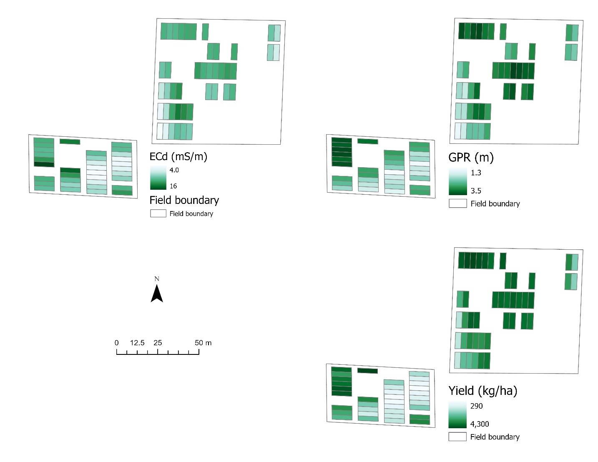
Figure 4.1 Spatial distribution of ECd, GPR, and 2020 rainfed yield

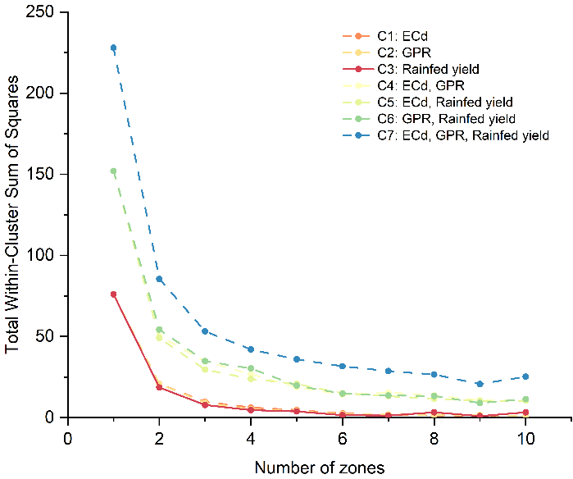
Figure 4.2 Within-cluster sum of squares for seven cluster methods

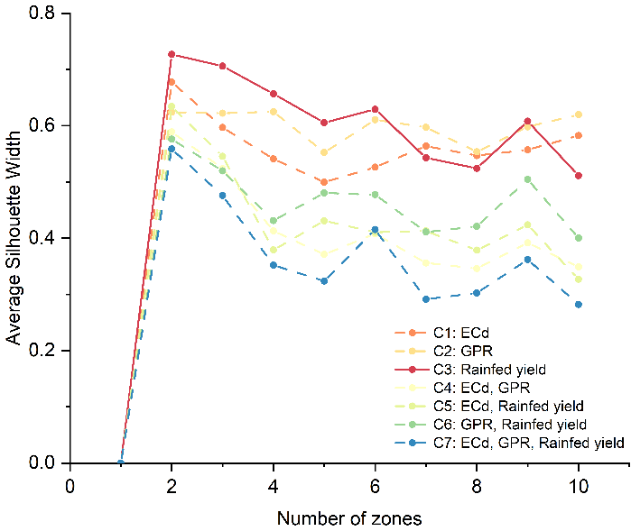
Figure 4.3 Average silhouette width for seven cluster methods

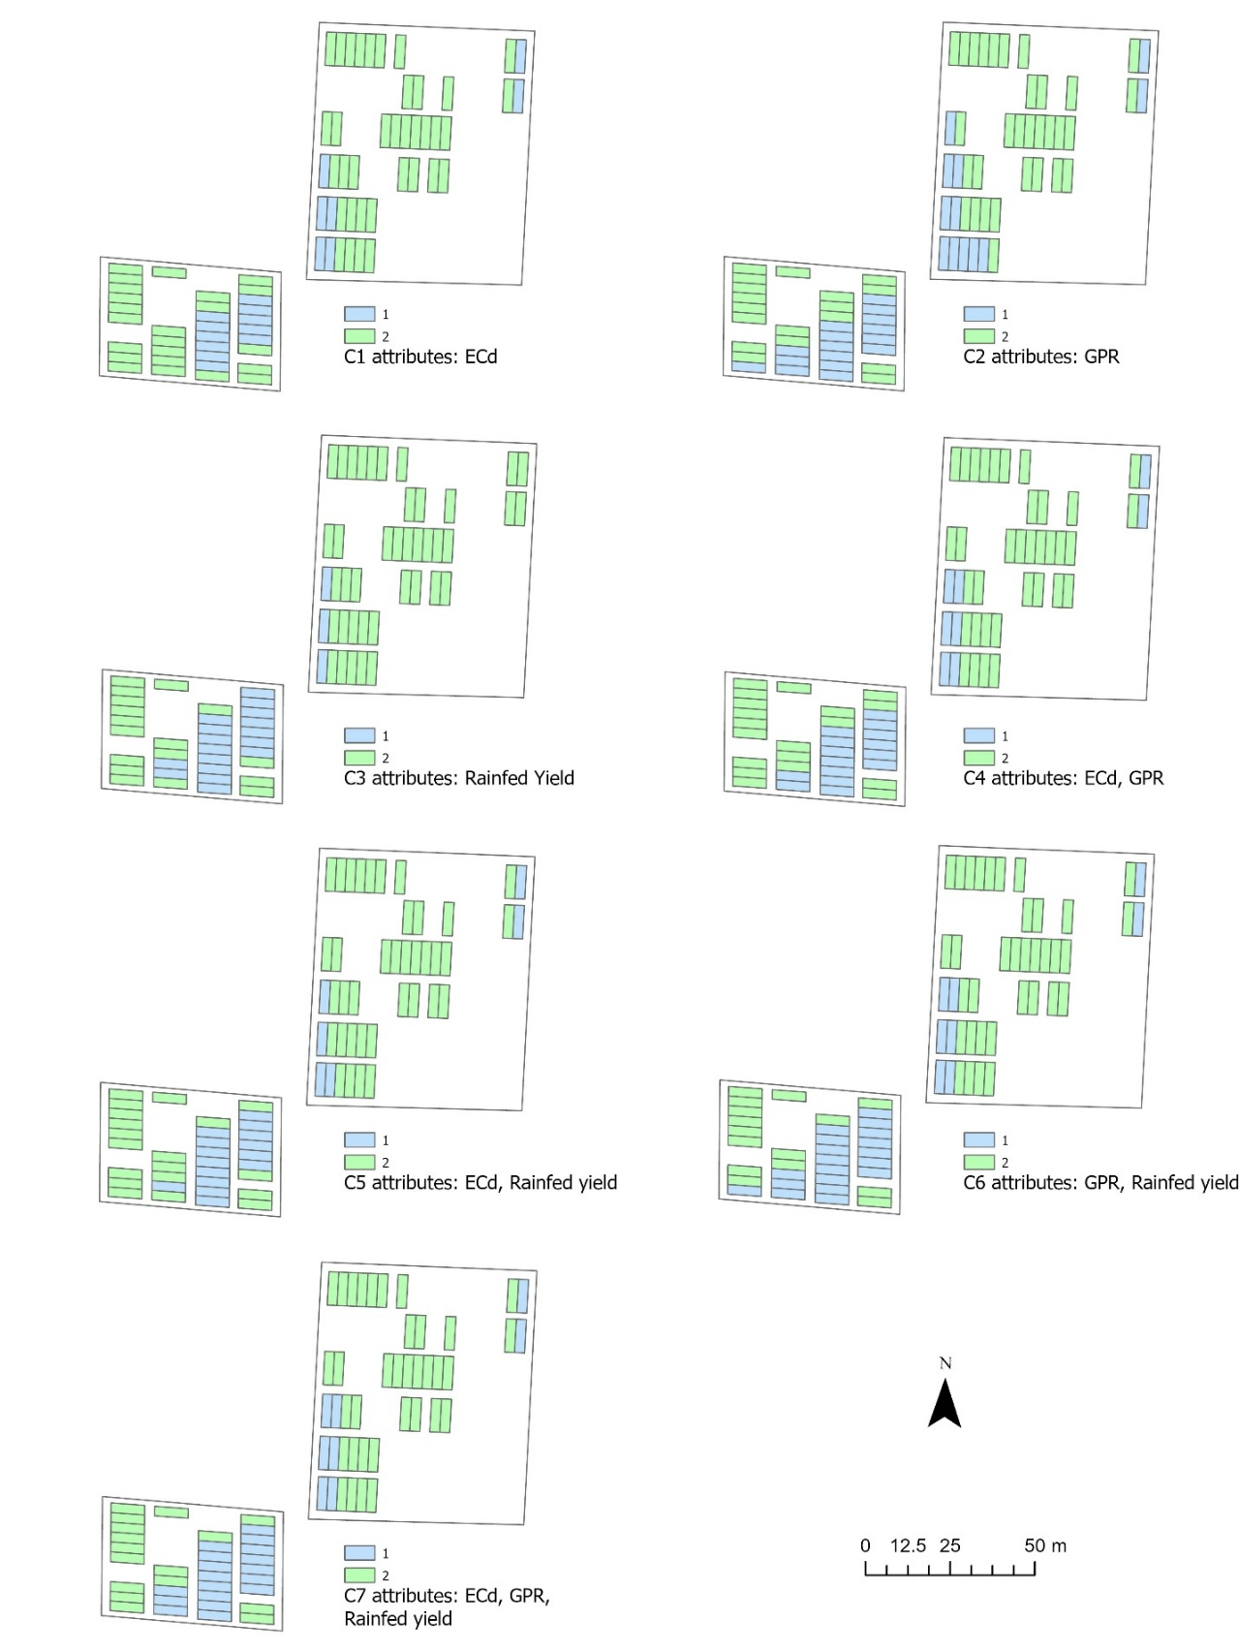
Figure 4.4 Management zone results for seven clustering methods

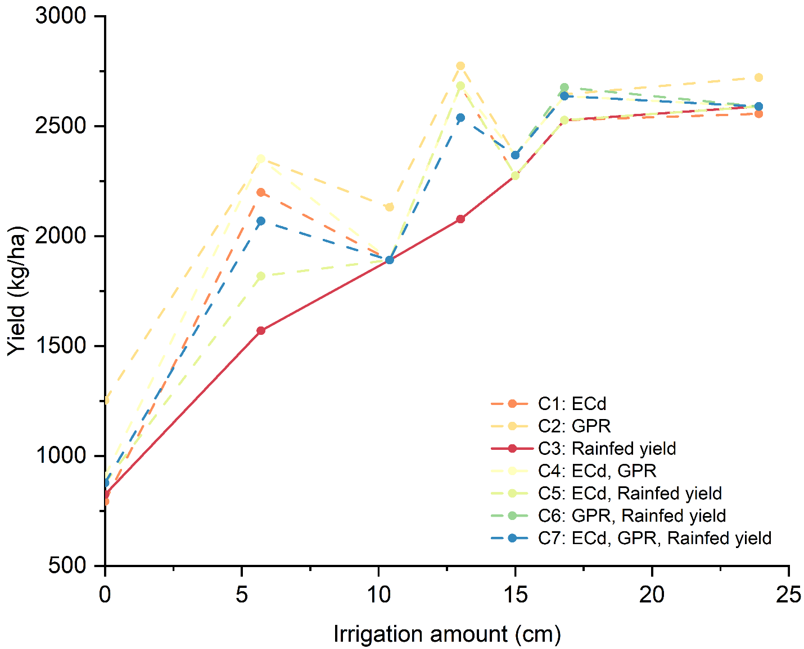
Figure 4.5 Soybean yield response to irrigation amount in zone 1 (2018) across seven clustering methods

Soybean yield prediction from UAV multispectral imagery under various irrigation regimes

Abstract
Field-scale yield prediction plays a crucial role in advancing precision agriculture and site-specific crop management. This study develops a soybean yield prediction model across multiple growing seasons by integrating multi-temporal UAV multispectral (MS) imagery with soil variability data. Seven supplemental irrigation experiments were conducted in 2023 and 2024 across a field exhibiting high spatial soil heterogeneity. Five-band MS images were acquired at three soybean growth stages (R1, R3, and R5) and nine vegetation indices (VIs) were derived. The research evaluates in- and post-season model's performance with various input feature combinations (RGB VIs, MS VIs, RGB VIs + soil feature, MS VIs + soil feature). Three machine learning methods (multiple linear regression, support vector machine, and random forest) and one time series model (long-short term memory) were used for in- and post-season predictions, respectively. The results reveal that VI-yield correlations varied significantly by growth stage, with NDVI and GNDVI demonstrating the strongest and most consistent relationships at reproductive phases. The incorporation of soil data substantially improved model performance, reducing prediction errors and enhancing explanatory power compared to VI-only approaches. Among the post-season models, the input combination of RGB VIs +soil demonstrated the highest performance (R² = 0.80, MAE = 458, RMSE = 578). In contrast, in-season yield prediction models highlighted the importance of growth stage specific strategies. 30 out of 36 in-season models achieved higher predictive accuracy than the LSTM-based models. The study provides a methodological framework for yield prediction in heterogeneous fields while highlighting the critical importance of soil-vegetation dynamics in crop modeling.

Introduction
Accurate yield prediction and effective water management are foundational to modern precision agriculture(Wanyama & Bwambale, 2023; Lakhiar et al., 2024; Xing & Wang, 2024). Among the many factors influencing yield variability, water availability remains one of the most critical as especially under increasing climate variability and frequent drought conditions (Bodner et al., 2015; Dietz et al., 2021; Javadinejad et al., 2021).
The timing and amount of water supply, particularly during flowering and seed-filling stages, influences soybean protein and oil content as well as yield (Oya et al., 2004; Crusiol et al., 2021). This challenge is especially pertinent in Tennessee, where soybean dominates 676, 000 hectares, generating 771 million dollars in annual value (NASS, 2025). However, the average yield of 3228 kg/ha exhibits high spatial variability within the field due to uneven water availability driven by unpredictable rainfall patterns and heterogeneous soils (Haghverdi et al., 2019; B. G. Leib et al., 2021; Xie et al., 2024b). Traditional yield prediction methods rely on labor-intensive field surveys and medium-resolution satellite imagery, which often lack the spatial and temporal resolution needed for precision agriculture. Consequently, timely and accurate soybean yield prediction has been a focal point of recent research with various innovative methods being developed to address this challenge.
Remote sensing (RS) technology has gained popularity for crop yield prediction due to its wide-area coverage, continuous monitoring, and affordability (Qiao et al., 2021; Meganathan et al., 2022). Crop yield prediction based on RS can be accomplished by two main categories of models: process-based biophysical (PB) and machine-learning (ML) models (Fathi et al., 2023). Process-based biophysical models rely on the understanding of the biological processes involved in crop growth to make predictions, such as crop height and leaf area index. However, the drawback of these models is the reliance on detailed ground data to calibrate the crop growth model, and the ground data is usually costly and time-consuming, which constrains its practicality for large scale application such as state level assessment (Huang et al., 2022; Mohite et al., 2023).
Machine-learning models offer an alternative approach for soybean yield prediction with remote sensing at different scales, including county level, regional, and farm level. On the county level, Sun et al. (2019) combined convolutional neural networks (CNN) and long short-term memory (LSTM) model for soybean yield prediction by demonstrating superior performance in both end-of-season and in-season predictions. Furthermore, Fathi et al. (2023) designed a model combining three-dimensional residual network (3D-ResNet) and bidirectional LSTM whose superior performance with shorter training periods could bring valuable insights into the county-level soybean yield prediction. At the regional level, Wang et al. (2023) proposed a three-dimensional CNN with dimension reduction and metric learning for crop yield prediction. Moreover, Mohite et al. (2023) integrated remote sensing and weather observations for soybean yield prediction at the municipality level, demonstrating the potential of such integrated approaches for in-season forecasting. You et al. (2017) proposed a deep gaussian process for regional and county-level crop yield prediction, which explicitly models the spatial-temporal structure of the data for accurate and scalable prediction.
On the farm scale, Unmanned Aerial Vehicles (UAVs) are carried out with the advantages in higher temporal and spatial resolutions unattainable by satellite. These UAVs are commonly equipped with cameras capable of capturing RGB bands. Some researchers (Y. Ma et al., 2022; Sanches et al., 2018; Zeng et al., 2021) believe these RGB cameras can be effectively employed to assess vegetation cover and canopy vigor. This is based on the principle that chlorophyll strongly absorbs red wavelengths while reflecting green wavelengths, making the latter more indicative of high chlorophyll levels. Furthermore, UAVs are often outfitted with multispectral cameras designed to capture more spectral reflectance of plants. This capability enables the visualization of spatial variability via vegetation indices (VIs) which is instrumental in enhancing the visibility of vegetation features by mitigating the effects of soil, viewing angles, and topography, thereby providing a more accurate evaluation of plant vigor and stress.
Recent studies have underscored the efficacy of UAV with multispectral cameras in providing timely insights into plant growth and development, which are crucial for estimating final crop yield potentials. Campos et al. (2018) highlighted this capacity, emphasizing the role of remote sensing in capturing dynamic crop biomass. Building on this, Yu et al. (2017) demonstrated that crop yields could be predicted by constructing remote sensing models that integrate crop-specific spectral reflectance features with VIs. Further expanding the application of this technology, Fu et al. (2020) described the successful use of a multispectral camera mounted on a UAV, showcasing its broad potential in monitoring crop growth indices and yield estimation. Crucial to accurately predicting soybean yield is the phenological stage at which images are collected. Maimaitijiang et al. (2020) identified an optimal time window for yield prediction, typically spanning from the flowering stage to the initial seed filling stages (R2 to R5), with several studies (Gao et al., 2020; B. L. Ma et al., 2001; Wu et al., 2013; K. F. Zhang et al., 2019) specifically pointing out the initial seed filling stage (R5) as most conducive for accurate predictions.
While crop yield prediction using UAV has seen rapid development in recent years, several methodological and practical gaps remain. A substantial number of studies rely either on RGB or multispectral imagery, but direct comparisons between these sensor types are still limited. This makes it difficult to assess the relative trade-offs between lower-cost RGB sensors and more spectrally rich but expensive multispectral systems (Maimaitijiang et al., 2020). In parallel, many studies emphasize yield prediction at a specific point during the season, yet few systematically evaluate how prediction accuracy varies between in-season estimates and post-season assessments, which are critical for real-time decision-making versus retrospective evaluation (Herrero-Huerta et al., 2020; Amankulova et al., 2023).
These limitations hinder a comprehensive understanding of sensor performance and temporal dynamics in yield modeling. Therefore, the objective of this study is to evaluate and compare the performance of yield prediction models based on RGB and multispectral UAV imagery, and to analyze how prediction accuracy differs between in-season and post-season prediction windows. These comparisons aim to provide practical insights into sensor selection and timing strategies for improving yield prediction accuracy in precision agriculture.

Method

Study site
This research was conducted at the West Tennessee Research and Education Center, Jackson, TN (35.624°N, 88.845°W). This area is characterized by a humid subtropical climate under the Köppen classification with an average annual rainfall of 1,300 mm, although the distribution is erratic. The soil profile of the experimental field is heterogeneous, comprising three predominant types: a shallow silt loam overlying sand, a moderately deep silt loam over sand, and a deep silt loam. Chapter Four had proved that rainfed yield in 2020 could be effective in identifying surface soil texture variability in this field. The rainfed yield in 2020 was used as the soil data in the predictive model (Figure 5.1).

Ground field experiment setup
Soybeans were cultivated using a no-till system with planting dates on May 3rd, 2023, and May 4th, 2024, respectively. Weed and pest management strategies followed in this study were consistent with University of Tennessee Extension guidelines for soybean production. The supplemental irrigation design encompassed the determination of both initial timing and irrigation rates (Table 5.1). The study involved seven treatments, which was replicated at least three times across three distinct soil types.
Irrigation scheduling was conducted on a weekly basis with the volume of water applied contingent upon the preceding week's rainfall. Specifically, irrigation was divided equally between Tuesdays and Thursdays, accounting for 50% of the weekly total on each day. A critical threshold was set at 2.8 cm of rainfall within a week (the designed minimum irrigation rate); surpassing this threshold negated the need for supplementary irrigation. In cases where rainfall was insufficient, irrigation was employed to compensate for the deficit. For instance, if weekly rainfall was 1 cm, treatment 2 would require an additional 1.8 cm of water, distributed equally over the two irrigation days.
The irrigation was maintained up until the soybeans reached the full seed stage (R6) at which point it was terminated. Rainfall data were recorded using a tipping bucket rain gauge situated within the study field. This data was then validated through comparison with readings from a National Oceanic and Atmospheric Administration (NOAA) standard weather station, located less than 400 meters from the research site.
A drip tape irrigation system (T-Tape, Rivulis) was designed to support optimal water supply for soybean cultivation. Each soybean row was individually serviced by a dedicated drip tape. The experimental setup comprised 77 trial plots with each plot encompassing four soybean rows. The row spacing was maintained at 0.75 meters. The dimensions of each plot were 3 meters in width and 9.1 meters in length. Notably, this research employed surface drip irrigation for small plot trials, a technique not typically used in this region. However, it shares operational similarities with the more commonly employed center pivot irrigation method, particularly in terms of irrigation frequency and the volume of water application.

UAV surveys
The aerial images were collected using a DJI Inspire 2 (DJI Technology Co., Shenzhen, China) platform equipped with a MicaSense Altum multispectral camera under low wind speed and clear skies conditions (Figure 5.2). This integration facilitated radiometric correction within the sensor system. The Altum camera captures images across five spectral bands: Blue (475nm ± 32nm), Green (560nm ± 27nm), Red (668nm ± 14nm), Red Edge (717nm ± 12nm), and Near-Infrared (NIR) (842nm ± 57nm). Our imaging campaigns spanned three distinct phenological stages of soybean growth: R1, R3, and R5 (Table 5.2). The flight plans for these surveys were designed and executed using the DJI GO 4 and Pix4Dcapture applications. The consistent flight altitude was 50 meters, achieving a longitudinal overlap of 90% and a transverse overlap of 90%. These overlaps were crucial for effective post-processing of the data. A calibration panel equipped with a QR code was employed to ensure accurate reflectance calibration.

Image processing
The multispectral imagery was acquired in its full resolution and underwent reflectance calibration using Pix4Dmapper (Pix4D SA, Lausanne, Switzerland). Ground control points were used during the image processing on Pix4Dmapper to improve the imagery accuracy. Subsequent steps including geometric correction, Vegetation Indices (VIs) calculation, and canopy pixel extraction were conducted using ArcGIS Pro. Based on the calibrated multispectral images, various VIs were computed. Table 5.3 provides a detailed overview of these indices, including their mathematical formulations and relevant literature references.

Yield prediction model

Input
To evaluate the impact of input data composition on yield prediction performance, the modeling framework was designed to accommodate four distinct feature configurations. The first configuration consisted of raw RGB spectral bands along with VIs derived from these bands (RGB VIs). The second configuration expanded on this by incorporating soil physicochemical properties into the RGB VI dataset (RGB VIs + soil). The third configuration employed VIs derived from five-band multispectral imagery (MS VIs). Finally, the fourth configuration combined MS VIs with the same soil data (MS VIs + soil).

Modeling methods
All modeling workflows were conducted in RStudio. To explore the potential of in-season soybean yield prediction, three widely used machine learning algorithms were implemented and evaluated: Multiple Linear Regression (MLR), Support Vector Machine (SVM), and Random Forest (RF). In parallel, LSTM was used for post-season yield predictions. The neural architecture processed temporal features through sequentially connected layers: First, a bidirectional LSTM layer with dimensionally scaled units processed the time-series data (timesteps = 3, including R1, R3, and R5). Features in each timestep include total irrigation amount during the specific timestep period and the various combinations among VIs and soil. The context vector was then concatenated with soil feature (when present) before passing through two dense layers (ReLU activation, 25% dropout) and a linear output. All models used Huber loss (δ=1.0) with Adam optimization (initial learning rate = 0.001; decay=1e-4), trained for ≤200 epochs with early stopping (patience=15).

Model validation
Due to the small number of samples, a K-fold cross-validation approach was applied to the dataset. The dataset was systematically partitioned into five stratified subsets. The dataset was randomly divided into 70% training and 30% testing segments to mitigate overfitting. Multiple training iterations were conducted, each exploring various combinations of model architecture and parameter configurations. Through this process, optimal hyperparameters - including the ideal quantity of hidden layer neurons - were empirically determined. The final model was then trained on the complete dataset using these validated parameter settings.

Model evaluation
To evaluate the performance of models, three statistical accuracy indicators were considered: the coefficients of determination (R²), mean absolute error (MAE) and root mean square error (RMSE).
$$MAE= \frac{\sum_{i=1}^{n}{\left|y_{i}-{\hat{y}}_{i}\right|}}{n}$$ | (1)
$$RMSE= \sqrt{\frac{\sum_{i=1}^{n}{{\left(y_{i}-{\hat{y}}_{i}\right)}^{2}}}{n}}$$ | (2)
where $y_{i}$ and ${\hat{y}}_{i}$ are the measured and the predicted grain yield, respectively.

Statistical analysis
To isolate the effect of irrigation treatments on soybean yield while controlling baseline productivity, separate Analysis of Covariance (ANCOVA) for the 2023 and 2024 growing seasons were conducted. In these analyses, the rainfed yield data from 2020 served as a covariate to account for inherent field variability, with irrigation treatment as the fixed factor and current-season yield as the response variable. This approach statistically removes the confounding influence of pre-existing soil productivity differences when evaluating irrigation effects.

Results

Results on Irrigation Effects and Yield Relationships
The ANCOVA results revealed distinct patterns in soybean yield responses across the two growing seasons (Table 5.4). In 2023, the irrigation treatment showed no statistically significant effect on yield (p = 0.21), suggesting that supplemental water application did not substantially enhance productivity during that season. In contrast, irrigation in 2024 had a highly significant impact (p < 0.001), demonstrating that water management practices played a critical role in yield improvement.
Notably, the baseline rainfed yield from 2020 was a strong predictor of subsequent productivity exhibiting significant effects in both 2023 and 2024 (p < 0.001 for both years). This indicates that inherent field productivity captured by the 2020 rainfed yield consistently influenced soybean yield. The lack of irrigation effects in 2023 may reflect favorable rainfall conditions or other agronomic factors that diminished the relative importance of supplemental water application, whereas the significant response in 2024 highlights the context-dependent benefits of irrigation under different growing conditions.

Pearson correlation between VIs and yield
The Pearson correlation analysis of VIs and yield at three growth stages were shown in Figure 5.3. At R1 stage, all VIs except TVI had a significant correlation with yield (p < 0.05). This can be attributed to the fact that the R1 stage (beginning flowering) represents a critical period of vegetative growth and early reproductive development, where VIs effectively capture variations in photosynthetic activity and biomass accumulation and canopy health and vigor are strongly indicative of final yield potential. However, as soybeans progressed to later growth stages (R3-R5), fewer VIs maintained significant correlations with yield. This decline likely reflects the shifting physiological priorities during reproductive growth, where factors such as pod formation, seed filling, and stress resilience become more influential than canopy-level vegetation metrics. Additionally, canopy closure and saturation effects in later stages may diminish the sensitivity of certain VIs to yield-determining parameters.
Among RGB-based VIs, only two indices (Red and VARI) exhibited strong correlations with yield at the R1 stage (r > 0.7), while at subsequent stages (R3 and R5), the correlation decreased (r = 0.3 – 0.7). This pattern suggests that RGB-derived indices relying on visible spectrum reflectance are more sensitive to early-stage canopy dynamics but lose discriminative power as the crop matures. The limited spectral information in RGB bands may fail to capture deeper physiological changes related to yield which become prominent in later stages. In contrast, due to the broader spectral range for better detection of subtle variation in plants health and stress responses, MS VIs maintained at least three indices retaining strong yield correlations (r > 0.7) across all growth stages.
Notably, NDVI and GNDVI maintained strong correlations with yield (r > 0.70) at every growth stage, underscoring their robustness as yield predictors. Their stability can be attributed to their reliance on near-infrared (NIR) and red-edge reflectance which are less susceptible to saturation effects and more sensitive to long-term photosynthetic efficiency and biomass trends. These indices effectively integrate both canopy structure and physiological status, making them reliable indicators of yield potential across developmental phases. The persistent high correlation of NDVI and GNDVI highlights their utility in precision agriculture applications, where consistent monitoring of crop performance is essential for yield forecasting and management decisions. In contrast, the weaker performance of other VIs in later stages suggests that their applicability may be stage-specific necessitating careful selection of indices based on growth phase when designing yield prediction models.

Post-season prediction model
The evaluation of different input combinations using the LSTM model revealed significant variations in predictive performance (Table 5.5). The results demonstrate that incorporating additional soil-related features alongside VIs consistently improved model accuracy, whereas relying solely on VIs led to higher errors and reduced generalization capability.
The RGB VIs + soil combination emerged as the optimal input set achieving the lowest prediction errors and highest R² values in both training and testing. Its superiority over MS VIs + soil suggests that the additional spectral resolution of MS data does not inherently translate to better performance when soil features are already incorporated and the dominate factor in this field. This observation is further supported by the negligible difference between standalone RGB and MS VI models, reinforcing that spectral resolution alone has minimal impact unless paired with auxiliary soil data. Thus, while VIs provides essential spectral information, their predictive utility is substantially amplified when combined with soil-related variables, highlighting the importance of feature synergy in LSTM-based modeling.

In-season prediction model
To support data-driven decision-making during the growing season, in-season yield prediction provides timely estimates of soybean yield and enables farmers and stakeholders to implement proactive and adaptive agricultural practices. Figure 5.4 revealed that model performance varied across growth stages and input types. Overall, SVM consistently outperformed MLR and RF at the R1 and R5 growth stages, regardless of input features. However, at the R3 stage, RF achieved higher accuracy when using RGB VIs, while MLR performed better when using MS VIs.
Focusing specifically on MLR when comparing performance between RGB VIs and MS VIs inputs, the MS-based predictions were generally more accurate with the highest accuracy observed at R3, while RGB-based predictions at R3 yielded the lowest accuracy. For SVM, performance was consistently lowest at R3 across all input types, indicating a potential limitation of this model at that specific developmental stage. In the case of RF when using only RGB inputs, the highest accuracy was achieved at R3; however, when MS or soil data were incorporated, prediction accuracy improved progressively from R1 to R5 and the R5 stage consistently produced the best results.
Importantly, similar to findings observed in the LSTM model, incorporating soil features significantly enhanced predictive accuracy across all modeling approaches, regardless of growth stage or spectral input. These results collectively underscore that there is no single universally optimal model or input configuration; rather, the best-performing combination depends on the specific growth stage and the available data types. This highlights the importance of flexible, stage-specific modeling strategies in the development of accurate in-season yield prediction frameworks.

Discussion

Comparison between in- and post-season prediction model
Most of the in-season methods (30 out of 36 models) achieved higher accuracy than the LSTM model. This discrepancy may stem from several factors. First, LSTM’s strength in sequence modeling typically requires larger datasets (e.g., >10,000 samples) to effectively capture temporal dynamics, whereas in-season prediction models often perform well even with small-to-medium datasets. Second, computational constraints limited hyperparameter tuning for the LSTM, potentially preventing it from reaching peak performance, while in-season models converged more efficiently to near-optimal solutions.
The results suggest that for single-flight yield prediction tasks, traditional methods may be preferable due to their cost-effectiveness and robust performance with limited data. However, LSTM’s potential remains evident in applications demanding continuous monitoring, such as stress response analysis, or when integrating multi-model data. Future research should explore hybrid architectures, such as combining LSTM for temporal feature extraction with RF for static feature processing to leverage the strengths of both paradigms.

Selection of VIs
This study's comparative analysis of VIs derived from RGB and MS sensors provides important insights for yield prediction modeling. Both sensor types demonstrated predictive capability, though their relative performance varied significantly depending on modeling approach and growth stage.
The analysis revealed distinct patterns in VI performance across different methodologies. For traditional machine learning approaches (MLR, SVM, RF), MS VIs generally outperformed RGB VIs regardless of the growth stage. However, the performance gap between RGB and MS VIs narrowed substantially when combined with LSTM modeling. This convergence suggests that the temporal processing capabilities of deep learning approaches may partially compensate for RGB's spectral resolution limitations. This finding has significant practical implications for sensor selection strategies. For operations constrained by resources and relying on single-flight data collection, RGB sensors may provide adequate predictive accuracy at substantially lower costs. However, MS sensors demonstrate clear advantages when monitoring key transitional growth stages or when used in traditional machine learning frameworks. Future research directions should focus on investigating optimal VI combinations across growth stages to develop stage-specific monitoring packages that balance information content with acquisition costs.

Conclusion
This study demonstrates the critical importance of integrating multi-temporal UAV-based VIs with soil variability data for accurate field-scale soybean yield prediction through systematic evaluation of in- and post-season prediction models using different feature combinations across multiple growing seasons. Among the VIs evaluated, NDVI and GNDVI showed the most consistent relationships between VIs and yield during the reproductive stages. More importantly, the incorporation of soil data substantially enhances model performance compared to using VIs alone. Among the post-season models, the input combination of RGB VIs +soil demonstrated the highest performance (R² = 0.80, MAE = 458, RMSE = 578). In contrast, in-season yield prediction models highlighted the importance of growth stage specific strategies. 30 out of 36 in-season models achieved higher predictive accuracy than the LSTM-based models. This finding suggests that both the choice of modeling approach and the selection of input features are critical determinants of yield prediction accuracy.

References
Amankulova, K., Farmonov, N., Akramova, P., Tursunov, I., & Mucsi, L. (2023). Comparison of PlanetScope, Sentinel-2, and landsat 8 data in soybean yield estimation within-field variability with random forest regression. Heliyon, 9(6), e17432. https://doi.org/10.1016/j.heliyon.2023.e17432
Bodner, G., Nakhforoosh, A., & Kaul, H.-P. (2015). Management of crop water under drought: a review. Agronomy for Sustainable Development, 35(2), 401–442. https://doi.org/10.1007/s13593-015-0283-4
Campos, I., González-Gómez, L., Villodre, J., González-Piqueras, J., Suyker, A. E., & Calera, A. (2018). Remote sensing-based crop biomass with water or light-driven crop growth models in wheat commercial fields. Field Crops Research, 216, 175–188. https://doi.org/10.1016/j.fcr.2017.11.025
Crusiol, L. G. T., Nanni, M. R., Furlanetto, R. H., Sibaldelli, R. N. R., Cezar, E., Sun, L., Foloni, J. S. S., Mertz-Henning, L. M., Nepomuceno, A. L., Neumaier, N., & Farias, J. R. B. (2021). Yield prediction in soybean crop grown under different levels of water availability using reflectance spectroscopy and partial least squares regression. Remote Sensing, 13(5), 977. https://doi.org/10.3390/rs13050977
Dietz, K. ‐J., Zörb, C., & Geilfus, C. ‐M. (2021). Drought and crop yield. Plant Biology, 23(6), 881–893. https://doi.org/10.1111/plb.13304
Fathi, M., Shah-Hosseini, R., & Moghimi, A. (2023). 3D-ResNet-BiLSTM model: A deep learning model for county-level soybean yield prediction with time-series Sentinel-1, Sentinel-2 Imagery, and daymet data. Remote Sensing, 15(23), 5551. https://doi.org/10.3390/rs15235551
Fu, Z., Jiang, J., Gao, Y., Krienke, B., Wang, M., Zhong, K., Cao, Q., Tian, Y., Zhu, Y., Cao, W., & Liu, X. (2020). Wheat growth monitoring and yield estimation based on multi-rotor Unmanned Aerial Vehicle. Remote Sensing, 12(3), 508. https://doi.org/10.3390/rs12030508
Gao, F., Anderson, M., Daughtry, C., Karnieli, A., Hively, D., & Kustas, W. (2020). A within-season approach for detecting early growth stages in corn and soybean using high temporal and spatial resolution imagery. Remote Sensing of Environment, 242, 111752. https://doi.org/10.1016/j.rse.2020.111752
Gitelson, A. A., Kaufman, Y. J., Stark, R., & Rundquist, D. (2002). Novel algorithms for remote estimation of vegetation fraction. Remote Sensing of Environment, 80(1), 76–87. https://doi.org/10.1016/S0034-4257(01)00289-9
Gitelson, A., & Merzlyak, M. N. (1994). Spectral Reflectance Changes Associated with Autumn Senescence of Aesculus hippocastanum L. and Acer platanoides L. Leaves. Spectral Features and Relation to Chlorophyll Estimation. Journal of Plant Physiology, 143(3), 286–292. https://doi.org/10.1016/S0176-1617(11)81633-0
Haghverdi, A., Leib, B., Washington-Allen, R., Wright, W., Ghodsi, S., Grant, T., Zheng, M., & Vanchiasong, P. (2019). Studying crop yield response to supplemental irrigation and the spatial heterogeneity of soil physical attributes in a humid region. Agriculture, 9(2), 43. https://doi.org/10.3390/agriculture9020043
Herrero-Huerta, M., Rodriguez-Gonzalvez, P., & Rainey, K. M. (2020). Yield prediction by machine learning from UAS-based multi-sensor data fusion in soybean. Plant Methods, 16(1), 78. https://doi.org/10.1186/s13007-020-00620-6
Huang, H., Huang, J., Feng, Q., Liu, J., Li, X., Wang, X., & Niu, Q. (2022). Developing a dual-stream deep-learning neural network model for improving county-level winter wheat yield estimates in China. Remote Sensing, 14(20), 5280. https://doi.org/10.3390/rs14205280
Huete, A. R. (1988). A soil-adjusted vegetation index (SAVI). Remote Sensing of Environment, 25(3), 295–309. https://doi.org/10.1016/0034-4257(88)90106-X
Javadinejad, S., Eslamian, S., & Askari, K. O. A. (2021). The analysis of the most important climatic parameters affecting performance of crop variability in a changing climate. International Journal of Hydrology Science and Technology, 11(1), 1. https://doi.org/10.1504/IJHST.2021.112651
Jordan, C. F. (1969). Derivation of Leaf‐Area Index from Quality of Light on the Forest Floor. Ecology, 50(4), 663–666. https://doi.org/10.2307/1936256
Lakhiar, I. A., Yan, H., Zhang, C., Wang, G., He, B., Hao, B., Han, Y., Wang, B., Bao, R., Syed, T. N., Chauhdary, J. N., & Rakibuzzaman, Md. (2024). A review of precision irrigation water-saving technology under changing Climate for enhancing water use efficiency, crop yield, and environmental footprints. Agriculture, 14(7), 1141. https://doi.org/10.3390/agriculture14071141
Leib, B. G., Knappenberger, T. J., Vellidis, G., & Wendroth, O. (2021). A regional approach to improving soybean irrigation management in the Southeastern United States. 6th Decennial National Irrigation Symposium, 6-8, December 2021, San Diego, California, 1. https://doi.org/10.13031/irrig.2020-054
Ma, B. L., Dwyer, L. M., Costa, C., Cober, E. R., & Morrison, M. J. (2001). Early Prediction of Soybean Yield from Canopy Reflectance Measurements. Agronomy Journal, 93(6), 1227–1234. https://doi.org/10.2134/agronj2001.1227
Ma, Y., Ma, L., Zhang, Q., Huang, C., Yi, X., Chen, X., Hou, T., Lv, X., & Zhang, Z. (2022). Cotton Yield Estimation Based on Vegetation Indices and Texture Features Derived From RGB Image. Frontiers in Plant Science, 13. https://doi.org/10.3389/fpls.2022.925986
Maimaitijiang, M., Sagan, V., Sidike, P., Hartling, S., Esposito, F., & Fritschi, F. B. (2020). Soybean yield prediction from UAV using multimodal data fusion and deep learning. Remote Sensing of Environment, 237, 111599. https://doi.org/10.1016/j.rse.2019.111599
Mohite, J. D., Sawant, S. A., Pandit, A., Agrawal, R., & Pappula, S. (2023). Soybean crop yield prediction by integration of remote sensing and weather observations. The International Archives of the Photogrammetry, Remote Sensing and Spatial Information Sciences, XLVIII-M-1–2023, 197–202. https://doi.org/10.5194/isprs-archives-XLVIII-M-1-2023-197-2023
Muruganantham, P., Wibowo, S., Grandhi, S., Samrat, N. H., & Islam, N. (2022). A systematic literature review on crop yield prediction with deep learning and remote sensing. Remote Sensing, 14(9), 1990. https://doi.org/10.3390/rs14091990
NASS. (2025, January 10). 2024 State agriculture overview - Tennessee. https://www.nass.usda.gov/Quick_Stats/Ag_Overview/stateOverview.php?state=TENNESSEE&utm_source=chatgpt.com
Oya, T., Lima Nepomuceno, A., Neumaier, N., Bouças Farias, J. R., Tobita, S., & Ito, O. (2004). Drought tolerance characteristics of Brazilian soybean cultivars. Plant Production Science, 7(2), 129–137. https://doi.org/10.1626/pps.7.129
Qi, J., Chehbouni, A., Huete, A. R., Kerr, Y. H., & Sorooshian, S. (1994). A modified soil adjusted vegetation index. Remote Sensing of Environment, 48(2), 119–126. https://doi.org/10.1016/0034-4257(94)90134-1
Qiao, M., He, X., Cheng, X., Li, P., Luo, H., Zhang, L., & Tian, Z. (2021). Crop yield prediction from multi-spectral, multi-temporal remotely sensed imagery using recurrent 3D convolutional neural networks. International Journal of Applied Earth Observation and Geoinformation, 102, 102436. https://doi.org/10.1016/j.jag.2021.102436
Rouse, J. W. R. H. H. J. A. S. and D. W. Deering. (1974). Monitoring vegetation systems in the Great Plains with ERTS. NASA Spec. Publ , 351(1), 309.
Sanches, G. M., Duft, D. G., Kölln, O. T., Luciano, A. C. dos S., De Castro, S. G. Q., Okuno, F. M., & Franco, H. C. J. (2018). The potential for RGB images obtained using unmanned aerial vehicle to assess and predict yield in sugarcane fields. International Journal of Remote Sensing, 39(15–16), 5402–5414. https://doi.org/10.1080/01431161.2018.1448484
Sun, J., Di, L., Sun, Z., Shen, Y., & Lai, Z. (2019). County-level soybean yield prediction using deep CNN-LSTM model. Sensors, 19(20), 4363. https://doi.org/10.3390/s19204363
Wang, N., Ma, Z., Huo, P., & Liu, X. (2023). Predicting crop yield using 3d convolutional neural network with dimension reduction and metric learning. 2023 IEEE 6th International Conference on Pattern Recognition and Artificial Intelligence (PRAI), 1004–1008. https://doi.org/10.1109/PRAI59366.2023.10331974
Wanyama, J., & Bwambale, E. (2023). Precision water management. In Encyclopedia of Digital Agricultural Technologies (pp. 1062–1069). Springer International Publishing. https://doi.org/10.1007/978-3-031-24861-0_213
Wu, Q., QI, B., ZHAO, T.-J., YAO, X.-F., ZHU, Y., & GAI, J.-Y. (2013). A Tentative Study on Utilization of Canopy Hyperspectral Reflectance to Estimate Canopy Growth and Seed Yield in Soybean. Acta Agronomica Sinica, 39(2), 309. https://doi.org/10.3724/SP.J.1006.2013.00309
Xie, S., Leib, B. G., Farhadi-Machekposhti, M., Grant, T. J., Adotey, N., & Butler, D. M. (2024). Soybean yield response to managed depletion irrigation regimes in a Mid-South silt loam soil. Agricultural Water Management, 292, 108657. https://doi.org/10.1016/j.agwat.2023.108657
Xing, Y., & Wang, X. (2024). Precision agriculture and water conservation strategies for sustainable crop production in arid regions. Plants, 13(22), 3184. https://doi.org/10.3390/plants13223184
You, J., Li, X., Low, M., Lobell, D., & Ermon, S. (2017). Deep gaussian process for crop yield prediction based on remote sensing data. Proceedings of the AAAI Conference on Artificial Intelligence, 31(1). https://doi.org/10.1609/aaai.v31i1.11172
Yu, K., Kirchgessner, N., Grieder, C., Walter, A., & Hund, A. (2017). An image analysis pipeline for automated classification of imaging light conditions and for quantification of wheat canopy cover time series in field phenotyping. Plant Methods, 13(1), 15. https://doi.org/10.1186/s13007-017-0168-4
Zeng, L., Peng, G., Meng, R., Man, J., Li, W., Xu, B., Lv, Z., & Sun, R. (2021). Wheat Yield Prediction Based on Unmanned Aerial Vehicles-Collected Red–Green–Blue Imagery. Remote Sensing, 13(15), 2937. https://doi.org/10.3390/rs13152937
Zhang, K. F., ZHANG, Z., ZHANG, Y. H., & LI, H. *. (2019). Experimental study of single-rotor UAV on droplet deposition distribution in soybean field. Applied Ecology and Environmental Research, 17(6). https://doi.org/10.15666/aeer/1706_1383313844

Appendix IV
Table 5.1. Irrigation treatment design
Treatment | Irrigation initiation stage | Irrigation rate (cm/wk)
1 | R1 | 4.1
2 | R1 | 2.8
3 | R3 | 4.1
4 | R3 | 2.8
5 | R5 | 4.1
6 | R5 | 2.8
7 | Rainfed

Table 5.2. The flight date of UAV
Growth stages | 2023 | 2024
R1 | 7/7 | 6/28
R3 | 7/14 | 7/18
R5 | 7/28 | 8/3

Table 5.3. Definitions of vegetation indices extracted from different sources
Source | VI | Formula | Author
RGB VIs | Excess Green Index | $$EXG =2G-R-B$$ | (Woebbecke et al., 1993)
RGB VIs | Visual Atmospheric Resistance index | $$VARI= \frac{G-R}{G+ R-B}$$ | (A. A. Gitelson et al., 2002)
MS VIs | Simple Ratio | $$SR= \frac{NIR}{R}$$ | (Jordan, 1969)
MS VIs | Normalized Difference Vegetation Index | $$NDVI= \frac{NIR-R}{NIR+ R}$$ | (Rouse, 1974)
MS VIs | Normalized Difference Water Index | $$NDWI= \frac{G-NIR}{G+ NIR}$$ | (McFeeters, 1996)
MS VIs | Green Normalized Difference Vegetation Index | $$GNDVI= \frac{NIR-G}{NIR+G}$$ | (Gitelson & Merzlyak, 1994)
MS VIs | Soil Adjusted Vegetation Index | $$SAVI= \frac{NIR-R}{NIR+R+0.5}$$ | (Huete, 1988)
MS VIs | Transformed Vegetation Index | $$TVI= \sqrt{NDVI+0.5}$$ | (Rouse, 1974)
MS VIs | Modified Soil Adjusted Vegetation Index | $$MSAVI= \frac{2NIR+1-\sqrt{{\left(2NIR+1\right)}^{2}-8\left(NIR-RedEdge\right)}}{2}$$ | (Qi et al., 1994)
Note: R: reflectance in red band; G: reflectance in green band; B: reflectance in blue band; NIR: reflectance in near-infrared band; RedEdge: reflectance in red edge band.

Table 5.4. ANCOVA analysis of irrigation impacts on soybean yield across growing seasons (2023, 2024) with 2020 rainfed yield as covariate
 | Yield in 2023 | Yield in 2024
Irrigation treatment | 0.21 | ***
Rainfed yield in 2020 | *** | ***
Note: ns: not significant; *: p<0.05; **: p<0.01; ***: p<0.0001.

Table 5.5. Validation statistics of different models for grain yield prediction
 | Training dataset |  |  | Testing dataset
 | R² | RMSE | MAE | R² | RMSE | MAE
RGB VIs | 0.62 | 794 | 612 | 0.59 | 837 | 659
RGB VIs + soil | 0.80 | 578 | 458 | 0.77 | 641 | 508
MS VIs | 0.62 | 799 | 602 | 0.60 | 837 | 656
MS VIs + soil | 0.75 | 645 | 463 | 0.73 | 698 | 529

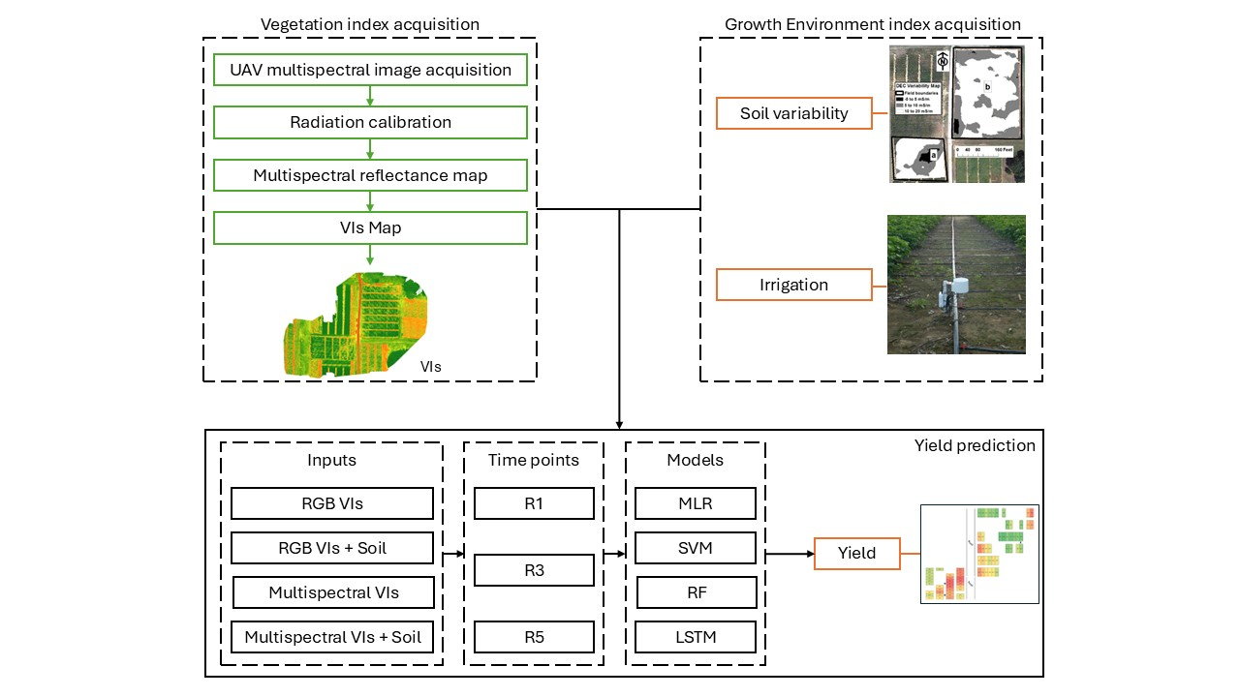
Figure 5.1. A flowchart of data processing

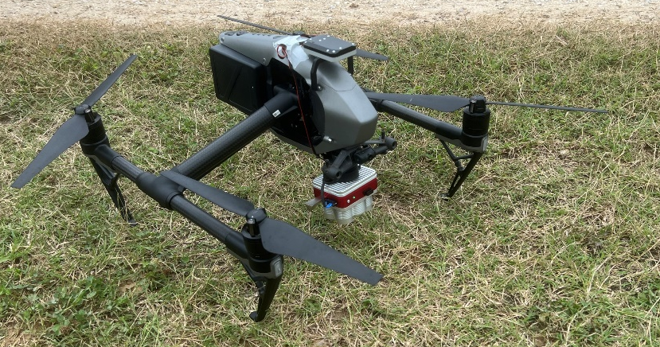
Figure 5.2. UAV systems

Figure 5.3. Correlation analysis heat map in R1, R3, and R5 stage, respectively

Figure 5.4. Results of training set of four input combinations (RGB VIs, RGB VIs + soil, MS VIs, and MS VIs + soil) with three machine learning methos (MLR, SVM, and RF).
Note: R1, R3, R5 represent the growth stage of flowering, podding, and seeding, separately.

Conclusion

This dissertation systematically investigated soybean irrigation management in Mid-South through multi-year field studies, integrating agronomic, soil-based, and remote sensing approaches.
Chapter 2 demonstrates that in silt loam soils, supplemental irrigation significantly increased soybean yields (average 18.5%). Optimal water use efficiency was achieved by delaying irrigation until R5 in most years (initiating at R3 in dry years) and applying higher rates (3.81 cm/week) once initiated. The MOIST water-balance model effectively guided irrigation timing, though soil matric potential sensors required threshold adjustments to avoid over-application.
Chapter 3 revealed soil type as the dominant factor influencing irrigation outcomes with yield responses and irrigation water productivity varying substantially across silt loam, silt-over-sandy, and sandy soils. While MOIST performed well in silt loam soil zone and sandy soil zone, its accuracy decreased in spatially variable silt-over-sandy zone,
highlighting the need for soil-specific calibration, particularly for root depth parameters. Matric potential sensors would have triggered more irrigation than needed to optimize yield, suggesting for careful placement, replicated measurements and possibly drier trigger thresholds.
Chapter 4 established that single-year rainfed yield data effectively delineated irrigation management zones, outperforming multi-attribute approaches in stability and practicality. A consistent irrigation threshold of 17 cm (seasonal total) maximized yields in responsive zones, demonstrating the potential for resource-efficient precision irrigation without extensive soil data.
Chapter 5 underscored the value of combining multi-temporal UAV vegetation indices (VIs) with soil data for yield prediction, with post-season models (RGB VIs + soil) achieving the highest accuracy (R² = 0.80). In-season models emphasized growth-stage-specific strategies, outperforming LSTM-based approaches in 83% of cases.
Collectively, these findings provide actionable insights for optimizing soybean irrigation in Mid-South and balancing water-use efficiency with yield goals.

Vita
Shuhua Xie was born in Taojiang, Hunan Province, China. He earned his Bachelor of Agricultural Water Conservancy Engineering in 2017 from Northwest A&F University in Yangling, China. Subsequently, he obtained his Master of Science in Hydraulic Engineering from China Agricultural University in Beijing, China, in 2020, where his research focused on garden irrigation system design and sprinkler hydrological performance tests. In Fall 2021, he joined the Department of Biosystems Engineering and Soil Science at the University of Tennessee, Knoxville, to pursue his Ph.D. under the guidance of Dr. Brian Leib.

