Collaboration in Transfer Student Work: A Cultural Historical Activity Theory Study at Four-Year Institutions

A Dissertation Presented for the
Doctor of Philosophy
Degree
The University of Tennessee, Knoxville

Jason M Mastrogiovanni
May 2022

Copyright © 2022 by Jason M. Mastrogiovanni
All rights reserved.

ACKNOWLEDGEMENTS
First, I would like to thank my family for their support. Most importantly, thank you to my partner, Melissa. Without her support, encouragement, and willingness to discuss abstract concepts, I do not believe that I would have been able to complete this dissertation. I sincerely hope I get the opportunity to return the favor. I also want to thank my boys, Bradán, Caolán, Rylan, and Declan for their patience with the many long nights Dad spent away from them while attending class and writing many drafts of “that paper.” The constant refrain, “are you done with that paper yet?” Yes, yes, I am. Also, thank you to my Mom for her support and for our “writing night” phone conversations.
Next, I want to thank the faculty who got me to this point. Dr. Lisa Yamagata-Lynch was the most supportive and flexible advisor I could have hoped for. Thank you for the guide rails you set for me along the way and the patience you extended to me, particularly in these last few years. I also want to thank you her for providing opportunities to conduct research with her and our graduate cohort. This was the best learning experience of my entire doctoral journey. Thank you to my committee, Dr. Jennifer Ann Morrow, Dr. Joel Diambra, and Dr. Karen Boyd. I could not be happier with your guidance and mentoring as I developed as a researcher. Thank you to Dr. Ashlee Anderson and Dr. David Matthews for letting me explore the dissertation paths not taken. I will always feel kindred interest in cultural studies and design thinking. Thank you to my master’s degree faculty advisors, Dr. Pamela Perry and Dr. Jane Fried who allowed me to pivot a music education thesis toward a higher education lens. Their support allowed me to take a first step toward the unique scholar-practitioner I have become today.
I also wish to thank my fellow graduate cohort for their camaraderie and assistance with this study. Makhosazana Lunga, Hsin Hui Chang, Lisa Shipley, and Erin Garty thank you for serving as my outside coders and reading what I am sure were the most fascinating transcripts you have ever read. In addition to those already mentioned, thank you to Katie Bevins, Takuya Hayakawa, Terri Durbin, Amanda Dascomb, Cody Villarreal, Andrea Arce-Trigatti, and Alexandra Ingram for the in- and after-class discussions. A special thank you to Anne Skutnik and Rosie Sasso who openly shared their prospectus, proposal, and final dissertations as a roadmap for me to follow through this process.
Next, I want to thank those individuals who specifically supported this dissertation study. Thank you to Dr. Stephanie Foote and Dr. Betsy Griffin of the John N. Gardner Institute for listening to the crazy ramblings of a doctoral student who needed to narrow his study long before he approached you. Thank you to National Institute for the Study of Transfer Students, Dr. Janet Marling, and Judith Brauer for encouraging me to apply for the research grant. Thank you to Dr. Carrie Klein for sharing her interview protocol. Thank you to Dr. Jennifer Engle at the University of Tennessee, Knoxville Institutional Review Board for allowing me to pester her every step of the process. Thank you to Meredith Malnar for taking the time to interview me with my protocol. Thank you to Dawn Kerstetter for helping me process the incentives for participants. Thank you to Dr. Tim Scott for supporting my educational advancement from day one as a new employee at Texas A&M.
Lastly, I want to thank the many mentors I have been fortunate to learn from over the years. Dr. Jean Peden Christodoulou you are a mentor and a friend. I miss you and I am serious about writing that book. Without the experience of working with you, I would not have become so passionate about collaboration. Dr. Charles Robbins, thank you for the care you have shown me, my family, and the seriousness with which you took all our conversations. Dr. Anton Reece and Dr. Ruth Darling, thank you for supporting me to begin this doctoral journey. While we did not always agree, I appreciated the conviction, with which, both of you approached your work. You made me a stronger professional. I could not have had better mentors at that critical point in my journey. Dr. Marisa Moazen, Dr. Stan Guffey, Dr. Jean Derco, and Dr. Brent Lamons our conversations and your friendship pushed me to do the work I do. Lastly, I want to thank Kathy Hobgood, who still wonders if she really had that much of an impact on me. I know others have worked with you for longer periods of time, but you showed me higher education as a career path. You also gave to me an impression of what a professional should look like in higher education. Always the educator.

ABSTRACT
Practitioner ability to effectively collaborate with colleagues both inside and outside of the institution is a critical function of creating and sustaining transfer student programs and services. This study will contribute understanding to the practice of collaboration in transfer student work from the four-year institution perspective. Interviews and documents from practitioners engaged in transfer student work at two institutions will be analyzed using qualitative methods and an Activity Systems Analysis (ASA) framework. This approach will enable practitioners the ability to understand the individual and social interactions of these collaborations in greater detail. A deeper understanding of the practitioner perspective of transfer student work will help institutions in the execution of the transfer student experience.

TABLE OF Contents
Chapter One: Introduction 1
Positionality and Background for the Study 2
Purpose of Study 4
Context 6
Transfer Student Services 8
Foundations of Excellence 9
Theoretical Framework 10
Definitions 12
Collaboration 12
Educator 13
Actions 14
Activity 15
Tensions 15
Significance of Study 16
Chapter Two: Review of Literature 18
Higher Education Context 18
Awareness of Need for Collaboration 19
Collaboration Literature in Higher Education 22
Collaboration Literature in Transfer Student Services 34
Cultural Historical Activity Theory 42
Origins 42
Criticisms and Misunderstandings of CHAT 46
Applications to Collaboration in Higher Education 49
Conclusion 51
Chapter Three: Methodology 53
Population and Sampling 53
Institutions and Institutional Support 55
Institution 1: Private University 55
Institution 2: State University 56
Participants 56
Incentives 61
Limitations of Recruited Populations 62
Inquiry Strategy 64
Data Collection 65
Document Collection 66
Interviews 68
Transcription 70
Transcript Review 71
Data Analysis 71
Open Coding 72
Focused Coding 74
Selective Coding 75
Memos 75
Thick Description 76
Activity Systems Analysis 77
Limitations 79
Conclusion 81
Chapter Four: Findings 84
FoE Activity Overview 85
Private University’s Activity 86
State University’s Activity 89
Theme 1: The Value of Including Others 93
Learning From Others 95
Empathizing with Different Perspectives 96
Forming Relationships 98
Lament of Lost Voices 100
Theme 2: Communication and Internal Perception of Progress 104
Communication Amongst the Grass Roots Campus Community 104
Leadership Role in Communication 108
External Factors and Communication of Progress 113
Theme 3: Differences in Institutional and Educator Motives 115
Institutional Motives 116
Educator Motives 122
Activity Systems Analysis 130
Private University: Inclusion, Communication, and Trust 132
Darren’s Activity: Inclusion and Trust 134
Esther’s Activity: Communication and Trust 137
Outcomes 139
State University: Perceived Agency, Communication, and Skepticism 139
Ingrid’s Activity: Grass Roots Inclusion and Skepticism 142
Tim’s Activity: Competition and Skepticism 144
Valerie’s Activity: Lack of Communication and Skepticism 147
Outcomes 153
Conclusion 154
Chapter Five: Discussion 155
Collaborative Practice in Higher Education 155
Implications for Transfer Student Work 162
Implications for Collaboration Research 166
Limitations 168
Future Research 170
Positionality and Reflection 172
References 173
Appendix A: Protocol for Communication with Institutional Liaison 189
Appendix B: Protocol for Communication with Institutional Participant 192
Appendix C: Interview Question Protocol 197
Appendix D: Coding Progression 202
Appendix E: Participant Activity Systems 207
Vita 219

LIST OF TABLES
Table 1: Roles of Population at Each Institution 58
Table 2: Roles of Recruited Participants at Each Institution 60
Table 3: Private University Participant Demographic and Biographical Information 87
Table 4: State University Participant Demographic and Biographical Information 90

LIST OF FIGURES
Figure 1: Engeström’s Depiction of Mediation 45
Figure 2: Engeström’s Expansion of Mediation. 47
Figure 3: Data Collection and Analysis Order 73
Figure 4: Example of ASA Triangular Graphical Organizer 78
Figure 5: Example of ASA Depiction of Tensions 80
Figure 6: Private University Activity System……………………………. ………...................133
Figure 7: Darren’s Inclusion and Trust Activity 136
Figure 8: Esther’s Communication and Trust Activity 138
Figure 9: State University Activity System 141
Figure 10: Ingrid’s Grass Roots Inclusion and Skepticism Activity 143
Figure 11: Tim’s Competition and Skepticism Activity 145
Figure 12: Valerie’s Lack of Communication and Skepticism Activity 148
Figure 13: Chris’s Activity Related to Transfer Implementation Group 150
Figure 14: Adrienne’s Activity Related to Transfer Implementation Group 152
Figure 15: Order of Actions for Communication with Institutional Liaison 190

Chapter 1: Introduction
Collaboration has become a de facto imperative in higher education, yet we are only beginning to understand its effect on educator practice in higher education (Kezar, 2005b; Manning et al., 2006; Whitt et al., 2008). Collaborative work has come to be viewed as a panacea for such institutional strategies as increasing efficiency (Wingspread Group on Higher Education [WGHE], 1993; Yeh, 2018b), combatting institutional fragmentation (American College Personnel Association [ACPA] & National Association of Student Personnel Administrators [NASPA], 1997; Boyer Commission on Educating Undergraduates in the Research University [BCEURU], 1998), and the improvement of student learning outcomes (Keeling, 2004, 2006; Manning et al, 2006). On many campuses, the delivery of transfer student services is a collaborative process that involves many educators, an intentionally inclusive term explained later in the definitions section of this chapter, engaged in the above strategies. However, the attention given in the literature places a greater scrutiny on two-year institutions while ignoring the responsibility of four-year institutions (Jain et al, 2020). The purpose of this study is to understand the collaborative practice of educators at four-year institutions in creating and improving transfer student services.
Studies on collaborative partnerships have revealed certain characteristics that tend to make partnerships work effectively (Kezar, 2005b). However, these characteristics have focused largely on the institutional level of change. Examining collaboration at this level fails to consider a practice-based ontology for collaboration that could benefit individual educators (Youngs, 2017). Specifically, researchers have increasingly encouraged awareness of the importance of cultural identity, institutional context, and power dynamics in collaborative practice (Conner, 2016; Gulley, 2016; Kezar, 2011; Klein, 2017).
Recently, faculty and staff have come together to address cross-divisional and cross-institutional higher education phenomenon such as the first-year experience (Young & Keup, 2019), transfer-student experience (Wetzstein & Yeh, 2019), and student success (NASPA, 2019) in ways that attend to culture and context. Of these contextualized approaches, the transfer student experience may be among the most challenging due to the involvement of cultures at two different institutions. The “transfer-out” institutions, often a two-year associate degree granting college, differ in culture from the “transfer-in” institutions, often four-year bachelor’s degree granting university, in size and educator roles (Amey et al., 2007). Educators at two-year institutions often wear many discipline hats and know their institutional colleagues better, leading some researchers to believe collaboration is more easily achieved on a two-year campus (Gulley, 2016; Kezar, 2001). At four-year institutions, educators may face a greater struggle in their institutional dynamic. The prospect of an inter-institutional collaborative partnership requires a navigation of not just an educator’s institutional culture, but also the partnering “transfer-out” institution. Unfortunately, the work of educators executing the transfer student experience at four-year institutions has not been studied in detail (Handel, 2011; Jain et al., 2020). This is particularly important because four-year institutions may have greater financial and human resources to support transfer students than their two-year counterparts (Kisker, 2007).
Positionality and Background for the Study
I began my approach to this study by acknowledging my motivation and explaining the choices I made before conducting data collection. Describing these motivations and choices allowed me to practice reflexivity, or a transparent examination of how I would influence the research and how it would influence me (Probst & Berenson, 2014). Additionally, this reflexivity illustrated how I came to combine the components of this study and explained the evolution of how I got to these positions.
The reason I chose the transfer student experience is both of practical and personal importance. From the practical perspective, access to community colleges and four-year institutions has expanded and contracted at different times in the history of higher education (Jain et al., 2020). However, at this point in time, four-year institutions are at an inflection point of expansion toward transfer students as a result of a shrinking national high school graduate population (Bransberger, 2017). As a result, many four-year institutions are engaged in the work of developing or improving transfer student services to meet enrollment demands.
My motivation for this study was to examine collaboration in a higher education work context. To do this, I needed to examine a context whereby my participants had some recognition of the bounded activity within which they were working. Put another way, I wanted the work context to be current and discrete for the participants.
In addition to the practicality of examining a common collaborative phenomenon in higher education, I had personal insight into the complexities of the interpersonal sub-cultures. I worked for six years as the institutional lead for a transfer student program between my own four-year institution and a partnering two-year institution. Routinely, I found myself not only serving as the link between the two institutions’ collaboration, but also found it necessary to negotiate inner dynamics of my own institution. These inner dynamics at the four-year institution were fueled by motivations that were external to the immediate implementers of the program, such as institutional branding and enrollment standards. They also created situations where a seemingly bilateral collaborative interaction would become convoluted with multiple motives. Often, this caused our two-year partners to wonder in frustration exactly what their four-year partners wanted.
At one point during my tenure in the program, my supervisor referred to me as the ombudsman for the program. This statement made me realize, contrary to hierarchical thinking, I was not in charge of this program. I was an educator amongst educators who had a personal motive for actions I took within this context. More importantly, the forty or so educators I worked with to execute this program also had personal motives driven by many factors. Knowing how to make this program function collaboratively came with no textbook answer of steps or components. Instead, it required attention and awareness of those constituent motives.
At the same time, I found my coursework in Cultural Historical Activity Theory (CHAT) to be resonant with understanding the professional challenges I experienced as an educator. Activity theory provided me a different way to examine my work. Often in higher education work, an initiative is defined by its components alone. CHAT provided a theoretical lens for me to examine those components in the context of institutional policies, cultures, and personal, as well as institutional, motives. Perhaps the policies could be changed. Perhaps the components needed to change. Perhaps the individual’s approach to the work could be changed. The core intent of this study is to explore these possibilities by examining the application of CHAT as a theoretical framework for understanding the motive-directed context of collaborative work.
Purpose of Study
The purpose of this study is to understand the motive directed actions of educators at four-year institutions during collaborative, cross-institutional transfer activity. The term educator is used as an inclusively, broad moniker. The purpose for this will be elaborated on in the definitions section. My research questions are:
- How do educators in four-year institutions contribute toward collaborative, cross-institutional transfer activity?
  - What motives do educators share while participating in the cross-institutional transfer activity?
  - How do educator motives differ while participating in the cross-institutional transfer activity based on their organizational goals and shared norms?
- How do educator motives in the four-year institution influence the cross-institutional transfer outcomes?
Borrowing inspiration from Engeström’s (2008) study of teams at work, this study relied on CHAT as a theoretical framework to examine the work of collaborative teams in higher education. Engeström examined the motive directed actions individuals take to change the way they work together in teams. Similarly, this study examined the motive directed actions of individual educators working in teams toward cross-institutional transfer activity to better inform educator practice.
This study used qualitative research methods to examine contextual documents and participant interviews. Themes were derived using the constant comparative method (Charmaz, 2014; Glaser & Strauss, 1967). What is distinct from Engeström’s study is the contextualization of this qualitative analysis in the CHAT-derived analysis method of Activity Systems Analysis (ASA). ASA is an analysis method that can help “researchers and practitioners understand individual activity in relation to its context and how the individual, his/her activities, and the context affect one another” (Yamagata-Lynch, 2010, p.1). This comprehensive view of the transfer student services allowed me to systemically analyze the qualitative data produced in a contextualized collaborative work activity. ASA added strength to the framework used by Engeström (2008) and may provide insight into how collaborative partnerships occur and are sustained by utilizing a consistent framework for understanding interactions within the activity.
Context
This study examined the context of collaborative activity between educators in two different four-year institutional settings. All educators had participated in an assessment of their institution’s transfer student services through the Foundations of Excellence (FoE) self-study assessment for transfer students. The assessment process was used as a mechanism by which educators would have a heightened awareness of their institution’s cross-institutional transfer activity. The activity of assessing and implementation served as the contextual activity and unit of analysis for this study. Each institution’s activity was treated as a case study of collaborative activity, like previous studies of transfer student partnership (Fink & Jenkins, 2017; Kisker, 2007). The perspective of the activity is situated in four-year institutions to qualitatively examine this perspective’s limited scrutiny in the literature (Jain et al., 2020).
The selection of institutions from the FoE self-study allowed for comparisons to be made of both on the institutionalized context of transfer student service activity (activity-based) and by the professionalization of certain educator roles in that activity (group-culture). It was possible that the two, four-year institutions may have had similar challenges navigating educator motivations toward a collaborative outcome. It was also possible that one, four-year institution may have employed an educator action that aligned the institutions motive for engaging in a collaborative outcome. The comparison of the two institutions’ activities was intended to provide insight into the practice of collaboration in the transfer student services work context.
The situated context of each activity may seem difficult to compare. However, Engeström’s (2008) analysis of health care and primary school teams provided access to what he termed middle-level phenomenon, or the motives hidden between the general macro structures and the micro intricacies of the specific context. In this study, I compared the hidden motives of individuals in the two cases. Outcomes of the collaboration were used as descriptors related to specific motives but are not the focus of analysis. Meaning that whether the outcome was the establishment of an inter-institutional transfer hub or an agreed upon regular meeting between two educators, the comparison focused on the motives in the collaboration and not a perceived worth of the product or outcome. The motive, termed object in CHAT, was the basis for meaning making from this study.
Another important factor in the context was the educators’ awareness of participation in a collaborative transfer activity and bounding the cases. It was important to bound the context for case studies in this design to avoid the data collection spiraling away from the context (Stake, 2005). To bound this case, the focus of questioning centered on the activity of the FoE assessment process and the educators’ interactions with each other as a result of the FoE assessment. The completion of the FoE self-study, described in more detail below, ensured participants were aware of and knowledgeable of their work interactions regarding transfer student services as a bounded activity because the participants spend a year engaged in the self-study process. This is of particular importance at four-year institutions where educators brought together for this activity are likely to be more specialized and will have different subcultures due to institutional complexity (Jain et al., 2020; Kezar, 2003).
The same complexity does not seem as prevalent at two-year institutions. Gulley (2016) found that despite the propensity of literature discussing culture difference between academic and student affairs in four-year institutions, the same dynamic was not found in practice at community colleges. This might be explained by two-year institutions tendency to be more naturally collaborative because personnel wear many hats and are used to frequent interaction (Kezar, 2001). However, it should be noted that the collaborative work of educators engaged in transfer student work at a four-year institution may require interaction with two-year institution colleagues. As such, participant selection at each institutional activity case allowed for the possibility of selecting a two-year partnering institution colleague to be included as a participant.
Transfer Student Services
I have alluded to my professional experiences with the nature of collaboration in transfer student work, but I will use this space to further delineate examples of that work reflected in the literature. The delivery of transfer student services presents many of the challenges of any collaborative work in higher education, but some researchers have indicated that the challenges may be compounded by the inter-institutional nature of transfer student work (Amey et al., 2007). Differences in the fundamental cultures of the “transfer-out” and “transfer-in” institutions make it difficult to initiate and sustain collaborative work between institutions (Amey et al., 2010). In particular, the motivations of educators in the facilitation of the transfer process may differ greatly from two-year to four-year institutions (Handel & Strempel, 2016). For example, it is common for two-year institution to be required to report formalized metrics of student graduation not only at their institution, but beyond at the four-year level. However, the mirror responsibility is often not required of the four-year institution (Jain et al., 2020). Thus, the motivations of staff at a four-year institution may be less focused on transfer student achievement. In states where performance funding is competitive between institutions, the four-year institution may even have a disincentive in supporting the two-year institution’s expanded reporting responsibilities.
Despite the challenges of initiating and sustaining collaborative partnerships, promising practices have begun to be forged. Institutions are beginning to share resources and create dedicated positions committed to the institutional partnership (Wetzstein, 2018). Yet the standardization of these practices is in its infancy and our understanding of how to achieve this level of collaborative work between two institutions is still not well understood (Coombe, 2015).
Foundations of Excellence
The Foundations of Excellence (FoE) is an institutional self-study framework developed by the John N. Gardner Institute (JNGI, n.d.-a) for Excellence in Undergraduate Education. In the early 1980s, Gardner began a nationwide movement around the first-year experience and is seen by many to be the founder of that movement. Formally, that movement was expanded to include transfer students through the establishment of the National Resource Center for The First-Year Experience and Students in Transition at the University of South Carolina. In 1999, Gardner left the University of South Carolina to establish a non-profit consulting group (JNGI) that partners with institutions to improve undergraduate education “outcomes associated with teaching, learning, retention, and completion” (JNGI, n.d.-b, “Our Mission” section).
A core component the FoE self-study is collaboration, with institutions typically drawing 80-100 educators from their campus to participate in task force involvement (B. Griffin, personal communications, October 4, 2018; JNGI, n.d.-a). The stated purpose of the collaboration is that it “allows faculty members to gain perspective on the work of student affairs professionals and vice versa” (Alexander & Gardner, 2009, p.21). The self-study consists of a full academic year process where documents are created or co-located outlining all institutional policies, data, and practices toward transfer students. A JNGI scholar guides campus educators from academic affairs and student affairs through analysis of these materials and the production of a comprehensive report with action items for the institution to improve its transfer student services.
For the purposes of this study, I did not intend to test the effectiveness of the FoE self-study on producing collaboration. Instead, I intended to use it as a tool in organizing a collaborative work team in context. I hoped to illicit a participant group who was more aware of the ways in which they collaborate because collaboration is discussed frequently during the self-study (B. Griffin, personal communications, October 4, 2018). I was aware that this may produce a participant group that was biased in that heightened awareness. However, in absence of this tool, participants may not have been able to articulate a thoughtful response on their collaborative contribution.
Theoretical Framework
This study applied a CHAT framework to examine educator work in transfer student services. CHAT has not been used to examine collaborative practice in transfer student services before this study. Utilizing new theoretical frameworks in research may help educators address future challenges in practice (Kezar, 2000).
CHAT is a social constructivist framework that originated in 1920s Russia in the work of Lev Vygotsky. Vygotsky and his contemporaries articulated the concepts in CHAT as a response to behaviorism that dominated psychological thought at the time. Instead of a focus only on the external stimuli, CHAT focused on the interactions that individuals have on society and that society has on the individual in a symbiotic way (Yamagata-Lynch, 2010).
Though early CHAT writings were situated in theoretical writing, researchers have recently designed studies with qualitative methodology to help us understand the interplay between individuals and their community activity. Engeström (2008), a contemporary CHAT researcher, examined systemic contradictions in teams to explain how the teams worked through tensions in their contextualized work activity. The practice of working through these tensions was a manifestation of the work team’s collaboration. Engeström used these tensions to discuss individual collaborative practice in a societal team using a CHAT framework. Yamagata-Lynch and Smaldino (2007) directly used ASA as a tool to focus collaborative group discussion on systematic challenges instead of placing blame on the barriers to their collaborative work. These examples lend credence to the belief by many CHAT researchers that all community activities contain tensions that either advance or stall that activity (Engeström, 1993). The identification of tensions, outside of the educator ego, may provide a catalyst for advancing collaborative activity.
I have mentioned how collaboration research has focused on institutions as the locus of change. The individual action of educators has been understudied in collaborative activity, in part, due to the complexity of institutional subcultures (Klein, 2017). However, examining tensions already known to exist in institutional, divisional, and professional cultures can impact our understanding of educator practice in collaborative work (Arcelus, 2008). ASA provides a consistent analysis framework where data from these complex subcultures can be analyzed in context to make meaning of the collaborative activity observed (Yamagata-Lynch, 2010). This study examined collaboration as the situated practice of individual educators in a complex work-based activity.
The concepts of CHAT and ASA require further explanation that are outlined later in this study. The origins and psycho-social components of CHAT are explored in chapter two. The use of ASA in data analysis are described in more detail in chapter three.

Definitions
The first two terms defined are positional from my perspective. Using perspectives from my understanding of the literature and professional practice, I am delineating my position on how I used these terms to address the previously stated intents of this study. In the case of collaboration, the intent is to form a practice-based definition. With the term educator, I am illustrating the inclusivity of that practice to include all manner of faculty and staff in higher education.
The remaining three terms, action, activity, and tension, all relate specifically to a prior detailed knowledge of CHAT and ASA. Given the relatively new nature of these qualitative frameworks in Western and educational research literature, I have decided to introduce these concepts for my readers at this time. I also wish to indicate my intentionality of use up to and throughout this document by defining them at this early point in my study. While I am defining the terms now, I will explain their use more fully in chapter three.
Collaboration
The term collaboration is often used to describe multiple things in higher education. To illustrate this point, I will describe a single researcher’s use of the term in five years of research. Kezar’s early work (2001, 2003) refers to collaborations in a commodified way. These studies used a quantified metric of the number of collaborations at an institution to determine a sample group. Kezar (2005b) described collaboration as a group of individuals working together to establish shared guidelines to make decisions in each activity. Kezar (2005a) describes collaboration as a process with multiple stages that a collective institution progresses through. Reading these studies, one could assume collaboration is a tangible thing to be counted, a collective activity of individuals, and a multi-stage institutional process. All these examples fall short of addressing the practitioner perspective.
I propose borrowing from CHAT literature to form a new definition of collaboration that changes the traditional ontological perspective from collaboration as an observable product to the collective work of individuals. In this definition all individuals’ perspective are valid. Yamagata-Lynch (2010) describes how researchers and practitioners can use ASA to understand complex learning environments. She describes these environments, “as situations in natural settings where multiple individuals are involved in shared activities within a single or multi-organizational context” (Yamagata-Lynch, 2010, p. vi). For the purposes of this study, collaboration will be defined as the descriptive situation, in which, educators interact with each other in the shared activity of creating or sustaining transfer student services at a four-year institution of higher education.
This definition addresses the concerns of those who might see collaboration as an imposed or inevitable construct (Magolda, 2005). This definition is neither pro nor con toward the use of collaboration. This definition avoids placing a valuation on the magnitude of the collaboration or a quantification of higher education work. Instead, it describes the interactions in a context as they relate to individual practitioners.
Educator
I use the term educator in this study as an inclusive term to include faculty, staff in student affairs (e.g., residence life staff, orientation staff, dean of students), staff in academic affairs (e.g., academic advising, student success, undergraduate research), staff in enrollment management (e.g., admissions counselors, financial aid staff, registrar staff), and administrators (e.g., Provost, Vice President for Student Affairs, President). The placement of the staff roles in the preceding sentence is arbitrary and will vary from institution to institution. My intent in naming them is to delineate the breadth of inclusivity with which I am using the term. The relevance of their role and situated unit is culturally and historically constructed in each institution’s working environment but matters little from the perspective of serving the student (Tinto, 1998).
The students’ perception aside, the inclusivity with which I approached this definition may illuminate the challenges of role confusion in the task at hand, educating transfer students. Scholars in the field have long argued that it is important for student life practitioners to view themselves as educators (American Council on Education [ACE], 1949; Keeling, 2004, 2006; Lloyd-Jones, 1954). However, self-perception as educator alone may not change peer perception as equal when it comes to educating students (Arcelus, 2008). This may create a tension between the divisional and professional cultures of would-be collaborators in the transfer student experience. Thus, my intent with this inclusive designation of educator is to draw attention to the perceptions, if not the responsibility, of individuals in these areas to affect student education by naming them all educators.
Actions
An action refers to individual educator acts that have influence on the overall group activity. The influence an action possesses is derived from the action itself and the impact it has on individuals in the activity. In CHAT, an action is said to be mediated because it imbues with it both a motive from the individual, termed “subject” in CHAT, who delivers it and an interpretation from others who perceive it (Vygotsky, 1934/1987). Additionally, the action may have a mediating effect on the contextual activity (Yamagata-Lynch, 2010). For example, a Provost may cut the transfer student services budget. This is an action. The Provost has a motive in cutting the transfer student services budget. Perhaps the Provost knows that transfer enrollment is declining and intends to cut funds proportionate to that decline. Additionally, the educator may perceive a motive for why the budget was cut that was different from the Provost’s intent. Perhaps the educator believes the cut is an indication of declining interest in attracting transfer students to the institution. Each of these, the budget cut action, the Provost’s motive, and the educator’s perception of motive may have a different effect on the transfer student services activity.
Activity
The word activity in CHAT is defined separately from action. Activity refers to the bounded work of a group of individuals toward an object (Yamagata-Lynch, 2010). If there is no object to be accomplished, no definable activity would exist. In this study, the assessment of transfer student services provided that bounded work context for the individual educators. In CHAT, this bounded context is termed the activity.
Engeström (2008) situated bounded activity by referring to it as “work,” However, it is important in this study that the transfer activity be separated from other educator activity. Although it is possible for factors outside of the shared transfer activity to have an influence on the transfer activity, this distinction will bring focus to the scope of this study.
Tensions
The word tension in ASA refers to incongruences between activity elements. Individual educator actions can cause tensions to arise in the activity (Cole & Engeström, 1993). In the example above, the Provost’s decision to cut the budget may have created a tension between themself as the subject and other educators involved in the activity. Examining tensions enables a researcher to understand how motive directed actions impact the overall activity. The discovery of tensions and their resolution helps describe the collaborative activity of transfer student work in this study.
Significance of Study
Many examinations of collaboration in higher education have been descriptive (Coombe, 2015) or quantitative (Kezar, 2001; 2003), lacking a deeper understanding of the motivations of individual educators. In this study, I intended to apply a theoretical framework and methodology that has yet to be utilized to examine this phenomenon in transfer student services. This empirical study builds on the practitioner literature base (ACPA, 1996; American Association for Higher Education [AAHE] et al., 1998; ACE, 1937, 1948; Fried, 1995; Keeling, 2004; Lester & Kezar, 2012) by establishing a new rigorous application for understanding the processes, components, and motivations of collaborative work in higher education context.
My intent was to open a new dialogue among practitioners about collaborative work by examining individual educator motivation as a factor of collaborative activity. By examining collaboration through a CHAT framework, those interested in better understanding how collaboration happens can “open up a field for further debate, theoretical work, and experimentation” (Engeström, 2008, p. 233). Educators who read this type of rich case analysis will benefit by adding these contextual written experiences to their own personal experiences to inform future practice (Flyvbjerg, 2011). CHAT and ASA methods are uniquely suited to understanding educator action in collaborative work and contributing meaningfully to practice as evidenced by studies in other similar fields (Engeström, 2008; Yamagata-Lynch & Smaldino, 2007).
This work holds specific significance for the transfer student practitioner perspective. Most research in transfer student work collaborations has focused on static manifestations, such as transfer articulation agreements (Kisker, 2007). However, a deeper understanding of how collaborative work initiates and progresses may help lengthen and strengthen partnership between institutions (Amey et al., 2010). It has recently been suggested that it is the intersections of cultures, policy, and practice where opportunities and barriers lie for collaborative transfer partnerships (Yeh & Wetzstein, 2019). The use of the term “intersections” by Yeh and Wetzstein is similar to the way tensions are discussed in CHAT literature and in this study. As a result, this study may forge a richer theoretical and methodological footing with which to ground this previously analyzed transfer partnership phenomenon. Additionally, the intersection of two-year and four-year institutional cultures has yet to receive significant scrutiny in the literature (Handel, 2011; Jain et al., 2020). This study may gain unique insight into the intra-institutional culture of four-year institutions when engaging in transfer student services work.

Chapter 2: Review of the Literature
In the introduction chapter, I alluded to the concept of collaboration having become an imperative in the field of higher education. As a follow-up to that assertion, I use this first section of my literature review to discuss the awareness of the need for collaboration in the field, highlight important research on collaboration in the higher education context, and lastly provide an overview of the literature that has addressed collaboration in transfer student services. The literature in this section gives indication of the different research approaches that exist in the field and sets a foundation for understanding why a more holistic perspective might be needed. I believe that CHAT, which I cover in the second half of my literature review, may provide researchers a way to examine collaboration in a holistic way.
Higher Education Context
Higher education was not always comprised of the diverse set of educators it is today. Up until the early twentieth century, presidents of institutions attended to the constituent groups of relatively small campuses. They did this work largely by themselves, retaining few administrative structures or divisions to manage this work (Geiger, 2015). However, this long-standing history was poised for change. One overarching factor was the changing demographic of the college student. Prior to the beginning of the twentieth century, college was primarily attended by affluent, mostly white, men of the cultural elite. As the middle class expanded, following events such as FDR’s New Deal and the GI bill following World War II, so did their opportunity to attend college (Geiger, 2015). Seeing this trend, institutions adjusted to the needs of these new populations by providing increased support.
In higher education, this is most clearly illustrated in the historical development of the field of student affairs or non-faculty employment. Various causes led to the creation and growth of non-faculty employment and responsibility in the institution. The growth was most pronounced in large institutions that sought to create services for growing student populations (Lloyd-Jones, 1954). One of the earliest examples came in 1922 from Walter Dill Scott, the tenth president of Northwestern University, who argued from an industrial psychological perspective the need for a separate (from the faculty) personnel unit dedicated to serve the whole student and help address enrollment management concerns. His overall intent was to make a large institution operate like a small one with more personalized attention and focus (Biddix & Schwartz, 2012).
Awareness of Need for Collaboration
The division of labor may have provided more capacity to support students, but it also created a greater need for educators to collaborate with one another. In the early years of student affairs work, called student personnel at the time, this was already becoming apparent. A document called the Student Personnel Point of View was drafted by student personnel workers and published by the American Council on Education, which sought to clarify student personnel work by providing a philosophy, scope, and the need for coordination within the practice and with other educators on and off campus (ACE, 1937). A few years later, this document was updated with, among other things, an elaboration of how coordination manifests through personnel worker structure within the institution and the specialization of educators (ACE, 1949). It was these manifestations recognized in the practice that later led to systemic issues of specialization and staff management that often conflicted with the original intents of more holistically fostering student education (Lloyd-Jones & Smith, 1954).
Unfortunately, the next major developments in understanding the need for collaborative work did not come for several decades. Harkening back to the holistic roots of the field, student affairs leaders sought to coordinate learning more holistically with their faculty counterparts by defining learning in the affective and personal development domains. This was codified in a document entitled, The Student Learning Imperative: Implications for Student Affairs (ACPA 1996). It was found that these domains were linked to the more cognitive and discipline specific learning taking place in the classroom (AAHE et al., 1998; ACPA 1996). It was argued that students did not separate their learning between the two locations and arguably needed to connect the classroom learning with co-curricular learning to be more successful learners (Tinto, 1998). As a result, student affairs educators increased calls for collaboration with their faculty counterparts to facilitate greater student learning (AAHE et al., 1998; ACPA & NASPA, 1997). An assertion in Powerful Partnerships noted the importance of an educator’s ability to model cooperative learning amongst different types of educators (AAHE et al., 1998).
At virtually the same time, higher education policy leaders outside of student affairs were beginning to realize external pressures for collaboration. There were calls to critically look at how students were being educated and the society to which they were contributing. Many leaders began to ask if the way that higher education had evolved was producing the engaged citizenry expected and hoped for in its origins (WGHE, 1993). Noting a disconnect from serving societal problems and a growing decline in public confidence, Boyer (1996) called for institutions to reengage in “collaboration, this commitment to the common good” (p. 22).
Another external pressure that began before the turn of the century and continues today is the imperative to do more with less financial resources (Marshall & Palca, 1992). Reduced funding levels significantly hindered additional specialization and, in some cases, forced collaboration. From a faculty perspective, academic programs low in enrollment turned to collaborative efforts to avoid dismissal (Coombe, 2015). The Boyer Commission (1998) advocated that when these barriers of specialization begin to break down, it begins to allow the resources to be used to their fullest potential.
External pressures began to cause administrators to reexamine long held institutional practices. For example, the reexamination of faculty tenure to encourage recognition of faculty work toward collaborative campus endeavors had been encouraged (AAHE et al., 1998; BCEURU, 1998). Boyer (1996) lamented that despite significant growth in the profession since the beginning of his tenure, many institutions still did not recognize this work in rewarding faculty service toward tenure. Additionally, senior institutional leaders and policy makers were encouraged to abandon a hands-off approach to learning and began to verbally and financially supporting collaborative practices to improve student learning (Association of American Colleges & Universities [AACU], 2002). It was argued, changes in support and recognition could free designers of the curriculum to engage in inquiry-based experimentation with collaborators to improve student learning (AACU, 2002; BCEURU, 1998). The tone of these authors called upon institutions to take a stand to support and expect all faculty and staff to work towards the creation of collaborative communities, engage students in active learning, apply clear and high expectations, to use of systematic inquiry, and the creation of supportive and inclusive environments for learning to take place (WGHE, 1993).
These changes began to transform what learning looked like in higher education institutions and who could have a role in it as educators. The next step of understanding student learning as a collaborative enterprise came in the form of transformative learning as defined in Learning Reconsidered and Learning Reconsidered 2 (Keeling, 2004, 2006). Collaboration manifested in these documents through programmatic initiatives, such as living-learning communities, showed promise in creating a transformative learning environment where faculty and student affairs professionals could co-mingle as educators. A case was made for leveraging the social context (e.g., student affairs) with the academic context (e.g., faculty) to design an institutional context (culture and structure) to address the numerous imperatives that require learning to be reexamined (Keeling, 2004). The argument made was sound, but the assertion of collaboration as the solution to fix the problem still faces challenges. Learning Reconsidered helped cement support for a growing trend toward structural collaborations where learning can be reimagined. However, the efficacy of how the structures succeed or fail in their collaboration had not been fully understood (Whitt et al., 2008).
Magolda (2005) cautioned that we must examine collaboration by more critically examining it and discourage viewing it as a panacea. We must also consider its cultural appropriateness for all student populations (Manning et al., 2014). I argue that if, as a collection of educators, we are incapable of modeling collaborative learning as a collective institution, we will always fall short of our ability to educate students in this new way of learning. Lloyd-Jones and Smith (1954) stated that studying the collaborative interactions between faculty and students may be the best way for students to learn what these collaborations look like, how to sustain them, and to understand their value. The obvious challenge for collegiate educators is that we must create something many of us never experienced in our own collegiate education and far too infrequently in our professional experience. This next section will examine what we have learned about collaboration and collaborative practice in higher education.
Collaboration Literature in Higher Education
My approach to digesting collaboration literature in higher education followed a circuitous path. I found that many authors have juxtaposed these terms to study a variety of phenomenon and contexts. For the purposes of this portion of the literature review, I have chosen literature that serves two purposes for my overall study. First, I chose literature that demonstrates the evolution in the research paradigm that has taken place in the literature and to where this study on collaboration resides. This evolution has generally progressed from positivist and interpretivist approaches toward critical and pragmatic paradigms. The progression also coincides with a trend from more generic understandings of collaboration on a college campus toward a deeply contextualized approach that is reciprocated and reinforced by the individual. Second, I chose literature that demonstrates the concepts from which I draw upon for my understanding of the components of collaboration in higher education. I do not necessarily see these two purposes as mutually exclusive. As such I have tried my best to explain these understandings as I discuss the literature.
In the previous section, I discussed literature that discussed the awareness for the need of more collaboration in higher education. Many of these pieces of literature outline the problems and motivations in the field for the push toward collaboration. However, it is worth noting that some scholars began to discuss applications for collaboration during this time. Notably, Lloyd-Jones and Smith (1954) wrote about guideposts for institutional leaders to consider as they managed the different organizational structures that had emerged in higher education and worked toward a connected practice of “deeper teaching.” Unfortunately, this work was not expanded upon by others at the time. Several decades later, Barr and Fried (1981), and later Fried (1995), discussed the importance of border crossing between student affairs practitioners and faculty. They called upon student affairs professionals to become “bi-lingual” in both cultures as a strategy toward improved collaborative practice. Smith (1982) began to outline strategies for how to approach this work by examining historical misinterpretations of student development in higher education. The implications of this examination were to develop understanding and relationships with colleagues outside of student affairs, find common shared values, understand the place and culture, understand the time and opportunities for change, and lastly to gather and create evidence in the form of assessment and research that compels collaborative discussion amongst cross-divisional colleagues. A few years later, NASPA dedicated an entire journal issue to discussing collaboration in 1988 (Brown, 1988). One article from this issue, began to examine survey data from CSAOs that explored the perceptions and collaborative actions taken by student affairs professionals at this early point in our understanding of collaborative practice in higher education (Reger & Hyman, 1988). These scholarly articles helped lay a foundation for the collaborative research that were to come.
The bulk of the research termed collaboration in higher education has only materialized in the last two decades. I did find some precedents prior to the codification of collaboration research. These precedents provide rich foundations for researchers to draw from to conduct research on collaboration in higher education, but these pieces of literature often used alternative terms such as teamwork, leadership, or learning in place of collaboration. This made disentangling the lineage of academic progression in this area of study complex. A full mapping of the literature could be a study in, and of, itself.
Additionally, the universality of working together in collaboration in one name or another lent itself to a variety of discipline-specific approaches to studying the concept. I reviewed many of these articles, such as PK-12 and university partnership programs (Magolda, 2001; Yamagata-Lynch & Smaldino, 2007), interuniversity partnerships (Akkermann et al., 2012; Coombe, 2015; Willcoxson et al., 2011), and faculty research collaborations (Abramo et al., 2011). From them, I gleaned insight into the different approaches researchers have taken to studying collaboration that may be relevant to other portions of my dissertation. However, I have ultimately chosen to omit these here in favor of focusing on studies that represent an education administration perspective on collaboration. This is the general perspective of my specific study context of transfer student services administration.
Early approaches to understanding collaboration in higher education have focused on component identification at the institutional or senior-level vantage point. One of the earliest pieces of research in higher education that studied collaboration did so under a different term. Bensimon and Neumann (1992) examined leadership teams and teamwork. The population for their study consisted of university presidents and up to four members of their leadership teams from 15 different institutions studied over a three-year period. Extensive interviews were conducted with over 70 individuals and included details about both the work relationship of the team and the overall perception of the effectiveness of the members and the team. Although rooted in the study of leadership and teamwork, Bensimon and Neumann describe conceptual components of team roles and functions that comprise collaborative work. Of note in the study, was the discovery of three functions exhibited in these teams: utilitarian, expressive, and cognitive. Utilitarian functions served the purpose of completing tasks. Expressive functions were those that reinforced the social community of the team. Cognitive functions were those that enabled the team to make sense of work by harnessing the power of the collective perspectives of the team members. The authors found that the complexity of cognitive function was often the determining factor of teams that were perceived to be effective by their participants. They also found that cognitive complexity was not usually present without the other two functions. It was this distinction that made the difference between what they called real versus illusory teams.
A decade later, Kezar (2001) used a nationwide survey developed by the Education Resources Information Center (ERIC) Clearinghouse on Higher Education, NASPA, and ACPA to conduct an examination of the characteristics of student and academic affairs partnerships that, in part, confirmed the growing calls for collaborative work were being answered. Kezar noted developments in the diversity of approaches that shaped more research to come. One such development was the creation of new organizational divisions to bridge the gap between student and academic affairs, such as enrollment management, that moved a bilateral collaborative relationship toward a multi-relational collaboration. Another development was the statistical finding that cultural strategies helped maintain and increase the number of collaborations between the two divisions. Lastly, the data indicated a need to further study educator motivations in approaching collaborative work.
In a follow-up study, Kezar (2003) examined responses from the initial survey for evidence of three approaches toward change: Kuh’s model drawn from human relation and
culture theories (see Kuh, 1996, for more detail), planned change model drawn from positional leadership theories (see Brill, & Worth, 1997; Carnall, 1995, for more detail), and restructuring models that organized work toward improvements in the division and organization of labor (see Brill, & Worth, 1997; Carnall, 1995, for more detail). Given that respondents to the survey were chief student affairs officers (CSAOs), it may not be surprising that most respondents indicated the use of and preference for strategies that aligned with Kuh’s model. Kuh is a well-known scholar in higher education literature through the discipline of education but may be less well-known amongst non-student affairs educators from other disciplines (AACU, n.d.). The use of Kuh’s model correlated to a higher number of institutional collaborations in the survey data. The use of restructuring change models lacked a significant number of respondents and prevented a detailed analysis of this approach. This may stem from the position that CSAOs sit in the institution. CSAOs may not be empowered to envision change at a higher-level where restructuring educator work cross-divisionally may be needed. Another interesting aspect of this study was the criteria used to measure magnitude. Collaboration was measured by the numerical presence of partnerships in the institution. This view of collaboration as quantifiable and not a component of daily contextual practice may be limiting toward how collaboration research is framed. Kezar (2003) concluded that “more detailed case studies [were] needed to understand the nuances of institutional culture, which are hinted in the data, but not borne out as statistically significant” (p. 154).
Next, Kezar (2005b) took a social constructivist approach and case study methodology to select four cases out of thirty potential highly collaborative institutional nominees. The classification of an institution as highly collaborative was again derived by the number of collaborations present on the campus. Kezar’s rationale was that an institution that had a significant number of collaborations present may indicate institutional components that facilitate collaboration. Following her analysis, she outlined a framework for the institutional components that included attention to the following areas, “(1) mission; (2) integrating structures; (3) campus networks; (4) rewards; (5) a sense of priority from people in senior positions; (6) external pressure; (7) values; and (8) learning.” (Kezar, 2005b. p. 833).
Some aspects of this study may be limiting toward our understanding of collaborative practice. The presence of these components is not often under the control of one or even a group of practitioners. Additionally, most of these components are targeted, as she stated in her abstract, on how institutional leaders change their institution to facilitate collaborative work. This approach neglects the individual actions of educators in sustaining collaboration. More simply put, it neglects practice. Finally, the institution-sized nature of the case may have been problematic in not contextually situating the activity of the collaborative work. For example, participants at the same institution may have been responding to different collaborative contexts within which they worked. Thus, not providing a clear picture of how collaboration works on the program level. Nevertheless, the study is an important steppingstone in the understanding of collaboration in higher education for its description of the tools and components of collaboration.
All these studies provided foundational origins for future collaboration research. The positivist approach by Kezar (2001) defined a national landscape that until this time had been largely unknown. This study confirmed that collaborative activity was indeed growing in institutions across the country, and it began to outline strategies for institutionalization of collaboration that could be studied by future researchers. Kezar (2003; 2005b) and Bensimon and Neumann (1992) adopted interpretivist approaches that focused on how leaders create and make change in their institutions toward collaborative work. While these studies were significant in the foundations they created, they remained confined to the vantage point of high-level or institutional examinations of collaboration. The next step in the literature came when researchers began conducting contextualized studies of collaboration.
Shortly after Kezar’s early work, a group of authors published a study that did contextualize partnerships and significantly increased the number of cases (Whitt et al., 2008). Whitt et al. examined program-level cases at 18 different institutions. The analysis of these cases led the authors to develop a principles framework for good practice in partnership programs. These principles included a reflection and advancement of the institutional mission, learning-oriented ethos amongst practitioners, building on existing relationships, recognizing and attending to institutional culture, valuing and implementing assessment, using resources creatively and effectively, and finally demanding and cultivating multiple manifestations of leadership. This study represented a more contextual framework that resisted partnership as a panacea for institution-wide implementation because site selection for the cases was determined by institutional interest in participation for established partnerships on their campus. Additionally, the authors stressed the use of the word “good” instead of “best” to define what they found from their study. This distinction was not only to caution about generalizability but went further in emphasizing the importance of context and applicability of engaging in collaboration. One of the stated limitations of this study is that it did not concern itself with the day-to-day problems of collaborators. They focused on the retrospection of early program leaders but acknowledged that developments in the collaboration may have occurred during and after their data collection.
A very different approach to contextualized collaboration was taken by Arcelus (2008) who conducted an in-depth ethnography at a single institution to examine academic and student affairs cultures. Arcelus’s research questions were to understand “how academic and student affairs staff members perceive their own and each other’s roles as educators and how these perceptions influence their perspectives on cross-divisional collaboration” (2008, p. iii). The year-long study consisted of interviews, observations, and document analysis that while not examining contextualized activity did focus on the contextual cultures of a single institution. The strength of this study is that it uncovered motivational driven qualities, as recommended by Kezar (2001), of the different cultures at play in the institution. These motivations in turn informed the biases and positions individuals in each group might bring with them to every collaborative activity.
Contextualized collaboration is further complicated when considering the institutional environment and the group culture together. Hirt (2000, as cited in Hirt et al., 2004, p. 106) found that student affairs professionals are often socialized in graduate programs that reside on research campuses and may hold beliefs that their work is largely similar from institution to institution. In a mixed-method study, when new student affairs professionals arrived on a liberal arts campus they were observed to be underprepared for the highly collaborative and political environment (Hirt et al., 2004). Hirt (2006) extended the examination of institutional environment and group culture by defining six institutional archetypes where student affairs professionals work. While these studies looked at the institution-level of context, the implication suggests that student affairs professionals may need diverse exposure or adaptability in their practice depending on the eventual work context.
These studies (Whitt et al., 2008; Arcelus, 2008; Hirt et al., 2004) adopted an interpretivist approach that focused on contextual activity. However, they also illustrate why context of both the activity and the group cultures within a collaboration need to be examined together in critical and pragmatist ways. In Whitt et al. (2008), we might call the contextual analysis of collaboration cases, an activity-based analysis, whereas Arcelus (2008) may be called a group-culture analysis. An activity-based analysis might illuminate context specific nuances to this type of collaborative work regardless of the educators involved. A group-culture analysis would inform the potential biases and motivations a group brings to collaborative work. Hirt et al (2004) examines these together and insights into practice are more easily made into the practical steps that may be taken to improve practice (i.e., modifying student affairs graduate programs).
Another example of this may be illustrated in the way administrators approach work in two different contexts. Senior-level administrators may be motivated by the improvement of retention as a contributing factor to higher institutional rankings. In an activity regarding the first-year experience the administrator’s motivation to improve retention may be highly influential because of the relationship of first-year experience activities to retention. However, if the same administrator were in a collaborative activity regarding the transfer student experience, their motivation may be less influential due to the nuance of the activity. Unlike retention of first-year students, four-year institutions are not required to record measures of transfer retention in national reporting (Fink & Jenkins, 2017; Handel & Williams, 2012; Jenkins et al., 2014). Thus, it is important to clarify contextual analysis as either activity-based or group-culture analysis and to acknowledge when one or the other is absent from the analysis.
In addition to contextual collaborative analysis, another strand of collaboration research literature examined the individual role in collaboration. Despite the development principles of good practice in Whitt et al. (2008), the authors acknowledged that their methodology did not illuminate the individual’s practice. Subsequent studies have analyzed individual motivations that factor into educator actions in a collaborative activity. It might be tempting to argue that the actions of an individual might not be worth examining in collaborative research, due to lack of generalizability. However, as will be demonstrated in the next two articles, it is from the perceived vantage point that collaborative research literature begins to shift toward critical and pragmatic paradigms. It is for the individual who lacks power, but is motivated for collaborative work to occur, that this paradigmatic shift will be important.
Kezar continued her study along these lines in working with her former students. Her original framework for collaboration was augmented to include different individual roles. At the educator level, it was recommended that an individual can help as a member of a campus network or as a campus change agent, from a role without formal authority (Kezar & Lester, 2009). Kezar and Lester advocated for those not in positions of authority to aid in idea creation, to keep others resilient, connect like-minded individuals, support collaborative proposals, elevate external pressures and voices, and encourage others involvement in professional development. It was also noted that part of the role of the educator is to resist the creation of top-down only environments. The critical framework provides a useful reflection on a career of observation of collaborative programs, but many of these individual practices need to be examined further in collaborative studies.
Another augmentation of Kezar’s work provides a pragmatic, albeit theoretical, framework of action steps for student affairs professional intending to engage in collaborative work. Kezar and Gehrke (2014) recommended starting with a problem area that required a cross-divisional solution or an area where some collaborative success had already been attained. Second, educators without formal authority were encouraged to meet with and implore senior leadership to act toward collaborative efforts through the sharing of research, institutional data, or through demonstration of a campus network of like-minded educators. Next, educators were expected to attend to culture, people, and planning by ensuring that dialogue between would-be collaborators developed into actionable goals and implementations conducted by the appropriate individuals on campus. Finally, educators were encouraged to attend to the dynamics and effectiveness of collaborative activity as they seek to become sustainable in the institution. This final step addresses the ongoing nature of partnerships and the collaborative context of an institution. For example, staff will leave an institution and it is important that collaborators on campus feel they have input on the selection of their new colleagues (Kezar & Gehrke, 2014).
In just the last few years, collaboration research in higher education has evolved to a place where researchers are examining the role of the individual in both activity-based and group-culture contexts. Klein (2017) affirms the need for understanding this combination of both how the individual operates in the activity and what cultural boundaries they are bound to. This is the paradigm in which I situated my study. It is also the paradigm in which I believe the chosen theoretical framework and subsequent methodology in Chapter 3 has much to offer in the ways of analysis and ability to inform practice. Here are a few of the examples of existing research in this evolution.
While the context of the activity and the culture groups that influence individuals are important to understand, Klein (2017) argued that collaboration ultimately comes down to the individuals who do the work and thus we must understand who the individuals are themselves. Klein (2017) conducted a single-site case study of organizational culture and the individual in collaborative process. Klein termed individual collaborators in this context “boundary spanners,” highlighting their role as the individuals who engage in cross-culture work by understanding both their own culture perspectives and actively seeking other culture individuals and perspectives beyond the boundary of their culture. This echoes practice-based strategies written about two decades earlier (Fried, 1995).
And finally, Youngs (2017) comes from a leadership perspective to propose an ontological shift in the way we view leadership in the collaborative context of higher education. Historically, the study of leadership theory began with a focus on the qualities and actions of the positional leader alone. Similar to early collaboration literature, this approach focused too much importance on the actions of senior leadership while neglecting the contextual culture and issues of power inherent in the institution. More recently, modern approaches to leadership theory have argued for a distributed or collaborative leadership approach. This was also mentioned earlier in Whitt et al. (2008) as a good principle for collaboration. While this approach intends to move the attention from the actions of senior leaders to many leaders, Youngs argued that this approach still places too much importance on the actions of individuals. Instead, Young proposed a practice-based approach that shifts the ontology of how collaboration works from the actions of individuals isolated to the actions of individuals in contextual activity.
The next section contextualizes collaboration in an activity-based way, transfer student services. Some researchers have begun to look at collaboration in transfer student services from an activity-based contextualization. However, in depth analysis of group-cultures as they intersect with activities is still lacking.
Collaboration Literature in Transfer Student Services
The previous sections in this chapter illustrated group-culture contexts of higher education collaboration. The historical split of student affairs and academic affairs culture imbued motivational characteristics that still impact individual’s approach toward collaboration. This section will explore the activity-based context of collaboration in transfer student service.
Despite the relative newness of collaboration research in higher education, literature on transfer student services collaboration does exist. This literature further grounds and contextualizes this inquiry into the practice of transfer student services. Additionally, this literature section helps to identify gaps and questions unanswered from existing literature. Following a similar trajectory to higher education literature, transfer student services literature began with early calls for advocacy around collaboration largely informed by practice (Archambault, 2016; Kisker, 2007). Much of the early literature focused on transfer articulation and not active collaborative practice (Kisker, 2007). The articles presented in this section focus all or in part on the strategies that have been used to study or scrutinize these partnerships.
A prevailing trend in transfer student literature places a large focus on the roles and responsibilities of the two-year institution (Bahr et al., 2013). The irony is that much of the literature on transfer student outcomes examines the two-year environment to determine the qualities that will help students attain a bachelor’s degree in the four-year institution (Jain et al., 2020). The origin of this trend can be traced back to an article in the American Journal of Sociology that argued community colleges “cool-out” the ambitions of students who might otherwise be motivated to transfer to baccalaureate-granting institutions (Clark, 1960). Since then, a debate has persisted in transfer literature about the purpose of community colleges; preparing students for transfer or providing a credential for students who would not otherwise be successful in a four-year institution environment (Handel, 2011). This community college-centric debate neglects the responsibility the four-year institution has as the dominant ideology in the preparation and path making for transfer students (Handel, 2011; Jain et al., 2010). To pivot this debate, Handel (2011) advocated for a ‘transfer-affirming culture” to be established in four-year institutions.
The power four-year institution wield in the determination of standards and communication to the community colleges is great and the information on how to collaborate with two-year institutions to do this is lacking in the literature. However, there are a few pieces of literature that look at both perspectives or focus on the role of the four-year institution in collaborative partnership to implement transfer student services. I have included those pieces of literature, of which, I hope to build upon.
Kisker (2007) distinguished partnerships between two- and four-year institutions were very little understood in terms of the processes needed to create and sustain successful collaboration. Kisker adopted a case-study approach to examine the collaborative environment between three community colleges and one four-year institution who had established partnerships originating from a Fund for the Improvement of Postsecondary Education (FIPSE) grant to improve the academic transfer culture between the institutions (Kisker, 2007). The data collection included semi-structured interviews of educators from each institution and used analysis of documents generated from the work of their collaboration as a triangulating source. The question formulation and analysis made use of a network embeddedness theoretical framework that had been utilized to describe strategic alliance creation in other fields (see Gulati, 1998, for more detail). Kisker’s approach provided a contextual precedent for the case study approach in this dissertation. However, the adherence to a theoretical framework toward collaboration, may have limited the author’s ability to capture and analyze the collaborative environment.
The case study presented several factors that helped create and sustain the two-year and four-year partnerships including previous relationships between the institutions, sustained funding, leadership support at both institutions, and the importance of the four-year university maintaining a presence on the two-year campuses (Kisker, 2007). However, given the journal the article was published in, Community College Review, the author decided to limit the findings and discussion to topics directed at the two-year institutions, challenges in partnership management and the involvement of faculty. The impetus for the partnership in this case was a FIPSE grant written and administered by the four-year institution. Participants in the project at the two-year institution cited several examples why this initialization from the four-year institution persisted in various aspects of the management of the partnership. Additionally, the case revealed that two-year institution faculty were viewed as critical to the success of students’ transfer from two-year to four-year institutions due to their regular contact with the students. Several participants revealed ways, in which faculty could aid student transfer when given the appropriate support and awareness to do so.
Kisker (2007) concluded by connecting these findings back to network embeddedness theory. Partnership management required a high degree of trust to be flexible and inclusive. When partnership administrators lacked this trust, more formal structural arrangements are formed which may inhibit collaborative flexibility (Kisker, 2007). Regarding faculty involvement, Kisker suggested more study was needed to understand why faculty are impactful in student transfer. The author suggested that through the lens of network embeddedness theory faculty may play a mediating factor between the administrator charge (successful student transfer) and the students’ holistic realities.
Amey et al. (2010) developed a conceptual model for partnership from the perspective of community colleges derived from discussion with a panel of community college experts. The model drew on the concepts of social and organizational capital to produce an outcome the authors have termed partnership capital. Of note in the article, the authors discussed the importance of understanding motivations in sustaining collaborative partnerships. In this case, they are referring to institutional motivations, but the precedent in the model provides support for the examination of individual motivations in this study. The authors concluded by indicating a need to better understand how partnerships form and are sustained over time.
A few years later, Strempel wrote an article for Planning for Higher Education Journal upon reflecting on her term as an American Council on Education Fellow (2013). Strempel made 45 site visits to various institutions over her time in the role and offered insights about how to secure the success of transfer students from two-year to four-year institutions. Strempel argued that four-year institutions can no longer just work with transfer students to shore up enrollment goals but must instead be holistically included in the educational teaching mission of the institution. Additionally, she argued that transfer students bring with them a wealth of benefits to the four-year institution that often go overlooked.
Strempel (2013) provided a strategic list of recommendations to four-year institutions that included guidelines for various areas within the institution. While not a rigorous empirical study, the article does implicitly acknowledge the importance of cross-divisional collaboration of the four-year institution, which had been neglected up until this article. Some collaborative strategies of note included the creation and support for dedicated admissions counselors and peer mentors that would serve as networked guides. This echoed the importance of social capital transfer from previous studies (Amey et al., 2010; Kisker, 2007). Additionally, Strempel recommended the importance of the placement of transfer services in the provost’s office where they would be viewed as having the highest level of institutional support. Subsequently, this placement would enable the dedicated staff to create cross-campus collaborative working groups to aid transfer student success.
In Partnerships that Promote Success, authors compiled a report on the Jack Kent Cooke Foundation’s Community College Transfer Initiative (CCTI) that issued $6.8 million in grants to 4-year institutions “to increase the number of high achieving, low-income community college transfer students” enrolling in their institution (Burack et al., 2014, p.3). The report measured the effectiveness of the grant program in achieving the increased enrollment and outlined the policies and programs utilized by the eight institutions awarded the grant. Additionally, the authors evaluation design specifically sought to determine faculty and staff experiences and attitudes toward the transfer programs established on their campus. It is from this question that they drew insights about the contextual needs of transfer student collaborations between institutions.
The authors advocated for creating advisory board structures between key individuals on both campus who had the authority to make decisions (Burack et al., 2014). An implicit finding in the report was the intentionality in identifying the target student population and their corresponding major. This would lead to more buy-in from stakeholders and elicit better “collaboration, information sharing, and knowledge creation” (Burack et al., 2014, p.38).
Another report written that year examined existing partnerships between two- and four-year institutions to make a case for regional, comprehensive, four-year institutions to have an active role in transfer partnerships (Jenkins et al., 2014). The authors asserted that successful partnerships require investment from both institutions but acknowledge that the greater investment may lie with the four-year institutions. The report outlined the existing challenges, potential benefits, provided examples of existing collaborative programs, but did not offer much in the way of how collaborations are formed or sustained.
Jenkins et al.’s (2014) report provided a broad summary of the collaborative context between two-year institutions and four-year institutions (particularly regional comprehensive four-year institutions). Some of the problems included complex transfer articulation processes that are often not intentionally designed to align between institutions. The lack of intentionality also permeated through communication to students who are often confused or misadvised to take courses that ultimately may not count toward an eventual bachelor’s degree. The authors advocated for simplifying credit and degree plan pathways for transfer students and acknowledge that recent movements to reward and hold four-year institutions accountable for their transfer students’ success have pushed some institutions to make investments. The report offered recent institutional exemplars’ investments and the perceived value to the four-year comprehensive institution. They concluded by pointing to potential strategies gleaned from change management literature.
Fink and Jenkins (2017) built on Kisker’s analysis of transfer collaborations by identifying seven couplings of transfer partnerships. The authors used data from the National Student Clearinghouse to identify effective couplings based on transfer rates and eventual bachelor’s degree attainment. Site-visit educator interviews were conducted at each institution using an assembled framework of questions from best practice literature on transfer partnerships (Handel & Williams, 2012; Burack et al., 2014; Jenkins et al., 2014). Each partnership site was analyzed individually for contextualized emergent themes using research team discussion and the creation of site visit reports (Fink & Jenkins, 2017). This contextualized approach mirrors the approach in this dissertation’s cases. Building on Fink and Jenkins’ concept of a site visit report to encapsulate the partnership, the ASA diagrams from CHAT will serve a similar purpose. These diagrams are explained later in this chapter and in chapter three.
The authors found that effective couplings of transfer partnerships made transfer a priority, aligned clear academic pathways with teaching capabilities, and included high-quality academic advising (Fink & Jenkins, 2017). Transfer can be made a priority by connecting it to both institutional missions, collecting and utilizing data to improve transfer, and by investing in the time and resources to foster improvement in transfer student services. Alignment of pathways included an intentional process of modifying curriculum and teaching between the institutions where faculty from both institutions come together regularly to discuss data and document progress. The variety of findings on high-quality advising demonstrated the importance of high-touch advising at both two- and four-year institutions. They concluded by acknowledging the inequity in two-year institution’s reporting to the U.S. Department of Education the number of students transferring to four-year institutions and a reciprocal requirement not in existence for four-year institutions regarding transfer student progress and graduation.
Lastly, researchers at the Community College Research Institute (CCRI) have begun to post “Data Notes” from their High-Performing Transfer Study. Similar to Fink and Jenkins (2017), their study identified transfer partnerships with high effectiveness in degree attainment. However, this time effectiveness is determined by associate degree attainment through reverse transfer evidenced from a national database, Credit When It’s Due (Yeh, 2018a). In a series of interviews of faculty, staff, and students at seven institutional pairs the researchers identified themes that overlapped with Amey et al. (2010) partnership capital theory (Wetzstein & Yeh, 2019). They found that these partnerships were codified by a shared student-centered philosophy and a view of the partnership as win-win for both institutions. Two additional themes that emerged were an equal commitment from both institutions and a web of connections between multiple educators at both institutions.
These articles presented a broad example of the inherent challenges in collaborative partnerships between two- and four-year institutions. However, Strempel (2013) is the only article that focused solely on the role of four-year institutions in the transfer process, albeit largely focused on functional area strategies. As with understanding collaborative practice in other facets of higher education, a more rigorous methodology is needed to scrutinize four-year institutions. This dissertation focused on how “transfer-affirming cultures” are established and sustained through these collaborations, with particular attention to the collaborative actions within and from the perspective of the four-year institution which appears to need more elaboration in the literature at this point.

Cultural Historical Activity Theory
As mentioned in Chapter 1, CHAT may provide a uniquely appropriate perspective into collaborative work in higher education that is missing in the literature. The previous section described the landscape of collaboration research in higher education and more importantly, the paradigmatic direction in which that literature seems to be progressing. Now responding to that paradigmatic shift, I shift to explain my understandings of the applicability of a CHAT framework by explaining the origins and criticisms of CHAT, and the possible applications to practice.
Origins
The historical development of CHAT literature is often grouped into three generations of scholars (Engeström, 2001; Yamagata-Lynch, 2010). The first generation was born in the writings of Vygotsky who came of age and began writing during the Russian Revolution. The second generation is composed of Vygotsky’s contemporaries who influenced by the newly formed Soviet Ukraine, broke off from Vygotsky and formed their own school of psychology in what is now Kharkov, Ukraine. Lastly, the third generation is separated by decades from the first two and by language. It is primarily composed of Western scholars who did not have access to first- and second-generation texts until the end of the 1970s after relations had cooled between the Soviet Union and the West, it was at this time that first- and second-generation texts were translated (Nicolini, 2013).
The most important concept from the first generation that endures in modern CHAT, is the concept of mediated action. Vygotsky, in response to the behaviorism that proliferated during his time, sought to expand a socio-cultural understanding of how we come to learn in the world. Mediated action describes the process by which an individual (i.e., subject) transfers knowledge through a tool to another individual (i.e., object; Bakhurst, 2005; Nicolini, 2013). Vygotsky believed that knowing was only achieved using some cultural or conceptual tool (Wertsch, 2007). Vygotsky explained that the tool is imbued culturally and historically with qualities that influence the receiver’s understanding of the knowledge. It is in this way that action is mediated, through a tool. The most basic of these tools is language. This base concept is presented simply here. However as explained further in this section, its simplicity is often mistaken for being unidirectional and lacking sufficient attention to the internalization process of the subject and the object.
The second generation took a decidedly stronger focus on the societal influences into human thought and action by making distinct the activity of the society and the actions of the individual (Engeström, 2001). Vygotsky believed that knowledge was mediated in context, but Leon’tev described a theoretical framework for how this happened in society (Leon’tev, 1974/1981). Important elements introduced by Leon’tev included the societal influences of rules, community, and the division of labor. Rules referred to stated or unstated norms in a group activity. Community referred to the individuals or subgroups present in a group activity. The division of labor referred to the roles members of the community assumed in a group activity. Leon’tev described how these societal aspects have influence on an individual’s learning.
In addition to these new societal elements introduced by Leon’tev and his colleagues in Ukraine, the second generation reframed the vantage point of CHAT toward a sociological perspective. In particular, the inclusion of societal influences changed the unit of analysis in CHAT literature from the individual to that of the bounded activity (Yamagata-Lynch, 2010). This opened new opportunities for understanding what conditions might be needed to produce a desired result. During this time, Leon’tev himself began to hypothesize whether a change in tool in different contexts might have a change in outcome (Leon’tev, 1974/1981).
The third generation worked from somewhat of a disadvantaged perspective relying on translations of the original Russian writings that were removed from the cultural influences that impacted the first and second generations. However, the third-generation’s synthesis of these translations led to important progressions in the field of CHAT. One misunderstanding often attributed to Vygotsky’s work is that it places too much emphasis on the unidirectional aspect of communication (Engeström, 2001). However, Cole depicted his understanding of Vygotsky’s psychological phenomenon, mediated action, as occurring in a triangle diagram where the subject (individual) interacts with society through a mediated artifact toward an object (Vygotsky, 1930/1978; See Figure 1). Engeström (2015) summarizes this new perspective toward psychology; “The individual could no longer be understood without his or her cultural means; and the society could no longer be understood without the agency of individuals who use and produce artifacts” (p. xiii). Engeström (2001; 2008) also reframed the concept of mediation as multidirectional by depicting the motive directed actions from the perspective of multiple subjects. Cole and Engeström’s contributions have helped craft a both/and mentality toward the individual and society instead of an either/or.
Another important progression brought on by the third generation of CHAT scholars was the adoption of an interventionist approach. Building on Leon’tev’s (1974/1981) theoretical idea of changing the tool, third-generation scholars have adopted approaches that seek to influence different aspects of the activity. Engeström (1993, 2000) utilized CHAT as an analysis framework to explain work conditions and discover possible solutions for specific motives. He referred to this work as Developmental Work Research (DWR). Similarly, Yamagata-Lynch and
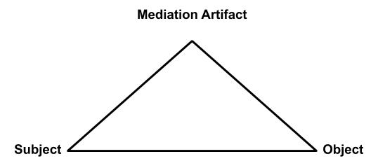
Figure 1. Engeström’s Depiction of Mediation

Smaldino (2007), utilized CHAT to examine real-world problems in K-12 school and university partnerships. The goal of their research was to propose possible solutions to these problems. Interventionist approaches in the third generation led to a greater focus on the motive-directed actions of the individuals engaged in these activities (Engeström, 2001).
Lastly, the third generation contributed to the explanation and analysis of complex human activity using graphical depiction. Engeström (2015) expanded Cole’s original triangular visual
of Vygotsky’s mediated action to incorporate the societal components from Leon’tev (See Figure 2). This depiction is now widely used in CHAT literature to help explain complex phenomenon in activity systems.
Criticisms and Misunderstandings of CHAT
The criticisms of CHAT largely stem from unclear interpretations of the first and second generations’ intentions. As such, it is important to understand the historical context, in which Vygotsky and the Kharkovites were writing under. For these Russian theoretical psychologists, that context was situated in the aftermath of the communist revolution and the rise of Stalin (Bakhurst, 2005). The societal oppression of independent thought and activity through communist rule led to oral interpretations of Vygotsky’s intentions (Bakhurst, 2005; Stetsenko & Arievitch, 2004). As a result, some criticisms of Post-Vygotskian CHAT have argued that an over emphasis on contextual influences fails to account for the self and the internalization processes of cognition (Stetsenko & Arievitch, 2004). As I mentioned previously, critics believed Vygotsky overemphasized a unidirectional influence of the environment on the individual. However, proponents have argued these criticisms fail to recognize the connection to the efforts by the Kharkovites to continue Vygotsky’s work after his untimely death (Yamagata-Lynch, 2010).
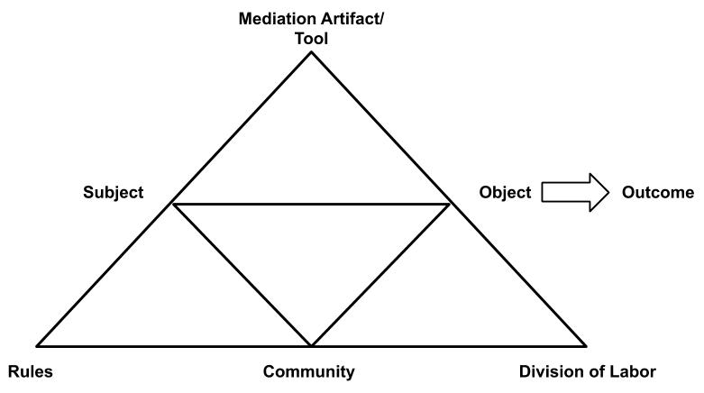
Figure 2. Engeström’s Expansion of Mediation

Another way the first and second generations are misunderstood is by the third generation, which is largely working from translations of original Russian texts (Bakhurst, 2005; Vygotsky, 1930/1978; Leon’tev, 1974/1981). As a result, many have argued that CHAT, particularly as understood in western culture, suffers from misinterpretations. One example informs the unidirectional misunderstanding. As Cole (2009) explained, the confusion stems from early translations where the word obuchenie was interpreted as either learning or teaching,
depending on the contextual understanding of the editor. In retrospect, subsequent translators have argued that the word has no direct equivalent in English because it refers to a bi-directional relationship of learning and teaching.
In addition to the repression of controversial ideas and translations, other aspects of CHAT indicate that Vygotsky was aware of the individual’s internalization processes. For example, Vygotsky’s (1930/1978) definition of zone of proximal development included the role the individual had in collaborating with more capable peers. Meaning the individual had a role in initiating the conditions for learning. Additionally, the unit of analysis in a CHAT approach is the activity itself, which begins with the individual’s orientation or motivation toward the object (Yamagata-Lynch, 2010). However, ASA has also shown us that the individual’s internalized orientation may be culturally influenced.
In short, I do not find it practical to argue the extreme origins of the self and context as some theorists seem fit to do (Leon’tev, 1974/1981, Toomela, 2000). I think it is safe to assume that both have influence on activity and their dialogical interaction is where meaning is affirmed and changed. Interestingly, this identification of individual or contextual origins surfaced in recent higher education collaboration literature, although under different terminology. Kezar and Gehrke (2016) have observed the influence and importance of onboarding new individuals to a context. Youngs (2017) has gone as far as graphically depicting that there may be no true beginning to collaboration in most higher education work environments because they are all culturally and historically imbued with influential baggage. For this dissertation and its application to collaboration in higher education, it may be appropriate in some circumstances to view an action as originating from the self (Stetsenko & Arievitch, 2004).
Application to Collaboration in Higher Education
The impetus for my application of this theoretical framework, CHAT, to collaborative practice in higher education was influenced by one work more than any other. Engeström’s From Teams to Knots: Activity-Theoretical Studies of Collaboration and Learning at Work (2008) reflected on the author’s 15 years of studying collaborative work teams from an activity theory perspective. Educators within the context of undergraduate education undoubtedly form various work teams. Engeström (2008) argued that empirical research on teams had largely consisted of experimental works that focused on the psychological impact on individuals. Only recently the literature has begun to examine the contextualized nature of the work of teams, but much of that work still “consists of uncritical management texts” (Engeström, 2008, p. 4). The bulk of the Teams to Knots demonstrated how CHAT and ASA can be used as a framework for understanding how teams collaborate and how they worked through tensions by examining case studies from the author’s past work. Each chapter contained a case that is used to examine different aspects of collaborative teams. For example, chapter two used a CHAT framework to examine a television broadcast team to gain insight about why teams stagnate (Engeström, 2008). Through this type of analysis, Engeström described in rich detail what transpires in the practice of working collaboratively (Nicolini, 2013).
As was previously stated, the literature on collaboration in higher education is largely focused on the agency of senior leadership positions in creating the context for collaboration. It could be argued that in a hierarchical organized institution, senior leadership prerogative is the only object of the activity. Whether that is both outwardly and inwardly true from the perspective of the members involved in the activity fails to be known without an examination of the individual members’ agency in contributing to the objective of the activity. Stetsenko and Arievitch (2004) elaborated on Leont’ev’s (1974/1981) writings about the self not just as unique constellations of meaning for each individual, but motivations or motives for future action. Reflective practice between the actual action and an idealized action is an example of how an internalized process manifests as new action in an activity (Lampert-Shepel, 2008). In short, the relationship between the individual and the environment is bi-directional, because the individual can determine influence through inaction or new action. Therefore, it is important that CHAT researchers “consistently use object-oriented activity as the unit of analysis in their investigations” (Yamagata-Lynch, 2010, p. 29). The internal motives of every individual in an activity are critical to understanding the activity.
Additionally, if collaboration is a group of individuals working together in context, a new member of a collaboration (e.g., a newly included or newly hired status) may come to the collaborative activity with a principal motive internalized before engaging in meaningful activity with the collaboration members (Kezar & Gehrke, 2016; Youngs, 2017). This principal motive could possibly be isolated internally having been constructed in different activities that occurred in the individual’s experience at another institution. However, from the viewpoint of the observed activity, initial actions from the individual may be viewed as originating from the self. I would argue activities do not always uniformly begin and adjourn. Instead, they may take on new members who in turn reify the collaborative practice, to its benefit or detriment, through the formation of new contextual relationships in the observed activity (Youngs, 2017).
Conclusion
The literature I have brought together in this chapter apply a strong theoretical framework to the practice-based ontological direction higher education collaboration has progressed. The combination of these two perspectives could have implications for the methodological approaches future collaboration research in higher education might take. The utilization of CHAT in a new context may also introduce a new body of researchers to this theoretical framework.
Some scholars of higher education have begun to outline the applicability of practice-based strategies for collaboration. However, these approaches have largely remained theoretical or confined to generic qualitative inquiry. For instance, (Fried, 1995; Magolda, 2001; 2005) built off the works of (Giroux, 1992; hooks, 1994) on border crossing to discuss its potential application to practice in navigating higher education cultures. The practice of border crossing is a proactive action in collaboration that implores the individual to better understand the other or the unknown (similar to boundary spanners in Klein, 2007). My belief is that the application of CHAT framework and relevant methodologies to collaboration may strengthen our understanding of practice-based strategies such as these.
Additionally, it could be argued that the literature of collaboration has progressed through the components of the activity systems described in CHAT. The focus on leadership and the components of collaboration described in Kezar (2005) could be described as a focus on a singular subject and a mediating tool used in the activity of collaboration. Kezar (2001) and Whitt et al (2008) examine the products of collaboration in terms of quantity and participant quality, which could be described as the object or outcome in activity systems. Arcelus (2008) and Hirt et al. (2004) examine the culture and norms that are engrained in educator subgroups. These could be described as rules and community in activity systems. The division of labor and work roles of collaborators have been examined (Fried, 1995; Kezar & Lester, 2009; Kezar & Gehrke, 2016), but under the terms of position and power. CHAT provides a theoretical framework toward understanding all these complex concepts together.
To that end, I am interested in how the individual can intentionally contribute to collaborative practice for the benefit of the collaborative activity. If the individual has a position of power, the collaboration literature has suggested that they need only set the conditions for collaboration. However, if the individual is joining the activity from a position subordinate to senior leadership, as most educators do, more nuance in their practice may be needed. To parrot a meme that originates from the 2001 film Lord of the Rings: The Fellowship of the Ring, “One does not simply have a collaboration”, you must actively work towards collaboration.

Chapter 3: Methodology
This qualitative study was designed to examine the activity-based experience of collaboration in a contextualized workspace. As described in the previous chapter, educators situated in different higher education group cultures have historically-constructed differences that may affect the motives of their work. The activity of creating a transfer student service is an activity that necessitates educators to work across these group cultures. This dissertation examined how motives that may exist in group cultures influence collaborative activity of the contextual work activity by employing qualitative methods augmented through ASA to answer the following research questions:
- How do educators in four-year institutions contribute toward collaborative, cross-institutional transfer activity?
  - What motives do educators share while participating in the cross-institutional transfer activity?
  - How do educator motives differ while participating in the cross-institutional transfer activity based on their organizational goals and shared norms?
- How do educator motives in the four-year institution influence the cross-institutional transfer outcomes?
Population and Sampling
The requirements of the design presented challenges in population identification and sample selection. As a researcher, I was open to studying any institution of higher education. However, finding one that had meaningfully and actively engaged in collaborative work on the transfer student experience recently, may have proved difficult. To navigate this challenge and get to the study’s intent, this purposive sample was acquired through partnership with the FoE self-study designed for improving the transfer student experience. The non-profit JNGI administers FoE, by partnering with higher education institutions who want to engage in this work.
The sampling method may be viewed as a criterion or opportunistic purposive sampling method (Collingridge & Gantt, 2008). Using an external contextual tool, FoE, as a sampling method is consistent with other researchers that have studied the transfer context: National Student Clearinghouse (Fink & Jenkins, 2017) and Credit When It’s Due in (Yeh, 2018). Additionally, a core component of the FoE self-study required educators to collaborate in assessing their entire institution’s transfer student offerings. This method represented a criterion sample because each potential participant had experienced the phenomenon of working together. The sampling method may also be viewed as opportunistic due to the window that JNGI was able to provide me to conduct the research.
The sampling method allowed me to contextualize the research question in transfer student work. However, it potentially presented challenges in applicability to other settings. For example, the opportunity to participate in an intensive self-study experience that prioritizes collaboration is not practically feasible for all collaborative work settings in higher education. The participants in this study may be hyper aware of their collaborative interaction because of the unique experience of the self-study. Additionally, when interacting with participants during the interviews there were times when they may have misinterpreted or assumed an evaluative motive on my part toward the self-study. Generally speaking, all of the participants had positive comments regarding JNGI, their JNGI facilitators, and the self-study tools themselves. A few of them took interview time to expound on this. As the researcher, I am left to wonder if they were concerned that I had an intent to critically view the self-study or JNGI. This was never my intention at any point in this study.
Institutions and Institutional Support
The FoE (Barefoot, 2004) study director Dr. Betsy Griffin and her colleague Dr. Stephanie Foote provided introductions to contacts at institutions that recently completed the FoE self-study for transfer students and met the criteria listed below. Dr. Griffin and Dr. Foote reached out to institution contacts to broker connections and initial interest. I consulted with each institutional contact to determine institutional willingness, potential timeline for participant interviews, and to explain the documents created during the self-study process that I intend to seek consent to access. This consultation process mirrored the institutional selection process undertaken by Fink and Jenkins (2017). Once two suitable institutions agreed, I worked with the institutional contact to confirm their institutional characteristics met the below criteria and determined an appropriate selection of interview participants.
Institutional criteria:
- A four-year institution
- Recently completed the Foundations of Excellence for Transfer Students self-study (within one to five years)
- Willingness of JNGI to provide access to the specific institutional contact
A protocol for communication and securing support with the institutional liaison can be found in Appendix A.
Institution 1: Private University. The first institution to respond and support participation in the study was Private University (a pseudonym). Private University is a private, religious-affiliated, four-year institution with an undergraduate enrollment between 1,500 and 3,000 students. Private is located in an urban area and is classified as a master’s university with medium programs by Carnegie. Private’s in-state tuition is more than $35,000.
Transfer students at Private University comprise 9% of the incoming undergraduate student population. Admissions requirements for transfer students are a 2.5 transfer grade point average and at least 15 transfer credits. Private has no guaranteed admissions agreements with other institutions and accepts transfer students in the fall, spring, and summer.
Institution 2: State University. The second institution to respond and support participation in the study was State University (a pseudonym). State University is a public, four-year institution with an undergraduate enrollment between 10,000 and 15,000 students. State is located in a suburban area and is classified as a doctoral university by Carnegie. State’s in-state tuition is less than $12,000.
Transfer students at State University comprise 22% of the incoming undergraduate student population. Admissions requirements for transfer students are a 2.0 transfer grade point average and at least 12 transfer credits. State has no guaranteed admissions agreements with other institutions and accepts transfer students in the fall, spring, and summer.
Participants
Interview participants were recruited from the population of educators at each institution who participated in the self-study. Typically, institutions have 80-100 individuals that participate in the self-study process (B. Griffin, personal communications, October 4, 2018). From the self-study participant lists provided by the institutional contacts, I intended to recruit a sample of five to seven individuals from each institutional site. This number is consistent with similar case studies in the literature that produced sufficient data for analysis (Fink & Jenkins, 2017; Kisker, 2007).
Participant criteria:
- Directly involved in the FoE for Transfer Students self-study
- Employed at the institution at the time of this study
- Not required to be involved with transfer student services at the time of this study
Table 1 indicates the roles of the population at each institution that participated in the self-study. Role of individuals were inferred by title and department from the provided participant list and later at the time of the study, as reported by the institutional contacts and verified in the document analysis. A second column in Table 1 indicates the number of individuals still employed at the time of this dissertation.
An implied feature of RQ1b is to understand the collaborative practice of educators from different group cultures within the collaborative activity. As a result, I utilized the provided participant list from the institutional contacts and in vivo interpretation of the document analysis to guide the order of recruitment outreach. In vivo understandings in qualitative research honor the perceptions and voices of the participant culture (Manning, 2017). My goal was to recruit a diverse set of participants on both the power continuum (e.g., leadership, middle-manager, entry-level, etc.), the position continuum (e.g., faculty, academic affairs, student affairs, administrator, etc.), and the FoE involvement continuum (e.g., committee chair and member). The exact hierarchy and organizational structure of institutions varied as indicated in Table 1. Allowances were made for other potential participants to emerge from the self-study participant population and snowball sampling (Atkinson & Flint, 2004).
Interview participants were recruited directly by me, but the institutional contacts did make the population aware that they may hear from me. The institutional contact was not aware of which participants I recruited or interviewed. Each participant received up to two recruitment

Table 1. Roles of Population at Each Institution
Role | Private University |  | State University
 | During FoE  self-study | At the time of this study | During FoE  self-study | At the time of this study
Position Continuum
Academic Affairs | 20 | 16 | 24 | 10
Student Affairs | 7 | 3 | 4 | 2
Enrollment Management | 7 | 4 | 10 | 5
Faculty | 24 | 20 | 13 | 2
Student | 4 | 4 | 5 | 4
Other Employees at 4-year | 12 | 7 | 4 | 0
Employees at 2-year institution | 9 | 9 | 0 | 0
Power Continuum
Front-Line | 25 | 22 | 15 | 6
Middle Manager | 31 | 25 | 36 | 10
Senior Leader | 13 | 11 | 4 | 3
Non-Employee | 14 | 5 | 5 | 4
FoE Involvement Continuum
Committee Chair | 16 | 12 | 15 | 6
Committee Member | 67 | 51 | 36 | 14
Other Role | 0 | 0 | 9 | 3
Total | 83 | 63 | 60 | 23

emails from me, a week apart. Once a potential participant did not respond to a second recruitment email, they received no additional communication from me. A protocol for communication with institutional participants can be found in Appendix B.
Following responses and non-responses, I adjusted the order of recruitment outreach accordingly. For example, at one point I had recruited two faculty, one in a leadership position and another who was in an assistant professor role. When the assistant professor responded, I had added faculty to the position continuum, but I lacked any response from leadership in other recruitment outreach. Thus, the next outreach was to an administrator who did not also hold a faculty title due to the available individuals in the population. This maximized the possibility of recruiting a participant on the leadership side of the power continuum.
Table 2 indicates the roles of the participants that were interviewed for this study. As previously mentioned, the participant pool allowed for the inclusion of two-year colleagues and
students as relevant. Institution 2 did not have two-year colleagues involved in their self-study process. Institution 1 did include them in their self-study process but was unable to secure the 2-year institution support in the time frame of the study. Although Institution 2 provided a letter of support for the inclusion of students in the study, Institution 1 did not respond with the same support for their inclusion. Given the lack of written support for recruiting these populations where they were present, I decided to omit them from participant recruitment and did not pursue IRB approval to do so. However, the inclusion of these roles in the institutional self-study may have influenced the perception of participant motives in the transfer student work collaboration as explained in Chapter 4 and 5.

Table 2. Roles of Recruited Participants at Each Institution
Role | Private University | State University
Position Continuum
Academic Affairs | 2 | 3
Student Affairs | 0 | 1
Enrollment Management | 0 | 1
Faculty | 3 | 0
Student | 0 | 0
Other Employees at 4-year | 0 | 0
Employees at 2-year institution | 0 | 0
Power Continuum
Front-Line | 2 | 2
Middle Manager | 2 | 3
Senior Leader | 1 | 0
Non-Employee | 0 | 0
FoE Involvement Continuum
Committee Chair | 4 | 3
Committee Member | 1 | 2
Other Role | 0 | 0
Total | 5 | 5

Incentives
Through the support of a research grant from the National Institute for the Study of Transfer Students, participants were compensated with an Amazon gift card in the amount of $50 or $100. Participants were compensated $50 for the completion of an interview. They had an opportunity to be awarded an additional $50 for completing a transcript review as outlined in the data collection section below. The intent of this incentive encouraged participation by offering appropriate compensation for the time that participants gave to the study, particularly during a global pandemic.
Incentivization through monetary payment in human subjects research remains controversial due to “concerns about coercion and undue inducement” for excessive payment
(Brown & Merritt, 2013). However, the practice persists, and little guidance is available to guide researchers on how to determine appropriate payment incentivization (Brown & Merritt, 2013; Dickert et al., 2002). A study examined the policies of 32 organizational IRBs from various sectors determined the most common approved incentivization reason was paying subjects for their time (Dickert et al. 2002). Dickert et al. (2002) indicated that while little guidance on this practice exists some institutions paid an hourly rate and others paid a flat rate per day, ranging widely from $25 to $125.
I have justified my compensation strategy as follows. The interview and subsequent transcript review were estimated to require approximately two hours of the participants’ time. One hour for the interview and approximately one hour for the transcript review. If a salary range of potential participants could be known, a per hour rate was possible to estimate. Educator salaries at four-year institutions vary greatly depending on demographic differences in organizational division, job responsibilities, and seniority in hierarchy. The intent of this study was to attract a diverse set of educators across these different demographics. This was why it was imperative to set an incentive that would be equivalent to the compensation received by some of the highest paid educators in the four-year institutions.
According to a 2018-2019 academic year salary study at four-year public institutions in the Chronicle of Higher Education, the average salary for non-instructional staff was $61,276 (2020a, 2020b). The same metric for faculty was further disaggregated by Carnegie classifications where average salaries ranged from $110,242 for very-high research, doctoral institutions to $68,168 for baccalaureate institutions that do not have a specific arts and science focus (2020c). Lastly, public four-year institution administrator median salaries were represented at the highest $495,813 for college presidents to $135,000 at the lowest for chief financial officers (2020d, 2020e).
In accordance with this salary information, the incentive amount for participants was set at $100 for two hours, or $50 per hour. When this rate was applied to a 40-hour work week and a 52-week calendar year, the resulting hypothetical salary would equal $104,000. The $50 per hour rate may have been above some potential participants actual pay rate, but the Chronicle data indicated that the proposed rate may have been under potential administrator or faculty participant actual pay rate. It is for these reasons that I justified the proposed compensation as a good faith estimate for a consistent incentive that addressed concerns of excessive compensation or undue coercion.
Limitations of Recruited Populations
The recruitment of participants for this study had some limitations. First, institutional sites and the participants within them were limited to those who have recently partnered with JNGI for the FoE study. Institutions who have participated in the FoE study incur a cost for the year-long, self-study and consultation with JNGI. It is reasonable to assume that the selection process may have excluded institutions that were unable to afford this cost. Similarly, the investment of funds to engage in the study may have indicated a level of institutional support for the transfer student experience. Thus, it is also reasonable to assume that institutions whose leadership did not place importance on the transfer student experience may have been excluded from this study’s design.
Another limitation of participant selection was my lack of awareness of individual contribution in the self-study process. The institutional contact provided a list of participants and the roles they fulfill positionally in the institution to help mitigate this concern. I also allowed the first phase of document analysis to inform purposive participant selection. Following initial interviews, I allowed space in the order of recruitment outreach for additional interview participants to be identified through snowball sampling obtained from feedback from participants (Atkinson & Flint, 2004). These processes are outlined further in the analysis section of this chapter and Appendix C.
I approached this study fully aware of these limitations but accepted them given the other alternatives I considered. As a practitioner, I have been a part of several institutional collaborations. While I could have examined a collaboration of which, I am a potential participant, I found this approach raised more questions regarding researcher bias (Balkin & Kleist, 2014). Alternatively, I could have used convenience sampling for institutions, where I was not a potential participant, but had established professional relationships with colleagues who were willing to assist me in my study. This approach may minimize the potential for researcher bias, but it still failed to address the issue of coherence for participants. For instance, how would I select a collaborative activity, for which, all participants had active and recent engagement in the collaboration? Additionally, by choosing the same collaborative activity at two institutions, bounded by the same self-study activity, I was able to make connections to cultural and historical challenges of transfer student work grounded in professional literature and each institution’s context. This approach brought together the general trends in collaboration research toward contextual, practice-based approaches that analyze the between groups interaction of collaborative work outlined in Chapter 2 (Arcelus, 2008; Klein, 2017; Youngs, 2017).
It is for these reasons I chose the above-mentioned recruitment plans. The case study approach outlined below provides a starting place for examining collaborations in this motive directed way. My intent was to begin a discussion in practice and provide a foundation for researchers who may wish to continue examining the practice of collaboration in higher education contexts.
Inquiry Strategy
This dissertation took the form of two qualitative case studies. As mentioned in the previous two chapters, research on collaborations in higher education have often adopted quantitative and institution-wide approaches that are hard to translate into practice. To get at the motive directed actions of individuals in context, qualitative methods are needed to allow participants to define how they made decisions in their activity. Qualitative methods are appropriate for answering “how” research questions (Josselson, 2013).
A case study approach to this dissertation, as described by Flyvbjerg (2011), suited both the intents and conditions of this dissertation. To engage in deep understanding of the motive directed actions of educators, it was important to focus on a limited number of participants. Given the previously mentioned difficulties in locating a suitable activity of collaboration in higher education, tackling a wider scale examination of participant group culture in higher education was outside the scope of this dissertation. Additionally, a case study approach followed the intent of studies I drew inspiration from and, to which, I hoped to add to our understanding of collaboration practice (specifically; Arcelus, 2008; Engeström, 2008; Fink & Jenkins, 2017; Kisker, 2007).
Flyvbjerg (2011) suggested that case study research can contribute to practice-based understanding through examining exemplary cases, but the researcher must be weary of summarizing useful details in the narrative explanation to achieve a theoretical model. My intent was not to develop a model for collaboration. Instead, I sought to add a deeper understanding to the ways in which collaboration occurs in a specific context. This deeper understanding contributes to educator practice through practitioner familiarization with multiple cases (Flyvberg, 2011). Additionally, the sequence of studying multiple cases can allow comparisons that increase external reliability of the study (Merriam & Tisdell, 2016).
Each case was bound by the collaborative activity of the FoE self-study at a single institution. Specifically, sample participants were not drawn from the entirety of the institution, but only those who were directly involved in the self-study process. Participants who were a part of the self-study and were no longer serving in an institutional role where they work with that institution’s transfer student experience could be included as participants in the activity. However, participants who were hired after the self-study, but were not part of that initial collaborative activity were not considered suitable participants.
Data Collection
This study included document analysis and participant interviews. The documents were obtained, with permission of the institutions, from JNGI who retained copies of each self-study report. It was important that document analysis happen before participant interviews. While I had general practitioner knowledge of the activity of transfer student experience, it was important for me to contextualize participant questions in authentic institutional realities gained through document analysis.
These different data collection methods added to the validity of the study by triangulating the lines of inquiry from institutional documents co-created and by individual perceptions elicited through private individual interviews (Flick, 2018). Document analysis served as preliminary evidence of activity actions within the collaboration and served a purpose in focusing subsequent interview questions. Interviews served a dual data purpose in illustrating both the actions that took place in the activity and informing the motives of the individual being interviewed. This second purpose of the interviews, individual motives, is particularly important when engaging in a study with a CHAT framework. When doing so, it is important to elicit a vicarious experience from the participant’s cognition that informs the psychological, or individual, aspect of the activity (Yamagata-Lynch, 2010). Failure to do this could lead to a misexecution of the Vygotskian bidirectional relationship with the environment. Specifically, Vygotsky (1930/1978) believed that both the thoughts of the individual and the societal environment have the potential to impact each other. In turn, that impact can change the human activity being observed.
Document Collection
Document collection was limited to materials that both institutions completed, self-study reports. These reports were obtained via FoETec, a digital document library curated during the FoE self-study and maintained by JNGI. These documents typically consist of nine, self-study dimension committee reports and the final institutional report.
Permission was acquired from each institutional contact to access the documents in FoETec to be analyzed qualitatively. Letters of support from each institution were submitted to IRB and JNGI indicating this institutional permission. Once permission was obtained, JNGI staff provided access to FoETec digitally. All documents were transferred digitally and entered into NVivo for analysis. NVivo is a qualitative analysis tool that allows a researcher to iteratively refine qualitative codes and themes as more data are analyzed. Additionally, I have prior experience using NVivo for document analysis and the software package was provided at no cost from my institution.
There were some differences in how each institution approached these documents. While both contained similar components, followed the same format, and were informed by the same source information guidance provided by JNGI, Private University never compiled their dimension reports into a final report. Conversely, State University did complete a polished final report for campus dissemination but uploaded much leaner drafts of their dimension reports to FoETec than those from Private which submitted final dimension versions. Given the relatively similar format and content between both dimension and final reports, all documents were analyzed as a complete set of documents for each institution. Documents from Private totaled 83 pages of written self-study reflection. Documents for State University totals 67 pages of written self-study reflection.
Document collection and analysis served two purposes. The first purpose was to examine each case for evidence of educator contribution to the collaborative activity. For instance, a dimension report from Private University indicated a previous existence of an adult degree program that had since been discontinued by a previous administration. Understanding the conditions of who discontinued this program and why, might have been an important educator contribution to note in analysis. It could have begun to answer questions of motives for individuals within the activity.
The second purpose was in service of the second phase of data collection, participant interviews. It was for this reason document collection and analysis was conducted prior to participant interviews. Terminology in higher education often has a historically created context. One institution’s transfer articulation may be equivalent to another institution’s transfer pathway. Familiarization with institutional terms aided me in asking the appropriate questions to interview participants (Merriam & Tisdell, 2016). Additionally, it was important to ask questions about different participants’ understanding of other individual’s motives. In the previous example, how did participants view the discontinuation of the adult degree program?
Interviews
The second phase of data collection consisted of participant interviews. Given the multi-site analysis and the ongoing COVID-19 pandemic, interviews were conducted via Zoom video conferencing. The Zoom video conference sessions were recorded in an audio/visual format using the Zoom conferencing software. All interviews were auto transcribed in Zoom, edited by me in Word, and reviewed by participants before being entered into NVivo for analysis. During my editing phase of the transcription, interviewees were assigned pseudonyms.
Participant interviews took the form of semi-structured interviews that included questions about participants’ role in the implementation of the transfer student services activity, their perspective on the collaborative actions in the transfer student services activity, and confrontational questions that ascertained their perspective on the transfer student services activity (Flick, 2014). Given the potential for divergent contextual experiences at each institutional site, the interviews followed a semi-structured format. The structure was customized following document analysis to include contextualized institutional information, while remaining focused on the research questions (Josselson, 2013). Each interview followed similar phases of inquiry with the participant. Consent protocols and the interview questions were estimated to take 45 to 60 minutes to complete. The actual interviews varied in length from 38 to 58 minutes. The interview protocol is listed in Appendix C.
The interview protocol questions were developed from several sources. First and foremost, the structure of the interview was framed in the chronological order in which the interviewee would have experience the FoE self-study activity. Next, the nature of the research questions and the proposed analysis methods below led me to follow a question schema that prioritizes individual educator motives. The intent of these interviews was to explore the cognitive understanding of the participants’ experience as educators working in a collaborative environment and the nature of how they perceived other educators as collaborators. Klein (2017) was the most closely aligned study to the intent of this inquiry into collaboration regarding motive directed actions. Klein constructed “interview questions to probe participants’ perspectives, motivations, values, strategies, and thought processes related to collaboration across internal organizational cultural boundaries” (p. 258). In response to this approach, my protocol includes questions related to perceptions, personal motives, and thoughts regarding actions within the collaborative activity. A copy of Klein’s question protocol was obtained to incorporate similar interview questions (personal communication, October 1, 2020). Lastly three studies, Fink & Jenkins (2017), Kisker (2007), and Wetzstein & Yeh (2019), represented the closest connection to the transfer student context and the topic of collaboration. These studies informed the proposed probes used during the semi-structured interview.
Finally, to bracket against potential bias and refine question flow, I was interviewed by a colleague using the interview protocol developed through the above means. This form of reflexive bracketing was appropriately situated during the preparation stage of the study (Gearing, 2004). I suspended my internal instincts and allowed my colleague to interpret their own approach to the questions as written. I responded from the perspective of previous work I had completed in transfer student services from a former job, as I would answer in that role. Following the interview, we discussed moments where it was hard to answer questions as worded and how my colleague interviewer felt transitions between question sets were abrupt or needed context. Adjustments were made that refined the wording of questions and transitional script between sets of questions. The final question protocol submitted to IRB can be viewed in Appendix C.
Transcription. Following the interviews, transcripts were autogenerated by Zoom. Each raw autogenerated transcription was formatted into a cleaner format that more clearly delineated turns between the interviewer and the participant. Then, each transcript was checked for errors against the audiovisual record of the interview from Zoom. During this process, the transcription was denaturalized by eliminating pauses, repeated words, and extraneous vocal ticks, such as “um.” This was done to aid the next step of transcript review, to be completed by the participant. In this study, a heavier focus was placed on the content of the interview and reflection of the participant than the accurate, but perhaps harsh realities of the accurate spoken record which may have risked insulting the participant (Forbat and Henderson, 2005; Mero-Jaffe, 2011). Lastly, the transcript was deidentified in reference to names, specific positions, specific organizational units, and institutions in a manner consistent to those described in Appendix B.
Transcript Review. Once a deidentified, denaturalized transcript was produced, I had listened to the full video at least one time and had made three passes through the transcript for the above-mentioned procedure. To validate the intentions of the participant were accurately captured as intended, the participant was sent this copy of the transcript for review via UT Vault. Participants were given two weeks to review and respond with additions or corrections to their interview transcript, also sent through UT Vault.
Participants were directed to review the content and substance of the text and not to be overly concerned with grammar or syntax. They were told that my intention was to get an accurate depiction of their perceptions regarding the collaborative activity. This step was important because it helped clarify the task for participants and mitigated the potential pitfalls of transcript review (Carlson, 2010).
The primary intent of this review was to validate the participants intentions. However, the review served two additional purposes. First, participants were offered the opportunity to add any additional comments to the responses that occurred to them during the review. Second, participants were able to view my pseudonym interpretations of their and other mentioned individuals’ position and organizational place in institutions for accuracy. This enabled me to preserve an element of positionality and culture in each participant’s interview perceptions while also affording them the control to alter or qualify remarks made in the interview that may be too direct. My intent was to build trust with the participant that I would represent their words in a way they felt comfortable with.
Data Analysis
Data analysis took place sequentially for the two data collection methods: documents and interview. As previously mentioned, document analysis took place first so that I, as the outside researcher, could familiarize myself with the institutional activity and begin to develop motive directed questions for the interview phase of data collection. This sequential process demonstrates how documents can be used for both content analysis and as a theoretical sampling process for subsequent data collection and analysis (Charmaz, 2014). Once interviews were complete, a phase of initial interview analysis took place. A visual order of the analysis has been provided in Figure 3 for ease of reference.
Analysis of the above qualitative data was conducted through a series of coding phases that employed the constant comparative method (conceptualized by Glaser & Strauss, 1967). This means that codes were checked and rechecked against other data in the data set. The researcher maintained a definition log for each new code created or refined throughout this process. Memos were also made throughout this process by the researcher to practice reflexivity
and consider thought processes of the researcher at that point in time (Merriam & Tisdell, 2016). Memos are described further in the next section.
Open Coding
Coding began with open coding of the text from document analysis. Open coding is a generative process of coding concepts as they appear to me as the researcher without judgment
(Charmaz, 2014). This initial step began the process of developing conceptual meaning of the data (Corbin & Strauss, 2015). During this initial phase, I coded by following the text in a line-by-line manner. Codes and questions raised in memos were used to refine the interview protocol in Appendix C for language norming and for the inclusion of probing questions enriched the research questions that the interview protocol was designed to answer.

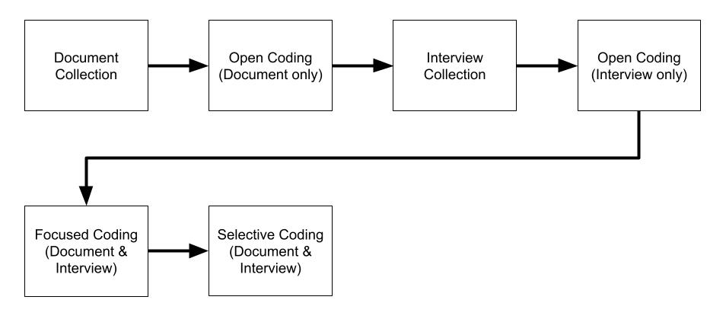
Figure 3. Data Collection and Analysis Order

Following interviews, the analysis of interview transcripts followed a similar open coding format to the initial document analysis. Coding was again conducted line by line with the same intent to generate code meanings from the data. After the conclusion of this separate interview analysis, the initial coding stage was complete and both documents and interview transcripts were analyzed simultaneously beyond this stage.
Concurrently with my own open coding analysis of the documents, I employed a strategy to increase the reliability of my interpretation. Deidentified copies of individual documents were sent to three of my fellow graduate cohort for a parallel process of open coding. This process of parallel analysis was used as a solidification strategy done in the process of analysis instead of a post hoc check on reliability (Marques & McCall, 2005). In addition, the resulting codes can be viewed as a constructive process that helped me not overlook relevant codes as viewed by diverse interactions of parallel coding (Madill et al., 2000). All three graduate colleagues were previously familiar with Cultural Historical Activity Theory and were asked to bring that lens to their open coding analysis in addition to coding what they saw in their assigned documents. Three different documents were coded by the three graduate colleagues. The codes derived from their analysis were used in focused coding.
Similarly, two graduate colleagues were given interview transcripts to increase reliability. Two transcripts were analyzed. The codes derived from these analyses were also used in the next phase, focused coding.
Focused Coding
The next phase of coding was focused coding of the data from both the documents and interview transcripts (Charmaz, 2014). Additionally, the intent of this phase was to look for broader themes that may include families and sub-families of the existing codes (Yamagata-Lynch, 2010). One component of this phase was to reconcile codes derived through open coding of the documents with the separate open coding of the interview transcripts. Additionally, a similar reconciliation of codes was conducted between my open coding process and those generated by my graduate colleagues during open coding. Codes were checked and rechecked in multiple data sources for examples to increase internal validity (Merriam & Tisdell, 2016).
Selective Coding
The final phase of coding was selective coding. Selective coding was used to reexamine the data around the primary codes that emerged as a result of the first two phases (Yamagata-Lynch, 2010). The selective coding process served as the translating stage for ASA, putting the data into the terms of activity systems analysis; “subject, tool, object, rule, community, and division of labor elements related to the study” (Yamagata-Lynch, 2010, p. 75). These components will be discussed later in this chapter.
Memos
Memo writing is a crucial component in qualitative research that helps the researcher document empirical evidence from the data that demonstrates the meaning made through the qualitative process. Memos take many forms, but they serve as a key tool in achieving clarity during narrative creation of a completed study (Flick, 2014). Additionally, memos are tentative in the moment they are captured, they can serve as a reminder of what needs further analysis or what initial ideas have evaporated in the data (Charmaz, 2014).
Memos manifested in three ways during this study. First, I made regular habit of journaling my thoughts, ideas, and questions during all parts of the study. These notes were recorded in a bound notebook.
Another way memos manifested was through the creation of a definition log. As I progressed through the phases of coding, I maintained a definition log in table form via the use of an Excel workbook where I could easily group and regroup related codes. Codes were initially more abstract in description during open coding but became more refined as I progressed through the phases of coding.
The last way I created memos relates to ASA and is visual in nature. ASA uses a triangle diagram to visually identify relationships between components of social activities. Drafts of triangle diagrams were created throughout the process as notes to me about ideas revealed in the collection and analysis stages of this study. Triangle diagrams were drafted and redrafted as understanding from the coding process evolved. This process continued until I drafted the findings of the study (Yamagata-Lynch, 2010). During this phase of analysis, tensions were identified and explored in the narrative and triangle diagram.
Thick Description
As the themes emerged through the constant comparative method, I drafted narrative description of each theme as I understood them sourced by the data. I relied on previous training and experience writing these thick description narratives for other studies in which I have participated (Yamagata-Lynch et al., 2017; Yamagata-Lynch et al., 2020). This step aided in transferring a more abstract analysis chapter toward a clearer story for my readers in the findings and discussion chapters (Merriam & Tisdell, 2016).
This step was of particular importance for the educator audience whom I wish this study to be of use. As described in the literature review, much of the literature on collaboration in higher education has been done on the macro-level of the institution. I believe a critical gap in the literature fails to speak to what my colleague refers to as the meso-level of collaborative educator work (Peden Christodoulou, 2019). For these educators to find a collaborative approach to their work, a rich narrative description of collaboration cases needs to be developed in a variety of settings.
Activity Systems Analysis
ASA is an augmentation of thematic qualitative analysis, derived from the CHAT framework, that allows the researcher to systematically and systemically examine complex human activity as the unit of analysis (Yamagata-Lynch, 2010). Prior to the development of ASA, scholarly approaches relied on the concepts of Engeström’s (2014) activity system but lacked a consistency in their analysis approach. ASA can aid a qualitative researcher in explaining “how changes in a contextual situation that create systemic contradictions can create tensions in individual activities and affect the nature of those activities” (Yamagata-Lynch, 2010, p. 3). In the context of this study, the formation of a team of educators to conduct the FoE transfer self-study introduced a systemic contradiction to the normal context of work because the formation disrupted the status quo of typical university educator activity. In turn, this created tensions in individual activities that affect the nature of future work in transfer student services at these institutions.
In ASA, qualitative data is organized in a triangular graphic organizer that represents the different components of human activity, discussed in modern CHAT literature (See Figure 4). Depending on the activity being studied, multiple triangle diagrams may be developed to represent different individual perspectives. The subject indicates the perspective from which the diagram is being viewed. The tool, or mediating artifact, is the reason the human interaction/activity exists. In my study, the FoE self-study is the primary tool, although it is possible that the data in an ASA study may indicate the emergence of additional tools that
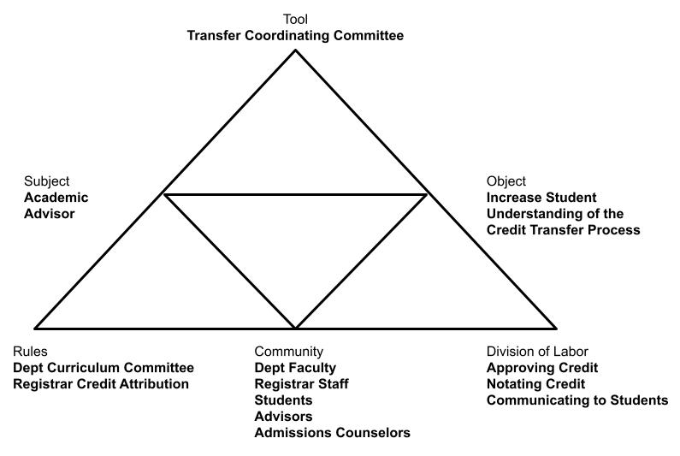
Figure 4. Example of ASA Triangular Graphical Organizer

perpetuate the activity. The object is the intended reason for the subject to be involved in the activity. This varied from each subject’s perspective and emerged from the data.
The other primary components of the triangle (i.e., rules, community, and division of labor) are explained as follows. Rules are any explicit or social agreements that influence the subject’s actions in the activity. The community represents the groups with which the subject interacts. The division of labor represents the collective understanding of who is doing what in the activity.
As participant perspectives are arranged in the triangular activity system, tensions may arise between the different components in the activity. These tensions may be discovered through participant response or incongruencies between different participant perspectives related to the activity. When these tensions are identified, they are depicted as squiggly lines between elements of the activity and labeled with a lower-case letter (Yamagata-Lynch, 2010; See Figure 5). This visual depiction aids the researcher in discussing the tension phenomenon in narrative explanation. I will use a similar format for this study.
Limitations
In addition to the limitations previously discussed in the selection of institutional sites and participants, this study also had limitations regarding length and depth of study. Ideally, this study design would be strengthened by further triangulation through the inclusion of an observation protocol for participants engaged in the collaborative work of the self-study. Additionally, an element of depth that could have strengthened this study would have been the ability to conduct extensive follow-up interviews and additional snowball interviews. However, given the confines of a student dissertation, I chose to omit additional data collection methods in service of completing the study in a reasonable time. These choices were made knowingly, with
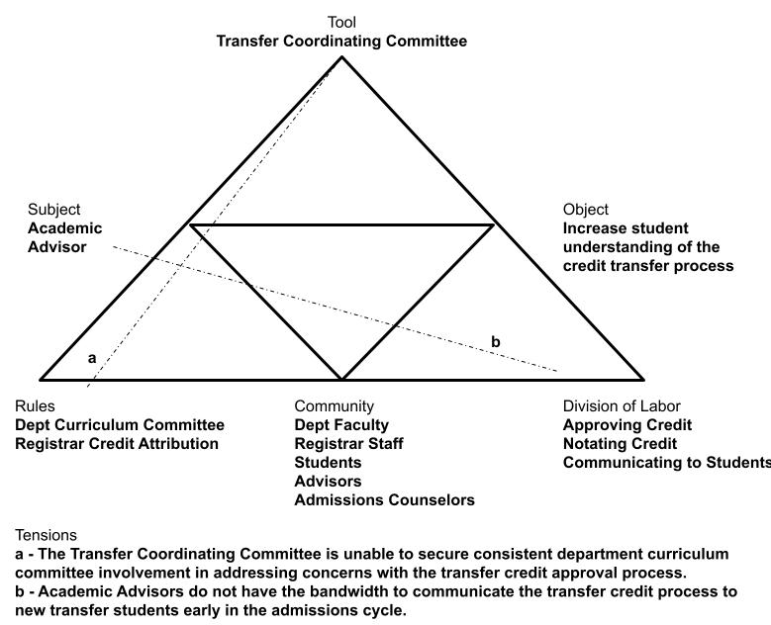
Figure 5. Example of ASA Depiction of Tensions

the intent to introduce CHAT and ASA to higher education collaboration literature, not as a flawless study of transfer student services collaboration. For that, further research will need to be conducted.
Conclusion
Through this methodological approach, I hope to have illuminated the contextual actions of collaboration in an activity taken by educators from various levels. Something that, at this time, remains unexamined in the literature. The intent of Engeström’s (2008) work was to “open up a field for further debate, theoretical work, and experimentation in activity fields with complex runaway objects” (p. 233). He utilized that study to conceptualize a framework for collaboration in teams, that he calls, knotworking. Similarly, I intend to open the discussion of collaboration into educator practice by giving language to concepts observed in this activity. The definitive solution to collaboration remained elusive.
My journey through these questions made me question many of my assumptions regarding the work I thought I wanted to conduct. I believe that every higher education institution is uniquely created through specific cultural and historical activities that have occurred in that environment. I also believe that educators need to learn how to improve their collaborative skills. The second belief implies an imperative to educate and train collaborative educators. The first, may imply that any learned skills may not work in context. For example, the best collaborative educator practice may not work at a particular institution at a particular time. Educators may find this frustrating.
This ASA research design approach presented a deeper understanding of the practice educators undertake while working in collaborative activities cross-divisionally. While definitively generalizable conclusions about collaborative practice cannot be made from this single study, the depth explored in this design will add to educators’ “intimate knowledge of several thousand cases” that inform their daily practice (Flyvbjerg, 2011, p. 303). A CHAT approach has previously been used to examine case studies of collaboration at work (Engeström, 2008). The contextual analysis and visual modeling in Engeström’s work provided an inspiration for this approach and deepened my understanding about teamwork in institutions. The addition of an activity systems analysis approach strengthened that understanding in this case, by the opportunity to examine where tensions existed and how participants responded to these tensions (Yamagata-Lynch, 2010).
This design compared educator collaborative practice in two institutional case studies. The cases were bound by the activities of educators in and around the institutional self-evaluation of transfer student services (Stake, 2000). Kezar (2005b, 2006) used the institution as a unit analysis. In her study, she sought to examine four exemplary cases of institutions with high collaborative activity to develop a model for institutional collaboration. The results of her study provided high-level detail of the presence of institutional attributes and behaviors associated with these highly collaborative institutions. However, understanding of the educator practice in these institutions was limited to executive decision making around setting institutional missions, values, and funding.
Kezar’s (2005a) work identified the high-level qualities of effective practices in higher education collaborations. This failed to recognize the situated and political context that researchers like Magolda and Fried have raised regarding the intentionality and need for collaborative work (Schuh, 2010). My path was to add a brick in the foundation already begun by researchers who have examined the cultures and individual professional identities that influence contextualized collaborative activity. “Good” practice in collaboration can be theorized, but Arcelus (2008) demonstrated the importance of attending to historic group cultures in the institution. In the activity of transfer student services, culture and collaboration have been examined in their situated context using general qualitative analysis (Kisker, 2007; Fink & Jenkins, 2017) This study’s contribution used ASA as a new qualitative approach toward investigating the collaborative practice from both the group culture and activity-based culture simultaneously.

Chapter 4: Findings
In this chapter, I organized the sections to build upon one another in a narrative format. In this first section, I provided an overview of the Foundations of Excellence process as experienced by each institution. I also included the demographic and biographical information of the participants. I chose to introduce my participants in this chapter to avoid unnecessarily complicating the methodology chapter and to allow their narratives to begin to weave into the findings as they emerged in analysis. Most of the narrative for this first section was drafted during open coding, a free-flowing process in which codes were identified without judgment. Open coding produced 112 individual codes in five broad categories.
Next, I have provided themes that emerged through constant comparative analysis of data at both institutions following focused coding, a process in which codes are checked and rechecked into thematic groups or families of codes. Given thematic appearance in both institutional cases, this may be view as an activity-based analysis of the transfer collaboration context. Focused coding revealed the most prominent codes and how they interrelated with other codes. I discovered these themes by reviewing my codes from open coding, reviewing my graduate colleague interrater codes, and by continuing to go back to the data for rechecking. Focused coding consolidated the open codes into 19 individual codes in four families.
In the final section, these themes are further broken out into activity systems analysis (Yamagata-Lynch, 2010) diagrams using selective coding, a process in which codes are reexamined in the resultant schema of focused coding and in this study the structure of activity systems analysis; subject, object, tool, rules, community, and division of labor. This analysis indicates a group culture analysis observed at each institutional site. Selective coding positioned the focused codes into the ASA code family. The code list progression of open, focused, and selective coding can be found in Appendix D.
FoE Activity Overview
Both Private and State University worked with JNGI starting in the summer of 2019 to implement the Foundations of Excellence for Transfer Students institutional self-study. The FoE self-study process typically consists of a yearlong effort that includes amassing institutional data, implementation of transfer student and employee surveys, engagement in campus discussion and debate, and the prioritization of action items. In the spring of 2020, the COVID pandemic impacted both institutions in a way that altered some of their original plans for the self-study.
The FoE self-study process organized the institutional activities into nine parts that the Gardner Institute referred to as dimensions. For the 4-year, transfer-in institutional self-study, dimensions were Philosophy, Organization, Learning, Faculty, Transitions, All Students, Diversity, Roles and Purposes, and Improvement. JNGI encouraged institutions to involve a cross-section of individuals from across the transfer experience. The work was generally divided into dimension group subcommittees with chairpersons who work on sub-reports that contribute to an overall institutional self-study report. Institutions identified lead individuals to form a steering committee and were responsible for collating the actions and reports of the self-study process with guidance from JNGI.
Beyond this basic structure, document analysis and interviews revealed differences in how each institution approached the FoE process. Differences included the number of individuals involved, the inclusion of two-year, transfer-out institutional partners, the make-up of the individuals who led their self-study, and how they organized themselves. Tables are provided to better understand the interview participants.
Private University’s Activity
Private University included a larger number of individuals in their process. Over 80 individuals contributed either through a dimension group or in the completion of the final self-study report. Participant demographics and brief biographical information for the participants
interviewed at Private University are available in Table 3. All participants have been assigned pseudonyms.
One of the unique aspects of their approach was the inclusion of faculty and staff from a
transfer-out institutional partner, Metro Community College. Metro completed a parallel iteration of the FoE self-study designed for transfer-out institutions concurrently with Private University and the support of JNGI. “Stanley”, a faculty member at Private indicated that this was the only time these concurrent processes have been run between a private four-year and a public two-year institution. “Jill”, an administrator at Private further elaborated on the intentionality between the two institutions:
there were Metro Community College people on each of our dimension groups, and then there are Private University people on each of their dimension groups as well. So, they ran a parallel process with a focus on Private University but also understanding that their students might want to transfer out to other schools.
Stanley later expressed enthusiasm for this “unique experience” claiming he thought it was “really motivational.”
Private also took a unique approach to the way they approached their steering committee. Private’s Philosophy dimension group pulled double duty by also serving as the steering committee. This group was the largest of Private’s dimension groups, including all chairpersons from the other dimension groups and according to the self-study documents 10 additional
Table 3. Private University Participant Demographic and Biographical Information
Name | Position | Power | FoE Involvement | Bio
Darren | Academic Affairs | Middle Manager | Committee Member | Darren worked in an academic affairs office that was responsible for strategic priorities of the institution. He was new to Private University when the FoE process was beginning and was enthusiastic about bringing an outsider's perspective to the process.
Stanley | Faculty | Middle Manager | Committee Chair | Stanley was a faculty member and department head for his academic unit during the FoE process at Private University. He became overloaded with the responsibilities of the academic unit leader halfway through the FoE process and was less involved in the later half of the process. Stanley also had academic advising responsibilities for transfer students.
Esther | Faculty | Front-Line | Committee Chair | Esther was a tenure-track faculty member and academic unit leader who was a transfer student during her undergraduate experience. Her motivation to participate was both intrinsic given her personal experience and pragmatic given her need to fulfill service requirements for tenure. She had received tenure at the time of this study.
Jill | Academic Affairs | Senior-Level | Committee Chair | Jill was a faculty member and academic unit leader who held an administration level position in academic affairs. She was enthusiastic about the prospect of examining data to make data-informed decisions for the institution.
Margaret | Faculty | Front-Line | Committee Chair | Margaret was a tenure-track faculty member and felt compelled to participate in this service opportunity at Private University. She was up for tenure during this study. She also had academic advising responsibilities for transfer students.

members who did not serve in chairperson capacities. This group had a total of 35 members. “Darren”, a staff member in academic affairs, expressed this dynamic most directly:
I do go back to the question of the steering committee was it a little bit too big? Because in some part, the steering committee was also its own working group. We were doing some of the philosophy stuff, so we were kind of trying to do both. … we did it, but there was something interesting about the way that group acted in kind of two different capacities. I feel like I didn't weigh in a whole lot of the working group portion, on the philosophy statements and things like that about transfer students. I was in that group technically, but I don't feel like I weighed in on that a lot.
It was also revealed in the document analysis that Private University never completed a final
report of the self-study. However, the Philosophy dimension was the longest of the dimension reports from Private University and did include recommendations from other committees.
Lastly, another unique aspect of Private University’s approach to the self-study was the intentionality of selecting many representative chairpersons for each dimension group. Jill commented on this structure, “we had tri- leaders. … we had a person from [student affairs], we had a person from [academic affairs], and then we had a person from the [enrollment management]. They were all leading it.” “Margaret” provided further evidence of this practice:
At the beginning, we had three of us and that person, the first person, left very soon and was basically not involved with the project. The second person was actually the [leader of an enrollment management unit] and he actually helped me finalize our report for our dimension and then has since left the university.
Stanley indicated a slightly conflicting perspective on this number of chairpersons by seeming to only recount two, “There were representatives from both institutions and a co-chair of each group, with one from each institution that served as the co-chair of the groups.” Further examination of his group’s self-study dimension report and his full transcript indicated that at one point there had been three chairs, and something happened in the course of the process that may have accounted for his comment here. Regardless, the intentionality by Capital to have more than two chairpersons manifested in multiple groups.
State University’s Activity
Despite being a much larger institution, State University only involved 52 individuals in the process of the dimension reports and steering committee. The other nine individuals listed in Table 1, were ancillary to the FoE project but were listed on the final report as contributors to the self-study. Only 23 potential participants were passed along to me for recruitment from the institutional contacts. The contacts mentioned that their list only included educators who still worked at State. Participant demographics and brief biographical information for the participants interviewed at State University are available in Table 4. All participants have been assigned pseudonyms.
State University did not view their transfer self-study as connected to a single transfer-out institution. Prior to the self-study, State had already invested in a full-time position that maintained relationships and articulation agreements with multiple transfer-out institutions. As a
result, there was no direct involvement of two-year, transfer-out institution employees in State’s self-study process. However, their voices were represented as “Valerie”, an academic affairs administrator, explained:

Table 4. State University Participant Demographic and Biographical Information
Name | Position | Power | FoE Involvement | Bio
Chris | Enrollment Management | Middle Manager | Committee Chair | Chris had a staff position in an enrollment management area at State University that didn't directly work with transfer students, however he did have responsibility for policy and practices that impacted transfer students and educators that work with them. He also served a support role to the FoE process aiding his colleagues in academic affairs in completing aspects of many dimension groups.
Ingrid | Student Affairs | Middle Manager | Committee Member | Ingrid was a staff member in a unit that had moved from a student affairs to academic affairs around the time of the FoE process at State University. She had a student affairs background and a position where she heard unique perspectives on students in distress, many of which she later connected were transfer students.
Adrienne | Academic Affairs | Front-Line | Committee Chair | Adrienne was an academic advisor embedded in an academic unit. Since the FoE study, she has been involved in a Transfer Implementation Group at State University.
Valerie | Academic Affairs | Middle Manager | Committee Chair | Valerie's position in academic affairs was directly related to transfer students. She co-chairs the Transfer Implementation Group at State University.
Tim | Academic Affairs | Front-Line | Committee Member | Tim was an academic advisor in a centralized advising unit at State University. Due to budget cuts, his position recently was given partial responsibility for students in an academic unit.

we did a community college partner survey and we got feedback on, What the top five schools that their students attend. They rated us in terms of affordability, which we always do very good on, being a very affordable university in the state. How well do we communicate with them? Are we appropriately represented in terms of recruitment on their campuses? And general feedback. The nice thing and a compliment… to the university, for having a position in [transfer office in academic affairs], was they did like having somebody, an office, dedicated to working with them with the transfer students.
“Ingrid” further supported this statement and the nature of the data:
I know that we looked at data we had collected. In particular, where were our students coming from, what was the profile of our student body. … But, I think we just looked at
more secondhand, not necessarily, direct communication or engagement with partners.
The survey was also referenced by “Chris” in his comments. Ingrid and “Tim” both seemed to have only a vague notion of involvement by transfer-out institution employees, but it was through the aforementioned full-time position that they referenced that involvement.
State University’s steering committee was treated separate from the dimension committees. Document analysis revealed a steering committee of 19 individuals, primarily comprised of co-chairs of the dimension committees. Only one member was not a committee chair and was later identified by a participant as the senior level administrator in academic affairs who had oversight for the self-study project. Covid was a complicating factor in the work of this group as Valerie explained, “because of Covid and everything shutting down, it was a little bit chaotic in our second year. There was a greater challenge then.” Chris further echoed these complications, “I think it's important to mention that the pandemic had a pretty significant impact on wrapping up the project. We were in the last stages as things started shutting down and moving to remote work.” He indicated that a handful of colleagues in academic affairs wrote the initial final draft and vetted it amongst themselves before forwarding to the larger steering committee.
Lastly, the perception was that some of State University’s dimension committees were led by faculty, academic unit leaders who may have not been as invested. “Adrienne” who served as co-chair explained her dimension group leadership as:
The chair of our group was a [faculty, academic unit leader]. …To be honest, he was pretty pessimistic from the beginning. He’s been on enough of these things, where he’s thinking all right, we're gonna put all this time in. Is anything going to come of it? So, we were a good team. … I really liked investigating things and looking into things. Which he told me that he appreciated, because he just didn’t have the time to dig in as deeply.
Chris, another committee chair, had the observation that, “Some of the chairs, I don't think were as invested in the project as others. So, I think some of the committees were spot on with the work that they were doing, more productive. Where others, not as much.” Later he clarified:
Interviewer: Why do you think some of the chairs weren’t as engaged?
Chris: Maybe too far removed from the work. We had a few [faculty, academic unit leaders] that were chairs and I think that that sometimes that their work is a little bit bigger picture and doesn't necessarily get in the weeds on some of these details that would have been helpful in a project like this.
Document analysis revealed that State University had six of the nine dimension groups co-chaired by faculty, academic unit leaders.
The next section explores themes that emerged from the data from both institutions during focused coding. The primary themes that emerged were the value of including others, the communication and internal perception of progress, and the differences in institutional and educator motives. These themes provide rich narrative of the similarities and differences in the activities that occurred at each institution. The activity systems in the next section will explain how these differences relate to the research questions.
Theme 1: The Value of Including Others
All 10 participant interviewees expressed a value on the inclusion of others in collaborative transfer student work. The value of inclusion was expressed through overt statements and positive benefits gained through the interaction with others. Specifically, I identified subthemes of learning from others, empathizing with different perspectives of others, and forming relationships. In addition, to expressing this theme through benefits, several participants lamented times when a voice was absent from the activity due to lack of engagement and inclusion, or activity design.
Participants from Private University were explicit about the intentionality their institutional leadership had in including others and how it influenced their personal motivations. Darren stated, “I think another big motivation is just that [Private University] really values all voices. They really want people from all areas of the institution to be involved in big studies, big strategy, big decisions.” Jill and Margaret indicated that Private appointed three co-chairs to many of the dimension groups as a way of giving equal voice to various areas. Jill later elaborated on the institutional culture, “that's kind of the MO on campus, that we were really thoughtful about bringing in voices from all over campus to make sure that we're capturing all the different perspectives.”
State University participants acknowledged the importance of including others but did not provide any evidence that this was an intentional strategy of their institutional leaders. Valerie, as one of the organizers of State’s FoE process, indicated she was not connected to educators in student affairs and struggled to initially include them in the process. After the process started, Ingrid stated:
the planning committee was really on board with bringing any individuals in. They reached out and invited those departments to participate in it. But I think, in terms of the initial startup process, with the way we approach projects, it is less about specifically identifying the areas that would be good to have representation from and more of, “Who do I know within my network across campus? Who would be willing to participate and take on this additional work and additional space?”
Ingrid felt she functioned as an “expert generalist” helping students navigate the university. Therefore, she had unique insight to whom might be valuable in the conversation and felt compelled to participate.
Learning from Others
Both institution’s participants expressed ways in which learning from others occurred. Participants expressed learning from others as a personal motivating factor in their work. Others expressed how learning from others improved the overall outcome of their work.
Private University’s participants spoke directly about the opportunity to learn from others as a motivating factor. “Esther” expressed that she learned a lot about university resources she didn’t know existed by interacting with other educators in the smaller dimension group. She was now more willing to reach out to others across campus. Darren was new to the institution when this process began. He spoke how much he appreciated being involved even though he felt like he did not know much of the actual workings of the university of the time. He also reflected on how the institutional leaders’ overt inclusion of his outsider perspective was motivating toward this collaborative work:
It was a great opportunity for me to start to learn about [Private], learn about what's going on here. What are some of the priorities and the things that they're focused on? So, there was kind of a reciprocity there, where I got to offer things, but I also got to learn and gain things from being in the process.
Jill spoke to how involving others helped the group learn and make better decisions. She expressed earlier in her interview that she was motivated by the opportunity to make data informed decisions at the institution. She elaborated that when everybody is learning together, “You've worked out all the fine details, because you realize where things are going to falter or where they're not going to falter.”
At State University, learning from others was expressed as a discovery activity that led to better outcomes. Chris expressed similar sentiments of learning about facets of the university that he had not previously been aware and how he felt this awareness would lead to better outcomes. Tim also expressed that the exchange of learning between advising offices was leading to better practices being cross-pollinated on campus. Ingrid reflected the importance of learning from others by acknowledging what she had learned through the process and how it was impacting her work. She later offered the following advice to would be collaborators regarding interactions with others, “dive both feet in. Even if you don't know how it relates to what you're doing.” Lastly, Valerie described an improvement made to an email user-interface. The institution was trying to figure out why students were not checking their email. She said that it was from advisors that they learned the interface needed to be explicit for students because the existing interface did not use the word “email.”
Empathizing with Different Perspectives
Another way that the value of including others was expressed was through perspective
taking. Perspective taking was a natural outgrowth of many participants’ learning from others experience. What sets responses in this section apart from the previous one is the way in which participants viewed problems and how it led to empathetic viewpoints.
Private University included two-year institution colleagues from Metro Community College in their activity. Several Private participants expressed their understanding of different perspectives from that vantage point. After learning more about Metro, Stanley carried their perspective to future activities. He described a purchase of a bed and breakfast by State University and posed a curricular partnership with Metro, wherein their hospitality major degree students would gain internship experience. Stanley later expressed the importance of spending time with people in person to hear their perspective and view things from their vantage point. Margaret explained that one of her co-chairs brought a perspective that was a constraint of the design of the self-study. She explained that her co-chair informed her that although Metro Community College was Private University’s largest feeder institution, it was far from their only. Later, she said she kept this perspective in mind when considering recommendations that would impact all transfer students. Darren later reflected on his thoughts on collaboration with the following statement:
I think a big part of it is, while we are focused on transfer students coming to our institution, how we support them, recruit them, and retain them, if we're going to collaborate effectively with another partner it can't be all about us. So, making sure we're thinking about what our partners need, how we can support our partners so that they're not just coming to serve our ends and our goals. So, make sure you're asking your partners, what do they need? how can we help them? how can we support them? Because they have goals, too, and maybe we can collaborate and support their goals.
This final statement typified the essence of empathetic perspective taking because Darren directly poses challenging questions from the two-year institution perspective that may not necessarily represent his institution’s priorities. The perspective taking led to an empathetic response.
At State University, participants experienced the benefits of perspective taking in much a similar way. Every participant except Tim overtly mentioned the importance of hearing different perspectives. Chris personified the inclusion of others as perspectives instead of people:
I think be very strategic about who is involved in the project. Making sure… various perspectives are present. So that those perspectives, are part of the project. Because you're just going to have a better outcome in the end, if more perspectives are part of the project from the beginning.
While Tim, did not overtly mention perspectives he did express a strong desire to work for
student equity which was viewed as related to empathetic perspective taking. Similar to Tim, Ingrid carried many perspectives with her into the conversation. She cited multiple times how her position gave her unique insights into the challenges that students and educators faced across
campus with issues related to transfer. She was able to bring those perspectives into her
collaborative discussions and it led to the inclusion of others in the self-study as well.
Adrienne’s perspective was directly linked to her motivation to understand more about the experience:
I would love to do like half-day, you shadow me and I shadow you, just to see what your day is like and have different departments. So not advisors and advisors. But I would love
to go and see what an admissions processor is doing for half a day. And then have them
come see what my advising role is for half a day.
Adrienne’s response crosses the threshold of just viewing the perspective, toward walking in another person’s shoes. Her motivation and this activity have led her toward more empathy.
Forming Relationships
The forming relationships subtheme stemmed from a sustained continuation of learning and perspective taking. Participants explained how the inclusion of others led to relationships being formed that extended beyond the collaborative activity. In some cases, relationships led to future collaborative activity.
At State, all participants, except for Esther, spoke of the relationships that were formed as a result of including others in the process. Darren stated, “personally, for me it was great for my network, because I was brand new and I sat in a room with all kinds of people from all areas that I didn't know.” Stanley indicated two different areas where relationships were formed. He shared that a close colleague of his in academic affairs had made a strong connection with their counterpart at Metro Community College, but he also gave more insight to his own relationship with an educator at Metro. He explained that because of the self-study, he was able to reach out to someone he met during the process who was able to secure a regular office space at Metro for his staff to communicate with Metro students about curricular opportunities at State in his academic unit. Margaret gave indication that the culture supported by leadership at Private may have encouraged lowering relationship barriers. When describing who was responsible for the FoE study and transfer work, she responded as follows:
He's also the [specific title] and maybe something else in his title. I call him [Name]. … She runs our [student affairs] office, and she has some title that starts with Dean of something, but again I know her as [Name]. So, we don't bother much with titles at [Private], I’m finding out as I’m telling you this.
Being on a first name basis with leaders across campus aided in Margaret’s personal relationship with them. She was included as a junior faculty member, not excluded from the administration. The inclusion of others in the self-study process led to changes in the way educators at Private interacted with one another.
At State, most of the participants mentioned relationships as an aspect of including others in the process. Chris did not explicitly refer to any lasting relationships that were formed as a result of including others in the self-study. Ingrid referred to her role and connecting with State educators on a more regular basis to solve student problems. She also mentioned during the FoE self-study that relationships in the admissions office were built that strengthened their connection to transfer support services after matriculation. Adrienne viewed the interaction with others as an opportunity to connect in the future contacts. She later gave indication that the relationships formed and strengthened during the self-study gave her stronger invitation to reach out to other to get support sooner and faster. Valerie echoed this sentiment by her observations, “I think there's a lot more people that are willing to ask questions or reach out. Whereas before there was a hesitation.” Tim indicated that the opportunity to form relationships was a motivating factor for his participation:
Once I saw that the individuals who were serving on the specific team that I was asked to be part of, I was even more glad that my supervisor had nominated me to be part of it and more excited about participating.

Lament of Lost Voices
The last subtheme of the value of including others related to the acknowledgment of when individuals were excluded or less engaged in the activity. Participants at both institutions indicated struggles with including students because of the timing of the self-study and the transiency of students. Private University, which did intentionally include Metro, lamented times when their voices were absent from the activity, due to Covid and other factors. Both institutions also indicated occurrences when members of the campus community lost interest or were unable to participate fully in the activity.
At Private, Margaret indicated that her task on the dimension group was made more difficult by the absence of students, “I felt like I was really trying to figure out the student perspective without having any students to talk to about it, I thought that was problematic.” She also explained that involvement was more than just a single student:
I think transfer students have to have a seat at the table. So, my advice is make sure that you've got transfer students who have a seat at the table. I think transfer students both of a traditional age and transfer students who are older, I think it's worth it to have both sets because they come with different things, they come with different means.
This statement acknowledged the inclusion of transfer students who represented the wide diversity of the population.
Darren and Stanley indicated that he was unclear of how many, if any, students were involved in the activity. He also expressed this was a “missed opportunity” for not having student involvement in greater numbers. Additionally, he added, “if we did all this work on a transfer self-study and never asked transfer students how they were experiencing our institution, it probably wasn’t thorough enough.”
Despite having an intentional partnership with Metro Community College in completing the self-study, Esther indicated that she wished there had been more interaction. She stated:
it would have been nicer to have more discussion with the administrative side of the
community college, I know that we had an informal opportunity to meet the new Provost
of the community college when this was going on. It was a very informal meet and greet
with hors d'oeuvres and, at that point in time, I got to go up and talk to them specifically
about our [specific academic program], things that were going on in our department, and the issues that we saw with transfer students.
She continued, “I know that there was plenty of communication going on at the administrative level between administrators, but it would have been nice to have a little bit more communication.” As mentioned earlier, Margaret also realized during the process that by focusing on one 2-year partner, Private may not have heard the perspectives of other 2-year institutions that might send students to her institution.
In addition to the lack of engagement of students and 2-year partners, Stanley acknowledged that he got bogged down and was less participatory in the second half of the self-study. Esther observed similar challenges in her dimension group:
I would have liked to have had our committee members present more frequently, but there's no real incentive to have them attend and participate other than just their desire to want to improve the campus. I think finding extra time for this is always an issue. In a dream world, you'd have these incentives for faculty and staff to participate in these in these issues. Or perhaps give course load time off, so faculty have time to participate in these and really commit to them.
Margaret indicated that there were times in the course of leading her dimension group when she felt the process suffered due to other absences. She lost two of her co-chairs due to other commitments and priorities. She expressed that this put more of the responsibility on her. Additionally, there were times when she felt they really needed an institutional data perspective or a student affairs perspective on her dimension. Her dimension group made some assumptions about institutional process in the absence of a more inclusive group. She lamented that the reliability of their findings may have suffered. Lastly, she expressed how the campus feedback plans on the self-study report were thwarted, in part, because of Covid.
At State, involving students was “tricky” according to Valerie. Chris indicated that “maybe one or two of the [dimension groups] had some student participation and involvement.” Valerie elaborated on the reason, “part of it was in the summer, some students were enrolled for classes, so that was a little bit of a challenge to get the students on the committees.” When she reflected on the dimension group reports, she lamented the missing voice of students:
When we read some of the reports, some of them were just, they almost lost focus of the
students. They almost lost focus of why they were there. There was some that were just
railing about the meaning of a term. So, it was like they lost perspective.
Ingrid did confirm that she was aware of a concerted effort to get students involved, but also confirmed that she did not believe they had enough student involvement. Adrienne further confirmed, “The majority of student involvement was through the survey. Many of the students who took the time to answer the open-ended survey questions were either very satisfied or very unsatisfied.” She also discovered in the process that the survey as administered excluded non-degree transfer students which she claimed were half of the transfer student population. She concluded by stating that she felt more student involvement would have “enhanced” the collaborative activity.
Aside from student absence, Adrienne also noted absence in the form of less engaged involvement. She referred to a student affairs administrator who, “was hesitant to participate due to his already thinly stretched schedule” and a member of her dimension group who was less involved because they were skeptical if anything would come of this work. Chris confirmed her comments about student affairs, “our [senior leader in student affairs] might be a person to talk to. You know, I don't think he was involved in the project.” He also provided support to her concerns about less engaged committee members:
Yeah. I think it's important to emphasize the importance of selecting quality committee chairs. And to be very strategic about who you select because that can really, if done well, it can really enhance the work. But if not, it can definitely have a negative impact on the work. Which is frustrating because you have some committees that are doing really good work and others, not as much. When each committee has a specific area of the transfer experience that they're covering, if one is not as strong that piece of the transfer experience is missed which is unfortunate.
Ingrid gave an example of intentional inclusion and the challenges to progress when this is not heeded:
This department might be a good department to have here because they're interconnected in this specific way. Maybe not as much as records is or financial aid is, but their vantage point might offer a very specific lens that is able to carry the conversation further.
Lastly, Adrienne, Ingrid, and Valerie confirmed the observation from the document analysis and participant list that many educators involved in the process in 2019 had left the university during or immediately following the self-study. Valerie also added that student affairs did not have a lot of employees to begin with, which indicated that this may have been some of the challenge in getting educators from student affairs to participate.
Theme 2: Communication and Internal Perception of Progress
Communication was a consistent theme that emerged in all 10 participants. Both institutions experienced moments where they noticed lapses in communication between campus community members or from leadership to the campus community. The institutions differed in what participants perceived about progress as a result of communication or the lack thereof.
Communication Amongst the Grass Roots Campus Community
Both Private and State expressed challenges and successes regarding communication between their campus community peers. Challenges often related to the previous theme’s subtheme of lost voices. Successes were an extension of the subthemes of learning, perspective taking, or relationship forming that led to perceived progress in campus transfer work by the participant.
At Private University, all members except for Margaret explicitly gave examples of communication amongst the campus community. The strongest example of this was in the clear articulation of transfer curricular pathways. Stanley, Darren, Esther, and Jill all mentioned the conversations that needed to happen on their campus to improve the communication to prospective students and partners at Metro Community College. Stanley expressed some of the motivation for better communication:
I would have students transfer from [Metro Community College] to us and they would take courses at [Metro] that didn't transfer into our program. And so, then those students would get mad at me. They'd get mad at [Metro Community College]. It was like there needs to be a way to keep this from happening. So, part of this whole work has been about, how do we make those kinds of experiences better for students and more seamless.
Darren and Stanley both indicated that work had been done during and since the FoE self-study to improve the communication of curricular alignment. This work included coordination with the registrar at Private as well as working to communicate and coordinate curricular changes at either institution. Esther talked from an advising perspective about making sure Metro advisors had clear and accurate advising sheets for Private majors. She explained how improving the communication between the campus community and the community college advisors instilled trust:
At least from the departmental standpoint, I think everyone was somewhat relieved to see that we sort of had clear cut requirements being articulated to the community college, because we hated it when students came from the community college with all these credits that basically didn't count towards their final degree.
Communication in the advising and curriculum were areas that Private participants were already seeing improvement.
However, Esther did mention that she wished that there was more communication with different internal areas of her campus. Jill also mentioned that communication ceased regarding the topic of financial aid when an individual from Private’s financial aid office was no longer able to participate in the self-study. She expressed that she was interested in that topic and was unsure if any progress had happened since the initial discussion.
All State University participants expressed the influence of communication amongst the campus community on transfer student work. Ingrid’s perception was that grass roots communication may have spurred the institution to work on the transfer student self-study. She explained that prior to FoE:
I think there were a variety of individuals who were kind of popping up and planting seeds in places. Now I know, in particular for this project that was launched, my understanding is that [Valerie] and our [middle manager in academic affairs] led the charge and [they] have been two of our biggest voices on campus for a need to support our transfer students.
Adrienne indicated that communication was a precursor to her involvement in the self-study. She described her motivation to communicate with others as driven by a need to understand the university and develop working relationships across campus. Prior to the self-study, she had interacted a lot with the Valerie and she believes that this led to her selection to co-chair a committee.
Similar to Private, State University participants described campus community discussions that indicated a need for improved communication around the topics of advising and credit articulation. What was different was that State’s participants viewed that improvement as an internal communication process of sharing info and best practices. It did not include an external component of communicating with students or two-year partners. State employees centered this communication on the advisor. Chris explained that it was important that transfer credit tabulation was important:
So that when [students] register for an advising appointment that the advisor goes to look at their records that their community college courses have been reflected in our student information system. And make sure that the advisors have all the information that they need to be productive when meeting with the student.
Tim reinforced this centering of the advisor by explaining:
One facet of the advising culture [at State] is that we make it clear to students that when they have questions about any damn thing at all, they can always come to their advisors
first, and then if we're not able to answer their questions directly, we’ll find the individual who will.
Adrienne and Tim both expressed that the FoE process encouraged them to learn more about and share their own processes with others for the improvement of advising services all over campus.
Lastly, State participants noted that the presence of communication could slow or progress activity. Adrienne described how despite meeting with her co-chair early in the process, the lack of frequent engaged communication on her co-chair’s part led to the slowing of progress. She stated:
We had to bring that back each time we met. What did we do last time? Because you know even meeting once a month, you get some work done, and then you go about doing the rest of the job until the next meeting. Then we would meet again and [Adrienne’s co-chair] would say, well, “what are we doing today, what did we do last time?”
She frequently felt as if they had to restart at the beginning of every meeting to rehash the material covered in the previous meeting. Chris and Valerie described how the process of completing the final draft of the self-study report was slowed because of disruptions to communication amongst the dimension group co-chairs. Valerie elaborated:
There were some technical trying to figure out things on their platform that we didn't necessarily get up front. … So, it was a little bit difficult. It just took a lot more time because of the format that we had to absorb the information they were giving to us. Especially the recommendations that they were looking for. There were some things that had we met… and everybody got so busy… that I think sometimes their final reports were great, but some of them were kind of piecemeal. So, we had some in an email we had some here. So, it was really putting all that together, meeting with them to know the recommendations that they had, and then putting all that together, and then eventually putting it together in a final report.
Despite these challenges, State participants did have times when communication progressed activities. Ingrid spoke of a number of conversations in her interview that influenced progress on transfer work. Valerie and Tim specifically noted how changes to transfer orientation developed naturally through internal communication amongst educators. Valerie, again, provided context:
We found that as we were working on different things at the university, that some thing's came about naturally. They were launching a new transfer student orientation that they had done online because of the pandemic. So, that was kind of interesting timing that worked out really well. And we were able to hop on that and say, “well, what are we going to do for transfer orientation, this is working really well.” And right away, the university invested in a module for transfer students. Right away, we've already got one thing checked off our list. The timing was good.
Leadership Role in Internal Communication
Participants at both institutions indicated times when they wished there was more contemporaneous communication from leadership about the progress of the self-study and the subsequent institutional action progress. At Private University, the participants also had many positive remarks about the way, in which, their leadership communicated regarding the activity. However, at State there was very little to no indication that participants received regular communication from their leadership about the transfer activity or its intentions.
Private University participants described their leadership as highly communicative both in the FoE self-study and as general practice. Darren and Stanley spoke to the intentionality of the communication of the self-study organization and goals. Private organized their self-study with Metro Community College. Everyone was aware of this fact and the intentionality of the design to improve the partnership because leadership communicated it frequently. Darren explained how the communication in the steering committee kept him informed during the FoE process:
I saw it in real time. One of the things the steering committee to get to see was the
progress for the process. So, we saw where different working groups were in submitting their reports, we knew what was coming in from that. So, we were able to see kind of updates of the process. They provided a lot of data, a lot of information up front to help us do the work.
Stanley spoke to the dissemination of the self-study findings in academic unit head meetings by leadership following the activity. Esther indicated this intentionality may not be limited to the FoE self-study and a part of the culture of Private’s leadership. She described open and frequent communication she had with the Provost and how much she valued that communication. This positivity toward the Provost’s communication was present in most of the participants at Private.
However, there were places where the participants thought communication in the process could be strengthened. For example, Jill expressed that she wished more communication had been given at the beginning of the process to communicate the time commitment involved. It was indicated by Darren, Jill, and Margaret there were times when schedules were not able to be aligned to meet. Jill suggested that this could have been more proactively communicated and planned for by leadership. Another example was that that they were unsure how the dissemination of the self-study reports occurred. No participants were aware if the findings had been shared with transfer students or Metro Community College educators. Additionally, there was some conflicting information about how it was shared with the campus community in general. Jill gave some indication that final findings had been organized, but that no formal communication had been created. She stated:
I know it was communicated with the [governing body]. The top 10 or 11 items. That was communicated with the [governing body] and that was communicated out with the institution as well. I don't think we put together a website related to it or anything like that.
Lastly, several participants expressed that they would like more communicated from leadership about progress made since the self-study report was finalized. Darren stated:
I would love to hear more about the actions. I’d love to hear more about, “hey we did
this thing, hey we did this thing, this is one of the action items, guess what we're doing that as of today.” It has been a little quiet as far as action items go. And I think Covid is some of that. Everything got pushed back. Our timelines all got pushed back.
Margaret and several other participants mentioned a new position that had been proposed, but she indicated she was unsure if it had been funded. She encouraged me to triangulate information about the position. Although several educators mentioned it and it was corroborated in document analysis, no one knew the current status of that hiring process. It is important to note that the participants at Private indicated the lack of communication, but they were positively inclined toward reasons why they had not heard anything yet. They trusted their institution and gave grace toward the pandemic, during which, this work has occurred. However, they did indicate that more information would be helpful.
At State University, the lack of communication from leadership manifested in similar and different ways. One major difference between the two institutions’ participants was that Valerie sat in a quasi-leadership role. Although her position power would not necessarily indicate institutional leadership, she was given responsibility for large portions of the self-study and subsequent related action. Her responses in this section can be viewed from both a leadership and non-leadership perspective. For example, like many of the participants at both institutions there were aspects of progress, of which, she had no knowledge. She mentioned that she was unsure what the progress of strategic enrollment plan was for transfer students. However, she later indicated a moment when she influenced communication from a leadership role:
faculty and staff took the survey and the students took the survey and some people really identified people or departments, too. So, we had to be careful in terms of how we share that and how we left out names. Because when I was reading through the hundreds and hundreds of responses that was where people who could get defensive when they're seeing people saying very nasty things or unkind things about a department, or about the things that they do, or, in some cases, calling somebody out by name. So, there was a balance there, in terms of making sure that we kept it on the positive side, and that things were shared, were shared with individual that could take the… because this wasn't a referendum on any particular person
Valerie altered the survey communication masking information. Whether that was appropriate is irrelevant because it indicated a tension with Adrienne’s perspective. Adrienne had direct conflict with this communication decision. She stated:
In terms of the survey, I've been very vocal with the group, … I happen to know the College advising offices, things are done differently in different offices. And we didn't separate the students in any way on their majors when they filled out the anonymous survey. I think somewhere along the line, somebody must have decided that that would be you know potentially identifiable information with the rest of the demographics.
Valerie had a logical reason for withholding the information, but Adrienne had a logical reason for needing more communication about the survey.
Like Private, many participants at State indicated they were unaware of how the report was communicated. Tim, Chris, and Ingrid were unaware of communication to students or any two-year partners. However, Valerie indicated in her interview that she was the one who personally communicated to State’s two-year institutional partners. No other participant was aware this had occurred.
Ingrid did positively indicate that the finalized self-study report which she did have a copy of was a helpful communication from leadership. She stated, “They're sharing this with us. And so, being able to have that disseminated to the working group in the larger campus community, I feel like put some oomph behind it.”
Additionally, similar communication issues existed on the progress of implementation. Adrienne, Chris, and Valerie indicated that they were more in the know about implementation, by referring to a Transfer Implementation Group that was formed post self-study completion. Adrienne and Chris both expressed that there was a great need for institution leaders to communicate what was being worked on. Adrienne stated:
I worry, because I think that's one of the things we need to be doing with transfer, the FoE project, is that you know going back and saying “oh, we did this based on this, and this was our data before” We need to finish that circle of evaluation and assessment, I'm hopeful that we can get to that piece of it.
Chris was asked in the interview, what advice he would give to others wishing to conduct this work. His comments seemed to echo his experiences with the Transfer Implementation Group and Adrienne’s comments:
I think that communication piece, I would be very upfront about what the aims are of this project. And make sure that's communicated throughout the process. That you're giving status updates about where we're at, where we're going, how do we get there, what we need from various committees. And just be very upfront about where we're at.
Valerie mentioned the work of the Transfer Implementation Group which she co-leads but did not indicate any information about communication of the group’s progress internally to State’s campus community. Interestingly, she did mention that one of the investments in the Admissions office was to spend more time with prospective students. She indicated that this is a change that the two-year campuses wanted and that they were already aware of this change. This may have indicated that she sees her responsibility to be exclusively external in nature.
External Factors and Communication of Progress
Participants did mention some external factors that affected communication between community members and potentially impacted institutional leadership communication. The biggest of which was Covid. Both institutions began their work on FoE in the summer of 2019 and Covid started impacting work life in the regions these institutions were located in mid to late March of 2020. Both FoE self-study processes were close to mature at that point, but the finalization of the report, the dissemination for feedback, and subsequent implementation were likely affected at both institutions. At Private, Esther indicated that one of her dimension groups final meetings was cancelled due to Covid. Additionally, Darren, Jill, and Margaret indicated that leadership cancelled plans for a “Gallery Walk” feedback process and delivered in an online format instead. There may have been a cancellation of the online format as well, according to Margaret. State never produced a final report, just a list of recommendations. No participant was able to point to a final version or number of recommendations. Document analysis revealed 14 recommendations in the Steering Committee-Philosophy dimension group report. Margaret indicated as many as 125 priorities at one point in the process.
State University had similar challenges due to Covid. Chris, Valerie, and Adrienne commented on how finalizing the report was time consuming and challenging because of Covid. State did produce a polished final report in pdf form with graphics. Document analysis revealed 26 recommendations. Chris expressed skepticism about the rigor of the final report:
I remember looking at the recommendations that were made from each of the committees and then looking at some of the evidence that they use to support those recommendations. I felt that there were some disconnect at times between those two.
This related back to Valerie’s concern that the dimension group reports came in “piecemeal.” According to Chris, Valerie, and Adrienne, a Transfer Implementation Group was working from the recommendations in the final report. Adrienne indicated the Transfer Implementation Group adopted a pragmatic approach. She stated, “that was one of the first goals, to come up with which ones we could actually implement in some way at this point during Covid.” Tim indicated that Covid affected the self-study context itself, “Of course, Covid has changed to everybody's ideas about in-person programming, and program generally, that’ll be something that will be reevaluated in light of recent experience.” These changes do not seem to be reflected in general communication that participants have discussed. The campus community may not be aware of this progression of events as it pertained to the transfer work.
In addition to Covid, participants at State expressed some additional factors that impacted their activity’s communication. Adrienne had indicated that some staffing and organizational reshuffles during and after the self-study may be adding to the confusion of institutional progress. She commented:
Our institution is shifting where things fall quite often. Which … can be a little confusing. I've been here for a while. … And I still find myself having to go back and look for org charts. Which sometimes I can find, sometimes I can’t. Just to see exactly where a department falls under.
Tim indicated that the external governing body of the institution may be influencing communication and decisions of leadership. He felt that State’s leadership was often forced to deliver communication to the campus community, with which, they did not personally agree. Tim expressed high praise for the administration. He also indicated that he believed the administrators personally reflected the values he and other colleagues shared.
Theme 3: Differences in Institutional and Educator Motives
I designed specific questions in the question protocol to elicit a clear response from participants about their motives for participating in transfer student work through the FoE self-study and their perceived institution’s motives for participation. In most cases, the data from those questions provided a clear position from the perspective of the participant. However, other questions not designed to specifically determine motivation also helped inform my understanding of institutional and educator motives. This last theme serves as a jumping off point to the activity systems that will follow.

Institutional Motives
Every participant, except for Ingrid, identified some combination of recruitment, enrollment, or retention as the primary institutional motives for engaging in the self-study and transfer student work. Many made a linkage of these motives to institutional funding. For example, Esther made the comment, “I know the administrative side is always looking at the bottom line in some way, shape, or form.” While other motives emerged, enrollment seemed to be the primary institutional driver of the work. This study did not discover how much institutional leadership emphasized this in the transfer self-study or transfer student work activity. In addition to enrollment and funding, participants at both institutions cited external pressures, prior institutional success with JNGI, and their own unique reasons as motives to engage in this work.
At Private, the institution’s motive for transfer student work was viewed through their partnership with Metro Community College. All participants mentioned this partnership in relation to institutional motives. Darren and Stanley explained the benefits of intentional partnerships as a financial benefit to the student. Darren said, “we see an opportunity to help students attain their four-year degree from us in a more affordable way through effective partnerships with [Metro].” Several participants referenced the institution’s active pursuit to strengthen that partnership through Metro Community College students’ sense of belonging. Margaret described the rationale for the motive:
Basically, we wanted [Metro] students to feel like they were [Private] students, the whole way. And just that they were starting out at [Metro] and then coming over to us permanently, but even in that time that they had access to the amenities, of a four-year college.
This study did not determine whether these institutional motives of partnership or increased student belonging were mutually exclusive from enrollment.
Participants perceived external pressures to have had an influencing factor at Private University. The most frequent cited external pressure was competition from other four-year competitor institutions who sought to enroll Metro’s prospective transfer students. Stanley commented on the pressure while describing the work with Metro, “We were looking for making it a preferred pathway. There are other private institutions in [Private’s state] and we really wanted to create the connection where we became the favored pathway.” Jill responded with a similar view:
So [in Private’s state], we have tons of colleges. We've got four-year institutions, state schools. We've got a ton of community colleges. And it's just easing that process of helping the students go from the community colleges into four-year institutions. I think it benefits both institutions, but it also benefits the students and it's really about the students.
This quote seemed to indicate the external competition was pushing the institutional to improve the student transition. Later, she made reference to the external competition being raised by prospective state policy on free two-year tuition. This time her response was more closely linked to money being the driving force:
Jill: I would say that there's probably something that sparks the transfer work. So right now, we know the conversation is about the possibility of having free community college. I don't know if that's part of the thinking back then. I want to say it was, but I don't know that we were that forward thinking. But clearly if that happens then, for us to survive we need to have pathways that ease that transition from community college into four-year institutions.
Interviewer: And what do you mean by survive?
Jill: [Private University] doesn't go under. If we were to keep our doors open.
Yeah, we have to be good at this.
Interviewer: From an enrollment perspective?
Jill: From an enrollment perspective. Mm Hmm.
Money in this case was not born out of greed, but instead survival. However, not everyone viewed the competition and increased work in the transfer arena as existential. Darren indicated that the institution was looking to actively grow the transfer student population to offer opportunities more intentionally to students. He continued, “And, quite frankly, other schools around us, are doing it, so we want it, we kind of want to get in there, too.”
Another source of institutional motivation that emerged from the data came from prior experience with JNGI’s work. All participants mentioned this motive. Margaret described the experience:
I think that we're big fans of John Gardner and the John Gardner Institute as a whole. We'd actually done, …a first-year retention kind of thing, where we were interested in DFWI rates, … we'd had good success with that and working on some introductory courses and fixing them up. So, we wanted to partner again with John Gardner and his foundation to do more work.
Similarly, Jill commented that they “had such success” with these processes with JNGI. Stanley and Esther referred to the experience Margaret described as “a really good experience” and “very rewarding”, respectively. Darren was newer to the institution and couldn’t speak to the prior experience, but he did connect it to the institution’s motive indicating he was aware of the relationship.
At State University, many participants indicated an institutional motive to be viewed as “transfer friendly.” Valerie and Chris expressed this motive as a historical perspective. Chris indicated that State has considered itself “a leader in student transfer” for decades. Valerie stated:
Broadly speaking, we've had a history of positive relationships with our transfer partners and the things that we do for transfer students. Over the years, we have tried to do things, policies and procedures, to make it easier to transfer credit, for students to make it easier for them to transition, and we've historically been known as a transfer friendly institution. Though over time, we started seeing transfer enrollments dip and we really want to explore what could we do to retain the students better and to attract more transfer students to get back to that reputation that we have for being transfer friendly.
Adrienne indicated that the reputation of State as a “transfer friendly” institution could also be influenced by retention and accreditation. She felt the administration may be motivated by these factors as well. Ingrid expressed the reputational perspective in terms of the work that still needs to be done.
people who have been in various roles across the institution, realizing that student experience needed to have some really dedicated focus on it to figure out how we best make sure that our institution is serving those students. I think a big topic that's been prompted by some of our executive leadership here on campus and their vision for our work is to shift our focus as professionals to how do we become a student-ready institution.
Valerie concluded with an affirmation that, “[State] is a very transfer friendly institution. We have a lot of great people that are committed to doing really good things for transfer students. We're looking for ways to work together to really bring all those things out.”
Participants expressed external factors of declining high school population, differences in competitor institution policies, and Covid influenced institutional motives toward enrollment and funding. Chris extended his assertion of being “a student leader in transfer” by acknowledging the challenges the institution faces:
We feel that our policies are competitive in that area. But, knowing that as our high school population in [State’s State] continues to drop for the next 10 years or so, we're going to be relying even more so on our transfer student population for enrollment. And so, we thought that would be an opportunity to review our whole approach to student transfer and make sure that we're doing the things that we need to do to be competitive.
Chris’s comments directly address the declining high school population but also indicate an oppositional nature by indicating that their policies are “competitive” presumably with other four-year institutions. Tim makes reference to competing institutional policies amongst State’s competitor schools.
Well, one thing that's important to understand about [State University] is that so much of the institution’s energy and priorities dissolve from the top down. Specifically, from our [State’s external governing body]. And the way governance works at four-year institutions in the state of [State’s state], is that there are only a handful that have elected [external governing bodies]. I believe the only elected boards are for [State’s in-state, four-year competitors]. The rest of the public universities in the state, including [State] have [State’s external governing body] that are political appointees.
Tim explained that these different governing priorities had impacts on the resources available to State to improve transfer services. At first glance, it may seem that Chris and Tim have differing views on the impact of institutional policy. However, context in their transcripts indicated that Chris was primarily referring to policies for transfer credit articulation. Tim was referring to institutional priorities around investment and prioritization set by the external governing body. Chris’s policies were within their control to modify and were used as a lever to make State competitive. Tim’s policies were outside the institution’s control and from his perspective were influencing institutional motivation. Tim also indicated that the pandemic exacerbated the external factors that were already challenging for the institution to manage “due to decreasing enrollment and consequent budget cuts.” Tim’s perspective is further elaborated on in the following sections.
Private had also worked with the JNGI on another self-study project. Only two participants at Private had any awareness of the institutional motive to work with JNGI. Valerie seemed to have the most knowledge.
We worked with the Gardner Institute for … improving outcomes for students that are at a disadvantage when they start school academically. That fall into the issues of having bad grades in high DFWI rates. And so, with that project they had a great deal of success and improving their outcomes for freshmen students. So, we really liked working with the Gardner Institute. We saw that the type of work that they do has had a lot of success. And we wanted to bring that in for transfer students.
Adrienne directly addressed the lack of communication around the prior experience, “I had heard of the other Gardner institute program our university had done, just because I was nosy looking at things, and I came across it. Nobody told me about it. Again, it comes back to communication.” The lack of awareness in the institutional motive to work with JNGI was significantly different than the awareness at Private University.
Educator Motives
Educator self-reported motives in the study did not include mentions of recruitment, retention, or enrollment. Additionally, none of the participants linked their motivation to funding or monetary gain. The motives of educators at both institutions can be grouped as improvement of the student experience and intrinsic. Participants at State indicated a third motive of obligation or existentialism.
At Private University all participants gave indication of motives they held to improve the student experience. Stanley and Darren were concerned with the financial impact of education on students. Ensuring students didn’t, “wast[e] money taking courses that aren't going to transfer over into a program” motivated Stanley. During transcript review, Darren echoed this motive to lessen the student financial impact when he elaborated on the motive to partner with Metro:
we see an opportunity to help students attain their 4-yr degree from us in a more affordable way through effective partnerships with [Metro]. We just haven’t effectively implemented those pathways—hence, the motivation for the transfer self-study.
Margaret was motivated to participate because she felt like she could “make a difference” leading her dimension groups. She added, “I like the fact that I was going to be able to figure out the student side of things, because giving them voice is really important.” When she elaborated on her opinions about the competition that Stanley and Jill mentioned as institutional motives, she asserted a motive of improving the student experience:
I don't see any reason at this point to consider competitor schools, the enemy, I think we're all trying to educate students. So, for me, I want what's best for a student when they can obtain the kind of degree that they need. We don't offer astronomy. So, if you want astronomy you need to go somewhere else. We don't have that particular program. I think really understanding how to shuttle students to the right places is important.
Stanley and Esther both articulated motives of improving the student advising experience. Esther wanted to ensure that students were advised accurately, “some of my transfer student advisees [indicated] that there were some big things that could be improved.” Stanley made a change as academic unit leader to assign all transfer advisees to himself. He wanted to ensure, “that there was one person that was always dealing with the transfer students and addressing if they had specific concerns and talking with them about the whole transfer policy.”
The other predominant motive of educators at State was intrinsic. Esther’s intrinsic motive was personal, “I actually was a transfer student when I was an undergrad. It wasn't a terrible experience, but I think it could have been better.” Margaret’s intrinsic motive derived from the trust she felt the institution had put in her to participate in the self-study. The opportunity to showcase their research prowess influenced Margaret and Jill’s decision to participate. Margaret stated:
I felt like, not everybody on campus is always trusted to do everything so, I do think that showcased that people had confidence in my skills and my abilities and that I was going to stick with it and see it through and all those things that are important on that front.
Jill indicated that as a person who “love[s] working with data” this was an opportunity to do what she loves, making data-informed decisions. Both of these comments relate back to the theme of including others that was strongly represented at Private. Jill also expressed a personal motive related to the institutions prior experience with JNGI.
So, I hadn't been involved in the other Foundations of Excellence. So, I was a little bit offended that I wasn't asked to participate in those. But I understood why, you know I got a lot of things going on. So, I was just thrilled that I was asked to participate in this.
Lastly, Stanley echoed back to the institutional motive of reputation:
Part of the motivation also was … that we are the only private four-year institution working with a public community college on this kind of transfer work in the country. So that unique experience is something that I thought was really motivational.
What was interesting about the educator motives at Private was how fluidly they reflected what the participants believed about their institution. Margaret and Jill believed they were asked because of the institution placing a value on them. Stanley was positively influenced by the uniqueness of Private’s approach to JNGI. He was proud of his institution and by extension himself for being involved.
There were some additional educator motives that could have been external pressure, but after further inquiry in the interview or participant elaboration, I believe are intrinsic for the participant. Both Esther and Margaret referenced being junior, or tenure-track, faculty at the time of the self-study. Margaret began, “So, I’m tenure track and service is good. It's hard to say no when you're an assistant professor.” This first part gave me pause as an interview, but she continued, “I give back a lot and I also think that I don't get to volunteer otherwise. My job is too time consuming, so the more I can do that I feel is making a difference, I think is important.” Esther mentioned tenure as a motivating factor and didn’t elaborate, so I asked follow-up questions:
Interviewer: Okay. Did you feel any pressure to be involved because you were junior faculty? How did you feel about the prospect of participating and being involved?
Esther: No, it was a very unpressured email just saying, “we're going to be initiating this transfer initiative, we would love for you to be involved in this capacity, would you be willing to serve” those sorts of things. But there would never been any repercussions, I don't think there would have been any bad feelings, if I had said no.
Interviewer: But your feeling was… yes? For a variety of reasons?
Esther: Yeah. Certainly. Knowing that it was a leadership role and would
help with tenure because that was on my radar that point in time. But I also have that motivation that it was a transfer experience and something that I personally had a connection to. So, it was like, “Oh, I think I might actually be able to contribute in a meaningful way to this process.”
There is no doubt from their statements that tenure was a pressure for involvement. However, I believe these comments show that they had internalized this pressure as intrinsic motives sympathetic to the trust they shared with the institution. Although Darren was not a faculty member, he expressed comments about his motivation to say “yes” as a new employee that made me consider he may have felt pressure. Later, he commented how Private’s “MO” to include many voices impacted his intrinsic motive:
I think another big motivation is just that [Private] really values all voices. They really want people from all areas of the institution to be involved in big studies, big strategy, big decision. And so, as someone who was brand new running my own office by myself it spoke volumes to have them want to have my voice heard.
Like Margaret and Esther, he had internalized a sympathetic reaction. In his case, to the values the institution espoused to him through their actions.
At State University educators also had motives related to improving the student experience. Chris’s improvement motive was directed toward his role as a reviewer of institutional policy and curriculum. Speaking on what he gained from the FoE experience he stated:
I think it's just one additional data point as I’m reviewing proposals for curriculum to think, “how does this impact transfer students?” If the department is going to change what they teach in a specific course, is that going to impact how the transferability of that course from a community college to get credit here at [State]. Those kind of things.
He commented earlier that these policies could have an impact on transfer student recruitment.
Tim placed his motive at a systemic level of improving the student experience. He expressed the transformative impact improving the transfer student experience could bring:
When you look at all the data that confirms the ways that people's lives, and the lives of their families, are positively impacted by completing a bachelor's degree, and when I consider my role in helping people complete their bachelor's degrees, the work I’m doing, that my colleagues and I are doing, that [is] social justice work.
Ingrid expressed a similar personal motive with regard to improving the student experience at the systemic level:
I think that over the last couple of years, there's really been this effort to build a culture where we, as an institution, are saying, “we need to become student-ready” and putting less of the ownership on students to know and figure out and cross the bridge of the entire way to be successful here. And saying, as educators. “We need to own that it's our responsibility to also make sure that this space is set up and conducive for them to have access and thrive in it.”
Adrienne indicated in her interview that she felt some of the recommendations could be improved. She later expressed that she was willing to put in more work to improve the student experience, “I feel like maybe that could have been drilled down a little bit more overall those recommendations.” She felt this work was important enough to dedicate additional time and scrutiny. What was interesting about these motives was that the educator often spoke in terms different than they used to describe the institutional motivation.
State University educators also responded with motives that could be described as intrinsic in nature. Tim stated in the direct question about his motive that he was honored to be asked, but even more excited about the people he would get to work with on the FoE self-study. He explained the discordance between his motive and the perceived outcome:
The resistance at our institution around collaboration doesn't relate to the process itself. Because so often, the people who participate in this are folks that it's frankly pleasurable to participate with. If there's any negativity or cynicism around the whole thing, it has to do with lack of expectation that anything positive will actually emerge substantively after the process is complete.
Adrienne had indicated that she gained motivation from connecting with others and learning more about the institution. Her motive was stated as follows:
I feel like you really need to know what's going on in other areas. So that was a big motivation and I've always found it helpful to connect with people in other areas of the university and other roles that I didn't know previously. Just they're great for future contacts. I mean, I think that's such a big part of this, and one of the best things that comes out of it, and that was a big motivation for me. Other than helping students, I mean that's why we're all working where we work… right? Because we want to help students.
The lingering question at the end of this quote may indicate an echo of Tim’s comments above. She later mused about her feelings on being asked to participate, “sometimes I wonder, was it something no one else wanted, so they came to me?” The activity diagrams below further elaborate on this theme of skepticism in the entire activity.
State educators also had stated motives that may have seemed initially intrinsic but had overtones of obligation or existentialism. Ingrid expressed an internal obligation in her motive answer:
So, it wasn't required. I would say, probably somewhere in between the nominated and sought it out mark is where I would land. The [middle managers in academic affairs] reached out to me to participate in this, but I had also had several conversations with them prior around knowing that they were involved and having conversations about the transfer experience to say, “hey, here's some of the things that we're hearing. Or here's the experience I would love to help facilitate. Any way that we can support students in this space?” So, probably somewhere in the spectrum between those two.
She explained later that the stories she was hearing from students were a “gut punch” to the work of the institution. She felt she had a unique insight into the experience because of her professional role in an office that “metabolizes information around the student experience.” She expressed regret that similar collaborative efforts on her campus have seemed insular. She thought it was important for her to be present and vocal about what she knows about the student experience. Valerie connected an intrinsic motive to her position as well. She stated that her, “desire to be part of the group [was] because everybody really looked to my office as where transfer is at.” Valerie co-led the FoE study for the institution with her supervisor. While not stated as an obligation, the institution “looked to” her office as the transfer authority and her supervisor co-tasked her with leading it. This could be personal conviction or obligation, but no data existed to delineate this determination. Additionally, performance on this task could be considered evaluative by her supervisor or the campus community and may indicate an existential motive. Tim also had a quasi-intrinsic motive expressed in a follow-up question regarding budget cuts that he had mentioned several times in the interview. When asked to elaborate on the budget cuts, he seemed to indicate an existential motive:
In the past, we would have had at least two advisors who would be doing the work that I’m doing now. And to tell you the truth, I only began working for the [academic unit] office last March. I’ve got colleagues in other advising offices, who are doing far more than I’m doing now, and have been doing it for longer than I’ve been doing it. And not surprisingly, we're losing a fair number of advisors. They don't stick around. One reason why they don't stick around apart from the workload, is that our institution doesn't pay as competitively as others. For example, the [State’s four-year competitor] just across the road from us, I can't count the number of really sharp young professional advisors that we have lost to the [State’s four-year competitor]. And well, it’s understandable, because the [State’s four-year competitor] doesn't have the enrollment issues we have. They want to enroll more students; they just turn on the tap. The dynamic is a little bit different for us. … And as individuals leave, they take their expertise and their energy with them, and just add to the anxiety of those of us who remain wondering, “my God, so will they let us replace this one? Will they post this position for us? And, if so, how quickly, can we bring in someone and bring them up to speed, so that they can help?”
Tim had given several indications in his interview that he was personally motivated to improve the student experience. However, this particular quote maps together a number of motives that Tim discussed regarding how the institution, and he approach transfer student work. He cares about students, but his institution needs funding to provide better advising support and keep his load manageable. Participants perceived improving funding as the primary factor in the institutional motive of enrollment. An increase in enrollment would take increased investment to staff up in the budget-cut advising areas, but his institution doesn’t have the funding. It’s cyclical. For Tim, his workload was directly related to improvement of transfer student services.
The juxtaposition of how each cases institutional and educator motives illuminated the differences in the two institutional activities. Private’s educators often responded to their motives in a sympathetic way related to their perceived institutional motive. While not an absolute rule, more often than not Private educators referred to their institution’s and their personal motives as “we” instead of “I.” State’s educators had very different personal motives than their institution but talked in a more detached way from their institutional motives. Conversely, when expressing their personal educator motives, they more often used the words “I” instead of “we.”
Activity Systems Analysis
After writing the narrative above, I examined the data from focused coding to reflect on my research questions, which are:
- How do educators in four-year institutions contribute toward collaborative, cross-institutional transfer activity?
  - What motives do educators share while participating in the cross-institutional transfer activity?
  - How do educator motives differ while participating in the cross-institutional transfer activity based on their organizational goals and shared norms?
- How do educator motives in the four-year institution influence the cross-institutional transfer outcomes?
During this process, I crafted an activity system from each participant’s motive-directed perspective. I derived the source data for this step from multiple memos and drawings made during data collection, open coding, and focused coding. This final analysis step served as selective coding for the constant comparative method (Charmaz, 2014). The selective coding phase, as designed, forced me to view the assembled data in the context of ASA as described in the previous chapter. In the section that follows, I have provided activity systems for each institution and specific participant activities relevant to the research questions and the themes discovered above. The full complement of participant activity systems generated are listed in Appendix E.
The activity of each institution is a summation of all the participant activities and institutional document analysis from that institution. In the sections that follow, Private University Leadership and State University Leadership are listed as the initial subject, or situated perspective, of the institutional activity. Individual educator participant activities differ from there institutional activity because they are situated from the perspective of the educator. For example, if it were relevant to depict the perspective of an academic unit head at Private, Stanley would be listed as the subject. When this perspective changes so do many of the other fields in ASA because that perspective may see different elements of the activity as relevant. To focus all this perspective information, the themes above and the tensions in the ASA diagrams below depict phenomenon that could be triangulated from multiple perspectives.
Additionally, I have situated the institutional activity as “Private University Leadership” to not anthropomorphize the institution. During their interview, participants often referred to “the institution” or “we” as an institution. As a result, I proceeded knowing that “the institution” is a conglomeration of perceptions from the participants. In truth, there is no true single institution perspective. However, I would argue that institutional leadership would be well served to understand a perspective that is informed from a variety of their community member perceptions.
Private University: Inclusion, Communication, and Trust
Private University embarked on the FoE study for transfer students in the summer of 2019 with a large number of educators from across their institution and Metro Community College. Metro completed a parallel FoE self-study with Private designed to help institutions improve the transfer-out experience for students. Private had prior experience working with JNGI, who administered and guided them through the FoE study. In March of 2020, their self-study was nearing conclusion when Covid shut down most of the country. They did not conclude the study in the way they had intended. Implementation of the recommendations proceeded and continued during a global pandemic. Perspectives were captured from participants beginning in September of 2021. The institutional activity can be viewed in Figure 6.
The activity at Private University indicated four tensions that were triangulated. The first two, tension a and b, relate to Covid. Tension a indicated that there were plans at Private
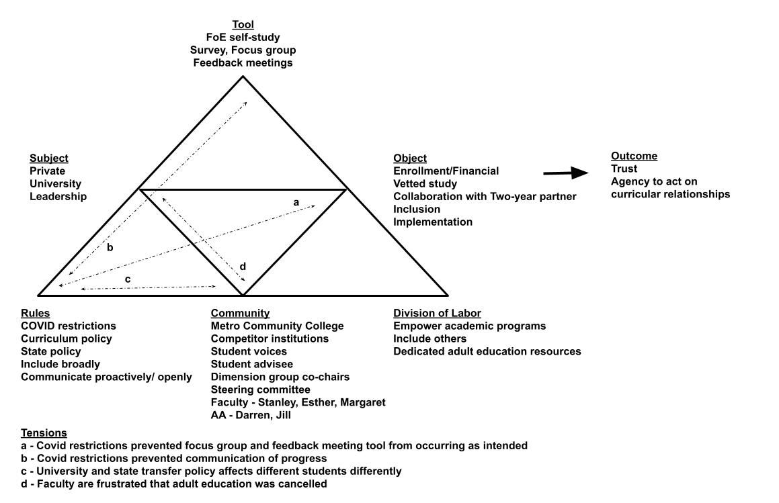
Figure 6. Private University Activity System

University to conduct additional community feedback that, because of Covid, did not happen as planned. Tension b reflected a concern by participants that they were unaware of the progress made on implementation since the conclusion of the study. Participants had a notion that Covid was a factor, but some did express that they would like to see leadership more vocally support the work that was done in the self-study and since toward implementation. Tension c reflected concerns around curricular alignment and credit articulation rules enacted by the state that were impacting the awarding of transfer student credit. In particular, Margaret noted a difference between students who transferred directly from an institution receiving more favorable awarding of credit than those who may be adults with transfer credit from a previous institution further in their past. Lastly, tension d was related to this concern by Margaret who amongst others noted that funding for an adult education office was cut. This action dissolved a service many saw as critical for serving the breadth of transfer student demographics. This was also referred to in document analysis, but neither the documents nor interviews indicated how far in the past this funding cut took place. The next paragraphs synthesize information from participant perspectives revealed about the activity in relationship to the research questions and thematic analysis.
Darren’s Activity – Inclusion and Trust. Many of the participants mentioned including others as an institutional motivation. Darren, Stanley, Jill, and Margaret connected their own personal motivations to the inclusion of Metro in the self-study. Darren indicated how “eye opening” the process of participating in FoE in partnership with Metro had been for him. He internalized this inclusion about how Private should think about this work when describing the process of FoE:
What was interesting about that, though, was the self-study was all about what's [Private] doing, how can [Private] do it, what are we doing for students? So how much does a community college partner have to say in that moment when we're talking about the structures that exist here for students? What would they say to answer those questions? I’m not sure. …whereas we're looking at this one college going let's build a transfer support system to get them from there to here. They're also doing that, with several other schools. So, it's not just about what [Private] wants or needs, it's also about what they're doing for their other partner schools. So, I think that's an interesting thing that probably says something about the way they would be involved in our self-study.
Darren admitted that he personally had less contact with Metro educators during the self-study because of the nature of his role at State. Metro had no direct equivalent educators, with whom, he could interact. But the intentional inclusion by both institutions did allow for other educators at both institutions to meet their counterparts and discuss improvements.
In the thematic analysis, we learned that Darren appreciated his institution’s inclusion of him in the activity as a new member of the community who “really [couldn’t] answer that because I’ve been here a week.” It motivated him to trust the institution and the process of inclusion. Taken with the quote above, we can begin to see how he started to extend that inclusion in thought to others (see Figure 7). When asked what lessons he had learned about collaboration in transfer student work, he commented:
while we are focused on transfer students coming to our institution, how we support them, recruit them, and retain them, if we're going to collaborate effectively with another partner it can't be all about us. So, making sure we're thinking about what our partners need, how we can support our partners so that they're not just coming to serve our ends and our goals. So, make sure you're asking your partners, what do they need? how can we
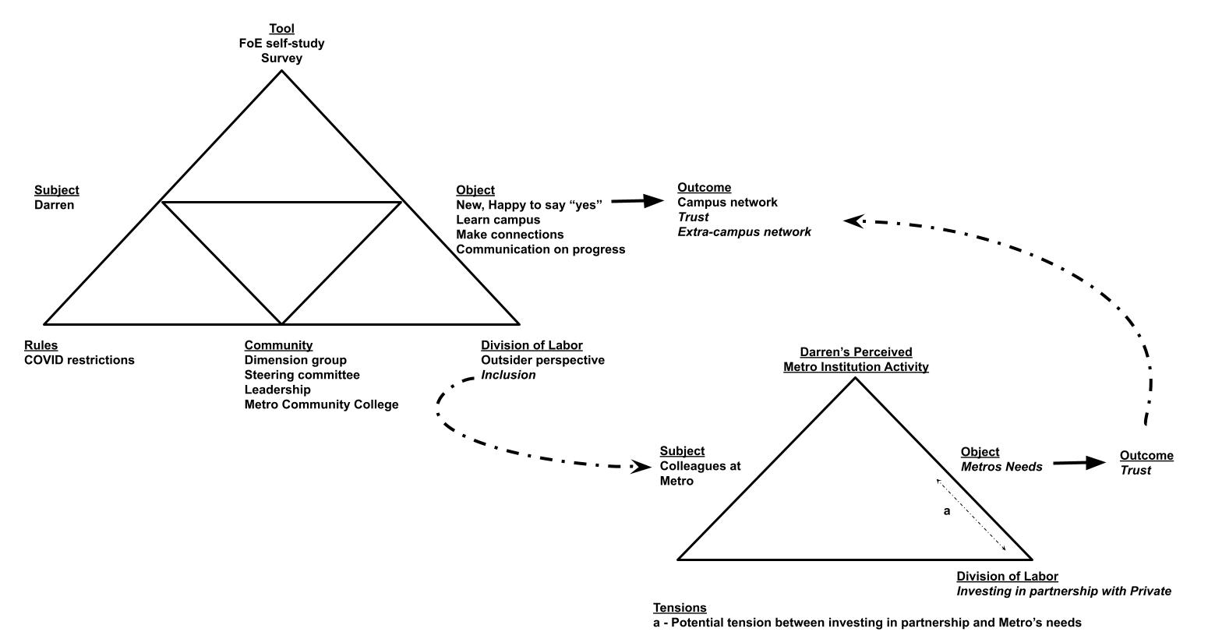
Figure 7. Darren’s Inclusion and Trust Activity

help them? how can we support them? Because they have goals, too, and maybe we can collaborate and support their goals. Darren doesn’t use the word trust. However, he and his colleagues mention how motivating inclusion had been to their willingness to participate in this institutional activity. His inclusiveness manifested toward Metro indicated a desire to elicit a similar reciprocity. He had gained trust in Private’s approach. He seemed in these quotes to have learned the value of inclusion and wanted to extend that inclusion and trust to State’s relationship with Metro.
Esther’s Activity – Communication and Trust. Esther and Margaret were both junior
faculty at the time of the self-study. When I asked probing questions about any obligation or
pressure to participate for fear of not achieving tenure, both expressed this was not a concern but
a mutually beneficial relationship. Esther went further and expressed that her experience might
be different than junior faculty at other institutions because the level of communication she has
with institutional leadership (see Figure 8):
We’re a pretty tight knit community at my institution. Our provost is pretty amazing. He checks in with the faculty. He checks in with the department. As [an academic unit leader], I meet with him once a month. Just in a private meeting with him, with my other co-chair. We talked to him about what's going on in our side of things. And we're not afraid to be brutally honest. He tells us very honestly what's going on the administrative side of things. We're pretty open in terms of information with the provost office.
Margaret echoed the connection between relationships and communication in the thematic analysis when she expressed that she was on a first name basis with most administrators. She also said that titles were not that important. Esther expressed this closeness might not be common at other institutions:
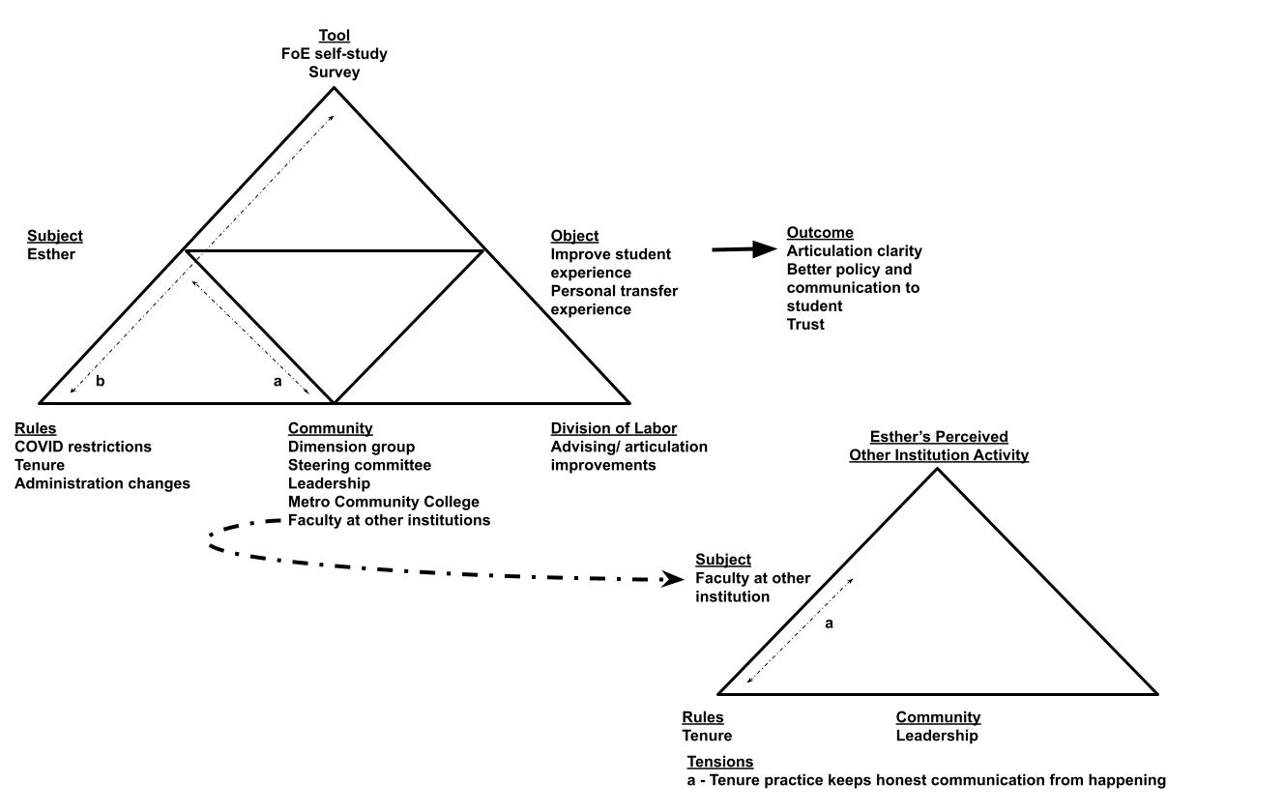
Figure 8. Esther’s Communication and Trust Activity

I know from speaking with colleagues outside of my campus from other institutions that it's not always a safe environment to say exactly what you're thinking and feeling. I’m lucky in that sense that I at an institution where I do feel safe and comfortable, even as a junior faculty member without tenure, I felt comfortable being brutally honest. That's also just my personality, I just can't help it.
She also expressed that the “criteria for tenure [were] very clear cut” at her institution. There was no hidden communication about the tenure process. These insights from Esther indicate the trust and high appreciation she had for the way her institution approached her. In her comments, she had nothing but praise for what they had done together.
Outcomes. These two educator activities supported the thematic analysis of Private University’s approach to the FoE transfer self-study. They were inclusive in partnering with Metro Community College to conduct the self-study. They demonstrated inclusivity by involving many individuals from across their campus. They communicated their intentions with the self-study well and designed many opportunities for feedback. While there were communications lapses and opportunities to provide feedback that did not end up happening, their educators led with trust in their institution and presumed that Covid was likely a big factor in these lapses. The educators at Private were also trusted by their leadership to act. While the entire transfer initiative could be better communicated, it did not seem to impede educators from making progress in their own work or sphere of influence.
State University – Perceived Agency, Communication, and Skepticism
State University began their FoE self-study in the same academic year as Private although with a smaller number of participants. Valerie commented on the difficulties of getting investment from educators in student affairs with whom she worked less closely. State did not work in tandem with another two-year partner. Instead, Valerie’s pre-existing position already served as a conduit to other two-year partners in the area because of her work with articulation agreements. Valerie was knowledgeable of their institutions, but they were not physically involved in the self-study. State also had prior experience with a JNGI project and many cited this precedent as the reason for utilizing JNGI’s FoE for transfer students as the mechanism to do this work with transfer students. Given the similar timeline, State’s self-study process was also impacted by Covid. A final report was completed after this initial Covid impact. State created a Transfer Implementation Group to enact the recommendations of the self-study. The institutional activity can be viewed in Figure 9.
At State University six tensions were identified related to the institutional self-study and subsequent implementation. The first two tensions had to do with the work of the dimension group leaders. Tension a indicated that some dimension group chairs were not fully invested in the object of the FoE activity. A number of participants indicated that dimension group chairs who also served as leaders of academic units were skeptical that this activity was likely to result in progress, given prior experience. The lack of buy-in was further supported by tension b, which indicated that several dimension group leaders did not complete their reports. In addition to the participant interview data, this was further supported by the lack of complete dimension group reports in the FoETec data management system. Tension c related to the formation of the dimension groups. In addition to Valerie’s comments above about the challenges of investment from student affairs, some participants felt that the selection was born more out of relationships than strategic inclusion. Tension d addresses the lack of communication from leadership regarding the self-study. Tension d1 indicated that the lack of communication created skepticism amongst the campus community. Tension d2 represented how the lack of communication
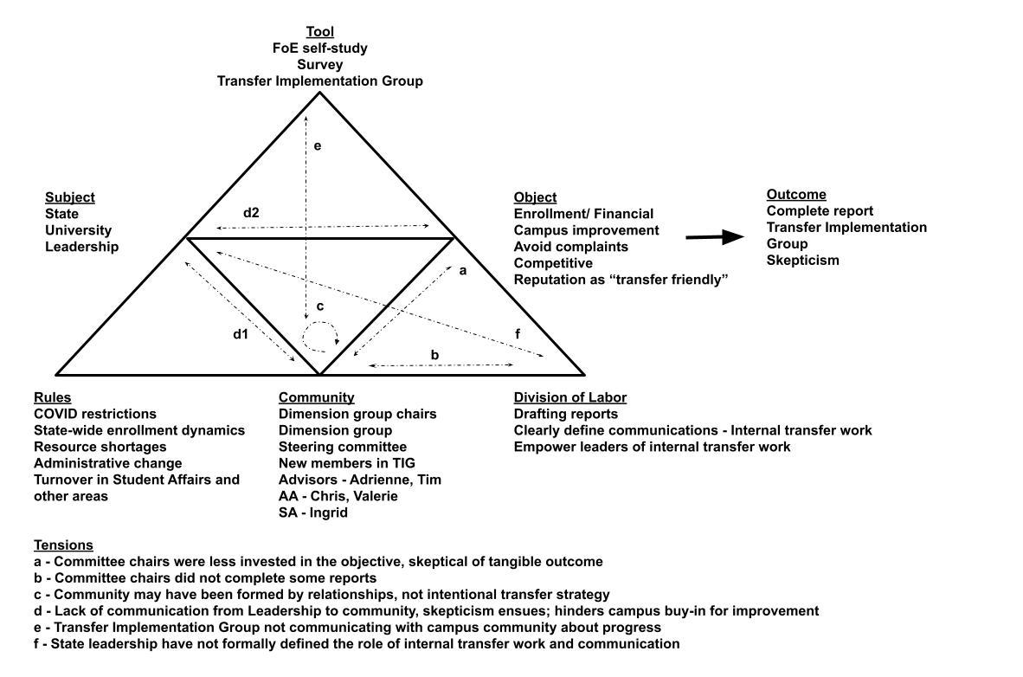
Figure 9. State University Activity System

hindered the object of the activity and potentially instilled more skepticism. Tension e extended tension d to the Transfer Implementation Group. Some participants gave indication that communication could be improved from this group as well. Lastly, tension f extends tension e to the division of labor. Participants indicated that it is unclear who is leading transfer efforts internally.
The next sections illustrate how different educator activities support these identified tensions. The first two activities give conflicting perspectives about how educators perceived their agency in affecting change as related to the thematic analysis. The third activity examined the challenges in Valerie’s role related to the agency of communication that she had as leader of the Transfer Implementation Group. Chris and Adrienne’s activities are used to support the findings in Valerie’s activity.
Ingrid’s Activity – Grass Roots Inclusion and Skepticism. As was mentioned in thematic analysis, Ingrid advocated for the inclusion of other educators in the FoE self-study. She was also vocal in her interview about bringing in the students’ perspective to these conversations. Her agency to advocate for students was derived from the responsibilities of her job. Her job responsibilities gave her unique insight into the community’s attitude toward the FoE self-study and subsequent work (see Figure 10). When asked about the community’s perception about the subsequent work, she responded:
I think that for the most part they are excited about where we're headed. I think that there's still apprehension of how much it will actually change in practice. I think that because it is something that's relatively new, it's going to take some time to get buy-in from the larger institution. Because [State], I think, specifically where it's at in this time and place, we've had a significant amount of turnover in faculty, staff, and administrators.
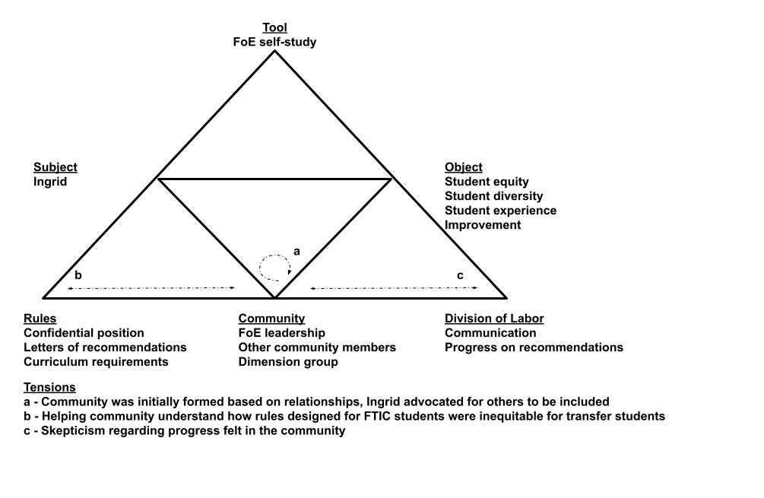
Figure 10. Ingrid’s Grass Roots Inclusion and Skepticism Activity

In particular, I think the time frame since doing this. Before, during, and since. So, I also think that there's some apprehension there around how much is the work that was put in, going to stick and stay and be continued to be invested in. If it's connected more to the people than it is to the areas and to the departments. Will those goals continue to roll over, over time? So, I think we've made a lot of good strides. Now, I think the bigger question is, in lieu of people coming and going, will those steps forward stick.
Ingrid understood the skepticism that State faced in moving this initiative forward, but her agency remained intact while others let skepticism seep in. Her advice to educators seeking to do this work stated her position well:
the best thing that we can do as educators is intentionally put ourselves in spaces. Even if we're not sure how we fit in that space to figure out how we fit in that space. Because you do in some way, shape, or form because you're a part of the larger institution no matter what department you're in or what you're doing, you're impacting that experience. And so, figuring out what that intentionally means when it comes to your work and how you can constructively approach that.
Other than Valerie, Ingrid was the only other participant that expressed a need for inclusivity. Ingrid used her knowledge of the grass roots perception of many to motivate her action in this activity.
Tim’s Activity – Competition and Skepticism. Tim has been at the institution for a while and may represent some of the community that Ingrid refers to. His activity indicated that external factors from the institutional governing body and competition from the other larger four-year competitor institutions were having an impact on his and others skepticism (see Figure 11). He stated:
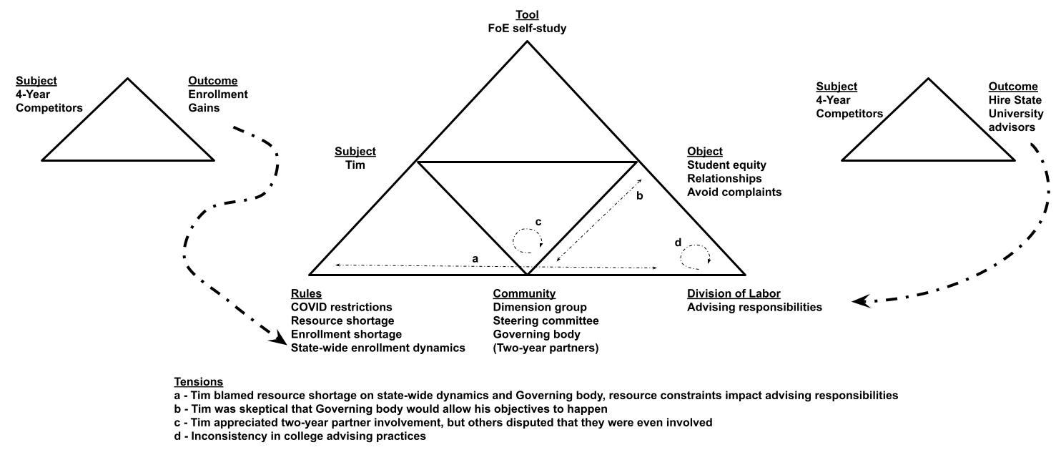
Figure 11. Tim’s Competition and Skepticism Activity

I have nothing but praise from my immediate supervisor and my supervisor’s supervisor. I’ve worked with both of them for years. I will go to the wall for either of them, as Lord
knows they've gone to the wall for myself, and for my colleagues, multiple times. I’ve worked personally for years with the current Provost who is marvelously forward thinking and marvelously sensitive to the needs and expectations of different constituencies. But with that said, it just gets frustrating sometimes because we folks in the rank and file, get the sense that decisions get made, not because those who are announcing the decisions wish to make them, but because they're made to announce them and they're made to make them, by those above them and that's deeply frustrating.
Tim had trust in his leadership, but placed blame externally with the governing body, as was mention in Theme 2. What was underlying in his quasi-existential motivation in Theme 3 was a systemic issue of the rewards and constraints of competition between four-year institutions. Figure 11 indicated that the competitor institution impacted his activity from two sides. The competition for enrollment and related tuition dollars is a tension that Tim doesn’t directly view as a tension. The second impact came from the competitor institutions recruiting State’s labor force. This in turn impacts not only Tim’s workload, but also State’s ability to deliver on improving the transfer student experience. Tim does not explicitly identify these issues as impacting the transfer student experience either. Hence, neither of these are listed in his activity as tensions but are instead indicated by dashed arrow lines to indicate where they are impacting his activity. In the thematic analysis, Tim potentially identified unique insight into a systemic problem of labor force loss. However, neither he, other participants, nor the final report at State referred to this directly. Competition may be a hidden tension in State’s activity that is adding to skepticism and taking agency away from educators who feel skeptical that State can make progress.
Valerie’s Activity – Lack of Communication and Skepticism. Valerie’s activity and role were perhaps the most complex and critical at State university. As stated by Valerie, her colleagues looked to her office as the leader in transfer work. The leadership has tasked her to co-lead the Transfer Implementation Group. However, knowing all this she was aware of the need to include community members, but not aware of her potential role in communication (see Figure 12). She stated:
I felt like I could see every angle. I could see the relationship we have with our partners. I could see it from the issues that students were having utilizing transfer credit and applying it. I could see it from the faculty perspective, in terms of, their confusion over transfer credits. I work closely with the advisors. I work closely with records. I was really in the middle and I could see that we really need everybody to see what others were doing. And I think everybody had a great desire to do good things for transfer students. Like I mentioned earlier, it was just so disjointed. Something great is going on in advising here, but it's never communicated over to this area.
This last statement highlights that Valerie recognized the communication was needed, but she placed that responsibility outside of herself.
It is important to note that Valerie’s role had traditionally been responsible for communicating with external partners. This was reinforced when asked in the interview how the internal campus community heard about the results of the study. Valerie stated that they shared it with “anyone who was interested.” This was a more passive approach compared to the response she gave about communicating to two-year institutional partners. She stated:
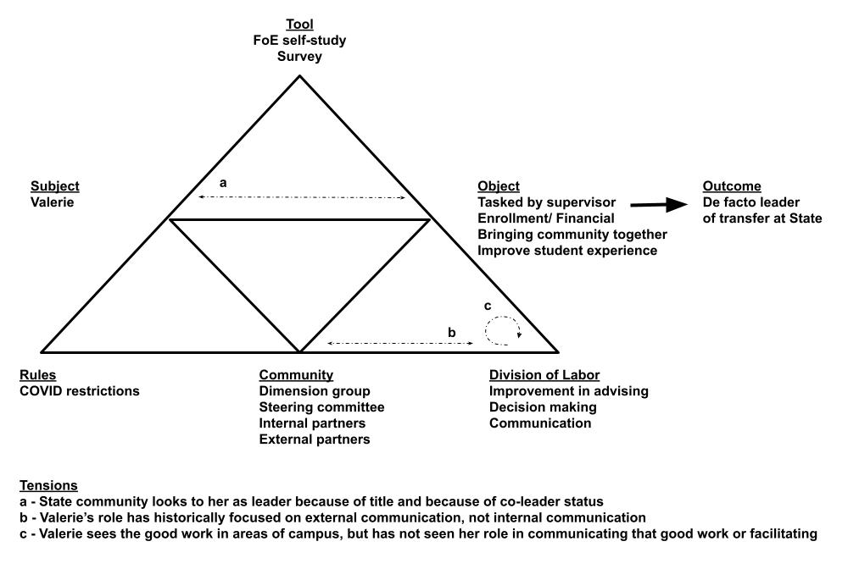
Figure 12. Valerie’s Lack of Communication and Skepticism Activity

Two years ago, we shared with them what the whole project was, where we were at with it. We provide updates along the way, and then this past March we talked about the final
stages, where we were at. And some of the recommendations that we had. So, that's how it was being communicated. So, they were aware of the fact that [State University] is committed to our transfer student population, and these were the type of things that we were doing to improve things.
This response was much more proactive and intentional. These different responses suggest Valerie had not been empowered to take on the role of internal communication even though the campus community is looking to her naturally and her supervisors have tasked her with it positionally as co-chair of the Transfer Implementation Group.
Chris and Adrienne’s activities support how the lack of communication from the Transfer Implementation Group may be leading to skepticism of the progress since the FoE self-study. Chris’s activity in Figure 13 depicts his concerns about communication regarding the group. When asked about the campus community’s perception of the group he said, “to be honest, I don't think that most people know that it's been formed.” This first statement indicated that internal communication about progress continued to be a persistent theme. When asked about his own perceptions of the group, he had mentioned attended some initial meetings, but his responsibilities have shifted him elsewhere. He recalled the following from those initial meetings:
I remember raising this as a concern in their first meeting that this group cannot be a sort of repeat of the FoE study. It’s got to take the recommendations that came out of this self-study and find a way to implement them based on that and not do sort of a second self-study.
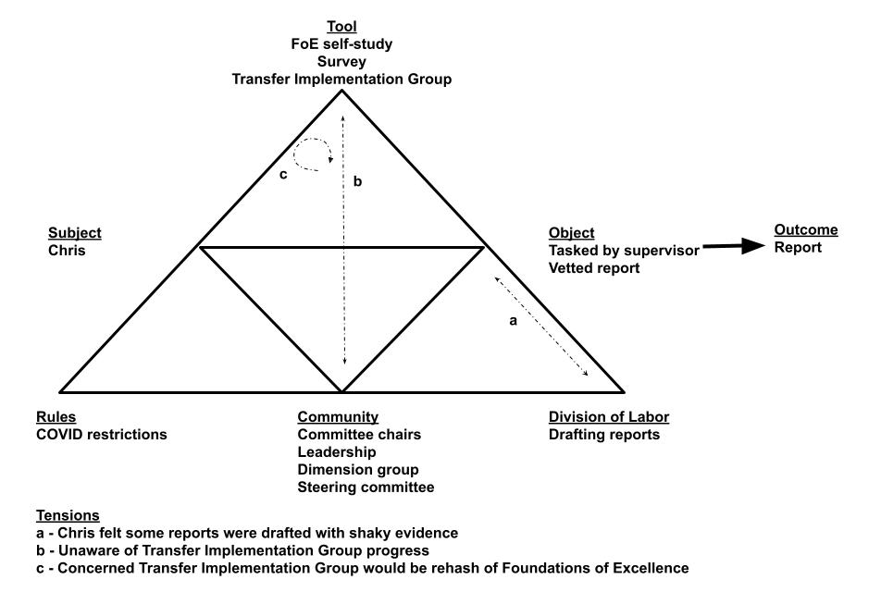
Figure 13. Chris’s Activity Related to Transfer Implementation Group

He later explained that he thought it was important to have a coordination group that communicated progress and had a platform to advocate for changes in policy, but he feared the
Transfer Implementation Group may not be that group. Adrienne had a more direct role in the group, but even she remarked that she was a little confused about progress (see Figure 14). When asked about the campus community’s perception of the group, she stated:
We haven't met in a while. I think the people that are involved are very excited about it. I don't think the others that were involved with the Foundations of Excellence project know what's going on with it. I don't think that's been communicated to them. In terms of my colleagues, let's just say the advisors in my office or advisors across campus, because the online orientation hasn't been activated yet, they're finishing it up and it hasn't been announced yet. They're probably not aware that anything has changed, that anything has really come of it.
Later she was asked what change had occurred for students as a result of the FoE study. She remarked:
I can't put my finger on anything that students would say is a big change. I'm hopeful for this communication plan, and I really feel like more people need to know more of what's going on. A lot of the questions you're asking me are coming back to that, “I'm like, oh my gosh, why haven't we done that? why don't we communicate that to the group?”
As a member of the Transfer Implementation Group, Adrienne was knowledgeable about the online orientation and did speak favorably about it. However, Valerie indicated that the origin of that activity happened “naturally” outside the group, The Transfer Implementation Group moved to invest and partially claimed the progress as an early win for the FoE study, but she admitted
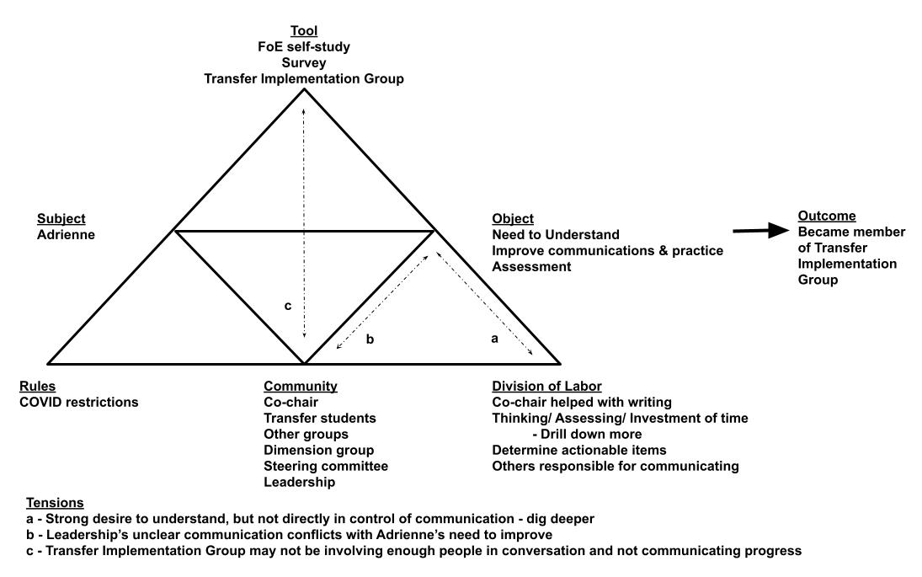
Figure 14. Adrienne’s Activity Related to Transfer Implementation Group

that it was already in motion as the group was forming. Ingrid referred directly to this in one of her final statements:
you want to support the student population, but are you just supporting the low hanging fruit? The things that you're going to get a quick fix, a quick endorphin rush of, we're doing awesome things. But not necessarily the foundational pieces being invested in as much. So, it feeling like you're on a shakier pedestal than what people may want or that would reinforce that this was a long-term investment versus a short-term investment. You put the roof on, before you build the first floor.
Outcomes. State’s educators who participated in this study conveyed a personal willingness to do transfer work as a part of this initiative. However, their responses also reveal tensions within the institutional activity that continue to sew doubt in the community and, in some cases, even themselves. What emerged from the data of State participants and differed from the institutional activity at Private was a lack of internal communication and a lack of perceived agency to speak for this initiative. Valerie’s role was unique and did not have a comparable counterpart in Private’s participants. However, it seemed the campus community was looking for a leader to be empowered to lead internal transfer efforts. Whether this should be added to Valerie’s more externally facing role or tasked to another educator is up to State University’s leadership to decide. From the analysis, it seemed more internal communication was needed to decrease the campus community’s skepticism. It was also clear that the communication needed to come from someone who was empowered to make meaningful change.

Conclusion
In this chapter, I provided a thick description narrative of the institutional activities as they emerged in the data analysis. The overview, formed during open coding, gave rich contextual information about the activity. The thematic analysis, formed primarily during focused coding, organized the large amount of data from the document analysis and participant interviews into themes of valuing inclusion, communication of progress, and difference in institutional and educator motives. The last theme formed a foundation for selective coding where the thematic information was placed into the ASA framework of motive-directed action.
The two primary themes of inclusion and internal communication and their proximity to motives of trust and skepticism have not received significant attention in the literature regarding collaborative practice or transfer collaboration. In Chapter 5, I place these themes in the context of what the literature does tell us about collaboration. The analysis may have indicated that inclusion is an important mechanism for establishing trust in collaboration, but it can be threatened by a lack of communication and is susceptible to external factors. Covid was lead among these external factors. Similarly, a lack of communication may have led to skepticism in some participants and their community.

Chapter 5: Discussion
This dissertation sought to understand the motive-directed actions of educators at a four-year institution while engaged in transfer student work. My primary research goal was to add to the scholarly literature of collaborative practice. In this chapter, I address the lessons I have learned from this work that may be applied to collaborative practice and how these lessons relate to the literature of practice in higher education. Next, I provide an overview of the implications for transfer student work with a focus on the four-year, or transfer-in, institution perspective. Following the contextual examination of transfer student work, I reflected back on the implications for collaboration research. Specifically, I reflected on where researchers have been pushing the literature and how this study might serve as a model for the trajectory of collaboration research. Lastly, I concluded with a discussion of the study’s limitations, the evolution of my positionality, and a roadmap for future research.
Collaborative Practice
The imperative to collaborate has been well established in the literature for decades. The understanding of how to develop the skills to collaborate, remains elusive. In particular, when the scope of that collaborative skill is needed cross-divisionally at institutions of higher education that continue to grow larger and more specialized (Lloyd-Jones and Smith, 1954). To understand the processes involved in collaborative practice we have to understand the interactions between the educators (Lloyd-Jones, 1954). The authors of Powerful Partnerships (AAHE et al., 1998) called on educators to model effective collaboration, but as Hirt et al. (2004) pointed out educators need more exposure to collaborative work in their development. Examining case studies such as this one is a way to gain that experience without the need to switch jobs and wait for time to pass.
Four decades ago, Barr and Fried (1981) called for staff practitioners to become bilingual border crossers with the other campus language and culture, faculty. Even as recently as the release of Learning Reconsidered and Learning Reconsidered 2, educators were implored to co-mingle the two contexts of higher education; student affairs and academic affairs (Keeling, 2004; 2006). However, as has been reflected in this dissertation and in recent literature by Klein (2017), educators are now called to be “boundary spanners” amongst multiple other campus languages and cultures. The literature on collaborative practice needs to transcend a binary narrative.
In this study, some participants gave indication that they were thinking in a boundary spanning way. This concept of spanning barriers to advance activity in this way is also mentioned in CHAT literature. Engeström (2008) referred to this with the similar term, “boundary crossing.” At State University, Valerie and Ingrid could see the connections across the silos. Valerie was empowered to bring the various constituents across her campus together for the FoE study. She and her institutional leadership struggled in getting all constituents to participate equally. Ingrid walked with students through their concerns and could see the institutional boundaries that each crossed in resolving concerns of the normal business of being a student. She used her boundary spanning awareness to organize discussion on a grass roots level. She described her identity not as a boundary spanner, but an “expert generalist.” Private may have benefitted from being a much smaller institution. As Gulley and Kezar (2017; 2001) noted, results from their study may have been influenced by differences in institutional type. Margaret and Esther were empowered to span boundaries because arbitrary barriers were removed, granting them access and fluency on their campus. Both junior faculty members had close working relationships with their chief academic officer. While this may not be common or practical at larger institutions, it proved beneficial for them. Another example included the way State approached rules on faculty tenure. It is clear from Esther and Margaret that their service in the collaborative FoE activity was valued, counted, and they were able to make positive contributions to the process. This supported the calls for tenure reexamination in collaborative imperative literature (AAHE et al., 1998; BCERU, 1998; Boyer, 1996). In both cases, the intentional actions of State University’s leadership to eliminate barriers and keep lines of communication open aided Esther and Margaret’s ability to span those boundaries. Eliminating barriers to aid the advancement of activity is consistent with findings in both higher education and CHAT literature (Boyer Commission, 1998; Yamagata-Lynch & Smaldino, 2007).
The conclusion of chapter 4 indicated that broad inclusivity of perspectives and regular communication of progress may improve the trust of educators involved in collaborative activity. Inclusivity is mentioned in the literature although often under different terms than were discovered in subthemes of this study (e.g., learning, relationships, and boundary spanning). The subtheme of learning was well represented in the literature on collaboration in higher education (AAHE et al.,1998; Bensimon & Neumann, 1992; Keeling, 2004; 2006; Kezar, 2005b, Kuh, 1998; Whitt et al., 2008). The forming of relationships and campus networks had also been observed in studies that examined good or successful collaborations (Kezar, 2003; Kezar, 2005b; Whitt et al., 2008). Perspective taking was not mentioned in the literature, but the aforementioned concept of boundary spanning requires the practitioner to understand the culture to some degree. Communication, however, was not explicitly mentioned in the literature review as it was discovered in this study. Additionally, none of the studies in higher education collaboration made linkages between these actions and the establishment of trust.
In this study, both institutions found motivation from the inclusion of others. However, Private University demonstrated inclusive behaviors that led to educator trust in their collaborative work. Jill expressed that the broad inclusion of individuals helped State learn better and avoid mistakes. As mentioned, Esther and Margaret took advantage of the inclusivity extended to them by access to administration to help them learn about what the realities were on the ground level of the student and faculty experiences. Darren spoke of the inclusion he experienced as a new member of the university community. The trust he was given as a new member of the institution allowed him an opportunity to learn about the university community right away. Additionally, he internalized that inclusion and encouraged extending that same level of inclusion to Metro Community College given what he had learned from the FoE study. Stanley extended the inclusive learning experience he had in the process to future collaborative partnerships not thought possible prior to this experience. Trust was extended to them in the FoE self-study and they used that trust to move the activity forward.
These findings at Private University may be related to Bensimon and Neumann’s three functions of collaborative teams (1992). Bensimon and Neumann indicated that work teams may exhibit three functions, utilitarian, expressive, and cognitive. Simply put, utilitarian is the logistics of coming together and doing work, expressive functions related to the relational aspect of the work between educators, and cognitive functions had to do with learning transformation in the work team. Bensimon and Neuman found cognitive functions were not reached by a team if the other two were not present. Meaning the presence of inclusive relationships where participants learned at Private may have led to the educators’ expressions of cognitive complexity in their work.
Communication was found to be a particularly impactful factor in perpetuating collaborative practice at both institutions. However, the absence of communication at State seemed to sew skepticism in the campus community. Adrienne did not express skepticism herself, but she did recognize that several other educators on her campus were not aware of progress on similar administrator initiatives. She was herself only vaguely aware of what had been done with the previous JNGI study conducted at State. She was driven, as a self-described character trait, by a desire to know more about the institution. However, she was unaware of communication on the progress of institutional activities. Her learning, an inclusive subtheme in this study, was hindered by lack of communication. Chris, Tim, and Ingrid also referenced skepticism and the lack of communication in various parts of their interview. Valerie in her quasi-leadership role was aware of progress in the transfer initiative but did not seem to be empowered to communicate it. In her perceived “lay person” role, she expressed an awareness of the lack of communication and how she thought someone should communicate it.
The lack of attention or findings related to communication in collaboration research or higher education practice literature may indicate a need for further exploration and definition of communication in service of collaborative practice. Instead, the literature presents a positional leadership perspective of the conditions needed or present in collaborations. Some often cited qualities are the establishment of vision, mission, shared values, or norms (Kezar, 2005b; Kezar & Lester, 2009;). It is possible that researchers need to examine these qualities further. Kezar (2005b) calls on these positional leaders to “attend to culture.” The word attend denotes a more continual approach. Leader communication does not end with setting the vision. Perhaps the continual communication of progress may provide a more concrete example of attending to culture.
This study also demonstrated the importance of grass roots communication. Darren, Stanley, Esther, Adrienne, and Ingrid all represented the importance of grass roots level communication to move progress forward in the collaborative transfer work. Ingrid demonstrated this in her work. She believed firmly that her “metabolization” of the student experience and the educators that work with them obligated her to communicate her learning to others. She believed this type of communication contributed to her institution’s motivation to take this work up through the FoE study.
The literature offers few mentions of communication at the grass roots level. Kezar and Lester (2009) provided advice for grass roots collaboration practice that directed those not in positions of power to aid in idea creation, keep others resilient, support collaborative proposals, include external voices, encourage learning, and connect with like-minded individuals. Kezar and Gehrke (2014) extended the findings in Kezar and Lester (2009) by offering a theoretical model for grass roots collaboration. It espoused steps through which the individual educator could progress. These steps again indicated the connection of like-minded educators in addition to attending to culture and ensuring dialogue between others. While pragmatically useful, these studies stop short of border crossing as mentioned in earlier literature and boundary spanning in Klein (2017). Ingrid’s example challenges the notion of only connecting with like-minded individuals. She gained much of her learning through grass roots communication from boundary spanning by communicating with those whose experience she was not familiar. Her example combined the findings on inclusion toward perspective taking and communication at the grass roots level. This suggests researchers may need to explore strategies to encourage engaging with different perspectives than one’s own, particularly to achieve the resultant communication and dialogue that may ensue.
In the course of analysis, I discovered a few anomalies that leave unresolved questions for collaborative practice. Jill acknowledged that she had previously been excluded from another JNGI study. However, Jill’s inclusion this time did not sour her enthusiasm. Kezar and Gehrke (2014) indicated that prior experience in collaborative environments may aid good collaborative practice moving forward. Communication may have played a counteractive measure in Jill’s trust in the institution. Jill had a reason communicated to her as to why she was excluded in the previous study. The fact that it was communicated, and she was included this time, seemed to eliminate the negative effects of exclusion, and not having a personal prior experience of collaborative history. Tim provided another anomalous activity. He trusted his institutional administration despite not necessarily receiving direct communication about why leadership made funding decisions regarding his area, advising. He reasoned that the external governing body was responsible for the decision to cut resources from advising. What led to his perception is unclear, but Tim gave indication that communication about the why did not come from his leadership.
Prior history of collaboration did not quite rise to the level of a theme in the data analysis, despite many educator participants acknowledging that both institutions had prior history. At Private, every participant was aware of the prior work through leadership and grass roots communication, but none cited it explicitly as being responsible for moving the collaborative activity forward. Participants at State had a history, but that history was tainted with a perception of action not occurring following the prior studies. As a result, educators at State did not indicate that the history advanced the activity. In their case, it may have stalled given the perceived nature of the result.
My lessons from this study regarding collaborative practice were to be mindful and attentive to intentional inclusion and communication of progress. As evidenced by Private, participants still recognized areas where communication could be improved. Had it not been for Covid, many expressed that communication would have been better at their institution. Had it not been better, Private’s participants may have had different responses related to trust. What I take away from this is collaboration is too often used as a noun. Collaborative work is not about checked boxes. It is about the continual wrestling and striving to improve practice. As that happens, whether in leadership or in positions without power, communication and inclusivity are key to moving the collaborative activity forward. Without it, the work may stagnate.
Implications for Transfer Student Work
Although this dissertation is, first and foremost, posed as collaboration practice research, the nature of the Cultural Historical Activity Theory lens allows for some insights into transfer student work. As described in chapters 1 and 2, the literature review revealed a scrutinization of the two-year institution’s responsibility in the transfer student services field but gives little attention to the four-year institution’s responsibility. By centering the collaboration research on the four-year institution environment this research study shined a light on areas for further study by examining the activity-based culture of transfer student work within that environment.
Jain et al (2010; 2020) and Handel (2011) advocated for the responsibility of four-year institutions in becoming transfer-affirming. This advocacy is problematized because of the little attention that has been given to the power dynamics of the four-year institution in the transfer student equation (Jain et al., 2020). It is also further exacerbated by the still-learning understanding of collaboration practice to move work forward mentioned in the previous section. A very well intentioned, Strempel (2013) gave recommendations of investments in structures and practices four-year institutions could adopt to become more transfer affirming. However, this advocacy for support can too often be distilled down to silver bullet answers by administration. Valerie said that educators on campus kept wanting JNGI to give them the answer to improve transfer. Unfortunately, that is not how improving transfer student work occurs. It is about the attention to the power dynamics and relationships in the context (Wetzstein & Yeh, 2019). Educators who wish to engage in transfer student work have to avoid the knee-jerk creation of components and structures found in the transfer literature and instead focus on the collaborative practice of transfer student work. Kisker (2007) found that the more trust participants had, the more likely they were to have agency to act for the betterment of transfer students. When trust was low, formal structures were created to conduct transfer student work. Burack et al. (2014) recommended the creation of advisory board structures. The authors found that these structures improved communication. However, this study observed the opposite. State University proactively implemented a Transfer Implementation Group and communication continued to be absent. Additionally, this lack of communication led to the decrease in trust in educators at State.
I approached this research with an acknowledged reflection that different group cultures may interact differently in the activity-based context of transfer student work due to different motivations. While this did not emerge as I thought it would, I believe there are implications for transfer student work. I had presupposed this might manifest as a divisional or silo difference at either institutional site. I believe Private may have been too small and centralized for this to have been likely, given observations in previously mentioned literature (Gulley, 2016; Kezar, 2001). At State, no participant expressed an overt tension between silos. The one exception being that student affairs was less involved. A number of participants indicated this might have been a resource issue and not a different motivational perspective related to the transfer activity, so I disregarded it as unrelated. However, Valerie’s pre-existing role as external communicator with two-year institutional partners conflicted with her potential new role of internal communicator offered through her co-chairship of the Transfer Implementation Group. Upon completing the thematic analysis and Valerie’s activity system, I began to realize that there may be an analogous phenomenon that fits my presupposed reflection and may more inclusively represents institutions, with which, I have had less practice experience (smaller and private). My experience had been that these different motivations were embedded in subcultures of the institution, but Valerie presented an example of motivations and responsibilities manifesting differently in the same person. Examining Adrienne and Chris’s activities helped further illuminate this for me. Valerie may have had a perceived responsibility to act externally and internally, but she only activated that agency externally. Why is this?
I believe that these responsibilities, and their correlated motivations, can be differently transient in individuals and organizational silos at the institution. Meaning Valerie had received in fact, or by perception, the role of communicator for transfer. However, she had not realized her role in internal communication. Therefore, educators on her campus are under the impression that no progress has been made, while her external partners are pleased with the increased attention on transfer students by State. The degree of progress was hard to determine at State. Many were unsure and Valerie seemed to indicate that the Transfer Implementation Group jumped on another project and claimed it. This is irrelevant. As the embodiment of transfer at State, Valerie had the potential to communicate what everyone was doing and change the perception of skepticism many at her institution held toward the Transfer FoE project. This response also would be more inclusive of the work being done by others at her institution.
It might serve those engaged in transfer student work to attend to both the internal and external communication of their institution’s work regarding transfer students as much as they give attention to who is doing the work and what is being done. The work responsibilities and their motivations often naturally go hand in hand. Admissions is typically concerned with enrollment as a motivation because they often have the work responsibility to recruit students. Student affairs or student success may be motivated by student development or transition, because of the responsibilities assigned.
In a field that often shares best practices that others hope to emulate (e.g., transfer centers, common course numbers, pathways) perhaps we should more fully examine the motivational implications these responsibilities tend to have in our institutional subcultures. If there is an investment in recruiting, it might signal that transition is less important to the individuals responsible for transfer activity. Conversely in Valerie’s case, progress on a responsibility outside of her historical work responsibility may have had an impact on her motivation to communicate progress internally. Adopting the “expert generalist” role described by Ingrid may be a viable way to move transfer work forward. Suppose Valerie retained all of her external responsibilities. Could she not assume a natural desire to know and an obligation to communicate the progress happening in other areas? Perhaps, the leader of transfer does not necessarily have to be responsible for all the work of transfer. This may prove a better working model for institutions that are struggling to structurally organize their responsibilities on campus but continue to face silo barriers.
The study indicated that bifurcating these communication points may lead to confusion for students and educators who are trying to navigate the services of the complex activity of student transfer. Particularly when those services are emergent or evolving. Reflecting on my bias, I have assumed a structural or silo alignment for this work. This research has led me to confront my practice biases and acknowledge that it is the coordination and proliferation of the communication that may be more important.
Implications for Collaboration Research
The literature review of this study was designed to bring together in one place the areas of higher education practice literature and collaboration research in higher education. While linked by subject, they often operate as different fields of study without significant cross pollination. I positioned this grouping as a way to improve educator practice, not to increase the number of collaborations or determine a best set of conditions for collaboration to occur. This distinction is important as much of the initial literature on collaboration research in higher education was posed as the latter two. Additionally, I have also sought to pivot the term “collaboration” away from a subjective good or bad evaluation, instead to an ongoing practice of action that advances progress or stalls it. During this process, I have come to believe that practice literature needs more rigorous methods of qualitative research and collaboration research needs a greater connection to practice.
As mentioned in the literature review the collaboration research in higher education has shown a general progression from quantitative and interpretivist toward pragmatic and critical stances to examine the phenomenon of collaborative work. The quantitative stances tended toward metrics that counted collaborations as a measure of success (Kezar, 2001; 2003). The interpretivist approaches began to describe the qualities of collaborative work and the educators, mostly leadership, who engaged in collaborative work (Arcelus, 2008; Hirt et al., 2004; Kezar, 2005b; Bensimon and Neumann, 1992, Whitt et al., 2008). As the literature shifted toward pragmatic approaches, components and initiatives of specific collaborations have been studied for their efficacy and impact on collaborative work activity (Burack et al., 2014; Fink & Jenkins, 2017; Kezar & Gehrke, 2014; Kezar & Lester, 2009; Strempel, 2013). Additionally, critical approaches have begun to interrogate our assumptions of successful work and the dynamics of power in the collaborative work within an institutional activity (Amey et al., 2010; Hirt, 2006; Jain et al. 2020; Jenkins et al., 2014; Kisker, 2007; Klein, 2017; Wetzstein & Yeh, 2019; Youngs, 2017). As these final two approaches pragmatic and critical interplay, a paradigm toward understanding collaborative practice in research has emerged. This paradigm of collaborative practice sits at the intersection of the activity-based and the group culture contexts of collaboration. Put another way, the unit of analysis has moved from institution to within activity context, the subject has moved from positional leadership to between groups analysis, and what being studied has moved from the commodity of collaboration to collaborative practice.
I adopted the CHAT framework and ASA method because I believed they could provide an avenue to study these emergent themes in the literature all together. Arcelus (2007) and Klein (2017) looked at group-culture but divorced from activity. Kisker (2007) and Fink and Jenkins (2017) studied activity in depth but did not significantly examine group culture. Youngs (2017) examined practice, but without analysis of activity or group culture. ASA allowed me as a researcher to examine all of these together and distinctly through the motive-directed action of various individuals who helped triangulate these findings.
For example, if it were not for the analysis of Valerie, Chris, and Adrienne activities, I would not have made the observations I did about Valerie’s role in transfer student work. ASA made me consider her actions through both an activity-based context, transfer student work, and through a group culture context, external responsibilities vs. internal responsibility. This led to a deeper understanding of her actual and potential practice as perceived by her and her colleagues.
This study served as a potential methodological model for future collaboration researchers to adopt a perspective that is responsive to both the pragmatic and critical stances by examining the practiced activity of collaboration from a specific context of differently motivated groups. My hope is that other researchers will see the potential in this approach and iterate on it for the betterment of collaborative practice. I believe this will also begin to bridge the gap between higher education practice literature and higher education collaboration research.
Limitations
This study did have several limitations of note. They included the limitation of recruited populations, comparisons between groups, and the inclusion of leadership. Researchers conducting research with similar designs may wish to consider how to mitigate these in the future.
As mentioned in the methodology chapter, participant selection was conducted within a very narrow context suitable to my needs and interests. The institutional connection to JNGI, the time since the collaborative activity occurred, and the self-selection of participants all played a factor in recruitment. The FoE self-study required an institutional investment that may have excluded many institutions. The inclusion of only two institutional types limits the potential relevance of these findings to all practitioners. Additionally, Hirt (2006) indicated differences in the conditions of student affairs work at different institutional types. This study intended to look at similar activity-level contexts, but it is important to note that these activities took place in different institutional types. Future researchers should be mindful of acknowledging these contextual influences or intentionally choosing them when framing their research.
The recruitment of the population also posed limitations for the research. As evidenced at State University, many collaborators who participated in the collaborative FoE activity no longer worked at the institution and as a result were no longer eligible to be studied. This made recruitment at State difficult. The recruitment of individuals was left up to their own self-selection to participate. Despite a reasonable incentive to compensate time toward the study, many participant recruitment emails went unanswered. A number of factors may have impacted this including interest, attractiveness of the incentive, and fear of the specific context being studied, their work environment. These sampling methods were intentional. However, future studies of this kind in collaborative work should consider different sampling methods to explore whether these choices influenced the data collected. Additionally, the importance of clearly delineating these sampling choices are important for future authors to indicate so comparisons can be made.
A related limitation to the selection and recruitment of participants was the difficulty in finding direct equivalents between the two institutional cases. Despite efforts to recruit in a specific order for participant characteristics, the actual response of those who participated in the study was left to their own personal motivations. At Private, this resulted in the recruitment of three faculty members and a fourth who also served in an administrator role. At State, it resulted in the recruitment of two academic advisors and two academic affairs administrators with responsibility to enrollment management. The intention of diverse perspectives in each institutional case was lost somewhat in this study. That said, this occurrence challenged my assumption regarding silo group culture. Additionally, some group culture insights were still able to be made, faculty regarding tenure and internal versus external communicators.
Ironically, the final limitation noted was the lack of administrator or positional leadership perspective. Given that the propensity of literature favors this perspective, this is a limitation that I prefer. However, future ASA collaboration research should examine collaborative activity by including as many perspectives as possible, including leadership. The demands of administrator roles and the potential low incentive rate versus administrator salary may have played a role.
Future Research
This dissertation presented multiple avenues for future research for this specific study, the transfer research context, and for higher education collaboration research in general. In this study, I would have liked to have heard from voices that chose not to participate in the research. While I cannot go back and attempt to recruit these individuals again, there may be some avenues to pursue. I have already mentioned the absence of top administration leaders. However, there were other potential participants uncovered during this study that may be worth further examination. Communication from the institutional contacts revealed that students were involved in the self-study process. Complications with the selection provision in the original IRB, prevented me from attempting to include these participants. In this case, I was able to secure permission from State, but I did not include the provision in my original request to Private. In order to complete this dissertation in a timely fashion, I chose to proceed ahead without their inclusion at both institutions. Additionally, two-year partners were also considered for inclusion. Again, the lessons learned through the IRB process prevented me from including them in this study. It was possible that I could have pushed to include representatives from Metro Community College in this study, however given a comparable two-year institutional partner with State, I chose to omit them from both. If given another opportunity, these perspectives would add richness to understanding the activity that happened at both institutions.
As other researchers advocated, more research needs to be conducted in the four-year environment, its responsibilities, and their impact on transfer students (Jain et al., 2020). Kisker (2007) studied both the community college and four-year participants, but only reported on the two-year findings. Other studies have examined the partnership as a whole unit (Fink and Jenkins, 2017; Wetzstein and Yeh, 2019). I recommend positioning more intentional research on the work environment of the four-year institution. Viewing the collaboration from the perspective of the two-year institution or from the whole binary relationship between the two institutions may limit sufficient scrutinization of the activity-based nuances of four-year educators working to improve transfer student work. The different motivations within the four-year institution will surely vary from institution to institution, but I fear we have not scrutinized them enough in the literature.
Collaboration research evolved quite a bit in the last twenty years. Methodologically speaking, most of the recent literature has followed only a basic qualitative data analysis approach with only a few examples of theoretical application. The theoretical framework of Cultural Historical Activity Theory may offer an approach that could prove useful in advancing the pragmatic and critical direction the literature seems to be headed. This dissertation aimed to normalize the application of Activity Systems Analysis in collaboration research. If more collaborative activities were used as the unit of analysis for collaborative studies, the literature may more directly contribute to a “meso-level” of understanding collaborative practice (Peden Christodoulou, 2019). I believe this will lead to more practitioner skill identification (e.g., importance of internal communication and the value of including others) instead of more esoteric or descriptive observations (e.g., “attending to culture” and the presence of missions, values, or visions) regarding collaboration.
Positionality and Reflection
I began work on this dissertation four years ago, as a part-time student and full-time educator. First and foremost, I have been in search of a holistic practice for collaboration in higher education to improve my effectiveness at bringing educators together to make progress in collaborative activity. Transfer student work was one of the areas which I have had the opportunity to do this while working in the student success area of higher education.
Many twists and turns led me to my research questions and study context. Much like my participants Covid was a factor in my progress on this study. I also changed jobs, moved out of state, and had another child. All this acknowledged, I emerged on the other side of this research more committed and passionate about this work than I was when I started.
I conclude this work with a passion for learning more on this subject and a desire to conduct additional research. I have opportunities in my new role to directly apply internal communication and inclusion in the context of transfer student and other student success related work. I look forward to these opportunities and have a newfound sense of responsibility to contextualize that work into what I have learned and to continue to learn and share with my colleagues.

References
Abramo, G., D’Angelo, C. A., & Di Costa, F. (2011). University-industry research collaboration: A model to assess university capability. Higher Education: The International Journal of Higher Education and Educational Planning, 62(2), 163–181. https://doi.org/10.1007/s10734-010-9372-0
Akkerman, A., Torenvlied, R., & Schalk, J. (2012). Two-level effects of interorganizational network collaboration on graduate satisfaction: A comparison of five intercollege networks in Dutch higher education. The American Review of Public Administration, 42, 654–677.
Alexander, J. S., & Gardner, J. N. (2009). Beyond retention: A comprehensive approach to the first college year. About Campus, 14(2), 18–26. https://doi.org/10.1002/abc.285
American Association for Higher Education, American College Personnel Association, & National Association of Student Personnel Administrators. (1998). Powerful partnerships: A shared responsibility for learning. http://www.myacpa.org/powerful-partnerships-shared-responsibility-learning
American College Personnel Association. (1996). The student learning imperative: Implications for student affairs. http://www.myacpa.org/student-learning-imperative-implications-student-affairs
American College Personnel Association, & National Association of Student Personnel Administrators. (1997). Principles of good practice in student affairs. http://www.myacpa.org/principles-good-practice-student-affairs
American Council on Education. (1937). The student personnel point of view. http://www.myacpa.org/sites/default/files/student-personnel-point-of-view-1937.pdf
American Council on Education. (1949). The student personnel point of view. https://www.naspa.org/images/uploads/main/Student_Personnel_Point_of_View_1949.pdf
Amey, M. J., Eddy, P. L., & Campbell, T. G. (2010). Crossing boundaries creating community college partnerships to promote educational transitions. Community College Review, 37(4), 333–347. https://doi.org/10.1177/0091552110365725
Amey, M. J., Eddy, P. L., & Ozaki, C. C. (2007). Demands for partnership and collaboration in higher education: A model. New Directions for Community Colleges, 2007(139), 5–14. https://doi.org/10.1002/cc.288
Arcelus, V. J. (2008). In search of a break in the clouds: An ethnographic study of academic and student affairs cultures. https://etda.libraries.psu.edu/catalog/8354
Archambault, K. (2016). Collaborating across campus to support transfer students. In S. J. Handel & E. Strempel (Eds.), Transition and transformation: Fostering transfer student success (pp. 3–8). University of North Georgia Press.
Association of American Colleges & Universities. (2002). Greater expectations: A new vision for learning as a nation goes to college. https://www.aacu.org/publications/greater-expectations
Association of American Colleges & Universities. (2013, November 5). George D. Kuh [Text]. Association of American Colleges & Universities. https://www.aacu.org/contributor/george-d-kuh
Atkinson, R., & Flint, J. (2004). Snowball sampling. In M. Lewis-Beck, A. Bryman, & T. Liao (Eds.), The SAGE encyclopedia of social science research methods (Vol. 1–3). Sage Publications. https://doi.org/10.4135/9781412950589
Bahr, P. R., Toth, C., Thirolf, K., & Massé, J. C. (2013). A review and critique of the literature on community college students’ transition processes and outcomes in four-year institutions. In M. B. Paulsen (Ed.), Higher education: Handbook of theory and research: Volume 28 (pp. 459–511). Springer Netherlands. https://doi.org/10.1007/978-94-007-5836-0_10
Bakhurst, D. (2005). Social memory in Soviet thought. In H. Daniels (Ed.), An introduction to Vygotsky (2nd ed..). Taylor and Francis.
Balkin, R. S., & Kleist, D. M. (2016). Counseling research: A practitioner-scholar approach. American Counseling Association.
Barefoot, B. (2004). Foundations of Excellence: A new model for first-year assessment. Assessment Update, 16(2), 5–7.
Barr, M., & Fried, J. (1981). Facts, feelings, and academic credit. New Directions for Student
Services, 1981(15), 87–102. https://doi.org/10.1002/ss.37119811512
Bensimon, E. M., & Neumann, A. (1993). Redesigning collegiate leadership: Teams and teamwork in higher education. John Hopkins University Press.
Biddix, J. P., & Schwartz, R. A. (2012). Walter Dill Scott and the student personnel movement. Journal of Student Affairs Research and Practice, 49(3), 285–298. https://doi.org/10.1515/jsarp-2012-6325
Boyer Commission on Educating Undergraduates in the Research University. (1998). Reinventing undergraduate education: A blueprint for America’s research universities. State University of New York at Stony Brook for the Carnegie Foundation for the Advancement of Teaching.
Boyer, E. L. (1996). The scholarship of engagement. Bulletin of the American Academy of Arts and Sciences, 49(7), 18–33. https://doi.org/10.2307/3824459
Bransberger, P. (2017). Knocking update: New data about private high school graduates. Western Interstate Commission for Higher Education.
Brill, P. L., & Worth, R. (1997). The four levers of corporate change. AMACOM.
Brown, B., & Merritt, M. W. (2013). A global public incentive database for human subjects
research. IRB: Ethics & Human Research, 35(2), 14–17.
Brown, S. S. (Ed.). (1988). Approaches to collaboration between academic and student affairs.
[Special issue]. NASPA Journal, 26(1). https://doi.org/10.1080/00220973.1988.11072071
Burack, C., Lanspery, S., Shields, T. P., & Singleton, S. (2014). Partnerships that promote success: Lessons and findings from the evaluation of the Jack Kent Cooke Foundation’s Community College Transfer Initiative. Jack Kent Cooke Foundation. https://www.jkcf.org/research/partnerships-that-promote-success-lessons-and-findings-from-the-evaluation-of-the-jack-kent-cooke-foundations-community-college-transfer-initiative/
Carlson, J. A. (2010). Avoiding traps in member checking. The Qualitative Report, 15(5), 1102–
1113.
Carnall, C. A. (1995). Managing change in organizations (Evans Library Stacks HD58.8 .C363 1990; 2nd ed.). Prentice Hall.
Charmaz, K. (2014). Constructing grounded theory (2nd ed.). Sage Publications.
Chronicle of Higher Education. (2020a, August 16). Average noninstructional-staff pay by sector, 2018-19. CHE. https://www.chronicle.com/article/average-noninstructional-staff-pay-by-sector-2018-19
Chronicle of Higher Education. (2020b, August 21). Average noninstructional-staff pay, by sector, 2018-19. Chronicle of Higher Education, 53.
Chronicle of Higher Education. (2020c, August 21). Average salaries of instructional staff at 4-year public institutions, 2018-19. Chronicle of Higher Education, 14–15.
Chronicle of Higher Education. (2020d, August 21). Median salaries of chief academic officers, 2019-20. Chronicle of Higher Education, 54.
Chronicle of Higher Education. (2020e, August 21). Median salaries of chief financial officers, 2019-20. Chronicle of Higher Education, 54.
Clark, B. R. (1960). The “cooling-out” function in higher education. American Journal of Sociology, 65(6), 569–576.
Cole, M. (2009). The perils of translation: A first step in reconsidering Vygotsky’s theory of development in relation to formal education. Mind, Culture, and Activity, 16(4), 291–295. https://doi.org/10.1080/10749030902795568
Cole, M., & Engeström, Y. (1993). A cultural–historical approach to distributed cognition. In G. Salomon (Ed.), Distributed cognitions: Psychological and educational considerations. Cambridge University Press.
Collingridge, D. S., & Gantt, E. E. (2008). The quality of qualitative research. American Journal of Medical Quality, 23(5), 389–395. https://doi.org/10.1177/1062860608320646
Conner, T. W. (2016). Representation and collaboration: Exploring the role of shared identity in the collaborative process. Public Administration Review, 76(2), 288–301. https://doi.org/10.1111/puar.12413
Coombe, L. (2015). Models of interuniversity collaboration in higher education – How do their features act as barriers and enablers to sustainability? Tertiary Education and Management, 1–21. https://doi.org/10.1080/13583883.2015.1104379
Corbin, J., & Strauss, A. (2015). Basics of qualitative research: Techniques and procedures for developing grounded theory (4th ed.). Sage Publications.
Dickert, N., Emanuel, E., & Grady, C. (2002). Paying research subjects: An analysis of current
policies. Annals of Internal Medicine, 136(5), 368–373. https://doi.org/10.7326/0003-4819-136-5-200203050-00009
Engeström, Y. (1993). Developmental studies of work as a testbench of activity theory: The case of primary care medical practice. In S. Chaiklin & J. Lave (Eds.), Understanding practice: Perspectives on activity and context. Cambridge University Press.
Engeström, Y. (2000). Activity theory as a framework for analyzing and redesigning work. Ergonomics, 43(7), 960–974. https://doi.org/10.1080/001401300409143
Engeström, Y. (2001). Expansive learning at work: Toward an activity theoretical reconceptualization. Journal of Education and Work, 14(1), 133–156. https://doi.org/10.1080/13639080020028747
Engeström, Y. (2008). From teams to knots: Activity-theoretical studies of collaboration and learning at work. Cambridge University Press.
Engeström, Y. (2014). Learning by expanding: An activity-theoretical approach to developmental research. Cambridge University Press.
Engeström, Y. (2015). Learning by expanding: An activity-theoretical approach to developmental research (2nd ed.). Cambridge University Press.
Fink, J., & Jenkins, D. (2017). Takes two to tango: Essential practices of highly effective transfer partnerships. Community College Review, 45(4), 294–310. https://doi.org/10.1177/0091552117724512
Flick, U. (2014). An introduction to qualitative research (5th ed.). Sage Publications.
Flick, U. (2018). Triangulation. In N. K. Denzin & Y. S. Lincoln (Eds.), The SAGE handbook of qualitative research (5th ed.). Sage Publications.
Flyvbjerg, B. (2011). Case studies. In N. K. Denzin & Y. S. Lincoln (Eds.), The SAGE handbook of qualitative research (4th ed.). Sage Publications.
Forbat, L., & Henderson, J. (2005). Theoretical and practical reflections on sharing transcripts
with participants. Qualitative Health Research, 15(8), 1114–1128. https://doi.org/10.1177/1049732305279065
Fried, J. (1995). Shifting paradigms in student affairs. University Press of America.
Gearing, R. E. (2004). Bracketing in research: A typology. Qualitative Health Research, 14(10),
1429–1452. https://doi.org/10.1177/1049732304270394
Geiger, R. L. (2015). The history of American higher education: Learning and culture from the founding to World War II. Princeton University Press.
Giroux, H. A. (1992). Border crossings: Cultural workers and the politics of education. Routledge.
Glaser, B. G., & Strauss, A. L. (1967). The discovery of grounded theory: Strategies for qualitative research. Aldine Publishing Company.
Gulati, R. (1998). Alliances and networks. Strategic Management Journal, 19(4), 293–317. https://doi.org/10.1002/(SICI)1097-0266(199804)19:4<293::AID-SMJ982>3.0.CO;2-M
Gulley, N. Y. (2016). A discourse analysis of collaboration between academic and student affairs in community colleges. Community College Journal of Research and Practice, 40(6), 496–507. https://doi.org/10.1080/10668926.2015.1070774
Handel, S. J. (2011). Improving student transfer from community colleges to four-year institutions: The perspectives of leaders from baccalaureate-granting institutions. College Board.
Handel, S. J., & Strempel, E. (Eds.). (2016). Transition and transformation: Fostering transfer student success. University of North Georgia Press.
Handel, S. J., & Williams, R. A. (2012). The promise of the transfer pathway: Opportunity and challenge for community college students seeking the baccalaureate degree. In College Board Advocacy & Policy Center. College Board Advocacy & Policy Center. https://eric.ed.gov/?id=ED541969
Hirt, J. B. (2000). Unpublished manuscript.
Hirt, J. B., Amelink, C. T., & Schneiter, S. R. (2004). The nature of student affairs work in the liberal arts college. NASPA Journal, 42(1), 94–110. https://doi.org/10.2202/1949-6605.1416
Hirt, J. B. (2006). Where you work matters: Student affairs administration at different types of
Institutions. University Press of America.
hooks, b. (1994). Teaching to transgress: Education as the practice of freedom. Routledge.
Jain, D., Bernal Melendez, S. N., & Herrera, A. R. (2020). Power to the transfer: Critical race theory and a transfer receptive culture. Michigan State University Press.
Jain, D., Herrera, A., Bernal, S., & Solorzano, D. (2010). Critical race theory and the transfer function: Introducing a transfer receptive culture. Community College Journal of Research and Practice, 35(3), 252–266. https://doi.org/10.1080/10668926.2011.526525
Jenkins, D., Kadlec, A., & Votruba, J. (n.d.). The business case for regional public universities to strengthen community college transfer pathways (with guidance on leading the process). 41.
John N. Gardner Institute for Excellence in Undergraduate Education. (n.d.-a). Foundations of excellence. Foundations of Excellence. Retrieved June 19, 2019, from https://www.jngi.org/foundations-of-excellence
John N. Gardner Institute for Excellence in Undergraduate Education. (n.d.-b). Mission, vision & history. Gardner Institute. Retrieved June 19, 2019, from https://www.jngi.org/mission-vision-history
Josselson, R. (2013). Interviewing for qualitative inquiry: A relational approach. Guilford Publications.
Keeling, R. (Ed.). (2004). Learning reconsidered: A campus-wide focus on the student experience. National Association of Student Personnel Administrators & American College Personnel Association.
Keeling, R. (Ed.). (2006). Learning reconsidered 2: A practical guide to implementing a campus-wide focus on the student experience. American College Personnel Association, Association of College and University Housing Officers–International, Association of College Unions–International, National Academic Advising Association, National Association for Campus Activities, National Association of Student Personnel Administrators, & National Intramural-Recreational Sports Association.
Kezar, A. (2001). Documenting the landscape: Results of a national study on academic and student affairs collaborations. New Directions for Higher Education, 2001(116), 39–51.
Kezar, A. (2003). Enhancing innovative partnerships: Creating a change model for academic and student affairs collaboration. Innovative Higher Education, 28(2), 137–156. https://doi.org/10.1023/B:IHIE.0000006289.31227.25
Kezar, A. (2005a). Moving from I to we: Reorganizing for collaboration in higher education. Change: The Magazine of Higher Learning, 37(6), 50–57.
Kezar, A. (2005b). Redesigning for collaboration within higher education institutions: An exploration into the developmental process. Research in Higher Education, 46(7), 831–860. https://doi.org/10.1007/s11162-004-6227-5
Kezar, A. (2011). Organizational culture and its impact on partnering between community agencies and postsecondary institutions to help low-income students attend college. Education and Urban Society, 43(2), 205–243. https://doi.org/10.1177/0013124510380041
Kezar, A., & Gehrke, S. (2016). Supporting and enhancing student learning through partnerships with academic colleagues. In G. S. McClellan & J. Stringer (Eds.), The handbook of student affairs administration (4th ed.). Jossey-Bass.
Kezar, A. J. (2000). Higher education research at the millennium: Still trees without fruit? The Review of Higher Education, 23(4), 443–468. https://doi.org/10.1353/rhe.2000.0018
Kezar, A. J. (2006). Redesigning for collaboration in learning initiatives: An examination of four highly collaborative campuses. The Journal of Higher Education, 77(5), 804–838.
Kezar, A., & Lester, J. (2009). Organizing higher education for collaboration: A guide for campus leaders (1st ed.). Jossey-Bass.
Kisker, C. B. (2007). Creating and sustaining community college-university transfer partnerships. Community College Review, 34(4), 282–301. https://doi.org/10.1177/0091552107300333
Klein, C. (2017). Negotiating cultural boundaries through collaboration: The roles of motivation, advocacy, and process. Innovative Higher Education, 42(3), 253–267. https://doi.org/10.1007/s10755-016-9382-7
Kuh, G. D. (1996). Guiding principles for creating seamless learning environments for undergraduates. Journal of College Student Development, 37(2), 135–148.
Lampert-Shepel, E. (2008). Cultural-Historical Activity Theory (CHAT) and case study design: A cross-cultural study of teachers’ reflective praxis. International Journal of Case Method Research & Application, 20(2), 211–227.
Leon’tev, A. N. (1981). The problem of activity in psychology. In J. V. Wertsch (Ed. & Trans.), The concept of activity in Soviet psychology (pp. 37–71). M. E. Sharpe; (Original work published 1974).
Lester, J., & Kezar, A. (2012). Understanding the formation, functions, and challenges of grassroots leadership teams. Innovative Higher Education, 37(2), 105–124. https://doi.org/10.1007/s10755-011-9191-y
Lloyd-Jones, E. M. (1954). Changing concepts of student personnel work. In E. M. Lloyd-Jones & M. R. Smith (Eds.), Student personnel work as deeper teaching (1st ed., pp. 1–14). Harper.
Lloyd-Jones, E. M., & Smith, M. R. (1954). The how and the who and the why. In E. M. Lloyd-Jones & M. R. Smith (Eds.), Student personnel work as deeper teaching (1st ed., pp. 336–349). Harper.
Madill, A., Jordan, A., & Shirley, C. (2000). Objectivity and reliability in qualitative analysis:
Realist, contextualist and radical constructionist epistemologies. British Journal of Psychology, 91(1), 1-20.
Magolda, P. (2001). Border crossings: Collaboration struggles in education. The Journal of Educational Research, 94(6), 346–358. https://doi.org/10.1080/00220670109598772
Magolda, P. M. (2005). Proceed with caution: Uncommon wisdom about academic and student affairs partnerships. About Campus, 9(6), 16–21.
Manning, J. (2017). In vivo coding. In The international encyclopedia of communication research methods (pp. 1–2). American Cancer Society. https://doi.org/10.1002/9781118901731.iecrm0270
Manning, K., Kinzie, J. L., & Schuh, J. H. (2014). One size does not fit all: Traditional and innovative models of student affairs practice (2nd ed.). Routledge.
Marques, J., & McCall, C. (2005). The application of interrater reliability as a solidification
instrument in a phenomenological study. The Qualitative Report, 10(3), 439–462. https://doi.org/10.46743/2160-3715/2005.1837
Marshall, E., & Palca, J. (1992). Cracks in the ivory tower. Science, 257(5074), 1196–1201. JSTOR.
Mero-Jaffe, I. (2011). ‘Is that what I said?’ Interview transcript approval by participants: An
aspect of ethics in qualitative research. International Journal of Qualitative Methods, 10(3), 231–247. https://doi.org/10.1177/160940691101000304
Merriam, S. B., & Tisdell, E. J. (2016). Qualitative research: A guide to design and implementation (4th ed.). Jossey-Bass.
NASPA—Student Affairs Administrators in Higher Education. (2019). 2019 NASPA conferences on student success in higher education. NASPA. https://www.naspa.org/events/2019SSHE
Nicolini, D. (2013). Practice theory, work, and organization: An introduction. Oxford University Press, Incorporated.
Peden Christodoulou, J. (2019). Collaborative tensions in academic and student affairs partnerships. Hofstra University.
Probst, B., & Berenson, L. (2014). The double arrow: How qualitative social work researchers use reflexivity. Qualitative Social Work, 13(6), 813–827. https://doi.org/10.1177/1473325013506248
Reger, M. P., & Hyman, R. E. (1988). Academic and student affairs. NASPA Journal, 26(1), 64–
70. https://doi.org/10.1080/00220973.1988.11072081
Schuh, J. H. (2010). Organizing higher education for collaboration: A guide for campus leaders [Review of Organizing higher education for collaboration: A guide for campus leaders, by A. J. Kezar & J. Lester]. Journal of Higher Education, 81(1), 118–120. https://doi.org/10.1353/jhe.0.0078
Smith, D. G. (1982). The next step beyond student development—Becoming partners within our
institutions. NASPA Journal, 19(4), 53–62. https://doi.org/10.1080/00220973.1982.11071828
Stake, R. (2005). Qualitative case studies. In N. K. Denzin & Y. S. Lincoln (Eds.), The Sage handbook of qualitative research (3rd ed., pp. 443–446). Sage Publications.
Stake, R. E. (2000). Case studies. In N. K. Denzin & Y. S. Lincoln (Eds.), Handbook of qualitative research (2nd ed.). Sage Publications.
Stetsenko, A., & Arievitch, I. M. (2004). The self in cultural-historical activity theory: Reclaiming the unity of social and individual dimensions of human development. Theory & Psychology, 14(4), 475–503. https://doi.org/10.1177/0959354304044921
Strempel, E. (2013). Fostering a transfer student receptive ecosystem. Planning for Higher Education, 41(4), 12–17. https://issuu.com/nrcpubs/docs/es_14_3_2017_final__3_/s/16632
Tinto, V. (1998). Colleges as communities: Taking research on student persistence seriously. The Review of Higher Education, 21(2), 167–177.
Toomela, A. (2000). Activity theory Is a dead end for cultural-historical psychology. Culture & Psychology, 6(3), 353–364. https://doi.org/10.1177/1354067X0063005
Vygotsky, L. S. (1978). Internalization of higher psychological functions. In M. Cole, V. John-Steiner, S. Scribner, & E. Souberman (Eds.), Mind in society: The development of higher psychological processes (pp. 52–57). Harvard University Press; (Original work published 1930).
Vygotsky, L. S. (1987). The problem and the method of investigation. In R. W. Rieber & A. S. Carton (Eds.), & N. Minick (Trans.), The collected works of L. S. Vygotsky: Problems of general psychology (Vol. 1, pp. 43–52). Plenium Press; (Original work published 1934). https://doi.org/10.1007/978-1-4613-1655-8
Wertsch, J. V. (2007). Mediation. In H. Daniels, M. Cole, & J. V. Wertsch (Eds.), The Cambridge companion to Vygotsky. Cambridge University Press.
Wetzstein, L. (2018). High-performing transfer partnerships and promising practices (Data Note 4; Transfer Partnerships Series). Community College Research Initiatives, University of Washington.
Wetzstein, L., & Yeh, T. L. (2019). Transfer partnerships: The importance of a culture of collaboration (Data Note 9; Transfer Partnerships Series). Community College Research Initiatives, University of Washington.
Whitt, E. J., Nesheim, B. E., Guentzel, M. J., Kellogg, A. H., McDonald, W. M., & Wells, C. A. (2008). “Principles of good practice” for academic and student affairs partnership programs. Journal of College Student Development, 49(3), 235–249. https://doi.org/10.1353/csd.0.0007
Willcoxson, L., Kavanagh, M., & Cheung, L. (2011). Leading, managing and participating in inter-university teaching grant collaborations. Higher Education Research & Development, 30(4), 533–548. https://doi.org/10.1080/07294360.2010.526095
Wingspread Group on Higher Education. (1993). An American imperative: Higher expectations for higher education. Johnson Foundation, Inc.
Yamagata-Lynch, L. C. (2010). Activity systems analysis methods: Understanding complex learning environments. Springer. https://doi.org/10.1007/978-1-4419-6321-5
Yamagata-Lynch, L. C., Chang, H.-H., Hayakawa, T., Mastrogiovanni, J. M., Shipley, L. A., Miller, C., & Durbin, T. M. (2020). Aha, I’m a designer?! Becoming empowered designers through course experiences. In B. Hokanson, G. Clinton, A. A. Tawfik, A. Grincewicz, & M. Schmidt (Eds.), Educational technology beyond content: A new focus for learning (pp. 11–26). Springer. https://doi.org/10.1007/978-3-030-37254-5_2
Yamagata-Lynch, L. C., Despande, D. R., Do, J., Garty, E., Mastrogiovanni, J. M., & Teague, S. J. (2017). Net neutrality and its implications to online learning. The International Review of Research in Open and Distributed Learning, 18(6). https://doi.org/10.19173/irrodl.v18i6.3129
Yamagata-Lynch, L. C., & Smaldino, S. (2007). Using activity theory to evaluate and improve K-12 school and university partnerships. Evaluation and Program Planning, 30(4), 364–380. https://doi.org/10.1016/j.evalprogplan.2007.08.003
Yeh, T. L. (2018a). Introduction to the high-performing transfer partnerships study (Data Note 1; Transfer Partnerships Series). Community College Research Initiatives, University of Washington.
Yeh, T. L. (2018b). State policy and its impact on collaboration to promote transfer in Minnesota (Data Note 5; Transfer Partnerships Series). Community College Research Initiatives, University of Washington.
Yeh, T. L., & Wetzstein, L. (2019). The dynamic nature of transfer partnerships: Catalysts and barriers to collaboration (Data Note 8; Transfer Partnerships Series). Community College Research Initiatives, University of Washington.
Young, D. G., & Keup, J. (2019). CAS cross-functional framework for first-year experience. Council for the Advancement of Standards for Higher Education.
Youngs, H. (2017). A critical exploration of collaborative and distributed leadership in higher education: Developing an alternative ontology through leadership-as-practice. Journal of Higher Education Policy and Management, 39(2), 140–154. https://doi.org/10.1080/1360080X.2017.1276662

Appendix
Appendix A: Protocol for Communication with Institutional Liaison
Figure 6 illustrates the order of actions from the point of interface with JNGI up until the point of interaction with individual participants.
First, I informed Dr. Betsy Griffin and Dr. Stephanie Foote from the John N. Gardner Institute, once IRB approved the study. Dr. Foote provided contact information for institutions that met the institutional criteria outlined in Chapter 3. Next, I sent an introductory email to institutional contacts provided by Dr. Foote. Once a response was received, I scheduled a Zoom conversation with the institutional contact(s) to confirm that institutional criteria had been met and answered any questions the institutional contact(s) had regarding participation.
When the institutional contact(s) agreed to participate, I provided them with a generic letter of support that outlined the critical needs for the study: the letter itself, permission to access documents through JNGI, permission to recruit institutional participants who met the criteria, and a list of potential participants. The list needed to include name, institutional role/ position, and an email address to contact the participants.
Next, the institutional contact(s) made edits to the document, personalizing it with letterhead, pertinent approver’s names and signature. Once this letter was obtained, I submitted it to IRB as an amendment to my existing IRB. When the amendment was approved, two actions happened concurrently. The letter of support was forwarded to JNGI to obtain access to the self-study documents. Additionally, the institutional contact was asked to provide the list of potential participants. Following receipt of this list, I proceeded with the Protocol for Communication with Institutional Participants outlined in Appendix B.
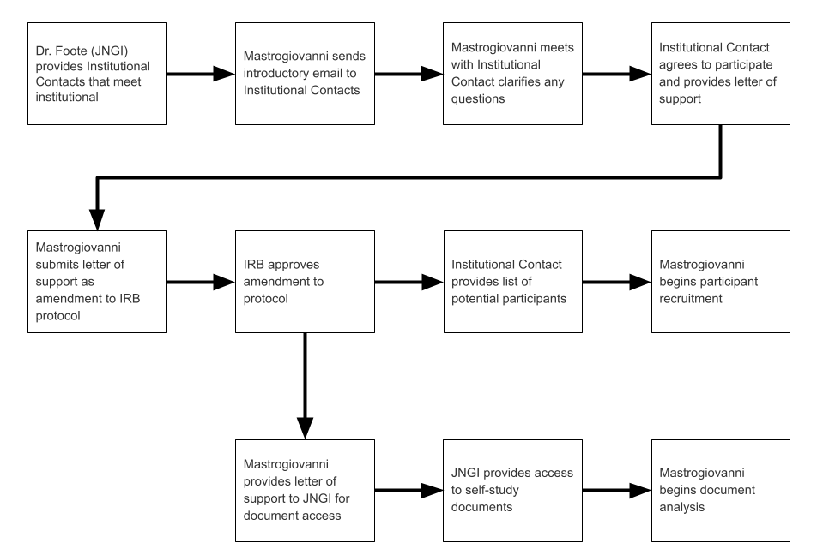
Figure 15. Order of Actions for Communication with Institutional Liaison

Generic Letter of Support
Dear Colleagues,
Private University is a [insert demographic description and/or mission]. I am writing to express our institutional support for the proposal Collaboration in Transfer Student Work: A Cultural Historical Activity Theory Study at Four-Year Institutions submitted by Jason Mastrogiovanni, a doctoral student at the University of Tennessee, Knoxville.
As a demonstration of our commitment to the proposal, Private University will provide the following:
- Dr. [insert name] will provide this letter of support to Mr. Mastrogiovanni for sharing with the John N. Gardner institute (JNGI) and the University of Tennessee, Knoxville Institutional Review Board.
- Private University supports Mr. Mastrogiovanni’s access to the Foundations of Excellence self-study reports completed by our institution. The reports do not contain any personally identifiable information and will be used by Mr. Mastrogiovanni for analysis. Mr. Mastrogiovanni will share this letter of support with Dr. Foote of JNGI to access the documents, of which, JNGI maintains record.
- Dr. [insert name] will provide Mr. Mastrogiovanni with a list of Private University employees who participated in the Foundations of Excellence self-study process.
- Private University supports Mr. Mastrogiovanni recruiting these employees for interviews as a part of his study.
Sincerely yours,
[insert name]
[insert title]
Private University

Appendix B: Protocol for Communication with Institutional Participant
Following the procurement of institutional support and a list of potential participants, the following messages were approved by IRB for recruitment. When a participant expressed interest in participation, they were asked to review and complete the consent form approved by IRB. Following the receipt of the completed release form, I scheduled an interview with the participant via the video conferencing tool, Zoom.
First Recruitment Email
Dear Dr __________,
My name is Jason Mastrogiovanni and I am an administrator at Texas A&M University and a doctoral student at the University of Tennessee. I have obtained permission from your institution to contact individuals who were involved in the Foundations of Excellence for Transfer Student self-study on your campus. Would you be interested in sharing your experience participating in this collaborative effort to facilitate improvement in your transfer student services for my dissertation research? If so, you need only respond to this email or jmastrog@utk.edu.
Please see the following informed consent statement to answer some introductory questions you may have.
Informed Consent Statement
In the study, in which, you are invited to participate we will examine the educator motivations and actions involved in the collaborative activity of creating transfer student services at four-year institutions. The risks to you and your institution are minimal. Additionally, your institution has consented to our outreach to you for this research purpose. All institutional and individual data will be anonymous through the use of pseudonyms. Position title or leadership roles will be similarly masked through generic institutional indicators. For example, if your position title at your institution is “Associate Vice President for Student Affairs and Strategic Initiatives” we would refer to you as a “senior-leader in student affairs”. The potential benefits are to our field of higher education, specifically the educator motivations toward transfer services and a greater understanding of collaborative practice.
We plan to interview 5 to 7 educators on your campus at different organizational positions within your university who had direct involvement with the Foundations of Excellence for Transfer Students institutional self-study. Following the interview we are asking participants to review a transcript of the interview to make any corrections or clarify any comments they would like to amend. If you consent, you will have the option to end your participation at any time within the study.
The interview will be 45 minutes to an hour in length and will be arranged via the video conferencing tool, Zoom. In the week following the interview, we will send you a transcript of interview for your review. You will have an opportunity to make any corrections or clarify any points you wish to. For your participation and time, you will receive $50 for completion of the interview and $50 for a returned transcript review within two weeks of receipt from us. The maximum amount of $100 will be issued to you in the form of an Amazon gift card following the completion of these two tasks or the expiration of the two-week time frame following the transcription review.
If you have any questions about this study, you may contact the principal investigator: Jason Mastrogiovanni at jmastrog@utk.edu, 631-560-8314 or the faculty advisor for this dissertation: Lisa Yamagata-Lynch at lisayl@utk.edu. If you have any questions about this research, you may contact the:
Institutional Review Board
The University of Tennessee, Knoxville
1534 White Avenue
Blount Hall, Room 408
Knoxville, TN 37996-1529
Phone: 865-974-7697
Email: utkirb@utk.edu
I know your time is valuable. Thank you for your time and consideration of this proposal.
Sincerely,
Jason Mastrogiovanni
University of Tennessee, Knoxville – Doctoral candidate
Texas A&M University – Executive Director for Student Success

Second Recruitment Email – One Week Later
Dear Dr __________,
My name is Jason Mastrogiovanni and I am an administrator at Texas A&M University and a doctoral student at the University of Tennessee. You received an email from me last week regarding the opportunity to participate in a study regarding your involvement in the Foundations of Excellence for Transfer Student self-study on your campus. I do not wish to bother you further if you are not interested. As such, this is the last email you will receive from me.

If you are interested in participating in my dissertation research, you need only respond to this email or jmastrog@utk.edu. Please see the following informed consent statement to answer some introductory questions you may have.
Participant Informed Consent
In the study, in which, you are invited to participate we will examine the educator motivations and actions involved in the collaborative activity of creating transfer student services at four-year institutions. The risks to you and your institution are minimal. Additionally, your institution has consented to our outreach to you for this research purpose. All institutional and individual data will be anonymous through the use of pseudonyms. Position title or leadership roles will be similarly masked through generic institutional indicators. For example, if your position title at your institution is “Associate Vice President for Student Affairs and Strategic Initiatives” we would refer to you as a “senior-leader in student affairs”. The potential benefits are to our field of higher education, specifically the educator motivations toward transfer services and a greater understanding of collaborative practice.
We plan to interview 5 to 7 educators on your campus at different organizational positions within your university who had direct involvement with the Foundations of Excellence for Transfer Students institutional self-study. Following the interview we are asking participants to review a transcript of the interview to make any corrections or clarify any comments they would like to amend. If you consent, you will have the option to end your participation at any time within the study.

The interview will be 45 minutes to an hour in length and will be arranged via the video conferencing tool, Zoom. In the week following the interview, we will send you a transcript of interview for your review. You will have an opportunity to make any corrections or clarify any points you wish to. For your participation and time, you will receive $50 for completion of the interview and $50 for a returned transcript review within two weeks of receipt from us. The maximum amount of $100 will be issued to you in the form of an Amazon gift card following the completion of these two tasks or the expiration of the two-week time frame following the transcription review.
If you have any questions about this study, you may contact the principal investigator: Jason Mastrogiovanni at jmastrog@utk.edu, 631-560-8314 or the faculty advisor for this dissertation: Lisa Yamagata-Lynch at lisayl@utk.edu. If you have any questions about this research, you may contact the:
Institutional Review Board
The University of Tennessee, Knoxville
1534 White Avenue
Blount Hall, Room 408
Knoxville, TN 37996-1529
Phone: 865-974-7697
Email: utkirb@utk.edu
I know your time is valuable. Thank you for your time and consideration of this proposal.
Sincerely,
Jason Mastrogiovanni
University of Tennessee, Knoxville – Doctoral candidate
Texas A&M University – Executive Director for Student Success

Appendix C: Interview Question Protocol
The following text has two parts that form the outline of the interview experience for participants. The first part, introductory protocol, is a verbatim script of the text I will read to every participant. The second part, interview questions, is the outline for the semi-structured interview questions.
Research Questions
- How do educators in four-year institutions contribute toward collaborative, cross-institutional transfer activity?
  - What motives do educators share while participating in the cross-institutional transfer activity?
  - How do educator motives differ while participating in the cross-institutional transfer activity based on their organizational goals and shared norms?
- How do educator motives in the four-year institution influence the cross-institutional transfer outcomes?
Introductory Protocol
Hello and thank you for agreeing to participate in this interview. To facilitate my analysis of our conversation, I would like to record our conversations today. Having received your release form consent to this practice I will begin this interview and the recording with your approval.
- Are you ready?
For your information, only researchers on the project will be privy to the recordings, which will be eventually deleted after they have been transcribed. The informed consent form you signed was devised to meet our human subject requirements. Essentially, this document states that: (1) all information will be held confidential, (2) your participation is voluntary, and you may stop at any time if you feel uncomfortable, and (3) I do not intend to inflict any harm. Thank you for your agreeing to participate.

I have planned this interview to last no longer than 45-60 minutes. During this time, I have several questions that I would like to cover. If time begins to run short, it may be necessary to interrupt you in order to push ahead and complete a line of questioning.

You have been selected to speak with me today because you have been identified as someone who was directly involved with your institution’s Foundations of Excellence for Transfer Students self-study. My research project as a whole focuses on the collaborative process of creating and sustaining transfer student services at four-year instituions. My study will specifically examine the motivations and actions of educators involved in this process and how those motivations and processes impact the activity. The questions I will ask you today are about your perspective and opinions about this process.
- Do you have any questions before we begin?
- Please state your name and position in the institution.

Interview Questions
- Originations
I want to begin by asking you some questions about your perceptions of why your campus engaged in this work.
- From your perspective, why did your campus engage in this work?
- Which individuals led your campus to improving the transfer student experience?
- Which individuals led your campus to engage in the Foundations of Excellence self-study?
- What do you think motivated their desire to work on/ invest in the activity?
- Personal motives
- What motivated your involvement in the activity?
- Was it required, were you nominated, did you seek it out?
- How did you feel about participating?
- Process
I want to ask you some questions about the process of the self-study.
- Was everybody involved in the process that should have been? Why or why not?
- How was work divided in the self-study process? What role or roles did you play in the work specifically?
- Was this division of work effective? Why or why not?
- How thorough was the process? What makes you think so?
Probes:
- What types of programs were included or not included?
- Were students or community college partners included?
- How was curricular alignment or transfer credit articulation included?
- How was transfer student recruitment included?
- How was transfer student advising included?
- How was transfer student support included?
- Conclusion of self-study
The next few questions I am going to ask are about the reports themselves.
- How did the final report align with your understanding of the findings of transfer student services on your campus? Could you explain why?
- Do you perceive that any individuals on your campus did not agree with the report findings? Why or why not?
Probes:
- How has information communicated regarding the self-study report?
- How have individuals from your feeder community colleges responded to the report findings?
- How have transfer students responded to the report findings?
- Action from self-study
Now, I am going to ask are about the actions that followed the report.
- What actions have come as a result of the FoE self-study?
- What are your perceptions about these actions?
- What are your perceptions of colleagues’ thoughts about these actions?
Probes:
- How have the actions been perceived as impacting students?
- How have the actions impacted different groups? Were some elevated and others diminished?
- How have informal collaborative networks been created or perpetuated?
- Reflections after the self-study
I want to conclude with some reflective questions about what you have taken away from engaging in this work.
- Have interactions between you and other individuals in transfer student services changed?
- What work still needs to be done regarding transfer student services?
- What advice do you have for other educators wishing to engage in collaborative work with transfer student services?
- What are strategies you might use in similar collaborative environments?
- Snowball sample question
- Who else would have unique insight into how this collaborative activity occurred? Why?

Appendix D: Coding Progression
Open Coding Result – 112 codes, 5 families.
Activity Systems Analysis
ASA-Action
ASA-Community
ASA-Division of Labor
ASA-Object
ASA-Outcome
ASA-Rules
ASA- Covid
ASA-Subject
ASA-Tension
ASA-Tool
Collaborative Qualities
CQ-Actionable
CQ-Barrier Elimination
CQ-Change
CQ-Collaborative Hist.
CQ-Communication
CQ-Compromise
CQ-Documentation
CQ-Feedback
CQ-Generative
CQ-Good Data Story
CQ-Improvement
CQ-Inclusion of Others
CQ-Incremental
CQ-Institutional Size
CQ-Intentionality
CQ-Learning
CQ-Name Collab.
CQ-Perspective Taking
CQ-Relationships
CQ-Sharing Info
CQ-Supportive Env.
CQ-Time Invested
CQ-Trust
Motivation
MO-Assessment Data
MO-Complaints
MO-Consistency
MO-External Pressure
MO-Financial Benefit
MO-Improvement
MO-Institutional Status
MO-Intrinsic
MO-Making Decisions
MO-Need Understand
MO-Resource Shortage
MO-ROI
MO-Service
MO-Student Belong
MO-Student Diversity
MO-Student Enrollment
MO-Student Equity
MO-Student Experience
MO-Student Know.
MO-Student Metric
MO-Student Prep
MO-Unrelated
UnCollaborative Qualities
UQ-Barriers
UQ-Buy-in
UQ-Competition
UQ-Different Values
UQ-Discrim./Exclusion
UQ-Hist. Invocation
UQ-Hopelessness
UQ-Not Priority
UQ-Not Sharing Info
UQ-Outsourcing
UQ-Poor Comm.
UQ-Poor Data Story
UQ-Poor Service
UQ-Reactionary
UQ-Resistance to Chg.
UQ-Silos
UQ-Skepticism
UQ-Status Quo
UQ-Top Down
Transfer Elements
(Old Recommendations)
REC-Academic Support
REC-Administrator
REC-Admissions
REC-Advising
REC-Articulation
REC-Assessment
REC-Bridge Initiatives
REC-CC
REC-Communication
REC-Coordination
REC-Curriculum Align.
REC-Early Alert
REC-Employee Diver.
REC-Faculty
REC-Family Services
REC-Financial Aid
REC-Governing Body
REC-Grass Roots
REC-Infrastructure
REC-Investment
REC-Learning Exp.
REC-Marketing
REC-Mentorship
REC-Orientation
REC-Policy Alignment
REC-PostMatric
REC-PreMatric
REC-Relationships
REC-Representation
REC-Residence
REC-Reverse Transfer
REC-Rewards
REC-Seminar
REC-Shared Value
REC-Student Cmty.
REC-System
REC-Transfer Students
REC-Understand

Focused Coding Result– 19 codes, 4 families.
Activity Systems Analysis
ASA-Action
ASA-Community
ASA-Division of Labor
ASA-Object
ASA-Outcome
ASA-Rules
ASA-Covid
ASA-Subject
ASA-Tension
ASA-Tool
VIO - Value of Including Others
Learning from Others
Empathetic Perspective
Forming Relationships
Lament of Lost Voices
CIP - Communication and Progress
Grass Roots Comm
Leadership Comm
External Factors
DIEM - Different Institutional and Educator Motivations
Institutional Motivations
Educator Motivations

Selective Coding Result– 10 codes, 1 family.
Activity Systems Analysis
ASA-Action
ASA-Community
ASA-Division of Labor
ASA-Object
ASA-Outcome
ASA-Rules
ASA-Covid
ASA-Subject
ASA-Tension
ASA-Tool

Appendix E: Participant Activity Systems
Private University Activity System
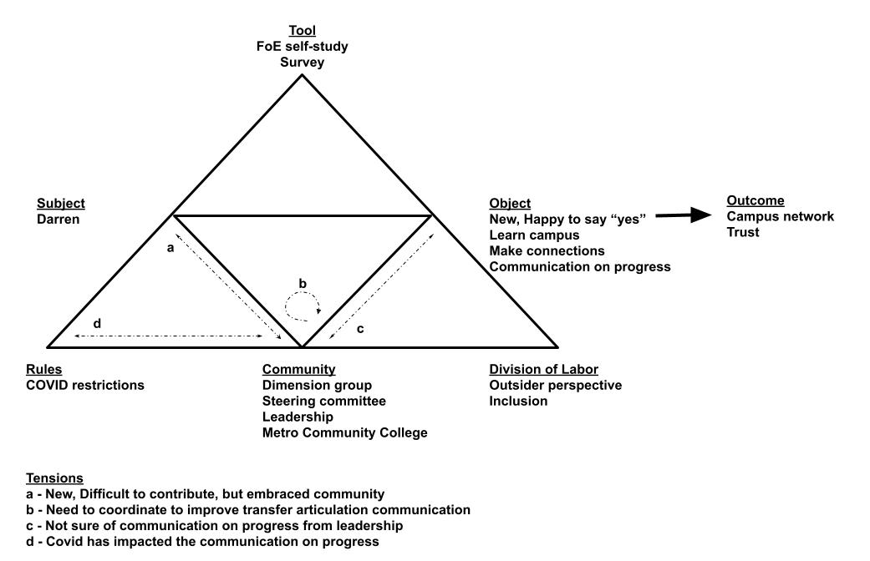 Darren (Private University) Activity System
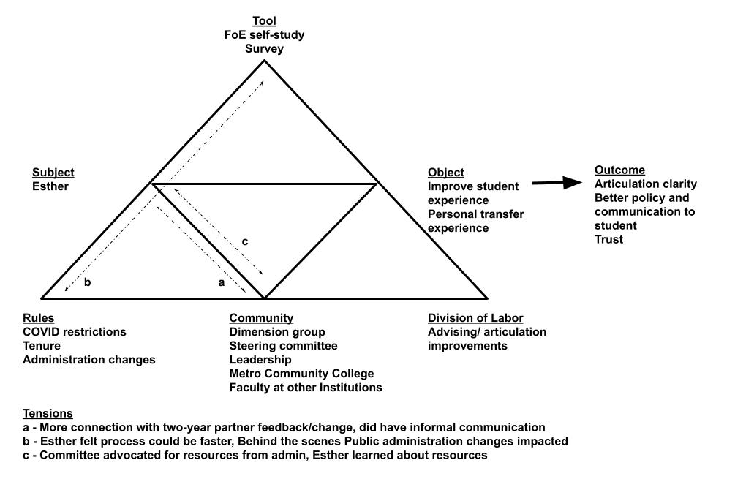 Esther (Private University) Activity System
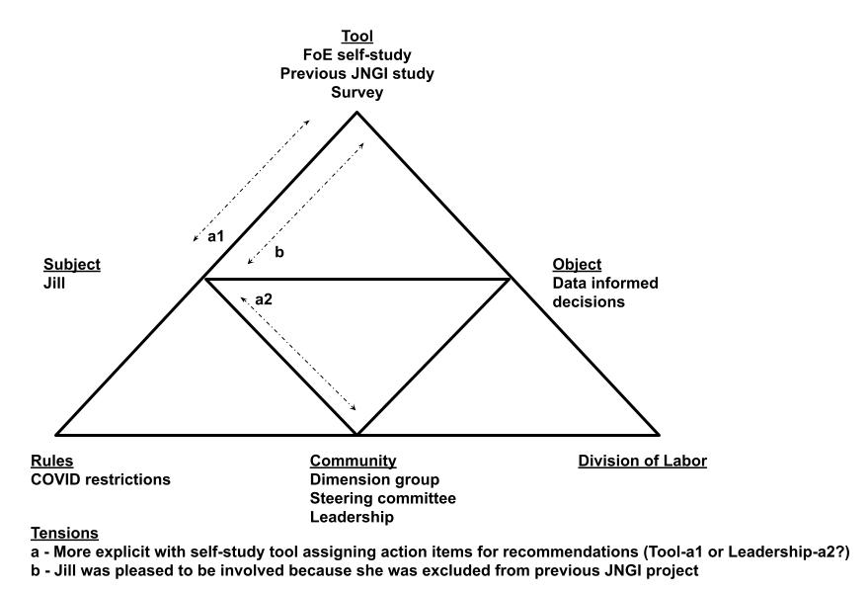 Jill (Private University) Activity System
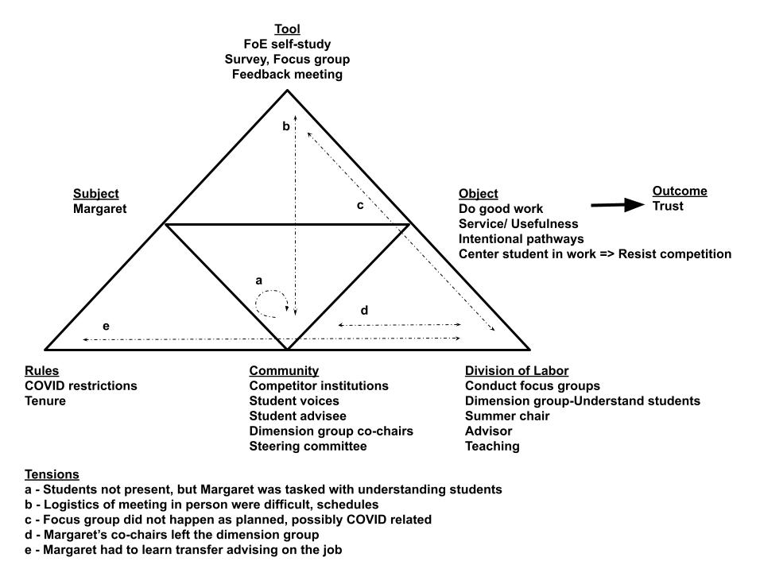 Margaret (Private University) Activity System
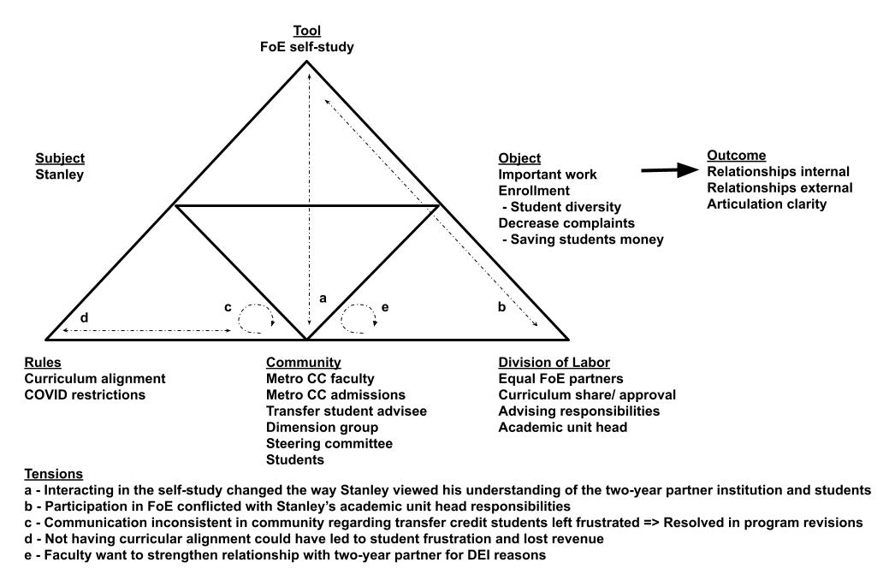 Stanley (Private University) Activity System
State University Activity System
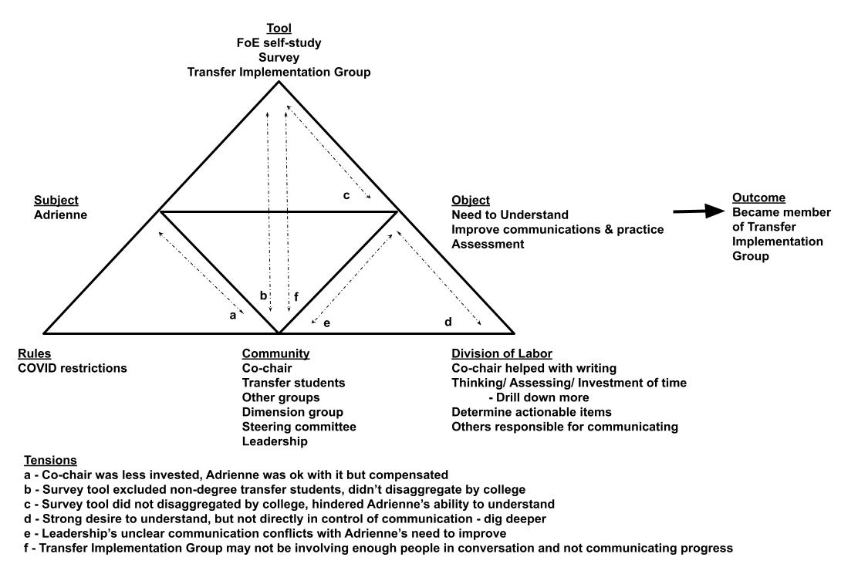 Adrienne (State University) Activity System
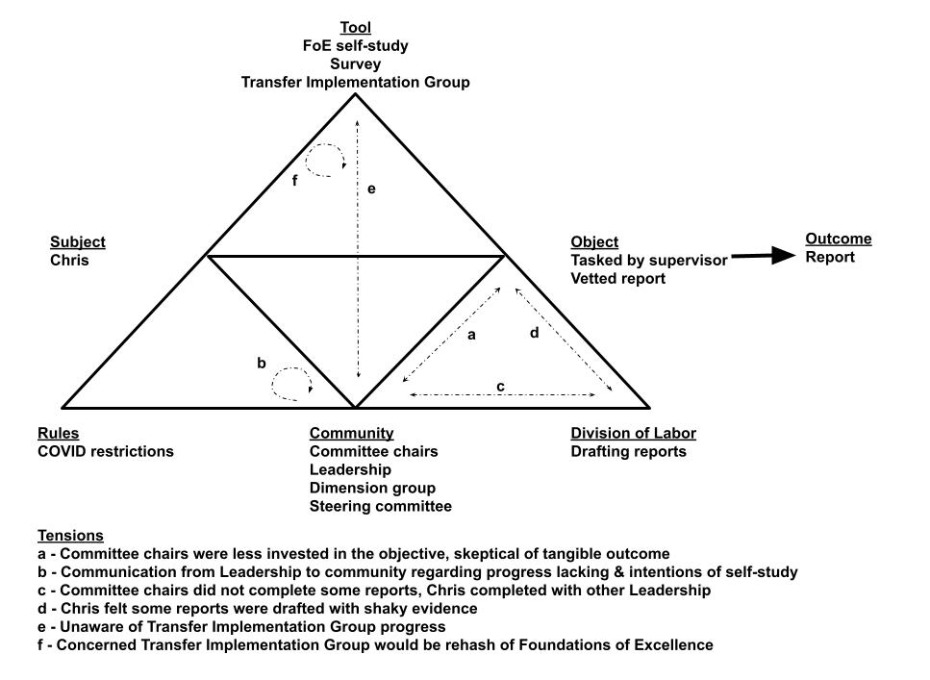 Chris (State University) Activity System
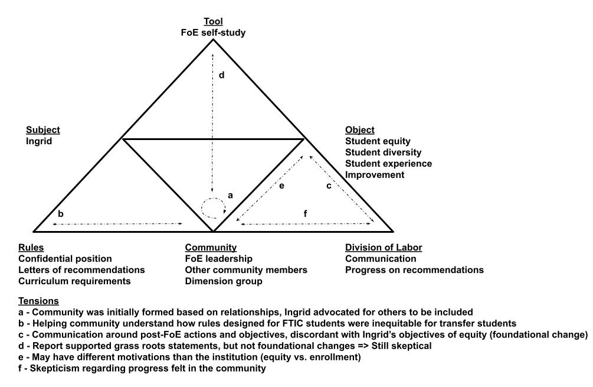 Ingrid (State University) Activity System
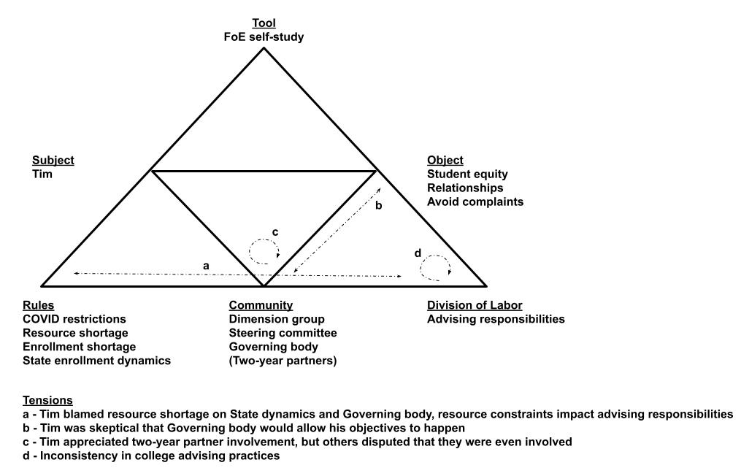 Tim (State University) Activity System
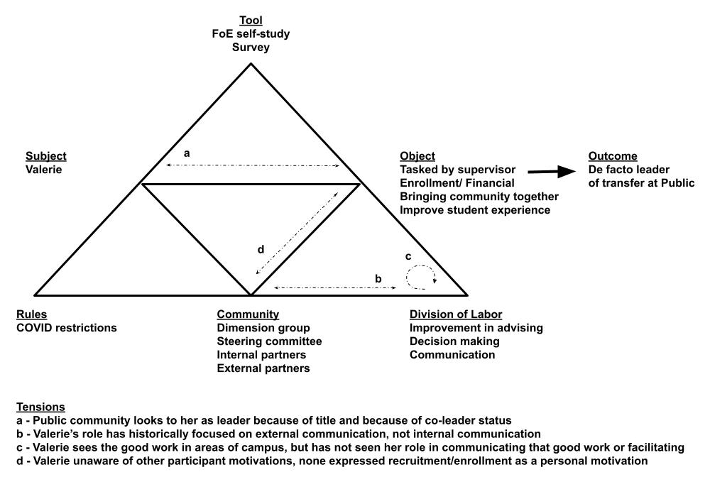 Valerie (State University) Activity System

Vita
Jason Mastrogiovanni earned a Bachelor of Music in Music Education from the University of Florida and a Master of Science in Music Education from Central Connecticut State University. This dissertation completes his Doctor of Philosophy in Education with a concentration in Learning, Design, and Technology at the University of Tennessee, Knoxville where his dissertation topic is Collaboration in transfer student work: A cultural historical activity theory study at four-year institutions. Jason joined the Office for Student Success at Texas A&M University in July 2019 as the founding Executive Director of the Office of Student Success. He brings with him over 16 years’ experience in student success and development. His portfolio has included academic advising, first-year experience, transfer experience, academic outreach, first-generation programs, as well as overall student success administration. Having made a habit of serving in newly created roles, he has served as the founding Director of First-Year Studies at the University of Tennessee, Knoxville and the founding Assistant Director of the Undergraduate Colleges at Stony Brook University. In addition to his professional and education roles he is an active member of several national organizations, including the National Institute for the Study of Transfer Students, the National Resource Center for the First-Year Experience and Students in Transition, and NODA: The Association for Orientation, Transition, and Retention. Most recently he served as editor of the publication, Building Successful Foundations: Best Practices in Orientation, Transition, & Retention and as author for several articles on collaboration, transition, and design thinking in the higher education environment. He has also held additional leadership roles in NODA including NODA Databank chair, Educational Initiative committee chair, and Retention Symposium faculty.

